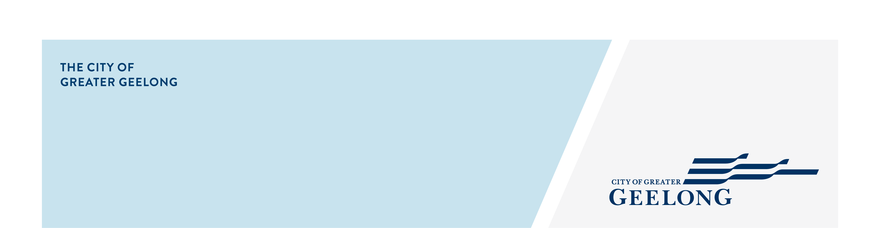
FILM permit

indemnity form
This section is to be completed by the permit holder or their authorised representative
I, |  | (name of person)
Of |  | (address of person)
Holding the position of |  | (role or position in business)
In the business named |  | (business name)
With ABN or ACN |  | (Australian business or company number)
Of |  | (business address)
For which business I am duly authorised to sign this indemnity
In consideration of the permit for |  | (the name of the event/activity)
On the date of the activity: |  | (the date of the event/activity)
On the footpath, parcel of land or roadway
Being granted to |  | (name of person or incorporated business name of the permit)
(Referred to as “the permit holder”) hereby covenants with City of Greater Geelong (hereinafter referred to as “the council”) that unless caused by a breach of statutory duty or common law by council or any of its officers, agents, employees or contractors, the permit holder agrees to indemnify the council and keep the council indemnified from and against all and any damage, loss, cost or liability incurred or suffered by any person as a result of the permit holder’s failure to comply with any conditions of the permit granted by the council, or any other failure to comply with any relevant law, lawful duty or obligation giving rise to any damage, loss, cost or liability incurred or suffered by any person as a result of or in any way associated with the exercise of this permit.
Signed sealed and delivered by
(Print name) |  | (sign)
(Print position) |  | (date)
In the presence of:
(Print witness name) |  | (witness signature & date)
Specific collection statement
The personal information requested on this form is being collected by City of Greater Geelong for the purpose of processing your event application. If the personal information is not collected, we will be unable to support your event. We will not disclose your personal information without your consent, except where required to do so by law. Our privacy policy is available on our website. If you wish to alter any of the personal information you have supplied to City of Greater Geelong, please contact us by sending an email privacy@geelongcity.vic.gov.au or call 5272 5272.

