DAVID LOCK ASSOCIATES

TOWN PLANNING & URBAN DESIGN
Algo Properties
Centre Master Plan
pos9t City
this ment Plan with
itG anno:ed documents (...l.. .... pages) 03 1.11 the Oeve!oprr.ontPIY1 propa to the ef Fbpens\blø A'*hcrity to the bid subject to DPO with moMing 43.04 of Paaninc Sci-erne.
CetAl-re Icey«
July 201 1
-e_ce q S PO
Jetty Road Neighbourhood Activity

Jetty Rd Neighbourhood Activity Centre Master Plan
Algo Properties

CONTENTS


1.0 INTRODUCTION
A
street-based
Retaii
and
Community
Public
open
Car
parking
15
16
16
2.0 KEY ELEMENTS.... ..
3.0 DESIGN RATIONALE.


Location
ASSOCIATES
Housing.......

Sustainable travel
Staging ...
Stage 1.....
Stage 2...
Stage 3

APPENDIX A: WORKSHOP PLAN.. . . . ............17
Algo Properties

1.0 INTRODUCTION
1.1 This report sets out the Master Plan for the development of a neighbourhood activity centre (NAC) in the Jetty Road growth area, in Curlewis. (See location plan overleaf.) It responds to the requirement of Schedule 20 to the Geelong Development Plan Overlay for a "Neighbourhood Activity Centre Masterplan" as part of the Development Plan for the Jetty Road growth area.
1.2 The Master Plan was developed through a collaborative process involving the landowner, key Council officers and consultants.

1.3 Since the preparation of the draft Master Plan in 2009, development in the area has
continued. This has seen Drysdale expand and mature as a residential area. The development of the Master Plan has taken into account various stakeholder interests.
1.4 In 2011, the planning scheme amendment that will enable the development of the activity centre is to be considered. This Master Plan is an input to the development assessment that will follow.
1.3 Section 2 sets out the key elements of the Master Plan.
- .4 Section 3 provides an explanation of the rationale underpinning the Master Plan. It also outlines how the Master Plan complies with the most relevant elements of the planning framework.
1.5 Section 4 contains guidelines for the staging of the development.

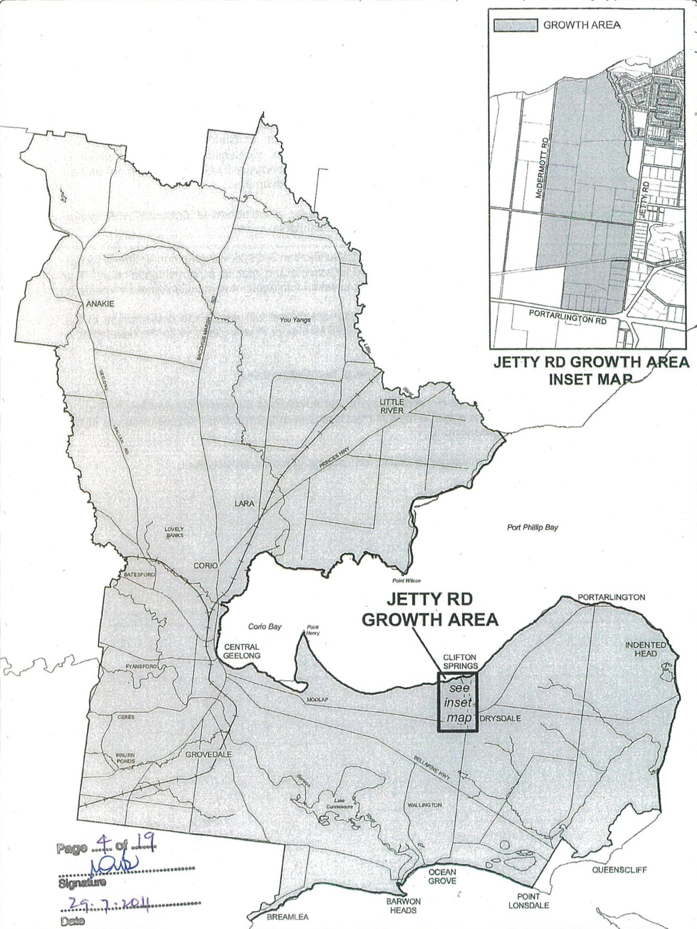
 REGIONAL CONTEXT MAP

GEELONG cored no JETTY RD URBAN GROWTH PLAN
Water
in
its
use.
Map No. 1
Al o Pro erties

2.0 KEY ELEMENTS
2.1 The Development Framework plan overleaf illustrates the key structuring elements of the Master Plan that the development of the NAC should conform with. These include:
- • The north-south primary road turning at the top of the hill to provide a view across Port Phillip Bay to the Melbourne CBD.
- The east-west primary road turning towards the hilltop park as it enters the centre, and forming the primary, pedestrian-oriented 'mainstreet' of the centre.
- A signalised intersection where the two primary roads meet, incorporating pedestrian crossings between the centre and the hilltop park.
- A main street that encourages pedestrian circulation along Wyndham Street.
- Further pedestrian crossing points in the east-west mainstreet.

- A supermarket facing the northern side of the mainstreet, 'sleeved' by specialty shops and other uses fronting the two primary roads and adjoining supermarket car park.
- Further specialty shops and other uses fronting the southern side of the mainstreet.
- A neighbourhood house, children's services and allied uses across the northsouth primary road from the centre and abutting the hilltop park,
- A park at the top of the hill and extending down its northeast slope to the 55m contour to gain filtered views of Port Phillip Bay. The park to have a frontage to the western side of the north-south primary road across from the activity centre uses.
- A compact, coherent shopping strip that engages the two primary roads.
- Mixed-use development and medium-density housing around the edge of the centre, particularly screening the loading dock of the supermarket.
Kerbside parking along both primary roads to optimise main street car parking.
- An off-street car park adjacent to the supermarket, well landscaped with canopy trees.
- A smaller car park to support the shops on the south side of the mainstreet.
- Local street connections which provide links with future development to the south and east.
- On-site car parks for uses in the neighbourhood centre.

山区トN山D AL一>一トDV 0〇〇工 っ〇8工D一山N 0<〇 トトト山「 も」2309
s6uあSO」0ue一 2呈d 材
き凸8 コSpaeqs
28一巴0コー p巴工
2d」20 eoeds〔 00=qnd
っ・ さ ーの 石2山 uョu〔80・一dogsfi12toedSー
ILI!Od
/ edOVN ・ 6u 型> do~=一工
&do==工
23」2凹 に一(霊一eoo一

SOSつ 0puedogs
聖OOdS」0一6をき&」20
畠当を三V
矼当0工POOモコoq一一5一ON
N<コd 区〇 山IA<区」 トN山IA]d〇コ山>山a

Al o Pro erties

2.2 The Master Plan provides for the following quantities of development and open space:
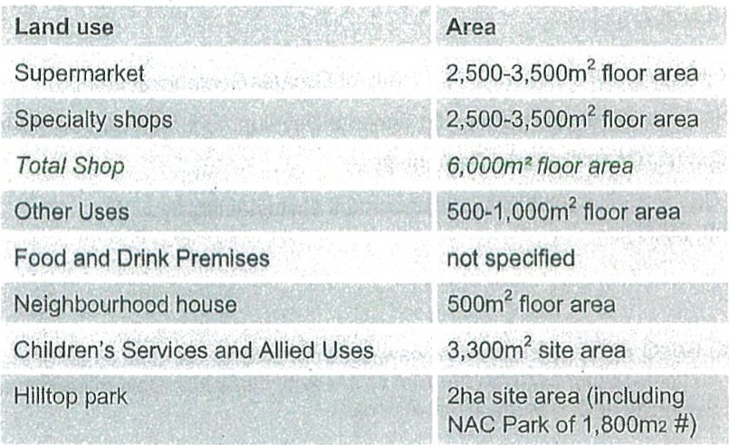
#as derived from Jetty Road Open Space master plan (6 April 2011)


Algo Properties

3.0 DESIGN RATIONALE
3.1 This section provides an explanation of the rationale underpinning the Master Plan. It also outlines how the Master Plan complies with the most relevant elements of the planning framework, including:
- Jetty Road Urban Growth Plan (UGP), City of Greater Geelong, June 2007
- Schedule 20 to the Geelong Planning Scheme Development Plan Overlay (DPO)
- City of Greater Geelong Retail Strategy 2006
- Activity Centre Design Guidelines, Department of Sustainability and Environment, 2005

Location
3.2 The Geelong Retail Strategy states that new centres "should be located on or near main roads". This is consistent with the Aim of the Activity Centre Design Guidelines to "Increase accessibility and integration" of centres
3.3 The UGP identifies the preferred location for the Jetty Road NAC on Map No. 10, Future Activity Centres and Community Infrastructure, reproduced overleaf. This location is on the main collector road network, as required by the Retail Strategy. It also reflects Objective 13.1 of the UGP, which states:
The Neighbourhood Activity Centre is to be located centrally to the urban growth area, and be adjacent to a significant hill and sub-regional park that is to be above the 55 AHD contour.
3.4 The DPO reinforces the requirement for the NAC to be adjacent to the hill, but goes further, requiring it to be generally south and southeast of the hilltop park. The C152 Panel Report recommends changes to the wording of the DPO to locate the NAC 'centrally to the Jetty Road growth area generally in the vicinity shown in the Jetty Road Urban Growth Plan 26 June 2007 (amended 23 September 2008)'. Refer to the Future Activity Centre and Community Infrastructure plan reproduced overleaf.
3.5 The Master Plan responds to these requirements. It places the NAC at the intersection of the two main collector roads and adjacent to the hilltop park. However, the proposed location is slightly north and east of that indicated in UGP Map No. 4. The primary reason for this is a desire to capitalise on views of the bay as part of the sense of place of the centre. In order to achieve this, the centre must be north of the ridgeline that runs from northwest to southeast through the hilltop. An additional benefit of this location is that it places the centre within a single landholding, facilitating comprehensive and coordinated development.
3.6 Importantly, the Master Plan provides for the resolution of the 'primary road' network that provides high levels of exposure and access to the centre.

%.-..I.-..ÄJ.L...............

7
Pori Phillip Bay
Kiosk Activity Centre

Clifton Springs
to meet local tourist' and Boat Harbtmr
C,fftcA1 Springs
convenience needs Club
Centrally located
Neighbourhood Activity Centre to meet the needs of the growth area community
cwrton
Spdngs ADA sr
Primary
=nnn
Local Convenience zuu;. Activity Centre to meet
the needs of the —1114'. growth area ,ii:: li/•hlii communit
RIYULE RD
Recreation
Reserve
Community based services and businesses to be encouraged within the Neighbourhood
Activity Centre and ixed use area
BELLARINE RNL TRAIL
Cud0B'js
Lake Lome
Reserve

Legend:

NEIGHBOURHOOD ACTIVITY CENTRE
LOCAL CONVENIENCE ACTIVITY CENTRE
FORESHORE KIOSK ACTIVITY CENTRE
MEDIUM DENSITY RESIDENTIAL This plan is a representation of some of the key CONVENTIONAL RESIDENTIAL principles within the Jetty Road Urban Growth Plan. MIXED USE DEVELOPMENT
While the plan will guide the general form of development, it does not indicate exact locations PRIMARY ROAD (Boulevard)
which will require detailed design work and future GROWTH AREA BOUNDARY develo menta roval.

GEELONG  o 0.1 0.2 | 0.4 0.6 | 0.8 | AND COMMUNITY INFRASTRUCTURE
Prcpnrcd City cf | Goa;ong. 2007 |  | JETTY RD URBAN GROWTH PLAN
Ntl•zugh duo | 'aken to onsure Ihar | da:utnant is cccrecl. no | No. 10
FUTURE ACTIVITY CENTRES

imNZd by thu City ot Graotcr Gcctong Water its usa. Map
Algo Properties

A street-based centre
3.7 The Geelong Retail Strategy, Activity Centre Design Guidelines, UGP and DPO all promote street-based centres. This means that the NAC should be structured by a network of public streets that provide direct connections with the centre's surroundings, form the primary address for all buildings, and constitute the majority of the public realm within the centre.
3.8 In particular, Objective 14.1 of the UGP states:
All activity centres within the growth area should be oriented to support active street frontages, street-based community interaction and pedestrian safety.
3.9 And Objective 14.2 states:
Activity centres are to be developed as public spaces, not privately owned 'shopping-centres' or enclosed malls; ie, all public space within the activity centre is to be publicly owned.
3.10 The Master Plan organises the centre around the two primary roads within the urban growth area. These streets are both designed to be public, pedestrian-friendly and act as the primary open space of the centre, along with one or more public plazas and the hilltop park.
3.11 The plan provides for development to address these streets with active frontages, creating a well-defined and safe public realm, and continuous retail frontages as promoted by the Geelong Retail Strategy. The supermarket is 'sleeved' with smaller retail and commercial premises, which face outwards to front the surrounding streets. The entrance to the supermarket is closer to the main street than it is to the car park entry.
3.12 Wyndham Street forms the east-west primary road (main street of the NAC). It is designed so that crossing the street is encouraged. The uses along each frontage are supported by practical, convenient car parking, bicycle parking, trees and footpaths. Bicycle lanes are included in the road. This is illustrated in the Indicative cross-section overleaf.
3.13 The primary roads provide direct connections with the whole Jetty Road growth area to the north, south and east. Traffic signals at the intersection of the two primary roads will provide safe crossing points for pedestrians walking •along these routes or to and from the hilltop park.
3.14 Local streets provide additional routes into the centre from all directions. This includes a direct link with the Clifton Springs Primary School, which passes between the retail core and the main car park to reach the heart of the centre. It also includes a local street leading directly south from the centre to connect with future development on the adjoining property.
3.15 The DPO requires the public space within the NAC to be "designed to create a strong sense of place ..." This is achieved in the Master Plan by the configuration of the public realm to focus on the hilltop park and Bay views. The bends in the alignment of each primary road as it reaches the NAC will reinforce the sense of arriving at a different place. The road around the eastern edge of the NAC is one part of a flexible road network that Will support the NAC. This road may function as a bypass of the mainstreet at times when the mainstreet is congested. The detailed design of the street and its intersections will enable this to occur.

9
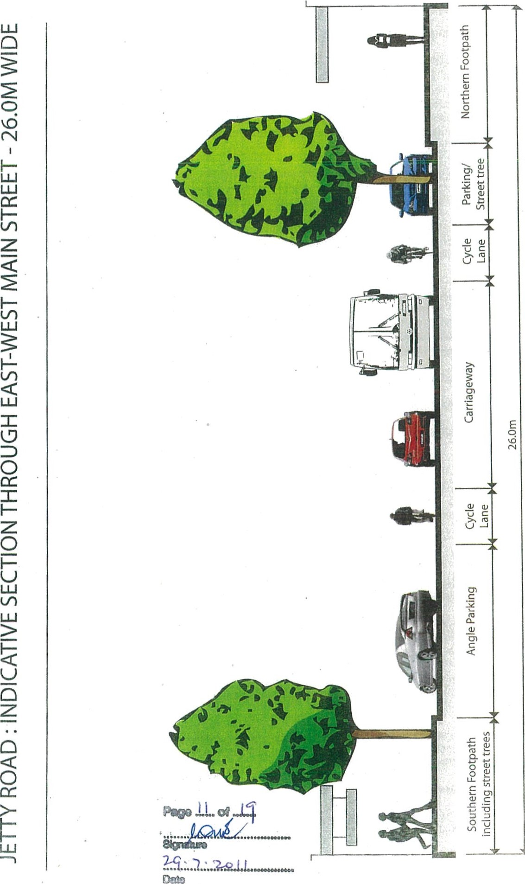
Al o Pro erties

Retail and commercial uses
3.16 The Geelong Retail Strategy 2006 sets out the retail hierarchy for Geelong. It states that neighbourhood centres "are generally characterised by a range of mainly convenience-related shopping needs such as newsagent, chemist, hairdresser, green grocer, butcher, takeaway food, etc, and anchored by a supermarket'. In response to this, the Jetty Road NAC Masterplan incorporates a supermarket in a central location and is designed to accommodate specialty retail of the types referred to above.
3.17 Objective 12.3 of the IJGP requires that the NAC "fall below the existing Drysdale Town Centre in the local activity centre hierarchy". Drysdale Town Centre has been the subject of multiple changes so that the retail scale is likely to be about 15,000m².
3.18 The Jetty Road NAC will fall well below this level providing about 6,000m² of shop floor space. It is likely to include a supermarket of approximately 3,200m². In addition it will provide some office uses, services and food and drink premises.
3.19 The DPO states that provision for commercial and non-commercial floor space in the order of 5,000m². Having regard to the need to activate the two primary roads and the relative scale of Drysdale, it is important to provide sufficient incentive for the multiple land owners to invest and create a sustainable centre. At the same time, the hierarchical relationship with Drysdale will be maintained. The master plan remains generally consistent with the DPO.
3.20 The inclusion of any gaming machines is to be prohibited.

Community facilities
3.21 Objective 15.1 of the UGP states:
Community services and infrastructure are to be provided within and in close proximity to the neighbourhood activity centre, to the satisfaction of Council. They may include:
- Joined up ... children's services including 90 places for kindergarten, childcare and occasional care .
- A neighbourhood house level facility of at least 500sqm
3.22 These requirements are reflected -in the DPO, which also requires "proper integration between commercial and community facilities .
3.23 The Master Plan provides for a 500m² Neighbourhood House and children's services centre. The Neighbourhood House and children's' services and allied uses are located across the street from the core of the NAC and adjacent to the Hilltop park. This will support activities that require open space, while ensuring good integration with the rest of the centre. Car parking is provided on site. However, it is intended that the buildings will address both the street and park, with parking and partially concealed behind them.
The design of the Neighbourhood House, children's services, allied uses and associated car park area will ensure that filtered views from the hilltop to the Bay and Melbourne CBD are preserved.

Public open space


Al o Pro erties
3.26 Objective 17.4 of the IJGP states:
A large central park of at least 2 ha should be provided adjacent the neighbourhood activity centre, including the natural high point of the site and providing views to the bay. ..
3.27 The Master Plan provides for a 2ha park on the hilltop adjacent to the NAC and almost entirely above the 55m AHD contour as required by Objective 13.1 and shown in Map 12, Future Public Open Space, reproduced overleaf. It is biased towards the north eastern slope of the hilltop in order to maximise views of the bay.
3.28 Views of the Bay and Melbourne CBD from the Hilltop will be filtered through existing and new vegetation and buildings in the foreground as illustrated below. These views may be protected and enhanced by limiting the height and bulk of development in the foreground or by raising the viewing point. The raising of the viewing point may be achieved either via an elevated viewing structure or through the use of fill from the surrounding development.
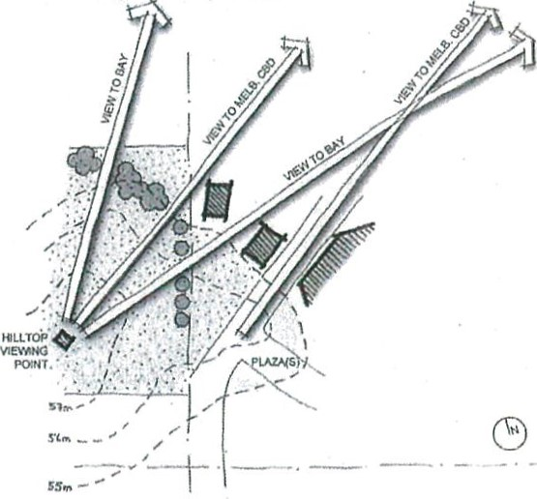
Should the use of fill to raise the height of the hill be considered, the following guidelines must be met unless otherwise agreed with council:
The soil to be used must be certified as clean fill
• Gradients should not exceed 1 :6

Mounding must be capped with top soil and consolidated and stabilised to suit any future landscaping and park infrastructure works
All earth works must be undertaken to ensure that grass, vegetation and landscaping have optimum growing conditions
The topsoil from the area to be filled must be removed, stored and replaced to ensure the retention of indigenous flora, fauna and microorganisms.

Dust suppressant strategies must be in place during and post earthworks


DAVID
Port Phillip Bay Legend:
FORESHORE RESERVE

Foreshore Reserve -
GRIGGS CREEK RESERVE minimum 100m wide from top of SUB-REGIONAL PARK escarpmen A SIGNIFICANT HILL
NATURAL DRAINAGE LINES
(may form linear reserves)

O INDICATIVE CATCHMENT BOUNDARIES
FOR LOCAL PARKS OF AT LEAST
0.5 ha WITHIN 400m WALKING
DISTANCE OF ALL RESIDENTS
LINEAR
G) OPEN SPACE
GROWTH AREA BOUNDARY
nu nun •
Griggs Creek Resetve
- minimum 30m wide
Gl%i from top of bank
A centrally PtimarySprings ADA ST located School sub-regional park of at least
2 hectares
DEI
Open space OLE R reserve a Local parks of minimum of at least 0.5 hectares 20m wide linking within 400m walking

McDermott Rd distance of all to the Bellarine residents Rail Trail
B ARiNE RAIL Ste.'?
eoi
Cudowis Goff Chib

Lako Lome
PORTA8L G N RD
This plan is a representation of some of the key principles within the Jetty Road Urban Growth Plan. While the plan will guide the general form of development, it does not indicate exact locations which will require detailed design work and future development approval.

GEL LONG FUTURE PUBLIC OPEN SPACE
100 200 600
JETTY RD URBAN GROWTH PLAN
Prepared CAY oi Gccahr Wy 2007 a" duo c.a'0 has been taken to that this [s conact, 00 wvrmty
is c. by City o! Ccc'ono Barv.•cn Water in uso. Map No. 12
Algo Properties

Housing
3.29 The Geelong Retail Strategy encourages "a wide mix of activities in centres, where commercially viable" and "non-retail uses where they contribute to an active and safe environment". This is consistent with the Aim of the Activity Centre Design Guidelines to "Encourage a mix of uses".
3.30 The retail strategy states that "Non-retail components of activity centres may locate at the fringe of centres, on streets perpendicular or parallel to the main retail street, or on the first floor or above shops, as they generally do not have significant reliance on a high degree of exposure or passing pedestrian traffic."
3.31 In addition to the retail, commercial, community and open space uses discussed above, the Master Plan provides for mixed and residential uses. These are generally located at the edges of the centre where they will provide an appropriate transition between the core of the NAC and surrounding residential areas.
3.32 The mixed use sites front the two primary roads, as encouraged by the UGP. The residential uses include medium-density housing located northeast of the supermarket in order to screen its loading area.

Sustainable travel
3.33 The Geelong Retail Strategy contains principles to "ensure that activity centres develop in an integrated fashion" and "encourage the use of sustainable forms of transport to access activity centres". This is consistent with the Aim of the Activity Centre Design Guidelines to "Promote a public transport focus".
3.34 The Master Plan provides for buses to penetrate right to the heart of the centre along either of the two primary roads. In the positioning of bus stops, it is preferable that they are located close to the heart of the centre without sterilising valuable street frontage in front of shops The locations of the bus stops will be determined by the developers following consultation with the Department of Transport and service operators
3.35 The Master Plan also incorporates dedicated cycle lanes along both sides of each primary road to facilitate access by bicycle.


DAVID

Algo Properties

Car parking & servicing
3.36 Objective 14.5 of the IJGP states:
Car parking in the Neighbourhood Activity Centre is to avoid negative impacts on the amenity and walkability of the centre.
3.37 The Master Plan distributes the required car parking throughout the centre to maximise its convenience and minimise its impact on the public realm. It provides for three different types of car parking:
- Kerbside parking*, which supports pedestrian amenity by contributing to traffic calming, providing a buffer between the footpath and moving vehicles, and reducing the size of off-street car parks which can separate the centre from their surroundings. The type of kerbside parking will be determined at a later stage.
- Off-street staff parking located behind buildings, where it will not impact on the public realm.
- Public car parks, which have been designed as well-surveilled and treed public spaces, incorporating direct pedestrian links into the centre from surrounding residential precincts.
3.38 The supermarket loading area is positioned on the northern side of the supermarket, away from the main pedestrian areas and scieened from the public realm by development. The car park to the south of the shops on the southern side of the mainstreet offers the potential for those shops to be serviced from the rear, away from the main pedestrian area.


DAVID
Al o Pro erties

Staging
4.1 The following guidelines should be followed by the staging of development within the NAC:
- The success of the centre will rely on the two primary roads. Therefore the two primary roads within the centre should be built before any part of the NAC is opened.
- The hilltop park will form an important component of thé NAC. Therefore, it should be built before or concurrently with the first substantial stage of the centre. However the development of the NAC should not be delayed by the timing of the release of Stage 2 of the Jetty Road Growth Area.
3. The supermarket will 'anchor' the specialty shops. Therefore, specialty shops should not be built before the supermarket.
- The shops and other commercial floorspace on the north side of the mainstreet are required to 'sleeve' the blank supermarket box. Therefore, they should be built at the same time as it.
- The main off-street car park is required to serve the supermarket. Therefore it should be built before or at the same time as it.
- The southern car parks are required to serve the shops and commercial space on the southern side of the mainstreet. Therefore, they should be built before or at the same time as those developments.
  - It is assumed that the shops on the southern side of the mainstreet will be built later than those 'sleeving' the supermarket, possibly in two stages, as the catchment grows. The supermarket may also be built in two stages in response to the catchment size. The timing of the provision of community facilities at the centre will be a matter for Council as it undertakes expansion of its municipal-wide services.
  - Given these guidelines, it is envisaged that the NAC will be developed in the following stages:
Stage 1
    - Both primary roads.
    - Supermarket.
    - The specialty shops and other uses 'sleeving' the supermarket on the north side of the mainstreet and adjoining plaza. The main off-street car park.
    - Hilltop Park.


DAWD
Algo Properties
Stage 2
Neighbourhood House.
- Childcare centre/ kindergarten.
- Remaining shops and other uses on the southern side of the mainstreet, along with the adjoining plaza. Related infrastructure
- Southern car park.
Stage 3
• | Any supermarket expansion.
- Mixed-use properties.
- Medium-density housing.
N.B. This staging is subject to change


DAVID
Al o Pro erties

APPENDIX A: WORKSHOP PLAN
The following plan was prepared in a workshop attended by representatives of Council and the landowner, and various consultants. It formed the basis of this Master Plan.
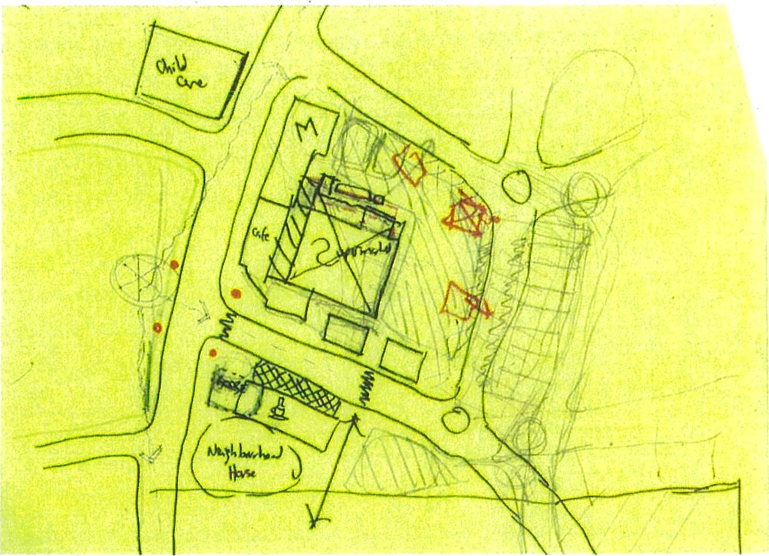


DAVID

DAVID LOCK ASSOCIATES
166 ALBERT ROAD. SOUTH MELBOURNE VIC 3205
TEL:0396828568 FAX:039682 1221 WEB: www.davidlock.cornau ,

