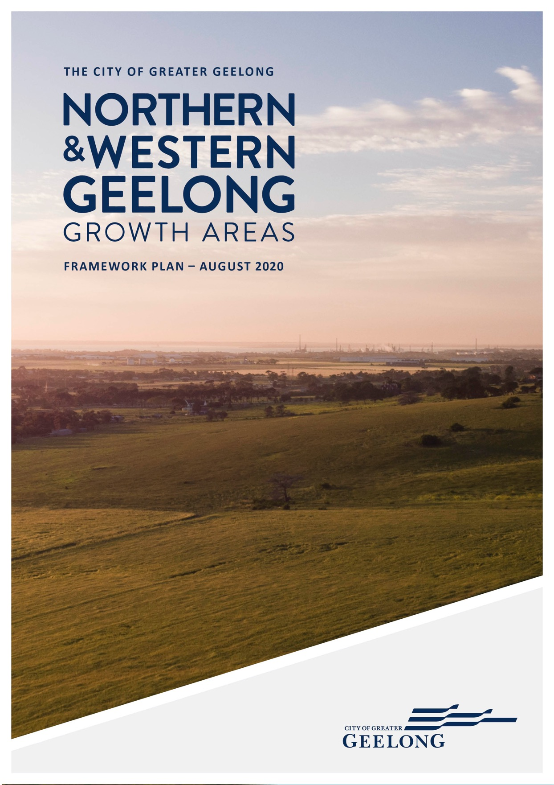

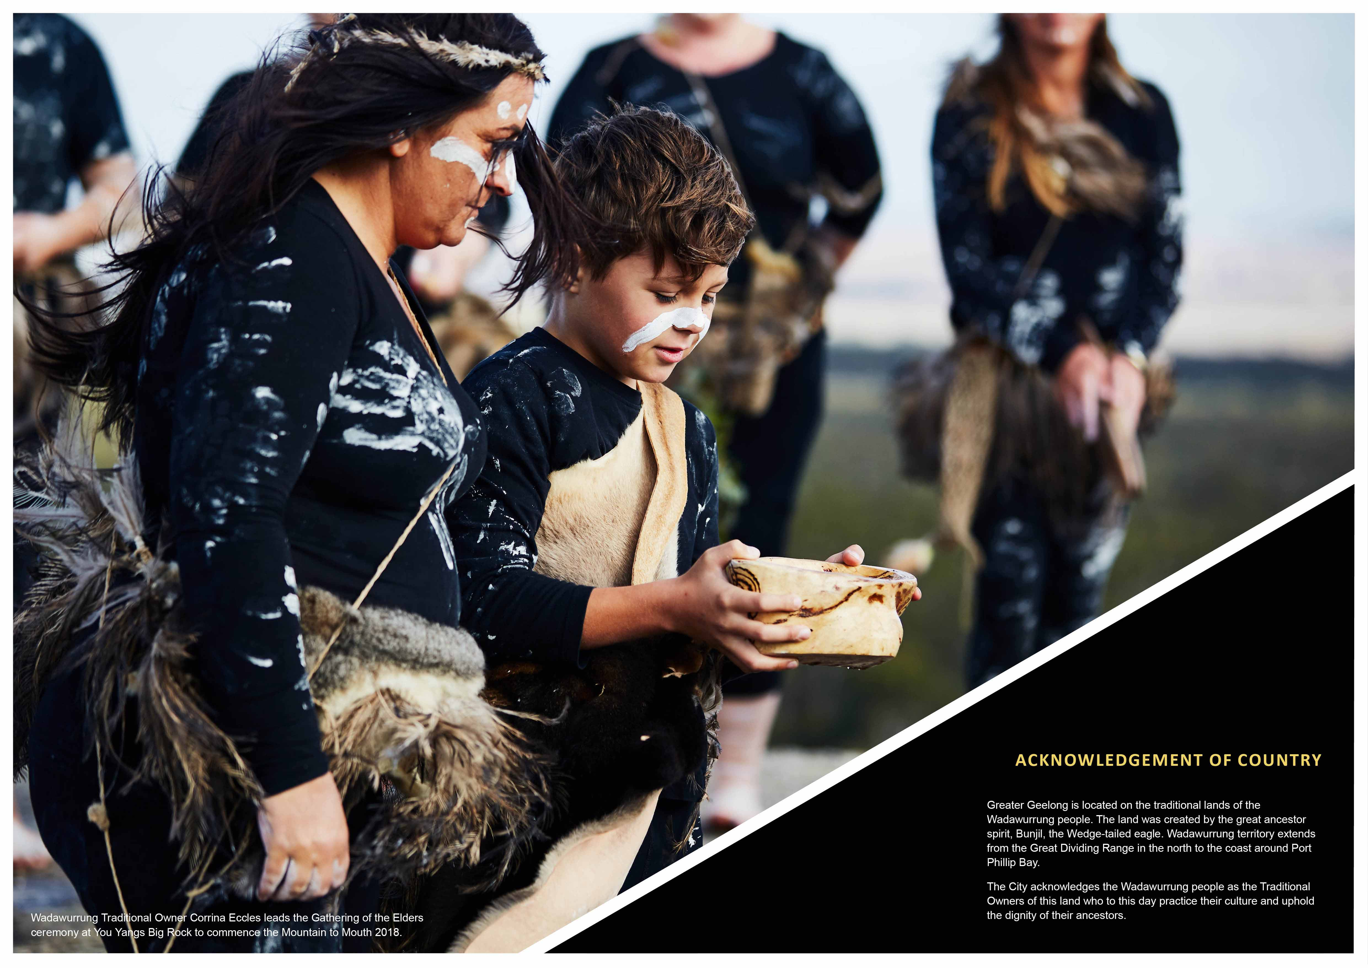

IMAGE IS NOT AVAILABLE WITHIN THIS VERION.
TO VIEW SUPPORTING VISUAL FOR THIS PAGE GO TO
www.geelongaustralia.com.au/futuregrowth/default.aspx
TO ACCESS PDF.

THE NORTHERN AND WESTERN GEELONG
GROWTH AREAS FRAMEWORK PLAN

IS AN ESSENTIAL PART OF THE CITY OF GREATER GEELONG’S PLAN TO ADDRESS THE LONG-TERM GROWTH OF OUR CITY.

Geelong is Victoria’s second city. We are now experiencing significant economic and population growth that will intensify as the region’s vibrant community and coastal setting attracts new residents and investment.
The City is well-placed to manage future growth in a progressive and sustainable manner. Our community is committed to creating a clever and creative future for Greater Geelong.
The Northern and Western Geelong Growth Areas Framework Plan is the largest greenfield planning project in regional Victoria with the capacity to accommodate 110,000 new Geelong residents.
The framework plan will guide urban growth that supports the community’s shared vision and meets the aspirations of the City and our G21 regional partners by establishing new neighbourhoods in Geelong that:
- Represent the CLEVER AND CREATIVE future of our city
- Protect and enhance the natural ENVIRONMENT
- Establish a vibrant and walkable NEIGHBOURHOOD
- Encourage job creation and growth of our local
ECONOMY
- Enable access and MOVEMENT
- DELIVER great places to live as part of the Geelong community.
Strategic implementation of the framework plan will ensure that development is facilitated in a sequenced and orderly manner with a focus on capturing the benefits of growth for the entire Geelong community and region.

The Northern and Western Geelong Growth Areas will exemplify Geelong’s transformation as a clever and creative city by building diverse, localised
and sustainable neighbourhoods that prioritise self-sufficiency whilst
maximising connections to the Geelong community, economy and identity.

IMAGE IS NOT AVAILABLE WITHIN THIS VERION.
TO VIEW SUPPORTING VISUAL FOR THIS PAGE GO TO
www.geelongaustralia.com.au/futuregrowth/default.aspx
TO ACCESS PDF.

ROLE OF THE FRAMEWORK PLAN

The Northern and Western Geelong Growth Areas Framework Plan is a high- level strategic document that describes considerations related to future urban development in the growth areas.
The framework plan describes the existing site context of the growth areas and outlines a vision and set of urban development objectives and actions to inform the
subsequent detailed preparation of precinct structure plans (PSPs).
The Framework Plan acts as a background document and should be interpreted in that light. It provides flexibility in its interpretation in the next stages of the planning process.
The framework plan proposes the sequential preparation of nine PSPs. Each PSP provides the basis for localised urban development and investment and will further consider and incorporate relevant directions outlined in this framework plan. Each PSP will elaborate on the framework plan by adding important land uses that support the local community such as local roads, schools, community facilities and open space not included at this preliminary level of planning.
Preparation of each PSP will be the subject of further detailed technical investigations and reports specific
to that precinct. A separate planning scheme amendment will facilitate the detailed future urban structure
and infrastructure requirements of the precincts. The location and extent of some features (e.g. road network, waterways and activity centres) depicted
in plan set of the framework plan are accordingly illustrative or enlarged with the intent that they will be refined or amended as part of the preparation of each PSP.
The framework plan summarises existing technical investigations that provide a preliminary basis for the preparation of each PSP. It is important to ensure that
the preparation of the PSP allows for the consideration and adoption of new technical information that may provide increased benefits to the future community.
Concept Precinct Structure Plans at pages 226-233 and 242-252 of this Framework Plan are only concept plans and will be subject to change through the process of preparing Precinct Structure Plans for the precincts in the growth areas.

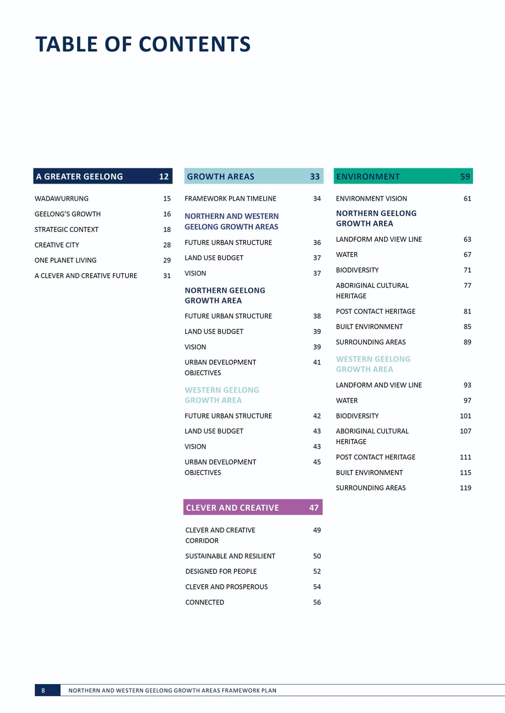
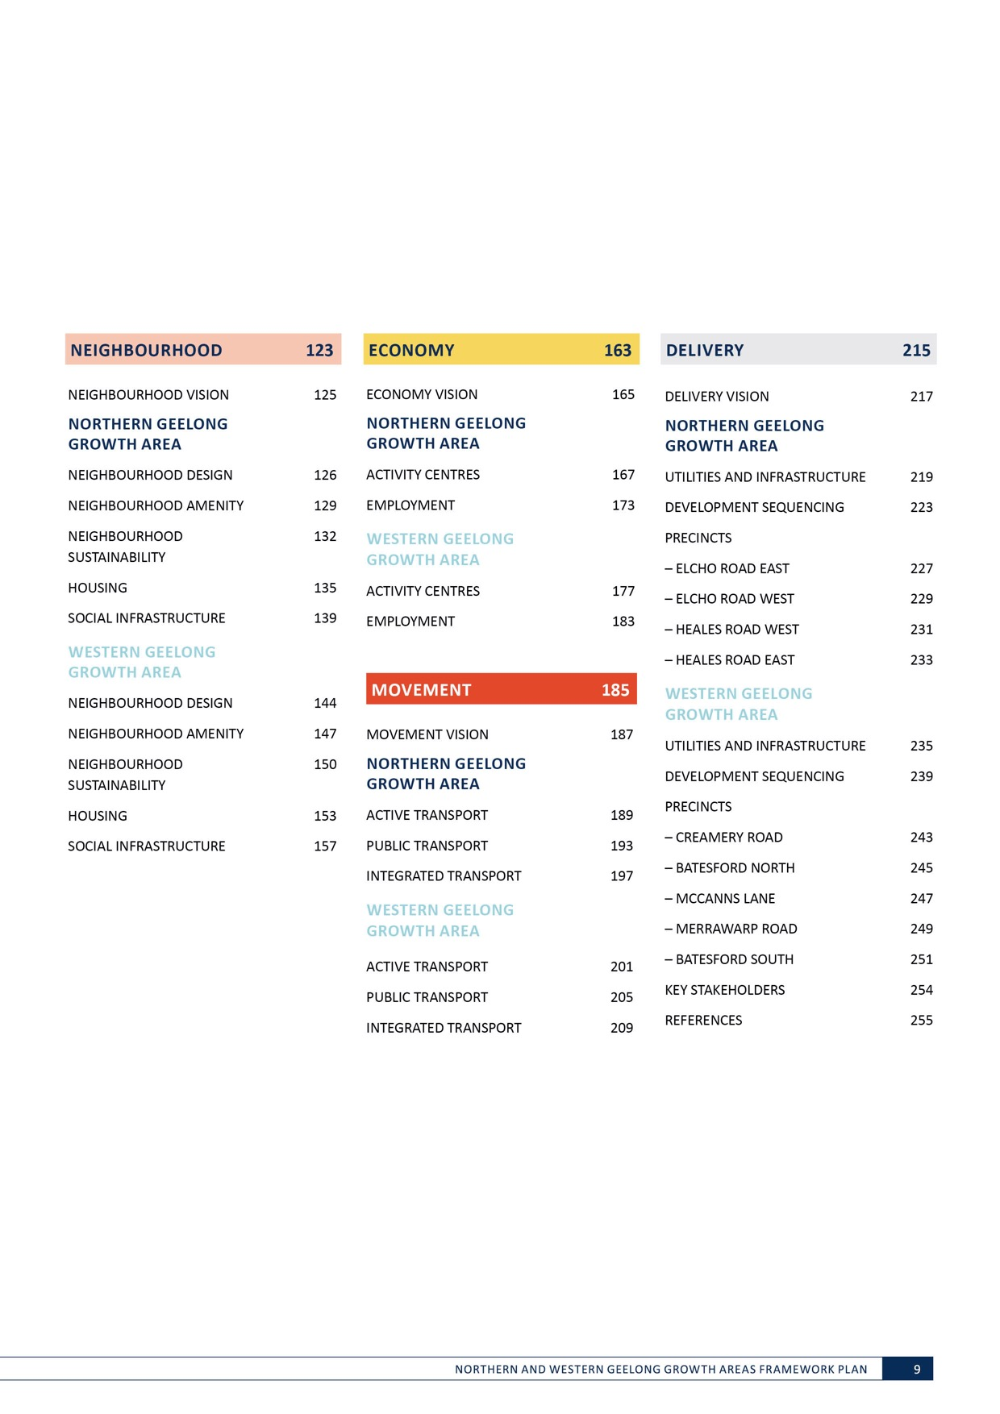

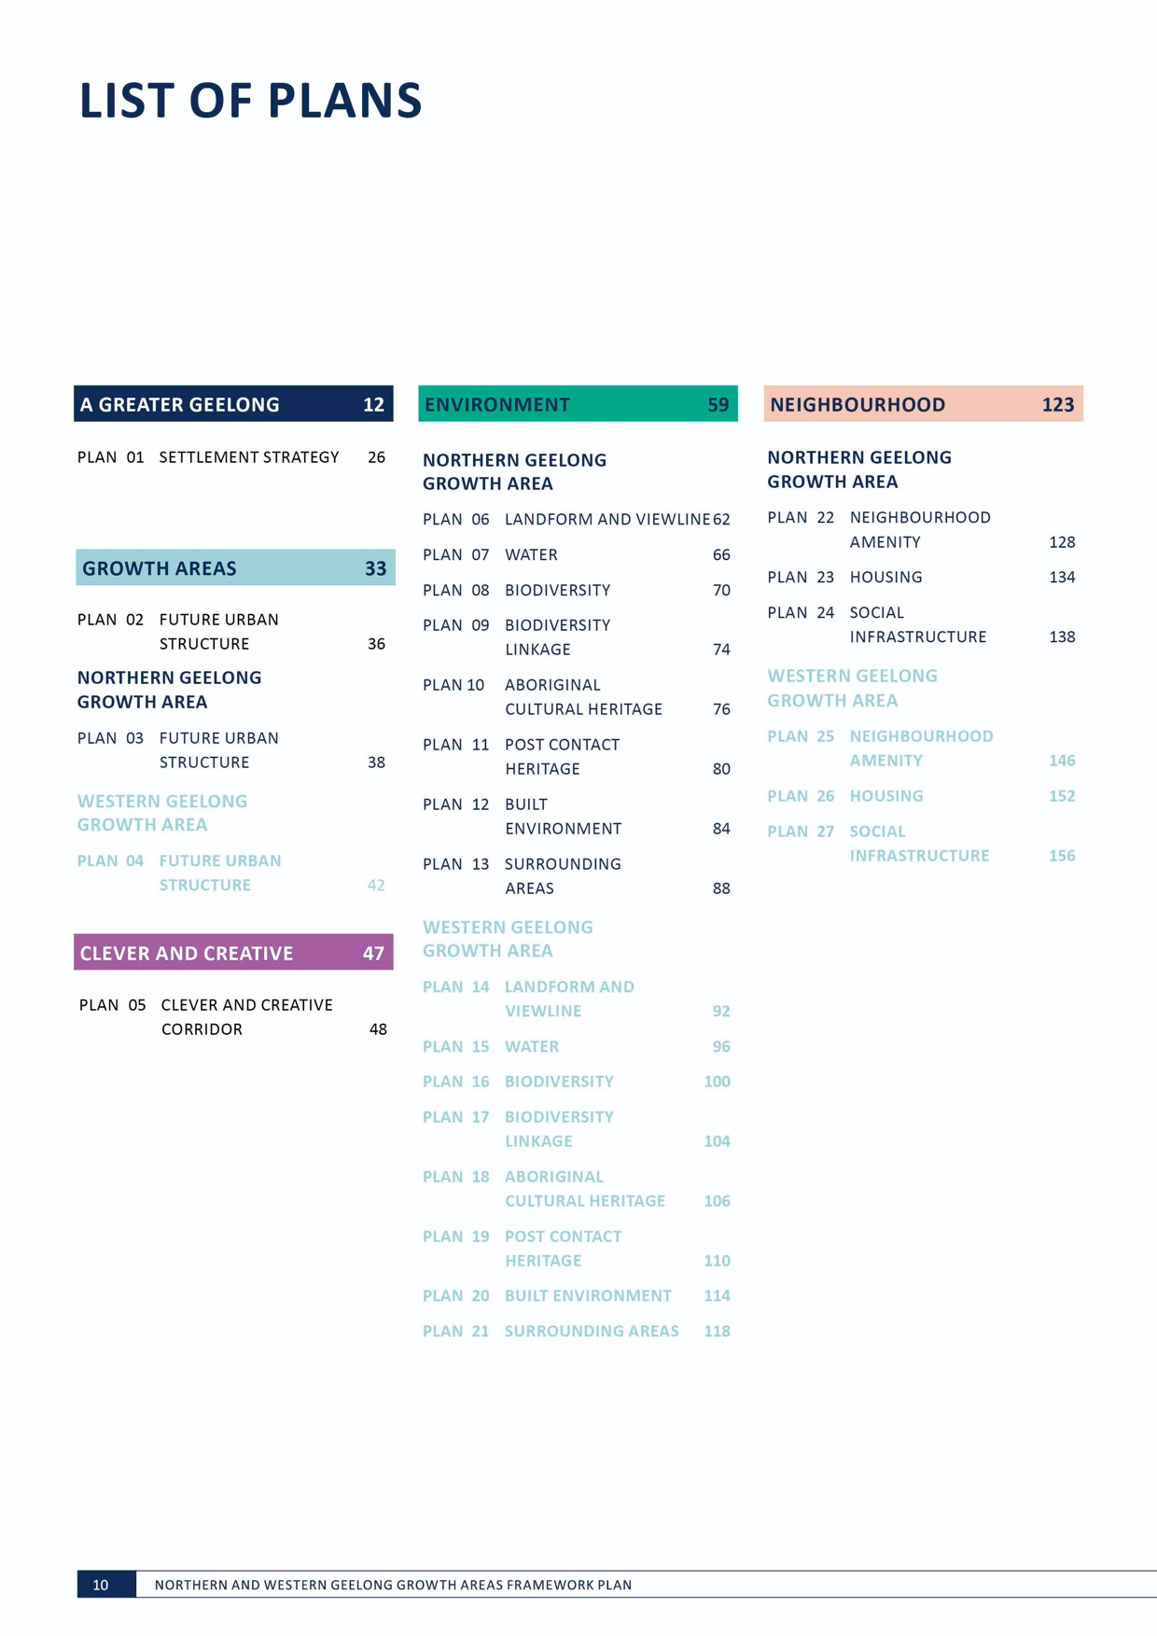
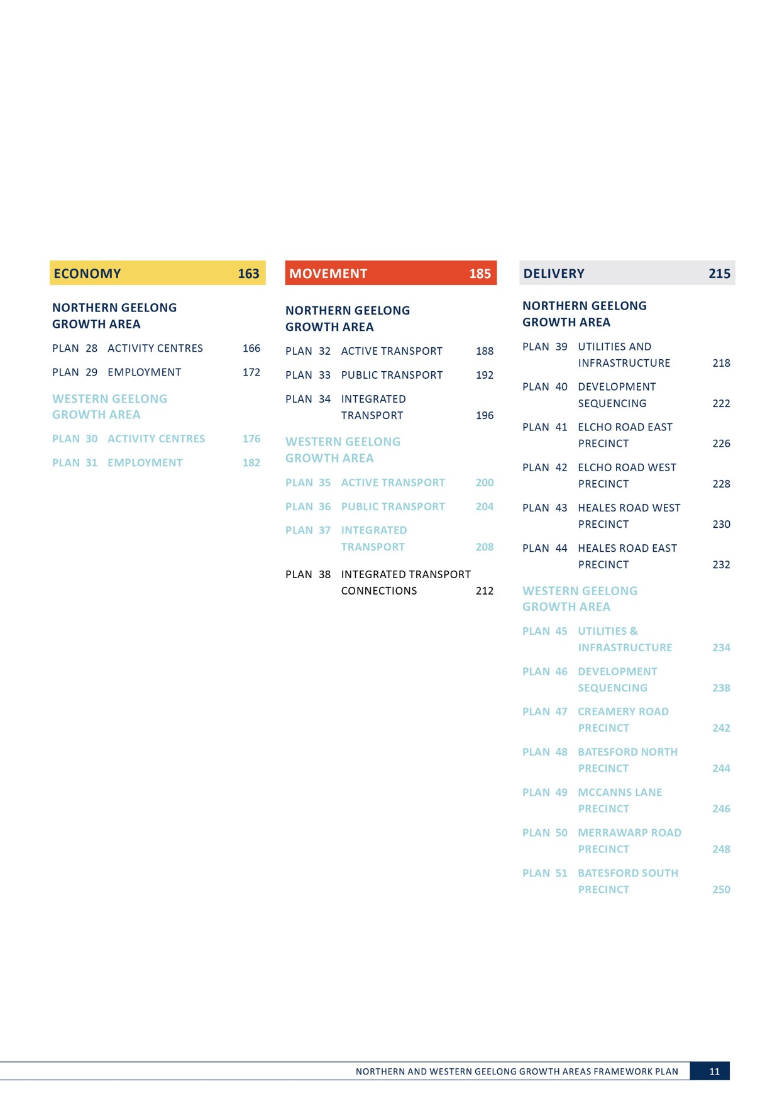

A GREATER GEELONG

THE GEELONG LIFESTYLE IS TOUGH TO BEAT.
Our vibrant and cosmopolitan community enjoys wide- ranging recreational choices, easy access to services and a strong and growing economy as Victoria’s second city.
Greater Geelong provides the opportunity to live in a major coastal city with direct access to Melbourne, the Bellarine Peninsula and the Great Ocean Road.
Our region is now experiencing significant economic and population growth that will continue in the coming decades.
As our beautiful city grows, we must protect and enhance what we love about Geelong.
The Northern and Western Geelong Growth Areas Framework Plan is the City’s plan to address Geelong’s long-term greenfield population growth.
The framework plan will shape Geelong’s new neighbourhoods and supports the city to grow in a clever and creative way.
Successful delivery of this city-shaping project will be measured by our capacity to harness the economic and community benefits of growth whilst maintaining the city’s enviable lifestyle
and character as part of a larger, greater Geelong.

IMAGE IS NOT AVAILABLE WITHIN THIS VERION.
TO VIEW SUPPORTING VISUAL FOR THIS PAGE GO TO
www.geelongaustralia.com.au/futuregrowth/default.aspx
TO ACCESS PDF.

IMAGE IS NOT AVAILABLE WITHIN THIS VERION.
TO VIEW SUPPORTING VISUAL FOR THIS PAGE GO TO
www.geelongaustralia.com.au/futuregrowth/default.aspx
TO ACCESS PDF.

IMAGE IS NOT AVAILABLE WITHIN THIS VERION.
TO VIEW SUPPORTING VISUAL FOR THIS PAGE GO TO
www.geelongaustralia.com.au/futuregrowth/default.aspx
TO ACCESS PDF.

WADAWURRUNG

Greater Geelong is Wadawurrung country.
In traditional language Wadawurrung means ‘people who belong to the water’ in reference to the rivers, creeks, lagoons and other water sources within their country.
The land and water that forms the Northern and Western Geelong Growth Areas was created by the great ancestor spirit, Bunjil the Wedge-tailed eagle. Bunjil establishes the laws and bonds connecting people to country and enables people to live on the land in harmony and in balance with the environment.
At the time of contact the Wadawurrung were living on country comprising over 1.8 million hectares of ocean and bay coasts, grasslands and wetlands of the volcanic plains, and woodlands of the Otway Ranges and Great Dividing Range.
Land in the Northern Geelong Growth Area falls within Wadawurrung country between Geelong and the You Yangs, centred around Hovells Creek.
Land in the Western Geelong Growth Area falls within Wadawurrung country centred on the Barrabool Hills and along the Moorabool River and Barwon Rivers.
Today the Traditional Owners are represented by Wathaurung Aboriginal Corporation, known as Wadawurrung, who are the Registered Aboriginal Party.
The growth areas contain distinctive landscapes and waterbodies that are highly significant to the Wadawurrung peoples; the waters of the Moorabool River, Barwon River and Cowies Creek flow through this land and the land faces north toward the
You Yangs.
The City is committed to recognising and protecting sites in the growth areas that are culturally significant sites and will work in partnership with the Wadawurrung people
to interpret and manage these sites with respect to their dignity and protocols.
The Wadawurrung peoples make an integral cultural, social, environmental, economic and spiritual contribution to the story and identity of Greater Geelong.

VICT

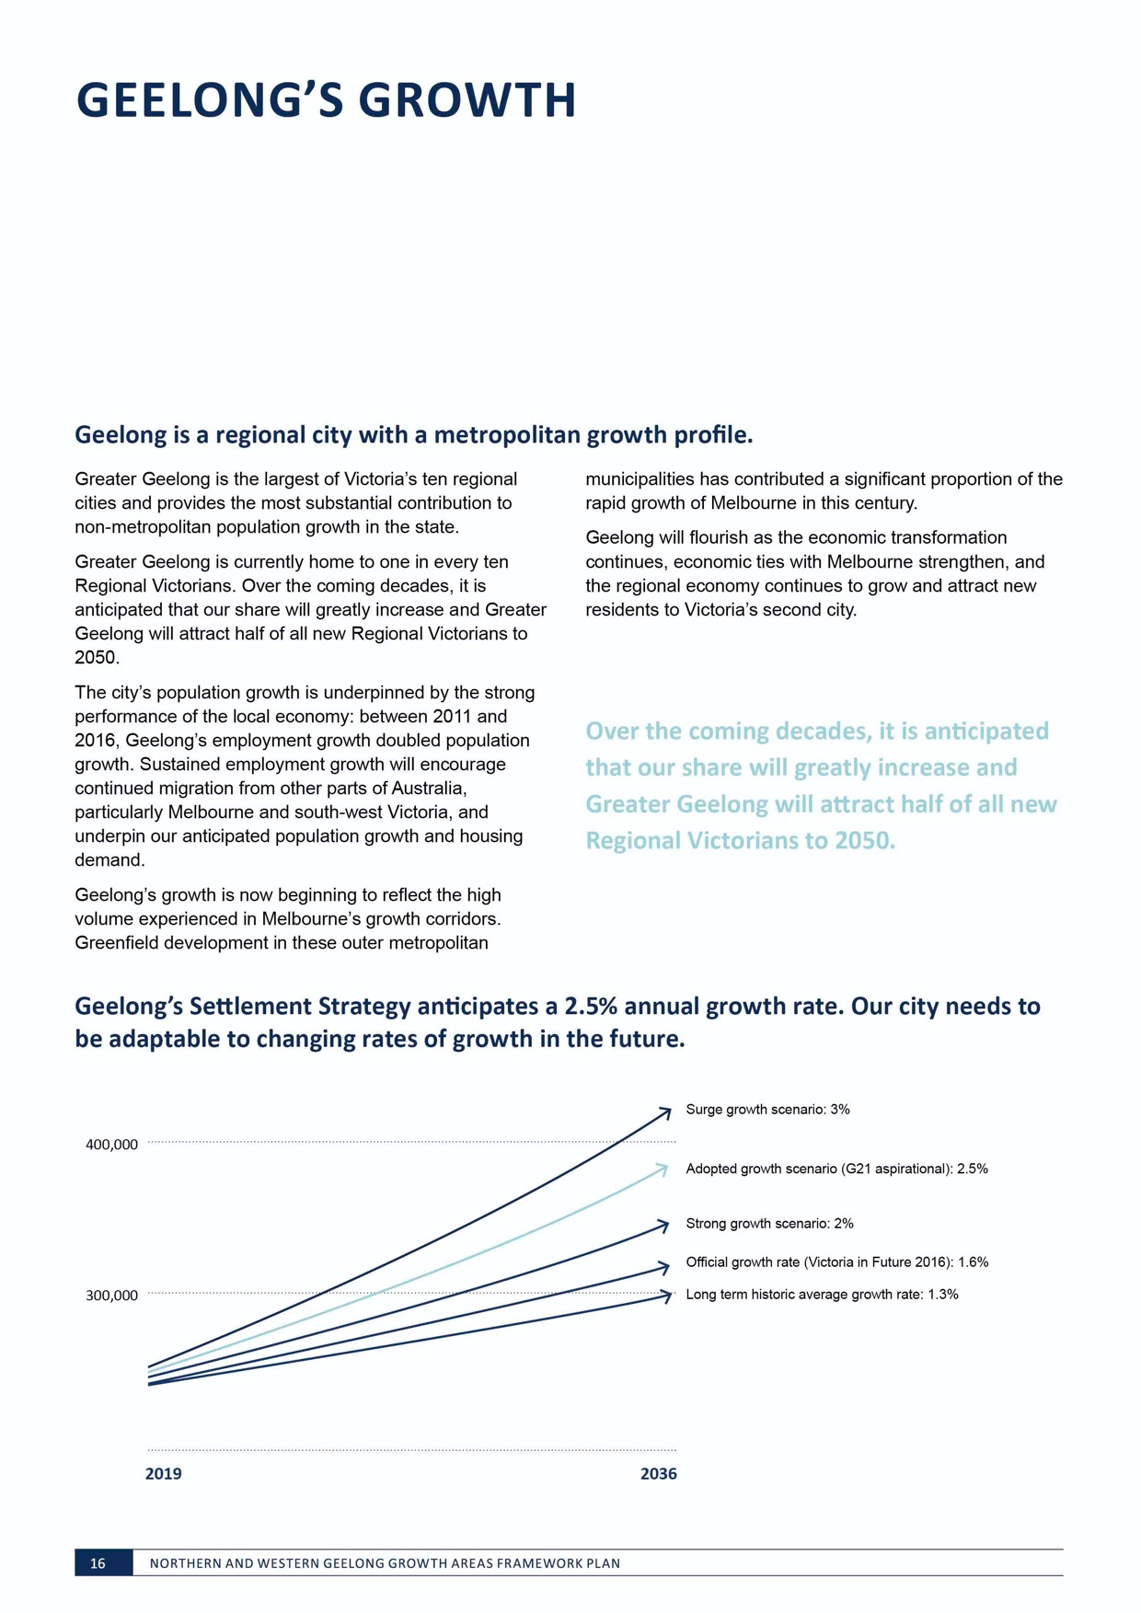
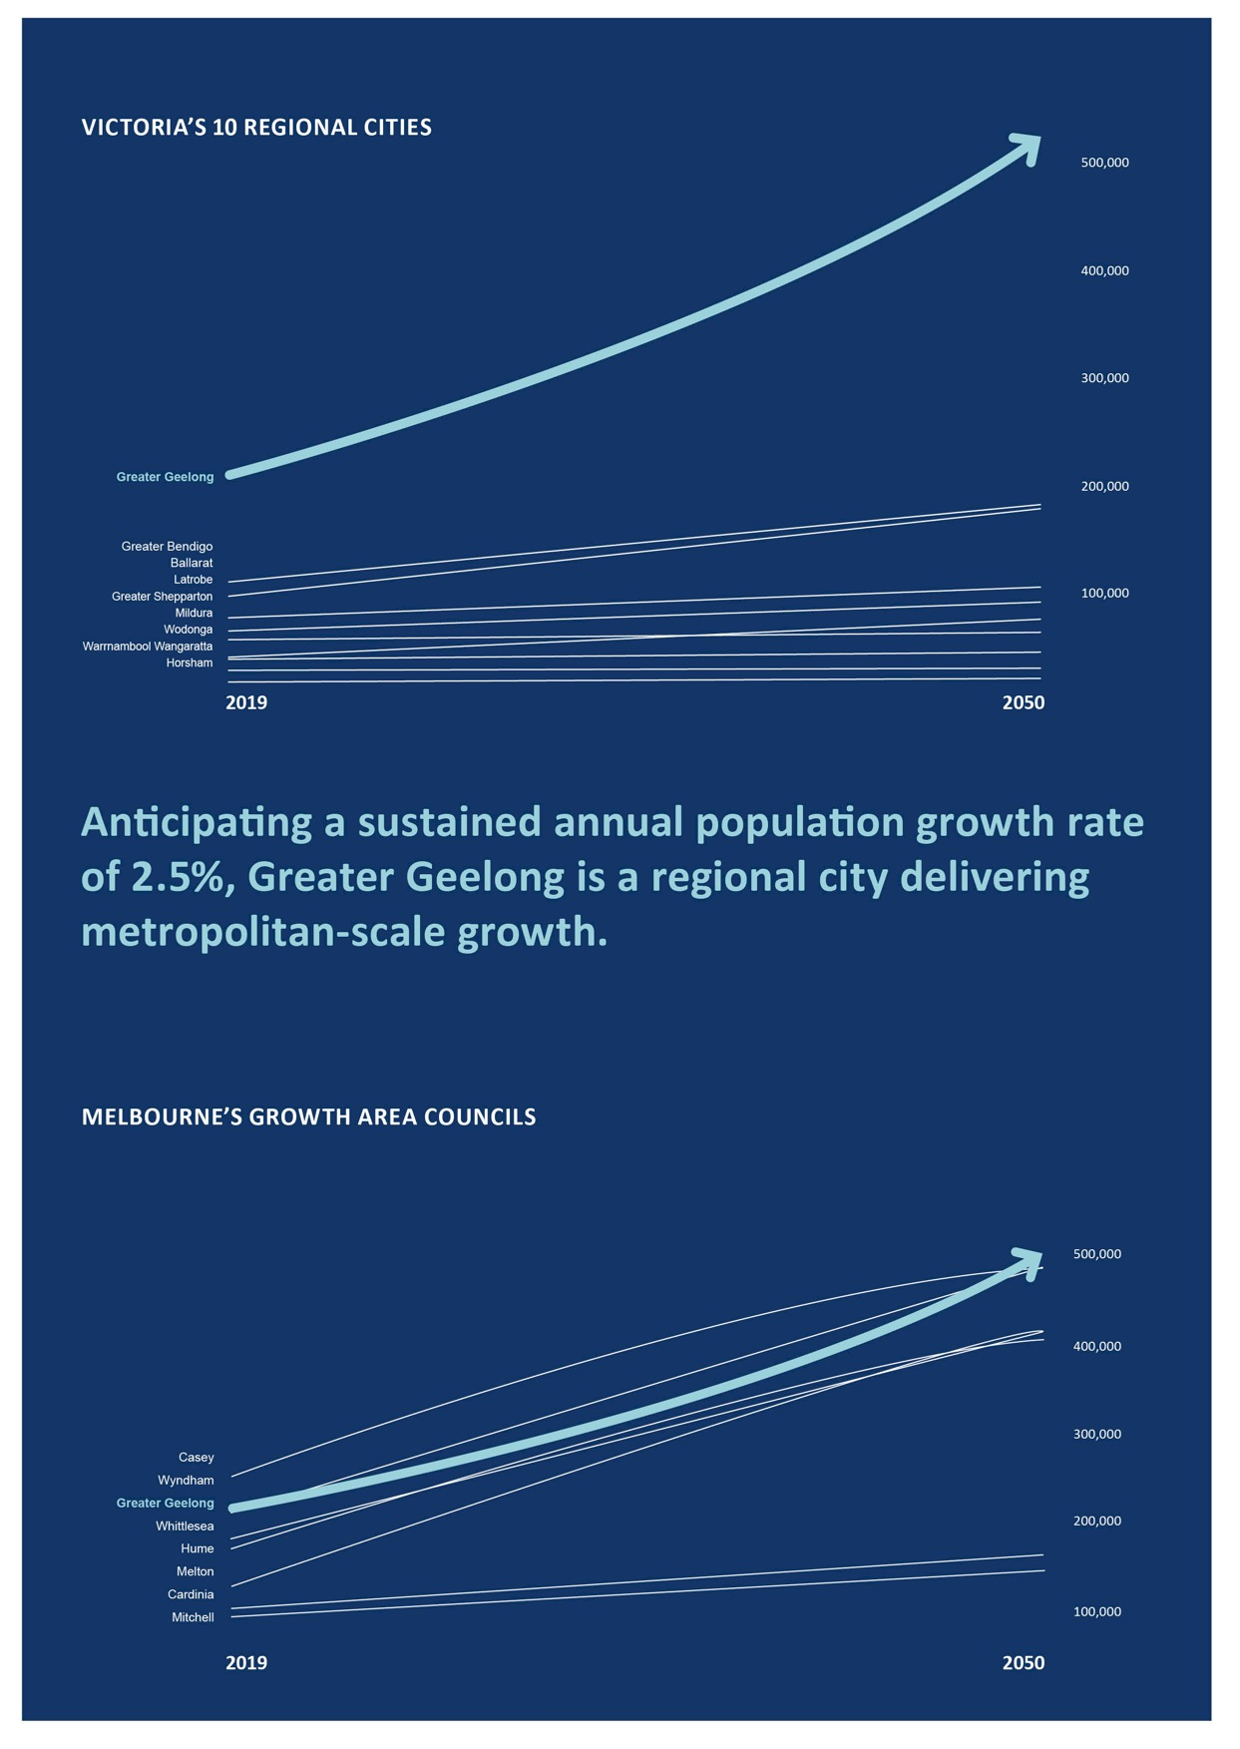

STRATEGIC CONTEXT

G21 REGIONAL GROWTH PLAN

G21 is the formal alliance of government, business and community organisations working together to improve the lives of people within the Geelong region across its five member municipalities – Colac Otway, Golden Plains, Greater Geelong, Queenscliffe and Surf Coast.

The G21 Regional Growth Plan manages the region’s land use and development pressures to 2050 by identifying opportunities for future residential and employment growth and the critical infrastructure required to support an anticipated 500,000 population.
The plan establishes a framework for strategic land use and settlement planning to promote a self-sustaining region that supports a stronger and more robust economy and attracts a diverse community. It is recognised in Clause 11.01-1R of the State Planning Policy Framework.
G21 highlights the pressures that significant growth will place on the region’s infrastructure networks and natural environment and focuses on innovative and sustainable solutions to address a set of critical challenges:
- Delivering land, infrastructure and services for identified growth
- Planning for and adapting to climate change
- Accommodating population growth without negatively affecting our unique environment and liveability
- Reducing our dependence on cars
- Education and building our skills
- Providing a variety of housing choices
- Managing land use conflicts
- Managing the expectations of the community.
Urban infill can meet these challenges by utilising existing infrastructure and facilitating higher density development in central Geelong and other activity centres. Geelong’s new growth areas must address these challenges from the outset.
The Northern and Western Geelong Growth Areas – identified as ‘further investigation areas’ in the plan – have been earmarked for their proximity to major urban areas and employment nodes, access to infrastructure and ability to integrate and connect efficiently to existing services and communities.

G21 REGIONAL GROWTH PLAN VISION
The Geelong region is Australia’s most desirable destination for living, working and investing; it is renowned for its vibrant cohesive community, exceptional physical environment and vigorous economy.

The G21 Regional Growth Plan Implementation Plan identifies critical infrastructure required to support housing and employment growth and provides a detailed analysis of the region’s longer term growth areas.

Implementation of the growth plan focuses on four elements:
- Sequencing and provision of key regional infrastructure
- Land supply
- Strategic housing incentives
- Detailed analysis and directions for the Northern and Western Geelong Growth Areas.
KEY REGIONAL INFRASTRUCTURE
The implementation plan identifies infrastructure for transport, utilities, community facilities, business and tourism and the environment to support the growth of the region. Projects that relate to the urban development of the growth areas include:
TRANSPORT
R1.16: Midland Highway duplication to Bannockburn R1.17: Hamilton Highway upgrade to Inverleigh G1.19: Bacchus Marsh Road duplication – South G1.20: Bacchus Marsh Road duplication – North G1.21: Rebuilding of Heales Road for heavy freight L1.24: McClelland Ave bypass and rail overpass
L1.25: Six-way intersection Forest Road-Station Lake Road
G1.44: Corio Station relocation and redevelopment
B1.56: Geelong-Ballarat passenger rail link G1.65: Reorganising of the bus network G1.66: Smartbus routes for Geelong R1.69: Principal cycling connections R1.70: Principal pedestrian connections

COMMUNITY FACILITIES
G3.03: Northern Geelong vocational training school
L3.05: Lara multipurpose community centre
G3.14: Geelong Northern Suburbs community hospital G3.28: Corio-Norlane subregional library expansion G3.52: Corio Leisuretime Centre redevelopment
ENVIRONMENT
R5.02: Implementation of the Barwon River Parklands projects
R5.05: Moorabool River Health Strategy

UTILITIES
The implementation plan identifies the need for utilities in the medium to long term to address the effects of climate change, infrastructure capacity and deterioration, and new technologies and energy sources.
BUSINESS AND TOURISM
The implementation plan identifies a significant recreation and tourism opportunity associated with the development of a lake within Batesford Quarry linked to extensive river corridors and recommends a master plan incorporating a Moorabool River Corridor Strategy.

STRATEGIC CONTEXT

G21 REGIONAL GROWTH PLAN

THE G21 REGIONAL GROWTH PLAN SETS OUT NINE PRINCIPLES FOR GROWTH IN THE REGION:

1. Optimise infrastructure and consolidate
2. Diversity, knowledge and innovation
3. Unique and connected communities
4. Protect, restore and enhance our unique environment
5. Food, water and energy security
6. Live, work and participate locally
7. Build our economy
8. Accessible transport choices
9. Balanced, consistent and collaborative approach
THE NORTHERN AND WESTERN GEELONG GROWTH AREAS
Analysis of the Northern and Western Geelong Growth Areas outlines their suitability for growth based on planning context, land capability, accessibility and capacity to deliver an integrated community. The relative ability of the growth areas to deliver liveable, vibrant and cohesive communities is considered against six goals:
- Ability to create a diverse and unique community
- Ability to deliver significant community benefit to Geelong
- Ability to provide accessible and integrated transport choices
- Ability to provide efficient infrastructure and services
- Ability to ensure efficient and sustainable use of land and resources
- Ability to provide exceptional physical environments.
The implementation plan identifies minimal land use constraints associated with growth in the Northern Geelong Growth Area but highlights the importance of delivering ample public transport connections and creating neighbourhoods that are not isolated from the rest of Geelong.
The Western Geelong Growth Area is considered an opportunity to create regional community and
environmental assets with a diversity of housing options but must address complex site conditions and constrained road connectivity.

GROWTH AREA OUTCOMES
The implementation plan outlines future growth area outcomes that should be implemented in the delivery of the Northern and Western Geelong Growth Areas including:
- Taking the ‘next step’ in planning for new communities, including development that achieves zero carbon, zero waste, sustainable water, sustainable transport and environmental outcomes
- Community infrastructure provision, community design and housing diversity
- Site specific considerations, including growth area extent, interfaces, integration, infrastructure, employment opportunities and transport choices.
DELIVERING GROWTH
The implementation plan identifies next steps to highlight the importance of guiding and supporting the delivery of the Northern and Western Geelong Growth Areas and considers timing and sequencing of development and ‘out of sequence’ considerations, sequential or concurrent development of each growth area, and future rezoning and precinct structure plans.
BACKGROUND REPORT
The G21 Regional Growth Plan Implementation Plan is supported by a comprehensive background report.
The background report outlines the impacts and benefits for all key regional infrastructure items proposed in the implementation plan.
The growth areas are analysed to determine their suitability for development on the basis of:
- Land capability, including geotechnical and land stability, topography, biodiversity, contamination, drainage and flooding, open space and fire
- Planning, including cultural heritage, landscapes, zones and overlays and existing land use
- Accessibility, including road and public transport network proximity, and walking and cycling networks
- Deliverability, including existing utility and community infrastructure and land assembly.
The background report presents an analysis of these issues, with potential treatments and suggested further work that informs the Northern and Western Geelong Growth Areas Framework Plan.

IMAGE IS NOT AVAILABLE WITHIN THIS VERION.
TO VIEW SUPPORTING VISUAL FOR THIS PAGE GO TO
www.geelongaustralia.com.au/futuregrowth/default.aspx
TO ACCESS PDF.

STRATEGIC CONTEXT

PLAN MELBOURNE 2017–2050

Plan Melbourne is the Victorian Government’s metropolitan planning strategy that defines the future shape of the city and state until 2050.
The plan sets a strategy for investment in regional Victoria to support local jobs and economic growth and deliver productive, sustainable and healthy communities.
Geelong is recognised as Victoria’s second city and Plan Melbourne prioritises land use strategies that position our region as a centre of employment and accelerated growth.
As the largest of Victoria’s ten regional cities, Greater Geelong’s vibrant community and diverse economy will attract the primary population growth outside Melbourne and strengthen the city’s importance to our surrounding communities.
Plan Melbourne highlights the importance of locally- led growth that is delivered in keeping with Geelong’s character and balanced with the protection of the productive land, economic resources and biodiversity assets that are critical to the state’s economic and environmental sustainability.
Directions in Plan Melbourne that support the Northern and Western Geelong Growth Areas:
Direction 7.1 Invest in regional Victoria to support housing and economic growth
The Victorian Government will work with Greater Geelong to support the growth of housing and employment and ensure that infrastructure and services are available to support the growth and competitiveness of our industries and access to global markets.
Direction 7.2 Improve connections between cities and regions
The Geelong region will benefit from the improvement of road and rail connections to Melbourne and other major hub destinations including other regional cities.
The Victoria Government’s Regional Network Development Plan outlines a long-term plan for transport investment in regional Victoria including commuter-style services with a minimum 20-minute train frequency in the peak times and 40 minutes in the off-peak for services to Geelong.
Plan Melbourne highlights the importance of maintaining a settlement break between Melbourne and Geelong and safeguarding the Avalon corridor’s nationally-significant economic assets, including airport, road, rail and waste facilities. The Northern and Western Geelong Growth Areas assists this outcome by concentrating Geelong’s long-term growth in locations that protect important land use buffers and areas of high biodiversity value.

IMAGE IS NOT AVAILABLE WITHIN THIS VERION.
TO VIEW SUPPORTING VISUAL FOR THIS PAGE GO TO
www.geelongaustralia.com.au/futuregrowth/default.aspx
TO ACCESS PDF.

STRATEGIC CONTEXT

STATE AND LOCAL POLICY

GREATER GEELONG PLANNING SCHEME
The Northern and Western Geelong Framework Plan is informed by the State and Local Planning Policy Framework set out in the Greater Geelong Planning Scheme.

STATE PLANNING POLICY FRAMEWORK
The State Planning Policy Framework provides key directions around settlement, housing, environment, infrastructure and transport.
Relevant considerations for the Northern and Western Geelong Growth Areas include:
- Ensuring a sufficient supply of land is available for residential, commercial, retail, industrial, recreational, institutional and other community uses
- Locating urban growth close to transport corridors and services and provide efficient and effective infrastructure to create sustainability benefits
- Managing the sequence of development in areas of growth so that services are available from early in the life of new communities
- Protecting, restoring and enhancing sites and features of nature conservation, biodiversity, geological or landscape value
- Protecting and restoring catchments, water bodies, groundwater and water quality
- Providing housing choice and delivering more affordable housing closer to jobs, transport and services
- Supporting the establishment and maintenance of communities by delivering functional, accessible, safe and diverse physical and social environments through the appropriate location of use and development and through high quality buildings and urban design
- Establishing and maintaining a diverse and integrated network of public open space that meets the needs of the community
- Providing fair distribution and access to social and cultural infrastructure and health and education services
- Encouraging the concentration of major retail, residential, commercial, administrative, entertainment and cultural developments into activity centres that are highly accessible to the community
- Delivering an average overall residential density in growth areas to a minimum of 15 dwellings per hectare

- Supporting a diversified economy that builds on the region’s competitive strengths
- Creating a safe and sustainable transport system by integrating land use and transport
- Sustainably managing water supply, water resources, wastewater, drainage and stormwater through an integrated water management approach
- Promoting the provision of renewable energy
- Providing social and physical infrastructure to be provided in a way that is efficient, equitable, accessible and timely.
LOCAL PLANNING POLICY FRAMEWORK
Local polices are used to implement the objectives and strategies of the Municipal Strategic Statement.
Relevant considerations for the Northern and Western Geelong Growth Areas include:
- Clause 21.06 Settlement and Housing that prioritises the investigation of future residential and industrial land
use needs for Geelong, as a basis for future growth area planning, including:
  - Assessment of the environmental, resource, landscape, development pattern, access, servicing, land use, economic and social constraints and opportunities associated with possible growth areas around Geelong
  - Identification of a preferred growth area or areas
  - Preparation of detailed growth area plans
- Clause 21.08 Development and Community Infrastructure that provides direction around development contributions to ensure that infrastructure, open space and transport infrastructure is delivered in an efficient and timely manner in line with population growth.

COUNCIL PLAN
Council Plan 2018–22: Putting Our Community First outlines the City’s immediate priorities that work toward making Greater Geelong a clever and creative city-region.
The plan informs the Northern and Western Geelong Growth Areas Framework Plan and focuses on strategic priorities that will also shape the subsequent precinct structure planning process including:
- Improved health and safety of our community
- Providing safer public places
- Creating healthy environments in children’s settings
- Working towards having the safest roads in Victoria
- Informed social infrastructure and planning
- Providing more quality open spaces that support active lifestyles
- Supporting the growth of localised and regional sporting facilities
- Delivering accessible and attractive community infrastructure
- Advocating and planning for a range of social and affordable housing options
- Maintaining our public open space
- A more inclusive and diverse community
- Supporting activities that improve social connections in our community
- Improving access to facilities and programs for people of all ages
- Planned sustainable development
- Making sure housing supply, diversity and affordability can meet the needs of our growing community
- Continuing to develop urban growth areas across the region
- Improving the environmental performance of new developments, using planning controls

- Effective environmental management
- Reduce our carbon footprint through the use of solar initiatives and other renewable energy options
- Planting more trees to green and cool our urban areas
- Integrated transport connections
- Delivering better-connected walking, cycling and trail paths across our region
- A thriving and sustainable economy
- Supporting and promoting local businesses, markets and products
- Innovative finances and technology
- Delivering smart technology solutions to areas such as street lighting, parking, waste management and children’s services
- Attracting more technology-focused businesses to our region
- Establishing sustainable financial and infrastructure management systems for our future.

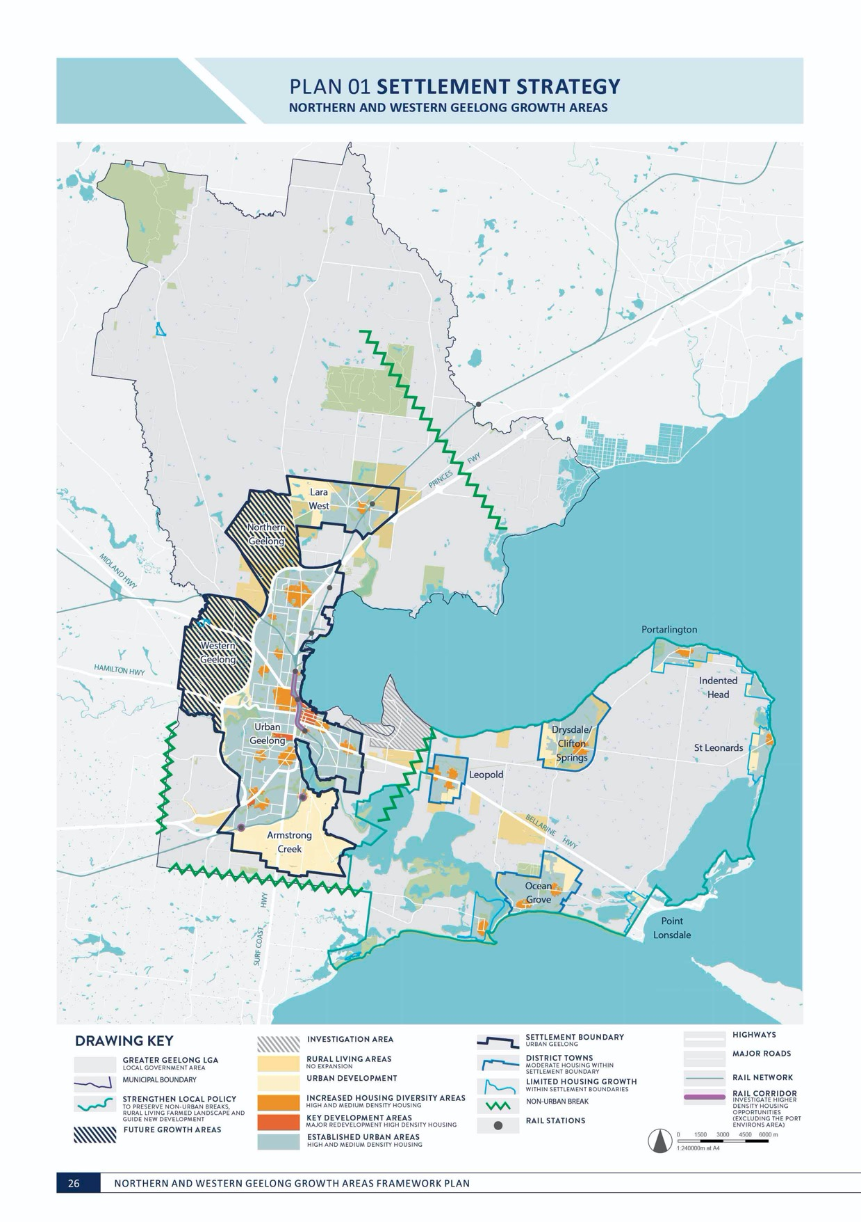

STRATEGIC CONTEXT

SETTLEMENT STRATEGY

Settlement Strategy is the City’s strategy to establish a clear policy framework that will guide planning and decision-making to meet the housing needs of Greater Geelong’s growing population until 2036.

The strategy directs future growth by determining the location of new development and the sustainable development principles that it must follow.
The City will diminish the share of new development on the Bellarine Peninsula and direct the majority of Geelong’s
future housing needs to urban areas including the Northern and Western Geelong Growth Areas.
Managing future growth in the Northern and Western Geelong Growth Areas is a key focus of the Settlement Strategy as reflected in its principles and directions.

SPATIAL DISTRIBUTION OF GROWTH AND LAND SUPPLY
Principle
Provide clear strategic direction on the spatial distribution of residential growth in Greater Geelong.
Directions
Direct the majority of future housing needs to urban Geelong (urban infill, Armstrong Creek and the Northern and Western Geelong Growth Areas).
HOUSING DIVERSITY
Principle
Ensure housing diversity is achieved in existing and growth area communities.
Directions
Increase housing diversity in growth areas through the delivery of a broad range of lot sizes, capable
of accommodating a variety of different housing types, including the identification of locations appropriate for mixed use, high and medium density housing in strategically identified locations.
Principle
Increase the level of affordable and social housing in Greater Geelong.
Directions
Work with the state government, community housing and the private sector to deliver more affordable and social housing options.
MANAGING FUTURE GROWTH
Principle
Ensure growth areas are well- planned and deliver sustainable communities.
Directions
Ensure the development of new growth areas is guided by a strategic framework plan and infrastructure plan that outlines the orderly and sequential preparation precinct structure plans.
Apply ‘One Planet Living’ principles to growth area planning and development.
Principle
Manage the release of new growth areas to make sure infrastructure, services and facilities are provided in a timely and efficient way.
Directions
Advocate for state infrastructure to be delivered in a timely way and for other levels of government to contribute
to regional and state infrastructure that isn’t funded by development contributions.
Prioritise for and promote the early provision of public transport
infrastructure and services in all growth areas.
Manage the number of precinct structure plans that can be prepared simultaneously.

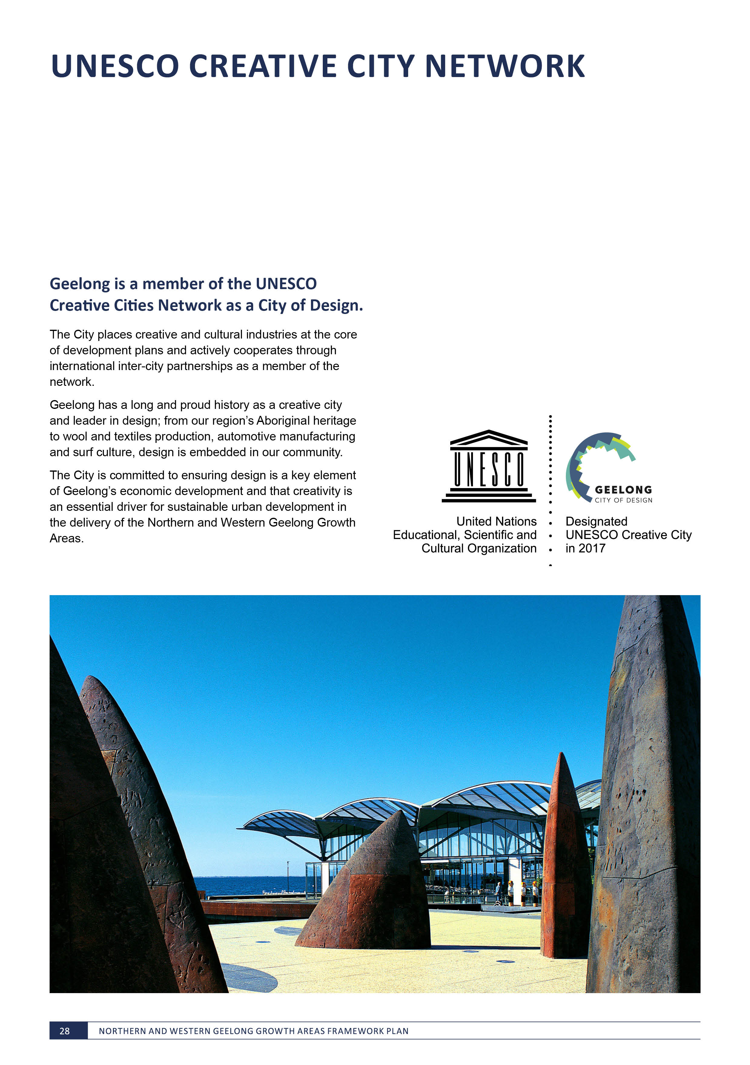

ONE PLANET LIVING

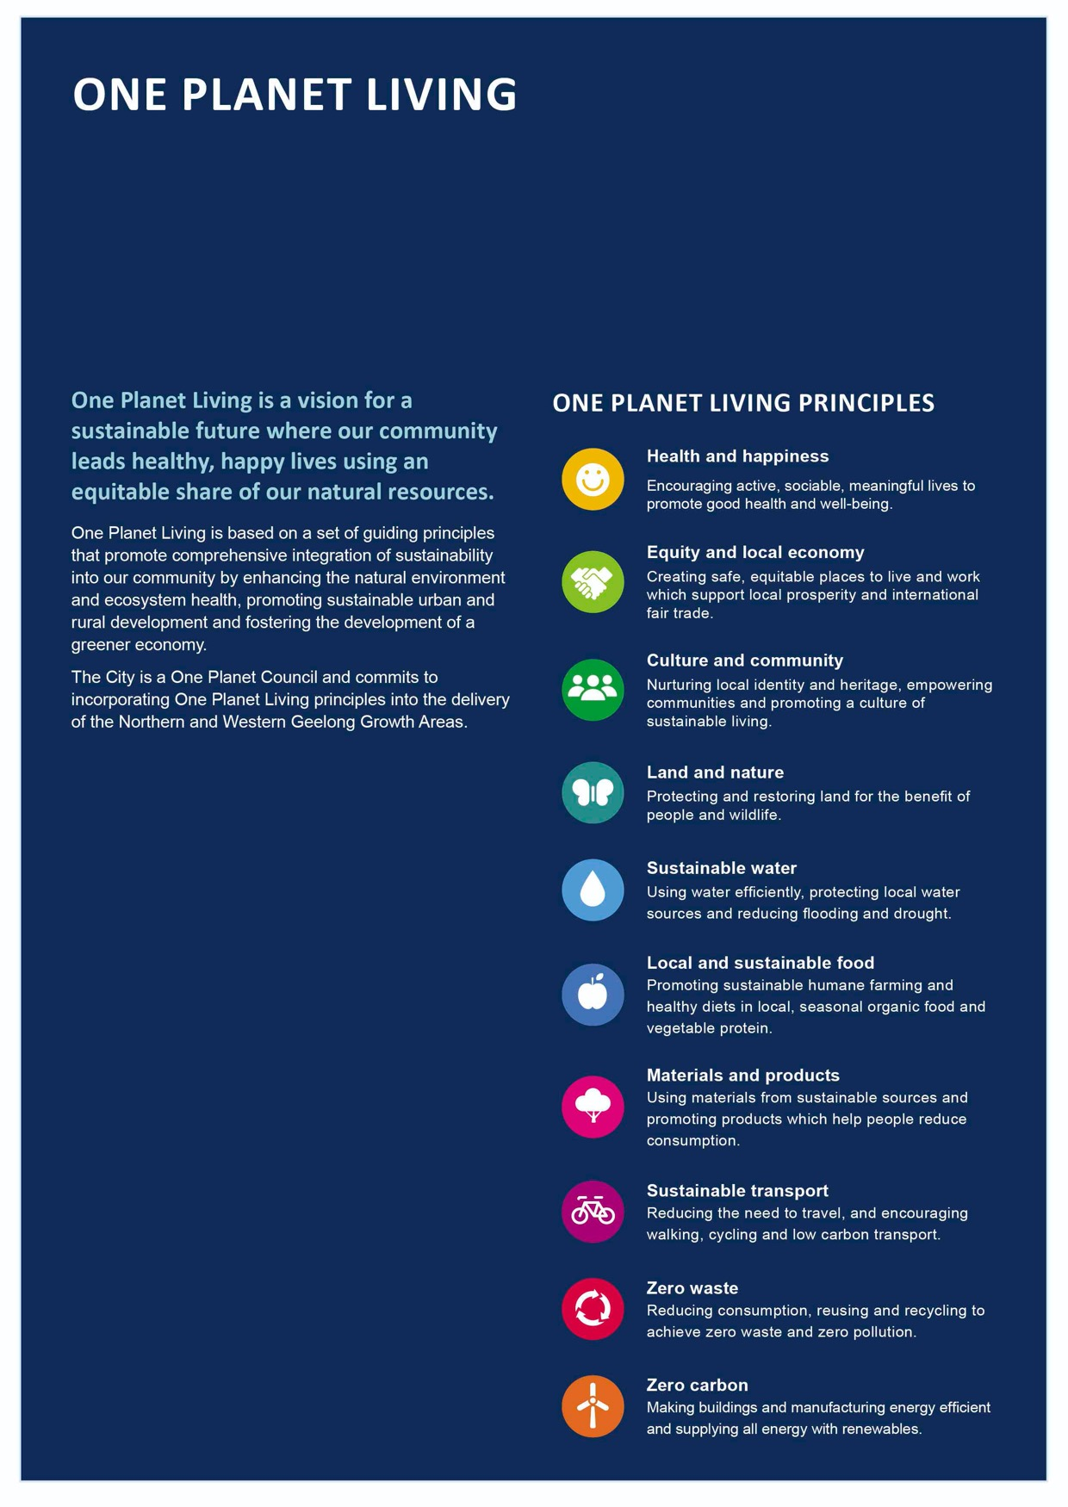
VISION:
By 2047, Greater Geelong will be internationally recognised as a clever and creative city-region that is forward looking, enterprising and adaptive, and cares for its people and environment.

IMAGE IS NOT AVAILABLE WITHIN THIS VERION.
TO VIEW SUPPORTING VISUAL FOR THIS PAGE GO TO
www.geelongaustralia.com.au/futuregrowth/default.aspx
TO ACCESS PDF.

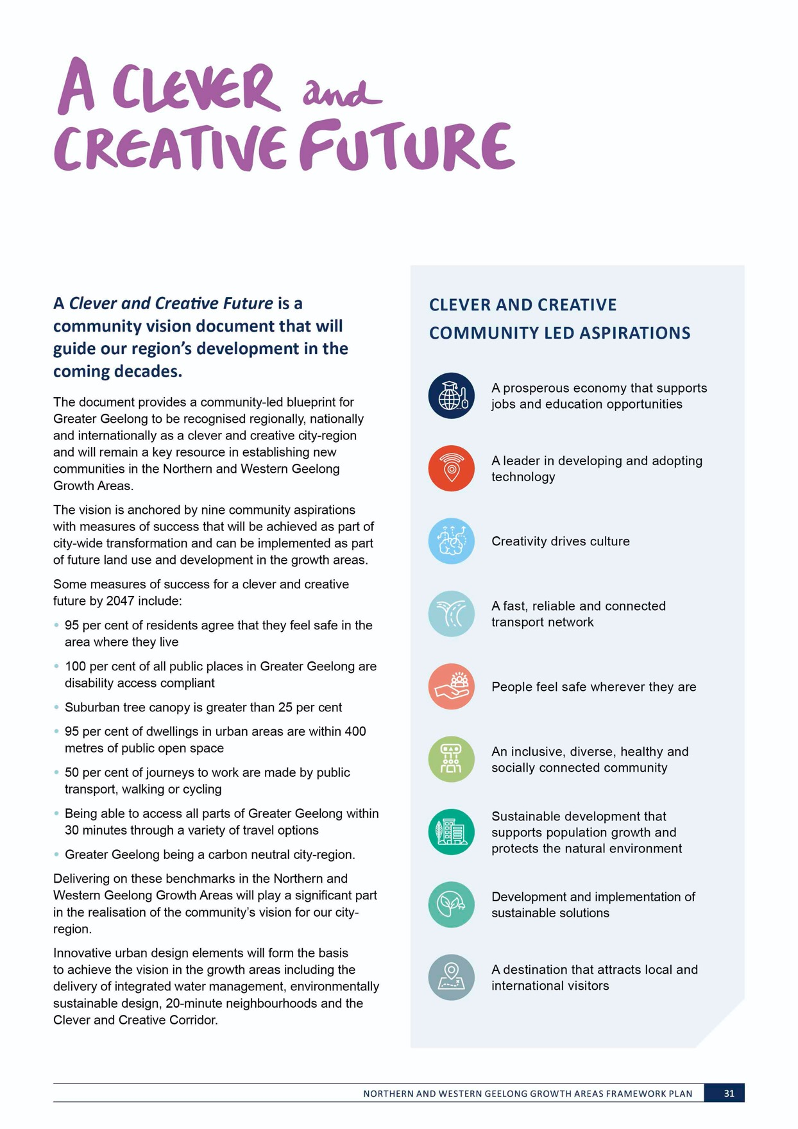

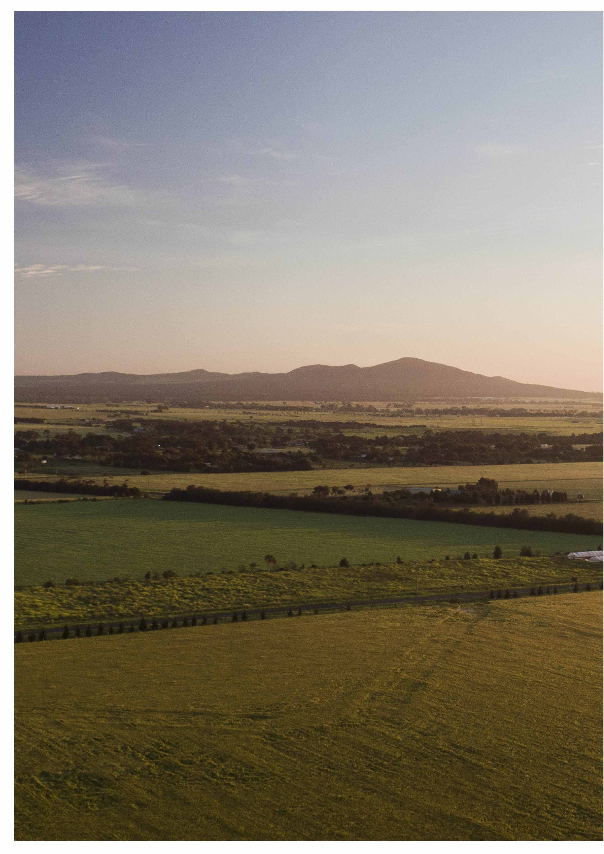

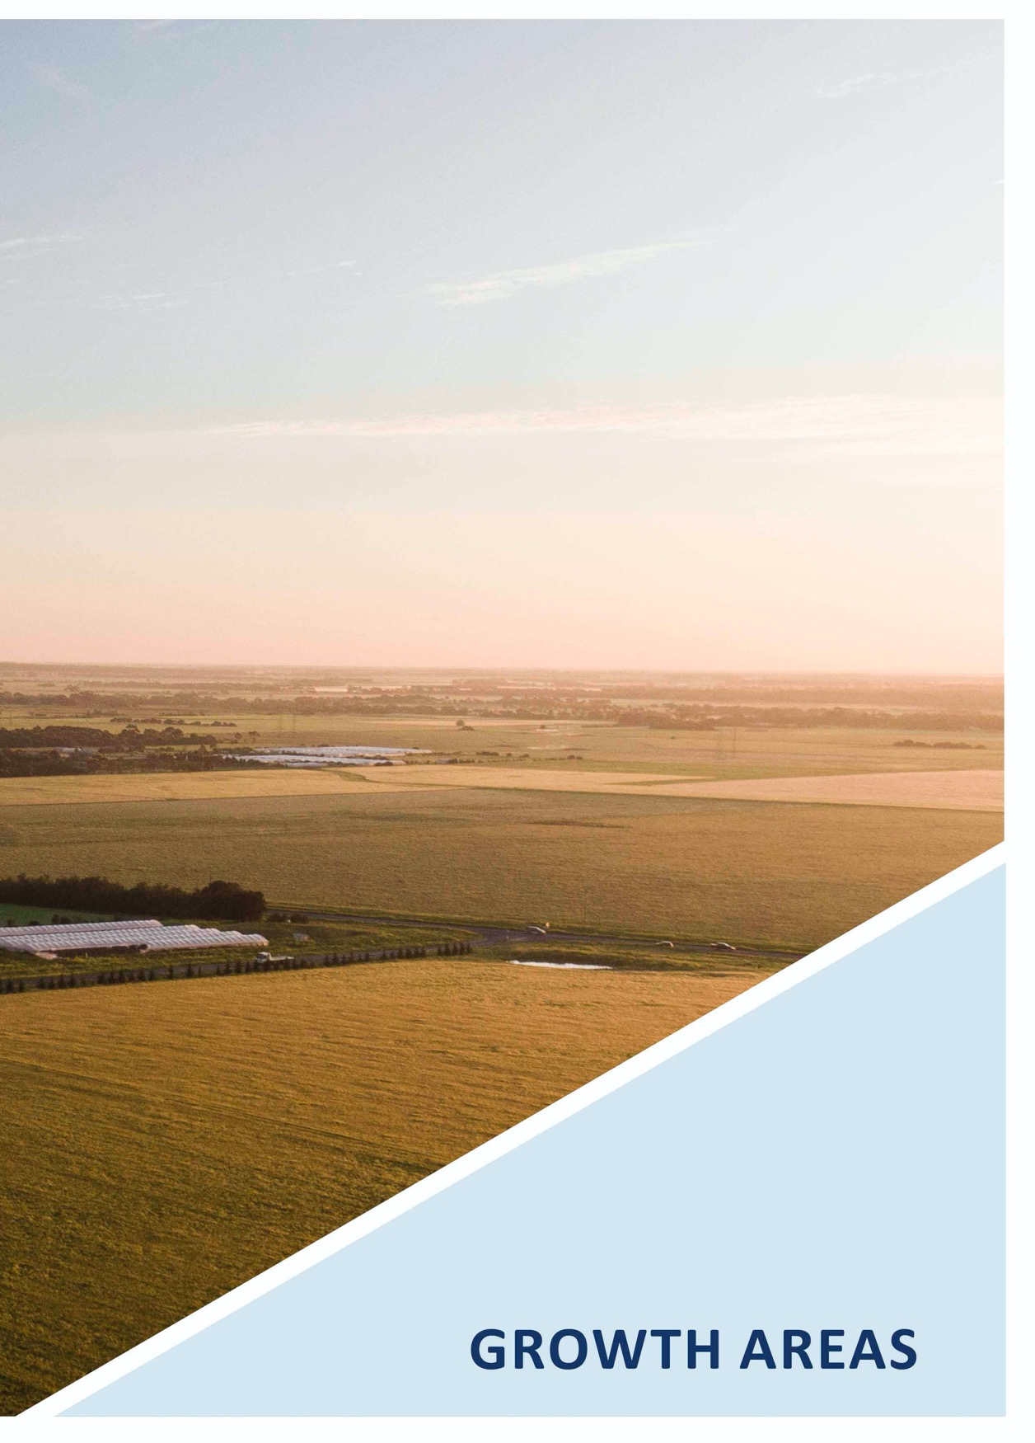

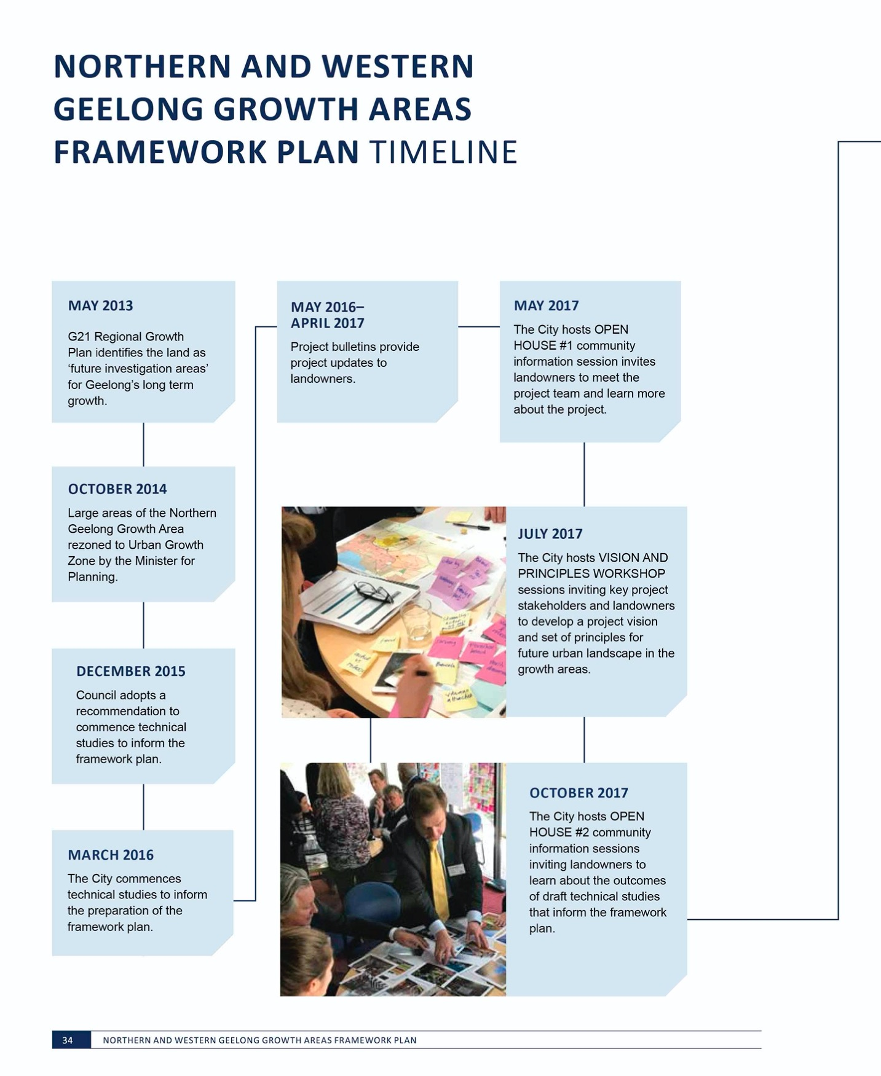

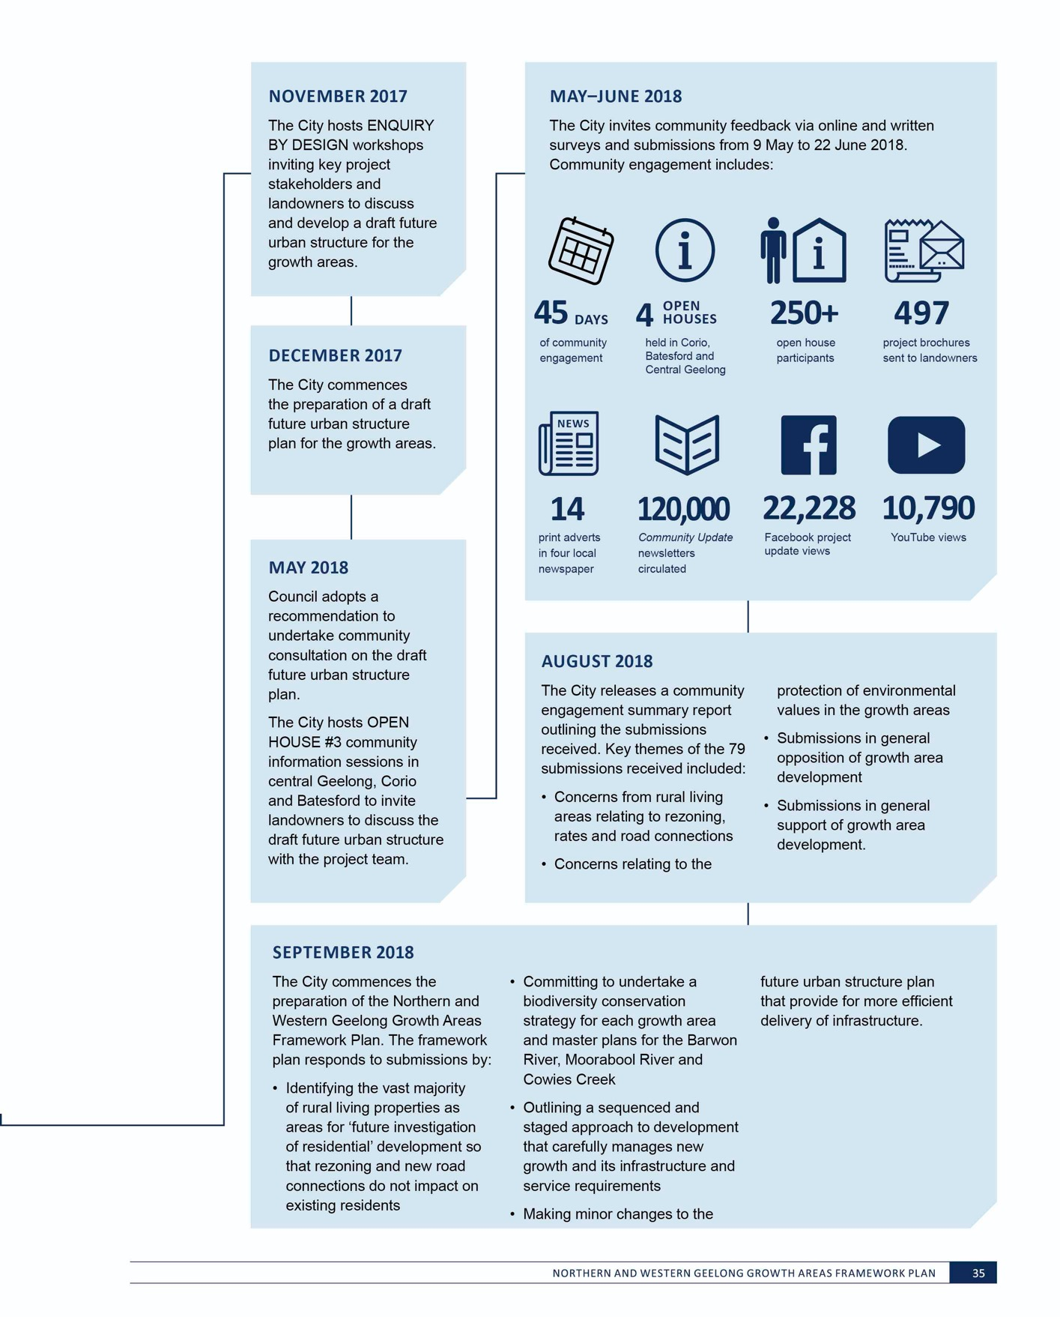
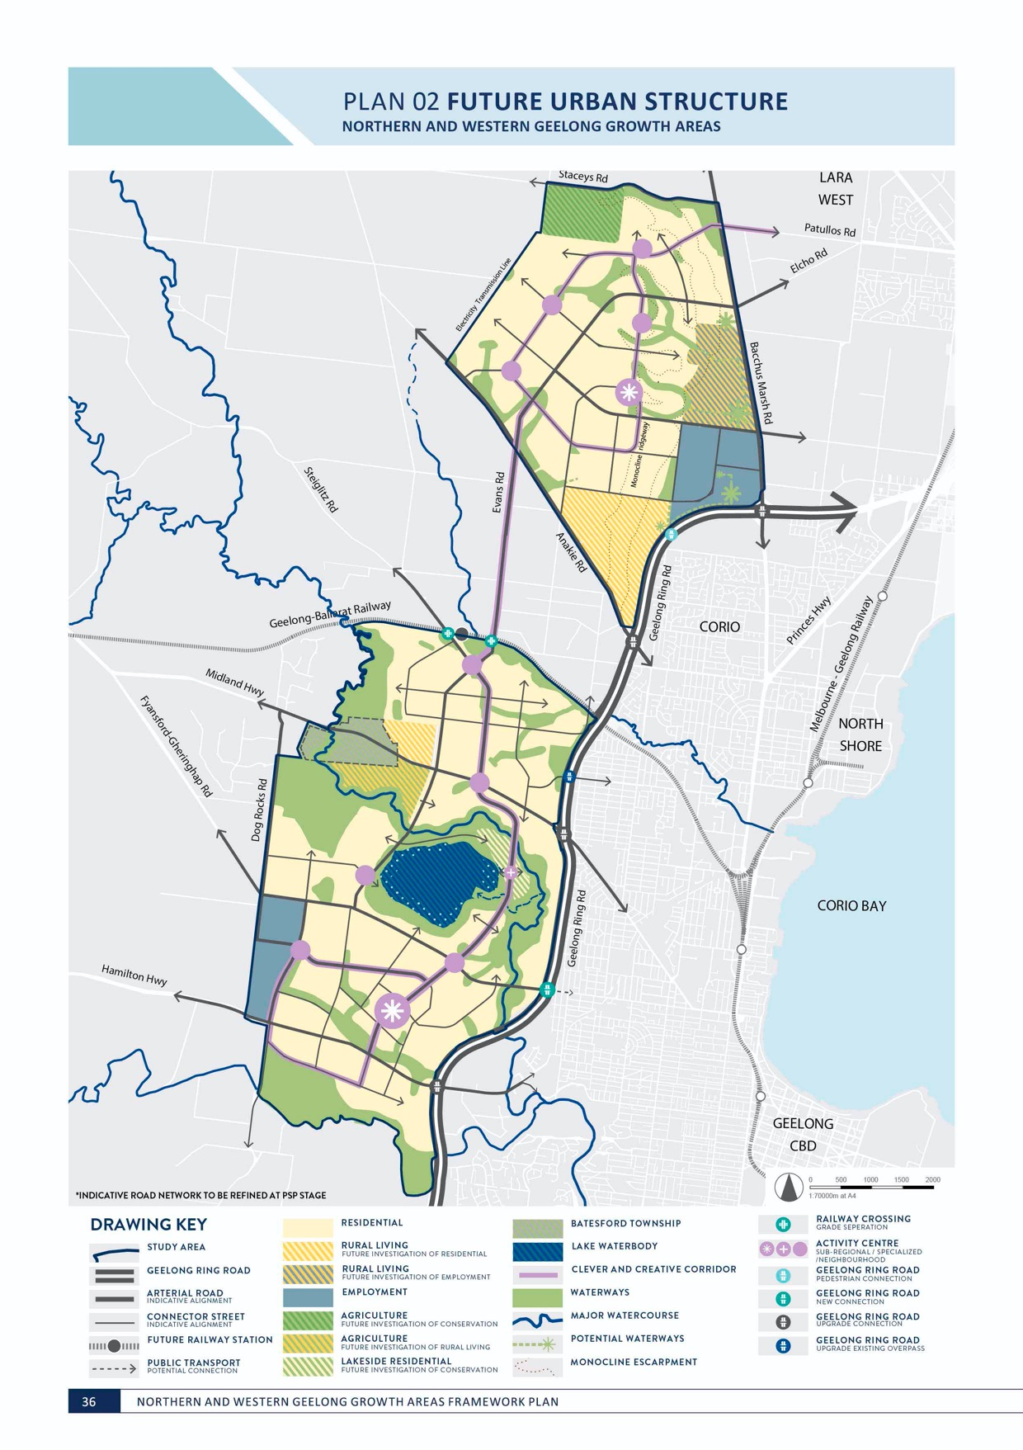
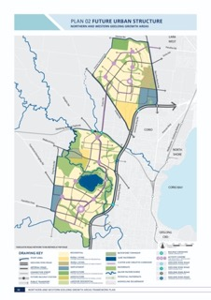

NORTHERN AND WESTERN
GEELONG GROWTH AREAS

ESTIMATED GROWTH POTENTIAL VISION FOR THE NORTHERN

AND WESTERN GEELONG GROWTH AREAS
TOTAL GROWTH AREA | 5,331 hectares
TOTAL RESIDENTIAL AREA | 3,309 hectares
ANTICIPATED DWELLINGS | 40,028
ANTICIPATED POPULATION | 112,078*
TOTAL EMPLOYMENT AREA | 294 hectares
NON DEVELOPMENT AREA | 1,728 hectares
FUTURE RESIDENTIAL POTENTIAL | 267 hectares
FUTURE EMPLOYMENT POTENTIAL | 125 hectares

The Northern and Western Geelong Growth Areas will exemplify Geelong’s transformation as a clever and creative city by building diverse, localised
and sustainable neighbourhoods that prioritise self-sufficiency whilst

maximising connections to the Geelong

Estimates of growth in the Northern Geelong Growth Area assumes a minimum average residential density of 15 dwellings per hectare and an average minimum residential density of 12.5 dwellings per hectare along the monocline escarpment. Estimated population attributes 2.8 persons per dwelling.
Estimates of growth in the Western Geelong Growth Area assumes a minimum average residential density of 15 dwellings per hectare and an average minimum residential density of 10 dwellings per hectare along the steep slopes. Estimated population attributes 2.8 persons per dwelling.
*Anticipated population includes residential development within areas subject to future investigation of residential to ensure that the framework plan anticipates the transport and social infrastructure needs of the future community at full build-out.

community, economy and identity.

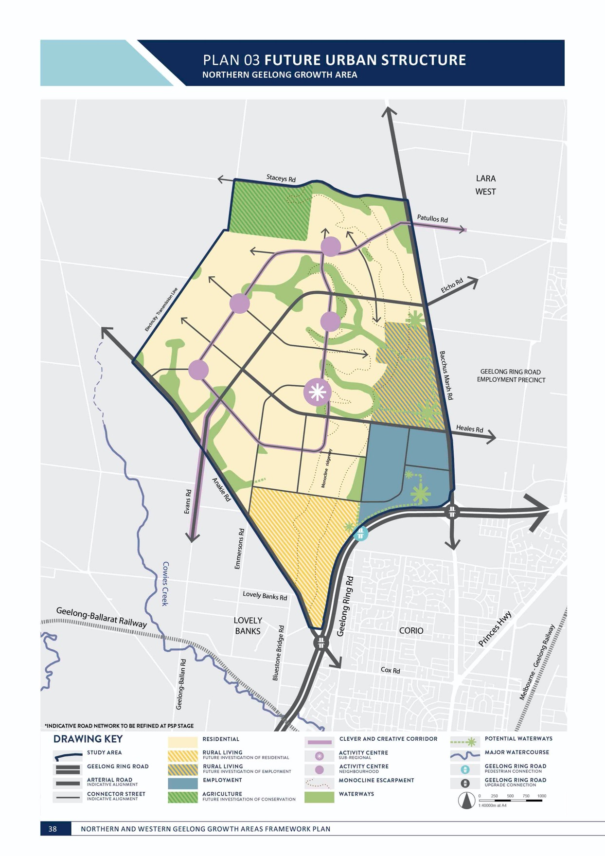

NORTHERN GEELONG GROWTH AREA

The Northern Geelong Growth Area is renowned for the Lovely
Banks monocline that defines the local landscape and allows stunning views to the You Yangs, Corio Bay and across Geelong.

The growth area is generally bounded by Bacchus Marsh Road to the east, the Geelong Ring Road to the south, Anakie Road and servicing easements to the west and Staceys Road to the north.

ESTIMATED GROWTH POTENTIAL

TOTAL GROWTH AREA | 2,090 hectares
TOTAL RESIDENTIAL AREA | 1,445 hectares
ANTICIPATED DWELLINGS | 17,075
ANTICIPATED POPULATION | 47,809*
TOTAL EMPLOYMENT AREA | 177 hectares
NON DEVELOPMENT AREA | 354 hectares
FUTURE RESIDENTIAL POTENTIAL | 202 hectares
FUTURE EMPLOYMENT POTENTIAL | 125 hectares

Estimates of growth in the Northern Geelong Growth Area assumes a minimum average residential density of 15 dwellings per hectare and an average minimum residential density of 12.5 dwellings per hectare along the monocline escarpment. Estimated population attributes 2.8 persons per dwelling.
*Anticipated population includes residential development within areas subject to future investigation of residential to ensure that the framework plan anticipates the transport and social infrastructure needs of the future community at full build-out.
VISION FOR THE NORTHERN GEELONG GROWTH AREA

Northern Geelong will be distinguished by neighbourhoods with panoramic views across the region and built around diverse and accessible employment hubs that epitomise Geelong’s creativity, innovation and enterprise.

IMAGE IS NOT AVAILABLE WITHIN THIS VERION.
TO VIEW SUPPORTING VISUAL FOR THIS PAGE GO TO
www.geelongaustralia.com.au/futuregrowth/default.aspx
TO ACCESS PDF.

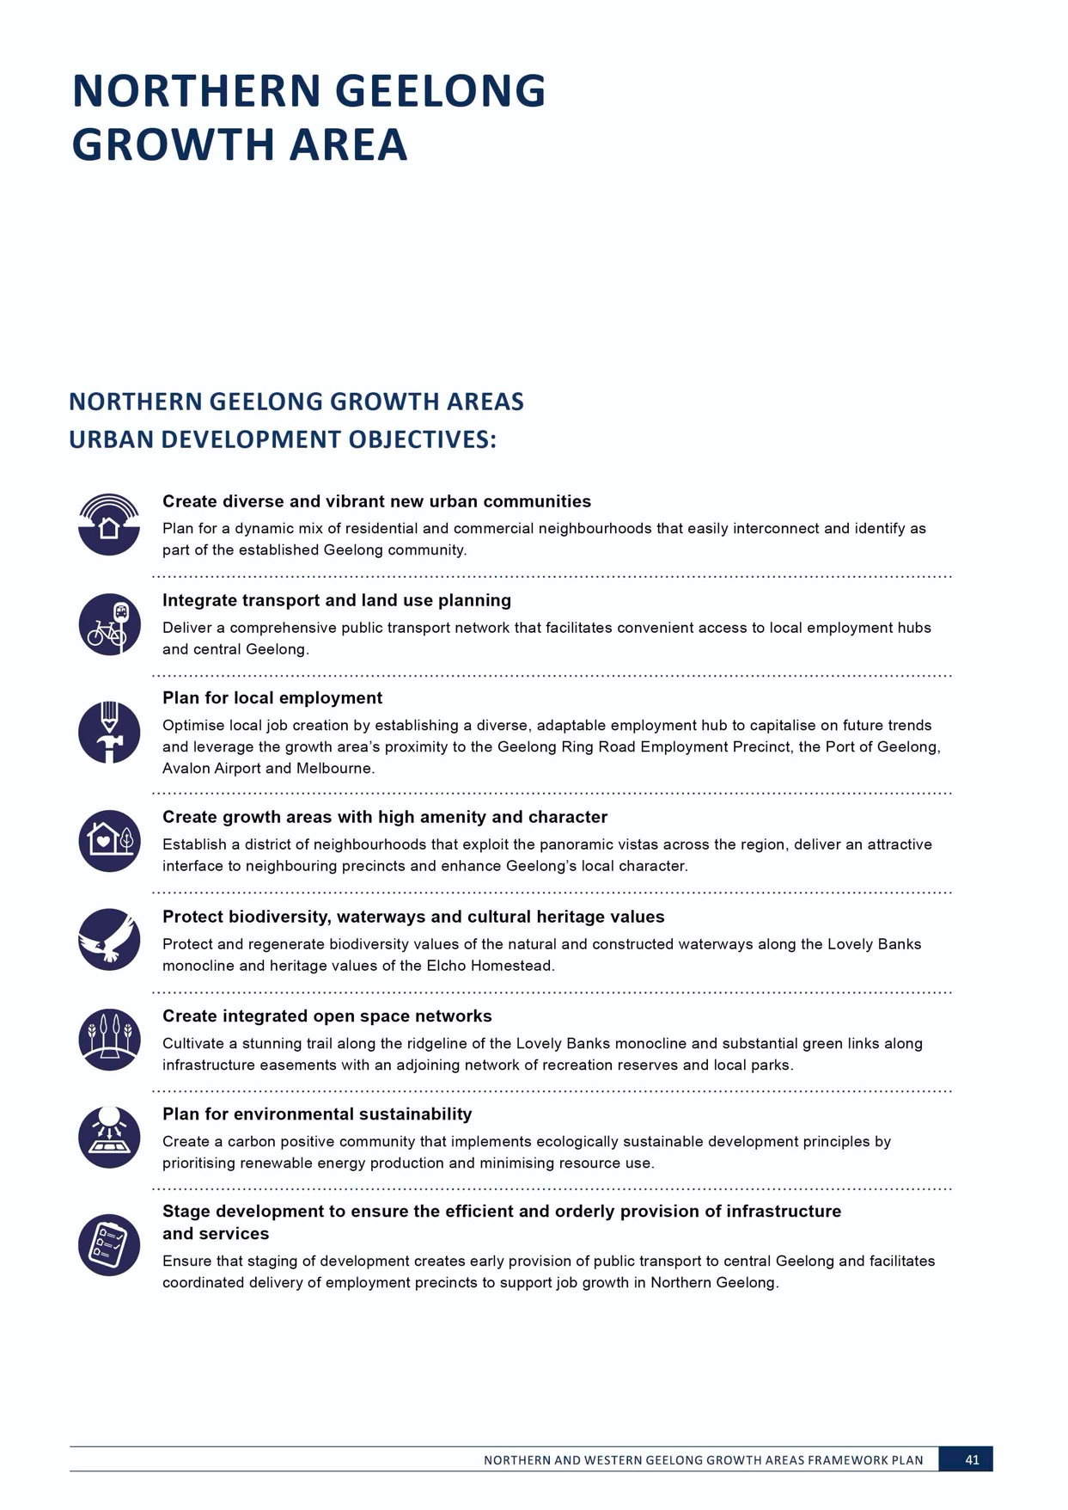

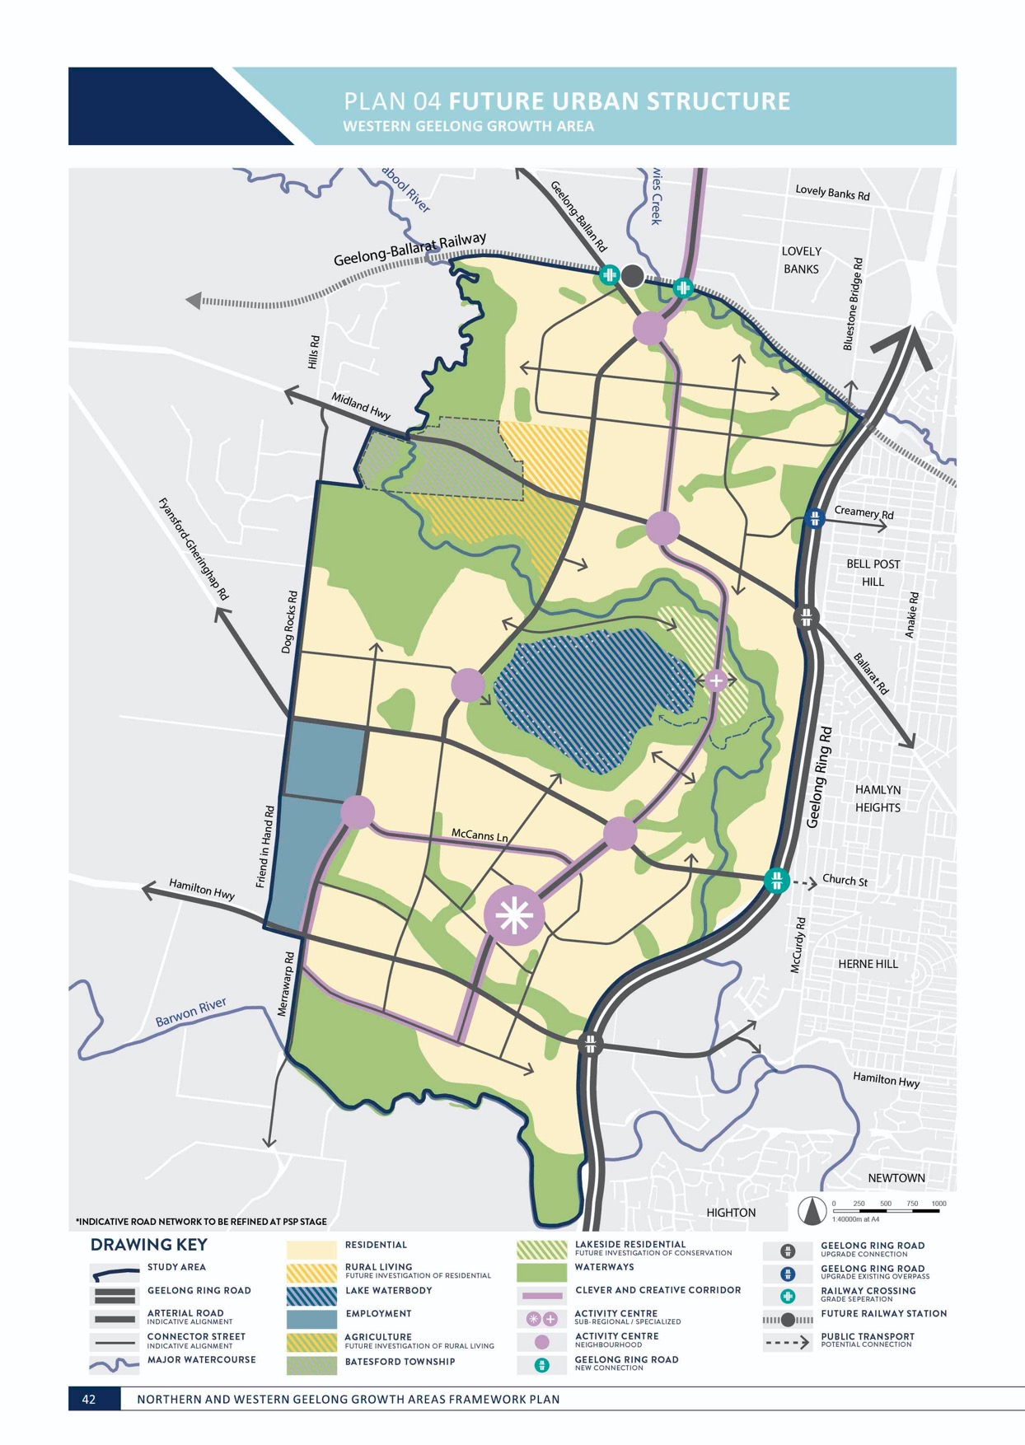

WESTERN GEELONG GROWTH AREA

The Western Geelong Growth Area is an iconic landscape characterised
by the Barwon and Moorabool Rivers with views across the Barrabool Hills and the Batesford Quarry as its centrepiece.

The growth area is generally bounded by the Geelong Ring Road to the east, the Barwon River to the south, the Geelong-Ballarat rail line to the north and Batesford township to the west.
ESTIMATED GROWTH POTENTIAL

TOTAL GROWTH AREA | 3,241 hectares
TOTAL RESIDENTIAL AREA | 1,864 hectares
ANTICIPATED DWELLINGS | 22,953
ANTICIPATED POPULATION | 64,269*
TOTAL EMPLOYMENT AREA | 117 hectares
NON DEVELOPMENT AREA | 1,377 hectares
FUTURE RESIDENTIAL POTENTIAL | 65 hectares

Estimates of growth in the Western Geelong Growth Area assumes a minimum average residential density of 15 dwellings per hectare and an average minimum residential density of 10 dwellings per hectare along the steep slopes. Estimated population attributes 2.8 persons per dwelling.
*Anticipated population includes residential development within areas subject to future investigation of residential to ensure that the framework plan anticipates the transport and social infrastructure needs of the future community at full build-out.
VISION FOR THE WESTERN GEELONG GROWTH AREA

Western Geelong will prosper as a district of lakeside neighbourhoods connected by healthy waterways and attractive open spaces that strengthen Geelong’s identity as a city built around water.

IMAGE IS NOT AVAILABLE WITHIN THIS VERION.
TO VIEW SUPPORTING VISUAL FOR THIS PAGE GO TO
www.geelongaustralia.com.au/futuregrowth/default.aspx
TO ACCESS PDF.

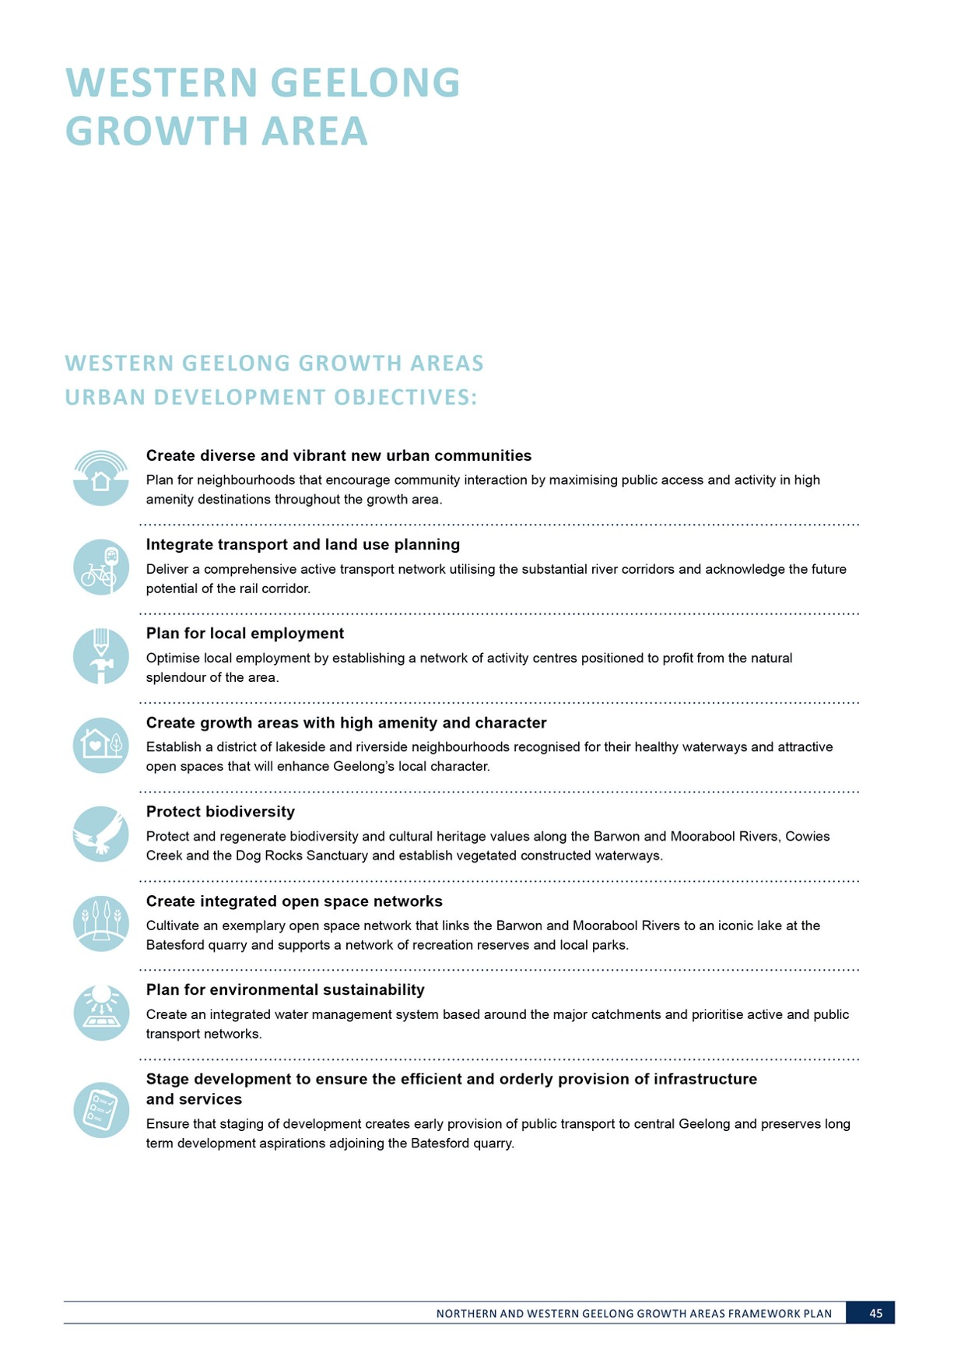
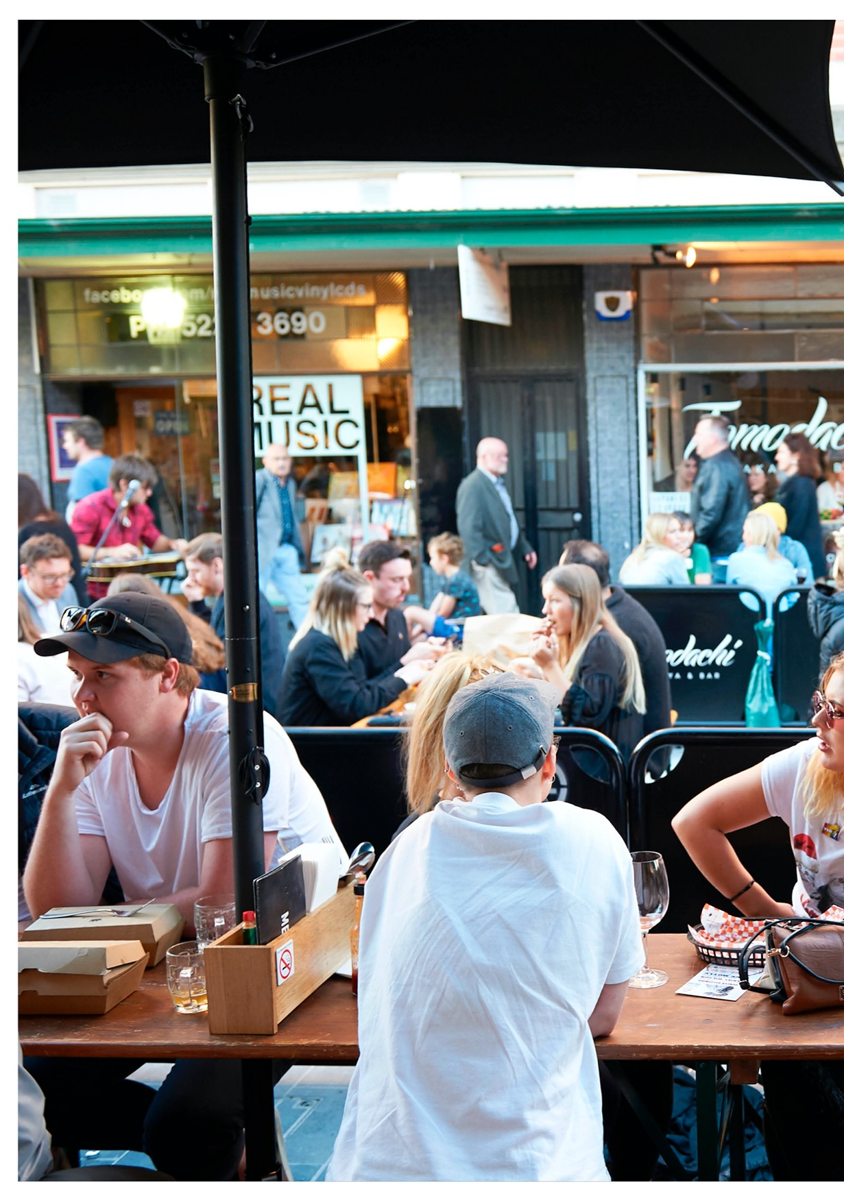

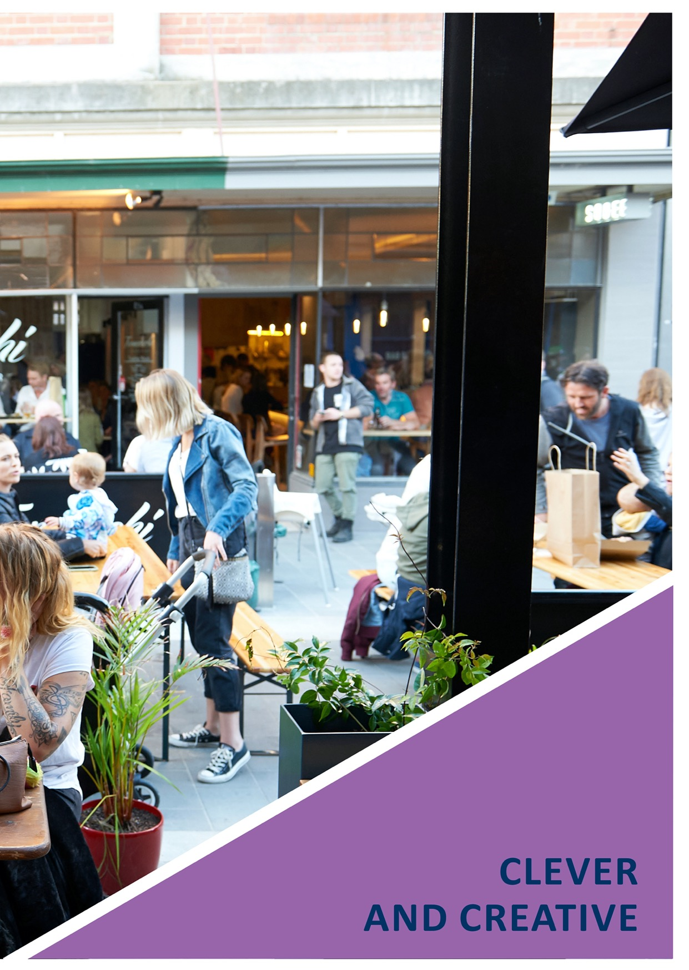

CLEVER AND CREATIVE CORRIDOR
Bellarine
ROAD NETWORK
ACTIVITY CENTRE NETWORK

400 METRE CATCHMENT
POTENTIAL CONNECTIONS
TO URBAN GEELONG

0 250 500 750 1000

1:70000m at A4

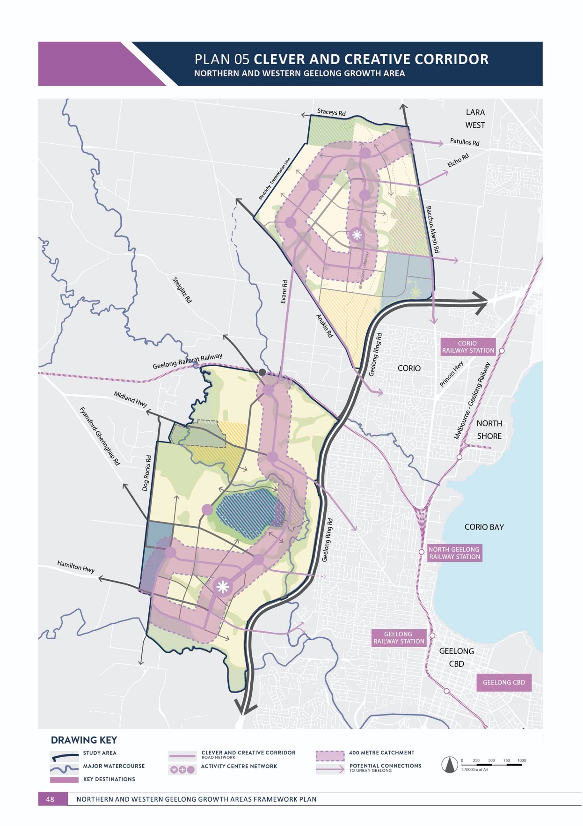

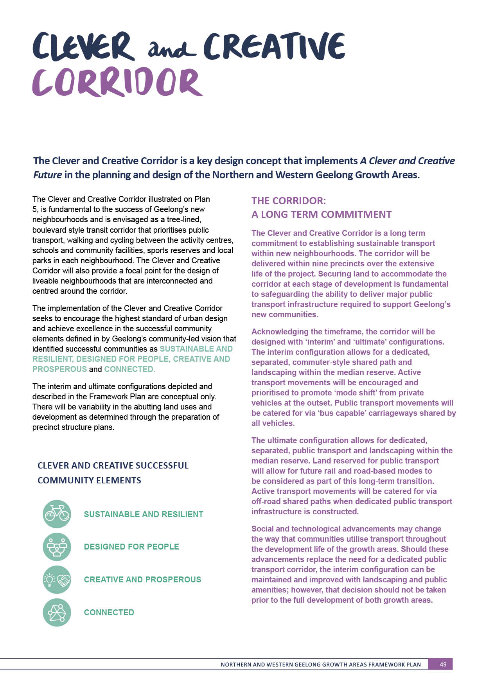
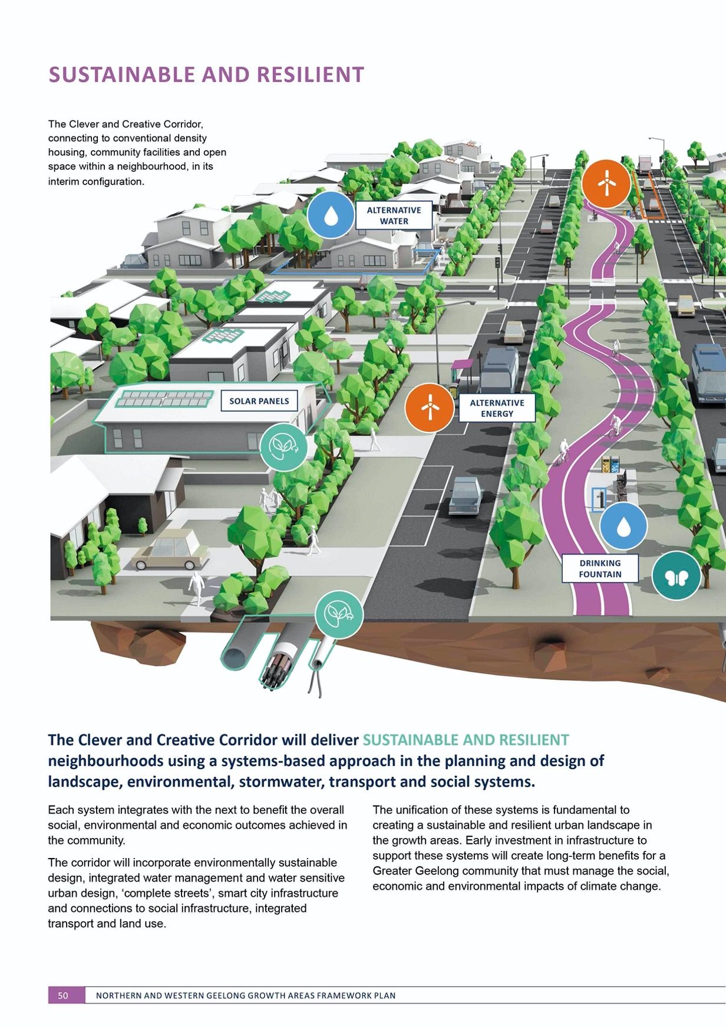

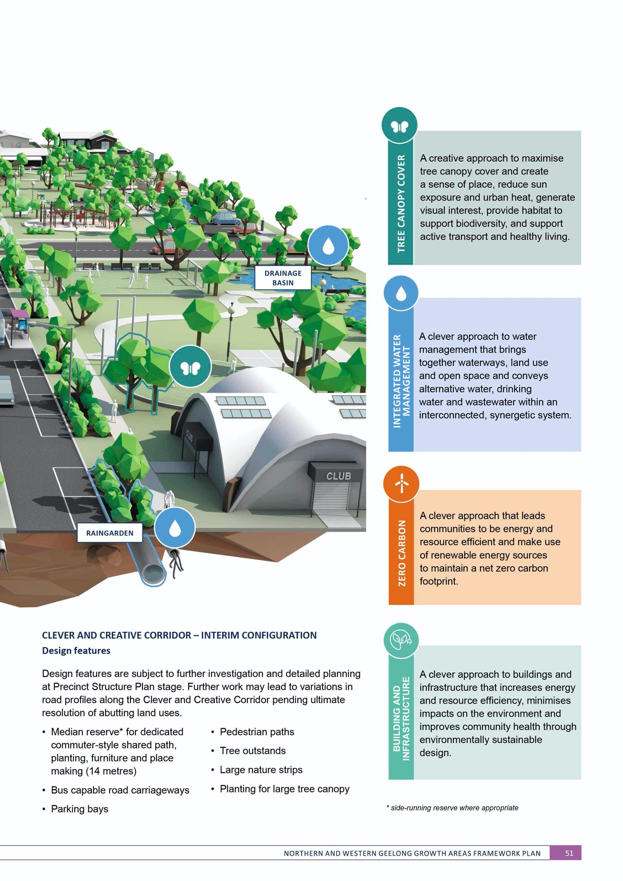
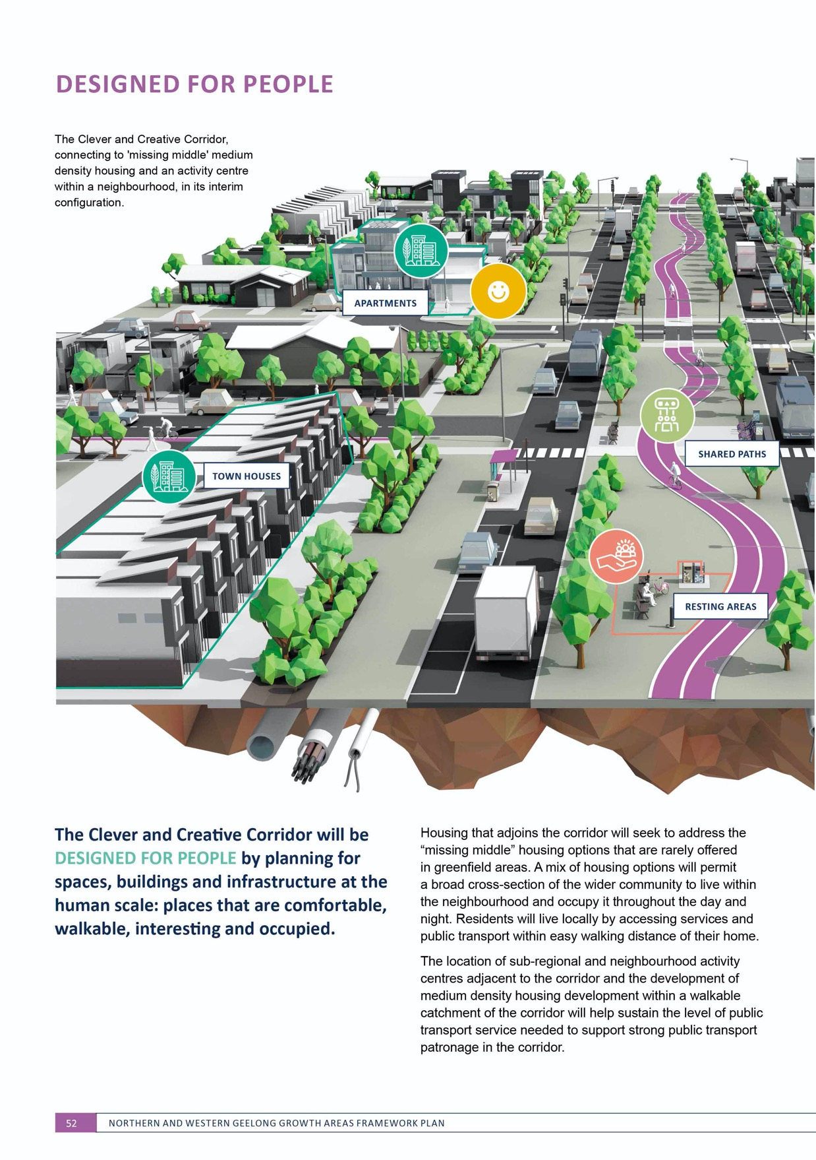

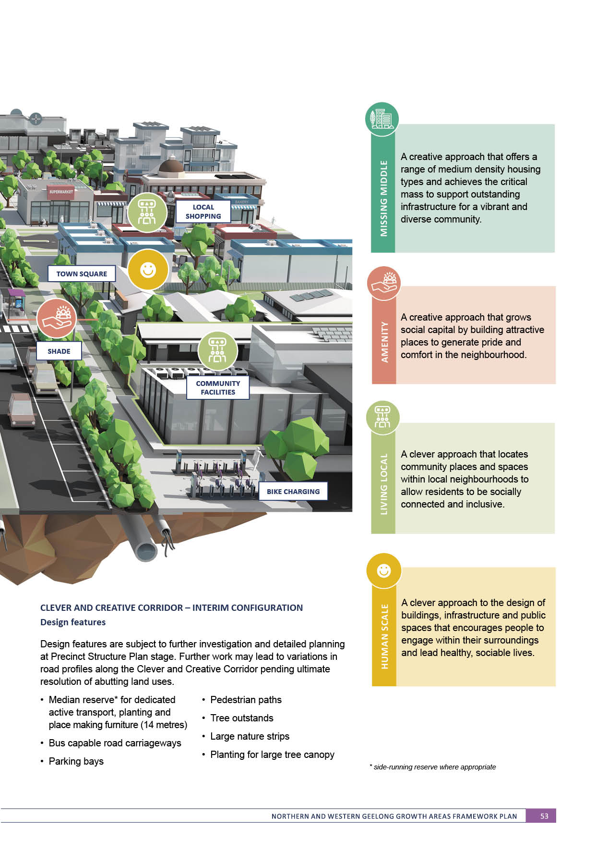

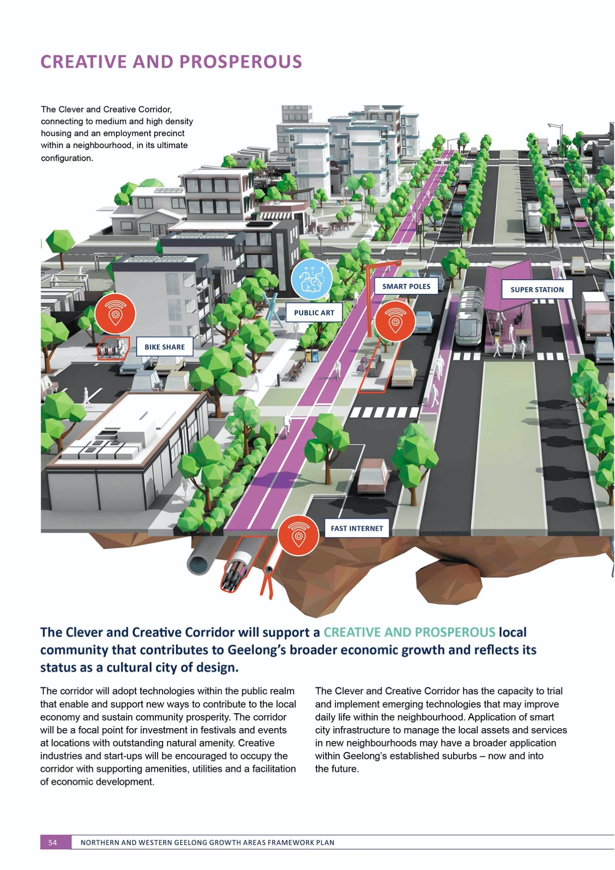

The Clever and Creative Corridor has the capacity to trial and implement emerging technologies that may improve daily life within the neighbourhood. Application of smart city infrastructure to manage the local assets and services in new neighbourhoods may have a broader application within Geelong’s established suburbs – now and into
the future.

  - Median reserve* for dedicated • Off-road shared path

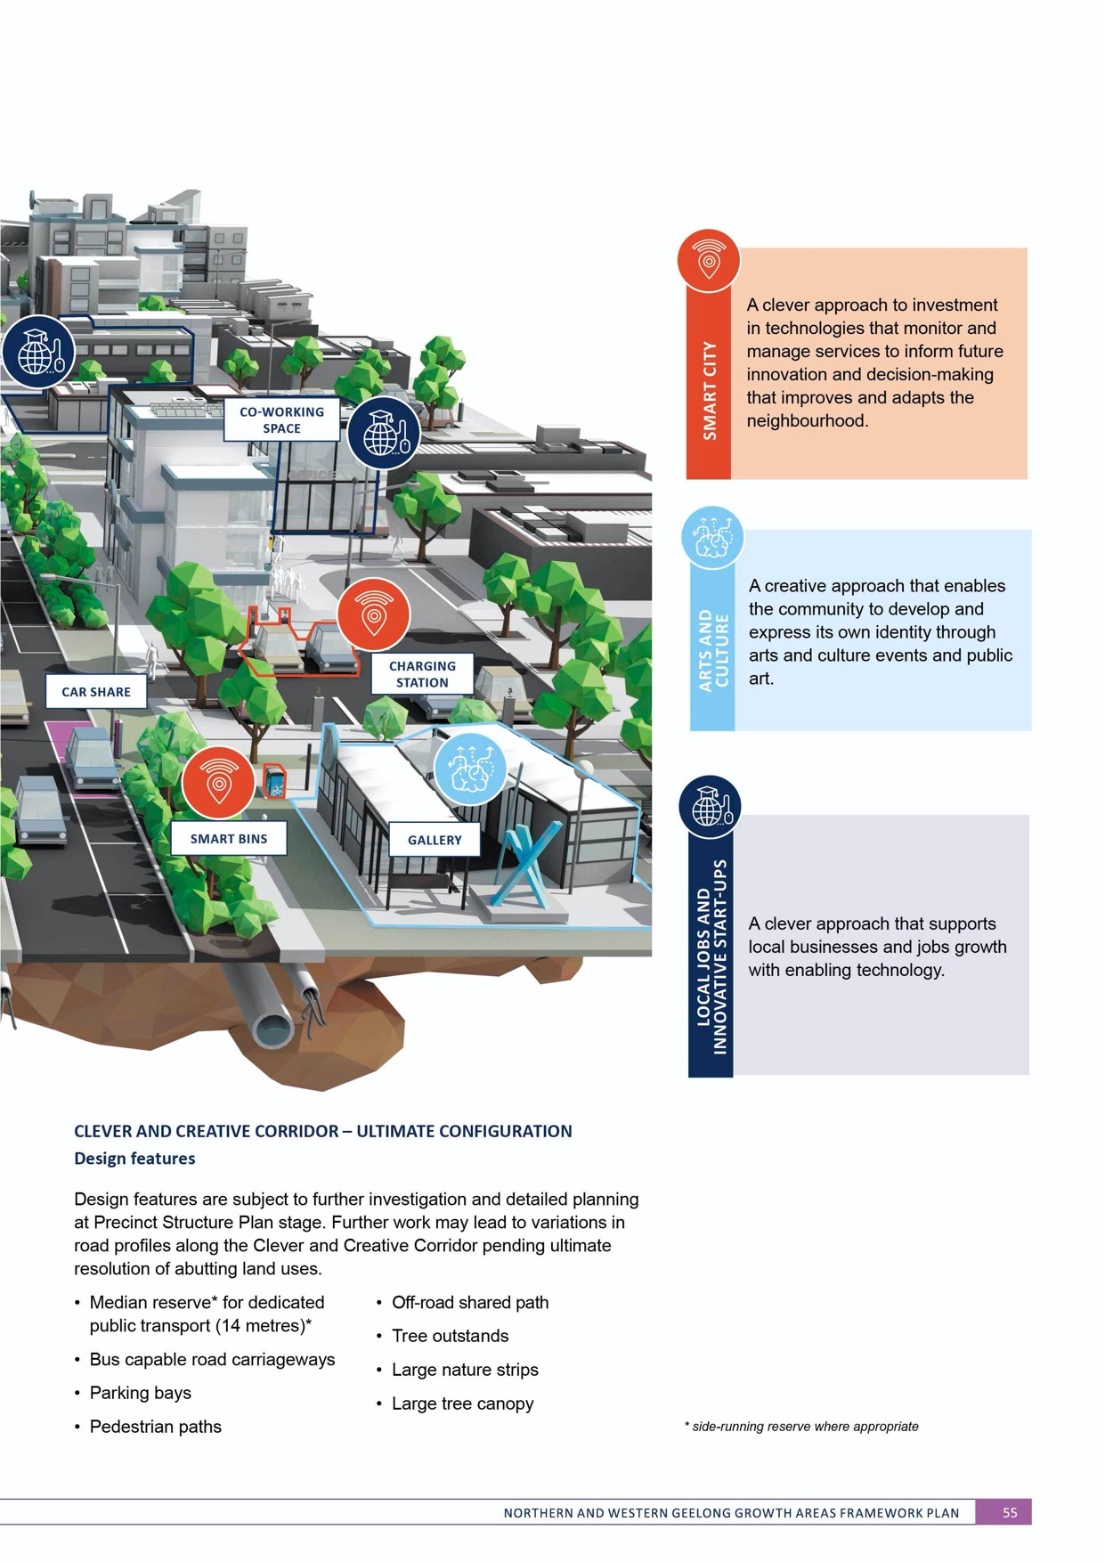

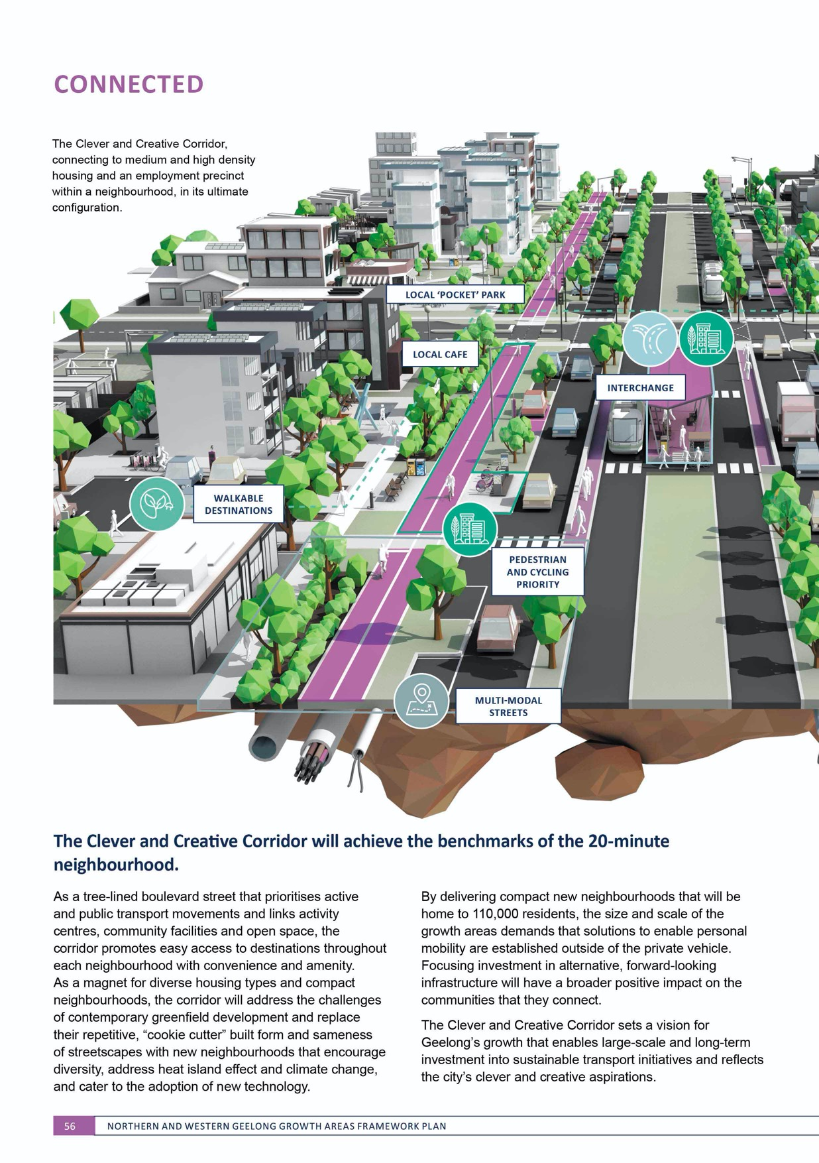

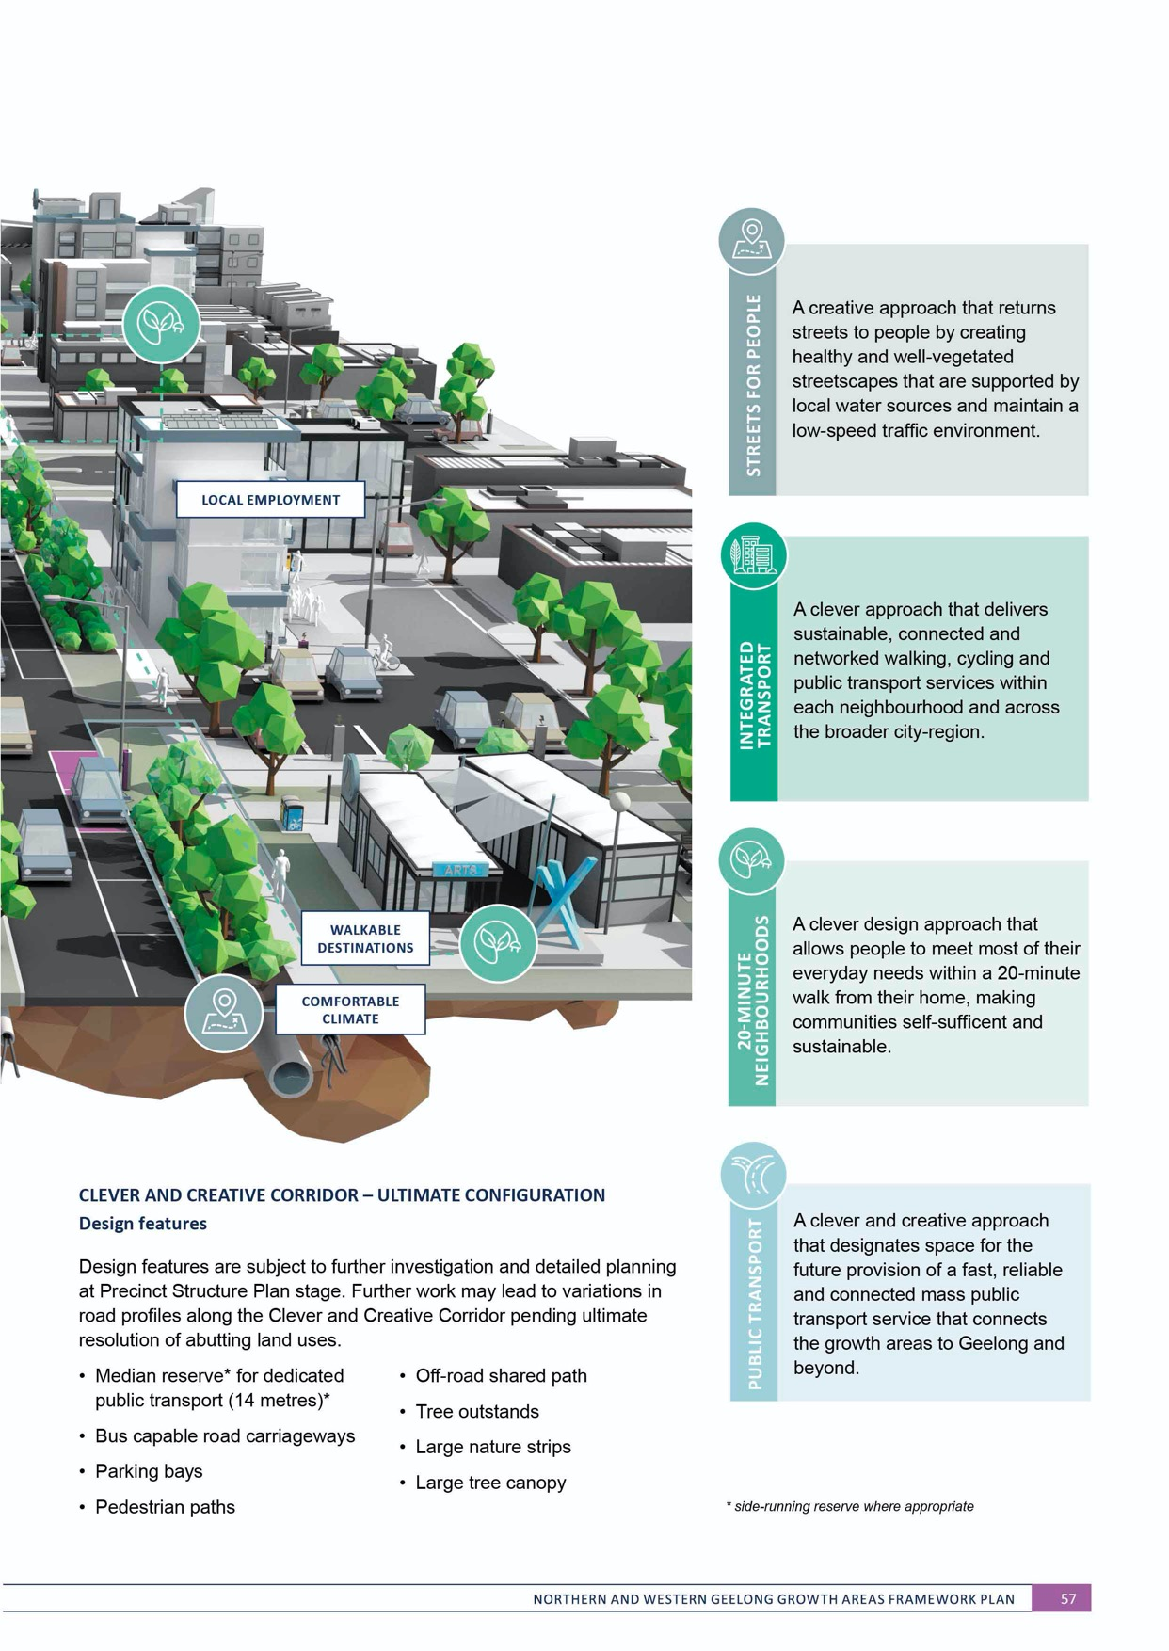

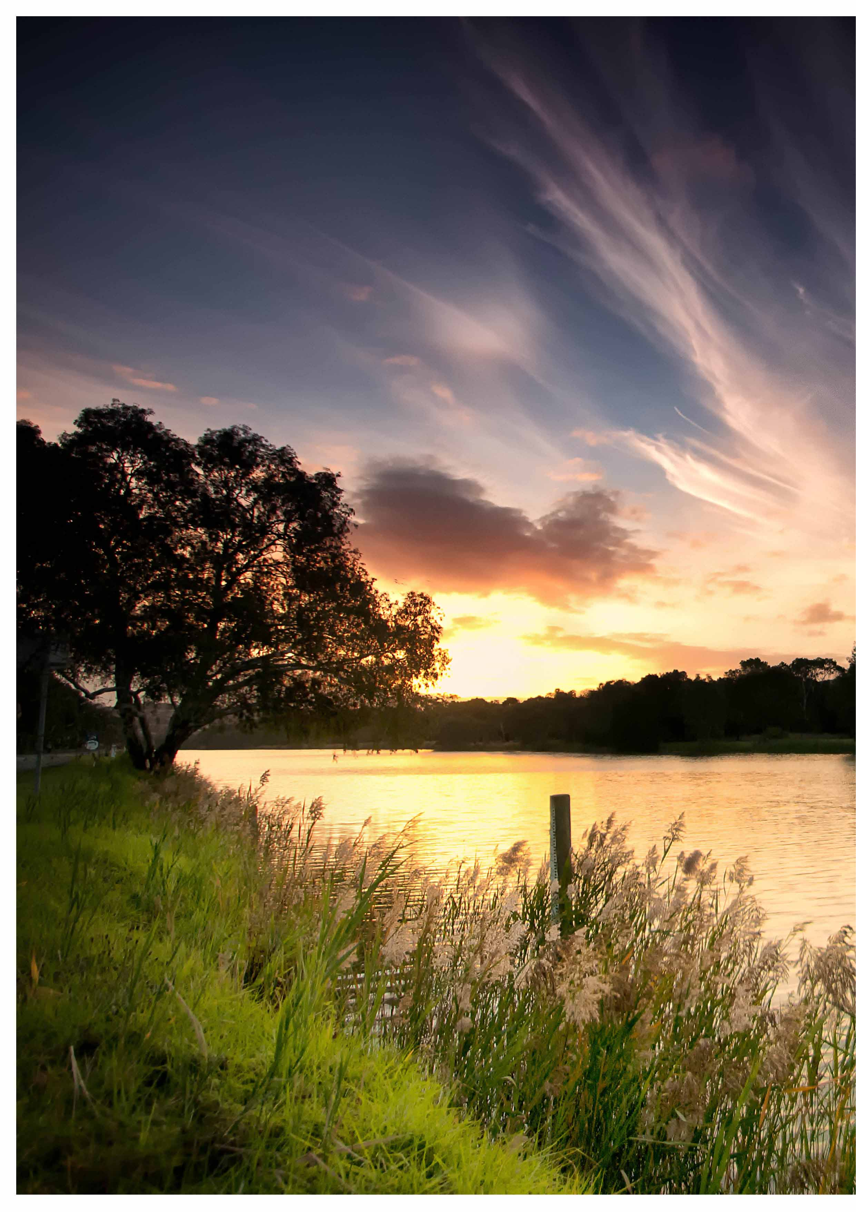


ENVIRONMENT

ENVIRONMENT is the element that distinguishes Geelong’s growth areas and provides the canvas for creating our new neighbourhoods.
A distance of less than two kilometres separates the Northern Geelong Growth Area from the Western Geelong Growth Area; despite their proximity, the areas have distinct environments with unique features and character, opportunities and constraints.
The environment in the Northern Geelong Growth Area will capitalise on the undulating Lovely Banks monocline and focus on cultivating great amenity and biodiversity throughout its grassland plateau.
IMAGE IS NOT AVAILABLE WITHIN THIS VERION.
TO VIEW SUPPORTING VISUAL FOR THIS PAGE GO TO
www.geelongaustralia.com.au/futuregrowth/default.aspx
TO ACCESS PDF.

The Western Geelong Growth Area will protect and enhance its signature environmental and cultural features
– the Barwon and Moorabool river corridors, Cowies Creek and Dog Rocks Flora and Fauna Sanctuary – and create
a new regional asset with the transition of the Batesford quarry.
ENVIRONMENT considers the existing conditions and future landscape of the Northern and Western Geelong Growth Areas including landform and view lines, water, biodiversity, heritage, built environment and surrounding areas.

PREVIOUS PAGE: CLEVER AND CREATIVE ENVIRONMENT – BARWON RIVER PARKLANDS

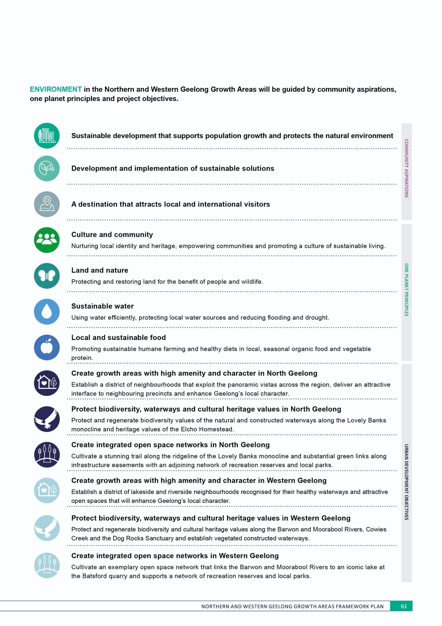

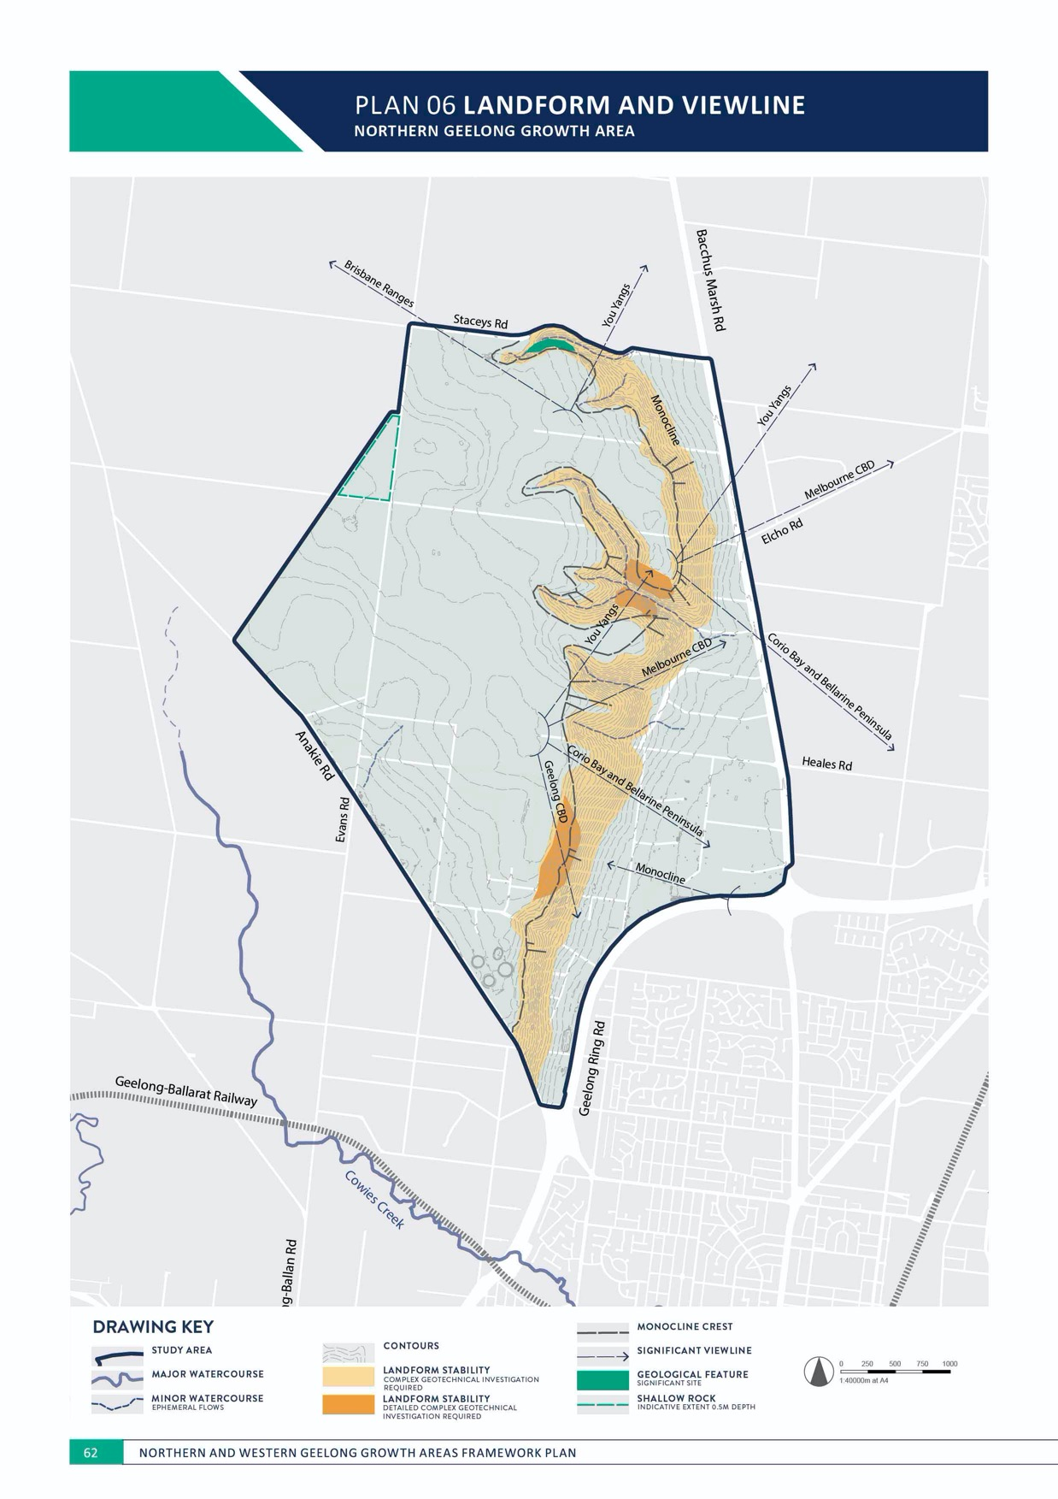

ENVIRONMENT
NORTHERN GEELONG GROWTH AREA

LANDFORM AND VIEW LINE
NORTHERN GEELONG GROWTH AREA

CONTEXT

Land in the Northern Geelong Growth Area consists of largely open, treeless agricultural land primarily utilised for grazing and cropping activities with adjoining areas of rural living.
The dominant feature in the landform of the area is the Lovely Banks monocline, a bend in the Earth’s crust that uniformly dips rock strata and defines the western boundary of the Port Philip Sunklands.
The Lovely Banks monocline runs north-south along the eastern extent of the growth area, dividing the high, gently sloping plateau in the west and low, relatively flat land in the east.
The monocline escarpment allows panoramic views across the region and its varied landform creates valleys and natural amphitheatres that will inform the urban landscape.
Significant view lines to landmarks include:
- Lovely Banks monocline escarpment, in proximity to Heales Road, with views to central Geelong, Corio Bay and the Bellarine Peninsula, metropolitan Melbourne and the You Yangs
- Lovely Banks monocline escarpment, in proximity to Elcho Road, with views to Corio Bay and the Bellarine Peninsula, metropolitan Melbourne and the You Yangs
- Lovely Banks monocline escarpment, in proximity to Staceys Road, with views to the You Yangs and Brisbane Ranges
- Plateau, in proximity to Evans Road, with views to the Brisbane Ranges.
- Geelong Ring Road, with views to the Lovely Banks monocline
- Localised views to the waterways and open space network.
Landforms and view lines are illustrated on Plan 6.

ACTION N1.1.1
The transition of the monocline escarpment to an urban landscape will be subject to detailed
investigation of land stability as part of the relevant precinct structure plans.
Detailed investigation of the landform of the monocline escarpment will assess its land capability for urban development including land stability, erosion, rock fall, hazard and landslide susceptibility and mitigation including buffers.

ACTION N1.1.2
Landform of the monocline escarpment will be maintained as part of urban development.
Land that is characterised by significant slope gradient will minimise landscape scarring and avoid the need for large amounts of cut and fill as part of urban development.

ACTION N1.1.3
Design and construction of public infrastructure will account for shallow bedrock.
The impact of shallow rock will be factored into detailed design
and costing of essential public infrastructure.

ENVIRONMENT

ACTION N1.1.4
The crest of the Lovely Banks monocline, the monocline ridgeway, will deliver a continuous linear public realm that provides public access to view lines along its entire length.
The monocline ridgeway will integrate the Clever and Creative Corridor, linear and local parks, activity centres, waterways and the integrated transport network to retain views to the Geelong region within the public realm.

ACTION N1.1.5
Key views will be protected and maximise using a street grid network that allows views to landmarks and is responsive to the sloping topography.
Key view lines identified in Plan 6 will be protected by incorporating fields of view that prevent visual intrusion into the urban landscape through key open space nodes and the orientation and design of the street network.

ACTION N1.1.6
View lines to significant landmarks and site features will be protected and maximised through consideration of development siting, height and visual bulk.
Reasonable sharing of views to landmarks will be achieved through careful consideration of development siting, height and visual bulk.

IMAGE IS NOT AVAILABLE WITHIN THIS VERION.
TO VIEW SUPPORTING VISUAL FOR THIS PAGE GO TO
www.geelongaustralia.com.au/futuregrowth/default.aspx
TO ACCESS PDF.
PLAN 07 WATER

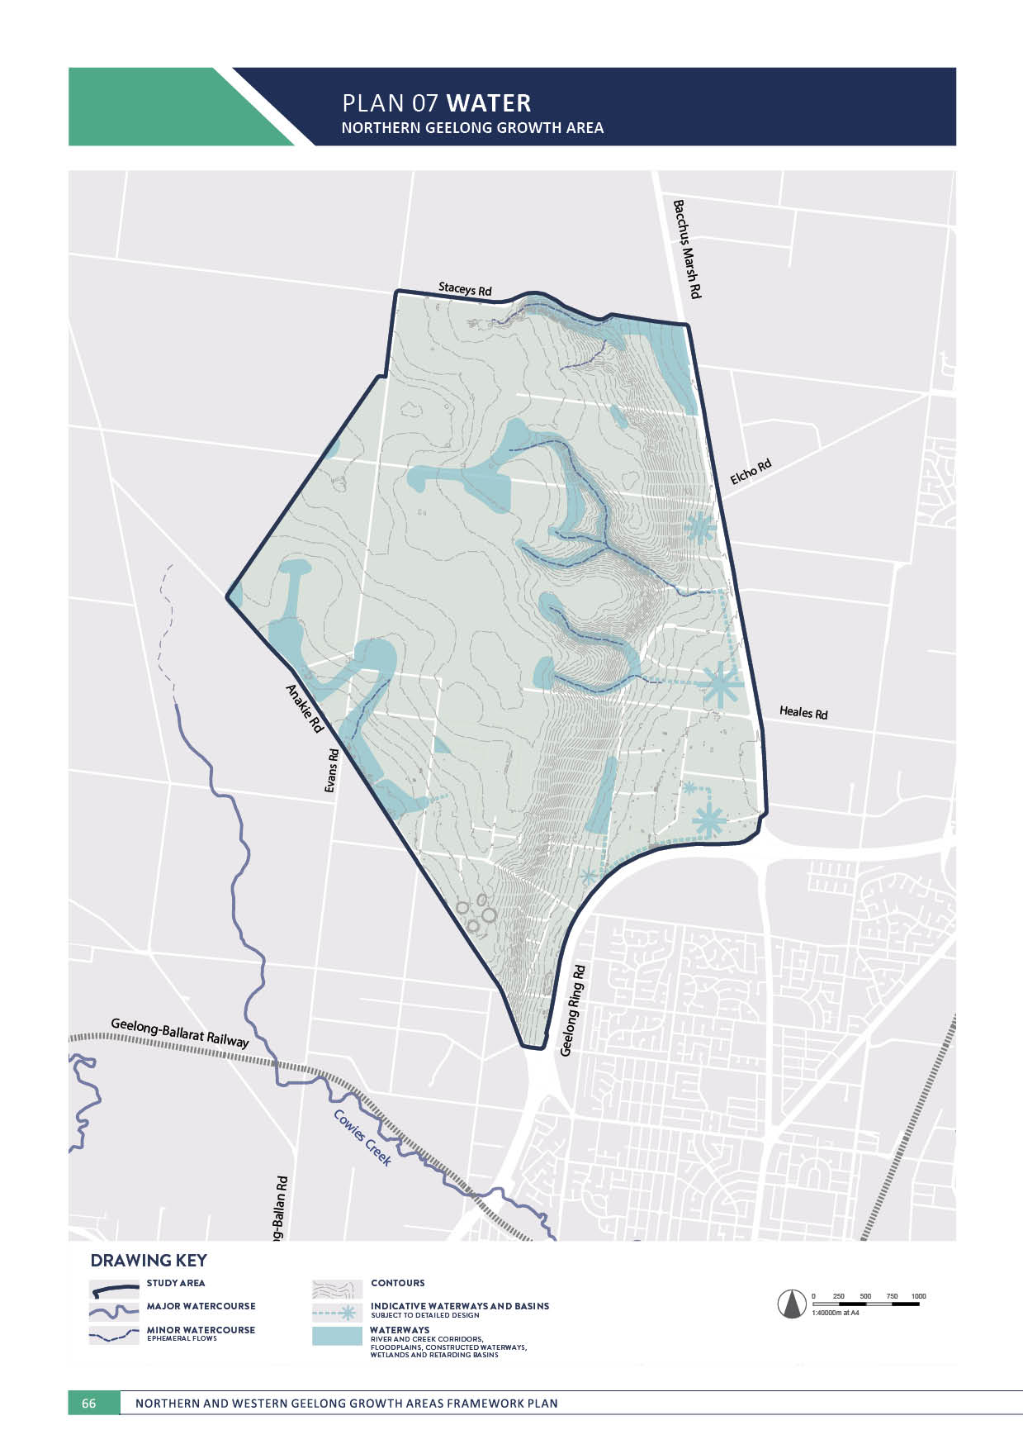
NORTHERN GEELONG GROWTH AREA

ENVIRONMENT

WATER
NORTHERN GEELONG GROWTH AREA

CONTEXT

Water is central to the quality of community life and nurturing the natural environment.
The Northern Geelong Growth Area is a relatively dry landscape that must manage flooding and stormwater drainage, protect downstream systems, and adapt to climate change effects including reduced water availability, higher temperatures and increased frequency of extreme weather events.
Stormwater in the growth area will outlet to existing infrastructure and waterways via a series of drainage catchments:
- Hovells Creek catchment
  - The north-east of the growth area is located within the Hovells Creek catchment and outfalls into the Lara West Precinct at Bacchus Marsh Road
- Elcho Road catchment
  - The catchment is located in the east of the growth area and outfalls into the Elcho Drain at via Bacchus Marsh Road

- Wharf Road catchment
  - The catchment is located in the south-east of the growth area and outfalls at Bacchus Marsh Road, south of the Geelong Ring Road.
- St Georges Drain catchment
- The catchment is located in the south of the growth area and outfalls at the Geelong Ring Road.
- Cowies Creek catchment
  - The south-west of the growth area is located in the Cowies Creek catchment and outfalls at Anakie Road.
Flooding and stormwater drainage management is a key element of the broader integrated water management plan for the growth area.
Each neighbourhood will utilise its water and interact with healthy waterways to contribute to a cooler, greener city and healthier environment. Integrated water management actions are outlined in NEIGHBOURHOOD.

ENVIRONMENT

ACTION N1.2.1
Waterways will be designed and constructed to retain natural characteristics and support the establishment of viable riparian vegetation that improves habitat and water quality.
Natural waterways are critical to the amenity of neighbourhoods and provide key linkages for biodiversity and passive recreation. Waterways should be delivered in accordance with the Melbourne Water Constructed Waterways in Urban Developments Guidelines.

ACTION N1.2.2
Flooding and stormwater management will maintain and enhance the predevelopment hydrology of the area and minimise downstream impacts.
Stormwater runoff quantity generated by urban development will be managed to minimise adverse impacts. Stormwater runoff quality will meet or exceed the water quality performance objectives of the CSIRO Best Practice Environmental Management Guidelines for Urban Stormwater prior to discharge to receiving waterways.
ACTION N1.2.3
Drainage schemes that outline the detailed design of stormwater management infrastructure and flood impact assessment will be undertaken as part of the precinct structure planning process in collaboration with Barwon Water and the Corangamite Catchment Management Authority.
Stormwater management will be designed to minimise downstream impacts in accordance with the relevant drainage scheme and delivered with regard to relevant standards, policies and strategies including:
- Infrastructure Design Manual
- City of Greater Geelong Stormwater Standard Drawings and Design Notes
- City of Greater Geelong Stormwater Services Strategy
- Melbourne Water Waterway Corridor Guidelines
- Melbourne Water Wetland Design Guidelines
- Melbourne Water Constructed Waterways in Urban Developments Guidelines
- CSIRO Best Practice Environmental Management Guidelines for Urban Stormwater.

ACTION N1.2.4
Stormwater will enhance the urban landscape.
Stormwater management will utilise open waterways that connect the broader open space network and deliver significant multifunctional values that enhance community access to water and the natural environment. Distribution of stormwater retardation, treatment and infiltration at the precinct, streetscape and property scale will contribute to water sensitive urban design within neighbourhoods.

ACTION N1.2.5
Flooding and stormwater management will respond to the natural landscape.
Design of stormwater management infrastructure will deliver extensive green-blue links and partially distributed assets that reduce the extent of end of line wetlands.
Major drains may be required to be piped in areas of high complexity such as the monocline escarpment and rural living properties.

ACTION N1.2.6
The transition of the monocline escarpment to an urban landscape will be subject to detailed
investigation of flooding and stormwater drainage as part of the relevant precinct structure plans.
Detailed investigation of waterways and stormwater management infrastructure that interface with the monocline escarpment will assess impacts on land stability, erosion and landslide susceptibility and mitigation.
ACTION N1.2.7
Water will be distributed and integrated into the urban landscape in a manner that is sustainable over time.
The design of stormwater management infrastructure will balance amenity, efficiency and safety with practicality of its construction and maintenance and will be informed by the outcome of the intergrated water management strategy

ACTION N1.2.8
Staging of urban development will provide for delivery of ultimate waterway and stormwater management infrastructure including stormwater quality treatment.
Where delivery of the ultimate infrastructure is not possible, alternative proposals will demonstrate how any interim infrastructure adequately manages stormwater generated from urban development and how the infrastructure
will enable delivery of the ultimate stormwater drainage scheme.

ACTION N1.2.9
Innovation in the design of the ultimate waterway network and stormwater management infrastructure will be considered in relation to net community benefit.
The waterway network and stormwater management infrastructure illustrated on Plan 7 is designed to balance cost and performance. An alternative drainage scheme that delivers innovative management of stormwater will be considered if the proposal reduces cost, increases
amenity and creates better integration with the public realm including activity centres, social infrastructure and the open space network.

PLAN 08 BIODIVERSITY
NORTHERN GEELONG GROWTH AREA

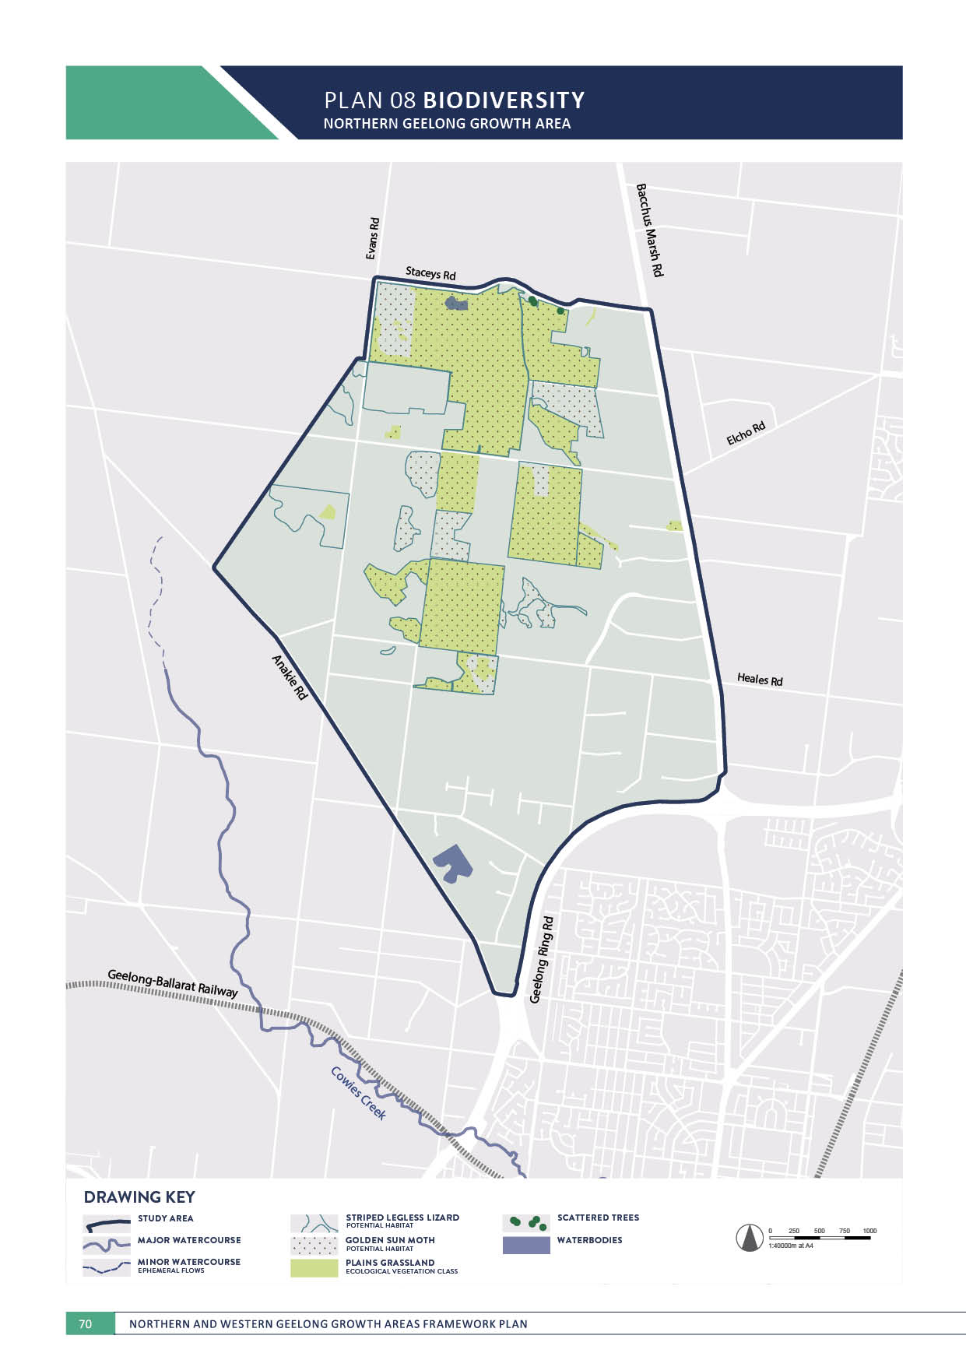

ENVIRONMENT

BIODIVERSITY
NORTHERN GEELONG GROWTH AREA

CONTEXT

Ecological values* on the land include:
- Approximately 408 hectares of remnant native vegetation patches, Plains Grassland, a critically endangered ecological community
- Three scattered trees
- Two wetlands
- Potential habitat for:
  - Commonwealth-listed significant flora species including Spiny Rice-flower and Large-headed Fireweed
  - State-listed significant flora species including Leafless Bluebush
  - Commonwealth-listed significant fauna species including namely Golden Sun Moth and Striped Legless Lizard
  - State-listed significant fauna species comprising predominately bird species that may disperse to more suitable breeding and foraging habitats.
Land in the area forms part of the Hovells Creek drainage catchment that outfalls into Limeburners Bay; this location (Point Wilson/Limeburners Bay) is one of six distinct areas that form the Port Phillip Bay (Western Shoreline) and Bellarine Peninsula Ramsar Site, a complex of wetlands of international importance.
Several ephemeral drainage lines and farm dams occur throughout the area although none are considered to be of national biodiversity significance.
Known biodiversity values are illustrated on Plan 8.

* Ecological values based on field assessments of 53% of study area.
ACTION N1.3.1
An overarching biodiversity conservation strategy will be prepared for the growth area that provides high level guidance for the management of nationally and state significant biodiversity values.
The strategy will spatially identify how outcomes for matters of national environmental significance will be delivered and must be approved by the Commonwealth Government prior to the finalisation of the initial precinct structure plan in the growth area.

ACTION N1.3.2
A network of linear corridors will be created to promote biodiversity linkages within neighbourhoods that connect between conservation areas, waterways and the open space network.
Corridors may be located as illustrated in Plan 9 to promote, retain and link a variety of flora and fauna habitats and allow the passive movement and long-term resilience of species throughout neighbourhoods. Corridors may be composed of a mixture of land uses including conservation areas, open space and waterways, social infrastructure and transport corridors.

ENVIRONMENT

ACTION N1.3.3
Any conservation areas that are identified will prioritise the protection and enhancement of local indigenous flora and fauna species.
Conservation areas will be retained to ensure their sustainability in relation to scale and connectivity to other natural assets. Conservation areas will be designed and managed with a focus on the protection and enhancement of biodiversity values including the management of public access and pests and the exclusion of hard surfaces and incompatible neighbouring
land uses.

ACTION N1.3.4
The integrated transport network will protect, minimise impacts and revegetate roadside vegetation.
Upgrade, widening and extension of the integrated transport network will retain and enhance native vegetation within existing road reserves and utilise existing road networks to limit the crossing of waterways and significant vegetation in road reserves.

ACTION N1.3.5
Large-scale revegetation utilising indigenous species will be undertaken at key rural-urban interfaces.
Green belts will be utilised to signify land use changes and provide a natural buffer between these areas.
ACTION N1.3.6
Stormwater drainage management will minimise the downstream impacts on the Port Phillip Bay (Western Shoreline) and Bellarine Peninsula Ramsar Site.
The Hovells Creek drainage catchment outfalls into the Ramsar-listed Point Wilson/Limeburners Bay wetlands.

ACTION N1.3.7
A Native Vegetation Precinct Plan will be prepared for each precinct to determine the presence and
management of significant flora, fauna and ecological communities.
Native Vegetation Precinct Plans will provide recommendations that include no net loss of native vegetation, securing offsets in accordance with the outcomes of the biodiversity conservation strategy, retention of remnant scattered trees and the application of appropriate planning controls to protect and manage native vegetation.

ACTION N1.3.8
‘Green-blue’ connections will be designed to promote flora and fauna by distributing water to soil through natural infiltration and irrigation.
Stormwater treatment will be located and designed to successfully incorporate natural systems and provide habitat for significant flora and fauna species. Waterways illustrated on Plan 7 will be designed to provide sufficient corridor width to establish continuous riparian reserves that allow for biodiversity values to thrive.

ACTION N1.3.9
Biodiversity will be integrated into the public realm and areas of high activity to ensure that all neighbourhoods have access to nature.
Public land will be located and designed to promote access to nature including the protection of view lines to open space, the use of interpretative signage, and the creation of multi-use spaces that retain, integrate and celebrate biodiversity values.
ACTION N1.3.10
Active regeneration of vegetation in conservation areas and the open space network will use indigenous species and regeneration methods.
Native vegetation in the growth area will be regenerated to represent at least 30% of the original vegetation diversity and reflect benchmark planting densities.

ACTION N1.3.11
The Clever and Creative Corridor will incorporate local native tree planting to strengthen connections between urban and natural systems.
The Clever and Creative Corridor illustrated on Plan 5 is the focal point for integrating a diverse mixture of land uses within each neighbourhood. Incorporating native vegetation within the corridor, particularly in locations that connect with the open space network, will maximise the community’s daily access to nature.

PLAN 09 BIODIVERSITY LINKAGE
NORTHERN GEELONG GROWTH AREA

Heales Rd

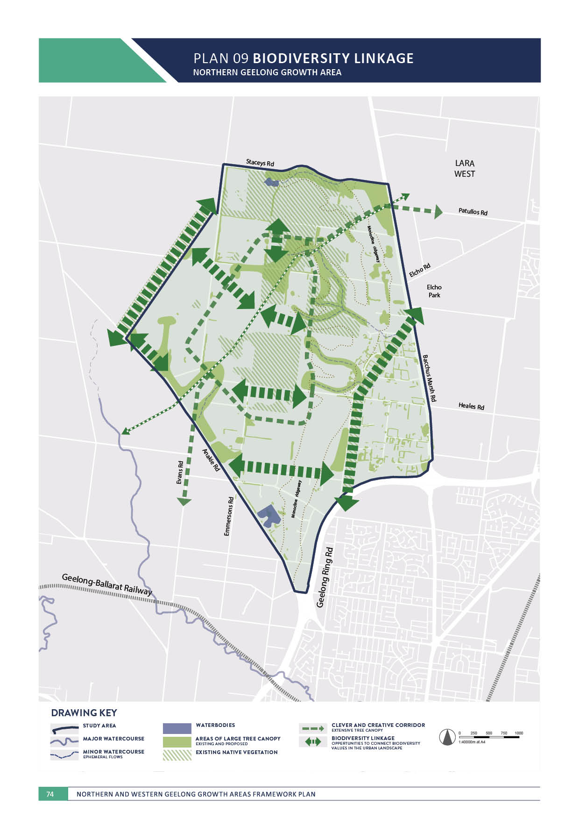

IMAGE IS NOT AVAILABLE WITHIN THIS VERION.
TO VIEW SUPPORTING VISUAL FOR THIS PAGE GO TO
www.geelongaustralia.com.au/futuregrowth/default.aspx
TO ACCESS PDF.

PLAN 10 ABORIGINAL CULTURAL HERITAGE
NORTHERN GEELONG GROWTH AREA

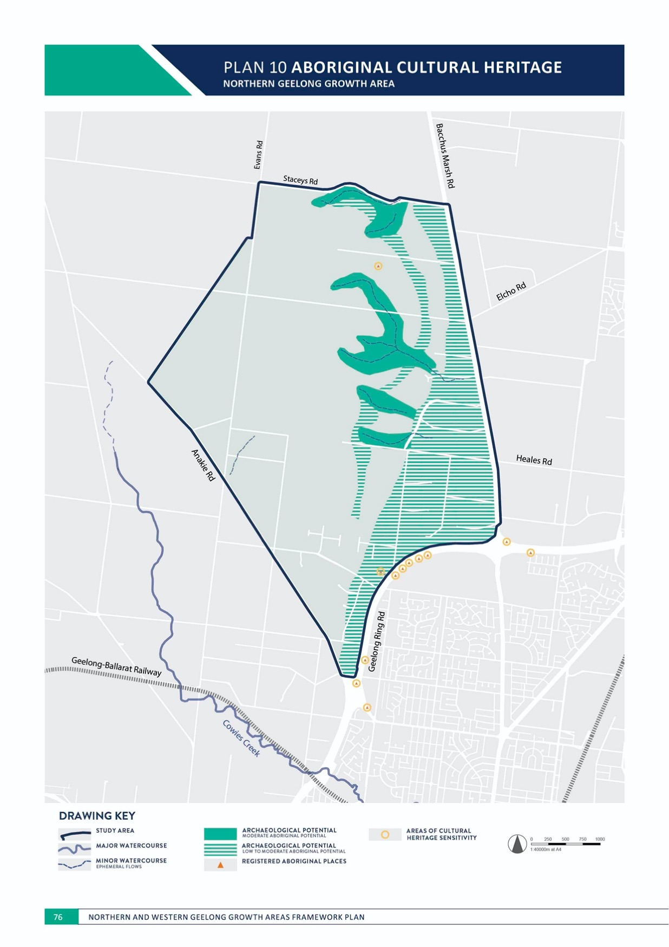

ENVIRONMENT

ABORIGINAL CULTURAL HERITAGE
NORTHERN GEELONG GROWTH AREA

CONTEXT

Land in the Northern Geelong Growth Area falls within Wadawurrung country that occupied the lands between Geelong and the You Yangs, centred around Hovells Creek.
There are two registered Aboriginal places in the area:
- A single stone (silcrete) artefact in the northern section of the growth area on top of the escarpment on flat plains landform
- A single stone (silcrete) artefact in the Tower Hill Drive road reserve.
Additional registered Aboriginal places are recorded directly adjacent to the growth area within the Geelong Ring Road reserve. The lack of registered Aboriginal places within the growth area is unlikely to be the limited use of the land by the Wadawurrung but more likely a result of limited archaeological investigations to date.
Preliminary Aboriginal site sensitivity mapping indicates:
- One area of high archaeological potential, the area of cultural heritage sensitivity within 50 metres of the northernmost single stone artefact
- Five areas of moderate archaeological potential
- Two areas of low to moderate archaeological potential
- Low archaeological potential within all remaining areas.
The nature of the land suggests that Wadawurrung people would have used the land for ephemeral activities such as hunting and gathering rather than long term occupation.
ACTION N1.4.1
Aboriginal cultural heritage will be protected.
It is an offence to harm any Aboriginal cultural heritage in Victoria under the Aboriginal Heritage Act 2006 and areas that are considered to have Aboriginal archaeological potential will be subject to further investigation prior to disturbance as part of urban development.

ACTION N1.4.2
The Wathaurung Aboriginal Corporation (trading as Wadawurrung) will be engaged as the Registered Aboriginal Party in relation to Aboriginal cultural and heritage matters and requirements of the Aboriginal Heritage Act 2006 and Aboriginal Heritage Regulations 2018, namely through the preparation of Cultural Heritage Management Plans.
The Cultural Heritage Management Plan process will recognise and protect sites that are culturally significant as required by Aboriginal Heritage Act 2006 with respect to the dignity and protocols of the Wadawurrung. The use of voluntary Cultural Heritage Agreements may also assist the management or protection of Aboriginal cultural heritage.

ENVIRONMENT

ACTION N1.4.3
An Aboriginal Heritage Impact Assessment will be prepared for each precinct to determine the presence of Aboriginal cultural heritage that may influence the design of the urban landscape.
Aboriginal Heritage Impact Assessments will undertake archaeological field surveys with the Wadawurrung as the Registered Aboriginal Party to identify Aboriginal places and areas or landforms that may influence the design of the open space network within neighbourhoods.

ACTION N1.4.4
Visibility of Aboriginal history and culture will be promoted within the urban landscape including:
- Using Aboriginal names for places, streets and major new public infrastructure
- Encouraging the use of Aboriginal public art in the public realm including areas of high activity and within the open space network
- Promoting site interpretation through signage or other mechanisms to promote awareness and appreciation of local Aboriginal cultural heritage
- Encouraging the use of indigenous plants and traditional materials that have significance to the Aboriginal community in landscaping public and open spaces.
The Wadawurrung people bestow a significant cultural, social, economic and spiritual contribution that is crucial to the character and nature of Geelong and its surroundings.

IMAGE IS NOT AVAILABLE WITHIN THIS VERION.
TO VIEW SUPPORTING VISUAL FOR THIS PAGE GO TO
www.geelongaustralia.com.au/futuregrowth/default.aspx
TO ACCESS PDF.

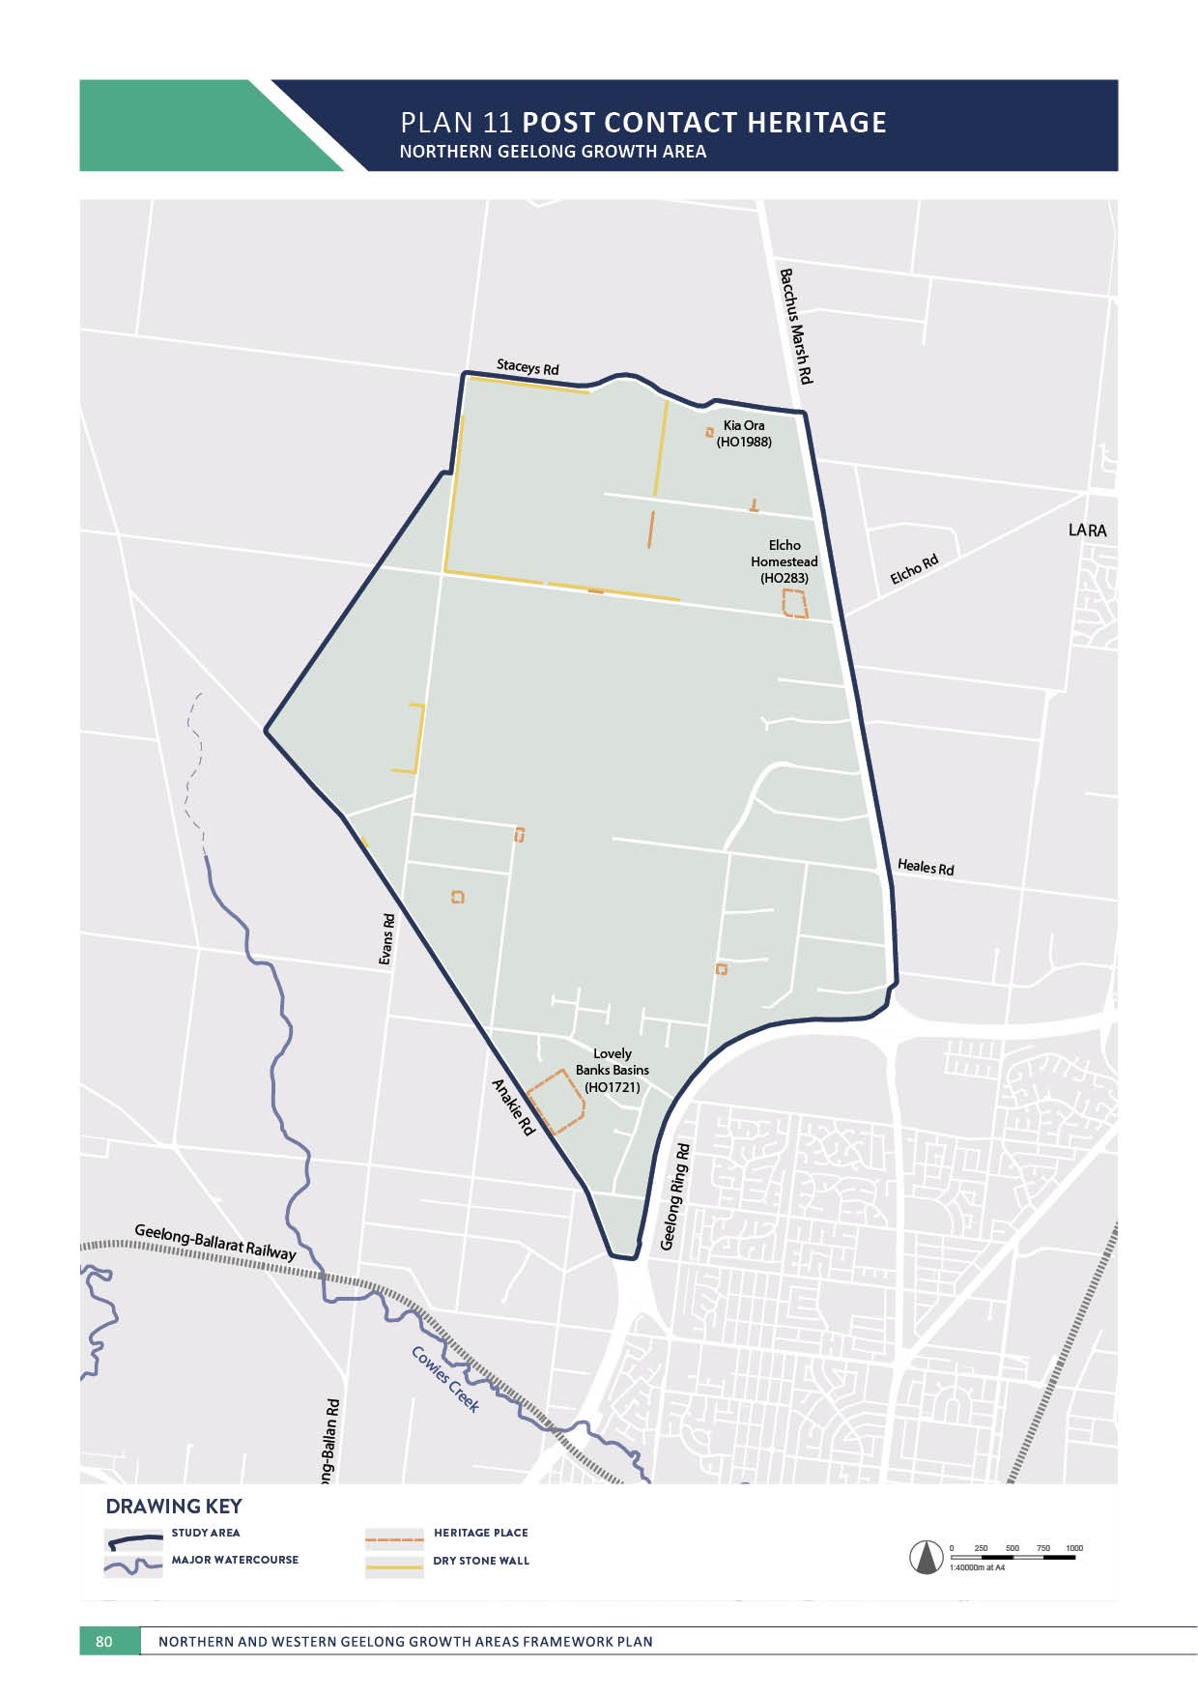
NORTHERN GEELONG GROWTH AREA

ENVIRONMENT

POST CONTACT HERITAGE
NORTHERN GEELONG GROWTH AREA

CONTEXT

Post contact heritage of the area relates generally to the early settlement of large pastoral estates and eventual subdivision to small-scale freehold agricultural enterprises as Geelong’s population expanded over time.
Three heritage places are registered within the growth area:
- Elcho Homestead
  - Elcho Homestead, constructed in 1867, is one of the most picturesque Gothic homesteads in Victoria and is of architectural and historical significance to the State of Victoria.
- Lovely Banks Basin
  - Lovely Banks Basin illustrates nineteenth century technologies of the water supply process and its basins and associated buildings are regionally-significant.
- Kia Ora
  - ‘Kia Ora’ residence is a largely intact Federation dwelling of local historical significance.
Several additional sites with potential heritage significance, including dry stone walls, are located within the growth area.
Known post contact heritage values are illustrated on Plan 11.
ACTION N1.5.1
The curtilage of registered heritage places will be protected and incorporated into the urban landscape.
Registered heritage places illustrated in Plan 11 will be subject to a heritage impact assessment that considers any impact to their fabric and heritage values as part of the detailed design of the surrounding area. The curtilage of these places, including driveways and vegetation, should be integrated into the urban landscape to contribute to the local character and sense of place.

ACTION N1.5.2
Detailed investigations of potential heritage places will be undertaken prior to urban development.
Locations of potential heritage places illustrated in Plan 11 will be subject to detailed assessment to
determine any heritage values and potential protection and incorporation into the urban landscape.

ENVIRONMENT

ACTION N1.5.3
Dry stone walls will be protected and incorporated into the urban landscape to contribute to the understanding of historical farming practices in the region.
Dry stone walls illustrated in Plan 11 will be subject to detailed assessment to determine any heritage values and potential protection and incorporation into the urban landscape and should be incorporated into the design of integrated transport network using appropriate buffers.

ACTION N1.5.4
Major upgrades to the integrated transport network will be designed to protect adjacent registered heritage places.
Bacchus Marsh Road, Anakie Road and Elcho Road have a number of registered heritage places in their direct vicinity that will be incorporated into the design and development of road upgrades and widening.

IMAGE IS NOT AVAILABLE WITHIN THIS VERION.
TO VIEW SUPPORTING VISUAL FOR THIS PAGE GO TO
www.geelongaustralia.com.au/futuregrowth/default.aspx
TO ACCESS PDF.

PLAN 12 BUILT ENVIRONMENT
NORTHERN GEELONG GROWTH AREA
(70

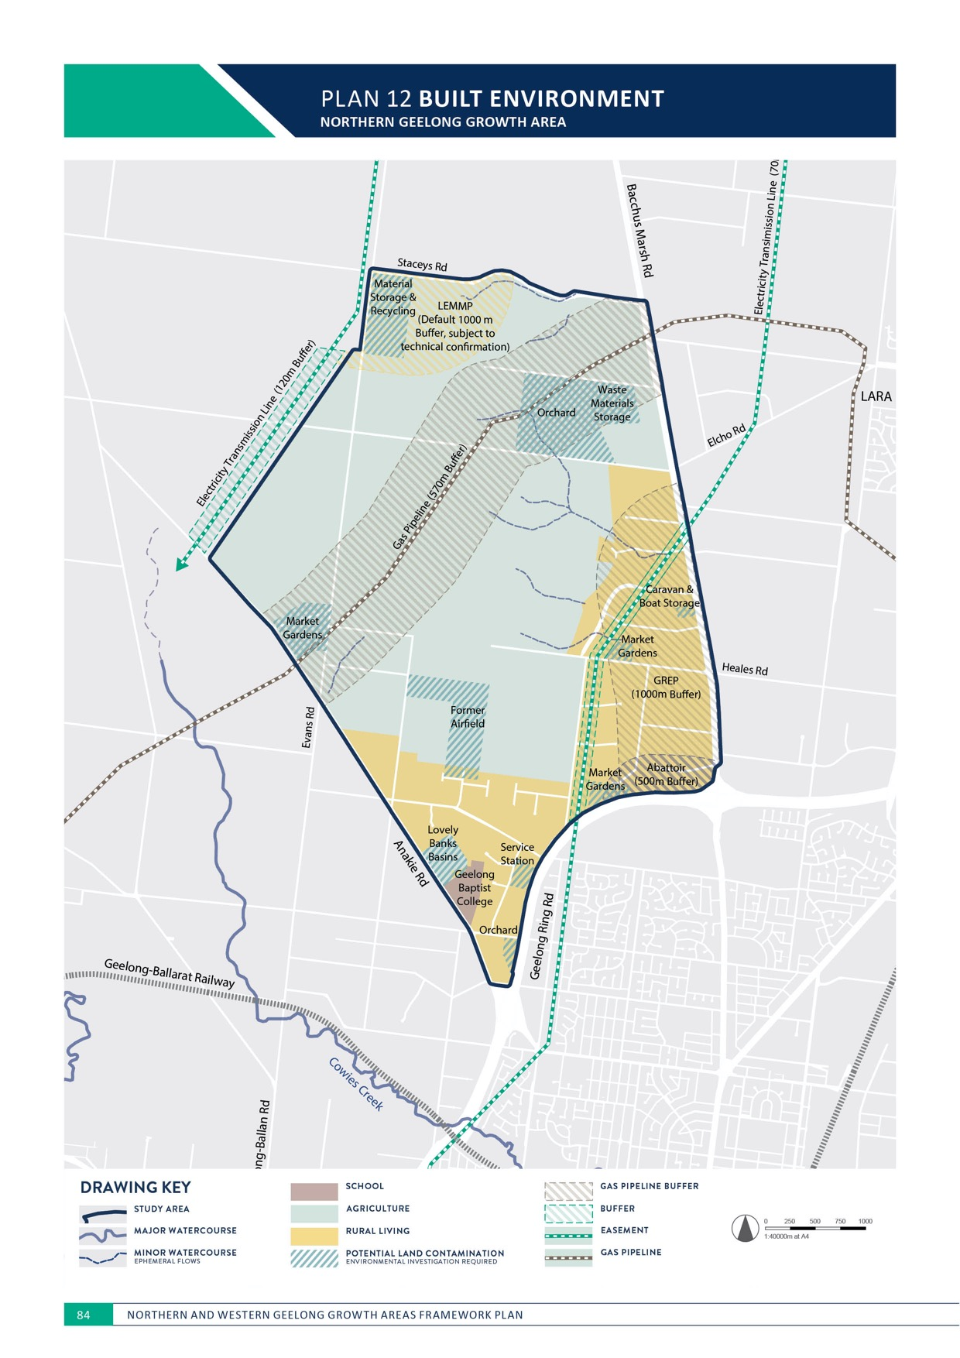

ENVIRONMENT

BUILT ENVIRONMENT
NORTHERN GEELONG GROWTH AREA

CONTEXT

Urbanisation of the land will change the majority of its existing use. It is anticipated that some existing land uses including residences, schools and utility easements will be retained as part of the urban landscape.
Existing land uses to be considered in the context of the urban landscape are illustrated
on Plan 12 and include:
- Gas pipeline
  - The T92 Lara to Iona Gas Transmission Pipeline diagonally bisects the growth area between Patullos Road and Evans Road.
- Electricity transmission lines
  - An overhead electricity transmission power line forms the north-western boundary of the growth area.
  - An overhead electricity transmission power line between Geelong Ring Road and Bacchus Marsh Road.
- Rural living
  - There are 297 properties in the growth area that support uses associated with rural living.
- Geelong Baptist College, an independent P-12 school located on Anakie Road, directly to the south of the Lovely Banks Basin
- Service station, adjoining the Geelong Ring Road.
- Material storage and recycling centre, located to the south of Stacey Road
- Former airfield, to the east of Emmersons Road
- Market gardens and orchards.
ACTION N1.6.1
Potential adverse amenity impacts of new neighbourhoods on rural living properties in the growth area will be identified and managed as part of urban development.
New neighbourhoods that directly interface with existing rural living properties within the growth area will minimise amenity impacts including light pollution. Interface management may include landscape buffers and screening, linear and local parks, sports reserves and local roads.

ACTION N1.6.2
Rural living properties will be permitted to subdivide to a conventional residential density as part of urban development.
Areas of rural living illustrated as ‘residential’ on Plan 3 will be permitted to subdivide to a conventional density residential as part of urban development.

ENVIRONMENT

ACTION N1.6.3
Rural living properties will be permitted to transition to employment land uses as part of urban development.
Areas of rural living illustrated as ‘employment’ on Plan 3 will be permitted to subdivide to employment land uses as part of urban development such as service industries and urban support, light manufacturing, freight and logistics.

ACTION N1.6.4
Rural living properties will be permitted to subdivide to a low or conventional residential density as part of urban development, subject to future investigation.
Areas of rural living illustrated as ‘future investigation of residential’ on Plan 3 may be permitted to subdivide to a low or conventional residential density as part of urban development. The timing for potential development of this land is long term. Detailed assessment of its capacity to deliver future residential land use will occur as part of the relevant precinct structure planning process.
ACTION N1.6.5
Rural living properties will be permitted to transition to employment land uses as part of urban development, subject to future investigation.
Areas of rural living illustrated as ‘future investigation of employment’ on Plan 3 may be permitted to subdivide to employment land uses as part of urban development such as service industries and urban support, light
manufacturing, freight and logistics. The timing for potential development of this land is long term. Detailed assessment of the need for employment land will occur as part of the relevant precinct structure planning process.

ACTION N1.6.6
Land uses within the high voltage electricity transmission line easement that forms the north- western boundary of the growth area will minimise risks to community safety.
Easements illustrated on Plan 12 should be utilised as part of the open space network with potential land uses including fire breaks, linear shared paths, local parks and off-leash areas, recreation, stormwater management and local roads.

ACTION N1.6.7
Land uses within the high voltage electricity transmission line easement between Geelong Ring Road and Bacchus Marsh Road will minimise risks to community safety.
Easements illustrated on Plan 12 should be utilised as part of the open space network with potential land uses including linear shared paths, local parks and off-leash areas, stormwater management and local roads. Employment
land use opportunities within the easement may include car parking, plant nurseries and hardstand areas for community markets (no buildings).

ACTION N1.6.8
Land uses within 570 metres of the gas pipeline easement must be planned carefully to minimise risk to community safety.
The siting of different land uses will have regard to the recommendations of a safety management strategy to
be prepared as part of the relevant precinct structure plan process.
ACTION N1.6.9
Potential areas of land contamination should be investigated and remediated as part of urban development including:
- High potential areas at the Lovely Banks Basins, service station and a material storage and recycling centre
- Medium potential areas at the former airfield, market gardens and orchards, and additional areas of scrap and vehicle storage
- Low potential areas throughout the remainder of the growth area.
Urban development in potential areas of high and medium land contamination illustrated on Plan 12 will need to be undertaken following conventional planning, assessment and remediation methods in accordance with EPA Victoria guidelines and local policy.

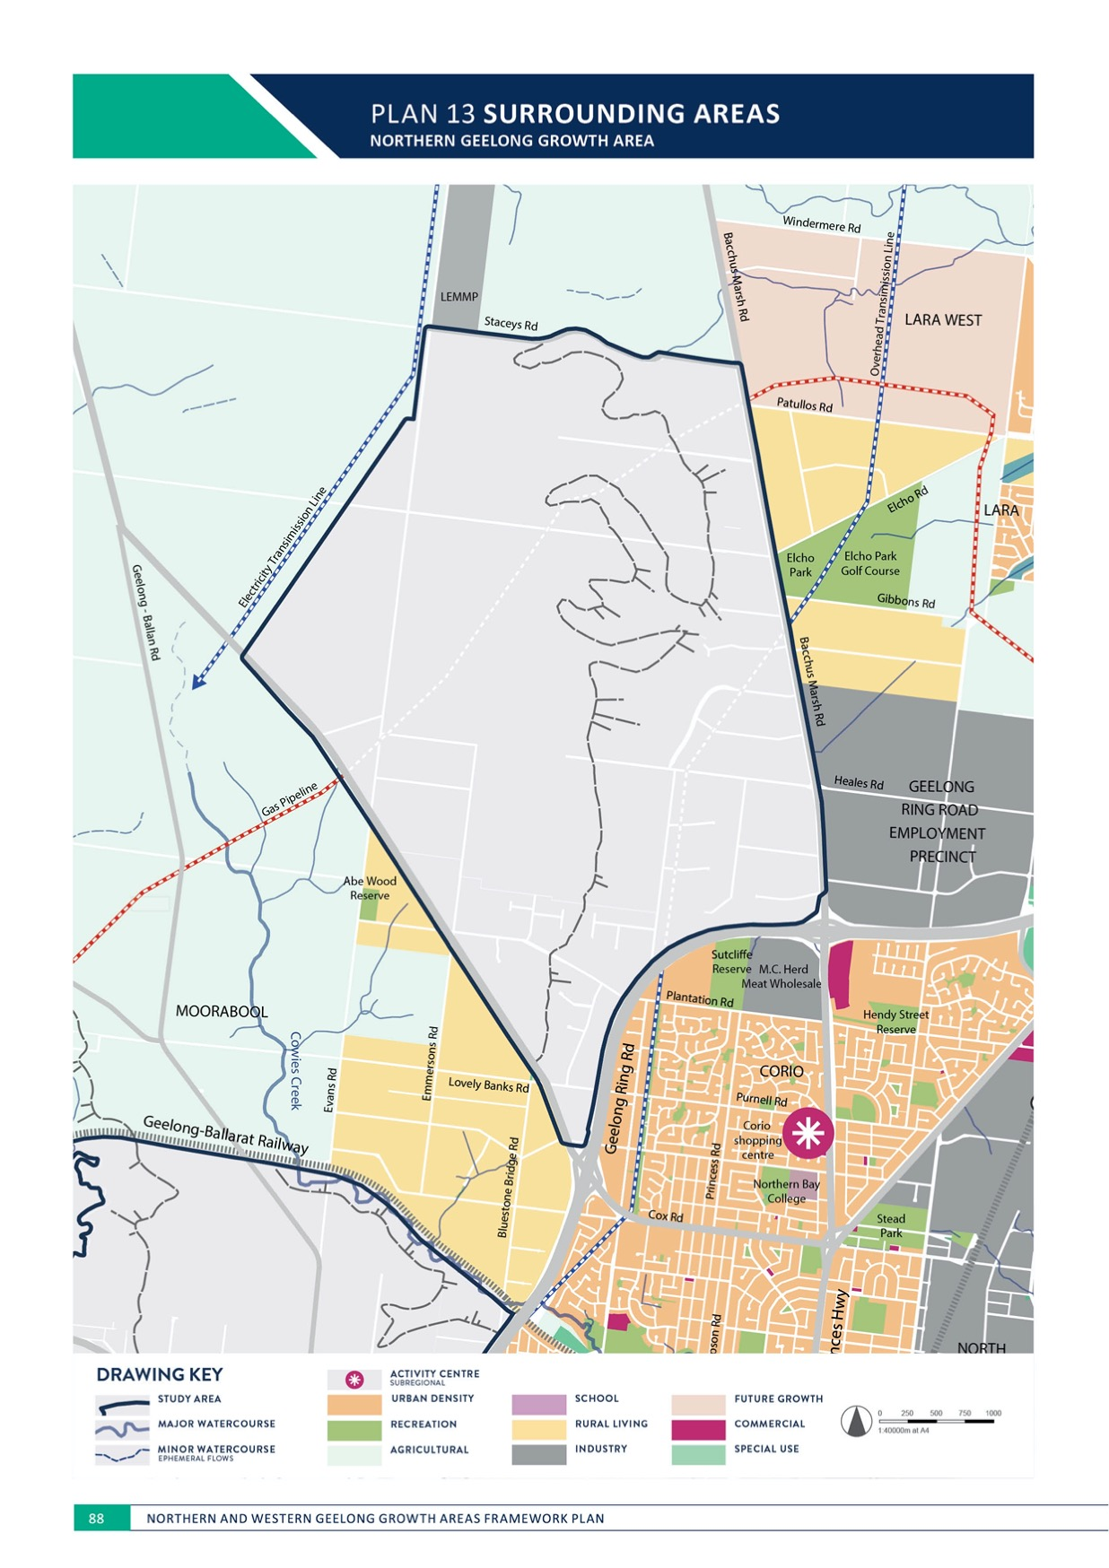
PLAN 13 SURROUNDING AREAS
NORTHERN GEELONG GROWTH AREA

ENVIRONMENT

SURROUNDING AREAS
NORTHERN GEELONG GROWTH AREA

CONTEXT

New neighbourhoods will connect Geelong’s northern suburbs to Lara and need to consider the surrounding areas, particularly the Geelong Ring Road Employment Precinct and Lovely Banks.
Surrounding land uses to be considered in the context of the urban landscape are illustrated on Plan 15 and include:
- Geelong Ring Road Employment Precinct (GREP)
  - Geelong’s largest designated employment precinct for industrial development, GREP includes 500 hectares of land zoned for heavy industrial purposes and established development guidelines.
- Local industry
  - Lara Energetic Material Manufacturing Plant (LEMMP), trading as Chemring, is located to the north of Staceys Road
  - M.C. Herd, an abattoir located to the south of Geelong Ring Road.
- Elcho Park, an 80-hectare park including a golf course, a soccer club and an equestrian centre
- Rural living properties, located to the south of Anakie Road and to the east of Bacchus Marsh Road
- Residential neighbourhoods in the Lara West precinct
- Farm land located to the north of Staceys Road and north-west of the electricity easement
- Geelong Ring Road and the adjoining existing neighbourhoods of Geelong.
ACTION N1.7.1
Noise and amenity impacts of the Geelong Ring Road will be identified and managed as part of urban development.
Noise attenuation and screening of the Geelong Ring Road will be provided in locations that interface with sensitive uses including residential development and social infrastructure.

ACTION N1.7.2
Potential fire risks associated with non-urban interfaces to new neighbourhoods will be identified and managed as part of urban development.
Interfaces with non-urban land uses that present grassfire or bushfire risks as part of the interim and ultimate development of new communities will be undertaken:
- Assessment of fuel loads (agricultural land and grasslands) and vegetation, slope and prevailing wind directions in urban design of subdivisions
- Creation of fire breaks and fuel reduction and minimisation using appropriate planting and management guidelines.

ENVIRONMENT

ACTION N1.7.3
Potential amenity and health risks associated with non-urban interfaces to new neighbourhoods will be identified and managed as part of urban development.
Interfaces with non-urban land uses that present amenity and health risks as part of the interim and ultimate development of new communities include:
- Buffers to agricultural practices that may contribute odour and noise impacts
- Buffers to agricultural practices that may use chemicals such as pesticides and weed killers
- Passive surveillance that minimises rubbish dumping and vegetation clearing
- Protection of native fauna species from domestic and feral animals.
ACTION N1.7.4
Potential adverse amenity impacts of new neighbourhoods on adjacent residential and rural living areas will be identified and managed as part of urban development.
New neighbourhoods that directly interface with rural living properties to the south of Anakie Road and to the east of Bacchus Marsh Road and residences in the Lara West precinct will minimise amenity impacts using landscape buffers and setbacks.

ACTION N1.7.5
Housing densities and upgrades to the integrated transport network along the northern and north- western boundary of the growth area will consider and respond to the adjoining rural interface.
Subdivision of land in direct proximity to Staceys Road and the westernmost electricity transmission line will deliver lower densities of residential development to provide a gradual transition between urban and rural land uses.
Future upgrade of Staceys Road should maintain elements of its existing rural character, particularly in proximity to areas of potential conservation.

ACTION N1.7.6
Geelong Ring Road Employment Precinct (GREP) will be protected by maintaining its existing 1,000-metre industrial buffer zone.
Geelong Ring Road Employment Precinct is protected by a 1,000-metre industry buffer that extends into the growth area and largely affects the rural living properties adjoining Bacchus Marsh Road. No additional sensitive land uses, including residential development and community facilities, will be permitted within the buffer to maintain the economic and employment potential of the GREP.
ACTION N1.7.7
Local businesses will be protected by establishing industrial buffer zones, including:
- A default buffer of 1,000 metres to the Lara Energetic Material Manufacturing Plant, subject to technical confirmation.
- A buffer of 500 metres to the M.C. Herd abattoir.
No additional sensitive land uses, including residential development and community facilities, will be permitted within these buffers. At the time of the preparation of the precinct structure plan the buffers should be reviewed to determine accurate, evidence-based buffers. Any future reduction or removal of buffers to these local businesses should be subject to detailed investigations in accordance with EPA Victoria guidelines and local policy.

IMAGE IS NOT AVAILABLE WITHIN THIS VERION.
TO VIEW SUPPORTING VISUAL FOR THIS PAGE GO TO
www.geelongaustralia.com.au/futuregrowth/default.aspx
TO ACCESS PDF.

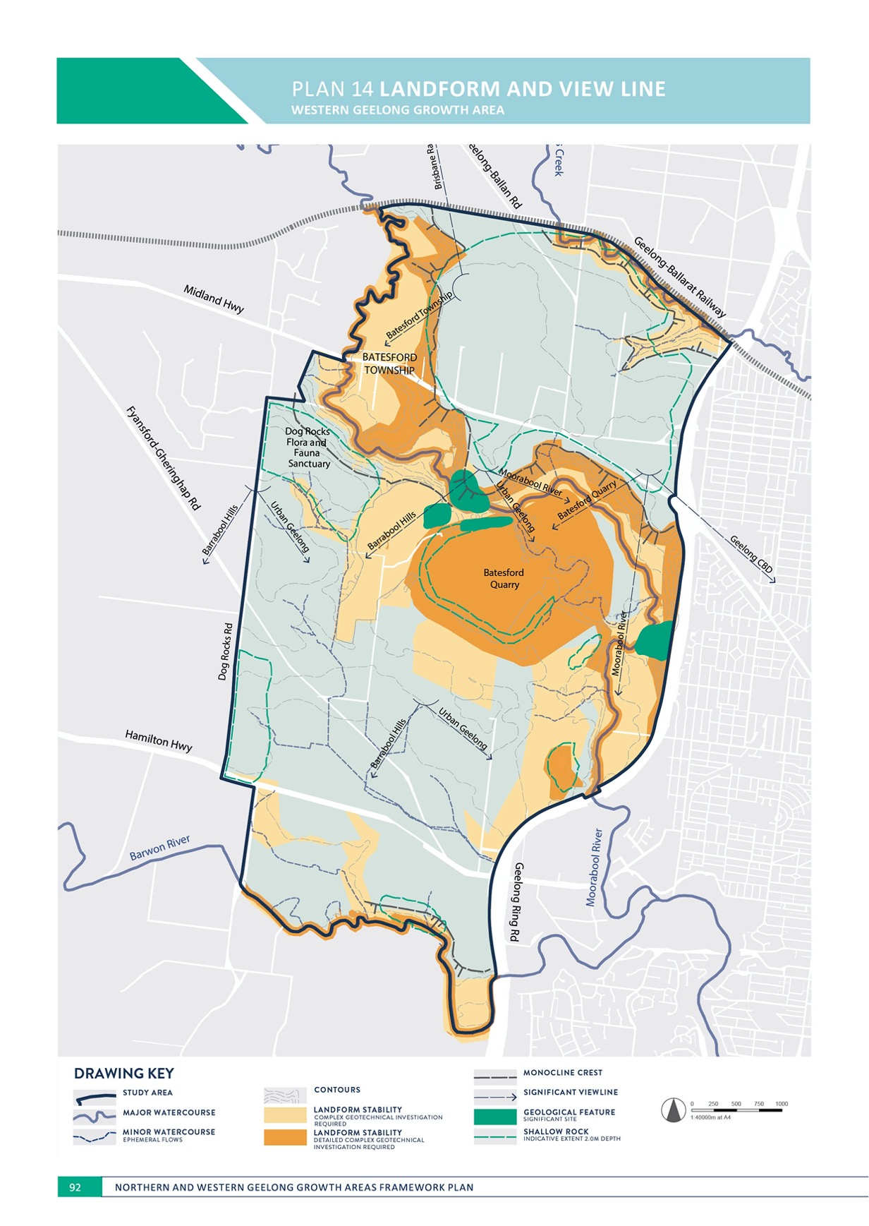

ENVIRONMENT
WESTERN GEELONG GROWTH AREA

LANDFORM AND VIEW LINE
WESTERN GEELONG GROWTH AREA

CONTEXT

Land in the Western Geelong Growth Area consists of agriculture land primarily utilised for grazing and cropping activities with Batesford Quarry in the centre of the growth area.
The dominant features in the landform of the area are the valleys and banks of the Moorabool River, Barwon River and Cowies Creek. Landslips have historically occurred on the banks of the rivers and creek. Dog Rocks Flora and Fauna Sanctuary is the highest point of the growth area.
The walls of the Batesford quarry pit are progressively being rehabilitated and shaped into stable slopes to an agricultural standard as mineral extraction is now limited to its eastern face. The Batesford quarry has been in use from 1888 and its overburden soil stockpiles may have constraints related to land stability and potential waste products at depth.
Significant view lines to landmarks include:
- Moorabool Valley, north of the Batesford township, with views across the valley and to the east towards urban Geelong
- Dog Rocks Road, adjacent to the Dog Rocks, with views to the south towards the Barwon River and Barrabool Hills and urban Geelong
- Midland Highway, near the Geelong Ring Road, with views to the south across Batesford Quarry
- Midland Highway, near Lynnburn Road, with views to the south-west toward the Dog Rocks Flora and Fauna Sanctuary
- McCanns Lane, with views to the south toward the Barrabool Hills
- Geelong Ring Road, with views to the south and west across the Moorabool River and Batesford Quarry
- Localised views to the waterways and open space network.
Landform and view lines are illustrated on Plan 14.
ACTION W1.1.1
Rehabilitation of Batesford Quarry will be completed to an urban standard prior to urban development in its proximity.
Detailed master planning of the lake transformation will outline its integration with the surrounding urban
landscape including public access and safety in relation to land stability and slope of the surrounding land. Detailed geotechnical and groundwater assessment and monitoring of the quarry and surrounds will assess its capability for the proposed end use, including land stability, contamination, erosion, rock fall, hazard and landslide susceptibility
and mitigation including any buffers. Land capability for the proposed quarry end use and surrounding areas of adjacent stockpiles and river banks, escarpments and floodplains must be proven prior to commencement of a precinct structure plan.

ACTION W1.1.2
Detailed geotechnical assessment and monitoring will be undertaken prior to urban development on all overburden soil stockpiles as part of the relevant precinct structure plan.
Detailed investigation of the stockpiles will assess their land capability for urban development including land stability and contamination, in conjunction with the quarry assessment.

ENVIRONMENT

ACTION W1.1.3
Detailed geotechnical and groundwater assessment and monitoring will be undertaken prior to urban development on the banks and floodplain areas of the Moorabool River, Barwon River and Cowies Creek as part of the relevant precinct structure plans.
Detailed investigation of the landform of the river and creek corridors will assess their land capability for urban development including land stability, erosion, rock fall and landslide susceptibility and mitigation.

ACTION W1.1.4
Design and construction of public infrastructure will account for shallow bedrock.
The impact of shallow rock will be factored into detailed design and costing of essential public infrastructure.

ACTION W1.1.5
The edge of the lake will deliver a continuous public realm that provides public access along its entire perimeter.
The lake will integrate the Clever and Creative Corridor, linear and local parks, activity centres, waterways and the integrated transport network into its immediate surrounds.
ACTION W1.1.6
Key views will be protected and maximised using a street grid network that is responsive to the sloping topography and allows views to landmarks.
Key view lines identified on Plan 14 will be protected by incorporating fields of view that prevent visual intrusion into the urban landscape through key open space nodes and the orientation and design of the street network.

ACTION W1.1.7
View lines to significant landmarks and site features will be protected and maximised through consideration of development siting, height and visual bulk.
Reasonable sharing of views to landmarks will be achieved through careful consideration of development siting, height and visual bulk.

IMAGE IS NOT AVAILABLE WITHIN THIS VERION.
TO VIEW SUPPORTING VISUAL FOR THIS PAGE GO TO
www.geelongaustralia.com.au/futuregrowth/default.aspx
TO ACCESS PDF.

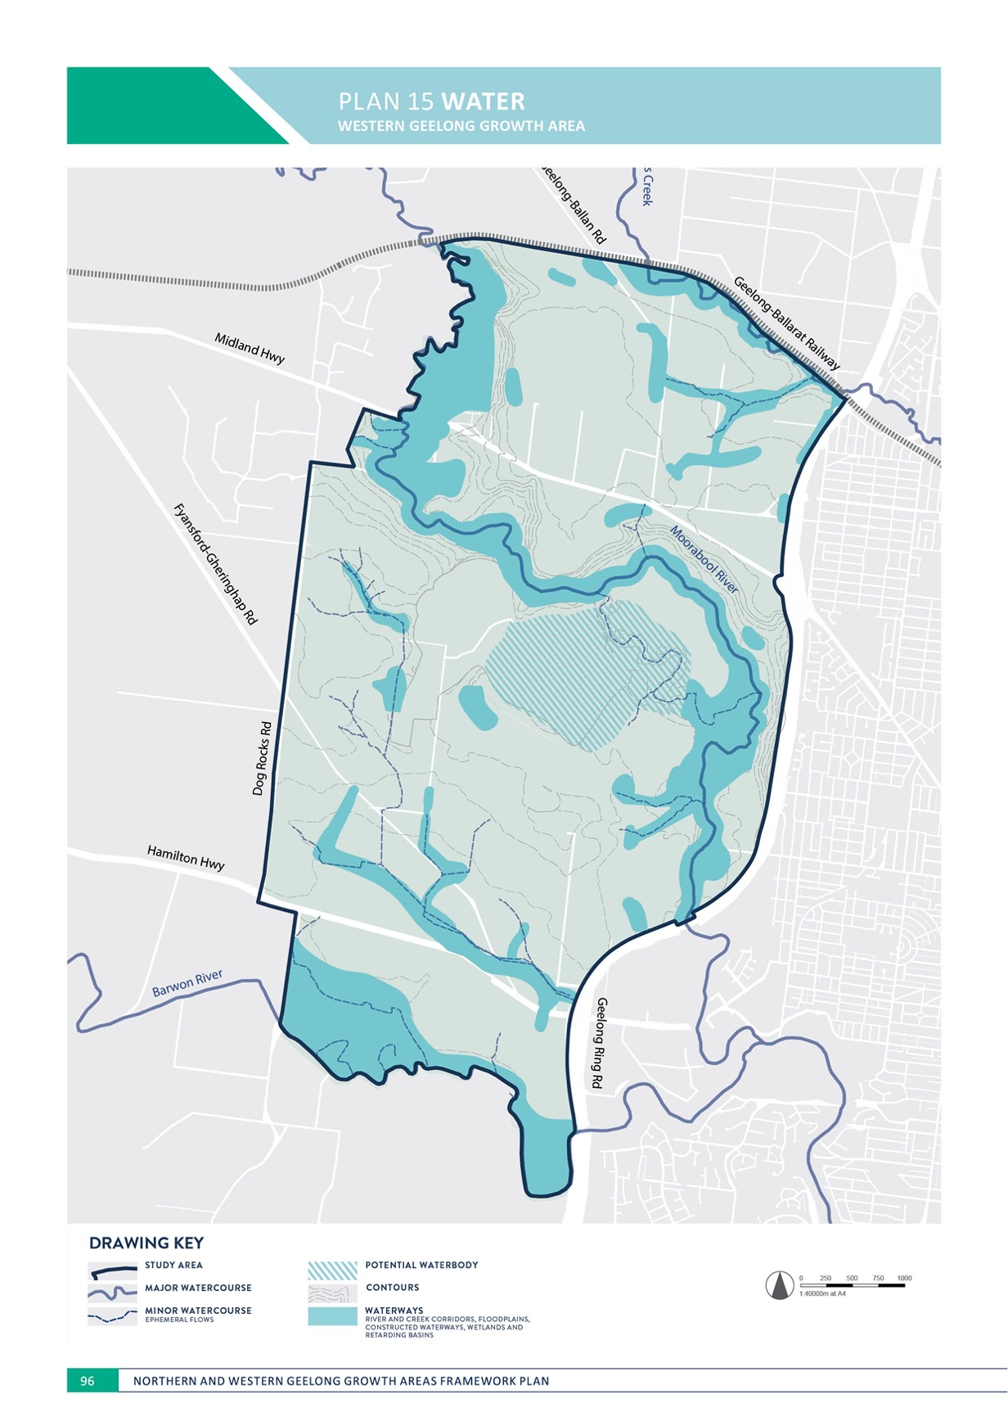
PLAN 15 WATER

ENVIRONMENT

WATER
WESTERN GEELONG GROWTH AREA

CONTEXT

Water is central to quality of community life and nurturing the natural environment.
The Western Geelong Growth Area is characterised by major river and creek corridors including:
- 12.4 kilometres of Moorabool River corridor, including river diversions undertaken as part of Batesford quarry
- 4.8 kilometres of Barwon River corridor
- 2.8 kilometres of Cowies Creek corridor.
Groundwater in the vicinity of Batesford Quarry is discharged into the Moorabool River as part of its extraction operations. Groundwater will naturally fill the quarry pit when extraction is concluded, gradually
transitioning the quarry into a lake. Filling of the lake will likely occur over 10-20 years based on several factors including the potential use of recycled water.
Urban development must manage flooding and stormwater drainage to maintain and enhance the natural environment and flows of the waterways and protect downstream systems. Adaption to climate change effects including reduced water availability, higher temperatures and increased frequency of extreme weather events is a key consideration of the urban landscape.
Stormwater in the growth area will outlet to existing infrastructure and waterways via a series of drainage catchments:

- Moorabool River catchment
  - The vast majority of the growth area is located within the Moorabool River catchment and outfalls along the River, with the southern section discharging via existing urban systems.
- Barwon River catchment
  - The southern portion of the growth area is located within the Barwon River catchment and outfalls along the River.
- Cowies Creek catchment
  - The north-east of the growth area is located within the Cowies Creek catchment and outfalls along the Creek.
Flooding and stormwater drainage management is a key element of the broader integrated water management plan for the growth area.
Each neighbourhood will utilise its water and interact with healthy waterways to contribute to a cooler, greener city and healthier environment.
Integrated water management actions are outlined in
NEIGHBOURHOOD.

ENVIRONMENT

ACTION W1.2.1
Ecological condition and functionality of waterways, wetlands and floodplains will be protected, restored, enhanced and maintained.
Maximum possible improvement in river health will be delivered through rehabilitation and waterway widths that meet or exceed the Melbourne Water Waterway Corridor Guidelines and Wetland Design Guidelines. Detailed master planning of river and creek corridors will integrate the protection and enhancement of natural flows with the urban landscape.

ACTION W1.2.2
Waterways will be designed and constructed to retain natural characteristics and support the establishment of viable riparian vegetation that improves habitat and water quality.
Natural waterways are critical to the amenity of neighbourhoods and provide key linkages for biodiversity and passive recreation. Waterways should be delivered in accordance with the Melbourne Water Constructed Waterways in Urban Developments Guidelines.

ACTION W1.2.3
Flooding and stormwater management will maintain and enhance the predevelopment hydrology of the area and minimise downstream impacts.
Stormwater runoff quantity generated by urban development will be managed to minimise adverse impacts. Stormwater runoff quality will meet or exceed the water quality performance objectives of the CSIRO Best Practice Environmental Management Guidelines for Urban Stormwater prior to discharge to receiving waterways.
ACTION W1.2.4
Drainage schemes that outline the detailed design of stormwater management infrastructure and flood impact assessment will be undertaken as part of the precinct structure planning process in collaboration with Barwon Water and the Corangamite Catchment Management Authority.
Stormwater management will be designed to minimise downstream impacts in accordance with the relevant drainage scheme and delivered with regard to relevant standards, policies and strategies including:
- Infrastructure Design Manual
- City of Greater Geelong Stormwater Standard Drawings and Design Notes
- City of Greater Geelong Stormwater Services Strategy
- Melbourne Water Waterway Corridor Guidelines
- Melbourne Water Wetland Design Guidelines
- Melbourne Water Constructed Waterways in Urban Developments Guidelines
- CSIRO Best Practice Environmental Management Guidelines for Urban Stormwater.

ACTION W1.2.5
Stormwater will enhance the urban landscape.
Stormwater management will predominantly utilise open waterways that connect the broader open space network and deliver significant multifunctional values that enhance community access to water and the natural environment. Distribution of stormwater retardation, treatment and infiltration at the precinct, streetscape and property scale will contribute to water sensitive urban design within neighbourhoods.

ACTION W1.2.6
Flooding and stormwater management will maximise responsiveness to the natural landscape.
Design of stormwater management infrastructure will deliver extensive green-blue links and distributed assets that reduce the extent of end-of-line wetlands.

ACTION W1.2.7
Water will be distributed and integrated into the urban landscape in a manner that is sustainable over time.
The design of stormwater management infrastructure will balance amenity, efficiency and safety with practicality of its construction and maintenance and will be informed by the outcome of the intergrated water management strategy

ACTION W1.2.8
Staging of urban development will provide for delivery of ultimate waterway and stormwater management infrastructure including stormwater quality treatment.
Where delivery of the ultimate infrastructure is not possible, alternative proposals will demonstrate how any interim infrastructure adequately manages stormwater generated from urban development and how the infrastructure
will enable delivery of the ultimate stormwater drainage scheme.

ACTION W1.2.9
Innovation in the design of the ultimate waterway network and stormwater management infrastructure will be considered in relation to net community benefit.
The waterway network and stormwater management infrastructure illustrated on Plan 15 is designed to balance cost and performance. An alternative drainage scheme that delivers innovative management of stormwater will be considered if the proposal reduces cost, increases
amenity and creates better integration with the public realm including activity centres, social infrastructure and the open space network.
ACTION W1.2.10
The transition of Batesford Quarry to a recreational lake will be subject to a detailed investigation prior to the commencement of the relevant precinct structure plan.
Upon the closure and decommissioning of the quarry, detailed investigation of its transition will need to assess the impacts on the surrounding areas including river health, groundwater, land contamination, erosion and stability, water quality, biodiversity and cultural heritage. Ongoing monitoring of these effects, as well as site maintenance and management of public access and safety, will need to occur from the commencement of the transition.

ACTION W1.2.11
A detailed master plan that outlines the transformation of Batesford Quarry into a recreational lake will be prepared and incorporated within the relevant precinct structure plan.
Detailed master planning of the lake transformation will be undertaken in conjunction with the broader Moorabool River corridor master plan and outline its integration with the surrounding urban landscape including the open space network, integrated transport network and built environment. Considerations relating to water will include water quality, public access and safety, recreational use of the waterbody, integrated water management and maintenance and management responsibilities.

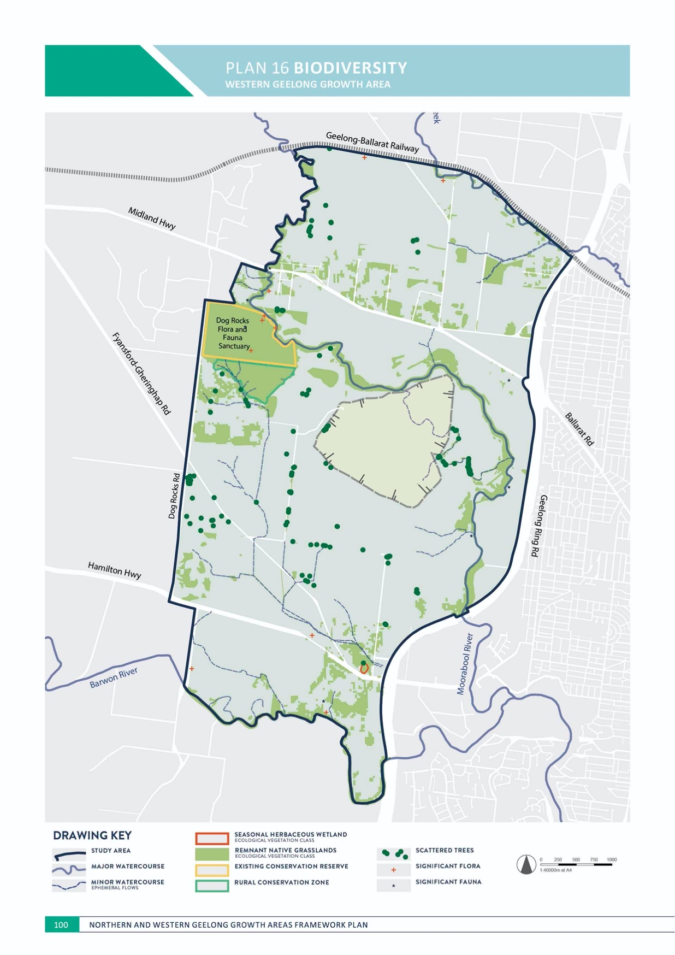

ENVIRONMENT

BIODIVERSITY
WESTERN GEELONG GROWTH AREA

CONTEXT
Ecological values* on the land include:
- Three significant watercourses including the Moorabool River (and deviation channel), Barwon River and Cowies Creek
- Dog Rocks Sanctuary and Moorabool River Reserve
- Commonwealth-listed ecological communities including Natural Temperate Grassland and Seasonal Herbaceous Wetland
- Approximately 268 hectares of remnant native vegetation patches including Plains Grassland, a critically endangered ecological community, Hills Herb-rich Woodland and eight additional ecological vegetation classes
- 137 scattered trees
- Six wetlands
- Known occurrence of:
  - Commonwealth-listed significant flora species including Spiny Rice-flower and Adamson’s Blown-grass
  - State-listed significant flora species including Melbourne Yellow-gum Snowy Mint-bush, Coast Hollyhock, Austral Crane’s-bill and Fragrant Saltbush.
- Known and potential habitat for:
  - Commonwealth-listed significant fauna species including Growling Grass Frog, Golden Sun Moth,
Striped Legless Lizard and seven additional species
  - State-listed significant fauna species including Blue- billed Duck, Powerful Owl and 16 additional species.
o A range of locally common species including kangaroos, echidnas and platypus.
Land in the area forms part of the Barwon River drainage catchment that outfalls into Lake Connewarre; this location is one of six distinct areas that form the Port Phillip Bay (Western Shoreline) and Bellarine Peninsula Ramsar Site, a complex of wetlands of international importance.
Known biodiversity values are illustrated on Plan 16.

* Ecological values based on field assessments of 75% of study area.
ACTION W1.3.1
An overarching biodiversity conservation strategy will be prepared for the growth area that provides high level guidance for the management of nationally and state significant biodiversity values.
The strategy will spatially identify how outcomes for matters of national environmental significance will be delivered and must be approved by the Commonwealth Government prior to the finalisation of the initial precinct structure plan in the growth area.

ACTION W1.3.2
Individual detailed master plans that outline the protection and enhancement of river and creek corridors will be prepared and incorporated within the relevant precinct structure plan including:
- Cowies Creek, between Geelong Ring Road and Geelong-Ballan Road
- Barwon River, between Geelong Ring Road and Merrawarp Road
- Moorabool River, between Midland Highway and Geelong-Ballarat Railway
- Moorabool River (and deviation channel), between Geelong Ring Road and Midland Highway and including Dog Rocks Sanctuary and Moorabool River Reserve.
Detailed master planning will integrate the protection and enhancement of natural flows and flora and fauna with the urban landscape including cultural heritage, integrated water management, tree planting, open space and recreation, walking and cycling, and interfaces with the integrated transport network and built environment. The plans will have regard to the objectives of existing projects including the Barwon River Parklands and Moorabool Living.

ENVIRONMENT

ACTION W1.3.3
A network of linear corridors will be created to promote biodiversity linkages within neighbourhoods that connect between conservation areas, waterways and the open space network.
Corridors may be located as illustrated in Plan 17 to promote, retain and link a variety of flora and fauna habitats and allow the passive movement and long-term resilience of species throughout neighbourhoods. Corridors may be composed of a mixture of land uses including conservation areas, open space and waterways, social infrastructure and transport corridors.

ACTION W1.3.4
Any conservation areas that are identified will prioritise the protection and enhancement of local indigenous flora and fauna species.
Conservation areas will be retained to ensure their sustainability in relation to scale and connectivity to other natural assets. Conservation areas will be designed and managed with a focus on the protection and enhancement of biodiversity values including the management of public access and pests and the exclusion of hard surfaces and incompatible neighbouring land uses.
ACTION W1.3.5
The integrated transport network will protect, minimise impacts and revegetate roadside vegetation.
Upgrade, widening and extension of the integrated transport network will retain and enhance native vegetation within existing road reserves and utilise existing road networks to limit the crossing of waterways and significant vegetation in road reserves.

ACTION W1.3.6
Large-scale revegetation utilising indigenous species will be undertaken at key rural-urban interfaces including tree canopy, where appropriate.
Green belts will be utilised to signify land use changes and provide a natural buffer between these areas.

ACTION W1.3.7
Stormwater drainage management will consider the downstream impacts on the Port Phillip Bay (Western Shoreline) and Bellarine Peninsula Ramsar Site.
The Barwon and Moorabool drainage catchments outfall into the Ramsar-listed Lake Connewarre wetlands.

ACTION W1.3.8
A Native Vegetation Precinct Plan will be prepared for each precinct to determine the presence and
management of significant flora, fauna and ecological communities.
Native Vegetation Precinct Plans will provide recommendations that include no net loss of native vegetation, securing offsets in accordance with the outcomes of the biodiversity conservation strategy, retention of remnant scattered trees and the application of appropriate planning controls to protect and manage native vegetation.

ACTION W1.3.9
‘Green-blue’ connections will be designed to promote flora and fauna by distributing water to soil through natural infiltration and irrigation.
Stormwater treatment will be located and designed to successfully incorporate natural systems and provide habitat for significant flora and fauna species. Waterways illustrated on Plan 15 will be designed to provide sufficient corridor width to establish continuous riparian reserves that allow for biodiversity values to thrive.

ACTION W1.3.10
Biodiversity will be integrated into the public realm and areas of high activity to ensure that all neighbourhoods have access to nature.
Public land will be located and designed to promote access to nature including the protection of view lines to open space, the use of interpretative signage, and the creation of multi-use spaces that integrate biodiversity values.
ACTION W1.3.11
Active regeneration of vegetation in conservation areas and the open space network will use indigenous species and regeneration methods.
Native vegetation in the growth area will be regenerated to represent at least 30% of the original vegetation diversity and reflect benchmark planting densities.

ACTION W1.3.12
The Clever and Creative Corridor will incorporate local native tree planting to strengthen connections between urban and natural systems.
The Clever and Creative Corridor illustrated on Plan 5 is the focal point for integrating a diverse mixture of land uses within each neighbourhood. Incorporating native vegetation within the corridor, particularly in locations that connect with the open space network, will maximise the community’s daily access to nature.

PLAN 17 BIODIVERSITY LINKAGE

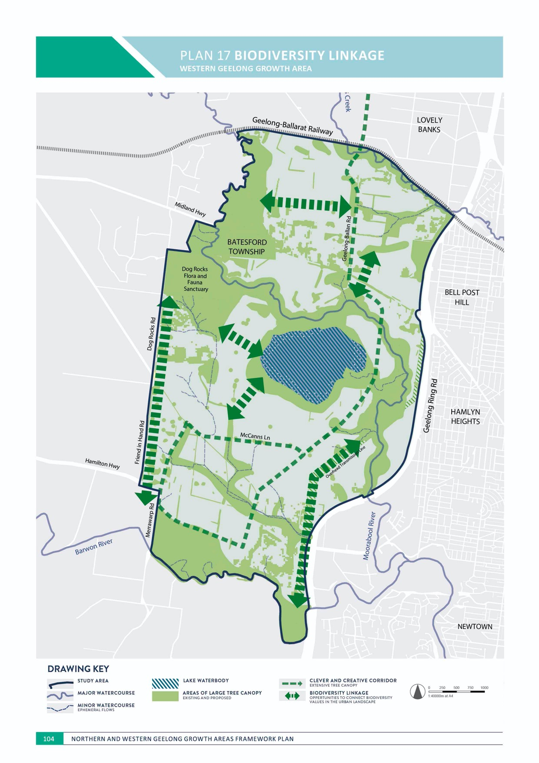
WESTERN

IMAGE IS NOT AVAILABLE WITHIN THIS VERION.
TO VIEW SUPPORTING VISUAL FOR THIS PAGE GO TO
www.geelongaustralia.com.au/futuregrowth/default.aspx
TO ACCESS PDF.

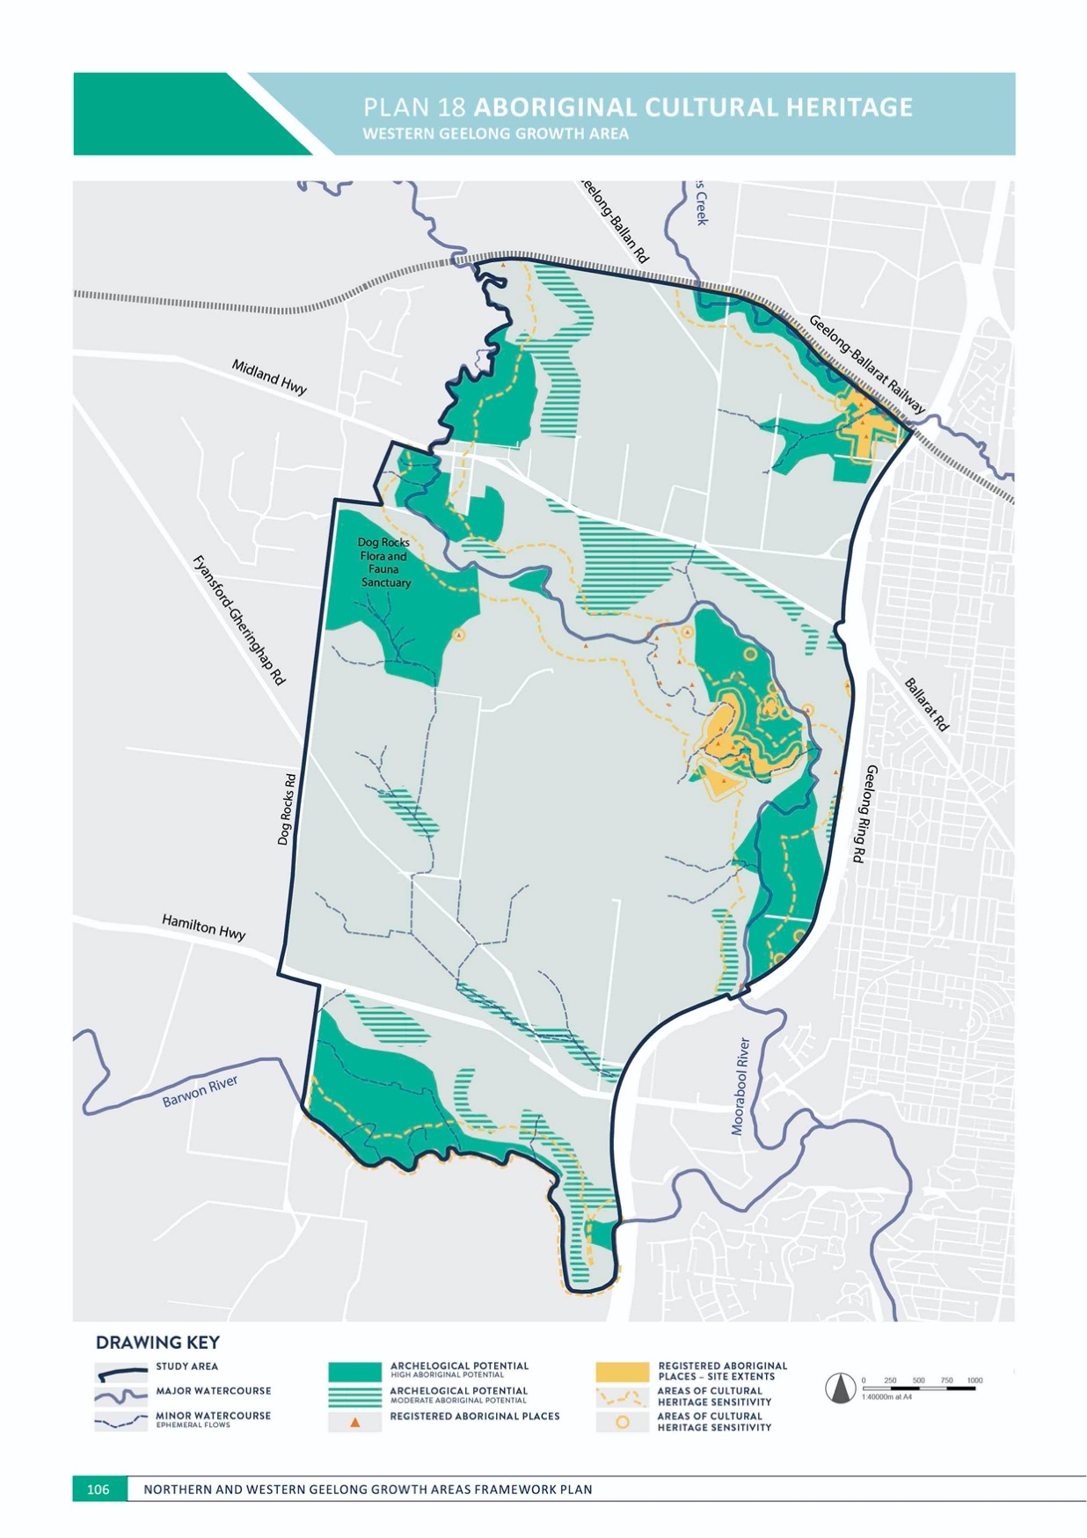

ENVIRONMENT

ABORIGINAL CULTURAL HERITAGE
WESTERN GEELONG GROWTH AREA

CONTEXT

Land in the Western Geelong Growth Area falls within Wadawurrung country centred on the Barrabool Hills and along the Moorabool River and Barwon Rivers.
There are 33 registered Aboriginal places in the area:
  - Greenstones Axe Quarry
  - An Aboriginal greenstone quarry located in Dog Rocks Flora and Fauna Sanctuary, consisting of outcrops of greenstones (epidorite) and associated granite boulders in the Moorabool River valley. The site is one of a group of greenstone quarries in Victoria with distribution patterns that indicate stone axe exchange and social interaction between Aboriginal groups in South Eastern Australia.
  - Thirty-two stone artefact sites, composed of a mixture of artefact scatters, isolated artefacts or low density artefact distributions. The sites are mostly located on
the floodplain and terraces along the Moorabool River to the east and north-east of Batesford Quarry with several additional sites at Cowies Creek.

Areas of cultural heritage sensitivity include:
  - Land within 200 metres of the watercourses of the Moorabool River, Barwon River and Cowies Creek
  - Land within 50 metres of actual extents of all 33 registered Aboriginal places
  - Land in the growth area within 50 metres of 12 registered Aboriginal places adjacent to the growth area, located mostly along the Geelong Ring Road.
Very few archaeological investigations have occurred in the growth area with the majority undertaken to the east of Batesford Quarry in relation to the expansion of the quarry footprint and Moorabool River diversion.
Preliminary Aboriginal site sensitivity mapping indicates:
  - Three area of high archaeological potential:
    - Moorabool River floodplain
    - Barwon River floodplain
    - The margins of Cowies Creek and its tributaries.
  - Several areas of moderate archaeological potential including crests of escarpments and small hill crests along the Moorabool River and Barwon River
  - Low archaeological potential within all remaining areas.

ENVIRONMENT

ACTION W1.4.1
Aboriginal cultural heritage will be protected.
It is an offence to harm any Aboriginal cultural heritage in Victoria under the Aboriginal Heritage Act 2006 and areas that are considered to have Aboriginal archaeological potential will be subject to further investigation prior to disturbance as part of urban development.

ACTION W1.4.2
The Wathaurung Aboriginal Corporation (trading as Wadawurrung)Wadawurrung will be engaged as the Registered Aboriginal Party in relation to Aboriginal cultural and heritage matters and requirements of the Aboriginal Heritage Act 2006 and Aboriginal Heritage Regulations 2018, namely through the preparation of Cultural Heritage Management Plans.
The Cultural Heritage Management Plan process will recognise and protect sites that are culturally significant as required by Aboriginal Heritage Act 2006 with respect to the dignity and protocols of the Wadawurrung. The use of voluntary Cultural Heritage Agreements may also assist the management or protection of Aboriginal cultural heritage.

ACTION W1.4.3
An Aboriginal Heritage Impact Assessment will be prepared for each precinct to determine the presence of Aboriginal cultural heritage that may influence the design of the urban landscape.
Aboriginal Heritage Impact Assessments will undertake archaeological field surveys with the Wadawurrung as the Registered Aboriginal Party to identify Aboriginal places and areas or landforms that may influence the design of the open space network within neighbourhoods.
ACTION W1.4.4
Visibility of Aboriginal history and culture will be promoted within the urban landscape including:
- Using Aboriginal names for places, streets and major new public infrastructure
- Encouraging the use of Aboriginal public art in the public realm including areas of high activity and within the open space network
- Promoting site interpretation through signage or other mechanisms to promote awareness and appreciation of local Aboriginal cultural heritage
- Encouraging the use of indigenous plants and traditional materials that have significance to the Aboriginal community in landscaping public and open spaces.
The Wadawurrung people bestow a significant cultural, social, economic and spiritual contribution that is crucial to the character and nature of Geelong and its surroundings.

ACTION W1.4.5
Aboriginal cultural heritage places will be identified, retained and celebrated, particularly in areas of cultural heritage sensitivity including:
- Moorabool River corridor and floodplain
- Barwon River corridor and floodplain
- Cowies Creek corridor and margins
- Dog Rocks Flora and Fauna Sanctuary.
River corridors and floodplains are areas of high cultural heritage sensitivity and will be reserved within waterway and riparian corridors, conservation areas and the open space network as a means of avoiding impacts on Aboriginal cultural heritage and minimising the requirement for unnecessarily complex assessment.

ACTION W1.4.6
Individual detailed master plans that outline the protection and enhancement of river and creek corridors will investigate the opportunity for cultural heritage trails that interpret places of Aboriginal cultural heritage including:
- Cowies Creek, between Geelong Ring Road and Geelong-Ballan Road
- Barwon River, between Geelong Ring Road and Merrawarp Road
- Moorabool River, between Midland Highway and Geelong-Ballarat Railway
- Moorabool River (and deviation channel), between Geelong Ring Road and Midland Highway and including Dog Rocks Sanctuary and Moorabool River Reserve.
The creation of trails has the potential to promote community education awareness of Aboriginal history and culture across the Geelong community. The plans will have regard to the objectives of existing projects including the Barwon River Parklands and Moorabool Living.

IMAGE IS NOT AVAILABLE WITHIN THIS VERION.
TO VIEW SUPPORTING VISUAL FOR THIS PAGE GO TO
www.geelongaustralia.com.au/futuregrowth/default.aspx
TO ACCESS PDF.

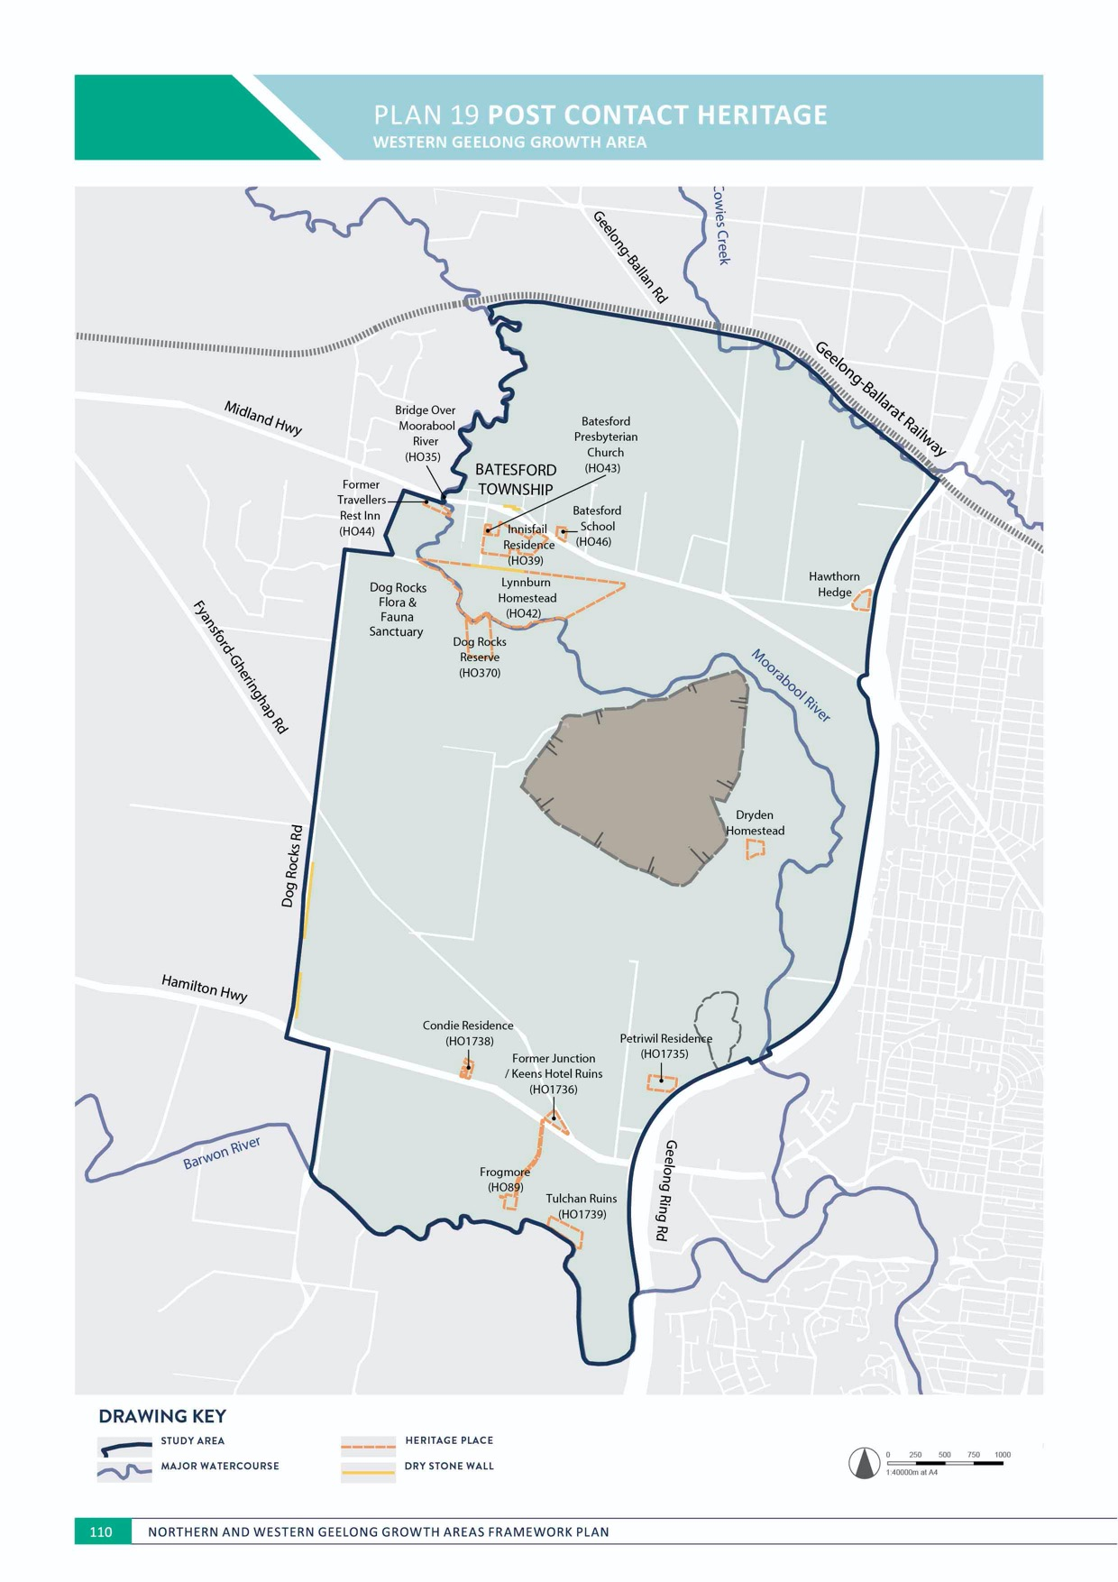
PLAN 19 POST CONTACT HERITAGE
WESTERN

ENVIRONMENT

POST CONTACT HERITAGE
WESTERN GEELONG GROWTH AREA

CONTEXT

Post contact heritage of the area is varied and relates to early settlement of large pastoral estates, rail and road infrastructure, quarrying and the history of the Batesford and Fyansford townships.
A total of 15 heritage places are registered within the growth area:
- Bridge Over Moorabool River
o The bridge at Batesford, constructed in 1859, is one of the earliest and longest stone arch road bridges in Victoria and is of architectural and historical significance to the State of Victoria.
- Former Travellers Rest Inn
- Former Travellers Rest Inn, constructed in 1867, is the oldest surviving building in Batesford and is one of the earliest constructed wayside inns in Victoria. The inn is of architectural and historical significance to the State of Victoria.
- Frogmore Homestead
  - Frogmore Homestead, constructed in 1859, is the site of the celebrated Frogmore Nursery, one of the earliest nurseries in Victoria and significant in the botanical development of the region. The homestead is of architectural, historical and archaeological significance to the State of Victoria.

- Elevated conveyor, a concrete limestone belt conveyor system used to transport material from Batesford Quarry to the cement works.
- Heritage places relating to the Geelong-Ballarat Railway including Cowies Creek Rail Bridge, the former Moorabool Railway Station and a viaduct
- Additional heritage places related to the Batesford township and surroundings including Lynnburn Homestead, ‘Innisfail’ Residence, Batesford Presbyterian Church, Batesford School and a hawthorn hedge
- Additional heritage places related to the Fyansford township and surroundings include Former Junction/ Keens Hotel, ‘Condie’ and ‘Petriwil’ residences and the ruins of
‘Tulchan’ residence.
Several additional sites with potential heritage significance, including dry stone walls, are located within the growth area. Batesford Quarry and associated places including Dryden Homestead are likely to have heritage significance.
Known post contact heritage values are illustrated on Plan 19.

ENVIRONMENT

ACTION W1.5.1
The curtilage of registered heritage places will be protected and incorporated into the urban landscape.
Registered heritage places illustrated in Plan 19 will be subject to a heritage impact assessment that considers any impact to their fabric and heritage values as part of the detailed design of the surrounding area. The curtilage of these places, including driveways and vegetation, should be integrated into the urban landscape to contribute to the local character and sense of place.

ACTION W1.5.2
Detailed investigations of potential heritage places will be undertaken prior to urban development.
Locations of potential heritage places illustrated in Plan 19 will be subject to detailed assessment to
determine any heritage values and potential protection and incorporation into the urban landscape.

ACTION W1.5.3
Dry stone walls will be protected and incorporated into the urban landscape to contribute to the understanding of historical farming practices in the region.
Dry stone walls illustrated in Plan 19 will be subject to detailed assessment to determine any heritage values and potential protection and incorporation into the urban landscape and should be incorporated into the design of integrated transport network using appropriate buffers.
ACTION W1.5.4
Major upgrades to the integrated transport network will be designed to protect adjacent registered heritage places.
The Geelong-Ballarat Railway, Hamilton Highway and Midland Highway have a significant number of
registered heritage places in their direct vicinity that will be incorporated into the design and development of road upgrades and widening. Crossing of the Frogmore
Homestead driveway should be limited to no more than the Clever and Creative Corridor.

ACTION W1.5.5
The extent of the curtilage for Lynnburn Homestead will be reviewed as part of detailed planning of the area.
The current curtilage of Lynnburn Homestead incorporates a large area of land between the Midland Highway and the Moorabool River that may be suitable for alternative land uses that area complimentary to the adjacent Batesford township, river corridor and sanctuary.

ACTION W1.5.6
The extent of the curtilage for the Batesford Quarry elevated conveyor and railway will be reviewed as part of detailed planning of the area.
The current curtilage of the elevated conveyor includes the former extent of the conveyor belts and railway to the quarry pit. Review of the curtilage should reflect the remaining elements of the conveyor belt that will be incorporated into the master plan for the adjacent Moorabool River.

IMAGE IS NOT AVAILABLE WITHIN THIS VERION.
TO VIEW SUPPORTING VISUAL FOR THIS PAGE GO TO
www.geelongaustralia.com.au/futuregrowth/default.aspx
TO ACCESS PDF.

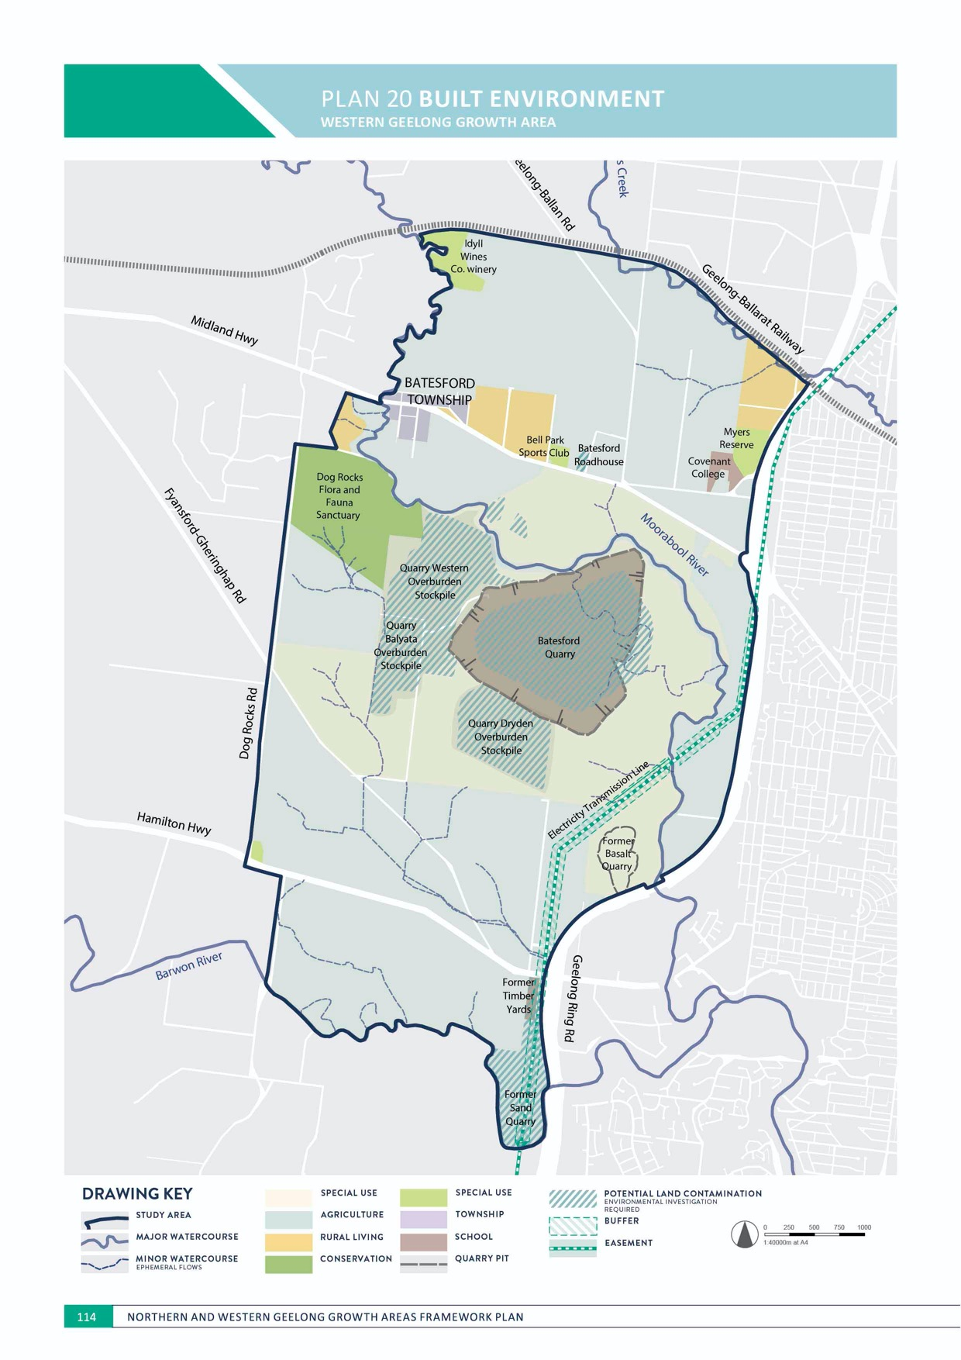
PLAN 20 BUILT ENVIRONMENT
WESTERN GEELONG GROWTH AREA

ENVIRONMENT

BUILT ENVIRONMENT
WESTERN GEELONG GROWTH AREA

CONTEXT

Urbanisation of the land will change the majority of its existing use. It is anticipated that some existing land uses including residences, schools and utility easements will be retained as part of the urban landscape.
Existing land uses to be considered in the context of the urban landscape are illustrated on Plan 20 and include:
- Batesford township
  - Batesford is a rural village on the Moorabool River and centred on the Midland Highway. The township is divided between the City of Greater Geelong and Golden Plains Shire, with a mixture of township and rural living properties of approximately 300 dwellings and 1,000 residents. The township includes the Batesford Hotel, a town hall, primary school campus and church.
- Batesford Quarry
  - Batesford Quarry is an active limestone quarry established in 1888 and located between the Midland Highway and Fyansford-Gheringhap Road. The quarry operated as part of the Geelong Cement Works for 113 years. The extractive pit of the quarry covers
approximately 100 hectares and the overall quarry site, including stockpiles and overburden, covers more than 900 hectares.
- Two smaller former quarries are located adjoining the Geelong Ring Road:
  - Former basalt quarry located to the west of Fyansford
  - Former sand quarry located to the north of the Barwon River.

- Dog Rocks Flora and Fauna Sanctuary, a woodland managed under a Trust for Nature covenant
- Electricity transmission lines
  - An overhead electricity transmission power line between the Midland Highway and the Barwon River.
- Rural living
  - There are 158 properties in the growth area that support uses associated with rural living, including Batesford township. Properties located beyond the general vicinity of Batesford township will have the potential to transition to an urban land use.
- Bell Park Sports Club, a soccer club with two pitches and pavilion
- Myers Reserve, a sports reserve including two ovals, three soccer pitches, four tennis courts, netball court, bowling green and three pavilions
- Covenant College, an independent P-12 school located on Creamery Road, directly west of Myers Reserve
- Idyll Wines Co., a winery in the Moorabool Valley, directly south of the Geelong-Ballarat railway corridor
- Material storage and recycling centre located to the south of the Hamilton Highway
- Batesford Roadhouse.

ENVIRONMENT

ACTION W1.6.1
The existing character of Batesford township will be protected by ensuring:
- Conventional or higher density residential development adjoining the Midland Highway is prohibited to the west of Lynnburn Road
- Any development to the west of Lynnburn Road retains existing views to the Moorabool Valley and the Dog Rocks Flora and Fauna Sanctuary and is limited to a minimum lot size of eight hectares to the south of the Midland Highway
- A buffer of low density residential development is established to the north and east of the Batesford township.
The rural village character of Batesford township is a prominent and culturally significant feature of the local landscape. Minimising urban development on the eastern approach seeks to retain the sense of arrival to Batesford township and reinforce its unique sense of place.

ACTION W1.6.2
Rural living properties to the east of Batesford township will be permitted to transition to low or conventional density residential as part of the detailed planning of Batesford township and its surroundings.
Detailed master planning will establish the protection and integration of the Batesford township with the urban landscape including appropriate buffers to the township, urban design guidelines and road network requirements in areas of increased density residential development. Residential density will decrease as proximity to the township increases.
ACTION W1.6.3
Rural living properties will be permitted to subdivide to a conventional residential density as part of urban development.
Areas of rural living illustrated as ‘residential’ on Plan 4 will be permitted to subdivide to a conventional density residential density as part of urban development.

ACTION W1.6.4
Existing social infrastructure will be integrated with surrounding neighbourhoods.
Urban design of new subdivisions adjoining Myers Reserve and Covenant College will provide road frontages to these facilities that maximise passive surveillance and provide convenient movement and access. Siting of new buildings at these facilities should have regard to the surrounding urban landscape.

ACTION W1.6.5
Land uses within the high voltage electricity transmission line easement will minimise risks to community safety.
Easements illustrated on Plan 20 should be utilised as part of the open space network with potential land uses including linear shared paths, local parks and off-leash areas, recreation, stormwater management, local roads and car parking, and extensive planting of indigenous grasses and shrubs.
ACTION W1.6.6
Potential areas of land contamination should be investigated and remediated as part of urban development including:
- High potential areas at the Batesford Roadhouse and a material storage and recycling centre (former timber yard)
- Medium potential areas at the Batesford Quarry and overburden stockpiles and the former sand quarry
- Low potential areas throughout the remainder of the growth area
- Potential presence of acid sulphate in the vicinity of the Moorabool River corridor.
Urban development in potential areas of high and medium land contamination will need to be undertaken following conventional planning, assessment and remediation methods in accordance with EPA Victoria guidelines and local policy.

IMAGE IS NOT AVAILABLE WITHIN THIS VERION.
TO VIEW SUPPORTING VISUAL FOR THIS PAGE GO TO
www.geelongaustralia.com.au/futuregrowth/default.aspx
TO ACCESS PDF.

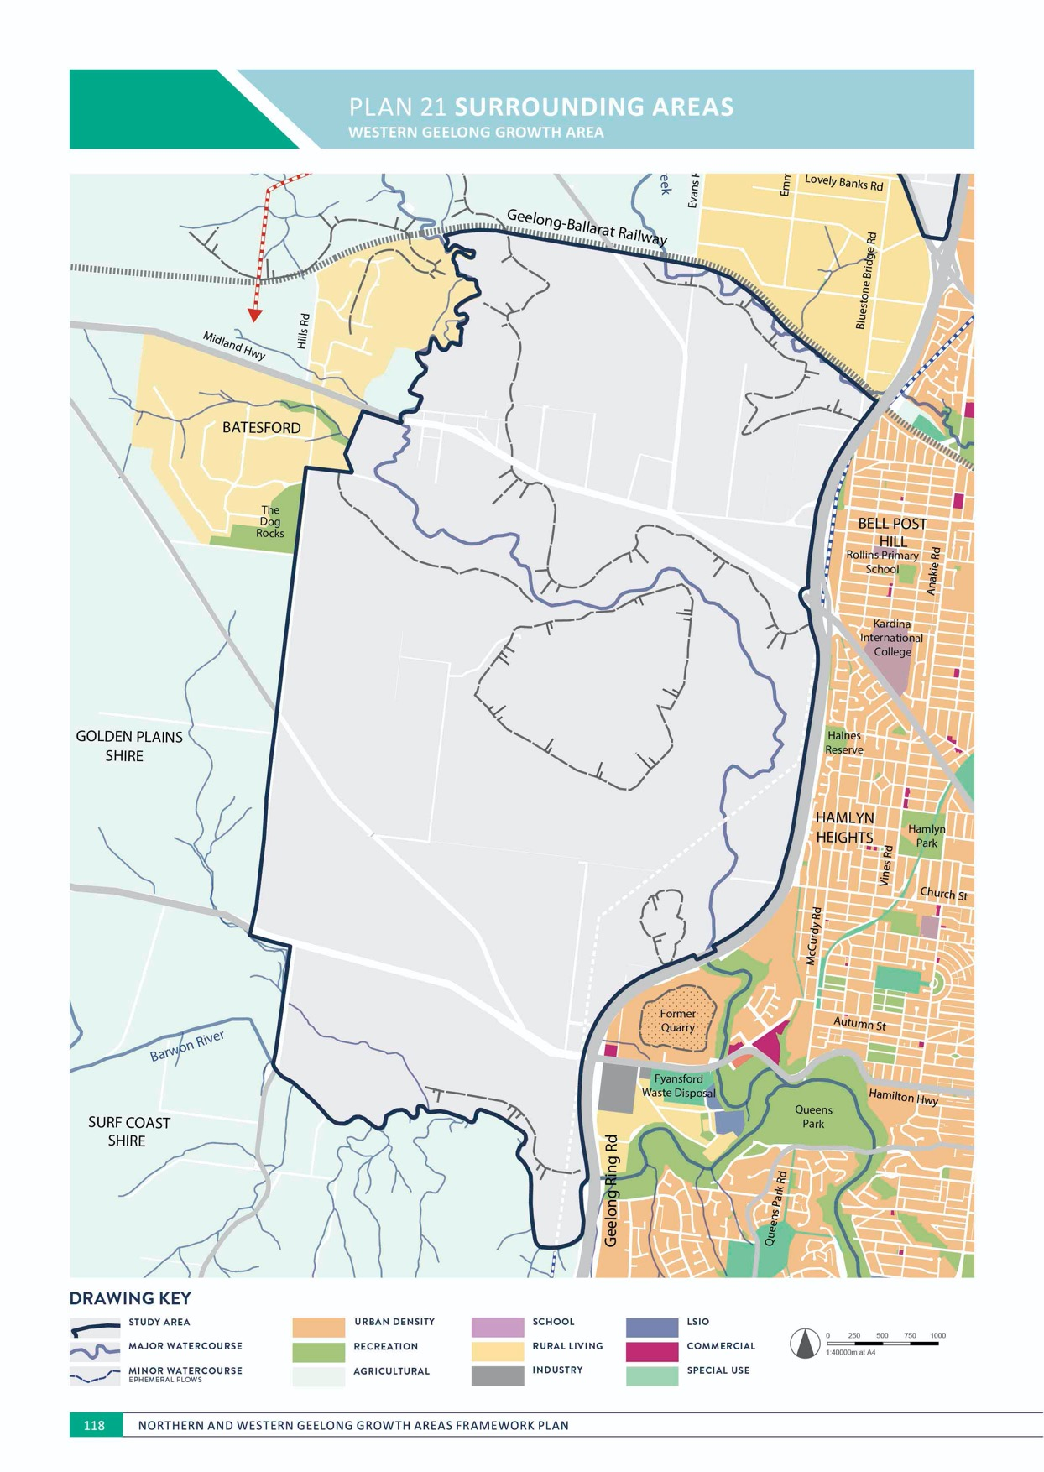
PLAN 21 SURROUNDING AREAS

ENVIRONMENT

SURROUNDING AREAS
WESTERN GEELONG GROWTH AREA

CONTEXT

New neighbourhoods will extend to the western boundary of the municipality and need to consider the surrounding areas, particularly the Batesford township.
Surrounding land uses to be considered in the context of the urban landscape are illustrated on Plan 21 are include:
- Batesford, predominately rural living properties that adjoin the western boundary of the growth area in Golden Plains Shire
- The Dog Rocks, a granite outcrop directly west of the Dog Rocks Flora and Fauna Sanctuary
- Rural living properties, predominately located to the north of the Geelong-Ballarat railway
- Farm land located to the north of the Geelong-Ballarat railway
- Farm land located to the south of the Barwon River
- Farm land located to the west of the growth area in Golden Plains Shire
- Geelong Ring Road and the adjoining existing neighbourhoods of Geelong.
ACTION W1.7.1
Noise and amenity impacts of the Geelong Ring Road will be identified and managed as part of urban development.
Noise attenuation and screening of the Geelong Ring Road will be provided in locations that interface with sensitive uses including residential development and social infrastructure.

ACTION W1.7.2
Noise and amenity impacts of the Geelong-Ballarat railway corridor will be identified and managed as part of urban development.
Noise attenuation and screening of the Geelong-Ballarat railway will be provided in locations that interface with sensitive uses including residential development and social infrastructure.

ENVIRONMENT

ACTION W1.7.3
Potential fire risks associated with non-urban interfaces to new neighbourhoods will be identified and managed as part of urban development.
Interfaces with non-urban land uses that present grassfire or bushfire risks as part of the interim and ultimate development of new communities will undertake:
- Assessment of fuel loads (agricultural land and grasslands) and vegetation, slope and prevailing wind directions in urban design of subdivisions
- Creation of fire breaks and fuel reduction and minimisation using appropriate planting and management guidelines.

ACTION W1.7.4
Potential amenity and health risks associated with non-urban interfaces to new neighbourhoods will be identified and managed as part of urban development.
Interfaces with non-urban land uses that present amenity and health risks as part of the interim and ultimate development of new communities include:
- Buffers to agricultural practices that may contribute odour and noise impacts
- Buffers to agricultural practices that may use chemicals such as pesticides and weed killers
- Passive surveillance that minimises rubbish dumping and vegetation clearing
- Protection of native fauna species from domestic and feral animals.
ACTION W1.7.5
Potential adverse amenity impacts of new neighbourhoods on adjacent rural living areas will be identified and managed as part of urban development.
New neighbourhoods that directly interface with rural living properties to the north of the Geelong-Ballarat railway
and to the west of Dog Rocks Road will minimise amenity impacts including light pollution.

ACTION W1.7.6
Housing densities and upgrades to the integrated transport network along the western boundary of the growth area will consider and respond to the adjoining rural interface.
Subdivision of land in direct proximity to Dog Rocks Road, Friend in Hand Road and Merrawarp Road will deliver lower densities of residential development to provide a gradual transition between urban and rural land uses.
Future upgrade of these roads should maintain elements of their existing rural character, particularly in proximity to Batesford township, Dog Rocks Sanctuary and the Dog Rocks.

IMAGE IS NOT AVAILABLE WITHIN THIS VERION.
TO VIEW SUPPORTING VISUAL FOR THIS PAGE GO TO
www.geelongaustralia.com.au/futuregrowth/default.aspx
TO ACCESS PDF.

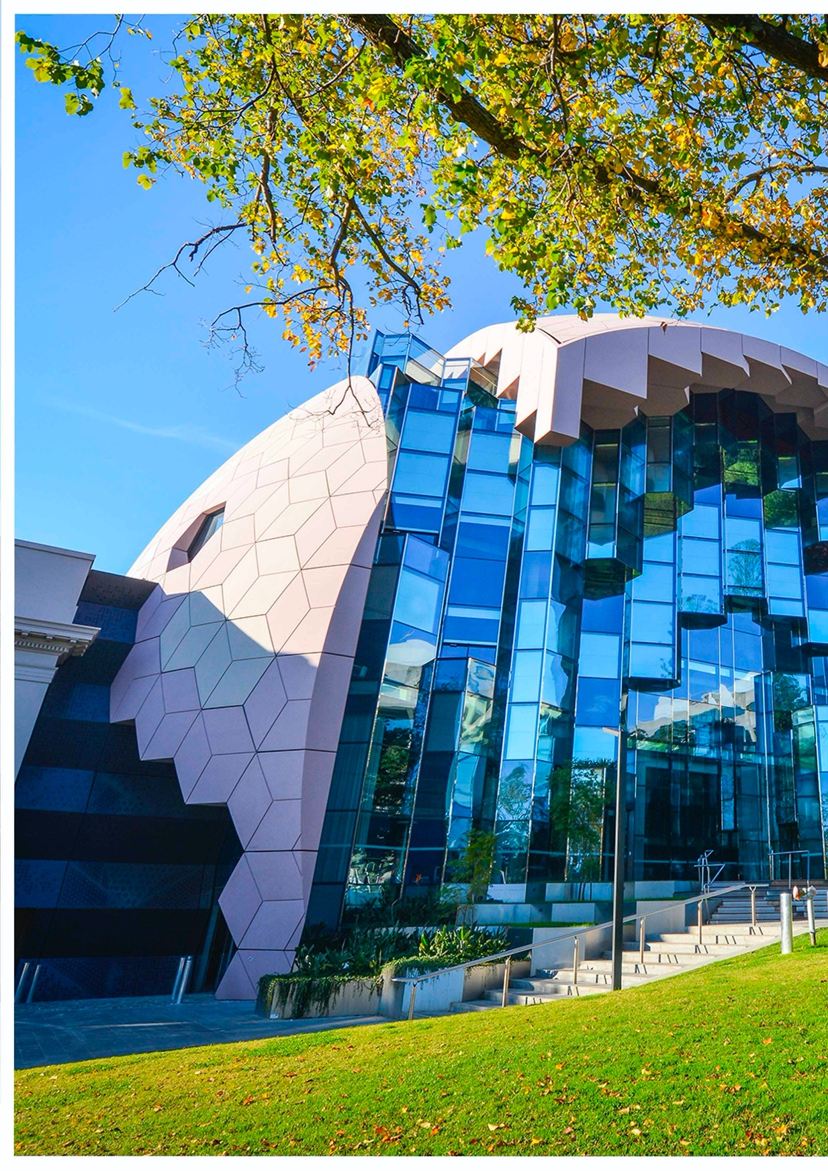



123

NEIGHBOURHOOD

NEIGHBOURHOOD is the element that enables Geelong’s new communities to live locally, sustainably and with pride of place.

Neighbourhoods are comprised of many components that make a place feel like home. Streetscapes and buildings, open space and the natural environments, local community facilities and sporting clubs are a few of the many essential components that contribute to the creation of a healthy neighbourhood.
The character of a neighbourhood is largely influenced by the land it inhabits. The growth areas are made up of many different places. Areas of dramatic landscape – the
Lovely Banks monocline and the Moorabool River corridor
– are located next to areas of flat terrain; a development response for all types of land is equally important to the future community that it supports.
The planning for the Northern and Western Geelong Growth Areas has taken an integrated and considered approach to the design of neighbourhoods that maximises the site context and scale of the combined growth areas.
The integrated approach is focused on the creation of a network of vibrant and unique neighbourhoods centred on the Clever and Creative Corridor, each with a sense of place and identity, and each servicing the daily needs of the local community within a 20 minute walk, cycle or public transport trip.
The Clever and Creative Corridor will provide a centralised focal point for community activity and mobility, including high quality, active and sustainable transport options that unify the individual neighbourhoods across the growth areas into a larger community that shares the Geelong identity. Travelling a route that traverses the Lovely Banks monocline, Cowies Creek, the Moorabool River, Batesford Quarry (and its future lake) and the Barwon River, the corridor will be emblematic of the city.
NEIGHBOURHOOD considers the elements that support localised, self-sufficient communities with a sense of place in their design, amenity, sustainability, diversity and social infrastructure.

PREVIOUS PAGE: CLEVER AND CREATIVE NEIGHBOURHOOD
– GEELONG LIBRARY & HERITAGE CENTRE

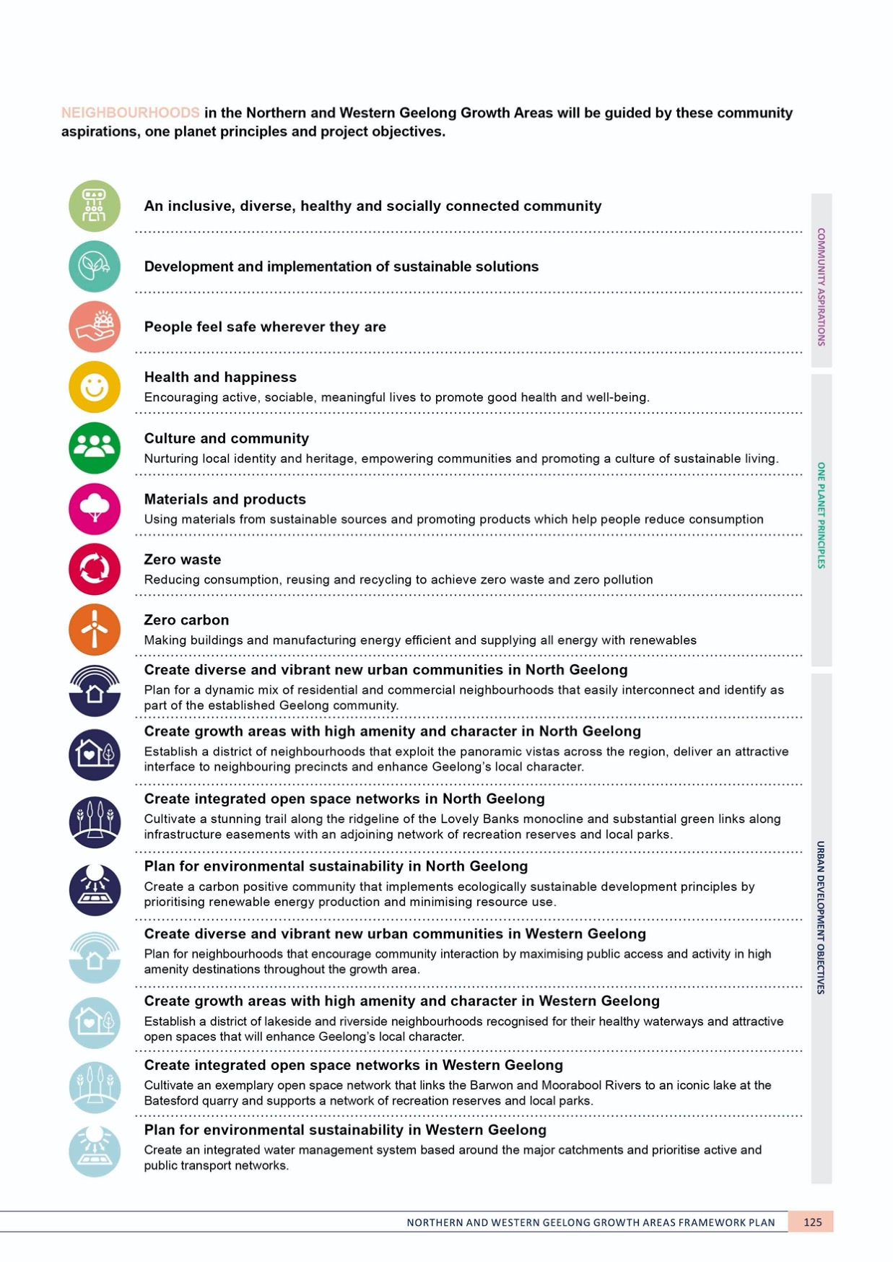
NEIGHBOURHOOD
NORTHERN GEELONG GROWTH AREA

NEIGHBOURHOOD DESIGN
NORTHERN GEELONG GROWTH AREA

CONTEXT

Effective neighbourhood design provides a site-specific design response. The neighbourhood highlights the existing characteristics of the land and celebrates natural and existing features, including landforms and view lines, topography, waterways, native vegetation and established trees, heritage and cultural values.
Demanding that the urban landscape utilises these elements – or makes up for their absence - is fundamental to the growth and ongoing success of a neighbourhood.
Establishing the structure of the neighbourhood relies on interpreting the land.
Neighbourhoods in the Northern Geelong Growth Area will create their own local sense of place based on the nature of the land and their proximity to services and activity. Each neighbourhood, despite its unique neighbourhood design, will form part of the larger, Greater Geelong community.

ACTION N2.1.1
Urban development will adopt 20-minute neighbourhood design principles.
Geelong’s new neighbourhoods will allow residents to live locally and meet most of their everyday needs within a
20-minute walk, cycle or local public transport trip of their home. The design of each neighbourhood will place activity centres, health facilities and services, schools, local parks and recreation facilities along the Clever and Creative Corridor within the 20-minute neighbourhood catchments.

ACTION N2.1.2
Walkability and cycling for local trips will be prioritised in the design of neighbourhoods.
Vibrant, walkable and rideable neighbourhoods encourage people to walk and ride within the neighbourhood.
Compact neighbourhood structures set around the Clever and Creative Corridor will support a connected, safe and legible network of shared paths. Streetscape design will give priority to pedestrians and cyclists in neighbourhoods and activity centres to encourage healthy, active and engaging communities

ACTION N.2.1.3
Neighbourhoods will be designed to create a unique sense of place, character and identity.
Neighbourhoods will enhance and interpret their unique localities including the natural characteristics, landform, features and heritage values. Neighbourhoods will offer unique interface treatments to the Clever and Creative Corridor that provide legibility in the urban landscape and deliver additional design initiatives in areas of limited amenity.

ACTION N2.1.4
Neighbourhoods on the western plateau will address the flat, exposed nature of the land.
Design responses on the western plateau will utilise windbreaks to reduce wind and dust, provide higher densities of mature street trees, create interesting streetscapes and provide higher quality public realm treatments.

ACTION N2.1.5
Neighbourhoods along the monocline escarpment will respond to the significance of the landform.
Urban development on the monocline escarpment will highlight and enhance its geological features and steep topography by maintaining significant views and deliver high quality built form that respects the prominence of the landform. Additionally, urban development surrounding the Elcho Homestead will respect and enhance its regionally- significant heritage values.
ACTION N2.1.6
Public spaces will be designed to be safe, comfortable and inviting.
Passive surveillance will be maximised to ensure public places feel safe and inviting.

ACTION N2.1.7
Minimum density requirements will be applied to deliver a compact urban form as illustrated on Plan 23 and include:
- Medium density housing within 400 metres of neighbourhood activity centres and locations on the Clever and Creative Corridor that offer employment, public transport access and community hubs
- Higher densities within 800 metres of the sub- regional activity centre before transitioning to medium density within the outer half of this catchment.
A compact urban form will support a higher population within neighbourhood catchments, providing the critical mass necessary to support high performing local economies and generate lively, active, socially-connected and interesting public spaces.

ACTION N.2.1.8
Subdivision layouts will be adapted to suit local landforms, key view lines and natural elements.
Neighbourhood design will require subdivision layouts to suit local landforms and view lines whilst demonstrating environmentally sustainable design principles. Subdivision layouts will ensure that streets are oriented to maximise views to significant features and street networks will encourage pedestrians and cyclists to use the Clever and Creative Corridor.

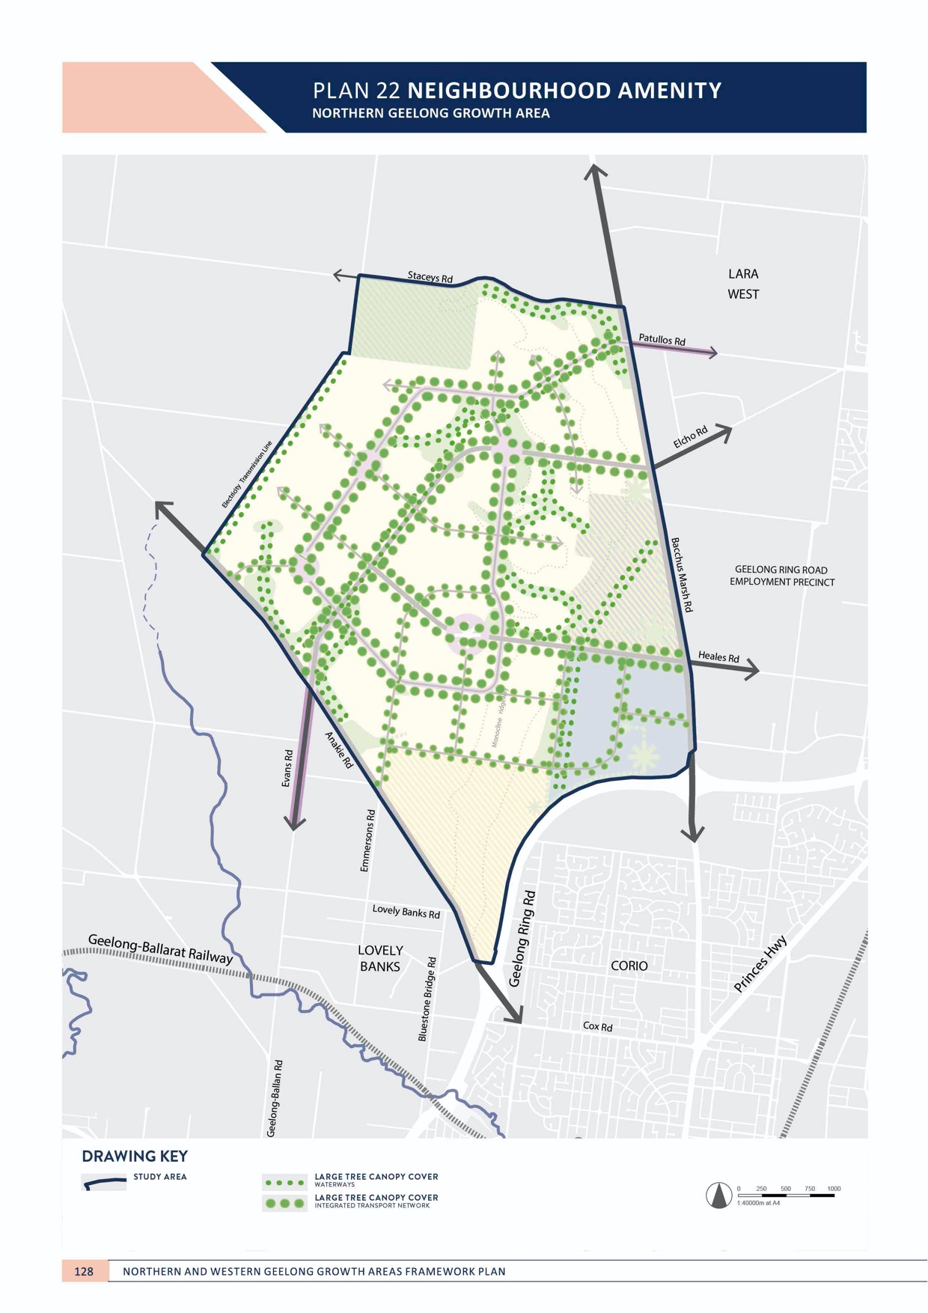

NEIGHBOURHOOD

NEIGHBOURHOOD AMENITY
NORTHERN GEELONG GROWTH AREA

CONTEXT

The appearance of a neighbourhood and its public realm is essential to its value within the community. Neighbourhood amenity builds social capital as it encourages residents
to use and enjoy their surroundings in daily life. Strong communities are connected, creative and set within a healthy environment that promotes activity, health and well- being.
Neighbourhood amenity is experienced at the human scale. Residents, upon leaving their homes, should immediately feel encouraged to walk within their neighbourhoods and engage with their community. Tree-lined streetscapes
and open spaces that are well vegetated and maintained create neighbourhood amenity. Comfort, safety and nearby attractive destinations encourage engagement with the public realm.
Significant tree canopy in neighbourhoods is fundamental to delivering high amenity within the neighbourhood and achieving a sense of place. Tree canopy cover provides shade to reduce heat and sun exposure, provides visual interest, delivers energy savings in buildings, provides habitat for wildlife, abates wind and improves the value of the street.
Broadly, creating and maintaining neighbourhood amenity is fundamental to securing Geelong’s economic future.
The amenity of the city attracts new residents, supports businesses, facilitates major infrastructure and investment in the city and its tourism, arts, culture and events.
The Northern Geelong Growth Area is largely treeless, pastoral land. Significant and early investment in the cultivation of tree canopy will be required by land developers to guarantee new communities will benefit from the appearance of trees in their neighbourhood.
ACTION N2.2.1
Tree canopy in the public realm will be maximised and contribute significantly to neighbourhood amenity. Tree canopy coverage, preferred species and priority locations for planting and revegetation will
be consistent with the directions of the Urban Forest Strategy to deliver:
- High tree canopy coverage on public and private land at a minimum of 25% suburban tree canopy at key destinations and along the Clever and Creative Corridor with complimentary in-and above-ground infrastructure.
- Priority tree planting at locations along waterways, open spaces and the integrated transport network
- A mix of local, indigenous and exotic species
- An extension of native canopy
The Urban Forest Strategy sets key targets for performance of the public urban forest and provides a framework to encourage growth of the private realm urban forest. Tree planting will extend the canopy extent of conservation areas by using local indigenous species in the adjacent road networks.

ACTION N.2.2.2
Streets will be orientated to key destinations and the open space network.
The street network will create line of site and direct access to attractive destinations within neighbourhoods including the monocline ridgeway, gas pipeline linear corridor and waterways.

IMAGE IS NOT AVAILABLE WITHIN THIS VERION.
TO VIEW SUPPORTING VISUAL FOR THIS PAGE GO TO
www.geelongaustralia.com.au/futuregrowth/default.aspx
TO ACCESS PDF.

NEIGHBOURHOOD

ACTION N2.2.3
Car parking in local streets will not dominate the streetscape.
Streets will be designed for people and subdivision design will ensure that on-street parking does not dominate the streetscape in local streets. Street design will manage and limit excessive on-street parking.

ACTION N2.2.4
Public realm will be designed to be a comfortable, inviting, visually interesting and support biodiversity.
The Clever and Creative Corridor will be a central location for focusing high quality investments in the public realm delivered in partnership with local artists, cultural and community groups to establish public events and art and creative community initiatives. The broader street network will incorporate mechanisms to allow for native, drought tolerant planting in nature strips.

ACTION N2.2.5
High quality street furniture will be provided to maximise comfort for pedestrians, cyclists and public transport users at frequent spacing.
The Clever and Creative Corridor will be a focal point for delivery of high quality street furniture, including seats, shelters and rest areas that support sustainable transport modes. The broader street network, especially the monocline ridgeway, will deliver street furniture in
areas of high activity and locations that capture key public views.
ACTION N2.2.6
Key existing arterial roads will be designed to ensure that upgrades and duplications reflect the urban nature of the area and provide high quality gateway treatments.
Road design on existing arterial roads will ensure that design speeds, cross sections, intersection treatments and interfaces are designed to respect the urban nature of the area, minimise widths and prioritise pedestrians, cyclists and public transport, where appropriate.

ACTION N2.2.7
Medium and high density housing areas will incorporate high quality public realm improvements to compensate for smaller private spaces.
Medium and high density housing areas will deliver more intensely planted street trees and centralised local parks to beautify the public realm and compensate for the loss of planting opportunities in private gardens.

NEIGHBOURHOOD

NEIGHBOURHOOD SUSTAINABILITY
NORTHERN GEELONG GROWTH AREA

CONTEXT

Greater Geelong is a One Planet Council that is committed to creating a carbon neutral city-region as part of a clever and creative future. Creating new neighbourhoods that are climate resilient, net carbon positive and environmentally sustainable is essential to achieving the community’s vision for prosperous, healthy communities within Greater Geelong.
Highly responsive and integrated environmentally sustainable design of infrastructure and the built
and natural environment is fundamental to achieving sustainable neighbourhoods.
Delivering integrated water management solutions in the Northern Geelong Growth Area is critical to protecting and enhancing its natural environment and maintaining healthy waterways.
The Clever and Creative Corridor will showcase how implementation of environmentally sustainable design, integrated water management and smart city technologies can be implemented within new communities.

ACTION N2.3.1
Urban development will be designed to achieve a zero carbon future for the Greater Geelong city-region.
An environmentally sustainable design (ESD) action plan will be prepared for each precinct structure plan demonstrating the actions that urban development will take to contribute net zero carbon to the city. A ‘smart city’ strategy will be included within the action plan that
establishes a framework for monitoring the performance of new neighbourhoods in delivering sustainable development and more efficient urban service systems. The Clever and Creative Corridor will support implementation of these technologies.

ACTION N2.3.2
Neighbourhood layout and orientation will reduce energy consumption and create comfortable buildings and resilient communities
Neighbourhood design will prioritise site and street layout to maximise north-facing facades and promote building massing and associated planting to create winter solar gain, summer shading, wind breaks and ventilation.

ACTION N2.3.3
Energy systems will anticipate renewable supply sources through all land use types.
Network-scale renewable energy production and storage will be anticipated and demonstrated by urban development. As urban development progresses over time, neighbourhood-scale renewable opportunities will be investigated to provide appropriate renewable energy
production, storage and trading. The action plan for each precinct will consider mandating the use of low-carbon energy sources and limiting the provision of natural gas to new urban development . The Clever and Creative Corridor will, where appropriate, be the central spine to implement network-scale renewable energy systems.

ACTION N2.3.4
Neighbourhoods will be designed to enable adoption of future, cleaner technologies.
Neighbourhoods will be designed with the capacity to adapt to new technologies including innovations in
buildings, transport, energy and waste. The Clever and Creative Corridor will provide space for incorporating future technologies and will implement enabling infrastructure
to support smart city assets, electric vehicle charging and autonomous vehicles.

ACTION N2.3.5
Innovation in the design of waste collection, transfer, treatment and disposal systems will be necessitated by large-scale urban development.
Waste minimisation, reuse and recycling that can be implemented in the construction and occupation of new neighbourhood will be assessed as part of each action plan to fulfil the City’s strategic goal of zero waste to landfill.
Consideration will be given to how waste infrastructure can be implemented into the Clever and Creative Corridor to support the zero waste to landfill goal.

ACTION N2.3.6
Neighbourhoods will maximise the use of alternative water sources to meet fit-for-purpose needs and deliver multi-functional benefits.
IMAGE IS NOT AVAILABLE WITHIN THIS VERION.
TO VIEW SUPPORTING VISUAL FOR THIS PAGE GO TO
www.geelongaustralia.com.au/futuregrowth/default.aspx
TO ACCESS PDF.

An integrated water management strategy will assess the feasibility of local and precinct-scale stormwater collection, treatment and reuse, wastewater treatment and reticulation through a dual-pipe network that
delivers recycled water to each neighbourhood for appropriate domestic and commercial uses. The Clever and Creative Corridor will showcase best practice integrated water management approaches and will integrate water sensitive urban design into the public realm to create attractive, interesting and drought resistant landscape elements.

ACTION N2.3.7
Neighbourhoods will deliver safe, reliable, high quality drinking water and sewage services.
Drinking water and sewage services will meet mandatory standards for each neighbourhood.

ACTION N2.3.8
New communities will enable innovative local food production opportunities
Multi-purpose urban spaces and appropriate planning mechanisms will support local food growth and community- based food growth opportunities. These opportunities
will be supported in appropriate areas of the Clever and Creative Corridor.

PLAN 23 HOUSING
NORTHERN GEELONG GROWTH AREA

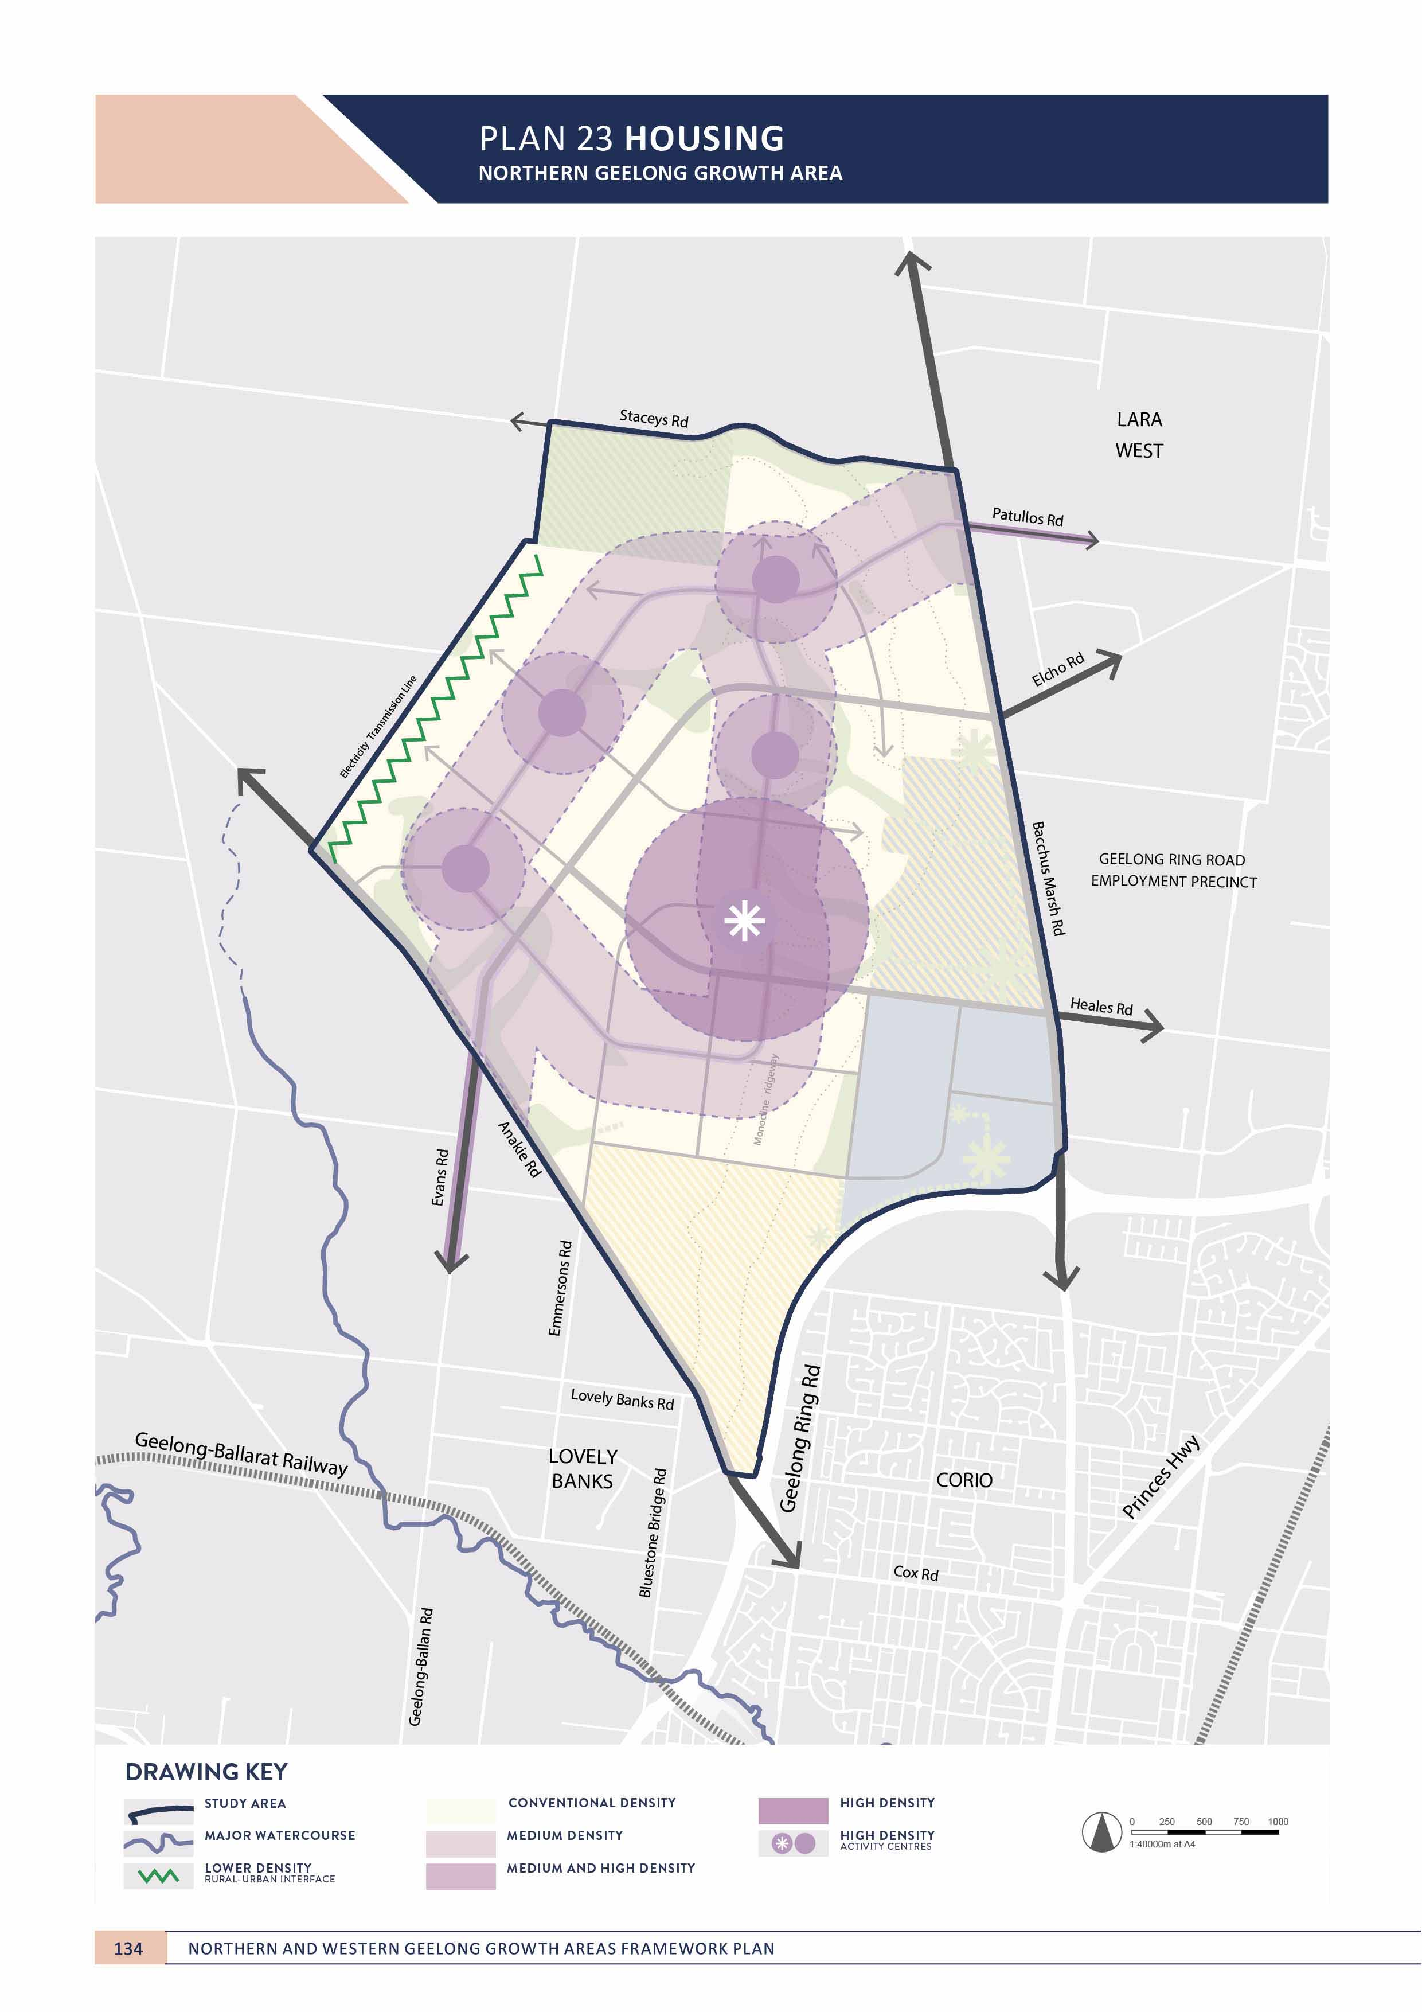

NEIGHBOURHOOD

HOUSING
NORTHERN GEELONG GROWTH AREA

CONTEXT

Housing diversity is vital to the success of neighbourhoods. A diverse mix of housing types and densities caters to a diverse community where demographics and cultures are combined. Housing diversity underpins a neighbourhood that is vibrant, activated at all times throughout the day
and maintains a range of services and facilities useful to all abilities and ages.
Housing diversity ensures that anyone can find a suitable place to live in the neighbourhood: where growing families can upsize, empty-nesters can downsize, and where students, workers and retirees can find compact living options that are affordable and close to services.
Housing diversity enables higher densities to be achieved, promoting a greater population that supports high quality and efficient infrastructure and services and resists continuous urban expansion.
Housing diversity improves built form outcomes as varied typologies and interfaces in the streetscape create a more interesting, socially connected, vibrant and active neighbourhood.
Implementing environmentally sustainable design (ESD) principles in housing plays an important role in neighbourhood sustainability by creating healthier communities that minimise impacts on the natural environment to potentially reduce long-term financial pressures on the community.
The Clever and Creative Corridor provides the opportunity to showcase how the ‘missing middle’ (medium) density housing types can be supported within neighbourhoods and will be an area where housing diversity and adoption of best practice ESD principles will be encouraged.
ACTION N2.4.1
Urban development will deliver a diverse mix of housing options throughout each neighbourhood.
A mix of housing densities and typologies will be delivered to support a diverse community. Housing will offer choices that meet the broad and changing requirements of the community and implement universal design principles.

ACTION N2.4.2
Housing in medium density areas will cater for the ‘missing middle’ housing types.
Medium density residential areas will be encouraged to deliver low-rise, multi-unit and clustered housing types that are mixed with a variety of building types.

ACTION N2.4.3
Housing within and adjoining activity centres will be delivered at high density.
Urban design frameworks for sub-regional and neighbourhood activity centres will determine appropriate areas of high and medium density housing within and adjoining activity centres that promote increased vibrancy of the streetscape, more prosperous local economies and enable greater access to amenities and services.

IMAGE IS NOT AVAILABLE WITHIN THIS VERION.
TO VIEW SUPPORTING VISUAL FOR THIS PAGE GO TO
www.geelongaustralia.com.au/futuregrowth/default.aspx
TO ACCESS PDF.

NEIGHBOURHOOD

ACTION N2.4.4
Housing on the monocline escarpment will be designed to integrate and enhance the natural amenity of the landform.
Housing throughout the monocline escarpment will be designed to enhance the amenity of its prominent
landform. Design of housing on the monocline will provide a reasonable sharing of views and incorporate elements that integrate housing into the slope and deliver high quality buildings that minimise visual bulk.

ACTION N2.4.5
Housing in rural interface areas will be designed to appropriately respond to the neighbouring environment.
Areas of rural interface along the north-western boundary of the growth area will be designed with conventional densities and designs that respect the rural interface. Areas of the northern boundary adjoining Staceys Road will utilise the same principles if waterways are no longer required on the interface.
ACTION N2.4.6
Neighbourhoods will provide opportunities for aged- care and affordable, community and social housing.
A mix of aged-care and affordable, community and social housing options will be encouraged within medium density areas to take advantage of services, amenities and public transport within a walkable distance.

ACTION N2.4.7
Housing will be encouraged to incorporate ESD principles in the design to deliver carbon neutral communities.
Housing design will incorporate guidelines on methods for achieving more climate resilient buildings that provide
comfort during extreme heat events, drought, flooding and reduced resource dependency. Initiatives to encourage carbon neutral housing within the Clever and Creative Corridor will be explored as part of the relevant precinct structure plan.

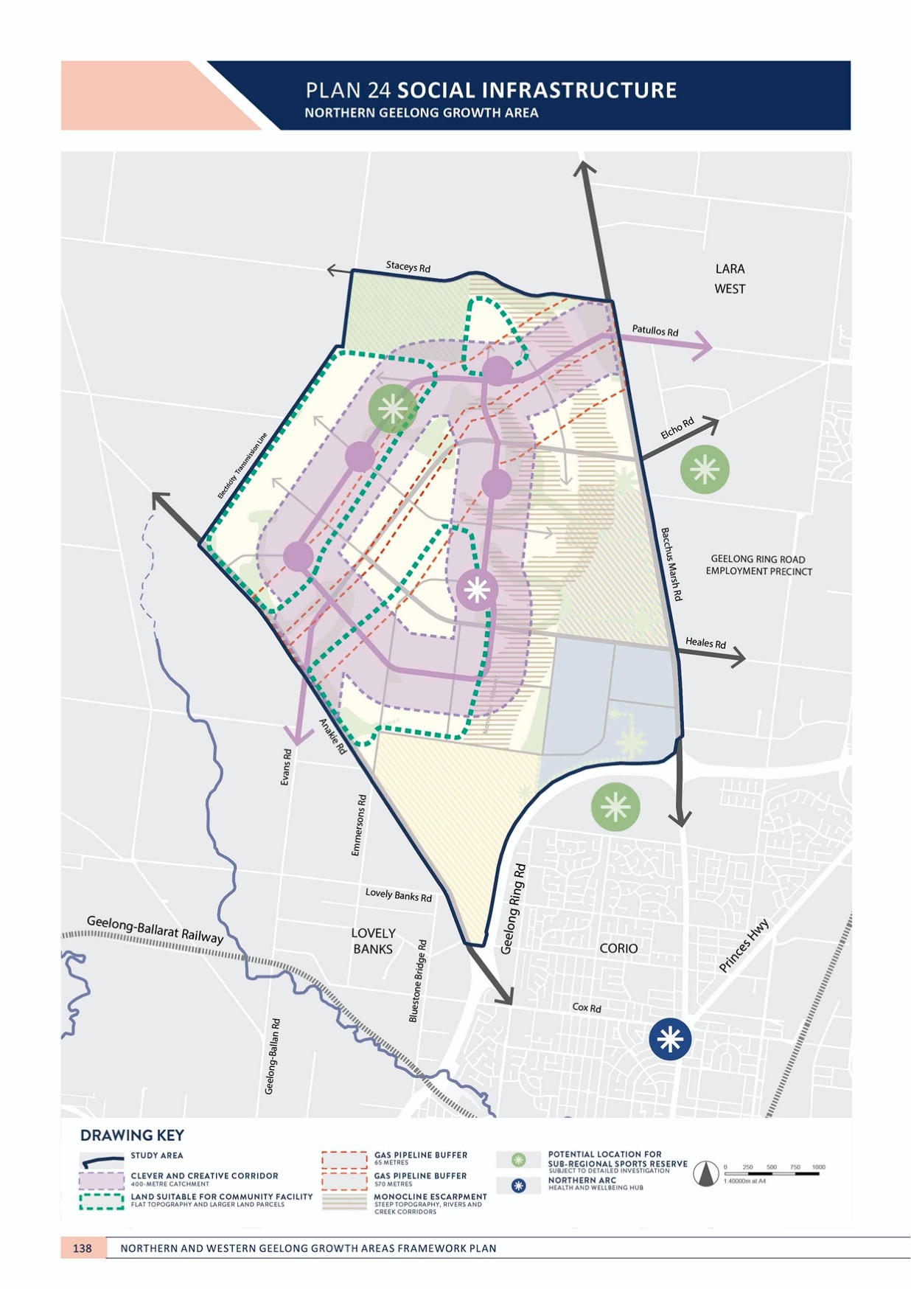

NEIGHBOURHOOD

SOCIAL INFRASTRUCTURE
NORTHERN GEELONG GROWTH AREA

CONTEXT

Social infrastructure is a fundamental component of the neighbourhood. Healthy communities enjoy easy access to a wide range of community facilities and services and public open space.
Social infrastructure will be delivered in the Northern Geelong Growth Area to provide a wide range of universal facilities and services including schools, community centres and meeting places, arts and cultural facilities and health and emergency services. Northern Geelong’s new neighbourhoods will be linked by a comprehensive open space network of local and linear parks and sport and recreation facilities.
The monocline ridgeway will provide an attractive linear corridor to link social infrastructure between
neighbourhoods and allow views across Corio Bay. The western plateau of the growth area provides ideal land for sports reserves.
The estimated social infrastructure required to support new communities in the Northern Geelong Growth Area includes:
Community facilities
- One cultural hub that incorporate a library, arts and cultural spaces and meeting rooms
- Two multi-purpose community centres that incorporate a neighbourhood house, flexible community meeting spaces and community gardens
- Two neighbourhood centres that incorporate flexible community meeting spaces
- Two integrated children’s centres incorporating maternal and child health services, community meeting spaces, a kindergarten and long and occasion care centres
- Two maternal and child health centres
- Two kindergartens
- Five long day child care centres

- One health and wellbeing centre incorporating a
community health centre, flexible community meeting spaces, youth and seniors spaces and services to support aged, people with a disability and culturally and linguistically diverse members of the community
- Eight primary schools
- Two secondary schools
- One police station co-located with a justice centre
- One emergency service hub incorporating ambulance, fire and state emergency services.
Open space, sport and recreation
- The monocline ridgeway, a linear park providing public access to the precinct’s best view lines
- The gas pipeline linear corridor, a linear park providing dedicated active transport movements
- A network of active open space (sports and recreation) and passive open space (local parks) for residential land throughout the growth area equivalent to 10% of the net developable area
- Internal demand throughout the growth area for a sub- regional sport reserves and facilities on ten hectares of unencumbered land
- Two indoor recreation centres
- A network of passive open space (local parks) for employment land throughout the growth area equivalent to 2% of the net developable area.
The anticipated population of the growth areas satisfies approximately half the benchmark provision trigger of 200,000 residents. Future demands on major health facilities will be assessed as part of Geelong’s growth and should be co-located with sub-regional activity centre, if provided.

NEIGHBOURHOOD

ACTION N2.5.1
A social infrastructure needs assessment will be undertaken for each precinct that identifies the community facilities and open space required to support new residents.
The assessment will provide recommendations for the provision of social infrastructure based on anticipated dwelling and population yields to be determined by detailed planning. Each assessment will be prepared to deliver social infrastructure in accordance with the Social Infrastructure Plan.

ACTION N2.5.2
Social infrastructure will be highly accessible to the entire community.
Social infrastructure will be comprehensive and interconnected delivering:
- Community hubs along the Clever and Creative Corridor unless prohibited by land use constraints
- Delivering active and passive open space along the Clever and Creative Corridor and/or waterway corridors, where landform is suitable and not fragmented
- Delivering a network of active and passive open space equivalent to ten per cent of the developable land in the growth area.
ACTION N2.5.3
Social infrastructure will be provided to new neighbourhoods in the early stages of urban development.
Early provision of infrastructure is critical to building social capital within new communities and enhancing the social value of new neighbourhoods. Social infrastructure will be delivered to ensure that each precinct is supported with ‘standalone’ infrastructure so that communities are not reliant on long-term development outcomes.

ACTION N2.5.4
Innovative methods of delivering social infrastructure will be explored to identify best practice provision methods that meet the needs of the community.
Delivery of social infrastructure will maximise community benefit by identifying innovative provision methods including private-public partnerships, shared use of infrastructure between facilities and services, and methods to secure land at the lowest cost to the community.

ACTION N2.5.5
Design of social infrastructure will create community spaces that are flexible, adaptable and multi-purpose.
Social infrastructure will be delivered with the capacity to incorporate a wide range of services that deliver benefits to the whole community and adapt to their changing needs.

ACTION N2.5.6
Community facilities will deliver accessible cultural spaces that support a wide range of cultural and community outcomes.
The network of higher-order community facilities will cater for large-format outdoor events spaces that are suitable for arts and cultural programs hosted within the community.

ACTION N2.5.7
Social infrastructure will be co-located to enable integration of services and create accessible, vibrant and socially diverse community hubs.
Co-location of social infrastructure allows access to a broad range of services in a single location to promote accessibility and social cohesion.

ACTION N2.5.8
The sub-regional activity centre will support higher- order social infrastructure.
An urban design framework will be prepared for the sub-regional activity centre that identifies higher-order
community facilities in locations that support an accessible and vibrant heart of the community.

ACTION N2.5.9
Social infrastructure and open space will be safe and accessible with high-quality active and public transport connections and active road frontages.
Social infrastructure will be designed and located to ensure that frontages are activated with attractive interfaces and provide passive surveillance and direct connections to active transport and public transport. Social infrastructure and open space will be integrated to enable complementary use of spaces.
ACTION N2.5.10
Integrated water management will maximise ‘green- blue connections’ to active open space that allows the operation of attractive, all-year facilities.
Integrated water management will identify methods to utilise water sensitive urban design (WSUD), stormwater treatment and recycled water to deliver open spaces that remain useable and attractive throughout the year. Local parks and sports reserves will be located along waterways and river corridors, where appropriate. Co-location of parks and reserves will seek to link and extend the recreational benefits to encumbered land.

ACTION N2.5.11
Emergency services will be located with direct accessibility to the Geelong Ring Road and the arterial road network.
The high accessibility requirements of emergency services will be catered for in the design of the integrated transport network.

NEIGHBOURHOOD

ACTION N2.5.12
The delivery of sub-regional active open space will be delivered in a manner that maximises the broader community benefit.
Sub-regional facilities serve the needs of both existing and new communities and their provision will be subject to detailed location assessments that consider their broader accessibility, connectivity to complementary uses, co-location with smaller facilities and the use of existing assets.
ACTION N2.5.13
Key features of the growth area will be utilised to create social capital with the community including:
- The Clever and Creative Corridor
- Continuous public realm and linear open space along the monocline ridgeway, allowing panoramic views across the region.
The monocline ridgeway provides excellent opportunities for passive enjoyment and can provide linkages between social infrastructure between neighbourhoods. Master planning for each of these assets should maximise the integration for social infrastructure in balance with other considerations.

IMAGE IS NOT AVAILABLE WITHIN THIS VERION.
TO VIEW SUPPORTING VISUAL FOR THIS PAGE GO TO
www.geelongaustralia.com.au/futuregrowth/default.aspx
TO ACCESS PDF.

NEIGHBOURHOOD
WESTERN GEELONG GROWTH AREA

NEIGHBOURHOOD DESIGN
WESTERN GEELONG GROWTH AREA

CONTEXT

Effective neighbourhood design provides a site-specific design response. The neighbourhood highlights the existing characteristics of the land and celebrates natural and existing features, including landforms and view lines, topography, waterways, native vegetation and established trees, heritage and cultural values.
Demanding that the urban landscape utilises these elements – or makes up for their absence - is fundamental to the growth and ongoing success of a neighbourhood.
Establishing the structure of the neighbourhood relies on interpreting the land.
Neighbourhoods in the Western Geelong Growth Area will create their own local sense of place based on the nature of the land and their proximity to services and activity. Each neighbourhood, despite its unique neighbourhood design, will form part of the larger, Greater Geelong community.

ACTION W2.1.1
Urban development will adopt 20-minute neighbourhood design principles.
Geelong’s new neighbourhoods will allow residents to live locally and meet most of their everyday needs within a
20-minute walk, cycle or local public transport trip of their home. The design of each neighbourhood will place activity centres, health facilities and services, schools, local parks and recreation facilities along the Clever and Creative Corridor within the 20-minute neighbourhood catchments.

ACTION W2.1.2
Walkability and cycling for local trips will be prioritised in the design of neighbourhoods.
Vibrant, walkable and rideable neighbourhoods encourage people to walk and ride within the neighbourhood.
Compact neighbourhood structures set around the Clever and Creative Corridor will support a connected, safe and legible network of shared paths. Streetscape design will give priority to pedestrians and cyclists in neighbourhoods and activity centres to encourage healthy, active and engaging communities

ACTION W2.1.3
Neighbourhoods will be designed to create a unique sense of place, character and identity.
Neighbourhoods will enhance and interpret their unique localities including the natural characteristics, landform, features and heritage values. Neighbourhoods will offer unique interface treatments to the Clever and Creative Corridor that provide legibility in the urban landscape and deliver additional design initiatives in areas of limited amenity.

ACTION W2.1.4
Neighbourhoods along the river and creek corridors and conservation areas will respond to the significance of the environments.
Urban development adjoining the Barwon River, Moorabool River, Cowies Creek and Dog Rocks Flora and Fauna Sanctuary will highlight and enhance their natural features by framing the corridors with active frontages and streets that reflect their ecological significance.

ACTION W2.1.5
Public spaces will be designed to be safe, comfortable and inviting.
Passive surveillance will be maximised to ensure public places feel safe and inviting.
ACTION W2.1.6
Minimum density requirements will be applied to deliver a compact urban form as illustrated in Plan 26 and include:
- Medium density housing within 400 metres of neighbourhood activity centres and locations on the Clever and Creative Corridor that offer employment, public transport access and community hubs
- Higher densities within 800 metres of the sub- regional activity centre before transitioning to medium density within the outer half of this catchment.
A compact urban form will support a higher population within neighbourhood catchments, providing the critical mass necessary to support high performing local economies and generate lively, active, socially-connected and interesting public spaces.

ACTION W2.1.7
Subdivision layouts will be adapted to suit local landforms, key view lines and natural elements.
Neighbourhood design will require subdivision layouts to suit local landforms and view lines whilst demonstrating environmentally sustainable design principles. Subdivision layouts will ensure that streets are oriented to maximise views to river and creek corridors and surrounding the lake and lakeside recreation areas. Street networks will encourage pedestrians and cyclists to use the Clever and Creative Corridor.

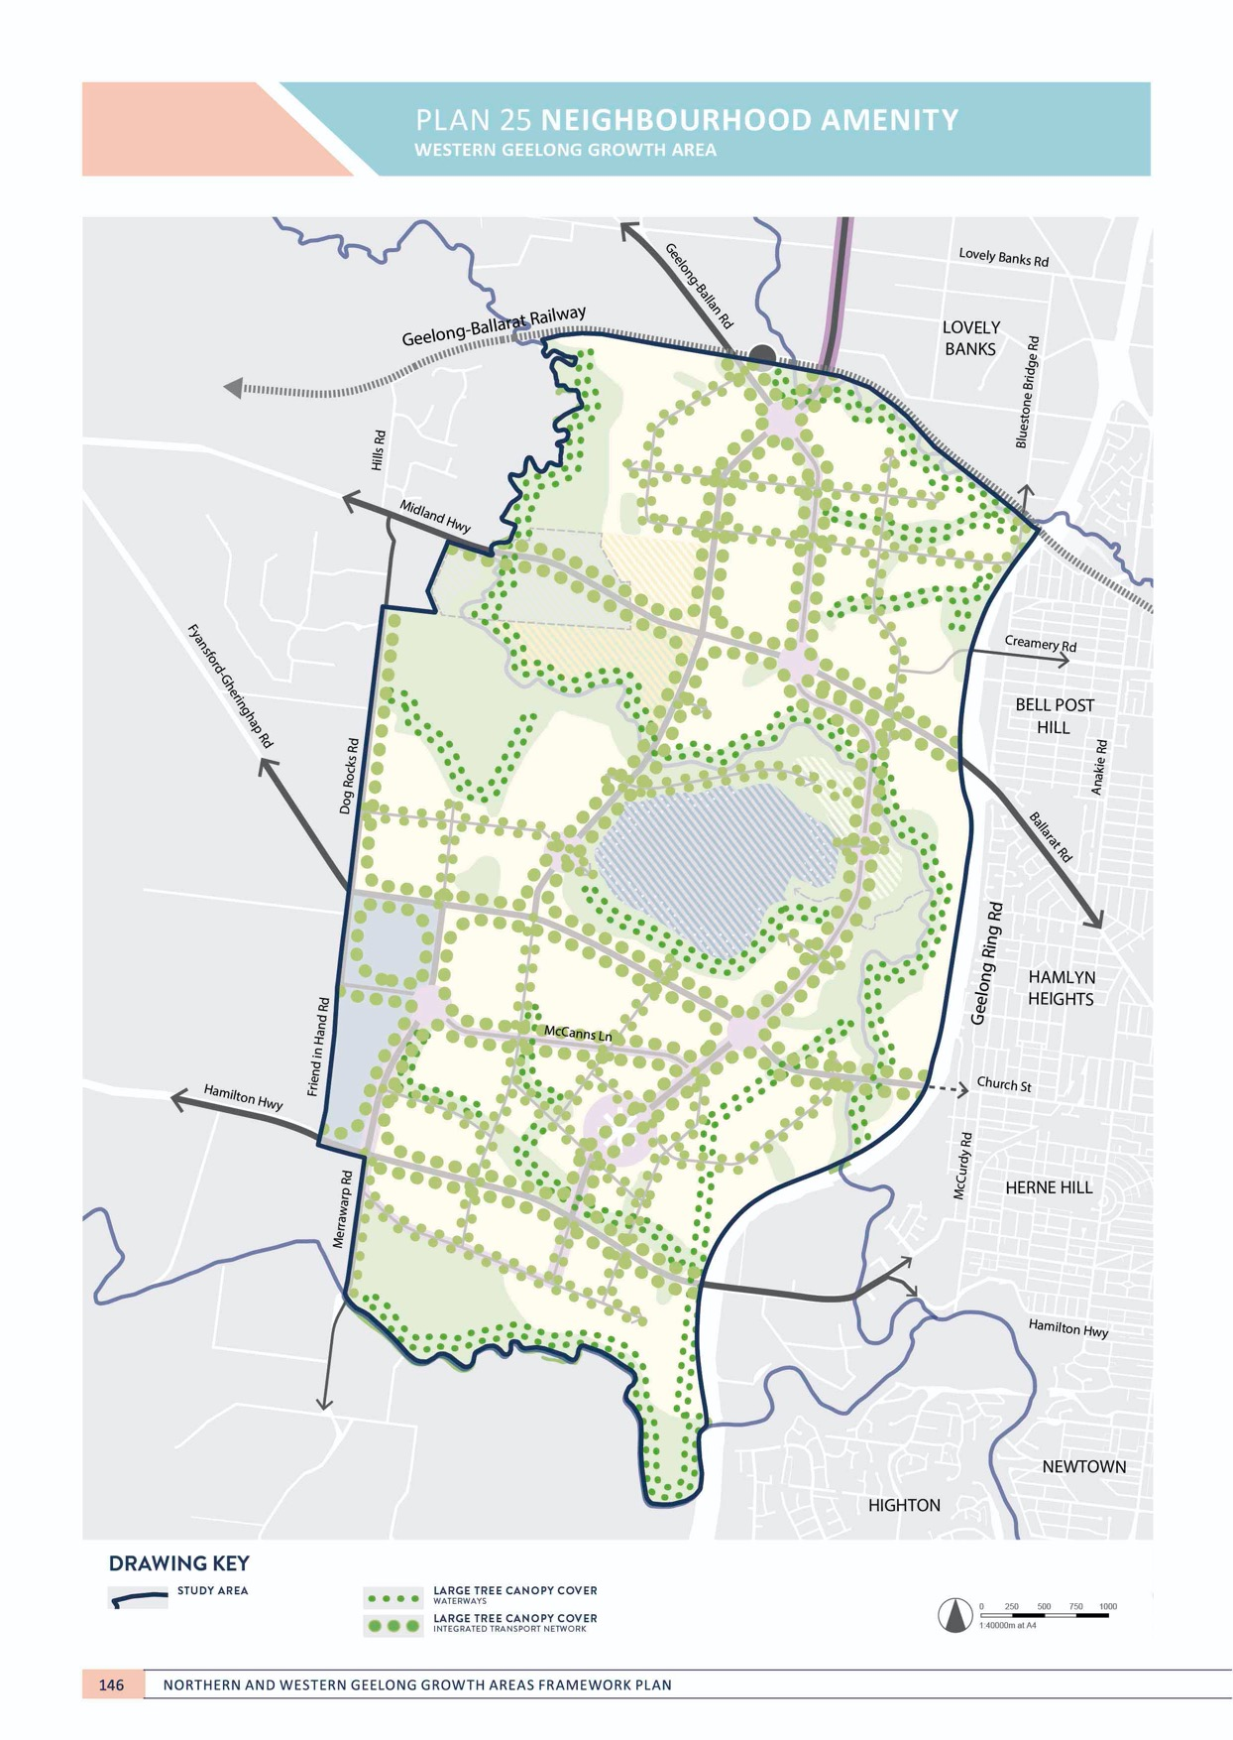

NEIGHBOURHOOD

NEIGHBOURHOOD AMENITY
WESTERN GEELONG GROWTH AREA

CONTEXT

The appearance of a neighbourhood and its public realm is essential to its value within the community. Neighbourhood amenity builds social capital as it encourages residents
to use and enjoy their surroundings in daily life. Strong communities are connected, creative and set within a healthy environment that promotes activity, health and well-being.
Neighbourhood amenity is experienced at the human scale. Residents, upon leaving their homes, should immediately feel encouraged to walk within their neighbourhoods and engage with their community. Tree- lined streetscapes and open spaces that are well vegetated and maintained create neighbourhood amenity. Comfort, safety and nearby, attractive destinations encourage engagement with the public realm.
Significant tree canopy in neighbourhoods is fundamental to delivering high amenity within the neighbourhood and creating achieving a sense of place. Tree canopy cover provides shade to reduce heat and sun exposure, provides

visual interest, delivers energy savings in buildings, provides habitat for wildlife, abates wind and improves the value of the street.
Broadly, creating and maintaining neighbourhood amenity is fundamental to securing Geelong’s economic future.
The amenity of the city attracts new residents, supports businesses, facilitates major infrastructure and investment in the city and its tourism, arts, culture and events.
The Western Geelong Growth Area has many natural amenities that will be complemented by high
neighbourhood amenity. Other large areas are treeless pastoral land or in need of significant rehabilitation and will require significant and early investment in the cultivation of tree canopy by land developers.

NEIGHBOURHOOD

ACTION W2.2.1
Tree canopy in the public realm will be maximised and contribute significantly to neighbourhood amenity. Tree canopy coverage, preferred species and priority locations for planting and revegetation will
be consistent with the directions of the Urban Forest Strategy to deliver:
- High tree canopy coverage on public and private land at a minimum of 25% suburban tree canopy at key destinations and along the Clever and Creative Corridor with complimentary in-and above-ground infrastructure.
- Priority tree planting at locations along waterways, open spaces and the integrated transport network
- A mix of local, indigenous and exotic species
- An extension of native canopy
The Urban Forest Strategy sets key targets for performance of the public urban forest and provides a framework to encourage growth of the private realm urban forest. Tree planting will extend the canopy extent of conservation areas by using local indigenous species in the adjacent road networks.

ACTION W2.2.2
Streets will be orientated to key destinations and the open space network.
The street network will create line of site and direct access to attractive destinations within neighbourhoods including the lake and lakeside recreation areas, river and creek corridors and Dog Rocks Flora and Fauna Sanctuary.
ACTION W2.2.3
Car parking in local streets will not dominate the streetscape.
Streets will be designed for people and subdivision design will ensure that on-street parking does not dominate the streetscape in local streets. Street design will manage and limit excessive on-street parking.

ACTION W2.2.4
Public realm will be designed to be a comfortable, inviting, visually interesting and support biodiversity.
The Clever and Creative Corridor will be a central location for focusing high quality investments in the public realm delivered in partnership with local artists, cultural and community groups to establish public events and art and creative community initiatives. The broader street network will incorporate mechanisms to allow for native, drought tolerant planting in nature strips.

ACTION W2.2.5
High quality street furniture will be provided to maximise comfort for pedestrians, cyclists and public transport users at frequent spacing.
The Clever and Creative Corridor will be a focal point for delivery of high quality street furniture, including seats, shelters and rest areas that support sustainable transport modes. The broader street network will deliver street furniture in areas of high activity and at locations that capture key public views.

ACTION W2.2.6
Key existing arterial roads will be designed to ensure that upgrades and duplications reflect the urban nature of the area and provide high quality gateway treatments.
Road design on existing arterial roads will ensure that design speeds, cross sections, intersection treatments and interfaces are designed to respect the urban nature of the area, minimise widths and prioritise pedestrians, cyclists and public transport, where appropriate.

ACTION W2.2.7
Medium and high density housing areas will incorporate higher quality public realm improvements to compensate for smaller private spaces.
Medium and high density housing areas will deliver more intensely planted street trees and centralised local parks to beautify the public realm and compensate for the loss of planting opportunities in private gardens.

IMAGE IS NOT AVAILABLE WITHIN THIS VERION.
TO VIEW SUPPORTING VISUAL FOR THIS PAGE GO TO
www.geelongaustralia.com.au/futuregrowth/default.aspx
TO ACCESS PDF.

NEIGHBOURHOOD

NEIGHBOURHOOD SUSTAINABILITY
WESTERN GEELONG GROWTH AREA

CONTEXT

Greater Geelong is a One Planet Council that is committed to creating a carbon neutral city-region as part of a clever and creative future. Creating new neighbourhoods that are climate resilient, net carbon positive and environmentally sustainable is essential to achieving the community’s vision for prosperous, healthy communities within Greater Geelong.
Highly responsive and integrated environmentally sustainable design of infrastructure and the built
and natural environment is fundamental to achieving sustainable neighbourhoods.
Delivering integrated water management solutions in the Western Geelong Growth Area is critical to protecting and enhancing its natural environment and maintaining healthy waterways.
The Clever and Creative Corridor will showcase how implementation of environmentally sustainable design, integrated water management and smart city technologies can be implemented within new communities.
ACTION W2.3.1
Urban development will be designed to achieve a zero carbon future for the Greater Geelong city-region.
An environmentally sustainable design (ESD) action plan will be prepared for each precinct structure plan demonstrating the actions that urban development will take to contribute net zero carbon to the city. A ‘smart city’ strategy will be included within the action plan that
establishes a framework for monitoring the performance of new neighbourhoods in delivering sustainable development and more efficient urban service systems. The Clever and Creative Corridor will support implementation of these technologies.

ACTION W2.3.2
Neighbourhood layout and orientation will reduce energy consumption and create comfortable buildings and resilient communities
Neighbourhood design will prioritise site and street layout to maximise north-facing facades and promote building massing and associated planting to create winter solar gain, summer shading, wind breaks and ventilation.

ACTION W2.3.3
Energy systems will anticipate renewable supply sources through all land use types.
Network-scale renewable energy production and storage will be anticipated and demonstrated by urban development. As urban development progresses over time, neighbourhood-scale renewable opportunities will be investigated to provide appropriate renewable energy
production, storage and trading. The action plan for each precinct will consider mandating the use of low-carbon energy sources and limiting the provision of natural gas to new urban development. The Clever and Creative Corridor will, where appropriate, be the central spine to implement network-scale renewable energy systems.

ACTION W2.3.4
Neighbourhoods will be designed to enable adoption of future, cleaner technologies.
Neighbourhoods will be designed with the capacity to adapt to new technologies including innovations in
buildings, transport, energy and waste. The Clever and Creative Corridor will provide space for incorporating future technologies and will implement enabling infrastructure
to support smart city assets, electric vehicle charging and autonomous vehicles.

ACTION W2.3.5
Innovation in the design of waste collection, transfer, treatment and disposal systems will be necessitated by large-scale urban development.
Waste minimisation, reuse and recycling that can be implemented in the construction and occupation of new neighbourhood will be assessed as part of each action plan to fulfil the City’s strategic goal of zero waste to landfill.
Consideration will be given to how waste infrastructure can be implemented into the Clever and Creative Corridor to support the zero waste to landfill goal.

ACTION W2.3.6
Neighbourhoods will maximise the use of alternative water sources to meet fit-for-purpose needs and deliver multi-functional benefits.
An integrated water management strategy will assess the feasibility of local and precinct-scale stormwater collection, treatment and reuse, wastewater treatment and reticulation through a dual-pipe network that delivers recycled water
to each neighbourhood for appropriate domestic and commercial uses. The Clever and Creative Corridor will showcase best practice integrated water management approaches and will integrate water sensitive urban design into the public realm to create attractive, interesting and drought resistant landscape elements.
ACTION W2.3.7
Neighbourhoods will deliver safe, reliable, high quality drinking water and sewage services.
Drinking water and sewage services will meet mandatory standards for each neighbourhood.

ACTION W2.3.8
New communities will enable innovative local food production opportunities
Multi-purpose urban spaces and appropriate planning mechanisms will support local food growth and community- based food growth opportunities. These opportunities
will be supported in appropriate areas of the Clever and Creative Corridor.

IMAGE IS NOT AVAILABLE WITHIN THIS VERION.
TO VIEW SUPPORTING VISUAL FOR THIS PAGE GO TO
www.geelongaustralia.com.au/futuregrowth/default.aspx
TO ACCESS PDF.

PLAN 26 HOUSING
WESTERN GEELONG
Bluestone Bridge Rd

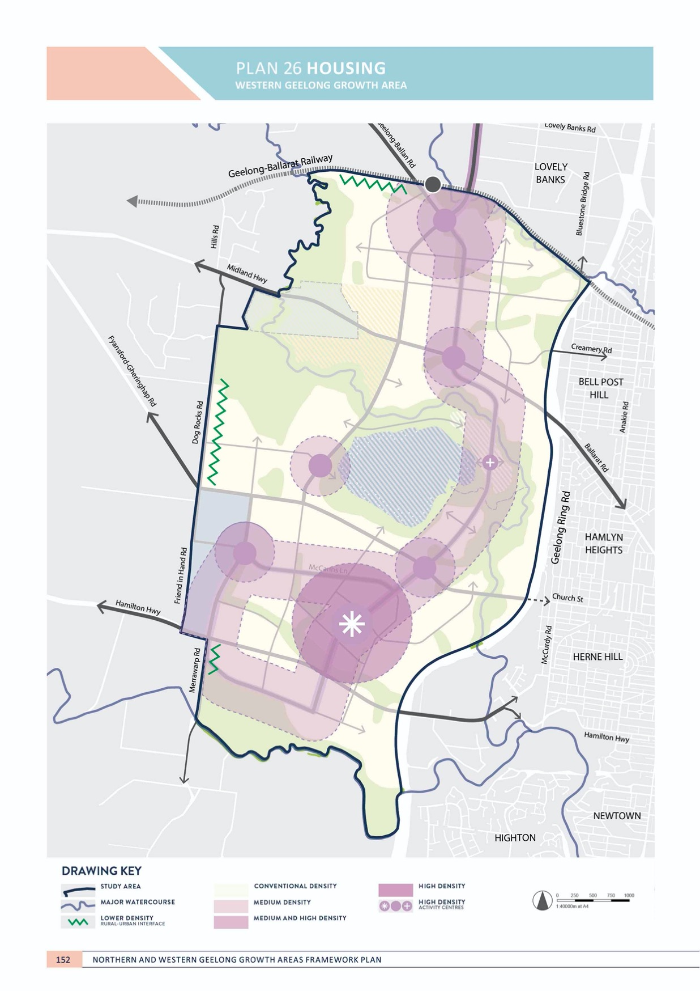

NEIGHBOURHOOD

HOUSING
WESTERN GEELONG GROWTH AREA

CONTEXT

Housing diversity is vital to the success of neighbourhoods. A diverse mix of housing types and densities caters to a diverse community where demographics and cultures are combined. Housing diversity underpins a neighbourhood that is vibrant, activated at all times throughout the day
and maintains a range of services and facilities useful to all abilities and ages.
Housing diversity ensures that anyone can find a suitable place to live in the neighbourhood: where growing families can upsize, empty-nesters can downsize, and where students, workers and retirees can find compact living options that are affordable and close to services.
Housing diversity enables higher densities to be achieved, promoting a greater population that supports high quality and efficient infrastructure and services and resists continuous urban expansion.
Housing diversity improves built form outcomes as varied typologies and interfaces in the streetscape create a more interesting, socially connected, vibrant and active neighbourhood.
Implementing environmentally sustainable design (ESD) principles in housing plays an important role in neighbourhood sustainability by creating healthier communities that minimise impacts on the natural environment to potentially reduce long-term financial pressures on the community.
The Clever and Creative Corridor provides the opportunity to showcase how the ‘missing middle’ (medium) density housing types can be supported within neighbourhoods and will be an area where housing diversity and adoption of best practice ESD principles will be encouraged.
ACTION W2.4.1
Urban development will deliver a diverse mix of housing options throughout each neighbourhood.
A mix of housing densities and typologies will be delivered to support a diverse community. Housing will offer choices that meet the broad and changing requirements of the community and implement universal design principles.

ACTION W2.4.2
Housing in medium density areas will cater for the ‘missing middle’ housing types.
Medium density residential areas will be encouraged to deliver low-rise, multi-unit and clustered housing types that are mixed with a variety of building types.

ACTION W2.4.3
Housing within and adjoining activity centres will be delivered at high density.
Urban design frameworks for sub-regional and neighbourhood activity centres will determine appropriate areas of high and medium density housing within and adjoining activity centres that promote increased vibrancy of the streetscape, more prosperous local economies and enable greater access to amenities and services.

NEIGHBOURHOOD

ACTION W2.4.4
Housing along the river and creek corridors will be designed to integrate and enhance the natural amenity of the landform.
The design of housing, subdivision and the urban environment along river and creek corridors will incorporate elements that integrate housing into the landform, protect the creek environs and deliver high quality buildings and urban design that respect the natural setting of the corridors through landscaping, allotment size and appropriate siting of buildings.

ACTION W2.4.5
Housing in direct proximity to Batesford township, Dog Rocks Flora and Fauna Sanctuary and in rural interface areas will be designed to appropriately respond to the neighbouring environment.
Areas of rural interface along the north-western and western boundaries of the growth area will be designed with designs that respect the rural interfaces, and character and amenity of the Batesford township and surroundings.
ACTION W2.4.6
Neighbourhoods will provide opportunities for aged- care and affordable, community and social housing.
A mix of aged-care, affordable, community and social housing options will be encouraged within medium density areas to take advantage of services, amenities and public transport within a walkable distance.

ACTION W2.4.7
Housing will be encouraged to incorporate ESD principles in the design to deliver carbon neutral communities.
Housing design will incorporate guidelines on methods for achieving more climate resilient buildings that provide
comfort during extreme heat events, drought, flooding and reduced resource dependency. Initiatives to encourage carbon neutral housing within the Clever and Creative Corridor will be explored as part of the relevant precinct structure plan.

IMAGE IS NOT AVAILABLE WITHIN THIS VERION.
TO VIEW SUPPORTING VISUAL FOR THIS PAGE GO TO
www.geelongaustralia.com.au/futuregrowth/default.aspx
TO ACCESS PDF.

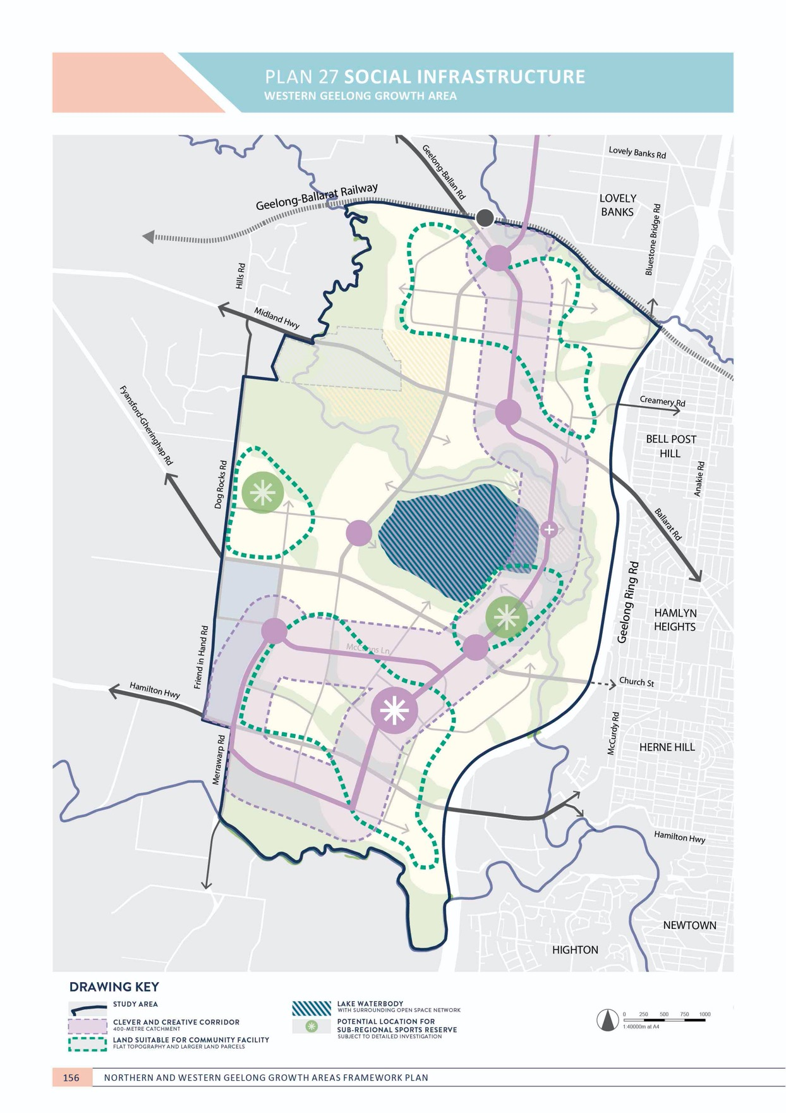

NEIGHBOURHOOD

SOCIAL INFRASTRUCTURE
WESTERN GEELONG GROWTH AREA

CONTEXT

Social infrastructure is a fundamental component of the neighbourhood. Healthy communities enjoy easy access to a wide range of community facilities, services and public open space.
Social infrastructure will be delivered in the Western Geelong Growth Area to provide a wide range of universal facilities and services including schools, community centres and meeting places, arts and cultural facilities and health and emergency services. Western Geelong’s new neighbourhoods will be linked by a comprehensive open space network of local and linear parks and sport and recreation facilities.
River and creek corridors offer an attractive linear corridor that will link social infrastructure between neighbourhoods and to central Geelong via the Barwon River corridor.
The centrepiece of Western Geelong is a lake. Transformation of Batesford Quarry to a recreational lake is a city-shaping opportunity that will create a new landmark for Geelong.
The estimated social infrastructure required to support new communities in the Western Geelong Growth Area includes:
Community facilities
- One cultural hub that incorporate a library, arts and cultural spaces and meeting rooms
- Three multi-purpose community centres that incorporate a neighbourhood house, flexible community meeting spaces and community gardens
- Three neighbourhood centres that incorporate flexible community meeting spaces
- Two integrated children’s centres incorporating maternal and child health services, community meeting spaces, a kindergarten and long and occasion care centres
- Three maternal and child health centres
- Four kindergartens
- Six long day child care centres

- One health and wellbeing centre incorporating a community health centre, flexible community meeting
spaces, youth and seniors spaces and services to support aged, disabled and culturally and linguistically diverse members of the community
- 10-11 primary schools
- Three secondary schools
- One police station collocated with a justice centre
- One emergency hub incorporating ambulance, fire and state emergency services.
Open space, sport and recreation
- Moorabool River corridor open space network
- Barwon River corridor open space network
- Cowies Creek corridor open space network
- Regional lake and open space reserve (former Batesford Quarry)
- A network of active open space (sports and recreation) and passive open space (local parks) for residential land throughout the growth area equivalent to 10% of the net developable area
- Internal demand throughout the growth area for a sub- regional sport reserves and facilities on twelve hectares of unencumbered land
- Two indoor recreation centres
- An aquatic centre
- A network of passive open space (local parks) for employment land throughout the growth area equivalent to 2% of the net developable area.
The anticipated population of the growth areas satisfies approximately half the benchmark provision trigger of 200,000 residents. Future demands on major health facilities will be assessed as part of Geelong’s growth and should be co-located with
sub-regional activity centre, if provided.

NEIGHBOURHOOD

ACTION W2.5.1
A social infrastructure needs assessment will be undertaken for each precinct that identifies the community facilities and open space required to support new residents.
The assessment will provide recommendations for the provision of social infrastructure based on anticipated dwelling and population yields to be determined by detailed planning. Each assessment will be prepared to deliver social infrastructure in accordance with the Social Infrastructure Plan.

ACTION W2.5.2
Social infrastructure will be highly accessible to the entire community.
Social infrastructure will be comprehensive and interconnected delivering:
- Community hubs along the Clever and Creative Corridor unless prohibited by land use constraints
- Delivering active and passive open space along the Clever and Creative Corridor and/or waterway corridors, where landform is suitable and not fragmented
- Delivering a network of active and passive open space equivalent to ten per cent of the developable land in the growth area.
ACTION W2.5.3
Social infrastructure will be provided to new neighbourhoods in the early stages of urban development.
Early provision of infrastructure is critical to building social capital within new communities and enhancing the social value of new neighbourhoods. Social infrastructure will be delivered to ensure that each precinct is supported with ‘standalone’ infrastructure so that communities are not reliant on long-term development outcomes.

ACTION W2.5.4
Innovative methods of delivering social infrastructure will be explored to identify best practice provision methods that meet the needs of the community.
Delivery of social infrastructure will maximise community benefit by identifying innovative provision methods including private-public partnerships, shared use of infrastructure between facilities and services, and methods to secure land at the lowest cost to the community.

ACTION W2.5.5
Design of social infrastructure will create community spaces that are flexible, adaptable and multi-purpose.
Social infrastructure will be delivered with the capacity to incorporate a wide range of services that deliver benefits to the whole community and adapt to their changing needs.

ACTION W2.5.6
Community facilities will deliver accessible cultural spaces that support a wide range of cultural and community outcomes.
The network of higher-order community facilities will cater for large-format outdoor events spaces that are suitable for arts and cultural programs hosted within the community.

ACTION W2.5.7
Social infrastructure will be co-located to enable integration of services and create accessible, vibrant and socially diverse community hubs.
Co-location of social infrastructure allows access to a broad range of services in a single location to promote accessibility and social cohesion.

ACTION W2.5.8
The sub-regional activity centre will support higher- order social infrastructure.
An urban design framework will be prepared for the sub-regional activity centre that identifies higher-order
community facilities in locations that support an accessible and vibrant heart of the community.

ACTION W2.5.9
Social infrastructure and open space will be safe and accessible with high-quality active and public transport connections and active road frontages.
Social infrastructure will be designed and located to ensure that frontages are activated with attractive interfaces and provide passive surveillance and direct connections to active transport and public transport. Social infrastructure and open space will be integrated to enable complementary use of spaces.
ACTION W2.5.10
Integrated water management will maximise ‘green- blue connections’ to active open space that allows the operation of attractive, all-year facilities.
Integrated water management will identify methods to utilise water sensitive urban design (WSUD), stormwater treatment and recycled water to deliver open spaces that remain useable and attractive throughout the year. Local parks and sports reserves will be located along waterways and river corridors, where appropriate. Co-location of parks and reserves will seek to link and extend the recreational benefits to encumbered land.

ACTION W2.5.11
Emergency services will be located with direct accessibility to the Geelong Ring Road and the arterial road network.
The high accessibility requirements of emergency services will be catered for in the design of the integrated transport network.

NEIGHBOURHOOD

ACTION W2.5.12
The delivery of sub-regional active open space will be delivered in a manner that maximises the broader community benefit.
Sub-regional facilities serve the needs of both existing and new communities and their provision will be subject to detailed location assessments that consider their broader accessibility, connectivity to complementary uses, co-location with smaller facilities and the use of existing assets.
ACTION W2.5.13
Key features of the growth area will be utilised for social infrastructure and celebrated to create social capital within the community including:
- The Clever and Creative Corridor
- Regional-scale open space and recreation opportunities created with the transformation of Batesford Quarry
- Regional-scale open space corridors along the Barwon River, Moorabool River and Cowies Creek.
The river and creek corridors provide excellent locations for recreation and passive enjoyment and can provide linkages between social infrastructure between neighbourhoods.
Transformation of the Batesford Quarry is a city-shaping regional open space opportunity. Master planning for each of these assets should maximise the integration for social infrastructure in balance with other considerations.

IMAGE IS NOT AVAILABLE WITHIN THIS VERION.
TO VIEW SUPPORTING VISUAL FOR THIS PAGE GO TO
www.geelongaustralia.com.au/futuregrowth/default.aspx
TO ACCESS PDF.

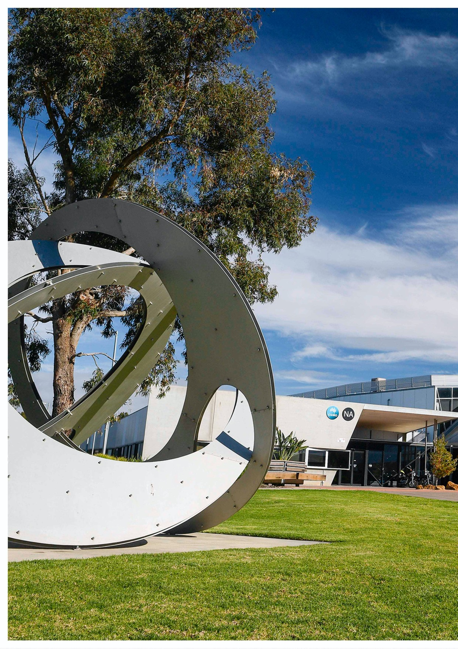

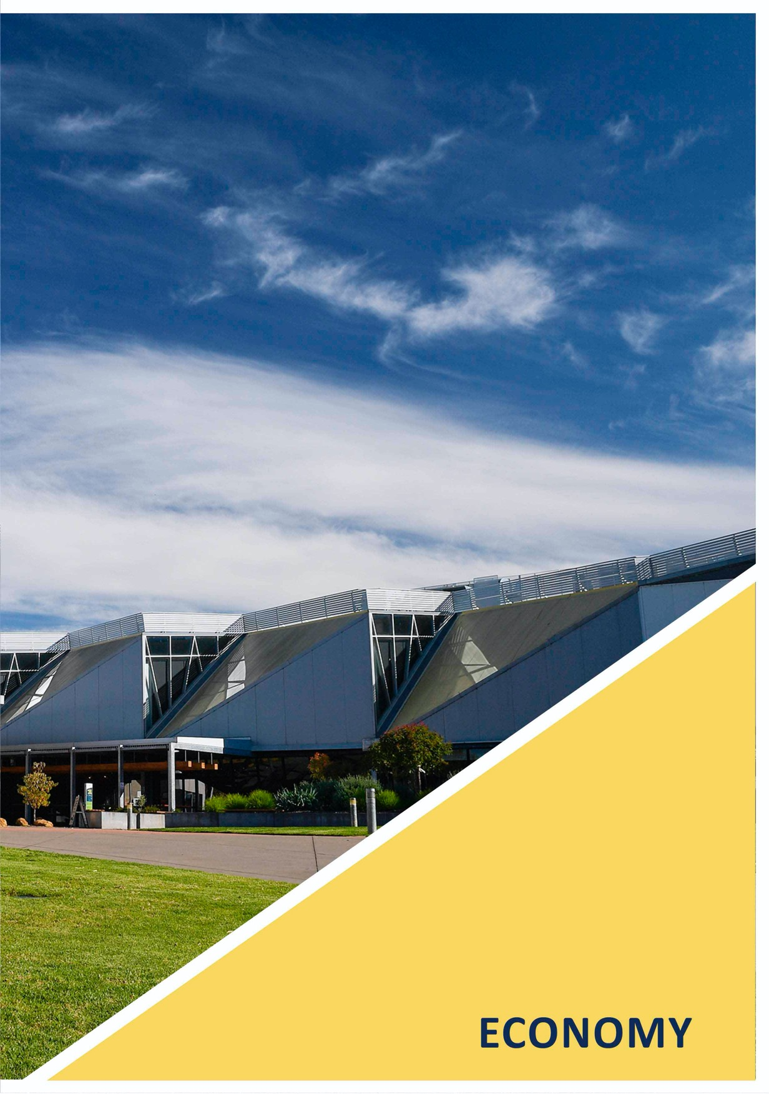

ECONOMY

ECONOMY is the element that commits Geelong’s growth areas to contribute to our creative, enterprising and prosperous economic future.
Access to local jobs and wider employment opportunities is a major contributor to the health and sustainability of new communities. The Northern and Western Geelong Growth Areas are well positioned to create business opportunities that are diverse, competitive and supported by a highly skilled workforce.
Economy in the Northern Geelong Growth Area will capitalise on direct access to many of Geelong’s diverse employment hubs including the Geelong Ring Road Employment Precinct, Avalon Airport and the Port of Geelong. Panoramic views and distinctive landforms afforded by the Lovely Banks monocline will provide an attractive setting for its activity centres.
The Western Geelong Growth Area will create a network of activity centres anchored by its most significant features including the river and rail corridors, employment precinct and lake. Dual access points to the Western District via the Hamilton and Midland Highways is a key advantage of its employment precinct.
Activity centres throughout the growth area will support sustainable, self-sufficient communities that enjoy services, facilities and places to meet and work in their neighbourhood.
ECONOMY considers the future economic landscape of the Northern and Western Geelong Growth Areas including the network of activity centres and employment precincts that will support a resilient, adaptive and innovative workforce.

PREVIOUS PAGE: CLEVER AND CREATIVE ECOMONY
– GEELONG FUTURE ECONOMY PRECINCT, DEAKIN UNIVERSITY

IMAGE IS NOT AVAILABLE WITHIN THIS VERION.
TO VIEW SUPPORTING VISUAL FOR THIS PAGE GO TO
www.geelongaustralia.com.au/futuregrowth/default.aspx
TO ACCESS PDF.

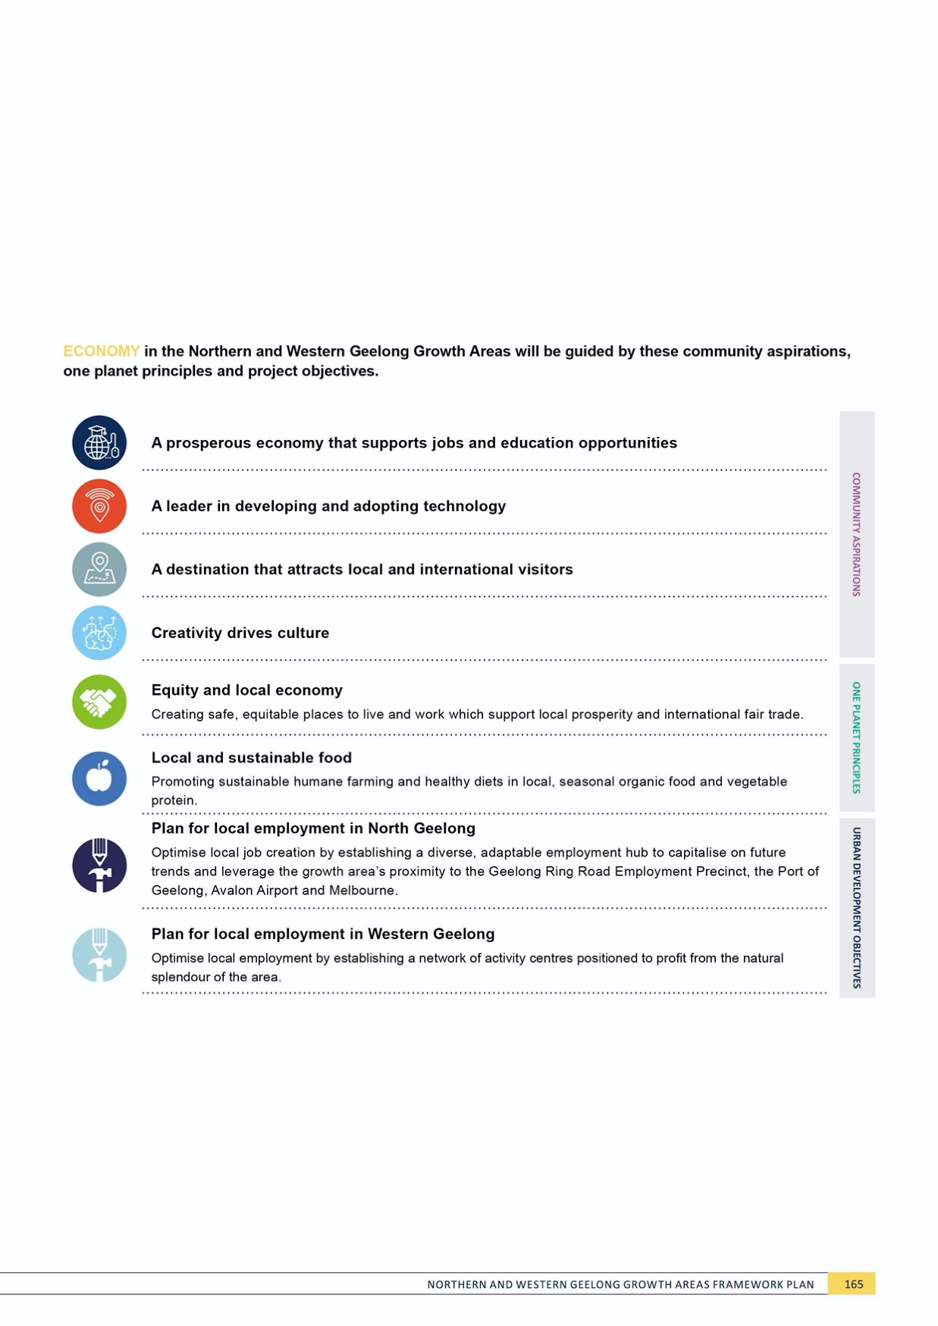

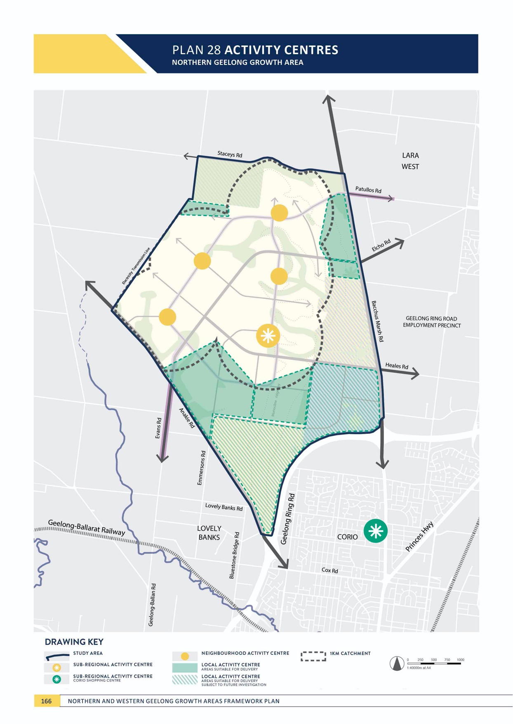
PLAN 28 ACTIVITY CENTRES
NORTHERN GEELONG GROWTH AREA

ECONOMY
NORTHERN GEELONG GROWTH AREA

ACTIVITY CENTRES
NORTHERN GEELONG GROWTH AREA

CONTEXT

The Northern Geelong Growth Area will accommodate a local population that is equal to the size of a large regional city. At this scale, the growth area must establish a network of activity centres that become the heart of the local community.
Activity centres are the meeting places and focus points for the neighbourhood, providing a range of retail, commercial, entertainment and community facilities and services at different scales. Activity centres provide residents, visitors and workers with easy access to a range of services
and facilities, along with opportunities to establish local businesses, make meaningful connections and build communities.
Urban Geelong’s retail hierarchy provides for a spatial distribution of shopping opportunities that minimises the cost of travel to consumers and the environment. The activity centre network consists of one regional centre, central Geelong, and four sub-regional centres at Corio, Belmont, Leopold and Waurn Ponds, with one planned for Armstrong Creek.
Activity centres in the growth area need to be considered in the context of Geelong’s existing retail hierarchy.
The timing, location and size of activity centres must be carefully planned to support the local communities
while managing impacts on the City’s broader network of centres.
ACTION N3.1.1
An activity centre will be located at the heart of each 20-minute neighbourhood, containing a mix of locally- oriented facilities and services, shops, community services and schools, where appropriate.
The activity centre hierarchy of the Northern Geelong Growth Area is illustrated on Plan 28 and includes:
- One sub-regional activity centre
  - Sub-regional activity centres deliver a comprehensive range of large-scale retail, commercial, entertainment and community uses required in the region and support high density residential development in the surrounding neighbourhoods.
- Four neighbourhood activity centres
  - Neighbourhood activity centres deliver a mix of everyday shopping needs and local services, co- locating with community facilities and services to create the local heart of the surrounding neighbourhoods. The centres complement the sub-regional activity centres without detracting from their role.
- Local convenience centres, in locations beyond activity centre catchments.
  - Local activity centres serve the day-to-day convenience needs of the immediate residential neighbourhood. A local activity centre provides an alternative for residents beyond a comfortable walk to the sub-regional or neighbourhood activity centre.

ECONOMY

ACTION N3.1.2
Activity centres will complement the existing activity centre network of Greater Geelong by supporting the Central Activity Area (central Geelong) as the primary centre in the region.
The network of activity centres in the Northern Geelong Growth Area will deliver the local, neighbourhood and sub- regional needs of their local communities without adversely impacting the existing broader network, most notably in Lara, Corio and central Geelong.

ACTION N3.1.3
The activity centre network will promote local food production.
The activity centre network will explore opportunities for permanent fresh food markets that support local food production in the surrounding local region.
ACTION N3.1.4
An urban design framework will be undertaken to inform the delivery of each sub-regional and
neighbourhood activity centre and will be based on concept plans prepared within the relevant precinct structure plan.
The urban design framework (UDF) will outline an integrated design vision that informs the future
development of each sub-regional and local activity centre. The UDF will identify development principles, key design concepts, place making initiatives and an implementation strategy with key actions. A key focus of the UDF will
be to ensure the structure of each sub-regional activity centre can respond to the changing needs of residents, businesses, and visitors over time. The UDF will address ESD principles and sustainability, public realm and amenity, land use and activity, access and movement, built form and character, and the integration of the activity centre with the Clever and Creative Corridor.

ACTION N3.1.5
All activity centres will incorporate best practice environmental sustainability in their design and operations.
Activity centres will incorporate design that optimises solar access, walkability and the use of active transport, water sensitive urban design principles, green buildings and integrated water management. Sub-regional and
neighbourhood activity centres will explore opportunities in renewable energy solutions, resource and material reuse opportunities, minimisation of maintenance requirements and access to open space and nature. Activity centres will be a key focus of the ESD action plan prepared for each precinct and will incorporate smart city principles.

ACTION N3.1.6
The sub-regional activity centre will establish a vibrant urban heart of the Northern Geelong Growth Area, delivering a diverse mix of retail, commercial, entertainment and community uses that activate the
area throughout the day and night, seven days a week.
The centre will provide a substantial and varied mix of land uses that meet the daily needs of the local community
and cultivate a lively, stimulating and safe environment at all times. The centre in the Northern Geelong Growth
Area will be delivered at a scale that generates significant local employment opportunities, with a retail floor space of approximately 25,000m2- 30,000m2, and non-retail space of approximately 10,000-20,000m2.

ACTION N3.1.7
The sub-regional activity centre will be developed with a welcoming, high amenity public realm, with safe
and accessible pedestrian environments, pedestrian priority, active ‘main street’ frontages and a range of high quality public spaces.
Vibrant and successful major activity centres will be facilitated by development of an attractive, safe and pedestrian oriented public realm. Built form and design of public spaces will ensure a walkable environment that
provides safety and comfort for pedestrians of all ages and abilities.
ACTION N3.1.8
The sub-regional activity centre will be characterised by a hierarchy of high quality public spaces that are part of a wider public realm network catering for the diverse aspirations and needs of the local community.
A welcoming, high amenity public realm will respond to the monocline escarpment and ‘main street’ based frontages to encourage the community to walk, linger, and engage. Built form and design of public spaces including streets, laneways, parks, public plazas, and waterways will deliver a walkable, attractive and stimulating environment that is safe and comfortable for users of all ages, abilities and transport mode choices. Public realm design will respond to the natural sloping landform, maximising opportunities to connect with the natural environment, including view lines to the You Yangs through the Lovely Banks monocline.

ACTION N3.1.9
The timing and scale of the sub-regional centre will proceed in a planned way that assesses the retail impact of the proposed centre and will allow any potentially affected existing centres time to adjust to new circumstances.
The Northern Geelong Growth Area will be planned and developed sequentially. The timing, location and scale of the proposed sub-regional centres, and any potential
impacts on the existing centre network, will be considered and floor space caps applied as part of each precinct structure plan.

ECONOMY

ACTION N3.1.10
The sub-regional activity centre will be delivered in a staged approach.
The sub-regional activity centre is likely to be delivered as a neighbourhood-sized activity centre as part of medium term development. The design of the sub-regional activity centre will be delivered in a staged approach that allows a seamless and future-proofed transition from neighbourhood to sub-regional scale as part of subsequent precinct structure planning. Extension of the activity centre to a sub- regional activity centre will address the views and landform of the monocline escarpment and ridgeway.

ACTION N3.1.11
The sub-regional activity centre will be located and designed to prioritise access by active and public transport.
Siting and design of the centre will prioritise walking, cycling and public transport, over private vehicle access through a permeable grid of landscaped streets and lanes that focus activity and services around public transport nodes. Pedestrian priority will be established by designing ‘main street’ frontages with high levels of amenity that respect the human scale and are directly connected to broader active and public transport networks; including the Clever and Creative Corridor.
ACTION N3.1.12
Four neighbourhood activity centres will be delivered throughout the Northern Geelong Growth Area located to provide convenient, walkable access to their respective catchments.
Neighbourhood activity centres will be provided and distributed within the growth area to serve neighbourhood catchments up to 10,000 people in a central location.
Each neighbourhood town centre will be highly accessible by active and public transport with direct interface to the Clever and Creative Corridor. The network of centres includes four neighbourhood activity centres with an estimated retail floor space of approximately 5,000-7,000m2 and non-retail floor space of 2,000-3,000m2 each.

ACTION N3.1.13
A mix of commercial and community uses will be provided for within each neighbourhood activity centre that meet local needs.
Each neighbourhood activity centre will provide range of retail, local community facilities and other essential services. The centres will typically include a full-line
supermarket, local shopping, medical and leisure services in a format that allows seamless co-location with schools, community facilities, open space and medium density housing and specialised accommodation such as aged care and student housing.

ACTION N3.1.14
Neighbourhood activity centres will be developed with safe and accessible pedestrian environments and a high quality public realm.
The design of each centre will acknowledge its importance as centre of community life by providing a high amenity public space that creates an identifiable heart of the community and provides an attractive setting for people to meet, linger and engage in local events. The design of the centre will always prioritise pedestrian movement, amenity and safety and create easy access points from the active and public transport network.
The neighbourhood activity centre located on the monocline ridgeway will utilise the landform and view lines in its design.

ACTION N3.1.15
Local activity centres will be supported in locations that are located beyond a comfortable walk to the sub- regional or neighbourhood activity centre.
Local activity centres will serve the local needs of the immediate residential neighbourhood within comfortable walking distance without detracting from the viability of nearby neighbourhood activity centres. Local activity centres will be identified within the relevant precinct structure plan on the basis of its connection to the integrated transport network, pedestrian and cycling accessibility and co-located community uses and will be informed by design guidelines and floor space caps based on its preferred location.

IMAGE IS NOT AVAILABLE WITHIN THIS VERION.
TO VIEW SUPPORTING VISUAL FOR THIS PAGE GO TO
www.geelongaustralia.com.au/futuregrowth/default.aspx
TO ACCESS PDF.

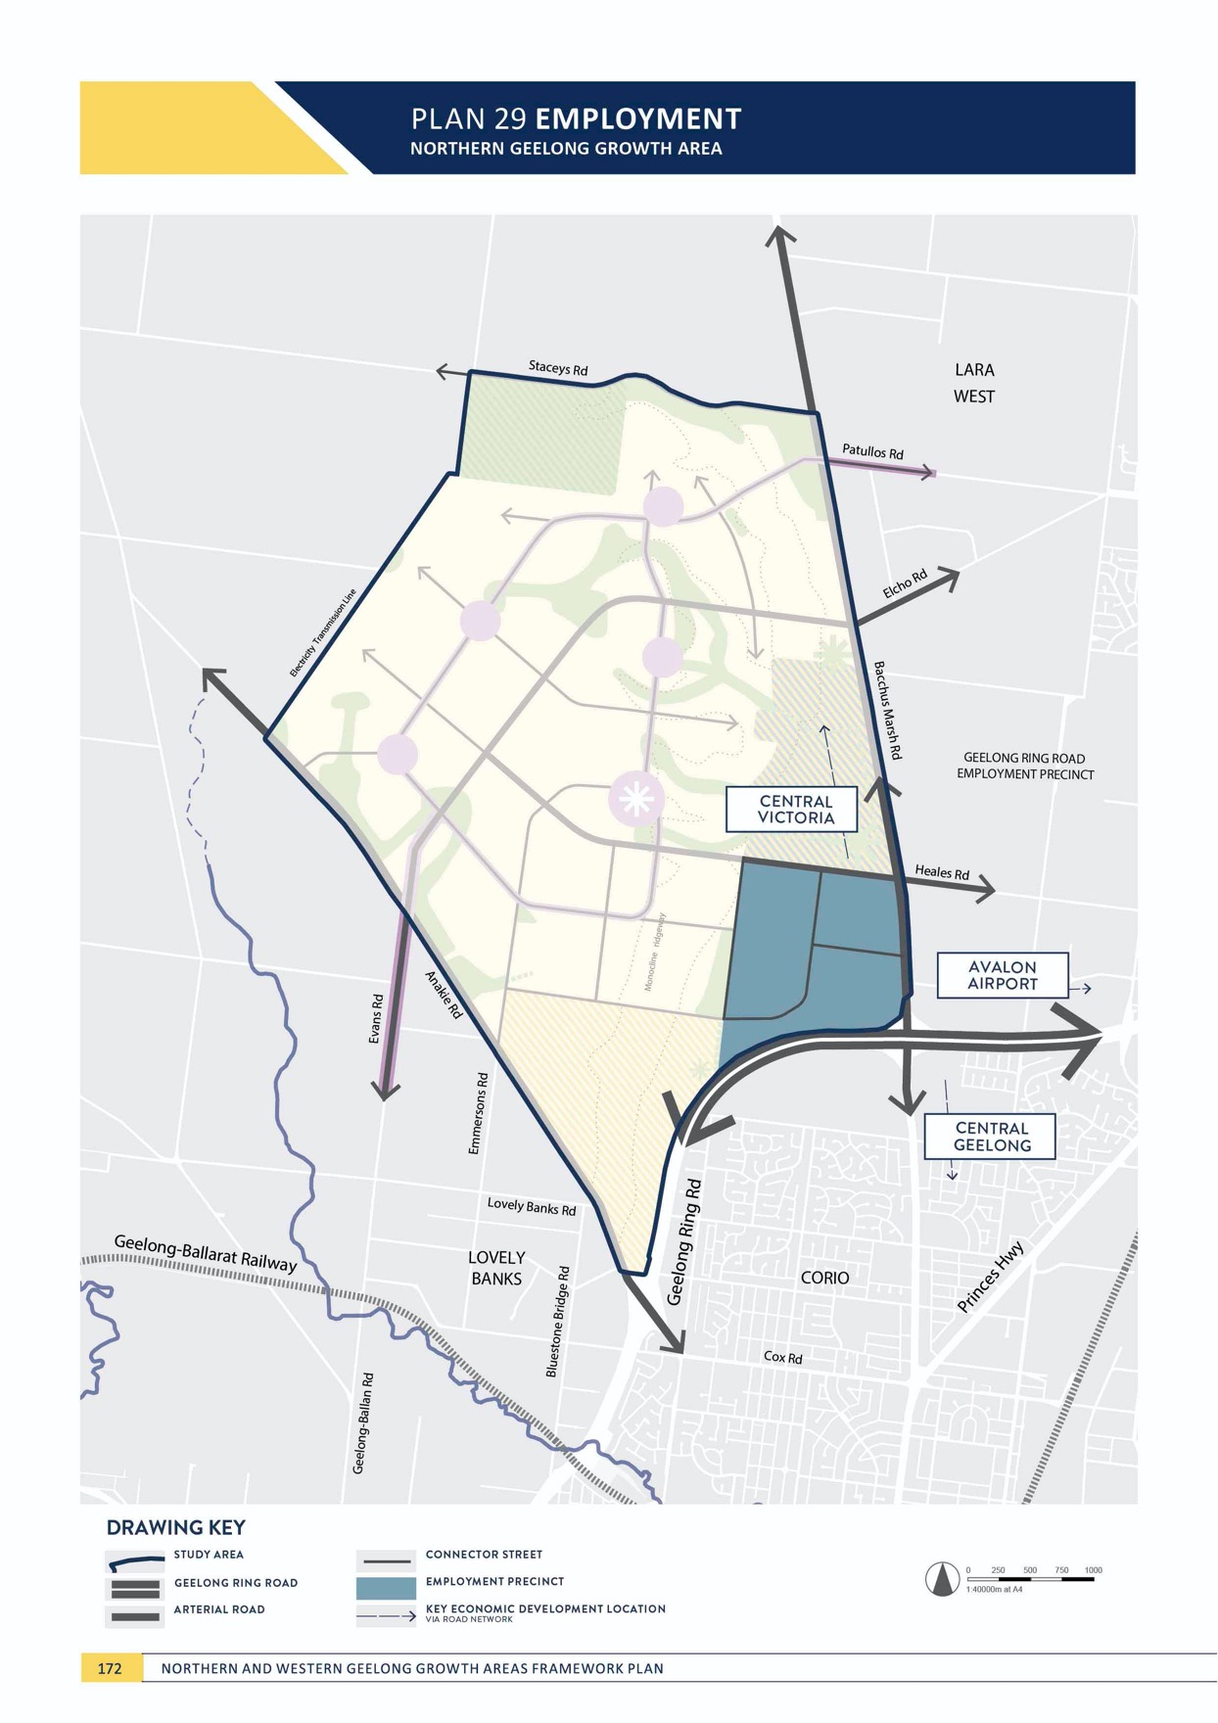

ECONOMY

EMPLOYMENT
NORTHERN GEELONG GROWTH AREA

CONTEXT

Providing local jobs in new neighbourhoods is essential to establishing self-sufficient and sustainable communities; however, it is important that Geelong’s growth benefits the broader city and continues to advance central Geelong.
The Northern Geelong Growth Area is anticipated to create up to 14,000 local jobs with a broader workforce of approximately 20,000 residents.
Many of these jobs will be provided in health and education, retail and related services, business and office- based sectors and will largely be catered for in activity centres and community hubs along the Clever and Creative Corridor.
Light industrial land uses – service industries, freight and logistics and light manufacturing – are less compatible with residential neighbourhoods and will be located within a precinct where industries can support each other and growth without impediment.
The location of the employment precinct in the Northern Geelong Growth Area is illustrated on Plan 29 and provides:
- 177 hectares of developable land bordered on all sides by arterial roads and connector streets
- Flat terrain that avoids heavy vehicle movements up and down the monocline escarpment and within residential neighbourhoods
- Outstanding access to the integrated transport network at the Geelong Ring Road and Bacchus Marsh Road.
High level analysis indicates that a total employment land required to support the local residents of the Northern Geelong Growth Area is up to 110 hectares. The proposed increased size of the employment precinct, and its potential to expand further north along Bacchus Marsh Road, is based on its strategic location adjoining the Geelong Ring Road Employment Precinct and direct proximity to the Port of Geelong and Avalon Airport. The employment precinct can grow by an additional 124 hectares, if required, to support Geelong’s long-term economic growth.
ACTION N3.2.1
Employment precincts will provide for a wide range of industrial and commercial uses to support the creation of new neighbourhoods and local job creation.
Employment precincts will be encouraged to deliver light industrial and commercial uses that include service
industries, light manufacturing, freight and logistics, urban services, business parks and offices, innovation and start- ups, indoor active recreation, service stations and places of worship.

ACTION N3.2.2
The employment precinct will be supported by providing efficient integrated transport connections to the freeway and regional highway network.
The employment precinct is located adjacent to Bacchus Marsh Road and will have convenient access to the Geelong Ring Road, providing links to the Princes Freeway, Avalon Airport, Port of Geelong and metropolitan Melbourne. Upgrades to intersections between Heales Road and the Geelong Ring Road will
be designed to allow appropriate access for heavy vehicle moments.

ECONOMY

ACTION N3.2.3
Urban design of the employment precinct will be outlined as part of the relevant precinct structure plan to minimise impacts to surrounding neighbourhood amenity.
Design guidelines, and the potential for an urban design framework, will be outlined in the relevant precinct structure plan to define the required road network and active and public transport access, landscaping of gateway and interface treatments, siting requirements, staging and indicative development timing to limit conflicts between new development and existing rural living properties.
Vehicle movements accessing the employment precinct will be primarily provided via Bacchus Marsh Road and Heales Road.

ACTION N3.2.4
Existing rural living land to the north of Heales Road may be appropriate for transition to employment land in the long term, subject to further investigation.
Further investigation of the potential of this land for future employment will be required as part of the relevant precinct structure plan. The suitability of this land for employment purposes will be subject to the demonstrated demand for employment land.

IMAGE IS NOT AVAILABLE WITHIN THIS VERION.
TO VIEW SUPPORTING VISUAL FOR THIS PAGE GO TO
www.geelongaustralia.com.au/futuregrowth/default.aspx
TO ACCESS PDF.

PLAN 30 ACTIVITY CENTRES

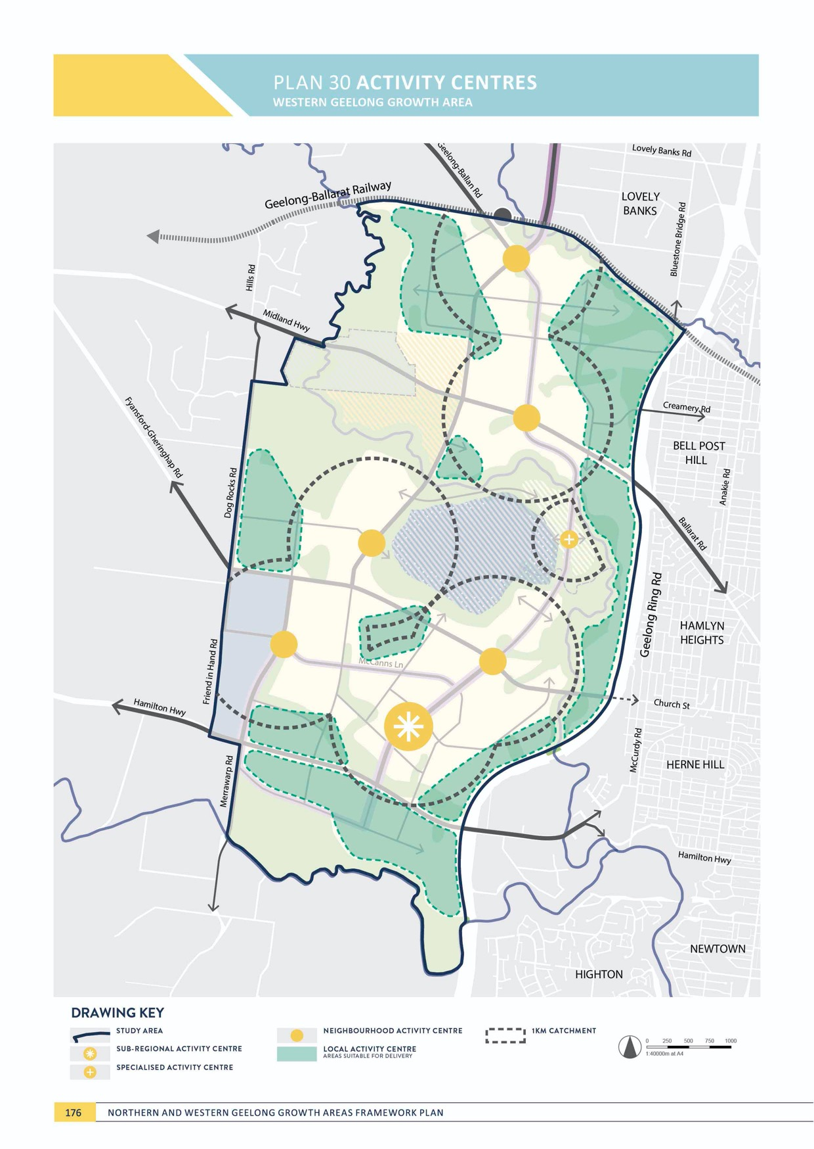
WE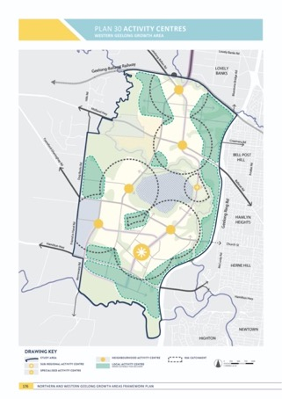STERN GEELONG GROWTH AREA

ECONOMY
WESTERN GEELONG GROWTH AREA

ACTIVITY CENTRES
WESTERN GEELONG GROWTH AREA

CONTEXT

The Western Geelong Growth Area will accommodate a local population that is equal to the size of a large regional city. At this scale, the growth area must establish a network of activity centres that become the heart of the local community.
Activity centres are the meeting places and focus points for the neighbourhood, providing a range of retail, commercial, entertainment and community facilities and services at different scales. Activity centres provide residents, visitors and workers with easy access to a range of services
and facilities, along with opportunities to establish local businesses, make meaningful connections and build communities.
Urban Geelong’s retail hierarchy provides for a spatial distribution of shopping opportunities that minimises the cost of travel to consumers and the environment. The activity centre network consists of one regional centre, central Geelong, and four sub-regional centres at Corio, Belmont, Leopold and Waurn Ponds, with one planned for Armstrong Creek.
Activity centres in the growth area need to
be considered in the context of Geelong’s existing retail hierarchy. The timing, location and size of activity centres must be carefully planned to support the local communities while managing impacts on the City’s broader network of centres.
The location of the sub-regional activity centre in the southern half of the Western Geelong Growth Area is an important factor to
ensure the future advancement of the Corio Shopping Centre.
ACTION W3.1.1
An activity centre will be located at the heart of each 20-minute neighbourhood, containing a mix of locally- oriented facilities and services, shops, community services and schools, where appropriate.
The activity centre hierarchy of the Western Geelong Growth Area is illustrated on Plan 30 and includes:
- One sub-regional (major) activity centre
  - Sub-regional activity centres deliver a comprehensive range of large-scale retail, commercial, entertainment and community uses required in the region and support high density residential development in the surrounding neighbourhoods.
- Five neighbourhood (local) activity centres
  - Neighbourhood activity centres deliver a mix of everyday shopping needs and local services, co- locating with community facilities and services to create the local heart of the surrounding neighbourhoods. The centres complement the
sub-regional activity centres without detracting from their role.
- Local convenience centres, in locations beyond activity centre catchments
  - Local convenience centres serve the day-to-day needs of the immediate residential neighbourhood. A local convenience centre provides an alternative for residents beyond a comfortable walk to the sub- regional or neighbourhood activity centre.
- One specialised activity centre, catering for local and visitor needs and incorporating ‘lakeside’
opportunities for dining and entertainment, recreation and local events.

ECONOMY

ACTION W3.1.2
Activity centres will complement the existing activity centre network of Greater Geelong by supporting the Central Activity Area (central Geelong) as the primary centre in the region.
The network of activity centres in the Western Geelong Growth Area will deliver the local, neighbourhood and sub- regional needs of their local communities without adversely impacting the existing broader network, most notably in Corio, Waurn Ponds and central Geelong.

ACTION W3.1.3
An urban design framework will be undertaken to inform the delivery of each sub-regional and
neighbourhood activity centre and will be based on concept plans prepared within the relevant precinct structure plan.
The urban design framework (UDF) will outline an integrated design vision that informs the future
development of each sub-regional and local activity centre. The UDF will identify development principles, key design concepts, place making initiatives and an implementation strategy with key actions. A key focus of the UDF will
be to ensure the structure of each sub-regional activity centre can respond to the changing needs of residents, businesses, and visitors over time. The UDF will address ESD principles and sustainability, public realm and amenity, land use and activity, access and movement, built form and character, and the integration of the activity centre with the Clever and Creative Corridor.
ACTION W3.1.4
All activity centres will incorporate best practice environmental sustainability in their design and operations.
Activity centres will incorporate design that optimises solar access, walkability and the use of active transport, water sensitive urban design principles, green buildings and integrated water management. Sub-regional and
neighbourhood activity centres will explore opportunities in renewable energy solutions, resource and material reuse opportunities, minimisation of maintenance requirements and access to open space and nature. Activity centres will be a key focus of the ESD action plan prepared for each precinct and will incorporate smart
city principles.

ACTION W3.1.5
The activity centre network will promote local food production.
The activity centre network will explore opportunities for permanent fresh food markets that support local food production in the surrounding local region.

ACTION W3.1.6
The sub-regional activity centre will establish a vibrant urban heart of the Western Geelong Growth Area, delivering a diverse mix of retail, commercial, entertainment and community uses that activate the
area throughout the day and night, seven days a week.
The centre will provide a substantial and varied mix of land uses that meet the daily needs of the local community
and cultivate a lively, stimulating and safe environment at all times. The centre in the Western Geelong Growth
Area will be delivered at a scale that generates significant local employment opportunities, with a retail floor space of approximately 40,000-50,000m², restricted retail space of approximately 20,000-25,000m² and non-retail space of approximately 40,000-45,000m².

ACTION W3.1.7
The sub-regional activity centre will be developed with a welcoming, high amenity public realm, with safe
and accessible pedestrian environments, pedestrian priority, active ‘main street’ frontages and a range of high quality public spaces.
Vibrant and successful major activity centres will be facilitated by development of an attractive, safe and pedestrian oriented public realm. Built form and design of public spaces will ensure a walkable environment that
provides safety and comfort for pedestrians of all ages and abilities.

ACTION W3.1.8
The sub-regional activity centre will be characterised by a hierarchy of high quality public spaces that are part of a wider public realm network catering for the diverse aspirations and needs of the local community.
A welcoming, high amenity public realm will respond to the ‘main street’ based frontages to encourage the community to walk, linger, and engage. Public realm design will respond to the natural sloping landform, maximising opportunities to connect with the natural environment, including view lines to the Barrabool Hills and connections to the nearby waterway corridors.
ACTION W3.1.9
The timing and scale of the sub-regional centre will proceed in a planned way that assesses the retail impact of the proposed centre and will allow any potentially affected existing centres time to adjust to new circumstances.
The Western Geelong Growth Area will be planned and developed sequentially. The timing, location and scale of the proposed sub-regional centres, and any potential
impacts on the existing centre network, will be considered and floor space caps applied as part of each precinct structure plan.

ACTION W3.1.10
The sub-regional activity centre will be delivered in a staged approach.
The sub-regional activity centre is likely to be delivered as a neighbourhood-sized activity centre in the medium term. The design of the sub-regional activity centre will be delivered in staged approach that allows a seamless and future-proofed transition from neighbourhood to sub- regional scale.

ACTION W3.1.11
The sub-regional activity centre will be located and designed to prioritise access by active and public transport.
Siting and design of the centre will prioritise walking, cycling and public transport over private vehicle access through a permeable grid of landscaped streets and lanes that focus activity and services around public transport nodes. Pedestrian priority will be established by designing ‘main street’ frontages with high levels of amenity that respect the human scale and are directly connected to broader active and public transport networks via the Clever and Creative Corridor.

ECONOMY

ACTION W3.1.12
Five neighbourhood activity centres will be delivered throughout the Western Geelong Growth Area located to provide convenient, walkable access to their respective catchments.
Neighbourhood activity centres will be provided and distributed within the growth area to serve neighbourhood catchments up to 10,000 people in a central location.
Each neighbourhood town centre will be highly accessible by active and public transport with direct interface to the Clever and Creative Corridor. The network of centres includes:
- Five neighbourhood activity centres with an estimated retail floor space of approximately 7,000-8,000m2, restricted retail space of approximately 3,000-4,000m2
- Potential to deliver a transit-orientated neighbourhood activity centre at the northern-most centre on the Geelong-Ballarat railway line as part of future upgrades to public transport services.

ACTION W3.1.13
A mix of commercial and community uses will be provided for within each neighbourhood activity centre that meet local needs.
Each neighbourhood activity centre will provide range of retail, local community facilities and other essential services. The centres will typically include a full-line supermarket, local shopping and medical and leisure
services in a format that allows seamless co-location with schools, community facilities, open space and medium density housing and specialised accommodation such as aged care and student housing.
ACTION W3.1.14
Neighbourhood activity centres will be developed with safe and accessible pedestrian environments and a high quality public realm.
The design of each centre will acknowledge its importance as centre of community life by providing a high amenity public space that creates an identifiable heart of the community and provides an attractive setting for people to meet, linger and engage in local events. The design of the centre will always prioritise pedestrian movement, amenity and safety and create easy access points from the active and public transport network. The neighbourhood activity centres in the Western Geelong Growth Area should capitalise on their surroundings including:
- Lakeside view lines at the neighbourhood activity centre located to the west of Batesford Quarry
- Potential co-location with waterways and potential regional open space opportunities at the neighbourhood activity centre to the south-east of Batesford Quarry.

ACTION W3.1.15
A specialised ‘lakeside’ neighbourhood activity centre will maximise integration with the surrounding open space network.
An urban design framework will be undertaken for the specialised neighbourhood activity centre on the eastern side of the lake that accords with the master planning to be undertaken to inform the transformation of the quarry and the Moorabool River corridor into regional open space assets.
ACTION W3.1.16
Local activity centres will be supported in locations that are located beyond a comfortable walk to the sub- regional or neighbourhood activity centre, particularly south of the Hamilton Highway.
Local activity centres will serve the local needs of the immediate residential neighbourhood within comfortable walking distance without detracting from the viability of nearby neighbourhood activity centres. Local activity centres will be identified within the relevant precinct structure plan on the basis of its connection to the integrated transport network, pedestrian and cycling accessibility and co-located community uses and will be informed by design guidelines and floor space caps based on its preferred location. A larger local activity centre will be supported to serve the Merrawarp Road precinct that acknowledges the barrier created by the Hamilton Highway corridor.

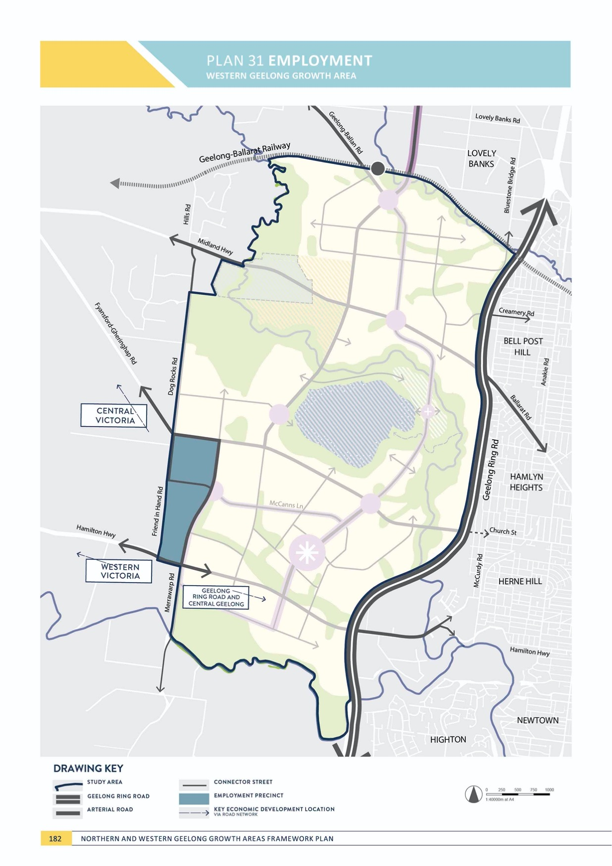

ECONOMY

EMPLOYMENT
WESTERN GEELONG GROWTH AREA

CONTEXT

Providing local jobs in new neighbourhoods is essential to establishing self-sufficient and sustainable communities; however, it is important that Geelong’s growth benefits the broader city and continues to advance central Geelong.
The Western Geelong Growth Area is anticipated to create up to 21,500 local jobs with a broader workforce of approximately 25,000 residents.
Many of these jobs will be provided in health and education, retail and related services, business and office- based sectors and will largely be catered for in activity centres and community hubs along the Clever and Creative Corridor.
Light industrial land uses – service industries, freight and logistics and light manufacturing – are less compatible with residential neighbourhoods and will be located within a precinct where industries can support each other and grow without impediment.
The location of the employment precinct in the Western Geelong Growth Area is illustrated on Plan 31 and provides:
- 117 hectares of developable land bordered on all sides by arterial roads and connector streets
- Flat terrain that avoids heavy vehicle movements in proximity to river corridors and Batesford Quarry
- Direct access from the Hamilton Highway that avoids residential neighbourhoods
- Outstanding access to the broader integrated transport network including the Geelong Ring Road and Midland Highway via Fyansford-Gheringhap Road.
High level analysis indicates that a total employment land required to support the local residents of the Western Geelong Growth Area is up to 130 hectares. The size and location of the employment precinct avoids interfaces with river corridors and acknowledges nearby employment precincts within Golden Plains Shire.
ACTION W3.2.1
Employment precincts will provide for a wide range of industrial and commercial uses to support the creation of new neighbourhoods and local job creation.
Employment precincts will be encouraged to deliver light industrial and commercial uses that include service
industries, light manufacturing, freight and logistics, urban services, business parks and offices, innovation and start- ups, indoor active recreation, service stations and places of worship.

ACTION W3.2.2
The employment precinct will be supported by providing efficient integrated transport connections to the freeway and regional highway network.
The employment precinct is located adjacent to the Hamilton Highway and will have convenient access to the Geelong Ring Road and direct access to the Midland Highway via Fyansford-Gheringhap Road. Upgrades to intersections between the Hamilton Highway and the Geelong Ring Road will be designed to allow appropriate access for heavy vehicle moments.

ACTION W3.2.3
Urban design of the employment precinct will be outlined as part of the relevant precinct structure plan to minimise impacts to surrounding neighbourhood amenity.
Design guidelines, and the potential for an urban design framework, will be outlined in the relevant precinct structure plan to define the required network and active and public transport access, landscaping of gateway and interface treatments, siting requirements and staging and indicative development timing. Vehicle movements accessing the employment precinct will be primarily provided via the Hamilton Highway. Key elements of the design response will be the gateway interface along the extension of Merrawarp Road and the integration of scattered trees and native vegetation with the precinct.

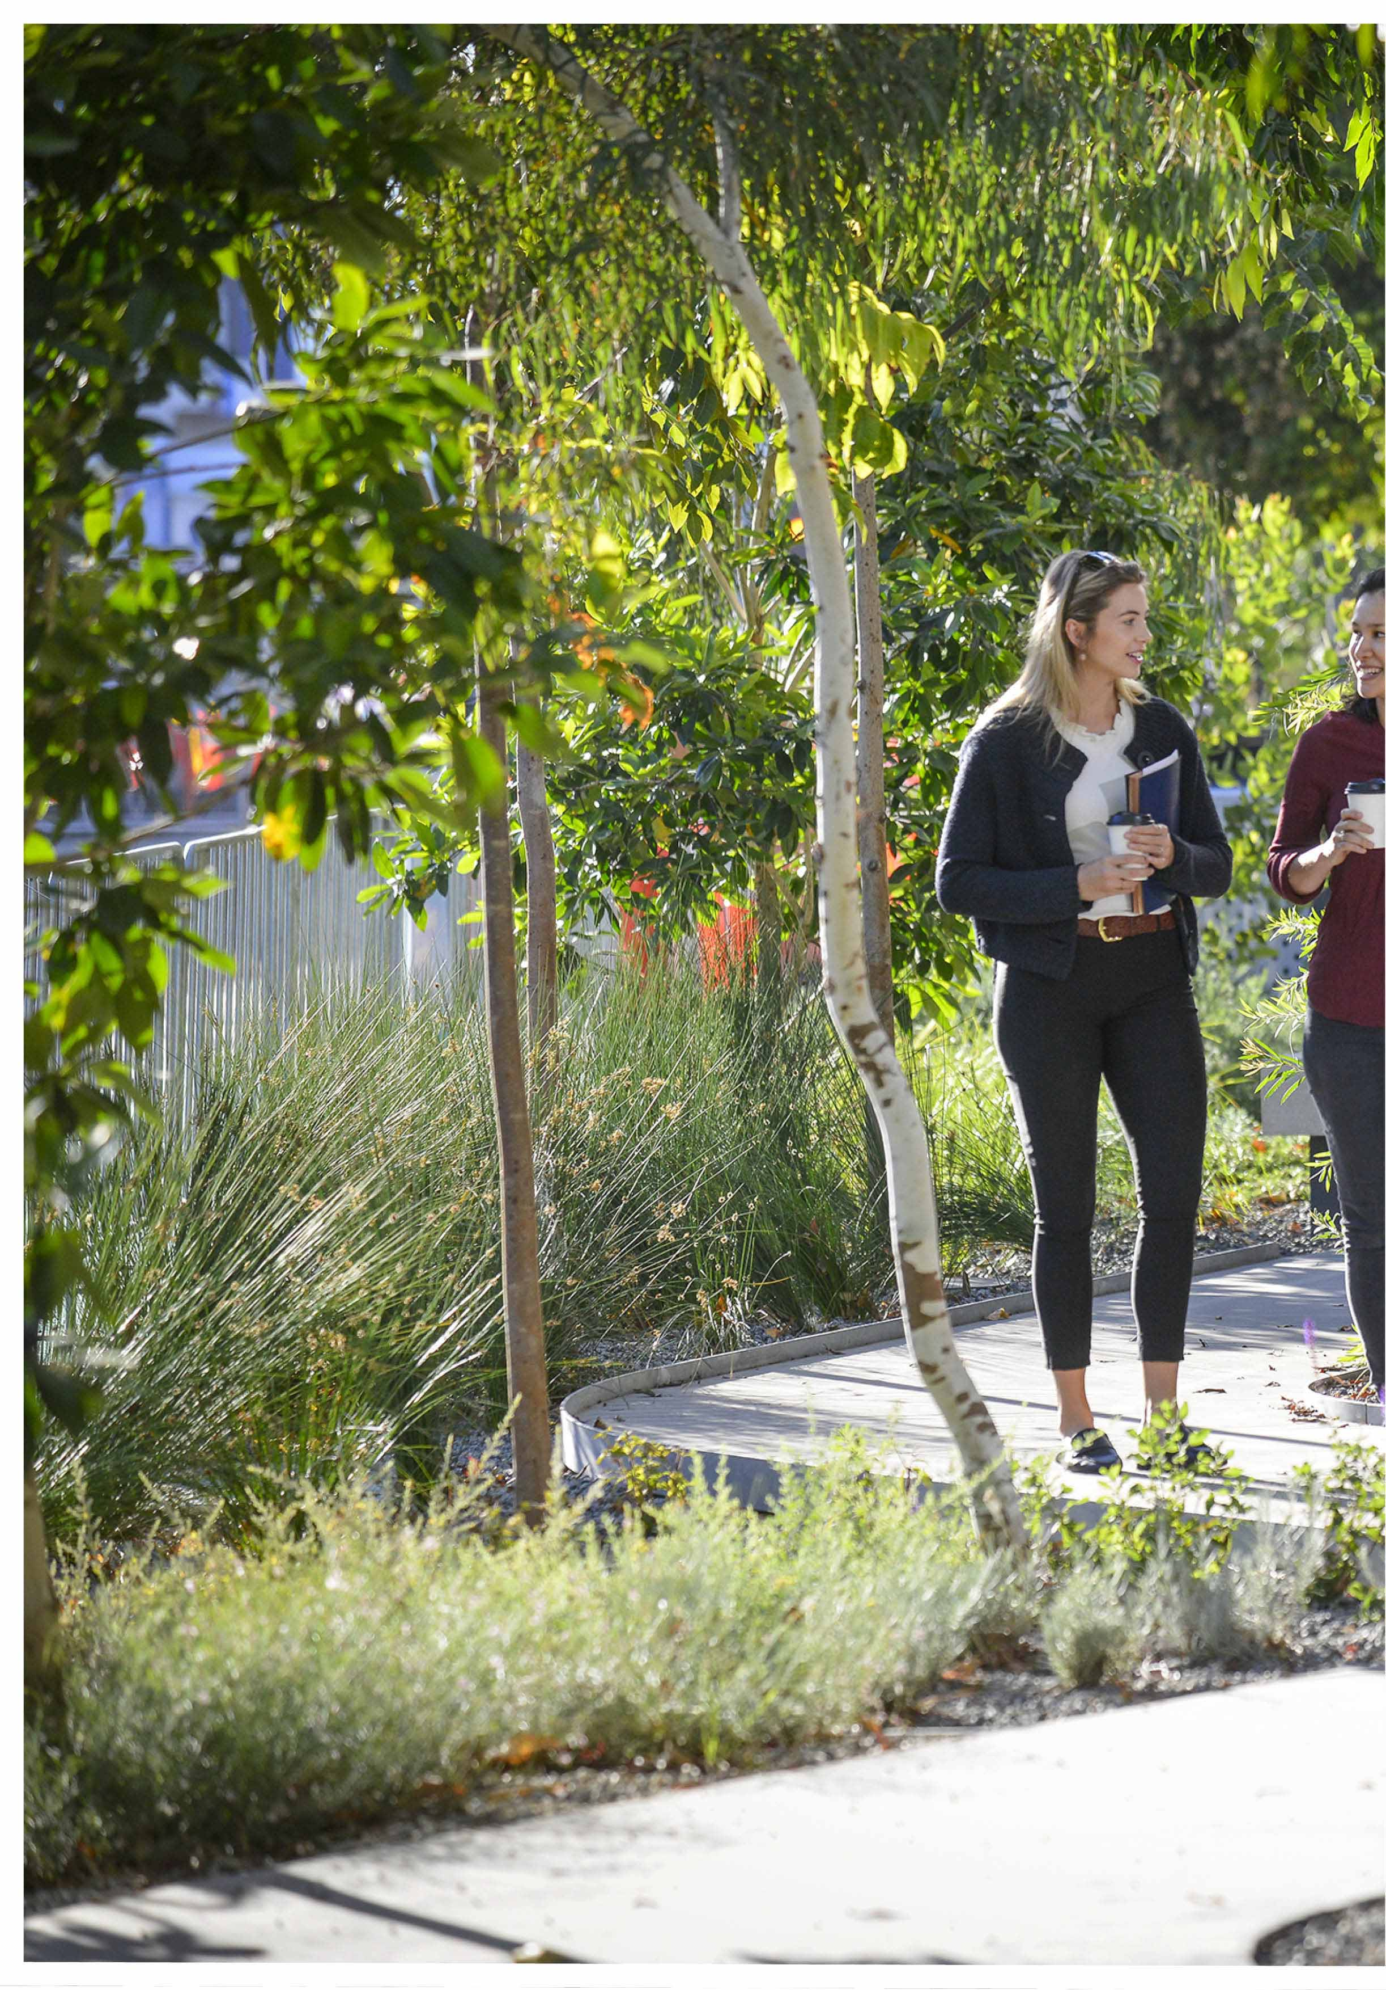

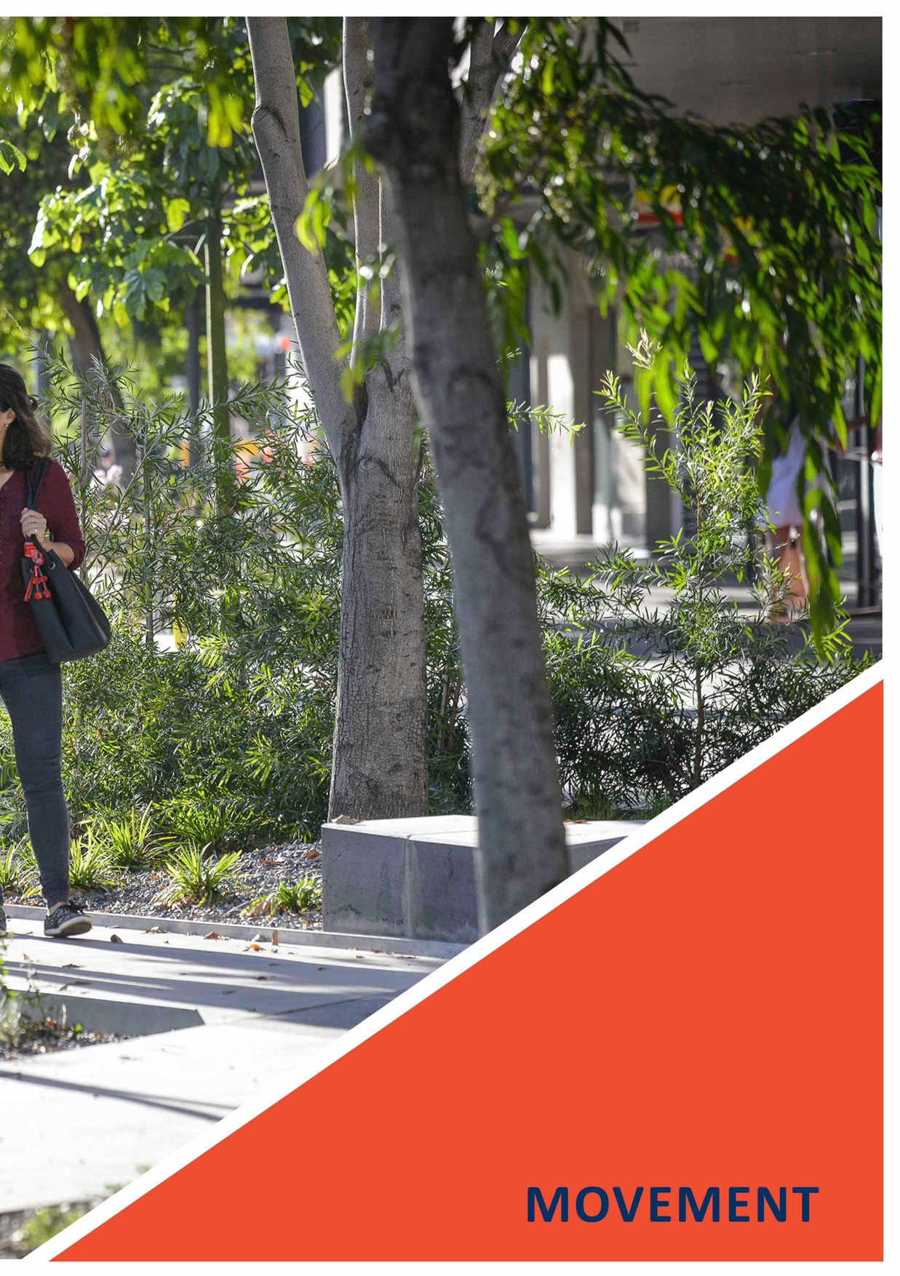

85

MOVEMENT

MOVEMENT is the element that commits Geelong’s growth areas to smart and sustainable ways of travel by prioritising safe, convenient and integrated active and public transport in the design of its neighbourhoods.

Ease of movement throughout the region is a fundamental aspect of Geelong’s appeal. As the city rapidly grows,
the capacity for private vehicles to cater for all journeys – particularly commuter trips – will be compromised. Mode shift to active and public transport is vital to retaining Geelong’s mobility.
Movement within the Northern and Western Geelong Growth Areas will focus on the Clever and Creative Corridor, a tree-lined, boulevard-style transit corridor that prioritises walking, cycling and public transport via dedicated, separated pathways.
The Clever and Creative Corridor will connect each new precinct throughout both growth areas and is designed to cater for emerging transport technologies to ensure that future investment in Geelong’s infrastructure is focused, effective and long-term.
Travel beyond the growth areas will focus on creating connections to the broader public transport network.
Major road, intersection and interchange upgrades will be undertaken to provide capacity for rapid bus connections to link all new neighbourhoods to the rail network and central Geelong.
The Geelong Growth Areas Transport Infrastructure Strategy will be developed by the City and its state government stakeholder partners to assess the impacts of future growth on the Geelong road network and identify infrastructure solutions.
The Western Geelong Growth Area will focus on providing east-west connections on the Hamilton and Midland Highways into urban Geelong, creating new north-south connections that frame the lake, and ultimately directing commuters to the Geelong-Ballarat railway when demand for passenger rail is realised.
The Northern Geelong Growth Area will create transport movements toward Lara and Melbourne and south into urban Geelong. Lara and Corio Railway Stations will be key destinations for access to the public transport network. Easy access up and down the Lovely Banks monocline will be a key consideration in the design of the integrated transport network.
Multiple access points to the Geelong Ring Road provide convenient connections between the growth areas and metropolitan Melbourne and the Surf Coast.
MOVEMENT considers the integrated transport network of the Northern and Western Geelong Growth Areas, establishing neighbourhoods that encourage walking and cycling, reduced car dependency and promote community safety and connectivity.

PREVIOUS PAGE: CLEVER AND CREATIVE MOVEMENT – MALOP STREET GREEN SPINE

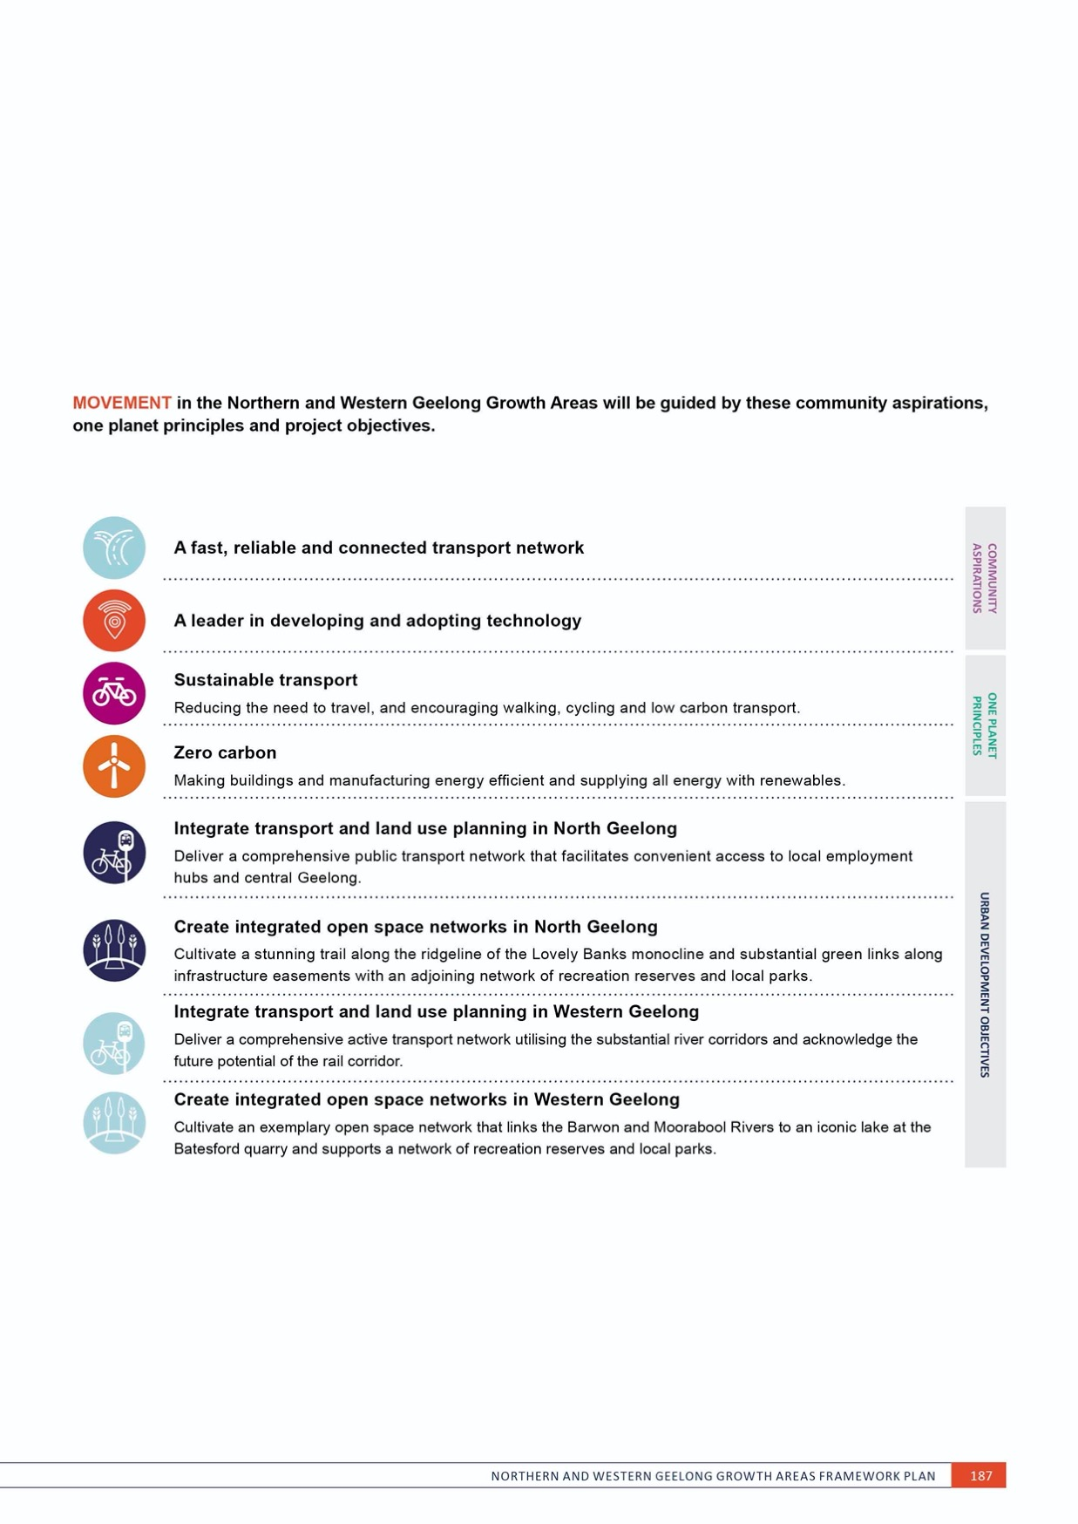

PLAN 32 ACTIVE TRANSPORT

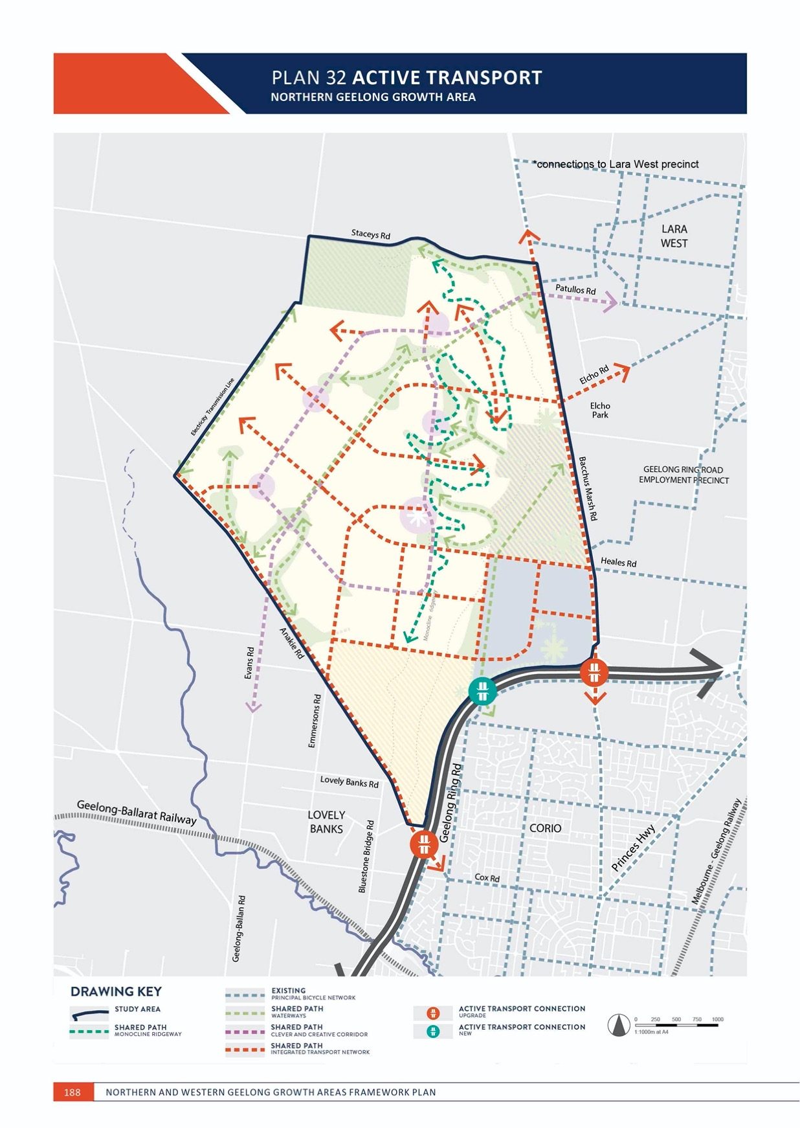

MOVEMENT
NORTHERN GEELONG GROWTH AREA

ACTIVE TRANSPORT
NORTHERN GEELONG GROWTH AREA

CONTEXT

Existing active transport infrastructure in proximity to the Northern Geelong Growth Area includes:
- Ted Wilson Trail, a 12-kilometre walking and cycling path adjoining the Geelong Ring Road linking Corio and Hamlyn Heights
- A shared path on Bacchus Marsh Road between the Geelong Ring Road and
Heales Road.
New active transport infrastructure to support urban development in the Northern Geelong Growth Area is illustrated on Plan 32 and includes:
- Safe and direct linear corridors that minimise crossovers and allow commuter-based trips, including the Clever and Creative Corridor
- Comprehensive networks, including off-road shared paths on all arterial roads and connector streets
- Shared paths to localised activity centres and social infrastructure that encourage walking and cycling
- Low-speed local and connector streets that allow safe on-road cycling
- Consideration of new and emerging active transport technologies including electric bicycles and scooters, bicycle-sharing systems and other micro-mobility and ‘last mile’ modes.

ACTION N4.1.1
Walking and cycling will be central to the design of neighbourhoods and promote mode shift from private vehicles to active transport.
A comprehensive active transport network will be established that prioritises walking and cycling within and between neighbourhoods. The network of shared paths will:
- Maximise safety and connectivity for active transport users
- Create direct access to the Clever and Creative Corridor
- Connect key destinations in the urban landscape, including activity centres, community hubs, schools and employment precincts
- Directly interface with the open space network and waterways, where paths are constructed above flood levels to an all-weather standard
- Overcome or avoid challenges associated with challenging topography in its design.

ACTION N4.1.2
Walking and cycling will be the highest priority in the design and management of the integrated transport network.
The integrated transport network will be designed as a pedestrian and cycle friendly environment by delivering a network of off-road shared paths, shared zones and priority spaces including:
- Footpaths on both sides of all streets
- Shared paths on connector streets and arterial roads
- Safe and convenient crossing points
- Safe and convenient transition between on and off-road bicycle networks
- Pedestrian and bicycle priority at intersections achieved with strong and consistent visual and physical cues.

MOVEMENT

ACTION N4.1.3
The Clever and Creative Corridor will be a key destination for active transport by supporting walkable neighbourhoods, delivering commuter-based cycling infrastructure and encouraging the adoption of new technologies. Dedicated active transport infrastructure will be delivered from ‘day one’ in the corridor to encourage early adoption of active transport in new neighbourhoods.
Design of the Clever and Creative Corridor will prioritise active transport at all stages of development by delivering:
- Dedicated off-road shared paths incorporated within the tree-lined median or side-running reserve as part of its interim design
- Dedicated off-road shared paths incorporated within the nature strip as part of its ultimate design
- Bicycle parking facilities at high activity and interchange locations along the corridor
- Bicycle sharing facilities at high activity and interchange locations along the corridor
- Pedestrian crossings and suitable landing areas at station locations as part of its ultimate design
- Substantial large tree canopy that provides shelter from all weather conditions.
ACTION N4.1.4
Active transport will be designed along the gas pipeline easement to provide an attractive linear corridor with safe transitions between the Clever and Creative Corridor and the arterial road network.
The easement of the gas pipeline provides an opportunity for linear open space that connects neighbourhoods across the growth area as part of Geelong’s Principal Bicycle Network. Shared paths along the easement will provide safe and convenient connection across and between the integrated transport network.

ACTION N4.1.5
Active transport will be designed along the monocline ridgeway to provide an attractive linear corridor
that connects activity centres and key open space nodes along the top of the Lovely Banks monocline escarpment.
The monocline ridgeway provides a linear open space opportunity that allows the wider community to experience the landscape and view lines of the monocline as part of Geelong’s Principal Bicycle Network. Shared paths along the monocline will be designed to maximise ease of use and provide safe and convenient connections between key attractions and the Clever and Creative Corridor.

ACTION N4.1.6
Active transport infrastructure will be designed along Heales Road and Elcho Road to manage safety and access constraints associated with the topography of the Lovely Banks monocline.
Impacts of steep slope on Heales Road and Elcho Road will be mitigated by providing adjoining shared paths that lessen slope gradients, control speed and provide opportunities for users to rest.
IMAGE IS NOT AVAILABLE WITHIN THIS VERION.
TO VIEW SUPPORTING VISUAL FOR THIS PAGE GO TO
www.geelongaustralia.com.au/futuregrowth/default.aspx
TO ACCESS PDF.

ACTION N4.1.7
Greater Geelong’s Principal Bicycle Network will expand into each neighbourhood to provide cycling connections to the broader city network and deliver:
- Upgrades to active transport infrastructure at the Bacchus Marsh Road freeway interchange and Anakie Road freeway interchange
- A pedestrian bridge across the Geelong Ring Road that links to the Ted Wilson Trail.
The Principal Bicycle Network provides cyclists with safe, accessible and connected cycling routes within Geelong and will extend into the growth areas via key entry points along river corridors, linear open spaces, arterial roads and interchanges along the Geelong Ring Road.

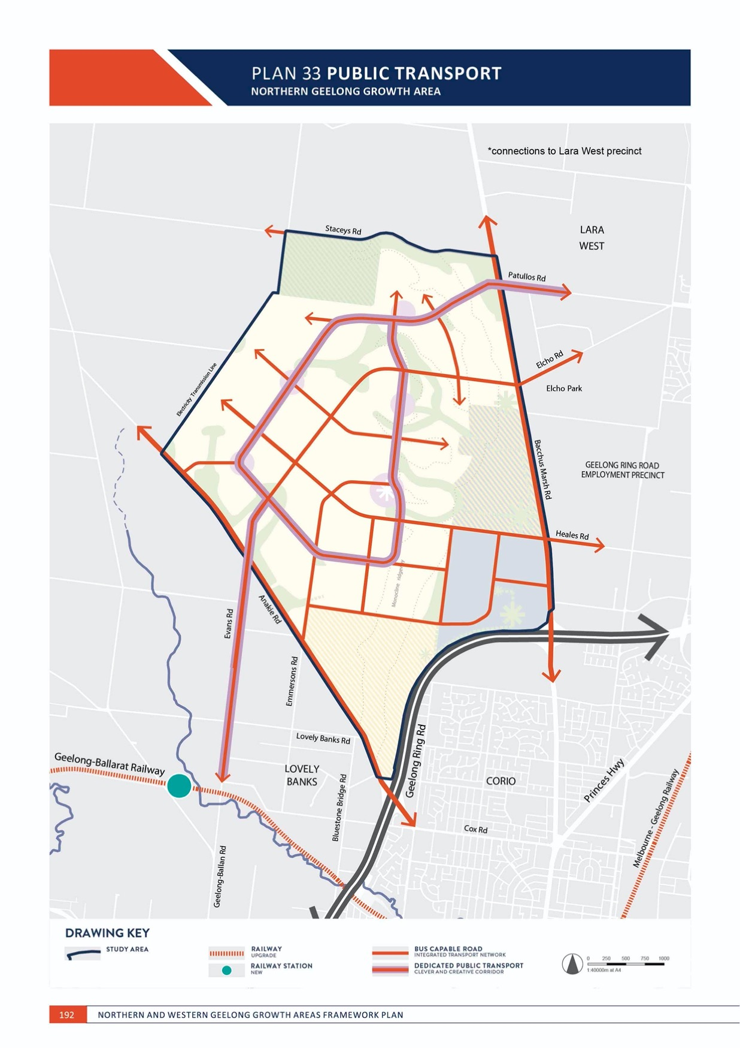

MOVEMENT

PUBLIC TRANSPORT
NORTHERN GEELONG GROWTH AREA

CONTEXT

Existing public transport infrastructure in proximity to the Northern Geelong Growth Area includes:
- Lara Railway Station, located 5.5 kilometres to the north- east
- Corio Railway Station, located 4.5 kilometres to the south-east
- Bus 10, between Lara Railway Station and Corio Shopping Centre, stopping on Bacchus Marsh Road.
New public transport infrastructure to support urban development in the Northern Geelong Growth Area is illustrated on Plan 33 and 38 and includes:
- Commuter-based passenger rail services on the Geelong-Ballarat railway between Geelong and Bannockburn
- A new railway station on the Geelong-Ballarat railway in proximity to Geelong-Ballan Road
- Public transport infrastructure linking the growth areas to Lara Railway Station and Corio Railway Station via high frequency services
- The Clever and Creative Corridor, providing a dedicated, separated public transport corridor linking neighbourhoods within the growth area and creating easier access to the broader Geelong region
- Public transport priority at intersections on the arterial road and Clever and Creative Corridor networks
- A bus-capable arterial road and connector street network
- Consideration of new and emerging public transport technologies including light rail, bus rapid transit, trackless trams, electric and autonomous vehicles and ‘last mile’ modes that link residents to public transport.
ACTION N4.2.1
Public transport will be central to the design of neighbourhoods and promote mode shift from private vehicles.
A comprehensive street network will be designed and established that prioritises public transport movements within and between neighbourhoods. The network will:
- Maximise safety and connectivity for public transport users
- Provide direct access to the Clever and Creative Corridor via local bus routes
- Support ultra-low-floor buses and convenient and frequent bus stops on arterial roads and connector streets that all households can access within a walkable distance
- Connect and interchange at key destinations in the urban landscape, including activity centres, community hubs, schools, employment precincts and arterial roads
- Overcome or avoid challenges associated with topography in its design.

MOVEMENT

ACTION N4.2.2
Public transport will be the highest priority beyond active transport in the design and management of the integrated transport network.
The integrated transport network will be designed to maximise public transport use by facilitating infrastructure that allows services to be accessible, frequent and reliable including:
- Bus capable arterial roads and connector streets
- Bus stops that are paired and connect to footpaths on both sides of all streets
- Safe and convenient crossing points in close proximity to bus stops
- Bus priority at intersections achieved with strong and consistent visual and physical cues.
ACTION N4.2.3
The Clever and Creative Corridor will be a key destination for public transport by supporting higher density neighbourhoods, delivering fast and convenient services and encouraging the adoption
of new technologies. Land for a dedicated, separated public transport infrastructure will be secured from ‘day one’ along the corridor to ensure that large-scale public transport modes can be supplied as part of urban development.
Design of the Clever and Creative Corridor will prioritise public transport at all stages of development by delivering:
- Land reservation for a 14-metre median or side-running corridor that can facilitate landscaping and all existing and future public transport infrastructure technologies including light rail, rapid bus transit and trackless trams
- Bus capable carriageways as part of its interim design
- Bus stops located on the outstand to maintain bus priority as part of interim design
- Intersections limited to connector street and arterial road intersections
- Substantial large tree canopy that provides shelter from all weather conditions
- ‘Station’ platform arrangements as part of the ultimate design that are:
  - Bilateral, opposing configurations within the 14-metre median
  - Expandable based on new technologies
  - Mid-block at attractors including activity centres and community hubs
  - Separated in each direction at major intersections
  - Safe and accessible for all ages and abilities.

ACTION N4.2.4
Urban development will provide ‘day one’ public transport services for initial residents of new neighbourhoods to combat reliance on private vehicles for commuter trips.
Public transport services will be provided for initial residents of new communities that link to central Geelong at morning and afternoon peak times. Early
provision of services may necessitate developer-operated shuttle bus services.

ACTION N4.2.5
Capacity to deliver public transport infrastructure will be a key consideration in the design of the integrated transport network where constraints are associated with the topography of the Lovely Banks monocline.
Impacts of the steep slope along the Lovely Banks monocline will be mitigated by designing the integrated transport network to navigate along contours and lessen slope gradients where possible.
ACTION N4.2.6
Greater Geelong’s Public Transport Network will expand into each neighbourhood to provide public transport connections to the broader city network and deliver:
- Upgrades to the Bacchus Marsh Road freeway interchange and Anakie Road freeway interchange
- Upgrades to the external road network connecting to Corio Railway Station
- Upgrades to the external road network connecting to Lara Railway Station.
New neighbourhoods will access Geelong’s ‘go anywhere’ public transport network that provides high frequency connections to central Geelong as part of the Transport Network Operation Plan.

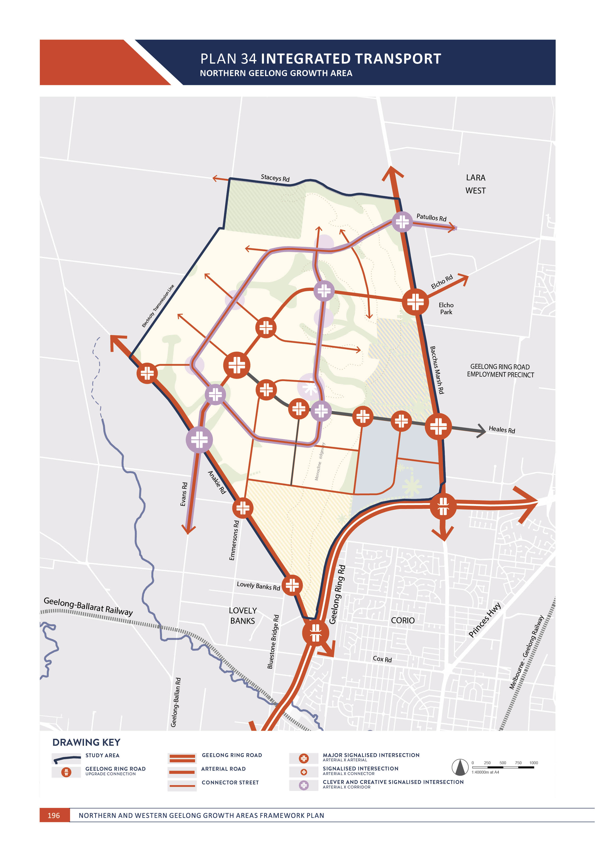

MOVEMENT

INTEGRATED TRANSPORT
NORTHERN GEELONG GROWTH AREA

CONTEXT

Existing road networks in proximity to the Northern Geelong Growth Area includes:
- Bacchus Marsh Road, a two-lane state arterial road with an interchange at the Geelong Ring Road
- Anakie Road, a two-lane rural arterial road with an interchange at the Geelong Ring Road
- Staceys Road, a two-lane rural arterial road
- Local roads entering the growth area at Elcho Road, Heales Road, Evans Road and Emmersons Road
- Minor local roads connecting to existing properties New integrated transport infrastructure to
support urban development in the Northern Geelong Growth Area is illustrated on Plan 34 and 38 and includes:
- The Clever and Creative Corridor
- Upgrade and duplication of Bacchus Marsh Road and Anakie Road to urban-standard arterial roads

- Upgrade of freeway interchanges on the
Geelong Ring Road at Bacchus Marsh Road and Anakie Road
- Upgrade, duplication and realignment of Elcho Road, Heales Road and Evans Road to urban-standard arterial roads
- Upgrade of Emmersons Road and parts of Tower Hill Drive to urban-standard connector streets
- A new and comprehensive connector street network
- Signalised intersections along the arterial road and Clever and Creative Corridor networks
- Controlled intersections along the connector street network, where required
- Consideration of new and emerging integrated transport technologies that are electrified, autonomous, shared and connected.

IMAGE IS NOT AVAILABLE WITHIN THIS VERION.
TO VIEW SUPPORTING VISUAL FOR THIS PAGE GO TO
www.geelongaustralia.com.au/futuregrowth/default.aspx
TO ACCESS PDF.

MOVEMENT

ACTION N4.3.1
Strategic transport modelling will be undertaken for each precinct to establish a detailed integrated transport network.
Assessment of the proposed integrated transport network will be utilised with detailed land use planning. Key elements of the framework plan, including access to Geelong rail network and the Clever and Creative Corridor, will form a key objectives of each assessment.

ACTION N4.3.2
The integrated transport network will be central to the design of neighbourhoods and positively contribute to the public realm. Arterial roads and local and connector streets will be designed as ‘streets for people.’
The integrated transport network will be designed to acknowledge streets as important shared public spaces providing benefits to all users. The network will deliver a green setting that contributes to the broader open space network and deliver:
- Continuous large tree canopy along all nature strips and central medians providing adequate width to grow large mature trees
- Low speed environments that minimise road widths
- Landscaped service roads on arterial roads that provide access to abutting properties and kerbside parking
- Shared paths on both sides of arterial roads and at least one side of connector streets
- Passive surveillance created by continuous development frontages or the open space network
- Rural road typologies along rural interfaces on the north and western boundary of the growth area
- Water sensitive urban design, where appropriate.
ACTION N4.3.3
Design and management of the integrated transport network will facilitate efficient private vehicle movements whilst encouraging mode shift to active and public transport.
The integrated transport network will cater for private and commercial vehicle movements by delivering:
- Upgrade and duplication of the Midland Highway and Hamilton Highway
- Upgrade and duplication of Bacchus Marsh Road and Anakie Road
- Upgrade of existing interchanges with the Geelong Ring Road
- Local arterial roads generally based on a one-mile grid, subject to local landform constraints
- Arterial road carriageways designed to maintain traffic flows and minimise conflicts by directing intermittent traffic movements (e.g. waste management) to service roads
- Connector streets generally centrally located within the one-mile grid, subject to local landform constraints
- Connection to all key destinations in the urban landscape including active centres, community hubs, schools, employment precincts and the open space network
- Arterial road and connector street movements within the Clever and Creative Corridor, where applicable
- Controlled intersections that cater for safe and convenient access, surrounding land uses and forecast traffic volumes.

ACTION N4.3.4
The integrated transport network will be designed to maximise community enjoyment of the Clever and Creative Corridor.
The Clever and Creative Corridor is the community’s central access point to activity centres, community facilities and services, open space, and active and public transport networks. The design of the integrated transport network will prioritise the strategic intent of the corridor by ensuring that:
- Local and connector streets directly adjoining the corridor are designed as low speed environments
- Crossovers of the corridor are limited to signalised intersections
- Intersections are designed to prioritise safe active transport movements.

ACTION N4.3.5
Design of the integrated transport network will consider constraints associated with the topography of the Lovely Banks monocline.
Impacts of steep slope along the Lovely Banks monocline will be mitigated by designing the integrated transport network to navigate along contours and lessen slope gradients where possible and avoid extended lengths of road running up and down the monocline escarpment.
ACTION N4.3.6
The integrated transport network will provide private vehicle connections to the broader city network and deliver:
- Upgrades to the Bacchus Marsh Road freeway interchange and the Anakie Road freeway interchange along the Geelong Ring Road
- Upgrades to the external road network connecting toward Lara
- Upgrades to the external road network connecting toward central Geelong
- Upgrades to Evans Road between the growth areas to connect the Clever and Creative Corridor.
Upgrades to the integrated transport network necessitated by urban development will be designed to be compatible with the delivery of the principal public transport network.

ACTION N4.3.7
Road treatments will be utilised to deter ‘cut-through’ movements in rural living areas.
Road design will safeguard rural living areas from intrusive traffic movements.

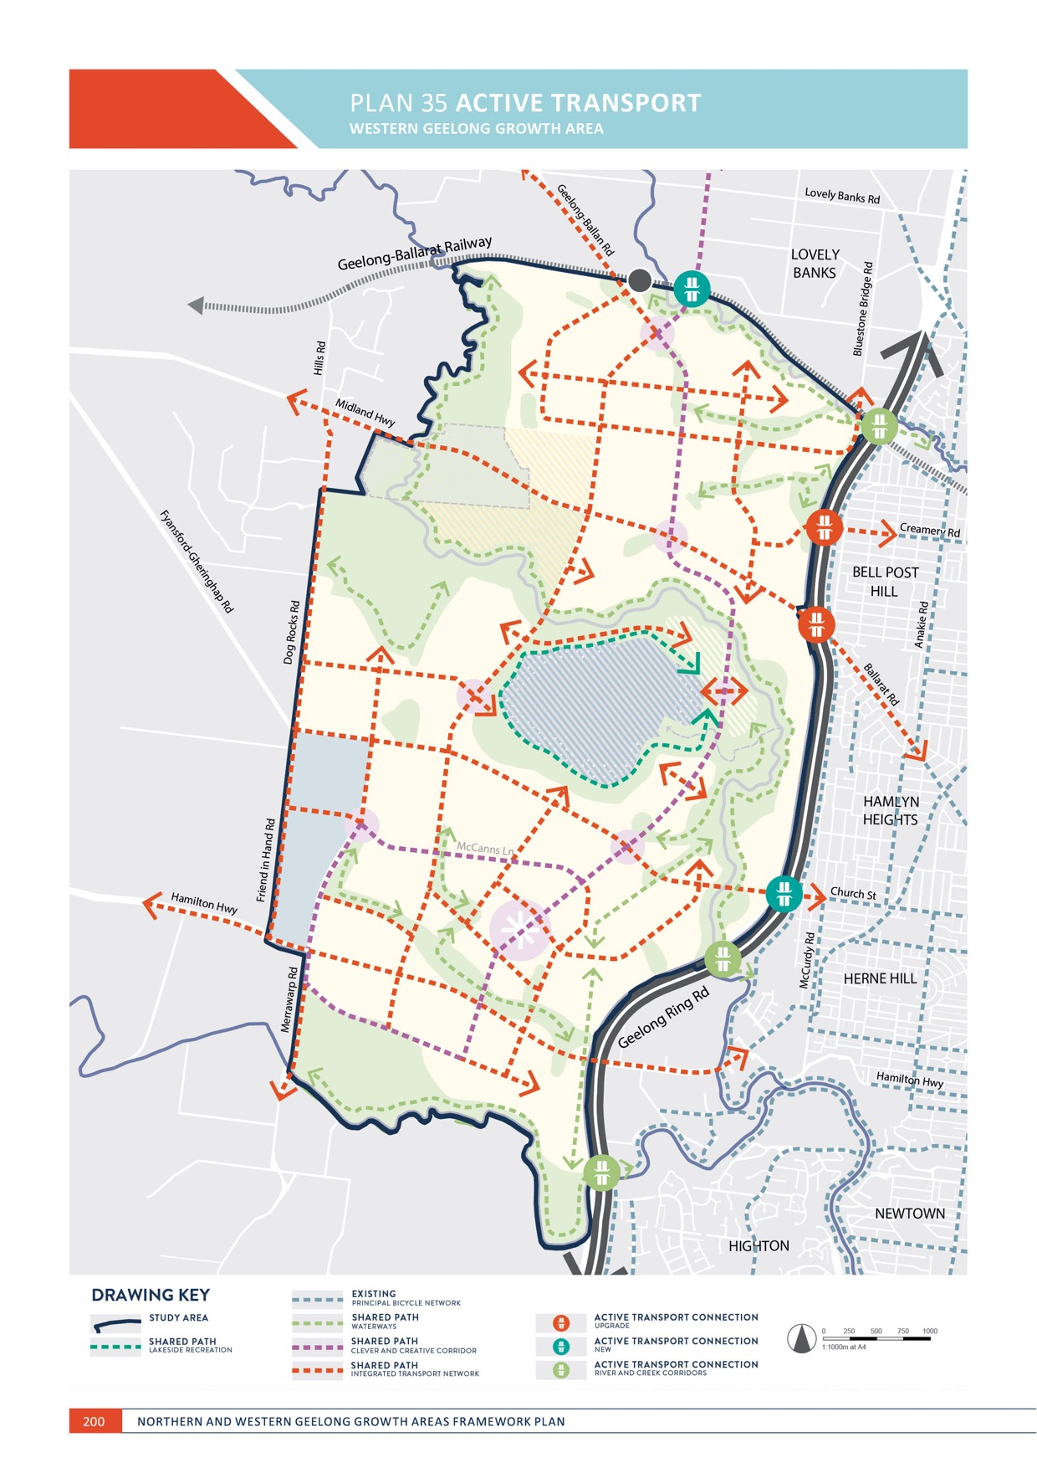

MOVEMENT
WESTERN GEELONG GROWTH AREA

ACTIVE TRANSPORT
WESTERN GEELONG GROWTH AREA

CONTEXT

Existing active transport infrastructure in proximity to the Western Geelong Growth Area includes:
- Ted Wilson Trail, a 12-kilometre walking and cycling path adjoining the Geelong Ring Road linking Corio and Hamlyn Heights
- Tom McKean Trail, a walking and cycling path along the defunct railway between Fyansford and North Geelong
- A shared path on the Midland Highway between the Geelong Ring Road and Geelong-Ballan Road
- A shared path to the west of Dog Rocks Road
- Local connection provided under the Geelong-Ballarat railway at Bluestone Bridge Road
- Local connection provided under the Geelong Ring Road at the Moorabool River in Fyansford.
New active transport infrastructure to support urban development in the Northern Geelong Growth Area is illustrated on Plan 35 and includes:
- Safe and direct linear corridors that minimise crossovers and allow commuter-based trips, including the Clever and Creative Corridor
- Comprehensive networks, including off-road shared paths on all arterial roads and connector streets
- Shared paths to localised activity centres and social infrastructure that encourage walking
and cycling
- Low-speed local and connector streets that allow safe on-road cycling
- Consideration of new and emerging active transport technologies including electric bicycles and scooters, bicycle-sharing systems and other micro-mobility and ‘last mile’ modes.
ACTION W4.1.1
Walking and cycling will be central to the design of neighbourhoods and promote mode shift from private vehicles to active transport.
A comprehensive active transport network will be established that prioritises walking and cycling within and between neighbourhoods. The network of shared paths will:
- Maximise safety and connectivity for active transport users
- Create direct access to the Clever and Creative Corridor
- Connect key destinations in the urban landscape, including activity centres, community hubs, schools and employment precincts
- Directly interface with the open space network and waterways, where paths are constructed above flood levels to an all-weather standard
- Overcome or avoid challenges associated with topography in its design.

ACTION W4.1.2
Walking and cycling will be the highest priority in the design and management of the integrated transport network.
The integrated transport network will be designed as a pedestrian and cycle friendly environment by delivering a network of off-road shared paths, shared zones and priority spaces including:
- Footpaths on both sides of all streets
- Shared paths on connectors street and arterial roads
- Safe and convenient crossing points
- Safe and convenient transition between on and off-road bicycle networks
- Pedestrian and bicycle priority at intersections achieved with strong and consistent visual and physical cues.

MOVEMENT

ACTION W4.1.3
The Clever and Creative Corridor will be a key destination for active transport by supporting walkable neighbourhoods, delivering commuter-based cycling infrastructure and encouraging the adoption of new technologies. Dedicated active transport infrastructure will be delivered from ‘day one’ in the corridor to encourage early adoption of active transport in new neighbourhoods.
Design of the Clever and Creative Corridor will prioritise active transport at all stages of development by delivering:
- Dedicated off-road shared paths incorporated within the tree-lined median or side-running reserve as part of its interim design
- Dedicated off-road shared paths incorporated within the nature strip as part of its ultimate design
- Bicycle parking facilities at high activity and interchange locations along the corridor
- Bicycle sharing facilities at high activity and interchange locations along the corridor
- Pedestrian crossings and suitable landing areas at station locations as part of its ultimate design
- Substantial large tree canopy that provides shelter from all weather conditions.

ACTION W4.1.4
Active transport will be prioritised in the design of linear open space corridors, particularly along the corridors of the Moorabool River, Barwon River and Cowies Creek and surrounding the lake.
The river and creek corridors provide linear open space opportunities that allows the wider community to
experience the natural landscape and connect directly into Geelong’s Principal Bicycle Network. Shared paths along the river and creek corridors will be designed to maximise ease of use and provide safe and convenient connections between key attractions and the Clever and Creative Corridor.
ACTION W4.1.5
Active transport infrastructure will be designed along the Moorabool River corridor, lake precinct and Geelong Ring Road to manage safety and access constraints associated with the topography of the area.
Impacts of steep slope along these corridors will be mitigated by providing adjoining shared paths that lessen slope gradients, control speed and provide opportunities for users to rest between key attractions and the Clever and Creative Corridor.

ACTION W4.1.6
Greater Geelong’s Principal Bicycle Network will expand into each neighbourhood to provide cycling connections to the broader city network and deliver:
- Upgrades to active transport infrastructure at the Midland Highway freeway interchange, Hamilton Highway freeway interchange and Creamery Road freeway flyover
- New active transport infrastructure that provides connections across the Geelong Ring Road along river and creek corridors
- New active transport infrastructure where additional connections are created to the Geelong Ring Road.
The Principal Bicycle Network provides cyclists with safe, accessible and connected cycling routes within Geelong and will extend into the growth areas via key entry points along river corridors, linear open spaces, arterial roads and interchanges along the Geelong Ring Road.

IMAGE IS NOT AVAILABLE WITHIN THIS VERION.
TO VIEW SUPPORTING VISUAL FOR THIS PAGE GO TO
www.geelongaustralia.com.au/futuregrowth/default.aspx
TO ACCESS PDF.

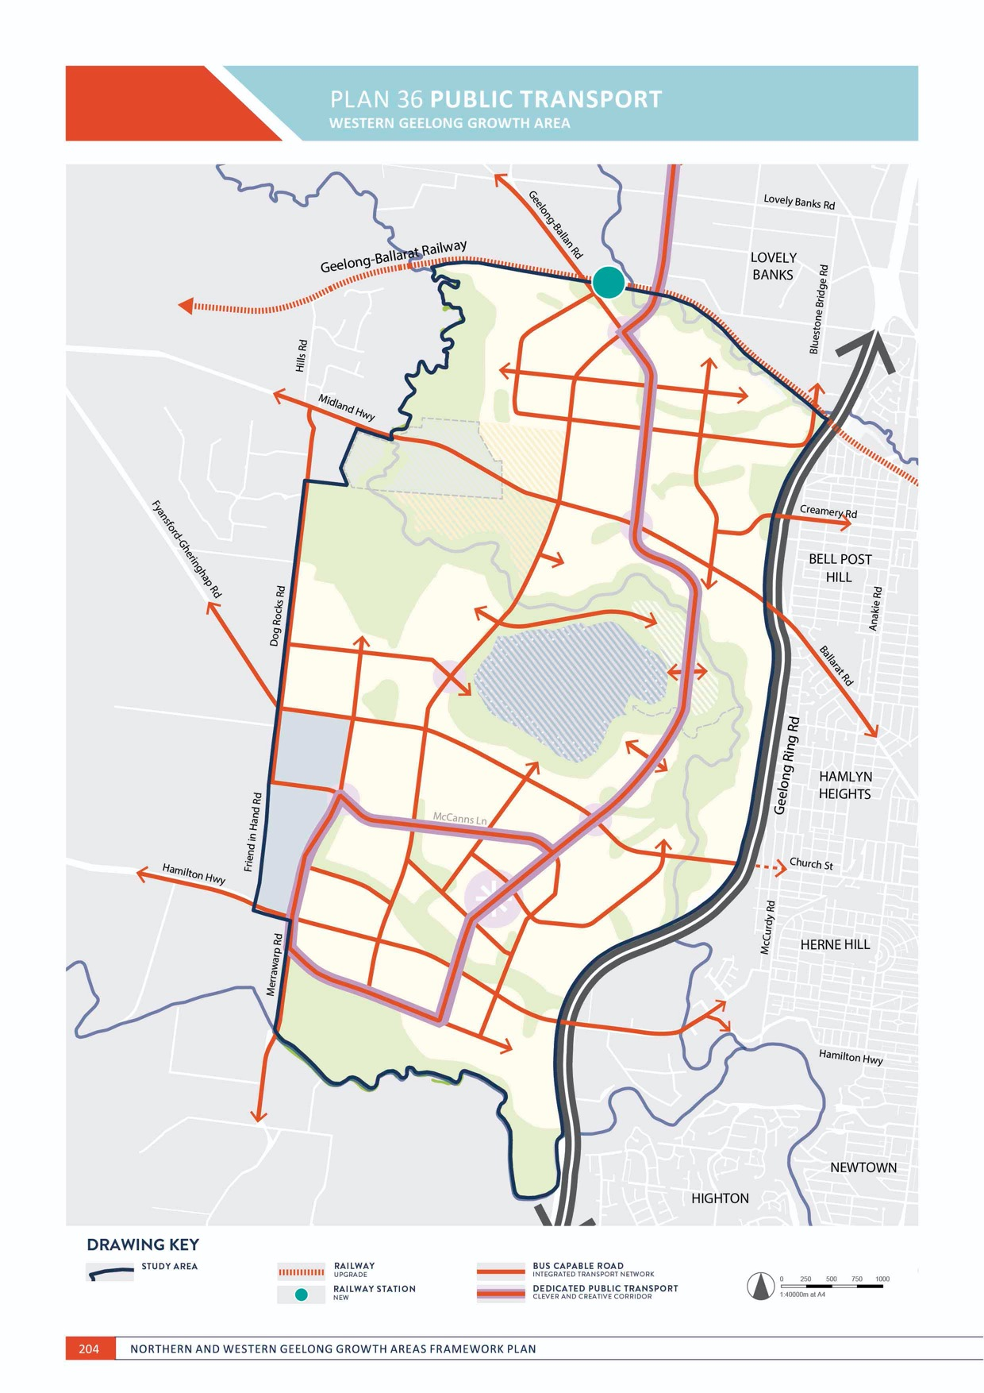

MOVEMENT

PUBLIC TRANSPORT
WESTERN GEELONG GROWTH AREA

CONTEXT

Existing public transport infrastructure in proximity to the Western Geelong Growth Area includes:
- Geelong-Ballarat railway currently carries freight rail and previously carried passenger services, with the former Moorabool Railway Station abutting the northern boundary of the growth area
- North Geelong Railway Station, located three kilometres to the east
- Geelong Railway Station, located five kilometres to the east
- Bus route 19, between Geelong and Bannockburn, operates along the Midland Highway
- Bus route 25, between Geelong Railway Station and Bell Post Hill, operates along Rollins Road and Braund Avenue.

New public transport infrastructure to support urban development in the Western Geelong Growth Area is illustrated on Plan 36 and 38 and includes:
- Commuter-based passenger rail services on the Geelong-Ballarat railway between Geelong and Bannockburn
- A new railway station on the Geelong-Ballarat railway in proximity to Geelong-Ballan Road
- Public transport infrastructure linking the growth areas to North Geelong Station and Geelong Railway Station via high frequency services
- The Clever and Creative Corridor, providing a dedicated, separated public transport corridor linking neighbourhoods in the growth area and the broader Geelong region
- Public transport priority at intersections on the arterial road and Clever and Creative Corridor networks
- A bus-capable arterial road and connector street network
- Consideration of new and emerging public transport technologies including light rail, bus rapid transit, trackless trams, electric and autonomous vehicles and ‘last mile’ modes that link residents to public transport.

MOVEMENT

ACTION W4.2.1
Public transport will be central to the design of neighbourhoods and promote mode shift from private vehicles.
A comprehensive street network will be designed and established that prioritises public transport movements within and between neighbourhoods. The network will:
- Maximise safety and connectivity for public transport users
- Provide direct access to the Clever and Creative Corridor via local bus routes
- Support ultra-low-floor buses and convenient and frequent bus stops on arterial roads and connector streets that all households can access within a walkable distance
- Connect and interchange at key destinations in the urban landscape, including activity centres, community hubs, schools, employment precincts and arterial roads
- Overcome or avoid challenges associated with topography in its design.

ACTION W4.2.2
Public transport will be the highest priority beyond active transport in the design and management of the integrated transport network.
The integrated transport network will be designed to maximise public transport use by facilitating infrastructure that allows services to be accessible, frequent and reliable including:
- Bus capable arterial roads and connector streets
- Bus stops that are paired and connect to footpaths on both sides of all streets
- Safe and convenient crossing points in close proximity to bus stops
- Bus priority at intersections achieved with strong and consistent visual and physical cues.
ACTION W4.2.3
The Clever and Creative Corridor will be a key destination for public transport by supporting higher density neighbourhoods, delivering fast and convenient services and encouraging the adoption
of new technologies. Land for a dedicated, separated public transport infrastructure will be secured from ‘day one’ along the corridor to ensure that large-scale public transport modes can be supplied as part of urban development.
Design of the Clever and Creative Corridor will prioritise public transport at all stages of development by delivering:
- Land reservation for a 14-metre median or side-running corridor that can facilitate landscaping and all existing and future public transport infrastructure technologies including light rail, rapid bus transit and trackless trams
- Bus capable carriageways as part of its interim design
- Bus stops located on the outstand to maintain bus priority as part of interim design
- Intersections limited to connector street and arterial road intersections
- Substantial large tree canopy that provides shelter from all weather conditions
- ‘Station’ platform arrangements as part of the ultimate design that are:
  - Bilateral, opposing configurations within the 14-metre median
  - Expandable based on new technologies
  - Mid-block at attractors including activity centres and community hubs
  - Separated in each direction at major intersections
  - Safe and accessible for all ages and abilities.

ACTION W4.2.4
Urban development will provide ‘day one’ public transport services for initial residents of new neighbourhoods to combat reliance on private vehicles for commuter trips.
Public transport services will be provided for initial residents of new communities that link to central Geelong at morning and afternoon peak times. Early provision of services may necessitate developer-operated shuttle bus services.

ACTION W4.2.5
Capacity to deliver public transport infrastructure will be a key consideration in the design of the integrated transport network where constraints are associated with the topography of the Moorabool River, Barwon River and Cowies Creek corridors, Batesford Quarry and the Geelong Ring Road.
Impacts of steep slope along the river and creek corridors, quarry and Geelong Ring Road will be mitigated by designing the integrated transport network to navigate along contours and lessen slope gradients where possible.
ACTION W4.2.6
Greater Geelong’s Public Transport Network will expand into each neighbourhood to provide public transport connections to the broader city network and deliver:
- Upgrades to the Midland Highway freeway interchange, Hamilton Highway freeway interchange and Creamery Road freeway flyover
- Upgrades to the external road network connecting to North Geelong Railway Station
- Upgrades to the external road network connecting to Geelong Railway Station.
- New public transport infrastructure where additional connections are created to the Geelong Ring Road, including a potential public transport-only flyover connecting to Church Street, Hamlyn Heights.
New neighbourhoods will access Geelong’s ‘go anywhere’ public transport network that provides high frequency connections as part of the Transport Network
Operation Plan.

ACTION W4.2.7
Sequencing of urban development will protect the opportunity for transit-orientated development along the Geelong-Ballarat railway between Geelong-Ballan Road and Evans Road.
Urban development in proximity to the Geelong-Ballarat railway will retain the capacity to deliver a railway station and associated infrastructure in anticipation of commuter- based passenger rail services between Geelong and Bannockburn, including grade seperations at Geelong- Ballan Road and Evans Road that provide safety for all transport movements.

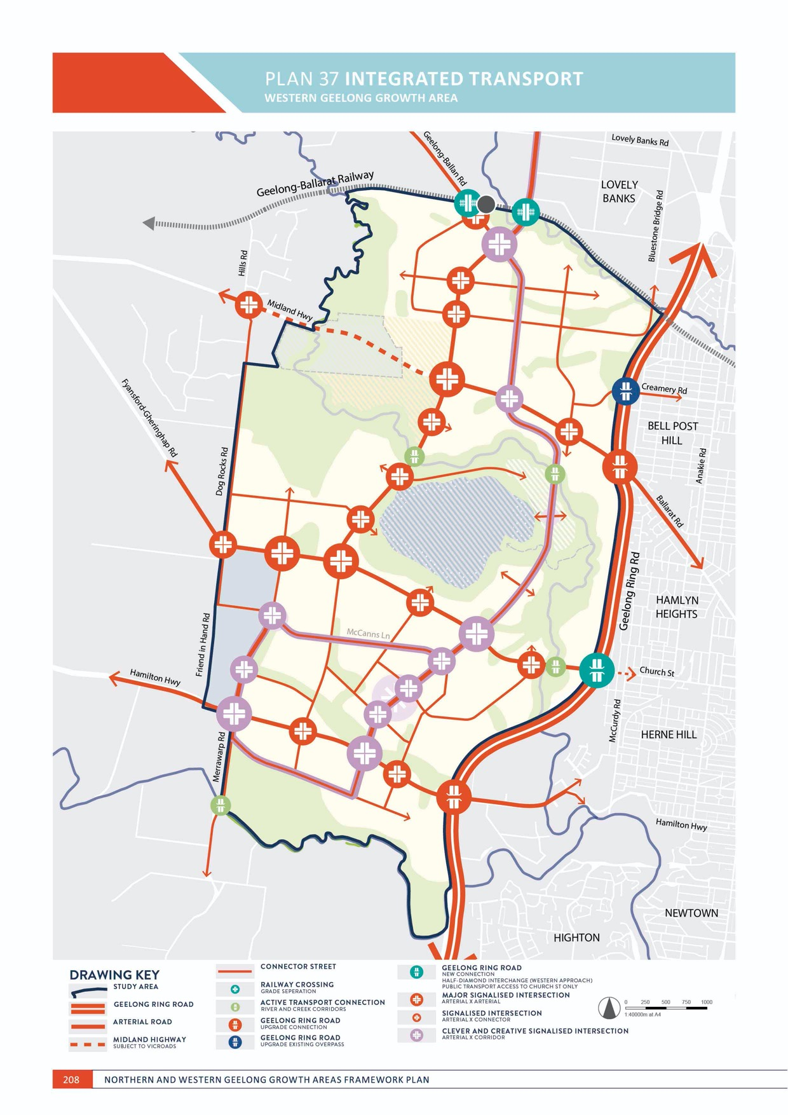
PLAN 37 INTEGRATED TRANSPORT
WESTERN GEELONG GROWTH AREA

MOVEMENT

INTEGRATED TRANSPORT
WESTERN GEELONG GROWTH AREA

CONTEXT

Existing road networks within proximity to the Western Geelong Growth Area includes:
  - Midland Highway, a two-lane state highway with an interchange at the Geelong Ring Road
  - Hamilton Highway, a two-lane state highway with an interchange at the Geelong Ring Road
  - Geelong-Ballan Road, a two-lane, rural-standard state arterial road
  - Fyansford-Gheringhap Road, a two-lane, rural-standard state arterial road
  - Merrawarp Road, a two-lane, rural-standard state arterial road
  - Friend in Hand Road, a two-lane, rural-standard arterial road
  - Creamery Road, a local road with a flyover on the Geelong Ring Road
  - Local connections entering the growth area at Evans Road and Bluestone Bridge Road
  - Minor local roads connecting to the Batesford town and other existing properties.
New integrated transport infrastructure to support urban development in the Northern Geelong Growth Area is illustrated on Plan 37 and 38 and includes:
  - The Clever and Creative Corridor
  - Upgrade and duplication of the Midland Highway* and Hamilton Highway to urban-standard arterial roads
  - Upgrade of parts of Geelong-Ballan Road, Evans Road and Lynnburn Road to urban-standard arterial roads

  - A new south-west arterial road to the west of Batesford Quarry
  - A new east-west arterial road to the south of Batesford Quarry
  - Upgrade of freeway interchanges on the Geelong Ring Road at the Midland Highway and Hamilton Highway
  - A new half-diamond freeway interchange on the west side of the Geelong Ring Road in direct proximity to Church Street, Hamlyn Heights (subject to detailed investigation)
  - Grade separations on the Geelong-Ballarat Railway as part of commuter-based services
  - Upgrade of Dog Rocks Road, Merrawarp Road,
Creamery Road, parts of McCanns Lane and
parts of Fyansford-Gheringhap Road, Blackall Road and Friend in Hard Road to urban-standard connector streets
  - A new and comprehensive connector street network
  - Signalised intersections along the arterial road and Clever and Creative Corridor networks
  - Controlled intersections along the connector street network, where required.

*The upgrade of the Midland Highway and any polential realignment is subject to future investigation by VicRoads

MOVEMENT

ACTION W4.3.1
Strategic transport modelling will be undertaken for each precinct to establish a detailed integrated transport network.
Assessment of the proposed integrated transport network will be utilised with detailed land use planning. Key elements of the framework plan, including access to Geelong rail network and the Clever and Creative Corridor, will form a key objectives of each assessment.

ACTION W4.3.2
The integrated transport network will be central to the design of neighbourhoods and positively contribute to the public realm. Arterial roads and local and connector streets will be designed as ‘streets for people.’
The integrated transport network will be designed to acknowledge streets as important shared public spaces that provide benefits to all users and deliver a green setting that contributes to the broader open space network. The integrated transport network will be designed to deliver:
- Continuous large tree canopy along all nature strips and central medians providing adequate width to growth large mature trees
- Low speed environments that minimise road widths
- Landscaped service roads on arterial roads that provide access to abutting properties and kerbside parking
- Shared paths on both sides of arterial roads and at least one side of connector streets
- Passive surveillance created by continuous development frontages or the open space network
- Rural road typologies along rural interfaces on the north and western boundary of the growth area, where appropriate
- Water sensitive urban design, where appropriate.
ACTION W4.3.3
Design and management of the integrated transport network will facilitate efficient private vehicle movements whilst encouraging mode shift to active and public transport.
The integrated transport network will cater for private and commercial vehicle movements by delivering:
- Upgrade and duplication of the Midland Highway and Hamilton Highway
- Upgrade and duplication of Bacchus Marsh Road and Anakie Road
- Upgrade of existing interchanges with the Geelong Ring Road
- Local arterial roads generally based on a one-mile grid, subject to local landform constraints
- Arterial road carriageways designed to maintain traffic flows and minimise conflicts by directing intermittent traffic movements (e.g. waste management) to service roads
- Connector streets generally centrally located within the one-mile grid, subject to local landform constraints
- Connection to all key destinations in the urban landscape including activity centres, community hubs, schools, employment precincts and the open space network
- Arterial road and connector street movements within the Clever and Creative Corridor, where applicable
- Controlled intersections that cater for safe and convenient access, surrounding land uses and forecast traffic volumes.

ACTION W4.3.4
The integrated transport network will be designed to maximise community enjoyment of the Clever and Creative Corridor.
The Clever and Creative Corridor is the community’s central access point to activity centres, community facilities and services, open space, and active and public transport networks. The design of the integrated transport network will prioritise the strategic intent of the corridor by ensuring that:
- Local and connector streets directly adjoining the corridor are designed as low speed environments
- Crossovers of the corridor are limited to signalised intersections
- Intersections are designed to prioritise safe active transport movements.

ACTION W4.3.5
Design of the integrated transport network will consider constraints associated with the topography of the Moorabool River, Barwon River and Cowies Creek corridors, Batesford Quarry and the Geelong Ring Road.
Impacts of steep slope along the river and creek corridors, quarry and Geelong Ring Road will be mitigated by designing the integrated transport network to navigate along contours and lessen slope gradients where possible and avoid extended lengths of road running up and down the monocline escarpment.
ACTION W4.3.6
The integrated transport network will provide private vehicle connections to the broader city network and deliver:
- Upgrades to the Midland Highway freeway interchange and the Hamilton Highway freeway interchange along the Geelong Ring Road
- A new half-diamond freeway interchange on the west side of the Geelong Ring Road in direct proximity to Church Street, Hamlyn Heights (subject to detailed investigation)
- Upgrades to the external road network connecting toward central Geelong
- Upgrades to Evans Road between the growth areas to connect the Clever and Creative Corridor.
Upgrades to the integrated transport network necessitated by urban development will be designed to be compatible with the delivery of the principal public transport network.

ACTION W4.3.7
Road treatments will be utilised to deter ‘cut-through’ movements in proximity to Batesford township.
Road design will safeguard Batesford township and rural living areas from intrusive traffic movements.

ACTION W4.3.8
Bridge crossings of the Moorabool River crossings will be limited to key access points.
New bridges that provide vehicle access across the Moorabool River corridor will be limited to opportunities illustrated on Plan 37.

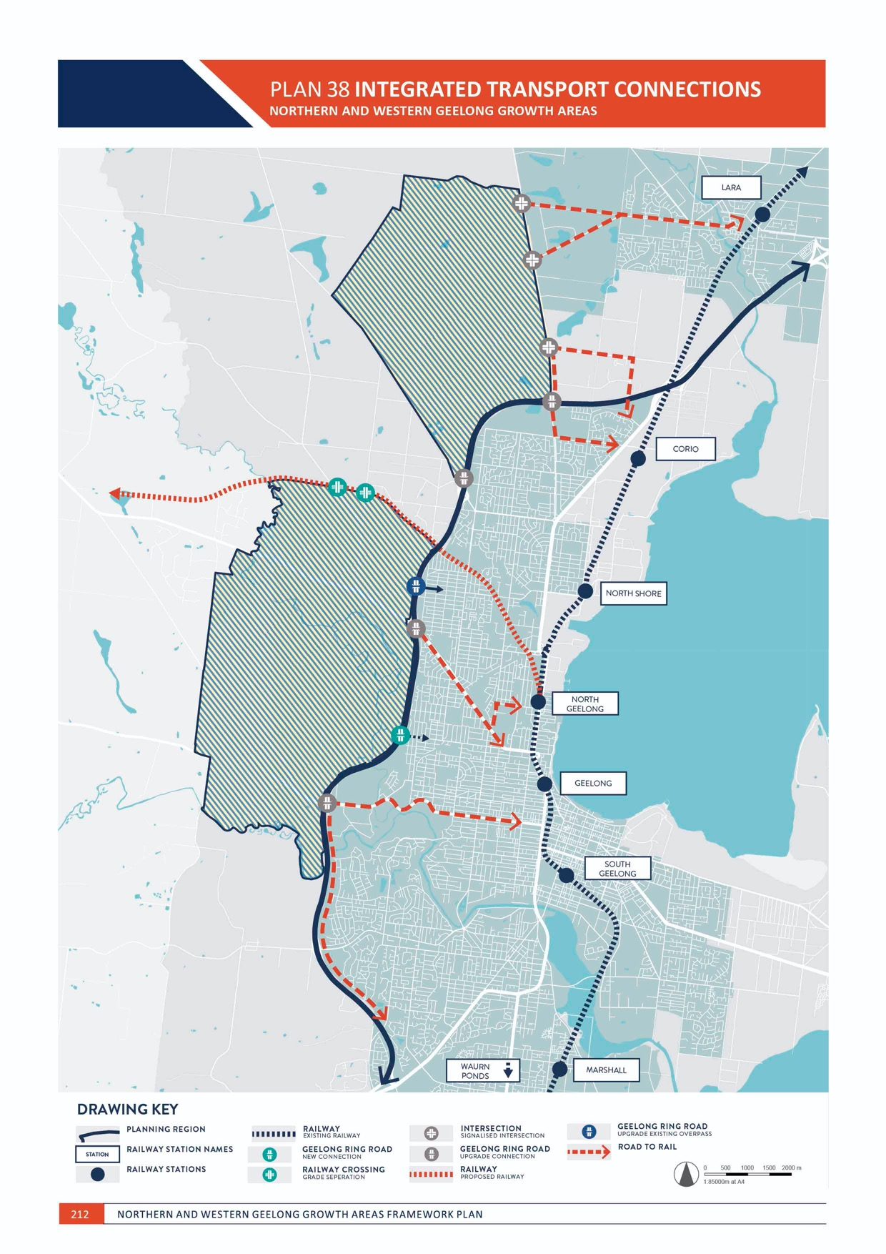

IMAGE IS NOT AVAILABLE WITHIN THIS VERION.
TO VIEW SUPPORTING VISUAL FOR THIS PAGE GO TO
www.geelongaustralia.com.au/futuregrowth/default.aspx
TO ACCESS PDF.

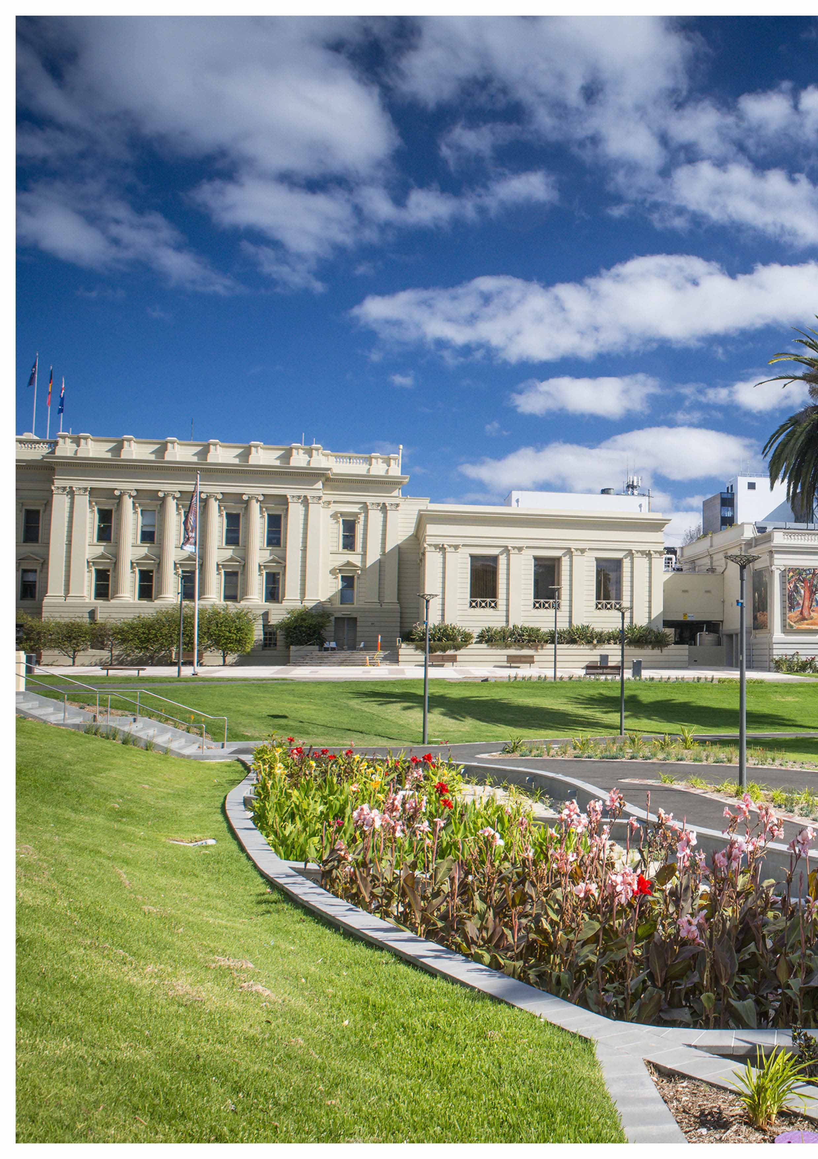



215

DELIVERY

DELIVERY is the element that commits Geelong’s growth areas to sustainable sequencing of new development that provides essential infrastructure and services from the outset.
Successful delivery of this city-shaping project will be measured by our capacity to harness the economic and community benefits of growth whilst maintaining the city’s enviable lifestyle and character as part of a larger, greater Geelong.
Greater Geelong’s Settlement Strategy provides a strategic framework for managing growth in the Northern and Western Geelong Growth Area and commits the City to:
- Deliver well-planned and sustainable communities
- Implement timely and efficient provision of infrastructure, services and facilities
IMAGE IS NOT AVAILABLE WITHIN THIS VERION.
TO VIEW SUPPORTING VISUAL FOR THIS PAGE GO TO
www.geelongaustralia.com.au/futuregrowth/default.aspx
TO ACCESS PDF.

- Prioritise and promote early provision of public transport infrastructure and services
- Monitor and control land releases and manage the programme of precinct structure plans.
The Northern and Western Geelong Growth Areas will be planned and developed in an orderly sequence of short, medium and long term precincts.
The Clever and Creative Corridor is the unifying element that traverses through Geelong’s new growth areas.
Commitment to delivering the corridor and its adjoining land uses and services is a long-term and fundamental element in realising Geelong’s clever and creative vison.
DELIVERY considers the sustainable sequencing of development in the Northern and Western Geelong Growth Areas by prioritising precincts and projecting the essential infrastructure and services required to support Geelong’s new neighbourhoods.

PREVIOUS PAGE: CLEVER AND CREATIVE DELIVERY – JOHNSTON PARK RAINGARDEN

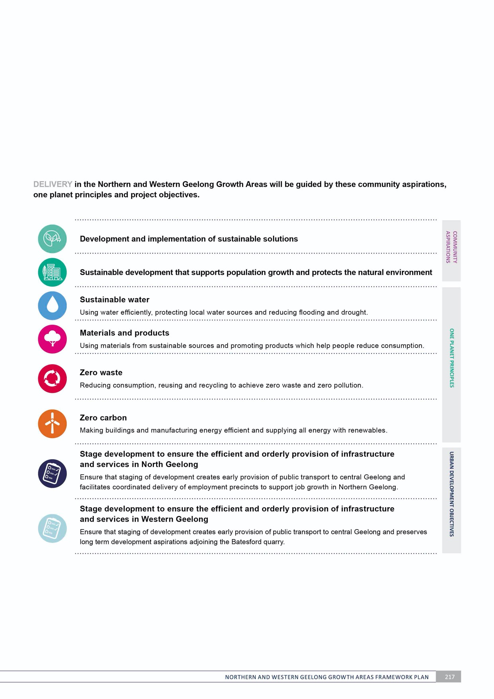

PLAN 39 UTILITIES AND INFRASTRUCTURE

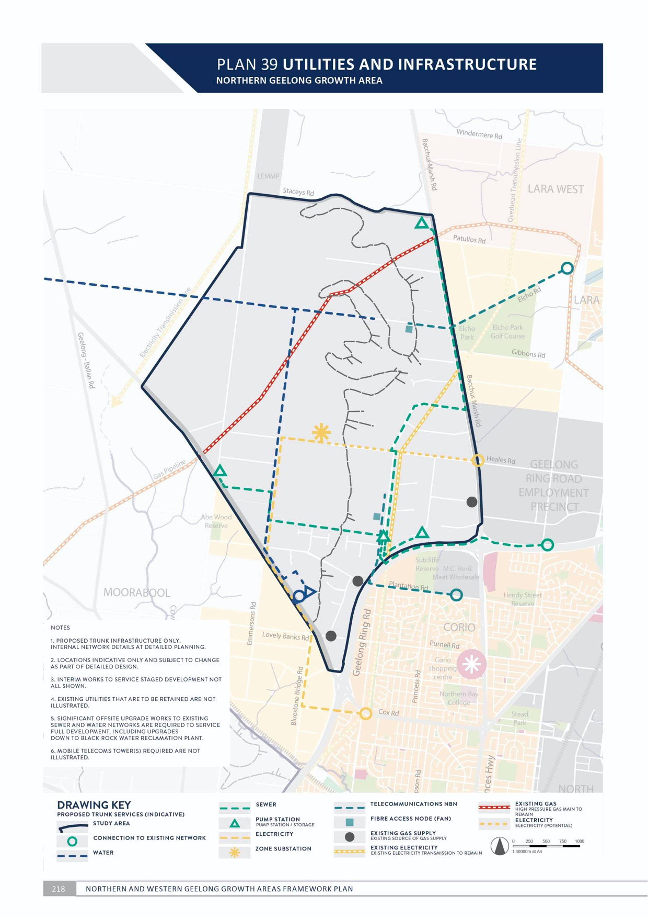
DELIVERY
NORTHERN GEELONG GROWTH AREA

UTILITIES AND INFRASTRUCTURE
NORTHERN GEELONG GROWTH AREA

CONTEXT

The infrastructure required to support a city-sized growth area is extensive and diverse. The scale of urban development in the Northern Geelong Growth Area
provides opportunities and constraints in the planning and delivery of essential infrastructure: city-shaping projects can be forecast, funded and delivered; however, rapid changes in technology and society may significantly impact utility and infrastructure provision prior to the full development of the growth area.
Greater Geelong is a One Planet Council committed to establishing itself as a carbon neutral city by 2047.
Creating carbon neutral neighbourhoods in the Northern Geelong Growth Area is essential to achieving the community-led aspiration for sustainable development that will achieve net
zero carbon.
Infrastructure will be delivered in the Northern Geelong Growth Area via various stakeholders and including:
- Capital works by the City of Greater Geelong
- Capital works projects by state government agencies
- Subdivision works by land developers
- Utility service providers.

Infrastructure will be funded in the Northern Geelong Growth Area via:
- Development contributions plans or infrastructure contributions plans as prepared by the City of Greater Geelong
- Works in kind projects completed by land developers on behalf of the City and/or state government agencies
- Agreement under section 173 of the Planning and Environment Act 1987
- Works by utility service providers
- City-funded projects
- State and federal government-funded projects.
A high level estimate of the transport, stormwater drainage and social infrastructure needed to support Geelong’s new neighbourhoods has been formulated for each precinct on pages 226–233.
The precinct concept plans at pages 226–233 are only intended to show the potential combination of land uses and infrastructure requirements that need to be addressed at the Precinct Structure Plan stage. The plans do not represent a final or preferred urban structure for the relevant precinct.
The purpose of the Precinct Infrastructure Requirements at pages 226–233 is to identify the broad infrastructure needs for each precinct. These will be refined as each Precinct Structure Plan is prepared.

DELIVERY

ACTION N5.1.1
All lots will be provided with potable water, electricity, reticulated sewerage, stormwater drainage and telecommunications.
Utilities will be delivered underground in a coordinated manner that:
- Bundles infrastructure to maximise space for large canopy tree planting within road verges
- Responds to the local site context and uses logical placement principles
- Locates infrastructure within existing easements, where practicable
- Relocates existing above ground electricity cables underground (unless greater than 66kV)
- Aligns with trunk infrastructure illustrated on Plan 39, subject to detailed investigation
- Minimises disruption during off site works to connect to existing supply networks
- Aligns with environmental protection principles for river and waterway crossings
- Follows a logical sequencing of development and efficient rollout of infrastructure
- Responds to site topography, particularly in steep areas of the monocline escarpment.
ACTION N5.1.2
A servicing plan will be prepared for each precinct structure plan that outlines the utilities required to deliver sustainable development outcomes reflected in the relevant integrated water management strategy and environmentally sustainable design (ESD) action plan.
Provision of other services, including recycled water and gas, will be subject to these detailed investigations to determine how urban development will deliver
sustainable water, zero carbon and zero waste. Indicative trunk infrastructure illustrated on Plan 39 represents a conventional servicing approach that is subject to change and innovation as part of detailed precinct structure planning.

ACTION N5.1.3
Placement of utilities will not detract from the amenity of the neighbourhood, particularly the open space network.
Utilities will be delivered to maintain an attractive and healthy public realm in a manner that:
- Locates above ground infrastructure outside of key view lines with landscape screening
- Avoids and minimises impacts on waterways and disturbance of their landform, biodiversity and heritage values
- Avoids and minimises impacts on any conservation areas.

ACTION N5.1.4
Staging of urban development will provide for delivery of ultimate utility servicing infrastructure.
Where delivery of the ultimate infrastructure is not possible, alternate proposals will demonstrate how any interim infrastructure adequately services the development and how the infrastructure will enable delivery of the ultimate servicing network.

ACTION N5.1.5
Subdivision of land will deliver a wide range of local infrastructure to support new neighbourhoods.
Subdivision of land will meet the total cost of delivering local infrastructure where it is not included in the relevant development or infrastructure contributions plan including:
- Local and connector streets (including the Clever and Creative Corridor), intersections, bridges and traffic management measures along arterial roads and local and connector streets and landscaping and lighting
- Shared, pedestrian and bicycle paths along the integrated transport network, waterway and open space networks and easements and appropriate bicycle parking and lighting
- Appropriately scaled lighting along all roads, major shared and pedestrian paths, and traversing public open space
- Basic improvements to the open space network, including local, linear and district parks and sports reserves
- Utilities and stormwater drainage
- Appropriate noise attenuation along the Geelong Ring Road.
ACTION N5.1.6
The integrity of the existing gas pipeline will be maintained as part of urban development.
Development within and adjoining the gas pipeline easement will deliver road, stormwater drainage and utility infrastructure that intersects the pipeline at 90 degrees with engineering that does not threaten the pipeline. Trees and shrubs will not be planted within three metres of the gas pipeline.

ACTION N5.1.7
Urban development will acknowledge and maintain electricity transmission line easements.
Subdivision layout and landscaping of land within and adjacent to electricity transmission line easements will seek to minimise the visual impact of the transmission lines and towers and achieve appropriate public interface with the easements.

PLAN 40 DEVELOPMENT SEQUENCING
NORTHERN GEELONG GROWTH AREA

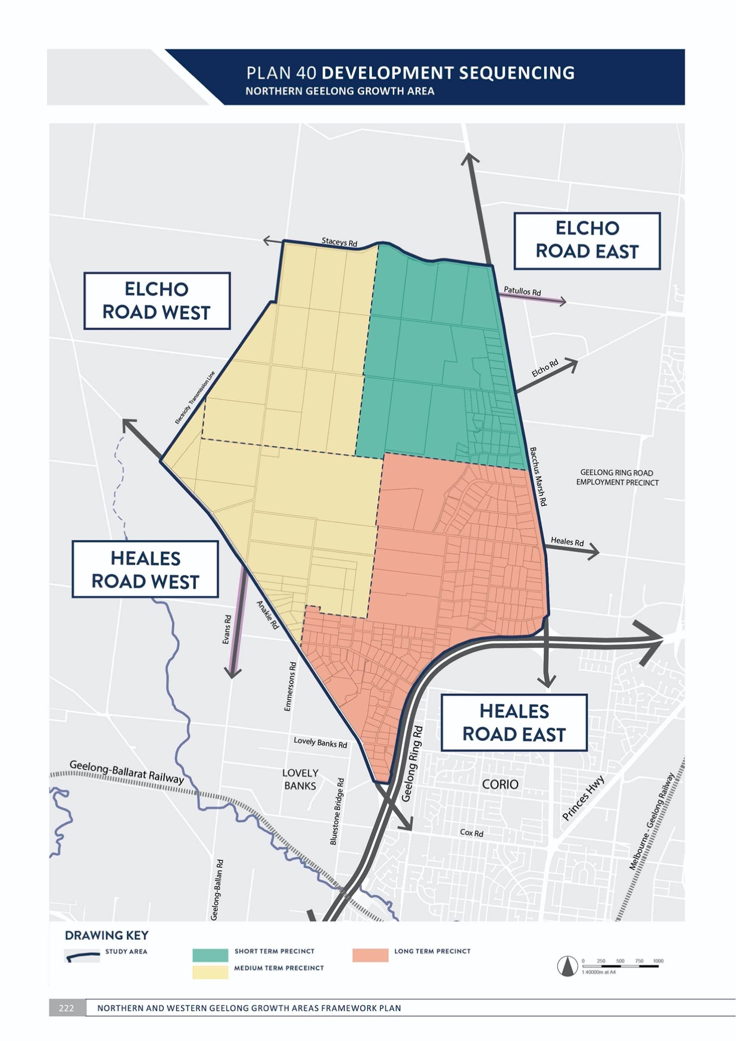

DELIVERY

DEVELOPMENT SEQUENCING
NORTHERN GEELONG GROWTH AREA

CONTEXT

Sequencing of urban development is critical to the success of Geelong’s new neighbourhoods and must be undertaken in manner that benefits the city’s broader community and economy.
The release and management of new development fronts has implications for the delivery of infrastructure and services. The City is responsible for funding growth area infrastructure in partnership with the Victorian Government and land developers. Managing the timing of costs associated with development begins with the decision to commence a precinct structure plan as it forms a direct pathway to urban development. Careful consideration for initiating a precinct structure plan is as important as the subsequent detailed planning.
Commencing new urban development in proximity to existing neighbourhoods is generally preferred as it will allow nearby access to services for new residents prior to the delivery of local infrastructure. Where possible, private sector investment and contributions toward early
infrastructure provision will be fully explored to support the early stages of Geelong’s new neighbourhoods.

The Northern Geelong Growth Area will be planned and developed in an orderly sequence of short, medium and long term precincts as illustrated on Plan 40:
- Short term precinct:
  - Elcho Road East (illustrated on Plan 41)
- Medium term precinct:
  - Elcho Road West (illustrated on Plan 42)
  - Heales Road West (illustrated on Plan 43)
- Long term precinct:
  - Heales Road East (illustrated on Plan 44). Urban development in the Northern Geelong Growth
Area will commence on the land adjoining Lara West and prioritise early connections to Lara Railway Station and Lara Town Centre. New communities will be established throughout the western plateau in the medium-term before urban development is considered in the south-eastern part of the growth area. The Clever and Creative Corridor will be accessible to all precincts.
Each precinct will accommodate a standalone, neighbourhood-sized community that is sufficient to support local services, ensuring the short-term precincts will not be dependent on the immediate or premature development of subsequent precincts.

DELIVERY

ACTION N5.2.1
The commencement of any precinct structure plan will be initiated by the City based on strategic policy and budgeting.
Recommendations for the commencement of a precinct structure plan will be based on:
- The City of Greater Geelong Settlement Strategy.
- Development sequencing set out in the Northern and Western Geelong Growth Areas Framework Plan.
- The need to maintain an adequate supply of urban land.
- Third party funding agreements with land developers to undertake technical studies.
- Whether the precinct will enable the staged extension of infrastructure networks in a way that minimises the real cost of infrastructure provision.
- Whether or not a precinct is subject to major constraints or uncertainties that is likely to delay development.
- Whether or not the precinct is of a size that is likely to result in a substantial and predictable development yield.
- The pattern of land ownership and the potential for multiple landowners to coordinate the planning and development of the precinct.
- Whether a precinct’s development will support the effective and early development of public transport infrastructure, town centre and employment precincts.
ACTION N5.2.2
Simultaneous preparation of precinct structure plans in the Northern Geelong Growth Area will be not be supported unless necessitated by the City’s strategic policy and considerations outlined in Action N5.2.1.
Releasing a new precinct structure plan for development necessitates the provision of infrastructure and services that must be carefully managed by the City and the Victorian Government. The anticipated dwelling and population yield of each precinct in the growth area is substantial in the local context. Preparation of a precinct structure plan requires significant resourcing, budgeting and community and stakeholder engagement and should be undertaken in succession.

ACTION N5.2.3
The commencement and approval of precinct structure plans in the Northern Geelong Growth Area will be undertaken in the following sequence:
- Elcho Road East Precinct Structure Plan prior to Elcho Road West Precinct Structure Plan or Heales Road West Precinct Structure Plan
- All other precinct structure plans prior to Heales Road East.
Urban development will be supported that provides initial connections to Lara and delays urban development in rural living areas in Lovely Banks and the southern half of the Lovely Banks monocline in the short and medium term.

ACTION N5.2.4
Precinct structure plans will be prepared by the City to provide detailed guidance for the design and development of Geelong’s new neighbourhoods.
Precinct structure plans establish clear guidance for future land use and development, offering greater certainty to stakeholders and supporting the timely and coordinated provision of infrastructure. A City-led precinct structure planning process will:
- Allow the City to plan and manage the impacts of growth
- Ensure that precinct structure plans are guided by community aspirations, one planet principles and project objectives
- Respond to the Northern and Western Geelong Growth Areas Framework Plan
- Execute individual third party funding agreements with land developers to fund a set of City-led technical reports needed to inform each precinct structure plan
- Deliver a suite of technical studies and supporting documents for the precinct structure plan
- Incorporate a development contributions plan or infrastructure contributions plan to identify funding mechanisms for essential infrastructure.
ACTION N5.2.5
Development staging will provide for the timely provision and delivery of the integrated transport network, including the Clever and Creative Corridor, and land for social infrastructure.
Creating sustainable communities will rely on providing early access to social infrastructure and safe and convenient public and active transport. Essential infrastructure will be provided from the early stages of urban development including:
- Bus-capable arterial roads (including reservations) and connector streets and bridges constructed to the property boundary
- Access from an arterial road to each new lot via a sealed road
- Connection of the on- and off-road pedestrian and bicycle networks to key destinations inside and outside each precinct
- Land for community infrastructure, active recreation and open space.

PLAN 41 ELCHO ROAD EAST PRECINCT
NORTHERN GEELONG GROWTH

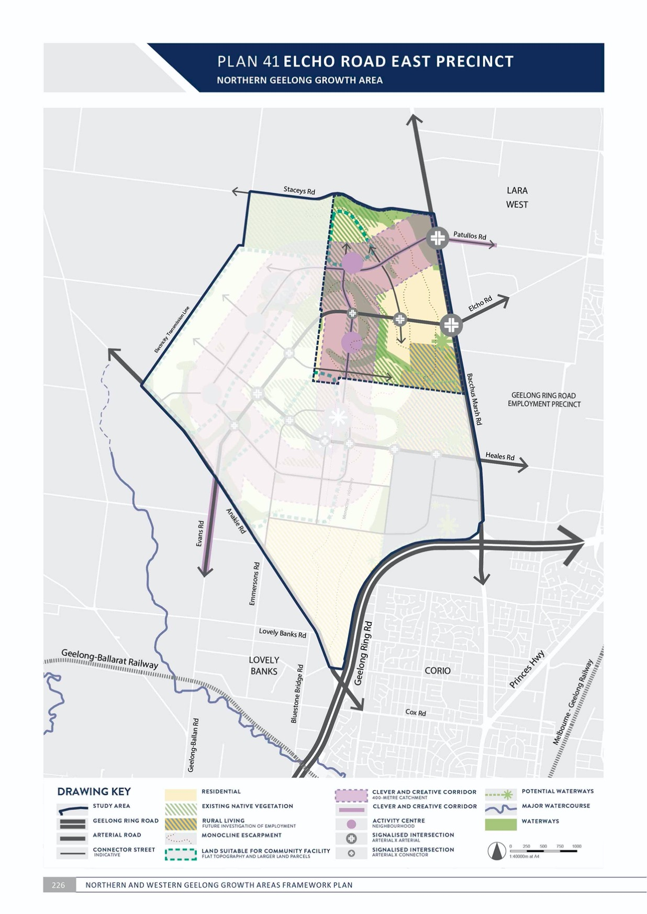

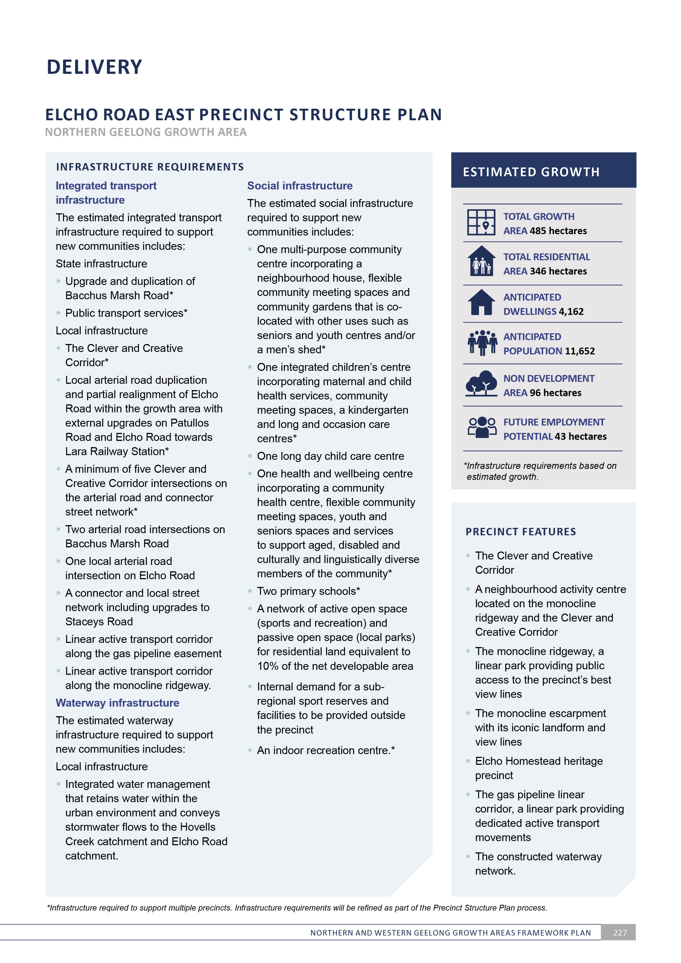

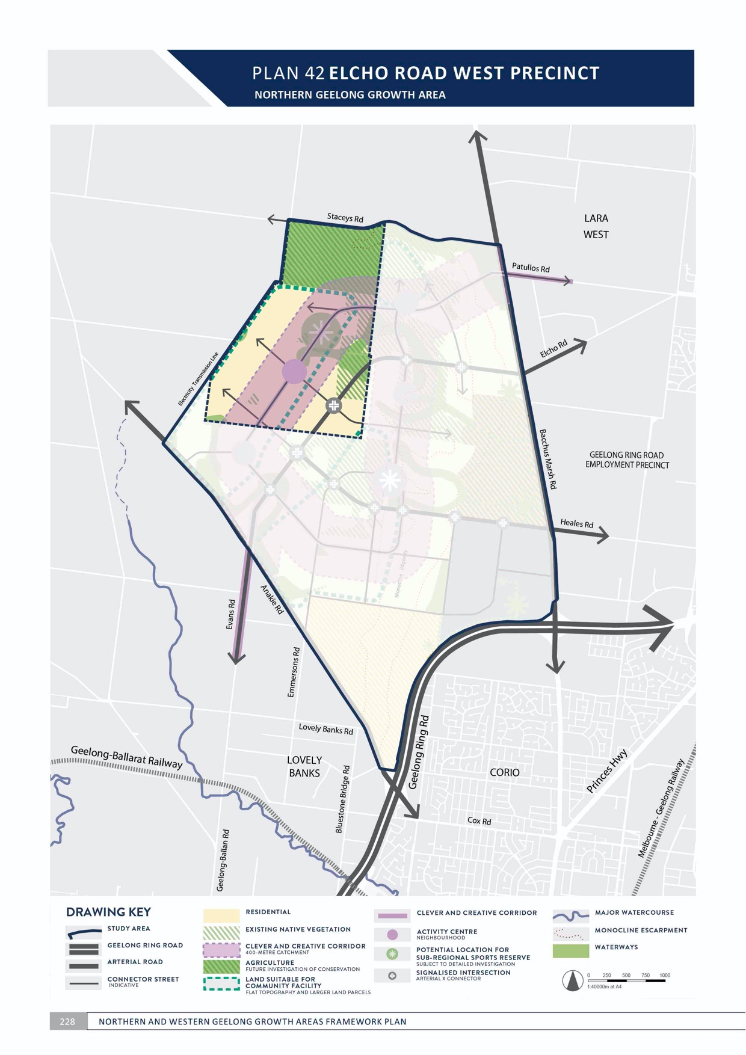

PLAN 43 HEALES ROAD WEST PRECINCT

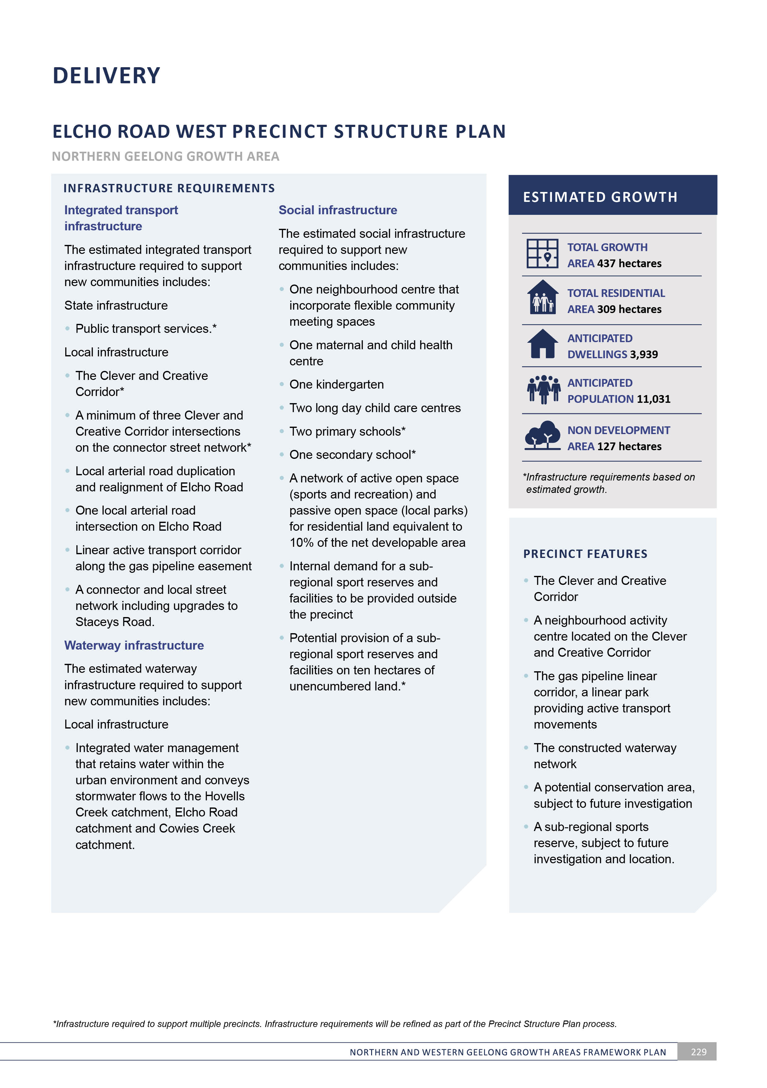
NORTHERN GEELONG GROWTH AREA

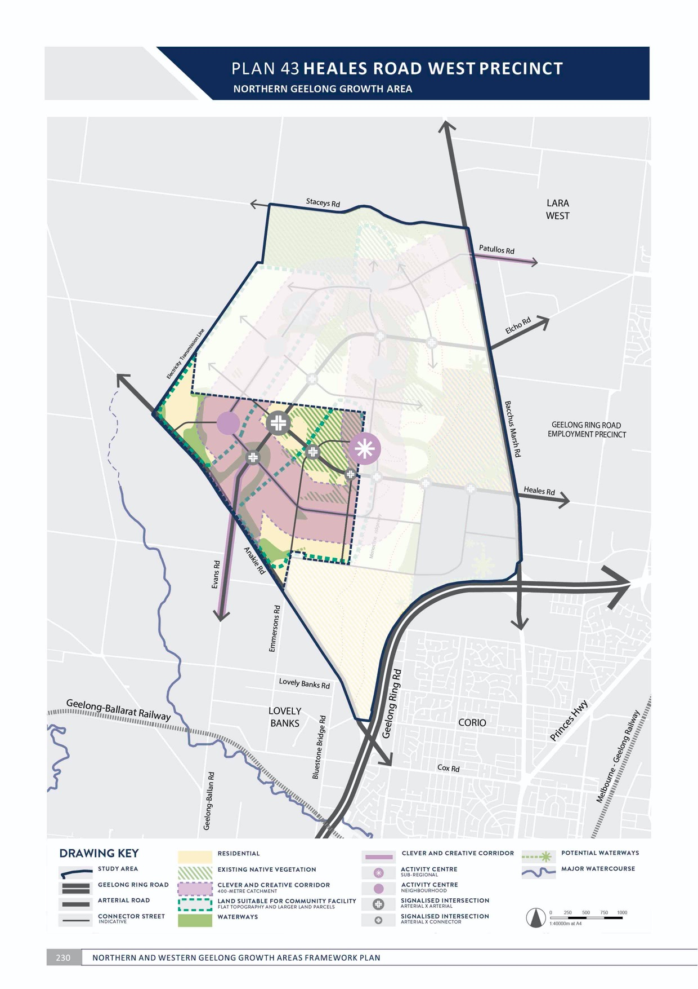
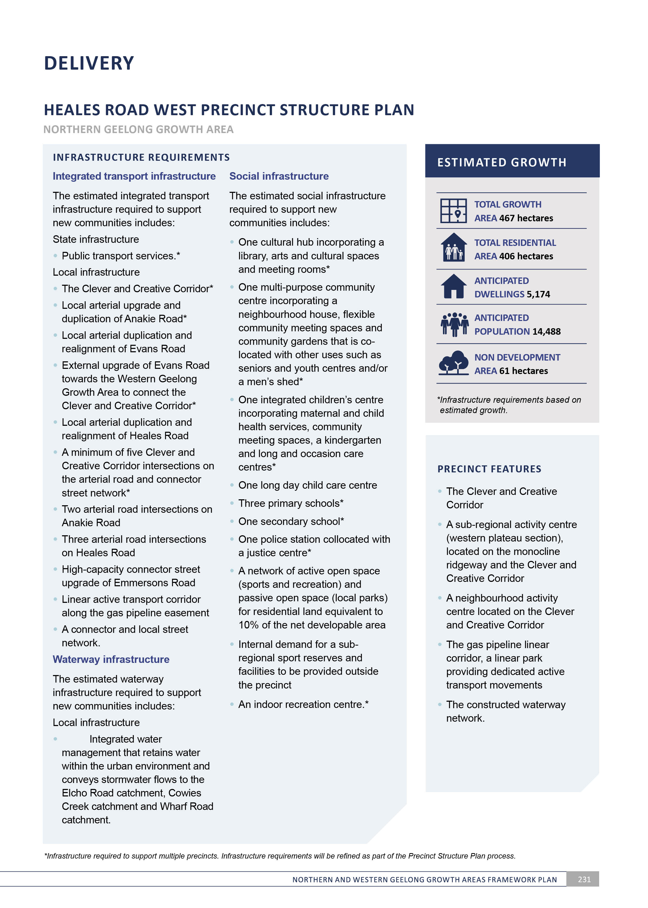
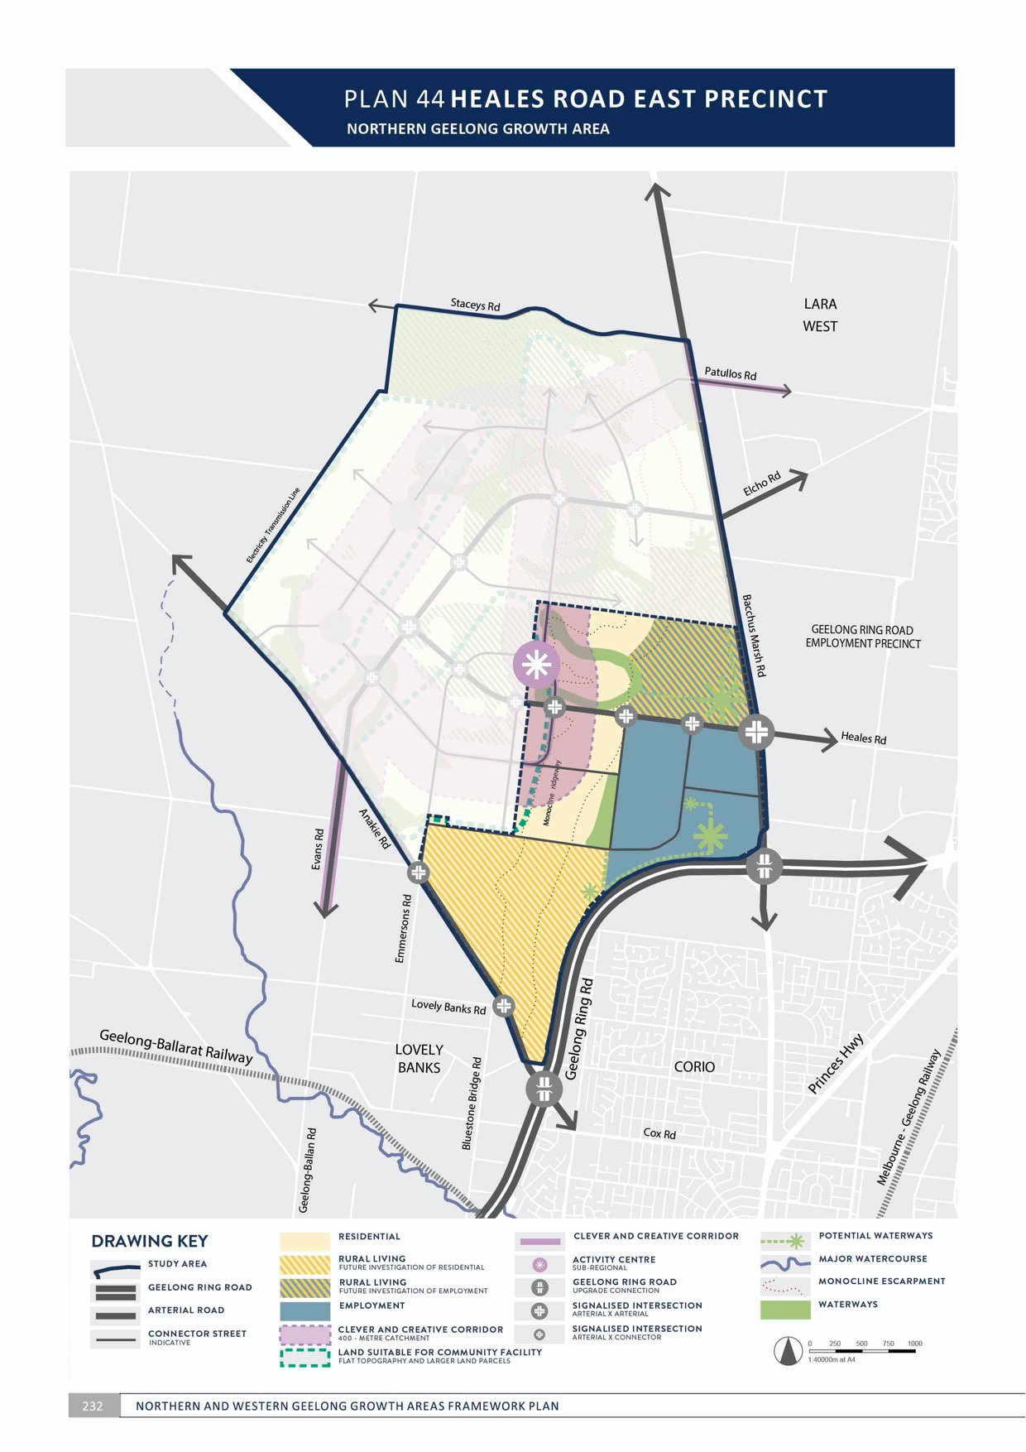
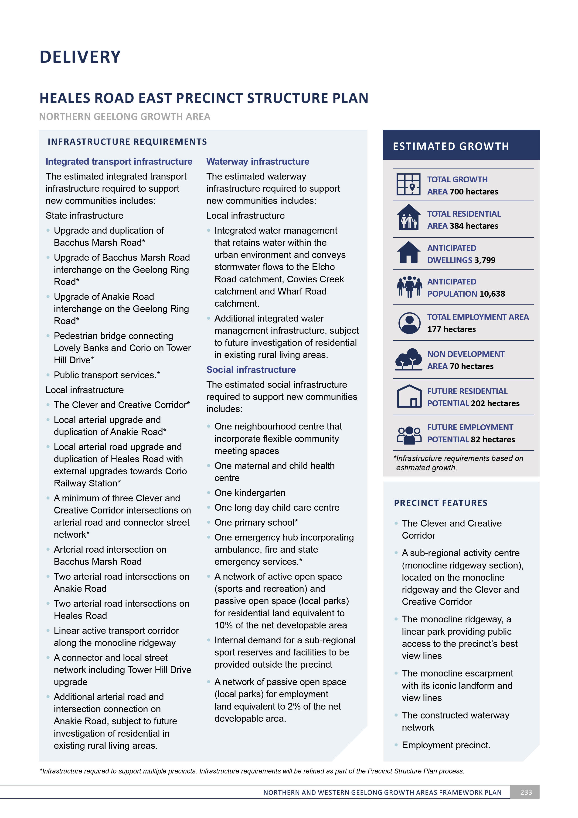

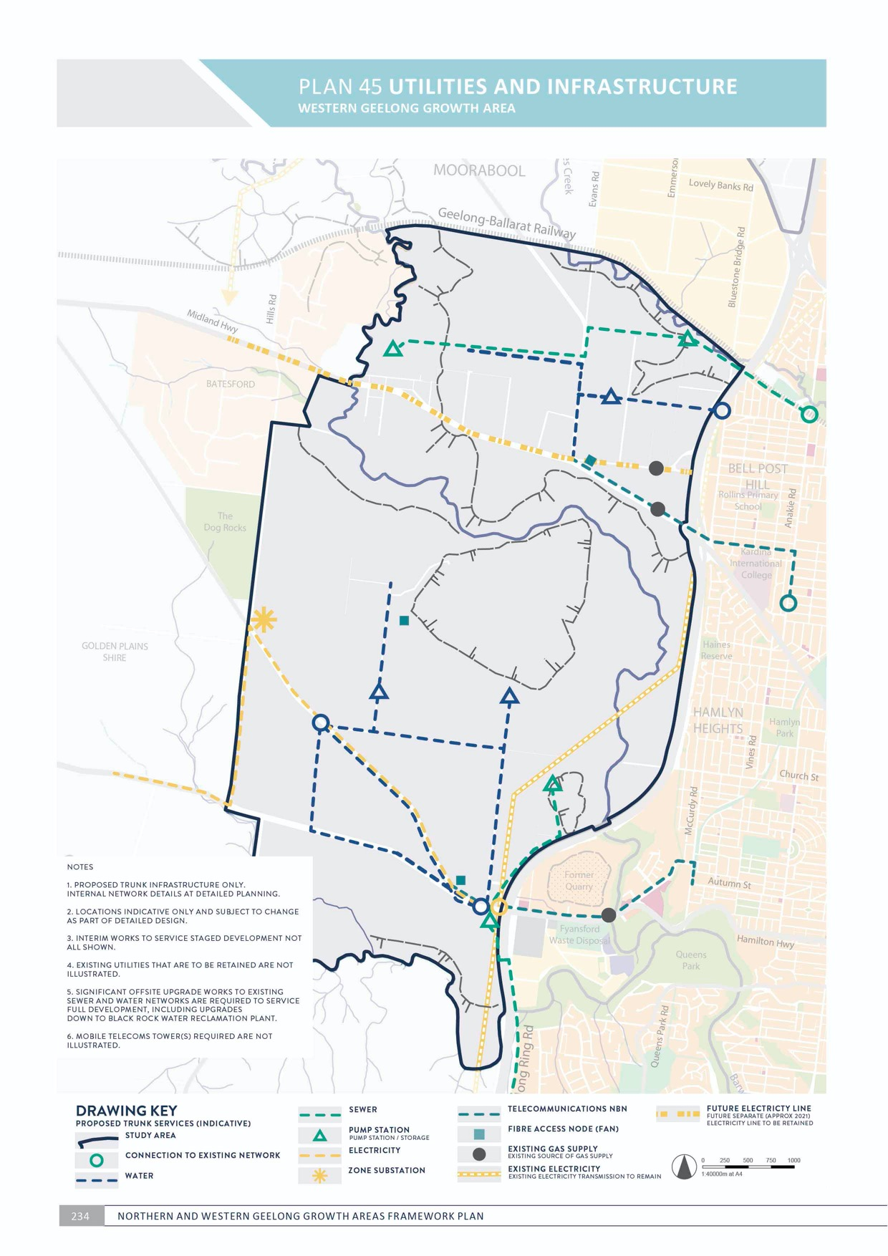

DELIVERY
WESTERN GEELONG GROWTH AREA

UTILITIES AND INFRASTRUCTURE
WESTERN GEELONG GROWTH AREA

CONTEXT

The infrastructure required to support a city-sized growth area is extensive and diverse. The scale of urban development in the Western Geelong Growth Area
provides opportunities and constraints in the planning and delivery of essential infrastructure: city-shaping projects can be forecast, funded and delivered; however, rapid changes in technology and society may significantly impact utility and infrastructure provision prior to the full development of the growth area. Ongoing extraction at the Batesford Quarry increases the complexity of future planning.
Greater Geelong is a One Planet Council committed to establishing itself as a carbon neutral city by 2047. Creating carbon neutral neighbourhoods in the Western Geelong Growth Area is essential to achieving the community-led aspiration for sustainable development that will achieve net zero carbon.
Delivery of utilities and infrastructure is particularly complex in the Western Geelong Growth Area given that initial urban development will occur to the north and south of Batesford Quarry as its operations remain active. Strategic planning of infrastructure will be important in facilitating early growth and delivering networks that connect when the quarry area is transformed.
The open space network, particularly the river and creeks corridors and floodplains and Dog Rocks Sanctuary,
will need to be protected when delivering infrastructure and utilities. Planning and construction of utilities and infrastructure should minimise disturbance to the Batesford township.
Infrastructure will be delivered in the Western Geelong Growth Area via various stakeholders including:
- Capital works by the City of Greater Geelong
- Capital works projects by state government agencies
- Subdivision works by land developers
- Utility service providers.

Infrastructure will be funded in the Western Geelong Growth Area via:
- Development contributions plans or infrastructure contributions plans as prepared by the City of Greater Geelong
- Works in kind projects completed by land developers on behalf of the City and/or state government agencies
- Agreement under section 173 of the Planning and Environment Act 1987
- Works by utility service providers
- City-funded projects
- State and federal government-funded projects.
A high level estimate of the transport, stormwater drainage and social infrastructure needed to support Geelong’s new neighbourhoods has been formulated for each precinct on pages 242–252.
The precinct concept plans at pages 242–252 are only intended to show the potential combination of land uses and infrastructure requirements that need to be addressed at the Precinct Structure Plan stage. The plans do not represent a final or preferred urban structure for the relevant precinct.
The purpose of the Precinct Infrastructure Requirements at pages 242–252 is to identify the broad infrastructure needs for each precinct. These will be refined as each Precinct Structure Plan is prepared.

DELIVERY

ACTION W5.1.1
All lots will be provided with potable water, electricity, reticulated sewerage, stormwater drainage and telecommunications.
Utilities will be delivered underground in a coordinated manner that:
- Bundles infrastructure to maximise space for large canopy tree planting within road verges
- Responds to the local site context and uses logical placement principles
- Locates infrastructure within existing easements, where practicable
- Relocate existing above ground electricity cables underground (unless greater than 66kV)
- Aligns with trunk infrastructure illustrated on Plan 45, subject to detailed investigation
- Minimises disruption during off site works to connect to existing supply networks
- Aligns with environmental protection principles for river and waterway crossings
- Follows a logical sequencing of development and efficient rollout of infrastructure
- Responds to site topography, particularly around the quarry, stockpiles and river and creek corridors.
ACTION W5.1.2
A servicing plan will be prepared for each precinct structure plan that outlines the utilities required to deliver sustainable development outcomes reflected in the relevant integrated water management strategy and environmentally sustainable design (ESD) action plan.
Provision of other services, including recycled water and gas, will be subject to these detailed investigations to determine how urban development will deliver
sustainable water, zero carbon and zero waste. Indicative trunk infrastructure illustrated on Plan 45 represents a conventional servicing approach that is subject to change and innovation as part of detailed precinct structure planning.

ACTION W5.1.3
Placement of utilities will not detract from the amenity of the neighbourhood, particularly the open space network.
Utilities will be delivered to maintain an attractive and healthy public realm in a manner that:
- Locates above ground infrastructure outside of key view lines with landscape screening
- Avoids and minimises impacts on waterways and disturbance of their landform, biodiversity and heritage values
- Avoids and minimises impacts on any conservation areas.

ACTION W5.1.4
Staging of urban development will provide for delivery of ultimate utility servicing infrastructure.
Where delivery of the ultimate infrastructure is not possible, alternate proposals will demonstrate how any interim infrastructure adequately services the development and how the infrastructure will enable delivery of the ultimate servicing network.

ACTION W5.1.5
Subdivision of land will deliver a wide range of local infrastructure to support new neighbourhoods.
Subdivision of land will meet the total cost of delivering local infrastructure where it is not included in the relevant development or infrastructure contributions plan including:
- Local and connector streets (including the Clever and Creative Corridor), intersections, bridges and traffic management measures along arterial roads and local and connector streets and landscaping and lighting
- Shared, pedestrian and bicycle paths along the integrated transport network, waterway and open space networks and easements and appropriate bicycle parking and lighting
- Appropriately scaled lighting along all roads, major shared and pedestrian paths, and traversing public open space
- Basic improvements to the open space network, including local, linear and district parks and sports reserves
- Utilities and stormwater drainage
- Appropriate noise attenuation along the Geelong Ring Road.
ACTION W5.1.6
Urban development will acknowledge and maintain electricity transmission line easements.
Subdivision layout and landscaping of land within and adjacent to electricity transmission line easements will seek to minimise the visual impact of the transmission lines and towers and achieve appropriate public interface with the easements.

PLAN 46 DEVELOPMENT SEQUENCING

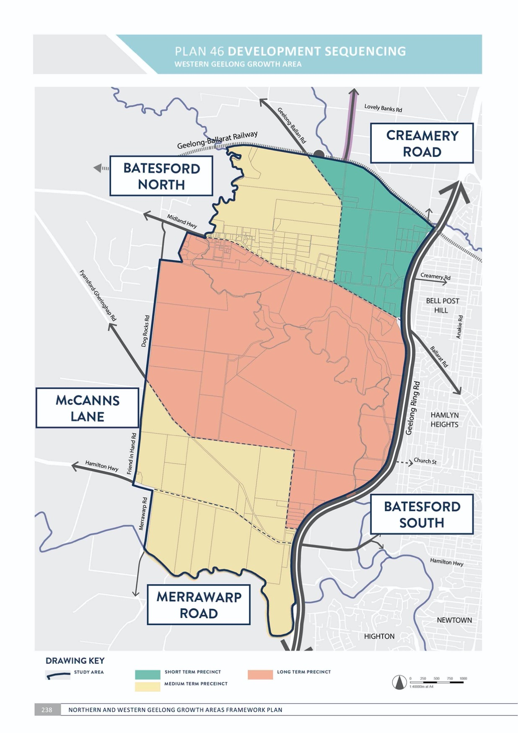

DELIVERY

DEVELOPMENT SEQUENCING
WESTERN GEELONG GROWTH AREA

CONTEXT

Sequencing of urban development is critical to the success of Geelong’s new neighbourhoods and must be undertaken in manner that benefits the city’s broader community and economy.
The release and management of new development fronts has implications for the delivery of infrastructure and services. The City is responsible for funding growth area infrastructure in partnership with the Victorian Government and land developers. Managing the timing of costs associated with development begins with the decision to commence a precinct structure plan as it forms a direct pathway to urban development. Careful consideration for initiating a precinct structure plan is as important as the subsequent detailed planning.
Commencing new urban development in proximity to existing neighbourhoods is generally preferred as it will allow nearby access to services for new residents prior to the delivery of local infrastructure. Where possible, private sector investment and contributions toward early
infrastructure provision will be fully explored to support the early stages of Geelong’s new neighbourhoods.

The Western Geelong Growth Area will be planned and developed in an orderly sequence of short, medium and long term precincts as illustrated on Plan 46:
- Short term precinct:
  - Creamery Road (illustrated on Plan 47)
- Medium term precinct:
  - Batesford North (illustrated on Plan 48)
  - McCanns Lane (illustrated on Plan 49)
  - Merrawarp Road (illustrated on Plan 50)
- Long term precinct:
  - Batesford South (illustrated on Plan 51).
Urban development in the Western Geelong Growth Area will commence on the land adjoining Bell Post Hill with direct access to central Geelong via Ballarat Road. New neighbourhoods will be established along the Midland Highway and Hamilton Highway corridors in the medium- term before urban development is considered in proximity to Batesford Quarry. The Clever and Creative Corridor will be accessible to all precincts.
Each precinct will accommodate a standalone, neighbourhood-sized community that is sufficient to support local services, easing the short-term precincts will not be dependent on the immediate or premature development of subsequent precincts. The large size and development potential of the Batesford South precinct
means that the Western Geelong Growth Area will develop as two separate, smaller growth corridors in the short and medium term with large-scale infrastructure requirements triggered by long-term urban development.

DELIVERY

ACTION W5.2.1
The commencement of any precinct structure plan will be initiated by the City based on strategic policy and budgeting.
Recommendations for the commencement of a precinct structure plan will be based on:
- The City of Greater Geelong Settlement Strategy.
- Development sequencing set out in the Northern and Western Geelong Growth Areas Framework Plan.
- The need to maintain an adequate supply of urban land.
- Third party funding agreements with land developers to undertake technical studies.
- Whether the precinct will enable the staged extension of infrastructure networks in a way that minimises the real cost of infrastructure provision.
- Whether or not a precinct is subject to major constraints or uncertainties that is likely to delay development.
- Whether or not the precinct is of a size that is likely to result in a substantial and predictable development yield.
- The pattern of land ownership and the potential for multiple landowners to coordinate the planning and development of the precinct.
- Whether a precinct’s development will support the effective and early development of public transport infrastructure, town centre and employment precincts
ACTION W5.2.2
Simultaneous preparation of precinct structure plans in the Western Geelong Growth Area will be not be supported unless necessitated by the City’s strategic policy and considerations outlined in Action W5.2.1.
Releasing a new precinct structure plan for development necessitates the provision of infrastructure and services that must be carefully managed by the City and the Victorian Government. The anticipated dwelling and population yield of each precinct in the growth area is substantial in the local context. Preparation of a precinct structure plan requires significant resourcing, budgeting and community and stakeholder engagement and should be undertaken in succession.

ACTION W5.2.3
The commencement and approval of precinct structure plans in the Western Geelong Growth Area will be undertaken in the following sequence:
- Creamery Road Precinct Structure Plan prior to Batesford North Precinct Structure Plan
- Creamery Road Precinct Structure Plan prior to McCanns Lane Precinct Structure Plan and Merrawarp Road Precinct Structure Plan
- All other precinct structure plans prior to Batesford South Precinct Structure Plan.
Urban development will be supported that provides initial connections to urban Geelong via the Midland Highway and Hamilton Highway. Urban development south of the Midland Highway and north of McCanns Lane will be avoided in the short to medium term to ensure that the transition of Batesford Quarry is undertaken in a strategic and consolidated manner.

ACTION W5.2.4
Precinct structure plans will be prepared by the City to provide detailed guidance for the design and development of Geelong’s new neighbourhoods.
Precinct structure plans establish clear guidance for future land use and development, offering greater certainty to stakeholders and supporting the timely and coordinated provision of infrastructure. A City-led precinct structure planning process will:
- Allow the City to plan and manage the impacts of growth
- Ensure that precincts structure plans are guided by community aspirations, one planet principles and project objectives
- Respond to the Northern and Western Geelong Growth Areas Framework Plan
- Execute individual third party funding agreements with land developers to fund a set of City-led technical reports needed to inform each precinct structure plan
- Deliver a suite of technical studies and supporting documents for the precinct structure plan
- Incorporate a development contributions plan or infrastructure contributions plan to identify funding mechanisms for essential infrastructure.
ACTION W5.2.5
Development staging will provide for the timely provision and delivery of the integrated transport network, including the Clever and Creative Corridor, and land for social infrastructure.
Creating sustainable communities will rely on providing early access to social infrastructure and safe and convenient public and active transport. Essential infrastructure will be provided from the early stages of urban development including:
- Bus-capable arterial roads (including reservations), connector streets and bridges, constructed to the property boundary
- Access from an arterial road to each new lot via a sealed road
- Connection of the on- and off-road pedestrian and bicycle network to key destinations inside and outside each precinct
- Land for community infrastructure, active recreation and open space.

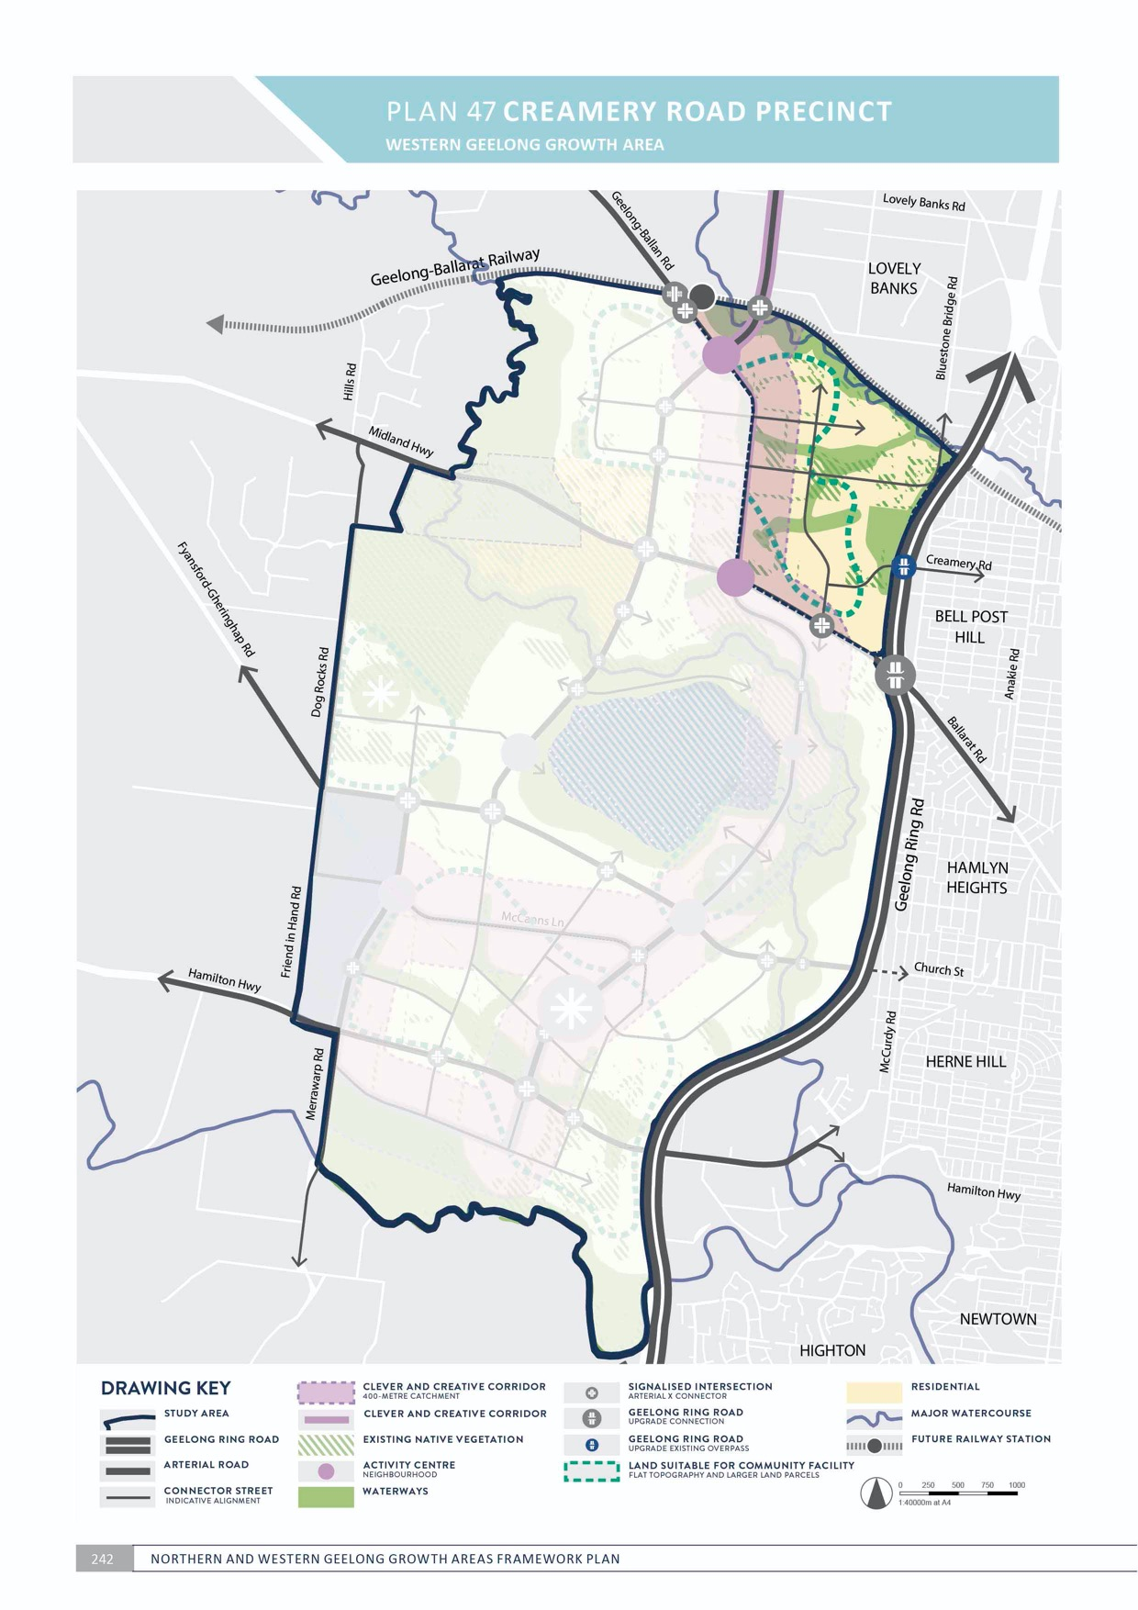
4

48 BATESFORD NORTH PRECINCT

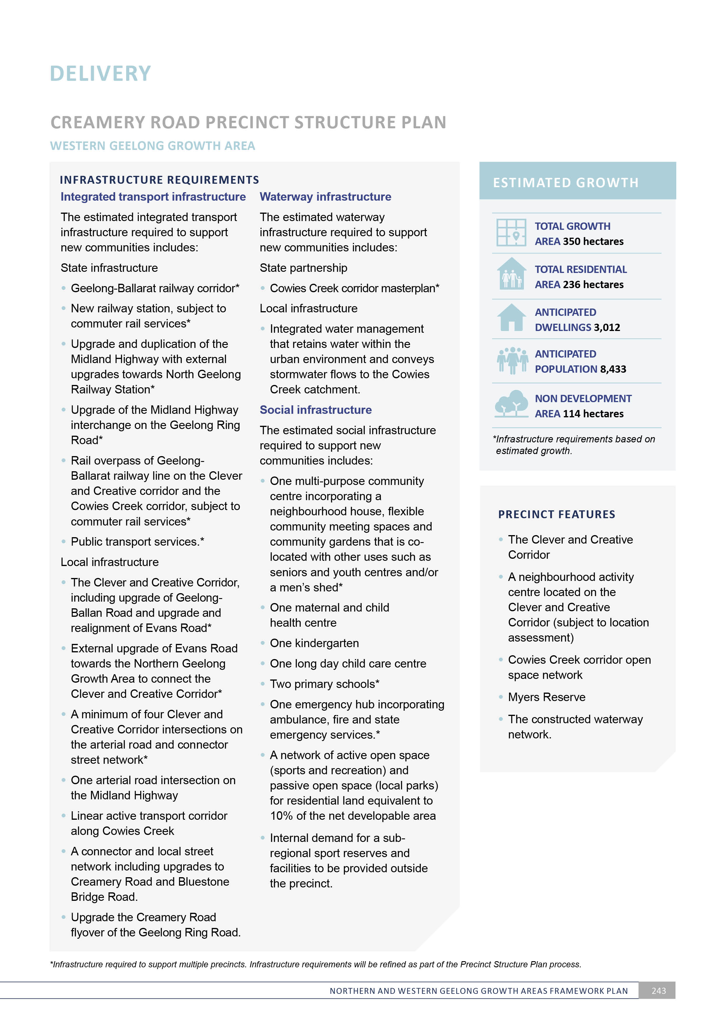

D

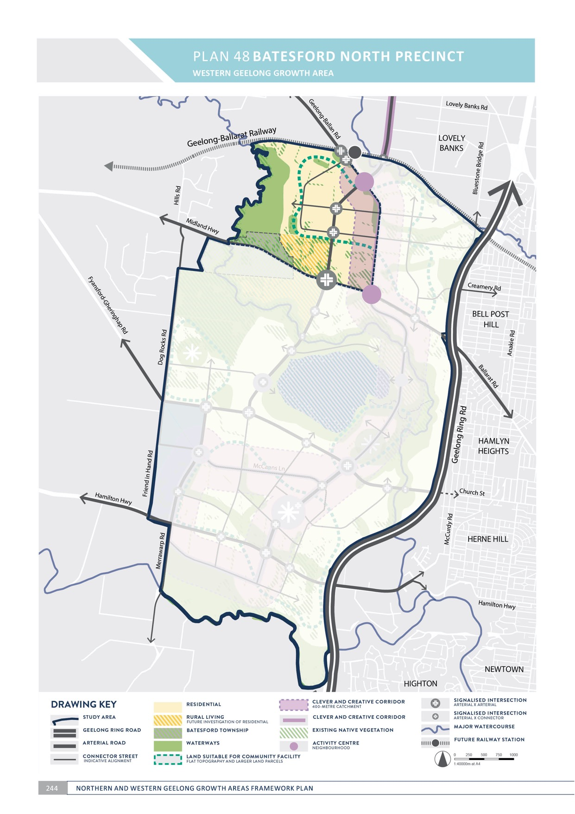

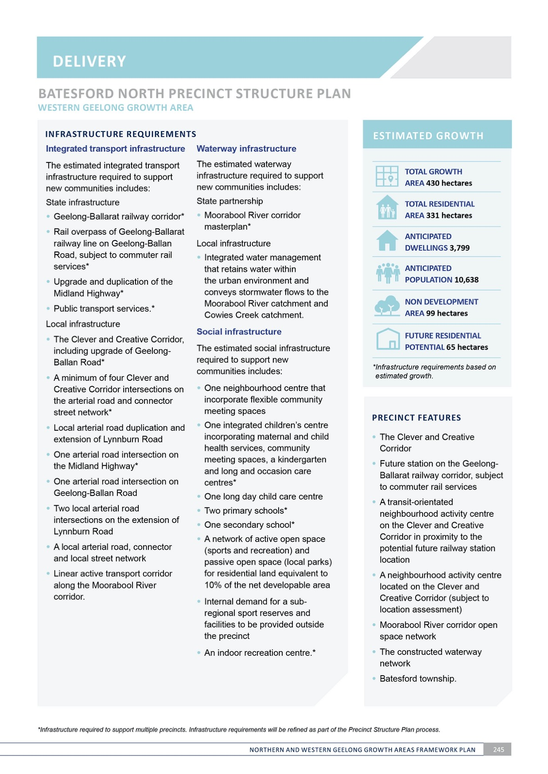

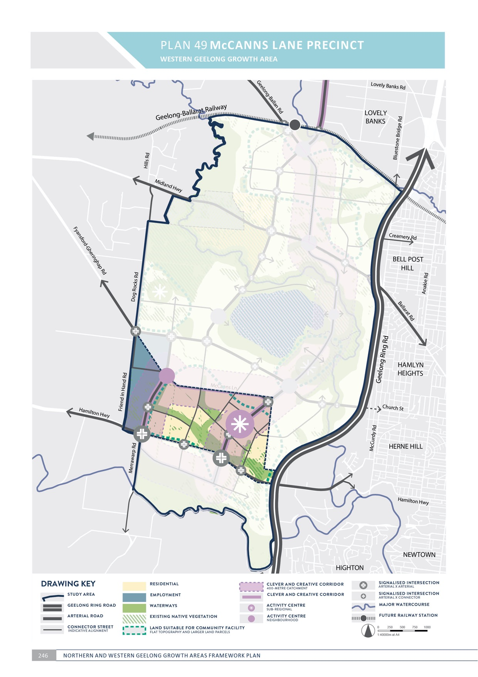

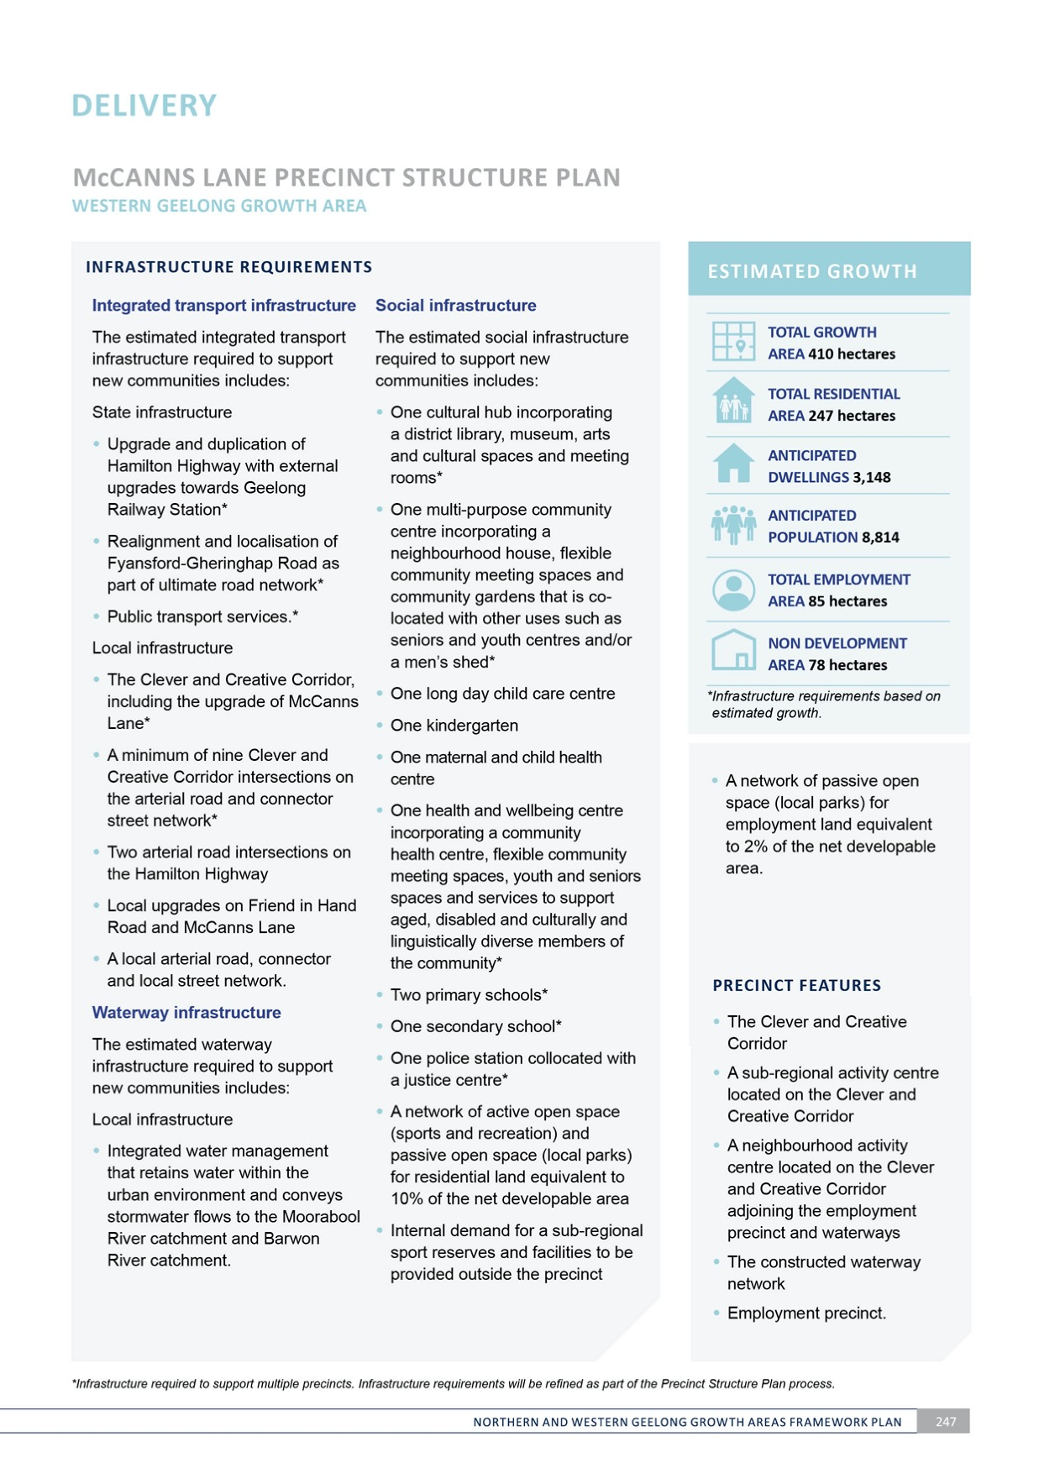

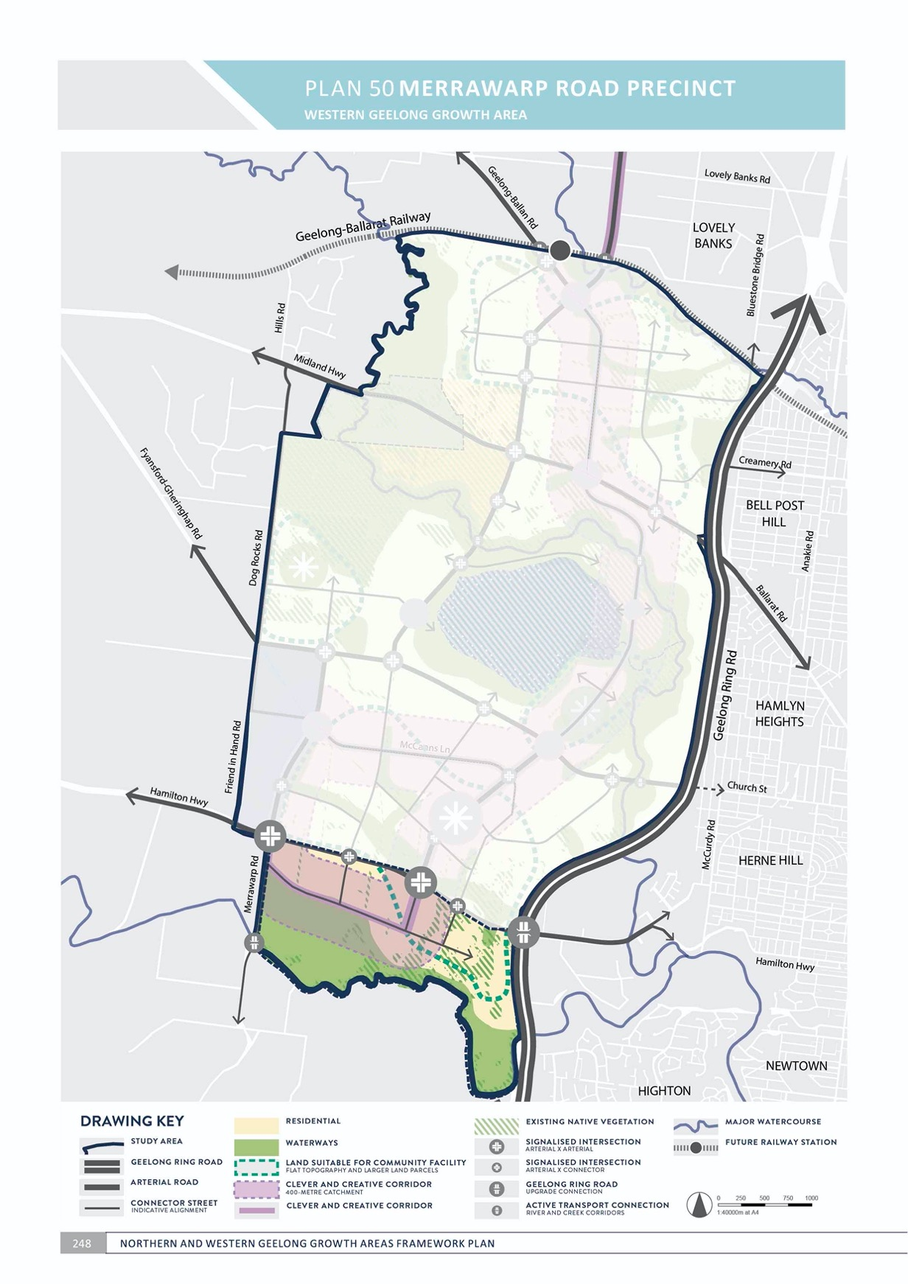

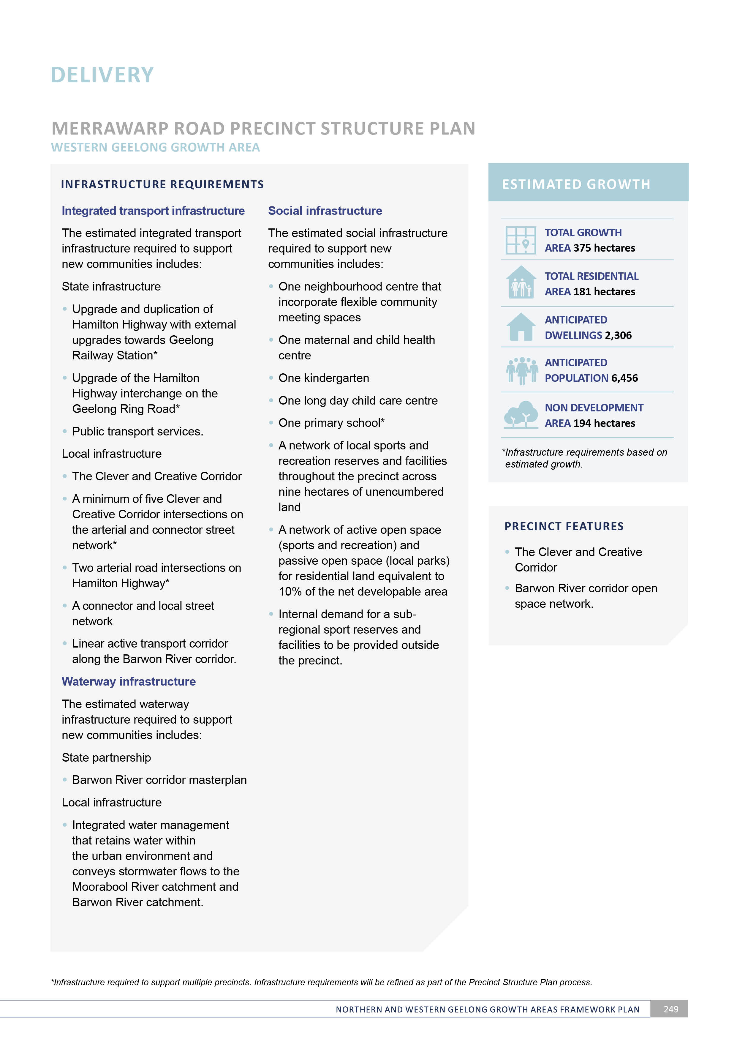
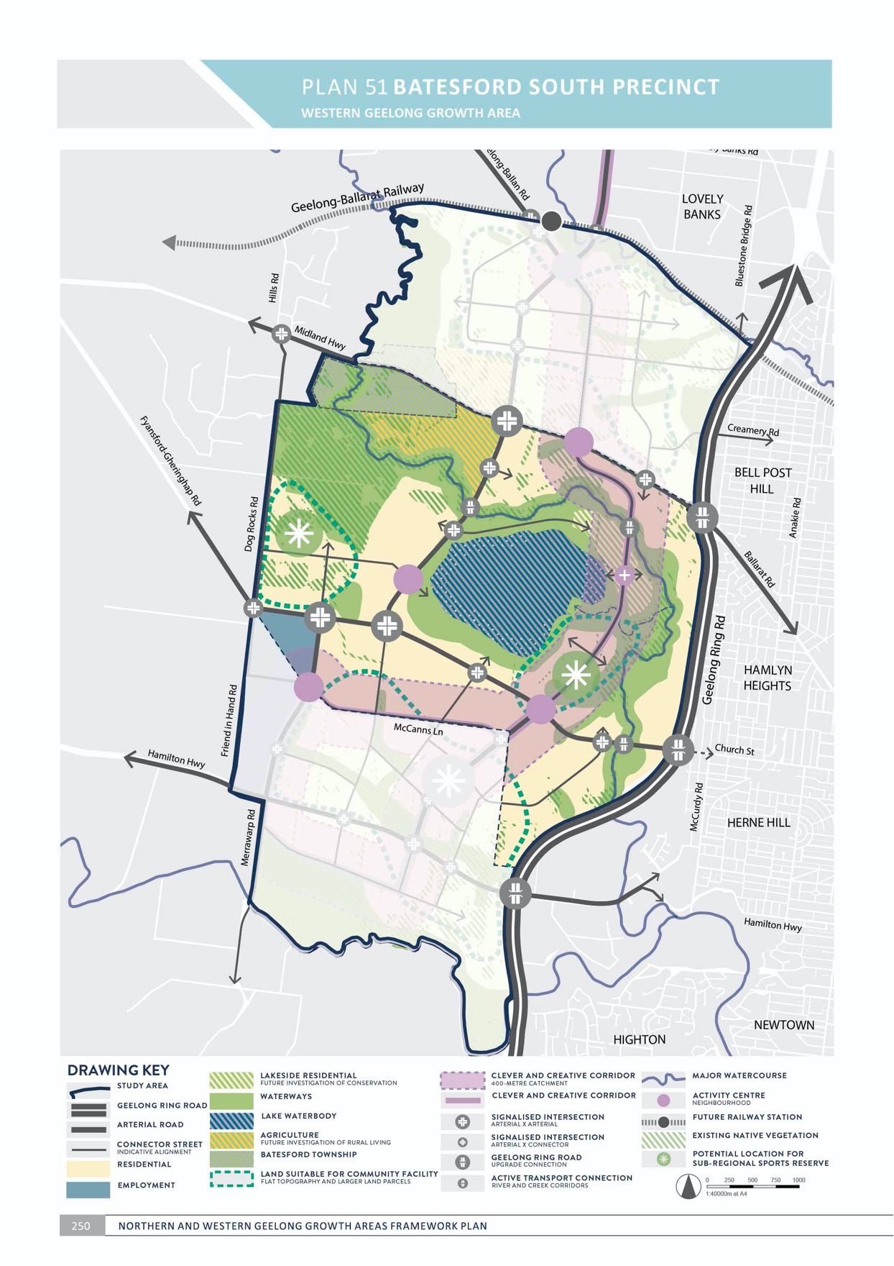

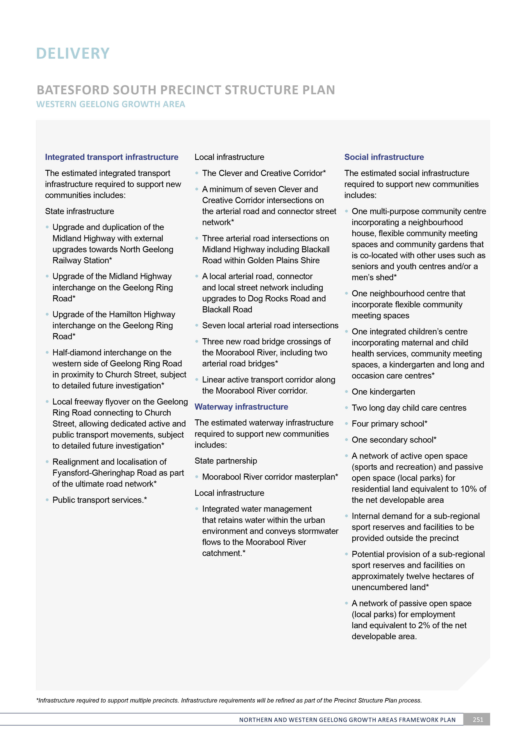
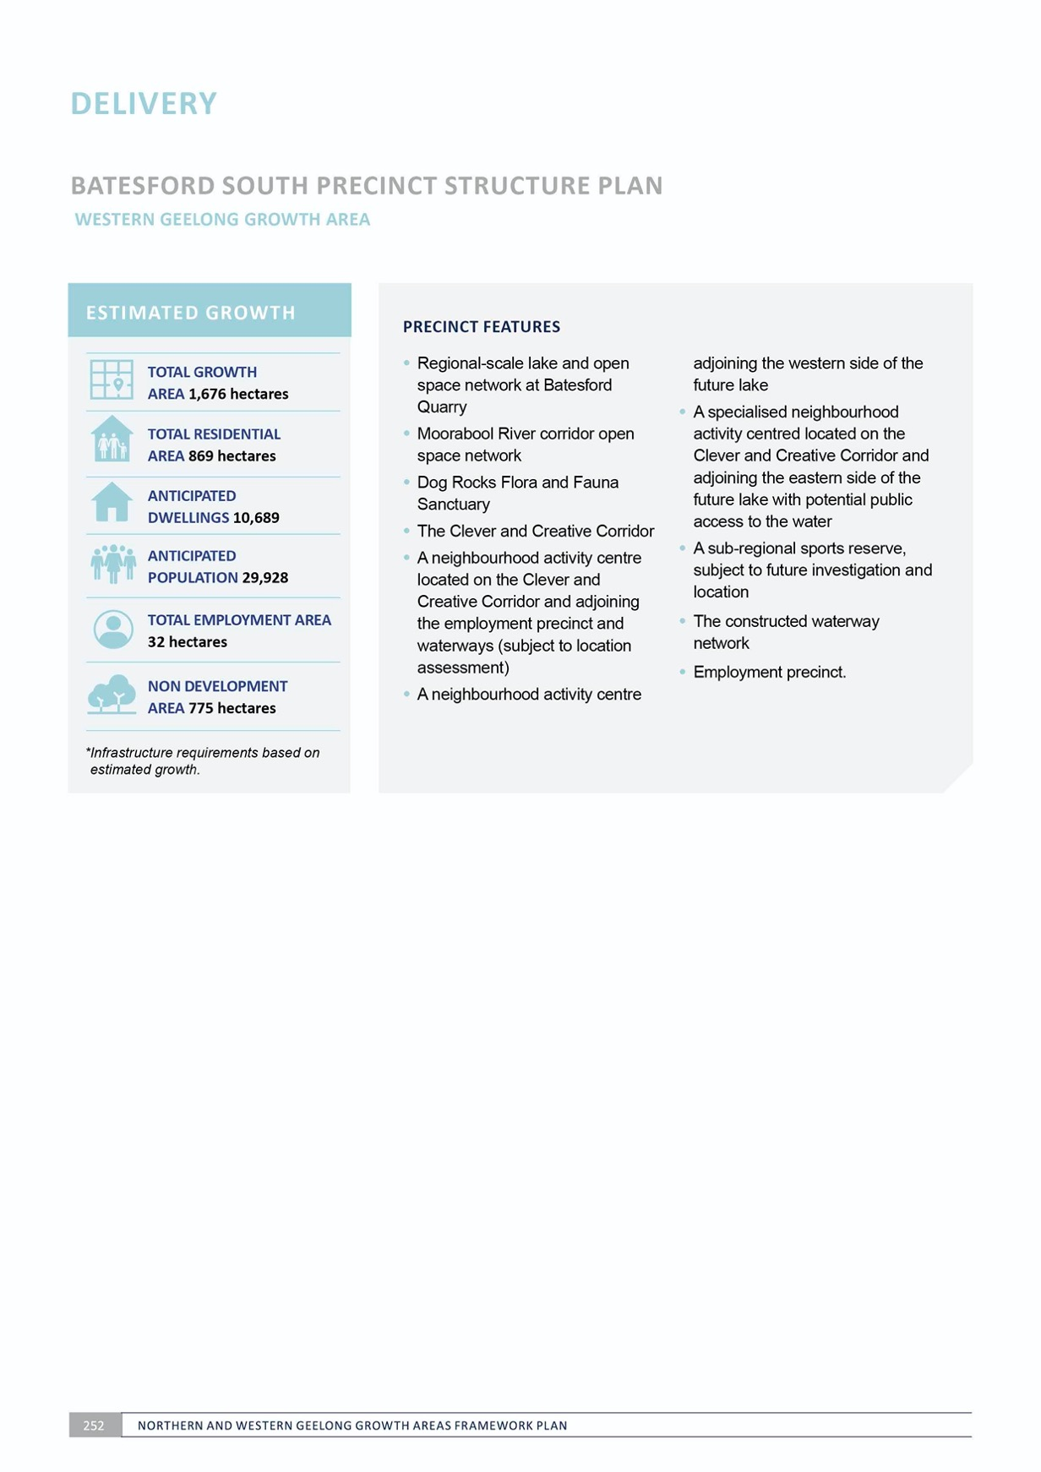

IMAGE IS NOT AVAILABLE WITHIN THIS VERION.
TO VIEW SUPPORTING VISUAL FOR THIS PAGE GO TO
www.geelongaustralia.com.au/futuregrowth/default.aspx
TO ACCESS PDF.

KEY STAKEHOLDERS

The Northern and Western Geelong Growth Areas Framework Plan has been prepared in consultation with a broad range of stakeholders including:

The Greater Geelong community
Landowners and occupiers of the Northern and Western Geelong Growth Areas
The Department of Education and Training
The Department of Environment, Land, Water and Planning The Department of Health and Human Services
The Department of Jobs Precincts and Regions The Department of Justice and Community Safety The Department of Transport
Regional Development Victoria Transport for Victoria
Victorian Planning Authority Regional Roads Victoria Major Road Projects Victoria VicRoads
Victoria Police Country Fire Authority Ambulance Victoria

Wadawurrung
G21 Regional Alliance Golden Plains Shire Barwon Water
Corangamite Catchment Management Authority Southern Rural Water
Deakin University The Gordon Barwon Health
Barwon South West Waste and Resource Recovery Group Geelong Regional Library Corporation
Catholic Education Melbourne APA Group
Ausnet Services Powercor Australia Telstra
NBN Co

REFERENCES

The Northern and Western Geelong Growth Areas Framework Plan has been prepared with reference to the following technical reports:

ENVIRONMENT
  - Stormwater Management Strategy and Flood Impact Assessment: Volume 2 Developed Conditions (draft) – Western Geelong Growth Area – Water Technology – February 2019
- Stormwater Management Strategy and Flood Impact Assessment: Volume 2 Developed Conditions (draft) – Northern Geelong Growth Area – SMEC – February 2019
- Stormwater Management Strategy and Flood Impact Assessment: Volume 1 Existing Conditions – Western Geelong Growth Area – Water Technology – January 2019
- Stormwater Management Strategy and Flood Impact Assessment: Volume 1 Existing Conditions – Northern Geelong Growth Area – SMEC – September 2018
- Integrated Water Cycle Management Position Paper – Barwon Water
and the City of Greater Geelong – September 2018
- Flora and Fauna Technical Report
  - Northern Geelong Growth Area
– Ecology and Heritage Partners – September 2017
- Flora and Fauna Technical Report
  - Western Geelong Growth Area
  - Ecology and Heritage Partners – August 2017
- Geotechnical, Hydrogeological and Contamination Assessment – Western Geelong Growth Area – Douglas Partners – May 2017
- Geotechnical, Hydrogeological
and Contamination Assessment
– Northern Geelong Growth Area – Ground Science – April 2017

- Post Contact Heritage Assessment
  - Northern Geelong Growth Area
  - Ecology and Heritage Partners – December 2016
- Post Contact Heritage Assessment
  - Western Geelong Growth Area
  - Ecology and Heritage Partners – December 2016
- Aboriginal Heritage Assessment
  - Northern Geelong Growth Area
  - Ecology and Heritage Partners – November 2016
- Aboriginal Heritage Assessment
  - Western Geelong Growth Area
  - Ecology and Heritage Partners – November 2016.
NEIGHBOURHOOD
- ESD Action Plan – Hip v Hype – Ongoing
- Social Infrastructure Report – Tap Consulting – March 2019
- ESD Opportunities Report – Hip v Hype – March 2017.
ECONOMY
- Employment Land Report – SGS – December 2017
- Activity Centres Assessment Report – Tim Nott – September 2017
- Activity Centre Catchment Analysis Discussion Paper – Northern Geelong Growth Area – Essential Economics
– August 2017
- Lovely Banks Urban Form and Capacity Assessment – Northern Geelong Growth Area – Essential Economics – July 2017
- Retail and Activity Centre Technical Report – Western Geelong Growth Area – Urban Enterprise – June 2017.

MOVEMENT
- Geelong Growth Areas Transport Infrastructure Strategy – Transport for Victoria and Victorian Planning Authority partnership – Ongoing project
- Movement and Access Strategy Report (draft) – GTA – March 2019
- Clever and Creative Corridor – AECOM – November 2018
- Road and Rail Planning Investigations
AECOM – September 2017
- Active Transport Principles Report – Movendo – August 2017.
DELIVERY
- Integrated Water Management Strategy – Barwon Water and DELWP partnership – Ongoing project
- Infrastructure Futures – Deakin University partnership – Ongoing project
- Utilities Servicing Strategy Report
(draft) – GHD – January 2019
- APA Gas Pipeline Safety Management Workshop Report – GPA Engineering – Northern Geelong Growth Area – January 2017.

