
Note 12 – Quality and finish of

concrete infrastructure;

footpaths, kerb and channel and

concrete pavement
REVISED by: | Matt Mulqueeney, Development Coordinator | REVISION DATE: | 18TH Oct 2023

Introduction
This Design Note reiterates the standards for the quality and finish of concrete infrastructure. Guidance is provided on expected standards and provides information for contractors to improve the likelihood of delivering acceptable works.

There are numerous standards governing the delivery of concrete infrastructure. Where civil assets are created in new subdivisions or through reinstatement activities, acceptance of works is subject to demonstrated compliance with relevant provisions of VicRoads Specifications or Austroads standards.

Relevant standards
Concrete works are to be delivered for the City of Greater Geelong in accordance with the following standards (unless otherwise agreed in writing):
- Infrastructure Design Manual (IDM)
- VicRoads Section 703 - General Concrete Paving
- AS1379- Specification and Supply of Concrete
- AS 2876 – Concrete Kerbs and Channel (Gutters)
- AS3600- Concrete Structures
- AS3610- Formwork for Concrete
- AS3727- Pavements -Part 1- Residential
- AS3799- Liquid membrane-forming curing compounds for concrete.
- CCAA - Residential concrete driveways and paths (2017)
- CCAA- Guide to Residential Streets and Paths (2004)

Strength
Strength is a basic performance-based requirement of all civil concrete assets and is to be specified on design drawings. The strength of concrete is to comply with the following requirements.

Strength
Asset class | Type
FOOTPATH | Minimum 32 MPa (N32)
vehcile crossing infill | Minimum 32 MPa (N32)
KERB AND CHANNEL | Minimum 280kg/m³ (28Mpa)
CONCRETE PAVEMENT | Austroads Guide to Pavement Technology 2010 and the Guide to Structural Design of Road Pavements 2006, with a minimum 20-year design life

Appropriate documentation shall be provided to prove the design criteria has been achieved. Testing is to be performed in accordance with AS 1379. Council inspectors will request this documentation to verify quality of concrete and testing of the supplied concrete may also be undertaken or requested by council if the concrete strength is an issue. Strength may also be verified by in-field rebound hammer test (by a suitably qualified practitioner).

Curing
Curing of concrete is critical for strength development and surface finish. An appropriate curing method in accordance with the Australian Standards must be employed on all concrete infrastructure. To allow correct curing of the concrete, it is important to protect the footpath from vehicles for a minimum of 4 days (unless otherwise approved). Evidence of curing must be available through Inspection and Test Plan using dockets or photos.

Cracking
Cracking of concrete elements may indicate inadequate strength or reinforcement. Where cracking is identified at any time between before the end of a 12-month Defects Liability Period, and it is considered a defect, The City of Greater Geelong will require the relevant section to be replaced (unless otherwise agreed in writing).

Surface Finish
The City of Greater Geelong expects a dense concrete free from voids, honeycombing, segregation or surface defects. Surface finish can indicate improper curing or the addition of too much water during finishing or environmental effects. Please note that the Class 3 finish as specified in VicRoads Section 703 - General Concrete Paving will not be applicable to footpath, kerb and channel or concrete pavements. The finish of concrete is to comply with the following requirements.

SURFACE FINISH
Asset class | Type
FOOTPATH | Lightly textured nonslip surface (broom finish)
vehcile crossing infill | Lightly textured nonslip surface (broom finish)
KERB AND CHANNEL | Smooth trowel finish
CONCRETE PAVEMENT | Rotary trowel lightly textured finish

examples

Footpaths
Acceptable:  Footpath cracking less than 0.2mm | 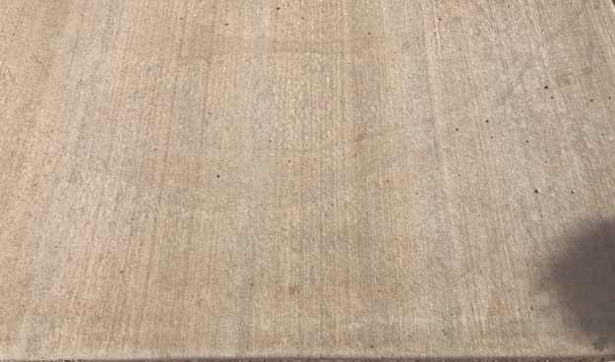
Unacceptable: Footpath cracking greater than 1mm in width | 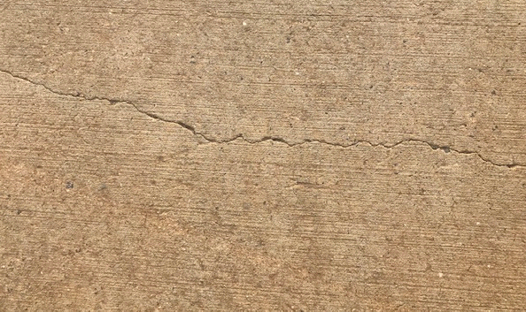
Unacceptable: Insufficient footpath base preparation, footpath not supported | 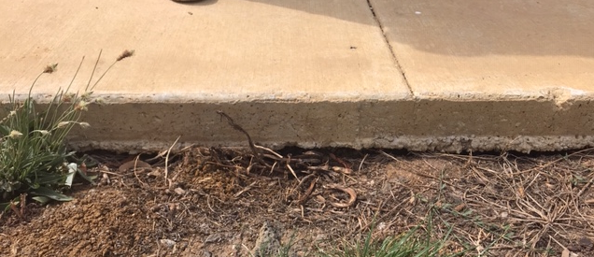

Kerb and Channel
Acceptable: Kerb cracking less than 0.2 mm | 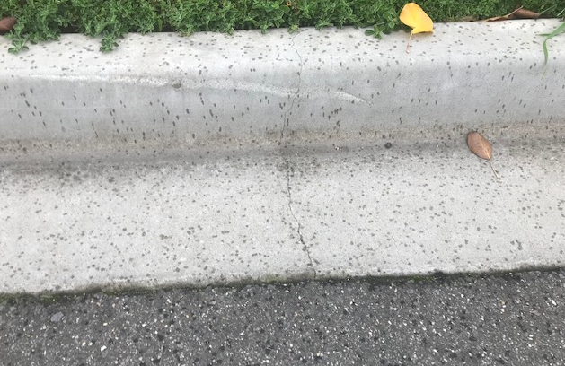
Unacceptable: Kerb cracking greater than 1mm | 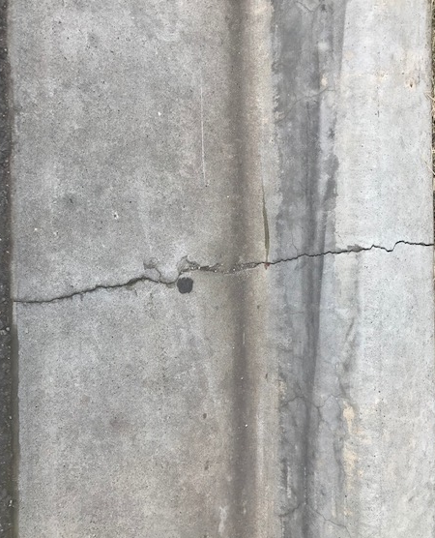
Unacceptable: Kerb “crocodile” or craze cracking in kerbing | 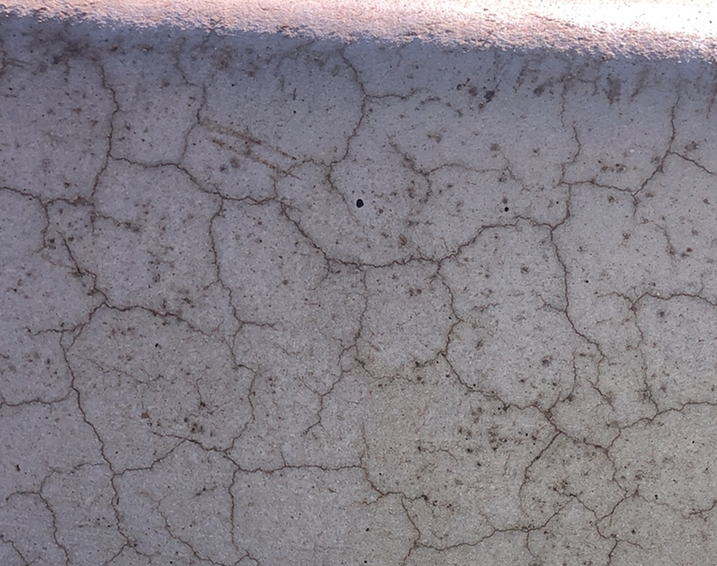

Surface Finish
Asset Class | Type
FOOTPATH | Heavy Textured broom finish
KERB AND CHANNEL | Smooth trowel finish
CONCRETE PAVEMENT | Rotary trowel lightly textured finish
Acceptable: Footpath surface finish
Acceptable: Kerb surface finish | 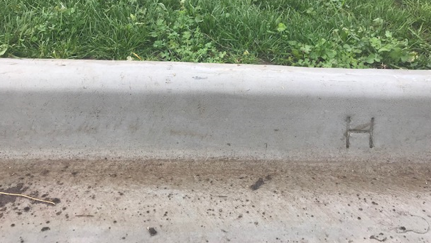
Acceptable: Footpath Builders Scraping /  Damage at end of 12-month Defects Liability Period | 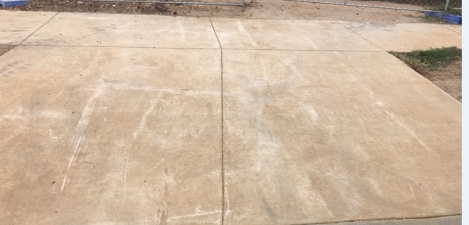
Acceptable: Kerb  Builders Damage at end of 12-month Defects Liability Period | 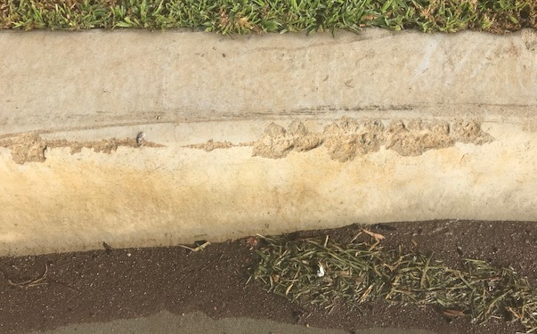
Acceptable: Footpath surface finish | 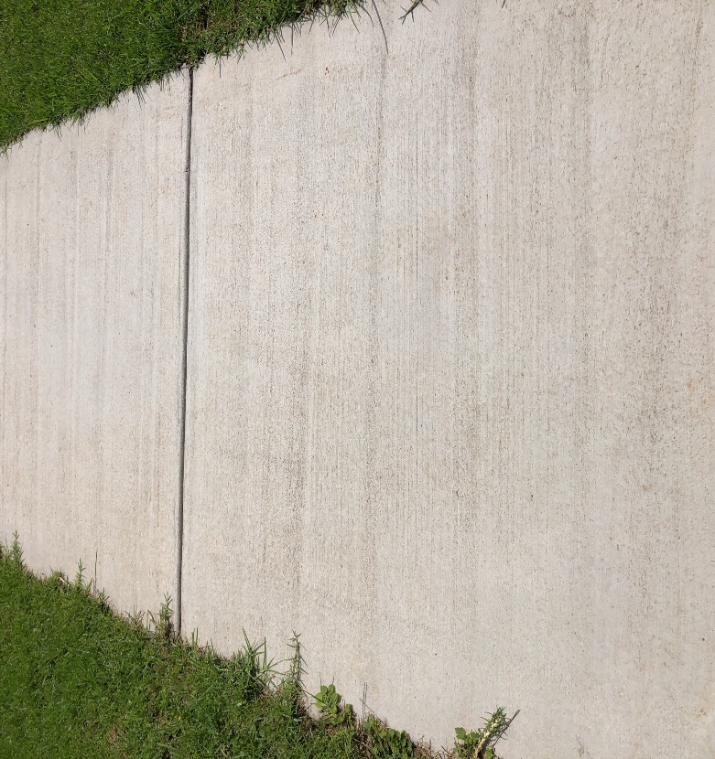
Unacceptable: Standard light broom finish footpath loss of surface and  Exposure of aggregate | 
Unacceptable: Footpath  exposed aggregate | 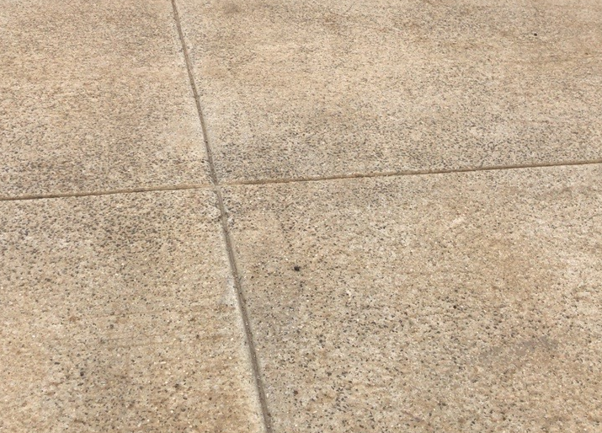
Unacceptable: Kerb Crocodile Cracking | 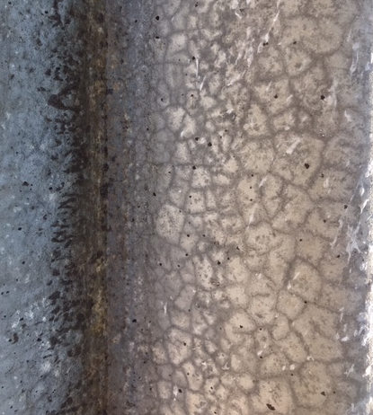

Infrastructure Design Manual (IDM) section 7.4
VicRoads Standard Specification 703.08

