
Setting up your

woRkstation

Things to remember when setting up your desk in the office or at home
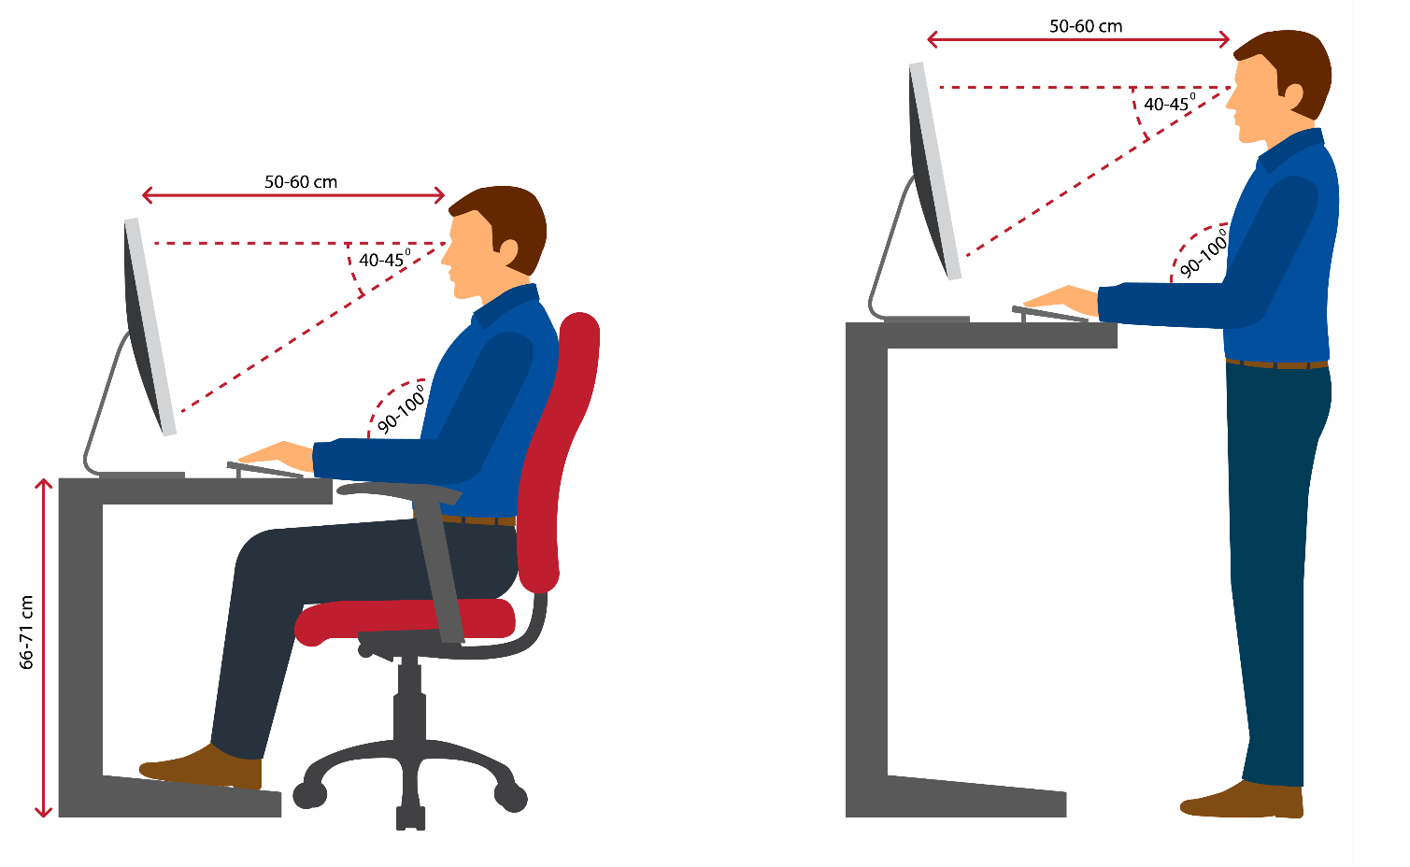

Chair and Desk set up

- Begin by setting up your chair correctly, then move on to your desk and equipment.
- Ensure your chair provides good lumbar and leg support. The lumber support should fit the curve of your lower back with the depth adjusted to your body.
- Adjust the forward/backward position of the backrest until a comfortable pressure is exerted on the lower back area while seated in the usual working posture at the desk.
- If the seat pan is adjustable, it should be in a position that allows 2 fingers space between the back of your knee and the front edge of the seat, while your back is fully against the backrest.
- To take pressure off your back and thigh, adjust the chair height so your knees are at approximately right angles and thighs parallel.
- Shoulders should be relaxed; your elbows should be bent in a ‘soft L’ (just over 90 degrees) and forearms placed as close to level of desk/table surface.
- Support your feet by placing them on the floor or use a footrest.
- If your chair has arm rests, ensure they can easily fit underneath the desk.
- If you have an adjustable desk, adjust the height to achieve the above points. If your desk is not adjustable, you’re encouraged to adjust your chair height and possibly use a footrest.

KEYBOARD/MOUSE
- Hands and wrist should be in a neutral position. Avoid any flexing of the wrist up/down or inwards/outwards.
- Ensure mouse and keyboard are close enough to prevent overreaching.

MONITOR
- Adjust your monitors to ensure comfortable viewing distance that places your neck in a neutral position.
- Your eyes should be looking at the top third of the screen when looking straight ahead.
- The screen should be approximately one arm’s length away.
- Use a separate keyboard and mouse and mount the screen higher to maintain a neutral neck position if using your Surface Pro.
- If you use 2 or more monitors, you will need to position these to allow a more neutral position for the majority of use.
- If you have a monitor that is your primary monitor (used >70% of the time) and the other monitors are only referred to occasionally, adjust the primary monitor central to your body and the other monitor directly adjacent but on a slight angle i.e., the 2 closest edges of the monitors should be touching or very close. If using your Surface Pro/Go as a third screen, position this centrally underneath the primary screen.
- Where you use both (or all 3) monitors close to equal amounts of time, position the monitors so that your body is directly in the middle of the 2 main monitors. Both monitors should be on a slight angle, with the touching edges furthest away. If using your Surface Pro/Go as a third screen, position this centrally underneath the middle of the 2 main monitors.

VIDEOS AND OTHER GREAT RESOURCES
- Head on over to Pure Workspace for lots of great resources: https://www.pureworkspace.com/
- Pure Workspace is provided by our physiotherapist partner Geelong Waterfront Clinic and all City employees have free corporate access.

REMEMBER TO:
- Take regular breaks – stand up and move approximately every 30-40 mins.
- Rest and refocus your eyes. Look away from the screen every so often and focus on something else for a few seconds.
- Regularly stretch throughout the day. Some stretches you might like to choose are on the following pages.

