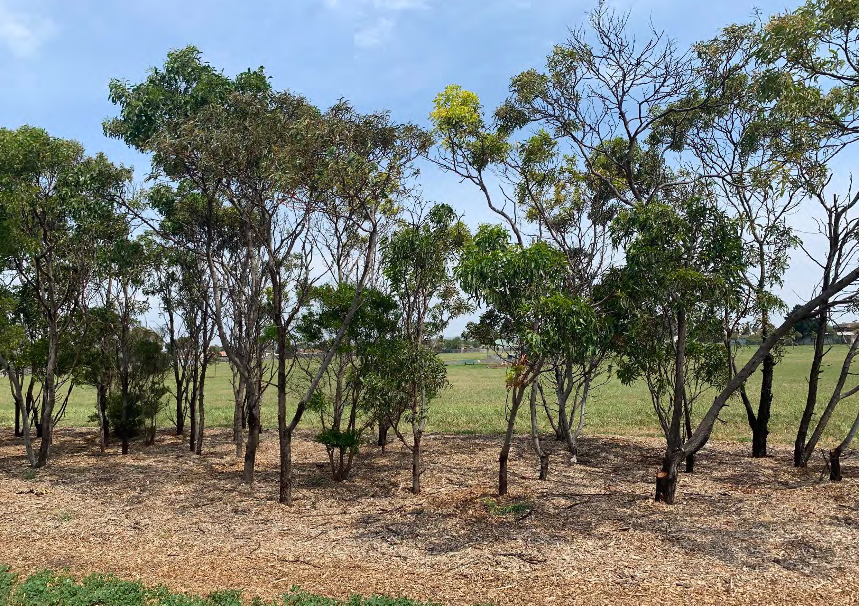ALDERSHOT RESERVE MASTER PLAN
FRONT PAGE IMAGE
MARCH 2021

1

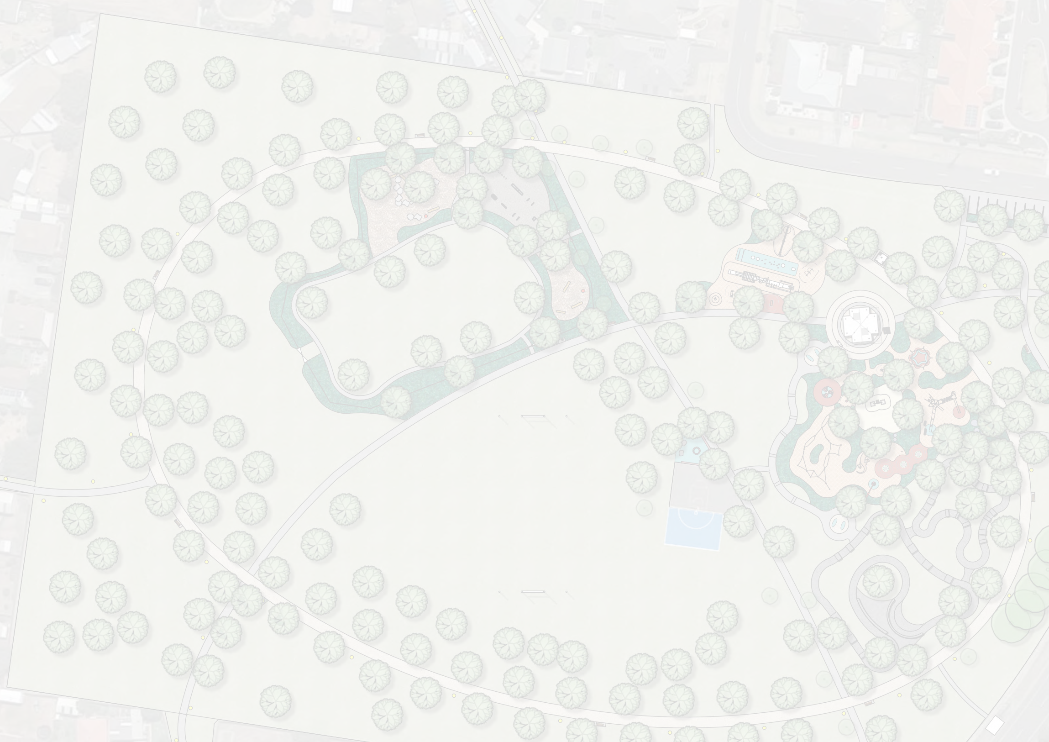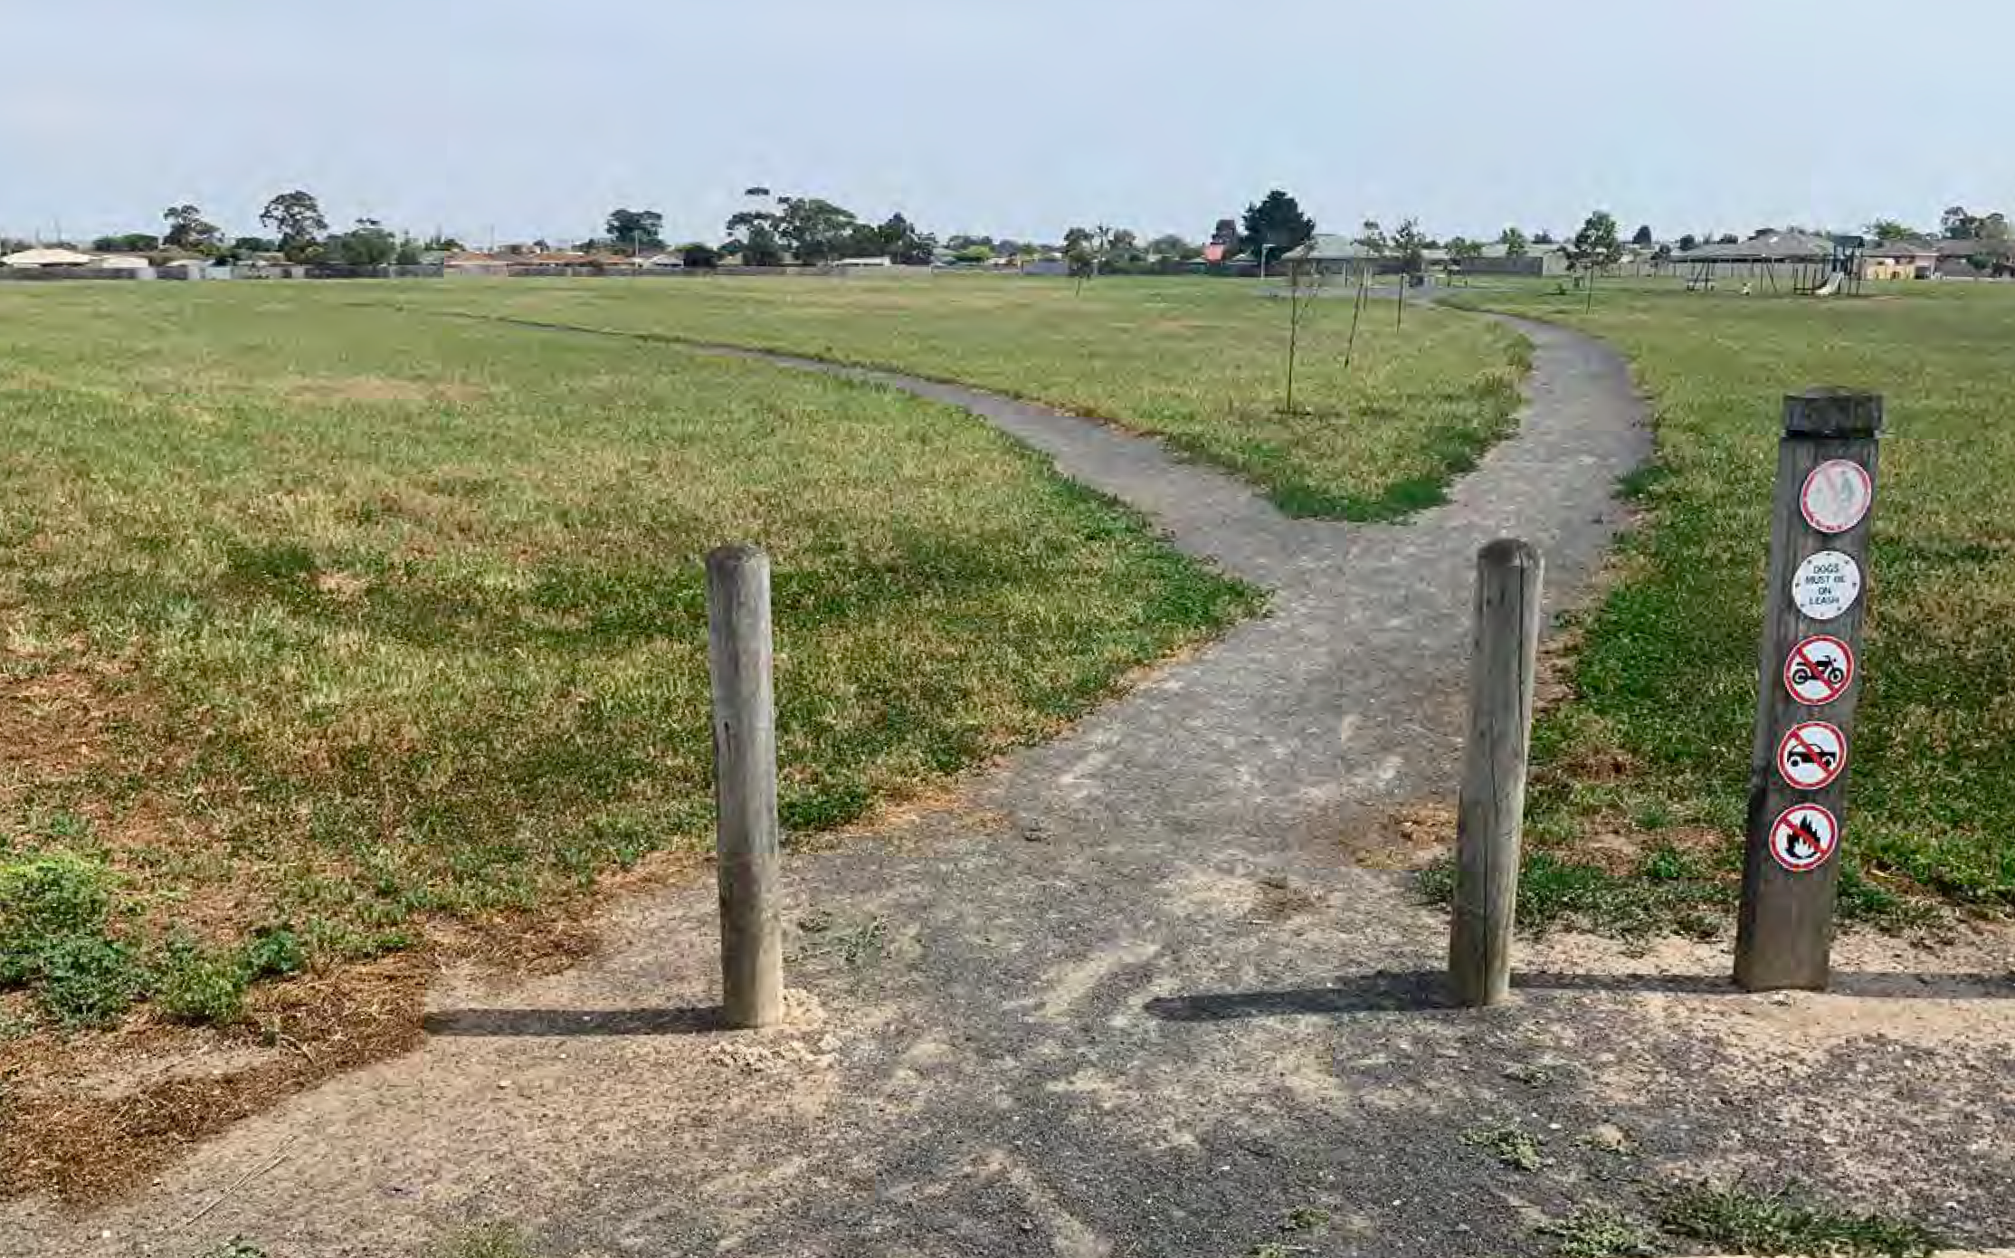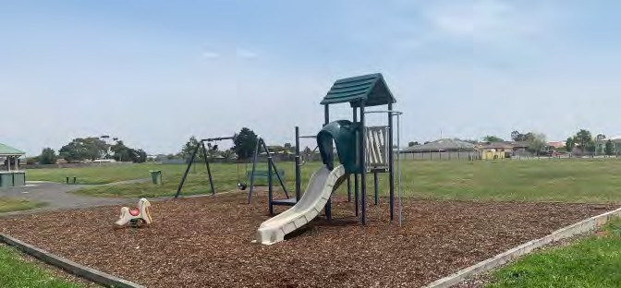Aldershot Reserve Master Plan

Contents

Context for Master Plan P1

Introduction P1

Background and Issues P1

Summary of Project/ Engagement Process P2

Master Plan P3

Active Recreation Zone Enlargement P4

Implementation Guidelines P5

Appendix P6

ii

Context for Master Plan

Introduction
Aldershot Reserve Master Plan

The focus of the project is Aldershot Reserve, which is located at 41-55 Aldershot Road, St Albans Park. The reserve is bounded by Aldershot Road along half of the northern boundary and Paramount Crescent along the eastern boundary, with the remaining boundaries comprised of residential lots backing onto the reserve.

Fitzgerald Frisby Landscape Architecture was engaged by the City of Greater Geelong to develop a new Master Plan for Aldershot Reserve, including an options analysis and development of a design concept that will provide improved user experiences of the reserve. Dr Terence Love was engaged as a subconsultant to provide a Crime Prevention Through Environmental Design (CPTED) assessment of the site and to review the draft Master Plan concept. (Dr Love’s report can be found in the appendix to this document.)

Background and issues

A master plan for Aldershot Reserve was completed in 2008. While this master plan ultimately recommended basic landscaping improvements to the reserve, the prospect of rezoning and selling part of the reserve to improve passive surveillance was raised during its development but was not supported by the community. A number of works were completed in the reserve following the adoption of the master plan including earthworks, construction of basketball half court, path network and tree planting, however many of the tree plantings failed.

In 2016-17 a budget of $100,000 was allocated to safety improvements in Aldershot Reserve in response to an assault that had taken place in the reserve. In May 2017 the Director Community Life approved a redirection of approximately 70% of these funds from capital improvements to an investigation into rezoning approximately 60% of the reserve in order to address the fundamentally poor urban form that creates the true safety issues in the reserve. The remaining funds were used to install LED bollard lights along entry points into the reserve.
Key points:
- Aldershot Reserve and the nearby reserves in St Albans Park are generally in poor condition with limited amenity for users.
- A master plan for the site was developed in 2008 and a number of works identified in the master plan
have been completed over subsequent years.
- In 2015 an assault took place in the reserve, resulting in media coverage and criticism of the design of the site.
- LED lighting was installed along entry points following funding allocation for safety improvements.
- The Geelong Play Strategy 2012-2021 identified that St Albans Park has 6 play spaces with equipment in
the suburb and the southern half of the suburb is lacking open space.

The issues outlined above emphasise the particular importance in this project of a transparent, consultative design process that takes into account the community’s concerns. Aldershot Reserve has the potential to be a significant asset to the St Albans area. The Master Plan must meet the expectations of the community, as well as being one that Council is supportive of and able to implement successfully.

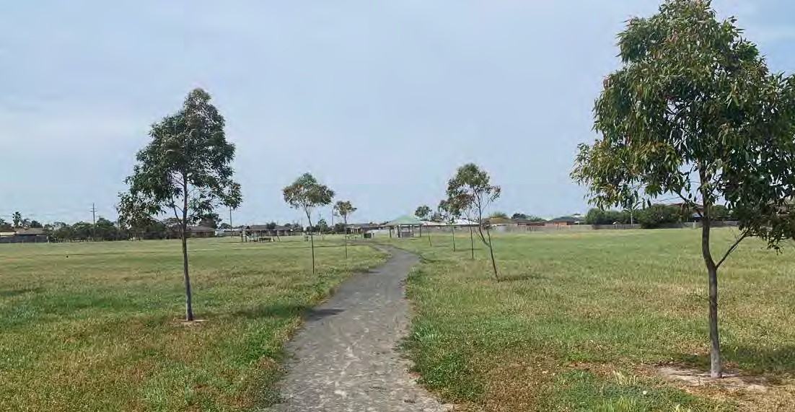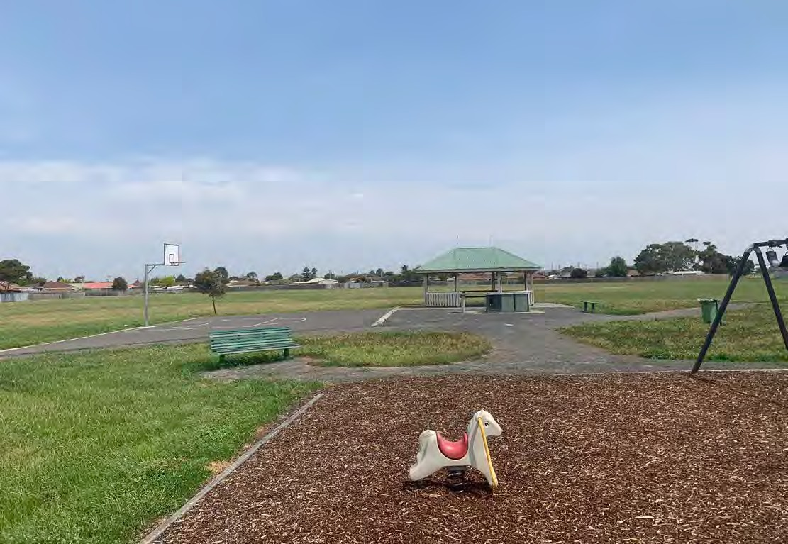

1

Context for Master Plan

Summary of Project/Engagement Process
Aldershot Reserve Master Plan

Two rounds of consultation and community engagement were undertaken. The reports can be found in the appendix to this document.

An initial round of community engagement was undertaken at the commencement of the project to assist the project team in understanding current use of the space, community attitudes toward the space, and to identify any ideas regarding the future of the reserve. It comprised:
- Distribution of postcards to the neighbourhood surrounding the reserve, notifying people of the 2 on-site engagement events and providing a link to the on-line questionnaire,
- An on-line questionnaire open during December 2019 that received 206 responses,
- Two on-site engagement events (one weekend and one weekday), with a total of about 50 attendees,
- A number of written submissions (some including plan proposals) have been made via email or in person at on-site engagement events.

The key findings from the initial consultation were used to develop the Master Plan proposal, and are summarised
here under a number of themes:
- Site history. Many residents are very aware of previous plans and ideas for the site, and noted that the previous adopted plan for the site has been largely unrealised, although there was no evidence of strong attachment to any individual parts of that plan. It is important that this project deliver a proposal for the site that is achievable.
- Safety. The majority were those who had few, if any, concerns regarding issues of safety within the reserve. Others, almost exclusively comprised people living in very close proximity to the reserve, cited anti-social activities as their dominant concern. Although in the minority, this second group are very important to the future of the reserve, providing the majority of the passive surveillance to the space, and it is critical that their experiences are addressed in plans for the future of the reserve.
- Play. ‘Improving children’s play opportunities’ at the site was the most selected option (63.2%) when people were asked in the questionnaire about ‘the most important things to be considered when coming up with a new design for Aldershot Reserve’. ‘Visiting the play ground’ (40.2%) was also the second most common response when people where asked about their main reasons for visiting the reserve. Bicycle and scooter paths/facilities (such as ‘pump tracks’) were also identified by a number of people, both at the engagement sessions and in the comments sections of the questionnaire.
- Vegetation. The second most selected option when people were asked in the questionnaire about ‘the most important things to be considered when coming up with a new design for Aldershot Reserve’ was ‘adding more trees’ (36.8%). The need for maintenance of grass and trees was also a theme in discussions at on-site engagement.
- Sport and recreation. A number of people attended the community engagement sessions to identify the opportunity for the space to house structured sport, however these ideas were not strongly supported by the broader community – only 8.3% of questionnaire respondents selected the ‘investigate options for sporting clubs to use the space’ option. There was much stronger support for a range of less-structured recreation activities, including: ‘Creating exercise and play opportunities for adults’, ‘Improving the quality of the grass’, ‘Improving the walking path network’, ‘Improving informal recreation opportunities (such as adding soccer goals)’. It is also noted that dog-walking is currently the number one reason people visit the reserve, according to the questionnaire (46.6% of respondents nominated it as one
of the main reasons they visit the reserve). An opportunity identified during the on-site engagement events was the proximity of the aged care/retirement facility opposite the reserve, and the opportunity to provide better pedestrian connections and attractors for older people (potentially including better paths, seating, and garden spaces).
- Barbeque/picnic facilities. The fourth most selected option when people were asked in the questionnaire about ‘the most important things to be considered when coming up with a new design for Aldershot Reserve’ was ‘improving BBQ/picnic opportunities’ (24.0%). In discussion with people about the kind
of improvements they’d like to see, the most common response related to the location of the facilities, with people preferring them to be located closer to car parking and access points. Responses to the questionnaire indicated that few people currently use the reserve for ‘socialising or barbeques’.
The subject of the second round of consultation was a Draft Concept Plan. The Draft Concept Plan was informed by findings from engagement undertaken at the commencement of the project which inquired into current use of the space, community attitudes toward the space, and ideas regarding the future of the reserve. The design was guided
by ‘crime prevention through environmental design’ (CPTED) principles, and reviewed by CPTED experts Design Out Crime.
- The second round of engagement comprised the following:
- A mail out to all residents in the Stage 1 communications catchment,
- Online content and survey,
- Presentation to Youth Council and opportunity for feedback,
- Targeted social media, on-site signage and direct email to residents who provided contact details during
the first stage of community engagement,
- The survey was also featured on the City’s online ‘Have Your Say’ page.

Responses included 245 hard copy surveys (including one blank and one incomplete) and 99 online surveys. The online ‘Social Map’ received 31 comments, which reflected similar sentiments to those expressed in the surveys. The Facebook ad logged 5694 views.

Overall, support for the Master Plan concept was very strong, with 95% of respondents supporting the plan and over 91% of respondents selected options indicating the reserve is likely to get more use if the concept plan is built. 55% of respondents did not have anything they would like to change on the plan. The weakest support for the master plan came from respondents who said their house joins the reserve or is immediately across the road from it (13.7% of total respondents). However, the level of support was over 85% even in this group.

A minority of comments on the Master Plan concept expressed concern about potential vandalism, anti-social behaviour and damage to trees as well as the need for improved maintenance. As a result of this feedback, additional detail was included in the Master Plan document clarifying the approach that is being taken with regard to safety and maintenance, with particular reference to lighting, open viewlines and public toilets. Some amendments were also made to the concept plan:
- Reduced number of proposed trees and increased distance between proposed trees and residence boundaries,
- Addition of a netball goal to the existing half-court,
- Dog park reconfigured to provide a min. 60m long lawn area.

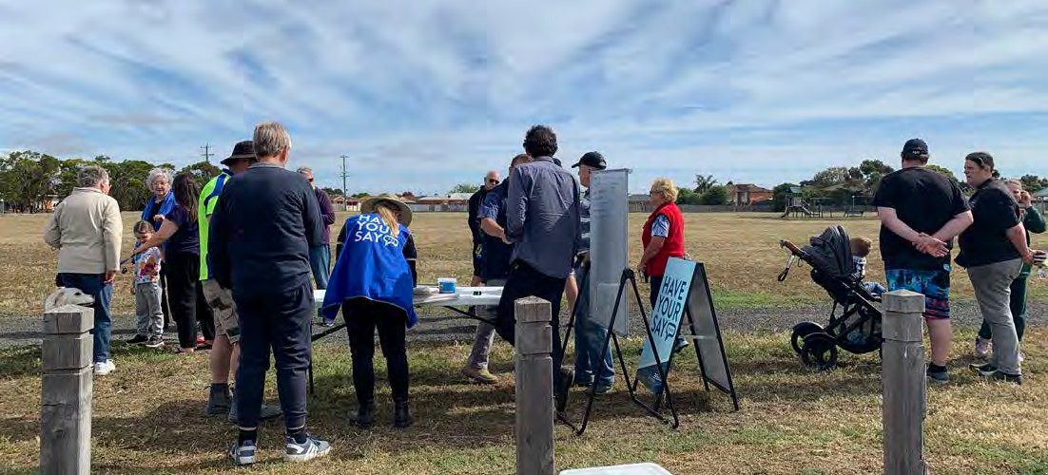
2

Aldershot Reserve Master Plan

Master Plan

4 Pump Track
650m path with distance markers
New crossing
•A sealed mounded circuit (or ‘pump track’), suitable for use by wheeled devices including bicycles and scooters, is proposed near the play space.
Entry art feature and historical
interpretive elements
2
•The track will be designed to allow use by a wide range of users, including younger children.
Toilet

7 5 Dog Park
5 •The community engagement undertaken showed
that the park is valued as a location for dog walking
1 and exercise, and the proposed design supports and encourages this ongoing use.
Shelter

6 •A dedicated fenced ‘dog park’ area is proposed for dog
exercise, located well away from the play space. The
Drinking fountain and rubbish bins
3 defined area includes facilities for dog walkers including
a drinking tap/bowl.

6 Open Spaces
Informal seating area
•One of the things that makes Aldershot Reserve unique
6 is the size of the park. While there is a community desire
4 to get more trees established on the site, there is also a desire to retain a sense of space and openness.

•The proposed design includes adding trees near the boundaries to help define the space, and trees focussed around activity areas. This creates a balance between providing shade and wind break benefits, while retaining views through the site and a sense of space.
Goals
Existing half-court to be retained and resurfaced

•The design proposes upgrades to the existing grass surfaces, to better allow them to be used for informal recreation activities (kicking balls, etc).
Existing bus stop
7 Fitness area
•A fitness space will be provided to encourage use of the space for exercise. A range of equipment will be provided so that all abilities and fitness levels are catered for.

Site Master Plan 1:1500 @ A3
1 Entry garden 2
Improved path network
•The new play space proposed will include a wide range of elements that will appeal to all age groups, including
Maintenance and Security
•Level of ongoing maintenance across the park to be increased in stages as Master Plan is implemented.

•The corner of Aldershot Road and Paramount Crescent
is a logical focus for activity, being close to footpath links
and a defined parking area.

•This corner of the park will be an entry garden including seating and a shorter path network aimed at use by people with limited mobility.

•A new shelter and barbecue (replacing those existing)
•A proposed sealed path network (replacing the existing
gravel path) links the different parts of the park and provides an opportunity for all-weather walking and exercise.

•A 650m long circuit path with distance markers will provide opportunities for strolling and exercise.
swings, spinners, and climbing elements.

•The play space will be located closer to the park edge and parking area than the current play space, making it easier to access.

•The play space is integrated with other play and recreation opportunities at the site, including grassy kick- about spaces, a cycle/scooter ‘pump track’, and a circuit
- CCTV and ‘target hardening’ of fences could be
considered by Council in the future in response to site activity.

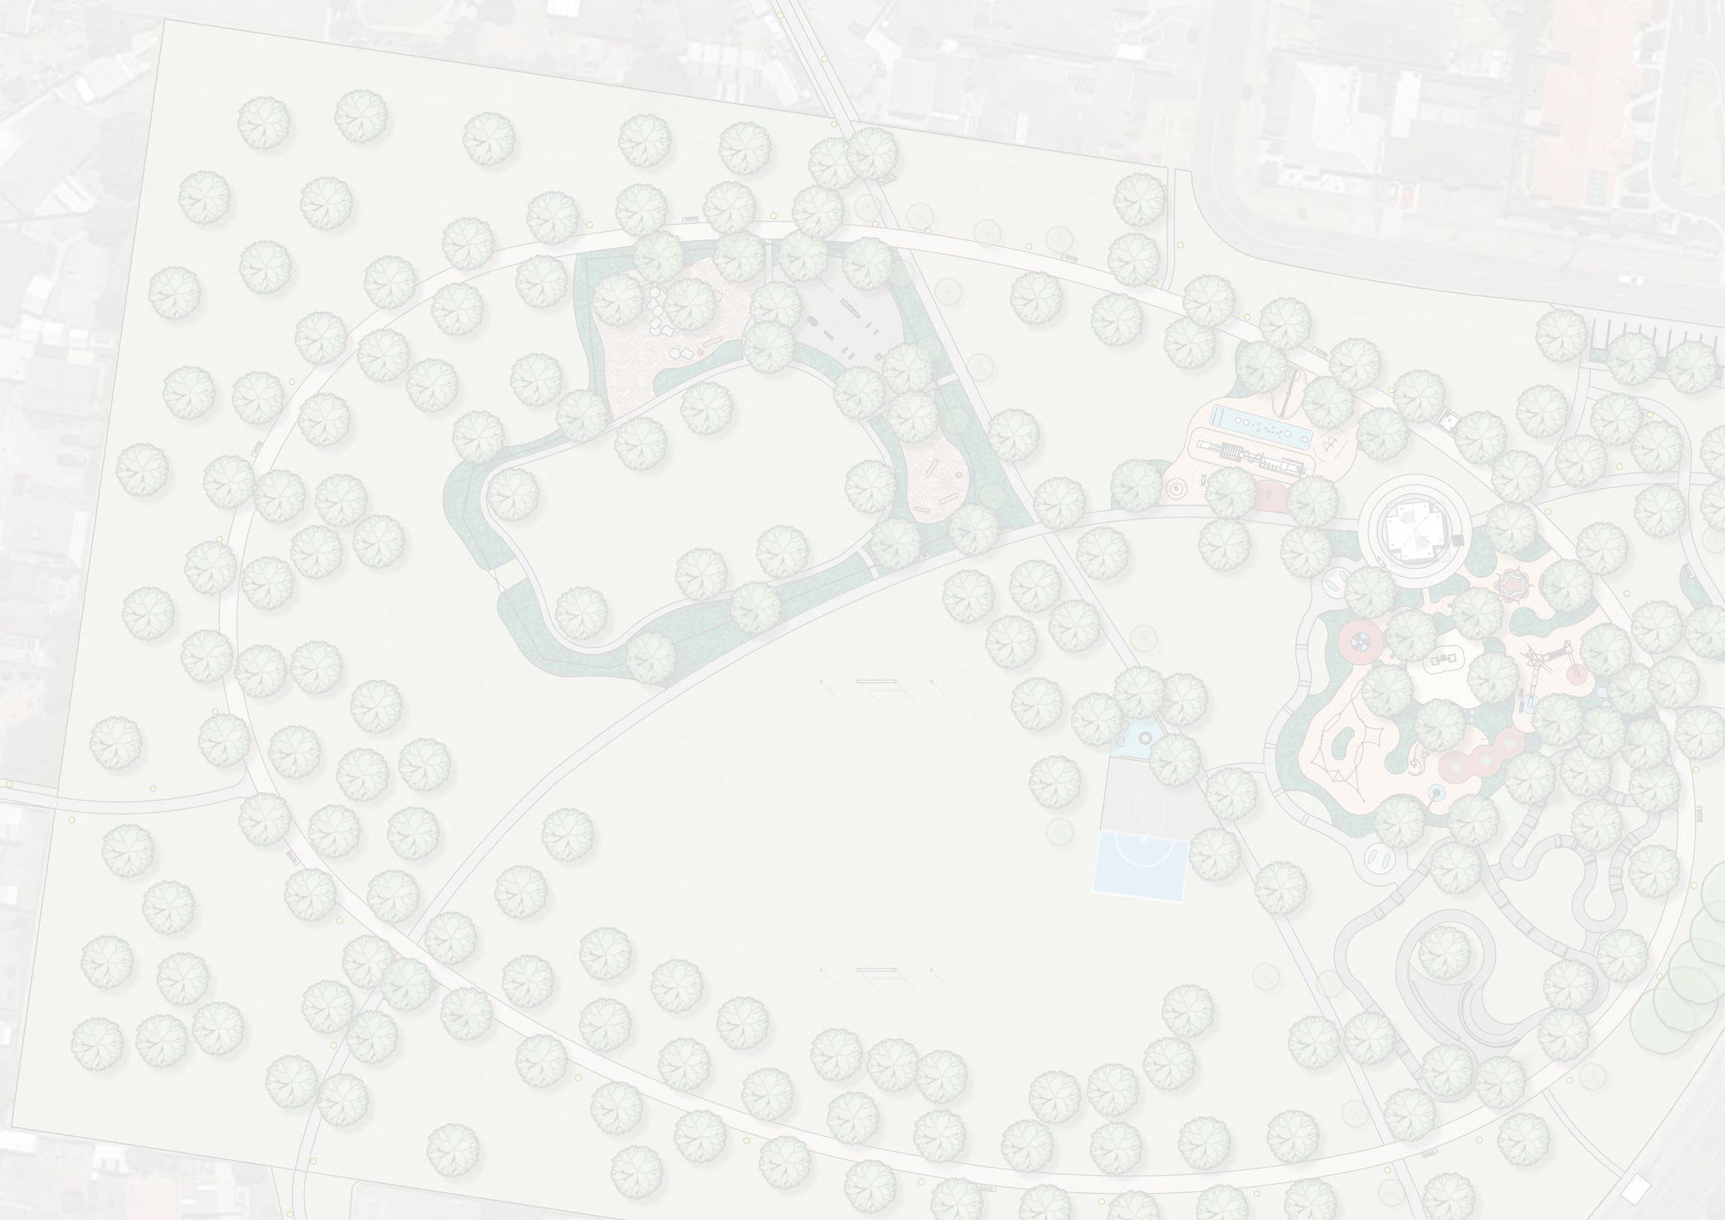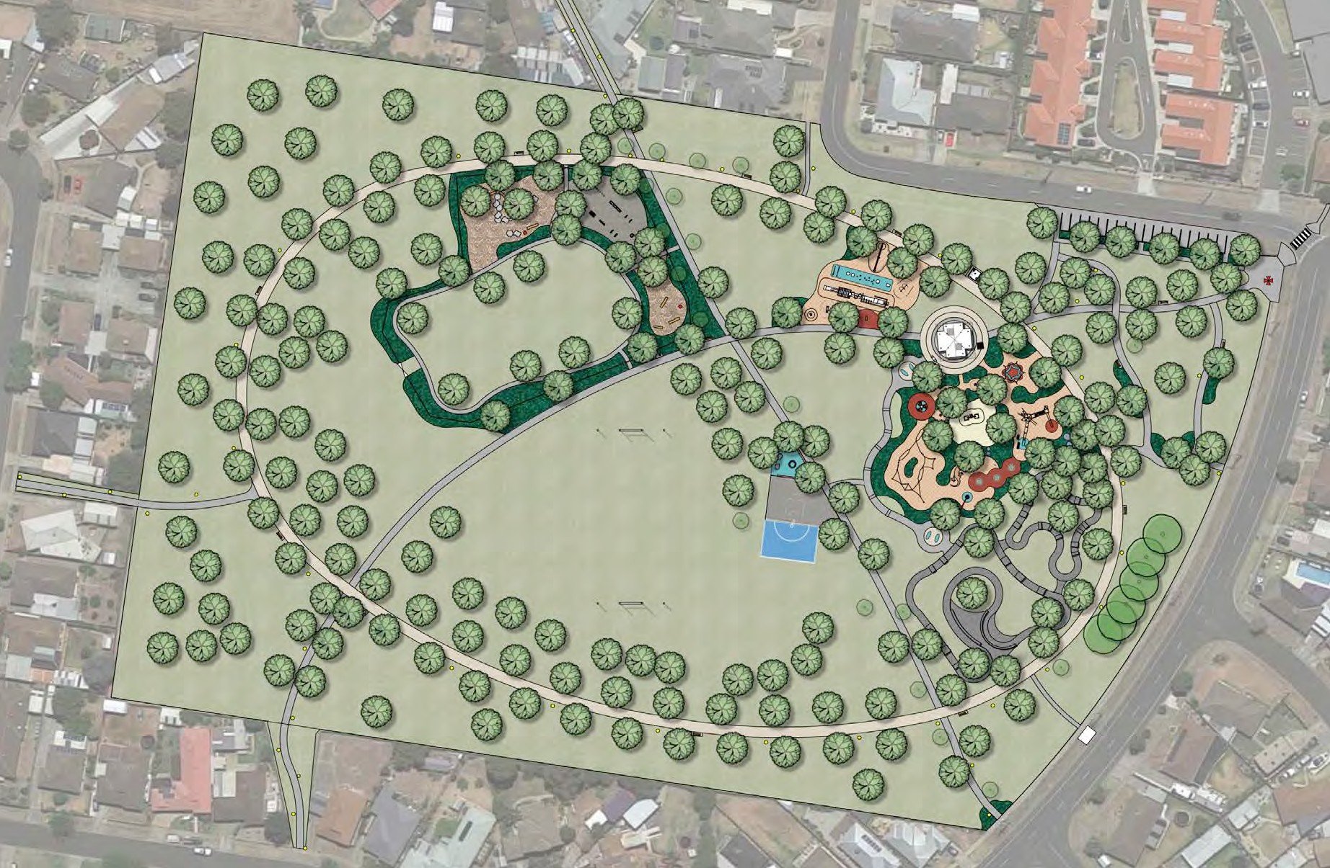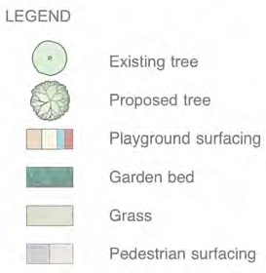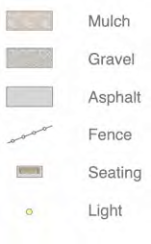are proposed for this easily accessible area.

•A toilet is proposed within this space. The level of improvements proposed for the park mean that it will require a public toilet to support these increased levels of use.
3 New play space
•Improving the play space was the most commonly requested improvement made during the community engagement undertaken.
path.

- Existing half-court retained and resurfaced. New netball half court to be added

3

Active Recreation Zone Enlargement
Aldershot Reserve Master Plan

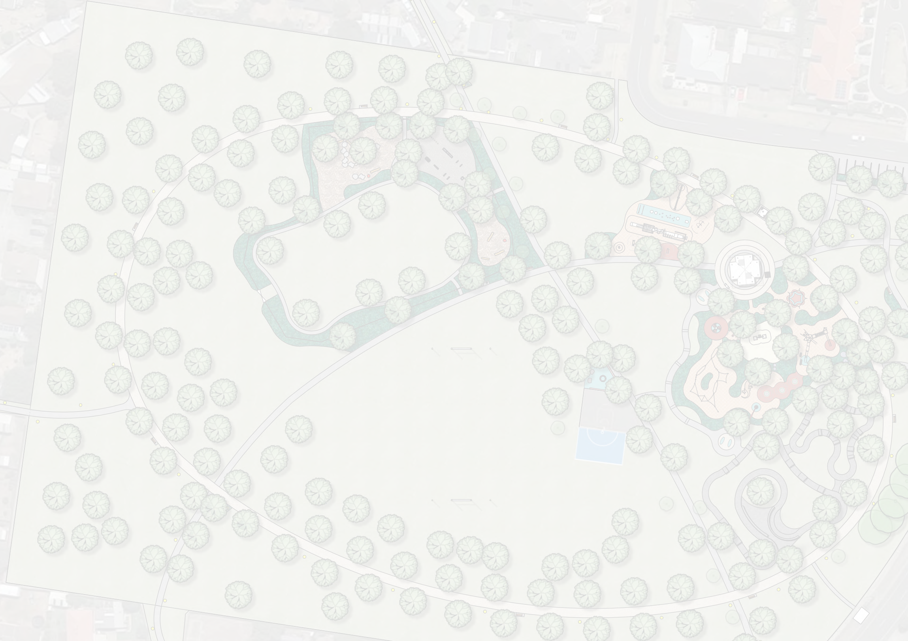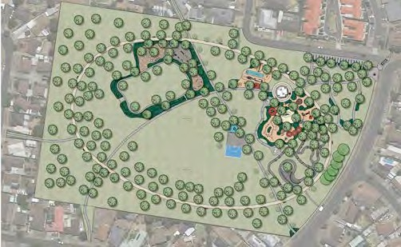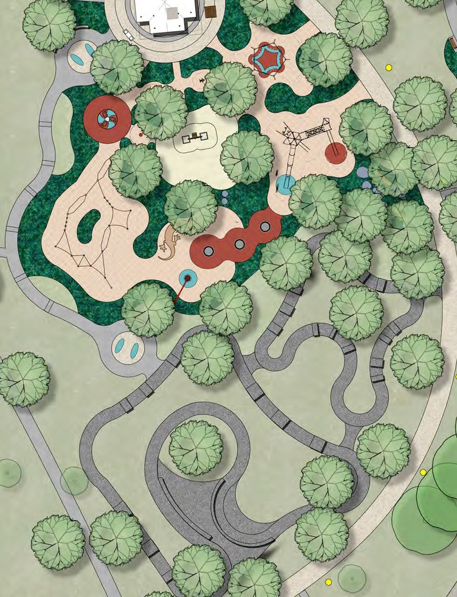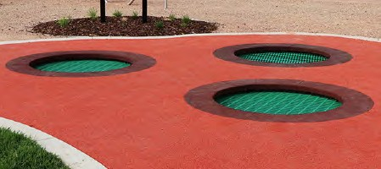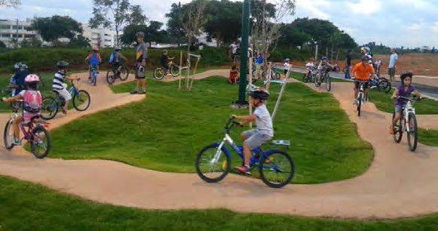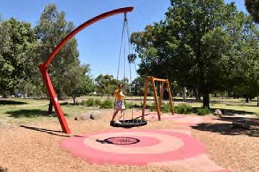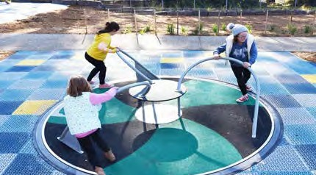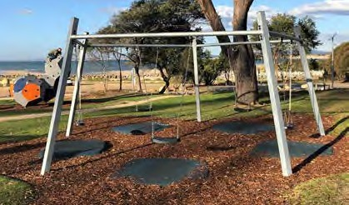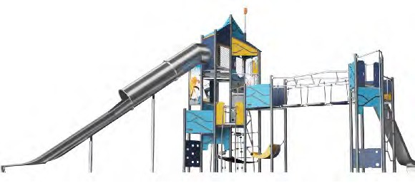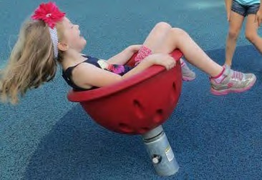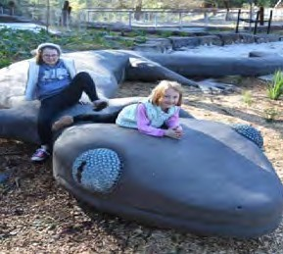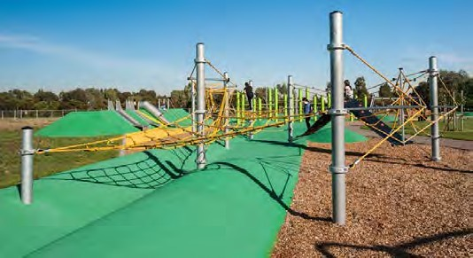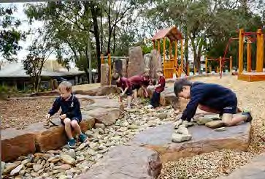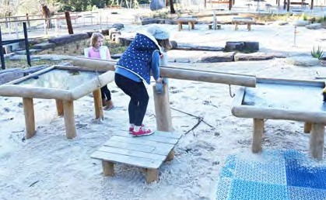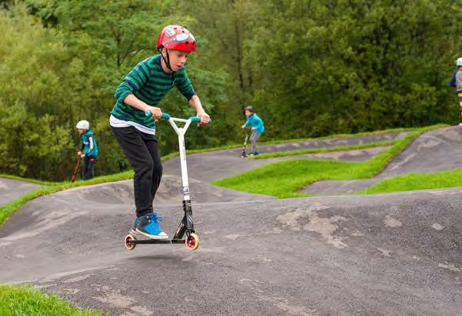
Examples of Play Equipment and Elements

Context Plan

Examples of Pump Track

Detail Plan 1:500 @ A3
4

Aldershot Reserve Master Plan

Implementation Guidelines

A Toilet
C Viewlines

A public toilet will be an important addition to the park, especially for kids and older people, and groups using the BBQ facilities.

The City of Greater Geelong document ‘Inclusive Public Toilets Design & Recommendations’ has been used to help determine the need for a toilet in the Aldershot Reserve Master Plan, as well
as where to locate it and what the setting should be like to make it as safe and easy to use as possible.

The Council document will also be used as a guide in making detailed design decisions about the toilet and the landscape around it, and about long-term management of the toilet.
Here is a summary of the considerations made in siting the toilet:
Public toilets should be clearly visible and easily accessible to all users.

toilet
carpark
fitness
As noted in the CPTED Report (see Appendix), maintaining clear viewlines through proposed vegetation and infrastructure will help to encourage use of the park while keeping viewlines open, thereby allowing natural surveillance. To achieve this, tree canopies will be lifted above 1800mm (after establishment) and the majority of understorey planting will have a maximum height of 30cm at maturity.

play space

Location of toilet
entry garden
shelter

Open viewlines and proximity to toilet from key areas such as shelter, carpark, fitness area and entry garden

Sealed path connections linking to the toilet from the surrounding area
Note: The toilet will be open for use only during daylight hours and will not be lit up after dark.

D Indicative proposed plant species

Throughout the park

*indigenous

Example of public toilet

B Lighting

Detailed design of lighting for Aldershot Reserve should take into account the recommendations outlined in the Crime Prevention Through Environmental Design (CPTED)

Acacia implexa*
Lightwood
5-15m x 4-7m

Allocasuarina verticillata*
Drooping Sheoke 4-11m x 3-6m

Eucalyptus ovata*
Swamp Gum
8-30m x 8-20m

Themeda triandra* Kangaroo Grass 0.3m x 0.3m

Atriplex semibaccata*
Berry Saltbush 0.3m x 1-3m

Poa labillardieri* Tussock Grass 0.8m x 0.8m

Report (refer to Appendix).

Lighting in the reserve will be designed to maximise safety.

Lighting bollards are a good way of illuminating paths or small spaces without lighting a whole area. This can help people to move through the park with greater ease.

If area lights are required timed or sensor lights can be used.
Within the entry garden

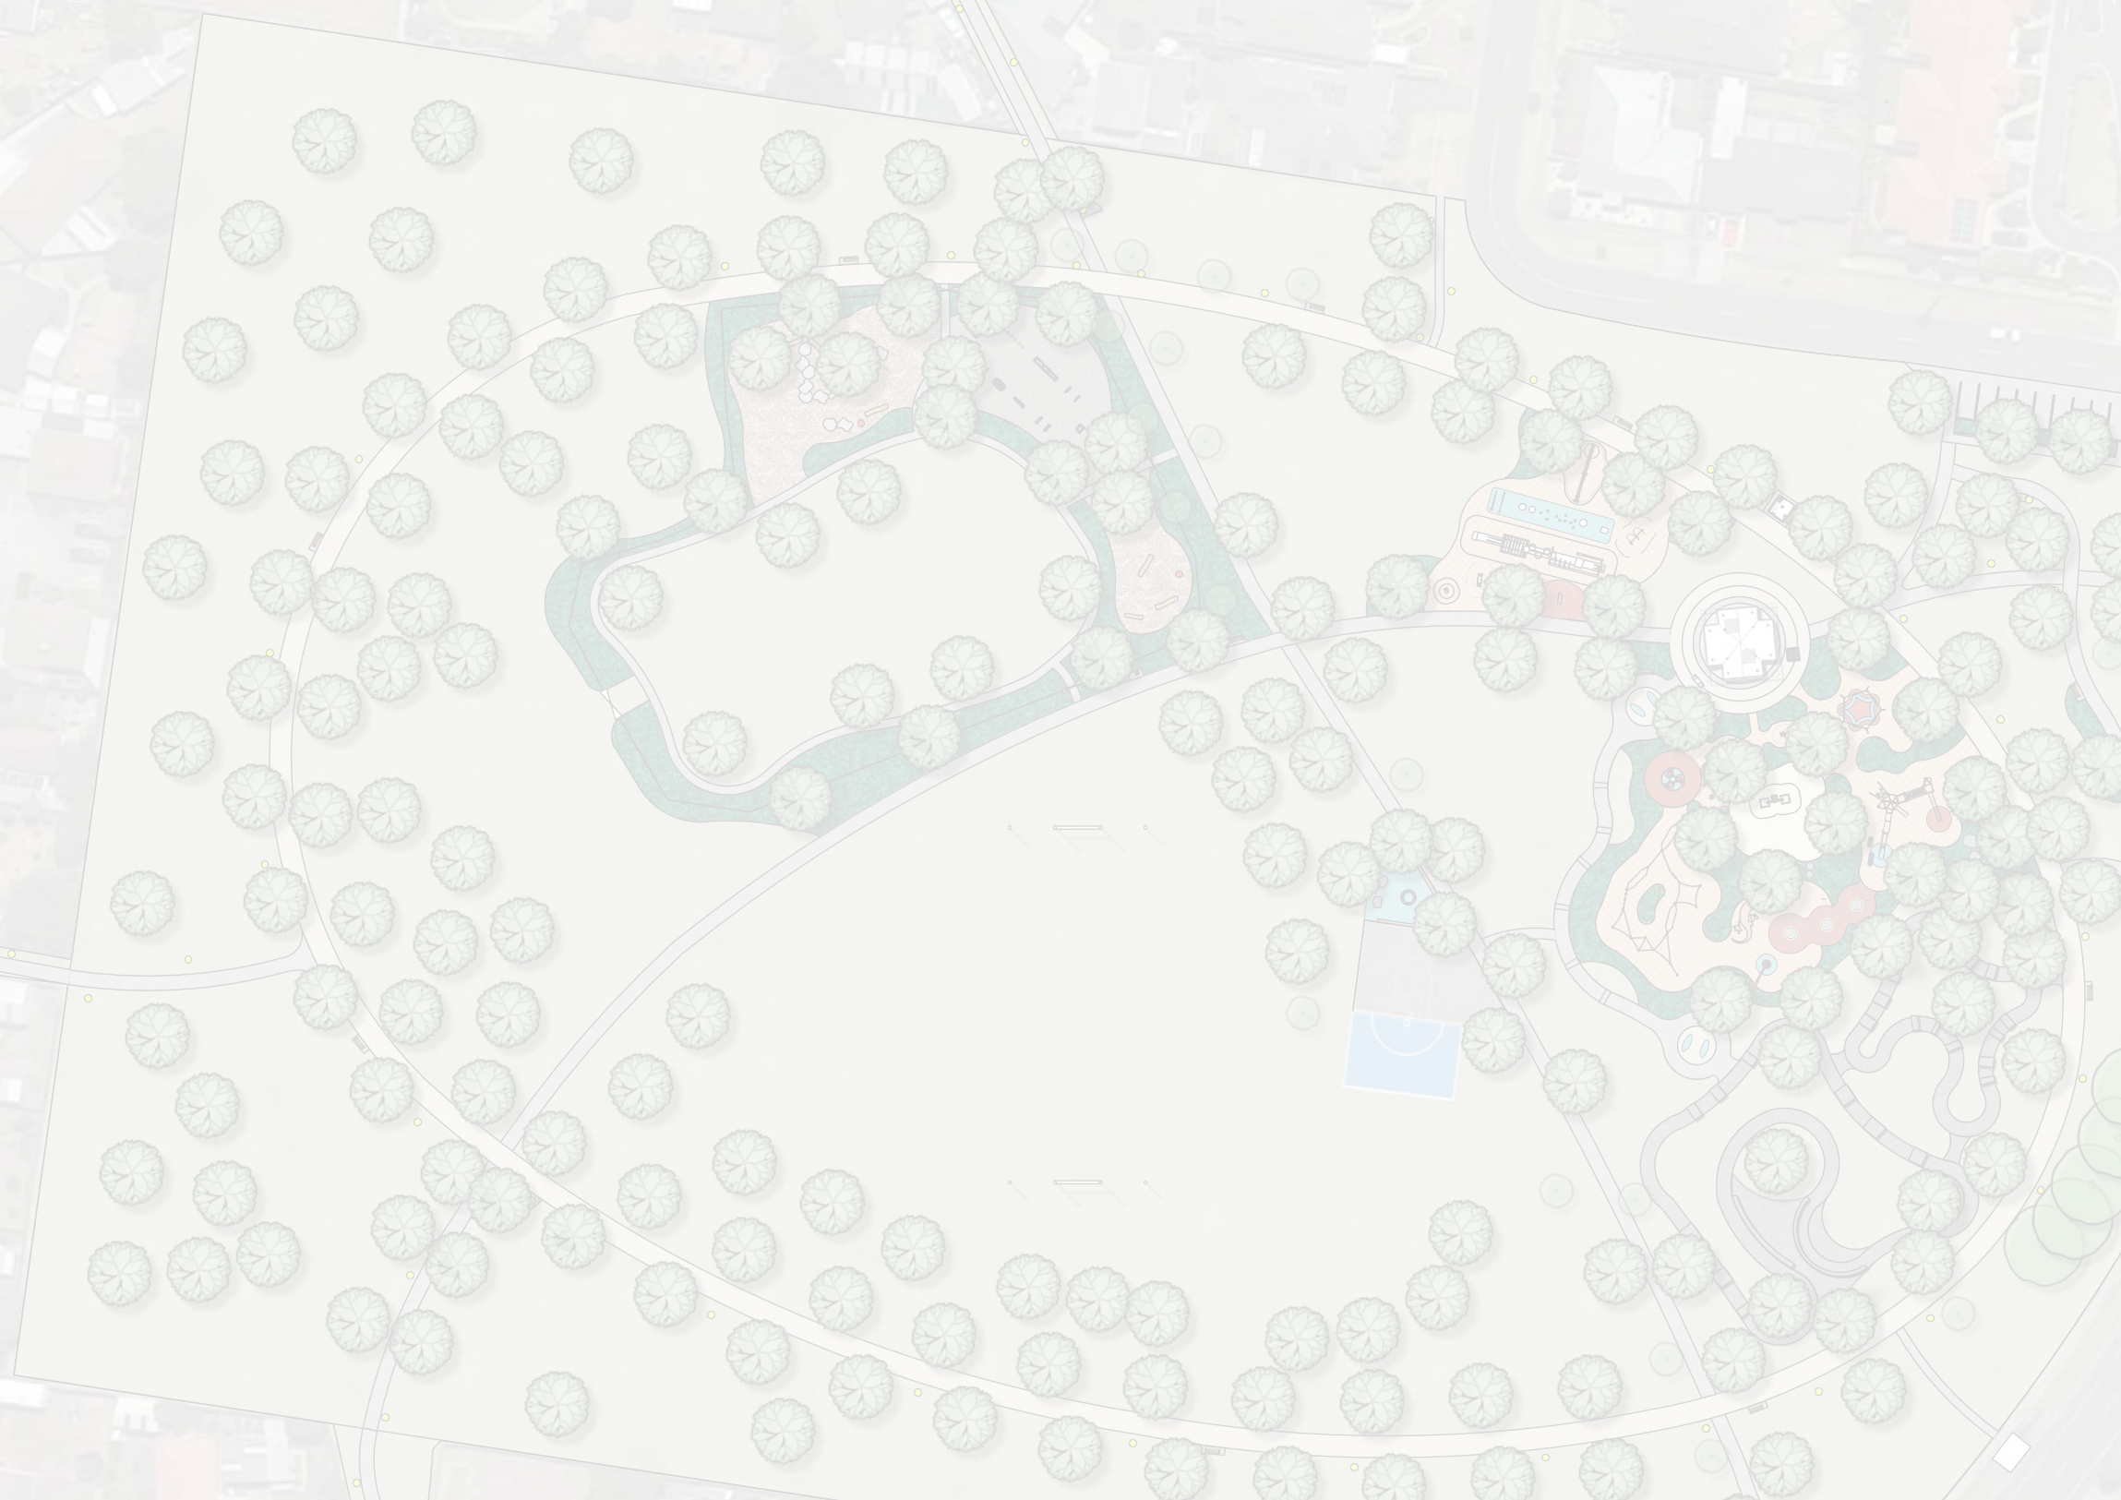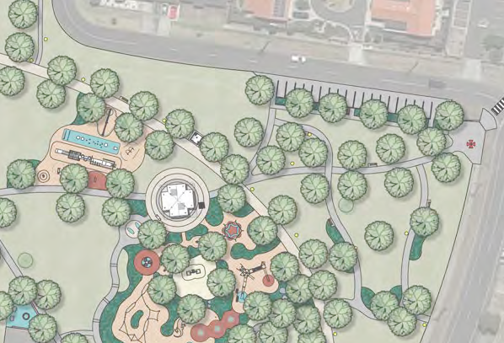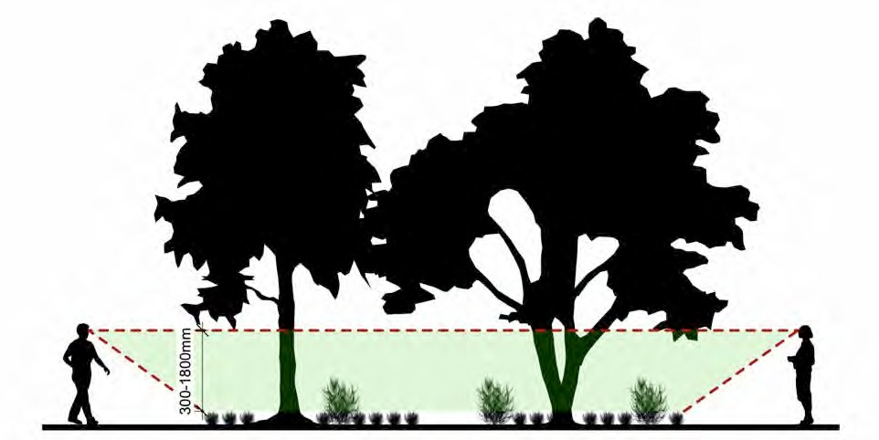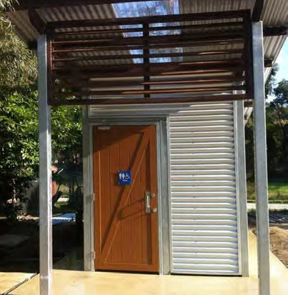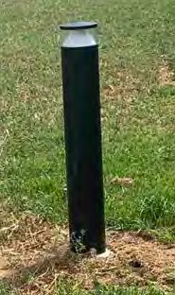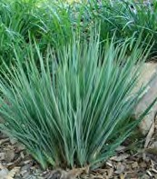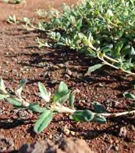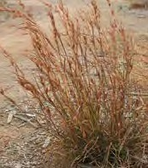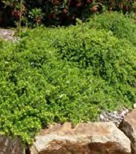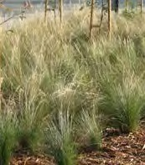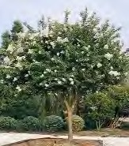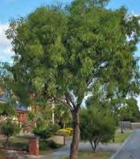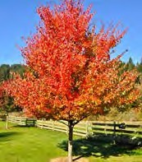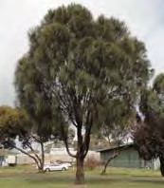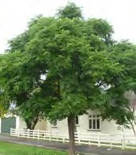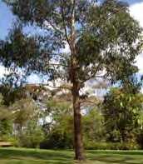The toilet will be open for use only during designated hours.

Existing bollard lights

Lagerstroemia indica
Crepe Myrtle 8m x 7m

Acer truncatum
Maple 10m x 6m

Melia azedarach White Cedar 10m x 8m

Lomandra confertifolia Lomandra Silver Grace 0.5m x 0.4m

Dianella revoluta* Black Anther Flax-lily 0.5m x 1.5m

Westringia fruticosa ‘Flat’n’Fruity’ Coastal Rosemary 0.3m x 0.5-2m
5

Aldershot Reserve Master Plan
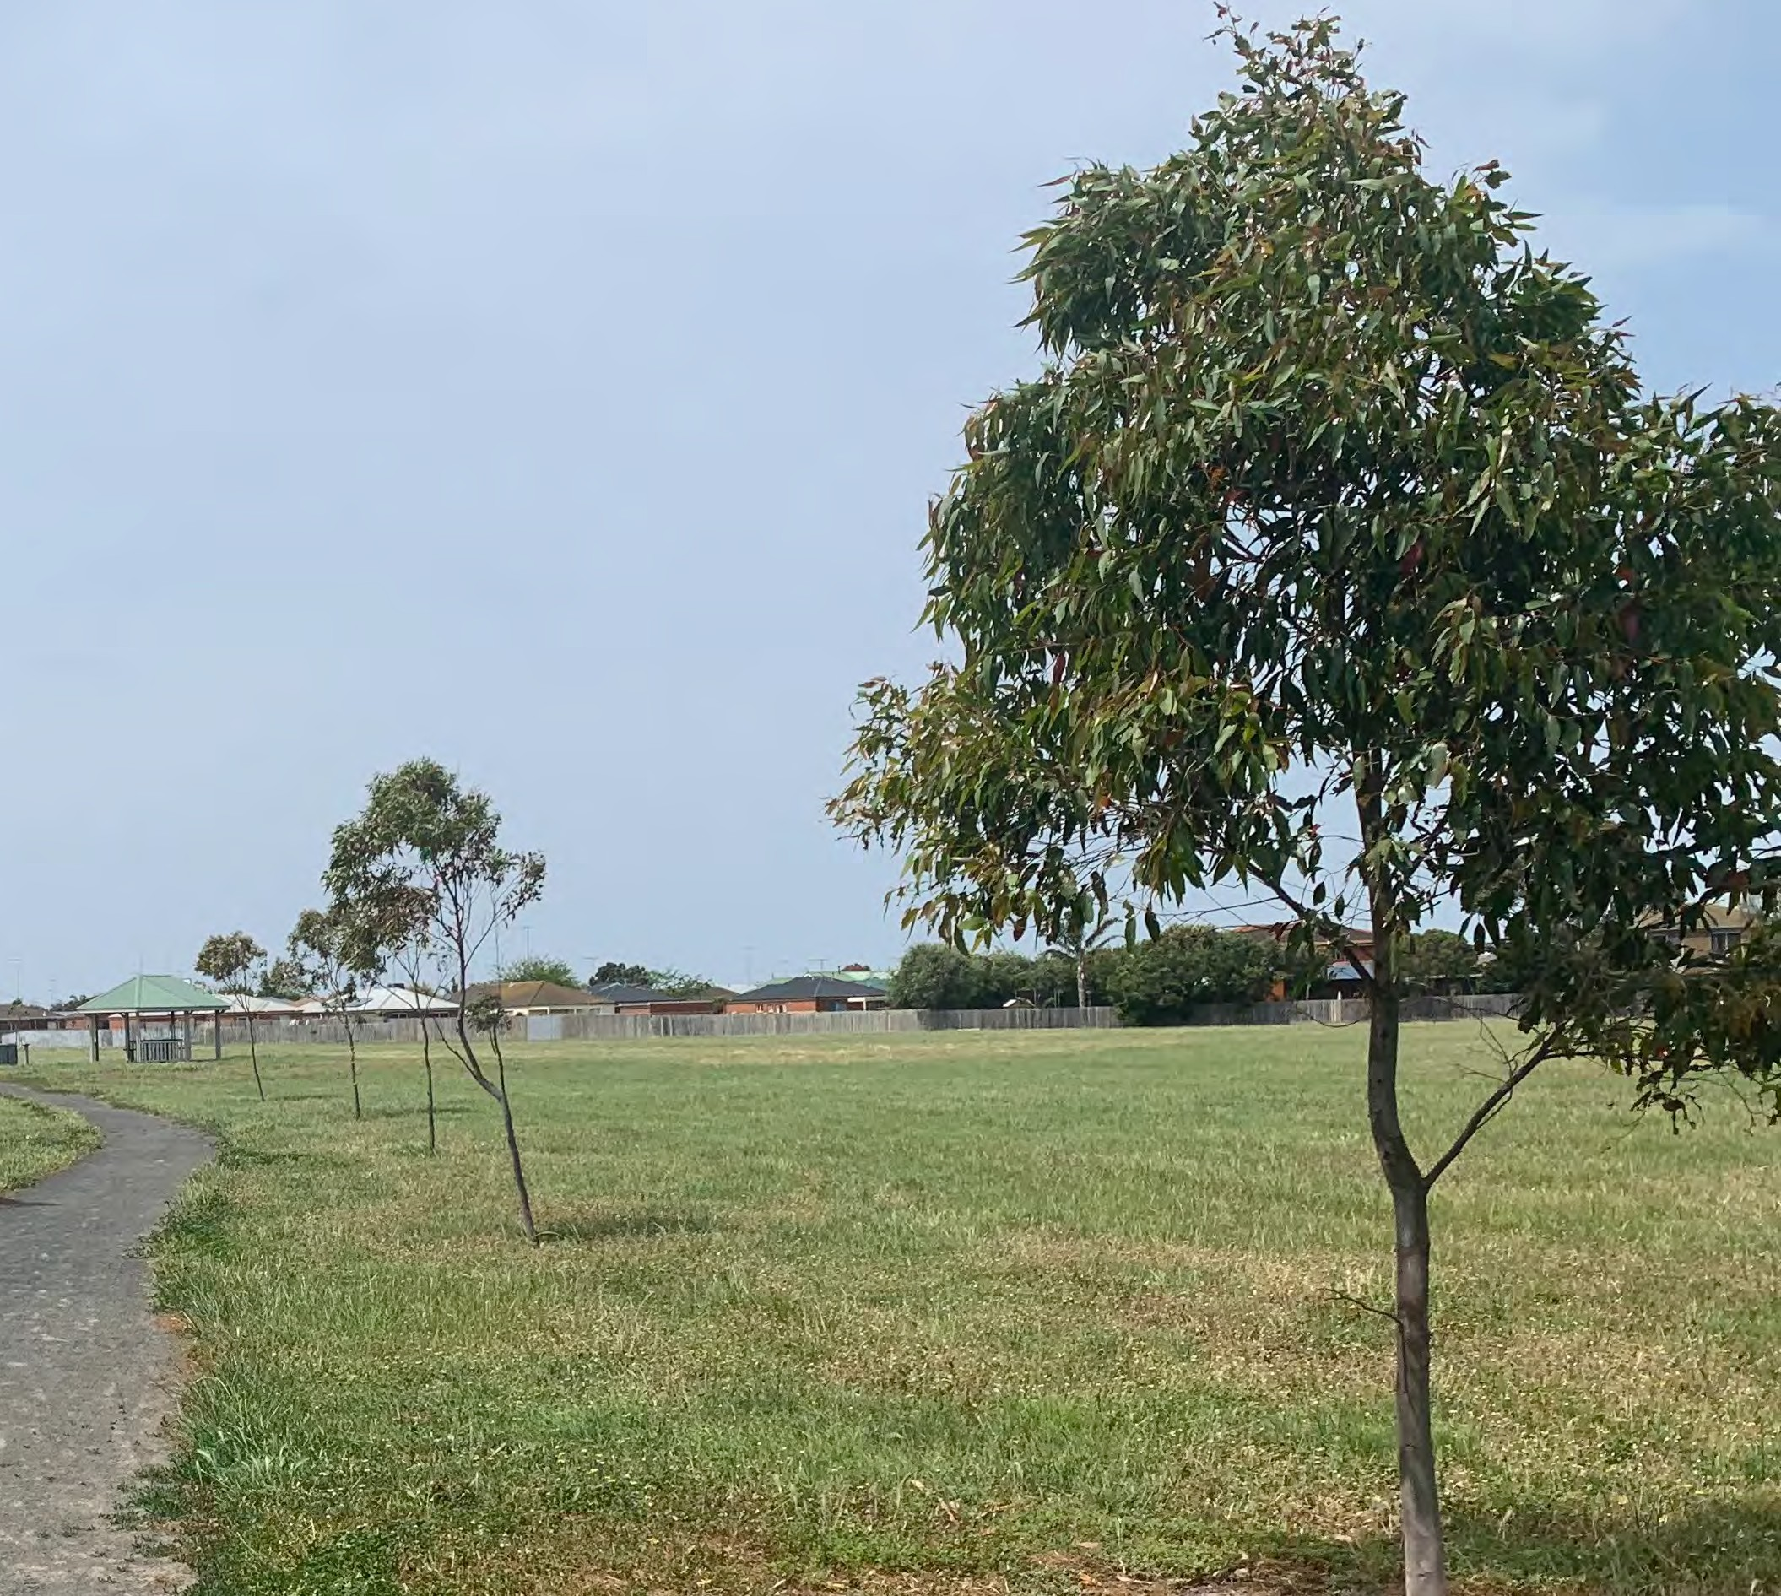

Appendix

Engagement report 1

Engagement report 2

CPTED report

6

ALDERSHOT RESERVE, ST ALBANS

Community Engagement

Summary
DRAFT 17.01.2020

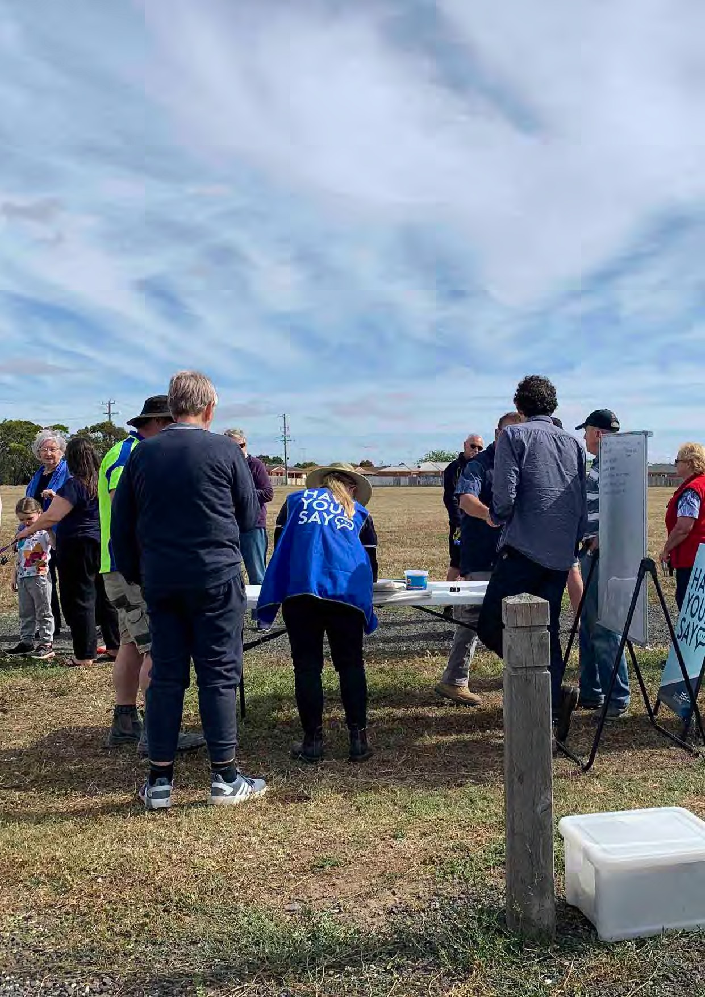
ALDERSHOTALDERSHOTRESERRESERVE,VE,STSTALBANSALBANS- COMMUNITY- COMMUNITYENGAGEMENTENGAGEMENTSUMMARSUMMARYY

1

fitzgerald frisby landscape architecture

Introduction 01
ALDERSHOT RESERVE, ST ALBANS - COMMUNITY ENGAGEMENT SUMMARY
Contents
Engagement findings 02
Site history 02
Safety 03
Play 04
Vegetation 05
Sport and recreation 06
BBQ/picnic facilities 07

Appendix 1 | Survey report | 08
Appendix 2 | On-site consultation record | 32
Appendix 3 | Community submissions | 32

List of figures
FIGURE 1 | Aldershot Reserve context plan | 01
FIGURE 2 | Aldershot Reserve 2008 Master Plan | 02
FIGURE 3 | Mervyn Court pedestrian link | 03

This report was prepared for the City of Greater
Geelong by Fitzgerald Frisby Landscape Architecture

January 2020

As a part of the preparation of a master plan and CPTED assessment for Aldershot Reserve, an initial round of community engagement has been undertaken. This engagement has been undertaken at the commencement of the project to assist the project team in understanding current use of the space, community attitudes toward the space, and to identify any ideas regarding the future of thee reserve.
ALDERSHOT RESERVE, ST ALBANS - COMMUNITY ENGAGEMENT SUMMARY
Introduction

This engagement has comprised the following:

- Distribution of postcards to the neighbourhood surrounding the reserve, notifying people of the 2 on-site engagement events and providing a link to the on-line questionnaire.
- An on-line questionnaire open during December 2019 that received 206 responses. The full results of this questionnaire are contained within this report.
- On-site engagement events:
  - A weekday evening engagement event held on the site between 4pm and 6pm on Wednesday 11th December. There were approximately 30 attendees.
  - A weekend morning engagement event held on the site between 10am and 12pm on Saturday 14th December. There were approximately 20 attendees.
A list of the issues raised (recorded as dot points on butcher’s paper and white boards) are included in this report, along with a discussion of key themes.
- A number of written submissions (some including plan proposals) have been made via email or in person at on-site engagement events, these are also provided within this report.

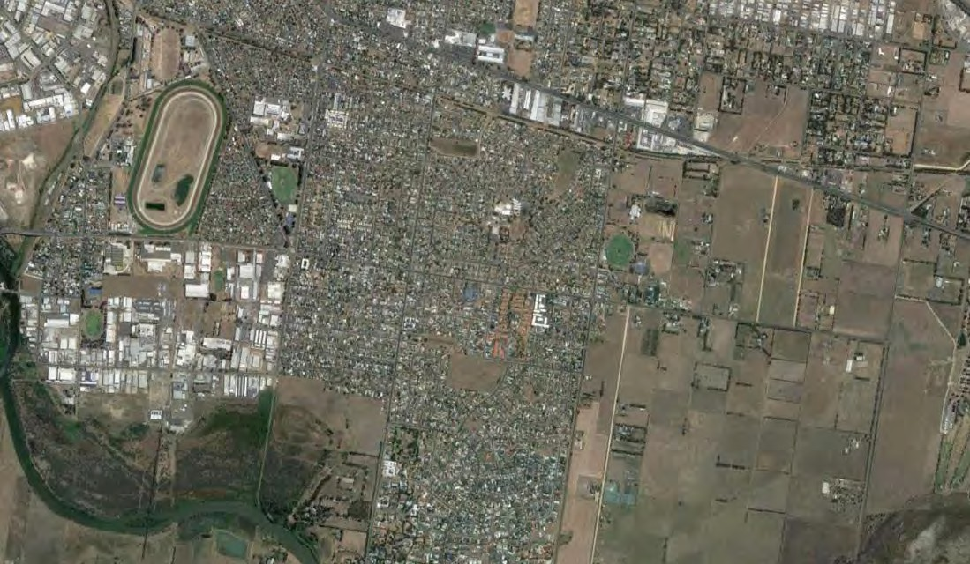FIGURE 1 - Aldershot Reserve context plan
GEELONG RACECOURSE
GRINTER RESERVE
ALDERSHOT RESERVE

The key engagement findings have been summarised under a number of themes below.
ALDERSHOT RESERVE, ST ALBANS - COMMUNITY ENGAGEMENT SUMMARY
Engagement findings

Site history
Many residents are very aware of previous plans and ideas for the site, and their responses to the engagement process included reacting to past ideas, rather than a ‘blank slate’.
In particular, a previous idea to sell off some of the reserve for housing was raised by multiple people, and the majority of people did not support the idea. The rationale for the idea at the time was that it would create more houses fronting the reserve, replacing some of the current back fence interfaces and improving surveillance of the reserve. The reasons for people not supporting the idea were usually related to the value people place upon public open space.

People also noted that the previous adopted plan for the site has been largely unrealised, although there was no evidence of strong attachment to any individual parts of that plan.

It is important that this project deliver a proposal for the site that is achievable.

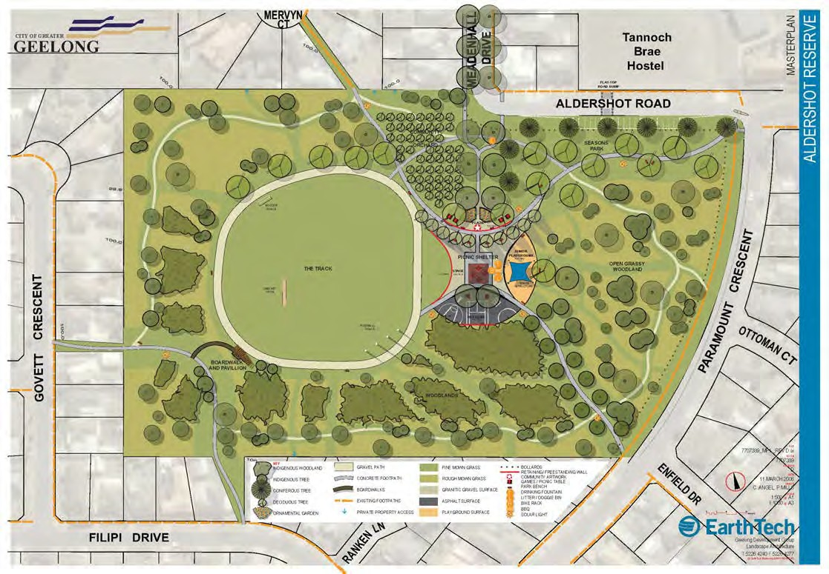

FIGURE 2 - Aldershot Reserve 2008 Master Plan

ALDERSHOT RESERVE, ST ALBANS - COMMUNITY ENGAGEMENT SUMMARY

Safety
Two distinct groups of people attended the engagement sessions. The majority were those who had few, if any, concerns regarding issues of safety within the reserve. This group were predominantly interested in improved infrastructure, supporting their existing use of the space (better paths, better play space, etc).

The second group were people for whom anti-social activities were their dominant concern. This group almost exclusively comprised people living in very close proximity to the reserve along the north-eastern edges, including in the vicinity of the Mervyn Court pedestrian link.

The people who live either side of the Mervyn Court pedestrian access into the park would like the accessway closed. They regularly observe people using the park as a destination for antisocial activities, making their way to the park via Jenna Court and Mervyn Court. They say that if Mervyn Court was closed off, they’d be forced to access the park via Meadenhall Drive, a busier road with better surveillance.

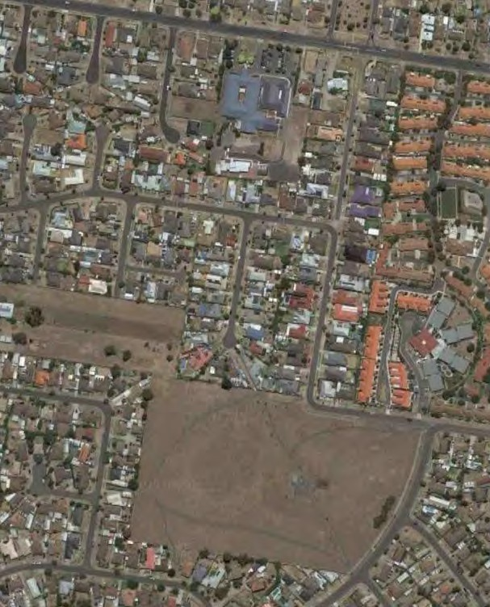Because the second group are in the minority, their concerns do not rank highly in analysis of the questionnaire findings. However, this group are very important to the future of the reserve, providing the majority of the passive surveillance to the space, and it is critical that their experiences are addressed in plans for the future of the reserve.
MERVYN COURT PEDESTRIAN LINK

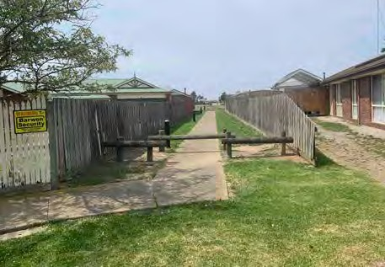

Image: View of link from Mervyn Court
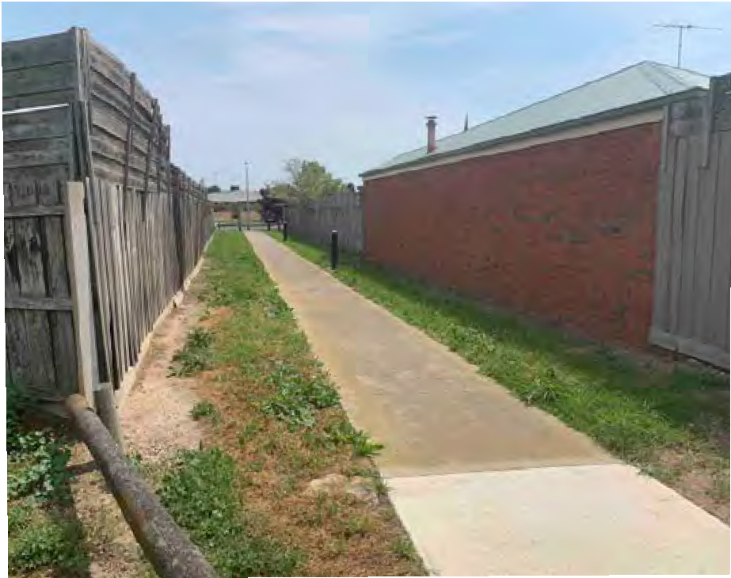

FIGURE 3 - Mervyn Court pedestrian link Image: View of link from Aldershot Reserve

ALDERSHOT RESERVE, ST ALBANS - COMMUNITY ENGAGEMENT SUMMARY

Play
‘Improving children’s play opportunities’ at the site was the most selected option (63.2%) when people were asked in the questionnaire about ‘the most important things to be considered when coming up with a new design for Aldershot Reserve’. ‘Visiting the play ground’ (40.2%) was also the second most common response when people where asked about their main reasons for visiting the reserve.

A lot of time was spent at the on-site engagement events discussing the kinds of play upgrades that people would like to see. In general, people are comparing the existing play offering at Aldershot Reserve with new play spaces being provided elsewhere.

Bicycle and scooter paths/facilities (such as ‘pump tracks’) were also identified by a number of people, both at the engagement sessions and in the comments sections of the questionnaire. These were seen as being a way to increase the appeal of play/recreation opportunities within the reserve to a wider age group.

The strength of this feedback indicates that a play space upgrade definitely needs to be a
part of the plan for Aldershot Reserve.

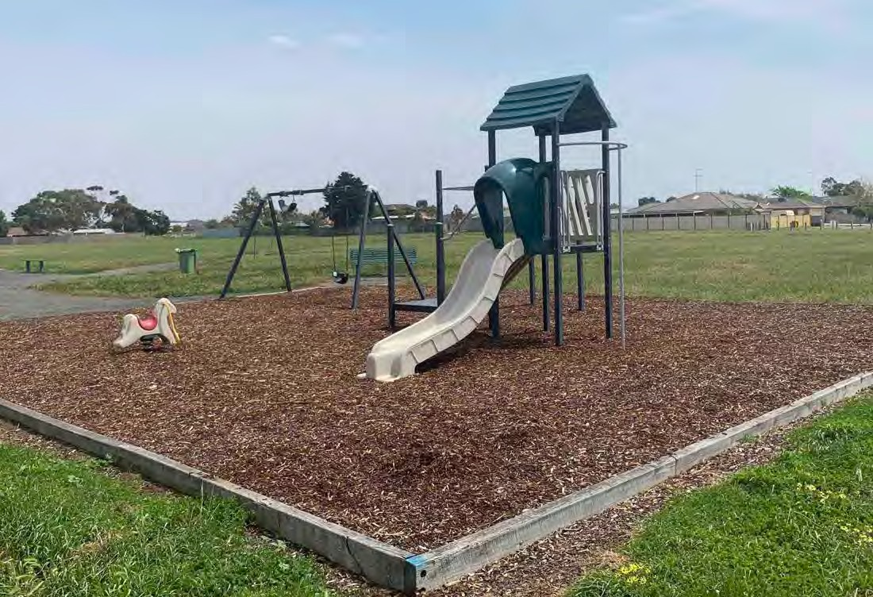

Image: Existing playground

ALDERSHOT RESERVE, ST ALBANS - COMMUNITY ENGAGEMENT SUMMARY

Vegetation
The second most selected option when people were asked in the questionnaire about ‘the most important things to be considered when coming up with a new design for Aldershot Reserve’ was ‘adding more trees’ (36.8%).

The issue of trees within the reserve was also extensively discussed at the on-site engagement event, including a wide range of views about the suitability of different species, the need for planted trees to be protected against vandalism, and the need for open view lines to be retained. A number of residents to the east of the reserve also noted property damage caused by very strong winds, and would like to see more vegetation installed to act as a wind break.

A number of people attended the community engagement sessions to advocate for initiatives such as community gardens, but the support for these ideas was not strong (12.7% of people selected ‘creating a community garden or orchard’ in the questionnaire).

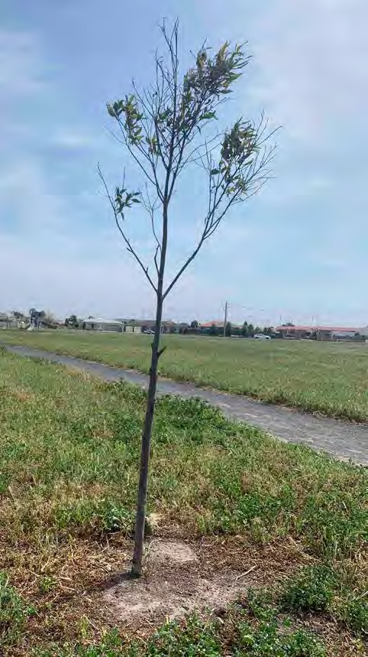

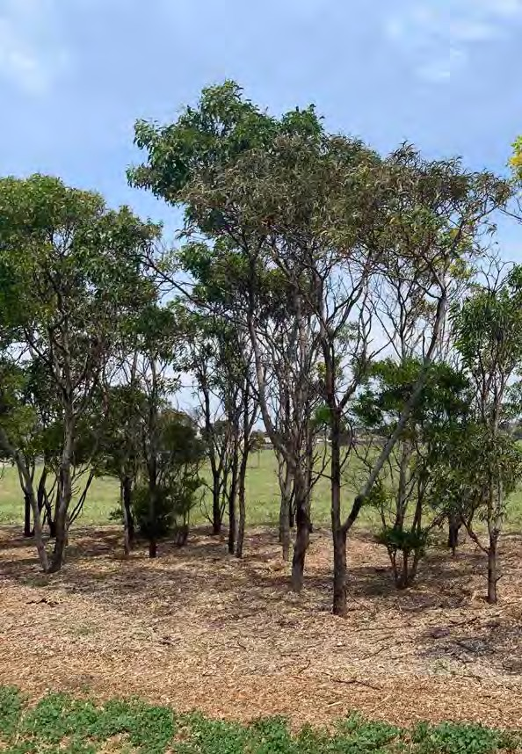

Image: Existing tree Image: Existing copse

ALDERSHOT RESERVE, ST ALBANS - COMMUNITY ENGAGEMENT SUMMARY

Sport & Recreation
A number of people attended the community engagement sessions to identify the opportunity for the space to house structured sport, potentially including football/cricket ovals and soccer fields. These ideas were not strongly supported by the broader community – only 8.3% of questionnaire respondents selected the ‘investigate options for sporting clubs to use the space’ option.

There was much stronger support for a range of less-structured recreation activities, including:
- ‘Creating exercise and play opportunities for adults’ (28.4%, the 3rd most popular response)
- ‘Adding facilities for dog walkers’ (20.1%)
- ‘Improving the quality of the grass’ (16.7%)
- ‘Improving the walking path network’ (14.7%)
- ‘Improving informal recreation opportunities (such as adding soccer goals)’ (13.2%)

It is also noted that dog-walking is currently the number one reason people visit the reserve, according to the questionnaire (46.6% of respondents nominated it as one of the main reasons they visit the reserve).

An opportunity identified during the on-site engagement events was the proximity of the aged care/retirement facility opposite the reserve, and the opportunity to provide better pedestrian connections and attractors for older people (potentially including better paths, seating, and garden spaces).

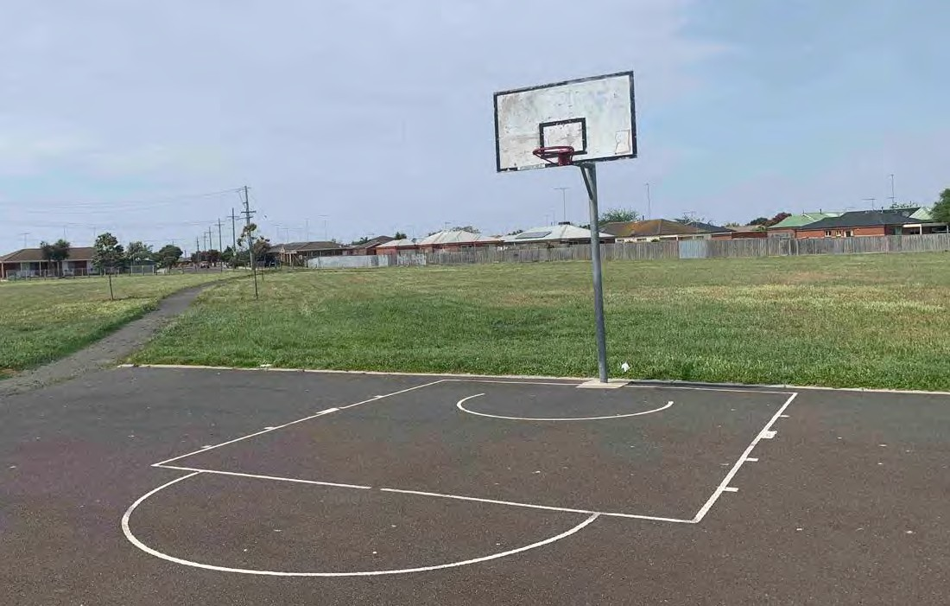

Image: Existing basketball half-court

ALDERSHOT RESERVE, ST ALBANS - COMMUNITY ENGAGEMENT SUMMARY

BBQ/picnic facilities
The fourth most selected option when people were asked in the questionnaire about ‘the most important things to be considered when coming up with a new design for Aldershot Reserve’ was ‘improving BBQ/picnic opportunities’ (24.0%). In discussion with people about the kind of improvements they’d like to see, the most common response related to the location of the facilities, with people preferring them to be located closer to car parking and access points.

Although one resident of the aged care/retirement facility opposite the reserve mentioned that rubbish and noise have been an issue when the existing facilities have been used, very few people indicated that they have used the existing BBQ, and in the questionnaire ‘socialising or barbecues’ was the least selected reason (4.4%) for people visiting the reserve.

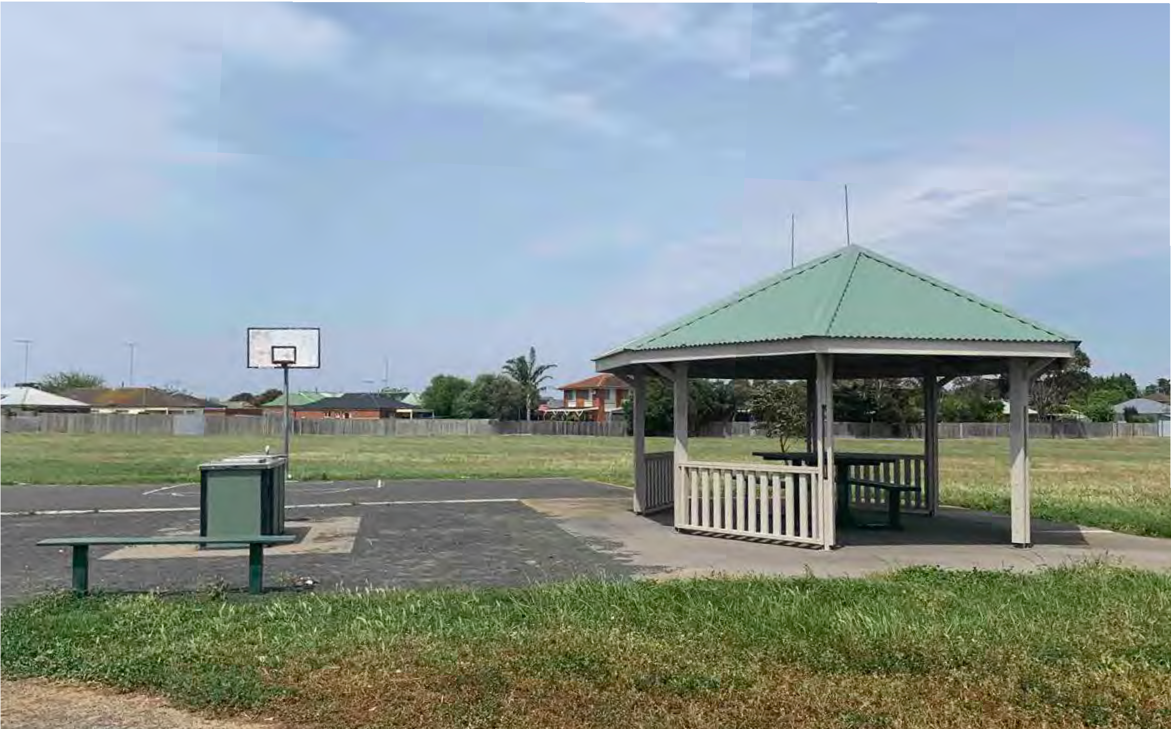

Image: Existing barbecue and shelter

ALDERSHOT RESERVE, ST ALBANS
ALDERSHOT RESERVE, ST ALBANS - COMMUNITY ENGAGEMENT SUMMARY

Community Engagement

Summary
DRAFT 21.10.2020

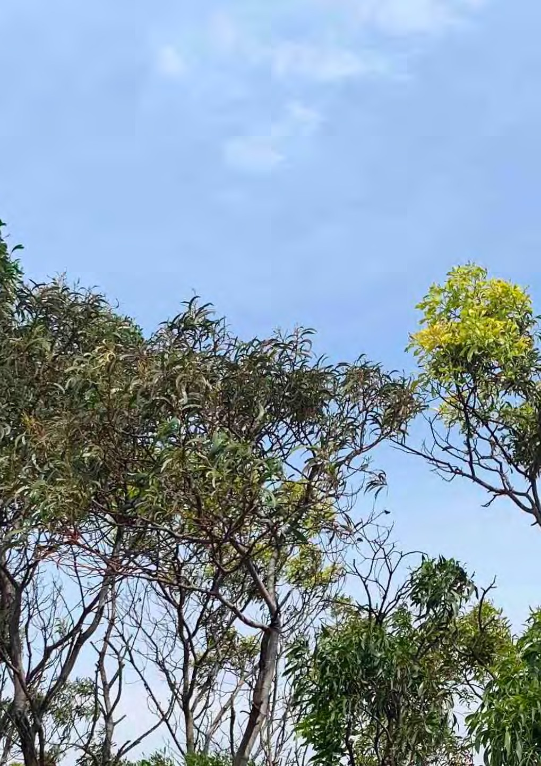
1

fitzgerald frisby landscape architecture

Introduction 01
ALDERSHOT RESERVE, ST ALBANS - COMMUNITY ENGAGEMENT SUMMARY
Contents
Engagement findings 02
Support for the Master Plan 02
Safety 05
Play, sport and recreation 09
Other 11

Appendix 1 Stage 1 engagement report
Appendix 2 Return brief
Appendix 3 CPTED report
Appendix 4 Youth engagement summary

This report was prepared for the City of Greater

HELP US REVIEW
THE DRAFT ALDERSHOT RESERVE MASTER PLAN
Find out more and have your say at: www.geelongaustralia.com.au/yoursay
Geelong by Fitzgerald Frisby Landscape Architecture

October 2020

Community engagement has been undertaken as a part of the preparation of a master plan for Aldershot Reserve. The subject of the consultation was a Draft Concept Plan, prepared for the City of Greater Geelong by Fitzgerald Frisby Landscape Architecture.
ALDERSHOT RESERVE, ST ALBANS - COMMUNITY ENGAGEMENT SUMMARY
Introduction

The Draft Concept Plan was informed by findings from engagement undertaken at the commencement of the project which inquired into current use of the space, community attitudes toward the space, and ideas regarding the future of the reserve. The design was guided by ‘crime prevention through environmental design’ (CPTED) principles, and reviewed by CPTED experts Design Out Crime.

The report on the first round of engagement can be found as an appendix to this document.

ENGAGEMENT PROCESS
On-site and in-person consultation was limited by restrictions imposed due to the COVID-19 outbreak that began in early 2020.

The second round of engagement has comprised the following:
- A mail out to all residents in the Stage 1 communications catchment (slightly greater than 400m), this included:
  - A copy of the concept plan;
  - A project update information sheet with summary of Stage 1 findings;
  - A hard copy feedback form and reply-paid envelope.
- Online content and survey
- Presentation to Youth Council and opportunity for feedback
- Along with the direct letter drop to residents in the catchment additional communications included targeted social media, on-site signage and direct email to residents who provided contact details during the first stage of community engagement.
- The survey was also featured on the City’s online ‘Have Your Say’ page.

Responses included 245 hard copy surveys (including one blank and one incomplete) and 99 online surveys. The online ‘Social Map’ received 31 comments, which reflected similar sentiments to those expressed in the surveys. The Facebook ad logged 5694 views.

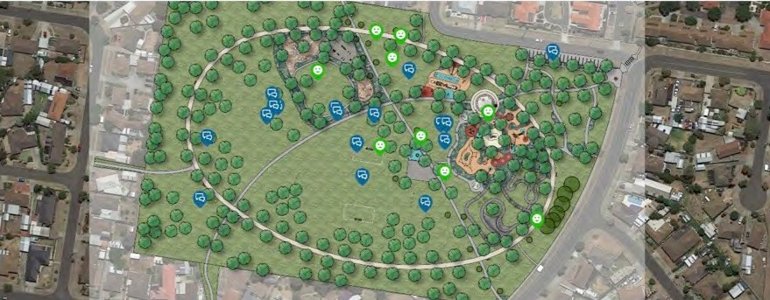
Image: Social Map

The key engagement findings have been summarised under a number of themes below.
ALDERSHOT RESERVE, ST ALBANS - COMMUNITY ENGAGEMENT SUMMARY
Engagement findings

Support for the Master Plan concept
Overall, support for the Master Plan concept was very strong, with 95% of respondents supporting the plan and over 91% of respondents selected options indicating the reserve is likely to get more use if the concept plan is built. 55% of respondents did not have anything they would like to change on the plan.

30% of people who responded to the latest consultation say that they also participated in the 2019 consultation process, and 97.1% of that group supported the draft Concept Plan.
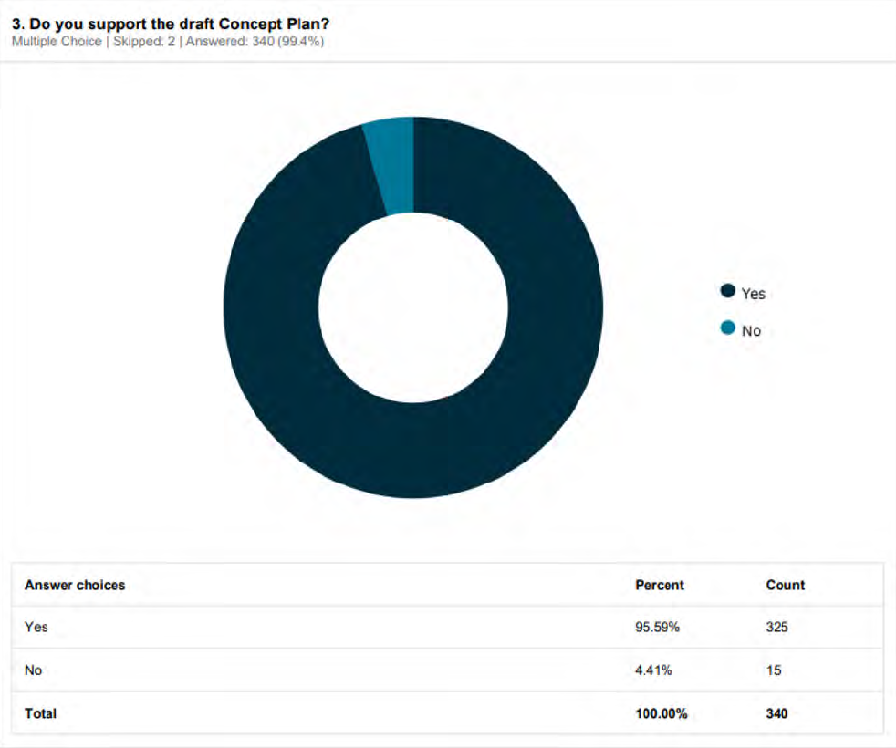
Survey responses: Support for the Master Plan concept

ALDERSHOT RESERVE, ST ALBANS - COMMUNITY ENGAGEMENT SUMMARY

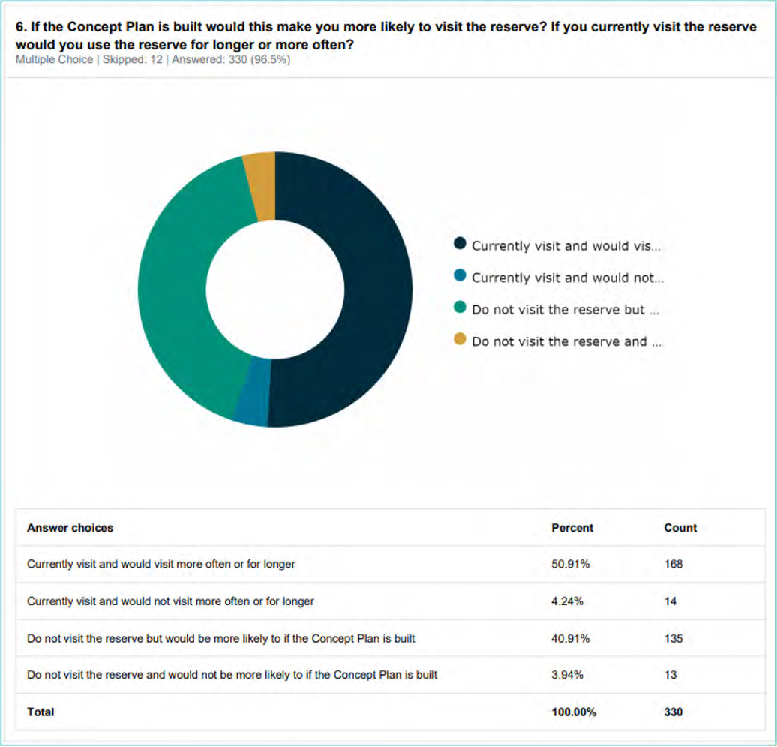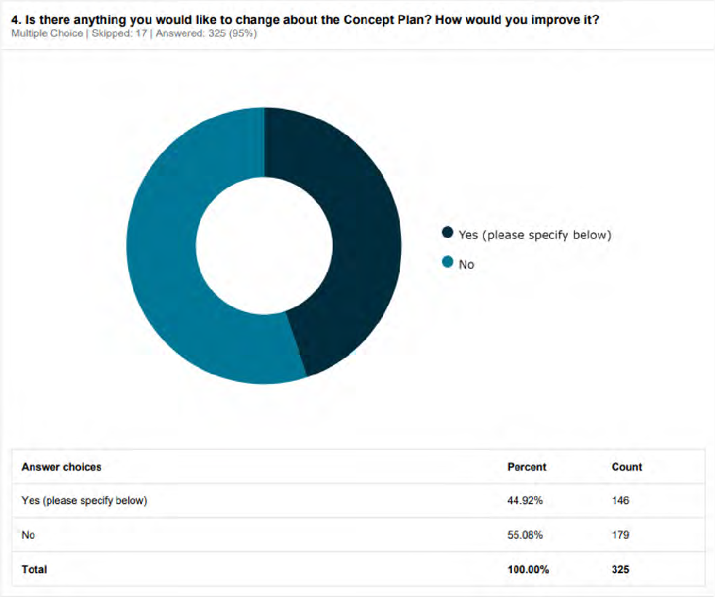
Survey responses: Questions exploring potential for increase in use of reserve
Survey responses: Is there anything you would change about the Concept Plan?

ALDERSHOT RESERVE, ST ALBANS - COMMUNITY ENGAGEMENT SUMMARY

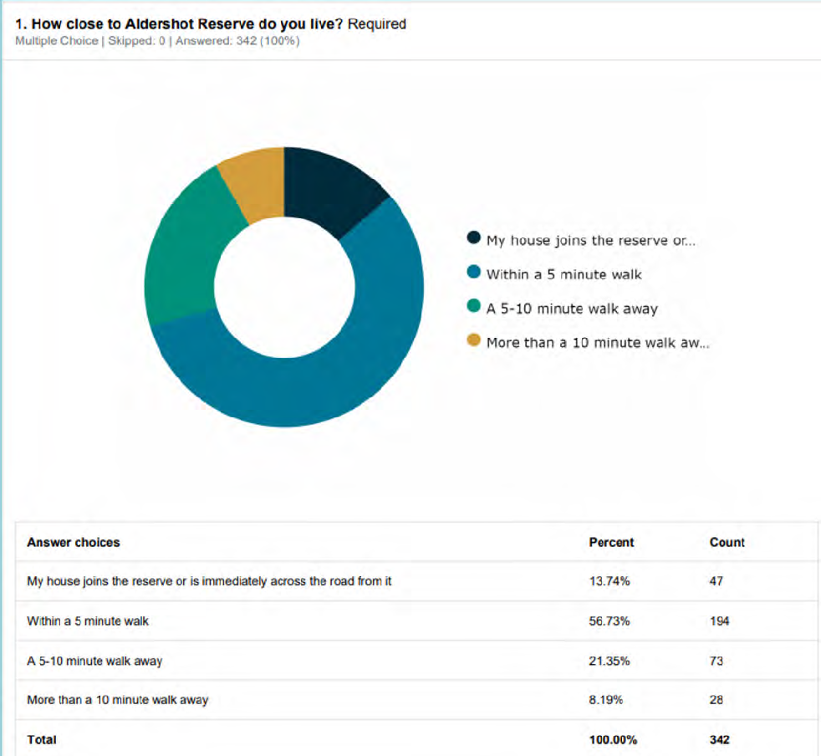
Survey responses: How close to Aldershot Reserve do you live?

A minority of comments on the Master Plan concept expressed concern about potential vandalism, anti-social behaviour and damage to trees as well as the need for improved maintenance. One resident bordering the reserve circulated a flyer encouraging others to comment and highlighting potential negative outcomes.

The weakest support for the master plan came from respondents who said their house joins the reserve or is immediately across the road from it (13.7% of total respondents). However, the level of support was over 85% even in this group. It is recommended that the final Master Plan Report clearly addresses the concerns of this contingent. The specific concerns and suggested changes raised by respondents will be discussed in the following sections.

ALDERSHOT RESERVE, ST ALBANS - COMMUNITY ENGAGEMENT SUMMARY

Safety
Safety - proposed actions
- Master Plan to include reference to the need for ongoing maintenance.
- Reduce number of proposed trees and increase distance from residences.
- Master Plan and detailed designs to ensure sightlines are maintained.
- Provide clear information about lighting strategy. (Strategy is aimed at providing after dark safety, but without encouraging night time gathering and events.)
- Provide further details and rationale regarding siting of the public toilet.
- Increased security measures (such as CCTV and ‘target hardening’ of fences) could be considered by Council in the future in response to site activity, but this is not a key component of the master plan proposal’.
- Position of pedestrian crossing to be further investigated as part of detailed designs.
As noted above and in the previous consultation report, safety concerns related to the Master Plan were far
more commonly expressed by respondents who said their house joins the reserve or is immediately across the road from it. 23.4% of this group commented about surveillance/safety, with the percentage decreasing to 0% for respondents further than a 10 minute walk away.

Although they are in the minority of respondents, it is critical that the experiences of adjacent residents are addressed in plans for the future of the reserve.

180

160

140

120

100

80

60

40

20

0
Within a 5 minute walk
Yes
No
My house joins the reserve or is immediately across the road from it
Yes
No
(blank)
More than a 10 minute walk away
Yes
No
A 5-10 minute walk away
Yes
No
Survey responses pivot chart: How close to Aldershot Reserve do you live?
Do you support the draft Concept Plan? 5

ALDERSHOT RESERVE, ST ALBANS - COMMUNITY ENGAGEMENT SUMMARY

MAINTENANCE
Maintenance concerns/questions account for 3.2% of the specific comments collated from responses. Concerns were raised about current inadequate maintenance at the reserve, and how the increase in maintenance requirements will be dealt with given the increased use that redevelopment of the reserve will generate.

Master Plan Response
- Adequate maintenance is vital to the success of the reserve redevelopment, and is crucial in perceptions of safety and security. Ensure that adequate provision for ongoing maintenance for 24 months is included in costings.
- Council assistance in ‘target hardening’ of the perimeter fence of properties adjacent to the reserve may assist in reducing resident concern.
- According to the CPTED report by Design Out Crime, ‘Effective anti-graffiti coatings on the fences (or anti-graffiti fencing) and rapid graffiti clean-up are likely to be effective in immediately reducing some of the key concerns of adjoining residents’ (p. 16).

SECURITY
Safety/surveillance concerns/questions account 9.6% of the specific comments collated from responses. CCTV was requested to deal with expected increase in anti-social behaviour.

Master Plan Response
- Potential for Council assistance for ‘target hardening’ of properties adjacent to the reserve, as recommended by CPTED review.1
- Increased security measures (such as CCTV) could be considered by Council in the future in response to site activity, but this is not a key component of the master plan
proposal’.

TOILETS
Concerns were raised about the inclusion of toilets ‘encouraging congregation’.

Master Plan Response
- A public toilet will be an important addition to the park, especially for kids and older people, and groups using the BBQ facilities.
- Provision of a toilet in the Master Plan at the reserve is in accordance with Council policy on public toilets.
- The revised Master Plan Report will include details of the considerations taken when siting the toilet, such as locating it near the road, ensuring open sightlines, and limited hours of operation.

1 Target hardening is typically restricted to situations in which crime rates are high and other CPTED methods are insuf- ficient. However, ‘In the case of Aldershot Reserve, crime rates are low and key elements of infrastructure (playground, pavilion, barbecue and bins) are already effectively target hardened.
If increase use of the reserve is planned, adjoining residents would likely appreciate support in target hardening their perimeters/ fencing in an aesthetic manner’ (Aldershot Reserve CPTED Review, Design Out Crime, 2020, p. 17)
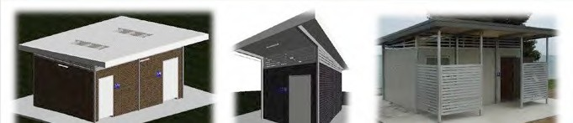
Image: Council public toilets guidelines, detail of cover

ALDERSHOT RESERVE, ST ALBANS - COMMUNITY ENGAGEMENT SUMMARY

LIGHTING
Concerns were raised about lighting provision being insufficient.

Master Plan Response
- The CPTED report notes that ‘Secure, well-lit pathways can be used (carefully) to provide security for vulnerable people crossing the reserve in the evening or night.’ The Master Plan currently proposes lighting bollards alongside pedestrian paving, as a means of allowing wayfinding without encouraging lingering by lighting a whole area. Potential for time-limited lighting of key thoroughfares to be reviewed by the project team.
- The CPTED report notes that ‘High-quality lighting to illuminate and define different use areas can improve activity support (and hence natural surveillance) by law abiding
individuals’ (p. 16). Timed or sensor lights can be used if area lights are required. Potential for time-limited lighting of key areas to be reviewed by the project team.
- Detailed design of lighting for Aldershot Reserve should take into account the recommendations outlined on page 16 of the CPTED report (refer to Appendix).
- More detail to be included in the Master Plan Report, including the following:
  - Lighting in the reserve will be minimal, with the intent being to maximise safety, not to promote use after dark.
  - The toilet will be open for use only during daylight hours and will not be lit up after dark.
  - The shelter will not include lighting.

Survey responses pivot chart: Desired changes among supporters and non-supporters of Concept Plan
Supports draft concept
Support left blank
Suggested changes
Does not support concept
40

20

0
Sum of Add/increase element(s)
60
Sum of Change location of facilities/element
Sum of Comments on materials/processes used
Sum of Remove/decrease element(s)
120

100

80
Sum of Safety/Surveilance
200

180

160

140

ALDERSHOT RESERVE, ST ALBANS - COMMUNITY ENGAGEMENT SUMMARY

TREES
Concern was expressed about the quantity and placement of trees proposed. These concerns related to safety proximity of trees to residential lots and trees blocking views leading to people feeling less safe.

There is also a perception that trees will not be maintained properly, increase fire risk, and/or will be vandalised.

Master Plan Response
- Strong support for ‘adding more trees’ was shown in the first round of consultation. The concept design includes significant tree planting both for amenity purposes, and as a measure to reduce exposure of the site’s users to sun and wind.
- The revised concept will provide a min. 10m offset between proposed trees and the residential boundary, and stipulate that trees are to be located at least 1.5x their maximum height at maturity away from residential boundary. Trees to be spaced to provide a minimum of 2m between canopies (ref. Landscaping for Bushfire, cfa.vic.gov.au).
- Consider provision of a maintenance schedule in the revised Master Plan Report, including guidelines on pruning to lift canopies to ensure sight lines are maintained. (The CPTED report recommends continuous sightlines between 30cm and 180cm from ground level, p. 17.)
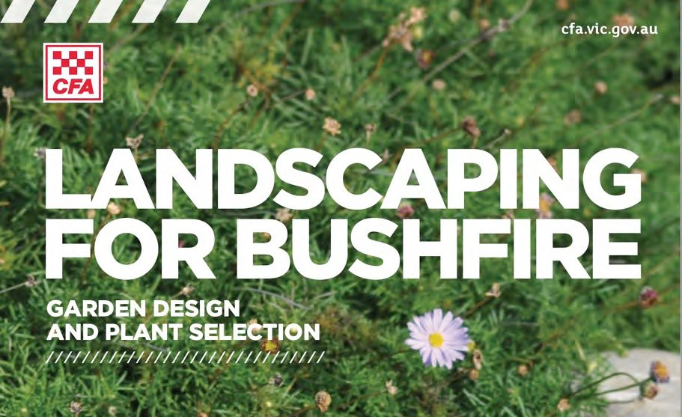
Image: Landscaping for Bushfire, detail of cover

TRAFFIC
A submission was made that the location of the pedestrian crossing on the Master Plan is unsafe.

Master Plan Response
- The configuration and position of the crossing is indicative and will be further examined during detailed design.

ALDERSHOT RESERVE, ST ALBANS - COMMUNITY ENGAGEMENT SUMMARY

Play, sport and recreation
Play, sport and recreation - proposed actions
- Shade proposed to be provided by trees - therefore no change to master plan.
- Add note to plan indicating distance markers on track.
- Identify proposed football goals on plan
- Add note indicating addition of netball goal to half-court.
- Dog park to be reconfigured to provide a min. 60m long lawn area.
- Show maintenance access gates to dog park.
- Add note indicating that Council guidelines on fenced dog-off-lead areas will be followed regarding provision of bins, water etc.

PLAYSPACE
Various requests for specific equipment were made, including:
- Flying fox
- Waterplay
- Shade over equipment

Master Plan Response
- Although specific items of play equipment have been shown on the plan they are not identified individually. At the master plan stage it is preferred to provide general information about the types of play experiences to be provided.
- Shade sails may be considered, however there is an ongoing cost implication as they require periodic replacement. The shade strategy taken in the concept design is for tree planting, however this will not be effective in the short term. Permanent structures would add significant cost.

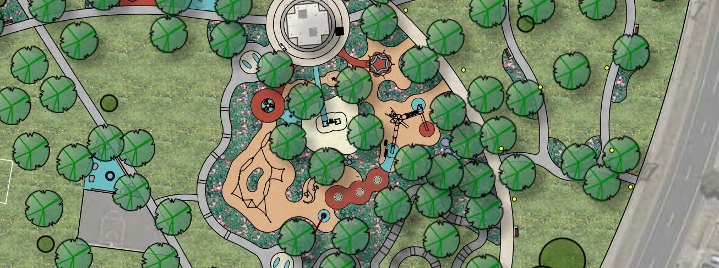
Image: detail of Master Plan

ALDERSHOT RESERVE, ST ALBANS - COMMUNITY ENGAGEMENT SUMMARY

SPORTS AND RECREATION
Various requests for specific elements were made, including:
- Skate bowl (comments were also made requesting that a skate bowl not be included)
- Soccer, football goal posts
- Create full basketball court
- Add netball goal to half-court
- Provide distance markers on circuit path

Master Plan Response
- The decision was originally made during the concept design not to include a skate bowl as other facilities are already available in the area.
- Master Plan to identify soccer, football goal posts shown on the plan.
- The Master Plan concept has been designed on the basis that the reserve is to be primarily focussed on informal recreation rather than formal sports, therefore inclusion of a full basketball court is not appropriate.
- There is potential to include a netball goal at the half-court, and this may encourage greater gender balance.
- Master Plan to include note relating to providing distance markers.

FENCED DOG PARK
Various requests and comments were made about the dog park, including:
- It is too small (need to be able to throw a frisbee)
- Provide separate antisocial dog area
- Ensure gates allow for maintenance access
- Move location adjacent to boundary
- Requirement for bins and water

Master Plan Response
- The dog park exceeds Council’s minimum size requirement for a fenced dog-off-lead area of 3000m2. Internal elements to be reconfigured to provide 60m long lawn area.
- Council guidelines require each separate dog-off-lead area to be a minimum of 3000m2 in size.
- Ensure gates allow for maintenance access.
- An alternative location adjacent to the fence was considered for the dog park, however the option preferred by Council is the one shown in the concept plan.
- Council has guidelines regarding provision of bins, water etc. for fenced dog-off-lead areas.

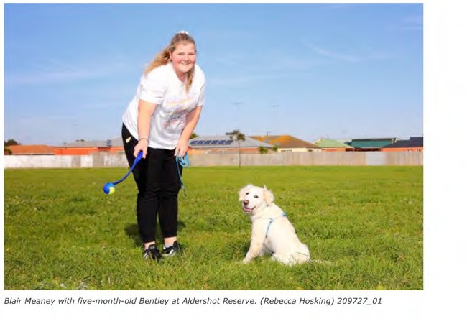Image: Media coverage in the Geelong Independent 10

ALDERSHOT RESERVE, ST ALBANS - COMMUNITY ENGAGEMENT SUMMARY

Other
Play, sport and recreation - proposed actions
- Parking, seating, shelters/picnic areas and rubbish bins are all shown on the plan already at levels appropriate for a reserve of this kind.
- While the master plan provides potential additional opportunities for activity such as temporary food and drink retail at the site, it is not proposed that specific infrastructure be provided to encourage this use.
ADDITIONAL ITEMS
Requests were made for additional provision of the following elements:
- Parking
- Seating
- Shelters/picnic areas
- Rubbish bins

Master Plan Response
- The project team will consider provision of additional items listed, and review Council and best practice guidelines where relevant.

VEGETATION
Requests were made for additional provision of the following elements:
- Improved grass surfaces
- Garden areas to include specific types of plants, ie. bird-attracting, natives, roses etc.
- Fruit trees or community garden

Master Plan Response
- Improved grass surfaces is a key element of the Master Plan proposal.
- Given the challenging nature of the site, plant selection is likely to be driven primarily by maintenance considerations.

RETAIL
- Food van or pop-up cafe location

Master Plan Response
- The project team will review Council guidelines on these items.

NATIVE FAUNA
- Concerns were raised about plovers nesting in the Reserve, both for the safety of the birds and of people (due to the swooping behaviour of that species).

Master Plan Response
- Informational signage educating visitors about plovers and their behaviour will be considered in detailed design of signage.

11

Design Out Crime and CPTED Centre

CPTED Report

Aldershot Reserve St Albans Park, Vic
Prepared for
fitzgerald frisby landscape architecture

14 January 2020

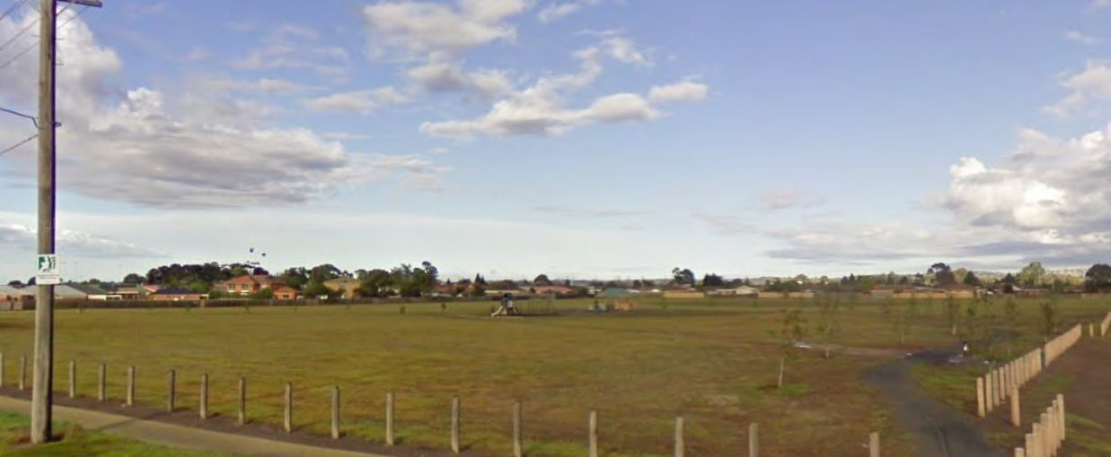

Dr Terence Love


www.designoutcrime.org

Contents
Executive Summary 1
Background 3
Local environment 4
Demographics 5
Crime Statistics Analysis 6
Routine Activity Analysis and Site Analysis 9
Evidence of minimal or very limited use of the reserve 10
Adjoining residents’ confidence the reserve is a safe law-abiding place 10
Reserve is over-endowed with space 11
Crime Opportunity Analysis 12
Aldershot Reserve Community Survey Analysis 12
Participant bias and suggested correction 13
Community engagement feature list 13
Importance of keeping open the accessway from Mervyn Court 13
Claims of anti-social behaviour not supported by current evidence 14
CPTED Analysis of Survey Data 14
Crime Prevention Through Environmental Design Guidance 15
Important note about crime rate changes 15
Key CPTED considerations 16
Immediate CPTED strategies 16
Natural surveillance 16
Natural Access Control 17
Target hardening 17
Territorial Reinforcement 17
Activity Support 18
Image and maintenance 18
3Ds 18
CPTED process, reports and evaluation 19
Appendix 1: List of CPTED Methods 21
Appendix 2: Images of Aldershot Reserve Error! Bookmark not defined.

CPTED Report

Aldershot Reserve, St Albans Park, Victoria

Dr Terence Love
Design Out Crime and CPTED Centre

Executive Summary
This CPTED report describes a CPTED review of Aldershot Reserve undertaken by Dr Terence Love of the Design Out Crime and CPTED Centre following a site inspection on 21 November 2019.
It analyses Aldershot Reserve through the lens of the 12 CPTED methods listed in Appendix
- From the analyses, it identifies key CPTED-related factors that offer guidance for redesign of the reserve.
This CPTED review and is based on analysis of evidence of conditions at Aldershot Reserve from the crime statistics made available by Victoria Police and the Crime Statistics Agency Victoria together with; analyses of physical features of the reserve. It also includes analysis of the demographic trajectory of the environs; geographic juxtaposition analysis, routine activity and land-use analysis based on data from profile.id website and maps of the reserve and surrounding areas; and a detailed site inspection of the Aldershot Reserve in collaboration with Community Safety and Planning officers from the City of Greater Geelong and Tim Fitzgerald of fitzgerald frisby landscape architecture. The site inspection was undertaken 21 November 2019.
The background context is there have been plans to develop/improve the facilities in the reserve for some years. Following a major sexual assault incident at Aldershot Reserve in 2015, planning for the reserve was reconsidered with the aim of reducing the potential for such incidents.
In CPTED and situational crime prevention terms, the physical features of the reserve, its use patterns, planning guidelines and stakeholder considerations indicate multiple differing pathways of development including the possibility of rezoning parts of the reserve to residential.
This report provides guidance Crime Prevention Through Environmental Design (CPTED) terms and in implementing CPTED features to reduce crime at the reserve and in its environs.
The analyses in this report follow the CPTED methods, analyses and process of Appendix 1. The primary findings include:
  - Aldershot Reserve is in an area of unusually low crime rates (Police crime incident data, LGA requests for service, detailed on-site CPTED inspection, Google maps review).
  - The behaviours of users and residents adjoining the reserve indicate that they have very little concern about crime on the reserve (i.e. low fear of crime). Exceptions

being the houses adjoining the reserve at the well-used laneway between Mervyn Court, which provides pedestrian access to the reserve for a significant catchment of cul-de sacs in the 400m pedshed to the NW of the reserve.
- Detailed CPTED on-site analysis indicates the reserve is currently only very lightly used.
- Local government history of requests for service relating to the reserve and environs are very low.
- The above factors offer significant beneficial opportunities for redesign of the reserve’s facilities and landscaping to increase its attractiveness and contribute to improved quality of life for its users.
- Currently, the reserve has evidence of low levels of crime and anti-social behaviour in part because of its low levels of use. This low level of use is likely to be strongly driven by the paucity of parking near the reserve and the lack of toilet facilities.
- Making the reserve easier and more attractive to use is expected to lead to proportionately increased numbers incidents of crime and anti-social behaviour providing crime rate (crimes per person using the reserve) are held constant.
- In this case, adjoining residents will see an increase in crime/residence.
- The current evidence indicates that the potential for crime is predominately limited by low use rather than for example by surveillance or other protective factors. Increase in use may increase crime rates over and above increases in use because of limitations to effective natural surveillance, and relatively low protective factors of natural surveillance from other reserve users.
- Increasing the use of the reserve implies greater need for improved natural surveillance and this would suggest the potential for rezoning part of the reserve to residential to provide increased natural surveillance.
- Regardless of planning changes, if the reserve is redeveloped to increase use. It is strongly recommended to use the 12 CPTED methods and CPTED process in Appendix 1 to minimise crime risks in the reserve; support the role of Community Safety and Planning to keep the reserve safe; and ensure the reserve provides improvements in quality of life for nearby residents and all other users, without significant increases in crime.

Background
Aldershot Reserve is a large, relatively underdeveloped public open space in St Albans Park, Victoria located approximately 3km South-East of the City of Geelong (Figure 1).
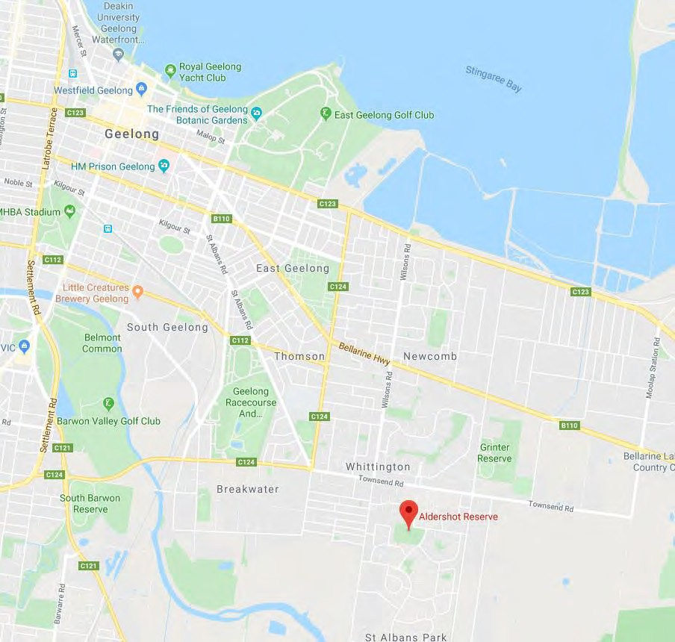

Figure 1: Location of Aldershot Reserve

Aldershot Reserve primarily comprises a large grassed are, with a small network of 6 narrow gravel paths. Towards the centre of the reserve is a small children’s playground, a two-pan electric public barbeque, an open sided pavilion and a basketball practice hoop (Figure 2).
There are three major access routes into the reserve (from Mervyn Court, Govette Crescent and Enfield Drive), with the major pathway across the reserve between Mervyn Court and Enfield Drive) (Figure 2).
The pattern of pathways on the reserve indicates the reserve is primarily a pedestrian access hub between pedestrian accessways on its perimeter in a way that reduces pedestrian access problems across the suburb due to the convoluted road network. This can be seen in the way that the majority of the pathways are between access laneways rather than to use the facilities of the reserve itself (Figure 2). Other more minor access to the reserve is via the

open edge to the north-east on Maidenhall Drive, Aldershot Road and Paramount Crescent; and by the pedestrian access to the south from Filipi Drive.
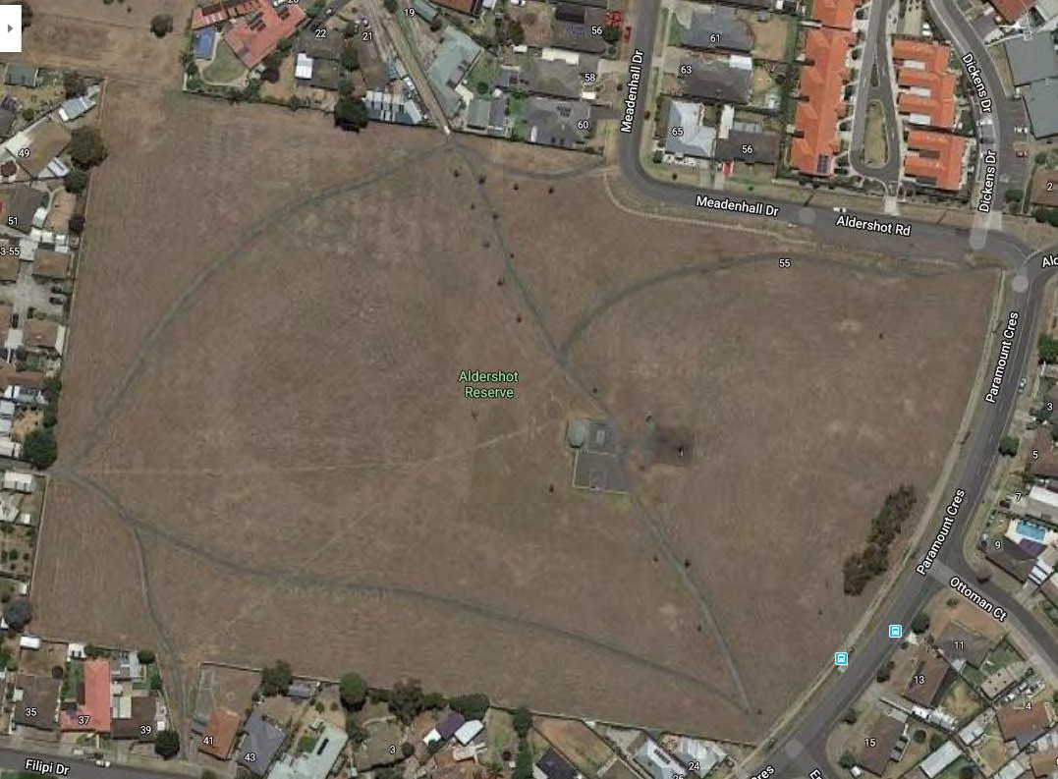

Figure 2: Aldershot Reserve showing access points, pathways and facilities
The reserve is primarily bordered and bounded by the rear fences of 28 residences with short lengths of road verge to the North and East.
It is overlooked directly by 10 residences, by travellers along Paramount Court and Aldershot Drive / Meadenhall Drive, and by those entering or leaving the large Windsor Park Retirement Community on Aldershot Rd.
Traffic is blocked from entering the reserve from the roadways by timber bollards with gates for access for LGA maintenance staff. Two of the laneways have barriers to block access from vehicles whilst enabling access for pedestrians, cycles, prams and buggies of people with a disability.

Local environment
Aldershot Reserve is in St Albans Park to the East of Geelong and is part of the City of Greater Geelong (see Figure 1 above).
The area has a peri-urban feel and is characterised by a combination of low density urban residential development situated between extensive green urban-rural/undeveloped areas and the riverbank reserves of the Barwon River, a small light industrial area, Geelong racecourse and Stingaree Bay to the north (see Figure 3 below).

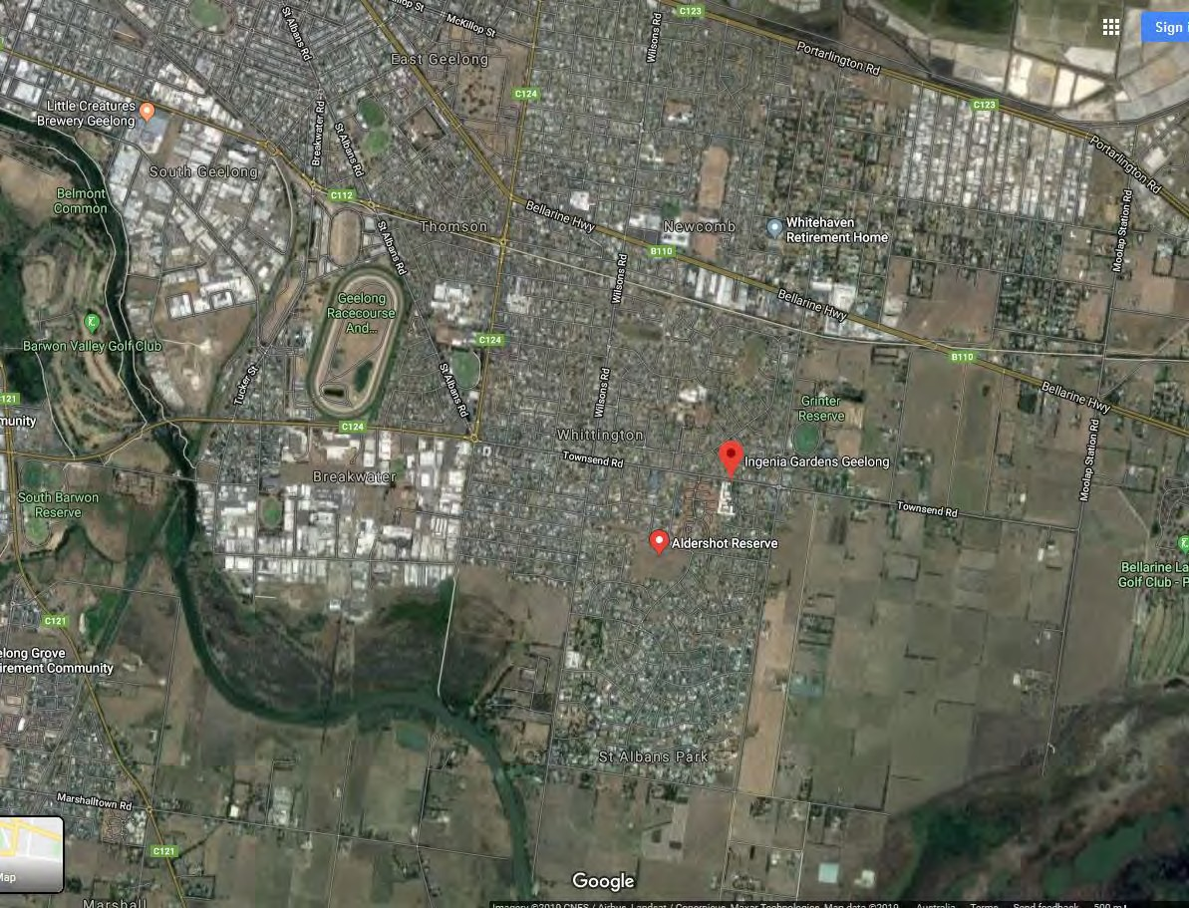

Figure 3: Local environment to Aldershot Reserve
Note: The nearby area has a small hospital and aged community institutions, including one immediately next to the reserve.

Demographics
In crime terms, the aged demographic of this area is characterised by very low crime risk as both victims and offenders (ABS 4530.0, 2017-18; https://crimestats.aic.gov.au/facts_figures/2_offenders/A1/ ).
Population and number of residences in St Albans Park have remained relatively constant as indicated by the 2011 and 2016 census data. The only significant differences were a reduction in the average population per house (2.41 to 2.35), which is in line with the aging of what seems to be a relatively stable population (see also age pyramid) and the exodus of people of Polish descent (which was a significant sub-group). (see https://profile.id.com.au/geelong/population?WebID=390 ).
The demographic analysis of profile.id made available by the City of Greater Geelong shows that St Albans Park and the locality within walking distance of the Aldershot Reserve are weighted heavily towards the 50-70 year age group (remembering that now (2019) is 3 years later than the profile.id data which is drawn from the 2016 census). See, https://profile.id.com.au/geelong/age-sex-pyramid?WebID=390 as shown in Figure 4.

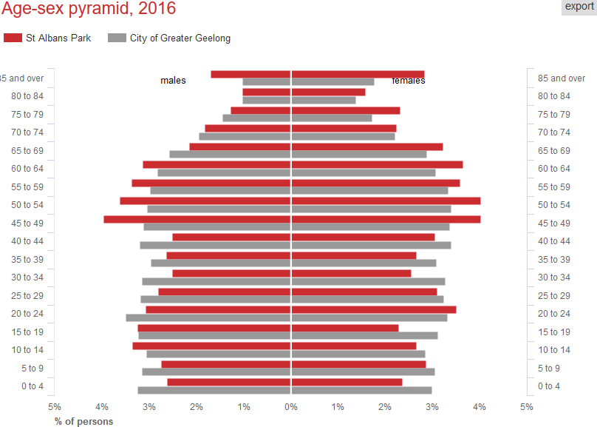

Figure 4: Age-sex pyramid 2016 for St Albans Park
The area has a population dominated by English speaking English, Australian, Irish and Scottish heritage (>90%). However, since the prior census there has been minor changes reducing the proportion of individuals of Australian heritage and increasing the proportion of individuals with English, Irish, Scottish, European (particularly German) and Filipino ancestry.
Income-wise, a slightly higher proportion of St Alban’s Park residents were paid in the region of $350-$1250 per week compared to City of Gelong as a whole and lower numbers of people in the pay bands above and below this range (https://profile.id.com.au/geelong/household-income?WebID=390 ).

Crime Statistics Analysis
St Albans Park is a low crime suburb as indicated by comparing the crime incident counts by principal offence of St Albans Park (see Figure 5) with crime incident rates of principal offence per 100,000 population of Greater Geelong (Figure 6 ) and Melbourne (Figure 7 ).
The population of St Albans Park is ~5000 persons and the incident information data from Figure 5 can be directly compared with those of Greater Geelong and Melbourne (crimes per 100,000 persons) by dividing the latter data by 20. Hence, we can compare recorded incidents for ‘crimes against the person’ in 2019 St Albans Park of 30 incidents with the scaled to 5000 persons recorded incidents for ‘crimes against the person’ in 2019 for Melbourne of 105 incidents, and for Greater Geelong of 52 incidents.
This indicates that the rate of ‘crimes against the person’ per person for the Aldershot Reserve environment of St Albans Park is less than 30% of the that of Melbourne and only 57% of that of the City of Greater Geelong.

Undertaking the same process across crime incident types indicates that St Albans Park is intrinsically a very low crime environment.
This low crime environment would be expected as a result of a number of situational factors:
  - The aging population;
  - The high proportion of land used for institutional purposes with relatively low crime generation effects (aged care homes);
  - The convoluted road layout;
  - The extensive use of cul-de-sacs;
  - The road layout resulting in a general discouragement of walking and non-vehicular traffic;
  - Lack of easy car parking for visitors to the area;
  - Lack of crime attractors (shops, pubs etc).

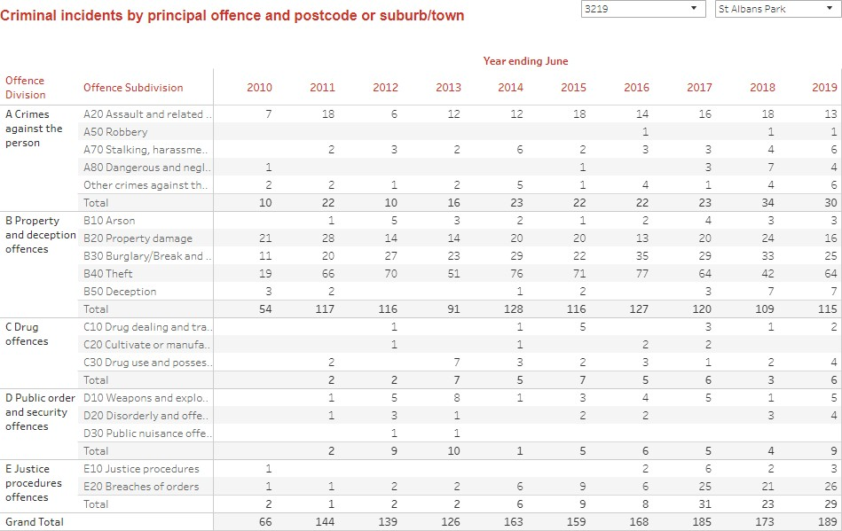

Figure 5: Crime incidents by principal offence for St Albans Park

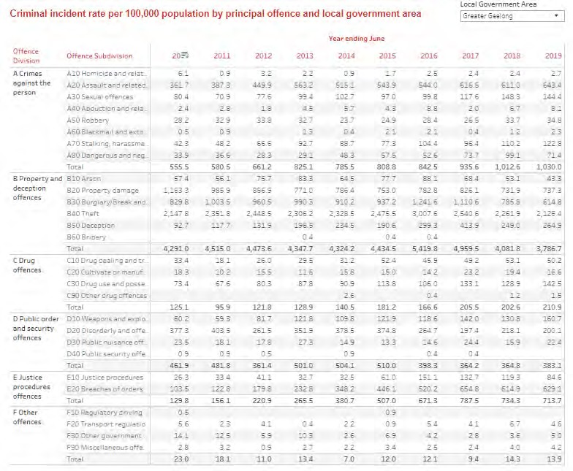

Figure 6: Crime incident rates per 100,000 population Greater Geelong
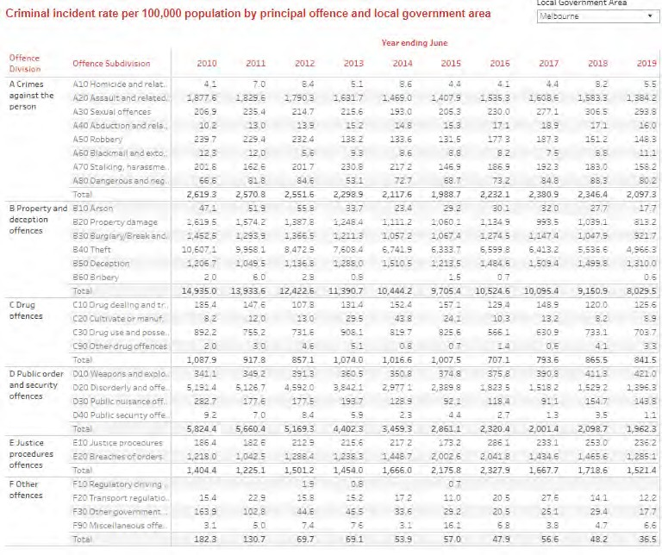

Figure 7: Crime incident rates per 100,000 population Melbourne

The above data from the Crime Statistics Agency Victoria indicate that St Albans Park is unusual in that although crime rates in St Albans Park are currently very low compared to other locations in Victoria, historically, they were even lower. A decade ago, they were around 1/3 of the current values.
This crime incident time profile of St Alban Park of slightly increasing crime incident rates from an extremely low base to its current very low levels across all categories is unusual and contrasts with the City of Greater Geelong for which the picture is more mixed, with falls in ‘property and deception offences’, ‘public order and security offences’ and ‘other offences’ ; and with the City of Melbourne, which shows falls in all classes of offences except public order offences (see https://www.crimestatistics.vic.gov.au/crime-statisticslatest-crime- data/recorded-criminal-incidents ).
The increases in these above very low levels of recorded crime over the last decade of St Albans Park appear to be NOT accounted for by increase in population because the population has been stable across the census counts of 2011 and 2016 and personal communication with City of Greater Geelong Planning Dept indicates there has been no significant increase in population or number of residences in the period 2016 to date. (See https://profile.id.com.au/geelong/population?WebID=390). Other obvious explanatory factors would likely have resulted in a step change rather than a gradual increase. The fact that the increase in incidents has seen a steady progression over the decade from very low to low crime remains unexplained.

Routine Activity Analysis and Site Analysis
The reserve was inspected in detail for indicators of use in a site visit on the 22nd of November 2019.
Grass had been cut a few days before the inspection of the reserve and it had rained in the intervening time. This facilitated the inspection; with the grass playing areas and granite dust walkways providing a good evidence record of recent use of the reserve.
The site analysis included detailed inspection of:
  - All pathways on the reserve;
  - All grassed areas of the reserve;
  - The condition of all fences of residences adjoining the reserve, along with any protective features or lack of;
  - The condition of each access of the reserve including indicators of us, evidence of damage, protection from adjoining houses (or lack of such protection and indicators of concern), access restrictions, environment on streets external to accessways;
  - All evidence of graffiti including age, type and characteristics (including whether done by same person);
  - Condition and use indicators of playground equipment, floor treatment and walkways to it;
  - Condition of barbecues and indicators of use;
  - Condition of shade pavilion and indicators of use;
  - Contents of rubbish bins (at pavilion and reserve boundary;
  - Condition of parking area and indicators of use;
  - Condition of access control gates and indicators of use;
  - Condition of barrier fencing and indicators of damage (or lack of);
  - Street environment surrounding the site (convoluted street network with extensive use of cul-de-sacs);
  - Site lines for natural surveillance from all sources;

- Limitations of clear observation of activities on the reserve due to size under different lighting condition (including lurk-lines and potential entrapment spots; and,
- Observation of activities of reserve users, local traffic and local pedestrians at that time.
All the indicators identified in the site visit combine to point to the following characteristics of routine activities at Aldershot Reserve:
- Minimal or very limited use of the reserve;
- Confidence by adjoining residents of the reserve that the reserve is a safe law- abiding place;
- The reserve is relatively over-endowed with space for the services and benefits it provides;
- Low use of the reserve is likely due to the very limited parking available; and,
- Low use of the reserve is also likely a significant driver of low crime.

Evidence of minimal or very limited use of the reserve
Main points from the detailed site review and routine activity analysis that indicate minimal or very limited use of the reserve are:
- Minimal pedestrian/pram/cycle/light vehicle traffic indicators to the walkways. The walkways are granite dust and evidence of each actual use is highly visible. The walkways are overgrown with grass runners indicating almost no traffic and this is evident even at locations where higher traffic might be expected
- Very low amounts of footprints, bicycle wheel tracks or pram wheel marks showing on the walkways - bearing in mind this is accumulated evidence over several days
- Only minimal signs of wear and erosion at the main entry access ways.
- Marks from only 2 single passes of motorcycles across the reserve. This is surprising and indicates an extremely low presence of such activity because there is no significant barrier to access by 2-wheel motor vehicles.
- Children’s playground shows minimal wear on the equipment except for limited disturbance in the mulch beneath the child swing seats indicative that a small number of parents and children use the swings each day for a small amount of time.
- Barbecue wear is minimal, and inspection of rubbish bins indicate only limited use.
- There are no strong indicators of wear on the pathways, grass, entries, perimeter or covered sitting area.
- There is minimal graffiti and careful observation indicates the small amount of graffiti was undertaken by the same person and most likely at a single time. Some small graffiti patches have been recently cleaned from neighbour’s fences on the access pathways to the NE, N and NW of the reserve. This appears to have been done using bleach or abrasive with minimal damage to the wooden fencing suggesting that the graffiti was not difficult to remove. There is no obvious evidence of repeated graffiti removal events over time. There is one small patch of graffiti on the floor in the covered seating area that is in a different colour (brown) and undertaken with higher skill that suggests it may have been a demonstration for the person doing the rest of the graffiti.

Adjoining residents’ confidence the reserve is a safe law-abiding place
There are strong indications that those living in close conjunction to the reserve consider it a safe and law-abiding place.

The perimeter of Aldershot Reserve is comprised primarily of the back fences of houses abutting it.
In this case, however, most residents do not use any additional forms of security. Their timber vertical plank fences are relatively low and easy to breach, and many residents are happy to leave expensive goods close to or overhanging their fences.
Additionally, the houses either side of the access entries to the reserve show almost no additional security. Viewed from the streets outside the reserve, the residences immediately adjacent to the access walkways to the reserve have minimal fencing, are open-fronted and have open gates and unsecured front fence lines.
All of the above are strong indicators that those living in residences immediately adjoining the reserve are confident the reserve is a safe law-abiding place.
In less law abiding circumstances, a similar residential environment would be regarded as a potentially high crime-risk situation because a reserve at the rear of residences enables easy access, a means for criminals to effectively surveil victims, easy and multiple escape routes, and poor visibility and poor natural surveillance of criminal activity. In such circumstances, if there was concern for safety and security there would more likely typically clear evidence of high security arrangements being undertaken by residents. These are not seen in Aldershot Reserve and, together with the evidence of low crime rates, indicates confidence by residents that the Aldershot Reserve and its environs are predominately safe and law - abiding safe.

Reserve is over-endowed with space
One point of view that emerged in discussions about the reserve is that the reserve is too big for its purpose. Some indicators that this is so are:
  - Very low levels of use of its facilities;
  - Pathways that indicate the main role of the reserve is providing pedestrian and cycle access and short cuts across the convoluted road layout of St Albans;
  - Its role as a dog-walking/dog toilet place is not highly used; and,
  - The size of the reserve is such as to make it difficult to identify the presence or activities of anyone at the other side of it.
From a CPTED point of view, the crime-related considerations of over-sizing of a land segment relative to its land-uses are whether the over-size compromises criminogenically protective factors such as:
  - Natural surveillance
  - Image management and maintenance
  - Activity support
  - Natural access control
  - Formal access control
  - Territorial reinforcement
From inspection, all the above are acceptable in Aldershot Reserve except natural surveillance, which is significantly compromised:
  - Most residences and sources of observation are facing away from the reserve
  - The potential sightlines from the aged care facility primarily turned inwards within the premises.
  - The large size of the reserve means that it is difficult to see across. In practical terms, when meeting at the reserve, meeting participants couldn’t be identified at the other side of the reserve. Additionally, their behaviour could not be identified.

However, the evidence indicates this lack of natural surveillance in Aldershot Reserve is relatively unimportant because crime rates for Aldershot Reserve and its environs are very low and hence the crime reducing effects of natural surveillance are irrelevant.

Crime Opportunity Analysis
The potential crime opportunities offered by Aldershot Reserve are those crime types common to most public open spaces (POS), viz:
- Theft
- Assault
- Stealing from vehicle
- Vehicle theft
- Trespass
- Vandalism, graffiti and anti-social behaviour
- Drug dealing
- Alcohol and drug use
- Sex-related crimes
- Increased crime risks to adjoining areas
However, the crime statistics and Local Government Request for Service Reports indicate none of the above are a significant problem.
The lack of a significant car parking area close to the reserve and no vehicle access into the reserve (except 2-wheel vehicles, prams and electric buggies) significantly reduces crime risks by reducing activity and participation of both users and potential criminals. This lack of parking is also likely a key driver of underuse of the reserve.
Currently, there is a short gravel informal car parking strip opposite the aged car facility. Otherwise, reserve users who wish to arrive by car must necessarily park in the limited parking in narrow nearby streets and walk some distance to access the park.
This lack of parking also provides significant protection against burglary crime risks for those houses backing onto the reserve because it provides poor escape routes exposing criminals to long times for potential observation when leaving, and makes transport of stolen items from burgled premises more difficult along with presenting difficulty in bringing burglary tools onto site.
In short, despite the lack of natural surveillance, there are easier targets.
In terms of illegal activities that can be undertaken within the reserve, there are many isolated locations nearby that offer even less risks (see Figure 3).
In parallel, the low activity at the park is protective as it reduces crime targets.
In criminological terms, the relative absence of activity means the reserve is not a crime attractor, compared to for example a shopping centre with the high level of people and cars being potential crime targets.

Aldershot Reserve Community Survey Analysis
The data from the community survey substantially aligns with the above CPTED analyses relating to Aldershot Reserve.

Participant bias and suggested correction
A caveat prior to the analysis. The survey is not impartial: participants are essentially self- selected, and the participant group necessarily is dominated by those who have an interest in using the power made available by the survey to influence things in terms of their preferences.
The most evident bias in participant self-selection is that it is over-dominated by dog- walkers/owners. Typical Australian levels of dog ownership are around 35% and this would be expected to be reflected in the community survey. However, around 60% (84 persons) of the participants in the survey within 5 minutes’ walk pedshed (142 persons) include dog walking as an activity on the reserve.
This suggests that a weighting adjustment needs to be made either by only considering 58% of the dog-walking participant data or adding 63% weighting to the non-dog-walking participant data to achieve appropriate balance in representation of the data.
There may be other participant bias in the data that haven’t been identified, and if found,
these need to be similarly addressed.
There are comments about the use of the reserve by young people. It would be useful to know the relative proportion of survey responses by young people in relation to the number of young people in the catchment. It would also be useful to know from young people what they currently use the reserve for – or what they would like to use the reserve for - which may be activities not captured by the survey.

Community engagement feature list
Reviewing the list of features suggested by participants shows many admirable and useful ideas for increasing quality of life. In crime terms of increasing activity support and potential for natural surveillance many of these are helpful.
Two issues are significant enough to address separately:
  - The importance to keep open the alleyway to Mervyn Court
  - Claims of anti-social activities not otherwise supported by evidence.

Importance of keeping open the accessway from Mervyn Court
In CPTED terms, the best approach for accessways is to provide territorial reinforcement and ‘ownership’ of the accessways to the users of the accessways. The users then act to ensure the accessway is well managed and the behaviour of problem users is restrained.
From experience (and the findings of a 12-month CPTED research project funded by the Western Australian Planning Authority) it is a serious mistake when territorial reinforcement support and ‘ownership’ of public accessways is given to the adjoining residences and residents.
The research shows:
  - If CPTED is applied erroneously, the adjoining residents try to discourage people from using the accessway;
  - If CPTED is applied erroneously, adjoining residents problematically try to police the alleyway as if it were their own property, to the disadvantage of accessway users and compromising the role of the accessway;
  - If CPTED is applied erroneously, adjoining residents problematically identify that it is in their financial interest to create an image of the accessway being a ‘problem’ in order to ask local government to close the accessway and persuade the local

government to sell the land to them (often to enable residents to have sufficient land to then profit by subdivision). This latter emerged in the research as a well-known strategy in the real estate industry advising house owners – and a problematic basis for Councillor corruption/bribery).
- If CPTED is applied erroneously to accessways, it results in significant quality of life and health costs with associated long term financial costs for the local government and community, pedestrians, cyclists, parents with prams, elderly with electric buggies etc when accessways, which are already in planning terms the most minimal allowance for non-motorised vehicle users, are restricted or closed.
In crime prevention terms, closing any accessway will increase pressures to commit crime and anti-social behaviours. It will move the location of such increased problem behaviours to alternative nearby locations at the expense of other nearby residents.
Better, in crime prevention terms, is to enable CPTED strategies to reduce issues in the accessway; use CPTED to support users in managing better behaviours in the accessway; to reduce any sense of territoriality or ownership for the accessway by the residents adjoining the accessway; and provide support to adjoining residents to assist them in using conventional security methods to secure their premises. Note: direct observation indicates the residences adjoining the Aldershot Reserve accessways have negligible security practices in place, and such conventional security measures would be more appropriate than closing the accessways.

Claims of anti-social behaviour not supported by current evidence
The Community Engagement feature list at several points raises the issue of dirt-bikes being used on the reserve. Site analysis of the grass, pathways and accessways indicates such use by moto-bikes is minimal or non-existent. Is there more evidence? How frequent is the problem?
One point refers to concerns about motorised bicycles being used on the reserve. As I understand it, it is legal to use motorised bicycles on Aldershot Reserve: this is under the same legislation as electric bicycles, electric scooters and electric disability buggies (https://www.vicroads.vic.gov.au/safety-and-road-rules/cyclist-safety/power-assisted- bicycles ).

CPTED Analysis of Survey Data
In CPTED terms, three key parameters in the Community Survey are:
- Reported usage of the reserve: daily and weekly by participants;
- Participant responses from residences abutting the reserve; and,
- Participant responses from residences within 5 minutes walking distance.
User visit numbers for occasional use of the reserve (less than weekly) are too small to shape CPTED response.
Participants in residences abutting the reserve have a special interest, particularly regarding the security of their residences.
Participants from residences within 5 minutes’ walk of the reserve are significant because 5 minutes walking is equivalent to around 350m which aligns with the 400m pedshed considered to be the primary usage group for any public service.
Estimated total population within 5 minutes of Aldershot Reserve = 622 persons (350m radius = O.4 sq.km and population density of 15.56 persons/hectare).

Within the 350-metre radius this implies approximately 20% representation by the Community Survey participants (142 survey participants).
From the community survey data for those within 5 minutes (350m) of the reserve:
  - ~ 60% visit the reserve for dog walking
  - ~ 40% visit the reserve for the playground
  - ~16% visit the reserve to travel to somewhere else Note:
For the latter figure, the layout and wear on pathways on the reserve (see Figure 2) suggest either that this figure is too low; or, more likely, that there is a significant cohort of Aldershot Reserve users who are not represented in the community survey (perhaps young people?).

Crime Prevention Through Environmental Design Guidance
Reviewing the above information suggests four possible pathways to the application of the CPTED evidence and analyses to guide ongoing development of Aldershot Reserve:
- In development of the existing Aldershot Reserve to make it generally more attractive to potential users.
- In development of the existing Aldershot Reserve to add activity areas to provide infrastructure support and encouragement for specific user cohorts (e.g. young people social activity, elderly, dog walkers, parents with children).
- As guidance to reduce the size of the reserve and develop the reduced area more intensely to make it attractive and useful to residents, particularly within the 400m pedshed. It would be likely helpful to convert some of the reserve into high-quality, high density residential dwellings overlooking the reserve.
- To guide a more limited strategy to undertake minimal improvements and maintain the current low levels of use and low levels of crime.
In whatever ways Aldershot Reserve is repurposed and replanned to a changed land-use, it is important in CPTED terms to bear in mind its role as a public pedestrian accessway ‘node’ providing pedestrian/exercise pathways across the convoluted road system.
If this role as a pedestrian node enabling easy pedestrian access between areas on opposite sides of the reserve is disrupted, then one would likely see a significant and unexpected redistribution of crime and antisocial behaviour incidents across St Albans Park and environs.

Important note about crime rate changes
Although Aldershot Reserve, and St Albans Park more generally, are very low crime locations; when activity at the reserve increases it is expected crime rates (crime incidents per 1000 user visits) will remain constant (they may also fall or rise depending on the exact balance of criminological factors).
This means that the numbers of crime incidents will increase roughly in line with increases in use of Aldershot Reserve. That is, five times the number of user visits will likely result in an increase five-fold in the number if crime incidents.
Users of the reserve will, however, likely not see any increase in crime because the average crime rate per user visit will remain relatively constant for them. As the number of crime incidents goes up, they are shared across the increases in user visits.
However, the number of properties adjoining the reserve is fixed (28) and does not increase in line with increases in user visits.

Hence, as user visits increase adjoining residents will likely see an increase in exposure to an increased number of crime incidents.
Using CPTED methods within the reserve can offset this proportional increase of crime incidents to some extent.

Key CPTED considerations
Crime risk is dominated by prior crimes and repeat victimisation. He crime statistics indicate that Aldershot Reserve and St Albans Park are both areas of very low crime.
By implication, individuals and premises that have not been subject to crime and antisocial behaviour have extremely low crime risk.
Also implicit in this is that those premises that have been subject to graffiti are likely to continue to be subject to graffiti unless there is significant visual change in their appearance and security.

Immediate CPTED strategies
Evidence indicates that strong additional time-controlled lighting in the laneways and on the reserve plus effective anti-graffiti coatings on the fences (or anti-graffiti fencing) and rapid graffiti clean-up are likely to be effective in immediately reducing some of the key concerns of adjoining residents.
High-quality lighting to illuminate and define different use areas can improve activity support (and hence natural surveillance) by law abiding individuals.
For lighting, care is necessary to ensure any light overspill is kept within legal limits and Australian standards are satisfied both before and after the evening cut-off times.
Secure, well-lit pathways can be used (carefully) to provide security for vulnerable people crossing the reserve in the evening or night. If LEDs are used it is important to manage issues of light contrast, light pooling and lamp redundancy. If solar battery-powered reserve lighting is used, it is important to do so securely to avoid the current crime fashion for battery theft.
Managed/timed lighting can be used to control use of the reserve in the late evenings.

Natural surveillance
Currently, the low levels of natural surveillance are almost irrelevant and match well with the low levels of use and very low levels of crime/antisocial behaviour.
With increased use of the reserve, it would be helpful to have improved natural surveillance to provide crime prevention support. Structurally, it is not easily possible to have natural surveillance from the existing residential layout.
Micro-lot terraced house developments have been identified as the preferred approach for creating natural surveillance over parks and reserves by the WA planning authority (see, e.g. https://www.watoday.com.au/national/western-australia/terrace-housing-trend-wa- minimum-block-size-likely-to-shrink-to-80sqm-20180314-p4z4ai.html). This could be used on Aldershot Reserve by ‘lining’ the reserve with such micro lot terraces and converting the current accessways to allow single track vehicle access, thus resolving some of the current concerns.
For other infrastructure within the reserve, it is helpful to ensure continuous sightlines between 30cm and 180cm from ground level. In planting and trees, this can be managed by

a combination of choice of vegetation and maintenance pruning. For fencing and other infrastructures, it is managed in part by avoiding the use of solid walls.

Natural Access Control
Currently, the only structures of natural access control within the reserve are its boundaries, the pathways; the changes in environment around the playground and pavilion/barbecue; and the small car park.
Natural access control offers possibilities using changes in ground treatment, edges, lighting colours, plantings etc to shape routines of use in the reserve. This would move it away from its current presentation of universal use or ‘anything could happen here’.
Signage offers ways of supporting natural access control to indicate and influence preferred behaviours.

Target hardening
Reserves offer unusual opportunities for aesthetic target hardening.
Target hardening, is typically, however, restricted to situations in which crime rates are high and other CPTED methods are insufficient.
In the case of Aldershot Reserve, crime rates are low and key elements of infrastructure (playground, pavilion, barbecue and bins) are already effectively target hardened.
If increase use of the reserve is planned, adjoining residents would likely appreciate support in target hardening their perimeters/fencing in an aesthetic manner.

Territorial Reinforcement
There are two dimensions to territorial reinforcement relevant to Aldershot Reserve and its environs:
  - Situational territorial reinforcement - shaping appropriate behaviours in particular areas; and,
  - Social territorial reinforcement – encouraging users to take care of the facilities they are using.
An example of situational territorial reinforcement is the use of a transition zone outside public toilets where the public space outside of the toilets is given a semi-public feel rather than a public feel (for example, one wouldn’t play football against the toilet door). This provides some crime protection against targeting victims using the toilet.
A successful application of social territorial reinforcement is to encourage users (rather than others) to take care of and responsibility for the facilities they are using. Where other forms of territorial reinforcement are applied it can easily result in significant adverse effects including increased crime and anti-social behaviour; and typically results in users feeling like they are using facilities on sufferance and results in pressures on users to no longer use the facilities.
This is the fundamental problem when accessway users are not given territorial reinforcement and instead territorial reinforcement is mistakenly and unhelpfully given to the adjoining residents of the accessway.
In contrast, if users (and this means all users (not just a clique or user subgroup) are supported with territorial reinforcement, it becomes in their interest to autonomously manage and improve the use of the facilities and the behaviours there.

A n important risk of territorial reinforcement is violence. In fact, this was its origins, in the ideas of gun protected ‘defensible space’ in America.
Territorial reinforcement is hard to do well and successfully.
In many cases, the use of Territorial Reinforcement may be best avoided.

Activity Support
Activity support, as its name implies, is the design of situations to provide support for law- abiding activities that are helpful in crime prevention terms.
There is an obvious and natural fit between activity support and the design of reserves and parks.
Almost any activity support can be beneficial.
In CPTED terms, activity support can increase the amount and crime preventive influence of lawful activities, increase natural surveillance and support improvements to image and maintenance.
The challenges in using activity support are:
- To avoid putting participants in incidental high crime risk situations;
- Avoid increasing crime targets and victims; and,
- Avoid equity issues in which some social groups are preferentially benefited by the activities.

Image and maintenance
Evidence indicates that crime and anti-social behaviour reduces if there is strong visual indications of recent care and attention to a location. Any improvements and maintenance can result in reductions in crime/anti-social behaviour.
A practical and well evidenced effective example is when graffiti is cleaned up in less than 24 hours. In jurisdictions in which this approach is undertaken, evidence indicates graffiti vandalism falls to almost unnoticeable levels withing a couple of years.
In general, experience appears to indicate that that if resources are limited, significant improvement in small areas is more effective in CPTED terms than unnoticeable changes distributed across large areas.

3Ds
The 3Ds is a CPTED architectural/planning process devised by Tim Crowe that provides a universal CPTED design tool that simultaneously reduces crime/anti-social behaviours and improves designed outcomes.
The three Ds are:
- Designate
- Define
- Design
The process comprises:
- Designating explicitly the purposes and roles of a particular environment or location;
- Defining the bounds of the environment, and the acceptable and unacceptable activities in that environment;

  - Designing the environment to as much as possible to support the purposes, roles and make effortless the acceptable behaviours, and design to discourage and make difficult the unacceptable behaviours. This approach can also include using carefully designed signage as well as designed physical environments.
Experience has shown that the 3Ds approach can be usefully applied even after something has been otherwise well designed.

CPTED process, reports and evaluation
Experience shows that the architecture of environments to reduce crime benefits by the use of a formal CPTED process identifying crime risks and relating criminogenic factors and addressing them as part of the overarching architectural or planning design processes.
Additionally, experience indicates significant benefits from creation of a formal CPTED report of the design features that also includes expected outcomes and proposals for evaluating the success of the CPTED intervention.
==

Appendix 1: List of CPTED Methods
For Aldershot Reserve, the following CPTED methods apply:
  - Crime Risk Assessment
  - Routine Activity and Opportunity Analyses
  - Land Use and Geographic Juxtaposition Analyses
  - Demographic analysis
  - Natural Surveillance
  - Natural Access Control
  - Target Hardening
  - Territorial Reinforcement
  - Activity Support
  - Image Management and Maintenance
  - Threat Assessment
  - 3-Ds
  - CPTED process, reports and evaluation

