WHAT IS SOCIAL HOUSING?

SOCIAL HOUSING
HOW MUCH SOCIAL
HOUSING DO WE NEED?
In Greater Geelong there are

3,300
households living in social housing
However, around
10,000
households are actually in need
of social housing and this is expected to grow to nearly
17,000
households by 2041.
Social housing is housing which is owned by government and community-based organisations, and where rents are set at an affordable level. Social housing provides secure housing for people and families with low incomes and rents are set at around 25%-30% of the household’s income.
Most social housing is either public housing, which is owned and managed by the state government, or community housing, which is managed by non-for-profit organisations.

WHY IS SOCIAL HOUSING IMPORTANT?
For people and families with low incomes, paying rent is a struggle and can result in homelessness, financial stress, and having to move into inappropriate housing away from family, friends, employment, education and support networks. Social housing provides security and certainty, allowing people to focus on their employment, education and health. It also allows people and families to connect with and contribute to their local community.

HOW MUCH SOCIAL HOUSING DO WE NEED?
In Greater Geelong there are 3,300 households living in social housing. However, around 10,000 households are actually in need of social housing and this is expected to grow to nearly 17,000 households by 2041.

WHAT ARE THE BENEFITS FOR THE COMMUNITY?
Increasing social housing helps us reduce levels of homelessness and improve the health and economic outcomes for people and families with low incomes. Social housing also has community-wide benefits like improvements in employment and productivity as well as a providing a boost to the local economy through the building of new homes.

To find out more about how the City of Greater Geelong is supporting Social Housing, go
to www.geelongaustralia.com.au/ socialhousing.
Building new social housing and improving existing social housing helps improve our communities by creating better homes and stronger, more stable, and more connected neighbourhoods. It can also contribute to the revitalisation of our neighbourhoods through improvements to community facilities and infrastructure.
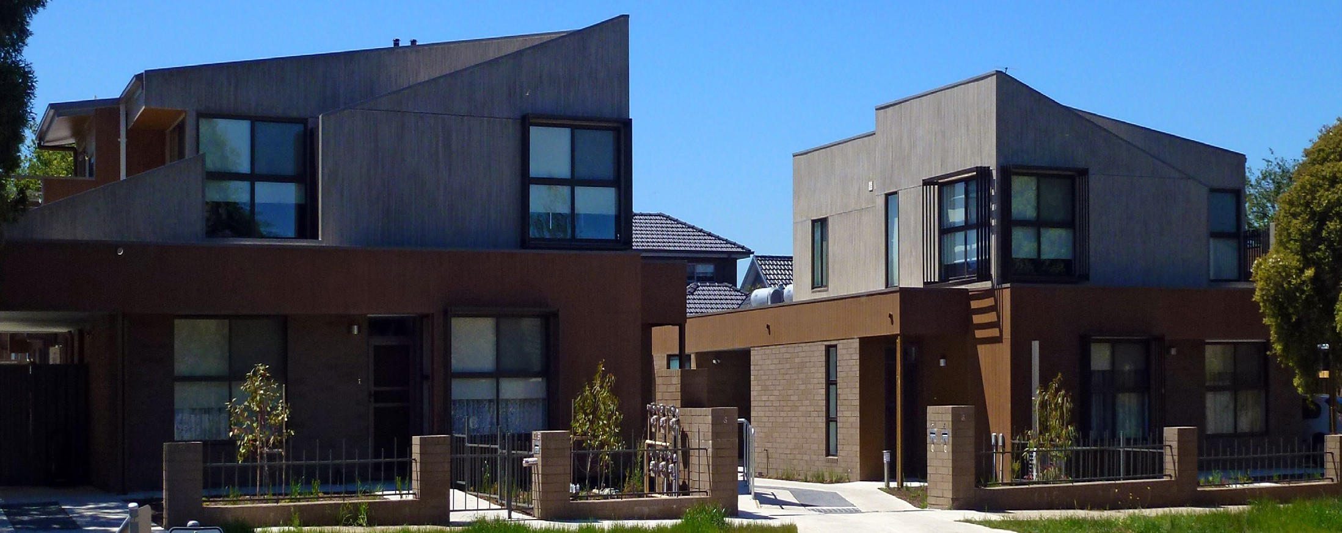

CITY OF GREATER GEELONG
WADAWURRUNG COUNTRY
PO Box 104, Geelong VIC 3220

P: 03 5272 5272
E: contactus@geelongcity.vic.gov.au
www.geelongaustralia.com.au
LATEST NEWS:
CityofGreaterGeelong @GreaterGeelong

@CityofGreaterGeelong CityofGreaterGeelong

