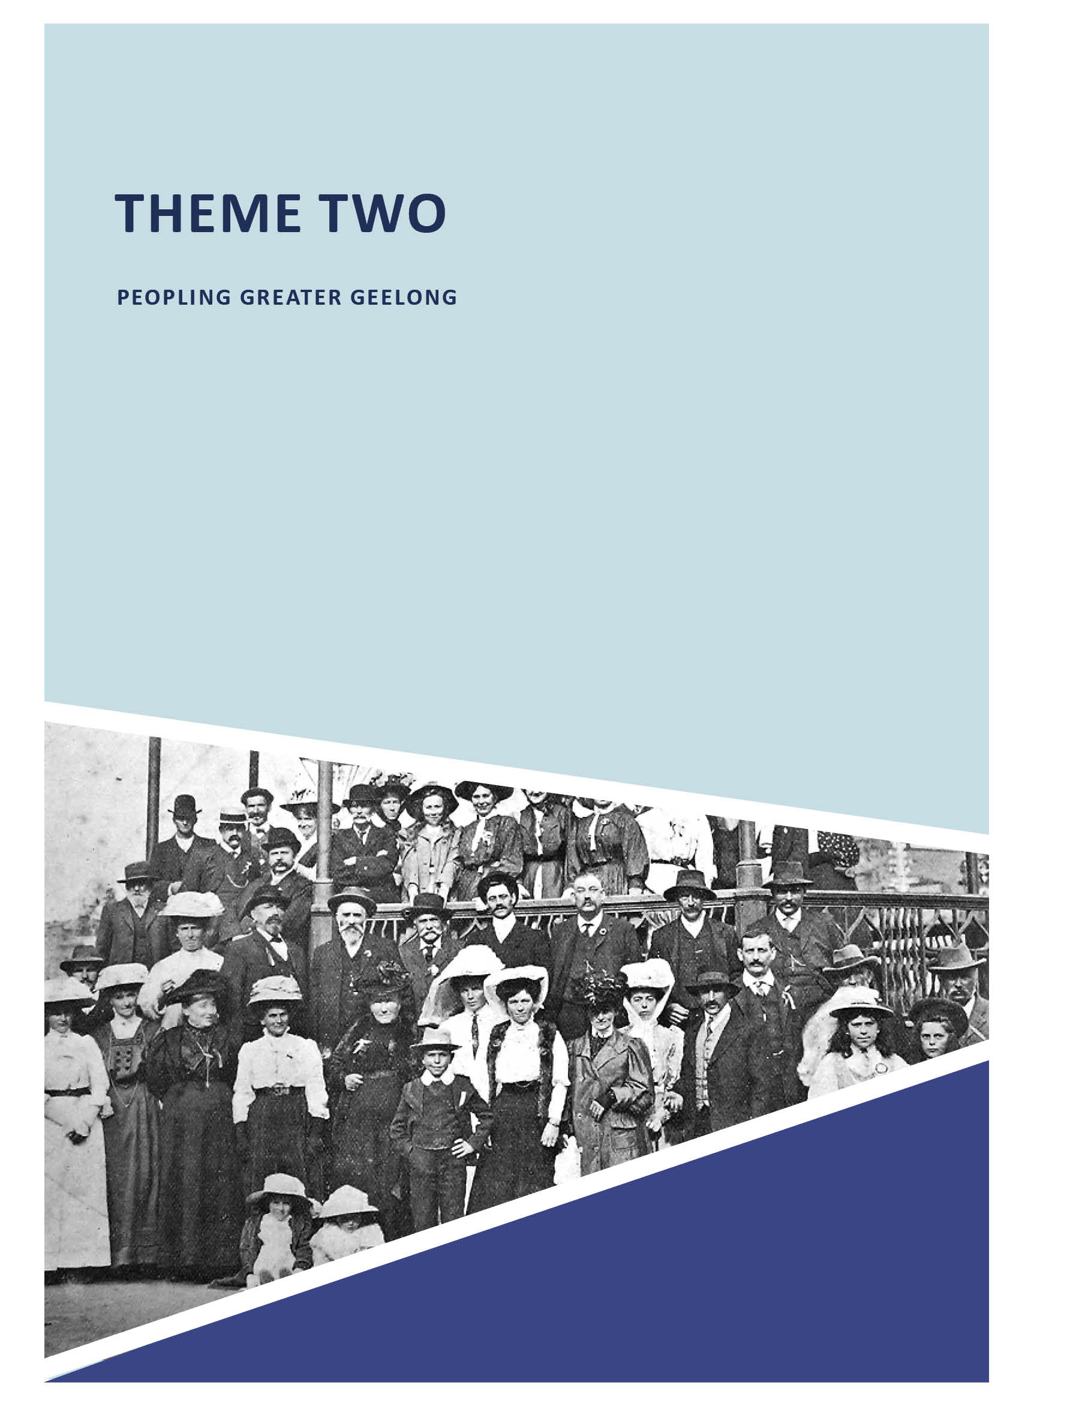
64 ABOUT CORAYO: A THEMATIC HISTORY OF GREATER GEELONG

THEME TWO

PEOPLING GREATER GEELONG

  - INTRODUCTION
The City of Greater Geelong is characterised by a diversity of peoples and cultures. This theme aims to celebrate and
explore the contributions made by all cultures both tangible and intangible.
The theme begins with a brief overview of the
Traditional Owners of the municipality the Wadawurrung: a Language Group that forms part of the Kulin Nations;
their Country; social interactions and their landscape and way of life prior to European colonisation in the 1830s.
The theme also gives an overview of European colonisation: explorations; the dramatic impact of Terra Nullius on the Wadawurrung and how Greater Geelong was transformed through the arrival of European pastoralists and British forms of law and order, and the dispossession of the Wadawurrung from Country, cultural and socio-economic traditions, their demise in the late 19th century and their amelioration in the early 21st century.
The theme provides an appreciation of the physical legacy of European pastoralism that has helped to shaped the identity (in part) of the City of Greater Geelong today. Details on farming and cropping, and the building of cities, towns and outlying centres are dealt with in Themes 4 and 6 respectively.
The importance of immigration (beyond the arrival of Europeans in the 1830s) is explored. In particular, the roles played by the arrival of Swiss and German vignerons, and other German immigrants of note are outlined, as is tangible evidence of significant German associations in Greater Geelong in the early 20th century and the implications caused by World War One.
The theme gives an account of contributions made by Asian and Indian immigrants to the Greater Geelong economy from the 19th century, and the very little surviving evidence of this contribution today. The almost ubiquitous Chinese market gardens of the 19th and early 20th centuries which provided fresh produce to Geelong residents no long exist, although some prefabricated timber Singapore dwellings are vestiges of imported labour to build them in the 1850s. More overt is the legacy of Italian immigrants in the late 19th and early 20th
centuries, and this theme explores the important and ongoing contributions made by early Italian fruiters to the commercial and social life of Greater Geelong, a contribution that continues to the present day.
An overview is given on Japanese migrants in Greater Geelong and the establishment of Japanese laundries that provided
a necessary service to meet commercial and community needs. While no physical fabric of the Japanese contribution to commercial and cultural life is known to survive today,
the social impacts while intangible today were a cause
of considerable hardship. This theme gives a basis for these hardships (being largely due to the establishment of the White Australia policy in 1901 by the fledgling Commonwealth Government, and subsequent legislation that became significant impositions on local people of Japanese descent, culminating from 1939 when Japan was at war with Australia until 1945), and the effects on the local Japanese and Australian-Japanese community.
By far the most significant widespread influence on cultural life in Greater Geelong after European colonisation was the arrival of migrants from Britain, Europe and almost every other part of the world after World War Two. This theme gives an overview of the different ethnic communities that made (and continue
to make) a highly important contribution to Greater Geelong s expanding workforce and economy, and cultural development.
The theme concludes by examining the further peopling of the outlying areas of Greater Geelong through the Closer Settlement and Soldier Settlement schemes of the early 20th century. The peopling of Greater Geelong into the 21st
century and the settlement framework proposed for a planned population expansion to 2036 is given through a reference to the City of Greater Geelong s draft Settlement Strategy 2018.

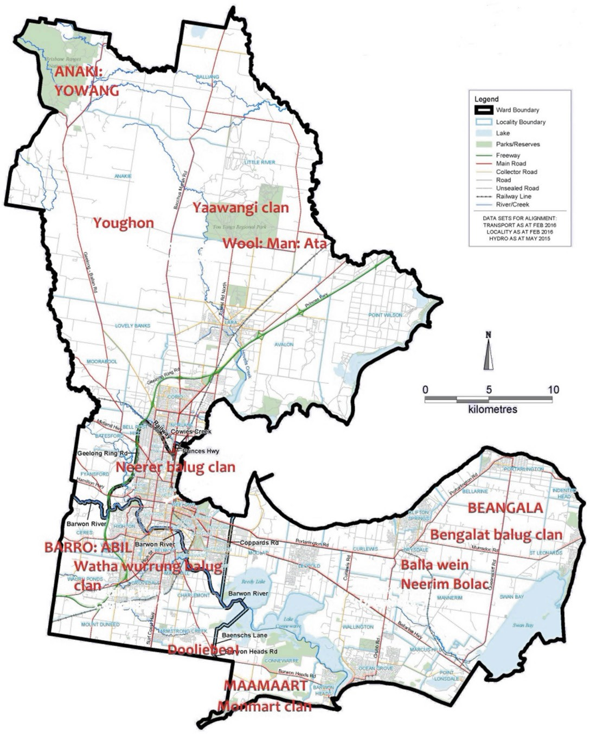

Figure 2.01: Map of the City of Greater Geelong showing Wadawurrung clan names, clan estate names & names of some locations. Source: I.D. Clark, Scars in the Landscape, op.cit., pp.169-170 & L. Lane, Various names of the Barrarbool tribal People as recorded in the Ethnography of the Region , manuscript no. 39, 1991, Special Collections, Deakin University Library. Base map by the Victorian Electoral Commission, Vicmap spatial data provided by DEWLP, 2017.

LIVING ON WADAWURRUNG COUNTRY

INTRODUCTION
Prior to European colonisation and for at least 45,000 years, the Country now known as the City of Greater Geelong was the land of the Wadawurrung Aboriginal people. The name of this language group traditionally meant the people who belong to the water , in reference to the rivers, creeks, lagoons and other water sources within the Wadawurrung boundary.1

WADAWURRUNG & THE KULIN NATION
The City of Greater Geelong is within a portion of Wadawurrung Country that is part of the Kulin Nation.2 The Kulin people comprise five communities: Boonwurrung, Djadjawurrung, Taungurong, Wadawurrung and Wolworung, and take in approximately two million hectares of the area in central
and southern Victoria.3 They speak a related language and share the same belief system in that they were created by the all- powerful Bundjil spirit (who also created the mountains and streams), which took the form of an eagle4 (see Theme 8 for further details). Another ancestral being significant in the belief system of the Kulin was Waa (the Crow) (see Theme
8). This second deity turned into man and created fire.5 Bundjil and Waa form the principal Moieties (or Balluk) of the Wadawurrung peoples.6

WADAWURRUNG COUNTRY, CLANS & INTERACTIONS
Wadawurrung country originally extended over approximately 7800 square kilometres, taking in the Bellarine Peninsula
and west towards the Otway forests and north boundaries to Mount Emu and Mount Misery, extending to Lake Burrumbeet, Beaufort and the Ballarat goldfields, and north of the Werribee River.7
Those clans to have inhabited Greater Geelong included Bengalat balug (Indented Head, including most of the Bellarine Peninsula known as Beangala ); Watha wurrung balug (Barrabool Hills, known as Barro: Abil , meaning place of rounded hills ); Neerer balug clan (between Geelong and the You Yangs, the territory known as Youghon ); and the Yaawangi (You Yangs area).8 Another clan and its location, ‘Monmart’ has been the subject of debate. Their estate, Maamart , was near Lake Murtnaghurt and extended along the coast to Point Impossible (at the mouth of Thompsons Creek)9 (Figure 2.01). Similarly, the Neerer balug clan, whose territory was called Youghon , was between Geelong and the You
Yangs, has been identified by Ian Clark in Scars in the Landscape but not the local work of the late Lou Lane.10

The Wadawurrung comprised a cluster of 25 clans across its territory.11 Each of the clans spoke the same language or a dialect thereof’, ‘owned a specific portion of the total tribal land and defended it against all intruders , shared the same religious creed and functioned under the same customs 12
Clan and sometimes inter-language group congregations formed an important part of socio/religio/commercial life (see Themes 7 and 8 for further details).13 Figure 2.01 gives a graphic overview of the different clan localities, with further details provided in Theme 6. Clan and inter-language group congresses gave opportunity to trade materials and products not available in each clan sub-territory (see Theme 5).

WADAWURRUNG LANDSCAPE & WAY OF LIFE
Seasonal changes dictated the locations of residence of each Wadawurrung clan at different times of the year,14 both
within their sub-territory or in another clan sub-territory where food was plentiful and following invitation from the host clan (see Themes 3 & 5). The way of life of the Wadawurrung
is rooted in their beliefs, uppermost being a deep respect for the environment (see Theme 8).15 A broad appreciation of Wadawurrung life as it related to land, agriculture, food and culture was given by Bill Gammage in Gardens without fences? Landscape in Aboriginal Australia :
The Aborigines made and managed Australia by shaping and distributing its vegetation. Plants and therefore animals were where Aborigines put them or let them be. Some areas were managed more intensively than others, but there was no wilderness. Aboriginal Law required every inch of ground to be cared for. It taught that the world began in the mind of God, who made the land, gave it light, and made creator ancestors. Each creator ancestor began a species,
travelled the land making landmarks and legends associated with its species, then rested in the features as proof of a creator s action and presence. They were under the most sacred obligation to preserve that. They could not make the land ‘better’ or ‘worse’, for that was not theirs to judge. They must leave the creators gifts as they found them.
But it did not follow, as many non-Aborigines assume, that they must leave the land untouched. That would let an ordered landscape decay let the garden go wild threatening species habitat and survival, for example of
species which need open country in areas prone to become bush. Instead, Aborigines inherited a regime of attentive and integrated management. Land care

was a fundamental duty of life, linking the beginning of creation to the infinite future. It followed that all land must be maintained. Even the harshest country was cared for not simply for its productivity, but because it was alive with ancestors and descendants. Senses of purpose and place reinforced each other.

Over long periods, usually centuries, people laid down a template of plant communities rainforest, open forest, scrub, heath, grass and so on. They could
leave as it was what climax (natural) vegetation they needed, but they made the other communities, and distributed them not randomly, but linked to each other, or associated. A common association was a grass plain
near water and ringed by open forest; another was swamp, grass, and scrub or heath. Associations provided habitats or edges between habitats for each plant and animal species, and balanced their myriad conflicting needs.
Aboriginal landscapes were consciously made to let all creation survive.
People used the templates to make resources abundant, convenient and predictable. For example, they fired plains before rain to bring on green pick. Grazing marsupials travel to fresh grass; red kangaroos especially chase rain for many miles to find it. Having spaced a template of plains, people fired them in turn to move the marsupials in a predictable sequence. The forest rings both sheltered the animals and made them easier to hunt. Then they grew spear-shy on one plain, another was nearby, fresh with green pick Good feed made kangaroos abundant, and feeding them in sequence made them convenient and predictable. Other plants and animals required different fire regimes or no fire at all. Burning therefore followed numberless intricate local patterns. We call this mosaic
or patch burning, but these words miss the variety and the purposeful association of plant communities which made Aboriginal practice so remarkable.16
In the Wadawurrung Country of the City of Greater Geelong, major food sources during the seasons included the Barwon River and its catchments, Thompsons (Bream) Creek, Armstrong Creek, Lake Connewarre, Reedy Lakes, Swan Bay, the coastlines and the inland areas from Waurn Ponds, along the Sutherlands Creek to Wurdi Youang and Anakie Youang.17 These areas supplied the different clans with their three main categories of foodstuffs, depending on the time of year. Some Aboriginal place names today gave hints of food sources. This includes Lake Connewarre

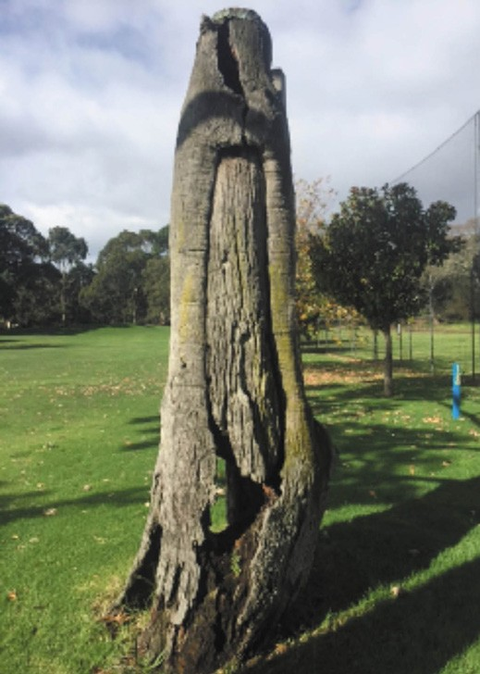
Figure 2.02: Canoe Tree, Queens Park, Highton, 2017. Source: Kevin Krastins, City of Greater Geelong.
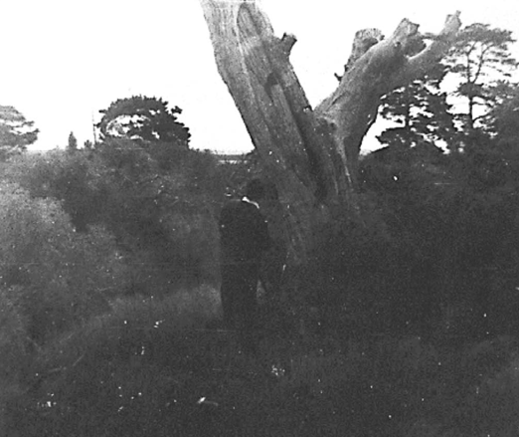
Figure 2.03: Canoe Tree, ‘Springfield’, Leopold, 1986.
Source: Bellarine Shire collection, image S23n29, Bellarine Historical Society.

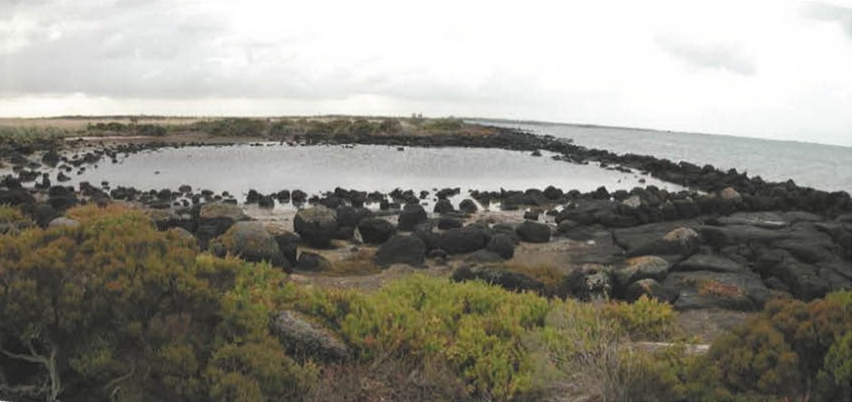
Figure 2.04: Fish Trap, Corio Bay foreshore, (specific location deliberately not provided), 2004. Source: B. Duncan, ‘Maritime Infrastructure Heritage Project’, prepared for Heritage Victoria, 2005 (updated 2006).

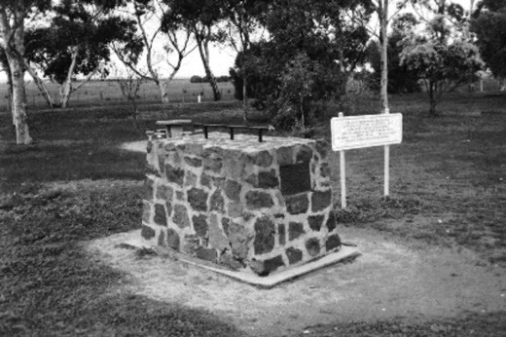

Figure 2.05: Flinders Memorial Cairn, Princes Freeway, Avalon, 1998. Source: David Rowe.

which translates to Koo: N: Warre, meaning mud oysters (although it is more widely known to the Wadawurrung as the place of the black swan).18
The perennial staple of the Wadawurrung was shellfish (both fresh and saltwater types). Seasonal staples including murnong (yam daisy roots) (which grew in good but heavy soil ),19 eels, lerp sugar, berries, seeds, grains, buds, bird s
eggs and shoots. Seeds included those harvested from wattle and swamp gum.20 Spider orchids (Caladenias) and doubt-tail orchids (Diuris) were common local tubers, while geranium dissectum had large roots which were roasted in ashes.21
Supplementary foods included snakes, lizards, tortoises, kangaroo and smaller marsupials, grubs, chrysalids and root- foods including orchids, rushes and ferns.22 Fungi was another important food source, including Mylita Australis, which grew below the ground and resembled boiled sago in appearance. 23
As part of Wadawurrung way of life, there was a distinction between the roles of men and women. As outlined by Lou Lane in The Wathaurung: Geelong s earliest inhabitants :
The Men hunted fast game with spears and missile-sticks. They protected their families from human enemies. They performed sacred rituals.
The Females forage (serving up the bulk of the food).
They bore and brought up their Children, teaching them all the arts of foraging. They carried all the Family possessions whenever the Clan moved from one living-site to another Father carried only a spear and a boomerang, so he could carry out his duties as a protector and provider as the Clan moved along.24
An earlier account by Protector William Thomas in the 1840s also gave an appreciation of the traditional roles of the Wadawurrung people:
In the Kulin tribes, they seldom travel more than six miles a day. In their migratory movements all are employed. Children are getting gum, knocking down birds; women are digging up roots, killing bandicoots, getting grubs; the men hunting and scaling trees for opossums. They are mostly

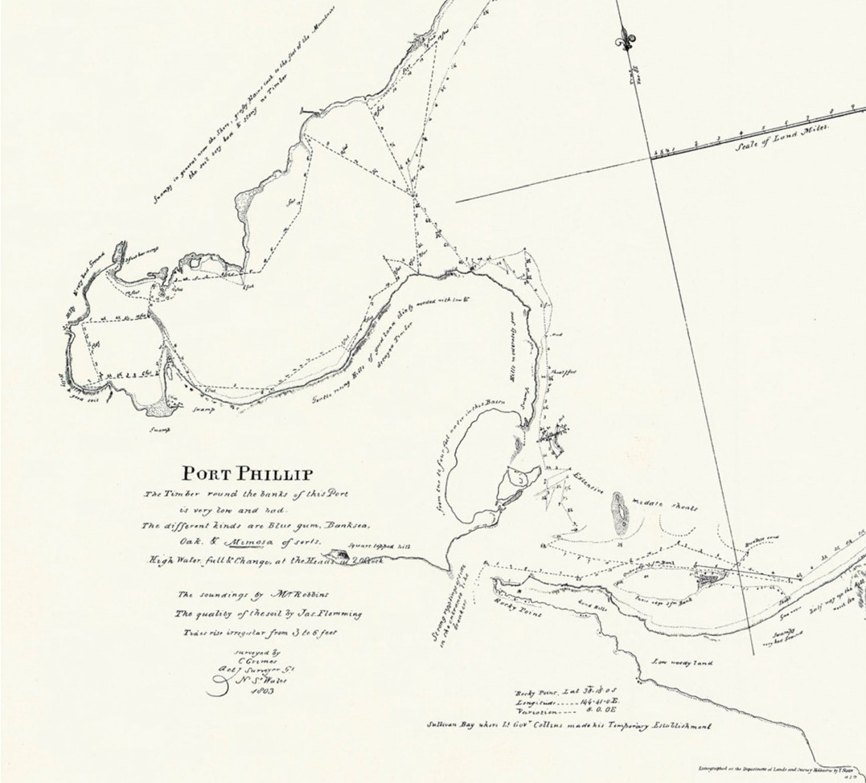
Figure 2.06: C. Grimes, Map of Port Phillip, 1803, showing the Greater Geelong portion. Lithographed at the Department of Lands and Survey by
T. Slater, 1879: Melbourne. Source: State Library of Victoria.

at the encampment an hour before sundown; the women first, who get fire and water; by this time their spouses arrive. They hold that the bush and all it contains are men s general property; that private property is only what utensils are carried in the bag; and this general claim to nature s bounty extends even to the success of the day; hence at the close, those who have been successful divide with those who have not been, so that none lacketh while others have it, nor is the gift considered as a favour, but as a right, brought to the needy and thrown down at his feet. 25
The Wadawurrung also manufactured hunting implements and utensils for obtaining food, personal ornaments and clothing, and weaponry. Fish and bird nets were made from paperbark or stringybark.26 Cloaks were made from possum, native cat, dingo and kangaroos skins involving considerable labour. Skins were dressed with a mixture of ochre and fat to render the cape waterproof. 27 Timber was also used to create elaborately- carved weaponry including shields, clubs and spears, as well as canoes, rafts and timber vessels.28

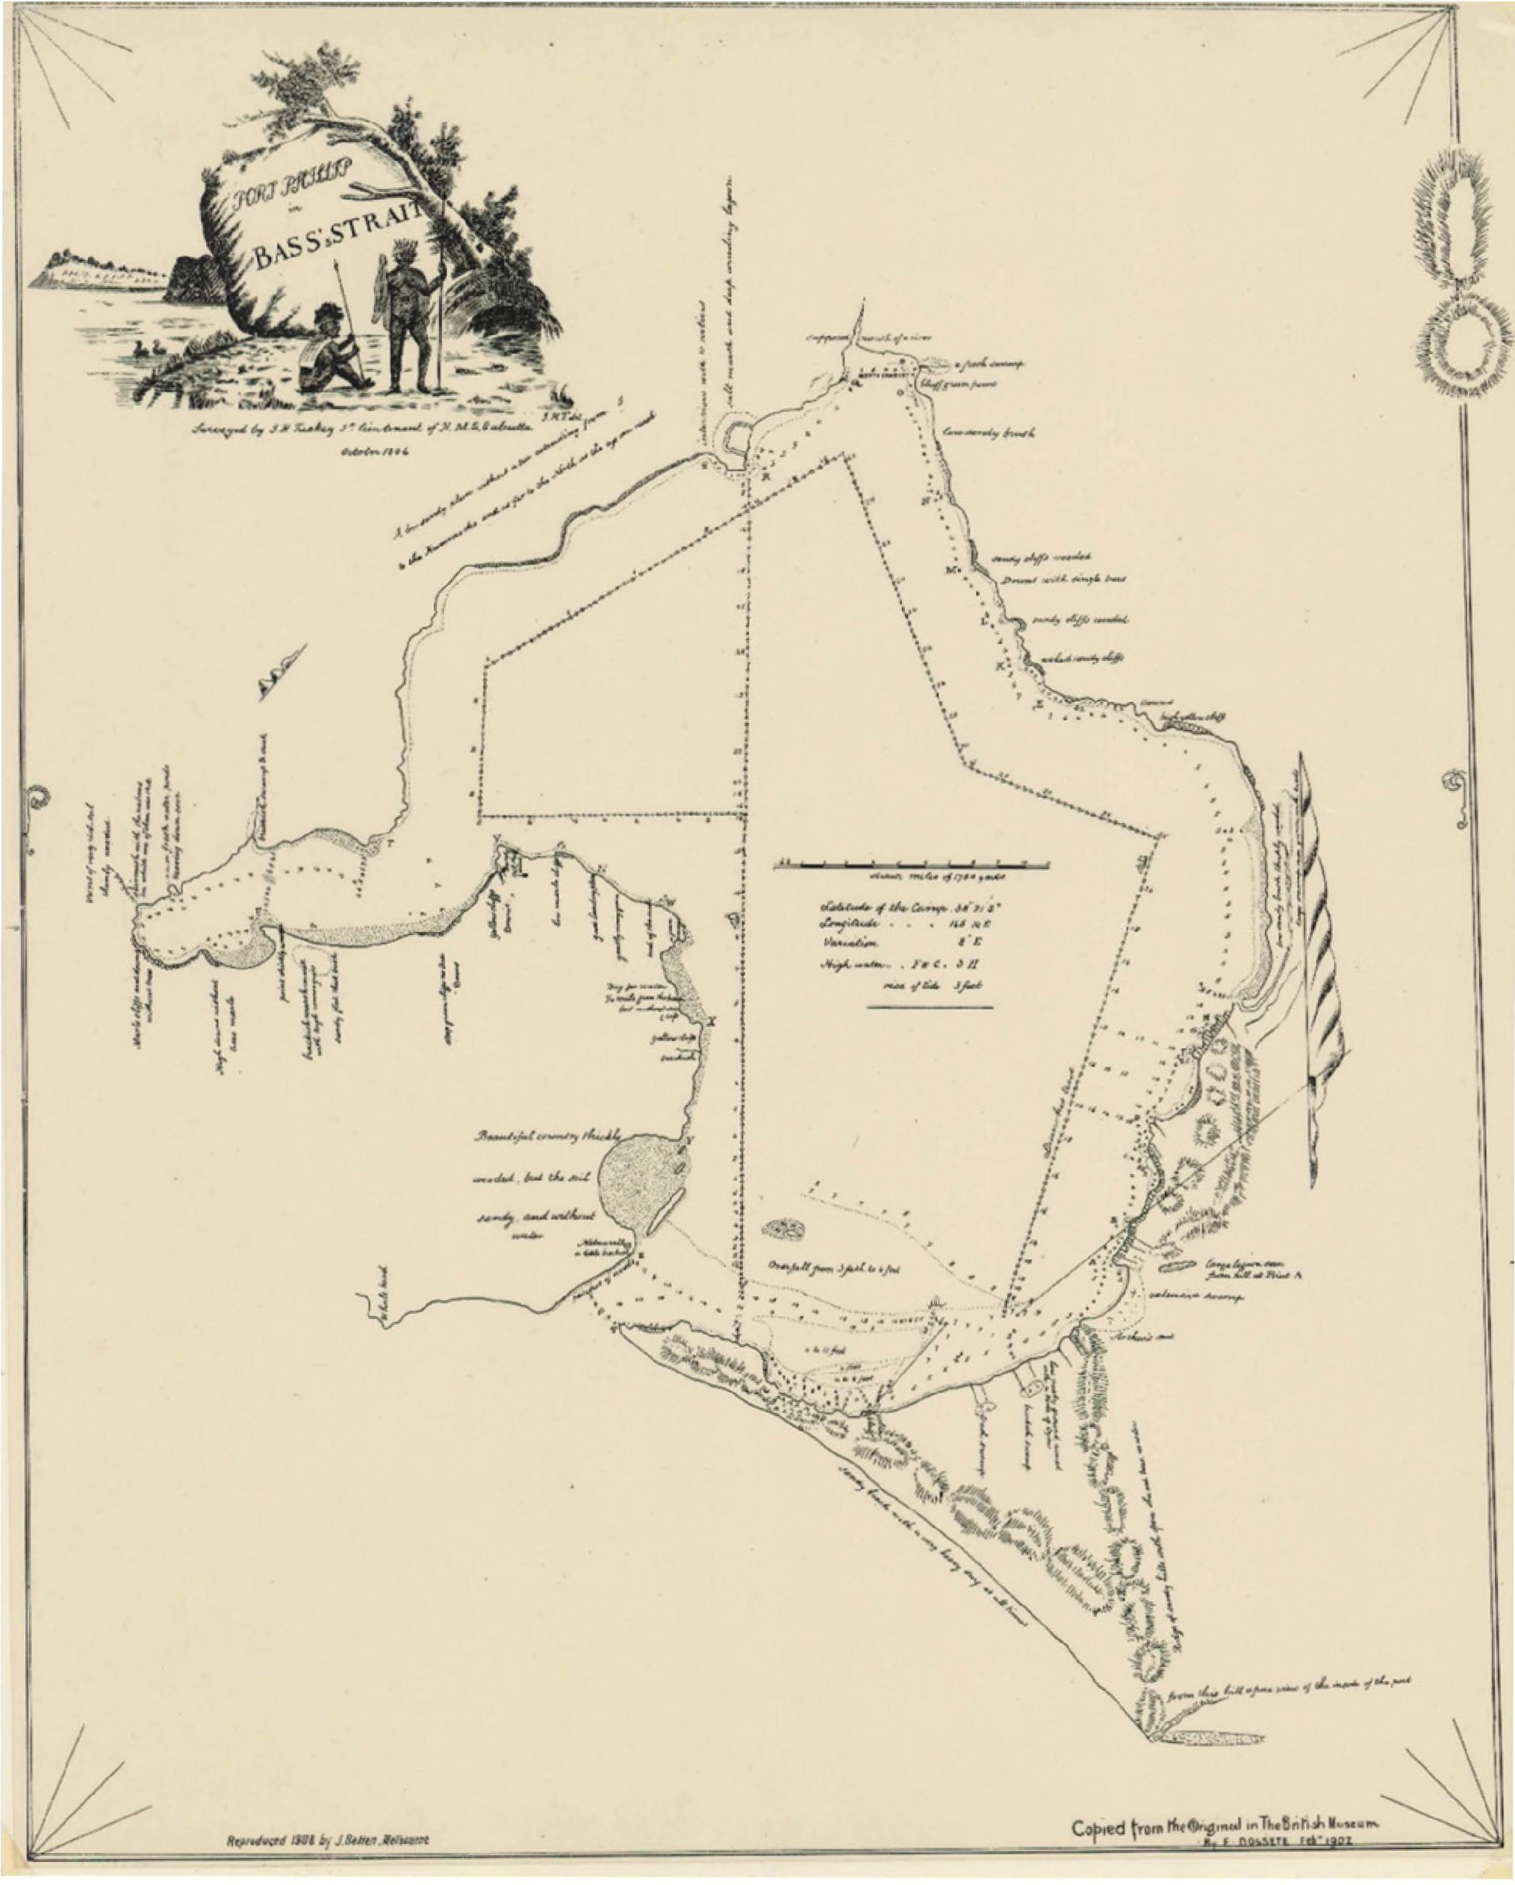

Figure 2.07: E. Dossete, Map of Port Phillip in Bass s Strait, February 1902 copy of original by J.H. Tuckey, October 1804. Note images of Wadawurrung in top left corner. Source: State Library of Victoria.

In 1988, remedial work was carried out on one of the few known surviving canoe trees in Greater Geelong at Queen s Park (Figure 2.02), one of the few physical legacies of Wadawurrung way of life.29 A River Red Gum, it showed where a two metre plaque of bark had been stripped from the trunk
to create simple water craft used to travel along and cross the Barwon River.30 Another canoe tree was still in existence at ‘Springfield’, Leopold in 1986 (Figure 2.03).
Other surviving legacies are stone fish traps along the bayside foreshore of Greater Geelong (Figure 2.04), and are a tangible reminder of a highly sophisticated method of fishing.31 The stone arrangement at Wurdi Youang forms
another highly significant and intact reminder of Wadawurrung ceremonial life (see Theme 8). Other examples are surviving artefacts, most of which are re-buried in their original localities following recording (for cultural reasons) although some museums hold examples of decorative timber weaponry
and implements, stone axe heads, grinding stones and other objects. Documented evidence of these artefacts gives an appreciation of the productive lifestyles of the Wadawurrung, and their commercial activities.
This includes a shield made by the Wadawurrung in c.1836 now held in the National Museums of Northern Ireland.
This and other weaponry are among the earliest Aboriginal material collection in the Port Phillip district and a reminder of the reality of frontier conflict in early Victoria’ (see later subsection).32 They had been taken to Ireland by John and Robert von Stieglitz, early Irish squatters to the Geelong and Ballan areas following their permanent return home
in the 1850s.33

EUROPEAN EXPLORATION & SURVEYS

EXPLORATION
While there have been claims and considerable debate that the Portegese discovered Australia in the 16th century
(see Theme 4), the earliest European exploration of the Greater Geelong area was by Lieutenant John Murray, who charted part of Indented Head in 1802.34 In this same year, Captain Matthew Flinders crossed Corio Bay and climbed the salient feature of the area, the You Yangs.35 From here he obtained a commanding view of the area and wrote that it was well suited to cattle though better calculated for sheep a forecast
that was later proved to be accurate. It was also at the You Yangs where Flinders met Wa Wa, the ngar: weit (clan head), presumably of the Yowangi clan of the Wadawurrung, and grandfather of Harry Gore and Willem Baa Nip (see following subsection).36 A memorial plaque at Flinders Peak, You Yangs (a plaque was unveiled in 1912 and replaced in 1974 now missing), stone cairn off the Princes Freeway, Avalon (unveiled in 1977) (Figure 2.05), and a plaque affixed to the random granite Pioneers Memorial at 1 Flinders Avenue (Six Ways), Lara (1974) commemorate Flinders visit.37
In the following year, 1803, Charles Grimes, acting surveyor- general, was sent by Governor King to explore the Port Phillip area more thoroughly. Most of this exploration was by sea with only occasional forays ashore, one of which was on the north- eastern shores of Corio Bay and led to Grimes recording on his map of the area that the soil was bad and stony.38 A legacy of Grimes expedition is his survey map of Port Phillip of 1803 (Figure 2.06).
It was the same area that was investigated in October of 1803 by Lieutenant Tuckey of the Calcutta, one of the
two vessels that had brought settlers and convicts to the abortive settlement at Sorrento.39 He made the first contact with the Wadawurrung, a contact which ended tragically
in confrontation and the death of one Aborigine (see following subsection for further details). Tuckey was more complimentary than Grimes about the potential of the area, saying that it was the only spot in Port Phillip he had seen which would answer for raising wheat or any other grain that
requires moisture. 40 The result of his survey was a Map of Port Phillip in October 1804 (Figure 2.07).

The next explorers came overland - from Lake George in New South Wales. In December 1824 Hamilton Hume and William Hovell reached the northern shores of Corio Bay either at Point Wilson or Bird Rock.41 They explored in the present day Lara region and learned from the Wadawurrung that the bay was called “Jillong” [Djilong].42 No settlement followed, however, as due to a miscalculation, the explorers thought they had

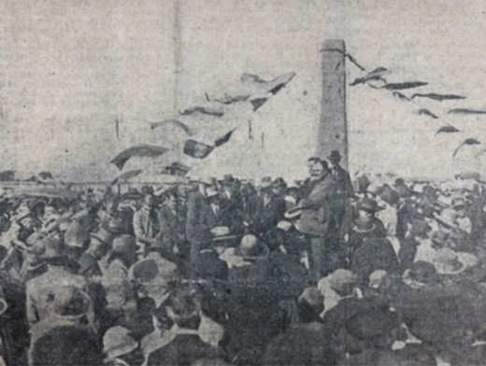
Figure 2.08: Unveiling of the Hume and Hovell monument, Lara, 1924. Source: Geelong Advertiser, 18 December 1924, p.1, GRS 2050/149, Geelong Heritage Centre collection.

reached Western Port and it was there that a settlement was made, existing briefly from 1826 to 1828.43 Today, the visit by Hume and Hovell is marked by the Hume and Hovell monument on the west side of the Princes Freeway at Lara. It was erected by the Hume and Hovell Centenary Celebrations Commmitte which was responsible for 37 monuments being built along
the route of 1824 following a map by Herbert Hansford.44
The rough-hewn granite obelisk designed by the sculptor, Paul Montford, was situated atop the Melbourne Hill (Figure 2.08) (and was relocated into its lower, present position following the widening of the freeway in 1955) and represents the southmost Hume and Hovell memorial of the long line of monuments erected between Lara and Campbelltown, New South Wales.45
A decade passed before the next explorers arrived, this time from the south, Van Diemen s Land. In 1835 John Batman, on behalf of the Port Phillip Association (see following subsection), using Indented Head as a base, carried out

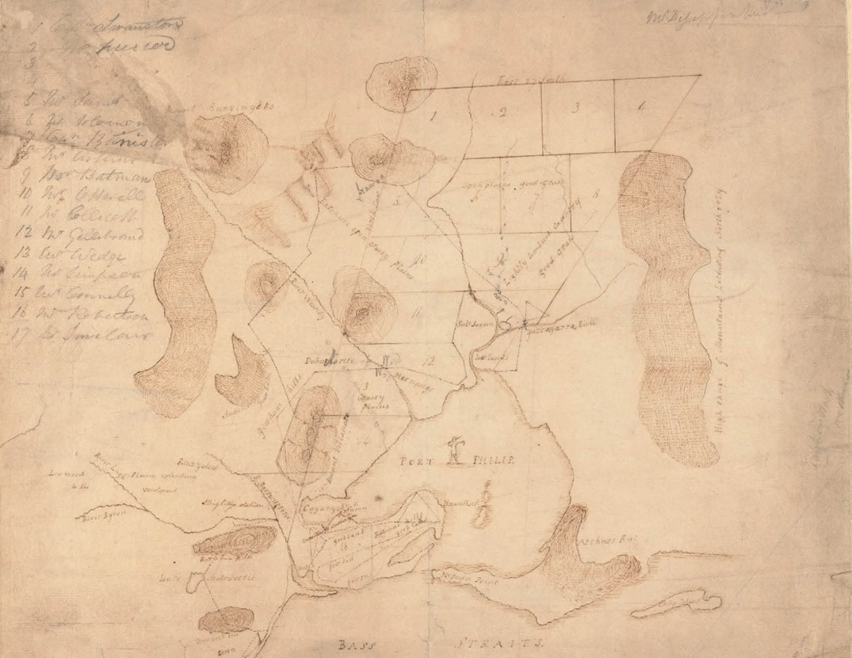
Figure 2.09: J.H. Wedge, Plan of Port Phillip, 1835. Source: accession MS13487 State Library of Victoria.

more extensive exploration of the Port Phillip area than had previously been achieved.46 He examined the You Yangs and Lovely Banks areas, giving his own names to the salient features and made friendly contact with the Aborigines.
Batman travelled further afield to what is now the Melbourne area where he concluded a treaty with the Aborigines to purchase 500,000 acres around Melbourne and 100,000 acres near Geelong.47 Although Batman might have been the first European to consider that the Traditional Owners had a title to their land in Victoria, his method of achieving ownership was flawed. It named eight clan heads of the Bun wurrung and Woi wurrung language groups, all of which did not belong to Wadawurrung country.48 Alistair Campell in John Batman and the Aborigines gave a particularly negative conclusion to Batman s treaty:
There can be no doubt that the deeds were fraudulent and that Batman was untrustworthy. His documentation was highly irregular and his intentions almost certainly devious.
These are aspects of Batman s story not previously told by historians, and certainly not part of the popular view of Batman as heroic adventurer, founder of Melbourne.49
Batman s exploration was followed in August of 1835 by that of another member of the Port Phillip Association, John Helder Wedge. A surveyor, his field book and later map (Figure 2.09) guided the pastoralists that were soon to flock to the shores of Port Phillip (see following subsection).50

INITIAL EUROPEAN
COLONISATION FOLLOWING ‘ TERRA NULLIUS’
Batman s exploration of Victoria and his so-called treaty with Aborigines in 1835 attempted to legitimise claims to the land for the Port Phillip Association. Initially known as the Geelong and Dutigalla Association, the Port Phillip Association was made up of a group of professional European men, government officials and shopkeepers who looked to Port Phillip to establish runs for their sheep given the scarcity of land in Van Diemen s Land (Tasmania).51 The leading members of the Association were John Batman, farmer; Joseph Gellibrand, lawyer and former Attorney-General; Charles Swanston, banker and member
of the Legislative Council; John Helder Wedge, surveyor and farmer; Henry Arthur, nephew of Lieutenant Governor George Arthur of Van Diemen s Land. Other members of the
Association included William Sams, Under Sheriff and Public Notary for Launceston; Anthony Cottrell, Superintendent
of Roads and Bridges; John Collicott, Postmaster General; James Simpson, Commissioner of the Land Board and Police Magistrate; John Sinclair, Superintendent of Convicts; Michael Connolly, Thomas Bannister and John and
William Robertson (who funded much of the cost of Batman s first expedition).52
The concept of Batman s treaty recognised Aboriginal rights to the land but its purpose was to gain vast land areas and avoid resentment from the Wurundjeri elders (at the expense of their culture and those of other Aboriginal language groups such as the Wadawurrung, and their connections to Country).53 The treaty also attempted to legalise occupation of Port Phillip in the eyes of Imperial and Colonial British authorities.54
British possession of Australia had emanated from the arrival of Captain James Cook to Port Jackson, Sydney, N.S.W. in 1770 when he raised the British flag and claimed the east coast of Australia as Terra Australis, in the name of the King of England.55 Cook claimed sovereignty and possession of the land, the basis being terra nullius, with the land not considered as belonging to anybody despite the obvious presence of people along the shores and rivers. 56 British colonisation
occurred in 1788 with the arrival of Captain Arthur Phillip at Port Jackson, Sydney, N.S.W.57 The area was seen as new land , and country beyond the limits of European occupation was labelled waste lands : useless and without form. 58
This began the occupation of European culture in Australia (and therefore the Greater Geelong area) without consideration of the Traditional Ownership of and kinship with the land by
the Indigenous peoples, their culture and human rights.59 Legally, Australian Aborigines and Torres Strait Islanders were given no status and Terra Nullius was used as a basis for the dispossession of the original inhabitants of the country.60

Like Batman in 1835, the concept of ownership of the land by the Traditional Owners was not completely ignored by all Europeans, but their views fell on deaf ears. For example, the French Surveyor, Nicolas Thomas Baudin (1774-1803)
offered Governor King of Sydney in 1802 an alternative, more humanitarian view of the occupation of the new land :
To my way of thinking, I have never been able to conceive that there was justice and equity on the part of Europeans in seizing, in the name of the Governments, a land seen for the first time, when it is inhabited by men who not always have deserved the title of savages or cannibals which have been given them, whilst they were but children of nature and just as little as civilised as are actually your Scotch Highlanders or our peasants in Brittany, who, if they do not eat their fellow men are nevertheless just as objectionable. From this it appears to me that it would
be infinitely more glorious for your nation, as for mine, to mould for society the inhabitants of the respective countries over whom they have rights, instead of wishing to occupy themselves in improving those who are so far removed by immediately seizing the soil which they own and has given them birth.61
European exploration of the wastelands beyond the limits of Sydney (and within what was to become Victoria) dramatically changed the perceptions of the land. Yet, these perceptions were not re-evaluated in recognition of the importance of country to the Traditional Owners, but as the great potential the land offered for European settlement - particularly for pastoral and grazing ventures.62 This was the commercial imperative of the Port Phillip Association and other Europeans pastoralists. From 1835, the Port Phillip Association s land purchase was subdivided into 17 allotments. In recognition for his exploratory work, Batman was afforded two lots, while another two portions were reserved for future allocation should this become necessary to help the Association s case for recognition of its claims, the balance being given to the other members.63 Those to have taken up land in parts of the area now in the City of Greater Geelong were John Helder Wedge (Little River area between the You Yangs and Werribee River), James Simpson (Lara, Avalon and Little River area between the You Yangs
and Corio Bay), Michael Connelly (the area south of the You Yangs including parts of Lara, Avalon, Batesford and Geelong), John and William Robertson (the western half of the Bellarine Peninsula) and John Sinclair (the eastern half of the Bellarine Peninsula).64 John von Stieglitz, while not a member of the Port Phillip Association was also one of the earliest Europeans to take up land at Geelong at Station Peak (Lara) from 1835.65

INITIAL ARRIVAL OF EUROPEAN PASTORALISTS
The land take-up by the Port Phillip Association was impetus for other Europeans to follow suit. It began in June 1836 when the Brig, Henry, arrived from Launceston, Tasmania, at what was to be named Point Henry (in recognition of the
first vessel to this location), Geelong, with a ‘pleasure party’.66 Under the leadership of Captain Whiting, the passengers included Kenneth Clark, Captain Tregurtha, Dr. Cotter, Messrs.
J.M. Matson, George Killam, Edward Hines and James Hewitt.67 A short expedition ensued by those who landed at Point Henry, as recalled by James Moon Matson:
Captain Whiting of the Henry , left Hobson s Bay for Geelong, being the first vessel which made the passage there, landed at the point which we named Point Henry. Started afterwards for Corio Bay and, after procuring a bullock team, took the ship s boat across to the Barwon, and with the boat s crew, Captain Whiting and myself and Buckley. Buckley J.M. started to find, if possible, the entrance to the river and to discover whether it was navigable or not. After getting into shallower water and night approaching, camped on the bank for the night.
Started again at daylight the next day, but unable to find a passage. Returned and transported the boat back to Corio Bay.68
It was from this time when Point Henry became the gateway to the Western District of Victoria. Thomas Manifold disembarked with 22,500 sheep in July 1836 and initially settled on the Moorabool River, west of Geelong, prior to taking up the Purrumbete Run with his brothers, John and Peter.69 An
early neighbour of the Manifolds on the Moorabool River was George Russell, manager of the Clyde Company, a Scottish pastoral and agricultural company established in 1836 and which was to become highly successful and prosperous in the Western District.70
British Imperial legitimacy for the European acquisition of land had come with the proclamation of the Crown Lands
Occupation Act in 1836.71 Within the area of the City of Greater Geelong there was a notable influx of Europeans that took up land, some acquiring the previous purchases of Port Phillip Association members. The pastoralisation of Greater Geelong during the 1830s and early 1840s is especially apparent when comparing Wedge s Map of Port Phillip in 1835 with A.J.
Skene s Map of the District of Geelong in 1845 (Figure 7.01).
The northern portion of the Greater Geelong area in the vicinity of Balliang was first taken up by George Synnot as the ‘Mowyang’ Run in 1840. At Anakie, European occupation of the land began in 1841 when Thomas Woolley established his pastoral run Anakie Yeoyang .72 Woolley s occupation was short-lived as the Run was taken up by Frederick Griffin in September 1842 and
it remained under his occupation until the area was subdivided into smaller farms at a Government land sale in 1855.73

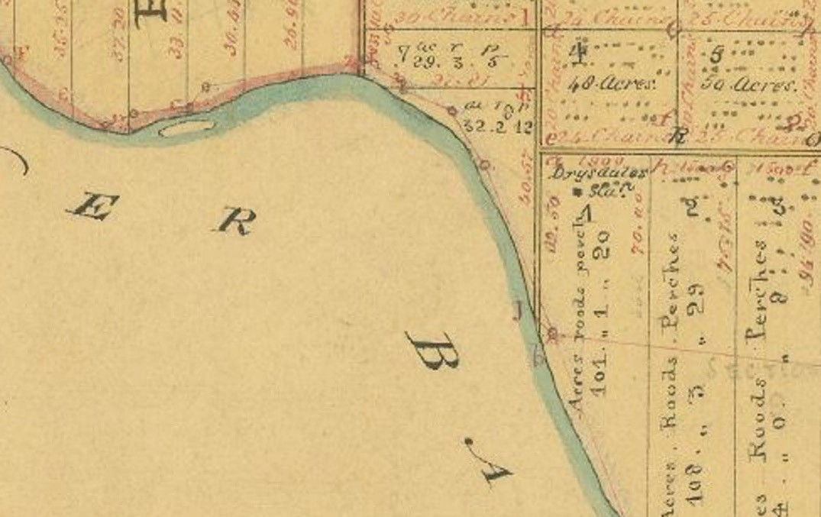
Figure 2.10: H.W.H. Smythe, Portion of the Survey of part of the Parish of Moolap, 1841, showing Drysdale s Borongook Station near the Barwon River. Source: VPRS 8168/P5, item Sydney M16, Public Record Office Victoria

At what was to become Staughton Vale, Simon Staughton took up the Brisbane Ranges Run in 1842, being north of the Anakie Youang.74 In 1842-43, Joseph and Robert Sutherland were the first European squatters to occupy land at Sutherlands Creek, north of Batesford which fed off the Moorabool River.75
The southern portion of the Greater Geelong area was initially taken up by 1836 by Alexander Thomson (near what was to be named Thomsons Creek), Elias Harding south of Lake
Connewarre, with E.H. Bowden at Buckley s Well , Breamlea.76
On the Bellarine Peninsula by May 1836, much of the eastern portion was taken up by Captain Charles Swanston as a cattle station. This station was managed by Dr Alexander Thomson in addition to his sheep station to the south of the
Barwon River near Geelong.77 By November 1837, Swanston s large cattle station was under the control of the Derwent Company when there were 400 cattle in occupation.78 This Company was largely owned by Charles Swanston. Large flocks of sheep were grazed on the site of the Geelong City today.79 In 1842, the Derwent Company was dissolved and
the cattle station at Indented Head reverted to Swanston who continued occupation with his son in law, Edward Willis, until 1837.80 The original home station was situated on the Yarram

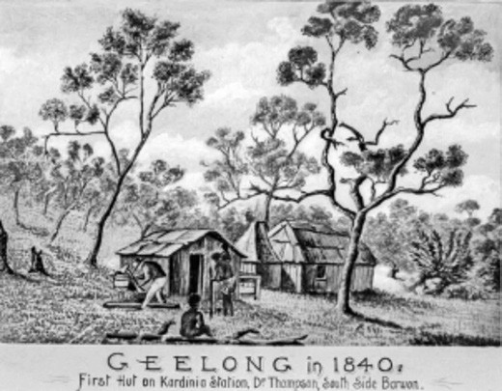
Figure 2.11: ‘Kardinia’, Alexander Thomson’s first hut, 1840. Source: Wynd collection, Authentic Heritage Services Pty Ltd.

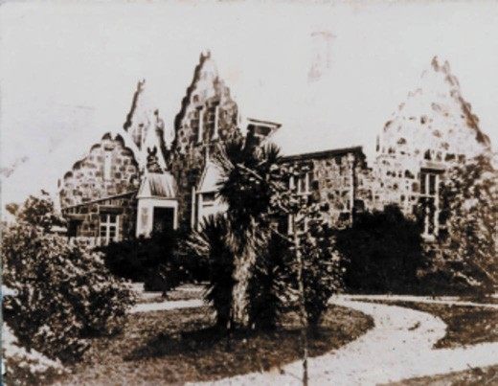
Figure 2.12: Coriyule , Curlewis, c.1870s. Source: Graham Paton.
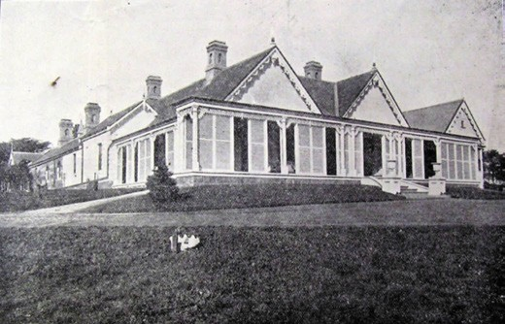
Figure 2.13: Spray Farm , Bellarine, Auction Notice, 27 November 1928. Source: GRS 2065/folio 4 map 150, Geelong Heritage Centre collection.

Creek, to the south-west of Swan Bay, as shown on a Plan of Indented Head in c.1837. From this time and until at least the 1860s, the majority of the Bellarine Peninsula was known as Indented Head.81
A second station had also been established in July 1837 on the north-western shores of Gellibrand Harbour on the Peninsula by a Mr Smythe, as it too was shown on the Plan of Indented Head. This station appears to have only been
temporary and may have been associated with W.H.Smythe, Assistant Surveyor.82
Others that appear to have also settled at Indented Head prior to 1840 included William Booth and Henry Baynton.83 By 1845, the Bellarine Peninsula was also the home of Brown, Sproat, Fenwicke, Langdon, and Misses Drysdale and Newcomb.84 Skene s Map of the District of Geelong (Figure 7.01) showed Misses Drysdale and Newcomb at their Boronggoop Run

on the Barwon River (taken up by Drysdale in 184085), in the western-most portion of the Bellarine Peninsula. H.W.W. Smythe s Survey Map of part of the Parish of Moolap in 1841 (Figure 2.10) showed Drysdale s Boronggoop Station on allotment 1 near the northern bank of the Barwon River.
Very few physical legacies survive in 2018 of the early European occupation of land for grazing in the 1830s and early 1840s. To the north, the two storey stone wing of Staughton Vale Homestead, 750 Staughton Vale Road, Staughton Vale (Figure 4.01) has associations with Simon Staughton as part of his Brisbane Ranges Station in 1842.86 Staughton (1796-1863) was born in Huntingdonshire, England, and with his family he arrived in Victoria in early 1841 when he took up Exford Station near Melton.87 In addition to this and his Brisbane Ranges Station, Staughton owned a station on the Darling and with many city properties, he became one of the largest land owners in Victoria.88
South of the Barwon River at Belmont, Dr Alexander Thomson (1860-1866) established his River Station in 1837 and built the original Kardinia House (for further biographical details, see Theme 7) (Figure 2.11). His original homestead was replaced by 1850 with ‘Kardinia House’, a five roomed timber dwelling with lodge and garden.89
On the Bellarine Peninsula, Coriyule at 1-69 McDermott Road, Curlewis (Figure 2.12), was built in 1849 for Misses Ann
Drysdale and Caroline Newcomb.91 The two storey picturesque Victorian Gothic Revival stone dwelling was designed by
the Melbourne architect, Charles Laing.92 Ann Drysdale (1792-1853) was born in Kirkcaldy, Fifeshire, the youngest of five children to William and Anne (nee Cunison) Drysdale.93 Following her childhood years in a semi-rural environment, she developed an interest in farming and uncommon for the period, in her adulthood she rented a large farm in Ayreshire, Scotland.94 With difficult times in Scotland in the 1830s and possibly with an ambition of owning her own farm,95 Drysdale emigrated to Port Phillip, arriving on 15 March 1840.96 After
a stay with Dr Alexander Thomson, Drysdale took up the Boronggoop Run between the Barwon River and Point Henry in 1841. Relocating to Coriyule in 1849, Drysdale died there on 11 May 1853. Miss Caroline Newcomb (1812-1874) was
20 years younger than Ann Drysdale. They struck a good friendship and successful pastoral business.97 Newcomb was possibly the first elected female representative to the earliest form of local Government in Victoria (as an elected member of the Portarlington Road Board in 1853) (see Theme 7 for further biographical details).
Spray Farm at 2261 Portarlington Road, Bellarine (Figure 2.13), is a legacy of the pastoral property established by Captain James Conway Langdon (1806-1887) in 1849, the first part of the surviving marine villa was built in 1851 to a design by the

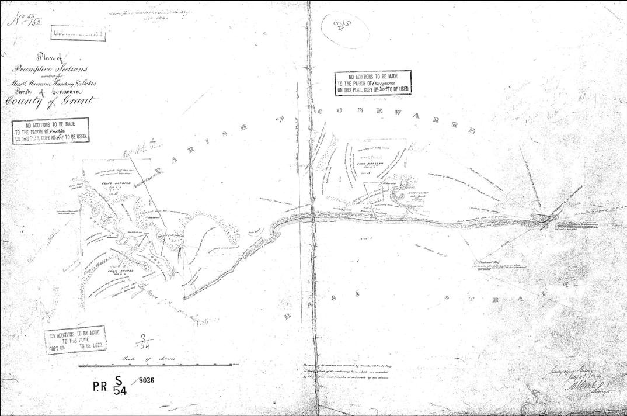
Figure 2.14: Plan of Pre-emptive Sections marked for Messrs. Macvean, Harding & Stokes, Parish of Conewarre, County of Grant, 1854. Macvean s pre-emptive right was near Murtnaghurt Swamp (right), with Stokes and Harding s station near Thomson s Creek (left). Source: VPRS 8168/P7, Unit 622, Public Record Office Victoria.

Geelong architect, John Young. Tenders were called for further works in 1857 and 1858.98 James Conway Langdon was the third son to the Rev. Gilbert Henry Langdon and Ann Langdon (nee Fizherbert).99 The Langdons were a well-educated family with close ties to Dorset. Family occupations were dominated by Church of England clergymen, career mariners and soldiers.100 Also a former Army Captain was J.C. Langdon s brother, Frederick William Langdon, who settled at Woodhalla, Indented Head by 1857.101 J.C. Langdon married Eleanor (Ellen) Cookson Nance in 1841 in Hampshire.102 She was the daughter of Andrew Nance (1778-1853) and Ann Nance (nee Norris) (1775-1850) who had firmly established themselves
in Portsmouth, England.103 In 1841, J.C. and Ellen Langdon emigrated to Port Phillip on the barque, Alexander, arriving on 24 December of that year.104 By 1845 they appear to have
settled at their Ellendale Run, Indented Head (now the location
of St. Leonards), where they lived until 1850. In addition to his farming interests, Langdon was part-owner in the nearby Bellarine Flour Mill from 1853.105 It was destroyed by fire in 1861.106 He also contributed much to the local community of Bellarine: in the establishment of the Portarlington District Road Board in 1853;107 construction of the Bellarine School
in 1855;108 and the establishment of the Indented Head Farmers Association.109

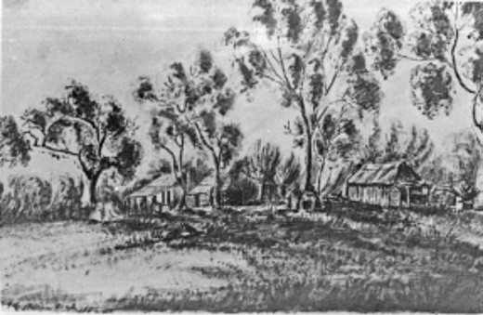
Figure 2.15: Station Peak Run, 1854. Source: E. von Steiglitz
(K. R. von Stieglitz ed.), Her Port Phillip & Victorian Album, K.R. von Stieglitz, Hobart, 1964.
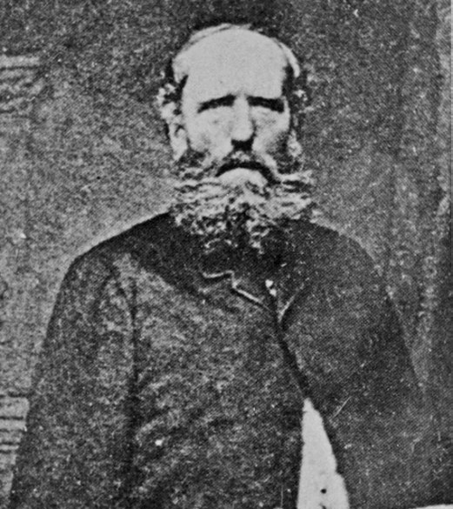
Figure 2.16: John von Stieglitz, n.d. Source: Wynd collection, Authentic Heritage Services Pty Ltd.

Assured tenure of suburban land came in February 1839 with the first Crown Land sales. Agricultural allotments, largely 25 acres in size, were made available for purchase in the Geelong West and Belmont areas (see Figure 6.49).
This was followed by the sale of Crown Land in outer parts of the Greater Geelong area in the ensuing years, leading to further European population (see Theme 6).
In the more rural parts, confidence in building homesteads emanated in 1847 when Orders-in-Council were passed by the Imperial Parliament. It gave a definite and assured tenure to leaseholders, with a pre-emptive right during the course of
their lease of their Runs preventing anyone (except them) from purchasing the land within and around the home station.110
All of Port Phillip was divided into three districts: The Settled Districts; The Intermediate Districts; and the Unsettled Districts.111 Much of Greater Geelong was in the Settled Districts, which comprised lands in the County of Grant within fifteen miles from the Town of Geelong.’112 Leases were for one year only in sections of 640 acres at a minimum rental of ten shillings per annum.113 In Greater Geelong, Parish plans reveal those Europeans who took up pre-emptive rights of their stations in the more rural areas. They included William Harding adjacent to Murraduc Hill on the Bellarine Peninsula; John Macvean near the Murtnaghurt Swamp, Connewarre;
Elias Harding and John Stokes (whose stations flanked each side the Thomson s Creek at Breamlea (Figure 6.50); John Armstrong s River Station at Mount Duneed; Simon
Staughton s Brisbane Ranges station at Staughton Vale; John von Steiglitz s Station Peak Run at Lara; Monckton Synnot s Moyong Run on the Little River; and the Sutherland Creek Run at Moorabool by Dr Robert Culbertson Hope and his brothers, George and James.114
Today, in addition to the two storey portion of the Staughton Vale Homestead associated with Staughton s Brisbane Ranges Run, little physical evidence survives of these
pre-emptive right properties and their original European tenants. The stone foundations of John von Stieglitz s Station Peak homestead at Lara (Figure 2.15) are extant.115 von Stieglitz (1809- 1868) (Figure 2.16) was born at Armagh,
Ireland, the son of Baron Heinrich Ludwig von Stieglitz and Charlotte (nee Atkinson), and grandson of Christian Ludwig von Stieglitz who had been created a baron of the
Holy Roman Empire in 1765.116 Following the baron s death in 1824, the family had been poorly provided for, Charlotte, along with three of her six sons (including John) and two daughters, emigrated to Tasmania.117

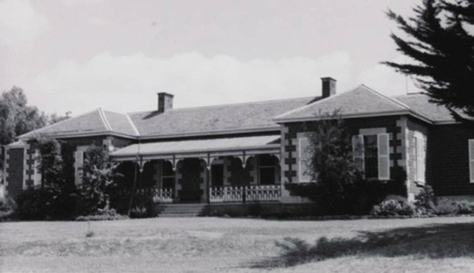
Figure 2.17: Darriwill Homestead, Moorabool, 20 February 1966.
Source: J.T. Collins, accession H98.250/561, State Library of Victoria.
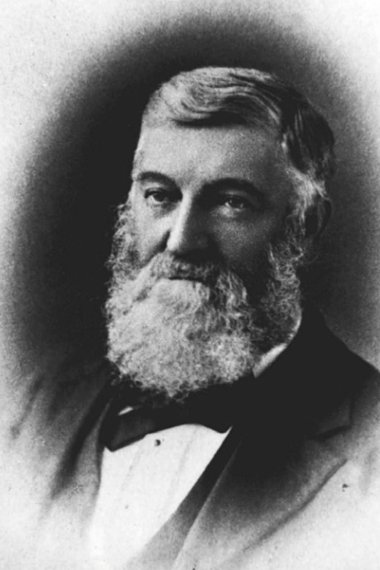
Figure 2.18: George Hope, n.d. Source: Wynd collection, Authentic Heritage Services Pty Ltd.

John von Stieglitz s brothers, Frederick Lewis, Francis Walter and Robert William arrived in Hobart in 1829, while another brother, Henry Lewis, arrived in 1830.118 After taking up his Station Peak sheep run in 1835,119 John von Stieglitz married Miss Emma Cowie, the daughter of George Cowie, bookseller and alderman of London.120 In addition to the Station Peak Run (which John held for eight years), von Stieglitz also took up the Ballanee Run near Ballan in 1838, the same year his
brother, Robert, acquired the Ballan Run.121 In 1852, he sold his landholdings (which then also included a vast, 192,000 acres at Lake Hindmarsh in the Wimmera) and returned to Ireland.122
At Moorabool, Darriwill Homestead (Figure 2.17) is a physical legacy of the Sutherland Creek Run acquired by the Hope brothers from Robert Hill Kinnear in c.1841.123 George
(1814-1884) (Figure 2.18) and James (1810-1877) Hope had overlanded from Sydney where they had separately emigrated in early 1839.124 They formed a partnership with their medical surgeon brother, Dr Robert Culbertson Hope, who had arrived in Sydney and established a medical practice in 1838, prior
to overlanding to Geelong in 1847.125 All three brothers were born in Roxburghshire, Scotland, the sons of Robert and Joan (nee Culbertson) Hope.126 In 1852, George married Miss Mary Anne Hassell at St. Paul s Church, Cobbity, New South Wales.127 Three years later in 1855, the Hope brothers partnership was dissolved and George Hope took up the Darriwill land which he developed as a farm with a substantial vineyard.128 The present bluestone Victorian homestead
was built in 1856, possibly to a design by Geelong architect,
J.L. Shaw.129 Hope s property was described in the Geelong Advertiser in 1863:
Darriwell [sic.], the property of Mr George Hope, is situated among the range of hills which ascends from the right bank of the Moorabool, in the parish from which the estate takes its name. It is distant only a few miles from the Viaduct, and a glimpse of this elegant and imposing structure may be obtained now and then through the openings of the lightly wooded, but remarkably picturesque country, leading
Mr Hope s property. Large masses of the pure granite are met with cropping out of the hills, and the splendid quality of the material may be witnessed in the handsome and commodious residence which Mr Hope has erected upon his estate.130
With James Hope, George established a flour mill at Batesford and another on the Barwon River near Inverleigh (known as Barwonleigh), and they also held a joint interest in Lake Wallace station near Edenhope.131 George Hope died at Darriwill in 1884.132

DISPOSSESSION OF WADAWURRUNG COUNTRY
The arrival of Europeans to the Greater Geelong area had a devastating impact on the lifestyle and culture of the
Wadawurrung people. Although the law of the British colonial government offered the Wadawurrung few protections in personal safety and land rights, Governor Charles La Trobe had remarked in 1842 to the Colonial Secretary in Sydney that grazing licenses should not disturb the natural right
of occupation of the Aboriginal inhabitants. 133 From the beginning of European arrival in 1802 and throughout the 19th century, the Wadawurrung people were dispossessed of their traditional land use practices, food gathering and customs, and coupled with the introduction of European diseases, the local population of the Wadawurrung was
decimated. Of the latter as early as 1839, several Wadawurrung females died of influenza134 (see Theme 8). Of the former, environmentally and culturally, the grazing of thousands
of sheep damaged cultural sites (including burial sites and middens) and disturbed the natural ecosystems that had formed a basis for Wadawurrung sustenance for thousands of years. This was because the hooved stock had degrading consequences on the soil. As early as 1844, damage caused by livestock was noticed in the Western District of Victoria with the disappearance of herbaceous plants and in landslips beside creeks.135 The marine landscape of the Greater
Geelong area - highly valued by the Wadawurrung as a source of staple food was another part of Indigenous life controlled and misunderstood by European law makers and settlers.
In 1866 for example, The Argus gave the following report on the ‘protection of fisheries’:
The Central Board [appointed to watch over the interests of the Aborigines] continue to give their attention to the protection of the fisheries and those swamps and lagoons where the aborigines have been in the habit of procuring ducks, teal, swans, and other game. Vast quantities of fish
are destroyed annually by netting, and the swivel-gun is not less distributive to birds. Both fish and game are ruthlessly killed in such a manner as to injure, not only the interests of the blacks, but those of the colonists generally.136
Exposure to European culture was also to have other negative impacts. In particular, the consumption of alcohol sometimes played a part in dispossession of culture and conflict with British law. In 1861-82, it was reported that different Aboriginal Language groups sometimes drunk for days together and
in this state they were guilty of frequent breaches of the peace, and not a few of the great crimes, inter se, are distinctly referrable to this cause. 137

‘COLLISIONS’ BETWEEN EUROPEANS AND WADAWURRUNG & THE PROTECTORATE
The arrival of Europeans to Greater Geelong ultimately led to conflict with the Wadawurrung. Described as ‘collisions’ by British authorities,138 the earliest documented conflict was during the expedition of Lieutenant Tuckey in 1803. This
involved the killing of a Wadawurrung man and the wounding of several others near the You Yangs.139 The collision with the Wadawurrung was not lost on Tuckey who illustrated
two Wadawurrung men in his Survey Map in October 1804 (Figure 2.07).
A number of killings followed in the ensuing years during the influx of European graziers. In 1836, the head of the Balug clan of the Barrabool Hills, Woolmudgin, was murdered by convict shepherd, John Whitehead.140 In 1837-38, two Wadawurrung men were killed in a battle involving 200 Aborigines outside Greater Geelong at the Clyde Company s Golf Hill station at Shelford.141 Ian Clark in Scars in the Landscape also identifies other massacre sites of Wadawurrung people. They were caused by the Traditional Owners being dispossessed of their land (and retaliating by damaging property and stealing and killing livestock as a means of survival), and by European ignorance in relation by the creation of Terra Nullius and the Wadawurrung s deep connection to the environment. Of the latter, this was highlighted by Robert von Stieglitz s Social Darwinist attitude who claimed that the general rule is, if the people cultivate or grass the land they have a claim on it, but these creatures did neither. 142 Some collisions also led to the loss of European lives, such as two of David Fisher s men at his station at Indented Head.143
Dispossession of clan estates and inter-cultural tensions also brought about collisions between different Aboriginal language groups which led to devastating consequences under British law. As early as 1841, Mumbowran of the Watha waurrung Balug [Barrabool Hills] was charged with the
murder of another Aboriginal.144 So poor was the treatment of Mumbowran that it was reported in the Geelong Advertiser, along with the growing tensions that ensued with the Wadawurrung:
Mumbowran, who, forty-five days ago, was captured by white treachery, charged with having assisted at the
execution of a fellow black who had been condemned to be speared for an attempt to murder a white man and who has now suffered six weeks unnecessary imprisonment, without his case having been entered into, - was, on Thursday evening last, escorted by a party of soldiers with fixed bayonets, and constables

armed with carbines, from the watch-house to the beach, a distance of two or three hundred yards, and put on board the cutter Governor La Trobe, amid the indignant yells of a crowd of aborigines.

The execrable management of this business from first to last, has created a great sensation among the blacks. Several strange tribes are now in the neighbourhood of Corio; and had not Mumbowran been removed, it was confidently expected that an organised attempt would have been made for his rescue. The fierce behaviour of the few who witnessed his embarkation, was not to be misunderstood; and had he been conveyed overland, a
rescue would doubtless have been attempted. We cannot see that his removal to Melbourne can efface the stain which marks the conduct of every one connected with his detention. In fact, it deepens the dye of their iniquity. It is an additional uncalled-for injury. He is a native of Geelong
his crime (if crime it be) was committed in Geelong his accusers and witnesses are in Geelong his Protector is in Geelong there is a court competent to decide his case at Geelong. Wherefore then is he removed to Melbourne? Merely to shew that they are doing something! But they cannot remove him out of the jurisdiction of our remarks, and we shall continue our weekly reproaches on the cowardly, cruel, bungling perverters of law, justice, and
humanity, until they cease the further infliction of wrongs on this defenceless wretch.145
Another notable example of tension between the recent European arrivals and the Wadawurrung occurred in 1837 at the hut of Captain Foster Fyans, Police Magistrate at Fyansford. Fyans had been ordered to assemble the Wadawurrung and provide them with gifts of blankets and flour. The congregation of 275 Wadawurrung men, women
and children became strained when there was an insufficient number of blankets.146 Fyans claimed the Wadawurrung to have been menacing and ordered his mounted police and constables to form in front of the police hut , with Fyans facing the clamorous crowd with a double-barrelled gun. 147 Almost 100 years later, the Geelong Advertiser claimed that William Buckley quelled the situation without bloodshed. 148
Forced from their territorial borders exacerbated tensions and conflicts amongst the Wadawurrung with their Traditional Owner neighbours. One particularly devastating encounter involving a large number of Aborigines occurred at Queens Park in 1839. It was there where Dan Dan Nook (known to Europeans as King Jerry) received a deep neck wound.149

THE ABORIGINAL PROTECTORATE
In 1837, a Report of the Parliamentary Select Committee on Aboriginal Tribes was tabled in the House of Commons of the Imperial Parliament in London. This report was the result of investigations into the treatment of Aborigines in various parts of the British colonies. It provided clear evidence of the dispossession of Aboriginal Countries by British settlers (in part as a consequence of British laws), the poor treatment of Aboriginal people and the ongoing decimation of Traditional Owner populations. A summary of the report read in part:
An apology may perhaps be expected for the present volume, consisting as it does, for the most part, of details which have already, in a somewhat different form, been brought under the notice of the British public. On the value of the accompanying Report there can hardly be two opinions. The appalling facts which it discloses, and the judicious suggestions it contains, combine to render it one of the most important documents which has ever come before the legislature. Replete with evidence as to the injustice and cruelty with which the Aborigines have hitherto been treated, and the pernicious effects which
have resulted to them from their intercourse with European nations, it abundantly proves the necessity of immediate legislative interference.
In an age distinguished for its liberality, its enlightened sentiment, and its Christian zeal, atrocities, the most daring and dreadful in their character, which, even in a darker era of the world s history, would have excited universal horror, have passed unnoticed and unreproved.
… The injuries we have inflicted, the oppression we have exercised, the cruelties we have committed, the vices
we have fostered, the desolation and utter ruin we have caused, stand in strange and melancholy contrast with the enlarged and generous exertions we have made for the advancement of civil freedom, for the moral and intellectual improvement of mankind, and the for the furtherance of that sacred truth, which alone can permanently elevate
and civilise mankind. Accustomed to view with indignation the tyranny of neighbouring states, we have yet by our silence given sanction to a policy not less iniquitous in its principles, and destructive in its tendency. Every law of humanity and justice has been forgotten or disregarded.
Through successive generations the work of spoliation and death has been carried out, until to the colonial possession of the most religious nation in the world the emphatic language of Scripture may with truth be applied they

are the dark places of the earth, full of the habitation of cruelty. It would be idle, as well as a painful task to trace the motives which may fairly be supposed to have actuated those, whose names will for ever be connected with the oppression of the innocent and unoffending Aborigines.

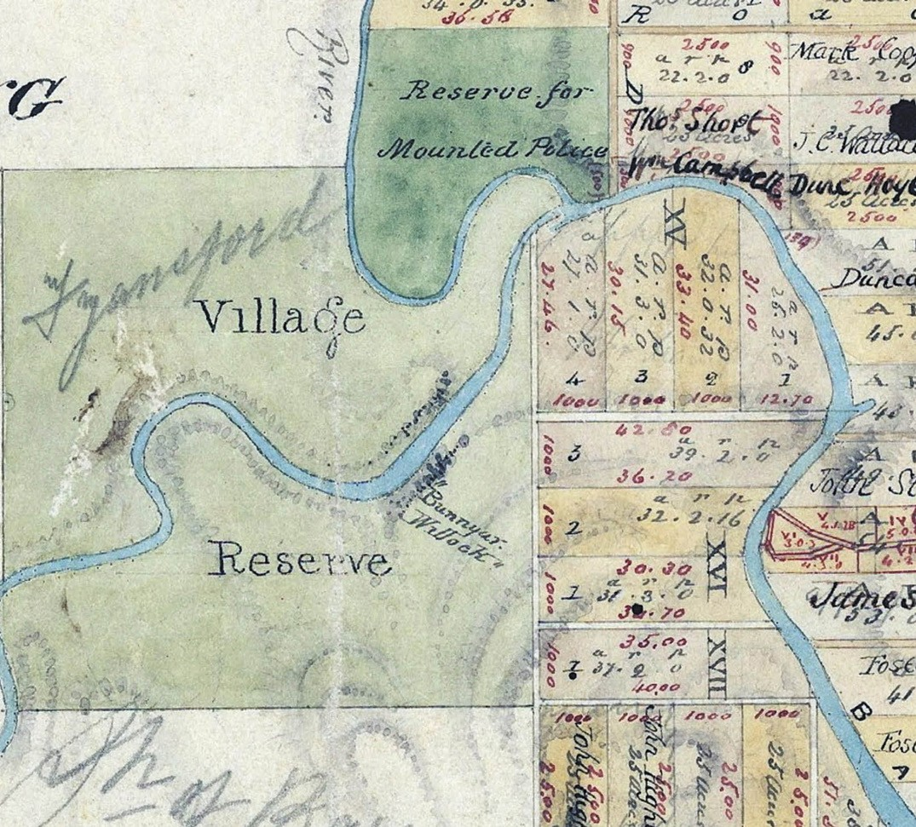

Figure 2.19: H.W.H. Smythe, Part of Plan of Suburban Allotments in the Neighbourhood of Geelong, 10 February 1839, showing Bunnyar Willock’ at the Fyansford Village Reserve. Source: VPRS 8168/P5, item Sydney B39A, Public Record Office Victoria.

The leading causes of these frightful calamities are not difficult of discovery. Much of the evil may be regarded as resulting from vicious or mistaken legislation. The acquisition of new territories, and the advancement
of British ascendancy, have too often been preferred to the claims of justice and sound policy. 150
Following the Report, in 1838 the House of Commons ordered the preparation of a list of massacres of Australian Aborigines and details on the trials of their murderers. Published a year later in 1839, this List Report included a

list of outrages , including some at Geelong, the western limit of Port Phillip.151
The Report of 1837 called for the protection of Aborigines through legislation expressly sanctioned by the Queen, except in cases of evidence and extreme emergency ,152 limitations
on contracts of service by Europeans with the Aborigines, prohibition of vagrancy laws and other similar regulations on the Aborigines, prohibition of the sale of ardent spirits to the Aborigines, prohibition on the acquisition of the lands of the Aborigines within any territories over which the domination of the Crown extends 153 and the provision of religious instruction and for the protection of the survivors of the tribes to which the lands comprised in that colony formerly belongs. 154

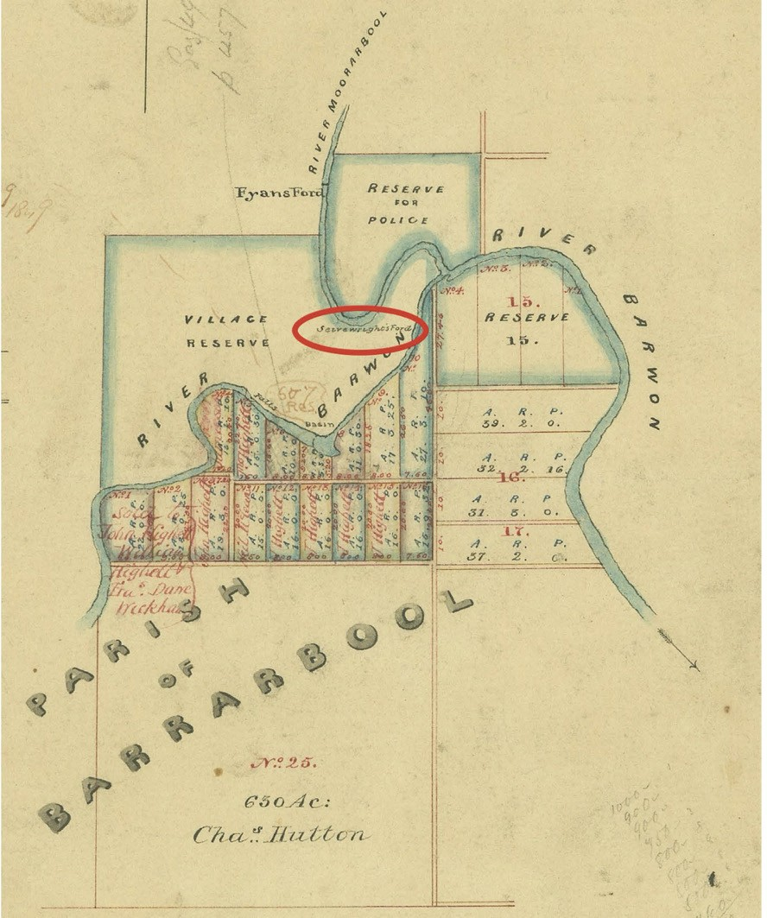
Figure 2.20: L. Clarke, Part of Plan of Allotments marked at the Reserve in the Parish of Barrarbool near the confluence of the Moorarbool & Barwon Rivers, 1849. Sievwright’s Ford is circled in red. Source: VPRS 8168/P5, item Sydney B40, Public Record Office Victoria.

While not all the recommendations of the Report to the House of Commons were realised, in January 1838 the Colonial Office in London created the Port Phillip Aboriginal Protectorate.
It was also the result of lobbying from the Aborigines Protection Society established in 1836.155 George Augustus Robinson was appointed Chief Protector and in March 1839 he allocated regions of the Port Phillip District to

Protectors under his control. Charles Sievwright was given the Western District and Edward Parker the Loddon District,156 both Districts taking in Wadawurrung country, and Sievwright s District took in the area that is now the City of Greater Geelong.
Charles Wightman Sievwright (1800-1855) was born in Edinburgh, Scotland and at a young age was commissioned as an ensign in a Scottish infantry regiment.157 After 20 years in the army, he was appointed Assistant Protector of

the Aborigines, and arrived with his family to live amongst the Wadawurrung at Geelong in 1839.158 There, Sievwright was initially afforded a hut by Fyans. By September 1839 Sievwright submitted to G.A. Robinson a plan for civilizing the Wada wurrung and favoured country southward of the Geelong road to Portland as the best site for a homestead in
this district. 159 The location of Sievwright s Protectorate Station was between the Moorabool and Barwon Rivers at Fyansford, below Bunnyar Willock 160 (Figure 2.19). The station was also adjacent to a ford over the Barwon River named after Charles Sievwright161 (Figure 2.20).
By 1840, Sievwright was well into carrying out the object of his mission at Fyansford.162 In 1879, Samuel Mossman reminisced of his experiences in Geelong in 1840. He had been saved from drowning by Dan Dan Nook (King Jerry).163 Mossman gave a further insight into the work of Sievwright and his daughter at the Protectorate station:
In this task [as Protector], he was assisted by his daughter, a young lady who espoused the case of the neglected, down-trodden aborigines. She was of an amiable disposition, and furthered the efforts of her father in dispensing the supplies liberally allowed by the society [Aboriginal Protection Society] for the maintenance of applicants who came for relief. Many did so, and were very glad to get sugar, rice, or flour – but no tobacco – for which they willingly gave their labor in chopping wood, bringing water from the river, stripping bark from the gum trees, and doing any domestic requirements for the station. For some time, the relations between the agent and the aborigines went on pleasantly, but when the latter were asked to cultivate the ground, assist in putting up fences, and attend regularly at religious services, they dropped off by degrees, and their presence, particularly that of the young men and women, became less day by day. At length the mission proved to be a failure, and the station was abandoned. It was found that the Barrabool tribe of aborigines preferred living in their own bark mia-mias to the huts at the station, or going into Corio [Geelong] for odds and ends of food.164

The demise of Sievwright s Protectorate station near Fyansford in 1841 was also a consequence of unrest by European settlers, due to the congregations of Wadawurrung and other Aborigines at his station, and Sievwright s suppression of Aboriginal aggression. 165 At least one massacre occurred in 1839 between the Wadawurrung and the Gulidjan (of Colac) at Queens Park, opposite Sievwright s station, given their forced coming together (see earlier subsection). On 14 March 1840, a public meeting of settlers of the Geelong district was held and a Memorial adopted requesting that the Governor devise some plan to save the natives from extinction. 166 While this plan was to save the Wadawurrung and other Aboriginal people from extinction , it was also a call for the protection of the European settlers as an earlier public meeting resolved the preparation of a Memorial to Governor Gipps which included:
That the settlers in this District having severely suffered by the aggressions of the Aboriginal population, which have been allowed to pass with impunity, deem it highly expedient to make an earnest appeal for the adoption of efficient measures to prevent their recurrence.167
Given the widespread negative sentiment, Sievwright abandoned his station at Fyansford and relocated to Lake Keilambete in Girai wurrung country in February 1841.168 Sievwright won considerable respect from the Aborigines who lived with him at several camps while at the same time becoming the most unpopular white man that ever breathed due to his determination to seek prosecutions of Europeans for mass murder in one case of up to eight people.169 He was ultimately dismissed on charges of misappropriation of government charges (to which he was later acquitted) and simultaneously on charges of
immoral behaviour.170
Charles Sievwright s brother, John, acquired the license to the former Protectorate station at Fyansford from Foster Fyans on 30 March 1842.171 He had proposed to establish an agricultural venture of supplying vegetables and milk to the people of Geelong, and he offered ‘to distribute supplies of flour and tea and other items to the old men and young children of the Wada wurrung. 172 This venture either did not get off the ground or was short-lived.173 No known physical evidence survives of Sievwright s station near Fyansford. Documentary evidence includes a list of names of the Barrabool tribe prepared by Sievwright s daughter during her tenure at Fyansford in 1842. By this time, the Wadawurrung population had dramatically declined to 118 men, women and children,174 just 40% of the number of Wadawurrung who had assembled at Foster Fyans hut in 1837.

WESLEYAN MISSIONARY SOCIETY, BUNTINGDALE WESLEYAN MISSION & THE WADAWURRUNG
Another of the suggestions of the Report of the Parliamentary Select Committee on Aboriginal Tribes in 1837 was the provision of religious instruction to the Aborigines. The
Report praised the work of the Christian Missionaries whose labours the case of humanity is unspeakably indebted. 175 The Wesleyan Methodist Church had formed in the 1700s
as a religion of the heart rather than intellect; social rather than individual. 176 This was the basis for the formation of the Wesleyan Methodist Missionary Society in 1813 by Dr Jabez Bunting.177 Its mission was to sending missionaries to
the heathen in the farthest points of the British Empire. 178

The Reverend Joseph Orton (1795-1842) had arrived in Van Diemen’s Land in 1831 and made his first visit to Melbourne in 1836.179 Two years later in 1838 and with financial backing, Orton had arranged for two Wesleyan Missionaries, Rev.
Francis Tuckfield and the Rev. Benjamin Hurst, to inaugurate the Wesleyan Methodist Missionary Society s cause in the Geelong district.180 Tuckfield first preached at ‘Kardinia’
(the home of Dr Alexander Thomson) on 29 June 1838 and later in the barn of David Fisher at South Geelong.181 It was from this time when Wesleyan Missionary Society made first contact with the Wadawurrung. In early 1839, a temporary mission appears to have been created on the Barwon River at Charlemont (earlier known as Marshall).182 Reference to his

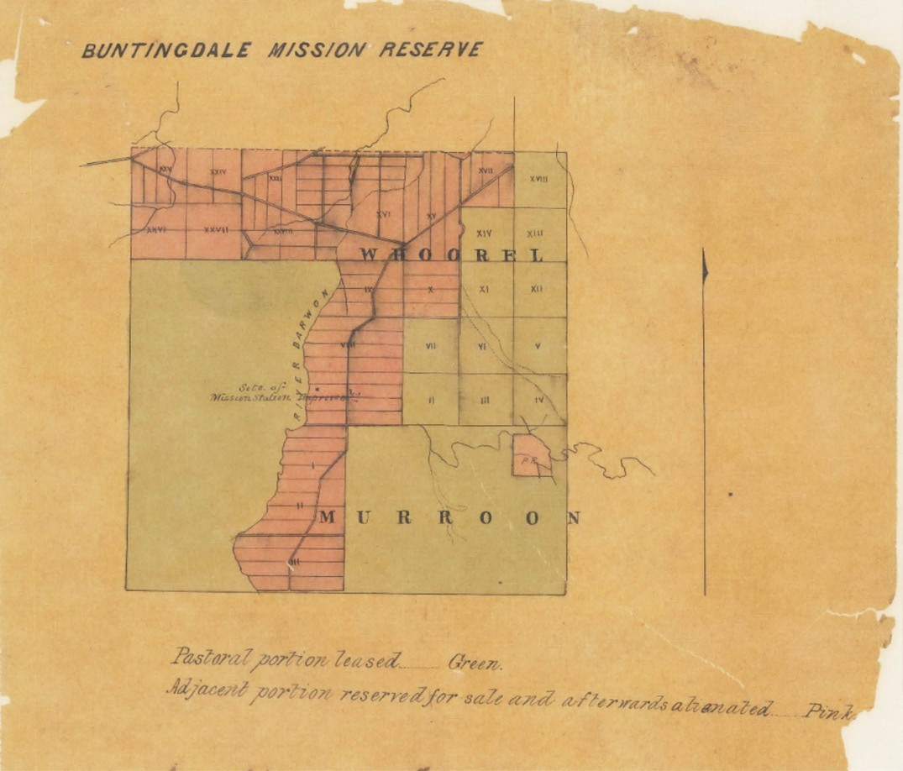
Figure 2.21: Plan of the Buntingdale Mission Reserve (coloured pink), 1882. Source: VPRS 8168/P5, Buntingdale Mission, Run 514, Public Record Office Victoria.

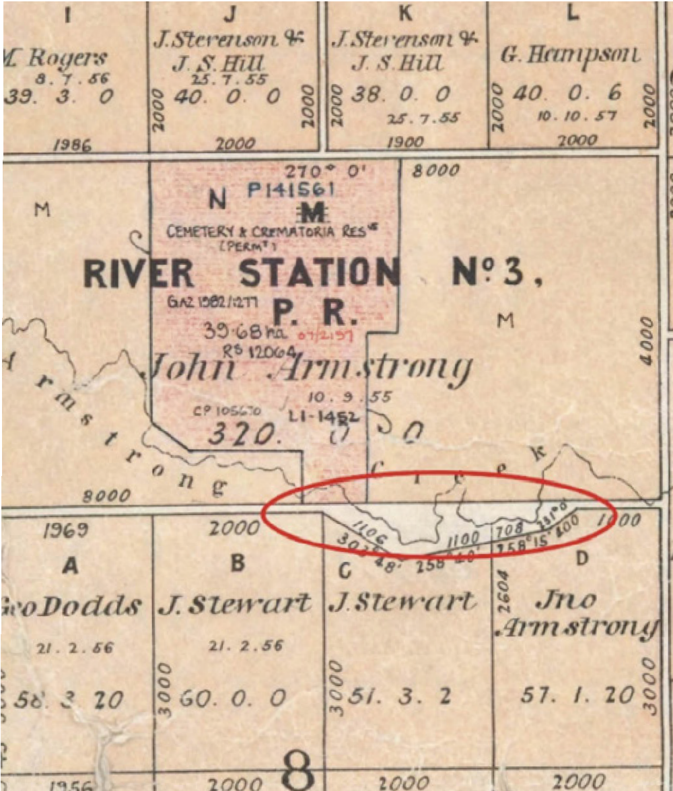

Figure 2.22: Part Conewarre Parish Plan (sheet 2), showing the unalienated area known as Dooliebeal & Stewarts Reserve, Department of Lands & Survey, Melbourne, 1962. Source: VPRS 16171/P1, item Plans Ch-Dr, Conewarre-2, Public Record
Office Victoria.

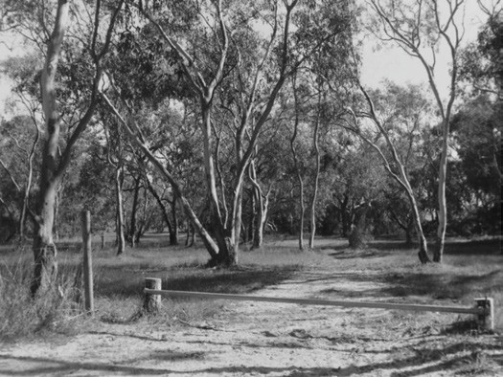
Figure 2.23: Dooliebeal/Stewarts Reserve, 1998. Source: David Rowe.

mission (albeit mistaken as a Presbyterian Mission) is given fleetingly by George Brewer in ‘Memories of Old Geelong’. His description of travelling along the Barwon River included the following:
Having plenty of sea room, as we circle to the south, we keep mid-stream and gaze on Barranghup , one of the very oldest residences in, or near, Geelong, built by the late Miss Drysdale on the eastern bank of the river in 1840.
Across the stream, a mile or so distant, directly opposite Barringhup, on the rising ground, lies Polidilok, the
site of Messrs. Thompson and Harding s sheep station, of the early forties. A little to the west of this again stood the Presbyterian Aboriginal Mission Station, its site now, we believe, the property of Mr. G. Gardiner, of Marshalltown
183

No physical or other corroborating documentary evidence is known of the Aboriginal Mission Station at Charlemont today.
The temporary nature of the apparent Charlemont station was due to the reservation of a more substantial mission reserve on the east bank of the Barwon River near Birregurra in the Parish of Whoorel in July 1839184 (Figure 2.21). Named the Buntingdale Aboriginal Mission in honour of the founder of the Wesleyan Missionary Society, Dr Jabez Bunting, it was the largest Aboriginal Mission station in the Colonies.185
The purpose of Buntingdale was to Christianize , civilise through education and agricultural training, and to provide welfare. However, the Mission Station was within the traditional boundary of the Gulidjan people. Although the aims of the Wesleyan Missionary Society were to encourage Wadawurrung, Gulidjan, Djab wurrung and Djarguard wurrung
peoples to reside at Buntingdale, this ideal through ignorance of traditional territorial boundaries and customs it was doomed to fail. Djarguard wurrung clans were ‘in constant conflict’ with Wadawurrung clans, while the Gulidjan clans claimed that they should be given most attention.186 This led
to further conflict with the Wadawurrung, and by 1842 only Guilidjan people were resident at Buntingdale.187 Only nine years after its establishment, the Buntingdale Mission Station was abandoned.188

FURTHER DISPOSSESSION, DOOLIEBEAL & THE COMUNN NA FEINNE SOCIETY
Throughout these years and beyond into the 1840s and 1850s, the Wadawurrung remained dispossessed of and displaced from their land and disenfranchised from traditional and European cultural life. Although E.B. Addis, the Commissioner for the County of Grant replied to a circular on the subject of proposed reserves, nothing immediately eventuated of his recommendations for two reservations in the Geelong area: Sievwright s temporary Protectorate Station at the breakwater near the junction of the Moorabool and Barwon Rivers; and land near Point Lonsdale.189
Rural European progress around Geelong forced the Wadawurrung into urban and suburban areas, causing even further conflict with the newly-arrived population. Increasingly desperate for food, collisions ensued.190 By 1852, only a
total of 16 Wadawurrung were resident in the Geelong district (possibly largely from the Beangali clan), comprising nine men, five women and two children.191 At this time, they
were accompanied by twelve men, eight women and three children of the Gulidjan Language group and eight men, six women and four children of Toolloora balug clan of the Wadawurrung language group (whose sub-territory was outside the City of Greater Geelong).192 A larger number of
Wadawurrung comprising 23 men, six women and one child were also resident along the banks of the Yarra River and Bourke Creeks and swamps at this time.193 In the Geelong district, E.B. Addis, Commissioner of Crown Lands, gave a report on the Wadawurrung and other Aborigines in Geelong in January 1852:
The Barrabool tribe still principally confine their wanderings to the neighbourhood of the Town of Geelong, as also
the Leigh and Colac tribes; and during the past twelve months the latter tribes have mixed more frequently than before with the former one. The great facility with which they procure food, by gifts of bread and flour from the inhabitants, as also offal from the slaughter-houses 194
The only dedicated (albeit unofficial) portion of land available for occupation by the Wadawurrung without conflict was Dooliebeal near Mount Duneed. It was east of the traditional winter estate at the western end of Fehans Lane in the rain shadow of Mount Duneed (the Wadawurrung had been excluded from this location following the Crown land sale of 1855).195 The site was also on the baaring (trail) between Mount Moriac and Lake Connewarre.196 In 1856, John Stewart, a European stonemason who had arrived in Geelong via Sydney in 1851, purchased allotments B and C of Section 8 in the
Parish of Connewarre.197 Immediately north of his Crown purchase was a narrow portion which flanked both sides of Armstrong Creek. Conewarre Parish and Geological Survey plans show that the Dooliebeal land was alienated from

freehold purchase and the neighbouring pre-emptive right of John Armstrong s River Station to the north, and appears to have formed part of the road reservation of what was to become Stewarts Road (Figure 2.22). However, the eastern portion of the alienated land on the north bank of the creek
was used by Armstrong for his sheep dipping pen, presumably without Government sanction.198 In c.1856, Stewart recognised the plight of the Wadawurrung, and while not part of his Crown purchase, he offered this portion of land as a safe place for
the Wadawurrung to live, with fresh water available from the creek. They were able to reside there until 1861.199 Stewart gave the name of the reservation Dooliebeal , an interpretation of the Wadawurrung terms Tooli (meaning a marshy place ), Toolim (meaning tussock or wiry grass ) and Beal (meaning river red gum ) however in the 20th century it became known as Stewarts Reserve, after John Stewart, European pioneer.200 Alienated from European licenses and crown purchases, this small portion of land had survived the ravages of European pastoralism, the natural bushland setting being characterised by red gum, manna gum, blackwood, black wattle, hedge wattle, hop wattle, sweet bursaria and cherry ballart.201 In 2019, Stewarts Reserve was officially renamed Dooliebeal in recognition of its enduring associations with the Wadawurrung peoples. The reserve remains a natural, undeveloped public reserve and is managed by the City of Greater Geelong (Figure 2.23).
The Wadawurrung were able to live in a place of significance and continue cultural traditions at Stewarts Reserve through the philanthropy of Robert de Bruce Johnstone, founder
and inaugural treasurer of the Comunn na Feinne Society in Geelong.202 This Scottish Society formed in December 1856 and its aims included the cultivation and preservation of the Gaelic Language and Highland Nationality and importantly, to engender in oneself a spirit of philanthropy. 203 Like Johnstone, the leading figures of the new Society, were
experienced in a whole range of social reform activities aimed at promoting the well-being of the Geelong community. 204 Such was the importance of Society s ideals of liberty and freedom from oppression that a key part its social policies related to the welfare of the Aborigines.205 The equality bestowed the Wadawurrung was illustrated in the Society s membership logo which illustrated a Highlander and Aborigine as equals in statue and might 206 (Figure 2.24). At Dooliebeal ,
Johnstone had erected several huts and supplied clothing and blankets to the inhabitants.207 Additional support to the
Wadawurrung was afforded by another member of the Society,

Dr William Baylie, who provided free medical and hospital aid for any members in districts . 208 The Wadawurrung were encouraged to become members of the Society. From 1858, they participated in the annual Highland Gathering procession of the Comunn na Feinne to the sports ground at South Geelong. They were identified ‘as a distinct “national”

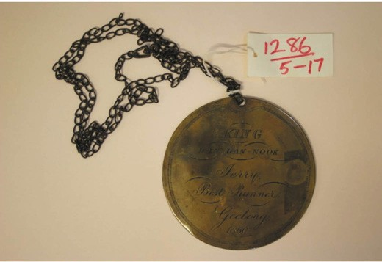

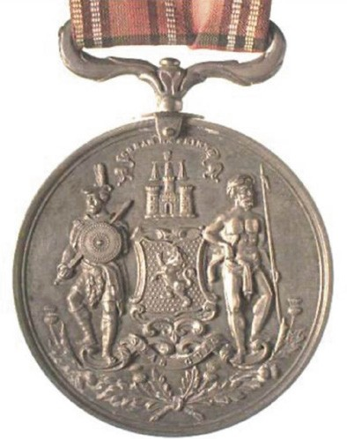
Figure 2.24: Comunn na Feinne medal awarded to J.S. Mackay, Secretary of the Comunn na Feinne Society in 1877. Note the figures of the Highlander and Aborigine, which were given equal status.
Source: Museums Victoria, image NU 34518.

presence and attended not only as spectators and some of them joined in certain of the sporting contests held on the day, as well as in competitions involving their own native skills. 209 The Wadawurrung people were particularly adept at the foot-racing. Dan Dan Nook (known to the Europeans as King Jerry) (Figure 2.25) took the honours in 1858 and again
in 1860.210 For his win in 1860, Dan Dan Nook was awarded by the Society with a brass medal as best runner (Figure 2.26).
This and similar medals awarded to the Wadawurrung for their success in the Society s games were the work of (Johann) Louis Kitz, a German watchmaker and jeweller.211 This medal is now part of the collection of the Geelong Heritage Centre.
In a reciprocal act of cultural sharing , the Wadawurrung gave a corroboree on the Eve of the Highland Gathering, which was open to everyone in the community.212 The corroboree became a regular feature of the Society s games,213 representing an early, organised and respected form of welcome to country by the Wadawurrung in Greater Geelong.
Figure 2.25: Medal with chain, presented to King Dan Dan Nook (Jerry), Best Runner, Geelong, 1860. Source: GRS 1286/5/17, Geelong Heritage Centre collection.
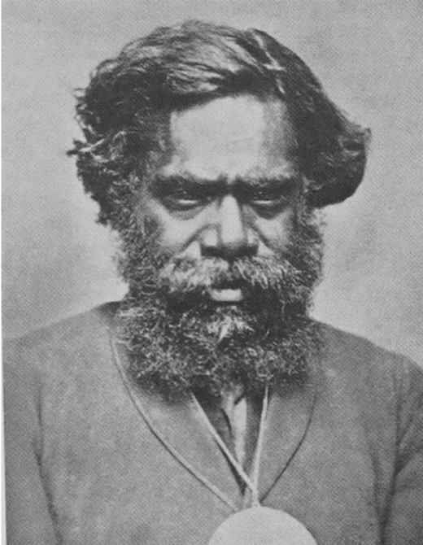
Figure 2.26: Dan Dan Nook wearing medal, n.d.
Source: GRS 2009/1192 Geelong Heritage Centre collection.

THE CENTRAL BOARD & ABORIGINAL RESERVES & THE WADAWURRUNG 1861-1885
While the Comunn na Feinne Society and Dooliebeal reserve provided some respite to the Wadawurrung from their dire circumstances, these measures did not prevent their rapid decline in population and the population of several Aboriginal communities throughout Victoria. In 1856, a pamphlet published for private circulation in Geelong was reported
in The Argus. The tragic circumstances of the Traditional peoples caused by the blindness of the British was outlined with sarcastic overtones. Amelioration was proposed by all surviving Aborigines near that town and in the populated districts being removed to one of the islands in the straits, with a staff of guardians or protectors and teachers. 214
The drastic measure outlined in the pamphlet of 1856 was noted by the Victorian Government. It heeded the need to consider the plight of Victoria s Indigenous people and in 1858 the Select Committee of the Victorian Legislative Council prepared a report on The Aborigines which was passed in Parliament in 1859. The Report found that:
The great and almost unprecedented reduction in the number of the Aborigines is to be attributed to the general occupation of the country by the white population; to vices acquired by contact with a civilized race, more particularly the indulgence in ardent spirits; and hunger, in consequence of the scarcity of game since the settlement of the Colony; and, also in some cases, to cruelty and
ill-treatment. The great cause, however, is apparently the inveterate propensity of the race to excessive indulgence in spirits, which it seems utterly impossible to eradicate. This vice is not only fatal, but leads to other causes which tend to shorten life.215
The Report recommended the formation of reserves for Aboriginal people on their own hunting grounds , thereby being of a size that would enable a combination of agricultural and gardening operations with the depasturing of a moderate number of cattle and sheep. 216 The report was therefore ignorant of the traditional and harmonious farming practices of Aboriginal people and their way of life as the report also suggested that every effort should be made to induce the Aborigines to take an interest in the occupations of civilised life and give their aid in carrying out the various branches of industry. 217
Resulting from the Parliamentary Inquiry was the establishment of the Central Board Appointed to Watch Over the Interests of the Aborigines in 1860. The Central Board system was a bridge between the retention of traditional customs and European cultural assimilation. Changes to Government legislation incrementally focussed on controlling the lives of Aboriginal people.218 The Board was able to exert an extraordinary control

over people s lives including regulation of residence, slavery as employment, marriage, social life and other aspects of daily life. 219 This was partly achieved by the reservation of land for seven Mission Stations operated by church bodies, to which Aboriginal people were encouraged to live.220 In the Geelong district (and other parts of Victoria) where a Mission Station was not created, the Central Board established an Honorary Correspondent Scheme. It operated between 1860 and 1868, and under its successor, the Central Board for the Protection of Aborigines from 1869 until 1904. The Board adopted the term Honorary Correspondents until 1871 when it was replaced with Local Guardian .221
In the Geelong district three Honorary Correspondents were appointed in 1860. All were staunch advocates of the temperance movement and members of the Baptist Church.
Henry Andrews (1798-1893), a draper and later founding member of the Crimea Street Baptist Church, St. Kilda, was an Honorary Correspondent until 1876.222 John Masters Garratt (1827-1881), merchant, Secretary of the Protestant Orphan Asylum, member of the Hospital Committee, house and land agent, member of the Fenwick Street Baptist Church and later Member of the Legislative Assembly, Geelong West Borough Councillor (including two terms as Mayor) also continued as Honorary Correspondent for Geelong until 1876.223 Charles Read (1817-1910), tailor, Deputy Registrar of Births, Deaths and Marriages, President of the Geelong Total Abstinence Society and Member of the Victorian Legislative Assembly, served as an Honorary Correspondents until 1869.224 In 1862, Dr Charles Mackin was appointed honorary medical officer ‘to attend upon the aborigines in the Geelong district. 225 He continued in this role until at least 1869.226
Each of these correspondents were noted for their philanthropy and the importance of social welfare. In 1861 in a letter to the editor, Garratt called on the Geelong community to refrain from soliciting alcohol to the Wadawurrung and visiting Aborigines, which had afflicted so many, ‘for the
sake of humanity. 227 His appeal couched in the welfare of the Wadawurrung but equally an advertisement for the temperance movement - concluded with the following:
Show your love for them in some other way; give them a basin of soup, a cup of coffee, anything rather than rum. Remember they have immortal souls as well as you, and for pity s sake don t send them down to their own place with bodies diseased and souls blasted by the fiery poison of alcohol.228
Garratt s plea for the humane treatment of the Wadawurrung did not extend to their accommodation. In 1861, 1 acre of land on the north side of

Ghazeepore Road, Mount Duneed,
comprising part of lot 9B, Section 9 in the Parish of Duneed was reserved for Aboriginal Purposes 229 (Figure 2.27). Known as the Duneed Reserve, the site was insufficient to lead anything

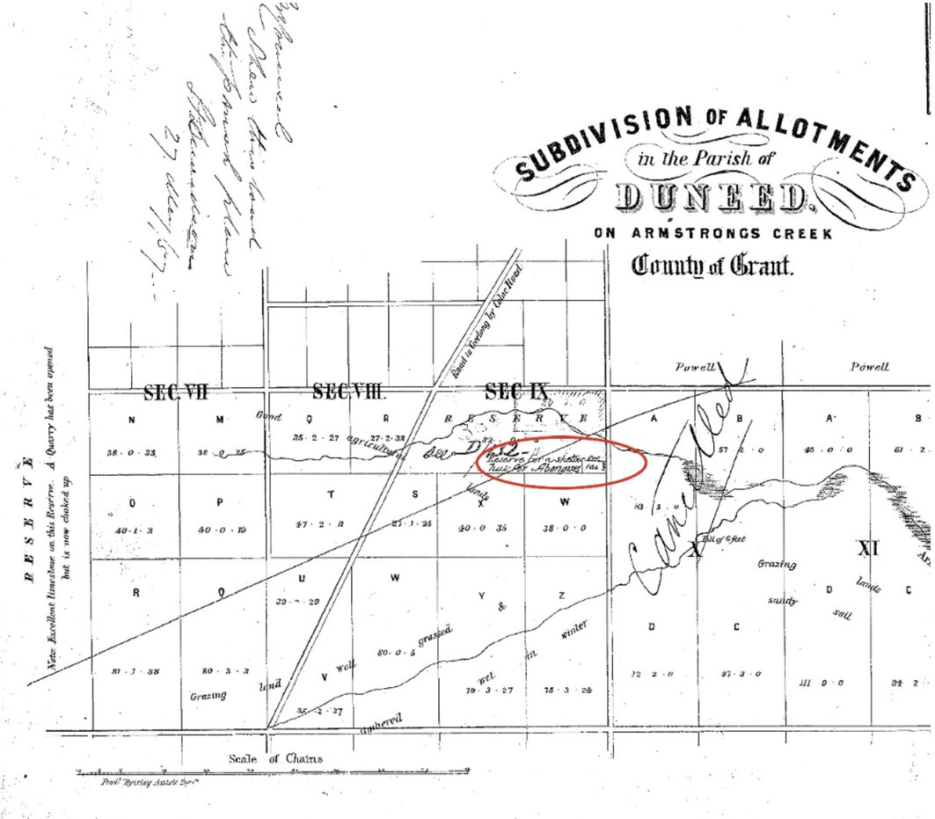
Figure 2.27: Part Plan of Subdivision of Allotments in the Parish of Duneed on Armstrongs Creek Country of Grant, 145 March 1865, showing location of Duneed Reserve (circled red). Source: Put-away plan D126/1, Landata, State of Victoria.

but a degrading existence. The selection of the reserve was deliberate to provide as little inducement as possible to visit the town [Geelong] at all.’230 While the Wadawurrung did visit Geelong begging for food for subsistence , a curfew meant that that they returned to the Duneed Reserve by
sundown.231 A timber shelter was erected by the Central Board in 1861- 62 at a cost of £40232 to accommodate the surviving seven Wadawurrung (being six males and one female) (see later subsection for further details).233 Initially in 1860, 12 pairs of moleskin trousers, 12 cloth caps, 2 flannel petticoats, 2 common cotton gowns, 12 pairs of strong shoes were issued by Garratt and 25 serge shirts, 25 pairs of blankets, 1 chest
of tea, three bags of sugar, three bags of flour, six billies and 25 pannicans were issued by Read.234 By 1886, the station accounts for Geelong had decreased to only £13 5s 0d,235
a consequence of the extinction of the Traditional Owners who were previously mainly resident in the Greater Geelong
locality, and the smaller number of Aborigines visiting Geelong from elsewhere (see following subsection for further details). In 1907, the Duneed Reserve was revoked by the Lands Department given that it had not been used for many years. 236
In 1861, the Central Board to Watch Over the Interests of the Aborigines reported that there were 20 Aboriginal men,

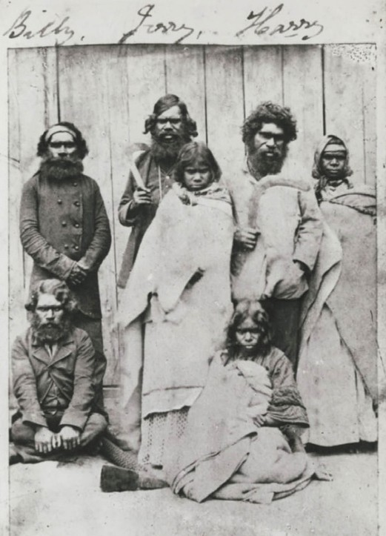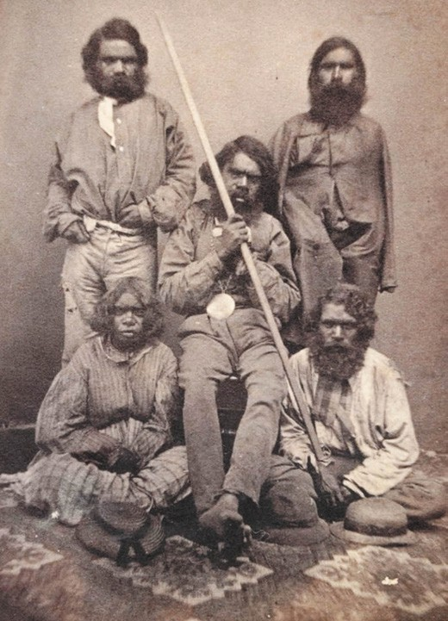

Figure 2.28: Wadawurrung people possibly at Duneed Reserve, c.1861. Standing from left to right: Willem Baa Nip (King Billy Gore), Dan Dan Nook (King Jerry), Eliza (Queen Eliza), Harry Douglas Gore and Mary. Sitting from left to right: Timboo (also known as Jumbo Mooranook and Timbo Douglas) and Emma. Source: accession H3406, State Library of Victoria.
women and children in the Geelong and Barrabool area.237
Of this number there were only 11 survivors of Geelong-based Wadawurrung.238 Photographs of c.1861 reveal the emaciated condition of these survivors. One photograph (Figure 2.28), was possibly taken at the Duneed Reserve (with the timber shelter hut in the background), showing four men and three women. They were (standing from left to right) Willem Baa Nip (King Billy Gore), Dan Dan Nook (King Jerry), Eliza (Queen Eliza), Harry Douglas Gore and Mary, and (sitting) Timboo (also known as Jumbo Mooranook and Timbo Douglas) and Emma.239 Harry Gore was the brother of Willem Baa Nip (Billy Gore) and these brothers were the relatives of Dan Dan Nook.240 The sister of Harry and Willem was Ellen Gore.241 She married Dick White who was shown in another photograph of c.1861 (sitting on the right) (Figure 2.29). This other photograph also included Johnny (standing left), Dan Dan Nook (seated wearing his Comunn na Feinne medal of 1860), Eliza (sitting), and Timboon (standing, right).
Figure 2.29: Wadawurrung people, c.1861. Johnny (standing left), Dan Dan Nook (seated wearing his Comunn na Feinne medal of 1860), Eliza (sitting), Timboon (standing, right) & Dick White (sitting, right).
Source: accession H17394, State Library of Victoria.

Several of the Wadawurrung survivors shown in the historic photographs perished in the 1860s. They included Dick White (1862), Mary (1862), Eliza (Queen Eliza) (1863), Ellen White
(nee Gore) (1864), Jemmy Nelson (1866), Timboo (1866) and Harry Gore (1868).242 All except Jemmy Nelson appear to have been from the Beangali clan. Jemmy may have been part of the Yawangi clan as his death record suggests that he was born in the Parish of Yowang.243
The surviving members of the Beangali clan, Dan Dan Nook and Willem Baa Nip, were encouraged to relocate to the Government Aboriginal Mission, Corranderk , near Healesville, and live with their friends who were already there. 244 Instead, they preferred to spend their time between Mount Duneed, Barwon Heads
and Queenscliff, which they had done with Timboo prior to his death.245 In 1867, Dan Dan Nook attended the official welcome of the Prince of Wales to Geelong.246 Dan Dan Nook s portrait photograph featured in a book prepared by the Curator of the

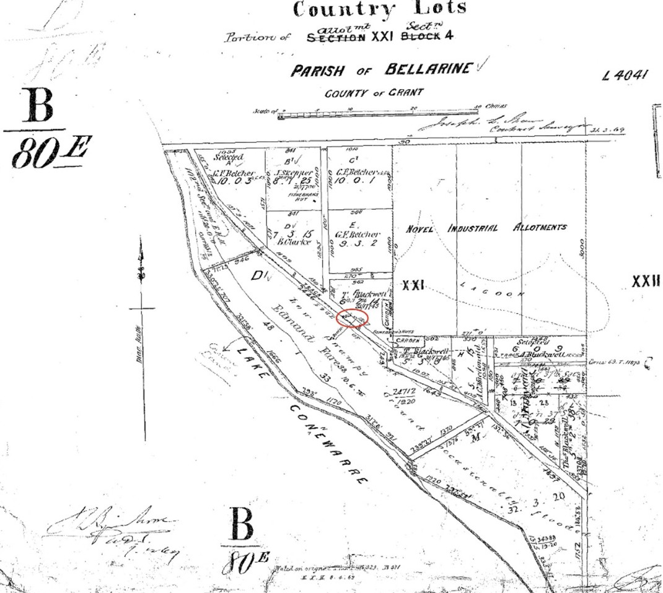
Figure 2.30: J.S. Shaw, Part Plan of Country Lots, Portion of Allotment XXI Section 4, Parish of Bellarine, County of Grant, 31 March 1869, showing Skepper s well (circled). Source: Put-away plan B80E/1, Landata, State of Victoria.

Botanic Gardens, Daniel Bunce (Theme 9), entitled Language of the Aborigines. Handsomely bound in blue morocco , the book included the following inscription:
Presented by King Jerry, the remaining representative of the Geelong, or the Dan-dan-nook, tribe. This book is, with the deepest respect, presented to His Royal Highness, as a specimen of the language of his own and other tribes of Australasia.247
Bunce s worthy intention of Dan Dan Nook presenting the Prince with the Language of the Aborigines book did not eventuate.
It was handed to the Governor by the Mayor and Town Clerk who requested that it be passed on to His Royal Highness.248
A member of the Comunn na Fienne Society,249 the ultimate intention of Bunce through the preparation of his publication was made clear in the preface:
It is trusted that the work in its present form will answer the end for which it was intended, namely as an assistant to parties engaged in civilizing, Christianizing, and otherwise ameliorating, the condition of this most unfortunate race of human beings a consummation devoutly to be wished, but which, he fears, unless parties employed in the
cause have a knowledge of their language, will be a work of slow accomplishment.250

The son of Warrarick, Dan Dan Nook died of tuberculosis at the Geelong Benevolent Asylum in 1870.251 He had been a well- known identity about Geelong and was known as the fastest runner in Geelong , a reference to his success at the annual Highland games.252 Dan Dan Nook was interred in the Baptist section of the Western Cemetery at Herne Hill, given that he was claimed to be of the Baptist religion. 253 This was probably due to his connections with the three Honorary Correspondents who were all Baptists Henry Andrews, John Masters Garratt and Charles Read.
Willem Baa Nip was also a prominent figure in Geelong and district, being respected and well learned, the high esteem afforded him was manifested in him being awarded a medal.254 The medal was illustrated in the News of the Week in 1917.
Born in 1836 on the banks of a lagoon at what is now Little Malop Street in Market Square, his name reputedly originated from Worm Bunyip as at the time of his birth, his father saw or imagined he saw a bunyip near the Waurn Ponds Creak at Jerringot (Belmont Common).255 A favourite camping place of
Willem Baa Nip was near a well (later known as Skepper s Well) that was situated near the eastern bank of Lake Connewarre where a lagoon (now called Blue Lake) drained256 (Figure 2.30). The well was 10 feet deep and 5 feet in diameter, and sunk in limestone rock.257 Surveyed as portion F of Crown Allotment 21, the site was taken up by Thomas Blackwell (1841-1923) in 1859 and he later held the land under lease under Section 42 of the Amending Land Act 1865.258 In 1874, he successfully made application accordance with Section 31 of the Amending Land Act 1865 for purchase of the land.259 It is likely to have been at this location where Harry Gore had been cared for by Blackwell prior his passing in 1868.260 In 1877, Willem Baa Nip and Thomas Blackwell had a falling out, with Willem having charged Blackwell of assaulting him. In court, it was found that both parties had known each other for many years. The case was outlined in the Geelong Advertiser:
They [Willem Baa Nip and Thomas Blackwell] were encamped on Blackwell’s land, which Billy [Willem] looks upon as his own territory, and as he refused to leave the land, Blackwell, to use the defendant s own language, routed him out with a soldering iron like he would a pig out of a stye [sic.].”261
This suggests that Willem Baa Nip had been camping at this location well before occupation by Blackwell, and from the time Blackwell had taken up the land.
After 1877, Willem relocated to Portarlington, with visits to Mount Duneed and Geelong. He continued to partake in the Highland gathering and it was likely to have been the Comunn na Feinne Society that awarded him a medal262 (Figure 2.31). Willem Baa Nip died at the Geelong Hospital on 11 November 1885.263 His funeral was held a few days later on 14 November,

attended by Mr. Brady, J.P. and Protector of the Aborigines of the Geelong district and Robert Shirra of the Comunn na Feinne Society and Thomas Wright.264 Willem Baa Nip was interred at the Western cemetery, alongside Dan Dan Nook, Jumbo Mooranook, Timboo, Jemmy Nelson, Harry Gore and
Ellen. The tomb marking the grave (Figures 2.32-33) had been funded by Robert de Bruce Johnstone in 1868, following Dan Dan Nook s death. Of Batesford stone, it had been fashioned by the sculptor, Nathaniel Brown.265 At the insistence of Robert Shirra, it had been determined by Mr. Brady that Willem Baa Nip s name, along with the names of the other Wadawurrung
buried alongside him, be suitably painted on the grave stone. 266 Shirra had also instigated a fundraising campaign for an iron railing around the graves in 1897 (the work being carried
out by Dickins of Geelong), and Willem Baa Nip s name was inscribed on the grave by J.T. Harvey, monumental mason.267 The graves and tomb at the Western Cemetery survive today in commemoration of these Wadawurrung people.

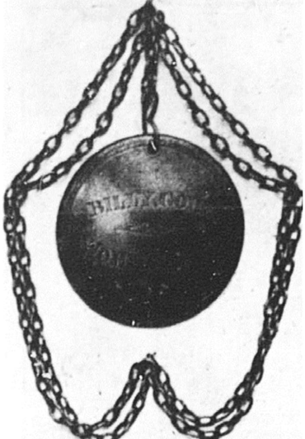

Figure 2.31: Billy Gore Worm Banyip medal. Source: News of the Week, 19 July 1917, p.14, GRS 2121, Geelong Heritage Centre collection.

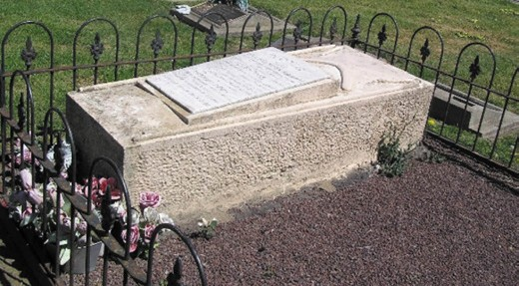

Figure 2.32: Grave of Willem Baa Nip, Dan Dan Nook, Jumbo Mooranook, Timboo, Jemmy Nelson, Harry Gore and Ellen, Western Cemetery, 2018. Source: Pam Jennings.
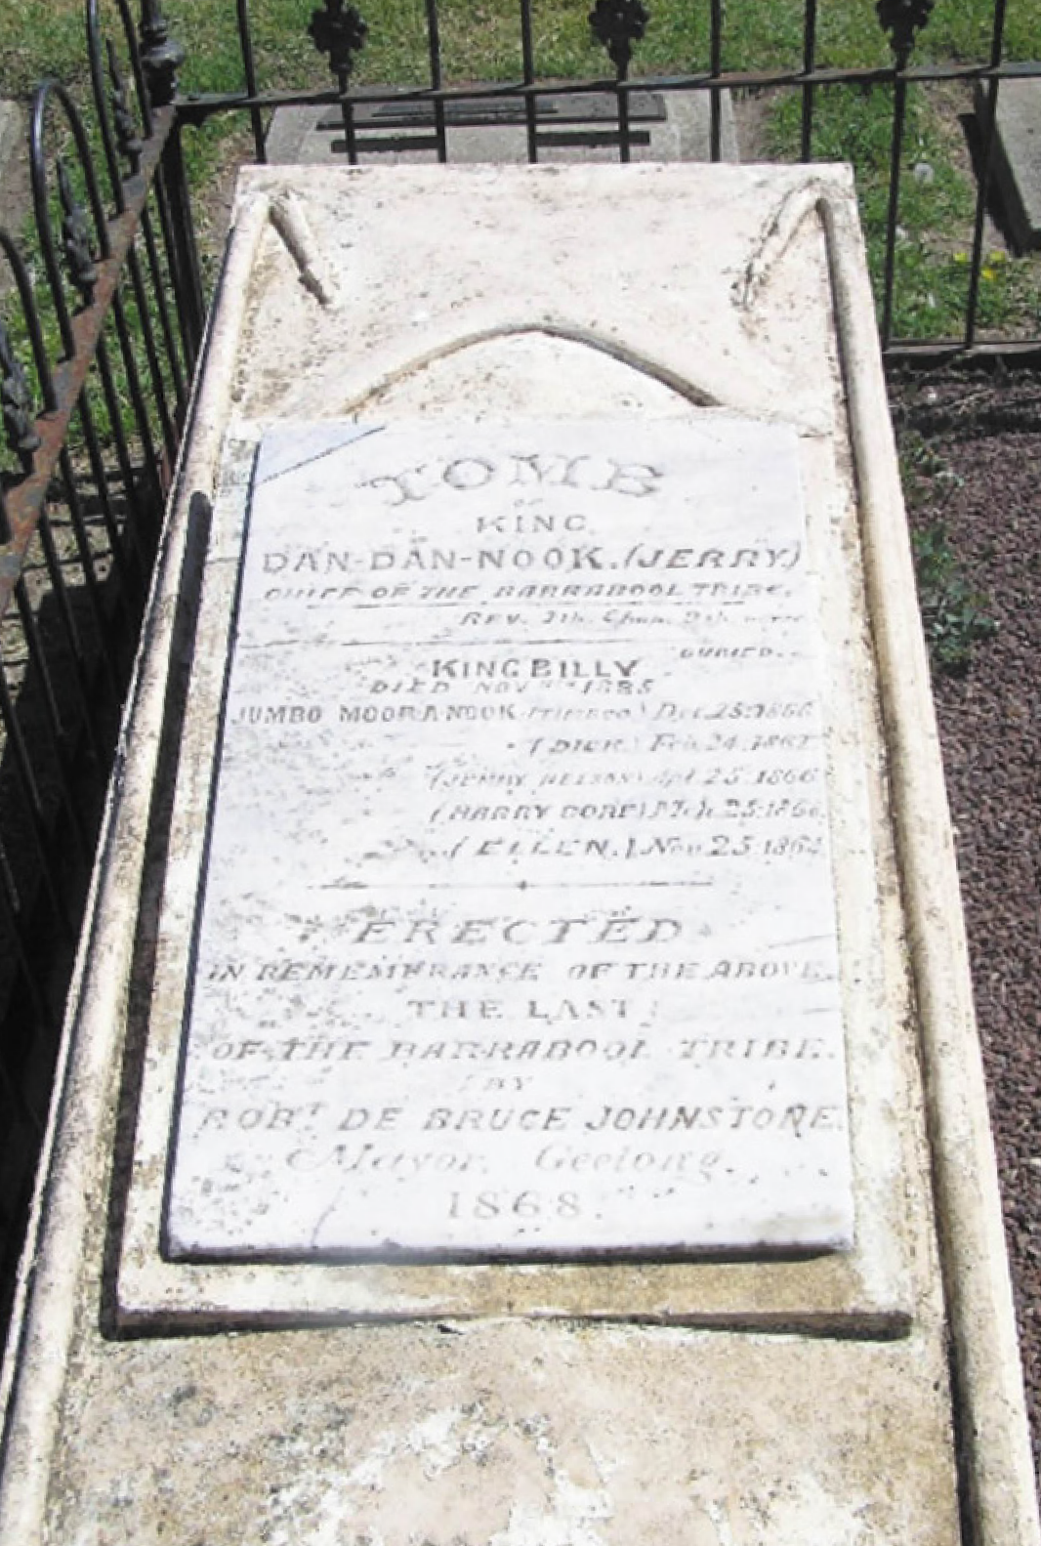

Figure 2.33: Detail of marble tablet marking the grave of the Wadawurrung, 2018. Source: Pam Jennings.

OTHER ABORIGINAL RESERVES OUTSIDE GREATER GEELONG
Outside the City of Greater Geelong but within the Wadawurrung boundary were two other reservations established by the Central Board. At Winchelsea, three acres was gazetted as an Aboriginal Reserve in 1861 and known as Karngun (it closed in 1907).268 It had a frontage to the Barwon River269 and a shelter shed was erected.270 This reserve was closed in 1907.271
At Beremboke, on the north bank of the Little River (the northern boundary of the Greater Geelong municipality), 640 acres was reserved in 1859.272 The site was named
Steiglitz Reserve after the British pioneer squatter Robert von Stieglitz who had taken up land on the Werribee River near Ballan. Steiglitz Reserve was situated adjacent to the Brisbane Ranges and Anakie Youang.273 An aim of the reservation was to keep the Wadawurrung people away from the nearby gold mining town of Steiglitz.274 A hut was built in the valley of the ranges, and near a spring.275 There were thirteen inhabitants at the reserve in 1859.276 The land was revoked as an Aboriginal reserve in 1901 and part of the site, along with the broader Brisbane Ranges area, was later created into a National Park (see Theme 1).277

BILLY LEIGH (C.1836-1912.
Another Wadawurrung member broadly known in the Anakie district in the late 19th and early 20th centuries was Billy Leigh. He appears to have been born into the Toolloora balug clan (outside Greater Geelong) in c.1836.278 During one of the Toolloora balug clan s regular visits to their camping place where the Max Hotel at 2 Gheringhap Street now stands, Billy Leigh was stolen or kidnapped by John Leech (1815-1908), an English labourer who arrived in Geelong in 1840 and worked at the vineyards in the Barrabool Hills.279 Leech claimed to have rescued Billy Leigh (much to the distress of his clan).280 When John Leech left Geelong for the Ballarat diggings in the early 1850s, Billy Leigh was employed by Frederick Armytage at Wooloomanta , Little River,281 nearby the Steiglitz Reserve where some of his Tolloora balug clan briefly inhabited.
Befriended by the Armytages, Billy appears to have reverted to the surname Leigh, after the European translation of the
Leigh tribe from which he originally belonged. Billy Leigh died on 9 April 1912, and was interred in the Eastern Cemetery.282 The high regard bestowed him by the Armytage family was highlighted in the family having a memorial cross erected to his memory. On view for 10 days at Wilcox Brother s workshop, Ryrie Street, the Geelong Advertiser reported that the epitaph and verse have attracted much attention. The Geelong
Advertiser continued:

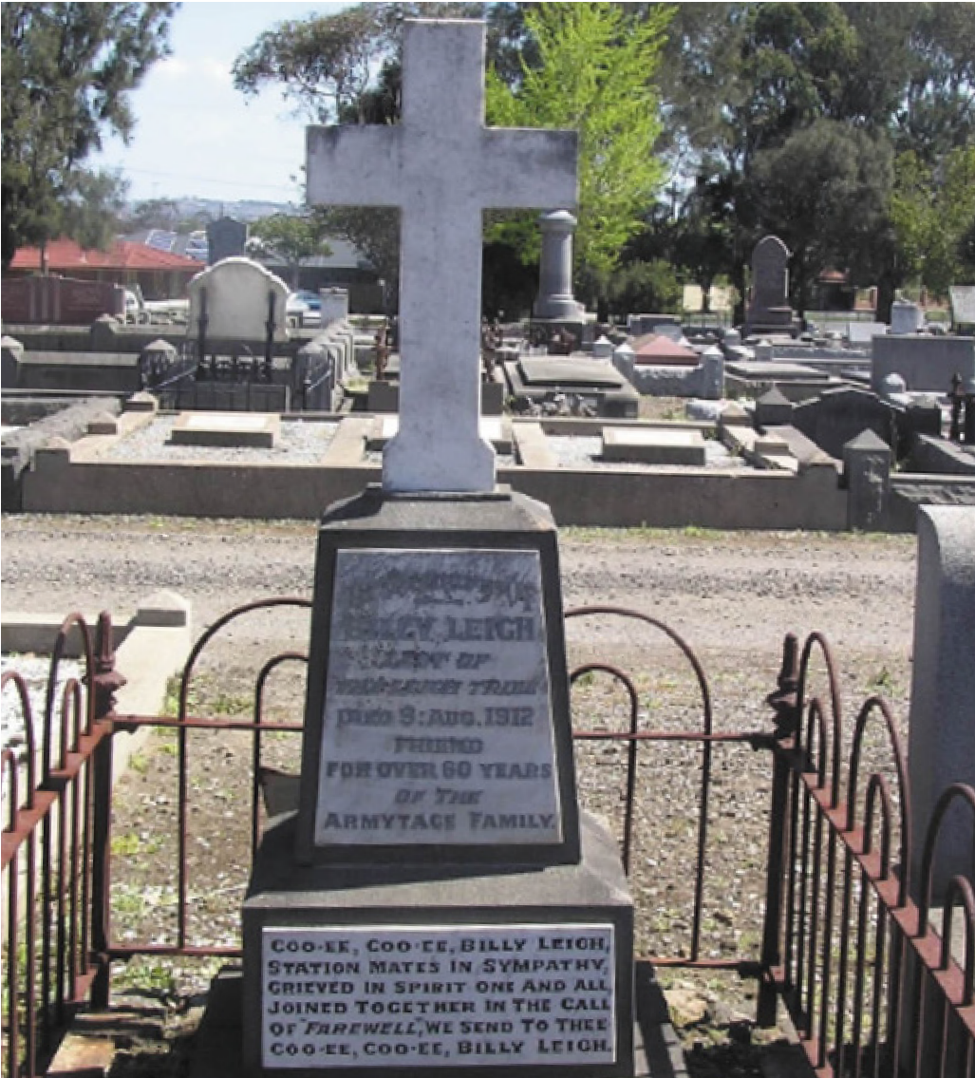

Figure 2.34: Grave of Billy Leigh with inscription by Harry Armytage, 2018. Source: Pam Jennings.

The inscription plate reads: To the memory of Billy Leigh, last of the Leigh tribe, died 9th August, 1912, friend for over 60 years of the Armytage family. On the base of the memorial the following lines from the pen of Mr. Harry Armytage, ex-M.L.A. for Grant, are engraved:-
Coo-ee, Coo-ee Billy Leigh, Station mates in sympathy. Grieved in spirit, one and all, Joined together in the call
Of Farewell , we send to thee Coo-ee, Coo-ee, Billy Leigh.283
The memorial cross survives today at Billy Leigh s gave in the Eastern Cemetery (Figure 2.34).
  - THE WADAWURRUNG & OTHER ABORIGINAL & TORRES STRAIT
ISLAND PEOPLE IN GREATER
GEELONG TO THE 21ST CENTURY

THE ‘STOLEN GENERATIONS’
The stealing of Billy Leigh from his family following European colonisation was just one documented example of children taken from their families. One of the earliest cases of an Aboriginal child stolen from his family was in 1837 when Geelong’s first European medical practitioner, Dr Jonathan Clerke (see Theme 8) obtained a young four year old Wadawurrung boy to care for until he grew up on a search to find the missing pastoralist, Joseph Tice Gellibrand.284 This event naturally caused distress to the boy s mother
and clan, and was investigated by Captain Foster Fyans, police magistrate. The clan had complained to Dr Alexander Thomson, squatter at Belmont, who was quite confounded when Foster credited Clerke for his actions. Named William, he was baptised by the Rev. Francis Tuckfield in December 1838.285 William was taught English, and repeat the Lord s Prayer with several hymns. 286 The devastation caused William and his family was lost on Clerke and Fyans, who declared that Clerke s raising of William was the only instance I have met with of a really domesticated native, and yet no additional Indigenous children were to be placed in the care of Europeans.287
Another example of Darwinist Socialism that pervaded Greater Geelong in the mid-19th century was of an Aboriginal lad
who was baptised into the Free Church, Little Malop Street, on 24 June 1855. Following his baptism, he was renamed John Lowe, having been taken some years ago, with the consent
of his parents and tribe, by a worthy and respected elder of Mr Tait s congregation. 288 The Geelong Advertiser and Intelligencer reported on the event and concluded:
The lad seems to have profited much, and has given many proofs of what may be done by private worth and perseverance in the reclaiming of the aborigines of this colony. To his instructor, it must be, if the lad
has been really imbued with religious feelings, a source of satisfaction that he has been instrumental in bringing one of a class so much despised into the ways of religion.289

The integration of Aboriginal children into European society from the mid-19th century was a precursor to the Victorian Government s introduction of the Aborigines Protection Act of 1886. This Act commenced a policy of removing Aboriginal people of mixed descent from Aboriginal stations and reserves
and assimilating them into European society.290 Labelled by the derogatory term, half-caste , it related to Aboriginal people who were not full blood Aboriginal.291 A basis for the Act was to limit the number of Aborigines on Government mission stations and reserves given that while the full descent Indigenous population was declining the mixed descent population was increasing. 292 A clear and concise appreciation of the Act was given in the Bringing Them Home Report:
The Aborigines Protection Act 1886 and its regulations provided that at the age of 13 years half-caste boys were to be apprenticed or sent to work on farms and girls were to work as servants. Having left, they were not allowed to return to their families on reserves without official permission for a visit. Orphaned half-cast children
were to be transferred to the care of the Department for Neglected Children or an institution for neglected children. All part-Aborigines aged 34 and younger were to leave the stations and their families although they remained under the control of the Board until 1893. At that time the government estimated there were about 833 Indigenous people remaining in Victoria, of whom 233 were classed as half-castes , including 160 children.
Subsequent regulations extended the Board s removal power further to allow it to send children of mixed descent, whether orphaned or not, to the Department for Neglected Children or the Department of Reformatory Schools for their better care and custody. Families refusing to consent to the removal of their children were told they would have to leave the stations and would be denied rations.293
Later Acts did little to ameliorate the damaging and enduring Government ideology of protection and assimilation by forcing the removal of Aboriginal children from their parents. This continued with the Aborigines Act 1957 which established the Aborigines Welfare Board to promote the moral, intellectual and physical welfare of aborigines with a view to their assimilation in the general community. 294 No specific powers were given to the Board in relation to Aboriginal children.
This role was played by Victoria Police who until 1985 were empowered to forcibly remove children under the child welfare laws. 295 In 1956-57, over 150 Aboriginal children (comprising over 10% of the Aboriginal population of Victoria at that time) were living in State children s institutions.296

While many of these children were taken to the Ballarat Orphanage, several were brought to Geelong, where they were handed over to the orphanages operated by different church denominations (see Theme 8), offered to foster parents or adopted by families of European background.297 Sacred Heart College (then Sisters of Mercy Convent, Orphanage
and School) established in 1859 in Newtown298 was one of the earliest surviving physical legacies associated with Aboriginal orphans . In 1871, the Geelong Advertiser reported on a young Aboriginal girl, a native of Gippsland , as one of the orphans under the care of the Sisters of Mercy. The Geelong Advertiser continued:
… the Sisters of Mercy had no little difficulty [with her] at first, but who is now happy and contented, and said to be remarkably intelligent. When first she took up her abode in this peaceful retreat study she abhorred; her delight was in romping or climbing trees. Now, whenever she is inclined to be turbulent, one has only to threaten to send her back into the bush, and she at once becomes docile and obedient. It is only a week or two ago that an uncle went to see her, clad in the inevitable blanket perhaps a picturesque attire, but certainly not an appropriate one for such a scene. The poor girl thought he had come to
fetch her away, and convulsively clinging to the garments of a Sister of Mercy, she steadily refused the oil her uncle had brought her, deeming it would be the most acceptable
present he could bring her. Whether to keep off mosquitoes was not elicited.299
The former Protestant Orphan Asylum (built in 1855) in McCurdy Road, Fyansford,300 survives as one of four of the earliest orphanages established in Victoria, and likely to have associations with Aboriginal children. It closed in 1933 when the Geelong and Western District Orphanage (later known as Glastonbury Children s Home) opened in Belmont301 (Figure 8.135). This orphanage is known to have taken Aboriginal children.302 Today it forms a campus of the Geelong Christian College. Another campus of the Christian College in Highton is the former St. Augustine s Catholic Orphanage which opened in 1939, having superseded the earlier St. Augustine s
Orphanage in Aphrasia Street, Newtown, which opened in 1857 (Theme 8).303
In 2008, the Prime Minister of Australia, the Hon. Kevin Rudd, M.P., gave an apology in Parliament to the Indigenous peoples of Australia and the stolen generations.304 This apology recognised the past mistreatment of those who were Stolen Generations this blemished chapter in our nation s history and for the laws and policies of successive Parliaments and governments that have inflicted profound grief, suffering and loss on these our fellow Australians. 305

In 2016, the Census by the Australian Bureau of Statistics revealed that the City of Greater Geelong had the largest Aboriginal and Torres Strait Islander population per municipality in Victoria.306 The reason for this population was the Stolen Generations and their families who maintain residency in the area.

FORMAL RECOGNITION THE REFERENDUM
On 27 May 1967, the Federal Government held a referendum
on changes to the Australian Constitution which discriminated against Aboriginal and Torres Strait Islander people307. While the right to vote had been legislated for Commonwealth elections in 1962, the Referendum successfully supported
the removal of the discriminatory sections of the Constitution, including them being counted as part of the people
of the Commonwealth, or of a State or other part of the Commonwealth. 308

ESTABLISHMENT OF THE WATHAURONG ABORIGINAL CO-OPERATIVE
In 1978, the Wathaurong Aboriginal Co-operative (formerly known as the Geelong and District Aboriginal Co-operative) was founded by a small group of Aboriginal community members to share cultural experiences and retain their sense of identity. 309 Registered as a co-operative in 1980, this organisation also supported the social, economic, and cultural development of Aboriginal people, particularly within the Geelong and surrounding areas. 310 A building was constructed at 62 Morgan Street, North Geelong in 1994-95 accommodating the administration and services staff.311

WADAWURRUNG TRADITIONAL OWNERS
ABORIGINAL CORPORATION (WADAWURRUNG)
In 1900, descendants of Wadawurrung families came together to form an organisation and on 12 October 1998 Wadawurrung- Wathaurung Corporation Pty Ltd was registered.312 In 2006, Wadawurrung was confirmed as a Registered Aboriginal Party under section 151 of the Aboriginal Heritage Act 2006.313 Its functions include: to act as a primary source of advice and knowledge for the Minister, Secretary to the Department and Aboriginal Heritage Council on matters relating to Aboriginal places in or Aboriginal objects originating from the area for which the party is registered ; advise the Minister regarding
the return of Aboriginal cultural heritage that relates to its area; consider and advise on applications for cultural heritage permits; evaluate and approve or refuse cultural heritage management plans related to the area; enter into cultural heritage agreements; and apply for interim and ongoing protection declarations.314 In 2018, a Geelong office of the Wadawurrung Traditional Owners Aboriginal Corporation was established.315
The Registered Aboriginal Party area of the Wadawurrung takes in the Geelong and Ballarat districts, including the coastal area near Aireys Inlet and as inland to the west between Beaufort and Lismore and to the north east as far as Ballan, Bacchus Marsh and the Werribee River.316
The Wadawurrung is the Traditional Owner of the land, having particular knowledge about traditions, observances, customs or beliefs associated with the area’; responsibility for significant Aboriginal places located in, or significant Aboriginal objects originating from the area. 317
Members of the Wathaurung Corporation have continued to live on country and have an ongoing relationship with the land of Wada wurrung people. 318 As Traditional Owners, all
members of the Wathaurong Corporation are descended from a Wadawurrung woman, Mary Phillips/Davie (who later married Bullip Bullip of Ballarat, known to Europeans as King Billy) (Figure 2.35), and her son John Robinson.319 Establishment
of a genealogical connection to John Robinson forms the basis of eligibility for membership of the Wathaurung Corporation.320

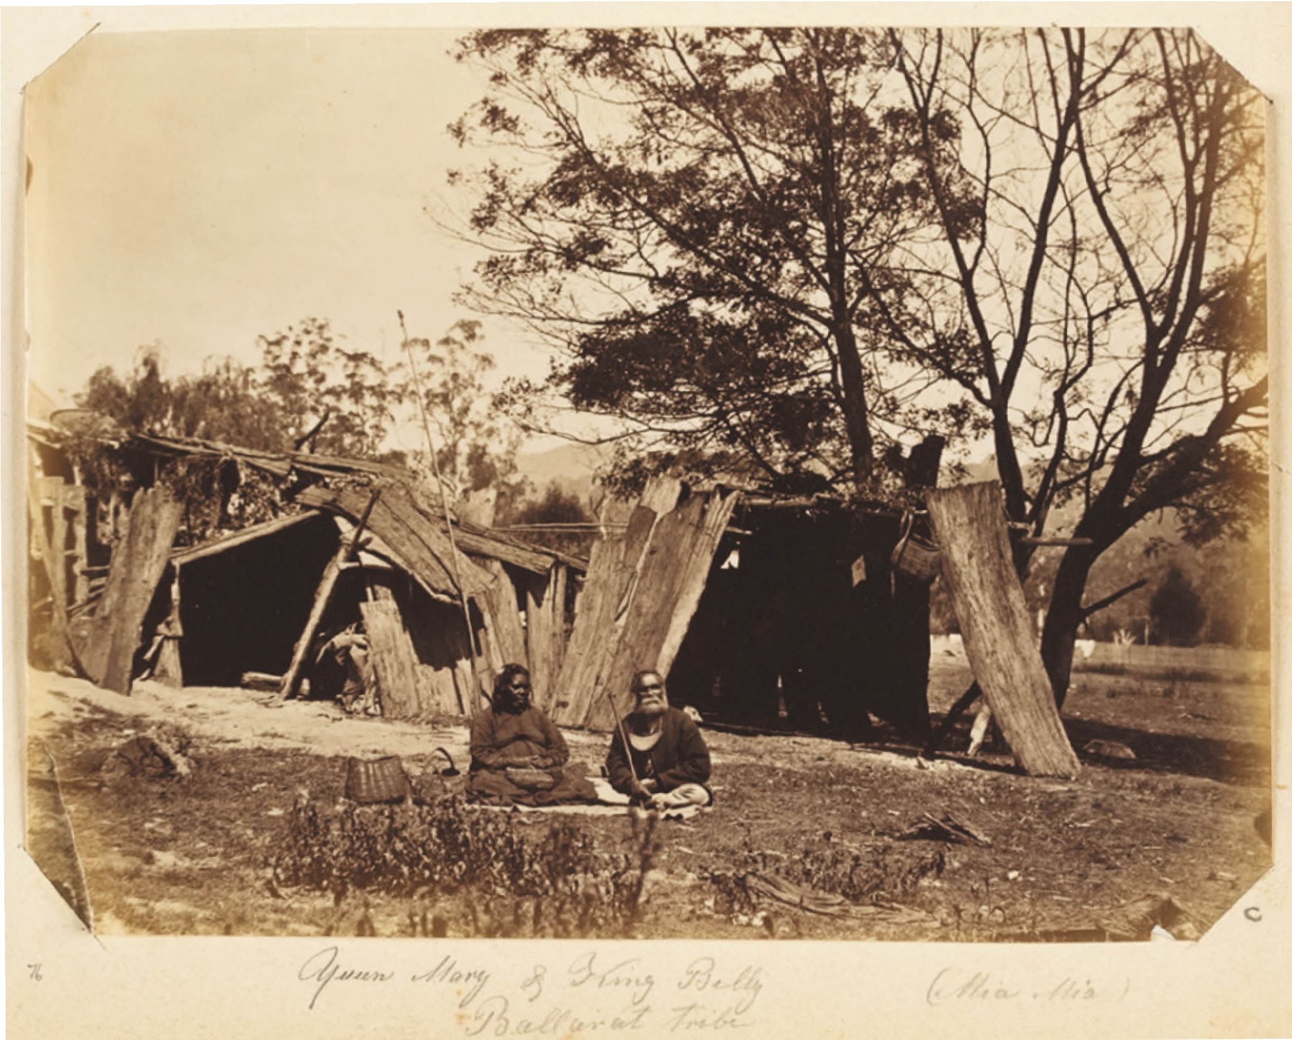
Figure 2.35: Queen Mary and King Billy outside their mia mia, 1878. Source: accession no. H41139/76, State Library of Victoria.

MABO DECISION: LEGAL RECOGNITION OF NATIVE TITLE
On 20 May 1982, Eddie Koiki Mabo, Sam Passi, David Passi, Celuia Mapo Salee and James Rice commenced a legal claim for owners of their lands on the island of Mer in the Torres Strait between Australia and Papua New Guinea.321 While the Supreme Court of Queensland was considering the facts of the case (as a requirement of the High Court of Australia), the Queensland State Parliament passed the Torres Strait Islands Coastal Islands Act which declared that Any rights that Torres Strait Islanders had to land after the claim of sovereignty in 1879 is hereby extinguished without compensation. 322 This
legislation was challenged in the High Court (the decision being known as Mabo 1) in that the newly-created Act was in conflict with the Commonwealth Racial Discrimination Act of 1975 and was therefore not valid.323
On 3 June 1993, 10 years after the case opened, the Mabo No. 2 decision was laid down by the High Court. By this time, Celuia Mapo Salee and Eddie Mabo had died.324 It was found that the Meriam people had traditional ownership of their land and that British possession had not eliminated their title and that the Meriam people are entitled as against the whole world to possession, occupation, use and enjoyment of the lands
of the Murray Islands. 325 The British claim of terra nullius in 1788 had been overturned326 and the most significant marker in Australian European history of Indigenous land rights had been legally recognised.327

NATIVE TITLE ACT & INDIGENOUS LAND CORPORATION
In 1993, the Commonwealth Parliament passed the Native Title Act which enabled Indigenous people throughout Australia to claim traditional rights to un-alienated land. 328 Simultaneously, a Land Fund (later named the Land Account) was established ‘to provide some land justice for the many Indigenous Australians who were unlikely to benefit’ from the Native
Title Act.329 The Land Account was to be managed by a new entity: the Indigenous Land Corporation (ILC).330 Its legislated purposes were two-fold: to acquire properties for Indigenous Australians on the open market and within a reasonable time grant title to Indigenous corporations, and to assist in managing Indigenous held land across Australia, however it was acquired. 331 In 1995, the Land Fund and ILC commenced.332
In May 1996, the ILC tabled in Parliament its foundation document. Following consultation with Indigenous communities, agencies and organisations, this document:
… focused on the acquisition of culturally significant land: while commercial or economic aspect of a land purchase proposal are considered important, the key criterion
for acquisition of land by the ILC should be the cultural significance of the land.’333
Proof of continuing association with the land in question by Indigenous peoples formed another basis of acquisition of land of cultural significance.334 However, this overlooked the
dispossession of Indigenous people from the onset of European settlement and their forced relocation.335 The term cultural significance’ was subsequently redefined to overcome this short-coming to be more inclusive of the different land needs
of the dispossessed Traditional Owners across the country.336 As outlined in the first National Indigenous Land Strategy in the ILC Annual Report of 1995- 96, a distinction was made between traditional, historical and contemporary significance:
For example, a parcel of undeveloped land in a densely- settled coastal region may have traditional values (the descendants) of the prior owners continue to identify with the land); historical values (three or four generations of displaced Indigenous people may have used the land and developed an association with it in that way); and contemporary value (as, for example, the last remaining pocket of comparable land in a closely settled area which is likely to be available on the open property market in the foreseeable future).337

The ILC acquired land not for individual Indigenous land owners but Title was granted to corporations representing Traditional Owners with inter-generational ties to particular land based in Indigenous tradition. 338 On 17 August 2006, the ILC purchased 368.894 hectares at Wurdi Youang and transferred Title to the Wathaurong Aboriginal Co-operative339 (this being prior to the appointment of Wadawurrung as the Registered Aboriginal Party in 2009). The land included the Wurdi
Youang stone arrangement, a highly significant and enduring purpose-built structure of the Wadawurrung in Greater Geelong (see Theme 8 for further details). Work by the Wathaurong Aboriginal Co-operative at Wurdi Youang was outlined in the Wurdi Youang Business Plan Summary in 2017:
Since 2013, Wathaurong Aboriginal Co-operative has managed a team of rangers to conduct eco-cultural works within high biodiversity areas at Wurdi Youang. Ongoing works and activities include enhancing endangered native grassland ecosystems, re-establishing Aboriginal Agri-Culture and management practices including
weeyn (fire), and undertaking pest animal and weed control, re-vegetation, propagation and native grass seed harvesting.340
At Wurdi Youang, the Wathaurong Aboriginal Co-operative also hosted research, cultural site tours, cultural awareness
training, reconstruction of cultural sites, coordination of cultural festivals and events and the facilitation of conservation and land management training.341

IMMIGRATION TO GREATER GEELONG: 19TH CENTURY
Since the arrival of European immigrants to Point Henry from 1835 and 1836, the Greater Geelong area has experienced an influx of immigrants from different parts of the world, bringing with them their cultures, religions and experiences which have helped to shape the municipality to the present day.

IMMIGRATION BARRACKS
In the late 1830s, while recent arrivals themselves, those Europeans resident in Geelong that had taken up land or had established a business here no longer regarded themselves as immigrants. In 1840, the NSW Governor,
Major Sir George Gipps, had ratified regulations for ‘the further encouragement of the introduction into the Colony of useful and respectable agricultural laborers, and mechanics from the United Kingdom. 342 In particular, immigrants of the following description was the focus of the scheme: agricultural labourers, shepherds, carpenters, blacksmiths, wheelwrights,
bricklayers, masons and female domestic and farm servants.343 In Geelong, a scheme was established as early as 1841
with the intention of importing a thousand families into this district direct. 344
Ships were procured to provide passage for the new arrivals, which in turn led to the need for temporary living quarters until they were billeted to their sponsored employers or
until they found alternative accommodation. In January 1842, Superintendent Charles La Trobe gave orders for the erection of huts at Geelong for the reception of a number
of the immigrants at present unemployed in Melbourne. 345 To accommodate thirty families, the immigrant males were employed on the built of the jetty and breakwater at the Geelong waterfront (see Theme 3).346
By 1848, the large influx of immigrants necessitated the construction of temporary barracks (Figure 2.36). It was described as a wooden moveable house , the size being ‘sufficiently large to make it both a spacious and comfortable dwelling for as many immigrants as are likely to be forwarded here at one time , measuring 36 feet by 22 feet.347 Land
was set aside on a gentle rising ground, a little beyond the cricketers’ fenced-in land [Theme 9], a spot that was used as a quamby ground by the natives, some four or five years
back. 348 This comprised the block of land on the north side of Ryrie Street, west of Swanston Street (see Figure 6.18). John Patterson was Acting Immigration Agent of the new facility.349 The Geelong Advertiser reported on two of the earliest families to occupy the immigrant dwelling in December 1848:
At the present time the inmates of this building consist of two families, one a labourer with a wife and five children, the other a lace maker (recently from France), with a wife and 5 children, another child belonging to him being in employment.350
By August 1849, the large influx of immigrations necessitated the need for additional accommodation.
The Geelong Advertiser gave an insight into the proposal:
tenders are invited for the erection of additional barracks, for the accommodation of immigrants. The site for the new building is to be near the present barracks, eastward of the town. The building is to be composed of bricks, with stone foundation, its depth to be 36 feet, by 19 feet in the clear; the height to the tie-beam 9 feet, and the number of sleeping berths 52. There is, however, no provision made to keep the single from the married. It is
proposed to separate them by keeping the males in the old barracks, and the females in the new. Another proposal
is to place the orphan girls, expected almost daily into this port, in the present building, and the other emigrants in the new. We suppose it is not yet finally arranged how the distinction is to be made. A proper regard no doubt will be had to keeping the single men and females in distinct
apartments, and these again from the married. Convenient outbuildings are to be attached to the barracks, and such accommodation afforded, as cleanliness, and the property observances of decent
life require.351
Most likely designed by Henry Ginn, Clerk of Works of the Public Works Office, Melbourne, tenders were called for the construction of the contextually substantial two storey gabled building (Figure 2.37) in August 1849.352 Bunk apartments were arranged either side of a central passage, there by a closet in one corner on the ground floor. Also constructed was a single storey wash house and office in 1850353 (Figure 2.38).
By May 1853, the barracks (Figure 2.39) had been
quite empty for many weeks , a consequence of the Victorian goldrush and the comparatively moderate rental obtainable for dwelling houses in Geelong at this time.354 In 1865, the Immigration Barracks was the location of the Industrial School (see Theme 8) and in 1881 the buildings were demolished the site subdivided into housing allotments.355

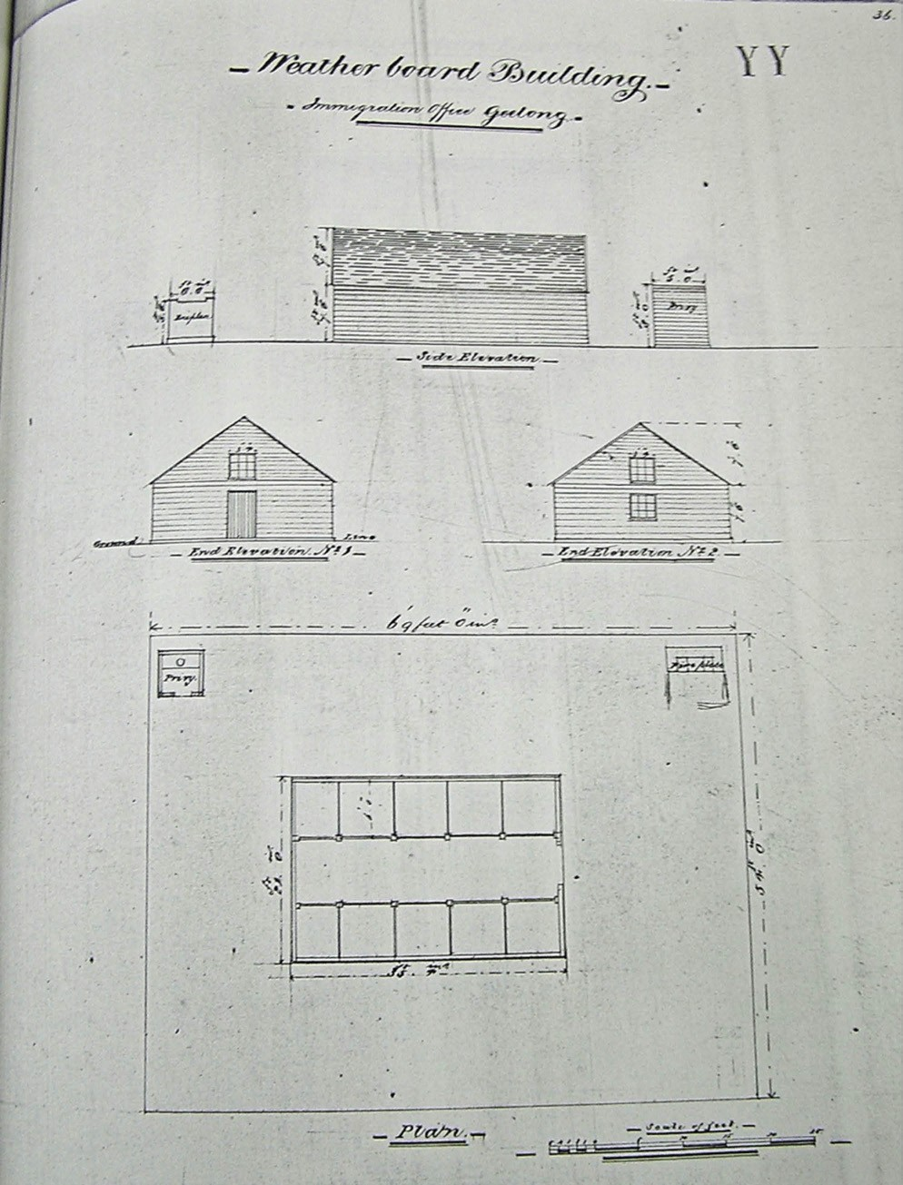
Figure 2.36: ‘Weatherboard Building – Immigration Office Geelong’, c.1850. Source: Book of Plans by Clerk of Works, Henry Ginn, VPRS 4107/P1 Unit 1, Public Record Office Victoria.

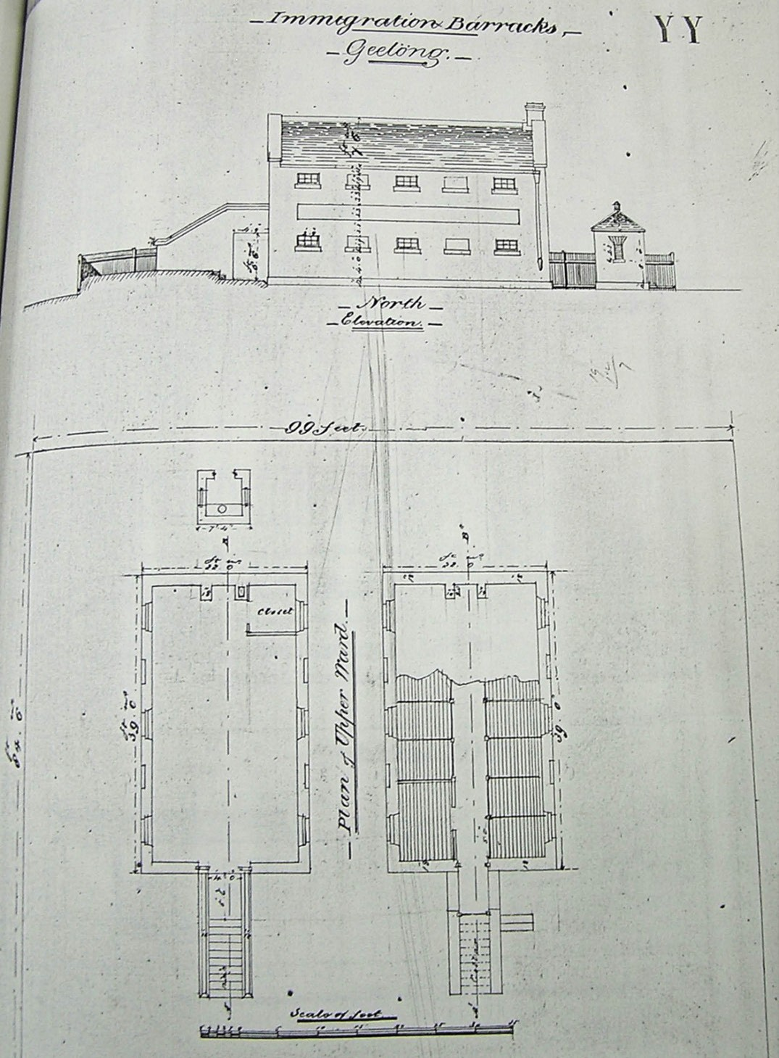

Figure 2.37: Immigration Barracks, Geelong , c.1850. Source: Book of Plans by Clerk of Works, Henry Ginn, VPRS 4107/P1 Unit 1, Public Record Office Victoria.

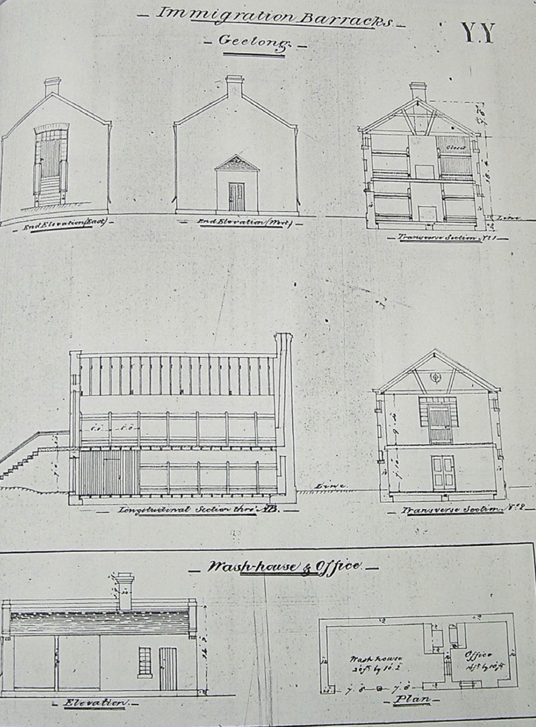

Figure 2.38: ‘Immigration Barracks, Geelong & Wash -house & Office’, c.1850. Source: Book of Plans by Clerk of Works, Henry Ginn, VPRS 4107/ P1 Unit 1, Public Record Office Victoria.

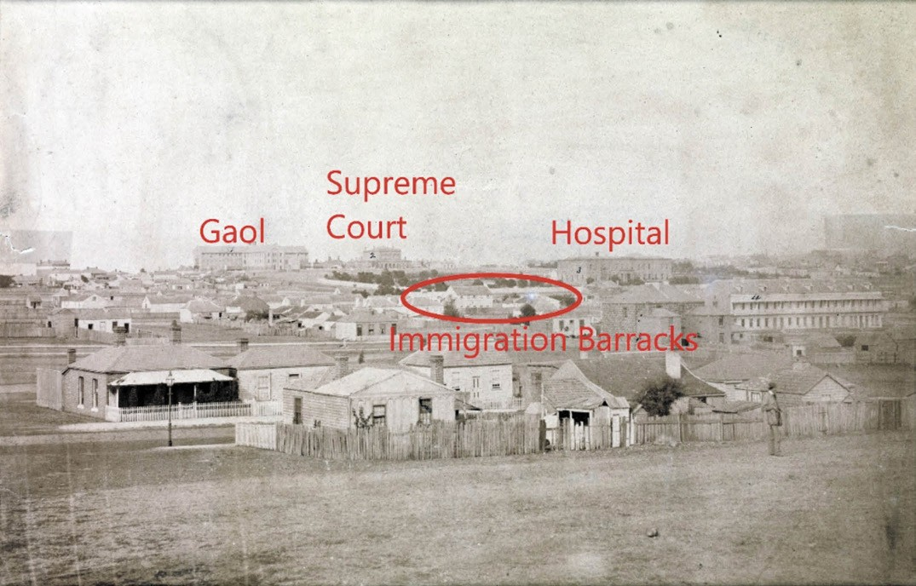
Figure 2.39: Immigration Barracks (circled) look south near north end of Fitzroy Street, c.1861. Also note the locations of the Geelong Gaol and Supreme Court in Myers Street (Theme 7) and the Geelong Hospital (Theme 8). Source: accession H2170, State Library of Victoria.

ARRIVAL OF THE SWISS VIGNERONS
Following the Napoleonic wars between 1807-1814
(where Neuchatelois men fought with great distinction ) and poor crops caused by economic crisis, Swiss vignerons looks to other parts of the world for a better life.356 In 1842, just seven years after British squatters initially set foot on the soil of Greater Geelong, the Geelong Advertiser reported on the arrival of the first group of Swiss immigrants to Geelong:
By the Platina, several Swiss gentlemen have arrived in the province with the intention of turning their attention to the culture of the vine, with the management of which, and the manufacture of wine, they are well acquainted. These gentlemen have brought out with them a large quantity of
vine cuttings of the different varieties cultivated in France.357

Two of the first arrivals were David Louis Pettavel (1817-1871) Frederic Breguet (1813-1872). They leased 25 acres from William Clark Haines and John Highett and planted the first vines in their Neuchatel Vineyard at Pollocksford (in the Surf Coast Shire).358 This became the first vineyard in Victoria.359 Four years later in 1846, their vines had matured to the
anticipated successful yield being described in the Geelong Advertiser and Squatters Advocate:
The Swiss Vineyard at Neufchatel, Pollock s Ford, is now in a high state of luxuriance. There are upwards of 20,000 vines in vigorous health, the most of which (although none of them more than 3-year-old plants) are bearing heavy clusters of grapes; many of them being expected to yield as much as 20lbs weight. About four tons of grapes will be produced, and the manufacture of wine will be immediately commenced.360
David Louis Pettavel (1817-1871) was born at Boudry in the Canton of Neuchatel. He brought with him cuttings of vines of the Sweetwater variety from Switzerland which were planted with the cuttings of Black Burgundy and Le Meunier that Frederick Breguet had brought from Dijon, France.361 These plantings were supplemented with cuttings from Superintendent Charles La Trobe (whose wife, Sophie was Swiss).362 In 1847, Pettavel married Esther Keanan.363 By 1848, Pettavel and Breguet had dissolved their partnership and David Pettavel established the Victoria Vineyard on 300 acres at Waurn Ponds (now 75 Kingsbury Lane)364 (see Figure

4.55-56). With a substantial stone cellar below his homestead (see Theme 6), this vineyard became highly successful and well-known.365 Such was the success of the Victoria Vineyard that Pettavel established a second property, the Prince Albert Vineyard in 1857.366 He placed his nephew, Charles Tetaz, in charge of this new establishment.367 Tetaz had arrived in 1856 with his family and Pettavel, who had returned to Switzerland to bring out members of his family given the shortage of labour exacerbated by the Victorian gold rushes.368
Other members of Pettavel s family circle that were also to become vignerons in the Barrabool Hills included
Frederick Guillaum Barbier (c.1827-1874) and Charles Marendaz (1847-1926).369 By 1864, Pettavel had induced 25 Swiss vignerons to come to the Ceres and Batesford districts, with
19 engaged in working the vines.370 These and others to have arrived included Friedrich Dietrich (1843-1929) to Batesford, Charles Frederick Maurer (1824-1891) to Highton; Charles Alfred Maurer (1845-1914) to Lara,371 Abram Tribolet (c.1828- 1909) to Waurn Ponds and Rudolph Tribolet (c.1834-1914) to Waurn Ponds.372
In 1870, Pettavel hosted a visit of the Duke of Edinburgh to his Prince Albert vineyard where the Duke tasted and approved of some of the district grown wine. 373 Pettavel s commitment to community life included his membership of the Agricultural Society and Vinegrowers Association, and to philanthropic causes.374 Pettavel died on 23 June 1871.375
Pettavel s pioneer business partner, Frederick Breguet, continued the Neuchatel vineyard (outside the City of Greater Geelong). He also established several extensive vineyards at Ceres and near Belmont. 376
Berramongo Vineyard off Crooks Road (near Dewings Ford
on the Barwon River) was also established in 1842 by brothers Jean and Alexandre Belperroud of Cornaux, Switzerland.377 Following some years of failing health, Breguet died on 22 August 1872.378
Several other Swiss families emigrated to the Batesford,
Fyansford and Barrabool Hills districts from the
mid-19th century. They included Jean Francois Amiet (c.1823- 1893) and family (who settled at Batesford), and Victor F. Cornu (c.1831-1866) (who settled at Fyansford).379 In 1862, Amiet and Cornu organised a wine competition with a fish repast as a means of providing a social occasion for their fellow Swiss compatriots, as well as highlight the quality of wine grown locally. As published by Cornu in a letter to the editor in the Geelong Advertiser:

Sir, - I consider my place here like my place at home in the old country Corcelles in Switzerland. It is three miles from town, which is equal to the distance in Neuchatel to the town where I sold my wine in the old country to most of the respectable merchants, and to such a class of merchants

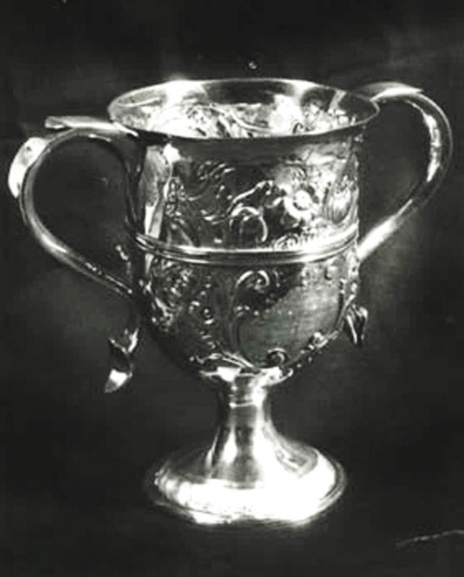
Figure 2.40: Cup presented by T.A. Siddlers to Abram Tribolet, 7 April 1863. Source: GRS 7352/0 Geelong Heritage Centre collection.

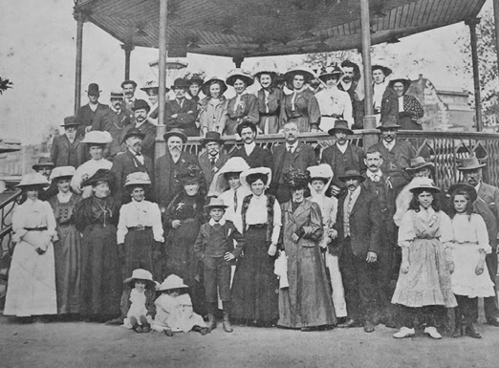
Figure 2.41: Geelong and District Swiss Society Picnic at Torquay, 1909. Source: News of the Week, 25 March 1909, p.26, GRS 2121, Geelong Heritage Centre collection.

and gentlemen as I now transact my business with in this new country.
I invite all my dear Swiss countrymen, next Saturday, to a fish repast at 1 p.m., in Mr Amiet’s Swiss boarding-house, such repast to be cooked in wine, same as we have been accustomed to in our old dear Swiss country.
My object now is not for money, but solely for competition, and to bring samples to prove to the satisfaction of all friends willing to compete, whose wine will make the best repast, such as we have seen in our old country.380
Cornu’s fish repast was a precursor to several colonial and local wine competitions. In 1862, the Victorian Board of Agriculture held a competitive exhibition of colonial wines. Prizes were awarded to Geelong growers at this inaugural event.381 The following year in 1863, the proprietor of the Geelong Chronicle, T.A. Sidders, offered a silver cup to
the vignerons of the Western District for the best sample of Colonial Wine of any age or description 382 (Figure 2.40). Presented at a dinner at the Wheatsheaf Hotel, Ceres, the presence of Mayor of Geelong, Alderman Hendrick, the cup was won by Abram Tribolet of Milpah , Waurn Ponds. This cup now forms part of the collection of the Geelong Heritage Centre.
In 1906, a meeting of natives of Switzerland and their descents was held at the Pension Swiss, James Street, Geelong, for
the purpose of establishing a Swiss Society. 383 Known as the Geelong and District Swiss Society, J. Deppeler was elected presented and E. Witnaeur secretary and treasurer. Potential membership initially included up to 42 names.384 A regular event was the annual picnic which was held at Torquay in 1909 with a large attendance, including Swiss residents of Melbourne and the Consul for Switzerland385 (Figure 2.41).

GERMAN IMMIGRANTS 19TH CENTURY
In 1849, the successful Melbourne businessman,
William Westgarth, led the establishment of the German Immigration Committee.386 Dr Alexander Thomson and a
Mr Hope led a local branch of the Committee.387 Journeys were organised with the shipping firm of J.C. Godeffroy and Son, of Hamburg, Germany, and emigration agent, Eduard Delius, of Bremen.388 On 19 December 1849, the Emmy arrived at Port Phillip with German immigrants destined for the agricultural area south of the Waurn Ponds Creek that soon became known as Germantown (see Figure 6.194). As outlined in The Argus:
The Government Immigration Board visited the Emmy yesterday, for the purpose of inspecting the vine-dressers, consisting of ten families, numbering thirty-seven

individuals, who had been imported by Dr. Thomson, of Geelong, under the regulations promulgated by the colonial government about two years ago. The immigrants will be landed to-day and lodged in the Immigration Barracks,
but they will not be open for engagement until Monday morning. The Committee have engaged the services of a Secretary, who speaks both German and English, for the purpose of facilitating the engagement of the immigrants, most of whom are unable to speak any language but the German.389
With none of the newly-arrived Germans able to speak English, Dr Thomson communicated with them through a Mr Linden. He had been born in Plymouth, England, but educated in Hamburg, Germany.390 One of the new arrivals
was a regularly bred gardener and vintager and also a good botanist who took a walk around Geelong with a local who spoke fluent German.391 He was particularly astonished with the country and:
spoke of the land about Kardinia and all the way to Fisher s property in the Barrabool Hills as suitable for vineyards, particularly the barren looking hill where the ferns grow fronting the riverlet between the lime kilns and Fisher s. 392
With much of the land nearby the Geelong township already selected by the time of the arrival of the Germans, Charles John Dennys instigated his own personal assistance program. He appears to have offered employment to some at his tallow works on the Barwon River at Breakwater (see Theme 6).
Equally importantly, he subdivided his land (comprising Section 19 in the Parish of Duneed) on the Waurn Chains of Ponds
into 1-10 acres and offered it for sale or lease (Figure 6.192). He built a dam across the creek and lessees were to be granted the privilege of obtaining manure from the tallow works. 393 It was there where several of the German arrivals established vineyards until the devastation of the phylloxera vastrix disease spread through Geelong in the 1870s, where some turned to orchards and vegetable gardening (see Theme 4).

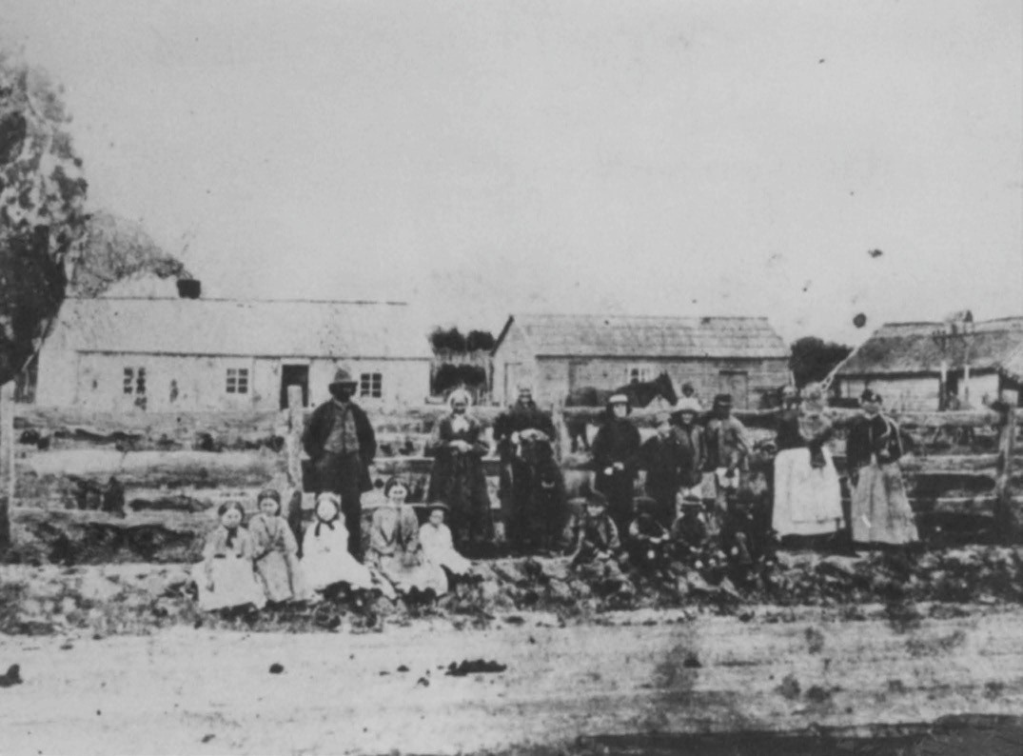
Figure 2.42: Germans at Germantown, c.1871. Left to right: Samuel Andrieski, Elizabeth Beiske, Ann Elizabeth Andrieske, Gottlieb John Andrieske, Wilhelm, and Rosina holding Emma. Girls in front: Louisa, Anna, Elenora. Boys in front: Heinrich (Harry), August, Charles. Source: L. Phelan (ed.), The Geelong Germans: A Record of some 19th Century Families, cover image.

Some of the German immigrants that took up land at Grovedale including Samuel Andrieske (c1818-1898), Gottlieb John Goldbach (1822-1887), Wilhelm Goldbach (1844-1913), Heinrich
Kosseck (1834-1925), Wilhelm Robert Lemke (1821-1893), Johann Gottlieb Pacholke (c.1836-1885), Christoph Petrass (1806-1885), Julius Heinrich Rau (1839-1897), Johann Michael Rossack (1831-1910), Friedrich Schulz (1825-1906), Johann Georg Winter (1807-1861) and his son, Heinrich Wilhelm Winter (1840-1936)394 (Figure 2.42). These and other names were shown on Samuel Bonney s Plan showing the Vineyards of Geelong and District in 1879 (Figure 4.51).
One of the vineyards shown on Bonney s Plan was the property of the Winter family which still exists at 197 Francis Street, Belmont, near the northern portion of Grovedale. The property was first taken up in 1854 by Johann Winter, one of the original immigrants who arrived on the Emmy in December 1849.395 After working as a market gardener at Cowies Creek and then trying his luck on the Victorian goldfields, Winter established
a stone cellar in Francis Street.396 It was operated by his son, Heinrich William Winter, for many years.397 The existing timber dwelling is a physical legacy of Heinrich s associations with the property (see Figure 4.67).
Further evidence of Germanic associations in the Grovedale area is the German Settler s Cottage at 224 Torquay Road (Figure 4.66). It was built in c.1857 for John Sohr.398 He was recorded as a farmer in 1857, owner of two houses and a farm on 22 acres. He was listed alongside Christian Sohr (c.1816- 1875) and Wilhelm Sohr (1813-1897) (possibly John Sohr s brothers) who were also recorded as farmers with houses and gardens in Grovedale. 399

The Grovedale Public Cemetery, Church Street, was the location of the original mud brick Lutheran Church built in 1854400 (see Themes 6 & 8). It has operated as a public
cemetery since 1861, with some of the earliest graves at that time of locals of Germanic heritage including Johan Gottfried Bohm and Johann Georg Winter.401 At 301 Torquay Road,
is St. Paul s Lutheran Church, established by Lutherans of German descent in the 19th century (see Theme 8).402 Situated at the corner with Heyers Road, this thoroughfare was named after the Rev. George Heyer, long-serving pastor of St. Paul s from 1868 until 1920.403 On his death in 1921, the Ballarat Star gave the following obituary:
Many residents of Ballarat will regret to learn of the death, which occurred suddenly at Kew, of the Rev. George Heyer, evangelical Lutheran minister. The deceased for nearly half-a-century divided his ministrations between the Lutheran Church at Germantown (the name of which was changed during, the war to Grovetown [sic.]), near Geelong, where he resided, and the church in Doveton street south, Ballarat, where he had at one time a large
congregation, including many prosperous German citizens, whose names will be readily recalled. The Rev. G. Heyer came to Australia from Alsace-Lorraine (which was ceded to Germany as a result of the Franco-Prussian war, in 1871, but was restored to France after the recent great war).
He was thus actually a native of the latter country, having been born in Alsace 77 years ago.404
Other German arrivals also settled at Ceres and the Barrabool Hills where they too established vineyards. They included Frederick Bernard (Bernard) and Gustav Alywin (Alwin) Seidel, Joseph Helms, Bernhardt Straubel, Richard Oberlander, Richard Taaft, Friederich Ferdinand (Frederick) and Carl Theodore Kawerau and Friedrich Bauer.405 Notable amongst this group were the Seidel brothers, Bernard (1817-1903) and (Gustav) Alwin (1822-1910)406 (see Theme 4).
Frederick Ferdinand Kawerau (1818-1876) spent little time tending vineyards in the outer Geelong area. Trained as an architect at the Royal Academy, Berlin, he arrived in Melbourne in 1849 on the Dockenhuden with his wife, Maria (Marie) and brother, Carl Theodore Kawerau.407 It would appear that the Kaweraus had been induced to emigrate to Victoria following
a visit to Germany by William Westgarth who had rendered considerable assistance to German immigrants as part of the German Immigration Committee.408 With Frederick as an architect and his brother, Carl, an accountant,409 they appear to have formed part of a targeted selection of immigrants as reported in the Sydney Morning Herald:
The Dockenhuden left Hamburg on the 4th November [1848], was three weeks in the Elbe, twelve days in the channel, and put into Rio de Janeiro on the 5th February

for water and provisions, and sailed again on the 16th. The immigrants are a very respectable class, having nearly all paid their own passages. They consist of farm overseers, architects, joiners, carpenters, &c.410
Following his arrival, Frederick Kawerau began marketing himself as an architect. He featured in The Argus in August of that year:
A German gentleman of the name of Kawerau (pronounced Carvero) by anybody wishing to be successful in finding him, has left at our office some plans and drawings of buildings erected by him in Hamburg and elsewhere.
We wish to call public attention to them as indicative of very considerable taste and ability. Having lately arrived in one of the German vessels, he is anxious to practice his
profession in this district, and as his talents appear equally to embrace the simplicity of a Pyramid, and the elaboration of an Alhambra, and he speaks of being perfectly capable of undertaking any building from a dog-kennel to a tower of Babel, we wish to draw the attention of intending builders to his claims for support, and feel convinced that he ought to procure as much employment as he could possibly stagger along under, in a place in which buildings are progressing with such rapidity as in Melbourne.411
In 1850, Kawerau was naturalised in order to become a British subject and therefore qualify to own land.412 Following his successful application, he purchased land in the German settlement of Westgarthtown (originally known as Neu Mecklenburg and now part of Thomastown, Melbourne).413 Frederick, Marie and Carl Kawerau appear to have abandoned Westgarthtown for Geelong, arriving in c.1850 where Frederick either acquired or built a complete Villa residence at the top of the hill, above Messrs. Manifold’s Vineyards [Herne Hill], having a delightful view of the Town and Bay. 414 He advertised the property for sale in 1851 and with Marie and Carl, when
to the Ballarat goldfields.415 While Carl remained there,416 Frederick and Marie returned to Geelong where Frederick commenced practice as an architect in 1852.417 It is from his architectural work that his enduring legacy survives in some of the earliest buildings in Geelong. On 1 January 1853,
he went into partnership with the engineer and surveyor from Devon, England, Edward Snell (1820-1880), with Snell having described Kawerau as ‘very clever and a jolly good fellow .418 Examples of their work in 1853 and 1854 included
the Terminus Hotel, 96 Mercer Street, Geelong; T.C. Harwood s brick cottage , Hawthorn , at 35 Skene Street, Newtown, and the St. Giles Presbyterian schoolmasters house and school house, 72-80 Gheringhap Street, Geelong, all of which are extant today.419 Snell and Kawerau were also involved with
the building of the Geelong to Melbourne Railway line for the Geelong and Melbourne Railway Company, with Snell as
engineer and Kawerau as the company s principal architect.420

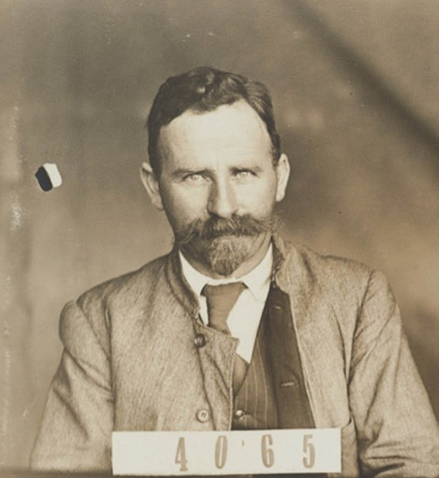
Figure 2.43: Laurell Messy-Rhine, c.1914-21. Source: NAA: D3597, 4065 National Archives of Australia.

A surviving architectural legacy of their associations with the construction of the railway line is the Werribee Railway Station, completed in 1857.421 The partnership of Snell and Kawerau ended in 1854 when Kawerau intended to return to Germany for health reasons, which never eventuated.422 The dissolution of the architectural partnership resulted in arbitration to settled financial affairs.423 In May 1856, Kawerau was appointed
Clerk of Works and Draftsman with the Victorian Public Works Department, rising to District Clerk of Works and Draftsman
in 1861.424 He took a 12 month leave of absence in 1867 and returned in late 1868.425 By 1875, Kawerau had returned to Berlin, Germany, as his wife, Marie, died there in September of that year.426 Kawerau died in Berlin in 1876.427

IMMIGRATION TO GREATER GEELONG: EARLY 20TH CENTURY

GERMAN ASSOCIATIONS WITH THE AUSTRALIAN PORTLAND CEMENT COMPANY
The death in 1908 of the founder of the Australian Portland Cement Company, Peter McCann, brought about significant change to one of Geelong s most successful manufacturing companies at Fyansford.428 Making a profit had become challenging as the old plant had become obsolete.429 In 1911 in an effort to inject additional capital into the business, Traugott Noske (1866-1948) led a group of businessmen in a takeover of the company.430 He was born at Mount Rouse, Victoria, the son of German parents, Johann Traugott Noske (1834-1923) and Johanne Auguste Lehmann (1834-1918).431 J.T. Traugott senior had emigrated from Prussia in 1852 (and was naturalised
in 1855).432 and had established a flour milling business at Horsham in 1900. T.J. Traugott junior had been a wheat farmer in Dimboola prior to his appointment as Chairman of Directors of the Australian Portland Cement Company at Fyansford.433 Another Director of the eight-member Board, Wilhelm Heinrich Nichterlein (1871-1952), was also of German descent.434 Born at Mount Gambier, South Australia, he was the son of Prussian- born farmer, Ludwig S. Nichterlein, a farmer of Natimuk.435
An accountant, in 1903 Nichterlein entered into partnership with J.T. Noske senior and W.A. Gunn in the purchase of the Warracknabeal Flour Mill.436
The new Board of Directors immediately set to work on new plant and equipment at the Cement Works, Fyansford. This included an aerial rope-way (to bring the raw material to the works) and new rotary kilns.437 To achieve this, plans for duplicating the Fyansford plant were sent to the world-
renowned German steel factory, Frederich Krupp Gruonwerk, AG, where machinery of the type required could only be obtained (see Theme 4 for further details).438 The Australian Portland Cement company had also sought the best man from Krupps to be sent out to Fyansford as chemist.439 This was Friederich Pflaum, son of the Director ‘of the largest cement works in Germany.440 Just 30 years of age, Pflaum ‘had gone through the universities, and had been connected with some of the largest manufactories abroad. 441 Pflaum was to become a shareholder in the Australian Portland Cement Company.442
Also engaged by the Australian Portland Cement Company in 1911 was Laurell Messy-Rhine (1875-1941), a German engineer (Figure 2.43). He had emigrated to Australia in 1910, having been born at Frankfurt- on- Main, Germany, where he studied Civil Engineering.443 From 1899, Messy-Rhine worked in England, Paris, Germany and the United States of America
as a Civil Engineer and had considerable experience in the latest in reinforced concrete construction.444 According to Don

Watson in Starting a structural revolution , Messy-Rhine s use of the name, Rhine , may be nationalistic, seeking to identify himself with the growing supremacy of German engineering. 445 In addition to bringing the latest engineering trends in the construction of the reinforced concrete factory at Fyansford, Messy-Rhine contributed substantially to public discourse on town planning. In 1912, he prepared schemes for residential subdivisions at Herne Hill and a more ambitious scheme for Greater Geelong which was subtitled by the News of the
Week as A Forecast of the Development of Greater Geelong By a Town Planner Who Has Faith in its Future (see Theme
6). While only in Geelong for two years, a legacy of Messy- Rhine s associations with the area is the Rhineland Estate in Newtown, a small residential development he established with
T.J. Noske in 1911-12 (see Theme 6 for further details).

EFFECTS OF WORLD WAR ONE ON THE GERMAN COMMUNITY IN GREATER GEELONG
The onset of World War One in 1914 brought about dramatic consequences for German immigrants living in the Greater Geelong Area. The Commonwealth Government introduced the War Precautions Act 1914 (amended in 1915, 1916 & 1918), expanding the Government s power to meet war time security precautions.446 Virtually overnight, German immigrants and German-Australians (those born in Geelong and other parts of the country) were prevented from leaving Australia or communicating with Germans (including family) or sending money overseas. Known as enemy aliens , the Act required
German-Australians to reside and remain within certain places or districts (and therefore change address if required).447
This was because Germany, Austria and Hungary were at war with Britain and its Empire (and therefore Australia).448 Failing to comply with regulations brought about a £100 fine or six month s imprisonment, or both.449 Imprisonment included being sent to an internment camp, initially at Langwarrin on the Mornington Peninsula between 1914 and 1915, and after that to the camp at Holsworthy, New South Wales.450 One local sent to Langwarrin in 1915 was Otto Sturmhoebel of Geelong West. As reported in the Geelong Advertiser:
Under the provisions of the War Precautions Act the Geelong West police yesterday apprehended a German named Otto Emil Alexander Sturmhoebel, a resident of Autumn-street, Geelong West, who is alleged to have attempted to send a letter to Germany. He was handed over to the military authorities in Geelong, and an escort was furnished for his prompt removal to the internment camp at Langawarria [sic., Langwarrin]. Sturmhoebel was until some months ago engaged by a Geelong firm in the manufacture of patent gates, which were marked with one of his Christian names. He has been out of employment for some months, and has been a keen student of the

developments of the war. It is stated that when the police suggested to his dependents yesterday that they should get aid from the Government, he expressed strong dissent, and said the German residents would see that all necessary sustenance was provided.451
In the ensuing years, as propaganda raged about the Hun German, further pressures were placed on
German-Australians. Employment became difficult to hold and find, and the high esteem previously afforded many of the German-Australians greatly diminished. Friendships fractured as retaining associations was akin to keeping friends with
the devil. 452 Exacerbating the segregation was the need for residents of German descent to be registered. This included those German-Australians not born in Australia or not naturalised, and even the children of German immigrants born in the Greater Geelong area. For example, this included H.G. Schumer, a British German born in Geelong who was required to register at his then place of residence in Fitzroy.453 Those who registered at Geelong between 1916 and 1918 included George Schulz, Elizabeth Sturmhob, Waldema Wille, Waldemar Dahse, Frank Doudert, Wilhelmina Fackler, Carl Jahns, Martha Jahns and Bulius Lange.454 Similar registrations were required during World War Two,
as regulations were introduced for enemy aliens for national security reasons.
The War Precautions Act and changed community sentiment during World War One also had an impact on board members and shareholders of German descent of the Australian Portland Cement Company, even those born in Victoria. The toasts afforded to T.J. Noske and W.H. Nichterlein in the presence
of the Premier of Victoria in 1912 at the opening of the new works at Fyansford, where Noske s courage, daring, and enterprise were celebrated,455 were replaced with outright public suspicion by early 1916.456 The Graphic of Australia ran an article on the proposed railway line from North Geelong to Fyansford for the Australian Portland Cement Company with the title Fyansford Railway. Who Is Behind It? Is Cement Co. German? 457 A Government investigation found that only one company Director, Mr Kaussmull, had been born in Germany.458 By this time, the Company was also chaired by D.H. Dureau, of Canadian descent.459
Today, the most tangible association with local community sentiment against German heritage during World War One is the name of the suburb, Grovedale. Originally known as Germantown, the named was changed to Grovedale
by the South Barwon Shire in 1915 (see Theme 6 for further details).

CHINESE, MALAY
AND INDIAN WORKERS IN GREATER GEELONG

THE EARLY YEARS
In December 1848, shortages in local labourers and an absence of authentic information upon the prospect of an extensive government emigration caused European settlers to bring to Victoria 219 Chinese, Malay and Indian workers from Singapore.460 A Mr Johnston had been engaged to travel to Singapore and return with the 123 Chinese, 81 Indians (Malabar coast), 8 Malays and 7 Indians (from different parts) by settlers including Aitcheson, Black, Chirnside, Willis and Johnstone.461 Locally, the Belperroud brothers of Berramongo vineyard
formed part of the enterprise.462 The immigrant labourers arrived on the Phillip Laing in December 1848.463 The Argus reported that many of them understand brickmaking, lime-burning, and other out of door employments , but that they made it an express condition that they not be employed in the mines.464 It seems that these immigrant labourers agreed to come to Victoria out
of desperation. As described in the Geelong Advertiser in 1848:
THE PHILLIP LAING Some particulars respecting the colored immigrants by this vessel, may be of interest to our readers. They diet somewhat differently to Europeans. In animal food they are more sparing; they
give a preference to rice, curry powder, and other tropical products. The Klings [people from the Malabar coast
of India] have been accustomed in their own country to the management of horses, cows, and sheep. It was the
intention of the party who proceeded to Singapore, to obtain a greater number of married couples, but in this object he failed, the females in Singapore, in point of number, being, as in Port Phillip, unequal to the other sex. The female
who came out has been placed in a comfortable situation as nurse. The Chinamen brought out have been laborers on sugar and nutmeg plantations. Several of them will be found on trial to be skilful in several of the arts, particularly the ordinary ones. It appears that at the last junk season (November 1847), no less than 10,000 Chinamen in a
state of extreme destitution, left their homes in junks for Singapore, in order to seek employ. So poor, indeed, were they, that parties requiring their services were compelled, before hiring them, to defray their passage-money. The prevailing practice at Singapore is to hire them for twelve months, at the expiry of which period they became again free, and by assiduity and frugality for a few years, many of

these once forlorn and houseless of our fellow-creatures amass large possessions. They have already discovered that their present apparel is unsuitable to their present clime, and their employers are providing them with warmer clothing such as pea jackets, &c.465
In February 1849, only two months after their arrival, some of the Chinese workers left the Kuruc-a-ruc Station near Cressy of George, Nairne and David Aitcheson, bringing with them loud criticism from the authorities. Further Malay labourers absconded in the following weeks, with 10 of them resident at Captain Foster Fyans residence in April of that year.466 Fyans himself was astonished of those European settlers who conceived the scheme, and especially without entering into a bond of a thousand rupees (then £100) to return them in safety.467
Notwithstanding the initial difficulties and criticisms, additional Chinese workers emigrated to Victoria in the ensuing years, largely resulting from acute labour shortages brought on
by a loss of the local population who had flocked to the Victorian goldfields. As early as April 1852, 236 Chinese emigrants arrived at Geelong on the Agnes and Elizabeth.468 By July of that year, Dalgety, Gore and Co. advertised for applications from persons desirous of obtaining Chinese Laborers. 469 One businessman who enthusiastically took up the employment of the Chinese was Alexander Fyfe. He had several Chinese workers build prefabricated timber houses using materials from Singapore. His endeavours caught the attention of the Sydney Morning Herald in early 1854:
An instance of successful energy and enterprise is presented in Mr. Alexander Fyfe, - a young Scotchman, who made some money by digging and storekeeping, and then struck out into more ambitious projects. When timber and labour were scarcest, Mr. Fyfe started off to Singapore, and brought down some cargoes of timber, and some scores of Chinese artizans. He made lots of money by the venture, both by selling part of the timber at once, and also by erecting houses with the aid of his Chinese workmen, which he sold or let.470
Physical legacies of Fyfe s prefabricated timber houses possibly built by his Chinese workmen include those at
127 Elizabeth Street and 7 Wellington Street, Geelong West, and 21 Brewongle Avenue, Hamlyn Heights (see Theme 6, including Figure 6.78).

While British businessmen and settlers capitalised on the cheap labour of the Chinese workforce, resentment of the Chinese presence in Geelong led to a public meeting being held at the Mechanics Institute in 1857. Chaired by Dr Alexander Thomson, Mayor of Geelong, the resolution of the 100 people at the meeting gave a clear indication of the poor regard bestowed the Chinese:
1st That this meeting regards the influx of so many Chinese, and fraught with the greatest danger to the social, moral, and political prospects of the colony, and is of opinion that the Legislature should immediately introduce the most vigorous measures to check any further increase of the Chinese race in Victoria.
2nd That this meeting is of opinion that the number of Chinamen at present located in the colony is dangerous to the peace and good government of the country, and believe it necessary to effect the reduction of their numbers, by enforcing such a poll-tax on all who may come hither as will induce them to prefer returning to their own country.
3rd That in the opinion of this meeting the Chinese passenger trade to this colony should be declared contraband, and after due notice all vessel engaged in the traffic shall be confiscated, and their owners or captains fine and imprisoned.
4th That a Committee of the following gentlemen:
His Worship the Mayor, Messrs. J.G. Carr, G. Wright, J.M. Main, and Charles Nantes, be appointed to prepare two petitions, one to the Upper and one to the Lower Houses of Parliament embodying the substance of the previous resolutions, and that the committee arrange for the presentation and support of the same
without delay.471
Notwithstanding the outright xenophobia towards the Chinese, they continued to be employed for European business owners.
In the 1860s, Alfred Douglas employed Chinese labourers at his Barwonside Wool Scouring works at Breakwater
(see Theme 6).472 It was also during this period when over fifty Chinese reapers were employed by J.C. Langdon, Parker and other European farmers at Indented Head and were reported as being extremely civil and particularly well conducted. 473
A small number of Chinese fishermen also settled in the Parish of Paywit, in the Portarlington and St. Leonards area in the early 1860s (see Figure 6.271). The earliest known Chinese fisherman to have settled there was Sing Chong in 1864.474
In 1891, the Land Board required all occupiers of fishermen’s residence sites be licensed. Those to successfully make application included Lee Chung and Tim Kee. 475

CHINESE MARKET GARDENS
It appears that the majority of Chinese immigrants in the Geelong area during the 19th century either established or occupied market gardens. They were situated at Breakwater (see Theme 6), along the banks of the Barwon River at South Geelong, Belmont, Marshall (Charlemont) and Newtown, Malop Street, Geelong (near Bellerine Street), Upper Autumn Street, Newtown, Aphrasia Street Newtown (west of Shannon Avenue), Geelong West and Fyansford.476 From at least 1865, the Chinese market gardeners developed a relatively sustainable occupation by supply local residents with fresh produce. Before this time, vegetables not privately grown were procured from Melbourne.477 The Geelong Advertiser was especially praiseworthy of the value of irrigation as part of cultivating what was considered useless and waste
lands.478 The method of irrigation near the Prince Albert Bridge, Newtown, was described as follows:
A long and deep trench has been cut along the higher portion, and from this trench a platform has been run into the river. At the end of this platform a drum has been erected, around which attached to a band of leather are buckets. The drum is turned by two Chinamen, and each bucket as it comes up from the river empties itself into a
channel running along the platform, and which conveys the water to the trench at the rear. When the trench overflows the water runs along small trenches by which the bank has been divided into beds. When the sun is not too powerful the water from these smaller trenches is scooped up and dashed over the beds, thus keeping them moist, and
the vegetables having thus a never failing supply thrive wonderfully throughout the year.479
In 1866, the value of the Chinese market garden was again detailed by the Geelong Advertiser. It reported on a market garden at Fyansford in December of that year:
In a great many of the large gardens it is becoming a matter of great difficulty to procure green stuff – a crisp lettuce is almost out of the question. This is totally different to what can now be seen in the Chinamen s garden, on the banks of the Barwon, at Fyansford. Here lettuces are as fresh and green as in the midst of winter; the young onions do not appear to wither, carrots and radishes, celery and other roots flourish amazingly, and all this is to be attributed to a simple but effective system of irrigation.480
By the late 19th century, the number of Chinese market gardens on the fringes of central Geelong and its suburbs appears to have diminished. In 1892, the Chinese gardens at Belmont and Marshalltown were blamed for polluting the Barwon River and for ‘objectionable smells’ emanating from the use of night soil. 481 While it was concluded that the

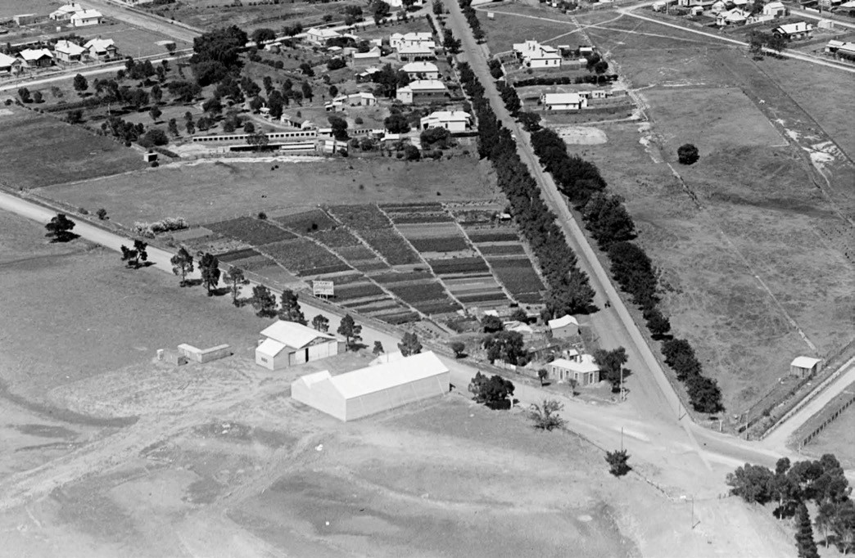
Figure 2.44: P. Pratt, Aerial view of market garden at Belmont, near junction of High Street & Barwon Heads Road, 12 January 1926. Source: accession H91.160/1374, State Library of Victoria.

pollution (including dead fish in the river) and smells was ‘more pronounced close to the tanneries,482 this did not prevent further pressures on the viability of the gardens, based in part by low community sentiment of the Chinese in the social order of the Geelong area. The nexus between being regarded as social outcasts and the highly valued commodity of the local produce provided by the Chinese to the Geelong community was notable. This was succinctly concluded by William
Irwin in 1897 who declared that ‘too often they [the Chinese] supply their goods to householders whose consciences do not inculcate honesty when it is only a Chinaman they are dealing with. 483 The introduction of regulations, whereby licenses were required for hawking vegetables, also brought further difficulties to the local Chinese, sometimes leading to prosecutions due to ignorance and cultural segregation.484 Nevertheless, the Chinese market gardens often provided their customers with Christmas presents or as was the case in 1910, pooled together and donated to the Geelong Hospital, thereby providing a community service beyond the provision of produce.485 By early 1920, the Chinese had been ordered to remove from Geelong municipalities, their gardens as
in the case of that at Geelong West considered a veritable eyesore. 486 Some established a vegetable garden at Moolap,
while one of the very few 19th century Chinese market gardens remained in existence until 1928 (but this was not to endure). As outlined in the Geelong Advertiser:
In these days of drought conditions it is pleasing to look upon Geelong s market gardens, some of which are a credit to their proprietors. Of particular interest is that at the corner of High Street and Barwon Heads Road, Belmont [Figure 2.44], which certainly does not look as though the country
is experiencing a particularly dry period. It is interesting to recall that a Chinese garden was in existence there in 1880, a face which speaks well for the richness of the soil
and the ability of those who have tended it. Much has been said about the desirability of obtaining the property for conversion into public gardens, thus improving the entrance to Belmont. It would be admirable for that purpose if trees, lawns, and flowers would thrive as well as other growth has done there for so many years.487
In 2018, this site was a car park for a large department store, supermarket and mechanics business.

THE CHURCH AND THE CHINESE MISSION
In 1855, a meeting in Geelong was held for the purpose of taking steps for the Evangelization of the Chinese population of the western district. 488 Developed under the auspices of the Church of England, two Chinese mission agents were brought out from China to provide Christian missionary on the Victorian goldfields.489 Additional agents, the Rev. Mr. Young and Lo-Sam-Yuen were also subsequently sent to Victoria by the Geelong Association, with the Rev. Young to divide his time between Geelong and Ballarat.490 In 1857, the Geelong and Western District Chinese Evangelization Association was formed.491 With a decline in the goldfields by the late 1850s, little further is known of the Geelong and Western District Chinese Evangelization Association after 1859.492
The Presbyterian Church played a significant role in assisting the Chinese in Geelong. In 1875, the Chinese Missions of the Presbyterian Church of Victoria held a public meeting to advise on the good work being done among the Chinese. 493
It was not until 1883 when the Geelong Young Men s Christian Association (YMCA), through the exertion of a Mr Martin,
took an interest in the welfare and religious instruction of the Chinese living on the Barwon River at Geelong.494 While the Chinese had been marginalised since their arrival in 1849, social segregation increased in the 1880s, culminating in the Victorian State Government hosting a conference in 1888 on the Chinese Immigration Question. 495 Views from the public
through their municipal bodies were sought. The outcome of a public meeting at the Geelong Town Hall largely reflected the sentiment of Europeans across the State at this time.
The community meeting in Geelong resolved:
This this meeting of ratepayers of the town of Geelong, having noticed the steady influx of Chinese, and their injurious effects on the prosperity of the colony, desired to record its disapproval of the present inadequate restrictive measures, and considers that the Government should introduced early next Session a Bill increasing the poll-tax to £100, authorizing a residential-tax of £20 each per annum, and abolishing the issue or acceptance of naturalization papers in the case of Chinese.496
Only one participant at the public meeting in Geelong has been recorded as supporting the continued migration of the Chinese to Geelong. As outlined in the Geelong Advertiser, Thomas Ottoway declared that:
It was unfair to say that they would prevent the Chinese coming into Victoria. The Chinese were a creditable class of colonists. (Uproar). It was a selfish policy to say that because a Chinaman grew a cabbage or made a chair that the Chinamen should be stopped from coming into this colony. It was un-English to say that the Chinamen must

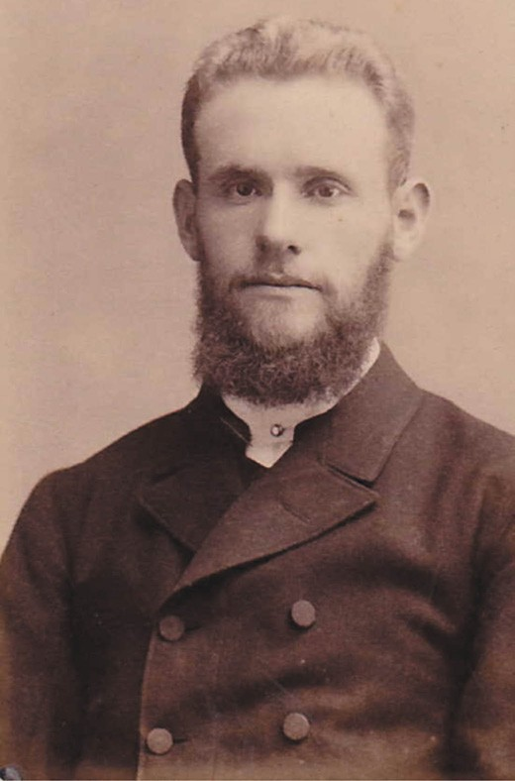

Figure 2.45: William John Irwin, n.d. Source: Faye Townley.

be prevented from coming to the colonies in the face of the demand of the Imperial authorities to be informed on what authority the poll tax had been imposed on the Chinese. (Boo-hoo).497
The negative sentiment towards the Chinese did not prevent some locals taking an interest in the spiritual welfare of this sector of the community. In 1891, the Geelong Chinese Town Mission was formed in the committee room of the YMCA building at 72 Ryrie Street in 1891.498 The progenitors of the cause were George Morison (c.1839-1918), Ann Morison (nee Vines) (1827-1916), and William John Irwin (1859-1904) and Emily Irwin (nee Aspinall) (1857-1917).499 Both couples
belonged to the Baptist Church and the temperance movement, with each of these organisations emphasising the importance of mission to the cause. George Morison had been a carpenter before becoming a sailor, rising to the position of Second Mate in 1863.500 He formed part of the crew on the Northam that arrived in Sydney in 1864.501 He was struck down by illness and turned his attention to writing books, his first being Springs

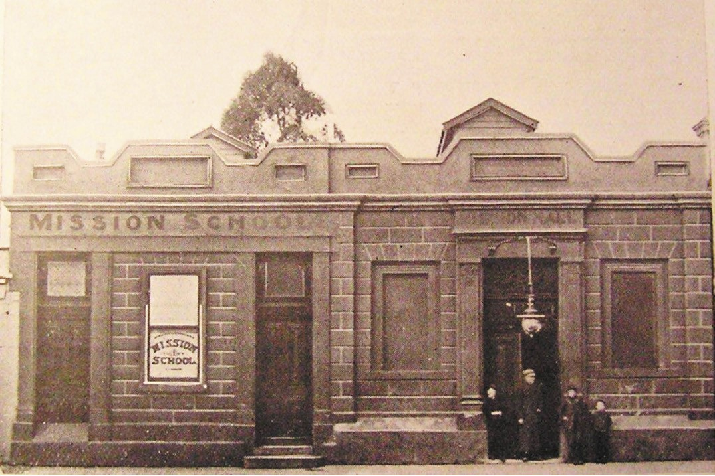

Figure 2.46: Mission School and Hall, Yarra Street, n.d. Source: 52nd Annual Report of the Geelong & Western District Ladies Benevolent Association For the Year Ending 1907, Geelong Heritage Centre collection.

in the Desert by an Hospital Patient, published in Melbourne in 1865. His second book, Devotional Readings was published in Geelong in 1869, where, under the alias, Ebenezer, he dedicated it ‘To the Inmates of the Geelong Infirmary and Benevolent Asylum, lamenting that years have elapsed since
I knew sound health, nor am I likely ever to know it again. 502 His publications were evangelical by design, emphasising his devotion to the non-conformist Christian message. By the late 1860s, he had relocated to Geelong, where, in addition
to authoring books, he became a teacher, presumably in reference to his work with the Chinese.503 He married Ann Vines in 1871 (daughter to Joshua Vines, coach proprietor).504 She conducted a home education service for two-three little girls as resident pupils at her home, Kammay Cottage, Cottage Street, where she also took in gentleman boarders in the 1870s.505
William John Irwin (Figure 2.45) was a clerk in charge of the Geelong Water Supply office and died on the job in 1904.506 In addition to conducting Sabbath evening meetings for the
Chinese Gospel Mission with his wife, Emily, he occupied the position of honorary treasurer to the Geelong auxiliary of the British and Foreign Bible Society.507 W.J. Irwin married Miss Emily Aspinal at the Woodhouse Grove Wesleyan Church, Box Hill, in 1881.508 Emily Irwin was the inaugural honorary secretary of the Geelong Chinese Town Mission.509
In addition to meetings held at the YMCA building, Ryrie Street (which still survives) and Mission Hall in Yarra Street (demolished) (Figure 2.46), services in the initial years were often held in a shed at the rear of the property of George
and Ann Morison, Ebenezer Cottage , Corio Street East.510 Later the Morisons relocated to 23 Alexander Avenue
(now demolished) where they also advertised their property as the Ebenezer Bible and Tract Depot in the early 1890s.511

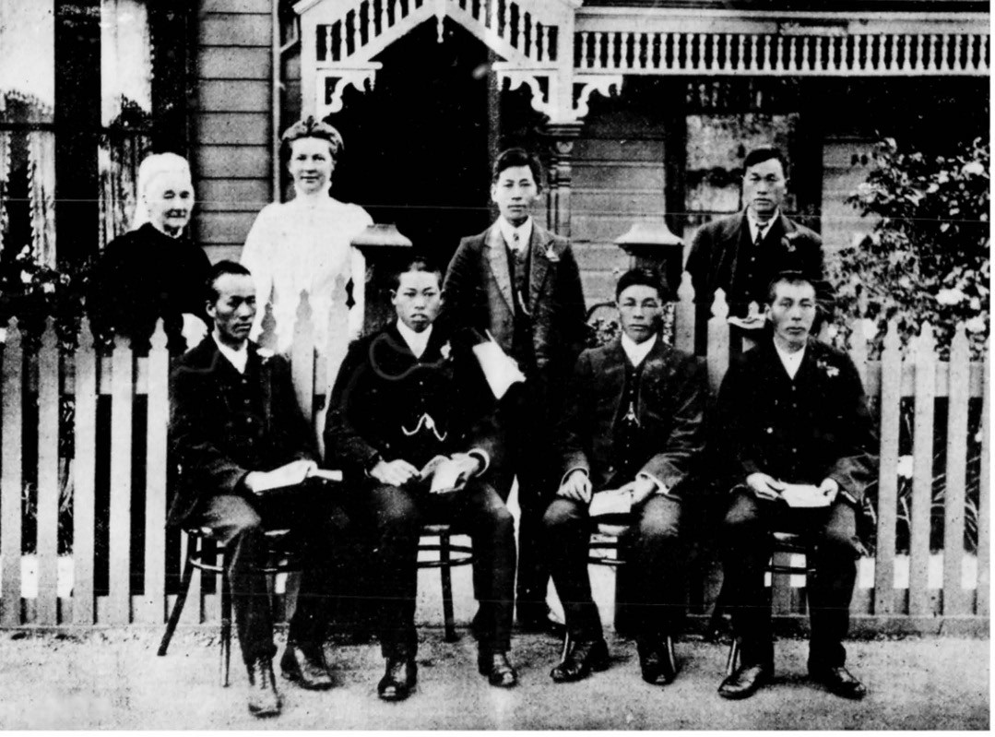
Figure 2.47: Wilmot, Mrs Eliza Freeman, Miss Mary Freeman and Chinese students outside Glenmore , 155 McKillop Street, 1910. Source: News of the Week, 17 November 1910, p.16, GRS 2121, Geelong Heritage Centre collection.

Also involved at the outset with the inception of the Geelong Chinese Town Mission was the Rev. James Moy Ling (c.1834-
.512 Born in Wong Kee Hong, China in c.1834, he emigrated to Victoria in 1855 and began work as a Wesleyan Minister at the Castlemaine goldfields.513 It was there where he became one of the few known Chinese immigrants that were naturalised.514 In Geelong in 1891, the Rev. Moy Ling had visited Chinese workers and held several meetings as part of his Christian mission work.515

In 1893, the Geelong Chinese Town Mission was formally disbanded, the responsibility of the Mission given to William and Emily Irwin of Fitzroy Street, Geelong, and George and Ann Morison of Alexandra Avenue, Geelong.516 This was due to a falling out with the Rev. W. Lee Heong (Young) who continued a separate mission under the original name.517

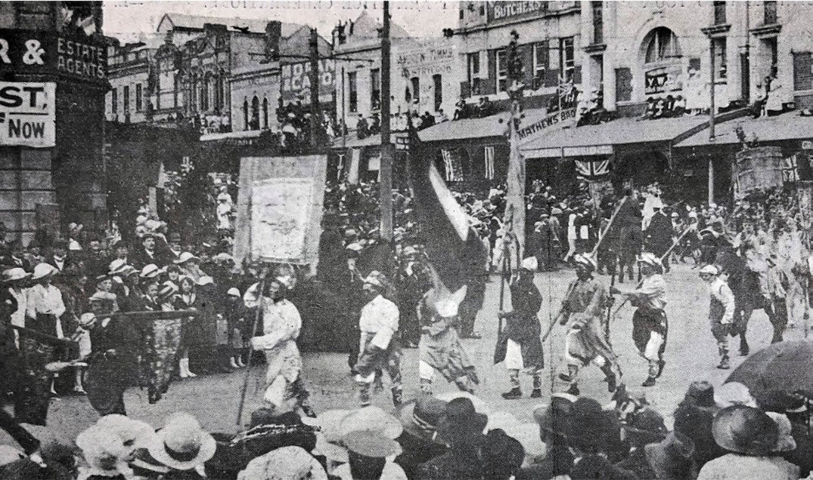
Figure 2.48: Chinese in the Gala Day procession, 1918. Source: News of the Week, 21 November 1918, p.14, GRS 2121/4, Geelong Heritage Centre collection.

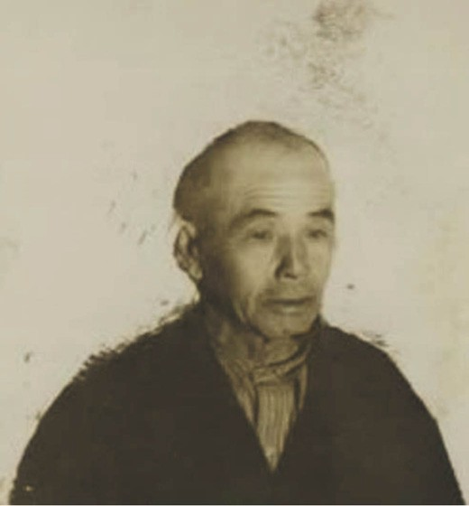
Figure 2.49: Ah Kong, 1939. Source: NAA: B6531, National Archives of Australia.
In 1914, under the auspices of St. George s Presbyterian Church, a Chinese Mission Church opened in Villamanta Street, Geelong West.518 In charge of this venture was the Rev. Charles Way, a Chinese Minister.519 After 30 years as an evangelist of the Presbyterian Church among the Chinese of
Victoria, the Rev. Way died in 1933 brought on by shock caused by a fire at his home in Spring Street, Geelong West.520 His death caused the closure of the Mission Church, the building offered for sale in 1934 and relocated to Moriac.521

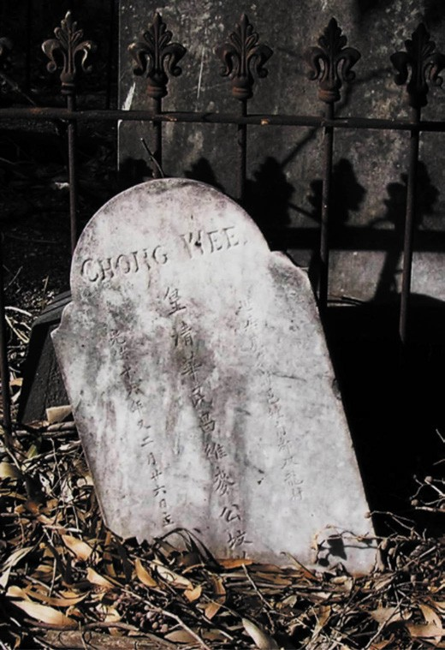
Figure 2.50: Headstone of Chong Wee, Eastern Cemetery, 2018. Source: Pam Jennings.
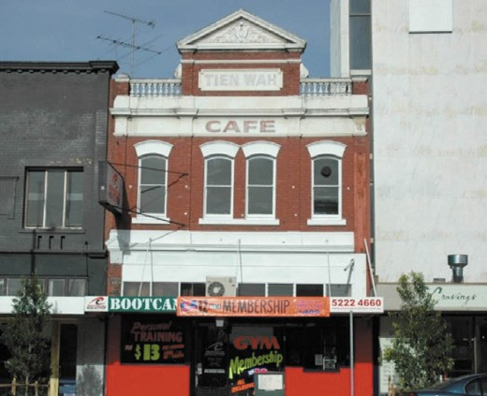
Figure 2.51: Former Tien Wah Caf , 26 Malop Street, 2005. Note the TIEN WAH signage in the parapet. Source:
David Rowe.

THE CHINESE IN THE 20TH CENTURY SCHOOLING FOR THE CHINESE
In c.1905, Mrs Eliza Freeman, widow of the late long-serving
Anglican incumbent at Winchelsea, the Rev. John Freeman, and her daughter, Mary, established a school for the Chinese at Geelong. The method was to commence with the teaching of English, leading to the teaching of the gospel.522 Impetus for the school came from a converted Chinaman , James Ah Loon, who had previously had contact with the Freeman family at Winchelsea.523 He asked Mrs Freeman to establish a school for his compatriots in Geelong.524 By 1910, up to 30 pupils attended evening classes twice a week. They were held in
the winter months only because in the long summer evenings market gardeners which comprised most of the class, were busy watering thirsty gardens. 525 Classes were initially held in the Ryrie Street Presbyterian School Hall (demolished) but also at the home of Mrs and Miss Freeman, Glenmore 526 (Figure 2.47). This timber dwelling still exists at 155 McKillop Street. By 1915, the School had relocated to the Chinese Mission Church in Villamanta Street, Geelong West.527

IMPACTS OF GOVERNMENT LAWS & THE CHINESE IN GEELONG
Following the federation of the Australian Colonies in 1901, the Commonwealth Government introduced the Immigration Restriction Act. Colloquially known as the White Australia Policy, it was to have a significant impact on Chinese immigration to Greater Geelong. The Act restricted the entry of non-Europeans to Australia through the use of a dictation test, and provided for the removal from the Commonwealth of prohibited immigrants. 528
Like the German-Australians living in Geelong, the Chinese community also became subject to the War Precautions (Aliens Registration) Regulations of 1916 (later replaced
by the Aliens Registration Act 1920). Non-naturalised aliens over 15 years of age were forced to register.529 Yet, at the introduction of the racially-based law, the Chinese in Geelong continued to proudly march in the annual Gala Day parade as a public response to their commitment to the locality and the community (Figure 2.48).
Between 1916 and 1922, over 108 Chinese living in the Geelong district were registered under the War Precautions Act.530
A select few had been living in the Geelong area for over 50 years, including Ah Lung (born March 1835) who arrived
in Geelong in c.1856 and was registered at Geelong South.531 William Ah Penn (born September 1828) was another. He arrived in 1853 and lived in Bailey Street, Belmont.532 It seems the majority arrived in Geelong in the 1880s and particularly the 1890s, until 1900, a time when racial resentment had been

foremost in local public discourse. One of the many market gardeners to arrive during this period was Ah Kong (born 1867)533 (Figure 2.49). He came to Victoria in 1899 and took up Market Gardening at Moolap.534 He returned to China in 1938 prior to World War Two in 1939, when the Aliens Registration Act 1939 and associated National Security (Aliens Control) Regulations re-introduced requirements for the registration of non-naturalised and naturalised aliens for national security reasons during World War Two.535 Ah Kong s compatriots in the Greater Geelong area were required to register, repeating a process they experienced in World War One.
In 2018, surprisingly very little physical evidence survives that is associated with the hundreds of Chinese who came to Greater Geelong from the 19th century and who made an important contribution to local industry and particularly the provision of produce. The only known purpose-built objects are the Chinese graves in the Eastern Cemetery536 (Figure
2.50). It was there where the Chinese often made pilgrimages. In 1924, the Geelong Advertiser gave a description of a visit to the cemetery:
It is one custom of many of the Chinamen of Geelong every four months to pay a visit to the Eastern Cemetery for
the purpose of paying homage to their dead countrymen. Yesterday about forty of the Celestials, taking with them a huge cooked pig, made their pilgrimage. At the cemetery they performed the ceremony of feeding the dead, carrying out their task with an earnestness that would put many Christians to shame. The pig was afterwards divided amongst those why took part in the visit, and in the evening a commemoration feast followed.537

The bodies of at least four deceased Chinese immigrants were exhumed and repatriated to China after their families were able to afford the associated fees. Those repatriated included Ah Chung (17 June 1889), Ah Tan (22 May 1923), Ah Sam (14
March 1903) and Ah Chung (17 June 1889).538
A more widely known physical legacy of Chinese immigration in Geelong is the former Tien Wah Chinese caf at 26 Malop Street (Figure 2.51). The name of the business still displayed on the parapet of the Federation era commercial building. It was opened as a Chinese caf by Lee Man Yee in 1956.539 He had previously opened the Golden Vine Chinese caf in Ryrie Street and later in Moorabool Street prior to establishing the Tien Wah caf . He continued to operate the business until the mid-1990s, it remaining as a Chinese caf until 2003.540

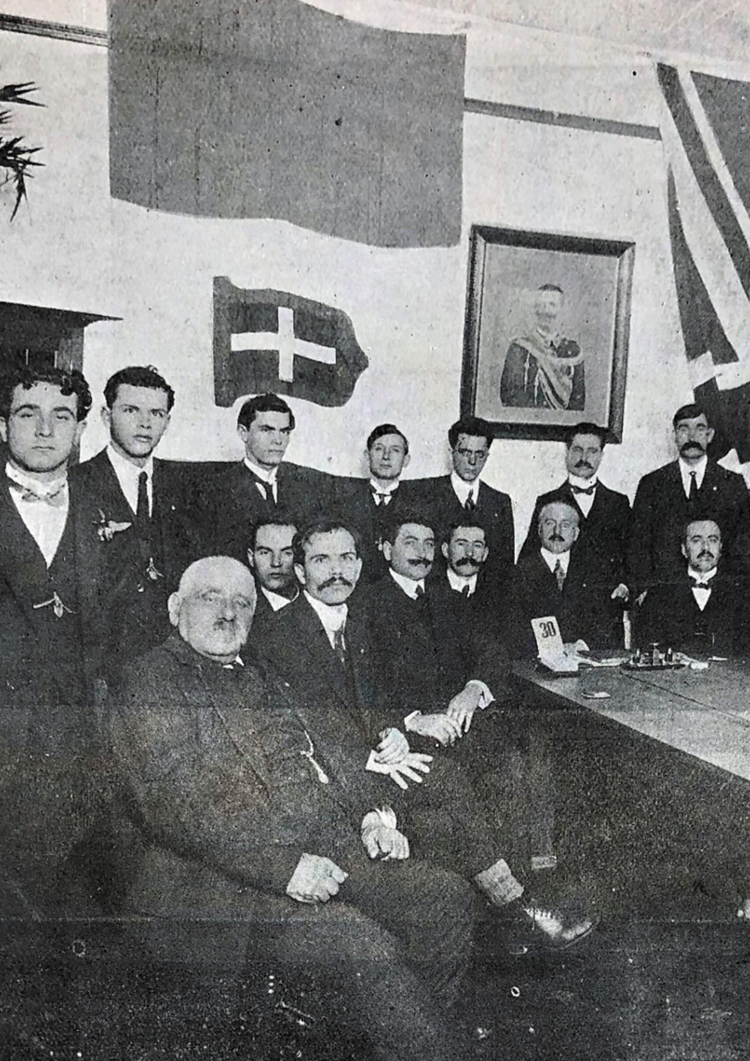

Figure 2.52: Circolo Italiano Savoia, Geelong Geelong Italian Club, 1917. Source: News of the Week Geelong Heritage Centre collection.

ITALIAN IMMIGRANTS

THE ARRIVAL OF THE FIRST ITALIANS IN GEELONG
A smaller number of the immigrants who arrived in Geelong in the late 19th and early 20th centuries and who made a significant contribution to commercial and cultural life were Italian. Several of the early families to arrive in Geelong
including the Biviano, Bongirono, Costa, Travaglia and Virgona families had emigrated from Salina, one of the Aeolin Islands north of Sicily in southern Italy.541 As outlined in the dedication by Des Tobin in Frank Costa: Family, Faith and Footy:
They arrived with no English, little money and few possessions. Through their indomitable spirit and desire for stability, they and their descendants have made an immeasurable contribution to the Australian way of life.542
One of the earliest to arrive in Australia (albeit temporarily) was Francesco Costa II (1861-1947). He was forced to leave the family vineyard (which had been worked by generations of the family) after the business collapsed in c.1891.543 Francesco worked in Melbourne, Geelong and Colac before returning home to Salina.544
There were also families that came from other parts of Italy, including the Barbutos from Sicily, Lescaris from Pescaro and Urbino, Marche, and the Arcaros from Potenza, Basilicata.545 Of the latter, Francesco (Frank) Arcaro (1874-1937) arrived in Melbourne in 1907.546 Unlike most of his compatriots, he was a professional musician.547 Arcaro was musical director of an orchestra that performed at the opening of the Joy Ark Picture
Palace (Figure 9.149) on the Eastern Beach foreshore in 1912.548

FORMATION OF THE ITALIAN CLUB
By 1917, there was a sufficient number of Italian families in Geelong to form an Italian Club. Impetus for the idea came from a visit from the Italian Consul-General for Australasia, Cavelier Eles.549 The Club was formally opened by Eles in 1917 at its rooms in the MacMullen s Buildings, 93-95 Ryrie Street550 (Figure 2.52). The inaugural officers of the Italian Club were Francesco Virgona (president), Antonio Bongiorno
(vice-president), Frank Arcaro (treasurer), G. Lescai (secretary) and committeemen: Felice Biongiorno, Guiseppe Costa
and Dominic Travaglia.551

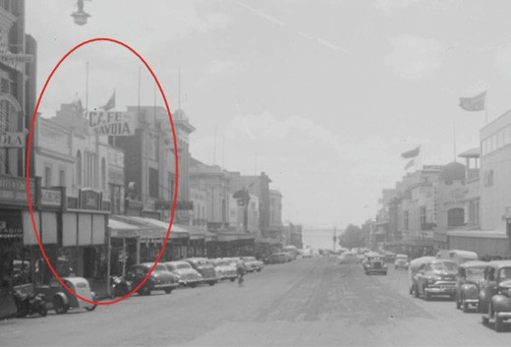
Figure 2.53: Caf Savoia , Moorabool Street (circled), c.1956.
Source: Rose series, accession H32492/8645 State Library of Victoria.
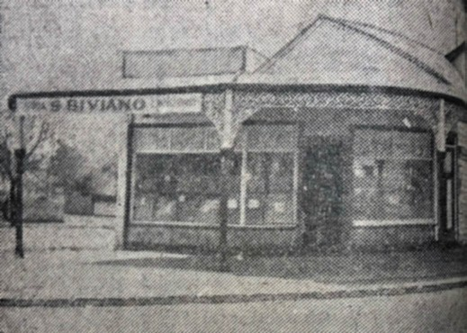
Figure 2.54: S. Biviano s Store, corner Ormond Road & Myers Street, 1936. Source: Geelong Advertiser, 10 October 1936, GRS 2050/197, Geelong Heritage Centre collection.
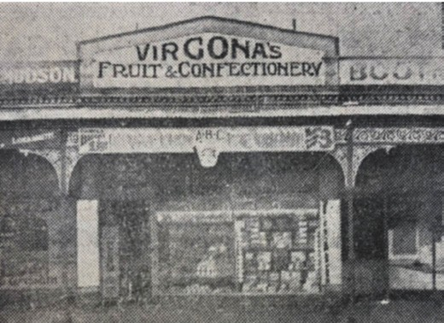
Figure 2.55: Virgona s Fruit & Confectionary store, 39 Ryrie Street, 1936. Source: Geelong Advertiser, 10 October 1936, GRS 2050/197, Geelong Heritage Centre collection.

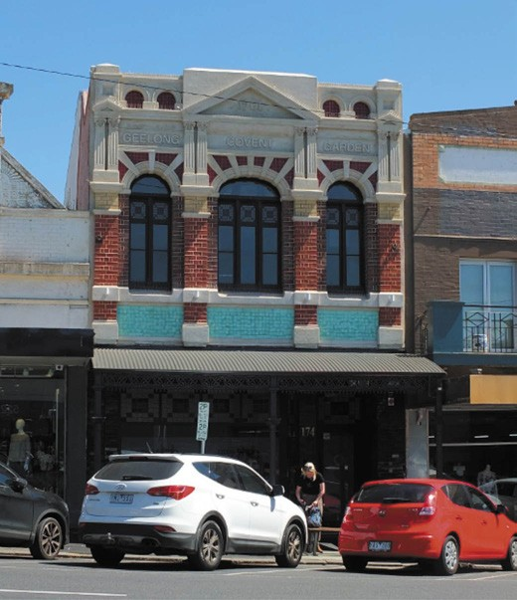

Figure 2.56: Geelong Convent Garden, 174 Moorabool Street, 2019. Source: David Rowe.

TREATY OF COMMERCE AND WORLD WAR ONE
The relative ease in which Italians were able to emigrate to and settle in the Geelong area was a consequence of a Treaty of Commerce signed by Italy and Great Britain in 1883.552 As Australia was then a colony of Great Britain,
Italians held greater liberties to enter, travel or reside in the territories of Great Britain compared to other white aliens (a term applied by the Commonwealth Government to describe non-British Europeans).553 Like the Chinese and Germans, non-naturalised Italians were also required to register under the War Precautions (Aliens Registration) Regulations 1916. Not surprisingly, registration included some members of the Geelong Italian Club, such as Francesco Virgona and Frank Arcaro (whose place of residence in 1916 was Carlton).554
Other Italians who had registered in Geelong in 1916 were to serve in the war given that all Italian reservists between the ages of 19 and 45 were required by their country of origin.555 In April 1918, Guiseppe Costa, Felice Costa, Salvatori Costa, Antonio Giacomo, Salvatori Traglio, Baetano Barbuto and Dominico Costa were called to the colors with other Italians , joining the Royal Italian Navy.556 The Treaty of Commerce of 1883 still endured, giving Italians full liberty to enter, travel or reside in the territories of the other. 557

In 1923, an agreement was reached with Italy by the Commonwealth Government, limiting the issue of passports to those Italians who could support themselves or had guarantors in Australia. A few years later, Italian arrivals were limited
to ‘those nominated by close relatives or who had definite employment prospects. 558 These restrictions did not prevent the return of local Italian servicemen and the arrival of some of their family members.

ITALIAN CAFÉ PROPRIETORS, CONFECTIONERS AND FRUITERERS IN GREATER GEELONG
Most prominent in the Geelong area from the early 20th century was the establishment of cafes and confectionary and fruit shops by Italians. One of the earliest was opened by Joseph Costa (1879-1941), only son of Plfillip Costa of Salina.559 By 1907, Costa was selling firewood and coal next to Daniel s ironmongery in Moorabool Street.560 The next year, 1908, he had opened a business from this location as a confectioner and fruiterer.561 In 1918, he relocated to a newly- erected two storey brick building at 140 Moorabool Street owned by Eli Phillips, hotelkeeper.562 It was there where Costa operated the successful and enduring Savoia Caf ,
opposite Bright and Hitchcock s Department Store (see Theme 5) (Figure 2.53). In addition to the sale of confectionary, ice cream and cool drinks,563 Costa offered meals, including fried fish and ‘chip potatoes’,564 being one of the earliest Italian businesses in Geelong to offer this cuisine (see Theme 5).
The Savoia was also a popular musical afternoon resort , whereby grand operas, comic operas, waltzes and intermezzos were performed by Frederick Earle.565 So successful was the business that alterations and additions were carried out in 1919 which included a new position for the orchestra. 566 The Savoia Caf continued after Joseph Costa s death in 1941 and the building survives today (albeit altered).
Equally enterprising was Peter Maggi, ice cream manufacturer who arrived from Ossolaro in September 1910.567 He commenced an ice cream manufactory which by January 1918 was so successful that he turned out 1000 quarts daily.568 In September 1918, Maggi announced that he had erected a new factory at 1 Collins Street, Geelong West (demolished), giving him the ability to supply the purest and most wholesome ice cream in large or small quantities. 569 Supplementing Maggi s Imperial Ice Cream in 1919 were biscuit cups and wafers.
Maggi had:
installed a plant for making these delectables, and is now turning them out in large quantities in various shapes and colors. The moulds are Mr. Maggi s own idea, and make cups with thick edges with prevent breakages, hence they are a great saving to the ice cream trade.570

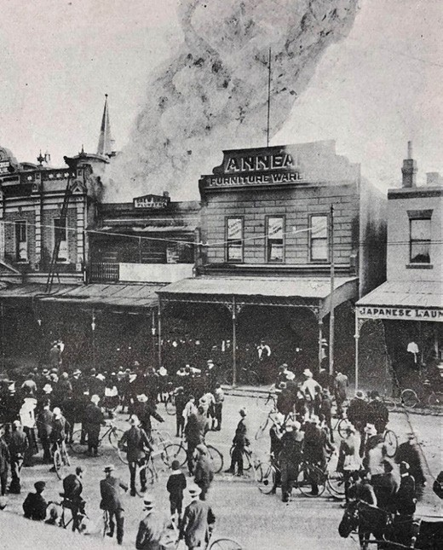
Figure 2.57: Fire at Miss Hobbs Confectionery Shop, Ryrie Street, 1912. Yokohama s Japanese Laundry, 62 Ryrie Street, 1912, is partly shown on the right.Source: News of the Week, 7 November 1912, GRS 2121/3, Geelong Heritage Centre collection.

More ubiquitous than the sale of ice cream was the confectionary and fruitery businesses established by some of the earliest Italian arrivals to Geelong. In 1936, the A.B.C. Velvet Kind Ice Cream was advertised in a double page illustrated spread in the Geelong Advertiser.571 Of the 14 businesses advertised, half were owned or operated by business people of Italian descent. The Bongiorno brothers had a shop at 364 Latrobe Terrace (built in 1911 - see Theme 6) and Salvatore Biviano operated a store at the corner of Ormond Road and Myers Street (Figure 2.54).
Particularly successful was the Virgona family, with stores at 39 Ryrie Street (Figure 2.55), Little Malop Street and 153 Ryrie Street (the latter in partnership with Giuseppe Serra who married into the Virgona family in 1936).572 The family
business was commenced by Francesco Virgona (1873-1941) in 1901 in a building in Moorabool Street owned by William Lloyd.573 In 1902, another member of the extended Virgona family, Guiseppe (George) Virgona (1873-1962) commenced a fruitery with Bartolo Costa in a newly-completed premises in Moorabool Street owned by Mrs Annie Coronel of Sydney.574 A two storey brick addition at the front of the building had been completed the previous year to a design by Geelong

architects, Hendy and Apted.575 This building remains extant and is situated at 174 Moorabool Street.
In 1925, George Virgona employed Antonino (Tony) Costa (1909-1985).576 A son of Francesco Costa of Salina who had briefly emigrated to Victoria in the early 1890s
(see earlier), Tony soon after established his own fruit shop in Warrnambool.577 He later returned to Geelong and purchased the Eastern Star Fruit Shop in East Geelong. A regular customer was Miss Mary Piccone, who was to become Tony s wife.578 Tony also established a partnership with his older brother, Giuseppe (Joe) Costa (1891-1968) who had emigrated to Australia in 1903.579 Their business was situated at 242 Moorabool Street. In 1937, Tony and Joe Costa operated their business from George Virgona s fruit shop at 174 Moorabool Street.580 In 1938, Tony and his wife, Mary, became sole owners of the business at 174 Moorabool Street which was named Covent Garden. With the business becoming highly successful, Tony Costa purchased the building from George Virgona in early 1949.581 In 1959, Frank and Adrian Costa (sons of Tony and Mary) purchased half of the family business which was expanded to include the wholesale provedore market.582 Further growth in the business occurred from
1969 when the Costa brothers purchased the warehouse owned by the Thomson Brothers situated in the lane behind Covent Garden583. This building was acquired as a wholesale warehouse. Following the death of Adrian Costa in 1972, Frank Costa’s other brothers - Anthony, Kevin and Robert – joined the firm.584 The Costa firm subsequently bought out the wholesale fruit business, J. Watson and Co. in Gordon Avenue and it was from here where fresh produce was supplied to supermarket chains.585 From humble beginnings, the Costa Company continued to expand in the late 20th century. As outlined by the Costa Group:
By the 1980s Costa Company was trading directly from the Melbourne Wholesale Markets in Footscray, with distribution centres in Werribee South, Shepparton and Monbulk. The operation included pre-packing, shipping and interstate trade. The company was now one of Australia s largest wholesale distributors and exporters of fresh fruit and vegetables.586

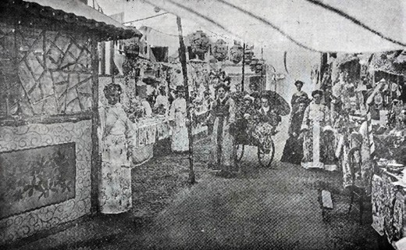
Figure 2.58: Japaese Village Fete in the Alexandra Tent, Methodist Church, Yarra Street, 1906. Source: News of the Week, 15 November 1906, p.14, GRS 2121/1, Geelong Heritage
Centre collection.
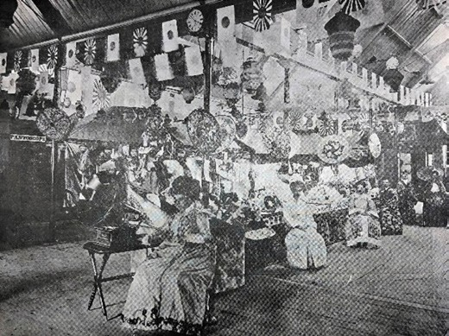
Figure 2.59: Japanese Village Fete, scene in the main building, Methodist Church, Yarra Street, 1906. Source: News of the Week, 15 November 1906, p.14, GRS 2121/1, Geelong Heritage
Centre collection.

In 2015, the Costa Group re-acquired the Covent Garden building at 174 Moorabool Street where the family business had first begun.587 Suffering substantial deterioration and having experienced numerous alterations, work began in 2017 in converting the building into administration offices for the Costa Group. The work involved additions as well as repairs and the reconstruction of the original (1901) front fa ade and verandah (Figure 2.56).

JAPANESE IMMIGRANTS
Between 1900 and 1901, a small but enterprising number of Japanese men immigrated to Geelong. Their arrival was immediately after Victoria had established its own immigration law to restrict immigrations through the Dictation test from 1899.588 Their arrival was also prior to the introduction of
the Immigration Restriction Act (White Australia Policy) in 1901. They included Shingo Ikenga, Motoshiro Ito, George Nakamura, Toranasuke Yoshisaka, Kunino Mitsutaro, Isabura Nishimura, Tetsuichi Nishimura and a Mr Nagai.589
Either singularly or in partnership, these men established laundries, working long hours (including nights) under difficult conditions.590 Exacerbating the challenges both physical and cultural were the xenophobic sentiments promoted
and enacted by the Commonwealth Government through the White Australia Policy. While these Japanese immigrants in Geelong contributed much to the local economy and donated to community causes like the Gala Day appeal,591 there was resentment of them living and working here. As early as 1902 in an address to the Geelong Trades and Labor Council, a Member of the Victorian Legislative Assembly bemoaned the existence in Geelong of Japanese and Chinese laundries
and declared that they should not be encouraged, as widows and other suffered thereby. 592 Several years later, such resentment continued in a letter to the editor in the Geelong Advertiser. While it was claimed that the enterprise, thrift and perseverance of the Japanese at their laundries was to be commended, it was framed within a discriminatory and xenophobic paradigm that appears to have reflected local community attitudes in the early 20th century:
would any Britisher be able to employ white labor to work these long hours? And in consequence are not the white laundries working under a disadvantage? It seems to me that the little yellow men have a strongly organised hold on the laundry business in Geelong, and it is to be regretted that more of the work is not given to white workers.593
One laundry operating in the early 20th century was that of Kanematsu Hawanishi at 62 Ryrie Street from 1909.594 The two storey building was owned by the Contractors Association.
By 1912, the business was known as the Yokohama Japanese laundry.595 The front of the building was partly shown in a photograph at this time (Figure 2.57).
The building was substantially remodelled in 1928 and
so there is no obvious signs of its former role as a Japanese laundry.
While there was local community resentment to the Japanese laundries, the Geelong community had taken an interest in Japanese culture from 1894 when Japanese Village fetes were held by the local churches as fundraising activities.596 The

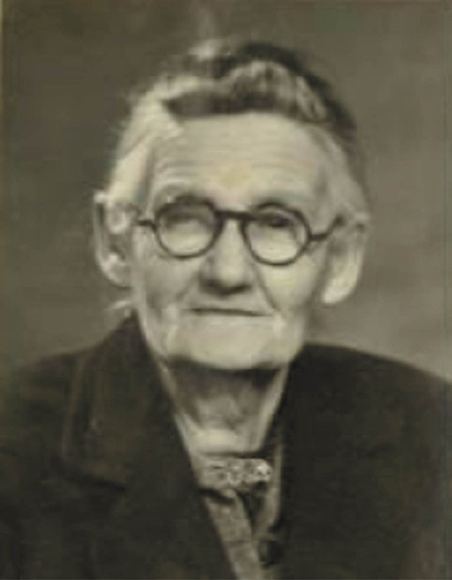
Figure 2.60: Mrs Ada Furuya, 1940. Source: NAA: B6531, National Archives of Australia.
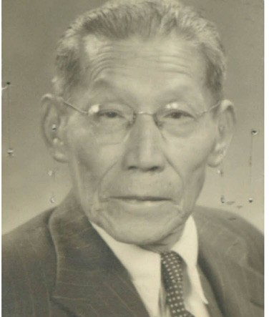

Figure 2.61: Motoshiro Ito, 1940. Source: NAA: B78, National Archives of Australia.

Geelong Advertiser gave basis for an interest in Japan at a fair held in the Geelong Mechanics Institute in 1894:
The idea of holding a Japanese fair, at the present juncture, when Japan is playing a strikingly successful part in the world s affairs, was a very happy one indeed, and the promoters are to be congratulated on the results they have so far achieved.597
The signing of the Anglo-Japanese Alliance in 1902
(and renewed in 1905 and again in 1911)598 brought about positive trading between Japan and Australia. It also galvanised the novelty factor of the Japanese Village fete. Although these fetes were held until 1923,599 it reached its zenith in 1906 with a fete held at the Methodist Church, Yarra Street (Figures 2.58-59):
Under the title of a Japanese Village Fete, there was opened at the Yarra-street school grounds last evening one of the most original and attractive fairs ever seen in Geelong. In their dress, conception of the beautiful, and style of architecture, the Japanese are most original, and have created distinct and picturesque national
characteristics, which make Japan one of the very popular hunting grounds of the tourist. It is therefore not surprising that Japanese fetes have become so favored in all parts
of the world, and with the exercise of a little ingenuity the charming features of the country may be reproduced certainly in a less beautiful, but still effective, degree in such fairs as that opened last night. The promoters of
the fete showed some enterprise in engaging the original village equipment designed by Mr. Barry Jaggers and used by him in most of the leading up-country towns of the State for church purposes.
The “village” was fitted up by him and a staff of assistants, and the result is unquestionably pretty. In the main
school buildings and the Alexandra tent, in the grounds, there are upwards of a score of Japanese business establishments laid out in the proper open front system common to Japan, and with the wares displayed without window protection. The red-tiled roof is prominent in all cases, and the forms of the stalls are either of the kiosk, tea-house, floral bower or pagoda style. Over the tiles the artists have painted representations of wisteria, cherry blossom, and other of the lovely blossoms of Japan, and one stall presents a striking appearance in its framework of cherry blossom.
Where no scenic effect is furnished resource has been had to the dainty art muslins of Japan, while lanterns, umbrellas, and other decorations peculiar to the land of the rising sun help to make the scene exceedingly
picturesque. The stall-holders are garbed in the Japanese kimonos, and those dressings embrace an almost

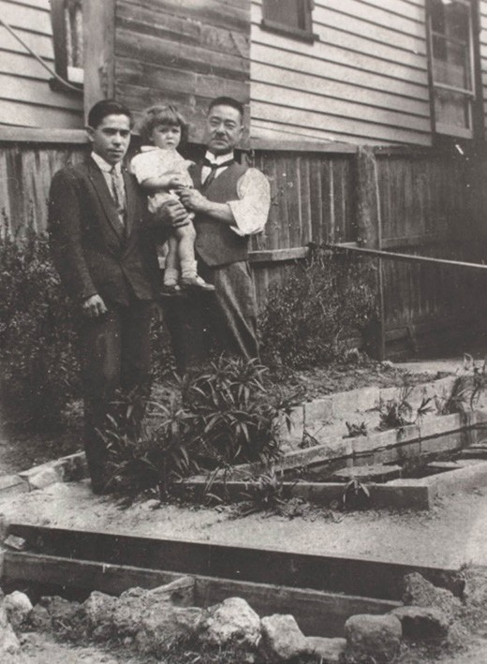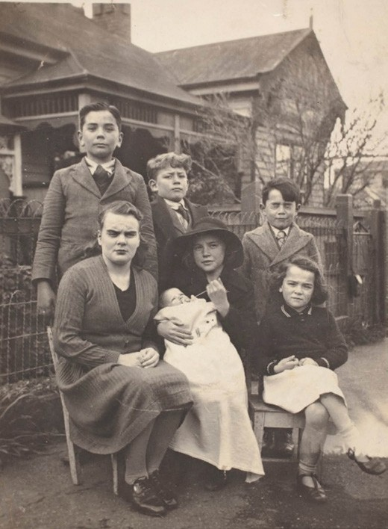

Figure 2.62: Setsutaro Hasegawa (right) & family at the rear of his home at 21 Lt Ryrie Street, c.1935. Source: item MM 107264 Museums Victoria.
Figure 2.63: Hasegawa family outside 21 Lt Ryrie Street, c.1930. Source: item MM 10762 Museums Victoria.

inconceivable range of color. The spectacle has to be seen to be appreciated, and during its run of eight nights the fete is bound to be a big draw.
A touch of realism is added to the scene by a locally constructed rickshaw, manufactured as a donation to the fete by Hargreaves and Armstrong. Drawn by a sturdy attendant, it proved a strong attraction to the children.
Amongst the side shows are some ingenious Japanese devices. In a spider web is seen the head of an apparently de-capitated man, while in the pautoscope an invisible hand designs richly colored pictures before the audience. The magic chair is another weird attraction, and the Punch and Judy show is as usual irresistible. Outside in a proper tea-house the ladies dispense refreshments. The whole thing gives a fair indication of what ought be witnessed in a typical Japanese village, and the fete should be the means of raising a goodly sum for the missions, church funds, boys brigade, and other departments of the school for the assistance of which it has been promoted.
The opening ceremony was performed last evening in the Endeavor Hall by the Hon. T. C. Harwood, M.L.C. He said he had been invited to perform the ceremony by Mrs. G. M. Hitchcock, and anything she asked in reason could not be very well refused. (Applause.) It gave him much pleasure to attend and declare the fete open, and he hoped that the hopes of Mrs. Hitchcock would be realised. The idea of making it a Japanese Village Fete was very appropriate
at the present time, because the Japanese were now the allies of Great Britain, and consequently the allies of
Australia. At the present time we did not treat them as well as we should.600

Amid the continued interest in Japanese culture, the War Precautions (Aliens Registration) Regulations of 1916, established as a consequence of security measures enforced during World War One, created uncertainty for some local Japanese-Australian families. While Japan participated in the war with Entente powers,601 Japanese citizens in Geelong were required to register. This included the Australian-born wives of the Japanese immigrants who were then considered Japanese subjects. It was not until World War Two, when Japan was at war with Britain (and therefore Australia) when the lives of local Japanese-Australian families became
particularly difficult. Surviving Japanese owned laundries that operated into the 1930s were forced to close and Japanese immigrants were either deported or interned, being separated from their Australian-born families.602 In 1940 for example,
Mrs Ada Furuya (Figure 2.60) of 81 Myers Street, Geelong, was forced to apply for naturalisation in her own right which was permissible under Section 18 (6) of the Nationality Act 1920-
36 given that she was born at Flemington, Victoria, in 1874.603 Ada Furuya had lost her British nationality when she married her husband, George Taroo Furuya, in Melbourne in 1904.604 While Mrs Furuya regained British nationality, there was no opportunity for her husband to seek British status. The leader of the local Japanese community who had interpreted at the port and in the courts and provisioned ships ,605 had operated a laundry in Geelong for several years. At the age of 72 years, George Furuya was separated from his wife and sent to the internment camp at Tatura.606 He was released under strict restrictions prior to war s end.607 He died in
Geelong in 1950.608
Two other Japanese laundrymen who lived in Geelong for many years and married Australian women were also
substantially impacted by the necessary security measures enacted by the Commonwealth Government. One was Motoshiro Ito (Figure 2.61) who was born in Kyoto, Japan in 1881 and emigrated to Victoria on the Yawata Maru in 1901.609 He married Miss Ethel Martini of Geelong in 1914.610 Following the tragic losses of his wife in 1919 and his son, Norman, in 1920,611 he married Bertha Kirwin in 1930.612 In December 1941, Ito was interned from his home at 53 Ryrie Street, Geelong, to the internment camp at Tatura, leaving behind his wife, Bertha, and his two married children from his first marriage.613 He died in Geelong in 1963 at the age of 87 years.614
The other Japanese laundrymen caught up in the security measures imposed during World War Two was Setsutaro Hasegawa (Figure 2.62). He was born in Tokyo in 1868 and he

later became a school teacher.615 Arriving in Melbourne on the Yamashiro Maru in February 1897, he was initially employed as a house boy by a Colonel Tucket in Melbourne.616 He married Australian born Ada Cole in 1905 and they had
three children.617 It was about this time when Hasegawa and family relocated to Geelong before moving to Ballarat where he opened the Japanese Laundry at 28 Peel street North, Ballarat East.618 It was there in 1913 when he applied for naturalisation but was swiftly advised that because he was a native of Asia he was not eligible to become naturalised
under the Commonwealth. 619 By 1924, the Hasegawa family had returned to Geelong where Setsutaro established a laundry at 221 Moorabool Street.620 It may have been about this time when Hasegawa and his wife, Ada, separated.
In 1927, Setsutaro purchased a house at 21 Little Ryrie Street, Geelong621 (Figure 2.63).
With the onset of World War Two in 1939, Hasegawa was immediately detained and interned at the camp in Tatura.
His appeal to the Victorian Aliens Tribunal failed, despite his senior years and at least one of his children then serving in the Australian Military Forces.622 In 1943, given his poor health, Hasegawa was released from the internment camp on the condition that he resided at his residence at 60 Ryrie Street; not associate or communicate with persons of enemy origin other than members of his own family ; not install a telephone or other form of communication in his residence; and not install a radio receiver in the premises. 623 In 1944, Hasegawa sought to have the restrictions lifted, but to no avail. The reasons given for the status quo were:
Because of this Japanese alien s health and Japanese appearance, it is felt that his presence in the streets
of Geelong might affect public morale. As the general policy has been against the release of Japanese nationals, it is considered that the other restrictions placed on him are fair and reasonable, and should not be revoked.624
Hasegawaa died in Geelong in 1952, aged 81.625
Today, there is no obvious physical evidence of the contribution made by these early Japanese immigrants to Geelong.

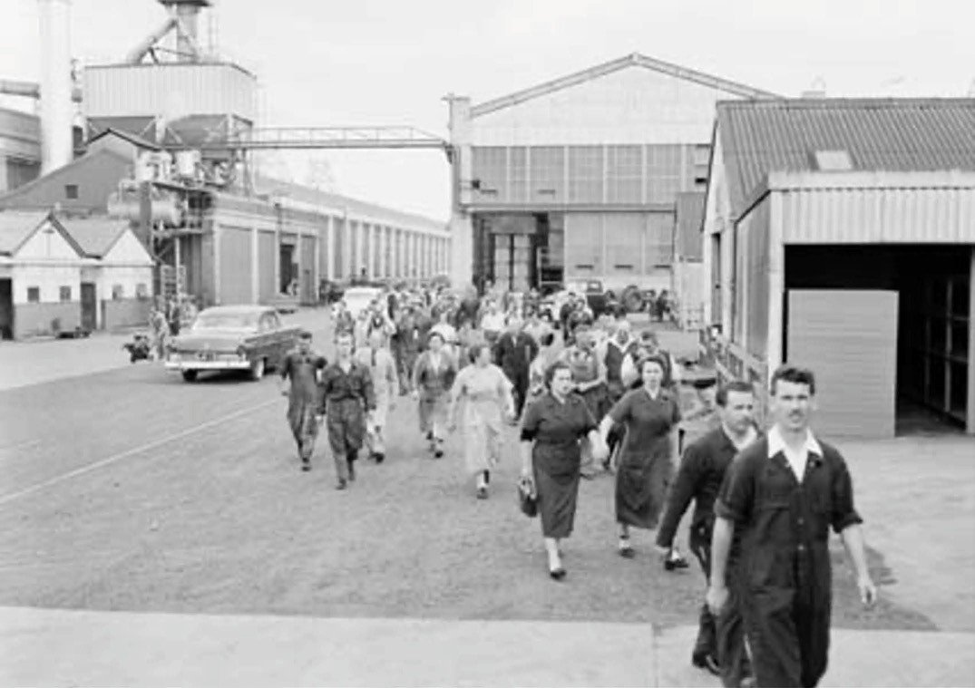
Figure 2.64: Migrant workers arriving for work at the Ford Motor Company, 1955. Source: NAA: A12111, 1/196/12, National Archives of Australia.

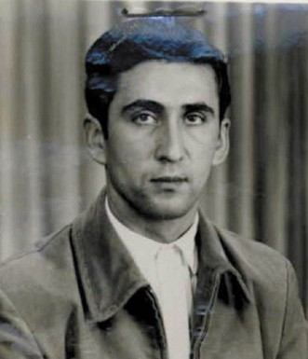
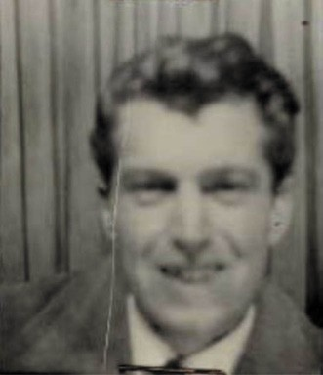

Figure 2.65: Guido Collari, 1954. Source: Application for Registration by Aliens Entering Australia, NAA: B78, National Archives of Australia.
Figure 2.66: Francesco Abbate, 1959. Source: Application for Registration by Aliens Entering Australia, NAA: B78, National Archives of Australia.

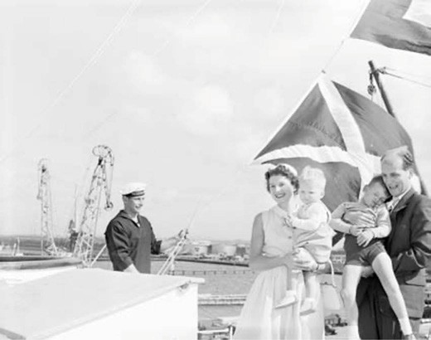
Figure 2.67: Zevenbergen family disembarking in Melbourne 5 November 1958. Source: NAA: A12111, 1/1958/4/91, National Archives of Australia.

POSTWAR (POST 1945) IMMIGRATION

CHANGES IN GOVERNMENT POLICY
& THE TRANSFORMATION OF THE GREATER GEELONG POPULATION
Prior to the end of World War Two in 1945, successive Australian Governments looked to the future and ways of increasing Australia s population to combat the severe
labour shortages that was substantially impacting the local manufacturing and building industries.626 Initially, the idea was to attract more ‘white’ people, to firm up the White Australia Policy of previous Governments as a larger mass [of white people] would be able to keep the danger of Asia (and communism, in the shape of the new Cold War) at bay. 627 In 1947, the British and Australian Governments funded a
ten pound assisted passage immigration scheme to bolster Australia s white British population.628 Simultaneously, there was a shift in political thinking about allowing immigrants into the country. The Chifley Government relaxed the Immigration Restrictions Act, allowing non-Europeans the right to settle permanently in Australia for business reasons.629 This was to have a positive impact on Greater Geelong s manufacturing sector. Two years later in 1949, the Immigration Minister,
Harold Holt permitted 800 non-European refugees to settle in Australia, and Japanese war brides were also admitted.630 Equally significantly, Europeans from Italy, Greece and eastern- block countries increased by the diversification
of the migrant intake.631
In Greater Geelong, the influx of British and European (including eastern European) migrants following World War Two was especially apparent in the industrial centre of Norlane

and North Geelong, in the former Shire of Corio. By 1953, between 200 and 300 German Austrian migrants had been employed, mainly at the International Harvester and the Ford Motor Company.632 Of the latter, in 1955, approximately 54% of its workforce (comprising 4500 employees) were recently- arrived migrants633 (Figure 2.64). Other existing companies were also sources of migrant employment, including
International Harvester at North Shore (which spent £1,630,000 on extensions for the production of tractors) and trucks in 1946634) (see Theme 5). Two Italian migrants attracted to the International Harvester factory were Guido Collari (Figure 2.65) and Francesco Abbate (Figure 2.66). Collari, aged 21, arrived in 1954 with the intention of being employed as a foundry worker.635 Abbate, aged 26, arrived in 1959 and was a labourer.636
Other major employers of newly-arrived migrants were the Grain Elevator Board at North Geelong, Alcoa Australia at Point Henry and Briton s Carpets at South Geelong.637
A particularly notable immigration employment scheme involved the Shell Oil Refinery at Corio. Constructed from 1952, over 1000 workers from 14 countries were involved, including 350 migrants from Holland.638 More enduring was the employment of Dutch workers once the refinery opened in 1954. It was staffed by 71 Dutch migrants amongst the 923 workers of 17 nationalities.639 Four years later in 1958, the Refinery welcomed the 100,000th Dutch migrant with the
arrival of Mrs Adrian Zevenbergen. She came on to Melbourne on the liner, Johan van Oldenbarneveldt with her husband, Cornelius and their two sons, Kees and Addo640 (Figure
2.67). A reception was given by the Netherlands Ambassador in Australia, Dr. A.H.J. Lovink when the shipped docked.
Cornelius Zevenbergen was employed as a fitter at the Shell Refinery, having previously worked in the role for the company in Pernis, Holland.641 He had previously been a ship s engineer and had visited several countries including the United States, Canada, South America, Sweden, France, Germany and South Africa, but it was Australia that he chose for his family.642 According to the Good Neighbour newspaper:
The Zevenbergens will be following hundreds of other Dutch migrants who have settled at Geelong, an attractive seaport of 90,000 people set on the edge of Corio Bay, 45 miles from Melbourne.643
Several other migrants became self-employed. This included a number of Italians and several Greeks who operated fishmongeries and fish and chip shops (for an overview of these businesses, see Theme 5). In 1944-45, there were
12 of these businesses listed in Geelong.644 By 1960, the number had increased to 20.645 They included Chris Chrisakis (220 Pakington Street, Geelong West); Jim Demetrious (116 Pakington Street, Geelong West), S. Gatzos (119 Elizabeth Street, Geelong West); P.H. Kanelopoulos (388 Latrobe

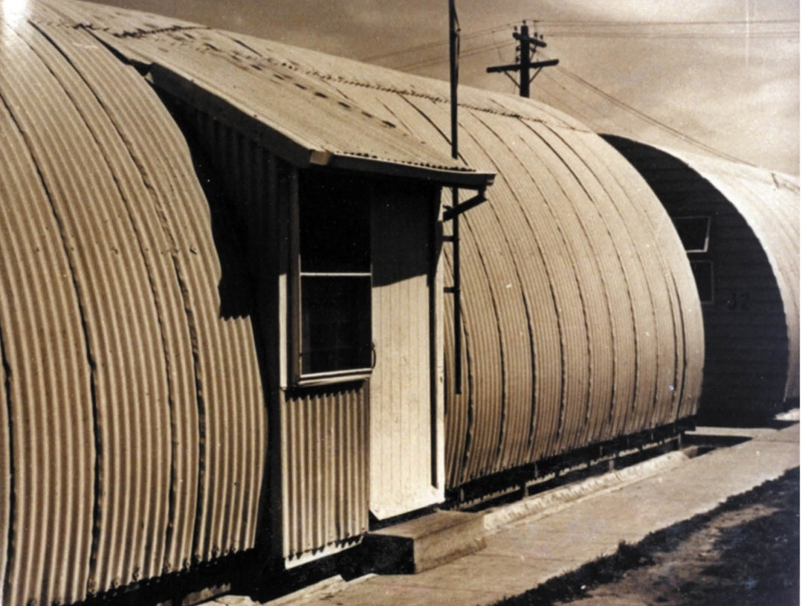
Figure 2.68: Nissen huts at Norlane Migrant Hostel, c.1960. Source: GRS 2009/02350/138, Geelong Heritage Centre collection.

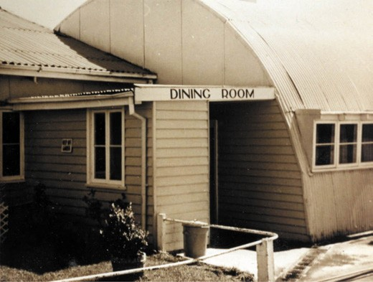
Figure 2.69: Dining room at Norlane Migrant Hostel, c.1960. Source: GRS 2009/02350/139, Geelong Heritage Centre collection.
Terrace, Newtown); P. Kayis (142 McKillop Street, Geelong); P. Koutspiz (7A Ormond Road, East Geelong), Mellas Brothers (196 Moorabool Street, Geelong), Messenes Brothers
(498 Moorabool Street, South Geelong), N. Sideris (53 Yarra Street, Geelong) and W. Spiric (Rose Avenue, Norlane).646 The tradition of Greek-operated fish and chip shops and the quality of the product continues in parts of Greater Geelong to the current day. In 2019, Theo Tsavaris of the Golden Flake fish and chip shop at St. Leonards won the highest honour at the National Fish and Chip awards organised by the Fisheries Research Development Corporation.647

The arrival of hundreds of migrants to Geelong therefore dramatically expanded its cultural identity. In the Corio Shire, in1971, British migrants constituted 22.2% of the total population, Yugoslavs 6.5%, Dutch 3.2% and Italians 2.1%.648 Twenty years later in 1991, 27.8% of the population were born
overseas but British migrants then constituted only 7.8% of the total population.649 From a migrant population of 5,000 in 1947, it had increased tenfold to 55, 694 in 1991.650

HOUSING THE MIGRANTS

COMMONWEALTH HOSTELS
In 1949, the Commonwealth Government planned to launch a program to house the thousands of migrants expected in Victoria in the ensuing years. Two hostels were proposed at Geelong: at Norlane and Belmont.651

NORLANE MIGRANTS’ HOSTEL
In 1949, the Commonwealth Government acquired a large site previously proposed for residential subdivision by Ford Estates Pty Ltd and consequently laid out for public housing by the Housing Commission of Victoria in 1948 (see Theme 6). It was situated to the west of the Melbourne Road, opposite the Ford Motor Company, its southern boundary having a frontage to The Boulevard. On 24 November 1949, the Commonwealth Department of Works and Housing in Melbourne called tenders for the construction and subdivision of 36 Nissen huts, one Romney hut and six other buildings, together with engineering services and fencing652 (Figures 2.68-69). The site was to house 400 Commonwealth-nominated British migrants. 653
The local building firm, J.C. Taylor and Sons was awarded the contract.654 Additional tenders were called in August 1951 for the erection of 103 Nissen huts, along with fencing, hot water and steam installations. 655 Nissen huts had been
developed by Captain Peter Norman Nissen when serving with the British Expeditionary Force on the Western Front during World War One.656 The distinctive, semi-cylindrical shaped lightweight corrugated steel structures became a prototype
for the production of over 100,000 huts for the British Forces for the remainder of the war.657 They were favoured for their economy of materials and portability, the design having been patented in 1917 and then later in Australia.658 The Romney hut superseded the Nissen hut during World War Two. It consisted of a similar semi-cylindrical form clad in corrugated steel, but the structure was constructed of a clamped tubular steel frame and as such, could be erected to a more substantial size.659
The first influx of British migrants had arrived at the hostel by July 1950, before all building works had been completed
on the first stage of construction.660 With all the huts not fully completed by May 1952, one migrant, L.E. Eden, expressed his frustration publicly in a letter to the Herald newspaper.661

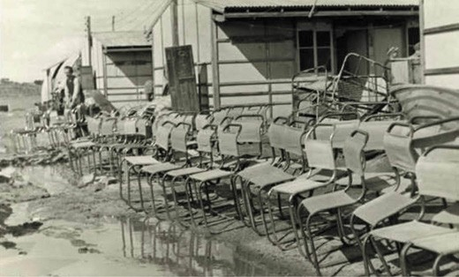
Figure 2.70: Belmont Hostel following the flood in 1951. Source: accession no. H2001.318/6 State Library of Victoria.
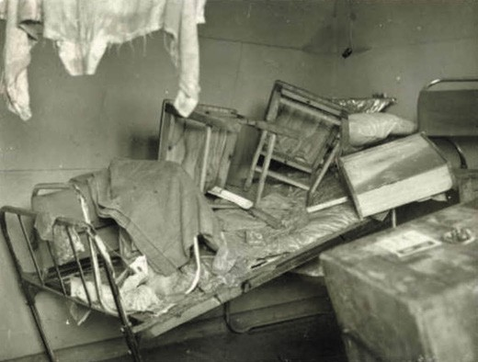
Figure 2.71: Interior of migrant hut, Belmont Hostel, showing flood damage in 1951. Source: accession no. H2001.318/7 State Library of Victoria.

The Norlane hostel like other similar hostels, became a small community in its own right. They were governed by a manager, assistant manager (catering) and junior assistant manager.662 Mr Bela Szaday, a Hungarian immigrant who
arrived in Melbourne in 1949,663 was a long-serving manager at Norlane, his tenure being between 1956 and 1970.664 An early catering manager was Jack Bristow between 1956 and 1958.665 By 1956, John Ribarich, a migrant from Trieste, Italy, had been appointed head chef. In 1966, he was still serving lunches
and dinners five nights a week for 48 weeks of the year. Over ten years, he had supplied meals for between 250 and 450 people.666 The manager and staff lived in cement sheet Bungalows built in a corner of the site. Food and supplies
were brought into the hostel, the first contracts being awarded to F. Watkins Pty Ltd (fresh meat and smallgoods), Polar Products Ltd, Geelong (milk), and A. McAllister (fresh fruit and vegetables).667

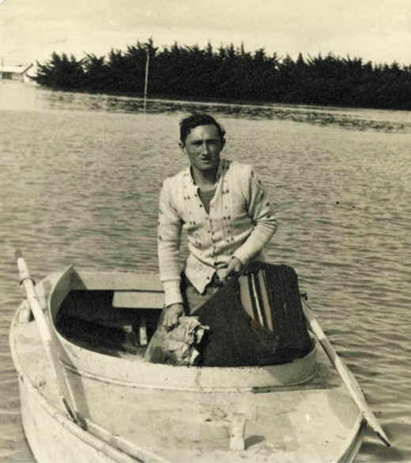
Figure 2.72: Wojciech Galaska on a boat in floodwater at the Belmont Common, 1951. Source: accession no. H2001.318/4 State Library of Victoria.
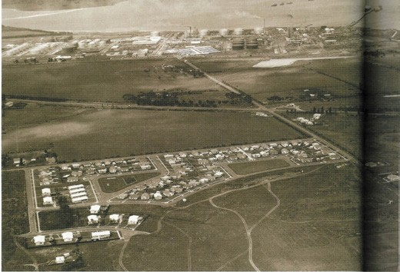
Figure 2.73: R. Pockley, Aerial view of the Shell Housing Estate, c.1955. Source: M. Hunter, Shell Geelong Refinery: 50 Years in Geelong, Shell Company of Australia, Hawthorn East, 2004 (with permission, Viva Energy Australia Pty Ltd).

By 1971, the Norlane Migrant Workers Hostel had closed but the Nissen huts provided valuable accommodation for various social and other community clubs (see later subsection). Today, none of building fabric of the Migrant
Hostel exists. Two memorial trees also appear to have been removed. On 22 May 1952, two English Golden Ash trees were planted and marked by plaques in memory of two young English children killed in accidents on the Melbourne Road

near the hostel.668 Peter Ford, aged 2 years, died from injuries sustained in a motor car collision.669 His father, Arthur Ford,
a fitter at one of the local factories, had been seriously injured but survived. The Ford family had emigrated to Sydney from Leeds, England,670 and had only been at the hostel for a short period. Jean Irvin, aged 7, died in April 1952 after being struck by a semi-trailer truck.671 According to The Argus, she was believed to have been running across the road to catch a bus to school. 672

BELMONT HOSTEL
In 1949, on the Belmont Common near the Barwon River at Belmont, the Commonwealth Immigration Department
established another hostel for migrants on a 15 acre site.673 It was to house 500 Europeans674 and was proposed as a miniature township run on community lines. 675 The local builder, H.R. Leach, was awarded the contract to build
the eight huts with each containing 26 double rooms.676 An administrative block, recreation room and dining hall
were also erected.677 Unlike the Nissen huts at the Norlane hostel site, the huts at Belmont were gabled in form and constructed of timber and fibro cement sheets, with some being clad in malthoid sheets reinforced with wire netting. This was considered a novel building material at the time. The construction of the huts was governed by available building materials, which were in short supply. Internally, the huts were lined with plaster and it was declared that they
should prove warm and comfortable throughout the Winter. 678 Works were almost complete by April 1950 (save for the installation of the roof cladding of the administrative block), the complex being available for the first influx of residents soon after.
The flat terrain of the Belmont Hostel site was considered ‘most suited for recreational purposes. 679 There were rows of pine trees on two sides and the Geelong Advertiser reported that the little settlement should be an ideal setting for immigrants starting a new life in a new country. 680 The Geelong Advertiser further declared that the buildings are being erected well
above water level, where there will be little danger of flooding after heavy rain 681 Yet, only a little over 12 months since their arrival, the residents of the Belmont Hostel were forced to evacuate in August 1951 due to floodwaters covering the
Belmont Common and inundating the Hostel (Figures 2.70-71). As reported in the Herald:
Twenty-eight European migrants were rescued in police flat-bottomed boats just before midday.
They had refused to leave with 380 others late last night and had to take to the roofs of their houses Only the tops of trees on the Common are showing.682

A second flood in June 1952 forced another evacuation of residents from the hostel.683 A third flood in 1956 required the evacuation of more than 100 migrants from the Belmont Common.684 Having been displaced from their homelands and still recovering from the devastation of World War Two, the floods marked further trauma to the hostel residents. The devastation caused by the flood of 1951 was photographed by the Galaska family. Wojciech Galaska (1922-2006) (Figure 2.72) and his wife, Czeslawa (1930-2015) had emigrated by air from Bremen, Germany, in 1950.685 They were displaced persons (refugees) from Poland and came to Australia under the Displaced Persons Scheme, an agreement between the Commonwealth Government and the International Refugee Organization signed in 1947.686 Wojciech Galaska was born in Lipowiec, the son of Piotr and Wanda Galaska.687 In later years Wojciech was resident at Crooked Circle, Warsaw.688 Following the invasion of Poland by Germany in World War
Two, Galaska became a platoon cadet in the northern group of the Polish Home Army, a polish underground resistance whose operation became known as the Warsaw Uprising of 1944.689 The intention of the Home Army was to liberate Warsaw
from Germany. The Uprising was defeated and Galaska was captured by the Germans and became a prisoner of war.690 By 1963 in Geelong, Wojciech and Czeslawa had opened their shop.691 They remained in Geelong for the rest of their lives.

COMPANY HOUSING
At least two major companies in the northern suburbs
of Geelong provided housing for their immigrant workers. In 1951, the Labor Call newspaper reported that the expansion of the International Harvester operations
at North Shore meant that it was then employing over 2000 men and women.692 Housing for migrants had also been completed:
New Australians are playing an important part in Australian industry and the Geelong Works [of International Harvester] has a hostel which houses 130 New Australians. It assists them to find permanent accommodation and solves the problems which confront a new arrival in a strange land.
Overlooking the bay, the hostel is surrounded by lawns and flower gardens.693

Nothing survives of the hostel today.

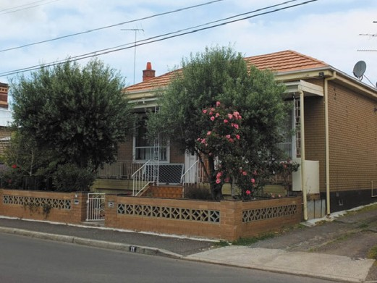
Figure 2.74: Altered Victorian dwelling in Hope Street, Geelong West, previously owned by Domenico Marafioti, 2018. Source: David Rowe.

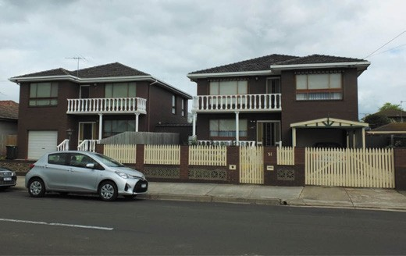
Figure 2.75: Brick dwellings, Gertrude Street, Geelong West, 2018. Source: David Rowe.
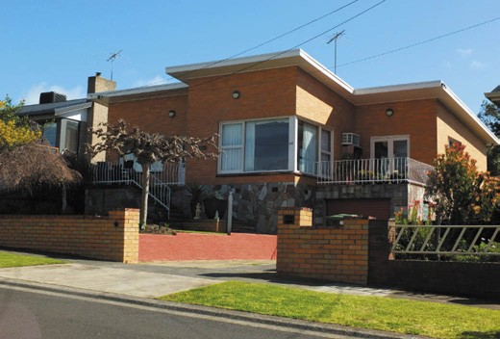
Figure 2.76: Dwelling featuring crazy stone wall cladding, Hamlyn Heights, 2019. Source: David Rowe.

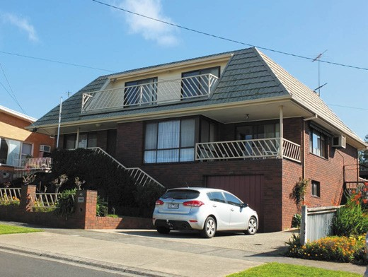
Figure 2.77: Dwelling featuring mansard roof, Hamlyn Heights, 2019. Source: David Rowe.

The Shell Refinery also provided accommodation for its employees. In 1952, a hostel was erected in the north-east portion of the refinery site at Corio at a cost of £220,000.694
It was to accommodate the hundreds of construction workers involved in the erection of the refinery.695 Initially, a row of houses were to be erected along the western boundary of the refinery site.696 A more ambitious scheme was the Shell
Housing Estate (Figure 2.73), established to the west of Hendy Street, Corio, adjacent to the Housing Commission Estate (see Theme 6). The estate was laid out by local architects, Buchan Laird and Buchan697 following their Garden City planning ideology earlier employed for the Housing Commission Estate in Newtown in 1940-41 and the Norlane Housing Commission Estate in 1948 (see Theme 6). The subdivision had been completed by August 1954.698 Streets were named after seashells, including Rotella Avenue, Teleta Crescent, Clavus Road and Telona Crescent. A.V. Jennings was contracted to construct Prebilt houses (being rectangular in form with low pitched roofs),699 while others were of steeper-pitched gabled and hipped forms. They were occupied by August 1955.700
he estate subsequently expanded to over 100 homes by the late 1950s.701 According to Marcella Hunter in Shell Geelong Refinery: 50 Years in Geelong:
One of the big attractions of a staff job at the refinery was the availability of accommodation on the Shell housing estate. With building materials for housing construction in short supply, the opportunity to rent a house at five per
cent of your salary was an added bonus. It was also a great place to bring up a young family, with the bush, the You Yangs and the beach all within easy reach.
… The houses were for staff only, with junior staff assigned the two-bedroom units and senior staff housed in three- bedroom dwellings. Rubbish bins clearly indicated your

status. Junior staff got one bin. Senior staff obviously had more rubbish and therefore got two bins!702
Many of these houses remain today as a physical legacy
of the original vision of the Shell Refinery to attract migrants after World War Two as part of its social welfare to its employees.

PRIVATE HOUSING IN THE SUBURBS
Many postwar migrants settled in the old and tired inner suburbs of Geelong, including South Geelong and
Geelong West.703 A stereotypical legacy of the ownership and occupation of some Victorian era dwellings by the newly-arrived migrants from southern Europe was the
Mediterraneanisation of these houses. A term used by Fiona Allon in Translated Space/Translated Identities , it directly relates to postwar migrants of Mediterranean descent and the changes made to Victorian era and other existing dwellings.704 Documentary and physical evidence suggests that these changes included new external claddings, replacement
of original timber window frames for aluminium windows and replacement of or alterations to front verandahs. The Mediterraneanisation extended to the front garden. Earlier settings were sometimes replaced with concrete and more
sparing plantings, and existing fences were replaced with low masonry types. This seems to have accorded alterations by migrants elsewhere in Australia where:
People invest[ed] [in] places with a host of social and cultural meanings that reflect [ed] their cultural histories and backgrounds, including, of course, a world-view shaped by experiences of ethnicity, race, gender and class
… in ‘Mediterraneanised’ houses, residents evoke[d] their translated identities and multiple belongings.705
The front spaces to these properties became terraces, their role reflecting the cultural background of their occupants. As explained by Mirjana Lozanovski, Iris Levin and Maria Gantala in Is the Migrant House in Australia an Australian Vernacular Architecture? :
The role of the terrace as a marker was more utilitarian and cultural. Our research showed how the terrace and veranda have provided migrants with spaces that are neither private nor public, but somewhere in between. They represent
a desire among southern European migrants to replicate the everyday social life of their homelands, where families lived in close proximity to one another and were involved in each other s everyday lives. The front terrace and the back verandah enable migrants to be part of a bigger community that extends beyond the walls of their house. Being able
to greet the neighbour from the verandah was imperative to the life of this community, just as being able to greet pedestrians while sitting on the terrace acknowledged the

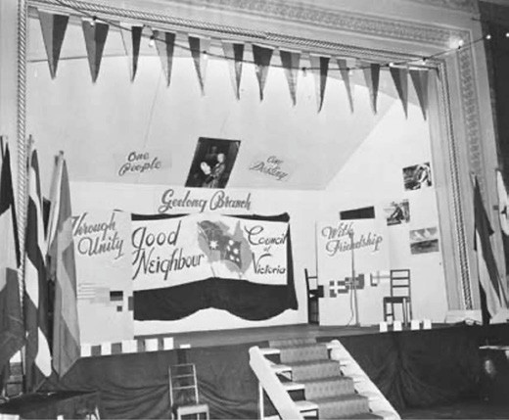
Figure 2.78: Good Neighbour (Geelong Branch) Display, 1956. Source: NAA: A12111, 1/1956/19/5, National Archives of Australia.

importance of street life, even in a suburban landscape.706
While a number of the heritage dwellings in Geelong West that had been Mediterraneanized have returned to their original appearance, one of the surviving examples that is a legacy
of change by Italian migrants in the second half of the 20th century is a property in Hope Street, Geelong West (Figure 2.74). Built as a Victorian weatherboard dwelling in c.1877- 78,707 it was occupied by Ferdinando Calvaresi in 1956.708 He had migrated to Geelong from Italy in 1952.709 By 1958, the property was owned and occupied by Domenico Marafioti and family.710 Marafioti was an Italian case maker and engine assistant and was resident at his Hope Street property until his death in 1999.711 Notable changes to the dwelling included the tiled roof cladding, brick wall construction, front verandah
supported by open steel trusses with an open steel balustrade, and the front garden dominated by two Olive trees and bound by a low masonry fence.
A similar stylistic approach was also adopted by some postwar southern and central European migrants for the construction of new houses. They were hallmarks of sheer hard work and family solidarity’, reflecting ‘the fact that they had “made it”
in a new country and a recollection of the culture from which they had come. 712 In very isolated parts of Geelong West, contextually large, brick, two storey, tiled hipped roofed houses rose above the single storey streetscape. In Gertrude Street, Geelong West, Branko Novacevski and his wife, Ljubica, had pair of double storey brick dwellings constructed in 1973-
74713 (Figure 2.75). Independent of the prevailing streetscape character, a feature of the dwellings was the neo Baroque balustrades to the front verandahs and balconies supported by

slender Corinthian columns. The front yards were bound by low masonry fences. Recessive side brick fencing with arched gateways connected both dwellings. From Yugoslavia, Branko and Ljubica had arrived in Melbourne in 1964.714 With Branko and Ljubica was Vasko Novacesvki. They had embarked
from Genoa and they were first resident at 54 Gertrude Street, Geelong West.715] Branko became a press operator and Ljubica a packer.716
A more notable number of Mediterranean dwellings were built in the suburbs of Bell Post Hill, Bell Park and parts of Hamlyn Heights where the largest proportion of postwar European migrants eventually settled (see Theme 6).
However, the stereotypical neo- Mediterranean dwelling was only one type of housing constructed for and by postwar migrants, based in part on their ethnic background. There were other houses that reflected architectural ideas or construction methods of their homelands, particularly those erected by migrant builders. An example is a brick veneer dwelling in Hamlyn Heights built in 1960-61 by Peteris Krastins (1922- 2015).717 A Latvian, he had emigrated from Germany in 1949 under the Displaced Persons Scheme.718 The crazy stone
base wall construction was a feature that Krastins reinvented from his European birthplace719 (Figure 2.76). A more obvious gesture to his Latvian homeland was the mansard roof form used in the construction of Krastin s second dwelling that he built in 1987 next door to his first house720 (Figure 2.77). While the functional necessity of preventing snow from building up was not required in Hamlyn Heights, the outward appearance was an expression of Krastin s desire to celebrate his Latvian roots,721 albeit in a more contemporary way.
By far the majority of the houses that were built reflected the standard double and tripled fronted brick veneer or weatherboard dwellings, sometimes with hints of the ethnic background of the occupant in the neo-Baroque or sway- bellied steel balustrading of the front porch such as those in Bell Park. The houses were affordable and fashionable, and were also a possible legacy of the Commonwealth Government s desire for new migrants to assimilate to Australian culture promoted through the Good Neighbour Council (see later subsection). They also accommodated migrants from diverse ethnic backgrounds.

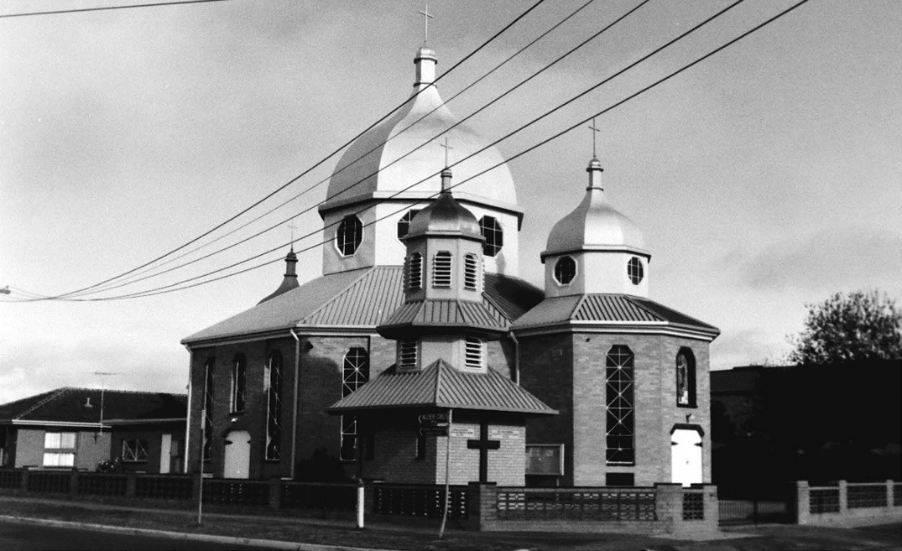
Figure 2.79: Our Lady s Ukrainian Church & Memorial, Bell Park, 1998. Source: David Rowe.

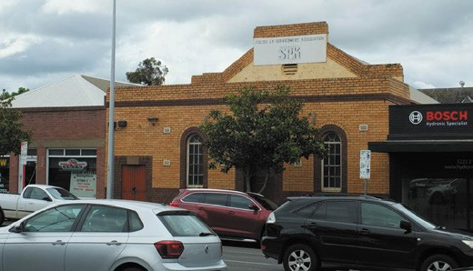
COMMUNITY & SOCIAL ORGANISATIONS

Figure 2.80: Former Polish Ex-Servicemen s Association Hall as marked by the surviving sign, 35 Ryrie Street, Geelong, 2018. Source: David Rowe.

GOOD NEIGHBOUR MOVEMENT
In 1950, the Commonwealth Government launched the Good Neighbour program with Good Neighbour Councils in each State to activate, encourage and co-ordinate the efforts of local church and community organisations in this role. 722 Its eventual aim was:
That whenever newcomers may settle in Australia there will be Australian men and women at hand pledged to help them in their early days in the community.723
One notable precursor to the formation of a Geelong branch of the Good Neighbour Council was an event arranged by the
Geelong Catholic Auxiliary for new Australians . In November 1950, they organised a welcome to migrants event at Ocean Grove.724 Guests from the Belmont Migrant Hostel came to the event which included a sports program and concert.
By 1952, a Geelong branch of the Good Neighbour Council had been formed.725 In 1956, the Geelong branch of the Good
Neighbour Council organised a display at the Victorian Building Industries Fair at the Exhibition Buildings726 (Figure 2.78).

D.W. HOPE CENTRE, ARUNGA AVENUE, NORLANE
In 1974, the Corio Shire Council acquired the former Migrant Hostel complex at Norlane.727 On the site, the Shire established the D.W. Hope Community Centre. It was named in honour
of the Shire s long-serving Councillor, Douglas Wallace Hope (1902-1977), who served from 1934 until 1971.728 Hope was a grazer of Darriwill North homestead, Moorabool.729 A number of community groups and clubs made their homes at the D.W. Hope Centre.730
The strong associations with the former Migrant s Hostel led to some migrant communities establishing clubs at the D.W. Hope Centre. They included the United Kingdom Settlers Association.731 With the deterioration of the Nissen huts by 1993 (with 14 of them vacant by this time), only three migrant clubs remained on the site in their own accommodation.732 They were the German Karneval Society (established in 1955), Geelong Spanish Association (established in 1980) and the Filipino Social Club of Geelong (established in 1982).733 These three organisations remain at the D.W. Hope Centre site today.

COMMUNITY & SOCIAL CLUBS & RELIGIOUS ORGANISATIONS
In addition to the above, numerous other social and religious organisations were established in separate locations throughout Greater Geelong by different ethnic groups.
They included the Austrian Club Geelong (1972), Croatian Community of Geelong, Geelong Dutch Club (early 1950s), Fiji Geelong Friendship Club Inc. (1985), Geelong Greek- Hellenic Community (1956), Hungarian Community (c.1950s),
Club Italia Geelong (1995), Geelong Lithuanian Community (1949), Macedonian Community of Geelong (c.1979-80), Polish Community (early 1950s),
Russian Community (early 1950s), Serbian Community (early c.1960s), Slovenian Cultural and Sports Association (1955) and Association of Ukrainians (c.1950s).734 Other related clubs also formed, including the Shell Club in 1952, where membership was open to refinery employees and contract workers.735
It was from these clubs and particularly religious organisations where the most overt expressions of cultural identity manifested in the buildings constructed between the 1950s and the 1990s. They included the Our Lady s Ukrainian Church and Memorial in Bell Park (built 1956) (Figure 2.79), Russian Orthodox Church, Bell Park (built 1958), St. Nicholas Serbian Orthodox Church and Hall, Hamlyn Heights (built 1964),
Club Italia, Moolap (built 1976), Holy Monastery of Panagia Gorgoepkioos (Greek Orthodox Monastery), Lovely Banks (established in 1993 at the former Monastery of the Oblate Fathers built in 1945), Macedonian Orthodox Church, Bell Post Hill (built 1979) and the Greek Orthodox Church, Hamlyn Heights (built 1988).736

Less overt are physical legacies of other migrant groups and associations of the immediate postwar period where
previously existing buildings were acquired. One example is the former Polish Ex-Servicemen s Association Hall 35 Ryrie Street, Geelong (Figure 2.80). An old sign continues to mark the former ownership of the old temperance hall (see Theme 8 for further details on the temperance hall) of this organisation. Today, White Eagle House, Fellmongers Road, Breakwater, is the headquarters of the local Polish community.
Another example is at 45 Bostock Avenue, Manifold Heights. In 1992-93, the bluestone Victorian Gothic former Uniting Church building was acquired by the Islamic Society of Geelong (a representative organisation of Muslims resident in Greater Geelong).737 The church building had been re-erected on the site in 1939 by the Methodist Church, having originally
been erected in 1858 in Wellington Street, Geelong West.738 The Islamic Mosque was gutted by a deliberately lit fire in 2016, but the Islamic Society continue to occupy and worship the site today following the repair and adaptation of the earlier structure completed in 2017.739

GEELONG ETHNIC COMMUNITIES COUNCIL
(TRADING AS DIVERSITAT) (FORMERLY GEELONG MIGRANT RESOURCE CENTRE)
In 1976, the Geelong Migrant Planning Committee was formed which led to the establishment of the Geelong Migrant Resource Centre as a non-for -profit charitable community service organisation to support multicultural communities and the disadvantaged in the Greater Geelong region.740 The core mission of the organisation which continues today under Diversitat has been to ensure that ethnic groups, organisations and individuals are given the opportunity to develop their potential and fulfil their aspirations as equal members of the community. 741 In 1977, the Geelong Migrant Planning Committee was replaced with the Geelong Ethnic Communities Council Inc.742 By 1985, the Council s membership included 19 communities.743 In 1997, the Geelong Ethnic Communities Council relocated to the newly-refurbished Geelong West Town Hall and Diversitat became the Registered Training Organisation, with this name becoming the trading name of the Council in 2005.744 In 2007, the City of Greater Geelong transferred a portion of land at the
D.W. Hope Centre site in Arunga Avenue to Diversitat for the development of the Northern Community Hub.745 Title was released in 2009.746 With a $1M grant from the Victorian State Government and $1.5M from the Federal Government in 2007, planning commenced for the Diversitat Northern Community Hub building complex at Norlane which was completed in 2010.747 In late 2011, work commenced on the construction of a Men s Shed in the north-west portion of the Diversitat site in Norlane.748 In 2015, a $1M grant was awarded from the Federal Government for building a Healthy Living Centre for Ageing in

Norlane.749 Located near the Arunga Avenue frontage of the site, the building was completed in 2017.750
Affiliated with 51 cultural communities in the Barwon region in 2018, Diversitat offers settlement services for new migrants, community programs, aged support for the elderly, services for young people, tradition and education, and arts and
events.751 One of the more enduring community events created in 1982 was the Pako Festa (which continues to the current day).752 In association with the Geelong West Traders and Geelong West City Council, the Geelong Ethnic Communities Council developed an ambitious community-driven party
that celebrated the region s diverse cultural communities. 753 Centred around a celebratory parade in Geelong West s commercial centre along Pakington Street. From the first Pako Festa in 1983 that attracted 12,000 people, over 100,000 people attended the Festa in 2017, with 5,000 participants in the street parade.754

IMMIGRATION IN THE EARLY 21ST CENTURY
Australian immigration changed dramatically towards the close of the 20th century with the introduction of mandatory detention of unauthorized arrivals (non-citizens without a valid visa). There had been an increase in unauthorized boat arrivals’ following conflicts in countries including Iraq and Afghanistan. The issue of refugees seeking asylum became highly political in the early 21st century.755
Notwithstanding the political controversies surrounding migration, Greater Geelong continued to welcome migrants in the first two decades of the 21st century. Further community groups and organisations were established including the Afghan Community (established in 2011), Bosnian Lily Association Inc. (founded c.2008), Bulgarian Society of Geelong, Congolese Community, Geelong Indian Association Inc., Indonesian Association of Geelong (formed in 2010), Geelong Iranian Society (established in 2007), Japanese Association of Geelong Inc. (established in 2017), Karen Community (people from the Burmese/Thai border) (founded from 2005), Lao-Thai Geelong Care Inc. (formed in 2016), Geelong Malay Association Inc. (Persatuan Melayu Geelong Inc.), Te-Arahina (Maori Culture Community, formed in 2004), and South Sudanese Community.756

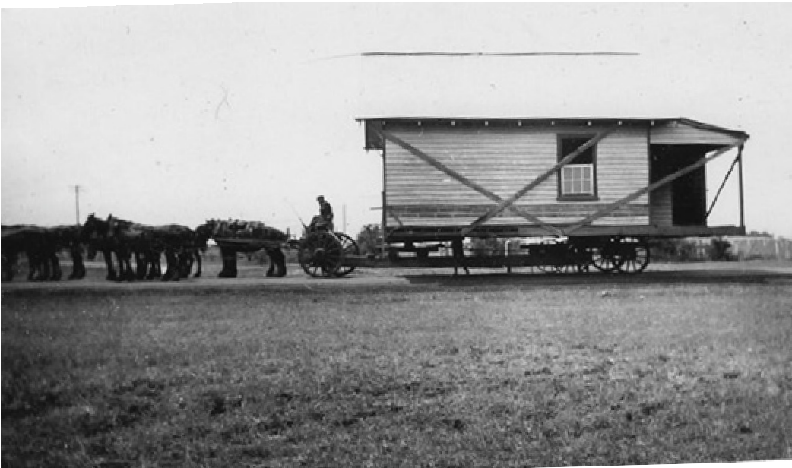
Figure 2.81: Dwelling from the Elcho Estate being relocated for the Phosphate Company to North Shore, c.1934. Source: I.M. & E.S. Whitcombe, private collection, at Culture Victoria online https://cv.vic. gov.au/stories/a-diverse-state/north-shore-geelongs-boom-town- 1920s-1950s/elcho-houses/

CLOSER & SOLDIER SETTLEMENT

CLOSER SETTLEMENT
Following the Depression of the 1890s and an increased demand for farming land, the Victorian Government moved to quell the potential loss of farmers to other colonies (due to most the land having taken up as large pastoral estates in the early-mid 19th centuries).757 To achieve this, the Government
enacted the Closer Settlement Act 1904, giving the Government the power to compulsorily acquire large freehold estates for subdivision and allocation as farm, agricultural labourers and workmen s home allotments.758 A Closer Settlement Board was established to administer the Act.
Additional land was also made available under the Small Improved Holdings Act of 1906. The purpose of this Act was to assist deserving persons to acquire small improved holdings in rural districts , the production of these small allotments thereby aiding economic development.759 Crown
land and land acquired for Closer Settlement was subdivided into allotments, their improvement and cultivation being supervised by an appointed foreman. The Act was repealed in 1909 and some sections of the Act were incorporated into the Closer Settlement Act 1909.760 Closely aligned with the Closer Settlement Act provisions, land for closer settlement and small holdings schemes was made available in in Greater Geelong to the north (Lara, Staughton Vale), south (Belmont, Highton and Newtown) and east (Bellarine Peninsula).
While the Closer Settlement schemes gave opportunity for the further peopling of Greater Geelong, a number of factors led to its initial demise. As outlined by P. Nelson and L. Alves in the Lands Guide:

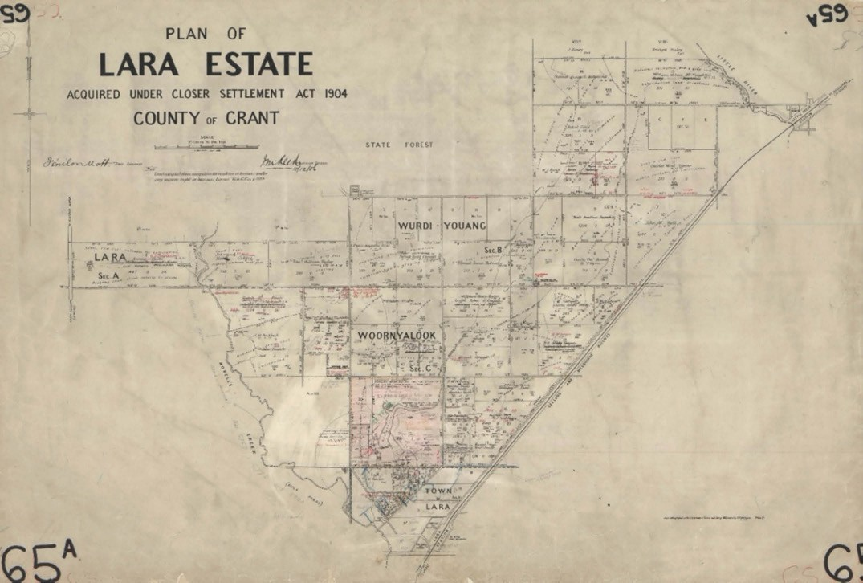
Figure 2.82: F. Mott, Plan of the Lara Estate Closer Settlement, photo-lithographed at the Department of Lands & Survey, Melbourne, by T.F. McGauran, 1906. Source: VPRS 16171/P2, item Plans, record Lara Estate (CS), Public Record Office Victoria.

Closer settlement achieved limited success. Some areas were unsuitable for intensive cultivation, some blocks were too small, and some settlers were unsuited to the task of farming. The general reliance on government advances
to settlers, combined with poor seasons and adverse economic conditions, resulted in the accumulation of large debts by settlers and the abandonment of many holdings. Several official inquiries into the effectiveness of closer and soldier settlement led to changes in administration, the easing of terms of occupation and the adjustment
of liabilities.761
In the north, there were major subdivisions either directly or indirectly associated with the Closer Settlement Scheme. At Elcho, Lara, a bluestone mansion had been built for John Galletly and his wife Elizabeth (nee Armytage) in 1864
(see Theme 4). In 1903, the property was purchased by H.M. Sutherland who had leased the estate since 1896.762 He made available the subdivision of outlying land as the Elcho Estate comprising 24 allotments and totalling 3118 acres, including land under crop. He retained a large homestead block but offered smaller blocks as the Elcho Estate. 763
In 1923, the Closer Settlement Board proposed the construction of about 20 cottages on their own blocks at Elcho as part of Training Farm for immigrants.764
British immigrants were sponsored by the Board to emigrated to Elcho and train them as farm labourers and small-scale farmers.765 The dwellings were to be of such a type that they might be removed to other localities in sections, if such course was considered desirable at a later date. 766 Stables and other farm structures were also built. State School No. 4250 opened at the Elcho Estate to educate the children of the newly-arrived immigrants.767 It was anticipated that the average attendance would be about 50. 768 By August 1924, eight migrant families were resident at the Elcho Estate and receiving agricultural instruction.769 This number had grown to about 20 families in 1925.770 Such promise of a successful Government training scheme enterprise was not to eventuate. As outlined by Peter Mansfield in ‘One Reminder of the Agricultural Instruction Farm at Elcho :
The Elcho training scheme was a well-intentioned failure.
In late 1927, it was reported that there were only two families at Elcho and government officials were perplexed as to

why so few English migrant families were not availing themselves of the benefits of the Close Settlement Scheme. Even well-publicized reports that migrants would be paid 30/- per week whilst receiving training, failed to attract more applicants. In fact, the public relations campaign caused some jealousy amongst Australian families
who were denied these government incentives. The Elcho scheme had failed within three years of its instigation 771
In 1930, the Government offered for sale the Elcho Estate. It included 41 cottages, a homestead and a hall. 772 Four years elapsed before the Elcho Estate Subdivision sale was initiated.773 It was also at this time when Elcho was the location of a military training camp of the 6th Infantry Brigade.774 It appears to have been soon after when Closer Settlement houses were purchased by the Phosphate Co-operative Company of Australia at Elcho and relocated to North Shore to accommodate Phosphate workers775 (Figure 2.81).
F.W. Armytage s Wooloomanata Estate, Lara, comprising 3000 acres, was offered for sale in 1904.776 Originally part of Station Peak Run of John von Stieglitz, it had been acquired
by Frederick Armytage in the 1850s (see Theme 4). The public auction of the Wooloomanata Estate occurred in the Lara Hall with a good attendance
of buyers.777
In 1906 the first land of the Pirra Estate, Lara, was sold as farm allotments under the Closer Settlement Act.778 This property had been established by George Fairbairn (husband of Virginia Armytage) in 1863 (see Theme 4). The vast outlying grazing land of Pirra was subdivided and offered for sale as the Lara Estate 779 (Figure 2.82). Immediately prior to the sale, the Weekly Times published the following:
The Lara Estate, which was purchased by the Government some time ago for the purposes of closer settlement, and is now open to application, is illustrated in this issue. The area of land available is about 8,300 acres. It is situated between Lara and Little River railway stations, on the west side of the railway line, and the nearest points are within a mile of both stations.
The soil consists of chocolate, black, grey and light sandy loam, and the bulk of it is easily worked. Good crops have been grown on the estate. Most of the land is level, and is suitable for irrigation. A considerable area of the property can be watered from the Little River. A survey has been made and a small channel which was constructed as a trial was successful in carrying the water for several miles.
The rainfall is generally enough for all purposes, the yearly average being about 24 inches.

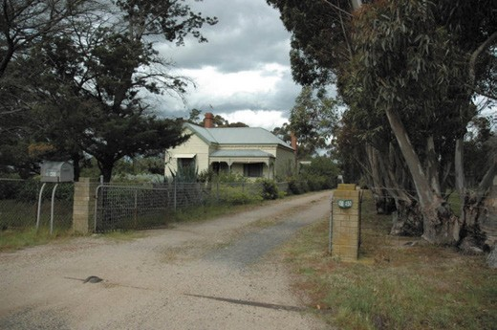
Figure 2.83: The Pines , 450 The Avenue, Lara, 2012. Source: Wendy Jacobs.
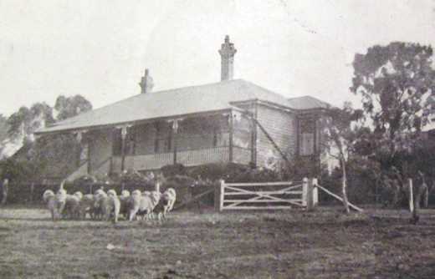
Figure 2.84: Lara Hill house, 1923. Source: Lara Hill auction notice, 13 September 1923, Geelong Heritage Centre collection.

The nearest point of the estate is nine miles from Geelong, and it is from 30 to 36 miles from Melbourne.
The estate is divided into 35 allotments, ranging from 70 acres to 448 acres, and in value from £550 to £2480. Two valuable homestead allotments are included, both of which are well improved.780
A portion of the Wooloomanata Estate also formed part of the Lara Closer Settlement Estate. Around 3000 acres of this substantial estate had previously been subdivided and offered for sale in 1904 by the owner, F.W. Armytage.781 This
created some confusion with prospective applicants of closer settlement land as part of the Lara Estate. As outlined in The Argus in January 1907:
The members of the Closer Settlement Board inspected Wooloomanata Estate on Thursday, and took the opportunity while passing through Lara of conferring with the inspector-general of the hospitals of the insane (Mr.

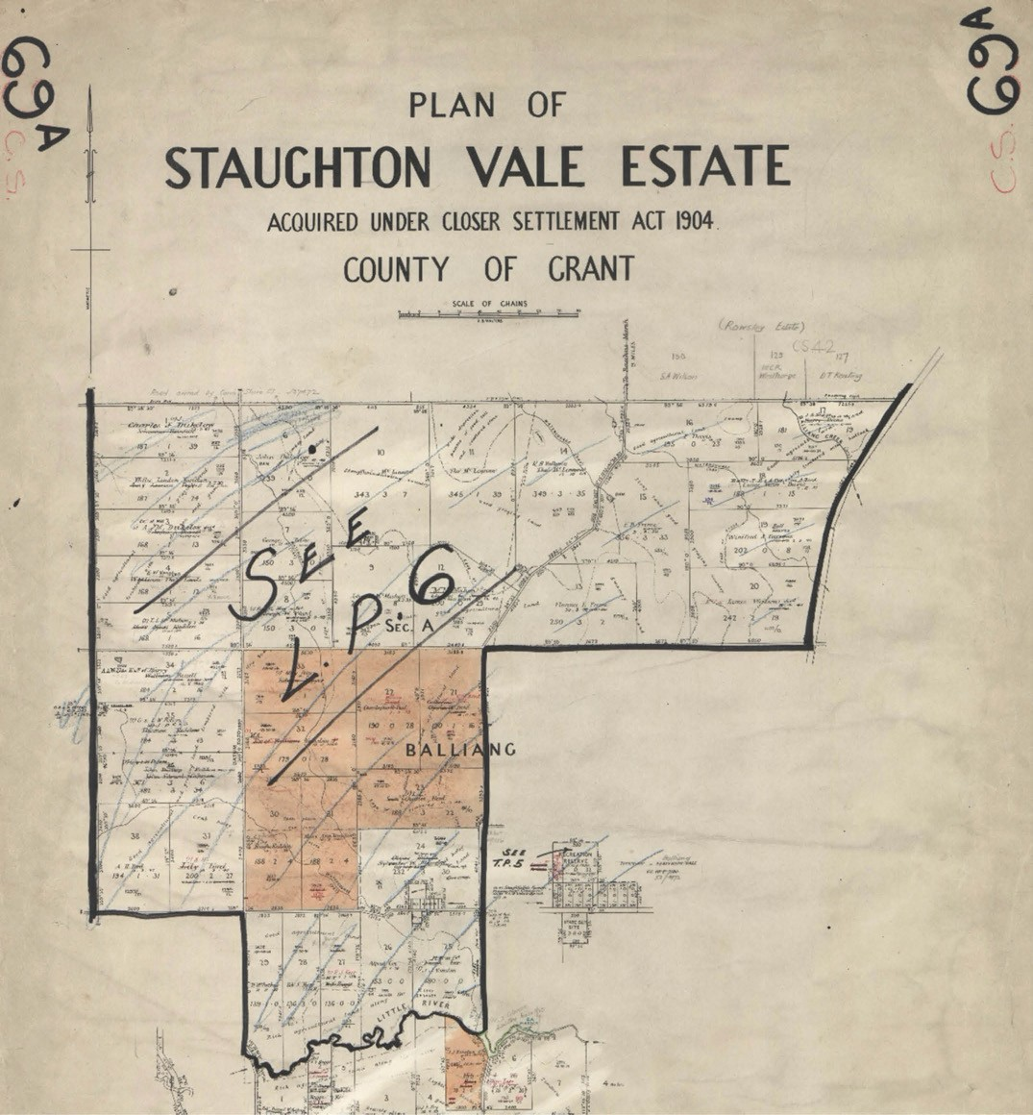
Figure 2.85: H.B. Walters, Part Plan of the Staughton Vale Estate Acquired under Closer Settlement Act 1904, photo-lithographed at the Department of Lands & Survey, Melbourne, 1908. Source: VPRS 16171/P2, item Plans, record Staughton Vale Estate (CS), Public Record Office Victoria.

Jones, M.R.C.S.) as to the suitability of the homestead allotment for the purposes of this department [Pirra homestead was selected instead see following and Theme 8]. The board also learned with surprise that a large number of intending applicants for closer settlement blocks, who had visited the Lara Estate, were under the impression that it was useless of them to apply for allotments now occupied by the tenants of Mr. Fairbairn, M.H.R. The
board desires it to be known that every allotment is open for application, and it is only in the event of competing applicants being in all other respect equal that the tenants in occupation are given the preference. Even then, a tenant is limited to one allotment, whereas at Lara several of the tenants have been cultivating areas now subdivided into two, and in certain cases more, allotments. Further, some of them would appear to be ineligible, as they already own freehold property, which with a closer settlement block would exceed the
value permitted.782
By February 1907, the successful applicants for the Lara Estate were announced in the Geelong Advertiser. They were Hedley William De Robert Ham and James Foote (lot 1), Robert Gebbie (lot 2), Charles William Tayler (lot 3), M. O Connor (lot 4), Patrick Wall Carroll (lot 5), E.J. Robinson (lot 6), William
Bodington (lot 7), John Danaher (lot 8), Kate Beatrice Reynolds (lot 10), John Stanley, (lot 11), Robert Foley (lot 12), Thomas Campbell Richmond (lot 13), Henry Reynolds (lot 14), Charles Ward Farrar (lot 15), J. Ball (lot 16), Charles Henry Smith
(lot 17), Sydney Albert Gillett (lot 18), Hamilton Calvert (lot 19), Joseph John O Connor (lot 20), George Jones (lot 21), Michael Coogan (lot 22), John A. Fletcher (lot 23), Robert Henry Sutterby (lot 24), William Plain (lot 25), John Carter (lot 26), Adolph Henry Schwartz (lot 27), J. Branch (lot 28), J.P.L. Jannssen (lot 31), William Ison (lot 32), Janet Smith (lot 33), Francis Augustus Rea (lot 34), W. Laycock (lot 35), Frederick Smith (lot 36).783 The Closer Settlement Board withdrew from sale allotments 29 and 30 as they formed part of the Victorian
Government s Inebriate s Retreat at the former Pirra homestead (see Theme 8). Allotments 37 and 43 were also set aside temporarily, to be sold at a later time as suburban or township lots given their close proximity to the Lara township.784
On the selection of the successful applicants, the Geelong Advertiser gave the following report:
In making the announcement of the recommendations arrived at, Mr. Jenkins [Secretary of the Land Purchase Board] said that the evidence put before the Board
by applicants had been carefully analysed and marks were awarded accordingly. Experience in farming, the possession of capital, having large families under 19 dependent upon the applicant, physique, were the things

that counted, and preference was given to those having families in the neighbourhood and being acquainted with the district, over entire strangers. They were met with the same difficulty as elsewhere in farmers agreeing amongst themselves as to what was the best land, with the result that many of those whom the Board were most anxious to please could not
be served.785
A tangible legacy of the Closer Settlement Board s initiative at Lara is The Pines , 450 Flinders Avenue, Lara (Figure 2.83). It appears to have been built for the successful applicant, George Jones Junior, farmer in c.1907. By 1915-16, the lease had been acquired by William and Beatrice Calvert, farmers.786
Another physical legacy of closer settlement at Lara are the ruins of Hedley Ham s Lara Hill property at 220 Hams Lane, Anakie. The station manager of Windermere Homestead (later Pirra Homestead), he had leased lots 9 and 10 of
the Wooloomanata Estate from F.W. Fairbairn and was subsequently successful in obtaining a conditional purchase lease (as lot 1) under the closer settlement scheme for the Lara Estate in March 1907.787 It was also at this time when he engaged the Geelong architects, Laird and Barlow, to design a six-roomed timber house on the site which he named Lara Hill 788 (Figure 2.84). This house was destroyed in later years and all that remain today are the foundations of the house and stone outbuilding ruins.

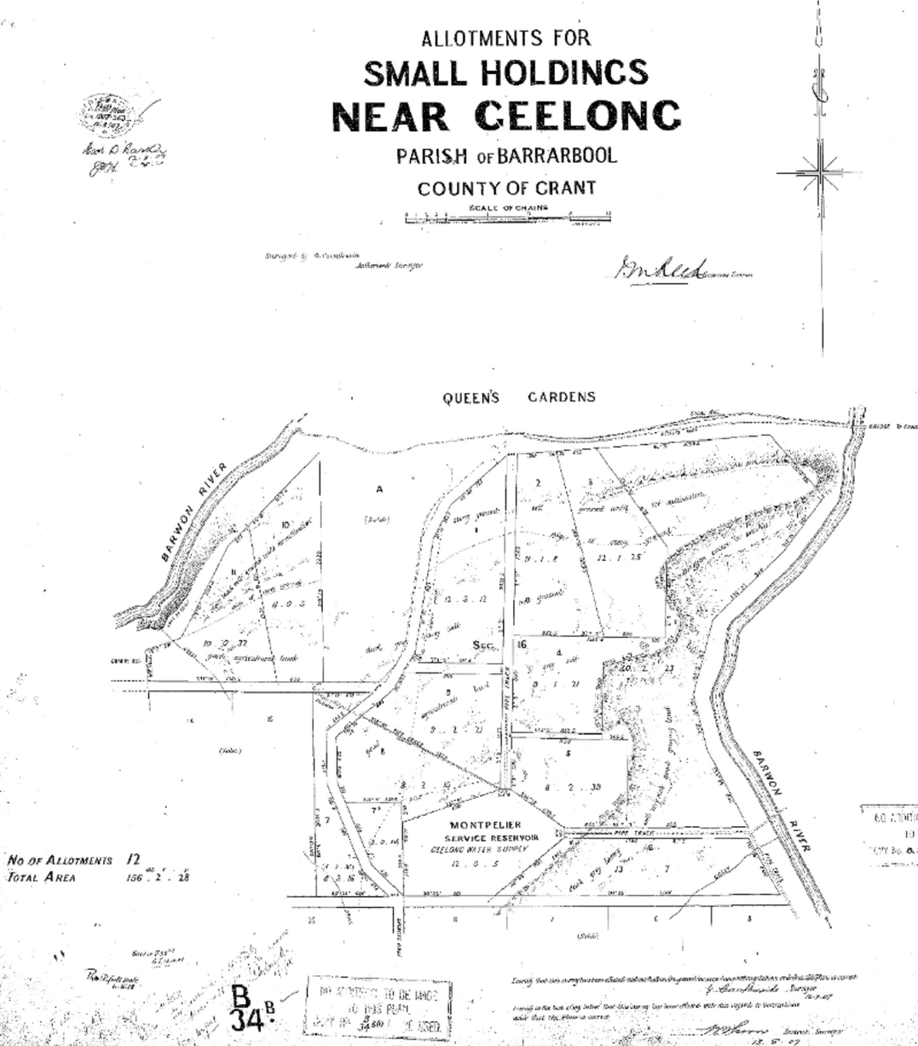
Figure 2.86: G. Cornthwaite, Allotments for Small Holdings Near Geelong, Parish of Barrarbool, County of Grant , 25 July 1907, put-away plan B34B/1, Landata, State of Victoria.

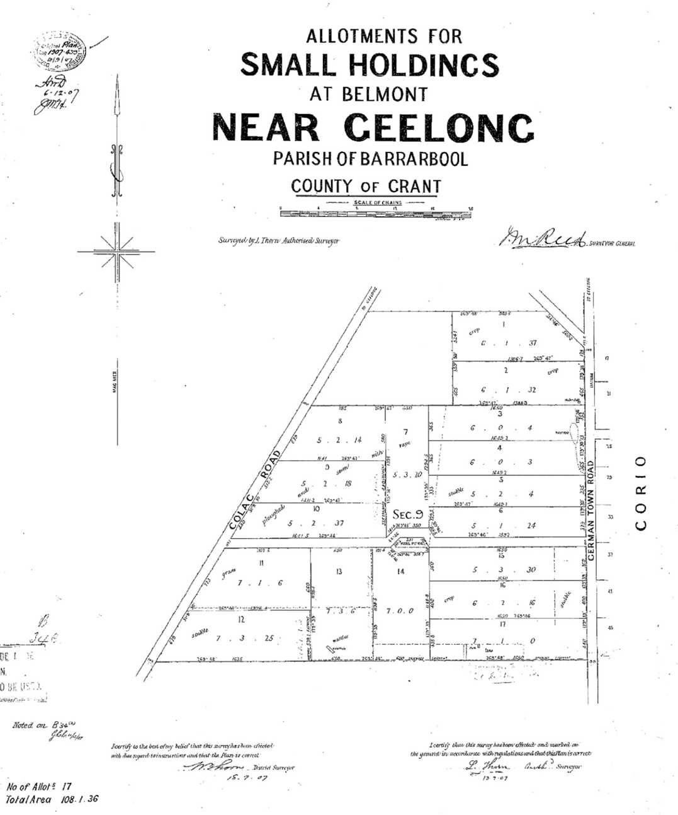
Figure 2.87: L. Thorn, Allotments for Small Holdings at Belmont Near Geelong, Parish of Barrarbool, County of Grant, September 1907, put-away plan B34B/1, Landata, State of Victoria.

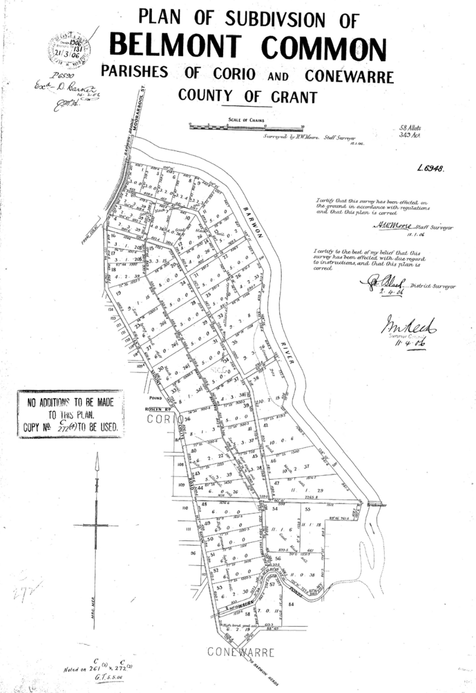
Figure 2.88: H.W. Moore, Plan of Subdivision of Belmont Common, Parishes of Corio and Conewarre County of Grant , 18 January 1906, put-away plan, C272/2, Landata, State of Victoria.

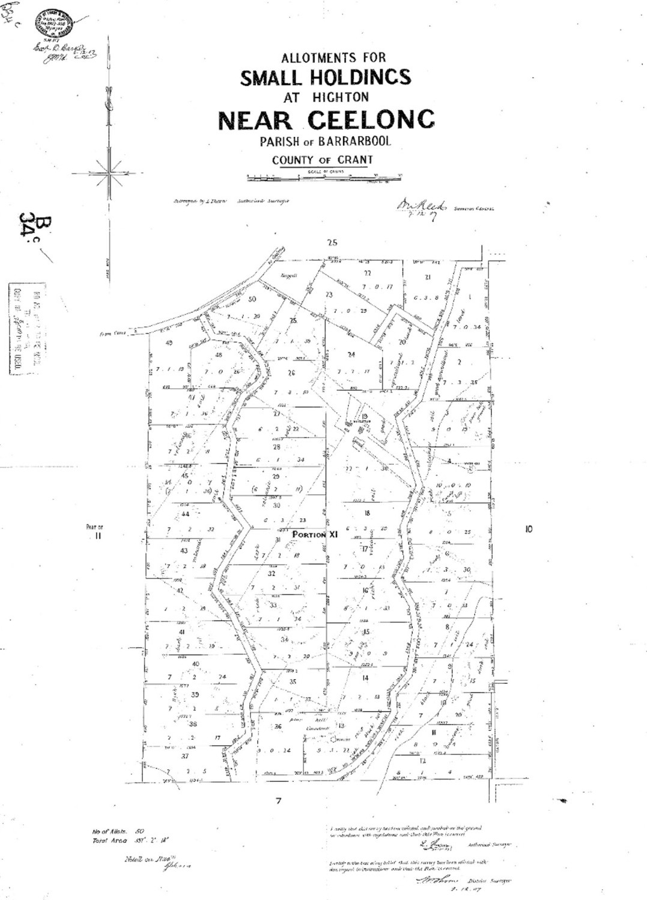
Figure 2.89: L. Thorn, Allotments for Small Holdings at Highton Near Geelong, Parish of Barrarbool, County of Grant, 7 December 1907, put-away plan B34C/1, Landata, State of Victoria.

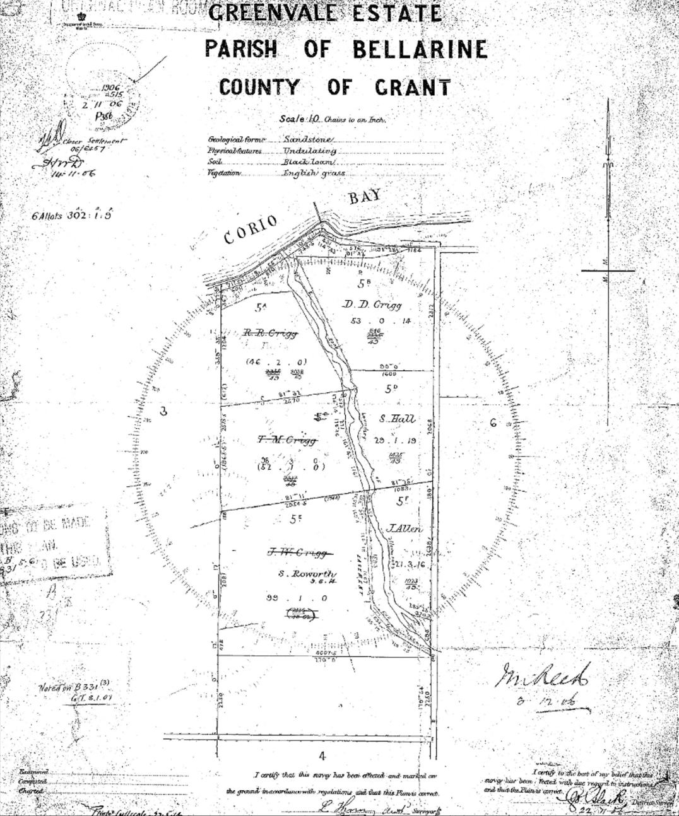

Figure 2.90: Greenvale Estate, Parish of Bellarine County of Grant , 1906. Source: Put-away plan B331B/2, Landata, State of Victoria.

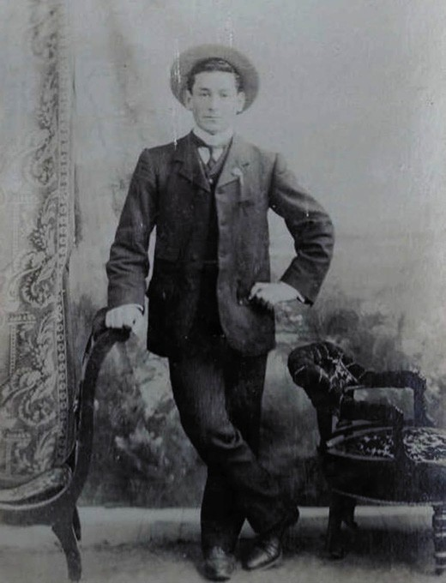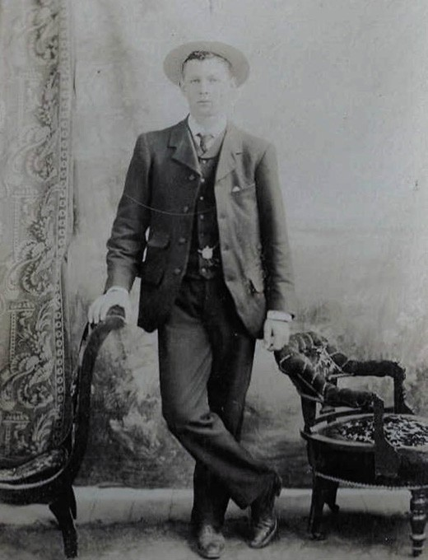

Figure 2.91: Grigg brother (possibly James Williamson), n.d. Source: Sherryn Batters.
Figure 2.92: Grigg brother (possibly Thomas Metheral), n.d. Source: item MM 10762 Museums Victoria.

Similar to the Lara Estate, parts of the Staughton Vale landholdings, originally part of Simon Staughton s Brisbane Ranges Run of 1842 (which stretched into the Parish of Lara) were opened up for closer settlement as the Staughton Vale Estate in 1908 (Figure 2.85) (see also Theme 6). Comprising 9838 acres, thirty-seven allotments ranging in size from
136 acres to 356 acres were made available at Balliang and Staughton Vale, on the north side of the Little River.789 Of the original 22 successful applicants, those who obtained land in the Parish of Balliang were: Harry Davis (lot 17), George
Victor Davis (lot 18), Christopher Howard Beet (lot 22), Samuel Charles Bird (lot 23), Oliver Burgess (lot 24), Frank Lee (lot 25), Alfred Coe (lot 26), Robert John Beggs (lot 27), Robert John Kerr (lot 28), Donald McArthur (lot 29), Hugh Redden (lot 30), Mary Ann Vanstan (lot 31), William Vanstan the younger (lot 32), Edwin Ripper (lot 33), William Bissell (lot 34), John Edward Chasmore (lot 36).790 Those who acquired land in the Parish
of Lara were John McCormack (lot 1), Donald Lamond (lot 2), William Phalp (lot 3), Mary Ellen Lee (lots 5 and 6), Henry William Alexander (lot 7) and Arthur Cashmore (lot 11).791 By
1913, it seems that only 11 settlers remained, and their success appears to have been mixed, with most under financial stress. As reported by a Closer Settlement Officer at the time:
I visited this Estate on 17th instant [17 December 1913] and called on eleven (11) Settlers where crop liens had been prepared and requested their signatures, or a reduction
of their arrears by cash to bring within the margin of their improvements. Four (4) lessees signed the Lien forms; three (3) were left with Settlers who requested time for consideration; One (1) was absent. Two (2) refused to sign or give security in any other form and one (1)- Phalp has a sufficient margin and was not pressed.
The Estate is devoted mainly to cereal crops and with the exception of the north west portion where the soil is light and stony, the returns from wheat, oats and barley are likely to be good. 792
In the south, the Small Holdings Scheme was pursued at Newtown, Belmont and Ceres (Highton) with the three areas subdivided in 1907.793 At Newtown, 156 acres of the former Newtown Common (comprising Section 16 in the Parish of Barrabool) was subdivided into 11 allotments ranged in size from 8 to 12 acres794 (Figure 2.86). These lots flanked parts of the Barwon River, Queens s Gardens (Queens Park) and the Montpellier Service Reservoir.795 These lots were considered to be suitable to the second class tenant: men who are able

to perform outside work to supplement their earnings. 796 The first successful applicants were: T. Fogarty, laborer, Richmond;
J. T. Edwards, laborer, Little River; W. J. Marks, laborer, Collingwood; O. Carroll, laborer, Camperdown; D. Burns, wood cutter, Bullarto; H. W. Grey, gardener, Highton; F. C. Bodley, gardener, Kew; J, Manning, farm laborer,
East Trentham; A. Gray, farm laborer, Yarraville;
W. D. Frith, contractor, South Ecklin; and R. Summers, laborer, Terang.797
At Belmont, 50 acres between the Colac Road and Germantown (Torquay) Road had been acquired from Emily Tadgell, Alexander McDonald and Ebenezer E. Hendy and subdivided into 17 lots ranging between 5 and 7 acres798 (Figure 2.87). The successful applicants were: S. C. Jones, labourer, Port Melbourne; R. W. Barker laborer, Geelong East; J. Canty, tanner, Marshalltown (Charlemont); E. Wilson, wharf laborer, Geelong; J. Alsop, laborer, Geelong; C. Carrol, plasterer, Middle Brighton; James McBride, gardener, Hawthorn; S. J. Woods, laborer, Geelong; J. R. Barwise,
laborer, Geelong; J. Marshall, laborer, Geelong; E. A, Chenery, machinist, Belmont; J, Lockyer, machinist, Belmont; A. Woolley, machinist, Belmont; V H. French, clerk, Belmont; A. T. Gathercole, poultry farmer, Geelong; James Atkinson, laborer, Lancefield; and A. J. Chenery, engineer, Belmont.799
A second subdivision had also been proposed at Belmont in 1905 for work homes on the Belmont Common. Consideration was given by the Victorian Government for about 1000 acres being obtained for the purpose.800 Fifty-eight allotments ranging between 2 and 11 acres were laid out in a Plan of Subdivision of the area between the Barwon River and the Barwon Heads (then Mt Colite) Road (Figure 2.88). Nothing eventuated of this proposal probably due to the potential for flooding and the high cost of constructing levees along the river banks.801
At Highton, 424 acres was taken up from Francis Richard Heard and subdivided into 50 allotments ranging from 6 and 10 acres, together with Heard s existing homestead and surrounding 22 acres of land802 (Figure 2.89).
In 1907, the Weekly Times announced the thirty successful applicants. Those to have first taken up land at Heard’s (Highton) Estate were: W. Park, labourer, Geelong West; J. Campbell, farm laborer, Iona; W H. Haderell, pastry cook, Geelong; W. L. Knight, labourer, Cannie, James Mathieson, farm laborer Lara; Alexander Mackay, farm laborer, Creswick;
A. E. Chapman, dairywoman, Wallan; J, W, Murcott, fireman, Footscray; J. P. Mather, laborer, Winslow; A. Williamson, laborer, Bendigo; W. P. O Neill, miner, Hepburn; J. Clarke, farm laborer, Germantown (Grovedale); J. Bennett, farm laborer, Deans Marsh; D. Duff, station hand, Darlington; J. M Gregor,

farm laborer, Loch; E. D. Brown, greengrocer, Melbourne;
P. H. Baverstock, gardener, Melbourne; H. J. Nunn, laborer, Richmond; A. V. Terria, tenterer, Geelong; T. W. Morris, laborer, Camperdown; G. Keefer, farm laborer, Beaumaris; D. Abbott, farm laborer, Beeac; C. F. Gilham, laborer. Lexton; R.
A. Campbell, carpenter, Upper Beaconsfield; J. Lonie, farm laborer, North Geelong; T. J. Sledge, carpenter, Gisborne; W. Sunderland, farmer, Apollo Bay; J. Hayes, market gardener, Wheeler s Hill; H. P. Bartlett, farm laborer, Camperdown; A. Burns, labourer, South Geelong; E. E. Smith, farm laborer, Wangoon; R. A. Jones, groom, Brighton Beach; A. E. W. St. Quintin, laborer, Mansfield; C. Jacobs, laborer, Mansfield; N. E. Murphy, farm laborer, Willaura; R. F. Andrews, farmer, Mildura;
R. Cleverley, laborer. Upper Hawthorn; M. Seaton, shearer, Spring Vale; W.T. Cullen, farmer, Ballarat; J. Larkins, laborer, Cudgee; R. Cutler, shearer, Epsom; W. Trew, laborer, Forrest;
J. Mason, farm laborer, Tolnie; J. W. Wells, laborer, Nyah; W. Summerton, carpenter, North Brighton; P. Meade, farm laborer, Ilowa; K. Nilson, laborer, Leongatha; J. S. Mewha, laborer, Noorat; and J. Bersica, laborer, Geelong.803
On the Bellarine Peninsula at Drysdale, two estates were laid out in 1906 and 1907. The first was the ‘Greenvale’ Estate (Figure 2.90). It comprised the former Greenvale farm of Thomas Tobias Grigg (1851-1930).804 The property had originally been established by Grigg s father in law, James Williamson (1804-1854) from September 1851, when the
first 58 acres was purchased at a land sale.805 Greenvale farm remained as part of Williamson s Estate and became the marital home of Thomas Grigg and his wife, Katherine (nee Williamson).806 With a frontage to Port Phillip Bay and traversed by a creek, the then 383 acre property was subdivided into six allotments ranging from 21 acres to 99 acres (the latter included the Greenvale homestead).807
Four of the lots of the Greenvale Estate were taken up by sons of the Thomas Grigg: James Williamson Grigg (1879-1962) (Figure 2.91) lot 5E (including the homestead), Thomas Metheral Grigg (1881-1956) (Figure 2.92) lot 5C, Donald Douglas Grigg (1883-1950) lot 5B and Richard Randolph Grigg (1885-1972) lot 5A.808 Their occupation was noted in the Geelong Advertiser in June 1906:

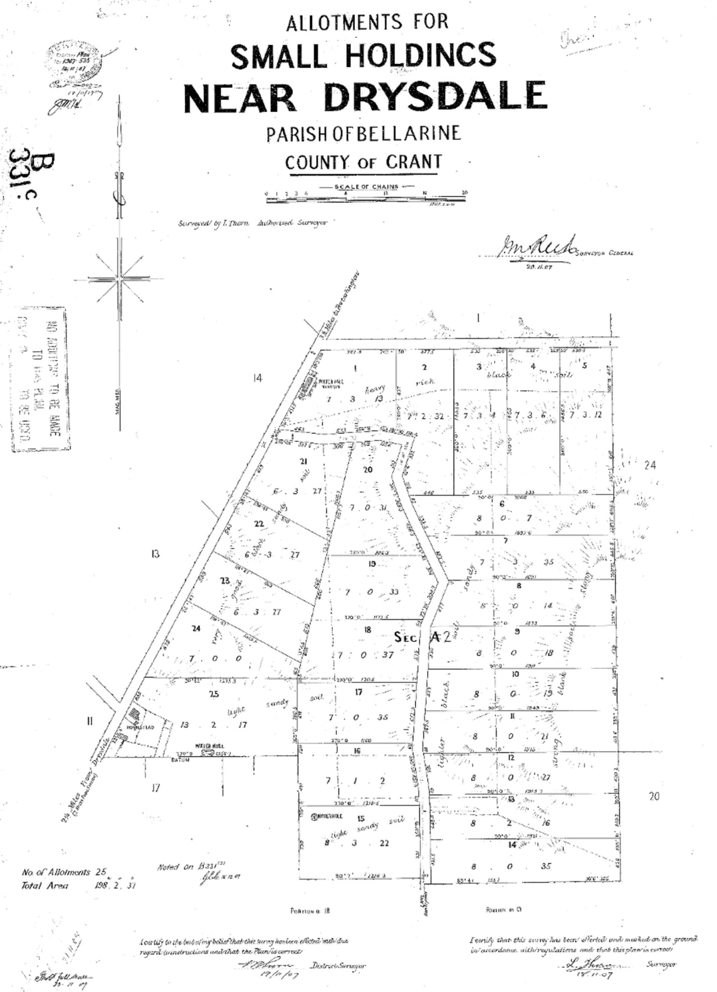

Figure 2.93: L. Thorn, Allotments for Small Holdings Near Drysdale , 9 October 1907. Source: Put-away plan B331C/1, Landata, State of Victoria.

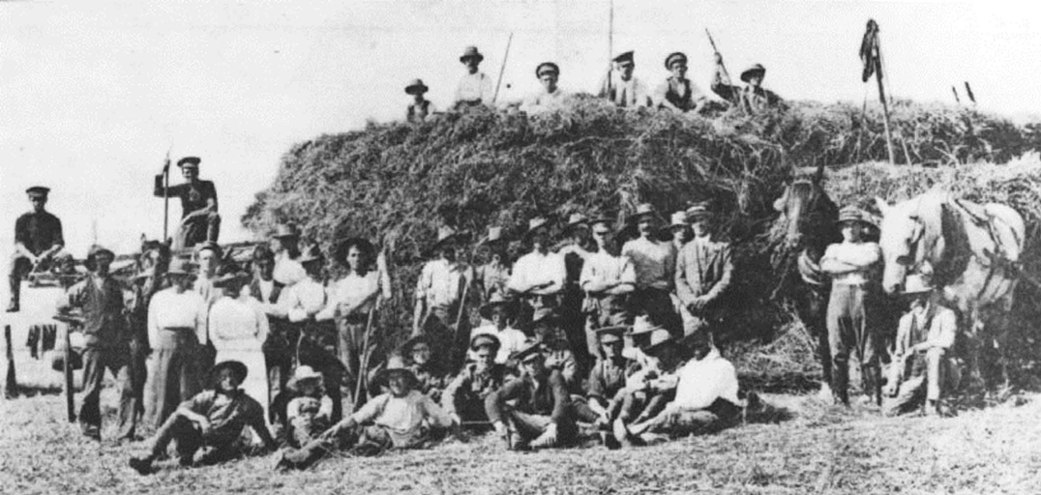
Figure 2.94: Working bee at Mrs Hammond s farm involving soldiers and local farmers, 1916. Source: News of the Week, 17 February 1916, p.15, GRS 2121, Geelong Heritage Centre collection.

Another well-known property reaching right down to the foreshore is “Greenvale” Estate, managed in conjunction with “Elsievale” [a separate property in the district] by four sturdy young brothers, R., J., D. and T. Grigg, who have acquired the property under the Closer Settlement Act.
As elsewhere in the district, chiefly oaten and wheaten hay are grown 809
The other successful applicants were Mrs Salina Hall (c.1854- 1909) lot 5D, and James Allen (c.1867-1941) lot
5F.810 Mrs Hall was the widow of Denby Hall and on her death in 1909, her lease was transferred to her son, Richard Garnet Hall (1877-1946).811 Mrs Hall s daughter, Ruby, married James
W. Grigg.812
To the north of the Drysdale township, a Small Holdings Estate was established on 204 acres of land acquired from Elizabeth, Horace, Llewellyn and Henry Trethowan in 1907 and colloquially known as the Trethowan Estate.813 The land was subdivided into 24 allotments ranging between 6 and 8 acres, plus the
13 acre existing homestead lot814 (Figure 2.93). Successful applicants were: W.H. Matthews, farm laborer, Drysdale; William Ferguson, laborer, Leongatha; C.G. Benning, wood cutter, Berringa; T.J. James, sawyer, Warburton; A.J. Jackson, fitter, Abbotsford; M. Burke, farm laborer, Beremboke; William King, laborer, Newmarket; T. Crough, farmer, Richmond; D. Martin, laborer, Camperdown; D. Boyle, laborer, Camperdown; W.H. Macauley, laborer, Camperdown; F. A. Holmes, miner, Outtrim;
J. McGregor, laborer, Williamstown; J. G. Rodgers, farm laborer, Drysdale; George A. Jago, laborer, Richmond; A. Gentles,
labourer, Port Fairy; F. Sommer, contractor, Poowong; John Rosen, laborer, Corop; James Reeves, laborer, Trafalgar; M. Eldridge, farm laborer, Colac West; O. King, farmer, Hartwell Hill; M. McMahon, laborer, Port Fairy; H.A. Hardware, gardener, Camberwell; and Charles Fuller, gardener, Streatham.815
A foreman had been appointed in 1907 to supervise the Small Holdings Estates. For those estate in Geelong, M. McLean had taken up the position while at Bellarine, H.L. Trethowan was commissioned to oversee developments on his former property. 816
By 1908, improvements had been made to each of the Estates. At the Small Holdings Estates at Newtown, Belmont and Highton, 78 houses had been erected.817 These dwellings were constructed by tradesman (or artisans) contracted by
the Board. As outlined in the First Annual Report of the small Improved Holdings scheme in 1908:
As it would have been folly to place good materials in the hands of unskilled workmen, it was therefore, decided to employ a tradesman, and engage the settler to assist him in the erection of his own house, and in this way, profitable employment was found for him. The houses are of four designs; three of them providing for four rooms, and one for five rooms, and this design was only used where the settler s family was exceptionally large.818

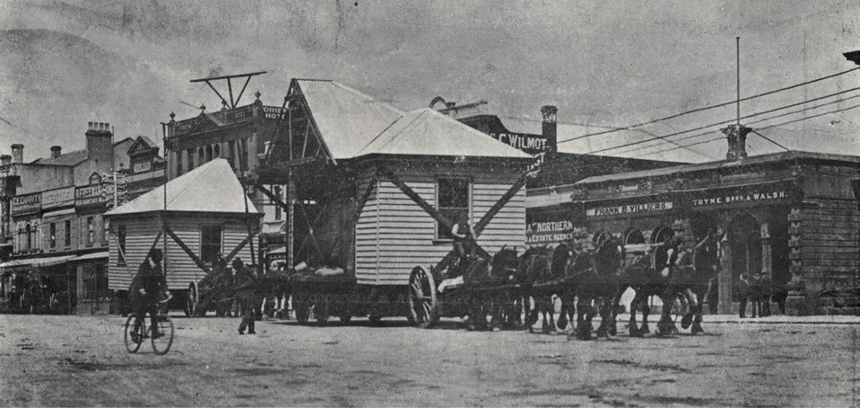
Figure 2.95: Closer settlement house from the Trethowan Estate in Malop Street, Geelong, enroute to Pender s Grove Estate, Clifton Hill (Melbourne), 1911. Source: News of the Week, 2 March 1911, GRS 2009/02295/063, Geelong Heritage Centre collection.

Houses at the Newtown, Belmont and Highton estates accommodated 134 adults and 294 children.
These newly-created properties also held 24 stock and 236 poultry.819 At the Trethowan Estate at Drysdale, 24 houses had been constructed to house 48 adults and 99 children.820 The allotments also included 9 stock and 55 poultry.821
The completion of the dwellings at Drysdale in December 1908 was celebrated with a social evening. As reported in the Geelong Advertiser:
The finishing of the work of cottage building on the small holdings estate at Drysdale was celebrated by a social evening in one of the cottages on Friday evening last.
Mr. James, one of the earliest settlers, acted as chairman during the evening. Mr. and Mrs. H.L. Trethowan and
Mr. Renfry were present as guests at the opening. The musical portion of the evening s entertainment consisted of: Overture piano, Mrs. Trethowan and Mrs. Glover; selections phonograph, Mr. McLean; songs by Messrs. Renshaw, Wilson, Mason, Glover and Matthews; recitations by Messrs. Shore and Trotman, Wilson, Matthews; dances, Highland fling, by Master Jim Macauley; sword dance by Master Jim Macauley and Mr. Sommers; pipe selections, Master Ken Macauley. The principal item of the evening was the presentation by Mr. B. Renshaw, on behalf of the settlers and artisans, to the foreman (Mr. Trethowan), of a very handsome morocco dressing case, suitably engraved. Mr. Renshaw spoke on behalf of the artisans of the able manner in which Mr. Trethowan had superintended the work in progress, and the efficient and courteous manner
in which he had carried out all his duties, and he hoped he would live long to use their small gift.
Mr. James spoke on behalf of the settlers of the assistance and kindness shown, by the foreman to them all from the time they arrived at the settlement.822
Although success was anticipated given the cordial and enthusiastic co-operation between the new settlers, workers and neighbouring farmers, the Closer Settlement and Small Holdings schemes were not immediately successful, both at Drysdale and at Belmont, Highton and Newtown.
Just one year into the scheme in 1909 at the Trethowan Estate at Drysdale, 13 of the original settlers had voided their leases.823 While two of these lots were taken up by new applicants Patrick Hassett and Annie Hammond (a widow),
by 1914 there were only three settlers on the Estate, each with multiple allotments.824 They were William Allen, William H. Matthews, Annie Hammond and E.S. Reynolds.825 Apart from Alexander McInnes (who had passed away),826 the majority of the remainder had gone into arrears through sickness, want of employment or other cause ,827 In 1916, Mrs Hammond struggled on with the assistance of 28 soldiers as well as neighbouring farmers in gathering her crop (Figure 2.94).

Unoccupied houses on 16 allotments of the Trethowan Estate were either removed to Pender s Grove Estate, near Clifton Hill828 (Figure 2.95), or sold. An account of the vacant houses proposed for sale was given by F.E. Kee of the Closer Settlement Branch:
I visited Bellarine [Trethowan] Estate on the 24th and inspected the vacant houses on allots 2, 12, 15 & 21. The houses are all more or less in bad order, windows broken, and in the case of house on allot 12, back door broken off. Mrs. Hammond who is leasing this allot is responsible for maintenance and I ascertained from, her that she would replace door at her own cost.
It is recommended:
- That the houses on allots 2, 15 and 21 be sold for removal, at a price of £80 each, and that the house on allot 12 be left for the present.
- That Mrs. Hammond be informed that she must
at once replace the back door in the house on allot 1 at her own cost, and stock must not be allowed to trespass, nor must produce be stored in
the building.
- That Messrs A.J. Young and Co. [auctioneers, Geelong] be informed that the Board will sell the vacant houses on allots 2, 15 and 21 on the same terms and conditions as those recently disposed of at Highton.829
At Highton there were a good many complaints , the settlers seeking increased areas, a reduction in the value, and deferred payments. 830 In 1914, there were only nine settlers remained on the estate, occupying 19 allotments.831 At Newtown, while some settlers were satisfied with the existing conditions,
others asked for more land and easier payments. 832 There were eight settlers occupying this estate, with just three having originally taken up the land and while five of them
were in arrears.833
At Greenvale, bad seasons had exacerbated the mounting debts. In September 1911, three of the Grigg brothers Donald, Thomas and Richard abandoned their leases.834 In January 1912, the leases for all four Grigg brothers were declared void for non-payment of the required instalments.835 This included the original Greenvale homestead on Lot 5E, where James Grigg had continued on his own account. Although having received official notice by the Closer Settlement Board to vacant the property, Grigg pleaded his case on two occasions in April 1912 to be able to remain on the land. His first appeal was to William Luly of the Lands Department:

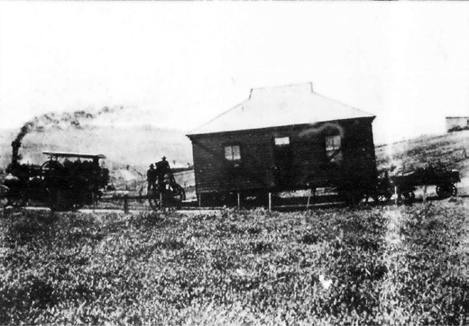

Figure 2.96: The first house being relocated from the Heard Estate, Highton, 1911. Source: News of the Week, 19 October 1911, GRS 2121, Geelong Heritage Centre collection.

Since you were here I have received a letter from the Office, stating that they still adhere to their previous letter, which says that I must vacate the allotment.
Now I think this most unfair, because in the first place had I not gone on with the work on my block last year when my brothers gave up theirs, the Board would not have had anything for last season at all. As it is they are getting all that I could possibly give them. I have put in hard work in order to try and make a decent show and remit them as much as possible. They will get about £105 out of the hay, which is a fair rental at last for the land. I have ploughed about 40 acres to date of my block and have sown a few acres already of swedes and barley, and have the ground
ready now to put in my hay at once but I am afraid to do so. I have bought the seed and manure and have also bought a plough and cultivator which completes my plant. I am entirely apart from my brothers and which for one clear years trial on my own, but the Board have evidently made up their minds not to give me. I have been absolutely fair with the Board having given them all that I had over and above actual living expenses and rates, fares, etc. Had I been allowed to continue when I asked last year, I would
have been the richer by at least £100 by way of grain, barley etc. but the Board would not give me that permission until at last I went on my own, but the wet season was against me and the seed I put in rotted and it was too late then to sow again. I have a great chance now if allowed to go on with the land, and I am well ahead with the work. All I ask is for the Board to grant me this year and if I don t make a show to their satisfaction then I am willing to clear out. I would give them a lien on all my crops so that they would be sure of their rent. What could be fairer than that? I would like you to put my case to the Board (they have never given me a chance to show them what I can do with my block now

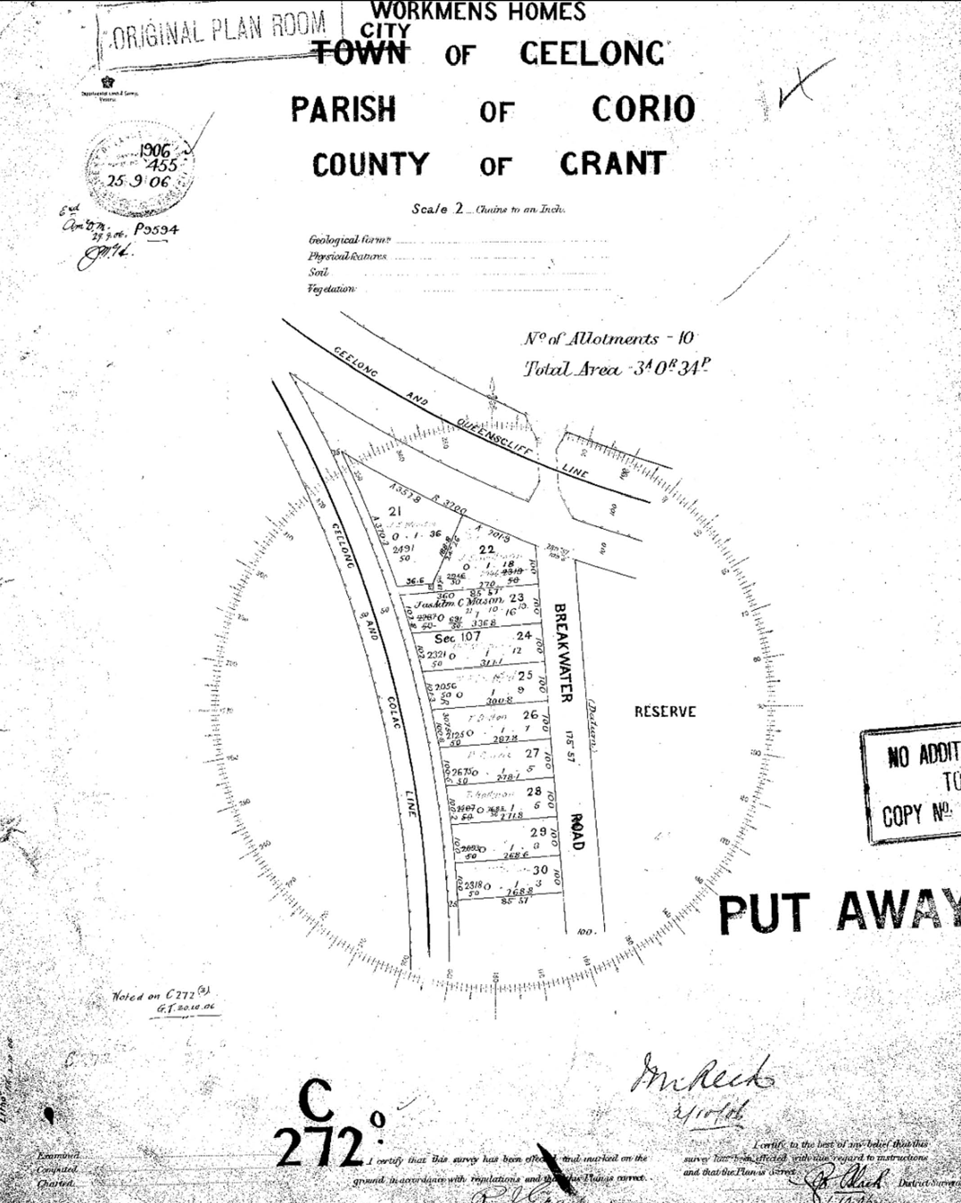
Figure 2.97: Workmen s Homes, City of Geelong, Parish of Corio , 1906. Source: Put-away plan C272O/1, Landata, State of Victoria.

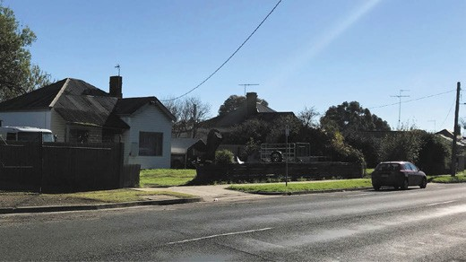

Figure 2.98: Former Workmen s Homes , 90 & 92 Breakwater Road, Breakwater, 2019. Source: David Rowe.

that I am on my own) - you know my position and that I am anxious to get on. I have now a full plant of my own and everything going satisfactorily for this year. Everything my wife and I hold dear is here in Drysdale and I want to keep the Old Place or my block at least which the family have held ever since it was selected in the first place. If you can do anything on my behalf, I and my wife would be under a lifelong obligation to you.836
Grigg s pleas to Luly and the Closer Settlement Board were to no avail. The property was put up for sale and purchased by Samuel Roworth in 1914.837 The leaseholds of Richard and Thomas Grigg (lots 5A and 5C) were acquired by Ernest Turner838. Richard Hall of lot 5D acquired Donald Grigg s land comprising lot 5B.839
By 1914, one of the remaining settlers at Greenvale had lost
£200 and three draught horses over two years by 1914, and his neighbours had ploughed his land for him, and assisted him in other ways, , and so he expected with good seasons to pull through all right . 840
The broad failure of the Closer Settlement and Small Holdings Improvement schemes in the Geelong area brought about their remodelling by the Closer Settlement Board in 1911.841 However, this did not prevent a scathing attack on the development of 424 acres of land previously owned by
Francis Richard Heard at the eastern end of the Barrabool Hills at Ceres by the Member of Parliament, William Kendell.842 As he declared:
When we look back and see the huge blunders criminal blunders some of them that were made in connection with closer settlement in the past I would recall to Mr. Richardson s mind what occurred at the hills near Geelong. The Government, or the [closer settlement] board, covered the butt of those hills with houses. They were shining there in the sun every day for about two years. Then we saw traction engines and bullock teams taking them away.843

The first houses from the Heard Estate were relocated to Werribee in 1911, with sixteen being moved by John Bannister and Son844 (Figure 2.96).
Little physical evidence of these closer settlement schemes survives today. At the former Trethowan Estate, Drysdale, the layout and names of the thoroughfare Settlement South and Settlement North Road is one of the few vestiges, as is
possibly the layout of some of the allotments. Of the Greenvale Estate, the only tenuous link to Closer Settlement scheme and the Grigg family is the name of the creek Griggs Creek. The area has been suburbanised. At Highton, a portion of Brownhill Reserve is a legacy of the original recreation reserve laid out
as part of the Small Holdings scheme. Nothing survives of the former Belmont and Newtown Small Holdings schemes.

WORKMEN’S HOMES ESTATES
Small Workmen s Homes estate were proposed in 1906, at East Geelong (Thomson) (Figure 2.98) and on part of the Osborne House Estate at North Geelong.845 Ten dwellings were to be constructed at each estate.846 Only part of the estate located near the junction of the Geelong and Queenscliff and Geelong and Colac railway lines on the west side of Breakwater Road
at East Geelong (now Thomson) appears to survive today. To be eligible for the lease of an allotment, an applicant needed to be engaged in some form of manual, clerical, or other work for hire or reward; had the means to erect a suitable house to
fence and cultivate the land; and was a deserving and suitable person. 847 No second-hand dwellings were also permitted to be erected on the land without the consent of the Board.
The successful applicants at East Geelong were resident by 1908. Almost all of the workmen were employed by the
Victorian Railways, with two employed at industries nearby at Breakwater. They were Joseph Edward Wensor, greengrocer; Charles Mason, fireman; Michael Thomas McConnell, labourer; William Frederick Bampfield, railway employee; Thomas Dalton, wool sorter; Patrick Gurrie, labourer; Thomas Hallinan, driver; James Hallinan, labourer and Daniel Fowler, fellmonger.848 Today, five of the original hipped roofed timber Edwardian styled dwellings remain as part of the Workmen s Estate at 56 Yorkfordshire Avenue and 76, 82, 84, 90 and 92 Breakwater Road
(Figure 2.99).

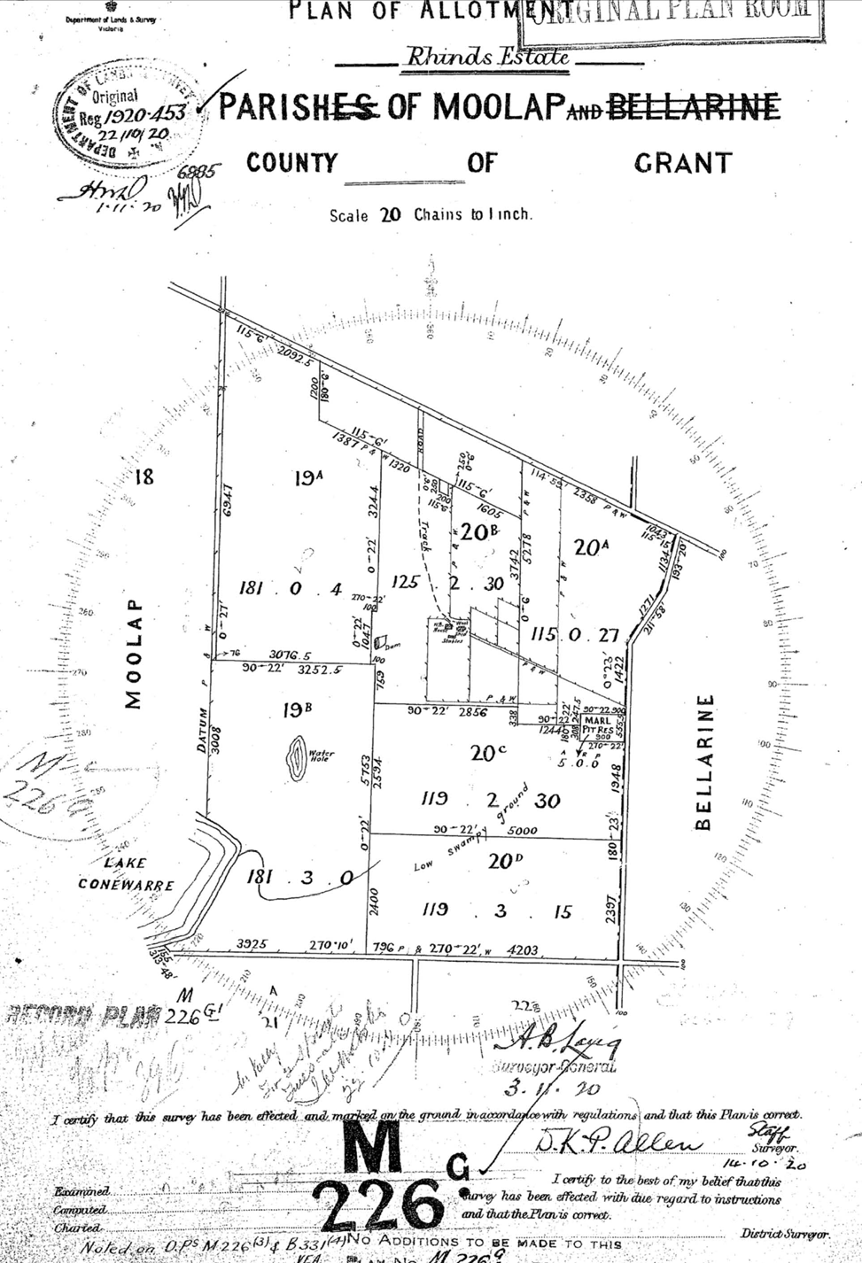
Figure 2.99: Plan of Allotment, Rhinds Estate, Parish of Moolap, County of Grant , 1920. Source: Put-away plan, M226G/1 Landata, State of Victoria.

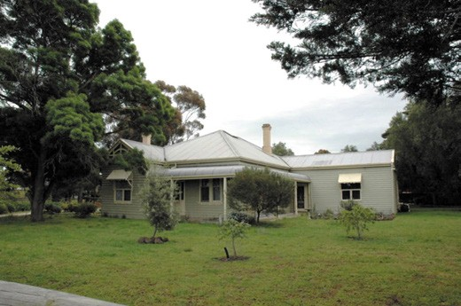
Figure 2.100: Glenoe , 10 Windermere Road, Lara, 2012. Source: Wendy Jacobs.

SOLDIER SETTLEMENT
In 1917, prior to the cessation of the First World War, the Discharged Soldier Settlement Act was enacted. It gave assistance in procuring farmland for returned servicemen ‘possessing the necessary aptitude and fitness’ as part of a Soldier Settlement Scheme.849 Unlike the compulsory
acquisition of substantial historic farm properties, in Greater Geelong soldier settlement was confined to existing Closer Settlement Estates (such as Lara) and mainly to individual allotments in outlying areas. Approximately 36 returned soldiers were offered land.850 They included Walter Ernest Wiffen (Parish of Bellarine, lot 22, section 1), James Wilson Hunter Branagh (Parish of Bellarine, lot 3A, section 3), Leslie George Anderson (Parish of Bellarine, lot 40A, section 2), Roy Neil Beckley (Parish of Bellarine, lot 40a, section 20, George Edsell (Parish of Bellarine, lot 40A, section 2), John Robert Cutler (Parish of Bellarine, lot 1C, section 3), John Frederick William Rechenberg (Parish of Connewarre, lot 21C, section 4), Charles Buchanan (Parish of Barrabool, lot 16, section
9), James William McIntyre (Parish of Moranghurk, lot 153), John Lachlan McIntyre (Parish of Moranghurk, lot 153), Arthur Joseph Johnson (Parish of Moranghurk, lot 186A), James Ernest Caple (Parish of Wurdi-Youang, lot 12, section B), Charles Edward Perkins (Parish of Wurdi-Youang,
lot 12, section B), William Henry Tayler (Parish of Wurdi- Youang, lot 6, section B and Parish of Woornyallook, a lot 9, section C), Murdoch McIntyre (Parish of Woornyalook, lot 12 section C), George Bates (Parish of Murtcairn, lot 1, section 8), Reginald Tayler (Parish of Woornyalook, lot 17, section C), Gilbert McKellar (Parish of Woornyalook, lot 70, section 11), Henry John Young Marshall (Parish of Anakie, lot 6), Joseph Samuel Beggs (Parish of Lara, lot 8, section B), Cecil John Moreton (Parish of Balliang, lots 132-133),
Thomas Russell Palin (Parish of Murtcairn, lot 10C), Samuel John Gugger (Parish of Barrabool, lot 15A), Ernest Matthews

(Parish of Barrabool, lots 25, 37 and 48, section 11), Fred Louis
Swinburne (Parish of Barrabool, lots 25, 37 and 48, section 11), George Frederick Butcher (Parish of Barrabool, lot 1, section 11), Hugh John Curtis (Parish of Barrabool, lot 6, section 16), Owen William Carroll (Parish of Barrabool, lots, 1, 5, 7 and 8, section 16) and John Kidd, Parish of Barrabool, lot 3).851
Physical evidence of the soldier settlement scheme survives at Wallington and especially at Lara. At Wallington in 1920, land acquired from David Rhind, experimental cultivator, stockbreeder and dairy farmer whose Chevy homestead was situated in Fenwick Street, Wallington (see Theme 6 for further details). The land was subdivided into six allotments (Figure 2.99) and was reported in the Geelong Advertiser:
Six allotments of land in the Wallington estate, purchased from Mr D Rhind, are to be dealt with at a special land Board sitting. A large number of returned soldiers have already lodged applications. Those with previous experience on the land will receive preference. The subdivisions include a 115 acres block, the homestead block of 125 acres, with house & dams; two 120 acre blocks and two blocks of 181 acres each. They range in value from £1848 to £2156. Mr W Dean, the President of Bellarine Shire Council, was asked to sit on the board which selected the men to occupy Rhind s Estate
– ‘a fine type of young manhood had secured blocks. In one instance a large orchard has been planted and shows signs of being successful. Houses have been erected and considerable areas put under cultivation .852
Edward Stanley Baglin was one of the successful applicants. He had served with the 10th Field Company in France and he was married with one child.853 Although a licensed drainer on sewerage work, he had been brought up on a farm in the Geelong district, and had leased and work for others in the district. He intended to carry out mixed farming.854
Sergeant Alfred Cyril Firth took up part of the Chevy homestead estate. He had served in the 13th Light Horse Regiment and had enlisted as a labourer.855 He was gassed in 1918 while serving in France and in 1919 he was awarded the Military Medal for bravery in the field.856
James Hammond was another successful applicant.
He appears to have been born in Boston, England, and at the time of enlistment in 1916 he was a labourer in St.Albans (now St. Albans Park), Geelong.857 He served in the 32nd Battalion.858
The fourth successful applicant was Oliver Albert Harding. He served in Belgium and France and was slightly wounded on two occasions.859 He had five years’ experience as an orchardist and farmer before the war, and he had intended to grow fruit and establish a
mixed farm.860

Frederick William Jury was a driver in the 10th Reinforcements, 8th Light Horse Regiment.861 His success at obtaining part of the Chevy estate was his previous experience on his mother s 80-acre farm.862 His intention was to establish a mixed farm.863
The final successful applicant was Bertram Maddock who served in the 10th Field Ambulance Brigade.864 He was
a labourer in Ballarat at the time of enlistment in 1915.865
Ultimately, those soldier settlers that endured at Wallington were Edward Baglin (who had taken up the original Chevy homestead), James Hammond, Bertram Maddock and Oliver Harding. In 1935, Firth s lease was taken up by E.N.
Batson and Jury’s land was jointly acquired by Maddock and Harding.866 Baglin s timber homestead appears to survive, and there are vestiges of the early soldier settlement layout (albeit altered).
Other physical evidence of the soldier settlement scheme in Greater Geelong is at Lara. In 1917, Reginald Tayler, a local farmer and soldier who, with his brother, William, was wounded in action in the First World War in 1915,867 obtained the lease to the property at 10 Windermere Road. Surrender of the lease under the Closer Settlement Act was sought in 1918, to be transferred to a lease under the Discharged Soldier Settlement Act 1917. This Act enabled the special provision for the settlement on the land of returned soldiers from World War 1, under more liberal conditions than for closer settlement. 868
The existing timber dwelling at 10 Windermere Road (Figure 2.100) was a product of the Closer Settlement scheme. It was built in c.1919 by the architects branch of the Closer Settlement Board.869 Section 9 of the Closer Settlement Act 1906 and Section 96 of the Close Settlement Act 1915 gave the Closer Settlement Board the power to erect dwelling houses and outbuildings and to make improvement on allotments. 870
In 1937, Murdoch McIntyre, a returned soldier from Casterton871 and a farmer, made application for allotments 12, 15, 16 and
17 of Section C in the Parish of Woornyalook, which included the property previously occupied by Reginald and Annette Tayler.872 Comprising 473 acres and 10 perches, the land had an unimproved capital value of £4050 and a House erected by Commission valued at £731.873

SETTLEMENT STRATEGY 2.18
In 2018, the City of Greater Geelong launched a draft Settlement Strategy. The Strategy provided an overview of current settlement and housing policies, an analysis of
population and housing trend, background information about issues and community aspirations, and recommendations designed to help provide housing for a growing population while simultaneously protecting Geelong s unique
lifestyle and environmental values. 874 The Strategy found that the population of Greater Geelong had grown from 216,000 to 239,000 people since 2013.875 The Strategy provided principles and directions on: Spatial Distribution of Growth and Land Supply. Direction was suggested for the majority of future housing needs to urban Geelong, Armstrong Creek and the Northern and West Geelong Growth Areas (see Theme 6). Maintaining the extent of rural hamlets including Breamlea, Ceres and Anakie and limit rural-living developments to existing zoned land in Lara, Drysdale, Wallington, Waurn Ponds, Lovely Banks,
Batesford, Fyansford, Leopold, Newcomb, Moolap, Curlewis,
Portarlington and Ocean Grove. It also provided a range of other recommendations in relation to future growth, the Bellarine Peninsula, permanent settlement boundaries and
urban consolidation, culminating with a Housing Framework Plan (Figure 2.101) projecting where and how Greater Geelong may be peopled in the 21st century until 2036.876

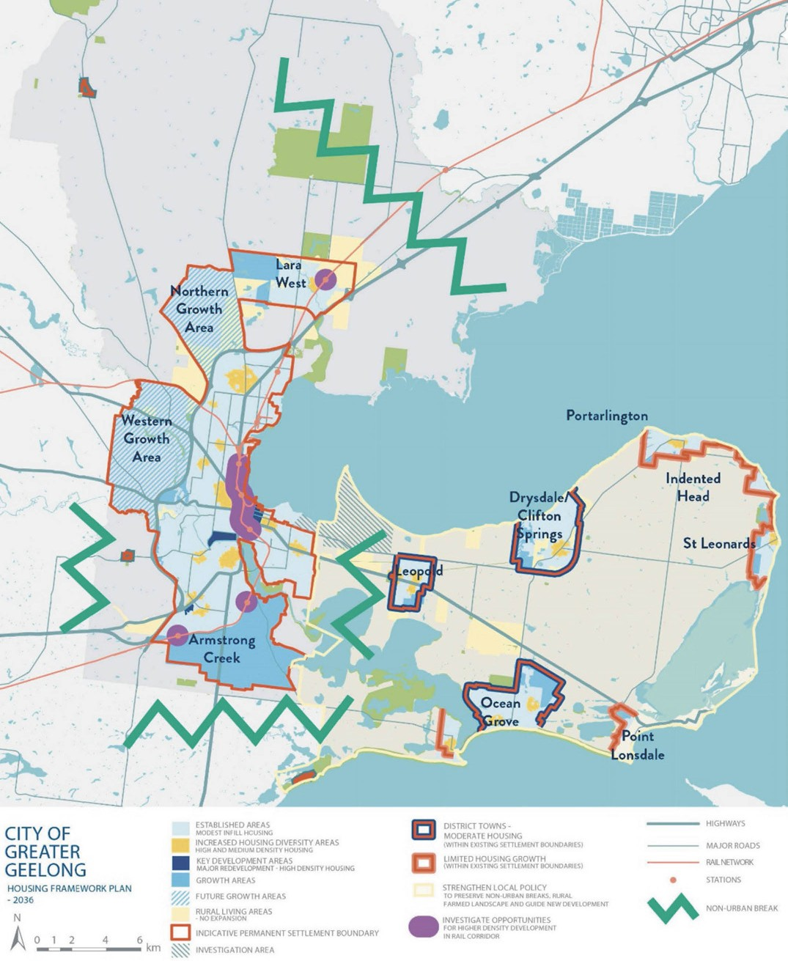

Figure 2.101: City of Greater Geelong Housing Framework Plan 2036. Source: City of Greater Geelong draft Settlement Strategy, 2018.

ENDNOTES

- L. Lane, The Inhabitants of Terra Nullius , Investigator: Magazine of the Gee- long Historical Society, vol. 29, no. 4, December 1994, p.138. The following
is based on 19th century reports by observers (some with prejudiced views of the Traditional Owners and their way of life), the research of Mrs Lou Lane, (amateur archaeologist, and expert in documenting Wadawurrung culture
from the 1960s and Honorary Warden under the Archaeological and Aboriginal Relics Preservation Act in the early 1970s), advice from the Wathaurung Ab- original Corporation (Wadawurrung) and more recent accounts. Some of this information is also based on archaeological evidence, the full extent of which is either not remaining (having long perished or destroyed during European occupation) and for cultural reasons, has not been specifically detailed. For biographical details of the Mrs Lane see J. Dearnaley, Louis (Lou) Lane, Amateur Archaeologist 1919-2015 , The Age, 5 April 2015 at https://www.theage.com.au/national/victoria/librarian-became-expert-in-in- digenous-culture-20150405-1mex7x.html
- A.W. Howitt, The Native Tribes of South-East Australia, Macmillan & Co., Ltd., London, 1904, p.41.
- The Kulin People of Victoria , brochure at http://www.parkweb.vic.gov.au/resources/04_1391.pdf & Kulin , Wikipedia online at
https://en.wikipedia.org/wiki/Kulin See also G. Presland, Aboriginal Mel- bourne: The Lost Land of the Kulin People, Penguin Books, Ringwood, 1994.
- The Kulin People of Victoria , op.cit.
- L. Lane, The Wathaurung: Geelong s earliest inhabitants , text of an address to the Geelong Historical Society, 22 March 1988, public reading room shelves, Geelong Heritage Centre (GHC).
- Lane, The Inhabitants , op.cit. & Lane, The Wathurungs , Investigator, vol. 23, no. 3, September 1988, p.99.
- I.D. Clark, Aboriginal Languages and Clans: An Historical Atlas of Western and Central Victoria, 1800-1900, Monash Publications in Geography No. 37, Department of Geography & Environmental Science, Monash University, Mel- bourne, 1990, p. 311. See also A.W. Howitt The Native Tribes of South-East Australia, Macmillan & Co., Ltd., London, 1904, p.70.
- These are the names given in I.D. Clark, Scars in the Landscape: a register of massacre sites in Western Victoria 1803-1859, Australian Institute of Aborig- inal and Torres Strait Islander Studies Report Series, Aboriginal Studies Press for the Australian Institute of Aboriginal and Torres Strait Islander Studies, Canberra, 1995, pp.170-171. Lane in The Inhabitants , op.cit., p.138 gave the clan name at the You Yangs as Worin Yaloke (who owned the land based on the You Yangs between the Moorabool and Little Rivers). Their territory was also given by Lane as Youghon (the land between the Moorabol and Little Rivers, including the You Yangs). See L. Lane, The Curious Business of Wathaurung Family Names , manuscript no. 29, 1990, p.5, Special Collections, Deakin University Library. Lane also gave a variation in the name of the Watha wurrung balug clan as Wood Thaurung / Wud: Taurung (who owned the territory south of the Barwon [River] as far as Armstrong’s Creek which flows south of Mt. Duneed to debouch into Reedy Lake. They may also have had access to the western shore of Corio Bay perhaps as far west as Lovely Banks and as far north as Hovells Creek. The Barrabool Hills lay in their estate. See also Lane (ed.), History with some Echoes of a lost local language, Abeng:
An Aboriginese-English Lexicon compiled 1970-1999 from Ethnographic Lit- erature Part 1, unpublished, supplied for use to the City of Greater Geelong by Lane in 2002, where she refers to the Yawang: I clan per Clark, op.cit.
See also Lane, Legend of the Min: Dii, manuscript no. 65, 1992, p.9, Special Collections, Deakin University Library.
- Clark, op.cit.
- Lane, History with some Echoes of a lost local language , op.cit., part 1, p.134, states that another clan identified by the name ‘Monmart’ by Clark (location unknown) cannot be determined and yet in Lane, The Inhabitants , op.cit., p.142 she illustrated the Maamaart clan territory to be near Lake Murt- naghurt, which she called Monmart . Lane made no mention of the Neerer balug clan identified by Clark.
- Ibid.
- Lane, op.cit.
- Ibid., p.100 & Lane, The Inhabitants of Terra Nullius , op.cit., pp.143-147.
- L. Lane, ‘Bunjil: Dowang: Un’, manuscript no. 35, 1991, p.6, Special Collections, Deakin University Library.
- Ibid. & Lane, The Wathaurung: Geelong s earliest inhabitants , op.cit.
- W. Gammage, Gardens without fences? Landscape in Aboriginal Australia ,
Australian Humanities Review, issue 36, July 2005.
- See for example, Lane, The Wathaurungs , op.cit. & known mapped Aborig- inal archaeological sites are held by the City of Greater Geelong, based on the Victorian Aboriginal Heritage Register. No specific details are deliberately given for cultural reasons.
- L. Lane, Legend of the Min: Dii, , op.cit., p.4 & R.B. Smyth, The Aborigines of Victoria, vol.2, John Ferres, Melbourne, 1878, p.193.
- Geelong Advertiser, 11 October 1890, p.1.
- Lane, Legend of the Min: Dii , op.cit.
- Geelong Advertiser, op.cit.
- Lane, The Wathaurung: Geelong s earliest inhabitants , op.cit.
- Geelong Advertiser, op.cit.
- Lane, The Wathaurung: Geelong s earliest inhabitants , op.cit.
- See Howitt, op.cit., p.767.
- Lane, Legend of the Min: Dii , op.cit., p.1.
- Lane, The Wathaurung: Geelong s earliest inhabitants , op.cit.
- Ibid.
- Lane, Legend of the Min: Dii , op.cit.
- Geelong Advertiser, 11 August 1988.
- B. Duncan, ‘Maritime Infrastructure Heritage Project’, prepared for Heritage Victoria, 2005 (updated 2006).
- Ibid.
- A True History of the Irish in Australia: Not Just Ned , National Museum of Australia online, September 2018, at http://www.nma.gov.au/exhibitions/irish_in_australia/exhibition_overview/ settling?result_
- Clark, Scars in the Landscape, op.cit., p.277.
- See M. Flinders, A Voyage to Terra Australis: undertaken for the purpose of completing the discovery of that vast country, and prosecuted in the years 1801, 1802, and 1803, in His Majesty’s Ship the Investigator, and subse- quently in the armed vessel Porpoise and Cumberland schooner, with an account of the shipwreck of the Porpoise, arrival of the Cumberland at Mau- ritius, and imprisonment of the commander durin, Libraries Board of South Australia, Adelaide, 1966. See also I. Wynd in So Fine A Country (1981), Barrabool. Land of the Magpie (1992) and various articles in Investigator, Vols. 1 and 2, 1965-67.
- A.M. Winstanley, Letter to the Editor, The Age, 23 February 1935, p.6.
- D. Rowe & L. Huddle, Greater Geelong Outer Areas Heritage Study Stage 2 , vol.12, prepared for the City of Greater Geelong 1998-2000 & D. Rowe & W. Jacobs, Lara Heritage Review , prepared for the City of Greater Geelong 2013 (updated 2016).
- I. Wynd, Environmental History in Rowe & Huddle, Greater Geelong Outer Areas Heritage Study Stage 2 , op.cit., vol.2, p.1.
- Ibid.
- Ibid.
- D. Rowe, Hume & Hovell Monument, Lara, Conservation Management Plan , prepared for the City of Greater Geelong, April 2002, pp.50-51.
- Ibid.
- Ibid.
- Ibid.
- Ibid
- D. Rowe & W. Jacobs, Batman Park & Boat Sheds Heritage Review, The Esplanade, Indented Head , prepared for the City of Greater Geelong, August 2013, pp.7-8.
- W.R. Brownhill & I. Wynd, The History of Geelong and Corio Bay with post- script 1955-1990, The Geelong Advertiser, Geelong, 1990, pp.4-5.
- A. Campbell, John Batman and the Aborigines, Kibble Books, Malmsbury, 1987, pp.99-106.
- Ibid.
- J.H. Wedge, Map of Port Phillip from the survey of Mr. Wedge and others,
J.H. Wedge, 1835, SLV.

- M. Cannon & I. MacFarlane (eds.), The Crown, The Land & the Squatter 1835- 1840, Historical Records of Victoria Foundation Series, vol.6, Melbourne University Press, Melbourne, 1991, p.1 & I. Wynd, So Fine A Country: A History of the Shire of Corio, Shire of Corio, 1981, p.10.
- Port Phillip Association , Wikipedia online at
https://en.wikipedia.org/wiki/Port_Phillip_Association & J.A. Hone, Robert- son, William (1798-1874), Australian Dictionary of Biography, National Centre of Biography, Australian National University, http://adb.anu.edu.au/biography.robertson-william-4491/text7339, pub- lished first in hard copy, 1976, accessed online October 2018.
- Port Phillip Association , op.cit.
- Ibid.
- C.L. Ogleby, Terra Nulius, The High Court and Surveyors , in The Australian Surveyor, vol. 38, no.3, September 1993, pp.171-189. Later published online at http://www.csdila.unimelb.edu.au/publication/misc/anthology/article/artic7. htm
- Ibid.
- M. Halsey, Deleuze and Environmental Damage: Violence of the Text, Ash- gate Publishing Co. Ltd., Burlington, 2006, pp.99-102.
- Ibid.
- A Brief Aboriginal History online, July 2017, at www.aboriginalheritage.org/history/history/
- Ogleby, op.cit.
- Ibid., sourcing the translation of a letter from Commodore Baudin, Elephant s Bay, to Governor King of Sydney, 23 December 1802.
- Halsey, op.cit.
- Wynd, So Fine A Country, op.cit., p.17.
- Wedge, op.cit.
- Ibid. & G. Bell, John Lewis von Stieglitz (1809-1868) online at http://www.bellsite.id.au/gdbtree/HTMLFiles/HTMLFiles_60/P3225.html
- Sydney Herald, 16 June 1836, p.2.
- Ibid.
- Pioneer Families Still Owning Original Holdings , Stock and Land, Melbourne, 21 November 1923, p.7, SLV.
- T. Manifold in T.S. Bride (ed.), Letters from Victorian Pioneers, Trustees of the Public Library by Robert S. Brain, Government Printer, Melbourne, 1898, p.135.
- Brownhill & Wynd, op.cit., p.9 & R.V. Billis & A.S. Kenyon, Pastures New: An Account of the Pastoral Occupation of Port Phillip, Macmillan & Company Ltd., London, 1930, p.75.
71 Ibid., pp.4-5.
- R.V. Billis & A.S. Kenyon, Pastoral Pioneers of Port Phillip, Macmillan and Co., Melbourne, 1932, p.143.
- Parish of Anakie Record Plan Sheet 2014, Landata.
- Billis & Kenyon, op.cit., p.124, 128. Staughton had simultaneously taken up the Exford Run north of the Brisbane Ranges Run near Melton at this time.
- Billis & Kenyon, op.cit., p.127.
- Thomson, Harding and Bowden were squatters in the vicinity of Connewarre shown in A.J. Skene, Map of the District of Geelong, James Harrison Advertis- er Office, Geelong, 1845, SLV. See also Billis & Kenyon, op.cit., p.19.
- See Theme 6.
- See Conewarre Parish Plan sheet 2, VPRS 16171 PROV, Billis & Kenyon,
Pastoral Pioneers, op.cit., p.19 & 158.
- Bride, op.cit., p.251.
- Wynd, op.cit., p.14.
- The Derwent Company was initially known as the Port Phillip Association. Most of the members sold out to Charles Swanston by 1837 and it was at this time when it became known as the Derwent Company. Port Phillip Associa- tion at Encyclopaedia Britannica online,
http://www.britannica.com/EBchecked/topic/470938/Port-Phillip-Asso- ciation. There were only three members of the Port Phillip Association that comprised the Derwent Company (including Swanston). See also Billis & Kenyon, Pastures New, op.cit., p.76.

- Wynd, op.cit. & C. Swanston, Swanston, Charles (1789 - 1850) , Australian Dictionary of Biography, Volume 2, Melbourne University Press, Carlton, 1967, pp 500-501.
- This is revealed in most of the maps of the area from the 1830s and 1840s.
- D. Rowe & W. Jacobs, Spray Farm, 2261 Portarlington Road, Bellarine , Conservation Analysis, prepared for the owner, January 2011, p.11.
- Billis & Kenyon, Pastures New, op.cit., p.48. 86 Ibid., p.124.
- See Theme 6.
- See Theme 6 & Billis & Kenyon, op.cit., p.124.
- Geelong Council Rate Books, 1850-57, GHC. The rate book only listed a weatherboard dwelling during Thomson s ownership in the 1850s.
- Geelong Council Rate Books, op.cit. & The Argus, 19 May 1863, p.5
- Ibid.
- Coriyule Homestead, 1-69 McDermott Road, Curlewis , Victorian Heritage Register, H272, Victorian Heritage Database online at http://vhd.heritagecouncil.vic.gov.au/places/342
- A. Drysdale (B. Roberts ed.), Miss D & Miss N: an extraordinary partner- ship, The diary of Anne Drysdale, Australian Scholarly Publishing, North Melbourne, 2009, p.1
- Ibid., p.7.
- Ibid., p.3.
- P.L. Brown & J.I. Martin, Drysdale, Anne (1792-1853) , Australian Dictionary of Biography, op.cit., vol.1, 1966,
http://adb.anu.edu.au/biography/drysdale-anne-2000/text2441
- Rowe & Jacobs, Spray Farm , op.cit., p.18.
- Descendants of the Rev Gilbert Henry Langdon 1688-1735 at http://langdon.50webs.com/.
- A. Dixon, Langdon & Sabine families in Pioneer Profiles, vol.3, Port Phillip Pioneer s Group, Carrum, 1995, p.43 & A. Dixon, Clerks Son, Captains and Co., Ann Dixon, Baringhup West/Maldon, Victoria, 1994.
- I. Wynd, Bella-wein: A history of the Shire of Bellarine to 1993, 2nd edn., Bellarine On-Line for the Bellarine Historical Society, Drysdale, 2005, pp.16-17.
- P.L. Brown, The Investigator, vol.10, no.3, September 1975, pp.62-67, 69.
- People in Portsmouth, Andrew Nance Four Generations, at http://www.history.inportsmouth.co.uk/people/nance/htm.
- Came to Port Phillip by 1849, News from Victoria Australia at http://vic1847.comlu.com/l/l03.html
- Wynd, op.cit., p.27.
- Geelong Advertiser, 20 February 1861
- Extract of Minute Book Portarlington District Road Board, 27 June 1854, Bellarine Historical Society & Susie Zada research notes.
- The Argus, 10 May 1855.
- Wynd, op.cit.
- Billis & Kenyon, Pastures New, op.cit., p.9.
- Ibid.
- Ibid.
113 Ibid., p.11.
- See Anakie, Balliang, Bellarine, Conewarre, Lara and Yowang Parish Plans, VPRS 16171 PROV.
- Wynd, So Fine A Country, op.cit., p.25.
- Bell, op.cit.
- Ibid.
- Ibid.
- Wedge s Map of 1835 (Figure 2.09) has Stieglitz s Station marked near the Barwon River. In the article, Pioneers of the Barwon in the Age,
24 September 1938, p.1, Stieglitz is claimed to have taken up the Run in 1836.
- Bell, op.cit.
- D. Rowe, Forest, Farmland & Gold: Thematic Environmental History of the

Western Region of the Moorabool Shire vol 2., prepared for the Moorabool Shire Council, 2016, p.13.
- Bell, op.cit.
- Billis & Kenyon, Pastoral Pioneers, op.cit., p.78.
- Wynd, So Fine A Country, op.cit., p.31, J. Tasker, George Hope Family Tree,
Ancestry online at
https://www.ancestry.com.au/family-tree/person/tree/67903532/per- son/34256880839/facts?_phsrc=aBt8&_phstart=successSource & Geelong Advertiser, 1 February 1877, p.2.
- M. Clark, Hope, Robert Culbertson (1812-1878) , Australian Dictionary of Biography, op.cit., vol.4, 1972, online at http://adb.anu.edu.au/biography/hope-robert-culbertson-3792/text5999.
- Tasker, op.cit.
- Ibid.
- Information kindly provided to the author by Alistair and Ellen Hope, Darriwill North homestead, February 2000.
- A. Willingham, Geelong Region Historic Buildings and Objects Study, vol.1, Geelong Regional Commission, Geelong, 1986, sheet 38 & D. Beaurepaire, The Stepping Stone: A History of the Shire of Bannockburn, D. Beaurepaire, 1995.
- Geelong Advertiser, 28 January 1863, p.2. 131 Ibid., 26 April 1884, p.2.
- Geelong Advertiser, 26 April 1884, p.2.
- P. Nelson & L. Alves, Lands Guide: A guide to finding records of Crown land at Public Record Office Victoria, Public Record Office Victoria in association with Gould Genealogy and History, Melbourne, 2009, p.147.
- Geelong Advertiser, 4 March 1844, p.2.
- J.G. Robertson (1852), Letter to Lt. Govt. C.J. La Trobe, 26 September, in Bride, op.cit., pp.34-35.
- The Argus, 14 June 1866, p.6.
- First Report of the Central Board to Watch Over the Interests of the Aborigi- nes in the Colony of Victoria, Melbourne, 1861, p.7.
- This was the term used by Frederick Powlett, Commissioner for Crown Lands, to Charles La Trobe in 1846. See F. Powlett to C. La Trobe, 11 September 1846, VPRS 19/P1, file 47/1348, PROV.
- Geelong Advertiser, 14 July 1902, p.4 & Clark, Scars in the Landscape, op.cit., p.173.
- Ibid., p.106, 173. See also Clark, Aboriginal Languages and Clans, op.cit., p.281-284.
- Clark, Scars in the Landscape, op.cit., p.174.
- A True History of the Irish in Australia: Not Just Ned , op.cit.
- D. Fisher, Roslin, Geelong, 21 September 1853 in Bride, op.cit.
- Geelong Advertiser, 30 January 1841, p.2. 145 Ibid., 20 March 1841, p.2.
- F. Fyans in Bride, op.cit., p.114. However, Clark, Aboriginal Languages and Clans, op.cit., p.299, claims the number of Wadawurrung at Fyansford amounted to 297 men, women and children.
- Ibid.

- The Argus, 27 August 1932, p.9. See also P.L. Brown (ed.), Memoirs re- corded at Geelong, Victoria, Australia by Captain Foster Fyans (1790-1870): transcribed from his holograph manuscript given by descendants to the State Library, Melbourne, 1962, Geelong Advertiser, Geelong, 1986, p.209. Both of these references give a total of 175 Wadawurrung present at this time.
- Geelong Advertiser, 26 June 1917, p.4.
- Report of the Parliamentary Select Committee on Aboriginal Tribes (British settlements), House of Commons, Parliament of Great Britain, London, 1837, p.vii.
- Australian Aborigines: copies of extracts of despatches relative to the massacre of various Aborigines in Australia, in the year 1838, and respecting the trial of their murderers, ordered by the House of Commonwealth, British Parliament, London, 1839.
152 Ibid., p.117.
153 Ibid., p.118.
154 Ibid., p.119.
- Clark, Scars in the Landscape, op.cit., p.3.
- Ibid.
- L. Arkley, Sievwright, Charles Wightman (1800-1855) , Australian Dictionary of Biography, op.cit., 2005, online at http://adb.anu.edu.au/biography/sievwright-charles-wightman-13194/ text23887.
- Ibid.
- Clark, Aboriginal Languages and Clans, op.cit., p.285.
- L. Clarke, Plan of Allotments marked at the Reserve in the Parish of Barrar- bool near the confluence of the Moorarbool and Barwon Rivers’, 1849, VPRS 8168/P5, item SYDNEY, record B40 PROV.
- The location was confirmed in the Port Phillip Gazette on 20 October 1841, p.3, which reported on a visit by the Governor, Sir George Gipps, the reporter stating that Gipps and his entourage crossed Fyans Ford by Mr. Sevwright s [sic.] huts, went up by the Barrabool Hills, round by Dr. Thompson’s [sic.] house and beautiful garden [Kardinia], to the break-water [at Breakwater].’
- An overview of Sievwright s Protectorate depot at Fyansford, and the Pro- tectorate associated with the Wadawurrung more broadly, is also given in F. Cahir, My County All Gone, The White Men Have Stolen It: The Invasion of Wadawurrung Country 1800-1870, Australian History Matters, Ballarat, 2019.
- S. Mossman, Geelong in 1840 , Geelong Advertiser, 9 December 1879, p.3.
- Ibid.
- Clark, Aboriginal Languages and Clans, op.cit., p.288.
- A. Thomson, Letter and Memorial from the settlers of the Geelong District to Sir George Gipps with reference to the Aborigines , 24 March 1840, VPRS 19/ P1 Unit 40, item 223 PROV.
- Ibid.
- Clark, Scars in the Landscape, op.cit., p.171.
- Arkley, op.cit & Description of Unregistered Correspondence regarding the Suspension of Charles Sievwright from Office of Assistant Protector of Aborigines, Western District, microfilm copy, VPRS 4467 PROV online at https://researchdata.ands.org.au/unregistered-correspondence-regard- ing-vprs-4467/154527
- Ibid.
- Clark, Aboriginal Languages and Clans, op.cit., p.293.
- Ibid.
- No documentary evidence of John Sievwright s venture has been discovered.
There are no newspaper articles of him at Fyansford in the 1840s.
- Davenport, Names of the Barrabool Tribe, About 1841-43 in Bride, op.cit., pp.310-311.
- Report of the Parliamentary Select Committee on Aboriginal Tribes (British settlements), op.cit., p.viii.
- H. Le Griffon, Campfires at the Cross: An account of the Bunting Dale Ab- original Mission at Birregurra, near Colac, Victoria 1839-1851, p.17.
177 Ibid., p.19.
- Ibid.

- A. Tyrell, Making Provision for the Native Peoples of the Empire; Joseph Orton, Missionary in Jamaica and Australasia , The LaTrobe Journal, no. 43, Autumn 1989, pp.6-8.
- M. Cannon & I. MacFarlane (eds.), The Aborigines of Port Phillip 1835-1839: Historical Records of Victoria Foundation Series, vol. 2A, Victorian Govern- ment Printing Office, Melbourne, 1982, p. 75.
- Brownhill & Wynd, op.cit., p.166 & M. Stainsby, Steadfast Through Change: a history of the Wesleyan-Methodist- Uniting Church in Highton 1853 to 2006, Marion Leigh Stainsby, Highton, 2008, p.26.
- G. Brewer in Memories of Old Geelong, The Connewarre Flatties : Their Home and Cruising Grounds , Geelong Advertiser,
10 September 1904, p.4.
- Ibid. The location of the Mission Station appears to have been Crown Allot- ment 15 of Section 1 in the Parish of Conewarre as this was the real estate listed in George Gardiner s statement of assets on his death in 1911. See G. Gardner, Probate Administration files, 1911, VPRS 283/P3 Unit 209 PROV.
- Le Griffon, op.cit, p.57.
- J.C.R. Camm, J. McQuilton & T.W. Plumb (eds.), Australians: A Historical Atlas, Fairfax, Syme & Weldon, Broadway, N.S.W., 1987.
- Clark, Scars in the Landscape, op.cit., p.103, pp.135-136.
- Ibid.
188 Ibid., p.136.
- Ibid., p.172. Addis had also recommended Buntingdale station remain a reserved site for Aborigines.
- Geelong Advertiser & Squatters Advocate, 25 October 1845, p.2.
- The surviving population is taken from E.B. Addis, Commissioner of Crown Lands, Half-Yearly General Return, District of Grant , in Aborigines, Return to Address, Mr. Parker – 21 October 1853, Parliament of Victoria, 24 January 1854, p.22.
- Ibid. The Tolloora balug clan were described as the Leigh tribe. Their clan estate was Mount Warrenheip, Lal Lal Creek and the west branch of the Moorabool river. See Clark, Scars in the Landscape, op.cit., p.171.
- W. Thomas, Guardian of Aborigines, Counties of Bourke & Mornington, Half-Yearly General Return , Aborigines, Return to Address, op.cit., p.8.
- Addis, op.cit., p.21.
- G. McLachlan, Stewarts Reserve , research notes, c.1997, held by the author.
- See L. Lane, Dooliebeal and Duneed, manuscript no. 38, 1991, p.3, Special Collections, Deakin University Library.
- See Theme 6 for further details.
- The sheep dip is shown on the Conewarre Put-away plan, C256/NIL001,
Landata online at https://www.landata.vic.gov.au/
- McLachlan, op.cit.
- Lane, op.cit.
- C. Hose, Stewarts Reserve , notes for the Geelong Revegetation Organization Inc., n.d. held by the author.
- Rules of the Comm na Feinne, Heath & Cordell, Geelong, 1859 (SLV) & K. Cardell, C. Cummin, R. Bakker, Comunn na Feinne 1856-1946: More Than a Pub Name (The History of the Geelong Highland Society and its activities 1856-1946), Peter Diggins, 2018, Appendix 3 (a), p.22.
- Ibid., p.6 (main text).
- Ibid., p.9.
- Ibid., 17 & Appendix 3 (a). Robert Shirra was a founding member of the Comunn na Feinne Society and architect of the Society s social policies especially as they related to Aborigines, street children, education (including the Industrial school and the working boy s night school.
- Ibid., p.18 (main text).
- Lane, op.cit., p.4.
- Cardell, et.al., op.cit., p.26.
209 Ibid., p.24.
- Ibid., pp.24-25 & photograph of medal awarded to Dan Dan Nook as best runner, 1860, GRS 1286/5/17, GHC.
- Geelong Advertiser & Intelligencer, 5 April 1853, p.1, Geelong Advertiser, 28

April 1860, p.2 & 5 July 1887, p.4.
- Cardell, et.al., op.cit., p.26.
- Ibid.
- The Argus, 2 April 1856, p.6.
- Report of the Select Committee of the Legislative Council on The Aborigines together with the Proceedings of Committee, Minutes of Evidence and Appendices, Parliament of Victoria, John Ferres, Melbourne, 1859, p.iii.
- Ibid., p.v.
- Ibid.
- J. Penney, Victorian Honorary Correspondent Supply Depots: Final Report, unpublished report prepared for Aboriginal Affairs Victoria, Melbourne, Sep- tember 1997, p.98.
- Aboriginal Protection Board, Wikipedia online, July 2017, https://en.wikipedia.org/wiki/Aboriginal_Protection_Board
- Nelson & Alves, op.cit., pp.151-152.
- I.D. Clark, The northern Wathawurrung and Andrew Porteous 1860-1877 , in
Aboriginal History, vol. 32, 2008, p.97.
- P. Ekins, Henry Andrews Family tree at Ancestry online https://www.ancestry.com.au/family-tree/person/tree/9474349/per- son/6069478571/facts?_phsrc=aBt12&_phstart=successSource, The Argus, 3 July 1895, p.5 & Geelong Advertiser, 5 July 1895, p.2.
- S. Anderson, John Masters Garratt Family tree at Ancestry online https://www.ancestry.com.au/family-tree/person/tree/40893637/per- son/19548769974/facts?_phsrc=aBt10&_phstart=successSource , John Masters Garratt , Re-Member database, Parliament of Victoria online at https://www.parliament.vic.gov.au/about/people-in-parliament/re-member, Brownhill & Wynd, op.cit., K. Thomson & G. Serle, A Biographical Register of the Victorian Legislature 1851-1900, Australian National University Press, 1972 & Geelong Advertiser, 12 March 1868, p.2.
- Charles Read , Re-member database, op.cit., & First Report of the Central Board to Watch Over the Interests of the Aborigines, op.cit.
- Geelong Advertiser, 3 September 1862, p.3.
- The final mention of Read was in the Sixth Report of the Central Board, op.cit., 1869.
- Geelong Advertiser, 17 May 1861, p.3.
- Ibid.
- Victoria Government Gazette, 29 June 1861, p.1264.
- Garratt & Read, Sixth Report of the Central Board, op.cit., 1869.
- Lane, op.cit.
- Second Report of the Central Board, op.cit., 1862, p.21.
- Lane, op.cit.
- First Report of the Central Board, op.cit., Appendix 1.
- Twenty-Second Report of the Board for the Protection of Aborigines in Victoria, op.cit., 1886.
- Geelong Advertiser, 25 January 1907, p.2
- First Report of the Central Board, op.cit.
- Brownhill & Wynd, op.cit., p.35, citing Garratt.
- Lane, op.cit. & Geelong Advertiser, 28 November 1864, p.2.
- Winstanley, op.cit., claimed that Harry Gore and Willem Baa Nip and Dan Dan Nook were cousins, while at an inquest on the death of Harry Gore in 1868 it was claimed that Gore was the nephew of King Jerry (Dan Dan Nook). See The Leader, 29 March 1868, p.22.
- Geelong Advertiser, 28 November 1864, p.2.

- Lane, op.cit., pp.9-10 & L. Lane, Willem Barniip , manuscript, no. 66, 1992, Special Collections, Deakin University Library.
- Victorian Births, Deaths & Marriages Indexes (VBDMs), Department of Justice online at
https://online.justice.vic.gov.au/bdm/indexsearch.doj
- Ibid.
- Ibid.
- Geelong Advertiser, 3 December 1867, p.2.
- Ibid.
- Ibid.
- Cardell, et.al., op.cit., Appendix 3 (a), p.3.
- D. Bunce, Language of the Aborigines of the Colony of Victoria, and other Australian Districts, 2nd edn., Thomas Brown, Geelong, 1859, pp.iii-iv.
- P. Munster, Little of Interest? A History of St. Leonards, Victoria, Peter M. Munster, 2nd edn., 2013, p.2-3 & Lane, Dooliebeal and Duneed , op.cit., p.10.
- Ibid. & The Advocate, 29 October 1870, p.14.
- Ibid.
- Prior to his death, Willem gave his medal to the grandfather of Arthur M. Win- stanley of Corio, it being in the possession of Arthur Winstanley in 1935. See The Age, 23 February 1935, p.6.
- Lane, Willem Baa: Niip , op.cit., p.1.
- Ibid., p.14. Lane stated that a favourite camping place of Willem Baa Niip was Skepper s Well at the corner of Astbury Street and Wallington Road, Ocean Grove. Further historical research has revealed the well to have been situated near the location where the lagoon drained into Lake Connewarre.
- T. Blackwell, Application to purchase land, 15 August 1874, VPRS 627/P0 Unit 206 PROV]
- Ibid.
- Ibid. See also Plan of Country Lots, Part of Allotment 21, Section 4, Parish of Bellarine, Country of Grant, Put-away plan B/80E, first dated 8 April 1869, Landata online, op.cit.
- Although it was claimed at the inquest into Harry Gore s death that Thomas Blackwell s house was at Barwon Heads, maps clearly show Blackwell to have been resident at Ocean Grove, and that he leased and later owned the land that included Skepper s well.
- Geelong Advertiser, 3 March 1877, p.2. 262 Ibid., 20 March 1877, p.2.
- Ibid., 12 November 1885, p.2
- Ibid., 14 November 1885, p.2.
- Ibid., 24 November 1868, p.2.
- Ibid., 14 November 1885, p.2.
- Ibid., 1 October 1897, p.2, 1 December 1897, p.2.
- L. Lane, Forty Useful Plants: The Location of Karngun Aboriginal Reserve , manuscript, no. 155, 1991, Special Collections, Deakin University Library.
- Ibid.
- Clark, Aboriginal Languages and Clans, op.cit., p.301.
- Lane, op.cit.
- See Correspondence, Office of Crown Lands & Survey 1859-60, VPRS 242/P0 Unit 466, file C15690 PROV.
- A.J. Skene, Plan showing the Aboriginal Reserve between the Brisbane Rang- es and Anakie Youang, historic plan collection, SP2A, PROV.
- S. Boland, The History of the Brisbane Ranges National Park , B.A. thesis, Monash University, 1992, p.21.
- See J. Goldstein, Plan of Country Lots, Parishes of Balliang and Mouyong, County of Grant, Crown Lands Office, Melbourne, 31 December 1858, VPRS 8168, FEAT 240 PROV.
- M. Maclean, List of Aborigines to whom blankets have been distributed , 8 April 1859, VPRS 242/P0 Unit 466 file C15690 PROV.
- Boland, op.cit.
- VBDMs, op.cit., gave the date at the time of death in 1912 as being 76 years. See also Geelong Advertiser, 12 August 1912, p.4.

279 Ibid., 1 April 1908, p.3.
280 Ibid. & 12 August 1912, p.4.
281 Ibid.
282 Ibid., 10 August 1912, p.2.
- Ibid., 14 January 1915, p.2.
- J.R. Briscoe, A sense of duty: The Clerkes An Anglo Irish Family in Colonial Tasmania , Master of Humanities (Tasmanian History) thesis, University
of Tasmania, June 1996, p.25 & I. MacFarlane (ed.), Aborigines and Their Protectors 1838-1839: Historical Records of Victoria Foundation Series, vol. 2B, Victorian Government Printing Office, Melbourne,
1983, p. 740-743.
- Copy of Register kept at the Wesleyan Mission Station Bunting-Dale, Gee- long, 1840, VPRS 10/P2 file 1840/274 PROV.
- MacFarlane, op.cit., pp.742-743.
- Ibid.
- Geelong Advertiser & Intelligencer, 25 June 1855, p.2.
- Ibid.
- Aboriginal Protection Act 1869 (Victoria) in Australia s Story, Museum of Australian Democracy,
https://www.foundingdocs.gov.au/item-sdid-22.html
- The Aborigine Protection Act 1886 in Victoria Government Gazette, 19 December 1886, p.283.
- Bringing Them Home: National Inquiry into the Separation of Aboriginal and Torres Strait Islander Children from Their Families, Commonwealth of Australia, 1997.
- Ibid., chapter 4 online at
https://bth.humanrights.gov.au/the-report/part-2-tracing-the-history/chap- ter-4-victoria
- Ibid.
- Ibid.
- Ibid.
- Ibid.
- D. Rowe & W. Jacobs, Sacred Heart Conservation Management Plan, 61 Retreat Road, Newtown , prepared for Sacred Heart College, 2010.
- The Advocate, 7 October 1871, p.4.
- Former Protestant Orphan Asylum and Common School, 150-220 McCurdy Road, Fyansford , Victorian Heritage Register, H1095, Victorian Heritage Database online at
http://vhd.heritagecouncil.vic.gov.au/places/2796
- D. Rowe, City of Greater Geelong Belmont Heritage Report Heritage Citations , vol.3, prepared for the City of Greater Geelong, 2007,
- 2015 Victorian Aboriginal Honour Roll, Office of Aboriginal Affairs Victoria, Department of Premier & Cabinet, Melbourne, p.30.
- D. Rowe & L. Huddle, Greater Geelong Outer Areas Heritage Study Stage 2 , prepared for the City of Greater Geelong, 1998-2000 & The Age, 26 May 1858, p.5.
- K. Rudd, Transcript of Apology to Australia s Indigenous Peoples, Australian Government online at
https://www.australia.gov.au/about-australia/our-country/our-people/apology- to-australias-indigenous-peoples
- Ibid.
- This was from statistics of the total population of Aboriginal and Torres Strait Islander people for the City of Greater Geelong, City of Greater Shepparton, City of Greater Bendigo and Rural City of Mildura. See 2016 Census at the Australian Bureau of Statistics online at http://www.abs.gov.au/websitedbs/censushome.nsf/home/2016

- The 1967 Referendum Fact Sheet 150 , National Archives of Australia online at
http://www.naa.gov.au/search/fact-sheets/searchresults. aspx?cx=006762012386158203175%3Aisbtgodru2s&cof=- FORID%3A9&ie=UTF-8&q=150&sa=Go
- Ibid.
- Wathaurong Aboriginal Cooperative, Submission, Inquiry into the Estab- lishment Effectiveness of Registered Aboriginal Parties , to Dr Reg Gardiner, Executive Officer, Environment and Natural Resources Committee, Parliament House, East Melbourne, 2011, p.3.
- ‘History & Profile’, Wathaurong Aboriginal Co-operative online at http://www.wathaurong.org.au/history-profile/
- The Barwon Water Drainage Plan S11215 dated 3 February 1995, suggested that the building had been constructed by this time.
- Mary Shuttleworth, Wathaurung Aboriginal Corporation to David Rowe, 5 June 2020.
- Ibid., Australian Securities & Investment Commission (ASIC) Company Regis- ter search online at
https://connectonline.asic.gov.au/RegistrySearch & Wathaurung Aboriginal Corporation trading as Wadawurrung , Aboriginal Victoria online at https://www.vic.gov.au/aboriginalvictoria/heritage/registered-aborigi-
nal-parties/wathaurung-aboriginal-corporation-trading-as-wadawurrung. html
- Aboriginal Heritage Act 2006, Section 148, Functions of a registered Aborigi- nal Party, at http://www6.austlii.edu.au/cgibin/viewdoc/au/legis/vic/consol_act/ aha2006164/s148.html
- Shuttleworth, op.cit.
- See Map of the Wathaurung Registered Aboriginal Party area at https://www.vic.gov.au/system/user_files/Documents/av/Wathaurung%20 RAP%20area.pdf
- Aboriginal Heritage Act 2006, op.cit., Section 7 Traditional Owners.
- Decision of the Victorian Aboriginal Heritage Council in Relation to an Appli- cation by Wathaurung Aboriginal Corporation to be a Registered Aboriginal Party , Victorian Aboriginal Heritage Council, 21 May 2009 at https://www.vic.gov.au/aboriginalvictoria/heritage/registered-aboriginalpar- ties/wathaurung-aboriginal-corporation-trading-as-wadawurrung.html
- Ibid.
- Ibid.
- Overturning the Doctrine of Terra Nullius: The Mabo Case Australian Institute of Aboriginal & Torres Strait Islander Studies, research paper, n.d., at https://aiatsis.gov.au/sites/default/files/docs/research-and-guides/native-ti- tle-research/overturning-doctrine-terra%20nullius-the-mabo-case.pdf
- Ibid.
- Ibid.
- Ibid.
- Ibid.
- Ibid.
- L. Porter & J. Barry, Planning for Coexistence? Recognizing Indigenous Rights Through Land-use planning in Canada and Australia, Routledge, Burlington Ashgate, 2016, p.53.
- Overturning the Doctrine of Terra Nullius , op.cit.
- People, Land, Opportunity: 20 Years of the Indigenous Land Corporation, Indigenous Land Corporation, 2015.
- Ibid.
- Ibid., p.3.
- Ibid., p.5.
333 Ibid., p.12.
334 Ibid., p.13.
- Ibid.
- Ibid.
- Ibid.
- Ibid.

- ILC Land Purchased , Indigenous Land Corporation, Australian Government online at
http://www.ilc.gov.au/Home/What-We-Do/Land-Purchased
- Wurdi Youang Business Plan Summary 2017, Wathaurong Aboriginal Co-op- erative, North Geelong, 2018, p.5.
- Ibid., p.6.
- NSW Government Gazette, 4 March 1840, p.200.
- Ibid.
- Geelong Advertiser, 12 June 1841.
- Ibid., 24 January 1842.
- Ibid.
347 Ibid., 25 July 1848, p.2.
348 Ibid., 5 August 1848, p.2. 349 Ibid., 18 July 1848, p.5.
- Ibid., 9 December 1848, p.2.
- Ibid., 4 August 1859, p.2.
- Ibid., 7 August 1849.
- Ibid., 20 August 1850, p.2. The tender described the works as an office and kitchen buildings, but the drawings (Figure 2.38) show it as an office and laundry building.
- Geelong Advertiser & Intelligencer, 3 October 1855, p.4.
- Geelong Advertiser, 1 June 1881, p.2.
- J. Tetaz, From Boudry to the Barrabool Hills: The Swiss Vignerons of Gee- long, Australian Scholarly Publishing, Kew, 1995, p.3.
- Geelong Advertiser, 1 August 1842, p.2.
- Tetaz, op.cit.
- Geelong Advertiser, 24 June 1871, p.3.
- Geelong Advertiser & Squatters Advocate, 24 January 1846, p.2.
- Geelong Advertiser, 23 August 1872, p.3.
- Ibid.
- M.F. Forbes, Esther Keanan Family Tree , Ancestry, op.cit.
- Tetaz, op.cit., p.35.
- Geelong Advertiser, 24 June 1871, p.3.
- Tetaz, op.cit., p.54.
- Ibid.
- Ibid.
- Ibid. & E. Kranjc & L. Phelan, The Geelong Swiss: A Record of some 19th Century Families, Geelong History Group Inc., 2010, p.6 & 28.
- Geelong Advertiser, 6 September 1864, p.2.
- Kranjc & Phelan, op.cit., p.16, 31.
372 Ibid., p.45.
373 Geelong Advertiser, 28 October 1870, p.3. 374 Ibid., 24 June 1871, p.3.
375 Ibid.
376 Ibid., 23 August 1872, p.3.
- Tetaz, op.cit.
- Geelong Advertiser, op.cit.
- Kranjc & Phelan, op.cit., p.13.
- Geelong Advertiser, 21 August 1862, p.3.
- Ibid., 24 October 1863, p.2.
382 Ibid., 6 April 1863, p.4.
- Ibid., 17 September 1906, p.2.
- Ibid.
385 Ibid., 15 March 1909, p.4.
- D. Nutting, German Immigration in Victoria in the 19th Century Overview online, 2001, accessed May 2018 at http://www.germanaustralia.com/e/victoria.htm
- Geelong Advertiser, 21 December 1849, p.2.

- Nutting, op.cit.
- The Argus, 22 December 1849, p.2.
- T.A. Darrah & R.N. Wuchatsch, From Hamburg to Hobsons Bay; German Emigration to Port Phillip (Australia Felix 1848-51), T.A. Darragh, R.N. Wuchatsch in association with the Wendish Heritage Society Australia, 1999, p.119.
- Ibid.
- Ibid.
393 Ibid., p.120.
- L. Phelan (ed)., The Geelong Germans: A Record of some 19th Century Families, The Geelong Family History Group Inc., 1993, p.2, 23, 24, 38, 43, 50, 52, 55, 57, 60, 69.
- Golden Oldies: Excursion to Germantown now Grovedale , Szene, April 1980, online, accessed May 2018 at http://www.agtv.vic.edu.au/files/Grovedale%20formerly%20German%20 Town.pdf
- Ibid.
- Ibid.
- South Barwon Shire Rate Books, 1857, GHC.
- Ibid.
- Huddle & Rowe, op.cit.
- Ibid.
- Ibid.
- Ballarat Star, 18 May 1921, p.1 & Victorian Births Deaths & Marriages Indexes, op.cit.
- Ballarat Star, op.cit.
- Phelan, op.cit.
- E. Cree, Carl August Seidel Family Tree , Ancestry, op.cit.
- Frederick Kawerau , Wikipedia online at https://en.wikipedia.org/wiki/Frederick_Kawerau & L. Huddle, Architects in Geelong 1840-1860 , Humanities Research Report, School of Architecture & Building, University of Melbourne, 1979, p.49.
- A. Brauer, The Beginnings of the Lutheran Church in Victoria , in Pinnaroo & Border Times (South Australia), 1 March 1935, p.3.
- See C. Kawerau, Naturalisation application, 1873 at Index to Naturalisation Certificates 1851-1900, reel no. 3, VPRS 4396 PROV at Ancestry, op.cit.
- Sydney Morning Herald, 30 April 1849, p.2.
- The Argus, 3 August 1849, p.2.
- Friends of Westgarthtown Inc. News, vol. 13, no.2, December 2009, p.5.
- Ibid.
- Geelong Advertiser, 3 July 1851, p.3.
- Ibid. & Frederick Kawerau , op.cit.
- See obituary for Carl Kawerau in The Ballarat Star, 15 September 1904, p.6.
- Huddle, op.cit.
- E. Snell (T. Griffiths ed.), The life and adventures of Edward Snell, Angus & Robertson & the Library Council of Victoria, Melbourne, 1988, p.325.
- Huddle, op.cit., p.51.
- Snell, op.cit.
- Werribee Railway Station, Victorian Heritage Register, H1309, Victorian Heritage Database online at http://vhd.heritagecouncil.vic.gov.au/places/2204
- Huddle, op.cit, p.49.
423 Snell, op.cit., pp.342-343, 345-350.

424 B. Trethowan, Victorian Public Works Department of Victoria 1851-1900: An Architectural History , vol.2, Appendix 1, pp.12-13.
425 Ibid.
426 The Argus, 20 September 1875, p.1. 427 Ibid., 24 July 1876, p.1.
- W.B. McCann, History of descendants of Peter McCann who landed in Australia in 1799 and the establishment of the cement industry and its devel- opment in Victoria, W.B. McCann, 1943, p.38.
- Ibid.
- Ibid.
- See Johann Traugott Noske Family Tree , Ancestry, op.cit.
- The Horsham Times, 17 May 1918, p.5, Graphic of Australia, 28 January 1916, p.2.
- D. Rowe & W. Jacobs, Newtown West Heritage Review , vol.2, prepared for the City of Greater Geelong, 2016.
- Wilhelm Heinrich Nichterlein (1871-1952) , Ancient Faces online at https://www.ancientfaces.com/person/wilhelm-heinrich-nichterlein/144332634
- VBDMs, op.cit.
- L. & P. Jones, The Flour Mills of Victoria 1840-1900: An Historical Record, The Flour Millers Council of Victoria, 1900, p.240.
- McCann, op.cit., p.38.
- Geelong Advertiser, 13 July 1912, p.4, 5 October 1907, p.4.
439 Ibid., 13 July 1912.
- Ibid.
- Ibid.
- Ibid., 31 January 1916, p.2.
- L. Messy-Rhine, ‘In The Matter of Objection by Laurell Messy’, Commonwealth of Australia, National Security (General) Regulations, Regulation 26, transcript of interrogation, Sydney, 24 October, 1939, series MP508/1, 255/741/25 National Archives of Australia (NAA).
- D. Watson, Starting a structural revolution: was Siemon s warehouse Brisbane’s first reinforced concrete framed building?’, Queensland History Journal, vol. 22, no. 3, November 2013, p.233.
445 Ibid., p.237.
- Commonwealth of Australia, War Precautions Act No. 10 of 1914, p.2.
- Ibid.
- Ibid.
- Ibid.
- Langwarrin, Victoria (1914-1915) , NAA online at http://www.naa.gov.au/collection/snapshots/internment-camps/WWI/langwar- rin.aspx
- Geelong Advertiser, 21 October 1915, p.2.
- Ibid., 9 January 1915, p.2.
- H.G. Schumer, Registration form under the War Precautions (Aliens Registra- tion) Regulations 1916, series MT269/1, NAA.
- See completed Registration forms under the War Precautions (Aliens Regis- tration) Regulations 1916, series MT269/1, NAA.
- Geelong Advertiser, 13 July 1912, p.4.
- Graphic of Australia, 28 January 1916, p.2.
- Ibid.
- Ibid., 29 December 1916, p.2.
- Ibid. See also D.H. Dureau Family Tree , Ancestry, op.cit.
- The Argus, 26 December 1848, p.2.
- Geelong Advertiser, 5 April 1849, p.1.
- Ibid.
- Ibid, 12 December 1848, p.2.
- The Argus, 26 December 1848, p.2.
- Ibid., 12 December 1848, p.2.
- Geelong Advertiser, 5 April 1849, p.1.
- The Argus 16 February 1849, p.3.

- Empire (Sydney), 21 April 1852, p.2.
- Geelong Advertiser & Intelligencer, 17 July 1852, p.3.
- Sydney Morning Herald, 18 March 1854, p.3.
- A. Thomson to the Honorable the Speaker and Members of the Legislative Assembly of Victoria in Parliament Assembled, 21 August 1857, VPRS 3253/ P0 Unit 49 item 478 PROV.
- W.J. Smith, Sand, Fireworks & Boxthorn: The History of Breakwater and Area, William Joseph Smith, Geelong, 2009.
- Geelong Advertiser, 22 January 1861, p.2.
- Bellarine Shire Valuation Book, entry 47, 1864, Bellarine Historical Society.
- Geelong Advertiser, 14 October 1890, p.4.
476 Ibid., 5 December 1865, p.2, 14 December 1866, p.2, 9 December 1878, p.2, 20 December 1886, p.2, 16 March 1892, p.2 & Rowe & Jacobs, Newtown Heritage Review , op.cit.
477 Geelong Advertiser, 5 December 1865, p.2.
478 Ibid.
479 Ibid.
480 Ibid., 14 December 1866, p.2. 481 Ibid., 29 March 1892, p.2.
482 Ibid.
483 Ibid., 9 October 1897, p.1.
484 Ibid., 4 August 19091, p.6.
- Ibid., 31 December 1910, p.2.
- Ibid., 9 December 1915, p.4, 12 February 1920, p.2.
- Ibid., 29 September 1928, p.6.
- The Star (Ballarat), 12 January 1857, p.1.
- The Argus, 5 August 1857, p.6.
- Ibid.
- The Star, op.cit.
- Geelong Advertiser, 9 July 1859, p.2 was the latest known reference to this association.
493 Ibid., 26 August 1875, p.2.
494 Ibid., 6 March 1883, p.2.
495 Chinese Immigration, Return to an Order of the House, Parliament of Victo- ria, 18 July 1888.
496 H. Meakin, Mayor of Geelong to the Honorable the Premier, 23 March 1888, in
Chinese Immigration, op.cit.
497 Geelong Advertiser, 21 March 1888, p.4. 498 Ibid., 29 April 1891, p.4.
499 Ibid., 26 November 1904, p.2, 7 May 1913, p.4.
- UK and Ireland, Masters & Mates Certificates, 1850-1927, Ancestry at https://www.ancestry.com.au/family-tree/person/tree/9807665/per- son/24058353893/facts?_phsrc=yMR17&_phstart=successSource
- New South Wales, Unassisted Immigrant Passengers Lists, 1864, State Records Authority of New South Wales, Ancestry at
https://search.ancestry.com.au/cgi-bin/sse.dll?_phsrc=yMR26&_ phstart=successSource&usePUBJs=true&indiv=1&db=nswunas- sisted&gsln=morrison&gsfn_x=1&gsln_x=1&cp=0&msady=1864&m- sady_x=1&_F0005868=northam&_F0005868_x=1&new=1&rank=1&redir=- false&uidh=if1&gss=angs-d&pcat=40&fh=1&h=1714430&recoff=9&ml_rpos=2
- G. Morison, Devotional Readings, Wise & Purdie, Geelong, 1869.
- Geelong West Rate Books, entry 58, 1875-76 & entry 582, 1877-78, GHC.
- G. Kent, Vines, Joshua (1834-1906) , Geelong Biographical Register, Geelong Historical Society Inc., June 2000.
- Geelong Advertiser, 6 January 1877, p.1, 13 February 1879, p.3.
- Ibid., 26 November 1904, p.2.
- Ibid.
- The Argus, 22 November 1881, p.1.

- Geelong Advertiser, 19 March 18992, p.3. 510 Ibid., 7 May 1913, p.4.
511 Ibid., 19 March 1892, p.3.
512 Ibid., 29 April 1891, p.4, 26 November 1904, p.2.
513 Moy Ling, James, Naturalisation papers, series A712 1883/Y7284 NAA.
514 Ibid.
515 Geelong Advertiser, 29 April 1891, p.4. 516 Ibid., 8 July 1895, p.4.
517 Ibid., 10 July 1895, p.4.
- Frewin & L. Phelan, Churches of Geelong & District, vol.1, Geelong Family History Group Inc., Geelong, 2002, p.107.
- G. Seaton, The Ashby Story: A History of Geelong West, Geelong West City Council, 1978, p.140.
- The Argus, 4 August 1933, p.1, The Horsham Times, 8 August 1933, p.4.
- Frewin & Phelan, op.cit.
- Geelong Advertiser, 20 October 1910, p.5.
- Ibid.
- Ibid.
- Ibid., 7 September 1910, p.2.
- Ibid., 20 October 1910, p.5, 31 December 1910, p.2 & News the Week, 17 November 1910, p.16.
- Geelong Advertiser, 16 September 1915, p.2.
- See Commonwealth of Australia, Immigration Restriction Act 1901 (commonly known as the White Australia Policy), NAA online at http://www.naa.gov.au/collection/a-z/immigration-restriction-act.aspx
- Commonwealth of Australia, War Precautions (Aliens Registration) Regula- tions of 1916,
https://www.legislation.gov.au/Details/C1916L00165
- See completed Registration forms under the War Precautions (Aliens Regis- tration) Regulations 1916 for Chinese in Geelong,
series MT269/1, NAA.
- Ibid.
- Ibid.
- Ibid.
- Ibid.
- J. Stacker & P. Stewart, Chinese Immigrants and Chinese-Australians in New South Wales: Chapter 5 Aliens, evacuees and internees , NAA online, 1996 at http://guides.naa.gov.au/chinese/chapter5/index.aspx
- See Figure 2.50 of the Chinese grave at the Eastern Cemetery.
- Geelong Advertiser, 4 April 1924, p.2.
- Geelong Cemeteries Trust Database.
- P. Begg, Picture of the Past: Memories of the Tien Wah Caf , Geelong Ad- vertiser, 12 December 2016.
- Ibid.
- Information taken from family tree information on Ancestry, op.cit. & D. Tobin,
Frank Costa: Family Faith and Footy, Killaghy Publishing, 2006.
- Ibid.
543 Ibid., pp.21-22.
- Costa Group: Our History online at http://costagroup.com.au/Our-History
- See Family trees on Ancestry, op.cit.

- F. Arcarao, Inward Overseas Passenger List (Foreign Ports), Kleist ship, 1907, VPRS 7667 & VPRS 947, PROV at Ancestry https://search.ancestry.com.au/cgi-bin/sse.dll?_phsrc=yMR27&_phstart=- successSource&usePUBJs=true&indiv=1&db=victoriapl&gsln=arca- ro&gsfn_x=1&gsln_x=1&cp=0&msady=1907&msady_x=1&_F0005959
=kleist&new=1&rank=1&redir=false&uidh=if1&gss=angs-d&pcat=40&f- h=0&h=4217261&recoff=7&ml_rpos=1
- F. Arcaro, Naturalisation Certificate file, 1932, series A1, 1932/9862 NAA.
- Geelong Advertiser, 18 December 1912, p.6. 549 Ibid., 14 May 1917, p.3.
- Ibid.
- Ibid.
- M. Langfield, ‘4. ‘White Alien (non-British European) Immigration Policy’,
Research Guide, NAA online at
http://guides.naa.gov.au/more-people-imperative/chapter4/index.aspx
- Ibid.
- F. Virgona & F. Arcaro, Completed Registration forms under the War Precau- tions (Aliens Registration) Regulations 1916, op.cit.
- Geelong Advertiser, 13 February 1918, p.3. 556 Ibid., 21 December 1918, p.6, 30 April 1918, p.2.
- Langfield, op.cit.
- Ibid.
- VBDMs, op.cit. & The Argus, 21 May 1904, p.9.
- Geelong Advertiser, 16 September 1907, p.3.
- Ibid., 8 January 1908, p.4 & Wises Directory, 1914.
- Geelong Advertiser, 27 July 1918 & Geelong Council Rate Book, entry 6, 1919, GHC.
- Geelong Advertiser, op.cit.
- Ibid., 5 November 1923, p.2.
- Ibid., 20 January 1919, p.2.
- Ibid.
- P. Maggi, Completed Registration forms under the War Precautions (Aliens Registration) Regulations 1916, op.cit.
- Geelong Advertiser, 28 January 1918, p.4.
- Ibid., 18 September 1918, p.4.
- Ibid., 1 October 1919, p.2.
- Ibid., 10 October 1936.
- Ibid. See also D. Celona, Guiseppe Serra Family Tree , Ancestry online at https://www.ancestry.com.au/family-tree/person/tree/67707345/per- son/272024037334/facts
- Geelong Council Rate Book, Villamanta Ward, entry 18, 1901, GHC.
- Ibid., Kardinia Ward, entry 10, 1902 & 1904.
- Geelong Advertiser, 25 June 1901, p.3.
- Frank Costa to David Rowe, 12 December 2018.
- Ibid.
- Ibid.
- Ibid. & Geelong Council Rate Book, Kardinia ward, entry 10, 1938, GHC.
- Ibid.
- Certificate of Title vol. 6067, fol. 327.
- Frank Costa, op.cit.
- Ibid.
- Ibid.
- Ibid.
- Ibid.
- Certificate of Title, vol. 8874 fol. 180.

- P. Oliver, Finding Dame Nellie Melba s butler: the hidden history of Victoria s Japanese immigrants 1869-1943 , public lecture given at the Immigration Museum, Melbourne, 9 April 2006 as part of the lecture series of the exhibition From Kimono to Sushi
The Japanese in Victoria .
- See Completed Registration forms under the War Precautions (Aliens Regis- tration) Regulations 1916 by Japanese residents in Geelong, series MT269/1, NAA & Geelong Advertiser, 27 August 1901, p.2.
- See for example, Geelong Advertiser, 17 June 1911, p.6.
- Ibid., 30 September 1919, p.3. 592 Ibid., 28 April 1902, p.4.
593 Ibid., 17 June 1911, p.6.
- Geelong Council Rate Books, entry 252, 1909 & entry 252, 1910, GHC.
- Geelong Advertiser, 23 December 1912, p.4 & Wise s Directory, 1914.
- Geelong Advertiser, 24 March 1892, p.2.
- Ibid., 15 November 1894, p.2.
- Anglo-Japanese Alliance , Wikipedia online at https://en.wikipedia.org/wiki/Anglo-Japanese_Alliance
- This was the last year Japanese Village fetes were reported in the Geelong Advertiser see 19 June 1923, p.8, 23 June 1923, p.11, 4 October 1923, p.7, 6 October 1923, p.7. The official termination of the Anglo-Japanese Alliance in 1923 might have been influential on the demise of the Japanese Village fetes in Geelong.
- Geelong Advertiser, 7 November 1906, p.2.
- This was an alliance reached in 1907 between the Russian Empire, the French Third Republic and the United Kingdom of Great Britain and Ireland.
- There was at least one surviving Japanese laundry operating in Geelong the 1930s see The Age, 21 July 1931, p.10.
- A. Furuya, Naturalisation Certificate file, 1939-40, series B6531, NATU- RALISED/1939-1945/FURUYA ADA, NAA.
- Ibid.
- Oliver, op.cit.
- Ibid.
- A. Furuyo, Department of Immigration, file papers, series A435, 1948/4/1545, NAA & S. Hasegawa, Correspondences files, Special Intelligence Bureau Central Office (Melbourne), Investigation Branch Central Office (Melbourne & Canberra), Commonwealth Investigation Service Central Office, 1941-1946, series A367, C71788, NAA.
- VBDMs, op.cit.
- M. Ito, Completed Registration form under the War Precautions (Aliens Regis- tration) Regulations 1916, op.cit.
- Ibid.
- Geelong Advertiser, 29 March 1919, p.2, 9 February 1920, p.5. 612 Victorian Births, Deaths & Marriages Indexes, op.cit.
613 Ibid.
614 Ibid.
615 M. McFadzean, Setsutaro Hasegawa, Japanese Migrant, 1897 , Museums Victoria online at
https://collections.museumvictoria.com.au/articles/2935 616 Ibid.
- Ibid.
- S. Hasegawa, Application for Certificate of Naturalisation, 1913, series A1, 1913/9453, NAA.
- Ibid.
- Geelong Advertiser, 29 November 1924, p.2, 25 July 1928, p.6.
- McFadzean, op.cit.
- Hasewaga, Department of Immigration, file papers, op.cit. 623 Ibid.
624 Ibid.
625 VBDMs, op.cit.
626 I. van Teeseling, Australia Explained: A site for newcomers and old hands ,

online at
https://www.australia-explained.com.au/history/post-war-migration 627 Ibid.
- C. Pullen, Post World War II British Migration to Australia , Museums Victoria collection online at
https://collections.museumvictoria.com.au/articles/13640
- White Australia Policy , Wikipedia online at https://en.wikipedia.org/wiki/White_Australia_policy#Post-war_immigration
- Ibid.
- Ibid.
- Advocate, 23 July 1953, p.22.
- Immigration Migrants employed in Australia , photographs, series A12111, 1/1955/16/12A, NAA.
- Kilmore Free Press, 23 January 1947, p.3.
- G. Collari & F. Abbate, Applications for Registration by Aliens Entering Austra- lia, series B78, NAA.
- Ibid.
- Immigration Migrants in Australian cities and towns , series A12111, 1/1967/10/5, NAA.
- Viva Energy Australia Our History online at https://www.vivaenergy.com.au/about-us/our-history & M. Hunter, Shell Geelong Refinery: 50 Years in Geelong, Shell Company of Australia, Hawthorn East, 2004, p.12.
- Good Neighbour (ACT), 1 November 1958, p.3.
- Ibid.
- Ibid.
- Ibid.
- Ibid.
- See Appendix 5.1.
- Ibid.
- Ibid.
- ‘Greek fish and chips shop in Victoria scores national award!’ in Neos Kos- mos online, 10 October 2019 at
https://neoskosmos.com/en/148268/greek-fish-and-chips-shop-in-victoria- scores-national-award/
- I. Wynd, The Final Years: Corio Shire 1980-1993 , manuscript, p.1, GHC. 649 Ibid.
- Ibid.
- Construction (Sydney), 29 November 1950, p.9.
- Commonwealth Government Gazette, 24 November 1949, p.3321.
- The Argus, 17 November 1950, p.6.
- The Lights of Norlane: An oral history of Norlane and North Shore , Norlane Neighbourhood House, 2006, p.148, GHC.
- Commonwealth Government Gazette, 2 August 1951, p.1934.
- Nissen: The Original Steel Buildings Since 1917 at http://nissenbuildings.com/History.htm
- Ibid.
- Ibid.
- Romney hut, Wikipedia online at https://en.wikipedia.org/wiki/Romney_hut
- Commonwealth Government Gazette, 3 August 1950, p.1985, published the acceptance of contracts for the supply for fresh meat and small goods and milk to the Migrant Hostel, Geelong, suggesting that the migrants had arrived by this time.
- Herald, 10 May 1952, p.4. See also N. Gibson (ed.), A Fresh Start in a New Land: Collected by the Bell Park Ethnic Oral History Team, Bell Park Oral History Project Team, Bell Park, 1988.
- The Argus, 9 July 1949, p.29.

- B. Szaday, Commonwealth of Australia, Incoming Passenger Card (Surface Vessels), series D4881, SZADAY BELA, NAA.
- Norlane Migrant Hostel in Geelong , Migrantweb.com Hostels Form online at http://www.migrantweb.com/hostelsforum/viewtopic.php?t=354
- Ibid.
- Commonwealth Government Gazettes, 3 August 1950, p.1985, 19 October
1950, p.2644.
- The Argus, 21 May 1952, p.3.
- Ibid.
- A. Ford, British Migrants, Selection documents, series A1877, 16/11/1950 NEW AUSTRALIA FORD A, NAA.
- The Argus, 1 May 1952, p.7.
- Ibid.
- Labor Call (Melbourne), 8 March 1951, p.7.
- The Argus, 17 November 1950, p.6.
- Ibid.
- Ibid.
- Ibid.
- Ibid.
- Ibid.
- Ibid.
- Ibid.
- Herald, 21 August 1951, p.3.
- Argus, 4 June 1952, p.3.
- Ibid., 11 September 1956, p.5.
- W. & C. Galaska, Migrant Selection documents for Displaced Persons who travelled to Australia per Airflight AUs/176-Syd 13 departing Bremen November 1950, series A12531, 13/14, NAA.
- Displaced Persons Scheme , series A12531, NAA online at https://recordsearch.naa.gov.au/SearchNRetrieve/Interface/DetailsReports/ SeriesDetail.aspx?series_no=A12531&singleRecord=T
- ‘Wojciech Galaska, Biography in Warsaw Uprising Museum online at https://www.1944.pl/powstancze-biogramy/wojciech-galaska
- Ibid.
- Ibid.
- Ibid.
- Electoral Roll, Corio Division, 1963, Ancestry, op.cit. 691 Information taken from migrant records at NAA online. 692 Ibid.
- The Age, 12 August 1952, p.2.
- M. Page, An Architectural Apex, Buchan Laird International, South Yarra, 1990, p.113.
- The Age, 12 August 1952, p.2.
- Ibid.
- Heritage Alliance, Survey of Post-War Built Heritage in Victoria , Stage One, vol.2, prepared for Heritage Victoria, 2008, citation 027-229, p.219.
- Plan of Subdivision, Part of Crown Allotments 71 & 73, County of Grant, LP 28034, 2 August 1954, Statutory Planning Department, City of Greater Gee- long.
- Heritage Alliance, op.cit. 700 Hunter, op.cit.
- Ibid.
- The address for Merrill Wilson, aged 11, was given as 1 Rotella Avenue, Corio, in a report of a drawing competition in August 1955, suggesting that the Hous- ing Estate was occupied by this time. See The Argus, 12 August 1955, p.22.
- F. Allon, Translated Spaces/Translated Identities: The Production of Place, Culture and Memory in an Australian Suburb , Journal of Australian Studies, January 2002, p.102, 107.
- Ibid.
- M. Lozanovska, I. Levin & M.V. Gantala, Is the Migrant House in Australia an

Australian Vernacular Architecture? , Traditional Dwellings and Settlements Review, vol. 24, no. 2, Spring, 2013, p.76.
- D. Rowe & W. Jacobs, Ashby Heritage Review , prepared for the City of Greater Geelong, 2010.
- Electoral Roll, Corio Division, 1956, Ancestry online, op.cit.
- F. Calvaresi, Alien registration documents, series B78, ITALIAN/CALVARESI FERDINANDO, NAA.
- Ibid.
- Electoral Roll, Corio Division, 1958, Ancestry online, op.cit.
- D. Marfioti, Will & Probate Record title description, 3 October 2000, Ancestry online at
https://search.ancestry.com.au/cgi-bin/sse.dll?indiv=1&d- bid=61315&h=292115&tid=&pid=&usePUB=true&_phsrc=OSa18&_phs
- R. Apperly, R. Irving & P. Reynolds, A Pictorial Guide to Identifying Australian Architecture: Styles and Terms from 1788 to the Present, Angus & Robertson, North Ryde, 19089, p.270.
- Construction date based on GWST Plans of Drainage, 12397 & 12398, first dated 29 November 1973 with final date 27 May 1974, City of Greater Geelong.
- See Incoming Passenger List, 17 October 1964, series K1269, NAA. 715 Ibid.
716 See Electoral Roll, Corio Division, subdivision of Newtown & Chilwell, 1980, Ancestry online, op.cit.
717 Drawing of B.V. Residence for Mr and Mrs P. Krastins , 31 August 1960, in possession of Kevin Krastins, City of Greater Geelong (son of the late Peteris Krastins) & Corio Shire Building Permit Register, entry 637, September 1960, City of Greater Geelong.
718 P. Krastins, Migrant Selection documents, Displaced Persons Scheme, series A11959, 151, NAA.
719 Kevin Krastins, personal comments to the author, October 2018. 720 Ibid.
- Ibid.
- Good Neighbour Council , Wikipedia online at https://en.wikipedia.org/wiki/Good_Neighbour_Council
- Good Neighbour, 1 August 1952, p.4.
- Advocate, 30 November 1950, p.7.
- Ibid.
- The Argus, 4 October 1956, p.9. The National Archives of Australia claimed that the Geelong Good Neighbour display was for an International Fair, but no evidence has been found for a fair of this type in 1956, apart from the Victorian Building Industries Fair.
- Wynd, The Final Years , op.cit.
- Victorian Births, Deaths & Marriages Indexes, op.cit. & Wynd, So Fine A Country, op.cit., p.273.
- The Argus, 18 August 1934, p.17.
- Another community group to use the D.W. Hope Centre as its clubrooms was the Geelong Gem and Mineral Club. See History of Geelong Gem & Mineral Club online at | http://gemfossicking.com.au/modules/wfchannel/html/GGMC_History.pdf
- United Kingdom Settlers Association VPRS 7882/P1 Unit 235 item 193939, PROV.
- Diversitat, Our Communities online at https://diversitat.org.au/about-us/our-communities/#tab-id-11
- Ibid.
- Ibid., Wynd, So Fine A Country, op.cit., pp.208-209 & Brief History of the Polish Community in Geelong online at http://whiteeaglehouse.com.au/uploaded_files/media/1452234728the_pol- ish_community_in_geelong.pdf
- Hunter, op.cit.
- Rowe & Huddle, op.cit.
- Certificate of Title, vol. 5236, fol. 178 & GWST Drainage Plan, GW10028, City of Greater Geelong.
- L. Honman, L. Huddle & R. Aitken, City of Geelong West Urban Conservation Study , vol.3, prepared for the City of Geelong West, 1986.

- Geelong Advertiser, 19 July 2017, p.9. 740 Diversitat, Our Story online at
https://diversitat.org.au/about-us/our-story/ 741 Ibid.
- Ibid.
- Ibid.
- Ibid.
- Ibid.
- City of Greater Geelong planning files. 747 See Nearmap aerial images 2009-2010.
- Ibid.
- Diversitat, op.cit.
- Nearmap, op.cit., 2016-17.
- Diversitat, op.cit.
- Ibid.
- The Pako Story online at https://www.pakofesta.com.au/
- Ibid.
- Immigration History of Australia , Wikipedia online at https://en.wikipedia.org/wiki/Immigration_history_of_Australia
- Diversitat, Our Communities , op.cit.
- Closer Settlement and Soldier Settlement Land Records, PROV online at http://wiki.prov.vic.gov.au/index.php/Closer_Settlement_and_Soldier_Settle- ment_Land_Records
- Nelson & Alves, op.cit., G. Taylor, The Problem of Closer Settlement in Victoria, June 1937, p.57 & Regulations for the Disposal of Lands Acquired Under the Closer Settlement Act 1904 and The Closer Settlement Act 1906, Parliament of Victoria, Melbourne, 1907, pp.3-4.
- Small Improved Holdings Act 1906 , PROV online at http://www.access.prov.vic.gov.au/public/component/daPublicBaseContain- er?component=daViewSeries&breadcrumbPath=Home/Access%20the%20 Collection/Browse%20The%20Collection/Series%20Details&entityId=15792#
- Ibid.
- Nelson & Alves, op.cit, p.285.
- Geelong Advertiser, 25 January 1896, p.4, 2 October 1903, p.2.
- Subdivision of Portion of the Elcho Estate, Geelong , 1 October 1903, map E12, Geelong Heritage Centre collection.
- The Ballarat Star, 12 January 1924, p.2.
- P. Mansfield, ‘One Reminder of the Agricultural Instruction Farm at Elcho’,
Investigator, vol. 51, no.202, March 2016, p.38.
- The Ballarat Star, op.cit.
- L.J. Blake (ed.), Vision and realisation: a centenary history of state education in Victoria, Education Department, Melbourne, 1973, p.1057.
- The Herald, 9 March 1925, p.3. 769 Mansfield, op.cit., p.39.
770 Ibid., p.40.
771 Ibid., p.41.
- The Herald, 16 October 1930, p.10.
- Elcho Estate Auction Notice , 26 October 1934, map E13, Geelong Heritage Centre collection.
- The Age, 23 February 1934, p.6.
- I.M. & E.S. Whitcombe (contributors), Elcho Houses , Culture Victoria online at
https://cv.vic.gov.au/stories/a-diverse-state/north-shore-geelongs-boom- town-1920s-1950s/elcho-houses/
- The Bacchus Marsh Express, 8 October 1904, p.3.
- Ibid.
- See Lara Estate Closer Settlement Plan , 10 December 1906 & Lara Estate Plan and Schedule , 5 January 1907, Geelong Heritage Centre collection.
- Lara Estate Closer Settlement Plans , op.cit.

- Weekly Times, 15 December 1906.
- The Age, 20 August 1904, p.2.
- The Argus, 7 January 1907, p.7.
- Plan of the Lara Estate acquired under the Closer Settlement Act 1904 , July 1906 VPSR 16171/P2 PROV.
- Geelong Advertiser, 9 February 1907, p.8 & Plan of the Lara Estate , op.cit.
- Geelong Advertiser, op.cit.
- Rowe & Jacobs, Lara Heritage Review , op.cit.
- Victoria Government Gazette, 14 August 1907, p.3722. 788 Rowe & Jacobs, op.cit.
- H.B. Walters, Plan of the Staughton Vale Estate Acquired under Closer Settle- ment Act 1904 , 1907-08, VPRS 16171/P2 PROV.
- Ibid. Applications for Conditional Purchase Leases Approved, 15 June 1908, newspaper clipping attached to plan.
- Ibid.
- A. Hastie to The Secretary, Lands Purchase Board, Staughton Vale Estate Crop Liens , 20 December 1913, VPRS 5714 Unit 1249 PROV.
- See G. Cornthwaite, Allotments for Small Holdings Near Geelong, Parish of Barrarbool, County of Grant , 25 July 1907, put-away plan B34/B1, L. Thorn, Allotments for Small Holdings at Belmont Near Geelong, Parish of Barrarbool, County of Grant, September 1907, put-away plan B34/B1 & G. Cornthwaite, Allotments for Small Holdings Near Geelong at Newtown , 1907, put-away plan B34/B3, Landata online at
https://www.landata.vic.gov.au 794 Ibid.
- Ibid.
- Geelong Advertiser, 1 July 1907, p.2.
- Weekly Times, 28 December 1907, p.23.
- H.C. Malcolm, First Report of the Small Improved Holdings, presented to both Houses of Parliament, Melbourne, 1908, Geelong Advertiser, 10 Febru- ary 1911, p.2 & 8 October 1917, p.3 & Thorn, op.cit.
- Weekly Times, op.cit.
- Geelong Advertiser, 28 April 1905, p.2.
- The Age, 12 June 1905, p.5.
- Malcolm, op.cit. & Thorn, op.cit. 803 Weekly Times, op.cit.
- Ibid., 30 September 1899, p.36 & Advocate, 10 February 1906, p.26.
- See The Argus, 20 September 1851, p.2. In 1848, James Williamson was listed as residing in Little Malop Street, Geelong in the List of Electors for the Port Phillip District. See The Argus, 3 July 1849, p.4.
- S. Batters, Thomas Tobias Grigg Family Tree, Ancestry online at https://www.ancestry.com.au/familytree/person/tree/10987286/per- son/-521199827/facts
- W. P. Anderson, Bellarine Parish Plan County of Grant, January 1878, put- away plan B331/3, Greenvale Estate, Parish of Bellarine County of Grant , 1906, put-away plan B331/B2, Landata online, op.cit., Weekly Times 30 September 1899, p.36 & Advocate, 10 February 1906, p.26.
- See Greenvale Estate Plan , op.cit. 809 Geelong Advertiser, 23 June 1906, p.7. 810 Geelong Cemeteries Trust Database.
811 S. Hall, Will, VPRS 7519/P2 Unit 437, Probate VPRS 28/P3 Unit 61 PROV. 812 Victorian Births, Deaths & Marriages Indexes, op.cit.
813 Malcolm, op.cit., p.3.
814 Ibid. & Thorn, Allotments for Small Holdings Near Drysdale , 9 October 1907, put-away plan B331/C1, Landata online, op.cit.
815 Weekly Times, 28 December 1907, p.23. 816 Malcolm, op.cit., p.4.
- Ibid., p.7.
- Ibid., p.4.
- Ibid., p.7.

- Ibid.
- Ibid.
- Geelong Advertiser, 11 August 1908, p.4.
- Bellarine Shire Rate Book, 1909, Bellarine Historical Society. 824 Ibid., 1914.
825 Ibid.
826 Ibid., 1909.
- Geelong Advertiser, 29 august 1913, p.2.
- The Australasian, 19 July 1914, p.16.
- F.E. Lee, Report on the sale vacant houses at Bellarine, 27 March 1915, VPRS 5417/P0, Unit 1106 PROV.
- Geelong Advertiser, 6 September 1913, p.6.
- The Australasian, 18 July 1914, p.16. 832 Geelong Advertiser, op.cit.
- The Australasian, op.cit.
- J.W. Grigg to W. Luly, Lands Department, 10 April 1912, VPSR 746/P0 Unit 312, item 649/59 PROV.
- Victoria Government Gazette, 7 February 1912, p.666.
- Grigg, op.cit.
- Greenvale Estate Plan , op.cit.
- Bellarine Shire Rate Books, 1911-14, op.cit. 839 Ibid.
- The Australasian, op.cit.
- Geelong Advertiser, 10 February 1911, p.2.
- Malcolm, op.cit., Geelong Advertiser, 10 February 1911, p.2 & 8 October 1917, p.4.
- Ibid.
- News of the Week, 19 October 1911.
- Geelong Advertiser, 3 September 1906, p.2.
- Ibid. & Workmen s Homes, City of Geelong, Parish of Corio , 1906, put-away plan C272/O1, Landata online, op.cit.
- Regulations for the Disposal of Lands Acquired under the Closer Settlement Act 1904 and the Closer Settlement Act 1906, op.cit.
- Geelong City Rate Book, Barwon Ward, 1908, GHC, J. Wensor, Probate Administration files, 1924, VPRS 28/P3 Unit 1407 PROV, C. Mason, Probate Administration files, 1919, VPRS 28/P3 Unit 951 PROV, W.F. Bampfield Probate Administration files, 1942, VPRS 28/P3 Unit 3738 PROV, T. Dalton, Probate Administration files, 1926, VPRS 28/P3 Unit 1716 PROV & P. Gurrie, Probate Administration files, 1933, VPRS 28/P3 Unit 2471 PROV.
- Authentic Heritage Services Pty Ltd, Survey of Victoria s
Veteran-Related Heritage: Volume 1 the Report, prepared for the Veterans Unit of the Department of Planning & Community Development, August 2008, p.91.
- Information taken from Battle to Farm: WW1 Soldier Settlement Records in Victoria , PROV online at
http://soldiersettlement.prov.vic.gov.au/ 851 Ibid.
852 Geelong Advertiser, 9 October 1920.
853 Battle to Farm , op.cit. and E.S. Baglin, Service records, B2455, BAGLIN ES, NAA.
854 Ibid. & E.S. Baglin, Service records, B2455, BAGLIN ES, NAA. 855 Battle to Farm , op.cit.
856 Ibid.
857 J. Hammond, Service record, series B2455 HAMMOND J, NAA. 858 Ibid.
859 Battle to Farm , op.cit. 860 Ibid.
- Ibid.
- Ibid.
- Ibid.

- Ibid.
- B. Maddock, Service record, series B2455, MADDOCK B, NAA.
- Rhinds Estate, Parish of Bellarine , revised put-away plan, B2326/G2, Landata online, op.cit.
- Geelong Advertiser, 22 October 1914, p.5 & 21 May 1915, p.2. See also First World War Embarkation Roll, 22 December 1914, at
https://www.awm.gov.au/people/rolls/R1821190/ 868 Nelsen & Alves, op.cit., p.57.
- See Report on Reginald Tayler s property by the Closer Settlement Board, 10 February 1925. Source: VPRS 5714/P0 Unit 3 PROV. A later application for lease (Conditional Purchase) by Murdoch McIntyre in 1937 indicated that
the dwelling had been erected by the Commission , this most likely being the Closer Settlement Board (and not the War Services Homes Commission).
- See Closer Settlement and Soldier Settlement Land Records , discussion, Public Record Office Victoria online, August 2015.
- VBDMs, op.cit.
- M. McIntyre, Application for a Lease (Conditional Purchase), Closer Settle- ment Act 1928 (Part II), Discharged Soldier, 28 January 1937, VPRS 5714/P0 Unit 203, file 557/12 PROV
- Ibid.
- The City of Greater Geelong Settlement Strategy, the City of Greater Geelong, October 2018, p.5.
- Ibid.
- Ibid.

