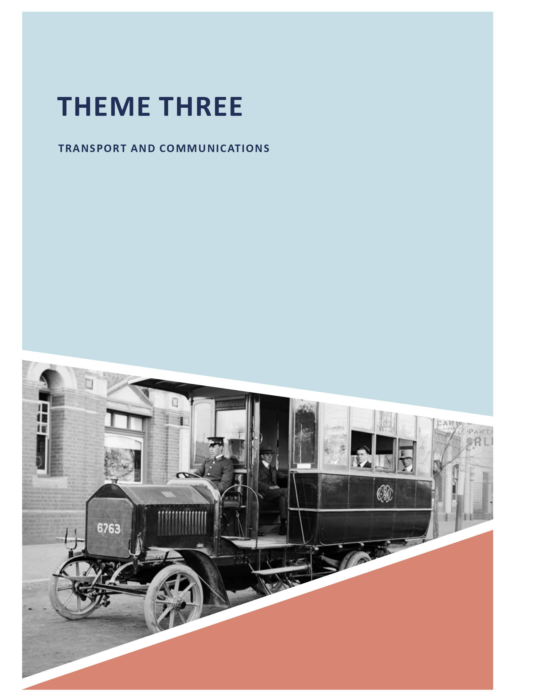

THEME THREE

TRANSPORT AND COMMUNICATIONS

ABOUT CORAYO: A THEMATIC HISTORY OF GREATER GEELONG
174

  - INTRODUCTION
Travelling and communicating throughout Greater Geelong has changed dramatically since the earliest routes for travel and trade were established by the Wadawurrung peoples many thousands of years ago. This theme therefore begins with an introduction of the importance of travel as part of the culture of the Wadawurrung, and documentary evidence of some of the earlier routes used by the Traditional Owners. Transport continues to play a major part in shaping the Greater Geelong environment.
The establishment and development of roads and associated infrastructure (bridges, toll gates and Government agencies) from European colonisation in 1839 to more recent infrastructure construction has had a substantial effect on the Greater Geelong landscape. Technological advancements, and Geelong s place within the major transformation of road travel is outlined in this theme: from the coach, to the bicycle, tram, motor car, bus and taxi. It highlights the transport businesses that contributed to Geelong s economy and social structure as a consequence of these technological changes: coach factories, bicycle manufactories and retailers, motor car garages and mechanics, bus companies, community groups and associated road transport services, such as
the introduction of the tram in 1912. It also celebrates locals at the cutting edge of road vehicle manufacture, including the inventive William Humble, who was one of the earliest to build a velocipede in Geelong in 1869, the first to build a motor car in Geelong in 1903 and the first to manufacture a
bus in Victoria also in 1903. The importance of the motor car is further explored as part of Geelong s industrial expansion and the establishment of the Ford Motor Company Factory in 1925. The success of Bonnie Bender in running Bender s Busways, and particularly her female business acumen in the provision in 1947 of special pram buses for mothers and young children, is outlined.
Critical to Greater Geelong s progress and economy was its railway network. The opening of the Geelong to Melbourne railway line in 1857 constituted the first country railway in Victoria. It had been surveyed and supervised by Edward Snell, an English engineer who previously been employed on railway construction in Britain. The opening of the Geelong to Ballarat line in 1862 resulted in Geelong being the railway hub between Melbourne and Ballarat (there being no direct railway line between these centres at the time).
The opening of the railways brought about considerable infrastructure projects in the construction of bridges, culverts, sidings and embankments. In particular, in brought about
the construction of the underground tunnel in 1874-75 that linked the Geelong and South Geelong stations following the opening of the Geelong line to Colac (opening to Winchelsea in 1876) and later the Geelong to Queenscliff line (opening
in 1879). The longest Victorian railway tunnel until the construction of the Melbourne underground railway loop, it remains in use to the present day. On the Geelong to Ballarat line, the construction of the vast Moorabool River viaduct in 1858-1862 brought about another major engineering feat that is extant to the current day. The railway network also became a major employer: during the construction of the lines and as part of their operations, repair and management. In Greater Geelong, the Victorian Railways Department employed numerous station staff and gatekeepers, including female workers. The first station mistress in Victoria, Mrs Jane Rollins, was stationed at North Geelong at Cowies Creek in 1860. A number of single, married and widowed females also kept the gates throughout Geelong.
With its bay foreshore, Greater Geelong has been a centre for maritime transport since the arrival of Europeans at Point Henry in 1836. This theme gives an overview of the early
wharf infrastructure at Point Henry and on the central Geelong foreshore (including the first stone jetty built by convict
and immigrant labour in 1840-42 which still survives), and following the establishment of the Geelong Harbor Trust in 1905, the creation of Corio Quay at North Shore and the ship building yards at Rippleside. Industrial expansion brought about the construction of further wharfs and piers in the 20th century for major companies including Shell and the Grain Elevators Board. Major land reclamations along the central Geelong foreshore associated with shipping in the 1880s
are also explored, as is the dredging of shipping channels (prior to which large ships were prevented from entering Corio Bay) and the role and importance of local shipping agents.
Apart from wharf infrastructure, little physical fabric remains of other associated maritime heritage in Greater Geelong, although at St. Leonards the remnants of the early social cabin of the Edina steamer that provided regular services between Melbourne and Geelong in the 19th and early 20th centuries, along with the wreck of the Ozone that was hulked off Batman Park at Indented Head in 1925. An important landmark at Point Henry also remains: the signal station built in 1939 to control shipping traffic entering and leaving the Port of Geelong.
Although little remains of Greater Geelong s aviation heritage, the Belmont Common was the location of the Geelong Flying Club and workshops of the Pratt brothers: Percy, Charles, and Frank from the 1920s until the Second World War.
Charles Pratt operated a charter business from the Belmont Aerodrome as well as pioneering aeronautical education at the Gordon Technical College where his brother, Percy, was to be appointed an instructor. They jointly and separately operated aviation businesses in Belmont. The extraordinary contribution by Charles Pratt is reflected today in the vast collection of aerial photographs from the 1920s, many of which are now part of the collection of the State Library of

Victoria. The theme also provides a brief overview of local airports (extant and no longer present).
The evolution and development of the postal, telegraph and telephone service in Greater Geelong is also considered in this theme. From the importance of the Bihar (messenger) of the Wadawurrung, the theme explores the establishment of the postal service from 1839 when Patrick McKeever, police constable, was appointed the first postmaster from a post office in Barwon Terrace, South Geelong. The theme gives an overview of the installation of pillar boxes from 1870, post office construction in Geelong and its suburbs, there being only four purpose-built post offices remaining (Geelong – built in 1889-91), Geelong West (built 1885-86), Portarlington (built 1888-89) and Drysdale (built 1925-26). Only the Geelong West Post Office continues to serve its original purpose today. The first postmasters – and postmistresses
– are also identified. The connection in 1854 of Geelong to the Telegraph service in Melbourne and its expansion and effect on Greater Geelong s progress is examined. The telegraph is physically manifested in the original coastwaiter s building (now a shelter in the Geelong Botanic Gardens) and the former Telegraph Station in Ryrie Street, built in 1857.
Geelong was also a leader in the establishment of telephone communication in Victoria through the inventive experiments
W.J. Thomas in 1877-78, the first long distance telephone communication in Victoria being made from Geelong in early 1878. The evolution of the telephone in Greater Geelong
is traced, culminating in the installation of an automatic telephone exchange in the former Geelong Post Office, Ryrie Street, in 1912, the first in the southern hemisphere.
Newspapers played a significant role in disseminating information to the people in Greater Geelong. The Geelong Advertiser, established in 1840, is Victoria s oldest morning newspaper. Its evolution and first editor, James Harrison, early postmaster and inventor, are outlined. While no built fabric survives of this newspaper business, the former Geelong Times office at 80 Little Malop Street remains extant and a brief overview of this firm is given.
The theme concludes with a brief overview on the development of radio stations in Greater Geelong.
The first was owned by the Geelong Advertiser from 1931 and known as 3GL. With a change to FM frequency it continues today under the name of K Rock. Other local stations are also given.

WADAWURRUNG ROUTES
The earliest routes for travel and trade within the City of Greater Geelong were those known and established by
the Wadawurrung People. Inherently interrelated with their beliefs (see Themes 2 and 8), the routes were defined as part of a broader cultural lore.1 Known as songlines , they connected the Creation stories:2
Songlines are a comprehensive knowledge system that can be visualised as corridors or pathways of knowledge crisscrossing the continent. They include all knowledge from the ontological to the scientific and the ancestral to the history. Like the Dreaming, they explain the origin
of life aand the land and they lay down the laws and customs of a people, which are necessary to sustain life on this continent.3
Songlines included oral maps where important topographical, cultural and other features were used as part of the navigational narrative.4
Some historical maps prepared by European explorers and surveyors in the early 19th century also gave an insight
to specific routes that may have been established by the Wadawurrung. The Map of Port Phillip from the survey of Mr. Wedge and others (Figure 3.01), dated c.1835, for example, showed Mr Batman s tracks. 5 These were the tracks used by John Batman as part of his extensive exploration of the Port Phillip area in 1835 (see Theme 2 for further details about Batman s exploration) as outlined in his journal.6 At
Avalon (following the naming of the inlet, Gellibrand Harbour), his reliance on Wadawurrung routes was made clear. The Aborigines that accompanied him from Sydney:
beat for their [Wadawurrung] trail, and, having
found it, we commenced to follow, and continued on the track for about ten miles, when one of my [Aborigines] caught sight of a [local Aborigine] at the distance of a mile.7

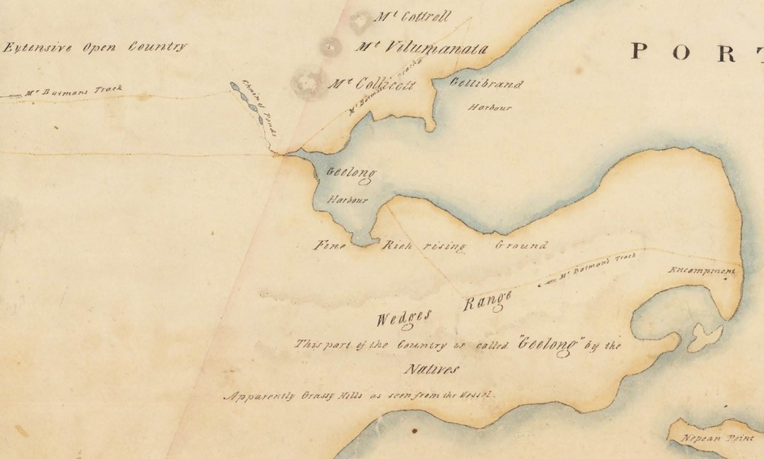
Figure 3.01: J.H. Wedge, Part Map of Port Phillip from the survey of Mr. Wedge and others’ showing the Greater Geelong area and the tracks used by John Batman, c.1835. Source: MF 821.08 1835 WEDGE State Library of Victoria.

ROADS AROUND GREATER GEELONG

INITIAL YEARS
It is likely that the earliest roads – or tracks – were those laid out from Point Henry following the arrival of sheep graziers with their flocks in 1836, and who settled in the outskirts of what is now the Greater Geelong municipality (see Theme 2). The earliest formalised roads were those established
as part of the Geelong town grid, the earliest main road being Bellerine Street that linked to the two portions of the township at north and south Geelong (see Theme 6). It was soon superseded by Yarra Street as the principal street with a roadway constructed through the gully to the foreshore at Corio Bay in 1852. It was in the mid-1850s when the earliest road forming program begun with the forming and kerbing
of Malop, Corio, Mercer, Ryrie and Yarra Streets in Geelong, and Autumn, Hope, Spring and Villamanta Streets in Ashby (Geelong West).8 Other roads, paths and infrastructure
in central Geelong and the suburbs soon followed (see Theme 6 for details).

EARLY ROAD MANAGEMENT
The poor state of the roads and tracks throughout Victoria in the years following European colonisation led to the appointment of a Select Committee of the Victorian Parliament in 1851 to investigate the location and condition of the fledgling State’s roads.9 It found them to be defective and recommended the formation of a Central Road Board that would formalise and maintain them.10 The Central Road Board was established in 1853 following the passing of An Act for making and improving Roads in the Colony of Victoria by the Victorian Parliament (see Theme 7 for further details).
The Central Road Board proclaimed the establishment of local road districts managed by district boards. In the Greater Geelong area, they were the Portarlington Road District (1853); Barrabool Road District (1853); Conewarre Road District (1856); South Barwon Road District (1857) and the Corio Road Board (1861) (see Theme 7 for further details).
It was from these Road Districts and Boards where the greatest initial achievements in road-making were made in the early 1850s.11

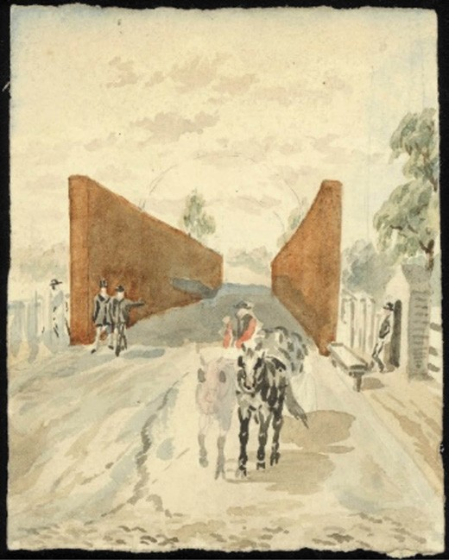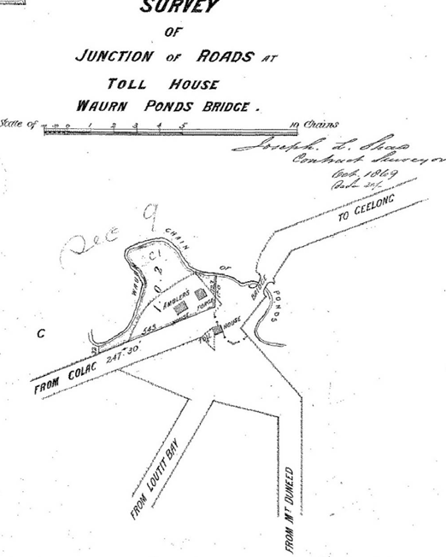

Figure 3.02: H.J. Woodhouse, ‘Old toll gate, Geelong, Barwon Bridge’, 1870. Source: accession H9346/6, State Library of Victoria.

In order to fund and maintain roads in each of the Road Districts, tolls were imposed at different locations, including District boundaries and river crossings. Gate- keepers were appointed to take the tolls. One of the tolls closest to the Geelong township was the gate on the south side of the Barwon Bridge at Belmont in the South Barwon District.
A fence was erected at the end of the bridge and a toll house constructed in 1859 to a design by the Road District Surveyor12 (Figure 3.02). Debate had ensued as to whether the gate house be equipped with a kitchen. One Councillor, Robert Tuffs declared that the toll keeper should be a respectable man, and as such he should not be bothered by a lot of women cooking and humbugging him about . 13 It appears that a Mr Shepherd was appointed the first toll- keeper until 1861.14
In 1855, two toll houses and gates had been erected on the Batesford and Fyansford Roads beyond what is the municipal boundaries of Greater Geelong today. They were built by John Cawker.15 In the Barrabool Road District, three gates were erected in 1858-59 known as Kardinia gate (corner Barrabool and Scenic Roads); Duneed gate (Colac Road, Geelong side of Waurn Ponds Creek) and Mount Duneed Road (Torquay Road).16 Others were built in the South
Figure 3.03: J.L. Shaw, ‘Survey of Junction Roads at Toll House Waurn Ponds Bridge , October 1869. Source: Put-away plan D133D/4, Landata, State of Victoria.
Barwon Road District at the junction of roads to Colac, Loutit Bay (Lorne) and Mount Duneed, Waurn Ponds (Figure 3.03); Mount Pleasant Road, Belmont, and at Breakwater
by 1859.17 In 1875, the Victorian Government contemplated the abolition of tolls, a consequence of growing resentment by ratepayers.18 Such abolition eventually ensued and all that remains of the tolls today are official records and maps marking their locations, construction and personnel that served them.

MAJOR ROUTES FROM GEELONG
As Victoria s second largest city, several major roads were constructed to outer parts of the Greater Geelong municipality and beyond, connecting Geelong with Melbourne, coastal areas along the Bellarine Peninsula and south-west Victoria, Colac, Buninyong and South Australia. Increasing population and the onset of the motor car in the late 19th century was impetus for the establishment of the Country Roads Board in 1913 and several major roads were either built, reconstructed or widened. This has continued throughout the 20th
century to the present day under the responsibilities of the Government authority, VicRoads (see Theme 7 for further details on VicRoads).

GEELONG TO MELBOURNE ROAD INITIAL YEARS
As early as 1839, the great distance by the road of Geelong
from Melbourne was considered as a hindrance to Geelong s prosperity. The provision of a new line of road nearer to Melbourne, and a punt over the Maribyrnong River, were considered to bring the townships of Melbourne, Geelong, and Williams Town into a nearer and more profitable
contact. 19 The present and proposed lines of Road and the Coast between Melbourne and Geelong were surveyed and mapped by W.W. Darke, Assistant Surveyor, in 1841.20 These new roads were south of the old roads between Melbourne and Werribee. Both new roads were to traverse Thomas Chirnside s land before crossing the Werribee River.21 To the west of the Werribee, the road was to extend across the land of William Cherry and James Austin, a portion of the latter’s land extending to the shore of Port Phillip Bay.22
Such anticipation for a new line of road and greater ease of overland access from Melbourne to Geelong was not to eventuate immediately. In 1841, a stage coach service was proposed for the provision of public transport and mail communications. However, the Geelong Advertiser quipped that:
The only obstacle to its commencing immediately, is, the bad state of the road between the Little River and the Weirabee [Werribee]. We hope His Honor will send half a dozen men down to Corio, with instructions to pick up the stones by way of amusement as they come along the road; and when they arrive here, they may return by the new line (which is fourteen miles shorter), amusing themselves in the same manner.23
By 1845, two tracks to Melbourne had been laid out as shown on A.J. Skene’s Map of the District of Geelong (Figure 3.04). There was a lower road which traversed the creeks and rivers closer to the western coastline of Port Phillip Bay, and an upper road that passed through the fledgling settlement
of Werribee in the north, and the locations of the future settlements of Ripley (at the Little River) and Duck Ponds (Lara). It was near the Duck Ponds where the two roads converged.
At Cowie s Creek, the old Melbourne Road in 1847 crossed the creek into a reserve to the distant north-west of the Geelong township at what is known as Corio today (Figure 3.05). A pedestrian and bicycle path denotes the
only surviving remnant of this original road between 257 and 299A Anakie Road, north of the Geelong-Ballarat Railway line and adjacent to the City of Greater Geelong depot. This road appears to have extended south and connected to the Geelong to Batesford Road.

The new Melbourne Road crossed Cowies Creek further east towards Corio Bay, approximately where the Princes Highway traverses the creek today. However, the road was originally intended to extend north-east (as opposed to north today).
Construction and upgrades to the road at Cowies Creek were carried out in the 1850s. In 1856, William Owen was awarded the tender to construct 50 chains of the road.24 The following year, Thomas Menzies constructed 250 lineal yards of the road at Cowies Creek25 while in 1858 Allan McDonald worked on the surface of the road, the funds for the works coming from toll revenue.26 Each portion of road was constructed following the Telford pitching method.27
Further north in 1859, James Pettigrew was the successful tenderer in upgrading the Melbourne and Geelong Road between the municipal boundary of Geelong and Rothwell (Little River).28 In 1860, the Geelong to Melbourne Road was proclaimed a Main Road, thereby being subject to the control and funding of the Central Road Board. As outlined in the Victoria Government Gazette:
The MELBOURNE and GEELONG ROAD – Commencing at Flemington, on the Mount Alexander road, in the county of Bourke; thence vid the Melbourne Cattle Yards and the Race-course; thence via the Saltwater [Maribyrnong] River Punt; thence vid Wyndham, Rothwell, and the Duckponds (Lara), to Geelong.29
The Geelong to Melbourne Road only remained a proclaimed Main Road for twelve months. In 1861, the proclamation was revoked,30 with responsibility for maintaining and funding ongoing maintenance again transferred to the District Road Boards. This was not well- received and in 1864 the Geelong Advertiser reported on the meeting of the Corio Shire in relation to the need for the Geelong to Melbourne Road to be re-proclaimed a main road:
Councillor Morris observed that, being in company some time ago with certain members of the Wyndham Shire Council, a desire was expressed that a conference of the two Councils should be held at an early date
at McShane s Hotel, Little River, for the purpose of considering the propriety of having the Geelong to Melbourne road proclaimed a main road; and from the statement of Mr Grant and others that it was the intention of the Government to increase the subsidy on main roads, he thought it very desirable to have the above road proclaimed, in order to have it thoroughly improved
throughout its entire length. Another important matter was suggested for consideration, viz the improvement of the crossings connecting the two districts. As the interests of the two Councils were identical, he would move That the secretary communicate with the Wyndham Council, and request that a date might be fixed for holding a meeting at the place named.31

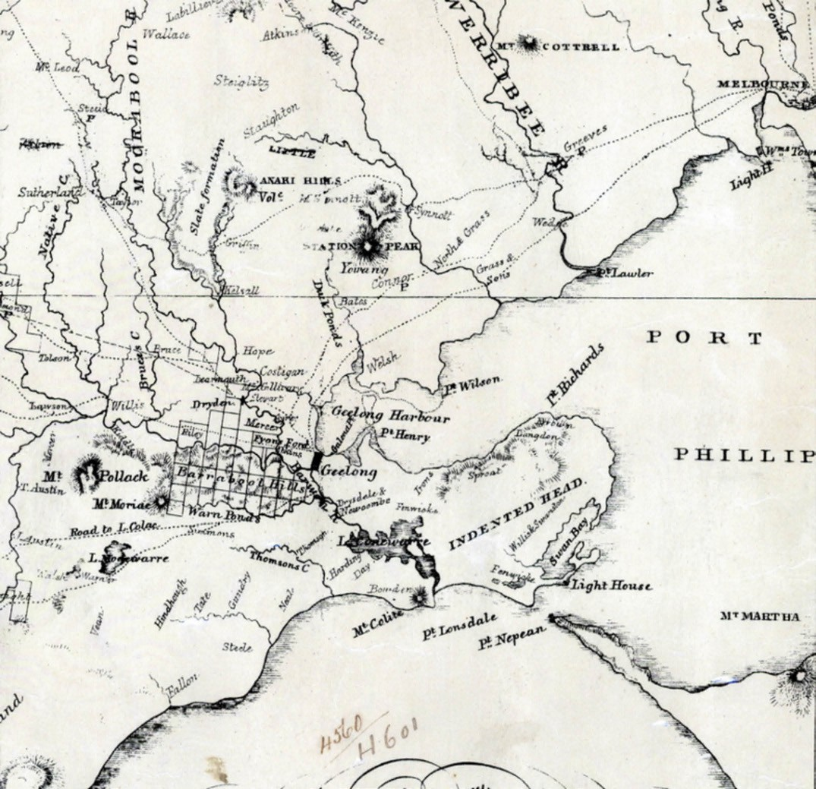
Figure 3.04: A.J. Skene, Portion of Map of Geelong & District, James Harrison, Advertiser Office, Geelong, 1845. Source: State Library of Victoria.

Although a joint deputation of Wyndham and Corio Shire representations was to be formed in 1865 to wait upon the Commissioner of Roads and Bridges, no immediate
proclamation of the Geelong to Melbourne Road as a main road was to eventuate.32

DEVELOPMENTS IN THE 20TH CENTURY
With the advent of the motor car in Victoria in the late 19th century came the need for improved roads for ease of travel. Additionally, the increase in motor vehicles brought about the deterioration in the Geelong to Melbourne Road. In 1912, the condition of the road was so bad that the Geelong Progress Association wrote to the Wyndham and Corio Shire Councils urging the need for repairs. 33 Western District motorists
were bypassing this route given the dire state of the road. In

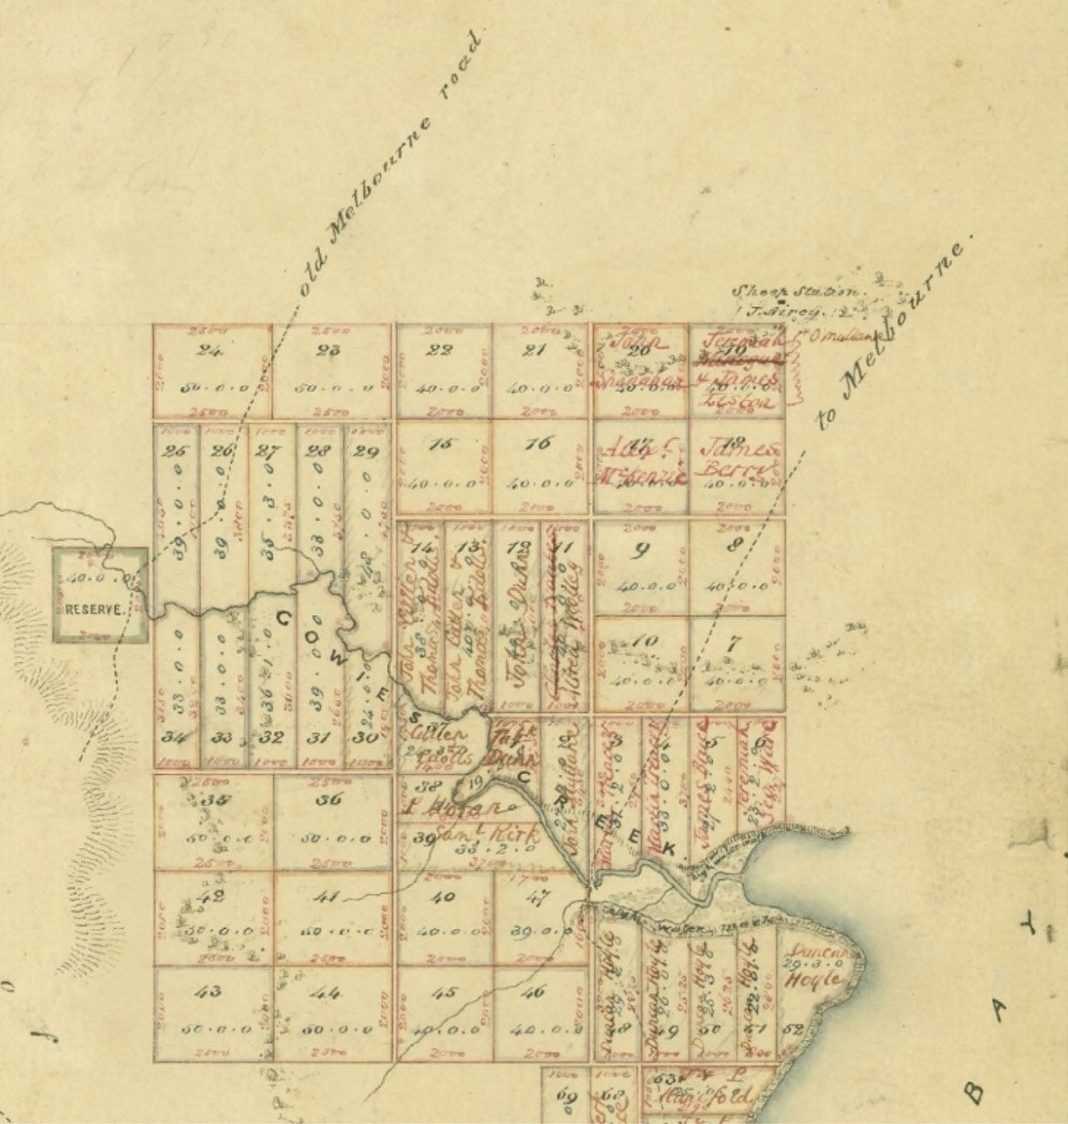
Figure 3.05: W. Pickering, Assistant Surveyor, Plan of Allotments marked at Cowies Creek and Corio Bay , 1847. Source: VPRS 8168/P5 Sydney Plans, Sydney C14: Cowies Creek, Public Record Office Victoria.

1913, the newly-formed Country Roads Board inspected the Geelong to Melbourne Road and concluded that it was in a very bad state and had ‘greatly interfered with the motor traffic to Geelong. 34 It found that stone foundations on some parts of the road were exposed due to neglect.35 Some immediate upgrades were carried out on a stretch of the road in 1913
(Figure 3.06), although the Annual Report of the Country Roads Board in 1914 gave the following:
In the case of the Melbourne-Geelong road, however, a short section near Little River appears never to have been constructed, while other extensive sections are in such
a condition that reconstruction is now necessary, and

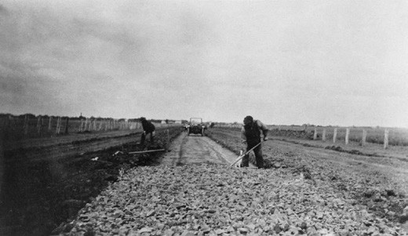
Figure 3.06: Geelong to Melbourne Road under construction, photographic collection, Roads Corporation, 1913. Source: VPRS 17684/P3 item 13/00153 Public Record Office Victoria.

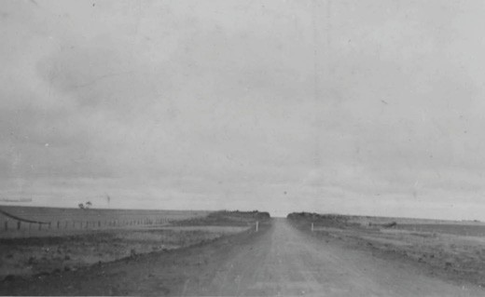
Figure 3.07: Geelong to Melbourne Road under construction c.1915, possibly between Werribee and Little River.
Source: Accession H372a, State Library of Victoria.

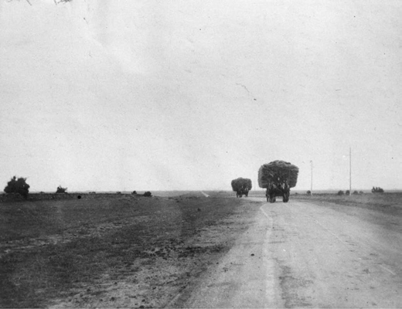

Figure 3.08: Geelong to Melbourne Road, photographic collection, Roads Corporation, 1921. Source: VPRS 17684/P3 it 21/00072 Public Record Office Victoria.
contracts are already in progress for sections of the road near the township of Werribee.36
In 1915 and 1916, nine miles of road were reconstructed in the Corio Shire portion, while 20 miles of road were reconstructed near Werribee, with three contracts let for the completion of the remaining section between Werribee and Little River37 (Figure 3.07).
World War One (1914-1918) postponed much of the upgrading of the Melbourne Road. Following the conclusion of the
war, the most important and extensive work was carried out in the completion of the Melbourne to Geelong Road through the Shires of Braybrook, Werribee, and Corio by 192138 (Figure 3.08). It was at this time when the Geelong to Melbourne Road was officially declared a Public Highway as part of the Princes Highway, named after the Prince of Wales (later King George VII and subsequently Duke of Windsor).39 The official opening of this stretch of highway
occurred in Mercer Street near Railway Terrace, Geelong, by the Mayor Geelong, Alderman Hitchcock.40 A year later in 1922, H.F. Richardson was commended in the annual report of the National Roads Association (Victorian branch) for
the active interest he took in the extension of the highway. 41 Richardson had visited most of the shires along the route, and spoke very emphatically on the advantages which must eventually come to the centres through which this highway passes. 42 Stretches of the Highway between Melbourne and Geelong were widened in the ensuing years and by 1930, 47 pipe or box type culverts had been extended or reconstructed to account for the road improvements.43
The 1920s also brought about the widening of the Melbourne Road at North Geelong and Geelong West. In 1925, The Herald reported that from the Bacchus Marsh junction the road reduces from a three-chain roadway, and eventually becomes bottle-necked. 44 This was due to the expansion
of industrial and residential development in the northern suburbs. A conference between the Corio Shire and Geelong West Town Council was arranged to investigate the project.45 The Geelong West Council was initially resistant to the idea of widening the road between Fishermen s Gully (Rippleside Park) and Glenleith Avenue given that 30 feet of private land for the distance of the road would need to be purchased and this was considered cost prohibitive. The Council felt that if the safety of the travelling public was so paramount then the Country Road Board should take the work in hand. 46
In April 1927, work began on the widening and upgrade of the Melbourne Road between the Bacchus Marsh Road junction and the railway bridge at Separation Street. As outlined in the Geelong Advertiser:
The costly scheme of widening the Melbourne Road has been commenced in earnest by Corio Shire Council.

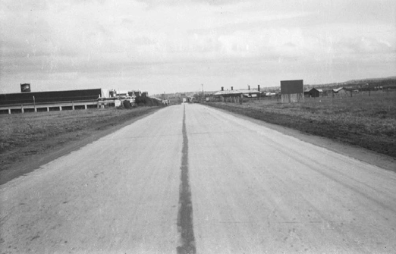
Figure 3.09: Concrete section, Geelong to Melbourne Road, North Geelong (note the Ford Motor Company on the left in the background), photographic collection, Roads Corporation, 1929. Source: VPRS 17684/P3 it 28/00087, Public Record Office Victoria.

Adjustments have been made in regard to compensation, houses and shops have been and are being removed to new building alignments, fences have been removed, and the contractors for the two miles of road work (Victorian Roads Ltd.), commenced last week near the junction of the Melbourne and Bacchus Marsh roads to break it up preparatory to putting down a
new foundation.47
The new stretch of road at North Geelong was constructed of reinforced concrete (Figure 3.09). The Country Roads Board had experimented with three types of concrete
road construction on the Dandenong Road in the Borough of Oakleigh in 1921.48 At North Geelong, the road was constructed of the Board s second type , being of concrete pavements 20 feet wide flanked by strips of asphaltic macadam 2 feet wide. The pavements were laid on
2-inch-thick clinker beds, the two layers of concrete between reinforced with British Reinforced Company s steel mesh. Each panel was connected with expansion joints held together with steel dowel bars and filled with precast bituminous sheets.49
In 1930, this section of newly-built, widened road was formally opened at Separation Street, North Geelong, by Alderman R. Purnell in the presence of a large gathering.50
In 1931, the Geelong to Melbourne Road within the City of Geelong was declared a public highway.51 The road between the Ford Motor Company and the Separation Street bridge was further widened in 1941,52 with more stretches south of the bridge having been widened inz earlier years.
It was from the late 1950s and early 1960s when the Princes Highway was upgraded and the townships of Werribee and Little River by-passed. In 1957, work began on the widening

of the concrete road at Norlane in preparation for duplication and provision of a service road. 53 The duplication of the road into a four lane highway had begun in 1955 at Brooklyn and Kororoit Creek.54 In 1959, the highway from Norlane to Little River was duplicated.55 Work had also begun with the construction of a by-pass road at Werribee.56 Completed in 1961, it was named in honour of Sir Thomas Maltby, local Member of Parliament for the seat of Geelong who had been closely associated with the building of the Princes Highway
between Melbourne and Geelong.57 From the Maltby By-Pass the highway took a more direct line following the original Lower Melbourne Road to Little River and Lara.
In 2008, in order to ease traffic congestion in Geelong the Geelong Ring Road between Corio and the Hamilton Highway at Fyansford was opened.58 The following year in 2009, the extension of the Geelong Ring Road between the Hamilton Highway at Fyansford and Waurn Ponds was opened.59 Four years later in 2013, the Geelong
Ring Road was linked to the Princes Highway from the Anglesea Road.60

GEELONG TO BUNINYONG ROAD (MIDLAND HIGHWAY)
A track, possibly first introduced by the Wadawurrung, was used by European pastoralists as early as 1836 as the transport route to Batesford and beyond to Buninyong.
This route gave overland access to Portland Bay.61 Within the Greater Geelong municipal area today, the
track crossed the Moorabool River at what was first known as Manifold s Ford, and later Bates Ford. In 1840, the Assistant Surveyor, Thomas Townsend, surveyed part of the proposed line of road leading from Geelong towards Boninyong. 62 The new surveyed road was to cross the Moorabool River further downstream to the north (Figure 3.10).
The alignment of Townsend s survey formed the basis of the road from Geelong to Buninyong today. In 1854, after the formation of the Central Road Board, the road was cleared of timber and portions were macademised through the north- western suburbs of Geelong, including ‘the flat

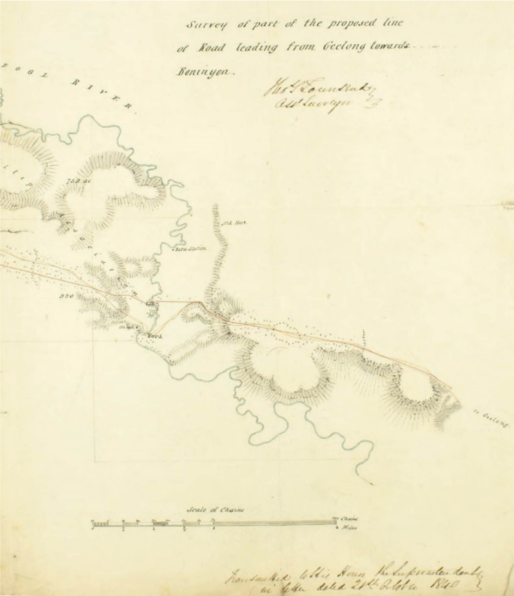
Figure 3.10: T. Townsend, Assistant Surveyor, Portion of Survey of part of the proposed line of Road leading from Geelong towards Boninyong , 21 October 1840. Source: VPRS 19/1 it 40/1075a, Public Record Office Victoria.

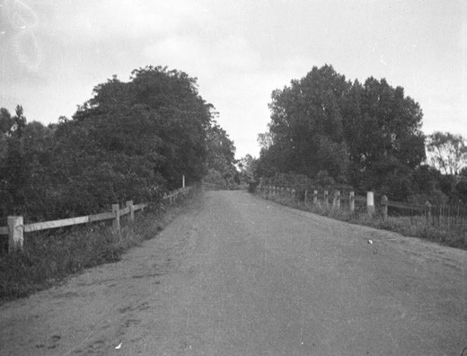
Figure 3.11: Midland Highway near the Batesford bridge, photographic collection, Roads Corporation, 1934. Source: VPRS 17684/P3 it 34/00105, Public Record Office Victoria.

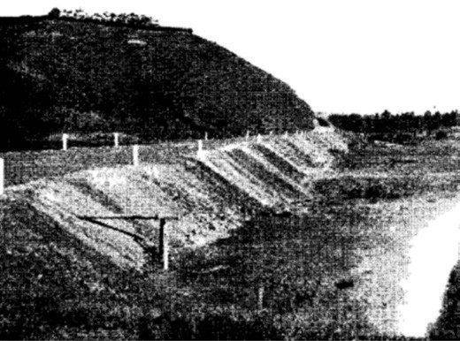
Figure 3.12: Deviation Road, Fyansford, under construction, c.1932. Source: Country Roads Board Annual Report, 1932, p.9, Parliament of Victoria collection. Reproduced by permission of the Speaker of the Legislative Assembly, Victoria, Australia.

at Batesford and hills on each side. In 1931, the Geelong to Buninyong Road became a State Highway as part of the Midland Highway. Two years later in 1933, the road (Figure 3.11) was improved:
The first section of the Midland Highway, which comprises 48.6 miles between Geelong and Ballarat, was immediately taken in hand by improving the riding qualities throughout. By the addition of gravel, which
forms part of the staged construction, a good temporary riding surface has been provided. Approximately 13 miles were re-conditioned ready for sealing early this Spring.65
Soon after the completion of the road upgrade, a large

volume of traffic from Ballarat and surrounding districts’ was now traversing this highway to Portarlington, Queenscliff and other seaside resorts on the Bellarine Peninsula, where the main roads radiating from Geelong have been placed in good condition. 66

GEELONG TO HAMILTON ROAD (HAMILTON HIGHWAY)
Before 1845, a track from Fyansford – which traversed the Moorabool River at Fyans’ Ford – gave access to Inverleigh and beyond to the Western District as far as Mount Elephant (see Figure 7.01). Known as the Lower Leigh Road by 1854, it was at this time when the Geelong Advertiser and Intelligencer reported that for this road (now Hyland Street) the hills
at Fyansford on each side of the river have been cut and improved, and the road metalled. 67 It was not until 1931 when work began on the construction of the Deviation Road at the western end of Aberdeen Street to provide alternative access to Fyansford and beyond to Inverleigh (Figure 3.12). The construction of the road was outlined in the Annual Report of the Country Roads Board in 1932:
The formation of the deviation of the Fyansford Road near Geelong was completed out of Unemployment Relief Funds. In addition to having provided suitable employment for a large number of men, the new road, besides affording a well-graded access to Geelong from the west side in place of the excessively steeply-graded road previously in use, will provide opportunities of viewing the scenic beauties of the Barwon Valley in the
immediate vicinity of the city. Recognizing the value of the new work, the Geelong Town Planning Association has already taken in hand a suitable scheme of tree planting along the sides of the road.68
The road was completed in 1932.69
In 1941, the Geelong Hamilton Road within the municipality of Newtown and Chilwell, Shire of Bannockburn, Shire of Corio and Shire of Colac was proclaimed a Main Road.70 It was later renamed as the Hamilton Highway, many years after the Leigh Shire Council had proposed the road from Geelong through Cressy, Hamilton and Coleraine to the South Australian border be proclaimed a State highway in 1925.71

GEELONG TO BACCHUS MARSH ROAD
The route to Bacchus Marsh from Geelong in 1851 was convoluted but following the goldrush at Mount Alexander it brought about increased traffic. The initial method of reaching Bacchus Marsh from Geelong was described
as follows:
Mount Alexander is north by west from Geelong. To go by the Werribee Bridge, on the Melbourne-road is too much

to the east, and by far too near to Melbourne Swamp – to go by Ballan is too much to the west.
The nearest and best way [to Mount Alexander] is between the two, by Bacchus Marsh, and this is the way the Mount Alexander coach will run. We [at Geelong] are nearer Bacchus Marsh than Melbourne is, and yet how little we know about it. It is only thirty-three miles from Geelong, and a road almost level, not one boggy place, and yet our letters must lay nine days before they arrive there, if posted here on Thursdays.
The first place is to Cowie’s Creek, then pull up
Ballan-road by making towards the Anakies, keep that road for five miles, then take Griffin’s-road, bearing to the right, which leads between the Anakies and Station Peak; pursue that road through the bush on to the plains; then make for a bald hill – on horseback leave the hill to the right, go through the bush right into the marsh where there is a fine road to the right leading to the marsh.72
By February 1853, a new road from Geelong to Bacchus Marsh had been opened, following a survey by A.J. Skene, Government Surveyor.73 It was claimed that the new road did ‘not present a single steep hill or other difficulty.’74 The existing Geelong to Bacchus Marsh appears to largely following the alignment marked out by Skene.

GEELONG TO COLAC ROAD (PRINCES HIGHWAY)
The original track from Geelong south-west to Colac appeared to follow the route of the Wadawurrung between ‘Jerringot’ (Belmont Common), along the north bank of the Waurn Chain of Ponds. At Waurn Ponds, the road separated into two, with one route passing the north of Lake Modewarre, the other to the south of the lake.75 In 1853, a new road was surveyed and constructed.76 In 1854, it was described as having been macadamised as far as the end of what has been termed Denny s line (at Grovedale).77 The road junction at Waurn Ponds was extended to include a road to Loutitt Bay (Lorne). In 1925, the Geelong to Colac Road was proclaimed a State Highway as part of the Princes Highway.78

GEELONG TO QUEENSCLIFF ROAD (BELLARINE HIGHWAY)
The first track from Geelong to Shortland’s Bluff (Queenscliff) appears to have been established in 1846 when it was proposed to convey the mail from Queenscliff to Melbourne via Geelong.79 By 1854, about a mile and quarter of the road had been macadamised and the line generally cleared of timber. 80 Two years later in 1856, the Geelong to Queenscliff Road was proclaimed as a Main Road to be known as The Queenscliff Road. 81 In 1865, given the intended erection
of elaborate defences at Queenscliff came calls from the

Queenscliff Borough Council and Indented Head Road Board for the Geelong to Queenscliff Road to be proclaimed a military road. The Borough Council argued:
What will be the use of the fortifications if they are not to be reached speedily, or, as the chairman of the Board
remarked, The gallant volunteers ought to have a means of retreat in the event of their being overpowered by the enemy. 82
Part of the stretch of road between Geelong and Leopold, earliest known as the Kensington Road, was planked instead of macadamised. The planks were replaced with metal in 1875 as the Geelong Advertiser reported on the work at this time:
The old plank road, which for many years has been an eyesore to travellers in the pretty farming district of Kensington, will be soon among the institutions of the
past. The planks were laid for a length of more than half a mile along the main toll road, in the days when metal was scarcer and much dearer than at present. For years they formed a kind of passable bridge over the mud which collected on the flat in winter, but the narrowness of the track prevented vehicles from passing each other without leaving the timber, and this gave rise to frequent complications. In summer when the mud became consolidated the road was disused, and through tear and wear the old planks have recently become dangerous and almost unserviceable in winter. Lately the Bellarine Council determined to abolish the planks, and now they
may be seen fairly walled in with substantial heaps of road metal, designed to take their place. During the next few weeks the planks will be removed, and what has for years been a source of complaint among carters and others will be banished from the district.83
By 1927, the Geelong to Queenscliff Road had become practically impassable during the winter months. 84 In 1928, the Country Roads Board carried out upgrades (Figure 3.13) which were described in its Annual Report
for 1929:
The state of the road between Geelong and Queenscliff, within the Shire of Bellarine, was the subject of severe criticism by the users, as the result of which the Board, after conference with the [Bellarine] Shire Council, agreed to carry out the work of restoration, and this was put in hand under day labour.
The method of reconstruction consisted of scarifying the base of the old roadway and bringing it to perfect section, spreading 3 inches of local sand, thoroughly rolling and dragging same continuously. At a later date the surface was treated with fuel oil and bitumen primer. Subsequently a seal coat of bitumen was applied and

gravel from Gherang rolled into the bitumen surface.
Since the work was completed twelve months ago, it has been kept to a good standard at a very much reduced maintenance cost per mile as compared with the cost of ineffective maintenance prior to reconstruction, although subjected to much heavier traffic, as many as 2,000 vehicles per day passing over the road during the week- end period. The board proposes to further seal the road with bitumen during the coming summer months. The cost of this work was at the rate of £700 per mile.85
In 1947, the Queenscliff Road was declared a State highway and was named the Bellarine Highway.86 In 1967, work began on the construction of dual carriageways with a 0.2 mile span between Swanston and Myers Streets, Geelong, and an extension of 0.5 mile of the carriageway between Boundary Road and Wilson Road, Newcomb.87 By the following
year, 0.5 mile of widening at Leopold had been carried out to allow for four traffic lanes.88 A further 0.9 miles of dual
carriageways were laid out between Wilsons Road and Twitts Road, Newcomb, and parts of the highway were sealed by 1970.89 Since this time, the highway has been progressively duplicated as far as Grubb Road at Wallington.

GEELONG TO PORTARLINGTON ROAD (PORTARLINGTON HIGHWAY)
In 1853, the Portarlington Road District was proclaimed. Action was immediately taken in repairing about 2000 yards of the earlier track between Geelong and the Bellarine Peninsula (and particularly Drysdale, Indented Head and Portarlington).90 The contract was awarded to Thomas Carroll.91 The road line was cleared, the road formed and drained and planks laid.92 By the early 1860s, the road had become impassable during winter months at Moolap and between Drysdale and Portarlington. At Moolap, 55 chains of road were metalled and parts of the remaining plank road were improved. Between Drysdale and Portarlington, the worst portion were metalled and culverts constructed.93
In 1877 and although hardly a highway by today s standards, the portion of the Geelong to Portarlington Road in the Shire of Bellarine was proclaimed a public highway.94
Major works and upgrades to the Portarlington Road were carried out in the 20th century. In 1935, a mile of road between Drysdale and Portarlington was upgraded with a bitumen surface.95 The poor state of the road, in particularly loose road surfaces led to the death of a woman (with her husband and son badly injured) when their car skidded
in loose metal in 1937.96 This appears to have led to road improvements later that year, with a realignment of the road at Moolap to modify two awkward turns 97 and the sealing of one mile of road from the Geelong City boundary. 98 The remaining unsealed portion of the road at Moolap (Figure

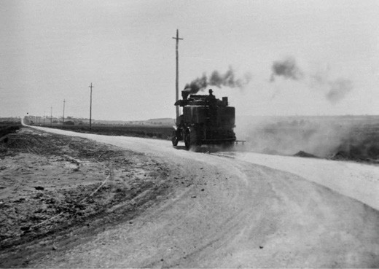
Figure 3.13: Geelong to Queenscliff Road, photographic collection, Roads Corporation, c.1928. Source: VPRS 17684/P3 it 25/00024 Public Record Office Victoria.
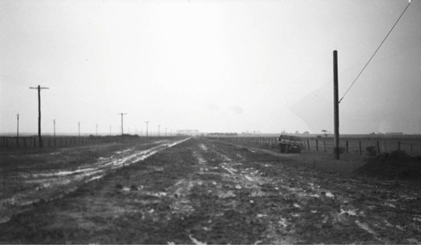
Figure 3.14: Geelong to Portarlington Road, photographic collection, Roads Corporation, 1938. Source: VPRS 17684/P3 it 38/00022 Public Record Office Victoria.

3.14) was sealed in 1938.99
In 1968, work commenced on the construction of dual carriageways for the Geelong to Portarlington Road
within the boundaries of the City of Geelong.100 This began the duplication of the as far as Drysdale. In 2018, work began on the Drysdale Bypass, a six- kilometre-long road from Jetty Road to Whitcombes Road around the central Drysdale township. The Bypass was expected to be completed in 2020.101

GEELONG TO BARWON HEADS ROAD
In 1914, the Country Roads Board declared that the Barwon Heads Road (from Geelong) was one of the district s principal roads.102 The need for a reliable road originates from 1854 when the Government opened up land in the Connewarre area (see Theme 6). Work was carried out on the road from 1859 when the South Barwon Council sought tenders for
one mile of road.103 In these initial years, the Mount Colite

(Barwon Heads Road) extended as far as the coast near Breamlea, linking to a reserved road way in the sand dunes to the Bluff at Barwon Heads (see Figure 1.07). In 1861, the Conewarre Road Board had surveyed a line of new road
(to supersede the old road) further north. This new road was to traverse the southern portions of the The Great Swamp (Lake Conewarre) as shown in Figure 1.07. With the construction of the Mount Colite Coffee Palace in 1889 and the opening up of land at Barwon Heads in 1891 by the Barwon Heads Estate Company (see Theme 6), the small village became an important seaside resort requiring a reliable roadway. By 1906, the need for an improved road
was so dire that the Barwon Heads Improvement Association began fundraising for half the cost of the road, the balance to be met by the Victorian Government.104 Little improvement appears to have been made in the ensuring years at in 1912
E. Langridge in a Letter to the Editor of the Geelong Advertiser
lamented the state of the road:
A pleasure party left Geelong on Saturday afternoon for Barwon Heads in a motor char-a-banc, but the road was distinctly bad.
Some effort seemed to have been made to improve the road since the writer was last over it, but the present state of the surface does not reflect any credit on the person or persons in charge of the work.
Any vehicle undertaking the journey to Barwon Heads at present has to encounter long stretches of large, sharp metal, just tipped on to the road, and flattened out to fill up the pot-holes.
To the motorist especially these bad stretches are deadly. A vehicle shod with solid rubber, cannot avoid having large pieces of rubber absolutely chipped out of
the tyres, while a pneumatic tyred car (unless light enough to take to the side tracks) cannot avoid punctures.
Perhaps the deserted appearance of Barwon Heads can be traced to the bad state of the road. Pleasure-seekers cannot be expected to face such fearful road conditions, even for a trip to such a pleasant spot.105
Although the Barwon Heads Road was declared a Main Road in 1914,106 it was not until 1917 when work began on upgrading the road by the Country Roads Board.107 The improvements were noted by the local community in the Geelong Advertiser in May 1917:
Motorists, patrons and residents of Barwon Heads are loud in their praises of the road from Barwon Heads recently finished by the Country Roads Board.
The crossing at the Big Marsh deserves to be specially mentioned, as it does credit to all concerned.108

Tarring of the road continued in 1919109 (Figure 3.15). It was also at this time when returned soldiers were employed to carry out road making at Barwon Heads110 (Figure 3.16).
In 1964, parts of the Barwon Heads Road were widened.111 Further widening and improvements were made in the following years and more recently, in the early 21st century. In 2018, the duplication of the Barwon Heads Road was proposed by the Victorian State Government.112

GEELONG TO TORQUAY ROAD (SURF COAST HIGHWAY)
Before 1861, a road to the quiet settlement of Spring Creek (as Torquay was earlier called) from Germantown and Mount Duneed had been established.113 However, travel to the coastal settlement in 1892 was curtailed with the loss of the bridge across Deep Creek. A new bridge was erected in late 1893, during which time travellers were reminded that they could reach Torquay along a road through private property. 114 In 1895, the Torquay Improvement Association donated
£100 to the Barrabool and South Barwon Shires to assist with improvements to the road. It was anticipated that when completed, the upgrade would give fully 11 miles of metal
road from Geelong , doing much to shorten the time occupied in making the journey to Torquay. 115 Further improvements stalled in 1907 when a grant of £100 from the Victorian Government lapsed.116 Criticism of the poor state of the road grew louder in the ensuing years, with one motorist in 1915 describing it as disgraceful. 117 While the South Barwon
Shire Council had metalled 1200 yards of the road in 1914, growing frustration by ratepayers caused the South Barwon and Barrabool Shire Councils to each take out a £1000 loan in order to fund the major upgrade.118 Further delays ensued with the improvements not carried out until 1917-18119 (Figure 3.17).In 1930, the Torquay Road was declared a Main Road.120 In 1971, work began on duplicate 0.4 mile of the Torquay Road between the Waurn Ponds Creek and Grovedale.121 In 1995, the Torquay Road was declared a State Highway and named the Surf Coast Highway.122 Work began soon after on the duplication of the road between Grovedale and Mount Duneed.

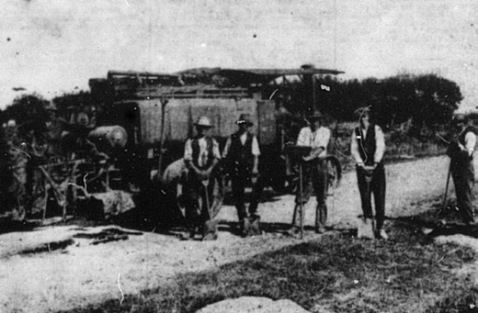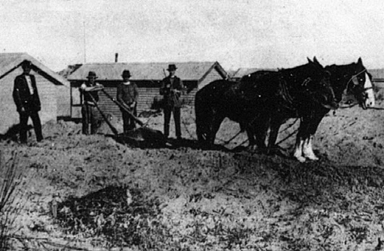

Figure 3.15: Tarring road at Barwon Heads, 1919. Source: News of the Week, 22 May 1919, GRS 2121, Geelong Heritage Centre collection.
Figure 3.16: Road making at Barwon Heads by returned soldiers, 1919. Source: News of the Week, 11 September 1919, GRS 2121, Geelong Heritage Centre collection.

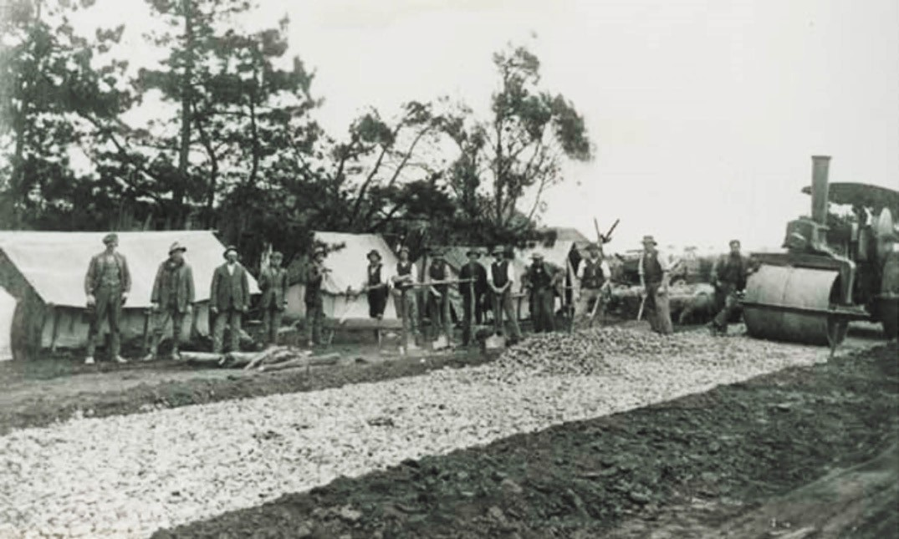
Figure 3.17: Road making, Torquay Road, c.1917-18. Source: GRS 2009/01846/062 Geelong Heritage Centre collection.

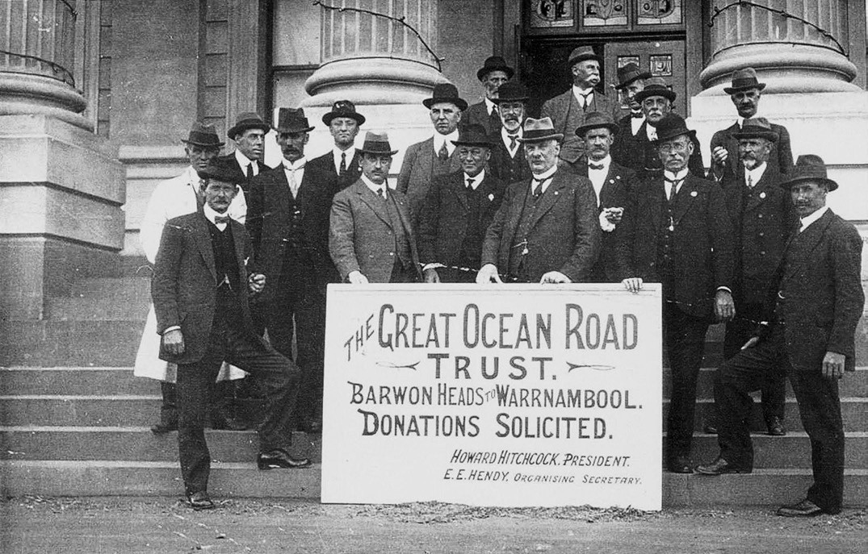
Figure 3.18: The Great Ocean Road Trust on the steps of the Geelong Town Hall, 1918. Source: D. Rowe, The Pleasure Grounds of the Barwon Coast: A History, p.46.

GREAT OCEAN ROAD
In 1917, the Mayor of Geelong, Howard Hitchcock, was a leading proponent for the development of a By-The-Sea Road from Barwon Heads to Warrnambool.123 Described as a ‘modern coastal highway’, Hitchcock was elected the first Chairman of the Great Ocean Road Trust when it formed in 1918. Other members of the Trust included E.E. Hendy, T.K. Maltby, M.L.A., A. Mair, M.L.A., H.H. Smith, M.L.A. and T.J.
Buchan, local architect.124 To be constructed as a memorial to the soldiers who fought and died in World War One – and to be built by returned soldiers – agreement was reached for the opening of the road with the Country Roads Board and the various local council authorities.125 Hitchcock and other members of the Trust travelled the length of the proposed road lobbying for donations for the road. On the steps of the
Geelong Town Hall in 1918, they were photographed holding a sign for donations (Figure 3.18), with the road:
commencing at and including a reinforced concrete bridge over the Barwon River at Barwon Heads; thence proceeding easterly via Torquay, Anglesea, Airey s Inlet, Lorne, Apollo Bay, Cape Otway, Glen Aire, Princetown,

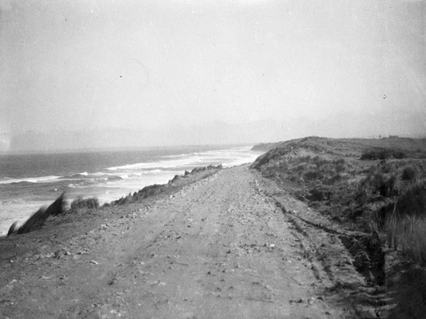
Figure 3.19: Barwon Heads-Torquay Road (Great Ocean Road), Thirteenth Beach, photographic collection, Roads Corporation, 1935 [1938]. Source: VPRS 17684/P3 it 34/00135 Public Record Office Victoria.

Loch Ard Gorge, Port Campbell and Peterborough, and thence to Warrnambool.126
The first section of the Great Ocean Road was opened at Grassy Creek in 1922,127 and not as might have been anticipated, at Barwon Heads. Although a section of the Ocean Road from Barwon Heads was to be surveyed in 1921, there was some anxiety by members of the Barwon Heads Golf Club that the new road might connect up with their links. 128 It was not until 1935 when the immediate plan of the Country Roads Board was to construct two miles of the Ocean Road from Barwon Heads where tourists could secure an excellent view of the ocean. 129 Yet, the road was not formed, graded and surfaced and marram grass planted in this two mile section to Thirteenth Beach
until 1938130 (Figure 3.19).
During the following decades, the Barwon Heads Park Trust (and later Committee of Management) continued to actively support the inclusion of Barwon Heads as part of the Great Ocean Road. In 1962, the Chairman of the Committee visited Lorne and agreed to send representative to the next meeting of the Promotion League with agreement to join in the promotion scheme. 131 In 1978, the Country Roads Board considered the construction of a link road from Thirteenth Beach westwards to Torquay. Because of the fragile sand dunes at Breamlea, the Soil Conservation Authority opposed the proposal. Another attempt was made in 1982 when the Barwon Heads Park Committee of Management gained the support of the Barwon Heads Progress Association, but the linking stretch of road was not constructed.132

OTHER ROAD-RELATED DEVELOPMENTS PUNTS AND FORDS
The earliest forms of river crossing for overland travel
from the 1830s were fords or punts. Although little evidence survives of these fords today, their locations have taken
on the names of some of the first Europeans to the area.
As early as 1836 a ford had been erected over the Moorabool River near Batesford. It was originally called Manifold s Ford after John and Peter Manifold temporarily grazed sheep there but following the arrival of Alfred and John Bates in 1838,
the ford – and small township, Batesford – was named after them (see Theme 6). At Fyansford, the ford was named after Captain Foster Fyans, first Police Magistrate, who arrived there in 1837 (see Theme 6).
From 1840, the breakwater established by Captain Foster Fyans at Breakwater formed an initial important crossing of the Barwon River as well as providing fresh
water (see following subsection and Theme 4). However, when the river was in flood, the breakwater ‘was altogether impassable. 133

Punts were also initially used to cross the Barwon River at different localities. From 1842, a punt provided the
river crossing at the southern end of Moorabool.134 A more reliable service at South Geelong came in 1846 when Benjamin Goldsmid Levien (1806-1890) established a punt service at South Geelong.135 Levien was born in London, England, son of Solomon Levien, one of twelve Jewish stock brokers in London in 1803.136 Solomon Levien emigrated
to Sydney in 1833 and Benjamin followed in 1837.137 In 1840, Benjamin Levin transported a punt from Sydney to the Maribyrnong River (then known as Saltwater River), Footscray, where he established a river crossing service associated with his Victoria Tavern in February 1841.138
In July 1846, Levien had successfully brought his punt along Port Phillip to Geelong where it was anchored off the jetty.
The Geelong Advertiser and Squatters Advocate reported that:
... the most difficult part of its transit has yet to be encountered – its conveyance overland through the township to its destined berth on the Barwon.139
Almost 100 bullocks were yoked to the punt to drag it up the cliff face at the Geelong waterfront and to Corio Terrace, South Geelong.140 By September 1846, the punt was in full work on the Barwon and was considered to prove a source of great accommodation for the Barrabool Hills settlers.141
With the impending completion of a bridge over the Barwon River next to his punt service in 1848, Levien relocated his punt further downstream to near his
Punt Inn beside the stone quarries at the west end of Aphrasia Street.142
William Batten143 and Patrick Connor also established a punt on the Barwon River at South Geelong in 1852 following
the loss of the bridge (see following subsection). In August of that year they were called before the Police Bench to account for the exorbitant charges being levied. In addition to complaints of extortion being made, Captain E.B. Addis, Commissioner of Lands, remarked that refusal had also been given to the police to cross free from expense. 144
A list of prices was subsequently laid down for the guidance of the puntmen. 145
In c.1889, punt services were established at Barwon Heads to provide a river crossing to Ocean Grove. It appears to have been the last punt to be established and operate within the City of Greater Geelong. Until 1906, the punts were operated by private controls and would-be travellers between Barwon Heads and Ocean Grove had to signal the ferryman from
the bank and if could be located, would ferry passengers across for sixpence each way. 146 The only physical and associational evidence of previous punt services in Greater Geelong is the former boot room near the Barwon Heads jetty that was built in 1889 for the Public Works Department.147

The construction of the building had been urged by the Hon. Jonas Felix Levien,148 son of Benjamin Levien, and it appears to have served as a waiting room for the punt until the construction of the Barwon Heads Bridge (see following subsection).149 While a Mr Dempsey was proposed to be caretaker of the jetty and shed in 1889, Samuel Challis was appointed instead.150 The former punt at Barwon Heads is also marked by the name of the local street, Punt Road.
In 1905, the Geelong Harbor Trust was established
(see Theme 7) and it took control of the management of the river. Harbor Trust Officers were stationed at both Barwon Heads and Ocean Grove as the first stage in erecting a ferry pontoon that was to be situated on the river close to the Heads.151 Due to a local disagreement, the ferry pontoon never made it to the area. Instead, the ferry was used at the Sparrovale Irrigation Farm at Marshall (owned by the Harbor Trust – see Theme 4) to transport livestock.152 As an interim measure, a motor launch had been placed on the river in 1909 by the Harbor Trust Commissioners, and during the holidays [it] was well patronised. 153
The idea of a ferry pontoon was revived in 1923 when the Geelong Harbor Trust and Shires of South Barwon and Bellarine held a conference to discuss the issue.
Two years later in 1925, the Geelong Advertiser highlighted the necessity for such a service:
While Barwon Heads has become very popular and at holiday-times has large numbers of visitors, Ocean Grove is, in comparison, neglected because of its semi- isolation. If means were provided whereby vehicles could be carried over-stream from the Barwon Heads side it is confidently believed that Ocean Grove would progress.154
In September 1925, the Geelong Harbor Trust had instructed Mr .E.E. Higgs ‘to prepare plans and specifications for a vessel that would meet the requirements of a service that
it is anticipated with be greatly availed of by tourists and holiday makers. 155 Estimated to cost about £5000, it was to be ‘one of the greatest benefits’ to both Barwon Heads and Ocean Grove as seaside resorts.156 To be built at the Harbor Trust s workshops at Rippleside, the development never proceeded.

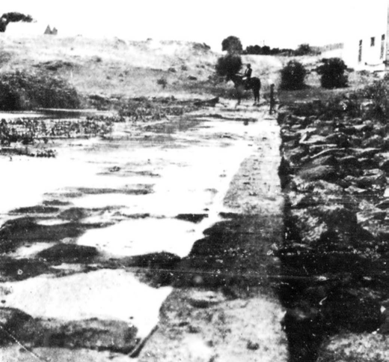
Figure 3.20: Breakwater, 1912. Source: News of the Week, 14 March 1912, GRS 2121, Geelong Heritage Centre collection.

SUBURBAN BRIDGES
The crossing of the Barwon River between the northern and southern parts of the Geelong region, particularly with livestock, was fraught and not possible in times of flood or lack of a punt service. From the 1840s calls grew louder for bridging the river at different locations.

BREAKWATER BRIDGE, BREAKWATER
The first bridge to cross the Barwon River at Breakwater was a ford over the breakwater. Works commenced in 1839 (or possibly in December 1838) under the supervision of Captain Foster Fyans.157 Completed in 1840 to provide a dam for fresh water for Geelong residents (see Theme 4), the work included a clay bank with large stone floaters and a two- coursed stone ashlar bridging roadway.158 A flood in 1844 damaged the breakwater and David Lennox, Superintendent of Bridges, prepared a ‘Specification of a Wall to be built at the fresh water dam on the Barwon river near Geelong on
22 March 1845.159 By April 1845, a wall had been built across the upstream side of the dam and work had commenced on a cut- stone paving on top of the dam wall (Figure 3.20). Work was completed by August 1845.160 Repairs were carried out in the ensuing years, the breakwater being approximately 352 feet in length and 12 feet wide.161 In 1867, a guide rail was built by the Borough of South Barwon and in 1886, a timber staging was erected to provide assistance to boatmen to
drag their boards across.162 In 1968, a low level concrete road bridge measuring 196 feet in length and 20 feet in width was built on top of the breakwater.163

In late 2009, VicRoads called tenders for the realignment of Breakwater Road and the construction of a 60 metre long bridge over the Barwon River to connect to Fellmongers Road, Breakwater.164 The tender was awarded to McConnell Dowell, with Pitt and Sherry providing alternative design solutions to the original bridge and road design by VicRoads.165 Costing $63 million, the project included a 1.3 km long road, with a 635 span of road being elevated over the Barwon River floodplain.166 The bridge was constructed of 10 metre cantilevered insitu piers and a 40 metre precast
concrete beam, together with concrete pole caps, piers, cross heads and insitu deck.167

BARWON BRIDGE, GEELONG-BELMONT
In February 1847, William Lonsdale, Colonial Administrator at Port Phillip, called tenders for the erection of a timber bridge, over the Barwon River, at Geelong.’ Specifications and plans were available at the Bridge Office, Melbourne.168 The contract was awarded to Robert Wayman, a contractor of Little Bourke Street, Melbourne.169 Under the guidance of the Superintendent of Bridges, David Lennox, construction was beset by numerous delays. Coupled with scarcity
of timber (leaving workmen idle), the Geelong Advertiser complained that the contractor needed to display greater energy. 170 In May 1848, Wayman disappeared, escaping his impending insolvency:
During the last fortnight there have been strange rumours afloat respecting the disappearance of Wayman, the Road Surveyor and Contractor. We did not think proper to allude to these rumours, so long as there was any probability of his re-appearance; but the application of his creditors to have his estate sequestrated, brings
the circumstances with the sphere of newspaper animadversion. He was the contractor for several works now in progress in Melbourne, as well as for the erection of the Barwon Bridge, the Marrabool Bridge, and the improvements now in progress in Yarra-street, in Geelong.
On Friday the 12th inst., he received from the Treasurer of the Yarra- street Fund the sum of forty pounds, thirty of which he paid to the overseers of the work for wages, and also left an order for twenty pounds, which was paid on the following day to the overseer. He then started
for Bates Ford, telling his overseer that he would be in Geelong again on Saturday evening. From a house in Ashby he took a bundle of bedding, and carried it before him on horseback to Bates Ford. Here he gave the men a trifling amount in money and a bottle of rum, and told them he was going next day to see some sawyers near
the Yowangs. It is said that on his arrival at Bates Ford he wore different clothes, at least a different hat, from what he wore when he left Geelong. On Friday night he slept
at the public house at the Ford; and the next morning was

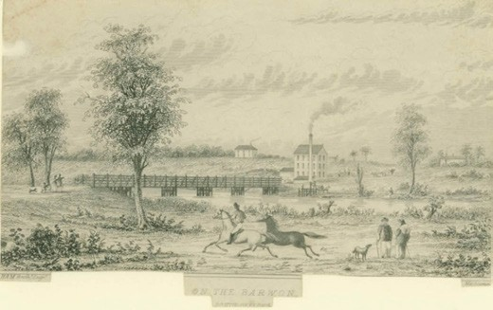
Figure 3.21: Ham Brothers, On the Barwon showing the recently- constructed bridge, c.1850. Source: accession H88.21/2258 State Library of Victoria.

up and away before daylight; but which road he went is not known. From that time to this no intelligence has been heard of him. For the first week, opinion was divided as
to whether he had absconded, or met with some accident in the bush. The fact of him having paid sixty pounds on the eve of his disappearance, favored the idea that he had not absconded; but others thought that this was a blind, and if so, it was not money thrown away, for it effectually lulled suspicion, and prevented the hue-and-cry that would otherwise have been immediately raised. The state of his circumstances, which inducted him to bolt, if he has bolted, is not clearly known. It is reported that he lately raised a large sum of money by way of mortgage on an unfinished building; that he was deeply indebted far and near; that some of his contracts would be losing ones, and that on the day before his disappearance he had received notice that his affairs were about to be brought to a crisis by his largest creditor petitioning the judge to place his estate under sequestration.171
By August 1848, a new contract for the completion of the Barwon Bridge had been let to Messrs. Wilson and
Anderson.172 Such was the urgent need of the bridge, that temporary planking was laid down to enable drays to cross before the remainder of the bridge was completed.173 By November 1848, the bridge was almost complete as tenders were called for construction of the approaches to the bridge174 (Figure 3.21).
The bridge was not to endure. In 1852, a substantial flood (see Theme 1) caused its destruction as described in the Geelong Advertiser and Intelligencer:
The Barwon Bridge stood well on Friday, in the afternoon of which day little damage was observable, save a slight disturbance on the roadway on the southern side, caused by a rush of water, which flooded the plains and country adjacent. The continuous heavy fall of rain soon gave an

irresistible impulse to the river s course, and the water, on that evening and the ensuing day made a complete breach over it; but the bridge stood well until about two o clock
on Sunday morning, when it yielded with a crash before the force of the water, and the injury it had sustained from drifting trees and logs. Piles and logs have gone; nothing is left but a post and a few rails, to mark where the bridge was.175
While tenders were called by the Public Works Department in January 1853 for a new timber bridge, nothing immediately eventuated.176 Instead, the Government moored two punts
in the river to form a floating bridge.177 It was described in
The Argus in September 1853:
The two Government punts hitherto plying across the stream, have been placed longitudinally on the river, connected to each bank by a wooden structure, which forms arching, the intervening space in the centre between the punts has been jointed in like manner. The whole being well secured and bound together by iron brackets three lashes thick and six inches wide. The structure
rises and falls with the water, consequently the injury from pressure or great weight is much removed.178
However, the floating bridge soon proved unsatisfactory as quadrupeds [livestock] were not permitted to be driven over. 179
While a new bridge constructed of iron was agreed upon in 1853,180 like the first timber bridge it was to replace, construction was fraught with delays. As early as October 1853, the Geelong Advertiser bemoaned the lack of action:
The facts relating to the Bridge are these. About five years ago, the erection of a bridge across the Barwon at Geelong was undertaken. Without much delay, the work was completed, and a very good, apparently substantial, bridge was opened to the public. The bridge, while
it lasted, was all that could be desired. In May, 1852, (seventeen months ago) the bridge was carried away by a flood unprecedented in the annals of the colony. Immediate representations of the urgent necessity of replacing it were made of the Lieutenant-Governor, and the reply he gave was that, as labour in the colony
was likely to continue high, he intended to order a large number of iron bridges. Our impression is that he afterwards said he had ordered, or that he had given instructions to order them. Nothing, however, has ever been heard of these iron bridges, and we are now coolly informed that there have not even been any enquiries into the use of any material except timber, which is too dear!181
At this time, information about the site of the bridge had been sent to the Colonial Agent in London, Edward Barnard, so that he could arrange for the design and fabrication

of the girders. Barnard failed to provide regular updates to the Victorian Government on the progress of the work, to the continual frustration of the newly-formed Central Road Board.182 However in 1854, the Central Road Board announced that orders had been made to England for iron bridges at Geelong
and Melbourne:
Remittances have been made to England for the purchase of three wrought-iron arches of 200 feet span each; two of them intended for two-arch bridge over the Barwon at Geelong, and one for a bridge over the Yarra in Melbourne.183
By late December 1855, the iron material had arrived and a building was under construction to store small ironwork.184
Although the iron girders were claimed by the Country Roads Board in 1925 to have been originally designed for use in military bridging in the Crimea, 185 this was not the case.
A letter prepared by the manufacturer, William Fairbairn and Sons in Manchester, England, to Governor Sir Charles Hotham in December 1854 clearly revealed the provenance of the design and construction:
We have the honor to recommend to the notice of your Excellency the bearer hereof Mr. John Croll who has been selected by us, with the sanction and approval
of the Agent-General for Crown Colonies in London, to superintend the reconstruction of the two wrought iron bridges which we have constructed for crossing the Barwon and Yarra Yarra Rivers.
Mr. Croll has had great experience in works of this character, having supervised most of the great Bridges which we have erected in this country and in Zeeland.
He is moreover an excellent practical Engineer and we feel sure your Excellency may with advantage to the public service avail yourself of Mr. Croll s practical knowledge and preserving [word to recognisable] habits.
We have confidence that the Bridges when completed will be found in every way satisfactory and we now only regret that we had not at the commencement of our contract more information regarding the localities where they are to be placed and the nature of the traffic they will have
to accommodate.
Within the last few days only, we have heard from your Excellency s predecessor, Mr. Latrobe, that a greater width of roadway might have (been) desirable – but we were bound by the instructions upon which we tendered and which fixed this width at 24 feet. Even during the progress of the work we proposed to the Engineer employed by Mr. Barnard, the addition of outside

Galleries, which would have entirely separated the (passenger?) and carriage traffics, and thus greatly increased the accommodation of the Public.
But the Agent-General did not we believe feel justified in any departure from the terms of the instructions forwarded from the Colony, and these galleries, which when loaded with (passengers?) would add materially to the load upon the Bridge, cannot now be added
with security.186
Initially, the contract for the foundations of the bridge were awarded to a Mr McKinnon by early May 1855.187 However, he declined to proceed with the work and further tenders at this time proved unsatisfactory.188 It was also at this time when Mr Barnard decided against John Croll to superintend the erection of the bridge, preferring Mr Braithwaite instead.
Unfavourable reports by Charles Rowand, road engineer (see following) resulted in Croll being appointed superintendent. 189
In October 1855, seven mechanics from England arrived to work on the bridge and that to be built at Richmond,
Melbourne. However, the works at Geelong had been delayed and construction could not commence. In May 1856, working drawings for the bridge were completed by Charles Rowand. A month later in June 1856, a contract to construct the abutments and piers was awarded to Cripps and Co.
at a cost of £14,564.190 In October 1856, John Croll arrived after working on the Yarra bridge. He devised the method of construction in that timber falsework across the river
spanning between the abutments and the central pier were to be erected so that the girders could be built directly onto it.191 Arguments ensued between Rowand and the contractors, leading to a suspension of works on 7 November 1856. In December 1857, new tenders were called and that of Pettigrew and McCann was accepted to complete the work which involve the foundation and masonry work for two abutments and as central pier.192
It was not until December 1857 when tenders were called for the erection of staging for the building of the bridge, the tender being awarded to David Barry and Co. for £1866.193 Additional delays transpired until May 1858 when Barry recommenced work with the laying down of planking in readiness for the erection of the iron plating.194
The bridge opened In October 1859.195 It comprised a superstructure of through type, in two spans of 208 feet, each consisting of two wrought-iron box girders, 13 feet deep, giving a road width of 22 feet196 (Figure 3.22).
Intimately involved in the design and construction of the bridge (and its approaches) was Charles Rowand (1826- 1908), Engineer for the Western District of the Central Roads Board.197 Rowand was the son of Dr Charles Rowand (born Paisley, Renfrewshire, Scotland, 1787) and Maria Hassells

(nee Griffin) (born Whitbourne, Herefordshire, England, 1796).198 Dr Charles and Maria Rowand had married in Lambeth, London, in 1818, where Charles appears to have relocated as a medical practitioner.199 Charles Rowand junior was born at Kennington, Surrey, England, in 1826 and by 1841 the Rowand family (then comprising 6 children) were resident in the Town of St. Helier’s on the Channel Island of Jersey.200 It was there were Maria Rowand died in 1849,201 although Dr Charles Rowand graduated as a Doctor of Medicine from
the University of Glasgow in 1844.202 It also appears to have been in Scotland where Charles Rowand junior may have undertaken engineering studies (with Scotland being the centre for engineering, shipbuilding and the production of locomotives).203 There, he was employed in the construction of the Scottish Central, Scottish Midland Junction, Glasgow, Paisley and Greenock Railway lines.204
Following the death of Maria Rowand, Dr Charles Rowand, Charles Rowand junior and other members of the Rowand family emigrated to Port Phillip on the Travancore in 1849.205 The Travancore was one of three vessels chartered by the Rev. J. Dunmore Lang, Presbyterian Minister, in bringing selected free settlers with some means to Victoria.206 Charles Rowand junior established a private practice as a civil engineer in Malop Street, Geelong, in 1850.207 It was also at this time when the Rev. A.M. Ramsay, Presbyterian Minister, wrote a letter of introduction to Governor Charles La Trobe on Charles Rowand s behalf, highlighting that
his professional services as a civil engineer comes highly recommended. 208 The Rev. Ramsay had been a little acquainted with Dr Charles Rowand, presumably in Glasgow where Ramsay was born and had studied at the University
of Glasgow.209 Whether Ramsay s letter of introduction had influenced Rowand’s appointment as a Road Engineer to the newly-established Central Roads Board in 1853 is unclear, but it was in this position where Rowand was responsible for the design of a number of bridges in the Geelong district in the 1850s. In addition to his involvement in the iron bridge over the Barwon River, Rowand also designed bridges at Fyansford, Waurn Ponds and Pollocksford.210 From 1853 until 1859, Rowand also provided honorary engineering services to the Barrarbool Road Board, through the good graces of the Central Road Board. 211
Although the iron bridge over the Barwon River served the residents of the Geelong area for 67 years, it became too narrow for increased traffic and the required tram service to Belmont.212 In 1921, designs for a new bridge were commenced and in 1922, it was announced that a new
concrete and steel bridge was to be erected over the Barwon River.213 However, the Geelong City and Geelong West Councils opposed a complete rebuilding of the bridge.214
This was due to the high cost of the work, the Country Roads Board having sought tenders on several occasions

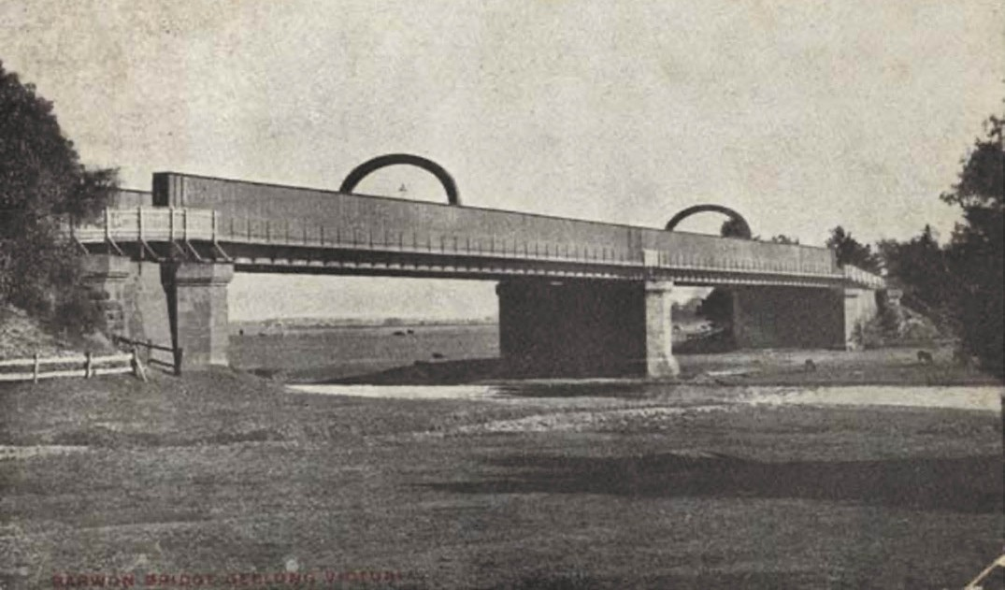
Figure 3.22: Barwon Bridge, c.1910. Source: GRS 6996/0 Geelong Heritage Centre collection.

which had greatly exceeded the expectations of the board s engineers. 215 In January 1924, the Country Roads Board (with the approval of the Minister for Public Works) accepted the lowest tender from Armstrong-Whitworth Pty Ltd for
£73,9000.216 At that time, this was the largest contract entered into by the Country Roads Board since its inception.217 The Board gave a description of the new bridge (Figure 3.23):
There are four spans of approximately 14 feet. This number of spans was adopted in order to salvage and make use of the foundations of the pier of the old two-span bridge. For the new superstructure steel-plate girders were used, as this was found to be the most economical form of construction and most suited to the site, which is an alluvial flat subject to great floods that rise within 2 feet of the girders. The
new abutments and piers are of mass concrete, and the foundations of the old abutments and pier were utilised, being strengthened with additional piles where necessary. The two new piers rest on ironbark piles. The substructure supports four lines of steel girders, which are arranged in a series of cantilever and suspended spans so as to obtain the greatest possible economy in the steelwork.
The reinforced concrete deck rests directly on the top flanges of the girders. It is surfaced with wood blocks.
The bridge is 33 feet wide between kerbs, and has a footway 5 feet wide on each side. The contract included excavation of the river channel so as to provide material for widening the approaches from 40 feet to 60 feet, at the same time straightening the river for rowing. The bridge carries a single line of electric tramway located on the centre line.218
Like earlier bridges at this location, construction was beset with some delays. The Building Trades Federation black-banned construction in early April, claiming that the contractors had not complied with the conditions of the building trades award.219 The dispute resurfaced in August 1924,220 but was resolved.
On 18 August 1926, the bridge (Figure 3.24) was officially opened by Lord Somers, Governor of Victoria.221
In 1965, the Country Roads Board proposed to widen the Barwon Bridge to provide for four traffic lanes. In its report on the completion of the work in 1967, the Country Roads Board gave the following description:
The design provided for minor modification of the existing sub structure by the use of post-tensioned concrete crossheads cantilevered from the pier shafts to carry an additional row of welded steel plate girders, on each side of the bridge. The existing piers are founded on timber piles, some of which were driven for the original bridge in 1857. Some details of the construction follow.

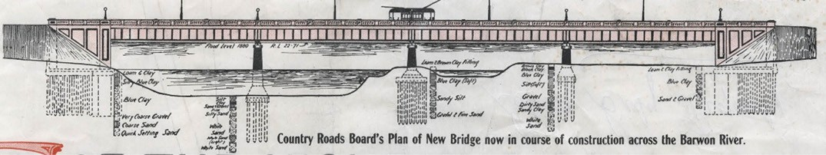
Figure 3.23: Elevation drawing of proposed Barwon Bridge, 1924. Source: Belmont Estate Subdivision Plan, 30 August 1924, GRS 2030/B30, Geelong Heritage Centre collection.

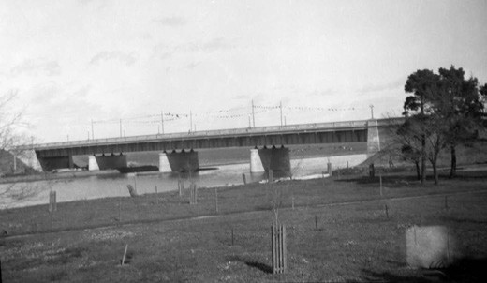
Figure 3.24: Barwon Bridge, photographic collection, Roads Corporation, 1926. Source: VPRS 17684/P3 it 256/00018 Public Record Office Victoria.

The pier crossheads were extended by casting a beam around the top of each existing pier crosshead.
The beam is supported on a bearing located at each end of each pier, and is cantilevered 6 feet beyond the outer bearing. The crosshead extension beams are each prestressed with four BBR CS 150 post-tensioned tendons.
The girders on the existing bridge are 8 feet high riveted plate girders, 104 feet long. The widening incorporates an extra line of girders located 8 feet beyond the existing outer girder on each side of the bridge. The new girders are welded mild steel plate units, each 8 feet high of slender section to
minimise weight.222

PRINCES BRIDGE, NEWTOWN-BELMONT
Like the Barwon Bridge, there was much deliberation and delay in the construction of the Princes Bridge that provided a river crossing between Newtown and Belmont. In 1855, the Newtown and Chilwell Council supported a petition from certain inhabitants for the construction of a pontoon bridge at Rocky Point near Mr Gregory s house at Marnockvale.223 Nothing eventuated and three years later in 1858 a meeting was called at the Duke of Wellington Hotel by the Newtown and Chilwell Council to discuss the building of a bridge. The
outcome of the meeting was reported in The Argus newspaper on 1 July 1858:
A meeting of those inhabitants of Chilwell and Newtown interested in opening a new communication with the Barrabool Hills district by means of a bridge over the Barwon, was held at the Duke of Wellington Hotel. As in most instances of the kind, a difference of opinion existed as to the proper locality for the new bridge, which is intended to be formed of pontoons. It was finally decided that it should be at the south end of Pakington-street.
This will most likely lead to a rumpus between the rival municipalities of South Barwon and that of Chilwell and Newtown.224
In October 1859, a Committee was formed by the South Barwon Council in liaising with the Newtown and Chilwell Council on the suitability of constructing a bridge near Captain Fyans property and linking with the southern end of the West Melbourne Road (Shannon Avenue), this being further west than the intended location at the south end of Pakington Street.225 The conference of Councils
ultimately agreed to the location but further delays ensued when both municipalities could not agree to its funding and maintenance.226 The timber bridge was then built and funded by the Newtown and Chilwell Council.227 Seeking an acceptable contractor was an arduous process.
The original successful tenders, Rourke and Munro, declined acceptance228 and in December 1861, the Council accepted the tender of Jonathan Chappell for £3957.229 Delays towards the completion of the bridge – three refusals to approve extensions of time – beset the Council with unwanted

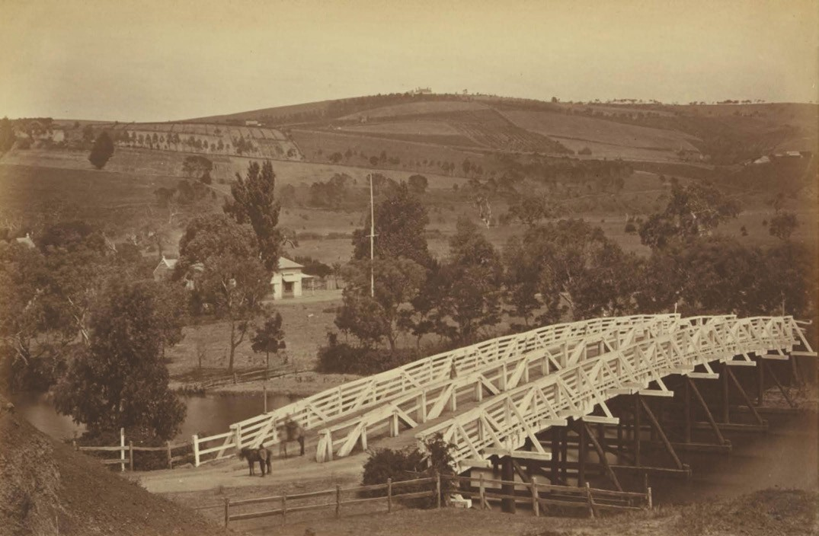
Figure 3.25: F. Kruger, Prince Albert Bridge, Chilwell, c.1866-78. Source: GRS 2009/00645a Geelong Heritage Centre collection.

controversy.230 By November 1862, the bridge (Figure 3.25) was almost complete and the Geelong Advertiser gave a detailed description:
About a mile or less above the present Barwon bridge may now be seen a light airy looking structure thrown across the river this is what is to be known in future as the Prince Albert bridge, and has been erected by the Newtown and Chilwell Municipality at a cost of, including the extras, something like £5,600.
Mr Simon Fraser [sic. – Messrs. Chappell and Co.]
has been the contractor, and the surveyor has passed the work and expressed himself much pleased with the manner in which the contract has been carried out. The bridge, although finished, will not be open for traffic until the municipality has had the bye-law empowering them to levy a toll on it be confirmed. This will be done and the bridge be thrown open; when no doubt it will prove a great benefit to many who find it at present rather a roundabout way of coming into town by the Barwon bridge. The structure is a timber truss bridge, the piles being brought from Bullarook Forest, and the other wood from Tasmania. It is built on eight tiers of piles, varying from fifty to sixty feet in length,
and driven from fourteen to twenty-two feet into the bed of the river. The arch is of 240 feet span, the roadway being 30 feet, and divided in the middle into two ways by a strong band railing fixed to the projections of the trusses, which have been extended for the purpose. This contrivance
will tend to prevent accidents, as it will compel vehicles, on all occasions, to keep their proper side of the bridge.
The arch has a camber of five feet in its whole length—the lower portions -the ends, being seventeen feet above the present level of the river, and a little above the level of the great flood of 1852: the crown of the arch being twenty-two feet above the present level of the water. The trusses or girders are of great strength, varying from twelve inches by fifteen in thickness to eighteen by fifteen, and are securely bolted and tied together by strong iron rods of nine to
ten feet in length, and varying from two and a half to two inches in thickness. All the superstructure has received four coats of paint white lead; while the lower timbers have been well tarred. The wood has been carefully selected not a particle of rot being observable in any portion of it. We congratulate the Newtown and Chilwell Municipality on the manner in which this, their first large job, has been carried out.²³¹

The substantial cost of the bridge forced the Newtown and Chilwell Council to erect a toll gate to raise revenue.232 Although named in honour of Prince Albert, it became colloquially known as Prince s Bridge.233
By 1886, the Prince Albert Bridge was in need of repair and it was closed to traffic.234 Tenders were called in early 1887 for its reconstruction by the Newtown and Chilwell Council.235 It was again in a dangerous state in 1888 and closed to traffic.236 The Borough Surveyor, R.S. Tuffs, prepared drawings for the new bridge and a contract was let to Messrs. J. and W. Tate
at a cost of £2,394.237 Initially, the bridge was to be built of red gum, but approval was given for its construction of jarrah.238
On the opening of the new Prince Albert Bridge (Figure 3.26) in 31 May 1889, the Geelong Advertiser gave a glowing report:
The newly constructed bridge over the Barwon river at the beginning of the West Melbourne road [Shannon Avenue], in the borough of Newtown and Chilwell, and known as the Prince Albert bridge, was formally opened in the presence of about 100 persons yesterday afternoon. The new structure took the place of the old one, which was erected in 1862, but which, through decay, had been condemned
a few years since. A great deal of trouble had been experienced in getting a new bridge, owing to the cost and the fact that other local bodies interested in the crossing over the river had declined to give pecuniary assistance
Mr R.S. Tuffs, said that as designer of the bridge he felt proud of the work. The contractors were first-class men and erected under a competent clerk of works the bridge over the Barwon river would prove, he considered, to be one of the best constructed in the district It is a pile bridge, necessitating the use of piles at least 64ft in
length, and most of those supplied were 65ft long In the composition of the bridge, which is essentially a wooden one, several tons of superior wrought iron have been introduced, and this work is noticeable in the matter of angle braces, which are shaped obliquely at each angle
to the piles and girders, and bolted thereto. These braces have a flange of 4 inches, the material being half inch thick, and after descending each pile about 4ft., continue without interruption along the girder the next pile. This style of truss has been introduced by Mr R.S. Tuffs 239
In 1964-65, a five-span reinforced concrete and steel bridge was erected on a realigned northern approach from Shannon Avenue. The bridge was 480 feet long and 28 feet between kerbs and continued the name, Princes Bridge 240 (Figure 3.27). It was opened by the Mayor of Newtown, Cr Zillah Crawcour, on 15 April 1965.241

QUEENS BRIDGE, NEWTOWN-HIGHTON
Simultaneous to the construction of the first Prince Albert Bridge by the Newtown and Chilwell Council in 1861 was the building of a bridge at the location of B.G. Levien s punt
adjacent to Queen s Park at the west end of Aphrasia Street. Initially proposed as a cattle bridge, community opposition to such a limited purpose caused a reconsideration by the Council, as did offers of funds towards its erection.242 D.W.
Petrie, Esq., of Moorabool street, offered £100 towards the erection of a traffic bridge in lieu of a cattle bridge at Levien s Punt; and the Town Clerk was instructed to write
to Mr. Petrie stating that the Council had already decided on a cattle bridge at Levien s. 243 The tender of Charles Ross for £105/10/0 (or £85/10/0 if the piles were not required to be drive into the river bed) had been accepted.244 By 20 June 1861, the Town Surveyor had revised the plan for the bridge so that it would be made available for traffic. The Council accepted the amendment and were prepared to provide an addition £44/10/0 to make the approaches if the balance were subscribed by the public. 245 By September 1861, the timber bridge (Figure 3.28) had been completed, the Geelong Advertiser reporting that the new bridge constructed at
Levien’s; the bridge is now open for traffic, and the ratepayers appear to avail themselves of the facility in getting their
cattle to the municipal commonage on the other side of the river. 246 Named Queen s Bridge in honour of Queen Victoria, colloquially it was widely known as Levien s Bridge after
B.G. Levien. In 1863, W. Stitt Jenkins had taken exception to the use of the name Levien s Bridge and made his concerns clear in a letter to the editor in the Geelong Advertiser. The Editor replied that Levien s Bridge is by far the better name of the two, and Levien s Bridge we shall continue to call it. 247
In 1871, tenders were called for the re-erection of
Queen s Bridge , to be completed by the end of that year by Messrs. Martin and Dowie.248 It seems that the bridge was not finished until mid-1872.249
Floods in 1880 forced the bridge from its abutments and carried it downstream.250 Thomas Pescott was awarded the contract of repairing the bridge at a cost of £47.251
In 1930, a new Queen’s Bridge (Figure 3.29) was officially opened by the Mayor of Newtown and Chilwell. It was the culmination of years of bickering with the South Barwon Shire Council over funding the bridge. Costing £4000, it was comprised of a steel structure and an improved road grade had been excavated at the west end of Aphrasia Street.252
The single lane bridge remains in use. In 1963, a cantilevered footway and 18-inch water main were added while in 1971 the top cord was raised and the deck modified.253

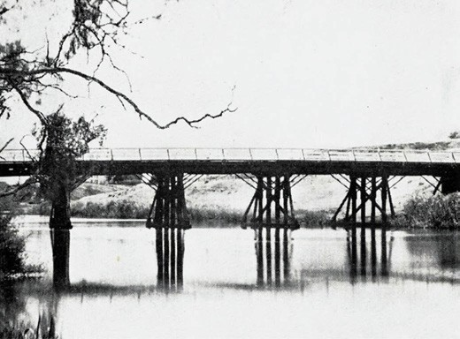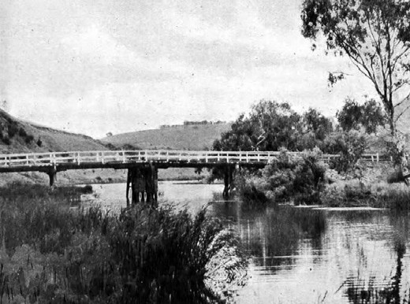

Figure 3.26: Prince Albert Bridge, 1928. Source: Geelong: 55 Photographic Views, Geelong, Victoria, Australia, The Valentine Publishing Co. Pty Ltd, Melbourne, 1928, p.15.

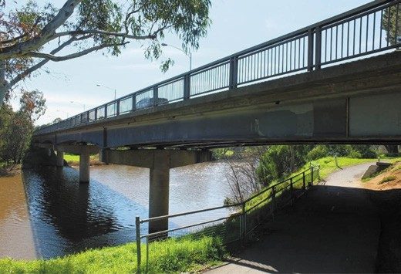
Figure 3.27: Princes Bridge looking north from the south bank of the Barwon River, 2019. Source: David Rowe.
Figure 3.28: Queen s Bridge, Queen s Park, c.1918. Source: Geelong for Business Health Pleasure, G.A. List, Geelong, 1918.

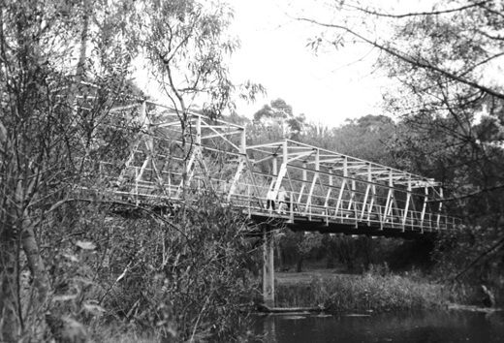
Figure 3.29: Queens Bridge, 1998. Source: David Rowe.

JAMES HARRISON BRIDGE, SOUTH GEELONG & BELMONT
In April 1987, work began on what was called the La Trobe Terrace Project by the Road Construction Authority, involving the building of a reinforced concrete bridge at the southern end of Latrobe Terrace to provide an alternative bypass
of Geelong s central business district. The project also involved the duplication of Settlement Road to form the then Princes Highway.254 Costing $26 million, the 520 m long structure255 was built as twin parallel double lane cantilever bridges featuring concrete box girder spans. Completed in 1990, it was named the James Harrison Bridge in memory of the founding editor of the Geelong Advertiser (see later subsection).

RURAL BRIDGES
Several bridges at river crossings were required to connect the arterial roads from other parts of Victoria. The key road bridges that were constructed in the 19th and 20th centuries were as follows:

BATESFORD
The earliest bridge over the Moorabool River was built by the British pastoralist, William Roadknight in 1836.256 He was assisted by the Wadawurrung in its construction.257 Situated below Bell Post Hill (and not Batesford), the River Red Gum bridge provided easier access to the fledgling settlement of Geelong from the west with Roadknight having first settled on the northern and southern banks of the Barwon River south- west of the Moorabool in 1836.258 While Roadknight claimed in 1841 that this ‘was the first bridge erected at Port Phillip’,259 it was washed away in a subsequent flood by 1838.260
In c.1845, a timber bridge over the Moorabool River was built by public subscription.261 Having stood the test of winter floods, the Geelong Advertiser and Squatters Advocate lamented its poor condition in 1847:
This erection has been repeatedly patched in former years, but is now in such a precarious state, that the first flood will probably carry it away altogether. This bridge is on one of the highways of the colony – the Port Fairy, Portland, and Adelaide mail being conveyed across it.262
By September 1847, the bridge had collapsed due to flood with a bullock dray that was crossing the bridge at the time having been precipitated into the river. 263 Although repairs were carried out at this time, tenders were called for a new timber bridge in January 1848.264 The tender was let to Robert Wayman at a cost of £368.265 Wayman was also responsible for the building of the Barwon Bridge (see earlier subsection) and following his insolvency, the Batesford Bridge was not finished until November 1848 by Messrs, Girvin and Roberts.

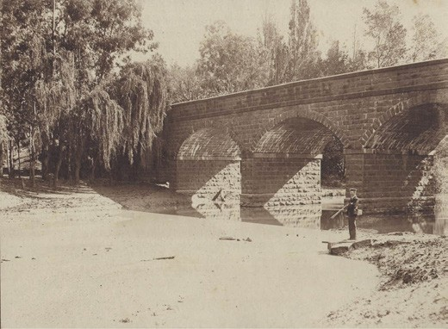
Figure 3.30: Batesford Bridge, 1898-1918. Source: accession H33027/11c State Library of Victoria.

The total cost of the bridge construction was £491.266
In early 1853 following flood damage, tenders were called for the building of another timber bridge.267 Completed by mid- 1854,268 the bridge was designed by Charles Rowand.
It was not until late 1858 when a more permanent stone bridge was proposed at Batesford.269 David Barry was the successful tenderer for the bluestone bridge at a cost of £3886.270 In April 1859, the Geelong Advertiser gave a description of the impending bridge:
It is expected that it will be five months yet before the new stone bridge over the Moorabool at Batesford will be completed. The bridge will have five arches, and here … piles must be driven before the foundation can be laid, as no bottom can be got more solid than mud, without digging to an unreasonable depth. Piles have already been driven for three of the piers and the stonework
has been carried above the winter level of the river
The raised approaches to the new bridge on either side of the river are in course of completion. There are said to
be forty men employed on the work. The contract is in the hands of Mr Barry.271
The bridge (Figure 3.30) was opened in late 1859.272
It provided a sound and reliable river crossing for over 110 years.
In 1970-71, a new bridge was erected adjacent to the stone bridge, the construction included steel H piles.273

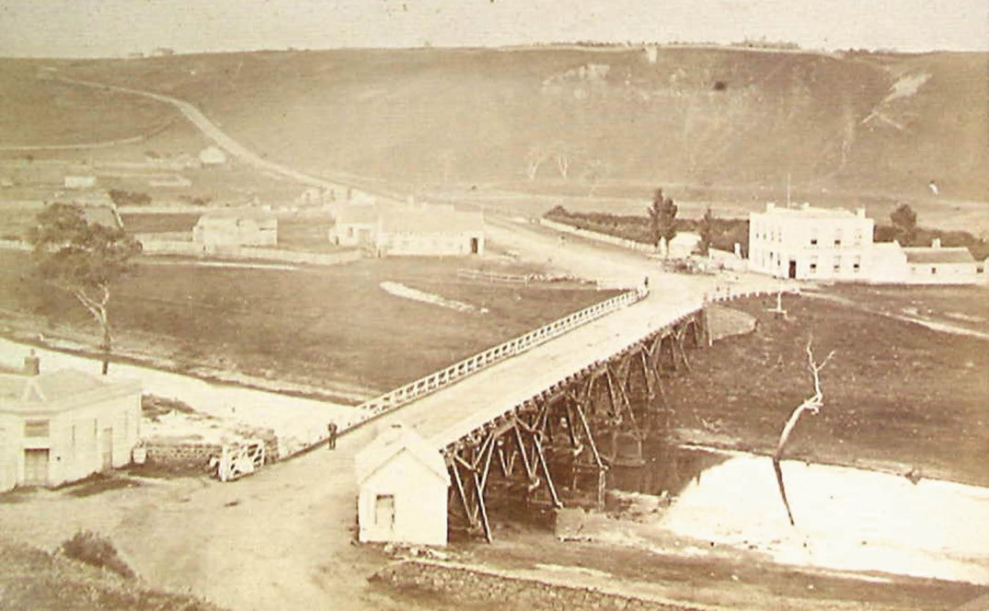
Figure 3.31: J. Norton, Fyansford Bridge, c.1866-1880. Source: accession H1822 State Library of Victoria.

FYANSFORD BRIDGE
While Fyansford had been served by the ford constructed by first Police Magistrate, Captain Foster Fyans, following his arrival in 1837, the influx of gold diggers to Geelong enroute to the Victorian goldfields necessitated the need for a substantial bridge. On 31 January 1854, the Central Road Board sought tenders for the erection of a timber bridge, with stone abutments, over the river Moorabool, near Fyansford. 274 Designed by Charles Rowand and built by Collier and Robertson, the timber bridge (Figure 3.31)
was opened on 1 September 1854 amid considerable fanfare in the presence of the Mayor of Geelong, Captain Foster Fyans and a detachment of troopers.275 Called the Fyans Ford Bridge in honour of Captain Fyans, the Mayor remarked that the fragments still remained of the humble habitation commenced by Fyans in 1836.276
By 1888, repairs to the bridge by the Corio and Bannockburn Shire Councils had amounted to £900.277 The tender of Baxter and Sherbourne had been accepted for £255 for additional repairs.278 By 1897, the Engineers for both the Corio and Bannockburn Shire Councils advised that the bridge was in such a rotten condition that its collapse at any moment may be expected. 279
In 1898, tenders were called for constructing a new bridge in either steel or concrete. After much discussion between the Corio and Bannockburn Shire Councils, and with financial support from the Victorian Government, the tender from Monash and Anderson, engineers, was accepted for £5309.280 The new bridge was to be erected on the Monier concrete system having been designed by J.T.N. Anderson, engineer, in consultation with Carter and Gummow and Company (agents in New South Wales for the Monier System of reinforced concrete) and with Richard Taylor of the Fyansford Cement Works.281 It was one of six bridges designed as Monier arches by Monash and Anderson between 1897 and 1901.282 Anderson’s business partner was John (later Sir John) Monash, distinguished reinforced concrete engineer and later revered army officer and first general manager of the State Electricity Commission.283 By October 1899, the arches for the new bridge had been completed (Figure 3.32) as reported in the Geelong Advertiser:
The most important stage in the building of the Monier concrete bridge at Fyansford was successfully passed at 7 o’clock last evening by the completion of the final section of the arches upon which the roadway is to be carried. The principle underlying the construction of bridges of the Monier type is simplicity itself, the arches

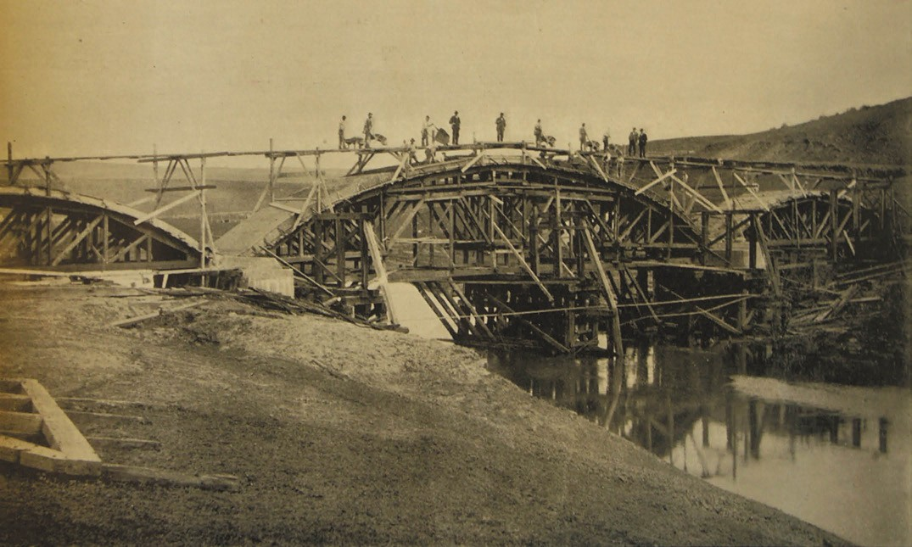
Figure 3.32: Monier bridge at Fyansford under construction, 1899. Source: Cazalys Contractor Report, vol.7, no.10, 5 September 1899, lift-out, State Library of Victoria.

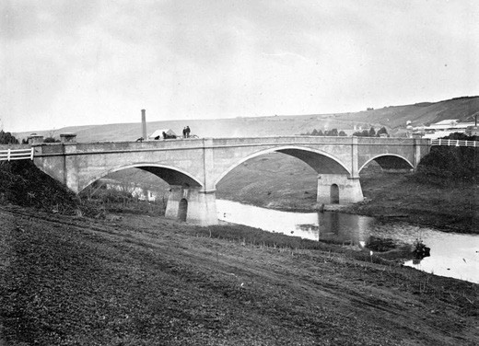
Figure 3.33: Monier bridge at Fyansford, c.1890. Source: Item MM5268 Museums Victoria.

being moulded in cement upon a framework of timber.
It is a heavy undertaking, the formation of the curves in which the material is set being prodigious. The formation of the arches was undertaken in two longitudinal sections, the first, which was completed about nine weeks since, being allowed to consolidate before the commencement of the second, was entered upon. Viewed from the south
side it is a noble looking structure, the central span of 107 feet being remarkably airy looking considering the nature of the construction. The setting of the second strip was commenced on Wednesday morning, and continued without interruption till its completion last evening. Fyansford cement was exclusively employed in the preparation of the Monier, and Mr Anderson, one of the contractors, speaks in the highest terms of its quality . The Monier basis of the arches is 16 inches thick, and it is clearly defined against the concrete of the superstructure like a curved band. Its tensile strength
is 40 per cent greater than that required by the Austrian [sic.] Government tests in connection with bridge
work; and a glance at the structure conveys the idea of indestructability. Messrs Monash and Anderson, the contractors for the work, began operations on March 29th, and the completion of the bridge is due on December 29th. Since they undertook this contract they have secured others for building bridges in various parts of the colony on similar lines, and a rocky formation at Brethen enabled them to put in for the construction of a Monier bridge at that place for a lower price than timber.284
In February 1900, a load test was successfully completed on the new bridge (Figure 3.33) following fourteen drays heavily laden with limestone, and representing a total weight of 40

tons having been situated over the centre arch. After the dead load test, a Corporation steam roller slowly traversed the bridge with minimal deflection.285 Yet, controversy prevailed over the ensuing weeks in relation to the contractors fees.286 Monash and Anderson took legal action against the Shires
of Bannockburn and Corio for recovery of fees and they were successful in receiving an additional £1902/10/- on the claim for extras and breach of contract.287 Nevertheless, the bridge was opened to the public. In 1906, an ominous
crack appeared in the new brick warranting a reported by Mr Catani, engineer of the Public Works Department.288 Repairs were carried out in May of that year289 after the Corio and Bannockburn Shire Engineers claimed that the condition
of the bridge was not so bad as made out by Mr. Catani, the Government engineer and all that was needed was strengthening of the spandrel walls with iron tie rod.290
In 1969, a new reinforced concrete bridge, being 270 feet long and 28 feet wide (between kerbs) was constructed to replace the Monier arch bridge.291 The earlier concrete bridge was retained to the north of the new bridge.

LITTLE RIVER
For some years, and reiterated in 1862 by the inhabitants of Little River, was the need for a bridge or dam over the river.292 Crossing the river over one of the fords was especially precarious at times of flood and in 1863, John Power, while attempting to cross the ford near the Rothwell Hotel, lost his life. The Geelong Advertiser scathingly reported the tragedy which it claimed could have been avoided if a bridge had been built:
Neither the Little River nor the Werribee can now be crossed except at the risk of life – a fact which reflects but little credit either to the Road Boards or the Government.
Repeated applications have been made to each for a bridge or railway approaches without effect, and at
Little River the lives and property of the inhabitants are constantly jeopardized by their being compelled to make use of the rail-track.293
During the following years, debate continued between the Corio and Wyndham Road Boards and the Victorian Government as to who should fund a bridge and where it should be located. Three road bridges were eventually
constructed in the 19th century while new bridges over the Little River in the Little River area were constructed in the 20th century.

ROTHWELL BRIDGE
While the Corio Road Board claimed that the construction of a bridge was outside its jurisdiction, it was prepared to co-operate with the Wyndham Road Board for the building of a bridge at Rothwell once funds became available.294 Corio Road Board Chairman and Member of Parliament,
J. Cummins, called for £1200 to be placed as an additional estimate in the Victorian Government budget for 1863 for the construction of a bridge over the Little River at Rothwell. He complained that this aid had been promised by successive governments, and the bridge was much needed for the prevention of accidents. 295 However, the motion was not carried and the funds not set aside for this purpose.296 Cummins persevered and was able to secure £600 as a special grant from the Commissioner of Roads and Bridges.297 Further hurdles followed, with the Wyndham Road Board declining to contribute to the cost of the bridge.298
In November 1863, the public works committee of the Corio Road Board were given the task of visiting potential sites along the Little River for the construction of the bridge.
As reported in the Geelong Advertiser:
Messrs. Wallace, Preston, King, and Garrett went round and pointed out the most eligible points, in their respective opinions – one at the end of Garrett’s Road; one near the north side of the Railway Station, near the ballast cutting on the Railway Reserve, and opposite to Mr Wallace s land, near the present railway bride on its south side, at a spot indicated by Mr Martin, one of the railway engineers, who was commissioned to select a site about two years ago by the railway department. The other site inspected was offered by Mr Preston, on his land, and opposite a water reserve near Mr Francis property. The committee then proceeded to inspect the Rothwell Ford, and though there appeared some slight difference of opinion as to the best, or at least the most acceptable site for the bridge, there was none whatever as to the necessity of immediate steps being taken to have this crossing on the main line
of road from Geelong to Melbourne put in proper repair immediately. It is understood that the surveyor is to prepare plans and estimates of cost of bridges, &c, at the various places pointed out, and have them ready in about a fortnight to submit to a special meeting of the Corio Road Board. After that a meeting of the inhabitants of Little River is to be held, to decide upon the best site. The approval of the Government must then be obtained before tenders can be called for the erection of the bridge. There appears to be a great deal of red-tapeism imported into what should be a very simple affair. Those persons who are interested in the erection of the bride, should bear in mind that the special appropriating of £600 will lapse if not expended during the current year.299

With the death of the Corio Road Board Engineer, Edward Prowse, his widow had been allowed to name his assistant, Bartlett to act as Board Engineer, but the Corio
Road Board had decided to delay plans until a new Engineer was appointed.300
In December 1863, a special meeting of the Corio Road Board was held at Ashby s Hotel, Rothwell, to discuss the siting
of the anticipated bridge. No definitive resolution was to be made.301 Debate continued into 1864. In May of that year, a meeting of residents of Little River had sought confirmation that the special grant of £600 would still be available for the building of the bridge, the location desired being on the road leading through O Brien s property , as opposed to another site desired by the Government.302
At the June meeting of the Corio Road Board, two memorials were presented that had been forwarded to the Government by local residents seeking the bridge to be built on different sites, and in some instance the same names appear[ed] on each. 303 The preferred location by the Corio Road Board was where the government road crosses the Little River at the north boundary of the Parish of Murtcaim. 304 Local resident and hotelier of Little River, Michael McShane, objected to this location and urged the Council to adhere to their former intention to have the proposed bridge at Little River erected in the immediate vicinity of his property, , claimed that if the bridge be built on the site lately decided on, the effect would be to render his premises entirely valueless. 305
It was not until January 1866 when construction began on a bluestone bridge at the Rothwell Ford to a design by John Barter (1792-1888), Wyndham Shire Engineer.306 John Berkley Barter was born at Kilmichael, Country Cork, Ireland in 1792, the son of Richard and Elizabeth (nee Berkley) Barter.307 He had been articled to his uncle, John Bennett, a solicitor in Melbourne, but ran away and joined the Queen of Spain s Legion, and served in Belgium under Lord Lyndock in 1814, and with the allied armies under the Iron Duke, in France and Belgium in 1815. 308 Present at the Quatre Bras, and attached to the 6th Brigade of the 8th Dragoons, he marched with allied troops in Parish in 1814. Barter was a personal friend of the Duke of Wellington.309 In the 1840s he worked as an assistant engineer for the Public Works Department in Dublin but by the mid-1850s he was resident in Melbourne where he worked as a surveyor of the Richmond Council before transferring to the Wyndham Council in 1863.310 He was twice married – first to Helen Hodder Masters (1824-c.1845) and then to Helen Sarah Graves (1820-1908) and had 11 children.311
The contract for the Rothwell bridge had been awarded to Clement Nash of Geelong at a cost of £1100.312 Controversy ensued during the completion of the structure when Nash disputed the refusal of the Shire Engineers (Goodall and Barter) to certify the amount owed to him.313 Nash sued the

Little River Bridge Committee for £500.314 This led to an embarrassing mix up in relation to the official opening of the two-arched stone bridge which did not go unnoticed by the Geelong Advertiser:
The Rothwell Bridge was to have been formally opened on Thursday last, but owing to some misunderstanding on the part of the Building Committee only one of the representatives of Wyndham-shire was present. It appears that a resolution was arrived at a previous meeting that the committee would not hold another meeting until the surveyors had passed this work.
This Mr Barter refused to do until certain trifling cuttings had been attended to; and as soon as this has been effected the formal opening will take place. There was a re-enactment of la journe des dupes, for it appears that
semi-official invitations were issued to the Councillors of the Shire of Corio to attend a public dinner at King s Hotel, to give eclat to the event, and consequently there was a strong muster, the only absentee being Councillor Officer; but to their utter disgust not the slightest preparations
had been made. As usual in such cases, nobody was to blame; somebody told somebody else to give the necessary orders, and that somebody forgot all about it until it was too late. I trust they will be more fortunate next time.315
After years of wrangling and delays, the Rothwell Bridge was to only last 14 years. In September 1880, a substantial flood brought about such damage as to cause an almost total wreck of the structure. 316 A Bridge Committee was formed comprising the three representatives of the Peak Riding of the Corio Shire, and an equal number of representatives of the South Riding of the Wyndham Shire was appointed. On the recommendation by Mr Nolan, Engineer for the Wyndham Shire Council, it was decided to reconstruct the stone bridge as a four-arched segmental structure (Figure 3.34), doubling the number of arches from the original bridge design.317 A Mr Thwaite was awarded the contract at a cost of £1005/8/8 and the bridge was completed in 1881.318
The Rothwell Bridge formed the main method of crossing the Little River on the Melbourne to Geelong Road for almost 80 years. In 1957, with the duplication of the Princes Highway, reinforced concrete bridges were built over the Little River south of the Rothwell Bridge, in the vicinity of the original Lower Melbourne Road .319

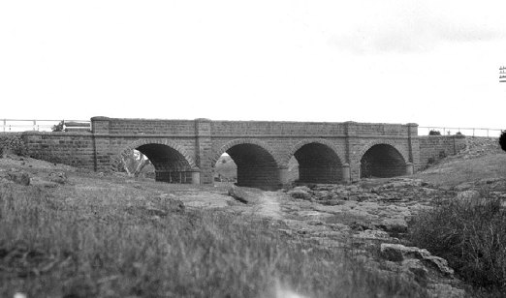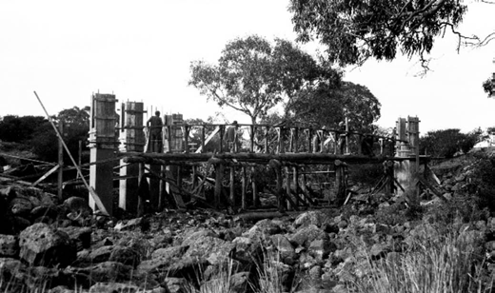

Figure 3.34: Rothwell Bridge, Little River, photographic collection, Roads Corporation, 1929. Source: VPRS 17684/P3 it 28/00073 Public Record Office Victoria.
Figure 3.36: Ripley Bridge under construction, photographic collection, Roads Corporation, 1928.Source: VPRS 17684/P3 it 28/00021. Public Record Office Victoria.

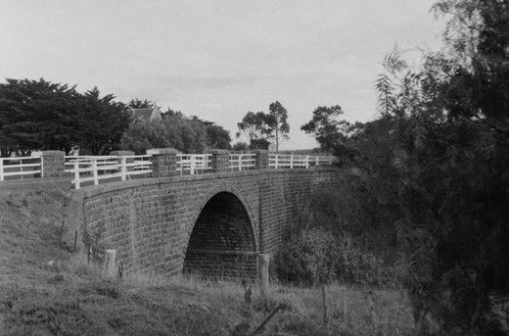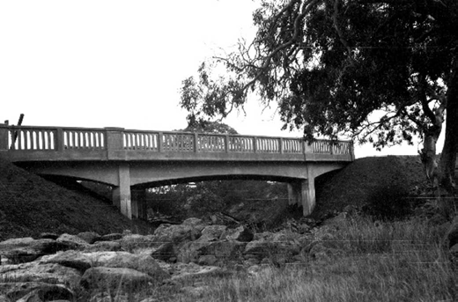
Figure 3.35: Grant s Bridge, Little River, 1998. Source: David Rowe. Figure 3.37: Newly completed Ripley Bridge, photographic collection,
Roads Corporation, 1928. Source: VPRS 17684/P3 it 28/00022 . Public Record Office Victoria.

GRANT’S BRIDGE
During the delays and deliberations in the construction of the Rothwell Bridge, a second bridge was constructed at Garrett s Crossing, Little River, in 1866-67, the preferred location for a bridge by Mr Garrett and other local residents.320 Tenders had been called in July 1866, and Joshua Metcalf won the contract to construct the bridge at a cost of £1444/18/6.321 As reported in the Geelong Advertiser, the bridge had been designed by
D.K. Goodall, Corio Shire Engineer (see Theme 7), was to be built in bluestone ashlar and was to:
… consist of a single arch of forty-five foot span, the crown of the arch being thirty foot three inches above the summer level of the river, the pillars, pilasters, &c., rising to a height of thirty-nine feet. The balustrades to be of timber. The width of the bridge to be twenty- two feet.322
The bridge (Figure 3.35) was funded by the Corio and Wyndham Shire Councils, the special grant of £600 obtained by M.J. Cummins in 1863, and an additional grant of £200 obtain by the Hon. J.F. Sullivan. It was named Grant’s Bridge, presumably after John Grant whose pre-emptive right was to the north of Station Peak.323

OTHER ROAD BRIDGES OVER THE LITTLE RIVER RIPLEY BRIDGE
In late 1872, the Corio Shire Council received a letter from
Messrs. Brown, Arnold and Lewis, ratepayers, requesting the construction of a bridge or crossing over the Little River on the road north of Mr Fawcett s selection. 324 Tenders were duly sought in March 1873 for a bridge325 to provide
a safe crossing over the Little River on the Geelong and Bacchus Marsh Road.326 J.T. Kirk and Son were awarded the contract at cost of £220 to build what was described as a neat structure to be substantially built of timber, and 99 feet long. 327 This bridge was completed in 1874.328
In 1928, the timber bridge was replaced by a three-span
two-pier type concrete structure constructed by the Country Roads Board (Figures 3.36-37). It measured 86 feet overall with a centre span of 50 feet, and a width between kerbs of 20 feet.329

KIRK’S BRIDGE
In January 1879, the jointed Bridge-building Committee of the Corio and Wyndham Shire Council s accepted the
tender of J.T. Kirk to construct a timber bridge over the Little River at what is now known as Kirks Bridge Road at a cost of £561/16/0.330 The bridge was almost completed by July 1879.331 The bridge appears to have been named after its builder, John Thomas Kirk, inaugural Councillor with the
Corio Shire and road contractor who had taken up farmland in the Parish of Murtcaim (see Theme 7).

WAURN PONDS BRIDGE, WAURN PONDS
In September 1851, inhabitants of Geelong petitioned
the Geelong Town Council for the construction of a bridge over the Waurn Chain of Ponds.332 In 1853, F. Murphy, President of the Central Road Board, called tenders for the construction of a timber bridge over the Waurn Ponds on the Colac Road. It had been designed by Charles Rowand.333 By August 1854, the timber bridge and approaches had been erected over Waurn Ponds Creek at the junction of the
Geelong to Colac and Geelong to Loutit Bay Roads at Waurn Ponds.334 It was washed away in a flood in January 1868 and the lessee of the toll gate, J. Callaghan, complained of ‘the severe loss entailed upon him as a consequence.335
By March 1868, the Barrabool Shire Surveyor,
Andrew McWilliams had designed a new stone bridge.336 The tender was awarded to Clement Nash at a cost of £883/8/4.337 Works proceeded in the ensuing months and in May 1868 the Geelong Advertiser gave a glowing report:
The new bridge at the Waurn Ponds is rapidly approaching completion, and promises to be one of the prettiest

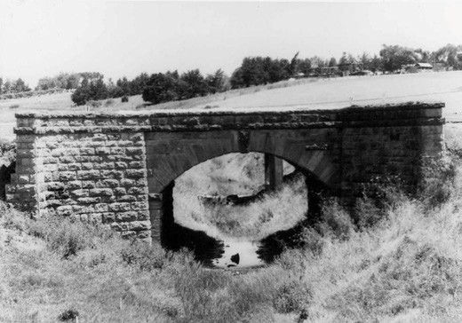
Figure 3.38: J.T. Collins, Waurn Ponds stone bridge, January 1970. Source: accession H98.2586 State Library of Victoria.

country bridges in the district. The walls are ready, and the arch is about to be commenced, the bluestone
foundation, limestone walls, and bluestone springstone having a good effect.338
By July 1868, the bridge (Figure 3.38) had been opened with the Governor of Victoria crossing it enroute to the Western District.339
In 1954-55, given the unsafe sharp turn in the Princes Highway, the Country Roads Board commenced construction on a new concrete bridge adjacent to
the existing stone bridge. As reported in the Board s Annual Report:
A scheme for the improvement of the alignment of the highway at this point involved the construction of a new bridge to replace an old stone arch bridge. A contract has been let for the work, and, despite foundation troubles, good progress has been made.340
The bridge was completed in 1956.

BARWON HEADS BRIDGE
Although the initial proposal for the Great Ocean Road in 1918 was for a commencement at Barwon Heads with the construction of a reinforced concrete bridge, it was not until December 1925 when the staunch proponent of the Great Ocean Road, Howard Hitchcock, announced to the Barwon Heads Park Trust of the impending erection of a bridge.341 The new river crossing was to be accessed by a road through the Barwon Heads Park and Hitchcock declared that as this
would mean considerably more traffic over the Park, therefore it would need to be kept in very sound condition. 342
In September, 1926, the Country Roads Board called tenders for the construction of the bridge at a cost of £11,726/7/8.343 The designer and supervising engineer of the bridge

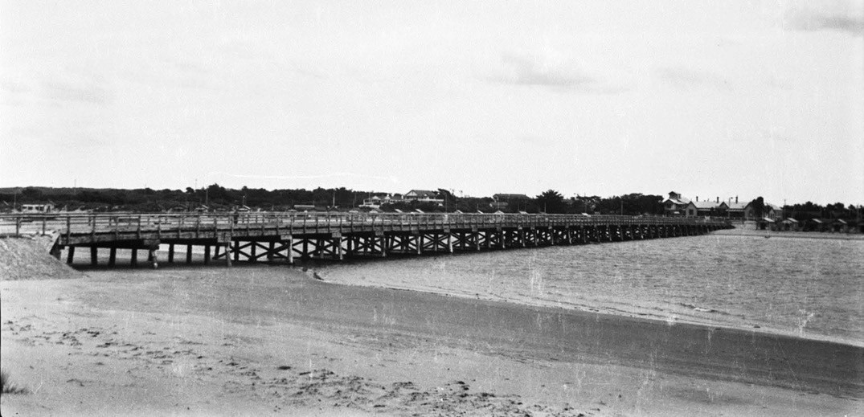
Figure 3.39: Barwon Heads Bridge viewed from Ocean Grove, photographic collection, Roads Corporation, 1927. Source: VPRS 17684/P3 it 25/00022 Public Record Office Victoria.

construction was Mr. D. Darwin, with the plans being drawn by Mr. W. Galt and the calculations by Mr. J. Masterston of the Country Roads Board.344 Between 1926 and 1927, the bridge was constructed by a company headed by S. Patience.345 Tragically, Patience was killed at the Marshalltown Yard during the building of the bridge.346 According to Les Jennings, Ronald Tait was the pile driver for the construction of the bridge, with other workers being Joe Tait, Jim Cotter, and Jim Jennings.347
Completed by December 1927,348 the Country Roads Board gave a detailed description of the bridge (Figure 3.39) that was to become a tourist attraction as much as an efficient mode of river crossing for pedestrians and vehicles:
The longest timber bridge yet erected by the Board was completed during this year, namely, that at the mouth of the Barwon River. The Bellarine peninsula contains several popular holiday townships, and the linking of these with Barwon Heads and so with the tourist area further along the Great Ocean-road constitutes an important part of the project for providing a continuous
scenic highway along the south- western coast of Victoria.
The alignment selected for the crossing is just above the lowest of the small boat jetties and the adjacent park,
in direct extension of the main street of Barwon Heads township, affording easy road approaches at each end, with a good view of the coast, and at the same time at a sufficient distance from the sea to make the structure free from the most severe wave action, whilst given a
considerable anchorage area for boats on the downstream
side. The bridge contains 33 spans of 30 feet and one of 19 feet at the centre of the low-tide channel, were a lift span may be introduced at some future date. The width between kerbs is 16 feet, and there is a footway 5 feet wide on the downstream side, where there are also four refuge bays for use
by fishermen.
To make the bridge as permanent as possible, New South Wales turpentine was used for piles and ironbark for braces and cross-heads of the piers, these timbers being relatively durable in sea water. For the superstructure messmate from Colac District was used. Funds were provided partly by local subscriptions and donations from local authorities and partly by loan funds under Permanent Works.349
In 2006, independent structural engineering reports identified significant deterioration in the timber structure of the bridge. In July 2006, the Victorian Government announced that the iconic bridge was to be saved from demolition but in the following months there was considerable debate about the extent of reconstruction and the construction of another bridge and its potential location.350 In January 2007, an Independent Panel found that the construction of a new bridge adjacent to the existing bridge was preferable to the construction of another bridge further upstream.351 The Panel also concluded that the design and construction of the original bridge needed to be adapted to meet contemporary legislative requirements and vehicular loadings.352 Drawings for the adapted and reconstructed bridge were prepared by

VicRoads and Peter Elliott Architecture.353 Works commenced on the rebuilding of the timber bridge and the construction
of the pedestrian bridge in May 2009, with the $40 million completed and opened to traffic in December 2010.354

ROAD ASSOCIATED EVENTS AND BUSINESSES COACH MANUFACTORIES
The provision of tracks and roads brought about the
need of coaches, carriages and buggies as some of the earliest modes of European transport within the Geelong district. Local coach factories (which not surprisingly also included the blacksmith and wheelwright trades) were substantial employers. From the four coach makers in Geelong by January 1854,355 there were 21 coach making and repair businesses in existence in the Geelong area by 1867.356 A list of the carriage, coach and wagon builders is given in Appendix 3.1. One of the earliest was that of
Thomas Stoneman (c.1822-1887), established in 1852- 53 at the corner of Latrobe Terrace and Spring Street (see Theme 7 for further details). Another was that of Henry Palmer who first established his coach factory in Malop Street in 1848.357 This business was taken over by Frederick G. Woods in 1853358 and then by G. Milnes by 1855. At this time, the manufactory was located in Corio Street near the Bellevue Hotel.359
By 1873, there was a sufficient number of coach-making manufactories to warrant the formation of a Geelong branch of the Victorian United Journeymen Coachmakers’ Society (a precursor to the establishment of a trade union the late 1890s for coach-making employees).360 T. Green was elected the inaugural president, with J. Fare, vice- president,
J. Clarkes, treasurer, and J. Gill, secretary. The aim of the Society was outlined in the Geelong Advertiser:
That the object of the Society shall be to give mutual support to its members, in assisting them to obtain a fair remuneration for their labor, to afford protection in cases of oppression, to assist members out of work to obtain employment, and as far as practicable to encourage and protect the interests of the legitimate coach-builders.361
In 1882, the Society supported and implemented the aims of the Eight Hours League, whereby nine hours pay for eight hours work would commence in early 1883 and steps taken to be taken to secure a half holiday
on Saturdays. 362
The diversity of employees required by the local coach manufactories, and the complexity of the coach building process, was outlined in the Geelong Times. In addition
to blacksmiths and wheelwrights, the manufactories required skilled carpenters, spring-makers and painters:

Coach-making is divided into a great many branches
of skilled workmanship. These are the body-making, the carriage-making, the wheel-making; the spring-making, the axletree-making, the smithing, the trimming and the painting. Nearly all these various branches can now be undertaken in the colony as successfully as in the older continents, but the materials used in the them have nearly all to be imported.
Axletree-making, too, is not sufficiently developed in this country to leave us independent of home workmen; though, possibly; a little judicious protection in that
line might make a difference. The timber used in coachbuilding has to be mostly imported. Ash, elm, and hickory are the imported woods chiefly used.
Our colonial timber does not seem to have found favour with the coachbuilding trade generally as yet. Possibly the quality of our Australian woods has not yet been fairly tested. Full grown and thoroughly seasoned wood is necessary in the construction of coaches. The steel for the springs of coaches used to be all got from Germany. The English article, however, has long since beaten the German, and here in Victoria we are able to make springs as good as any fabricated in London or Edinburgh.
About £1000 worth of ash and hickory is annual imported into Geelong from England and America for the coachbuilding trade.
A great deal of ready-made iron work for coach construction is also imported from England, but all the best iron work used is made in the colony.
The leather used in coach-building comes principally from England and America. It is to be hoped, however, that the magnificent show of colonially prepared leather in the Melbourne Exhibition, will do something towards bringing us the use of Australian fabrics in preference to the imported one. The leathers used are enamelled leather for the heads and knee boots, and spit leather for the dash and wings, also the artificial or imitation leather. All these come chiefly from England.
The axle-trees are, as a rule, all imported, except when some special size is required which cannot be obtained without making it purposely. Very powerful boring machines are required for making the axle-trees, and the fabrication of this important portion of vehicles is a distinct industry in England.363
A number of coach manufacturers endured in the Geelong area until the advent of the motor car. In 1910, there were fourteen carriage, coach and wagon builders and dealers in Geelong, and eighteen in 1915 (see Appendix 3.1).364 Although were still 10 coach builders operating in 1925,

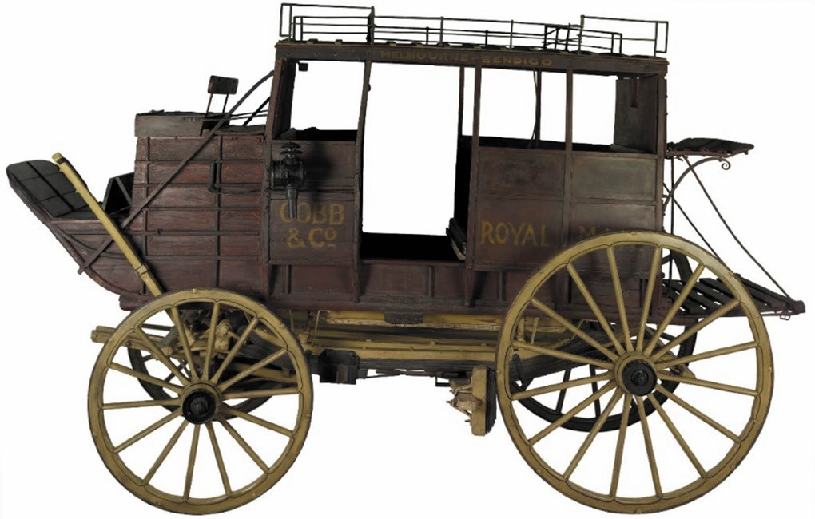
Figure 3.40: Cobb & Co. Coach, presumed to have been manufactured in Geelong in c.1880.Source: M. Churchward, ‘Cobb & Co. Coach, Victoria, circa 1880 in Museums Victoria Collections, https://collections.museumvictoria.com.au/articles/15079 , accessed 3 January 2019.

by 1935 they had all but disappeared.365
Little physical evidence remains of these once prolific businesses. A Cobb and Co. Coach, presumed to have been manufactured in Geelong in 1880 and part of the collection
of Museums Victoria366 (Figure 3.40), is one of the very few known surviving vehicles of the coach manufacturing era.
While limited physical evidence remains, there is historical evidence of the local coach builders. Some of the more well- known are as follows.

W. THORBURN AND SON
Walter Thorburn (c.1805-1985) emigrated from England with his wife, Ellen, sons James, Walter junior and William and daughters Margaret, Mary and Ellen junior on the Mangerton, arriving in Geelong in June 1852. He seems to have first tried his luck at the Victorian goldfields as he was listed as returning with 8 ounces in December of that year.367 Before 1854, he had established a blacksmith s shop in Autumn street, Geelong West, and by mid-1854 the business had progressed to a coach building and repair shop which also employed Walter junior (the business being known as W. Thorburn and Son).368 By 1856, the Thorburn manufactory had relocated to the corner of Gheringhap and Little Ryrie Streets, to the north end of Moorabool Street by 1863369 and then by 1868 to Little Malop Street West.370 By this time, their advertisements boasted that they were carriage builders by special appointment’ to ‘His Excellency the Hon. Sir J.H.T. Manners-Sutton, K.C.B., Governor of Victoria. 371 With Walter
Thorburn s health failing and his retirement in 1880, his coach factory was closed and several wagonettes, ‘unfinished vehicles and 2 sewing machines were advertised for sale.372

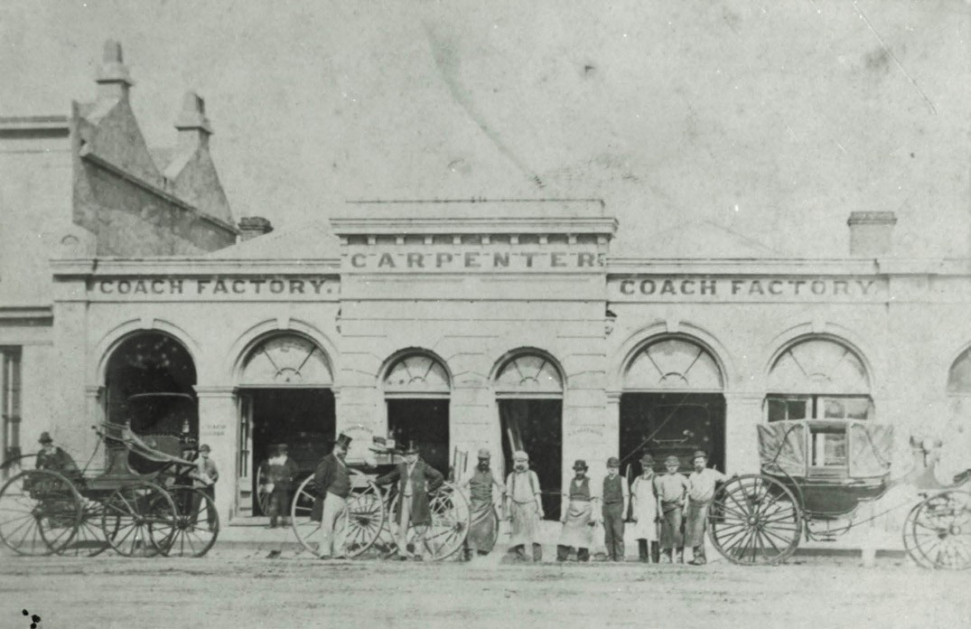
Figure 3.41: William Carpenter s Coach Factory, Little Malop Street, c.1870. Source: GRS 2009/00700 Geelong Heritage Centre collection.

WILLIAM CARPENTER
William Carpenter arrived to Victoria from London in 1852 and first tried his luck on the goldfields.373 By 1856, Carpenter had relocated to Pakington Street, Geelong West, and it was at this time he first worked locally as a coach builder.374 In
October 1862, he opened a salubrious, Palladian styled single storey coach factory in Little Malop Street opposite Market Square375 (Figure 3.41).
Between 1863 and 1870, Carpenter represented the Bellarine Ward on the Geelong Town Council. Having operated a successful coach building operation, business waned in the late 1870s and in early 1883 he commenced the disposal
of his property. Carpenter travelled to Sydney to spend his retirement years with his son but tragically he fell from the gangway, suffering a severe head injury and he died a few days later.376

THOMAS WOODWARD
Thomas Woodward (1823-1889) was born in Horsley, Derby, England, the son of Stephen Faulks and Marianne Woodward.377 After his marriage to Agnes Brown at Southampton in 1854,378 they emigrated to Geelong from Hampshire, England, in 1855 on the Samarang379 where he was listed as a carpenter. Thomas and Agnes first settled in Chilwell, Newtown, where their daughter, Caroline, was born.380 By June 1859, Woodward had established a coach
building business in Moorabool Street, opposite the Geelong Grammar School. He advertised the sale of a ‘first class family car. 381 In 1862, Woodward became insolvent.382 By 1864, he had re-established his coach building business and relocated to Little Malop Street, opposite McPherson s Livery Stables.383 He again relocated the business to Moorabool Street (between the Victoria Hotel on the north-east corner
of Moorabool and Malop Streets, and the Chamber of Commerce)384 (Figure 3.42). There, he had a large and useful assortment of buggies and other kinds of useful traps, including the Excelsior jump-seat (capable of seating four people), a turn-over of the most approved pattern , a double Concord described as a splendid piece of coachbuilding and

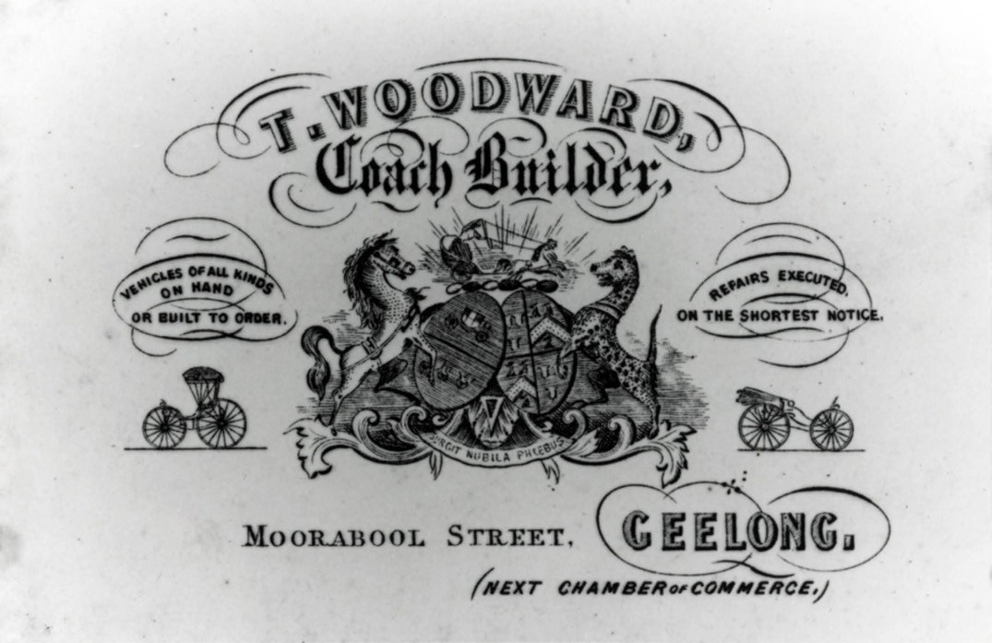
Figure 3.42: T. Woodward Coach Builder, Moorabool Street, signage, n.d. Source: GRS 2009/1999/014 Geelong Heritage Centre collection.

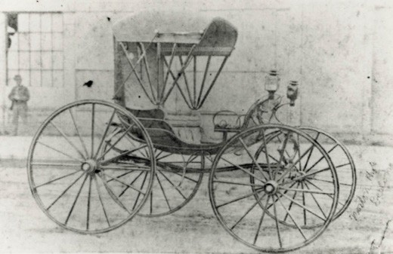
Figure 3.43: J. Norton, Pantheon coach built by T. Woodward, n.d. Source: GRS 2009/1999/015 Geelong Heritage Centre collection.

a spring wagon of a pattern in which neatness and strength are nicely combined (Figure 3.43). Each of these vehicles took first prizes in the Geelong Agricultural Show in 1875.385 In 1882, part of Woodward s coach factory was partially destroyed by fire.386 With Woodward s death in March 1889, his coach factory was sold.387

HARGREAVES AND NOTT
The coach building partnership of Solomon Simon Hargreaves (1846-1925) and John Nott (1848-1920) commenced in 31 July 1877 when they advertised that they had worked for 16 years for both Messrs. Woodward and Carpenter and that on sale at their Ryrie Street premises (Figure 3.44) was ‘one highly-finished turnover-seated buggy. 388 This began a successful coach building business, with Hargreaves taking on the construction of the coaches and Nott responsible for the coach painting. Within 10 years, they attracted influential and wealthy clientele as noted in the Geelong Advertiser in 1883:
At the present time there is quite a rage among sporting men in the metropolis to possess smart two-wheeled conveyances, in which to drive to race meetings and other descriptions of sports gatherings. Many of them have, of late, appeared in the streets of Melbourne in smart-looking vehicles, and their displays have attracted attention. To the credit to the local coachmakers, it may be stated
that Geelong workmanship has not been overlooked, for Messrs Hargreaves and Nott, of Ryrie-street, have just

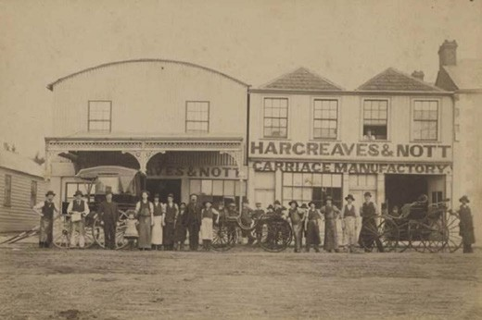
Figure 3.44: Hargreaves & Nott Carriage Manufactory, Ryrie Street, c.1880. Source: GRS 2055/15 Geelong Heritage Centre collection.

completed the manufacture of a four passenger dog-cart, and a Stanhope gig, for Mr W. Branch of Melbourne, and Mr Jas. Wilson, of St. Albans, respectively. The object
of the sportsmen named is to drive tandem teams, and the traps made to their order are in every way well calculated to show that the tradesmen of this town can
furnish a superior article. The dog-cart is an elegant piece of workmanship, and is built on the square principle, which makes it a showy two-wheeler. Both vehicles are of hickory and ash, and all the ironwork of the undercarriage of the gig is supplied with steel bearings. The dog-cart
is fitted with adjustable box spring cushions on a new design, so that they may be easily arranged in balancing the weight on the wheels. The trimmings are of maroon- colored Russian leather, and are very handsome. The vehicles are painted a purple lake color, picked out black with fine lines of red, so that they have a neat appearance. The upper portions of the framework are close-plated. On the side of Mr Branch s trap his crest has been artistically painted by Mr Nott. It shows the head and neck of a fowl resting on a gold crown, and holding in the bill an olive branch whilst underneath there is a blue ribbon scroll bearing the words Bonne Fortune. 389
In 1890, the business of Hargreaves and Nott was dissolved and their stock in trade, machinery and plant sold.390 Solomon Hargreaves subsequently went into partnership with James Armstrong as Hargreaves and Armstrong, Coach Builders, until 1912,391 while Nott continued under his own
account.392 By 1912, the iron building of the recently dissolved firm of Hargreaves and Armstrong in Ryrie Street was demolished to make way for a theatre.393
Solomon Simon Hargreaves (1846-1925) was born in Tasman, Tasmania, the son of Simon Solomon Hargreaves (1811- 1884) (a convict of Halifax, Yorkshire, England, transported to

Tasmania in 1830 and granted a ticket of leave in 1841) and Mary Ann Gordon (1821-1891).394 By 1852, the Hargreaves family had relocated to Geelong where Simon Hargreaves had established a wheelwright and blacksmith business with James Hellings in Malop Street, Market Square.395 Solomon Hargreaves may have worked with his father, Simon, before being employed by Woodward in 1861.396 By 1914, Solomon Hargreaves had retired to Kerangville , Noble Street, Newtown.397 He died in Sydney, New South Wales, in 1925.398
John Nott was born in Bristol, Gloucestershire, England, in 1848, the son of Robert Nott (contractor) and Willmot
Greenoff. They emigrated to Geelong in 1855.399 John Nott followed his father into the painting business.400 It seems that Nott was employed by William Carpenter prior to Nott s coach building partnership with Solomon Hargreaves.401 In 1871, Nott married Martha Ann Windsor and they had five children.402 In 1901, John and Ann Nott returned to England to visit Ann s relatives.403 John and Ann Nott subsequently emigrated to Troyeville, Johannesburg, South Africa, and John Nott died at the residence of his son in law, F. Moult at Waldeck s Plant, Barkley West, Kimberley South Africa, in August 1920.404

WILKS FAMILY
One of the more rural coach manufactories was that of the Wilks family at Fyansford (Figure 3.45). It was first established by James Wilks by 1855 as it was at this time
when he advertised the need for a wheelwright, blacksmith and hammerman.405 It was also in 1855 when James Wilks’ brother, Joseph (1824-1876) arrived from Essex with his wife, Ann (1825-1870) and their four children (a fifth child was born at Fyansford soon after their arrival, the Wilks having a total of 10 children by 1866).406 Joseph Wilks was a wheelwright and he took over the business of James at Fyansford, with James relocating to Ballarat where he established a Hay
and Corn Store (including coach building) and was later a hotelier.407 At Fyansford in 1856, Joseph Wilks was credited with making and perfecting a bullock dray wheel in ten hours and five minutes.408 Working with him was his other brother, William Wilks. The motto of the business was Thorough and the Wilks brothers became well known for the quality of their wagon and coach building.409 After the death of William in 1860, Joseph fell on hard times in 1861, being declared insolvent.410 His son, James Wilks, became a coach builder, being employed by the Western Stage Company and later with Hargreaves and Nott, and then Thomas Woodward before entering employment with the
Geelong Tramways.411

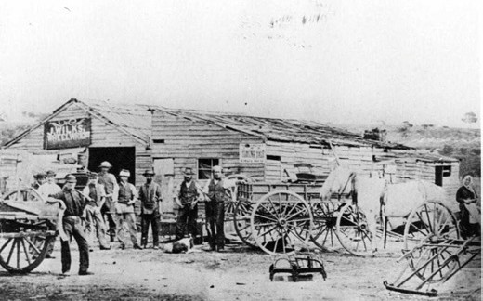

Figure 3.45: J. Wilks Wheelwright & Carriage Manufactory, n.d. Source: Late J.C. Wilks, Ancestry online at https://www.ancestry.com. au/ .

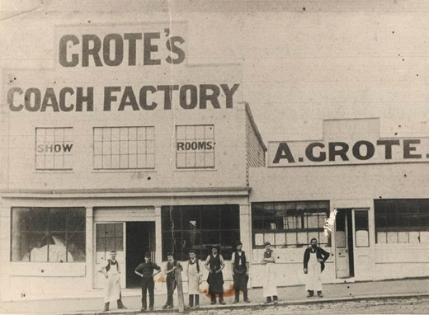
Figure 3.46: Grote s Coach Factory, 71-73 Gheringhap Street, n.d. Source: Christine Hughes, Little River.

AUGUSTE GROTE
Auguste Grote (c.1826-1929) was born in Brunserauk, Germersheim, Rhineland-Palatinate, Germany, the son of Charles and Catherine Grote.412 Prior to his emigration to Victoria, he married Louise Edelmann. They first settled in Melbourne upon his arrival in 1866.413 In 1870, Grote purchased William Gaulton s coach building premises in Ryrie Street opposite the Post Office.414 Four years later in 1874, he relocated to the south-east corner of Gheringhap and Little Ryrie Streets, where he established a coach factory, show room, workshop and forge at the south- east corner of Gheringhap and Little Ryrie Streets (71-73 Gheringhap Street)415 (Figure 3.46). The following year, he was noted as having a selected collection of vehicles of
different descriptions. 416 Grote maintained his coach building business at this location until 1915, when it appears he was

forced to close due to his German descent, with Britain at war with Germany in World War One, although he had become a naturalised British subject in Geelong in 1894.417

GREEN AND EVERETT
In 1882, Thomas Green (1832-p1892) joined Joseph Everett (1850-1917) in a coach factory business in Mercer Street, Geelong.418 In September of that year, they advertised the following in the Geelong Advertiser:
Green and Everett, Coachbuilders, Mercer-street, are now prepared to receive orders for Carriages and Buggies, and every other description of vehicle. New and second- hand buggies and express wagons for sale. All kinds of repairs, painting, trimming, etc., done at shortest notice, and lowest rates.419
The partnership was not to endure as Green and Everett advertised its dissolution in the Victoria Government Gazette in 1885.420 Both coach builders continued under their own accounts with Everett retaining the factory in Mercer Street (Figure 3.47).
Thomas Green was born in Seymour, England, in 1832 and emigrated to Victoria in c.1850.421 In 1860, he married
Margaret Fleming.422 For several years, Green was employed by Thomas Woodward, rising to the position as foreman in the drafting of designs and in the construction of carriages.423 Following the dissolution of his partnership with Everett in 1885, Green continued working from Swanston Street where he died in 1892 at the premature age of 45 years.424
Joseph Everett (Figure 3.48) was born at Hinxton, Cambridgeshire, England, in 1850, the son of Thomas Everett and Eleanor (Ellen) Brack Robinson.425 In 1855, the Everett family emigrated to Victoria on the British Empire. Thomas Everett s occupation at this time was an agricultural labourer.426 In 1856, the Everett family were resident in Wellington Street, Geelong West, where Thomas Everett was a carter.427 He later became a brickmaker when the family lived in Britannia Street, Geelong West.428 Joseph Everett spent two short periods at Shelford and Carlton before returning to Geelong.429 By 1877, Joseph Everett had entered into a coach building partnership with Robert Kitchen (under the name of Kitchen and Everett) in Mercer Street.430 It was at this time when Everett married Miss Emma Mary Elliott.431 The partnership of Kitchen and Everett was dissolved
in 1879432 and Everett continued the business under his own name until he was joined by Thomas Green in 1882.
By the early 1880s, Joseph and Ellen Everett lived at 21 Weller Street. Everett also owned neighbouring allotments.433 Houses were built for Joseph Everett’s children, possibly to designs by a son of Joseph and Ellen, Percy, in the early 20th century. They included the Late Victorian timber dwelling

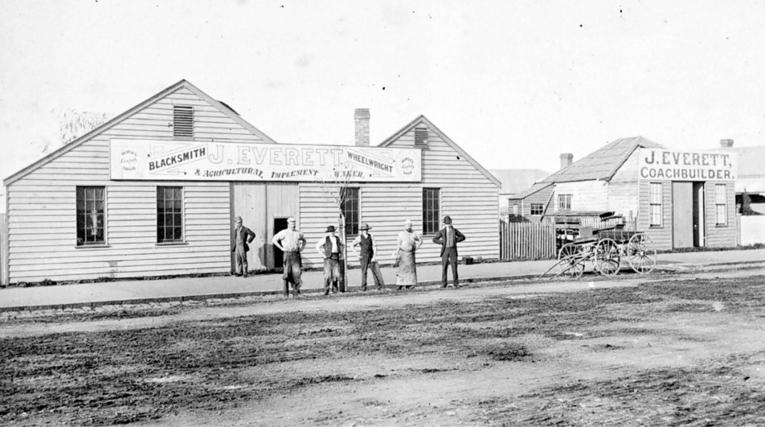

Figure 3.47: J. Everett, coachbuilder, blacksmith, wheelwright, agricultural implement maker, Mercer Street, c.1885. Source: Item MM7255 Museums Victoria online.

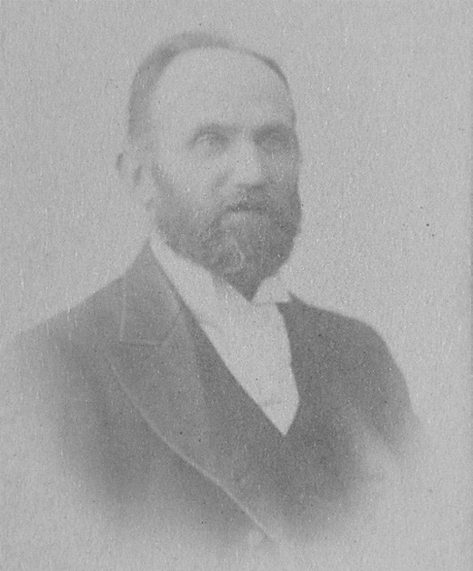
Figure 3.48: G.L. Massingham, Joseph Everett, 1896. Source: accession H11608 State Library of Victoria.
at 17 Weller Street for Emma Margaret Everett (built 1902- 03) and ‘Nyora’ at 19 Weller Street for George J. Everett, blacksmith, in 1910-11.434 By 1903, Joseph Everett’s son, Joseph Arthur Everett, had joined his father as a coach painter,435 the firm being known as J. Everett and Son. By 1910, another son, Ernest Harry Everett, coach builder, had also entered the firm, the name of the business then known as J. Everett and Sons.436 They were also joined by another son, Geoffrey J. Everett, blacksmith. By this time, in addition to coach building given advances in technology and the rise of the motor car and motorcycle (see following
subsection), Everett and Sons offered motor car body making services.437 In 1912, Everett and Sons manufactured the first ‘torpedo’ designed motor body fitted with a La Buire chassis. According to the Geelong Advertiser, several motorists have expressed their opinion that it is better than imported bodies as Australian woods suited to the climate have been used. 438 The car was on sale at J.C. Brown and Co.’s motor garage in Geelong439 and by 1915 Everett and Sons had made several timber car bodies.440
In 1913, Joseph Everett publicly farewelled his son, Percy Edgar Everett (1888-1967) who at that time was part of the Building Construction and Architecture Instructional Staff at the Gordon Technical College and was departing on a 12
month tour to England and Europe to gain experience in his architectural profession. 441 Percy Everett was to become

Chief Architect of the Public Works Department of Victoria in future years and design several public and government buildings throughout the state (see Themes 6, 7 and 8).
In addition to his working life as a coach builder, Joseph Everett was heavily involved in the Primitive Methodist Church, Pakington Street, where he was a regular attendant for 63 years.442 As part of the Church, he was a member of the Gospel band, district evangelist, teacher, and singing conductor at anniversaries.443 Joseph Everett died on 23 December 1917.444

FRANCIS BENT
One of the later carriage factories to operate in Geelong West was that of Francis Bent (1866-1936). He was the son of Francis Bent (who arrived from England with his parents and siblings at Point Henry on the Sir George Seymour in 1849, aged 2 years) and Katie Stroud Whitten.445 By 1905, Francis Bent junior had established the Geelong West Coach Factory in Pakington Street.446 The workshop, blacksmith s shop
and a two roomed weatherboard building was owned by the Estate of the late William Barnes.447 On Francis Bent s death in 1936, the business was continued by Leslie Bent.448 By the Second World War, the business had closed.449

CYCLES AND CYCLE BUSINESSES450

THE INITIAL YEARS OF THE BICYCLE
As early as 1817, the forerunner to the modern bicycle was launched by Baron Karl von Drais, a German, with
the unveiling of his Laufmaschine, a kick bicycle.451 However, it was in the 1860s in France and America, when the self- propelled bicycle and tricycle by means of feet driving pedals rather than running along the ground’ were first manufactured with great interest. In the early 1860s, Pierre Michaux in
his blacksmith s in Paris commenced building bicycles with pedals while a former employee, Pierre Lallement developed an improved version) in Connecticut in 1865.452 A year later in 1866, Lallement patented his bicycle invention.453
It was not until April 1869 when the Geelong Advertiser gave an insight into the velocipede – the latest mode of road transport:
Anybody who has visited Paris within the last few months cannot have failed to notice the large number of velocipedes going to and fro, especially in the evening; indeed, the number that may now been seen any evening in the Champs Elysees is so large that a recent police edict compels the riders to affix a lamp to them
in consequence of the accidents that have happened from their use. According to some investigations that have been made, it has been ascertained that on a good road, where the gradients are not much greater than on

railroads, the rider may travel from 80 to 100 kilometres in a day, which is about the same speed as the mail coaches used to attain in France; and that this may be done several days in succession, without over-fatigue, by a moderately strong man. Very much, however, depends on the perfection with which the machine is constructed. If it is unskilfully made, the fatigue of working it is so greatly increased that it ceases to be a pleasure and becomes
an exceedingly laborious exercise. It is not exactly the ease, as has been stated, that the rate of speed is an exact proportion of the force employed. On a hard, level road the traction is so small, owing to the narrowness of the wheels, that it runs along with great rapidity by the momentum given to it, and with the expenditure of very little force on the part of the rider. Of course where the roads are soft, or there is a steep hill to ascend, the labor of propelling it is increased in proportion to the depth and nature of the soil and the steepness of the ascent. The cost of the best of the velocipedes in France is about £12, but they will probably be manufactured at a much lower price in England if they come into extensive use, as it is not unlikely, considering that they afford opportunities for vigorous exercise, in addition to the facility with which long journeys may be accomplished by them 454
By the end of April 1869, velocipedes were being built by coach builders in Ballarat and the Geelong Advertiser quipped that the road near Geelong area, we imagine, [would be] suitable for such locomotion. 455 In May 1869 even the Geelong Literary and Discussion Class held a conversazione on Velocipedes .456 A month later in June 1869, this new mode of transport made its debut in central Geelong, the event not being missed by the Geelong Advertiser:
The appearance of three velocipedes, two tricycles, and one bicycle in Moorabool-street and other principal streets on Saturday evening was the cause of considerable commotion. The drivers were unable to show the speed they could attain owing to the crowd of boys and men by whom they were followed during their travels. There were one or two narrow escapes from accident owing to the unseasonable hour the drivers selected to display their skill, and although, of course they could hardly be held responsible for the boy nuisance again presenting itself as usual on the appearance of anything novel, yet there were decidedly wrong in selecting a dark night, and one when the street is usually filled with people for the display.
The crowd had the effect of almost suspending traffic for a time, and even the velocipedists themselves nearly met with accidents. We should recommend them in future to confine themselves to the day-time, or to select some of the back streets where they were not much traffic.457
The novelty of the bicycle, velocipede and tricycle was not to

be confined to the male population. Changes were made to women’s skirts in New York in June 1869 to allow them to take part in the latest craze:
The problem for a lady s attire for the velocipede appears to be in fair way of solution. A party of young ladies have taken up the matter in New York, preparatory to making their debut in the approaching summer, and the Velocipedist thus describes their dress:- Let the outer dress skirt be made so as to button its entire length in front. The back part should be made to button from the bottom to a point about three-eighths of a yard up the skirt. This arrangement does not detract at all from the appearance of an ordinary walking costume. When the wearer wishes to prepare for a drive she simply loosens
two or three of the lower-buttons at the front and back, and bringing together the two ends on each side separately, buttons them in this way around each ankle. This gives a full skirt around each ankle, and, when mounted the dress falls gracefully at each side of the front wheel.458
By 1878, the velocipede had been surpassed by the bicycle as the most popular cycling machine. This was highlighted at this time in the Illustrated Australian News:
The clumsy lumbering contrivance which a few years ago was the only form of velocipede in actual use, and which was then regarded as a wonderfully clever contrivance, has completely dropped out of existence, and were one to traverse the main thoroughfares of the present day upon such a machine he would probably be treated in much
the same way as Tom Hampden was on introducing his umbrella, and be greeted in no very complimentary terms by the precocious small boys that throng our streets. The introduction of the bicycle speedily swept away its three and four wheeled predecessors, and opened up a new era of this description of locomotion. The two wheels were originally made the same size, but now the driving wheel is in most cases the only one worthy the name, the hind one being a mere roller intended to assist the rider
in maintaining his equilibrium. In England and on the continent the bicycle is quite a recognised institution, and is largely patronised by all classes. Its introduction into Australia has been very slow work, which is doubtless explained by the fact that here the vehicles are the property of the rider, while in other countries thousands are hired out by persons who make it their business at so much per month; a would-be bicyclist has therefore an easy opportunity of ascertaining whether the amusement

is in accord with his inclination without having to incur the cost of purchasing a bicycle for himself. Slowly but effectively, however, the innovation has gained ground
459

As the popularity of cycling grew so did improvements in cycle design and technology. In 1885, the Englishman, John Kemp Starley, created the Rover safety bicycle which featured a rear chain drive and steerable front wheel.460 A version of the safety bicycle was exhibited at the Geelong and Western District Agricultural and Horticultural Show in November 1886.461 In Geelong in 1891, the safety bicycle was augmented by the arrival of the new pneumatic tyre.462 The ride considered to be more easier and enjoyable. 463 Of the pneumatic tyre, the Geelong Advertiser gave the following:
Riders of bicycles will be pleased to learn of another improvement in the locomotive powers of the safety machines. Mr H. Hawthorne, of the cycle depot, in Gheringhap-street, has just received one of the new pneumatic-tyred safety bicycles which contains a number of improvements, and which has beaten all the world s records for time. The bicycle has a pneumatic tyre, which is composed of a rubber tube about 1 inches in diameter, filled with compressed air, which is bound to the rim by
a linen easing, and protected by rubber thickened at the wearing part. The air is pumped in through a nozzle with a special blower, and a patent non-return air-valve prevents its escape. The advantages of this tyre upon a roadster cannot be thoroughly understood except by a personal trial. Should the tyre get pierced or the valve damaged in any way, either can be repaired at a very small cost and within a few hours time.464
This newer and improved version of the bicycle included models for women, where a version known as a step-front frame was created with the top tube (or cross bar) absent.
Other improvements and modifications were made to the bicycle in the following years.465 One of the more novel and localised variations was a yacht-bicycle or land yacht developed by Roy Holden at Barwon Heads January 1911. Photographed at this time (Figure 3.49), Holden gave the following description:
My land yacht at Barwon Head 1911-12. Return trips to Point Lonsdale were sometimes made from Ocean Grove along the hard sand at low tide. Tacking against the wind was quite easy and speeds of twenty miles per hour were obtained in good conditions. Leaning out to windward

with a side breeze easily counteracted any tendency for the ship to capsize, in fact I don t remember ever coming a cropper in that way. The sail and spars had been made at Hong Kong Naval Dockyard silk of some kind and bamboo for the mast and boom.466

THE ADVENT OF THE MOTORCYCLE
The popularity of the bicycle in the 1890s brought about a new invention: the motorised bicycle. In 1896, the Geelong Advertiser announced that there were two motorcycles in course of construction in Melbourne and that they were almost ready for a trial trip. In addition, the newspaper article made mention of news in the English Cyclist, whereby the Riley Cycle Company were experimenting with something quite new :
The new machine is a safety bicycle with an auxiliary motor, which is so small and neat that it only occupies about as much room as a gearcase, and can, indeed,
be fitted inside one. It is said that in an experimental run 16 miles were accomplished within the hour.467
The following year in 1897, C.E. Charity exhibited the novel motor cycle at a local bicycle show in the Exhibition Buildings in Moorabool Street.468 This was followed by the exhibition
of a motorcycle by the Austral Cycle Agency Pty Ltd at the Agricultural and Horticultural Show by the Austral Cycle Agency Pty Ltd.469 By 1903, the motorcycle, along with the motor car and traction engine, had become so popular that representatives of the district Councils in the Geelong area called a meeting to investigate measures for controlling motor traffic.470

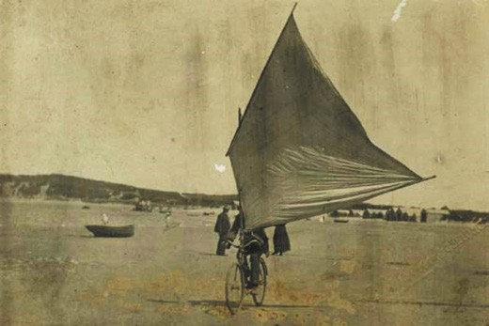
Figure 3.49: Roy Holden driving his land yacht, Barwon Heads, 1911. Source: GRS 2009/2007 Geelong Heritage Centre collection.

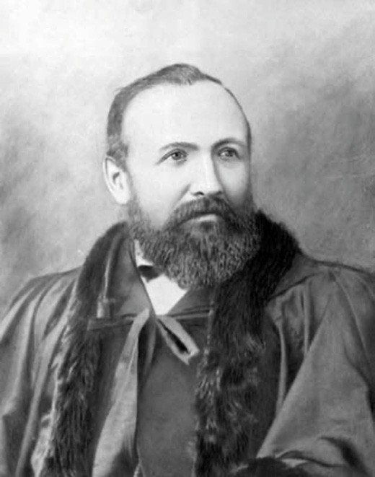
Figure 3.50: Cr William Humble, c.1888. Source: GRS 1947/23 Geelong Heritage Centre collection.

CYCLE BUSINESSES INITIAL YEARS
The earliest cycle enterprises in Geelong emanated from
the inventive coach builder, William Gaulton and iron manufacturer, William Humble, in 1869.471 It was at this time when the Geelong Advertiser gave an insight into Humble s and Gaulton s velocipede achievements:
We may shortly expect to see plenty of velocipedes travelling about this district, two of these much lauded vehicles having been made by Mr Humble and Mr Gaulton. Mr Humble s is a three-wheeler, and met with an accident whilst crossing the channel on Monday. Mr Gaulton s is a two-wheeler, very light and easy to drive. A considerable amount of practice in balancing will, however, be required before a driver will be at all sure of keeping his seat in the saddle, the front having a nasty knack of swerving and causing the machine to buck up. 472
William Humble (1835-1917) (Figure 3.50) was from Richmond, Yorkshire, having been apprenticed as an agricultural implement maker before working for Hornsby and Sons, Grantham, and Bates and Vaughan, Middlesborough.473

Humble arrived in Victoria in 1858 and worked at Fulton s foundry, Melbourne.474 He soon relocated to the Corio foundry in Geelong and assisted in casting postal pillar boxes for Melbourne streets.475 In 1861, he commenced business with John Simmons and Ward Nicholson at the Western foundry, Geelong, under the name of Messrs. Humble and Simmons, until Simmons death in 1864 when Humble
and Nicholson continued in partnership, initially under the name of Humble and Co. and from 1877 as Humble and Nicholson.476 The partnership lasted until 1900.477 In 1866, they had purchased the Vulcan Foundry in Little Malop Street,
Geelong,478 and it was from here where Humble invented
a velocipede and later motor vehicles (see later subsection) as well as manufacturing iron works and refrigerators
(see Theme 4 for further details).479 Humble contributed much to community life, including serving as a Geelong Town Councillor from 1869 until 1889 (with a term as Mayor in 1888-89), first treasurer of the Gordon Technological College; trustee of the Geelong Free Library, board member of the Geelong Hospital, director of the Geelong Coffee Palace and ardent member of the Methodist Church.480
William Gaulton (1831-1909) was born in the Isle of Wight, England, son of George Gaulton, coach painter who, with Mrs Gaulton and one sibling, emigrated on the Winwick from London to Hobart, Tasmania, in 1841, as part of Tasmanian Colonial Government s bounty (assisted immigrant) scheme.481 The Gaulton family was one of four immigrants
from the English coach building trade on board the Winwick.482 In Hobart, William Gaulton served an apprenticeship with Alexander Fraser, coach builder of Hobart, before relocating to Melbourne in 1850 and to the Castlemaine goldfields in
the early 1850s.483 In 1853, he married Jane Davies.484 In c.1860, they went to New Zealand before returning to Victoria where their son, William George Gaulton, was born at Forest Creek in 1861.485 In 1865 with George Chapman, he acquired
S. Stoneman s coach and carriage factory in Gheringhap Street, Geelong.486 In addition to making and repairing coaches, Gaulton continued to manufacture velocipedes.487 He was associated with the Methodist Church, being a Sunday School teacher with the Ashby Wesleyan Sabbath School for four years until 1870 when the Gaulton family went to Kyneton and eventually returned to Castlemaine where William Gaulton purchased a coach building business which had become the largest in the Castlemaine district
by 1888.488 Gaulton was a Councillor with the Castlemaine Borough Council and served as mayor in 1885-86.489 He died in Burwood, N.S.W., in 1909.490

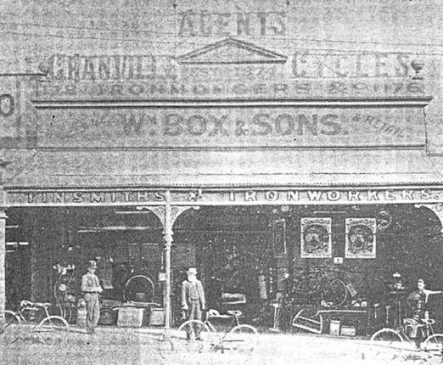
Figure 3.51: Wm. Box & Sons, Granville Cycles Agents, Moorabool Street, c.1897. Source: E.A. Vidler, The Book of Geelong: Its People, Places, Industries and Amusements, Henry Franks & Co., Geelong, 1897, p.42.

THE BOOM YEARS OF THE 1890S AND EARLY 20TH CENTURY
It was from the 1890s, when bicycles were mass-produced when the boom in bicycle trade began. In 1895, there were 220 articles, advertisements and detailed lists in the Geelong Advertiser under cycle . In 1896, this had increased to 1,067 entries.491 Initially, existing retailers – including ironmongers and sewing machinists – together with avid bicycle sportsmen became bicycle agents. In 1896, they included William
Box and Sons ironmongers and tinsmiths which had been established in 1874 and from their new store in Moorabool Street they sold Granville cycles, as proudly advertised on the parapet of the premises492 (Figure 3.51). A Mr Robertson
was the agent for Wertheim and Electra bicycles at his Sewing Machine Depot in Moorabool Street.493 Beeston Humber bicycles were sold by Alex McRae at his store at 150 Ryrie Street.494 This brand was also available from the Austral Cycle Agency in Ryrie street.495 Winter Wilson had available the Raleigh and Sparkbrook cycles at his cycle depot at
95 Malop Street.496 He was a representative for the Scott and Morton agency and a month after his commencement he was replaced by Jim Carpenter, a ‘colonial rider of great stature. 497 The Word, Quinton, Zimmy-Mascotte, Tourist and Princess Mary bicycles were available at William Gurr s
Exhibition Exchange,498 Massey-Harris bicycles from Canada were offered by a Mr Galbraith at his sports depot at 175 Ryrie Street,499 while C.E. Charity was the agent for Nimrod- Zimmy bicycles at his Piano and Fine Art Gallery, Malop and Moorabool Streets.500 It was also at this time when J.A. Price, general merchant took delivery of a shipment of bicycles and Herbert Yeoman, a local racing man, advertised as a bicycle

repairer, machinist, locksmith and perambulator repairist.501
According to Rod Charles in A Whirr of Many Wheels, the bicycle mechanic pioneers in Geelong at this time were Will Calder and Percy Whitfield:
Two local men, however, sowed the seeds for other bicycle mechanics to set up business on their own accounts. Will Calder and Percy Whitfield were the first bicycle builders in Geelong since William Gaulton. Several days after the sports of March, a note in the Advertiser reported that Mr Will Calder, older brother of Andy Calder, winner of the first Scott-Morton road race and then with the Austral Wheel agency, was about to set up in business building bicycles. He was building
racing machines and had just built a ladies machine for a local gentleman who intends presenting it to his wife as a birthday present. By October it was reported, Calder intended to build machines on a large scale. He is daily expected to hand over 100 sets of parts and has taken the flat over Dalgety’s corner to manufacture the Pivot Cycles.’ In September Mr. Percy Whitfield, builder of the local triplet, with assistance from Mr. W. Calder had just completed the building of a racing machine for his own use. Mr. Whitfield, it was said, was one of the ‘cleverest mechanical engineers in the colony. He also sold
Circe and Alexa cycles.502
Born in 1866, the son of John Anderson Whitfield and Sarah Part, Percy Whitfield married Ellen Lilian Taylor in 1895.503 He was one of the first motorcycle mechanics in Geelong,
advertising Cycles and Motor Cycles built and repaired from his Little Malop Street depot in 1904.504
By 1905, there were 10 bicycle manufacturers, importers, agents and repairers in Geelong (see Appendix 3.1).505 This number had increased to 15 in 1910 and 16 by 1925.506 Like Percy Whitfield, a number of these cycle manufacturers and repairers also offered mechanical and sales services for motorcycles although it was not until 1910 when motorcycle services were separately listed (along with motor cars) in the Geelong section of the Sands and McDougall Directory of Victoria. By 1950, the popularity of cycling and cycle racing was reflected in the continued high number of bicycle retail outlets (there being 14 in total). Only L.F. Pratt Motor Cycles Pty Ltd at 231 Moorabool Street specialised solely
in motor cycles, although it had competition by 1955 when
K. Dangerfield moved from cycles and motorcycle repairs.507
Of this contextually large number of cycle retail and mechanical outlets, a limited number were to endure throughout much of the 20th century. They included the following:

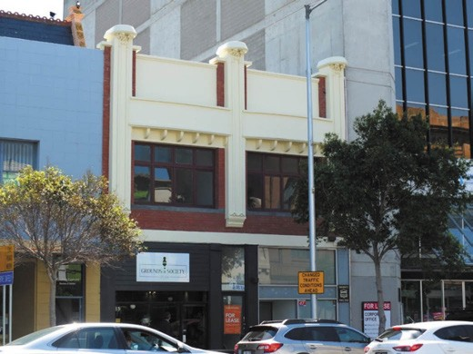
Figure 3.53: Former Balfours building, 45-47 Malop Street, Geelong, 2018. Source: David Rowe.

BALFOUR BROTHERS
Stuart Hamilton Gordon (1867-1942), John Thomas (“Jack”) (1878-1962), Thomas Robert ( Robert ) (1880-1961) and Victor (1882-1916) took an active interest in the cycling industry, as noteworthy race competitors, cycle club committee members, cycle agents and mechanics. It was as cycle mechanics and agents where the success of some of the Balfour brothers endured most. They were the sons of Captain John Balfour (1823-1899), a mariner from Fife, Scotland, who arrived in Victoria after 1851.508 He married Miss Eliza Hamilton in 1859.509 Captain Balfour was Master of the schooner, Flora (formerly Henrietta Helena), shipping goods between Melbourne and Geelong.510 By 1890, he was shipping agent for the Australasian United Steam Navigation Company Ltd.511
The Balfour brothers appear to have gained experience as cycle mechanics from the late 1890s. Robert Balfour had commenced work as a cycle mechanic in 1899, joining the Geelong branch of the Ballarat-based firm of Davies Franklin in c.1901.512 Jack Balfour also worked for Davies Franklin in Geelong by 1903513 although he later became a timber clerk.514 Victor Balfour, best known in the early 1900s as a trick rider at sports gatherings and other events, was a local cycle mechanic while is brother, Stuart, was a cycle builder.515 It was also about 1903 when the Balfour brothers: Robert, Victor and Stuart established a cycle agency at 61 Malop Street under the name of T.R. Balfour, cycle manufacturer of Federal Cycles516 (Figure 3.52).
By 1909, T.R. Balfour was the sole agent of the Triumph motorcycle under the auspices of the Triumph Motor Cycle Depot.517 In 1911, Victor Balfour purchased Norrish s boarding house at 45-47 Malop Street and he engaged the Geelong architects, Laird and Buchan, to design commodious two

storey brick shops.518 Completed in July 1912, the new building (Figure 3.53) – and its use – was described in the Geelong Advertiser at this time:
On the site of Norrish s boarding-house in Malop-street, Messrs Balfour Bros. have erected two well-appointed shops with plate-glass windows, and every convenience. They are an acceptable addition to the street architecture. One is used as a cycling depot, and a good show is made of bicycles and parts; machines are built on the premises, and repairs carried out by competent workmen. Go-cart tyres are fitted by the latest method. In the other shop tailoring in all branches is executed and everything turned out is guaranteed.519
It appears that by this time the partnership of Victor, Robert and Stuart Balfour had been formalised as Balfour
Brothers – Cycle Manufacturers and Agents, Locksmiths and Gunsmiths. On Victor s untimely death in 1916, his share of the partnership, and his building at 45-47 Malop Street, were bequeathed to Robert and Stuart.520 Two years later in 1918 Robert and Stuart Balfour acquired Dennys Lascelles brick motor garage at 155 Mercer Street (corner of Mercer and Gheringhap Streets. They continued to occupy the building at 45-47 Malop Street until new workshop additions were completed in late 1919.521 While ownership of the Malop Street building was retained until 1949,522 it was at the motor garage at 155 Mercer Street where the Balfours Brothers continued the cycle business in addition to the repair of motor cars, selling Victor Federal roadsters and Biplane racing cycles built by the Biplane Cycle Manufacturing Company.523 The Balfours Motors business name at 155 Mercer Street
was to last for almost 90 years (see following subsection for further details).524

M.J. HEDE AND SON
Michael James Hede was born in Carlton in 1878, the son of Thomas Hede, a policeman, and Winifred O Brien.525 Thomas Hede s brother, Patrick, had opened the Cash Inn in Little Malop Street, Geelong in 1847 (see Theme 5 for further details).526 M.J. Hede’s infancy was spent at Abbotsford and following his father s transfer to Mt Egerton, he attended the local school there.527 Hede first took up employment with a wholesale grocery firm in Queens Street, Melbourne before joining the cycling firm of Davies Franklin in Ballarat.528 It was in Ballarat where Hede participated in several cycling races.529
In 1901 with H.J. Ross and Peter Grant, Hede established Diamond Cycles Pty Ltd in Geelong. The business was not to endure, in 1902 it went into liquidation.530 Hede subsequently established a cycle business in Ryrie Street. On 14 January 1908, he married Annie Jane Boyd and they had a son, John Douglas Hede, in 1917.531 In 1926, Hede sold his cycle shop
in Ryrie Street532 and established a partnership with Eugene

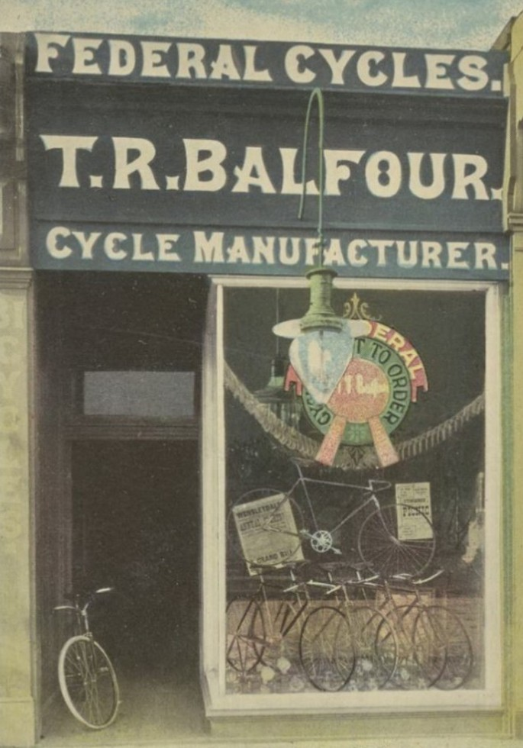

Figure 3.52: T.R. Balfour, Federal Cycles, 61 Malop St., Geelong, c.1903. Source: Object 125570, National Museum of Australia.

ABOUT CORAYO: A THEMATIC HISTORY OF GREATER GEELONG
222

Cowley (1872-1959),533 cycle agent, as promoters of cycle and foot races during the summer months at Kardinia Park (which was to become known as the Geelong Drome) (see Theme 9 for further details).
After the partnership ceased in 1936 Hede and Cowley re- established their own cycle businesses.534 M.J. Hede opened a store at 192 Ryrie Street and by 1940 he had relocated to 167 Ryrie Street535 (Figure 3.54). After the Second World War,
M.J. Hede was joined by his son, John (returned soldier), the business then being known as M.J. Hede and Son.536
Following M.J. Hede’s death in 1959, J.D. Hede continued the business into the 1960s although it had closed by 1970.537

ELSWORTHY BROTHERS
Also involved in bicycle racing and local bicycle club were the brothers, John (Jack) H. Elsworthy (c.1912-2004) and Alfred Henry Elsworthy (c.1914-1992).538 In 1937, Jack Elsworthy took over the cycle business of Alfred Jorgenson at 464 Moorabool Street.539 By the early 1940s, Alfred joined
his brother in the business, it being known as Elsworthy Brothers.540 They relocated to 446 Moorabool Street in 1953.541 From this location (now 399 Moorabool Street), the business was expanded into the sale of white goods and electricals and it continued at this location as Elsworthy s Retravision until it closed in 2013.542

L.F. PRATT MOTOR CYCLES PTY LTD
Leonard Frank Pratt (1901-1957) was born in New Zealand, the youngest of seven children to Justin Percival Pratt (a carpenter) and Elizabeth Margaretta Pellatt (formerly of Folkstone, Kent, England).543 With his older brothers, Percival (1888-1968) and Charles (1892-1968), Leonard (or Frank as he was known) became well-known pioneer aviators in Australia, based in Geelong. Frank Pratt emigrated to Geelong in c.1923 and was trained as a pilot by Charles, and joined his brother s aviation business, the Geelong Flying School (see later subsection for further details). Frank s next role as mechanic as part of a charter business for Lieutenant Parer in New Guinea was cut short in 1928 when he contracted malaria
and he and Charles returned to Geelong.544 On his return in 1929, the business C.D. and L.F Pratt Pty Ltd was formed for the encouragement and development of aeronautics. 545
Frank Pratt s enduring interest was motorcycles. While initially retaining his partnership with Charles in the local aviation business, Frank s interest in motorcycles was heightened after his experience at the motorcycle race at Phillip Island on Boxing Day, 1928.546 An excellent mechanic who could repair planes, cars and motorcycles , Frank s passion for tuning and repairing motorcycles progressed
to him establishing a sub-agency business for Sunbeam motorcycles.547 He combined this with motorcycle racing,

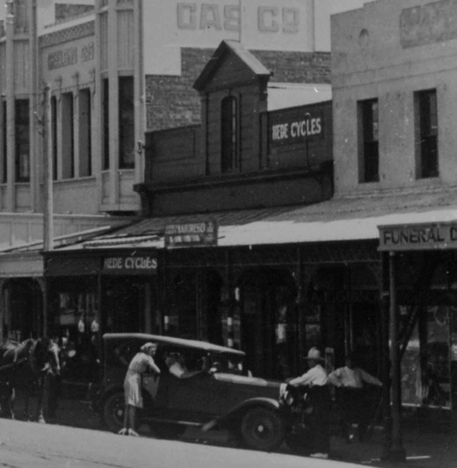
Figure 3.54: Hede Cycles shop, 167 Ryrie Street, Geelong, c.1940. Source: accession H32492/4850B State Library of Victoria.
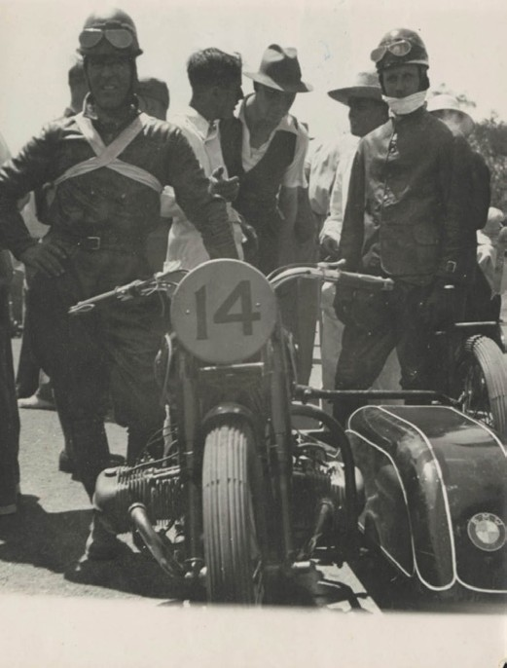
Figure 3.55: Motorcycle race entrants (presumably Frank Pratt on left and Percy Coleman on right), Phillip Island, c.1931. Source: accession H2016.296/156 State Library of Victoria.

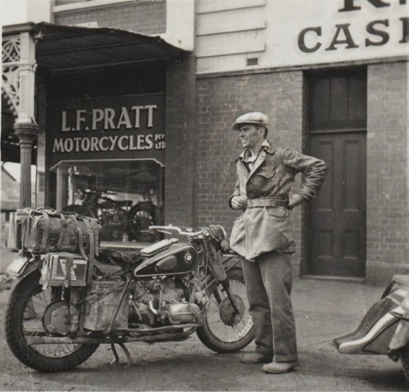
Figure 3.56: L.G. Pratt Motorcycle shop, 131-133 Moorabool Street, possibly with Frank Pratt standing, c.1950. Source: accession H2012.126/867 State Library of Victoria.

entering the sidecar event at Phillip Island with Percy Coleman in 1931548 (Figure 3.55). Finishing second, it was in 1932 when Frank (together with passenger, Alick Smith)
won the Australian Grand Prix at Phillip Island on 1 February 1932.549
It was after Pratt s Grand Prix win in 1933 when L.F. Pratt Motor Cycles Pty Ltd was established at 245a Moorabool Street. The directors were Frank Pratt, Arthur Leonard Royce and Robert Charles David Warne-Smith.550 Pratt continued as an agent for Sunbeam motorcycles.551
A former bakery, the shop was small and so motorcycle parts were stored in the former bakery ovens.552 He also
helped to establish the Geelong Motor Cycle Club (see earlier subsection). He also helped establish the Bonnyvale Racing circuit at Ocean Grove, the property of James Wilson.553
In 1934, the motorcycle business was relocated to
225 Moorabool Street, allowing Pratt to expand his agency to include Sunbeam, MW, DKW, Utility, New Imperial and Coventry Eagle motorcyles.554
In the 1940s, Pratt acquired the two storey building at 231-233 Moorabool Street (Figure 3.56) that had been built in 1911-12 and had been partly occupied for many years by McMartin and Sons, butchers (see Theme 5).555 Norm Osborne joined the business in 1948 and became a partner, the firm being known as Pratt and Osborne.556 He also competed in motor cycle races under the name, Reg East .557 By 1954, Pratt had also opened a motorcycle shop in Elizabeth Street, Melbourne.558 Following Frank Pratt s death in 1957, the

business continued at 231-233 Moorabool Street until the building was sold in 2007.559

G. DE GRANDI CYCLES
In 1929, George De Grandi (1884-1957) acquired
George Hose s cycle business at 72 Mercer Street.560 Born at Meredith, George Arthur De Grandi was the son of Louis Arnold De Grandi and Louisa Croft.561 and grandson of Felix and Franzisca (nee Dreher) De Grandi, Swiss immigrants who settled at Ararat.562 George De Grandi s interest in cycles emanated from his father opening a cycle shop in Warrnambool in the late 1890s.563 In 1911, George De Grandi married Annie O Rouke when he was working in the Valley Cycle shop in Kyabram.564 He returned to Warrnambool
in 1915 and established a cycle shop with a friend, Claude Eagles.565
De Grandi continued to trade from his Mercer Street store throughout the 20th century, advertising Valencia Cycles in 1930 and the Healing Bicycle in c.1940566 (Figure 3.57).
George De Grandi’s son, Norman, also entered the firm, the business becoming known as G. De Grandi and Son in the 1950s.567 After George De Grandi s death in 1957, Norm, had success in growing the company in his own right.568 In 1994, De Grandi s cycle store relocated to 437 Moorabool Street, Geelong, where it continues as De Grandi Cycle and Sport under brothers, Damian, Shane, Peter, Tim and Dominic, the third generation of the De Grandi family.569

CYCLES FOR BUSINESS
The growth in the popularity of the bicycle as a mode of road transport for sport and recreation was also exploited for business. One of the earliest was Dr Sidney Rudge Robinson (c.1817-1898) in the 1870s and 1880s.570 In 1865, he had
taken over the medical practice of Dr Teague in Ryrie Street before relocating to Myers Street by 1886 (the location of the Geelong Homoeopathic Dispensary) and later to Fenwick Street (see Theme 8 for further details).571 Dr Robinson became well known in Geelong, not only as one of the town s local medical practitioners, but because he carried out his daily rounds to patients by riding his Singer Omnicycle tricycle.572
By 1900, the efficiency of the bicycle was seen as a valuable addition to the post and telegraph service. At some suburban Post Offices in Melbourne, bicycles were supplied for the messengers of telegrams in order to save time. 573 It was not until 1911 when four bicycles were provided for postmen at the Geelong Post Office ‘in order to facilitate deliveries.’574 So successful was the innovation that two extra bicycles were order in 1912.575 A new garage and bicycle stables (Figure 3.58) were subsequently erected at the rear of the Post
Office in Ryrie Street (now demolished). Bicycles were also

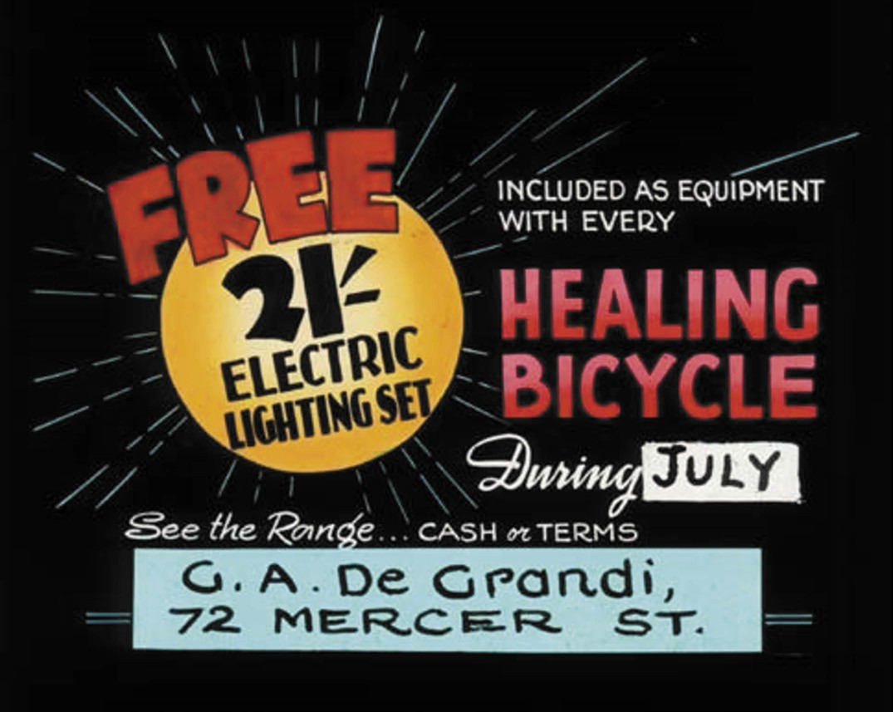
Figure 3.57: G.A. De Grandi, advertisement for the Healing Bicycle, c.1940. Source: GRS 2067/77 Geelong Heritage Centre collection.

later provided to suburban Post Offices,576 and the bicycle comprised the main mode of suburban postal delivery until it was replaced with the motorcycle in the late 20th century.
In 1915, the Geelong Advertiser reported on a novel sign of 100 cadets mounted on bicycles:
They rode in splendid order in a column of fours down the hill to the banks of the Barwon, and one would have thought that a bicycle corps had been established, and that the youngsters were out for their first exercise.577
Several years earlier and by 1897, the Military Bicycle Corps had been recognised of growing importance to the modern armies in Germany, Italy, Austria, and United States National Guard.578 However, it was not until 1916 when the Australian Cycling Corps was formed in Egypt as part of the Australian Imperial Force, fighting on the Western Front
in France and Belgium during World War One.579 The key functions of the Bicycle Corps were as despatch riders and for reconnaissance and patrol missions.580 Geelong was associated with the Bicycle Corps, holding a camp in 1916.581
The efficiency and quickness of the bicycle for despatch, postal and telegraphic services progressed further in the early 20th century. By the early 1940s, motorcycles were used by despatch riders at the Geelong Fire Station (Figure 3.59).

ARRIVAL OF THE MOTOR CAR
By the early 1890s, numerous experiments had been carried out on the production of the motor car. In 1891, the Oakleigh Leader declared that the electric storage battery car is the prettiest example of the class , the ordinary steam engine being the most objectionable on account of noise and

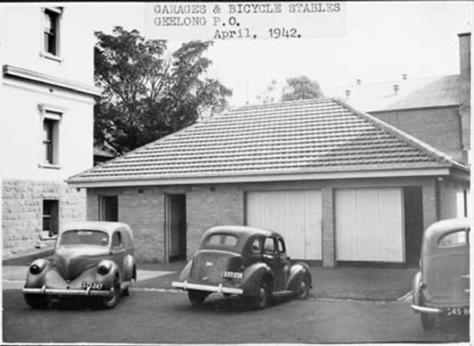
Figure 3.58: Geelong Post Office, ‘Garages and Bicycle Stables’, April 1942 (now demolished). Source: NAA: B5919.13/227, National Archives of Australia.

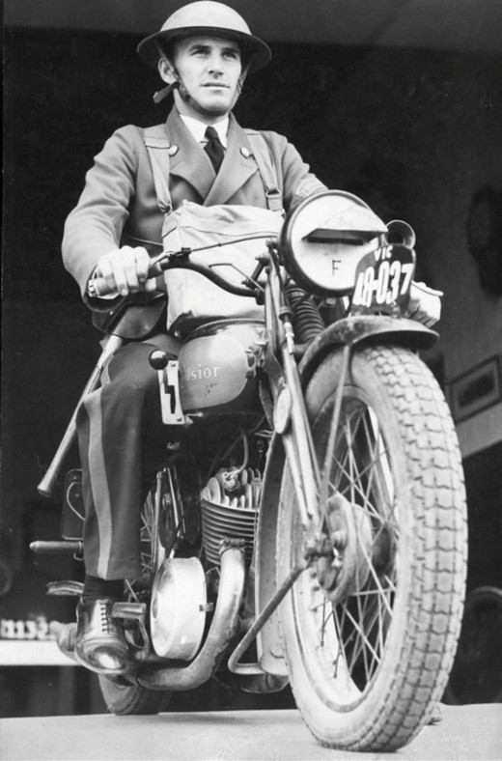
Figure 3.59: Fireman Smith Despatch Rider, Geelong City Fire Station, 1942. Source: accession H99.201/2746 State Library
of Victoria.

smoke , while motors burning oil have been tried but do not give satisfaction as yet for various reasons. 582 Other
experiments had been made with chemical and compressed air motors.583 By 1896, The Age declared that latest product of mechanical invention, the autocar, or horseless carriage, will soon be running in the streets of Melbourne. 584 At the turn
of the century, the first steam car had arrived in Geelong on order from E.H. Lascelles, senior partner of the firm, Dennys Lascelles, Austin and Co., woolbrokers, and stock and station agents. Built in 1899 by the Locomobile Car Company of Bridgeport, Connecticut, U.S.A., it was powered by a 6 horse power marine engine of two cylinders with a chain driver, rear boiler and tiller steering585 (Figure 3.60). It survived until at least 1955 in Norman E. Preston s car wrecker s garage.586 The first motor car built in Geelong was in 1903, when William Humble and Ernest Schultz of the Vulcan Factory designed the body and chassis and fitted a one cylinder De Dion engine587 (Figure 3.61). According to the Geelong Advertiser, several well-known citizens worked on the job, and for a long time the car excited much curiosity. 588 In this same year,
George Jones of Lara filled his spare time by constructing a motor car following several parts being made to order in
Geelong. Just days away from being finished, a fire broke out in Jones’ shed and the car was destroyed.589
Initially, ownership of a motor car in the early 20th century in Greater Geelong was confined to the upper and middle classes.590 Tom Hawkes of Llanberris , Western Beach, was one of the earliest residents to own a motor vehicle in Geelong. He acquired a Benz in c.1907 and employed a chauffeur to drive him and his family591 (Figure 3.62).
It was at this time when Councillor H.F. Richardson (later first president of the Geelong Road Users Association and
the local branch of the Royal Automobile Club of Victoria) was critical of motor vehicles and called for the need for regulations at a district municipal conference. As reported in the Geelong Advertiser:
At the close of the district municipal conference on traction engine traffic yesterday, Cr. H.F. Richardson drew attention to the motor-car traffic, which was almost as big a question. In the old country much damage was done to the roads by motors, chiefly through the blinding
being sucked off the surface. The Government of Victoria had brought in a bill two sessions ago to regulate the traffic, but opposition was raised by the Labor party,
who wanted a minimum wage for drivers, and the bill was withdrawn. He moved that the Ministry be urged to re-introduce the measure. He remarked that many
country women were afraid to drive into town alone, and he considered there should be some regulation in regard to racing. It was practically of no value to prove that a car could travel 50 or 60 miles an hour, and it was an absolute

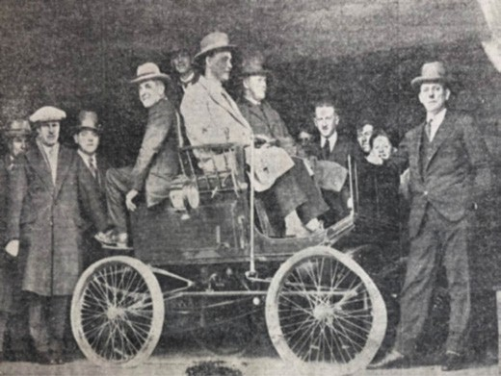
Figure 3.60: First motor car in Geelong. Seated included members of Geelong’s first Motor Show Committee, E. Lanbridge, chairman (right) & Ernest Smith, secretary (left). Source: Geelong Advertiser, 11 June 1927, GRS 2050/159 Geelong Heritage Centre collection.

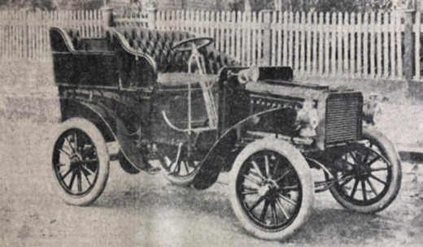
Figure 3.61: First motor car built in Geelong in 1903.
Source: Geelong Advertiser, 4 June 1927, GRS 2050/159 Geelong Heritage Centre collection.

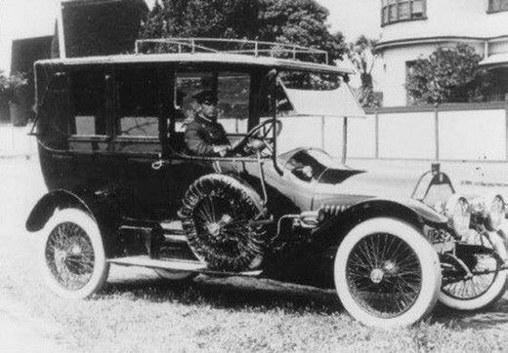
Figure 3.62: T.S. Hawkes Benz (with chauffeur) outside Llanberris , Western Beach Road, c.1911. Source: Sue Richardson, Geelong.

necessity that such scorching should be stopped. Mr. Meaden, secretary of the Municipal Association,
stated that the president and himself had waited on the Chief Secretary on the previous day to urge legislative action, and a resolution passed by the conference would strengthen their hands. The motion was seconded by Cr. McGuinness. He remarked that most of the cars appeared to be owned by the rich class, and he considered them profoundly ignorant and wanting in manners. Farmers who had only the smattering of education the State could afford them, observed the rules of the road, and pulled half off the road to let even a bicycle pass, but motor car owners would drive everybody off the road. The motion was carried.592

MOTOR GARAGES AND BUSINESSES
The early 20th century brought about rapid progress with the importation and local manufacturer of the motor car in Geelong. Some coach builders and cycle agents soon
provided motor car repair services. In 1910, there were three dedicated motor car and motor cycle repairers in Geelong: Everett and Sons in Mercer Street (who also continued their coach factory business at this address) and new-comers, J.C. Brown and Co., of Malop Street (Figure 3.63), and Winter and Taylor of Little Malop Street.593 This latter firm was to become one of the most enduring car businesses in Geelong. A list
of Motor Garages and associated businesses is given as Appendix 3.1.

WINTER AND TAYLOR
Former employees of the well-known Melbourne firm of Kellow Motor Company,594 Messrs. Winter and Taylor had commenced their business in Little Malop Street in 1908.595 In 1910, they engaged the local architect, T.D. Slevin to design a new motor garage (Figure 3.64) (now demolished) immediately east of the London Chartered Bank in Malop
Street. The new garage soon boasted a display of Napier and Buick motor cars and Preston motor cycles.596 Business was so successful that additions were carried out to the garage in 1913 to a design by T.D. Slevin.597
In 1915 at the height of World War One, one of the directors, John Henry Winter, went to England to assist in making munitions for the war effort.598 This gave him the opportunity to experience the latest ideas and modern methods in manufacturing and in 1916 he predicted a great revolution
in Commonwealth industries at war s end.599 In 1926, Winter and Taylor were appointed as General Motors Holden Dealers which continued throughout the 20th century.600 The firm was taken over by the Morphy family in 1948, with Shelley Morphy as managing director.601 This was the year when General Motors Holden unveiled the first all-Australian motor vehicle

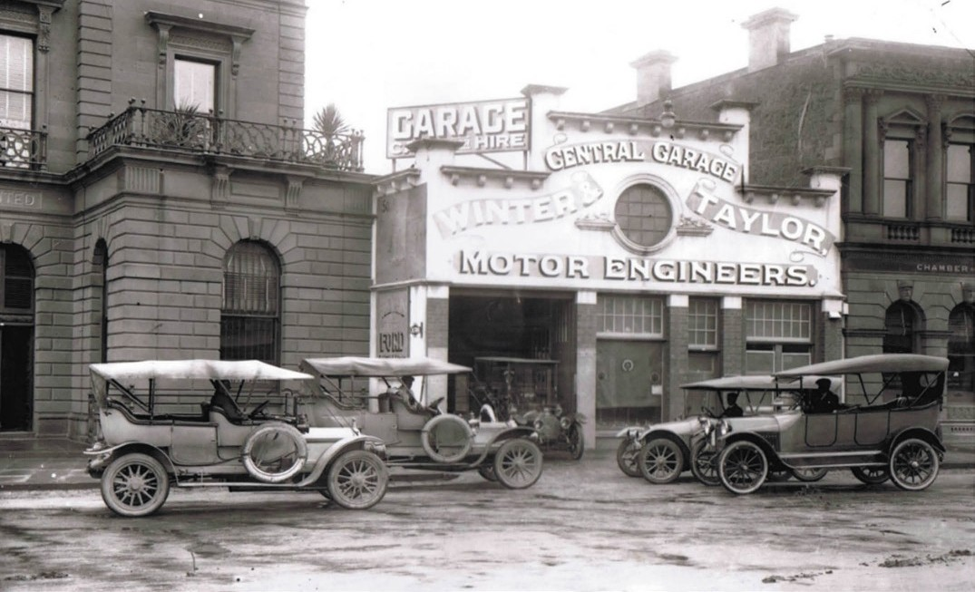

Figure 3.64: Winter and Taylor s Central Garage, Malop Street, Geelong, n.d. [c.1925] (now demolished). Source: Davies collection, Lorraine Huddle.

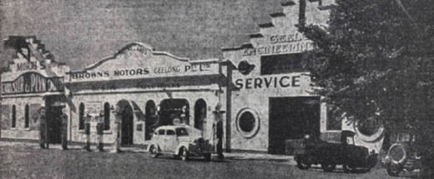
Figure 3.63: Brown s Motors Geelong Pty Ltd, 147 Malop Street, advertisement, 1938 (now demolished). Source: Geelong Advertiser, 8 October 1938, p.31, GRS 2050/205 Geelong Heritage Centre collection.

LONDON PIONEER MOTOR COMPANY
Continued progress in the development of motor garages was made in Geelong after 1910. In 1913, the Geelong Advertiser reported that still another motor garage is to be built in the city; this time the London Pioneer Company. 604 Seeley, King and Everett, Architects, had been engaged to design the single storey Federation Free Style building at 210 Moorabool Street (Figure 3.66), it being built by Harry Beach and Son
at a cost of around £1000.605 By c.1930, the business was operated by Harrison Motors.

(Figure 3.65).Winter and Taylor relocated to 101 Mercer Street in 1974. In 1981, Shelly Morphy s sons, Ron and Brom Morphy, took over the dealership and in 2001 the third
generation of the Morphy family, James Morphy, took over the firm.602 In June 2018, the Winter and Taylor Motor Group was acquired by the Blood Motor Group.603

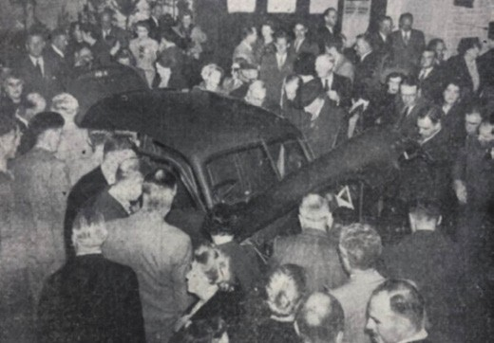
Figure 3.65: Inspecting the first all-Australian made Holden, 1948. Source: Geelong Advertiser, 4 December 1948, GRS 2050/232, Geelong Heritage Centre collection.

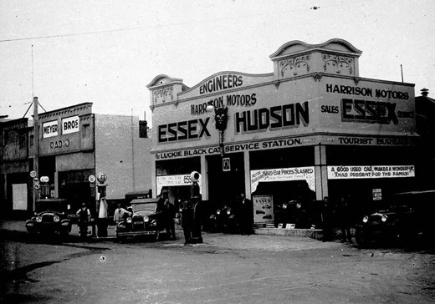
Figure 3.66: Harrison Motors Garage, Moorabool Street, c.1920 (now demolished). Source: Item MM6786, Museums Victoria.

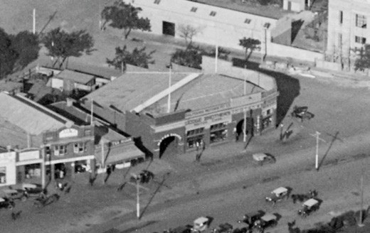
Figure 3.67: C. Pratt, Balfours Garage, Mercer Street, c.1925 (right). Also note Richardson s two storey garage (original wing) on the left. Source: accession H91.160/838 State Library of Victoria.

DENNYS LASCELLES MOTOR GARAGE (LATER BALFOURS MOTORS)
One of the largest motor garages to be constructed in early 20th century Geelong exists at 155 Mercer Street. The single storey brick building (Figure 3.67) was designed by leading Geelong architects, Laird and Buchan in 1913 as a motor garage for the woolbroking firm, Dennys Lascelles.606 It was this building that was acquired by the Balfour Brothers in 1918607. After workshop additions were carried out in 1919
(to the original design of 1913),608 further extensions were built to a design by Laird and Buchan in 1926.609 By this time, Thomas Robert Balfour had retired from the company and his interests in Balfour Motors were taken over by Eric Vaughan. Stuart Balfour remained with the firm, presumably until his death in 1942 at the age of 56 years.610 The Balfour Motors Pty Ltd continued at 155 Mercer Street until the early 21st century.

HENRY G. RICHARDSON MOTOR GARAGE
Another motor garage established in the early 20th century was that of Henry George Richardson (c.1883-1971). A previous employee of the neighbouring Balfours Motors garage, Richardson commenced business in his new two storey brick garage in 1921611 (Figure 3.67). Business was so successful that Richardson extended his motor garage to the identical design as the original wing in 1927612 (Figure 3.68). Richardson continued is motor garage business at this location until the late 1930s.613 Richardson s garage still exists at 151-153 Mercer Street.

MOTOR GARAGE EXPANSION IN THE 20TH CENTURY
By 1925, there were 26 motor depots and garages in Geelong which testified to the growing number of residents that had acquired a motor car (see Appendix 3.1). This number of motor engineer, depot and garage businesses was to reach its peak in the mid-1930s when 47 garages were operating in Geelong.614 The construction of the Ford Motor Company s factory in North Geelong in 1926 and particularly the mass production of Model A fords from 1928 (see following subsection) was a key factor in the explosion of local motor garages.
The contextually high number of motor garages and motor mechanical businesses in central and suburban Geelong continued into the late 20th century (see Appendix 3.1).
One operator was B.W. McConachy at 50 Little Ryrie Street (Figure 3.69). The success of these businesses further supported Geelong s reputation of one of the pre-eminent car manufacturing hubs in Victoria.

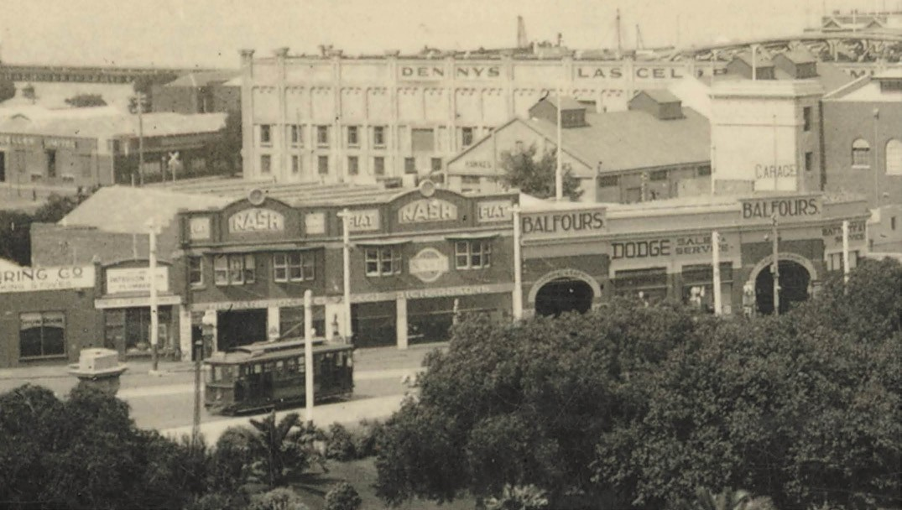
Figure 3.68: C. Pratt, Richardson s Garage (including two storey addition) (left) and Balfours Motors Garage (right) c.1927-54. Source: accession H2009.50/245 State Library of Victoria.

FORD MOTOR COMPANY
Ford s interest in Australia began in 1909 when Robert Durance established a network of dealers throughout the country and began the assembly and sale of Ford vehicles through them. With stronger competition by 1923, Ford Canada sent two executives, H.C. French and M. Brooks, to Australia on a reconnaissance visit.615 The consequence
of this visit was to establish a Ford Motor Company plant in Australia.616 In November, 1924, P.W. Grandjean, secretary of Ford Canada, returned to Australia to choose an appropriate site.617 A single central plant based on the Canadian model had been ruled out due to the lack of uniformity of railway gauges.618 Nearly four months later, the decision was
made to build in Geelong, on a 100 acre North Geelong site sold by the Geelong Harbour Trust.619 A single storey brick factory (Figure 3.70) covering 200,000 square feet
was to be erected and when completed would employ 5000 people.620 French was appointed general manager, R.A. McFarlane sales manager, and E.F. Hughes secretary.621 Branches in Brisbane, Adelaide, Sydney and Fremantle would assemble parts from Geelong and overseas.622 Construction commenced on the Ford Motor Company complex on the Melbourne Road, North Geelong, on 22 May, 1925, to a design that had apparently been imported from Ford s latest Canadian (Toronto) works.623 The design

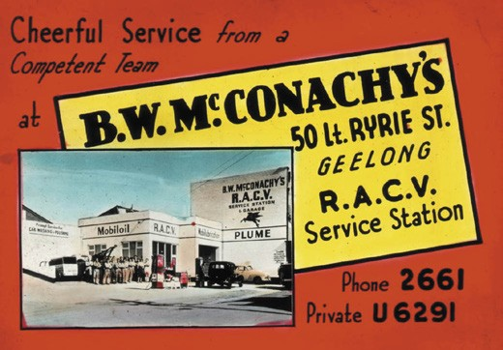
Figure 3.69: B.W. McConachy s R.A.C.V. Service Station advertisement, 1954. Source: GRS 1623/10 Geelong Heritage Centre collection.

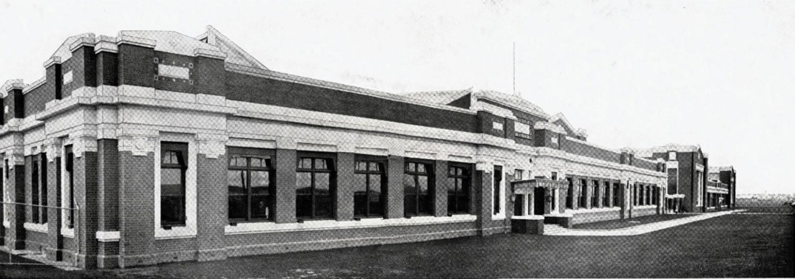
Figure 3.70: Ford Motor Company, North Geelong, 1928. Source: Geelong: 55 Photographic Views, Geelong, Victoria, Australia, The Valentine Publishing Co. Pty Ltd, Melbourne, 1928, pp.12-13.

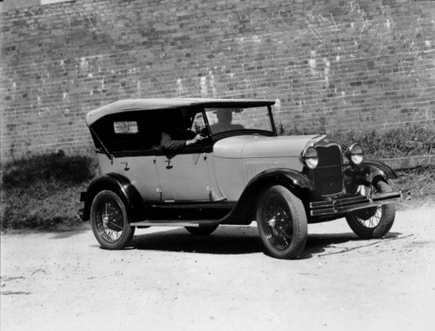
Figure 3.71: Model A Ford, 1928-29. Source: Negative 104912, State Library of Queensland.

engineers were Fyffe & Stewart, in association with W.J. Grassick of Melbourne.624 The major contractor was Concrete Constructions Ltd of Sydney and they used Johns & Waygood steel procured locally from BHP and from the UK.625 Ford s American architect (and the designer of the North Geelong complex) was Albert Kahn. He had been commissioned by Henry Ford as early as 1908 to design the Ford Highland Park Plant, Detroit, U.S.A.626
In 1928, the first Model A Ford cars were produced at Geelong (Figure 3.71) and by 1932 the factory had manufactured over 32,000 of them.627 Military vehicles were developed for the Defence Department.628 After World War Two, there was
an expansion of manufacturing and in 1960 the first fully Australian Ford, the Falcon, was produced.629 An assembly plant at Broadmeadows had been built especially as an
assembly plant for this model, while the Geelong plant concentrated on engine manufacturing.630 One of Geelong s largest employers throughout the 20th century, the Ford Factory at North Geelong closed in 2016.631

ROAD TRANSPORT SERVICES COACH SERVICES
THE EARLY YEARS
European colonisation, and the establishment of the Town of Geelong and its suburban and rural centres, required transport services for the public and for mail communication. In 1839, William Wright commenced a mail cart between Geelong and Melbourne.632 He had procured a coach from Tasmania which he called Tulip .633 Wright s competition from 1841 was Henry Field.
In June of that year he advertised the following in the Geelong Advertiser:
Overland Conveyance, between Melbourne and Corio. Henry Field respectfully announces to the inhabitants of Port Phillip generally, that he has entered into arrangements by which he will be able to guarantee the greatest regularity in running a commodious vehicle
between the two townships, and from his long experience on the road, and a proper attention to the comfort of
his passengers, he confidently expects to merit their patronage.
The Conveyance will start as follows: - From Mr. Mortimer s, Crown Inn, Lonsdale Street, Melbourne, every Wednesday morning; and will arrive at Corio on the evening of the same day. From Corio, every Saturday morning, and will arrive in Melbourne on Saturday

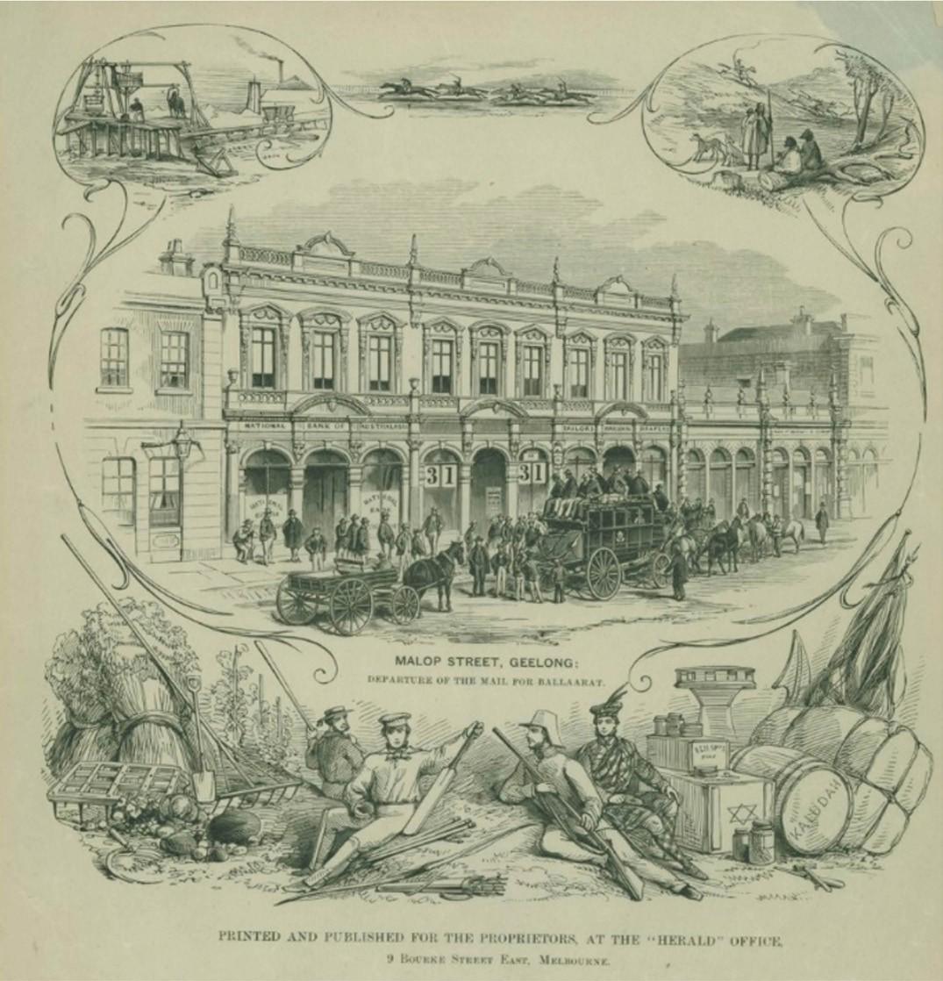
Figure 3.72: Malop Street, Geelong: Departure of the mail for Ballaarat , 1861. Source: The Herald, March 1861, accession H4203 State Library of Victoria.

evening. Fare 30s. Passengers from William s Town will have an opportunity of taking their seats at Mr. Levien s, Saltwater River.634
The Victorian goldrush in the early 1850s brought with it the need for a more expansive and reliable road coach service. One of the earliest and most popular was the firm of Cobb and Co., founded in Melbourne in 1853 by the American, Freeman Cobb and his partners, John Peck, James Swanton and
John Lamber.635 Between Geelong and Ballarat, two teams

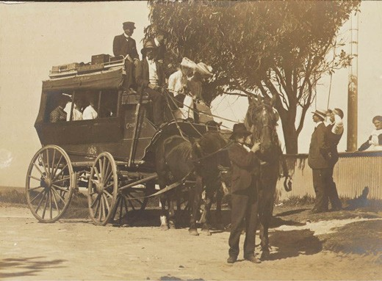

Figure 3.73: J.W. Lindt, Barwon Heads coach, n.d. [c.1901]. Source: accession H33027/1b State Library of Victoria.

were established to offer the coach service.636 The opening of the Melbourne to Geelong railway in June 1857 expanded Cobb and Co. s services from Geelong to Ballarat, with passengers availed of train travel from Melbourne to Geelong and then connecting to the Ballarat goldfields by coach from Geelong.637 The coach service became so well patronised that in January 1860 Cobb and Co. updated its vehicle between Geelong and Ballarat with the Leviathan coach
that could carry almost 100 passengers driven by a team of eight horses.638 In Geelong, the Cobb. and Co. booking office was at 31 Malop Street in a commodious two storey building (Figure 3.72) (now demolished).639
Cobb and Co. mail and coach services were extended to Hamilton and Mt Gambier, covering the Western District from Geelong. By 1860, several of the Cobb and Co. coaching firms in the Western District of Victoria had been taken over by the Australian Stage Company.640 In 1866, the Western Stage Company was established and it provided services throughout the Western District.641 The directors of the new company included Thomas Stoneman who was later to become the first Mayor of the Borough of Geelong West (see Theme 7). By 1896, the head office of the Western Stage Company was in Geelong, the extent of the services offered being outlined in the Weekly Times:
The Western Stage Company, better known by the name of Cobb and Co., has now fine livery and letting stables in Warrnambool, at the Western Hotel, situate at the corner of Timor and Kepler streets. The extent of the business of this company may be inferred from the face
that it now possessed, in addition to its head office, which is at Geelong, no less than seventeen branches, at the following place: - Ballarat, Egerton, Gordons, Bacchus Marsh, Hamilton, Warrnambool, McArthur, Coleraine, Port Fairy, Koroit, Queenscliff, Drysdale, Ocean Grove,

Barwon Heads, Portarlington, Steiglitz, and Rokewood. Telegrams are promptly attended to, and special conveyances can be obtained at all hours, whether day or night. Relays of horses can be obtained throughout the Western District, and express conveyances are furnished to all parts of the colony upon the shortest notice. The firm keeps a large number of horses in its stables, and
all sorts of conveyances, including buggies, carryalls, waggonettes, private coaches, carriages and omnibuses. The requirements of commercial travellers are specially studied, and picnic parties can be supplied with equipages at very short notice. During the season Cobb and Co. will have cabs running to the principal sights of the district
of Warrnambool. Their telephone number is 65. The charges made by the firm are strictly moderate. The district manager is Mr Thomas Vines.642
The Western Stage Company had commenced a Cobb and Co. coach service to Barwon Heads in 1889 (Figure 3.73). Travel could be directly to Barwon Heads from Geelong, or by way of Ocean Grove and the Wallington. 643 At Barwon Heads, the Cobb. and Co. stables were located at the north- west corner of Hitchcock Avenue and Bridge Road. At Ocean Grove, the Cobb and Co. depot was in The Parade. The service ran twice daily and took around 3 hours.644
In 1919, Cobb and Co. was purchased by H. Womersley, motor car proprietor who offered an up-to-date motor service twice daily during the summer season to the favorite seaside resorts of Barwon Heads, Torquay and Ocean Grove and Anglesea and Airey s Inlet.645

CABS AND TAXIS FIRST CABS
A cab service began in central Geelong in January 1848.
However, the Geelong Advertiser claimed that it was
made available only as yet by disreputable men and females, who may be seen riding about in all directions through the town, and at all hours of the day and night. 646 Such negative depiction of the first cab in Geelong continued in the following months, to a point where the Geelong Advertiser labelled it
the cab nuisance :
As an offensive adjunct to the several houses of disreputable character in Geelong, about two months since a cab was brought into requisition for the sole purpose of being employed in driving females of questionable notoriety about the town and suburbs,
an annoyance to the respectable portion of the community of no trifling nature.647

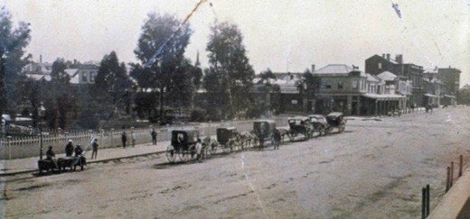
Figure 3.74: Line of Hackney Cabs, Malop Street (outside Market Square), n.d. Source: Wynd collection, Authentic
Heritage Services.

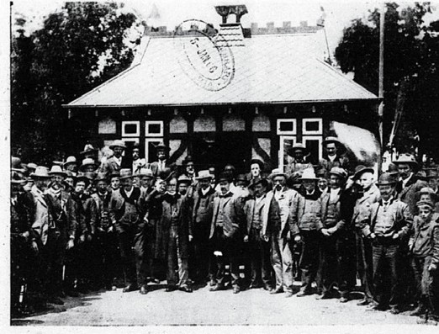
Figure 3.75: Opening of Victoria Cabmen s Shelter, 1906. Source: News of the Week, 4 January 1906, GRS 2121, Geelong Heritage Centre collection.

HACKNEY CABS
In 1850, a Bill was passed by the N.S.W. Legislative Council allowing the provision of a bye-law for the licensing and regulating of hackney carriages in the City of Melbourne. The Geelong Advertiser lamented the lost opportunity for a similar by-law to have been afforded the Geelong Town Council.648 However, it was on 7 March 1865 when the bye-law no.
27 was passed by the Geelong Town Council regulating hackney cabs649 (Figure 3.74). Between this time and 1869, the responsibility for the regulation resided with the Town Inspector.650 He was relieved of his duties in January 1869 as the regulations were considered to be defective and the Hackney Carriages Committee had been constituted by the Council to frame new regulations.651 Comprised of members of the Town Council, the improvements included more rigorous license management, including annual inspections, licensing of carriages and providing governance in relation to complaints made against or by drivers, fares and carriage stands.652 The new regulations were not passed by the

Council until 1872.653 Minutes of the Market and Hackney Carriage Committee revealed the names, numbers and addresses of the cab drivers in 1877 after the name of the committee had changed from the Market Committee. There were 48 cab licenses issued to cab drivers mainly resident in Geelong, Geelong West and Newtown and Chilwell.654 By 1903, the number of licensed cabs had swelled to 70 and there were 9 licenced buses.655 By 1929, motor taxis were in competition with the traditional horse-drawn cabs.656 Ironically, the motor cabs were also licensed as Hackney Carriages, indicating that technological progress had
overtaken the traditional governance of the Council s license system.657 The Council had however established separate cab stands for horse-drawn and motorised cabs in 1926.658 While most of the cabs were replaced with motorised vehicles in the ensuing years, there was at least one drag operating
in 1940.659

HANSOM CABS
A number of the cab drivers owned Hansom cabs. Designed and patented in 1834 by Joseph Hansom, an architect from York, England,660 the horse-drawn carriage was not introduced to Geelong until 1887 when a Mr McMullen, a well known wagonette proprietor , acquired a cab specially built by Mr Hackett, of Melbourne, at a cost of £120. 661 McMullen found business so successful that he procured another. A third
was manufactured by August Grote of Gheringhap Street in 1888 for A. Farrell and it was described as being constructed of most substantial material, besides being neatly and pleasingly colored. 662 The cabs operated from specific locations known as Hansom cabstands, the first being located in Malop Street for Mr McMullen.663

CABMEN’S SHELTERS
In 1903, the Geelong Council Surveyor reported to the gardens committee on the cost of erecting a shelter for cabmen in Market Square.664 It had been instigated by local cabmen following a similar movement in Melbourne which called for shelters to be erected for cabmen while waiting for a fare (the first being erected next to Parliament House in Melbourne in 1898), with the origins of the movement the Cabmen s Shelter Fund having been established in London
in 1875.665 Known as the Victoria Shelter in memory of Queen Victoria,666 it was built in Malop Street (near Moorabool Street intersection) in 1905 (Figure 3.75) while a second structure was erected in Ryrie Street (near Moorabool Street) in 1906667 (Figure 3.76). This shelter was named the King Edward VII Memorial Shelter.668 Both shelters were designed by William Cleverdon, the genesis of the designs of the gambrel-roofed timber structures being the distinctive forms in London and Melbourne (including the crowning lantern). The shelter in Ryrie Street was described as being designed on ornate lines

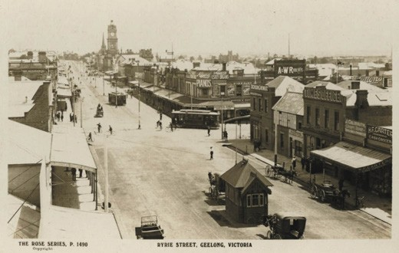
Figure 3.76: The Rose Series, Ryrie Street (looking west) showing Edward VII Cabmen s Shelter east of Moorabool Street, c.1920.
Source: GRS 2009/053400, Geelong Heritage Centre collection.

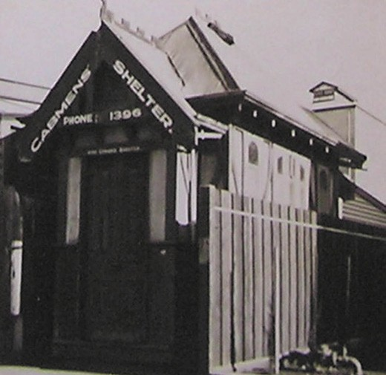
Figure 3.77: Relocated Edward VII Cabmen s Shelter (location unknown), Public Works Department photograph, c.1940. Source VPRS 10516/P3, Unit 10 Public Record Office Victoria.

with seating accommodation for a number of the men. 669 Both shelters accommodated telephones and subscribers to the Telephone Exchange were able to get a cab at a moment s notice. 670 Shelter committees were formed to manage and regulate the use of the structures. Controversy ensued in 1911 when the Market and Gardens Committee
proposed to debar certain cabmen from using the telephones. This decision was overturned.671
The expansion of the Geelong tram system to East Geelong along Ryrie Street in 1922 (see later subsection) necessitated the relocation the King Edward VII shelter.672 It was subsequently removed to the Post Office site with a frontage

to Gheringhap Street. The relocation and changes to the shelter were outlined in the Geelong Advertiser:
The shelter shed has been placed on a vacant allotment belonging to the Postmaster-General s Department, and has been structurally altered so that the entrance is no longer at the side, but at the front, facing the street. The telephone, in some measure, will compensate the cabbies for their compulsory transfer from so central a position
as Ryrie street. The average daily attendance at the new stand will be about six or eight cabs.673
In 1938, the King Edward VII shelter was privately sold for £8 and relocated elsewhere674 (Figure 3.77).In 1926, the construction of shops at Market Square required the
relocation of the Victoria Shelter in Malop Street but the City Council would not approve its continued use in a new location in the same street but further east.675 In January 1927, the Council proposed the sale and removal of the shelter.676 On 26 January the shed was sold at auction to local merchant, Harry Hooper for £36/10/, who outbid the Eastern and West Beach organisation who sought to retain the shelter in
public ownership.677 Built by public subscription, it seems the concept of private ownership was not well received and instead the shelter was purchased by the Citizens Beach
Improvement Committee for initial use as an office for a beach carnival at Eastern Beach.678 It was anticipated that after
the completion of the carnival, the shelter would be moved further east and used by the Open Sea Bathers League.679 In subsequent years the shelter was relocated to Eastern Park and in
1988 it was again removed to the Geelong Botanic Gardens and substantially restored and adapted for use
as a garden shelter.680

MOTOR TAXI CABS
Horse-drawn Hackney and Hansom cabs were phased out in Geelong in the early 20th century. In 1913, two modern taxi- cabs of the laundaulette type, with folding roof , were serviced at Winter and Taylor s garage.681 This was the beginning of the firm’s venture into the taxi business, with a further three vehicles to complete the fleet. A separate company was formed in January 1913 in order to operate the business and was known as the Geelong Taxi- cab Company. Cars for hire were also made available.682 This began the local taxi and car hire services in Geelong.

OMNIBUSES

FIRST OMNIBUS SERVICES
Omnibuses came into service in Geelong in the 1850s for transporting larger groups of people. These services were separate to the mail coach runs until the establishment of Cobb and Co. Within the Geelong township, Thomas Ogilvie owned an omnibus travelling carriage before 1853683 while
A. Atkins of Mack s Hotel provided an omnibus service from Mack s Hotel in Brougham Street to the Geelong Railway Station after the opening of the railway line in 1856.684 In 1872, there were two omnibus businesses. One was James Doull’s bus ‘Express’ which operated from Jeffrey’s Hotel in Shannon Avenue, Newtown to Ashby (Geelong West) and the Barwon Bridge and Chilwell.685 The other was operated by W. Lane who had acquired a Perseverance omnibus.686 The Geelong Advertiser gave a report on the opening of the service
in December 1872:
Mr Lane s new omnibus started running yesterday, and appeared to be well patronised considering that it was the first day, and people had not had time to fully appreciate the advantages offered by a cheap and easy mode of transit. There are always some who dislike being seen riding about in a span new conveyance, especially if different in style to those to which they are accustomed, but there is little doubt as the comfort of Mr Lane s omnibus becomes better known, he will have no reason to complain of want of patronage.687

WALKER’S OMNIBUSES
The most expansive omnibus service established in Geelong was that by William Walker (1846-1922) in 1886. Born in Grantham England, Walker had emigrated to Victoria in 1849 on the Larpent with his parents, Thomas and Catherine and other family members.688 After 16 years working for Joseph Kerley’s carrier business from 1860, he acquired Jean
D Helin s tobacconist business in 1874, the year he married the wealthy widow, Jane Kishere (nee Clydesdale).689 They also established Pleasant Bank Farm at Moolap. In 1884, Walker commenced business with a Mr C. Dalwood, leasing livery and bait stables in Little Malop Street.690 This was Walker’s first venture in the transportation business which formalised into his omnibus business with the purchase of The Pivot omnibus in 1886. According to Enid Shann in a Walker family history:
It [the bus service] began from the Market Square in Moorabool St. at 8 a.m., and travelled to Newtown at the corner of Aphrasia Street and Shannon Avenue, then called West Melbourne Road. There was an old stone inn there with a tall wooden viewing tower called Jeffrey’s Fernery. The bus made four trips a day This was so

successful that William bought two more buses in Ballarat, and made three trips a day to Belmont, with another route to Pakington Street in West Geelong. Next came services to Herne Hill, and the Gardens in East Geelong.691
In 1888, Walker relinquished his livery, letting and bait stables in Little Malop Street, to his brother in law, John Clydesdale.692 This was to enable Walker to establish a public company
with a Mr Frederick Bryant for the purpose of erecting a grand concert hall in Market Square fronting Malop Street.693
Designed by the architect, J.S. Jackson, T.F. Seeley was Clerk of Works.694 To cost £15,000, the main walls were completed by April 1889.695 However, Walker and Bryant had difficulties in raising the necessary capital and the substantial edifice was never realised.696 Walker became insolvent in 1890.697
Following the resolution of its financial difficulties, the firm of Walker and Bryant continued, but as omnibus and livery stable proprietors at its substantial stables between Corio
Street and Corio Terrace.698 The partnership was dissolved in April 1895 and an extensive clearing sale of horses, vehicles and harnesses ensued.699 The ending of the business appears to have weighed heavily on Frederick Bryant. A former successful miller in Collingwood and Mayor of Collingwood, he took his own life in Eastern Park on 17 April 1895.700
With the sale of the Corio Street business, William Walker established his omnibus premises at the corner of Shannon Avenue and Leslie Street in 1895.701 He acquired a new omnibus called The Sunbeam (Figure 3.78) which received glowing reports in the Geelong Advertiser:
Travellers on the Newtown bus route will be pleased to learn that a special effort has been made by Mr William Walker to study their convenience and comfort. The omnibus which has performed such good service for the past few years is to be supplanted by a new, handsome and commodious vehicle, specially constructed upon modern improvement lines. It will be found not only
an attractive conveyance, but one possessing all the conveniences of an elegant and comfortable tramway car, being one of Andrews patent safety busses , which was shown in the Melbourne Exhibition a few years since, but never used on Victorian roads. The vehicle was imported from Cardiff, where it was specially constructed to compete with the electric tramway system in vogue there, and it has remained in bond until recently, when Mr Walker purchased it, and since then it has been prepared and fitted up for the Newtown and Jeffrey’s Fernery ‘bus route. The vehicle has been named The Sunbeam after Lord Brassey s steam yacht now on its way to Victoria with the new Governor and his family. It is built upon the tramway principle, with stout springs on the outside, weight 39 cwt. and runs with freedom, ease and comfort. The interior,

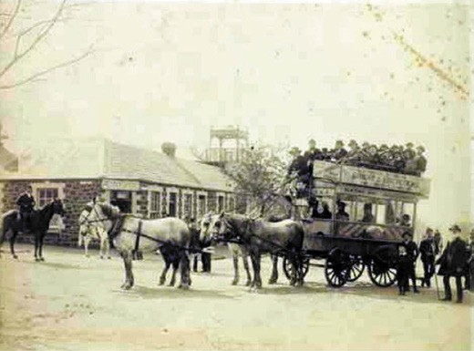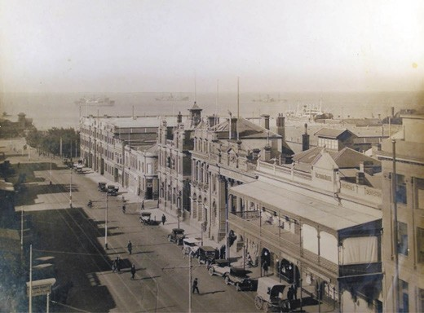

Figure 3.78: Walker’s omnibus outside Jeffrey’s Fernery Hotel, north-west corner of Shannon Avenue and Aphrasia Street, c.1895. Source: GRS 2009/0113, Geelong Heritage Centre collection.
Figure 3.79: Moorabool St, looking north-east, showing cast iron & timber electricity poles for tram service at the centre & sides of the street, c.1930. Source: GRS 2009/1304a, Geelong Heritage Centre collection.

which is designed to accommodate 15 passengers, is nicely fitted up with velvet pile seats: fixed windows of thick plate glass form the upper sides of the conveyance, and there are special methods of ventilating the omnibus which will be found in every way commendable. The roof of the tramway car is provided with seven garden seats, affording accommodation for 15 passengers, and it is reached by means of a staircase rising from a platform at the rear of the vehicle.702
Walker continued to operate his omnibus business
in Newtown until 1901 when he sold it to John Stokes.703 William Walker died at Cheltenham on 26 September 1922.704

ELECTRIC TRAMS
In 1888, Abraham and Sutherland, brokers for the Electric Light, Tram and Omnibus Company and James Henry, broker for the Geelong and District Electric Tramway Company Ltd were behind a proposed venture to establish tram-cars in Geelong and suburbs.705 Approved by the local Councils in 1890, the Tramway Syndicate (as it was called) sought an extension of the terms of the commencement of the works.706 The Syndicate ultimately forfeited its preliminary deposit following the Tramway Conference committee cancelling the tram agreement.707 In 1909, the directors of the Melbourne Electric Supply Company in London approved an electric tram system for Geelong and suburbs and proposed the deferment of the construction of the line to the Barwon Bridge given the difficulty with the level railway crossing in Moorabool Street.708 In 1910, Government acceptance of the proposal by the Melbourne Electric Supply Company was given to construct and operate an electric tram service in Geelong.709
Much discussion and debate transpired about the proposed tram routes in relation to safety and infrastructure. Two routes were first settled upon to Newtown and Geelong West, with two city termini at the Wharf and the Geelong Railway Station, with both linked to the Newtown and Geelong
West termini.710 The Newtown line extended from Ryrie Street, Aberdeen Street and south along Pakington Street to Aphrasia Street, and west to Shannon Avenue.711 The Geelong West took in Ryrie Street to Pakington Street as north as Church Street. Initially, a motor bus service was
provided for the proposed East Geelong route along Ormond Road, terminating at the Boundary Road intersection.
Work began on the construction of the overhead tram cables in Aberdeen Street in January 1911, but there was a delay with the commencement of the laying of rails due to the
late arrival of the rail shipment from New York.712 In central Geelong, the rows of poles were made with timber uprights in cast iron bases (Figure 3.79), which the Geelong Advertiser declared were not altogether without embellishment. 713 Suburban poles were solely of timber.714 Rails began to be laid in February 1911. They were set in concrete, causing a
good length of the track in Pakington Street to be roped off.715 By April 1911, considerable progress had been made on the laying of the tram lines as reported in the Geelong Advertiser:
Practically the whole of the tram line from the City terminus to the northern end of Pakington-street, Geelong West, has been laid; and the Newtown line is slowly being extended to the west of Pakington-street hill before turning west to Aphrasia-street terminus. Yesterday the track to the railway station from Moorabool-street was pegged
out and grades laid for the route to the wharf and power station.716

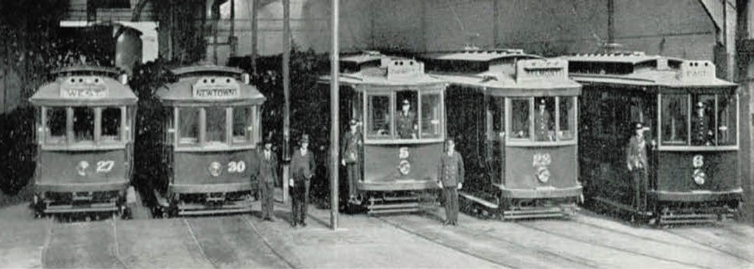

Figure 3.80: Tram Shed, c.1930. Source: Geelong: Its Advantages and Opportunities, Geelong Publicity Council, Geelong, 1930, p.36.

Land for a tram depot was acquired by the Melbourne Electric Supply Company in 1910.717 Designed by local architects, Tombs and Durran, tenders were called for the construction of the tram office in January 1911.718 The local building firm of Tingate Brothers was awarded the constructed in March
of that year.719 Tombs and Durran had also designed the first section of tram sheds and workshops and the tender of Drew Brothers and Ebbels was accepted for this work in May 1911.720 By August 1911, six additional workmen had been employed to construct the tram office.721 The tram shed (now demolished) was doubled in size in 1913 with the ‘roofing over the space between the exiting depot and Blakiston s stables 722 (Figure 3.80).
In 1911, the first quantity of wheels, undergear and other parts for the tram cars (based on the California model) arrived from Melbourne on the steamer, Coogee for the initial fleet of seven cars and four trailers.723 They had been manufactured overseas724 . The car bodies (Figure 3.81) were made by Duncan and Fraser in Adelaide. This firm had
previously manufactured tram car bodies for the Malvern line in Melbourne and the Adelaide system.725 These cars were known as Butterboxes. 726
For the East Geelong line not yet constructed, three single deck Milnes-Daimler bus chassis were fitted to saloon bodies (Figure 3.82) manufactured by Duncan and Fraser.727
On 14 March 1912, the Geelong tram service was opened with a gala attended by various Commonwealth, State and local dignitaries.728 The official opening was especially marked by the involvement of the Mayoresses of the Geelong, Newtown and Chilwell and Geelong West. Three tram cars – signifying each of the local Councils associated with the tram service
– and a further car representing the Melbourne Electric

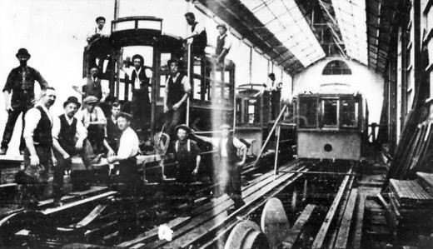
Figure 3.81: Geelong tram cars under construction, 1911. Source: News of the Week, 7 December 1911, GRS 2121, Geelong Heritage Centre collection.

Supply Company, were decorated under the direction of the Mayoresses as outlined in the Geelong Advertiser:
The four cars which made the official circuit of the routes were admirably decorated. The civic fathers had entrusted the task to their ladies, who are to be complimented on evolving pretty schemes of ornamentation. The city car had lattices of white entwined by artificial white blossom. The front panel had the city coat of arms, and white streamers waved from the sides of the car. Newtown
and Chilwell had a blending of pale blue and green. Evergreens formed the background for festoons of pale blue flowers, unique trumpet lilies, silken blue flags were clustered on the canopy of the car front and back, and the borough name was emblazoned on either side.
Geelong West’s color scheme was red and white. Artificial blossoms (They might have been cherry and pear blooms) were daintily set amongst asparagus fern and similar light

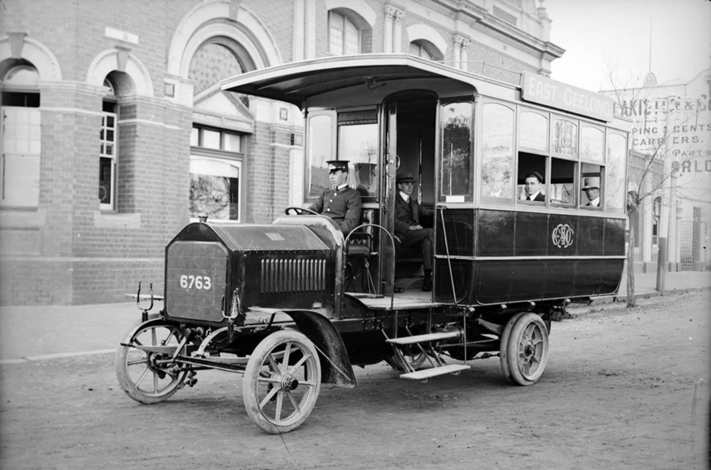

Figure 3.82: Geelong Tramways motor bus for East Geelong Route, c.1912. Source: accession H2008.28/2 State Library of Victoria.

foliages; over all red and white ribbons were prominent; and this car too, had its own name badge. The company s car … was a modest decoration in green and gold – the uprights and windows picked out in columns of foliage studded with miniature sunflowers, Japanese marigolds, etc.729
Female involvement in the opening ceremony went beyond mere decoration. Each of the tram cars were driven by the three Mayoresses led by Mayoress Williams (Geelong) and followed by Mayoress Clutterbuck (Newtown and Chilwell) and Mayoress Dickins (Geelong West) (Figure 3.83).
Following was the Melbourne Electric Supply Company car. It was driven by Miss Jobbins, daughter of G.G. Jobbins, company manager for Geelong (in 1930 Jobbins became an engineer and manager for the State Electricity Commission and later its chairman).730 In Moorabool Street next to Queen Victoria s statue in Market Square, Mayoress Williams cut the silk ribbon in the company of the Mayor and the Hon. Agar Wynne. Similar ceremonial ribbons were cut by Mayoress Clutterbuck in Pakington Street and Mayoress Dickins in Aberdeen Street. 731
A bus shelter shed was constructed in McKillop Street (corner of Ormond Road) in 1917 for the East Geelong route732 (Figure 3.84). The gabled design of the small waiting room was based on an earlier shelter built at the southern terminus in Moorabool Street near the Barwon Bridge.733 This earlier shed was subsequently relocated to the corner of the Colac Road (High Street) and Mt Pleasant Road, Belmont, in 1936.734
Expansion of the tram service occurred in the following years. The southern route along Moorabool Street was extended to Fyans Street in 1913, following the excavation of a subway
in Moorabool Street and the construction of an overhead railway bridge in 1912 (see later subsection).735 The east line was opened in Ryrie Street between Moorabool Street in 1922 (Figure 3.85) and extended along Ormond Road to Humble Street in January 1923 and to Boundary Road in March 1912.736 Other major extensions included the line to Belmont (terminating at the High Street and Roslyn Road intersection) in 1927 and in the north, from Mercer Street to Bell Parade in 1928, Bell Parade to Victoria Street in 1929 and Victoria Street to Separation Street in late 1929.737 In 1948, a report by the Melbourne Tramways Board recommended the replacement of trams with buses and a suburban tram service using the

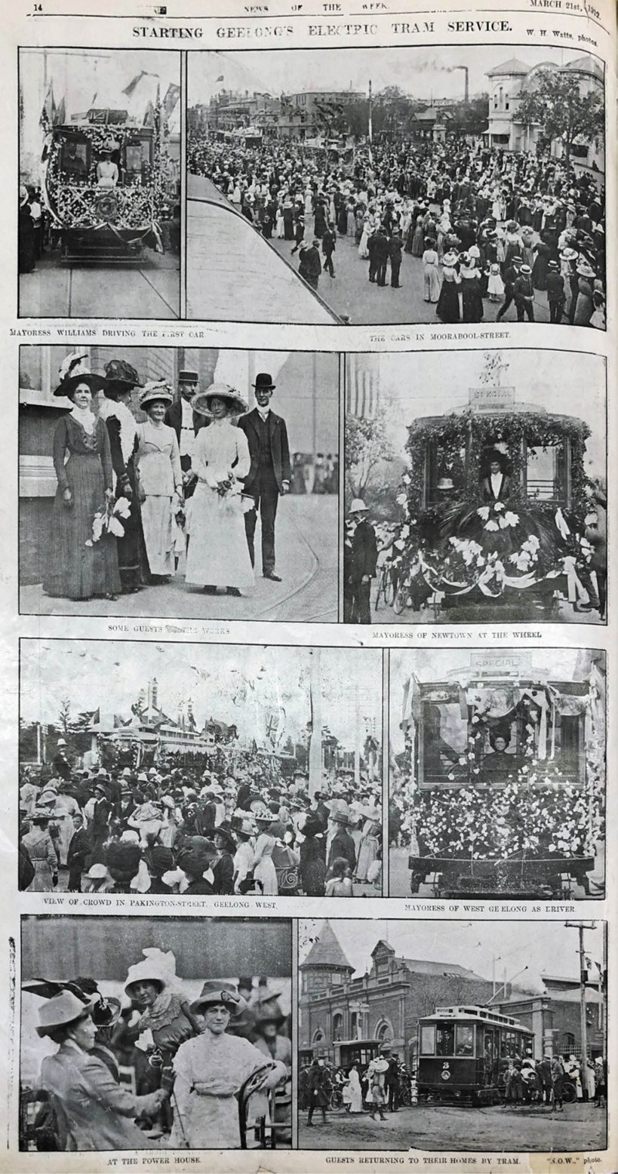

Figure 3.83: W.H. Watts, Selected scenes at the opening of the Geelong Tramway, 1912. Source: News of the
Week, 21 March
1912, GRS 2121/3,
Geelong Heritage Centre collection.

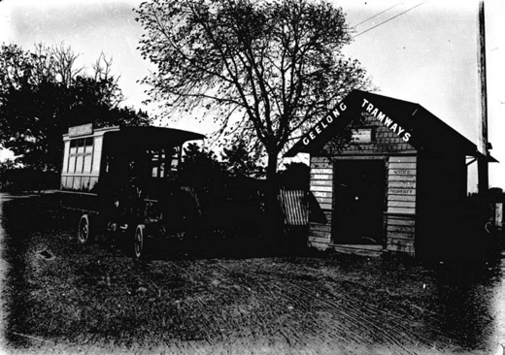
Figure 3.84: Geelong Tramways bus shelter, East Geelong, c.1920 Source: Item MM6840 Museums Victoria.

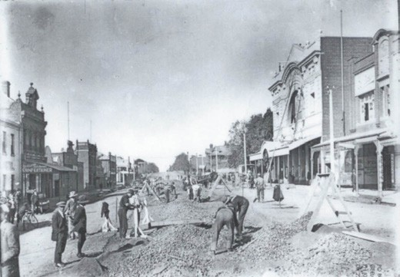
Figure 3.85: Ryrie St (between Moorabool & Yarra Streets), with tram line under construction, c.1922. Source: McDonald collection, Kevin Krastins, City of Greater Geelong.

existing rail network.738 In 1956, the tram network in Geelong was officially closed.739

MOTOR BUSES
The first motor bus manufactured in Victoria was at
the Vulcan Foundry of Humble and Sons in Little Malop Street in 1903 (Figure 3.86). As outlined in the
Geelong Advertiser:
The credit of manufacturing the first motor bus in these states belongs to Messrs. Humble and Sons, of the Vulcan Foundry, Geelong. Recently the firm named received
an order from the Albion Cycle Works, of Melbourne, for two of these buses for use in Tasmania, and the first bus was sent away from Geelong on Saturday. It is a highly finished vehicle of attractive appearance, and was favorably commented upon as it passed through
the streets on Saturday on its way by road to Melbourne.

The bus has been subjected to a thorough trial prior to leaving, and was found to be in first-class order and
well up to the standard of efficiency required for such a conveyance. The whole of the machinery and gearing worked smoothly and effectively from the outset, and the long run from Geelong to Melbourne was successfully negotiated, a telegram being received, by Messrs. Humble and Sons to the effect that the bus reached its destination in thorough order after a highly satisfactory run.
The proprietor of the Albion Cycle Works was a passenger by the bus on its trip to Melbourne, and expressed his pleasure and satisfaction at the satisfactory nature of
its maiden journey. The body of the bus is well made of seasoned timber with open sides to roll up when required, the interior being nicely upholstered and carpeted.
The top is railed round to carry half a ton of luggage, and the motive power is derived from a double cylinder engine worked by petrol, in connection with electric batteries.
Machine- cut steel gearing is used throughout, and heavy chains are employed connecting from the gearing to the rear wheels. The wheels are of the heavy artillery pattern with channel steel rims and solid rubber tyres, these latter ensuring the easy running of the vehicle. The bus is tastefully painted, lined and varnished, and altogether presents a striking appearance, and runs with an amount of freedom from friction and noise that reflects very much credit upon its producers. The carrying capacity is 16 passengers, besides the luggage already referred to. The second bus is now in course of construction at the Vulcan Foundry, and will be completed shortly after
the new year.740
It was another nine years before the first formalised motor bus service was introduced in Geelong with the commencement of the Melbourne Electric Supply Company s temporary bus service to East Geelong between 1912 and 1923 until the tram line was laid (see earlier subsection). A number of private bus companies were also established in Geelong and outer areas, providing a public transport service that complemented the Geelong tram service, and filling a market beyond the extent and capacity of the tram system.

WISE FAMILY BUS SERVICES
In the 1920s, John M. Wise, a conductor (and later driver) on the Geelong trams, established a bus business with a Model T Ford. He had the car fitted with a saloon body with rear access for the passengers.741 Initially Wise s service operated between the city and Geelong West but he later expanded
to include services from Minerva Road, Hamlyn Heights to the city; and from Geelong West to the large employers of the Ford Motor Company at North Geelong and International Harvester at North Shore.742 Wise s brother, Tom, also established a bus service in the early 1920s, taking on the

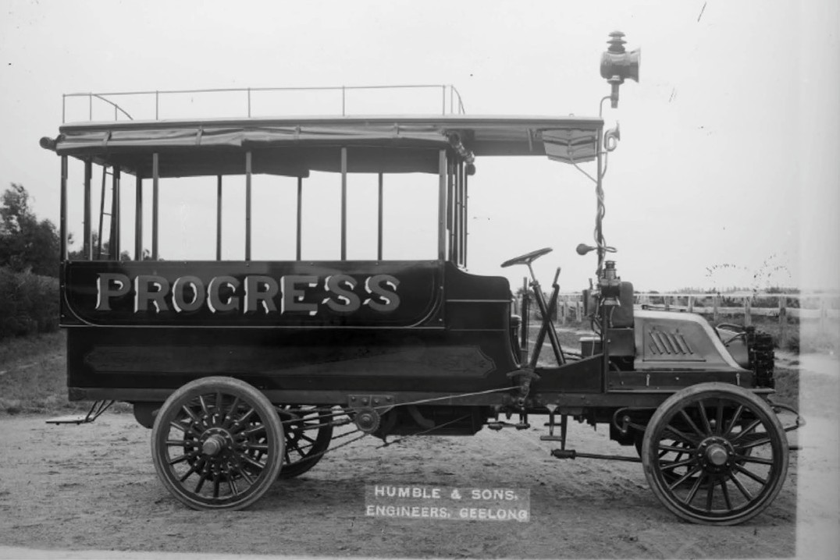
Figure 3.86: ‘Progress’ bus manufactured by Humble & Sons, Geelong, c.1903. Source: accession H99.10/70 State Library of Victoria.

route from Geelong West to the city.743 He later commenced a charter service for Ford Motor Company employees at North Geelong.744

BENDERS BUSWAYS 1926
In 1926, Ernest and Aimee (Bonnie) Bender obtained a Hackney Carriage license from the Geelong City Council to operate a bus service between Geelong and Chilwell.745 Ernest Bender (1888-1967) was born in Drouin and had been driver mechanic for the Divisional Supply Company
in the Australian Imperial Force in World War One.746 Aimee (Bonnie) Annie Gwendoline Pretoria Bender (nee Lyons) (1901-1967) was born at Mitcham, South Australia, the product of a relationship between Catherine Hogan and Goodman Lyons.747 She seems to have been raised by Thomas Davidson.748 Ernest and Aimee married in East Melbourne in 1923.749 They had one son, Norman Ernest Bender in 1924.750 In Geelong, their initial fleet was a Reo Speed wagon and a Willys Knight.751 In May 1930, the Geelong City Council approved a new motor bus route for Benders Busways, it being between Gheringhap Street (opposite City Hall) and Minerva Road, taking in Railway
Terrace, Gordon Avenue, Spring, Pakington, Gertrude, Coquette and Aberdeen Streets, Shannon Avenue and Upper Skene Street.752 In 1936, previous war injuries prevented Ernest from continuing to work and so Bonnie Bender continued on her own account.753 Making the most of Geelong’s industrial expansion, she doubled the bus fleet to four in 1937 with Ford buses made locally and by 1945 she had 14 Ford V8 buses operating from three routes to North Shore, Newtown and Chilwell from the company s base
at Newtown (adjoining the Bender residence).754 In 1945, recognising the need to cater for the postwar baby boom, and following the innovation of the Melbourne Tramways Board with its Northcote-Clifton Hill bus service for infants in 1941,755 Bonnie Bender value- added to the business with the introduction of a pram bus 756 (Figure 3.87). The vehicle had been modified with a widened front door and a swivel seat for the driver to allow for the manoeuvring of prams. The Special Pram Bus as it was called accommodated 15 prams and up to
seven pushers in addition to passengers. A hostess was also employed to assist with the prams and children.757 Further details were given in The Advocate:

Bender s Ford V-8 Bus Service has prepared a converted bus for the transport, to and from the city, of mothers with young children. The bus, which made its initial
run on Monday, takes aboard perambulators and their occupants, kindergarteners and other youngsters, and the juvenile passengers already are finding their new mode
of transport one of enjoyment and interest. The interior and exterior of the bus have been appropriately decorated with nursery motifs. The bus makes four trips daily to and from the Newtown terminus at the corner of Minerva-road and Aberdeen -street. The picture shows some of
the perambulators and babies being taken aboard.
The interior decoration of the bus shows highlights in the career of Snow White and the Seven Dwarfs.758
The pram bus service was expanded in 1947 with an additional service to Manifold Heights.759
In 1948, Norman Bender was made a full partner in the family business which acquired the passenger service of H.C. Thompson at this time, expanding its routes in the Newtown area.760 Further expansion continued in the postwar years and with the closure of the Geelong tram service in 1956 Benders Busways acquired the North, Chilwell and Newtown runs.761 Further services were added to meet the demand of the industrial workforce in Geelong s northern suburbs and a daily service was offered to Ballarat.762 In 1965, Benders Busways acquired Corio Bus Lines, which added the Belmont, Highton and Geelong West routes to the Benders service.763 In 1983, the Geelong Transit System was created
with the co-operation of the four operators and local councils, which included Benders Busways (the other major operators being McHarry’s I.J. Cook and Trans Otway).764 The business of I.J. Cook and Son was added to the Benders service in 1987.765 In 2000, Norman Bender died. After 75 years as a family business, Benders Busways was sold to the Kefford Corporation.766 A Hockey and Tennis Centre at the Geelong Grammar School s Corio campus was built and named in memory of Norman Bender (a former student and School Councillor) in 2001 through a generous benefaction of his widow, Helene Bender.767
In 2009 the Kefford Corporation that had acquired Benders Busways was sold to ComfortDelGro and Cabcharge (CDC) and the name of Benders Busways was rebranded to CDC Geelong.768

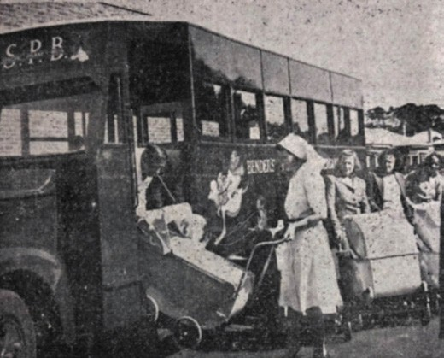
Figure 3.87: Benders Busways pram bus , 1945. Source: Geelong Advertiser, 22 November 1945, p.1, GRS 2050/226, Geelong Heritage Centre collection.
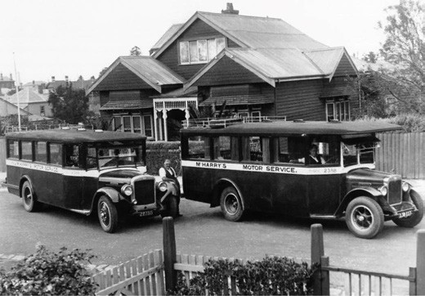
Figure 3.88: John McHarry (left) & Norman McHarry (right) outside the depot in Kooyong Road, Drumcondra, 1932. Source: Ashley McHarry, McHarry s Buslines Pty Ltd.

MCHARRY’S BUSLINES PTY LTD 1925769
Impetus for the establishment by McHarry s Buslines came in 1925 when John McHarry (1876-1940), master builder, was transporting his employees to building works at the Ford Motor Company at North Geelong and was inundated with requests from Ford employees for a ride to work. McHarry purchased an International bus from the Victorian Railways in 1927 and commenced his first service between Geelong and Highton. In 1933, John’s son Norman (1910-1975) commenced with the firm and he provided the service for Ford Motor Company employees (Figure 3.88). Norman s wife, Alice, became an active part of the business following their marriage in 1935. Just five years later in 1940, John McHarry was killed in an accident at the bus depot. The business was continued by Norman and Alice and in 1951
it amalgamated with the Green Star Passenger Service that operated to coastal areas. The name of the firm became Geelong Associated Buslines and at this time the East Geelong-Breakwater route service was acquired from the Kenny family. In 1953, the Geelong Associated Buslines – as one amalgamated operation – was dissolved and McHarry’s recommenced business as a single operation. The former Corio Buslines depot was purchased in Catherine Street, Geelong West, in 1965 and the surviving Geelong Associated Buslines operation was purchased, doubling the McHarry s fleet to 36 vehicles.
In 1975, following the untimely death of Norman McHarry, Alice McHarry was assisted by their children, John and Corinne. McHarry s formed part of the Geelong Transit System of bus operators in 1983 and a year later in 1984, McHarry s acquired the addition of the East Geelong service as well as the Geelong West route, requiring an additional 17 vehicles as part of the fleet. The Trans Otway bus terminal in Ryrie Street was leased and it was from there that the business operated. With 67 buses and 86 employees by 1988, a new depot was built at Breakwater. The fourth generation of McHarry family members entered the firm in the 1990s. The Bellarine Buslines and Advance Coaches company was acquired in 2000 and an additional 49 buses increased the fleet to a total of 125 vehicles, creating the largest bus company in Geelong. McHarry s Buslines
remains a family-owned and operated company to the present day with a fleet of 210 buses, employing over 300 staff.

TRANS OTWAY 1948
In 1948, Trans Otway Ltd was formed following the amalgamation of three existing operators: Ocean Road Passenger Services (under Eric Batson), Port Fairy Service Cars (under Allan Cobbledick) and the transport service of Keith Quick.770 These operators had provided passenger and freight services between Melbourne, Geelong, Lorne,

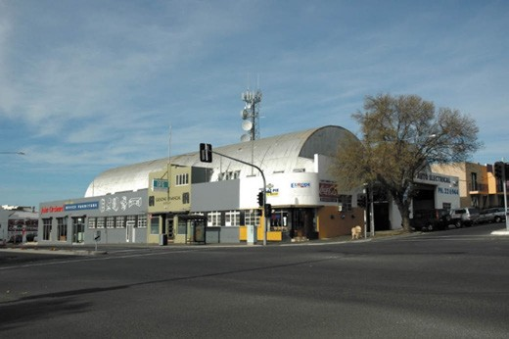
Figure 3.89: Trans Otway building, 34-66 Ryrie Street, 2005 (now demolished). Source: Wendy Jacobs.

Apollo Bay, Warrnambool and Port Fairy.771 Confidence in establishing the Geelong-based Trans Otway firm came from the impending closure of the Geelong tram service. Initially, an office was established at 32 Gheringhap street, Geelong and the fleet comprised 19 passenger vehicles.772 Allan Deacon was the first managing director.773
In 1949, with an expanding fleet, Trans Otway had a depot constructed at the south-east corner of Ryrie and Fenwick Streets (Figure 3.89). The site had been acquired by the Ocean Road Passenger Services Pty Ltd during the period of company amalgamations to form Trans Otway Ltd.774 The firm engaged the Geelong architect, J. Gordon Williams
to design the new terminus. Costing £35,000,775 three steel prefabricated military huts formed the basis of the
construction. Sourced from Milne Bay, Papua New Guinea, they had previously accommodated American soldiers during World War Two. The design prototype was a larger
variation of the Quonset hut known as a Warehouse, Elephant or SAAR hut.776 Quonset huts developed in the 1940s by George A. Fuller and Co. in the U.S.A.777 A shortage of materials after the work is likely to have led to the recycling
of these structures (and an uncommon example in Australia of repurposed army huts used for a commercial purpose).778 In Geelong, the roof structure of the Trans Otway terminal was set on concrete pillars. A loading platform was provided, while the building also accommodated bedrooms and
shower rooms for drivers who bring buses in late at night , a comfortable rest lounge for passengers as well as a caf and bookstall.779 The terminal was proposed to provide accommodation for 500 passengers an hour and handle up
to 1500 passengers and 20 buses a day.780 The new terminal was opened on 12 October 1950 and was claimed to be the largest and most up-to-date in Australia.781 In 1953, the local architectural firm of Buchan, Laird and Buchan designed additions to the terminal.782

Business increased for Trans Otway Ltd following the purchase of Tom Wise s bus service,783 Geelong West, and the closure of the Geelong tram service in 1956. The firm took up the franchise for the East, Eastern Park and Geelong West routes.784 In 1969, Trans Otway offered tour services for school and other groups to major venues in Victoria and interstate.785 The year 1983 brought about major change
to Trans Otway. The East Geelong, Geelong West, Corio Village and North Shore bus routes were sold to McHarry s Buslines, with the charter and tour services and travel agency interests were acquired by Lenmera Pty Ltd (a group of local businessmen) and the head office and terminal in Ryrie Street to a consortium. The terminal continued as the headquarters for Lenmera and McHarry s Bus Lines.786 In 1984, Trans Otway became one of the four major operators of the Geelong Transit System. A year later in 1984 the Trans Otway name was acquired by Lenmera Pty Ltd and the business continued to trade under this name.787 The terminal was used by McHarry’s until it relocated to its new office and depot in Breakwater in 1988. The terminal has subsequently been used as a furniture outlet. The only surviving bus terminal in 2018 original to a local Geelong bus company, the building was demolished in 2019 to make way for a commercial and apartment development.

CORIO BUSLINES
In 1950, the Chisholm family purchased J.M. Wise’s Geelong West bus service. The business was named Corio Bus Lines.788 Following the close of the tram service in 1956, Corio Bus Lines took up the Belmont route franchise.789
The firm soon expanded to include Highton, Corio and also a service to Barwon Heads. The depot was situated in
Catherine Street, Geelong West. The business was acquired by Benders Busways in 1965.790

I.J. COOK AND SON
In 1917, Ivan James Cook purchased a motor bus to continue a service between Geelong and Herne Hill first established by his father, John, with a horse drag in the early 1900s.791
In 1957, the business acquired the Eastern Park service from Trans Otway.792 The business was formalised as a company under the name of I.J. Cook and Son in 1963, 10 years after Ivan Cook s son, Ross, became manager in 1953.793 Following Ross death in 1975 his widow, Noele
took over control of the business with assistance from her son, Jonathon. In 1987, the company was sold to Benders Busways.794

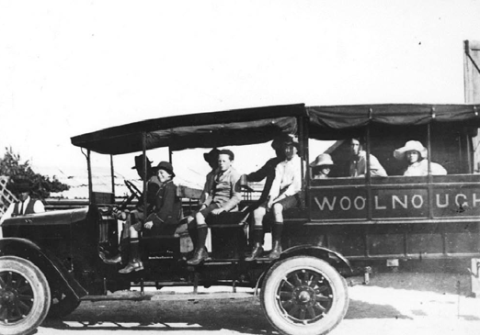
Figure 3.90: Woolnough’s first bus with drag body fitted, Portarlington, c.1921. Source: Image 1891, Bellarine Historical Society.

DISTRICT AND OTHER BUS SERVICES
One of the earliest district bus services in Greater Geelong was operated by George Woolnough (1883-1971) of Portarlington. In 1904, he took over the Cobb and Co.
Portarlington to Geelong service his father, Stephen, established in 1900.795 The original Concord coach was replaced with a four-horse drag and over time the fleet expanded to three drags, three wagonettes and six buggies (the latter largely used to deliver the mail to St. Leonards and Indented Head).796 In May 1921, Woolnough announced to the public that he would being an up-to-date Motor Service between Portarlington and Geelong in place of Coach and he kindly requested a share of the public patronage. 797 Woolnough s Model T Ford (Figure 3.90) was just the beginning of his motorised passenger vehicle fleet. With his
son Arch (who had joined the business as a driver in 1927), by 1953 the fleet totalled 10 buses.798 Arch Woolnough continued the business after his father s death until 1980 when it was sold to John and Brenda Masterton. It was named the Bellarine Bus Lines.799
Throughout the early 20th century, a number of bus operators provided passenger services to areas beyond suburban Geelong. In the 1920s, these businesses included the Geelong and District Motor Transport Service (Queenscliff service), F.J. Menzies (Ocean Grove to Geelong service), and John Hazel (Geelong to Barwon Heads service).800 There was also a larger number of firms which operated a Geelong to Melbourne service. They included Hudson and Preston, All Red Motor Carrying Company, and Pickett s Motor Service.801
The large number of bus operators providing multiple services to Melbourne was due to the upgrades to the Geelong to Melbourne Road in the 1920s, having been declared a public highway (Princes Highway) in 1921

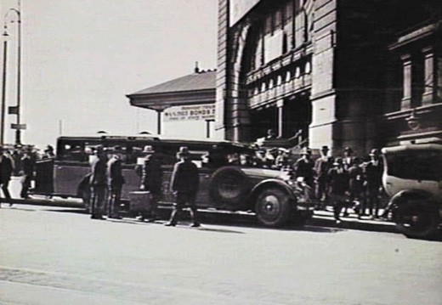

Figure 3.91: First Victorian Railways Geelong Bus, 30 November 1925. Source: accession H1077 State Library of Victoria.

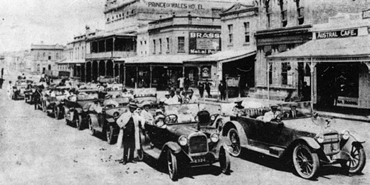
Figure 3.92: Geelong Branch of the Road Users Association dubbed The Geelong Motor Drivers Own Picnic of 18 Cars to Torquay , 1919. Source: News of the Week, 20 February 1919, GRS 2121, Geelong Heritage Centre collection.

(see earlier subsection). It was also a result of insufficient trains between Melbourne and Geelong.802 The proliferation of private bus operators subsequently resulted in a financial deficit for the Victorian Railways in 1924.803 In order to compete with the private bus companies, the Victorian Railways Department established its own Geelong to Melbourne bus service in 1925804 (Figure 3.91). The Werribee Shire Banner gave a report
on the impending service:
Commencing next Monday, 30th November, the railways will operate a road service between Melbourne and Geelong by a luxurious motor limousine, capable of carrying 28 passengers, with accommodation for luggage.
The fare will be 5/ each way, and arrangements have been made for two trips each way every day, including Sundays. Booking at Melbourne may be done seven days in advance, either at the Tourist Bureau or at the Flinders Street Station booking office, and on the day of
travel at the car. At the Geelong end the advance booking arrangement will be conducted at the Savoia Caf ,

Moorabool Street, and on the day of travel at the bus.
The car will leave Flinders Street, near the Swanston Street entrance to Flinders Street station. The corresponding point in Geelong will be outside the Savoia Caf , in Moorabool Street. The departure time from Melbourne on week days and Saturday at 9.50 a.m. and
1.45 p.m. for Geelong, and on return will leave Geelong at
11.30 p.m. [sic.] and 4 p.m. Passengers will be landed in Melbourne in time for luncheon and dinner respectively. On Sundays the bus will leave the stand in Flinders Street at 10.40 a.m. and 3.30 p.m., and on the return journey will depart from Geelong at 1 p.m. and 7 p.m. 805
While the service offered by the Victorian Railways provided much promise with its luxurious vehicles and convenient departures, it was not to endure as operations ceased in June 1931.806

MOTOR CAR CLUBS & ASSOCIATED ORGANISATIONS
The growing popularity and ownership of the motor vehicle in the early 20th century led to the formation of motor car clubs for enthusiasts and commercial businesses. They included the following.

ROAD USERS’ ASSOCIATION OF VICTORIA (GEELONG BRANCH)
In 1917, a Geelong branch of the Road Users Association was formed. One of its aims was to lobby for the improvement
of Geelong s roads. The inaugural President was H.F. Richardson and the honorary secretary was E.E. Hendy.807 In September 1917, he advertised for a Lady Canvasser to
obtain new members at 5/- per annum and applications from suitable your ladies were invited.808 Social activities were also part of the Association, including a picnic to Torquay of 18 cars in 1919 (Figure 3.92).

ROYAL AUTOMOBILE CLUB OF VICTORIA (RACV) (GEELONG BRANCH)
In 1921, a meeting was held at the Exchange Building, Little Malop Street, to form a Geelong branch of the Royal Automobile Club of Victoria.809 A local branch was subsequently established, the benefits for membership being the provision of direction boards and danger signs on Victoria s roads erected at the expense of the RACV, and legal defence in any individual or criminal court of members of the club free of charge. 810 More particularly,
the club offered members opportunities to contribute to the community in the provision of car trials for fundraising causes (the first being a motor run from Geelong to Queenscliff in
aid of the Blind Appeal) and voluntary passenger services for community and charitable organisations. The inaugural

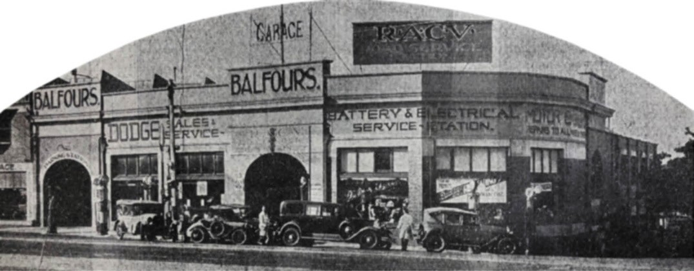
Figure 3.93: Balfours Motors Garage, Geelong headquarters of the R.A.C.V., 1932. Source: Geelong Advertiser, 20 April 1932, p.39, GRS 2050/179, Geelong Heritage Centre collection.

committee comprised Mayor Howard Hitchcock (president), Dr Grimwade and Messrs. J.G. Laidlaw and H.J. Storrer (vice presidents), P.J. Baxter (secretary) and Messrs. Basil Collins,
G.G. Jobbins, J.P. McCabe Doyle, M. Jacobs, A.J. Holden,
D.F. Griffins, George McFarline and Dr. Chapman.811
In 1932, the Geelong headquarters of the RACV was relocated to the motor garage of Balfours Motors Pty Ltd. (Figure 3.93). The new headquarters – and the services offered by Balfours Motors – featured in the Geelong Advertiser in April 1932. The feature article included
the following:
Recently Balfours Motors Pty. Ltd. took over the headquarters of the Geelong branch of the of the Royal Automobile Club of Victoria, and again alterations had to be carried out on the premises. A pleasant sitting room, with a writing room and waiting room attached, was built for the benefit of members of the Association, and these rooms are always available.
The Royal Automobile Association of Victoria has carried out wonderful work in the past in the interests of motorists, and it has been pleasing that motorists in Geelong have realised how much they owe the Association. This has been proved by the large number of members of the association who reside in Geelong and district. Apart from the many benefits that are available to members,
the fact that the Association is always striving to protect the motorist is something that should weigh strongly with those motorists who have not joined up. The R.A.C.V. roadside service station is also established at the garage, and from this centre the district patrol officer operates.
As Geelong is recognised as the hub for the seaside traffic, and thousands of motorists pass through the city at holiday time en route to the various seaside resorts scattered along the bayside and along the southern coast of Victoria, the services of the patrol officer are greatly availed of.
To encourage country motorists to join the Association there is a reduced membership fee available for those living outside a certain radius of Melbourne. All particulars of membership and free service for members can be obtained from Balfours Motors.
One of the advantages of membership of the Royal Automobile Club of Victoria is the privilege of using the club s headquarters and spacious rooms in Melbourne.
When touring in other States it is an advantage to be a member of the Victorian body as many benefits are available.812

COMMERCIAL MOTOR USERS’ ASSOCIATION (GEELONG BRANCH)
In 1928 a Geelong branch of the Commercial Motor Users Association was established as a reaction to the Victorian Government s Motor Ominbus Act and the Highway and Vehicle Act amending Bill which gave more stringent regulation to private commercial vehicle businesses that was considered (by commercial motor users) to favour railway transportation.813 The Motor Ominbus Act was to provide for legislation to meet the contemporary commercial motor user businesses (the first Ominbus Act had been passed in 1924). At issue to local commercial operators were the fees. Each motor vehicle was required to pay the annual registration under the Motor Act Car 1928 as well as an additional fee
for a motor omnibus for which a regular services licence was granted. The fee depended on the type of tyres used.814 In Geelong, the first committee of the Commercial Motor Users’ Association comprised J.R. Henderson (president),
F.W. Webb (secretary) and members M.A. Kaye, M. Evans,
J.M. Wise, Kenny, and Bender.815 The Association folded in subsequent years and in 1937 there was a proposal for form a new Motor Users Association.816

OTHER CLUBS AND ORGANISATIONS OF THE 20TH CENTURY
Several enthusiast and interest groups relating to motor vehicles were formed in the 20th century. They included the MG Club Geelong, Geelong Classic Car Club, Western District Historic Vehicle Club and the Geelong Museum of Motoring (see Theme 9).817

RAILWAY NETWORK IN GREATER GEELONG
Soon after European settlement, the provision of a railway network within and beyond the Greater Geelong area was considered essential; for providing greater opportunities for trade and commerce; and ultimately for the survival of Geelong, given the challenging river crossings and poor roads to Melbourne and the Western District. The earliest proposed line was in April 1846 when a private company proposed a 200-mile horse-drawn tramway from Geelong to
the junction of the Wannon and Glenelg Rivers in the Western District, the line to be known as the Geelong and Glenelg Railway.818 The venture failed. Success came in the 1850s with the construction of two principal train lines: Geelong to Melbourne in 1857 (and later extended to Winchelsea in 1876 and eventually beyond to Warrnambool), and the Geelong to Ballarat in 1862. A number of branch lines were also key to the development of other areas and activities. The earliest was the Cunningham Pier line that was built from 1854 in conjunction with the Geelong to Melbourne line. It was followed by the branch line to the first Geelong Race Course at Marshall (now Charlemont) in 1878 and the Geelong
to Queenscliff line that opened in 1879. Lines were also proposed to Torquay in 1888 and Barwon Heads in 1889 (as an extension of the race course line).819
Major infrastructure works were carried out which included the building of culverts, bridges, a tunnel, subways, stations and signal boxes. The provision of the railway network
also led to the employment of station masters and others to manage the rail system.
THE MAJOR RAILWAY LINES

GEELONG TO MELBOURNE LINE

GEELONG AND MELBOURNE RAILWAY COMPANY & THE OPENING OF THE
RAILWAY LINE
In September 1852, the prospectus of the proposed Geelong and Melbourne Railway Company was issued. There was
to be £350,000 of capital in 17,00 shares of £2 each.820 The provisional committee consisted of John Henry Mercer, James Ford Strachan, Alexander Thomson, John Sleath Hill, George Thomas Lloyd, William Harding, Edward Willis, T. Maher Sparks, Charles Nantes, Silas Harding, Charles Nuttall Thorne, Patricius William Welch and James Harrison.821
In February 1853, the Geelong and Melbourne Railway Company was incorporated.822
In October 1852, the engineer, Edward Snell (1820-1880),

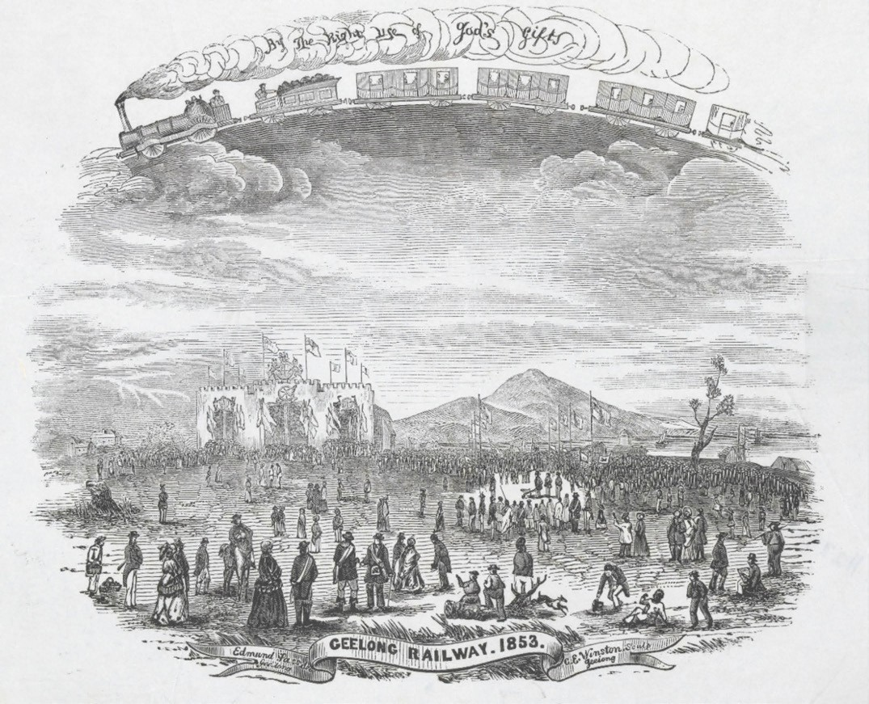
Figure 3.94: E. Sasse (artist) & C.E. Winston (engraver), ‘Geelong Railway 1853’. Source: accession H23920 State Library of Victoria.

accepted the contract to provide the whole of the civil engineer s work required for the Geelong to Melbourne line. He was later publicly described as the engineer and
architect for the Geelong and Melbourne Railway Company.823 Snell was born in Barnstaple, Devon, England, the son
of silversmith, jeweller, watch and clockmaker, Edward Snell, and Elizabeth (nee Stothert) Snell.824 He was later apprenticed to Stothert s iron foundry in Bath that had been established by his great uncle, George Stothert.825 He played an important role in encouraging and helping Snell in his engineering career.826 At the foundry, Snell worked under his other cousin, Henry Stothert.827 After the completion of his indenture in 1842, Snell took up a position at the Avonside Ironworks in Bristol (the business of his uncle, George), and after only three weeks he left and joined the Swindon workshops of the Great Western
Railway Company in 1843, following an introduction from George Stothert who used his influence with the Locomotive superintendent, Daniel Gooch.828 Snell took up the position of head draughtsman and was later promoted to deputy works manager.829 The Great Western Railway had been established in 1833 and engineered by the eminent, Isambard Kingdom Brunel. This railway linked London with the south- west and west of England, including Snell s birthplace of Devon.830 Immediately prior to Snell s emigration to South Australia on the Bolton in 1849, he was briefly manager of
the Devonport Foundry.831 He arrived in South Australia with his friend, Edward Prowse in December 1849.832 After a time of surveying and painting (including a Plan for the Grand Junction Canal between Adelaide and the North Arm in 1851), Snell was lured to the Castlemaine gold diggings in 1852 where he amassed £341 worth of gold in just five months.833

It was as an architect and engineer in Geelong where
Snell amassed a greater fortune in private practice (including partnerships with Frederick Kawerau– see Theme 2), in addition to other business ventures. In 1858, Snell returned to England with his wife, Charlotte (nee Bayley) (whom he married in Geelong in 1853) and their children and enjoyed a life of retirement.834
By November 1852, Snell had completed the survey for the Geelong to Melbourne railway line.835 On 20 September 1853, in the presence of the Governor of Victoria, Charles La Trobe, Mayors and Councillors of the Corporations of Geelong and Melbourne, Members of Parliament, Directors and Shareholders of the Geelong and Melbourne Railway
Company, Chambers of Commerce, Officers of the Army and Navy, Bishops and Clergy, Snell and Kawerau, and other distinguished guests, the foundation stone was laid for the station building and the turning of the first sod at Geelong.836 The celebrations also included an inauguration fete and a banquet held at Hooper s Royal Mail and Family Hotel, Yarra Street.837 The significant event was illustrated by the artist, Edmund Sasse (Figure 3.94).
Prior to the foundation stone celebration in 1853, the building of the railway line had begun in earnest. Tenders had been called for the beginning of works at the Geelong end of the line, including the timber for cutting and splitting 75,678 railway sleepers.838 This contract was let to the Apollo Bay Timber Company who was also successful in obtaining the contracts for the timber piles for the railway pier on the Corio Bay foreshore (see later subtheme) and road bridges over the railway crossings at Mercer Street and the Bates Ford Church (later replaced with the Telegraph Bridge at the east end of Church Street).839 By 1854, other contracts either completed or in progress included the construction of Good s Office (awarded to Cakebread) and workshops (including the
terminus, awarded to Gray) at the Geelong terminus; formation of the mainline between the terminus at the Ocean Child Hotel at North Geelong (by Russell and Hobson); construction
of a culvert (subway) at the west end of Brougham Street; construction of a small stone culvert near Fisherman s Gully (North Geelong) (awarded to Russell and Hobson – it was completed by Adam Brown in 1860 and the associated timber bridge was built by G. Walker), and formation and cutting of an embankment at Cowie s Creek (by Musson and Cutter).840 Within the central Geelong township, a stone culvert was
constructed by Munro and Ross to connect a branch line to the Railway Company s pier on the foreshore.841 G. Walker was awarded the contract to build the bridge over the incline to the Company s Pier, in Mercer-street. 842
Snell s foresight in the design process of the original terminus (a consequence of his British railway experience) brought with it necessary economies. As he outlined:

The carriage shed has been converted into workshops, forges have been erected, and the building will now be made available for this purpose until the line is opened, when it will be appropriated to the uses for which it was originally intended.843
Extraordinary progress had also been made in procuring other infrastructure for the line in 1853. Snell had appointed his cousin (and former employer), Henry Stothert of the Avonside Iron works, Bristol, as Agent in England on his behalf to examine everything ordered which included two thousand 18-foot lengths of foot rail, 300 tons of Barlow s patent rails, 500 tons of Smith s patent arched rails, two passenger engines, sundry first, second and third class carriages, tilt and box wagons for goods, stone truck, parcel vans and platform roofs for the terminus.844
Rapid progress in 1853 and the early part of 1854 was thwarted by a slowdown in Geelong at this time, a lack of funds and shortage of labour due to many workmen going to the goldfields.845 To overcome the labour shortage, the Victorian Government hired 100 prisoners to the Geelong and Melbourne Railway Company at £5/- each day.846 The prisoners were accommodated in a penal hulk brought from Williamston and moored in Corio Bay.847 In early 1855, Snell despaired about the railway being met with a great deal of opposition from some of the Townspeople who thought it would ruin Geelong. 848 Yet, work continued throughout these quiet times. A steam locomotive was built locally by Walker, Munro and Company and was named Ariel , with two steam engines (for the locomotives named Typhoon and “Sirocco”) being acquired from Snell’s cousin’s firm,
Stothert, Slaughter and Co. of Bristol.849 Another six were ordered from R. and W. Hawthorne of Newcastle-upon-Tyne, and another two from Robert Stephenson locomotive, these latter locomotives being named Titania (no. 34 train) and Oberon (no. 36 train).850 Titania was the Geelong and Melbourne Railway Company’s first yard shunter.851
Major railway bridges were constructed over the key river crossings at Little River and Werribee. Built between 1856 and 1857, they had also been designed by Snell.
The Geelong Advertiser and Intelligencer gave a detailed description of the proposed structures:
In the engineer’s office we noticed a wooden model of a bridge (also to be constructed of wood),and which is to connect the two banks of the Little River where the railway crosses it. at a distance of 15 miles from Geelong. The model is a beautiful piece of workmanship, on the scale of an inch to the foot, prepared by Mr E. Snell, the engineer to the company. The bridge will be 80 feet in span and
25 feet in width between the inside of the parapets, giving space for a double line of rails. The contract for

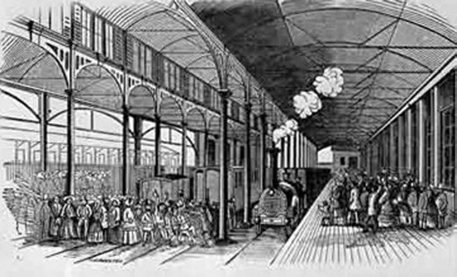
Figure 3.95: E. Snell (artist) & C.E. Winston (engraver), ‘Opening of the Geelong and Melbourne Railway for Public Traffic, June 25th 1857’. Source: VPRS 12903/P1, Box 523-15 Public Record Office Victoria.

its erection has been taken by Messrs Craigg and Dale, who have been the contractors for many of the buildings attached to the terminus. The small model of the bridge has borne a weight which would show the bridge itself to be capable of bearing 1300 tons, according to the scale; but as the bridge when erected will be much more substantially fixed and supported than this little model, it
is calculated that it will bear at least ten times that weight in reality. Some estimate of its strength may be arrived at by bearing in mind coincidently with the above calculation, that the weight of a line of engines placed all along the bridge would be only 160 tons. There is in the same room a model of the Duck Ponds bridge. and drawings of two other bridges,- one to be erected where the railway passes over the Exe or Werribee River, twenty-five miles from Geelong. (This bridge is of a construction similar to the one above referred to, and has 100 feet span), the other
is to cross Cowie s Creek. This last mentioned bridge is also of wood; the frame has the appearance of lattice work, but it is said to be very substantial.852
Amid great excitement, the Geelong to Melbourne Railway line was officially opened on 25 June 1857 in the presence of the Governor, Sir Henry Barkly.853 It was a significant event as it constituted the opening of the first country railway in Victoria.854 A temporary stage had been erected with timber flooring over the four railway lines between the arrival and departure platforms855 (Figure 3.95). The new luggage room was the location of a banquet, a highlight of the day following the running of two trains from Geelong to Greenwich (Williamstown) and return (for this was as far as the train
line originally extended given that the Government had not completed the final stretch to Melbourne).856
The Wadawurrung people were invited guests at the opening ceremony and banquet. The four Aborigines that attended were supplied with new blankets, and performed a

corroboree.857 Indigenous culture formed part of a celebratory display in the banquet room as detailed as
part of a report on the festivities:
The room in which the banquet was held was the luggage-room at the railway station a very extensive building, exact proportions of which, how-ever, we regret to acknowledge our inability to procure and
a most suitable room for the occasion. The pillars and cross-beams were decorated with numerous flags and streamers, and the Royal Standard of England hung on the wall immediately behind the chairman. The walls were also tastefully panelled for the occasion with pink and white cloth, and green boughs and various devices, composed of native flowers and evergreens, were placed at intervals. To give a martial air to the whole, at one
end of the room there were two or three stars formed of bayonets and swords of the Volunteer Corps of Geelong, and at the other end several native war and hunting implements, mingled with others from the South Sea Islands, were formed into other devices. The words (in the language of the Aborigines) Ghego magi uri uri, with their translation Go along, quick, quick, were displayed in large letters at each end of the room, and in still larger letters over the entrance, the words Lead on, surrounded by an olive wreath. The military band was
stationed in a commodious orchestra, and played several appropriate and favorite airs during the repast. A dais was raised about the centre of the room, on the left hand, for the accommodation of the chairman and some of the most distinguished guests. Charles M. Thorne, Esq., President of the Company, occupied the chair. He was supported
on the right by his Excellency the Governor and the Hon. the Chief Secretary; and on the left by Dr Thomson,
(the Mayor of Geelong), and the Rev. Dr Perry. Several members of both Houses of Parliament were present at different stages of the proceedings. Our own reporter having reached the banqueting hall just in time to be too late, the following report of the speeches delivered on the occasion we extract from the Geelong Advertiser. Taking the report as a whole it is correct, though from what we did hear, there are several portions that we entirely dissent from, both as regards statements of facts and in respect
of language. After the usual loyal and patriotic toasts had been proposed and responded to. Just after the toast
of the Queen, Prince Albert, and the Royal Family had been duly honored, the chair-man rose and informed the guests that another train had that moment arrived from Williamstown with four hundred and fifty additional visitors from Melbourne. He said he feared from the already crowded condition of the hall that there would not be room for these guests. Room, however, he suggested, might be made if those gentlemen present who were shareholders

would vacate their seats in favor of the Melbourne guests. This request on the part of the chairman was immediately complied with, and the visitors from Melbourne were speedily seated and served.858
The late arrival of the second train was the result of the accidental death of Henry Walters, superintendent of locomotives who drove the first train carrying the Governor.
A description of the fatality was given in The Age:
The first train started at half-past ten, taking these persons and a large number of others, to the number of six hundred, to Greenwich [Newport] Station, his Excellency and suit occupying the first carriage. The train proceeded at an easy rate till it neared Cowie s Creek, when Mr Henry Walters, superintendent of locomotives for the company, was standing on the engine looking after something connected with the carriages, and not observing his vicinity to the wooden bridge under which the line passes, he unfortunately, in an unguarded moment, came into contact with one of the beams. He was struck on the head and stunned, and in falling his head again struck against the iron steps of the first carriage, and the corner of the post. The train was at once stopped, and the unfortunate man picked up quite insensible. Medical assistance
was immediately in attendance, but the poor fellow had received such severe injuries in the head and spine that no hope was entertained of his recovery. He was taken to town with the greatest care, but he died in the course of the afternoon. This sad accident cast gloom over the minds of all who heard of it. The train proceeded on
its journey, stopping only at the Exe [Werribee] River, while his Excellency inspected the bridge. On arriving at Greenwich, as before mentioned, it stopped for about
three quarters of an hour and then returned to Geelong.859

VICTORIAN RAILWAYS COMMISSIONERS & CHANGES TO LOCAL RAILWAY INFRASTRUCTURE
A number of changes and improvements were made to the Geelong to Melbourne Railway line over the following years. A notable change came 1861 when the Victorian Government acquired the Geelong and Melbourne Company at a cost of
£529,663/9/-.860 Responsibility for the railway network was given to the Victorian Government Railway Department as part of the Board of Land and Works.861 The Government had paid for the railway network.

SIGNAL BOXES
In 1883, Victorian Railways Commissioners were appointed to make better provision for the construction, maintenance and management of the state railways. 862 Locally, one of the first projects undertaken was the erection of a gabled timber

signal box in 1884 (later known as Signal Box C) near the Geelong Station. The signal box made provision for 25 lever frame and controlled the southern end of the line beyond the station.863 Railway signals displayed instructions or warnings to the train driver. A second signal box was erected in 1903 (known as Signal Box B) and a third (Signal Box C).864 Other signal boxes were also built on the Geelong to Melbourne line including two at North Geelong (1879 and 1903) (Figure 3.96), Lara (1899) and Little River (1899) and Corio (1914).865

RAILWAY YARD EXTENSIONS AND LOCOMOTIVE DEPOT
In 1908, the Victorian Railway Commissioners proposed an extension of the railway yard to the west of the Geelong
Station terminus (in the location of the existing car park). The acquisition of the site required the demolition of buildings fronting Latrobe Terrace (Figure 3.97). There was also consideration given to the purchase of the St. Paul s Church site. As reported in the Geelong Advertiser:
Following on the visit of the [Railway] departmental engineers to Geelong some months ago, when levels were taken and other points noted, the department has entered into negotiations for the purchase of the strip of land to the west of the railway line, running from a point just below the Latrobe Terrace crossing to the Brougham Place subway. If this extra territory is acquired, it will largely increase the railway facilities, and should tend
to prevent the congestion of traffic that occurs pretty frequently under existing conditions. The purchase of the block by the department will mean the removal of the houses thereon, and, we understand, the department is prepared to consider an offer for the acquirement of the
whole of the grounds on which St. Paul s vicarage, school buildings and church now stands. If this be arranged, it will mean the re-erection of St. Paul s Church on another site, and already an elevated position, centrally situated, is mentioned. Portion of the church ground, at any rate, is required by the department, and there is a feeling that the whole site should be disposed of, as the running of trains to and fro would be likely to affect the church building in the course of time.866
St. Paul s Church site was spared from the demolisher s hammer as part the yard extensions and improvements. However, St. Paul s Vicarage and the dwellings fronting both sides of Latrobe Terrace were acquired and removed as part of the scheme.867 On the west side, this included private land between Wellington and Preston Streets. This was to allow the Railways Department in 1915 to construct an engine shed (for 36 engines), 70 feet turntable and an elevated coal staging area on newly-acquired land between the railway
line and Pakington Street868 (Figure 3.98). Opened in 1917,

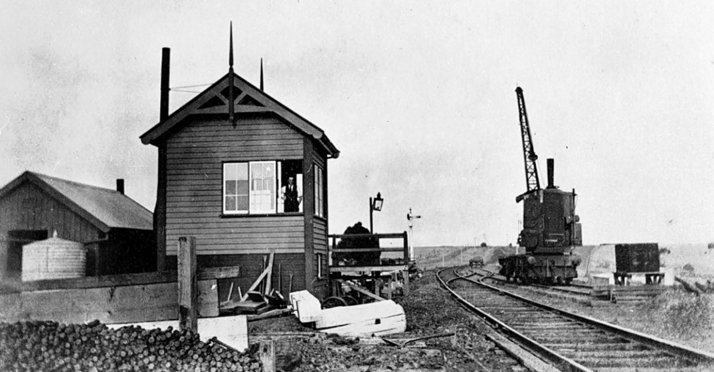
Figure 3.96: Signal box, North Geelong, c.1915. Source: Item MM7020 Museums Victoria.

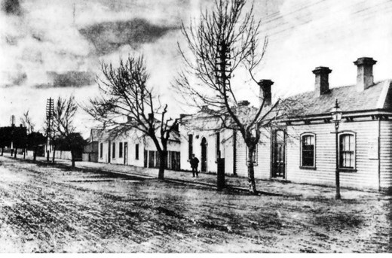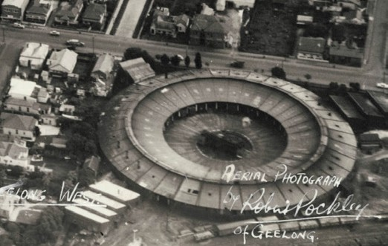

Figure 3.97: Buildings to be demolished in Latrobe Terrace for enlargement of railway yards, 1908. Source: News of the Week, 18 June 1908, GRS 2121, Geelong Heritage Centre.
Figure 3.98: R. Pockley, aerial view of Geelong West showing railway round house, c.1950-54. Source: accession H2007.25/23, State Library of Victoria.

the railway round house was unique to Victoria, the boiler working plant the first of its kind in the state and the coal stage was the largest outside Melbourne.869

RAILWAY TERRACE SUBWAY
Another key work as part of the Geelong Railway terminus improvements was the construction of a subway and railway bridge at Railway Terrace, south of the Geelong Railway Station. A level crossing had been established with the construction of the Geelong to Colac line in 1879 (see following subsection). Significant vehicular and pedestrian congestion at this crossing posed a public danger.870 In 1911, the Geelong City Council petitioned the Railways Commissioners for the construction of a subway and rail
bridge to alleviate the problem.871 Surveying and construction commenced in 1912 involving 95 workmen for the excavation of the subway (Figure 3.99) and building the brick retaining walls (of Melbourne bricks) and steel structure for the bridge.872 An opening in the centre of the structure was to admit the light and fresh air. 873 The subway (Figure 3.100) officially opened in December 1916.874 and it continues to operate to the present day.

INDUSTRIAL SIDINGS
With industrial expansion in Geelong s north came the need for rail connections. Sidings were subsequently connected to the Geelong to Melbourne railway network for the Western and Wimmera districts of Victoria Freezing Company in 1899, Harbor Trust at Corio Quay from 1909, Oriental Timber Company Mill at Corio Quay in 1909, Vacuum Oil Company at North Geelong in 1920, Phosphate works at North Shore in 1924, Ford Motor Company at North Geelong in 1925, Corio Distillery at Corio in 1928, International Harvester at North Shore in 1938, Shell Refinery at Corio in 1954 and Elders IXL at Lara in 1986.875
A siding was also established at Corio in 1912 for the transportation of building materials used in the construction of the Geelong Grammar School.876

LATER 20TH CENTURY IMPROVEMENTS
In 1953, diesel locomotives replaced the old steam engines.877 A commencement was made in duplicating the railway line in subsequent years, with the new duplicated line between North Geelong and Corio opened in 1959. The automated signalling for both-way trains was a first in Australia.878 In 1981 and 1982 the Corio to Little River line was duplicated.879

GEELONG TO BALLARAT LINE

EVOLUTION AND DEVELOPMENT
In 1855, the Victorian Royal Commission on Transport (which had been appointed by the Victorian Government in the previous year) gave recommendations on the required actions for removing any restrictions that would prevent the Government from building a railway network throughout

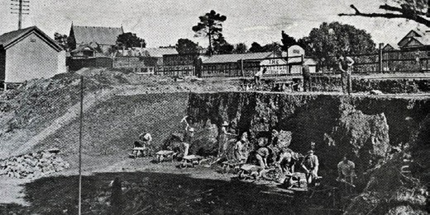
Figure 3.99: Subway under excavation, 1912. Source: News of the Week, 22 August 1912, GRS 2009/01404/029, Geelong Heritage Centre collection.
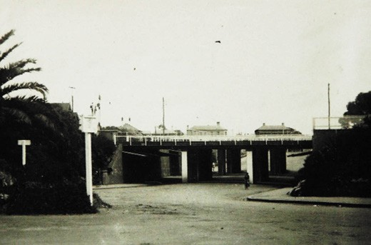
Figure 3.100: Subway, c.1930. Source: Holmes collection, Authentic Heritage Services.

the Colony.880 The Commission further recommended that surveys and cost estimates be prepared for railway lines from Melbourne to Bendigo; from Melbourne towards Sydney; and from Geelong to Ballarat.881
It was during 1856 when a separate Railway Committee recommended that the Government raise funds for the construction of the Geelong to Ballarat railway line, at the same time as the line between Melbourne and Echuca
(the Melbourne to Geelong line had already commenced as a private enterprise).882 Public pressure had increased for the commencement of the Geelong to Ballarat line. By 1857, Edward Snell had been engaged to survey the route for the line although he soon relinquished the project.883
On 26 August 1858, the Governor of Victoria, Sir Henry Barkly, turned the first turf for construction to begin.884 The contract for this mammoth task had been let to Evans, Merry and Co. Main depots were established at the Geelong
end at Moorabool, and at the Ballarat end at Warrenheip.
885 Over 3000 men were employed to construct the railway line886 which involved the laying down of 200,000 sleepers.887 Throughout the following years, progress was laborious and

slow, resulting from a number of strikes and the financial difficulties of the contractors, Evans and Merry, who transferred the responsibility for building the line to Williams, Little and Co.888 In April 1861, The Argus gave a detailed description of the disruptions to the work, together with the progress that had been made:
It is with regret that we now proceed to disillusionate our readers, and check the pleasant anticipations to which that announcement gave birth [opening of the railway line], for it is scarcely to be hoped that even this year will see trains running from the Geelong and Melbourne and Ballarat junction to the great centre of the industry of the western districts. Various causes have brought about this untoward conclusion, not the least of which is the fact that, through some mismanagement, the material expected from England is all behind. Miles and miles of line duly formed and levelled, surmounted by a straight and comely ridge of regularly-laid blue metal, beside which are great stacks of sleepers, await the rails, which have to arrive and be properly fixed before the way can be opened.
As our readers might have expected from our last description of the line from the junction at Geelong West to the Moorabool, that portion may be looked upon as completed, for both lines are permanently laid, and a settled aspect pervades the whole. The only station between the [Geelong West] junction and the Moorabool is to be erected at the Stieglitz-road crossing, which is about a mile from the Moorabool viaduct, on the Geelong side, and this will, of course, serve to connect this tolerably important agricultural district with the principal markets.
Proceeding at the present rate, the [Moorabool] viaduct will scarcely be finished this year, but that is a matter of small consequence, considering the condition of the line near the Ballarat terminus, and, moreover, Mr. Williams, the contractor by whom the railway works are being managed, has professed himself ready, for a consideration, to so add to the staging that the bridge would be completed in four months.889
On 10 April 1862, the railway line was officially opened by the Governor of Victoria, Sir Henry Barkly.890 A special train had carried Councillors and passengers from Ballarat in the morning. However, all did not go completely to plan, as the
train was delayed for half an hour at the Caledonian Bridge as it had difficulty climbing the steep gradient to Warrenheip.891 Firewood had been exhausted by the time it reached Meredith, which caused another delay.892 Eventually, the train arrived at Geelong 4.25 hours after leaving Ballarat, where the Governor boarded, the training returning to Ballarat by 2.45 pm.893 The day had been declared a public holiday in Ballarat and it was celebrated with a public dinner at the Ballarat

Mechanics Institute.894
It was not until 1903 when a loop line was laid out to connect the Melbourne and Ballarat lines at North Geelong.895

RAILWAY INFRASTRUCTURE IN THE CITY OF GREATER GEELONG
The design and construction of the Geelong to Ballarat railway line was tasked to George Christian Darbyshire, Railways Department Engineer-in-Chief, and his deputy, Robert Watson.896 Darbyshire was born at sea in 1820, the son of George Darbyshire senior, a civil engineer who worked for George Stephenson in Darby, England, and Elizabeth Darbyshire (nee Smith).897 George Darbyshire junior
appears to have trained as both a surveyor and engineer, first appearing to have been employed by his father’s firm of George Darbyshire and Son.898 He later entered into
a partnership with his brother, John, where in c.1839-41 they prepared a number of surveys for Tithe maps. As an engineer, Darbyshire gained experience under Robert
Stephenson on the Midland Railway, England.899 Darbyshire married Maria Wragg in 1846 and in 1853 they emigrated
to Victoria where Darbyshire was appointed Engineer of Construction and District Surveyor for the Victorian
Government at Williamstown.900 In 1857, he was appointed Deputy Surveyor General of Victoria. Between 1856 and 1860 he was Engineer-in-Chief of the Victorian Railways.901
Darbyshire was responsible for the designs of nine bluestone culverts and two bridges in 1857 in the Geelong section of the line to Moorabool.902 They were constructed by Evans,
Merry and Co. Partially completed by May 1859, a detailed description of the new infrastructure was given in the Geelong Advertiser:
With a rather rapid incline (which will be corrected when the rails are laid permanently) the Geelong and Ballarat line branches off to the North-west from the Geelong and Melbourne line of railway, at a point a little nearer town than the West Geelong Station. The new road curves away from the Melbourne line along a track sufficiently level naturally without any imported cuttings or embankments, and for a considerable distance flush
with the level of the land which it traverses Further on a heavy embankment

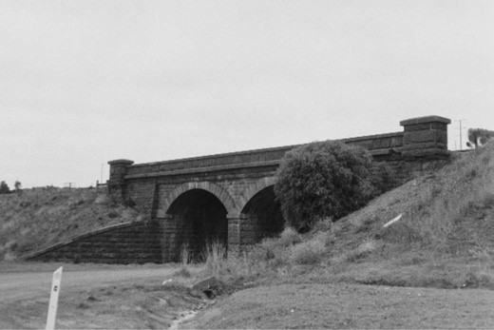
Figure 3.101: Railway bridge, Rollins Road, Bell Post Hill, 1998. Source: David Rowe.

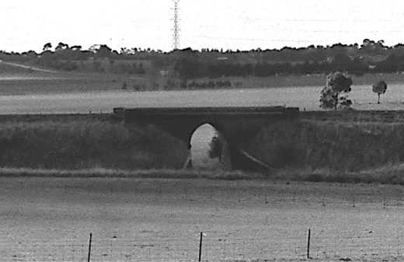
Figure 3.102: Railway bridge, Moorabool, 1998. Source: David Rowe.

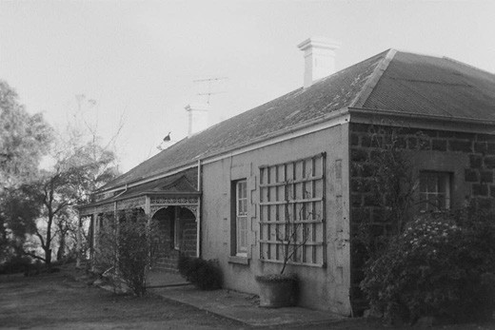
Figure 3.103: Craigton , original residence of Mr Duxbury, Moorabool, 1998. Source: David Rowe.

has been made across a portion of Cowie s Creek, and is drained by a bluestone culvert about seven feet in height and eight in width The Ballan road, near the old Fountain of Friendship (Warren s), is crossed by an embankment which is continued over another arm of the creek, drained by a culvert of the same dimensions as the first-mentioned. Another cutting, and then a steep
embankment with a bridge in the middle. The rails (single line) are laid along the whole of the distance traversed, but only with a pro tempore durability, to serve merely
the purpose of a tramway for the trucks of materials and ballast. The permanent line of rails will be laid alongside the present line, and will be heavily ballasted with broken blue stone. There have been several good quarries opened along the line. After passing the last-mentioned embankment, there is a very deep cutting, along which the rails are not continuously laid. With this exception and that of a short break in the embankment on the further side of the Cowie s Creek bridge, the rails are laid from West Geelong to the camp at the Moorabool 903
Today, the bluestone Cowies Creek culvert survives at Corio Quay (albeit altered with a new deck), as do the double- arched and single arched bridges respectively at Bell Post Hill (crossing Bluestone Bridge Road) (Figure 3.101) and Moorabool (crossing Cowies Creek)
(Figure 3.102).

MOORABOOL VIADUCT
The railway workers camp for the Geelong end of the line construction was situated at Moorabool, at the location of the construction of a viaduct to traverse the substantial Moorabool River valley. A community of 1,400-2,000 was employed on the construction of the viaduct and this section of the railway line.904 Hotels, a post office, a literary institute, a Protestant church, a National school, a temperance hall,
and a hospital were all established at the fledgling, temporary settlement.905 Of more permanent bluestone construction was the residence of Mr Duxbury (Figure 3.103), superintendent of works and a nearby lockup (see Theme 7).906
Work began on the construction of the viaduct in 1858 under the direction of Darbyshire.907 Nine monolithic bluestone piers and two bluestone abutments supported ten deck type warren iron trusses, the whole structure being 396 m long. Bluestone was procured from the Moorabool valley hillside, the Geelong Advertiser reporting in 1859 that the whole of the ground on the hill appears to be one vast quarry .908 This was supplemented by stone from Lethbridge. The immense scale of the construction was outlined in the Geelong Advertiser in 1860:
Unquestionably the greatest of our colonial engineering works which have as yet been taken in hand is the

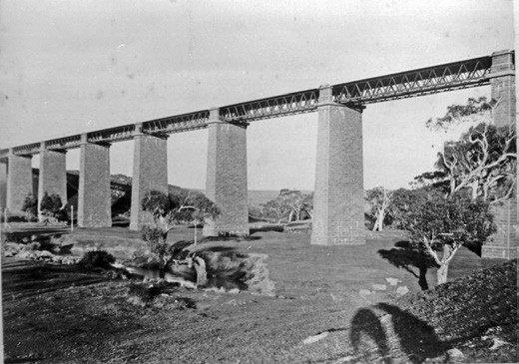
Figure 3.104: Moorabool Viaduct, c.1880s. Source: Wynd collection, Authentic Heritage Services.

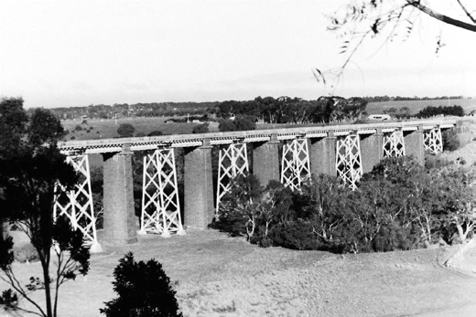
Figure 3.105: Moorabool Viaduct, 1998. Source: David Rowe.

construction of the Moorabool Viaduct. Everybody who has inspected this work must have been struck with admiration at the massive and finished manner in which the piers are being erected, every stone being perfectly dressed on the bed. There will be in all nine of these magnificent pieces of masonry, ascending 85 feet from the base course, each being at a distance of 130 feet from centre to centre, making with the abutments a length
of 1300 feet across the valley of the Moorabool. These piers, three of which are in a forward state of progress, are constructed upon a foundation of piles, filled in with concrete. The stonework rests on a platform on the top of the piles and is thence carried up to the level of the surface of the ground. The majority of these stones are at least 6 ft. long, 3 ft. wide by 2 ft. deep. Arriving at about 4
feet from the surface, the top course of stones is wreathed off and axed in the most workmanlike manner to form a base course. The dimensions of the plinth are 14 feet 3 inches by 32 feet 3 inches by 32 feet 3 inches diminished

to 10 feet by 28 feet. The height of the stonework from planning to plinth in piers No. `1 and No. 2, is 15 feet; Nos, 2, 4, 5, 67, the height is 20 feet; and in No. 8, 18 feet, 3 inches. The stone is supplied from the Lethbridge quarries, at the rate of 40 cubic yards per day, and there are already 1000 cubic yards of stone on the ground and ready to be set.909
Completed by July 1862, it was regarded as the greatest engineering feat in Australasia as the largest metal truss bridge in the Colonies910 (Figure 3.104).
In 1918, given concerns by W.C. Kernot, Professor of Engineering at the University of Melbourne in relation to the structural capacity of the viaduct and the weight of locomotives, A. Goudy, Engineer of the Victorian Railways, designed structural modifications and additions.911
They included the provision of open steel trussed pylons between the stone pier spans, and the replacemen
t of the iron girder spans with a steel superstructure912 (Figure 3.105). The steelwork was fabricated by
Dorman, Long and Co. Ltd.913 In 1983, a new concrete deck was installed.914

GEELONG TO COLAC LINE

EARLY EVOLUTION AND DEVELOPMENT
Known today as the Geelong to Warrnambool line, agitation for a railway connection from Geelong to the Western District had continued following the collapse of the initial venture
to construct a tram line from Geelong to the Wannon in the 1840s (see earlier subsection). At issue was the location of the line from the Geelong township given the steeply-sloping topography south of the Geelong Railway Station. One early proposal was a bayside route from a new terminal at the Geelong waterfront. This was to avoid the need for tunnelling. In 1866, the local Member of the Legislative Assembly, J.H. Connor forwarded a suggestion for the bayside route to the local Traders and Citizens Association which had it published in the Geelong Advertiser:
The vacant piece of ground between Yarra and Bellerine- streets, close to the wharf, would be a good site for
the new terminus; and taking that as the terminus, the line of railway might go across Bellerine-street on a level crossing close to the battery [see Theme 7] and along the base of the hill, winding round Limeburner s Point, between the beach and the powder magazine, across the flat at the cricket ground, and across the
Portarlington road on a level crossing from Geelong East to the Breakwater, via Germantown [Grovedale], Lake Modewarre, Winchelsea South, on the South side of
the River Barwon to Birregurra, thence along the South

boundary of Irrewarra to Colac. The line at the terminus to be connected with Railway Wharf, so as to give facilities for the shipping of wool and other produce.915
While the Select Committee on the Colac Railway in the Victorian Parliament advocated an alternative eastern route along Brougham Street in front of the Custom-house and south-east to Sydney Place and beyond to the Breakwater,916 this never eventuated. Instead, a southern connection was adopted involving the need for a tunnel under Ryrie and Myers Streets.
Simultaneous to the discussion of the best outlet for the line from Geelong, considerable debate had also ensued on the overall railway route to Colac. In 1870, Thomas Higinbotham, Engineer-in-Chief for the Victorian Railways Department, presented the Victorian Parliament with a Map of Victoria with proposed routes in different colours:
From Geelong, by way of Colac, Camperdown, &c., to Hamilton; this is commonly known as the Black line.
From Ballarat, by Beaufort and Ararat, to Hamilton; this is commonly known as the Pink line.
From or near to Meredith Station, on the Geelong and Ballarat Railway, by Rokewood, Skipton, Streatham, and Wickliffe to Hamilton [the green line].917
Of the Black line, Higinbotham gave the following analysis:
If the Black line were made, goods could be carried between Geelong and places on the route of the black line at lower rates than they can be taken for at present. Camperdown is the farthest point to which the trade with Geelong now reaches; but the railway would probably extend this limit, and enable Geelong to trade beyond Camperdown with places which are now supplied by way of Warrnambool and Belfast.918
Further years of debate followed Higinbotham s proposals. The green line was favoured by some with a connection on the Geelong to Ballarat line at Bannockburn.919 While the most expensive option at a project cost of £1,192,176, the
black line was eventually adopted in 1874 which included a tunnel below and railway cuttings within Johnstone Park.920
Thomas Higinbotham (1819-1880) was born in Dublin, the son a Henry Higinbotham, a merchant, and Sarah Higinbotham (nee Wilson).921 Following his education in Dublin, he relocated to London in c.1839 and was initially employed by
a firm that promoted railway companies. He subsequently worked for many years as an engineer on the British railroads and in 1854 was elected a member of the Institution of Civil Engineers.922 Higinbotham emigrated to Melbourne in 1857, and following a short period in private practice, he joined

the Victorian Railways in 1860 as Engineer-in-Chief.923 He held this position until 1878 when he and other senior public officials were removed from office by the Berry government. Reappointed in March 1880, he died on 5 September of that year, having ‘left a profound influence on the development of Australian communications in the second half of the nineteenth century. 924
Permanent surveying of the new railway line began in 1874. Loftus Jones of the railway Survey Department established an encampment at the Belmont Common from which the survey could commence.925 By June of that year, nineteen miles had been completed and the camp was relocated near Winchelsea.926 With a contract having been let to Overend and Robb at a cost of £49,612/5/8 for the first 12 miles of the line, 927 the turning of the first sod was officially carried out by the Mayor of Geelong on 23 October 1874 and reported in the Geelong Advertiser the following day:
The place where the first sod was turned was on the embankment of the old quarry immediately opposite the Railway terminus, a space, twenty yards broad by a hundred long having been roped in. This space it had been intended should be kept apart for the mayor, the members of the Town Council, our representatives in the Council and Assembly, members of Parliament, the members of the League, the contractors, and the representatives of the various public bodies for an
hour or more [the crowd] waited with exemplary patience, under a hot sun, for the arrival of the Mayor, the only break in the monotony of the proceedings being the arrival of
a handsomely polished cedar wheelbarrow and a spade, with which the sod was to be turned.928
The official ceremony was complemented with a banquet held in the Town Hall amid 150 invited guests.929

RAILWAY INFRASTRUCTURE IN THE CITY OF GREATER GEELONG
The construction of the first 12 miles of the Geelong and Colac railway line from the Geelong terminus was fraught with complications. The works involved the construction of a tunnel between Ryrie and Kilgour Streets, two bridges, embankments, sidings and stations.

GEELONG TUNNEL
Work began on the 422.45 m long tunnel below Ryrie and Myers Streets on 15 October 1874 when the first sod
was turned prior to the official railway sod turning ceremony several days later.930 As outlined in the
Geelong Advertiser:
The first sod of the Geelong and Colac Railway was turned yesterday morning, at 8 o clock, without the assistance of the Hon. Commissioner of Railways or any other magnate, in the presence of three burgesses and sundry small boys, drawn together by the novelty of seeing about 30 stalwart fellows, with picks and shovels, muster on the sloping ground leading down to McKillop street, at the south end of the tunnel. The ceremony observed was somewhat peculiar, and would doubtless have astonished the demonstration committee. About half the gang, armed with round-nosed shovels, stood in a circle, while the rest, each with a pick on this shoulder, stood in a circle outside the shovel men. At a given signal from the foreman,
each man in the inner circle lifted his foot and pressed the point of the shovel into the soil, while the pick men formed into line across the ground to be broken up, and drove their picks into the ground; then off came coats and waistcoasts, and, in some instances, the outside shirts
of the navvies, and in a few minutes the spot which were was as quiet and dull as possible became a scene of bustling activity, and during the day several hundreds of Dobbin loads of earth were taken over the south side of McKillop-street, and there utilised in filling up some low- lying building allotments. At noon another gang of men were started to open up the cutting leading to the tunnel at the north end, and by 5 p.m. many loads of earth were deposited on the extensions of Fenwick Street.931
Four shafts had been dug to assist tenders to determine information they required as to the nature of the ground they have to go through ,932 and to provide access in putting in drives to connect one shaft to another.933 There were
two central shafts in the Matthew Flinders School reserve, a northern shaft on the north side of Ryrie Street, and a southern shaft at the proposed tunnel outlet at the rear of Dr Robinson s residence in Myers Street.934 Constructed of bricks supplied by the Geelong Brick, Pipe, Tile and Pottery Company Ltd.,935 the northern and southern portals of the

horseshoe-profiled tunnel also included bluestone from Clement Nash s Lethbridge quarry. Gravel was sourced from the Belmont Common and gravel pits were established along the Barwon River at South Geelong (which appears to have led to the origins of the name of the thoroughfare, Gravel Pits Road).936
The construction of the tunnel and associated cuttings brought with it some other notable changes. It required the demolition of all the Shops, Dwellings, and other Erections now on the ground in Ryrie-street, in the occupation of Messrs. Lawry & Adamson, Foster, Wilson, and Tinney.’937 More controversial was the northern extension of Fenwick Street carried out by the Geelong Town Council as part of the building of a culvert in the Western Gully, the spoil of the railway tunnel being used to form the road that punctuated Johnstone Park.938 The railway cutting through the west portion of Johnstone Park was also contentious in that it divided Maiden s Walk (laid out in 1866 with trees funded by local single females – see Theme 9).939 It was recommended that a timber footbridge be erected to provided continued access.940 Further debate ensued as to whether a level crossing or bridge be erected at Little Malop Street. Despite
the Resident Engineer, Robert Watson, believing that the road should be closed, an iron girder bridge was erected.941
Robert Watson (1822-1891) was born in Devonshire, England, and was employed in railway construction works in Wales before emigrating to Victoria in 1854.942 There, he was as associate to George Darbyshire as an assistant surveyor in the railway surveys carried out by the Crown
Lands Department.943 One of Watson s earliest works under Darbyshire was the survey of a road from Melbourne to Ballarat via Ballan, and soon after made a preliminary survey of the Melbourne to Ballarat railway line.944 Watson was responsible for the survey of the Geelong to Ballarat railway line and the survey of the Geelong to Queenscliff, Melbourne to Bendigo, Bendigo to Echuca, Essendon to Wodonga and Gippsland lines.945 The construction of each of the railway lines were personally superintended by him, as was the railway tunnel at Geelong.946 Watson’s clerk of works – or site engineer – for the construction of the shafts of the Geelong tunnel was Mr Burton. He was later transferred to the construction of the railway bridge at Breakwater.947
The construction of the tunnel brought with it injuries to the workmen and the death of Thomas McDonald, a labourer at shaft 3 in 1874.948 He accidentally fell to the bottom of the shaft, the jury at the inquest into McDonald s death were further of opinion that a light should be kept at the mouths of all such shafts and that the ropes uniting the sling or chain to the main rope be made a fixture.’949
On 16 November 1875, the tunnel (Figure 3.106) was completed.950 Watson was given the honour of laying the last

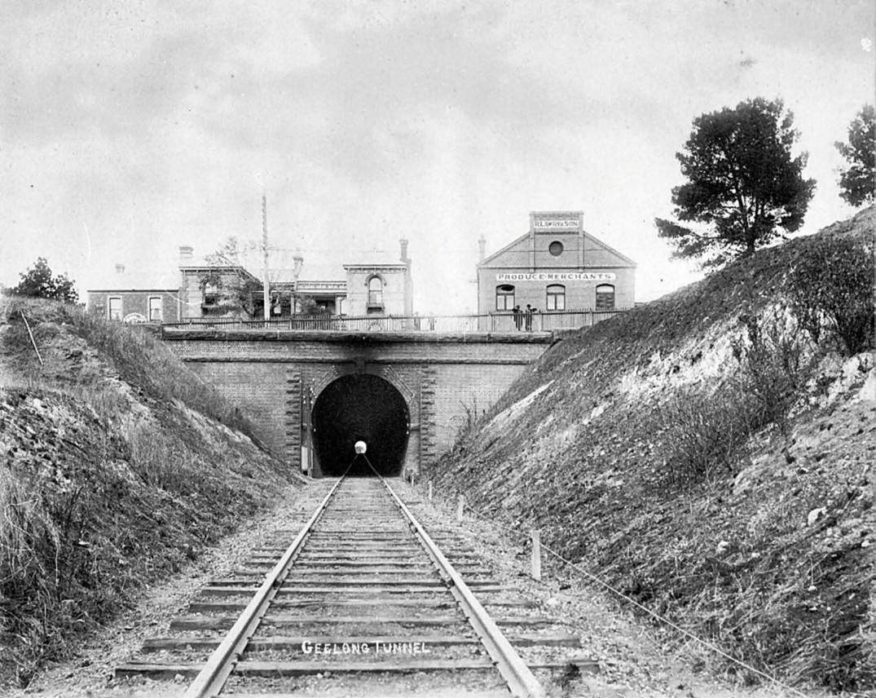
Figure 3.106: Geelong Railway Tunnel, northern portal (below Ryrie Street), c.1890. Source: Item MM5267, Museums Victoria.

stone in a ceremony at the northern end of the tunnel. He was presented with a silver towel following the striking of the
stone.951 A celebratory banquet was held in the tunnel catered by Messrs Bennett and Son, the tunnel for the occasion being described as follows:
A portion of the tunnel, some sixty yards in length, had been blocked off by means of tarpaulins and the space so enclosed converted into a decidedly substantial banqueting hall; this was festooned with flowers and evergreens, and the effect was very good.952
Until the construction of the Melbourne underground railway loop, the Geelong tunnel was the longest on the Victorian railway network.953

BREAKWATER AND WAURN PONDS BRIDGES AND EMBANKMENTS
Further infrastructure was required for the railway line to the south of Geelong. Raised earthen embankments and a timber pile bridge over the Barwon River above the breakwater,
and a small timber bridge further south-west over the Waurn Ponds Creek, were required. Works were advanced by February 1875 when the Geelong Advertiser gave a detailed report:
The Breakwater is a sort of beehive of industry, some scores of men being constantly employed there making the embankment across the river flat and constructing

the pile bridge over the Barwon. The piles are of redgum and ironbark shod with iron, well driven and stayed so as to withstand any possible strain to which they will be
subjected. Over a dozen piles have been driven, together with a number of stay piles along the bed of the river.
Some of the former have been surmounted with caps of iron, on which rest substantial wooden sleepers designed apparently to carry the rails. From its present appearance, it may safely be presumed that when completed the bridge will be far more utilitarian than ornamental, the style of its architecture will be highly characteristic of the colony and its present rules. In making the embankment across the flat the earth alongside from the river’s margin has been excavated to a depth varying from four to five feet, and between one and two chains in width. This will form of itself a commodious channel in times of floods, and will serve greatly to relieve the earthwork and protect it from injury. At the junction of the Waurn Ponds creek with the river a bridge is being made of sufficient span to enable a very large volume of water to escape in case of any heavy inundation. Already the larger portion of the embankment has been raised to its required height 954
Costing £3,000, the Breakwater bridge (Figure 3.107) was 610 feet long with 20 spans of 30 feet each.955 This and the Waurn Ponds bridge and associated embankments were completed on 13 January 1876 and a special train conveyed Messrs. Ford, Martin, G.V. Jones, and Maddern, Government engineers; Mr Overend, contractor, Mr Burton, construction supervisor and other practical gentlemen to test the completed works.956

OPENING OF THE GEELONG TO COLAC RAILWAY LINE
On 24 November 1876, the line from Geelong to Winchelsea was formally opened by the Hon. Joseph Jones, Commissioner of Railways follow a special train of six carriages from Geelong to Winchelsea where there was a banquet in the Winchelsea Shire Hall.957 Commencing at the Geelong railway station, the official party continued through the newly-built tunnel, the line being curved at the southern tunnel portal and traversed through South Geelong, the view from the line at this location being described in the Geelong Advertiser:
A very agreeable view is afforded the traveller by train on emerging from the tunnel at Maude-street, for below in the valley the several factories on the banks of the Barwon River give a thriving look to the approaches to Geelong, whilst the picturesque spots about Highton, and the well laid-out streets of Chilwell, and a portion of Newtown, are seen to advantage.958

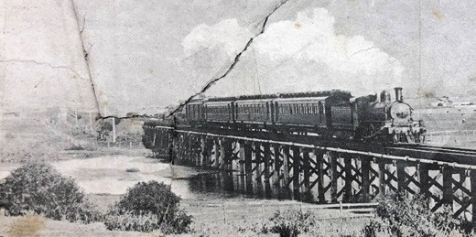
Figure 3.107: Breakwater Rail Bridge, 1911. Source: News of the Week, 6 July 1911, GRS 2121/3, Geelong Heritage
Centre collection.

Further work on the railway line brought about extensions to Colac in 1877, Camperdown in 1883, Terang in 1877 and Warrnambool, Dennington and Port Fairy in 1890.959 Today, the line terminates at Warrnambool following the closure of the line further south-west to Port Fairy in 1977.960

LATER IMPROVEMENTS
A number of improvements were made to the Geelong to Colac railway network within the City of Greater Geelong in the early 20th century. Two of the more substantial was the construction of a bridge over Moorabool Street, and upgrades to the bridge at Breakwater.

MOORABOOL STREET BRIDGE
Until 1913, the railway line between the Geelong and South Geelong stations included a level crossing over Moorabool Street. With the proposed tram network in 1911, the Railway Commissioners refused to allow trams to pass over the level crossing. 961 To overcome this concern, a subway
at Moorabool street, regrading of the line from the tunnel to South Geelong, together with earthen embankments and an iron bridge were constructed.962 By May 1912, the embankment opposite Kardinia Park had grown apace but was not yet up to the standard level of the work. 963 Rail lifting had also commenced on the section of line between
Moorabool and Yarra Streets.964 The proposed bridge was to be constructed of wrought iron girders with brick abutments. They were placed in position in November 1912:
Blocks and tackle and wooden skids are used to place in position the wrought-iron girders which in the near future will carry all railway traffic above the Moorabool- street crossing, South Geelong. The girders on low sideless trucks were backed on to the new embankment from Yarra-street, and were unshipped edge down alongside the brick piers. Between these a stout wooden beam held up on temporary stays was placed and along it on small

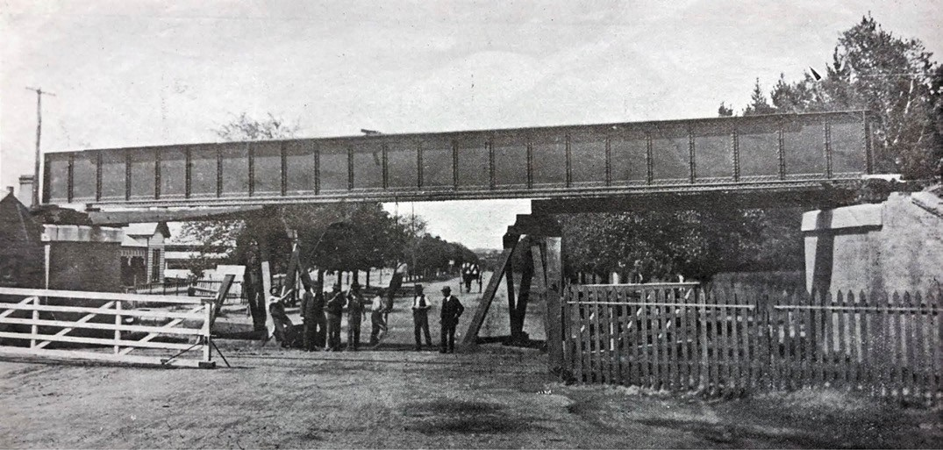
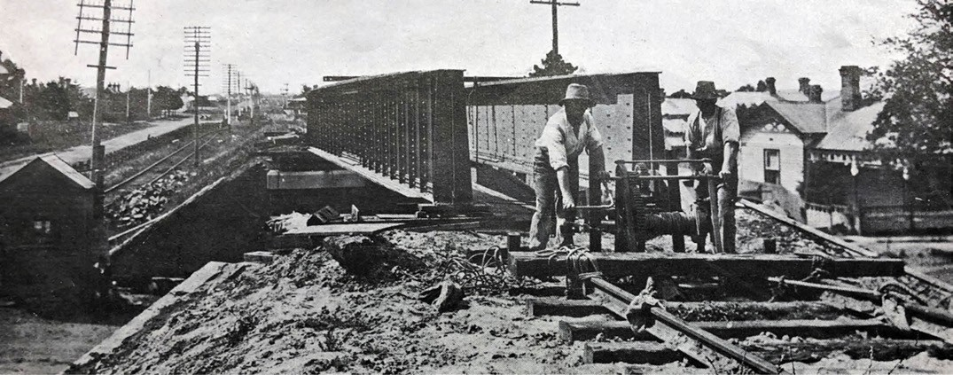
Figure 3.108: Moorabool Street Railway bridge nearing completion, 1912. Source: News of the Week, 12 November 1912, p.14, GRS 2121/3, Geelong Heritage Centre collection.

rollers the 40 ft. girder was hauled by tackle manipulated from the opposite end of the cutting. There is little hope of the road grading being started till the end of the year.965
Sleepers were laid on the new embankments from January 1913 and the bridge opened a month later966 (Figure 3.108).

UPGRADES TO THE BREAKWATER BRIDGE
In the early 1940s, the Victorian Railways Board carried out a track relaying and brick renewal program. By mid-1974, works were under way with the replacement of the timber railway bridge at breakwater with concrete pylons and steel superstructure.967

GEELONG TO QUEENSCLIFF LINE
While a railway line between Geelong and Queenscliff was first mooted in the 1850s,968 it was not until 1873 when a meeting of the people of Queenscliff and the Western Railway League lobbied for the black line of railway proposed to the

south-west of Victoria from Geelong.969 Nothing eventuated and in July 1877, a deputation of Councillors of the Geelong, Queenscliffe, Newtown and Chilwell, South Barwon and Geelong West Councils, together with other local influential men made a deputation to the Minsters of Railways lamenting the exclusion of a proposed Geelong to Queenscliff railway line.970 The Mayor of Queenscliffe, Mr Admans, referred:
to the immense number of persons who now visit Queenscliffe, Sorrento, and Portsea, by steamers, which would be considerably increased if they had railway communication. He also pointed out that Drysdale
and the Clifton Springs were attractions of themselves sufficient to induce the Government to construct the line. Then, Geelong, which was insufficiently supplied with firewood, could receive some thousands of tons yearly, and the mails as they arrived from the mail steamer could be delivered in Geelong two hours earlier than at present.971
In late 1877, a railway line to Queenscliff was approved, the Geelong Advertiser reporting that two Surveyors are on the ground; one will commence from Geelong, the other (Mr Loftus Jones) from Queenscliffe.’972 The survey work commenced in the following January of 1878, the starting point from Geelong being at the foot of Garden- street, at the point where the Colac line makes a sweep towards the Breakwater. 973 In September 1878, a contract for the 20 mile line was let to Topham, Angus, and Smyth at a cost of
£58,977/7/6.974 Work commenced from both ends and on 29 April 1879, the line was joined at a ceremony performed by Robert Watson, Engineer-in-Chief:
Plate-laying on the Geelong and Queenscliffe line of railway is now all but accomplished. For some time past the process has been carried out simultaneously from both termini, and this (Saturday) evening the ceremony was performed of formally uniting both ends by the Engineer-in-Chief, Mr Watson. A silver spoke was provided for the occasion by Mr W. Simpkin [Queenscliff engineer and blacksmith], to the order of Mr Smith, one of the contractors, and at about a quarter to six the spike was driven, in the presence of the Mayor and several of the Councillors, and a numerous crowd of spectators.975
The route of the new railway from Geelong passed through Newcomb, Moolap, Leopold and Drysdale, where a railway station was erected. From Drysdale the line extended south- east, taking in Bellarine, Marcus Hill and Mannerim before arriving at Queenscliff.
Considerable infrastructure was built as part of the line. At Queenscliff, low lying ground was raised between Mrs Wakefield’s property and Off-street above the level of the centre of that street,’ while 14 fishmen’s residences required

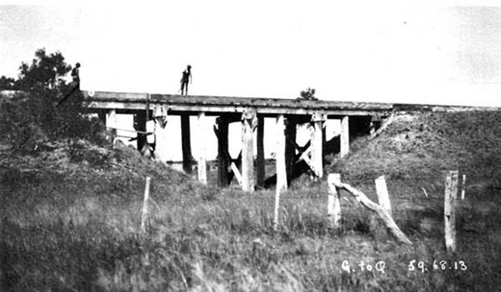
Figure 3.109: Railway Bridge, Geelong to Queenscliff line, photographic collection, railway negatives, 1885. Source: VPRS 12800/P1, H 4666, Public Record Office Victoria.
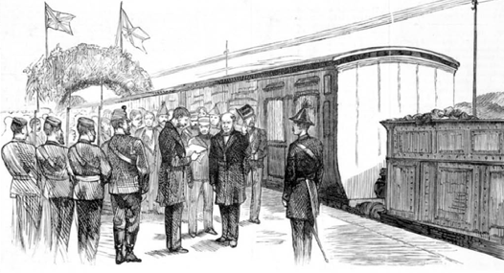

Figure 3.110: Opening of the Geelong to Queenscliff Railway by the Governor at the Queenscliff Railway Station, 1879. Source: Illustrated Australian News, 7 June 1879, accession IAN 07/06/79 State Library of Victoria.

relocation to make way for the railway yard.976 The deepest cutting for the line was near the Queenscliffe station were 35,000 yards of earth were removed, while the longest cutting was made at the hill at Leopold. More complex was the crossing of 41 occupation and carriage roads , construction of 40 timber pile bridges (Figure 3.109) (the largest at Bellarine, being 75 feet long and 18 feet high) and building
of 74 culverts, the more substantial being near Lake Lorne, Drysdale. A water reservoir for supplying the locomotives was constructed at Yarram Creek near Queenscliff.977
On 21 May 1879, the Geelong and Queenscliff railway line was officially opened at Queenscliff following a ceremonial train service from Geelong.978 A festive display greeted the 300 special guests upon arrival at Queenscliff:

A novelty in arches was erected at the entrance gate to the railway station by the fishermen of Queenscliffe. They had obtained the masts and spars from some of their boats, formed a scaffolding of them, and artistically decorated the poles with flowers, shrubs, etc. In the centre of a
large circle formed of leaves there was the model of a full-rigged ship, the letters R.R. being on either side of
the vessel, whilst underneath were white flags bearing the words Welcome, the whole scaffolding being lined with bunting. Emblematical of their occupation, the fishermen displayed two enormous schnapper, and two equally large yellow tail fish, which were slung lengthways across the archway, and from the tops of the small arches were dangled a couple of unfortunate crayfish.979
At the platform, the Hon. George Constantine, Marquis of Normanby and Governor of Victoria declared the line open (Figure 3.110) before alighting a carriage to attend
a celebratory banquet at the Royal Hotel.980 The rail service between Geelong and Queenscliff was not to endure. In 1931, passenger services ceased (primarily due to bus competition) although goods trains continued to operate until the line was closed in 1959.981 It soon reopened in late 1959 to service the conveyance of shell grit from Lakers Siding to Spotswood for glassmaking, the service operating twice weekly until 1973.982 Excursion trains operated during this period as well as a freight train to Cheetham s siding until 1978.983 Today, tourist trains operate on the Geelong and Queenscliff line between Drysdale and Queenscliff, while much of the remaining line
to South Geelong is now a walking and cycling trail known as the Bellarine Rail Trail.984

NORTH GEELONG TO FYANSFORD LINE
In 1918, a railway line was constructed from North Geelong to Fyansford, opening in September of that year. It provided rail transport for the Australian Portland Cement Company s operations at Fyansford985 (Figure 3.111).

RAILWAY STATIONS AND STATION SIDINGS
To service the railway transport required for passengers, goods and crops, several railway stations and associated sheds and yards were constructed on the Geelong and Melbourne line from the 1850s, Geelong to Ballarat line from the early 1860s, Geelong to Colac line from the early 1880s and the Geelong to Queenscliff line from the late
1870s. Today, few railway stations of the 19th and early 20th centuries survive.

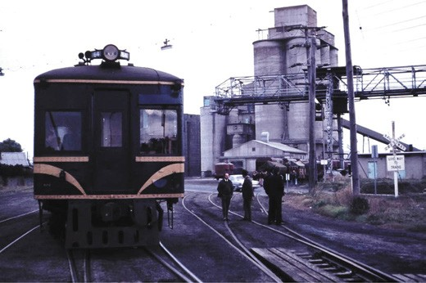
Figure 3.111: W. Langford, Locomotive near the cement works silos, Fyansford, on the North Geelong – Fyansford line, 22 June 1975. Source: Weston Langford Railway Photograph online https:// www.westonlangford.com/media/photos/113417, Creative Commons license.

STATIONS ON THE GEELONG TO MELBOURNE LINE
In addition to the construction of significant 19th and early 20th century infrastructure – some of which remains
physically present to the current day – the Victorian Railways Department was a notable employer. A list of early railway employees on the lines associated with Geelong is given as Appendix 3.2.

GEELONG

FIRST STATION COMPLEX
Key infrastructure in the formation of the Geelong to Melbourne line was the construction of the railway terminus at Geelong. Designed by Snell and Kawerau, the foundation stone of the station building was laid by the Governor on 20 September 1853.986 The contract for the construction of the stone buildings was awarded to William Cakebread at a cost of £4000.987 A carriage shed was first built and converted into workshops and forges installed to assist in the construction of the railway system.988 Most of the station building was completed by early 1854.989 By August 1855, Messrs. Craigg and Dale had won the tender for erecting the iron roofs over the arrival and departure passenger platforms.990 This work was finished by May 1856 when the Geelong Advertiser and Intelligencer gave a description of the terminus complex:
we proceed to the station proper, to have a look at the engines and the carriages which are already marshalled at their posts. The station is roofed with corrugated iron. A platform of 20 or 22 feet in width runs along either side of the station, for the accommodation of passengers arriving and departing. Doorways open off these platforms, which

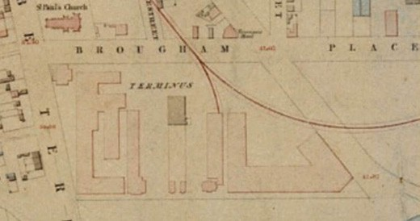
Figure 3.112: Plan of Geelong Railway Terminal complex, 1854. Source: J.H. Taylor, Map of Geelong, Surveyor-General’s Department, Melbourne, 1854. Source: VPRS 8168/P2, Unit 5416, item Roll 39 Geelong, Public Record Office Victoria.

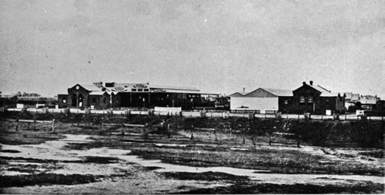
Figure 3.113: E. de Balk, Geelong Railway Station terminus, 1866. Source: accession H87.251 State Library of Victoria.

will give access to the refreshment rooms and waiting rooms adjoining.991
The complex of terminus buildings was shown in Taylor s Map of Geelong in 1854 (Figure 3.112) and in a photograph by Eugene De Balk in 1866 (Figure 3.113) and Charles Nettleton in the c.1870s.
The first stationmaster at the Geelong Railway Station was William Cadwallader (1822-1904).992 He was born in Birmingham, England, the son of Oliver and Mary
(nee Baughan) Cadwallader.993 William Cadwallader worked as a coachbuilder and in 1845 he married Miss Hannah Pipe at St. Paul s Church, Birmingham.994 In 1855, Cadwallader emigrated to Victoria on the Donald Mackay, bringing out first rolling stock for the Hobsons Bay railway on behalf of the Birmingham engineering firm that manufactured it.995 Prior
to his arrival, he had commenced negotiating an agreement with the Geelong and Melbourne Railway Company as stationmaster at Geelong.996 Cadwallader had commenced duties at the opening the Geelong to Melbourne Railway line in 1857.997 He was reunited with his wife and three sons
when they arrived in Geelong in 1859. With the take over the Geelong to Melbourne Railway line by the Victorian Railways in 1860, Cadwallader was reappointed stationmaster.998 He

remained as Geelong stationmaster until 1874 when he took up the position of district superintendent for the Victorian Railways Department.999

SECOND STATION COMPLEX
The construction of the Geelong to Colac line necessitated changes at the south end of the terminus. In 1876, it was decided to construct new station buildings, in keeping with Geelong s status as an important regional city. Surveying work commenced in May of that year.1000 A design was prepared by G.W. Sims, engineer and assistants of the works branch of the Victorian Railways Department in late 1876, the new station building to be situated on the site of the old goods shed, in line with the newly-completed tunnel to the south on the Geelong to Colac railway line.1001 A detailed description
of Sims proposed station complex (Figures 3.114-115) was given in the Geelong Advertiser:
The building, which is to cost £8758, is to be located between the present station and the goods sheds. It will harmonise in accordance with the latter building, being of course, more ornamental. Like the sheds, it will be built end on to the railway terrace, the frontage of the station facing the sheds. Passengers will enter the station from a broad pathway at right angle with the street, and the platform will be on that nearest Latrobe-terrace. The station will be built of dark Geelong brick, with white brick dressings. The verandah on the frontage near the goods shed, will occupy about a third of the entire frontage, being in the centre. It will be 53 ft. 6 in. long and 13 ft wide, and will be supported by four iron columns, on two of which will be drinking fountains. The remainder of
the frontage will be flush up to the footway, the length of the whole building being 181ft. Arriving at the verandah, the passenger will enter the booking lobby and walk from thence on to the platform which will be about 500 ft. long, one end of it reaching to Railway-terrace. The verandah protecting the platform will be 196 ft. long and 15 ft. wide. It will be supported by 10 iron ornamental columns, six of which will have small fountains similar to those of the exterior of the building. At the northern end, nearest to the railway crossing at St. Paul s church, will be the stationmaster s quarters, consisting of a drawing-room, dining room, bedroom and kitchen. At the verandah frontage portion, it should have been
mentioned, will be the booking, ticket and parcels offices, entered by two doors. At the side of the verandah nearest to Railway- terrace, there will be two bath rooms and a lavatory for the use of passengers; and the engineers, porter s and guards rooms, and purveyors quarters will take up the remainder of the frontage. Next to the booking lobby, or centre, on the platform side the building, will
be a gentlemen s waiting and coffee-room, 20ft x 16ft,

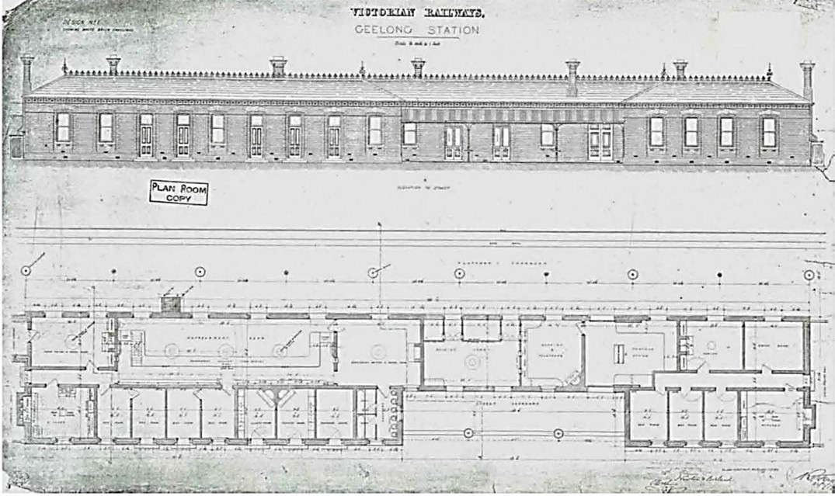
Figure 3.114: G.W. Simms, Victorian Railways Geelong Station, ‘Elevation to Street & Floor Plan’, 1879. Source: GRS 3133, Geelong Heritage Centre collection.

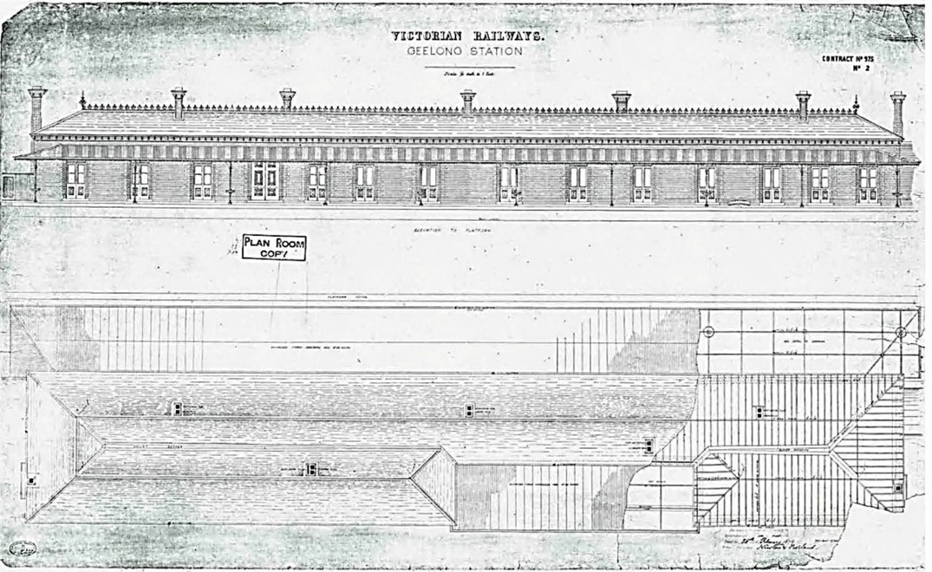
Figure 3.115: G.W. Simms, Victorian Railways Geelong Station, ‘Elevation to Platform & Roof Plan’, 1879. Source: GRS 3132, Geelong Heritage Centre collection.

3in. This will open into the general refreshment room, the dimensions of which will be 52 x 16ft. 3in. The room
will be fitted up with counters and shelving in the ordinary manner, and underneath is to be a cellar, which the workmen are engaged in digging. The ladies coffee
and waiting rooms, opening off the booking lobby, will be comfortably fitted with patent tip-up lavatories. All the rooms will be ventilated with Sted s and Murphy s
ventilators, and the large rooms are to have cornices with cement skirtings.1002
Tenders were called for the construction of the new complex in June 1878.1003 The contract for the goods shed was awarded to Messrs. Sutherland and Pickering at a cost of
£9997/15/-, with the building of the passenger station being carried out by Messrs Newton and Borland at a cost of
£8,758/14/10.1004
While the Geelong Advertiser had detailed the promise of a well-designed station complex, towards its completion there was wide criticism on its appearance, location and interior planning.1005 Even the Mayor of Geelong, J.M. Garrett was staunchly opposed to the new structure, declaring it a wretched apology for a railway station , and that it would be a disgrace to a roadside township. 1006 Completed in November 1879, there was no fanfare for its opening, the gloom aired
by Geelong’s civic fathers and others apparently sufficient to quell any formal celebration. The lavish opening of the Industrial and Juvenile Exhibition in Market Square by the Governor (Marquis of Normanby) on 18 December 1879
provided an opportunity for the Governor s carriage to be the first to arrive at the newly- completed railway station. The only hint of celebration for the opening of the new station was a salute of 21 fog signals that exploded as the train entered the northern entrance to the terminus.1007
The loud criticism afforded the design and function of the new railway station did not fall on deaf ears. On 21 May 1881,
G.D. Langridge, Commission of Public Works, J.B. Patterson,
Commissioner of Railways, Mr Elsdon, Engineer-in-Chief of Railways made a visit to Geelong to ascertain the actual requirements of the railway station, approaches thereto, and adjacent crossings of the line, and also any other public works the Corporation might invite their inspection
of. 1008 By September 1881 drawings (Figures 3.116-117) for altering and extending the station had been completed by Samuel Bindley, architect of the Department of Education. A detailed description of the changes was given in the Geelong Advertiser:
The plans of the proposed improvements to the station, as prepared by Mr Bindley, an architect from the office of the Education Department, are indeed of a very attractive kind. If carried out, the present station – which is one of the most inconvenient that could have been constructed

– will be made one of the handsomest on the Government lines of railway. It is proposed to widen the platform from 18ft. to 29ft., by cutting off the line of useless small rooms from the northern to the southern end. At the southern extremity, and facing Railway Terrace and the tunnel of the Colac line, there will be a two storey structure to be used as a dwelling for the stationmaster. Below the dwelling apartments, that is on the ground floor, a spacious booking lobby, 31 feet by 16 feet, is to be provided affording communication with the approach to the station and on to the platform, and there is to be a booking office, 31 ft. by 14ft., attached. In front of the same building, and facing the platform, will be the stationmaster’s office, 16
ft. by 13 ft. in dimensions, and the whole structure will be surrounded by an ornamental verandah. The present booking office and lobby, both of which are narrow and draughty, will be abolished, and the room formed into a large vestibule leading on to the platform. The present limited refreshment-room is to be increased in size, from
52 ft. by 16ft. to 72ft. by 19ft., a large space being provided for the bar attendants. This will be done by extending
the building towards the goods shed. Better luncheon rooms are to be provided for ladies and gentlemen; the former s will be 26ft. by 15ft in dimensions, and the
gentlemen’s 18 ft. by 16ft. Between the stationmaster’s house and the ladies room, there is to be a waiting room 24ft. by 18ft., for use by the general public. At the rear
of the ladies and refreshment rooms there will be bath, yard, and other accommodation, and at the southern end guards and porters rooms will be provided. A second storey is to be placed on the refreshment rooms, which will be utilised for bedrooms, parlor and dining room, and for a kitchen, the latter being increased in size from 15ft. by 12ft., as at present, to 25ft. by 15ft. The cooking is to be performed upstairs, and the catables, etc., required by travellers by the train will be lowered by means of lifts at both ends of the kitchen apartment to the dining rooms on the ground floor. These additions to the buildings are to be ornamented in the same style as the present white and red brick fronts. Both the platforms at the station
are to be used for the reception and despatch of trains, so as to avoid, as far as possible, the shunting across Railway Terrace, which has been the cause of so many complaints. In order to effect this, a footbridge will be constructed across the three lines of railway, to what is termed the central platform, that is, the narrow causeway between the main platform and the old and disused platform. There will be two flights of stairs at each end of the bridge, which is to be an ornamental one, springing from the vicinity of the refreshment room. It is proposed to construct a corrugated iron archway over the bridge and the lines, in order to protect the platform from the effects of the weather. To do this a retaining wall is to be

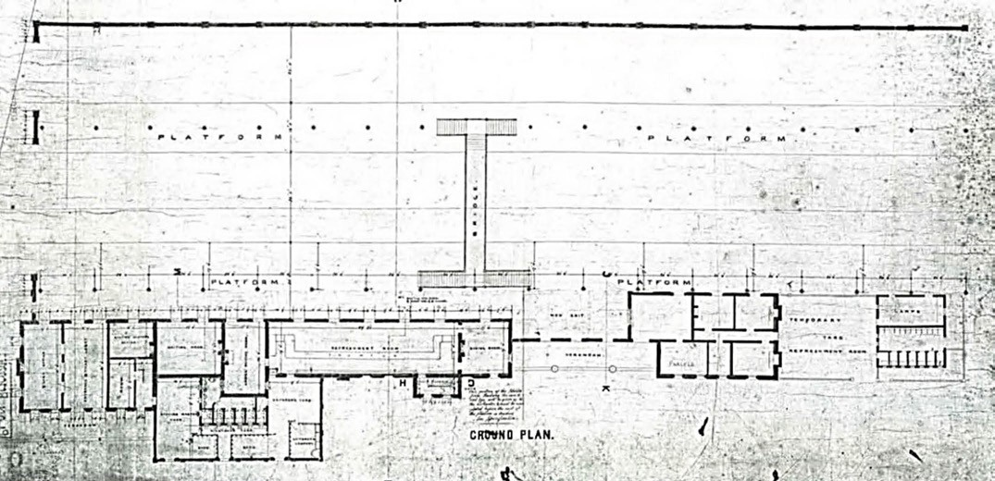
Figure 3.116: S. Bindley, Geelong Railway Station Ground Plan, 1881. Source: GRS 3149, Geelong Heritage Centre collection.
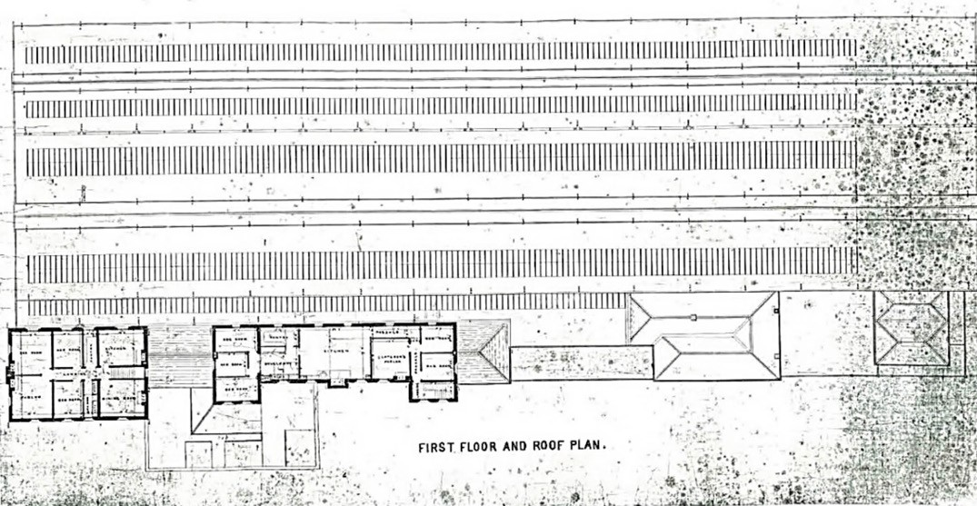

Figure 3.117: S. Bindley, Geelong Railway Station First Floor & Roof Plan, 1881. Source: GRS 3148, Geelong Heritage Centre collection.

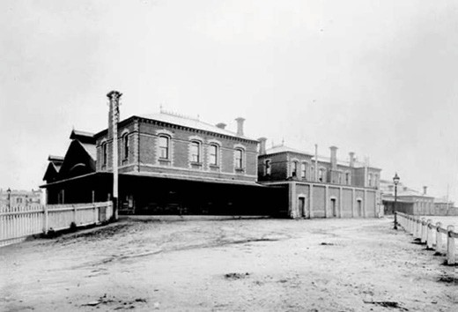
Figure 3.118: Geelong Railway Station, east and south elevations, photographic collection, railway negatives, c.1900. Source: VPRS 12800/P1, Unit 195 Public Record Office Victoria.

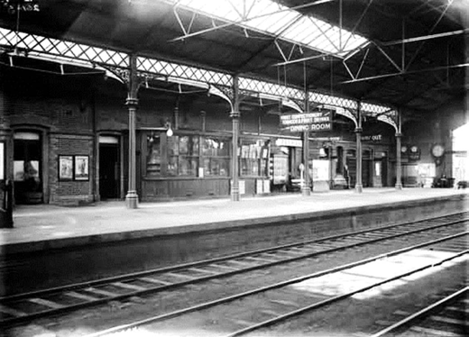
Figure 3.119: Geelong Railway Station Train Hall & Platform 1, photographic collection, railway negatives, c.1920s. Source: VPRS 12903/P1, it 261/05, Public Record Office Victoria.

constructed parallel with the old station and locomotive shed. One arch will span from the western wall of the new station, rest on ornamental columns at the central platform, and then stretch across to the retaining wall. In order that traffic may not be interfered with, it is intended to first construct the retaining wall, and cover the railway lines, and also to build the new dwellinghouse, etc., for the stationmaster, and the booking offices. The present unsightly structure formerly used as the stationmaster s residence, is to be cleared away.1009
On 6 December 1881, tenders were called for the works.1010 The contract was awarded to Newtown and Borland (the contractors responsible for the earlier station building) at a cost of £12,539/9/0.1011 The altered and extended station was opened for business on 21 May 1883, and again no formal ceremony was observed.1012 While the new station (Figures

3.118-119) was found to be most commodious for the public , the lobby had been sealed up on one side and used as a parcel offices, creating discontent with the cabmen that
paid for the privilege of waiting in the yards for passengers (who were consequently prevented from exiting from the station through the lobby).1013 Further disquiet came when the lifts from the upper floor kitchen ‘were found to be altogether inadequate, the ordinary crockery employed for keeping chops, steaks, joints, etc., hot being too large for the limited spaces left in the trays attached to the lifts. 1014 The Geelong Advertiser noted that a prompt remedy was needed for these considerable inconveniences.1015
In 1887, a new locomotive shed was constructed at the railway station. It was described as a rather curiously shaped building , presenting an appearance of one-fourth of a circle , the building accommodating a gigantic turn-table for the locomotives1016 (Figures 3.120-121). This turntable was removed and relocated to Newport in 1917 following the laying of additional railway lines and other improvements to the west of the station building (see earlier subsection).1017
In 1952, a contract was let for the construction of a new goods shed and offices after the previous building had been destroyed by fire.1018 A new loading platform was also constructed.1019

SUBURBAN STATIONS CORIO
Two suburban stations were built on the Geelong to
Melbourne line in 1857: Cowies Creek and West Geelong.1020 The Cowies Creek station was half a mile north of the creek. It was known as a flag station – where the train would only stop when a flat or other signal was displayed. Of interest
is that Mrs Jane Rollins (nee Robinson) (c.1836-1904) was station mistress from September 1860.1021 The earliest and only female station mistress in 1860 in Victoria,1022 Mrs Rollins was also a mother of very young children, with her sons, Frank and George born at Cowies Creek in 1859 and
1860 respectively.1023 After her resignation on 30 September 1861,1024 Jane later established a farm at Bell Post Hill with her husband, George, where Rollins Road was to be named after their son, Frank (see Theme 6). Cowies Creek station was not to endure as by 1882 it had been removed and the station reserve (planted with wattles) had been mistakenly sold by the Lands Department (the sale subsequently found to be illegal).1025 A new flag station was built in 1890 ‘at a point six miles from Geelong and it was named the Cowie Station.1026 The station was renamed Corio in 1913.1027 The old flag station was replaced with the existing station in 1981.1028

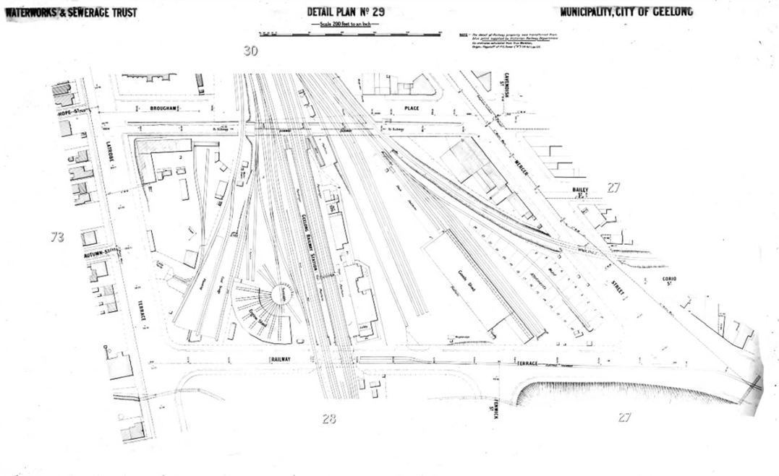
Figure 3.120: Geelong Waterworks & Sewerage Trust Detail Plan No. 29, n.d., showing layout of Geelong Railway Terminus including circular locomotive turntable & engine shed built in 1887. Source: Barwon Water.
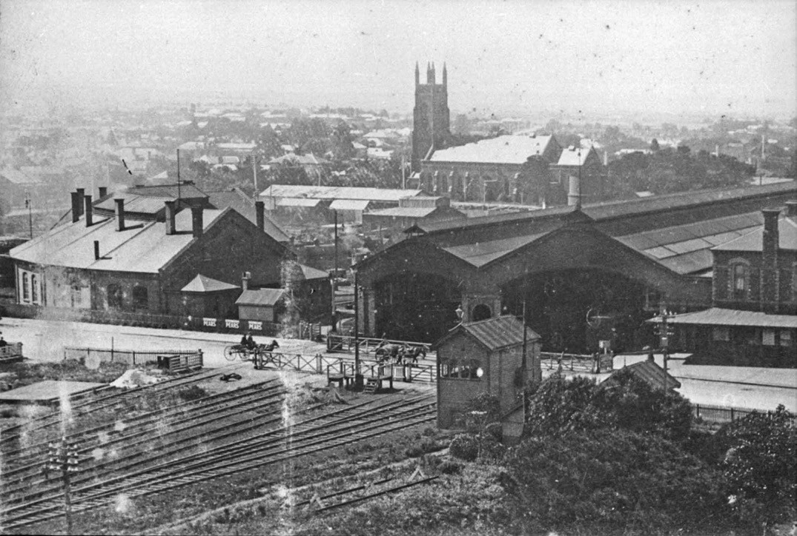
Figure 3.121: View looking north-west to Geelong Railway Station, showing the station building and train hall (right), locomotive turntable & engine shed (left), & level crossing prior to the construct of the subway, n.d. [pre 1912]. Source: Wynd collection, Authentic Heritage Services.

NORTH GEELONG
At North Geelong, the West Geelong Geelong Railway was situated on the east side of the line, opposite the intersection of the Melbourne Road and Swinburne Street. With the opening of the Geelong to Ballarat line in 1862, the station grew in importance, being at the junction of the Melbourne and Ballarat lines. The first stationmaster was Benjamin Tertius Scott (1827-1867), a Canadian who had emigrated to Geelong by 1854 at this time he was listed as a merchant.1029 Scott remained at the Geelong West station until he was transferred to the East Ballarat terminus in 18641030 and subsequently to the Kyneton station.1031 He died in 1867, the Geelong Advertiser describing him as gentlemanly, always kind and always obliged, and highly respected by all whose avocations caused them to pay visits to Melbourne. 1032
In 1877, the Geelong Town Council lobbied for a cattle siding at North Geelong to service its nearby saleyards. Sites at the north end of Pakington Street and near the gasworks were considered.1033 While the Minister of Railways was open to the proposal, there was debate between the Geelong and Geelong West Councils in relation to the proposed site, with the Borough of Geelong West opposing the Corporation s suggestion that it be situated near the gasworks. So heated was a discussion between Council representatives in the Minister’s office in 1878 that the Minister quipped that ‘his room was not the proper place for disputes, and besides, they were unnecessarily occupying his time. 1034 In October 1878, the Minister approved the site for the new siding next to the gasworks,1035 immediately north of the Victoria Street and Melbourne Road intersections. It appears that in 1882 a new passenger station was built further south of the original station near Victoria Street and the new cattle yard siding adjacent to the gasworks.1036 Situated on the east side of
the line, it was an elongated hipped roofed timber building with a gabled wing at the north end, and a post- supported platform verandah on the west side. The name of the station was changed from West Geelong to North Geelong in early 1886.1037 In November 1920, work commenced on the construction of a new gabled timber station building on the west side of the railway line.1038 It survived until 1990 when a new station was erected, followed by a passenger shelter on the east of the line in 2008.1039

NORTH SHORE
In 1895, the Victorian Railways Department constructed a new platform and station at North Shore (Figure 3.122). This outlying fledgling suburb north of Geelong was steadily growing and the nearby freezing works also created demand for the service. However, the approaches to the station were yet to be completed and were knee deep in mud. 1040 The

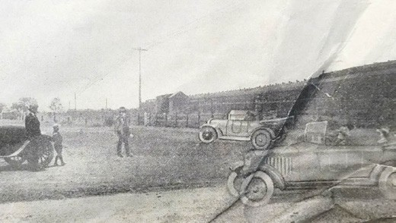
Figure 3.122: North Shore Railway Station (background), c.1926. Source: Bay View Estate Plan, n.d., Special Collections, Deakin University Library.
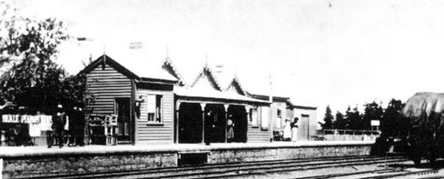
Figure 3.123: Lara Railway Station, n.d. [c.1900]. Source: K. Eastman in From Duck Ponds to Lara, p.60.

name of the station was changed to Corio in December 1908 before returning to the name of North Shire in 1913.1041 A new island platform erected in 1959 and supplemented by a small waiting shed. It was replaced by bus shelters by the 1990s.1042

LARA
Originally known as Duck Ponds, the terminus at Lara was the first to be completed outside Geelong in 1856. In May of that year, the Geelong Advertiser and Intelligencer reported that great activity is being manifest at present in order that the line may be opened before July as far as the Duck Ponds.’1043 A station had been erected by 1857.1044 A small gabled timber flag station appears to have been the first station erected, followed in later years by a picturesque, gabled station with post-supported verandah (Figure 3.123).
The first stationmaster at Duck Ponds was William McElwee (1826-1882).1045 Born in County Derry, Ireland, he arrived
in Melbourne in 1858, having worked as a labourer.1046 He married Miss Emily Goodall shortly after in 1858.1047 At Lara in 1861, McElwee was appointed Deputy Registrar of births and deaths.1048 The high esteem held by McElwee by the Lara community was highlighted in 1864, on his departure for Lancefield. The Geelong Advertiser gave an account of the

presentation of a gold watch prior to McElwee s departure:
On Friday evening some of the leading farmers end gentlemen residing at the Duck Ponds met at Bragg s Hotel for the purpose of presenting to Mr William McElwee a token of the respect in which he was held by the inhabitants of the district, prior to his taking charge of the Lancefield Road Station to which he has recently been promoted. The testimonial, which cost about £1.25, consisted of a very handsome gold watch with all the recent improvements, and a massive solid chain. On the inside of the watch the following inscription had been engraved:
Presented to William McElwee, Station Master, Duck Ponds, by the inhabitants, as a token of respect. August 5, 1864.1049
At Lara in 1886, pressures mounted on the inadequacy of the local railway to cater for the burgeoning local lime industry (see Themes 5 & 6 for further details on the lime industry).
A deputation of lime burners met with the Commissioner of Railways seeking the erection of a siding about three quarters of a mile from Lara, in the vicinity of the kilns.1050 Instead, in the following year, the existing lime shed at the Lara station was extended by Parker
and Vickers.1051
The railway station was subsequently destroyed by fire and the existing brick station building and platform were built in 1926, as outlined in The Argus:
A commencement has been made with the erection of a new railway station at Lara. The new platform will be 400ft. longer than the existing one to cope with the long trains now run on the Geelong line.1052
In 2007, major alterations were made to the station building and improvements to the platforms.1053
In 2015, work began in an extending the car park at the Lara station.1054

STATIONS ON THE GEELONG TO COLAC LINE MARSHALL
On the Geelong to Colac line, three stations were erected
in the Geelong area in the 19th century. The earliest was at Marshall in 1879 when a modest gabled timber flag station was opened as the Connewarre station.1055 It seems that the stationmaster combined the role with that of postmaster and gatekeeper in subsequent years. Mrs Jessie Glossop was in charge at Marshall between 1917 and 1920 (although the
Electoral Rolls only identified her husband, John, as a railway employee).1056

The flag station had relocated to the front of the gatekeeper’s cottage in Marshalltown Road by the mid-20th century where it served as the local post office.1057 Closing in 1979, it was donated to the Bellarine Railway by Postal agents, Angus and Elsie Taylor, and removed to the Drysdale Railway Station.1058 It was relocated again in 1989, to Lakers Siding, and restored by volunteers in 2007 with funding from the Australia Post Philatelic Museum.1059 It now forms part of the Bellarine Rail Trail.
In 2004, a new station was opened at Marshall, the demand for the service so great than the carpark was extended and a second platform added in 2010.1060

SOUTH GEEL ONG
In May 1882, a site between Yarra and Bellerine Streets at South Geelong for a timber station (to originally also serve as a post and telegraph office) was visited by railway officials.
It was considered most central for persons residing at Geelong East, South Geelong, and Chilwell.1061 However, the visit – and particularly the proposed site – was hotly debated by some locals in attendance. As noted in the Geelong Advertiser:
The mere mention of the site, however, caused great excitement, and a few hot-tempered individuals almost settled their disputes by a display of muscular
Christianity. The division of opinion was as to sites close to Moorabool, Yarra, and Bellerine-street crossings,
and, on the engineers finding that the residents who are likely to be befitted by a station at South Geelong were at loggerheads, they sprang into the special train, and
sped away to the Breakwater township, leaving the people indignant, excited, and quarrelsome.1062
The site between Yarra and Bellerine Streets was officially settled and in October 1882 F. Holyoak won the tender for the erection of the station, platform and other buildings at a cost of £1165/1/10.1063 Completed by mid-1883, tickets could be purchased at the station by November 1883, although it was not officially ‘opened for traffic’ until a month later.1064
The first stationmaster appears to have been Charles Wells (c.1854-1901),1065 his appointment at South Geelong being a promotion from the position of porter he had previously held with the Victorian Railways Department.1066
The railway station (Figure 3.124) continued in use until it was demolished in October 1983 to make way for the existing brick station that opened on 30 September 1984.1067

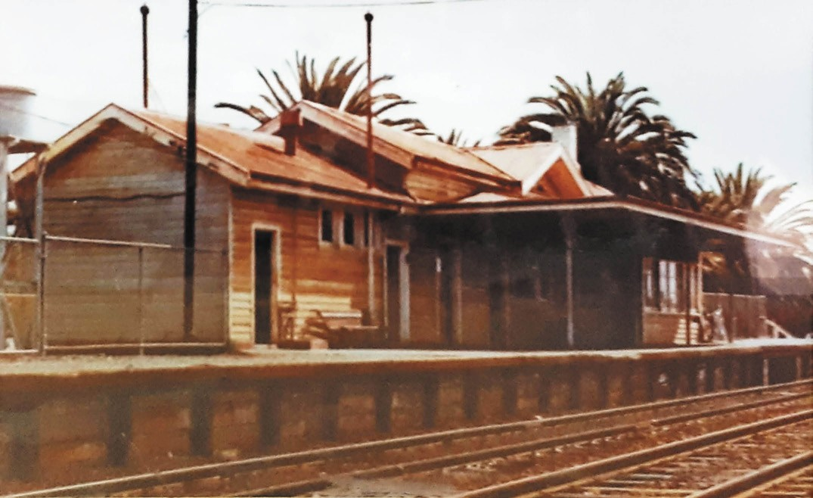

Figure 3.124: South Geelong Railway Station (now demolished), c.1983. Source: VLine, South Geelong Railway Station (with permission from Larissa Scanlon, Regional Manager, South West, VLine).

RAILWAY DWELLINGS AT SOUTH GEELONG STATION
In 1911, the Victorian Railways Commissioners proposed the construction of a new timber stationmaster s residence, the Geelong Advertiser declaring that it would be a decided improvement of the present low-built and badly placed
structure. 1068 The new dwelling had a frontage to Yarra Street and was situated in the south- west corner of the railway site, adjacent to the side street of Verner Street. Comprising a standard gambrel-roofed design of the Railways Department, the timber dwelling was constructed in 1912 by local contractor, Charles Stock of Geelong West, at a cost of
£102/10/9.1069 The dwelling was demolished in 2015.1070
In 1949, the Victorian Railways Department ordered 1,000 pre- cut dwellings from W.J. Simms, Sons and Cooke Ltd. In England. A further 500 houses were ordered in 1950- 51.1071 Postwar materials shortages and the large numbers of
immigrants employed by the Railways Department required innovative solutions to meet the Department s housing demand.1072 It appears to have been in the 1950s when one of these imported pre-cut houses were constructed at 221
Yarra Street, immediately north of the existing stationmaster s residence.1073 It was demolished in 2015.

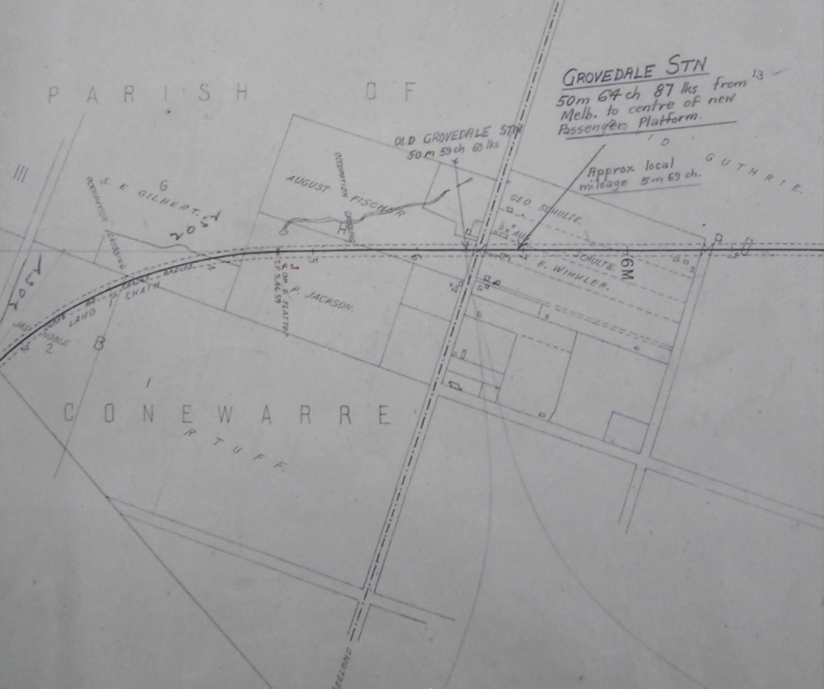
Figure 3.125: Map showing the locations of first and second railway stations at Grovedale, Railway Construction Branch, Board of Land & Works, Melbourne, July 1874 (the Torquay Road is shown by the broken line, the route to Geelong being at the bottom of the map). Source: VPRS 5751/ P1 Unit 23 Public Record Office Victoria.

GROVEDALE
A gabled timber station opened on the east side of the Torquay Road at Grovedale on 8 September 1890.1074 Known as the Germantown Railway Station (after the name of the suburb that Grovedale was then called – see Themes 6 & 7), the gabled timber building was originally situated on the east side of the Torquay Road and in 1913 it was relocated to the west side, where new sidings were constructed1075 (Figure 3.125).
The first stationmaster appears to have been Jenkin Edwards (1862-1919).1076 He was born at Cochrane s Creek, Bealiba, Victoria, the son of Morgan and Johanna (nee Lynch) Edwards. He married Miss Emma Elizabeth Thomas in
Ballarat in 1891.1077 Edwards was later to be transferred to the Winchelsea and Armytage railway stations before returning to Grovedale by 1919 where he died after a short illness in April of that year.1078
The Grovedale Railway Station closed in November 1952 and no longer survives.1079

BREAKWATER AND SHOWGROUNDS (EAST GEELONG/ BREAKWATER)
In 1889, work began on the construction of a small flag station opened at Breakwater following years of lobbying by local residents. In August 1889, the Geelong Advertiser reported that work was steadily progressing and that a special effort was being made to have the siding completed for the Geelong Racing Club s winter race meeting.1080 The station opened
in December of that year and was described in the Geelong Advertiser:
The siding is what is known as a flag station and is to
be used in the picking up and setting down of passengers as may be required and signalled. In addition to the passenger traffic it will be used also for light goods, that is that no package shall exceed 5 cwt and all goods will be received and despatched at the risk of the owners.1081
In 1895 the station was closed.1082
Another siding was opened on the Geelong to Queenscliff line at Breakwater in 1891 to service the newly opened showgrounds on the north side of the line.1083 It had been designed by L.A. Laird as part of an architectural for fencing, a grandstand, stock sheds and other infrastructure for the Geelong and Western District Agricultural and Horticultural Society (see Theme 8). The platform was condemned by the Railways Department in 1910, at which time the a new siding and flag station was built on the Geelong to Colac line at Breakwater, south-west of the race course (this also being the location of the showgrounds by this time).1084 It was named the Geelong Showgrounds platform until it was renamed the Geelong Racecourse station on 3 May 1915.1085

PETTAVEL
In 1878, a meeting was held at the Scotch School, Pettavel Road, by residents of Pettavel, Waurn Ponds, Paraparap and all parts of Duneed to consider the best means of obtaining further railway accommodation in the form of a flag station.1086 A site known as Dulhunty Gate, near Fox s, on Victoria road was that chosen by those in attendance and lobbying began to have the station realised.1087 A flag station including a passenger platform and goods siding
were not erected until 1882, at the Petteval Road crossing.1088 The station was officially named Pettavel Road until it was changed to Pettavel on 5 December 1904.1089 The station closed in 1952.1090

DUNEED
In 1913, a new station was opened between South Geelong and Moriac and named Duneed.1091 Trucking yards were

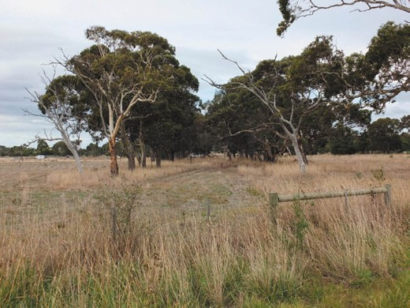
Figure 3.126: Remnant reserve of the former race course railway line lined by gum trees, 2014. Source: David Rowe.

erected at the station in the following year.1092 It was closed in subsequent years.

WAURN PONDS
In 2014, a new railway station was opened at Waurn Ponds at a cost of $25.9 million. Constructed as a single platform station, it included a booking office, passenger amenities, road bus bays, bicycle storage and parking for 200 cars.1093

OLD RACE COURSE BRANCH LINE
Impetus for a railway line to the Marshalltown racecourse (established in the 1850s – see Theme 9) came in 1876, following the opening of the Geelong to Colac line as far as Winchelsea. A platform was built at Marshalltown and the first race trains stopped there for the meeting held on
Friday 26 January and Saturday 27 January 1877.1094 It was anticipated that race meetings could attract larger crowds if the trains could transport passengers to the racecourse itself. Surveys were subsequently carried out and construction commenced on the branch railway line throughout 1877.1095 On 12 January 1878, an inspection of the line and the racecourse was made by Mr. Robinson, secretary of the Geelong Racing Club, Alexander Davidson, architect, and several officials from the railways who made the journey by train.1096 The branch line curved away from the main line into the race course grounds and it was formally opened on 22 January 1878.1097 A special train, conveyed the Hon. John Woods, Commissioner of Railways, Geelong Racing Club officials and other guests from the Geelong Railway Station to the new siding at the racecourse. 1098
The branch racecourse line at Marshalltown was closed in

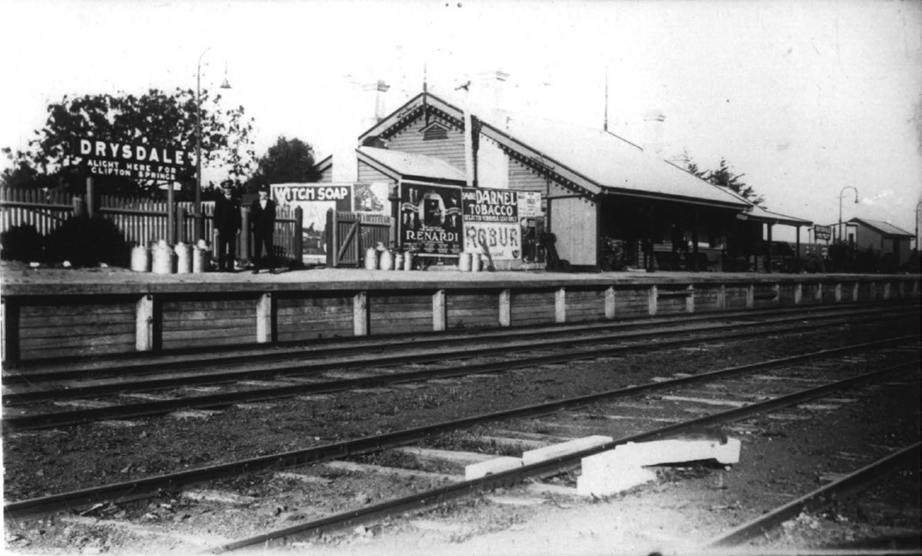
Figure 3.127: Drysdale Railway Station, n.d. Source: Image 0482, Bellarine Historical Society.

1909.1099 Material that was recovered from the line at this time included points and iron and steel rails. The racecourse railway reserve to the south east of the Geelong to Colac Railway line was used as a storage yard (with narrow gauge tracks laid) for the concrete pipes manufactured by Stone and Siddeley for the Geelong Waterworks and Sewerage Trust s ocean outfall sewerage scheme between 1912 and 1915 (see Theme 4).1100 Today, evidence of the Marshalltown racecourse railway line is identified in the narrow, curved and slightly elevated land lined with gum trees to the south of the existing Marshall Railway Station and east of Drews Road (Figure 3.126).

GEELONG TO QUEENSCLIFF LINE DRYSDALE
In 1878, the Victorian Railways Department approved the
location of a railway station at Drysdale to be situated near Lake Lorne. Such a site was a concern to local residents given its distant location from the Drysdale township and the potential for a new township to develop adjacent the station. The preferred location was within six chains of the Shire Hall, which abuts the main road to Portarlington. 1101 Concerns
of the local residents fell on deaf ears at the location next
to Lake Lorne was finalised.1102 Tenders were called for the construction of the passenger station in February 1879 and the contract was awarded to T. Cowley.1103 By early May 1879, the Geelong Advertiser reported that the station was almost completed:
Good progress is being made with the railway. The new station, although not very pretentious, is a substantial weatherboard building, and is now approaching completion.1104
The Drysdale station (Figure 3.127) was opened as part of the formal opening of the Geelong to Queenscliff line on 21 May 1879. The special train enroute to Queenscliff from Geelong stopped at Drysdale where 23 members of the Drysdale contingent of the South Grant Artillery Corps and a number
of other local residents alighted the carriage.1105 The broad gable roofed timber building featured decorative bargeboards and a post-supported verandah. Other station buildings flanked the main building which survives in a partly altered state today.
The first stationmaster (head porter) at Drysdale did not commence duties until after the opening of the station. In late 1880, Emil Berbling (c.1849-1903), a Prussian immigrant who had arrived in Australia and married Miss Julia Roache

in 1873, became a naturalised British citizen in 1878 when serving as a porter at Inglewood.1106 Berbling s tenure at Drysdale was short-lived as he was transferred to Trentham in 1881.1107

OTHER STATIONS
A small number of sidings and modest stations were erected along the Geelong to Queenscliff line but there is no evidence of their existence today. The first was a portable station
on top of the hill at Leopold (then known as Kensington) in 1880.1108 It was relocated to the flat in 1881 (it closed in 1961).1109 Others established included those at Moolap
(opened in 1881 with a shelter shed and office constructed in 1887 – it closed in 1936), Marcus Hill (opened as a platform under the name of Ocean Grove in 1883 with a platform station building and good shelter erected in 1887 – the station was renamed Mannerim in 1890 and removed in 1950), and Curlewis (opened in 1914 with the relocation of the portable station from Scarborough near Queenscliff – it closed in 1961).1110

STATION ON THE GEELONG TO BALLARAT LINE MOORABOOL
In 1861, the Victorian Railways Commissioners chose a
site next to the level crossing on the Steiglitz [Ballan] Road upon which to erect a railway station given the agricultural character of the district. 1111 This caused unrest among some locals who petitioned Ministers and public works officials
for the station to be erected as near as practicable to the Moorabool Viaduct , in close proximity to their vineyards.1112 After further debate, the Steiglitz Road site was settled upon. In January 1862, a contract was awarded to John Campbell and Co. for the construction of the bluestone buildings at a cost of £2,954/11/0.1113 A month later, the Geelong Advertiser reported that ‘the station at Steiglitz road, a fine bluestone structure, is in course of erection and will be finished by the line is completed. 1114 Yet, the station (Figure 3.128) was
not completed at the time of the opening of the Geelong to Ballarat line in April 1862 and the positive newspaper description of the station in February had dissipated at this time when the new building was described as follows:
It is composed of a rather pretentious pile of substantial blue stone buildings, with a commodious platform, most of which are so far advanced as to be roofed in; but certainly there is nothing about the look of the place to justify the large expenditure incurred by its erection.1115
The first stationmaster was P. McDowall, with John Weaver possibly as gate keeper.1116 McDowall s tenure at Steiglitz Road station was to be short-lived as he appears to have transferred to Meredith in 1863.1117

In 1863, the name of the station was officially changed to the Moorabool Railway Station.1118 By 1868, the promise of a bustling station at Moorabool had not come to fruition. The Ballarat Star reported on the intention of the Railway
Department to lease the stationmaster s residence for a term given that trains had ceased stopping there to take up or set down passengers. 1119 Such closure was controversial and an application was made to re-open the station in 1869.1120
It was also at this time when details came to light of staff rationalisation as a consequence of the closure of the station but the need to man the railway gates at the Steiglitz Road crossing:
The gate and station are only about 60 yards apart.
On two occasions during some years past it was sought to make the station-master or porter in charge to act
as gateman, as well as live in and work the station.
Each time this attempt failed in consequence of the difficulty in making the porter hear while he was within the walls of the stone building, and proportionately more so at night when the man was asleep. The result was that two men were put on – a porter in charge of the station and a gateman at the crossing.1121
The station was subsequently re-opened, the stationmaster in 1878, John O’Connor, passing away at his post, the reason given as being as a consequence for suffering from gout
in the knees for twenty years.1122 In 1904, the two-roomed portable timber gate keeper s cottage was destroyed by fire.1123 A substantial garden was laid out at the station during the tenure of M.C. Austin in the early 20th century. Upon
his departure for Lubeck in 1918, it was reported that he had converted an unkept waste into a beautiful and delightful garden, including the planting of 200 trees in the station premises.1124 In 1976, the Moorabool station closed to all traffic and the station building was sold the following year and converted into a dwelling.1125

KEEPING THE GATES
Ubiquitous throughout the 19th and early 20th centuries along each of the railway lines to and from Geelong were gate keeper s cottages. At each major level road crossing, gate keepers were appointed by the Victorian Railways to operate timber railway gates that were closed to vehicular and pedestrian traffic to allow trains to pass. Cottages were erected adjacent to these roadside gate crossings (Figure 3.129).
Between 1859 and 1876, 64 gate keepers had been appointed by the Railways Department for the main Melbourne, Geelong and Ballarat lines.1126 With the construction of the Geelong to Colac line, 27 additional gate keeper s cottages were erected by the contractor, John Foot in 1877.1127 A further 19 cottages were built by W. Quayle and D. Spence on the Geelong to

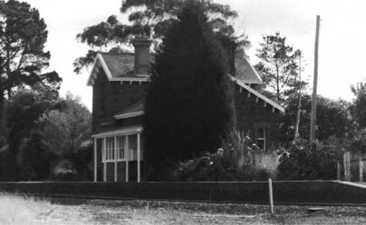

Figure 3.128: Moorabool Railway Station, 1998. Source: David Rowe.

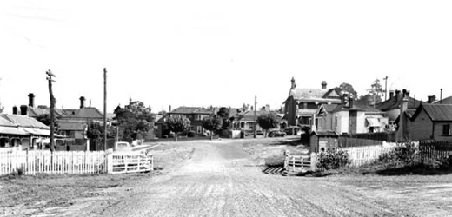

Figure 3.129: Railway Gates, McKillop Street (looking west), photographic collection, railway negatives, 1961. The gatekeeper s cottage was on the right (now demolished). Source: VPRS 12800/P1, H2956 Public Record Office Victoria.

Queenscliff line in 1879.1128
In the central Geelong area, gate keeper s cottages included those erected at Victoria Street, North Geelong; Maitland, Wellington and O Connell Streets, Geelong West; Kilgour, Maud and McKillop Streets, Geelong; and Bellerine Street, South Geelong. The latter crossing was closed in 1914 and the gate keeper s cottage removed.1129 It was to allow for the provision of new yards.1130 New hand gates were erected
at the Swanston Street level crossing with a gate keeper appointed in 1914.1131 A cottage was built at this time south of the line at 162 Swanston Street (Figure 3.130) to a standard Victorian Railways Department design. This cottage is one
of only two known surviving in the Greater Geelong area today, the other being at 57 Marshalltown Road, Marshall (corner Station Road), built in 19131132 (Figure 3.131).
The task of the gate keeper was a tedious operation.
It required the management of the gates through the day and into the evening. With the growth in population in Geelong in the early 20th century, the closure at some of the gates at night was controversial. In 1916, the Geelong City Council complained of the closing of the Swanston Street crossing

Figure 3.130: Former Gate Keeper s Cottage, 162 Swanston St, South Geelong, 2019. Source: David Rowe.
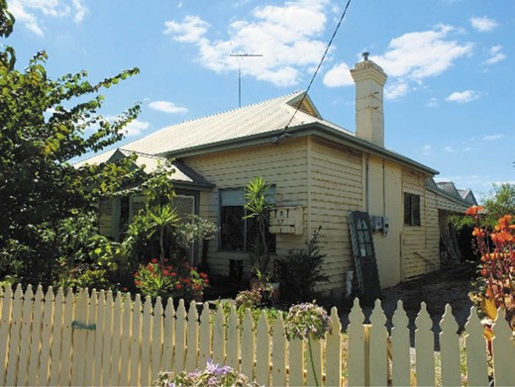
Figure 3.131: Former Station Master’s & Gate Keeper’s Cottage, 57 Marshalltown Rd, Marshall, 2019. Source: David Rowe.

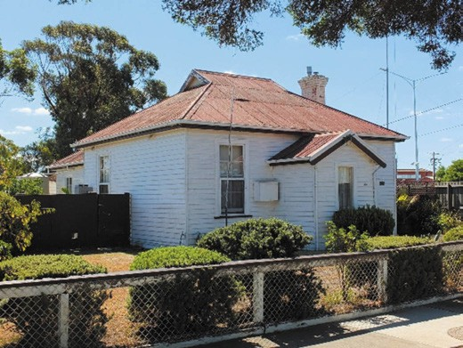
in the evening, causing an inconvenience to road traffic.1133 Open until about 8.45 pm each evening, the Railways Department argued that they were promptly opened for the public at any hour required. 1134 The Department also stated that:
The Yarra-street gates [which had also been installed at the opening of the Geelong to Colac line in 1876] were closed at night, but there was always someone on duty at the South Geelong station during the whole 24 hours, and there should be no difficulty in having the gates opened when desired for road traffic.1135
Hand gates continued to be operated at several crossings in Geelong until the introduction of flashing lights in the late 20th century. Gates were removed at the Woods Street crossing
in South Geelong in 1967, at Victoria Street, North Geelong, in

1973 (with Victoria Street closed and access replaced with an overpass at Margaret Street), at Swanston Street in 1976 and as late as 1986 at
Yarra Street.1136
The work of the gate keeper was also dangerous, with several gate keepers either injured or killed while on the job. In 1881, Robert Fogarty, a 73 year old gatekeeper at Kilgour Street was killed when he was hit by a gate after failing to open
them in time for the locomotive to pass.1137 In 1909, the gate keeper for the Wellington Street crossing, James Boxell, was run down and killed by a goods engine. He too, was too late opening the gates, the engineer striking the gate upright and hurling Boxell onto the track.1138
Several of the gate keepers employed by the Victorian Railways Department were women: either single, married or widowed. Of the latter, some had been married to railway workers who had been killed while in the employment of
the Department.1139 The employment of married women by the Victorian Railways Department (a Government agency) throughout the 19th and early 20th century was also unusual (the Post Office and Telegraph Department also employed women). Not all the public supported the Department s agenda in the employment of women, with one local particularly critical of the situation at the Maud Street at in 1911:
Being a constant traveller through this gate, I am disgusted with the Railway department in appointing another woman to take the responsibility which should be entrusted to a man, making matters worse, they have put a repairer s wife there with less pay than the ordinary woman gatekeeper receives, and, worse still, the repairer is out earning his seven shillings a day. Why not put the proper gatekeeper there and do away with sweating? I am informed that the young man that has been stationed there is a relieving hand, and thoroughly understands his work. Why not put him back there, and work eight hours, the same as was worked with the gatekeeper just gone
out, which would ensure public safety, and which will be a great danger if the present way is kept going?1140
The editor of the Geelong Advertiser responded to the complaint by indicating that the slightly lower rate paid to the gatekeeper is compensated for by a special rent allowance. The ganger is paid 1/less per day than other men in the section. 1141
Possibly the earliest female gate keeper in Victoria was Mrs Ann Treves (nee Wood) (1836-1905) who had been appointed on the Geelong to Melbourne line on 1 September 1860.1142
It is likely that Mrs Treves was a gate keeper at Werribee, as it was there where her daughter, Rose, was born in 1861.1143 Ann Treves was married to Thomas Treves (1832-1917) who

was employed by the Railways Department for 37 years.1144 Ann and Thomas Treves later settled at Leopold where they had a farm.1145 Ann Treves died in Geelong in 1905.1146
Locally, female gate keepers included Mrs Catherine Large, widow, at St. Albans, East, Geelong in 1881 (her husband, Robert, had died in 1878); Miss Stuart at Cowies Creek in 1890, Mrs Mary Ann Morgan, widow, on the Queenscliff line in 1891, Mrs Mary Wakefield at Maitland Street, Geelong West, in 1883 (Mary Wakefield’s husband, Alfred was also gatekeeper at this location).1147 Miss Lizzie Drew and Mrs Nolan, gate keepers at different crossings at South Geelong in 1894.1148

RAILWAY GARDENS
By 1910, the Victorian Railways Department had established a garden nursery at Kensington, Melbourne. The purpose of the nursery was given in the Department s Annual Report in 1910:
The work of improving the appearance of a number of the suburban station grounds and railway lands adjoining the suburban lines, and of country station grounds, by tree-planting and the formation of gardens and lawns, has been continued. About 70,000 ornamental and shade trees, obtained from the Departmental nursery at Kensington, were planted on railway land alongside the lines.1149
In an effort to promote the importance of garden and landscape settings for railway infrastructure and properties, the Victorian Railways Department established an annual garden competition for the most neatly kept gardens and residences, provoking a spirit of emulation among railway employees.1150 In 1919, Mrs Caroline Askew, wife of Michael Askew, line repairer and gatekeeper at the Victoria Street crossing, North Geelong, won third prize in the Western District section of the annual Victorian Railway garden competition1151 (Figure 3.132). In 1930 and 1935, the South Geelong Railway Station won first prize in the South-Western District section for best maintained garden.1152 The railway yard featured a landscape of chrysanthemums and dahlias (Figure 3.133) which has been replaced with carparking.
Similarly, nothing remains of the Askew garden, although the Askew name continues in the street in Geelong West
being named in memory of Michael and Caroline s son, Alfred William Askew, who was killed in action in Belgium in World War One.1153

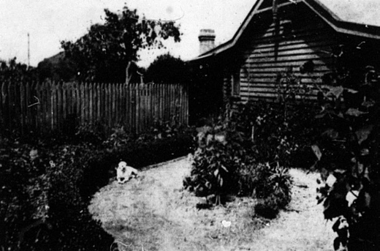

Figure 3.132: Mrs Caroline Askew s garden, North Geelong, 1919. Source: News of the Week, 6 March 1919, GRS 2121, Geelong Heritage Centre collection.

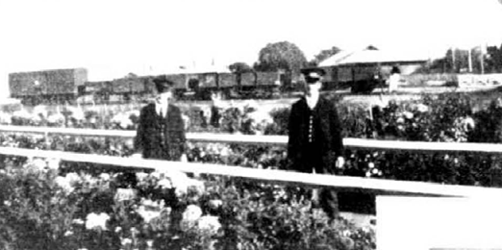
Figure 3.133: A. Newman (stationmaster) and J. Branagh (railway worker) amongst the chrysanthemums and dahlias in the South Geelong Railway Station garden, 1930. Source: Weekly Times,
13 June 1931, p.34.

LOCAL RAILWAY ORGANISATIONS

VICTORIAN RAILWAYS INSTITUTE (GEELONG BRANCH)
In 1899, the Commissioner of the Victorian Railways,
John Mathieson recommended the formation of an Institute with accommodation for classes on technical subjects connected with railways working as part of providing technical education in a systematic way to railway employees.1154 It was not until 1909 when the first meeting of the Institute was held at the Masonic Hall in Collins Street, Melbourne.1155 In January 1910, the Institute was officially opened at a meeting in the ballroom of the Flinders Street Railway Station.1156
In 1914, a Geelong branch of the Victorian Railways Institute was established to provide educational classes and social activities for railway employees stationed in Geelong and surrounding districts.1157 A temporary classroom was created in the Ways and Works Building at the Geelong

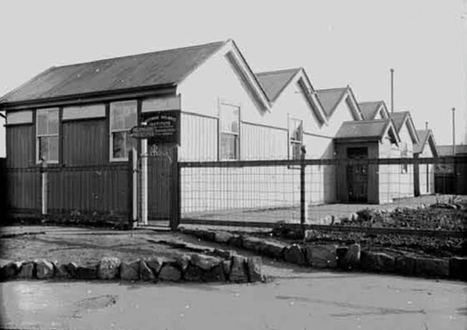
Figure 3.134: Victorian Railways Institute, Geelong West, photographic collection, railway negatives, c.1920.
Source: VPRS 12903/P1, it 009/14 Public Record Office Victoria.
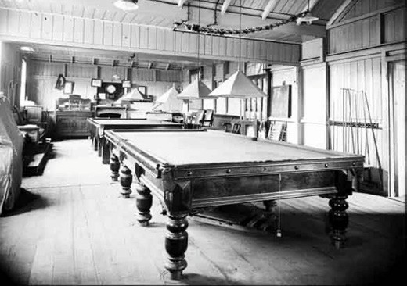

Figure 3.135: Billiard Room, Victorian Railways Institute, Geelong West, c.1925, photographic collection, railway negatives.
Source: VPRS 12903/P1, it 009/15 Public Record Office Victoria.

station complex from which classes in engine working and Westinghouse brakes, elementary electricity and magnetism, general education, safe working, typewriting and shorthand were held.1158 In 1916, classes were held at the nearby Gordon Institute of Technology.1159

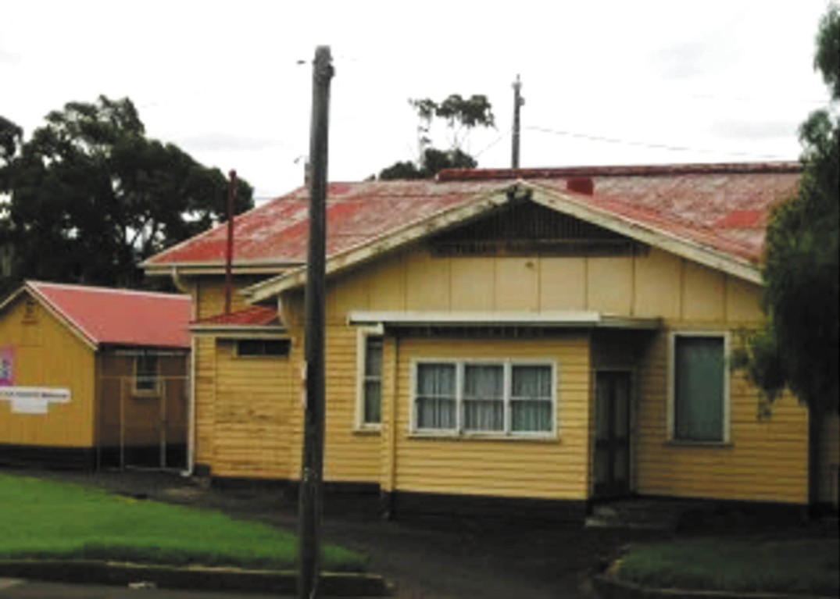
Figure 3.136: Victorian Railways Institute building, Latrobe Terrace, 2017. Source: Jennifer Bantow.

From the time of its instigation, a permanent site for the Victorian Railways Institute in Geelong was mooted.
In 1917, the newly-formed Railway Athletic and Social Club’ was the first to lease a just-completed building on the Moorabool Street pier, the upstairs having been fitted out as a general recreation room for boxing and punching ball,
and other games, with the intention of another room used for amusements following the purchase of a piano.1160
It was also in 1917 when the Railway authorities approved the construction of a purpose-built building for billiard, reading and meeting rooms on newly-acquired Railways Department land at the corner of Preston Street and Latrobe Terrace.1161 The Geelong Advertiser reported on the site being between Wellington and O Connell-streets, but an aerial photograph by Charles Pratt, dated c.1927, showed the Institute building at the corner of Preston Street and Latrobe Terrace.1162 The six-gabled, modestly- scaled building (Figure 3.134) was subsequently built of rudimentary corrugated galvanised steel and cement sheet construction. The Institute building was formally opened with a ceremony in the billiard room
in July 1919 by George Lorimer, superintendent of the Locomotive Department and President of the Institute.1163 At this time, the Institute boasted a library of 260 books which had been informally opened a few months earlier.1164 There was a subscription fee of 6/- entitling members to all privileges, including the attendance and instruction at
classes in typewriting and shorthand, safe working of trains, and telegraphy. 1165 Then comprising 21 members, social activities were also available, with the provision of a billiard table (Figure 3.135), accommodation for card playing, an area for reading and a piano was on order.1166 Rules of the club included that it be run on strictly tee-total lines and gambling was prohibited.1167 Growth in membership in 1923 forced the acquisition of a second billiard table.1168
In 1924, lobbying began for the construction of a new Institute building.1169 The Institute had been fundraising to assist with the project.1170 A site fronting Mercer Street on Railways Department land was mooted but seven years later in 1931 a site on the railway reserve at the north-east corner of Latrobe Terrace and Gordon Avenue was confirmed.1171 A portion of

the offices of the Signal Shops at Newport were relocated to the new Institute site and adapted for Institute purposes.1172 According to the Annual Report of the Victorian Railways Commissioners:
Class rooms, a social hall, and billiards room, with good lighting and ventilation, are provided, and there is sufficient area around the building for an ornamental garden.1173
The new building was officially opened in September 1934.1174 It consisted of a broad gabled hall wing with secondary gabled, hipped and flat-roofed wings addressing the corner location at the front (Figure 3.136). At the rear were separate, modest gabled buildings that accommodated billiards and a library. While substantial additions were proposed in 1947 to a design by L.E. May, Chief Architect, they did not proceed.1175 Throughout the 20th century, the Institute building served
the community for other recreational activities, including dances.1176 Today, the Institute building is occupied by different community groups. In January 2019, part of the building suffered fire damage.1177

RECENT RAILWAY ASSOCIATIONS

GEELONG STEAM PRESERVATION SOCIETY
The Geelong Steam Preservation Society was established in 1970, the first Society of volunteers in Victoria whose aim was to preserve historic steam engines. Trains were originally
run from the Belmont Common until the Society relocated to the Queenscliff-Drysdale section of the former Geelong to Queenscliff line in 1976. The Society now operates and maintains the Bellarine Railway.1178

GEELONG AND SOUTH WESTERN RAIL HERITAGE SOCIETY
The South Western Railway Society was established in 1995 to foster the restoration of the Birregurra station and associated infrastructure on the Warrnambool line.1179 The Society was dissolved in 2006 and in 2007 the Geelong and South Western Heritage Society Inc. was formed to continue much of the original work of the previous Society.1180 Its aims included the retention and enhancement of railway infrastructure and rolling stock for the Geelong and South Western Railway, fostering an interest in railway history,
encouraging liaison with railway operators and the promotion of general railway activities.1181

SHIPPING
The earliest and most reliable form a transport to and from Geelong for immigrants, tourists, commuters and the mail service were ships and steamers in the 19th century. Pier and wharf infrastructure, and the excavation of channels in Corio Bay, were required to service this industry, and associated businesses followed to manage it, including ship builders
and shipping agents. Regulation of port and maritime trade required the establishment of Government services, such as customs (see Theme 7).

MARITIME INFRASTRUCTURE IN GEELONG¹¹⁸²
The arrival from Launceston of the brig, Henry, to Point Henry in June 1836 with the first Europeans to disembark at Geelong (see Themes 2 & 6) brought with it the need for maritime infrastructure. A sand bar prevented large ships from entering Corio Bay and hence Geelong’s first port was located at Point Henry. A jetty and anchorage ground were
soon established on the western shores of Point Henry.1183 In March 1840, the Port Phillip Gazette gave a description of the harbour:
Point Henry to the left, gives an indented profile to the coast, in the deepest part of which and rather on the Southern shores, lies Kohrio Bay. On the highest cliffs of this secure bight stands the present small and scattered township of Geelong; the approach, however, to the immediate beach is prevented by a bar of sand and oyster shells of small breadth but great consistency except
to vessels not exceeding ten or eleven feet draught of water. Large ships, therefore, laid on for wool, have been hitherto compelled to anchor off Point Henry, where the loaded teams are driven direct from the country, or the warehouses of Geelong; distant half-a-mile, and the bales taken off by ship s boats or those supplied by the agents. A preventive or boarding officer is stationed here, through whom ship s papers may be forwarded by the overland mail to Melbourne, and a clearance obtained, a measure which is preferable to returning to Melbourne for the sole purpose of clearing a vessel out at the custom house established there. For coasting craft, a channel well beaconed has been marked off through the bar and into Kohrio Bay itself, where the depth of water within the bar would allow the largest vessel to ride within ship s length of the shore. Geelong, by its position, naturally forms a trading depot to all the country which comprehends the central district of Port Phillip, and has this year stored sufficient wool to load two ships for London direct.1184

A customs house and officer (John McKenny) were stationed at the Geelong foreshore from August 1839, months prior
to the erection of a permanent a stone jetty from 1840 using convict labour.1185 Known as Queen s Wharf, it was centrally located between Moorabool and Yarra Streets and was accessed by a gully in the high limestone cliffs.1186 This began the landing of small vessels to the central Geelong foreshore, with other customs infrastructure erected in subsequent years (see Theme 7). The harbour was also policed by a Harbour Master from 1841, the first being Captain Charles Ferguson (see Theme 7 for further details).
As early 1855, a petition was put to the Mayor of the Geelong Town Corporation for the provision of wharfage accommodation as part of the establishment of a local Harbor Trust.1187 This was considered perhaps, the most important topic that ever affected the interests of Geelong
and the Western District 1188 given the sandbar that prevented easy access to the Geelong town port, and that Geelong
was becoming the wool capital of Vitoria. A Geelong Harbor Trust Committee was constituted in September 1854 and included the Mayor of Geelong, Chairman of the Chamber of Commerce and the Collector of Customs.1189 The aim of the Committee was to request the Victorian Colonial Government to enact a local popular elective board to manage the harbour.1190 Nothing eventuated from this initiative and again in 1889 a meeting of locals met at the Geelong Mechanics institute to propose the formation of a Harbor Trust.1191 Those present lamented that the previous harbour committee had done very little and that the port was going back in the
way of shipping facilities instead of progressing. 1192 They desired the removal of the sand bar at the entrance to Corio Bay to secure free and safe passage of steam and sailing vessels. 1193 For the next 16 years, the desire of Geelong residents for the establishment of a Harbor Trust continued to fall on deaf ears.
The Geelong Harbor Trust Commission was established in 1905 to manage and regulate activities at the port of Geelong and within Corio Bay, the outer Geelong harbour and costal ports at Queenscliff, Barwon Heads, Lorne and Apollo Bay (see Theme 7 for further details). It was reconstituted as the Port of Geelong Authority in 1981. The Authority had the same responsibilities as the former Geelong Harbor Trust.

MAIN PIERS AND WHARFS

QUEENS WHARF-CUSTOMS WHARF-STONEY PIER- EASTERN JETTY
The first jetty to be constructed on the central Geelong foreshore east of the end of Yarra Street was Queens Wharf (Figure 3.137). Work began on the erection of the first section by convict labour in 1840, although it was to take some months to be fully completed.1194 Beset by a number of difficulties, the Geelong Advertiser argued in January 1841 that it should be made double the width, and run into two fathoms of water. 1195 This was not to transpire. In early 1842, unemployed immigrants in Melbourne were sent to Geelong to assist in the erection of the final stages of the structure, replacing the convict labour of earlier months.1196 Three of them drowned while assisting to place a large block of stone in the jetty s construction.1197 By May 1842, the Geelong Advertiser cast scorn on the structure and the Government s handling of its construction:
It is a pity that this structure should be rendered almost useless to the public, by the way in which it is kept unencumbered and blocked up by the government. The lazy, lumbering movements of the men employed, would be less provoking if they did not interfere with the more important avocations of those who pay for the use of the wharf. The jetty is more than thirty feet wide, and yet there is seldom room for two carts to pass on any part of it; the entire surface being strewn with immense boulders of stone, weighing about half-a-ton each. There can be no reasonable excuse for the continuance of this nuisance; as there is abundance of room near the wharf without lumbering the most valuable part of it. The stubborn and insolent behaviour of the convict overseer is another ground of complaint. The appointment of such a man
to an office of authority over free labourers is a crying shame, and would not be tolerated even in the penal districts of
the colony.1198
The jetty was completed later in 1842.1199 Rules and Regulations were gazetted for the maintenance of good order on the Jetty’ in 1843. They included:
No person allowed to loiter on the Jetty after sun-set.
No nuisance to be committed, and no rubbish or filth to be landed on the Jetty.
Boats are not to be permanently stationed at the Jetty, and only to be there for temporary purpose.
Goods or timber landed on the Jetty, to be immediately removed.

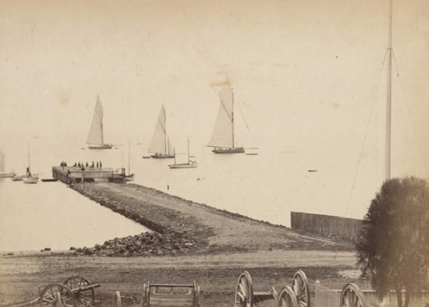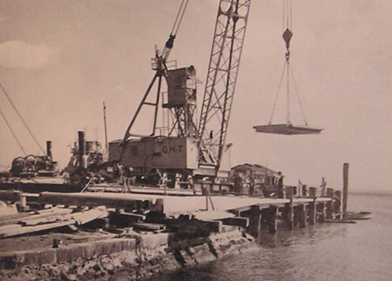

Figure 3.137: F. Kruger, Customs Wharf, c.1880-81. Source: accession H33802/9 State Library of Victoria.
Figure 3.138: Eastern Pier with original Queens Wharf in foreground, 1959. Source: Geelong Harbor Trust Commissioners Annual Report, 1959, Geelong Heritage Centre collection.

No cattle, sheep, horses, pigs, or goats are suffered to remain on the Jetty, except for the purposes of landing or embarking.
… Vessels or boats alongside, or made fast to the Jetty, are to make way for the Steamers when required.1200
By 1847, further extensions to the jetty were required and tenders were called in February that year.1201 The substantial workload required of the jetty continued
to take its toll and in 1849, David Lennox, Superintendent of Bridges, sought tenders for repairs to Corio
Jetty approaches.’1202
A custom house shed was erected at the beach in 1853 adjacent to the stone jetty at a cost of £500.1203 Associated with Customs and the harbour master, the stone jetty was officially proclaimed as the Customs
Wharf in 1856.1204
In 1905, the maintenance and management of the Customs Wharf was handed over to the Geelong Harbor which added a slipway by 1937. In 1959, the site was acquired by the Royal Geelong Yacht Club and the club
rooms were built over the slipway which remained underneath the building.1205
Further alterations and additions were made to the wharf in the ensuing years, including a side pier added by 1880.1206 A cargo shed designed by Percy Everett, architect for the Geelong Harbor Trust, was erected at the end of the pier
in 1908.1207 Known by this time as the Eastern pier, further improvements were carried out in 1915 and in 1921 beams and decking on the timber portion were renewed in 1921.1208 In 1959, the northern timber portion of the Eastern jetty was removed and replaced with a concrete slab on timber piles
(Figure 3.138). The then L-shaped pier included protective berthing facilities for the Geelong Harbor Trust s small craft.1209 Today, the original stone jetty of 1840-42 survives and is surfaced in bitumen. It is a rare legacy of wharf infrastructure at the beginning of European colonisation
in Geelong.

STEAMPACKET JETTY
In 1847, the Geelong Advertiser and Squatters Advocate announced a proposal to establish steam communication with the Australian colonies. Superior classes of vessels with screw-propellers were anticipated to travel between London via the Cape of Good Hope; and the other by means of packets to run (in correspondence with packets from England to Alexandria), from Suez to Ceylon, and thence to Sydney
by way of Singapore. 1210 These steam packets (derived from packet boards that originally carried mail) were to transform marine travel to Geelong.
By 1849, passenger steamers were frequenting Geelong in significant numbers to warrant a new jetty. Initially, the Government proposed a site near the end of Bellerine
Street before resolving that it be constructed at the end of Moorabool Street. Eventually, a site west of Queens wharf between Yarra and Moorabool Streets opposite Mack s Hotel was fixed1211 (see Figure 3.139).
Designed by the Superintendent of Bridges, David Lennox, tenders were called in November 1849.1212 A year later in November 1850, the new jetty was open to the public, the east side to be exclusively used by the steamers , the west side reserved exclusively for lighters employed in the export trade. 1213

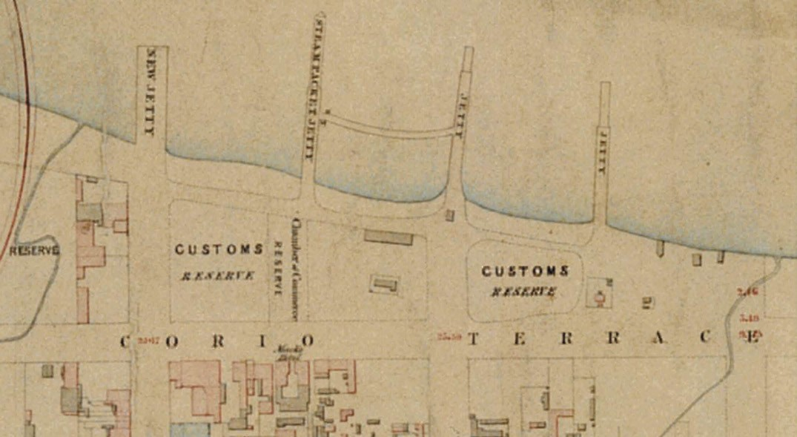
Figure 3.139: Locations of wharfs on the Geelong foreshore in 1854. Left to right: Moorabool Wharf, Steampacket Wharf, Yarra Street Wharf & Queens Wharf. Source: J.H. Taylor, Map of Geelong, Surveyor-General’s Department, Melbourne, 1854. Source: VPRS 8168/P2, Unit 5416, item Roll 39 Geelong, Public Record Office Victoria.

On 12 November 1850, the jetty was opened, a significant event in that the first steamer to be berthed there brought with it the news of separation of the Port Phillip from
the colony of New South Wales. As reported in the Geelong Advertiser:
Tuesday last was the first time the steamers moored alongside the New Jetty. On that evening a large concourse of spectators were assembled anxiously awaiting the approach of the vessels which were seen across the tranquil waters of the bay with their streamers flying, in token, as it was afterwards ascertained of the joyful intelligence of which they were the bearers. As soon as the Thames came alongside the rush was tremendous and questions in rapid succession were put to the different passengers, as they leaped ashore, as to whether the
Bill had passed or not. The poor news vendors were besieged by successive enquiring coteries and it was with the utmost difficulty that they threaded their way through the anxious besiegers. One urchin who had a package of papers under his arm as soon as he saw an opening in the crowd bolted with the sped of Pagasus [sic.] up the hill and didn’t slacken pace till, all puffing and blowing like a Newmarket roarer he deposited our complement of our hundred eyes contemporary. It was rather a memorable
circumstance that the steamers should be moored to the new jetty for the first time on the occasion of bearing the tidings of Separation – the time and circumstance were auspicious.1214
The structure was variously named Steampacket and Steamboat jetty although in 1856 the Government proclaimed the name as Steampacket Wharf.1215
The Steampacket wharf was not to endure. In 1872, the Geelong Advertiser reported that its condition is becoming more and more unsafe, but whether it will be repaired or rebuilt seems doubtful. 1216 In 1875, the wharf was abandoned and around three years later, the footbridge that connected it to Queens wharf was dismantled1217 (Figure 3.140).
Ninety years later in 1985, homage was paid to the former Steampacket wharf when the Geelong Regional Commission transformed the central foreshore area between the Moorabool and Yarra Street piers and named it Steampacket Gardens.1218

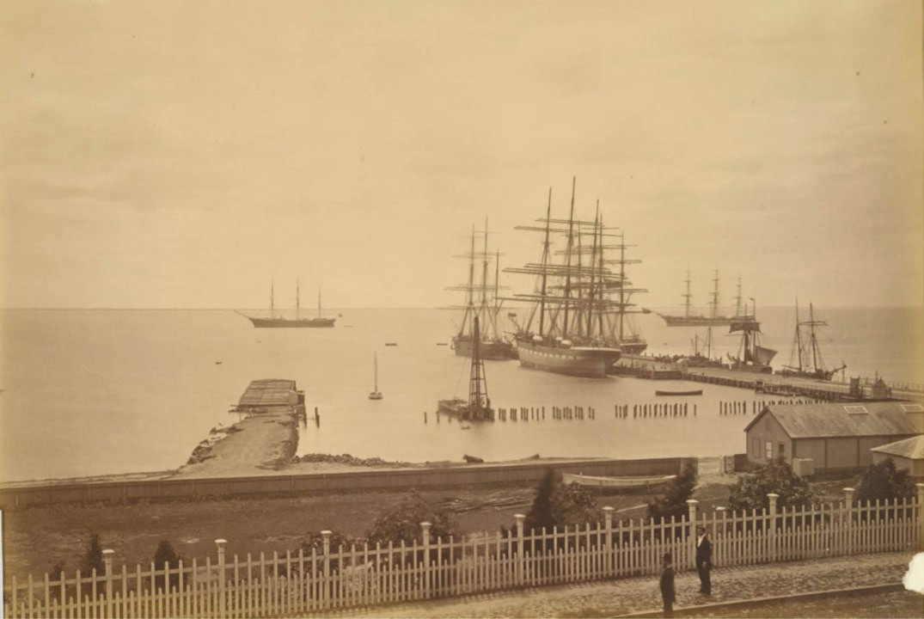
Figure 3.140: F. Kruger, Yarra Street, wharves, Geelong (the ruinous former Steampacket Wharf is shown on the left, with remnant piles extending to Yarra Street Wharf on the right), c.1878. Source: accession PH208-1979, National Gallery of Victoria, Melbourne. Gift of Mrs Beryl M. Curl, 1979.

YARRA STREET PIER
Repairs to the approaches of Queens Wharf and the construction of the Steampacket Wharf were insufficient to meet the demands of the Geelong township s berthing
needs. In August 1849, it was the opinion of Captain Foster Fyans, Police Magistrate and Commissioner of Crown Lands that liberty might be given for a jetty in front of the Custom House, and to prevent timber boats and other vessels having access. 1219 The Superintendent of Bridges, David Lennox, was subsequently instructed to prepare a design. Tenders for the building of a stone jetty were called in March 1850.1220 It was not until April 1851 when the last pile was driven and the jetty was completed a few days later to service the influx of vessels to the Geelong port.1221 A jetty had also been
built between the Steampacket and Yarra wharves for the convenience of passengers.1222 In 1856, the jetty was officially named the Yarrow [Yarra] Street Wharf 1223 (Figure 3.141).

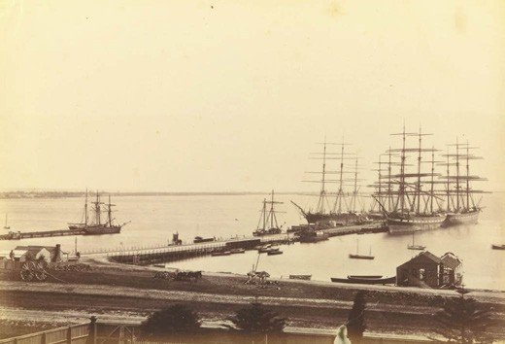

Figure 3.141: F. Kruger, Yarra Street Wharf, Corio Bay, Geelong, c.1886-87. Source: Accession PH326-1979 National Gallery of Victoria, Melbourne. Gift of Mrs Beryl M. Curl, 1979.

Improvements were made to Yarra Street wharf in the 19th and 20th centuries. Various extensions were made to the platform and jetty in 1858, 1859 and 1863. A crane was installed in 1866.1224 More significant changes were
announced in 1928 (when the wharf was widely known as the Yarra Street pier):
The Yarra street Pier, which was originally built for the accommodation of small barques many years ago, has undergone many improvements since it was first
constructed. Further improvements are now being carried out to the pier by the Geelong Harbor Trust. The loading platform on the east side of the pier has been raised, and new piles driven. Old and faulty piles have been replaced, and, where needed, repairs have been effected to the cross-heads and decking. The Harbor Trust has fenced
in a large area of the reclaimed land near the stevedores storage shed, and has installed a saw-bench and plant, where timbers for wharf repairs and for the construction of the barge for the Barwon River dredging are being prepared.1225
In 1937, The Herald reported on a proposal to reconstruct the Yarra Street pier to provide for discharging sheds and more space. 1226 In 1943, the Geelong Harbor Trust proposed works at a cost of £1,441,880 for revitalising the port of Geelong following the conclusion of World War Two.1227 Five years later in 1948, the Geelong Harbor Trust used its newly- acquired 48 ton floating crane to lift and relocate a former cargo shed (built in 1938) from the Moorabool Street Pier to the approach at the Yarra Street pier.1228 The shed was lifted in sections and rebuilt on the Yarra Street pier site where it served as a cargo shed until it became derelict in the late 20th century. In 1988, much of the Yarra Street pier was destroyed by fire.1229 In 1998 after a transformation, the cargo shed was opened as a restaurant and caf .1230

MOORABOOL JETTY-MOORABOOL PIER
Calls for the construction of a jetty at the end of Moorabool Street began as early as the 1840s, and in 1849, the Government had resolved to build a wharf there before reconsidering and building the Steampacket Wharf further east.1231 In January 1853, tenders were called for the construction of a ‘Stone Jetty and Embankment opposite Moorabool-street, Geelong. 1232 It appears that the structure was designed by Charles Rowand, engineer (see earlier subsection for details).1233 While construction commenced by Messrs Cutter and Musson, contractors shortly after,1234 progress was slow and the jetty was then already inadequate to meet the growing demand. As outlined in The Banner:

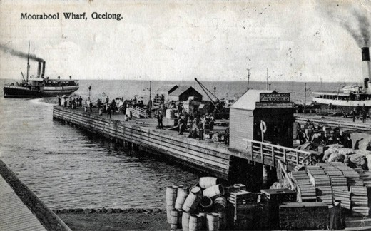
Figure 3.142: Moorabool Wharf, c.1910. Source; GRS 2009/00436 Geelong Heritage Centre collection.
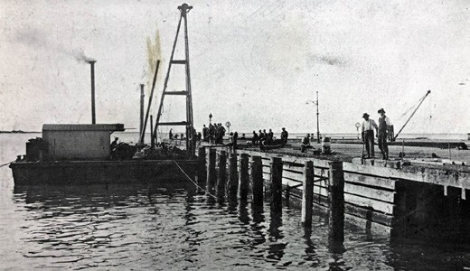
Figure 3.143: Widening of Moorabool Pier, 1913. Source: News of the Week, 1 May 1913, GRS 2121/3, Geelong Heritage Centre collection.

At present there is a small jetty being constructed, opposite the foot of Moorabool Street, but it is progressing at so very slow a pace, that no one knows when it possibly will be finished; and when finished it will be only able to give berth to ten or twelve vessels at most.1235
Slow progress continued throughout 1854 although it was advancing towards completion by September of that year.1236 By December 1854, cargo vessels were being berthed at the new wharf although the Duncan Hoyle had docked there in August for the Governor’s official visit to Geelong.1237 In 1856, the new wharf was officially proclaimed as the ‘Moorabool Wharf.1238 The wharf was extended in 18571239 and almost
20 years later in 1878 major repairs were carried out when the western side was removed and replaced with new piles, the old timber had been seen swinging about, only secured by the planking at the top. 1240 The work included half of the
wharf being erected level with the road allowing drays to back in opposite the vessels.1241

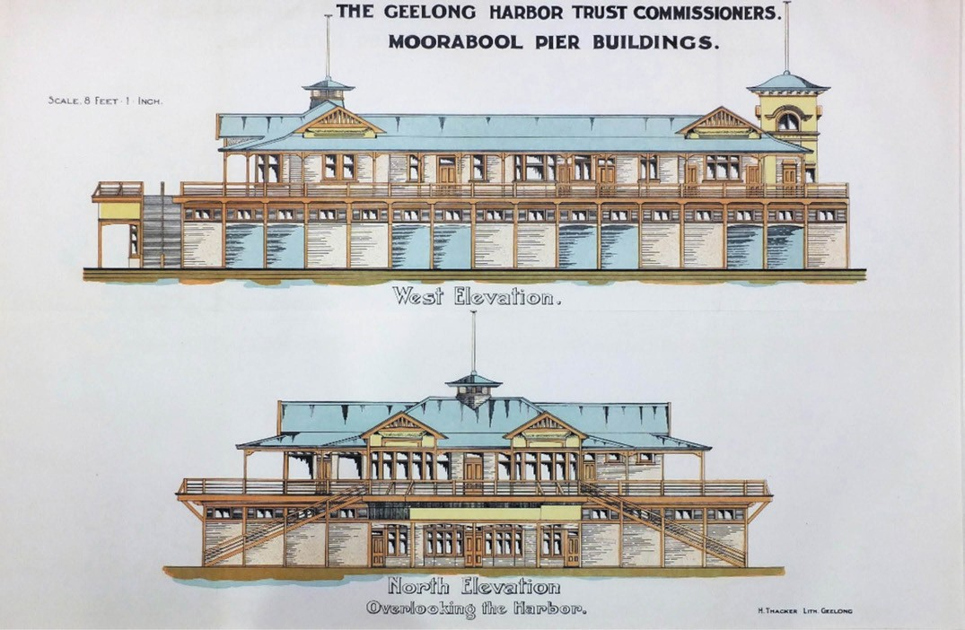
Figure 3.144: Moorabool Pier Buildings, West & North Elevations, H. Thacker lithographer, Geelong, c.1912. Source: Special Collections, Deakin University Library.

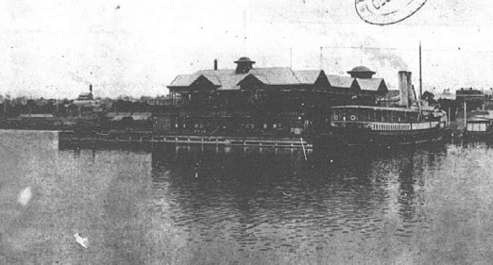
Figure 3.145: Moorabool Pier & Two Storey Pavilion, 1920. Source: News of the Week, 11 March 1920, GRS 2121, Geelong Heritage Centre collection.

In 1904, a year before control of the Moorabool Wharf (Figure 3.142) was vested in the Geelong Harbor Trust, investigations were carried out by Mr McLean, Engineer for Ports and Harbors for the purpose of having a cargo shed
constructed on the Moorabool pier in which to store valuable packages. 1242 It appears that the small shed was erected as an interim measure soon after.1243
A proposal for larger cargo and passenger sheds at the Moorabool Wharf was vexed. For many years, there was debate and dispute between the Geelong Harbor Trust, Customs Department and shipping agents, principally in relation to the responsibilities as to who should fund it.1244 The work involved a 70 feet widening of the western side of
the pier (Figure 3.143), together with a two storey pavilion and cargo shed.1245 In 1912, the Geelong Advertiser announced that at last :
Preparations are being made by the Harbor Trust Commissioners to put in hand this month the erection of a two-storey pavilion over the whole of the Moorabool-street pier. The pier floor will be devoted to cargo traffic, and passengers will be able to move about on the upper floor without fear of being hustled by trucks and trollies! While the work is in progress the bay steamers will go to the Yarra street pier.1246
Possibly designed by the Geelong architects, Tombs and Durran (the turreted design had a similarity to the recently- constructed Solomon s building in Moorabool
Street), or the Harbor Trust s previous architect, Percy Everett

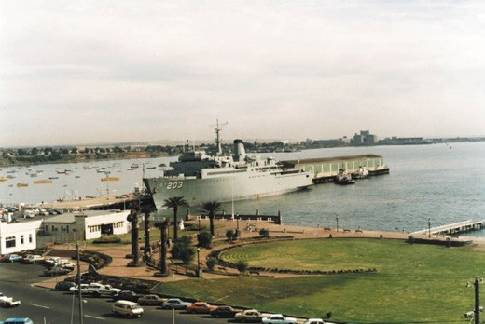
Figure 3.146: Geelong waterfront from Sailors Rest roof showing Moorabool Street Memorial Pier Wall (centre, middle ground), c.1997. Source: Kevin Krastins.

(the domed corner bay of the nearby Sailor s Rest building have an affinity with the proposed building), approximately 50 men were employed by the Harbor Trust in the construction of the pier extension and new building1247 (Figure 3.144).
Nearing completion in February 1914, it was intended to lease several apartments for the purposes of book-stalls,
refreshment rooms, billiard room, etc. 1248 It was first occupied by the Railway Athletic and Social Club in 1917 (see earlier subsection). The pier continued to provide an important berthing location of passenger steamers while the new cargo and passenger shed became landmark on the Geelong waterfront at the end of Moorabool Street (Figure 3.145). It was also the location of a Royal Australian Naval depot in the 1920s.1249
A damaging fire on the Moorabool pier in January 1933 was the beginning of the end of the two storey pier building.1250 In 1938, the Geelong Harbor Trust demolished the cargo and passenger sheds and commenced construction on
two new single storey hipped roofed cargo sheds each measuring 185 feet by 30 feet.1251 They had been designed by local architects, Schefferle and Davies, in association with J. Gordon Williams.1252 Completed by March 1938, the Moorabool Street pier was considerably shorter and became the berthing location for smaller interstate vessels.1253
The cargo sheds served the Moorabool Street pier until 1948 when a floating crane dismantled the sheds, with one of them relocated (in parts) to the approach of the Yarra Street pier (see earlier subsection). In 1949, the Geelong Harbor Trust demolished the Moorabool pier1254 and by early 1950 a look- out platform had been built at the approach to the former pier. Designed by architects Leith and Bartlett,1255 it was reported in The Argus:

The Geelong Harbour Trust is building an observation platform overlooking Corio Bay at the foot of Moorabool st., following the removal of the pier.
The platform is semi-circular, with an ornamental stone wall and a flagstaff in the centre.1256
The wall with flagpoles and platform (Figure 3.146) were part of a movement to beautify the Geelong foreshore. The wall became a memorial to the Moorabool Street wharf and its contribution to Geelong s maritime heritage.
In 2000, considerable excavation of the former approach to the Moorabool pier was carried out as part of a waterfront redevelopment.1257

RAILWAY/CUNNINGHAM PIER
A key part of the construction of the railway network by the Geelong to Melbourne Railway Company in the early 1850s was a jetty at Corio Bay. This infrastructure was
considered vital in yielding an immediate return on the capital expended by the Railway Company for the railway network
if anticipated improvements were made to the sand bar in Corio Bay.1258 Consequently, the Geelong Town Corporation attempted to thwart the building of the jetty as according to its architect, Edward Snell, it would probably monopolise the great part of the [shipping] traffic.’1259 Approved by the Colonial Government, tenders were called for the supply of 600 piles, beams and planking for the timber jetty in October and November 1853.1260 By January 1854, excavations
and embankments had been rapidly proceeded with. 1261 The timber was supplied from the Apollo Bay Timber Company while Mala bar teak was cut and delivered for the superstructure of the jetty by Macindoe, Taylor and Co.1262 Messrs. Ross and Munro had also been engaged to form and construct the incline between the Geelong terminus and the Company s jetty, and built a culvert at Corio Terrace (Brougham Street).1263 By early January 1855, the jetty was
almost completed (Figure 3.147). Built with raised platforms, the Company s President, Charles Thorne announced that:
The pier, one thousand feet in length, is in active progress, and will be completed during the next month, in accordance with the contract. Some difficulty was at first experienced from the softness of the bottom, in securing the piles efficiently; but this obstacle has been completely overcome by affixing a large additional bearing for each pile, as required. The branch from Corio Bay to the station will be ready for use within three months; and the directors are happy to inform the shareholders that the Government has been pleased to grant a piece of land for the erection of suitable warehouses in the immediate vicinity.1264
By 1862, the railway jetty was in a dilapidated state.
A deputation from the Geelong Chamber of Commerce

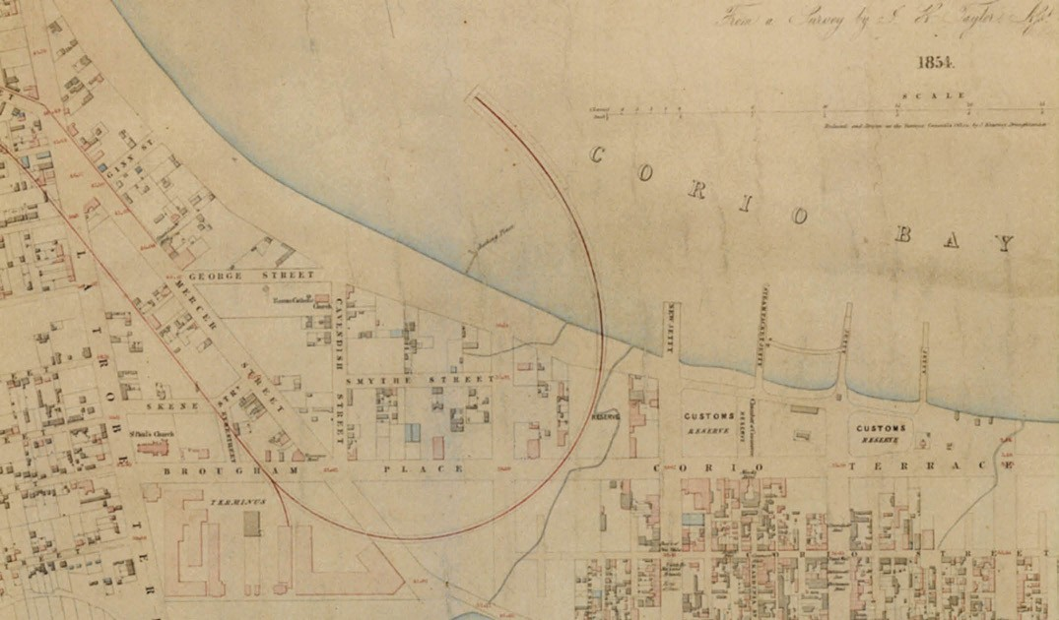
Figure 3.147: Plan showing railway pier branch line and curved pier extending into Corio Bay, 1854. Source: J.H. Taylor, Map of Geelong, Surveyor-General’s Department, Melbourne, 1854. Source: VPRS 8168/P2, Unit 5416, item Roll 39 Geelong, Public Record Office Victoria.

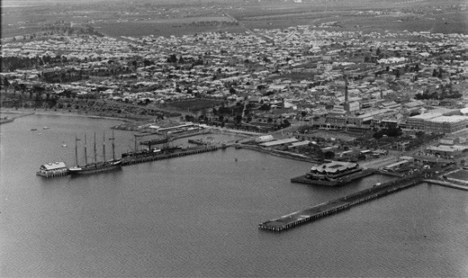
Figure 3.148: C. Pratt, Geelong Harbour, 27 September 1927, showing Cunningham Pier (right). Also note the other major piers: Moorabool (with two storey pavilion) and Yarra Street Pier (left).
Source: accession H91.160/802 State Library of Victoria.

waited on W.F. Mitchell, Commissioner of Railways (given that the jetty had been purchased by the Victorian
Government in 1861) to have it rebuilt to a different design. Thomas Higinbotham, engineer-in-chief of the Victorian Railways Department, found that the curved layout of the jetty meant that it was not in sufficiently deep water. He

proposed a straight pier that would extend into a depth of 22 feet of water, the raised platform being removed on one side to allow a railway to run alongside the ship, in order to facilitate the discharge of the inward cargoes of coals, timber, &c., at once into the railway trucks; and to leave the
raised platform on the other side, which would accommodate vessels loading wool. 1265 Tenders were called for the removal of the old jetty and construction of the new pier structure in December 1862,1266 the contract being awarded to H. Dalrymple at a cost of £17,416/16/2.1267 Works had been completed by 1864.1268
In 1908, improvements were made to the pier to enable the handling of grain traffic.1269 Twenty years later in
1928 reconstruction works were carried out by about
60 workers to provide a coal berth at the pier.1270 By this time, the railway pier had been renamed the Cunningham pier (Figure 3.148), after the nearby Cunningham Street that had been named in honour of George Cunningham M.L.A.1271
In 1946, iron and timber buildings at Cunningham pier were offered for sale.1272 Re-decking in concrete was carried out in 1962 and work commenced on a new cargo shed on the outer eastern portion of the pier.1273

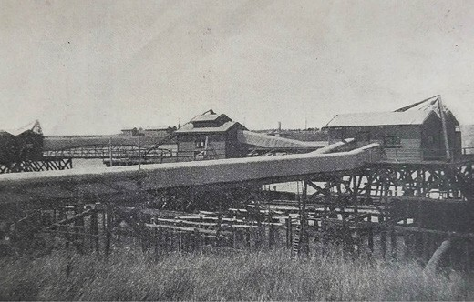
Figure 3.149: Enclosed wheat loading jetty, Corio Quay, c.1926. Source: Bay View Estate Plan, n.d., Special Collections, Deakin University Library.

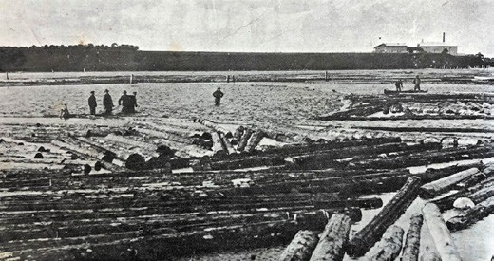
Figure 3.150: Paddocking the Logs , Oriental Timber Corporation s Log Pond, Corio Quay, 1911. Source: News of the Week, 14 September 1911, GRS 2121/3, Geelong Heritage Centre collection.

In 1996, Cunningham pier underwent a $10 million redevelopment with a family restaurant, caf and function room provided in addition of berthing facilities for larger vessels.1274 These works were complementary to the redevelopment of the central Geelong foreshore, including a baywalk with bollards capturing the local history of Greater Geelong, the artwork of Jan Mitchell. West of the Cunningham pier forecourt, a children s playground was constructed following the theme of the Voyage of the Poppykettle by local author and artist, Robert Ingpen.1275

CENTRAL GEELONG FORESHORE LAND RECLAMATIONS
To assist with increasing demand by shipping and stevedoring companies and the Customs department, work began on the reclamation of the foreshore east of the Moorabool pier in 1883. The Geelong Advertiser declared in August of that year that the reclamation works opposite the custom house, we may point out, are now almost completed. 1276 However, no start had been made on the
land reclamation and construction of a sea wall between the Moorabool and Railway piers.1277 While the reclamation was long desired, when work began in 18841278 it was subject to staunch criticism.1279 This was especially highlighted in the Geelong Advertiser in August 1885:
It is gratifying to us to find that the remarks we have made from time to time in our leading columns, on the foolish piece of reclamation work being carried out between the Railway and Moorabool wharves, have at last attracted the attention of the Hon. Commissioner of Public Works. We have always insisted that the stone wall should have been continued from the Moorabool wharf to some distance westward of the Railway wharf, thereby doing away
with about 70 yards of pile railway wharfing, and giving splendid shunting ground for trucks east and west of that wharf. We condemned the stone wall running parallel with that wharf, north and south, as wasteful and useless expenditure, and Mr Cunningham writing last night from Melbourne, tells us that this wall is to be taken up, and the stone used in continuing the wall underneath the Railway pier, and beyond it westward. This work will considerably extend the reclaimed foreshore, and materially improve the Western Beach.1280

CORIO QUAY
Impetus for a new cargo port at North Shore came following the dredging of the Hopetoun Channel in 1893 (see following subsection), allowing larger ships into Corio Bay for the first time but shallower water at the central Geelong waterfront prevented them from berthing there. A port location in Geelong s northern suburbs also offered opportunities to be connected to the railway network at a time when the city was on the cusp of industrial expansion. The first jetty at North Shore was to the north of the Cowies Creek inlet. It was built in 1895 into the deep water in Corio Bay for the Western and Wimmera districts of Victoria Freezing Company at which vessels could safely call for the purpose of taking to England and elsewhere the frozen products. 1281 In 1901, the Western Wimmera Districts of Victoria Freezing Company went into liquidation and was wound up voluntarily.1282 The company and lease of works at North Shore were acquired by Messrs. W. and R. Fletcher Limited.1283 Much of the jetty

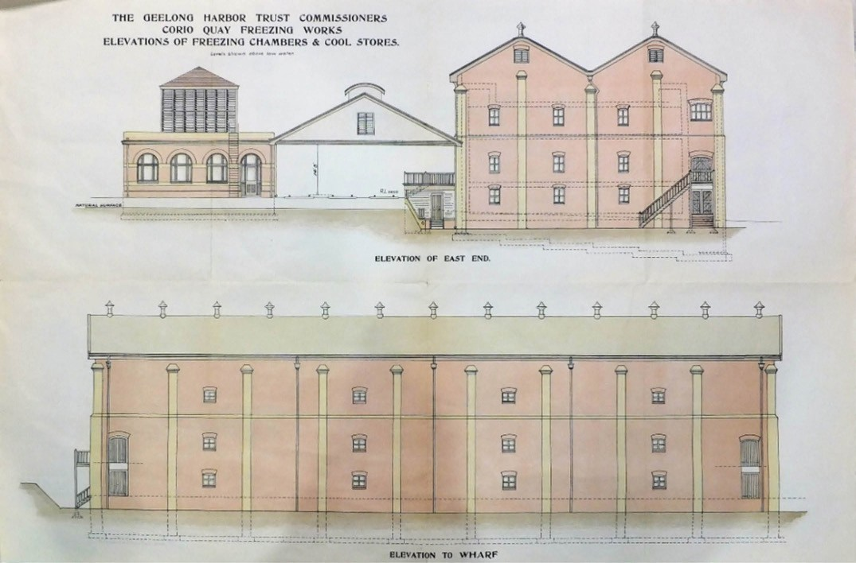
Figure 3.151: Corio Quay Freezing Works, Elevations of Freezing Chambers & Cool Stores, The Geelong Harbor Trust Commissioners, 1909. Source: Special Collections, Deakin University Library.
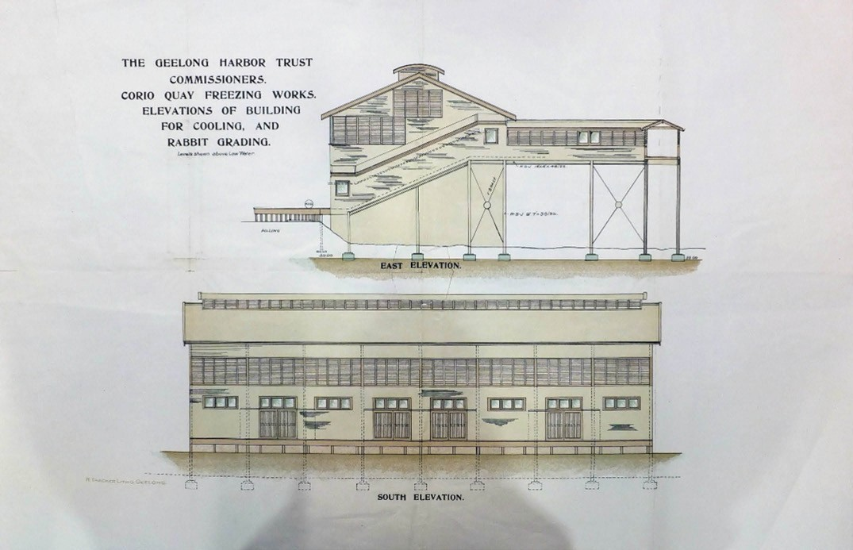
Figure 3.152: Corio Quay Freezing Works, Elevations of Building for Colling, and Rabbit Grading, The Geelong Harbor Trust Commissioners, 1909. Source: Special Collections, Deakin University Library.

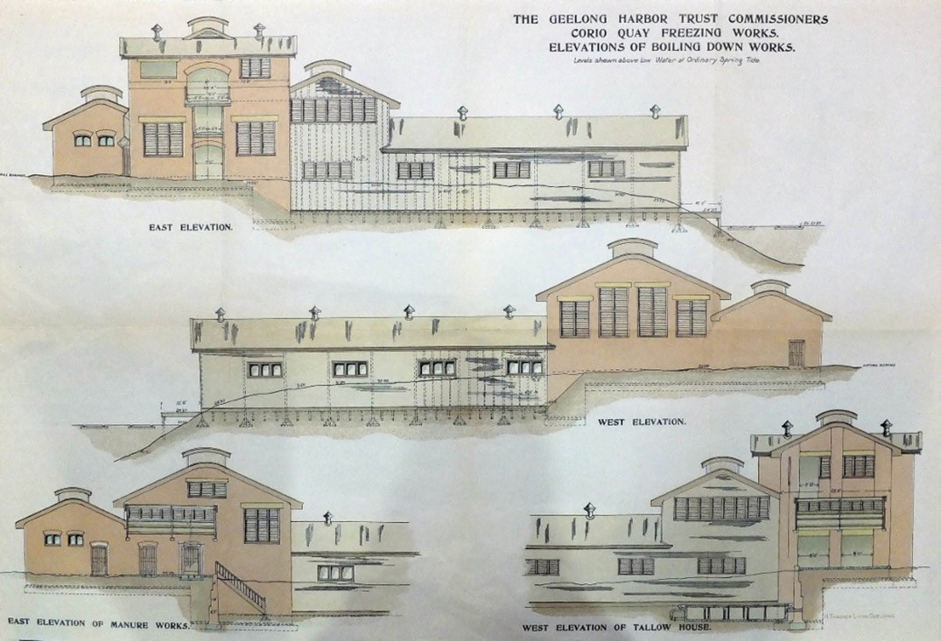
Figure 3.153: Corio Quay Freezing Works, Elevations of Boiling Down Works, The Geelong Harbor Trust Commissioners, 1909. Source: Special Collections, Deakin University Library.

was demolished in 1953-54 given that it had been out of commission for many years. 1284
It was following the creation of the Geelong Harbor Trust in 1905 when major redevelopment of the North Shore foreshore into Corio Quay was carried out including the redevelopment of the Freezing Works. In 1908, the Harbor Trust began
the construction of a wharf on the south side of Corio Quay where wheat could be loaded from railway trucks1285 (Figure 3.149). A Royal Commission in 1902-03 had highlighted the adaptability of the projected high-level pier at the North
Shore, Geelong , to loading in bulk and in particular grain by the elevator system.1286 The Harbor Trust s grain scheme at North Shore was comprehensive and the Geelong Advertiser argued would give to Geelong shipping facilities of no mean order. 1287
It was also in 1908 when the Geelong Harbor Trust signed a 21-year lease with the Oriental Timber Corporation Limited of Australia.1288 This involved the construction of a log pond in the inlet to Cowies Creek and dredging works1289 (Figure 3.150).
In 1909, the Geelong Harbor Trust established the Corio Freezing Works complex on the northern shores of Corio Quay (the site of the earlier Freezing Works) (Figures 3.151- 153). Duncan Urquhart of the Smithfield Freezing works
at Timaru, New Zealand, was appointed the inaugural manager.1290 The foundations for the new freezing chambers had been completed by March 1909, the building constructed of brick and three storeys to accommodate the latest type of refrigerating machinery.1291 Dredging for a berth for vessels to take cargo of frozen produce was almost completed
in June 19091292 and work commenced on the construction of the jetty in September of that year.1293 Sheep receiving yards had also been completed by 1911 following a request from the Geelong Woolbrokers Association.1294
Several improvements and additions were made at Corio Quay throughout the 20th century. In 1953-54, reclamation works began in the northern portion of the Quay to enable the addition of berths and the construction of roads, storage areas and cargo sheds.1295 The new facilities were completed in 1961, a year after a new cargo berth had been created at Corio Quay South.1296

OTHER INDUSTRIAL WHARFS
The interwar and postwar eras witnessed substantial industrial expansion and the need for further wharfage accommodation on the shores at North Geelong and North Shore. Those constructed during this period were: Lascelles Wharf at North Shore for the Co-operative Phosphate Company of Australia (1927-28, it was extended in 1951 and 1959 and known as King s Wharf); Ford Motor Company at North Geelong (1928); Bulk Wheat piers at Corio Quay for the Grain Elevators Board (1935 and 1938); and the Refinery Pier at Corio for the Shell Oil Refinery (1953 – it was duplicated in 1956).1297

TOURIST PIERS
Jetties and piers were erected at tourist destinations on the bay foreshore and coastline in Greater Geelong to cater for visitors, commuters and the shipping of cargo and produce. They included those at St. Leonards (1857), Portarlington (1859) and Clifton Springs (1873 and 1890).1298 The jetties at St. Leonards and Portarlington were also important for
transporting produce and other goods., the former first being partly constructed from a hulk scuttled by Captain George Ward Cole at the end of Murradoc and Harvey Roads.1299
On a smaller scale, a jetty was also erected for fishermen at Barwon Heads in 1889.1300

BAY CHANNELS
Thwarting Geelong s development throughout much of the 19th century was the sand bar between the inner and outer harbours near Point Henry. It prevented large ships from entering the inner harbour to the central Geelong foreshore. Smaller craft could navigate a natural channel (known as the North Channel) near Bird s Rock which had a maximum
depth (after dredging) of 13 feet.1301 In 1839, three buoys were requested to assist vessels navigate the small channel. Their arrival was delayed because the original vessel engaged to bring them from Sydney was too small and they subsequently arrived on the Louisa.1302
The anchoring of buoys was only a small measure in alleviating the channel problem. In 1841, the Chair and Deputy Chair of the Melbourne-based Committee of Exchange petitioned the Governor, Sir George Gipps for:
the navigation of the outer and inner harbours of Port Phillip and Geelong; and in submitting to your Excellency s judgment, the insuperable necessity of surveying and buoying the various channels that run through the banks on the directions which have been instanced 1303

In 1847, a Geelong Harbour Committee was established to pursue the clearing of the channel leading into the harbour, to a depth of 14 feet. 1304 However, the Governor would not commit to the immediate dredging of the channel because
£5000 had been placed on the estimates for a steam dredge at Port Phillip and until such time as this dredge was acquired, the clearing could not be carried out.1305
Notwithstanding the need for dredging, Charles La Trobe supported the idea of a survey of Corio Bay being carried out if a competent person for the undertaking could be found.1306 Under the superintendence of Henry Ginn of the Colonial Architect’s Office, Messrs. Garrard and Manton were engaged to carry out the survey. They proposed a new channel from Port Phillip Bay to the inner Harbour of a breadth of 264
feet and a depth of 18 feet (Figure 3.154). It would traverse the south-west portion of the existing boat channel and provide a more direct route between Port Philip Bay and the inner harbour of Corio Bay.1307 The channel was not to be immediately realised.
In July 1853, the Duncan Hoyle dredge was towed from Williamstown and anchored in Corio Bay. The Geelong Advertiser and Intelligencer quipped that it brought ease to the long vexed question of deepening the Channel into our inner Harbour. 1308 Such positive expectations of a deep and reliable channel soon evaporated. The lean years of progress in Geelong in the late 1850s brought with it loud criticism of further Government inaction on the matter and the formation of a local Bar Committee to press for the removal of the bar
to which it would assist with funds. At its first meeting, the following was resolved:
That a league be formed for the removal of the bar; that the subscription to the league be 5s. each half-year; that a paid collector be appointed; that the amounts so raised be expended in forwarding the removal of the bar, and that any surplus funds be divided between the Geelong Hospital and the Geelong Orphan Asylum; that all members be admitted free to all meetings; and non-
members pay 6d. each admission to any such meetings; and that the members of the Committee collection subscriptions, and that each member of Committee pay
£1.1309

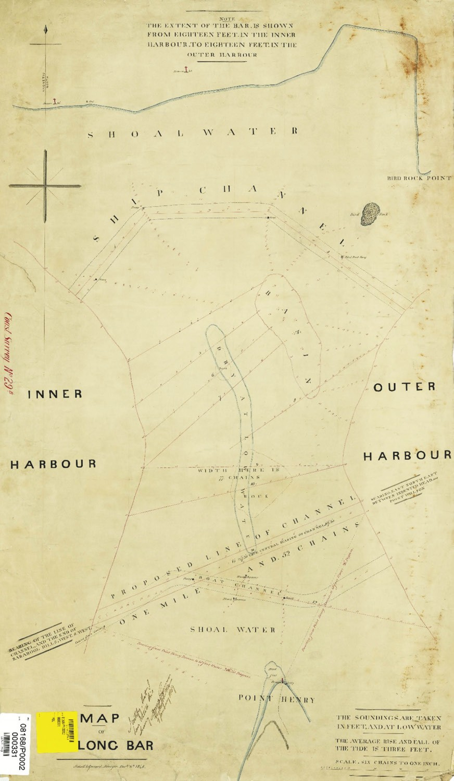
Figure 3.154: H.H. Garrard, Surveyor, Map of Geelong Bar, 6 December 1848. Source: VPRS 5168/P5, Sydney Plan, CS298 Public Record Office Victoria.

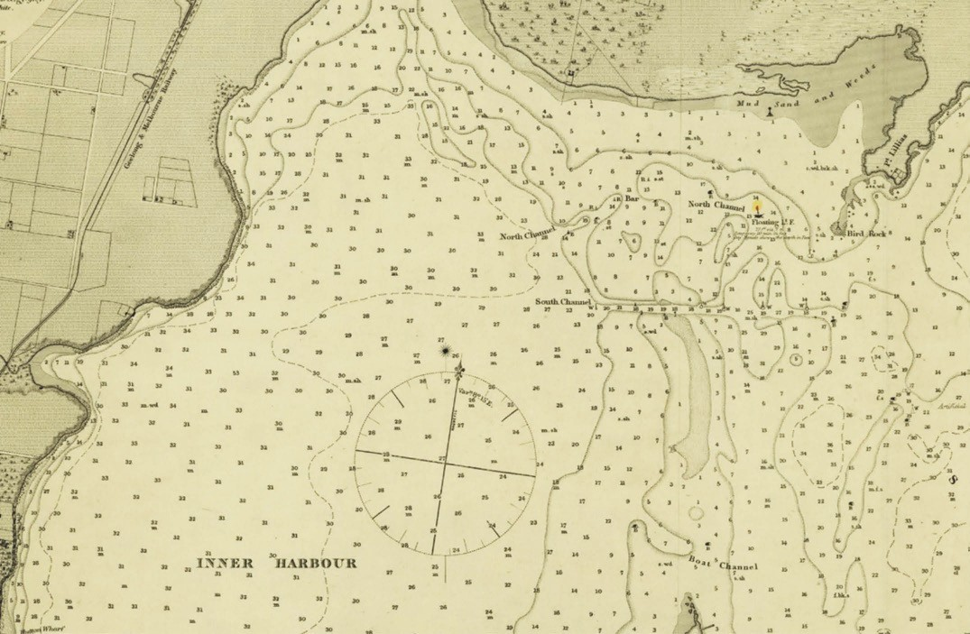
Figure 3.155: H.L. Cox (assisted by T. Bourchier & P.H. McHugh), Survey of Geelong Harbour 1864 showing North & South Channels (the point of Point Henry is shown at the bottom of the map). Source: Source: VPRS 8168/P5, Sydney plan, item MCS 76, Public Record Office Victoria.

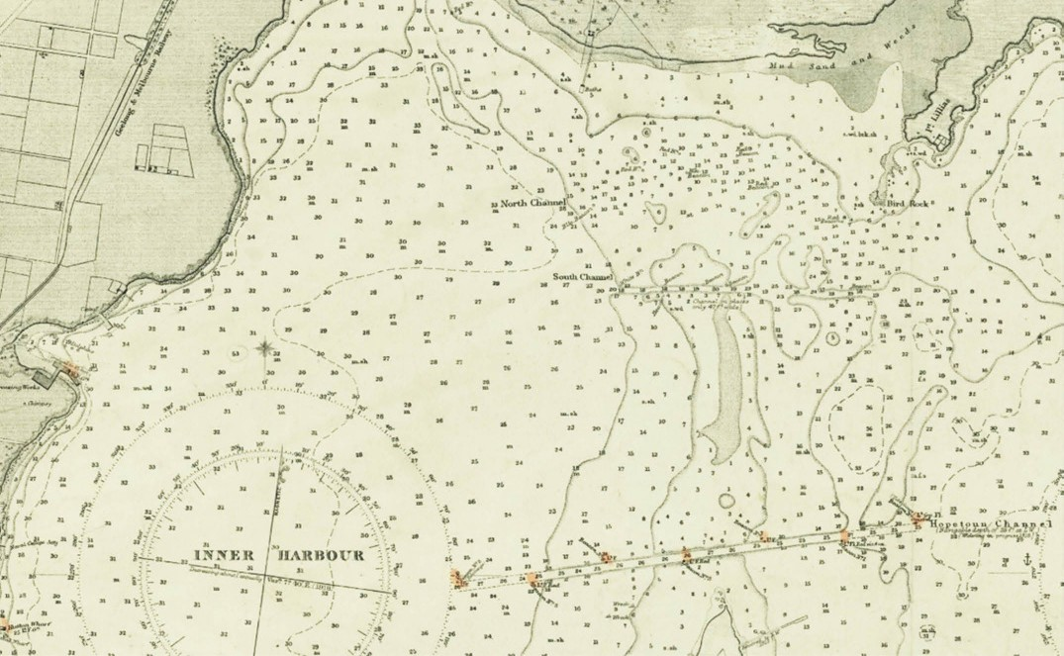

Figure 3.156: H.L. Cox (assisted by T. Bourchier & P.H. McHugh), Survey of Geelong Harbour 1864 updated in 1892, 1905 & 1914 showing North, South, & Hopetoun Channels (the tip of Point Henry is shown at the bottom of the map). Source: VPRS 8168/P5, Sydney plan, item MCS 77, Public Record Office Victoria.

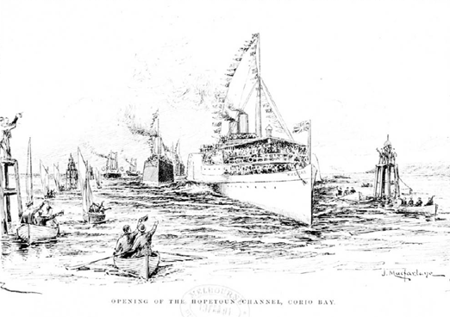
Figure 3.157: J. Macfarlane, ‘Opening of the Hopetoun Channel, Corio Bay , 1894. Source: Illustrated Australian News, 1894, accession IAN 01/02/94 State Library of Victoria.

The work of the Committee paid off and in March 1861 it proudly announced the completion of the South Channel:
We have this month the pleasurable task of announcing the completion of the greatest harbour improvement ever attempted in this part of the world. There is now a channel with 18 feet at low water leading from the outer into the Inner Harbour of Geelong. The channel is short, and perfectly straight, and although only one chain wide, will, so soon as it is buoyed, be available for the admission of the largest class of merchantmen frequenting our port.
The dredges will be continued at work until the channel shall be two chains wide, but as it may be made available immediately, we are justified in saying that, so far as regards the present requirements of commerce, the work is completed, and there is now no obstacle to the initiation of a direct trade in first class ships between England
and this port. The advantages of this improvement will become fully apparent when next wool season comes round, but it is to be hoped that there is sufficient enterprise left alive, to take an earlier advantage of access to a harbor which is now unquestionably the finest in Victoria, and which gives access to markets second only to that of the metropolis. The traders of Ballarat and the other western and north-western centres of trade, will, upon the opening of the railway, be enabled to have their goods hoisted from the ships hold and passed into the trucks that are to carry them by the shortest line of land carriage to the nearest point to their own door.1310
The South Channel (along with the North Channel) was shown in a map of the Geelong Harbour in 1864 by Commander H.L. Cox, assisted by T. Bourchier, Master, R.N. and P.H. McHugh (Figure 3.155).

Owing to drifting sand, the South Channel constantly silted up and became unsafe.1311 In 1878, Sir John Coode, Cornish engineer, was appointed by the Victorian Government to survey Corio Bay to determine the best course of action for the channel. He recommended the excavation and dredging of the existing Boat Channel, providing a length of cut of 3600 yards and a depth at low water for a width of 132 feet of 20 feet at the sides to 22 feet 6 inches in the centre 1312 (Figure 3.156). Cutting of the new channel commenced in 18811313 but twelve years were to transpire before it was completed.
The dredging was carried out by two dredges – Alligator and John Nimmo – and the steam tug, George Rennie (as a tender to the Alligator). The master of the Alligator was J.S Harris (who had 11 employees under him). J.H. Silke was master
of the John Nimmo and A.R. Rennie master of the George Rennie. He employed 6 crew.1314 Finally, at a cost of £80,000, the new channel was opened on 20 December 1893 and named in honour of Lord Hopetoun (Victorian Governor)
who formally declared it open at an official ceremony on the
Hygeia in Corio Bay1315 (Figure 3.157).
Deeper and wider channels were dredged in the second half of the 20th century.1316

PASSENGER STEAMERS
While the wharfs and channels provided opportunities for the transportation of cargo to overseas markets, they also enabled a regular and reliable mode of passenger transport for commuters to Melbourne, interstate and beyond. They also soon provided regular bay services to nearby marine resorts including Clifton Springs, Portarlington and St.
Leonards. From the early 1840s, steamers from Melbourne berthed at Queen s Wharf until the construction of the Steampacket Wharf in 1850. Those steamers to frequent the Geelong port included the Aphrasia, Vesta, Keera, Courier, Excelsior, Geelong, Edina, Hygeia and Ozone.1317
Evidence of the significant contribution these vessels made to the Geelong transport system in the 19th and early 20th centuries is almost lost. Aphrasia Street in Newtown and Keera Street in Geelong are a subtle reminder of the service of these steamers.1318
The first steamer engaged in providing a regular bay service between Geelong and Melbourne was the Aphrasia. It was built in Sydney in 1840 for the Port Phillip Steam Navigation Company.1319 The maiden voyage from Melbourne was anticipated for June 1841, as reported in the Geelong Advertiser:
The establishment of a Steam communication with the neighbouring settlements will undoubtedly mark the commencement of a new era in the destinies of this

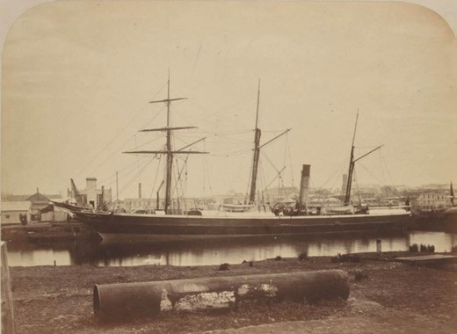

Figure 3.158: Edina, Melbourne, c.1865-70. Source: accession H3999 State Library of Victoria.

township. Admirably adapted as it is for becoming the centre of traffic in the finest district in the Southern
Hemisphere, the numerous visitants who will then have opportunity of seeing the beauties and advantages of its situation, will soon rescue it from the obscurity into which it has been thrown by the mad infatuation which has prevailed in favour of Melbourne.
We are informed that this beautiful boat (Aphrasia) is to make her maiden trip, or rather trial, on the 24th instant, the Queen s birth-day; she is to ply all that day round the port with a select party on board. She is intended for the Port Phillip trade, and is commanded by Captain Lawler. She is expected to sail for Melbourne on the 1st of June. She possesses splendid accommodation for passengers; her cabins are most elaborately and even splendidly fitted up, particularly the state cabin, in the fitting up of which nearly £1000 have been expended. This fine vessel, which is a beautiful model of naval architecture, reflects great credit on the builder, Mr. Lowe.1320
In 1852, the newly-formed Geelong Steam Navigation Company acquired the Keera that had been made by
R. Stephenson and Co., of Newcastle, in 1851.1321 It was claimed as ‘undoubtedly one of the finest crew steamers afloat’ and in December 1852 it was put to a trial trip ‘over the bar, and round the shipping at Point Henry. 1322
Physical evidence survives of two other early bay steamers: Edina and Ozone. At 11 St. Leonard s Parade, St. Leonard s a portion of the existing dwelling is reputedly a former cabin of the S.S. Edina and known as Edina cottage .1323 One of the longest serving steam vessels in the world, the Edina (Figure 3.158) was built by Barclay, Curle and Co. on the Clyde River, Glasgow, Scotland, in 1853 for the Leith, Hull and Hamburg Steam Pack Company.1324 It was requisitioned by the

Figure 3.159: Captain William Forbes, 1899. Source: The Australasian, 24 June 1899, p.27.

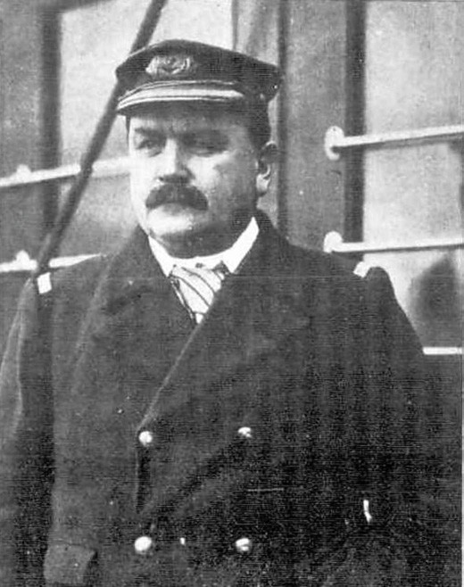
Admiralty in 1855 to carry stores and horses to the Black Sea during the Crimean War.1325 At the conclusion of the war, the Edina was worked on the trade routes in the United Kingdom and Mediterranean before being acquired in 1861 and used as a blockade runner for the American Civil War, carrying cotton from the Confederate states.1326 In 1863, the Edina was purchased by Stephen Henty in western Victoria and later used to carry gold prospectors between Victoria and New Zealand. Used in the coastal trade along the Queensland coast for Howard Smith following a refit in 1870, the Edina returned to Victoria and commenced the Melbourne-Geelong trade as a cargo and passenger vessel.1327 In 1917, the Edina was refitted, altering its appearance with a new mast, funnel, bridge and promenade deck. The vessel continued in serve until 1938 when it was renamed Dinah and used as a lighter until 1958.1328
The long-serving captain of the Edina for 36 years at the time of the refit in 1917 was Captain William Chalmers Forbes (1852-1936)1329 (Figure 3.159). Born at Leslie, Fife, Scotland, Forbes came from a seafaring family and in 1868 he served a two year apprenticeship in the North Sea on the Geordie brig.1330 In 1873, Forbes came to Australian on the Loch Katrine and joined the schooner Sybil that traded

between Port Phillip and the Clarence River.1331 Forbes joined the Edina in 1880 and was made captain from 1882, a position he held until his retirement in March 1920.1332 His
enduring fondness for the Edina was able to continue into his retirement as in 1917 the Geelong Advertiser reported:
To Captain Forbes, the skipper, when the old decking and fittings were removed, it was like parting with his old ship. But the captain intends to keep a substantial memento, and he has bought the old social cabin which used to stand on the upper deck. This he is going to remove to his farm between Portarlington and St. Leonards. With some other old fittings from the ship, he intends to fix up the cabin as it used to be on the Edina to remind him of old days.1333
After his retirement in 1921, W.C. Forbes took over the 5-acre fisherman residence license of his brother, A.M.
Forbes, which he had held since 1913.1334 The allotment was situated on the Indented Head foreshore, adjoining Batman Park. By October 1921, Forbes had erected a six- roomed dwelling, presumably from the former cabin of the Edina.1335 Forbes dwelling was featured in the Weekly Times in 1935, the panelled walls with banks of small rectangular windows reflecting the earlier portion of the Edina (Figure 3.160).
Edina cottage (Figure 3.161) was relocated to 11 St. Leonards Parade, St. Leonards in 1951 following
Miss Shirley Fletcher s purchase of the vacant site from
the Estate of William Hamilton Gerrand in 1950.1336 It survives today as a legacy of the highly significant and enduring service of the S.S. Edina.
Now almost totally lost, the paddle steamer Ozone was hulked at Indented Head as a breakwater in 1925 by W.C. Forbes as part of a local syndicate that had acquired the vessel from Melbourne.1337 Forbes was an inaugural member of the Batman Park Committee of Management at this time and the need for a breakwater at Half Moon Bay, Indented Head, was considered essential by the Committee for safe harbourage.1338 The Ozone was built in Glasgow, Scotland
in 1886, and it was sailed to Australia via the Mediterranean Sea.1339 Painted green and white with bright orange funnels and lit at night by electric light, the Ozone had three decks with a dining room, a ladies saloon and several bars.1340 Upon arrival in Melbourne in 1886, the Illustrated Australian News gave the following glowing description of the new steamer:
Not a few prominent citizens have summer residences at Queenscliff, Sorrento, Portsea, Mornington, or other
places on the shores of the harbour [Port Phillip Bay], and they find the change from the dust and bustle of the city as efficacious as a tour in Tasmania, while it may be indulged in frequently at little expense. A notable indication of
the popularity of these trips is the arrival of the grand

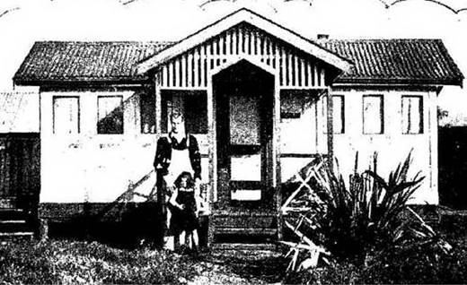
Figure 3.160: Edina Cottage , Indented Head, 1935. Source: Weekly Times, 31 August 1935, p.36.

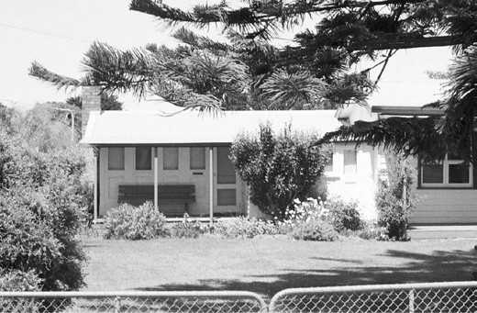
Figure 3.161: Edina Cottage , 11 St. Leonards Parade, St. Leonards, 1996. Source: Bellarine Heritage Study .

new excursion steamer the Ozone, which has a speed of 17 miles per hour. This vessel greatly reduces the time occupied in the water journey, and gives increased opportunity for the passengers to enjoy themselves on land.1341
Retired in 1918, the steamer formed a notable landmark as a breakwater off the foreshore at Batman Park from 1925 (Figure 9.87). Only remnants of the paddle wheel survive. Further homage to the Ozone was also paid the naming of
Ozone Street at St. Leonards and Ozone Road (as part of the Barwon Heads Estate in 1891 – see Figure 6.231) at Barwon Heads, in 1906.

SHIPPING AGENTS
Integral to the successful operations at Geelong s port from the 1840s and throughout the early 20th century was shipping agents. These companies were responsible for managing cargo and passengers for ship owners, managers and others associated with the shipping industry. Some of the earliest
in Geelong included Charles Ruffle (from 1841), Captain

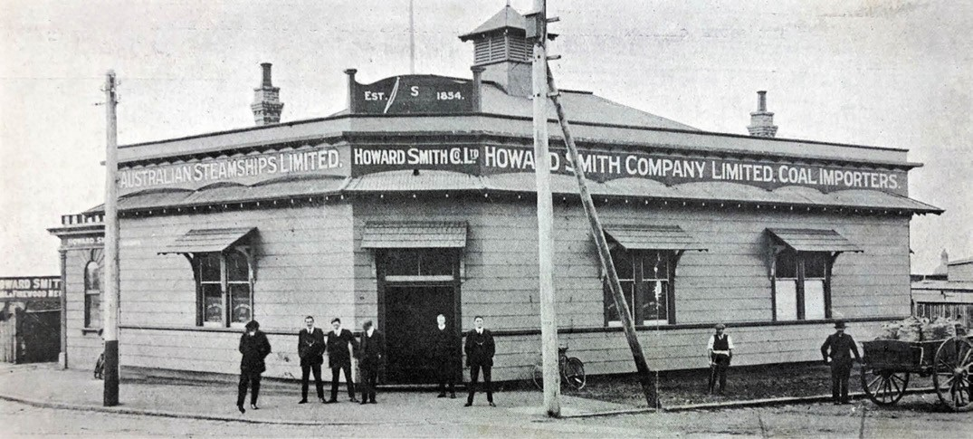
Figure 3.162: Howard Smith Company Ltd, Geelong waterfront, 1913. Source: News of the Week, 26 June 1913, GRS 2121/3, Geelong Heritage Centre collection.

Thomas Ogilvie (from 1853), H. Fitchett (from 1854), William Howard Smith and Sons (from 1854), and Thomas J. Parker (representing J.D. Parker and Co.) (from 1853).1342
Two of the most enduring firms doing business in Geelong were W.H. Smith and Sons, and Huddart Parker and Company:

W.H. SMITH AND SONS¹³⁴³
The founder of this company was William Howard Smith (1814-1890) who was born at Yarmouth, Norfolk, England, the son of Ormond Smith, a mariner, ship-owner and mail contractor of Amsterdam and Rotterdam, Holland. Howard Smith later studied navigation and qualified as a master, becoming a partner in his father’s firm at the age of 21 and was given command of the steamship, Adonis. In 1854,
at the height of the Victorian goldrush, Smith emigrated to Melbourne with his wife, Agnes. He acquired the Express with S.P.O Skinner and began a regular trade between Melbourne and Geelong. Thomas James Parker was appointed the agent in Geelong and in 1861 Parker purchased Smith s share of the business. After a short return to England, Smith commenced working the intercolonial trade but he subsequently established a partnership with L.J.L. Burke in the Newcastle coal trade. Smith purchased his former firm outright in the mid-1860s and in the late 1870s three of his sons had taken charge of the Melbourne, Sydney and Brisbane offices. In 1883, the firm became a limited liability company known as Howard Smith and Sons Ltd.
With the completion of reclamation works on the east side of
the Moorabool pier in 1883, Howard Smith and Sons acquired yards on the eastern approach to the pier. It was situated on the north-east corner of Moorabool Street and Eastern Beach Road (then known as Victoria Terrace). It was also in 1883 when the company moved from its offices on the west side of Moorabool Street (near the corner of Western Beach Road)1344 to a ‘very handsomely fitted up’ office on the north-west corner of Moorabool and Corio Streets.1345 The office formed part of a newly-built complex of three buildings.1346
Following Howard Smith s death in 1890, the company was reorganised and controlled by four sons: Edmund, Walter, Harold and Ormond. Melbourne-based Walter Sydney Howard Smith had charge of the Geelong operations (that were situated in Market Square) until his retirement as a director in 1911.1347 In 1913, the firm constructed new offices on the foreshore at its yards at the eastern approach to the Moorabool Street pier1348 (Figure 3.162).
With the redevelopment of the Geelong waterfront in 2000, the
W.H. Smith and Co. offices and buildings were demolished. No physical evidence of this enduring shipping agency in Geelong survives.

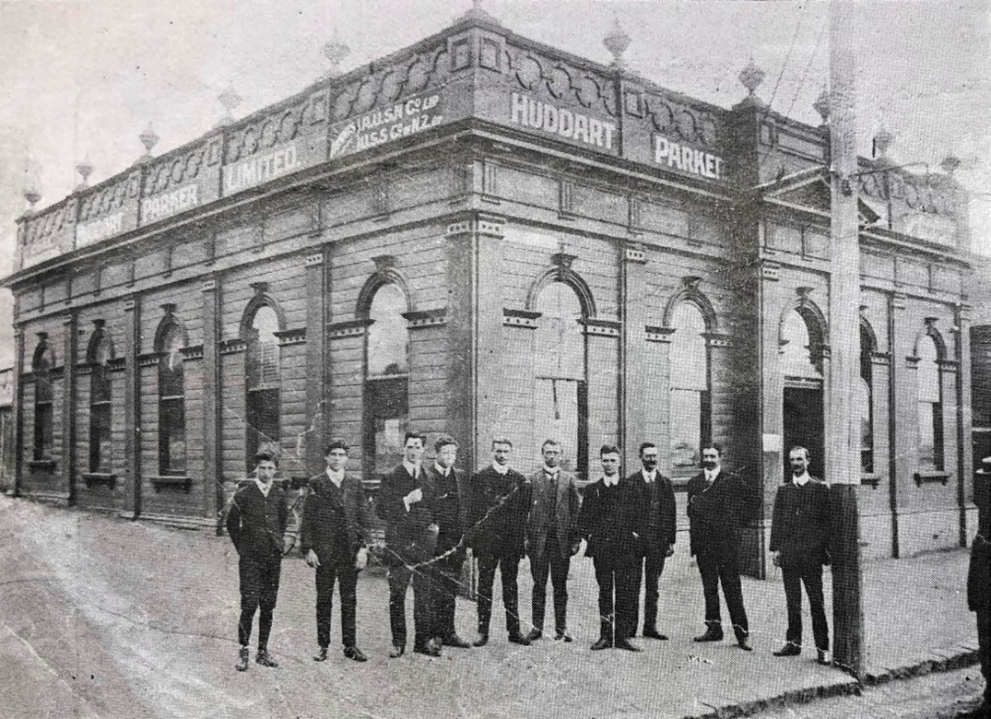
Figure 3.163: Huddart Parker & Co., Geelong waterfront, 1912. Source: News of the Week, 22 February 1912, p.16, GRS 2121/3, Geelong Heritage Centre collection.

HUDDART PARKER AND COMPANY
Captain Peter Huddart (1818-1904) was born at Gosforth, Cumberland, England and joined the British Merchant Service in c.1840.1349 He was awarded his Master’s Certificate of Service as a carpenter mate and master in 1852,1350 and he made his way to Geelong where he established a shipbroking and corn agency in Yarra Street. He soon added coal transportation to his shipping business.1351 Peter Huddart was joined in the business in 1861 and by his nephew, James Huddart, later forming a business in Ballarat before returning to Geelong with the importation of coal and export of produce at Geelong.1352
In 1876, James Huddart joined Messrs Parker, Traill and Webb to form the firm of Huddart Parker and Company, coal importers and merchants.1353 James Huddart was appointed manager and was based in Melbourne.1354 Thomas James Parker had arrived in Geelong in 1853 presenting the firm
of D. and J. Parker, warehousemen of London. Settling in
Geelong, he erected an iron store in Little Malop Street that he had brought out from England and commenced business as an importer.1355 In 1854, he became the Geelong agent for the steamer Express that was under the command of Captain William Howard Smith.1356 Parker was joined at Geelong in 1855 by John Traill as chief officer of the Express Steamer Agency.1357 In 1861, Parker bought out Howard Smith s share of the business and in 1867 after the death of Skinner, the remaining share was purchased jointly by Trail and Captain Webb.1358 The fleet of Huddart Parker and Co. changed with technology, bringing about a relocation of the firm’s head office from Geelong to Melbourne. As outlined in The Argus:
The first fleet owned by the firm consisted almost entirely of sailing vessels. They included the Olivia Davies, the Medea, and the Queen Emma, and later the Conference and the Frederica. On taking over the business of a Melbourne coal importer named Morley, the firm removed its head office from Geelong to Melbourne, and largely

ABOUT CORAYO: A THEMATIC HISTORY OF GREATER GEELONG
301

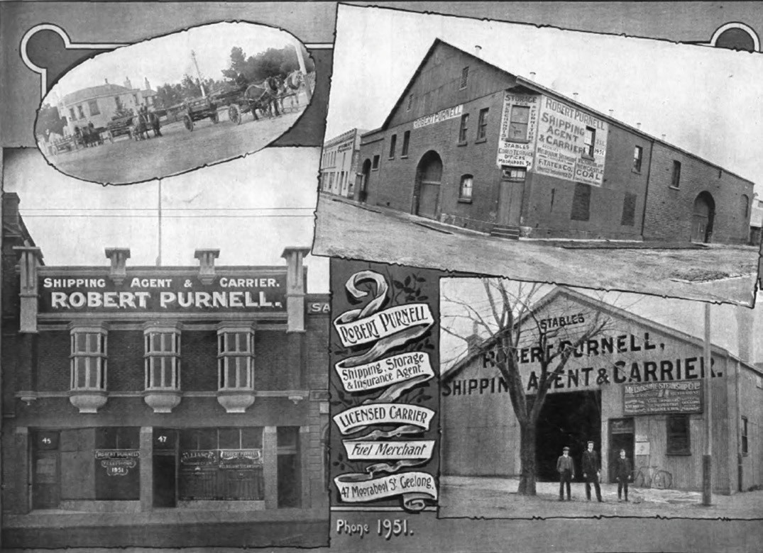
Figure 3.164: Robert Purnell Shipping Agent & Carrier Offices & Buildings, c.1918. Source: Geelong for Business Health Pleasure, G.A. List, Geelong, 1918.

extended its operations. This was a period of great Colonial expansion and also a rapid increase in the number of steamers. The firm acquired the Nemesis, an iron screw steamer of 1,393 tons gross, built in 1880, and she was followed by the Lindus and the Wendouree. In 1882 the partners decided to enter the Sydney trade, and increasing business soon demanded the addition of the Burrumbeet and the Corangamite to the fleet.1359
In 1889, Huddart Parker and Company was listed as a limited company.1360 It was during this year when the firm relocated its Geelong office from Moorabool Street (south of Dennys Lascelles woolstore at the south-west corner of Moorabool and Brougham Streets)1361 to the newly reclaimed land
on the west side of Moorabool Street, at the approach to the Moorabool pier (Figure 3.163). Designed by the local architect, A.J. Derrick,1362 the substantial development was described in the Geelong Advertiser:
Extensive improvements are now being made to the reclaimed land on the west side of Moorabool-street, near the steamboat wharf, which has been procured under lease by Messrs Huddart, Parker and Co., owners of the international fleet of steam colliers and passenger boats, as well as the bay pleasure steamers. A long row of weatherboard buildings has been erected immediately behind the goods storage shed at the entrance to the wharf to be fitted up as a storeroom, four-stalled stable with loose boxes, a feed room, dray shed, a shed for housing the steamers discharging gear, and a workshop for stevedores and carpenters. Preparations have also been made for the erection of a handsome suite of offices for the firm’s staff of clerks, a manager’s room, stationery room, lavatories, and
a weighbridge.1363
No direct physical associations with Huddart Parker
and Company of the 19th century remain in Geelong. The company’s offices and site were transformed as part of the

ABOUT CORAYO: A THEMATIC HISTORY OF GREATER GEELONG
302

waterfront redevelopment in recent times. There are tenuous associations with the original portion of Clounoulty at 27 Retreat Road, Newtown, built in c.1860 for Peter Huddart (who lived there in the 1860s until 1870);1364 and with Duncan s Place , 3 Pevensey Street, Geelong, built in 1860-61 for Morris Jacobs, draper and sold to John Traill in 1872-73.1365 As manager of the Geelong operations of Huddart Parker and Company, Traill lived there until 1887.1366

ROBERT PURNELL
A notable inclusion on the shipping agency scene in the early 20th century was Robert Purnell (1855-1937).1367 He was born at Chilwell, Newtown to William and Margaret (nee Lamb) Purnell. William Purnell was a successful early builder in Geelong and he was to be joined by his other sons, William and Alexander carpenters, with another son, Frederick, becoming an architect.1368 Robert Purnell attended Flinders School before being employed in the warehouse of C. Andrews, draper and M.L.A.1369 In c.1881, he was appointed clerk to the Western Stage Company, a position he held for several years before being appointed manager.1370 In 1897, he established his own shipping and carrying business
in Brougham Street (then known as Corio Terrace) until
he built a commodious and distinctive Art Nouveau-inspired two storey building at 47 Moorabool Street in 19121371 (Figure 3.164). He also held warehouses and stables, and a site
at the railway wood yard for the transporting of Newcastle coal.1372
Throughout his life, Purnell contributed much to community life. He was a local Councillor with the Geelong City Council between 1915 and 1931, serving as Mayor between 1923- 24.1373 It was during his Mayoralty that Purnell, along with Dr Frederick Moreton, was able to use his influence in the formation of the Geelong Town Planning Association, and he was a key figure in the City’s tree planting scheme (see Theme 7). Purnell was elected a Member of the Legislative
Assembly in the Victorian Parliament in 1917, holding his seat until 1920 when he was defeated.1374 He also held several other prominent positions, including President of the Geelong Chamber of Commerce in 1911-12, chairman of the Geelong Harbor Trust between 1920 and 1933, and President of the Geelong branches of the Protestant Federation and Anti- Liquor League, a consequence of his adherence to the Baptist Church where he was a member of the Aberdeen Street congregation and one-time President of the Baptist Union of Victoria. He died in 1937.1375
While Purnell s business continued throughout the
20th century, morphing into Purnell s World Wide Travel Agency,1376 his office built in 1912 at 47 Moorabool Street was demolished in 1988 to make way for the Bay City Plaza shopping complex development (see Theme 6). However,
associations with Robert Purnell are physically manifested in his former family home, Myrtleholme at 10 Hermitage Road, Newtown.1377

GEELONG SHIPPING AGENTS AND WHEAT SHIPPERS’ ASSOCIATION
In 1928, the Geelong Shipping Agents and Wheat Shippers Association was formed. Its objects were to obtain uniformity in the handling of ships calling at Geelong, to foresee and settle any possible disputes arising in connection with the handling of vessels, and to assist in improving the facilities of the Port of Geelong.1378 The inaugural chairman was Gilbert Edward England (c.1866-1930), employee and later manager of Huddart, Parker and Company for 50 years.1379 He built Comara at 303 Shannon Avenue, Newtown, in 1910 although he sold this property in 1913 and relocated to 45 Retreat Road, Newtown (his residence also being called Comara ).1380

RIPPLESIDE SHIPBUILDING WORKSHOPS EARLY YEARS
In 1905 following the formation of the Geelong Harbor Trust,
the bayside property at Fisherman s Gully known as Ripple Side was acquired as a site for shipbuilding workshops (see Theme 6 for details on Ripple Side ). The site was considered the only place suitable for the erection of a dock , given its foreshore location in a deep valley.1381 The acquisition also included Hutton s wharf (built in 1854-55 by
the auctioneer, J.B. Hutton – see Theme 6). In its first Report in 1907, the Harbor Trust
gave details on the progress of works completed, and those pending:
At Rippleside , North Geelong, workshops are being provided which will ultimately be placed on a reclamation forming part of a line of permanent berthage, where also a slip will be constructed for the repairing of floating plant. Suitable machinery was purchased from the Phoenix Foundry Co., Ltd., when their establishment discontinued operations.1382
By 1912, £2,793 had been spent on the construction
of buildings and installation of equipment for the repair of dredges and other work.1383 In 1914, a cargo shed on
the Moorabool Street pier was relocated to the Rippleside workshops for storage and shelter for horses and trucks.1384 This shed appears to have had a semi-circular roof and was situated at the approach to the Moorabool pier prior to its relocation to the Rippleside foreshore1385 (Figure 3.165).
Further improvements were made in the ensuing years, the substantial extent of the complex was given in the Geelong Advertiser in 1923:

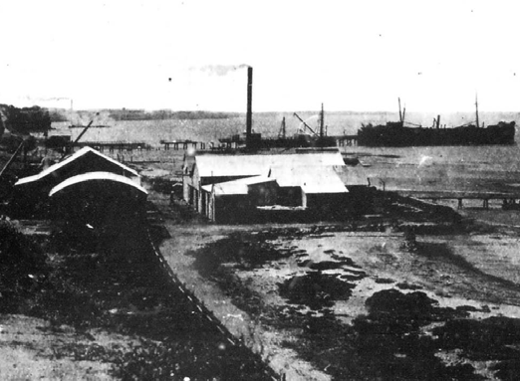

Figure 3.165: Rippleside Shipbuilding Workshops, 1919. Source: News of the Week, 6 March 1919, GRS 2121, Geelong Heritage Centre collection.

Here is to be found a complete plant for the execution of all floating repairs to the Harbor Trust property, as well as for the manufacture of the ironwork required for the maintenance of wharves, while work is even turned out for the roads. Should any of the Harbor Trust craft need attention, the Rippleside establishment will provide it. If a pier requires touching up, Rippleside will do it. There is little limit to what Rippleside can turn out in the way of ironwork requisites – although some jobs that could have been done have to be left undone because of the stern limitations of possible expenditure. At the present
moment, one of the jobs being turned out is the provision of 36 long iron bolts for the Yarra street wharf.
The carpentry and joinery work is also done at Rippleside, but not now by the Trust. The carpentry and joinery workshops are let to the firm of Higgs
and Benoit.
Boilermaking work is one of the activities at Rippleside, and all boiler repairs in connection with the Trust, from Sparrovale to Sims, Cooper s, is carried out by the Rippleside plant, including what is required on the tug, the dredges, the steam hoppers, and the launches. In the blacksmith s shop at the present moment one may see giant pins that were manufactured some little time ago for the dredge buckets, and there is now an ample stock in hand. In the blacksmith s shop is to be seen a 3-roller machine for bending the plates for boilers. From
a flat sheet a plate up to 12 feet long by 6 feet wide can be bent out in cylindrical form. There are planing machines, drilling machines; large power lathes – three of them,
and on one of which a piece of metal up to six tons has been turned; there is a bolt-screwing machine; an emery grinding wheel, three drilling machines; a pipe screwing

machine for putting threads on wrought iron pipes; a shaping machine for persuading pieces of metal into any shape desired; and a punching machine and shearing machine in connection with the boiler-making plant. There is also that wonderful instrument, the steam hammer –
not a Nasmyth (although there are examples of the firm’s products in the workshops) but one made by Davis and Primrose, of Leith, Scotland. Some of the repairs carried out are of the most delicate order – in fact, “surgical operations in iron and steel.
In course of construction is a new slip. The bottoms of the Trust barges have not been seen for a year or two, and they require attention. When the new slip is completed, what are called cradles will be run on rails right under the water, and the barge floating on to the top of these, the whole outfit will then be wound up by steam winch until the barge is on the slip out of the water, and in a position in which the examiners and repairers can get underneath her.
The Trust s twin-screw dredge, the Thomas Bent, is undergoing a complete overhaul at Rippleside just now. The job is one of some magnitude. For four years this dredge was loaned to the Melbourne Harbor Trust, and did good work for that body. It will take a week or two to get it ready for commission again. The vessel needs a good deal of paint, and the ironwork generally requires toning up. The Thomas Bent is what is known as a bucket dredge, and is an immensely powerful machine for the purpose. It can dredge to a depth of 35 feet – which is quite sufficient for Geelong …
At the works may be observed a number of Priestman grabs. These are used when the hoppers (one of which is propelled by steam) are transformed into dredges. The hoppers often dredge about the vicinity of the piers, and can get down to a depth of 35 feet.
A number of iron buoys that are in use were made at the Rippleside works, where repairs to those are also
effected. The workshops are under the charge of Mr. H.J. Richardson.1386
The expansive machinery, equipment and facilities at the Rippleside workshops had resulted from the Geelong Harbor Trust’s desire from 1920 to establish a ‘large and profitable industry of ship-building. 1387 Geelong already had a history of boat builders, including W.E. Curnow (who in 1876 built the schooner Miranda, for James Huddart, claimed to have been the largest craft built in Geelong in the 19th century)1388
Clement Blunt, James Sinclair and Peter Tait.1389 In the 1910s, the Harbor Trust had leased its facilities to shipbuilders including A.B. Gibson of Melbourne in 1918 for the refitting
of the hulk, Malaita).1390 The work was completed at the

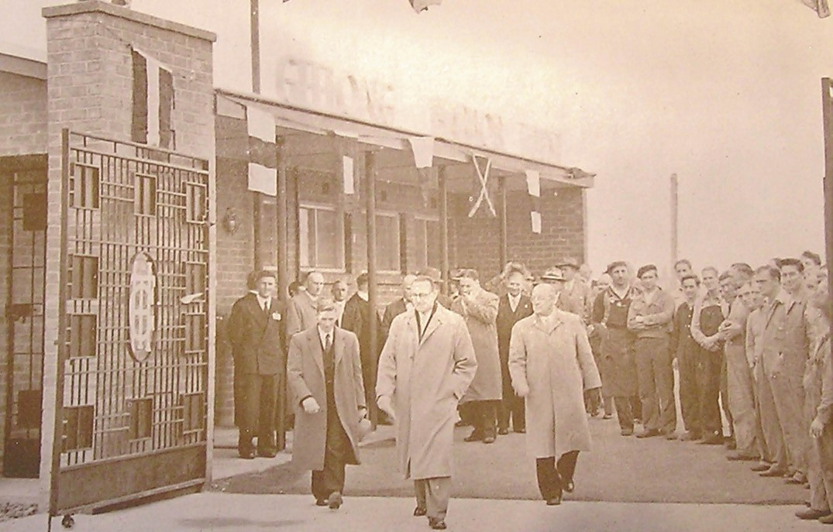
Figure 3.166: Official opening of new Rippleside Workshops by Geelong Harbor Trust Commissioners, April 1955. Source: Annual Report of the Geelong Harbor Trust Commissioners, 1955, Geelong Heritage Centre collection.

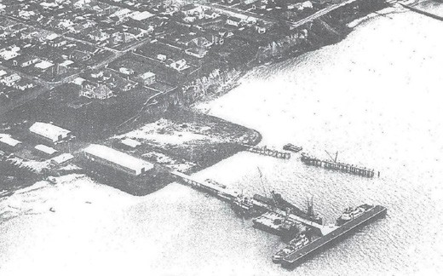
Figure 3.167: Aerial view of Rippleside Workshops showing reclaimed area & new pier, c.1956. Source: Annual Report of the Geelong Harbor Trust Commissioners, 1956, GRS 1058, Geelong Heritage Centre collection.
Rippleside workshops by H.B. Flack and Co.1391
In 1920, the Harbor Trust announced Messrs. Higgs had intended to take up shipbuilding at the Trust s workshops, with the former Ripple Side to also be occupied by the shipbuilders.1392 Edward Higgs (c.1848-1928) had arrived in Devonport, Tasmania, from Pimlico, London, in 1866
where he was apprenticed to the ship wright, John Drake.1393 Establishing his own successful boat-building business, he was later joined by his sons, including Ernest Edward Higgs (1874-1964). They expanded the business of Messrs. Higgs and Sons to Victoria in 1919 with the building of a ship at Port Albert.1394 At Rippleside, Messrs. Higgs had completed their first commission in 1922. A schooner for the Lorne Saw Mills Company, it was the first of its kind to be built in Geelong at
a cost of £5000.1395 Ernest Higgs remained a boat builder in Geelong following his father s return to Tasmania. He later established a workshop at Chilwell where he built a new motor launch for the Geelong Harbor Trust in 1937.1396

IMPROVEMENTS OF THE WORKSHOPS IN THE 1950S
The postwar years led to an expansion of the Rippleside Workshops by the Harbor Trust. In 1952 work commenced on ‘filling in the sea’, involving northward land reclamations.1397
In 1954, new workshops, marine store, office and amenities buildings and a crane shed were almost complete and major plant that had been purchased for installation included an overhead crane (from Noyes Brothers), turret lath (from Ward), air compressor (from Atlas) a milling machine (from Cincinnati) and mobile cranes (from Fowler).1398 A new pier had been built measuring 304 feet in length by 22 feet in width. It was to form a breakwater for the reclaimed site.1399 Further land reclamations were in progress. The purpose of these improvements was to meet a long-standing need in the port for more effective maintenance and general economy, particularly in relation to the many units of floating plant owned and operated by the Trust. 1400 At a cost of £160,000, the new workshops and pier were officially opened in April 1955 by the Geelong Harbor Trust Commissioners1401 (Figures 3.166-167).
In 2014, construction commenced on a major apartment and marine development in the northern part of the former Harbor Trust workshops site.1402
In addition to the Harbor Trust workshops site, boat building continued elsewhere in the 20th century, particularly on
the Western Beach foreshore to the west of Cunningham pier. There during World War Two Ernest Higgs and his brother completed and launched landing craft built at the Ford Factory. Nearby in the 1950s Lew Marine commenced boat building at the former Geelong Nautical Centre previous established for housing paddleboats and a speedboat for pleasure rides at Eastern Beach. Evidence of the Lew Marine boat building operations survives in the gabled shed and slipway.1403

SAILORS’ REST
On 1 February 1895, a Sailors Rest was opened in rooms at Bethel, Corio Street, Geelong to extent a brotherly welcome to those who do business in great waters . 1404 Proceedings had been opened by R.C. Clement in the presence of the Mayor, F.H. Richardson, who declared the Geelong Sailors Rest open.1405 The rooms were to be made available for all seamen from 6.30 to 10 each evening.1406 Non-conformist churches, including the Baptists and Methodists, and other charitable organisations including the Young Women s Christian Association (Y.W.C.A.) assisted with the ongoing mission, given the strong affiliation of these organisations with the temperance movement and importance of Christianity.1407 This began the Sailors Rest in Geelong, an organisation that originated from the formation of a Sailors

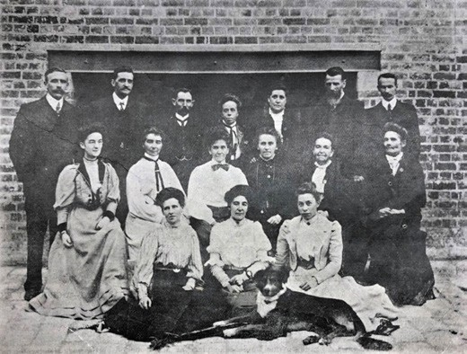
Figure 3.168: Miss Howard (photographer), Geelong Sailors Rest Workers Committee, 1907. Standing (from left to right): Mr. Clements, Mr. R.J. Moore (secretary), Mr. W. Robin, Miss Fagg, Mrs. Harvey, Mr. Harvey, Mrs S. Newbury. Seated (middle row, from left to right): Miss
E. Robin, Miss Kitchen, Miss Berryman, Miss Clements, Mrs. Robin, Mrs Ponting. Seated (front row, from left to right): Miss Potter, Miss H. Robin, Miss E Fagg. Source: News of the Week, 18 April 1907, p.15, GRS 2121/1, Geelong Heritage Centre collection.

Society in London in 1817.1408 The Sailors Rest at Geelong provided welfare for visiting seamen by offering opportunities for recreation, including the playing of games, reading, entertainment, songs and food, all underpinned by a Christian ethic.1409 In 1899, the Sailors Rest relocated to the Liverpool London and Globe Insurance Company building at 51 Moorabool Street.1410 This building was used in an illustrated flyer for the Geelong Sailors’
Rest in c.1904.
Underpinning the success of the Geelong Sailors Rest was its Workers Committee. Members of the committee advocated the underlying temperance and
non- Conformist Christian principles. In 1907, the Committee was photographed at its Moorabool Street rooms (Figure 3.168):
As early as 1901, the Committee sought to have its own building constructed.1411 A fund was established and negotiations commenced with the Government authorities for a piece of land on the Geelong waterfront. In May 1910, the Geelong Advertiser gave an outline of
the proposal:
As a result of Mr. Plain, M.L.A. s efforts, a site has now been definitely fixed for a new Sailors’ Rest. The Premier (Mr. Murray), on his last visit, gave the rest authorities the choice of a block facing the beach, or one in Moorabool- street. The Superintending and Workers Committees held a combined meeting, and it was unanimously decided to

gratefully accept Mr. Murray s offer of the block having a frontage to Moorabool-street of about 50ft., with a depth of 100 ft. The land is part of the Customs Reserve, and commences at a point about 50ft. from the corner of Victoria-terrace [Eastern Beach Road] It is probably that provision will be made in the new building for caretaker s quarters, so that the Rest may be kept
open all day, as well as in the evenings. The committee are in hope that someone will come forward and
set the ball rolling for a building fund by a substantial donation. Many promises of support have been already received.1412
A design for a building on the anticipated site was prepared by Geelong architects, Seeley, King and Everett in 1910.1413 The domestic-like structure was to feature a hipped roof with widow s walk, with a centrally-located entrance portico on the Moorabool Street frontage.1414
By 1911, the site at the north-west corner of the Customs Reserve was approved. Percy Everett had redesigned the proposed building1415 that has been claimed as probably the most important institutional building erected in Geelong at the turn of the century. 1416 The two storey building – built
as a memorial to King Edward VII - boasted a corner tower surmounted by a domical roof and flagpole, the Free styled brick and render edifice being detailed with Art Nouveau decorations on a nautical theme.1417 Of equal innovation was the use of reinforced concrete raft foundations due to the soft ground, the first in Victoria.1418
Tenders for the new Sailors’ Rest building were first called in 1911, the estimated cost being £1100.1419 A contract was accepted from Dew Brothers and Ebbels in September
1911.1420 On 3 February 1912, the foundation stone was laid at an official ceremony by the Premier, John Murray in the presence of the Mayor of Geelong, Members of Parliament, several clergymen and other prominent citizens.1421 The building (Figure 3.169) was officially opened on 9 November 1912 in the presence of 200 guests and was described in the Geelong Advertiser:
It is well designed as it is substantial. The entrance hall offers a warm welcome to the wandering sailor. On the ground floor is a cosy room for the committee, nicely furnished by the present, Mr. J.H. McPhillimy; a bathroom with hand basin and plunge in white enamel; and part of the caretaker’s quarters. On the second floor directly in front of the landing is a reading room with stylish fireplace, casement windows, a new bagatelle table donated by the Ladies Guild, a polished bookcase given by Miss Emily Mercer, and containing the nucleus of a library of maritime works and plenty of table space for reading and writing.
To the south of it is the concert room supplied with a piano and ample seating accommodation. A folding wooden

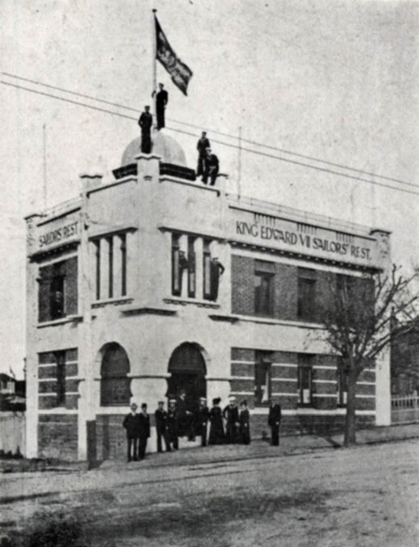
Figure 3.169: Sailors Rest building, 3 Moorabool Street, 1913. Source: News of the Week, 4 December 1913, p.23, GRS 2009/02296/024, Geelong Heritage Centre collection.

petition may be swung back and music and reading rooms thrown into a spacious entertainment hall. On this floor there is also a refreshment buffet so conspicuous that there will be no excuse for any tar leaving hungry. A popular feature will be the flat roof accessible by a ladder. It covers the full expanse of the building, is electrically lighted, and commands a fine view of Corio Bay and the beaches. When fitted with seats and laid out in palms
and pot plants it will be an ideal summer evening retreat. The furnishing of the Rest is not complete yet, but Saturday s inspection suggested several donations. Dr.
A.S. Grimwade donated two tables for the reading room and Mr. B. McKinnon gave a large framed photo of the late King Edward to grace the main hall. The garden, only trimmed over three weeks ago, already has a vigorous English grass lawn.1422
By the time of the opening of the Sailors Rest, the organisation had joined with the British and Foreign Sailors Society, an interdenominational Protestant group.1423

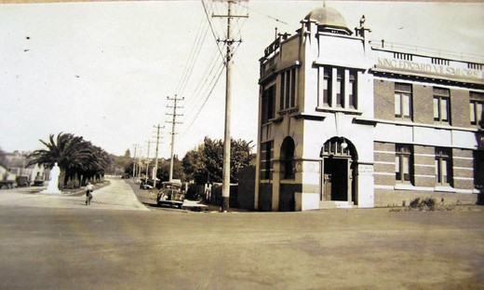

Figure 3.170: Sailors Rest building, 3 Moorabool Street, c.1940, showing globe sign above the parapet on north (left) facade. Source: VPRS 10516/P3, Unit 11, Public Record Office Victoria.

In 1921, possibly in order to combat the attraction of sailors to local hotels, the Rev. T. Worsley Maguire suggested the
erection of a large electric sign over the Sailors Rest building. He claimed that if the men knew there was a Sailors Rest in Geelong, they would make it their first port of call on land.’1424 The Committee had previously proposed a large wire netting sign similar to that over Dalgety s Stores, but had shelved due to a lack of funds.1425 Notwithstanding the dire financial position, the Mayor of Geelong (Alderman Hitchcock)
pressed on with the idea and had T. Brown, Superintendent of the electric services, to prepare a design. He also had it approved by G.G. Jobbins, Engineer-in-charge.1426 It was anticipated that the sign would be operational within a month as the President of the Sailors’ Rest, J.H. McPhillimy, had guaranteed its cost.1427 However, five years elapsed before the sign (Figure 3.170) was installed and turned on:
A very interesting function took place last evening at King Edward VII Sailors Rest. Members of the executive met officially to turn on an electric sign recently erected on the roof of the Rest by the Melbourne Electric Supply Company. The sign will flash out across the harbour the words Sailors Rest, directing the sailors to this popular haven The turning on of the electric current took
place at 8 p.m. by a representative of the Electric Supply Company. Following this ceremony members present inspected from the wharves and it was considered a great success.1428

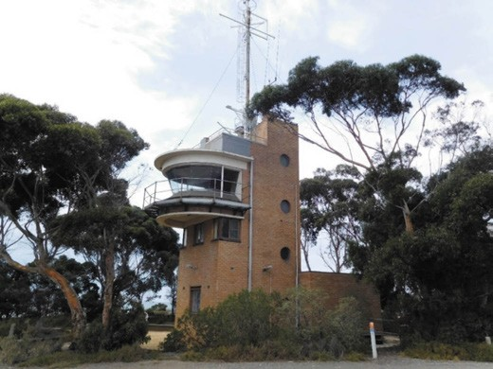
Figure 3.171: Point Henry Signal Station, 2015. Source: David Rowe.

POINT HENRY SIGNAL STATION
Until the early 20th century, shipping traffic in the bays and coastline of the Greater Geelong area was uncontrolled and self-regulated.1429 An improvement was subsequently made with the installation of temporary signal stations at the Moorabool and Portarlington piers. The custodian
of the latter was housed in a diminutive structure on the Portarlington Pier, with a telephone, binoculars, signals flags and a flagstaff.’1430
In order to provide safe, secure and regulated shipping traffic, the Geelong Harbor Trust acquired a plot of land at Point Henry in the late 1930s on which to construct a signal station. The local architect, Norman Schefferle, was engaged to design the structure1431. Built in 1939, The Argus gave an insight into the pending commencement of the signal station in October 1940:
Designed to give more adequate control of shipping traffic entering and leaving the Port of Geelong through the Wilson Spit and Hopetoun channels, the signal station erected by Geelong Harbour Trust on the bluff at Point Henry will come into operation on November 7. A signal- man will be on duty continuously throughout the year. In addition to controlling traffic he will receive and transmit messages and supply Information to masters and agents. A powerful searchlight will be used for transmitting messages by day in the international code, while a smaller light will be used for night signalling in Morse code. After berthing, vessels will communicate with the signal station by telephone. The station number is 3838. When the station is in operation, the temporary port control centre, at the harbourmaster’s office on Moorabool Pier and on Portarlington Pier will cease to function.1432

Constructed of cream brick, the vertically-composed Modern Functionalist designed signal station (Figure 3.171) comprised a top deck (from which flags could be hoisted) below which was signal room with a fireplace, desk and a mercury barometer.1433 It lead out to the curved, flat-roofed signalling platform that boasted a 24 inch signal light with
a Morse shutter having a range of 10 miles.1434 It was manufactured at Croydon, England, at a cost of £200.1435 The viewing platform also included a brass telescope. Below
the signalling platform was a lunch room. A landing outside this room accommodated a washbasin. On the ground floor was a garage, battery room, emergency generator room, and a toilet under the stairs. Lighting the stairwell were portal windows.1436
A continuous watch was kept at the Point Henry signal station for 52 years from November 1940 until 1993.1437
In addition, the signalmen monitored the movement of the floating plant of the Harbor Trust, fishermen, and yachts, and provided weather observations. The station was a hub of communication between ships and the various shore authorities.1438 Radio and telephone communication were later installed. Early signalmen at Point Henry were Mac
Macdonald and Tug Wilson.1439 They were replaced in 1963 by Fred Burns and John ‘Biscuit’ Huntley.1440 Andy Cowley commenced as a relief signalman in 1964. He was the last signalman to staff the signal station, his final shift being overnight on 31 January 1993.1441
While no longer in operation, the former signal station still exists at Point Henry.

AVIATION

TOWARDS THE ESTABLISHMENT OF AN AVIATION INDUSTRY IN GREATER GEELONG
In 1903, the Wright brothers in the United States of America were the first to successfully fly a motorised plane when they flew their 120 foot Kitty Hawk on a 12 second flight at North Carolina.1442 In 1908 from a meadow outside Paris, Leon Delagrange was the first passenger for a flight piloted by the Frenchman, Henri Farm.1443 These landmark aeronautical events provoked a strong interest in air transport around
the world. In 1911, the first aeroplane flew over Geelong and attracted considerable attention. The New Zealander,
J.J. Hammond, who had arrived at Altona near Melbourne a week earlier, had unpacked his No. 10 Bristol biplane, and on 10 February 1911 he flew to Geelong and landed at the Showgrounds at Breakwater1444 (Figure 3.172). The unique event – and the reaction by the community – was romantically detailed in the Geelong Advertiser:
All went well aloft, and before 6.30 a.m. he was mystifying drowsy householders at North Geelong with the aggravated bee-buzz of his seven-cylindered Gnome motor. A few farmers in milking sheds beheld him, with open mouths, swish hundreds of feet overhead citywards, and the first big knot of spectators was approached at
the Corporation Yards, where auctioneers and buyers had wondered for some minutes at the strange din, never contemplating the sensation of an aeroplane visit. When the machine forced itself on their notice bids went by the board, and everybody cheered lustily
at the graceful object overhead. Turning eastwards over Church-street Hammond brought out dozens of curious people from Geelong West clad in night attire, and then wheeled again towards the Western Baths. Cutting off the corner at Cannon Hill [Western Beach] he was for a few seconds over water, and coming in behind the baths was heartily welcomed by the early brigade of morning swimmers. From the piers cheers went up from shipping and workmen, and were acknowledged from aloft with a wave of the hand. Manoeuvring eastwards the bi-plane, now at an altitude of 1500 ft., appeared to pass almost directly over the electric works smoke stack, and then followed the beach reserves as far as Swanston-street, to receive another hearty bathers welcome there. When miles off Hammond had selected the flats around South
Geelong as a desirable spot to land, and from the sea end of Swanston-street he turned south to make the descent.
Once more over the populated area, the machine with its booming continuous whirr was waking late sleepers; but few divined the cause, and thus missed the inspiring
sight. Only a mere handful of people were out of doors to

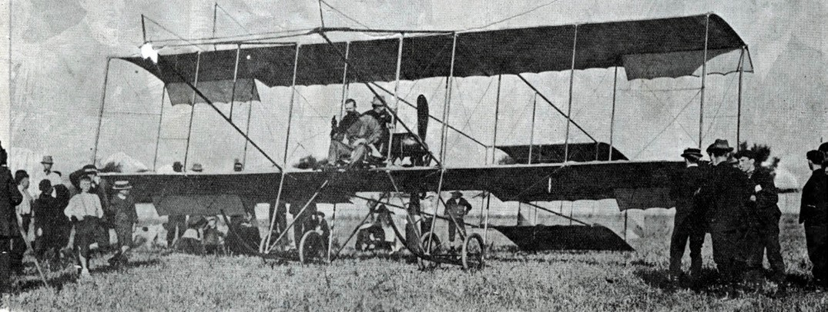
Figure 3.172: Mr Hammond, aviator, being greeted at the showgrounds, 1911. Source: News of the Week, 23 February 1911, p.18, GRS 2295/052, Geelong Heritage Centre collection.

send a feeble but well-meant cheer up to the airman, who swerved more to the west before making his final choice for the run down. The Show Grounds looked the most favourable spot, and he could not have chosen better.1445

BELMONT COMMON AERODROME
The pioneer of aviation in Geelong was the New Zealander, Charles Daniel Pratt (1892-1968)1446 (Figure 3.173). He was one of seven children to Justin Percival Pratt (a carpenter) and Elizabeth Margaretta Pellatt (formerly of Folkstone, Kent, England).1447 With his brother, Alfred Joseph (1894-1963), Charles enlisted as militia members of the Heretonga branch of the Wellington Mounted Rifles.1448 In 1910, Charles was employed as grocer s clerk for Ernest Sutherland in Nagaoi before taking up the same position with H. Anderson at Helensville. Both Charles and Alfred enlisted to serve in World War One.1449 With Alfred, he spent time at Gallipoli where Alfred was soon injured and repatriated back to New Zealand.1450 As an accomplished horseman and skilled motorcycle mechanic and rider, Charles was subsequently attached to the New Zealand Light Horse in Palestine as a signaller.1451 Promoted to Lance-Corporal, Pratt accompanied the New Zealand and Australian Light Horse from Palestine to Syria as a motorcycle despatch rider.1452 In December 19017, he joined the Royal Flying Corps and given his high aptitude, he was appointed a certified instructor.
Following the end of the war in 1919, Pratt purchased four surplus aeroplanes in Egypt to be shipped to New Zealand where he proposed to commence an aviation business.1453 Signed on as a crew member of the Cooee to accompany his purchase home, the route included a stop-over at Melbourne where there was a shipping strike. The delay caused Pratt to assemble one of his planes at the wharf.1454 Pratt then began

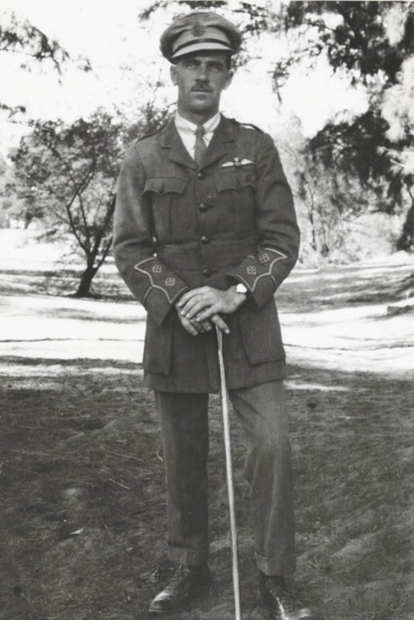
Figure 3.173: Charles Pratt as an Officer in the Royal Flying Corps, Egypt, 1918. Source: K. O Reilly, Charles Pratt of Belmont Common,
p.5 (with permission).

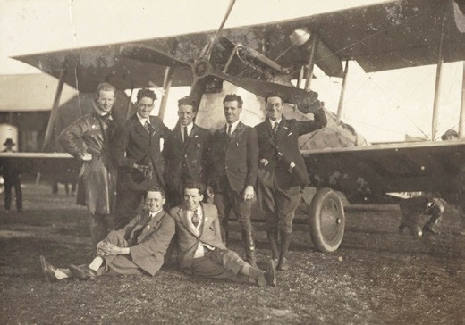
Figure 3.174: Charles Pratt & others with bi-plane, c.1920s. Source: accession H2016.96/97 State Library of Victoria.

flying in earnest and in 1920 proposed to establish an aviation company at the Belmont Common with Captain Leslie Clarke, formerly of the Royal Flying Corps1455 (Figure 3.174). The Geelong Advertiser gave the following report:
Messrs. Pratt and Clarke have definitely decided to establish their aerodrome and works in Geelong.
At present a company is in process of formation, and particulars will be definitely announced later. The balance of Lieut. Pratt s machines has now arrived from Sydney, and are in course of construction at the Gordon College workshops. There will be four machines for the present. The one which did such a successful flying during the summer season is still on the Belmont Common; one
is being assembled, and the other two are being taken from the cases for assembly. There will now be two De Havilands, one of the latest type Avros, and a pup,
in addition to half a dozen spare engines. Business travelling will be the main occupation during the winter months, but with the coming of the finer weather the pleasure trips will start again.1456
The Geelong Advertiser article indicated that Pratt had established connections with the Gordon Technical College, with its Principal, George King, realising the benefits of training students in aeronautical engineering. Pratt s brother, Percival Justin Pratt (1888-1968) had also been appointed to supervise the students.1457 In 1924, the Geelong Advertiser claimed that from the Gordon College workshop, the Pratt brothers were ‘the first to construct an aeroplane in Australia. 1458 Percy Pratt later claimed that he had built the first commercial aeroplane in Australia.1459
In addition to supervising the construction of aeroplanes, Charles Pratt operated a charter business while the brothers also ran the Geelong Flying School. In 1922, R. Mawson became the first student to qualify with his pilot’s certificate

as part of the joint venture of Pratt and the Gordon Technical College.1460 It was also in 1922 when Charles Pratt visiting Rainbow in the Wimmera where he met the local mechanic, George MacKenzie (1896-1984).1461 MacKenzie had joined the Point Cook Flying School in 1918 but his training was cut short due to his Germanic heritage.1462 He maintained contact with Graham Carey, formerly of the Flying School who operated the Melbourne Air Service. He supplied the instruments and an engine for Mackenzie s own aeroplane
which he built in a hay shed at Pella, near Rainbow.1463 While the first test flight in 1921 proved unsuccessful (the test
pilot, Captain Whittingham crashing it into Mallee scrub), it was during repairs when Charles Pratt came to Rainbow.1464 Mackenzie was offered employment as a mechanic with
the Pratt Brothers at the Belmont Common and was later promoted to chief engineer.1465 He was later to open a motor garage repair business at the corner of High and Sommers Street, Belmont.1466
In c.1923, Charles and Percy Pratt were also joined by their brother Frank (Leonard Frank) Pratt and following pilot training, he became part of the Geelong Flying School.1467 The Aircraft Manufacturing and Supply Company of Australia was established by the Pratt Brothers in 1924 and headed
by Percy. He was reported in the Geelong Advertiser at this time:
Mr. P.J. Pratt is thoroughly convinced that aircraft for Australia should be designed and built in Australia to suit our conditions, owing to the wide range of flying
conditions in the various parts of Australia, also the many different purposes which aircraft can advantageously
be made use of. Therefore he is now setting up an aircraft manufacturing industry in Geelong. His objects in establishing the industry are to manufacture aircraft, recondition aircraft, and stock aircraft materials, both for military and civil aviation in Australia. The present time Pratt Bros. have a D.H.9 240 h.p. Siddeley Puma engine which has been reconditioned for the Department of Defence.1468
The school, charter business and workshops were accommodated in gabled hangars in the north-west corner of the Belmont Common, near the intersection of High Street and Barwon Heads Road (Figure 3.175).

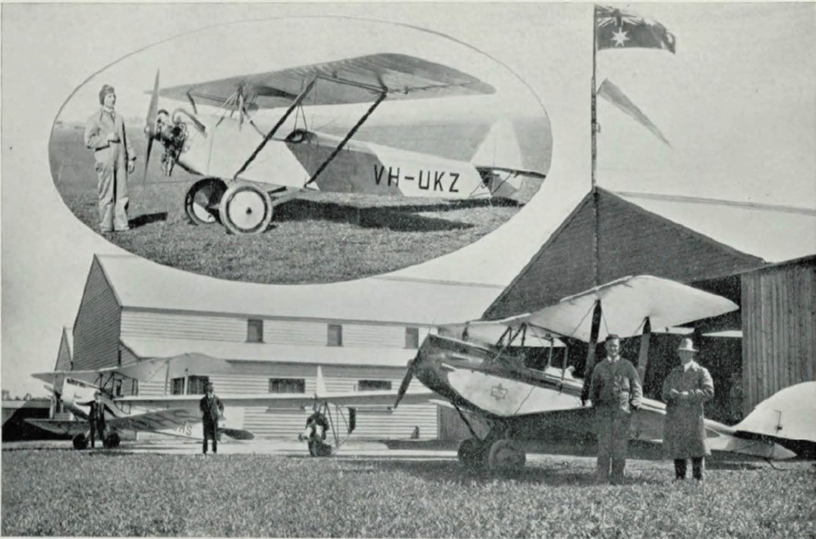
Figure 3.175: Belmont Aerodrome, c.1930. Source: Geelong Its Advantages & Opportunities, 1930.
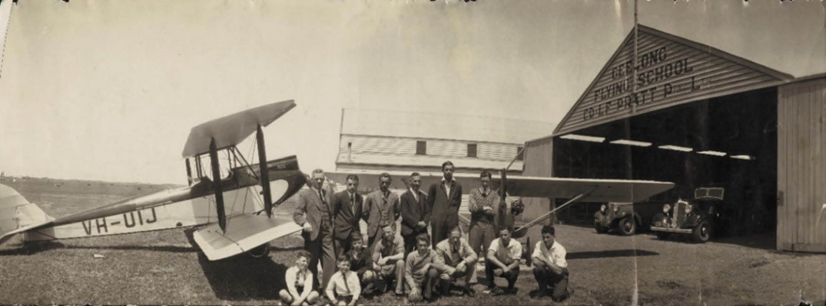
Figure 3.176: Group photograph at the Geelong Flying School, c.1920s. Source: accession H2016.297/17 State Library of Victoria.

In late 1927 with Lieutenant Ray Parer s aeroplane service in New Guinea proving so successful and the need for addition planes given the opening of gold fields,1469 Charles Pratt provided a charter service between the coast at Salamonoa and the goldfields.1470 He was joined by Frank Pratt as mechanic until Frank contracted malaria in 1928 and the brothers returned to Geelong.1471 Meanwhile, Percy Pratt had established a gliding business at the Belmont Common which caused a falling out with Charles, their differences irreconcilable.1472
In 1929 from their return from New Guinea, Charles and Frank formed C.D. and L.F Pratt Pty Ltd for the encouragement
and development of aeronautics. 1473 Frank went into the motorcycle business in 1933, with Percy continuing the Aircraft Manufacturing and Supply Company. Charles Pratt continued to operate his Flying School at Belmont (Figure 3.176). One of his more notable pupils during this period was John (Jack) Evan Price (1911-1941).1474
At Belmont, the value of the Pratt Brothers aerodrome was outlined in 1938 by the E.C. Johnston, Controller of Civil Aviation to the Geelong Harbor Trust (who owned the land):
The Commissioners of the [Harbor] Trust doubtless realise the advantages to the residents of Geelong of a suitable aerodrome being available, and it is hoped the Trust will continue to permit a portion of Belmont Common to be used for aerodrome purposes. In this connection might I refer to a reported statement of Mr. Robert Purnell, Chairman of Geelong Harbor Trust, at a meeting of the Geelong Chamber of Commerce on 8th April 1929, that the area of Belmont Common had been reserved permanently as an aerodrome.1475
Percy Pratt continued his gliding business at the Belmont aerodrome and during World War Two he established the Australian Air League to school cadets in all aspects of flying training.1476 Having lived in a room at the his workshop at the Belmont Common, Pratt sold the remainder of his business during the war and retired to St. Leonards and later to Batesford, before returning home to New Zealand where he died in 1968.1477
Charles Pratt had relocated his flying school to Essendon in 1938. An avid photographer, he also purchased a model K Cine camera with three lenses from Harringtons. Since he commenced flying in Geelong, Pratt had taken a unique collection of Airspy aerial photographs of the Geelong and surrounding areas, often flying the original aerial photographer, William Hansom of Airspy on professional shoots.1478 This he continued until the 1960s. While no physical legacy of the Pratt Brothers’ flying school and
workshops at the Belmont Common survive, Charles Pratt s large collection of aerial photographs from the 1920s until

the 1960s are a highly significant legacy of his extraordinary contribution to aviation in Geelong and beyond.

SUBURBAN AIRPORTS LOVELY BANKS
An airport was opened at Lovely Banks south of Elcho Road
(west side of the Bacchus Marsh Road) before May 1950.1479 It appears that the site was then owned by Hugh Emmerson, a grey hound trainer.1480 He sold it to Jack Ellis and Stan Vandewiel in 1968 who established the Pilot Makers Ellis
Flying School.1481 The runway was graded and the aerodrome operated as a training ground and for aircraft maintenance in its initial years.1482 It also provided fuelling facilities. Later, the aerodrome was used for business flights, with East Coast providing travel to Sydney.1483 Return flights were at times more precarious, for the plane would land on a paddock
that is now Corio Village Shopping Centre if the window as blowing from the wrong direction. Sky driving was also part of the activities at the site.1484 By the early 1980s, the
aerodrome was no longer in use, the aircraft facility having been disbanded (Figure 3.177), possibly with the further development of Avalon Airport and as a consequence of the severe air space restrictions and instrument approach system limitations.1485

GROVEDALE
In 1966, allotment H of section 12 on the west side of the Torquay Road (now Surf Coast Highway) comprising the farmland of James Rainford was purchased by Leslie Mahon, local aviator, and his wife.1486 It served the Geelong community as an airport until the major residential
development known as Armstrong Creek commenced in 2013 (see Theme 6).

BARWON HEADS AIRPORT
In c.1978, the Geelong Aero Club acquired the former Connewarre Presbyterian Church and site at 1401-1409 Barwon Heads Road. The Federation Carpenter Gothic styled church building had been built in 1915 (although two acres
of land had been temporarily reserved by the Presbyterian Church as early as 1861). The Barwon Heads Airport continues to function to the present day.1487

AVALON INTERNATIONAL AIRPORT
In 1949, the owner of Avalon Homestead, Richard Austin, sold 2,400 acres of his Avalon Homestead sheep grazing property to the Commonwealth Aircraft Corporation for use as a jet test field and assembly plant.1488 In 1987, the Government Aircraft factories were partially privatised, with operations being
taken over by Aerospace Technologies Australia.1489 By 31

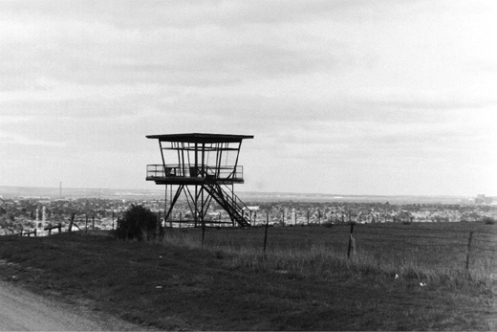
Figure 3.177: Abandoned air traffic control tower, Lovely Banks airport, 1999. Source: David Rowe.

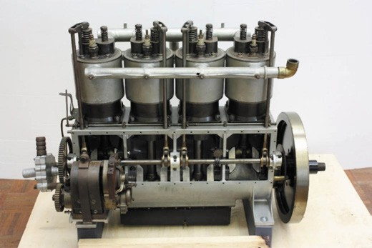
Figure 3.178: Wright Model A aero engine previously owned by Hans Anderson of Geelong. Source: Item ST 20914 Museums Victoria.

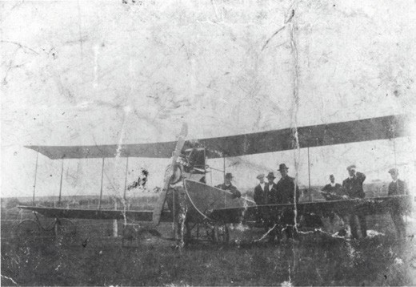
Figure 3.179: Hans Anderson (seated in cockpit) & a group of six mean, probably at the Belmont Common, c.1916. Source: Item MM 107177 Museums Victoria.

December 1997, the airport was completely owned by Linfox Transport (Aust.) Pty Ltd.1490 Air shows were held at Avalon from around this time.
Although the first schedule passenger flights from Avalon began in February 1995 and operated by Hazelton Airlines, the service was discontinued due to a lack of patronage.1491 In 2004, Avalon airport became a terminus for Jetstar and
from 2010 Tiger Airways (although the latter ceased operating from Avalon a year later).1492 In 2012, it was announced
that Avalon was to become Victoria s second international airport terminal. It was not until December 2018 when the international terminal was opened.1493

WRIGHT MODEL ‘A’ AERO ENGINE
While no planes, machinery or other equipment are known to survive from the Pratt brothers in Geelong, Museums Victoria holds a four cylinder vertical water- cooled aero engine (Figure 3.178) designed by Orville Wright in c.1906 that has associations with Geelong.1494 It was built under licence by Bariquand et Marr , a Parisian engineering firm in c.1908- 09.1495 A modification was made to the valve and cam design, much to the displeasure of Wilbur Wright who supervised
the manufacture of the engine in France. According to Museums Victoria, this is the engine from the only Wright biplane imported into Australia. 1496 Known as the Wright Model A , it was imported by Lawrence Arthur Adamson from Europe in October 1909.1497 Named The Stella , the engine was used by Colin Defries ‘to achieve the first powered flight in Australia from Victoria Park Racecourse, Sydney.1498 In 1915, Hans Christian Anderson, a Danish-born motor garage proprietor of Geelong purchased an Avro-Type bi-plane from John Duigan (which he had built at Ivanhoe) and fitted it with the Wright Model A aero engine previously owned by Colin Defries.1499 Anderson had established a motor car garage in Geelong several years earlier but became insolvent in 1909 due to dullness in trade. 1500 By 1915, he had re-established his motor car garage in Myers Street before relocating to
249 Moorabool Street by 1920 and to 256 Moorabool Street by 1926.1501 An avid aviator, Anderson was well-known to Charles Pratt who was a visitor to the Anderson residence.1502 Anderson appears to have kept his plane at the Belmont Common as it was from there where he made several flights in his plane before crashing it at Lovely Banks1503 (Figure 3.179). Following the crash, Anderson s Model A engine languished in a Geelong garage for many years before being donated to Museums Victoria in 1975.1504

POSTAL AND
TELEGRAPH SERVICES

THE FIRST ORGANISED COMMUNICATION SERVICES IN GREATER GEELONG
Organised and recognised communication between communities in Greater Geelong stems back many thousands of years. Clans of the Traditional Owners of Greater
Geelong, the Wadawurrung, and other Language Groups who visited the area communicated through their Bihar, a highly respected member and official messenger (postman) of each Clan.1505

EUROPEAN POSTAL AND TELEGRAPH SERVICES IN GREATER GEELONG

POSTAL SERVICES
The establishment of postal and telegraph services throughout Greater Geelong from the early 19th century was essential to the ongoing development of towns and rural centres. At the beginning of 1839, a year after a township plan for Geelong had been prepared, tenders were advertised for a regular mail service between Melbourne and Geelong.1506 Delays ensued due to the cost of the service, and James Raymond, Postmaster General of the General Post Office in Sydney wrote to Captain Lonsdale in Melbourne seeking out what prospect the Government may have of the postage on letters to that settlement defraying the expenditure. 1507 In March 1839, an informal mail service between Geelong and Melbourne was established.1508
It was not until 6 March 1840 when the mail service was formalised by the New South Wales Government.1509
The Port Phillip Gazette had announced a few weeks earlier that:
The mail will be despatched from the Post Office here every Friday morning, and will return on Sunday evening. The Clerk of the Bench at Geelong has been appointed Postmaster for that town.1510
While Alfred J. Eyre had replaced Henry Hesketh as Clerk of the Bench in October in 1839, the first official postmaster appointed for Geelong was the local Police Constable, Patrick McKeever (1809-1870), and not as might have been expected, the Clerk of the Bench.1511 He combined the role as postmaster with his policing responsibilities from a post
office established in Barwon Terrace, South Geelong.1512 By 1840, a second post office outlet had been established in the offices of P.W. Welch and Co., merchants, Malop Street, ‘North’ Geelong, with Welch’s clerk acting as unofficial postmaster.1513
By May 1841, the official post office had relocated to ‘Fyans

street, nearly opposite Mr Langhorn s building in South Geelong.1514
Geelong’s first postmaster, Patrick McKeever, resigned in June 1841.1515 He was born in Omah, Fermanagh, Ireland, the son of John and Bridget (nee Hands) McKeever. In 1827, he enlisted in the 4th (King s Own) Regiment, his first posting being to Tynemouth Castle, Northumberland. After commissions at Edinburgh Castle and at Glasgow, Cavan and Dublin in Ireland, and Stockport, Chester and
Bicester in England, he was posted aboard the convict ship William Glen Anderson in 1831.1516 He arrived at Hobart, Tasmania with 166 convicts in November of that year.1517 He remained in Tasmania until he was posted to Norfolk Island and Moreton Bay (where he was batman for Captain Foster Fyans – see Theme 7). In 1837, McKeever was discharged from New South Wales and took up a position as one of the first constables at Geelong under the charge of Fyans. In addition to his duties as constable and postmaster, he was the Inspector of Distilleries and of Slaughterhouses.1518 McKeever resigned from the police and public service in 1847 and took over the license of the Retreat Inn, South Geelong.1519 McKeever s time as publican was cut short due to ill-health and he returned to England in December 1847 with his wife, Sarah, and daughter, Mary.1520 McKeever and family returned to Geelong in 1848 where he took up the license of the Petrel Hotel at Ashby (Geelong West).1521 He died at his residence at Western Beach, Geelong in 1870 at the
age of 61.1522
Alfred Eyre was appointed postmaster of the Geelong Post Office in place of McKeever in 1841.1523 In July of that year, he had the post office relocated to Corio Street, ‘North Corio’ (Geelong), in the north end of Mr. Shaen s Stores 1524 (this might have been when the post office outlet in Welch’s offices closed). Eyre was already overtaxed with his duties as Clerk of Courts and appointed Benjamin Shaen as his assistant.1525 Shaen was manager of Henry Ward Mason s store in Corio Street.1526 When Eyre sought permission to resign as postmaster in November 1841, he had recommended Shaen take over the role.1527 However Shaen relinquished his management of Mason’s store in January 1842 and in March of that year, Eyre s other postal assistant, William Turner, was appointed to the role instead.1528
When Turner resigned in August 1842 to return to England,1529 James Harrison, recently-appointed Editor of the Geelong Advertiser (see later subsection), became the postmaster.1530 The post office was relocated to Yarra Street, in the building formerly occupied by Miss Fulloon s school from 1841.1531
The post office moved next door to a ‘new stone building’ in 1844.1532 For a brief period between 1847 and 1848, the local merchant, William Roope of Little Malop Street, acted as

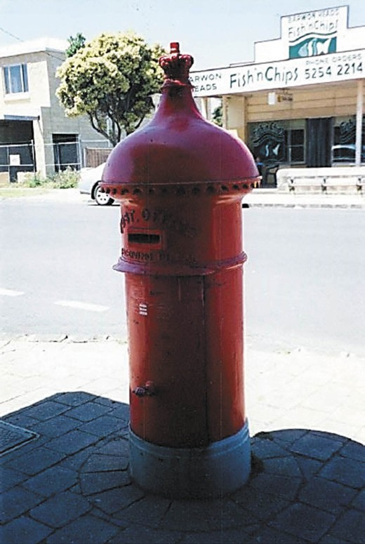
Figure 3.180: Pillar Box, Hitchcock Avenue, Barwon Heads, 2002. Source: David Rowe.

postmaster.1533
In June 1856, William Thacker was appointed postmaster and served at Geelong until 1869.1534 He was postmaster when the Clerk of Works, Henry Ginn, called tenders for
improvements to the post office in 1850,1535 possibly when the post office had moved to ‘a small wooden cottage’ opposite the Royal Theatre in Malop Street.1536 By 1854, the post office had relocated to Peter and James Donnelly’s timber auction rooms at the corner of Little Malop and Union Streets (later the Newmarket Hotel).1537

POSTAL SERVICES AND POST OFFICES IN GREATER GEELONG

OVERVIEW
The postal service kept pace with population growth1538 in Greater Geelong. Throughout the 19th and early 20th centuries, over 60 post offices were opened
(see Appendix 3.3 for a list of all known post offices that opened in Greater Geelong).1539 Several of these outlets reflected the population growth and elevated status of some outlining centres such as Anakie (opened 1858), Batesford (opened 1856), Bellarine (opened 1855), Fyansford (opened 1859), Leopold (opened 1858), Moolap (opened 1864), Portarlington (opened 1863) and St. Leonards (opened 1860).1540 The opening of the different railway lines also influenced the location and establishment of some post office such as those that opened at railway stations at Marshall (Connewarre) (c.1910) (replacing a more substantial timber post office at the junction of the Barwon Heads Road built in 1873),1541 Drysdale (c.1910), and Marcus Hill (1890). Others were created to meet specific demand such as the Geelong Cricket Ground Post Office (1933-1940) and the Ocean Grove Military Post Office (20 November 1939-19 December 1939) (see Theme 7 for further details).1542
Of this substantial number of post offices that served Greater Geelong, only four 19th and early 20th century buildings still exist: former Geelong Post Office; Geelong West Post Office, former Portarlington Post Office; and the former Drysdale Post Office.1543 The Geelong West Post Office is the sole surviving building that continues to serve its original post office purpose.

PILLAR BOXES
An economical method of servicing the suburbs and outer areas was the installation of cast iron post office letter receiving pillars. These cylindrical hollow iron structures were to become distinctive throughout the suburban streetscapes and some rural areas given their bright red paintwork. The earliest appear to have been commissioned in 1866, with John Anderson appointed to manufacture and erect 33 iron letter-receiving pillars at different locations, presumably across Melbourne.1544 The first pillars in Greater Geelong came in 1870 when it was announced that they were to be placed on the Fyansford Road near the building formerly known as the Travellers Hotel; at the corner of
Aphrasia Street and Shannon Avenue, Newtown; at the corner of Ryrie and Yarra Streets, Geelong; at the corner of Malop and Fitzroy Streets, Geelong; and at the corner of Myers and

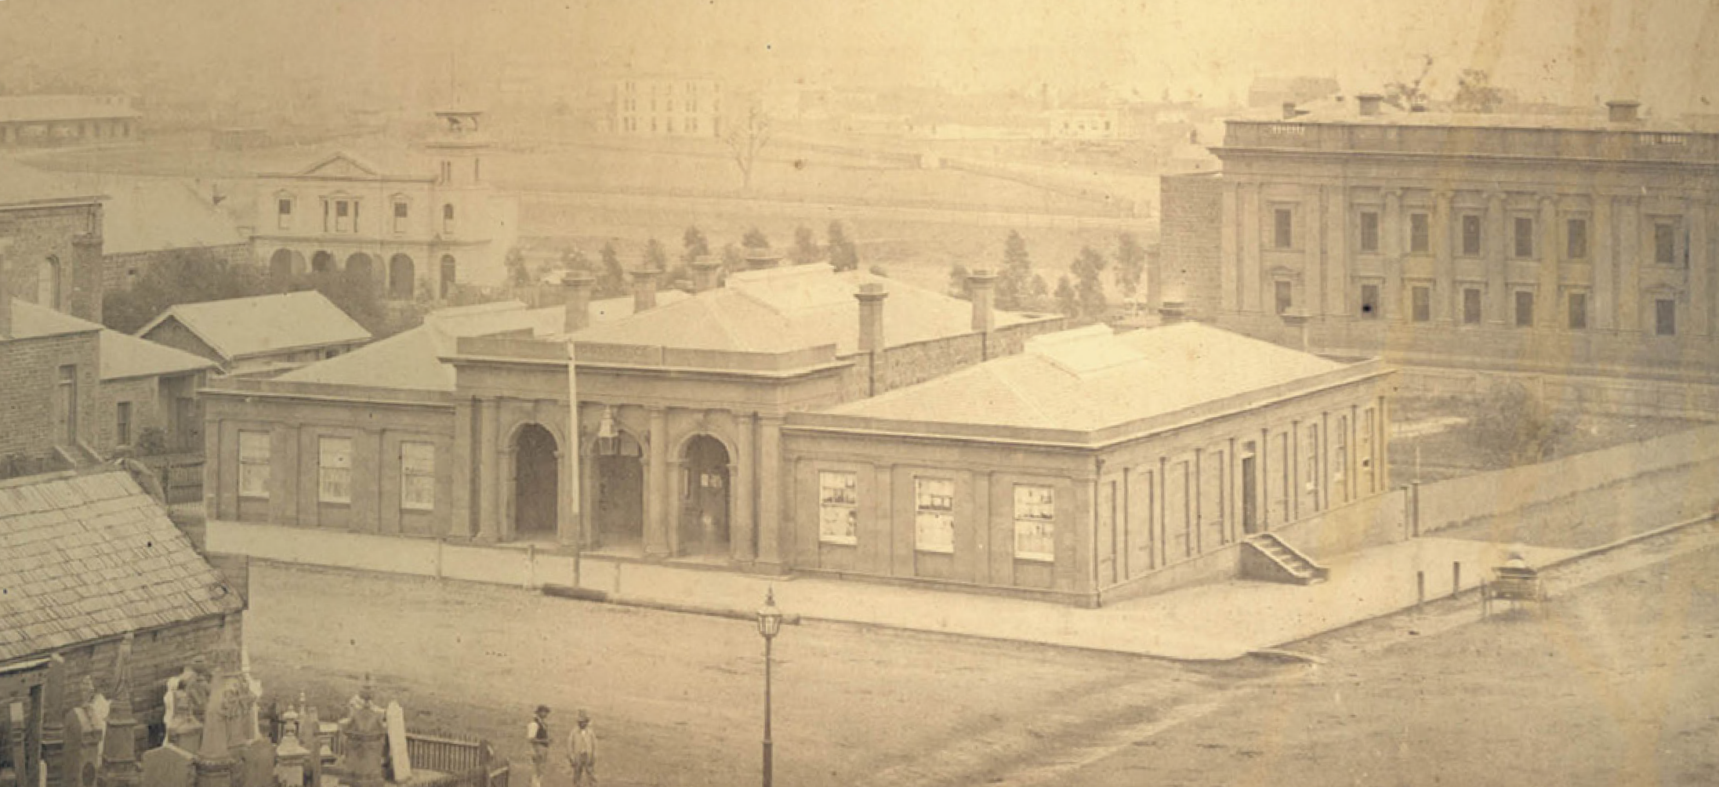

Figure 3.181: Geelong Post Office, fronting Ryrie Street, n.d. [c.1860). Source: GRS 1231/2 Geelong Heritage Centre collection.

Bellerine Streets, Geelong.1545 The patterns and manufacture for the local pillars were prepared by Messrs. Humble and Co. of the Vulcan Foundry, Geelong.1546 By 1922, 45 pillar boxes had been installed throughout the city and suburbs.1547 Only two survive in 2019: one at the north-east corner of Swanston Street and Alexandra Avenue, the other in Hitchcock Avenue, Barwon Heads (Figure 3.180).

GEELONG POST OFFICE
In May 1853, the Geelong Advertiser and Intelligencer declared that an imperative necessity was ‘a Post Office adequate to the property discharge of an increased business, and an additional number of clerks. 1548 The existing
building at the corner of Little Malop and Union Streets was considered too small.1549 Recommendations of a site for a new Post Office were given by the Geelong Town Council to the Victorian Government. Three locations were provided: land occupied by the watch house at the corner of Corio and Moorabool-streets; north side of Malop street (Between Clare and Gheringhap Streets); and the south side of Malop Street, at the corner of Gheringhap Street.
Although Council initially suggested the watchhouse site, the decision was reconsidered and a recommendation was put to the Government that a site at the corner of Ryrie and Gheringhap Streets be approved.1550 This site had formed part of the original 49 acre reserve for ornamental gardens (Johnstone Park) between Ryrie Street and Brougham Plan, and Gheringhap Street and Latrobe Terrace.1551 While the choice of site might have been strategic in being nearby the site of the proposed Geelong Town Hall on the Johnstone
Park reserve, in viewing distance to the Geelong railway terminus then under construction and on the main route west to the goldfields, not all were convinced that this was the most ideal location for a post office. The Argus called Geelong locals our grumbling friends in relation to the petitioning for and ‘central location’ of a post office.1552 Yet, the Geelong Advertiser declared that the post office could have filled ‘the unsightly gap in Moorabool-street at Market Square, quipping that its proposed location – and that of the Town Hall – were to be built in some out-of- the-way corners, nobody knows exactly where. 1553
By late 1854, a design had been prepared for a single storey post office by the Colonial Engineer’s Office.1554 This was a time of notable change within the public service as from 1 January 1854 the Colonial Architect’s office had merged with the Colonial Engineer’s Office, and some public works were postponed until the arrival of the new Governor, Sir Charles Hotham.1555 After taking office, Hotham retrenched several departmental officers in an effort to reduce government expenditure.1556 Hotham also suspended public works in June of 1855, and on 1 January 1856 the Public Works Department was created, headed by Charles Pasley, Commissioner.1557 The designer of the first purpose-built post office at Geelong is unclear, but the Palladian composition with its raised, parapeted central wing and arcaded entrance loggia, and flanking hipped bays, expressed the hallmarks of the work
of J.J. Clark, departmental draftsman, who had prepared a design for Geelong’ first Supreme Court in Myers Street and a new Custom House in Brougham Street, simultaneous to the preparation of the design of the post office (see Theme 7).

Given the departmental turmoil, a contract was approved in April 1855 for the construction of part of the new post office only, comprising a raised central bay and an east wing. It was awarded to W.C. Cornish and Co. at a cost of £8200 and it was built of Barrabool stone.1558 The new post office opened on 28 December 1855, with the furniture and material from the previous building being relocated to the new premises that evening.1559
In June 1856, Charles Pasley called tenders for the ‘second wing’ of the post office.1560 The contract was let to Cowenden and Gray at a cost of £2900.1561 Building works were completed and postal operations had commenced in April 1857, with one Melbourne citizen declaring:
on a recent visit [to Geelong] we had the pleasure of seeing the very handsome and commodious Post Office [Figure 3.181] now erected in Geelong, and we have pleasure in testifying that the clerks there were most civil and attentive; were ready not only to weigh letters, but to give every information in their power.1562
The first postmaster of the purpose-built building was the existing incumbent, William Thacker (1816-1875). He was born at Leeds, Yorkshire, England, the son of
William Thacker, a printer, and Hannah (nee Cope) Thacker. In 1842, the year William Thacker junior married Miss Sarah Annie Birkwood Taylor at Leeds Parish Church, Yorkshire, he emigrated to Australia with his wife.1563 He was appointed a collector and shipping reporter for the Port Phillip Gazette and Settlers Journal until 1846 when he took up a position as a junior clerk in the Melbourne Post Office.1564 In 1848, Thacker was promoted to postmaster at Geelong.1565 It was there where three of his four children were born: Sherwood (1850), unnamed female (died aged 7 weeks, 1852) and Birkwood (1859).1566 In 1859, William Thacker s brother, Henry, (1826- 1908), also emigrated from Yorkshire to be with his brother.1567 In Geelong, Henry followed his father in the printing business, establishing a printery in Ryrie Street (see Theme 5). Both Thacker brothers were involved in the Methodist Church,
their father having been a local preacher for many years.1568 William Thacker also became a local preacher in Geelong, as well as a class leader of the Sunday School.1569 In 1865, William Thacker and his family returned to England for a holiday. The high regard paid to Thacker on his pending departure was outlined in the
Geelong Advertiser:
During all these years Mr Thacker has discharged the duties of his office in a manner that has gained him the general esteem of all classes. We have had a great deal to do with the Post-office. The letters sent and received by us during Mr Thacker s reign must be numbered by tens of thousands, the newspapers by hundreds of thousands, yet, we are not aware that even one single letter or paper

ever went astray or was unduly delayed in delivery through any fault in the Geelong office. As to letters, our experience is entirely favorable, not only to the Geelong office but to all others in the colony. Where irregularities have occurred and been traced, they have in variably been found to be the result of defective address, insufficient stamps, or other carelessness on the part of the sender or his messenger. But we are wandering from Mr Thacker, to whose ability and courtesy in the discharge of his onerous duties we can testify on the strength of seventeen years experience. We trust that he will not be allowed to depart, though it may only be for a time, without some little token of remembrance from his Geelong friends, both public and private.1570
Thacker returned to his position as postmaster at
Geelong until 1869 when he was transferred to Ballarat.1571 His departure was precipitated by the amalgamation of the Post Office and Electric Telegraph in March 1869.1572 The Geelong Advertiser was not impressed with
the amalgamation:
This embodying the telegraph station with the post-office is another slight which our representatives ought not to allow to be passed on Geelong, as there can be no doubt either of the offices is quite as much as any one man can superintend.1573
Thacker’s successor was Samuel Vivian, a Telegraph Officer stationmaster since 1854.1574

SECOND POST OFFICE BUILDING
By the 1880s, the high regard earlier paid to the post office building had evaporated. The Victorian gold rushes and the boom years of the 1880s had brought the construction of very handsome and exceptionally commodious Post and Telegraph offices’ at Bendigo, Maryborough, Horsham, Stawell, Warrnambool, Queenscliff and elsewhere.1575 Geelong, as the State s major regional city, had been left
behind. Even the new post and telegraph office that was built in 1886 in Geelong West, was considered superior, the Mayor of Geelong lamenting at the laying of the foundation stone
of the Geelong West building that in Geelong proper they had no public buildings of which they could be at all proud and that he hoped that some money would soon be granted them in Geelong, for the purpose of a post office at least.’1576 Further criticism of the Geelong edifice was extolled by the Geelong Advertiser:
For years complaints have been made of the wretched, ugly structure at the corner of Ryrie and Gheringhap streets which has accommodated the post and telegraph office employees to a certain degree, and aggravated the public. From time to time alterations and additions

of a very trivial description have been effected, but whilst satisfying the public spasmodically the main cause of complaint has been left unremedied, thus continuing the same sources of annoyance as in days of yore. The existing building is a low squat structure, built of freestone, altogether inadequately supplied with ventilating appliances, and somewhat deficient in the
matter of affording light to persons compelled to pass the hours of daylight within its frowsy, forbidding walls. The business, both in the postal and telegraphic branches, has gradually increased for many years, and in importance
the offices in Geelong may safely be reckoned to be, if not in the first at least in the second rank, under the
circumstances entitled to receive due attention from the Government.1577
Civic agitation for the construction of a new post office was led by the Mayor, Henry Meakin, in 1887. A year later in 1888 a site meeting was held with the Postmaster-General who agreed that ‘Geelong warranted a new post office and that his department would select a site for a new post office’ but that he could make no commitments.1578 In April 1888, John
Henry Marsden, Public Works Department, met Mayor Meakin and Messrs Donaghy and Andrews M.L.A.s in relation to
a new post and telegraph office building, the meeting being reported in the Geelong Advertiser:
Mr Marsden considered the present site of the offices referred to was an excellent one for the new premises, and submitted the details of the sketch plans for the proposed structure, which is to be a two-storey building, made of Geelong bricks, cement on the outside. It is to have two frontages, one facing Ryrie-street and the other facing Gheringhap- street, and above the corner a clock tower is to be made a conspicuous ornament. The upper storey of the new building is probably intended to be utilised for a Telephone Exchange, and for the post and telegraph masters quarters. The sketch of the proposed structure, together with the details, were approved of, and it was stated that plans would be immediately prepared and submitted to the Hon. The Postmaster-General.1579
J.H. Marsden (1844-1913) had joined the Victorian Public Works Department in 1872 and throughout his career he was responsible for various public works design in Western
Victoria as well as some of the most important State buildings in the metropolis’, with the Geelong Post Office being one of his more noteworthy designs.1580
Marsden s scheme was to provide for one of the largest regional post offices in Victoria. Designed in a flamboyant Late Victorian Boom style with influences of French Second Empire (Figure 3.182), the building was to become a local landmark. On the ground floor (Figure 3.183), a posting

arcade (flanked by public lobbies) was to provide entry to a large central mail room. On the east side was to be a private delivery and stamp branch room, stairhall, lobby and electric telegraph room in the north-east corner. On the west side was to be the private entrance for the postmaster, together with private living quarters (dining room, kitchen, larder and scullery). To the north of the mail room was to be a lobby, postmaster s room and messenger s waiting room. First floor spaces (Figure 3.184) flanked a central lantern light to the mail room below. On the south side was to be a Lands and Survey office and Lands Board Room while to the east
was proposed public offices with a telephone exchange in the north-east corner. On the west side was the remainder of
the private quarters of the postmaster, including drawing room, four bedrooms, servant s room and bathroom. To the north was the night operator s bedroom (with a bathroom), day operator s retiring room and a storeroom. Given the steeply sloping topography of the site, the design allowed for a basement at the north end, within which were to be housed the letter carrier s room, a lobby, stair hall, wash house, battery room and female retiring room.
The contract for the new building was awarded to
David Kinnaird at a cost of £17,850 in September 1889.1581 The Corio Brick and Tile Company were contracted to supply the bricks.1582 L. Ryan of the Union Club Hotel purchased the old post office for removal, the building ‘rapidly disappearing’ by October 1889. The stone was transported to 240-242 Malop Street where it was used to build two dwellings designed by Joseph Watts.1583
On 12 February 1890, the Governor of Victoria, Lord Hopetoun, laid the foundation stone for the proposed commodious edifice. The ceremony was attended by 3,500 people who witnessed the burying of a time capsule.1584 Temporary postal services had been relocated to the former skating rink in Little Malop Street. Postal operations commenced in the new building on 27 April 1891.1585
It was not until 1911 when the post office tower was embellished with its intended clock. The lack of a clock at the time of the opening of the building was a cause for much consternation. Funded by public subscription as a memorial to the late King Edward VII, a King s Memorial Clock Committee had formed to realise the installation.
Manufactured by Benson and CO., England, the clock (Figures 3.185-186) was activated by Alderman H.A. Austin, chairman of the Memorial Clock Committee at an official ceremony on 22 December 1911.1586 The Post Office was then finally complete (Figure 3.187).
In 1901, responsibilities for the Post Office were transferred from State Victorian control to the newly-created Commonwealth Government, and in particular, the

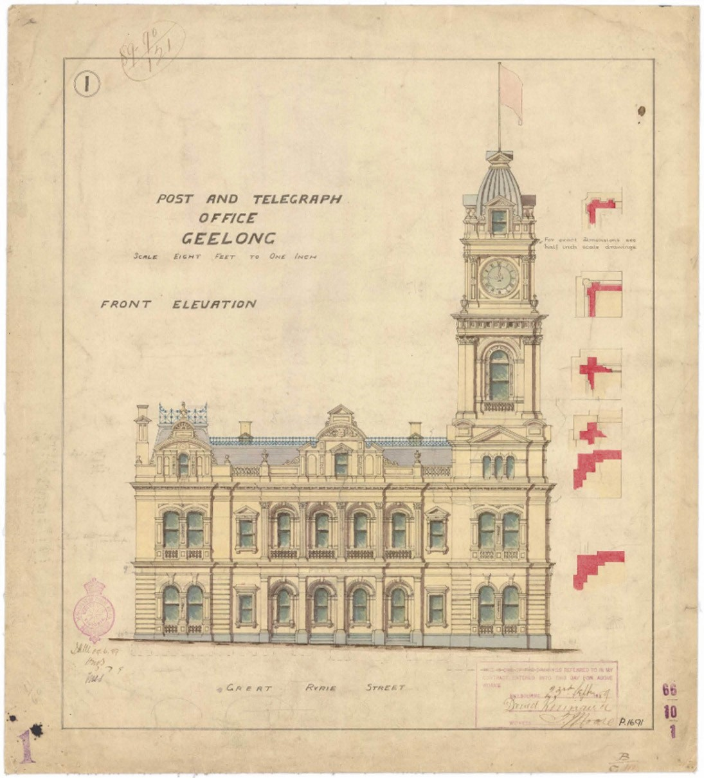
Figure 3.182: J.H. Marsden, Post and Telegraph Office Geelong, Front Elevation, 1889. Source: NAA: B3712, drawer 66, folder 10, part 1, National Archives of Australia.

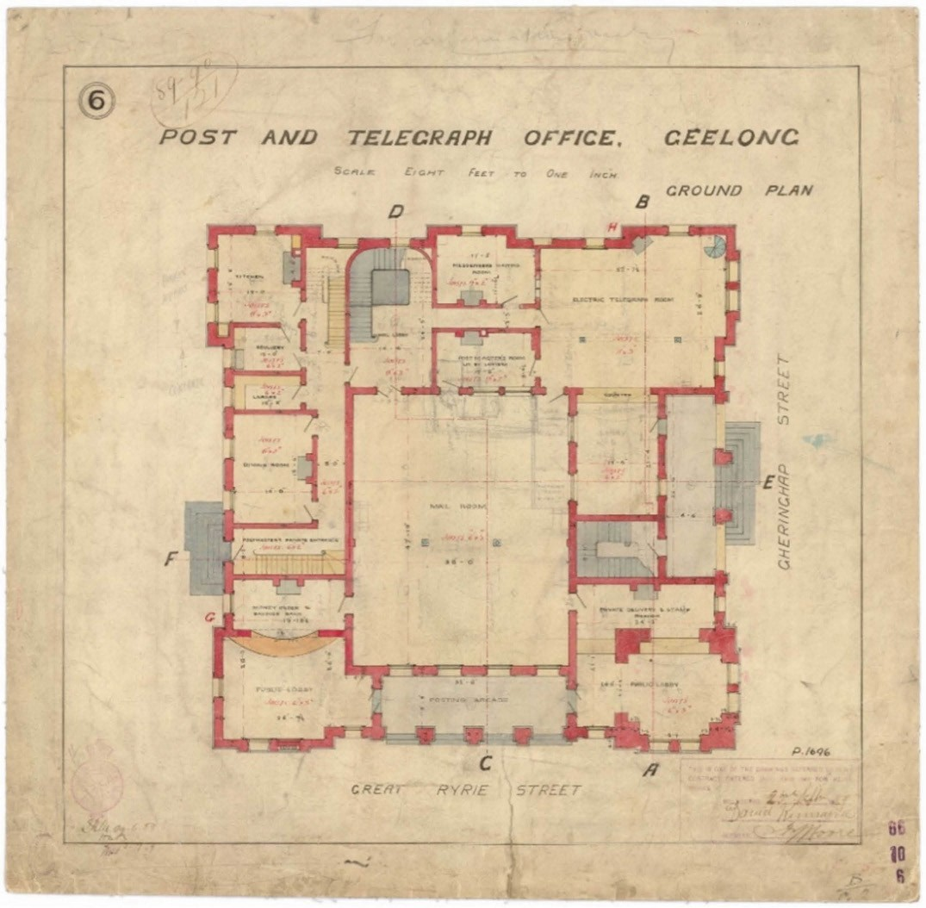
Figure 3.183: J.H. Marsden, Post and Telegraph Office Geelong, Ground Plan, 1889. Source: NAA: B3712, drawer 66, folder 10, part 1-2, National Archives of Australia.

Commonwealth Postmaster-General. At this time, the fledgling Commonwealth bureaucracy amounted to 1400 public servants with all the official files of the Prime Minister kept in one black bag.1587

A major improvement in the operations of the post and telegraph service at the Geelong Post Office came in July 1911, when a new automatic telephone exchange was activated, replacing the outdated existing system (see following subsection for further details).

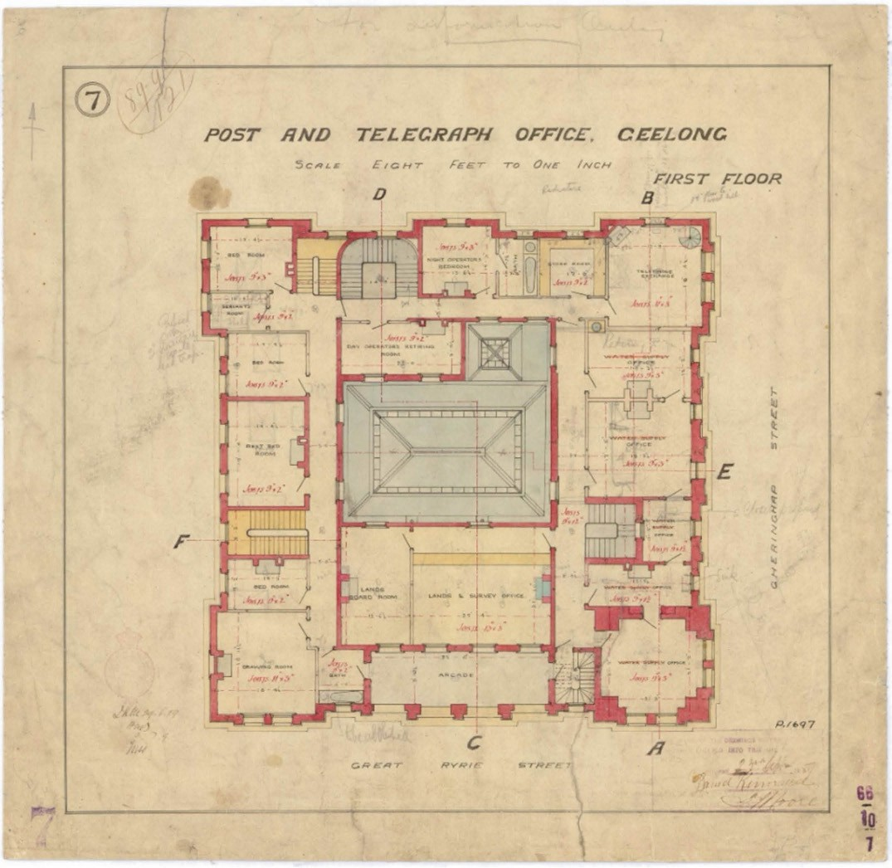
Figure 3.184: J.H. Marsden, Post and Telegraph Office Geelong, First Floor Plan, 1889. Source: NAA: B3712, drawer 66, folder 10, part 2-2, National Archives of Australia.

The Post Office continued to function for its original purpose until 1994 when the Victorian Government sold it to the
City of Greater Geelong on a $670,000 interest-free loan.1588 Australia Post relocated to a shop in the Market Square Shopping complex, Moorabool Street. In 2018, consideration was given by the Council to sell the building.

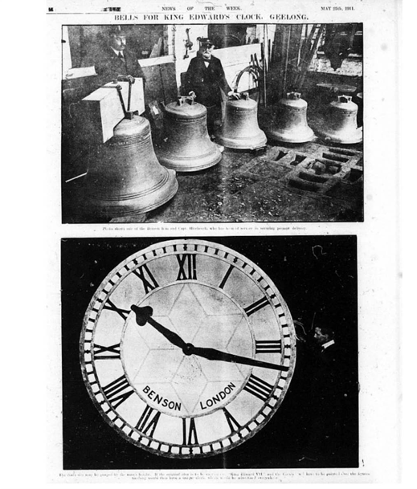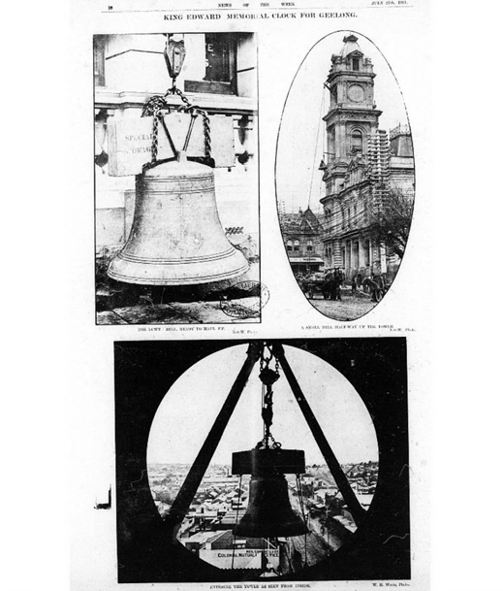

Figure 3.185: Bells and clock face for the proposed King Edward VII Memorial Clock, 1911. Source: News of the Week, 25 May 1911, GRS 2121, Geelong Heritage Centre collection.

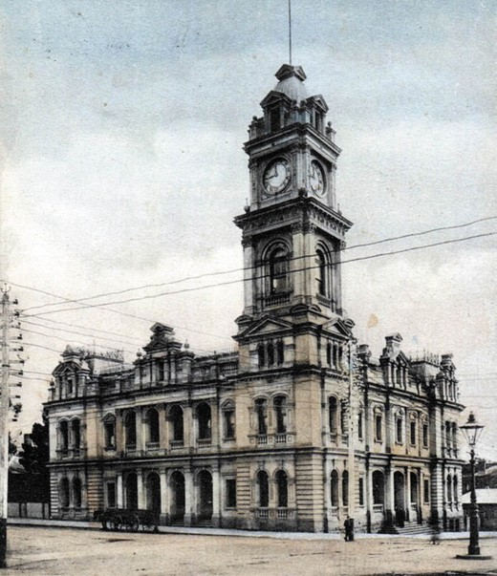
Figure 3.187: Geelong Post Office, after 1911. Source: accession H90.25/16 State Library of Victoria.
Figure 3.186: Bell, Post Office & bell installation, 1911. Source: News of the Week, 25 May 1911, GRS 2121, Geelong Heritage Centre collection.

GEELONG WEST POST & TELEGRAPH OFFICE
Until 1886, the extent of the postal service in Geelong West were letter-receiving pillar boxes at the nearby Geelong Railway Station (installed in 1878) and in Pakington Street (installed in 1884).1589 The need for a post and telegraph office was put to Government authorities and in August 1883 the Geelong Advertiser noted that substantial promises had been given for the construction of the building.1590 By April 1884 a site in Pakington Street was mooted,1591 and a meeting with the Chief Secretary Graham Berry, confirmed the desire of the Geelong West Borough Council that the new building should be erected at the south-east corner of Pakington and Hope Streets.1592 This land had been owned by the late Mr Conley.1593
By February 1885, the Post and Telegraph Department had approved plans for the new building.1594 The single storey brick post office with attached postmaster’s residence was designed by G.B.H. Austin of the Public Works Department1595 (Figure 3.188). The distinctive Flemish gables to the principal (Pakington Street) and secondary (Hope Street) elevations became key features of the post office and court house designs of the Public Works Department in the late 1880s and early 1890s.1596
A corner porch was proposed to lead into a lobby, providing

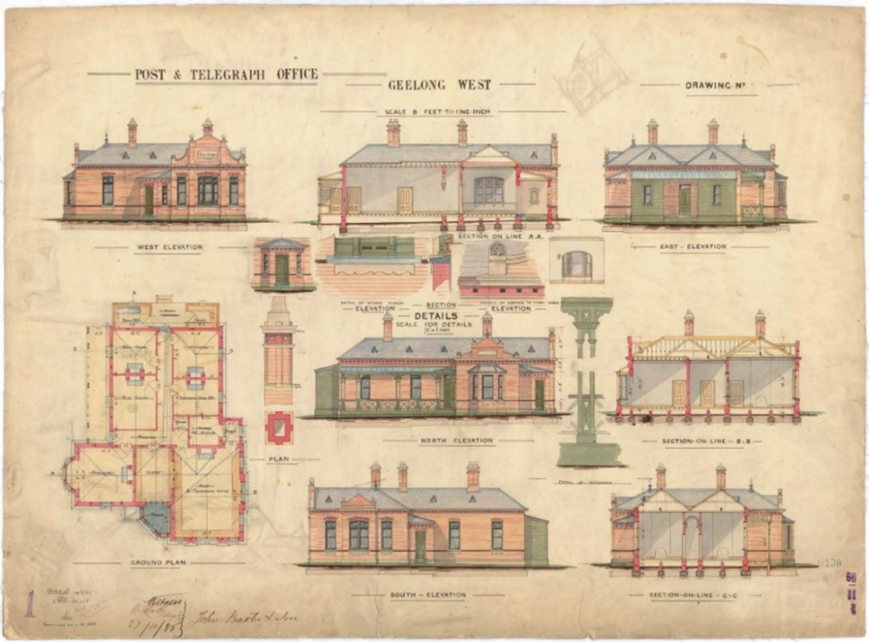
Figure 3.188: G.B.H. Austin, Post & Telegraph Office Geelong West, Floor Plan, Elevations, Sections & Details, 1885. Source: NAA: B3712, drawer 66, folder 11, National Archives of Australia.

access to the post and telegraph office (and battery stores) at the front. A door opening was also to lead into the private
quarters of the postmaster including a parlour, two bedrooms, servant s bedroom and kitchen, with a skillion wing at the rear to accommodate a bathroom, store and verandah.
In October 1885, a contract was accepted by Messrs J. Baxter and Sons for the construction of the post and telegraph office at a cost of £1,595.1597 In the presence of a large crowd, the Chief Secretary, Graham Berry, laid the foundation stone
on 20 January 1886. The proposed building was described as a neat brick structure, with white facings, and a parapet in front. 1598 The works were under the supervision of
J. Davey.1599 The building (Figure 3.189) opened for business later in 1886.
The first person appointed to head the Geelong West Post Office appears to have been Miss Sophia Cole
(1856- 1936).1600 Born at Gardiner to George and Emma (nee Leak) Cole, Sophia Cole had previously been postmistress at Lismore and Cobden.1601 Cole s tenure was to be brief as she married John Walter Beckwith in Melbourne in 1888.1602
However, Cole s appointment illustrated the desire of the Post Office and Telegraph Department to employ women in its workforce, similar to the Railways Department.

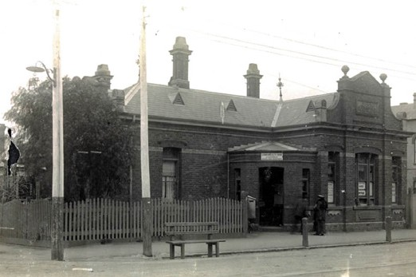
Figure 3.189: Geelong West Post & Telegraph Office, Pakington Street, 1917. Source: accession H89.105/96 State Library of Victoria.

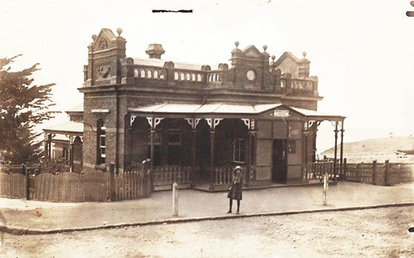
Figure 3.190: Portarlington Post Office, c.1917-30. Source: accession H89.105/189 State Library of Victoria.

PORTARLINGTON POST OFFICE
In 1859, the Bellarine Farmer s Association lobbied the Secretary to the General Post Office for the establishment of a post office at Portarlington.1603 The Department had however already selected a location at East Bellarine, much
to the dismay of the Association given that the new post office would be less than three miles from the existing facility at Drysdale.1604
It was not until 1868 when the first Post Office opened in Portarlington with John Calhoun appointed the first
postmaster.1605 He was the owner of the Bayview Hotel and store.1606
Initial preparation was made for a new post and telegraph office in 1887 when the Board of Land and Works excised a site from the market square reserve.1607 A commodious post and telegraph office with attached quarters was designed by G.B.H. Austin of the Public Works Department in late 1887.1608 Austin had previously designed the Geelong West

Post and Telegraph Office, and while the composition for the Portarlington building was different, it showed the consistent idiosyncrasies in the Flemish gables and other details of
the architectural branch of the Department. Tenders were called in February 1888 and a contract was awarded to Messrs. Gross and McClure of Williamstown at a cost of approximately £1500.1609
The impending construction of the new edifice was proudly declared to provide ‘the first public building in the whole shire. 1610 The importance of the occasion was not lost on the Portarlington Town Improvement Association which organised the largest public gathering ever held in the shire
for the laying of the foundation by the Hon. J.F. Levien. on 28 September 1888.1611 In addition to Members of Parliament and local councillors, nearly 700 children from the Portarlington, Paywit, Murradoc, St. Leonards, Moolap, Drysdale and East Bellarine Schools participated in the event.1612 A description of the proposed building was given at this time:
The new public building is to be of dark-colored bricks, with white brick facings, the whole structure to rest on a concrete foundation. It will be a single-storey building, and whilst providing post and telegraph offices, it will comprise a sitting room, two bedrooms, kitchen, etc. The new offices will have a frontage of 40ft to Newcombe- street by a depth of 47ft along the main road leading to the jetty, commanding a foremost view of the seaway entrance to the township, and close to the Free Library and the weighbridge.1613
Community pride in the proposed post office soon turned sour once the walls were built. In November 1888, the Portarlington Town and District Improvement Association was able to gauge of more accurate appreciation that the building would have when complete and it found that the
walls would not be high enough to give the structure anything but a miserable, dwarfed, and insignificant appearance, quite unworthy of our rapidly growing town.1614 The Association s concerns found favour with the Department and the walls were subsequently raised 2-3 feet and ornamented to some extent. 1615 The floor was also raised an additional two feet.1616 Finishing touches were made for the completion of the building (Figure 3.190) in early April 1889.1617
The first permanent head of the Portarlington Post and Telegraph Office was Miss Emma Deane.1618 She appears to have emigrated to Melbourne from London on the Chimborazo in 1882 and in 1883 was appointed as a postmistress to the Department of Postmaster-General.1619 By 1888, Emma Deane was postmistress at the Yarraville Post Office.1620 Miss Deane s tenure at Portarlington lasted until c.1891 when she was appointed acting postmistress at Rutherglen and was later permanently appointed to
that position.1621

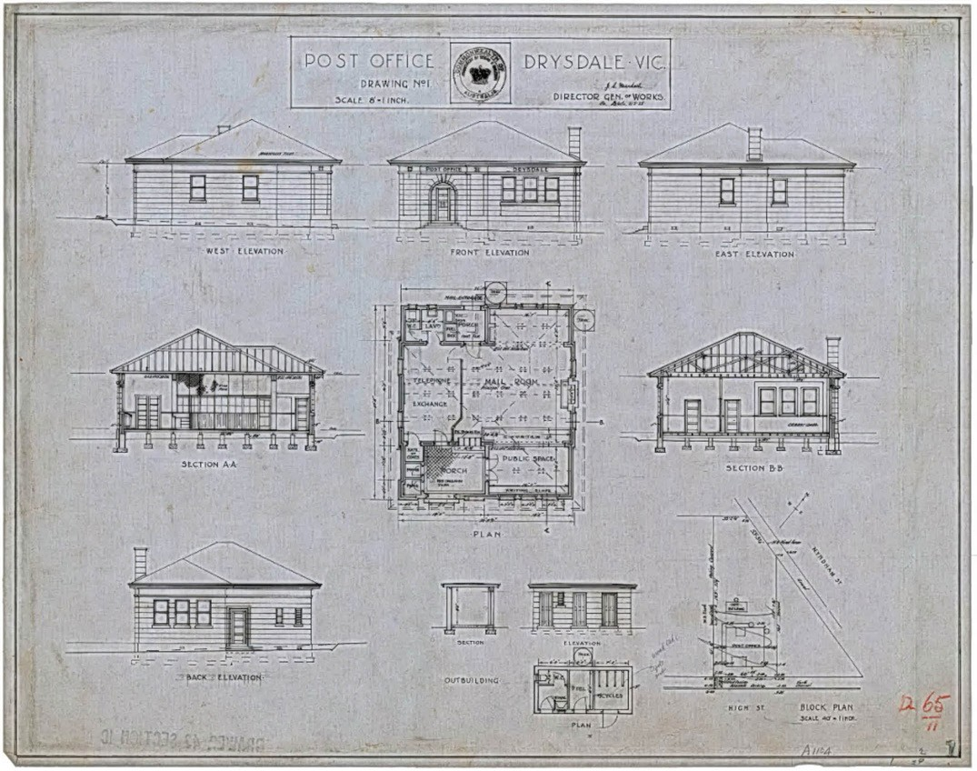
Figure 3.191: J.S. Murdoch, Post Office Drysdale, Details Drawing, 1925. Source: NAA: B3712, drawer 65, folder 11, National Archives of Australia.

DRYSDALE POST AND TELEGRAPH OFFICE
The first post office at Drysdale opened in 1855 and was known as Bellarine.1622 The inaugural postmaster was A.W. Bailey.1623 Following his death in 1859, postal responsibilities were taken over by his brother in law,
Samuel Eades.1624 Samuel s wife, Ann, was postmistress for much of 1862 before Samuel returned to the role in
December of that year.1625 By 1868, Eades had been replaced by J.P. Burrows.1626 In 1872, the name of the post office
was changed to Drysdale and Charles Brazier had been appointed postmaster.1627 With the opening of the Geelong to Queenscliff Railway line, a telegraph station opened at the Drysdale Railway Station in 1879.1628 Noticeably distant from the township centre, the Postmaster-General was petitioned
to fund a new building in a more central location.1629 Approval was subsequently granted and by June of that year ‘good
progress was being made on the new weatherboard Post and Telegraph Office in High Street.1630 Opening in August 1882, the Geelong Advertiser gave a glowing report:
The new Post and Telegraph Offices here were opened last week, and prove great conveniences. Not only is the building another fixture in the township, but the facilities offered for business people are largely taken advantage of.1631

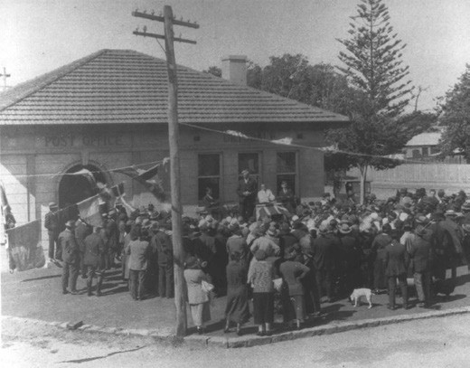
Figure 3.192: Opening of the Drysdale Post Office, 9 February 1926. Source: Image 308 Bellarine Historical Society.

Miss Esther Conboy had been appointed postmistress for the newly-completed building.1632
In 1900 the people of Drysdale complained of the inadequacy of the post and telegraph office building, and the need for a new facility.1633 As an interim measure, it was suggested that the Colonial Bank building at the corner of High Street and Murradoc Road might be rented from the bank authorities.1634 This did not transpire until 1907 when the bank relinquished its premises for the post and telegraph office and relocated into one of the rooms of the Shire Hall. 1635
During the ensuing years there was further agitation for a new, purpose-built post office building. The Commonwealth Government did not secure land at the corner of High and Collins Streets and Clifton Springs Road until 1924.1636 A concept for a modestly scaled, hipped roofed rendered brick building had been prepared by 1925.1637 Signed by
D.W. Crawford, Supervising Architect of the Central Office of the Public Works Branch of the Department of Works and Railways on behalf of J.S. Murdoch, Director-General of Works, the scheme showed all the hallmarks of Murdoch s modern Renaissance design repertoire used for many post offices and telephone exchanges across the country.1638 This included the deliberate austere character accentuated by stripped Classical detailing in the entrance portico (with flanking vestigial pilaster and simple keystone in the arched
opening), roundel motifs in the eaves and smooth- rusticated walls (Figure 3.191).
Tenders for the construction of the post and telegraph office building were called in June 1925.1639 In August 1925, a contract was accepted from J. Smith of Meredith for the construction of the building at a cost of £2,223/2/6.1640 The building was completed by early 1926 and was officially

opened by J.H. Lister, M.H.R. on 9 February of that year1641 (Figure 3.192).
Mrs Susan Bridget Curtain (c.1873-1949) was the first postmistress in charge of the new post and telegraph office.1642 She had held the position since 1912 at the previous post office (save for a period in 1918 as relieving postmistress at Birregurra).1643 Born in Sale, Victoria, to Michael and Julia (nee Joyce) Coffey, Susan Curtain had married the Mounted Police Constable, John Thomas Curtain, in 1896.1644 They were stationed at Birregurra in 1897
where their daughter was born.1645 John Curtain died at the Raywood Police Station, Sale, in December 1897, aged 32 years.1646 This tragic event forced Susan Curtain to re-enter the workforce. She remained as postmistress at Drysdale until November 1926 when she left to take up relieving work in Melbourne.1647

TELEGRAPH, TELEPHONE AND INTERNET ELECTRIC TELEGRAPH
THE EARLY YEARS
In 1854, the Victorian Legislative Council passed the Electric Telegraphs Bill to allow the installation of the electric telegraph in Victoria and therefore further open up communications throughout Greater Geelong and beyond. Rules and regulations concerning the operation of and fees for the telegraph were subsequently passed by the Victorian Parliament in 1855 and 1856.1648 Samuel W. McGowan was appointed Superintendent of the Electric Telegraph, being stationed in Melbourne. The construction of the Geelong to
Melbourne Railway line from 1853 gave impetus for the laying out of the telegraph line between Melbourne and Geelong
to be parallel with the railway.1649 On 5 December 1854, communication between Melbourne and Geelong was first established following the construction of 50 miles of telegraph line between the two towns and via Williamstown.1650
On 30 January 1855, communication with Queenscliff and Geelong was made after the building of 20 miles of line.1651
In Geelong, further infrastructure was established throughout 1854. As reported in the Geelong Advertiser and Intelligencer:
The work is now being proceeded with extraordinary rapidity, and the contractor promises to have it finished by [10 August 1854]. A flag staff will in a short time be erected near to the hospital, and the time ball, indicating P.M., will rise and fall at the correct time. These matters will be a great boon to the inhabitants of Geelong, and they will, no doubt, appreciated anything to further their interests.1652

In December 1854, electric communications commenced in temporary accommodation, being the little wooden house behind the Custom House’ – the original bureau for the coast waiter despatched from Sydney to Geelong in 1838 and
now in the Geelong Botanic Gardens (see Theme 7).1653 The instrument adopted by the Superintendent to transmit and receive messages was the Morse s Recording Telegraph. He described it as follows:
The key is simply a small horizontal brass lever, about four inches in length, having near its centre a blunt point, below which is placed a similar point called the anvil. The lever is maintained in a slightly raised position by means of a spring, so that, upon moderately pressing the ivory knob attached to the end of the lever, the two points are brought into contact; upon removing the pressure the spring instantly raised the lever to its former position. By the use of this portion of the apparatus the main circuit between each office is completed or broken at pleasure
– one termination of the main wire being attached to the lever itself, and the other to the anvil, it follows that when the two points are apart the current passing on the main wire is interrupted, and when the contact is
made, by pressing them together, the circuit is once more completed.
By thus interrupting and completing the circuit at certain intervals, and making contacts of varied duration, letters, words, and sentences are formed by the aid of the relay and the register, with its fillet of recording paper.1654
A more humorous account of the Morse Telegraph machine was given by the Geelong Advertiser and Intelligencer which declared it to be a wonderous machine and well worthy of a visit :
The telegraph speaks yaaap, yap, y p, yaap, y p, y p, goes the metal tongue, which means that Melbourne is talking to Williamstown: yap, yap, y p, y p, yaap, Williamstown is replying to Melbourne; yap, yap, yap, again goes the clapper. It is lunch time, we ll be back
at half-past one, yap, yap, yap, wait a minute, I have a question to ask, and so on. Operators who are very experienced, can repeat the message from the sound alone, but to avoid the possibility of the telegraph retracting its statements, it actually writes them at the same instant that the clapper tongue goes on yap, yapping! The replies are impressed on a strip of stout
paper that is drawn through a certain arrangement of small cylinders, and comes out impressed with a series of dots and lines of various lengths, from which hieroglyphics,
the operator reads off fluently the exact words of the message! It is the greatest invention of the age.1655
Although the Telegraph Station had opened in the original custom house in December 1854, tenders had been called

earlier in August of that year for the construction of a telegraph station at Geelong, a contract for the work was not advertised in the Victoria Government Gazette.1656 However, by April 1855, a new telegraph station had been erected
on a reserved site at the south-east corner of McKillop and Bellerine Streets, being described as follows:
A substantial brick building with square tower for a flag staff, has been lately completed as the Geelong Electric Telegraph Station. The building itself is unexceptionable, but the situation is too far from the centre of business to be long tolerated by the people of Geelong. The electric telegraph itself has hitherto worked to admiration.1657
The isolated situation of such an important communication hub for the Geelong township caused its removal to a more centralised location in the newly-built post office at the corner of Gheringhap and Ryrie Street in July 1857.1658 The brick telegraph station at the corner of McKillop and Bellerine Streets was demolished and later replaced with the Haimes Memorial Homes (see Theme 8).

PERMANENT TELEGRAPH STATION
The relocation of the telegraph station to the post office was only to be a temporary measure. Tenders were called for the construction of the building in October 1857.1659 Patterson and Belle were awarded the contract in November of that year at a cost of £2,038.1660 The single storey hipped roofed building was constructed of Barrabool stone and featured a central tower surmounted by a time ball (Figure 3.193). The designer responsible for the Georgian building is conjectural.
Early drawings of the proposed structure were included in a book of drawings by Henry Ginn, Colonial Architect until April 1853.1661 Royal assent had not been given for the Act of Electric Telegraphs until November 1854, after
Ginn s resignation from the Department. The building to be constructed in Ryrie Street was also not approved until 1857. Draftsman working the Department in 1857 included J.J. Clark (who had designed the supreme court and custom house buildings, and possibly the post office), William Davidson and Samuel Merrett.1662 It is possible that one of these staff added to a book of drawings first commenced by Ginn.
Opening in 1858, the first stationmaster of the permanent Geelong Telegraph Station (Figure 3.194) was William Hill James (1802-1861).1663 Born at Falmouth, Cornwall,
England, he had arrived in South Australia by 1845 as he was reported as inventing the rapid transmission of letters and light dispatches through tubular passages. 1664 He was first appointed by the Governor in 1853 and took up his position at Geelong on 21 September 1854.1665 In 1861, James’ life was cut short, and the Geelong Advertiser gave the following obituary:

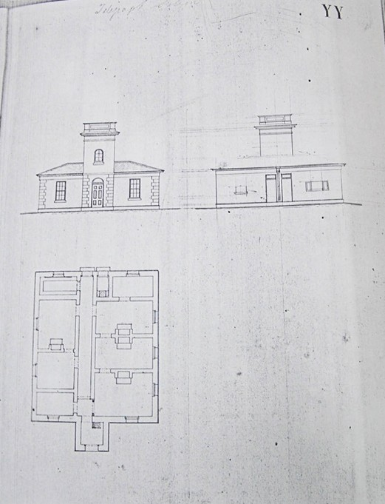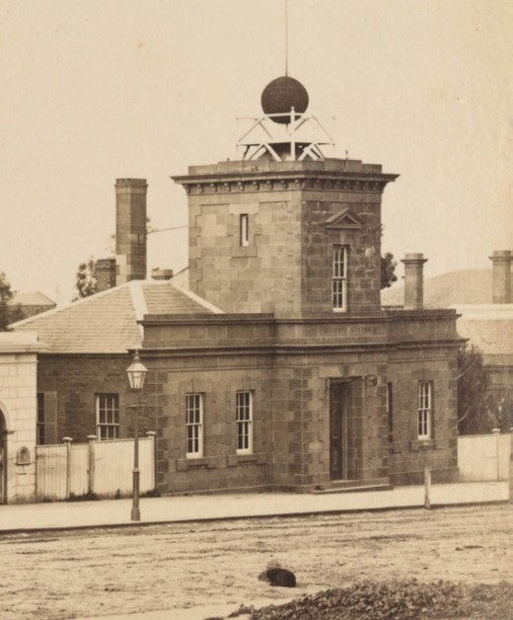

Figure 3.193: Geelong Telegraph Station, Floor Plan & Elevation Drawings, c.1857. Source: Book of Plans by Clerk of Works, Henry Ginn, VPRS 4107/P1 Unit 1, Public Record Office Victoria.

He was early initiated into an acquaintance with mining details; and subsequently for ten years he filled the post of mineral surveyor of the Mining Company
of Ireland.
Upon his arrival in Adelaide, he received a similar appointment in connection with the South Australian Mining Association, and in the Assay and Mint Offices established there shortly after the discovery of gold in Victoria, he took a prominent part during the whole period of their existence.
In this colony, also, he held the situation of gold assayer to the government, until it was abolished in 1854; and it was under his directions that the furnaces were constructed, which have since been bricked up in the present Survey Department.
During all these later years of active and unwearied effort, working ungrumblingly for twelve to fourteen hours a
day, we can bear testimony to his courteousness and his willingness to advance the public interests. He leaves a large family, some of whom are yet in infancy, to regret his loss. His last days were peaceful, and his end was unmarked by pain.1666
Figure 3.194: F. Kruger, Geelong Telegraph Station, Ryrie Street, c.1882. Source: accession H39614.52, State Library of Victoria.

James Fisher had been appointed Telegraph Operator, with Augustus Smith, Junior Assistant.1667
Some telegraph operators combined the role as postmaster at smaller offices from 1861. This brought out efficiencies and the system was continued throughout Victoria from this time. As outlined in the Report on the Affairs of the Post Office Department:
There can be little doubt that this has been attended with benefit to the public, for besides being on the whole a measure of economy it has had the advantage of placing the duties of postmasters in the hands of an officer wholly and exclusively in the service of the Government, and has led to the extension of the Money Order System to places where it would not otherwise have been commenced for some time.1668
The success of the combined system led to the formal amalgamation of the departments of the Post Office and Electric Telegraph in 1869.1669 From this time, the responsibilities of the telegraph office rested with the
postmaster however at Geelong the first appointment under the new regime was Samuel Vivian, a Telegraph Officer (see earlier subsection).

Following the opening of the new post and telegraph office in 1891, the old telegraph station was no longer used for its original purpose. It was subsequently leased to other
government departments1670 and has been lately managed by Working Heritage Inc., a non-profit organisation that manages heritage places on
Crown Land.1671
Other telegraph branch offices continued to operate in Geelong. In 1886, a telegraph was fitted up in the
front offices of the Exhibition Hall, Market Square.1672 It was also in 1886 when another branch telegraph was installed at the Geelong Sale Yards, Weddell Road, North Geelong.1673 A third branch telegraph office was established in 1890 in the grandstand of the Geelong Cricket and Football Club, Corio Oval, Eastern Park.1674 This service was a great advantage compared to the special cabs previously despatched to convey messages to the Telegraph Office in Ryrie Street from which scores were relayed to Melbourne. The new
installation at Corio Oval at during the football season in June 1890 as reported by the Geelong Advertiser:
The convenience of the extension line was fully experienced on Saturday, and was well appreciated by the public. A couple of operators and several attendants were kept busily employed during the two hours the football match lasted, and a very large number of telegrams were despatched. The wires have been extended to the football enclosure, on the condition that the club guarantee a
sum of £5 every time an operator is sent from the office in Ryrie-street to the office at the oval, and all receipts above that sum are taken by the telegraphic department.1675
The advent of telephone technology brought about the end of the branch telegraph services in subsequent years.

THE TELEPHONE

BEGINNINGS OF THE TELEPHONE IN VICTORIA BY W.J. THOMAS
On 10 February 1869, the Geelong Advertiser and Intelligencer reported that Mr W.J. Thomas was to give a lecture that evening on the Electric Telegraph , and
given Thomas known acquaintance with the subject, an instructive evening may be anticipated. 1676 This was one of several lectures to be given by Thomas, second Clerk and Warehouse-keeper for the Customs Department at Geelong, whose particular interests were astronomy, electricity and magnetism and their practical application, and the working of the electric telegraph.1677 With the patent for the telephone in March 1876 by Alexander Graham Bell of Boston, U.S.A.,1678 Thomas took an immediate scientific and practical interest. In mid-1877, following a review of the American Scientific Journals, Thomas commenced experimenting with the telephone based on Bell s theories and drawings,1679
the outcomes to have a dramatic impact on telephonic communications not only in Geelong, but State-wide.
In August 1877, the Geelong Advertiser announced (via the Melbourne correspondent of the Warrnambool standard) that the telegraph department was making trials of the newly invented telephone. 1680 However, apart from reference to overseas installations (such as at least five telephones being in operation in New York),1681 it was not until 27 December 1877 when the Geelong Advertiser declared that W.J. Thomas had succeeded in constructing a telephone on Professor Bell s principle. 1682 The article further stated that the telephone worked admirably, voices and selections of music having been distinctly heard at the distance of half a mile. 1683 A more fulsome account of Thomas s extraordinary achievement was given on 28 December 1877 when the Geelong Advertiser stated:
We believe that Mr W.J. Thomas deserves the credit of having been the first to introduce the telephone into Victoria. At any rate, no mention has ever hitherto been made of the new instrument being either used or experimented on in the colony. In his spare moments at his house in Skene-street, during the past month,
Mr Thomas has constructed a very simple-looking instrument. It is a small box, 7 in. long, 3 in. broad, and 2 in. deep, having at one end a bell-shaped mouth and at the other end two binding screws for connecting with
the line wire. Inside of the box there are four permanent horseshoe magnets, and connected with their north poles there is a short piece of iron, very thin, soft, and good.
Around this piece of iron there is a coil of exceedingly fine copper wire insulated by a covering of silk, the coil being three-eighths of an inch in width and an inch in diameter,

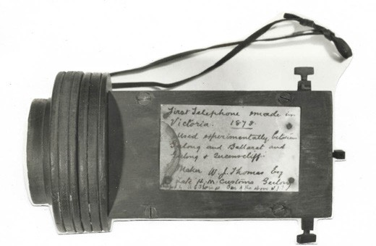

Figure 3.195: W.J. Thomas, telephone device, 1878. Source: Marco Laudani, Australian Historic Telephone Society.

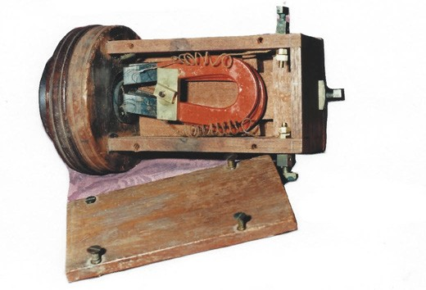
Figure 3.196: W.J. Thomas, telephone device, 1878. Source: Marco Laudani, Australian Historic Telephone Society.

and the two ends of the wire lead back to the binding screws, the latter being connected with the line and earth wires respectively. In front of the small electric magnets, within the coil and at the least possible distance, is the most important part of the apparatus – the diaphragm
– which is of extremely thin iron about as thick as the finest writing paper, and this is fixed to the instrument with washers of lead. The box, with lid screwed down, is thus complete, there being adjusting screws, springs,
and other minor details which have suggested themselves to Mr Thomas during the construction of the instrument. Of course, there is an instrument exactly similar at each end of the wire. In sending messages the instrument is lifted to the mouth, and the speaker uses it as one would use a speaking-trumpet, and in receiving messages the listener has to place the second instrument to his or her ear. The contrivance is in every way of a very simple character. Yesterday afternoon a trial of the telephone

was made, and the result was eminently satisfactory. A wire, three- quarters of a mile in length, was run from
Mr Thomas house, thence through an orchard, winding over the fruit trees to a summer house about 30 yards or 40 yards from the main building. Conversations were carried out on between different persons in each room; the words could be distinctly heard, and the voice of each person easily identified … Mr Thomas deserves
to be complemented on his success, and yesterday s experiment will no doubt lead to further tests of the wonderful powers of the telephone. In fact, we may state that already negotiations have been entered into with the view of having the telephone fixed on the telegraph line between Geelong and Queenscliffe, for the purpose of testing the capabilities of the instrument.1684
Henry Sutton, a music seller in Ballarat, constructed a telephone at the same time as W.J. Thomas in late 1877.1685 While his first phone transmitted sounds it was not as ‘perfect as the maker wished and so he began the construction of another.1686 Thomas s experiments in Geelong therefore suggest that he was the first to introduce a locally-made telephone communication in Victoria. In February 1878 he arranged a novel and interesting entertainment by running
a single telephone wire from his residence at the south- east corner of Skene and George Streets (now demolished) along various fences at the back of different properties to
the parlour of his neighbour, John Cochrane Brownhill at 131 Skene Street (this dwelling exists in an altered state today).1687 The earth connections at each end were the water taps of the dwellings. A circuit was established to allow the telephone
to be handed to various people in different parts of the room, the messages and replies being heard with remarkable distinctness and a lady sang The Irish Emigrant with piano accompaniment, the effect through the telephone being excellent.1688
Aside from providing novel entertainment, the real value of Thomas invention was to provide a clear and reliable
communication for official, commercial and private purposes. On 31 December 1877, the first long distance telephone communication came from Thomas experimentation with
a line between the Telegraph Office, Geelong, and that in Melbourne, connected at looping lines at the Werribee
Railway Station.1689 The Melbourne Telegraph telephoned a series of cooeys . 1690 Ten days later on 9 January 1878,
similar experimental telephone connections were made from Geelong to Queenscliff, with Mr Dod at the Queenscliff office of the Telegraph Department singing Genevieve with W. Upton singing a reply at Geelong being Yankee Doodle .1691 Similar experimentation between Geelong and Ballarat occurred on 26 February 1878.1692

The contribution of William Jackson Thomas to Greater Geelong, and more broadly, Victoria, is manifested in the telephone system still in use today. Historically, several of his instruments, including the telephone used during tests in early 1878, now form part of the collection of the Telstra museum (Figures 3.195-196).
William Jackson Thomas (1820-1909) was born in Swansea,
Glamorgan, Wales, the son of William and Susannah (nee Jackson) Thomas.1693 He came to Victoria in 1838 with his parents and three youngers sisters, his father being appointed Protector of Aborigines in Port Phillip.1694
In Victoria, W.J. Thomas took up farming at Dandenong and in the Westernport district, and also assisted with his father s farm at Coburg.1695 He subsequently surveyed the source
of the Yarra River with E.J. Walpole.1696 In 1847, Thomas was appointed First Clerk in the In-door Department of the Customs Department at Geelong.1697 and in 1848 he married Miss Sarah Truckle Dredge and they were to have eight children.1698 They first lived at 4 Moorabool Street opposite the Christ Church School House before relocating to a cottage in Skene Street, Newtown.1699 In 1853, the Thomas family relocated to Brunswick where W.J. Thomas worked as a customs agent .1700 The Thomas family returned
to Geelong in 1861 and took occupation of a dwelling in Skene Street owned by Charles Rowand, engineer (see earlier subsection).1701 At this time, W.J. Thomas again took up a position as Warehouse Keeper with the Customs Department.1702 By 1873, Thomas had built his own home at the south-east corner of Skene and George Streets.1703 It was from this location where he developed his interests in the telephone, and first constructed and experimented its
potential.1704 Following his landmark experimental telephonic achievements, he lectured widely, both in Geelong and at the Ballarat School of Mines.1705
On his retirement in 1887, Thomas was honoured with
a public testimonial at the Geelong Mechanics Institute, it being declared that:
In all scientific matters Mr Thomas had taken a foremost part locally, and he had given his assistance without expecting fee or reward for instruction to the people in astronomy, electricity, and other matters, alike to the people acquainted with them as well as others. Mr Thomas s surety of manner, and promptness in rendering intellectual aid in every way, had endeared him to the people of the town
and suburbs.1706
Thomas and his family retired to Wenvoe , Canterbury Road, Balwyn where W.J. Thomas died on 26 March 1909, leaving behind an extraordinary legacy of the telephone
to Victoria.1707

EARLY TELEPHONE SERVICE IN GREATER GEELONG
The experiments by William Thomas and Henry Sutton were progenitors to formalised and regulated telephone services throughout Victoria. Private lines were initially established, with one of the first in Geelong proposed in 1882 between the Corio Tannery near the beach and the Australian Tannery
at Marshall.1708 In 1883, there were seven telephones operating in Geelong, with one line being established for Dr Reid between his surgery in Malop Street and his private residence in Chilwell.1709 A year later in 1884, the grocers,
J. and A. Price connected their stores in Malop Street, Geelong and Pakington Street, Geelong West, the necessary telegraph posts’ being erected in June of that year.1710
Officially, the Post office and Telegraph Department began its own telephone service in Melbourne in 1880. It
constructed its first telephone exchange for Messrs. Sands and McDougall ‘for the private use of the firm.’1711 In 1883, an amendment of the Post Office Statute was passed in the Victorian Parliament which regulated the telephone system by giving authority to the Postmaster- General alone for constructing, granting leases of, or otherwise providing for the public use of lines for telegraphic or telephonic purposes. 1712 In Geelong in 1886, the Post Office and Telegraph Department would not support the
establishment of a telephone exchange without the pledges of £10 each of 50 subscribers.1713 In September 1888, the Geelong Telephone Exchange was officially opened with 33 subscribers. The Geelong Advertiser gave the following report:
Yesterday morning the Telephone Exchange in Geelong was opened by Mr Smibert, Deputy Postmaster-General. The only ceremony observed was that arranged for by Mr Smibert himself, and was confined to the ringing up of each subscriber, and informing them that the telephone wires were in working order and ready for use from and after nine o clock yesterday morning. It was expected,
that some formalities would be observed on the occasion, to mark the important event of a general introduction
of the telephonic system into the town of Geelong. The expectation was not realised, for the Government officers were not instructed to arrange for any formal opening, and subscribers towards the system had not made any special effort to publicly recognise, the novel departure from the ordinary method of conducting business in this town. For some years past telephonic communication has existed in Geelong, but it has been confined to four or five firms having offices in town, and connected with their manufacturing departments on the banks of the Barwon river, so that the actual use of the telephone is not a novelty, although in its extended form it has a bearing

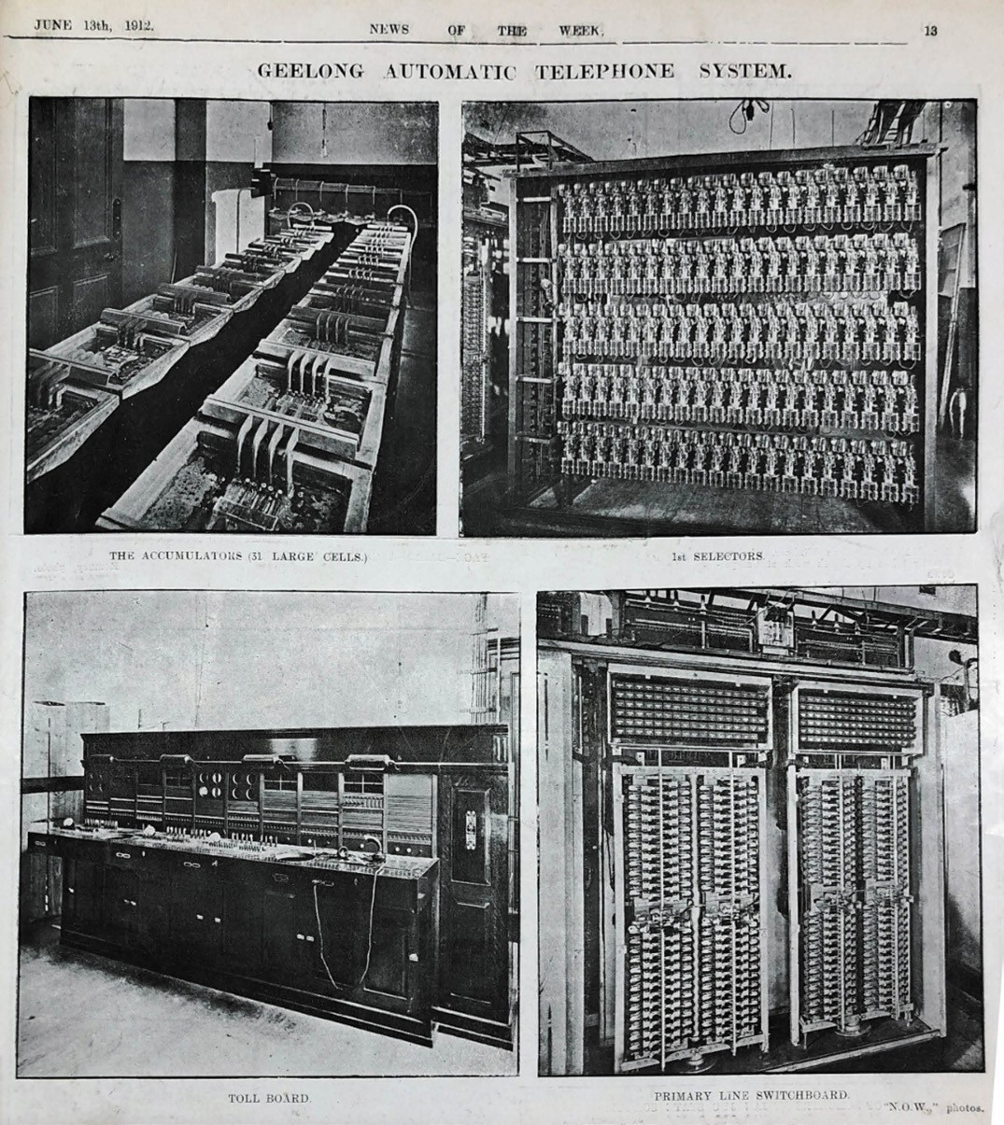
Figure 3.197: Accumulators, selectors, toll board & primary line switchboard comprising automatic telephone exchange, Geelong, 1912. Source:
News of the Week, 13 June 1912, p.13, GRS 2121/3, Geelong Heritage Centre collection.

which commands more than passing notice.1714
The first subscribers included some of the oldest and well- established firms, including the Western Stage Company, Gheringhap Street; George Hague and Co., the woolbrokers (Strachan, Murray, Shannon and Co. and Dennys, Lascelles, Austin and Co.), Corio Terrace; H.F. Richardson, Exhibition Exchange, Moorabool Street; Bright and Hitchcocks, Moorabool street; Humble and Nicholson, Little Malop Street; Donaghy and Son, Pakington Street, Geelong West; and Huddle, Parker and Co., Moorabool Street.1715
The only known physical evidence today of Geelong s original telephone exchange are some of the interiors in the former Geelong Post Office at the corner of Ryrie and Gheringhap Street.

GEELONG AUTOMATIC TELEPHONE EXCHANGE
In 1896, John Hesketh, had previously been an Electrical Engineer in Blackpool, England, 1716 was appointed by the Queensland Colonial Government to organise the telegraph and telephone department in that state.1717 In 1905, Hesketh travelled overseas to study the latest telephone systems.1718 The majority of the systems he experienced were of the modest common battery manual type which he recommended but he also concluded that interest should not be lost in the automatic system.1719
In 1906, Hesketh was appointed Chief Electrical Engineer to the Commonwealth Postmaster-General s Department. In this position, he transformed the telegraph and telephone systems throughout the country.1720 In his role, Hesketh was responsible for the installation of the automatic telephone exchange in the Geelong Post Office, the first in Australia and the earliest in the southern hemisphere.1721
In January 1911, the Postmaster-General’s Department called tenders for a new switchboard service to meet the growing demands of telephone communications in Geelong.1722 Tenders for three types of exchange were sought: branding multiple magneto lamp-signalling switchboard; full automatic; and a semi-automatic switchboard.1723 In March of that year, Hesketh declared that while final settlement on an automatic exchange for Geelong had not been reached, he intimated that if such an automated service was decided upon an order would be placed with an American automatic company.1724
By September 1911, it had been decided that an automatic telephone exchange would be installed in Geelong.1725 On the day of the opening of the exchange (Figure 3.197) on 6
July 1912 by Mr Thomas in place of Mr Fraser, Postmaster- General (who was ill), with Mr Oxenhan, General Secretary of the postal Department and Mr Bright, Deputy Postmaster- General,1726 the Geelong Advertiser gave the following report on the newest technological installation:

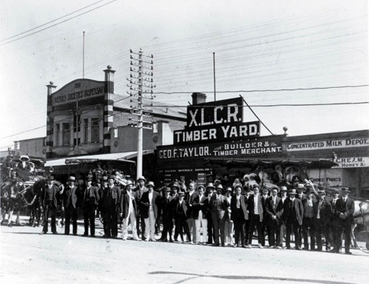
Figure 3.198: Installation staff standing in Ryrie Street, Geelong Automatic Telephone Exchange,1912. Source: GRS, 2009/1846/107, Geelong Heritage Centre collection.
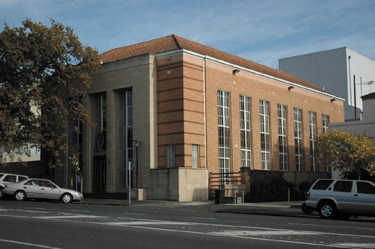
Figure 3.199: Former Telephone Exchange, 50 Gheringhap Street, 2005. Source: David Rowe.

The new service is known as the Strowger system which has only lately been installed at Epsom in England,
the first place in the British Isles to have the automatic exchange. Geelong will be the first south of the line [southern hemisphere]. The patent is in the hands of Automatic Telephones, Limited, Chicago, and to bring it to its present stage of almost human ingenuity and perfection 20 years of study and experiment have been needed. Nothing could be nearer human; to see it work
and grasp what it does makes it look supernatural. It is so ingenious as to almost beggar complete description. In the big telephone room at the Geelong Post-office are a series of iron and glass cabinets filled with neat devices wonderfully delicate of construction but remarkably accurate. These are linked up with a maze of wires, charged with current generated by a 10 h.p. motor,

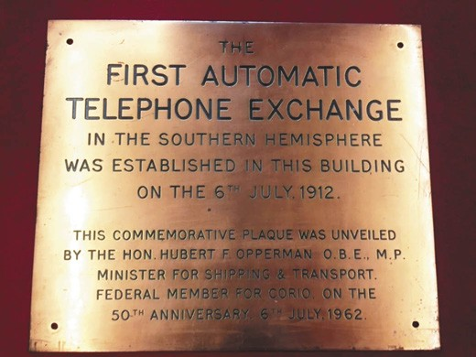
Figure 3.200: 50th Anniversary Plaque commemorating the First Automatic Telephone Exchange in Australia. Source: Geelong Heritage Centre collection (prior to re-installation on the Ryrie Street façade of the former Post Office).

which feeds a series of storage batteries. The force of this current will give a very powerful system clear and resonant.1727
The installation of the telephone exchange was a major feat and involved 22 installation staff, including technicians from the United States of America (Figure 3.198).
After 27 years of occupying the first floor of the Geelong Post Office, the automatic telephone exchange was transferred
to a new purpose-built building next door at 50 Gheringhap Street. The three storey, face cream brick, interwar Stripped Classical styled building (Figure 3.199) had been designed by Commonwealth Department of Works and Railways under the leadership of Edwin Hubert Henderson, Director- General of Works, and Horace John Mackennal, State Works Director for Victoria.1728 Costing £15,000, the building was
constructed by the local builders, J.C. Taylor and Sons.1729 In November 1939, the Electrical Engineer and Construction Co. Pty Ltd of Burnley, Victoria, was accepted as the successful tenderer to supply and install the main switchboard in the new Exchange.1730 This exchange building remained under Government ownership until 1993.
The significance of the first automatic telephone exchange in the southern hemisphere was not to be forgotten. On 6 July 1962, the Federal Minister for Shipping and Transport, Hubert
F. Opperman, unveiled a commemorative plaque at the Post Office to mark the 50th anniversary1731 (Figure 3.200). In later years, the plaque was removed from the Gheringhap Street façade of the Post Office and was recently reinstated in 2018.

The third (and existing) automated telephone exchange
in Geelong came in late 1964 when a new communications centre was completed at 19 Little Ryrie Street at a cost
of £210,000.1732

MOBILE PHONE AND THE INTERNET
On 23 February 1987, the Minister for Communications, Michael Duffy, made the first official call using an analogue mobile phone.1733 These mobile hand-held devices dramatically transformed telephonic communication throughout the world from the late 20th century, with
calls able to be in any location where connection to the mobile network could be made. According to the Australian Mobile Telecommunications Association in 2019:
Today there are more than 20 million mobile phone services in Australia. A decade and a half ago there were 635,000 mobile phones in Australia.
Today mobile services in operation as a proportion of the Australian population is nearly 100%. Fifteen years ago fewer than 4% of people had one.
In 2006, there were 10.2 billion text messages sent
in Australia. In 1987 there were none. Seven years ago when text messaging started there were only 642 million sent in 2000-01.
The direct contribution the mobile phone industry makes to the Australian economy is $5.8 billion in 2006, according to Access Economics. However, it indirect
or spillover impact on the broader Gross Domestic Product is estimated to be $6.4 billion – greater than the direct economic impact. Access says mobile
telecommunications punches above its weight because of its ability to drive productivity gains throughout the Australian economy.1734
Aside from the mobile devices, physical evidence of mobile phone communication throughout Geelong is the mobile phone towers connecting calls to the network.
It was also in the late 20th century, and particularly from 1989 when permanent internet access was made available to universities through the Australian Academic and Research Network (AARNet).1735 The network provided the delivery of data, voice and facsimile services.1736 Public use was pioneered by Pegasus Networks in Bryon Bay, New South Wales, at this time.1737 In 1995, the Australian Vice Chancellors Committee (now known as Universities Australia, a private company whose members comprise
39 Australian Universities) transferred its commercial customers, associated assets and management of interstate and international links to Telstra.1738 Having acquisition of

all of the infrastructure, this comprise the more mainstream beginning of the internet in Australia. Internet Access Providers (IAPs) and Internet Service Providers (ISPs) were subsequently established as commercial entities to connect its customers to the network.1739 Traditional telephone copper wires initially provided the physical connection (first known as ADSL) until cable, fibre, satellite and wireless technologies were subsequently introduced. In 2010, the Federal Government established the National Broadband Network.1740 This involved the roll out of fibre optic cables across the country to junctions (nodes) in the network, from which
users were connected by existing copper wire networks. The provision of the internet dramatically transformed the communication throughout Australia, including in Greater Geelong, providing accessibility to information previously unavailable and opening up opportunities for social network platforms. At the forefront of the new technological age for communication was Deakin University in Geelong, the first Australian University to specialise in distance education (see Theme 8 for further details).1741

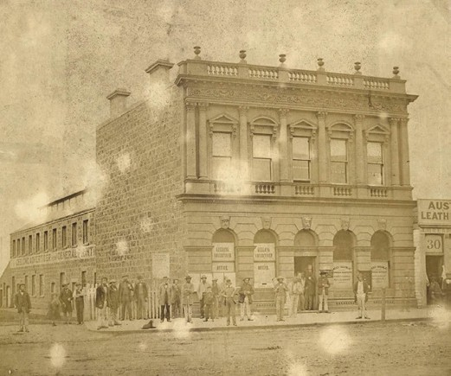
Figure 3.201: Geelong Advertiser Office, Malop Street, c.1860. Source: accession H21482 State Library of Victoria.

NEWSPAPER PRODUCTION
Essential to communications throughout the City of Greater Geelong from the beginnings of European colonisation has been newspapers. The dissemination of information about events, politics, births, deaths and marriages, real estate, businesses (including advertising), sport and world events was made possible by the 52 news sheets established in the Geelong district between 1840 and 2016. Appendix 3.4 provides a list of these newspapers and journals.
The earliest newspaper was the Geelong Advertiser, established in 1840. While no early buildings associated with the newspaper survive, it remains the longest- running newspaper. At 80 Little Malop Street, is the former
headquarters of another early newspaper, the Geelong Times, established as the Evening Times in 1871. This newspaper no longer exists. The following gives a brief overview of the contributions and locations of the Geelong Advertiser and the Geelong Times in Geelong.

THE GEELONG ADVERTISER
In a building in Malop street, Geelong, near Swanston Street, the first issue of the Geelong Advertiser was published on 21 November 1840.1742 The proprietor was John Pascoe Fawkner (1792-1869) of London who had come to Tasmania as a boy in 1801 following his father s conviction of receiving stolen goods and being sentenced to 14 years transportation.1743 Fawkner was one of the earliest European pioneers to colonise Victoria, permanently settling at Hobson s Bay in October 1835.1744 In addition to hotel keeping and a range

of other business interests, it was at Hobson s Bay where Fawkner began his newspaper publishing empire with the release of the Melbourne Advertiser in January 1838.1745 At Geelong, Pascoe appointed his relative, William Watkins, as printer and publisher but this was not to endure (he being replaced by John H. Scamble by June 1841).1746
The first editor of the Geelong Advertiser was James Harrison (1816-1893), journalist, early Geelong postmaster, scientist and inventor (including refrigeration – see Theme 9). He
was born at Bonhill, Dumbartonshire, Scotland, the son of William (a salmon fisherman) and Margaret (nee McGregor) Harrison.1747 He was apprenticed as a printer at an early age, during which time he became self-taught in Gaelic, and undertook evening classes at Anderson s University which gave instruction for sons of mechanics and tradesmen.1748 After attending the Glasgow Mechanics Institution during his employment with Edward Khull, topographical printer, he went to London and worked at Valpey s printer and publishing business. He emigrated to Sydney in 1837
and was employed by the printer, James Tegg.1749 He later was appointed foreman for the Monitor and was then employed by the Sydney Morning Herald. Harrison relocated to Melbourne in 1839 and was employed as a compositor for
J.P. Fawkner’s Port Phillip Patriot, later becoming editor and general factotum.1750 In 1840, Fawkner suggested Harrison establish a newspaper at Geelong. By 1842, Harrison had become the proprietor of the newspaper and retained the role of editor.1751 His newspaper was the first to break the news
of the discovery of gold at Clunes in 1851. The following year, 1852, Harrison took into partnership his brother, Daniel Harrison, publisher of the Intelligencer from 1849.1752
The partnership was dissolved in 1861 when James Harrison became insolvent due to his refrigeration experiments. The Geelong Advertiser business was sold to Alfred Douglass and Joseph De Little but Harrison remained as editor until 1865.1753 By this time, Alfred Douglass was sole proprietor
of the newspaper under the name of Alfred Douglass and Company. Harrison, meanwhile, established the Register newspaper which he sold to Graham Berry, M.L.A. and Alfred Douglass.1754 This partnership included ownership of the Geelong Advertiser (during which time Berry was briefly editor) until it was dissolved in 1880 and Douglass again became
sole proprietor.1755
From 1842 until 2019, the Geelong Advertiser office has had numerous relocations. By September 1842, Harrison had relocated the Advertiser office to Yarra Street, in the building previously occupied from 1841 by Miss Fulloon s school.1756 In 1844, the post office moved next door to a ‘new stone building and the Advertiser may have followed.1757 Following

Harrison’s relinquishment of post office duties, the newspaper officer was moved to Clare Street in 1850 where it remained until 1853.1758 By 1855, the newspaper had relocated to a commodious stone classical building in Malop Street (Figure 3.201) until 1866 when the business was moved to a more modest two storey building in Malop street.1759 The next
move was to a single storey classical building in Moorabool Street, where operations remained until 1889.1760 At this time, the Advertiser engaged the local architect, Joseph Watts, to design a two storey Victorian Boom Classical styled building in Little Malop Street, opposite Market Square.1761 In 1928 to a design by the architects, Laird and Buchan, the fa ade of this building was rebuilt as part of a major extension of the building on the east side, taking in the corner of Little Malop and Union Streets.1762 At this time, Ramsay B. Cook was Chairman of Directors.1763 In April 1960, a new office was opened in Ryrie Street and the Advertiser remained there until January 2019 when the business moved to a new office at 126 Little Malop Street.1764 The Geelong Advertiser is Victoria s oldest morning newspaper.1765

GEELONG TIMES
In 1871, Benjamin Hoare (1842-1932), a journalist from Buckinghamshire, England, joined a co-operative venture in the establishment of the Geelong Evening Times newspaper.1766 Horatio Rowcroft was initially editor
and manager until co-operative membership fell away and a partnership was formed in 1877 between Hoare,
William Bell and Mrs Ann Knight, mother in law of Hoare.1767 The newspaper commenced in an office in Claire Street1768 although by 1888 it was situated in Malop Street, opposite the Union Club Hotel.1769 The newspaper business moved in new premises in 1889 in Ryrie Street.1770
Benjamin Hoare had joined the Portland Chronicle at the young age of 15 years.1771 This began his journalistic career that continued at the Hamilton Spectator in 1861 and the Adelaide Advertiser from 1865.1772 At Geelong, Hoare and his business partner, William Bell, in an effort to compete with their rival, Graham Berry at the Geelong Advertiser, converted the Evening Times into a morning paper known as the Geelong Times.1773 Tension between Hoare and Bell, and Berry increased 20 years later when Hoare and Bell escaped a libel suite brought on by Graham Berry and David Syme following a negative editorial in the Geelong Times.1774 In 1887, a more lengthy court battle ensued between Hoare, Ann Knight and their previous business partner, William
Bell (Bell’s son, James had taken his part in the business in 1886) over a partnership dispute and the sale of the business.1775 Mrs Knight was a shareholder having funded
Hoare s part in the establishment of the newspaper business,

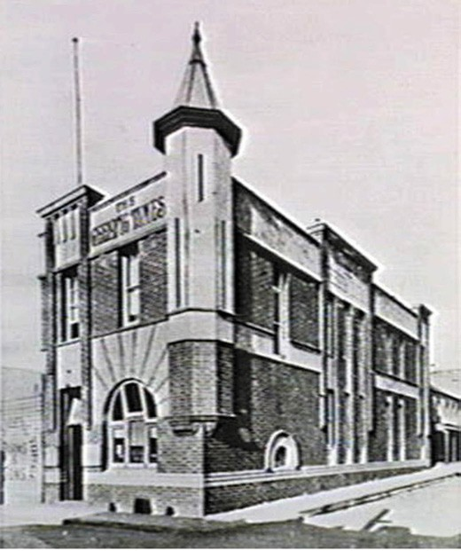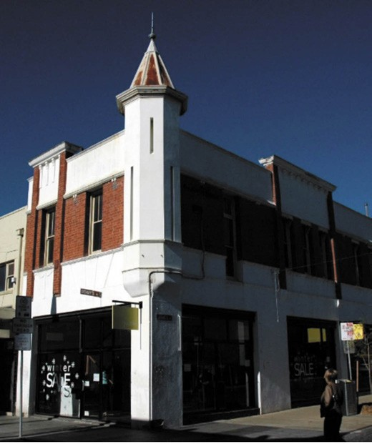

Figure 3.202: C. Fox, Geelong Times Office, 80 Lt Malop Street, 1936. Source: accession H19362 State Library of Victoria.
Figure 3.203: Former Geelong Times Office, 80 Lt Malop Street, 2005. Source: David Rowe.

and while initially benefiting from weekly dividends, she does not appear to have taken any active journalistic part in the business.1776 The stress of the legal proceedings may have contributed to her death in October 1887. The original court decision that found William Bell acting improperly
as a trustee was lost an appeal of the Full Court in 1887.1777 Further court orders in relation to the proceeds of the sale of the business were issued in June and October 1888.1778
From this time, the Geelong Times was continued by James Bell until 1909 when it was sold to B.L. Hickie and others.1779 Hickie was appointed managing director and editor. In 1914, the Geelong Times relocated into a purpose-built publishing office it had built at 80 Little Malop Street.1780 The Two storey Federation Free style brick building (Figures 3.202-203) had been designed by the local architects, Laird and Buchan, and built by William Murphy.1781 While the Geelong Times closed in 1923, the building at 80 Little Malop Street survives as the only built legacy of early newspaper publishing in Geelong.

WIRELESS RADIOS
Wireless radio services provided broadcasts to the Greater Geelong community from the early 20th century. The earliest was the 3GL Radio Station, first owned by the Geelong Advertiser, commenced broadcasting on 3 December 1930.1782 It was the second country station created in Victoria. The inaugural manager (and a director) of the station was E.J. Haynes who came to Geelong to establish the station.1783 The studio was at the premises of A. Leslie, Sutton (director of
the station) at the National Mutual building, corner of Malop and Moorabool Street, with the transmitter and administration being at the Geelong Advertiser office in Little Malop Street.1784 The studio was relocated to the Commercial Bank building in Moorabool Street (near Little Malop Street).1785
A significant increase in aerial power from 100 to 500 watts brought significant expansion to the radio station in 1938.1786 Owned by this time by Geelong Broadcasters Pty Ltd, The Argus gave an outline of the developments:
An area of land has been purchased at Grovedale for a new transmission station. This station will be four and a half miles from the city, and will be connected with the studio by land lines. The transmitter will be of the
latest type, and the tubular steel aerial will be 185ft. high.
The company has also acquired a two-story building in James street for a new studio and general office accommodation.1787
The new operations commenced in September 1938.1788
In 1990, the AM service was replaced with a new FM band, the station known as K Rock which continues to operate to the current day. The transmitter is currently located
at Murradoc Hill on the Bellarine Peninsula.1789
The transmitter facilities are shared with three other radio stations: 93.9 Bay FM, 94.7 The Pulse and 96.3 Rhema FM. Bay FM first went to air on 10 December 1989 and studios were established at the former Corio Distillery in Lowe Street, Corio (see Theme 5).1790 The station changed its name to Bay
93.9 in 2015. From 2018, the radio studios were in Moorabool Street.1791

On 1 May 1988, fulltime broadcasting of 3YYA (You Yangs Radio) commenced as a community radio station.1792 In 1996, the name was changed to Geelong Radio and in June 2001 to
94.7 The Pulse when a change in frequency was mandated. Initially located in studios in Shorts Place, Geelong, the current studios at 68-70 Little Ryrie Street were built by volunteers with hand-made mudbricks as part of upgrades to an existing building in 1992.1793
Another radio station went to air on 1 September 1994: 96three FM (then known as Rhema FM).1794 Still operating today, it is an incorporated, non-profit, non- denominational Christian community radio station that broadcasts throughout the Geelong region, with studios at Grovedale.1795

ENDNOTES

- For cultural reasons, specific songlines of the Wadawurrung cannot be mentioned.
- R. Roberts, ‘Songlines – Connection for Us All’ in The Museum:
National Museum Australia Magazine, vol. 12, September 2017 – February 2018, p.12.
- A. Page, The Science of Songlines , The Museum, op.cit., p.8.
- R.P. Norris, Dawes Review 5: Australian Aboriginal Astronomy and Navigation , Publications of the Astronomical Society of Australia, Cambridge University Press, 2016, p.11.
- J. Batman, The Settlement of John Batman in Port Phillip: from his own Journal, Literary Dramatic Society, George Slater, Melbourne, 1856.
- Ibid.
- Ibid. p.12.
- W.R. Brownhill & I. Wynd, The History of Geelong and Corio Bay with postscript 1955-1990, The Geelong Advertiser, Geelong, 1990, p.88.
- P.M. Griffiths, Three Times Blest: A History of Buninyong and District 1837- 1901, Buninyong & District Historical Society, Buninyong, 1988, p.40.
- Ibid. p.42.
- Geelong Advertiser & Intelligencer, 18 August 1854, p.4.
- Geelong Advertiser, 8 March 1859, p.2.
- Ibid., 5 October 1859, p.2. 14 Ibid., 20 March 1862, p.3.
- Victoria Government Gazette (VGG), 15 February 1855, p.44.
- I. Wynd, Barrabool, Land of the Magpie, Barrabool Shire Council, Torquay, 1992, pp.126-127.
- J. Pescott, South Barwon 1857-1985, Neptune Press & City of South Barwon, Geelong, 1985, p.30.
- Geelong Advertiser, 28 September 1875, p.3.
- Port Phillip Gazette, 23 March 1839, p.2.
- M. Cannon & I. MacFarlane (eds.), Surveyors Problems and Achievements, 1836-1839, Historical Records of Victoria Foundations Series, vol. 5, Victorian Government Printing Office, Melbourne, 1988, pp.332-333.
- Ibid.
- Murtcaim Parish Plan Put-Away Plan, C249/NIL001, Landata online at https:// www.landata.vic.gov.au/
- Geelong Advertiser, 30 January 1841, p.2. 24 VGG, 28 September 1856, p.1632.
25 Ibid., 28 July 1857, p.1403.
26 Ibid., 13 July 1858, p.1341.
27 Country Roads Board (CRB) 1st Annual Report, 1914, Parliament of Victoria, Melbourne, p.26 at https://www.parliament.vic.gov.au
28 VGG, 12 April 1859, p.746.
29 Ibid., 9 March 1860, p.442.
30 Ibid., 25 June 1861, p.1212.
31 Geelong Advertiser, 10 October 1864, p.3. 32 Ibid., 4 May 1865, p.3.
33 Ibid., 12 April 1912, p.2.
34 Ibid., 24 June 1913, p.3.
35 CRB, op.cit., p.26.
36 Ibid., pp.26-27.
37 CRB Annual Reports, 1915, 1916. 38 Ibid., 1921.
- VGG 19 August 1921, p.2956 & CRB Annual Report 1922. The Prince of Wales had earlier approved his title being given to the main Gippsland road from Melbourne to the New South Wales border in 1920.
- Geelong Advertiser, 4 November 1921, p.4.
- Ibid., 17 February 1922, p.4.
- Ibid.
- CRB Annual Report 1930, p.7.
- The Herald, 21 May 1925, p.5.
- Ibid.
- The Age, 15 January 1926, p.15.
- Geelong Advertiser, 12 April 1927, p.5.
- The Argus, 5 December 1921, p.9, CRB Annual Report, 1926, p.29.
- CRB Annual Report, 1928.
- The Age, 17 July 1930, p.6.
51 VGG, 14 October 1931, p.2855.
- The Argus, 16 April 1941, p.2.
- CRB Annual Report 1957. 54 Ibid., 1956, p.10.
55 Ibid., 1960, p.32.
56 Ibid., p.40.
- R. Murray, Maltby, Sir Thomas Karran (1890-1976) , Australian Dictionary of Biography, National Centre of Biography, Australian National University,
http://adb.anu.edu.au/biograpohy/maltby-sir-thomas-karran-11045/text19651, published first in hardcopy 2000, accessed online 10 February 2019.
- Princes Highway , Wikipedia online at https://en.wikipedia.org/wiki/Princes_Highway
- Ibid.
- Ibid.
- D. Rowe, ‘Forest, Farmland & Gold: Thematic Environmental History of the Western Region of the Moorabool Shire , vol.2, prepared for the Moorabool Shire Council, October 2016, p.22.
- T. Townsend, Assistant Surveyor, Geelong, Map of proposed road from Geelong to Boninyong , 21 October 1840, VPRS 19/P1, item 40/1075a Public Record Office Victoria (PROV).
- Geelong Advertiser & Intelligencer, 18 August 1854, p.4.
- CRB Annual Report 1931. 65 Ibid., 1933.
66 Ibid., 1934, p.16.
- Geelong Advertiser & Intelligencer, op.cit.
- CRB Annual Report 1932, p.9.
- Ibid.
70 VGG, 1 November 1941, pp.3760-3761.
- The Age, 5 December 1925, p.16.
- Geelong Advertiser, 6 December 1851, p.2.
- Geelong Advertiser & Intelligencer, 7 February 1853, p.2.
- Ibid.
- A.J. Skene, Map of the District of Geelong, James Harrison, Advertiser Office, Geelong, 1845, State Library of Victoria (SLV).
- Geelong Advertiser & Intelligencer, 18 August 1854, p.4.
- Ibid.
- CRB Annual Report, 1926.
- Geelong Advertiser & Squatters Advocate, 5 September 1846, p.2.
- Geelong Advertiser & Intelligencer, op.cit.
- Victoria Government Gazette, 12 December 1867, p.2127.
- Geelong 50 Years Ago , Geelong Advertiser, 10 July 1915, p.12.
- Ibid., 7 January 1875, p.2.
- Ibid., 9 February 1927, p.6.
- CRB Annual Report 1929, p.7. 86 VGG, 3 December 1947, p.5946.
87 CRB Annual Report 1968, p.36. 88 Ibid., 1969, p.38.
89 Ibid., 1970.
- VGG, 1 September 1854, p.1969.
- Ibid.
- Geelong Advertiser & Intelligencer, 18 August 1854, p.4, Argus, 4 December 1854.

- Geelong Advertiser, 17 July 1863, p.2. 94 VGG, 15 February 1878, p.379.
- The Argus 14 January 1935, p.3.
- The Dandenong Journal, 25 February 1937, p.8.
- The Argus, 3 December 1937, p.12.
- CRB Annual Report 1938, p.16.
- Ibid. & Annual Report 1939, p.17. 100 Ibid., 1969, p.51.
- Victoria s Big Build, Drysdale Bypass , Victoria State Government online,
December 2018 at https://bigbuild.vic.gov.au/projects/drysdale-bypass
- CRB Annual Report 1914, p.26.
- Geelong Advertiser, 24 May 1859, p.2. 104 Ibid., 16 May 1906, p.2.
105 Ibid., 28 May 1912, p.5.
106 Ibid., 24 March 1914, p.2.
107 CRB Annual Reports 1917-18, p.29, 1920, p.5.
- Geelong Advertiser, 5 May 1917, p.3.
- News of the Week, 22 May 1919.
- Ibid., 11 September 1919.
111 VGG, 9 December 1964, p.3685.
- Barwon Heads Road Duplication , Victoria s Big Build, Victoria State Government online, December 2018 at https://bigbuild.vic.gov.au/projects/barwon-heads-road-duplication
- R. Daintree, Plan of Duneed, Barrarbool, Connewarre & Puebla: Geological Survey of Victoria no. 28, 1869, VPRS 8168/P5, item MD28A, PROV
- Geelong Advertiser, 4 November 1893, p.2.
- Ibid., 18 January 1895, p.4.
- Ibid., 14 September 1907, p.2.
- Ibid., 10 February 1915, p.4.
- Ibid., 17 December 1915, p.4.
119 Ibid., 23 August 1918, p.4. 120 VGG 6 August 1930, p.2061.
121 CRB Annual Report 1972. 122 VGG 4 May 1995, p.1050.
- Geelong Advertiser, 3 December 1917, p.2. & D. Rowe, The Pleasure Grounds of the Barwon Coast: A History, Barwon Coast Committee of Management Inc., Barwon Heads, 2002, p.45.
- Ibid.
- Geelong Advertiser, 30 March 1918, p.5.
- Rowe, op.cit.
- Geelong Advertiser, 8 March 1922, p.4. 128 Ibid., 6 July 1921, p.4.
- The Herald, 25 November 1935, p.18.
- Ibid., 17 September 1938, p.6.
- Rowe, op.cit., p.47.
- Ibid.
- Geelong Advertiser, 1 August 1842, p.2.
- Port Phillip Patriot & Melbourne Advertiser, 12 May 1842, p.4.
- Geelong Advertiser & Squatters Advocate, 23 September 1846, p.2.
- E. Johnson s British Gazette & Sunday Monitor, 1803, in Wright Family Tree, Solomon (Shlomeh Levehn) Levien , Ancestry online at https://www.ancestry. com.au/family-tree/person/tree/12544498/person/13280731501/facts
- Ibid.
- Geelong Advertiser & Squatters Advocate, 8 July 1846, p.2, Port Phillip Gazette, 27 February 1841, p.2.
- Geelong Advertiser & Squatters Advocate, op.cit.
- J.H. Bottrell, ‘Early History of Geelong: The Homes of Newtown’, Geelong

Advertiser, 23 August 1930.
- Geelong Advertiser & Squatters Advocate, 23 September 1846, p.2.
- Geelong Advertiser, 15 August 1848.
- For William Batten s biographical details see Theme 7.
- Geelong Advertiser & Intelligencer, 31 August 1852, p.2.
- Ibid.
- A. Townsend, These Friendly Shores: A personal history of Ocean Grove, A. Townsend, Ocean Grove, 1988, p.13.
- Geelong Advertiser, 4 February 1889, p.2, stated that tenders were invited through our advertising columns by the Public Works Department of extension of jetty and erection of a shed on the west bank of the river at Barwon Heads.
- Geelong Advertiser, 30 January 1889, p.2.
- D. Rowe & L. Huddle, ‘Greater Geelong Outer Areas Heritage Study Stage 2’, prepared for the City of Greater Geelong, April 2000.
- Research notes held by the author from Barwon Heads Park Trust Minute Book, 1889, p.11 & Geelong Advertiser, 4 November 1889.
- Rowe, op.cit., p.43.
- Ibid.
- Ibid.
- Geelong Advertiser, 25 May 1925.
- Ibid., 22 September 1925. See later subsection for details on E.E. Higgs.
- Ibid.
- P. Alsop, ‘Bridging the Rivers 1839-1859: Part 1 – The Barwon Breakwater’,
Investigator, vol.3, no.2, 1968, pp.87-88.
158 Ibid., pp.89-90.
159 Ibid., p.89.
160 Ibid., p.91.
161 Ibid., pp.99-102.
162 Ibid., p.102.
- CRB Annual Report 1968, p.51.
- Australian National Construction Review, 27 March 2012, p.124.
- Ibid.
166 Ibid., p.123.
167 Ibid., p.126.
- Geelong Advertiser & Squatters Advocate, 12 February 1847, p.3.
- Geelong Advertiser, 24 December 1847, p.2 & The Melbourne Argus, 6 June 1848, p.3.
- Geelong Advertiser, 24 May 1847, p.2. 171 Ibid., 31 May 1848, p.2.
- Ibid., 5 August 1848, 22 August 1848.
- Ibid.
- The Argus, 10 November 1848, p.4.
- Geelong Advertiser & Intelligencer, 24 May 1852, p.2.
- Ibid., 26 January 1852, p.2.
- Ibid., 7 October 1853, p.5.
- The Argus, 24 September 1853, p.5.
- Geelong Advertiser & Intelligencer 30 September 1853, p.2.
- Ibid., 15 December 1853, p.4.
- Ibid., 13 October 1853, p.2.
- P. Alsop, ‘Bridging the Rivers – Part V: The Barwon Iron Bridge’, Investigator, vol.4, no.2, p.85.
- Geelong Advertiser & Intelligencer, 18 August 1854, p.4.
- Ibid., 22 December 1855, p.2.
- CRB Annual Report 1925, p.6.
- Alsop, op.cit., p.87, transcription of a letter from Fairbairn & Sons, Manchester, 20 December 1854, to His Excellency, The Lt.
Governor of Victoria.
187 Ibid., p.88.

188 Ibid.
189 Ibid., p.89.
190 Ibid., p.90.
191 Ibid.
192 Ibid., p.91.
- The Age, 12 December 1857, p.5.
- The Argus, 31 May 1858, p.6.
- Geelong Advertiser, 15 November 1859, p.2.
- CRB Annual Report 1925, p.6.
- Geelong Advertiser, 9 March 1859, p.2. See also P. Alsop, Bridging the Rivers – Part V’, op.cit., p.90.
- S. Langley, Charles Rowand GG GF Family Tree, Ancestry online at https:// www.ancestry.com.au/family-tree/person/tree/38289678/person/19299845404/ facts
- Ibid.
- Town of St. Helier’s, Parish of St. Helier’s, Island of Jersey, Census, 1841 at Ancestry, op.cit.
- Langley, op.cit.
- The University of Glasgow Story, University of Glasgow online at https://universitystory.gla.ac.uk/biography/?id=WH9298&type=P
- Scotland in the modern era , Wikipedia online at https://en.wikipedia.org/wiki/Scotland_in_the_modern_era
- C. Rowand, Civil Engineer, Minutes of Evidence, 4 July 1854, Report of the Commissioners Appointed to Enquire into the Best Mode of Providing for the Internal Communication in the Colony of Victoria, Parliament of Victoria, John Ferres, Government Printer, Melbourne, 1854, p.54.
- Travancore Passenger List, 1849, PROV at Ancestry, op.cit.
- Extract from the Colonist and Western District Advertiser, 9 November 1849 ,
Investigator, vol.3, no.1, 1968.
- The first reference to Rowand advertising his services as a civil engineer in Malop Street was in May 1850 – see Geelong Advertiser, 28 May 1850, p.1.
- A.M. Ramsay to Governor Charles La Trobe, Melbourne, 17 January 1850, VPRS 19/P1 item 50/155 PROV.
- Leader, 8 January 1870, p.13.
- Geelong Advertiser, 5 September 1908, p.3, West Gippsland Gazette, 8 September 1908, p.7 & ‘Charles Rowand’, Mount Duneed History Group online, 1 February 2017 at
https://mdpa.weebly.com/blog/charles-rowand
- Wynd, op.cit., p.126.
- Brownhill & Wynd, op.cit., p.593.
- CRB Annual Report 1928, p.12, Geelong Advertiser,
5 September 1924, p.4.
- The Herald, 13 December 1923, p.10.
- Geelong Advertiser, 29 November 1923, p.4.
- The Age, 17 January 1924, p.12.
- CRB Annual Report, 1925, p.5. 218 Ibid., 1928, p.12.
- Geelong Advertiser, 5 April 1924, p.5.
- CRB Annual Report 1928, p.12.
- The Argus, 11 August 1924, p.13.
- CRB Annual Report 1967-68, p.58.
- Geelong Advertiser & Intelligencer, 22 March 1855, p.2.
- The Argus, 1 July 1858, p.5.
- Geelong Advertiser, 5 October 1859, p.2. 226 Ibid., 23 May 1861, p.2.
227 Ibid., 23 May 1861, p.2.
- Ibid., 17 December 1862, p.3.
- Ibid., 19 December 1861, p.2.
- Ibid., 17 December 1862.
- Ibid., 4 November 1862, p.2.

232 Ibid., 25 March 1862, p.3.
- Ibid., 14 February 1863, p.3.
- Ibid., 20 January 1888, p.4.
- Ibid., 19 February 1887, p.4.
- Ibid., 20 January 1888. 237 Ibid., 1 June 1889, p.2. 238 Ibid., 28 July 1888, p.4. 239 Ibid., 1 June 1889, p.2.
- CRB Annual Report 1965, p.32.
- Brownhill & Wynd, op.cit., p.710.
- Geelong Advertiser, 6 June 1861, p.2.
- Ibid.
244 Ibid., 12 June 1861, p.3.
245 Ibid., 20 June 1861, p.2.
- Ibid., 21 September 1861, p.2.
- Ibid., 12 February 1861, p.3. 248 Ibid., 21 June 1871, p.1.
249 Ibid., 4 July 1872, p.3.
250 Ibid., 3 July 1880, p.2.
- Ibid., 15 October 1880, p.3.
- The Herald, 15 July 1930, p.9.
- M. Lewis, Engineering Structures of Geelong , Institution of Engineers, Engineering Heritage Branch, 25 February 1990, pp.11-12.
- Road Construction Authority Report, Parliament of Victoria, Melbourne, 1989, p.47.
255 Ibid., & 1987, p.65.
- W. Roadknight, Port Phillip Patriot & Melbourne Advertiser, 30 September 1841, p.4.
- Ibid.
- W.R. Dexter, The Squatting Roadknights: Early Colonists in Geelong and the Western District of Victoria , W.R. Dexter, Geelong, n.d. [c.1990], p.3.
- Roadknight, op.cit.
- Dexter, op.cit., p.31. The bridge was not shown on H.W.H. Smythe s Plan of the Parish of Gheringhap (published 1839), VPRS 8168/P5 Sydney plan, FEAT 487 Moorabool & Barwon Rivers, surveyed in July 1838, PROV.
- I. Wynd, So Fine a Country: A History of the Shire of Corio, Shire of Corio, 1981, p.131, states that the bridge was built by 1847.
- Geelong Advertiser & Squatters Advocate, 28 May 1847, p.2.
- Melbourne Argus, 2 September 1847, p.2, Port Phillip Gazette & Settlers Journal, 4 September 1847, p.2, New South Wales Government Gazette (NSWGG), 19 January 1848, p.22.
- Melbourne Argus 18 January 1838, 12 January 1848, p.4.
- Wynd, So Fine a Country, op.cit.
- Ibid.
- Geelong Advertiser & Intelligencer, 25 May 1852, p.2, VGG
19 January 1853, p.61.
- Geelong Advertiser, 31 January 1854, p.6. The Geelong Advertiser & Intelligencer, 20 June 1854, p.7, made references to the Batesford Bridge suggesting it had been completed by this time.
- The Argus, 3 December 1858, p.7.
- Geelong Advertiser, 5 January 1859, p.2.
271 Ibid., 5 April 1859, p.2.
- The Argus 13 January 1860, p.5.
- CRB Annual Report 1971, p.73.
- The Banner (Melbourne), 31 January 1854, p.9.
- Geelong Advertiser, 5 September 1908, p.3, Geelong Advertiser & Intelligencer 2 September 1854, p.4.
- Geelong Advertiser & Intelligencer, 2 September 1854.
- Geelong Advertiser, 29 February 1888, p.4.

- Ibid.
- Ibid., 10 September 1887, p.4.
- Ibid., 12 December 1898, p.4.
- C. O Connor, Bridges in M. Lewis (ed.), 200 Years of Concrete in Australia, Concrete Institute of Australia, North Sydney, 1988, pp.37-38.
- Ibid.
283 Ibid., p.37.
- Geelong Advertiser, 27 October 1899, p.3.
- Ibid., 17 February 1900, p.2. 286 Ibid., 23 March 1900, p.2. 287 Ibid., 17 July 1900, p.4.
288 Ibid., 4 April 1906, p.2. 289 Ibid., 21 May 1906, p.2. 290 Ibid., 2 May 1906, p.1.
- CRB Annual Report 1970, p.42.
- Geelong Advertiser, 30 June 1862, p.3. 293 Ibid., 21 March 1863, p.3.
- I. Wynd, Bridging the Little , Investigator, vol. 13, no.1, p.12.
- The Age, 26 August 1863, p.7.
- Ibid.
- Geelong Advertiser, 16 September 1863, p.3.
- Ibid., 9 October 1863, p.3.
- Ibid., 20 November 1863, p.2.
- Wynd, op.cit., pp.12-13.
- Geelong Advertiser & Intelligencer, 5 December 1863, p.3, Wynd, op.cit., p.3.
- Geelong Advertiser, 9 May 1864, p.2. 303 Ibid., 8 June 1864, p.2.
304 Ibid.
305 Ibid., 15 July 1864, p.3.
- Wynd, op.cit., p.17, Geelong Advertiser, 4 June 1863, p.3, Bacchus Marsh Express, 16 May 1874, p.1.
- See Victorian Births, Deaths & Marriages Indexes (VBDM Indexes), Department of Justice, Melbourne, online at https://online.justice.vic.gov.au/ bdm/indexsearch.doj, Accounts & Papers of the House of Commons, vol. 52, 1847, p.47, Parliament of Victoria, Melbourne, online, The Argus, 8 October 1859, The Herald 6 November 1863, Geelong Advertiser, 20 November 1863, p.2, Portland Guardian 16 March 1888, p.2 & Record (Emerald Hill), 17 March 1888, p.2.
- Ibid.
- Ibid.
- Ibid.
- Ibid.
- Geelong Advertiser, 7 July 1866, p.2.
- Ibid., 1 September 1856, p.3.
- Ibid.
315 Ibid., 31 July 1866, p.3.
316 Ibid., 1 March 1881, p.3.
- Ibid.
- Ibid.
- CRB Annual Report 1957-58, p.16.
- Geelong Advertiser, 9 May 1864, p.2, 31 July 1866, p.3.
- Ibid., 1 September 1866, p.3.
- Ibid.
- D. Rowe, Lara Heritage Review Phase 2 Thematic History , vol.2, prepared for the City of Greater Geelong, August 2013 (revised May 2016), p.16.
- Geelong Advertiser, 8 November 1872, p.3. 325 Ibid., 26 March 1873, p.3.
326 Bacchus Marsh Express, 5 April 1873, p.3.

- Geelong Advertiser, 9 May 1873, p.2.
- Ibid., 8 January 1874, p.3.
- CRB Annual Report 1929, p.25.
- Geelong Advertiser, 25 January 1879, p.4.
- Bacchus Marsh Express, 12 July 1879, p.3.
- Geelong Advertiser, 8 September 1851, p.2.
- Geelong Advertiser & Intelligencer, 10 May 1853, p.4.
- Ibid., 18 August 1854, p.4. The bridge was shown in R. Meikle, Allotments in Sections VII, VIII, & IX, Parish of Duneed on the Waurn Ponds at the Victoria Inn, County of Grant , 13 February 1855, folio 19, map 40 Waurn Ponds, Gee- long Heritage Centre (GHC).
- Geelong Advertiser 29 January 1868, p.3. 336 Ibid., 27 May 1868, p.3.
337 Ibid., 18 March 1868, p.2.
338 Ibid., 27 May 1868.
339 Ibid., 22 July 1868, p.2.
- CRB Annual Report, 1955, p.37.
- Rowe, The Pleasure Grounds, op.cit., p.43.
- Ibid.
- G.W. Marshallsea, Divisional Engineer, Country Roads Board, to Mrs B.K. Pritchard, 17 December 1975, in the Barwon Coast Committee of Management collection.
- Ibid.
- Ibid.
- Ibid.
- Interview by David Rowe with Les Jennings, Barwon Heads, 22 June 2001.
- Geelong Advertiser, 31 December 1927, p.6.
- CRB Annual Report 1928, pp.16-17.
- A. Mathieson, Association tells minister to rein in VicRoads half the bridge not enough , Independent, 16 November 2007.
- L. Townsend, M. Baron, H. Turnbull, Barwon Heads Bridge: Report of the Advisory Committee, 29 January 2007, p.49.
352 Ibid., p.75.
- Heritage permit P13151, 19 August 2008, issued by Victoria.
- Barwon Heads Bridge , Wikipedia online at https://en.wikipedia.org/wiki/Barwon_Heads_Bridge & Gertzel Engineering Surveyors, Barwon Heads Bridge at https://www.gertzel.com.au/portfolio/barwon-heads-bridge/
- Geelong Advertiser, 26 February 1874, p.2.
- Stevens Geelong & Western District & Squatters Directory of Victoria, 1866-67.
- Geelong Advertiser, 1 July 1848, p.2.
- Geelong Advertiser & Intelligencer 29 April 1853, p.1.
- Ibid., 31 December 1855, p.3.
- Vehicle Builders Employees Federation, Victorian Branch , University of Melbourne Archives online, January 2019 at https://gallery.its.unimelb.edu.au/imu/imu.php?request=search
- Geelong Advertiser, 10 December 1873, p.2.
- Ibid., 18 December 1882, p.2. The report declared that the eight hours system was to commence on 2 January 1883. This system included nine hours pay for eight hours work.
- Our Local Industries, Coach Building , Geelong Times, typescript, n.d. [c.1870s], Geelong Family History Group Library holdings at the Bellarine Historical Society, Drysdale.
- Figures taken from Sands & McDougall, Directory of Victoria, 1910 & 1915, State Library of Victoria (SLV).
365 Ibid., 1925, 1935.
366 M. Churchward, ‘Cobb & Co. Coach, Victoria, circa 1880’ in Museums Victoria Collections,
https://collections.museumvictoria.com.au/articles/15079 , accessed 3 January 2019.

- Geelong Advertiser & Intelligencer, 9 December 1852, p.2.
- The Argus, 9 June 1854, p.2, Geelong Advertiser & Intelligencer, 2 June 1854, p.2.
- Ibid., 3 December 1863, p.2 & Geelong Advertiser, 8 January 1868, p.1.
- Ibid.
- Ibid.
- Ibid., 5 October 1880, p.3. 373 Ibid., 13 March 1883, p.4.
- Electoral Roll, 1856 at Ancestry online, op.cit.
- Geelong Advertiser, 6 October 1862, p.2.
- Geelong Advertiser, 13 March 1883, p.4.
- W. Grime, Thomas Woodward , Grime/McIllroy Family Tree, Ancestry online, January 2019, op.cit.
- Ibid.
- Samarang Assisted & Unassisted Passenger List, 8 July 1855, PROV at Ancestry online, op.cit.
- Grime, op.cit.
- Geelong Advertiser 22 June 1859, p.4.
- Ibid., 25 September 1862, p.3.
- Ibid., 1 August 1864, p.3.
- Ibid., 28 December 1866, p.2.
- Ibid., 30 October 1875, p.4.
386 Ibid., 1 March 1882, p.2.
387 Ibid., 8 March, 1889, p.3, 30 April 1889, p.3.
388 Ibid., 31 July 1877, p.3.
389 Ibid., 19 April 1883, p.3.
390 Ibid., 15 February 1890, p.3.
391 Ibid., 18 December 1889, p.3, 8 June 1912.
- Ibid., 15 December 1891, p.3.
- Ibid., 30 December 1912, p.4.
- Simon Hargreaves, Prison Hulk Register & Letter Book, 1 August 1829 PRO, London at Ancestry online, op.cit., The Courier (Hobart), 18 June 1841, p.4.
- The partnership was dissolved in 1862. See Geelong Advertiser & Intelligencer, 22 July 1852, p.2.
- Geelong Advertiser, 31 July 1877, p.3.
- Electoral Roll, 1914, at Ancestry online, op.cit.
- The Argus, 30 March 1925, p.1.
- M. Clarke’ John Nott’, Windsor Family Tree, Ancestry online, op.cit.
- On Robert Nott s death in 1871, he was described as a painter. See Geelong Advertiser, 4 October 1871, p.2.
401 Ibid., 31 July 1877, p.3.
- VBDM Indexes, op.cit.
- England Census, Somerset, 1901 at Ancestry online, op.cit.
- Geelong Advertiser, 21 September 1920, p.1.
- Geelong Advertiser & Intelligencer, 5 December 1855, p.3.
- T. Maidment, Wilks Family Tree , Ancestry online, op.cit.
407 Star (Ballarat), 28 May 1857, p.3, 20 April 1858, p.3, 24 July 1858, p.2, 26 July
1858, p.2.
- Geelong Advertiser & Intelligencer 19 February 1856, p.2.
- J.H. Bottrell, ‘Fyansford’ in Investigator, vol. 17, no.3, September 1982, pp.75- 76.
- Geelong Advertiser, 17 March 1860, p.2, 30 September 1861, p.2.
- Bottrell, op.cit.
- August Grote , Kirwood/Orr Family Tree , Ancestry online at https://www. ancestry.com.au/family-tree/person/tree/4890660/person/6147132326/facts
- Ibid.
- Geelong Advertiser, 13 July 1870, p.3.
- Geelong Council Rate Book, 1874, GHC collection.

- Geelong Advertiser, 30 October 1875, p.4.
- The last listing of rates in the Geelong Council Rate Books was in 1915, op.cit. See also A. Grote to External Affairs, 14 April 1916, A1, 1916/10618 National Archives of Australia (NAA).
- Geelong Advertiser, 5 May 1882.
- Ibid., 15 September 1882, p.3.
420 VGG 11 December 1885, p.3499.
- Thomas Green Death Certificate (copy), Geelong Family History Group collection at the Bellarine Historical Society, & Geelong Advertiser, 15 September 1882, p.3.
- VBDM Indexes, op.cit.
- Geelong Advertiser, 5 May 1882, p.3.
- Ibid., 21 January 1892.
- ‘Joseph Thomas Everett’, Everett Family Tree at Ancestry online https://www. ancestry.com.au/family-tree/person/tree/61356834/person/38068951070/ facts?_phsrc=vBy1&_phstart=successSource
- British Empire Passenger List, 1855, PROV at Ancestry online, op.cit.
- Electoral Roll, 1856 at Ancestry online, op.cit.
- Geelong Advertiser, 25 February 1873, p.3.
- Spectator & Methodist Chronicle, 30 January 1918, p.118.
- Geelong Advertiser, 2 August 1877, p.3.
- VBDM Indexes, op.cit.
432 VGG, 5 December 1879, p.2840.
- D. Rowe & W. Jacobs, ‘Ashby Heritage Review’, prepared for the City of Greater Geelong, 2010.
- Ibid. Joseph Everett also owned other houses in Weller Street.
- Electoral Roll, 1903, Ancestry online, op.cit.
- Geelong Advertiser, 31 May 1910, p.2.
- Sands & McDougall, Directory of Victoria, 1910, op.cit. This was the first known year that Everett and Sons were listed as being associated with the motor car.
- Geelong Advertiser, 1 July 1912, p.2.
- Ibid.
- Ibid., 11 November 1915, p.4. 441 Ibid., 15 March 1913, p.4.
- Spectator & Methodist Chronicle, op.cit.
- Ibid.
- Geelong Advertiser, 24 December 1917, p.1.
- Sir George Seymour Passenger List, 1849, PROV at Ancestry online, op.cit.
- Geelong Advertiser, 29 July 1905, p.3.
- Geelong West Council Rate Book, 1916-17, GHC collection & Probate Administration files, VPRS 28/P3 Unit 113, item 115/024 PROV.
- Geelong West Council Rate Book, 1936-37, op.cit. 449 Ibid., 1945-46.
- A comprehensive overview of the history and development of the bicycle is given in R. Charles, A Whirr of Many Wheels: Cycling in Geelong, A Chronicle from 1869 to 1914, vol. 1, 2013; A Chronicle from 1869 to 1980, 2015; and A Chronicle from 1945 to 1980s, 2016, Rod Charles, Manifold Heights.
- T. Myllyntaus, Preface, in T. Mannisto-Funk & T. Myllyntaus (eds.), Invisible Bicycle: New Insights into Bicycle History, Parallel Histories and Different Timelines, Brill, Leiden, The Netherlands, 2009, p.vii.
- R. Charles, Whirr of Many Wheels, vol. 1, op.cit., p.3, Pierre Michaux , Wikipedia online, January 2019 at https://en.wikipedia.org/wiki/Pierre_Michaux & ‘Pierre Lallement’, Wikipedia online, January 2019 at https://en.wikipedia. org/wiki/Pierre_Lallement
- Ibid.
- Geelong Advertiser, 12 April 1869, p.3. 455 Ibid., 30 April 1869, p.2.
456 Ibid., 12 May 1869, p.2.

457 Ibid., 28 June 1869, p.2.
458 Ibid., 16 June 1869, p.3.
459 Illustrated Australian News, 3 October 1878, p.170.
460 ‘Bicycle Association Leads Birthday Celebrations for JK Starley, Creator of the Safety Bicycle’, 4 January 2015, Bicycle Association of Greater Britain online at http://www.bicycleassociation.org.uk/
461 Geelong Advertiser, 4 November 1886, p.4. 462 Ibid., 14 March 1891, p.2.
- Charles, op.cit., pp.186-197.
- Geelong Advertiser, 14 March 1891, p.2.
- See Charles, op.cit.
- R. Holden, photograph of land yacht at Barwon Heads with accompanying description, GRS 2009/2007 GHC collection.
- Geelong Advertiser, 16 November 1896, p.3. 468 Ibid., 23 April 1897, p.3.
- Ibid., 12 September 1899, p.2.
- Ibid., 3 November 1903, p[.2.
- Charles, op.cit., p.34 & G. Parson, ‘Humble, William (1835-1917)’, Australian Dictionary of Biography, Australian National University, http://adb.anu.edu. au/biography/humble-william-3816/text6035, first published in hardcopy 1972, accessed online 6 January 2019.
- Geelong Advertiser, 19 May 1869, p.2.
- A. Sutherland (ed.), Victoria and Its Metropolis: Past and Present, McCarron Bird & Co., Melbourne, 1888, vol. 2, p.154 & Parson, op.cit.
- Ibid.
- Ibid.
- Geelong Advertiser, 25 November 1864, p.3, 11 June 1877, p.3.
- Sutherland, op.cit.
- Ibid.
- Parson, op.cit.
- Ibid.
- Sutherland, op.cit., p.245 & Winwick Passenger List: Register of Arrivals under the Bounty System 26 June 1841, film SLTX/AO/MB/158, series CB7/9, Tasmania, Australia, Immigrant Lists, Ancestry online, op.cit.
- Ibid.
- Sutherland, op.cit.
- VBDM Indexes, op.cit.
- Ibid.
- See Geelong Advertiser & Intelligencer, 9 June 1865, p.2 & 8 September 1865, p.1.
- Geelong Advertiser, 2 June 1865, p.1.
- Sutherland, op.cit.
- Ibid.
- Register of Births, Deaths & Marriages, NSW Department of Justice online at https://familyhistory.bdm.nsw.gov.au/lifelink/familyhistory/search/result?8
- These figures are based on a search of the Geelong Advertiser for 1896 and 1896 at Trove: Digitalised Newspapers online at https://trove.nla.gov.au/ newspaper/
- Charles, vol.1, op.cit., p.272.
- Ibid.
- Ibid.
- Ibid.
- Ibid.
- Ibid.& Geelong Advertiser, 20 October 1896, p.3.
- Ibid., 15 December 1896, p.4.
- Ibid., 5 November 1896, p.4 & Charles, op.cit., p.276.
- Geelong Advertiser, 20 March 1896, p.3.
- Charles, op.cit.
- Ibid.

- VBDM Indexes, op.cit.
- Geelong Advertiser, 10 May 1904, p.1.
- Sands & McDougall, Directory of Victoria, op.cit. See Appendix 3.1 for a detailed list of names and addresses.
- Ibid.
- Ibid.
- Census, Scotland, 1851 at Ancestry online, op.cit.
- VBDM Indexes, op.cit.
- See Geelong Advertiser 10 March 1859, p.1 and articles and advertisements in the Geelong Advertiser in the 1860s.
511 Ibid., 7 June 1890, p.1.
512 Ibid., 28 May 1903, p.4.
513 Ibid., 25 March 1925, p.4.
- Electoral Roll, 1906, Ancestry online, op.cit.
- See for example, Geelong Advertiser, 21 July 1903, p.2, 3 August 1903, p.2 & Electoral Roll, 1906, Ancestry online, op.cit.
- The Geelong Town Council Rate Books from 1902 onwards listed Balfour Brothers but the signage shown in Figure 3.52 revealed that the business was first known as T.R. Balfour, Cycle Manufacturer.
- Geelong Advertiser, 16 October 1909, p.3.
- Ibid., 4 October 1911, p.3, Laird & Buchan Contract Books, 1911-12, GRS 210, Book 4, GHC collection.
- Geelong Advertiser, 23 July 1912, p.3.
- V. Balfour, Will, 1916, VPRS 7591/P2 Unit 544 PROV.
- Geelong Advertiser, 19 August 1919, p.2.
- Geelong Town Council Rate Book, Villamanta Ward, 1949, GHC collection.
- Charles, vol.2, op.cit., p.206.
- D. Rowe, Geelong City C Citations Project , prepared for the City of Greater Geelong, 2002.
- VBDM Indexes, op.cit. & J.D. Hede, ‘Dirt Track Memories’, Investigator, vol.16, no. 4, December 1981, p.126.
- VBDM Indexes, op.cit.
- Hede, op.cit.
- Ibid.
- See for example, Ballarat Star, 16 May 1899, p.4. 530 Ibid., 18 April 1902, p.2.
- VBDM Indexes, op.cit.
- Herald, 22 September 1926, p.22.
- Eugene Cowley Family Tree, Ancestry online, op.cit.
- Ibid.
- Sands & McDougall, op.cit., 1935.
- J.D. Hede, Australian Military Forces records, B883, VX46550, NAA & Sands & McDougall, 1950,op.cit.
- M.J. Hede & Son was listed in the Sands & McDougall Directory of Victoria for 1965 but not in 1970.
- Charles, op.cit., p.204, J.E. Elsworthy, Probate Administration files, 2004, VPRS 28/P34, Unit 319,PROV & ‘Deceased Search’ database, Geelong Cemeteries Trust online at http://www.gct.net.au/deceased-search/
- Geelong Council Rate Book, Kardinia Ward, 1924-1937, op.cit.
- Sands & McDougall, op.cit., 1940 & Geelong Council Rate Book, 1946, op.cit. 541 Ibid., 1953.
- ‘High profile Geelong ex-Retravision closes after almost 80 years’, Appliance Retailer online at https://www.applianceretailer.com.au/2013/06/sxsomywzqv/
- K. O Reilly, Charles Pratt of Belmont Common: A Life in the Air, Geelong s Pioneer Aviator, Aerial Photographer and Flying Instructor, Kevin M.
O Reilly, Dingley Village, 2016, p.1.
- Berry, op.cit., p.143.
- Herald, 5 August 1929, p.18.
- Berry, op.cit., p.144.

- Ibid.
- Herald, 26 January 1931, p.13.
- Argus, 2 February 1932, p.8.
- Herald, 7 March 1933, p.17.
- Berry, op.cit., p.145. 552 Ibid., p.146.
- Ibid., p.147, L. Huddle, R. Howe. R. Lewis & K. Francis, ‘Bellarine Heritage Study , vol. 3, prepared for the Australian Heritage Commission, City of Great- er Geelong & Heritage Victoria, June 1996 & The Age, 24 April 1947, p.9.
- Berry, op.cit.
- Rowe, Geelong City C Citation Project , op.cit.
- Berry, op.cit., p.149. See also The Osborne Dynasty in Old Bike Australasia, 1 February 2017.
- Sporting Globe, 15 October 1936, p.10.
- Berry, op.cit., p.150.
- See Certificate of Title vol. 10149, fol. 903, 13 August 2007.
- F.W. Hose, Frank William Hose , manuscript, Burleigh Heads, Queensland, n.d., GHC collection & Sporting Globe, 10 September 1930, p.12.
- VBDM Indexes, op.cit.
- Ibid. & F. De Grandi, Application for Naturalisation, 1864, A712, 864/G6790, NAA.
- See Age, 29 December 1989, p.5, & Argus 15 June 1901,p.11.
- VBDM Indexes, op.cit. & Charles, vol.1, op.cit., p.475. 565 Ibid., p.476.
- Sporting Globe, 10 September 1930, p.12 & Cinema advertisement for Healing Bicycle by De Grandi, c.1940, GRS 2061/077, GHC collection.
- See Sands & McDougall, op.cit., 1955 & 1960.
- De Grandi Cycle and Sport online at http://www.degrandi.com.au/about/
- Ibid.
- VBDMs Indexes, op.cit. & B. Armstrong, History of Homeopathy in Australia online at http://www.historyofhomeopathy.com.au/people/item/136-robinson- dr-sidney-rudge.html
- Ibid.
- Ibid. & Charles, op.cit., p.140.
- Geelong Advertiser, 20 October 1900, p.2. 574 Ibid., 13 April 1911, p.2.
575 Ibid., 4 October 1912, p.2.
576 Ibid., 4 April 1914, p.8.
- Ibid., 22 February 1915, p.3.
- Ibid., 6 September 1897, p.3.
- Australian Cycling Corps, Wikipedia online at https://en.wikipedia.org/wiki/Australian_Cycling_Corps
- Ibid.
- News of the Week, 8 June 1916, p.13.
- Oakleigh Leader, 31 October 1891, p.7.
- Ibid.
- Age, 28 November 1906, p.4.
- Geelong Advertiser, 11 June 1927, p.1 & 6 June 1927, p.1.
- Brownhill & Wynd, op.cit., p.463.
- Geelong Advertiser, 2 June 1927, p.4. 588 Ibid., 4 June 1927, p.1.
589 Ibid., 10 July 1903, p.2.
590 R. Southern, Our Road to the Coast: Behind the building of the Main Road from Melbourne to Geelong and on to the West Coast 1912-1932, Geelong Historical Society, Rippleside, 2007, p.19.
591 Sue Richardson, granddaughter of Tom S. Hawkes to the author, 7 July 2015, stated that Hawkes acquired the Benz either in 1907 or 1911. Confirmation that Hawkes owned a Benz is found in the Personal Estate in his Probate

Administration files, 3 April 1924, VPRS 28/P3 Unit 1466, item 197/400, PROV.
- Geelong Advertiser, 3 May 1907, p.2.
- Sands & McDougall, op.cit., 1910.
- Geelong Advertiser, 20 January 1909.
- Winter and Taylor Holden at 101 Mercer Street online https://addr.ws/winter-and-taylor-holden-car-dealership--geelong-au.html
- Geelong Advertiser, 12 September 1912, p.4.
- Ibid., 20 September 1913, p.3.
598 Ibid., 26 August 1915, p.4.
599 Ibid., 1 November 1916, p.3.
600 Winter and Taylor Holden, op.cit. 601 Ibid.
- Ibid.
- Geelong Advertiser, 20 June 2018.
- Ibid., 7 August 1913, p.2.
- Ibid.
- Rowe, Geelong City C Citations Project , op.cit. 607 Ibid.
- Geelong Advertiser, 8 November 1918, p.2.
- Rowe, op.cit.
- Deceased Search , op.cit.
- Geelong Advertiser, 8 November 1918, p.2, 30 November 1918, Geelong Council Rate Books, 1917-1922, op.cit.
- Geelong Council Rate Books, 1927, 1928, op.cit.
- He was still at this location in 1936 as he applied for a building permit with a Mr Oliver to erect a petrol pump. See Geelong Building Permit Register, 1936, Building Department, City of Greater Geelong.
- Sands & McDougall, op.cit., 1935. 615 Rowe & Huddle, op.cit.
- Ibid.
- Ibid.
- Ibid.
- Ibid.
- Ibid.
- Ibid.
- Ibid.
- Ibid.
- Ibid.
- Ibid.
- Ibid.
- Ford Motor Company Complex , 365-455 Melbourne Road, Norlane, Victorian Heritage Register H2305, Victorian Heritage Database online at https://vhd. heritAgecouncil.vic.gov.au/places/12548
- Ford Motor Company Complex , op.cit. 629 Rowe & Huddle, op.cit.
630 Ibid.
631 C. Jacobs, ‘Ford closes its Australian factories after more than 90 years of car-making , ABC news online, 8 October 2016, accessed May 2018 at https:// www.abc.net.au/news/2016-10-07/ford-closes-its-australian-factories-after- more-than-90-years/7909836
632 Sydney Morning Herald, 20 March 1839, p.2, Sydney Gazette & NSW
Advertiser, 6 June 1839, p.3, A.W. Greig, ‘Story of Cobb and Co., “Scorching” to the Diggings , The Argus, 20 May 1922, p.5.
633 Port Phillip Patriot & Melbourne Advertiser, 6 March 1839, p.5. 634 Geelong Advertiser, 5 June 1851, p.1.
635 K.A. Austin, Cobb, Freeman (1830-1878), Australian Dictionary of Biography, op.cit., published first in hardcopy, 969, accessed online January 2019 at http://adb.anu.edu.au/biography/cobb-freeman-3237/text4883
636 Greig, op.cit.

- Ibid.
- Ibid.
- Malop Street, Geelong: Departure of the mail for Ballaarat , wood engraving, The News Letter of Australasia No. 55, George Slater, Melbourne, March 1861, accession no. H4203, SLV.
- The Star (Ballarat), 14 January 1861, p.2.
- Geelong Advertiser, 24 December 1866, p.3.
- Weekly Times, 5 December 1896, p.9.
- Geelong Advertiser, 14 December 1889, p.2.
- McKeown, op.cit.
- Geelong Advertiser, 12 December 1919, p.2.
- Ibid., 11 January 1848, p.2.
- Ibid., 26 December 1848, p.2.
648 Ibid., 15 June 1850, p.2.
649 Ibid., 22 February 1869, p.3.
650 Ibid., 26 January 1869, p.2.
651 Ibid., 26 January 1869, p.2, 28 October 1872, p.2.
652 See Geelong Market and Hackney Carriages Committee Minute Books, GRS 853, Units 1-5, GHC collection.
653 Geelong Advertiser, 28 October 1872, p.2.
654 Geelong Market and Hackney Carriages Committee Minute Books, op.cit., 27 December 1877, GRS 853/1.
655 Ibid., 8 December 1903, GRS 853/2.
656 Ibid., 15 April 1929, GRS 853/2.
657 Geelong Advertiser, 31 March 1926, p.7.
658 Ibid.
659 Melbourne Argus, 12 December 1940, p.7. 660 Hansom Cab , Wikipedia online at
https://en.wikipedia.org/wiki/Hansom_cab 661 Geelong Advertiser, 30 August 1887, p.2.
662 Ibid., 27 September 1888, p.2.
663 Ibid., 11 August 1887, p.3.
664 Ibid., 2 June 1903, p.2.

- Ovens & Murray Advertiser, 12 March 1898, p.3. The origins of the movement of the Cabmen s Shelter Fund were in London from 1875. See Cabmen s shelters, London, London Landmarks at Urban 75, January 2007, updated February 2009 at http://www.urban75.org/london/cabmans-shelters.html
- The Age, 27 January 1927, p.12.
- Geelong Advertiser, 18 December 1905, p.1, 22 December 1906, p.1.
- The Age, 14 November 1938, p.14.
- Geelong Advertiser, 22 December 1906, p.1.
- Ibid., 22 December 1906, p.1.
671 Ibid., 20 June 1911, p.4.
672 Ibid., 12 April 1922, p.4.
673 Ibid., 29 April 1922, p.5. 674 The Age, op.cit.
675 Ibid., 27 January 1927, p.12.
- Geelong Advertiser, 19 January 1927, p.6.
- Ibid., 27 January 1927, p.4.
- Ibid., 16 February 1927, p.6.
- Ibid., 15 February 1927, p.5.
- City of Greater Geelong, ‘Eastern Park & Geelong Botanical Gardens’, Heritage Council of Victoria Registrations Commission submission, 24 August 2006.
- Geelong Advertiser, 24 December 1913, p.3.
- Ibid.
- Geelong Advertiser & Intelligencer, 28 February 1853, p.3. 684 Geelong Advertiser, 23 February 1859, p.3.
- Ibid., 7 September 1872, p.2.
- Ibid., 3 December 1872, p.2.
- Ibid.
- D. Rowe & W. Jacobs, ‘Newtown West Heritage Review’, prepared for the City of Greater Geelong, 2016.
- Ibid.
- Ibid.
- E. Shann, Each Name a Star: The story of Catherine Walker (Fitchett), a pioneer woman of Victoria’, typed booklet, 1982, Geelong Library & Heritage Centre.
- Rowe & Jacobs, op.cit. 693 Ibid.
- Ibid.
- Ibid.
- Ibid.
- Ibid.
- Ibid.
- Ibid.
- Ibid.
- Ibid.
- Geelong Advertiser, 3 April 1895, p.2.
- Ibid.
- Ibid.
- Geelong Advertiser, 25 June 1888, p.4, 26 June 1888, p.4.
- Ibid., 21 November 1890, p.2.
- Geelong Advertiser, 24 January 1891, p.2.
- Cazalys Contractor Reporter, 29 June 1909, SLV.
- Geelong Advertiser, 22 July 1910, p.2.
- Geelong: its advantages and opportunities, Geelong Publicity Council, Geelong, 1930, p.36.

- W.F. Scott, Last Tram at eleven: tramways of Ballarat, Bendigo, Geelong, Full Parallel Productions, Clunes, 2008, p.177. See also D.J. O’Neil, History of the Geelong Electric Tramways: 1912-1956, David J. O’Neill;, Geelong, 1994.
- Geelong Advertiser, 11 January 1911, p.2.
713 Ibid., 24 June 1911, p.3.
714 Ibid.
715 Ibid., 15 February 1911, p.2.
716 Ibid., 20 April 1911, p.2.
717 Ibid., 31 December 1910, p.7.
718 Cazalys Contractor Reporter, op.cit., 24 January 1911.
719 Ibid., 14 March 1911.
720 Ibid., 16 May 1911.
721 Geelong Advertiser, 29 August 1911, p.2.
722 Ibid., 25 August 1913, p.2.
723 K. McCarthy, Twenty Five Years Ago The Closure of the Geelong Tramways , Trolley Wire, no. 193, April 1981, p.7.
724 Geelong Advertiser, 9 September 1911, p.2.
725 Ibid., 12 January 1911, p.3. 726 Scott, op.cit., p.155.
727 Geelong Advertiser, 28 September 1911, p.2 & McCarthy, op.cit., p.4. 728 Geelong Advertiser, 15 March 1912, p.3.
729 Ibid.
730 The Age, 11 October 1954, p.2, The Argus, 11 October 1954, p.11.
731 Geelong Advertiser, 15 March 1912, p.3.
732 Ibid., 22 March 1917, p.3, 16 June 1923, p.3.
- Ibid., 4 August 1916 ,p.2.
- See The Age, 8 June 1936, p.12.
- McCarthy, op.cit.
- Ibid.
- Ibid.
- Ibid., p.8.
- Scott, op.cit.
- Geelong Advertiser, 21 December 1903, p.2.
- J. Maddock, People Movers: A History of Victoria s Private Bush Industry 1910-1992, Kangaroo Press, Kenthurst, N.S.W., 1992, p.69.
- Ibid.
- M. Herd, History of Passenger Road Service in Geelong , Investigation for the Humanities Department, Gordon Institute of Technology, 5 October 1973.
- Maddock, op.cit.
745 Ibid., p.73.
746 E. Bender, Attestation Paper/Service Record , 17 September 1914, B2455, Bender E, NAA.
747 J. Webster, ‘Ernest Norman Bender Family Tree’, Ancestry online, op.cit. 748 Ibid.
749 VBDM Indexes, op.cit.
750 Norman Bender, Billion Graves online at https://billiongraves.com/grave/Norman-Bender/10019541
751 Maddock, op.cit., p.79. 752 Age, 10 May 1930, p.17.
753 Maddock, op.cit.
754 Ibid., p.73, Age, 17 March 1937, p.20.
755 The Argus, 18 March 1941, p.4. 756 Maddock, op.cit., p.73.
757 Ibid.
758 The Advocate, 5 December 1945, p.5.
759 Age, 2 July 1947, p.3.
760 Maddock, op.cit., pp.73-74.

761 McCarthy, op.cit., p.8. 762 Maddock, op.cit., p.74. 763 Ibid.
- Ibid.
- Ibid.
- ‘CDC Geelong’, Wikipedia, January 2019 at https://en.wikipedia.org/wiki/CDC_Geelong
- The Norman Bender Hockey and Tennis Centre, Programmes and Past Projects, Geelong Grammar Foundation online at https://www.ggs.vic.edu.au/Foundation/Our-Foundation/Programmes-and- Past-Projects
- CDC Geelong , op.cit.
- Information from McHarrys Buslines, Our History online at http://mcharrys.com.au/about-us/ & Ashley McHarry, Executive Director, McHarry s Buslines Pty Ltd, to David Rowe, 17 September 2019.
- Maddock, op.cit., p.71. 771 Ibid.
- Marriage that Endured , Geelong Advertiser, 13 May 1969 & O’ Warlond, ‘Trans Otway Building, 36-48 Ryrie Street, Geelong’, School of Architecture & Building, Deakin University, Geelong, 1990, sourcing Twenty Second Annual Report – notices of Meeting’, Trans Otway Ltd.
- Maddock, op.cit.
- See Certificate of Title, vol. 3454, fol. 367.
- The Argus, 13 October 1950, p.10.
- I. Stuart, Of the hut I bolted: A preliminary account of prefabricated semi- cylindrical huts in Australia , Historic Environment, vol. 19, no. 1, December 2005, pp.52-53 & RBA Architects & Conservation Consultants, ‘City Fringe Heritage Area Review Part 2, prepared for the City of Greater Geelong, May 2017, E17.
- Stuart, op.cit., pp.51-56. 778 Ibid.
779 The Age, 11 October 1950, p.4.
780 The Herald, 26 September 1950, p.2, The Argus, 29 September 1950, p.6.
781 Ibid., The Age, 11 October 1950, p.4, 13 October 1950, p.4. 782 Buchan Laird and Buchan Contract Book, 1953, op.cit.
783 Herd, op.cit.
784 McCarthy, op.cit., p.10. 785 Maddock, op.cit., p.72. 786 Ibid.
787 Ibid.
788 Ibid., p.69.
789 McCarthy, op.cit.
790 Maddock, op.cit., p.71. 791 Ibid., op.cit., p.80.
792 Ibid.
793 Ibid.
794 Ibid.
795 Ibid., p.77.
796 Ibid.
797 Geelong Advertiser, 21 May 1921, p.1. 798 Maddock, op.cit., p.80.
- Ibid.
- Geelong Advertiser, 18 October 1921, p.1, 19 December 1924, p.9, 5
September 1928, p.1.
- Werribee Shire Banner, 19 November 1925, p.6 & Geelong Advertiser, 11
January 1926, p.4.
- Werribee Shire Banner, 19 November 1925, p.4.
- Ibid., 26 November 1925, p.5.
- Ibid.

- Ibid.
- Melbourne and Geelong Victorian Railways Motor Services 1925 to 1993 , Bus and Coach Society of Victoria online at http://bcsv.org.au/vm/melbourne- geelong-vr-motorservices-until-1993/
- Geelong Advertiser, 14 September 1917, p.2, 15 September 1917, p.5.
- Ibid.
- Ibid., 3 August 1921, p.3.
- Ibid., 4 August 1921, p.4.
- Ibid.
- Ibid., 20 April 1932.
813 Ibid., 17 January 1928, p.5, 13 March 1928, p.5.
814 Motor Omnibus Act 1928, Parliament of Victoria, Melbourne, p.1026. 815 Geelong Advertiser, 17 January 1928, p.5.
- The Age, 17 November 1927, p.19.
- Western District Historic Vehicle Club Inc., Geelong Australia online at https:// www.geelongaustralia.com.au/directory/item/996.aspx & Geelong Museum of Motoring and Industry online at https://www.geelongaustralia.com.au/ directory/item/996.aspx
- Geelong Advertiser & Squatters Advocate, 15 April 1846, p.1.
- C. Kellaway & D. Rowe, ‘Farmland, Forest & Surf: Environmental History’, Surf Coast Shire Heritage Study Stage 2B, prepared for the Surf Coast Shire, July 2009, p.62 & Geelong Advertiser, 12 June 1889, p.4.
- Geelong Advertiser & Intelligencer, 22 September 1852, p.1. 821 The Argus, 29 September 1852, p.3.
822 Geelong Advertiser & Intelligencer, 23 February 1853, p.2.
823 The Argus, 21 October 1852, p.5, Courier (Hobart), 22 November 1854, p.3. 824 Edward Snell (engineer) , Wikipedia online at
https://en.wikipedia.org/wiki/Edward_Snell 825 Ibid.
826 J. Cattell, ‘Edward Snell’s Diary: A Journeyman Engineer in Bath in the 1840s’ in B.J. Buchanan, Bath History Volume 9, Bath Archaeological Trust in association with Millstream Books, Bath, England, 2002.
827 Ibid.
828 Edward Snell , op.cit. 829 Ibid.
- Great Western Railway , Wikipedia online at https://en.wikipedia.org/wiki/Great_Western_Railway
- E. Snell (T. Griffiths, ed., A. Platt, cont.), The Life and Adventures of Edward Snell: the illustrated diary of an artist, engineer, and adventurer in the Australian colonies 1849 to 1859, Angus & Robertson & the Library Council of Victoria, North Ryde, N.S.W., 1988, p.1.
- ‘Edward Snell’, op.cit. & South Australian Gazette & M ining Journal, 1 December 1849, p.2.
- Ibid.
- Ibid.
835 Snell, op.cit., p.321, 323.
836 Geelong Advertiser & Intelligencer, 21 September 1853, p.2. 837 Ibid.
838 Ibid., 5 July 1854, p.4.
839 Ibid.
840 Ibid. & 6 September 1860, p.2.
841 Ibid., 5 July 1854, p.4.
842 Ibid.
843 E. Snell, Engineer, Geelong and Melbourne Railway Company, Report of the Engineer in Geelong Advertiser & Intelligencer,
4 January 1854, p.4.
844 Ibid. & 5 July 1854, p.4.
845 Snell, The Life and Adventures, op.cit., p.333, 337 & L.J. Harrigan, ‘Geelong Line Centenary in Railway News Letter, June 1957.
846 Ibid.

847 Ibid.
848 Snell, op.cit., p.337.
849 Geelong Advertiser 13 May 1856, p.1, The Argus, 17 August 1916, p.5. 850 Geelong Advertiser, op.cit.
851 Harrigan, op.cit.
852 Geelong Advertiser & Intelligencer, 13 May 1856, p.1. 853 Snell, The Life and Adventures, op.cit., p.366.
- Harrigan, op.cit.
- Snell, op.cit.
- Ibid. & The Age, 27 June 1857, p.4.
- Ibid.
- Ibid.
- Ibid.
- Statistics of the Colony of Victoria for the Year 1861 compiled from official, records in the Registrar-General s Office, Parliament of Victoria, Melbourne, 1863, p.226.
- Harrigan, op.cit.
- Victorian Railways (also Victorian Railways Commissioners) , 1883-1983,
Agency VA 2876, PROV.
- HLCD Pty Ltd, Geelong Railway Station Conservation Management Plan , prepared for the Department of Planning & Community Development – Transit Cities, 2008, p.32.
- Ibid.
- Rail Geelong online at https://www.railgeelong.com/ 866 Geelong Advertiser, 13 April 1908, p.2.
867 Ibid., 4 November 1908, p.2.
868 Ibid., 19 August 1913, p.3, 29 January 1915, p.2.
869 Rail Geelong, op.cit. & Geelong Advertiser, 22 July 1918, p.3. 870 Ibid., 19 August 1913, p.3.
871 Ibid., 21 June 1911, p.2.
- Ibid., 26 March 1914, p.3, Evening Echo (Ballarat), 20 November 1914, p.3.
- Geelong Advertiser, 19 August 1913, p.3.
- Ibid., 9 December 1916, p.2.
- Victorian Railways: Report of the Victorian Railways Commissioner, Parliament of Victoria, Melbourne, 1901, p.20, Geelong Advertiser, 9 July 1910, p.4, 2 July 1919, p.2, 24 May 1924, p.4, 25 May 1925, p.4, 19 December 1927,
p.4, Yackandandah Times, 30 July 1908, p.3, Australasian 19 November 1938, p.28, Argus 6 January 1949, p.1 & Vicsig.net online at
http://vicsig.net/index. php?pAge=infrastructure&section=locations&name=Elders%20 IXL%Siding%20
- Rail Geelong, op.cit.
- Report of the Victorian Railways Commissioners, op.cit., 1954. 878 History-Making Signalling , in Railway News Letter, January 1960.
879 Report of the Victorian Railways Commissioners, op.cit., 1981, 1982. 880 Griffiths, op.cit., p.52.
881 Ibid.
882 Ibid.
883 Snell, op.cit., p.367.
884 Griffiths, op.cit., pp.52-53.

885 Ibid. & ‘Final Returns on Line Contracts Filed at Cashiers’ & Appendix No. 29 Statement Showing Dates of Opening and Length in Miles of the Different Sections of the Victorian Railways , 1919, pp.86-90, Commonwealth Parlia- mentary Papers, 1929, National Archives of Australia.
886 Griffiths, op.cit.
887 VGG, 28 October 1859, p.2308.
888 Griffiths, op.cit.
889 The Argus, 23 April 1861, p.5.
890 Ibid., 10 April 1862. 891 Griffiths, op.cit., p.53. 892 Ibid.
- Ibid.
- The Argus, 11 April 1862, p.4.
- Geelong Advertiser, 22 December 1903, p.2.
- Engineering Heritage Victoria, Nomination for Recognition under the Engineering Heritage Australia Heritage Recognition Program for the Goldfields Railways – Geelong to Ballarat Railway’, January 2012, p.11.
- George Christian Darbyshire , Wikipedia online at https://en.wikipedia.org/wiki/George_Christian_Darbyshire
- Ibid.
- Ibid.
- Ibid.
- Ibid.
- Geelong Advertiser, 13 May 1859, p.2.
- Ibid.
- I. Wynd, City of Greater Geelong Outer Areas Heritage Study Thematic History ( Thematic History ), prepared for the City of Greater Geelong, 2000,
p.11.
- Ibid.
- Geelong Advertiser, 3 March 1859, p.2.
- The Age, 8 December 1858, p.5, reported that bluestone quarries had been opened and large quantities of stone are being dressed for the construction of the piers , with the foundations for the viaduct also excavated. The claim that the viaduct was the design of the eminent English engineer, Isambard Kingdom Brunel in the statement of significance for the Moorabool Viaduct in the Victorian Heritage Register (H1105), Victorian Heritage Database online, op.cit., and in A. Goudy, Renewing the Moorabool Viaduct: A Great Undertaking by the Victorian Railways in The Commonwealth Engineer, 1
August 1918, p.16, is unfounded according to the Nomination for Recognition ,
op.cit., p.19.
- Geelong Advertiser, op.cit.
- Ibid., 17 February 1860.
- Moorabool Viaduct , Victorian Heritage Register, op.cit. The Moorabool viaduct was superseded by the building of the Hawkesbury River Bridge as the largest metal bridge in 1889.
- Goudy, op.cit.
912 Ibid., pp.16-19.
913 Ibid.
914 Moorabool Viaduct , op.cit.
915 Geelong Advertiser, 7 June 1866, p.2.
916 Ibid., 27 May 1867, p.2.
917 Ibid., 19 December 1870, p.3.
918 Ibid.
919 Ibid., 20 October 1873, p.3.
920 Ibid., 25 June 1874, p.2, 15 October 1874, p.2.
921 See R.L. Wettenhall, Higinbotham, Thomas (1819-1880) , Australian Dictionary of Biography, op.cit., published first in hardcopy, 1972, accessed online 12 February 2019 at http://adb.anu.edu.au/biography/higinbotham- thomas-3767/text5941 & VBDM Indexes, op.cit.
922 Ibid.
923 Ibid.

924 Ibid.
925 P.F.B. Alsop, A History of the Geelong Railway Tunnel, Peter F.B. Alsop, Gordon Media Services, Geelong, April 1996, p.13 & Geelong Advertiser, 20 January 1874.
926 Ibid., 25 June 1874, p.2.
- Ibid., 26 September 1874, p.3, VGG, 6 November 1874, p.1981.
- Ibid., 24 October 1874, p.2.
- Ibid.
- Ibid., 16 October 1874, p.2.
- Ibid.
- Ibid., 24 September 1874. 933 Alsop, op.cit., p.16.
934 Ibid., p.15.
935 Ibid., p.26.
- Ibid., p.25, Geelong Advertiser, 21 January 1875, 2 February 1875.
- Ibid., 28 January 1875, p.3.
- Alsop, op.cit.
- Geelong Advertiser, 16 December 1874, p.2.
- Ibid.
- Ibid. & Evening Times, 16 December 1874.
- The Age, 8 April 1891, p.6.
- Ibid.
- Ibid.
- Ibid.
- Ibid.
- Alsop, op.cit., p.42.
- Inquest Proceedings, Thomas McDonald, Footscray, 2 October 1875, VPRS 24/P0 Unit 314 PROV.
- Ibid.
- Geelong Advertiser, 17 November 1875, p.3.
- Ibid.
- Ibid.
- Alsop, op.cit., p.1.
- Geelong Advertiser, 2 February 1875, p.2.
- The Argus, 14 January 1875, p.2.
- Geelong Advertiser, 14 January 1876, p.2.
- Ibid., 25 November 1876, p.2.
- Ibid.
- Warrnambool Railway Line , Wikiwand online at http://www.wikiwand.com/en/Warrnambool_railway_line
- Ibid.
- Geelong Advertiser, 27 July 1911, p.2.
- Ibid.
963 Ibid., 1 May 1912, p.2.
964 Ibid.
965 Ibid., 20 November 1912, p.2.
966 Ibid., 4 January 1913, p.2, 6 February 1913, p.2.
967 Report of the Victorian Railways Commissioners, op.cit., 1974. 968 Brownhill & Wynd, op.cit., p.446.
- Ibid.
- Geelong Advertiser, 20 July 1877, p.2.
- Ibid.
- Ibid., 18 December 1877, p.2.
- Ibid., 9 January 1878, p.2.
974 VGG, 13 September 1878, p.2254.
975 Geelong Advertiser, 28 April 1879, p.3.
976 Ibid., 12 May 1879, p.3.

977 | Ibid.
978 | Ibid., 22 May 1879, p.3.
979 | Ibid.
980 | Ibid.
981 | P. & K. Kenny, Trains, Troops & Tourists: The South Geelong Drysdale Queenscliff Railway, Paul & Kathleen Kenny, St. Leonards,  2004, p.12, 16, 17
982 | Ibid.
983 | Ibid.
984 | See The Bellarine Railway online at  http://bellarinerailway.com.au/ and Bellarine Rail Trail Trail at Geelong City online at  https://www.geelongaustralia.com.au/parks/paths/article/  item/8cc9e1ca0578791.aspx
985 | Report of the Victorian Railways Commissioners, op.cit., 1924, p.7.
986 | Geelong Advertiser & Intelligencer, 11 October 1853, p.5.
987 | Ibid., 22 April 1853, p.2, 4 January 1854, p.5.
988 | Ibid.
989 | Ibid.
990 | Ibid., 21 August 1855, p.2, The Argus, 4 January 1856, p.4.
991 | Ibid., 13 May 1856, p.1.
992 | VBDM Indexes, op.cit.
993 | William Cadwallader , Newtown Family Tree, Ancestry online, op.cit., accessed December 2018.
994 | Ibid.
995 | Cadwallader Family , Orbost & District Historical Society Newsletter, February 2011.
996 | Memorandum of Agreement, W. Cadwallader & the Geelong and Melbourne Railway, 28 May 1855, VPRS 12800/P1 Unit 46, item MEMORANDUMS 2, PROV.
997 | See for example, Argus, 9 July 1857, where Cadwallader gave evidence into a fatal accident on the Geelong and Melbourne railway line at declared that he was acting station-master at Geelong.
998 | Report of the Victorian Railways Commissioners, op.cit., 1863, p.26.
999 | Geelong Advertiser, 8 August 1874, p.2, Age, 8 December 1904, p.8.
1000 | Geelong Advertiser, 27 May 1876, p.2.
1001 | Ibid., 10 February 1877, p.2, 6 August 1877, p.3.
1002 | Ibid., 2 April 1879, p.2.
1003 | Ibid., 11 August 1877, p.2, Report of the Victorian Railway Commissioners, op.cit., 1880, p.21.
1004 | Ibid., 11 June 1878, p.4.
1005 | Ibid., 11 August 1879, p.2 & Report of the Victorian Railway Commissioners, op.cit.
1006 | Geelong Advertiser, 10 October 1879, p.3.
1007 | Ibid., 19 December 1879, p.2.
1008 | Ibid., 21 May 1881, p.3.
1009 | Ibid., 17 September 1881, p.3.
1010 | Ibid., 6 December 1881, p.3.
1011 | VGG, 3 March 1882, p.579.
1012 | Geelong Advertiser, 22 May 1883, p.2.
1013 | Ibid., 22 May 1883, p.2.
1014 | Ibid.
1015 | Ibid.
1016 | Ibid., 2 August 1887, p.2.
1017 | Ibid., 1 November 1917, p.2.
1018 | Report of the Victorian Railway Commissioners, op.cit., 1953, p.26.
1019 | Ibid.

1020 | T. Ham, Plan of Suburban Lands, Parish of Moorapanyal near Geelong, County of Grant, Public Lands Office, Melbourne, 31 August 1857, Wynd  collection, Authentic Heritage Services Pty Ltd.
1021 | Statistics of the Colony of Victoria for the Year 1861, op.cit., p.399.
1022 | Ibid., pp.219-399. No other female station mistresses were listed.
1023 | VBDM Indexes, op.cit.
1024 | Statistics of the Colony of Victoria for the Year 1861, op.cit., p.399.
1025 | Geelong Advertiser, 18 August 1882, p.3.
1026 | Ibid., 29 January 1890, p.3, 24 July 1913, p.2.
1027 | Ibid., 24 July 1913, p.2.
1028 | Rail Geelong, op.cit.
1029 | R.A. Hudson, Benjamin Tertius Scott , Hudson-Hammond Family Tree, Ancestry online, op.cit., accessed February 2019.
1030 | The Star (Ballarat), 25 January 1864, p.1, reported on the promotion of the then existing stationmaster, Mr Tetley, as inspector of staff and stations for the Victorian Railways. It was at this time when Scott relocated to Ballarat.
1031 | Ibid., 24 May 1867, p.2.
1032 | Geelong Advertiser, 22 May 1867, p.2.
1033 | Ibid., 4 October 1877, p.3, 28 September 1878, p.3.
1034 | Ibid., 19 September 1878, p.3.
1035 | Ibid., 31 October 1878, p.2.
1036 | Report of the Victorian Railway Commissioners, op.cit., 1883.
1037 | See Geelong Advertiser, 30 December 1855, p.4.
1038 | Ibid., 17 November 1920, p.3.
1039 | Rail Geelong, op.cit.
1040 | Geelong Advertiser, 20 September 1895, p.2.
1041 | Names of Railway Stations Altered, Parliament of Victoria, Melbourne, 14 July 1909, p.2, Geelong Advertiser, 24 May 1913, p.2.
1042 | Rail Geelong, op.cit.
1043 | Geelong Advertiser, 23 May 1856, p.2.
1044 | The Age, 27 June 1857, p.4.
1045 | VBDM Indexes, op.cit.
1046 | Shooting Star Passenger List, 5 February 1858, Unassisted Immigrants, PROV at Ancestry online, op.cit.
1047 | VBDM Indexes, op.cit.
1048 | Geelong Advertiser, 28 September 1861, p.8.
1049 | Ibid., 10 August 1864, p[.3.
1050 | The Argus, 27 May 1886.
1051 | VGG, 15 July 1887, p.2114.
1052 | The Argus, 16 June 1926, p.10.
1053 | Vicsig.net, op.cit.
1054 | Geelong Advertiser, 15 October 2015.
1055 | Geelong Advertiser, 11 July 1879, p.2, 5 October 1880, p.3.
1056 | See Electoral Rolls, 1917-1920, Ancestry online, op.cit., and Geelong  Advertiser 9 February 1920, p.4 which stated that During the past week Mrs. Glossop, who has been in charge of the Marshall railway station and post office for nearly three years, left to take up a similar position at Mossiface [Gippsland].
1057 | An Interpretive plaque, Lakers Siding station, Bellarine Rail Trail, claims that the flag station was relocated to the Barwon Heads Road in 1953 but the photograph of the building in 1973 showed in outside the gate keeper s cottage in Marshalltown Road.
1058 | Interpretive plaque, op.cit.
1059 | Ibid.
1060 | D. Rowe & W. Jacobs, ‘Armstrong Creek Urban Growth Area: Marshall & Western Employment Precincts, Post Contact Cultural Heritage  Assessments’, prepared for the City of Greater Geelong, May 2013 & VicTrack  Annual Report, 2009-10, p.17.
1061 | Geelong Advertiser, 9 May 1882, p.3.
1062 | Ibid.

1063 | VGG, 13 October 1882, p.2471.
1064 | Geelong Advertiser, 10 November 1883, p.2, 25 December 1883, p.3.
1065 | Ibid., 9 November 1887, p.2.
1066 | Public Departments: Persons Employed In, and Promoted Since 1st July 1881, Parliament of Victoria, Melbourne, 1882, p.30.
1067 | Rail Geelong, op.cit.
1068 | Geelong Advertiser, 6 October 1911, p.2.
1069 | Ibid.,15 January 1912, p.2, 16July 1912, p.2 & C.O. Stock, Contract No. 22272, Erection of Station Masters Residence at South Geelong, invoice, 17 June 1912, VPRS 17077/P1 Unit 104, PROV.
1070 | Time of demolition extrapolated from NearMap aerial images, November 2014  – March 2015, City of Greater Geelong.
1071 | Report of the Victorian Railway Commissioners, op.cit., 1951, p.21.
1072 | Ibid., p.6.
1073 | Nearmap, op.cit.
1074 | Geelong Advertiser, 7 June 1890, p.4, Age, 24 June 1893, p.13.
1075 | Report of the Victorian Railway Commissioners, op.cit., 1914 & Geelong Advertiser, 5 July 1913, p.7.
1076 | VBDM Indexes, op.cit. & Geelong Advertiser, 16 April 1919, p.5.
1077 | VBDM Indexes, op.cit.
1078 | Geelong Advertiser, 11 June 1913, p.6, 16 April 1919, p.5.
1079 | Grovedale Railway Station card, Michael Menzies collection.
1080 | Geelong Advertiser, 2 August 1889, p.2.
1081 | Ibid.,28 December 1889, p.2.
1082 | Ibid., 10 May 1895, p.4.
1083 | Ibid., 28 August 1891, p.2.
1084 | Argus, 9 June 1910, p.5, 14 December 1910, p.15.
1085 | Rail Geelong, op.cit.
1086 | Geelong Advertiser, 24 October 1878, p.3.
1087 | Ibid.
1088 | Ibid., 9 May 1882, p.3, 28 October 1882, p.4.
1089 | Names of Railway Stations Altered, op.cit., p.2.
1090 | Report of the Victorian Railway Commissioners, op.cit., 1952, listed the Pettavel station but it was not listed in the Annual Report for 1953.
1091 | Geelong Advertiser, 23 August 1918, p.8.
1092 | Ibid., 9 May 1914, p.3.
1093 | State Government of Victoria Media Releases, 26 April 2013 & 4 February 2014.
1094 | Rowe & Jacobs, ‘Armstrong Creek Urban Growth Area’, op.cit.
1095 | Ibid.
1096 | Ibid.
1097 | Ibid.
1098 | Ibid.
1099 | Ibid.
1100 | Ibid.
1101 | Geelong Advertiser, 4 July 1878, p.2.
1102 | Ibid., 8 February 1879, p.4.
1103 | Kenny, op.cit., p.4.
1104 | Geelong Advertiser, 3 May 1879, p.3.
1105 | Ibid., 22 May 1879, p.3.
1106 | VBDM Indexes, op.cit., E. Berbling, Naturalisation Certificate, 1878, Ancestry online, op.cit.
1107 | Geelong Advertiser, 22 October 1881, p.2.
1108 | Kenny, op.cit., p.25.
1109 | Ibid., pp.23-25.
1110 | Ibid., 24-25, 32-33.
1111 | Herald, 6 April 1861, p.6.
1112 | Geelong Advertiser, 6 May 1861, p.3.

1113 | The Argus, 11 January 1862, p.7.
1114 | Geelong Advertiser, 4 February 1862, p.3.
1115 | Ibid., 11 April 1862, p.2.
1116 | Report of the Victorian Railway Commissioners, op.cit., 1862, listed an S. McDowall and John Weaver at the Steiglitz Road station. An A.P. McDowall published a letter under the title, Station master, Meredith in the Geelong Advertiser, 23 October 1863, p.2.
1117 | Ibid.
1118 | Report of the Victorian Railway Commissioners, op.cit., 1863.
1119 | Ballarat Star, 10 December 1868.
1120 | Argus 16 February 1869, p.5.
1121 | Geelong Advertiser, 8 October 1869, p.3.
1122 | Ibid., 7 May 1878, p.2.
1123 | Ibid., 19 October 1904, p.2.
1124 | Ballarat Star, 6 March 1918, p.6, Ballarat Courier, 12 March 1918, p.5.
1125 | J. McLean, ‘Moorabool Station Closes’, Newsrail, Australian Railway Historical Society, September 1977, p.192 & ‘Former Moorabool Railway Station, 275 Ballan Road, Moorabool , Victorian Heritage Register H1579, Victorian Heritage Database online, op.cit.
1126 | Report of the Board of Land and Works, Parliament of Victoria, Melbourne, November 1862, pp.28-29.
1127 | Report of the Victorian Railway Commissioners, op.cit., 1877, p.30.
1128 | Ibid., 1880.
1129 | Geelong Advertiser, 15 September 1914, p.2.
1130 | Report of the Victorian Railway Commissioners, op.cit., 1915, p.59.
1131 | Ibid. & Kenny, op.cit., p.21.
1132 | Geelong Advertiser, 9 August 1913, p.6.
1133 | Ibid., 23 May 1914, p.4.
1134 | Ibid.
1135 | Ibid.
1136 | Kenny, op.cit., p.22, Rail Geelong, op.cit. & Weekly Notice, no. 9, 11 March 1986, pp.38-381.
1137 | Geelong Advertiser, 21 November 1881, p.3.
1138 | Ibid., 5 April 1909, p.3.
1139 | Ibid., 14 April 1892, p.2.
1140 | Ibid., 26 May 1911, p.4.
1141 | Ibid.
1142 | Report of the Board of Land and Works, op.cit., p.29.
1143 | VBDM Indexes, op.cit.
1144 | Geelong Advertiser, 31 March 1917, p.7.
1145 | Ibid.
1146 | Ibid., 2 February 1905, p.1.
1147 | Geelong West Council Rate Book, op.cit., 1883. See also Geelong Advertiser, 5 February 1894, p.1.
1148 | Ibid., 1 February 1881, p.2, 4 March 1890, p.2, 21 November 1891, p.2, 29 September 1894, p.4 & VBDM Indexes, op.cit.
1149 | Report of the Victorian Railway Commissioners, op.cit., 1910, p.12.
1150 | Hamilton Spectator, 3 March 1916, p.4.
1151 | Geelong Advertiser, 24 February 1919, p.2.
1152 | Weekly Times, 13 June 1931, p.34, The Argus, 28 February 1935, p.13.
1153 | W. Morrow, Streets of Geelong , n.d. unpublished, GHC collection, VBDM Indexes, op.cit. & Geelong Advertiser, 28 August 1919, p.5.
1154 | ‘History ‘, Victorian Railways Institute online, accessed January 2019 at http:// vri.org.au/history/
1155 | The Age, 23 October 1909, p.13.
1156 | Table Talk, January 1910, p.10.
1157 | Geelong Advertiser, 19 June 1914, p.2.
1158 | Ibid. & 20 July 1914, p.3.
1159 | Ibid., 12 November 1915, p.3.

1160 | Ibid., 25 July 1917, p.2.
1161 | Ibid., 17 October 1917, p.3.
1162 | See C. Pratt, aerial photograph, accession no. H91.160/688 SLV.
1163 | Geelong Advertiser, 5 July 1919, p.4.
1164 | Ibid., 8 April 1919, p.2.
1165 | Ibid.
1166 | Ibid., 5 July 1919, p.4, 21 December 1920, p.3.
1167 | Ibid., 5 July 1919.
1168 | Ibid., 31 May 1923, p.2.
1169 | Ibid., 28 July 1924, p.4.
1170 | Ibid.
1171 | Ibid., 19 October 1926, p.1, 24 January 1927, p.4 & The Age 16 March 1931, p.9.
1172 | Report of the Victorian Railway Commissioners, op.cit., 1934, p.28.
1173 | Ibid.
1174 | Age, 7 September 1934, p.16.
1175 | L.E. May, Chief Architect, Drawing, Victorian Railways Institute Geelong: Proposed Alterations, 1 December 1947, VPRS 4986/P1, PROV.
1176 | Geelong Advertiser, 14 January 2019.
1177 | Ibid.
1178 | ‘About the Bellarine Railway’ online, accessed January 2019 at http://bellarinerailway.com.au/about-us/
1179 | ‘Geelong Rail Heritage online, accessed January 2019 at https:// geelongrailheritage.wordpress.com/
1180 | Ibid.
1181 | Ibid.
1182 | For a comprehensive analysis of the maritime archaeological heritage along the foreshore of Corio Bay, see B. Duncan, Maritime Infrastructure Heritage Project Stage Two: Geelong’, Report to Heritage Victoria, June 2004 (updated May 2006).
1183 | In 1965, 125 years later, a new concrete pier, 4000 feet in length, was constructed at Point Henry to provide for the discharge of alumina consigned from Western Australia to Alcoa of Australia Pty Ltd.  See Geelong Harbor Trust Commissioners Annual Report, 1965,  GHC collection.
1184 | Port Phillip Gazette, 14 March 1840, pp.2.-3.
1185 | Ibid., 26 September 1840, p.3 & Geelong Advertiser, 3 April 1841, p.2, 10 April  1841, p.5, 18 April 1849, p.2.
1186 | Port Phillip Gazette, 26 September 1840, p.3 & Geelong Advertiser, 3 April 1841, p.2, 10 April 1841, p.5, 18 April 1849, p.2.
1187 | Geelong Advertiser & Intelligencer, 19 September 1854, p.4.
1188 | Ibid.
1189 | Ibid., 14 May 1855, p.4.
1190 | Ibid.
1191 | Geelong Advertiser, 6 December 1889, p.3.
1192 | Ibid.
1193 | Ibid.
1194 | Port Phillip Gazette, 14 March 1840, p.2.
1195 | Geelong Advertiser, 30 January 1841, p.3.
1196 | Colonial Observer (N.S.W.), 9 February 1842, p.2.
1197 | Launceston Examiner, 6 March 1842, p.4.
1198 | Geelong Advertiser, 16 May 1842, p.2.
1199 | Ibid., 27 March 1843, p.2, reported that at 200 ton vessels could berth at Geelong.
1200 | VGG, 7 November 1843, p.1466.
1201 | Ibid., 24 February 1847, p.66.
1202 | Ibid., 13 June 1849, p.372.
1203 | Geelong Advertiser & Intelligencer, 10 January 1853, p.1.
1204 | VGG, 19 August 1856, p.1364.
1205 | Duncan, op.cit.

1206 | Ibid.
1207 | R. Aitken, Edwardian Geelong: An Architectural Introduction , Architecture Division, Deakin University, November 1979, p.72.
1208 | Geelong Harbor Trust Commissioners Annual Reports, op.cit., 1915 & 1921.
1209 | Ibid., 1959, 1960, GHC collection.
1210 | Geelong Advertiser & Squatters Advocate, 21 September 1847, p.2.
1211 | Geelong Advertiser, 7 August 1849, p.2.
1212 | NSWGG, 21 November 1849, p.890, Geelong Advertiser, 27 November 1849, p.1.
1213 | Ibid., 11 November 1850, p.2.
1214 | Ibid., 14 November 1850, p.2.
1215 | VGG, 19 August 1856, p.1364.
1216 | Geelong Advertiser, 3 May 1872, p.2.
1217 | Brownhill & Wynd, op.cit., p.45.
1218 | G.A. McLean, The History of the Geelong Regional Commission , PhD (Arts) thesis, Deakin University, 2005, p.170.
1219 | F. Fyans to Charles La Trobe, 29 August 1849., VPRS 19/P1, file 49/1072, PROV.
1220 | NSWGG, 13 March 1850, p.207.
1221 | Geelong Advertiser, 3 April 1851, p.2.
1222 | Ibid., 1 February 1851, p.2.
1223 | VGG, 19 August 1856, p.1364.
1224 | Public Works Department Contract Summary Book, 1858-66, VPSR 972/P1, PROV.
1225 | Geelong Advertiser, 29 November 1928, p.4.
1226 | The Herald, 23 October 1937, p.8.
1227 | The Age, 14 December 1943, p.3.
1228 | The Daily News (Perth), 23 March 1948, p.12.
1229 | Former Queens Wharf , Victorian Heritage Inventory, H7721-0198, Victorian Heritage Database online, op.cit.
1230 | City of Greater Geelong, The Waterfront Story , Geelong Australia online, accessed January 2019 at https://www.geelongaustralia.com.au/common/ public/documents/The-Waterfront-story-Geelong.pdf
1231 | Geelong Advertiser, 7 August 1849, p.2.
1232 | VGG, 26 January 1953, p.128.
1233 | Ibid. The drawings could be seen upon application to Mr Charles Rowand, Geelong, and at the Bridge Office, Melbourne’, which might suggest Rowand’s hand in the design.
1234 | The Banner, 19 May 1854, p.9.
1235 | Ibid., 7 October 1853, p.9.
1236 | Geelong Advertiser & Intelligencer, 22 September 1854, p.2.
1237 | Ibid., 17 August 1854, p.4, 30 December 1854, p.2.
1238 | VGG 19 August 1856, p.1364.
1239 | Ibid., 16 January 1857, p.96.
1240 | Geelong Advertiser, 20 June 1878, p.2.
1241 | Ibid.
1242 | Ibid., 30 March 1904, p.2.
1243 | Ibid., 20 March 1904, p.2 & 11 August 1914, p.3.
1244 | Ibid., 11 January 1909, p.2, 19 October 1909, p.2.
1245 | Ibid., 25 August 1909, p.4, 16 September 1911, p.2.
1246 | Ibid., 13 February 1912, p.2.
1247 | Ibid.
1248 | Ibid.
1249 | See for example, Geelong Advertiser, 23 June 1926, p.6.
1250 | The Argus, 21 January 1933, p.25.
1251 | The Age, 19 November 1937, p.16, 30 November 1937, p.132, 31 December  1937, p.12.
1252 | Ibid., 30 November 1937.

1253 | The Argus, 12 March 1938, p.4, The Age, 14 July 1938, p.21.
1254 | The Argus, 13 August 1949, p.38.
1255 | ‘Moorabool Pier Memorial Wall & Gardens’, National Trust of Australia (Victoria) classification, 12 April 1999, Victorian Heritage Database online, op.cit.
1256 | The Argus, 31 January 1950, p.7.
1257 | Duncan, op.cit.
1258 | Geelong Advertiser & Intelligencer, 4 January 1854, p.4.
1259 | Snell, op.cit., pp.337-338.
1260 | Geelong Advertiser & Intelligencer, 29 October 1853, p.1, 9 November 1853, p.3.
1261 | Ibid., 6 January 1854, p.4.
1262 | Ibid., 5 July 1854, p.4.
1263 | Ibid.
1264 | Ibid., 3 January 1855, p.2.
1265 | Geelong Advertiser, 7 May 1862, p.2.
1266 | VGG, 16 December 1862, p.2590.
1267 | Report of the Board of Land and Works, op.cit., 1863, p.15.
1268 | Geelong Advertiser, 21 July 1864, p.2.
1269 | Ibid., 24 August 1908, p.2.
1270 | Ibid., 13 February 1928, p.4, 19 November 1908, p.4.
1271 | Morrow, op.cit.
1272 | The Argus, 5 October 1946, p.36.
1273 | Report of the Geelong Harbor Trust Commissioners, op.cit., 1962.
1274 | The Waterfront Story , op.cit.
1275 | Ibid.
1276 | Geelong Advertiser, 14 August 1883, p.2.
1277 | Ibid.
1278 | Ibid.,18 December 1884, p.2.
1279 | Ibid., 13 August 1883, p.2, 18 December 1884, p.2.
1280 | Ibid., 26 August 1885, p.2.
1281 | Ibid., 10 June 1896, p.3.
1282 | VGG, 9 October 1901, p.3815.
1283 | Geelong Advertiser, 10 August 1901, p.4.
1284 | Report of the Geelong Harbor Trust Commissioners, op.cit., 1954.
1285 | Geelong Advertiser, 21 October 1908, p.3.
1286 | Report of the Royal Commission on Handling Grain and Other Produce in Bulk or Otherwise, Parliament of Victoria, Melbourne,  8 January 1902, p.xxvii.
1287 | Geelong Advertiser, 21 October 1908, p.3.
1288 | Ibid., 25 July 1908, p.3.
1289 | Ibid., 5 August 1908, p.2.
1290 | Ibid., 29 June 1909, p.2.
1291 | Ibid., 23 March 1909, p.3.
1292 | Ibid., 19 June1909, p.2.
1293 | Ibid., 25 September 1909, p.2.
1294 | Reports of the Geelong Harbor Trust Commissioners, op.cit., 1911, 1916.
1295 | Ibid., 1954.
1296 | Ibid., 1960.
1297 | Ibid., 1954, 1956, 1959, Geelong Advertiser, 5 March 1928, p.5, Argus, 20  February 1926, 24 September 1953, p.8, 2 April 1938, p.6, Age, 17 June 1937,  p.16, 19 may 1951, p.6 & Weekly Times, 20 July 1935, p.52.

1298 | See Huddle, Howe, Francis & Lewis, op.cit. & Geelong Advertiser, 21 February 1890, p.2. For further details on tourism at Clifton Springs, see  Themes 6 & 9.
1299 | P. Munster, George Ward Cole and the Founding of St. St. Leonards, Victoria, The St. Leonards Heritage Committee, St. Leonards, 2007, pp.32-33.
1300 | Geelong Advertiser, 17 June 1889, p.2, 12 February 1889, p.3.
1301 | Royal Commission on the Geelong Harbor Trust Final Report with Appendices, Parliament of Victoria, Melbourne, 1912.
1302 | Mr Nicholson, Sydney, to Captain Lonsdale, Police Magistrate, Melbourne, 1839, VPRS 4/P0, folder 55, PROV.
1303 | The Sydney Gazette & NSW Advertiser, 16 November 1841, p.3.
1304 | A. Thomson, Honorary Secretary, Geelong Harbour Committee, to C.J. La Trobe, 14 March 1847, VPRS 19/P1, item 47/116, PROV.
1305 | Geelong Advertiser & Squatters Advocate, 8 June 1847, p.2.
1306 | Ibid.
1307 | H. Ginn, A Report Upon the Improvement of the Navigation of Geelong Harbour, with the Survey Report and Map of the Same, laid upon the Council Table, Parliament of Victoria, Melbourne, 13 November 1851, pp.249-251.
1308 | Geelong Advertiser & Intelligencer, 29 August 1853, p.5.
1309 | The Argus, 26 August 1858, p.6.
1310 | Geelong Advertiser, 25 March 1861, p.3.
1311 | Royal Commission on the Geelong Harbor Trust, op.cit.
1312 | Age, 24 April 1879, p.4.
1313 | Geelong Advertiser, 24 April 1879, p.4.
1314 | Statistical Register of Victoria (Blue Book), no. 10, Parliament of Victoria, Melbourne, 1890.
1315 | Geelong Advertiser, 21 December 1893, p.2.
1316 | Brownhill & Wynd, op.cit., pp.290-291.
1317 | Ibid., pp.292-298.
1318 | See Morrow, op.cit., for origins of street names, Aphrasia and Keera.
1319 | The Colonist (Sydney), 22 December 1840, p.2.
1320 | Geelong Advertiser, 29 May 1841, p.2.
1321 | Geelong Advertiser & Intelligencer, 6 December 1852, p.2.
1322 | Ibid.
1323 | See C. Crotty, ‘SS Edina, Coastal Trader & Passenger Ship, 1853-1938’, in Museums Victoria collections online, accessed 28 January 2019 at https:// collections.museumvictoria.com.au/articles/6227
1324 | Ibid.
1325 | Ibid.
1326 | Ibid.
1327 | Ibid.
1328 | Ibid.
1329 | Australasian, 24 June 1899, p.27.
1330 | Ibid.
1331 | Ibid.
1332 | Geelong Advertiser, 1 April 1920, p.3.
1333 | Ibid., 16 November 1917, p.2.
1334 | See Transfer of Fisherman Residence Area licence from A.M. Forbes to W.C. Forbes, 27 April 1924, VPRS 5357 Unit 365, PROV.

1335 | A.E. Johnson to the Secretary, Crown Lands, St. Leonards, 4 October 1921, VPRS 5357 Unit 365, PROV. Johnson stated that there was ‘a 6 roomed house which is private property (abutting to the foreshore) on 5 acres of land. However, other documentary evidence claimed that Forbes dwelling was built from other steamers. On 3 October 1936, The Argus stated that Forbes built a cottage at St. Leonards using timber from the hull of the old coastal trader Buninyong.’ Yet, the ‘Recollections of Alfred J. Payne 1917-1999’, stated that Alex. Forbes, brother of Capt. Forbes built a house from materials obtained from the ‘Ozone’. See A. Morgan, ‘Recollections of Alfred J. Payne 1917-  1999 , c.1996, manuscript, kindly provided by Alan Morgan to the  author in 2012.
1336 | See Certificate of Title vol. 3804, fol. 673. The Bellarine Shire Rate Books, Bellarine Historical Society, listed Gerrand as owning vacant land, the first record of a house being in 1951-52 under the ownership of Shirley Fletcher.
1337 | D. Rowe & W. Jacobs, ‘Batman Park & Boat Sheds Heritage Review’, prepared for the City of Greater Geelong, August 2013 (updated November 2013), p.42.
1338 | Ibid.
1339 | Ibid., p.43.
1340 | Ibid.
1341 | A Holiday Tour Round Port Phillip , Illustrated Australian News, 18 December 1886.
1342 | Geelong Advertiser, 6 February 1841, p.3, 21 April 1849, Geelong Advertiser  & Intelligencer, 19 April 1853, p.1, 23 January 1854, p.5 & The Argus, 8  February 1930, p.6.
1343 | Information from the following (unless otherwise referenced): G.R. Henning, Smith, William Howard (1814-1890) , Australian Dictionary of Biography, op.cit., published first in hardcopy, 1976, accessed online 14 December 2018 at http://adb.anu.edu.au/biography/smith-william-howard-4620/text7607, & The Argus, 8 February 1930, p.6.
1344 | Geelong Council Rate Book, op.cit., 1886.
1345 | Geelong Advertiser, 29 November 1886, p.3.
1346 | Ibid.
1347 | Ibid., 3 March 1911, p.6.
1348 | Ibid., 4 October 1913, p.8.
1349 | P. Huddart, Master’s Certificate of Service, 26 July 1852, Ancestry online, op.cit. & Geelong Advertiser, 9 December 1911, p.7.
1350 | Huddart, op.cit.
1351 | The Argus, 8 February 1930, p.6.
1352 | Geelong Advertiser, op.cit.
1353 | Ibid.,
1354 | Ibid.
1355 | Ibid.
1356 | Ibid.
1357 | Ibid. & The Argus, op.cit.
1358 | Ibid.
1359 | Ibid.
1360 | Weekly Times, 26 January 1889, p.12.
1361 | Geelong Council Rate Book, op.cit., 1885.
1362 | Geelong Advertiser, 7 June 1889, p.4.
1363 | Ibid., 12 July 1889, p.3.
1364 | Context Pty Ltd & R. Peterson, ‘City of Newtown Urban Conservation Study’, prepared for the City of Newtown, 1991.
1365 | Rowe, ‘Geelong City C Citation Project’, op.cit. & Geelong Council Rate Books, op.cit., 1870-88.
1366 | Ibid. & Geelong Advertiser, 26 June 1888, p.1.
1367 | Geelong for Business, Health, Pleasure, Under the Seal of the Geelong City Council & The Patronage of the Progress Association, G.A. List, Geelong, 1918.

1368 | ‘William Purnell Family History’, manuscript, n.d., GHC collection & Rowe &
 | Jacobs, ‘Newtown West Heritage Review’, op.cit.
1369 | Robert Purnell , Re-Member Database, Parliament of Victoria online, https:// www.parliament.vic.gov.au/about/people-in-parliament/re-member
1370 | Herald, 2 June 1937, p.10.
1371 | See Geelong Council Rate Books, op.cit., 1912-14.
1372 | Geelong Advertiser, 13 July 1912, p.7.
1373 | Robert Purnell , op.cit.
1374 | Ibid.
1375 | Ibid.
1376 | This was the company name of the signage on the verandah in c.1979 – see Aiken, op.cit., p.42.
1377 | Herald, op.cit. & K. Krastins, ‘Newtown Heritage Study Review’, prepared for the City of Greater Geelong, July 2009.
1378 | Geelong Advertiser, 5 April 1928, p.6.
1379 | Rowe & Jacobs, ‘Newtown West Heritage Review’, op.cit.
1380 | Context & Peterson, op.cit. & Electoral Roll, 1928, Ancestry online, op.cit.
1381 | Royal Commission on the Geelong Harbor Trust, op.cit., p.xxvi.
1382 | Geelong Advertiser, 17 September 1907, p.3.
1383 | Royal Commission on the Geelong Harbor Trust, op.cit.
1384 | Geelong Advertiser, 11 August 1914, p.3.
1385 | The semi-circular cargo shed was shown in a photograph of the Moorabool pier by Charles Rudd between 1892 and 1902 – see accession no. H39358/23, SLV.
1386 | Geelong Advertiser, 19 September 1923, p.6.
1387 | Ibid., 24 June 1920, p.2.
1388 | Ibid., 13 May 1918, p.2.
1389 | Ibid., 15 March 1881, p.2, 17 April 1922 & Williamstown Chronicle, 19 June  1932, p.3.
1390 | Ibid., 17 September 1918, p.2.
1391 | Ibid., 4 December 1918, p.2.
1392 | Ibid., 24 June 1920, p.2.
1393 | Examiner (Launceston), 13 March 1919, p.3.
1394 | Ibid.
1395 | Geelong Advertiser, 17 January 1922, p.4.
1396 | Herald 22 November 1937, p.10.
1397 | Ibid., 3 April 1952, p.2.
1398 | Report of the Geelong Harbor Trust Commissioners, op.cit., 1954, p.12,  Construction (Sydney), 11 November 1953, p.9.
1399 | The Argus, 29 April 1955, p.6.
1400 | Report of the Geelong Harbor Trust Commissioners, op.cit.
1401 | Ibid., 1955.
1402 | Geelong Advertiser, 20 December 2014.
1403 | Duncan, op.cit.
1404 | Geelong Advertiser, 2 February 1895, p.4.
1405 | Ibid.
1406 | Ibid.
1407 | Ibid., 24 February 1909, p.6, 27 October 1919, p.2.
1408 | Sailors Society , Wikipedia online at https://en.wikipedia.org/wiki/ Sailors%27_Society
1409 | Geelong Advertiser, 19 February 1895, p.4.
1410 | Ibid., 2 February 1899, p.4.
1411 | Ibid., 5 February 1912, p.4.
1412 | Ibid., 23 May 1910, p.2.
1413 | Ibid., 24 March 1911, p.2.
1414 | Aitken, op.cit., p.52.
1415 | Geelong Advertiser, op.cit.
1416 | Aitken, op.cit., p.51.

1417 | Ibid.
1418 | Ibid., p.52 & Ballarat Star, 7 August 1911, p.1.
1419 | Ibid.
1420 | Geelong Advertiser, 2 September 1911, p.2.
1421 | Ibid., 5 February 1912, p.4.
1422 | Ibid., 11 November 1912, p.3.
1423 | Sailors Rest Electric Sign, 3 Moorabool Street, Geelong , Victorian Heritage Register H2338, Victorian Heritage Database online, op.cit.
1424 | Geelong Advertiser, 26 February 1920, p.2.
1425 | Ibid.
1426 | Ibid., 26 April 1921, p.3.
1427 | Ibid.
1428 | Ibid., 14 December 1926, p.5.
1429 | C.P.C. Gordon, Point Henry Signal Station , Investigator, vol. 28, no.4, December 1993, pp.117-118.
1430 | Ibid., p.118.
1431 | Ibid.
1432 | The Argus, 22 October 1940, p.7.
1433 | Gordon, op.cit.
1434 | Age, 6 February 1940, p.12.
1435 | Ibid., 19 March 1940, p.1.
1436 | Gordon, op.cit.
1437 | Ibid.
1438 | Ibid., p.120.
1439 | Ibid.p.123.
1440 | Ibid.
1441 | Ibid., p.132.
1442 | ‘History of Aviation – First Flights’, AVjobs (Aviation Job Search) online at https://www.avjobs.com/history/index.asp
1443 | Ibid.
1444 | Geelong Advertiser, 21 February 1911, p.3.
1445 | Ibid.
1446 | O Reilly, op.cit., p.1.
1447 | Ibid.
1448 | Ibid.
1449 | Ibid.
1450 | Ibid.
1451 | Ibid., pp.2-3.
1452 | Ibid., p.3.
1453 | Ibid., p.4.
1454 | Ibid., p.7.
1455 | Ibid., p.11.
1456 | Geelong Advertiser, 5 June 1920, p.3.
1457 | Ibid., 9 April 1924, p.3.
1458 | Ibid.
1459 | Ibid., 13 March 1928, p.4.
1460 | The Herald, 5 October 1922, p.12.
1461 | K. O Reilly, George Mackenzie of Pella and home built Silver Swings The Hay Shed Aeroplane that flew’, manuscript, 2018.
1462 | Ibid., p.7.
1463 | Ibid., p.8.
1464 | Ibid., pp.8-9.
1465 | Ibid., p.9, 13.
1466 | Ibid., p.23.
1467 | Berry, op.cit., p.143.
1468 | Geelong Advertiser, 9 April 1924, p.3.
1469 | The Herald, 24 December 1927, p.2.

1470 | Geelong Advertiser, 13 December 1927, p.4, 8 December 1927, p.6.
1471 | Berry, op.cit.
1472 | O Reilly, Charles Pratt of Belmont Common, op.cit., p.1.
1473 | Herald, 5 August 1929, p.18.
1474 | S. Zada, Family Group Record for Sidney Evan Price and Eveline May Batten’, manuscript, kindly provided by Susie Zada, January 2019. Following his attendance at Geelong College between 1923 and 1928, he undertook studies in the woollen industry and was employed at the Federal Mill, North Geelong. After qualifying as a pilot at the Belmont Aerodrome, he acquired  a Gypsy Moth and commenced a commercial aviation business throughout the country. In 1937, while enroute from Canberra to Geelong, Price was forced to land at the township of Lobbs Hole, his pilot skills required to make a safe landing. In 1938 Price was appointed instructor of the Royal Aero Club of West Australia but he soon relocated to Blenheim, New Zealand as head instructor of the Aero Club there. After extensive flying in England, and  unable to join the Royal Air Force in World War 2 (due to insufficient residency in the United Kingdom), he went to Canada and was appointed an instructor at Edmonton. He subsequently joined the Canadian Pacific Railways as Captain in ferrying aeroplanes across the Atlantic (for delivery to the Royal Air Force) and in 1941 during one of these trans-Atlantic crossings he lost his life when the plane he was a passenger in crashed into a hillside at the Isle of Aran near Scotland. See also J. Affleck (ed.), Geelong collegians at the Second World War and subsequent conflicts, Geelong College Foundation, Point Lonsdale, 2010, pp.75-76, Lobbs Hole Landing , Tumut & Adelong Times, 7 December 2018, p.12, provided by Bob Piper, Military Aviation Historian, Canberra, to  Susie Zada, January 2019 & The Age, 27 January 1938, p.17.
1475 | E.C. Johnston to the Secretary, Geelong Harbor Trust, 30 June 1938, VPRS 1140/P1 Unit 28, PROV.
1476 | O Reilly, Charles Pratt of Belmont Common, op.cit., p.1.
1477 | Ibid.
1478 | Ibid., pp.208-209.
1479 | The Argus, 10 May 1950, p.9.
1480 | Rowe & Huddle, ‘Greater Geelong Outer Areas Heritage Study’, op.cit.
1481 | Ibid.
1482 | Ibid.
1483 | Ibid.
1484 | Ibid.
1485 | Ibid.
1486 | See Certificate of Tile, vol. 8625, fol. 627.
1487 | Rowe & Huddle, ‘Greater Geelong Outer Areas Heritage Study’, op.cit.
1488 | Wynd, op.cit., p.243. M. Budd, C. Delaney, J. Grainger (eds.), From Duck Ponds to Lara: A Collection of Memories, Lara Heritage Festival Inc., Lara, 2004, p.165 stated that the land was purchased on 7 February 1952.
1489 | Ibid.
1490 | Ibid.
1491 | Avalon Airport , Wikipedia at https://en.wikipedia.org/wiki/Avalon_Airport
1492 | Ibid.
1493 | Avalon Airport becomes Australia s newest International Airport , Avalon Airport Blog online, 2 December 2018 at https://www.avalonairport.com.au/ airport/blog/general/avalon-airport-opens
1494 | ‘Aero Engine – Bariquand & Marre, Wright Model ‘A’, 1909’, Item ST 29014, summary, Museums Victoria online, op.cit.
1495 | Ibid.
1496 | Ibid.
1497 | Aero Engine , op.cit.
1498 | Ibid.

1499 | Ibid. See also Summary and description of content for a photograph of  ‘Duigan’s Avro-Type Biplane with Bariquand & Marré Wright Engine at Gee-
 | long, c.1916 , item MM 107177.
1500 | Geelong Advertiser, 21 April 1909, p.2.
1501 | Sands & McDougall, op.cit., 1920 & Electoral Roll,  1926 at Ancestry, op.cit.
1502 | O Reilly, Charles Pratt of Belmont Common, op.cit., p.9.
1503 | Summary, Item, MM 107177, op.cit.
1504 | Aero Engine , op.cit.
1505 | L. Lane, The Wathaurung: Geelong s earliest inhabitants , text of an address to the Geelong Historical Society, 22 March 1988, public reading room shelves, GHC.
1506 | Port Phillip Gazette, 16 February 1839, p.3.
1507 | J. Raymond, General Post Office, Sydney, to Captain Lonsdale, Melbourne, 23 February 1839, VPRS 4/P0 Unit 6, folder 38, PROV.
1508 | Port Phillip Gazette, 9 March 1839, p.3.
1509 | Ibid., 29 February 1840, p.2.
1510 | Ibid., 19 February 1840, p.3.
1511 | D. Thomson, Colonial Secretary’s Office to C. La Trobe, Superintendent, Port Phillip, 28 October 1839, VPRS 19/1, item 39/148, PROV.
1512 | Geelong Advertiser, 1 May 1841, p.2.
1513 | S. Mossman, Geelong in 1840 , Geelong Advertiser, 19 December 1879, p.3.
1514 | Geelong Advertiser, 1 May 1841, p.2.
1515 | R. Hill, McKeever, Patrick , Geelong Biographical Register, Geelong Historical Society, 1988.
1516 | Ibid.
1517 | Ibid.
1518 | Ibid.
1519 | Geelong Advertiser & Squatters Advocate, 12 January 1847.
1520 | Geelong Advertiser, 17 December 1857 & Hill, op.cit.
1521 | Geelong Advertiser, 28 July 1848, 8 September 1849.
1522 | Ibid., 15 July 1870, p.2.
1523 | E.D. Thomson, Colonial Secretary’s Office, to C.J. La Trobe, Superintendent,  Port Phillip, 30 June 1841, VPRS 19/1 item 41/1008, PROV.
1524 | Geelong Advertiser, 29 August 1841, p.1.
1525 | N.A. Fenwick to C.J. La Trobe, 30 November 1841, VPRS 19/1 item 41/1818, PROV.
1526 | Geelong Advertiser, 10 January 1842, p.1.
1527 | Fenwick, op.cit.
1528 | Geelong Advertiser, op.cit. & N.A. Fenwick to C.J. La Trobe, 17 March 1842, VPRS 19/1 item 42/558, PROV.
1529 | W. Turner to C.J. La Trobe, 1 August 1842, VPRS 19/1 item 42/1401, PROV.
1530 | One of the earliest records of Harrison as post master is in September 1842 – see Geelong Advertiser, 19 September 1842, p3.
1531 | Ibid., 27 March 1841, p.3, 21 November 1844, p.4.
1532 | Ibid.
1533 | J.F. Waghorn, Index: Victoria’s postmasters and postmistresses 1837-1901, John F. Waghorn, Thomastown, 1987.
1534 | Statistics of the Colony of Victoria for the Year 1856, op.cit., (published 1858),  p.32 & VGG, 9 April 1868.
1535 | Geelong Advertiser, 19 September 1850, p.4.
1536 | Ibid., 4 January 1865, p.2. The Geelong Council Rate Book, op.cit., 1850, listed the Royal Theatre in Malop Street.
1537 | Ibid., 1854-55, Geelong Advertiser 4 January 1865, p.2 & W.J. Morrow & I. Wynd, Geelong Hotels and Their Licensees, Geelong Historical Society, 1996, p.36.

1538 | C. Gibbs, History of Postal Services in Victoria, Australia Post, Melbourne,  1984, p.90.
1539 | Information derived from Premier Postal Auctions online at https://www.premierpostal.com/cgi-bin/wsProd.sh/  Viewpocdwrapper.p?SortBy=vic&country=, Statistics of the Colony of Victoria (Blue Books), op.cit., 1860-63, L. Willey, The waterholes: a history of Drysdale on the Bellarine, Bellarine Historical Society, Drysdale, 2010,  Geelong Advertiser, 28 August 1894, p,4, 16 May 1907, p.2 and records at the  National Archives of Australia (NAA).
1540 | Premier Postal Auctions, op.cit.
1541 | Geelong Advertiser, 7 November 1873, p.2.
1542 | Premier Postal Auctions, op.cit.
1543 | The former Connewarre Railway Station, now at Lakers Siding, still survives.  It served as a post office but was purpose-built as a railway station.
1544 | VGG, 19 January 1866, p.150.
1545 | Ibid., 27 October 1870, p.3.
1546 | Ibid., 15 September 1870, p.2, 20 February 1871, p.2.
1547 | Ibid., 10 January 1922, p.5.
1548 | Geelong Advertiser & Intelligencer, 21 May 1853, p.2.
1549 | Ibid.
1550 | Brownhill & Wynd, op.cit., p.581.
1551 | See R. Hoddle, Plan of the Town of Geelong, 23 July 1850, VPSR 1868/P0, Sydney plan, FEAT 578 Geelong, PROV.
1552 | Geelong Advertiser & Intelligencer 25 April 1854, p.4, citing The Argus.
1553 | Ibid., 9 September 1854, p.9.
1554 | The Colonial Engineer’s office called tenders for the new post office in the  VGG 7 November 1854, p.2483.
1555 | A. Dodd, J.J. Clark Architect of the Australian Renaissance, New South Publishing, University of New South Wales Press Ltd, Sydney, 2012, p.23.
1556 | Ibid.
1557 | Statistics of the Colony of Victoria for the Year 1856, op.cit.
1558 | VGG, 24 April 1855, p.1030.
1559 | Geelong Advertiser & Intelligencer, 29 December 1855, p.2.
1560 | VGG, 3 June 1856, p.926.
1561 | Ibid., 8 July 1856, p.1130.
1562 | The Argus, 9 April 1857, p.6.
1563 | V. Omond, William Thacker 1816-1875 Family Tree, Ancestry online, op.cit.
1564 | Port Phillip Gazette & Settlers Journal, 13 June 1846, p.2.
1565 | Geelong Advertiser, 7 June 1848, p.2.
1566 | VBDM Indexes, op.cit.
1567 | Omond, op.cit.
1568 | Ballarat Star, 22 November 1875, p.2.
1569 | Ibid.
1570 | Geelong Advertiser, 4 January 1865, p.2
1571 | Ballarat Star, 1 February 1869, p.2, VGG, 9 April 1869.
1572 | Report of the Post Office & Telegraph Department for the Year 1869,  Parliament of Victoria, Melbourne, 1870, p.5.
1573 | Geelong Advertiser, 5 February 1869, p.2.
1574 | Ibid. & Statistics of the Colony of Victoria for the Year 1856, op.cit., p.48.
1575 | Geelong Advertiser, 16 December 1887, p.3.
1576 | Ibid., 21 January 1886, p.3.
1577 | Ibid., 16 December 1887, p.3.
1578 | P. Mansfield, ‘A Brief History of the Geelong Post Office and Geelong’s Post, Telegraph and Telephone Services , social history manuscript prepared for the City of Greater Geelong, 2018, p.13.
1579 | Geelong Advertiser, 14 April 1888, p.2.

1580 | D. Rowe & W. Jacobs, ‘Federation University Australia – School of Mines  Campus , Conservation Management Plan prepared for Federation University
 | of Australia, 2017, pp.177-178.
1581 | Geelong Advertiser, 14 October 1889, p.4.
1582 | Ibid., 9 December 1889, p.3.
1583 | Ibid., 11 October 1889, p.2 & Rowe, ‘Geelong City C Citations’, op.cit.
1584 | Mansfield, op.cit., p.15.
1585 | The Argus, 25 April 1891, p.10.
1586 | Mansfield, op.cit., pp.17-18.
1587 | D. Rowe, ‘Building a National Image: The Architecture of John Smith Murdoch, Australia s First Commonwealth Government Architect , PhD (Arch.) thesis, School of Architecture & Building, Deakin University,  1997, p.124.
1588 | Mansfield, op.cit., p.21.
1589 | Geelong Advertiser, 30 July 1878, p.2, 8 April 1884, p.2.
1590 | Ibid., 14 August 1883, p.4.
1591 | Ibid., 21 April 1884, p.3.
1592 | Ibid., 19 November 1884, p.3.
1593 | Ibid., 21 January 1886, p.3.
1594 | Ibid., 25 February 1885, p.4.
1595 | Austin’s name appears on the drawings for the post office. See series B3712, drawer 66, folder 11, NAA.
1596 | See D. Rowe & W. Jacobs, ‘Former Rochester Court House’, Conservation Management Plan prepared for Mint Inc., Melbourne, October 2013.
1597 | Geelong Advertiser, 21 October 1885, p.4.
1598 | Ibid., 21 January 1886, p.3.
1599 | Ibid.
1600 | VBDM Indexes, op.cit.
1601 | Ibid. Waghorn, op.cit., stated that Cole did not commence until 1887 although the post office was opened by December 1886.
1602 | VBDM Indexes, op.cit.
1603 | Geelong Advertiser, 10 June 1859, p.2.
1604 | Ibid.
1605 | Report of the Post Office Department for the Year 1868, op.cit., (published 1869), p.7, 29.
1606 | Bellarine Shire Valuation Book, Paywit Riding, 1868-69, Bellarine Historical Society collection.
1607 | Geelong Advertiser, 7 July 1887, p.4, VGG, 23 September 1887, p.2760.
1608 | B. Trethowan, The Public Works Department 1851-1900: An Architectural History in Two Volumes , Research Report, vol.2,  Appendix 3, Department of Architecture and Building, University of  Melbourne, 1975.
1609 | Geelong Advertiser, 20 January 1888, p.2, Queenscliff Sentinel, Drysdale, Portarlington & Sorrento Advertiser, 6 October 1888, p.1.
1610 | Geelong Advertiser, 31 August 1888, p.4.
1611 | Ibid., 29 September 1888, p.4.
1612 | Ibid.
1613 | Ibid.
1614 | Ibid., 8 November 1888, p.4.
1615 | Ibid., 4 December 1888, p.2.
1616 | Ibid.
1617 | Queenscliff Sentinel, Drysdale, Portarlington & Sorrento Advertiser, 6 April 1889, p.1.
1618 | Geelong Advertiser, 12 August 1889.
1619 | Chimborazo Passenger List, 1 August 1882, Assisted & Unassisted Passenger Lists, PROV at Ancestry online, op.cit. & Statistical  Register of Victoria for the Year 1888 (Blue Book), op.cit., (published 1889), p.115.
1620 | Ibid.

1621 | Statistical Register of Victoria for the Years 1890 and 1892, op.cit. (published 1891 & 1892-93), & Ovens & Murray Advertiser,  15 October 1892, p.7.
1622 | Premier Postal Auctions, op.cit.
1623 | Ibid. See also Statistical Register of Victoria for the Year 1861, op.cit.
1624 | Geelong Advertiser, 9 March 1859.
1625 | Statistics of the Colony of Victoria for the Year 1864 (Blue Book), op.cit.
1626 | Ibid., 1868 (published 1869), p.27.
1627 | Report on the Affairs of the Post Office & Telegraph Department of the Year 1872, Parliament of Victoria, Melbourne, 1873, p.33.
1628 | I. Wynd, Bella-wein: A history of the Shire of Bellarine to 1993, 2nd edn., Bellarine On-Line for the Bellarine Historical Society,  Drysdale, 2005, p.71.
1629 | Geelong Times, 11 March 1882.
1630 | Geelong Advertiser, 15 June 1882, p.4, 12 June 1903, p.4.
1631 | Ibid., 1 September 1882, p.4.
1632 | Report on the Affairs of the Post Office & Telegraph Department for the Year 1882, op.cit., (published 1883), p.65.
1633 | Geelong Advertiser, 12 July 1900, p.4.
1634 | Ibid., 12 June 1903, p.4.
1635 | Ibid., 15 May 1907, p.4.
1636 | Ibid., 29 April 1924, p.9.
1637 | See drawing of proposed Drysdale Post Office details, series B3712, drawer 65, folder 11, NAA.
1638 | See Rowe, Building a National Image , op.cit.
1639 | Commonwealth of Australia Gazette, 18 June 1925, p.977.
1640 | Ibid., 6 August 1925, p.1222.
1641 | Geelong Advertiser, 12 February 1926, p.1
1642 | Ibid., 29 November 1926, p.3.
1643 | Electoral Roll, 1912, Ancestry online, op.cit. & Geelong Advertiser, 3 June 1918, p.2.
1644 | VBDM Indexes, op.cit.
1645 | Ibid.
1646 | Leader, 1 January 1898, p.4.
1647 | Geelong Advertiser, 29 November 1926, p.3.
1648 | Electric Telegraphs Bill, Parliamentary Paper, Parliament of Victoria,  1853-54 & Revised Rules and Regulations and Scale of Charges of Electric Telegraph, Parliament of Victoria, Melbourne, 30 January 1855.
1649 | Geelong Advertiser & Intelligencer, 5 July 1854, p.4.
1650 | S.W. McGowan, Report of the Superintendent of the Electric Telegraph of the Proceedings in Connection with the Establishment of Lines of Electric Telegraph, to 31st December 1856, Parliament of Victoria, Melbourne, 1856- 57.
1651 | Ibid.
1652 | Geelong Advertiser & Intelligencer, 17 June 1854, p.4.
1653 | Ibid., 9 December 1854, p.4.
1654 | McGowan, op.cit., pp.4-5.
1655 | Geelong Advertiser & Intelligencer, op.cit.
1656 | Only the tender was advertised – see VGG, 11 August 1854, p.1779.
1657 | Geelong Advertiser & Intelligencer, 30 April 1855, p.2.
1658 | VGG, 21 July 1857, p.1327.
1659 | Ibid., 30 October 1857, p.2073.
1660 | VGG, 24 December 1857, p.2483.
1661 | Book of Plans by Clerk of Works, Henry Ginn, VPRS 4107, PROV. For the date of Ginn’s resignation, see A. Willingham, ‘Ginn, Henry’ in P. Goad & J. Willis (eds.), The Encyclopedia of Australian Architecture, Cambridge University Press, Port Melbourne, 2012, pp.273-274.

1662 | Statistics of the Colony of Victoria for the Year 1862, op.cit. (published 1862-  63), pp.359-360.
1663 | Ibid., 1859-60, p.92.
1664 | South Australian Gazette & Colonial Register (Adelaide), 25 October 1845, p.4.
1665 | Statistics of the Colony of Victoria, op.cit.
1666 | Geelong Advertiser, 13 March 1861, p.2.
1667 | Statistics of the Colony of Victoria, op.cit., p.92.
1668 | Report on the Affairs of the Post Office Department, op.cit., 30 September 1863, p.13.
1669 | Report of the Post Office & Telegraph Department for the Year 1869, op.cit.  (published 1870), p.5.
1670 | Brownhill & Wynd, op.cit., p.583.
1671 | About Working Heritage online at https://www.workingheritage.com.au/about- us
1672 | Geelong Advertiser, 26 February 1886, p.2.
1673 | Ibid., 13 January 1886, p.3.
1674 | Ibid., 9 June 1890, p.2.
1675 | Ibid.
1676 | Geelong Advertiser, 10 February 1869, p.2.
1677 | Statistics of the Colony of Victoria (Blue Book), op.cit., 1867, p.59 & Geelong Advertiser, 17 May 1873, p.2.
1678 | Alexander Graham Bell , Wikipedia online at https://en.wikipedia.org/wiki/Alexander_Graham_Bell
1679 | M. Laudani, ‘Telephone History in Geelong. William Jackson Thomas’,  Investigator, vol. 47, no.2, June 2012, p.48.
1680 | Geelong Advertiser, 9 August 1877, p.2.
1681 | Ibid., 12 November 1877, p.3.
1682 | Ibid., 27 December 1877, p.2.
1683 | Ibid.
1684 | Ibid., 28 December 1877, p.3.
1685 | Ballarat Star, 16 January 1878, p.3.
1686 | Ibid.
1687 | Ibid., 1 February 1878, p.3.
1688 | Ibid.
1689 | Ibid., 2 January 1878, p.3.
1690 | Ibid.
1691 | Ibid., 10 January 1878, p.3.
1692 | Ibid., 28 February 1878, p.3.
1693 | Laudani, op.cit., p.47 & VBDM Indexes, op.cit.
1694 | Leader, 3 April 1909, p.51.
1695 | Ibid.
1696 | Ibid.
1697 | Statistics of the Colony of Victoria for the Year 1861 (Blue Book), op.cit.,(published 1862-63) p.381 & Melbourne Daily News & Port Phillip Patriot, 11 October 1848, p.2.
1698 | VBDM Indexes, op.cit.
1699 | Geelong Council Rate Book, op.cit., Kardinia Ward, entry 294, 1851, Geelong Advertiser, 22 July 1853, p.1.
1700 | Laudani, op.cit. & Electoral Roll, 1856, Ancestry online, op.cit.
1701 | Geelong Advertiser, 16 January 1869, p.3.
1702 | Statistics of the Colony of Victoria, op.cit.
1703 | Geelong Advertiser, 12 June 1873, p.3.
1704 | Laudani, op.cit.
1705 | Leader, op.cit.
1706 | Geelong Advertiser, 19 March 1887, p.3.
1707 | Leader, op.cit.
1708 | Geelong Advertiser, 2 December 1882, p.2.

1709 | Ibid., 11 April & 27 April 1883, p.2.
1710 | Ibid., 26 June 1884, p.3.
1711 | Report upon the Affairs of the Post Office & Telegraph Department for the Year 1880, op.cit., (published 1880-81), p.18.
1712 | Ibid., 1882, p.10, 1883, p.4.
1713 | Geelong Advertiser, 29 October 1886, p.4.
1714 | Ibid., 11 September 1888, p.3.
1715 | Ibid.
1716 | J.F. Moynihan, ‘Early Automatic Telephony in Australia', paper,  Second National Conference on Engineer Heritage, Melbourne, May 1985, p.100.
1717 | The Argus, 19 July 1917, p.6.
1718 | Ibid.
1719 | Ibid.
1720 | The Argus, 19 July 1917, p.6.
1721 | Geelong Advertiser, 9 July 1912, p.3.
1722 | M. Laudani, ‘Telephone History in Geelong – Part 2’, Investigator, vol. 47, no.2, June 2012, p.89.
1723 | Ibid.
1724 | Geelong Advertiser, 21 August 1911, p.2.
1725 | Ibid., 19 September 1911, p.2.
1726 | The Sun (Sydney), 31 July 1912, p.7.
1727 | Geelong Advertiser, 9 July 1912, p.3.
1728 | Rowe, Geelong City C Citations Project , op.cit.
1729 | Ibid.
1730 | Ibid.
1731 | Information inscribed on plaque on the former Post Office building.
1732 | Rowe, op.cit.
1733 | Mobile telecommunications come of Age in Australia , Australian Mobile Telecommunications Association (AMTA) online at http://www.amta.org.au/ articles/amta/Mobile.telecommunications.come.of.Age.in.Australia
1734 | Ibid.
1735 | R. Clarke, A Brief History of the Internet in Australia , version 3.1, 5 May 2001 & ‘Origins and Nature of the Interest in Australia, 1998-2004’, Xamax Consultancy Pty Ltd online at  http://www.rogerclarke.com/II/OzI04.html
1736 | Ibid.
1737 | Ibid.
1738 | Ibid.
1739 | Ibid.
1740 | History of the National Broadband Network Wikipedia online at https://en.wikipedia.org/wiki/History_of_the_National_Broadband_Network
1741 | History , Deakin University online at http://www.deakin.edu.au/about-deakin/reputation/history
1742 | Brownhill & Wynd, op.cit., p.616.
1743 | H. Anderson, ‘Fawkner, John Pascoe (1792-1869)’, Australian Dictionary of Biography, op.cit., published first in hardcopy, 1966, accessed online 6  February 2019 at http://adb.anu.edu.au/biography/fawkner-john-pascoe-2037/  text2517
1744 | Ibid.
1745 | Ibid.
1746 | Geelong Advertiser, 21 November 1840, p.4, 5 June 1841, p.4.
1747 | I. Wynd, ‘Harrison, James (1816-1893)’, Geelong Biographical Register, op.cit.
1748 | Ibid.
1749 | Ibid.
1750 | Ibid.
1751 | Ibid.
1752 | Ibid.

1753 | Ibid.
1754 | Ibid.
1755 | VGG, 30 April 1880, p.964 & Brownhill & Wynd, op.cit., p.816.
1756 | Geelong Advertiser, 19 September 1842, p.3, 21 November 1844, p.4.
1757 | Ibid.
1758 | Ibid., 20 October 1928, p.1.
1759 | Ibid.
1760 | D. Rowe, Architecture of Geelong: 1860-1900 , B.Arch thesis, School of Architecture & Building, Deakin University, 1991.
1761 | Ibid.
1762 | Geelong Advertiser, op.cit.
1763 | Ibid.
1764 | Ibid., 16 February 2018, 14 January 2019.
1765 | About Us , Geelong Advertiser, https://www.geelongadvertiser.com.au/help/ about
1766 | C. Close, Hoare, Benjamin (1842-1932) , Australian Dictionary of Biography, op.cit., published first in hardcopy, 1983, accessed 6 February 2019 at http:// adb.anu.edu.au/biography/hoare-benjamin-6689/text11537
1767 | Ibid.
1768 | Evening Times, 2 November 1874, p.4.
1769 | Geelong Advertiser, 10 July 1888, p.3.
1770 | Ibid., 25 April 1889, p.1.
1771 | Close, op.cit.
1772 | Ibid.
1773 | Age, 19 March 1923, p.8.
1774 | Ibid.
1775 | Ibid.
1776 | Geelong Advertiser, 7 June 1887, p.4.
1777 | Ibid.
1778 | See A. Knight, Probate Administration files, 14 November 1888, VPRS 28/P0 Unit 462, PROV.
1779 | Age, op.cit.
1780 | Geelong Advertiser, 20 April 1914, p.2.
1781 | Ibid., 20 April 1914, p.2.
1782 | The Argus, 2 December 1930, p.8.
1783 | The Age, 28 September 1951, p.4.
1784 | Brownhill & Wynd, op.cit., p.590.
1785 | Ibid.
1786 | The Argus, 11 June 1938, p.6.
1787 | Ibid.
1788 | Ibid.
1789 | K rock 95.5 , Wikipedia online at https://en.wikipedia.org/wiki/K_rock_95.5
1790 | Bay 93.9 , Wikipedia online at https://en.wikipedia.org/wiki/Bay_93.9
1791 | Ibid.
1792 | 94.7 The Pulse, About Us online at https://www.947thepulse.com/about-us.html
1793 | Ibid.
1794 | Rhema FM , Wikipedia online at  https://en.wikipedia.org/wiki/Rhema_FM & [96threeFM’, About Us’ online at http://www.96three.com.au/about-us/
1795 | Ibid.

