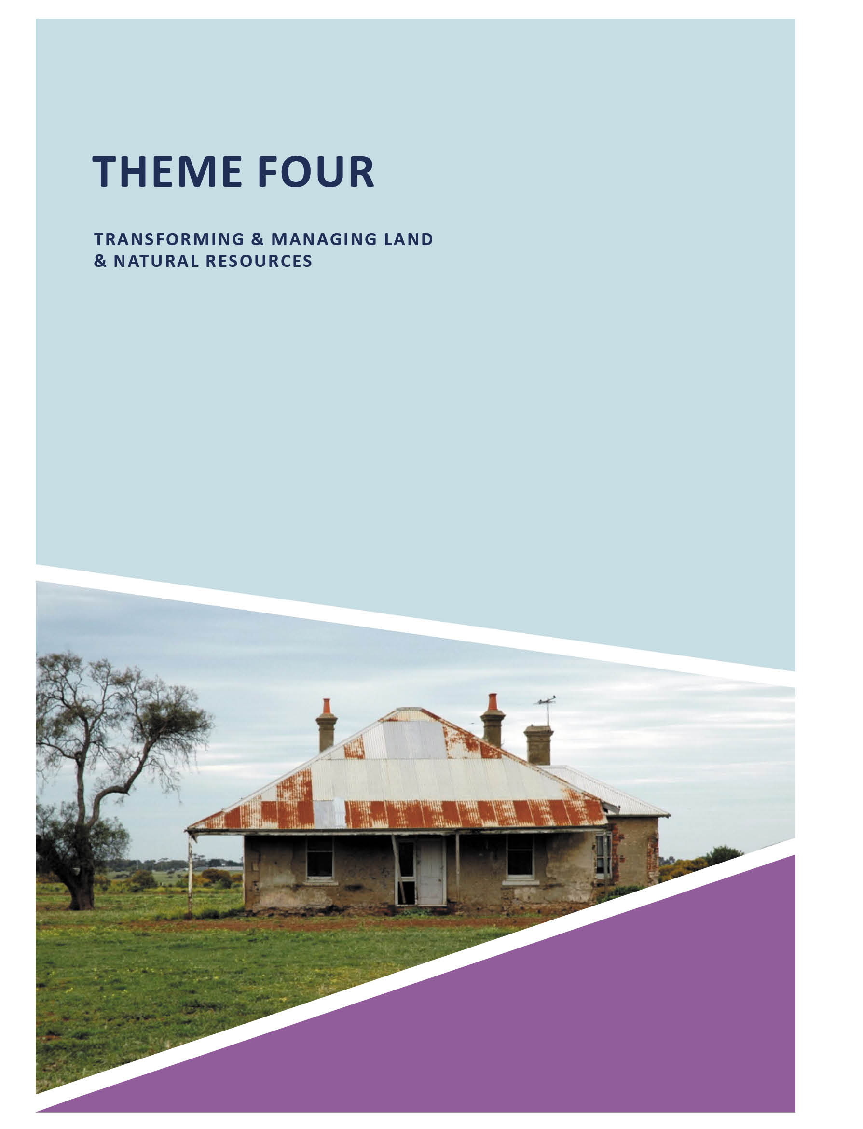

THEME FOUR

TRANSFORMING & MANAGING LAND & NATURAL RESOURCES

ABOUT CORAYO: A THEMATIC HISTORY OF GREATER GEELONG
361

  - INTRODUCTION
The land now comprising the City of Greater Geelong has been managed by the Wadawurrung peoples for tens of thousands of years as part of their traditional fire, farming and lifestyle practices. This forms the beginning of this theme which especially explores the transformative effects brought about by European colonisation since 1836.
The theme examines livestock grazing, one of the earliest forms of European farming within Greater Geelong, and the physical legacies that survive today in the homesteads, woolsheds and other farm buildings dating from the
19th century. A focus is also provided on the horse breeding and training accomplishments of the Wilson family at St.
Albans Stud (St. Albans Park), Frankfort (Suma Park, Marcus Hill) and Bonny Vale (Ocean Grove).
Transformative on the landscape were the many cultivated farms established in the 1840s in the production of wheat and other grains and crops; the excavation of guano as fertiliser; establishment of model farms involving orchards, vineyards and dairies; the importance of the asparagus farm near Barwon Heads in the early 20th century; the mixed farming practices (including dairying) and the success of various farmers from the 1850s to the early 20th century, including the establishment of ‘Sparrovale’ at Marshall by the Geelong Harbor Trust in 1907; the construction of dry stone walls; and the now lost hay stacking practices.
The planting of the first vineyard in Victoria commenced in 1842 near Greater Geelong at Pollocksford by David Pettavel and Frederic Brequet. This began the unique proliferation of vineyards and orchards, particularly by Swiss and German vignerons in the Barrabool Hills, Ceres, Waurn Ponds, Mount Duneed and Batesford. Together with similar establishments created by British settlers at Fyansford, this theme gives
an overview of the development (and physical legacies)
of this industry until many of the vineyards were destroyed by
Phylloxera vastatrix disease in the 1870s.
Exploitation of the indigenous landscape through wattle barking – was specific to the Bellarine Peninsula from the 1860s. Large tracts of thickly-timbered land was cleared to supply the burgeoning tanneries at Marshalltown, Breakwater and South Geelong, and similar industries beyond the boundaries of the municipality. An historical
overview is given on the importance of this trade to farmers at Portarlington, St. Leonards, Mannerim and Wallington.
Fundamental to the success of Greater Geelong’s building industry was the procurement of stone, and clay for bricks. The earliest gouging of the land for building purposes in Greater Geelong was the limestone quarry established
at Limeburner s Point in 1838. In parts of Newtown from the 1840s – and particularly Ceres, Barrabool Hills and
Waurn Ponds – the land was quarried for sandstone. Tangible evidence of the operations of these former quarries are numerous 19th century sandstone buildings in the municipality. The production of bricks, first at Ashby (Geelong West) and Newtown from the early 1840s
and later at North Geelong, Belmont and Portarlington (and elsewhere), brought about significant employment as well as further change to the landscape. Some manufacturers, such as T.H. Widdicombe of Portarlington, were particularly inventive. In addition to masonry, lime was critical and the burgeoning Melbourne and Geelong markets brought about
several lime burning operations: initially at Limeburners Point; and subsequently at Belmont and especially at Lara, where evidence of the industry survives today. This theme gives an account of these developments.
The frenzy of the Ballarat goldrush in the 1850s had an influential effect on Geelong citizens. Several unsuccessful attempts were made to mine gold at Mercer’s Hill, Newtown, from 1851. In addition to providing an overview of these enterprises, this theme gives an account of the more unusual secondary impact of gold mining in the land tenure legislation that affected some farming, lime burning and building developments in the Lara, Little River and Anakie areas, a consequence of the close proximity of these places to the Steiglitz Division of the Ballaarat Mining District.
The theme concludes by providing an overview of the development and evolution of the water supply and sewerage system for Greater Geelong. Numerous proposals were
put forward before a water supply scheme by Henry O. Christopherson was adopted and work commenced on the gravity fed Upper Stony Creek Reservoir in 1866. This
dramatically changed the natural landscape in the Brisbane Ranges but provided Greater Geelong a permanent and reliable water supply. Defects in the embankment of the Upper Stony Creek Reservoir caused the construction of the Lower Stony Creek Reservoir in 1873-74. Designed by the Scottish Engineer, George Tindal Gordon, this reservoir was not only essential to the completion of the initial water supply, but the engineering and constructional innovation in the concrete dam wall (of Portland cement) is highlighted. Similarly, the innovative concrete construction employed in the ocean outfall scheme from 1911 and particularly the
work of the engineers, Stone and Siddeley in the manufacture of ovoid concrete pipes and Barwon ovoid sewer aqueduct built on the French Considére system – is especially examined.

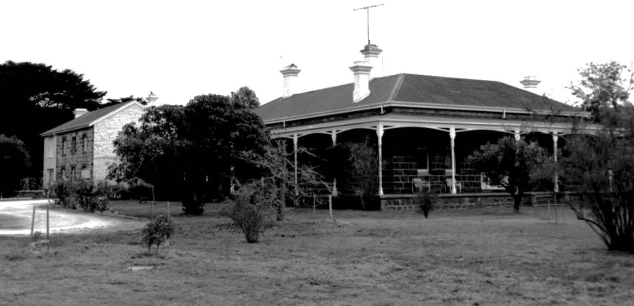

Figure 4.01: Staughton Vale Homestead, 532 Staughton Vale Rd, 1998. Source: David Rowe.

FARMING AND AGRICULTURE

INDIGENOUS FARMING
Farming began in the City of Greater Geelong by the Wadawurrung people. It was inherent to their survival but was also sophisticated. Wadawurrung farming underscored their animist beliefs of respecting and celebrating the environment as part of seasonal change (see Theme 2). It was about managing the land rather
than transforming it.1

EUROPEAN FARMING AND AGRICULTURE LIVESTOCK GRAZING
The earliest forms of European farming in Greater Geelong
was livestock grazing, including horses, cattle, pigs and especially sheep. It had begun when Thomas Manifold disembarked with 22,500 sheep at Point Henry in 1836 and was soon progressed by squatters associated with the Port Phillip Association, Derwent Company and the Clyde Company who had taken up cattle and sheep stations at
Anakie, Balliang, Sutherlands Creek, Connewarre, Breamlea and the Bellarine Peninsula (see Theme 2). Of the numerous sheep stations established throughout the 1840s and early 1850s, physical evidence survives of very few, including Coriyule at Drysdale (built in 1849 for Misses Drysdale and
Newcomb); Spray Farm at Bellarine (built in 1851 for Captain James Conway Langdon); and Kardinia, Belmont (first built as a replacement for an original dwelling in 1850 for Dr Alexander Thomson) (see Theme 2 for further details).
By 1857 the northern and north-western and western parts of Greater Geelong, including Anakie, Balliang, Cowies Creek, Lara, Lovely Banks, Little River, Moorabool and Sutherlands Creek,2 boasted the largest number of sheep grazed, with
a total of 53,445 stock.3 Other livestock was considerably fewer, including 6054 horned cattle, 274 horses and 1919 pigs.4 In the Parish of Barrabool, only 800 sheep were grazed at this time, along with 673 horses, 1194 cattle and 1220 pigs.5 In the southern parts, more substantial numbers of sheep were grazed in the Parish of Duneed, with 4053 being recorded in 1857.6 In the Conewarre Parish, there were 1303 sheep, along with 1045 cattle and 284 pigs. The Bellarine Parish grazed no sheep at this time but 1799 cattle and 1192 pigs.7 Similarly, the Parish of Moolap grazed 1256 cattle and 1287 pigs as well as 700 sheep.8
In addition to Coriyule, Kardinia and Spray Farm, physical evidence of the early sheep grazing enterprises survive in some of the few remaining farm properties: in existing farm homesteads, woolsheds or other outbuildings. Most of these properties also carried out different forms of cultivation. They include the following.

STAUGHTON VALE HOMESTEAD, STAUGHTON VALE
Situated on the southern bank of the Little River between Anakie and Balliang, Simon Staughton established his Brisbane Range Station there in 1842.9 The gabled two storey portion of the existing homestead at 750 Staughton Vale Road is a physical legacy of Simon Staughton’s Run. The single storey bluestone extension with encircling verandah was constructed in 190510 (Figure 4.01).
Brisbane Ranges Station was an adjunct to Simon Staughton’s main station, Exford, near Melton.11 No less than 16,000-17,000 sheep were grazed at the Brisbane Ranges Station, along with ‘a good many head of cattle.’12
In 1872, construction began on a mill at the Brisbane Ranges Station (then owned by Simon Frederic Staughton) for the experimental production of sugar beet by the Victorian Sugar Beet Company.13 With the involvement of local farmers, 350 acres of sugar beet were planted.14 The influx in employees to work the mill brought about a daily mail service between Staughton Vale and Little River.15 It was at this time when the name of the station was changed to Staughton Vale.16 A new timber State School was erected at 535 Staughton Vale Road in 1875 to serve the increased population (although no longer serving its original purpose, the building remains).17 However, the larger numbers of school children was short-lived given that closure of the promising sugar beet mill in 1874.18

WOOLOOMANATA HOMESTEAD
Wooloomanata Homestead (Figure 4.02) off the Bacchus Marsh Road, Lara, was built for the eminent
Victorian pioneer, Frederick William Armytage in c.1860,19 the bluestone Victorian Italianate styled dwelling being
possibly designed by Leonard Terry.20 He advertised tenders for the erection of offices and cottages at Wooloomanata in 1866. A biography of F.W. Armytage is given in Henderson s Australian Families:
He was a great lover of horses, and his coach, drawn by four magnificent specimens, used to attract much attention in the early days. During his world travels he collected many valuable pictures, some of which were exhibited in the National Gallery in Melbourne and later acquired by the Trustees. Many of the Victorian and visiting Governors were entertained by Mr. Armytage at Wooloomanata, which was renowned for its good pheasant shooting … Both Mr. Armytage and his wife took a great interest in the welfare of the aborigines around Wooloomanata, one of whom, Billy Leigh, ‘king’ of the tribe, was baptised and confirmed at the Church
of England at Lara. … [see Theme 2] Frederick William Armytage, together with George Fairbairn and Hastings

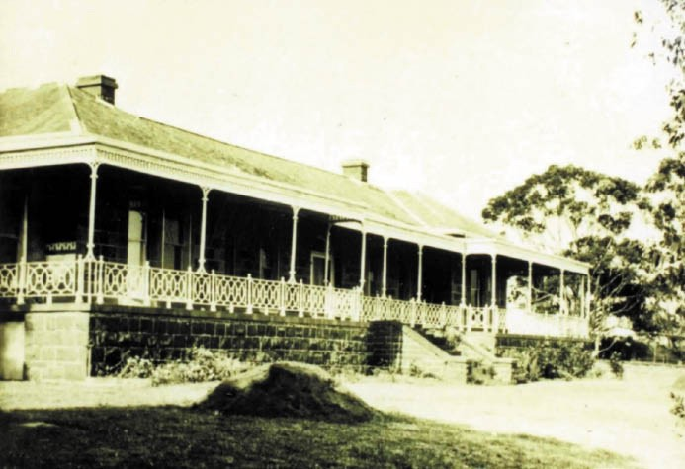
Figure 4.02: Wooloomanata Homestead, Lara, n.d.
Source: GRS 2009/00464e, Geelong Heritage Centre collection.

Cunningham, pioneered the frozen meat export industry in Australia, and the greater part of the initial shipment to England in the steamer Strathleven in 1879 was owned by him, and the first bill of loading for frozen products shipped from Australia was in his name. He was appointed a Justice of the Peace in 1871, was a director of several companies in Melbourne, and a prominent member of the Melbourne Club. He married Mary Susan, daughter to Simon Staughton, of Exford, Melton, Victoria.
… Frederick William Armytage died at Como, South Yarra, 3rd September 1912, at the age of 74.21
The property continues to serve as a farm to the current day, and outbuildings (including stables and a woolshed) survive.

NARADA HOMESTEAD
At 130 Mount Road, John Browne had the Geelong architect, John Young, design a single storey bluestone homestead, Narada in 1864.22 Two storey additions and a cast iron balcony and verandah were built to a design by Joseph Watts, architect, in 187323 (Figure 4.03). ‘Narada’ remains as one
of the more substantial dwellings at Anakie. Comprising 4028 acres in 1886, the sheep station was sold to Frederick Armytage in 1886.24 By 1911, the property (then comprising 6000 acres) was owned by W.E. Sargood, a third ear-marked for wheat growing, some for pig- breeding the remainder
as a merino stud.25 The basis of the stud was given in
The Australasian:
Having decided upon Riverina-bred ewes, which showed a heavy infusion of Wanganella blood, a deal was made for 1,750 ewes off Mooloomoon, 80 miles north of Deniliquin, and for 30 stud ewes off Wanganella. The former are by Wanganella rams out of Moffat ewes. The latter and 40
of the tops of the Mooloomoon ewes were mated with

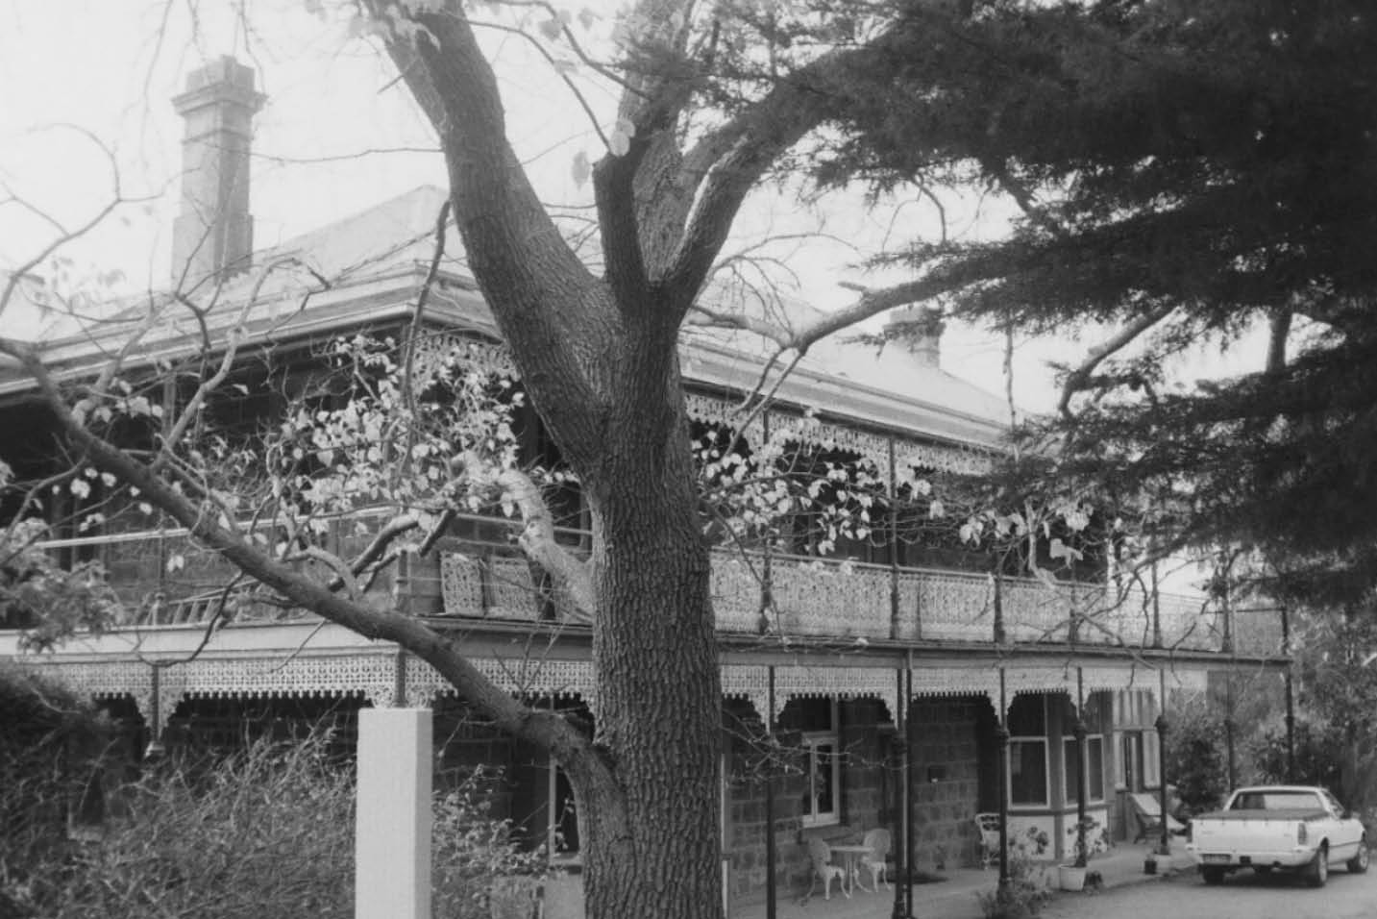
Figure 4.03: Narada Homestead, Anakie, 1998. Source: David Rowe.

particularly good Tasmanian ram bred by Mr. F.G. Gibson, of Meadowbanks; this rams combines the best features of Esk Vale and Winton, is of goodly frame, comparatively free from body-folds, and carries a bright, dense, fleece of
pleasing character and high quality … For a first venture at stud formation, few breeders have the luck to meet with so many pleasing characteristics as are now in evidence in these youngsters, both male
and female.26

PIRRA HOMESTEAD²⁷
First known as Windermere and then Lara House, Pirra Homestead (Figure 4.04) has its roots during the
Fairbairn family occupation between 1863 and 1907. George Fairbairn (senior), one of Australia’s most prosperous pastoralists and owner of millions of acres of land throughout Australia, established Pirra as a premier sheep stud. An original homestead was built in the early- mid 1860s (and
has been subsequently demolished), with a second extant single storey homestead built in c.1869. The brick two storey hipped roofed mansion house was designed in 1880-82 by the prolific architectural firm of Alexander Davidson and
Co. The Victorian Eclectic house style, with several highly unusual French mediaeval decorative features, represented an important example of the work of the Davidson practice.
During the Fairbairn ownership, Pirra developed into a large property of 5436 acres and included the construction of a
70-acre water reservoir to service the expansive grazing land and homestead complex. This complex included several outbuildings such as stables, manager’s house, slaughter house, shearing shed, men’s huts, dairy, and machinery shed. As a typical 19th century homestead complex, Pirra also was known for its cultivated areas, including the house orchard and garden, tennis and croquet courts, and the cricket ground to the north of the mansion with a view of the You Yangs framed by stone pine trees.

By the early 1890s, Pirra was managed by George Fairbairn’s sons, Thomas and George junior. The latter son eventually had sole ownership of the property. As a member of the Victorian Legislative Assembly from 1903, George junior (later Sir George) used Pirra as his country residence, whereby he developed a well-known Merino and Shropshire sheep stud.

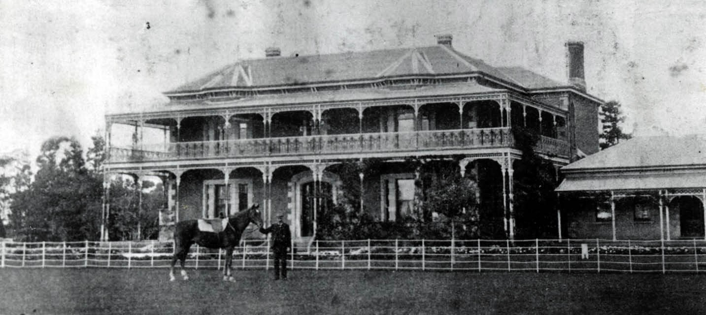

Figure 4.04: Pirra Homestead, c.1910. Source: GRS 2009/01847/134, Geelong Heritage Centre collection.

By 1907, the Pirra property had been sold for Closer Settlement as the Lara Estate, with the homestead and
637 acres being taken over by the Lara Inebriates Institution. This Government sanatorium constructed an Inebriates Dormitory at this time, and in 1927 an Inebriates’ Laundry was built south of the two storey mansion house (see Theme 8 for further details).
After the closure of the Inebriates’ Institution in 1930,
Pirra was sold to James McDonald in 1938. He grew crops on part of the property and ran sheep on the remainder. In 1946, he leased the former Inebriates’ building to the States Tobacco Company.
In 1948, the Tobacco Company had folded and Pirra was sold to Oscar and Edna Mendelsohn. Employees from the Tobacco Company were employed by the Pelaco Factory which occupied the former Inebriates’ building. The Mendelsohn’s renamed the property ‘Serendip’.
They established a commercial almond orchard in the vicinity of the original orchard and the large water reservoir was proclaimed a sanctuary for the protection of the local birdlife. Oscar Mendelsohn was also appointed assistant inspector of the Fisheries and Game Department at this time.
Further subdivision of the Pirra property was experienced in 1959, after the Mendelsohn’s sold to the Department of Fisheries and Wildlife who took control of the 600 acres
surrounding the sanctuary. The immediate homestead, now reduced to 37 acres, was taken over by the Social Welfare Department. The two storey mansion house and nearby buildings became the Pirra Girls Home in 1961 and it was at this time when the property was named Pirra (see Theme 7
for further details).
No buildings associated with the property s early sheep grazing function survive.

AVALON HOMESTEAD²⁸
‘Avalon Station’ was first taken up by James Austin in the late 1830s as a sheep Run. While there is some debate whether Austin ever lived at Avalon, it continued under his ownership. He had returned to England in 1856 and made only one further visit to Avalon in 1889. Austin died in England in 1895. From 1879, the Avalon property was leased to James Austin’s, son, Frank although W.H. Bullivant also had an interest in the property from the 1860s until the early 1880s.
Both were sheep graziers and they became well-known sheep breeders.29 Frank Austin (1859-1914) was born in England and educated at Clifton College. He came to Victoria to
take over the management of Avalon from his father, and purchased the property in 1881. He later became a pillar of support to the Australian Sheepbreeders Association and he also served as President of the Geelong Racing Club and the Geelong Agricultural Society.30
In 1908, the Pastoralists Review published a book on the Avalon property, highlighting it as a premier Merino stud:
Every visitor to the annual show at Melbourne of the Australian Sheepbreeders Association will be familiar with the Avalon sheep. Other competitors will no doubt be even more familiar with them, for when Mr. [Frank] Austin does not make a clean sweep of the prizes he at any rate carries away a large proportion of them. On one recent occasion he took no less than seven-eighths of the total

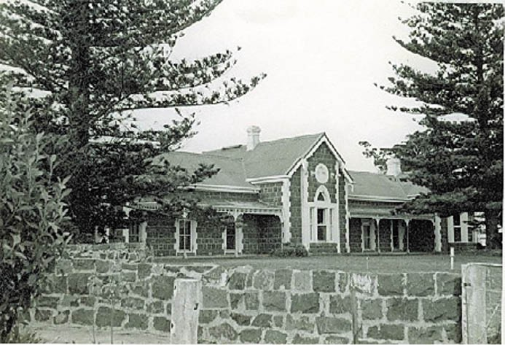
Figure 4.05: Avalon Homestead, c.1963. Source: National Trust of Australia (Victoria), B1116, Victorian Heritage Database online.

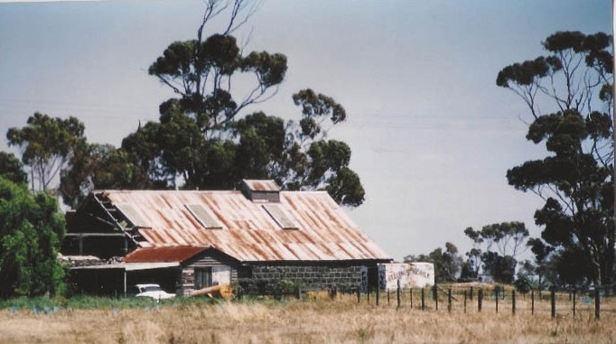
Figure 4.06: Avalon Woolshed, n.d. [c.1963]. Source: National Trust of Australia (Victoria), B1116 Victorian Heritage Database online.

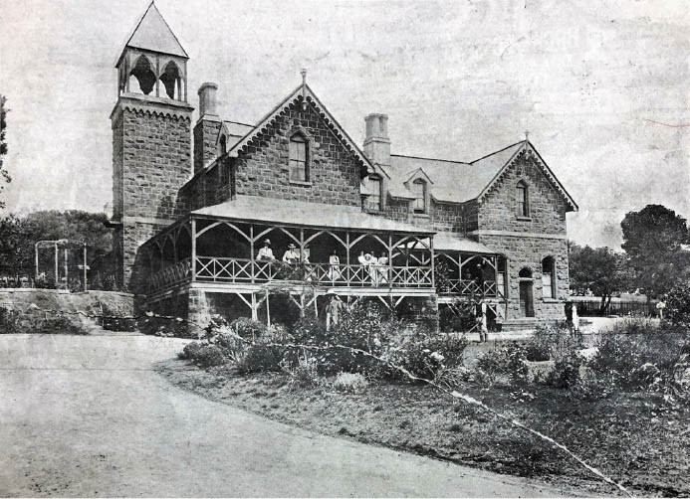

Figure 4.07: Elcho Homestead, 1907. Source: News of the Week, 14 February 1907, p.13, GRS 2121/1, Geelong Heritage Centre collection.

prize money given in the Merino section.
Mr. Austin’s ideal in evolving a distinctive type of Merino sheep has been to acquire length and density of wool, somewhat on the strong side in the fibre, and to achieve a hard constitution. So large a measure of success has he achieved in accomplishing what he has aimed at that he has some 300 stud and flock rams
and a similar number of stud ewes available for sale every year.31
It appears that the first bluestone dwelling at Avalon was built in 1842-43. The existing single storey, bluestone, Victorian Picturesque Gothic styled homestead (Figure 4.05) was built in 1880-81 to a design by the well-known architect, Alexander Davidson, who simultaneously had also been responsible
for the design of nearby Windermere (Pirra). In 1896, the Melbourne architect Walter Butler was engaged to design a porte cochere extension to the homestead. It was described as ‘one of the largest such structures in Victoria’, designed to mask the west end of the main body well as to provide weather protection.
The sheep grazing function of Avalon is especially identified by the surviving woolshed (Figure 4.06) nearby the homestead, although no longer part of the property. The gabled bluestone woolshed was built in 1869 to a design by Geelong architect J.L. Shaw for W.H. Bullivant.32

ELCHO HOMESTEAD
The substantial bluestone Victorian Picturesque Gothic styled Elcho homestead (Figure 4.07) was built in 1864 for John Galletly and his wife, Elizabeth (nee Armytage) on a four- thousand-acre property fronting the Bacchus Marsh Road.
The substantial and picturesque Gothic-inspired homestead was designed by the eminent Melbourne architect, Leonard Terry.33 A wing on the north side of the dwelling was added in c.1872.34
On John Galletly’s death in 1876, Elcho remained part of his Estate for many years and was occupied by successive managers. In 1890, the Trustees of the Estate proposed to
subdivide Elcho into five- and ten-acre blocks.35 An extensive survey was made and some dwellings erected.36 With the demise in the land boom caused by an economic down-turn, the subdivision was a failure. In 1892, the firm of Williams and Co. of Ballarat relocated four of the houses from the Elcho Estate, with one taken to the farm of Henry Warren at Moolap.37
In 1896, a lease for Elcho was taken up by Hugh Mann Sutherland (1848-1916) of North Shore.38 He commenced breeding pure Border-Leicester sheep39 and cultivating English grass, oats, barley and Lucerne ‘on true scientific lines. 40 Born in 1848 at Clashmore in the Highlands of

Scotland, H.M. Sutherland came to Victoria in 1872, having been engaged by Thomas Chirnside to work at his Werribee estate for three years. Sutherland married Sarah Crossley in 1878.41 In Geelong, Sutherland became a real estate agent under the name of Abraham and Sutherland in 1888 and W. Abraham and Sutherland, Robertson and Company in 1890. The firm was successful in the sale of ‘choice allotments’ as part of the residential subdivision of North Shore (see Theme 6). In 1903, Sutherland purchased the Elcho property and subdivided outlying land into 24 allotments (see Theme 2).
The property was later acquired by John Sutherland (born in 1881 in Shepparton), on his father’s death in 1916.42 By 1923, the Elcho property had been acquired by the Lands
Department and was initially used as a training farm for British immigrants (see Theme 2).

SOME OTHER PROPERTIES ASSOCIATED WITH SHEEP GRAZING
Physical evidence exists of other sheep grazing establishments in the northern parts of Greater Geelong. They include the woolsheds at: ‘Marathon’, 1385 Ballan Road, Anakie (built in c.1867 for Sir Samuel Wilson); ‘Darriwill’, 225 Steiglitz Road, Moorabool (built in 1878 for George Hope by S. and J. Bond at a cost of £113/9/6); ‘Ripley Park’, 75 Gilmores Road, Balliang (built in c.1870 for Joseph Love); and the stone dairy of James Tait in Staceys Road, Connewarre (possibly constructed in c.1855).43
At 75 Staceys Road, Lovely Banks, the property ‘Kia Ora’ (Figure 4.08) represents a later example of a sheep farm. It was designed by Laird and Barlow, Geelong architects, in 1903 for H.M. Sutherland of ‘Elcho’ on behalf of his son, John Sutherland.44 He also became a well-known breeder of Border Leicester sheep. In 1913, John Sutherland was successful at the Australian Sheepbreeders Association s
Annual Exhibition in Sydney. As was reported in the Adelaide Advertiser, ‘In Border Leicesters Mr. John Sutherland, of Kia Ora, Lara, had things practically his own way, and he annexed the championships for ram and ewe. 45 A year later in 1914,
The Leader newspaper
also commented on Sutherland’s fine breed of prize-winning sheep:
BORDER LEICESTERS. This fine breed of mutton sheep is attractively represented by a large number of high grade animals. Borders are steadily winning their way in Australia, their alertness and capacity as foragers standing them in good stead even under
adverse conditions. Honors in this section easily went to John Sutherland, of Lara, who a few years ago imported some of the best sheep obtainable in Scotland, and is
to-day reaping the reward of his enterprise. His four-year- old ram Allanfearn, who secured the championship, is a

large, shapely sheep of gay carriage, marked by the great spring of rib and solid back, for which the breed is famous. His younger ram, another descendant of the imported ram Lord Elcho, and a fine representative of the breed, was given the reserve champion ribbons. J. Sutherland was also successful in other ram classes.46

WILSON HORSE TRAINERS

JAMES WILSON SENIOR & ST. ALBANS STUD
Influential and well-known in horse racing circles throughout Australia was James Wilson (c.1829-1917). Born in Yorkshire, his interest in horses began at an early age.47 In 1848
at the age of 18 years, he emigrated to Victoria on the Mahomed Shah, his occupation at this time being as a saddler.48 In 1856, Wilson married Miss Mary Jamieson.49 He subsequently gained experience in horse racing in
the Western District where he was a fierce competitor as a cross-country horseman with Adam Lindsay Gordon
(renowned poet and horseman) who was a personal friend out of the saddle. 50 James and Mary Wilson had a daughter Anne in 1854, followed by a son James junior at Hamilton
in 1856.51 Other children followed: Sarah (1858), William (1859), Sarah Jane (1860), Emma (1860) and Mary 1862).52 Following Mary Wilson’s death in 1863, James Wilson married Elizabeth Clements in Geelong in 1867.53 They had a son, George Joseph Clement Wilson at Dunkeld in 1868.54 Soon after, James Wilson was appointed to take charge of John Moffat’s Leigh Stud farm at Shelford in the 1860s.55 In 1870, Wilson established his own training establishment at St. Albans, east of Geelong, which he named the St. Albans Stud.56 In 1873, Wilson won the Melbourne Cup with
the horse, Don Juan.57 In this same year he engaged the Melbourne architect, James T. Conlon to design a substantial single storey polychromatic brick Victorian homestead58 (Figure 4.09). The Geelong Advertiser gave a glowing report on the developing stud property in July 1873:
When he [Wilson] first arrived he contented himself with an “ancient” house in the retired little village of St. Albans, but soon found the allotment of land attached thereto
far too small for the stable accommodation he required, besides which, like many other trainers, he preferred having a course on his own private property to giving horses their trial gallops on a public common. One of the chief improvements is the circular course about one mile and three quarters in circumference, and for the purposes required it is not to be equalled by any course with which we are acquainted in Victoria. … The sowing of couch along with the English grasses will be the means of retaining this refreshing green appearance all the year round The present cost of the course is

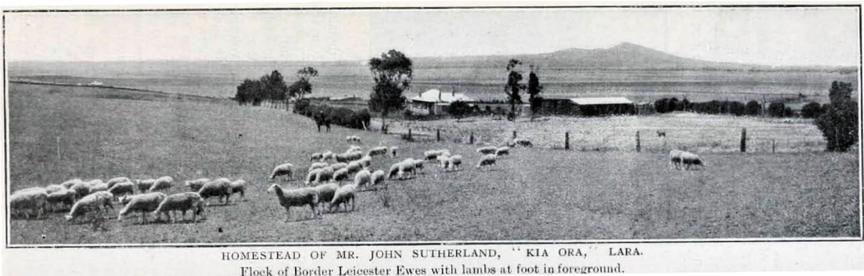

Figure 4.08: ‘Kia Ora’ sheep farm, Lovely Banks. Source: Journal of Agriculture, Victoria, 11 January 1909, p.56.
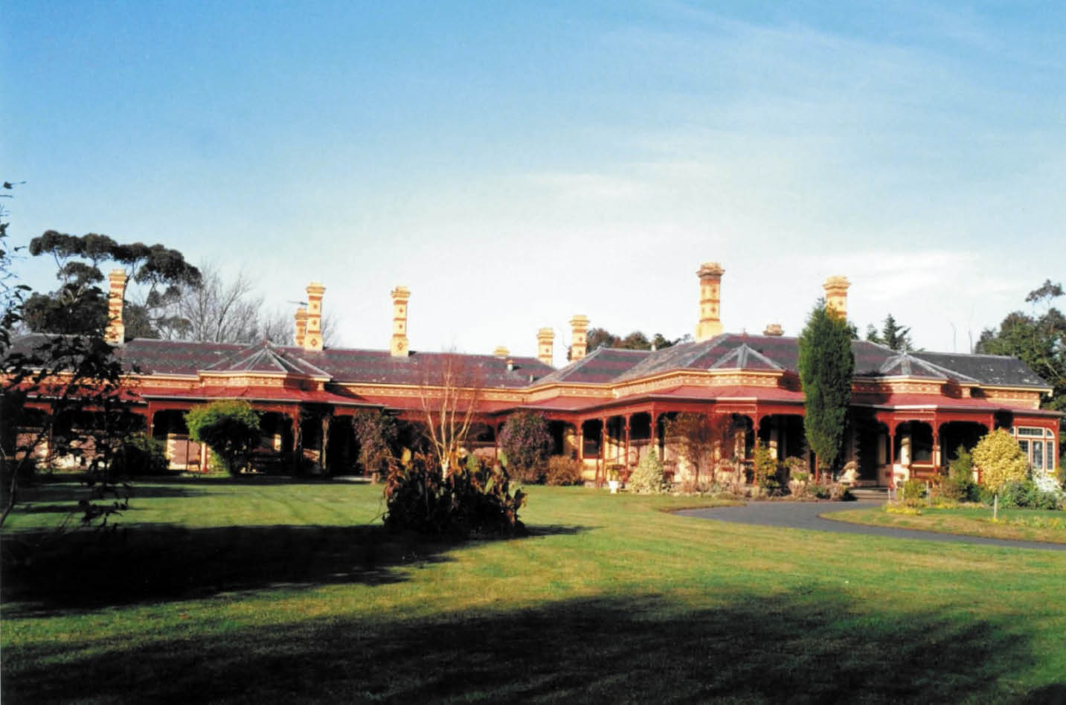

Figure 4.09: St. Albans Homestead, 6-30 Homestead Drive, St. Albans Park, 1990. Source: David Rowe.

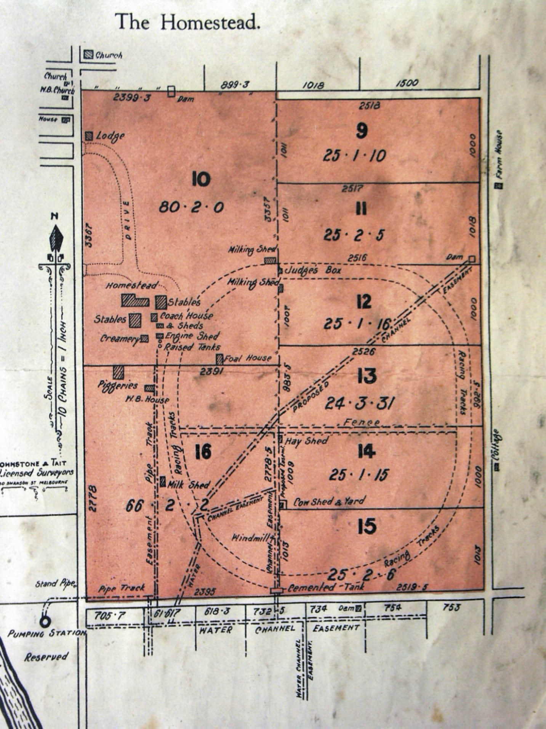
Figure 4.10: Site Plan of the St. Albans Estate showing homestead & outbuildings, racing tracks & gate lodge, 11 November 1925. Source: St. Albans Estate Auction Notice, 11 November 1925, Authentic Heritage Services collection.

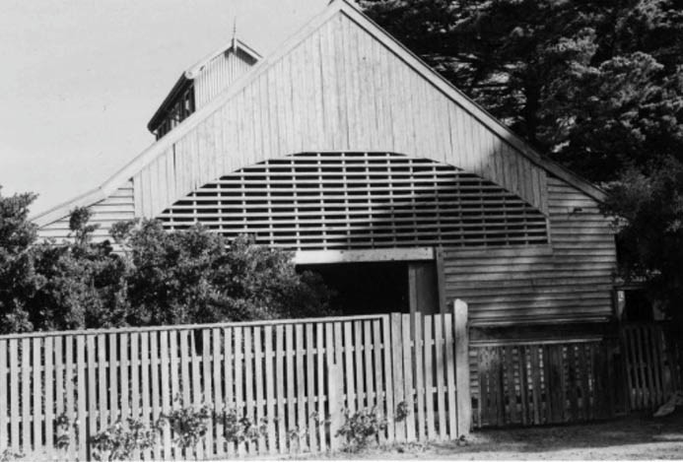
Figure 4.11: J.T. Collins, St. Albans Stud Stables, 27 April 1978. Source: accession H96.210/656, State Library of Victoria.

estimated at over £2,000, and Mr Wilson, determined to give the grasses every chance of taking firm hold of it, is now engaged in making an inner course for ordinary training purposes. On the rising ground to the west
of the course a lofty and capacious wooden, zinc roofed, building, 90ft. x 51ft., has been erected, in which, on the eastern side are to be found six loose boxes 14 ft. x 12 ft., and a harness room. the center of this building is an open space, 25 feet broad, in which ample room will be provided for the horses in training to take walking exercise in wet weather. On the western side are a store-room and granary, 12 feet wide, the latter being provided with platforms on iron, vermin proof, standards. Not far from this building, about 70 or 80 yards, and to the west of it,
is a new and handsome brick-built villa residence, from which a fine view can be obtained of the surrounding country. When completed, this residence which has been built from plans prepared by Mr Conlon, of Melbourne, will compare favourably with any in the district, and afford ample accommodation for numerous friends, it being
much larger than it appears when viewed from outside. At the rear of the house is a brick cemented tank, 21ft. x 17ft., and close alongside of these fourteen loose boxes are to be provided in a building now in course of erection, 86ft. x 42ft.59
James Wilson relinquished ownership of the St. Albans Stud in 1886.60 In 1899, new timber racing stables were erected to a design by the local architects, Tombs
and Durran.61
In late 1925, the St. Albans Stud property (then owned by
A.W. Jones) was offered for sale, either as a whole or as subdivided allotments ranging from 25 acres.62 At this time, the vast estate not only included the private racing tracks and complex of homestead buildings, but a substantial tree-lined

drive and gate lodge (built in brick in 1890-91 to a design by the Melbourne architects, Henderson and Marryat)63 (Figure 4.10).
The property remained intact as a horse stud in the ensuring years and in 1930, the famous race horse, Phar Lap was secretly stabled at St. Albans Stud as a safety measure64 (Figure 4.11). As reported in The Argus:
Phar Lap, whom a shooting attempt was made at Caulfield on Saturday, was taken to the St. Albans Stud, Geelong, early on Sunday morning, and there he remained until yesterday, when he was driven to Flemington in a motor- float, accompanied by a strong police guard. While at St. Albans, Phar Lap was exercised on the private track there, and was taken to the Geelong racecourse for a gallop yesterday morning.65
The homestead and stables remain today in the suburb of St. Albans Park.

KINGSTON ESTATE, OCEAN GROVE
In 1882, James Wilson acquired the 1170 acre farm property, ‘Kingston’ from the grazier, John Archer.66 In partnership with W. Branch, horse trainer, Wilson established another
private race course and training ground as part of the stabling of horses.67 This property was sold in two parts in 1884 and 1885 to John Robertson and Donald McPherson following the dissolution of Wilson s partnership with Branch.68 Nothing survives of the Kingston horse stud today.

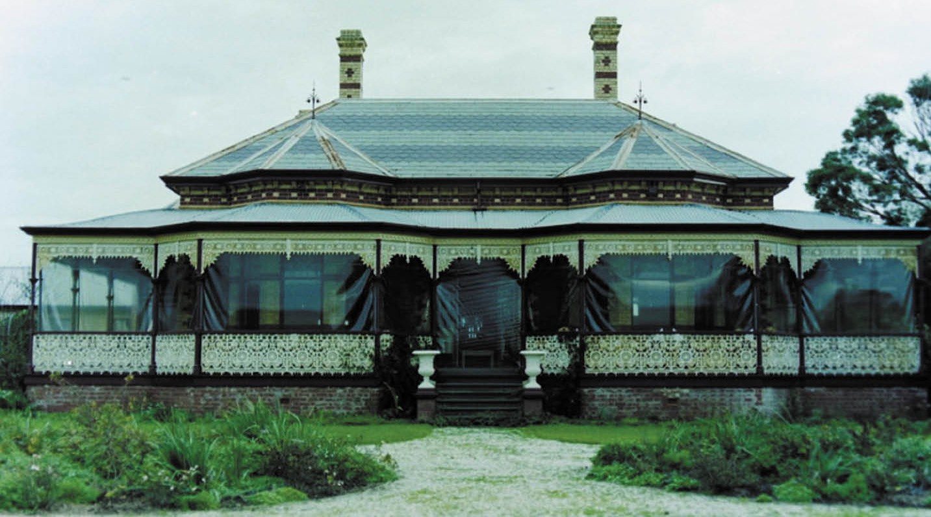

Figure 4.12: ‘Suma Park’, 2135-2165 Bellarine Highway, 1991. Source: David Rowe.

FRANKFORT (SUMA PARK), MARCUS HILL
James Wilson senior returned to England for a holiday in 1886 during which time his son, James Wilson junior acquired 450 acres of land near Queenscliff on his behalf in order to establish a new stabling facility and training track.69 The racecourse was completed by January 1887 as the annual meeting of the Queenscliff Racing Club was held there in February of that year.70 A 13-roomed brick villa, built to a remarkably similar design to Wilson s previous St. Alban s Stud, was completed in 1887 and named ‘Frankfort’71 (Figure 4.12). Wilson senior lived there until his death in 1917.72 Now called Suma Park, the complex (without race course) still survives.

JAMES WILSON JUNIOR & BONNY VALE, OCEAN GROVE
James Wilson junior (1856-1935) followed his father in the horse racing industry. He first commenced as a stable hand at St. Albans Stud before becoming a successful jockey (his first ride was at Flemington on New Year’s Day, 1869),
trainer and owner.73 Wilson s athleticism and interest in sport continued beyond horse racing. He captained the Geelong Football Club between 1879 and 1882, and also captained the
Victorian team on a visit to Adelaide as part of an interstate match.74 In 1889, Wilson acquired the 370 acre property near Ocean Grove previously owned by R.G. Talbot, horse trainer in Tasmania.75 Talbot does not appear to have developed
or improved the site as he went to England for 12 months in 1888.76 Called ‘Bonny Vale’, Wilson had a dwelling, stables and other horse-training facilities constructed77 (Figures 4.13-15). Further south towards Bass Strait and immediately behind the sand dunes, Wilson developed a private race track. This training course survived until at least 1954 but was disused at this time. In addition to horse training, the
property also produced oaten hay as horse feed. Bankruptcy in 193478 appears to have taken its toll on James Wilson as he died in the following year, 1935. Today, the homestead (albeit altered) is all that remains of the Bonny Vale Stud.

CULTIVATED FARMS
The majority of farms throughout Greater Geelong from the mid-19th century were mixed in that they produced a range of grains and other produce. The transformation of the land began in earnest in the 1840s, and by 1847 the Barrabool Hills were ‘laden with potatoes, wheat, oats, vegetables and butter,’79 with farming enterprises extending to Moolap in

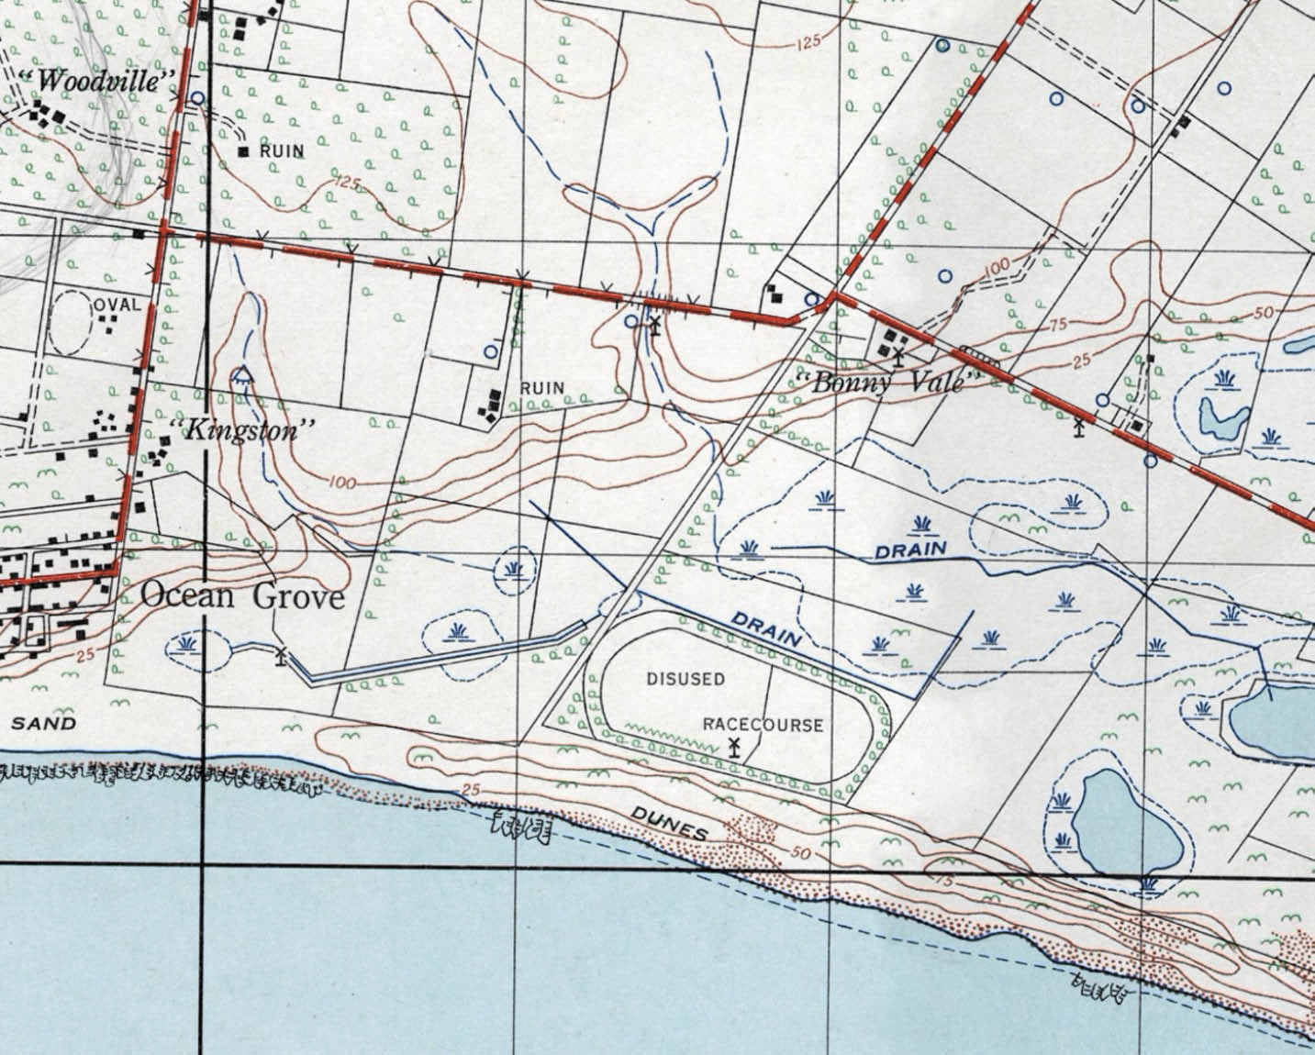

Figure 4.13: Royal Australian Survey Corps, Corio (special) Military Survey Map, Part Sheet No. 867/1, Zone 7, 1956, showing Ocean Grove. Source: GRS 2030/R055, Geelong Heritage Centre collection.
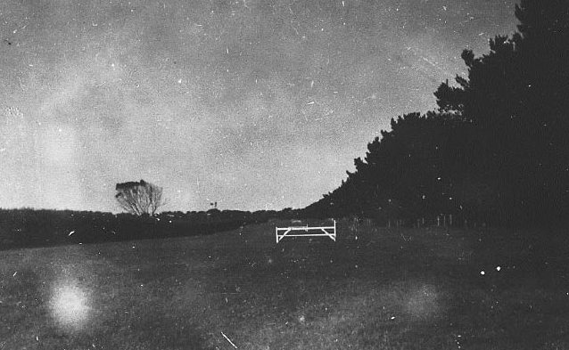
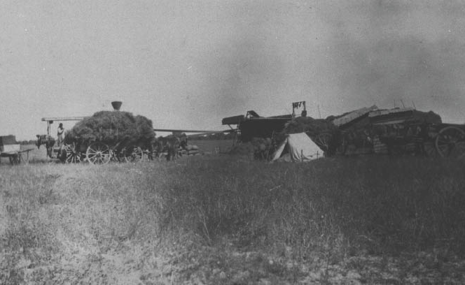

Figure 4.14: ‘Bonny Vale’ training course, c.1926. Source: Bellarine Shire collection, image 11/06, Bellarine Historical Society.
Figure 4.15: Threshing oat hay at ‘Bonny Vale’, c.1925. Source: Bellarine Shire collection, image 10/15, Bellarine Historical Society.

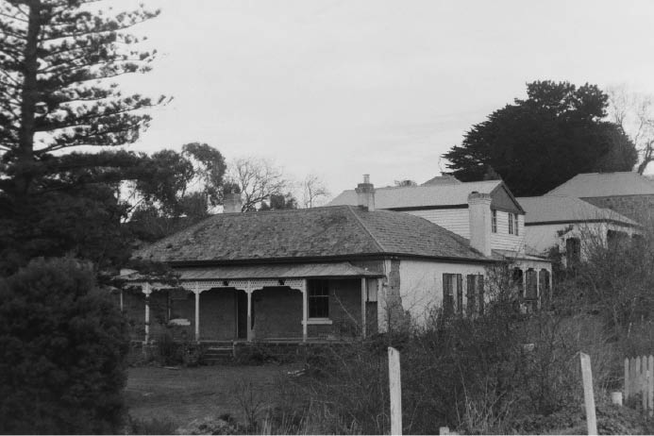
Figure 4.16: Newlands Homestead, Barrabool Rd, Ceres, 1998. Source: David Rowe.

1848, as outlined in the Geelong Advertiser in 1848:
A considerable quantity of purchased land has lately been put under cultivation on the flat ground, about three miles on this side of Point Henry. The soil appears to be a dark rich loam, and suitable for harvest produce such as wheat, oats, and barley, but perhaps not so well adapted for potatoes. The distance from Geelong is about three miles, with an excellent road for the transit of produce all the way into town. This last desideratum will tend greatly to enhance the value of the land, although here is an absence of conveniences (chiefly the want of a supply of water nearer at hand). Several good huts have already been built by the owners of the allotments, and others are in the course of erection. As yet only small portions of
land have been ploughed, but in the course of a very short period, by the industry of the purchasers, many acres will be under direct cultivation.80
By far the largest producers of wheat in 1857 were situated in the Bellarine Parish, with 130,890 bushels grown.81
They were followed by farms in the Barrabool Parish with 94,499 bushels. Wheat grown in lesser (but still considerable) amounts were in the Parishes of Duneed (38,617 bushels), Moolap (23,929 bushels), Moorpanyal (20,693 bushels), Conewarre (12,727 bushels) and Paywit (10,327 bushels).
By 1899, the volume of wheat grown in the Greater Geelong region continued to be substantial, the Shires of Bellarine and Barrabool producing 14,845 and 12,297 acres worth respectively.82
Barley was grown in considerably less volumes in the 1850s, the largest concentration being in the Bellarine Parish in 1857 with 2,969 bushels.83 A larger volume of oats were grown
in this Parish at this time, amounting to 34,931 bushels.84 However, the Barrabool Parish boasted a production of 39,241 bushels, with the Parish of Moolap having farms that

produced 21,174 bushels.85 By 1899, oats and malt were the secondary principal grains grown in the region.86
‘Newlands’ Homestead at 670 Barrabool Road, Ceres (Figure 4.16), is a physical legacy of mid-19th century developments in cultivated farming in the Greater Geelong region.
Previously part of the vast estate of Charles McLachlan, the land now comprising Newlands Homestead had been taken up by James Piper (1819-1911) who cut his first wheat crop in 1846 which yielded well and which Piper recalled with satisfaction in 1898.87 Part of the Merrawarp Estate subdivision in the early 1850s, Piper secured his tenure by taking up a freehold purchase. One of the first Barrabool Shire Councillors (see Theme 7), Piper built his stone dwelling in 1853, with various outbuildings subsequently erected including a stable (built 1861) and a dairy.88
Further east at 50 Prospect Road, Ceres, John Leigh (1815-1886) had a substantial Barrabool stone homestead constructed in 1861 to a design by Geelong architect and surveyor, Andrew McWilliams.89 Leigh had settled at the
Barrabool Hills as early as 1846, as outlined in his obituary in 1886:
The deceased gentleman, who had reached the ripe age of 71 years, was the oldest resident on the Barrabool Hills. He arrived at Melbourne in 1841, and five years later he settled on the hills, at which place he resided ever since, conducting with every success the business of a farmer. His quiet, unobtrusive demeanour, assisted by all those genial qualities so characteristic of the agriculturist, earned for him the respect and esteem of everyone on the hills … The deceased was a native of Devonshire, England.90
Prospect Farm was continued on by the Leigh family and in 1898 the Geelong Advertiser reported that the hay crop will give a satisfactory return, and a wheat crop, which has filled out very well, is one of the most advanced of its kind on the hills. 91 The homestead and other early outbuildings survive at the property today (Figures 4.17-18).
At Anakie, Lara and Lovely Banks, a number of other farms dating from the 19th century exist that were known for their hay, barley and oat crops. At 125 Buckingham Street, Lara, is the stone cottage and stables of David McHarry built in 1874- 75 now known as Laurence Park 92 (Figures 4.19-20). At 785 Bacchus Marsh Road, Anakie, is a timber Federation styled dwelling associated with the farm of Richard and Martha Wisely. The dwelling was built in 1906-07.93 At 450 Staceys Road, Anakie, is ‘Roselea’, a Federation era farm with timber dwelling and outbuildings established by the Leigh brothers of Ceres: Albert, Frederick and Rowland, in 1911.94 The success of these farms was outlined in The Leader in 1916:
The average of the farmers in the Lara district is up to a

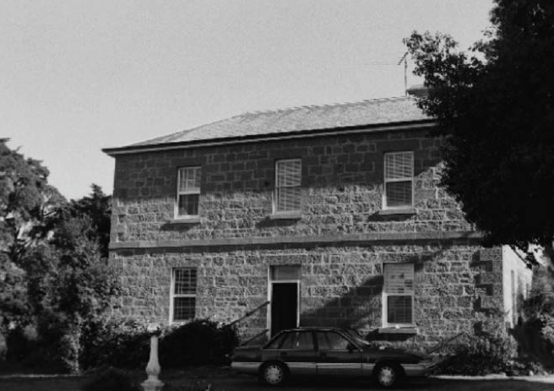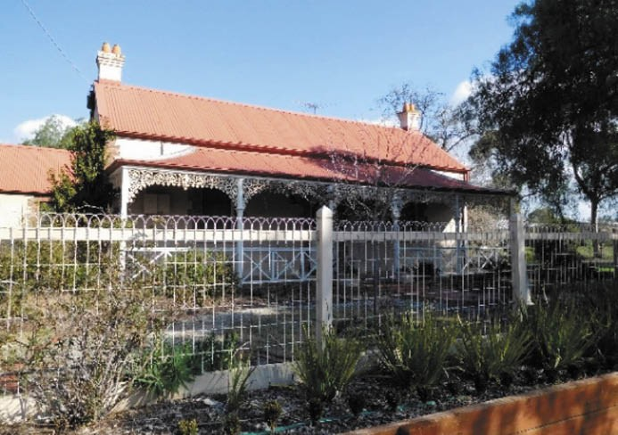
Figure 4.17: Prospect Homestead, 1998. Source: David Rowe. Figure 4.19: ‘Laurence Park’, Lara, 2015. Source: David Rowe.
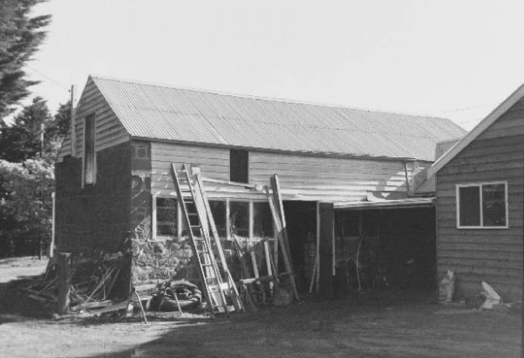
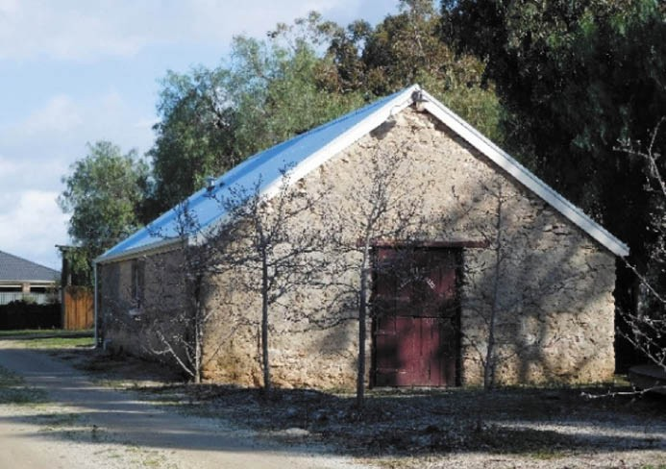
Figure 4.18: Prospect Stables, 1998. Source: David Rowe. Figure 4.20: ‘Laurence Park’ Stables, 2015. Source: David Rowe.

very good standard in the working of their land. This is shown in the continued fertility of the older farms lying outside of the Fairbairn [Lara Estate] subdivision. The Lee [sic. – Leigh] Brothers reflect credit upon their training, obtained originally on the Barrabool Hills. Their proportion of grain cultivation for market over and above that provided for their sheep grazing is larger than the average, and the quality of their work is indicated by their yields of oats, running to averages of from 35 to
45 bushels per acre, and their Cape barley from 30 to 35 respectively. The older settlers did not consider the
district suitable for wheat, but Mr. Wisley, from the Mallee, has attracted attention by the growth of a very fine crop
of Federation wheat last year. Not much has yet been done about lucerne, although there is no reason against that best of all fodder plants doing well here, considering its success (without irrigation) in the adjoining Western district, whose climate and conditions generally are much the same as those of Lara. Lara is essentially a good
winter country. The temperature is comparatively mild, and growth, both of crops and pasture, continues right through the winter season. There is a tradition about Mr. McCarry [sic. – McHarry], a very early settler in this
district, having once put in a small paddock with lucerne, only he did not then know the value of the plant. He called it a weed, and tried to get rid of it by ploughing. He remarked that it was the most stubborn weed he had ever met with, as the more he ploughed it up in the effort to exterminate it the better and more persistently it grew.95
Fewer mixed farms of the 19th and early 20th centuries remain on the Bellarine Peninsula that were known for their large wheat crops and other produce, particularly potatoes. In 1857, 1,132 tons of potatoes were grown in the Bellarine Parish, the most substantial quantity in the Greater Geelong region at this time.96 By 1899, the Bellarine Shire had 661 acres under potato crops.
A well-known mixed farm on the Bellarine Peninsula in the

1860s was Jonas Levien’s ‘Murradoc Farm’ on Founds Road, Drysdale. On 640 acres he grew grains, potatoes and seeds as a ‘model farm’ with guano procured from nearby Mud Island to fertilise his crops.97 Established in 1864 when the soil was choked with weeds,’98 the Geelong Advertiser gave a detailed account of Levien s farm enterprise in 1869:
It had been cropped for the past 13 or 14 years
with cereals so for the first two years he allowed it to rest and applied large amounts of manure. Many neighbours have now followed his example of not over-cropping.
He is now engaged in growing seeds, growing crops in rotation and preparing the soil beforehand.
After growing a crop of potatoes from heavily laden manured soil, Levien sows seeds, the next year a crop of cereal and the fourth year is lies fallow. Grain is drilled into the soil as this method is best for land subject to the wet.
Mr Levien leases Flat Island where excellent guano is obtained. It is also fortunate that Levien prefers seed farming as he is obliged to employ more men than he would have to do for an ordinary farm, and many have benefited from the work during the winter months. On an average he employs 20 men and currently has 24 men and 8 boys.
This season 380 acres are under cultivation with wheat, hay, onions, barley, mangolds, garden seeds, peas, canary seeds, flower seeds and potatoes. Some 120 acres are under English grass, 40 acres with original grasses and 100 acres fallow. In some of the barley, caterpillars have made an appearance so this part of the crop has been cut down already.
Some of the oat crops are so thick that Levien has purchased one of Robinson’s machines to cut them down. A man and a boy are required to manage the pair of horses pulling the machine which can harvest 15 acres
per day. The wheat being grown is purple straw and Mount Gambier. The barley is either English or Cape varieties.
The 5 acres of seeds being grown include: carrots, peas, spinach, beetroot, parsnips, onions, marrow, cucumbers and long, red mangolds. An acre of mignonette casts a beautiful perfume about. The 25 acres of canary seed
is to fill orders and if he had twice as much he could find ready buyers! The 3 acres of cabbage lettuce looked like the ground had been scattered with green cannon balls
the hearts of the plants having been taken out to allow the seed to push through if this had not been done it is probable, the hearts being so hard, the plants would have decayed before the spur could get through.99
In 1871, the architect Andrew McWilliams designed a cottage for J.F. Levien that was later known ‘Murradoc House’.100

Levin (1840-1906) was the son of Benjamin Goldsmith and Eliza (nee Lindo) Levien, early punt operator in Geelong (see Theme 3). Educated at the Geelong Grammar School,
J.F. Levien entered politics as a conservative protectionist for South Grant in 1871, defeating Peter Lalor. It was also in 1871 when Levien married his first cousin, Clara Levien.101 As a politician, Levien’s interest in science of agriculture
continued as minister of mines and agriculture between 1883- 86 during which time he introduced the bill that established the Council of Agricultural Education, with Levien installed
as its first president.102 Levien died in 1906 at his home in St. Kilda Road, Melbourne.103 Levien s earlier farm property at Drysdale was advertised for sale in eight allotments on 11 March 1921 as the Bellarine Farms (Figure 4.21), being
described as within the heart of this noted dairying and onion district. 104 Today, Levien’s previous farm is the location of Scotchmans Hill Winery.
Seed cultivation was also a key part of Robert Willey’s ‘Avondale’ farm, 10 Church Road, Bellarine (Figures 4.22-23). Unlike Levien’s ‘Murradoc Farm’, ‘Avondale’ exists today as a physical legacy of mixed farming on the Peninsula. The existing timber dwelling (built in c.1868) first commenced
as the Farmer’s Hotel on land originally owned by Robert Willey’s father, Frederick105 (see Theme 6) Educated at Geelong College, Robert Willey had established a garden at his Farmer’s Hotel property by 1871 as it was at this time
when he won first prize in the garden produce section for his twelve onions in the Geelong and Western District Agricultural and Horticultural Society s Spring Exhibition.106 By 1888, Willey had turned his full attention to farming and nominated Avondale for the best managed farm in the Geelong and Western District Agricultural and Horticultural Society s annual competition.107 The extent and type of farming carried out at Avondale by Willey was detailed in the Australasian:
One of the most interesting farms at East Bellarine is a small property of 80 acres owned by Mr. Robert Willey, of Avondale. He has other land in the district, I believe; but on this property, where he resides, there is an immense amount of farming done, labour employed, money laid out and, generally speaking, a remarkable quantity and variety of produce grown. Mr. Willey’s house, and some of the stock he keeps and the crops he grows, are shown in the accompanying pictures, and anyone can see at a glance that an air of prosperity and comfort pervades the place.
A small but select herd of dairy cattle are kept, mostly pedigreed Jerseys. In the way of dairying little more is attempted than supplying household requirements, but even in doing thus much Mr. Willey aims at doing it in the best and cheapest way possible, by keeping good cattle and treating them well. Whatever work he does is done thoroughly; there are no mediocre, unprofitable cows, calves, pigs, or poultry about his premises. His house, his

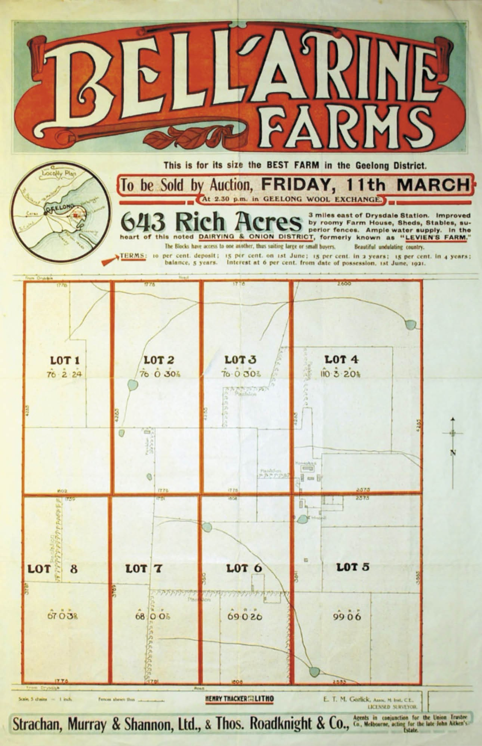
Figure 4.21: Bellarine Farms Auction Notice, 11 March 1921. Source: Map 9, Bellarine Historical Society.

barns, and stables, and machinery and all the very best of their kind; there is nothing but what is tidy and neat.
Mr. Willey’s specialty, however, is seed growing. Farm and garden seeds are raised on a large scale. The most of
the farm is devoted to seed growing, and dealing with so many different kinds of plants requires no little skill and accuracy in carrying on such work. Nearly every kind of seed is grown, including peas, onions, lettuces, carrots, cabbages, parsnips, and vegetables of every kind, far too numerous to mention. The land for seed-growing purposes is laid out in sections or plots, as shown in the accompanying illustration, and a prettier sight, when the different crops are in bloom, is hard to find. The minute and technical features of this business are too intricate to describe on paper, but it may be said that order and system prevail throughout. Every operation has to be
done with accuracy and precision, and exactly at the time it should be done, or the seeds would be spoiled. A large quantity of machinery is necessary for thrashing and planting the various seeds grown, as well as numerous barns and granaries for storing and preparing them for market. All those things are provided, and the buildings of one kind and another on the place form what may be correctly described as a small township. Mr. Willey has done useful service for Victorian Government in testing both seeds and manures, and in the numerous prizes and certificates which adorn his dwelling, gained at industrial exhibitions in various parts of the world, testify that his seeds are of the highest quality.108
Part of the success of potato growing on the Bellarine Peninsula was the exploitation of guano as fertiliser
(see Theme 5 for further details on the industrial manufacture of guano). The use of this sedimentary material and bone dust was noted in the 1860s in the Geelong Advertiser
as the cause of the crops in the Bellarine district looking exceedingly well. 109 Along with J.F. Levien, one of the earliest proponents of guano as a fertiliser was Detliv Julius Moller (1814-1865), Danish poundkeeper and farmer of Leopold.110
He was photographed excavating for guano on the Bellarine Peninsula in 1861 by the surveyor, Richard Daintree
(Figure 4.24).
Moller’s son, Andreas Kranker Moller (1855-1932) took up 21 acres of land at Leopold (at what is now Mollers Lane) in 1880.111 There, he grew potatoes and continued his father’s practice of fertilising the soil. A.K. Moller was also a successful orchardist.112 Detliv Moller’s grandson,
Herbert Andrew Moller (1891-1979) was a third generation of the Moller family to cultivate the land at Leopold and grow potatoes. He too continued the practice of his grandfather by fertilising the soil, but with superphosphate. As he outlined in 1928:

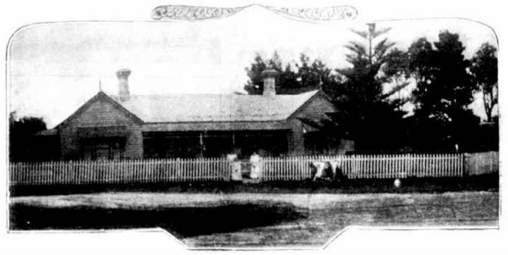
Figure 4.22: ‘Avondale’, Church Rd, Bellarine, 1894. Source:
Australasian, 10 November 1894, p.7.
My father has been growing potatoes for half a century
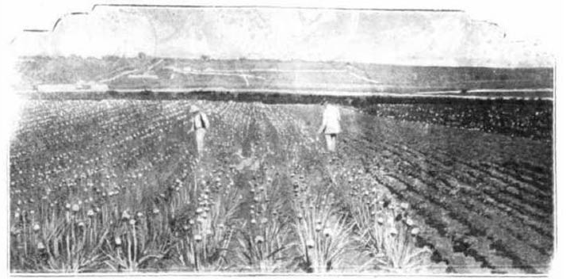
Figure 4.23: ‘Avondale’ seed farm, Church Rd, Bellarine, 1894. Source: Australasian, 10 November 1894, p.7.

on the same land, and this season one of the best crops in the district was on that ground. We begin ploughing either in summer or autumn, and the land must be frequently worked with a spring tooth cultivator or some other suitable implement, and kept free of weeds to conserve moisture and combat the pea mite, which can be controlled to a certain extent by thorough cultivation. Before ploughing a heavy dressing of stable manure is spread over the surface of the ground and turned under, and this adds considerable humus and plant food to
the soil. It is difficult, if not impossible, to get this class of manure in Geelong, and the majority of farmers are stabling their horses to ensure a supply. At planting time the land is ploughed again, and artificial fertilisers are sown in the furrows in which the seeds are placed. Of recent years a mixture of six parts of superphosphate to one part sulphate of ammonia has been used 113
H.A. Moller had taken up 20 acres of farmland at 61-81 Mollers Lane in 1913.114 It might have been about this time when the existing Edwardian timber dwelling was constructed. Moller was president of the Leopold and
Wallington District Fruit and Vegetable Growers’ Association when it held its first potato show at Leopold in 1930.115 He had increased the size of his property to 40 acres by 1931 when

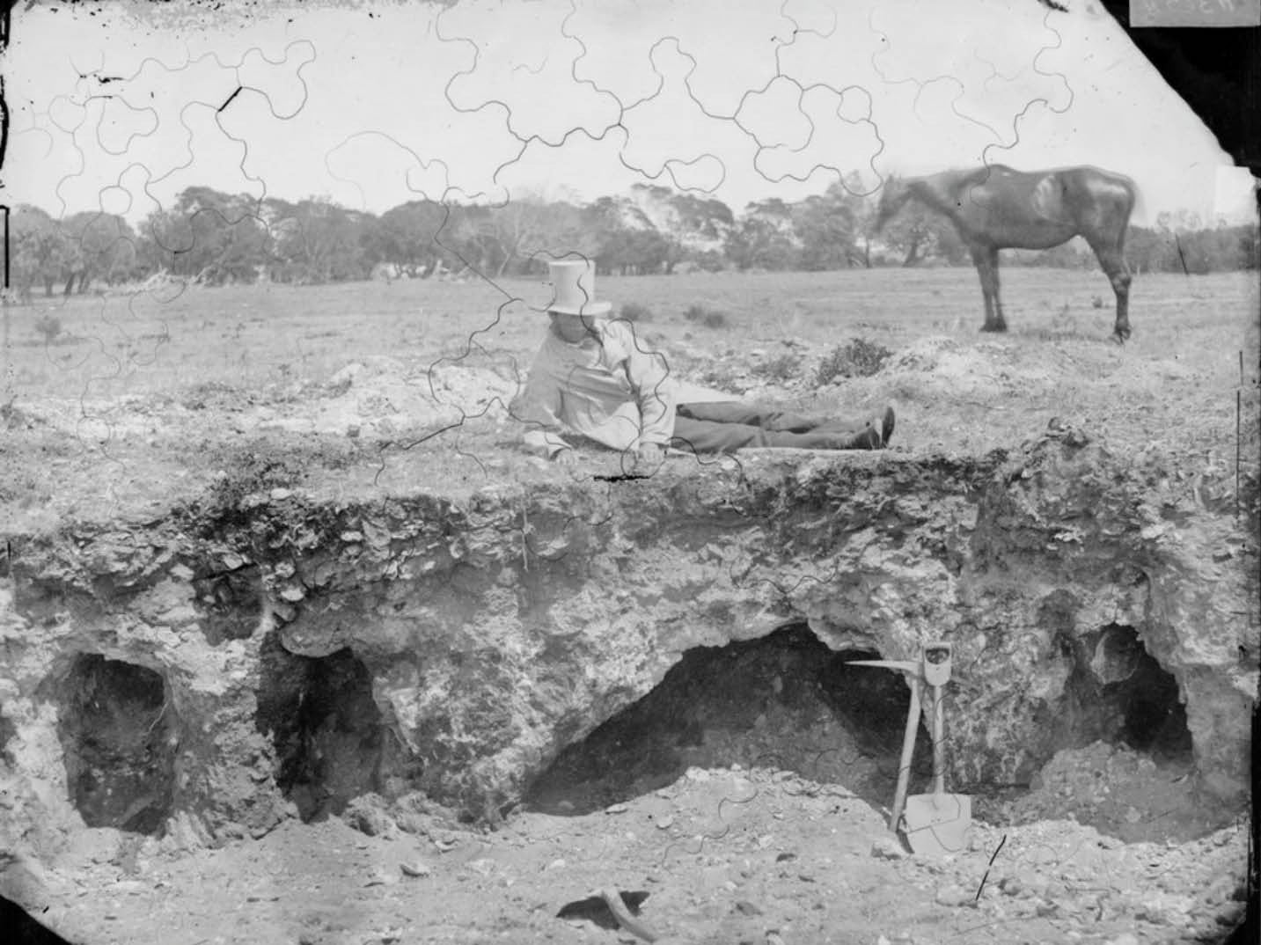

Figure 4.24: Detliv Julius Moller reclining beside his guano excavation, Bellarine Peninsula, 1861. Source: R. Daintree, accession H36571, State Library of Victoria.

he cultivated cabbages, cauliflowers, onions, lettuce, carrots, parsnips, melons, pumpkins, marrow and ‘the most popular salad plants in addition to potatoes.116 In 1936, Moller also grew French beans and maize117 (Figure 4.25).
The popularity and success of potato growing continued throughout the 20th century. In 1965, the Victorian Year Book declared that Victoria was the largest producer of potatoes
in Australia and that crops are grown in favoured localities where the risk of frost is not great, such as in the Bellarine Peninsula 118

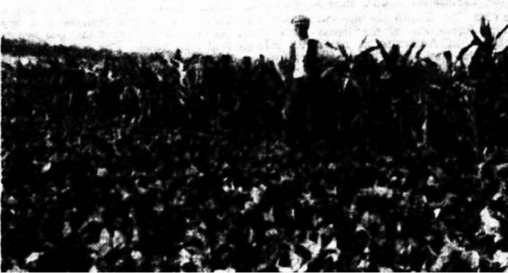
Figure 4.25: Herbert Andrew Moller tending his crop at Leopold, 1936. Source: Weekly Times, 28 March 1936, p.28.

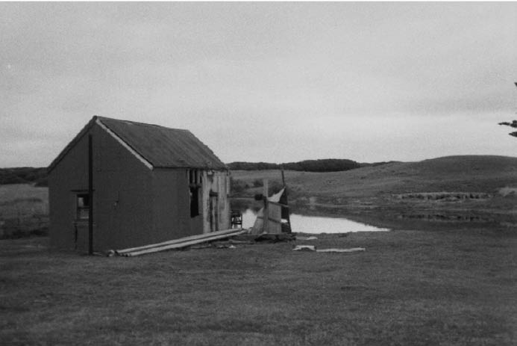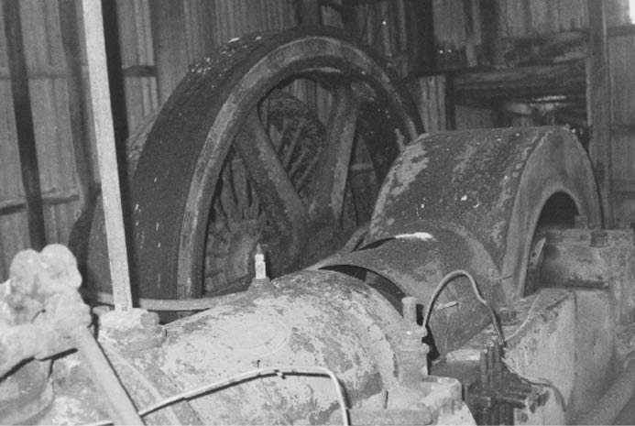

Figure 4.26: Asparagus Farm Pump House (now demolished), 1998. Source: David Rowe.
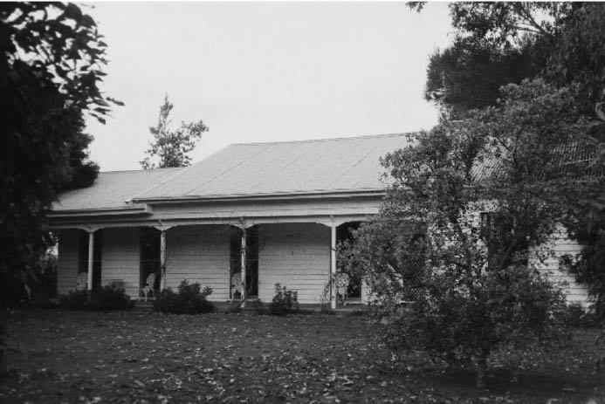

Figure 4.28: Asparagus Farm Manager’s House, 1998. Source: David Rowe.

ASPARAGUS FARM, BARWON HEADS
In 1910-11, Walter Higgins, bulb merchant, acquired
65 acres of land on the south side of the Barwon Heads Road at Barwon Heads from Edwin Collins, adding to his existing adjoining landholdings where he had established a bulb farm.119 The new-acquired land included part of the
Murtnaghurt Swamp.120 In 1919, Messrs. Higgins and Co. had commenced the cultivation of asparagus at Barwon Heads and it was also had this time when the firm’s bulb farm at Corio (North Shore) was transferred to the Barwon Heads site.121 In 1919, Higgins’ crop was the largest asparagus
farm in Australia, covering 30 acres and with 25 acres in full bearing.122 The Geelong Advertiser described the farming operation:
Hidden away on a side track [now Lings Road] from the main road to Barwon Heads, the asparagus growers are located. There are eight men employed, three of whom are returned soldiers. Rich sandy soil is said to be just
Figure 4.27: Alexander Shanks & Son Ltd Engine in pump house, 1998. Source: David Rowe.
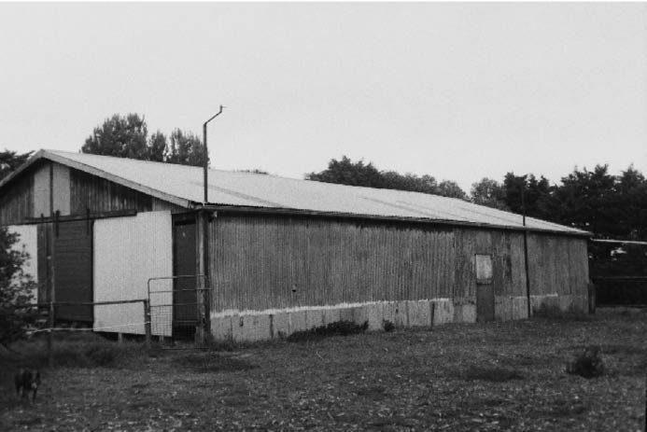

Figure 4.29: Asparagus Farm Stables, 1998. Source: David Rowe.

the thing for asparagus culture, and here it is ideal …The output of the farm at present is about 60 tons per year, and an average of two tons of asparagus is sent every week to a Melbourne canning firm. So prolific are the plants that they must be cut every day Sundays included. It seems incredible that so much could grow in one night. Each day seven men traverse the 25 acres, and cut the shoots, which are just showing above the ground. The latter are trimmed at once in the sheds nearby, and packed ready
to catch the afternoon coach to Geelong, and thence sent by rail to Melbourne. It is contended that the asparagus sweats and loses much of its goodness by the journey, and that canning adjacent to the area of production would make for a better product.123
It was about 1919 when a pump house (Figure 4.26) was constructed and an Alexander Shanks & Son Ltd. engine installed (Figure 4.27) to pump water from the Murtnaghurt Swamp through the grid of hundreds of underground concrete

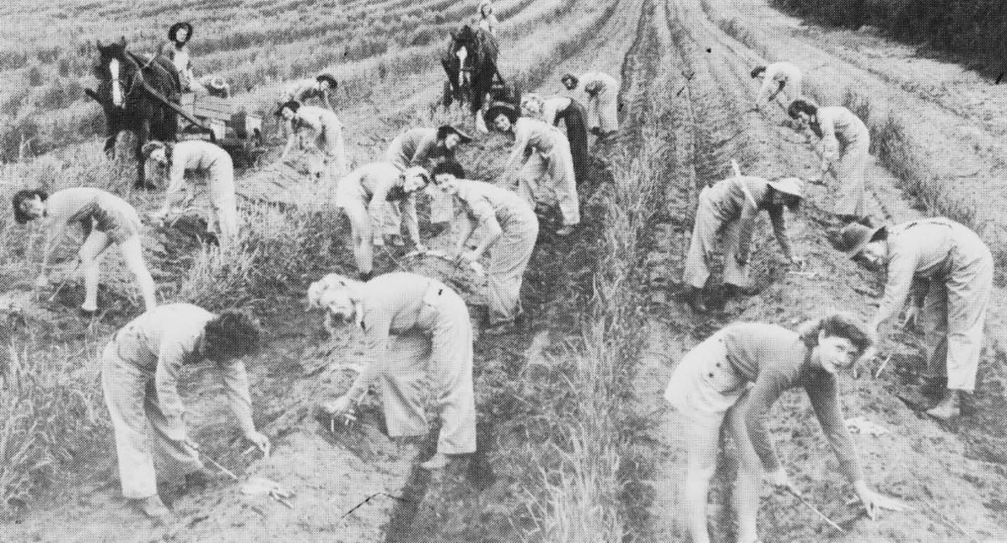

Figure 4.30: Women’s Land Army workers at the asparagus farm, 1939. Source: J. Pescott, South Barwon 1857-1985, p.137.

pipes that had been installed to water the asparagus.124 A manager s house and outbuildings were also constructed at this time (but later altered)125 (Figures 4.28-29).
In late 1922 or early 1923, Higgins’ asparagus farm (then comprised 220 acres) was sold for £7600 to A.M. Robinson, acting for the Australasian Jam Company in Melbourne.126 The Geelong Advertiser reported that the farm had been sold to the Geelong and Western District
Preserving Company.127 Both companies appear to have been associated with of Henry Jones (IXL) Co-operative Ltd as part of a confederation of companies.128 The property had been managed by Neilson and Neilson of Geelong and in 1922-23, George and Walter Foster, asparagus farmer, were appointed managers.129
The property was later acquired by P.J. Ling (from whom Lings Road is named) and with labor shortages during World War 2, the Women’s Land Army was called in to cultivate the asparagus130 (Figure 4.30). In the early 1970s, asparagus farming was replaced with cattle grazing until the farm was sold in 1999 to a joint venture to establish the 13th Beach Golf Links and Resort.131 Today, the former manager’s house and stables remain at 95 Lings Road, while the pump wheel of the former Alexander Shanks and Son engine forms a landscape feature beside the 5th green of the beach course.

MIXED FARMING - DAIRYING
A number of farming establishments in the Greater Geelong region from the 19th century also mixed dairying with different forms of cultivation. A smaller number survives to the current day.

‘ROSEDALE’/’LINCOLN’S FARM’, PORTARLINGTON
One of the more notable was ‘Rosedale’, 1-65 Point Richards Road, Portarlington, acquired by Edwin Collins in 1862 from Joseph Birkett, the first Crown purchaser in 1849 who had established ‘one of, it not the best and most productive farms in the whole of the Bellarine district as well as a dwelling house and all necessary outbuildings. 132 In 1864-65, Collins had extended the double-gabled four-roomed dwelling with the construction of a zinc-roofed dairy that consisted of
a submerged white-washed stone coolroom with a gabled loft above.133 There, he commenced the manufacture of cheese, winning second prize for his ‘Five Cwt Cheese’ in the Autumn Exhibition of the Port Phillip Farmer’s Society in 1865.134 In 1866, Collins won first prize by the Board of Agriculture for his salted butter that had successfully made the return voyage to England.135 In 1872, the Geelong Advertiser gave a detailed account of Collins enterprise:

Alterations and additions to his previously large dairy establishment, have been made during the past few months, by Mr Collins, Bellarine, whose Cheddar cheeses are so sought after in this and the Melbourne markets, that he is able to command his own price, and although he anticipates making ten tons this season, he has already received orders for nearly every pound of it. Mr Collins success shows what may be done by careful dairy farming. A very few years ago, colonial cheese,
like colonial ales, and wines, was not appreciated, and Mr Collins had some difficulty in making his article
well-known, and to be known, knew would cause it to be appreciated. In those days our colonial cheesemakers either did not know how to make cheese, or they had not the pasturage adapted for the business, and it was not until Mr Cooper of Turkeith, Mr Coulson of Ondit, and Mr Collins of Bellarine, the two former with Stilton and Mr Collins with Cheddar cheese began to send their goods to market that the use of the imported article commenced to decrease in favor and give way to the produce of our own makers. Whatever others may have done since, there is not much doubt about it that the pioneers of good cheese- making in this district were the three persons mentioned, and their doings are always therefore watched with interest. The season for cheesemaking has just opened, and that, owing to the cold wet weather, very unfavorably as from cows fed on cold wet grass the milk could not possibly be so rich as would otherwise be the case. Still Mr Collins looks forward to a very successful season,
he having made a large quantity of English grass hay on which the cows taken from the pasturage thrive amazingly. His place, as already reported, has been sown with English grass, and that portion reserved for the grazing
of his cattle is about 200 acres in extent. From the cows so fed he anticipates, this season, making at least £1000 worth of cheese, or at the rate of £5 to the acre.136
In 1875, the Illustrated Sydney News and News South Wales Agriculturalist and Grazier described Collins
‘Rose Hill’ Farm:
On the 335 acres 1200 head of cattle, young and old, are kept, and the luxuriance of the pasture shows that the farm is not overstocked. The dairy cows in milk at one time run from about 25 to 50 head, the usual number being about 40. The subdivision of the farm, by permitting the fields, time about, to be rested and seeded, contributes along with the system of fertilising adopted, to keep the large quantity of stock always in abundance of pasture.
In a large yard opening from the milking shed hundreds of loads of sea-shells are carted from the beach throughout the year, and deposited and spread. This serves the two fold purpose of keeping the yard clean, and by absorbing

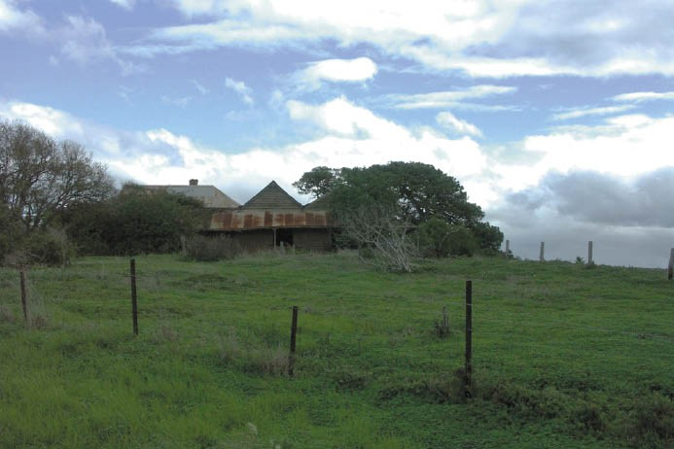
Figure 4.31: Lincoln’s Farm, Portarlington, 2007. Source: David Rowe.
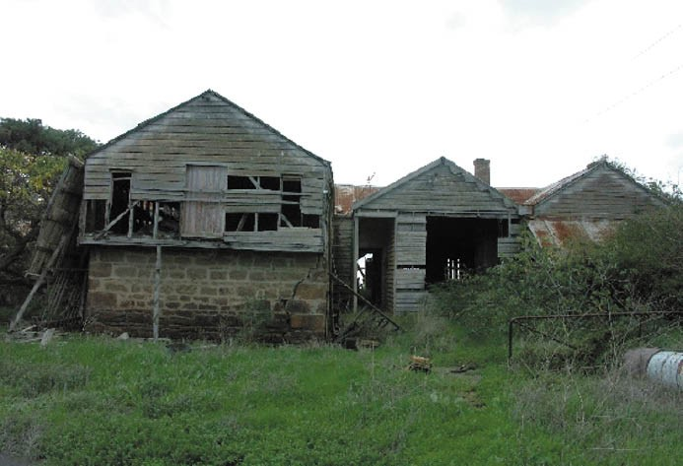
Figure 4.32: Dairy, Lincoln’s Farm, Portarlington, 2007. Source: David Rowe.
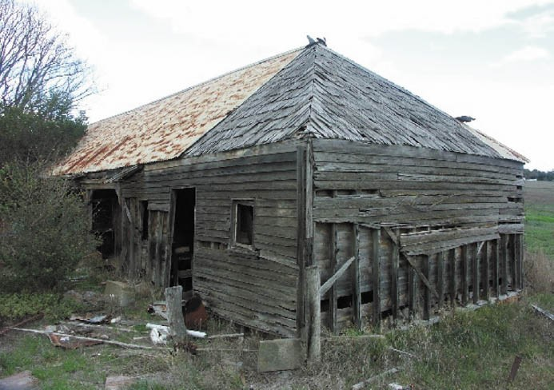
Figure 4.33: ‘Main Shed, Lincoln’s Farm, Portarlington, 2007. Source: David Rowe.

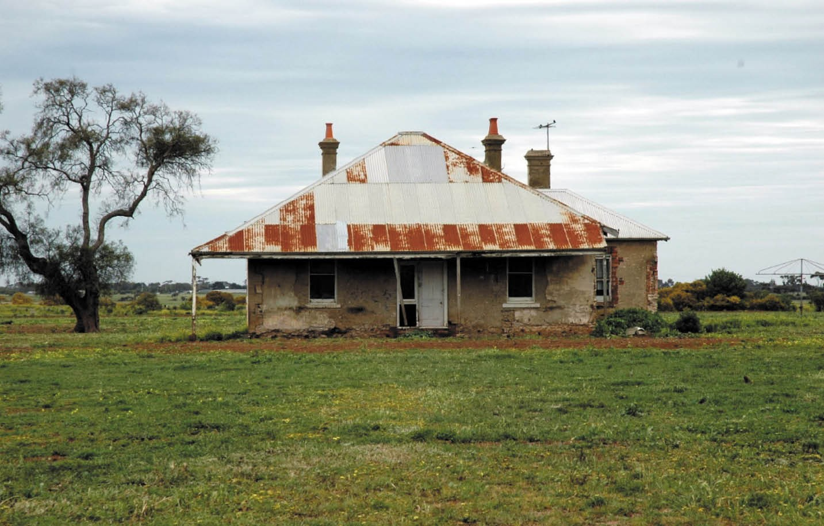
Figure 4.34: ‘Clover Hill’, Forest Road South, Lara, 2012. Source: Wendy Jacobs.

all the liquid and solid manurial matter from the herd adds to the value of the sea-shell, which, of itself, is found to be a most valuable fertiliser for the class of soil of which the farm consists, viz., strong black loam. From the yard the fields are systematically top-dressed with this compost, beginning with one paddock and going round till all
have received a turn, the more clayey patches receiving the thickest coat. The influence of this fertiliser is most marked in its effects on the thickness of the pasture, and that the grass is also sweetened is shown by the fondness of the cows for the top-dressed portion of an unfinished field. Mr. Collins’s out-buildings, including milking-house, cheese-house, and milking sheds are notable for their handiness and cleanliness, but cow-sheds for winter stabling are not used The cows are fed in the winter with oaten hay, and in the summer with green maize, liberal supplies of which are raised on the farm and always kept on hand.137
Collins sold the farm in 1876 and it was later named Lincoln s Farm’ after William Lincoln, owner in the later 19th century.138 Today, only part of the dairy remains in a parlous and neglected state (Figures 4.31-33).

OTHER DAIRY FARMS
At Lara and Leopold are other surviving dairy farms. In c.1866, Irish emigrant, William McClelland, took up ownership of 350 acres of Bates’ land holdings at 155 Forest Road, Lara.139 There commenced a long-standing and successful farm that was continued on by two of his sons in later years.140 In the early days, McClelland ran a dairy farm on the property.141 The farm later included stud stock with a Clydesdale horse stud established by William and later carried on for many years by his sons.
In 1916, The Leader newspaper reported that McClelland had earned a reputation for the breeding of high-class Clydesdales. 142 A jersey cow stud was also established by McClelland’s sons, Abraham and Robert McClelland, and it continued until the 1950s. The Clover Hill farm house (Figure 4.34), built of limestone, was gutted by fire in
1926 and rebuilt.143
Only stone ruins exist of another early dairy at Lara, it being ‘Blairgowrie’, 25 Blairs Road, the former property James and Grace Blair from 1868144 (Figure 4.35). The dairy farm was operated by Mrs. Blair,145 with Mr. Blair serving as the Secretary of the Corio Road Board (later the Corio Shire

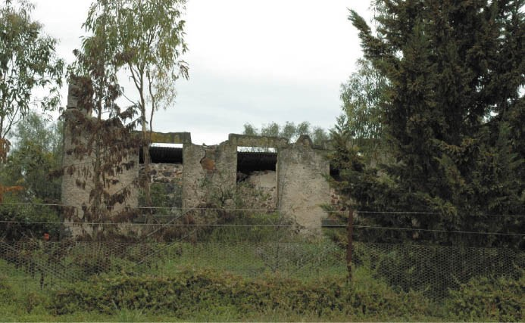
Figure 4.35: ‘Blairgowrie’ ruins, 25 Blairs Road, Lara, 2012. Source: Wendy Jacobs.

Council) for forty years from 1862 until 1902 (see Theme 7).
At 2 Harriott Road, Armstrong Creek (previously 105-205 Groves Road, Connewarre) are the ruins of the former dairy farm of John Bogan (Figures 4.36-37). The land had been first acquired by Alfred Firmin in 1855, but as he resided in the Barrabool Hills, it was not until c.1862- 63 when a small farm complex appears to have been constructed for Bogan at Connewarre.146 Bogan was the landlord of the Breakwater Hotel operated by Michael Murnane in 1855 (and who was
to become Bogan s father in law).147 At Connewarre, Bogan ran his dairy farm and conducted a milk delivery service around Geelong.148 In 1895-96, the farm had been expanded to 170 acres and it was jointly owned by John and his brother, Michael Bogan.149 The property was leased to William Kee from 1904150 but by the early 1940s, it was again occupied
by descendants of John and Michael Bogan.151 The ruinous farm cottage at Bogan s former dairy farm was demolished in recent years and the surviving chimney and underground tank are proposed for removal in 2019 to make way for a residential subdivision.
At 40 Ashgarth Avenue, Leopold, the surviving Victorian vernacular dwelling and farm buildings erected in 1866 and 1870 reflect the farm dairy first established by William
Brinsmead (1815-1905)152 (Figure 4.38). Peas, potatoes and other vegetables were later cultivated on the farm and pigs grazed, with second prize being awarded to the Brinsmead brothers for their sow not over 12 months at the spring show of the Geelong and Western District Agricultural and Pastoral Society.153 William Brinsmead was born into farming at St.
Giles in the Wood, England. He married his cousin, Ann Brinsmead, in 1839, possibly at the Methodist Chapel on Ann s father s farm next to the farmhouse.154 After farming in the village of Alwington, they emigrated to Port Phillip via Adelaide in 1850 with their children: Thomas Ireland (born 1841), Mary Ann (born 1844) and William (born 1847).155 Settling at Leopold, they named their property, ‘Allens Week
Farm’, after the family farm in St. Giles in the Wood.156 At ‘Chevy’, Fenwick Street, Wallington, David Rhind,
experimental farm cultivator, stockbreeder and dairy farmer157 established an extensive model farm which included a dairy herd. Originally part of Fairfax Fenwick’s Chevy Estate (Theme 6), including his homestead built in c.1853,158 Rhind had purchased his 3000 acre property in 1886, following
the death of the then owner and first Town Surveyor of the Geelong Council William Weekes (see Figure 7).159 The land included leased dwellings, vineyards and other farming properties between Lake Connewarre and Curlewis as well as Wallington.160 Rhind appears to have made changes to the original homestead with the construction of substantial Victorian Italianate styled additions (Figure 4.39).
In 1906, the Geelong Advertiser gave a detailed account of Rhind’s farm. It was considered to be ‘one of the best known properties around Geelong with its location on the
hills overlooking the lakes .161 Over 200 acres were devoted to cultivation, including wheat (where the Department of Agriculture had trialled formalin pickled wheat without success), peas, beets, broad beans, rye, rape, barley and flax, the latter Rhind believed had the potential to be profitable.162 He also stocked pigs and cows, as well as Hong Kong geese (bred in New Zealand) and Minorca and White Leghorn fowls which gave good egg returns. 163 Of his dairy farm, the Geelong
Advertiser stated:
The dairy herd at Chevy numbers between 40 and 50 cows, chiefly Ayreshires, and mostly bred by Mr. Rhind, who has to cull extensively in getting his herd together. Bulls are also bred for the market and command top prices. The stock with few exceptions has been dehorned, and in that condition there is less chance of the animals inflicting bodily injury on one another. While deeming it advisable to treat dairy herds in that manner, Mr. Rhind believes in following a humanitarian course, and the operation is preformed when the stock are small calved and the horns just the size of a button.164
A legacy of ‘Chevy’ today is the homestead in Fenwick Street, Wallington.
‘Springfield’ at 532-560 Bellarine Highway, Leopold (Figures 4.40-41), is one of the few remaining dairy farms still functioning, albeit primarily for sheep grazing. The property was first acquired in c.1857 for dairy farming and sheep grazing by Michael O’Halloran of County Clare, Ireland on land previously occupied by Misses Newcomb and Drysdale’s Lap Lap out-station and later John Cumming, founder of Geelong s Volum brewery.165 O Halloran arrived in Geelong
in 1850 and was first employed by the Anderson family in the Barrabool Hills. He then went to the Ballarat goldfields

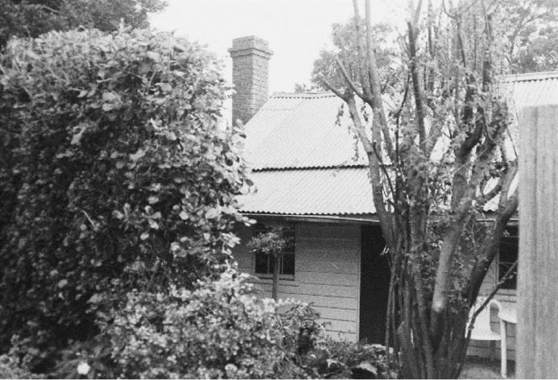
Figure 4.36: Cottage, Bogan’s Farm, Armstrong Creek, 1998 (now demolished). Source: David Rowe

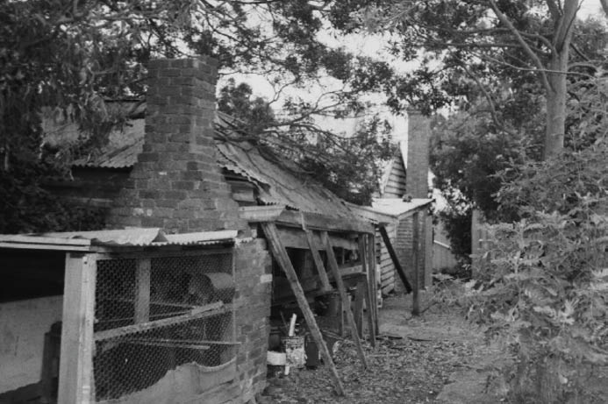
and to Sydney (where he married Margaret Kenovan in

Figure 4.37: Rear Cottage, Bogan’s Farm, Armstrong Creek, 1998 (now demolished). Source: David Rowe.

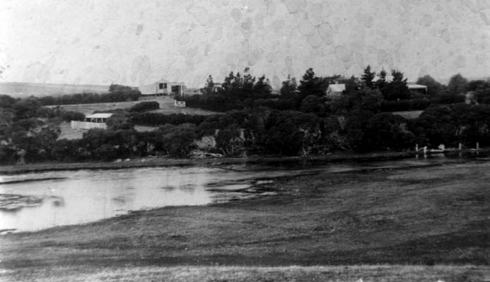
Figure 4.38: ‘Allens Week’ Farm, Ashgate Ave, Leopold, n.d. Source: Image 1792, Bellarine Historical Society.

1853)166 before returning to Geelong where he leased the London Hotel in Moorabool Street and subsequently the Red Lion Hotel.167 First known as ‘Springfield Avenue’ farm,
O Halloran introduced the latest principles of agriculture and dairying. 168 He gave up dairy farming in 1874.169 O Halloran s sons, William, Stephen and Denis took over the management of the farm in 1884.170 Denis O Halloran (c.1856-1937) married Sarah Larkins in c.1890 but their marriage was brief as
Sarah died in 1894.171 He then married Mary Ann Fitzgerald in 1897,172 the same year the existing Late Victorian timber dwelling was erected to a design by the Geelong architects, Laird and Barlow.173 Denis O Halloran revived the dairy farm at ‘Springfield’. On his death in 1937, The Age reported that:
Mr. O’Halloran was for 39 years a member or the Bellarine shire council, and at the time of his death was a representative of the Moolap riding. He was four times president. For some years he was associated with the Geelong Agricultural Society, and was connected with the
Leopold Progress Association and Leopold hall committee since their inception.174
In addition to the homestead, a number of early farm outbuildings remain on the property.

SPARROVALE FARM
With the relocation of the Geelong Racecourse from its first site near the Barwon River at Marshall in 1891 - and the creation of the Geelong Harbor Trust in 1905 - this land, together with the Connewarre Farmers’ Common was
endowed to the Trust.175 The low-lying, salt-ridden flats were proposed to be reclaimed in order to increase their capital value, operate a farm from it and thus generate an income to offset the vagaries of port revenue.176 The land was cleared, fenced and the salt leached from the soil by surface and underground drainage and irrigation.177 The Geelong Harbor Trust named the farm ‘Sparrovale’, after Mr. E.R. Sparrow, the well-known auctioneer and secretary of the Geelong Racing Club.178 In 1907, William Baird was appointed manager of the farm ‘on the share system’, his appointment being influenced by his previous experience and success in such general farm practice. 179 Baird had been the inaugural chairman of the Wallace Millbrook and District Butter Factory and Creamery Company at Wallace from 1893, a neighbouring settlement
to his dairy farm at Bungaree.180 He resigned as chairman in 1903 and relocated to Moe where he continued dairy farming before moving to Sparrovale
in 1907.181
The design and construction of Sparrovale Farm was carried out under the direction of A. C. MacKenzie, engineer of the Geelong Harbor Trust.182 Open channels and agricultural drains were first constructed and maize crops planted (Figures 4.42-43).

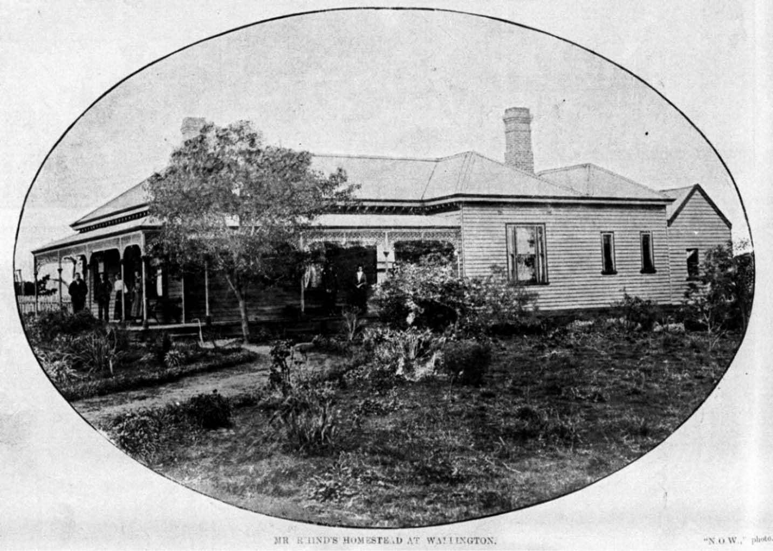

Figure 4.39: Chevy Homestead, (date unknown) [c.1918]. Source: News of the Week in the Bellarine Shire collection, sheet 08 image n33, Bellarine Historical Society.
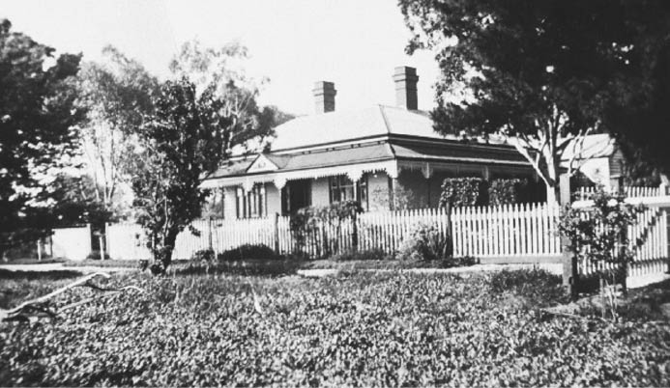
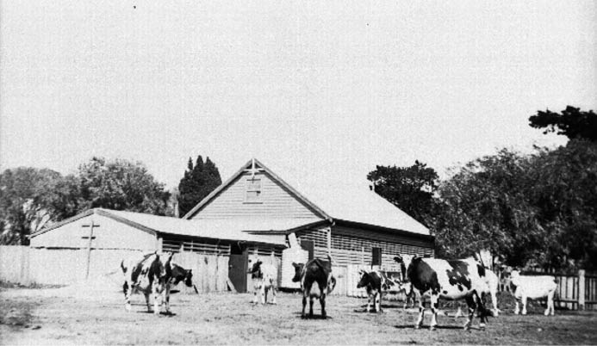

Figure 4.40: ‘Springfield’, Moolap, c.1922. Source: Image 796, Bellarine Shire Collection, Bellarine Historical Society.
Figure 4.41: ‘Springfield’ dairy, Moolap, c.1922. Source: image 801, Bellarine Shire Collection, Bellarine Historical Society.

By 1908 the Sparrovale Homestead site had been laid out (Figure 4.44). Situated on higher ground, a Federation styled manager’s residence had been built in timber (Figure 4.46) and a flower garden and shrubbery laid out. Behind it to the east was the main working area of the farm including the workmen’s quarters. was described by J.S. McFadzean, Dairy Supervisor, in August 1908:
These comprise a large weatherboard building containing kitchen, dining-room, two dormitories, and two bath- rooms, all lofty, well lighted and
neatly fitted.183
Other infrastructure situated in the working area included stables (Figure 4.47), machine shed, carpenter’s shop, engine shed, blacksmith’s shop, laundry, foreman’s room, boiler and creaming, engine house, two large concrete silos (built on the Monier system) (Figure 4.45), hay shed, milking shed and row of pigsties, together with neatly laid out hay and straw stack yards, bull yards, and sow yard. The main entrance gates were to the south of the manager’s residence, separating
the main working area from the poultry yard, holding yards and horse paddocks. To the west, an acre of ground had been reserved for a future nursery to be managed by a practical gardener and forester. 184 Calf sheds were also built (designed by a Mr. G. Harmer, Government Dairy Supervisor for the Geelong district) with two exercise yards.185
McFadzean also gave a detailed description of the dairy buildings:
The first of these is a two-storied brick building, the lower portion of which is to be fitted as a refrigerating-room.
Upstairs is the milk testing room, which it is intended to furnish with every convenience requisite for the work – Mr. Baird being a very firm believer in the benefits to being derived from systematic testing of the yields. In the next building to this the separating, cooling, and general dairy work is done; and a pully-hoist is at the door for loading and unloading the milk. Next to this is the boiler-house, and a temporary steaming-room with vats for scalding feed as required for any of the stock.186
The extensive dairying operations at the height of Sparrovale’s production in the first decades of the
20th century saw milk transported to Melbourne by passenger train.187 A tramway line ran directly from the middle of the dairy shed with the milk cans transported by rail truck to the Marshall Railway Station, whereby it was loaded onto the passenger train.188 Because Sparrovale was also under the constant threat of flooding due its low-lying location near
the Barwon River, and after damaging inundations in 1909 and 1911, the Trust decided to protect the property by a levee bank almost three miles long in January, 1912.189 Work carried on throughout 1913 and 1914 with a sufficient height

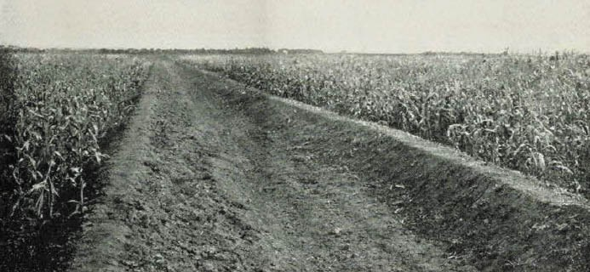

Figure 4.42: ‘Sparrovale’, irrigation pumping plant & farm ferry, c.1908. Source: Journal of Agriculture, Victoria, 10 August 1908, p.499.
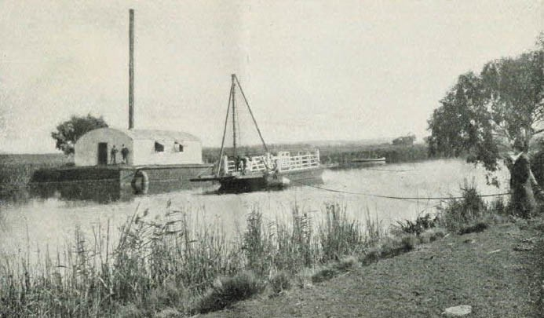

Figure 4.43: ‘Sparrovale’, maize crop, c.1908. Source: Journal of Agriculture, Victoria, 10 August 1908, p.499.

being established to prevent ordinary flooding (but fell short of an optimum height to stop abnormal flows).190 With the retirement of William Baird in 1927, Sparrovale was leased until 1934 when it was sold as a private property.191
By the 1930s, the then owner, Stradbroke Fowler, changed his farm into dairying.192 On a visit from his friend, the Anglican Vicar of Barwon Heads, the Rev. D.D. Carruthers, the surplus woolshed was purchased by All Saints Anglican Church and relocated to Hitchcock Avenue, Barwon Heads and it opened as a church in 1937 (see Theme 8).193 Today, the former manager’s house, stables, milking shed, boiler and creamery, and ruins of the silos bases are the main fabric that remains of the Geelong Harbor Trust s Sparrovale farm venture.

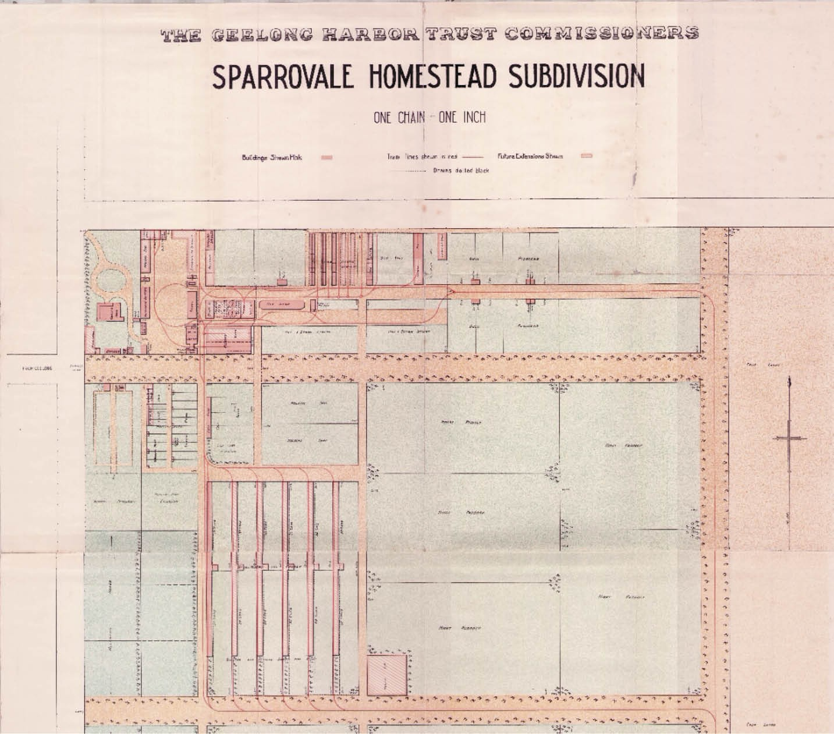

Figure 4.44: Part of the Sparrovale Homestead Subdivision, The Geelong Harbor Trust Commissioners, c.1908. Source: Karen Ware, Stawell.

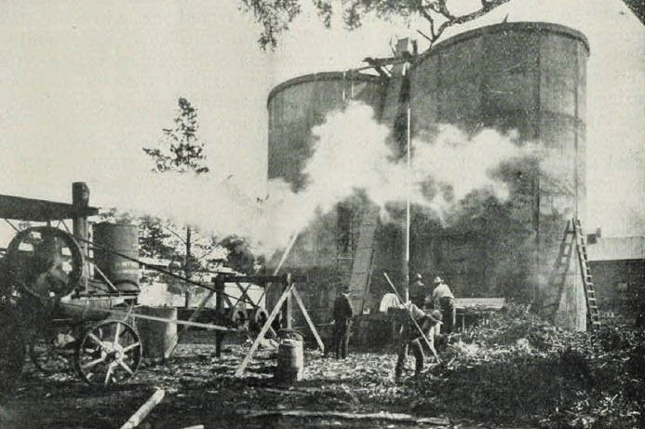

Figure 4.45: ‘Sparrovale’, concrete silos, c.1908. Source: Journal of Agriculture, Victoria, 10 August 1908, p.501.

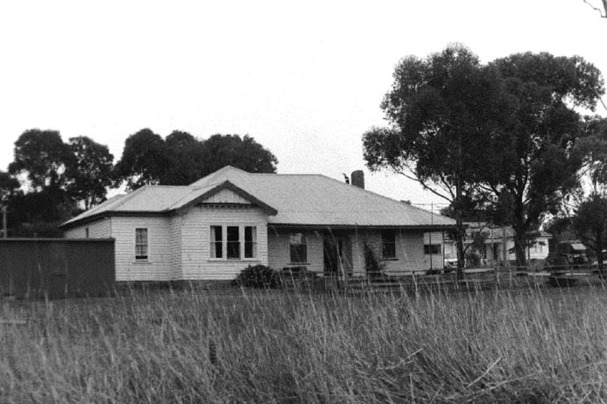
Figure 4.46: ‘Sparrovale’ Manager’s House, 1998. Source: David Rowe.

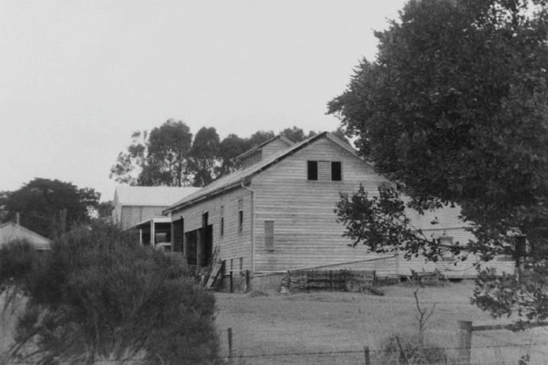
Figure 4.47: ‘Sparrovale’ Stables, 1998. Source: David Rowe.

DRY STONE WALLS
Important functional elements that also became landscape features in rural parts of Greater Geelong was the construction dry stone walls. They were especially prevalent at Anakie, Avalon, Balliang, Batesford, Ceres, Fyansford, Lara, Little River, Lovely Banks, Staughton Vale and Sutherlands Creek where stony ground proliferated. These stone walls were highly valued as a reliable and enduring barrier for the containment of livestock and gardens. This was intimated in several sale notices for properties from the 1850s. In Newtown, for example, a property next door to Sladen House at 410 Pakington Street was offered for sale
in 1867, the ‘desirable family residence’ being ‘delightfully situated on the banks of the Barwon’ with the ‘finest agricultural land, enclosed on both sides with stone walls’.194
In rural parts of Greater Geelong, the walls reflected British farming practices in providing fencing between paddocks and enclosing farm stations. Some of the earliest were constructed in the mid-19th century for the substantial pastoral and viticultural operations. In 1859 for example, a ‘valuable farm on the Moorabool River’ adjoining the estate of George Hope (known today as ‘Darriwill’) was offered sale, the whole 20 acres being enclosed with stone walls.195 The large scale of Frederick Armytage’s ‘Wooloomanata’ station
meant that stone fencing continued to be erected over several years, with some walling built in 1867, seven years after the completion of the homestead.196 Also in 1867 at Fyansford’, Batson’s vineyard was offered for sale, the ‘very desirable vineyard property being described as comprising 20 acres really superior land, well fenced with stone wall.’197 In 1868, the large sheep grazing property, ‘Marathon’ at Anakie, boasted 13 paddocks subdivided by substantial stone walls and post-and-rail fencing. 198 Similarly, dry stone walls
were erected at Elcho Homestead, Lovely Banks.199 At the ‘Paradise Vineyard’, Batesford, 1000 feet of dry stone wall was built in 1872 with stone near at hand. 200 Other dry stone walls came in subsequent years, including walls at Barrabool and Waurn Ponds in 1899 for the Barrabool Shire Council.201
The continued construction of dry stone walls in rural parts of Greater Geelong throughout the second half of the
19th century was due in part for the need for rebuilding them following the damaging impacts caused by rabbits after their introduction at Winchelsea by Thomas Austin in 1859 (see Theme 1). This was highlighted in an article by
a correspondent of Little River in the Geelong Advertiser in 1880:

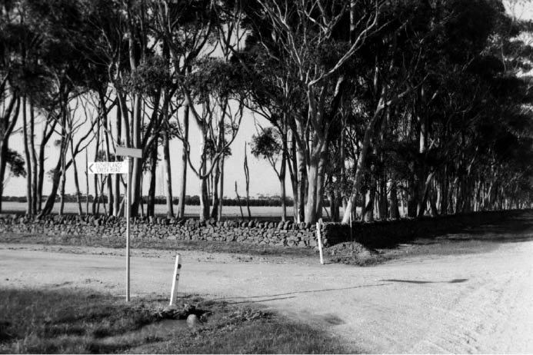
Figure 4.48: Dry stone walls, 380 Robbs Road, Sutherlands Creek, 1998. Source: David Rowe.

Quite a new grievance, a sort of con-comitancy with the rabbit plague, has recently sprung up in this locality. The nature of the country here being inclined to be stony,
the whole of our fences, with but few exceptions, are built with stone wall. As is generally the rule when the land is stony, the soil is always too strong and clayey for burrowing, and consequently the rabbits are forced to take refuge in the only hiding places on the plains
stone walls. Accompanied with a pack of half-bred greyhounds and other mongrels, the larrikin element of our population inveterate rabbit hunters are not slow in discovering the whereabouts of a bunny in the first wall they come to. Down comes the wall instanter, the booty is secured, the hunt re-commenced, and so on, until the required number of rabbits is secured, the young vandals, however, always conveniently forgetting to replace the stones removed, The destruction that is now going on
is something scandalous, chains of fencing in some instances, particularly at Bulban and Mouyoung, requiring to be re-built.202
Further dry stone walls were erected following closer settlement subdivisions in the early 20th century.
They included those as part of the Lara Estate in 1907 and the Staughton Vale Estate in 1908 (see Theme 2).203
Today, surviving dry stone walls are a physical legacy of a lost farming practice. They include those in parts of Anakie (outside 1215 Geelong-Ballan Road and at 220 Hams Lane), Lara, Lovely Banks (Geelong-Bacchus Marsh Road opposite the prisons), Little River and Sutherlands Creek (380 and 555 Robbs Road and adjacent to the Sutherlands Creek Cemetery) (Figure 4.48).

HAYSTACKING
Ubiquitous throughout the rural parts of the Greater Geelong region in the 19th and early 20th centuries were haystacks (Figure 4.49). These transient structures dotted the farming landscape until needed to feed stock. In 1857, the Barrabool Parish produced 4,949 tons of oaten hay, the largest volume in the district.204 It was followed by the Moolap Parish with 1,100 tons and the Moorpanyal Parish with 1,069 tons.205 By 1899, the Barrabool Shire produced 3,331 acres of wheaten hay and 4,969 acres of oaten hay.206 By comparison, the Bellarine Shire produced 1,711 acres of wheaten hay and 7,357 acres of oaten hay. Initially, the cutting, mowing, loading and stacking of hay was laborious.207 In 1859, the Geelong Advertiser reported that the demand for agricultural labor continues unabated. 208 The process of haystacking was outlined in detail in the Geelong Advertiser in 1917:
As the builder is building his walls and patting them back into position, he should allow a little swell, so that the walls are inclined outward slightly. All loose hay should be removed from the top of the stack as building proceeds. It is a nuisance, if left there, when taking the stack down for chaffing, and it will very likely cause the sheaves to slip whilst bunding. Loose hay should similarly be got rid of from the top of the waggon load as unloading proceeds.
This loose hay is best put in a cock by the chaffcutter, to be chopped and fed to the horses at the first opportunity, thus getting rid of the nuisance and making full use of
it with minimum loss. Great care must be taken of the two outside rows of sheaves during building; if they are interfered with they will slip; the pitcher must throw the sheaves further in toward the centre than these two
rows, and must not let his fork touch them as he pitches. The receiver also must stand well in toward the centre. It is well for the pitcher not to continually drop his sheaves in the one spot, nor for the receiver to constantly stand in the one place, as this is apt to cause unequal settlement when the stack sinks down, and this may ruin the pitch of the roof and cause a leak. It is wise where it is possible to let the loads come in on alternate sides of the stack in order to avoid this evil. When the stack gets too high for the pitcher to throw the sheaves in further than the first two rows, it is best to rig a stage on to which he can throw the sheaves and from which the receiver can pitch them
well on to the top of the stack. A day or two after the stack has been finished, all loose hay should be raked off. This not only gives the stack a better appearance, but it gives
a freer run for the water to drain off the roof. Always allow plenty of hay to complete the roof; it is disastrous to run short and have to build the roof too flat. As the stack should remain undisturbed for several weeks before being opened for chaffing, it is well to build a butt of hay near the

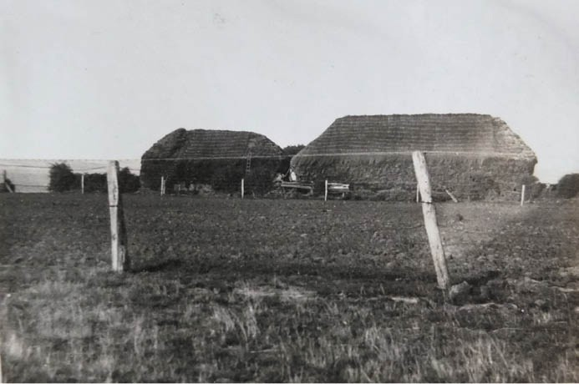
Figure 4.49: Haystacks, Connewarre, 1931. Source: T.T. Holmes collection, Authentic Heritage Services.

cutter to supply the horses for these few weeks, and as it is of small moment whether this butt contains three weeks or three months’ supply, it is wise to err on the safe side, and start the roof while ample hay is left, putting all that is left over into the butt. With a stack of ordinary shape, from a quarter to one-third of the total hay in the stack is in the roof.209
The building of hay stacks was also potentially dangerous given the scale and weight of the stacks. One instance of injury to a haystacker was reported in 1896:
Upon reliable information, I have to report that a serious accident, which might have terminated fatally, happened to a well-known farmer of Bellarine. He was engaged thatching a large haystack near the above post office some 50 feet high, when he was seized with a fit of dizziness. A bystander had the presence of mind to seize a fork and stick it in the stack, thereby breaking his fall, otherwise the consequences would have been more serious. As it is, he is now recovering.210
The skills required to building hay stacks led to farmers’ associations and particularly the Geelong Agricultural and Pastoral Society to hold hay stacking competitions. In 1923, for example, the Society held a competition that was opened to all farmers within a radius of 20 miles from the Geelong Post Office.211 Prizes were awarded and the competition conditions were:
- stack to contain not less than 40 tons; (2) to be the product of 1923 harvest; (3) each competitor is allowed to nominate one only; and (4) the name of the builder is to be supplied with entry.212
Technological developments brought an end to the 19th and early 20th century building of haystacks. In 1937, for example, Messrs. F.W. Parris and Sons in Nagambie worked

their ‘unique’ method of baling hay by pulling their hay baling machine into a paddock. It moved along the rows or to conveniently placed heaps with a minimum of time and effort. 213 Similar machines were soon to be used within Greater Geelong.

VINEYARDS, ORCHARDS & NURSERIES VINEYARDS OF GREATER GEELONG:
AN OVERVIEW
The planting of the first vineyard in Victoria in 1842 by David Louis Pettavel and Frederic Breguet at ‘Neuchatel’,
Pollocksford (in the Surf Coast Shire) began a transformation of the Barrabool Hills district into established vineyards, orchards and other produce, largely by Swiss and German immigrants (see Theme 2).214 By 1857, the Parishes of Barrabool and Duneed cultivated the largest quantity of vines in Victoria, with Barrabool producing 7,400 gallons of wine, and Duneed 2,800 gallons.215 The success of the German and Swiss vignerons was noted in a report in 1857 by John Elkington, Statistical Collector for the counties of Grant and Polwarth:
That the grape culture has hitherto formed a very profitable item of investment there can be no doubt, as notwithstanding the outlay of capital and length of time where the grower can look for a return in the shape of the first fruits of his labor, and as a period of four years usually passes after first planting the vine before any profit can
be derived from it, it is remarkable that so few complaints are heard as to the general results of these investments, but it is worthy of notice at the same time to bear in mind that the majority of the vine growers are skilful, steady, and industrious men, chiefly natives of Germany and Switzerland, who display great economy in their system of cultivation and are frugal in domestic concerns; but unlike many of our colonists who are oftentimes impatient in their undertakings and eager for rapid gains; these German
and Swiss cultivators possess a large share of patient endurance, which leads them cheerfully through their toil and pursuit, till arriving at something like independence in circumstances, and enabling them to live in comparative ease and comfort.216
In addition to vines, most of the vignerons grew orchards.
In 1857, 170,500 lbs of fruit were sold from vineyards and orchards in the Parish of Barrabool, compared to 78,000 lbs in the Parish of Duneed, 21,500 lbs in the Parish of Moorpanyal and 20,000 lbs in the Parish of Bellarine.217 The locations
and names of the vineyards established in the Barrabool Parish featured in a coloured map by Andrew McWilliams (Figure 4.50). By 1878, there were 74 vineyards in these areas, ranging from those that boasted healthy crops, to

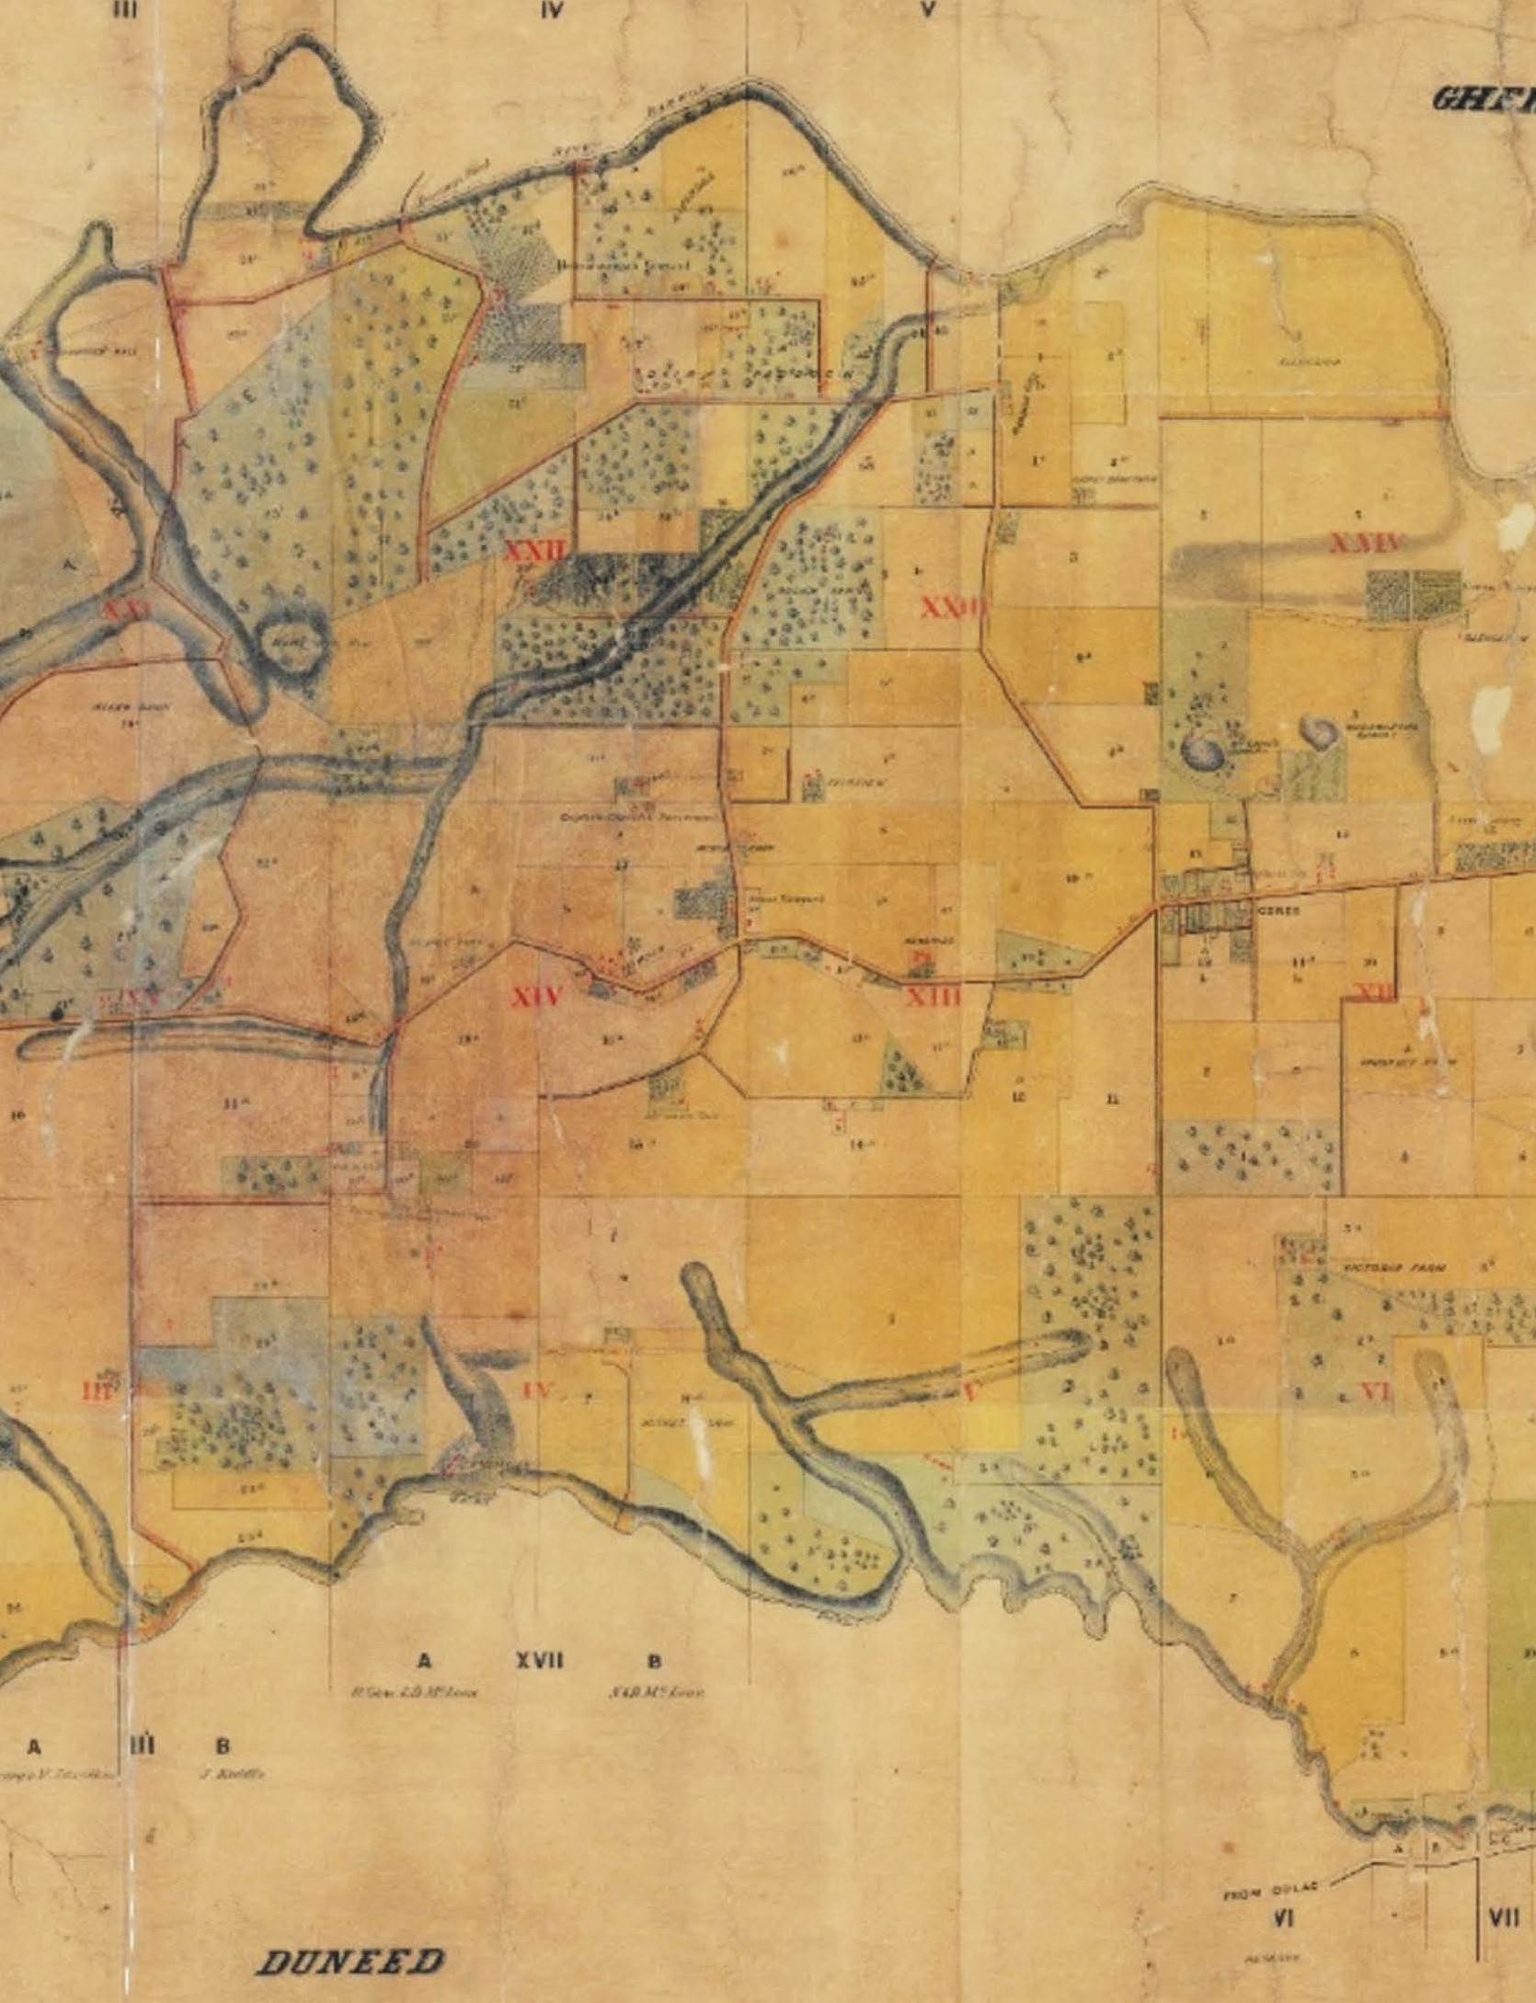

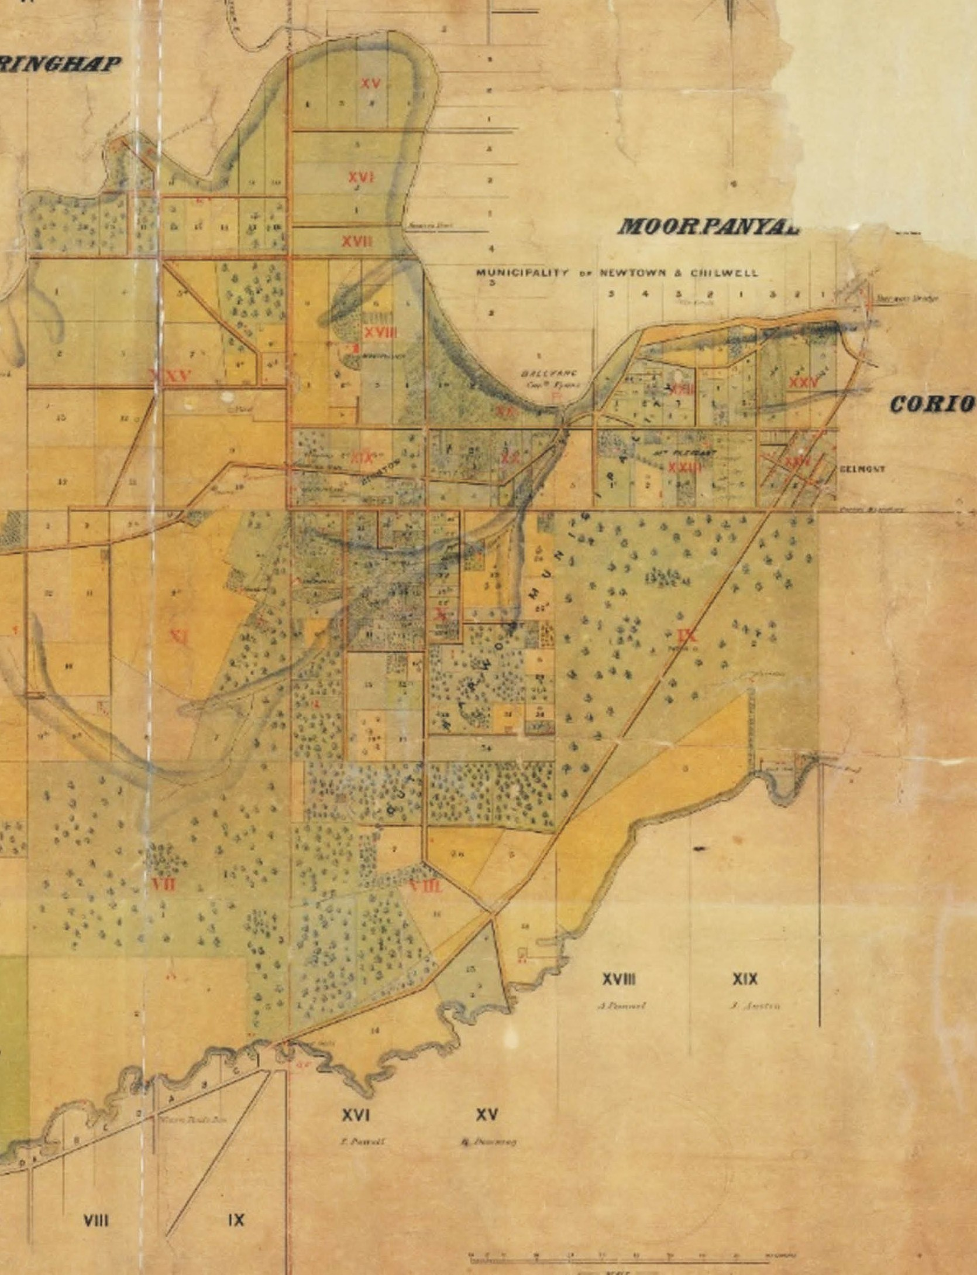

Figure 4.50: A. McWilliams, Part Barrabool Parish Plan, 1861. Source: Jennifer Bantow, Geelong.

those neglected or diseased (see Appendix 4.1 for a list of the vineyards and their locations). These properties were shown on a Plan of the Vineyards of the Geelong District in 1879 (Figure 4.51).
Diseased vineyards had been brought on by attacks of Phylloxera vastatrix, microscopic, pale yellow sap-sucking insects that caused deformations on grapevine roots and secondary fungal infections.218 While only 13 vineyards were effected in 1877, it proved catastrophic with the sustainability of many local vineyards in the ensuing years. A report by the Inspectors of Vineyards, A.R. Wallis and Edwin Hopton, gave an overview of the possible locations where the disease first took hold:
It would be difficult to say where the disease first made its appearance in the Geelong district; but it would seem, from the progress which it made in the several infected vineyards, that it started from two, if not three, points, viz., from Mr. Wyatt’s Frogmore Nursery, spreading to Mr. Ball’s, Mr. Marendaz’s, Mr. Dietrich’s, and Messrs.
King and Son’s vineyards; from Mr. Dardel’s vineyard, at Batesford, spreading to Mr. Hammerley’s and Mr. Deppeler’s; and from Mr. Kerger’s, at Germantown [Grovedale], spreading to the
adjoining properties.219

FORMER VINEYARDS & ORCHARDS AT BARRABOOL AND CERES
Several surviving properties associated with earliest development of vineyards and orchards at Ceres are located just in the Surf Coast Shire, outside the Greater Geelong area. They included the Suisse vineyard (now named ‘Neuchatel’), 460 Merrawarp Road, Barrabool, the property of the pioneer vigneron at Pollocksford, Frederick Brequet, planted in the late 1850s, Belperroud and ‘Berramongo’, 100 Crooks Road,
Barrabool, where Jean (John) and Alexandre Belperroud first planted their vineyard in 1842.220 In 1859, Belperroud’s
essay (prepared in 1858), ‘A Concise and Practical Treatise on the Cultivation of the Vine in the Colony of Victoria was the first of two treatises that won a prize offered by the Geelong and Western District Agricultural and Horticultural Society and which were published in 1859. He gave an overview
of vineyards already established in the Ceres, Barrabool, Fyansford, Batesford, Pollocksford and Waurn Ponds areas, together with guidance on choosing the aspect, siting and soil for a vineyard, and the preparation and treatment for cultivation. Of ‘Berramongo’, Belperroud gave the following details:
This far-famed Vineyard, of which Edward Willis and Charles L. Swanston, Esqrs., are the proprietors, has been

worked by John Belperroud for the last sixteen years, and possesses all the requisites for a Vineyard of the first class. The aspect being north and east, it receives the
benefit of the sun both morning and evening. This site is a very gentle slope from the middle to the foot of a tolerably high hill, which shelters all the Vineyard from the strong cold south and west winds. The soil is of different kinds
– one square of calcareous, deep, light, and warm soil, fit for any kind of Grape worth cultivating; a second, of rich black soil, producing Grapes of the best quality; another, of pretty deep soil, containing a mixture of sand, vegetable mould, and white clay, from which large crops of Grapes of good quality are obtained; and the fourth, of sand, gravel and reddish clay, full of granite stones, and this produces very large quantities of good Grapes given the best light dry wine, similar to the French “Sauterne.”221
Notable amongst the group of German vignerons were the Seidel brothers, Bernard (1817-1903) and (Gustav) Alwin (1822-1910)222 In Dresden, Alwin married Augusta Frederike Frobe (1823-1895) in 1848 and in 1849 they emigrated with Bernard Seidel to Victoria on the Emmy as
part of the immigration program of the German Immigration Committee.223 Alwin Seidel sought naturalisation in June of that year in an effort to purchase Title of land in Ceres.224 Following naturalisation and with assistance from Dr
Alexander Thomson, Alwin and Bernard purchased 40 acres of Section 12 in the Parish of Barrabool from David Fisher in 1850.225 There, they established the ‘Ceres Nursery’. Alwin Seidel had been a Gastell-macher (coach maker) in Dresden, and Bernard Seidel a Zumftgartner (Guild gardener), taking after his father who ‘held the high position of Master Gardener to the King of Saxony, at Dresden.’226 According to A. Lauterbach:
Alywin s talent and skill as coach and implement marker no doubt assisted in the manufacture of vats, tubs
and presses, necessary to operate a vineyard, while Bernhard’s qualifications as a Master gardener could not have been more allied to that of a vigneron. Like many of the early pioneers, they toiled hard and long to make a success of their nursery and vineyard.227
Following initial success, the Seidel brothers suffered from a disastrous fire on Black Thursday, 6 February 1851. The Geelong Advertiser reported on the considerable losses,
including the ‘Germans near Mr Fisher’s,’ who ‘have lost their stacks (see Theme 1 for further details).228
In 1854, the well-known German artist, Eugene von Guerard captured the Seidel brothers’ farm at Ceres (Figure 4.52).
Soon after, the Seidel brothers went to the Victorian

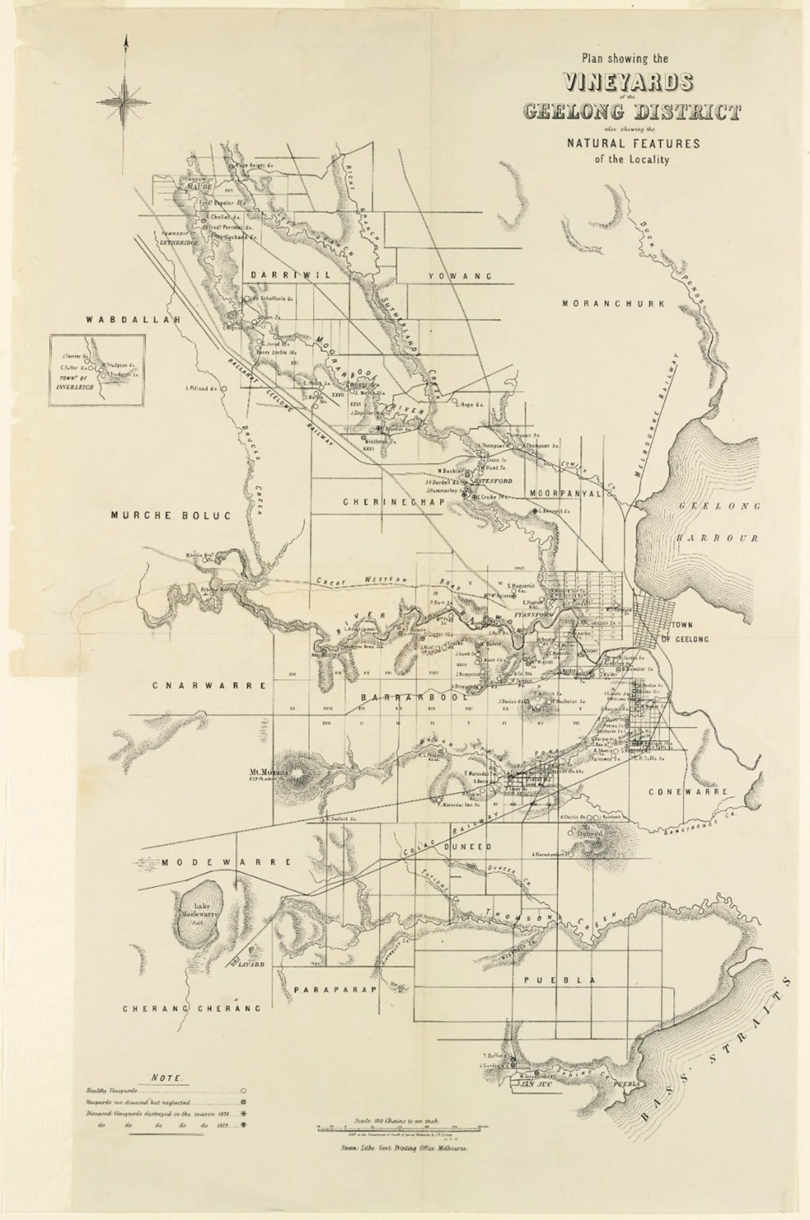
Figure 4.51: S.B. Bonney, Plan showing the Vineyards of the Geelong District also showing the Natural Features of the Locality, 22 September 1879, Dept, Lands & Survey, Melbourne. Source: State Library of Victoria.

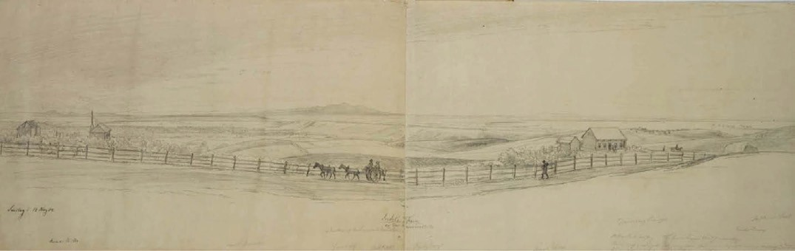
Figure 4.52: E. von Guerard, ‘Seidels’ Farm, pencil sketch, 1854. Source: image 1638009h, Mitchell Library, State Library of NSW.

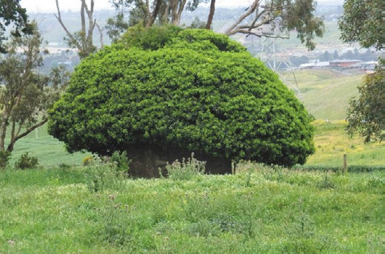
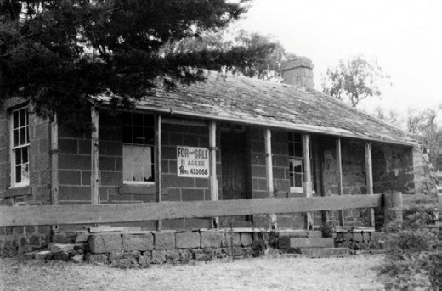

Figure 4.53: Cellar ruins of the former Seidels’ Ceres Nursery, November 2016. Source: David Rowe.
Figure 4.54: J.T. Collins, ‘Barwonside’, front view, c.1980-85. Source: accession H94.200/649, State Library of Victoria.

goldfields, as did Oberlander, Straubel and the Kawerau brothers.229 Physical evidence of the Ceres Nursery survives in the ruins of the stone cellar (with a tree growing out of it) immediately west of the property at 410 Barrabool Road, Ceres (Figure 4.53). At 240 Gully Road, the ruins of ‘Barwonside’ (Figure 4.54) survives (built by 1856), having been originally established by Robert McDonald, an Irish
farmer, in 1850.230 There, McDonald laid out a 1 acre vineyard although he had greater success as a wheat farmer following his use of Flat Island Guano fertiliser, writing to Alexander Reid, Commission Agent in Geelong in February 1862 that:
The Flat Island Guano I had from you last season
I harrowed in for a wheat crop at the rate of 1 cwt per acre on rather poor soil. I was much pleased with its effects; the crop came rich, green, and healthy-looking, and the increase of yield from the use of the guano must have been about 7 to 8 bushels per acre. On the whole, I think very favourably of it as a manure, and I shall require a couple of tons more this year. Taking
the difference of price into account, I consider it far preferable to Peruvian.231
‘Barwonside’ was sold to David Lamb of Rock Bank Farm, Gheringhap by February 1876. A few years later, the vineyard was recorded as being neglected.232 Only the Barwonside dwelling now almost ruinous - survives of this early vineyard.

FORMER VINEYARDS AND ORCHARDS AT WAURN PONDS
Within the City of Greater, Geelong one of the earliest and most substantial vineyards was the Victoria Vineyard, Waurn Ponds (now 75 Kingsbury Lane) established by David Pettavel in 1848 on 300 acres.233 The importance of Pettavel to the vine growing area in the Geelong district is given in Theme 2. His knowledge was also influential. In 1859, Pettavels’s essay (prepared in 1858), ‘A Concise and Practical Treatise on the Cultivation of the Vine in the Colony of Victoria won second prize offered by the Geelong and Western District Agricultural and Horticultural Society and was published with Belpourroud s treatise. It was at Victoria Vineyard where Pettavel changed his farming practices and trenched with the plough:
Although I commenced to cultivate the Vine in this Colony in 1842, and assisted to form the Vineyard at Pollock’s Ford, it was not till 1848 that I could sufficiently throw aside my prejudices in favour of the spade and forked hoe, which I had always seen used in the Vineyards of Switzerland, to induce me to adopt the plough as my usual method of trenching. However, the scarcity of labour in Victoria, the consequent high rate of wages, and the comparative slowness of the return fom the time of commencing to invest capital in the cultivation of the Vine, have compelled me to try the experiment, of which I am now able to report the complete success.
When the land has been carefully cleared by grubbing, or by long continued cultivation of other crops, commence to trench at the lowest part of the ground by a common plough, drawn by two strong horses, striking out a furrow; as soon as they have got sufficiently ahead, let the trenching plough, drawn by from ten to twenty bullocks, according to the nature of the ground and the strength required, follow, going as deep as it can; let it be followed by one, two, or more men, as may be necessary, to remove stones, roots, &c., which will be brought to light, and to throw up and break large lumps, which would otherwise fall back and lie in the furrow, and prevent the next sod from turning down well. As soon as the horse plough has gone to the end of the furrow, let it be drawn back, without entering the ground, to the end from which it started at first; then turn over a slice, if possible, of from seven to eight inches, which will fall into the furrow left by the bullock plough; when the bullock plough has got to the end of the furrow, let it be thrown out and turned back, as was done with the horse plough; then let it follow the horses as before, and in the course of a few furrows, each being kept well cleared by men following as previously mentioned, the bullock plough will get the full depth of from fifteen to eighteen inches, and the work will go on in

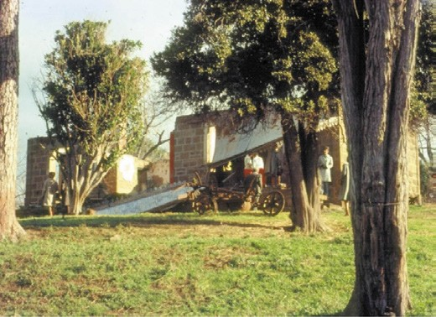
Figure 4.55: Ruins of Pettavel’s house, Victoria Vineyard, c.1970s. Source: Wynd collection, Authentic Heritage Services.
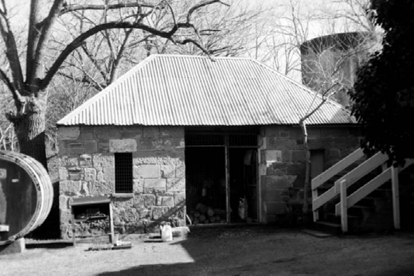
Figure 4.56: Former Blacksmith’s Shop previously part of Victoria Vineyard, 1998. Source: David Rowe.

the same manner till the piece of ground intended to be trenched is completed.
… Doing the work in this manner, I am sure that the spade could not do better, neither will any levelling to required after the ploughing has been finished.234
At 75 Kingsbury Lane, the cellar of Pettavel’s original
eight-roomed stone house (which was in ruins by the 1970s) (Figure 4.55) and a blacksmith’s shop survive at as a legacy of his former Victoria Vineyard.235 (Figure 4.56).
In 1857, Pettavel established the Prince Albert Vineyard, where he installed in charge his nephew, Charles Tetaz (see Theme 2). Nothing survives of this property today. Other local vineyards that contributed to the local economy at Waurn Ponds and where the early dwellings survive included George Hanson’s at 76 Ghazeepore Road (built c.1860); John Lowe’s at 35 Lemins Road (built c.1860) (Figure 4.57)

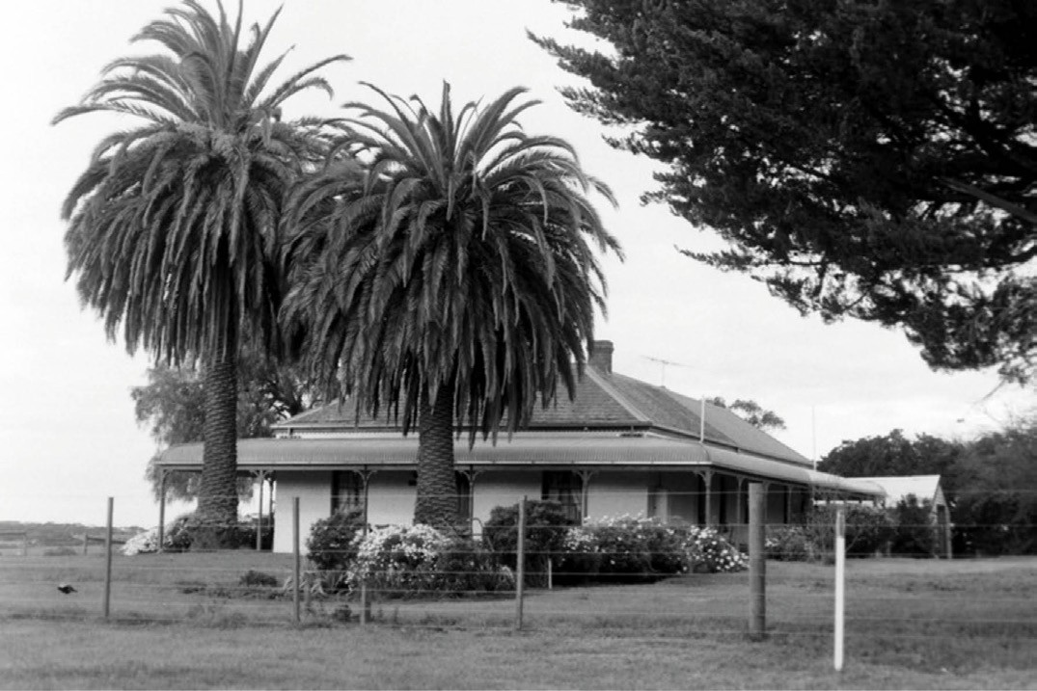
Figure 4.57: Dwelling, 35 Lemins Rd, 1998. Source: David Rowe.

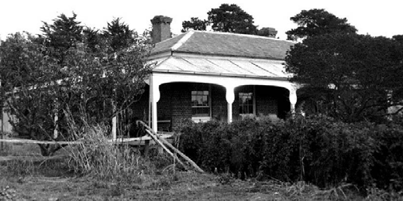
Figure 4.58: ‘Claremont Homestead’, Waurn Ponds, prior to subdivision, 1998. Source: David Rowe.

and Rudolpoh Tribolet’s at 125 Lemins Road (built c.1870).236 Following the destructive phylloxera infestation, inhabitants turned to fruit growing. This included the Baum family who took up ‘Claremont Homestead’ (Figure 4.58) at 16 Kinsmead Street in 1894.237 The homestead had been built in 1857 to a design by Shaw and Dowden, for Thomas Powell (1812-1787),

brewer of Little Malop Street, Geelong238 (see Theme 5), who had a vineyard established. In the early 21st century, the vast acreage was subdivided and the orchard lost.

FORMER VINEYARDS & ORCHARDS AT BATESFORD
At Batesford, one of the most well-known vigernons and orchardists in Victoria was Joseph Henry Dardel (1811-1903) who came to Australia from Switzerland in 1842.239 Although his Paradise Vineyards (four in total) were established on the western banks of the Moorabool River (now part of the Golden Plains Shire), they began the transformation of the Moorabool valley at Batesford. In 1868, the Geelong Advertiser gave a detailed outline of Dardel s Paradise vineyard:
An old camping ground at Batesford, over the bridge, has within the last five years undergone a wonderful transformation. Under the talismanic touch of the proprietor, Mr J.H. Dardel, who purchased the land some years since, a scene blooming and blossoming like
the rose has followed the original wilderness camping ground. In no part of Victoria is there to be found a more

magnificent spot. The vineyard covers an area of twelve acres, and the orchard twenty-five acres. There is also a large extent of grazing land. The property is bounded on one side by the Moorabool, and an artificially formed lagoon forms a line of division between, that irrigates both the vineyard and orchard. A dwelling in keeping
with the surroundings of the spot has lately been erected, as well as a cellar and every appurtenance.
The vineyard is now nearly five years old. The varieties planted are the burgundy and hermitage for red and chasselas and tokay for white two of each kind being only cultivated.
… The orchard, as before stated, is twenty-five acres in extent, and contains every variety of fruit tree. [cherries, gooseberries, apples, plums, damsons, peaches, pears]
… The trees were first planted in the orchard, where they did not appear to thrive. They were then transplanted to the sloping grounds in proximity to the vines, and terraces were formed for them. The result has been unexpectedly good. … There are some 80 trees of the Mandarin, St.
Michael and Sicilia varieties, also lemon trees.
… The avenue, extending for about a quarter of a mile, and other paths are lined with borders composed of French roses on the one side and English box on the other, with other descriptions equally beautiful.
On the pleasures grounds adjacent are trees and shrubs of exquisite beauty. Camelias, roses, myrtles, flowery acacias, laburnums, weeping ash, &c., are in gorgeous profusion.240
A celebrated vigneron at Batesford within today s
City of Greater Geelong was Dr Robert Culbertson Hope (1812-1878). With his brothers, George (1814-1884) and James (1810-1877) Dr Hope acquired the Sutherland Creek Run now the location of Darriwill Homestead in c.1841
(see Themes 2 and 6). There in the 1850s, George Hope established a vineyard241 and had a three storey bluestone wine house and cellar constructed in 1863 to a design by the Geelong architect, J.L. Shaw.242 However, it was Dr Robert
C. Hope at his property, ‘Lynnburn’ (Figure 4.59), 600 Ballarat Road, Batesford, who was the more successful viticulturist.243 He had a substantial bluestone homestead constructed in 1853 to a design by the architect, Walter Sheridan.244 This homestead exists today, albeit altered. Between late 1863 and early 1864, he also had a stone cellar and wine house erected which has been claimed to have been one of the best in Victoria .245 Only the
cellar ruins survive today (Figure 4.60), the design possibly reflecting wine house at ‘Darriwill’ built a few months earlier.
Robert Hope commenced planting his vineyard at ‘Lynnburn’ in 1858, with two acres cultivated ‘on the lowest portion of

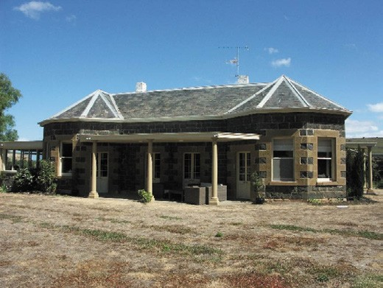
Figure 4.59: ‘Lynnburn’, Batesford, 2010. Source: David Rowe.
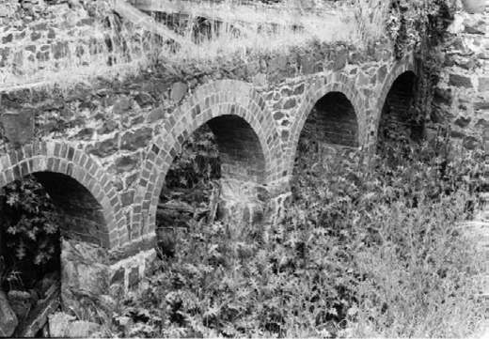
Figure 4.60: ‘Lynnburn’ wine house cellar ruins, Batesford, 17 October 1973. Source: J.T. Collins, accession H91.100/1227, State Library of Victoria.

the hillslope, on the extreme eastern boundary.’246 Hope s vineyard was described in detail in 1864:
The vineyard hill rises from a flat on the eastern bank of the Moorabool; the highest point on which vines are planted being from 100 to 120 feet above the river s bed
The two acres originally planted were hand-trenched to a depth of 24 inches, but in his subsequent trenching Dr. Hope has adjured manual labor in favour of the plough.
He uses the large American implement for the trench furrow, which completed inverts the soil, bringing the subsoil to the surface. The ground has been trenched with this plough from 15 to 24 inches, the lesser depth being adhered to where the subsoil is clay, as well as for the undesirability of bringing so much of that to the surfaced as for the difficulty of getting the plough
down into it. The varieties planted in 1858 were chiefly

Hermitage, Miller’s Burgundy and Riesling, with a small proportion of table varieties, including black and white Muscats. In 1861 planting was continued on the crown of the hill, above the two acres first planted, and to the
hollow in the centre of the vineyard. Five acres of Riesling were then put in, eight of the Hermitage and about half-
an-acre of Miller’s Burgundy. In the two following years an additional eleven acres, forming the southern wing of the vineyard, was planted with Hermitage alone, the total breadth now under vines being 26 acres.
… With prudent forethought of the immense quantity of wine this large vineyard will produce in another season or two, Dr. Hope has a capacious cellar, fermenting rooms, and wine-house in course of erection. The building will consist of three stories, each of which will be forty feet by thirty in the cellar. The grapes will be pressed on the top one, the floor of which will be about level with the middle slope of the vineyard, the lower stories being excavated in large vats on the second story, and conveyed thence by hose to the store casks on the lowest floor. There will be one drawback to this lowest cellar – namely, that the
entrance to it faces the north; but it is proposed to remedy this by having a double set of doors, so that one may be closed before the other is opened, and thus to insure the exclusion of hot winds.247
Qualified as a Doctor of Medicine in Edinburgh in 1834,
Dr Hope resided at ‘Lynnburn’ with his wife, Catherine
(nee Hassall) Hope and their nine sons and two daughters.248 He was elected a Member of the Legislative Council in 1856, serving until 1864 and again from 1867 until 1874.249 He also served as chairman of the Board of Agriculture and president of the Geelong Vinegrowers Association and the Geelong and District Agricultural and Horticultural Society.250 Failing health forced Hope s retirement from politics and his vineyard in 1874 and he relocated permanently to Melbourne.251 Lynnburn was leased (and later sold) to Charles Craike who continued the vineyard until it was attacked with Phylloxera vastatrix in January 1879.252 Although vines were uprooted, further testing in 1883 revealed the phylloxera clustering in thousands on remaining vine roots.253
Craike sold ‘Lynnburn’ to Jacob Deppeler in 1891, a vigneron who previously held vineyards on the western side of the Moorabool River at Moorabool.254 He revived the vineyard as the Batesford Experimental Viticultural Station with the planting of phylloxera resistant vines, under the direction of the Government superintendent of nurseries, Mr Adcock.255
The success of the American vines at Lynnburn was outlined in 1901:
About six miles to the north-west of Geelong, on the old Ballarat-road, a group of orchards, massed along either

side of the Moorabool River, furnish ample evidence of soil fertility in this picturesque valley. In the same locality viticulture was an important Industry until the advent of phylloxera, when the uprooting of vines throughout the Geelong district caused a check, the severity of which is even felt to the present day by some vignerons. On the slopes of a hill lying back from the Moorabool, a vineyard of 25 acres was established by Dr. Hooper [sic. Hope], and later on destroyed in order to check the increase
of phylloxera. On the same property, and adjoining the old vineyard site, Mr. J. Deppeler planted out six acres under vines, while 30 acres are devoted to fruit trees. The vines, comprising Chasselas and Hermitage as the varieties best adapted to the locality, represent one of the comparatively few plantations established hear
Geelong since the uprooting period. Now that phylloxera has been again discovered in the district, the salvation of the industry is centred on the system of reconstruction with American vines, with this object in view, a nursery for the propagation of phylloxera resistant stocks
was established in Mr. Deppeler’s vineyard last year, and further supplies will be added during the present season.256
Deppeler became a promoter of American resistant vines following his success at ‘Lynnburn’, with cutting sand rootlings available for purchase from 1904.257 He continued to reside at Lynnburn until the property was sold in 1954.258 None of Deppeler s vineyard and orchard appear to survive at Lynnburn today.

FORMER VINEYARDS & ORCHARDS AT FYANSFORD

SWAN HOTEL AND PLEASURE GARDENS
At Fyansford, one of the earliest vineyards and orchards where vestiges may survive is at the Swan Inn on the west bank of the Moorabool River, established by Herbert
Swindells in the early 1850s. The Inn had been built in 1842 for John Atkins to a design by Alexander Skene259 (see Theme 6). It was closed to the public by 1845.260 When Swindells went insolvent in March 1855, his estate included ‘the fruit and vegetables contained in the gardens attached to the Swan Hotel, Fyans’ Ford.’261 The garden was expanded into ‘pleasure grounds’ by the subsequent occupant, William
Bohn as part of a revival of the hotel business in 1855.262 The pleasure grounds were also to be supplemented with zoological specimens. 263 Bohn s occupation of the hotel
and gardens came to an end in 1858 following the mysterious death of his wife, Sarah Bohn, ‘from a wound caused by the talons of an eagle hawk. 264 The property was taken over by Samuel Hassell and in 1860 the pleasure gardens featured in

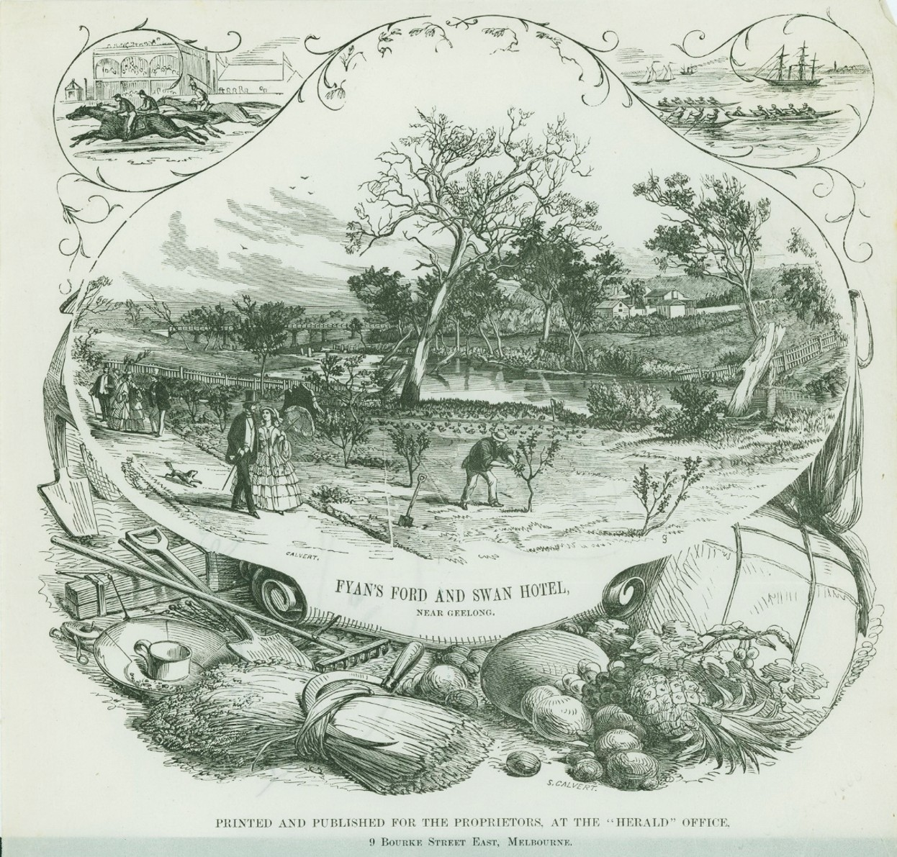

Figure 4.61: ‘Fyan’s Ford and Swan Hotel, near Geelong’, October 1860. Source: G. Strafford (artist) & S. Calvert (engraver), accession no. H4955/12, State Library of Victoria.

wood engraving by the engraver, Samuel Calvert (the work of George Stafford) (Figure 4.61).
In September 1862, William Barrell became the proprietor.265 He promoted his picnic gardens and pleasure grounds as a ‘beautiful retreat’, and employed George Hodgson, member of the Victorian Horticultural Improvement Society, to direct the cultivation of the vineyard.266 The variety in the gardens was detailed in December 1862:
The gardens of the Swan Hotel, though not just now so redolent of the early crops of fruit as they were a few weeks back, proffer great attraction. The glorious
harvest of cherries which has been gathered in, and no more for this year, except a few for “leazing,” and they are superb in size and flavor. The peaches, nectarines, and apricots are bowing down under the weighty crops, and fast approaching maturity. The almond trees in

refreshing verdancy invite the visitor to repose under their umbrageous shadow. Apple trees groan under the luxuriance of their own burthen, and pear trees charged with fruit, by the potentiality of their weight, sway to and fro with an ominous indication of a crash. But, perhaps,
the most attractive features of the gardens are to be found in the vineyard, which is under the direction of Mr George Hodgson. A more luxuriant crop of grapes it would be difficult to imagine, than that presented here. The different styles of managing the vine are exemplified, and the results shown, practically, of the effects of pruning and training, under the different methods obtaining in England, and practised on the Continent, and introduced here
by the vignerons of our wine district.267

‘FROGMORE’, 425-465 HAMILTON HIGHWAY, FYANSFORD
At ‘Frogmore’, Charles Wyatt (1823-1885) planted a vineyard as part of his nursery in 1858.268 The property had first been established by Captain John Montagu, a partner in the Port Phillip Association (see Theme 2) in 1843.269 The existing Victorian Italianate styled bluestone homestead was built
in 1857 to a design by Edward Prowse for Charles Wyatt following his acquisition of the property in 1856270 and the former stables are located nearby (Figures 4.62-63).
In 1863, a detailed account of Wyatt’s fledgling vineyard was given:
At present only twelve acres are under vines and fruit trees, and the position of the vineyard is indicated by the large bluestone residence, and extensive stabling and offices lying about 500 yards to the left of the road, a mile and half westward of the Fyans-ford bridge … Mr Wyatt commenced operations in 1858, with one acre, by spade trenching the ground to a depth of eighteen
inches. New horse and cow dung was laid in the trenches to produce a rich soil for the roots by the time the fibres should strike down so far, and compost to the extent of two hundred loads was well worked in with the soil. The cuttings for this acre were procured from Sydney, and turned out principally Black Prince and Black Hambro’, which were planted at 4 ft. by 4 ft. The following years two acres more were submitted to a similar process and planted chiefly with Chasselas and Gouais cuttings from
the Berramonga Vineyard [Barrabool] The vineyard and orchard are by no means all that is worthy seeing on this property. The nursery, which is a model of neatness and professional order, comprises a very extensive collection of conifers from all parts of the world, some of the more recent arrivals being from New Caledonia, California, and New Zealand. … The descent to the river, which forms a graceful bend at this portion of its course, is made by a

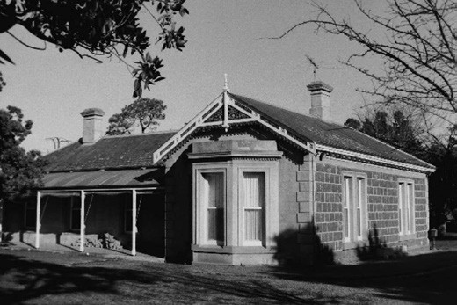
Figure 4.62: ’Frogmore’, Fyansford, 1998. Source: David Rowe.
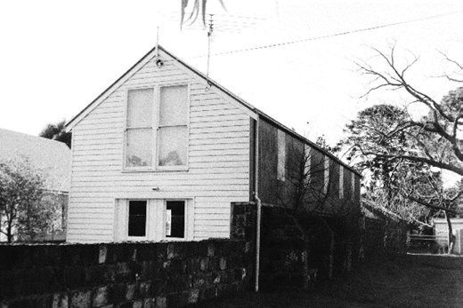
Figure 4.63: ‘Frogmore’ outbuildings, 1998. Source: David Rowe.

long flight of stone steps, the slope on either side being laid out in terraces and planted with various kinds of fruit trees.271
In the 1870s, Wyatt’s vines showed signs of sickness which was confirmed in 1877 with the presence of Phylloxera vastatrix.272 Wyatt had apparently underestimated the extent and seriousness of the disease in the Geelong region and following his return from an extended stay in Tasmania,
was shocked to discover the vineyard had been entirely destroyed. It was the remaining portions of his Frogmore Nursery, including the fruit trees, ornamental and forest trees, shrubs, and wide variety of plantings and bulbs that enabled it to survive. Following Wyatt’s death in 1885, the property was leased to James Matthew and subsequently to W.J. Lobb, nurseryman of St. Kilda.273 By the turn of the century, ‘Frogmore’ had supplied most of the trees in the parks and gardens of Geelong, and the elms along St. Kilda Road.
However, when the property was purchased by Andrew Condie in 1907, the nursery had been discontinued.274

FORMER VINEYARDS & ORCHARDS AT HIGHTON
On the hill overlooking the Barwon River, a substantial
two storey Italianate villa of Barrabool stone was constructed for John Highett in 1850-51 known as Highton (and later Highton House )275 (Figure 4.64). The name of the property derived from the Highett family farm at Weymouth, England276 (see Theme 5 for biographical details on Highett). By January 1859, Highett had sold ‘Highton House’ and it became
Edwin Hooper’s Montpellier Hotel, vineyard and gardens.277 The name appears to have derived from Montpellier, a city built on a hill in the south of France. All that survives of ‘Montpellier’, Highton, today are stone ruins and mature trees being remnants of the once notable garden setting.
Another prominent nursery at Highton from 1851 was ‘Kardinia’ (Figure 4.65), first established by Thomas Adcock (1820-1900) (see Theme 7 for biographical details).
A comprehensive account of the Kardinia Nursery was given in the Geelong Advertiser in 1867:
The above far-famed nursery is situated in a romantic valley on the Barrabool Hills, about three miles from Geelong A more delightful spot could not well be imagined, nor one more suited for the establishment of a nursery. Nature has been assisted by industry and art, and what in 1851 was merely uncultivated bush land, now teems with floricultural and horticultural novelties, in the midst of which appears the substantial mansion of the proprietor, Mr Thomas Adcock. The nursery is twenty- two acres in extent, facing the north, and is well protected from the sea breeze. Looking through a valley to the right the visitor obtains a fine view of the town of Geelong;
and on the left, a picturesque country, dotted here and there with villa residences. In addition to the nursery there are two acres of vines. The vineyard, however, was not established for the purpose of wine-making, but the produce is sold as it ripens. In 1866 the quantity of fruit of all sorts sold was 20,578 lbs, and in 1867 16,937 lbs, the greater part of this fruit consisted of grapes, as most of the fruit trees, which number 200,000, are young and intended for transplanting … The first place we visited was the extensive shelter shed near the dwelling-house. There we found at least 20,000 pot plants of infinite variety; of pines alone there were thirty varieties, and many of them very rare. Among them we observed the pinus Puce, pinus tuberculatea, pinus Coulterii, and others, for the names
of which we refer our readers to the printed catalogues, which can be obtained of Mr W. Clarkson, in Great Ryrie- street … A fine variegated New Zealand flax plant with its swordlike leaves is a curiosity in its way, and if in England would command a very high price. In the pits adjoining the shelter house we find an immense number of two-year- old cypresses goveriana, a shrub of quick growth and

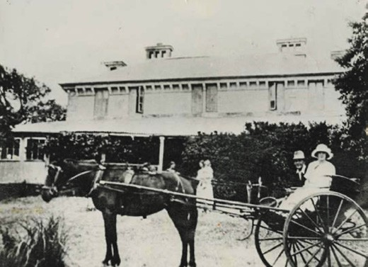
Figure 4.64: ‘Monpellier’, Highton, c.1900. Source: GRS 6185/0, Geelong Heritage Centre collection.
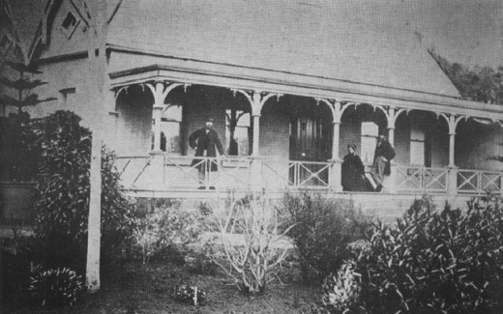
Figure 4.65: Adcock’s Residence, ‘Kardinia Nursery’, n.d. Source: J. Pescott, South Barwon 1857-1985, p.91.

highly ornamental, the pinus canariensis, the auracaria uleii, the true silver tree of Africa, etc. In addition to the corniferous trees mentioned in the catalogue some fine specimens of the cedrus Atlantica, the silver cedar of Lebanon, were brought under our notice, and in bedding plants we were shown twelve new varieties of Japanese chrysanthemums. In conclusion we must not forget to mention the very large collect of standard roses, and two very large and fine specimens of Cupressus Lambertiana and Norfolk Island pine planted opposite Mr Adcock’s residence.278

FORMER VINEYARDS & ORCHARDS AT MOUNT DUNEED, GROVEDALE AND BELMONT
The numerous vineyards and orchards established in Mount Duneed, Grovedale and Belmont, primarily by German
and Swiss emigrants (see Themes 2 & 6), have largely been replaced with suburban expansion (see Theme 6). A number of dwellings have been demolished since 2000.279 The earliest surviving dwelling associated with German immigrants and the establishment of a vineyard is the
‘German Settler’s Cottage’ at 224 Torquay Road (Figure 4.66). It was built in c.1857 for Johann Sohr.280 By 1870, it had been sold to John Andresson, vine grower.281 The steeply-pitched gabled cottage was built of light timber framed construction and represented the amalgamation of northern German and British Colonial building traditions.282
At 197 Francis Street, Grovedale, is Winter’s Cellars (Figure 4.67). The property was first taken up in 1854 by John Winter, one of the original immigrants who arrived on the Emmy in December 1849.283 After working as a market gardener at Cowies Creek and then trying his luck on the
Victorian goldfields, Winter established a stone cellar at 197 Francis Street.284 It was operated by his son, Heinrich William Winter, for many years ‘until phylloxera swept the district and devastated the vineyards. 285 The existing timber Victorian dwelling was built in 1878.286
At Mount Duneed, the gabled bluestone Victorian farm dwelling, ‘Oak Trade’ at 50 Whites Road (Figure 4.68), was built between the late 1850s and 1863 by the English pioneers, Joseph and Elizabeth Rainford.287 They had
emigrated from Liverpool in 1852 and following employment as a wool presser, Joseph tried his luck at the Ballarat gold diggings without success.288 They returned to Geelong where Joseph became a market gardener at Marnock Vale, as well as a stone cutter. They purchased 57 acres of land at Mount Duneed in 1857, the property being first-named ‘Oakgrove.’ There, Joseph and Elizabeth Rainford established a 2-acre vineyard which in 1878 was described as being well attended and pruned. 289 Rainford also farm red clover from which he made hay.290
Nearby at 140 Whites Road is a surviving remnant of the vineyard established between 1865 and 1869 by Wilhelm Schulz (1819-1879), a Prussian immigrant from Kay.291
He had arrived in Victoria in 1853 on the Wilhelmsburg.292 Accompanying him were Louise Schulz (aged 25), Johanna (aged 7) and Rudolph (aged 2) as they were identified in the Wilhelmsburg passenger list.293 Johanna Pauline Schulz and Rudolph Schulz were the children of Wilhelm Schulz and Johanna Schwalb, his wife in Prussia.294 A shoemaker, it appears that Schulz went to the Bendigo goldfields upon

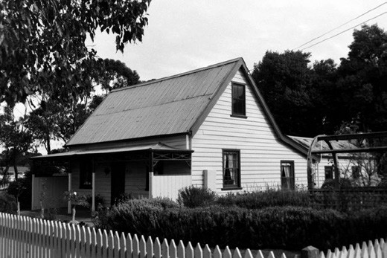
Figure 4.66: ‘German Settlers Cottage’, 224 Torquay Rd, 1998. Source: David Rowe.
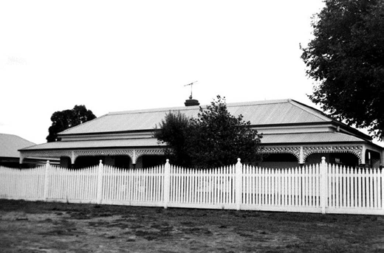
Figure 4.67: Winter’s Cellars, 197 Francis St, 1998. Source:
David Rowe.
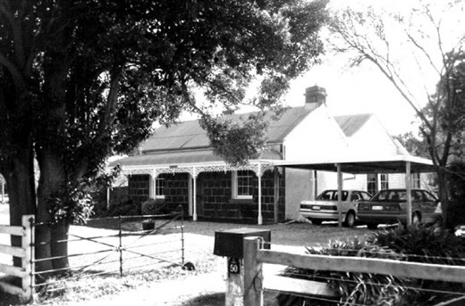
Figure 4.68: ‘Oak Trade’, 50 Whites Road, Mt Duneed, 1998. Source: David Rowe.

arrival in 1853 as there references in later years to the family s connections in Bendigo.295 In 1862, Schulz was a farmer
at Puebla (presumably Mount Duneed) when he applied for naturalisation.296 At his Mount Duneed vineyard at 140 Whites Road, Wilhelm Schulz and Louisa Stenka – whom Wilhelm described as his housekeeper - had two children: Amelia Florentina (1865-1867) and Matilda (1872).297 By 1878, the name, Auguste Schultze (possibly erroneous for Wilhelm Schulz), was given as the occupier of the vineyard
at this time, the vines described as being ‘in excellent order’ and with a good crop at this time.298 On Wilhelm Schulz s death in 1879, the property contained 60 acres ‘on which is erected a four roomed wooden cottage. 299 The property was bequeathed to Louisa Stenka although it remained occupied and under the name of the Schulz family and Adolph Pohl until it was advertised for sale in 1912.300 At that time it included 120 acres of ploughed land watered by Armstrong s Creek and by dam and a man s hut and 8-stall stable. 301 Although the timber stables and two gabled huts survived in a parlous condition in 1998,302
all that remains today is one of the gabled stone huts (Figure 4.69).
In Belmont are three existing properties associated with vineyards of the 1860s. At 80-84 Francis Street, James Goodall Francis (1819-1884), M.L.A. for Richmond between 1859 and 1874, and for Warrnambool between 1878 and 1884, established a five-roomed weatherboard house with cellar and a vineyard in 1864.303 This was an adjunct to his more substantial Goonawarra vineyard at Sunbury that he had created in 1863. By 1879, Francis’ vineyard was not diseased with phylloxera but neglected. 304 In 1884, the Estate of J.G. Francis sold the property to William Newtown Sommers, publican, and in 1887 half the estate was purchased by
Leon Monbon who established a market garden there.305 In the 1890s, the house and market garden were acquired by Thomas Mallett and leased to John Hebbard, gardener.306 By 1908, the property had been subdivided and the dwelling was owned by William Sumner Hunt.307 He carried out substantial alterations and additions to a Federation design. Named ‘Karrima’, the Victorian dwelling (with Federation era alterations) survives (Figure 4.70), including the original cellar.
At 26 Spring Street, a Victorian timber dwelling is a legacy of a vineyard established in 1864 by Thomas Cain, a ‘celebrated horticulturist’, and owned by the publican of the Caledonian Hotel in Little Ryrie Street, Thomas Campbell.308 Between 1874 and 1876, the property was occupied by Edwin Butt, one-time curator of the Corio Cricket Ground (former Corio Oval, Eastern Park).309 He tended to the vineyard and garden that was then set in a paddock covering about ten acres.310

Although Campbell sold the property to James Fitton, hotel keeper in 1877, it was acquired by Robertson Chamberlain in 1878.311 John Hebbard, farmer, occupied the site for much of Chamberlain’s ownership, which ended in 1889 when it was purchased by the gardener, Charles Brame. His death in 1890 brought the transfer of the property to Brame’s son, Alfred and Herbert, farmers and market gardeners.312
At 103 Mt Pleasant Road, Belmont, is ‘Mount Pleasant Villa’ (Figure 4.71), built in c.1872 for Morris Jacobs (c.1852- 1927), well-known Geelong draper.313 The brick villa was constructed on land previously comprising two vineyards.
The first was established by Mary Transton in c.1853 and the other John Davison in c.1856 (the latter on land owned by James Noble of Connewarre).314 First known as the Jacobs’ Vineyard315 Morris Jacobs and his wife, Emma, had named their property ‘Mount Pleasant Villa’ by 1878.316 Although Jacobs continued his business interests as a draper, the vineyard was retained, presumably by employed gardeners. In 1878, Jacobs’ 6 acre vineyard was described as being ‘well attended with a good crop. 317 Hendy and Apted, architects of Geelong and Queenscliff, called tenders for ‘renovating and painting and raising and re-blocking one wing of the villa in 1901.318 In 1924, the 71 acre ‘Mount Pleasant Villa’ property was subdivided into smaller residential allotments (see Theme 6).

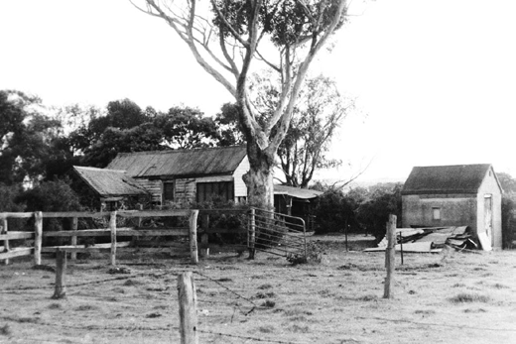
Figure 4.69: Early outbuildings associated with Schulz vineyard, 1998. Only the gabled bluestone building (left) appears to survive today. Source: David Rowe.

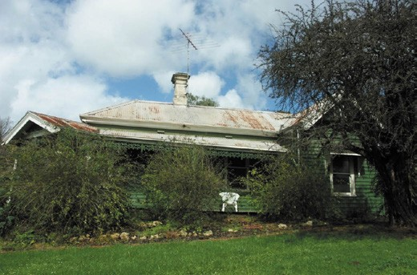
Figure 4.70: ‘Karrima’, 80-84 Francis Street, Belmont, 2005. Source: David Rowe.

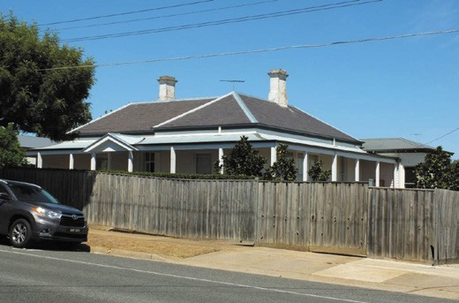
Figure 4.71: ‘Mt Pleasant Villa’, 103 Mt Pleasant Rd, Belmont, 2019. Source: David Rowe.

FORMER VINEYARDS & ORCHARDS AT WALLINGTON
Throughout the 19th and 20th centuries, Wallington was known for its fertile soil, including the growing of orchards, fruit and vegetable crops. One of the few physical legacies is the dwelling, ‘Willow Bank’ (now ‘Carinya’), 20 Rhinds Road. Of brick construction, it was built in 1864-65 for Thomas Magarey and occupied by Arthur Douse who had established a vineyard and fruit garden there in c.1861.319 In partnership with Douse for a time was a Mr Reynolds. The vineyard
had been abandoned by 1884 as the Geelong Advertiser described the property (which was then for sale as part of the ‘Chevy’ Estate of W.R.H. Weekes) as ‘good grass land substantially fenced and formerly known as the estate and vineyard of Messrs Douse and Reynolds, and contains, among other improvements, a well-built brick cottage, etc.’320

FORMER VINEYARDS & ORCHARDS ASSOCIATED WITH THE NOVEL INDUSTRIES ACT
In 1862, the Victorian Legislative Assembly passed the Duffy Land Act which included Section 47 to encourage the development of novel industrial enterprises. 321 Conditions
of the lease included the planting of vineyards, tobacco, olive trees or hop plantations or any useful plant or industrial enterprise or process which was previously unknown or not generally known. The lessee had a pre-emptive right of purchase following expiration of the lease, or after 5 years, at the price of one pound per acre.322
Within Greater Geelong, at least 25 leases under Section 47 for the production of wine, olives, tea, mulberries, oranges, tobacco, maize, flax, linseed, cider, cherries, plums, pears, peaches and other fruits were registered (see Appendix 4.2). One lease was taken up by John Myles in 1862 at Ocean Grove on the north side of Thacker Street (west end).323 Myles had served as a Member of the Legislative Assembly from 1852 until financial difficulties caused the end of his political career in 1861. At Ocean Grove, he proposed to establish 6 acre vineyard, 6 acre orchard (apple and pear trees for cider and perry production; cherries and peaches for brandy; and plums and gooseberries for jam and dried preserves); and a 2 acre tobacco plantation.324 Myles soon purchased his property and then offered it for sale in 1866 with 234 acres, six-roomed house, 10 acre vineyard together with an orchard.325 Nothing survives of Myles’ vineyard at Ocean Grove, the land comprising a residential estate.

TIMBER INDUSTRY

WATTLE BARKING
From the time of European colonisation, transformative of the Greater Geelong landscape particularly in the Bellarine Peninsula, was wattle barking. Initially, land was cleared by pastoralists in order to cultivate and graze it. Yet, from the early 1860s, the thickly-timbered areas at Portarlington, St. Leonard’s, Queenscliff, and Wallington provided a much- needed and prized wattle bark product for the burgeoning tanneries at Marshalltown, Breakwater and South Geelong (see Theme 5). Wattle bark was a key ingredient in the production of tannin liquor used to immerse hides as part
of the manufacture of leather.326 Several farmers on the Bellarine Peninsula were to capitalise in providing the tanneries with this prized commodity.
At Indented Head between Portarlington and St. Leonards in 1860, Edward Alfred James Harvey purchased the sheep run, ‘Woodhalla’ established by Captain Frederick William Langdon (brother of Captain J.C. Langdon of ‘Spray Farm’
see Theme 2) by 1857.327 With the principal purpose of sheep grazing, Harvey attempted to further clear the land ‘by eradicating the wattles growing thereon, but they grew too thickly and too fast. 328 With the land covered with wattles, in subsequent years Harvey found if profitable to strip the wattles for their bark and deliver it to industries in Melbourne.329 In 1877-78, Harvey shipped 500 tons of bark from Portarlington with much more sent by road to Geelong. 330 Nearby, the Sheppard brothers were one of Harvey s competitors.331
It was also from the 1860s at Mannerim when newly-arrived sheep graziers exploited the wattle bark as another source of income, and created a permanent industry in growing and barking the trees. Larger growers at this locality included R. and P. McDonald of ‘Blairwood’, Mrs Davies, G. Dunn and J. Dutton.332
By the 1870s, the wholesale stripping of bark from wattle trees had become ‘one of the most flourishing trades of Australia 333 led to shortages of the product. Together with wattle barking in other parts of Victoria, much of it had been shipped to England where it was worth three times the value than in the colonies.334 However, wattle trees had not been planted to replenish the rapidly diminished supplies.335 The ensuing crisis led to the appointment of a Board of Enquiry on 7 January 1878.
The Board of Enquiry visited Geelong to take minutes of evidence and to inspect the local bark-producing areas. Its findings read in part:

Evidence was taken at Geelong, Portarlington, Queenscliff, and Wallington … Wattles were seen growing in singular luxuriance, the trees being uniformly of a fresh, vigorous growth, and of the species known among tanners as the golden wattle. The foliage is quite distinct from the commoner kinds of acacia, known as the black and silver respectively; the leaf of the latter being light and feathery, while that of the golden is broad and glossy, resembling that of a lightwood. The bark is highly esteemed by the tanners. Portarlington is an important bark-producing district, an excellent trade being carried on by road and water with Geelong and Melbourne, the superior quality of the bark finding for it a ready sale. Several of the persons examined stated that the cultivation of the wattles on their land yielded them a handsome profit, but if the price of bark were reduced, they would destroy the trees as fast as they could … The Board, on the road home, held a sitting at Wallington, and heard evidence of a similar character, one of the witnesses going so far as to assert that it was utterly impossible to extirpate the wattles on his land.
He had for years struggled with the wattles to keep them down, but they had absolutely mastered him, and lately he had encouraged their growth on account of the high rates he received for bark.336
Joseph Brearley, proprietor of the Australian Tannery at Marshalltown from 1852 (the largest in the southern
hemisphere see Theme 5) gave evidence to the Board of Inquiry. His firm had initially sought bark supplies until 1860 from the Western District, and on average absorbed 1,300 tons of bark each year.337 Brearley found wattle bark to be superior compared to the bark of other trees, with ironbark not making leather suitable for the English market (it being too light in colour) and honeysuckle bark also not being as strong as wattle.338
The Board of Inquiry recommended measures be put in place to ensure a sustainable supply of wattle bark, including the provision of wattle tree plantations and bark harvesting licenses.339

LOGGING
In addition to wattle barking, indigenous trees were logged for a range of reasons. At St. Leonards, Captain George Ward Cole employed 300 men in cutting timber as firewood for export to Melbourne from 1857 until the 1870s.340 At the You Yangs in 1853, 75 men were employed to fell timber for the construction of the Geelong to Melbourne Railway line.341 You Yangs timber was also exploited for fire wood, especially for the local lime burning operations.342 In the Brisbane Ranges near Anakie, logging was first carried out to create sheep
and cattle runs. Clearing continued in the 1850s with the timber required to service the gold mining town of Steiglitz

nearby.343 In 1879, iron bark in the Brisbane Ranges was used in the construction of the new bridge at Little River by Mr Kirk, contractor (see Theme 3).344

FORESTRY AND OTHER RESERVATIONS YOU YANGS
The burgeoning lime burning industry in the 19th century
resulted in the need for timber. The Little River and Duck Ponds Common and associated forested land at the
You Yangs were an ideal source to fuel the lime burning fires. The reserve took in Station Peak and the immediately surrounding land. In 1865, members of the Corio Shire Council became concerned about the extensive cutting of both dead and green timber and in 1866, 800 hectares was declared a timber reserve.345 A ranger was appointed in 1868 to police the reserve. In 1877, the timber reserve was increased to 2000 hectares and a tree planting program commenced in the following years.346 However, tree removal continued until a sustained tree planting effort commenced in the 1880s. By 1896, 480,000 trees had been planted including wattles to provide bark for leather-tanning, willows for making baskets and bamboo to prevent erosion.347
The superintendent of the plantations was John Blair.348
With the establishment of the Forestry Commission in the 1920s, further reafforestation efforts of the Timber Reserve were made.349 Since the Second World War, many sugar and brown mallet trees have been planted. Habitats for native fauna were established by the Geelong Field Naturalists’ Society and the Bird Observers Club.350
Yet, since the 19th century and throughout the 20th century, the You Yangs has provided gravel for roads, timber for public sale and sand for the ready-mix concrete market.351

BRISBANE RANGES NATIONAL PARK
On 5 October 1894, part of the Brisbane Ranges was reserved from further destruction by logging. Advertisements appeared in the Steiglitz Miner ‘offering a reward for information leading to a conviction of people responsible for cutting timber and young saplings. 352 While the gold mining town of Steiglitz met its demise (thereby reducing demand
for timber in the Brisbane Ranges), between 1949 and 1951 the Forest Commission of Victoria established a timber cutters camp in Boar Gully (now the camping area in the Brisbane Ranges National Park). The camp employed 50 men harvesting of the natural resources contained in the reserved Park.353 Between 1965 and 1970, a limited supply of timber was provided to the CSR Chipboard Mill at Bacchus Marsh.
The short-lived venture was ‘due to the poor quality of the timber being supplied. 354 In 1973, 3,023 hectares of bushland was reserved as the Brisbane Ranges National Park. This Park was further extended in 1979 the purpose being to preserve the rare diversity of flora and to ‘primarily provide public enjoyment, education, and inspiration in natural environments. 355

FARMERS’ COMMONS
In 1861, the Victorian Colonial Government set aside Crown Land as farmers’ commons, giving opportunities for farmers to graze stock for an annual licence fee. With the existing boundaries of the City of Greater Geelong, commons were set aside in: Anakie Parish (approximately 7150 acres near the Little River); Conewarre Parish (about 4500 acres); and Little River and Duck Ponds at the You Yangs.356 Other commons were established at Belmont (1860), Geelong (as the Town Common, 1861), Newtown and Chilwell (Fyansford, 1861), Moolap (1862), Portarlington (1862) and Drysdale (1878).357 Given the urbanisation of the municipality, it appears that none of the original commons survive for their original purpose.

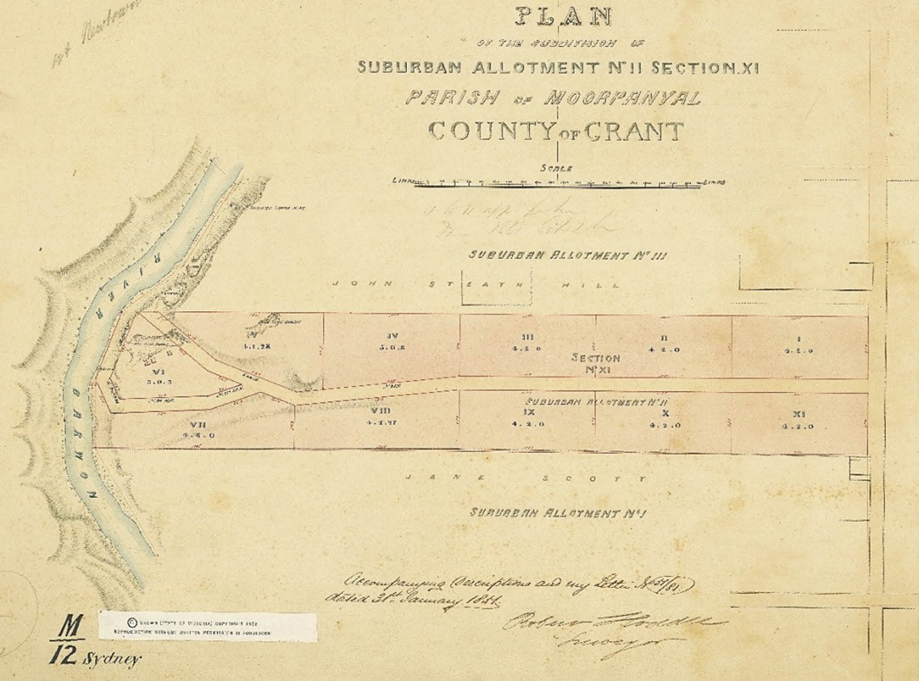
Figure 4.72: Plan showing quarries at the west end of Camden Road, Newtown, beside the east bank of the Barwon River, 1850. Melville’s quarry was in the triangular allotment VI. Source: R. Scott, Assistant Surveyor (R. Hoddle, Surveyor), Plan of the Subdivision of Suburban Allotment No. II Section XI, Dept Crown Lands & Survey, 31 January 1851, VPRS 8168/P2 Unit 6171 SYDNEY M12 MOORPANYAL, Public Record Office Victoria.

STONE QUARRYING358
With the development of Melbourne and Geelong following European colonisation in the 1830s came the need for building materials. The Greater Geelong area, and particularly the banks of the Barwon River and the Barrabool Hills, were the locations of bluestone and freestone quarries which fed the extraordinary demand for masonry as a building material in the early-late 19th century. The stone quarries were to provide for a much-needed commodity at the expense of the natural landscape.

EARLY QUARRIES & QUARRYMEN INITIAL YEARS
The earliest quarry in the City of Greater Geelong was that
of the Wadawurrung at the Dog Rocks, Batesford, where greenstone was procured and made into axe heads and other implements and objects for trade.359
Quarrying was one of the earliest European extractive industries established on the Corio Bay foreshore at Limeburner’s Point by Patrick Melville in 1838.360 There, he worked a lime quarry with James Boucher until their partnership was dissolved in 1843 (see following subsections).361 The following year in 1839, stone was quarried for the construction of the breakwater at Breakwater (see Theme 3).362

By early 1841, Robert Somerville (c.1814-1880) had established a quarry in Geelong. He advertised his freestone quarry and thanked existing customers for their patronage in the Geelong Advertiser:
R. Somerville, Stone Mason and General Builder,
In returning thanks to his friends for the liberal support he has received since his commencement in Geelong, in the above branches of business, begs to assure them and the public, that no effort on his part shall be spared to deserve its continuance; and as his motto has ever been, and
will be “not words” but “actions,” he will make that alone his guarantee to public favour. And as a claim on their support, he further begs to remind them of his being the first to carry out the onerous task of opening a Freestone Quarry of superior quality in the neighbourhood, from which the public can be supplied to any extent they may require.363
The location of Somerville’s quarry is not known (he gave his address as South Geelong) but stone from his quarry was used to build the architraves and window sills at St. Andrew s Presbyterian Church in Yarra Street from March 1841, the first church in Geelong364 (Figure 8.02). Construction was carried out by Somerville and R.H. Marr.365

NEWTOWN QUARRIES, BARWON RIVER
While Somerville’s tenure of his quarry seems to have been short-lived, other quarrymen and stonemasons established quarries under license on and near the banks of the Barwon River at Newtown and Marnockvale. The earliest and originally most substantial was that of Patrick Melville (1817-1857) (see Figure 4.72). He commenced work there in the early 1840s366 following limeburning at Limeburner s Point (see following subsection).367 At Newtown, Melville named his enterprise the Barwon Quarry . It was situated at the west end of Camden Road, (bound today by Camden Road, Jackman Road and the Barwon River). The quarry was shown in a part Plan of Moorpanyal by Robert Hoddle, Surveyor, on 31 January 1851.
In early 1847, Melville endured criticism by a competitor, the claim being made that Melville had a monopoly on the quarry trade. In responding, Melville gave the following insightful information of quarrying in Newtown at this time:
during the seven years I have resided at the stone quarry – my envied residence – that no less than five to six licenses have been granted to different parties to quarry some nearly on the same bank I am working. Some have abandoned doing so any longer, from the fact that they could not make laborers’ wages, or scarcely a livelihood; and because they would not remove the obstacles or go through the faults when they met them, as they thought,

when done, they could not get sufficient remuneration for their labor. Those parties did procure stone equal to such as my much-desired quarry contains; but, because these could not procure rock without trouble and less expense, they abandoned their operations, and turned their attention to other pursuits more profitable. Which if they had expended, as I have done, from three to four hundred pounds, together with the labor of seven years, they would be able now to occupy as good a quarry as
I now hold.368
Patrick Melville (Mulvailie/Mulvillie) was born at Ennis, County Clare, Ireland, in 1817, the son of John Mulvalle, a farmer
of County Clare.369 A Catholic, Melville became a Land Steward in Ireland.370 He married Miss Arrabella Cullinan, a Protestant school mistress, in c.1834.371 They emigrated to Port Phillip on the Calcutta, arriving in October 1838 and
Melville immediately commenced quarrying.372 At his Barwon Quarry, Newtown, by February 1847, Melville procured Barrabool stone for the construction of the English Church (presumably Christ Church, Moorabool & McKillop Streets, completed in 1847) and Wesleyan Chapel (presumably Wesley Church, Yarra Street, erected in 1844-46).373 Melville’s stone was also used in the construction of Sladen House, Newtown, in 1850.374 Melville died in Geelong on 11 May 1857, aged 40 years, leaving his wife, Arrabella, and eight children.375
Melville’s competitors at Newtown in 1847 were Archibald Grant (c.1813-1874)376 and Nicholas McCann (1803-1879) (see later subsection). Grant’s quarry appears to have been
immediately north of Melville’s at the west end of Noble Street (see Figure 4.73). Nicholas McCann’s freestone quarry was situated further north on the steeply-sloping banks of the Barwon River, adjacent to where Benjamin Levien relocated his punt and later the location of the Queens Bridge (Figure 3.28) (see Theme 3).
The importance and extent of stone procured from these quarries was given in the Geelong Advertiser on 14 March 1848:
Some idea may be formed of the stone buildings, at present in the course of erection, at Geelong, when the fact is related, that four quarries are now at work, and in active operation. The average amount of stone that is daily brought into town is thirty loads, or about one
thousand tons per month! Two of the quarries are worked by Mr Melville; a third by Mr Grant; and the fourth by Mr McCann, all on Crown lands, and under license. Rubble stone is sold at seven shillings per load; cut stone, eightpence halfpenny per foot. There are other higher prices paid per foot for stone, according to the dimension or the particular manner it is required to be cut; but the three mentioned descriptions is the kind in greatest

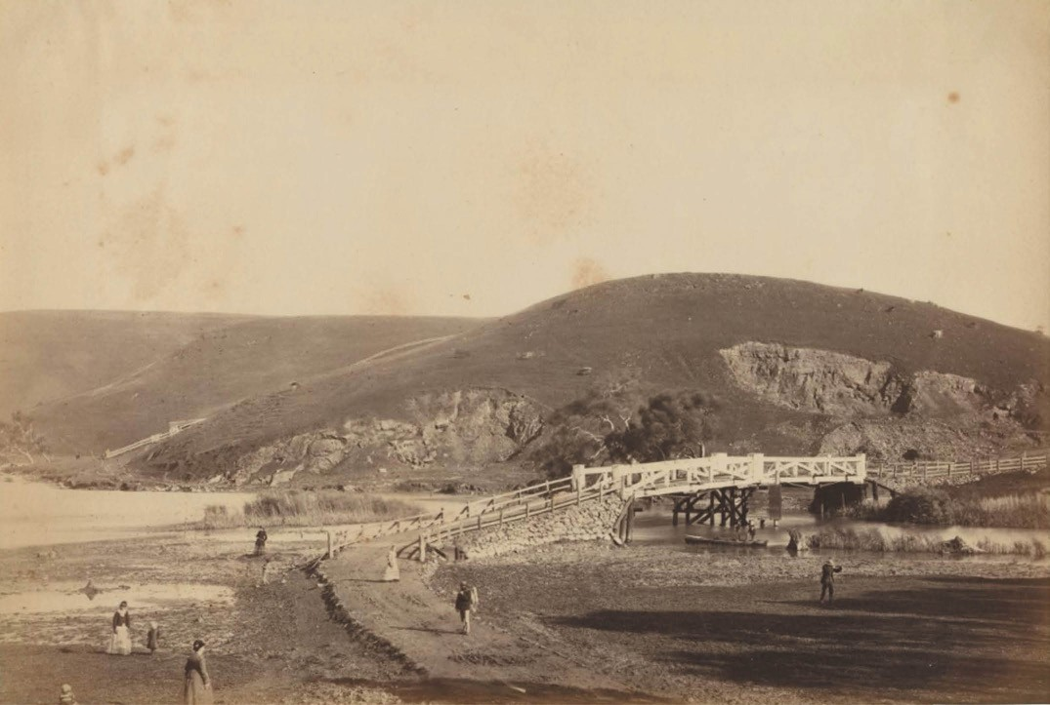
Figure 4.73: View on the Barwon River near Queen’s Park, Geelong, c.1878. Note the quarries above the east bank of the Barwon River at Newtown earlier worked by Nicholas McCann. Source: F. Kruger, accession PH321-1979, National Gallery of Victoria, Melbourne. Gift of Mrs Beryl
M. Curl, 1979.

demand. It will be perceived that the amount paid for this article of demand is very great. Beside the four quarries mentioned, for which there are several other places from which this building material is obtained, and occasionally in large quantities, that cannot be termed quarries, as the ground is only worked a little below the surface.377
The majority of these quarrymen on the banks of the river at Newtown were not to endure at this location. In 1849, Archibald Grant relocated to a property on the Barrabool Hills, lately occupied by Mr Williams [sic. Willis]’ where he commenced working a freestone quarry and advertised to
builders the superiority of his product.378 While a partnership as builders and quarrymen between McCann and Grant, Bellerine Street, was dissolved in late 1850, McCann also followed Grant to the Barrabool Hills to continue quarrying as well as farming (see later subsection).379 Patrick Melville continued quarrying until his death in 1857.
Others took up quarrying on the Barwon River, including Fredric Allen in 1850.380 Soon after, James Austin had acquired two quarries on the Barwon River.381 One appears to have been Archibald Grant’s former quarry north at the west end of Noble Street, the other possibly the former quarry of Nicholas McCann near Queens Bridge.382 One of the earliest contracts from Austin’s quarry was in 1854 for 2000 yards of stone for the Geelong Gaol (see Theme 7).383 In 1889, John Windmill (1857-1939) and his brother, William (1859-1943) son of Josiah Windmill (1810-1887), formed a partnership and took out a seven year lease of Austin’s quarry384 (Figure 4.74). In 1892, the Windmill Brothers procured a new stone crushing plant which featured in a report in the Geelong Advertiser in 1892:

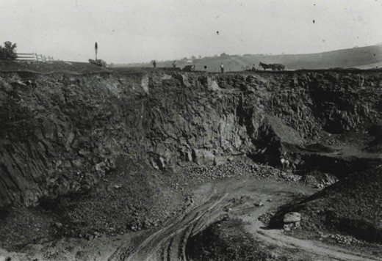

Figure 4.74: Austin’s (Windmills’) Quarry, Newtown, n.d. Source: GRS 2009/02372/097, Geelong Heritage Centre collection.

The demand for machine broken metal for road making purposes and for ballasting has induced Messrs J. and W. Windmill to enter largely into the business and they have just completed the erection of a valuable stone breaking and crushing plant in the vicinity of the Austin quarries
at the west end of Noble-street close to the River and the Queen s Park Bridge over the river Barwon. The plant is that known as the Victorian Patent Stone-Breaker made by Messrs Jaques Bros., of Coppin-street, Richmond, and it is the first of its kind introduced to notice in this district, the breaker being capable of crushing the hardest of ores, quartz, and stone … In this district, the Messrs Windmill Bros. promise to provide for the public the various kinds of broken metal for roads, streets, footpaths and yards, as well as screenings for asphalt pavements and courts, and metal for concrete work.385
Austin’s quarry remained under the ownership of James Austin until his death in 1896. At this time, the quarry was leased to the Windmill Brothers at an annual amount of
£50. The property was valued at £1000.386 By 1897- 98, the Windmill Brothers had purchased the quarry and 13 1/5 acres of land from James Austin s Estate.387
In 1911, the firm of J. and W. Windmill was dissolved and the quarries and stone crushing plant put up for sale.388 The property was purchased by John Windmill389 who continued business there with his sons, Josiah and William. The quarry continued to be worked by Josiah and William after John s death in 1939.390 In the 1950s, they donated the quarry to the Newtown and Chilwell Council for recreational use. It is now known as Windmill Reserve.391 The only other recognition
of the previous associations with quarries in the area are the names of the streets: Grant (after Archibald Grant) and Windmill (after John Windmill).

MARNOCKVALE QUARRIES
In 1851, the Victorian Colonial Government offered a one year lease for a stone quarry comprising 1 acre and 16 perches ‘at allotment 4, section 12, Moorpanyal.’392 This was a triangular portion of land to the south-west of the Shannon Avenue
and West Fyans Street intersection and was to become the Corporation quarry where bluestone was procured for road- making and other engineering infrastructure (see Theme
6). In 1854-55, it was worked by William Allen, Pascoe Ellis, Hewin and Chappel, Shields and John Williams.393 The quarry featured in Richard Daintree’s Geological Survey Map of 1861 (published in 1863) (Figure 4.75).
By 1866, the quarry site had been subdivided into three municipal quarries for the Geelong Corporation and Boroughs of Newtown and Chilwell, and South Barwon, respectively394 (Figure 4.76). In 1901, the quarry site became a rubbish
tip for the Newtown and Chilwell Council.395 In 1984, the former quarry was transformed into a terrace garden known as Leach-Wood gardens.396 It was opened by the Hon. J.L.
Simmonds, M.P., Minister for Employment and Training on 24 November of that year in the presence of Mayor and Councillors, and Town Clerk and City Engineer of the Newtown City Council.397
Several other quarries were established at Marnock Vale from the 1850s. Some of these were shown in Daintree s Geological Survey Map (Figure 4.77). In 1854, two whinstone quarries were worked by quarrymen also associated with
the nearby corporation quarry: Pascoe Ellis, and Hewin and Chappel.398 On the south side of West Fyans Street between Shannon Avenue and Bridge Street were at least two quarries. At different times they were worked by a Mr Oates, Jonathan Chappel (honeycomb bluestone quarry) and Mark Daniels.399 Before 1873, W. Bottrell acquired Chappel’s honeycomb quarry.400 Following acquisition by the Newtown and Chilwell Council, these quarries were filled in.401 The site is now largely a mountain bike park. There were other quarries south of Bartlett Terrace (these quarries were purchased
by the Newtown and Chilwell Council in 1947 as a site for a swimming pool, this being the location of the Geelong Aquatic Centre today).402 At Rocky Point, a bluestone quarry had been in operation before 1855.403 Between 1878 and 1898, James Walker had a quarry that supplied his steam-powered stone crushing works at
103 Fyans Street.404
Possibly the most interesting quarrying enterprise in the second half of the 19th century at Marnock Vale was Scott’s quarry. Jane Scott had acquired 53 acres comprising allotment 1 of section 1 in the Moorpanyal Parish in 1847.405 Situated on the north side of West Fyans Street (and west of Shannon Avenue), she was to live there with her husband, Duncan Scott, an inaugural Councillor with the Newtown and

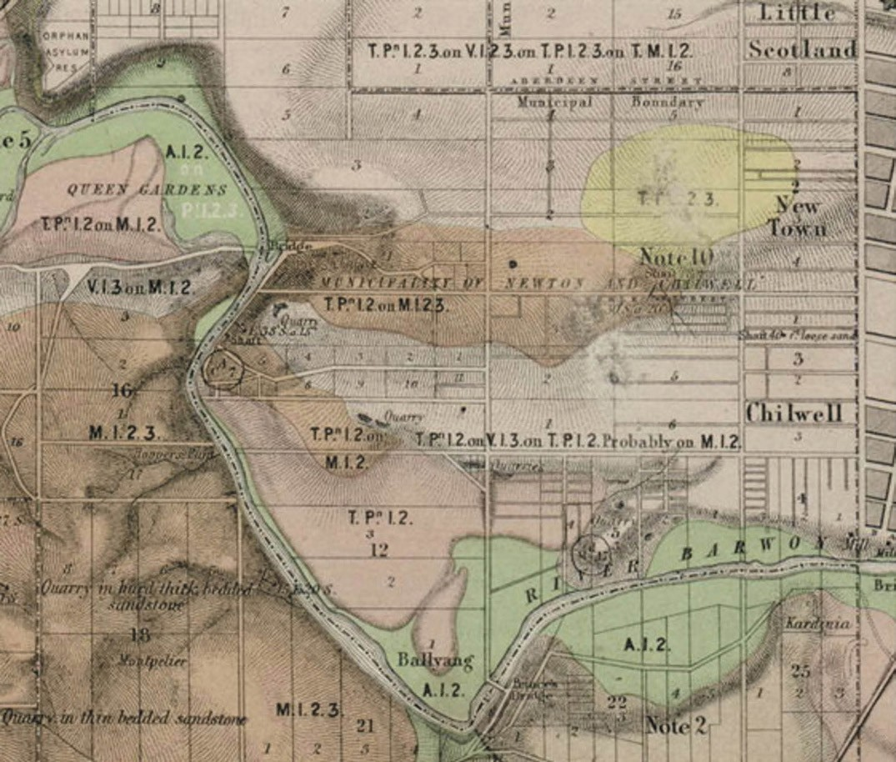
Figure 4.75: R. Daintree, Part of Geological Survey of Victoria Map 24 SE: Gherineghap, Moorpanyal, Barrarbool, Corio, geologically surveyed 1861, published 1863, showing quarries at Newtown (centre), including Marnock Vale (circled). Source: Earth Resources online http://
earthresources.vic.gov.au/ data/assets/image/0003/1125588/9_24se_2879x2190_big.jpg.

Chilwell Borough Council in 1858 (see Theme 7). A quarry had been established on the Scott property by 1860 as James Morris, quarryman, had been charged ‘with blasting stone
in the vicinity of Mr Duncan Scott’s, Fyans street, without license and without taking proper measures of precaution to avoid accidents from splinters, &c.’406 Duncan Scott claimed that ‘he, as well as his family, had narrow escapees of their lives from the splinters falling about. 407 The location of the quarry was shown in Daintree’s Geological Survey Map (Figure 4.75).
While it was variously known as ‘Scott’s quarry’ and
‘Mrs Scott’s quarry’,408 it appears that Jane and Duncan Scott
never operated it. In 1878, this quarry supplied the bluestone for the railway ballast for the construction of the Geelong
to Queenscliff railway line.409 The contractors, Messrs. Topham, Angus and Smith, laid an iron tramway from West Fyans Street to a railway yard between Moorabool and Yarra Streets.410 While the contractors were praised for their speedy and efficient construction of the railway line, complaints had ensued about the tramway from the quarry in that ‘on downhill grades the horses were unhitched and the wagons allowed to roll unattended at considerable speeds terrifying pedestrians as they went by. 411 The tramway had been removed by September 1879.412 The quarry continued to be worked in the

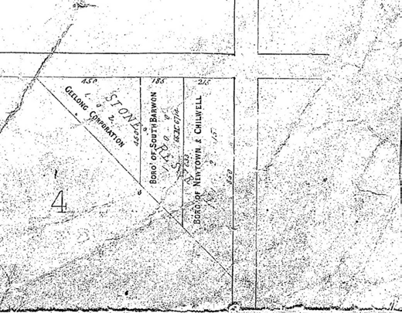
Figure 4.76: Bluestone quarry, Williams Road, Mount Duneed, 1999. Source: Jeremy Smith for Authentic Heritage Services.

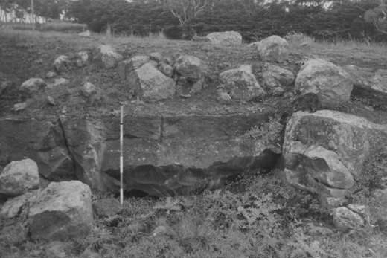
Figure 4.77: Bluestone quarry, Williams Road, Mount Duneed, 1999. Source: Jeremy Smith for Authentic Heritage Services.

ensuing years and the site is now a public reserve known as Rotary Centennial Park.

OTHER SUBURBAN GEELONG QUARRIES
Numerous other private and corporation quarries were established throughout the suburban areas of Geelong from the mid-19th century (Figure 4.77) and worked by a number of quarrymen (see Appendix 4.3 which includes a list of quarrymen). There were also other quarrymen that gave different occupations, such as builders, contractors and stonemasons.413

MARBLE QUARRY AT LIMEBURNER’S POINT
At Limeburner’s Point on the Corio Bay foreshore, in addition to limestone, a marble quarry was worked at different times.414 From 1849, Alfred Ronalds, a recently-arrived English engraver and copper-plater,415 in an effort to locate local lithographic stone, fossicked the eastern shores of Corio Bay. His initial marble discovery at Point Galena (as Limeburner s Point was earlier called)416 found that it was so impregnated with quartz as to be of little use except in such small blocks as rendered its commercial value for artistic purposes of small moment. 417 In 1851, Ronalds came across another outcrop that was different to those he had previously seen. He forwarded samples to Sir Thomas Mitchell, then Surveyor-General of New South Wales, seeking an opinion about the quality of the stone. Mitchell’s reply was that ‘they were beautiful samples of Sienna and brocatelle marble and if there was sufficient quantity, a Sydney firm was willing to acquire it.418 However, the Victorian gold rush put a halt to Ronalds’ enterprise, the value of gold outweighing that of the marble at eastern beach.419 In 1862, promise was again given to the possibility of eastern beach marble being quarried in commercial quantities. Robert Shanklin, a Ballarat chemist and son in law of Alfred Ronalds, obtained a lease to work the marble quarry. Although a block was polished and presented the appearance of Sienna marble ‘of a very beautiful quantity,’
Alfred Selwyn, Government Geologist, visited the site
and expressed doubt that the marble would exist for any considerable depth below the surface. 420 Nevertheless, Shanklin persisted in establishing a company to work the marble quarries. The Geelong Advertiser gave the following description:
A prospectus has been issued by Mr Shanklin, of Ballarat, of a Company to work the Marble Quarries, at the Point. A lease has been obtained of three acres, and it is proposed to raise a capital of L2,000, in shares of L25 each. Not- withstanding the number of specimens to be seen about town, not a few it seems are incredulous as to the fact
of such quarries existing. We may state, however, from personal observation for we visited the spot yesterday, that the material does exist, and in such quantity, quality, and variety as to leave no doubt whatever of it proving
a most valuable investment to the fortunate lessee. Conversing with a man who was busily employed there roughly squaring a specimen block, he stated that he had been working at the kilns for the last three years, and
thousands of tons of it had been burnt into lime. He traced along the shore several huge blocks, which he said would not be less than two or three ton boulders, probably more.
Most of the rock eastward of the powder magazine and a little to the west-ward of it appears to be of a yellowish
grey,— the real Sienna marble in fact; while more eastward the blocks are generally of another character, darker in

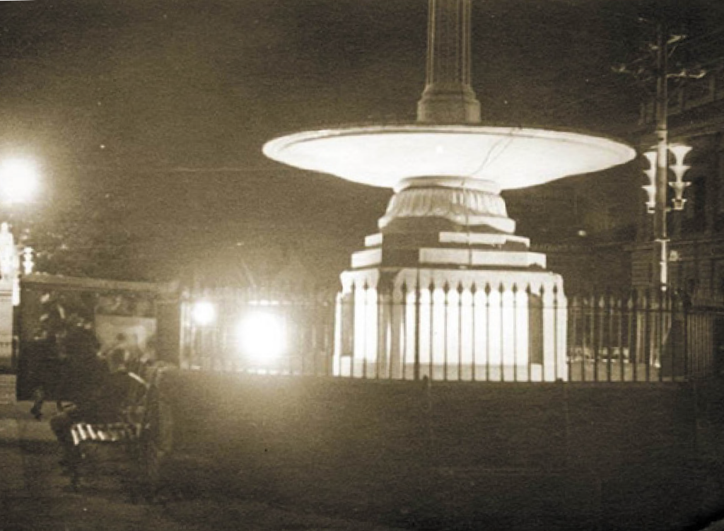

Figure 4.78: Explorers’ Fountain Monument, Ballarat, 1935.
The Eastern Beach marble tablets are located in the incised panels at the base of the monument. Source: J. Walton, image MM4334, Museums Victoria.

color and closer in grain. Some that we cracked (for we went a la Murchison) was of a bluish black, with veins of white and yellow. Another specimen was a rich mixture of blood red, white and black. A third resembled a very
handsome granite. The variation in color of rocks which lie close to each other is very extraordinary, one often being a Sienna while its next neighbour is perhaps nearly jet black. A large boulder of Sienna marble has been prized, and will be found just past the Chinaman’s hut. We are not aware whether Mr Shanklin’s lease of three acres takes up the whole sea frontage along which these rocks extend; we should think not. In any case the lime kilns frontage embraces sufficient quantity of the material to give ample room for a second company, if necessary; and knowing now the true character of the stone which, by the way,
has won for Mr Cakebread’s lime a world-wide reputation, it is possible that gentleman may enter the field as the rival of our enterprizing Ballarat friend. The shares in the present projected company are too high, we think, for the
investment to become at once popular. A lower sum would be more certain to command immediate success. We shall shortly, too, have the wool ships in port, affording a ready and speedy means of access to a foreign market, and if operations are quickly commenced, share-holders would have to wait but a short time for a handsome dividend upon their outlay. There is another feature in this matter which should not wholly be lost sight of. It is quite possible as these quarries are worked that a pure magnesian limestone adapted for lithographic purposes may be found. The stone burnt during the last year or two, of this character has been decidedly superior in quality to that of former years. There have been generally fewer quartz nodules in it, and the color has been considerably more promising. We saw some

yesterday which had all the appearance of being sufficiently good for the smaller sizes used, and we confidently expect it will come out by and bye of a quality little if at all inferior to the French and German stone. Lithographic stone in slabs is worth in London from 2d to 3d per lb wholesale, and here where it is extensively used in the Government surveying departments of all the colonies, besides the quantity annually taken up by the trade it would readily command a higher price. For the present then we will leave the matter to fructify in the public mind, convinced that the natural wealth which lies within grasp will be wisely availed of to their advantage.421
Although Shanklin s anticipated success in procuring marble at the Geelong quarries never met expectations, the marble was to feature as memorial tablets donated by Shanklin for the construction of the Explorer’s Monument, Sturt Street,
in 1867422 (Figure 4.78). The ‘white’ marble ‘with a few dark veins 423 has been removed in subsequent years given that the incised panels in the granite base have black marble tablets today.424

HAYE’S PATENT VICTORIA STONE MANUFACTORY, EASTERN BEACH
In 1854, Messrs. Hayes and Co. took out a permissive occupancy of foreshore land at Eastern Beach and established a factory to manufacture Victoria stone 425 (Figure 4.79). Having previously formed a factory at Sandridge (Williamstown), Patrick Hayes continued to prosecute
various experiments to prosecute slabs of stone, ‘admirably calculated for street pavements, or for the flooring of kitchens, workshops, &c.’426 Considered to be far cheaper than imported pavement stone, the Geelong Advertiser and Intelligencer gave a description of the characteristics of the new masonry material:
For all purposes of drainage or walls under water, the sand-stone is peculiarly adapted, owing to its being thoroughly impervious to water, and so easily moulded to any required form. It may be sunk in the shape of cassoons, and thus used for any sub-marine works.
By applying a thin coating of the stone, while in a soft state, to the surface of any building, it may be made to form a covering bidding defiance to all moisture, and adhering as firmly as any cement known to the walls or boarding to which it may be applied. Another useful purpose is answered by this manufacture, namely the
production of a very brilliant gas, which is given out in the process of amalgamating some of the ingredients that enter into the composition of the stone, and is produced without any waste of the materials as regards their use in the formation of the stone.427
Hayes’ manufactory was not to last, it closing after 1856.428

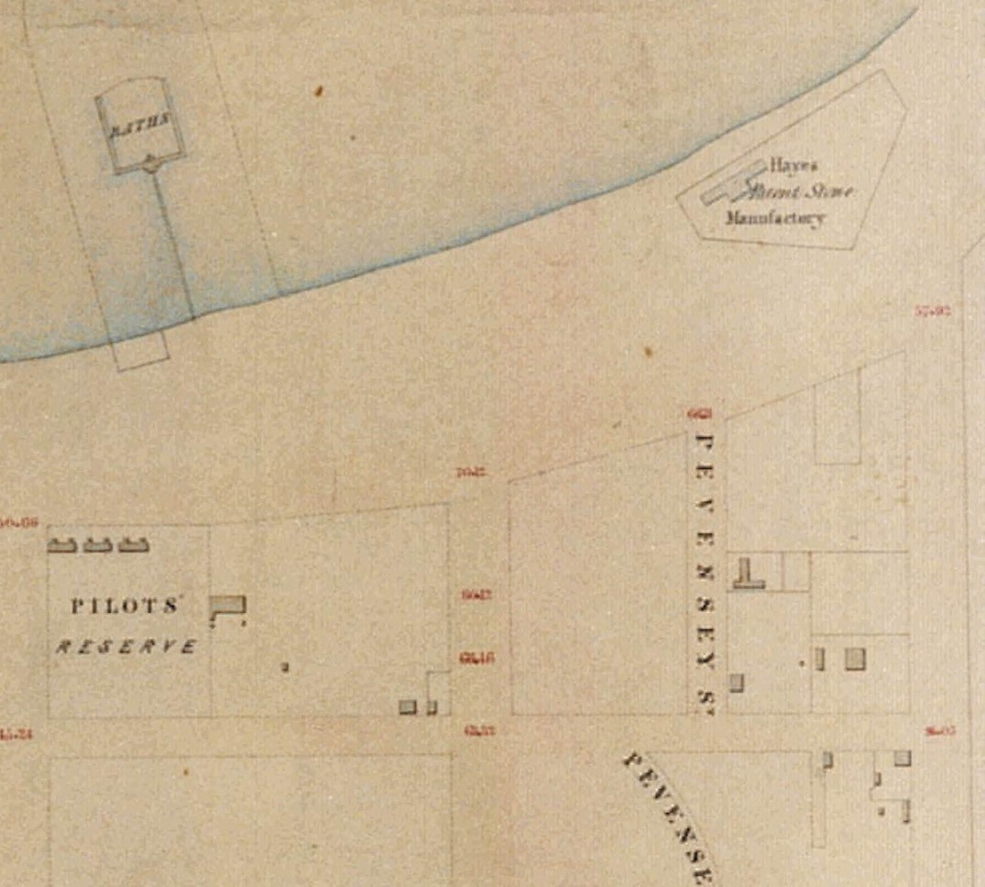
Figure 4.79: Map showing the locations of Hayes’ Patent Stone Manufactory, 1854. Source: J.H. Taylor, Map of Geelong, Surveyor-General’s Department, Melbourne, VPRS 8168/P2, Unit 5416, item Roll 39 Geelong, Public Record Office Victoria.

BLUESTONE COUNCIL QUARRY, BELMONT
At Belmont on the southern bank of the Barwon River (and below Strawberry Hill), a reserve had been set aside by 1851 ‘for quarrying purposes “blue stone”’429 (Figure 4.80). By 1857, the quarry had been subdivided for use by the Barrabool District Road Board, Geelong Corporation and the South Barwon Municipality430 (Figure 4.81). These quarries were still in use in 1886 when the South Barwon Shire Council called tenders for quarrying ‘200 yards of bluestone, near Belmont. 431 The quarry had closed by 1903 when the site
was transformed into an ornamental plantation.432 It was later named in honour of Dr Frederick Moreton (1861-1948), local medical practitioner, tree preservation advocate and inaugural President of the Geelong Town Planning Association (see Themes 1 and 7).

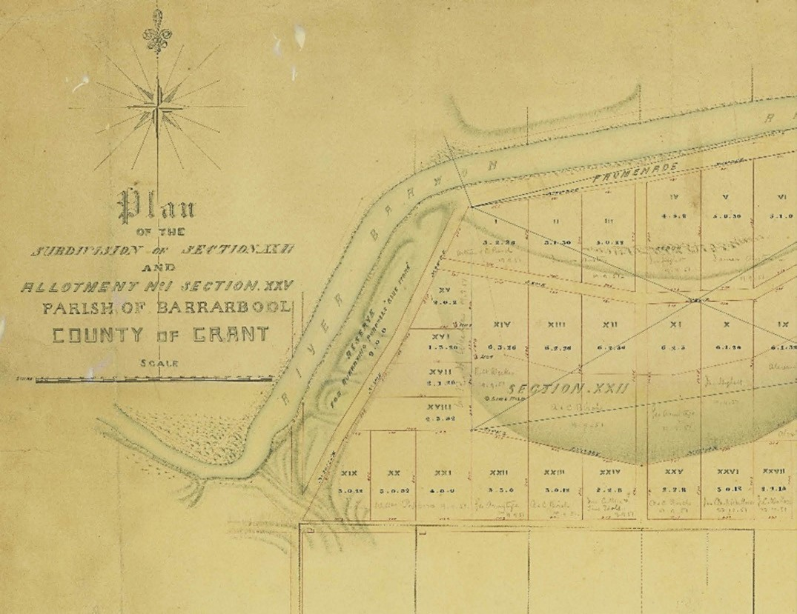
Figure 4.80: R. Hoddle, Plan of the Subdivision of Section VVII and Allotment No. 1 Section XXV, Parish of Barrarbool, County of Grant, 21 March 1851, showing quarry reserve (left). A lime kiln and limestone huts are circled. Source: VPRS 8168/P5 Item SYDNEY Record B1, Public Record Office Victoria.

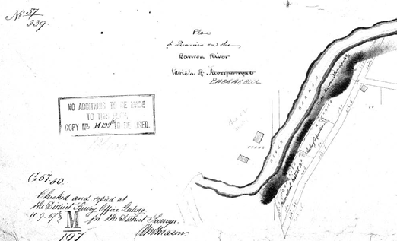
BREAKWATER CORPORATION QUARRY
At Breakwater, a corporation quarry was in use in 1855 with blue metal used in the construction of 20 chains of the Point Henry Road.433 It was situated to the north of the
breakwater.434 In 1887, another corporation quarry was in use ‘near the police paddock, at South Geelong’, again for making a road near Point Henry.435 This quarry had been reserved in 1884 and was situated to the north of
the police paddock, adjoining the Geelong to Colac Railway line.436

Figure 4.81: A.M. Mason, Plan of Quarries on the Barwon River, Parish of Barrarbool, 11 September 1857. Source: Put-away plan M197/1, Landata, © State of Victoria.

BARRABOOL HILLS & WAURN PONDS QUARRIES & QUARRYMEN
The most prolific quarries from the mid-19th century
in Greater Geelong were situated in the Barrabool Hills: at Ceres, Barrabool and Waurn Ponds. The vast estate of Charles McLachlan and Captain Charles Swanston were subdivided into a number of estates from 1850, including
the Merrawarp estate west of Gully Road, Ceres (Theme 6). Other neighbouring pastoralists also subdivided their properties from this time, including David Fisher who subdivided his Roslin Estate in 1850 into small farm lots and created the village of Ceres (see Theme 6). Immediately north of the Ceres village, Matthew Holmes subdivided his Glencairn dairy farm in 1851437 and offered leaseholds for farm lots. On a number of these farm lots were opportunities for quarrying Barrabool sandstone. The principal quarrymen and stonemasons were Nicholas and Peter McCann, and Ezra Firth and Benjamin Holdsworth.

NICHOLAS AND PETER MCCANN
Nicholas McCann was born in 1803 in New South Wales, the son of Peter and Mary McCann.438 He married Miss Catherine Johnson in 1826 when McCann was a stonemason at Parramatta.439 With his wife and two sons, Charles and Peter, Nicholas McCann relocated to Georgetown where Catherine McCann died in 1831. At Campbell Town, Tasmania in 1836, McCann married Catherine Nelson.440 Soon after, McCann heard glowing reports of the grazing potential in Victoria and in 1837
the family sailed to Westernport and then to Port Fairy. There, he became involved in the whaling and building industries. In 1840, he travelled from Victoria in search
of grazing land.
Arriving in Geelong in 1841, he became a builder, stonemason and quarry developer. It appears McCann’s first solo venture in 1845 when he advertised his ‘new quarry’, giving his occupation as a builder:
The undersigned begs leave to return his sincere thanks to the people of Geelong and the public in general, for the liberal support which he has received since his residence amongst them; and he further begs leave to intimate that he has opened a new quarry on the banks of Corio Bay, and he feels assured of being able to keep a full supply of the best material of stone that has ever been offered in Port Phillip, and at the most moderate prices. The undersigned trusts by strict attention and good workmanship to give general satisfaction to all who
may give him their patronage. All orders for Melbourne or elsewhere strictly attended to. Specimens of stone may be seen in Yarra-street, facing Mr. Harrison’s; it has been examined by Mr Skene, architect, and been approved by

him as the best material he has seen in Port Phillip.441
It appears that McCann’s quarry on the foreshore of Corio Bay was short-lived given his relocation to the bank of the Barwon River at Newtown in 1847. While he retained leases over two quarries at Newtown until 1851, he also took up a lease in 1849 of a quarry with ‘very superior stone on the Barrabool Hills that he leased from E. Willis.442 Willis was the son in law of Captain Swanston, owner of the Merrawarp Estate.443 In 1850, Garrard and Shaw, surveyors, prepared
a subdivision Plan of the Village of Merrawarp for Messrs. Swanston, Willis and Swanston (Figure 4.82). The newly- created allotments flanked both sides of the Barrabool Road to the east and west of the junction with Merrawarp and Honeys Roads. The eastern allotments on the south side of Barrabool Road included the location of McCann’s quarry, together with the quarries of G. Grigg and J. Highett.444 McCann and Grigg purchased these quarry allotments.445
McCann might also have worked a quarry on James Piper’s Newlands Homestead opposite McCann’s quarry site.
In 1898, Piper was reported as recalling the following:
In the early 50’s a freestone quarry on his land was rented to a party by Mr Piper, and hundreds of tons of material were taken out, and used in building construction in Geelong, Melbourne, and other parts
of the colony.446
In February 1851, David Fisher subdivided his 1280 acre ‘Roslyn Estate’ at Ceres ranging in allotments between
2 and 42 acres. Advertised as the ‘Garden of Port Phillip’, the subdivision included ’11 lots of quarry land.’447 Situated on both sides of the Barrabool Road east of Gully and Cochrane’s Road, and excluding the newly-created Village of Ceres, 750 acres of the land was acquired by William Harding.448 Immediately east of the Ceres Village, Nicholas McCann leased farm land on the north side of Barrabool Road. In 1855, McCann’s farm and the remaining allotments owned by Harding, were advertised for sale in 1855. The property leased by McCann was described as follows:
No. 4 is a farm occupied by Mr. Nicholas McCann, consisting of 59 acres, 0 roods, 10 perches. The whole of which is under the most profitable cultivation. This farm has been truly described as the model farm of the Barrabool Hills. The land is a rich black alluvial soil, perfectly clean, and produces the most luxuriant crops with less labour and outlay than any other farm of the same extent in the parish. One side of this farm adjoins the Village of Ceres.
There is a valuable stone tank made to hold twelve months’ supply of water. The dwelling, stables, barns, and outhouses are all suitable for profitably conducting farming operations.

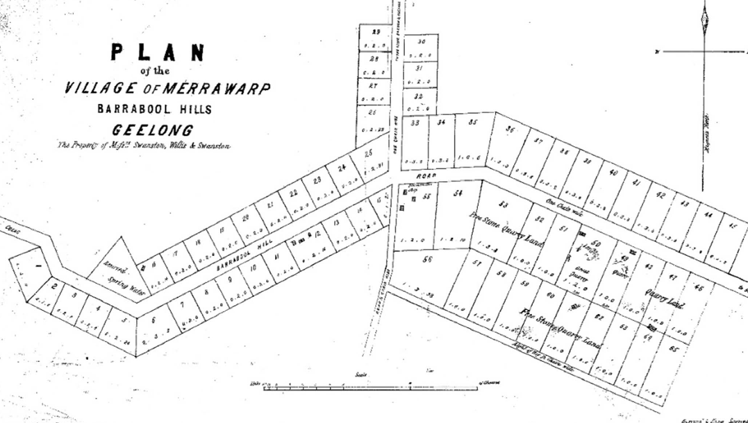
Figure 4.82: Garrard & Shaw, Plan of the Village of Merrawarp, Barrabool Hills, Geelong, September 1850, showing quarry allotments (circled). Source: GRS 2030/M137/001 Geelong Heritage Centre collection.

The present tenant’s lease expires on 1st April, 1858.449
McCann therefore combined his quarrying operations with farming. In 1859, he gave the name of his property as ‘Fairview Farm.’ It is likely that McCann had named his farm on the Barrabool Road by this name, being the same
name as ‘Fairview’, Merrawarp Road, owned and occupied by James Huggett from at least 1856.450 It is also likely that McCann purchased his farm from Harding in 1855.451 In 1856, McCann’s dwelling was described as ‘a neat, but humble and unpretending, building.’452
McCann’s continued interests in quarrying in the late 1850s appear to have been in partnership with his son, Peter McCann (1828-1908). In July 1859, Nicholas outlined his lament at the prejudice of Melbourne architects against the use of Barrabool stone, ending his letter to the editor as ‘McCann and Son’.453 In particular, McCann declared:
We are aware that a prejudice has existed in the minds of architects resident in Melbourne against Geelong stone, simply from the fact that many of the mouldings and other projecting parts of buildings erected with a kind of stone found near Geelong some years since has not resisted the weather as well as could be wished; but it is only necessary to understand two facts connected with the matter in order to clear that prejudice entirely away. First,
that in the olden days no care was taken to have the stone put in the building in such a way as to lie on its natural bed a precaution that is indispensably necessary with all kinds of freestone. Secondly, that we have now quarries of a very much superior character to those in use at the time referred to, as evidence of which we challenge
any one to show the slightest crack or sign of decay in any building erected with stone from our present quarries.454
Robert Upston, Overseer of the Immigration Depot in Geelong took umbrage to McCann’s claims. He advised the Messrs. McCann ‘to look at the Chamber of Commerce and the Savings’ Bank again, although neither is yet finished, and if they cannot find some cracks of a very serious, nay, even one of a – to me – dangerous nature, I will point out the same to them upon their calling upon me. 455 Upston did further state that ‘in justice to the stone, I think I should ask for any inquiry as to whether the fault lies in the frailty of the stone or the quantity used to support the weight placed upon it.’456 In reply the following day, Nicholas McCann defended his product and chastised Upston s claim that the stone was defective:
In reply to Mr Upston we beg to say that before he again rushes into print about a matter he evidently does not understand, it would be well for him to get the advice of some professional friend as to what constitutes a fault

of defect in stone,” he will thus be saved from the error of ascribing a break in a lintel (caused by excessive and improper pressure in the middle) to a defect in the stone.
However, as there happens to be positive proof of the superiority of Barrabool stone for the purpose of lintels we would just refer Mr Upston to the report of M J.G. Knight, bywhich he will find that Barrabool stone is capable
of bearing nearly double the weight sustained by either Bacchus Marsh, Tasmanian, or indeed any other stone yet discovered in the colonies. At the same time, as Mr Upston seems interested on behalf of the Hobart Town stone, we would recommend him to examine the lintels in the Bank of Victoria. If he does, he will find that three
out of four have broken, and that too across opening very much narrower than those of the Chamber of Commerce, while also the lintels of the Bank of Victoria possess the advantage of a support in the middle.457
Interestingly in 1863, Richard Daintree, geologist, in his Report on the Geology of the District from Bacchus Marsh to Bass s Straits gave inference to some deficiencies in quarrying Barrabool stone:
McCann and Holdsworth’s quarries on the Barrabool Hills supply freestone to the district; but here, as everywhere in the series, joints running in all directions through the stone cause a large amount of “spoil”, and a difficulty in raising large sound blocks.458
At Ceres, Nicholas McCann also gave generously to the Wesleyan cause in the establishment of the Wesleyan church and to the Barrabool Hills Total Abstinence Society, donating the land for its hall in 1861.459 He died at Ceres in 1879.460

PETER MCCANN
Peter McCann was the second son of Nicholas and Catherine McCann. He was born in 1828 at Parramatta, New South Wales.461 He went with his father to Port Fairy, helped him in the whaling and building business before becoming a partner in his father s business.462 In 1850, Peter McCann travelled
to England to bring back his sister, Ann, who, following the death of Catherine McCann, had been adopted to a couple in Launceston who relocated to England. There, McCann married Miss Elizabeth Begley.463 From 1852, McCann was actively involved in sandstone quarrying at Ceres as well as contracting.464 He had established his ‘Eureka’ quarry on 50
acres of Matthew Holmes’ ‘Glencairn Farm’. Holmes left Ceres after the death of his youngest child in the Black Thursday bushfires of 6 February 1851.465 He subdivided the farm into farming and quarry lots and leased them. It was from there where considerable freestone was procured for building many of Geelong s masonry structures and which was shown on Andrew McWilliam’s Map of Barrabool in 1861 (Figure 4.83).

With Mr Pettigrew in 1857 and 1858, McCann worked the Corporation quarry at Marnockvale for stone used in the construction of the piers for the Barwon River bridge at South Geelong.466 McCann and Pettigrew also built the piers (see Theme 3) and suffered a heavy financial loss in the process.467 By the early 1860s, McCann also had a quarry
at Cowies Creek, which he had established with his step- brother, William Nelson McCann, stonemason and Member of the Legislative Assembly from 1860 until 1 August 1867 when his seat was forfeited following McCann’s conviction of forgery and subsequent imprisonment.468 Peter McCann’s most substantial quarry was to commence at Batesford in 1867469 and in 1888 he purchased an adjoining property there
which was to become the quarry of Australian Cement Limited (see following subsection). He initiated the cement works at Fyansford in 1890 and was the chairman of the first board of directors of Australian Portland Cement Co. Ltd470
(see Theme 5).
In 1872, Holmes offered for sale his ‘Glencairn’ Estate and in 1876-77 Peter McCann purchased 84 acres (including the Eureka quarries).471 He had also taken over ownership of his father s property in 1870-71.472
Following Benjamin Holdsworth’s death in 1881,
Peter McCann took over the quarry and limestone operations at Waurn Ponds473 with his eldest son, John Nicholas McCann (see following subsection). They traded under the name P. McCann and Son.474 In addition to his business pursuits, Peter McCann was a member of the Ceres Roads Board and a justice of the peace. On Peter McCann’s death in 1908,
the Geelong Advertiser outlined the buildings constructed by Nicholas or Peter McCann, including the buildings constructed of stone from their quarries. Captain Foster Fyans’ house, ‘Balliang’ and B.G. Levien’s house near the Queens Bridge, Newtown, were some of the first works carried out by the McCann family. The Geelong Advertiser continued:
Of late years, Messrs. P. McCann and Sons have completed large contracts for the supply of Barrabool and Waurn Ponds stone to important public buildings
in the State, notably the Anglican Cathedral, Melbourne; Scot’s Church, and Roman Catholic Cathedral, Bendigo.475

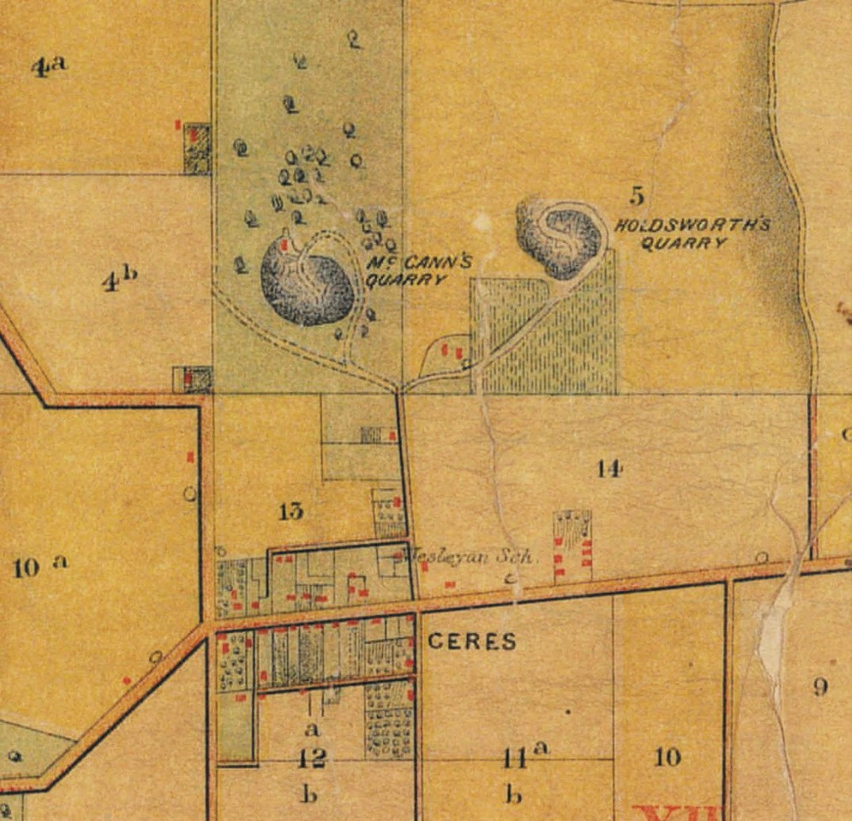
Figure 4.83: A. McWilliams, Part Barrabool Parish Plan, 1861, showing McCann’s and Holdworth’s Quarries. Source: Jennifer Bantow, Geelong.

EZRA FIRTH AND BENJAMIN HOLDSWORTH EZRA FIRTH
Ezra Firth was born at Bradford, Yorkshire, England, in 1823,
the son of John and Sarah Firth.476 He married Miss Eliza Craggs in 1842. A stonemason, Firth emigrated to Victoria on the Larpent in 1849, and first worked for George Armytage at ‘Ingleby’ homestead, Winchelsea, 50 kilometres from Geelong.477 With the discovery of gold at Ballarat in 1851,
Firth tried his luck at the diggings and within two months he had collected over 250 ounces of gold. To gain a better price, he took the gold to England, working as a seaman for the journey.478 He returned to Victoria in 1852 and settled at
Ceres where he established a freestone quarry with Benjamin Holdsworth479 on part of Matthew Holmes’ ‘Glencairn’ estate and adjacent to McCann’s quarry (see Figure 4.84). Stone from their quarry was used to build several substantial structures in Geelong and Melbourne, including the Town Hall, Customs House and old Supreme Court buildings in Geelong.480 In 1858- 59, a Board appointed by the Victorian Parliament to report on Building Stone assessed samples of stone provide by Holdsworth and Firth in considering superior building stone in the colony. The Board concluded:
The stone placed third on the list is forwarded by Messrs. Holdsworth and Firth from their quarries near the Township of Ceres, on the Barrabool Hills, about six miles from Geelong. This stone is certainly superior to the material used in most of the buildings at Geelong, which is obtained from quarries more contiguous to the town. The indiscriminate use of this latter stone has no doubt placed the better kind from the Barrabool Hills at a disadvantage.
The principal objection to the stone is its color, a dull greenish brown; in other respects the Board are of the opinion that if it were selected of equal quality to the sample submitted for their examination, it would be but little inferior to that imported from Kangaroo Point.481
Firth and Holdsworth ‘were also extensive farriers’, operating a forge in the Ceres Village.482 In January 1864, Frith advertised a clearing sale of household furniture and effects on account of him and his family leaving for Queensland.483 There, he established the Mount Surprise sheep station in the far north of the state, initially in partnership with James Atkinson.484 Retiring from the station in 1884, Ezra and Eliza Firth travelled to England before settling in Brisbane where Ezra Firth died in 1910.485

BENJAMIN HOLDSWORTH
Benjamin Holdsworth was born in Leeds, Headingley, Yorkshire on 6 October 1815, the son of Joseph and Dorothy (nee Elwand) Holdsworth.486 Benjamin married Miss Ann

Fisher in Leeds in 1839, where he was a clothier.487 They emigrated to Victoria in 1849, arriving at Point Henry in 1850.488 In Geelong, Holdsworth worked as a contractor and subsequently established what became widely known as Holdsworth’s quarry with Ezra Firth at Ceres. In 1855, Holdsworth and Firth advertised that ‘they are now prepared to supply in Melbourne, on the shortest notice, any quantity
of their superior Freestone, cheaper than any in the colony.’489 From about this time, Holdsworth and his family were resident at Highton.490 In 1856, Holdsworth and Firth obtained equity in the Great Western Hotel, 177 Aberdeen Street and following the insolvency of Charles Corbett in 1857, acquired complete ownership.491 They advertised the sale the hotel between February and April 1859. It seems for a brief period in mid- 1859 Holdsworth managed a quarry at Bacchus Marsh as he advertised for a freestone quarryman at Bacchus Marsh as manager on the works at this time.492
Holdsworth’s quarry interests however remained at Ceres until 1869 when he took out leases of a large area of land on the Colac Road, Waurn Ponds.493 There, in addition to farming, Holdsworth re-opened freestone and limestone quarries that had been in operation before 1861 as several quarries on the south side of the Colac Road at Waurns Ponds, as well as flanking the Waurn Chain of Ponds in that locality were shown on Daintree s Geological Survey of Duneed and Barrabool.494 Several of the earlier quarries appear to have been smaller than the quarry re-established
by Holdsworth. His freestone quarry was such a success that by 1870 its opening out brought a call for it to be fenced in as on a dark night it is dangerous to any stranger coming to the main road by the upper road. 495
In 1872, the Geelong Advertiser gave a glowing and detailed report of Holdsworth’s quarry enterprise (Figure 4.85) in 1872:
The quarry was opened up, and it was found that not only was there every indication, of the quality of the stone improving as the cutting proceeded, but the quantity
was likely to be unlimited. Machinery was imported, operations were commenced, and the stone, which had only to be applied to building purposes to re-commend itself, soon came into extensive use. Mr J. Watts, builder and architect, of Geelong, was among the first to bring its merits as a building material prominently before
the public. He used it extensively in the erection of an elegant villa residence in Latrobe-terrace for Mr Hensley, and subsequently in a new building for Dr Mackin. The appearance of the stone contrasting with the red bricks was universally admired, and it rapidly won its way into popular favor. At Birregurra a new Church of England was about to be built and Mr Terry, of Melbourne, architect and contractor, had resolved upon sending to Tasmania for stone, when the fact was brought under his notice that

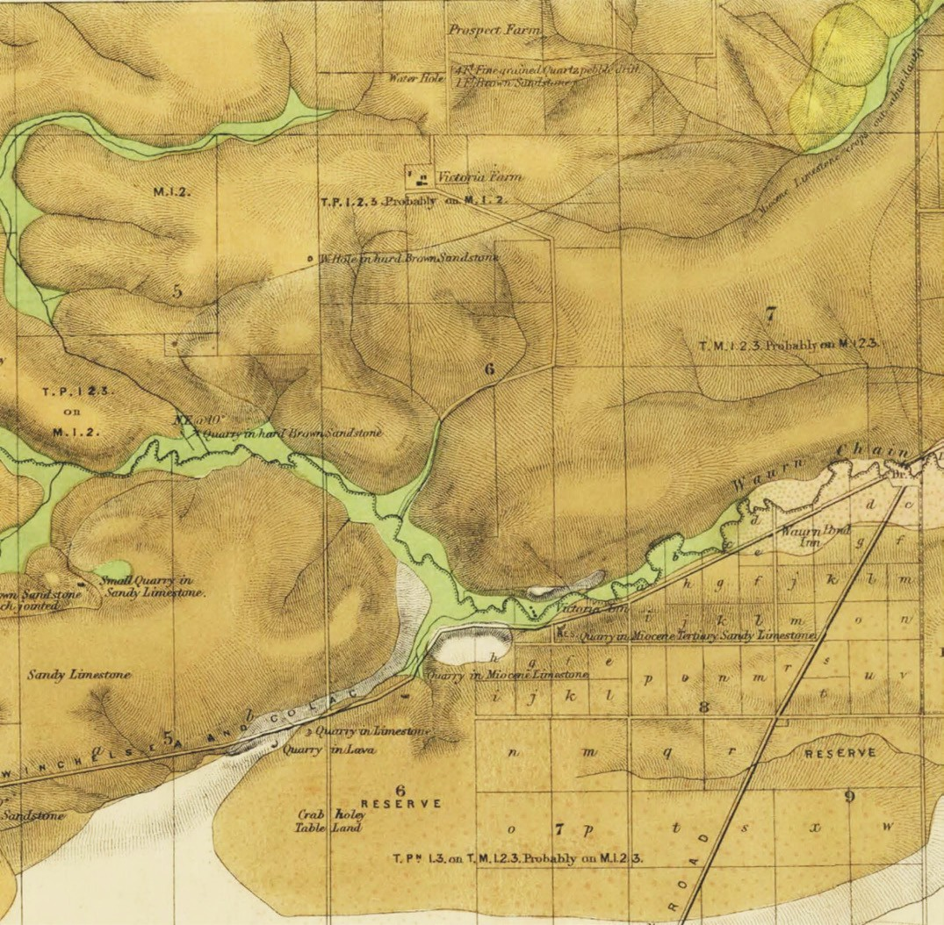
Figure 4.84: R. Daintree, Geological Survey of Victoria part Barrarbool, Duneed & Conewarre, 1861, showing quarries at Waurn Ponds (lower centre). Source: VPRS 8168/P5, item MD, record 28A, Public Record Office Victoria.

better material could be found only a few miles from the site of the proposed church at less than half the cost. The Waurn Ponds’ stone was therefore used and has fulfilled expectations. More recently the Scotch College, Geelong, was partly built of this stone, and the Waurn Ponds School and Church. During the past twelve months it has been used extensively in the ornamentation of new buildings, and by monumental masons. Mr Brain, the sculptor,
is now engaged executing some carvings from it for the
new warehouses in process of erection in Moorabool street, and the door pillars surmounted by lions’ masks that embellish what was previously a common place building at the corner of Ryrie and Moorabool streets are pleasing evidences of the skill of the artist, and
the beauty and intrinsic value of the material. At the present time Mr Terry, whose name has already been mentioned, is engaged erecting a Church of England at Williamstown with stone from Mr Holdsworth’s quarry.

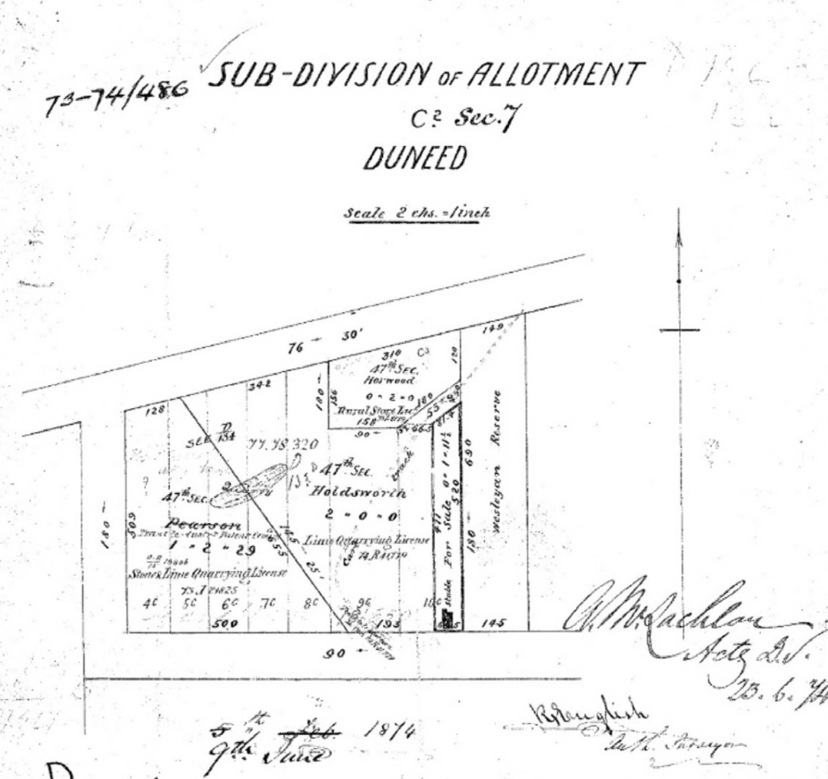
Figure 4.85: R. English, Plan of Subdivision of Allotment C2, Section 7, Duneed, 9 June 1876, showing Holdsworth’s quarries, Waurn Ponds. Source: Put-away plan D134B/1, Landata, © State of Victoria.

Tested with samples of the different kinds of building stone from all parts of this and adjoining colonies, the Waurn Ponds stone stands next to that of the Grampians so far as pressure is concerned, and will, it is confidently anticipated, occupy the foremost position in reference
to other equally important characteristics. Examined beneath the micro-scope, it is found to be lime stone, the production of myriads of industrious zoophytes of past ages. Its adhesive properties render it especially valuable for works of art or ornamentation. Fresh from the quarry it
can be sawn or cut into any shape with facility and is full of moisture, but exposed to the atmosphere it becomes as hard and durable as granite, and unlike brick or sandstone repels rather than absorbs the damp. It contains not a particle of grit or earthy substance, and therefore free from any liability to decay or vegetate. As the hill is penetrated, the mass is be-coming more consolidated, it contains few seams, and columns of almost any size can be obtained. At first it is a beautiful cream-colour, but becomes whiter from exposure, and is free from spots and imperfections,

the tint being uniform. Already large quantities have been forwarded by lighters to Melbourne, and, as it becomes better known, there is every prospect of its coming into very general use in the construction of the best public edifices of the metropolis. In the meantime there is one drawback - the fact of its distance from town, but the “black” line of railway, should that be the line adopted, will go far to obviate all difficulty on this score, seeing that it will pass the scene of operations, and tap this apparently the most valuable quarry of the Western District and, in all probability, the colony.496
On Holdsworth’s death in March 1881, his quarry was taken over by Peter McCann (see earlier subsection).

BORAL CEMENT QUARRIES
In 1964, the largest limestone quarry was established at Waurn Ponds (130 Reservoir Road) by the Victorian Portland Cement Company,497 the company established by Peter McCann (see following subsection and Theme 5). A clinker kiln, two mills, silo storage and railway sidings formed part of the plant. In 1974, the quarry and cement works were taken over by Blue Circle Southern Cement and in 1987 by Boral Ltd.498 In early 2018, this company announced its intention to close at the Waurn Ponds site and it earmarked $24 million ‘for the rehabilitation of the limestone quarry, which includes filling the quarry voids.’499

BATESFORD
The quarrying dynasty of the McCann family also continued at Batesford from 1867 when the most substantial quarry of monolithic proportions was to be established on the west side of the Moorabool River, north of Fyansford. There, bluestone and especially limestone was procured, initially for building construction. The earliest building erected of bluestone and limestone from McCann’s new Batesford
quarry was the Ashby Common School (later the first Geelong West Town Hall) in Pakington Street (see Theme 7 for further details). Built from early 1867, the Geelong Advertiser gave an insightful description of the provenance of the building s stonework:
The walls are substantially built of bluestone from the west side of the Moorabool river near Batesford, and the quoins with limestone from the same locality, where McCann has recently opened a quarry. The limestone is of a very superior quality, it is easily worked, and it is said hardens by exposure. As this is the first time it has been used in a public building we shall therefore watch its further development with much interest, hoping it will prove as efficient as Mr Balding, the Town Surveyor, prognosticates. Should his judgment be correct, the stone will be invaluable, and will drive the Barrabool

freestone, which has been provided to be affected by the atmosphere, out of the market. Whether it will or not time will prove. At any rate, we can only say that it adds materially to the appearance of the blue stone walls, by relieving them of their otherwise sombre appearance. It is very similar to the English Bath stone, and to that now
being imported into Melbourne for buildings, from Oamara [sic. Oamaru, New Zealand].500
McCann’s bluestone was also used in the rebuilding of the Yarra Street pier in November 1868, for the stone abutments (see Theme 3). It was reported that ‘some of the finest blocks of stone we have seen for some times are being used in the walls’ and ‘finer bluestone could hardly be desired for any purpose. 501
The limestone at McCann’s quarry was to transform this part of the Batesford landscape and bring ultimate success to Peter McCann and other McCann family members in the creation of a lucrative, internationally-renowned cement works company (see Themes 2 and 5). The advantages of the limestone were outlined by Peter McCann’s son, W.B. McCann in 1943:
The Limestone deposits on the Moorabool River and Batesford were also opened up (this being the deposit which later on was to become of great value for the manufacture of cement) and was used in the first place by my Father for the manufacture of dripstone filters for purifying water and as stone dressing for buildings in a number of churches and public buildings in Geelong and
elsewhere, and can be seen in a great number of buildings at the present time, the stone being of a very soft texture and can be easily sawn with an ordinary wood saw, is of
a very durable character and hardens on exposure to the atmosphere, and although the buildings referred to, in which it was used have now been in existence for over eighty years the stone shows no sign of decay, beyond the usual weatherings which appear on all Freestone.
The Batesford Quarry on the North side of the Moorabool River was also opened by my Father. This stone was used in the construction of the new Court House at the corner of Russell and Latrobe Streets, Melbourne, but was found to be very expensive stone to work, the granite for the Dog Rocks nearby having become mixed with the Limestone.502
The acquisition in 1888 of the Dryden Estate at Batesford adjoining McCann’s existing limestone quarry provided an area of 1200 acres of limestone deposits.503 This gave
impetus of Peter McCann to continue his experiments in the material for suitability for the manufacture of cement. This was formalised in 1890 when the Australian Portland Cement Company Ltd was established at Fyansford, the Batesford

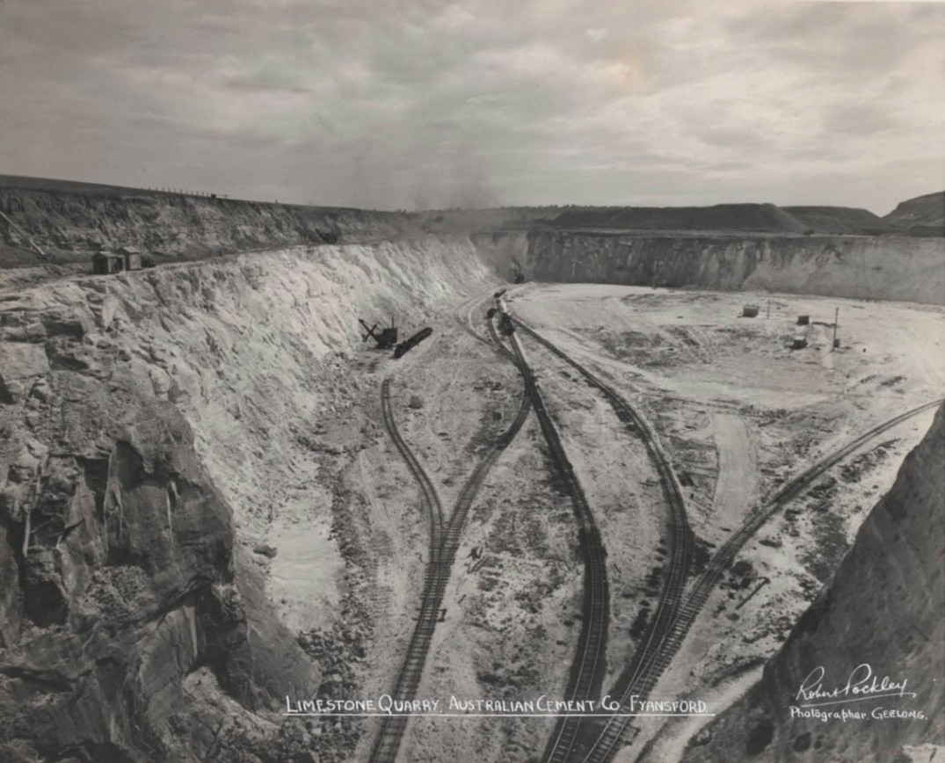
Figure 4.86: R. Pockley, Limestone Quarry, Australian Cement Co., Batesford, c.1950-54. Source: accession H200.25/26 State Library of Victoria.

quarry (Figure 4.86) providing the product for the operations (see Theme 5).504
The quarry supplied limestone for the Geelong Cement manufacturing works at Fyansford until the company closed in 2001.505 Over 100 million tonnes of limestone and overburden had been excavated from the quarry since
1890.506 After the closure of the Australian Portland Cement operations, a new company was formed, Batesford Quarry, and this company continues to provide limestone and sand resources, with an estimated 20-30 year supply available.507

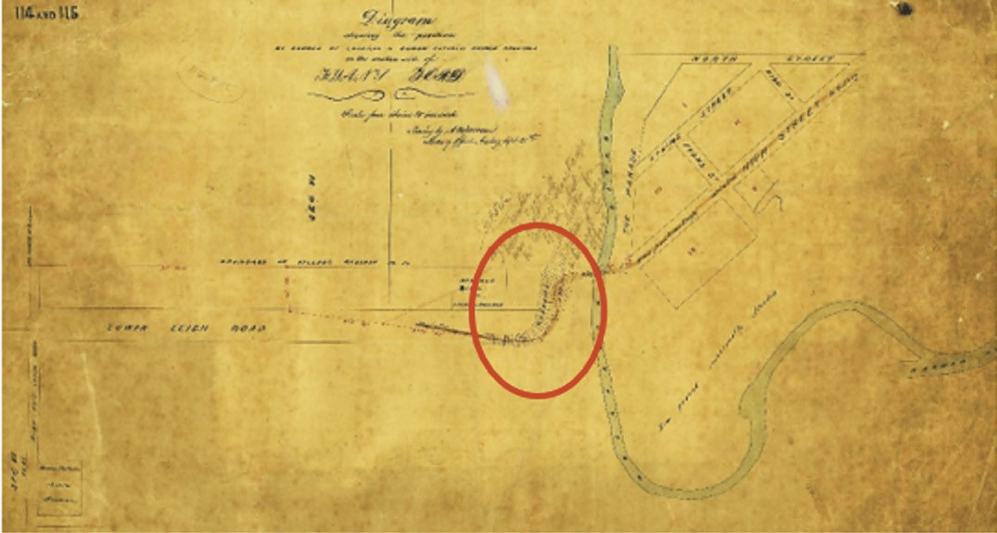
Figure 4.87: A.M. Mason, Diagram showing location of quarries west of the Moorabool River at Fyansford, 1882. Source: A.M. Mason, Diagram shewing the position of Church of England & Roman Catholic Church Reserve in one the western side of Fyansford, VPRS 8168/P5, item CEM, record 115 Public Record Office Victoria.

FYANSFORD
Quarries were also established at Fyansford before the early 1880s, making notable changes to the natural topography
to the west of the Moorabool River (Figure 4.87). They were located on the rise between the bridge and the school reserve.
At 5-103 Hamilton Highway (south side), west of Lower Paper Mills Road, Ludwig Carl Wilhelm Nichterlein (c.1868-1942) established a bluestone quarry in the 1920s,508 brother of Wilhelm Nichterlein (1871-1952), Director of the Australian Portland Cement Company at Fyansford from 1911 (see Theme 2). Before 1934, Ludwig Nichterlein worked the quarry and had gone into partnership as cartage contractors with Frederick Kayler-Thomson under the name Fyansford Quarries.509 Fyansford Quarries Pty Ltd was created in
1936 with Ludwig Carl Wilhelm Nichterlein and Frederick Kayler-Thomson as subscribers.510 The quarry employed between 20 and 25 men and provided metal and screenings that were highly rated by the Country Roads Board.511 Following Nichterlein’s death in 1942, the quarry remained under the ownership of the Nichterlein and Kayler-Thomson families, including Frederick Kayler-Thomson’s son, Bill, and Ludwig Nichterlein’s nephew, Hugh Collyer, until 1988.512
It was then sold to Geelong Quarries who held quarry operations on the north side of the Hamilton Highway.513 The quarry continues in operation to the current day.
At 6 Hamilton Highway (north of the highway and behind the old Fyansford school site and other properties fronting the highway), Mobile Quarries was established in 1951- 52 on land owned by the Synot family.514 The founding directors of Mobile Quarries were Messrs. Strickland, Martin, Richardson and ‘Digger’ Dietrich, who was also quarry manager.515 Blue metal and screenings were broken by Italian spallers for crushing.516 In 1960, Mobile Quarries was sold to Messrs.
Chisholm and Lockyer, trading as Geelong Quarries.517 The plant was re-equipped to produce 200 tons of blue metal per hour.518 Employing 50 men, Len Vautier was later appointed quarry manager.519 Geelong Quarries was sold to Farley and Lewers in 1976 and five years later to C.S.R. Readymix.520 The area is currently being transformed into a residential development (see Theme 6).

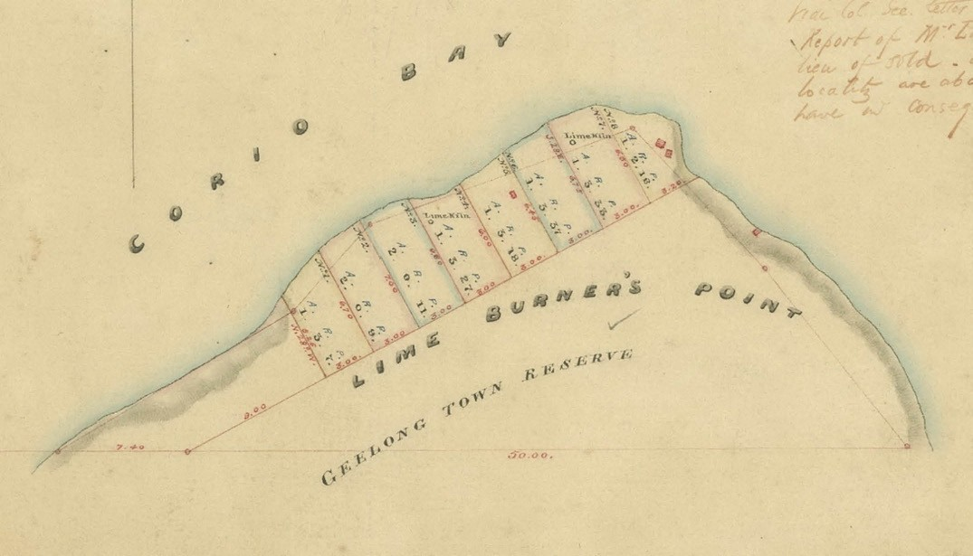
Figure 4.88: L. Clarke, Plan of 8 Allotments marked at Limeburners Point Corio Bay near Geelong (part), showing lime kilns, 1849. Source: VPRS 8168/P5, item SYDNEY, record G9 Public Record Office Victoria.

LIME BURNING

INITIAL LIME BURNING AT LIMEBURNER’S POINT
The need for the production of mortar in the construction of permanent masonry construction brought about one of the earliest industries in Geelong. Lime was essential in the construction of masonry buildings and chimneys. In
addition to the quarrying of limestone was the construction of pits and masonry kilns, either in hillsides or as freestanding structures, comprising cylindrical or bottle shapes.521 The earliest in Geelong was at Limeburner’s Point (first known
as Point Galena) in 1838 when Patrick Melville commenced the quarry and James Boucher the limeburning.522 Just three year later in 1841, 400 bushels of lime were exported to Tasmania for the Launceston market in anticipation of a ‘considerable trade’ ‘not only with Launceston, but several other ports. 523 In 1847, Boucher began construction of ‘a larger kiln than ordinary. 524 This suggested that Boucher had considerable demand for his lime product. Historically
however, Boucher became widely known as the discoverer of five keys found during his excavation in 1847.525 These keys were misinterpreted by Superintendent Charles La Trobe
as being of Portugese origin and which led to considerable debate as to whether the Portugese had discovered Australia
in the 16th century before British colonisation in 1788.526 The debate was revived in 1977 with the Kenneth McIntyre’s publication, The Secret Discovery of Australia, but more recent analysis has concluded the keys were most likely those of a Geelong local who had accidentally dropped the keys into the bottom of Boucher s open excavation.527
Both the two kilns and eight quarry sites were shown in a Plan of Allotments at Limeburner’s Point by Lindsay Clarke, Assistant Surveyor, in 1849 (Figure 4.88).
By 1848, Thomas Taylor joined Boucher in residing at and operating a lime kiln at Limeburners Point.528 James Boucher s kiln operation was taken over by
Wesley Boucher in 1852 and in 1853 John Adolphus Jenner commenced lime burning in place of Boucher.529 Jenner was to patent an invention for the manufacture of a certain description of cement in 1866.530 An enduring licensee was a Mr Baker, who worked lime kilns at Limeburner’s Point between 1853 and 1864.531 In 1854-55, Richard Boyce and George Cakebread took up the license of two lime kilns and a six roomed weatherboard dwelling (in 1855-56, Boyce
had taken up a lime kiln in his own right).532 Between 1855 and 1865, Dyer and Co. worked three lime kilns. By 1865, there were four kilns in operation and a jetty had been built at the point on the foreshore.533 Cakebread had taken

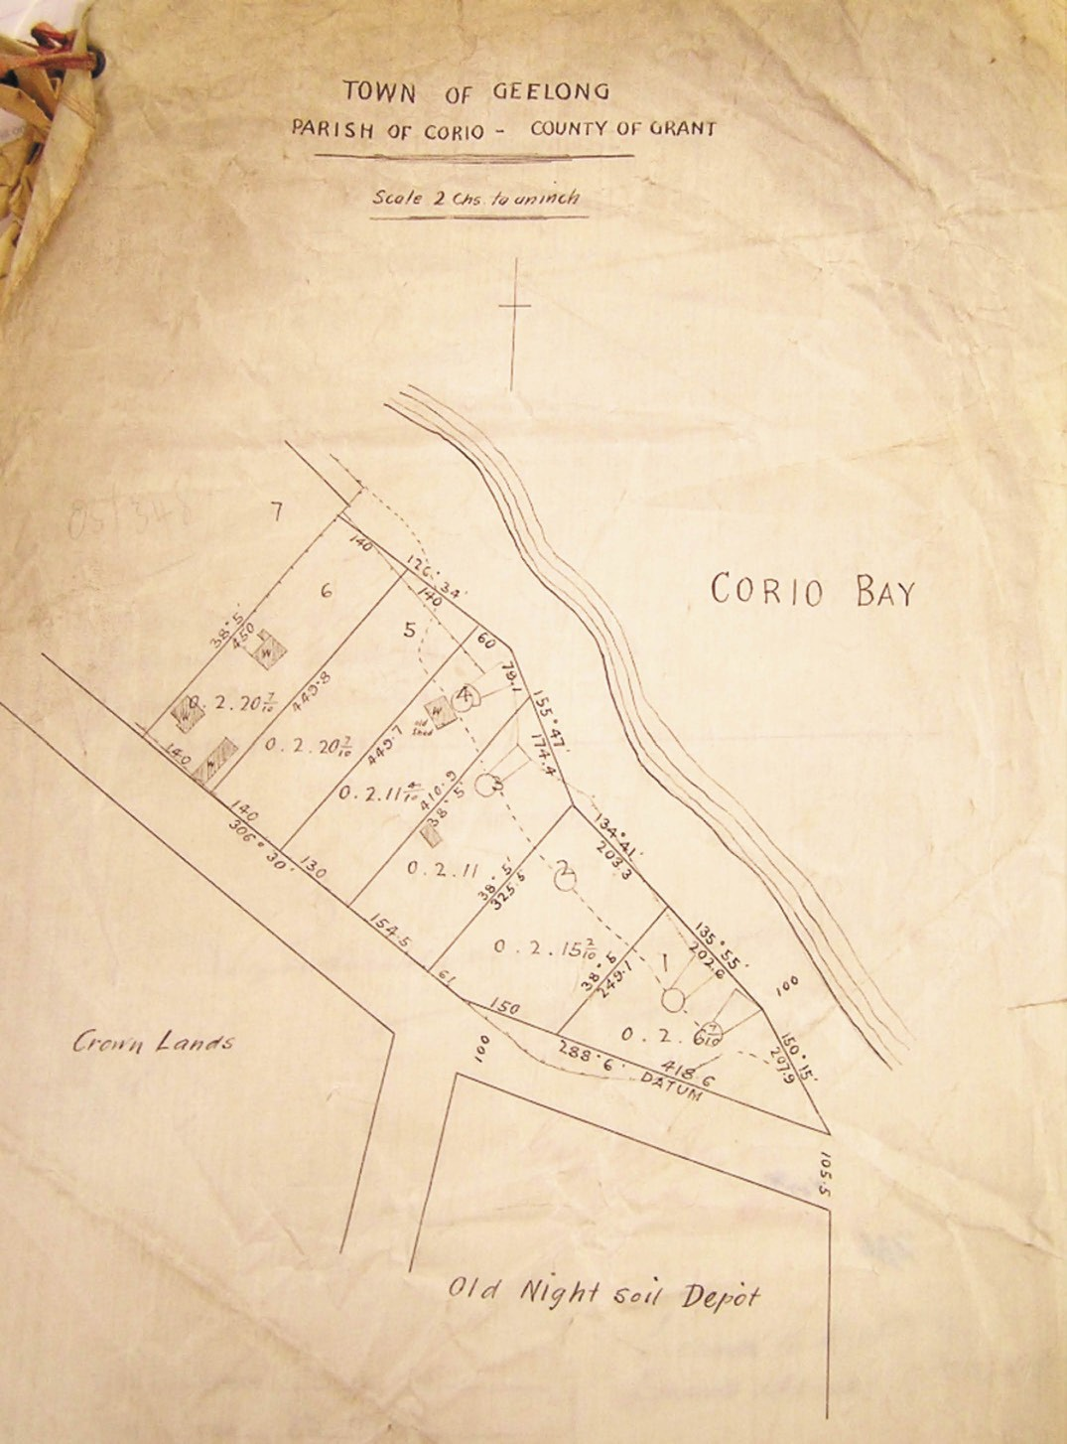
Figure 4.89: Plan of allotments at Limeburner’s Point, Town of Geelong Parish of Corio, 3 April 1905. Source: VPRS 5357 Unit 438 Public Record Office Victoria.

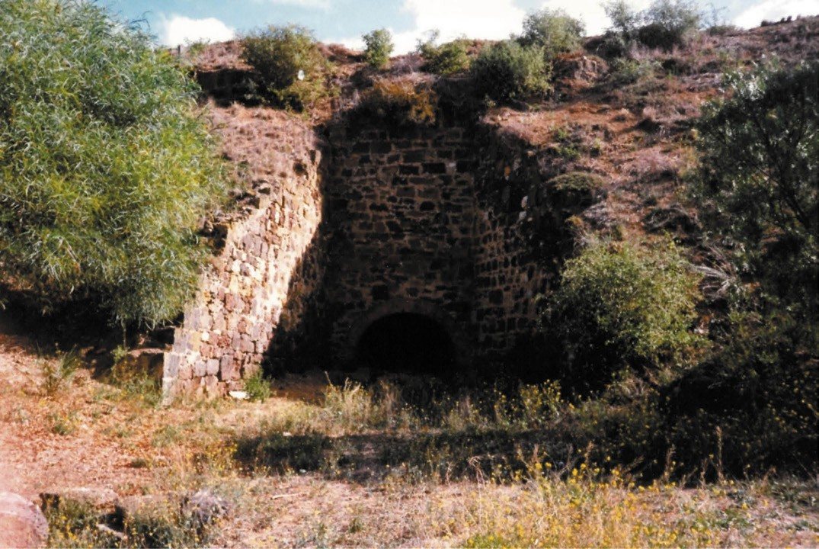
Figure 4.90: Lime kiln, Limeburners Point, 1995. Source: Kevin Krastins.

up the lease of a third kiln by 1870-71, which by 1872 he worked in partnership with a W.A. Blair before moved on from Limeburners Point.534 He formed a company with a Mr Campbell under the name Victoria Lime and Cement Co. which in 1865-66 held three kilns.535 Others to hold a lease of one of the six kilns until the 1880s included William Anderson (1854); Mr Pettigrew (1854-55); James F. Mixiner and Co. (1865-69); and Donald Murray (1873-74 – three kilns).536
By 1883, only one kiln was in operation, due in part to criticism emanating from some sectors of the community about the noise and negative impact the quarries and kilns were having on the adjoining Eastern Park and Geelong Botanical Gardens, and the superior product being produced at Lara and Waurn Ponds.537 At this time, the Geelong
Advertiser gave a report on the operations at Limeburners Point:
At one time four large kilns were constantly at work, but now only one kiln is used. In former times wages to the extent of £300 per week were paid away, but this sum has dwindled down to about £30 per week. It will thus be seen that the operations are not now on so extensive a
scale as they were a few years since. At the present time four quarrymen and four “strippers” are employed at the quarries, whilst four men are engaged at the only kiln at work, and three carters are busily employed in removing the stone from the quarries to the kiln. The complaints regarding the heavy blasts appear to be greatly exaggerated.538
In 1904, the Geelong Council sought to level the mounds and beautify Eastern Beach beyond Garden Street. The Town Clerk was instructed to see if the lessee of the limekilns was required to fill in the excavations.’539 The Council s desire
for improvements to the transformed landscape at the north end of Eastern Park were however delayed. The reserved quarry allotments were Crown Land and while ownership was taken over by the Geelong Harbor Trust in 1905, the kiln and quarries (Figures 4.89-90) continued to be worked by Edison, Utting, McCrae and Akhurst, lime merchants, until 1909.540

BELMONT
By April 1841, Bernard McKenna and John Byewater had discovered a Quarry of Pure Limestone near the Barwon River. The location was given as the ‘Suburban Property of Captain Swanston 541 (which was on the north bank of the Barwon River at Chilwell) although later reports confirmed that the lime kiln was in the limestone hill that ran along the south bank of the Barwon known today as Belmont.542 The quality of the lime was endorsed by the local architect and surveyor, Alexander Skene who declared:
I have this day examined the sample of stone lime burnt by Mr. B. McKenna, and find it to be of a good quality and strength, and with very little admixture of grit or sand.543
McKenna elaborated that the lime ‘would improve when the kiln has been used some time, as the slight admixture of sand came from the sides of the kiln, and does not exist in the limestone. 544
In May 1841 of that year limestone excavators discovered several fossil remains.545 Limestone workers cottage were also built on the hill top overlooking the Barwon River. The partnership of McKenna and Byewater also included John Whitehead and traded under the name of the Barwon Lime Kiln. In August 1841, McKenna advertised that the company had erected kilns and obtained a superabundant supply
of the most superior Limestone. 546 Yet, within a year, the partnership of McKenna, Byewater and Whitehead had dissolved and the lime kiln closed, possibly due to the difficulty in transporting the lime across the river. In July 1842, McKenna advertised that he had been granted a license to burn lime ‘on the Beach, in Corio Bay’,547 but McKenna’s tenure at Eastern Beach was not
to endure.
In September 1851, the lime kiln and cottages (described as huts) were shown on a plan of subdivision (Figure 4.80). The lime kiln and one cottage were then situated on allotment 14 of section 22 in the Parish of Barrarbool. This allotment was purchased by W.R.W. Weekes, Town Surveyor.548 By 1852
it had been sold to J.A. Gregory, who with other allotments, established the Township of Strawberry Hill.549 Named after a railway station on the southern-west line about 10 miles from London, the township did not eventuate.550 In 1853, Gregory offered for sale the lime kilns, adjoining allotments and lime kiln cottages .551 The lime kiln and its site was acquired by Alfred Firmin (c.1826-1913) where he offered lime
for sale to builders and others from March 1854.552 Firmin was an inaugural Councillor of the Shire of South Barwon (see Theme 7). Nothing survives of the kiln and lime kiln cottages at Belmont today.

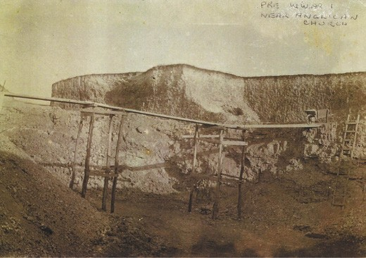
Figure 4.91: Walker’s limestone quarry, Curletts Road (near Holy Trinity Church, before World War One. Source: Joan Wilks, Lara.

LARA
The abundance of limestone at Lara brought about the creation of a highly successful lime manufacturing industry. Impetus for establishing local lime burning activities came from a confluence of circumstances. Firstly, there was increased concern of the lime burning operation near
the newly-established Geelong Botanical Gardens at Limeburners Point. Secondly, the goldrush of the 1850s had created a building boom that increased the demand for lime.553 The material was essential in making mortar.
A lime kiln had been established at Lara beside the northern bank of Lara Lake as early 1853, as it was shown on J.L. Shaw’s Plan of the Village of Lara (see Figure 6.167). Other lime kilns had been created by 1861 at the confluence of Hovells Creek (Duck Ponds) near the crossing of Flinders Avenue. They are shown on Daintree s Geological Survey Map with the annotation ‘Lime Kilns in excavating which several bone caves were found. 554
The Victorian Directory for 1868 listed six lime burners that were operating at Duck Ponds and beside the nearby Limeburners Bay to the south-east of the Lara village.555 They included John Jenkins and the Melbourne Builders
Lime and Cement company that was managed by Robert Bell Walker.556 The kiln was 30 feet (9.1 m) high and it cost £300 to build. In 1878, Walker opened his own lime burning and crushing business in Walkers Road known as the Waverley Lime Works,557 although no physical evidence survives today. Walker had quarries in Kees Road and Curletts Road (behind the Holy Trinity Church)558 (Figure 4.91). The name of the lime works Waverley originated from the name of the train station in Scotland, the birth place of R.B. Walker.559 In 1888, he had ‘worked up a good connection, sending away about 4000 bags per month. 560

David McHarry (senior) was another pioneer lime burner in Lara. He had arrived by 1868, having been listed in the Victorian Directory at that time. McHarry had previously taken up the position of foreman of lime kilns at Daylesford561 and so he possessed experience in the lime industry. At Lara, he commenced his own lime burning business at a time when the Melbourne Builders Lime and Cement Company had been established locally. According to Victoria and Its Metropolis in 1888, ‘… Mr McHarry declined to go into business with this company. ‘He had his lime tested by the Government, and it was declared to be of the first quality, the result being that his business began to increase at once, and he now ships some
8000 bags per month. 562 While McHarry owned a farm property at 125 Buckingham Street, it is not known whether he carried on lime burning from this location. It is known that he operated a kiln immediately north of Windermere Road and adjacent to Hovells Creek as in 1903, the ‘McHarvy [sic.] & Co. Lime Kilns’ were annotated on the Subdivision Plan of the Elcho Estate.
Other early lime burners included James Sullivan and John Spalding.563 The latter was to become a long-standing resident of Lara. Spalding had emigrated from Suffolk, England in 1854 and in the following year he had established the first store and a butcher’s shop at Lara.564 He subsequently commenced operations as a lime merchant and proprietor of lime kilns in 1862 and in 1866 his sales had amassed a remarkable 52,887 bags.565 Spalding resided at ‘Limella Cottage’, 31-45 Forest Road South, although it is not known whether any lime burning operations were carried out there. Known as the Lara Lime Works, John Spalding’s son, James appears to have been responsible for the lime business in the early years until he became an ordained Minister of the Church of England. James Spalding again took over the operations of the Lime Works after 1893.566 It
became a successful industrial operation and local employer.
Other lime burning operations were established by McClelland, Foot, Firth, and Reeves and Fletcher (they were listed as lime burners of Duck Ponds in 1863).567 William Foot’s lime burning operations were nearby Hovells Creek, possibly on or near his farm property at 80 Gebbies Road. Today, there is only evidence of lime quarries near the banks of the Creek (remnant quarries being almost ubiquitous throughout the Lara area).
The success of the lime industry at Lara was recorded in 19th century newspapers. In 1883, The Argus reported that the quantity of Lime forwarded from Lara to different parts of the colony this month was over 770 tons. 568 In 1894, the Bacchus Marsh Express commented that 6000 bags of lime were trucked from the Lara Railway Station and declared:

Thus it would appear that a rift is breaking in the cloud of depression that has hung over the country for so long, and that a gleam of prosperity is beginning to shine upon the
building trade. The Lara lime is of a hydraulic character, and is largely used by the cement manufactories.569
A lime burner who commenced business much later in the 19th century was James McClelland of ‘Clover Hill’.
McClelland went in for lime crushing. In 1891, the Geelong Advertiser reported on his lime burning and crushing activities:
Mr. McClelland’s kilns are situated within a stone’s throw of the Lara creek, and are backed by several acres of limestone country. Although not in the business many years McClelland, jun., has shown any amount of enterprise in introducing the lime crushing machinery
to Lara in order that he should be equal to outside competition, and place the product of his kilns upon the market in the condition most acceptable to buyers. He is satisfied with the results attained by the crusher, although the demand for lime is just entering upon a revival after the depressing influence [of the collapse of the land boom].570
In addition to the use of lime for the making of cement, it was also produced as a fertiliser. The success of liming the land was outlined in The Leader in 1916:
The advantages of applying agricultural lime to the soil have been well tested in this district. The examples are very marked, especially in the poorer fields, where, for instance, a crop of oats being grown for grazing and eventual harvesting for hay can be observed where it has been limed, showing up a bright green in color, thick and dense, some eighteen inches high, even now in
the middle of winter, sharply defined up to where there has been no lime applied, and where the crop is short, scraggy and a dull, unhealthy yellow in color. This is quite in accord with the scientific position, the action of lime being partly physical, affecting the texture of the soil, and partly chemical, setting free the dormant supplies of plant food.571
In 1904 and again in 1914, there were 11 lime burners listed in Wises Directory at Lara. The Lara Lime Company site and three kilns near Hovells Creek at 105 Blairs Road are all that appear to survive of the once-thriving lime burning industry (Figure 4.92). At 105 Blairs Road, the kilns are now in poor condition and there is little noticeable evidence of the tram line that once linked the kilns near Hovells Creek to Blairs Road.

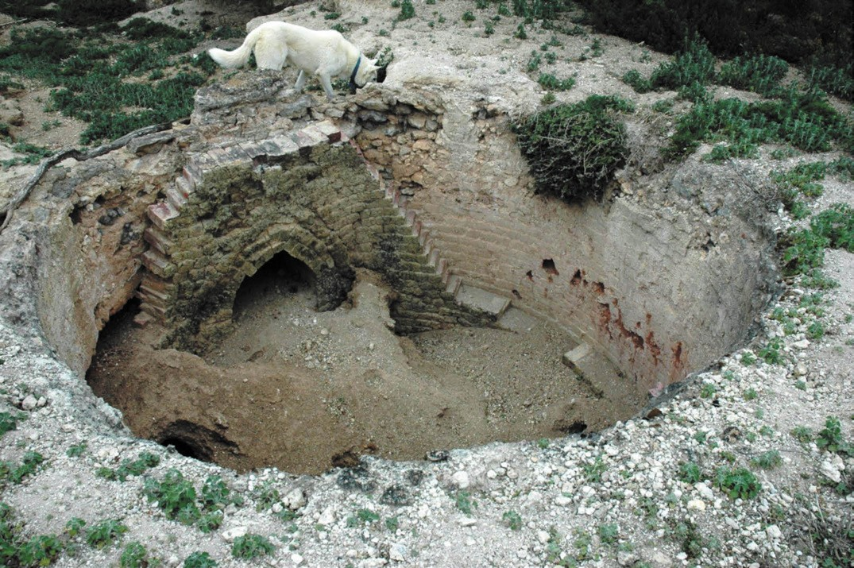
Figure 4.92: Lime kiln, 105 Blairs Road, Lara, 2012. Source: Wendy Jacobs.

WAURN PONDS
The earliest lime burning operation on a commercial scale at Waurn Ponds had commenced by 1849 when Robert Moore of the Victoria Lime Kilns announced the availability of lime from his Lime Store in Yarra Street, between Mr Davidson’s timber yard and the Prince Albert Hotel.572 The Victorian Lime Kilns operation was situated at Victoria Farm, Waurn Ponds (now the location of ‘Canterbury Park, 155 Cochranes Road). This farm had been established by Cornelius Hogan on 1 July 1847 (with a stone house erected in 1849)573 on land leased by the Hon. Henry Miller (1809-1888) who had acquired it before 1845.574 Moore’s lime burning enterprise appears to have been short-lived as he no longer advertised his product after 1851.575
More enduring and successful was the limeburning operations established by Peter McCann adjacent to Benjamin Holdsworth’s quarry that he had acquired in c.1881 following Holdsworth’s death. By 1882, a rotary kiln was in operation, the site (Figure 4.93) being a
hive of activity:
In addition to the quarrying of stone for building purposes, a lime-kiln is extensively used in the production of excellent hot lime, obtained by the burning of what
are known as the spalls. The lime meets with ready purchasers, both in this district and in Melbourne.576
In 1924, the lime works at Waurn Ponds were placed on the market, the improvements then consisting of ‘a stone house and stables’, ‘a splendid brick rotary kiln and lime house and blacksmith’s shops’, and 40 acres of ‘splendid limestone hills. 577
More substantial were the lime kilns at the Portland Cement Company’s quarries to the south-west, established in 1964, and more particularly at Fyansford, established from 1890 (see Theme 5).

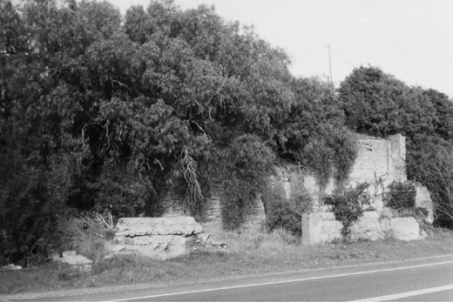
Figure 4.93: McCann’s Lime kiln and quarry, Waurn Ponds, 1998. Source: David Rowe.

BRICK MAKING
The Greater Geelong landscape, particularly suburban
and outer-suburban parts, was scoured with the excavation of brick fields to meet the demand for bricks required for building construction (see Theme 6 for further details on building development). By the 1850s, Geelong boasted over 50 brickmakers and about 30 bricklayers (see Appendix 6.1). Most were resident in Geelong
West (Ashby and Kildare) and Newtown and Chilwell (including Irishtown).

SOUTH GEELONG
The earliest brick fields were at South Geelong operated by Thomas Skinner in 1841.578 It was likely that the bricks from South Geelong were used in the construction of St. Andrew s Presbyterian Church in Yarra Street from March 1841, this being the earliest brick Presbyterian Church building in Victoria.579
The brickfields at South Geelong were to operate for only seven years as in October 1848 the Geelong Advertiser announced that:
The Brickmakers living at South Geelong have received intimation from the authorities, that they must quit their present field of labor, at or before the expiry of the present year, as it is the intention of the Crown to dispose of the land in that direction about Easter next.580
No evidence of the location or the early brickfields at South Geelong are known to exist today.

NEWTOWN
At Newtown above the bank of the Barwon River near and between Melville’s and McCann’s freestone quarries (see earlier subsection), brickfields had been opened up by 1847.581 They were followed by a brick field near the south- east corner of Aphrasia Street and Shannon Avenue (and taking in the properties now addressed as William and Margaret Streets) where ‘the clay soil had attracted perhaps twenty brickmakers. 582 Owned by a Mr Richardson, he sold the land as three lots in 1852, the third lot being a ‘valuable brick field, comprising kiln, two large sheds capable of holding 100,000 bricks.’583 The advertisement claimed that ‘the bricks from this field are too well known to require any remark as to the superior quality of the earth.’584 At Marnock Vale (near Gregory Avenue) from 1888, a brick kiln was operated by James Walker. The bricks were hand-made
by Archie Sykes. This enterprise was short-lived as the cost of production outstripped profits.585
In the early 20th century, and particularly from 1914, the Geelong Brick Company had a brickworks factory at the west end of Noble Street.586 By 1925, this ten acre site had been leased to the Albion Quarrying Company and in the following year the site, ‘together with the buildings and erections and the brickmaking machinery and plant thereon was advertised for lease.587 The brick making machinery and plant were auctioned in 1934 and the site held by the Geelong Brick Company until 1943 when it was acquired by Hazel Heath
of ‘Chesterfield’, 221 Noble Street.588 There is no immediate evidence of the brickfields and kilns in Newtown today.

GEELONG WEST
The largest concentration of brickmakers in Geelong in the 1840s was in Geelong West, with 80 men employed in 1848.589 At this time, Geelong was producing 80,000 bricks a week.590 In 1849, Hill and Hitchins auctioned ‘about forty lots’ at the Kildare brickfield’, their advertisement declaring that ‘bricks having now risen to 30s. per 1,0000 at the kiln, parties in want of Brick Land should not lose this opportunity, as there is none other near town. 591 By this time, in the Ashby-Kildare area on the south side of Church Street, between Pakington Street and Elizabeth Street (and taking in Britannia and Isabella Streets) the brickfields were the largest and most well-established, and supplied the best clay in the Geelong region.592 The closure of the South Geelong brickfields provided the expansion of the brickmaking operations at Geelong West.

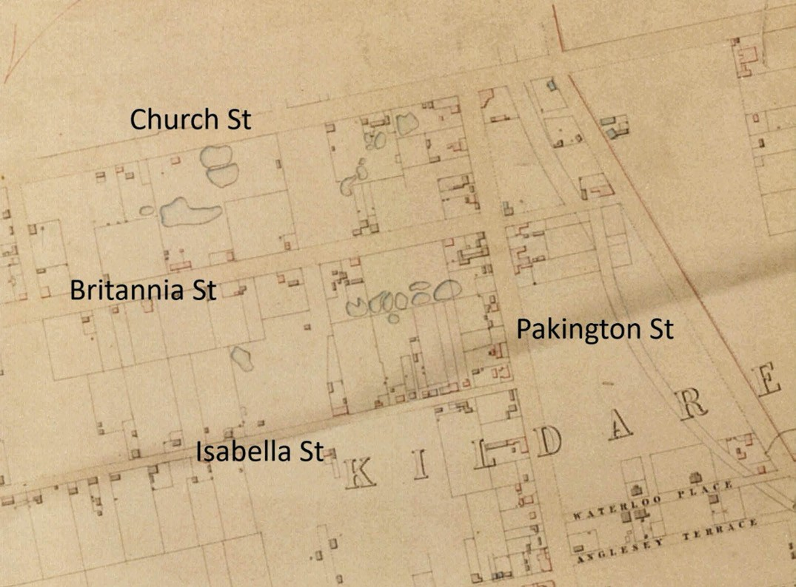
Figure 4.94: Map showing the locations of the brickfields in Geelong West (Kildare), 1854. Source: J.H. Taylor, Map of Geelong, Surveyor- General’s Department, Melbourne, VPRS 8168/P2, Unit 5416, item Roll 39 Geelong, Public Record Office Victoria.

J.H. Taylor’s Map of Geelong of 1854 graphically illustrated the brick quarries at Kildare (Figure 4.94). Some of the early brickmakers in this locality included John Grundle in
Isabella Street; John Bliss off Britannia Street; John Cooper, Britannia Street; John Fayle, Church Street; John Matthews, Isabella Street; Richard Powell, Isabella Street; Daniel Slevin, Britannia Street; and Joseph Winter, Isabella Street.593 Others were soon to make their way to this location, including Thomas Everett, who had relocated from Aberdeen Street.594
By 1872, there were only seven brickyards at Geelong West that employed 20 men.595 Demand substantially increased with the construction of the railway tunnel for the Geelong and Colac Railway line in 1875, with two brickfields in the goldfields town of Ballarat and a new brickfield in Belmont (see following subsection) also supplying the railway given that those in Geelong West could not keep up with the number of bricks required.596 Over the next few years, these brickfields had been worked out. By 1925, only one ‘old
brick yard’ at 2 Britannia Street survived but was unused, the property of William Grundell.597 No evidence of the clay pits remain today as in 1928 the Geelong West Council gradually began filling them with refuse.598 More enduring physical evidence survives in the mid-19th century brick dwellings in Geelong West, including those at 30 Weller Street (built c.1852 for James Meek); 8 John Street (built c.1854 for Thomas or James Neal); 20 John Street (built 1858 for William Pardy, police sergeant); 11 Preston Street (built c.1855-56 for William Barbour) and 7 Candover Street (built c.1856 and owned by Thomas Everett, brickmaker).599 Of particular interest with the brick dwelling, ‘St. Elmo’, 127 Elizabeth Street (Figure 4.95).
It was built by the brickmaker and bricklayer, George Arnott (c.1825-1920) in 1866 as a replacement of his earlier timber dwelling of 1859.600 Arnott demonstrated his bricklaying skills in the stylistic variations in the four chimneys.

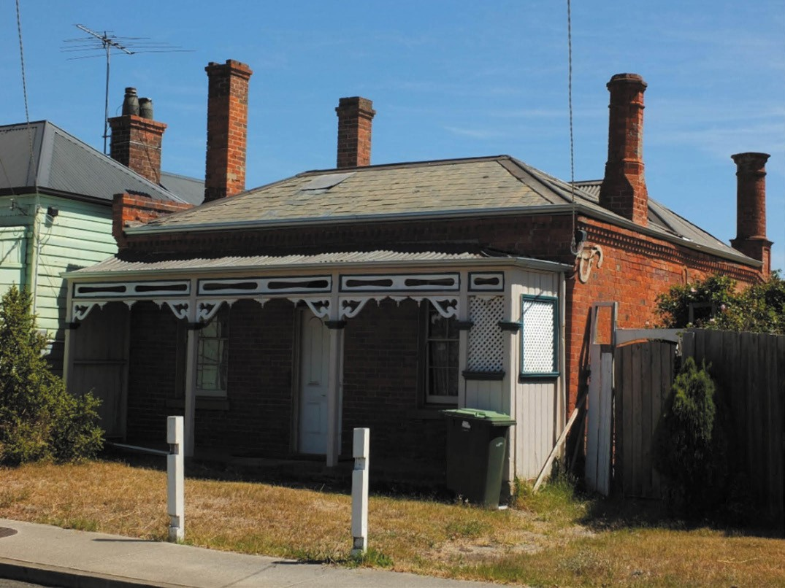
Figure 4.95: ‘St. Elmo’, 127 Elizabeth Street, Geelong West, 2019. Source: David Rowe.

NORTH GEELONG
With the brickfields at Geelong West worked out by 1887, a new brickfield and kilns were established by ‘several
enterprising citizens’ on five acres of land at North Geelong, west of the gas works.601 The site had previously been laid out as the Rothschild and Windsor residential estates from 1853 (see Theme 6). The new enterprise known as the Corio Brick Company - was opened at a ceremony at the site on 27 April 1887. The Geelong Advertiser gave a detailed description:
The company was formed owing to the great demand which exists for bricks of superior quality for building material, in the metropolis as well as in Geelong … the ground has been enclosed by a substantial fence, drying sheds erected, machinery placed in position, two kilns constructed, and operations commenced by removing the clay from an excavation made in the south-eastern part of the ground. Each kiln is capable of burning 100,000 bricks at a time, whilst the adjacent sheds are
to be fitted as to provide drying room for 200,000 bricks. The portable engine, a 10 h.p. one, made by Messrs Clayton and Shuttleworth, is used in hauling the clay from the pit to the Chilean mill, and drives the machinery employed in grinding and pulverising the clay, which, when properly moistened and mixed, drops down a shoot to the brickmaker’s below the upper level, and is there fashioned into bricks. Fourteen persons are engaged
in the manufacture of the building material, and they are under the general supervision of Mr George Cakebread. The works have been successfully established by Mr Conwell, of Brunswick, who has acted as the managing director the time being, and, now that the hands engaged in the sheds are making an average over 7000 bricks per day, the formal opening of the undertaking was made a feature of yesterday afternoon.602
Adjacent to the Corio Brick and Tile Company
(which went into liquidation in late 1892),603 were several

long-time brickmakers who were either separately engaged or worked for the Corio Brick and Tile Company at the North Geelong brickfields. They included George, Rueben and Walter Dorling; William Everett, William Grundell; Daniel, John and Thomas Slevin, and Robert and William Welsh.604 By 1915, only three brickmaking businesses existed; Everett Brothers, Slevin Brothers (Daniel and John) and William Saddler (who first appeared from 1908 and remained in business until at least 1920).605
Rueben Dorling (1842-1917) and his brother, George (1844-1919) were sons of Samuel Dorling.606 Rueben lived
in Geelong West until the death of his wife, Eliza, in 1879.607 He was then resident in Victoria Street, North Geelong, with his brother, George, when their father died in 1891 and lived there until his death in 1917.608 George Dorling was
appointed caretaker of the Corio Brick and Tile Company site in 1892.609 His son, Walter Rueben Dorling (1879-1917) sought employment at the neighbouring gas works after the closure of the brickworks.610
Thomas Everett (1814-1891) had arrived in Geelong in March 1853 with his wife, Eleanor (Ellen) Everett (nee Robinson) and their four children: William (born 1842), Elizabeth (1844), Ellen (born 1848), Joseph (born 1850) and James (born 1851). Another son, Charles, was born in Geelong in 1854.611 The Everett family lived in Britannia Street, Geelong West.612 Thomas and Ellen Everett’s son, Joseph, became a coach builder, blacksmith, wheelwright and implement maker in Mercer Street and his son, Percy, trained as an architect and became Chief Architect of the Public Works Department of Victoria (see Theme 3). Thomas Everett s grandsons and sons of William and Maria Everett - Joseph Thomas (born
1868) and William John (born 1869), followed their grandfather in brickmaking at North Geelong.613 They traded under the name of Everett Brothers.614
William Grundell (1859-1931) was the son of John and Elizabeth (nee Burns) Grundell of Isabella Street, Geelong West.615 He remained an occupier of the property at 2 Britannia Street with the old brick yards until he purchased the property in 1915-16 from the previous owner, John Baxter. His operational brick yard in the early 20th century was in North Geelong (Figure 4.96). He died there in 1931.616
Daniel Slevin (1823-1893) was from Country Tyrone, Ireland and arrived on the Bourneuf from Liverpool in September 1852 with his sister, Miss Jane Slevin, a domestic servant.617 An agricultural labourer, Daniel Slevin was a brickmaker
in Britannia Street, Geelong West, soon after his arrival.618 In 1853, he married Margaret Armstrong. They had ten children, three of which became brickmakers in North Geelong: Thomas (1857-1913); Daniel James (1870-1980);
and John (1876-1942). Another son, Patrick (1854-1922) was a painter.619 His son, Thomas Daniel Slevin (1880-1955),

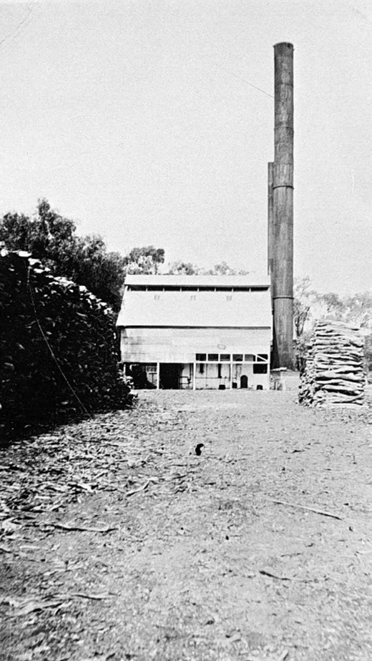
Figure 4.96: Grundell’s Brickworks, North Geelong, c.1915. Source: Image MM219, Museums Victoria.

became an architect responsible for a number of distinctive designs in Geelong, including ‘Montana’ at 53 The Esplanade, Drumcondra in 1911 (see Theme 6) and the additions to the Geelong Town Hall in 1917 (see Theme 7). Daniel Slevin s sons, Daniel and John, had formed a partnership under
the name of Slevin brothers, brickmakers, by the early 20th century.620

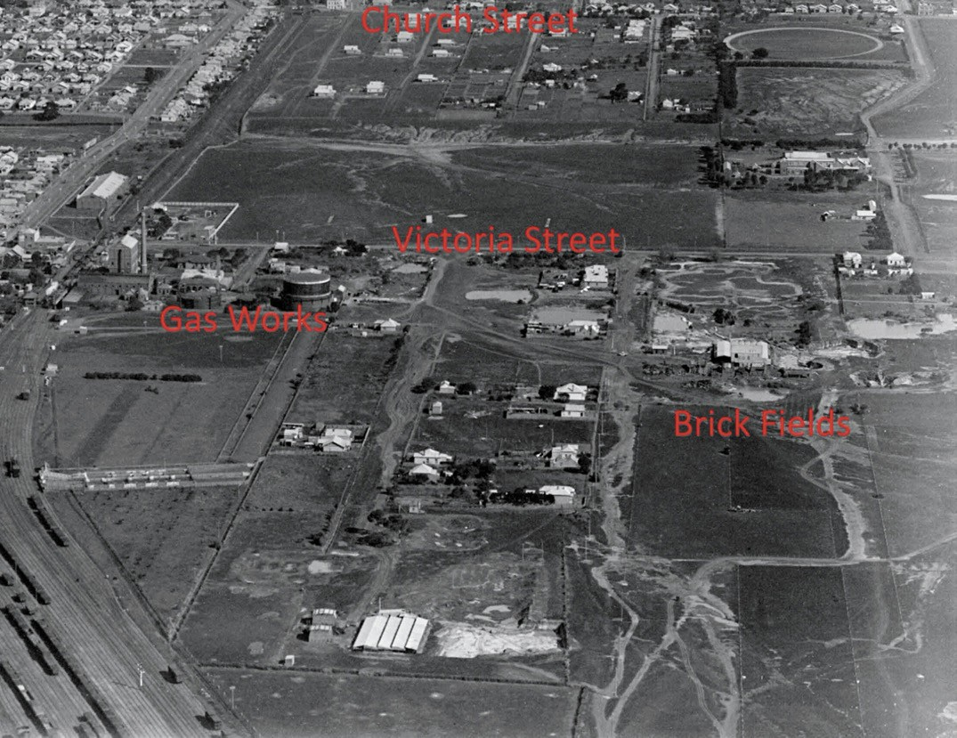
Figure 4.97: C. Pratt, Part aerial view of North Geelong showing the brick fields, c.1927. Source: accession H91.160/871 State Library of Victoria.

By 1918, it appears that the down turn in building during World War One brought an end to most of the small number of brickmaking operations at North Geelong. In 1919, the Geelong Advertiser reported on the need for good quality bricks and the potential for an updated brickworks operation at North Geelong:
In and around North Geelong clays have been made into bricks for many years. But the trouble is that the kilns have not been able to turn out a uniformly colored article. The fault is uneven firing. Bricks from light red to a slate color are turned out. The latter are exceptionally durable, but suffer in their appearance. Geelong bricks have mainly been made from hand moulds. The clay although it makes a strong brick, does not give as smooth a surface as those made near Melbourne. Properly worked, with up-to-date machinery, the kilns could be made a profitable proposition. Several small yards have been
carried on chiefly by small parties. The brothers Everitt, Slevin and Dorling and Welsh hare been chiefly engaged in the industry, and with the Corio Brick Co., carried
on operations until after the outbreak of the war, when conditions told against them. Their product was very serviceable, but their want of appearance prevented their use for outside work. If the makers could blend the slate colored and red bricks so as to get a blue color, and so introduce uniformity, there is no reason why they should not be powerful competitors of those of the Melbourne suburban output.621
Contrary to this proposal, the Geelong West Shire engineer,
H.G. Oliver, expressed his lament about the state of the former brickworks site, with concern that it ‘might easily become a slum area and that that it was a great pity that such an area of land should to practically go to waste given the intention in the 1850s for it to be a prime residential estate.622

He encouraged the Council to resume the site under the Local Government Act 1915 and remodel it as a residential estate.623
Instead of being transformed into a residential estate, brickmaking continued at the North Geelong brickfields in the ensuing years. In 1920, the brickmaker William Saddler continued working his site.624 By 1925, the North Geelong Brick Works Pty Ltd company was formed.625 In 1928, bricks had been procured from the site for some buildings then under construction and the new company sought shareholders:
The North Geelong Brick Works Pty Ltd. is now issuing 22,000 £1 shares to the investing public. The nominal capital of the company is £50,000. Out of the capital to be obtained from the new issue the company will purchase 30 acres of a most valuable clay deposit at North Geelong and will install modern plant and machinery. Included in the new plant will be a new continuous kiln, which will cost about £5000. The works will then be able to deliver 176,000 bricks per week. The company has expended
a large sum of money in experimental work, and has from time to time installed various kinds of machinery to enable it to deal with the extraordinarily plastic North
Geelong clay. It has now succeeded in producing a brick which when burnt under proper conditions is as hard as steel,” and completely outclasses bricks made from ordinary reef clay. The various clay mixture from the pits
will produce bricks of beautiful colors which are absolutely unobtainable in other Victorian yards. Since the new brick has been made, orders have poured in to such an extent that the present plant is quite unable to cope with them.
Orders can be closed now for over one million bricks, and Melbourne architects will specify North Geelong bricks at a big price if obtainable. However, it is practically certain that Geelong and district will quickly absorb the output of the new plant. If intending investors require any evidence of what North Geelong bricks are like, they should inspect such buildings as the new St. Matthew’s Church at
East Geelong [see Theme 8], Geelong College, etc., now under construction. The Chief Architects of the Public Works Department, Melbourne, have publicly stated that they will place orders now for 300,000 North Geelong bricks if obtainable.626
The brickworks site was shown in an aerial photograph by Charles Pratt about this time (Figure 4.97).
Today, the former brickworks site is an industrial estate. Slevin Street (previously Richmond Street) takes its name from the long-serving Slevin family brickmakers at this locality while the Boral Asphalt site at Victoria Street is a vestige of
an industry association with brickmaking. In Corio, Dorling Avenue is named after Rueben Dorling, the brickmaker.627

HERNE HILL
In 1856, the architect, Christopher Porter, established a brick and pottery making business behind the Fairview Hotel,
north-west corner of McCurdy Road and Hyland Street, Herne Hill (see Theme 6 for further details on Porter). The enterprise appears to have been revived in 1875 and known as the Fairview Brickworks when 30,000 bricks in the kiln on the site had been burnt.628

BELMONT
In 1871, James Miller, publican of the Prince of Wales Hotel, Belmont,629 purchased the Mount Pleasant Vineyard established from c.1851 by Alexander Mackenzie (c.1808-1873), vigneron and later President of the Victorian Board of Agriculture.630 Miller’s interest was not in
Mackenzie’s ‘excellent stone-built dwelling and various out buildings, with about nine acres of vineyard and orchard’ situated on Mount Pleasant Road (and extending to Roslyn Road to the south),631 but in the quality of the clay on the site.
Miller had recognised the scarcity of brick manufacturing in Geelong and at his new site he had engaged four men to
carry sinking to ascertain the extent and value of the red clay deposits.632 In addition, the excavators discovered ’16 feet of fine white or pipe clay.’633 The Geelong Advertiser gave a report on Miller’s proposed development:
Messrs. Davidson and Henderson, the architects, with some other experienced gentlemen, having visited and inspected the ground, have pronounced the opinion that the clay is of a most superior quality – in fact, that there is nothing like it developed in the district. The proprietor has arranged for the erection as speedily as possible
of a brick-making factory, furnished with all the latest improvement and similarly arranged, though on a small scale to the works at Brunswick. An order for the requisite plant and machinery, estimated to cost £1500, will be forwarded to England by the outgoing mail, and
it is expected when once erected and in operation, from 15,000 to 20,000 will be turned out daily at the works. In the meantime brick-making by hand will be carried on, and Monday men will be employed to make a start with the patent kiln, sheds. &c, required in connection with the machinery.634
Miller sold part of his land to the Geelong Brick, Tile and Pottery Company Ltd. to operate the brickworks, with a Mr Simpson appointed superintendent of the brickfield and
a Mr Leighton the manager of the pottery works.635 Just three months later in August 1874, at least eight shafts had been sunk, a trial kiln was under construction, 3000-4000 bricks had been made, and a timber storage shed was under construction to hold 46,000-50,000 bricks.636 This infrastructure fronted onto Roslyn Road.

Of the pottery enterprise, the Geelong Advertiser gave the following:
In the pottery shed Mr Leighton was as busy as a bee, preparing jugs, basins, milk pans, and a variety of other articles for the trial kiln, and the dexterity with which he converted a shapeless lump of clay, as soft and tenacious as good putty, into handsome jugs, was remarkable, and quite an interesting sight. When taken out of the ground the clay intended for pottery purposes is run through a sieve; it is then mixed with water to the consistency of rich cream, after which it is placed in a brick boiling-pan close at band until the water has evaporated sufficiently to solidify it to the consistency required. A circular kiln will have to be built for pottery purposes, and the articles manufactured will stand inside this on fire-brick rings, or stands, known by the name of “saggers.” Affairs had not, however, sufficiently advanced yesterday to allow of our describing the process, which is said to be an interesting one. The potter’s wheel was not quite completed, when
it is, Mr Leighton states that, assisted by a clever lad, he will be able to manufacture a hundred dozen of flower pots per diem. As may be seen by the above few particulars
the works, when completed, will be well worthy of inspection.637
Tenders had been called by the architects, Davidson and Henderson, for the construction of the sheds and kiln in July 1874.638 By January 1875, the large kiln had been completed and was officially opened in the presence of the Mayor of Geelong.639 Although initial firing produced blistered bricks, the quality was sufficiently improved by June 1875 when the bricks were used in the bottom invert
of the railway tunnel between Ryrie and Kilgour Streets then under construction (see Theme 3).640 The Geelong Brick, Tile and Pottery Company had experienced difficulties to the high moisture content in the clay and the need for additional drying of the bricks prior to firing. This led to additional expense with the construction of further shedding and a track room with covering. To provide accommodation for the manager and additional outbuildings, the Company sought to purchase the remaining portion of Miller’s property, it being the former stone dwelling, outbuildings and garden of Alexander Mackenzie fronting Mount Pleasant Road.641 The company directors also sought to increase manufacturing operations.642 However, the anticipated success of the brickmaking enterprise did not meet expectations and in
November 1875 the Geelong, Brick, Tile and Pottery Company advertised the sale 300 dozen flower pots, 4000 agricultural drain pipes and 5000 bricks, together with the lease of the company s grounds.643 During its short duration, the Geelong Brick, Tile and Pottery Company had manufactured 180,000 bricks.644 The company was dissolved in 1897.645 The brick grounds were eventually sold, as was the stone residence

built by Alexander Mackenzie. The latter was purchased by G.S. Vince, a nurseryman to Queen Victoria on the Isle of Wight. He lived in Mackenzie’s bluestone dwelling until the construction of the existing Late Victorian styled timber dwelling, ‘Minyip’ at the front of the site (now 67 Mount Pleasant Road) in 1911 and the bluestone house was then demolished.646 Apart from the brick construction of parts of
the railway tunnel in Geelong, no other physical evidence of the brickworks at Belmont are known to survive.

PORTARLINGTON AND THE BELLARINE PENINSULA
At Portarlington in 1870, Thomas Henry Widdicombe (1823- 1907), miller, commenced the manufacture of bricks and tiles at the Portarlington Flour Mill (built in 1857)647 (see Theme
5 for details on the flour mill). Known as the Paignton Flour Mill648 after the village in Devonshire where Widdicombe was born (see Theme 5 for biographical details on Widdicombe), there had been a downturn in flour milling operations as a result of rust devastating the nearby wheat crops.649 It was in October 1871 when Widdicombe won honourable mentions for his bricks and flooring tiles.650 At this time, the mill and 19 acre site was leased to Widdicombe by the owner, James Fry, a miller of Ballarat.651 By 1871, Widdicombe had purchased the mill property which the Geelong Advertiser described
in December 1870 as ‘Mr Widdicomb’s [sic.] famous
brick-making establishment. 652 Widdicombe had constructed a kiln (Figure 4.104) and opened a brickfield adjacent to the mill on Crown land leased from the Government.653 Through the first few months of 1871, Widdicombe continued to experiment with his brick and tile production process as by April of that year the Geelong Advertiser reported that:
We have received another lot of samples from
Mr Widdicomb’s [sic.] brick manufactory at Portarlington, which are a marked improvement on these previously sent to this office. They consisted of an ordinary brick, a white fire-brick, and some tiling. All are close to the grain, well- burnt, heavy, of excellent quality, and much harder than anything we have ever seen made in the district.654
From this time, ‘superior ornamental white and red dressed bricks’ and ‘flooring tiles’ were offered for sale.655 Early success of Widdicombe s manufacturing came from the patronage of the prolific Scottish architects in Geelong, Davidson and Henderson, in 1872. Widdicombe’s bricks were used for first time in the architectural firm’s design
of the Sydney Hotel, Mercer Street for Peter McMahon (now demolished) (Figure 4.98):
Mr. Widdicombe of Portarlington had recently registered a new kind of brick and brick coping both of which are ornamental. With pressure any given pattern can be pressed on the brick before burning and when burn it

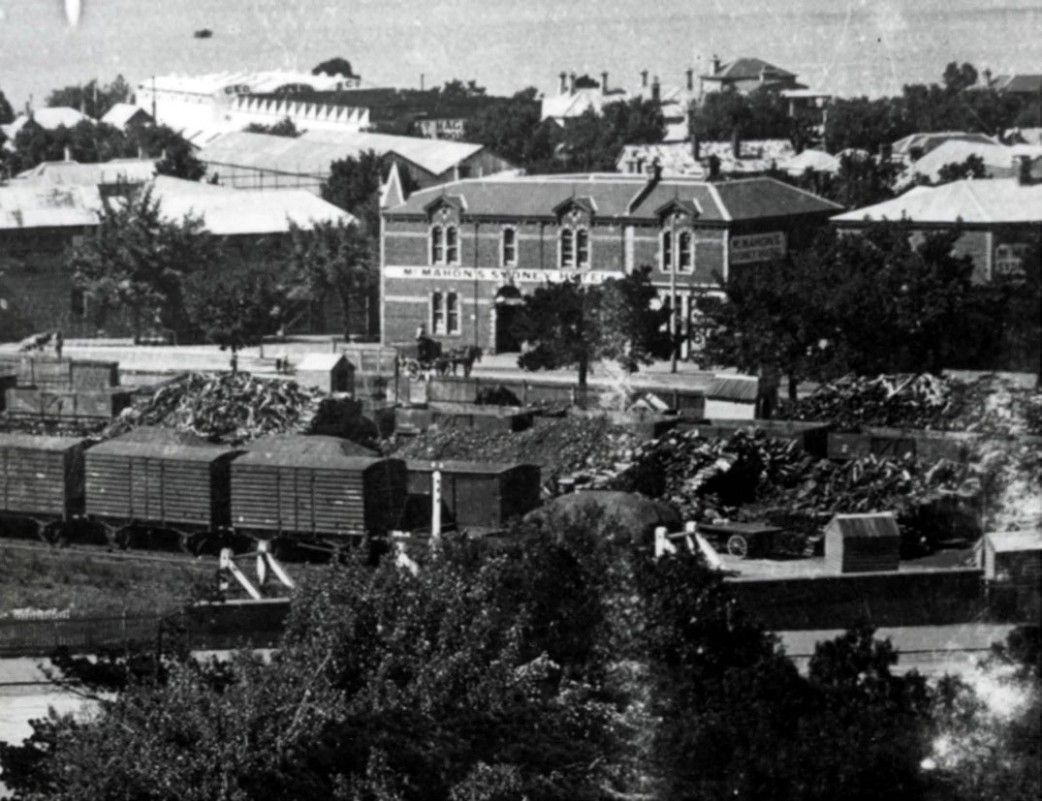
Figure 4.98: McMahon’s Sydney Hotel, Mercer Street, Geelong, 1910, where Widdicombe’s brick were used for the first time in 1872. Source: GRS 2009/01703/111, Geelong Heritage Centre collection.

looks like a cast in cement or stone carving. These bricks to be used for the first time in the new hotel being built for
P. McMahon in Mercer Street.656
More locally, Widdicombe’s brick factory produced bricks for numerous buildings on the Bellarine Peninsula. One of the earliest and most substantial was St. James Anglican Church, Drysdale (Figure 4.99). Designed by Andrew
McWilliams, architect and opened in July 1872 and described as follows:
The style is pointed Gothic, with lancet windows.
The tower is on the southwest gable and is finished with pinnacles. The walls are built with the celebrated
Widdicombe bricks from Portarlington. The dressings are white pressed bricks from the same place. The copings are cement. The color of the bricks is deep red, which, with the white facings and dressings, has a remarkably pleasing effect.657
In 1871, Widdicombe also applied for a patent for his ‘bond brick used for hollow wall construction658 in which he advertised in the Geelong Advertiser on 2 April 1872 (Figure 4.100).
The design of the brick was based on the ramped profile bond brick patented in England by George Jennings.659 The firm of Davidson and Henderson may have been the first to implement Widdicombe s bond brick in the construction
of their residence, ‘Waverley’, at 94 Western Beach Road, Geelong (Figure 4.101), in 1871, prior to the registration of the patent.660
While Widdicombe’s brickworks were highly regarded, inventive and even celebrated, he went insolvent in May 1873, a consequence of ‘the difficulty in getting in monies owing, and the pressure of creditors. 661 This forced the sale of the Paignton Mill, machinery, brick residence, foreman’s house, stables, coach house and sheds, and about five acres of

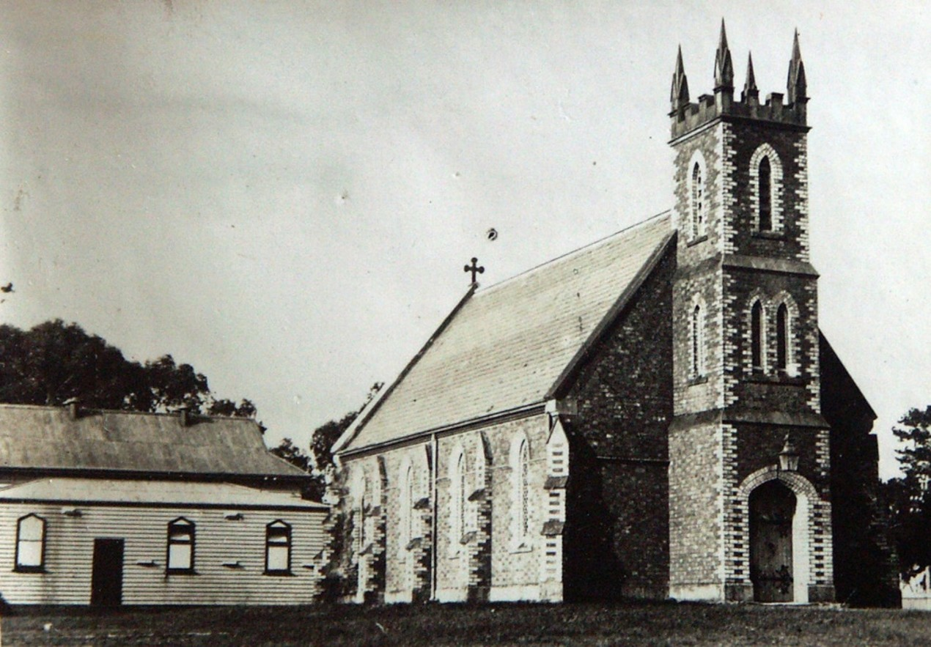

Figure 4.99: T.T. Holmes, St. James Anglican Church, Drysdale, 20 September 1930. Source: T.T. Holmes collection, Authentic Heritage Services collection.

land in October 1873.662 The mill property was purchased by Samuel Allnut of ‘Glenholme’, East Bellarine.663 The flour mill was leased to the Church of England at Portarlington as a temporary place of worship.664 Widdicombe was able to
hold his Government lease of the brick field and continue the manufacture of bricks by leasing back the brick residence and brick factory from Allnut.665 Others also held licenses for adjoining brickfields, including Allnut and Edwin Collins.666 Bricks produced by Widdicombe soon after the sale of the mill property, included those for the new Temperance Hall at Portarlington in May 1874 and the Portarlington State School in 1875667 (Figure 4.102).
In 1878, Widdicombe closed his brick factory at Portarlington a consequence of ‘a sensational disaster that ‘passed through in politics. 668 He relocated to Ballarat669 but retained the lease of the Government land with the brick clay deposits670 until they were taken up by Captain Howard Smith671 (see Theme 3 for biographical details of Howard Smith) but it was not until 1884 when Howard Smith and Sons purchased the Paignton flour mill and brick factory site.672 The property was managed
by Harry Bellingham Smith673 and he also obtained a lease of brick fields previous licensed to Widdicombe (Figure 4.103).
In February 1885, the Edina steamer transported the machinery necessary for the new brick and tile factory.674 Brick manufacturing had begun by October 1885, with Widdicombe returning from Ballarat to the factory
as manager.675 The Queenscliff Sentinel, Drysdale,
Portarlington and Sorrento Advertiser gave a description of the works (Figure 4.104):
To those of our readers who are not acquainted with the Port, and all should be, it will be necessary to mention that the locality of the works is at the foot of a hill, within a few yards of the beach, and handy to the pier. The
material from which the bricks and tiles are made is easily obtained from a cutting in the hill. There appears to be
an almost unlimited supply of clay. From the time that the pick touches the clay till it is turned out from the machine in brick form ready for the kiln a few minutes only elapse. The process of brickmaking is a very simple one. Men

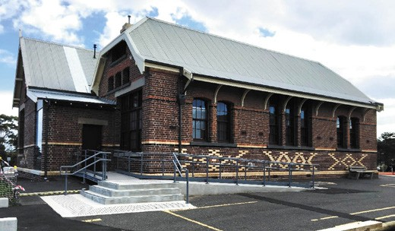

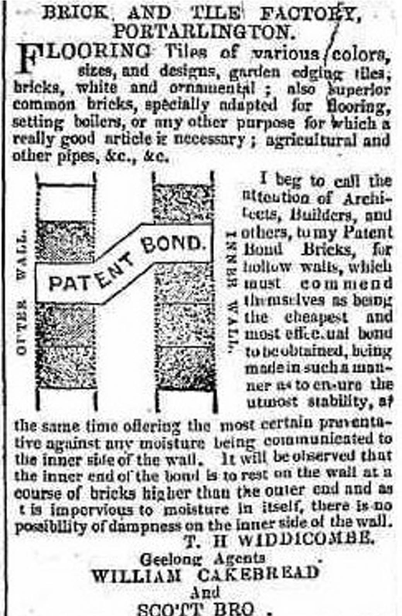
Figure 4.100: Advertisement of Widdicombe’s patent ‘bond brick’, 1872. Source: Geelong Advertiser, 2 April 1872, p.4.

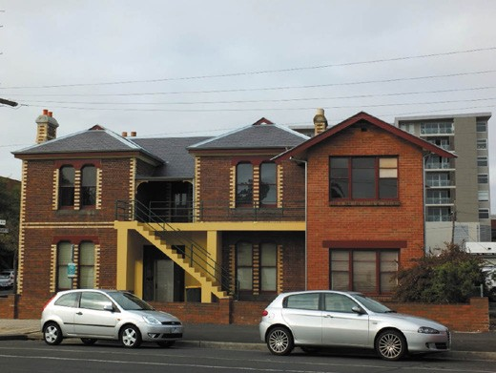
Figure 4.101: ‘Waverley’, 94 Western Beach Road, 2014. The original wing is on the left, the addition of 1873 (centre). Source: David Rowe.
Figure 4.102: Portarlington Primary School, 2019. Source: Jennifer Bantow.

take the clay from a face in the cutting and shovel it into trucks, which run for a few yards on rails to the works, and the contents of the truck is tipped over falling down between two revolving rollers. Passing between these rollers, the clay is crushed, so that all hard pieces which might be in it are reduced and softened. The clay then falls into a receptacle, which is called a pug mill, and from this it is forced through a square shaped tube, coming out in brick shape. As it is forced through, a board on small revolving rollers is ready to receive it, and when enough is ejected to make 8 bricks, another board is ready to take a fresh supply. The clay is cut into brick size eight at a cut by 8 wires, and is then piled in the long sheds, ready for the kiln. The time they lay in the long sheds for drying is about two weeks, but the period required very much
depends on the weather. There are 25 hands employed at present and they turn out between 7,000 and 8,000 bricks a day of eight hours. The wood consumed in burning
will amount to about 160 tons a month, and even this item alone will afford plenty of local employment. The wood is being obtained from Swan Bay. Mr Smith has a vessel of his own for this purpose, and also to ship the bricks by [to Melbourne].676
It appears to have been from this time when bricks were marked ‘PORTARLINGTON B&T. WORKS’ (Figure 4.105).
In 1889, the Portarlington Brick and Tile factory closed. Harry Bellingham Smith, merchant, was listed as the owner and occupier of the factory, and lessee of the brick field at that time.677 This brought a final end to the former Portarlington flour mill site as the location of a brickworks factory. In 1890, the factory site was leased to Frank Vial, leather merchant, the mill house being leased to Widdicombe678 (see Theme 5 for further details. It appears that Widdicombe had occupied the mill house since his return in late 1884 or early 1885). In addition to brick buildings manufactured of Portarlington bricks in the 1880s, there appears to be evidence of the clay

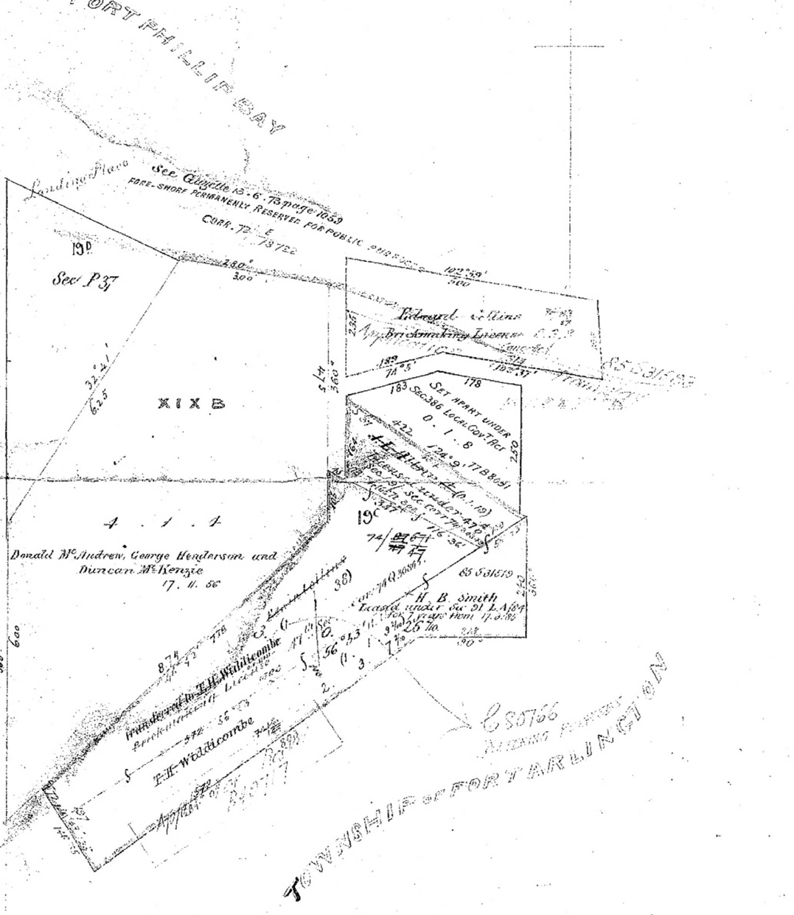
Figure 4.103: A.J. Skene, Plan of Allotment XIXB in the Township of Portarlington, County of Grant, showing brickfield allotments & licensee (some names added later), 27 August 1856. Source: Put-away plan, P38/1, Landata, © State of Victoria.

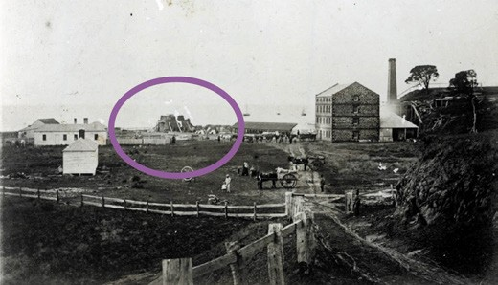
Figure 4.104: Portarlington Flour Mill & Brick Works (kiln circled), 1887. Source: GRS 2009/00883, Geelong Heritage Centre collection.

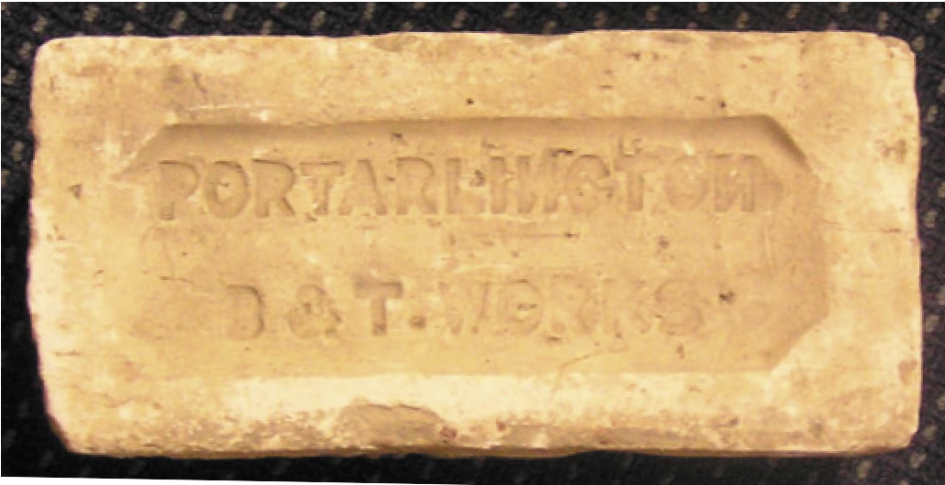
Figure 4.105: Brick from the Portarlington B & T Works, in the collection of the Bellarine Historical Society Inc., 2019.
Source: Pam Jennings.

pit in the cliff face below Newcombe Street to the east of the former Portarlington Mill which also survives at 7 Turner Court.

OTHER BRICKWORKS ON THE BELLARINE PENINSULA
No evidence appears to survive of the brick fields established at St. Leonards and Marcus Hill. In 1860, a Mr Anderson
had established five kilns at St. Leonards, the location now being the golf course.679 At Marcus Hill, James Hutchings leased land from Will Luke (part allotment 22 of Section 23 in the Parish of Paywit) where he worked a brick field.680 His neighbour was owner and occupier Charles Phillips, whose land also included a brick field. On his death in 1906, the Geelong Advertiser gave the following obituary:
The late Mr. Charles Phillips, farmer, of Marcus Hill, who died at his residence on Saturday, last, had an interesting career. The Sunday previous to his death, he celebrated the jubilee of his residence, at Marcus Hill, having settled there just fifty years ago. He was born in Berkshire, England, in 1826 and came out to New Zealand in the good ship De Auvergne in 1837. From, there he came across to

Victoria in the Tuscan, in command of Captain Ormond, father of the late Sir Francis Ormond, who was on board. The latter and deceased were then boys together, and played together on board the ship. Mr. Phillips started the battle of life, in Victoria amidst the hardships then prevalent, and was whip for the first hunt club meeting
held in Melbourne. He rode the racehorse Dauntless in the Town Plate, which afterwards evolved into the Melbourne Cup. He engaged in various pursuits, from a bullock driver to a barrister’s clerk, and took a trip home in the Sussex
to bring out his mother in 1852. In the year 1856 he took up a block of land at Marcus Hill, and did the first carting on the roads from Geelong and Queenscliff. He married a daughter of Mr. and Mrs. Allison, in the district, and leaves a grown up family of six sons and five daughters.
Deceased, who was widely respected in the district, was fond of relating intelligent and interesting reminiscences of the early days of Victoria. The remains of deceased were buried at Point Lonsdale yesterday.681

MARSHALL
In 1855-56, the newspaper proprietor, Alfred Douglass, established a brickfield at Charlemont (Marshalltown), near Goat Island on the south bank of the Barwon River.682
It appears to have been short-lived, the site later serving as Barwonside Tannery (see Theme 5).

ANAKIE
In 1960, the Anakie Brick Company was formed and commence the production of brickmaking, with 40-60,000 bricks a month being produced by 1981.683

GOLD MINING

GOLD AT NEWTOWN⁶⁸⁴
The frenzy of the Victorian goldfields in the early 1850s created considerable interest and enthusiasm by prospectors in Greater Geelong, and gave hope that local gold deposits might be discovered and provide financial rewards. As early as August 1851, the Geelong Advertiser reported that:
Messrs. Stephens & Co. have left with us a specimen of quartz, intermixed with gold. The locality in which it was found is within ten miles of Geelong. We expect, in a few days, to be able to make disclosures that will astonish our quiet neighbours.685
While the specimen found by John Stephens and Company near Mercer’s Well at Mercer’s Hill above the north side of Noble Street, Newtown, proved fruitless, it identified further gold there,686 gold was discovered ‘under a gum tree’ nearby, the Geelong Advertiser giving a humorous report on 7 August 1851:
Mercer’s Hill was again visited yesterday, by great numbers, who came trooping from all adjacent places. Detachments of miners from South Geelong and Chilwell, met bands of explorers from Corio, Little Scotland, and the regions of Ashby, and from the lands of Kildare in the far West – a motely throng, interspersed with equestrians, a few adventurous wives, and a fair sprinkling of nurserymaids, with their tender charges. Explorations were carried on in real earnest, and a sufficiency of quartz was broken up to supply the Corporation with metal for the whole of Geelong. The deep diggings at the west end of Malop-street were deserted for the more favoured locality, where large masses of stone might be seen shattered to fragments, - every fragment of which was examined with most minute enquiry, to detect, even if it were but a pin-head of the prized metal. At the foot
of yonder gnarled and contorted gum-tree, excavating under the very roots, were three men digging with clasp knives to get what the spade had failed to procure and showing in handfuls an admixture of reddish brown earth, quartz pebbles, and specks of black sand, enlivened
with a profusion of deceptive spangles which yielded to the pressure of the finger and thumb, and were lost in a sombre smudge. One party carefully folds up some sand in paper and puts it in his waistcoat pocket another carries away a pocket full of gravel like brown sugar,
for private washing. All have specimens producible on demand, and go home handicapped with “debris”, “detritus,” – and fragments of the primary formation.687
While this southern face of the Newtown Hill had been scarred by the feverish excavations, the freeholder of the land, W.D.

Mercer, publicly gave permission for the working of his land on the condition that he ‘may be sent the first hundred pounds weight of gold found, in order that the same may be presented by me to Her Majesty.’688 Mercer’s return to Scotland in October 1851 did not include £100 pounds worth of gold as the Mercer’s Hill diggings were ‘nearly abandoned,’ the specks
of gold in ‘pebbles of water-borne quartz’ not leading to any major finds.689
Eleven years later in August 1862, a public meeting, convened by Stephen Sleator, was held at the Newtown and Chilwell Council Chambers for the purpose of organizing an association to prospect the Municipality for gold and minerals. 690 Sleator argued that new life needed to be ‘infused’ into the community, and ‘where it were gold or
coal that was found; either would have the effect of largely benefitting the district.’691 In attendance at the meeting was William Blair who declared that he only that day had been shown a very promising specimen obtained in excavating for a tank. 692 There was also discussion about the advice of the Government Geologist, Alfred Selwyn, to the Geelong Exploration Committee about the potential for coal deposits ‘in the neighbourhood of Melville’s Quarry’, at the west end of Camden Road, Newtown.693 The outcome of the meeting
was the formation of the Newtown and Chilwell Gold and Coal Prospecting and Mining Association, the capital to be raised being £2000 in shares of £1 each.694
Enthusiasm for the creation of the Prospectus for the Geelong, Newtown, and Chilwell Gold and Coal Prospecting and Mining Association might have emanated from the feverish reports of gold discoveries at Newtown and Chilwell in the days after the formation of the Association. On 15 August 1862, the Geelong Advertiser reported that if half
of the stories about gold discoveries in Chilwell were to be believed then the area would assuredly become as famous for its quartz reefs as Ballarat was for its jewellers’ shops in the balmy days of 51. 695 The report further elaborated that
W.J. Thomas of the Customs Department had discovered three specimens of gold at his leased residence on Newtown Hill, Mr Osborne of Malop Street had ‘five or six very fine specimens found some time back in a gully near the Barwon breakwater’, Mr Lowe had discovered specimens in Russell Street, Chilwell while ‘two or three persons with pick and shovel unearthed a large mass of quartz in the middle of Hotham terrace. 696 The crown of a reef of the latter find revealed it to be ‘considerably honey-combed and burnt,’ and while the colour was not verified, ‘the stone was pronounced by an old reefer to be as promising looking stuff as he
had ever seen. 697
The Prospectus of the Geelong, Newtown and Chilwell Gold and Coal Prospecting and Mining Association was published in October 1862. The Provisional Board of Directors were

Nicholas Foott, M.L.A., chairman; William Blair, treasurer; and Stephen H. Sleator, honorary secretary.698 The Committee comprised 41 notable and successful men of Geelong including William Kernot, Peter Huddart, Joseph Lewis, D.K. Goodall, Dr Grace, William Thomas, William Siddall, William Stitt Jenkins, Moses Adamson, Joseph Carr, Dr Day and William Noble.699 A shaft was put down on Mercer’s Hill in October 1862, the result not striking gold but the contractors and all the experienced were
most sanguine as to the result. 700 Ultimately, the result failed. Some of the shareholders suffered heavy financial losses, including Joseph Lewis, publican and owner of ‘Woolmers’ (now ‘Newtown Brae’), Stephen Street, Newtown, which contributed to his insolvency.701 Another failure was an independent shaft in Bond Street.702 Other mining companies tried their luck including The Newtown Hill Quartz Prospecting Company in 1866 but is lasted only 12 months, it being reported that mining had ‘been discontinued, the movement not being so well supported as could have been wished. 703 In 1873, the Corio Quartz Mining Company let a shaft at Mercer’s Hill in 1873 and this company subsequently disbanded.704
Soon after in 1875 the prospectors to be later associated with the Chilwell Gold Mining Company sunk a shaft on the north side of Noble Street. In August that year, the Geelong Advertiser gave the following report:
It is well known that a few enthusiastic individuals have for some time past been spending a great deal of time and money in prospecting for gold in various parts
of Chilwell. Hitherto their operations have been confined to sinking small shafts in back yards, but as we have
not yet heard of any large parcels of the precious metal being deposited in any of the local banks, we can only conclude that their efforts have not met with that success their pluck and perseverance deserves. They have now, however, brought their operations under the notice of the public by commencing to sink a shaft on the north side of Noble Street, on the spot where the celebrated rush took place some years ago, and where a tunnel was driven some distance into the side of the hill and afterwards abandoned.705
In June 1876, the prospectors sought assistance from the Department of Mines in determining whether the geological characteristics of Mercer’s Hill held the potential for gold.706 The Geological Surveyor, Ferdinand M. Krause, visited Mercers Hill and prepared a report on 25 July 1876. His report was accompanied by a ‘Geological Sketch Plan’ (Figure 4.106) showing six shafts: numbers 1-3 on the north side of Hotham Terrace (being approximately located at 90-94 Prospect Road today) and numbers 4-6 on the north side of Noble Street (approximately in the vicinity of 98-102 Noble Street today).
Krause concluded that:

The “coarse” gold reported by the [Chilwell Quartz Mining] company is apparently a misconception of the term, for the washings shown me on a former occasion provided the gold to be “scaley,” and requiring some hundreds of specks to make up one penny-weight. The presence of coarse gold implies the proximity of the older palaeozoic rocks; while fine gold may be carried a considerable distance from the source, and occur in small quantities overlying indiscriminately rocks of any older order than the drift with which it is associated. If it can be shown that, as appears probable, the bed rock at Newtown Hill is a carbonaceous rock, with or without overlying miocene beds, then it is useless to expect any remunerative results from the operations in search of gold. The sinkers of the shafts, however, aver that the bottom is identical with the “reef slate” of Ballarat. If that were correct, the company will have made a discovery of great scientific as well
as economic value; for if the Silurian rocks (the nearest outcrop of which is at Sutherland’s Creek, north-east of Maude) underlie the tertiaries and newer volcanic which extend from there to the seaboard, then the principal conditions of a goldfield may be admitted to be present.707
Krause’s findings were sufficient for the prospectors to float a company in August 1878 called the Chilwell Gold Mining Company.708 John Masters Garratt was appointed company manager (see Theme 2 for biographical details on Garratt).709 At this time, only 300 shares had been attracted of the
total anticipated issue of 1000, with 117 shareholders (see Appendix 4.4).710 The shareholders came from diverse socio- economic backgrounds, the majority being men, including Charles Dennys, woolbroker; Edward Nicholls, town clerk; and T. Templeton, cabinetmaker.711 There was also a sizable number of shareholders that were foundrymen, including Andrew Younger of Mercer Street, Geelong, Archibald Hardie of Catherine Street, Geelong West, and Samuel Wheeler of Malop Street, Geelong.712 Female shareholders included Mrs Emma Dobson and her daughter, Mary Ann (domestic duties) and Mrs Mary Martin, a widow of Noble Street, Newtown.713 The first directors of the company elected in December 1878 were Messrs. W. Humble, L. Ryan, J. Donaghy, E. Richardson,
H. Anderson, J. Brown and T. Pescott.714
Like the mining companies before it at Mercer’s Hill, the Chilwell Gold Mining Company was not to endure given the lack of gold finds. The company was wound up in August 1879 and its land holdings were offered for sale in September of that year.715 Apart from an independent shaft sunk nearby in Bond Street, Newtown, the shafts in the Mercer’s Hill area represent the only and most prolific gold mining activity in the inner Geelong area.716

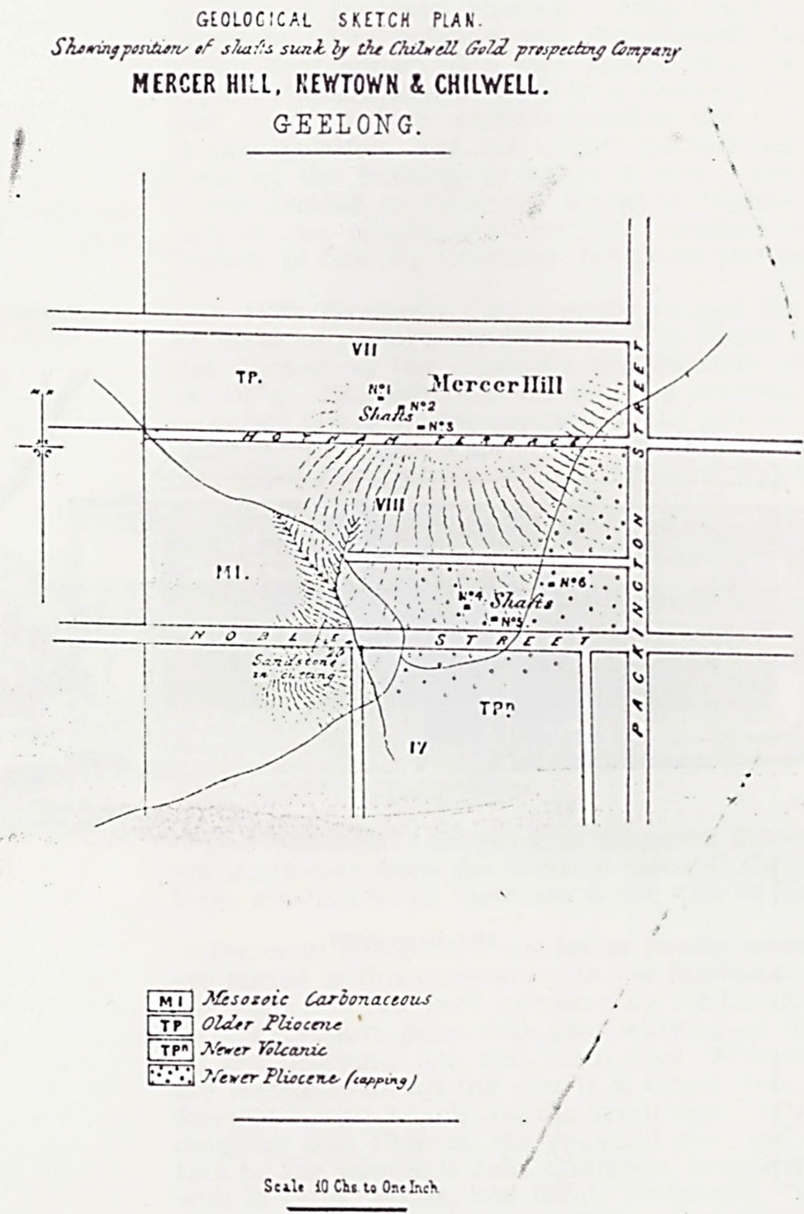
Figure 4.106: F.M. Krause, Geological Sketch Plan, Shewing position of shafts sunk by the Chilwell Gold prospecting Company, Mercer Hill, Newtown & Chilwell, Geelong, 1876. Source: D. Hamilton, ‘Geelong’s Own Gold Mine’, Investigator, vol. 21, no.3, September 1986.

DOG ROCKS
Similar excitement ensued at the Dog Rocks near Batesford as that of Newtown in 1861 when David Hughes alleged his discovery of gold. On 29 November of that year, a special meeting was held of the Geelong and Western District Exploration Committee to finalise negotiations with Hughes in relation to financial dealings with the exploration. The agreement reached included:
Mr Hughes undertakes to make known to the public through the Geelong and Western District Exploring Committee, a new and payable gold field within 20 miles of Geelong, and at least ten miles from any other diggings, on the following terms:
That £300 be paid by the Geelong and Western District Exploring Committee as a reward for the said discovery. The sum of £100 to be paid as soon as 1000 ounces of gold have been raised, if within a month, from the 29th inst., and if 500 men are on the ground during the last week of December, 1861. That the second sum of £100 shall be paid if 1000 men are on the ground at the end of January, 1862. That the third sum of £100 shall be paid if 1000 are on the ground at the end of February, 1862, and if at that date 5000 ounces of gold have been got from the field.717
The agreement by the Geelong Western District Exploring Committee with Hughes caused an immediate rush to the Dog Rocks. One hundred people came by horse and on foot from Geelong, it being noted that the people in the neighbourhood of the Dog Rocks ‘were in a state of blissful ignorance of the rush, and their puzzled, half-doubting looks and expressions when chaffingly hailed by the passers-by about going to the diggings were amusing. 718 With the place of the discovery shown by Hughes, ‘several tin dishes were immediately filled with the quartz gravel and clay of which the soil is composed, and were carefully washed at the water holes close by, but not one single speck of gold was found by anybody. 719 By the end of the day, only one party considering camping overnight, the rush to the Dog Rocks proving fruitless.720

LITTLE RIVER
Enthusiasm for prospecting for gold was revived in 1864 when a discovery was reported in the bed of the Little River.721 The great excitement in the immediate neighbourhood that had been caused soon deflated. Nevertheless, a party of experienced diggers began sinking in the river bed opposite the gully on the western bank in the direction of the You Yangs. Only one or two specs were found over two days. It had earlier been concluded by Mr Fitzalian, then Government Botanist in Queensland who had found small specs on the banks of the river in c.1858, that the physical characteristics

of the surrounding country suggested that gold would not be found in payable quantities.722

RURAL DEVELOPMENT & CLAUSE 42 OF THE AMENDING LAND ACT
It was not actual gold mining within Greater Geelong where the most notable physical evidence survives, but Government legislation that restricted freehold purchase of land in the northern and north-western parts of the municipality. In particular, Section 31 and Section 42 (also described as Clause 42) of the Amending Land Act of 1869 enabled licenses to be issued to reside on or cultivate small allotments on or adjacent to goldfields. In particular:
Section/Clause 42 of the Amending Land Act 1865 was designed to allow the use of lands on or adjacent to the goldfields to the advantage of the general population without interfering with the operations of miners.
Occupation, at a modest rental, was to be temporary and for the purposes of residence and cultivation.
Each licence was to cover a maximum of twenty acres for no more than one year although persons could apply for multiple licenses.723
Section 31 of the Amending Land Act 1869 enabled holders of licenses under section 42 of the Amending Land Act 1865 to purchase their land or obtain a lease leading to purchase. 724 The Lara, Anakie, Little River and Sutherlands Creek areas were located “adjacent to” the Steiglitz Division of the Ballarat Mining District proclaimed in the Victoria Government Gazette in 1858. The eastern portion of the Steiglitz Division was described as including:
… the Anyche Youang hills; thence by the range to the Little River; thence by the Little River to its junction with its main tributary; thence by a line north-easterly to the junction of the Djerriwarrah Creek and the River Werribee
725

The boundaries and names of the divisions and subdivisions within the Ballarat Mining District (Figure 4.107) changed a number of times in the 19th and 20th centuries.726 By 1890, there were 10 divisions within the district, this number falling to six by 1917.727

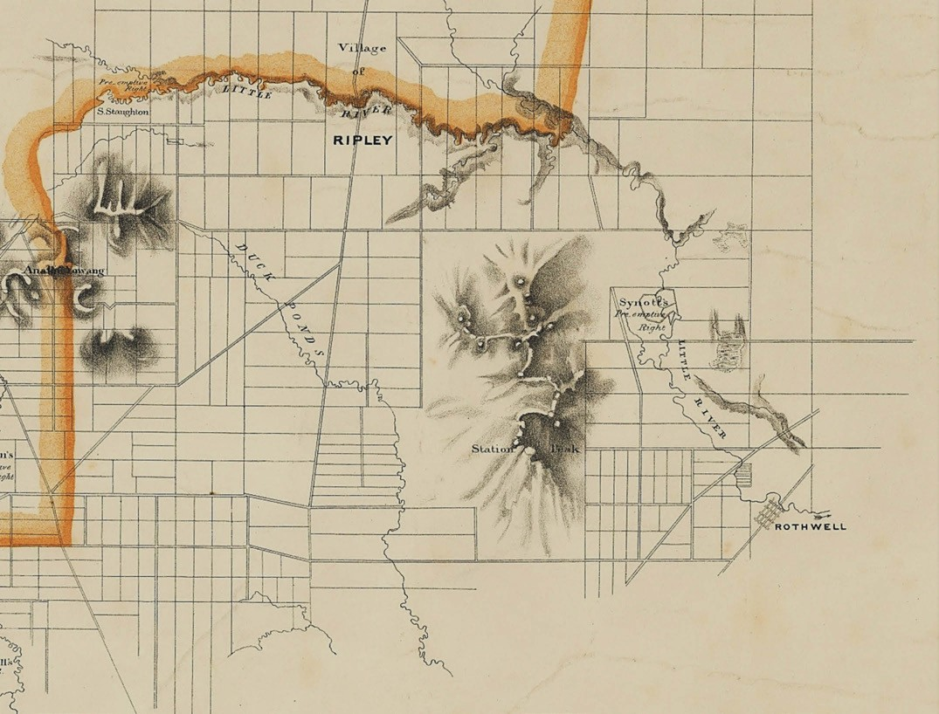

Figure 4.107: Detail of the Lara area in the Plan of the Mining District of Ballaarat, 25 June 1859. The Lara area is situated in the bottom right corner. The boundaries of the Mining District are shown in the orange border. Source: Plan of the Mining District of Ballaarat, compiled from, the maps in the Surveyor General’s Office and the Mining Surveyors Plans at the Office of the Board of Science, lithographed and printed in colours by DeGruchy & Leigh, Melbourne, 25 June 1859, State Library of Victoria.
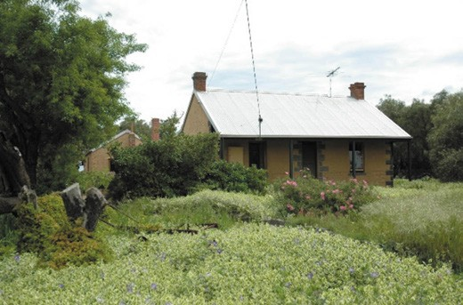
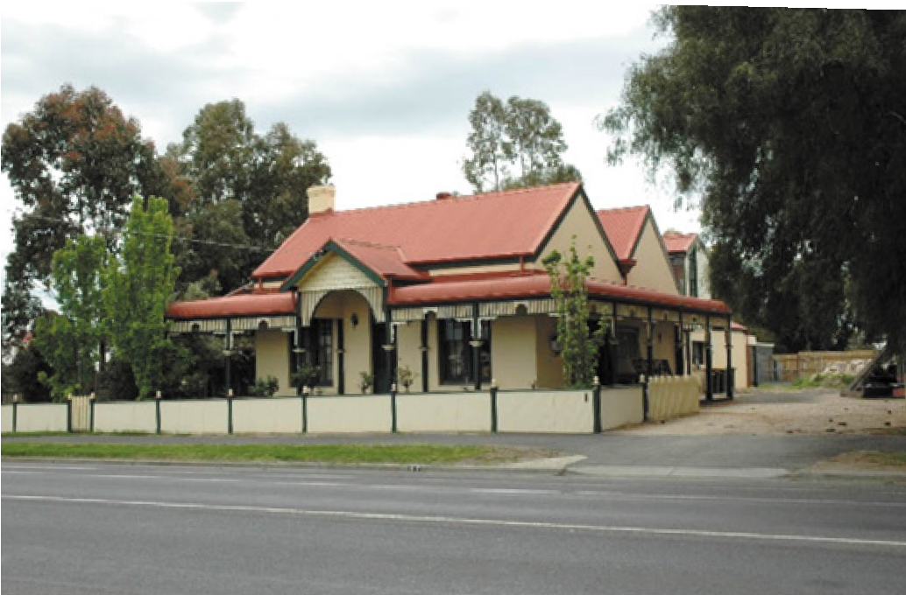

Figure 4.108: Cottage, 85 Curletts Road, Lara. Source: Wendy Jacobs, 2012.
Figure 4.109: ‘Limella Cottage’, 31-45 Forest Road South, Lara, 2012. Source: Wendy Jacobs.

Small surviving farms and particularly vernacular stone dwellings associated with the Amending Land Acts are
a physical legacy of these land provisions that led to some of the earliest developments for the working class at Lara and in nearby areas. At Lara, the surviving limestone Victorian vernacular cottages at 85 Curletts Road (built in 1869 for William Harding (Figure 4.108), farmer and builder); ‘Limella’ Cottage, 31-45 Forest Road South (built in 1872-73 for John Spalding, limeburner) (Figure 4.109) and the cottage complex at 80 Gebbies Road (built 1869-74 for William Foot) are a tangible legacy of the Amending Land Act and Lara s close proximity to the Steiglitz Division of the Ballarat Mining District.728 There are also ruins at 60 Branch Road (the former dwelling built in 1871 for John McGillivray) and at 120 Duggans Lane (built in c.1864-84 for Maxwell Bell) that have similar associations.729
While at least an additional 12 settlers purchased land in the northern Lara and Little River areas in the Parish of Wurdi Youang in the 1870s under Section 31 of the amending Land Act 1869 previously held under license (under Section 42
of the Land Act 1865), it appears that only one dwelling survives outside Lara.730 Located on lots 10 and 11 of Section A (now 160 Drysdales Road, Little River), it was possibly
built for William Chesterfield in the 1860s (the land being purchased in 1877).731 Other associations with the Section 31 provision of the Land Act beyond Lara include the stone ruins at 65 Drysdales Road, Little River, built in c.1860s for Moodie Drysdale (the land being purchased in 1876), and the
ruins at 185 Little River Ripley Road, Little River, possibly built for John Henry.732 In the Parish of Moranghurk were at least another seven settlers who purchased land under the same land provisions, but the original dwellings and structures do not appear to survive.733 Only three settlers in the Parish of Lara, surrounding the old Township of Ripley, are known to have occupied land under Section 42 and later purchased it under Section 31.734 In the Anakie Parish were another seven settlers who purchased land under Section 31 of the Act.735 Dwellings associated with the original purchases of the land do not appear to survive.

4.8 WATER SUPPLY AND SEWERAGE736
Transformative to the Greater Geelong landscape was the construction of water supplies and a sewerage system.
These initiatives began during the earliest European colonisation of the municipality and involved changes to the Barwon River, with further and more substantial infrastructure transforming gullies in the Brisbane Ranges, and excavations in other outlying parts.

EARLY WATER SUPPLY THE BREAKWATER
The choice of site for the Geelong Township in 1837 was
governed by its close proximity to both Corio Bay and the Barwon River (see Theme 6) but there was a distinct disadvantage in that the Barwon River was brackish downstream from Buckley’s Falls. To combat this, a dam was built from January 1839 (or possibly December 1838)
on the Barwon River, south-east of Geelong, to a design by Captain Foster Fyans.737 He had presented his design for the breakwater on a visit to the Governor, Sir George Gipps, in Sydney of 1838.738 The construction of the breakwater
which also served as a river crossing (see Theme 3) - resulted in fresh water being 152 mm higher than the rush the saltwater tide, and therefore gave Geelong its first water supply.739 The first third of the dam was built by convict labour, with Governor Gipps having supplied 50 prisoners that boosted the 12 convicts already under Fyans’ charge.740 By November 1840, the dam was almost complete as the Geelong Advertiser gave a glowing report:
THE BREAKWATER – This great undertaking is now nearly completed. We call it “great,” when we measure it by the usual scale upon which the Government conduct their operations. The term Breakwater will be apt to mislead many; we will therefore attempt to explain it for the benefit of our Melbourne readers. The River Barwon, which forms the southern frontage of the town, although wider and deeper than the Yarra, has a navigable outlet to the ocean, where it empties itself into a series of salt water lakes to the westward of the Heads of Port Phillip. The tide, however, flowed past Geelong, and the water was almost constantly brackish. To remedy this evil, as well as to serve the purpose of a bridge, the Breakwater was proposed. It is about a mile from Geelong and consists
of two massive walls of rough stone, with clay filled in between. It is so far completed that there is an effectual separation of the fresh from, the brackish water, and a
loaded dray can now cross over in safety.741

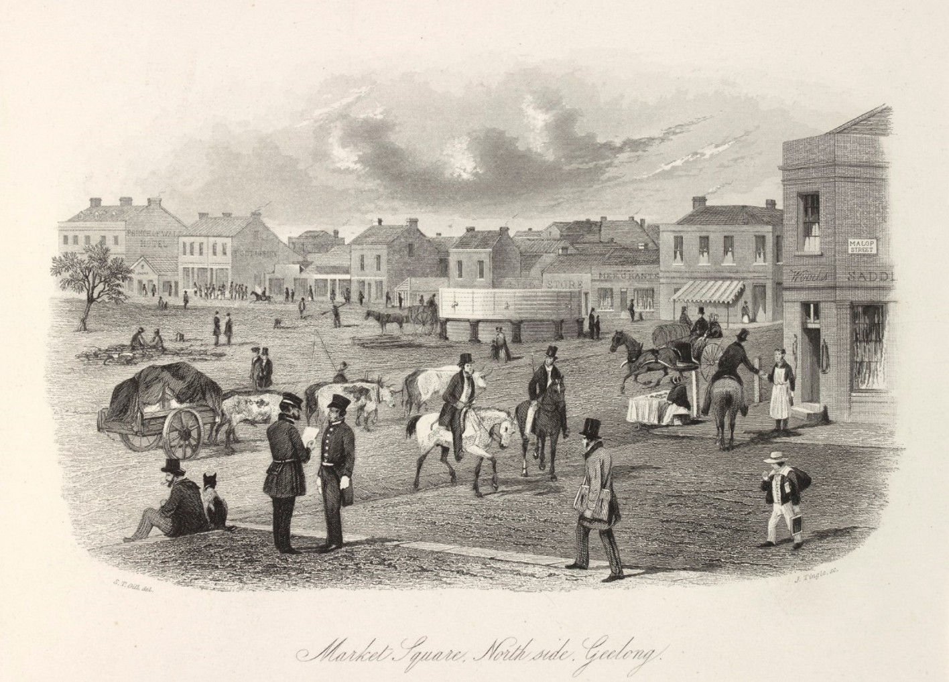
Figure 4.110: S.T. Gill (artist), J. Tingle (engraver), Market Square, north side Geelong, 1857 showing Gray’s water tank. Source: accession 30328102131660/24, State Library of Victoria.

Further alterations were made a few years later due to flood damage (see Theme 3).

GRAY’S WATER TANK, MARKET SQUARE
Capitalising on the regular supply of fresh water from the Barwon River was William Gray (1811-1891).742 He had arrived in Geelong in 1838 and established a store in Corio Street
and flour mills at South Geelong and Gheringhap Street (overlooking Corio Bay) in subsequent years (see Theme 5).743 At South Geelong from 1849, Gray used his flour mill as part of his Government-approved water supply system. The Geelong Advertiser gave the following report at this time:
Our enterprising townsman, Mr. Gray, has now completed every preliminary arrangement to enable him commencing on his work for bringing water into the town from the Barwon for the supply of the inhabitants. The Scotia, which left this port yesterday, will bring with her, on her
return passage, the iron pipes which have been cast in Hobart Town and are now quite ready for shipment. The labour of digging the large reservoirs will be commenced immediately, whilst other portions of the work will proceed simultaneously. The commencement of another season will witness the completion of a spirited undertaking,
by which that most appreciable convenience of every inhabitant receiving his supply of water from the very heart of the town, can be obtained.744
From his steam engine at the mill, he pumped water at night (allowing flour milling operations to continue during the day) in cast iron pipes laid under Moorabool Street to a substantial, brick-lined, subterranean 60,000 gallon holding tank on top
of the Moorabool Street hill, at the north-west corner with McKillop street).745 From there, the water was piped by gravity feed to a ‘water fountain’ in Market Square.746 Designed by his engineer, Mr. Easby, Gray supplied water for a nominal fee.747 Problems ensued due to low water pressure and so in early 1851 a large metal tank (Figure 4.110) was installed in Market

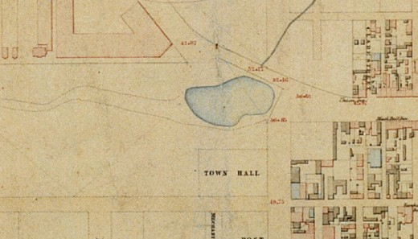
Figure 4.111: La Trobe’s Dam shown in J.H. Taylor, Map of Geelong, Surveyor-General’s Department, Melbourne, VPRS 8168/P2, Unit 5416, item Roll 39 Geelong, Public Record
Office Victoria.

Square as described in the Geelong Advertiser:
The Tank in Market square is fast approaching completion, and will prove a great ornament to the Square, whilst at the same time it will be of essential service to the whole town. It is about 90 feet in circumference, and six feet deep. It is supported by substantially well worked stone pillars, on which rests the wood-work intervening between the pillars and the superincumbent tank. When finished, it will be quite a refreshing object for the eye
to rest upon, and when the houses which are rapidly advancing, are completed, a great change will have been worked on the sombre aspect which this large square presented.748
Gray continued to supply water until a dispute with the Geelong Town Council (of which Gray was a member for some time) about water changes and occupancy of his tank in Market Square brought to an end this early enterprising water supply service.749 No evidence of Gray s water system
exists today, his underground iron pipes being dug up in 1874, his tank in Market Square removed, and his brick tank at the corner of Moorabool and McKillop Street converted into a dwelling of novel design in 1885750 until the property was sold in 1890 and the existing two storey brick dwelling, ‘Blandford’ built for Alderman James Strong to a design by local architect Albert Derrick.751

LA TROBE’S DAM, JOHNSTONE PARK
In 1848, the Superintendent of Port Phillip, Charles La Trobe, visited Geelong and proposed the construction of a dam at the west end of Malop Street (and later part of Johnstone Park).752 The dam was to be thrown over the western Gully and La Trobe instructed William Weekes, Geelong Town Surveyor, to carry out the necessary survey work. The proposal was reported in the Geelong Advertiser at this time:

The dam is to be made 16 feet high, and will be the means of retaining an immense reservoir of water which would otherwise run into the bay. A bridge will be built in
proximity, from which two great advantages will be derived first, an easy ingress and egress to and from the town for carts and drays, as well as foot passengers; and second, to allow the surplus water, which in wintertime and during heavy rain may rise above the level of the dam to run off.753
Laborers commenced excavations on the dam on
21 December 1848 and in July 1849 a contract for building the dam embankment and roadway was awarded to Thomas Stevens.754 The completion of the dam, with its soft base
and unstable embankment, led to drownings and several accidents, the initiative being mired in controversy and inquests. In December 1850, steps were taken to fence in the dangerous portions which was completed in January 1851.755 Yet loud criticism of the dam continued. In July 1851 the Geelong Advertiser quipped that ‘the object was to form a useful and ornamental reservoir of water, it should have been constructed higher up the gully, where the banks are
shelving and the bed of moderate depth—not where the sides are precipitous and slippery, and the depth greater than in
the ship channel of Corio Bay! 756 The extent of the dam was shown at what was then the eastern end of Johnstone Park and took in much of the intersection known today as Malop, Gheringhap and Mercer Streets (Figure 4.111).
Despite the drawbacks, in 1855 the dam was recognised for its benefit (and potential benefit) to the Geelong citizens:
in affording a ready supply of water in the direst summers, for horses and cattle, for saw mills, and for domestic purposes where extreme purity is not essential; but it is as a ready source of the wherewithal to extinguish fires, although happily we have never yet had occasion to draw upon it for that purpose, that the Dam assumes it full important.757
In April 1857, the Geelong Town Council resolved ‘to increase the width of that part of Malop-street which intersects the Dam leading to Mercer-street, to the extent of 99 feet, by filling in a large portion of the reservoir.’758 These works were subsequently completed and the road intersection and reduced dam were shown on Robert Balding’s Map of the Town of Geelong of 1864 (Figure 4.112):

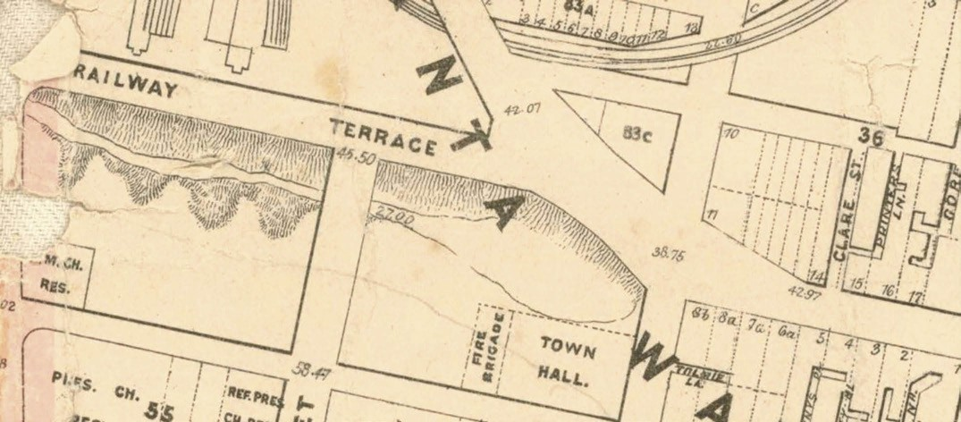

Figure 4.112: Reduced size of La Trobe’s Dam in R. Balding, Map of the Town of Geelong & Boroughs of South Barwon & Newtown & Chilwell, 1864. Source: City of Greater Geelong.

UNDERGROUND TANKS
Ubiquitous throughout Greater Geelong as private water supplies were underground brick-lined water tanks. These spherical subterranean structures were a receptacle for rainwater collected from residential rooftops. The tanks were either stuccoed or finished with plaster of Paris, the upper portion being exposed above the ground. An inner- city example is the brick tank at former Wesleyan Minister’s residence, 1 Little Ryrie Street, Geelong, built before 1854759 (Figure 4.113). At ‘Laura Villa’ (known today as ‘Claremont’), 17 Drysdale Street, Portarlington, a rendered underground tank was built in 1875-76,760 the iron lid being the work of the prolific iron founders in Geelong, Humble and Son (Figure 4.114).

TOWARDS A RELIABLE & SUSTAINABLE WATER SUPPLY

PRIVATE AND PUBLIC INITIATIVES
Geelong was to experience the formation and disbandment of a number of private and public organisations whose ambit was to secure a more reliable and fresh water supply for Geelong. Several proposals were put forward throughout the 1850s before a scheme was eventually agreed to by both locals and the Victorian Government.
On 6 July 1852 at the Royal Hotel, Malop Street, a group of townspeople held a meeting to take into consideration the best means of supplying the town of Geelong with pure water. 761 It was from this meeting that the Geelong Water Company was formed, a provisional committee was established comprising Messrs. James Ford Strachan,
Alexander Thomson, John Cumming, W.H. Baylie, T. Edols,
J.S. Carver, J. Wallis, A. Gregory, Thomas Kerr, William Roope, T.C. Riddle, J. Towle, J.B. Hutton, William Timms,
F. Champion, James Harvison, T. Curle and James Cowie.762 The capital of the company was to be £30,000 with a Mr. Wallace appointed secretary.763 The need for a new water supply, according to the new company, was because the existing water at the breakwater was more or less deleterious in its use. 764 It proposed work necessary for the introduction of water either from Buckley’s Falls, or from the Barwon River.’765

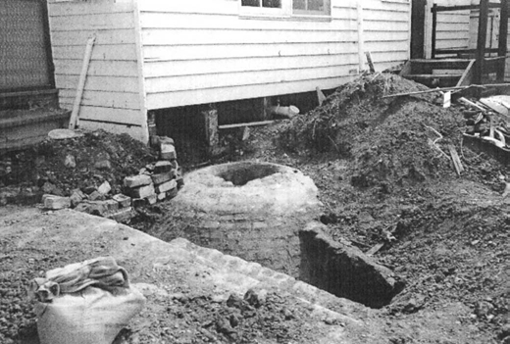
Figure 4.113: Excavations exposing underground tank at rear of 1 Little Ryrie St, Geelong, 1998. Source: David Rowe.

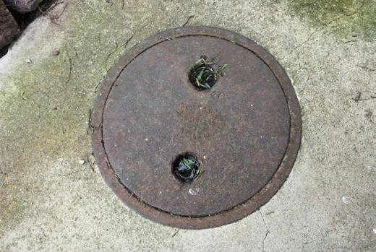
Figure 4.114: Detail of cast iron cap to underground tank at ‘Claremont’, Portarlington, 2011. Source: David Rowe.

While the Geelong Water Company was beginning its investigations, the Geelong Town Council appointed a committee and engaged John S. Henry, local civil engineer, architect and surveyor to carry out surveys and cost estimates for an alternative water supply to the existing breakwater in the Barwon River.766 By January 1853, Henry’s concept was to extract water from Buckley’s Falls:
A filter will be fixed at the Falls, and on the crest of the Fall will be raised a dam four feet high, furnishing two water powers. The expenses of steam will be got rid of the main supply being procurable by the action of its own power, the descent from the summit of the Fall affording the requisite declination, and economising outlay and labour. This plan would leave the Barwon open to industrial pursuits, and make the river what it ought to be, the drain of the southern side of the Geelong and obviate that which it is fast becoming a reservoir of impurities and stagnation.767

While new and improved water supply was therefore anticipated by private and public initiatives in the early 1850s, both the Geelong Water Company’s objectives or the plans of the Geelong Town Council committee were never realised as originally intended but they did provide a basis for further deliberations.
On 12 April 1855, J.H. Taylor, Assistant Surveyor, furnished a report on the potential for the construction of a breakwater at Barwon Heads near the mouth of the Barwon River. The basis of Taylor s report was to investigate a breakwater as a potential new water supply for Geelong. He concluded:
The best position for the construction of a breakwater would be about half-a-mile from the estuary; any site selected nearer the mouth would be greatly exposed to tidal wave, and a greater extent of sand hummock would have to be protected; and any site above the proposed one, the river increases in width, with a bed of soft black mud to a great depth, and the banks being nearly level with the tide would have to be protected for a considerable distance. The proposed site is 1076 feet across from bank to bank, great difficulties would have to be overcome from the shifting nature of the sand hummucks, every inland flood tending to waste them away. It would be impossible to construct a breakwater of any use at the mouth of the river without protecting the banks on both sides, both above and below, and the cost of such an undertaking would be great.768
The overall cost of Taylor’s scheme was £75,000.769 It never eventuated.
On 30 April 1856, the Victorian Commissioner of Public Works appointed a Board for the purpose of reporting on the most eligible mode of supplying Geelong with water, and for other purposes connected therewith. 770 Appointed as Commissioners to the Board were Alexander Thomson, James Ford Strachan, John Henry Mercer, W.G. McKellar and Edward Willis.771 Mercer was appointed chairman at the Board’s preliminary meeting on 8 May 1856.772
Chemical examination of waters and engineering investigations of supplying a scheme were carried out by the Geelong Water Commission’s Engineer-in-Chief, John
Millar (1807-1876).773 A ‘man of extravagant claims, exuberant schemes and quixotic behaviour,’774 Miller had been an architect in Belfast, Northern Ireland, prior to going bankrupt and coming to Melbourne (temporarily in 1854 and more permanently in 1855).775 His appointment

to the Geelong Water Commission appears to have been his first foray primarily as an engineer, a role he continued as engineer to the Town of Dunedin, New Zealand
in 1864.776
Millar’s examinations and proposed water supply scheme were based on a plan and reports for a scheme prepared for the Government by Assistant Surveyors of the Victorian Department of Lands and Survey, George Darbyshire and
John Hamlet Taylor prior to the establishment of the Geelong Water Commission, and a plan and report of a very similar scheme prepared by John Henry (who had earlier been engaged by the then defunct Geelong Water Company), were considered.777
Initially, the Barwon River above Buckley’s Falls at Fyansford had been examined given its natural advantages and the less expensive outlay. However, it was found the proposed reservoir would be too low and so a very limited portion only
of the town could be served on the comparatively inexpensive principle of gravitation, and recourse to steam power would be imperative’, thereby requiring a ‘constant working expense and liability to casual disarrangement. 778 Ultimately, the Geelong Water Commission extended its investigations considerably further south-west, and with John Millar, devised a scheme involving the construction of a reservoir on John Henry Hopkins’ station at Wormbete near Winchelsea, where water would be piped overland for 30 miles and traverse
the Barwon River at the Fyansford Reserve, extend along Noble Street to Shannon Avenue, where it would be laid northwards to Aberdeen Street, and then extend eastwards along Aberdeen Street before connecting with a pipe along Moorabool Street that was to have outlets at Corio Bay and the Barwon River (Figure 4.115).
The Commission, while carrying out much preparatory work, fell under heavy criticism at a public meeting in January 1858.779 Additionally, a memorial was presented to the Victorian Legislative Assembly indicating that the £200,000 voted by a former Legislative Assembly for water supplies for both Melbourne and Geelong had not resulted in any expenditure for the latter, the 25,000 inhabitants being ‘still dependent upon the precarious supply of water by carts from the River Barwon.’780 In February 1858, being disgusted at the treatment they had so long received at the hands of the Government’, the chairman and other Board members of the Geelong Water Commission resigned.781 This brought to an end the third water supply body in Geelong.
On 4 February 1858, yet another committee was formed to investigate the best means of supplying Geelong with
water.782 This time, a select committee had been appointed by the Legislative Assembly. A report by Captain Pasley, Commissioner of Public Works, and M.B. Jackson, engineer of the Sewerage and Water Commission concluded that the

water of the Barwon, near Geelong, is not a desirable water for the supply of a town’, and ‘the water of the Barwon, below its junction with the Leigh, has become perceptibly worse and more turbid and disagreeable during the last few months.783 Pasley and Jackson suggested that the best and cheapest method of establishing a water supply was by Mount Buninyong, Lal Lal and Warrenheip ‘impounding the same
in one or more reservoirs, as may be required.’784 Again, nothing immediately was realised from this scheme.

A REALISED SUPPLY: THE STONY CREEK SCHEME UPPER STONY CREEK RESERVOIR
On 16 March 1862, the Geelong Advertiser reported on one
of the most disastrous visitations by fire ever experienced in Geelong’ with the destruction of ‘Singapore Terrace’,
Geelong s greatest ornament of the Esplanade overlooking the Eastern Beach (see Theme 6).785 While water from Gray s fountain in Market Square was carted in a vain attempt to save the building, the disaster yet again highlighted the lack of a reliable, reticulated water supply.786 Just two days after the demise of Singapore Terrace, the Geelong Town Council appointed a select committee to consider upon the best and most economical mode of supplying Geelong with water. 787 The committee consisted of the Mayor William Bell, Aldermen Parker, Hedrick and Knight, and Councillors McWilliams and Gundry.788
Motivation for finding a solution was not immediate. However, in June 1864, the committee had appointed the recently- arrived civil engineer from New South Wales, Hendrick (Henry) Oscar Christopherson (1834-1892) to prepare a report on the possibilities of a suitable water supply scheme.789 It appears that Christopherson first acquired his mathematical and engineering interests from his father, Irving Carlyle Christopherson, a teacher who patented ‘an invention for various mechanical purposes and for manufacture and use of certain instruments with which to extract balls, bone, or other substances, from gunshot wounds or deeply incised wounds; for dilating contractions in the same, and in the oesophagus, and in the urethra; and for extracting liquid and calculi, or other substances, therefrom.’790 H.O. Christopherson had been appointed to a position in the Colonial Government in July 1856 and in January 1857 he had taken up a position
as architectural and mechanical draftsman in the Victorian Railways Department.791

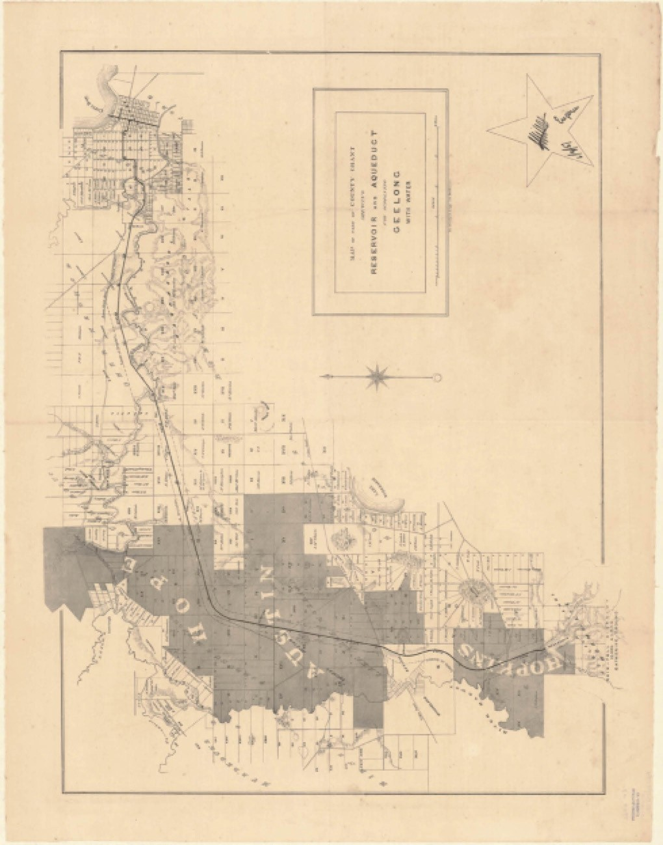
Figure 4.115: J. Millar, Map of Grant showing Reserve & Aqueduct for supplying Geelong with Water, Ge Gruchy & Leigh lithographers, Melbourne, 1857. Source: Bib ID 4977661, National Library of Australia.

Having investigated the country around Geelong, he concluded that the head of the Stony Creek (the southern branch of the Little River) possesses
advantages far outweighing those of any other place within reasonable distance of Geelong. 792 It was Christopherson s proposal that formed the basis of the Upper Stoney Creek Reservoir transforming part of Stony Creek and adjacent gullies and swamps in the Brisbane Ranges (located immediately outside today s municipal boundary) into a large water storage catchment.
Christopherson was complemented for his proposal by Government officials.793 He was subsequently appointed Chief Inspector of Waterworks and in 1866, the Victorian Water Supply Department commenced the construction of Christopherson s scheme at Stony Creek. A ceremony for the turning of the first sod was held on 15 June of that year.794 Jonathan Chappel of Geelong was awarded the contract to construct the storage reservoir at a cost of £42,572/17/9, a contract for cutting a trench on the site of the dam for the reservoir having been given to William Fallon at a cost of
£261/18/4.795 A Mr Cuthbert was appoint assistant-engineer to the scheme, with stonemason, Nicholas McCann of Ceres, occupying a post of some responsibility. 796
Details on the proposed reservoir were documented by the Geelong Advertiser a few months after the commencement of construction in October 1866:
The Stony Creek reservoir, it should be understood, as marked out by contour lines on the ground itself is, in form, like a monster square-headed fish, the tail of which is rather more than a mile up the Creek, in the direction of the Burnt Station, the head being formed by a hug dam.
The dam itself is a remarkable specimen of native industry. As we approached it from the office, our road was in a direction transverse to the creek, and in a line with the great wall, so that what met the eye was a large clay colored triangular patch on the opposite bank of the ravine, 150 yards at the base, rather more from base to apex, which latter was 15 feet wide. This triangular patch was cut in steps two feet in height from bottom to top. On nearing the work, it was seen that our side of the creek was similarly prepared, and we were able, by the steps that had been dug, to make an easy descent. Along the centre of these triangles and transverse to the creek,
was a trench not less than six feet deep in most parts, and in one place, as much as 70 feet in depth. This was the foundation of the great earth wall that is to stretch across the valley forming a straight roadway at the top, 15 feet in width and sloping on each side so as to cover the patches we have described. The steps are designed to give stability to the superincumbent earth, which as
a quasi-fluid would have a tendency to step out of its

intended place. The trench is to be filled with puddled clay prepared by a machine, which was unfortunately not at work. The deep part of the trench was made necessary
by a fault in the rock … the Length of the wall will be 18 chains, or nearly a quarter of a mile, the cubical contents half a million yards 797
In 1868, Jonathan Chappel was awarded a contract for additional works for the construction of the reservoir.798 In the following year, 1869, tenders were called by the Board of Land and Works for the construction of an aqueduct, flumes and tunnels from the Stony Creek reservoir to Anakie (to a pipe head reservoir), and outlet works for the Stony Creek reservoir.799 The contract for the cast iron outlet was awarded to Langland’s Foundry Co. Ltd. at a cost of £5,685/5/2.800 This outlet tower (Figure 4.116) was supplied with valves to admit water to flow in at different levels. Prefabricated in England801 before being erected by the Langland’s Foundry, the tower was to be 80 feet high.802 In May 1871, the completed tower was described in the Geelong Advertiser:
Its total height out of the water is between twenty and thirty feet, the dome being surrounded by a gilded lightning conductor. On approaching the structure it was found that the depth of water registered was a little over 63 feet, there being indications that at some previous time it had been a foot higher. The Mayor and his companions having gladly accepted Mr Henderson’s invitation to inspect the inside of the tower were agreeably surprised at the very clean and perfect state in which the machinery and place are kept. There are two chambers in the tower, the lower one being well filled with archimedian screws and other machinery used in opening and closing the valves, the machinery being easily set in motion by a capstan in the chamber – overhead, from whence, by slipping outside on to a small balcony, a fine view can be obtained.803
Construction of the aqueduct, tunnels and flumes ‘from Stony Creek to Anakie Gap’ was awarded to Young and McGuigan at a cost of £18,869/19/6.804 In 1870, a contract for the construction of an aqueduct from Wallace’s Swamp (north
of the Stony Creek Reservoir) was issued to John Butler Dwyer805 while George S. Evans and Co. carried out the lining of the tunnels ‘on the line of Aqueduct between the Stony Creek reservoir and the Anakies’ for £3134/4/0.806 They completed additional lining works in 1871 at a cost of
£3360/18/4.807 Their work involved lining the invert and walls with concrete blocks (composed of one part cement and five parts gravel) and the arch of brick construction.808
While the Geelong Advertiser glowingly reported on the Stony Creek reservoir in April 1871 as a splendid sheet of water, the tunnels, flumes, &c,’ and the genius of the work,809

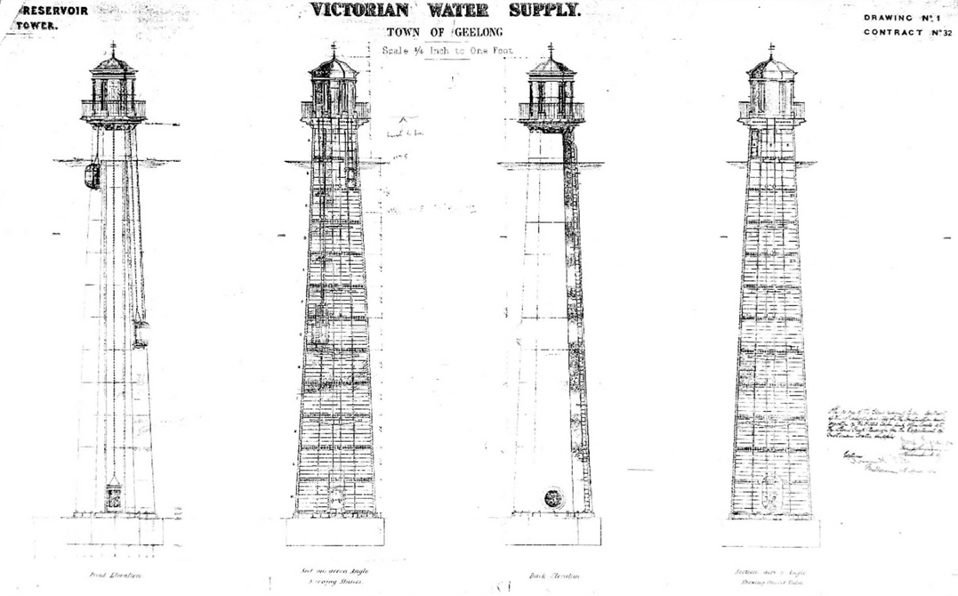
Figure 4.116: Victorian Water Supply, Town of Geelong, Elevation & Section Drawings of proposed Reservoir Tower, n.d. [c.1869]. Source: Barwon Water.

and yet in the following month a portion of the dam wall had subsided and the open aqueduct leading from the reservoir had the potential for contamination.810 With Christopherson s dismissal in 1870 due to insolvency and issues surrounding the construction of the Malmsbury water supply (in which he was involved)811 the Victorian Government commissioned Lieutenant-Colonel Richard Hieram Sankey (1829-1908),
an Irish engineer then assistant to the chief engineer in the Mysore territory, southern India, to review the construction of the Stony Creek system.812 He declared:
With reference to the reservoir, no sufficient allowance having originally been made for natural subsidence, the crown of the embankment sank some 4 feet in the highest part. This will therefore now require to be dealt with, The bye-wash, moreover, being in great measure cut through soft schist (almost pipeclay), it would be undesirable
to allow more water than is necessary to pass over till the whole has been remodelled and paved. In view to complete both works, it appears desirable not to allow the water in the reservoir to rise higher than within 15 feet of the bye-wash level, and to maintain this for about two or three years, till all subsidence has ceased. There is, I should say, no present or prospective danger to be
apprehended if this precaution be observed.
As regards the open channel from Stony Creek Reservoir to the Pipe-head Reservoir, near Mount Anakie, I consider that it will be desirable, on the whole, to fall back on the plan originally proposed by
Mr. Christopherson, namely, to carry the water by pipe the whole way, as, although there would be no engineering impossibility in completing the portion of the work as
at present designed, there can be little doubt that the open channel, where carried on moved soil, would be a continual source of anxiety (from the risks inherent to a design of this nature) and of expense.813
At this time, the Stony Creek embankment was one of the highest in the world.814 Originally intended to hold 2839 megalitres, following the subsidence it could only hold 636 megalitres815 (Figure 4.117). In 1873, Edward Dobson (c.1816- 1908), resident engineer for the Geelong Water Supply Works (with training in architecture and engineering and experience as a railway engineer near Nottingham, England), sought to reduce the height of the embankment by 8.5m, the earth to then be placed in front of the dam to strengthen it.816 This therefore permanently reduced the water capacity of the

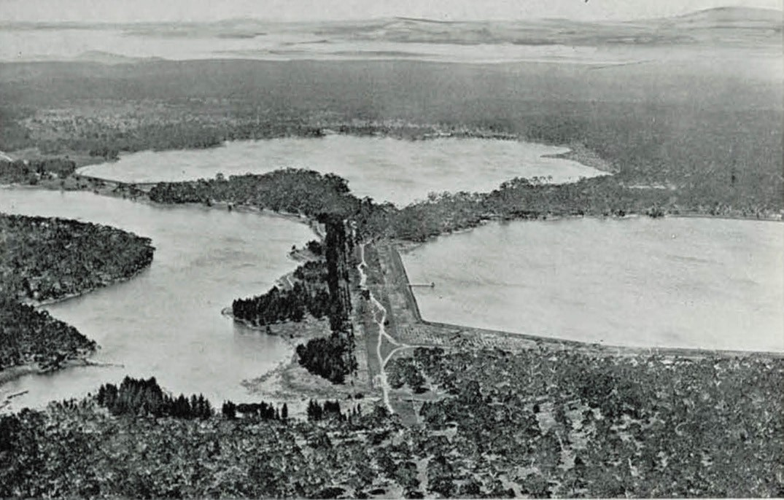

Figure 4.117: Aerial View of Upper Stony Reservoir, 1930. Source: Geelong: its advantages and opportunities, Geelong Publicity Council, Geelong, 1930, p.34.

reservoir. The work was carried out by Alfred Chitts at a cost of £468/5/3.817

LOWER STONY CREEK RESERVOIR
In January 1873, a new concrete dam was proposed to
be constructed to supplement the Stony Creek Reservoir.818 A month later the Geelong Advertiser reported that the additional storage is proposed to be secured by building a
masonry or concrete dam on the creek about four miles below the present reservoir. 819 The site was considered ideal, with four square miles of steeply sloping country ‘available as additional gathering ground’, yielding 878 megalitres a year.820 Given the lowness of the proposed reservoir location, a tunnel over a mile in length through the ridge was also required.821
The engineer for the proposed works was George Tindal Gordon (1829-1907), a Scot who had been apprenticed to a consulting engineer in England and who had gained
experience in Holland (with four years as chief engineer of the Amsterdam Water Company) and in India (as chief district engineer of the Madras Irrigation and Canal Company).822 In May 1872, Gordon was appointed chief engineer of the Board of Lands and Works.823 The Lower Stony Creek Reservoir
constructed of Portland cement824 - was one of Gordon s major engineering achievements.825 The proposal was described in the Geelong Advertiser in January 1873:
A walk down a cart track [from the Upper Stony Creek Reservoir] made down a side gully brought us to where the new dam or weir is to be built. It would be almost impossible to find a place where a dam could be so cheaply constructed to hold so much water, nature having almost formed the dam. The ranges at this place converge together, forming a narrow gorge not ten yards
wide at the bottom, the ranges rising almost perpendicular from the bottom of this gorge. Immediately in front of
the proposed dam or weir the creek opens out into an immense basin, fully a quarter of a mile wide and nearly level, the south side of the range forming a huge natural buttress to retain the water, which will be retained by a weir 60 feet high, formed of concrete, as the stone on the sides of the ranges cannot be got in blocks of sufficient size to make good masonry. The cost of this work will be very moderate, as three large reefs rise upon each side of the ranges through the site of the weir, and no expensive works will be required to carry off the surplus water, which

will be allowed to flow over the top of the weir.826 Work began following the acceptance of the tender of
George Patrick for clearing the site for the proposal.827 The foundations of the new dam had been constructed by early May 1873 and the building of the concrete wall – with pointed- arched valve houses projecting from the base (Figure 4.118)
- commenced soon after. It was reported that as a proof that Mr Dobson intends to have the work done well, it may be mentioned that he has already condemned 600 barrels of cement, and positively refuses to allow any to be used that will not set quickly.’828 Upwards of 50 men were employed in the construction of the reservoir, but delays occurred due to difficulties carting the large quantities of cement required through the poor roads in winter.829 Half the work had been
completed by the end of 1873.830 Completed March 1875 at a cost of £17,306/12/-,831 the Lower Stony Creek Reservoir was a major engineering feat. It was the first mass concrete gravity dam in Australia and in the southern hemisphere; the third in the world (at the time); an early use of Portland cement for a substantial construction; and an early utilisation of stability engineering analysis.832
Unlike the open aqueduct for the Upper Stony Creek Reservoir, the new Lower Stony Creek weir was serviced by an elevated cast iron flume833 (Figure 4.119).

SERVICE RESERVOIRS
Christopherson s original scheme for the Stony Creek water supply also involved the construction of a service reservoir (now known as service reservoir no. 1) and filter beds (settling pond) at Lovely Banks. A contract for the work was awarded to George Simmie and Co. in April of that year at a cost of £8,868.834 A lime house/ inlet tower was also constructed and a timber caretaker s cottage erected.835 A
second reservoir was built in 1910-11 (Figure 4.120) and a third in 1926.836 Ornamental trees had been planted in 1893 and again in 1896 while the reservoirs were stocked with fish.837 While some alterations have been made to the service basins at Lovely Banks in recent years, the site still functions for its original purpose.
As the population grew and demand for water increased, additional service basins were constructed in the ensuing years. At Highton flanking Scenic Road, the first of the Montpellier service basins (no.1) was constructed in 1900.838 The basin was named after John Highett’s home Montpellier as the ruins of this home are located nearby. (see earlier subsection & Theme 6), The pipelines that formed part of the Montpellier Service Basin site were transported using an innovative aerial tramway across the Barwon River
from Camden Road to Montpellier by the carrying firm of
J. Bannister and Son.839 The tramway was in operation on 6 August 1900, when pipes were successfully hauled

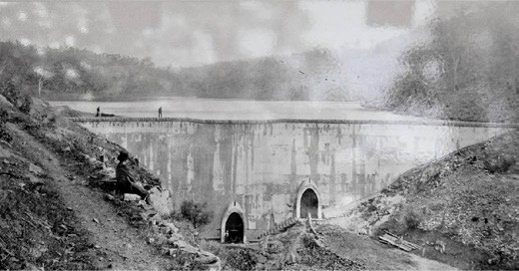
Figure 4.118: Lower Stony Creek Concrete Wall, 1906.
Source: News of the Week, 6 September 1906, GRS 2121, Geelong Heritage Centre collection.
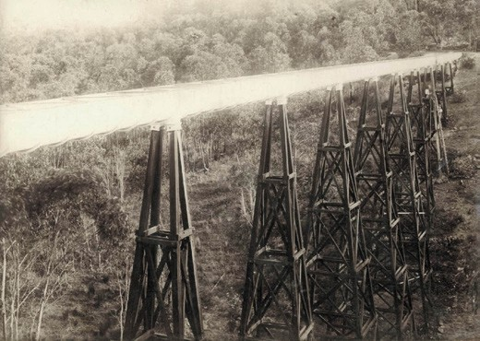
Figure 4.119: Elevated cast iron flume, Lower Stony Reservoir, c.1873. Source: State Rivers & Water Supply Commission photographer, accession rwo/u1, State Library of Victoria.
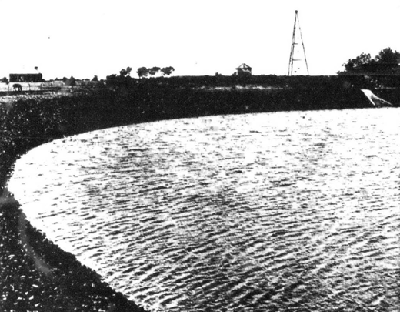
Figure 4.120: Portion of reserve no.2, Lovely Banks, 1913. Source: News of the Week, 4 December 1913, GRS 2121, Geelong Heritage Centre collection.

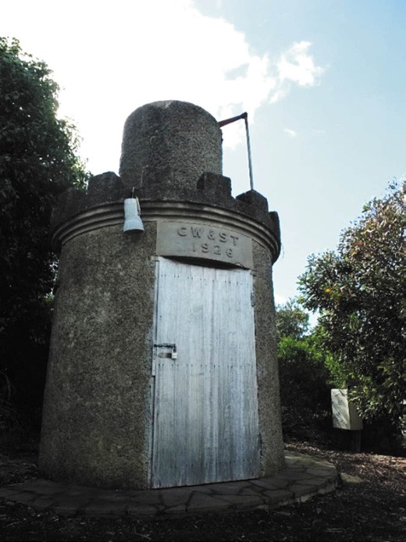
Figure 4.121: Former valve tower to the Bell Post Hill basin, Heritage Drive, Hamlyn Heights, 2019. Source: David Rowe.

over the 900 feet of cable span above the river by a donkey engine.840 The inlet pipe took water into the new reservoir for the first time on 14 November, 1900. Service basin no.2 was constructed in 1919, whilst basins no.3 and no.4 were built in 1926 and
1970 respectively.841
In 1926 a service basin was also laid out at Bell Post Hill on a 12-acre site between ‘Glenpanyall’ and ‘Morongo’, south of
the Ballarat Road.842 It was designed to hold up 41 megalitres of water. Alterations were carried out in 1963 and by the
mid-1980s the reservoir was no longer in service.843 It was partly filled with soil although the valve house remained in place until the site was sold as part of a residential estate in 2002. The area of the previous water reservoir was created into a public reserve and named Sharland Park in 2003844 after James Sutherland Sharland (c.1867-1948), inaugural secretary and engineer of the Geelong Municipal Waterworks Trust in 1908,845 and first engineer of the Geelong Waterworks and Sewerage Trust from 1910 (and later engineer in chief 1917-1935).846 Sharland had been appointed secretary, engineer and rate collector to the Kilmore Shire Council in 1894847 and subsequently held similar positions with the Yea Shire (from 1897), Springfield Shire (from 1900), Alexandra

Shire (from 1901) and Corio Shire (from 1902) before being appointed Town Survey and Treasurer to the Geelong Town Council in 1905.848 Sharland continued in his engineering position with the Geelong Waterworks and Sewerage Trust until 1935.849 A trademark of his association with the Trust was the battlemented designs of the outlet towers to the water reservoirs,850 the former tower to the Bell Post Hill basin now a feature in a road reserve in Heritage Drive (immediately south of the Road Ballarat Road), Midland Highway (Figure 4.121).

GEELONG WATER SUPPLY NETWORK OUTSIDE GREATER GEELONG
In addition to Upper Stony Reservoir, much of the water supply for the City of Greater Geelong was established beyond today’s municipal boundaries. In 1900, they included a diversion weir at Bolwarra north of Ballan with water supplied by an open channel (known as the Ballan channel).851 In 1908, work began on a reservoir at
Korweinguboora. Completed by June 1910, it had a capacity of 1741 megalitres.852 In 1927, work commenced on the building of a reservoir at Wurdee Buloc near Winchelsea
to service towns on the Bellarine Peninsula, Barwon Heads, Torquay and Anglesea.853 In 1953, work began on a reservoir across the Eastern Moorabool River south of Korweinguboora. With a capacity of 6208 megalitres, it was named the Bostock Reservoir after Thomas Edward Bostock, Mayor of Geelong (1905-08) and connected to the Moorabool system by an aqueduct 5.5 miles in length.854 To the south-west between Forrest and Gellibrand in the Otway Ranges, the West Barwon Reservoir was opened
in November 1965. It could hold 18,170 megalitres.855

RETICULATION PIPES
The gravity feed system established by Christopherson also involved the laying down of reticulation pipes throughout the central Geelong city area and inner suburbs. In April 1869, Robert Walton Carrick had been issued a contract for the transportation of pipes between Anakie and Geelong.856 A few months later in December 1869 and again in January 1871, Humble and Co. were awarded the contract for supplying cast iron pipes and other castings for the Geelong Water Supply.857 Other water pipes were supplied by Oppenheimer and Co. soon after and by James McEwan and Co. in February 1872.858
The digging up of Geelong s streets was to be delayed. By September 1869, Garrick had almost completed his contract in carting and distributing the pipes to the desired locations. Yet, the Geelong Advertiser bemoaned the lack of progress in having them laid:
The water pipes are now pretty well distributed throughout the town, and much dissatisfaction is expressed that

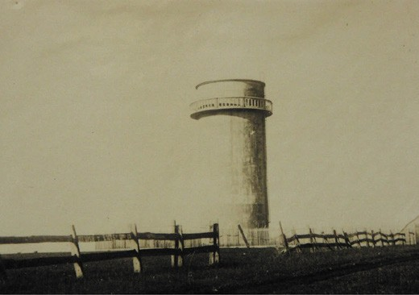

Figure 4.122: Water Tower, East Geelong, c.1930. Source: T.T. Holmes collection, Authentic Heritage Services.

steps have not been taken to lay them the places they will henceforward occupy in the reticulation of the town.
But as we understand it, the work is too particular a one to be entrusted to contractors, who in bustling along with the work might crack a pipe or two, and the accident would not perhaps be discovered until the water was let on, and then it would be a serious nuisance to have to take up the pipes and stop the supply, and this at a great cost. … The reason why we particularly urge that the pipes be hidden from view is to prevent accidents; several slight ones have already occurred 859
Further delays came from the workmen employed in digging the trenches for the laying of the pipes.860 By late September 1869, satisfactory progress had been made in laying the pipes in Moorabool Street.861 Most of the pipes within the Geelong city had been laid by November 1870862 but delays in the opening of the mains came from the inadequacies in the embankment at the Upper Stony Creek Reservoir. Water was first supplied to the Geelong Infirmary and Benevolent Asylum by November 1873 and the first domestic supplies commenced from 13 January 1874.863

WATER TOWER AT EAST GEELONG
In 1927 to improve the water supply for residents at
East Geelong, St. Albans (now Whittington and St. Albans Park) and other neighbouring districts, a round, reinforced concrete water tower (Figure 4.122) was built ‘near Hinchcliffe’s corner’, on the north side of Ormond Road, west of Boundary Road.864 Officially known as a water stand pipe, it was erected to a height of 18.75m and with an external diameter of 7.62m. It held 168,600 gallons of water. The structure was constructed at a cost of £2000 by B. Murphy
of Geelong.865 Under construction in June 1927, the Geelong Advertiser reported on the proposed water facility:

From almost any elevated position in Geelong, from Belmont, and other localities on the outskirts of this city, may be seen rising up in the east a structure in shape and form not unlike a tower. This imposing pile has been the subject of comment amongst numbers of people attending recent football matches at Corio Oval, where a full view of the structure is obtained.
… The design shows straight, vertical lines, the variations in thickness in the walls being made inside the stand pipe. At a position eleven feet from the top of the structure there is a balcony with a pre-cast balustrade. Its purpose is purely utilitarian, as it is to
be used for inspection purposes, but it also invests the structure with a certain amount of architectural
dignity. In face the whole appearance of the stand pipe adds a peculiar charm to the locality in which it was been erected.866
The tower was removed in the late 20th century.

GEELONG OCEAN OUTFALL SEWERAGE SCHEME SANITARY CONFERENCE
With a large increase in the population of Geelong in 1854
came the considerable deterioration in the local water supply and sanitation. However, it was not until after the passing of the Water Act in 1890 when agitation increased for a proper sewage disposal system.867 In December 1906, a Sanitary Conference was held at Geelong to explore the options for the establishment of a sewerage scheme for the town.868 At the Conference were members of the Geelong Town Council and representatives of the Borough of Newtown and Chilwell, Borough of Geelong West and the Shires of South Barwon and Corio.869
A critical outcome of the Conference was the securing of the services of the Sydney Civil Engineer, J. Hayden Cardew.870 He visited Geelong and prepared a report that was published in 1907 on the possibilities of establishing
a sewerage system in Geelong. Cardew reported on three schemes the basis of which was sewers draining to septic tanks on the foreshores of Corio Bay near Limeburners Point and on the Barwon River at the foot
of Swanston Street. 871

ESTABLISHMENT OF THE GEELONG MUNICIPAL WATERWORKS TRUST & GEELONG WATERWORKS & SEWERAGE TRUST

GEELONG MUNICIPAL WATERWORKS TRUST & THE FIRST COMMISSIONERS
In that same year in 1907 following the proclamation of the Geelong Municipal Waterworks Act, five Commissioners were appointed in 1908.872 Two were to represent the Geelong Town Council, with one each from the Borough of Newtown and Chilwell and Borough of Geelong West, and one Commissioner to represent the Shires of Corio, Bellarine and South Barwon.873 Those appointed to represent the Geelong Town Council were I.G. Hodges and J.P. McCabe Doyle.
Other Commissioners appointed were H. Blomfield Brown (Newtown and Chilwell), H.F. Christopher (Geelong West) and
H.M. Sutherland (South Barwon, Corio and Bellarine).874
Isaac George Hodges (1860-1930) was appointed the inaugural Chairman. He was the son of the Isaac and Isabel (nee Smart) Hodges.875 Isaac junior following his father in the brewing business.876 Hodges contributed much to public life, holding the seat in the Geelong City Council for 17 years and chairmanship of the Geelong Municipal Waterworks Trust – and later Geelong Waterworks and Sewerage Trust for 21 years.877
John Patrick McCabe Doyle (c.1869-1941), the son of Patrick Aloysius Doyle and Ellen Mary McCabe.878 He attended St.
Francis Xavier’s College and studied law at the University of Melbourne.879 After admittance to the Bar, he worked for Messrs. King and Duffy before he relocated to Geelong in 1898 to established a legal practice under the name of Doyle and Picket (which later became Doyle and Kerr).880 He married Miss. M.J. Ryan in 1903. McCabe Doyle was
a staunch Catholic, being ‘a vigorous and effective lay spokesman. 881 He was also prominent in community affairs including holding office with the Geelong Town Council, Geelong Hospital, orphanage and community club committees,882 and he was associated with the Gordon Institute of Technology where he suggested the Institute s motto: Meliores Priores The Better Man, The Pride of Place. 883
Henry Blomfield Brown (1851-1923) was born at Boreham, Country Kent, England, the son of the Rev. Henry Brown, Rector of Woolwich and Canon of Rochester Cathedral.884 His mother was Maria Blomfield. Brown came to Australia around 1880 and subsequently settled in Geelong and worked was
an auctioneer and estate agent for W.F. Ducker at his auction rooms in Little Malop Street.885 Brown was later appointed a partner and later acquired the business which he renamed H. Blomfield Brown and Co.886 He was active in public life as a

Councillor for the Borough of Newtown and Chilwell (serving as Mayor for three terms) and from 1885 he was a Councillor with the Geelong Town Council.887 Other community roles included secretary of the Geelong Hospital Committee, secretary of the Geelong Club, president of the Newtown and Chilwell Fire Brigade and president of the Geelong Auctioneers and Estate Agents Association.888 He married
Minna Spencer Wills in 1883, the daughter of Horatio Spencer Wills, who had been regarded as ‘one of Victoria’s best known pioneers. 889
Henry Frederick Christopher (c.1870-1941) was an engineer.890 He married Miss Marianne Elizabeth Warner in 1892.891 Christopher also contributed substantially to community life, serving as a Councillor with the Borough of Geelong West between 1903 and 1915 (including three terms as President); correspondent for the Geelong West Board of Advice from 1905, member of the Geelong West Free Library Committee from 1906, President to the Geelong West Fire Brigade in 1909, member of the Geelong West Progress Association in 1909, and Secretary of the Geelong West Park Committee from 1912.892 In 1916 he was appointed a Justice of the Peace and in 1922 he was patron of the Geelong West Bowling Club.893
Hugh Mann Sutherland (1848-1916) was an auctioneer and at the time of appointment to the Trust a breeder of pure Border- Leicester sheep at Elcho homestead (see earlier subsection for further details).

GEELONG WATERWORKS & SEWERAGE TRUST & ITS SUCCESSORS
Following the proclamation of the Geelong Waterworks and Sewerage Act in 1909, the name and constitution of the Geelong Municipal Waterworks Trust was altered to the Geelong Waterworks and Sewerage Trust in 1910.894
A basis for the change of name was the focus on providing an adequate sewerage scheme for Geelong (following the sanitary conference and appointment of Cardew in 1907) in addition to ensuring a reliable water supply.
The importance of the Geelong Waterworks and Sewerage Trust as a public body was to be reflected in the construction of a contextually elaborate Federation Free styled, two storey masonry office building at the west end of Ryrie Street neighbouring the Presbyterian Church. Designed in 1911 by
the local architects, Laird and Buchan,895 the building (Figures 4.123-124) was constructed by F. Apted.896 On its opening in July 1913, the Geelong Advertiser gave a description of the interior spaces:
The Revenue Department is in the left passage at the main entrance, and most of the water administration is on the ground floor. Upstairs the sewerage draughtsmen will be

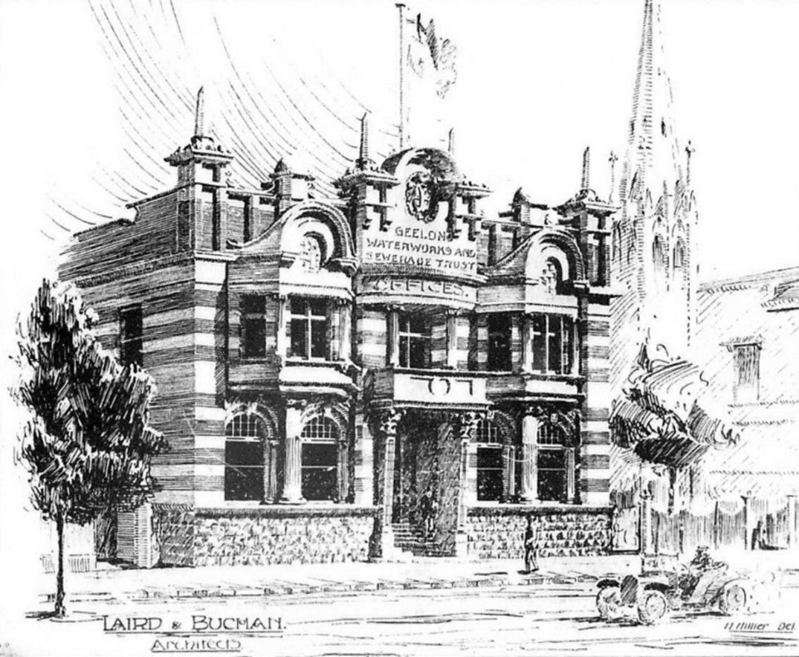

Figure 4.123: Laird & Buchan Architects, Sketch of the proposed Geelong Waterworks & Sewerage Trust Offices, 1911. Source: News of the Week, 9 March 1911, GRS 2121, Geelong Heritage Centre collection.

located, and two special rooms have been built on the roof for the copying of drawings and designs. The building is heated by a steam pipe system attached to a small boiler in the basement. Generally one stoking first thing in the morning with coal will keep the radiation warm for the rest of the day. A private telephonette system keeps the whole of the apartments in touch.897
The office building was replaced with a new Brutalist design in the 1970s, and in recent years this replacement building has been transformed into a nationally award-winning design (see Theme 6).
In 1983, the Victorian Government passed the Water and Sewerage Authorities (Restructuring) Act. Consequently, the Geelong Waterworks and Sewerage Trust was replaced with
the Geelong and District Water Board in 1984.898 Raymond Wallace (Wal) Whiteside was appointed its inaugural chairman for a four year term and he served in this capacity until 1992.899 On 23 January 1994, the Geelong and District Water Board was reconstituted and its name changed to the Barwon Region Water Authority (Barwon Water).900 This Authority continues to manage Greater Geelong s water supply to the present day.

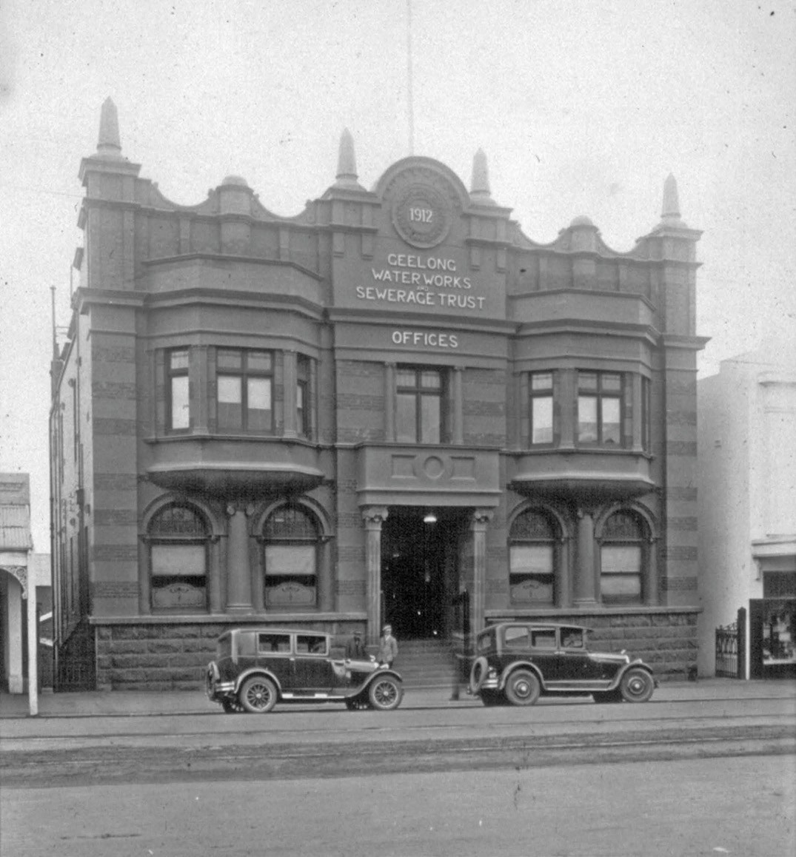
Figure 4.124: Geelong Waterworks & Sewerage Trust Offices, Ryrie Street, c.1930s. Source: Wynd collection, Authentic Heritage Services.

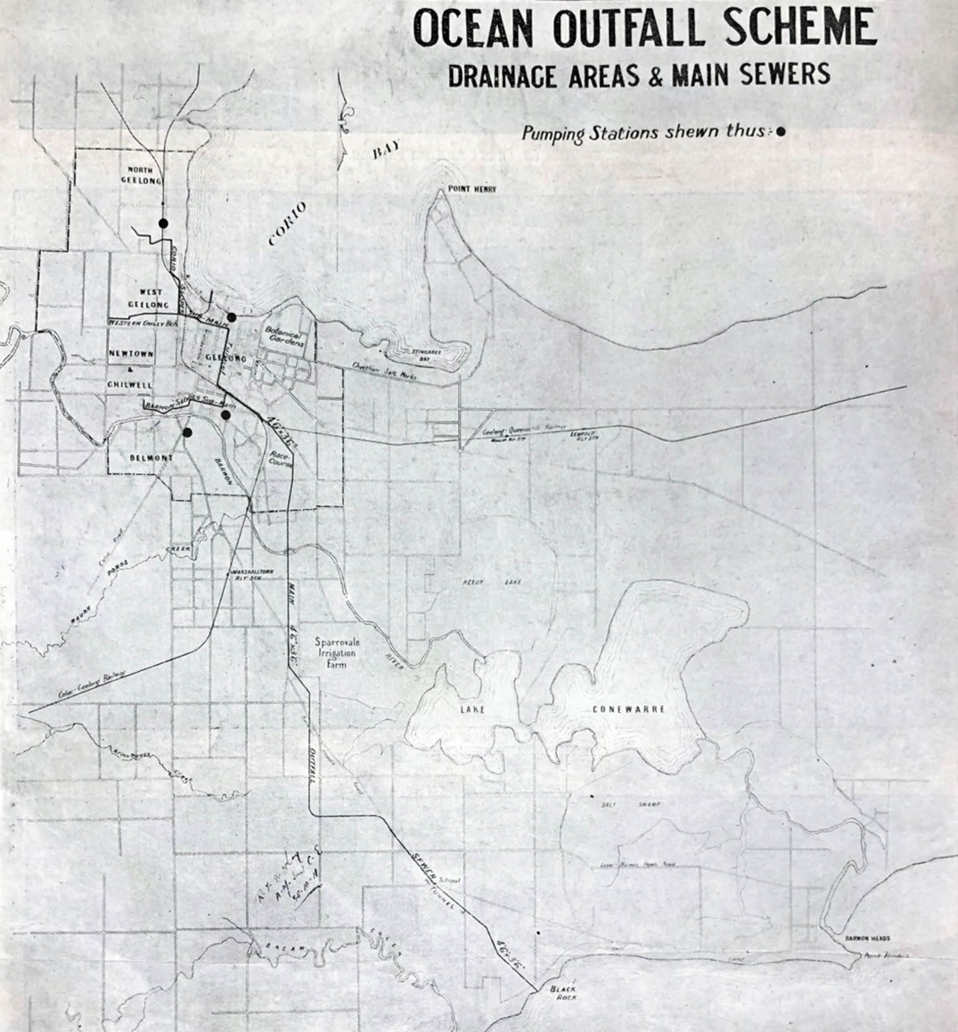
Figure 4.125: R.T. McKay, Plan of proposed Ocean Outfall Scheme Drainage Areas & Main Sewers, 1911. Source: News of the Week, 2 November 1911, p.14, GRS 2121/3, Geelong Heritage Centre collection.

OCEAN OUTFALL SCHEME
Upon its formation, the Geelong Waterworks and Sewerage Trust concentrated on obtaining information about sewerage schemes in other parts of Australia and in New Zealand, following on from the sanitary conference and appointment of Cardew in 1907.901
On 1 June 1910, the Trust appointed Charles Campbell Breen, an experienced surveyor from the Melbourne and Metropolitan Board of Works (M.M.B.W.).902 His role was to carry out surveys and ground tests to ascertain where the proposed sewers should be laid.903 Calder E. Oliver, engineer of M.M.B.W. also reported on the feasibility of a sewerage farm for Geelong at Point Henry at this time.904 This latter proposal was however not recommended.
In May 1911, the Trust appointed R.T. McKay, civil engineer of the Public Works Department in Sydney, to design and carry out a sewerage scheme. His first task was to review the other reports and recommendations by the previously appointed engineers and surveyors.905 In his report to the Trust in 1911, McKay ‘dealt exhaustively with various methods of sewage disposal’ and submitted schemes for Septic tanks, Sewerage Farm and Ocean Outfall.906
In the Chairman s Fifth Report for year ended 30 June 1912, the Trust reported on McKay’s findings and it was the ocean outfall scheme that he found to be the most practical and economical (Figure 4.125). The Trust had accepted McKay’s recommendation for an ocean outfall scheme in October 1911.907
On 23 February 1912, tenders were called for the manufacture, supply and delivery of oviform reinforced concrete pipe sewers and for the construction of the main outfall sewer
from Marshall to the ocean at Blackrock.908 The successful tenderer for both contracts was the newly formed partnership of Messrs. Stone and Siddeley, specialist concrete engineers.909 Stone had designed the Dennys Lascelles Austin store in Brougham Street, Geelong, in 1909, which was built on the Considère system – a French system of concrete construction.910
Edward Giles Stone (1873-1947) was born in Strathfield, Sydney (the son of J.J. Stone, a civil engineer),911 and he was educated at Sydney University.912 Stone gained experience in the engineering of sewerage systems after his employment with the N.S.W. Public Works Department.913 There, he was inspired by the recently-completed aqueduct at Annandale, the first major aqueduct of Monier concrete construction.914 He transferred to the Sydney Harbour Trust in 1900 as Chief Designing Officer and resigned in c.1907 to practice as a consulting engineer and structural architect, specializing
in reinforced concrete.915 Before the end of 1909, Stone designed the highly innovative Dennys Lascelles Austin

store in Brougham Street, Geelong. Until its controversial demolition in the late 1980s, this building represented just one of two known structures in Victoria built using the exotic reinforced concrete construction system: the French Consid re system (the other being the Barwon ovoid sewer aqueduct – see later subsection). On his death, the Dennys Lascelles Austin store was regarded as having the greatest area of floorspace without supports of any building in Australia. 916
Ernest Joshua Siddeley (1872-1965) was born at Kew,
Victoria, the son of William and Emma Catherine
(nee Forward) Siddeley.917 Educated at the Melbourne Grammar School, he later trained in engineering at the Working Men’s College in Melbourne.918 Siddeley first worked as an engineer for Austral Otis in South Melbourne and subsequently at the Smelting Company of Australia before taking up a position as mining engineer in South Africa in 1902.919 Following his return to Australia in c.1905, he was appointed Chief Engineer of the Chillagoe Mine and Railway in Queensland and later moved to Sydney.920 With the calling of tenders for the Geelong Waterworks and Sewerage Trust s Ocean Outfall Scheme in 1912, he entered into partnership with E.G. Stone.921

CONSTRUCTION OF THE OCEAN OUTFALL SCHEME
In June 1912, Stone and Siddeley commenced the establishment of a pipe making factory ‘at the Marshalltown Railway Station, where a lease of Railway property alongside the siding’ was granted by the Railway Commissioners. The Geelong Advertiser reported on 6 June 1912 that:
Mr. Stone, one of the contractors for the ocean outfall sewer, is expected in Geelong this week to make preparations for the erection of the pipe making plant at Marshalltown. Some of the material is ready on the site adjoining the Marshalltown railway station.922
By August 1912, the factory was virtually completed. A tram line had also been laid along the former racecourse railway reserve (see Theme 3) for the purpose of transporting the pipes from the factory to the excavation sites and for handling the materials for the manufacturing process and excavation (including the removal of surplus soil).923 On 24 August 1912, the Geelong Advertiser favourably reported on the factory complex:
Messrs. Stone and Siddeley’s best enterprise in the contract is the construction of the pipe factory at Marshalltown, adjoining the railway station, at a cost
of £8000. It is an iron building 180 ft. long by 50 ft. wide, and has a railway platform siding immediately
at its doors.924

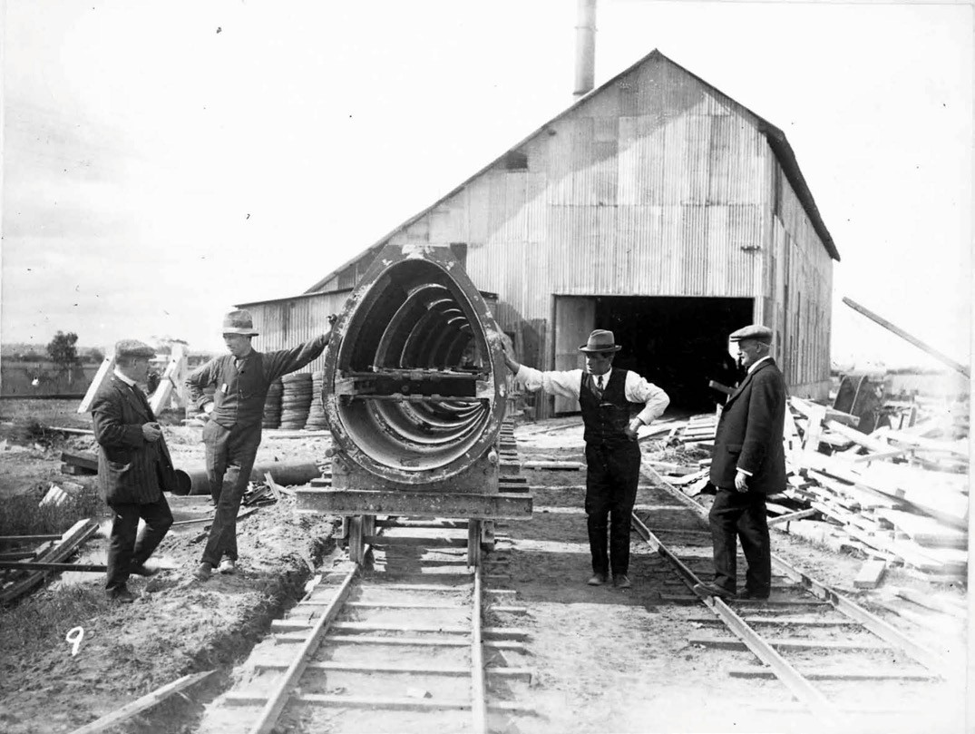
Figure 4.126: Pipe factory, Marshall, n.d. [c.1012]. Source: Barwon Water.

The large, two storey, gabled, unassuming pipe factory building was clad in lapped galvanised corrugated steel, with a timber and steel structure (Figure 4.126). At both ends were large, hinged timber doors that allowed for the factory
tramline. There was also a round chimney stack for the boiler at one end.
Adjacent to the factory building were rudimentary open skillion sheds clad in galvanised corrugated steel, testing equipment and structures, and the curing yard for the pipes on the former racecourse railway reserve
(Figure 4.127).
Nearby the pipe factory and along the route of the sewer to Blackrock, poppet heads, ‘reminiscent of the mining days, were erected as miners from the recently closed deep lead mines in central Victoria and elsewhere, sank shafts and commenced tunneling operations. 925 A further reference to the earlier central Victorian goldfields were the tents which the Geelong Advertiser described as canvas towns. 926
The contract for the manufacture, supply and delivery of approximately 40,000 feet of 4 ft. 3 in. Oviform Reinforced Concrete pipes represented a departure from standard practice. The Chief Engineer of the Trust had specified a minimum length of 8 feet that was twice the length of any pipes constructed in Australia.927 The Chairman’s Fifth Annual Report described this unique specification
as follows:
The use of the longer length of pipe makes for greater efficiency with the consequent lessening of the number of joints to be made on the sewer. This innovation on the part of the Chief Engineer is one which will have far- reaching effects, and is one to which all the pipe makers
must subscribe in order to be able to compete for the large trade in Reinforced Concrete Pipes.928
The purpose of the oviform pipe was to reduce fouling. As the Geelong Advertiser described on 24 August 1912:

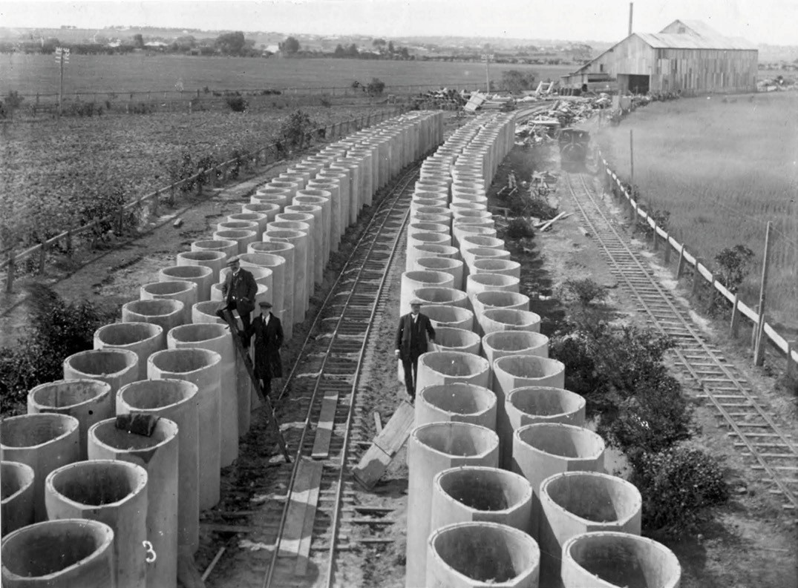

Figure 4.127: Curing yard for ovoid concrete pipes, Marshall, c.1912. Source: Barwon Water.

The selection of oviform pipes is the result of modern experience that this design means less fouling. The pipes will be laid with the smaller end down; it will be better understood by the illustration of an egg being stood on
its point. When the flow of sewerage is at minimum there is less surface of pipe to be fouled than in a spheroid, where the smallest section would be more flat than the oviform.929
Of further innovation was the method of pipe manufacture by
E.G. Stone. Again, this was a departure from the accepted methods of the time and the factory and its equipment were claimed to have been unrivalled in Australia, dispensing with manual labour as far as possible . The Geelong Advertiser gave a detailed description of the innovative manufacturing process
as follows:
Sand, metal and cement can be landed [by rail] at the spot at a great reduction on road cartage, and once delivered
go through the process of manufacture into pipes without any further handling by manual labor. In this respect the factory is unique. Elevators convey the materials into large bins, whence it gravitates in required quantities into the concrete mixer. Water is injected automatically into the huge iron concern one of the largest in Australia.
The next stage of travel is into the concrete receiver, where compressed air steps in and forces the mixture into the steel mould in which reinforcement has already been placed. The mould is of Mr. Stone’s own design, in fact, the whole system of manufacture is original, and has been patented by the firm throughout Australia. The mould is
a massive steel structure, with inner and outer skins, the latter detachable so that after the necessary period of compression the pipe can be drawn out without damage. The process takes far less time than any other system and will turn out a better and longer reinforced pipe than any hitherto attempted in Australia. Each mould weighs three tons, and is mounted on wheels, so that they can

traverse any part of the complete factory tramway. This tramway is another great economy of the undertaking. Road cartage would work out at 6/- per ton, and the bill would be immense. With the cost of locomotive and track thrown in the haulage bill under this modern method will not run into more than £8000. The engine is a sturdy midget, with mushroom-like boiler, and at the end of next week a track will have been laid for it to travel almost up to Black Rock. It is only a surface track 2 ft. 6 in. gauge, without ballasting, and the tiny engine does not attempt speed records. Still it can haul pipes to any point along the sewer line, whose contour the rails follow. Power
for the factory is furnished by a simple non-condensing engine with “Jackass” boiler. The plant, apart from the casting appliances, is simple though there is a very neat air compressor, which is an important feature. It might be mentioned that Mr. Stone has made tests with Fyansford concrete and several specimen blocks of concrete made from it have turned out remarkably well. He has, therefore, decided to use the Geelong article right through the works.930
The first pipe manufactured for the outfall sewer was on 5 September 1912. The Trust Commissioners Small and Christopher, together with R.T. McKay and J.S. Sharland, visited the factory for the event.931 Manufacture of the
pipes commenced slowly at first due to a lack of moulds.932 Although the initial expectation was to produce 178 feet of pipe daily, the maximum daily length after additional moulds were made appears to have been 120 feet.933
This was from November 1912 when the employees worked double shifts once a small electric light plant
had been installed.934
Separate tenders were simultaneously called for the laying of the reticulation pipes in the city and suburban areas.935 Initially residents were concerned that existing infrastructure
that conveyed the stormwater were to be used for sewerage936 but their fears were quelled following laying of the pipes.
From 1912, trenches were laid in the streets in readiness for the pipe layers.937 Throughout 1913, Stone and Siddeley were successful in securing contracts for supplying, delivering, laying and joining oviform concrete pipes for the construction of the sewer from the racecourse at Breakwater to Mercer Street, and from the Geelong Railway Station (Mercer Street) to the Abattoirs at North Geelong.938 Shafts also dominated the streetscapes (Figure 4.128). As reported in the Geelong Advertiser:

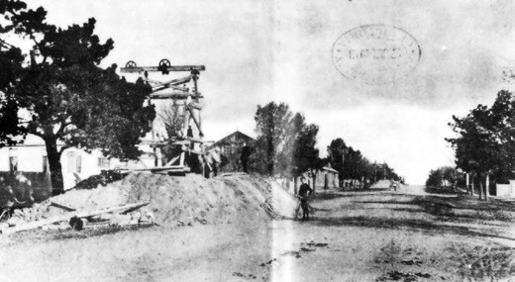
Figure 4.128: Sewerage shaft, Bellerine Street (near Myers Street), 1913. Source: News of the Week, 19 June 1913, GRS 2121, Geelong Heritage Centre collection.

The shafts which are being sunk in connection with the sewerage scheme are the cause of much curiosity to passers by, who besiege the workmen with questions. The men at one shaft have hit upon the expedient of chalking a notice up, and now the enquirer is faced with the following bit of satire: “This is 60ft. deep. For further particulars enquiry within.” As two men were working in one of the sewerage shafts in Bellerine-street a boy
leaned over and threw an apple, which hit one of the men on the head, stunning him for a minutes; he, however, was able to continue his work.939
By August 1913, two new types of moulds were made of concrete for casting concrete pipes at the Marshall factory. Claimed to be ‘the first of their kind in the world’ with the inner surfaces being ‘as smooth as planed wood’, the moulds produced small pipes to be laid on the city side of the Barwon
River.940 The laying out of the pipes brought on the demolition of dwellings in Russell Street and neighbouring streets in Chilwell that were ‘almost past repair, and certainly not worth sewering. 941
Today, pipe remnants remain at the old factory site, now the carpark to the Marshall Railway Station.

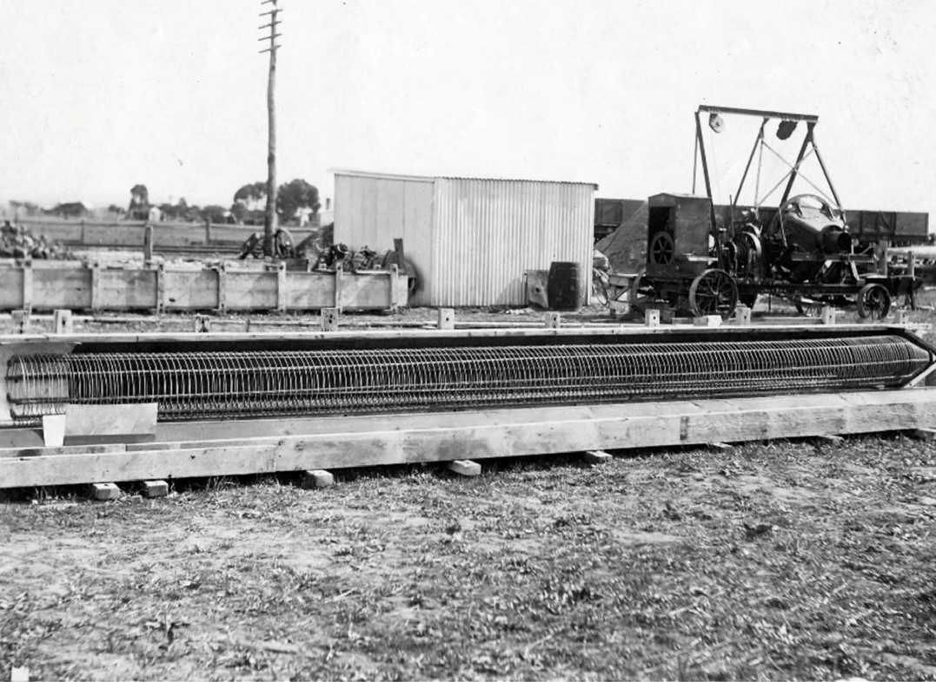

Figure 4.129: Wire reinforcement for a pile for the aqueduct, c.1913. Source: Barwon Water.

MANUFACTURE OF PILES FOR AQUEDUCT
On 17 July 1912, the Geelong Waterworks and Sewerage Trust called tenders for the construction of a sewer aqueduct over the Barwon River at Marshall in either steel or concrete.942 The tender of Stone and Siddeley for
£18,450 was provisionally accepted on 1 October 1912 for a reinforced concrete aqueduct, subject to working drawings and specifications being submitted for approval.943 They were accepted in February 1913.944
Stone’s design for the aqueduct had a familiarity with the coathanger trusses found in the Fowler and Baker design of the iron Forth Bridge across the Firth of Forth
near Queensferry in Scotland.945 While the design in itself was highly unusual, the method of reinforced concrete construction and manufacture was inventive for Australia at that time.
At the factory, eighty piles for the construction of the aqueduct were made in the early months of 1913.946 These piles were octagonal in shape and measured 18 inches across the flats’.947 They were cast in various lengths to suit the varying depths of the rock line along the line of the aqueduct. Like
the manufacture of other structural members of the aqueduct, these piles were based on the Consid re system of reinforced concrete construction (Figure 4.129). Prof Miles Lewis has considered Consid re construction to be the most exotic of all the reinforced concrete systems of the early 20th century.948 Named after the French engineer, Armand Considère, the system of reinforcing was confined to the compression members of the frame, the rest being derived from the Hennebique system, a well-known French reinforced concrete construction method.949 Lewis provided the following description of the Consid re system:

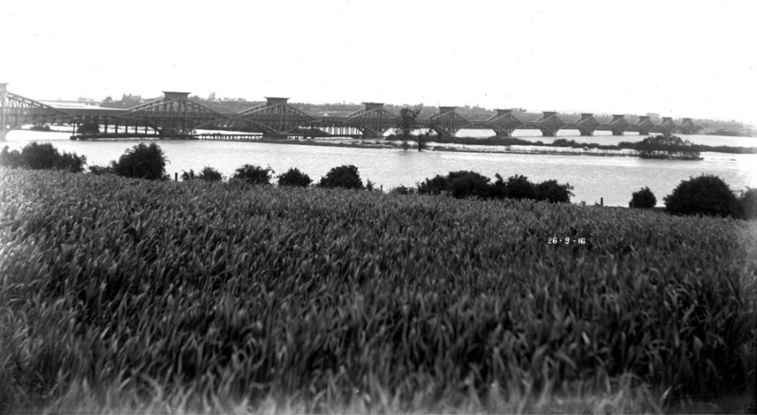
Figure 4.130: Barwon Ovoid Sewer Aqueduct, 29 September 1916. Source: Barwon Water.

Considère’s columns were octagonal or round, and the vertical bars were wound around spirally with a bar much heavier than would be required for simple ligature. The theory was derived from experiments by Consid re in which he established that the compressive strength of the core concrete was increased by this peripheral constraint, and he introduced his helical winding wherever there was compression, such as sloping up the angles of haunched beams.950
The spiral reinforcing and completed piles for the aqueduct (Figure 4.130), based on the Considère system, were in early photographs. The Commonwealth Engineer described the reinforcing system for the piles in 1916:
The reinforcement is of ordinary commercial steel rods. The disposition of the bars throughout the structure is of interest, the full tensile strength being taken up by laps; in no place are they mechanically connected. The rods in the upper boom are arranged in concentric rings, the laps of which break joint along its length. The diagonals are in tension, and the ends of the rods through them are accurately bent around the rods in the upper and lower booms.951
It was also at this time when the Concrete and Constructional Engineering Journal in London declared the aqueduct to
be ‘one of the finest reinforced concrete constructions in Australia. 952
Although no longer in service, the ovoid sewer aqueduct survives as testimony to the extraordinary engineering accomplishments of the engineers, Stone and Siddeley, and as a legacy of the early ocean outfall system adopted by the Geelong Waterworks and Sewerage Trust.

ENDNOTES

- For further information, see L. Lane, ‘The Wathaurung: Geelong’s earliest inhabitants’, text of an address to the Geelong Historical Society, 22 March 1988, public reading room shelves, Geelong Heritage Centre (GHC) & L. Lane, ‘Oven-Mounds – Australian Aborigines: A Mirrnyong …. What’s that?’, manuscript no. 3, 1982, p.6, Special Collections, Deakin University Library.
- These parts took in all or parts of the Parishes of Anakie, Lara, Moranghurk, Murtcaim, Woornyalook, Wurdiyouang and Yowang.
- Statistics of the Colony of Victoria for the Year Ending 31 March 1857, Parliament of Victoria, Melbourne, 1857-58, p.33.
- Ibid.
- Ibid.
- Ibid.
- Ibid.
- Ibid.
- R.V. Billis & A.S. Kenyon, Pastoral Pioneers of Port Phillip, Macmillan and Co., Melbourne, 1932, p.124.
- I. Wynd, So Fine a Country: A History of the Shire of Corio, Shire of Corio, 1981, pp.218-219 & Balliang 90 Years of Settlement: 1908-1998, Back to Balliang Committee, Balliang, 1998, p.1.
- Bacchus Marsh Express, 17 October 1914, p.3.
- Ibid.
13 Ibid., 4 May 1872, p.3.
- Wynd, op.cit., p.217.
- The Argus, 4 November 1872, p.4.
- Bacchus Marsh Express, 17 October 1914, p.3.
- Rowe & Huddle op.cit., vol. 16.
- Bacchus Marsh Express, 20 April 1895, p.3.
- Frederick Armytage married Miss Mary Susan Staughton, daughter of Simon Staughton, in December 1859, and it appears that Wooloomanata was built soon after as Mrs Armytage gave birth to a son there in October 1860. See Geelong Advertiser, 14 December 1859, p.2 & 27 October 1860, p.2.
- A. Willingham, Geelong Region Historic Buildings and Objects Study, vol.1, Geelong Regional Commission, Geelong, 1986, sheet 134.
- A. Henderson, Henderson s Australian Families: A Genealogical and Biographical Record, A. Henderson, Melbourne, 1941, facs. edn., The Genealogical Society of Victoria Inc., 2004, pp.308-309.
- Willingham, op.cit., sheet 109.
- Ibid.
- The Argus, 11 Jan 1886, p.4.
- The Australasian, 4 February 1911, p.7.
- Ibid., 7 February 1911, p.7.
- Information taken from D. Rowe, ‘Pirra Homestead’ Conservation Analysis, vol.1, June 2002, unless otherwise referenced.
- Information taken from HLCD Pty Ltd, ‘Avalon Homestead Complex’, 480 Avalon Road, Lara, Conservation Management Plan, June 2006, unless referenced otherwise.
- ‘The Avalon Merino Stud: The Property of Mr Frank Austin’, The Pastoralists Review, Sydney, N.S.W., 1908, p.11.
- Ibid.
31 Ibid., p.12.
- Geelong Advertiser, 27 April 1869, p.4.
- Wynd, op.cit., pp.239-242, Willingham, op.cit., sheet 131 & Geelong Advertiser, 18 May 1864.
- Willingham, op.cit.
- Geelong Advertiser, 14 December 1899, p.6.
- Ibid.
- Ibid.
38 Ibid., 24 May 1892, p.2.
39 The Leader, 26 August 1916, p.6 & Geelong Advertiser, 25 January 1896, p.4.
40 Ibid., 25 January 1896, p.4, 22 June 1897, p.4, 9 December 1899, p.5.
- P. Jennings, Family Group Record for H.M. Sutherland, November 2012, sourcing Victorian Births, Deaths and Marriages Indexes & Geelong Cemeteries Trust Database. See also The Adelaide Advertiser, 29 July 1913, p.11, The Pastoral Review, 16 August 1916, p.725.
- P. Jennings, Family Group Record for H.M. Sutherland, November 2012, sourcing Victorian Births, Deaths and Marriages Indexes & Geelong Cemeteries Trust Database.
- See A. Sutherland, Victoria and Its Metropolis: Past and Present, McCarron Bird & Co., Melbourne, 1888, vol.1, p.129, Geelong Advertiser 19 August 1867, p.3, which described ‘Marathon’ as having ‘a new bluestone woolshed’, D. Rowe & L. Huddle, ‘Greater Geelong Outer Areas Heritage Study Stage 2’, prepared for the City of Greater Geelong, 2000, J. Pescott, South Barwon 1857-1985, City of South Barwon, Belmont, 1985, p.131 &
G. Threlfall, ‘Taits Point, Lake Connewarre’, Duneed History Group online, 11 January 2019 at https://mdpa.weebly.com/blog/category/connewarre- history]
- D. Rowe & W. Jacobs, ‘Lara Heritage Review Phase 2’, vol.3, prepared for the City of Greater Geelong, August 2013 (revised May 2016).
- The Adelaide Advertiser, 29 July 1913, p.11.
- Leader, 26 September 1914, p.2.
- Victorian Births Deaths & Marriages (VBDMs) online, Department of Justice, Melbourne & Sporting Globe, 20 November 1935, p.6.
- Mahomed Shah Passenger List, 1848, Public Record Office Victoria (PROV) at Ancestry online, https://www.ancestry.com.au/
- ‘James Wilson’ in Kirby Family Tree at Ancestry online, op.cit.
- Melbourne & Sporting Globe, op.cit.
- VBDMs, op.cit.
- Ibid.
- Ibid.
- ‘James Wilson’, op.cit.
- Leader, 11 September 1869, p.8, Sporting Globe, op.cit.
- Geelong Advertiser, 1 October 1870, p.3.
- Observer (Adelaide), 1 December 1917, p.30.
- D. Rowe, ‘Architecture of Geelong 1860-1900’, vol. 1, Bachelor of Architecture thesis, School of Architecture & Building, Deakin University, 1991, p. 145.
- Geelong Advertiser, 23 July 1873, p.3.
- Ibid., 18 February 1886, p.4.
- Cazalys Contractor Reporter, 14 February 1899.
- Geelong Advertiser, 17 October 1925, p.15.
- ‘St. Albans Homestead, 6-30 Homestead Drive, St. Albans Park’, Victorian Heritage Database online, 28 June 1999, accessed June 2018 at http://vhd. heritagecouncil.vic.gov.au/places/1213
- The Argus, 5 November 1930, p.9.
- Ibid.
- Certificate of Title, vol. 839 fol. 713.
- Geelong Advertiser, 10 October 1884, p.3.
- Ibid.
- Ibid., 3 August 1886, p.4.
- Ibid., 10 January 1887, p.3.
- Rowe, op.cit. See also J. Wilson, Probate Administration files, 1917, VPRS 28-P3 Unit 804 PROV.
- Sporting Judge (Melbourne), 1 December 1917, p.1.
- The Argus, 18 November 1935, p.12.
- Ibid.
- Geelong Advertiser, 15 September 1888, p.2.
- The Tasmanian, 24 November 1888, p.5.
- See Bellarine Shire Rate Books, 1887-1889, Bellarine Historical

Society (BHS).
- The Herald, 9 October 1934, p.3.
- Geelong Advertiser & Squatters Advocate, 17 August 1847, p.2.
- Geelong Advertiser, 14 March 1848, p.2.
- Agricultural and Livestock Statistics of the Colony of Victoria, for the Year Ending 31st March 1857, Parliament of Victoria, Melbourne,
1857, p.7.
- Ibid.
- Ibid.
- Ibid.
- Ibid.
- Statistical Register of The Colony of Victoria for the Year 1899, Part VI Production, Parliament of Victoria, Melbourne, 1900, p.16.
- Geelong Advertiser, 30 November 1898, p.4.
- N.S. McAdam, ‘A Tour of the Barrabool Hills and Batesford’, Investigator, vol.6, no.2, June 1971, p.37 & Geelong Advertiser, 14 February 1914, p.6.
- Ibid., 9 November 1860, p.1. 90 Ibid., 19 May 1886, p.2.
- Ibid., 30 November 1898, p.4.
- Rowe & Jacobs, ‘Lara Heritage Review’, op.cit.
- Ibid.
- Ibid.
- The Leader, 26 August 1916, p.6.
- Agricultural and Livestock Statistics of the Colony of Victoria, for the Year Ending 31st March 1857, op.cit. The Barrabool Parish closely followed with 1,298 tons.
- Geelong Advertiser, 19 November 1869.
- Ibid.
- Ibid.
- Ibid., 23 February 1871, mp.1.
- L.E. Fredman, ‘Levien, Jonas Felix (1840-1906)’, Australian Dictionary of Biography, National Centre of Biography, Australian National University, http://adb.anu.edu.au/biography/levien-jonas-felix-4016/text6369, published first in hardcopy 1974, accessed online 22
March 2019.
- Ibid.
- Ibid.
- Bellarine Farms Auction Notice, 11 March 1921, map 9, BHS.
- Bellarine Shire Rate Book, entry 113, 1868, op.cit. & R. Willey, Probate Administration files, 20 October 1923, VPRS 28/P3 Unit 1368 PROV.
- Geelong Advertiser, 13 October 1871, p.3.
- Ibid., 7 December 1888, p.3.
- Australasian, 10 November 1894, p.27.
- Geelong Advertiser, 30 June 1869, p.2.
- J. Gray, ‘Detliv Louis Moller’, Family Tree, Ancestry online, op.cit. &
Electoral Roll, Victoria, 1856 at Ancestry online, op.cit.
- Bellarine Shire Rate Book, 1880, op.cit.
- Geelong Advertiser, 29 December 1896, p.2.
- Australasian, 3 January 1931, p.26.
- Bellarine Shire Rate Book, 1913, op.cit.
- Australasian, 27 December 1930, p.34.
- Weekly Times, 21 November 1931, p.49. 117 Ibid., 28 March 1936, p.28.
- V.H. Arnold, Victorian Year Book 1965, no. 79, Commonwealth Bureau of Census and Statistics, Melbourne, 1965, p.525.
- South Barwon Rate Books, 1910-11, GHC.
- Rowe & Huddle, op.cit.
- Geelong Advertiser, 13 August 1920, p.3.
- Ibid., 4 November 1919, p.3.

- Ibid.
- Rowe & Huddle, op.cit. 125 Ibid.
- Ibid. & Geelong Advertiser, 18 January 1923, p.4.
- Ibid.
- J. Reynolds, ‘Jones, Sir Henry (1862-1926), Australian Dictionary of Biography, op.cit., http://adb.anu.edu.au/biography/jones-sir-henry-6874, published first in hardcopy 1983, accessed online 22 March 2019 & T. Stephens & L. Dale-Hallett, ‘Jam Factory – Factory & Companies Timeline’ in Museums Victoria Collections, https://collections.museumvictoria.com. au/articles/2686,
accessed 22 March 2019.
- South Barwon Rate Books, 1922-23, op.cit.
- Pescott, op.cit., p.137.
- History of 13th Beach Golf Links’, 13th Beach Links online, https://www.13thbeachgolf.com/cms/
- Geelong Advertiser, 10 April 1849, p.1 & 30 June 1862, p.3.
- Bellarine Shire Valuation Books, 1863-64, 1865, op.cit. 134 Age, 30 March 1865, p.5.
- Leader, 3 December 1870, p.6.
- Geelong Advertiser, 15 July 1872, p.2.
- Illustrated Sydney News & New South Wales Agriculturalist & Grazier, 16 October 1875, p.18.
- W. Lincoln, Probate Administration files, 1908, VPRS 28/P0 Unit 1378, item 106/751, PROV.
- Rowe & Jacobs, ‘Lara Heritage Review’, op.cit. 140 Ibid.
- Ibid.
- The Leader, 26 August 1916, p.6.
- Rowe & Jacobs, op.cit. 144 Ibid.
- Ibid.
- Conewarre Parish Record Sheet 2421, Landata online at https://www.landata.vic.gov.au/ & Electoral Roll, 1856, op.cit.
- VBDMs Indexes, op.cit. & Geelong Advertiser, 1 December 1855, p.2, 21 October 1862, p.3 & 10 November 1888, p.2.
- Pescott, op.cit., p.131.
- Rowe & Huddle, op.cit.
- Geelong Advertiser, 17 February 1904, p.4.
- South Barwon Shire Rate Books, 1942-43, op.cit.
- ‘The Brinsmeads Down Under’ online, accessed June 2018 at http://www.brinsmead.net/downunder/du7williamann.html
- Geelong Advertiser, 15 November 1884, p.3.
- ‘The Brinsmeads’, op.cit. 155 Ibid.
- Ibid.
- Weekly Times, 11 June 1904, p.38 & Geelong Advertiser, 16 June 1886, p.2.
- P. Jennings (comp.), Wallington at War 1914-1918, Bellarine Historical Society, Drysdale, 2016.
- Plan of Portion of the Chevy Estate, 21 December 1886, folio 3, map 57, GHC.
- Sale Plan of the Chevy Estate, 4204 Acres Near Geelong, 9 December 1885, folio 3, map 74, GHC.
161 Ibid., 16 June 1906, p.7.
- Ibid.
- Ibid.
- Ibid.
- P.L. Brown, ‘Leopold Memories’, Investigator, vol.14, no.3, September 1979, pp.85-89 & D. O’Halloran, Letters to the Editor, Geelong Advertiser, 13 April 1917, p.4.

- New South Wales Births, Deaths & Marriages Index, 1853, online at https:// www.bdm.nsw.gov.au/Pages/family-history-research/family-history- search.aspx
- Willingham, op.cit., vol.1, sheet 97a.
- Age, 22 November 1937, p.12.
- Geelong Advertiser, 11 April 1874, p.3.
- Bellarine Shire Rate Book, 1884, op.cit.
- VBDMs Indexes, op.cit. & Geelong Advertiser, 13 February 1894, p.1.
- VBDMs Indexes, op.cit.
- Geelong Advertiser, 31 August 1896, p.3.
- Age, op.cit.
- N. Houghton, ‘Light Railways: Geelong Harbor Trust Tramways’ in Geelong & Western District Railways, July 1981, pp.6-10 & J.M. Ferguson, ‘Sparrovale Farm, Marshall’ Investigator, September 1993, pp.71-81.
- Ibid.
- Royal Commission on the Geelong Harbor Trust Final Report with Appendices, Parliament of Victoria, Melbourne, 1912.
- Ferguson, op.cit.
- Royal Commission, op.cit., p.7.
- D. Rowe & W. Jacobs, ‘West Moorabool Shire Heritage Study Stage 2A, 2014-16’, vol.5, prepared for the Moorabool Shire Council, 2016, p.657 & Ferguson, op.cit.
- Ibid. & Geelong Advertiser 6 December 1911, p.3.
- Ferguson, op.cit.
- Ibid.
- J.S. McFadzean, ‘A Farm in the Making: The Geelong Harbor Trust’s Farm, Sparrovale, Geelong’, Journal of Agriculture, Victoria, 10 August 1908, p.493.
- Ibid.
- Ibid.
- Pescott, op.cit., pp.125-126.
- Ferguson, op.cit.
- Ibid. & Houghton, op.cit.
- Ibid.
- Geelong Harbor Trust correspondence, 1934 & ‘Sparrovale’ and ‘The Wyllies’ auction notice, 29 November 1934, VPRS 242/P0 Unit 770 PROV.
- ‘All Saint’s Barwon Heads 1937-1987: Fifty Years of Worship’, anniversary booklet, GHC.
- Ibid.
- Geelong Advertiser, 11 April 1867, p.3.
- Ibid., 1 February 1859, p.3. 196 Ibid., 23 August 1867, p.3. 197 Ibid., 4 July 1867, p.3.
- Ibid., 16 January 1868, p.3.
- Ibid., 4 January 1913, p.3.
- Ibid., 18 November 1872, p.3.
- Ibid., 20 September 1899, p.4 & 11 October 1899, p.3. 202 Ibid., 9 June 1880, p.4.
- The dry stone wall at 22 Hams Lane is associated with Hedley Ham s Lara Hill’ property, obtained under conditional purchase under the Lara Estate Closer Settlement scheme in 1907. The Plan of the Staughton Vale Estate of 1908 (Figure 2.85) has ‘stone wall’ and ‘stone fence’ annotated on it.
- Agricultural and Livestock Statistics of the Colony of Victoria, 1857, op.cit.
- Ibid.
- Statistical Register for the Colony of Victoria, 1899, op.cit.
- Ibid.
- Geelong Advertiser, 3 December 1859, p.2.
- Ibid., 22 December 1917, p.11.
- Ibid., 30 December 1896, p.4.

- Ibid., 15 December 1923, p.7.
- Ibid.
- Goulburn Valley Stock and Property Journal, 27 October 1937, p.5.
- One exception was the vineyard beside the Moorabool River at Herne Hill by the English brothers, John and Peter Manifold in 1949 – see Theme 6.
- J. Elkington, Agricultural and Livestock Statistics of the Colony of Victoria, 1857, op.cit.
216 Ibid., p.49.
- Ibid.
- I. Wynd, Barrabool: Land of the Magpie, Barrabool Shire, Torquay, 1992, pp.59-92 & ‘Phylloxera’, Wikipedia online at https://en.wikipedia.org/wiki/Phylloxera
- A.R. Wallis & E. Hopton, Phylloxera Vastrix: Report of The Inspectors of Vineyards on the Vineyards in the Geelong District, Parliament of Victoria, Melbourne, 1878, p.619.
- J. Belperroud, ‘A Concise and Practical Treatise on the Cultivation of the Vine in the Colony of Victoria’, The Vine with Instructions for its Cultivation, for the Period of Six Years; The Treatment of the Soil, and How to make Wine from Victorian Grapes, being the Two Essays to which the Prize Offered
by the Geelong and Western District Agricultural and Horticultural Society were Awarded, Heath and Cordell, Geelong, 1859, p.8 & The Argus, 28 January 1861, p.5.
- Ibid., p.8.
- E. Cree, ‘Carl August Seidel Family Tree’, Ancestry, op.cit.
- Ibid. & The Argus, 9 August 1849, p.2.
- Seidel, Alwin, Certificate of Naturalisation 1849, State Records Authority of New Sales Wales, N.S.W, Registers of Certificates of Naturalization 1849- 1859, series NRS 1040, Roll; 128A at Ancestry, op.cit.
- T. Darrah & R.N. Wuchatsch, From Hamburg to Hobsons Bay: German Emigration to Port Phillip (Australia Felix 1848-51), T.A. Darragh,
R.N. Wuchatsch in association with the Wendish Heritage Society Australia,1999, p.121.
- A. Lauterbach, ‘History of the Ceres and the Barrabool Hills Vineyards 1842- 1876’, manuscript, p.10, GHC.
- Ibid.
- Geelong Advertiser, 13 February 1851, p.2.
- Darrah & Wuchatsch, op.cit., p.122.
- D. Rowe & W. Jacobs, ‘Ceres Heritage Citations Project, prepared for the City of Greater Geelong, May 2017 (updated September 2018).
- Farmers Journal & Gardeners Chronicle, Melbourne, 5 April 1862, p.2.
- Rowe & Jacobs, ‘Ceres Heritage Citations Project’, op.cit.
- J. Tetaz, From Boudry to the Barrabool Hills: The Swiss Vignerons of Geelong, Australian Scholarly Publishing, Kew, 1995, p.35.
- D.L. Pettavel, ‘A Concise and Practical Treatise on the Cultivation of the Vine in the Colony of Victoria in The Treatment of the Soil, op.cit, pp.61-62.
- Huddle & Rowe, op.cit.
- Ibid.
- Geelong Advertiser, 30 June 1894, p.4.
- Huddle & Rowe, op.cit.
- Geelong Advertiser, 7 January 1903, p.2.
- Ibid., 14 November 1868, p.3.
- Ibid., 17 October 1862, p.3.
- Ibid., 9 January 1863, p.1.
- Ibid., 17 October 1862, p.3.
- I. Wynd, So Fine a Country: A History of the Shire of Corio, Shire of Corio, 1981, p.21.
- W.R. Brownhill & I. Wynd, The History of Geelong and Corio Bay with postscript 1955-1900, The Geelong Advertiser, Geelong, 1990, p.563.
- Geelong Advertiser, 19 February 1864, p.12.
- The Farmers Journal & Gardeners Chronicle, 19 February 1864, p.12.

- ‘Robert Culbertson Hope’, Australian Medical Pioneers Index online at http://www.medicalpioneers.com/cgi-bin/index.cgi?detail=1&id=68 & VBDM Indexes, op.cit.
- M. Clark, ‘Hope, Robert Culbertson (1812-1878)’, Australian Dictionary of Biography, op.cit.,
http://adb.anu.edu.au/biography/hope-robert-culbertson-3792/text5999, published first in hardcopy, 1972, accessed online 22 March 2019.
- Ibid.
- Ibid.
- Wynd, op.cit., pp.213-215, Geelong Advertiser 27 January 1879, p.2. 253 Ibid., 9 June 1883, p.3.
- Ibid., 22 July 1891, p.3, 22 January 1894, p.3. See also S.B. Bonney, Plan showing the Vineyards of the Geelong District also showing the Natural Features of the Locality, lithographed at the Department of Lands & Survey, Melbourne, 22 September 1879, State Library of Victoria (SLV) – see Figure 4.51.
- Geelong Advertiser, 4 June 1904, p.3 & Weekly Times, 21 July 1900, p.40.
256 Leader, 29 June 1901, p.10.
257 W.J. Morrow & I. Wynd, Geelong Hotels and Their Licensees, Geelong Historical Society, 1996.
258 Age, 9 April 1954, p.17.
- Old Swan Inn, 4 Hamilton Highway, Fyansford’, Victorian Heritage Database online, 4 June 1999, accessed May 2018 at http://vhd.heritagecouncil.vic.gov.au/places/511
- Morrow & Wynd, op.cit., p.23.
- Geelong Advertiser & Intelligencer, 24 March 1855, p.1. 262 Ibid., 1 July 1855, p.3.
- Ibid.
- The Age, 19 February 1858, p.5.
- Geelong Advertiser, 3 September 1862, p.3.
- Farmers Journal & Gardeners Chronicle, 13 December 1862, p.12 &
Geelong Advertiser, 15 March 1862, p.3.
- Farmers Journal, op.cit.
- Ibid., 14 February 1863, p.11.
- ‘Frogmore, 425-465 Hamilton Highway, Fyansford’, Victorian Heritage Register H696, Victorian Heritage Database online at https://vhd.heritagecouncil.vic.gov.au/places/512
- Ibid.
- Farmers Journal, op.cit.
- ‘Frogmore’, op.cit.
- Ibid.
- Ibid.
- Geelong Advertiser, 17 September 1850, p.2, 9 January 1855, p.3. See also Geelong Town Council Rate Books, 1850 & 1851, Geelong Heritage Centre collection. Highett was not listed in 1850, but the Rate Book of 1851 listed him as owner of an unfinished 8 roomed stone dwelling and office.

- The Early Days of Highton & Belmont, Geelong Historical Society, 1982,
p.23 & M. Stainsby, Steadfast Through Change: a history of the Wesleyan- Methodist-Uniting Church in Highton 1853 to 2006, St. Luke’s Uniting Church, Highton, 2008, pp.6-10.
- Geelong Advertiser, 3 January 1859, p.1. 278 Ibid., 29 May 1867, p.3.
- Huddle & Rowe, op.cit., vol. 10.
- South Barwon Shire Rate Books, 1857, GHC.
- Ibid.
- ‘German Cottage, 222 Torquay Road, Grovedale’, Victorian Heritage Register, H714, Victorian Heritage Database online, at http://vhd.heritagecouncil.vic.gov.au/places/561
- ‘Golden Oldies: Excursion to Germantown now Grovedale’, Szene, April 1980 online at http://www.agtv.vic.edu.au/files/Grovedale%20formerly%20German%20 Town.pdf
- Ibid.
- Ibid. See also Age, 5 September 1936, p.10.
- Willingham, op.cit., vol. 3, sheet 400.
- Huddle & Rowe, op.cit.
- ‘Joseph and Elizabeth Rainford’, Duneed History Group Blog online, July 2017 at
https://mdpa.weebly.com/blog/joseph-and-elizabeth-rainford
- A.R. Wallis & E. Hopton, Phylloxera Vastrix: Report of The Inspectors of Vineyards on the Vineyards in the Geelong District, Parliament of Victoria, Melbourne, 1878, p.7.
- Geelong Advertiser, 14 March 1873, p.2.
- The Schulz vineyard was not shown on Subdivision of Allotments in the Parish of Duneed on Armstrongs Creek’, 14 March 1865, Put-away
plan,D126/001, Landata, but Schulz was rated in the South Barwon Shire Rate Book in 1869 (entry 105) as the owner of 54 acres in the Connewarre Division, South Grant (Mount Duneed), GHC.
- Wilhelmsburg Passenger List, 1853, PROV at Ancestry online, op.cit & Schulz, Wilhelm, Naturalisation papers, 1862, A712, 1862/V3791, National Archives of Australia.
- Wilhelmsburg Passenger List, op.cit.
- C. Pearson, ‘Pauline Johanna Elisabeth Schulz’, in Pearson Family Tree at Ancestry online, op.cit. It is possible that Johanna Schulz had passed away at the time of the Schulz family voyage to Victoria. L. Phelan, The Geelong Germans: A Record of some 19th century Families, The Geelong Family History Group Inc., 1993, claimed that Louisa Stenka had previously married a Friedrich Hahn and an August Schmidt although she was listed as Louisa Schulz in the Wilhelmsburg Passenger List, op.cit.
- The death notice for Louisa Schulz in the Geelong Advertiser, 30 September 1907, p.1, stated that she was ‘relict of the late William Schulz, of Mt. Duneed and Bendigo,’
- Schulz, Naturalisation papers, op.cit.
- VBDM Indexes, op.cit. See also W. Schulze, Probate Administration files, 1879, VPRS 28/P2 Unit 97 & L. Schulz, Probate Administration files, 1907, VPRS 28/P0 Unit 1349 PROV.
- Wallis & Hopton, op.cit
- W. Schulz, Probate Administration files, op.cit.
- W. Schulz, Will, 1878, VPRS 7591/P2 Unit 51, PROV & Geelong Advertiser, 22 February 1912, p.8.
- Ibid.
- Rowe & Huddle, op.cit.
- ‘James Goodall Francis’, Re-Member Database, Parliament of Victoria online at
https://www.parliament.vic.gov.au/about/people-in-parliament/re-member/ details/24/507 & South Barwon Shire Rate Books 1857-1919, op.cit.
- Bonney, op.cit.
- Certificates of Title, vol. 1615 fol. 863 & vol. 959 fol. 730.
- South Barwon Shire Rate Books, op.cit.

- Certificate of Title vol. 3744 fol. 637.
- Rowe & Huddle, op.cit. and D. Rowe, ‘City of Greater Geelong Belmont Heritage Areas Report Heritage Citations’, vol.3, prepared for the City of Greater Geelong, August 2007.
- Ibid.
- Ibid.
- Ibid.
- Ibid.
- See Land Application 4593, Law Library, Laverton, which documented Jacobs’ acquisition of the original two parts of his property in 1871 and 1873 respectively. The Jacobs family resided in Pevensey Street until 1872 see Geelong Council Rate Books, Bellarine Ward, 1870-73, GHC. The Jacobs family were resident at ‘Mount Pleasant Villa’ by February 1873 as their daughter was born there at this time see Geelong Advertiser, 14 February 1873, p.2.
- Land Application 4593, op.cit. & South Barwon Shire Rate Books, 1857- 1874, op.cit.
- Geelong Advertiser, 28 March 1872, p.4.
- Ibid., 22 April 1872, p.2. The property had previously been called Mount Pleasant Vineyard see Geelong Advertiser, 14 February 1873.
- Wallis & Hopton, op.cit., Appendix A, p.6.
- Geelong Advertiser, 13 June 1901, p.3.
- Ibid., 23 September 1861, p.4, 7 March 1862, p.2, Bellarine Shire Valuation Books 1863-66, op.cit.
- Geelong Advertiser, 24 November 1885, p.4.
- P. Nelson & L. Alves, Lands Guide: A guide to finding records of Crown land at Public Record Office Victoria, Public Records Office Victoria (in association with Gould Genealogy and History), Melbourne,
2009, p.50.
- Ibid.
- J. Myles, Register of Lease, Section 47 of the Land Act 1862, VPRS 13017/ P1, Unit 1 PROV.
- Ibid.
- Geelong Advertiser, 24 May 1886, p.3.
- POI Australia, ‘Early Wattle Bark Stripping & Tannin Industries’, POI Australia online at
https://poi-australia.com.au/the-wattle-bark-stripping-tannin-industies-of- the-1800s/
- E. Harvey, Minutes of Evidence in E.J. Dixon, J. Bosisto, M.L. King, G.R. Fincham, J. Rees, T. Cope & F. Von Mueller, Report of the Wattle Bark Board of Inquiry, Parliament of Victoria, Melbourne, 1878, p.51 & D. Rowe & W. Jacobs, ‘Spray Farm Conservation Analysis’, prepared for the owner, 2011, p.16.
- Harvey, op.cit.
- Ibid.
- Ibid.
- Weekly Times, 13 May 1905, p.38.
- Ibid.
- Dixon, et.al., op.cit., p.2.
- Geelong Advertiser, 8 February 1878, p.2.
- Dixon, et.al., op.cit., p.3.
336 Ibid., p.20.
- J. Brearley, Minutes of Evidence in Dixon et.al., op.cit., p.50.
- Ibid.
- Ibid.
- P. Munster, Little of Interest? A History of St. Leonards, Victoria, 2nd edn., St. Leonards Progress Association, St. Leonard, 2013, pp.20-21 & I. Wynd, 2nd edn., Geelong Historical Society, Newtown, 1986, p.49.
- Geelong Advertiser & Intelligencer, 22July 1853, p.2.
- D. Rowe, ‘Lara Heritage Review Phase 2 Thematic History’, prepared for the City of Greater Geelong, August 2013 (revised May 2016), p.27.
- S. Boland, ‘The History of the Brisbane Ranges National Park; An Historical

exploration of land utilisation in the area which is now incorporated in the Brisbane Ranges National Park’, B.A. Honours thesis, History Faculty, Monash University, 1992, p.32.
- Geelong Advertiser, 3 April 1879, p.2.
- Pescott, op.cit., p.78 & Victoria Government Gazette (VGG), vol. 12, 30 January 1866, p.236.
- Pescott, op.cit.
- Ibid.
- Ibid.
- Wynd, So Fine a Country, op.cit., p.249.
- Ibid.
- Ibid.
- Boland, op.cit., p.36. 353 Ibid., pp.36-37.
354 Ibid., p.37.
355 Ibid., pp.61-62.
- Victoria Government Gazette, vol. 13, 5 February 1863, p.286 & J.H. Brooke, President of the Board of Land & Works, Farmers Commons, Parliament of Victoria, Melbourne, 1860-61.
- Geelong Advertiser, 14 November 1860, p.2, 5 June 1861, p.3, 30 September 1861, p.1, 15 March 1862, 12 August 1862, p.2, 24 October 1862, p.3, 17 December 1878, p.2.
- A comprehensive overview of the history and development of the stone quarries, quarrymen and other facets of stonemasonry (and particularly Barrabool stone) is given in J. Bantow & R. Lewis, Barro-abil: Our Beautiful Barrabool Stone: History and use of Barrabool Sandstone, Jennifer Bantow & Ros Lewis, Geelong, 2017.
- D. Beaurepaire, The Stepping Stone: A History of the Shire of Bannockburn, Golden Plains Shire Council, Bannockburn, 1995, p.202.
- J. Harrington, An archaeological and historical overview of limeburning in Victoria, Heritage Victoria, 2000, p.32 & Geelong Advertiser, 16 August 1843.
- Ibid.
- Bantow & Lewis, op.cit., p.88.
- Geelong Advertiser, 6 March 1841, p.1.
- Bantow & Lewis, op.cit., p.126.
- D. Rowe. ‘St. John’s Lutheran Church, 165 Yarra Street, Geelong’, Conservation Management Plan, prepared for St. John’s Lutheran Church, 2003, p.15.
- Geelong Advertiser, 2 February 1847, p.2, stated that he had resided at the stone quarry for seven years.
- Harrington, op.cit. & Geelong Advertiser, 16 August 1843.
- Ibid., 2 February 1847, p.2.
- C. Locke, ‘Patrick Melville’, Locke Family Tree, Ancestry online, op.cit.
- Ibid.
- Ibid.
- Ibid., Calcutta Passenger Details, typescript.
- Geelong Advertiser, 2 February 1847, p.2, ‘Christ Church’, Victorian Heritage Register, H186, Victorian Heritage Database online, op.cit. & Willingham, op.cit.
- Geelong Advertiser, 3 January 1850. 375 Ibid., 11 May 1857, p.4.
376 Ibid., 4 November 1874, p.3. 377 Ibid., 14 March 1848, p.1. 378 Ibid., 14 April 1849, p.2.
- Ibid., 28 November 1850, p.2.
- See Victoria Government Gazette (VGG), August 1851 in Bantow & Lewis,
op.cit., p.97.
381 Ibid., pp.97-98.

  - Ibid. A stone quarry of 3 roods and 24 perches at allotment 1 section 10 Moorpanyal Parish, was offered for a 12-month lease
by the Colonial government. This was the location of McCann’s earlier quarry.
  - Geelong Advertiser & Intelligencer, 25 January 1854, p.4.
  - Geelong Advertiser, 1 November 1889, p.4 & R. Windmill, ‘History of dwelling at 245 Noble Street and Windmill Family History’, manuscripts kindly provided to the author, 2016.
  - Geelong Advertiser, 26 February 1892, p.4.
  - J. Austin, Probate Administration files, 1896, VPRS 28/P2 Unit 447 PROV.
  - Newtown & Chilwell Council Rate Books, 1896-98, GHC.
  - Geelong Advertiser, 11 March 1911, p.5 & 13 March 1911, p.6.
  - Ibid., 1 March 1911.
  - Windmill, op.cit.
  - Ibid.
  - See VGG, 25 August 1851 in Bantow & Lewis, op.cit.
  - Geelong Council Rate Books, 1850-55, 1855-56, GHC.
  - Part Moorpanyal Parish Plan put away plan, M199/003, 1866, Landata online, op.cit.
  - Geelong Advertiser, 19 November 1901, p.4.
  - Plaque Leach-Wood Gardens.
  - Ibid.
  - Newtown & Chilwell Council Rate Book, 1854, op.cit.
  - J.H. Bottrell, ‘The Early Homes of Marnock Vale’, Geelong Advertiser, 18 June 1927, p.6 & P. Alsop, ‘Marnock Vale’, Investigator, vol.39, no.2, June 2004, p.67. See also Geelong Advertiser, 1873, p.3. However, Alsop, op.cit.,
p.67 stated that William Bottrell bought a section of Scott s land on the north-west corner of the Shannon Avenue – Fyans Street intersection.,’
- Ibid.
- Alsop, op.cit.
- Argus, 15 August 1947, p.6.
- Geelong Advertiser & Intelligencer, 17 December 1855, p.5.
- Alsop, op.cit.
- See Moorpanyal Parish Plan, VPRS 16171/1, PROV.
- Geelong Advertiser 14 August 1860, p.3.
- Ibid.
408 Ibid., 1878-1897.
- Ibid., 17 September 1878, p.3.
- Ibid.
- Alsop, op.cit.
- Geelong Advertiser, 13 September 1879, p.3.
- Other early quarries exist at Point Wilson, Point Lillias and Mount Duneed – see Rowe & Huddle, op.cit.
- Geelong Advertiser, 3 August 1849, p.3.
- Ibid.
416 Ibid., 13 August 1862, p.2.
417 Ibid., 25 August 1862, p.2.
418 Ibid.
419 Ibid.
420 Ibid.
421 Ibid., 13 August 1862, p.2.
- Ibid., 24 April 1863, p.2, 8 May 1863, p.5, Ballarat Star, 31 October 1867, p.2.
- Ballarat Star, 4 November 1867, p.2.
- W.B. Withers referred to inlaid marble slabs in the masonry rising from the stone basin’, but did not described the type of marble. See W.B. Withers, History of Ballarat, facs. edn., Queensberry Hill Press, 1980, p.179.
- Geelong Advertiser & Intelligencer, 22 April 1854, p.4.
- Ibid.
- Ibid.

- ‘Hayes Patent Stone Manufactory’, Victorian Heritage Inventory H7721- 0219, Victorian Heritage Database online, https://vhd.heritagecouncil.vic.gov.au/places/111659
- R. Hoddle, Plan of the Subdivision of Section VVII and Allotment No. 1 Section XXV, Parish of Barrarbool, County of Grant, 21 March 1851, VPRS 8168/5, item SYDNEY, record B1 PROV.
- A.M. Mason, Plan of Quarries on the Barwon River, Parish of Barrarbool, 11 September 1857, Put-away Plan, M197, Landata online, op.cit.
- Geelong Advertiser, 10 April 1886, p.2. Tenders were simultaneously sought for 200 yards of limestone see following subsection on limestone for further details.
432 VGG, 21 October 1903, p.3406.
- Geelong Advertiser, 18 April 1855, p.2.
- See Corio Parish Put-away Plan, C272/002, Landata online, op.cit.
- Geelong Advertiser, 15 December 1887, p.4.
- Corio Parish Put-Away plan, op.ciot.
- Oamaru Mail (New Zealand), vol. XXII, issue 6796, 23 January 1897, p.2,
Papers Past online at https://paperspast.natlib.govt.nz/newspapers
- N.S.W. Births, Deaths & Marriages online, op.cit.
- ‘Nicholas McCann’ Family Tree, Ancestry online, op.cit.
- J. McNeill, A Journey to Destiny 1890-1990: 100 Years of Cement Manufacturing at Fyansford by Australian Cement Limited, Australian Cement Limited, Melbourne, 1990, p.88.
- Geelong Advertiser, 8 March 1845, p.3. 442 Ibid., 24 April 1849, p.1.
- Wynd, Barrabool Land of the Magpie, op.cit., p.22.
- Garrard & Shaw, Plan of the Village of Merrawarp, September 1850, GRS M137/001, GHC.
- Wynd, op.cit.
- Geelong Advertiser, 30 November 1898, p.4.
- Ibid., 7 February 1851, p.3.
- Geelong Advertiser & Intelligencer, 16 July 1855, p.3.
- Ibid.
- Huggett was listed as a farmer and owner of freehold, Barrabool Hills, in the
Electoral Roll for 1856, Ancestry online, op.cit.
- McCann donated the land for the Temperance Hall in McCann Street in 1861. This land formed part of his 59 acre ‘model farm’ property. See Rowe & Jacobs, Ceres Heritage Citation Project, op.cit.
- Geelong Advertiser & Intelligencer, 26 July 1856, p.2.
- Geelong Advertiser, 22 July 1859, p.2.
- Ibid.
455 Ibid., 26 July 1859, p.2.
456 Ibid.
457 Ibid., 27 July 1859, p.3.
- R. Daintree, Report on the Geology of the District from Bacchus Marsh to Bass s Straits, Geological Survey of Victoria, Melbourne, 1863, p.19.
- Geelong Advertiser, 6 April 1912, p.7.
- Ibid., 3 December 1879, p.2.
- P. McKay, ‘McCann, Peter (1828-1908)’, Australian Dictionary of Biography, National Centre of Biography, Australian National University, http://adb.anu.edu.au/biography/mccann-peter-7303/text12669, published first in hardcopy 1986, accessed online 3 February 2017.
- Ibid.
- Ibid.
- Ibid.
- Oamaru Mail, op.cit.
- Geelong Council Rate Books, 1856-58, op.cit.
- Geelong Advertiser, 20 June 1908, p.3.
- Wynd, So Fine a Country, op.cit., p.87 & ‘William Nelson McCann’,

Re-member Database online, op.cit.
- Geelong Advertiser, 13 July 1867, p.2.
- McKay, op.cit.
- Geelong Advertiser, 4 July 1872, p.3.
- Barrabool Shire Rate Books, 1869-78, GHC.
- McNeill, op.cit.
- W.B. McCann, History of descendants of Peter McCann who landed in Australia in 1799 and the establishment of the cement industry and its development in Victoria, W.B. McCann, 1943, p.30.
- Geelong Advertiser, 20 June 1908, p.20.
- Brisbane Courier, 22 January 1910, p.13.
- Jillong Pocket magazine, no.2, December 2013, pp.5-7.
- Ibid.
- Ibid. & Geelong Advertiser, 26 December 1854, p.6.
- Jillong Pocket, op.cit.
- C. Pasley, A.R.C. Selwyn, F. McCoy, J.G. Knight, R. Brough Smyth, S. Ramsden, Building Stone, Parliament of Victoria, Melbourne,
1858-59, p.6.
- Geelong Advertiser & Intelligencer, 26 July 1855, p.2.
- Ibid., 26 January 1864, p.3.
- Brisbane Courier, 11 July 1908 p.12 & ‘How the North Was Won’ online at
http://www.chapelhill.homeip.net/FamilyHistory/Other/QueenslandHistory/ HistoryoftheAthertonTableland.htm
- Jillong Pocket, op.cit.
- B. Merritt, ‘Benjamin Holdsworth’, Merritt Family Tree at Ancestry online, op.cit.
- Ibid.
- Ibid.
- Geelong Advertiser, 18 July 1855, p.2.
- Electoral Roll, 1856, at Ancestry online, op.cit.
- D. Rowe & W. Jacobs, ‘Newtown West Heritage Review’, prepared for the City of Greater Geelong, 2016.
- Geelong Advertiser, 5 January 1859, p.3, 28 April 1859, p.2, 8 June 1859, p.1.
- Ibid., 13 September 1872, p.3.
- R. Daintree, Geological Survey of Victoria; Map of Part of Barrarbool and Duneed, surveyed in 1861 & published under the direction of Alfred R.C. Selwyn, Government Geologist, Geological Survey Office, Melbourne, 1863, VPRS 8168/P5 item MD28A PROV.
- Geelong Advertiser, 23 November 1870, p.3.
- Ibid., 13 September 1872, p.3.
- Boral News, April 2018, p.5.
- Ibid.
- Ibid.
- Geelong Advertiser, 13 August 1867, p.2.
- Ibid., 24 November 1868, p.2.
- W.B. McCann, op.cit.
503 Ibid., p.34.
504 Ibid.
505 ‘Batesford Quarry’, History online at http://www.batesfordquarry.com.au/Main.asp?_=Our%20History
506 Ibid.
507 Ibid.

- Fyansford Quarries’ online at
https://www.fyansford.com/fyansford-s-quarries & VBDM Indexes, op.cit.
- Age, 20 November 1934, p.7.
- Daily Commercial News & Shipping List, 26 November 1936.
- Beaurepaire, op.cit., p.203.
- Ibid.
- Ibid.
- Ibid. & Argus, 9 July 1952, p.18.
- Beaurepaire, op.cit.
- Ibid.
- Ibid.
- Ibid.
- Ibid.
- Ibid.
- Harrington, op.cit., pp.10-12.
- Ibid.
- Geelong Advertiser, 20 December 1841, p.2.
- Harrington, op.cit., p.33.
- M. Johns, ‘Charles La Trobe and the Geelong Keys’, Victorian Historical Journal, vol. 85, nho.2, December 2014, pp.255-273.
- Ibid.
- Ibid.
- Geelong Advertiser, 19 September 1848, p.2.
- Geelong Council Rate Books, op.cit., 1850-53.
- Geelong Advertiser, 11 June 1866, p.3.
- Geelong Council Rate Books, op.cit., 1853-64. 532 Ibid., 1854-55, 1855-56.
533 Ibid., 1855-56, 1864-65.
534 Ibid., 1870-71, 1872-1891.
- Ibid., 1865-66, Harrington, op.cit., p.34.
- Geelong Council Rate Books, op.cit., 1854-1891.
- Harrington, op.cit.
- Geelong Advertiser, 9 April 1883, p.3.
- Ibid., 22 November 1904, p.4.
- Licence Application, Kiln sites (6), allotment 1-b, Parish of Corio, Town of Geelong under Section 145 of the Land Act 1901, 3 April 1905, VPRS 5357 Unit 438 PROV & Geelong Council Rate Books, op.cit., 1905-09.
- Geelong Advertiser, 17 April 1841, p.3.
- Ibid., 13 June 1841, p.1, 22 May 1841, p.2. See Geelong Advertiser & Squatters Advocate, 26 March 1847, p.3 for McKenna’s first name.
- Geelong Advertiser, 17 April 1841, p.3.
- Ibid.
545 Ibid., 22 May 1841, p.2.
- Port Phillip Gazette, 18 August 1841, p.2.
- Geelong Advertiser, 1 August 1842, p.1.
- Plan of Subdivision of Section XXII and Allotment No. 1 Section XXV, Parish of Barrarbool, op.cit.
- Geelong Advertiser & Intelligencer, 20 October 1852, p.3.
- J.H. Bottrell, ‘Beautiful Highton: The Village over the River’, Investigator, vol.17, no.1, March 1982, p.8.
- Geelong Advertiser & Intelligencer, 12 January 1853, p.2, 9 September 1853, p.3, 30 September 1853, p.2.
552 Ibid., 24 March 1854, p.6.
553 Harrington, op.cit., p.32.
554 R. Daintree, Geological Survey of Victoria, No.19, 1861 (published 1863), MAP RM2335/19, National Library of Australia.
555 Bailliere s Victorian Directory 1868. See also J. Harrington, ‘The Lime- Burning Industry in Victoria: An Occupance Approach’, Australian

Historical Archaeology, vol. 14, 1996.
- Harrington, An Archaeological and Historical Overview, op.cit.
- Sutherland, op.cit., p.170.
- M. Budd, C. Delaney, J. Grainger (eds.), From Duck Ponds to Lara: A Collection of Memories, Lara Heritage Festival Inv., Lara, 2004, p.161.
- J. Wilks, grand-daughter of David Walker, to J. Hurse, City of Greater Geelong, 14 November 2012.
- Sutherland, op.cit.
- Ibid., p.165 & Harrington, op.cit.
- Sutherland, op.cit.
- Harrington, op.cit.
- A. Sutherland (ed.), Victoria and Its Metropolis: Past and Present, McCarron Bird & Co., Melbourne, 1888, vol. 2, p.169.
- Ibid. & Spalding, The Lara Lime Company 1874-1974, GHC.
- E. Spalding, ‘Spalding Family History Notes’, Eileen Spalding collection, Lara.
- Geelong Advertiser, 18 April 1863.
- Ibid., 1 August 1883, p.5.
- Bacchus Marsh Express, 4 August 1894, p.3.
- Geelong Advertiser, 10 June 1891.
- The Leader, 26 August 1916, p.6.
- Geelong Advertiser, 14 November 1849, p.4. 573 Ibid., 4 May 1849, p.2, 24 May 1849.
574 Port Phillip Patriot & Morning Advertiser, 20 May 1846, p.1.
575 The last advertisement was in the Geelong Advertiser, 29 May 1851, p.3.
576 Ibid., 21 November 1882, p.3. 577 Ibid., 11 July 1924, p.4.
- Ibid., 4 September 1841, p.3.
- Rowe, ‘St. John’s Lutheran Church’, op.cit.
- Geelong Advertiser, 21 October 1848, p.1.
- G. Seaton, Model Borough: An Introduction to old Newtown and Chilwell, City of Newtown, 1983, p.20.
- Ibid.
- Geelong Advertiser & Intelligencer, 11 March 1852, p.3.
- Ibid.
- C.S. Walker (comp.), Earlier Days of Newtown and Chilwell, Henwood & Dancey, Geelong, 1958, p.30.
- Geelong Advertiser, 14 May 1914, p.3, Sands & McDougall Directory of Victoria, 1920, State Library of Victoria (SLV).
- Geelong Advertiser, 23 March 1920, p.1, 27 October 1920, p.1, 28 May 1926,
p.7 & Sands & McDougall, op.cit., 1925.
- Newtown & Chilwell Council Rate Books, op.cit., 1933, 1935, 1936, 1943.
- G. Seaton, The Ashby Story: a history of Geelong West, Geelong West City Council, Geelong West, 1978, p.25.
- Geelong Advertiser, 14 March 1848, p.1. 591 Ibid., 12 May 1849, p.2.
- Seaton, The Ashby Story, op.cit.
- See Appendix 6.1.
- See Electoral Roll 1856 at Ancestry online, op.cit.
- Wynd, So Fine a Country, op.cit., p.86.
- Geelong Advertiser, 24 June 1875, p.3.
- Geelong West Rate Books, 1925-26, GHC.
- Seaton, op.cit.
- D. Rowe & W. Jacobs, ‘Ashby Heritage Review Stage 2’, prepared for the City of Greater Geelong, January 2010.
- Geelong Council Rate Books, op.cit., Villamanta Ward, entries, 1340 & 1313, 1858-60 & 1860-61.
- Geelong Advertiser, 28 April 1887, p.4.

- Ibid.
- Ibid., 15 December 1892, p.3.
- Corio Shire Rate Books, 1899-1914, GHC, Sands & McDougall,
op.cit., 1915 & 1920.
- Ibid.
- VBDM Indexes, op.cit.
- Geelong Advertiser, 31 December 1879, p.2.
- Ibid., 21 February 1891, p.1 & 18 December 1917, p.8.
- Ibid., 15 December 1892, p.5.
610 Ibid., 13 April 1927, p.13.
611 Ibid., 25 February 1873, p.3.
612 Ibid.
613 VBDM Indexes, op.cit.
614 Geelong Advertiser, 24 September 1902, p.3, 11 September 1909, p.1. 615 VBDM Indexes online, op.cit., Geelong West Rate Books, op.cit., entries
1751 & 2068, 1898-99 & 1915-16, W. Brundell, Probate Administration files,
1931, VPRS 28/P3 Unit 3054 PROV.
- Ibid.
- Bourneuf Passenger List, September 1852, PROV at Ancestry online, op.cit.
- S. Zada, ‘Biographical Family Report for Thomas Daniel Slevin’, manuscript, Bellarine Historical Society Inc., Drysdale, February 2008.
- Ibid.
- See Sands & McDougall, op.cit., 1915. 621 Geelong Advertiser, 27 August 1919, p.3.
622 Ibid., 30 January 1919, p.2.
623 Ibid.
624 Sands & McDougall, op.cit., 1920.
625 Ibid., 1925.
626 Geelong Advertiser, 27 September 1928, p.9.
627 Morrow, ‘Streets of Geelong’, n.d. unpublished, GHC. 628 Wynd, So Fine a Country, op.cit., p.87.
629 Geelong Advertiser, 16 May 1874, p.2.
630 Mackenzie purchased land on portion no.4, Section 23, Parish of Barrarbool at the Government land sale see The Argus, 28 June 1849. He was not included on a list of electors in the Geelong Advertiser on 4 September 1851, but was rated for the first time in 1852 – see Geelong Council Rate Book, op.cit., 1852. See also The Australasian, 28 December 1866, p.26.
631 Geelong Advertiser, 9 May 1876.
632 Ibid.
633 Ibid., 16 May 1874, p.2.
634 Ibid.
635 Ibid., 12 August 1874, p.2.
636 Ibid.
637 Ibid.
638 Ibid., 20 July 1874, p.3.
639 Ibid., 7 January 1875, p.2.
640 Ibid., 24 June 1875, p.3.
641 Ibid., 23 June 1875, p.3.
642 Ibid., 12 July 1875, p.2.
643 Ibid., 3 November 1875, p.3.
644 Ibid.
645 VGG, 12 November 1897, p.4178.

646 Rowe, ‘City of Greater Geelong Belmont Heritage Review’, vol.3, op.cit. 647 Geelong Advertiser, 28 December 1870, p.2.
648 See Bellarine Shire Rate Books, Bellarine Riding, 1870, BHS. 649 Australasian, 27 October 1928, p.6.
650 Geelong Advertiser, 14 October 1871. 651 Bellarine Shire Rate Books, op.cit.
652 Geelong Advertiser, 28 December 1870, p.2.
653 Ibid., 27 August 1873, p.3.
654 Ibid., 15 April 1871, p.2.
655 Ibid., 22 May 1871, p.1.
656 Ibid., 29 May 1872.
657 Ibid., 20 July 1872, p.2.
- Ballarat Star, 2 October 1871, p.2.
- M. Lewis, Chapter 6.03: ‘Bricks and Tiles: The Cavity Wall’ in Australian Building, manuscript, Professor Miles Lewis, University of Melbourne, n.d., p.16.
- Ibid. Lewis stated that Widdicombe s new product was reported in the Australian Mechanic in November 1872, with Widdicombe identified as the Victorian patentee of the Jennings bonding brick.’ See A. Willingham, “Waverley: “An Exceedingly Neat and Compact House”, The Former Residence of Davidson & Henderson Architects, 94 Western Beach, Geelong, 3220: A Brief Cultural History Assessment of Cultural Heritage Significance and Fabric Conservation Report, prepared for Deakin University, Geelong. March 2002, p.20, which stated that ‘Waverley’ was constructed of cavity wall construction and with Widdicombe s bricks.
It is likely that the addition to Waverley in 1874 was constructed with a different form of cavity bond brick given that Widdicombe had gone
insolvent and particularly because Davidson and Henderson had invented their own bond brick which the Geelong Advertiser described as follow: It combines cheapness with durability, and disposes of the difficulty usually experienced in preventing mortar droppings lodging on the bond, the iron in the new brick resting on its edge. See Geelong Advertiser, 14 May 1873,
p.2. The Geelong Council Rate Book for 1872, op.cit., listed a two storey 5 roomed brick dwelling for Alexander Davison [sic.] while the Rate Book, for 1874 listed a two storey 7 roomed brick dwelling and the following year in 1875 a two storey 8 roomed brick dwelling.
- Geelong Advertiser, 24 May 1873, p.2.
- Ibid. 25 October 1873, p.1.
- Shire of Bellarine Rate Books, Bellarine Division,1873-75, op.cit. 664 Geelong Advertiser, 27 April 1874, p.2.
- See Shire of Bellarine Rate Books, op.cit.
- Ibid., Geelong Advertiser 27 August 1873, p.3. See also Figure 4.103.
- Geelong Advertiser, 27 April 1874, p.2, 15 April 1875, p.3.
- Queenscliff Sentinel, Drysdale, Portarlington & Sorrento Advertiser, 24 October 1885, p.2.
- Geelong Advertiser, 20 August 1878, p.3.
- See Plan of Allotments XIX B in the Township of Portarlington, County of Grant put-away plan, Landata online, op.cit.
- Geelong Advertiser, 25 August 1882, p.3.
- Ibid., 10 November 1884, p.2.
- See Bellarine Shire Rate Books, op.cit., 1883-89, 1889-90.
- Geelong Advertiser, 7 February 1885, p.4. 675 Queenscliff Sentinel, op.cit.
676 Ibid.
677 Bellarine Shire Rate Book, op.cit., 1888-89. 678 Ibid., 1890-91.
679 Wynd, Balla-wein: A history of the Shire of Bellarine to 1993, 2nd edn., Bellarine On-line for Bellarine Historical Society Inc., Drysdale, 2005, p.116.
680 Geelong Advertiser, 14 March 1906, p.3.
681 Ibid.
682 Geelong Town Council Rate Book, 1855-56, GHC.

- Wynd, So Fine a Country, op.cit., p.87.
- A detailed analysis of gold prospecting at Mercers Hill, Newtown, is given in
C.A. Ganly, Gold on Mercer s Hill; That Well Known Auriferous Place, Chris Ganly, Geelong, 2015.
- Geelong Advertiser, 4 August 1851, p.2.
- Ibid. & 5 August 1851, p.2.
- Ibid., 7 August 1851, p.2.
- Ibid., 8 August 1851, p.2.
- Ibid.
690 Ibid., 12 August 1862, p.2.
691 Ibid.
692 Ibid.
693 Ibid.
694 Ibid.
695 Ibid., 15 August 1862, p.3.
696 Ibid.
697 Ibid.
698 Ibid., 22 August 1862, p.2.
699 Ibid.
700 Ibid.
701 Rowe & Jacobs, ‘Newtown West Heritage Review’, op.cit., vol.2. 702 Geelong Advertiser, 6 November 1862, p.2.
703 Ibid., 26 January 1867, p.2.
704 Ibid., 20 May 1873, p.2.
705 Ibid., 9 August 1875,
706 K.M. Krause, ‘Geological Surveyor’s Report: The Chilwell Gold Prospecting Company, Mercer Hill, Geelong’, 25 July 1876 in R.A. Murray, F.M.
Krause, N. Taylor, A.W. Howitt, W. Nicholas, Prof. McCoy & J.C. Newbery, Geological Survey of Victoria, Report of Progress No. IV, for the Secretary for Mines, John Ferres, Melbourne, 1877.
707 Ibid. & D. Hamilton, ‘Geelong’s Own Gold Mine’, Investigator, vol. 21, no.3, September 1986, pp.88-89.
708 Geelong Advertiser, 22 August 1878, p.3.
709 VGG 29 November 1879, pp. 3008-3009.
710 Geelong Advertiser, 24 December 1878, p.3, VGG, op.cit. 711 Ibid.
712 Ibid.
713 Ibid.
714 Geelong Advertiser, op.cit.
715 Ibid., 12 June 1879, p.3, 13 September 1879, p.3.
- K. Krastins, ‘Newtown Heritage Review’, vol.1, prepared for the City of Greater Geelong, 2009.
- Geelong Advertiser, 30 November 1861, p.2.
- Ibid.
- Ibid.
- Ibid.
- Ibid., 26 September 1864, p.2.
- Ibid.
- Descriptive notes on the register of Applications, All Districts, Section 42, Amending Land Act 1865, VPRS 14140, PROV.
- Ibid., Descriptive notes on Section 31 of the Land Act 1869. 725 VGG, 5 January 1858, p.5.
726 ‘Ballarat Mining District’, description of Agency VA 3800, PROV online.
727 Ibid.
728 D. Rowe & W. Jacobs, ‘Lara Heritage Review Phase 2’, op.cit. 729 Ibid.
730 See Parish of Wurdi Young Plan, VPRS 16171 PROV.

731 Information from Parish Plans and Corio Shire Rate Books, op.cit., 1860- 1890, as part of Rowe & Huddle, op.cit.
732 Ibid.
733 See Moranghurk Parish Plan, VPRS 16171 PROV. 734 See Lara Parish Plan, VPRS 16171 PROV.
735 See Anakie Parish Plan, VPRS 16171 PROV.
736 A comprehensive analysis of the evolution and development of Geelong s water supply and sewerage system is given in L. Edmonds, Living By Water: a history of Barwon Water and its predecessors, Barwon Region Water Authority, Geelong, 2005.
737 P. Alsop, ‘Bridging the Rivers 1839-1859: Part 1 The Barwon Breakwater’,
Investigator, vol.3, no.2, May 1968, pp.85-87.
738 Ibid.
739 Ibid., p.87.
740 Ibid., p.89.
741 Geelong Advertiser, 21 November 1840, p.2.
742 Geelong Cemeteries Trust Deceased Search Database online at http://www. gct.net.au/deceased-search/
743 Geelong Advertiser, 9 July 1891, p.3.
744 Geelong Advertiser, 20 September 1849, p.2.
745 Ibid., 4 April 1850, p.2.
746 Ibid., 25 October 1850, p.2.
747 Ibid., 4 April 1850, p.2.
748 Ibid., 27 February 1851, p.2.
749 Geelong Advertiser & Intelligencer, 17 June 1856, p.3.
750 Geelong Advertiser, 20 February 1885, p.2.
751 Ibid., 3 May 1890, p.3, 16 June & 2 July 1890.
752 Geelong Advertiser 4 February 1848, p.2.
753 Ibid.
754 Ibid., 21 December 1848, p.2, 10 July 1849, p.2.
755 Ibid., 7 January 1851, p.2.
756 Ibid., 7 July 1851, p.2.
757 Geelong Advertiser & Intelligencer, 24 September 1855, p.2. 758 Brownhill & Wynd, op.cit., p.207.
759 G. Butler & Associates, ‘Geelong City Urban Conservation Study’ vol.4, prepared for the City of Geelong, 1993, pp.51-52.
760 Bellarine Shire Rate Books, op.cit., 1875-76.
761 Geelong Advertiser & Intelligencer, 7 July 1852, p.2. 762 Ibid.
763 Ibid., 13 July 1852, p.2.
764 Ibid., 11 August 1852, p.2.
- Ibid.
- Ibid., 21 February 1853, p.2, 6 January 1854, p.1.
- Ibid., 8 January 1854, p.2.
- J.H. Taylor, Survey of the Mount of the Barwon, Parliament of Victoria, Melbourne, 12 April 1855, presented to the Legislative Council, 17 April 1855.
- Ibid.
- J.H. Mercer, Supply of Water to Geelong: report of Chairman of Geelong Water Company together with reports of Chemical Investigation and Analyses of Waters in the Vicinity of Geelong, Parliament of Victoria, Melbourne, 1857, p.3.
- Geelong Advertiser & Intelligencer, 9 May 1856, p.2. 772 Ibid.

- J. Macadam, First Report of Chemical Investigation and Analysis of Waters, Conducted for the Geelong Water Commission, January 1857, in Supply of Water to Geelong, op.cit., p.6.
- P. Read, ‘Engineer cast shadow’, Otago Daily Times, New Zealand, 26 July 2014 at
https://www.odt.co.nz/lifestyle/magazine/engineer-cast-shadow
- ‘Millar, John’, Dictionary of Irish Architects 1720-1940 online at https://www.dia.ie/architects/view/3481/MILLAR,+JOHN
- Ibid.
- Mercer, op.cit.
- Ibid.
- The Age, 12 January 1858, p.6.
- Ibid.
- The Argus, 10 February 1858, p.7.
- Kyneton Observer, 9 February 1859, p.2.
- M.B. Jackson & C. Pasley, ‘Geelong Water Supply’, Report furnished to the Government on the subject of Water Supply to the Towns of Geelong and Ballaarat, 29 June 1859, Parliament of Victoria, Melbourne, published 7 February 1860, pp.1-2.
- Ibid.
- Geelong Advertiser, 10 March 1868, p.2.
786 Ibid., 19 March 1862, p.2.
787 Ibid., 18 March 1862, p.2.
788 Ibid.
789 Brownhill & Wynd, op.cit., p.233. 790 Ballarat Star, 2 April 1867, p.3.
791 Statistics of the Colony of Victoria for the Year 1859 (Blue Book), Parliament of Victoria, Melbourne, 1859-60, p.71.
792 Brownhill & Wynd, op.cit.
793 Geelong Advertiser, 3 October 1864,p.2. 794 Ibid., 27 June 1866, p.3.
795 VGG, 31 August 1866, p.1864.
796 Geelong Advertiser, 27 October 1866, p.3.
797 Ibid.
798 VGG, 28 February 1868, p.480.
799 Geelong Advertiser, 11 March 1869, p.2.
800 VGG, 30 April 1869, p.685.
801 Edmonds, op.cit., p.49.
802 Geelong Advertiser, 26 January 1867, p.3.
803 Ibid., 11 May 1871, p.3.
804 VGG, 6 August 1869, p.1197. Langland’s Foundry accepted a second contract for additional works to the outlet see VGG, 4 November 1870, p.1648.
805 Ibid., 29 July 1870, p.1085.
806 Ibid., 2 September 1870, p.1301.
807 Ibid., 24 February 1871, p.355.
808 Geelong Advertiser, 14 October 1871, p.2.
809 Ibid., 27 April 1871, p.3.
810 Ibid., 20 May 1871, p.2.
- Argus, 19 August 1870, p.2. & Weekly Times, 31 December 1870, p.6.
- ‘Sir Richard Hieram Sankey,’, Wikipedia online at https://en.wikipedia.org/ wiki/Richard_Hieram_Sankey & Geelong Advertiser, 17 March 1871, p.2.
- Ibid., 24 August 1871, p.3, which published Sankey’s report.
- A.E. Shepherd, R.K. Whately, I.V. Swinburne, J.A. Hipworth, R. Ruthven & J.V. Drew, Report of the State Development Committee on The Geelong District Water Supply, Parliament of Victoria, Melbourne, 1949, p.6.
- Ibid.
- Geelong Advertiser, 31 January 1873, p.3.
817 VGG, 19 September 1873, p.1660.

  - Geelong Advertiser, 13 January 1873, p.2.
  - Ibid., 15 February 1873, p.4.
  - Ibid.
  - Ibid.
  - D.S. Garden, ‘Gordon, George (1829-1908)’, Australian Dictionary of Biography, op.cit.,
http://adb.anu.edu.au/biography/gordon-george-3637, published first in hardcopy, 1972, accessed online 22 March 2019.
  - Ibid.
  - The Ballarat Courier, 4 June 1873, p.2.
  - George Gordon (engineer) in Wikipedia online at https://en.wikipedia.org/ wiki/George_Gordon_(engineer)
  - Geelong Advertiser, 31 January 1873, p.3.
827 VGG, 29 August 1873, p.1549.
828 Geelong Advertiser, 24 May 1873, p.2.
829 Ibid., 25 June 1873, p.2.
830 Ibid., 31 December 1873, p.2.
831 The Sydney Mail & N.S.W. Advertiser, 7 August 1875, p.6.
832 ‘Lower Stony Creek Dam’, Nomination for Engineering Heritage Recognition Program, Engineers Australia, Engineers, Heritage Australia, Engineers Heritage Victoria, February 2018, p.3 & ‘Lower Stony Creek Dam Wall’, Victorian Heritage Register, H2371, Victorian Heritage Database online https://vhd.heritagecouncil.vic.gov.au/places/162321/download-report
833 Geelong Advertiser, 30 January 1874, p.3.
834 VGG, 30 April 1869, p.685.
835 Rowe & Huddle, op.cit.
836 Geelong Advertiser 2 August 1910, p.2, 11 February 1911, p.3, 30 October
1926, p.5.
837 Ibid., 10 April 1896, p.4. 838 Rowe & Huddle, op.cit. 839 Ibid.
840 Ibid.
841 Ibid.
842 Ibid.
843 Edmonds, op.cit., p.360. 844 Ibid.
845 The Age, 27 February 1908, p.6. 846 Edmonds, op.cit., p.416.
847 Kilmore Free Press, 13 September 1894, p.1.
848 Age, 29 September 1897, p.6, 12 December 1900, 27 February 1908, p.6,
Argus 7 October 1901, p.9, Geelong Advertiser, 18 July 1905, p.2.
849 Argus, 24 August 1935, p.11. 850 Edmonds, op.cit., p.161.
851 D. Rowe, ‘Forest, ‘Farmland & Gold: Thematic Environmental History of the Western Region of the Moorabool Shire’ in D. Rowe & W. Jacobs, ‘West Moorabool Heritage Study’, op.cit., vol.2.
852 Ibid.
853 Geelong Advertiser, 12 March 1927, p.8. 854 Rowe, ‘Forest, Farmland & Gold’, op.cit. 855 Edmonds, op.cit., pp.187-190.
856 VGG, 30 April 1869, p.685.
857 Ibid., 3 December 1869, p.1916, 6 January 1871, p.7.
858 Ibid., 3 February 1871, p.241, 16 February 1872, p.386.
859 Geelong Advertiser, 16 September 1869, p.2.
860 Ibid., 28 September 1869, p.2.
861 Ibid., 29 September 1869, p.2.
862 Argus, 5 May 1870, p.4.
863 Geelong Advertiser, 28 October 1873, p.2, 6 November 1873, p.2, 16
January 1984, p.3.

864 Ibid., 22 January 1927, p.5. For the exact location of the water stand pipe, see Corio Parish Plan, VPRS 16171/P1 PROV.
865 Geelong Advertiser, 22 June 1927, p.5.
866 Ibid.
867 A. Cooke, ‘The Geelong Sanitary Conference’, Investigator, vol. 16, no.1, March 1981, p.21.
868 Ibid., pp.22-23.
869 Ibid., p.24.
- Ibid.
- Ibid.
- VGG, 3 January 1908, p.6.
- Ibid.
- Geelong Advertiser, 27 January 1908, p.4.
- VBDM Indexes, op.cit., Geelong Advertiser, 22 August 1884, p.2. 876 Electoral Roll, 1903 at Ancestry online, op.cit.
- The Herald, 1 October 1930, p.10.
- J. Cooper, ‘John Patrick McCabe Doyle’, Cooper Family Tree, Ancestry online, op.cit.
- Advocate, 25 September 1941, p.6.
- Ibid.
- Ibid.
- Ibid.
- G. Long, The Gordon: A Century of Influence, Gordon Technical College, Geelong, 1987, p.16.
- Geelong Advertiser, 9 March 1923, p.5.
- Ibid.
- Ibid.
- Ibid.
- Ibid.
- Ibid.
- Henry F. Christopher, Probate Administration files, 1941, VPR 28/P3 Unit 3481 PROV.
- VBDM Indexes, op.cit.
- Seaton, The Ashby Story, op.cit., pp.242-244, Geelong Advertiser, 23 September 1905, p.2, 29 January 1906, p.4, 10 February 1909, p.5, 6 May
1909, p.4, 7 October 1912, p.2.
- Ibid., 9 February 1916, p.3, 18 September 1922, p.7.
894 VGG, 23 February 1910, p.1514.
895 Geelong Advertiser, 22 March 1911, p.5.
896 Ibid., 21 July 1913, p.3.
897 Ibid.
898 VGG, 27 June 1984 & ‘Geelong and District Water Board’, PROV at Research Data Australia online
https://researchdata.ands.org.au/geelong-district-water-board/492507 899 VGG, 25 July 1984, p.2684 & Edmonds, op.cit., p.407.
900 VGG, 31 March 1995, p.1.
901 A. Willingham, ‘The Ovoid Sewer Aqueduct at Breakwater, Geelong, Victoria: Assessment of Cultural Significance, Preparation of a Conservation Plan’, prepared for the Geelong and District Water Board, June 1991, p.22.
902 Cooke, op.cit., p.55. 903 Ibid.
904 Ibid.

905 The Chairman s Fifth Report & Statement of Accounts, Geelong Waterworks & Sewerage Trust, Geelong, 1912, GHC.
906 Ibid.
907 Ibid.
908 Geelong Advertiser, 23 February 1912, p.2 & 25 February 1912, p.5.
909 Ibid., 30 March 1912, p.3.
- M. Lewis, ‘E.G. Stone & The Considére System in Exedra: The Journal of the School of Architecture, Deakin University, vol.2, no.1, Winter 1990, pp.17-19.
- Sydney Morning Herald, 31 August 1921, p.14.
- Mudgee Guardian & North Western Representative (N.S.W.), 6 November 1947, p.20.
- Ibid.
- Lewis, op.cit.
- Ibid.
- Mudgee Guardian, op.cit.
- VBDM Indexes, op.cit. 918 Willingham, op.cit.
- Illawarra Mercury (Wollongong, N.S.W.), 28 May 1902, p.2.
- Willingham, op.cit.
- Ibid.
- Geelong Advertiser, 6 June 1912, p.2 & The Chairman s Fifth Report, op.cit.
- Geelong Advertiser, 24 August 1912, p.7.
- Ibid.
- Cooke, op.cit.
- Geelong Advertiser, op.cit.
- The Chairman s Fifth Report, op.cit.
- Ibid.
- Geelong Advertiser, op.cit.
- Ibid.
- Ibid., 31 October 1912, p.2.
- Ibid.
- Ibid.
- Ibid., 16 November 1912, p.3.
- See for example, Geelong Advertiser, 29 August 1914, p.6. 936 Ibid., 30 November 1911, p.2.
937 News of the Week, 25 July 1912.
938 The Chairman s Seventh Report & Statement of Accounts, Geelong Waterworks & Sewerage Trust, Geelong, 1914, Barwon Water archives & Willingham, op.cit., p.46.
939 Geelong Advertiser, 28 May 1913, p.2.
940 Ibid., 26 August 1913, p.3.
- Ibid., 15 April 1912.
- The Argus, 17 July 1912, p.1.
- Geelong Advertiser, 2 October 1912, p.2.
- Ibid., 26 November 1913, p.4.
- Ibid.
- Ibid.
- M. Lewis (ed.), Two Hundred Years of Concrete in Australia, Concrete Institute of Australia, North Sydney, 1988, p.188.
- Ibid.
- Ibid.
- Ibid.
- ‘Reinforced Concrete Aqueduct, Geelong, Vic., Sewerage Undertaking’, in
The Commonwealth Engineer, vol.3, 1 January 1916.

- ‘Reinforced Concrete Aqueduct over the River Barwon, Australia’ in Concrete and Constructional Engineering: A Monthly Journal for Engineers, Architects, Surveyors & Contractors and all interested in Cement, Concrete, Reinforced Concrete, Fire-Resisting Construction and Structural Steel, London, vol. 11, no.1, 1916, p.51.

