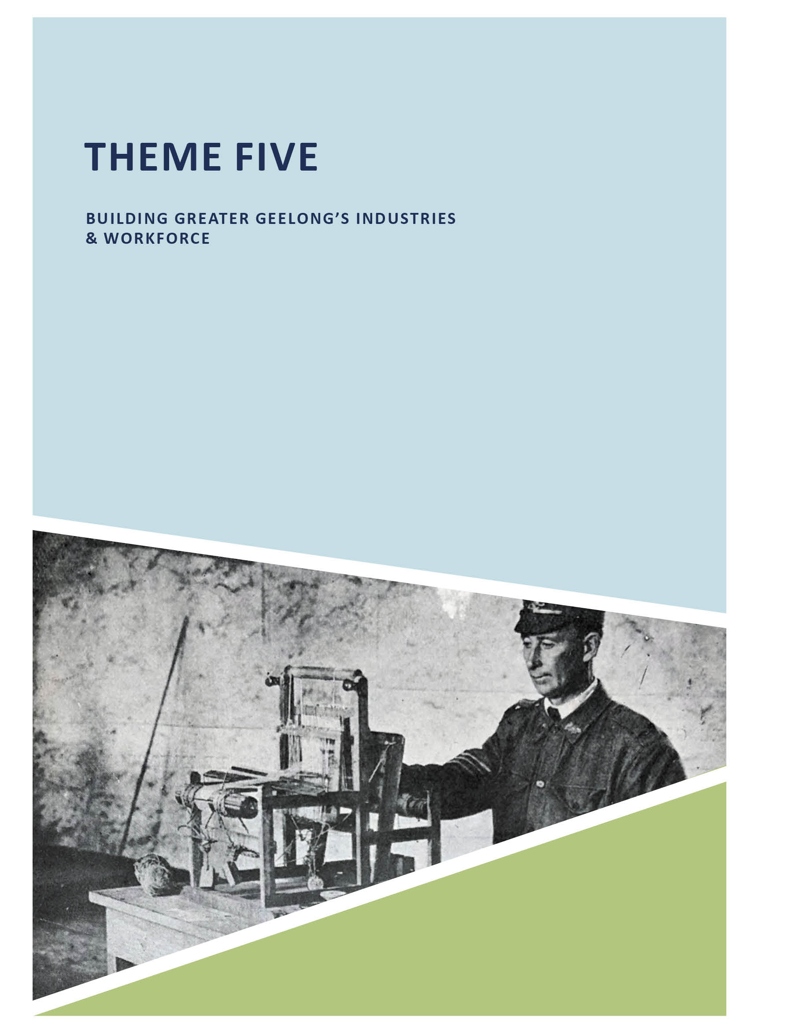
ABOUT CORAYO: A THEMATIC HISTORY OF GREATER GEELONG 486

THEME FIVE

BUILDING GREATER GEELONG’S INDUSTRIES & WORKFORCE

5.1 INTRODUCTION
Fundamental to the local economy of Greater Geelong from the time of the Wadawurrung, has been commerce. Shaping the evolution and development of the region since European colonisation have been the industrial, trade, commercial, financial, insurance, legal and hospitality sectors. Appendix
  - provides detailed lists of the personnel involved with each of these sectors at different times in the 19th and early 20th centuries, based on Proeschel s Map of Geelong and Directory of c.1855, Electoral Roll of 1856 and different editions of
Sands and McDougall’s Directories of Victoria. This appendix identifies additional subsets of the Greater Geelong workforce than outlined in this theme.
The industrial sector has played an especially prominent and influential role in Greater Geelong’s economy and workforce. This theme focuses on progress with the industries associated with sheep and wool (given that Geelong became the wool capital of Victoria): boiling down establishments, tanneries, fellmongers, wool scouring works and woollen mills which proliferated along the banks of the Barwon River between Marnockvale (Newtown) and Breakwater and Charlemont from the 1840s. It also gives an outline of other important historical industries (especially where physical evidence survives
or where the enterprise made a substantial contribution to Greater Geelong’s economy and workforce), including
several flour mills, former ropeworks at Geelong West, former Paper Mills at Fyansford and Newtown, oil and glue works
at Charlemont, starch factory at Highton, and iron foundries, boiler makers, agricultural implement makers and glass factories. The importance of breweries, extractive industries, and other manufacturing progress in the 20th century (and beyond) are also outlined.
The trade sector, being aligned with the industrial and commercial sectors, was also essential to the Greater Geelong economy from the mid-19th century. It included wool broking and wool sales. It also included the much-needed necessities of 19th and 20th century commercial and domestic life: ironmongers, bakers, livestock and grain merchants and auctioneers, cabinet makers and undertakers, bootmakers and shoe repairers, butchers, merchants and importers, warehousemen and timber merchants and printers and stationers (see Appendix 5.1). Each of these trades comprise a focus for this theme, particularly where associated fabric survives, as well as the key people behind these trades.
The commercial sector has been defined as grocers and storekeepers, and drapers, clothiers, tailors and dressmakers. A concentration is given on those grocer

and draper families who made a significant contribution to commercial life in Geelong, based on existing stores and other buildings associated with them. They include the Hooper family (who were successful grocers in Geelong West, Geelong and more broadly the Geelong region by the 20th century); Richard Clarke and his grocery at 86 Ryrie Street; Leggo’s at 88 Ryrie Street; Bright and Hitchcock and their former department store at 115-139 Moorabool Street; Julius Solomon and his Solomon’s Department Store (now Market Square), 95-135A Moorabool Street; the Crawcour Brothers and their Emporium at 184-192 Pakington Street, Geelong West; and a small number of other draperies.
The financial sector provided the economic basis for local industrial, commercial and domestic life. This theme gives an overview of the early banking system and the surviving 19th and 20th century banks that contributed much to the local economy.
Aligned to the financial sector is the insurance sector.
This theme gives a brief exploration into the development of the insurance system in Greater Geelong, particularly through the construction of buildings for different insurance companies in the late 19th and early 20th centuries.
Important in the administration of justice and business, and contracts and conveyances, was the legal sector.
This theme gives a basic appreciation of the early solicitors that made an important contribution to Greater Geelong, particularly where their associations with legal practice remain manifest in physical fabric.
Another sector discussed in this theme is that of hospitality. It gives an overview in the development of the multitude of hotel businesses and buildings from the early 19th century (which provided food, accommodation and space for public, political and other meetings and gatherings); the rise of the coffee palace by the Temperance Movement as an alternative to the hotel; and the several guest houses and boarding houses established throughout Geelong (and particularly near the waterfront) and tourist towns such as Barwon Heads, Ocean Grove, Portarlington and St. Leonards.
The final sector included in this theme is the utility sector. This includes the establishment of the Geelong Gas Company in 1857, its gas works at North Geelong providing gas to
light the City’s streets from 1860. It also briefly explores the evolution and development of the Electric Lighting and
Traction Company in 1899, and its Geelong ‘A’ Power Station built in 1900. Following acquisition by the State Electricity Commission (SEC) in 1934, the theme also touches on the construction of the Geelong ‘B’ Power Station at North Geelong which opened in 1954 and which was, for a short period, the State s largest power station.

WADAWURRUNG ‘BY:ERRS’
Commerce between Wadawurrung clans and other language groups were organised as by:errs , a socio/religio/ commercial congress.1 The by:errs gave opportunities to trade materials and products not available in each clan sub- territory. These included axes and other implements, and ochre, which was a prized commodity that was quarried by
the Wadawurrung and used for ceremonies, artwork, painting and clothing.2

INDUSTRIAL SECTOR
Key to the progress of Geelong from European colonisation from the 1840s was the establishment and development of the industrial sector. Notable among the industries created were the secondary industries associated with sheep grazing: boiling down establishments; tanneries, fellmongeries; wool scouring works; and woollen mills. Other industries included flour mills; butter factories and creameries; iron foundries
and implement makers; ropeworks; and extractive industries including saltworks and cement works. Technological developments brought about a range of new manufacturing businesses in the early 20th century, mainly centred at North Geelong. In the first years of the 21st century, several of these earlier industrial complexes have been transformed to create new vibrant business and employment opportunities.

BOILING DOWN ESTABLISHMENTS, TANNERIES, FELLMONGERIES AND WOOL SCOURING
As the gateway to the sheep and cattle grazing in the Western District, local businessmen soon capitalised on the secondary industries associated with livestock. The Barwon River between Marshall and Newtown provided a water supply and a conduit for the waste produced in each of these industries. The key establishments included boiling down works for the production of tallow (for making candles and soap); fellmongeries for the sale of sheep skins; tanneries (for manufacturing leather); and wool scourers (for the cleaning of wool).
These types of river-side industrial developments were first centred at the breakwater (Breakwater) and Charlemont (earlier known as Marshalltown) (Figure 5.01). The earliest was the Barwon Steam Tallow Establishment of Willis and Lloyd at the breakwater in 1844.3 It was followed by three neighbouring works on the west bank of the river: C.J.
Denny s boiling down establishment in 1847,4 the fellmongery of Patrick McDonald and Lawrence Webster in 1849,5 and the fellmongery of Henry Concannon from October 1848. All of these industries at the breakwater prospered, so much so

that Dennys took into partnership Thomas Marshall junior in 1848.6 He was the son of Thomas Mulcuster Marshall, early European colonist who had taken up several large allotments on the south bank of the Barwon below the Breakwater where he ran sheep. The locality, Marshalltown (now Charlemont) was to be named after him.7 Following the dissolution of the partnership in 1852, Thomas Marshall
continued a fellmongery and tannery in his own right north of the breakwater, as did his brother, Foster Marshall.8
The formation of these early fellmongeries and wool scour works was impetus for the Government to subdivide land at Breakwater and Marshalltown in 1849 as suburban (industrial) allotments. The plan of allotments ‘on the Barwon River below the Breakwater’ by Lindsay Clarke, Assistant Surveyor, showed those businesses that had already been established.
At Charlemont within the Corporation of Geelong and flanking the south bank of the Barwon River near Goat Island, seven allotments were laid out by Lindsay Clarke in 18499 (Figure 5.02). It appears none of them had been developed prior to the survey, and it was not until the 1850s before industrial development commenced nearby.
By the mid-1850s, there were at least 13 wool scourers, fellmongers, and curriers and tanners who had established their businesses at Breakwater and Marshall (see Appendix 5.1). By 1882-83, this number increased to
25, a consequence of the boom years in the wool industry.10 One celebrated tannery which had commenced by this time was James Munday’s Geelong Tannery on the Barwon River at South Geelong in 187511 (Figure 5.03). Munday had previously leased Douglass’ Barwonside Tannery at Charlemont.12 The Geelong Tannery was designed by the prolific local architects, Davidson and Henderson, with assistance from manager and practical fellmonger, Charles Smith, who had ‘sketched out’ the requirements.13 Forty staff were employed at the tannery which produced leather
products (with leather-belting providing the greatest success) from approximately 50,000 skins and hides a year.14
Economic expansion and greater employment opportunities soon dwindled with the collapse of the wool price in the
late 1890s and the infamous Federation drought that devastated the industry.435 Only around 9 fellmonger, tanner and wool scour operations had survived in Geelong by 1905.16 Conditions improved after World War One in the 1920s with around 21 businesses operating.17 This number decreased during World War Two with around 16 tanneries and wool scourers operating, and the number remained constant throughout the postwar wool boom years and beyond 1960.18 Today, only one wool scour business

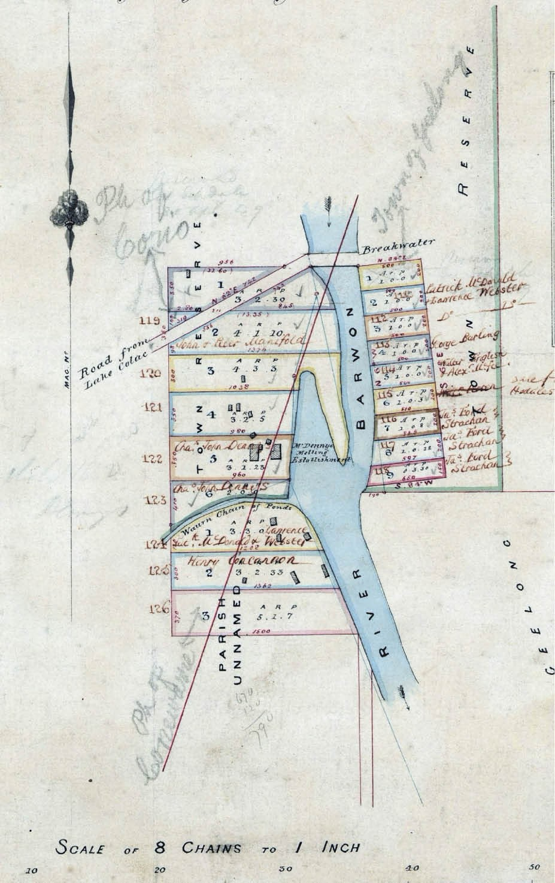
Figure 5.01: L. Clarke, Plan of Allotments marked within the Township Boundary of Geelong on the Barwon River below the Breakwater, 21 April 1849. Source: VPRS 8168/P5, item SYDNEY: G17: GEELONG, Public Record
Office Victoria.

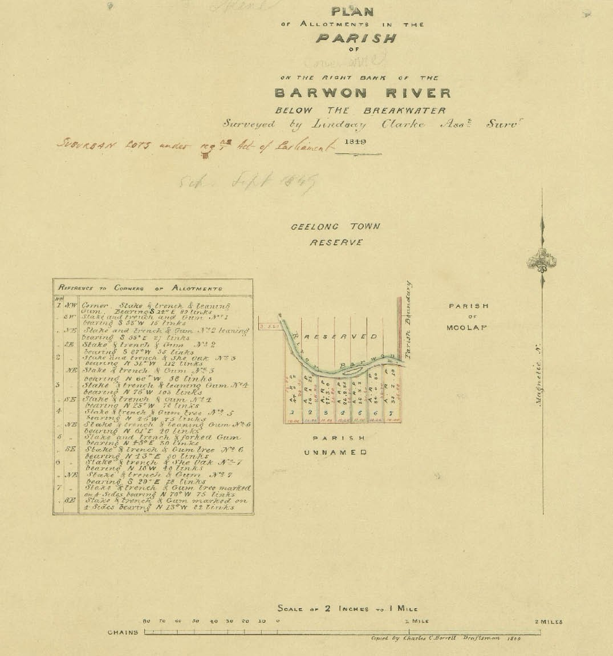
Figure 5.02: L. Clarke, Plan of Allotments in the Parish of Conewarre on the right bank of the Barwon River below the Breakwater, 1849. Source: VPRS 8168/P5, Sydney Plans C 6: Conewarre, Public Record Office Victoria.

Riversdale Woolscouring and Carbonising Mill, Bridge Road, Newtown – continues to operate in the Greater Geelong area.

‘BARWONSIDE’ TANNERY, CHARLEMONT
Of the numerous boiling down works, tanneries, fellmongeries and wool scouring operations along the Barwon River from the 19th century, physical evidence survives for only a few.
Just ruins remain of two of the most substantial tanneries in the region. Both were situated at Charlemont: Barwonside (later Victoria) Tannery and the Australian Tannery. The
Barwonside Tannery was established in 1864 by Alfred Douglass and Co., under the leadership of newspaper proprietor, Alfred Douglass (see Theme 3) (he had previously established a brickfield on this site in 1855-56.19 Douglass good friend, John Wright, was appointed manager.20 Operational in 1865, the ‘Barwonside’ Tannery was described the Geelong Advertiser as follows:
The Barwonside Tannery is situated below the Breakwater on the River Barwon, and about three miles from Geelong. It has been formed within the past year. A large quantity

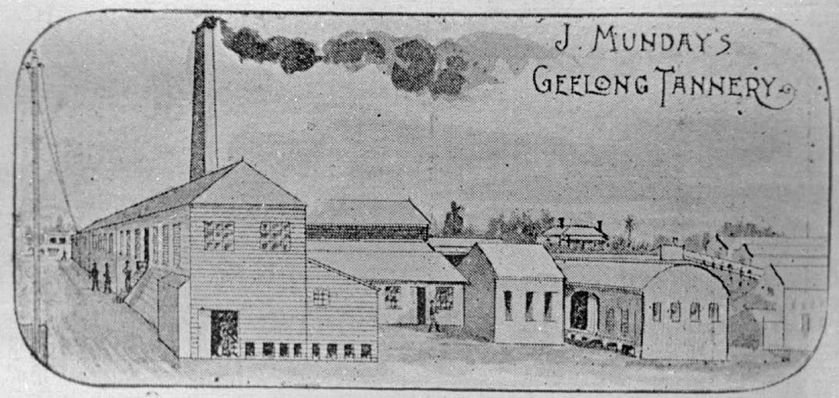

Figure 5.03: James Munday s Geelong Tannery, c.1897. Source: E.A. Vidler, The Book of Geelong: Its People, Places, Industries and Amusements, p.29.

of skins were on the premises, consisting of calf, kangaroo, sheep, goat, and dog skins, in the various stages of conversion into morocco and other fancy leathers prepared in the German and French styles, under the superintendence of artisans from these countries. The kangaroo skins make a very soft and beautiful leather, and appear equal to the finest kid; they also take the various dyes in a very favourable manner. The various kinds of calf are prepared to the satisfaction of the Government, which has just accepted a tender from the firm for the supply of calf and fancy leathers to the value of nearly
£800.
The water required is pumped by a small windmill into
a tank. The works are extending, and new pits have just been erected. The number of men now employed in the various departments is twelve, whereof the greater part are foreigners; and this number will be augmented when the order for the Government is in hand.21

VICTORIA TANNERY, OIL AND GLUE WORKS AND BONE MILLS, CHARLEMONT
In 1867, the Barwonside Tannery was bestowed an honorary certificate at the Exhibition in Paris, ‘being the only scoured Victorian wool for which an award was given at the greatest show ever held in the world. 244 By this time, the number
of employees at the Barwonside Tannery had increased substantially, ranging between 30 and 40, with two Chinese men having been employed at the tannery for 17 years,245
prior to Alfred Douglass’ take-over in 1865. In 1901, the Trustees of Douglass estate auctioned for removal all the buildings and machinery of the Barwonside Tannery.246 The site was sold to George Gardiner (c.1846-1911) at this time who amalgamated it with his Victoria Tannery, Oil and Glue Works and Bone Mills25 (Figure 5.04).
George Gardiner had established a glue and oil manufactory at Marshalltown in 1873 (see Theme 7). After it was partially destroyed by fire 1894, Gardiner had additions and tan pits built in 1895 to designs by
the local architects, Tombs and Durran.26 Gardiner s extensive operations were reported and illustrated in the Leader in 1899:
One of the most prominent figures associated with the progress of the industries of Geelong is Mr. George Gardiner, proprietor of the Victoria Tannery, Oil and Glue Works and Bone Mills, situated at Marshalltown, on the south bank of the Barwon River. Originally Mr. Gardiner started in a small way in the manufacture of oil, about 30 years ago; but since then he has extended his operations, all the time showing in a practical manner a thorough determination to achieve success in the industries which he had decided to foster. The first extension of his business was in adding the manufacture of glue to his works; and then followed the erection of a tannery; and eventually he added the manufacture of fertilisers as an adjunct to his business.
… His [Gardiner’s] establishment, in its various branches,

provides labor for a large staff of employees, and in other ways the proprietor has assisted materially in the development of Geelong as a manufacturing centre. The distribution of capital in the purchase of wattle bark and
bones for cash from farmers and others in rural districts is continually in progress; the purchase of hides locally, and the importation of these productions for the other colonies all have their influence on the port of Geelong.
… The greatest care is taken in the selection of hides at the Victoria tannery, and the tanning process is carried on under the most improved principles, and the skilled manner in which both the raw material and the manufactured article are handled accounts for the reputation of the Victoria Tannery in the markets of the world.27

AUSTRALIAN TANNERY, CHARLEMONT
Brearley Brothers’ Australian Tannery was also situated at Charlemont on the Barwon River.28 Joseph Brearley
(1823-1911) and Sharp Brearley (1827-1905) were from York,
England. In 1846, Joseph, Sharp and their brother, William all curriers were convicted of stealing iron wire and
sentenced to 7 years’ imprisonment each at Millbank Prison. There, Joseph and Sharp were trained as shoemakers.29 The incarceration of the Brearley brothers was at a time
when reforms had been introduced in England, based on the philosophies of Jeremy Bentham as part of the Pentonville Prison model of providing trade skills, enacting virtual solitary confinement and providing religious instruction.30 Significantly, Lord Stanley, Secretary of State for the colonies had reinstated the transportation of convicts. Unlike the earlier system of transportation to New South Wales and Tasmania, convicts were transported to fill a dearth in hired labour as a free citizens.31 However, they could not return
to England during the balance of their sentences.32 In 1848, the Brearley brothers were exiled to Geelong, arriving on the convict ship, Anna Maria, in June that year where they were employed as hired labour.33
It appears that one of the Brearley brothers went it partnership with Gilbert Brown in a tannery a Tarra Creek near Port Albert until 7 July 1851.34 By 1853, Joseph and Sharp had established a business known as the Geelong Leather Warehouse in Yarra Street, under the name Brearley Brothers.35 In 1855, they had been sufficiently successful for Joseph Brearley to purchase 5.109 hectares south of
the Barwon River at Charlemont, comprising allotment 8 of Section 1 in the Parish of Conewarre. There, they established a four roomed two storey building, five-stall stable with loft and a leather and bark mill that was completed by 1855-
56.36 In 1860, the Geelong Advertiser described the newly- completed chimney as ‘a handsome brick shaft, 70 feet in

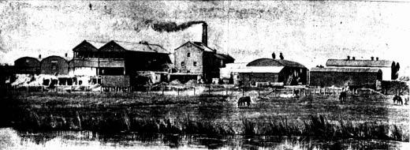
Figure 5.04: Victoria Tannery, Oil & Glue Works, Charlemont, 1899. Source: Leader, 3 June 1899, p.16.
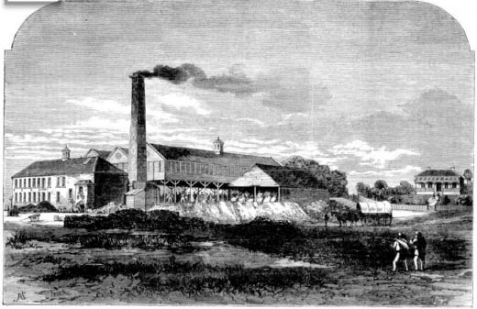
Figure 5.05: Australian Tannery, Charlemont, 1869. The manager’s house (right) still survives. Source: Illustrated Australian News for Home Readers, 4 January 1869, p.12.

height’ and ‘a capital landmark.’37 The complex included an engine room with its ten horse power engine, a back store that could hold 100 tons of ground material, a mill where a ton of stuff can be turned out every hour,’ a liquor well ‘into which sewers from the various pits discharge the infusion weakened by the work it has performed,’ and 62 soaking pits (each five feet deep and able to hold 50 hides).38 The product produced by the Brearley Brothers was sole leather, the brothers combining their tanning experience with their prison training as shoemakers.
In February 1864, a two storey brick building of the Brearley Brothers’ tannery was destroyed by fire.39 ‘A good deal of tan bark and other property was saved.’40 Robert S. Tuffs, architect was engaged to design the replacement buildings and tenders were called on 20 February 1864 the rebuilding of what was then known as the Australian Tannery.41 In January 1869, the Illustrated Australian News for Home Readers published an illustration of the tannery complex (Figure 5.05). It showed the long timber shed over the pits that had been built following the fire, and a stone and brick eastern wing (left).
Further major improvements were made in 1869 to designs by Robert Tuffs (Figure 5.06). The works included
150,000 bricks.42 In July of that year, the Geelong Advertiser

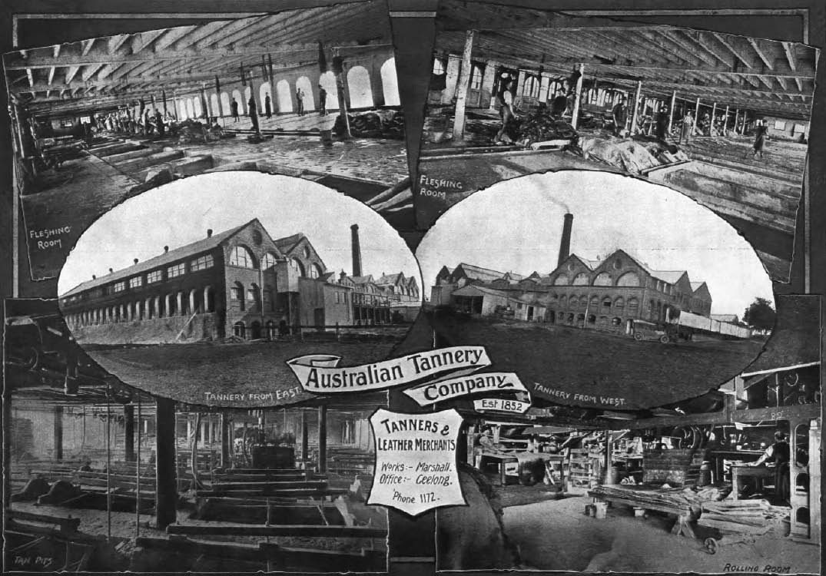
Figure 5.06: Australian Tannery, Charlemont [Marshall], c.1918. Source: Geelong for Business, Health, Pleasure, The Geelong City Council and Geelong Progress Association, Geelong, 1918, p.32.

reported on one of the most important events that has ever occurred near Geelong , being the laying of the foundation stone for the extensive tannery buildings.43 The manufactory afforded employment to scores of men enabling them to provide food and education for their children and it became a perfect hive of industry. 44 In 1872, the Geelong Advertiser gave a detailed description of that it claimed as the largest establishment of the kind in the southern hemisphere.’ Costing £30,000, the new work – which commenced in 1869 and was in still incomplete - was to be:
… exactly like the eastern one, and which serves to complete the picture as viewed from the river. At present it has only been carried back a portion of the distance, more room being required for the introduction of new machinery, some of which has already arrived and placed in position The river frontage now comprises two wings, each 60 feet wide, and each having two gables.
The space between the two wings, 103 feet, is filled in by the original tannery and a new engine houses, the whole length being surmounted by a tasteful parapet. The
brickwork in this frontage is not of that dead and alive character usually found in such buildings, but is agreeable relieved with numerous breaks, panels, reveals, arches, &c., and also with a judicious mixture of Connewarre dressed bluestone, of which the sides, necks, keystones, stringcourse, and coping, are composed, and the whole has a most imposing appearance, and reflects credit
on the skill and taste displayed by the architect, Mr
R.S. Tuffs. … The area covered by the Australian Tannery is 52,120 superficial feet; the number of pits is 191; men and boys employed, 100; … Messrs Brearley Bros. have some 600 or 700 tons of bark in Gippsland, which are
to be forwarded by steamer as soon as the lakes are navigable.45
Sharp Brearley retired from the Australian Tannery in
1875 and in 1881 he established the Corio Tannery at Western Beach.46 The Australian and Corio Tanneries soon merged but later went into liquidation. The Australian Tannery
was purchased by Alexander Gray in 1886 and by 1928- 29 the business had been sold to Michaelis Hallenstein

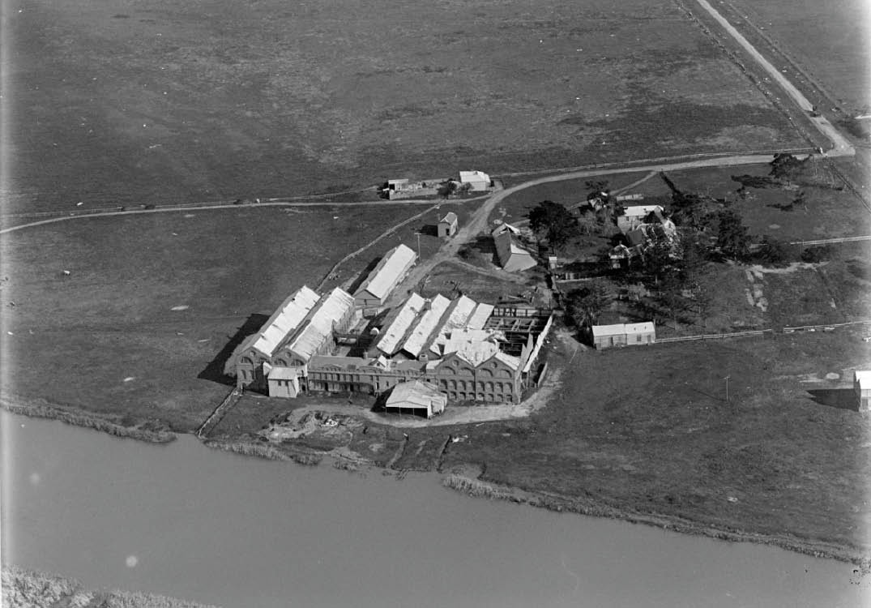
Figure 5.07: C. Pratt, Aerial view of derelict former Australian Tannery, c.1930-40. Source: Accession no. H91.160/865, State Library of Victoria.

Pty Ltd, tanners and manufacturers.47 With the advent of new technology in the early 20th century, particularly the petroleum and automotive, the Marshall operations
of Michaealis Hallenstein closed in the 1940s, leaving the buildings to fall disrepair48 (Figure 5.07). In addition to the surviving ruins, the former manager s house of rendered brick construction with a slate roof and built inc.1855 – remains extant.49 It was occupied by the nephew of Joseph and Sharp Brearley, James Jackson (c.1838-1900), who had arrived from England as manager in 1865 (see Theme 7 for further details).

SUNNYSIDE WOOL SCOURING WORKS, BREAKWATER
At 76-78 Tucker Street, Breakwater, the former Sunnyside Wool Scouring Works survive as an intact physical legacy of 19th century river side tannery, fellmongery, and wool scouring operations in the 19th and 20th centuries. The earliest development on the site appears to have been
in 1867-68 when Edmund Haworth (c.1818-1895), an

English tanner and fellmonger, built a stone wool washing establishment on the Barwon River next to the breakwater and immediately north of Thomas Marshall s tannery
and woolstore, established in 1851.50 Howarth had earlier built a weatherboard shed and 21 tan pits, together with a six roomed brick dwelling (‘Barwon House’) with garden, in 1860-61, further south of his wool washing establishment.51 Between 1882 and 1883, Haworth made substantial improvements to his wool washing premises as the net
annual value almost doubled to £100.52 These improvements included a large galvanised iron shed on the southern boundary.53 However, the most substantial improvements came in 1895 and 1896 when Haworth’s son, John, had a tannery building (including brick chimney stack), tanning pits, fellmongery additions and a galvanised shed and outbuilding erected to designs by the local architects Seeley and King.54
Impetus for the major improvements was the death of Edmund Haworth in 1895. He bequeathed the fellmongery business at 76-78 Tucker Street to his son, John, who had been carrying on business there.55 Edmund Haworth’s

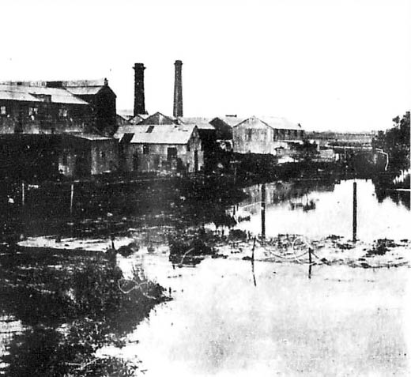

Figure 5.08: Sunnyside Wool Scouring Works, Breakwater, 1909. Source: News of the Week, 8 December 1909, GRS 2121, Geelong Heritage Centre collection.

other son, Frank, was given the tannery further south on the east side of Tucker Street.56 The location of the tannery was shown on a sketch plan.57 In the following years,
John Haworth leased his fellmongery at 76-78 Tucker Street. On his death in 1903, it was described as a ‘Woolshed Machine House’ with drying rooms, engine house and tanks, and valued at £1500.58 The property was taken up by the Breakwater Woollen Mills Company.59 In 1908, it was owned by Richard John Kennedy before being purchased by Gustav Robert Lemke in 1910.60 Henry O’Beirne and Co.
leased the premises from Lemke until his company purchased it in 1915 and continued business there until 1935 when it was sold to the Dominion Wool Company.61 The wools scouring establishment was sold to James Joseph and Harold Vincent Fowler in 1938 and they continued to operate the site until
at least the 1960s.62 It may have been at this time when the premises was named Sunnyside .63
In 1895, the tannery was completely destroyed by fire.64
A new tannery (Figure 5.08) was subsequently constructed from late 1895 to a design by Thomas Seeley.65

CLYDE FELLMONGERY, SOUTH GEELONG
Another physical legacy of a 19th century fellmongery and tannery operation is at 8-10 Gravel Pits Road, Geelong.
First known as the Clyde Fellmongery, it was built in 1875 as a weatherboard building of four large rooms for the wool brokers, H.M. Strachan, William Murray and Charles Shannon.66 Charles Henry Smith, previously an employee
of ‘Barwonside’ tannery, was appointed manager.67 By 1878,

the weatherboard buildings had been partly replaced by buildings of stone and brick, the main building being a two storey brick and timber structure. The Clyde Fellmongery was destroyed by fire in 1900, the Geelong Advertiser reporting that the site of the main buildings was occupied by a heat whitened chimney stack that stood alone amidst a vast area of smoking debris and ruined machinery.’68
The site was subsequently acquired by Smith who rebuilt the factory complex in 1904, using his practical engineering
experience and ‘rare inventive skill’69 (Figures 5.09-10). Smith had also designed and patented a wool scouring machine, with scoured wool from his machine winning several prizes (see Theme 9). On Smith’s death in 1908, his Clyde Works at South Geelong employed 20-30 hands.70 He was described as having ‘a bluff demeanour, but withal had a kindly heart, and always had a penchant for giving old employees the preference. 71

RIVERSDALE WOOLSCOURING AND CARBONISING MILL, NEWTOWN
The only operating wool scour works in Geelong today is the Riversdale Woolscouring and Carbonising Mill operated by
E.P. Robinson Pty Ltd at 13 Bridge Road, Newtown (Marnock Vale). It was commenced by Herman Wilms (1871-1939) as the Marnockvale Woolscouring Works from February 1920.72 Wilms had been educated at the Church of England Grammar School, Melbourne, and commenced business with his father, Charles Adolph Wilms, in Melbourne, in 1899, under the name of C.A. Wilms, shipping agents. Following Charles Wilms’ death in 1911, Herman became the sole proprietor.73 The opening of Wilms’ Marnockvale Woolscouring and Carbonizing Works was described in the Geelong Advertiser:
Yesterday afternoon a large party of citizens assembled at Marnockvale to celebrate the opening of the
latest establishment – the wool scouring works of
Mr. H.E. Wilms. The proprietor of this promising industry has chosen Geelong for his enterprise because he
believes the workmen are better and more inclined to consider the mutual interests of the employers and themselves in a reasonable manner’ ... They [the guests] were shown through the buildings substantial, well- lighted structures, with concrete floors throughout, and effectively drained. The machinery, which has just been installed, was the centre of interest. There are the latest improved scouring machines, drying and carbonizing machines and it is a matter worthy of special note that this machinery has been entirely built locally, the maker being Mr. Dyson, of South Geelong. Everything in connection with Mr. Wilms property suggests an industry started on sound lines. Extensions are already proceeding in course of erection. Upstairs in the main building, there is a great

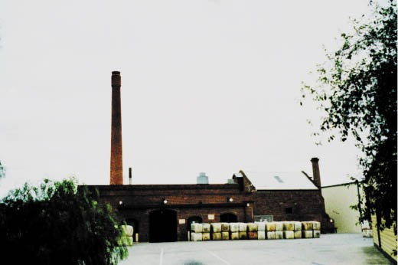
Figure 5.09: Clyde Fellmongery, 2002. Source: David Rowe.
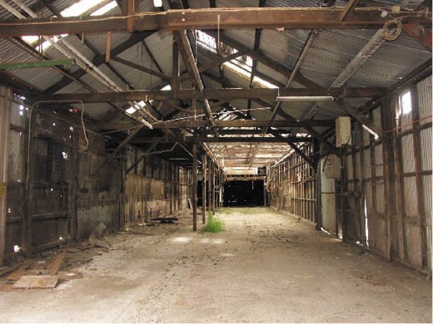
Figure 5.10: Clyde Fellmongery interior, 2009. Source: David Rowe
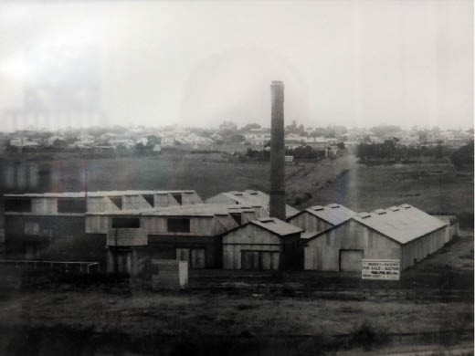
Figure 5.11: Marnockvale Wool Scouring Works, 1927. Source: E.P. Robinson Pty Ltd, Newtown.

quantity of wool of various classifications …. After the loyal toasts had been honoured, the Mayor of Newtown and Chilwell proposed the health of Mr. Wilms, and prosperity to his industry.74
By July 1927, Wilms had sold the Marnockvale Woolscouring Works (Figure 5.11) to the well-known local family wool company, Collins Brothers (see following subsection).75 They renamed the factory the Union Mill No.2. At this mill Collins Brothers continued to manufacture flannels and blankets (see later subsection).76 Considerable alterations and additions were made to the building complex to accommodate milling operations as well as wool scouring works. After four generations of Collins family ownership, the Union Mill No.2 was leased to E.P. Robinson Pty Ltd in 1980 before this firm purchased the site in 1988.77 It is only one of three processing operations remaining in Australia.78

PHOENIX WOOL SCOURING WORKS, NEWTOWN
Another late comer to the development of wool scouring operations in Geelong was the establishment of the Phoenix Wool Scouring Works, corner Marnock and Riversdale Road, Newtown, in 1919 after the end of World War One.79 Largely of timber and iron construction, the wool scouring works were designed by Fred Purnell, local architect and former Lieutenant-Colonel in World War One (Purnell also designed Smith’s residence, ‘Mossgiel’ at 133 Noble Street in 1922).80
The works were founded by Brigadier-General Robert Smith.81 Wool scouring had first been carried out on the Barwon River at Marnock Vale (Newtown) years earlier by W. Francis and
J. Cook.82 Having served in World War One, Brigadier Smith was conscious of employing as many returned servicemen as possible. In 1919, 46 of a total of 60 staff had served in the war.83 After a temporary closure in 1921,84 a wool carbonizing plant was installed at the Phoenix Works and it was at this time when Smith’s firm become Phoenix Wool Co. Pty Ltd. This was the first of its type in Victoria.85 Throughout the 20th century, Phoenix wool became well-known on the London market and compared favorably with overseas products.86 All that remains today of the Phoenix Wool Scouring Works as the former brick boiler house and chimney, the majority of the complex having been demolished.
Brigadier-General Robert Smith (c.1882-1928), C.M.G., D.S.O. and bar, and Croix de Guerre V.D., was educated at Scotch College, Melbourne, and was a gifted athlete.87 His sporting interests later included a term as president of the Geelong Cricket and Football Club.88 Smith s business involvements were largely devoted to the wool industry having first gone into business with his father at a wool scouring works at Abbotsford.89 Following the onset of World War One, he enlisted in 1915 as a Major, and was second in command of the 22nd Battalion, and had a distinguished war career.90 On

his return, he established the Phoenix Wool Scouring Works and later he acquired the Austral Wool Scouring Works on the Austral Paper Mills site at Newtown (see later subsection).91 Smith was also Chairman of Directors of the Geelong Returned Soldiers’ and Sailors’ Mill at Chilwell.92 In 1927,
he went into partnership with Messrs. W. and I. Smith, wool merchants.93 He died prematurely in 1928 at the age of 46.94

WOOLLEN MILLS
The prosperity afforded the secondary industries of tanning, fellmongering and wool scouring in the 1840s were substantially supplemented twenty years later from the 1860s with the establishment of the first woollen mills on the Barwon River. These enterprises helped elevate Geelong’s importance as the State s wool capital from an industrial perspective. In January 1868, The Age newspaper declared that ‘the first piece of cloth ever manufactured in the colony of Victoria has been produced at the Geelong Woollen
and Cloth Manufactory …’95 Situated on the Barwon River at South Geelong, this began the woollen mill industry in Geelong. By 1882-83, there were at least four local woollen mills: Albion, Barwon, Union and Victorian.96 In 1905, there were at least six mills and this number remained reasonably constant until after World War Two.97 In 1960, there were seven mills: Albion (Newtown); Collins Brothers (Chilwell); Federal (North Geelong); Geelong Returned Soldiers’ and Sailors’ Woollen and Worsted Co-operative (Chilwell); Godfrey Hirst Co. Pty Ltd (South Geelong); W.R. Redpath and Sons (Marnock Vale); and the Valley Worsted Mills Ltd (South Geelong).98 Employers of a contextually substantial proportion of the Geelong population, five of these mill
complexes continue to exist although the original woollen mill function has ceased.

VICTORIAN WOOLLEN AND CLOTH MILL (NOW GODFREY HIRST)
In 1865, the Victorian Woollen and Cloth Mill was established with John Lang Currie, pastoralist and sheep breeder of ‘Larra’, Lismore, as chairman and principal shareholder of the Victorian Woollen and Cloth Manufacturing Company.99 The directors of the company investigated numerous sites for its location and eventually settled on the Victorian Government’s offer of six acres near the police paddock and Barwon River.100 The architect, Jacob Pitman undertook
the first design of the first building, it being a single storey bluestone structure with a chimney and engine room.101 Built by Clement Nash, it was soon found that it would not be sufficient to accommodate all the required machinery.102
Clement Nash was awarded the contract to construct another building at a cost of £1717.00.103 By 1 January 1867, the building was almost completed but production could not commence as the machinery had not arrived from England.104

It had arrived by the end of the month.105 A year later, the mill produced the first piece of cloth in Victoria.106
In August 1873, a fire necessitated rebuilding parts of the mill.107 The prolific architects, Davidson and Henderson, were awarded several commissions after they prepared a plan
for the factory complex in 1874.108 The single storey brick building featured pilasters and blind arcading in the exterior facades. The Geelong Advertiser described the almost- completed works:
… the factory has been extended to the north by the addition of a building of brick and stone, uniform in size and structure with the new room previously erected, and measuring 144 feet each way. The result is that the factory is now divided into three large compartments, the engine being near the centre. This additional accommodation has enabled the manager – Mr Squire Ward – after weeks of unwearied exertion, to re-arrange the machinery, and
to bring order out of chaos. … No longer are carding and spinning machines mixed up together. The new room
is entirely devoted to the weavers. At one corner a few warpers are at work, who supply the weavers with the yarn ready for work as they require it. Ranged along one side are the handlooms, where the heavier cloths, shawls, and blankets are woven, while the rest of the room is occupied with steam looms. In all there are 77 looms in this room, of which number 30 have recently been imported, 56 are now at work, and the remainder will be in operation as soon as some of the new machinery being fitted up in the adjoining rooms can be got ready for work. The adjoining room, or what was formerly known as the big room where carding, spinning, and weaving used to be carried on, is now entirely devoted to carding and spinning. The removal of the looms has given a large additional space, and this has already been pretty well occupied with new machinery.
One grand improvement effected is the introduction of the friction clutch, with the aid of which the machinery in the two rooms described can be immediately detached. The clutch is situated against the wall that divides the rooms, and resembles two iron cups fitting into each other. While in contact, the shaft throughout the whole building is kept in motion, but directly they are detached,
which is accomplished by turning a small wheel, the whole of the machinery by which the steam looms are worked
is thrown out of gear without producing the slightest perceptible effect on the engine or the rest of the shafting. Thus any waste of steam power is entirely prevented, and at night or during meal hours, when the looms are not at work, the machinery in the weaving room is at a standstill, while the carding machines, &c., are at work. Near the engine house, between the original factory and the new structure, a drying room is now in process of construction, where it is intended to dry the manufactured material,

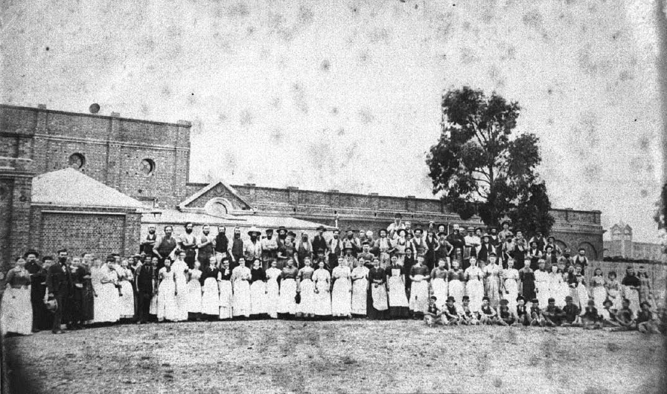
Figure 5.12: Staff outside the Victorian Woollen & Cloth Mill, c.1880. Source: GRS 2009/91, Geelong Heritage Centre collection.

instead of having to depend on a dry atmosphere, as at present. The portion of the premises about to be occupied in this way was, previous to the fire, known as the old woolley room. Some alterations are about to be made
in connection with the engine-house, a third boiler being proposed to be added to the two now in use, and provision made at the same time for a fourth when required.
Detached from the mainchain of buildings on the east side is the new woolley-room, a fine substantial structure of brick, stone, and iron. Here it is where the wool, having been dyed and dried, is, so to speak, cleaned and purified. Attached is a pretty little engine of 14-horse power – the production of a Glasgow foundry. In the woolley room, which is almost fire-proof, the “devil” resides, and is applied to a very useful purpose, namely, the removing of all kinds of foreign substances from the dyed wool. The little machine with the Satanic name whirls the wool about inside of a circular cage or “scray,” by an excellent set of revolving fans, drives all the waste siftings into a corner. This waste material or residue is not without its value, for in England it is esteemed as manure or exceptional value by hop-growers. At a convenient distance from the “devil” is the burring machine, where the wool that has escaped the searching operation of his majesty is combed and brushed till every burr or bit of grit, however tenacious,
is extracted. Proceeding to the old room – the original
factory itself – we find the “gigs,” or large cylinders, furnished with angry teazles, used for raising a nap, having mostly been removed to the adjoining apartment, and those which remain are in process of removal. This room is intended to be a finishing room in reality as well as in name. In it the tweeds, &c., will be cut and hot pressed and stored till wanted, and everything will be kept as clean as a new pin. What is termed “milling and raising, a process for which the gigs are employed, will almost exclusively be carried on in future in the big room that some years ago comprised the principal portion of the factory. … Another industry that the establishment
of the factory has called into existence is the extraction of animal oil from the waste material of the tanneries at the Breakwater. Oil is largely used in the preparation of the wool, and, irrespective of other mills, a local maker realises from £50 to £60 per month from the Victorian
Factory for this article. At present there are 200 operatives employed from 6 a.m. to nine p.m., trade being so brisk that they have to work overtime. A year ago the number was 140, and in a few weeks, when everything is in full swing, there will be 230 to 250 hands in full employment.
Many of the workers reside some distance away from their work, and do not go home to their meals. At present these have to dine off the benches in their work rooms, but it is intended shortly to erect a dining-room for their

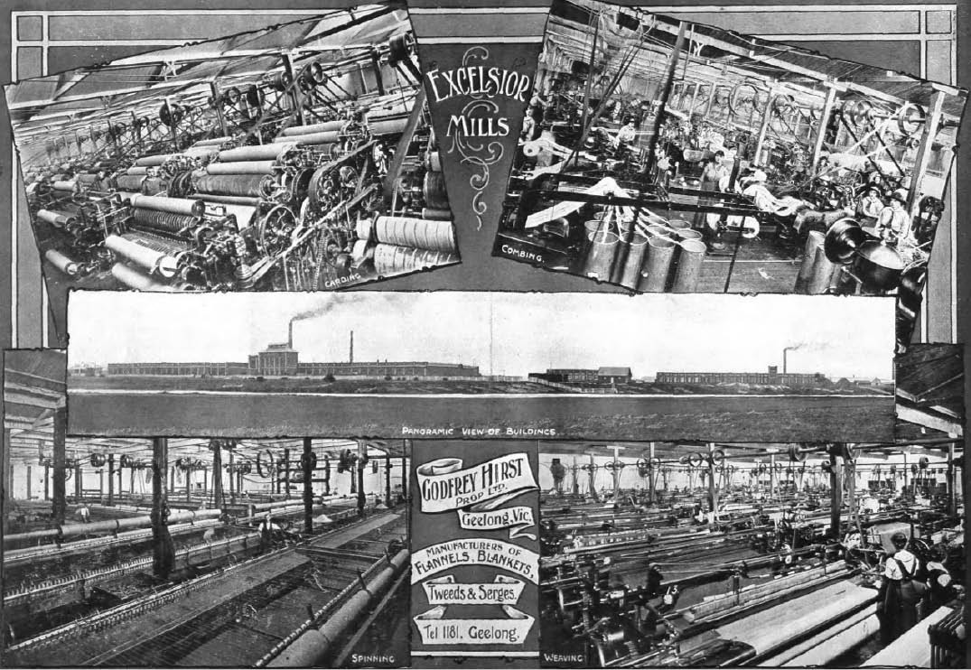
Figure 5.13: Excelsior Mills, c.1918. Source: Geelong for Business, Health, Pleasure, p.14.

accommodation, and in connection with that institution, to have a library provided, so as to enable them to beguile their leisure time in intellectual pleasures till the signal whistle recalls them to their labors.109
The inaugural manager of the Victorian Woollen and Cloth Mill was Squire Ward. A trader, he arrived from England on the Dover Castle in February 1867 with his wife, Ellen and their four daughters.110 His skill and experience in the woollen industry in England largely contributed to the successful establishment’ of the Victorian Woollen and Cloth Mill, and
its rapid growth.111 In addition to his knowledge, he ‘had an excellent understanding’ with the factory employees.112 He also had good business acumen which came to the fore when he introduced the manufacture of blankets at the factory
in 1871. Initially, only 50 pairs were made but by 1874 the mill turned out 1500 pairs.113 On his departure in 1875, a presentation was made at the school-room, South Geelong,
in the presence of 200 factory employees.114 A photograph of staff outside the factory was taken in c.1880 (Figure 5.12).
In January 1892, the Victorian Woollen and Cloth Manufacturing Company went into liquidation,115 a
demise that was to beset other woollen mill operators in Geelong, including the neighbouring Barwon Woollen Mill that had been established in 1874 and also designed by Davidson and Henderson.116 In 1899, the Victorian
Woollen and Cloth Mill site was purchased by Godfrey Hirst and Charles Shannon (with Shannon as Hirst’s financial backer and Hirst as managing partner) (C.H. Smith of the nearby Clyde Works later became a business partner in the firm).117 These businessmen were hailed as having shown splendid enterprise in building up the industrial reputation of Geelong. 118 The Victorian Woollen and Cloth Mill was
renamed ‘Excelsior No. 2’ Mill, with ‘Excelsior No.1’ Mill being the former Barwon Woollen Mill acquired by Godfrey Hirst and Co. in 1892119 (Figure 5.13). In 1912, the former Barwon Woollen Mill was destroyed by fire but it was soon rebuilt following Hirst’s visit to England for new machinery.120 Today, the former Excelsior Mills (Victorian Woollen and Cloth and Barwon Mills) are the site of numerous production plants and
the head office of Godfrey Hirst Pty Ltd, carpet manufacturers, and recognised as one of the top 10 carpet manufacturers
in the world. 121

Godfrey Hirst (1857-1917) was the son of a woollen mill spinner at Royd Edge, Meltham, Yorkshire, England and with his parents, his childhood years were spent at the family home in Royd Green, a street populated by woollen mill workers.122 He served his apprenticeship in the woollen manufacturing industry at Huddersfield, Yorkshire, ‘where he was engaged in every branch of the trade. 123 Emigrating to Geelong in 1884,124 he was employed at the Barwon Woollen Mill until it went into liquidation and he became unemployed.125 He then commenced his own small hand- weaving plant in Fyans Street and his success, together with financial support from Charles Shannon, brought on the purchase of the Barwon Mills in 1892.126 Hirst’s contribution to the woollen manufacturing industry in Geelong was highlighted in the Geelong Advertiser:
Mr. Hirst’s demonstration of the capabilities of Geelong as a woollen manufacturing centre had an immediate effect on the other mills in the vicinity, and a revival of trade took place. It can safely be said that had it not been for Mr. Hirst’s foresight, the Commonwealth mills [North Geelong] would never have come to this district. He had the satisfaction of knowing that having started with a
single hand loom he was instrumental in establishing here in the Excelsior factory the largest woollen mills in the Commonwealth, employing over 300 hands.127
Godfrey Hirst died in 1917 at his residence, ‘Royd Grange’, overlooking the Barwon River at Belmont, which had had built in 1898 to a design by Laird and Barlow.128

ALBION MILL, NEWTOWN
In 1869, Alexander Gray and R.H. Robinson established a private company and commenced the Albion Woollen Mill on the north bank of the Barwon River, Latrobe Terrace, Newtown.129 The southern-most portion of the Albion Mill on the river bank, comprising a modest, gabled two storey masonry structure with a chimney, had been built by William Gray as the Bridge Flour Mill in 1847.130 In 1869, he carried
out substantial two storey additions in order to commence the Albion Woollen Mill (Figure 5.14). The extent of the works was described as follows:
While orders for the necessary machinery were in course of being executed by the manufacturing firms in England, the buildings were in course of erection here. These consist, in addition to the old mill premises, of a large building erected on the most approved principles, and containing two large rooms, each about 80 feet by 70 feet, one above the other, and also an engine room, dye house, and other necessary places. These, with the exception of the dye house, are all substantially built of brick, and the upper room in the main building has the roof constructed on the same principle as that adopted

in the erection of the factory of the Victorian Company, whereby the greatest amount of light is obtained without allowing the sun’s rays to descend into the room. By the time these buildings were completed the machinery commenced to arrive, and with it came Mr. Thackeray, who has been retained as manager of the factory and
three other skilled hands to superintend its erection. The expedition with which this part of the work has proceeded is most satisfactory and is creditable to all concerned. In the lower floor where the heaviest machinery is situated, two sets of carders, scribblers, and condensers have been erected, and now await only the fixing of the carding in the cylinders which cannot be done until the wood has been properly seasoned. There are also four mules, all erected, and ready for work. Two of them are self-acting, and without exception the finest machinery we have ever seen. The movements are necessarily most intricate
and complicated, yet everything works with clockwork precision and with a facility that is astonishing. One man turning one of the wheels can with ease work the whole machine, allowing every motion of the machinery to
be witnessed. If the word perfection can be applied to human device, this wonderful contrivance is deserving of the term. In the upper storey are situated the looms, sixteen in number, all, like every piece of machinery in the place in fact, of the most beautiful finish, and of the very latest pattern. … The whole plant in fine is such as to bear comparison with any to be obtained in England, and it does great credit to those who were entrusted with its selection. … The whole of this extensive machinery is now in an advanced stage so far as the erection
is concerned, and it is anticipated that by the end of February Geelong will be able to lay claim to two woollen factories in full working order. The benefits arising from this important industry are almost incalculable. The Albion factory alone will employ from 60 to 80 persons at first, and will turn out from 1500 to 1800 yards of cloth per week, thus conferring a benefit not only on the working population, but affording the colonists an opportunity
of observing the increased prosperity induced by the establishment of such valuable industries.131
The first sale of tweed from the Albion Mill occurred in John Davison’s auction room, Market Square, in May 1870.132
In 1874, the Albion Mill was doubled in size with a north extension 77 feet in length, together with a west addition 18 feet wide and 80 feet in length133 (Figure 5.15). These additions were constructed in brick and of matching design as the original mill of 1869. In 1878, the Albion Mill won a
silver medal for its tweeds at the Paris Exhibition.134 The mill building was substantially damaged by fire in 1916 and rebuilt to a different height in 1917.
Alexander Gray (c.1827-1913) arrived in Geelong from

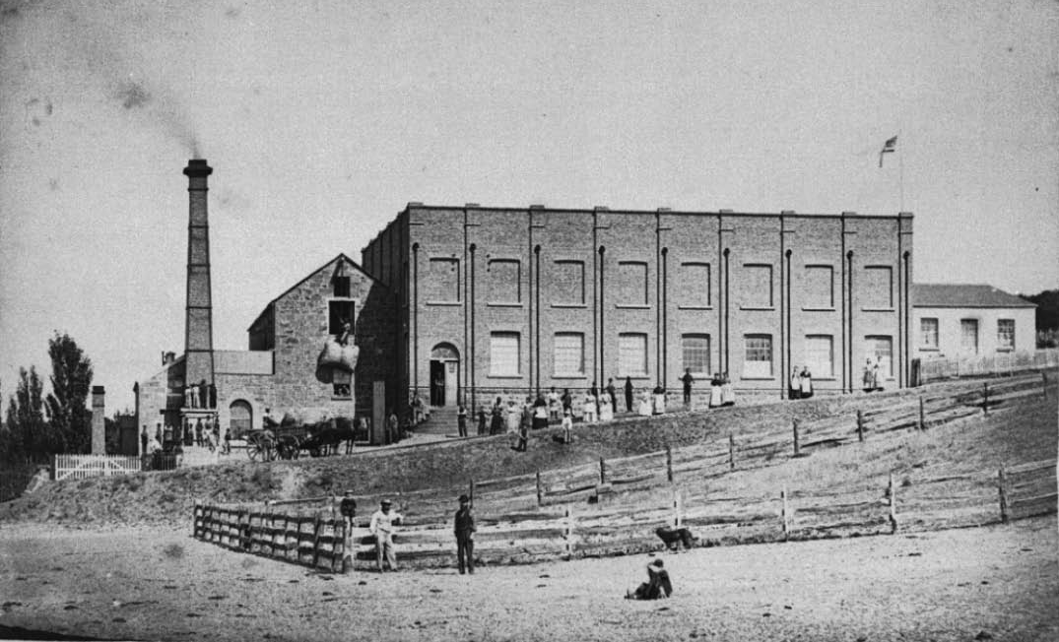
Figure 5.14: Albion Woollen Mill, 1870. The small gabled wing between the mill building and the chimney was the earlier Chilwell Mill and later the Union Steam Flour Mill (see later subsection). Source: GRS 2009/332, Geelong Heritage Centre collection.

Scotland in early 1852.135 He was first employed by Messrs. Timms, Wilson and Co., merchants. He later worked the Shannon Flour Mills on the Barwon River with Messrs.
Reynolds and Robinson.136 It was with Robinson that Gray built the Albion Mill in 1869.137 Following Robinson s death, Gray took into partnership William Thackrah, and they purchased the Australian Tannery at Charlemont.138
Gray later became sole proprietor of the Albion Mill,139 which he expanded with a second plant (known as Albion East) in 1907.140 It was situated opposite his original Albion Mill on the east side of Latrobe Terrace. After 1860, Gray purchased ‘Rosebank’ immediately north-west of his Albion Mill (now 480 Latrobe Boulevard).141 Originally built for Isaac Westcott in 1854, Gray carried out extensive additions in 1871, the dwelling was transformed into a two storey Italianate villa.142 There, Gray lived until his death in January 1913. Gray did not take a prominent part in public life but ‘he gave liberally to innumerable charitable objects, preferring that it should be done in a quiet and unostentatious way, without any public reference. 143

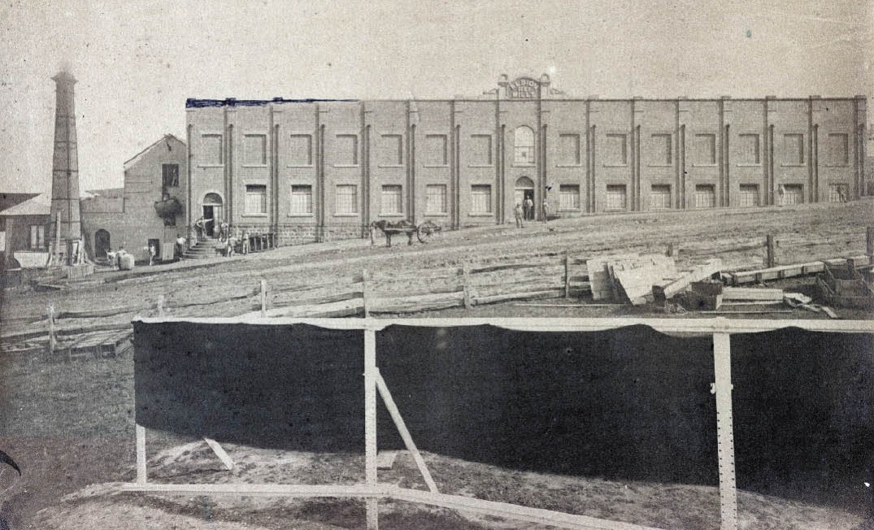
Figure 5.15: Albion Woollen Mill, 1880 showing additions. Source: GRS 2009/002241, Geelong Heritage Centre collection.

UNION AND COLLINS BROTHERS MILLS, NEWTOWN
At the time the Albion Mill was being extended in 1874, William Henry Collins (1809-1890) and his sons, William Gilbert and Marcus Edward Collins, engaged the Ballarat architect, Henry Caselli, to design a commodious brick woollen mill just three feet west of the Albion Mill, having a frontage to the Barwon River and access from Latrobe Terrace.144 By May 1874, the foundations had been excavated and the main building was
to measure 144 feet by 80 feet.145 The fourth woollen mill built on the Barwon River, the Union Mill was completed in 1875. The Geelong Advertiser gave the following description:
In the present instance it is sufficient to state that no unnecessary delay has occurred in perfecting all the necessary but intricate mechanical contrivances, and commencing the manufacture of tweeds. The finishing process was begun about a week ago, and some idea can therefore now be formed of the quality of the article turned out. The mill possesses the advantage of having thoroughly experienced weavers and self-acting “spinners.” The spinners are quite a novelty in their way, for they have no fingers to be hurt, and never require rest, but are always at work when wanted. This will be
understood when it is explained that the spinning mules are the manufacture of John Tatham, of Rochdale, and by a simple contrivance are made self-acting. Besides the labor and attention they save they are particularly valuable, because of uniform manner in which they twist the worsted, the latter only being wound when it reaches a certain degree of tension. The scribblers are the manufacture of J. Thornton, of Yorkshire; the hoppers are made by Evans and King, of Glasgow; and the looms by Pearson and Spurr, of Bristol. There are fourteen steam looms, all of highly improved construction, and capable of turning out a very considerable amount of excellent
work. These are all placed in the upper storey, the heavier finishing machinery being kept on the ground floor. The building is well lighted a thing of great advantage to the workpeople by enabling them to exercise the amount of care which is always essential to good workmanship. On the ground floor is a ponderous clipping machine where the ends and objectionable knots, should any exist, are neatly shaved from the surface of the tweed; next there
is a brushing machine, which drives all the waste loose fragments out of the material; and then there is the hot press or calender, and the hydraulic press in which the bales are squeezed to the extent of as much as five tons,

when necessary. In Mr. E. Gaunt, the proprietor, has a highly qualified and experienced manager, who takes entire charge himself of the dyeing, one of the most
important of the departments in the factory. Nothing more astonished us than the appearance of the dyed wool,
and to the care taken in this part of the process must in no small degree be attributed the beauty of the finished article. In the meantime, attention was exclusively paid to the manufacture of tweeds, and no attempt has been made to manufacture either shawls, blankets, or
flannels. … In concluding this brief account of the Union Woollen Mill, we can only add that the proprietor deserves credit for having introduced the best and most improved machinery, secured the services of apparently diligent and experienced operatives, extended this field of industry by giving employment to about 50 hands, and is materially assisting to confine the wealth of the colony within
its proper local channels by adding something like
1500 yards weekly to the supply of colonial manufactured tweeds.146
The inaugural manager of the Union Mill was Edwin Gaunt (1851-1892) who had been engaged to emigrate from Yorkshire to take control of the new business.147
Born at Hurslet, England, Gaunt had experience as a woollen cloth weaver and arrived in Geelong in 1874.148 His tenure at the Union Mill was four years, and upon his departure for the Yarraville Woollen Factory in 1877, he was presented with a gold locket as a token of appreciation for his services, and ‘in making himself a favorite with all he operatives.’149
The original owner and driver of the Union Woollen Mill was William Henry Collins (1809-1890).150 He was born in Tasmania, the son of Captain Collins and nephew of
Lieutenant-Colonel Collins who formed the first European colony in Victoria at Sorrento in 1803. W.H. Collins was educated in England and in 1835 he came to Victoria and built a flour mill at Fyansford.151 His most enduring success came with the establishment of the Union Woollen Mill.
Collins’ prosperity allowed him to purchase ‘Lismore’ at 126 Kilgour Street, Geelong, in 1858. Three years later in 1861, he engaged the local architect, Edward Prowse to design two storey brick additions to the bluestone dwelling152 (Figure 5.16).
Several alterations and additions were made to the Union Mill from the late 19th century. Most of the designs were prepared by local architects, Laird and Barlow, including moving the factory building down the hill in 1896; erecting tintering room in 1896; mill additions in 1902, erecting a sulphur house,
coal bunker and foundation dye house in 1904; constructing an additional storey to the mill in 1905 and additions to the flannel mill in 1907 and 1908.153 An important work in 1910 was the construction of a single storey Federation styled brick

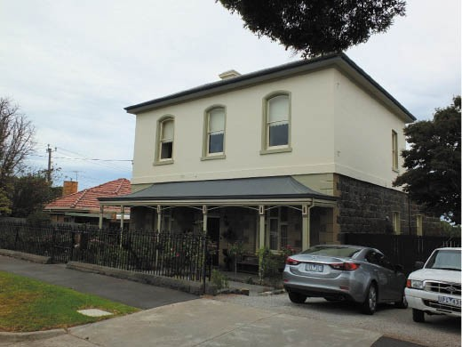
Figure 5.16: ‘Lismore’, Kilgour Street, Geelong, 2016. Source: David Rowe.

office building fronting Latrobe Terrace154 (Figure 5.17).
Following William Collins’ death in 1890, the Union Mill was carried on by his sons. In September 1913, a registered company was formed: Collins Bros., the first directors being Messrs. Marcus E. Collins and Basil Noel Marcus Collins.155 In 1927-28, Collins Bros. acquired the Marnockvale Wool Scouring Works in Bridge Road and converted the site into a woollen mill known as Union Mill No.2.156 There, as at
Union Mill No.1 on the Barwon River, Collins Bros. continued to manufacture flannels and blankets and in particular, the proprietary brand, Physician (Figure 5.18), which became ‘well and favourably known throughout Australia.’157 In 1938, Collins Bros. commissioned Laird and Buchan architects to design two storey Modernist additions.158 Only the former Collins Bros. office and outbuildings survive today, the Union Mill fronting the Barwon River having been demolished.

FEDERAL WOOLLEN MILL, NORTH GEELONG
In 1910, the fledgling Commonwealth Government planned a system of factories to ensure that Australia was self-sufficient in essential military equipment.159 Instrumental in influencing the Government to establish a woollen mill for the production of military uniforms was local woollen magnate, Godfrey Hirst (see earlier subsection). In March 1912, the newly- appointed Commonwealth textile adviser, James Smail, visited Geelong to inspect sites suggested by a local committee, there being two sites at Breakwater, one at North Geelong and another near the old Austral Paper Mill at Newtown.160 A site near Corio Bay at North Geelong was granted by the Geelong Harbor Trust Commissioners and the mill complex was designed by the Chief Commonwealth Architect, John Smith Murdoch with technical input from James Smail.161 Unlike the multi-storey mills of the 19th century on the Barwon River,

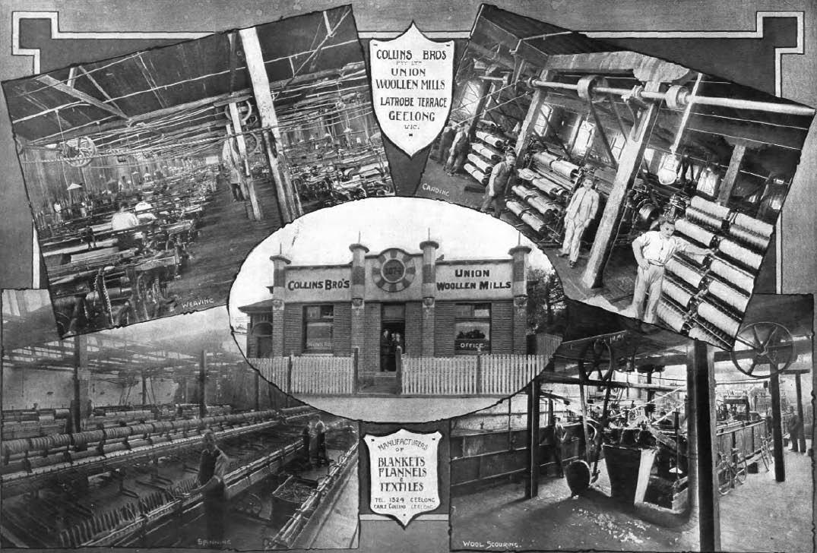
Figure 5.17: Collins Bros.’ Union Woollen Mills Office, c.1918. Source: Geelong for Business, Health, Pleasure, p.8.

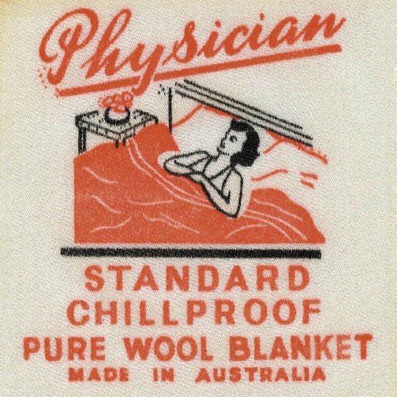
Figure 5.18: ‘Physician blanket cover, Collins Bros.’ Union Mills, n.d. Source: National Wool Museum, Geelong, object 999.
the Federal Mill was a well-ventilated, largely single storey complex of brick and iron buildings with concrete footings, a power house served with steam turbine engines,162 the landmark being the brick chimney. They formed a small settlement with a main central thoroughfare. In 1914, the
Geelong Advertiser reported on the plant that had been built:
The plant so far assembled consists of carding and spinning machines, which will be needed first to spin yarn for the 72 looms which will give the establishment a big weaving capacity. The factory will manufacture the whole of its yarn, and in this regard will be different from most of the Australian private plants, which invariably import. About 250 to 300 hands will be employed when the industry is in full swing 163
On 21 December 1915, the Commonwealth Mills was officially opened by the Governor-General, in the presence of 200 distinguished guests including members of the Federal Ministry, members of both houses of the Federal Parliament, State Parliamentarians, representatives of the woollen industry throughout the country, and local council mayors, councilors and town clerks.164 A detailed description of the

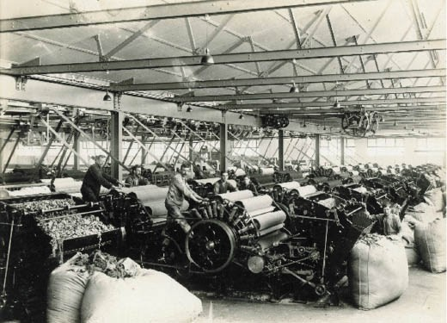
Figure 5.19: Carding Room, Commonwealth Woollen Mills, c.1918-
20. Source: Murgatroyd collection, National Wool Museum, object 6764.
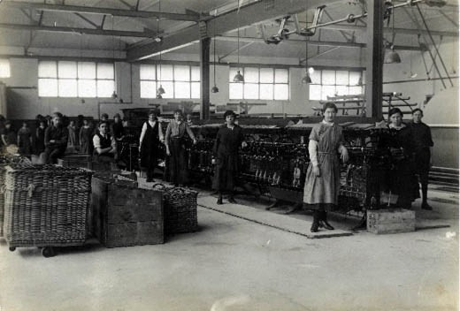
Figure 5.20: Spinning Department, Commonwealth Woollen Mills, 1918. Source: Murgatroyd collection, National Wool Museum, object 6775.

newly-opened complex (Figures 5.19-20) was given at this time:
The buildings are in brick, and include wool, scouring, dyeing, teasing, combing, card and spinning, weaving and finishing rooms. There are ten sets of woollen cards and two sets of worsted cards with all the requisite machinery: the 72 looms are the most up-to-date obtainable, and
have special automatic attachments and changing shuttle motion. In general design and equipment, the factory is stated to be one of the finest of its kind in the world. The capacity is equal to 400,000 yards per annum, and over 250 people are employed. All told the cost
runs into £156,000. Every department of the mills was closely inspected yesterday. The raw material was seen undergoing the scouring, teasing, combing and other processes till it became the finished article – khaki, which

will be used in clothing the Australian troops at the front. A large quantity has already been manufactured, but it will be turned out at a much greater rate when the mills are
in full swing. In the finish room piles of stuff are waiting to be made up into overcoats, trousers and coats, and all the material is of excellent quality. That for the overcoats is absolutely waterproof.165
The inaugural manager of the Federal Mill was James Smail (1871-1946). Born in Selkirk, Selkirkshire, Scotland, Smail became a tweed designer166 and after extensive experienced in the woollen manufacturing industry in Scotland, Smail was brought to Australia by the Commonwealth Government in 1912 to select a site for a Commonwealth Mill and to manage it.167 During World War One until 1918 he was also textile adviser to the Commonwealth Government.168 In February 1920, Smail resigned as manager of the Commonwealth
Mills at North Geelong to take up a management position with Messrs. Vicars Worsted and Woollen organization
in Sydney.169 He later transferred to the Sunnyside Mill of the Ballarat Woollen and Worsted Co. Ltd before taking up the management of the Myer Woollen Mill, Ballarat.170 In 1939, he was adviser on textiles to the Commonwealth Department of Supply of Shipping during World War Two until his health
prevented him continuing in the role. A former president of the Ballarat Rotary Club and member of the council of the Ballarat School of Mines, he died in Ballarat in 1946.171
Following the conclusion of World War One in 1918, the factory commenced the manufacture of cloth for other defence purposes, and from 1919 the supply of tweed for the civilian trade.172 In 1923, the Commonwealth Mills was considered surplus to the Government s needs and it was sold to a private consortium led by James Dyer, a merchant from Flinders Lane, Melbourne; and Senator James Guthrie, manager
of Dalgety and Company, Geelong (who gained two years’ experience working in woollen mills at Bradford and elsewhere in England).173 Other directors were, Julius Solomon, local draper; Robert Vincent, pastoralist and businessman;174 Sidney Evan Price, manufacturer (son of John Evan
Price, wholesale and retail grocer - see later subsection), James Robertson, manager of the Commonwealth Mill;175 and William Stawell, solicitor of Malleson, Stewart, Stawell, and Nankivell.176 The name of the factory was changed to Federal Mills at this time (Figure 5.21) and it prospered until the 1970s when it was owned and known as Classweave Industries.177
In recent years, the Federal Mill has been transformed into Federal Mills Park, a regional tech hub that supports a range of innovative and collaborative businesses.178
The transformation celebrated the heritage fabric of the former woollen mill (Figures 5.22-23).

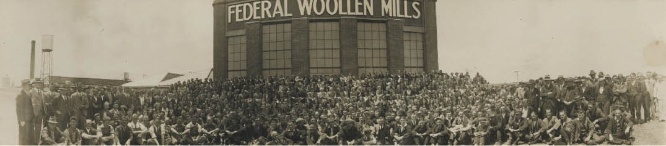
Figure 5.21: Federal Woollen Mills and staff, North Geelong, 1933. Source: GRS 2009/01698, Geelong Heritage Centre collection.
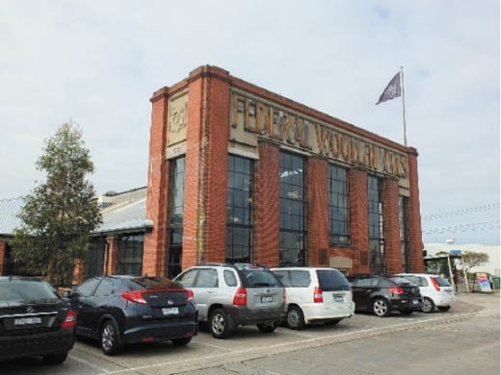
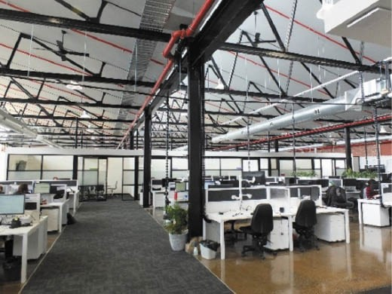

Figure 5.22: Exterior, former Federal Woollen Mills, 2015. Source: David Rowe.
Figure 5.23: Former Federal Woollen Mills interior adapted into an office, 2015. Source: David Rowe.

VALLEY WORSTED MILLS, SOUTH GEELONG
In 1921, 16 acres of Crown Land previously set aside as a police reserve were purchased by Seymour Church, merchant of Flinders Lane, Melbourne.179 With his brother, Hereward Church, they discreetly established the Valley Worsted
Mills Pty. Ltd. company on behalf of the woollen magnate of Bradford, Yorkshire, William Gaunt.180 He had made his
fortune by procuring government contracts during the war and at war’s end he invested in wool growing in Africa, theatres
in the United Kingdom, numerous businesses in the United States, and textile mills in Australia.181 Secrecy shrouded the proposed mill business in the ensuing months and years so much so that it was described as the mystery mill. 182 Public interest in the venture was heightened in early June 1923 when E.H. Bucknole, recently-arrived ‘resident architect’
for the Valley Worsted Mills Pty Ltd, called tenders ‘for the erection of the Block “B,”, which includes a Wool Warehouse, Woolwashing Shed, Noble Combing Shed, Cellar, Soap Store, Lavatories, etc. etc.,’ as part of a factory in Swanston Street, South Geelong.183 The first buildings of a complex built between 1922 and 1927, the early portion of the factory was almost complete in May 1924 when a large number
of representatives of the woollen manufacturing and wool scouring industries, wool broking firms and parliamentary representatives, and the Council of the Gordon Institute and Technology held a gathering to officially welcome Arthur Wilby, recently-arrived manager from England of the Valley Worsted Mill.184 Wilby declared that the aim of the factory was ‘to endeavor to produce material excellent in quality, yet not so expensive as imported goods.’185 With 750 employees
proposed, by March 1925 there were 150 hands working at the mill, a third being British employees.186
A leading initiative at the Valley Worsted Mill, based on British precedents, was the consideration in the welfare
of its staff. This was outlined in the Geelong Advertiser
in 1925:
The social welfare movement, which is bridging the gap between employer and employees to a certain extent
in English industrial establishments has borne fruit and created such a feeling of mutuality that its correlative value is almost essential to promote success in large manufacturing undertakings. During the past fortnight a canteen has been established at the Valley Mills, and the

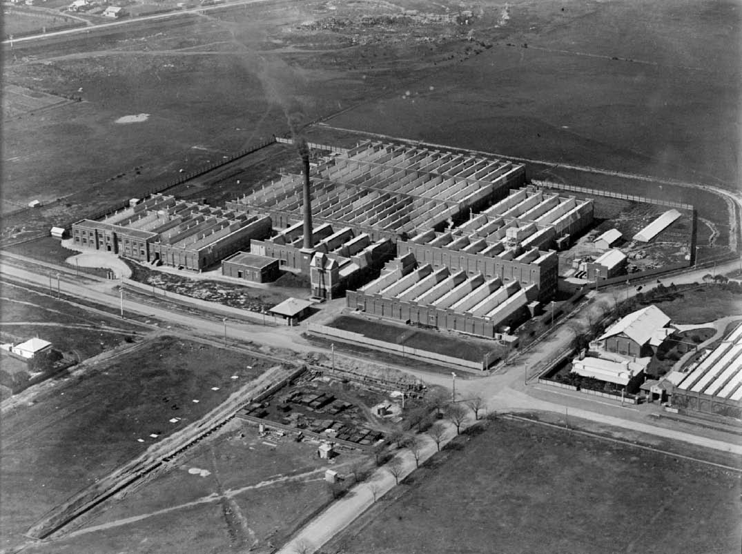

Figure 5.24: C. Pratt, Aerial of the Valley Worsted Mill, 27 September 1927. Source: accession H91.160/1499, State Library of Victoria.

employees now enjoy a three course hot dinner and cup of tea for the sum of 9d or a cup of tea and a scone for 2d. So that the employees can be refreshed by hot stimulants during their working hours, they are permitted to leave their work for ten minutes to have morning and afternoon tea at a minimum expense.
The management intend also to provide facilities for recreation among the workers by purchasing sporting material. Already a cricket club has been formed and use has been made of the 15 acres of land in close proximity to the mills. The girls held a meeting during the week, and have decided to form three basket ball teams to enter the local competitions. It is also proposed to form self- improvement clubs in choral and elocutionary work so as to improve the mental as well as the physical condition of employees.187
After its completion, Valley Worsted Mill (Figure 5.24) was claimed to be ‘the largest mills of their kind in the southern hemisphere. 188
The Mill’s first manager, Arthur Wilby (1881-1946), had been appointed to head the Valley Worsted Mill operations given his experience at Bradford in England and Galashiels in Scotland. Known for his retiring nature, he was well known and respected for his ‘high capabilities’ and expansion of the woollen industry.189 On his resignation in 1931, he was
entertained at a complimentary dinner organised by members of staff.190 After retiring to Melbourne, Wilby took up the managerial position of the Gippsland Woollen Mills in 1935 before relocating
to Lithgow, N.S.W. in 1940 to manage the Bowenfels Woollen Mills.191

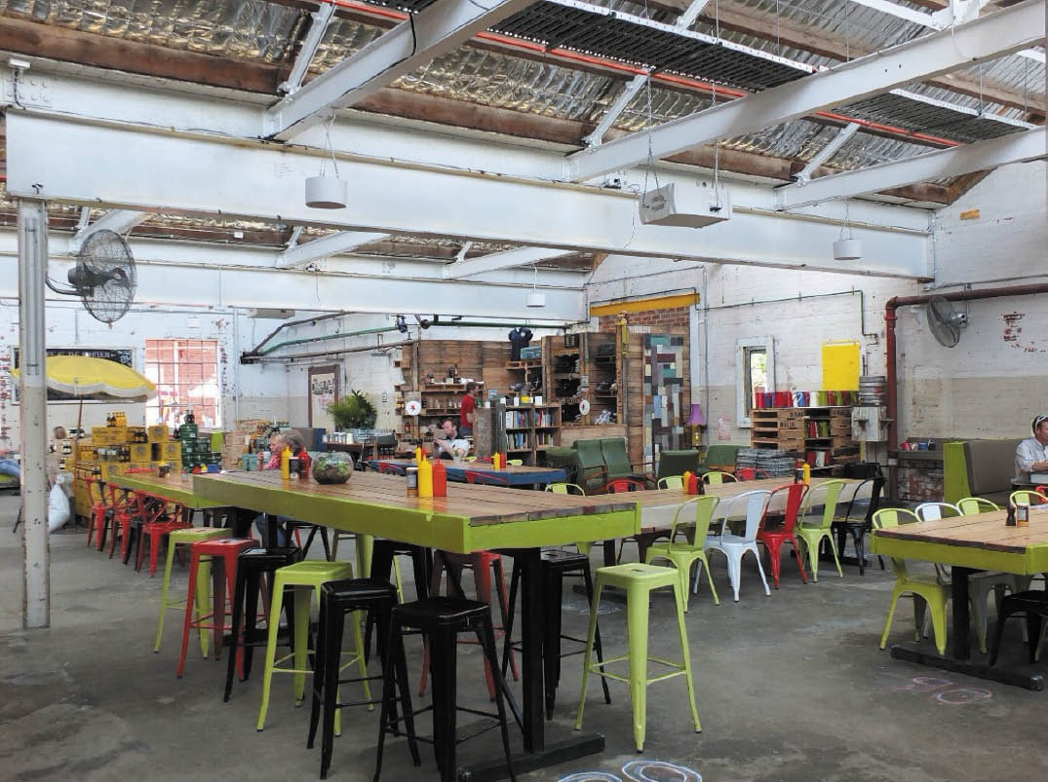

Figure 5.25: Little Creatures Brewery (former Valley Worsted Mill) interior, 2014. Source: David Rowe.

The Valley Worsted Mill passed out of English ownership in 1937, with the earlier private company being converted into a public company under the same name.192 In 1973, the name of the mill was changed to John Foster Valley Ltd. It closed in 1986 and was taken over by Godfrey Hirst Ltd.193 Woollen mill operations ceased at the site in the early 21st century.
In recent years, several of the old woollen mill buildings have been cleverly adapted into boutique breweries for Little Creatures (Figure 5.25) and White Rabbit.

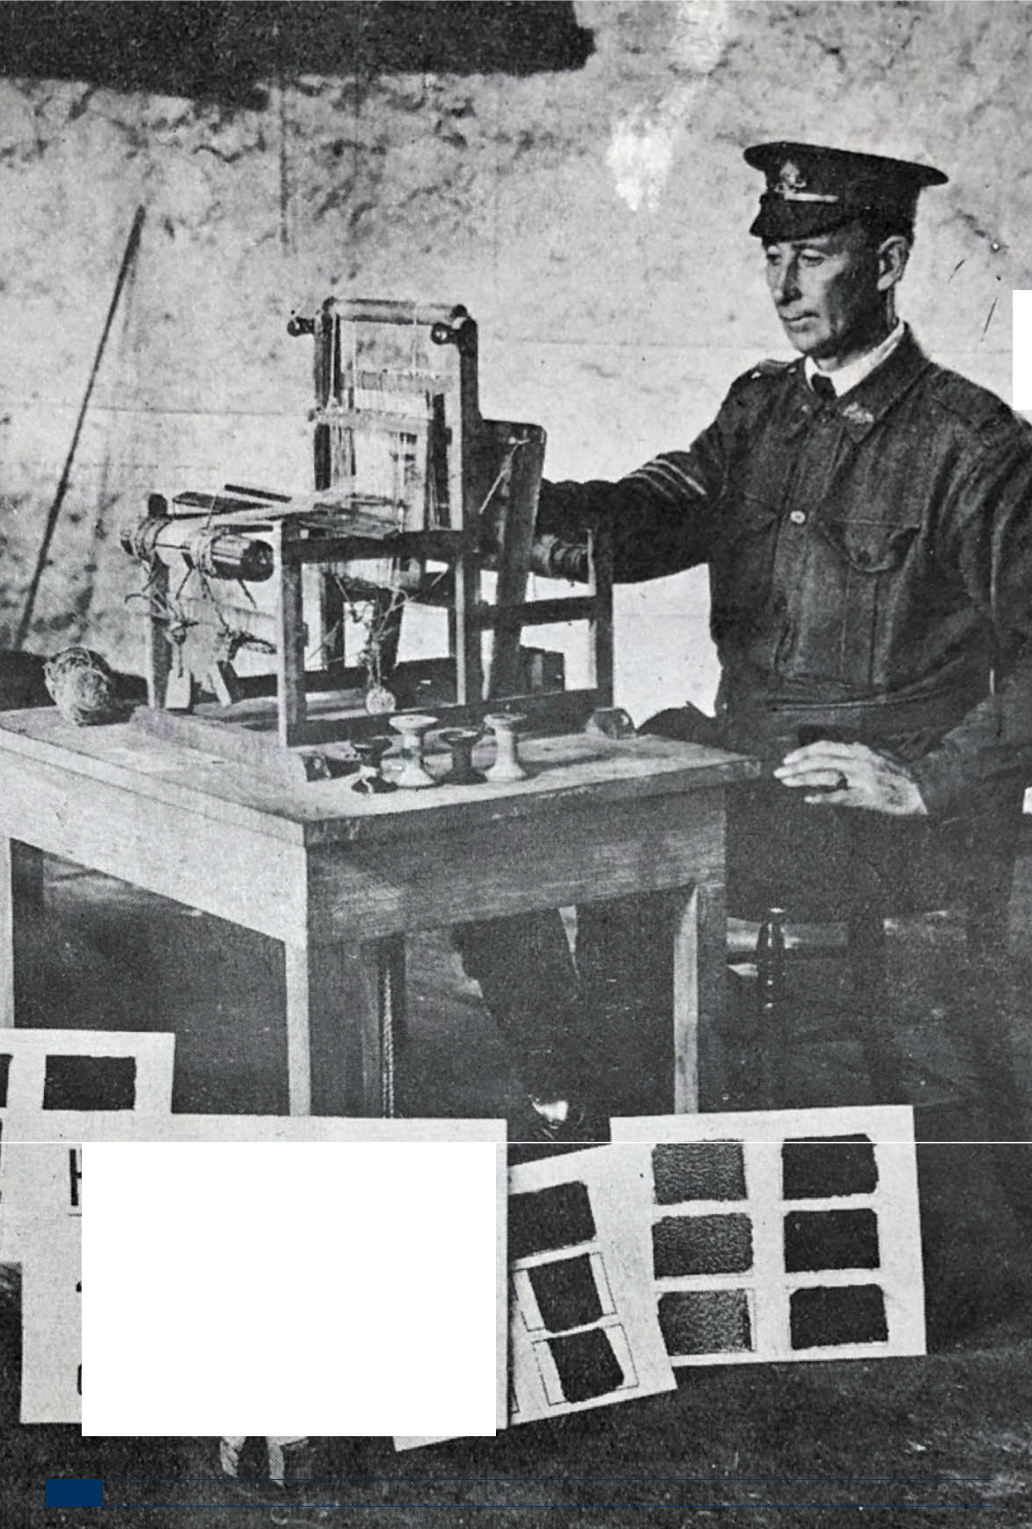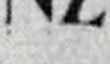Figure 5.26: Returned soldier, Gordon College working a hand loom at the Gordon College, 1917. Source: News of the Week
GRS 2121/4, Geelong Heritage Centre collection.

.
I

- HAND-WOVEN TWEEDS.
,\.\JI. I y
" Z C," ldicr
GORDON COLLEGE. GEELONG.

509

RETURNED SOLDIERS’ AND SAILORS’ WOOLLEN MILL, NEWTOWN
In 1916, the State War Council petitioned the Gordon Technical College to consider the introduction of textile classes for returned soldiers. Major Sinclair of the Textile Advisory Committee subsequently devised a scheme that provided for returned soldiers who may have lost a leg
‘to be trained to work hand looms in their homes.’194 Sinclair designed model looms and by January 1917, returned soldiers were working hand looms195 (Figure 5.26).
Major Sinclair s scheme formed a basis in 1920 for the establishment of a woollen mill in Geelong to be run by, and in the interests of, returned soldiers following the
formation of a company under the government of the Geelong branch of the Returned Sailors and Soldiers Imperial
League Association.196 Brigadier-General Robert Smith was appointed the inaugural chairman of directors and a prospectus was soon prepared, with Messrs. Fairnie and Lake appointed to manage the 5000 shares at £20 each.197
By April 1920, a site had been acquired ‘in Fyans-street, at the southern end of Pakington-street where there was ‘an excellent river frontage.’198 The Geelong Advertiser further reported:
The 13 acres will probably be too big for requirements, and the erection of workmen’s homes will be considered. This will take the form of a model suburb on much the same lines as adopted at Messrs. Cadbury’s work at Bourneville, in England.199
In December 1921, the local architects, Laird and Buchan, in conjunction with Fred Purnell called tenders for the
construction of the mill that was to cost £20,000 to build and
£70,000 for the machinery from England.200 In February 1922, in the presence of the Prime Minister, the Hon. W.M. Hughes, Federal and State Parliamentarians, representatives of the local councils, and directors and officials of the Returned Sailors and Soldiers Co-operative Company, the foundation stone for the mill complex was laid.201
A single storey, brick, saw-toothed roofed building complex with brick chimney stack, the first piece of blue twill woven at the mills was in January 1923202. It was divided amongst the directors and shareholders the Returned Sailors and Soldiers Co-operative. The expected production from the mill was 350,000 yards per year, the product to have a heavy weight of 72 threads to the square inch to meet the market for winter wear.203 By 1924, the mill employed 170 hands, and in this same year the first display of the mill’s products
were available for viewing at Thear and Sons furniture shop in Ryrie Street.204 According to the Geelong Advertiser:
The exhibit comprises worsteds in fanciful designs, woolens of various weaves, and travelling rugs of beautiful designs. the display has been arranged for the boosting of local products. Geelong people hardly realise that here the finest material in Australia is manufactured. A very high opinion regarding this
material is said to be held by Sir William Vicars, of Sydney, and Professor Barker, textile expert from the Adelaide University, the latter remarking that he was agreeably surprised to see the remarkably fine finish this mill was obtaining with its goods.205
In 1925, extensions were built to provide accommodation for an addition 20 looms imported from England.206 Further expansion occurred in 1926, when Laird and Buchan
architects designed additions on the western side.207 In 1927, extensions were carried out ‘on the Pakington Street side’, involving new scouring operations.208 In 1929, administrative offices were constructed, along with the installation of new plant (Figure 5.27). As reported in the Geelong Advertiser
in December 1928:
Approximately £11,000 is being expended upon additions, new plant, and new offices at the Returned Soldiers’ Mill. An addition to the wool scouring section has just been completed, and the plant is now being installed therein.
In order to provide more room for development, the office staff is to be accommodated away from the main
building in offices to be erected at the corner of Pakington Street and Rutland Street. These will be in brick, and are expected to be completed in February.209
The new offices were officially opened in 1929, the occasion being marked by the unveiling of ‘The Spirit of Anzac’ statue in an arched niche at the Mill corner, above the foundation stone210 (Figure 5.28). The memorial statue was the work of Wallace Anderson who designed it in 1928 for the Australian War Memorial in Canberra.211 Anderson had also designed Simpson and the Donkey situated adjacent to the Shrine of Remembrance, Melbourne.212 The statue was later relocated to the opposite corner of the mill complex and placed above a boulder.213
The ongoing success of the mill operations were to be partly thwarted in 1930 when the scouring and dyeing departments were destroyed by fire, causing £15,000 worth of damage.214
It was rebuilt in mid-1930. Further extensions were planned in mid-1934 and subsequently constructed.215 The neighbouring riverside property on the east side of Pakington Street, Sladen House, was purchased by the Co-operative in 1940.216 The masonry dwelling was dismantled and reconstructed to its original design and used as an amenities centre for mill employees.217

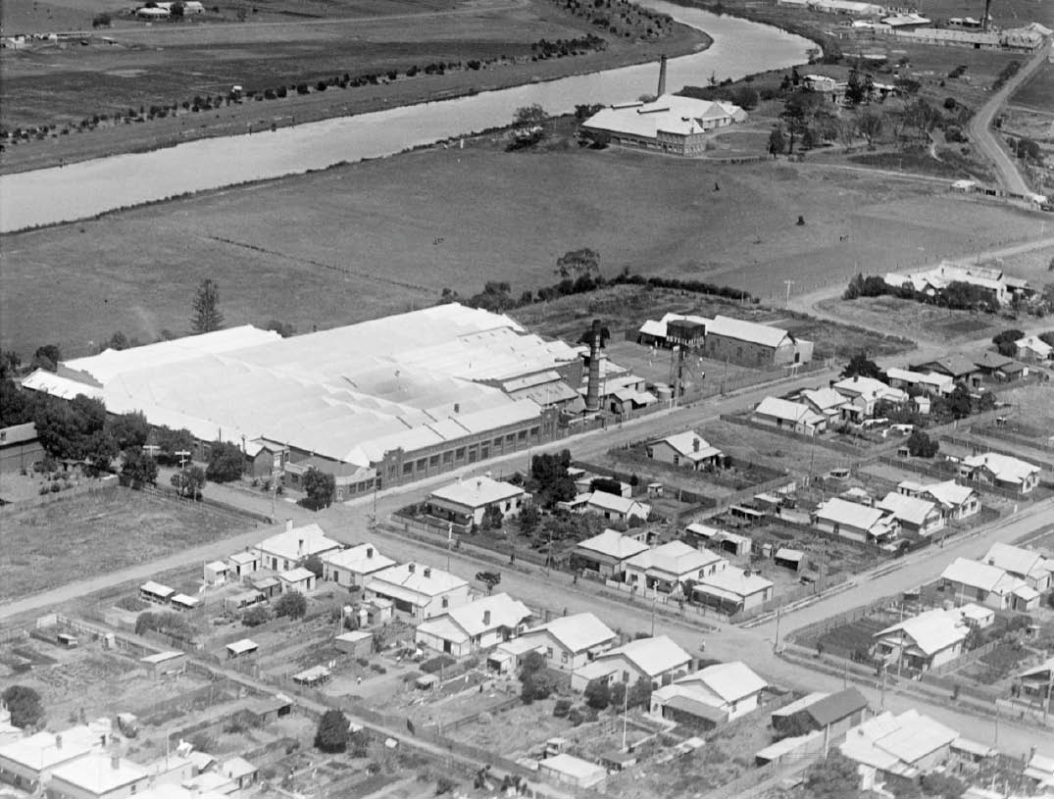

Figure 5.27: C. Pratt, Aerial of the Returned Soldiers’ & Sailors’ Mill, c.1929. Source: accession H91.160/987, State Library of Victoria.

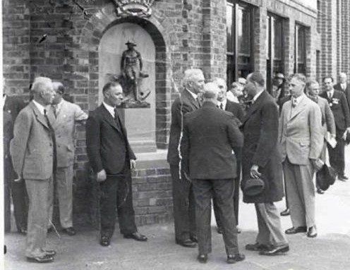
Figure 5.28: Unveiling of the Spirit of Anzac Statue in the corner niche of the new Mill offices, 1929. Source: National Wool Museum, object 1524.
The inaugural and long-serving manager of the Returned Sailors and Soldiers Mill was Albert Schofield (1891-1969).218 The son of John Schofield, an esteemed factory hand at the Barwon Woollen Mill in the 1870s and early 1880s,219 Albert Schofield was born in Geelong and educated at Swanston Street State School.220 Prior to his commencement as manager of the Returned Sailors and Soldiers Mill in 1921, he had worked at the Albion Woollen Mills.221 Soon after his appointment, Schofield travelled to England to purchase machinery for the new factory.222 In 1927, he was appointed Managing Director.223 Schofield’s contribution to the Returned Sailors and Soldiers Mill, and more broadly to the textile industry in Australia, was substantial. He was held in high esteem by the Australian and Victorian Associations of the Wool Textile Manufacturers, serving as president of the Australian Association in 1932-33.224 During World War Two, Schofield was Assistant Controller of Woollen and Worsted Textiles for the Commonwealth.225 At the Returned Sailors

and Soldiers Mill, he specialised in the manufacture of fabrics for women.226 In 1953, Schofield was awarded the Coronation Medal for services rendered in World War Two and in 1959 he was bestowed an MBE for his outstanding contributions to the Australian textile industry.227 Schofield died in 1969 while still managing director, after 48 years service.228

FLOUR MILLS
Given the high proportion of grain grown in the Greater Geelong area from the beginning of European colonisation and particularly from the 1850s (see Theme 4), a contextually notable number of flour mills were established to meet
the demand for turning grain into flour (see Appendix 5.1). Geelong was climatically and geographically well-suited for the growing of English wheat varieties, allowing the flour mills to provide product in excess of local requirements. This excess heralded another lucrative market: exportation to the rapidly growing population in Melbourne.229 The first steam flour mill was proposed by William Henry Collins of Tasmania in 1844, the Geelong Advertiser lamenting the lack of such an enterprise in Geelong at that time:
The disadvantages against which the agriculturists of this district have had to contend, in addition to the
depressed state of the markets, have been such as have materially tended to limit their operations and enterprise.
It is therefore with great pleasure we congratulate them upon the prospect of the removal of the most grievous of these drawbacks – the want of a flour mill – which rendered it necessary that the wheat should be
exported and reimported before it could even be sold for consumption in the Geelong market; so that the growers could not profitably compete with the agriculturists of the neighbouring colonies. Mr. Collins, of Van Diemen’s
Land has nearly completed his arrangements for erecting and bringing into operation before the end of the ensuing harvest, a steam mill, (the material of which is now ready for shipment from Van Diemen’s Land.) The mill will
be situated on one of South Geelong Suburbans, with
a frontage to the river, from which the supply of water will be obtained by a cutting leading to a cistern underneath the building. The establishment of the mill must lead to an immense increase of agricultural operations next year.230
Construction had commenced for Collin’s Mill (first known as the Chilwell Mill and later the Union Steam Flour Mill) by
February 1845231 and it was operational by the next harvest.232 The mill was situated on the north bank of the Barwon River at Chilwell, west of Latrobe Terrace (and later incorporated into the Albion Woollen Mill – see earlier subsection).
The completion of Collins’ mill in 1845 provided impetus for the establishment of several more flour mills in the ensuing years. In 1847, William Gray built his Bridge Mill on the

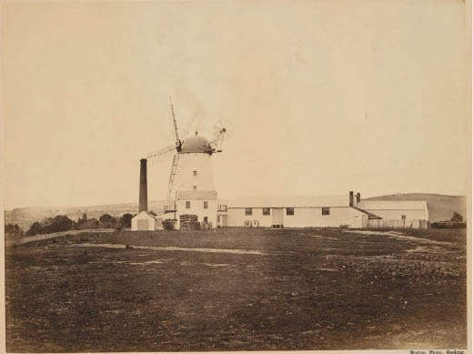
Figure 5.29: J. Norton, Riversdale Flour Mill, Chilwell, 1866. Source: accession H1240, State Library of Victoria.
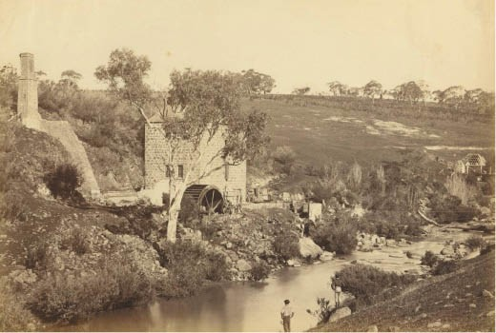
Figure 5.30: F. Kruger, James Hope’s Flour Mill on the Moorabool River, Batesford, c.1879. Source: accession PH241/1979, National Gallery of Victoria.

Barwon River near the south end of Moorabool Street (and the bridge), South Geelong.233 By 1856, there were 12 flour mills in operation: John Armstrong’s Connewarre Flour Mill (established in 1856); Bellerine Flour Mill Company’s Bellerine Flour Mill, Drysdale (established 1853, opened 1854); Messrs. Barthold, Miller and Low’s Mill, Fyansford (established 1855); Geelong South Mill (establishment unknown); William Gray’s Corio Mill, Gheringhap Street, ‘North’ Geelong (established 1851); John Highett’s Barrabool Mill, Highton (established 1851); Thomas Biscoby’s Lincoln Mill, Moolap (established 1854); J.L. Mackenzie’s Mill, Victoria Terrace (Eastern Beach Road), Geelong (c.1855); Messrs. Portarlington Flour Mill Company’s Portarlington Mill (established 1855, operational 1857); T.C. Riddle’s Riversdale Wind & Steam Mill, Chilwell (established 1856) (Figure 5.29); Gray and Robinson s Shannon Mill, Barwon Terrace, South Geelong (established

in 1854, operational 1855) and W.H. Collins’ Union Steam Flour Mill, South Geelong (established 1845).234 Two others were built in the following years: W.H. Bowden’s Belmont Flour Mill, Mt Colite [Barwon Heads] Road, Belmont (1858)235 and James Hope’s Flour Mill on the Moorabool River
at ‘Lynnburn’, Batesford (1859)236 (Figure 5.30).
By 1905, only one flour milling business was listed in Sands and McDougall s Directory of Victoria for the Geelong area, it being Harvey, Dann and Company’s establishment in Gheringhap Street.237 No mills were listed in 1925 although in 1944-45 the Barwon Flour Mill was in operation.238 Two milling businesses were listed in the directory in 1960: Co- Dair Products (Geelong) Ltd, 48 Mercer Street; and Geelong Co-op Dairying Association Ltd., 40 Little Malop Street.239 The heady days of flour milling in the Greater Geelong area had come to an end. Today, physical evidence of the historic flour mills is only known to exist for the ruins of former Barrabool Mill at Highton, and in the mill and manager’s dwellings at Portarlington.

FORMER BARRABOOL MILL, HIGHTON
In 1851, the local architectural firm of Sheridan and Wright called tenders for the ‘quarrying of all the bluestone for the erection of a five-storey stone mill to be erected near Geelong for J. Highett, Esq.’240 Situated above the Barwon River
in the location of the weir below Buckleys Falls that had been created before 1849.241 Upon completion, Frederick C. Morris was appointed manager. Powered by a water wheel, a flood in 1852 caused substantial damage, the mill requiring
rebuilding which took place in 1854 as outlined in the Geelong Advertiser and Intelligencer:
A new flour mill is in the course of erection by Mr Highett, at the Buckley Falls, Barwon River, and Mr Buchan, of the firm of Chapman & Buchan, is the contractor for
the greater portion of the work. The mill consists of bluestone; the walls are one yard thick, and the building is 100 feet long by 40 feet wide, and five stories high at the lower end. There are at present upwards of twenty men employed upon it, and it will be finished in about three weeks, and when completed will be a very handsome and substantial affair.242
By 1860, Highett had leased the mill (then known as the Barwon Water Mill) to D.W. Petrie who declared that ‘the greatest care will be taken in the selection of good samples of wheat’ and that ‘no expense shall be spared in maintaining the high character of the flour from the mill.’243 Petrie was agent for John Highett and in 1863 he advertised the lease of the mill ‘with or without the paddocks containing about 140 acres. 244

John Highett (1810-1867) was born at Weymouth, Dorset, England and with his brother, William Highett (for whom the Melbourne suburb of Highett was named), he emigrated
to Tasmania in 1830.245 There, the Highett brothers took up 202 hectares of land at George Town.246 This was the beginning of number of land acquisitions in Tasmania that
were managed by John while William took up an accounting position with the new Land Bank at Launceston.247 In 1837, John Highett began his pastoral interests in Victoria, taking up Mount Hesse station with his cousin, William Harding.248 Ten years later in 1847-49, Highett acquired land in the Parish of Barrabool, and in 1850-51 he built a substantial Barrabool stone residence overlooking the Barwon River which was named ‘Highton’ (see Themes 4 & 6). It was also in 1850 when Highett established the ‘new village’ of ‘Highetton’ (later Highton) (see Theme 6).249 He died in 1867.250
Highett’s death brought about the demise of milling at the Barwon Water Mill. Two years later in 1869, the
Geelong Advertiser bemoaned that ‘the flour mill here is still in status quo’ and that efforts to start a company to work it had failed.251 The mill remained idle throughout the 1870s, notwithstanding attempts by John Highett’s son, John M. Highett, to dispose of it at auction.252
In 1887, Highett’s Barwon Water Mill was sold to the
Price brothers, John Evan and Alfred David, local merchants and grocers.253 They established a starch manufactory there under the name of the Fyansford Manufacturing Company254 (Figure 5.31). It was placed in telephonic communication with the firm’s retail establishments in Geelong and the borough of Geelong West. 255 The Price brothers proposed to manufacture starch from rice, and in October 1889 they exhibited ‘a pyramid of packets containing starch made
at Fyansford [Highton] from the test rice.’256 The starch ‘was pronounced by experts to be of the finest quality, equal to anything manufactured and cheaper.’257 The proprietary brand given the product was ‘Snowflake Crystal Starch 258 using rice imported from Singapore.259 The Price brother’s inventiveness extended beyond the starch to
the transportation of goods by the installation of an aerial tramway. It consisted of a wire and cage that was used between two platforms on either side of the river.260
In 1897, the business partnership under the name of J. and A. Price, and Fyansford Manufacturing Company was dissolved. The business at Fyansford was carried on by John Evan Price and his two sons, Sidney Price and Herbert Price under the name of the Fyansford Manufacturing Company.261 In 1900, the County Court found against J.E. and A.D. Price in an interpleader case brought on by the Commercial Bank.262 The pressure from creditors and the depreciation in the value of real estate, had brought about the insolvency of John Evan

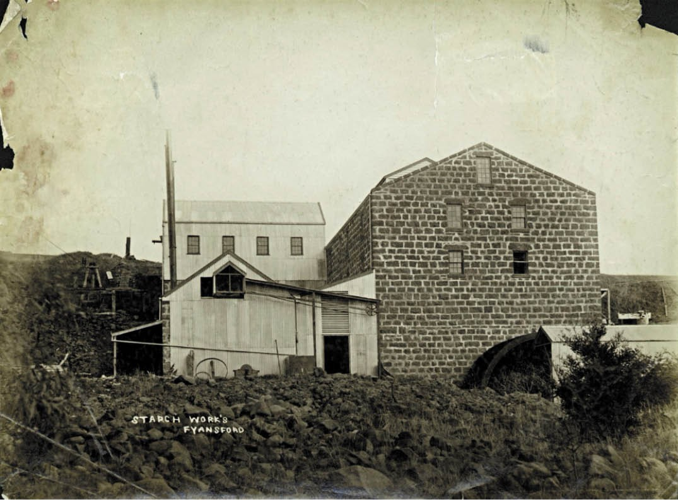
Figure 5.31: Starch Works, Fyansford Manufacturing Company, c.1887-1904. Source: accession H13265, State Library of Victoria.

Price.263 The stress caused by this events might have brought on John Evan Price s death at his mother s residence,
‘Neath Villa’, 313 Shannon Avenue, Newtown, in October 1900 at the age of 50 years.264
John Evan Price (1850-1900) and Alfred David Price (1856- 1928) were the sons of Evan and Elizabeth (nee Jones) Price of Liverpool, England, where Evan was a warehouseman and where Elizabeth had worked as a book keeper.265 They subsequently emigrated to Columbus, Ohio, U.S.A., where John Evan and Alfred David were born.266 With their parents and sister, John Evan and Alfred David emigrated to Victoria, arriving on 21 February 1859.267 Evan Price tried his luck on the Ballarat diggings while Elizabeth Price, using her book keeping skills, established a grocery store. The business was soon built up by Evan, the grocery store for much of
his business career being at the corner of Lyons and Eyre Streets.268 In 1871, Evan Price assisted John Evan Price to establish a business as a grocer and wine and spirit merchant
at Stawell.269 After the dissolution of the partnership in
1874 between Evan Price senior, Evan Price junior and John Price,270 Alfred David Price went into partnership with his brother under the company name J. and A. Price.271 The Price brothers expanded the business with branches at Murtoa, Jung Jung and Horsham.272 They were large operators in wheat, having representatives at almost every rail station in the Wimmera, and were the largest shippers in the colony. 273 In 1880, J. and A. Price were appointed sole agents for
W. and A. Gilbey, London, and they opened a business in Melbourne.274
In 1884, J. and A. Price opened a store in Geelong in a one-roomed shop on the ground floor of the iron-clad
‘York House’, north-west corner of Malop and Kardinia Streets (now demolished) (Figure 5.32).275 The building was owned by James Noble of Connewarre.276 Robert Munro was appointed manager of the Geelong store, and a domestic staff member of A.D. Price’s lived upstairs.277 This was a time of

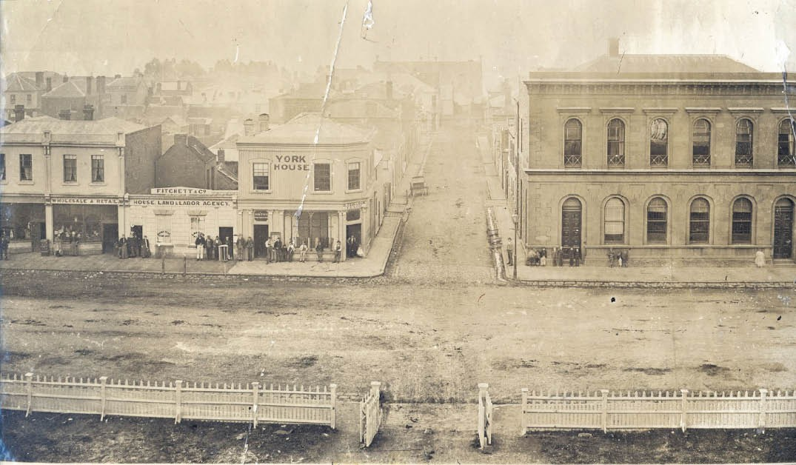
Figure 5.32: Malop Street from the Market Square Clock, c.1868-75, showing ‘York House’ (centre) of corrugated iron construction, the first building occupied by the Price brothers. To the far left was the second building they were to occupy. Also note the Bank of N.S.W. on the right (see later subsection). Source: GRS 2009/1321, Geelong Heritage Centre collection.

rapid expansion for the company as it was also in 1884 when the Price brothers took over the former premises of T. Watson at 137 Swanston Street, Melbourne, as their headquarters.278 John Evan Price initially stayed on in Stawell as in 1885 he was addressed at this location (and Alfred David at Geelong) when the business registered its Elephant Brand trade mark for cornsacks, bran bags and gunny bags.279 Disaster struck in December 1886 when a fire destroyed the store’s contents: bottled liquor, biscuits and general groceries.280 In 1889, the
J. and A. Price firm relocated few doors further west 69 Malop Street, and to a commodious 20 roomed two storey brick shop with offices and stores also owned by Noble (Figure 5.32).281 The firm had continuous occupation of these premises
until 1900.282 In addition in 1884-85, the firm established a grocery store in Pakington Street, Geelong West (north of Aberdeen Street).283 By 1891, it was operated by Henry Price,
J.E. Price s son.284 It appears to have closed by 1900.285
In 1897, the Starch Factory at Highton was continued by John Evan Price and his sons, Sidney Evan Price (1874-1945)
and Herbert Price (1875-1949) under the name of Fyansford Manufacturing Company until the financial collapse of J.E. Price286. Following his insolvency and untimely death in 1900, the Fyansford Manufacturing Company, and the production of starch, was continued on under the partnership of Sidney and
Herbert Price, with their mother, Elizabeth Price, and siblings also contributing.287 They expanded operations into jam and sauce making. Mrs Elizabeth Price took charge of the female employees at the factory, while the 25 acre orchard was tended by Henry Price. Herbert was responsible for making tomato sauce.288 In 1902, the company exhibited an array of jams, jellies, preserves and starch at the Geelong Show and was credited as being one of the most attractive displays. 289 In 1903, seven tons of apricot pulp was exported to London.290 Yet, the factory ran into financial trouble and the Highton premises were sold at a mortgagee s sale in 1904.291 All that remains of the factory today are ruins.
The Fyansford Manufactory Company relocated to a two storey brick, stone and iron store in Moorabool Street owned by the London Bank of Australia and south of Dennys Lascelles Wool store.292 The business continued there until it was sold in 1908 to the Geelong and Western District Preserving Company (established in 1908 along the co-operative system).293 Sidney Price was appointed one of the managers of the new company294 whose factory was built at the north-west corner of Western Beach Road and Cunningham Street, Geelong, near the waterfront.295

PORTARLINGTON (LATER PAIGNTON) FLOUR MILL
On 1 August 1856, the Portarlington Flour Mill Company was formed, the inaugural chairman being John Henderson with
A.W. Bailey as secretary.296 Other directors in the company were E. Huxtable, T. Savage, J. Birkett and G. Stewart
with J.D. Oliver as miller (he had previously managed the Bellerine Flour Mill at Drysdale).297 Andrew McWilliams was commissioned to design a four storey stone mill298 (Figure 5.33). A brick manager’s dwelling and five weatherboard worker’s cottages were also constructed.299 In August 1856, an advertisement was made for ‘an engine of not less than sixteen-horse power, Four Pairs French
Burr-Stones, patent Dressing and Smutting Machines, and all gear complete. 300 The mill was in operation by April 1857.301
In December 1864, the Portarlington Flour Mill was offered for sale. The Argus gave a detailed description of the premises:
The mill is four stories high, built in the best manner of stone, solid and substantial flats both for wheat and flour, with massive upright supports; slate roof, 60 x 32; stone store, 23ft. 6in. x 32ft; engine-house, sheds of brick,
20-horse power high-pressure steam-engine, two large Cornish boilers (one recently cost £600), all necessary gear, four pairs splendid French burrs, dressing- machine; elevators; brick cottage residence, with five rooms, five modern-built weatherboard cottages, for the operative labourers, with slate roofs; ample stabling; private tramway and jetty, for loading and discharging; large excavated tank; all standing on five acres of
land. Promising wheat crop throughout Bellerine – no competition – improving township. Capable of turning out 50 to 60 tons flour weekly.302
The mill complex was sold to James Fry and Co. of Ballarat in December 1865.303 James Fry (1821-1903) was a farmer and flour miller from Cassington, Oxfordshire, England, who had emigrated to Geelong in 1854.304 He went to the goldfields and acquired property near Mount Blowhard where in 1856 he purchased a primitive flour-milling plant at Geelong and erected it on his property.305 This began his successful flour mill business that expanded across Victoria.306 Fry appointed Thomas Henry Widdicombe (1823-1907) as the manager
and miller at the Portarlington Mill. Widdicombe had been employed at Fry’s Ascot Mills at Mount Blowhard from 1857.307 At Portarlington in 1866, Widdicombe renamed the business the Paignton Flour Mill after his birthplace in England.308 By 1870, a downturn in flour milling brought to an end Fry’s business at Portarlington. Widdicombe remained and leased the site as his brickworks factory until he purchased it in
1871 (see Theme 4). Insolvency caused the sale of the mill property in 1873 and it was subsequently purchased by Samuel Allnut of ‘Glenholme’, East Bellarine.309 The flour

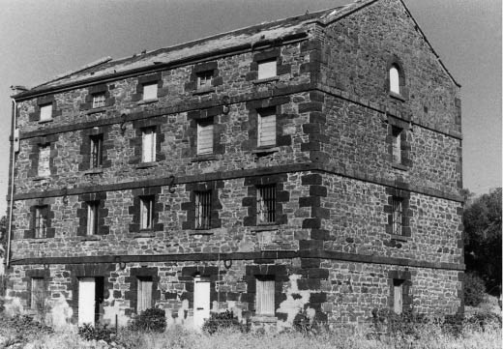
Figure 5.33: J.T. Collins, Former Portarlington Flour Mill, Portarlington, 22 December 1970. Source: accession H98.250/1796.

milling plant and machinery had been sold and so the mill was not to operate for its original purpose again. In 1884, Howard Smith and Sons purchased the mill site and commenced
the Portarlington Brick and Tile Works there.310 In 1901, Widdicombe acquired the mill property and he lived there until his death in 1907.311
Thomas Henry Widdicombe was born at Paignton, Devon in 1833, the son of Thomas Widdicombe, a farmer and labourer, and Anne Rendle.312 He emigrated to Victoria in 1854313
and went to the Ballarat goldfields where in July 1855 he advertised for a respectable mate for the diggings, with about
£20. 314 Widdicombe soon found employment with James Fry at his Ascot Flour Mills where he remained until he relocated to the Portarlington Mill in 1866. After working at his brick factory following the closure of the flour mill, Widdicombe returned to Ballarat in 1878 where he remained until 1890 when he had again returned to Portarlington (see Theme 4).

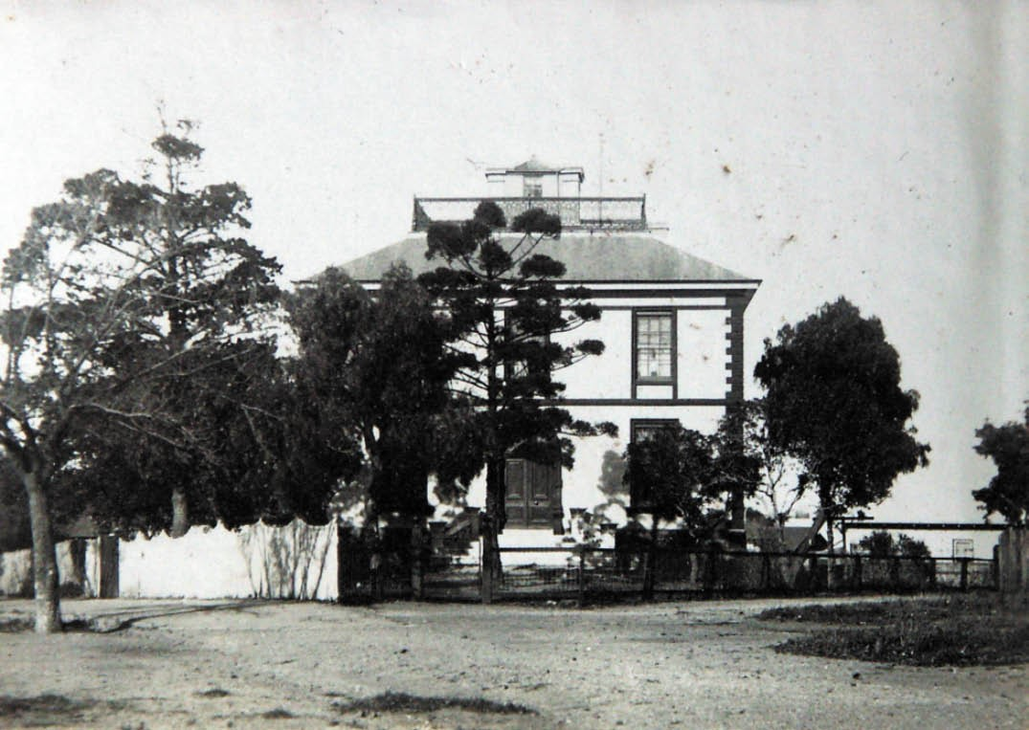
Figure 5.34: T.T. Holmes, ‘Fairfield Hall’, corner Myers Street & Bourke Crescent, c.1931 (now demolished). Source: Holmes collection, Authentic Heritage Services.

FOUNDRIES, BOILERMAKERS, AGRICULTURAL IMPLEMENT MAKERS
Critical to the development of Geelong was the local iron foundries, boilermakers, and agricultural implement makers who could manufacture the necessary building, agricultural, industrial, domestic and vehicle products. One of the earliest and most successful blacksmiths in Geelong was William Croll of Dundee, Scotland. He emigrated to Victoria with his wife and children in 1842,315 and by 1847, the Croll family had relocated to Geelong where William worked as foreman for H.
and R. Langlands and Co.316 In March 1848, Croll took over the business, advertising the following in the Geelong Advertiser:
W. Croll, respectfully informs the inhabitants of Geelong and neighbourhood that he has succeeded the Messrs. Langlands and Co., Little Malop-street, adjoining the stores formerly occupied by Messrs. Dalgety & Co.,
where he will be able to execute any orders for Blacksmith and Wheelwright’s work, in the most desirable and workmanlike manner.

Settlers and others may rely on being supplied with drays, &c, made from well-seasoned materials, having an extensive and well assorted stock on hand.
W.C. having had much experience in Ship Iron Work, engages to make or repair, in the most substantial manner, any description he may be favored with.317
Such was the success of Croll’s business that in 1854 he announced that he was starting his Vulcan Foundry.318
He had a new furnace, steam engine and other machinery installed.319 Impetus for Croll’s success was the Ballarat gold rush where he enjoyed the patronage of gold mining companies in the manufacture of steam engines, quartz crushers, pumps for the deep sunk shafts, raising gear, and machinery for a flour mill, and in making gas holders and connections for the Ballarat Gas Company.320 Locally, Croll manufactured the machinery for Leech’s steam flour mill at Mount Moriac in 1856 (which was claimed to be superior
in equipment to most of the others in the neighbourhood of Geelong ),321 cast a 300 pound alarm bell for the Geelong

Fire Brigade in 1857 (it was installed in 1858)322 and a steam plough for a farm property in the Barrabool Hills in 1861.323 Such was Croll’s success that he was able to construct a two storey villa residence at the junction of Myers Street and Bourke Crescent in 1856 to a design by the architects, Backhouse and Reynolds (Figure 5.34). Named ‘Fairfield Hall’, it became a landmark until its demolition in 1962, 101 years after Croll’s untimely death in 1861.324 No buildings or products from Croll’s foundry are known to survive today.

19TH CENTURY DEVELOPMENTS
By 1854 William Croll had been joined by 10 other blacksmiths in Geelong,325 testimony to the prosperity brought on
by the Victorian goldrush (see Appendix 5.1). However, Croll appears to have been the only blacksmith to have a substantial foundry. By 1882-83, there were at least 37
blacksmiths in Geelong. They included H.F. Evans’ Eagle Foundry off Mercer Street; T. Veitch’s Barwon Implement Manufactory in Moorabool Street North; James Woods and Co.’ Great Western Implement Manufactory in Moorabool Street South; and Humble and Nicholson’s Vulcan Foundry in Little Malop Street.326

HUMBLE AND NICHOLSON’S VULCAN FOUNDRY
The most successful, enduring and innovative of the foundries following Croll’s business was that of Humble and Nicholson. In 1861, William Humble (1835-1917) had taken over the Western foundry with John Simmons and Ward Nicholson (1836-1908), trading under the name of Messrs Humble and Simmons (see Theme 3 for biographical details on Humble). In 1866 the firm purchased the Vulcan Foundry in Little Malop Street first established by William Croll.327
At this time it was ‘one of the most extensive establishments of its kind in the colony.’328 Humble and Simmons worked by the motto: go ahead , and introduced new machinery and as a consequence, they received orders from all over Victoria.329 The firm employed 25 men in manufacturing wool presses, engines and agricultural implements. These
included thrashing machines, winnowers and horse works.330 A detailed description of the different parts of the foundry (Figure 5.35) were given in the Geelong Advertiser in 1866:
The pattern room is in the second storey of the building, and the curious in such matters will there alone find amusement enough in watching the pattern makers at their delicate task; delicate, as the success of every piece of casting mainly depends on the accuracy with which the wooden pattern is cut. An extensive forge was the first department we inspected, and here we found several stalwart bronze-faced individuals preparing wrought iron cylinders which were to form a portion of an engine which had been ordered for a sawmill near Melbourne. Passing

onwards we were ushered into a large apartment filled with machinery of various kinds, and all worked by means of ten horse-power engine which is situated just inside the building. This was by far the most interesting portion of the establishment the men and boys busy at their work, the wheels of the various machines going round at a constant and steady pace as if stopping was out of the question … A splendid self-acting drilling machine boring holes through three-inch wrought iron first attracted our attention, and the rapidity and evenness with which it
did its work was astonishing; work that would formerly occupy a man hours was got through in an incredibly short space of time. Next we come to a punching and shearing machine,- one thrust with the punch, and a hole was made through a plate of iron nearly half an inch in thickness, - one steady downward cut with the shearing machine, and hard iron was cut with the ease that a housewife would cut a colonial cheese or a bar of soap. In another portion of the apartment were men and boys busy at screw machines, plate lathes, and in finishing iron drums for the sawmill before allude to. The finest piece of machinery, however, was a self-acting lathe, which was occupied in paring down a very large wrought- iron cylinder. This lathe can be set going early in the morning, and the accuracy with which it finishes its work and the little watching it requires – for it will go for hours without anything needing to be done by hand renders
it invaluable. The casting-room occupies an extensive wing of the building, and is as complete in its domestic economy as the other departments. The metal is melted in three large cupolas, capable of turning out respectively, six tons, three tons, and one ton. When casting is being done, the ladles containing the boiling metal are lifted into the moulds by means of a powerful crane. As an example of what could be done in the way of casting, we were shown a large iron engine bed- plate, weighing about a ton. At one end of the casting-room is an air furnace, which is principally used for melting brass. The moulds are made of a peculiar dark yellow sandy clay, found
near Geelong.331
John Lessels had taken a temporary interest in the business on Simmons’ death in 1864. He was succeeded by John Valentine before Humble and Nicholson became the sole partners.332 In 1877, the business name was changed from Humble and Co. to Humble and Nicholson. Ward Nicholson was born in 1836 at Low Walker near Newcastle-on-Tyne, England, where he served his apprenticeship and worked as a journeyman blacksmith.333 In 1857, he emigrated to Victoria, and came to Geelong where he was employed at Ford s Foundry until 1861 when he went into business with Humble and Simmons.334 During the partnership of Humble and Nicholson, the firm was responsible for manufacturing

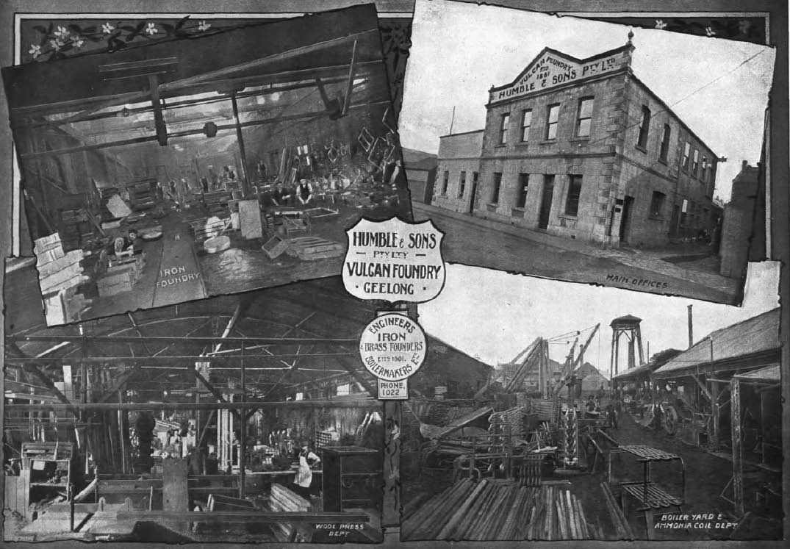
Figure 5.35: Humble & Sons Vulcan Foundry, Geelong, c.1918. Source: Geelong for Business, Health, Pleasure, p.40.

wool presses. This included the wool presses designed and patented by David Ferrier from 1876 (Figure 9.186 Theme 9).335
The Vulcan foundry was also inventive. This had begun with William Humble’s velocipede innovation as well as some of the earliest vehicles in Geelong (see Theme 3). In addition to the proliferation of wool presses, in 1893 the firm had patented an ammonia compression refrigerating
machine (Figure 5.36). Described as ‘exceedingly simple and effective , it was specially manufactured for butter factories and ice making.336 The Humble and Sons firm continued after William Humble’s death in 1917, it being one of few Australian engineering firms with an export trade in the 1920s.337 Today, a car park takes up much of the former Vulcan Foundry site in Little Malop Street. However, physical legacies of the prolific business include surviving wool presses (such as those at the Waterfront Campus of Deakin University, 1-11 Gheringhap Street and in various woolsheds throughout rural Australia), and the more ubiquitous cast iron decoration to Victorian and early 20th century buildings, and cast iron palisade fences.

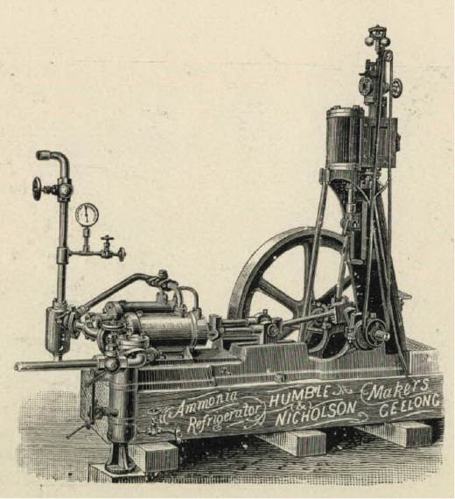
Figure 5.36: Humble & Nicholson, Ammonia Refrigerator, c.1897. Source: Vidler, The Book of Geelong: Its People, Places, Industries and Amusements, p.52.

VICTORIA FOUNDRY AND ENAMELLING WORKS, 26-34 LUPTON STREET, GEELONG WEST
In 1890, Francis John Newberry, an employee of Humble and Nicholson’s Vulcan Foundry, together with his work colleague, Alfred Walker, went into partnership as iron moulders, establishing the Victoria Foundry at 26- 34 Lupton Street (then Virginia Street), Geelong West.338 From these premises the business was to manufacture a range of iron products, some of the earliest including castings for the iron
verandahs to some of the commercial buildings in Geelong.339
In 1895, the entrepreneurial partnership patented an improved cast-iron washing copper framer. 340 By 1906, the product was known as the “Unique” copper frame (Figure 5.39) and
in 1908 another patent was taken out.341 The firm advertised the “Unique” copper frame throughout Victoria, New South Wales, South Australia and Tasmania. Claimed to boil water quicker ‘then the old style boiler’ using ‘about half the fuel,’342 it was glowingly reported in the McIvor Times and Rodney Advertiser:
This firm’s “Unique” copper frames (which are patented through the Commonwealth) are a boon to all users, but more especially to the dairymen and farmers by reason of their portability and general usefulness. This copper frame should be in every household, as it is the most

economical to buy, costs less than a brick furnace, and wears longer. Made of extra heavy cast-iron, it costs but very little more than the ordinary sheet-iron frame, which scales into holes and becomes useless in a very short time. It is constructed on scientific principles,
allowing no heat to go to waste, consequently less firing is required, and water boils quicker than in other frames. It is constructed to burn either wood or coal, and by the use of the patent drop-door in front, 2ft. wood may be used.
The firm are contractors to the Governments of Victoria and New South Wales, and also supply cast- iron boilers with these frames for farmers, dairymen, butchers, and others. As there are imitations on the market, purchasers requiring the best frame made should see it is stamped with the size and the name “Newberry and Walker.”
The firm’s address is Geelong West.343
The “Unique” copper frame was also to be widely promoted in New Zealand over many years.344 In 1906, Newberry and Walker had dissolved their business partnership, with Walker relocating to Dunedin.345 Both in Victoria and Dunedin, the business name of Newberry and Walker was retained, and the rights to the “Unique” copper frame was retained by both parties.346
In 1911, following a visit to England,347 Newberry expanded his business on the Geelong West site. He engaged the builder, George Moreland, to construct his first enameling shop using the point-arched windows of the former Ashby State School 348 (Figure 5.37). In 1912, Newberry first advertised his new business in The Age:
Enamelled Iron Signs, for general advertising purposes, street names, door and cabin numbers; tiling for ranges, sinks and baths. Manufactured by the Victoria Enamelling Works, Virginia-st., Geelong W., Victoria.349
From this time, Newberry received numerous commissions. One of the earliest was in 1913 when the Vacuum Oil Company placed an order for 12,000 enamel advertising plates.350 Orders by Governments and interstate companies soon followed, giving employment opportunities to several local men and women (Figure 5.38). By the 1960s, the business was known as the Victorian Ferrous enameling Works, Geelong. The signs manufactured by the firm included Lifebuoy Soap sailor Man, Waratah Motor Spirit, Voco Petrol, Shell Imperial Spirit, Golden Fleece Motor Spirit, Please Shut he Gate and Use Federal Manure, Motor Serve Station, Sennitts Ice Cream, W. Haughton & Co. Skins Wood Hides Tallow, and Hudson’s Soap, The Time and Money Saver.351 In subsequent years, the factory was relocated
to Moolap and in the early 1980s it was taken over by Geoff and Annie Morgan, a family-owned and operated business that continues to the present day.352

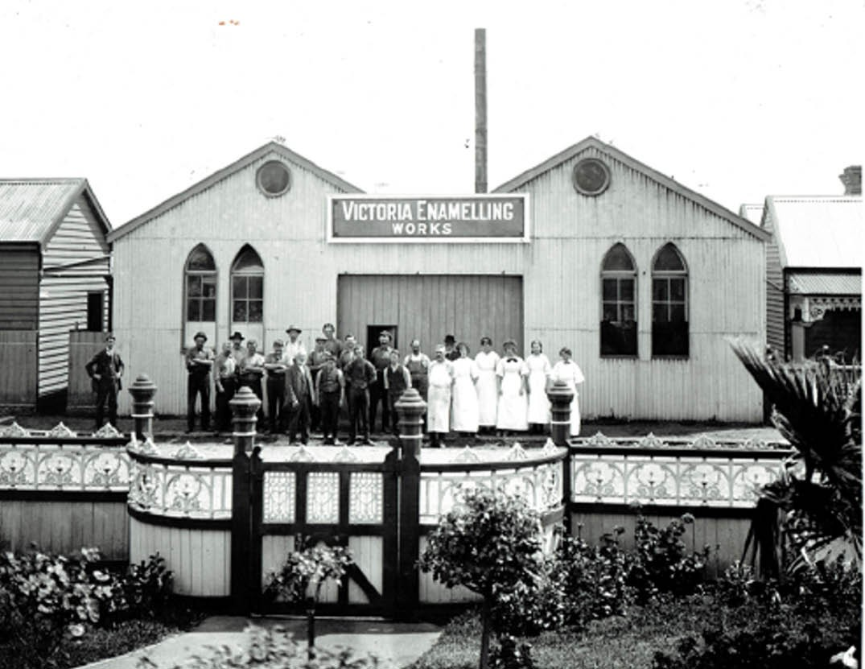
Figure 5.37: Victoria Enamelling Works & Staff, Lupton Street, Geelong West, 1922. Source: The Australasian, 22 April 1922, p.39.

Francis John Newberry (1855-1947) (Figure 5.39) was born in Bridport, Dorset, United Kingdom, to Thomas and Elizabeth (nee Chapple) Newberry.353 From his early adulthood he worked as an iron moulder.354 In 1878 in Somersetshire
he married Clara Ancrum and after 1881 they emigrated to Adelaide.355 After five years there, Newberry walked to
Victoria where he joined the firm of Humble and Nicholson, Geelong s leading iron founders.356 He experienced difficulties following the establishment of his business with Alfred Walker357 at the height of the world-wide recession in the early 1890s. These difficulties did not quell his
inquisitiveness, which was the basis for the “Unique” cast iron frame. As outlined in The Age in 1939:
At the tea table one evening he was reflecting on his position and was toying with cups. He upended one cup and stood another on it. The simple act provided him
with the inspiration for the cast-iron frame for a wood fire copper.358
This was the turning point in the iron foundry business of Newberry and Walker.359
Newberry also contributed much to community life. In 1939, he was recognised as the oldest Councillor in Geelong West, having served for 18 years (including two terms as Mayor) and then at the age of 85 years, was re-elected unopposed for the South Ward of the Geelong West City Council.360 Newberry was also a member of the council of the Chamber of Commerce, the committee of the Geelong and Western District Protestant Orphanage, Geelong West Fire Brigade (where he served a term as president) and was a foundation member of the Geelong branch of the Royal Society of St.
George.361 He died in 1947.362

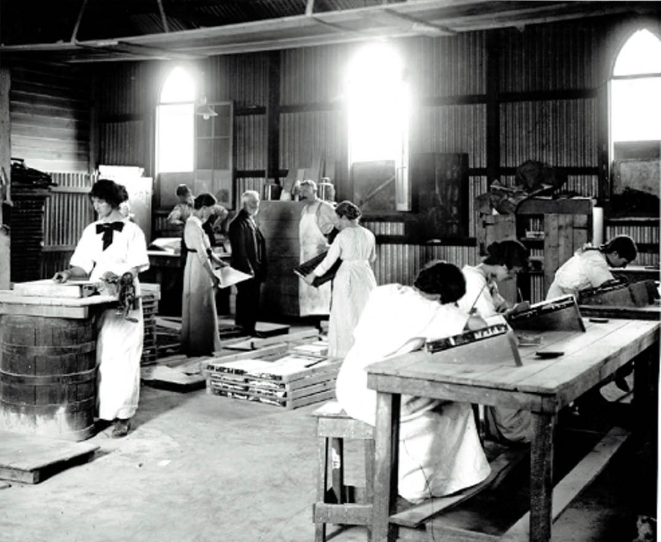
Figure 5.38: Interior, Victoria Enamelling Works, Lupton Street, Geelong West, 1922. Source: The Australasian, 22 April 1922, p.39.

20TH CENTURY DEVELOPMENTS
By 1905, the number of blacksmiths, agricultural implement makers, iron and brass founders and machinery merchants in Geelong had diminished to eight.363 Massey-Harris Ltd, the largest agricultural equipment maker in the British Empire (established 1891)364 had a branch in Ryrie Street.365 Humble and Sons continued to operate in Little Malop Street, while Scott Hamilton Co. in Ryrie Street were largely involved
in ironmongery and the sale of agricultural implements (see following subsection).
A new business established in the Central Business District of Geelong in 1914 was that of Edwin Bruce and James McClure of Bruce and McClure agricultural implement and windmill manufacturers, Warrnambool.366 They purchased
land at South Geelong bound by Fitzroy, Carr, and Forrest Streets.367 The site was chosen for its close proximity
to the South Geelong Railway Station, their business in Warrnambool having been thwarted by freight charges
on materials.368 Construction appears to have commenced on the building of a small factory near the corner of Fitzroy and Carr Streets in 1915, as by May 1915 Bruce and McClure advertised for a ‘small brickwork job’ at Fitzroy and Carr Streets.369 However, the business was not to endure as the site was taken up by United Glassworks Ltd in 1920 (see later subsection). At the time of acquisition the agricultural and implement manufactory consisted of two substantially-built galv. Iron buildings, each 60ft. by 30ft. 370 They appear to have been situated on the west side of the site, with one of the buildings being gabled, the other saw-toothed.371 Nothing

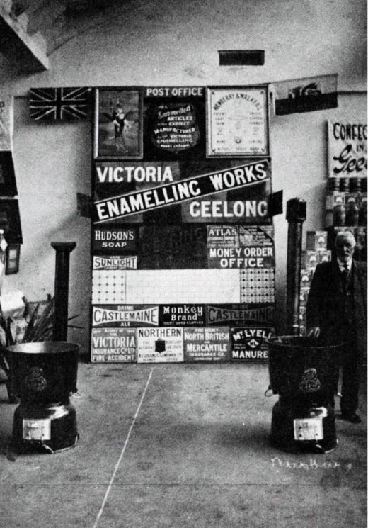
Figure 5.39: F.J. Newberry at the Victoria Enamelling works, with the “Unique” copper frames in the foreground & an array of enamelled signs in the background, n.d. Source: G. Seaton, The Ashby Story, p.113.
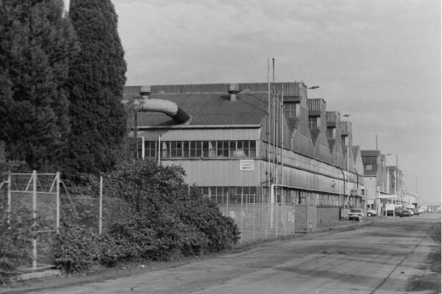
Figure 5.40: Former International Harvester Factory complex, 1998, North Shore (now demolished). Source: David Rowe.

is known to survive of the factory of Bruce and McClure.
By far the most substantial employer of agricultural implement and vehicle manufacturing was the International Harvester Company. On 4 July 1938, the first sod was turned at a site
at North Shore for the factory complex (Figure 5.40) and a railway siding was constructed to initially freight agricultural implements and after World War Two tractors, power units and up-to-date farm implements’ in ‘assisting Australian farmers to produce more food economically and without the old-time farm drudgery. 372 While production commenced in 1939, it was thwarted by World War Two when manufacturing was diverted to meet war needs.373 Following the war, production expanded and by 1951 the company employed over 2000 men and women in what was regarded as the most modern plant of its kind in the Southern Hemisphere.’374 At this time, Labor Call gave a glowing description of the plant:
Manufacturing is a complex business involving a large number of departments – drawing rooms and experimental section, laboratory, pattern shop, foundry, forge department, automotive machine shop, welding shop, sheet metal shop, tool room, implement machine shop, malleable iron foundry, paint shop, woodmill, canvas
room and, finally, the assembly lines. All department are laid out for safe, easy working under the most pleasant conditions possible. The foundry is an example of how careful planning and consideration can result in greatly improved working conditions. The general atmosphere of light and cleanliness is noticeable compared with the grime and gloom generally associated with foundries.375
In later years the International Harvester Company ran into financial difficulties and it closed in 1982.376

PAPER MILLS
An important industry in Greater Geelong from the
19th century was paper manufacturing. Two paper mills were established in Geelong, the Barwon Paper Mill and the Austral Paper Mill, the latter to be temporary.

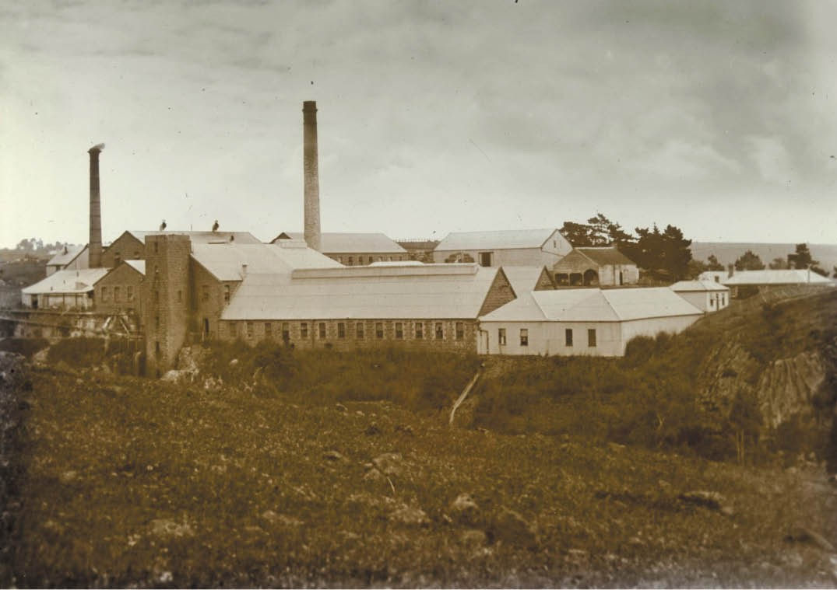
Figure 5.41: J.H. Harvey, Barwon Paper Mill, 1875-1938. Source: accession H2009.100/426, State Library of Victoria.

BARWON PAPER MILL, FYANSFORD
In March 1875, the engineer, Andrew Millar and other speculators including W.F. Ducker, auctioneer and
James Volum, brewer, acquired a site and the right to operate a mill race on the northern bank of the Barwon River at Fyansford.377 It was not until November 1876 when it was publicly announced that a paper mill was to be established at Fyansford, and that Millar had returned from England having purchased the latest machinery for the new industry. 378 The mill complex was designed and constructed by Millar, drawing on his English experience and exploiting the latest world standards.379 In February 1877, Millar called tenders for the building of the race wall380 and by April the shaft for the water wheel had been sunk, the race was approaching completion, and the main building was under construction.381 Situated
on high ground, construction of the mill complex continued throughout 1877, including the construction of bluestone buildings taking in a rag house, “woolley” and dusting house, bleach house, paper machine house, and an engine and boiling house.382 Between 50 and 60 workmen were
employed in building the mill, the bluestone being described as of peculiar shapes, octagonal and pyramidical being most common and of the very best description for building purposes. 383
By January 1878, the construction of the mill buildings (Figure 5.41) had been completed and the installation of the machinery had commenced.384 In August, the first quantity of brown wrapping paper was manufactured from old sugar bags and rope, the sample being described as splendid. 385 However, ‘old sails, rags and even grass’ was purified at the factory and transformed into paper.386 Almost 100 hands were employed at the mill by 1889,387 including women and girls who removed buttons from rags, the residue being discarded on a slope downstream known as ‘Button Hill’.388 A row of six single storey worker’s cottages, together with a manager s had been built of bluestone in 1879 to a design by the Geelong architect, Joseph Watts.389 This same architect had also designed a manager s house.390
Known as the Barwon Paper Mill and costing between
£40,000 and £50,0000 to establish,391 the business was taken

over by the newly-formed Victorian Paper Manufacturing Company in 1888.392 Its first manager was William Daniel Hughes (1853-1916), the son of Robert Hughes, an English papermaker.393 He had emigrated with his wife, Caroline Hughes (nee Rothwell), a paper bag and envelope maker.394 Hughes’ tenure at the Barwon Mill was to be short-lived
as the Victorian Paper Manufacturing Company sold out to Messrs H.L. Littlewood and Co. in 1890.395 In 1929, the
factory complex was sold to Hydro Manufacturing Co. Pty Ltd and cool stores were established and ice manufactured,396 bringing to an end the making of paper at Fyansford.

AUSTRAL PAPER MILL, GREGORY AVENUE, NEWTOWN
With the sale of the Barwon Paper Mill in 1890, the manager,
W.D. Hughes, acquired the ‘Barwon Bank’ estate on the Barwon River at Marnockvale built in 1853-56 to a design by
T.R. Yabsley for John Alexander Gregory, Geelong solicitor (see later subsection).397 On this estate Hughes built a substantial polychrome paper factory known as the Austral Paper Mills (Figure 5.42). With the intention of employing up to 500 people,398 the enterprise was to be short-lived. The business suffered financial collapse and the property was auctioned at a mortgagee s sale in 1893.399 In a dilapidated state in 1912,400 the factory buildings were used by Brig. Gen. Robert Smith (see earlier) as the Austral Wool Scouring Works before being taking over by W.R. Redpath in 1934
and converted into a woollen mill.401 The main building and chimney stack survive at the site today.

BREWERS, BREWERIES AND DISTILLERIES EARLY BREWERIES
A key industry from the mid-19th century in Geelong were
the breweries which provided the much sought-after product for the area s booming hotel industry. In January 1854, there were only two brewers listed in Geelong – Cumming and Powell.402 By the mid-1860s, there were eight brewers and this number remained relatively constant until the early 20th century. Two prominent brewery families in Geelong were the Hodges and Volum families. Isaac Hodges (1823-1877) of Witham, Essex, England, arrived in Geelong in 1854 and commenced business as a grocer and general trader.403 On
his death in 1877, his Will directed the executors of his Estate, Edward Jacobs Jones, William Colledge and Frederick Hodges (his son) ‘to invest all moneys not immediately distributable in Govt. or freehold securities in Victoria. 404 Nevertheless, the brewing business was operated by Isaac Hodges’ sons and known as Hodges Brothers. In 1893, they engaged the local architects, Watts, Tombs and Durran to design brick outbuildings and fencing at the Great Western Hotel at 177 Aberdeen Street, Newtown.405

In 1895, William Colledge and Edward Jones retired as trustees of Isaac Hodges’ Estate.406 They were replaced
by Harry Barkley Hodges and Isaac George Hodges, joining their brother as executors of their father’s Estate. The Hodges Brothers retained ownership of the Great Western Hotel until 1924.407
The patriarch of the family, Isaac Hodges, was born in c.1821 and emigrated to Geelong in 1854.408 For many years he carried on business as a grocer and general trader before becoming the proprietor of the Prince of Wales Hotel in Little Malop Street.409 During this time he achieved success in mining speculations in Ballarat.410 Relocating to Ballarat, he took up the Rainbow Hotel in Sturt Street but after limited success, he returned to Geelong in 1868 and opened his own brewery in the former Theatre Royal, Malop Street, known
as the Royal Brewery.411 Hodges had married Miss Isabella Smart and they had 12 children, including Frederick, Henry Barkley, Arthur Benton, Minnie Mary Lilian, Isabell Victoria,
James Leopold and Florence Rachel Fanny who were all to follow their father into the brewing business.412 In 1876, management of Isaac Hodges’ brewery empire was taken over by two of his sons, Frederick and Harry, the business
becoming known as Hodges Brothers.413 The family brewery business had other hotels in the 1870s, including the Swan Hotel in St. Albans (Geelong) and the Native Creek Hotel at Teesdale.414 The business also bought the West End Brewery in Latrobe Terrace and the Hodges Brothers operations were transferred to this location which included a substantial two storey brewery building (Figure 5.43). In 1892 they had the Globe Hotel in Pakington Street, Geelong West, while in 1923 they rebuilt the De La Ville Hotel in Little Myers Street.415
James Volum (1803-1884), a former Scottish sea captain, came to Geelong with his younger brother, Andrew in the early 1850s.416 In 1856, they purchased the brewery of John Cummings at 101 Corio Street, Geelong, first established in 1845.417 A bluestone malt house had been added in 1851 to a design by Charles Laing in a Victorian Georgian style.418 Both James and Andrew Volum never married.419 Known as the Volum Brewery (Figure 5.44), the brothers traded under the name of Messrs. James Volum and Co. and by 1868 supplied a large proportion of the local trade.420 In 1872, a new malt house was erected as Messrs. Volum and Co. and
they commenced making their own malt rather than importing it as in previous years.421 A building was erected and the site and brewery-making process was described in the Geelong Advertiser:
Strangers cannot mistake the brewery, especially if they come to Geelong by steamer. It stands on a high piece of land, and is the most prominent building visible; its height above the sea level being 75 feet, and a tall brick chimney, stuck in the rear, keeping watch and guard over

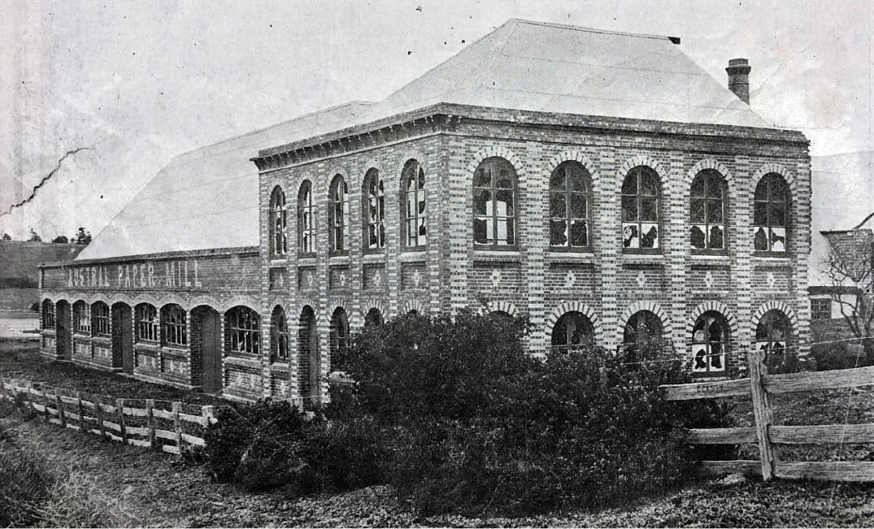
Figure 5.42: Former Austral Paper Mill, Newtown, 1912. Source: News of the Week, 23 May 1912, p.16, GRS 2121/3, Geelong Heritage Centre collection.

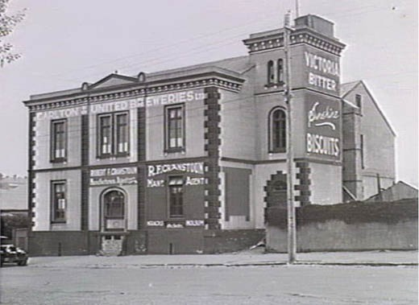
Figure 5.43: C. Fox, Hodges Bros. West End Brewery, Latrobe Terrace, Geelong West, 13 August 1940. Source: accession H19352, State Library of Victoria.

it like a sentinel. The first place we will introduce the reader to, is a new brick and stone malt-house and grain loft, 82 feet long by 27 feet wide. The grain loft is capable of containing 6000 bushels of barley, and is divided into large bins, which enables barley to be prepared and made into good samples for malting directly it comes in.
Before leaving the grain-loft, it may be added, that a door connects it with the malt-kiln in the old bluestone building, erected by Mr Cumming, in 1851. The malt-house below would present, but for the brick walls at the side, the appearance of a between-decks in a very large vessel,
the wooden ceiling and beams overhead being varnished, and supported in the centre by neat iron pillars. Here the malt is steeped, &c. Passing from this new building we will next proceed to the engine-house, which contains a horizontal condensing engine, of 20 horse-power, which, aided by a boiler and a fly-wheel, 14 feet in diameter,
and three tons weight, does all the work required in the establishment, and which it is possible for steam-power to do. Thence into the new brewery, the total height of which is about 44 feet from the surface. On the ground floor is found the malt crushing-machine, from which the malt, when crushed, is raised by small buckets on an endless band which revolving, conveys the malt into a large grist- chest on the top floor of all; and here to give some idea of the simple process that has been adopted, we must asked our readers to accompany us. On the same story as the grist-chest, as it is called, is a hot liquor-chest, containing a jacketed pan, with a capacity of 50 barrels, the contents being heated by steam, supplied from the boiler below.

On the floor underneath is the mash-tin, a large wooden vessel 9 feet in diameter by 4 feet deep, made of Kauri pine, by Mr Burns, of Geelong. The mashing operation is performed by a machine made by C. Maitland, Allows, New Brunswick. This machine is connected with the hot liquor and grist-chests above, by means of pipes, and all that is required is to turn the valve in each pipe and the liquor and grist are mixed in the machine, and rush out
into the tun below mashed. On the same floor is a jacketed copper pan, by Henry Pontifex, and Sons, of King’s Cross,
London. In this the sugar is prepared (Messrs J. Volum & Co. import all their sugars), down on to another floor, and one of the very latest additions is to be found. This is a very large copper-jacketed pan, built by Pontifex, and combining all the most recent improvements. The bottom portion of this pan, in which forty-five barrels can be boiled, is of copper 3/8 of an inch thick, encased in
boiler-plate jacket. … On the same floor is a screw press, perforated at the bottom. In this the hops, after being boiled, are pressed, and the liquor runs in to a copper pan, into which all the worts from the large pan is poured
before going to the refrigerator, thus none of the goodness of the hops is lost. The refrigerator, which is on a lower floor, is an invention of Mr James Harrison [see Theme 9], and is very like those used by distillers. It consists of a channel 6 inches deep, by half an inch broad, and circling downwards its length being 220 feet; and Mr Volum stated, it answers its purpose admirably. From the refrigerator the “cooled” liquor runs into three large fermenting “gyles,” or vats, on a lower floor. Each of these two, being built by Mr Burns, will ferment 21 hhds at a time; in these the liquor
is allowed to stop a certain time, according to the state of the weather. After being sufficiently “attenuated,” the beer is let down into cleansing casks in the cellar below, from which it is racked off, and sent out as required by customers.422
The Volum family continued to be associated with the brewing at this site until 1953.423 It was claimed as being the oldest brewery in Australia still operating on the same site.424 Today, the south fa ade and western wall of the former brewery survive as remnants of the once vast brewery operation (Figure 5.45). The adjacent two storey Georgian styled former Scottish Chiefs Hotel at 99 Corio Street (built in 1848) was acquired by James Volum and Co. in 1865 for use as a residence for brewery staff.425

OTHER BREWERIES AND DISTILLERIES FORMER CORIO DISTILLERY, LOWE
STREET, CORIO
In 1927, a merger of English and other distillery firms, including Dewars, Buchanans, Johnny Walker and King

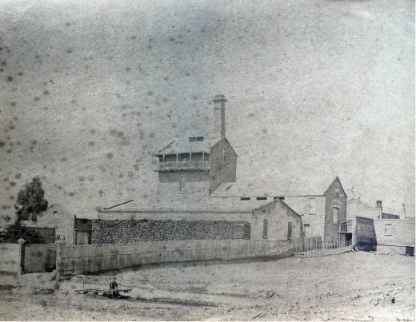
Figure 5.44: Volum Brewery, Corio Street, Geelong, 1879. Source: GRS 2170/34, Geelong Heritage Centre collection.

George formed the Distillers Agency Ltd. of Edinburgh.426 Its intention was to establish distilleries in each State of Australia (where there was a reliable water supply) under the name of the Distillers’ Co-operation Pty. Ltd.427 By April of that year, a site in Queensland had already been purchased and 30 acres of land at North Shore (now known as Corio) had also been settled.428 The choice of site was due to the close proximity
of the both the railway line and Corio Quay, as well as road transport, good quality air, available water and an electricity supply. The aim of the company was to manufacture Australian whisky and gin. The Geelong Advertiser reported that ‘the buildings would be designed by an expert in England, and tenders would be invited locally for the erection of the buildings. 429 The Melbourne architectural firm of Hare and Hare were appointed the consulting architects, the cost of
the project being about £250,000.430 The first section of the distillery complex was built by Cooper and Co. Pty., building contractors of Melbourne431 under the supervision of M. Young who had been brought out by the firm from Scotland to also supervision the installation of the machinery.432
Works were completed for the opening ceremony on 21 March 1929. The Distillers Corporation Pty Ltd invited all residents to the opening, as well as 250 official guests, from Melbourne and interstate.433 A substantial number of visitors were transported by a special train from Melbourne.434 The day after the opening, the Geelong Advertiser provided a detailed description of the Distillery (Figure 5.46):
The buildings comprise a grain intake plant to lift grain from the company s own siding and store it in a series of large silos. The buildings consist also of a milling plant, both for grinding barley and malt. Then there is the mash house for mashing it with grain and mixing it with malt.
... [There are] also three separate still houses. The first

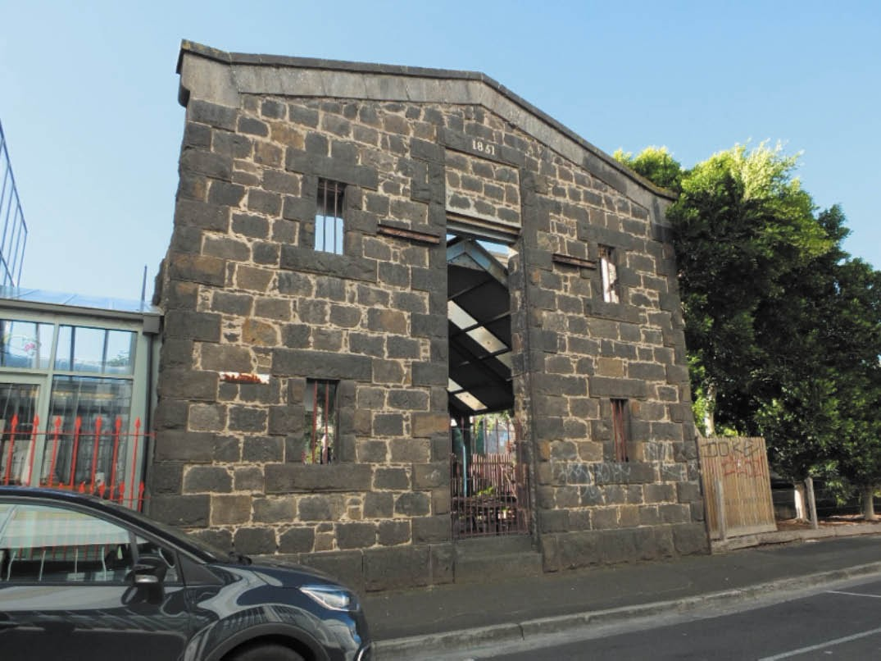
Figure 5.45: Façade remnant of the former Volum Brewery, Corio Street, Geelong, 2019. Source: David Rowe.

was a potstill house for giant pots for the manufacture of potstill whisky, a still house for the manufacture of grain spirits, and a still house containing three gin stills for the manufacture of gin. Then in addition there are separate stores for the storing of spirit on leaving the various stills
... There is a filling warehouse where the casks of whisky may be stored, a warehouse where they will be stored for a period of years. The building is very fine and has
been built on sound lines, and there is the very best plant obtainable ... A group of houses has been erected for staff quarters ...435
The row of hipped roofed staff bungalows had a frontage to Lowe Street, there being a main thoroughfare to the distillery complex between some of the northern-most houses. The substantial brick and concrete distillery buildings were largely situated towards the central and western portions of the site, nearer the railway line.
Known as the Corio Distillery, it became a successful

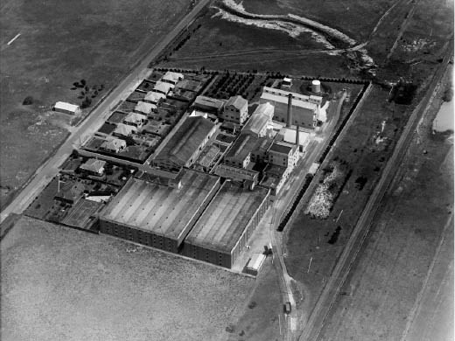
Figure 5.46: C. Pratt, Aerial view of Corio Distillery, November 1936. Source: accession H91.160/1009, State Library of Victoria.

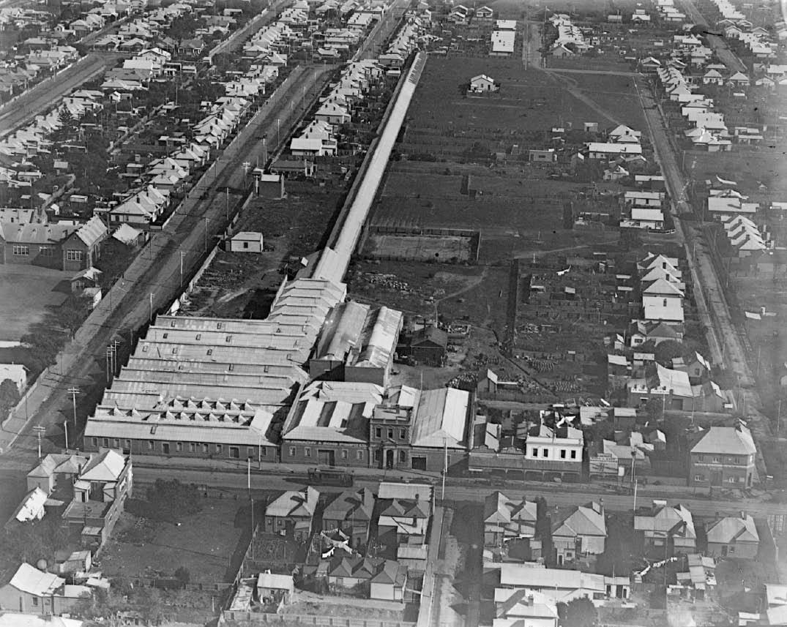
Figure 5.47: C. Pratt, Aerial view of Donaghy’s Rope Works, c.1930. Source: accession H91.160/1523, State Library of Victoria.

business in Geelong for several years, employing
60 workers.436 The business was later taken over by the United Distillers and it closed down in 1977. It took another ten years before all the stocks were sold.437 In 1989, the Bay FM radio station opened studios there438
and in more recent years the complex has been owned by Cheetham Salt Pty Ltd. In recent months, there has been a proposal to re-establish a distillery operation at the site.

LITTLE CREATURES BREWERY, SOUTH GEELONG
In recent years, the former Valley Worsted Mill at South Geelong, completed in 1927 (see earlier subsection) was revitalised as breweries for Little Creatures and White Rabbit. The transformation the former woollen mill retained the essential fabric and features of the complex, and provided employment opportunities.

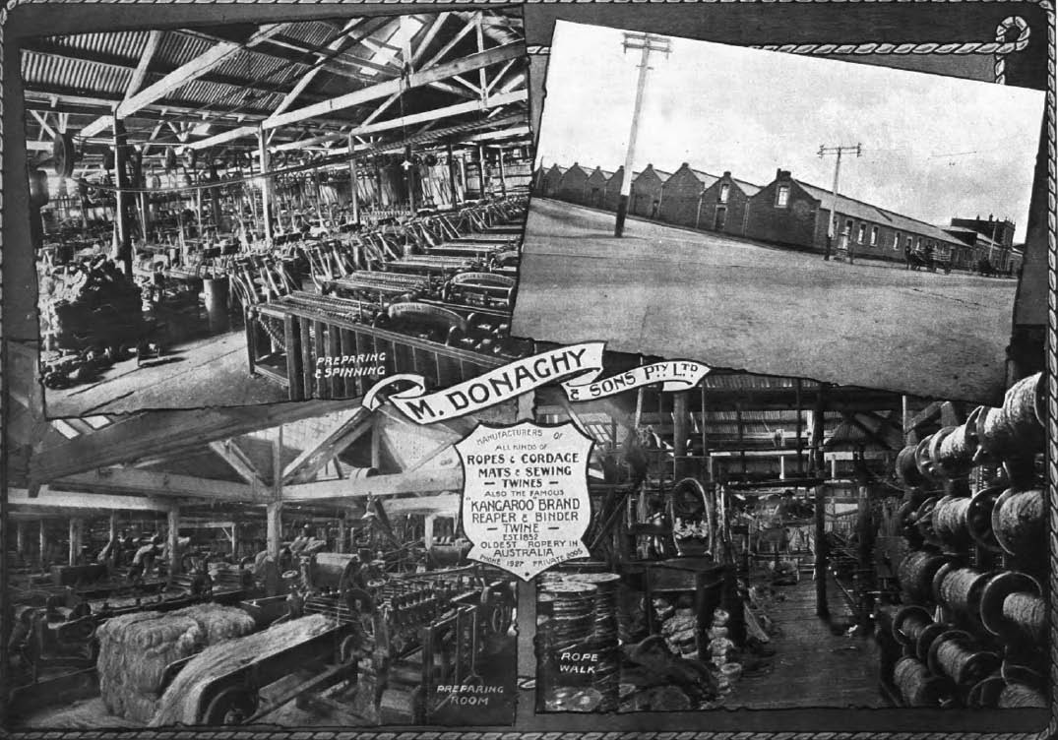
Figure 5.48: Donaghy’s Rope Works, Geelong West, c.1918. Source: Geelong for Business, Health, Pleasure, p.28.

THE ROPE INDUSTRY

FORMER DONAGHY’S ROPEWORKS, PAKINGTON STREET, GEELONG WEST
In 1852, realising a void in the manufacture of rope in Victoria, the Irish immigrant Michael Donaghy (1818-1882) established a ropeworks factory in a small shed near the Barwon River at Marnock Vale in 1852.439 Born in County Armagh, Northern Ireland, Donaghy married Miss Mary McManus in 1841 and after a time in Liverpool, England, they emigrated to Victoria.440 His rope making business gradually prospered after recognising the demand for flat rope for
gold mining.441 In 1872, he took a visit to England to inspect the latest advances in rope manufacture.442 In the following year, 1873, he relocated his business to a seven-acre site in Pakington Street, Geelong West.443 Known as Donaghy s Fairview Ropeworks (Figures 5.47- 48), the establishment was operated by Donaghy and his sons, John and Michael
(junior)444 together with Henry Sargeant and Frederick Scarlett following a restructure prior to Michael Donaghy s death in 1882.445 The factory (now demolished) was constructed in
1874 and various structures were built at later times.446 Other factories for the firm were later built in Dunedin, New Zealand; and Adelaide.447 In 1899, the Leader gave an overview of the rope manufacturing process at Geelong West:
In the preparing room we see the initial process of manufacture of rope and twine. The raw material in its rough state is prepared through stages, and it is astounding to watch the rapidity and precision of the
machines, all taking their part in softening and spreading the raw product. When the Manila has become pliable,
it is passed through drawing machines which are on revolving tables fitted with steel teeth of various degrees of fineness, which comb out the fibre until it is ready to be spun into yarn or twine. The spinning room forms
a great scene of activity, numerous spinning machines at work, which make from 1000 to 1700 revolutions a minute, each turning out large quantities of yarn. This is
afterwards made into cord, and eventually converted into rope or twine by a finishing process. In the preparing and spinning rooms there is a whirl and rattle of machinery, leather belts revolve from shafts overhead, men, women

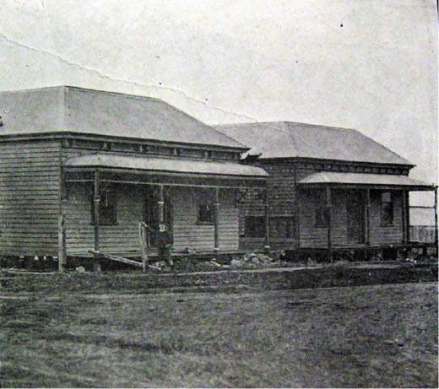
Figure 5.49: Dwellings in Waratah Street relocated from Ballarat, 1911. Source: News of the Week, 14 September 1911, GRS 2121, Geelong Heritage Centre collection.
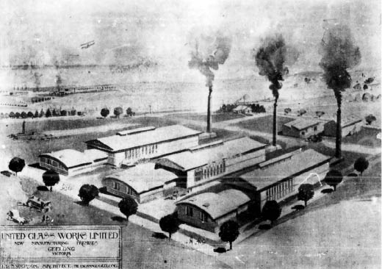
Figure 5.50: I.G. Anderson, Axonometric drawing of proposed United Glassworks, Geelong, 1920. Source: News of the Week, 10 June 1920, GRS 2121, Geelong Heritage Centre collection.

and boys feed the machines with a constant regularity, and display of human activity makes the first stage
of rope making an interesting process. The rope walk is 2,500 feet long, and is the largest in the colonies, and at times orders are executed here for special cables which could not be made in any other works in Australia.448
At different periods in the 19th and early 20th centuries, Donaghy’s Fairview Ropeworks was the biggest single source of employment in Geelong West.449 Today, the rope walk building survives amid much of the site having been transformed into a shopping complex. There are also at least 31 dwellings that were either built or occupied by ropemakers

or employees of Donaghy’s Ropeworks in Waratah Street and nearby streets.450 These dwellings were mainly built in the later 19th or early 20th centuries, with several having been relocated in 1911 from the Ballarat goldfields region (Figure 5.49), including Pitfield Plains, Berringa, Brown Hill, Maleno and Hollybush.451 It was also from the initial establishment
of the ropeworks at the Geelong West site in 1873 that led to some of the population expansion in the area.

GLASS MANUFACTURING

TOWARDS GLASS MAKING IN GEELONG
The manufacture of glass, needed for windows in buildings and bottles and other objects, alluded the industrial sector in Geelong in the 19th century. In 1874, F.W. Benness
and Co. announced its intention of establishing a glass factory in Geelong, seeking land at Eastern Beach near the Botanic Gardens.452 The application for the land was refused by the Geelong Council and subsequently by the Commissioner of Lands as such a development ‘would
interfere with the salubrity of the locality, and prove offensive to the residents. 453 In 1879, Messrs Gill and Young sought to establish a glass factory on three acres of land on the east side of the Agricultural Society Ground, and south of the Botanical Gardens’ in Ryrie Street.454 A new firm called the Geelong Glass Company was formed and the erection
of buildings was to commence following the advertising of tenders in May 1879. Buildings were designed by James Balmain, architect of Melbourne, the buildings being 40 feet by 60 feet, to provide accommodation for four blow-holes.455 The company had a large display of their glass products
at the Geelong Exhibition in 1880, including ‘cut and plain glass, lamp chimneys, decanters, and confectioner s show shades. 456 Although there was much promise, the Geelong Glass Factory was not to endure, the proprietors having transferred the business to Melbourne by 1883.457

UNITED GLASSWORKS LTD, 135 FITZROY STREET
In 1919, a new Geelong glass company was formed.458 Known as United Glassworks Ltd.,459 its intention was the acquisition of land at North Geelong for its factory.460 This site did
not eventuate and in 1920 the company purchased the agricultural implement and windmill factory of Bruce and McClure at 135 Fitzroy Street.461 The company commissioned the local architect, I.G. Anderson, to design the factory complex. In January 1920, Anderson called tenders for erecting timber and galvanised iron factory and warehouse buildings’ at the corner of Fitzroy and Carr Streets.’462 Anderson’s design was illustrated in the News of Week. It showed three detached pavilions, each with elevated gabled foundries, each with chimney stacks at the western (Fitzroy Street) ends and elliptical-arched offices to the east, fronting

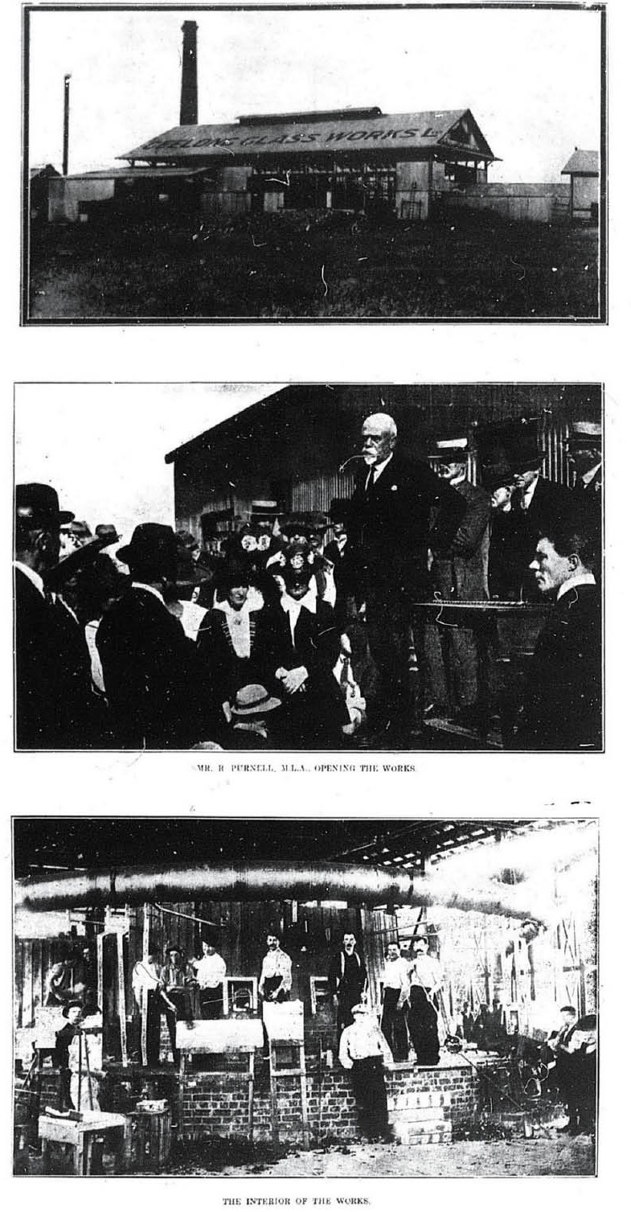
Figure 5.51: Opening of Glass Works, Geelong, 1920. Source: News of the Week, 10 June 1920, GRS 2121, Geelong Heritage Centre collection.

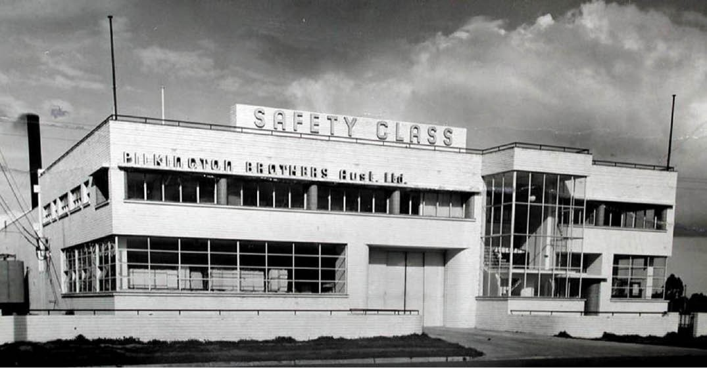
Figure 5.52: Pilkington Brothers Glass Factory, North Geelong, n.d. [c.1936]. Source: MHG Asia Pacific online at http://www.mhg.com.au/page/ history1.html

Forrest Street (Figure 5.50).
Built by the Cornelius Brothers, ‘Geelong’s newest industry’ was formally opened by Robert Purnell, M.L.A. on 4 October, 1920463 (Figure 5.51) The initial employees came from Melbourne and the first shift in the manufacture of bottles was watched by a crowd of a few hundred people.464 Only the northern pavilion of the United Glassworks factory was constructed at the time of the opening, and this was to be the only portion of Anderson’s scheme to be realised (Figure 5.84). In 1921, Title for the property was transferred to the Geelong Glass Works Ltd., which in turn was immediately acquired by the Australian Glass Manufacturers Co. Ltd. of
Spotswood.465 In the following year, 1922, this company went into liquidation and in 1923 the Geelong Advertiser reported on the sale of the Geelong factory:
Commodious and substantial g.i. [galvanised iron] buildings, known as the Geelong Glass Works, with about 10,000 feet of floor space. These buildings are well built and comprise several buildings, measuring about 50 x 110, 60 x 30, 50 x 30, 21 x 30, 30 x 30, and 50 x 50 feet.
The land is fenced with a substantial high Jarrah Fence, and has a frontage of 325 feet to Carr-street, 296 feet to Fitzroy-street, and 328 feet to their other street, close to the South Geelong Rail Station.466

FORMER PILKINGTON GLASS FACTORY, MELBOURNE ROAD, NORTH GEELONG
A more successful and enduring glass manufactory was established on the Melbourne Road at North Geelong in 1936 for Pilkington Brothers (Australia) Ltd.467 This company had been founded in 1826 by members of the Pilkington and
Greenall families at St. Helens, Lancashire, England, and from 1845 it was solely owned by Pilkington Brothers.468 The site at North Geelong had been acquired from the Geelong Harbor Trust.469 The company commissioned the local architectural firm of Laird and Buchan to design the factory. In particular, it was designed by Ewen Laird, who had recently returned from Europe and had been influenced by work of Dutch architect, Willem Marinus Dudok.470 Concurrent with a progressive, streamlined and cuboid design Laird had prepared for his brother George’s home in Newtown (see Theme 6), the Pilkington glass factory reflected a radical departure in factory design in Geelong (Figure 5.52). It was described by the eminent architect and writer Robin Boyd as ‘more like a Gropius design than anything previously seen in Victoria (in reference to Walter Gropius International Style that emanated from the Bauhaus, Germany).471 The strong horizontally- aligned building constructed of brick deliberately painted off- white was off-set by steel-framed windows and a projecting glazed stairwell at the south end. The modern design was noted in the Melbourne press in 1937:

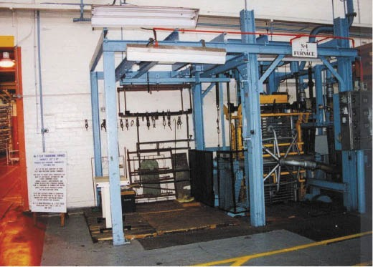
Figure 5.53: Pilkington Glass Factory, North Geelong, No.1 Furnace, 1999. Source: Lorraine Huddle.
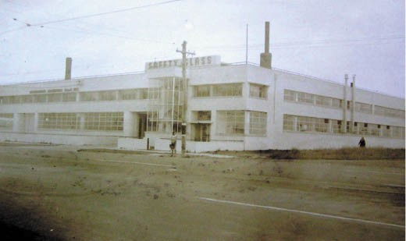
Figure 5.54: Pilkington Glass Factory, North Geelong, showing northern extensions (left), Public Works Department photograph,
n.d. [c.1950]. Source: VPRS 10516/P3, unit 11, Public Record Office Victoria.

The new building is of brick, concrete and steel construction, the main elevation to the Melbourne Road being of painted brickwork, with recessed horizontal joints. Recessed windows on the first floor are divided by circular piers tiled in royal blue. The metal lettering imposed on the hood is painted silver and royal blue.472
The progressive image of the factory building reflected the new glass manufacturing process within. It produced
laminated safety glass for the vehicle industry. In 1938, the factory commenced the manufacture of armour plate glass which involved an entirely new glass making process.473 A flat toughening furnace (known at the factory as No.1 furnace) (Figure 5.53) was installed with a capacity of 32” x 32”, being the first machine to produced toughened armour plate glass, the machine having been made in Kings Norton, United Kingdom474.

The Pilkington company was successful and expanded in 1947, again using BLB to design the extension in a highly compatible design with the original475 (Figure 5.54).
By 2006,476 the glass factory was closed and furnace no. 1 was sold to the City of Greater Geelong and is now housed at Osborne House, North Geelong. This furnace is the sole survivor of four flat high pressure quench furnaces. For over 25 years, these processed the bulk of Australia’s automotive and other toughened glass. Goggle glasses, tank windows and scuba glasses were produced during World War Two.
Thousands of combustion heater door strips were produced during the 1950s building boom.477

EXTRACTIVE INDUSTRIES
From the late 19th century, two extractive industries were established in Greater Geelong in addition to the quarrying and brickmaking operations of earlier years (see Theme 4 for quarrying and brickmaking). While both the Cheetham Saltworks at Moolap (and later also at Avalon), the Geelong
Cement Works at Fyansford, and the Chemical Manufacturing Works at North Geelong were highly successful, they no long survive.

CHEETHAM SALTWORKS
In 1862, Richard Cheetham (1836-1900) emigrated to Victoria from Manchester, England, where: he had been raised by his father Samuel, a print warehouseman and his mother,
Catherine;478 he attended the Manchester Grammar School;479 and married Miss Mary Mills in 1857.480 In Melbourne, Cheetham was a manufacturing chemist at East Prahran and at Western Port he began his first enterprise in salt production based on some knowledge
of the salt gathering industry in Southern Europe.481 In 1888, he acquired a 21 year lease of Crown land on the Stingray Bay foreshore at Moolap.482 The swamp was cleared, land reclamation carried out, and embankments, coffer dams and paddocks laid out for the production of ‘solar salt’ (Figure 5.55), as outlined in the Geelong Advertiser in 1891:
The work of draining the marsh land and laying it out for the purpose required has so far proved a costly feature of the undertaking, the value of the improvement now effected being estimated at not less than £10,000. The
area dealt with is enclosed by an outer embankment three miles in length. It is a solid piece of work, 15 feet wide and six deep, and constructed of puddled clay, loam and seashell. In order to make it of the required strength to resist the influence of wind and tide it was necessary before commencing the erection of the embankment,
to remove all the soft surface silt until the bed clay was reached. The enclosed area was then divided

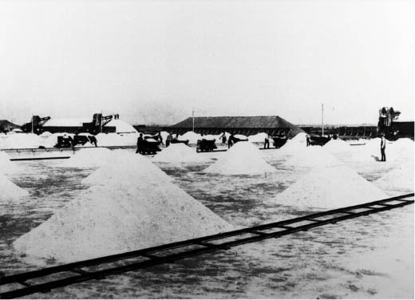
Figure 5.55: Salt field, Cheetham Salt Works, Moolap, c.1920. Source: Bellarine Shire collection, Bellarine Historical Society.
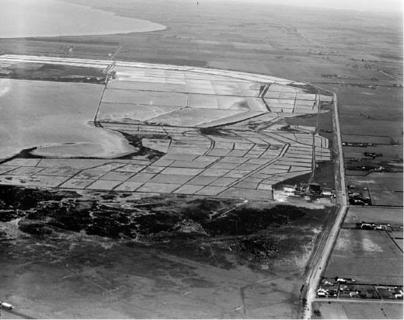
Figure 5.56: C. Pratt, Aerial view of Cheetham Salt Works, Moolap, c.1927. Source: accession H91.160/963, State Library
of Victoria.

into condensing paddocks and crystallisers by inner embankments, of which there are about sixteen miles. The latest piece of work executed was that of constructing a coffer dam, impounding a surface of from 170 to 209 acres, the earth walls of which are strengthened with and without with timber lining. Into this coffer dam the tide waters from the bay are admitted through a sluice gate, which closes automatically when the dam, which is three or four feet deep, is filled with the supply of sea water required for condensing. After being impounded in this dam the progress of evaporation is allowed to continue until the lime attains a strength of 12 to 15 percent. It is then elevated by a steam centrifugal pump into the first
or outer condenser, after which it passes into the inner condenser, and then to the finishing condenser, the

density of the liquid increasing until it becomes pure brine. From the finishing condenser the brine is pumped into crystallising pans, where the formation of salt crystals
is commenced. The growth of the saline particles can be observed constantly going on, the crystals as they increase in gravity sinking to the bottom, where they form into prettily shapes and glittering clusters. The crystallisers, of which there are six, are each about 70 feet by 60 feet in dimensions, and lined with wood. The salt formation continues until the bottom of the pans is covered with a coating of pure white salt, several inches in depth, and the remaining liquor having been drained off the salt yield is harvested. Six large moulds of salt, comprising about 650 tons of the material in its crude state, represent the harvest for the season just closed.
The heaps are almost as solid as cement, and will have to be broken with picks before they can be removed. In its present state the salt is fit for cattle, for fertilizing land, or for making brine.483
By 1895, there were 25 men employed as the saltworks and with the granting of additional land and the introduction of further machinery, the number of workers was to increase to 100 following the Government agreeing to a 99 years
lease.484 Cheetham’s partner in the business was Alexander
W. Cunningham, a retired bank manager who provided financial backing.485 On Richard Cheetham’s death in 1900, his son Andrew Cheetham became managing director, a position taken up by a second son, Alexander, in 1921.486 Known as Cheetham Salt Pty Ltd from the early 20th century, the company’s Moolap field took up an extensive area of foreshore (Figure 5.56). It also expanded its operations with a second saltworks at Laverton in 1924 and another at Avalon in 1951.487 At Moolap, operations ceased in 2009.488
While all industrial buildings have been removed, the layout of the saltpans currently survives. On the south side of
the Portarlington Road opposite the salt pans, there is the former managing director s house (built in 1900 to a design by Seeley and King),489 Cunningham Memorial Hall (built
in 1921 for the use of Cheetham Welfare Club in memory of
A.W. Cunningham who died in 1916) and the attached A.H. Cunningham Memorial Library (built in 1922- 23 to a design by Frederick Purnell, architect, in memory of Andrew Hassell
Cunningham, managing director and son of A.W. Cunningham who died just 2.5 months after he officially opened the hall
to the memory of his father).490 Remaining idle for several years from the late 20th century, the memorial hall and library buildings (Figure 5.57) were adapted and extended into
an early learning centre which opened in 2018.

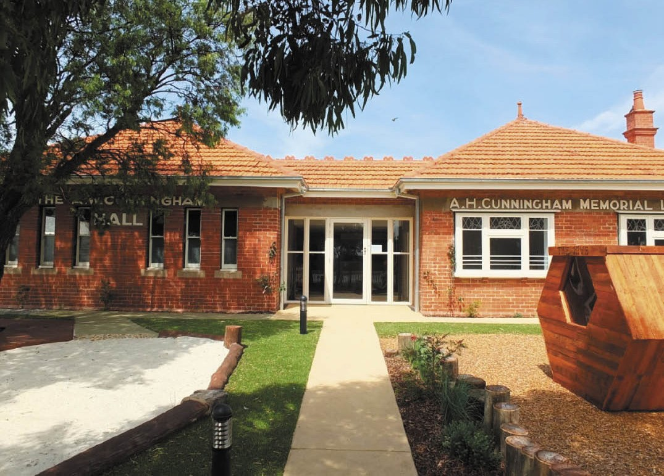
Figure 5.57: The Hive Early Learning Centre (former Cunningham Memorial Hall & Library Buildings), 2018. Source: David Rowe.

GEELONG CEMENT WORKS, FYANSFORD
In 1890, the Geelong Portland Cement Company was founded, the inaugural directors being Peter McCann, John Holton, Robert Camlin, William Radden, Phillip Kemp and Thomas Peters, master builders of Melbourne and Geelong. The aim was the production of cement on the steeply sloping land at Fyansford using limestone quarried nearby on the Moorabool River flats at Batesford (see Theme 4). Richard Taylor was appointed the first manager and secretary of the Company and he was responsible for the construction of plant that was to produce 300 tons of cement per week.491 Six bottle-shaped brick kilns were constructed on the side of the Fyansford Hill, with the raw milling carried out on the upper level and the burnt material (after passing through the kilns) was distributed on the lower level where the final grinding was undertaken.492 Construction was under way by March 1890.493 Around 40 employees were soon engaged in the manufacture of cement.494
For twelve years until 1902, the cement works operated
intermittently without the payment of a dividend.495 A new rotary kiln had been manufactured by this time and Richard Taylor was overseas to inspect the latest developments where he acquired the Australian rights for the “Weinberg” pipe, of Danish origin.496 An experimental plant was built at Fyansford following Taylor s return and a major contract was entered into with the Metropolitan Board of Works to supply the cement product.497 With the company not able to agree to terms with Taylor for the patent rights of the new product, he resigned. The Geelong Portland Cement Company remained unprofitable and went into liquidation. The cement works property was purchased by Peter McCann and three of the original directors: Radden, Kemp and Peters joined him in
re-establishing the business in 1905. W.B. McCann was appointed manager and secretary.498
Following the death of Peter McCann in 1908, and with the business still struggling financially due to outdated machinery and fierce competition, additional capital was needed. A new Company was registered on 17 August 1911, the directors being T.J. Noske (chairman), D.H. Dureau, Thomas James,

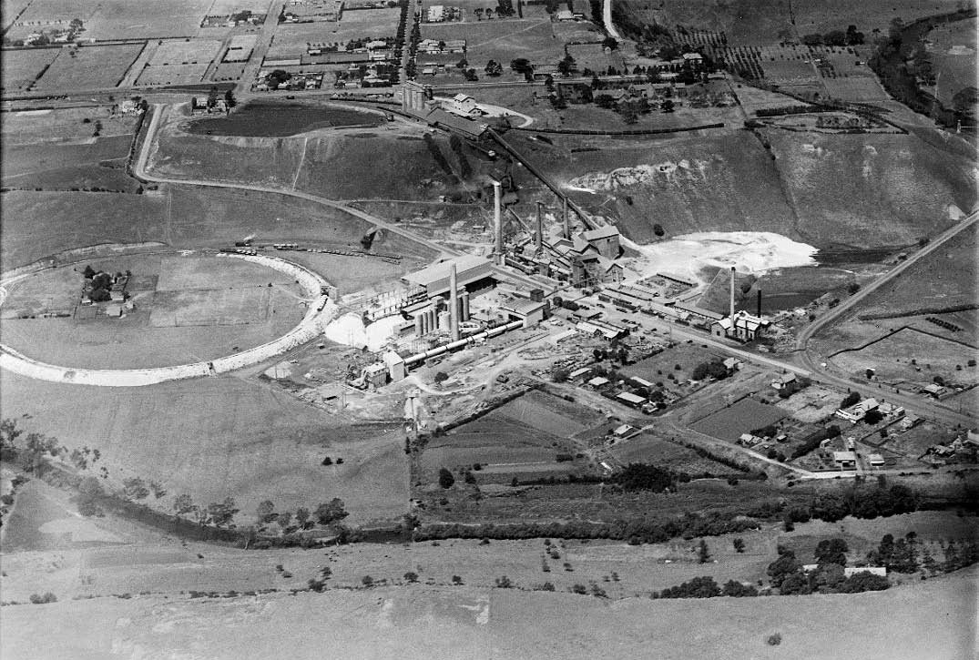

Figure 5.58: C. Pratt, Aerial view of the Geelong Cement Works, Fyansford, November 1938. Source: accession H91.160/977, State Library of Victoria.

W.C. Cone, W.H. Nichterlein, S.H. McCann, W.B. McCann (director and manager) and P.L. Munster (secretary).499
The earlier plant was largely removed and replaced with new modern plant following the dry process. 500 From 1912 until 1924 the first rotary kiln plant was built on the original site with a complete change of process.501 In January 1924, The Age reported on a contract having been let by the Australian Portland Cement Company to the Monier Concrete Company to build four silos at the terminus of the Fyansford railway
for the storage of the company s cement. 502 Each silo was to be 73 feet in height and 35 feet in diameter, with a storage capacity of 1500 tons.503 Costing approximately £20,000, the silos were to be automatically filled by the provision
of conveyors from the works.504 From this time, the plant underwent major expansion, the cement manufacturing process was upgraded and there was a reorganization of services (Figure 5.58). Overseeing these changes was the Australian Portland Cement Company’s chief engineer, Norman John Percival Wilson (1883-1964).505 The storage silos and bagging plant at the top of the hill in McCurdy Road
was demolished in 2020 (following the closure of the Cement Works operations at Fyansford in 2001). However, the company’s head office, built entirely of concrete in 1923 (Figure 5.59) still exists, having replaced an earlier timber building.506

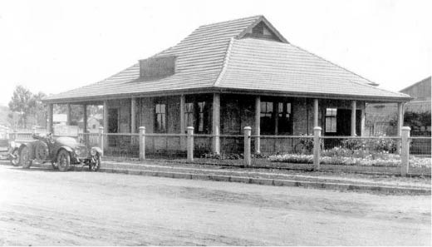
Figure 5.59: Geelong Cement Works Administration Office, McCurdy Road, 1928. Source: John Flatt.
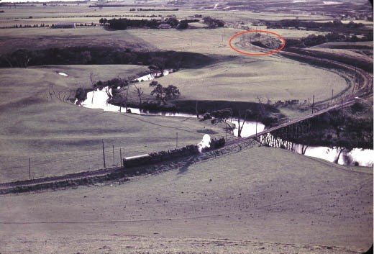
Figure 5.60: W. Langford, Geelong Cement Works locomotive approaching the bridge over the Moorabool River, 21 July 1963. The entrance to the tunnel is circled. Source: Weston Langford
Railway Photograph online, https://www.westonlangford.com/media/ photos/103151, Creative Commons license.

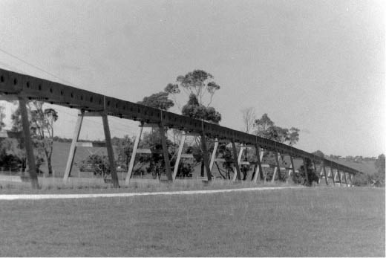
Figure 5.61: Transport conveyor system, Fyansford, 1998. Source: David Rowe.

An aerial ropeway was built by Pohlig in Germany to transport the raw material from the quarry at Batesford to Fyansford. It was replaced between 1925 and 1926 with a railway system erected by the company s employees, including a timber trestle bridge over the Moorabool River507 (Figure 5.60).
From late 1927, a tunnel was driven at the northern end of the railway line for approximately three quarters of a mile to connect the railway system to the quarry.508 In 1966, the railway line was replaced with a limestone belt conveyor system involving an elevated protected concrete structure
supported by concrete pylons (Figure 5.61), spans of which survive to the present day.509

CHEMICAL MANUFACTURING

CHEMICAL WORKS, NORTH GEELONG
In 1881, the Geelong Manure and Chemical Manufactory was established adjoining the Gas Works at North Geelong.510 While nothing of the original manufactory survives today, the importance of these works was initially for agricultural purposes: to produce sulphate ammonia (soil fertiliser)
for farms; but later companies at this site subsequently manufactured chemicals for a range of purposes. The Geelong Manure and Chemical Manufactory was owned by Messrs. W.J. Woolcott and Co.; of Melbourne. A commodious shed was erected by Messrs. Trevena and Gubby, the chimney stack being built by a Mr Andrews and the ironwork was entrusted to a Mr McGuire of Pakington
Street.511 The location of the manufactory so close to the Gas Works was to take advantage of the sulfuric properties to the waste gas liquor, as well as the blood and offal of the nearby Abattoirs (converted into portable manure) and guano.512
The manufactory at North Geelong was initially supervised and managed by Stephen Cox (c.1823-1897). Born in Bristol, England, he became the original proprietor of the Netham Chemical Works and Aluminous Cake Works at Bristol and later the Liver Alkali Works in Liverpool, and therefore had experience in the manufacture of sulphate ammonia and other chemicals and artificial manures.513 He arrived in Melbourne with his family in 1875514 and he soon went into partnership with W.J. Woolcott and Co. in Melbourne although he was insolvent by 1877.515 At North Geelong, Cox’s tenure was to be brief as he relinquished his connections with
W.J. Woolcott and Co. in March 1882.516 Cox subsequently established his own chemical works at Geelong West in 1883 but advertised his address as the Goods Shed at the Geelong Railway Station where he stored 500 tons under the building. The guano had been extracted from caves at Pomborneit near Camperdown, Victoria.517 He advertised a draft prospectus for the Geelong Guaranteed Chemical Manure Company in 1889518 but like his other local business ventures, this does not appear to have realised any success.

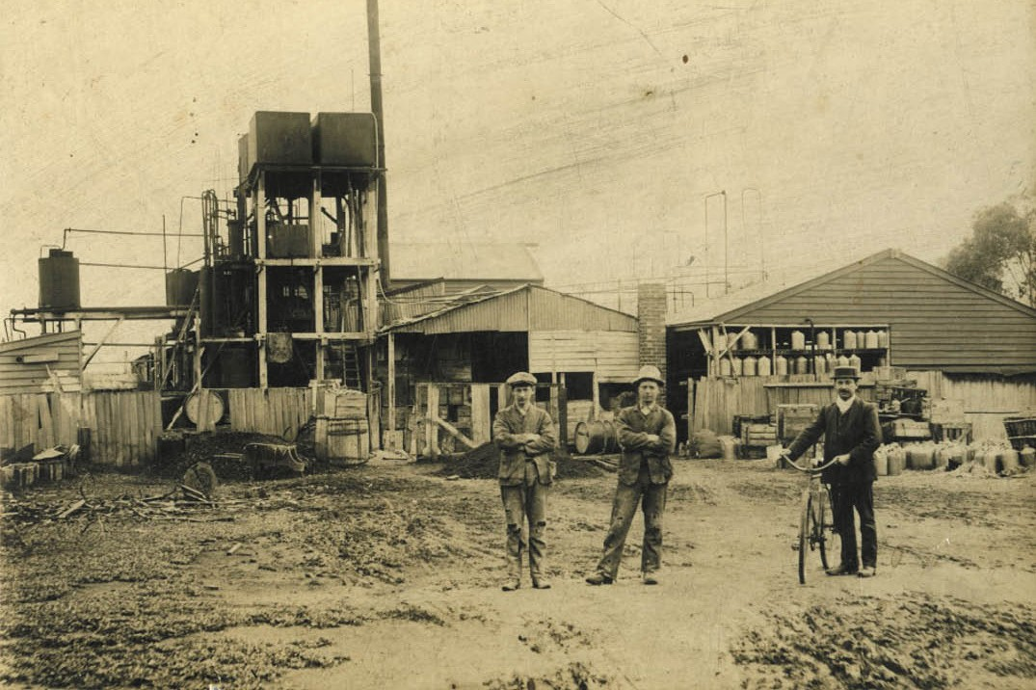

Figure 5.63: Fletcher’s Chemical Works, North Geelong, c.1896. Source: GRS 2009/00598A, Geelong Heritage Centre collection.

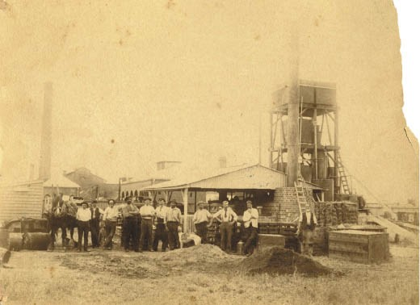
Figure 5.62: Fletcher’s Chemical Works, North Geelong, c.1896. Source: GRS 2009/00597A, Geelong Heritage Centre collection.

At North Geelong, the Geelong Manure and Chemical Manufactory seems to have been renamed the Geelong Ammonia Works. In 1888, W.J. Woolcott advertised the sale of the plant and the lease of the manufactory.519 It appears to
have been taken up by Stephen Cox as his draft Prospectus for the Geelong Guaranteed Chemical Manure Company included the purchase of his contract with the Geelong
Gas Company five years’ of the gas liquor.520 The business was subsequently taken up by the Australian Explosives and Chemical Company Ltd (founded by Friedrich Krebs, a German Lithofracteur of Deer Park).521 It advertised the sale of its North Geelong operations in December 1893.522
By 1896, the North Geelong works of the Australian Explosives and Chemical Company Ltd had been purchased by Richard Jaques Fletcher (c.1868-1925)523 (Figures 5.62- 63). Born in Leicester, England, as a child he emigrated with his parents to Nova Scotia, Canada, where he undertook
his education, including the study of chemistry.524 He later returned to London where he worked for a number of
chemical firms.525 He came to Geelong in the mid 1890s and operated his highly successful manufactory throughout the late 19th and early 20th centuries with large scale chemical goods being produced.
In 1903, Fletcher established a trademark (Figure 5.64) for chemical substances principally used in

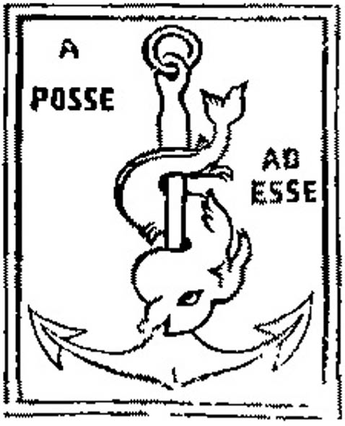
Figure 5.64: Fletcher’s Chemical Works Trademark, 1903. Source:
Victoria Government Gazette, 21 January 1903, p.164.

manufactures. 526 The origins of the symbol of a dolphin entwined around an anchor has its roots in the classical adage, Festina lente, meaning more haste less speed. 527 The trademark also included the Latin term ‘A Posse Ad Esse , meaning from possibility to actuality. 528
During the early stages of World War One, Fletcher developed a formula for neutralizing German chlorine gases529 (see Theme 9). Throughout his career in Geelong, Fletcher was for a time president of the Melbourne Chemical Society and the Geelong Chamber of Commerce, and a member of the Gordon Institute of Technology. On his death in 1925, he ‘was regarded as a great authority as a chemist and his advice was sought by most of the leading wholesale chemists of Australia.’530 Fletcher bequeathed £7,000 to the University of Melbourne ‘to promote research concerning Cancer and/or concerning the cure of Cancer and concerning Anesthetics and/or concerning the employment of anesthetics for the prevention and relief of suffering. 531 The R.J. Fletcher Research Scholarship was established and it continues to
the present day. One of the more recent recipients has been Dr Ian Luk, currently a Postdoctoral Research Fellow at the Olivia Newton-John Cancer Research Institute.532
Fletcher’s chemical works at North Geelong continued long after his death. In 1965, it was known as R.J. Fletcher and Co. of Roseneath Street, North Geelong.533

GEELONG PATENT CHEMICAL MANURE WORKS, NEAR EASTERN BEACH
A second chemical manure manufactory was established east of Eastern Beach and the Geelong Botanic Gardens in 1887.534 Known as the Geelong Patent Chemical Manure Works, it was also known as Hunter’s Patent Disinfecting
and Fertilising Company (established in 1881 by Archibald D. Hunter for deodorizing buried night soil).535 The works were owned by the Victorian Farmers’ Loan and Agency Company Ltd (formerly James Fry and Co. Ltd) which had an office in Market Square.536 The works near Eastern Beach were not to endure.

BUTTER FACTORIES AND DAIRIES
The dairy farms in suburban and rural Greater Geelong from the late 19th century (see Theme 4) helped to support the establishment of butter factories and dairies. Butter factories prepared, packed, canned or manufactured for sale butter, cheese and other dairy products. Rural dairies were often associated with the dairy farm. Suburban home retail dairies were premises where milk and other dairy products were kept for sale, having been supplied from the dairy producer.537 These establishments later morphed into what became known as ‘milk bars.’538

BUTTER FACTORIES
The genesis for the establishment of butter factories in Geelong came from the evolution and development of larger-scaled enterprises elsewhere in Victoria in the 1870s (including the butter and cheese factories at Hopetoun and Bacchus Marsh in disused flour mills),539 and especially as
consequence of the enterprising work of David Wilson, a dairy farmer of Spring Bank Farm and Dairy, Mt Egerton, Victoria.
He was to transform the agricultural pursuit of dairy farming in Victoria into a recognised, scientifically- controlled and regulated production industry. Keenly interested in improving practices and quality control, he made a systematic study of dairying.540 He was also one of the first to import a De Laval cream separator for farm use, having read in a Scottish newspaper of its success in Denmark and Sweden.541
Wilson s product was eagerly sought after by Melbourne grocers.542 He won major prizes at the Ballarat and Geelong shows and in 1881 he successfully exported butter to Britain.543 Yet, Wilson’s greatest achievement came when he was appointed State dairy expert in 1888.544
He superintended the Victorian Government’s model dairy at the Centennial International Exhibition and in the following year he travelled throughout northern and western Victoria with Alexander Crawford demonstrating the cream separator and instructing farmers in its operation.545

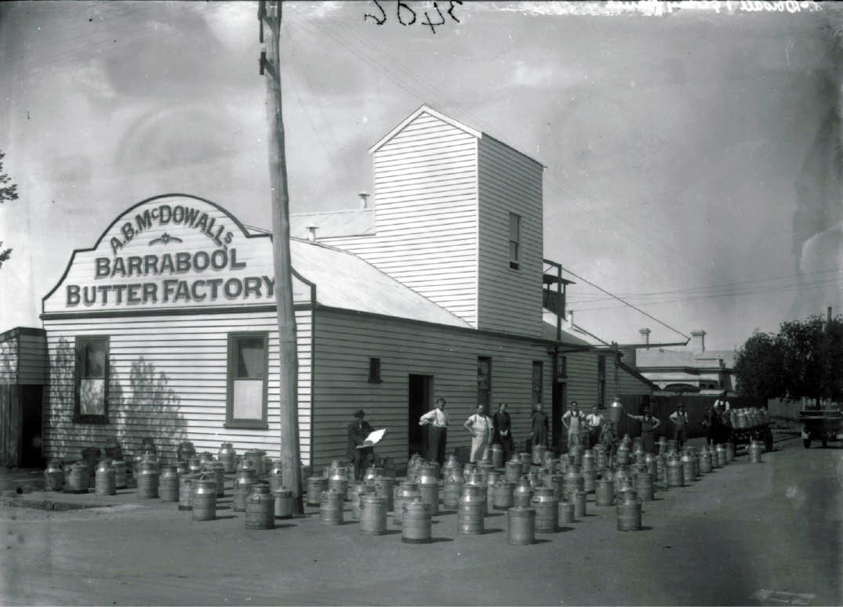
Figure 5.65: Barrabool Butter Factory, South Geelong, n.d. Source: Lorraine Huddle.

In the Greater Geelong area by 1905 there were three butter factories: Drysdale Butter Factory, Geelong Butter Factory and the Barrabool Butter Factory (based at South Geelong).546 The Drysdale operation had commenced in a central
location in the township in 1891 having been established by young local farmers, and particularly Thomas Grigg.547 The Barrabool Butter Factory in Fyans Street, South Geelong was established in 1892.548 The two storey brick building was almost destroyed by fire in 1904 and replaced with a timber factory by August of that year549 (Figure 5.65).
In 1893, a triangular piece of land bound by Lonsdale,
Carr and Bellerine Streets was set aside for the construction of the Geelong District Butter and Cheese Factory, the site being influenced by the adjacent Geelong to Colac railway line and therefore convenient transport to retail markets.550 The factory building was opened in 1894, the year the directors erected a creamery at Lovely Banks.551 By 1909, the Geelong Butter Factory had been taken over by Edward O’Connell.552 In 1921, he also took over the Barrabool Butter
Factory at South Geelong.553 In 1923, the Geelong Butter Factory building in Lonsdale Street was replaced with a more commodious two storey gambrel-roofed building designed by
I.G. Anderson.554
Three years later in 1926, Leslie Lucas built a brick butter factory at 57 Little Ryrie Street (north-east corner of Little Ryrie and Market Streets) as his Excelsior Butter Factory.555 Owned by the Geelong Co-operative Dairy Association by 1941, a ‘modern’ milk factory was erected on the Little Ryrie Street site at this time.556 The Co-operative Dairy Association were also responsible for the construction of a wheat storage silo in Mercer Street in 1947.557 To cost £3739, the silos (with a capacity for 80,000 bushels of wheat) were built by Messrs.
S. Haunstrap and Co. of Melbourne.558 A flour mill was also anticipated to be erected but does not appear to have been realised.559
The concrete silos remain as a landmark in Mercer Street today but all of the butter factories and creameries no longer exist.

DAIRIES
Ubiquitous throughout suburban and rural parts of Greater Geelong from the second half of the 19th century were dairies. Some had connections that extended well into the 20th century, such as the Tomkins family at Belmont, whereby the family patriarch, George Tomkins, had established a dairy farm in Roslyn Road in 1861.560 The Tomkins name was to
be associated with the Belgrove and Riverview Dairies in the 20th century.561
The agricultural areas in close proximity to the Geelong township, and particularly Newcomb, Moolap, St. Albans (Whittington), Belmont and Highton had a notable number resident dairymen.562 There were also dairies in outlying locations such as Drysdale, Portarlington and Ocean Grove.
In 1890, the Dairymen’s Association of Victoria
was established in Melbourne. The objects of the association were:
To promote and encourage practical dairying in all its branches; to arrange for standards in milk, whereby payment should be made according to quality; to establish a bureau for the educating and supplying of male and female expert labor for the industry generally; to improve the present system of artificial fodder, and thus minimise the losses at present sustained during long periods of drought and floods; to arrange for a better means of transit for the dairy to the local as well as the foreign consumer, by means of cool railway, steamer and delivery transit at lower rates; to discover and decide upon the best means of placing the surplus production; to decide upon the best method of packing for the export trade, to hold annual exhibitions of dairy produce and to generally endeavor to improve the quality, quantity and value of the butter and cheese production of the colony.563
A Geelong Dairymen’s Association had formed by 1912. Its focus included milk price regulation.564 The importance of the local Association especially came following the Dairy Supervision Act in 1915 which legislated the inspection and supervision in Victoria of dairies, dairy farms, dairy produce, milk stores, milk shops, milk vessels, dairy cattle and grazing
grounds. 565 Membership of the Association was consolidated following the passing of the Milk Supply Act in 1922 which legislated the establishment of milk depots, treatment
and cooling of milk and milk products and transportation. Dairymen were therefore required to be licensed.566 In 1926, there were 13 milk vendors in the Moolap Riding east of the Geelong township at Whittington and Moolap, 12 in Belmont and Highton, and one in Newtown.567 They included Robert McPhan, H.C. Whittington, Leonard Whittington, Edward Mitchell and William Beardon of Whittington, Thomas Warren of West Moolap, Albert C. Tomkins, Harriet Tomkins and
F.W. Tomkins of Belmont , and Alwyn Johns of Highton.568

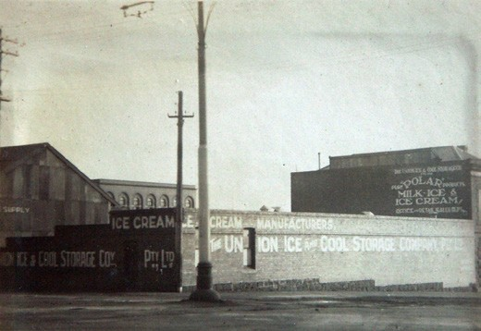
Figure 5.66: Union Ice and Cool Storage Company Pty Ltd factory, Moorabool Street (corner Brougham Street), 1932. Source: Holmes collection, Authentic Heritage Services.
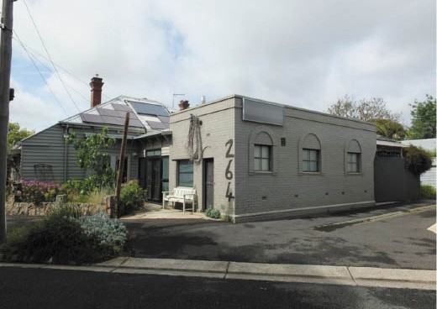
Figure 5.67: Former dairy, 264 Kilgour Street, East Geelong, 2019. Source: David Rowe.
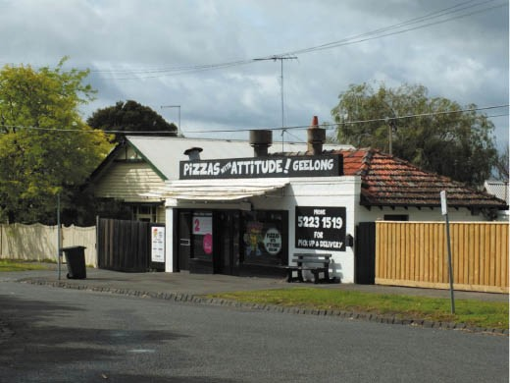
Figure 5.68: Former dairy, now pizza shop, 37A Bourke Crescent (fronting Walls Street), Geelong, 2019. Source: David Rowe.

Notable dairies included ‘Rosebank’, 181 Boundary Road, operated by William and Henry Nairn from 1917.569 Further afield at Ocean Grove, the Newington Dairy was established in the late 19th century and in the early 20th century it was taken over by Catherine and Charles Warren and renamed Warren s Dairy.570 The business passed to the Warrens daughter, May Mitchell, who in turn bequeathed it to her son, Percy Mitchell who renamed it Mitchell s Dairy.571
This dairy business continues to operate in Ocean Grove today, although the original premises in Wyatt Street were demolished in 2011.572 Other dairy licensees in the mid-late 20th century included Frank Moore of Moore’s Dairies Pty Ltd, 58 Church Street, Geelong West, A.C. and K.J. Howes of Portarlington, Welwyn Dairies Pty Ltd of Regent Street, Newcomb, A.H. Trewin of St. Leonards, Larcor Dairy, Lara, and Sargent’s Norlane Dairy Pty Ltd, Norlane.573 None of these businesses survive today.
One dairy that continues to operate is Geelong Milk at 30 Bloomsbury Street, Newtown. A brick factory was erected at this site in 1955 for Polar Products Pty Ltd.574 This company had formed in 1933 at the north end of Moorabool Street, having taken over the business and building of the Union Ice and Storage Company Pty Ltd (established in 1911) (Figure 5.66). The Union Ice and Storage Company had begun its ‘Polar Pure Milk Supply’ in 1926 following the installation of a most modern plant. 575 Ice cream also formed part of the ‘Polar’ product range.Physical legacies exist throughout suburban Geelong of the smaller home retail dairies. All of these dairies have closed and the buildings repurposed for
domestic or commercial use. They include those at 99 Skene Street, Newtown (established in c.1942 by Allan Gordon at the rear of his dwelling); 264 Kilgour Street, East Geelong (established in c.1945 by Rodham Lucas in a brick dairy beside his Edwardian dwelling) (Figure 5.67); 275 McKillop
Street, East Geelong (established by A.L. Moore in c.1948 in a brick dwelling at the rear of his Bungalow); 17 Meakin Street, East Geelong (established by Ian McGuiness in c.1948 in a brick building at the rear of his dwelling); and 37A Bourke Crescent, Geelong (established by George Berridge in c.1948 with a frontage to Walls Street).576 The latter dairy has been converted into a pizza shop (Figure 5.68).

OTHER MANUFACTURING IN THE 20TH CENTURY AND BEYOND
From the late 19th century and especially the early
20th century, the northern suburbs of Geelong became an industrial hub that offered employment opportunities for hundreds of workers. It had begun with the construction of the Western and Wimmera Districts of Victoria Freezing Company at North Shore in 1896 (see Theme 3).577

From 1896 with the opening of the Western and Wimmera districts of Victoria Freezing Works and subsequent construction of Corio Quay by the Geelong Harbor Trust in 1908 (see Theme 3), the northern suburbs of Geelong were transformed. A number of these manufacturing industries
– including the Oriental Timber Company and Fellmongery Works (1908), Ford Motor Company (built 1924, closed 2016) (Theme 3), International Harvester (opened 1939 and closed 1982) (see earlier subsection) and the Shell Oil
Refinery (opened 1953) – have either closed or employment opportunities have diminished. A similar scenario is also found in other parts of Greater Geelong as the dominance of the manufacturing sector wanes.
One of the early 20th century heavy industries still in operation at North Shore is the former Phosphate
Co-operative of Australia Ltd. (now Omya Australia), one of two superphosphate manufacturers established in the
area in the 1920s.578 At North Shore, the Phosphate Co- operative leased a site from 1924 after a number of years of negotiations.579 Formed in 1919 ‘to deal with phosphatic rock in Australia and from the Pacific and South Sea Island’,580
the production of superphosphate was critical to successful farming, being the equivalent of guano used in earlier years (see Theme 4). The early directors of the Phosphate Co- operative were the Hon. W.C. Hill (chairman), D.P.C. Wilson,
A.W. Corney and A.S. Reid, with capital raised by farmers.581 By May 1924, a railway siding had been erected and tenders called for one steel and two timber storage sheds.582 The main shed was to be built by Messrs. Redpath, Brown and Co. Ltd., of Morwell.583 Delays ensued with the progress
of the works which neared completion in September 1926 and it was claimed that the works were ‘the most up-to- date of its kind in Australia.’584 The layout of the buildings was carefully planned, being parallel and perpendicular to the railway siding. The rock storage shed was built of
Oregon pine and Whittlesea hardwood with galvanised steel sheeting and a concrete floor, below which was a tunnel that ran lengthwise along the centre where crude rock was
moved by conveyor and delivered to the crushing plant.585 A crushing house was built of steel and covered by black iron (the colour created by a mixture of dehydrated coal tar and lime to protect it from corrosion).586 The site also included
a den house and the ‘super’ shed, the largest of its kind in the Southern Hemisphere, with a steel frame and galvanised steel sheeting providing a covered area of 1 acres (Figure 5.69). There was also a nitre store of concrete construction, and a roofless sulphur store.587 A wharf was also to be
built in late 1926.588 Manufacturing of superphosphate commenced in 1927.589 In addition to the factory site, some existing dwellings at North Shore also have associations with the phosphate works, including the interwar Bungalow

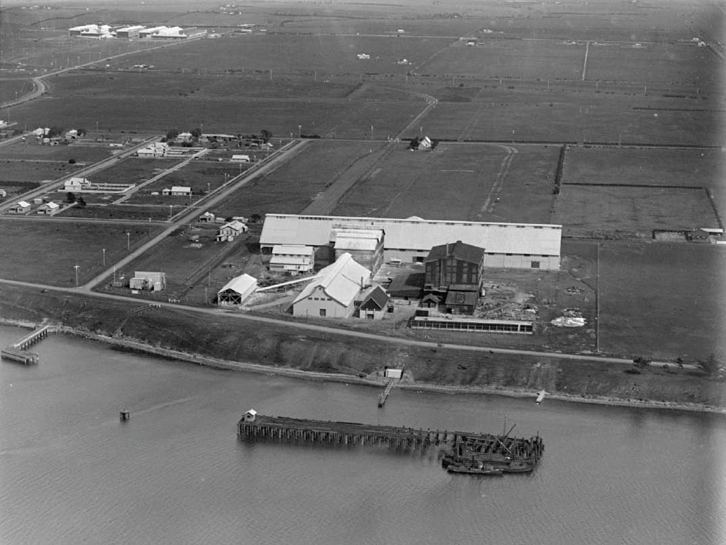
Figure 5.69: C. Pratt, Aerial view of the Phosphate Co-operative of Australia Ltd., North Shore, c.1927-37. Source: accession H91.160/1092.

at 57 The Esplanade, built in 1927 for the company s engineer (see Theme 6).590
While Greater Geelong experienced a shift in employment opportunities from a manufacturing hub to a location for health, educational and insurance sectors from the late 20th century (see Theme 6), new industries were also established. They included the formation of the Cotton-On Group, a clothing company from 1988 with a head office and global support centre in North Geelong, distribution centre at Avalon, and stores in Geelong.591 Another was the Carbon Revolution Pty Ltd company at Waurn Ponds, which developed world-leading technology in the manufacture
of composite wheels from 2004. Together the company includes research and development specialists from leading aircraft manufactures, industrial composites manufacturing specialists and numerous PhDs with world-leading materials and structures knowledge.’592

TRADE SECTOR
Partly aligned with both the industrial and commercial enterprises in Greater Geelong to provide employment was the trader sector. Chiefly among these enterprises was wool broking and wool sales which became lucrative businesses and enduring employers. Other commercial trades provided much-needed necessities associated with the lifestyles of 19th and 20th century residents including ironmongers, bakers, livestock and grain merchants, cabinet makers and undertakers, painters and decorators, confectioners and pastrycooks, bootmakers and shoe repairers, butchers, hairdressers and tobacconists, merchants and importers, warehousemen and timber merchants. The following provides tangible physical connections to some of these trades.

WOOL BROKING AND WOOL SALES
The rich pastoral lands of the Geelong area and the western district was taken up by squatters and pastoralists from the 1840s.593 Thousands of sheep and cattle were brought as a means of making fortunes on the land.594 Geelong became the centre of the wool market, where wool was stored and shipped to London. Public wool sales were first held from 1850, requiring the construction of wool stores and it was from these early beginnings that the foundations for Geelong to become Victoria s wool centre.595
The importance of Geelong as Victoria s wool capital is reflected in there being 17 local wool brokers listed in the Geelong Commercial Directory and Almanac in 1854.596 Especially associated with this industry were James Ford Strachan (1810-1875), Frederick Gonnerman Dalgety (1817- 1894), Charles John Dennys (1818-1898), Charles Shannon (1841-1922), Edward Harewood Lascelles (1847-1917) and Edward Arthur Austin (1875-1940). One of the earliest bonded stores to be established was that of J.F. Strachan and Co.
in Corio Street in 1840.597 Strachan was born at Montrose, Scotland and went to Tasmania in 1832.598 Strachan first visited Port Phillip in 1836 and in the following year he worked as a squatters’ provider in Melbourne.599 In 1838, he opened a store in Geelong.600 A stone building was completed in 1840 and his suburban mansion house, ‘Lunan’ was constructed
in 1849.601 From Geelong, Strachan combined pastoral and mercantile pursuits and was a Victorian Parliamentarian from 1851 to 1866, and from 1867 to 1874.602
Frederick Gonnerman Dalgety was born in Canada in 1817, the son of Alexander Dalgety army officer and Elizabeth Dalgety (nee Doidge).603 Having emigrated to Sydney in 1834, he became a clerk before relocating to Melbourne in 1842 as manager of a new firm.604 By 1848, he was a successful and independent merchant contracting on ‘the squatters’ trade’
by providing merchandise for the squatters and buying their

produce.605 After a time in London from 1854 setting up the headquarters of a metropolitan-colonial enterprise associated with the Victorian pastoral industry, he established a partnership with Frederick Du Croz, Charles Ibbotson, James Blackwood following his return to Victoria in 1857 under the name of Dalgety and Co.606
Charles John Dennys was the son of an English wine merchant of London, Nicholas Belfield Dennys, and
Eliza Dennys (nee Lascelles).607 He migrated to Melbourne in 1842 and shortly afterwards relocated to Geelong and established a farm on ‘model’ principles on the Barwon and Moorabool Rivers.608 In 1847, he acquired the tallow works at the Breakwater known as the Barwon Melting Establishment and expanded his business interests with a
leather warehouse in 1850.609 With some setbacks following the goldrush, he established a general agency business with his brother in law, Edward Walton, and cousin, Thomas Allen Lascelles junior, trading under the name of C.J. Dennys and Co.610 The partnership was dissolved in 1853 and after a time in England, Dennys returned to commence business in wool auctions.611 He was joined in partnership in 1864 with his nephew, Martin Lascelles Dennys, ensuring the Dennys name remained as part of the business.612 In 1875, the business name changed to Dennys Lascelles and Co., and in 1877 David Strachan replaced M.L. Dennys as a partner.613 In 1881, further changes occurred with Sidney Austin of Barwon Park, Winchelsea, prominent sheep grazier, joining the firm.614
At this time the business was name as Dennys, Lascelles, Austin and Co. Others to later join the wool broking firm were Marcel Conran, and George Young
of Horsham.615
Charles Shannon was born at Greenoch, Scotland, in 1841 and came to Geelong in 1865 when he joined the form of John Wilson and Co., merchants.616 He later became a partner in the business and on Wilson’s retirement, the firm merged
into that of Strachan, Murray and Shannon. This company became one of the leading wool broking firms in Geelong. In addition, Shannon was financially involved in the formation of Godfrey Hirst and Co., and the acquisition of the Barwon and Victorian Woollen Mills on the Barwon River at South Geelong.617 He contributed much to community life including local government, Geelong College Council, Geelong Hospital, Try Boys and the Presbyterian Church.618
Edward Harewood Lascelles was born in 1847 at Bothwell, Tasmania, the son of Edwin Lascelles and Eliza Lascelles (nee Nicholas).619 Following the death of his mother, Lascelles went to live with his uncle, C.J. Dennys in Geelong.620 He joined his uncle’s wool broking firm at the age of 16 and was a partner by 21, the firm becoming Dennys Lascelles and Co. in 1875. It was also in this year when Shannon married Emily Agnes Strachan.621 During this

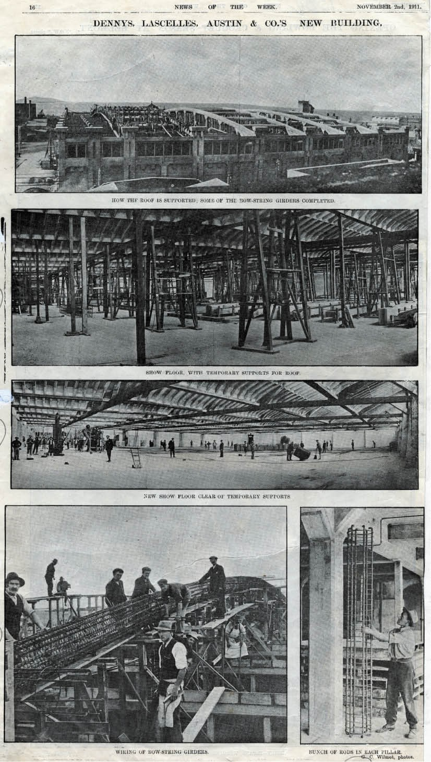
Figure 5.70: G.C. Wilmot, Dennys Lascelles Austin & Co. ‘Bow Truss’ Woolstore under construction, 1911. Source: News of the Week, 2 November 1911, p.16, GRS 2009/002295/145-149, Geelong Heritage Centre collection.

period, Lascelles became an expert wool classer and broker, together with being the chief wool valuer and manager.622 He also took up pastoral interests at Winchelsea (with Ingleby Homestead) and in the Mallee on Yarriambiac Creek (Lake Corrong sheep station).623 He was the first to introduced share farming in Victoria and the first president of the Karkarooc Shire in 1896-97.624 At the turn of the century, he had the first steam car to arrive in Geelong (see Theme 3).625
Edward Arthur Austin was born in 1875, the fourth son
to Sidney Austin and the great nephew of Thomas Austin, sheep grazier of Barwon Park, Winchelsea.626 Edward Austin was later employed as secretary at Dennys, Lascelles, Austin and Co. and following a period as secretary of the Austin family’s pastoral interests in New South Wales, became the secretary and bursar of the Geelong Grammar School.627 He served as a Member of the Legislative Assembly between 1923 and 1935.628
Throughout the 19th and 20th centuries, there were around seven wool merchant and broker businesses in Geelong (see Appendix 5.1). Most of these businesses were centred around Brougham Street, and particularly west of Moorabool Street and Western Beach Road. A particularly inventive
wool store was constructed in Brougham Street in 1910-11 for Dennys, Lascelles, Austin and Co.629 It was designed by the engineer, Edward Giles Stone of New South Wales630 who, with E.J. Siddeley, was to win the contract for engineering the Geelong Waterworks and Sewerage Trust’s Ocean Outfall Sewerage Scheme (see Theme 4). The construction of the wool store was unique. Stone had combined the Considére system of reinforced concrete construction (see Theme 4) with a girder design based on those in a bridge that Considére had developed with the Ponts et Chaussées in France.631 The six reinforced concrete girders were tied together in pairs and were referred to as bowstring girders or trusses (Figure 5.70). During its construction in May 1910, the Geelong Advertiser highlighted the innovative construction and the public interest being generated in it:
The novel process of construction of Messrs. Dennys, Lascelles, Austin and Co’s new reinforced concrete wool store continues to prove a source of attraction to hundreds of people daily. A large section of the pillars from the basement and the first floor has been laid, and when the casings are removed a remarkably smooth and solid structure is revealed. The top floor of the large
structure will be entirely free from uprights, and when the huge expanse of floor area is considered the marvel of this engineering is better appreciated.632
Amid considerable controversy, the Premier of Victoria overruled the Historic Buildings Council allowing the demolition of the building in late 1989.633

The woolstore buildings associated with wool broking and wool sales on the Geelong waterfront continued to be developed after World War Two. This was due to the unprecedented boom in wool values. In 1948, The Argus reported that ‘Australian current general wool values are
unquestionably on boom levels never previously approached in wool history. 634 The increasing price in wool was due to the intense demand for merino wool from the Western district, which was sold and stored at Geelong.635
The wool boom required the expansion of the wool storage facilities. Between the early 1930s and the mid 1950s, the architectural office of Buchan Laird and Buchan, Geelong, prepared numerous proposals for alterations and additions to Dennys Lascelles woolstores in Geelong.636 They also prepared an equivalent number of drawings for changes
to the woolstores of Dalgety and Co.637 The Buchan Laird and Buchan firm (earliest known as Laird and Barlow) had first been engaged to design a brick wool warehouse in Gheringhap Street in 1891.638 Numerous commissions
followed. The continued patronage from the 1930s of Dennys Lascelles might also have been due to a family connection with the wool broking company. George A. Laird (1900-1996), was a wool expert and wool manager of the Dennys Lascelles firm from 1932.639 He was the brother of Ewen Laird, partner of Buchan Laird and Buchan.640
The importance of Geelong and its woolstores in the expanding market was reported in The Horsham Times in 1954:
High wool prices have had the effect of advertising the importance of the product and have also given publicity to the outstanding position of Geelong as a selling centre.
… Stores of the respective brokers are equipped to handle a quarter of a million bales of wool a year and in all provide about 36 acres of floor space for receival, storage, treatment, display and delivery of this huge quantity of wool.
… It will be seen that the Geelong market has undergone many changes. In the first year of auctions [c.1857], 4,000 bales were sold, in 1889-90 the sales totalled 47,792 bales and in 1947-48, 254,888 bales were handled.641
In 1956, New Zealand Loan and Mercantile Agency Company Ltd. announced its intention of building a new woolstore in Moorabool Street:
In order to provide adequately for future expansion at Geelong the Company recently acquired a splendid site at the corner of Moorabool Street and Corio Terrace [Brougham Street], which is in the wool store area of Geelong and intends to erect on this site a modern wool

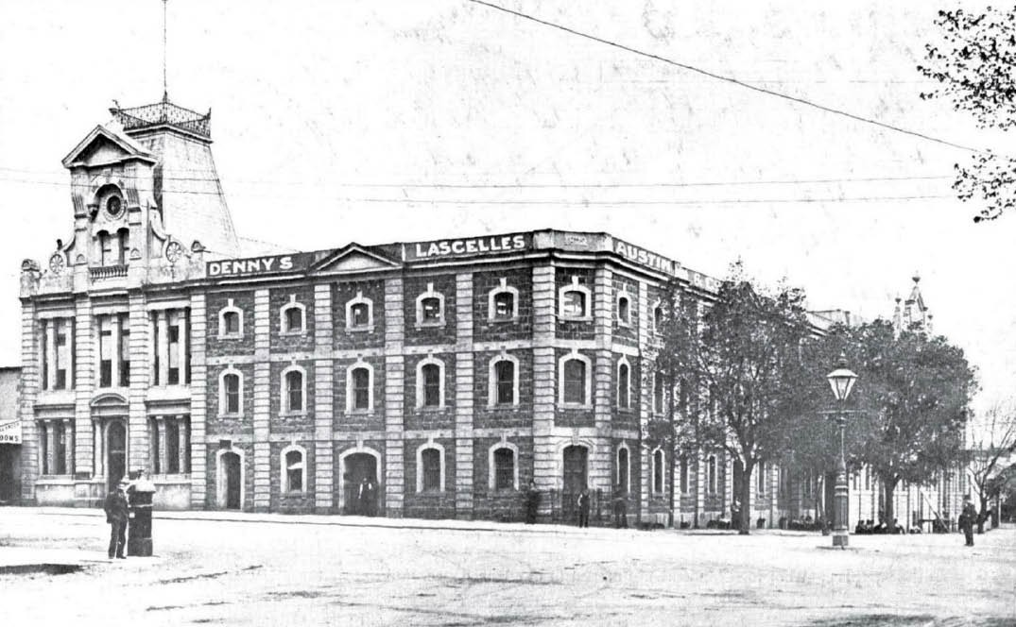
Figure 5.71: C.J. Dennys and Co. (later Dennys Lascelles Austin & Co.) Wool Ware House, 1907, showing office addition (left) (the mansard roof was demolished in c.1930).645 Source: 50 Years Selling Wool in Geelong 1857-1907, Dennys, Lascelles, Austin & Co., September 1907, p.1, State Library of Victoria.

store with show floors embodying the best features in the display of wool for sale.642
While none of the 19th and 20th century woolstores in the northern and north-western portion of central Geelong function for their original purpose today, they provide a unique legacy of this critical industry in Geelong. They have all been substantially changed but the inherent industrial vernacular characteristics form a distinction presence in this part of Geelong. These buildings are also supplemented with other wool broking related structures, including the Wool Exchange in Corio Street and the former Dalgety and Co. Ltd. Administrative office at 1-7 Malop Street.

NATIONAL WOOL MUSEUM (FORMER C.J. DENNYS AND CO. WOOLSTORE),
26 MOORABOOL STREET
One of the most substantial and earliest-surviving woolstores in central Geelong, the former C.J. Dennys and Co. Woolstore was built in 1872 and its size, innovative design and distinctive fa ade brought general acclaim.643 The newly- completed building (Figure 5.71) was detailed in the Geelong Advertiser:
From time to time during the past few months we have referred to the progress of the building of the new store for Messrs C.J. Dennys and Co., which is now completed,
and occupies a position at the bottom of Moorabool-street, where it can be seen by all approaching the town by water, a monument of successful commercial enterprise, and a land mark for wool ships as they come up the Bay. It is the second largest wool store in the colony, and was built under the supervision of Mr Charles John Dennys, whose lengthened experienced in the business has enabled him to offer suggestions to the builder, which, carried out, have made the store the most complete in its arrangement of any store in the colony. Messrs. Goldsbrough and
Co. have the largest store, but it is admitted that for the purposes intended the one now under notice is to be preferred The basement of the warehouse was planned and superintended by Mr Jacob Pitman, architect, but
the superstructure has been designed and erected by Mr Jonathan Coulson, architect and contractor, of Ballarat. This gentleman has carried out his own design in a manner that reflects credit on his ability as an architect and his honesty as a contractor. The warehouse consists of four stories, including the basement; the total height is

48 feet, a splendid view being obtainable from the roof; length, 132 feet; and breadth, 64 feet. The foundations are very massive, the whole of the foot course being composed of solid headers, or though stones, 3ft. by 3ft. by 1ft., on a foundation of concrete. The elevation
exhibits foot courses of tuck pointed rock faced bluestone, alternating with piers rusticated in cement. The windows, parapet, and basement are also cemented, and form
a fine contrast to the bluestone. The site chosen is specially adapted for facilitating the work of a wool and produce warehouse, a gentle incline from Moorabool street towards Brougham place affording facilities for wagons and drays loading and unloading on the ground, floor, which at the archway entrance is just on a level with the body of the vehicles. Waggons therefore, will enter the archway, discharge their load and pass out into a right-of-way leading into Corio-street. In addition to the facilities afforded by the archway entrance, there are three other receiving and delivering doors, so that an order for shipment or delivery can be executed at the same time that large quantities of wool may be coming
into the warehouse, an advantage in the prompt despatch of business which will be understood and appreciated
by those who know what it is to be blocked with wool in the height of the season, with draymen clamouring to be discharged and buyers and consignees pressing to get their bills of loading for the mail. The building is lighted by windows on every side, so placed as to admit of two rows of bales between each window, leaving a well lighted passage between each double row of bales, by means of which wool can be examined and passed, or any bale that may be wanted can be got at without delay. It is however, the show or sample room on which Messrs. C.J.D. and
Co justly pride themselves, this is indeed a handsome room. It is 129 feet by 61 feet 6 inches in the clear, the walls lined with brick, and the ceiling of wood. The walls are colored, and the ceilings painted a pale French grey color, which, while having a very good effect, tempers the light that might, with whitened walls and ceiling, be sometimes too trying for the eyes. The room is lighted
like the woollen factories, by southern light ribbed glass in the roof, and ventilated by windows on every side, which will open and admit a fresh current of air from any point
of the compass, a desideratum that will be appreciated by those whose business compels them to undergo the ordeal of valuing hundreds of lots of wool on a hot day, with the thermometer at 80o or 90o in the shade and a hot wind blowing, in a steaming wool store with an iron or unceiled slate roof. The cellar is another striking feature in the building, and is intended for the sale of hides and
skins. The floor has, at great expense, been cemented over in the most substantial manner possible, while the light streams in on all sides without in any manner increasing

the temperature, which will be nearly uniform in winter and summer. In one corner there is a little sanctum sanctorum in which, doubtless, much genuine hospitality will be dispensed in years to come in the shape of a glass of beer or a “nip,” with a biscuit and colonial Cheddar, to buyers and sellers alike, provision being also made for total abstainers of whom there are not a few among the attendants at hide and skin sales. The whole cellar will be kept admirably dry by underground pipes and metal drains intersecting the natural soakage about the foundation and running into the main two drain which discharges itself in the Bay. To sum up, the warehouse is built for the business to be carried on in it, and is in every respect admirably planned and suited for the carrying on the large and prosperous business of
the enterprising firm, who have so spiritedly expended thousands of pounds in its construction.644
The building served as a wool store and warehouse for over 100 years until it was converted into the National Wool Museum in 1988 (see Theme 8).

DEAKIN WATERFRONT CAMPUS, 1-11 GHERINGHAP STREET⁶⁴⁶
The earliest section of this former woolstores complex fronting Gheringhap Street was built in 1891 for Dalgety and Company Limited to a design by Laird and Barlow.
Extensive additions were made to this wing in 1929, involving the construction of a third storey (Figure 5.72). In 1940, further extensions were carried out, as well as the complete rebuilding of the Gheringhap Street façade. All of these works were designed by Laird and Buchan architects.
The central portion of the former woolstores complex fronting Western Beach Road was built in 1901. The brick Industrial Romanesque styled building was defined by giant openings with four levels of windows within.
The eastern portion of the woolstores complex was built in 1934. The six storeyed building was designed with vertical bays of timber framed double hung windows.
In 1994, construction commenced on adapting the western and central portions of the former woolstores complex into a waterfront university campus. Numerous alterations were carried out, but the essential fabric and character of the woolstores were retained. In more recent years, the eastern portion of the woolstores complex (built in 1934) has been
adapted and altered as part of the university functions (Figure 5.73).

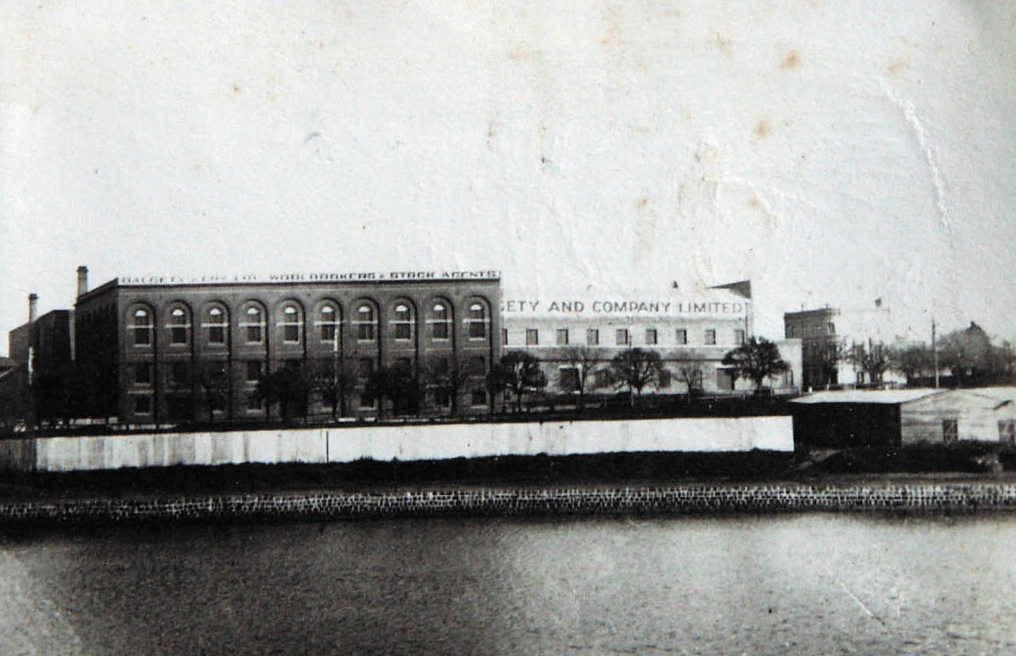
Figure 5.72: T.T. Holmes, Dalgety and Co. Ltd. Woolstores Complex, 4 July 1931, from Cunningham Pier. Source: Holmes collection, Authentic Heritage Services.

WESTFIELD SHOPPING CENTRE, MOORABOOL, BROUGHAM & YARRA STREETS, GEELONG⁶⁴⁷
The south-west corner facades of the Westfield Shopping Centre represent the former Strachan, Murray, Shannon Woolstores complex. The first stone woolstore was built on this site in 1840 for James Ford Strachan. It was replaced from 1889 with a four storey red brick building that has been systematically altered and extended in 1896, 1898, 1900, 1906,1925 and later (Figure 5.74). The evolution of change was carried out in a consistent manner.
In 1987, all except the street facades of the former Strachan Murray, Shannon Woolstore and the adjoining Electricity Lighting and Traction Co. building were demolished as part of the development of a shopping centre. New openings were introduced and some original openings were altered or blocked up. Alterations and additions were made to the parapets.

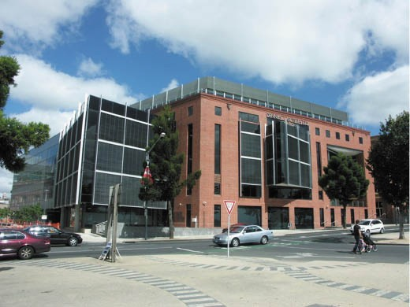
Figure 5.73: Deakin University Waterfront campus (east wing) (former Dennys Lascelles Ltd woolstore built in 1934), Western Beach Road, Geelong, 2011. Source: David Rowe.

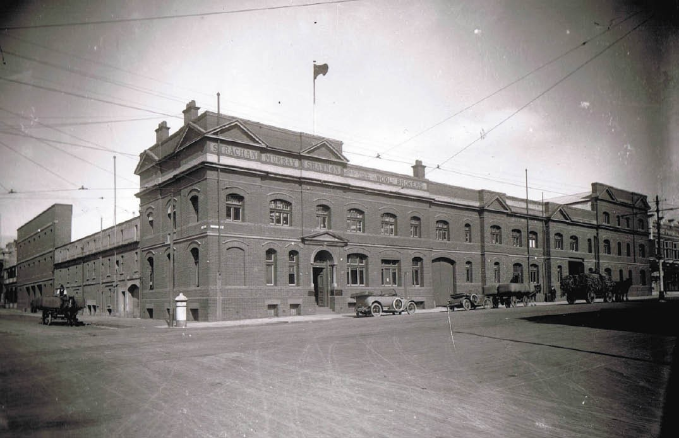
Figure 5.74: Strachan Murray, Shannon Woolstores, Moorabool & Brougham Streets, n.d. [before 1933]. Source: D. Davies collection, Lorraine Huddle.

WOOL EXCHANGE, 44 CORIO STREET, GEELONG
While private wool sales in Geelong occurred from the 1840s, the first public wool sale in the town was held in December 1850 when Alfred Douglass advertised his Geelong Wool Mart:
Geelong Wool Mart.
To Squatters, Merchants, and Wool Buyers.
The undersigned begs to inform the Squatters, Merchants, and Wool Buyers of Port Phillip, that he has taken a portion of the premises now in the occupation of Messrs Swanston, Willis and Co, Yarra street, Geelong, as a Wool Store, where he will be happy to receive wool for sale, assorting, or dumping.
He flatters himself that his long experience in preparing wool for the home market, from having the last ten years had the management of Mr C.T. Smith’s Wool Warehouse, in Hobart Town, will enable parties to rely upon having every attention paid to the requisite classing.
No charge will be made for receiving or storing wools intended for repacking; other charges will be the same as
at Melbourne.
Sales by auction will be held when wished, the vendors selecting their own auctioneer.648
By 1868, wool sales were held at Mack’s Hotel, Brougham Street.649 In 1876, Messrs. Dennys, Lascelles and Co.; announced that they were to hold their first sale of wool at the Free Library in Moorabool Street.650 Other wool brokers and merchants followed by having their sales at the library.651
In 1892, following the opening of a central sale room for wool buyers in Melbourne, Messrs. Dalgety and Co. Ltd. and Messrs. Strachan, Bostock and Co. led to the construction of a purpose-built wool exchange behind the Victoria Hotel in Moorabool Street in 1892.652 Designed by Laird and Barlow architects, the exchange was built by W. Murphy to
comfortably seat 150 people.653 Opened on 14 October 1892, the brick building was described as ‘being lofty, splendidly lighted, and well ventilated. 654
The exchange behind the Victoria Hotel served the wool buyers until 1928 when the existing exchange building was constructed by H. Beach and Sons Pty Ltd at 44 Corio Street to a design by Laird and Buchan architects (Figures 5.75-76).

It was described in the Geelong Advertiser:
The new Wool Exchange forms a creditable addition to the architecture of a progressive commercial city such as Geelong. The façade, which is finished in a buff colored stucco, has been influenced by the traditions of Italy, and embodies the spirit of that delightful period of architecture known as the Italianate Renaissance, as developed by those master-architects of the fifteenth century of whom Michael Angelo [sic.] was one of the leaders. Treating this style along modern lines the architects have struck the keynote of successful design, that is elimination and simplicity, which combined with quality of detail, gives an effect of restrained dignity. The lower story of the fa ade, which is heavily rusticated, is pierced by semi-circular headed openings, well-proportioned and beautifully spaced. The upper story is treated with coupled pilasters, crowned with a rich cornice and balustrading, while the main entry is emphasised by a triangular pediment. The building is flanked by a small staircase tower which gives a note of interest to the skyline. The planning is simple and straightforward and embodies all the necessary offices for the successful running of a modern wool exchange. From the main entry hall which is treated
with a vaulted ceiling, access may be obtained to parts of the building. A broad corridor leads to a writing room for the convenience of buyers, and thence a circular passage gives entrance to both sides of the main auction room. This is a large classically-treated hall, flanked
on either side by large semi-circular headed windows which give brilliant lighting to the interior. The ceiling is divided into bays by coffered panelled ribs, finished with enriched corbels, with three light wells which are concealed by open patterned plaster grilles. The walls are finished in sand finished plaster while the doors and skirtings are painted a delicate French blue color,
contrasting pleasantly with the buff of the walls. The seats of the buyers are arranged in circular form in front of the auctioneer’s rostrum, and rise away from the floor so that all may see the auctioneer plainly. Above is the growers’ gallery, to which access from the entry hall is obtained by a fine staircase, the treads of which are finished in marble terrazzo. Here, the spectators may witness all that is taking place below them and hear the prices as the wool is sold. Also on the first floor are the offices of the secretary and those who are responsible for the successful conduct of the sales. On the left of the entry hall is the star lots auction room, where the small lots are sold. Here too, the buyers have an excellent view of the auctioneer from a ramped and stepped floor. This room is simply finished
in white plaster, with heavily beamed ceiling. Ample lavatories, cloak room accommodation, and storage space complete the building. The concrete floors throughout

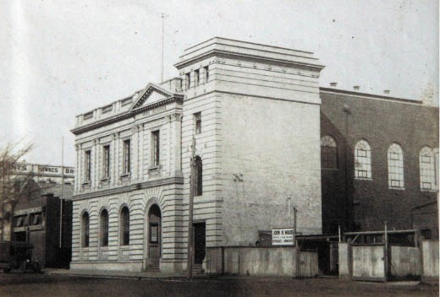
Figure 5.75: T.T. Holmes, Geelong Wool Exchange, Corio Street, c.1931. Source: Holmes collection, Authentic Heritage Services.
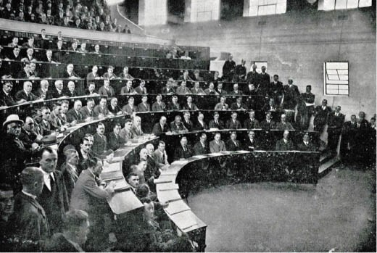
Figure 5.76: Wool buyers at the Wool Exchange, c.1930. Source: Geelong: its advantages and opportunities, Geelong Publicity Council, Geelong, 1930, p.39.

are covered with heavy cork and rubber linos, given the necessary silence throughout the building.655

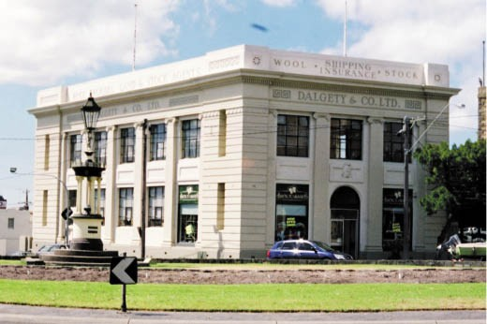
Figure 5.77: Former Dalgety & Co. Ltd. Administration Office, 1 Malop Street, Geelong, 2002. Source: David Rowe.
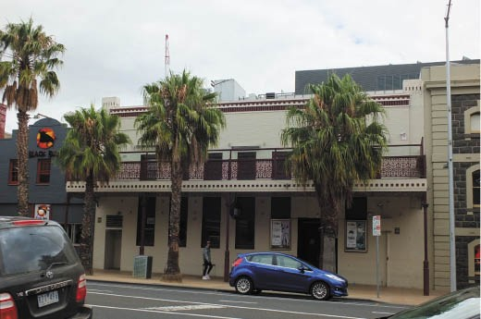
Figure 5.78: Former E.R. Sparrow & Co. Woolstore & Auction Room, 40-42 Moorabool Street, 2017. Source: David Rowe.

FORMER DALGETY AND CO. LTD ADMINISTRATION OFFICE, 1-7 MALOP STREET
In 1924, the wool broking firm of Dalgety and Co. commissioned the local architects, Laird and Buchan, to design a new building to house the company s administration offices at 1-7 Malop Street.656 According
to the Geelong Advertiser, the interwar modern Renaissance design (Figure 5.77) was to provide for a massive building :
The progressive firm of Messrs. Dalgety and Co. Ltd. some few months ago purchased the valuable site at the corner of Malop and Gheringhap-streets, with a view to erecting
a block of modern offices thereon … The scheme has now advanced to a stage of reality … [and] … comprises a spacious well-lighted basement, and two floors above for offices, and will face Gheringhap-street to a depth of ninety feet, while occupying the total available frontage of forty-eight feet to Malop-street. The main entrance to the

offices will be from Malop-street and a second entrance, given easy accessibility to the three floors will be provided from Gheringhap-street. The walls are to be built of brick and the floors of reinforced concrete, and the whole of
the building externally will be finished in fine stucco. The building while fulfilling all the requirements of up-to- date offices, has been designed in a modern adaptation of the classic style, which, besides forming an imposing edifice at the main entrance to the city proper, will be
in complete harmony with the fine buildings of the civic centre opposite.657
Today, only the principal facades largely remain, forming the base of an office tower occupied by WorkSafe.

FORMER E.R. SPARROW AND CO. WOOLSTORES AND AUCTION ROOMS

40-42 MOORABOOL ST⁶⁵⁸
In 1936, E.R. Sparrow and Co. proposed a new woolstore to a design by Buchan Laird and Buchan architects. The Geelong Advertiser gave a report on the proposal:
the new store, which is to be two-storied, will be constructed of brick with concrete and wood floors.
The Moorabool Street elevation will be attractive in appearance, verticality being expressed in the design and harmonising with the firm’s new buildings on the corner of Moorabool and Corio Streets.
It seems the building was completed by 1937. The rudimentary parapeted brick building has been overpainted, a post-support balcony and verandah constructed at the front and the original saw-toothed roof has been replaced (Figure 5.78).

54-58 MOORABOOL ST⁶⁵⁹
Built prior to 1852 as a music hall, a building at the corner of Corio Street and Moorabool Street served as Ogilvie and
Robinson’s Auctioneers’ office from 1872. It became the office of Robinson, Burns and Sparrow in 1886. This building is shown in the accompanying photograph taken before 1932. In 1932, the existing parapeted two storey building at the corner of Moorabool and Corio Streets was constructed to a design by Laird and Buchan architects as a wool store and showroom (Figure 5.79). A three-bayed extension was constructed immediately north in 1953 while the roof of the c.1870s building was removed and altered, possibly at this time (the 1850s south wall appears to survive). It seems that the building at
54 Moorabool Street was built as an extension to the Sparrow woolstore in the 1950s.

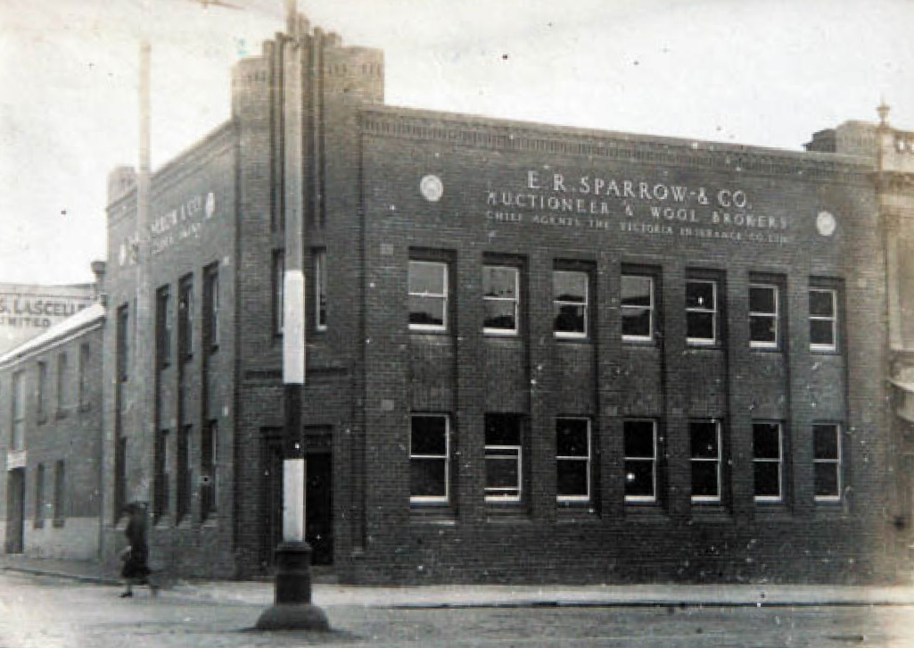

Figure 5.79: T.T. Holmes, Former E.R. Sparrow & Co. Auctioneer’s Office, 58 Moorabool Street, 1932. Source: Holmes collection, Authentic Heritage Services.
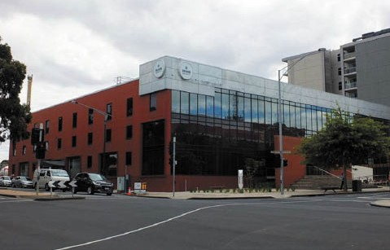
Figure 5.80: Former Dennys Lascelles Woolstore, 12-14 Gheringhap Street, 2017. Source: David Rowe.

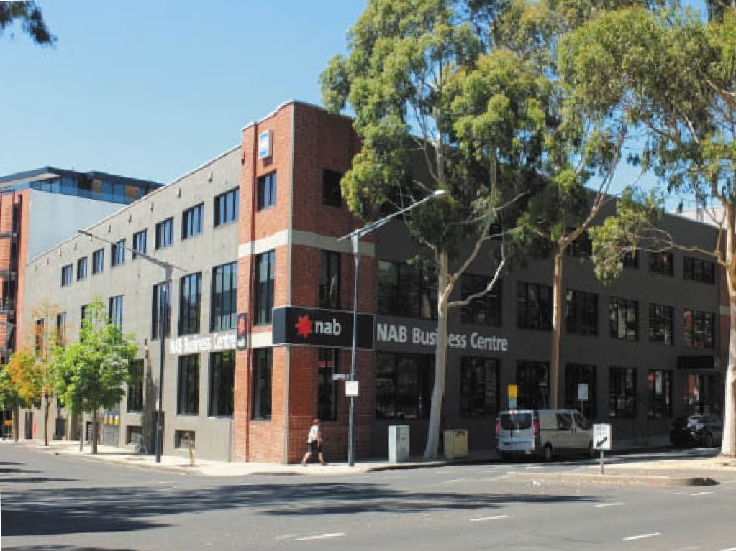
Figure 5.81: Former Dennys Lascelles Woolstore, 45 Brougham, Street, 2017. Source: David Rowe.

FORMER DENNYS LASCELLES WOOLSTORE, 12- 14 GHERINGHAP ST⁶⁶⁰
This woolstore appears to have been built in 1958-59, replacing an earlier brick store occupied by Dennys Lascelles. Constructed in brick with a saw toothed roof, the front (Gheringhap Street) fa ade was of temporary galvanised iron, the building then having a setback to Gheringhap Street. This was shown in the film ‘Life in Australia - Geelong in 1966’.
In more recent years, a glazed and lightweight parapeted addition was built at the east end (Figure 5.80). New aluminium framed windows and doors have also replaced original windows and doors. The building was converted into the Ford Discovery Centre before more recently being occupied by Deakin University.

FORMER DENNYS LASCELLES WOOLSTORE, 45 BROUGHAM ST⁶⁶¹
In 1940, Dennys Lascelles proposed a three storey parapeted building at the south-west corner of Brougham and Cunningham Streets to meet demand for increased wool storage space. The proposed building was described as being of steel frame and brick construction, and was to be connected to the larger Dennys Lascelles store on the south side of Brougham Street by an underground, reinforced
concrete tunnel, ‘fitted with mechanical conveyors for moving wool.’ The woolstore (Figure 5.81) was designed by Buchan Laird and Buchan and built by J.C. Taylor and Sons. The building has been converted into an office and alterations made to the facades, including rendering and painting (save for the corner bays) and new windows and doors installed.

FORMER DENNYS LASCELLES WOOLSTORE, 20 BROUGHAM ST⁶⁶²
By 1947, a two storey brick chaff and fodder works established by Lyall and Son served as a woolstore for Strachan and Co. Ltd. before being purchased by
Denny Lascelles Ltd in 1951. (see following subsection). In 1953, the local architectural firm of Buchan Laird and Buchan designed alterations and three storey brick additions. Built by
J.C. Taylor and Sons to meet the increased demand for wool storage, the works included saw-toothed roofs, parapeted brick facades and alterations to existing windows (Figure 5.82).

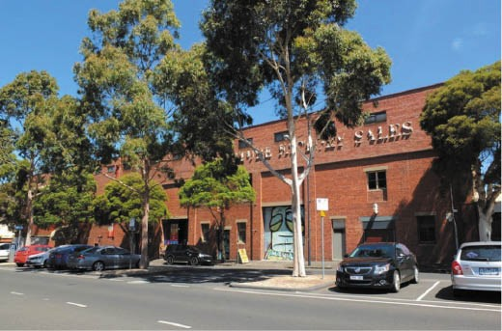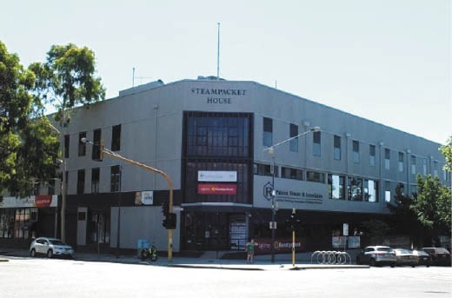

Figure 5.82: Former Dennys Lascelles Woolstore, 20 Brougham, Street, 2015. Source: David Rowe.
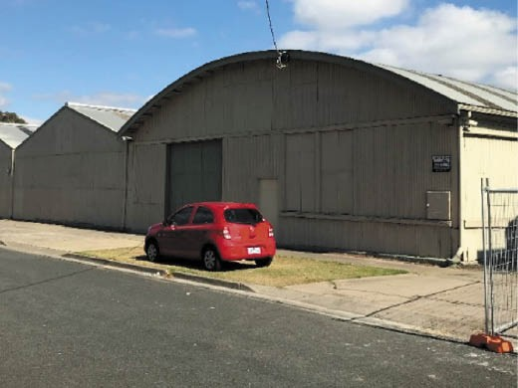
Figure 5.84: Former Dennys Lascelles Ltd Woolstore, 135 Fitzroy Street (Forrest Street frontage), 2019. The arched-roofed building in the foreground (with elevated gabled building behind/right) is the original glass factory (see Figure 5.50). Source: David Rowe.

FORMER NEW ZEALAND LAND & MERCANTILE AGENCY CO. WOOLSTORE (NOW STEAMPACKET HOUSE), 6-24
MOORABOOL ST⁶⁶³
In 1956, the New Zealand Land and Mercantile Agency Company Ltd (NZL) acquired the business of E.R. Sparrow and Company, wool brokers. To meet future storage demand, NZL announced that the company had ‘recently acquired a splendid site at the corner of Moorabool Street and Corio Terrace [Brougham Street] and intends to erect on this site
a modern wool store with show floors embodying the best features in the display of wool for sale. The building has been refaced and window and door openings altered (Figure 5.83).
Figure 5.83: Steampacket House (former New Zealand Land and Mercantile Agency Company Ltd), 6-24 Moorabool Street, 2017. Source: David Rowe.
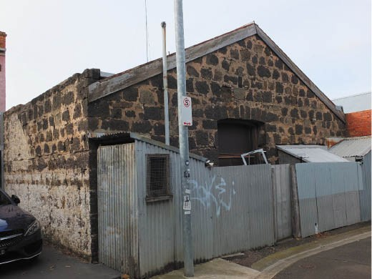
Figure 5.85: Former Hay Store, O’Farrell Place, Geelong, 2019. Source: David Rowe.

FORMER DENNYS LASCELLES LTD WOOLSTORE, 135 FITZROY ST, GEELONG⁶⁶⁴
A contextually unique surviving legacy of the wool broking era is the former wool store at 135 Fitzroy Street, built as the factory of United Glassworks Ltd. In 1920 (see earlier subsection). It was purchased by Dennys Lascelles Ltd. in 1927 and converted into a woolstore. On 22 February 1952, the Geelong architects, Buchan Laird and Buchan sought a building permit for the construction of ‘extension
to woolstore of timber and galv. Iron at corner of Forrest and Carr Streets.’ It would appear to have been from this time that the open yards were replaced with the existing gabled roofed structures (Figure 5.84).

GRAIN DEALERS, PRODUCE MERCHANTS, STORES, MARKETS, AUCTIONEERS AND TERMINALS
Given its close proximity to several well-established farms, Geelong boasted at least thirteen corn and hay, and produce merchants by 1855. Two of the earliest businesses were Dennis and Osborne at the corner of Malop and Ryrie Streets, and Charles Sach, 23 Myers Street.665 By 1882, there were at least eighteen hay, corn and produce dealers in Geelong and this number increased to around twenty in 1905. The decline in these businesses began in the 1920s with the growth in the industrial manufacturing sector, there only being six produce merchants in Geelong in 1944 and five in 1960.666 In addition, saleyards were established by the Geelong Corporation in the 19th century: at North Geelong and in Myers Street.

EARLY CORN STORE, O’FARRELL PLACE, GEELONG
Today, very few sites remain that are associated with this early trade. One of the earliest is a modest gabled bluestone building in O’Farrell Place (at the rear of 92-94 Ryrie Street) (Figure 5.85) that was erected in 1857 as the hay store for George William Barker’s ‘Eureka’ stores fronting Ryrie Street.667

HAY AND CORN MARKET, MYERS STREET
In 1854, land was surveyed on the south side of Myers Street (between Moorabool and Yarra Streets) as site for a Hay and Corn Market.668 The Western District Agricultural Society had previously lobbied for such a market reserve.669 The site was subsequently leased by the Council.670 Pigs were later sold at this market. The market closed in the 20th century. All that remains of the hay and corn market function is a remnant bluestone wall on the western boundary, and some paving.

GEELONG SALE YARDS, 125 WEDDELL ROAD, NORTH GEELONG
In Weddell Road, North Geelong, the Geelong Town Corporation established a cattle and sheep market on a 25 acre allotment in 1868.671 Alderman Mathews and the Town Surveyor, Robert Balding were ‘deputed to visit Ballarat and Melbourne if necessary for the purpose of examining the Cattle Markets at these places as to their construction, utility and other matters connected therewith and report thereon
to this committee. 672 Balding visited both the Ballarat and Melbourne cattle yards in the ensuing days, and had taken notes and plans of these sites. Pens and yards were built throughout 1869. On 6 September of that year, the Geelong Sale Yards were officially opened. A marquee had been erected for the partaking of a ‘tastefully arranged luncheon’ provided by a Mr Bennett of the market square.673 Because of the interest in the Sale Yards – both as a result of their much anticipated value to the Geelong community and due

to the political debates that had raged in previous years - the Geelong Advertiser ran two separate stories on the opening the following day. One article described at length the various speeches of the official guests, the opening being presided by the Mayor of the Town of Geelong. The second article was more succinct and circumspect in its message, but certainly indicated the importance of the event, the large number of people that attended and the first sales:
The formal opening of the new cattle yards at Kildare yesterday, was witnessed by between one and two thousand persons. Seldom has anything the Corporation has done created such a deal of interest. There were three mayors present, we do not know how many aldermen and councillors, two members of the Upper House, and four M’s.P. A number of speeches were made, but these were necessarily short, and as will be found by a report which appears elsewhere, singularly uninteresting, in fact it was too early in the morning to make good speeches, beside which, the salesmen wished to proceed with their usual weekly business as quickly as possible.
Everybody appeared to be convinced that the markets are a great success, and many got elated upon the strength of it. The first bullock was sold by Mr Buckland, salesman to Mr George Synnot, to Messrs Mathews Bros., for £12 15s; this is not an extraordinary price, but fully £3 more than the beast was worth. It was intended that the first beast sold should be the finest in the yard, but as this
was in Messrs Roadknight and McKenzie’s lot, and as Mr Buckland had won the toss for first sale, the intention could not be carried out. It is a pity an arrangement
was not made for Councillor Ducker, who is also an auctioneer, to sell the first bullock. This would, perhaps, have done away with any jealousy on the part of the cattle salesmen.674
A range of improvements were made to the sale yards in the ensuing years. In April 1910, the Market Committee approved the addition of 24 sheep pens (that were to be pitched throughout), along with a receiving yard, drafting yards and race.675 Eighteen additional cattle pens were also provided.
While this work had been approved, it was not completed in the immediate term and the Geelong Associated Stock and Station Agents Committee resolved that the ‘Council be written to again and asked to have the pens divided at
once. 676 In return, the Stock and Station Agents Committee were prepared to compromise on the impending renovation of the Market Office building, with the associated costs to be used for the improvements to the pens instead.677 During
this same time, the tender of R.C. Moodie had been accepted by the Market Committee for filling and tar paving the sheep pens at a cost of £81.9.0.678 A new Market Office building was constructed in 1912. In 1913, 36 additional sheep pens and a suitable number of yards were erected.679 By c.1914,

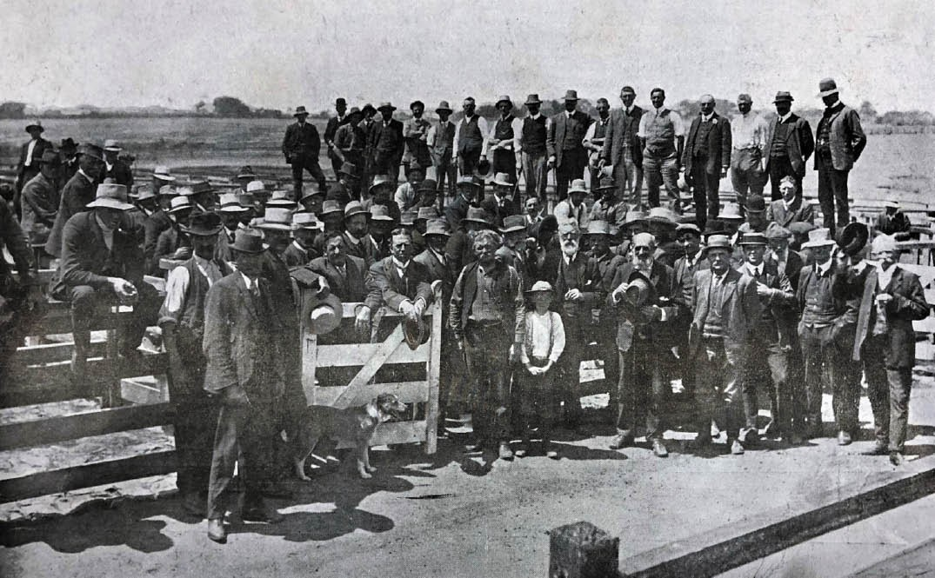
Figure 5.86: J. Lockwood, Mr Toyne and the auctioneers at the Geelong Sale Yards, 1913. Source: News of the Week, 12 February 1913, p.16, GRS 2121/3, Geelong Heritage Centre collection.

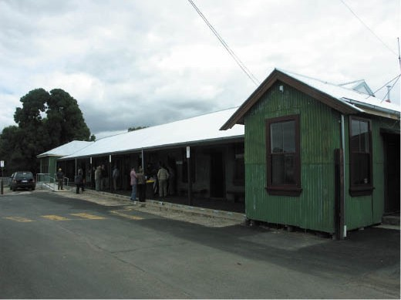
Figure 5.87: Recently restored Market Office Building, 2010 (subsequently destroyed by fire). Source: David Rowe.

there were 200 sheep pens plus 16 large sheep pens near the west boundary and 22 large sheep yards to the east (fronting Weddell Road) (Figure 5.86). There were also 72 regular cattle pens with 63 small and large cattle pens (adjoining
the regular pens to the north and east).680 With the onset of
the motor vehicle in the early 20th century came the need for cattle and sheep races, the earliest being a timber cattle loading race built in 1929.681
By 1942, there had been further alterations and additions to the sheep pens and yards.682 The evolving nature of the sheep and cattle yards continued in the second half of the 20th century. In 2010, the market office building was
substantially repaired (Figure 5.87). It was destroyed by fire in an arson attack soon after.
In recent years, after considerable deliberations and debate, the most intact functioning 19th century corporation sale yards known in Victoria were closed and most of the
infrastructure removed to make way for a proposed residential development.

ROBINSON, BURNS AND SPARROW MARKET BUILDING, 100-108 RYRIE STREET
In 1889, the auctioneering firm of Robinson Burns and Sparrow acquired the sale yards and market site first established by John Stephens in May 1849683 and which included a long narrow covered pen on the western boundary by 1854.684 The new owners spent £500 on making improvements to the premises making them ‘attractive to
the farming classes and traders , as outlined in the Geelong Advertiser:
The entrance to the yards from Ryrie Street for a distance of 120 ft. by a width of 40 ft. has been covered over by
an arched roof of corrugated iron, and it forms now an ornamental approach to the premises where the broken and unbroken horses are kept for sale. This affords splendid shelter for every person having to visit the yards during all kinds of weather, and the sheds are well lighted and ventilated.
The old pens or sties used for the pig department of the yard have been removed and in their place 22 substantial pig pens have been constructed. These are of large dimensions, the flooring asphalted throughout, water laid on to each pen, and a complete system of effective drainage adopted.
Everything about the place is new, and Messrs. Trevena and Gubby, the contractors have justly earned the terms of commendation passed on their work by persons who have considerable business transactions at the yards.
The salesmen and proprietors of the yards have in contemplation the picking up of the present metal roadway leading up to the yard to Little Ryrie Street and having a tan track made, an improvement the advent of which will be admitted by those interested in the business.
At present there is a cottage in the centre of the yards, which obscures the cattle pens from persons approaching from the Ryrie Street entrance. It is intended at no
distant date to remove this obstruction and to continue the covered-in archway from Ryrie Street [Figure 5.88] to Little Ryrie Street, and when that is effected the yards will be found to be the most complete of their kind in the colony.685
In March 1905, W.H. Cleverdon, architect, invited tenders for offices and shops in Ryrie Street for Messrs. Burns and Sparrow. The new building provided a commodious entrance to the existing sale yards (Figures 5.89-90).
It was constructed by W. Murphy and Son and following
its completion in November 1905, the architect took up office in the building. It was described as follows:
The elevation to Ryrie-street is of Northcote bricks, tuck-

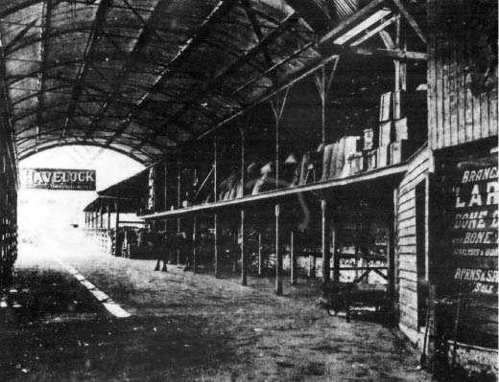

Figure 5.88: Arched-roofed covered interior, Burns Sparrow market (looking south), 1910. Source: News of the Week, 13 January 1910, GRS 2121, Geelong Heritage Centre.

pointed, with cement and tile dressings. The frontage is 66 feet. Two shops are on the ground floor, one being 30 feet by 20 feet 6 inches, and there is an entrance to the first floor from Ryrie-street. Four offices will be utilised by the firm, two of them being 16 feet by 13 feet. Provision has also been made for a strong room. The fittings are of redwood, oak and kauri, oiled and varnished. The ceilings are made of Wunderlich s patent embossed steel, and the doors are filled in with leadlights. The shop fronts are of plate glass, with fanlights over the verandah. There are six offices upstairs, a lavatory, and a large meeting room, 26 feet by 24 feet, with a stairway from the sale yards at the rear. Mr. Cleverdon’s private office is fitted with steel ceilings and dados. The entrance to the sale yards is in the centre of the premises.686
The firm of Robinson, Burns and Sparrow comprised John Dawson Robinson (1828-1891), John James Burns (1845- 1908) and Edward Rogers Sparrow. J.D. Robinson was born in Bolton-on-Sands, Lancashire, England and emigrated to Tasmania in 1843 where he took up a position with the trading firm of Burns, White and Co. He came to Victoria to try his luck on the Ballarat goldfields in 1852 and without having success, returned to Tasmania.687 In 1854, he came back to Victoria and entered into partnership with J.R. Ogilvie where they carried out a successful auctioneering and stock and station agency business in Moorabool Street.688 The death of Ogilvie brought about a change in the business when John Cullen commenced a partnership with Robinson under the name Ogilvie, Robinson and Co.689 This was dissolved in 1881 and John James Burns was made a partner.690 Born in Geelong in 1845, J.J. Burns was the son of John and Margaret (nee Castles) Burns.691 On 1 January 1882, E.R. Sparrow was

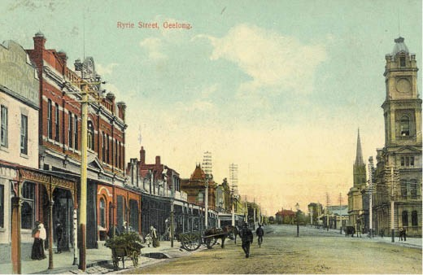
Figure 5.89: Burns & Sparrow Market Offices, 100-108 Ryrie Street (circled), n.d. [c.1910]. Source: GRS 2009/447 Geelong Heritage Centre collection.
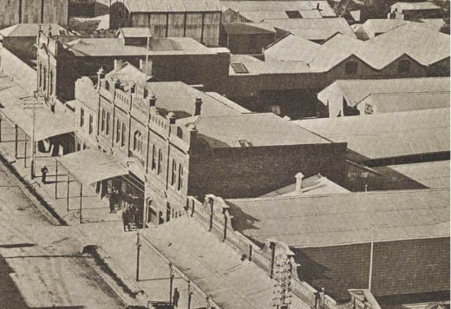
Figure 5.90: Burns & Sparrow Market building (centre) showing arched covered yards at rear (right) (taken from the Post Office clock tower), 1910. Source: News of the Week, 16 June 1910, GRS 2009/2295/26, Geelong Heritage Centre collection.

taken into partnership692 under the name of Robinson, Burns and Sparrow. Born in 1847 to Joseph Wheeler and Jane (nee Bruce) Sparrow, E.R. Sparrow was one of the first to be
educated at the Geelong College in Skene Street, Newtown.693 Following the death of J.J. Burns in 1908, Sparrow took sole control under the name of E.R. Sparrow and Co.694 In addition to his business interests, Sparrow also served as Secretary
of the Geelong Racing Club. He was connected to the well- known horse breeder and trainer, James Wilson (see Theme 4), having married Wilson’s daughter, Anne Maria Wilson (1854-1946).695 The Geelong Harbor Trust’s irrigation farm, ‘Sparrovale’ at Charlemont was named after E.R. Sparrow (see Theme 4). On his death in 1918, the Geelong Advertiser described him as a breezy raconteur, sportsman and friend of Old Collegians.’696

J.T. KERLEY AUCTION ROOMS, 185 MOORABOOL STREET
In 1910, James Thomas Kerley (1874-1947) and
John James Young (1882-1954) commenced business as Kerley and Young, estate agents and auctioneers. They had also been appointed chief agents for the Norwich Union Fire Insurance Society.697 The auction rooms were located in a brick shop at 185 Moorabool Street, owned by the Estate
of Mrs Jane Brown698 (Figure 5.91). The shop seems to have been built in c.1896.699 Their earliest auctions were in real estate and included a compact villa in McKillop Street
(one door from Swanston Street), a corner building allotment (corner of McKillop and Normanby Streets) and an allotment in Connor Street.700 The Kerley and Young partnership endured until July 1927 when J.J. Young relinquished his role in the business.701 Kerley then took into partnership Joseph Kelso Lannan (1890-1955), a managing clerk with the local legal firm of Doyle and Kerr. They would have been known to each other through the land and property sales as Doyle and Kerr were solicitors for property settlements.702
By 1934, Kerley was in sole business at the Moorabool Street premises, working there until his death in 1947.703 The business was taken over by his sons, Neil and Frank, until they sold it in 1993 to their employees, Richard Howells and Steven Robinson. In March 2020, after 110 years, Kerley s auction business closed.704
James Thomas Kerley was born in Geelong in 1874, the son of James Kerley, a warder, and Anne Kerley (nee McNamara).705 In 1896, he commenced business as a grocer and produce merchant in a store previously owned by his late father at the corner of McKillop and Swanston Streets.706 Illness forced the closure of Kerley s grocery business for 12 months until March 1904, when he resumed at the McKillop Street store.707 World War One brought Kerley’s business interests in the
real estate and auctioneering partnership with J.J. Young to a temporary halt, for he enlisted in 1916 and after serving abroad, he returned in 1919 with the rank of Sergeant.708
A prominent Catholic, Kerley served the community as a member of the Geelong Hospital Committee (including four years as president), Charities Board (where he served for a time as chairman), Country Hospitals’ Association, Geelong branch of the R.A.C.V. (where he served as president), Geelong Hibernian Club, Geelong St. Patrick’s Race Club and as trustee of the Geelong Friendly Societies Dispensary.
Kerley was also involved with the Eastern Park Bowling and Tennis Clubs and the East Geelong Free Library.709

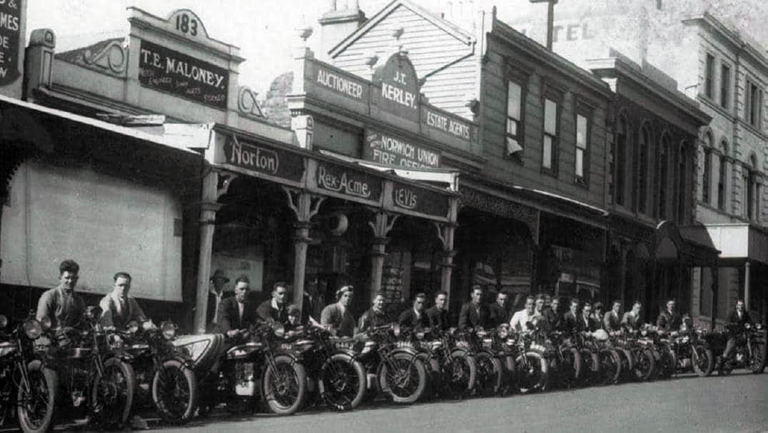
Figure 5.91: J.T. Kerley Auction Rooms (centre), Moorabool Street (centre), April 1930. The photograph also shows members of the Geelong Norton Bicycle club lined up outside Norton’s shop. Source: Steven Robinson, Kerleys, 2009.

HARVEY DANN AND CO. OFFICES, 96-98 RYRIE STREET
In 1915, the firm of Harvey Dann Pty Ltd demolished a produce store built in 1857 to construct a commodious two storey brick office building for their flour milling and produce business.710 Designed by the local architect, William Henry Cleverdon,711 the tender of W. Murphy had been accepted
to construct the building at a cost of £2100.712 Completed in 1916, the building was built of brick and cement with a frontage of 60 feet, a semi-circular feature window in the first floor and a cantilever verandah at ground level, the ground floor was largely devoted to storage space, save for
a sales counter, inquiry room and board room (Figure 5.92). Upstairs were accommodated the clerical department and the principal s rooms.713
The Harvey brothers, Henry (1832-1867) and Frederick (1836- 1931) were from Kent, England and came to Geelong in the 1850s were they established a produce mercantile business in 1857 known as H. and F. Harvey.714 Frederick Harvey continued on his own account following Henry’s death in 1867 until the business was amalgamated with Thomas Dann and Co., to become Harvey, Dann and Co. Pty Ltd. in 1883.715 Thomas Dann (c.1829-1900) had established the Clyde Flour Mill at Russell’s Bridge in 1857.716

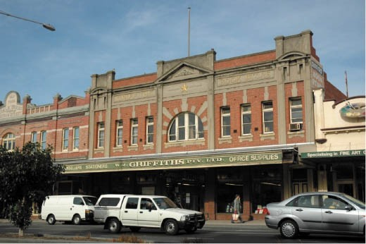
Figure 5.92: Former Harvey Dann & Co. Store (& former Griffith’s Bookstore), 96-98 Ryrie Street, 2005. Source:
Wendy Jacobs.

Occupation of the new building in Ryrie Street by Harvey Dann and Co. from 1916 was not to be long as in 1924 it was offered for sale.717 The building was later more widely known as Griffith’s Bookstore.

LYALL AND SON COMPRESSED FODDER WORKS, 20 BROUGHAM STREET, GEELONG

Prior to 1907, the firm of Lyall and Sons, chaff and grain merchants, leased the premises of the hay and corn merchant, Joshua Bannister at what is known today as
20 Brougham Street, Geelong.718 The building (Figure 5.93) had been constructed as a wool and tallow store for Guthrie, Bullock and Middleton in 1867.719 Lyall and Son continued to operate their business in Geelong as well as from North Melbourne throughout the early 20th century.720
In 1919, the Geelong business was curtailed when the building was destroyed by fire caused by a lightning
strike (Figure 5.94). The incident was reported in the Geelong Advertiser:
Shortly after one o’clock yesterday there was a vivid flash of lightning right over the centre of Geelong, followed by a peal of thunder. Almost simultanesouly a tongue of flame shot through Messrs. Lyall and Sons’ produce works, situated between Brougham place and Bayley street. It
is thought that the lightning fused the wires in the south- east corner of the building in the upstairs cleaning room. Within an hour the whole place was completely gutted, the walls levelled, and about £15,000 worth of damage done.
Originally the property belonged to Messrs. Joshua Bannister and Co., from whom it was acquired by Messrs. Lyall and Son, whose main premises at North Melbourne were recently burnt. There are really two buildings, one three-story of wood and iron, and the other of brick. It was in the former that the fire originated. The Gas Co.’s offices are situated on the east side of the produce works, and the Harbor Trust offices on the west. Both of these were saved, partly owing to the exertions of the firemen, but largely owing to the wind which changed several times, and also the solid dividing walls.
… Whilst the fireman were devoting their energies to the adjoining premises the fire burnt fiercely right through Lyall’s store. There was a big crowd of sightseers,
but they kept well clear of the building, as there was a possiblility of the walls collapsing. This eventually
happened: first the iron roof fell in, then the brick wall, which sent a shower of bricks half-way across Brougham- place. There were a number of firemen and other workers on the Habor Trust roof, from which they gazed into an inferno.721
As early as 31 March 1919, the remains of the destroyed building of Lyall and Son were removed and burnt bricks cleaned for use in the construction of a new building.722 Robert Lyall inspected the site with the local manager,
Mr Gill, ‘taking measurements for the several departments

for the new building. 723 A few weeks later on 16 April, 1919, the Geelong Advertiser gave an account of the proposed building:
A commencement was made yesterday, under the supervision of Mr. W. Harrison, with the concrete foundations for Messrs. Lyall and Son’s new fodder and chaff works. The whole of the debris has been cleared, and excavations made to a depth of three feet.
Large quantitites of the old concrete and bricks are to be utilised in the new foundations. The new buildings are to be in brick, two stories high, and will have a front of 132 ft. by a depth of 99 ft. The job is to be carried out under the day labor system.724
It appears that the building was completed in the later months of 1919. The two storey red brick building was crowned by
a painted brick parapet that read “LYALL & SONS Pty Ltd”, which screened a saw tooth roof (on a north-east axis). The main (north) façade had two large vehicular openings flanked by brick piers. There were small window and door openings in the other bays, including a central bay of ground and first floor doors and flanking small windows.
In 1951, the property of Lyall and Sons, and the adjoining property at the corner of Brougham and Gheringhap Streets, was acquired by the long-standing wool broking firm, Dennys Lascelles Ltd.725 While Lyall’s original building of 1919 was subsumed by later additions, it forms part of the western portion of the existing building today
(see Figure 5.82).

GRAIN ELEVATORS BOARD WHEAT TERMINAL, NORTH GEELONG
The most substantial grain storage facility in Greater Geelong came after the passing of the Grain Elevators Act of 1934 which provided for the handling of grains in bulk, and for the constitution of the Grain Elevators Board. Connected by the railway network were 139 elevato s at country railway stations throughout Victoria, with Geelong and Williamstown serving as terminal elevators.726 In 1936, tenders were invited for the construction of concrete silos of gigantic proportions near Corio Quay,727 the contract initially being awarded to Ernest
A. Watts of Collins Street, Melbourne although the working house and silos were to be built by Lewis Constructions Pty Ltd of Melbourne.728 The turning of the first sod for
the construction of the silos was made by the Minister for Agriculture, Mr Hogan on 9 September 1936.729 Completed in 1938, the silos marked a new era in the handling of grain in Victoria.730 The towering ‘working house’ and 28 cylindrical concrete silos were built to a height of 66 m and 33.5 m respectively, the total storage capacity being 2,250,000 bushels.731 They formed an imposing landmark in Geelong’s northern foreshore.732 (Figure 5.95). The terminal came into

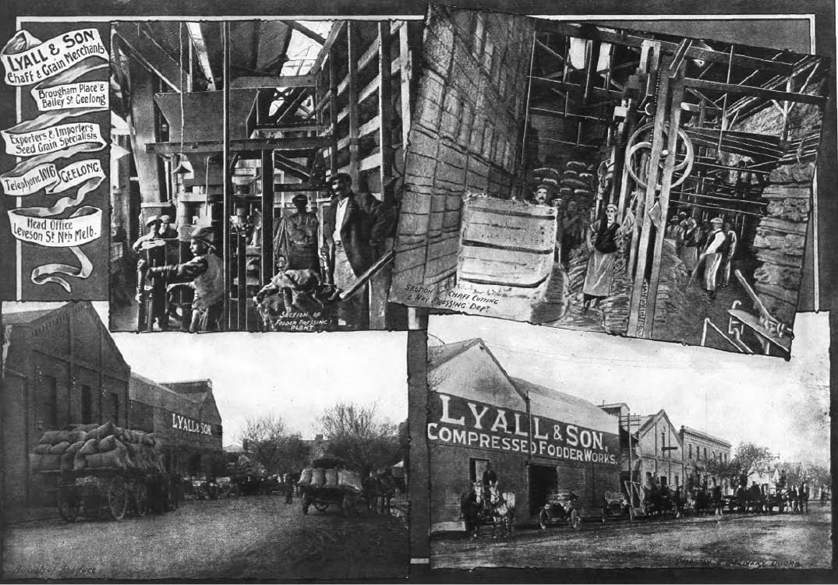
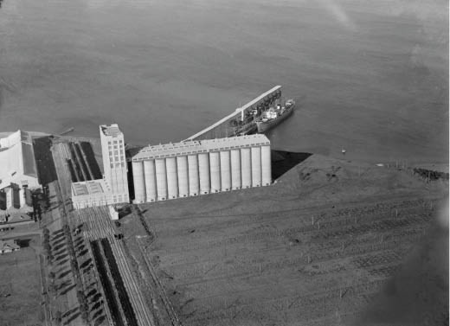
Figure 5.93: Lyall and Son Chaff & Grain Works, 20 Brougham Street, c.1918. Source: Geelong for Business, Health, Pleasure, The Geelong City Council and Geelong Progress Association, Geelong, 1918, p.34
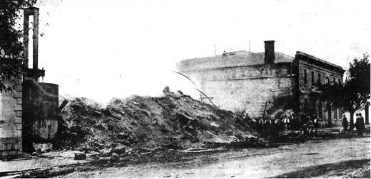
Figure 5.94: The ruins of Lyall’s store following the fire in 1919. Source: News of the Week, 13 March 1919, GRS 2121, Geelong Heritage Centre collection.

Figure 5.95: C. Pratt, Grain Elevators Board Wheat Silos, North Shore, June 1948. Source: accession H91.1690/321, State Library of Victoria.

operation at the beginning of the 1939-40 season, and it was connected to elevators by railway lines in the western portion of the State.733 Massive elliptical-arched gain storage sheds were also to be constructed. Grain was then loaded from the terminal onto ships docked at the pier at Corio Quay.

BAKERS
An important trade-service industry from the beginning of European colonisation in Geelong was the bakery given that bread was a staple part of the European diet. The importance of the trade is found in there being 11 bakers operating in Geelong in 1854 and at least 39 bakers by 1856.734 By 1882- 83, this number had reduced to around 26, with approximately 20 bakers in Geelong in 1905, but the number had increased again to 37 bakers and pastrycooks by 1925.735 Ubiquitous throughout Greater Geelong in the 19th and early 20th centuries, few original bakeries exist today. In addition to
the former bakery erected in 1892 at 23 Clifton Springs Road, Drysdale (see Theme 6), they include the following.

BAKERY, 34 SPRING STREET, GEELONG WEST
The two storey, rendered brick Victorian Georgian building with an early six paned shopfront window at 34 Spring Street, was built in 1854 as a shop and bake house for John Dunlop (c.1777-1872).736 He had earlier built two brick and one modest timber cottage in Spring Street from as early as 1850.737 Dunlop had been born in Arygllshire, Scotland and had emigrated to Dungarvan, County Cork, Ireland, at the age of 16 years to manage a farm for an English landlord
as payment for his father s debt.738 There, he became an accomplished horseman and was commissioned a Captain in the British Army’s Irish Cavalry Regiment and served under the Duke of Wellington in the battle of Waterloo in 1815.739 In c.1842, Dunlop migrated to Portland, Victoria with the Henty family and worked for them.740 He had relocated to Geelong by 1843 as it was at this time when he married for the second time (he was to marry up to five times).741 With his friend, James Regan, he was the first to discover gold at Ballarat in 1851.742 He died in Ballarat in 1872 when attempting to break in a horse at the age of 96.743
By 1914-15, James and Leo Kelly ran the bakery at 34 Spring Street, the property being under the ownership of George Bowerman, baker, from 1887-88744 (Figure 5.96).

THOMAS HUNT’S BAKERY, 55A GHERINGHAP STREET, GEELONG
Possibly the earliest bakery building in the central Geelong city area, the two storey hipped roofed brick building was constructed in 1855 for Thomas Barber Hunt (c.1827-1907), a baker.745 The property included a bakehouse.746 He also owned an iron store fronting Ryrie Street in 1859-60 which he leased to Dr Henry John Goulter, dentist, in 1861.747

It appears that Hunt established what became known as the Australian Produce Stores and Bakery at 55a Gheringhap Street, which by 1874 he offered to lease given he had taken up occupation as a shipping agent.748 Between 1886 and 1887, the former bakery was occupied by John Murray and Co. and known as the office of the Geelong Trade Union
for the Recovery of Debts749 (Figure 5.97). In later years it was used by Thomas Hunt as his office and storeroom when in the occupation as a coal and lime merchant, and
grazier.750 Hunt died in Geelong in 1907, having been born in Parramatta, New South Wales. He had come to Geelong in 1851 and in addition to his business interests, he was heavily involved in the Methodist Church and became a preacher as a teenager.751 It seems that after Hunt’s death the southern portion of the former bakery building was removed to create an accessway to Harvey Dann’s Produce store.

UXBRIDGE HOUSE, 19 SHARP STREET, NEWTOWN
Henry Hampton (1828-1903) had established a timber shop and bake house at 19 Sharp Street in 1856-57, having earlier been located in nearby Saffron Street.752 By the mid-1860s, he had built a brick shop which might form the basis of Uxbridge House today. In 1885, the property was leased to Frederick James Drayton who continued the bakery business there.753 It would appear that the earlier brick building was altered in 1895 when Drayton took ownership of the building which was called Uxbridge House.754 The premises continued as a bakery until at least the 1990s when M.E. Beaumont Pastry Cooks Pty Ltd were the owners.755

FORMER BAKERY, 100-100A PAKINGTON STREET, GEELONG WEST
A one-roomed brick shop and bake house had been built at 100-100A Pakington Street for Frederick Fawkner by 1854- 55.756 It was acquired by George Wilson (c.1827- 1882) in 1856-57 and by 1860-61 the shop comprised four rooms as well as a bake house where there was a cottage and stable.757 The single storey brick shop was replaced with the existing two storey building for Wilson in 1869-70758 (Figure 5.98). He continued his bakery business there until his death in 1882, leaving a widow, Esther Ann Wilson.759

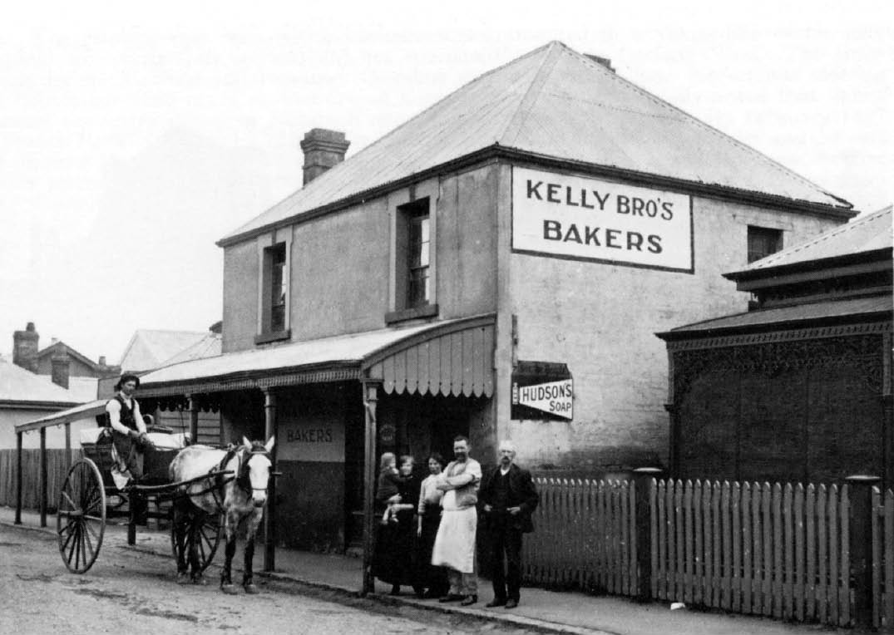
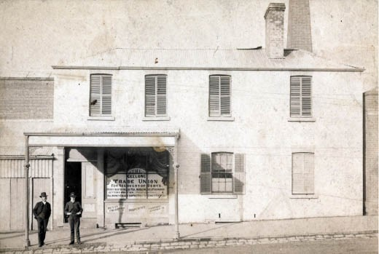
Figure 5.96: Kelly Bros. Bakery, 34 Spring Street, Geelong West, c.1914-15, far right: James A. Kelly & George Bowerman. Source: G. Seaton, The Ashby Story, p.159.

Figure 5.97: Geelong Trade Union for the Recovery of Debts, 55a 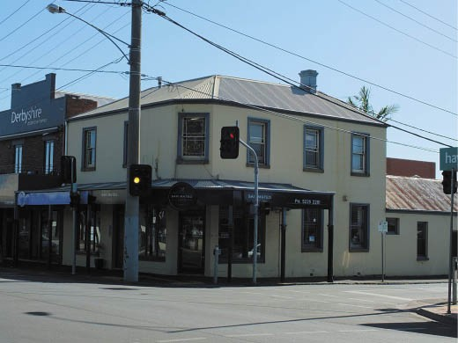 Gheringhap Street, 1886-87. Source: GRS 2009/00030, Geelong
Heritage Centre collection. Figure 5.98: Former Bakery, 100-100A Pakington Street, Geelong West, 2018. Source: David Rowe.

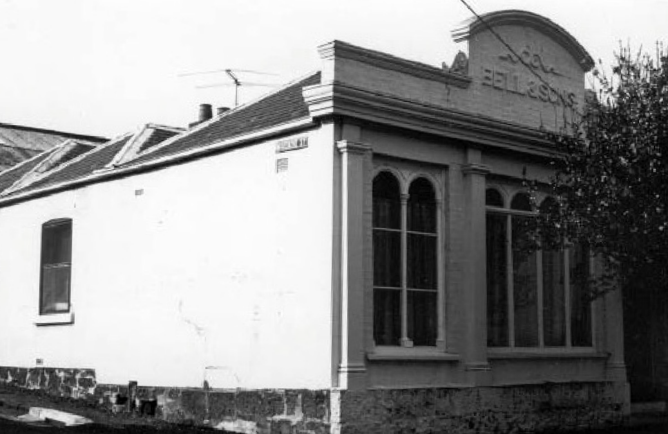
Figure 5.99: Bell’s Bakery, 121 Kilgour Street, c.1979. Source: Lorraine Huddle.

BELL’S BAKERY, 121 KILGOUR STREET, GEELONG
As early as 1855, Thomas Bell (1820-1898) owned a stone double shop of two rooms at 121 Kilgour Street.760 In 1860, it was rebuilt as a three -roomed brick shop and bakery to a design by the local architect, Christopher Porter761 (Figure 5.99). There, Bell carried out his bakery business until his
death in 1898.762 He had been born at Canongate, Edinburgh, Scotland and appears to have arrived in Victoria on the Hibernia in February 1854.763 The business was continued by Thomas Bell’s sons, Archibald and William until 1940 when the Kelly Brothers ran their bakery from this location.764

NEWBURY’S BAKERY, 162 BELLERINE STREET, GEELONG
The existing timber shop was built in 1892-93 for Charles Hyatt Newbury (1828-1894) to a design by the Geelong architects, Watts and Durran.765 A brick bakery oven appears to have been built at this time as bread was being sold on the premises in 1893.766 Newbury’s occupation of the premises was to be short-lived as he died in 1894.767 It was taken over by his son, Samuel, who operated a general store and bakery until 1913.768 Both the shop and the oven exist on the site today.

FORMER BAKE HOUSE, 28 MERCER STREET, GEELONG
The two storey masonry building at 28 Mercer Street, adjoining the former boot and shoe manufactory of George Beattie at 26 Mercer Street and now part of a hamburger and pizza outlet, was built between 1891 and 1892 as bakery and residence.769 It was first occupied by Jonas Feazey (1858- 1931) who had emigrated to South Australia with his wife, Ellen in the early 1880s.770 From 1895, the property was

occupied by Harry Potter, baker, and he continued to work and reside there until his death in 1903.771

BUTCHERS
Equally prolific within Greater Geelong from the 19th century were butchers. In January 1854, there were at least 11 butchers in Geelong by but 1856 this number had increased to 60.772 Some combined their butcheries with grocery businesses. This number had been halved to around 30 butchers by 1882-83, with the decline continuing to around 20 butchers in 1905.773 Population growth and a resurgence in manufacture lead to an increase in butchers by the 1920s, to around 38 in 1925.774 The postwar years lead to an even further increase to approximately 65 butchers in 1960.775

FORMER LYONS BROS. FAMILY BUTCHERS, 182-184 BELLERINE STREET
Few of the 19th and early 20th century purpose-built butcher s shops exist today. One of the earliest is the former Lyons Brothers Family Butchers shop and dwelling at 182-184 Bellerine Street, Geelong (Figure 5.100). It appears to have been built in 1895-96 at the north-west corner of a larger
site (with a frontage to Bellerine Street) for Edmund Lyons (1831-1903), a butcher from Somerset, England, who had settled at ‘Cadbury Farm’, Drysdale in the mid 1850s.776 He had also established a butcher s shop and slaughterhouse in Drysdale.777
Lyons’ wife, Elizabeth (nee Ashley) (1833-1904) had first acquired the corner site in Geelong in 1888, where Edmund worked his butchery with his sons in a three-roomed weatherboard shop (addressed as Maud Street) and also occupied a two storey weatherboard dwelling (fronting Bellerine Street), both built around 1885.778 The latter building appears to have been demolished in 1895 to make way for the new corner shop and dwelling.779 Following Edmund Lyons’ death in 1903, the butchery was continued by his sons, Alfred Charles Lyons and Arthur Ashley Lyons, under the business name of Lyons Bros. Family Butchers. With the death of
Mrs Elizabeth Lyons, Alfred Lyons was offered a lease of the premises for 10 years.780 In 1913, the Geelong Advertiser announced that:
The contract was let on Monday by Messrs. Seeley, King & Everett to Messrs. Tingate Bros., for the removal of the old shop and adjoining private dwelling, at the corner of Bellerine and Maud-streets, Geelong, and the re-erection of a brick shop on the corner site [Figure 5.102], which will necessitate an expenditure of about £900. The premises are being erected for Messrs. Lyons Bros, Geelong.781

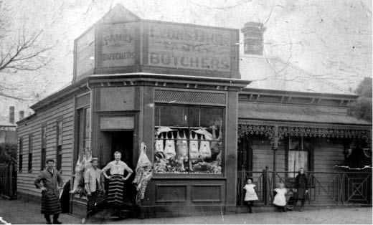

Figure 5.100: Lyons Bros. Family Butchers, 162 Bellerine Street, Geelong, c.1905. Source: Museum Victoria, item MM6598.
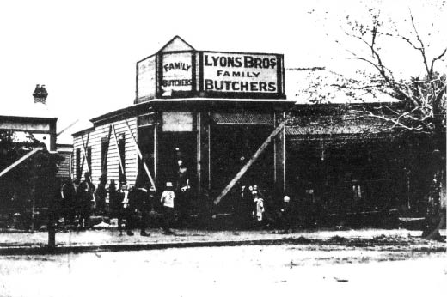
Figure 5.101: Moving premises to another site without interruption to business , 1913. Source: News of the Week, 30 October 1913, GRS 2121, Geelong Heritage Centre collection.
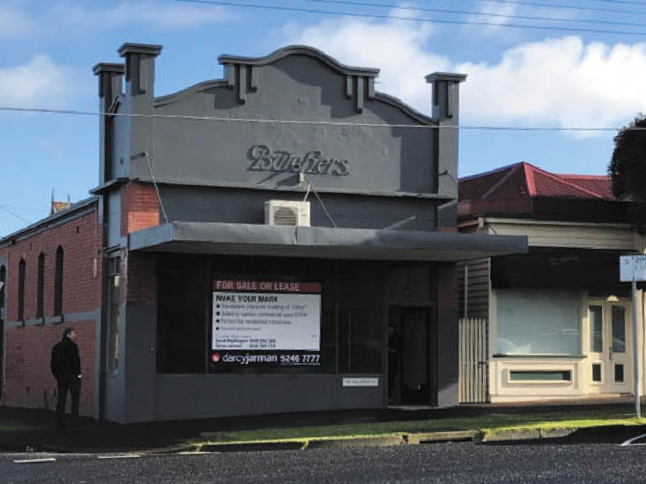
Figure 5.102: Former Lyons’ Bros. Shop (built 1913) (left) and relocated (and altered) earlier timber shop and dwelling (right), 182- 184 Bellerine Street, 2019. Source: David Rowe.

Figure 5.103: Mathews Bros. Butchers’ Shop, 164 Moorabool Street, 1911. Source: News of the Week, 7 December 1911, p.23, GRS 2121/3, Geelong Heritage Centre collection.

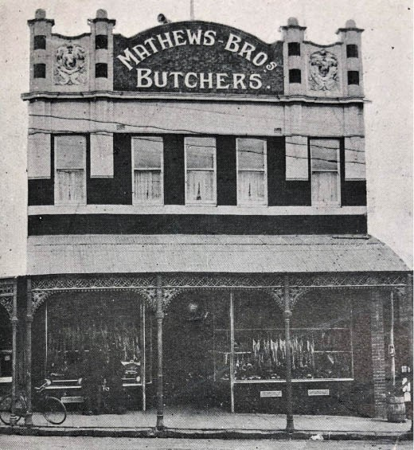
A photograph of the early shop and dwelling in 1913 suggests that it was temporarily placed on another site (Figure 5.101) before being removed to 182 Bellerine Street, immediately north of the new corner shop.782 In later years, Arthur Lyons subsequently acquired the properties. He continued to operate the butcher s shop until 1938 when it was sold to Alice Foley.783

MATHEWS BROTHERS’ BUTCHER’S SHOP, 164 MOORABOOL STREET, GEELONG
The former Mathew Bros. Butcher’s shop at 164 Moorabool Street, survives (albeit altered), having been built in 1911 by Dew Brothers to a design by Laird and Buchan for
the long-standing family butchers, Mathews Brothers of Wiltshire, England.784 The new building featured a distinctive parapet (now missing) (Figure 5.103). James Mathews had established a butcher s shop in Malop Street by 1859785 and by 1860 he had been joined by his brother, William (1830- 1883), trading under the name Mathews Bros.786 In 1873, they opened a shop at 164 Moorabool Street which was replaced with the existing building in 1911.787 In later years, William s son, Frank Edwin Mathews became a partner in the firm,
and the family business continued to trade under the name Mathews Bros. until 1920 when the business was sold.788

MCCARTIN AND SONS BUTCHER’S SHOP, 233 MOORABOOL STREET, GEELONG
In 1911-12, Horace Frank Richardson, auctioneer, had a two storey building at the north-east corner of Moorabool and Myers Streets constructed789 (Figure 5.104). While not purpose-built as a butcher’s shop, the first tenant (and later
owner) was Michael McCartin (1849-1934). He had emigrated from Armagh, Ireland and married Mary Cecilia Little in Albury, New South Wales in 1879.790 After around 10 years’ operating butcher’s shops in Albury and South Australia, McCartin and his family relocated to Geelong, where his son,
Edward, was born in 1891.791 Michael McCartin continued in the butcher trade, being located in Moorabool Street by 1902.792 In 1912, Michael McCartin took his sons into the business under the name of M. McCartin and Sons.793 This was when he relocated his business to the newly-completed building at 233 Moorabool Street, McCartin advertising the following:
A new butcher’s shop, and a new firm of butchers.
M. McCartin & Sons
Have commenced business in those up-to-date premises, corner of Moorabool and Myers-streets, and hope by close attention to business to receive a fair share of public patronage.
The shop will remain open after hours for the sale of Cooked Meats and small Goods, in great variety.
In relation to the above, Mr. McCartin wishes to thank all those who during the last 20 years so liberally supported him, and asks for the same generous treatment for the new firm.794

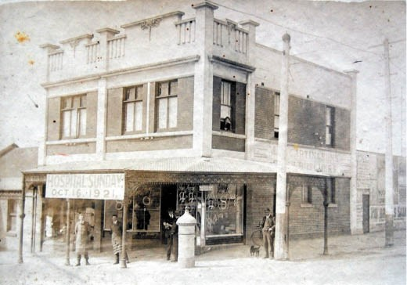
Figure 5.104: M. McCartin & Sons Butchers’ Shop, 233 Moorabool Street, c.1920s. Source: Helen Doyle, Historian.
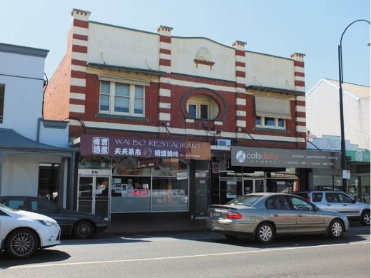
Figure 5.105: Bee Hive Building (C. Boocock Butcher), 214-216 Pakington Street, Geelong West, 2018. Source: David Rowe.
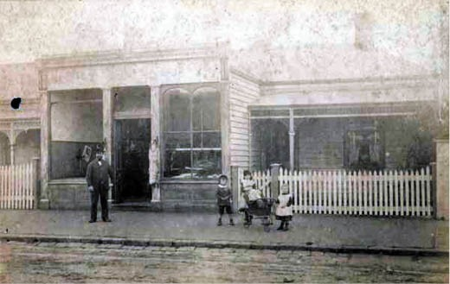
Figure 5.106: Charles Wood and family outside the butcher’s shop and dwelling, Latrobe Terrace, c.1890. Source: GRS 2009/00114 Geelong Heritage Centre collection.

In 1923, McCartin purchased the building and retired from the butchering business. His former shop was leased, initially as a bakery.795

BEEHIVE BUILDINGS, 214-216 PAKINGTON STREET, GEELONG WEST
In August 1924, Percival Wood (1878-1959) and Craven Boocock (1890-1970) announced that ‘they will open up a new business in up-to-date premises, erected for them, in Pakington-street, known as the “Beehive” building, for the purveying of the highest-grade meats at prices to suit all pockets.’796 Located at 214-216 Pakington Street, the building (Figure 5.105) had been built by J. Johnson.797 Initially,
half of the premises was occupied by Craven Boocock and Percival Wood, butchers, the other half being leased to William and Leo Walker, grocers.798 Craven Boocock was born in Haworth, Yorkshire, England, and in 1913 he married Miss Helena Boocock (possibly a cousin) at St. James, Yorkshire.799 They emigrated to Geelong soon after where Craven Boocock was appointed manager of the Pakington Street store of Wood’s Spot Cash Butchers.800 Percival John Wood was born in Geelong to George Charles Wood, butcher, and Mary Esther Wood (nee Ward). Following his education, he entered his father s butchering business which became known as G.C. Wood and Son.801 The business had been established in Mercer Street in 1873 by George Wood.802
Born in Brighton, England, he had emigrated with his parents from Sussex as part of a group of 50 people with the intention of establishing a small colony (which never transpired).803
By the early 20th century, Wood’s butchery and attached residence were located in Latrobe Terrace, Geelong West804 (Figure 5.106).
Percival Wood was an inaugural member of the Master Butchers’ Association in Geelong in 1913.805 On the death of G.C. Wood in 1923, the plant, horses, rolling stock and ‘Electric Motor and Silent-Cutter’ of the butchering business was bequeathed to P.J. Wood, along with half of the real and personal estate.806 This seems to have provided the capital for the construction of the ‘Beehive Building’ in Pakington Street.

BOOT & SHOE MAKERS & REPAIRERS
In January 1854, there were 12 boot and shoe makers in Greater Geelong.807 Just two year later, this number had expanded to 58,808 testimony to the substantial population growth since the late 1830s. Around 50 men of this trade were listed in 1882-83 and about 37 in 1905.809 By 1925, there were 55 boot and shoe manufacturers and salesmen, but with larger-scale manufacturing in subsequent years this number dropped to just eight in 1944.810

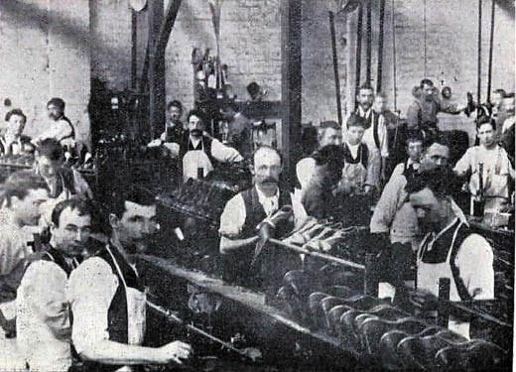
Figure 5.107: Boot and Shoe Bottoming Department, c.1897. Source: Vidler, The Book of Geelong: Its People, Places, Industries and Amusements, p.64.

FORMER GEELONG BOOT FACTORY, BAYLIE PLACE, GEELONG
One of the very few boot-making buildings surviving from the 19th century is the former Geelong Boot Factory in Baylie Place, Geelong, the first portion was constructed
in 1874.811 Built for the firm, Strong and Pierce, this building served as the factory, with a two storey warehouse and extensive show-rooms’ opposite the lane fronting 168 Moorabool Street also constructed at this time.812 The premises were described in the Geelong Advertiser in 1879:
The factory fronts Moorabool-street, is situated on the rise of the hill above Ryrie-street for a distance of 200ft. The firm named have shown every desire to push their business well to the front, and, judging from the extensive character of the works in operation there every day, the place must be a regular hive of industry [Figure 5.107].
The firm have expended on plant and buildings, and in making sundry improvements, the sum of £7000, and the 108 persons of both sexes who are employed in the factory succeed in making 1300 pairs of boots, shoes, and slippers every week, whilst an efficient staff execute repairs of every description. Messrs. Strong and Pierce, who are boot and shoe manufacturers in every sense of the word, are also large importers, and their stock is of
immense proportions. The work turned out at the factory is quite equal to that displayed on imported goods, whilst the cost has been greatly reduced for the consumer.813
The boot and shoe manufactory had first been established by James Strong (1842-1894) in Mercer Street in 1856.814 He had arrived in Geelong from Blandford, Dorsetshire, England, in 1853.815 In 1867, the firm of Strong and Pierce was formed, with William Pierce (1845-1928) entering as a partner.816 Born in Geelong,817 Pierce had operated his own

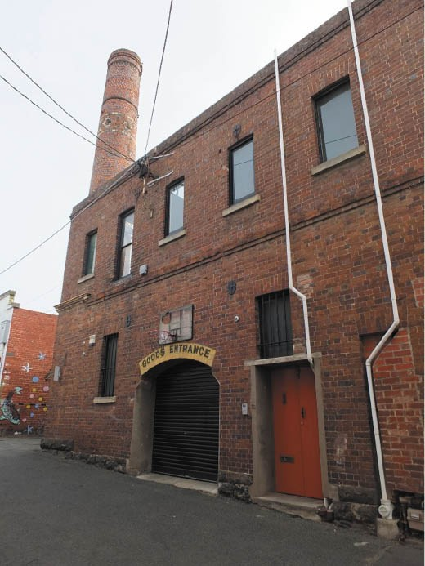
Figure 5.108: Former Geelong Boot Factory, Baylie Place, Geelong, 2019. Source: David Rowe.

boot and shoe making business in Collingwood until he went insolvent in 1861.818 By 1872, Strong had purchased a two storey brick building in Ryrie Street (west of the Moorabool Street intersection) and it was from there where the boot manufactory was operated until Strong sold the property in 1874 for £3000819 in which to raise capital to fund the new neighbouring factory and warehouse (Figure 5.108). By the 1870s and while still under the name of Strong and Pierce, James Strong s brothers: George and William Strong; and also Walter W. Wiggs, were also partners of the firm.820
In 1880, Pierce resigned from the business821 and it continued under the original name until the death of Walter Wiggs in 1887822 when it was changed to James Strong and Brothers. By 1888, the firm had branches of the business at Colac, Ballarat, Horsham and Camperdown and employed 130 men and women.823 The founder of the business, James Strong, contributed much to community life, serving for 16 years
on the Geelong Town Council, including a term as Mayor in 1890-91.824 It was during this term when Strong built the two storey brick mansion, ‘Blandford’, at 53 McKillop Street, to
a design by Albert Derrick.825 He died there in 1894.826 The

boot manufacturing business was continued by Strong s brothers and it would appear that the existing parapet to the shop at 168 Moorabool Street was added in 1897 to a design by Laird and Barlow architects.827 In subsequent years, the business was carried on by James Strong s brother, George. By 1925, it was known as G. Strong and Son828 and by 1944 the business had closed.829

G. BEATTIE’S BOOT AND SHOE MANUFACTORY, 26 MERCER STREET, GEELONG
In 1873, George Beattie (c.1825-1907) announced that he had opened his ‘new and extensive premises’ in Mercer Street, ‘with a large, varied and well-assorted stock of boots and shoes, selected by himself, together with a large stock of Colonial goods of his own manufacture.’830 Beattie had opened a single storey boot and shoe manufactory in Mercer Street in 1859-60,831 and it was on the site of this building where a two storey addition was constructed to a design by the architect, Joseph Watts832 (Figure 5.109). The son of Joseph and Barbara (nee Kelso) Beattie, George Beattie had arrived in Geelong by 1852 as it was at this time when he married Miss Anne Jane Hamilton.833 Apart from an absence of 4 years in the early 1890s, Beattie worked from his boot and shoe manufactory almost until his death in 1907.834 Although the brickwork has been overpainted, the ground floor altered and a post-supported verandah introduced, the
two storey building still exists today as a pizza and hamburger outlet.

INTERWAR BOOTMAKERS’ SHOPS IN GEELONG WEST
While mass-manufacturing began a decline in boot making operations in the early 20th century, two boot making buildings were constructed in Geelong West in the 1920s. The first was ‘Thompson’s Buildings’ at 175-177 Pakington Street (Figure 5.110), built in 1920 by W.H. Horward to
a design by Laird and Buchan architects for Samuel
H. Thompson, bootmaker. The second was ‘Shirley’s’ bootmaker’s shop at 151A Pakington Street (Figure 5.111), constructed in 1924 for H.J. Shirley.835 Completed ‘immediately before Christmas’ 1924, it was described as ‘a commodious new two storey building. 836

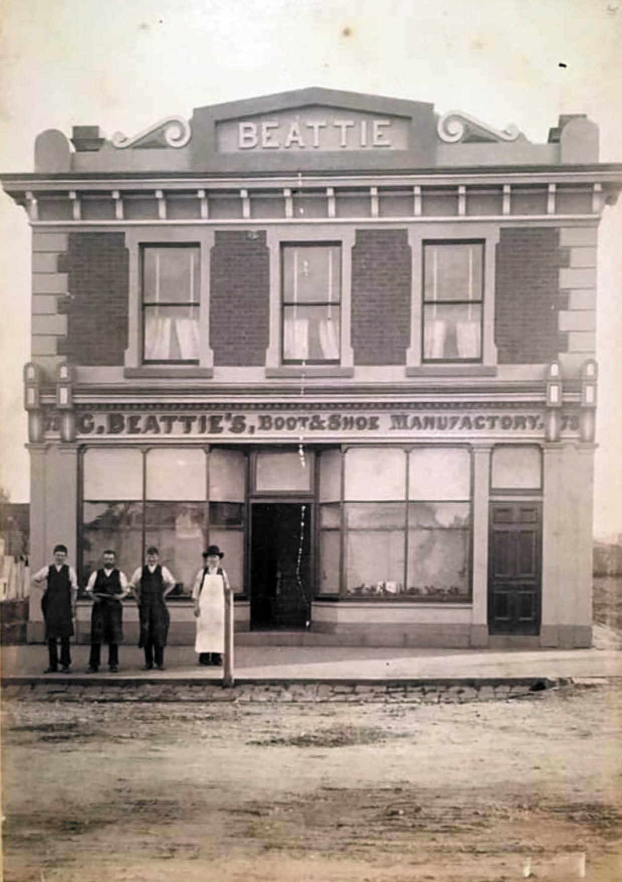

Figure 5.109: G. Beattie’s Boot & Shoe Manufactory, 28 Mercer Street, Geelong, n.d. [c.1870s-80s]. Source: Sarah Watts, Geelong In Historical Pictures Facebook page.

570

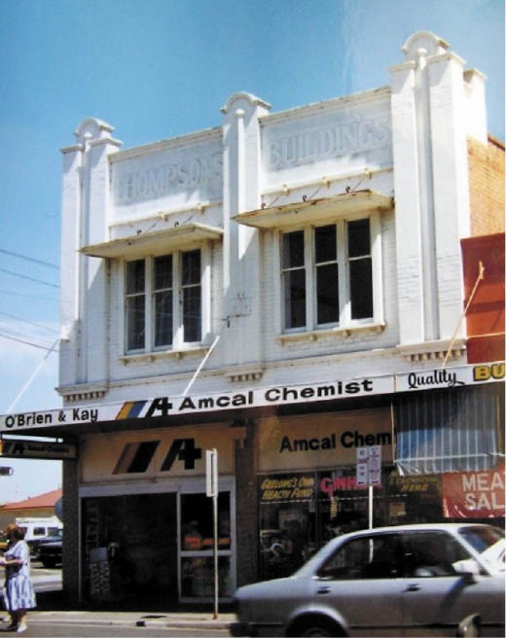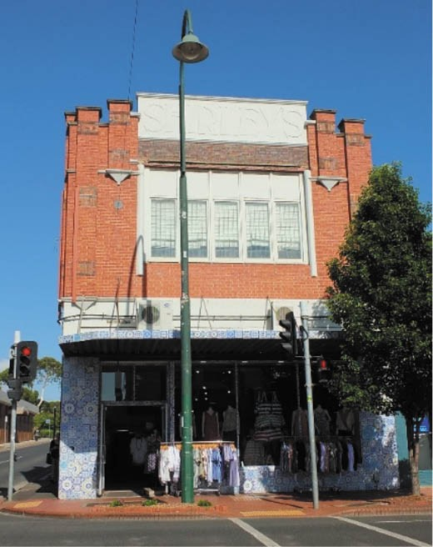

Figure 5.110: Thompson’s Buildings, 174-177 Pakington Street, Geelong West, 1986. Source: Honman, Huddle & Aitken, ‘City of Geelong West Urban Conservation Study.
Figure 5.111: Shirley’s Building, 151A Pakington Street, Geelong West, 2018. Source: David Rowe.

CABINET MAKERS, FURNITURE MANUFACTURERS AND UNDERTAKERS
By the mid-1850s, cabinet makers also combined the trade of furniture manufacturing and upholstering, with some also taking up business as undertakers. In January 1854, there were 12 cabinet makers, upholsterers and/or undertakers mainly centred on Moorabool Street.837 By the 1880s, there had been a clear division of trades, with John Bennett (Moorabool Street), Jenkins and Bennett (James Street),
W.B. King and Sons (Moorabool Street) and James Monro (Ryrie Street) operating solely as undertakers.838 By 1905, only three cabinet makers were listed in the Sands and McDougall Directory of Victoria: F. Annear, B. Singh and J.R. Thear.839 There were four undertakers listed at this time:
R.N. Carbines., W.B. King and Son, Alexander Monro and the Wellington Brothers.840 A similar number of undertakers operated in Geelong in the mid 1920s and mid 1940s.841

JAMES MONRO AND SON UNDERTAKERS & FUNERAL FURNISHERS,
24 RYRIE STREET, GEELONG
One of the earliest purpose-built undertaker premises that still survives is the two storey brick building at 24 Ryrie Street (Figure 5.112), built in 1874 for James Monro (1825-1913).842 A carpenter, he had emigrated from Fife, Scotland in 1854
with his wife, Jean (nee Whyte) and daughter, Mary Alexandra Monro.843 They initially lived in William Street, Geelong, where James worked as a joiner and cabinetmaker.844 This included an undertaking business.845 By 1859-60, the Monro family had relocated to a weatherboard double shop and
shed at 24 Ryrie Street.846 In 1888, he also advertised as a furnishing undertaker, offering ‘economic funerals.’847 In 1896, Monro’s eldest son, Alexander (1875-1953)
became a partner in the business, the firm being known as James Monro and Son, undertakers and funeral furnishers.848
Following James Monro s death in 1913, the business was continued by Alexander Monro.849 It may have been about this time when a Federation Free style parapet was added to the front fa ade and the earlier Victorian balcony and verandah replaced in timber.850 Alexander Monro continued

to work and reside at 24 Ryrie Street until his death in 1953.851

FORMER ANNEAR’S FURNITURE WAREHOUSE, 64-66 RYRIE STREET, GEELONG
The two storey Late Victorian timber shop at 64-66 Ryrie Street (Figure 5.113) was built in 1899 for the prominent draper, Alexander Miller (1842-1914) to a design by local architects, Tombs and Durran.852 The first (and
long-standing) occupant was Frederick Annear (c.1861-1934), who occupied the building as his cabinetmaking and furniture warehouse until 1918. Annear’s brother, William (1863-
1913) had commenced a furniture-making business in Ryrie Street in 1888, being joined by Frederick by 1890.853 In 1896, Frederick Annear displayed a piece of furniture called ‘cosy corner which featured in the Geelong Advertiser:
There is on view at the cabinetmaking establishment of Mr Frederick Annear, in Ryrie-street, one of the “cosy corner pieces of furniture manufactured to the design of Mr Tombs, of Tombs and Durran, architects. The cosy corner” is intended to fill in the corner of a drawingroom, and is fitted with cabinets, shelves, etc., for the purpose of displaying ornaments, pot plants, and bouquets, the article being constructed in such a way that whilst it becomes a useful addition to the furniture of a room it does not monopolise
much space.854
The original owner of the building, Alexander Miller, made a substantial contribution to commercial and philanthropic life in Geelong. Born in Aberdeen in 1842, he migrated to
Geelong with his mother, his father having arrived earlier.855 After a minimal education, Alexander Miller was first apprenticed to Hall Brothers, drapers.856 Following a £100 inheritance from Miller s maternal Uncle, he commenced a drapery business at 220 Pakington street, Geelong West,
in Union Jack House (see later subsection).857 After a few years he went to Ballarat858 but returned to Geelong in 1874 and took over the drapery at 84 Moorabool Street known as ‘Victoria House’ built in 1870 for Messrs. Flynn, Lonargan and Co., drapers.859 This store was replaced with a new Victoria House’ drapery in 1884 when the business was known as Alexander Miller and Co.860 (Figure 5.114). It was from this time when Miller established chain stores throughout Victoria including at Horsham, later at Euroa, Hamilton, Maryborough, Shepparton, Numurkah, Rushworth and Echuca.861 By
1906, Miller had purchased a row of shops and land at 190- 196 Moorabool Street.862 He subsequently purchased the buildings at 198-200 Moorabool Street and in 1907 engaged Laird and Barlow architects to design alterations and additions, and uniform parapeted facades for all six shops (190-200 Moorabool Street). They were to become known as Miller’s Buildings.863

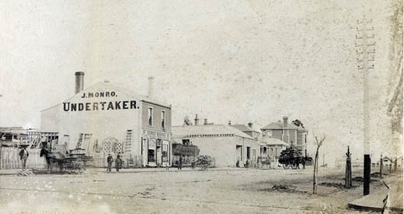
Figure 5.112: J. Monro’s Undertaker establishment (left),
24 Ryrie Street, c.1874. Source: GRS 2170/17, Geelong Heritage Centre collection.

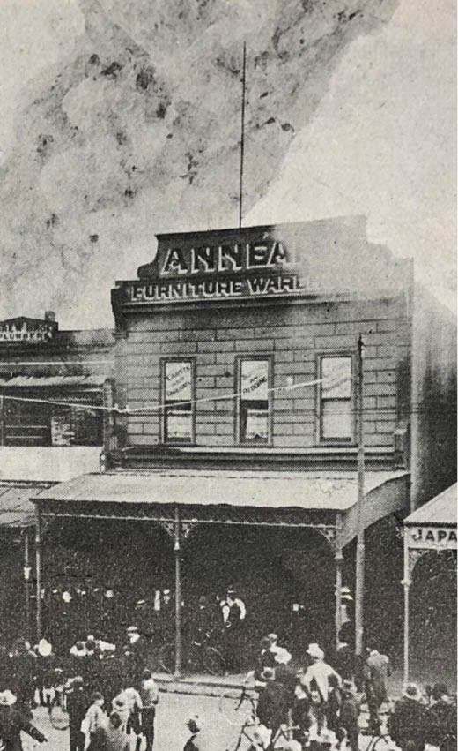
Figure 5.113: Annear’s Furniture Warehouse, Ryrie Street, 1912. Source: News of the Week, 7 November 1912, p.15, GRS 2121/3 Geelong Heritage Centre collection.

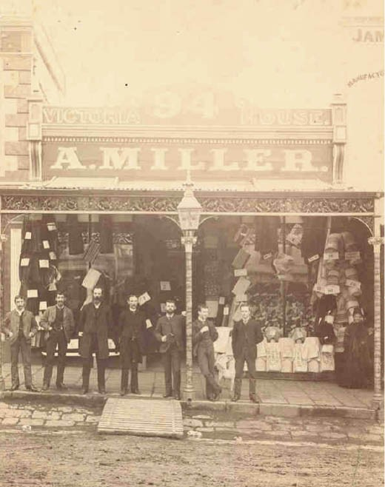

Figure 5.114: A. Miller’s Victoria House, 94 Moorabool Street, 1890, with Alexander Miller (third from left). Source: GRS 2009/283b, Geelong Heritage Centre collection.

As well as investing in farming at Ceres,864 real estate and general stores, Miller was highly respected for his
philanthropic pursuits. His philanthropic legacy continued after his death in 1914, his Estate was charged with building welfare houses known as the Alexander Miller Memorial Homes, there being 195 homes built by 1984.865

MACROW’S FURNITURE ARCADE, 85-87 RYRIE STREET, GEELONG
In January 1911, the architects Tombs and Durran called tenders ‘for Re-building (in brick)’ a two storey shop for Messrs. Henry, Lear and Co., agents.866 Completed in October 1911, a notable tenant in one of the two shops at 85-87 Ryrie Street (corner Gheringhap Street) was William Macrow and Son, furniture dealers.867 The Federation Free style building (Figure 5.115) featured a crown-like corner bay surmounted
by onion-like cappings, the domed roof being a trademark of the work of the architects. The Geelong Advertiser reported on the handsome new building and the opening of Macrow s business:
Three busy days have been spent in moving and arranging their large stock of furniture, pianos, phonographs and

musical instruments. To-day the warehouse is open to the public, and invitation is extended to all our readers to visit the new establishment of Messrs. Macrow. On the ground floor, pianos and musical instruments are displayed, whilst the whole of the first floor is devoted to modern and up-to- date furniture. The building is a handsome addition to the business buildings of Geelong.868
William Macrow (1860-1946) was born in Ballarat and in 1880 he established a bookselling business there.869 Following his relocation to Melbourne, he specialised in the furniture and musical instrument trade, ‘making many trips overseas.’870 His son, Lt. William Reginald Fairbairn Macrow,871 later became a partner, the firm being known as W. Macrow and Son Pty Ltd. They continued at 85-87 Ryrie Street until 1916 when they moved to a factory in Baylie Place South, off Little Ryrie Street.872 Kearney Brothers, bootmakers, took over the building at this time.873

TUCKERS FUNERALS, 57 HOPE STREET, GEELONG WEST
In c.1920, Frank Henry Tucker, his wife Elizabeth and their family relocated to Geelong West. Formerly of Wycheproof,
Frank Tucker had established a business there in 1883 as F.H. Tucker and Son, builders, undertakers and timber
merchants.874 In 1925 with his son, Charles, Frank established
F.H. Tucker and Son Funeral Directors in Geelong West (Figure 5.116).875 It appears that a brick funeral parlour (listed as a shop) had been built by 1928-29.876 Both the interwar Bungalow dwelling and the funeral parlour survive today.
Frank Tucker was associated with the Methodist Church and also with the temperance movement.877 He died at Geelong in 1932.878 Charles Tucker continued the family business with his wife, Irene (whom he had married in Ballarat in 1913).879
In 1916, he joined the A.I.F. at Wycheproof as part of the 29th Battalion and in 1918 he was awarded a military medal for bravery in France.880 It appears that it was on his return from the First World War when the Tucker family relocated to
Hope Street, Geelong West. Between 1935 and 1948, Charles Tucker was a Geelong West City Councillor, being Mayor in 1945 and 1946.881 He retired due to ill health, after also being a member of the Geelong Rotary Club, Australian Natives Association, President of the Geelong West Pipe Band and member of the St. Andrew’s South Masonic Lodge.882 He died in 1954 and was cremated at Fawkner.883
Tucker’s employee, Les Cole, took over running the company with Irene Tucker upon Charles Tucker’s death.884 Cole eventually became sole owner of the business in the ensuing years and he spent 60 years supporting the community and developing and improving the funeral business.885 The family business was continued on by Cole’s sons,886 with a larger funeral chapel constructed opposite the original building in

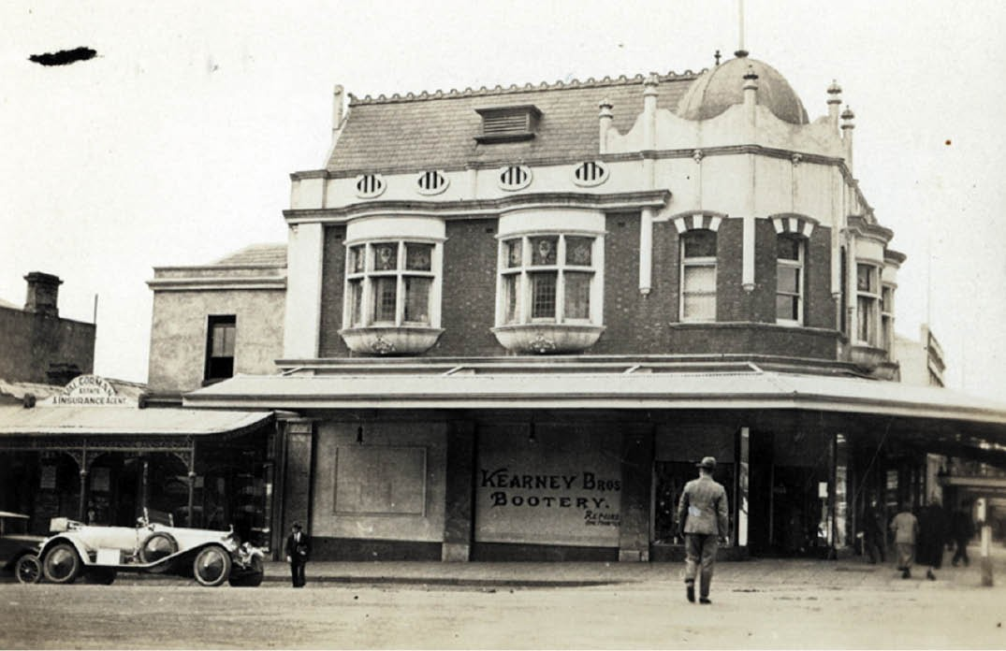
Figure 5.115: Former Macrow’s Furniture Arcade (when Kearney Bros. Bootery), 85-87 Ryrie Street, Geelong, c.1920. Source: GRS 2009/00802.

Hope Street in the later 20th century.

PAINTERS AND DECORATORS
Approximately seven painters were listed in Geelong by 1854 and in 1856 there were sixteen.887 By 1882-183, this number had swelled to thirty-three, the services provided also including signwriting.888 By 1925, this trade (numbering 19) also advertised paperhanging services, although this had formed part of the work of earlier painters and decorators.889 By 1944, there were around 18 painting and decorating businesses operating in the Geelong area.890

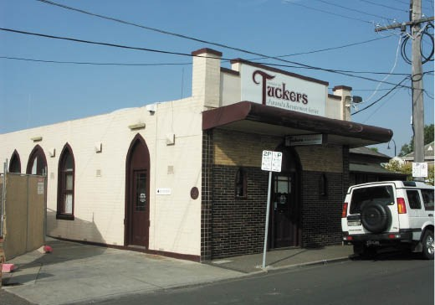

Figure 5.116: Tuckers Funerals Office, 57 Hope Street, Geelong West, 2009. Source: David Rowe.

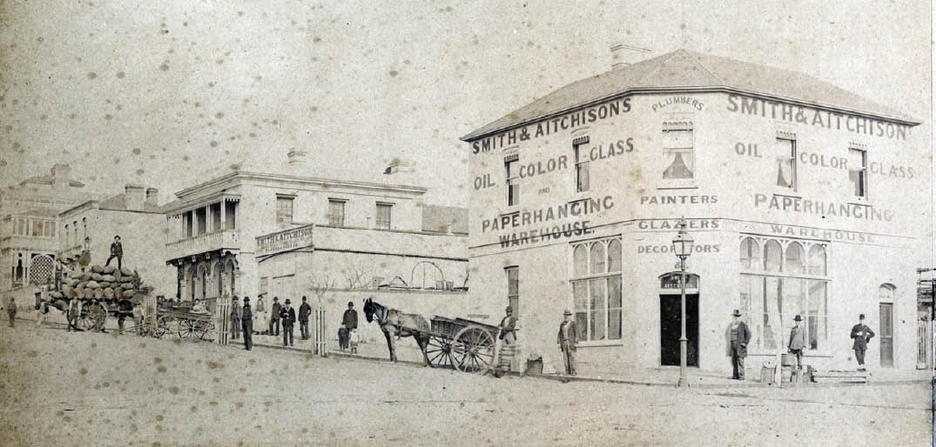
Figure 5.117: Corner of Ryrie & Fenwick Streets looking south-west to Smith & Aitchison’s building (right), 1879. Source: 2170/17, Geelong Heritage Centre collection.

SMITH AND AITCHISON
One of the earliest painting and decorating firms in Geelong was that of Smith and Aitchison in Elizabeth Street, Geelong West.891 William Black Smith (1814-1881) was born in Edinburgh, Scotland, and by 1843 he had emigrated to Sydney, NSW, as it was at this time when he married Elizabeth Barfoot (1815-1886).892 Roderick McLean Aitchison (1827-1889) was also born in Edinburgh, Scotland.893 He married Miss Maria Smith (sister of William Black Smith) in London 1852.894 They had emigrated to Geelong by 1854 as it was at this time when their son, Roderick William Aitchison was born (he died in 1855).895 A physical legacy of the Smith and Aitchison firm is the two storey Victorian building at 34 Ryrie Street, Geelong (Figure 5.117). It was built between 1866 and 1867 and included the firm’s shop (with residence above), with a galvanised iron workshop and timber stables at the rear.896 The business of Smith and Aitchison continued after the deaths of the founders until the property was purchased in 1908 by William Purnell and Sons.897

MOLYNEUX & SON
A successful painting, decorating and signwriting firm from the second half of the 19th century was Molyneux and Son. The business had been commenced by John Molyneux (c.1827-1894) at 69 Autumn Street, Geelong West, before 1882-83.898 His son Edwin Molyneux (1863-1937) following his father into the painting and decorating business.899 Edwin continued the family firm after his father’s death in
1894, as well as establishing a taxi service between Geelong and Torquay at this time.900 At Torquay, Molyneux later established a café and garage.901 In 1904, Edwin Molyneux had built a two storey weatherboard painting and decorating shop (Figure 5.118) and by 1925 he was operating a motor garage and depot at the rear.902 Molyneux’s shop and motor garage have subsequently been demolished.

TIMBER MERCHANTS
Supplying the demand for timber for building construction, cabinet-making, undertaking and other businesses, were timber merchants. Some of these merchants were also ironmongers, offering iron goods. In 1854, there were
five timber merchants listed in Geelong but by 1856, there were 17.903 By 1882-83, there were only around six, and this number remained reasonably constant until at least 1960.904

SCOTT BROTHERS
One of the earliest timber merchant business in Geelong was that of the Scott Brothers. The business was founded in 1853 by James, John and Donald Scott of Caithness, Scotland.905
It was first situated in Corio Street until around 1863 when the firm acquired a site in Ryrie Street near James Monro’s undertaking establishment906 (Figure 5.119). In 1897, the following description was given of Scott Brothers:
The firm has a widespread connection, not only in Geelong but throughout the large surrounding district, supplying all kinds of timber and building materials –

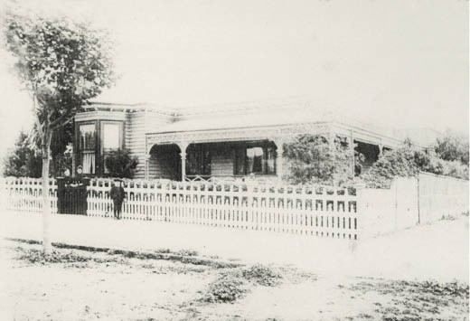

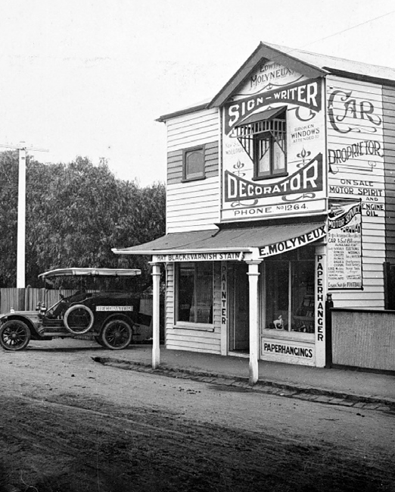
Figure 5.118: Edwin Molyneux’s Signwriting & Decorating Shop, Autumn Street, Geelong West, c.1915. Source: item MM7213, Museums Victoria collection.
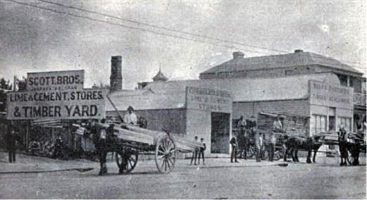
Figure 5.119: Scott Bros. Lime & Cement Stores & Timber Yard, Ryrie Street, c.1897. Source: E. Vidler, The Book of Geelong: Its People, Places, Industries and Amusements, p.50.

including bricks, lime Portland cement, plaster, corrugated iron, rain pipes, spouting, and the usual ironmongery indispensable in building operations. The firm is prepared to furnish estimates for the erection of all kinds and sizes of buildings.907
Nothing survives of the Scott Brothers’ timber yard in Ryrie Street today. Associations with the Scott family exist in the Victorian villa, Wandsworth , 371 Ryrie Street, built by 1869
Figure 5.120: ‘Czergym’, 28 Fitzroy Street, Geelong, n.d. [c.1890]. Source: GRS 2009/2121/28h, Geelong Heritage Centre collection.

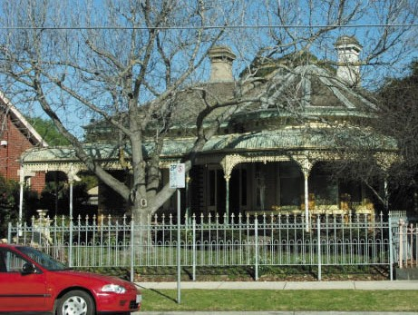
Figure 5.121: ‘Warrain’, 56 Western Beach Road, 2005. Source: David Rowe.

for Donald Scott (1812-1916).908 He lived there with his family in 1879.909

B. MARTIN AND SONS TIMBER MERCHANTS
Similarly, physical evidence of the successful business of B. Martin and Sons remains only in the timber Victorian Italianate dwelling, ‘Czergym’ at 28 Fitzroy Street (Figure 5.120), built
in 1882 for George Martin (1840-1921)910 and a brick villa, ‘Warrain’ at 56 Western Beach Road, Geelong (Figure 5.121), built in 1888 for John James Martin (1848-1906).911 They were the sons of Boyle Martin, timber merchant and pioneer of Geelong, having arrived in 1837.912
George Martin, gold miner and carpenter, founded a timber business in Geelong with his father, Boyle Martin, under the name of B. Martin and Sons.913 George Martin contributed much to community life, serving on the Geelong Town

Council for 20 consecutive years, first as a Councillor of the Barwon Ward from 1876 and Alderman from 1880, including a term as Mayor in 1884-85.914 For 34 years he was a member of the Geelong Infirmary and Benevolent Asylum (including 20 years as President), a Justice of the Peace, President
of the Geelong Timber Merchants’ Association, Vice Consul for Norway between 1902 and 1918, Sunday School Superintendent at the Fenwick Street Baptist Church and President of the
Baptist Union of Victoria 1897-1898.915 Martin died in
1921 and “Czergm” was advertised for sale in November of that year.916
John James Martin became a full partner of the family firm following the death of his father, Boyle.917 He also contributed to public life being elected a Councillor for the Villamanta Ward of the Geelong Council in 1900 and was Alderman from 1905.918 He was also director and chairman, of the Western Beach Sea Bathing Company, his residence, ‘Warrain’, being nearby the baths at Western Beach.919 J.J. Martin was also
a staunch upholder of teetotal principles and was a member of the Sons of Temperance for many years, filling every office of the order including an extended period as Grand Secretary of the Victorian Grand Division of the Sons of Temperance.920 Following his death in 1906, an enlarged photograph of J.J. Martin was unveiled to his memory in the Temperance Hall, Ryrie Street.921

FAGG BROTHERS
The most enduring and continuing timber merchant business in Geelong was that established in 1863 at the corner of Pakington and Russell Streets, Newtown by the Fagg brothers: Samuel (1827-1909), a clerk, and William (1831- 1902), a carpenter.922 The sons of Richard and Rhoda (nee Hadley) Fagg of Kent, England, the two brothers – along
with their other brother, Clement, emigrated to Victoria in 1852.923 They tried their luck on the Ballarat goldfields and before starting a carting business between Geelong and Ballarat.924 Another brother, George – an architect -
emigrated to Tasmania and gained success in his profession there, designing many residences and public buildings, was superintendent architect for St. David’s Anglican Cathedral, Hobart and designed the addition to St. Mary’s Catholic Cathedral).925
In Victoria, Clement became a recluse and lived in a tent at Clunes926 while brothers Samuel and William returned to Geelong permanently where they went
into business with William Purnell in 1854, advertising the following:
Chilwell, to parties building.
Plans and specifications furnished, estimates given;

and every description of Carpenters’ and Joiners’ work executed with economy and dispatch.
Sashes, doors, and a general assortment of building materials, always on sale.
Fagg, Purnell & Fagg. Russell-street,
Opposite the Cremorne Hotel.927

In 1863, Samuel and William Fagg acquired a new site at the corner of Moorabool Street and Barwon Terrace, South Geelong, where they established a weatherboard ‘double shop’, timber yard and ironmongery known as
the Barwon Bridge Timber Yard928 (Figure 5.122). Having relinquished their partnership with William Purnell, they traded under the name of Fagg Brothers. In 1869, the brothers partnership was dissolved and Samuel Fagg continued on his own account under the name Fagg Brothers.929 He sold the business to William Fagg in 1875 and in 1880 Samuel entered into a partner with the timber merchant, Thomas Peters, trading as T. Peters and Co.930 At South Geelong, William Fagg continued to trade under his own name and went into furniture dealing.931
William Fagg suffered heavy losses in 1901 when a substantial fire engulfed his two storey furniture warehouse at the corner of Moorabool Street and Barwon Terrace, as did his brother, Samuel, whose adjoining timber yard, hardware store and mill (with frontages to Little Fyans Street and Barwon Terrace) were destroyed.932 On William’s death the following year, 1902, his premises were taken over by Samuel Fagg.933 With his sons, Charles Richard, George William,
Thomas Gus, Frank Fernley and Henry Clifford, he rebuilt and continued business there until his death in 1909.934 The hardware, timber yard and ironmongery were kept going
in subsequent years by his sons under the name of Fagg Brothers. They expanded operations in subsequent years, purchasing the timber and ironmongery business of John Baxter and Son at 167- 171 Pakington Street, Geelong West, in 1914.935 They replaced the two storey weatherboard shop with a brick single storey produce store to a design by Laird and Buchan architects in 1920.936 This building still survives (Figure 5.123), the original Fagg Bros. Pty Ltd Timber Merchants signage still displayed on the parapet under existing Geelong Fresh Foods signage.
In 1965 Fagg Bros. joined the Mitre 10 marketing and distribution group.937 This provided further opportunities to expand the business with the acquisition of the Mitre 10 store at North Geelong. In 2008, Fagg’s Geelong Pty Ltd, under the direction of Barry and Keith Fagg, purchased the trading business of Fagg’s Mitre 10 from Fagg Bros. Pty Ltd which continues to the current day.938 In 2011, the business underwent a major redevelopment program at its

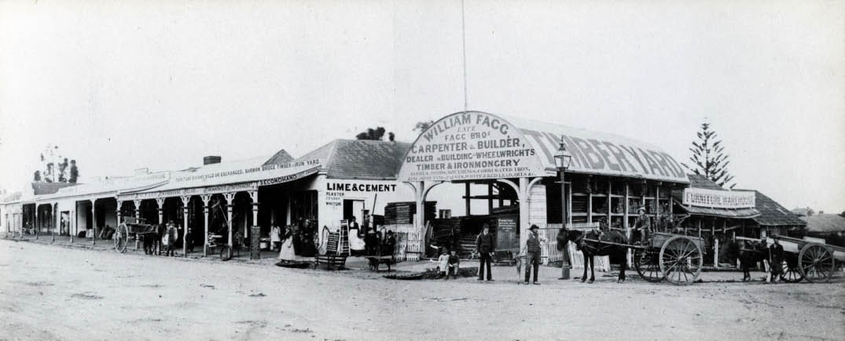
Figure 5.122: William Fagg’s premises, South Geelong, c.1900. Source: GRS 2009/01273, Geelong Heritage Centre collection.

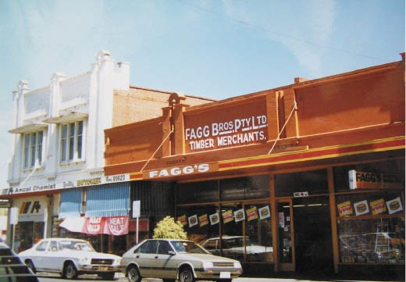
Figure 5.123: Fagg Bros. Pty Ltd. Timber Merchants building, 167- 171 Pakington Street, Geelong West, 1986. Source:
Honman, Huddle & Aitken, ‘City of Geelong West Urban Conservation Study.

South Geelong operations and established another store at Wallington.939

IRONMONGERIES
Now more commonly known as hardware stores, several ironmongeries were established in Geelong to cater for the growing population and building industry with the sale of household and garden goods, tools, building products (such as nails, screws and iron materials). From the early 1850s, the gold boom in Victoria also led to the sale of
mining equipment such as pans, picks, ‘gold-diggers’ belts’, clouts, lamps, boring screws and cooking stoves.940 In 1854, there were nine ironmongers listed in Geelong by 1856 this number had expanded to twelve. This number remained
reasonably constant until the mid-1920s, after which industrial manufacturing took its toll and by 1944 there were only six ironmongers listed.941 Physical evidence of this commercial trade exists in at least four sites in Greater Geelong today.

PARKER’S IRONMONGERY STORE, SHORTS PLACE, GEELONG
The earliest of the surviving buildings associated with ironmongeries is a two storey Victorian Italianate bluestone building at 10 Shorts Place, Geelong, built in 1861-62 as a store for Richard Parker (1811-1884).942 From Cumberland, England, he arrived in Victoria in 1840 and established a general store in Elizabeth Street, Melbourne, with Jonathan Fleming Boadle which was dissolved in 1842.943 He continued business on his own account under the name of Parker and Co. before selling it to his brother in law, Germain Nicholson, in 1843.944 He came to Geelong in 1847 and continued business in Corio Street in a three roomed shop.945 He introduced penny token coins as part of his marketing.946 In 1851, he first imported plate glass for the use in his two storey premises then
under construction in Moorabool Street, opposite
Market Square947 (Figure 5.124). The building was completed in 1853.948
Parker’s bluestone store in Shorts Place was situated behind his shop in Moorabool Street and it is extant today (Figure 5.125). He continued working from his Moorabool Street and Shorts Place premises until ill-health forced
his retirement. On his death in 1884, the Geelong Advertiser
remarked:
Mr Parker laid the foundation stone of the Geelong Gas Company’s works at West Geelong, and for a long

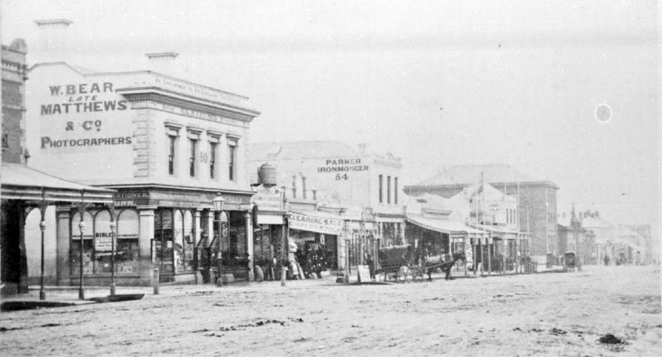
Figure 5.124: Stevenson & McNicoll, Parker’s Ironmongery (circled), Moorabool Street, c.1880-1890. Source: Wynd collection, Authentic Heritage Services.

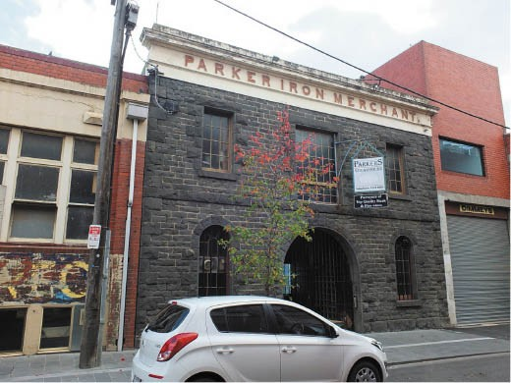
Figure 5.125: Former Parker’s Ironmongery Warehouse, Shorts Place, Geelong, 2019. Source: David Rowe.

time acted as chairman of directors, and was one of the principal supporters of the company. For very many years he took an active part in the management of the Geelong Hospital, and he was also an able representative of the ratepayers in the Geelong Town Council. He occupied the position of mayor of the town some 20 years since, and
in the capacity of chief magistrate he proved himself well worthy of the honor conferred. As a justice of the peace he
was very attentive to the duties pertaining to the office. He was an enthusiast in matters which engross the attention of amateur anglers, and his death will be a source of regret to many rod and line men of this town
and district.949

JOHN DANIEL, IRONMONGER,
186 MOORABOOL STREET, GEELONG
In 1858-59, John Daniel (1834-1902), a Cornish miner who had arrived in Victoria on the Shalimar in February 1855, opened a weatherboard ironmongery shop owned by George Synnot.950 By 1862-63, the property was owned by Daniel and in October 1863 he called tenders for the construction of a stone store.951 Completed in 1864,952 the gabled two storey bluestone building survives at the rear of 186 Moorabool Street today (Figure 5.126). By 1866, Daniel had replaced his
weatherboard shop fronting Moorabool Street with two double storey rendered brick shops.953 They appear to exist in part behind introduced cladding (and with altered shopfronts and first floor windows) on the Moorabool Street frontage (Figure 5.127). In 1874, Daniel acquired the adjoining premises to the north of his ironmongery establishment (now 184 Moorabool Street) where he opened a new shop in addition to his existing premises.954 In 1877, he had a two storey corrugated iron house relocated from Yarra Street to the property at 184 Moorabool Street.955 This iron building no longer survives.

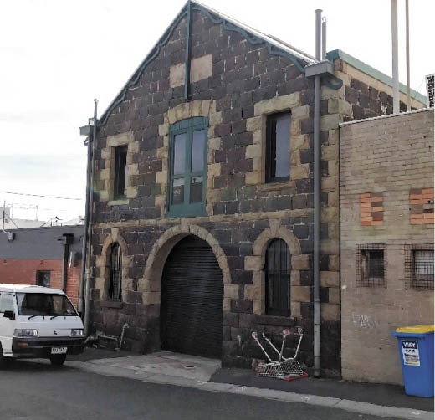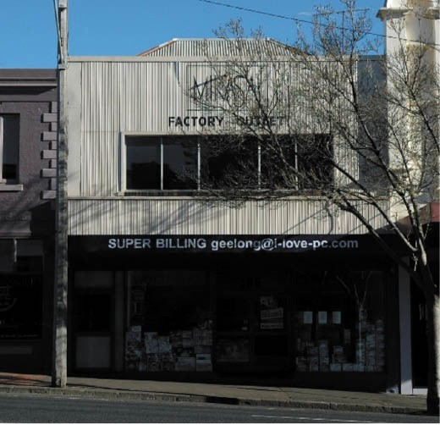

Figure 5.126: Daniel s former bluestone ironmongery, rear of 186 Moorabool Street, 2019. Source: David Rowe.
Figure 5.127: Daniel s former ironmongery shops, 186 Moorabool Street, 2005. Source: David Rowe.

On Daniel’s death in 1902, the Geelong Advertiser gave the following obituary:
An old and respected resident of the town in the person of Mr John Daniel, ironmonger, died at 3.30 o’clock yesterday morning from paralysis of the heart, and during the day the flags, on many business places were at half- mast, out of respect to his memory. He had reached the ripe age of 75 years, and his end was a peaceful one. For something like 45 years he was engaged in business as an ironmonger, and his residence in Geelong covered almost half a century. He was a generous contributor
to the different charitable institutions, and no Christmas was allowed to pass by the deceased without his making provision for Christmas cheer for the orphans and the sick and infirm. Many years ago he was an active member of the Salvage Corps, and at one time occupied a seat on the council of the Geelong Agricultural Society. He was also one of the oldest trustees of the Yarra-street Methodist Church. The deceased leaves a wife and grown-up family of six—four sons and two daughters.956

THOMAS BALDOCK, IRONMONGER, 154 RYRIE STREET, GEELONG
In 1888, the prolific local architect, Joseph Watts, called tenders for the construction of a two storey shop in Ryrie Street (Figure 5.128) for Thomas Baldock (1824-1892).957 Comprising two premises, the Geelong Advertiser praised the completed edifice:
In the same locality, and within the past eighteen months, two excellent shops have been constructed for Mr Baldock, one of which he occupies, and the other is now occupied by Mr Wilton. The work effected here was the erection of brick party walls and wooden frontage, and the construction of a galvanised roof, the whole being carried out at a cost of £350, by James Durran, contractor, under the superintendence of Mr Watts, architect.958
Today, along with the former Annear’s furniture warehouse at 64-66 Ryrie Street, Baldock’s building is a rare surviving
example of a Victorian commercial building with a front timber fa ade.
Thomas Baldock was from Bishopsgate, London, and had emigrated to Sydney by 1846 where he married Miss Anne Hannah Chambers at St. Patrick’s Church of England.959 By 1850, with wife and infant daughter, Jane (born Sydney, 1849), Baldock had relocated to Geelong.960 In 1854, he opened a new weatherboard shop and workshop as part of his ironmongery, advertising the following:

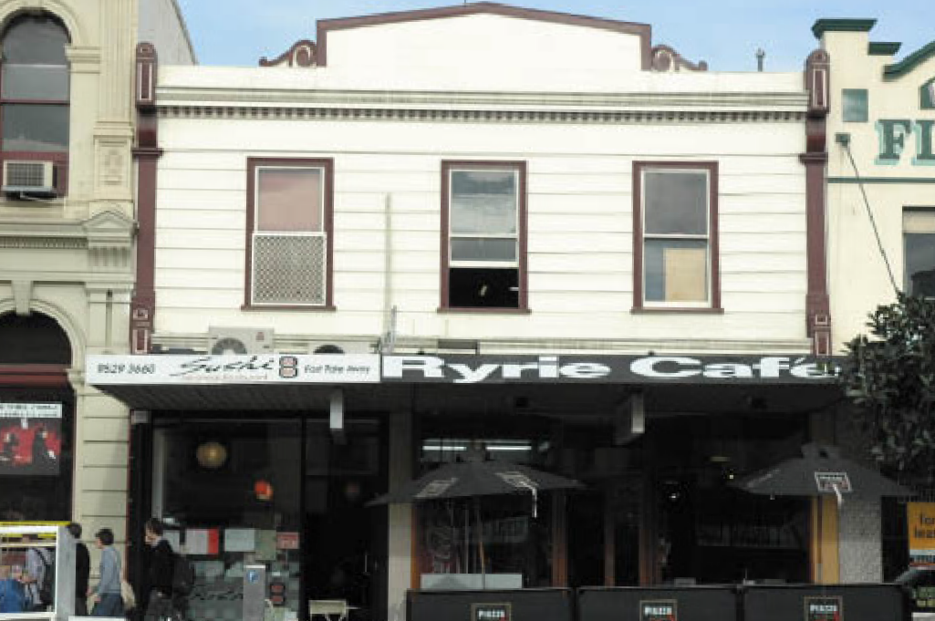

Figure 5.128: Former Baldock Ironmongery, 154 Ryrie Street, Geelong, 2005. Source: Wendy Jacobs.
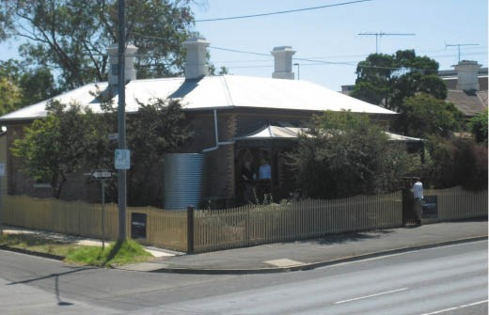
Figure 5.129: Kardinia Villa , Moorabool Street, Geelong, 2009. Source: Jennifer Bantow.

THOMAS BALDOCK – The top of Moorabool-street. Tin and Iron plate worker., Wholesale and Retail Manufactory, begs leave to return thanks to his friends and the public in general for the benefit which he has received, and hopes to merit a share of the public patronage. Storekeepers will find it to their advantage to give a trial, as all orders are executed on the premises. All work warranted to
be sound, made of the best of material, and best of workmanship. All orders sent to the undersigned carefully packed and sent according to order. Zinc and tin spout pipes and heads; contracts taken by the above and executed with the greatest dispatch.961
In 1864-65, Baldock relocated to a weatherboard shop and workshop in Ryrie Street.962 Following the death of his wife, Anne, in 1874, he married Charlotte Collins in 1881.963 Three years later in 1884, he built a new brick dwelling at
344 Moorabool Street, Geelong, which was named Kardinia Villa 964 (Figure 5.129). His new ironmongery premises in 1888 were built on the site of his earlier establishment.965 He died at Kardinia Villa in 1892.966

HAWKES BROTHERS WHOLESALE HARDWARE & IRON MERCHANTS, CLARE STREET, GEELONG
In December Thomas Southam Hawkes (1823-1894), an ironmonger from Oxfordshire, England, emigrated to Geelong on the Queen of England, arriving in December 1852.967 In March 1854, he advertised the opening of
his ironmongery: THOMAS HAWKES,
Wholesale and Retail Builders’ Furnishing and Store- keeper’s Ironmonger,
Mercer-Street, Geelong,
Respectfully acquaints the public, in town and country, that he has commenced the above business in that improving locality, and trusts, that by keeping a well selected stock, combined with moderate charges
and strict personal attention, to receive a share of their support.
Address – Next door to the steam Coach Hotel. Mercer-street, February 2, 1854.968
Four years later in 1856, he married Miss Jane Adams.696 By 1859, Thomas had been joined by his half-brother, Frederick (1832-1867), trading under the name of Hawkes Brothers. The partnership was dissolved in 1863 but soon
re-established until 1867, when Frederick and his wife, Emma, were lost at sea following the wreck of
the schooner, Jane and Elizabeth, off the coast of Tasmania.970 Thomas Hawkes continued on under the same business name.
In 1889, Hawkes Brothers purchased the three storey wool warehouse built in 1874 for George Synnot and Co. in Clare Street.971 It was in May of that year when the firm invited tenders for alterations and additions to the firm’s premises, Clare and Corio Streets.972 It may therefore have been at this time when the two storey portion of the existing building at 1-3 Clare Street was built for Hawkes Brothers. It was shown in a photograph (Figure 5.130) of the firm in c.1915.
In 1890, Thomas Hawkes admitted his son, Frederick A. Hawkes as a partner of the firm and in 1893 this was followed by another son, Tom Henry Southam Hawkes973 The
year 1894 witnessed the death of Thomas Hawkes at his residence, ‘Llanberris’ (built in 1888) at 30 Western Beach Road.974 The Geelong Advertiser marked the event with the following obituary:
Mr. Hawkes will be greatly missed by a very large circle of friends and business acquaintances by whom he was always held in high esteem. His generous and amiable
disposition and his well-known interest in outdoor pursuits have gained him a wide popularity. He was a prominent

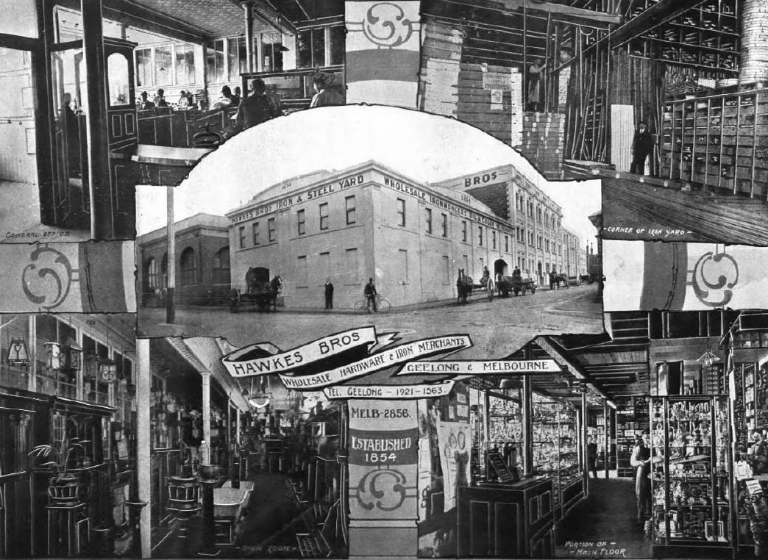
Figure 5.130: Hawkes Bros. Wholes, Hardware & Ironmonger Store, 1-3 Clare Street, Geelong, c.1918. Source: Geelong for Business, Health, Pleasure, p.10.

member of the congregation of St Paul’s Church, and has been connected with St Paul s ever since his arrival in the town. He has always given generous support to the church, and the Sunday school, and particularly
the Church Union hall, are greatly indebted to his benefactions.975

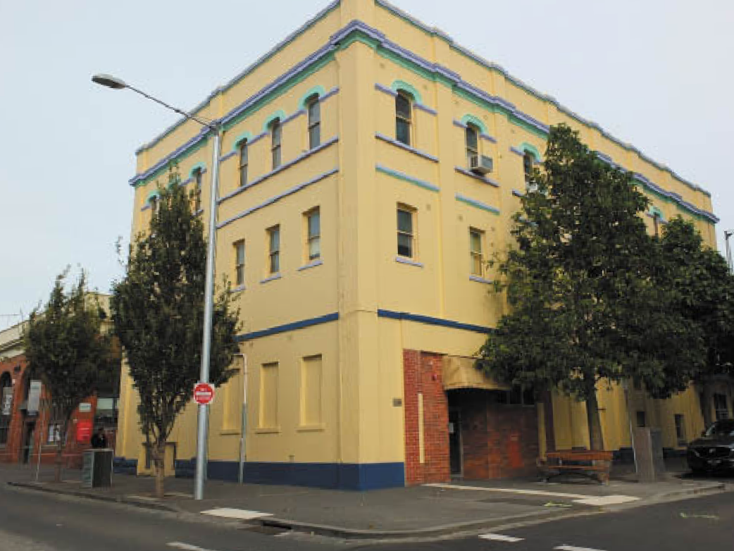

Figure 5.131: Former Hawkes Bros. Store and Warehouse, 1-3 Clare Street, Geelong, 2019. Source: David Rowe.

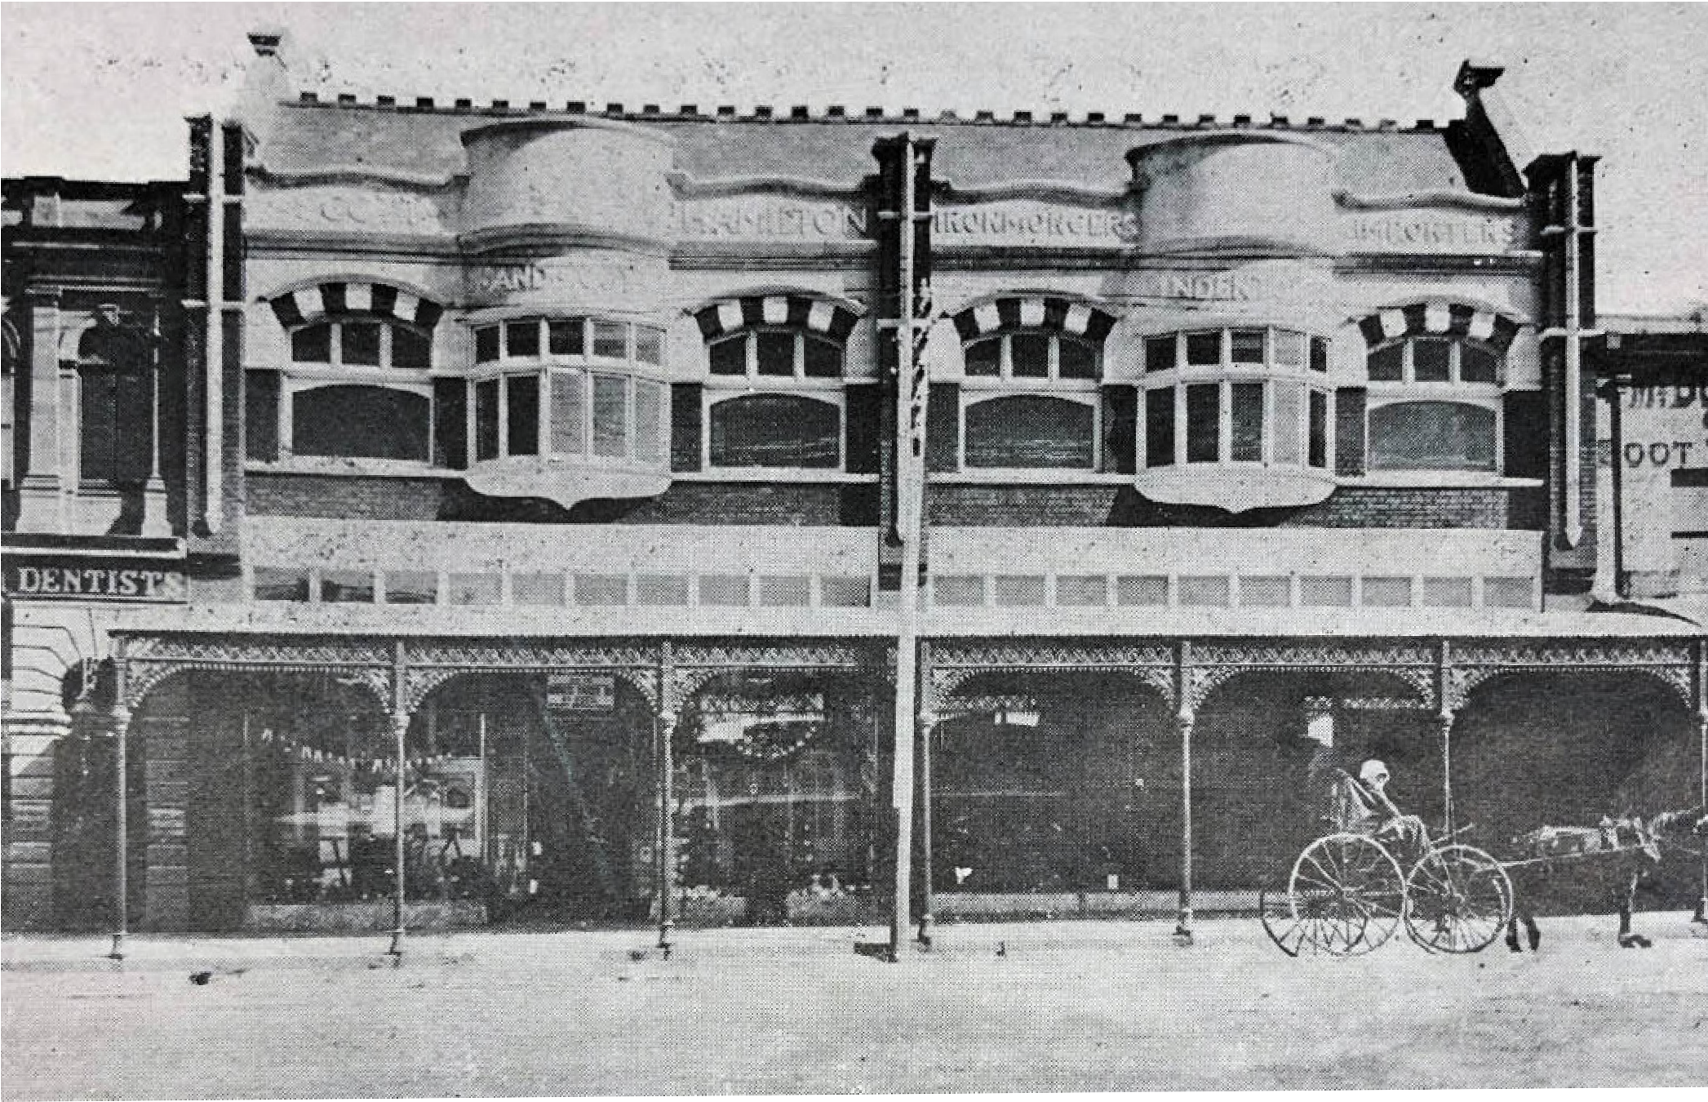

Figure 5.132: Scott Hamilton & Co. Building, Ryrie Street, Geelong, 1911. Source: News of the Week, 7 December 1911, p.23, GRS 2121/3, Geelong Heritage Centre collection.

The business was continued by Hawkes’ sons until tragedy again struck the family when Tom S.H. Hawkes was killed as a result of the destruction of the Oriental Palace at Yokohama, Japan, the result of an earthquake in 1923 (his wife, Leila, survived).976 Yet, the Hawkes Bros. business was to endure and in 1928 they engaged the Geelong architects, Laird and Buchan, to design upper floor additions to their warehouse
at the Clare and Corio Street corner.977 From the Clare Street premises, Hawkes Bros. hardware operated until the mid-late 1960s.978 Although altered as part of residential apartments, the Hawkes Bros. store at the corner of Clare and Corio Streets remains discernible to the current day (Figure 5.131).

SCOTT HAMILTON AND CO., 126 RYRIE STREET, GEELONG
In 1883, the newly-formed ironmongery firm of Scott Davison and Co. acquired Alfred Crook’s ironmongery business which included a single storey stone and brick building and iron store at 126 Ryrie Street.979 John Scott (c.1816-1887) of
Caithness, Scotland, had previously operated an ironmongery in Pakington Street.980 He continued at that location while
the furnishing and general ironmongery business in Ryrie
Street was to be carried on by his son, Robert Murray Scott (1860-1931) and John Herbert Davison (who for 11 years had been associated with Alfred Crook).981 Some of the first products to be advertised by the new business were footballs ‘in time for the favorite winter sport’ and Hornsby’s
string sheaf binding harvester.982 After John Scott’s death in 1887, the firm of Scott Davidson and Co was dissolved and in its place Scott Hodgkins and Co. was created in 1888.983 John Davison had resigned from the company and had been replaced with George T. Hodgkins.984 The new firm advertised the sale of chaff cutters, hand and horse power
horseworks, furrow ploughs, harrows, horse shoes, simmers, scarifiers, field rollers, leading and plough chains, horse seed drills, fishing tack, guns, ammunition, bedsteads, spring mattresses, colonial ovens, builders ironmongery, sewing machines, mangles, and coach builders ironmongery.985
In 1904, James Hamilton was admitted as a partner, the business being known as Scott, Hamilton and Co.986

Tangible evidence of the enduring ironmongery firm is the two storey Federation Free style brick building (Figure 5.132) constructed by G.F. Taylor to a design by Tombs and Durran.987 By July 1911, the building was ‘nearing completion. 988 The business was continued by Robert M. Scott until about 19 months before his death in 1931.989 This brought about a change of ownership of the store at 126 Ryrie Street but the Scott, Hamilton and Co. firm continued on and occupied the building until c.1970.990

PRINTERS & STATIONERS
Critical to the ongoing education and creation of Greater Geelong’s citizens from the 19th century were books, magazines and journals. Key to successful marketing – whether for commercial or political purposes was printed matter. Until the advent of television in the mid- 20th century, book sellers, stationers and printers, and newsagents provided an important service. Two of the earliest were George Mercer and Thomas Brown, both of Moorabool Street. By January 1854, there were around 10 stationers, printers and booksellers in the Greater Geelong area that were
mostly centred around the central Geelong township.991 One exception was Reuben Quarril of Russell Street, Chilwell.992 By 1882-83, there were at least 11 businesses of this type in Geelong, including Henry Franks and Co., whose premises at the corner Moorabool and Malop Streets from c.1860 became a local landmark993 (Figure 5.133) until it was replaced with the existing former National Mutual Life Association of Australia Ltd Building in 1924-26 (see later subsection).994
Today, there are at least three buildings of the 19th and early 20th centuries known for their associations with booksellers, printers and stationers, including those at 220 Pakington Street, Geelong West; 131-133 Ryrie Street, Geelong and 96- 98 Ryrie Street, Geelong.

J.R. COXON’S STORE, 220 PAKINGTON STREET, GEELONG WEST
One of the most substantial and extant commercial buildings of the mid-19th century in Greater Geelong was the two storey rendered masonry store built in 1856-57 for J.T. King.995 It was named Union Jack House in 1861 when ownership
was acquired by Edwin Hopton who ran a drapery there.996 From 1871 until 1873, Alexander Miller started his Union Jack Drapery at this location, his business later became very successful and known as Alexander Miller and Co. (see earlier subsection for further biographic details).997 By 1882, the store was known as Borough House.998 It was
occupied by J.R. Coxon (1864-1930), stationer from 1886 and a few years later he purchased the premises and operated his stationery and newsagency business there until his
death in 1930999 (Figure 5.134). Coxon was born at Ashby

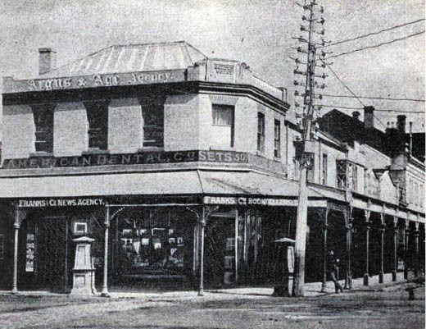
Figure 5.133: ‘Frank’s Corner’, corner Moorabool & Malop Streets, c.1897. Vidler, The Book of Geelong: Its People, Places, Industries and Amusements, p.30.
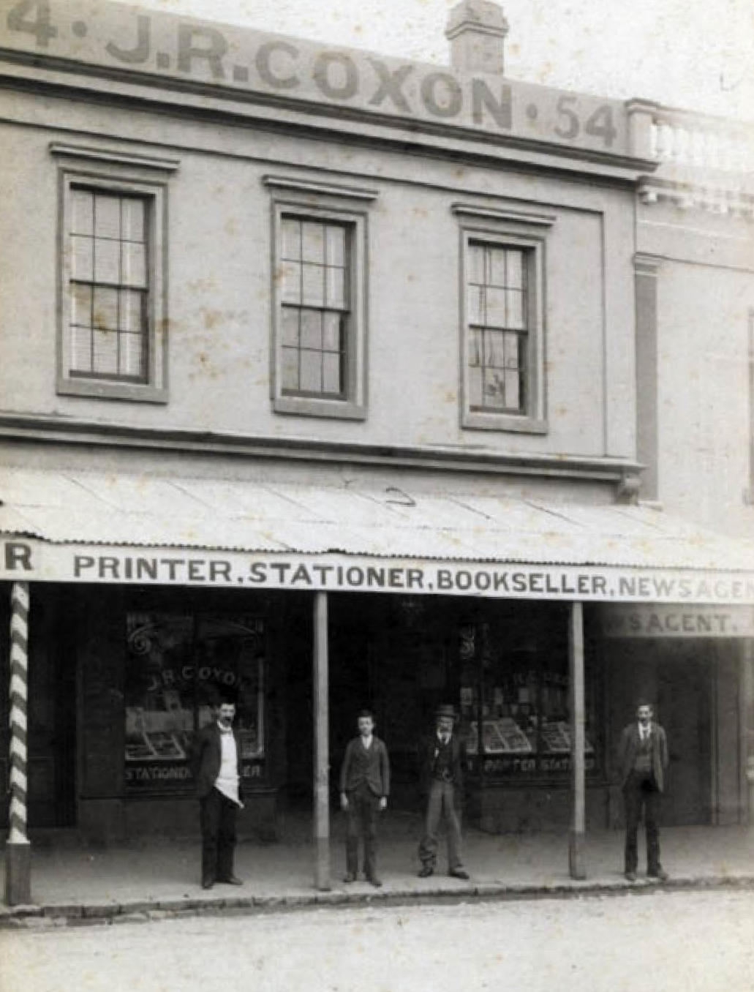

Figure 5.134: Clark Bros., Coxon’s Store, 220 Pakington Street, Geelong West, c.1890. Source: GRS 2009/00105, Geelong Heritage Centre collection.

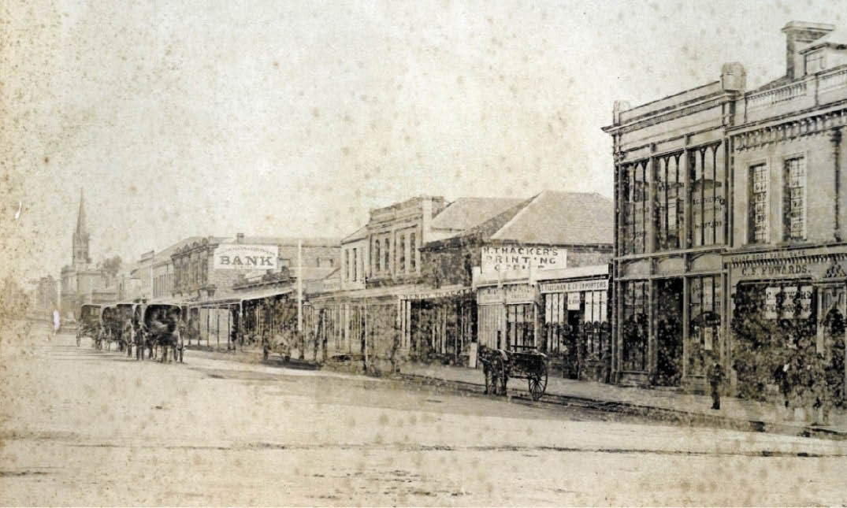
Figure 5.135: Ryrie Street looking west showing Thacker’s Printing building (circled), 1879. Source: GRS 2170/03, Geelong Heritage Centre collection.

(Geelong West), Victoria, to Mark Pinder Coxon, a butcher, and Rebecca Coxon.1000 He made an important contribution to the local community as a Councillor with the Geelong West Borough and Town Councils between 1920 and 1929, including terms as Mayor between 1921 and 1924.1001

THACKER’S PRINTING AND STATIONERY, 131-133 RYRIE STREET, GEELONG
In 1859, Henry Thacker (1826-1908), arrived from Leeds, Yorkshire, England, to be with his brother, William Thacker, postmaster of the Geelong Post Office (see Theme 3). Having followed his father, William Thacker (1816-1875) in the printing trade, Henry Thacker established his own printing and stationery business in a weatherboard shop at 131-133 Ryrie Street in 1864-65 built for J. Waddleton in 1850-511002 (Figure 5.135).
Thacker worked from his Ryrie Street premises for the next 44 years. In 1902, the Geelong Advertiser gave a description of his stock available for purchase:
Mr Henry Thacker, bookseller and stationer, Ryrie-street, is showing a carefully-selected stock, which is thoroughly up-to-date. Fancy goods make a particularly attractive display, and there are many novel lines especially
suitable for Christmas and New Year presents. Special attention has been paid to stocking the establishment with seasonable books, which are in great variety and excellence. A liberal discount is allowed by Mr Thacker to schools purchasing books from him. This year Mr Thacker has sold an enormous quantity of Christmas cards and calendars, and he has still a large stock on hand, the calendars, in particular being exquisitely got up. Mr Thacker has just opened fresh supplies of photo, materials, and in the stationery line he is in a position to meet the requirements
of all tastes.1003
Henry Thacker died in 1908 at his residence in McKillop Street. The Geelong Advertiser gave an obituary:
The death of Mr. Henry Thacker, the well-known stationer and printer of Ryrie-street, occurred early this morning, at the age of 83 years. The late Mr. Thacker had been indisposed for some time, and his demise was not
unexpected. Deceased was a colonist for upwards of half a century, and he came to Geelong very shortly after his arrival in Australia, and remained in the town ever since.
Soon after taking up his abode in Geelong he labored at the printing trade, and as a reward for his industry he worked up the lucrative business of a stationer and

printer, and up to the time of his death carried on under his name. Deceased was one of the best known and widely respected residents of the town, but being of a retiring disposition he never took up any public position, although he was ever ready to assist any movement which was
for the welfare and advancement of the place. He was an active member of the Yarra-street Methodist Church, in the management of which he took keen interest.1004
Thacker’s printing and stationery business was carried on by Thacker’s widow, Elizabeth, and his son, (William) Henry
Thacker. In 1912, the Thackers engaged the architects, Laird and Buchan to design substantial alterations and a new front fa ade to the printing and stationery premises1005 (Figure 5.136). Completed by January 1913, the Geelong Advertiser gave an insight into the work:
The new premises recently completed for Mr H. Thacker, replacing the oldest building in Ryrie-street, are a new type of design in brick and cement. The storeys, which were very low, have been raised several feet, and the shop allows of the stock being handled easily, and greatly increases show conveniences: the windows provide a large area for show purposes. Copper and black marble complete the shop front. The doorway on the left leads
to a stairway given access to the upper storey, which is tenanted by Mr. T.G. Newton, dentist, and the Central Lending Library. The architects were Messrs. Laird and Buchan, and Mr. G.J. Searle was the contractor.1006
Following Mrs Thacker’s death in 1914,1007 the business
was continued by her son, Henry. The enduring printing and stationery firm of Henry Thacker Pty Ltd operated from the Ryrie Street premises well into the 20th century, and were listed in the Sands and McDougall Directory of Victoria in 1970.

GRIFFITH’S STAR BOOKSTORE, 96-98 RYRIE STREET, GEELONG
In 1925, William J. Griffiths (1868-1946) of W.J. Griffiths Pty Ltd purchased the commodious two storey brick building at 96-98 Ryrie Street built for and previously occupied by Harvey Dann and Co., produce merchants from 1916 (see
earlier subsection). Some changes were made to the building (Figure 5.137) as reported in the Geelong Advertiser:
The new owners are W.J. Griffiths Pty Ltd, so well- known in Geelong and Western District as the proprietors of the Star Book Store and Circulating Library. The whole of the ground floor is to be re-modelled and will give an area for the display of books, stationery, etc., and for a new
library, with a total of 4500 square feet. New windows and leadlights are to be installed in the Ryrie Street frontage. From the architects’ preliminary sketches, the new Book

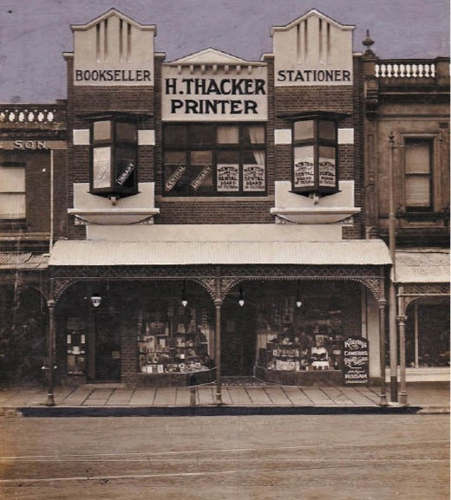
Figure 5.136: H. Thacker Printer, Bookseller & Stationer Building, Ryrie Street, n.d. [c.1920]. Source: Bill Votsaris, Geelong.

Store promises to be a decided acquisition to the city, and the new owners are to be congratulated on their enterprise.1008
The extensive alterations were to the designs of Fred Purnell, local architect.1009 The work was carried out by Messrs. T. Pescott and Sons and involved lowering and modernizing the front plate glass windows, the provision of new leadlight transoms, the laying of jarrah flooring over the whole of the ground floor of the building, lining of walls and ceilings with fibrous plaster sheeting.’1010 Glazed leadlight screens were installed in the shop, the shopfront windows also fitted up with English ash timber linings.1011
Griffiths bookstore operated from the Ryrie Street for
85 years, closing in 2010.1012 The founder of the firm, William Joseph Griffiths, was the son of David and Agnes (nee Robertson) of Angus, Scotland (they married in Geelong in 1863).1013 William Griffiths married Helen Frances Cathie
in 1903 and they were initially resident in Pevensey Street, Geelong.1014 W.J. Griffiths spent his working life as a bookseller and stationer, and in 1911 he commenced his own business, the ‘Star’ book store in a store previously occupied by W. Shaw in Ryrie Street.1015 On Griffiths’ death in 1946, The Age gave the following obituary:
Mr. William J. Griffiths, 77 years, founder of Griffith’s book store, Ryrie-street, Geelong, died on Sunday. The late
Mr. Griffiths spent his life in the bookselling and news

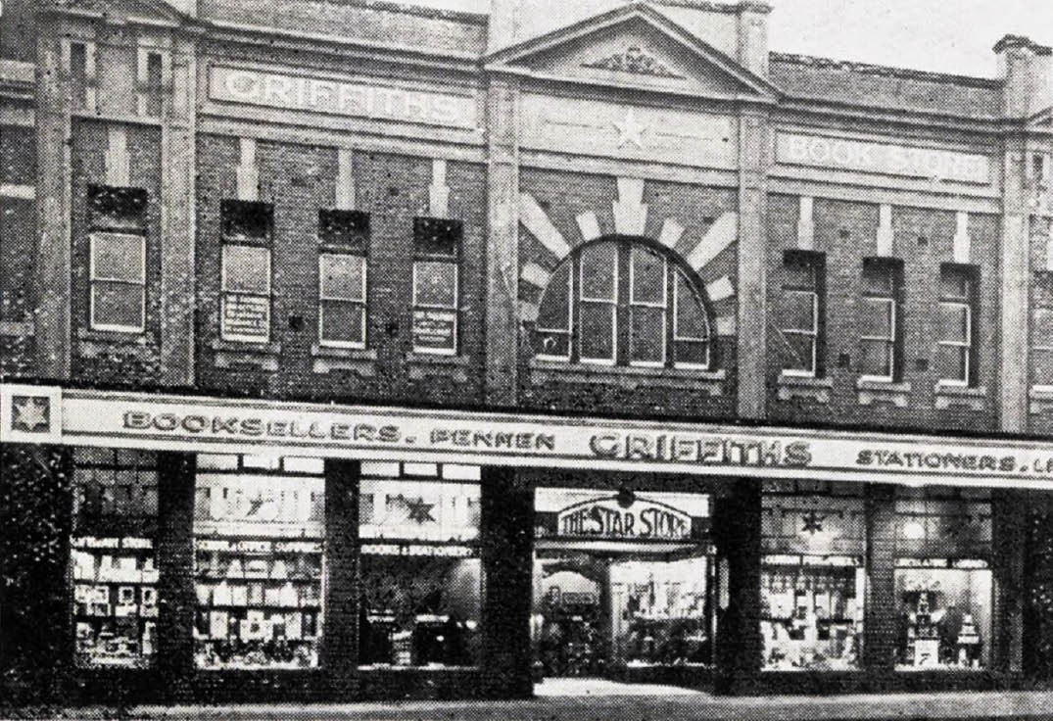
Figure 5.137: Griffith’s ‘The Star’ Bookstore, Ryrie Street, 1928. Source: Geelong: fifty-five photographic Views, Geelong, Victoria, Australia, Henry Franks, Geelong, 1928, p.26.

agency business. He took a keen interest in all things for the advancement of Geelong, and we keenly interested in movements for young people. For several years he was a joint secretary of the Presbyterian Guild. He was closely associated with the Presbyterian church, was superintendent of the St. Andrew’s Sunday school for 25 years, and was a member of Geelong Rotary and Royal Geelong Yacht Clubs.1016

COMMERCIAL SECTOR
Commercial life in Greater Geelong extended beyond the industrial and trade sectors and included the sale of
groceries, drapery, clothes, jewelry and other valuables, and as well as the insurance and financial sectors. Some of these businesses combined with the trade sector in the sale of produce, hardware and other goods already outlined. Other businesses produced goods that are more rare today, such as Anthony Derry’s basket-making store (Figure 5.138), built in 18851017 and which still exists at 105- 107 Moorabool Street.
Also rare today are physical purpose-built legacies of the once ubiquitous jewelry trade (see Figure 5.1). One of the few known examples is at 98 Moorabool Street (Figure 5.139), built in 1905 to a design by the architects, Seeley and King, for William Stott, jeweler.1018 Completed by the contractor,
G.F. Taylor, the Geelong Advertiser gave a glowing description of the handsome building :

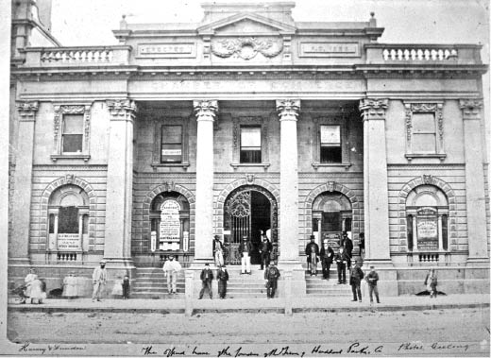

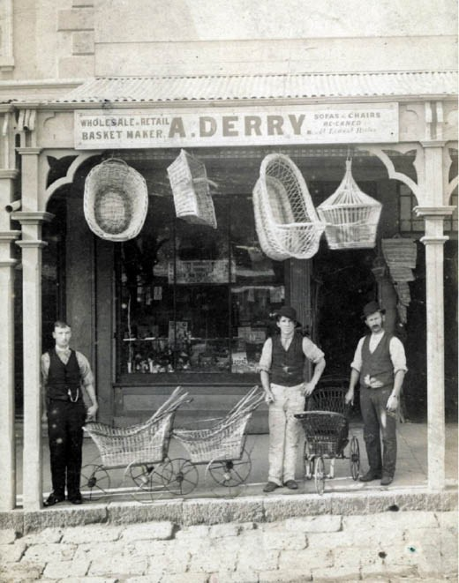
Figure 5.138: A. Derry’s Basket making store, Moorabool Street, c.1885. Source: GRS 2009/0028, Geelong Heritage Centre collection.
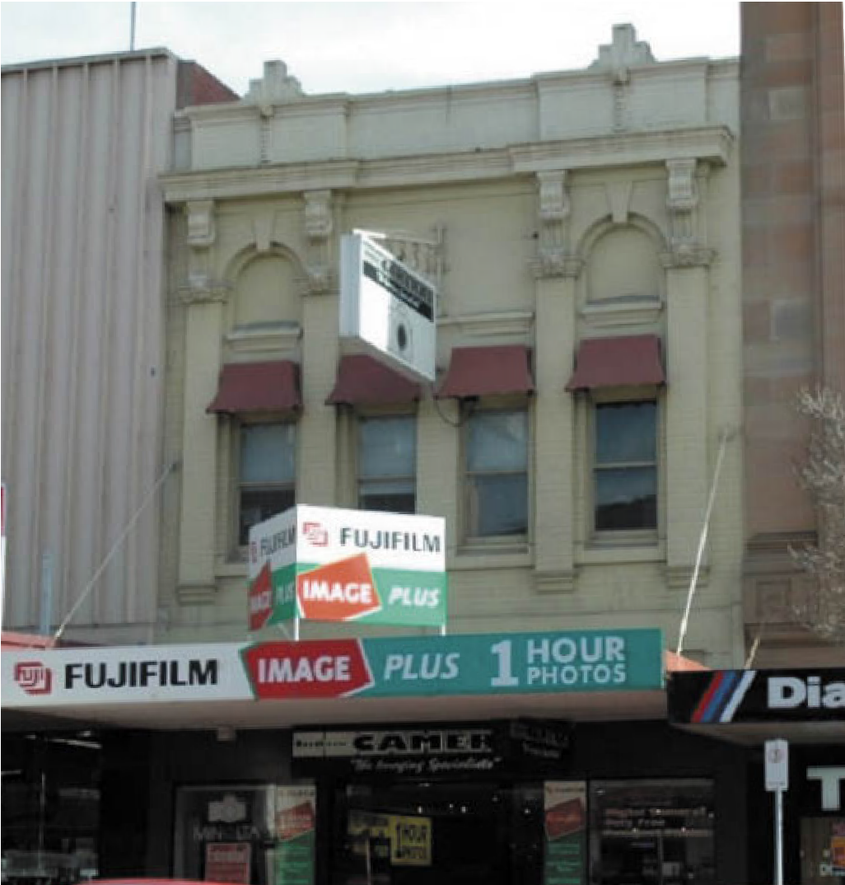

Figure 5.139: Former Stott s Jewellery Store, 98 Moorabool Street, Geelong, 2005. Source: Wendy Jacobs.
Figure 5.140: Geelong Chamber of Commerce, Moorabool Street, 1863. Source: Wynd collection, Authentic Heritage Services.

The new building is constructed on modern lines, and is lofty, well-lighted and excellently ventilated. It is a two-storey brick structure, and presents a pleasing
appearance both inside and out. It is faced with Hoffman compressed bricks and cement dressings, and the effect is enhanced by the use of the blue enameled tiles, and terra-cotta panels.1019

GEELONG CHAMBER OF COMMERCE
Actively supporting the commercial life of Geelong has been the Geelong Chamber of Commerce. Established in 1853, the objects of the chamber were: the promotion of measures calculated to benefit the mercantile and trading interests of its members, and of the town and neighborhood of Geelong generally; to represent and express the sentiments of the commercial community; to settle mercantile affairs on a
firm and equal basis; and to undertake the settlement of questions and disputes arising out of the trade, by arbitration or otherwise, when submitted to it for decision. 1020 The first chairman of the Chamber of Commerce was James Ford Strachan, M.L.C., the deputy chair being William G. McKellar. Notable contributors amongst the 106 member organization included William Bright, J.G. Carr, Frederick Champion, A.F. Cunningham, Charles Ibbotson, T.A. Lascelles, Charles Sladen, C.L. Swanston, Charles Nuttall Thorne and Alexander Fyfe.1021 The Chamber of Commerce continues to the present day, although its elaborate Classically-derived building in Moorabool Street (built in 1858-59 to a design by the architect, Christopher Porter) (Figure 5.140) no longer survives (it was demolished in 1955).1022

GROCERS, DRAPERS, CLOTHIERS, TAILORS, DRESSMAKERS

GROCERS AND STOREKEEPERS
In 1854, the business of the grocer was separately defined from that of a storekeeper. Grocers traded in staple foodstuffs included tea, coffee, sugar and flour, as well as fresh produce and beer, wine and spirits. They were also known as greengrocers. A storekeeper, also known as a merchant, might have had an expanded range of goods for sale, including hardware and military ware. In the Greater Geelong area at this time at least 41 businesses were defined as storekeepers and merchants, with an additional seven listed as greengrocers and a further 24 identified as wine and spirit merchants.1023 These businesses contributed much to the local economy and provided employment opportunities.
A number employed family members. Existing legacies of the grocery stores include the following.

HOOPER FAMILY GROCERS
In January 1863, Lloyd Hooper (1841-1927), a sail maker, arrived in Melbourne from Exmouth Devon, England, with his mother, Ann, and brothers, Michael and Henry,
ropemakers.1024 Their departure from Devon was two years after the death of family patriarch, Michael, a mariner.1025 In 1866, Lloyd Hooper married Miss Margaret Robb (1840-1902). They had seven children: Mary Ann (1866-1952), George (1868-1947), Frank Lloyd (1870-1939), Sydney Lance (1871-
1871), Edwin James (1872-1955), Margaret Lloyd (1873-1874), and Henry (Harry) Robert (1879-1951).1026 By 1868, they were resident in the Bellarine Shire.1027
In 1870, Hooper established a grocery store in Rev. David Rees’ shop in Skene Street, Newtown.1028 Four years later in 1874, he purchased a site at 132 Aberdeen Street, Geelong West (corner St James Street) where he had built a commodious two storey brick store to a design by
J. Matthews of Gheringhap Street.1029 It was there from 1875 where Hooper ran his Western Cheap Grocery store1030 (Figure 5.141).
Lloyd Hooper’s four sons, George, Frank, Edwin and Harry followed him into the grocery business. In 1885, Lloyd Hooper opened another store in two brick shops now addressed as 92-94 Ryrie Street (in an earlier building).1031 It was at this time when he changed the name of the business to Lloyd Hooper and Co.1032 This might have been when he admitted his son, George, as a partner, as George advertised under the name of Geo. Hooper and Co. in later years.
George also later formed a partnership with his brother, Frank, which continued until 1905.1033 In 1911, George Hooper leased (and subsequently purchased) Richard Clarke’s two storey grocery store at 86 Ryrie Street (see

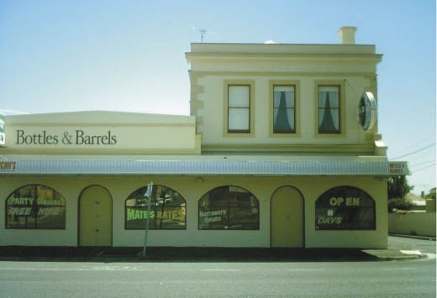

Figure 5.141: Lloyd Hooper’s former Grocery Store, 132 Aberdeen Street, Geelong West, 2008. Source: David Rowe.
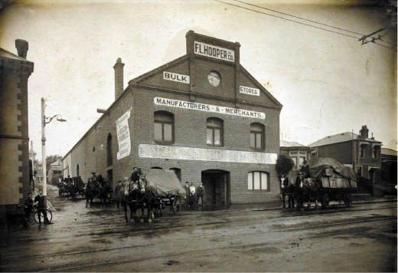
Figure 5.142: H.V. Leckie, F.L. Hooper’s Bulk Stores, 16-18 Ryrie Street, c.1917. Source: GRS 2009/1287, Geelong Heritage Centre collection.
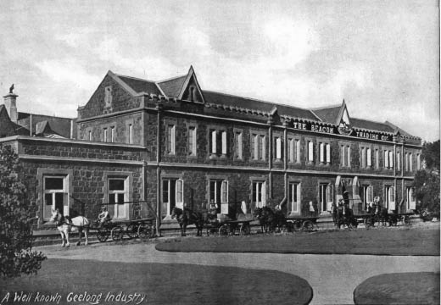
Figure 5.143: The Beacon Trading Company (formerly Geelong Grammar School), McKillop Street, c.1918. Source: Geelong for Business, Health, Pleasure, p.38.

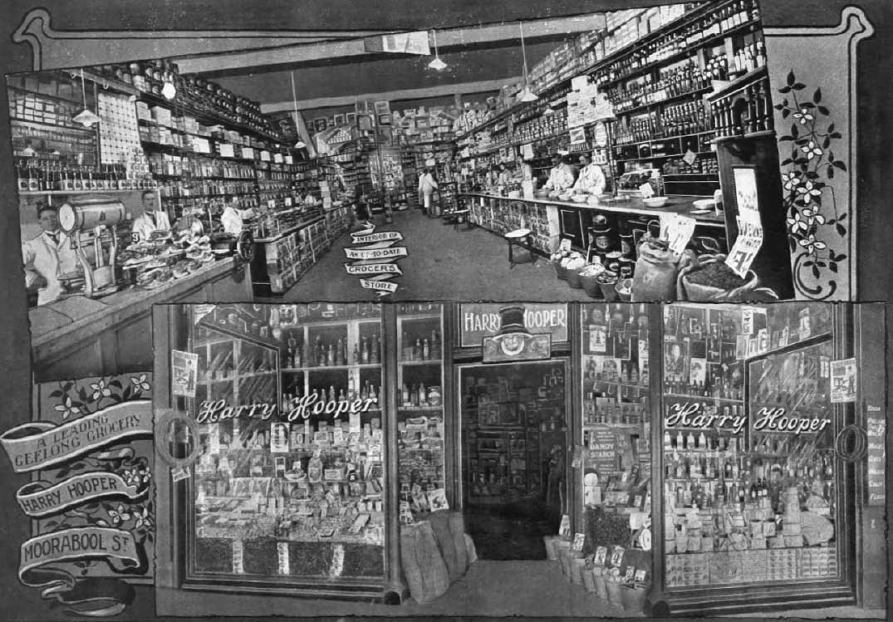
Figure 5.144: Harry Hooper’s Grocery Store, 130 Moorabool Street (demolished), c.1918. Source: Geelong for Business, Health, Pleasure, p.50.

following subsection).1034 Two years later in 1913, he had two single storey shops built next door to a design by Laird and Buchan. These shops were leased.1035 By the 1920s, George Hooper also had a store at the corner of Aberdeen and Pakington Streets,
Geelong West.1036
Meanwhile, Frank Lloyd Hooper established a wholesale drapery business in Gheringhap Street.1037 Nothing is known to survive of these premises but by 1917 he had become
an agent for the Beacon Trading Company and at this time he occupied a two storey brick warehouse at 16-18 Ryrie Street owned by Samuel Falls (this building was later to be transformed as Hearne’s Druggist Store – see Theme 8)1038 (Figure 5.142). Hooper subsequently took control of the Beacon Trading Company1039 which from 1916 had its head office in the north wing of the former Geelong Grammar School in McKillop Street (Figure 5.143) (now demolished)1040
Frank Hooper’s brother, Edwin James Hooper established a grocery store at 108 Moorabool Street in a two storey brick building in 1895 previously occupied by James Ashley

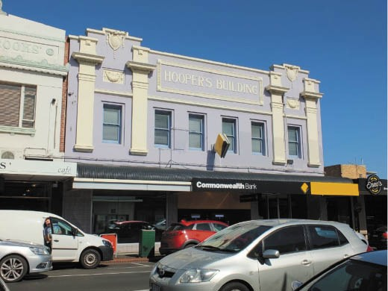
Figure 5.145: Hooper’s Building, 143-147 Pakington Street, Geelong West, 2018. Source: David Rowe.

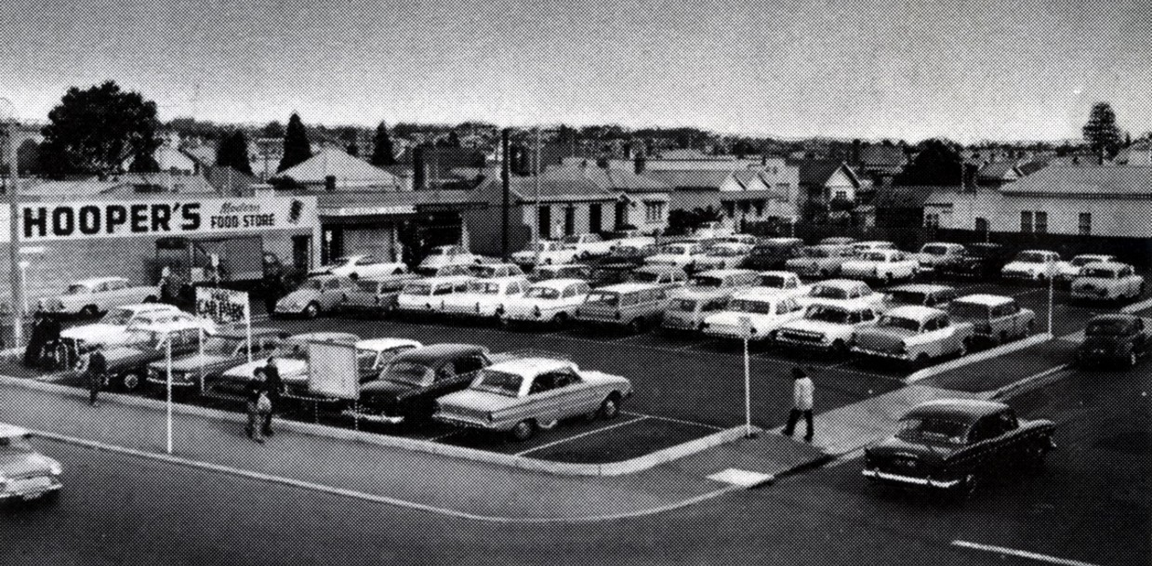

Figure 5.146: Hooper’s Modern Food Store, Pakington Street, Geelong West (left), c.1970. Source: GRS 1160/05/58, Geelong Heritage Centre collection.

(demolished).1041 He ran his business under the name of E.J. Hooper and Co. until 1925 when his brother, Harry took over the building1042 (Figure 5.144). Harry Hooper had previously gone into business on his own account (under the name of Harry Hooper and Co.) at 130 Moorabool Street, in 1905.1043 This building was owned by the Estate of James G. Carr and it was sold to the Commercial Bank of Australasia in 1925 (see following subsection) which forced Harry Hooper’s relocation.
It was also in 1925 when Harry, with his father, Lloyd, built a two storey store at 143-147 Pakington Street, Geelong
West1044 (Figure 5.145). Known as ‘Hoopers Building’, it was designed by Laird and Buchan architects and constructed by
H. Searle.1045 The new edifice had three shops at the ground floor (one being occupied by Hooper’s grocers), the others leased, along with two apartments upstairs.1046
Known as ‘Happy Harry’ due to his ‘happy, sunny-natured’ personality, Harry Hooper married Dorothea Martha Hawkesworth in 1913.1047 He was known for his public and philanthropic work, serving as a Councillor with the Newtown and Chilwell Council, and had affiliations with the Geelong College Old Boys’ Committee, the Geelong Agricultural and Pastoral Society’s governing body and Geelong Hospital Committee.1048 Although business competitors, Hooper was also friends with the Coles brothers, including George J. and Arthur, who, with their three other brothers, established the Coles supermarket empire.1049 Arthur Coles and Harry Hooper had both attended Geelong College and it was their student days where the friendship formed.1050 Their friendship
extended as far as Hooper leasing his home, ‘Monaro’, 5a Stephen Street, Newtown, to the Coles family between 1927 and 1931.1051 The grocery business of Harry Hooper continued on after his death in 1951, with ‘Hooper’s Food
Stores’ being established as forerunners to Harry Hooper’s supermarkets affiliated with SSW (‘Self Service Wholesalers’) during the second half of the 20th century.1052 Locations
of Hooper’s supermarkets included Geelong West (Figure 5.146), Belmont and Newcomb.

CLARKE’S GROCERY STORE, 86 RYRIE STREET, GEELONG
In early 1878, the local grocer, Richard Clarke (1826-1918) engaged the prolific architectural firm of Alexander Davidson and Co. to design a two storey grocery store at the south-west corner of Ryrie and Gheringhap Streets, the former site of Clement Nash’s monumental mason’s yard (see Theme 9).1053 The proposed building (Figure 5.147) was described in the Geelong Advertiser:
The new store to be erected for Messrs R. Clarke and Co. at the corner of Ryrie and Gheringhap-streets, promises to be an imposing structure. It will consist of a shop and store on the ground floor, and a large storeroom above the shop. The dimensions of the shop are 40 feet by
28 feet, and the store below 28 feet by 25 feet. There will be a private counting-house at the rear of the shop, and a hydraulic lift will be used between the ground and upper store. The building, which is to be erected after

the Byzantine style of architecture, is to be of brick on bluestone foundations, the outside to be cemented, and there will be pressed cement enrichments in the cornices and string cause. The front of the store is to
have an ornamental cement parapet, and there will be two mansards in the roof fronting Ryrie-street.1054
Business commenced at the new store in early 1879.1055 The head of the firm, Richard Clarke, was born in Haversham, Buckinghamshire, England in 1826 and came to Victoria with his wife, Caroline, in 1851.1056 He had been lured by
his brother, Thomas, who had established a grocery store in Collingwood.1057 The Clarke brothers came to Geelong in 1853 and opened the Victoria Stores previously occupied by James McSwiney in Market Square.1058 Another store was soon established on the goldfields at Ballarat.1059 After 12 years in partnership with his brother, Richard Clarke commenced business on his own account before admitting
Ross Bell as a partner.1060 He later took into partnership T.R. Handley and it was at this time when the business became known as R. Clarke and Co.1061 In the 1890s, Clarke took into partnership his son, Henry, about the time Handley retired.1062 Clarke took an active interest in public affairs, being elected a Councillor to the Geelong Town Council in 1881 (serving
as chairman of the finance committee until 1885) as well as serving on the committee of the Protestant Orphan Asylum (including terms as President) and being appointed a Justice of the Peace.1063 He retired from business and leased (and subsequently sold) his store to George Hooper.

LEGGO’S, 88 RYRIE STREET, GEELONG
The site at 88 Ryrie Street owned by Thomas Barber Hunt, baker, who built an iron store in 1859-60 (see earlier subsection). These premises had a long association with the grocery trade as Hunt seems to have established the
Australian Produce stores from this location before 1874.1064 In 1882, Sceney and C. opened it as a whole fruit and produce store and offered farm, garden, and dairy produce, and ‘poultry in any quantity.’1065
In 1900, a grocer from Daylesford, William Leggo (1871- 1931) began his association with the store at 88 Ryrie Street.1066 He purchased the property from Thomas Hunt’s Estate in 1911 and in 1923 he admitted his son, James Maddron Claude Leggo as a partner, the firm then being known as Leggo and Son.1067 A year earlier in 1922, in anticipation of the new partnership, Leggo had engaged the Geelong architects, Laird and Buchan, to design a new two storey brick store1068 (Figure 5.148). Ironically, Leggo was never to operate his grocery from his new building. The business was sold to Robert Dawson (former manager of Moran and Cato Pty Ltd, Geelong) and Arthur F. Skirrow (former manager of Fletcher Chester and Co., Melbourne), although Leggo retained

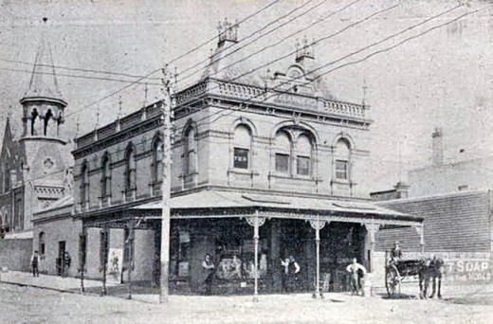
Figure 5.147: Richard Clarke’s Grocery Store, 86 Ryrie Street, Geelong, c.1897. Vidler, The Book of Geelong: Its People, Places, Industries and Amusements, p.49.
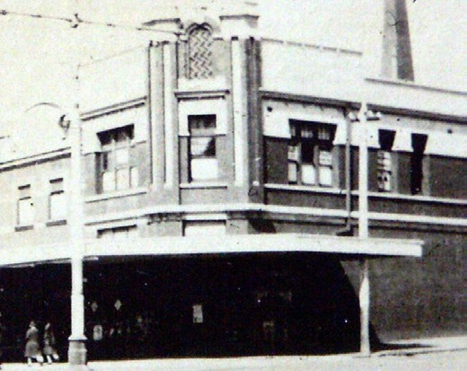

Figure 5.148: T.T. Holmes, Leggo’s Grocery Store, 88 Ryrie Street, Geelong c.1932. Source: Holmes collection, Authentic Heritage Services.

ownership of the new building.1069 While Leggo may never have operated from the store, it became widely known as Leggo’s Building given that name of the family firm, W. Leggo and Son, Grocers, was emblazoned permanently on the building s parapets.

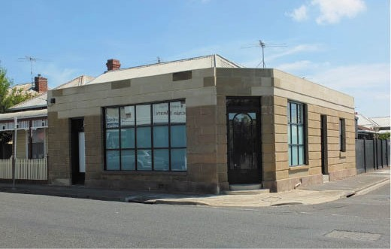

Figure 5.149: Former Oddy Store, 71 Elizabeth Street, Geelong West, 2015. Source: David Rowe.
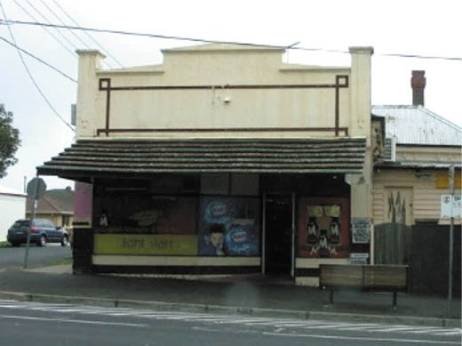
Figure 5.150: Shop & Dwelling, 312 Pakington Street, Newtown, 2008. Source: Kevin Krastins.
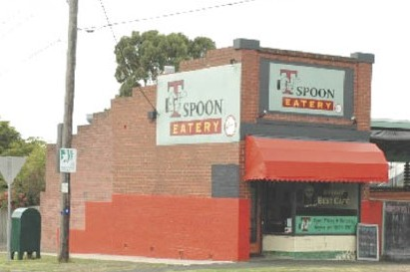
Figure 5.151: Shop & Dwelling, 56 Mt Pleasant Road, Belmont, 2007. Source: David Rowe.

SUBURBAN STORES AND MILK BARS
An extension of the grocery store throughout the late 19th and especially 20th centuries was the development of the suburban general store later known as milk bars. Sometimes located on corner residential sites, the shops were integrated with the dwellings at the front of the property. These stores provided groceries and other goods as a convenience
for nearby residents. One of the earliest examples is the Barrabool stone store at 71 Elizabeth Street, Geelong West (Figure 5.149), built in 1858 by James Oddy (1818-c.1884), a mason and storekeeper from Yorkshire.1070 The store appears to have been operated by Oddy’s wife, Charlotte, who continued business following the disappearance of her husband in 1884 while working on additions to St. Bridget’s Catholic Church, North Fitzroy.1071
A more substantial number of suburban shops attached to dwellings were built in the late 19th and early twentieth centuries. They include the Late Victorian dwellings and
shops at 164 Kilgour Street and 197 Yarra Street, as well as interwar era shops and Bungalows at 33 and 40 Elizabeth Street, Geelong West. Nearby in Newtown are further legacies of this type of commercial development, including the corner shop at 312 Pakington Street (built in 1927 as an addition to an Edwardian dwelling) (Figure 5.150) and the shop at 313 Pakington Street built as a confectionary store in 1935-36 (as an extension to a timber cottage constructed in c.1870).1072 Another confectionary shop was built in 1936- 37 at 56 Mount Pleasant Road, Belmont (Figure 5.151), in association with a Bungalow erected at the same time.1073 It was constructed by local Geelong builder, Eric Lyons, for Percival Bleasdale, a telephone mechanic who operated the shop for at least 20 years.1074
A smaller number of similar establishments were constructed in newly-developed suburbs and elsewhere in the mid-20th century. One example was the ‘Orungal’ Milk Bar (Figure 5.152) built in 1949-50 by Alfred Ronald (Jack) Jennings (1908-2000) at 56 Hitchcock Avenue, Barwon Heads.1075 Jennings was a carrier from Newtown and he had worked on the salvage of the wreck of the Orungal off Barwon Heads which came aground in November 1940.1076 The shop was
attached to a dwelling Jennings had relocated in 1943-44 from the corner of Noble and Jasper Streets, Newtown.1077 The President of the Geelong Football Club (between 1945 and 1970), Jennings operated the Orungal Milk Bar until he sold it in c.1949-50.1078 The milk bar was converted into a Fish and Chip shop by John Hunter in c.1953-54.1079

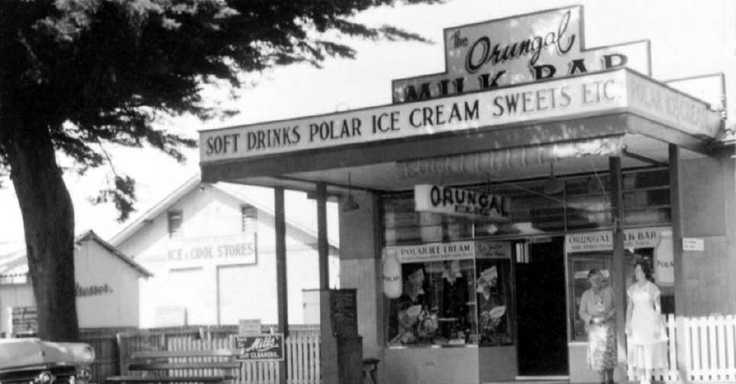

Figure 5.152: Orungal Milk Bar, 56 Hitchcock Avenue, Barwon Heads, c.1950s. Source: Martin Klabbers.

DRAPERS & CLOTHIERS, TAILORS & DRESSMAKERS
In 1854, there were 45 drapers, tailors, dressmakers and milliners operating in Geelong. Yet, there were more working in the townships, suburbs and outskirts because in 1856 there were at least 50.1080 These businesses too, provided employment opportunities for the area. By 1882-83, there were still around 50 drapers and clothiers, dressmakers and milliners and tailors working in Greater Geelong.1081 The number had diminished substantially to just 13 businesses
in 1905, but with the rise in manufacturing in subsequent years there were again around 50 drapers and clothiers operating.1082 Yet, manufacturing was to be the downfall of the small operators, there only being 17 drapery businesses in 1944 although the postwar population boom increased this number to 38 in 1960.1083 This included Myer Emporium
Ltd, which had taken a controlling interest in Morris Jacobs Pty Ltd, drapers in Malop Street (established in 1852) in 1950 and led to the construction of a major department store there which initially included the old Bank of New South Wales (see later subsection)1084 (Figure 5.153).
A selection of the larger and enduring businesses, as well as some smaller outlets where physical fabric survives are outlined as follows.

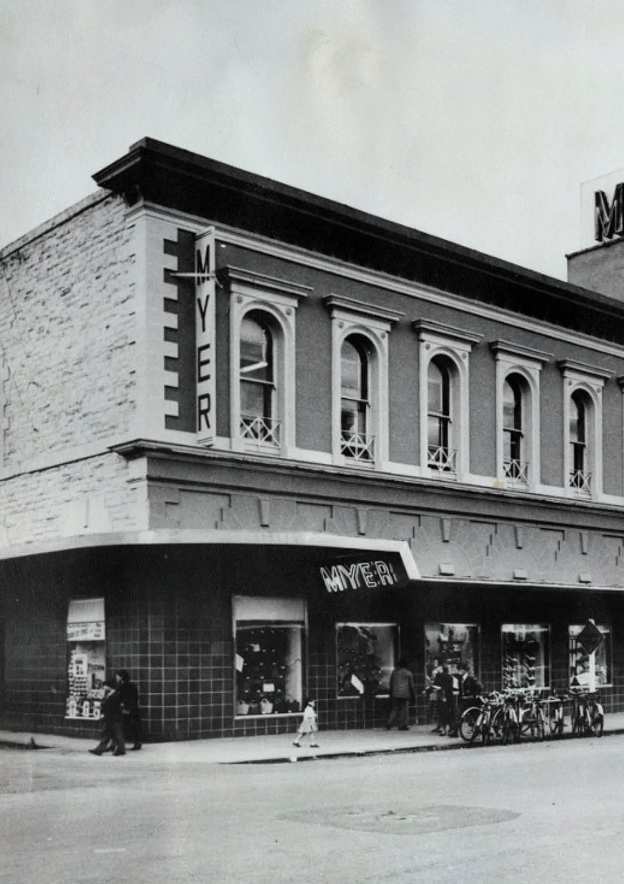

Figure 5.153: R. Pockley, Myer Department Store, Malop Street (the west wing comprising the former Bank of N.S.W.), c.1960. Source: GRS 2009/02748, Geelong Heritage Centre collection.
595
595
ABOUT CORAYO: A THEMATIC HISTORY OF GREATER GEELONG

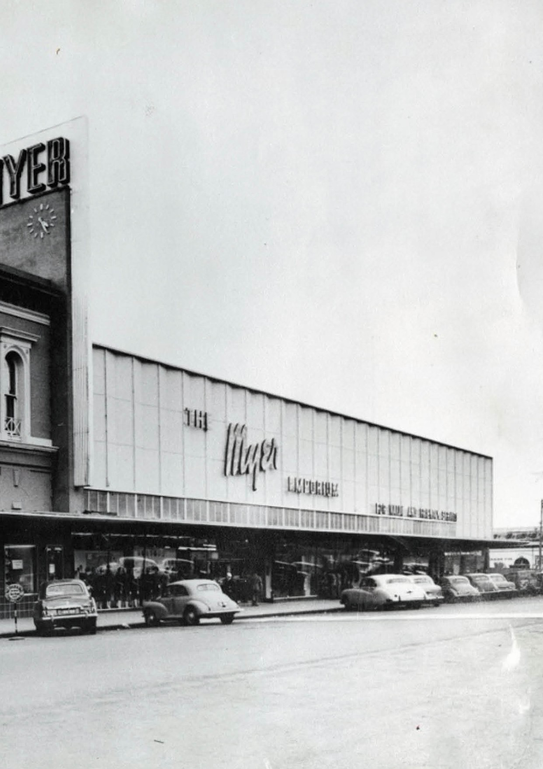

59

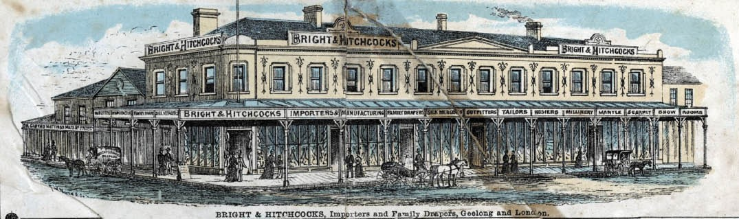
Figure 5.154: Bright & Hitchcocks store, Moorabool Street, Geelong, 1887. Source: ‘View of Geelong, Victoria, Australia’, Queen’s Jubilee Supplement to the Geelong Advertiser, GRS 2009/3134, Geelong Heritage Centre collection.

BRIGHT AND HITCHCOCK’S DEPARTMENT STORE, 115- 139 MOORABOOL STREET, GEELONG
In 1850, William Bright (c.1829-1875), a draper of 86 Regent Street, London, announced that he had just arrived from London on the Amity Hall, and that he had drapery on sale at British prices’ from his ‘temporary Premises, a Brick Cottage, Moorabool Street, on the left towards the English Church.’1085 Bright’s shop was situated two doors south of Ryrie Street on the east side of Moorabool Street.1086 In 1851, he relocated to the south-east corner of Moorabool and Little Malop Streets, opposite Market Square, and this began one of the oldest drapery stores in Victoria.1087 Bright had come to Geelong with his wife and two daughters, arriving in May 1850.1088
Also cabin passengers on board the Amity Hall were William Hitchcock (1810-1867), his wife Ann Michelmore Hitchcock (1784-1847), their sons George Michelmore (1831-1912),
Walter Michelmore (1832-1923), Ernest James Sewell (1841-1868) and William (1844-1895).1089 In June 1850,
three of the Hitchcock brothers: George, Walter and William immediately established Hitchcock Brothers and Co. opposite the Union Bank in Yarra Street.1090 They first stocked zinc, tools, ironmongery, agricultural implements, paints and
paper hangings, guns, saddlery, drapery and haberdashery, boots and shoes and ready made clothes. 1091 Born at Barnstaple, Devon, England, the Hitchcock brothers had been apprenticed to their uncle, George Hitchcock, merchant of George Hitchcock and Co., St. Paul’s Church-yard, London.1092
In 1853, William Bright admitted into partnership George M. and Walter M. Hitchcock, trading as William Bright and Company and the firm operated from William Bright’s store in Moorabool Street.1093 By 1858, the firm had been renamed Bright and Hitchcock’s, and this became the enduring title of the firm for over 100 years.1094 In 1864, William Bright retired
from the firm, the business being carried out by William, George Michelmore and Walter Michelmore Hitchcock under the name of Bright and Hitchcocks, importers and drapers in the City of London and town of Geelong.1095 Walter Hitchcock returned to London to direct the importing operations for
the firm.1096 Having built ‘Herman Lodge’, Brassey Avenue, Highton, in 1854 and after also residing in Villamanta Street, Geelong West, Bright and his family returned to London.1097 After a long illness, he died there in 1875.1098
Business continued apace under the Hitchcock brothers’ partnership. While Walter Hitchcock withdrew from the firm in 1881,1099 its success and endurance was largely due to George Hitchcock’s management who also opened branch stores at Queenscliff, Camperdown and Terang.1100 In 1884, George’s son, Howard (1866-1932) entered the firm as an assistant and about 1889 he was appointed a junior partner.1101 He became managing director on his father’s death in 1912 and in 1926 he sold the business to five of his
employees, one being J. Spencer Hall who had joined the firm as a sub accountant in 1910.1102
The existing former Bright and Hitchcock’s Department Store is an historical and physical legacy in the development of one of Geelong s major employers in the 19th and early 20th centuries. It reflects numerous transformations. In 1854,
the firm acquired an adjoining shop in Little Malop Street.1103 A third shop was purchased to meet the expansion of the business in the 1860s when over 100 employees worked at the store.1104 In 1879, the architects Davidson and Co. called tenders for the first contract of fittings for the ‘new premises’ for Bright and Hitchcock’s’1105 (Figure 5.154). Details of the new work were outlined in the Geelong Advertiser:
Their large stock and the demands for space for all their departments consequent on the still increasing business, have again rendered necessary further enlargement

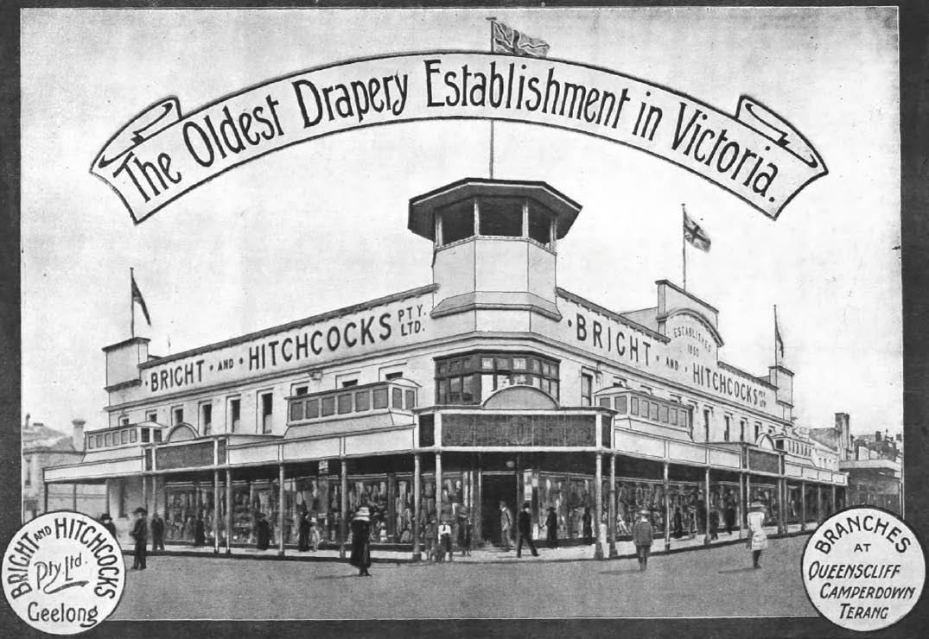
Figure 5.155: Bright & Hitchcocks Department Store, c.1918. Source: Geelong for Business, Health, Pleasure, The Geelong City Council and Geelong Progress Association, Geelong, 1918, p.16.

of their premises. With this end in view, some small adjoining shops in Moorabool street were recently thrown down and removed, and in their stead there has been erected a compact and extensive building of a solid and imposing appearance. This building covers a frontage of 50ft. by a depth of 29 feet, less a sectional frontage of 12 feet let for a jeweller s business. When it is completed, the firm, will be enabled to have all their departments
on the ground floor, leaving the upstairs rooms in the uninterrupted possession of their workpeople. The new show room is certainly one of the largest in the colonies, and although at present used as a temporary sale room, it will be invested with from about the 1st prox. with its real character by which time, it is expected, the cedar fixtures and fittings will have been finished.1106
In 1912, further alterations and additions were carried out to a design by the architects, Tombs and Durran.1107
By 1913, a ‘huge airy basement’ had been constructed and the elevations remodeled to remove the unevenness of the old façade.’ New post-supported verandahs had been
constructed and a central feature that was to become a local landmark was the erection of a corner first floor bandstand toweret 1108 (Figure 5.155).
Further alterations were carried out in 1921 when two small shops were demolished in Moorabool Street and the store extended with an interwar Beaux Arts façade.1109
At the height of the depression between 1930 and 1932, further alterations and additions were carried out. The Geelong Advertiser gave the following insight in 1932:
Geelong Store Expands : When, despite the depression, and the pessimism of so many people, a business firm launches out in a big developmental scheme, involving large expenditure, it certainly deserves commendation. Such confidence in the future of the city should bring its own reward in the shape of greatly increased patronage. Geelong is fortunate in having in her midst business men who believe that better times are coming, and are prepared to back their opinions by making adequate
preparations for the expected expansion. The directors of

Bright and Hitchcocks, Pty. Ltd., are amongst this number, and there is little doubt the whole population of this district will join in congratulating them on the completion of the splendid addition to their already fine departmental store.
When the decision was made some three months ago to proceed with this work, the fact of so much employment being given during the winter months
had a very heartening effect upon the public, because building operations in our city had been at a standstill for a painfully long period. And it was felt that this was the beginning of better times in the building trade. That
feeling was right, for facts have proved that something like a real revival of building activity is about to take place.
The task confronting the contractors at Brights was no easy one. A great timbered roof more than 50 years old which covered the former showroom had to be removed without disorganising business and a new roof built and a floor above it to conform with the section of the store erected about 10 years ago. There was much discomfort and a great deal of noise during the building operations, but the fact that all through this trying period the number of sales within Brights’ Store steadily increased, is a solid proof of public patience and approval. Now that the commodious new floor has been completed the
advantages are obvious to all who walk through the Store.
Although commodious, the old showroom was crowded, and it was difficult to handle customers efficiently in
that part of the business. But now the conditions are altogether ideal. The whole of the first floor is devoted to showroom needs, and the sequence of departments is far more satisfactory than that to be found in most Metropolitan stores. Stepping out of the electric elevator one is in the new Babywear Department, where excellent facilities are provided for mothers who wish to buy for
very young children. Close by is the section for Juveniles, Maids and School Girls, where every necessary garment will be found in great variety. And quite near there is the department for Blouses, Skirts and Knitwear furnished with a fitting room and every desirable comfort. The well stocked Millinery section is adjacent, and forms a natural link with the rest of the Showroom.
Walking into the spacious new floor one notices at once what a fine space has been allotted to the section still known as the Mantle Department, although the word “Mantles” is quite an anachronism in this age. Here ladies will find Fashionwear of every kind, Frocks,
Suits, Costumes, Evening Gowns, and Coats, and the facilities for buying these will please even the most fastidious person.
A richly-carpeted floor adds considerable comfort, and

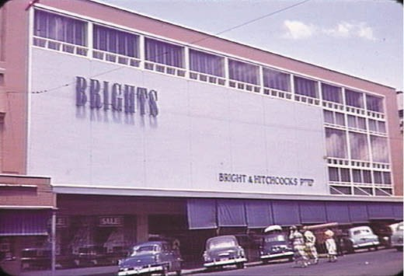
Figure 5.156: Bright & Hitchcock’s Department Store, c.1955. Source: accession no. H91.244/907, State Library of Victoria.

several well-equipped fitting rooms give the necessary privacy when trying on garments. There is a section for Misses’ wearables with its own fitting room, and over against the west wall there is a large fully-stocked Underwear Department with a special Hygienic section attached, and a fine Corset Department with a large comfortable fitting room.
As one looks about the new Showroom the exceptionally fine system of lighting makes an immediate and favourable impression. The light is indeed so good that customers can inspect the stock and see it to the best advantage no matter what the weather may be outside.
That there have been already numberless expressions of pleasure and satisfaction regarding the new Showroom is not to be wondered at, for such conditions are almost
unknown in provincial stores. We are of the opinion that if there is not a really big public response to this great effort to provide shopping comfort and service it will be very strange indeed. And so we extend our congratulations and good wishes to the Directors of Bright’s Store as
they start trading operations in the new Showroom which commence with the great event of to-day.
We are told that other improvements have been planned within the walls of Geelong s greatest store, and soon there will be such a happy blending of departments that shopping will be made more and more pleasurable.1110
While other changes were carried out in 1934 and 1936, it was a major rebuilding project between 1953 and 1955 to mark
the firm’s centenary that was particularly transformative and evident today.1111 The architects A.S. and R.A. Eggleston of Melbourne were engaged to prepare the design which was jointly supervised by firm and Buchan Laird and Buchan of Geelong.1112 The southern section of the department store

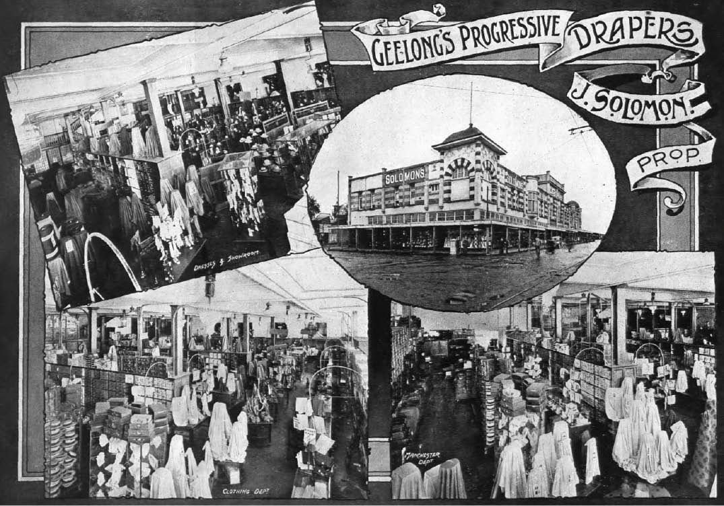
Figure 5.157: Solomon’s Building (now Market Square complex), Moorabool Street, c.1918. Source: Geelong for Business, Health, Pleasure, The Geelong City Council and Geelong Progress Association, Geelong, 1918, p.26.

was completely redeveloped with only the corner bandstand retained without alteration. The completed facades attracted considerable favorable attention, it presented a radical image with its modernist, streamlined cuboid appearance and pastel colours (Figure 5.156).
In 1959, Bright and Hitchcock’s was taken over by
Cox Brothers of Foy and Gibsons.1113 The Cox Brothers went into receivership in 1966 and Ken Nall (son of Spencer Nall who had joined the firm by 1950) continued as managing director by the receivers of the company.1114 The business was sold to a consortium in 1968 and was formally renamed Brights Geelong.1115 In 1969, it was purchased by Burns Philp and sold again to Moores in c.1975 until all Moores stores closed in c.1979,1116 bringing to an end one of Geelong s most successful businesses.
In addition to the physical legacy of the former department store, George and Howard Hitchcock made substantial contributions to the Geelong community. Both were Councillors with the Geelong Council with Howard also serving as Mayor.1117 George was also active in the Chamber Commerce and for 22 years he was chairman of the Council of the Gordon Institute of Technology.1118 With his wife, Annie (whom he married in 1859) he lived at ‘Roslyn’, 272 Latrobe Terrace, Newtown (built in 1855 for John Guthrie),1119 Howard was prominent in the Yarra Street Methodist Church,

was active in fund raising campaigns after World War One (including helping to raise £1.5M for the building of the Kitchener Memorial Hospital) and was the progenitor for the movement in the building of the Great Ocean Road, being chairman of the Great Ocean Road Committee (see Theme 3).1120 His holiday house was ‘Bernarty’, 18 Ewing Blyth Drive, Barwon Heads, built in 1889 (see Theme 6).

SOLOMON’S BUILDINGS, 95-135A MOORABOOL STREET, GEELONG
Although a most significant change to Market Square in central Geelong came in 1879 with the construction of the palatial Exhibition Buildings, controversy ensued from 1909 when the Geelong Town Council proposed to further develop the Crown Land to raise revenue and create a sinking fund for loans for remunerative enterprises. 1121 Debate was increased in 1910 when the Premier of Victoria, Mr. Murray, visited Geelong and declared the town to be one of the most over-lunged places he knew’ (see Theme 9), thereby giving support to the Council’s proposal.1122 Julius Solomon (1878- 1933), who had followed his father into the drapery business at Talbot, came to Geelong and occupied part of the former Exhibition Building known as ‘The Colosseum’ from 1909 (see Theme 9).1123 In 1911, he took up a 50 year lease of
the north-western portion of Market Square in 1911.1124 The Geelong City Council gave Solomon two years to construct his department store before he would be charged rent.1125 He subsequently engaged the Geelong architects, Tombs and Durran to design the edifice and in February 1912 the tender of W. Murphy was accepted at a cost of around £1800.1126 Officially opened on 16 April 1913, Solomon claimed that
‘his store had the third largest floor space in Victoria, without break of walls.’1127 Known as Solomon’s Buildings (Figure 5.157), the two storey drapery and furniture emporium gave employment to 150 people.1128 Externally, the building was arranged in a series of parapetted bays defined by projecting pilasters. At the north and south ends were squat towers, the central entrance fronting Moorabool Street defined by a raised pavilion. Striped face brick and rendered finishes and projecting oriels accentuated the external appearance on the
first floor, the glazed ground floor shopfronts being separated by post-supported flat-roofed verandahs.
Julius Solomon was born at Amherst, near Talbot, Victoria, in 1878, the son of Julius (Isiadore) and Sarah (nee Tobias) Solomon.1129 In addition to learning the drapery trade, Julius junior entered local politics at a young age and in 1903, aged 21, became the Mayor of Talbot.1130 In 1905, he married Ella Phillips.1131 Solomon continued with public life in Geelong, being elected to the Geelong City Council in

1923 and served as Mayor in 1927.1132 He was also involved with the Geelong Racing Club, Agricultural Society, Turf Cricket Association, Geelong Football Club and Victoria Coursing Club. In addition to managing Solomon’s Buildings, he became a director of the Federal Woollen Mill in North Geelong.1133 Following his death in 1933, his son, Loris, became a governing director and his wife, Golda, also held
a directorship. In 1953, the managing director was R.J. Hughes.1134
Associations with Solomon’s’ Buildings by the Solomon family came to an end in the 1970s when the Geelong City Council commenced planning redevelopment options.1135 They were halted in 1983 when the Geelong Regional Commission unveiled the City by the Bay planning strategy which proposed to place buildings in Market Square in the hands of private developers.1136 The failure of the City by the Bay plan revived the Council’s determination to redevelop the site.1137 The proposed redevelopment included major alterations to Solomon’s Buildings to create a shopping plaza along American lines. Costing $16 million, work began in 19851138 and was completed in 1986. Today, while the original character and integrity of Solomon’s Buildings has been lost, the landmark towers are a distinctive legacy of the departmental store era established by Julius Solomon.

CRAWCOUR BROTHERS, 184-192 PAKINGTON STREET, GEELONG WEST
In 1926, the local architect, Norman Schefferle, designed
a contextually unusual emporium for the Crawcour brothers: Harold Samuel (1882-1945) and Adrian (1891- 1962).1139
The building was constructed by W.J. Kelly, the Geelong Advertiser described it as ‘unique in design, it being an adaptation of Spanish architecture 1140 (Figure 5.158).
The building had replaced two brick shops earlier occupied by the father of Harold and Adrian, Joseph Crawcour (1836- 1901), an English immigrant, pawnbroker and member of the Jewish community.1141 After his death, Harold ran a
jewelry store in one of the shops and another brother, Joseph (1884-1921) operated a drapery.1142 The new emporium was completed in 1927 and opened in August of that year.1143
The Crawcour’s continued ownership of the emporium until December 1953 when John McIlwraith Industries Ltd.,
plumbing and building suppliers commenced trading there.1144

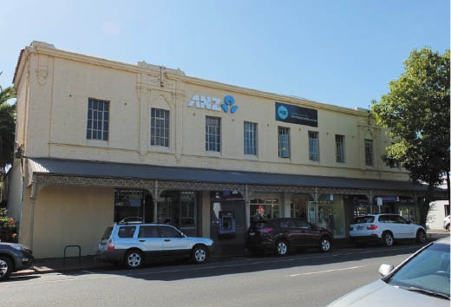
Figure 5.158: Former Crawcour Bros. Emporium, 184-192 Pakington Street, Geelong West, 2018. Source: David Rowe.
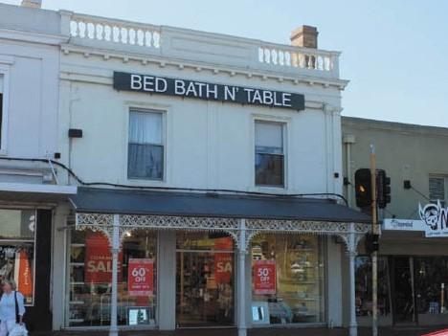
Figure 5.159: Former draper’s store of Andrew Murphy, 222 Pakington Street, Geelong West, 2018. Source: David Rowe.
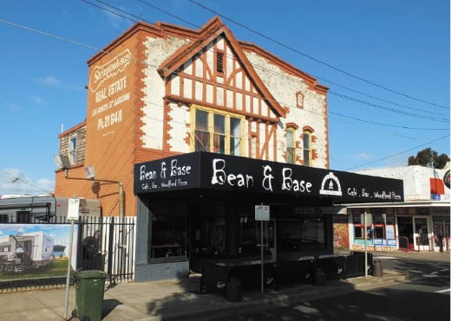
Figure 5.160: William Bennett’s former drapery, 157 Melbourne Road, Rippleside, 2019. Source: David Rowe.

OTHER DRAPERIES IN GREATER GEELONG
A number of other drapery buildings of the 19th and 20th centuries existed in Greater Geelong, albeit on a smaller scale. They include those at 222 Pakington Street, Geelong West (built in 1873-74 by Edwin Hopton and sold to Andrew Murphy, draper in 1875) (Figure 5.159); 144 Moorabool Street, Geelong (built in 1893 for G.F. Belcher to a design by Tombs and Durran, the first tenant being Messrs. Creer and Roberts, drapers); and 157 Melbourne Road, Rippleside (built in 1928 to a design by Norman Schefferle for William Bennett, draper)1145 (Figure 5.160).
A more enduring and nationally-recognised department store established in Geelong was Target. Its origins begun in 1926 when George Lindsay and Alex McKenzie opened a drapery and clothier business at ‘Malop House’, 78-80 Malop Street.1146 They relocated to a larger store at 42-44 Malop Street in 1938.1147 In 1956, the business was sold to Lionel Rough and Geoff Betts, previous employees of Lindsay
and McKenzie.1148 From this single store, the business had expanded to 14 stores across Victoria by 1968.1149 At this time, the business was sold to the Myer Emporium Ltd and renamed Target Australia.1150 With its head office in Geelong, the discount retail business had expanded to 54
stores throughout Australia in 1976.1151 Head office relocated to new offices at Williams Landing, Melbourne, in 2018.1152
In May 2020 during the coronavirus (COID-19) pandemic, Target announced the closure of 75 of its 167 stores, and the conversion of another 92 shops into Kmart stores as part of a major restructure and rationalisation by its then owner, Wesfarmers.1153

FINANCIAL SECTOR
Underpinning the success of commercial life in Greater Geelong was the financial sector, and in particular, the banking institutions. In 1839, a prospectus for a Port Phillip Bank was established in Melbourne.1154 A branch of this bank was hastily opened in April 1840 as competition for the impending local opening of the Tradesmen’s Bank
of Melbourne and Geelong (this bank never opened as a consequence of the Port Phillip Bank’s opening).1155
With G.D. Mercer as the representative of the Port Phillip Bank branch in Geelong, it was to be short-lived.1156 It closed around July 1840.1157 By December 1840, the inconvenience of local financial transactions having to be settled by orders on the Melbourne banks was highlighted as a major obstacle in Geelong s progress.1158 In April 1841, the Geelong
Advertiser lamented the lack of a bank in Geelong:
The want of a Banking Establishment in Corio, is severely felt by every class of the community. We trust that a Branch will speedily be opened here, otherwise the march of our prosperity will be seriously impeded. We understand that several months ago, a Branch establishment existed here, when speculation and competition were almost unknown. Since then, the extraordinary extension of our commercial relations, imperatively require the re-institution of that branch, which, although too prematurely established, has not be have reason to believe, been totally abandoned.1159
Heeding the calls of the public, the Port Phillip Bank established a more modest agency in Geelong in 1841 where Dr Alexander Thomson acted for the issuing of notes and later for the collection of bills and cheques payable in Geelong.1160 In September 1841, the Melbourne merchants, Campbell
and Woolley, opened a store in Geelong.1161 They became agents for the Bank of Australasia, for note circulation.1162 Dr Thomson also became manager of the Geelong branch for the Union Bank in 1842, in addition to his associations
with the Port Phillip Bank.1163 Not to be outdone, the Bank of Australasia did away with its local agency and established
a branch at ‘Caledonian House’ at this time.1164
By 1855, Geelong boasted seven banks: Bank of Australasia; Colonial Bank; Geelong Savings Bank; London Chartered Bank of Australia; Bank of New South Wales; Union Bank
of Australia; and the Bank of Victoria,1165 and in 1866 the Geelong Advertiser discerned that the buildings in which they carry on business would not disgrace the best built quarters of London.’1166 By 1882-83, there were nine banks in Geelong.1167

SURVIVING 19TH CENTURY BANKS EARLIEST PURPOSE-BUILT BANKS
In 1846 the first purpose-built bank was erected at 58 Corio
Street (this street being an early commercial thoroughfare see Theme 6). The Geelong Advertiser and Squatters’
Advocate announced that the premises intended for the Geelong Branch of this Bank are now completed, and the transaction of business will be commenced immediately upon the arrival of Mr Matson, from Adelaide.1168 George Matson (1817-1898) soon arrived as the Bank’s inaugural manager at Geelong. Yet, the Bank of Australasia was to last only 2 years at this location, for in 1848 the bank building was converted into the Red Lion Hotel for Patrick Hede, and in turn in 1852 it became the Bush Inn Hotel (Figure 5.161) licensed to Thomas Purflett.1169 The original north-east corner of the two storey building may be the original Bank of Australasia, albeit altered externally and extended on the west side in 1878.1170 The inaugural bank manager, George Matson had relocated to Hobart, Tasmania, to manage the bank’s branch there.1171 It was there where his new born son was born and where in 1863, his wife, Frederica Christina Matson (nee Sievwright) (daughter of Charles Sievwright – see Theme 2), died.1172
More substantial was the construction of a Victorian Georgian styled bank for the Union Bank of Australia at 76 Yarra
Street (corner Little Malop Street) in 18471173 (Figure 5.162). Designed by Charles Laing, local architect,1174 the Barrabool stone building had a central projecting portico to Yarra Street, with Ionic columns in-antis. When completed, the Union Bank Inspector deemed it to be an ornament to the town. 1175 By 1845, John Matheson (1821-1882) had been appointed the manager of the Union Bank at Geelong.1176 Born in Scotland, he had emigrated to Tasmania and took up the position of junior bank clerk with the Union Bank in Hobart.1177 Matheson was the first manager to occupy the new premises in Geelong in 1847 and remained there until he was promoted to a managerial position in central office, Melbourne, in 1851.1178 The Union Bank occupied its building at 76 Yarra Street until 1917.1179 Although altered with single storey shops built on the main and side elevations, the original Georgian design of the former bank building remains clearly discernible today.

THE BOOM YEARS OF THE MID-19TH CENTURY
In August 1856, The Argus declared that ‘it is expected that within six months some really splendid public buildings will be commenced, particularly those intended for the Bank of Australasia, the London Chartered Bank, and the Colonial Bank of Australasia.1180 These substantial banks were to be built at the west end of Malop Street, near the railway
station (completed in 1857 see Theme 3) and where it was anticipated Geelong s commerce would be centred.

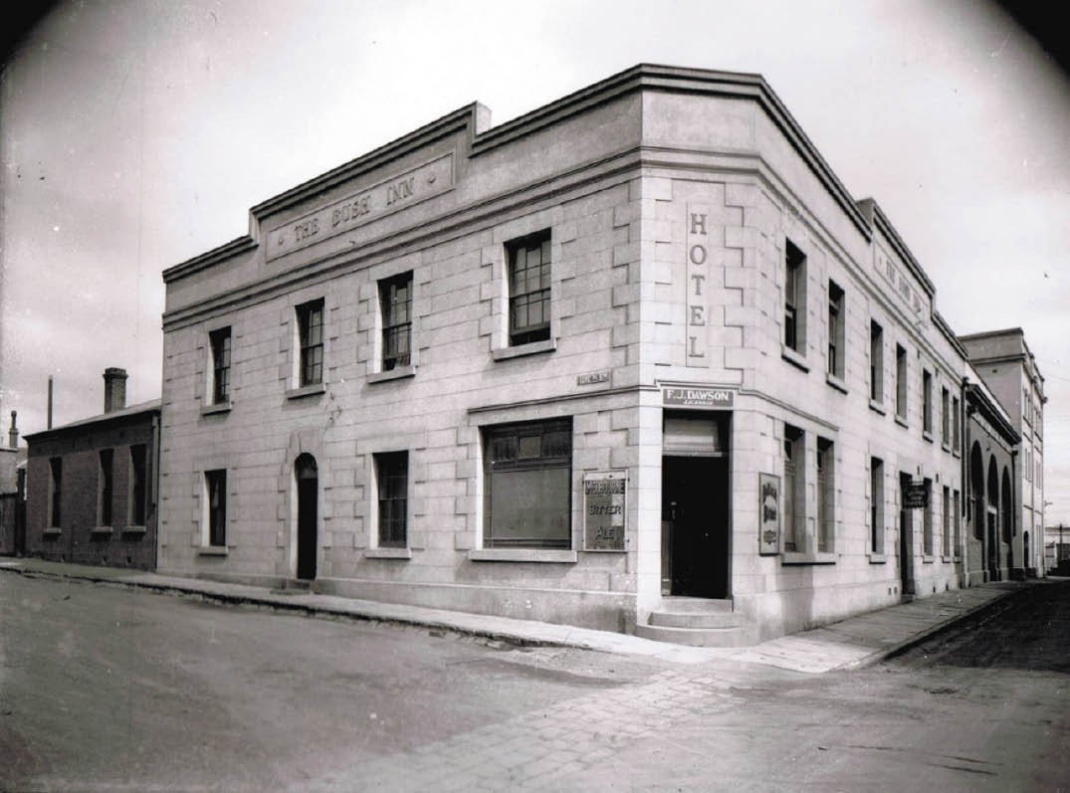
Figure 5.161: The Bush Inn, 58 Corio Street, Geelong, n.d. [c.1920]. Source: D. Davies collection c/o Lorraine Huddle.

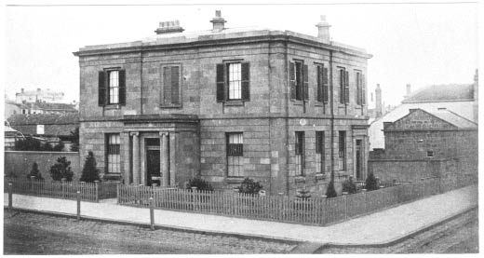
Figure 5.162: Union Bank, Yarra Street, n.d. Source: Lorraine Huddle.
The first to be erected was the Colonial Bank of Australasia at 8 Malop Street (Figure 5.164). Designed by the local architectural firm of Shaw and Dowden, tenders were called for the two storey bluestone Renaissance Revival styled branch of the Colonial Bank of Australasia in September 1856.1181 Additions were constructed in 1873 and 1886 designed by J.L. Shaw and Joseph Watts respectively.1182 The inaugural manager of the new branch was George Butchart (c.1821-1886). He was born in Scotland and was a bank clerk at Barony, Lanarkshire, in 1851 prior to his emigration.1183 Butchart remained at the Colonial Bank in Geelong until 1860.1184

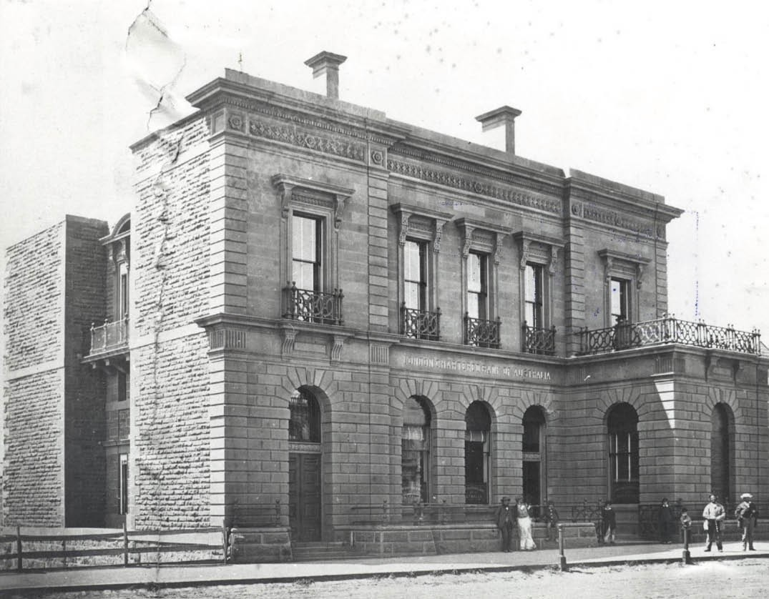

Figure 5.163: London Chartered Bank, Malop Street, c.1870. Source: GRS 2009/1375, Geelong Heritage Centre collection.

In December 1859, the Geelong Advertiser
remarked that:
The chief architectural additions lately to the town are two new banks in Malop-street … one for the London
Chartered Bank, and the other for the Bank of Australasia. Both are remarkably fine buildings and when completed will cost £14,000 or £15,000 each.1185
Construction had commenced on the London Chartered Bank at 9-11 Malop Street in early 1859 by Boynton and Conway.1186 Designed by the prolific Melbourne architect, Leonard Terry, the bank building was built of Barrabool stone in a Renaissance Revival style (Figure 5.163). It opened
for business in May 1860.1187 The substantial and solidly- built building was designed as three vertical bays defined by rusticated pilasters, with the ground and first floors accentuated by projecting moulded stringcourses. At the east end, the regularity of the design was interrupted by a
projecting single storey bay. The first manager of the new building was John Galletly1188 who built Elcho Homestead (see Theme 4). With the amalgamation of the London Bank and the English, Scottish and Australian Bank Ltd in 1921, the Malop Street building became a branch of the E.S. and A. Bank.1189
Across the road at 2 Malop Street, the imposing Bank of Australasia (Figure 5.164) was completed by the end of 1860 by James Pettigrew to a design by Purchas and Swyer,
architects of Melbourne.1190 Costing £19,000, the new edifice was considered to be ‘a fine specimen of chaste, light, and yet substantial architecture. 1191 The Renaissance Revival styled building was entered by a central Doric portico into
a banking chamber measuring 15.3 m by 9.3 m lit by glazed ceiling panels and adorned with Ionic cornices. On the west side was a stair hall with a fine oval staircase.1192 The first manager of the new bank building was John Rendall Morris

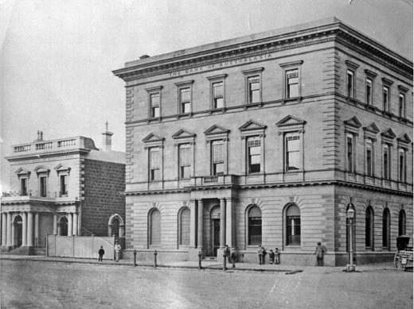
Figure 5.164: London Chartered Bank, Malop Street, c.1870. Source: GRS 2009/1375, Geelong Heritage Centre collection.
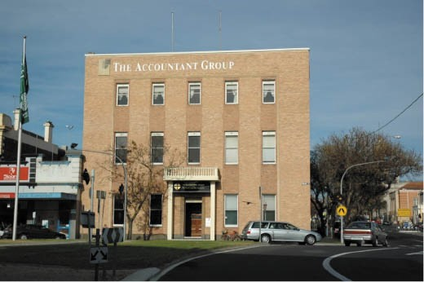

Figure 5.165: Former Bank of Australasia, 2 Malop Street, 2005. Source: Wendy Jacobs.

(c.1819-1872), who had commenced as manager of the Geelong branch in 1853.1193 He held the position until his death in 1872, after 33 years with the Bank of Australasia. Of quiet, unassuming manner, Morris was held in high esteems as ‘an able financier’ and for his contributions to as trustee and treasurer of the Hospital and Benevolent Asylum and Botanical Gardens, and churchwarden and
treasurer of Christ Church.1194 Such was the esteem afforded Morris that in October 1872, a memorial window, designed by Urie and Ferguson of Melbourne, was proposed to be installed at Christ Church, Moorabool Street, to his memory, with donations received from members of almost every denomination. 1195
On 1 October 1951, the Bank of Australasia Ltd. amalgamated with the Union Bank of Australia Ltd. to become the Australian and New Zealand Bank Ltd.1196 By 1956, the Barrabool

stone exterior had deteriorated substantially. The building was subsequently brick veneered at a cost of £13,000,1197 dramatically changing the original Renaissance Revival appearance (Figure 5.165) although much of the interior has been retained.
Further east in Malop Street at the corner of Kardinia Street, a site was selected for a Bank of New South Wales. A two storey stone Renaissance Revival bank building was erected in 18561198 (Figure 5.32) but was demolished in the 20th century, the site now forming part of the Westfield Shopping complex.

OTHER 19TH CENTURY BANKS
On the Bellarine Peninsula in the 1880s, George Jobbins, architect of Warrnambool and Melbourne designed two Conservative Classical styled buildings for the Colonial Bank of Australasia. The first was at Drysdale in 1880 when the Geelong Advertiser reported that special premises were
to be erected by the Bank given that its branch had ‘proved a great boon to the residents in the district. 1199 In April of that year, Jobbins called tenders for the new building which had been completed by October1200 (Figure 5.166). The manager of the new building was William Alfred Cuddy
who had previously opened a branch of the Colonial Bank of Australasia at Winchelsea in 1876.1201 In 1889, Cuddy
resigned as manager of the bank at Drysdale after nine years’ service and having been commissioned a Justice of the Peace.1202 He took up a position as manager of the Australian Finance Company in Melbourne.1203 The son of William Cuddy, solicitor of Melbourne, Cuddy was found guilty of embezzlement in 1890 and sentenced to seven years hard labor, following in the footsteps of his brother, John Cuddy, former manager of the Colonial Bank of Australasia at Wood’s Point and Koroit, who had been sentenced to prison for a similar misdemeanor in 1877.1204
At Portarlington, the branch opened in 1887 having been built by M. Hannah1205 (Figure 5.167). The Geelong Advertiser described it as following:
It is situated at a corner of the intersection of Fenwick and Harding streets, having a front of 36ft 4in to the former, and 33ft 2in to the latter, and is constructed of the best local bricks, resting on a foundation of bluestone concrete; the brickwork from thence upwards to the level of the floor being built in cement mortar. The exterior
of the main fronts and returns is finished in cement, the design being a pleasing one, composed of panelled piers resting on a moulded plinth and carrying an entablature surmounted by an open moulded cement parapet. The windows are placed between the piers, and have paneled recesses under – the rest of the work above the sill band being rusticated. The chimneys are also neatly finished in

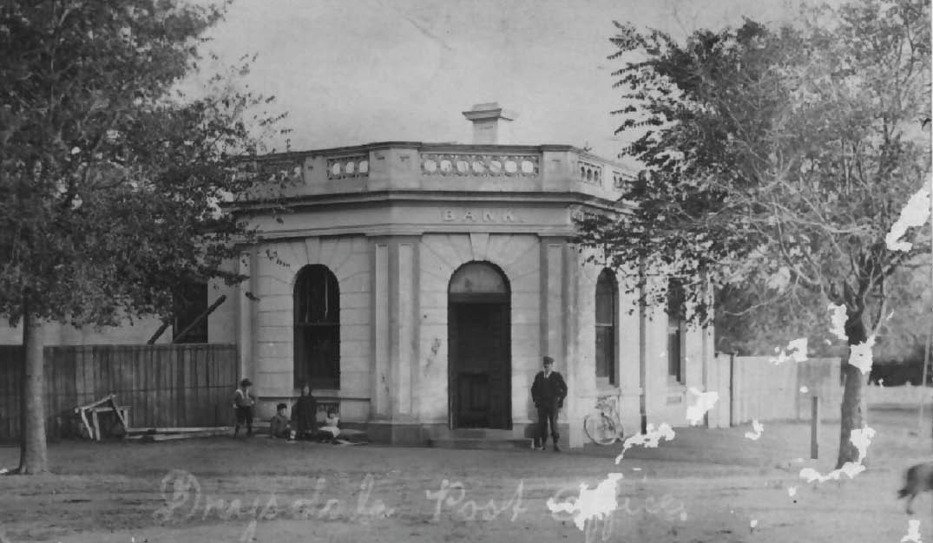
Figure 5.166: Former Colonial Bank of Australasia, Drysdale, c.1900-07. Source: Photo 505, Bellarine Historical Society collection
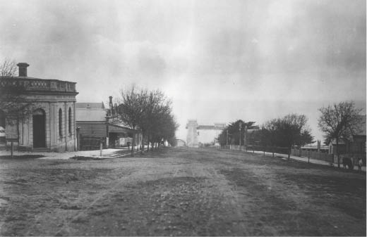
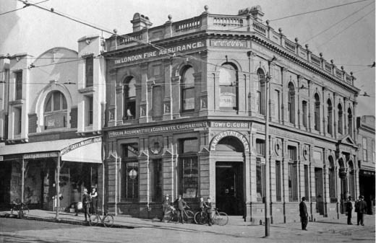

Figure 5.167: Harding Street, Portarlington (looking north), with Colonial Bank on left, n.d. Source: Photo 614, Bellarine Historical Society collection.
Figure 5.168: Former Mercantile Bank (when occupied by London Fire Assurance Co.), corner Moorabool & Ryrie Streets, n.d. [c.1920] Source: Wynd collection, Authentic Heritage Services.

cement. The entrance door is on the angle, and admits to the banking chamber, 16ft 9in by 16ft, which is furnished with neat yellow deal fittings and porch with swing doors, furnished with plate glass panels and cut glass handles The manager’s room and strongroom are off the banking chamber The private entrance door is at the side, away from the street, gained through the front gate in Harding- street, and opens into a hall or passage, on the right of
which is a bedroom and at the end a dining-room, a small lobby connecting with the manager s room on the
left. The building has been designed to admit of future extension.1206

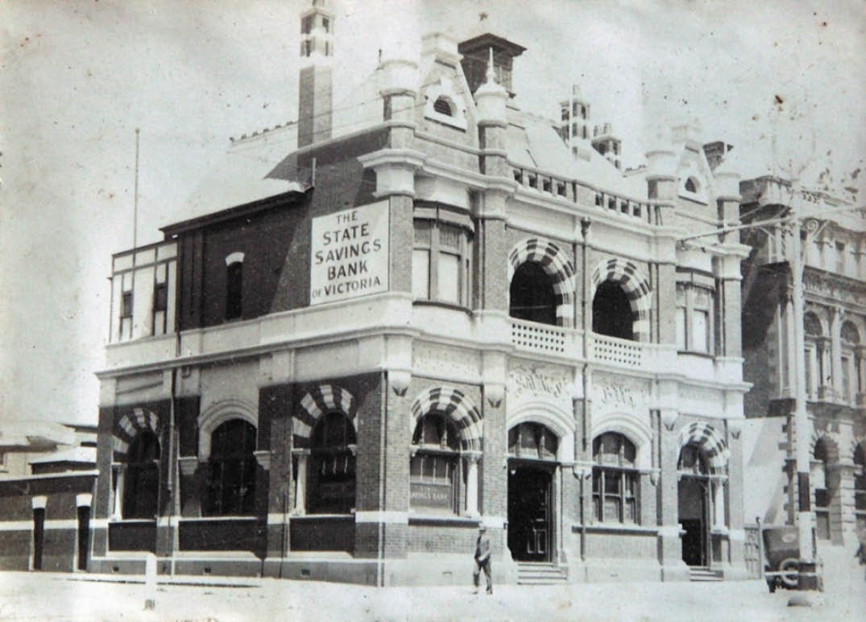

Figure 5.169: T.T. Holmes, State Savings Bank, Moorabool Street (corner Corio Street), Geelong, c.1930. Source: Holmes collection, Authentic Heritage Services.

The manager of the new bank was Samuel Christie Mitchelhill (1863-1925) of Leith, Midlothian, Scotland.1207 He served
as manager for 23 years (and also took on the managerial responsibilities for the Drysdale branch).1208
In Geelong in 1888, the Mercantile Bank engaged the Melbourne architect, William Salway, to design a contextually flamboyant Boom Classical styled bank branch at the south- west corner of Moorabool and Ryrie Streets1209 (Figure 5.168).
A contract for £8000 was awarded to Thomas Pescott and the foundation stone on 27 July 1888 and the bank opened in 1889.1210 Built of rendered brickwork on a superstructure of Malmsbury bluestone, the Geelong Advertiser declared the new edifice to be a ‘massive, elegant, and imposing banking premises’, the architecture being ‘a novel one, the
top portion being in the Corinthian, and the lower portion in the composite order, and described as a free Italian classic style.1211 The first manager of the new building was William Jones Langford (1865-1900), who was born in Ireland and came to Australia with his parents before 1874. Following the collapse of the Mercantile Bank in 1892,1212 Langford was appointed manager of the Standard Bank in Melbourne. He then became manager of the Mutual Store Company in 18961213 before enlisting as a Sergeant in the South African Light Horse to serve in the Boer War where he was killed in action in January 1901.1214

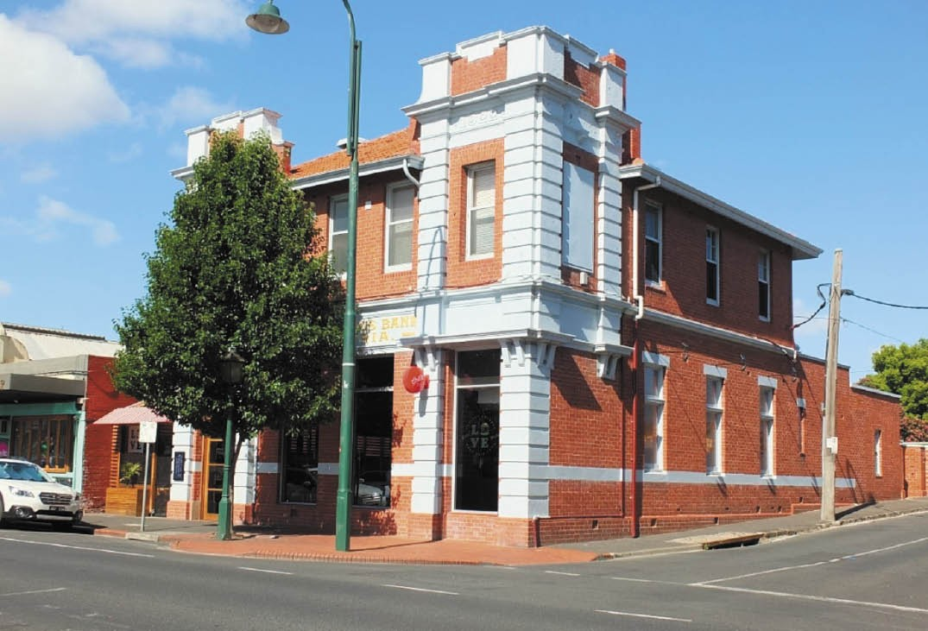

Figure 5.170: Former State Savings Bank, 135a Pakington Street, Geelong West, 2018. Source: David Rowe.

EARLY-MID 20TH CENTURY BANKS
Following the aftermath of the world-wide financial recession of the early 1890s, the new millennium brought about the development and construction of more banks in Greater Geelong in the early 20th century. It began with the construction of an elaborate Queen Anne styled State
Savings Bank branch (Figure 5.169) at the south-east corner of Moorabool and Corio Streets, designed by the local firm, Tombs and Durran (the building was demolished in the late 20th century).1215 By 1905, in addition to the Savings Bank, there were 10 bank branches in Geelong: Bank of Australasia, Malop Street; Bank of New South Wales, Malop Street;
Bank of Victoria, Malop Street; Colonial Bank, Malop Street; Commercial Bank of Australia, Ryrie Street; London Bank of Australasia, Malop Street; National Bank of Australasia Ltd, Malop Street; Union Bank, Yarra Street, and the two Colonial Banks of Australasia at Drysdale and Portarlington.1216

5.6.3 SURVIVING EARLY 20TH CENTURY BANKS
Other bank branches were constructed in Greater Geelong in the 1920s. At least four purpose-built bank buildings of this period are extant today, although none serve their original purpose.
At 135a Pakington Street, Geelong West, in 1922 the State Savings Bank constructed a two storey brick branch to a design by the local architects, Laird and Buchan1217 (Figure 5.170). Nearing completion in November 1922, it
was described as handsome and will enjoy the distinction of having the most valuable building in the main street of Geelong West. 1218 The first manager was Arthur Knight, former State Savings Bank Manager at Horsham.1219
He remained at Geelong West for six years before being transferred to the Ripponlea branch.1220
In 1925, the Commercial Bank of Australia constructed
an imposing stripped Classical styled rendered brick bank

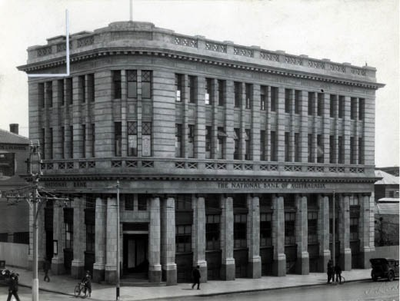

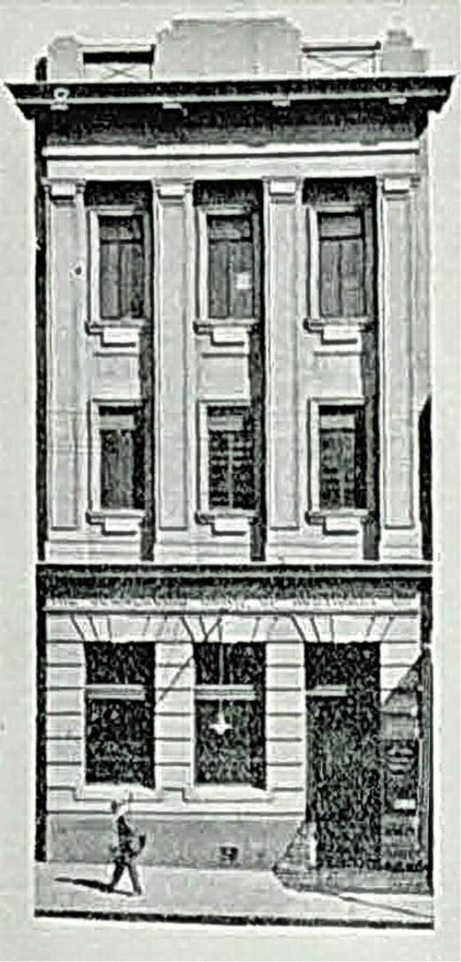
Figure 5.171: Commercial Bank of Australia, 130 Moorabool Street, Geelong, 1930. Source: Geelong: its advantages and opportunities, Geelong Publicity Council, Geelong, 1930, p.65.
Figure 5.172: J. Lockwood, National Bank of Australasia, 53 Malop Street (corner Moorabool Street), Geelong, c.1930. Source: GRS 2009/00355, Geelong Heritage Centre collection.

at 130 Moorabool Street, Geelong (Figure 5.171), having earlier been situated in Ryrie Street.1221 The building was designed by the Melbourne architects, Anketell and K. Henderson in conjunction with Carleton and Carleton on a site previously occupied by Harry Hooper, grocer.1222 The tallest building in this part of Moorabool Street when it opened in January 1926,1223 the first manager of the new branch was Thomas James Victor Paull (1876-1936). Born in Ballarat, by 1903 Paull was a clerk in Ballarat West.1224 After his marriage to Amy E Gorton in Sydney in 1906,1225 had joined the Commercial Bank of Australia. Prior to his arrival in Geelong in 1919, he had been manager of the Bank at Rupanyup and Bendigo.1226 In Geelong, Paull had been elected the inaugural vice president of the Geelong Bankers’ Club in 1925.1227
He transferred to Melbourne in 1927.1228
Another landmark in central Geelong was created with the construction of the National Bank of Australasia at 53 Malop Street (north-west corner of Moorabool Street) in 19271229 (Figure 5.172). H.W. and F.B. Tomkins, architects of Melbourne were responsible for the Grecian Revival design in 1926. Consisting of a basement, ground and two other floors, the design was described in the
Geelong Advertiser:

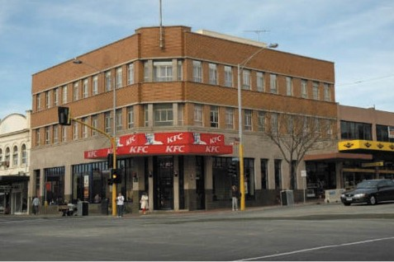
Figure 5.173: Former Bank of New South Wales, 165 Moorabool Street (corner Ryrie Street), 2005. Source: Wendy Jacobs.

An imposing entrance between two detached columns will give access to the banking chamber occupying the whole of the ground floor and having a clear height of 21 feet. The greater portion of the basement will
be occupied by the Bank, and in addition to the usual strong rooms required, a safe deposit for the use of the Bank’s customers will be installed. Access is given by a staircase from the banking chamber. A separate entrance is provided at Malop Street with staircase and electric elevator giving access to the front portion of the basement and two upper floors, which will be let to tenants.
The outer walls of the building will be constructed of brickwork. Floors and roofs throughout will be fireproof and soundproof hollow concrete blocks and reinforced concrete. The base course to the two main frontages will be of polished Harcourt granite. The Ionic columns and pilasters, and the rusticated courses up to the entablature at the first floor level, will be in Faience work with copper caps to the pilasters and copper panels to the risers of the windows. The remainder of the elevation will be finished with white Sandusky cement and coarse sand. All the external doors will be copper-cased and all windows throughout will be of steel.1230

The inaugural manager of the new bank was Herbert Henry Washington (1870-1954). He had come to Geelong in 1914 to manage the National Bank, and when this bank amalgamated with the Colonial Bank of Australasia, he was appointed Geelong manager.1231 He continued as manager until his retirement in 1931 after working for the bank for 45 years.1232 He died in Geelong in 1954.1233
In 1936, the directors of the Bank of New South Wales acquired the corner site at 165 Moorabool Street from the Standard Bank.1234 The architectural firm of Godfrey and Spowers, Melbourne, together with the Geelong-based firm of Buchan Laird and Buchan were engaged to design a new model steel and concrete building.1235 This building was to contain banking chambers, shops and office accommodation at a cost between £30,000 and £40,000.1236 Tenders were called in August 1937, and Andrew Douglas of Melbourne was successful.1237 The ‘striking’ new building featuring
a ground floor exterior of Stawell freestone and polished Dromana granite base, with specially selected bricks in the upper two floors of the three storey building, was completed in the last week of 19381238 (Figure 5.173). The first manager was James H. Spark, who had previously worked for the bank in Melbourne. He remained in Geelong until 1943 when he was appointed manager of the branch at Suva, Fiji.1239

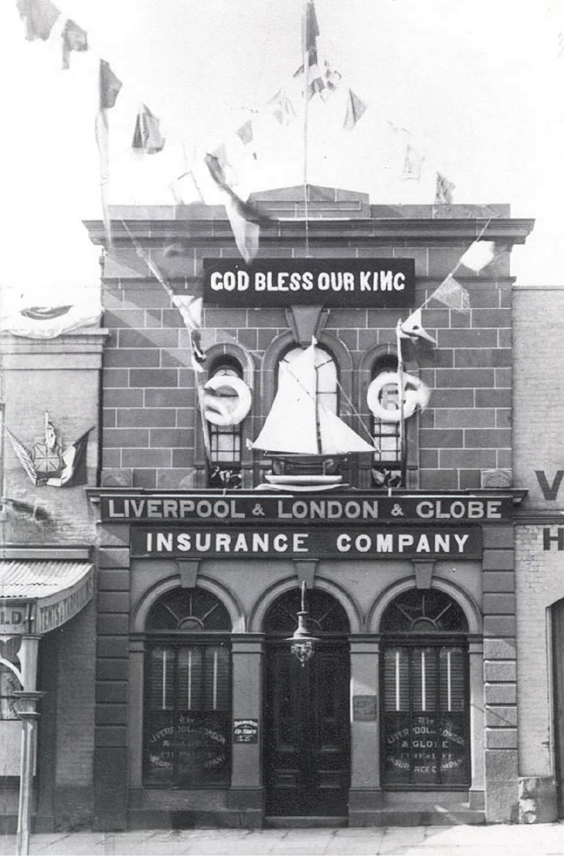
Figure 5.174: Liverpool & London & Globe Insurance Company building, 51 Moorabool Street, 1901, decorated for the coronation of King Edward VII. Source: GRS 2009/421, Geelong Heritage Centre collection.

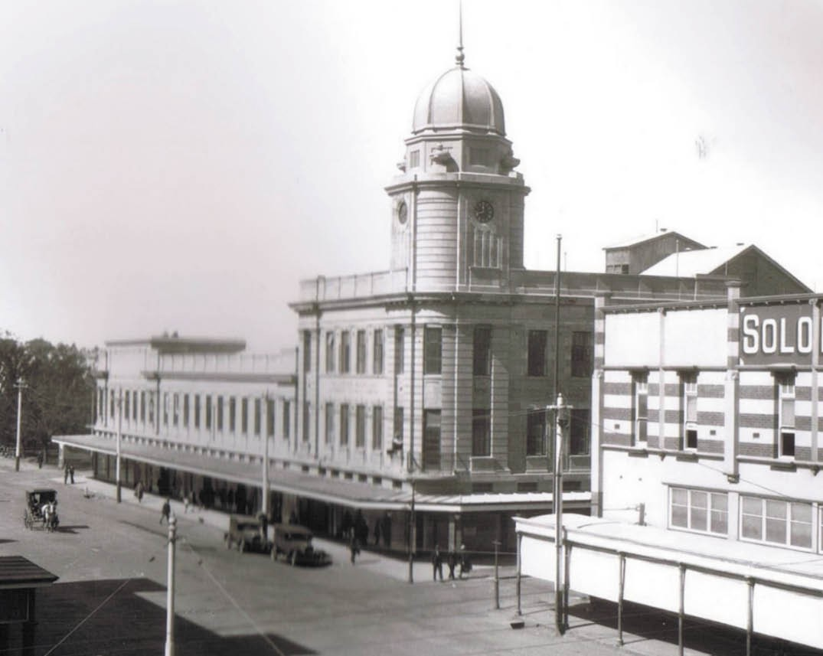
Figure 5.175: CML Building, Malop Street, n.d. [c.1930]. Source: D. Davies collection, Lorraine Huddle.

INSURANCE SECTOR
The provision of insurance services by companies and agencies was to give Geelong locals the necessary confidence from which to construct buildings and establish businesses, farms and other enterprises. As early 1850, a meeting was called at Mack’s Hotel, Geelong, of ‘gentlemen favorable to the establishment of an Insurance Company
in Geelong. 1240 John Sleath Hill (1792-1863), ship and commission agent of William Street, Melbourne from 1844, was appointed the interim secretary1241 and by 1851 the first manager of the Geelong and Western District Fire and Marine Insurance Company.1242 A second company established in Geelong at this time: the Victoria Fire and Marine Insurance Company (formed in Melbourne in 1849), the inaugural secretary being Robert Reeves.1243 By 1854, there were eight
insurance companies in Geelong (see Appendix 5.1). This number had increased to 22 by 1882-83.1244 This included the Liverpool and London and Globe Insurance Company which had purchased the two storey stone and brick store at 51 Moorabool Street (built in 1856 to a design by Backhouse
and Reynolds) (Figure 5.174). The insurance company was to remain there for 80 years.1245
Confidence in business expansion continued in the 1920s and 1930s with major buildings erected for insurance companies in central Geelong throughout this period. Some surviving purpose-built insurance company buildings include the following.

FORMER CML BUILDING, 54 MALOP STREET, GEELONG
The Colonial Mutual Life Assurance Society Ltd (CML) Building at 54 Malop Street, Geelong (now part of Market Square shopping plaza) was built in 1925-26 to a design by the local architect, I.G. Anderson.1246 A report on the proposed building was given in the Geelong Advertiser in March 1926:
It is the Colonial Mutual Building, for which Mr. I.G. Anderson is the architect, some indication is obtainable of what the completed height of the building will be. It is now advanced in the height of the second story, and an additional story, surmounted by a tower, will completed the total height of 86 feet. The tower was added for the accommodation of the Austin clock, the property of the City Council and the citizens, which formerly stood in the Square, and which will be
installed at the expense of the Colonial Mutual Life Assurance Society.1247
Built in conjunction with the local firm, Messrs. J. and N. Tait (they were to occupy a separation portion),1248 the Geelong Advertiser had also given a sketch of the interwar modern Renaissance styled building a year earlier, the style made fashionable in the construction of Provisional Parliament House, Canberra, in the early 1920s. The Austin clock was installed in the tower of the completed Barrabool stone building (Figure 5.175) which opened in October 1928, the Geelong Advertiser remarked that the clock ‘is symbolical as a link of the past which is traditional of a society such as the Colonial
Mutual which has established itself in the community and business circles .1249
The Colonial Mutual Life Assurance Company Ltd. had been founded in Melbourne in 1873, the inaugural president being Sir Redmond Barry.1250 The first Chief manager was Thomas Jacques Martin.1251 A diverse financial services company, its core businesses were life and general insurance, retirement savings, and banking and funds management.1252

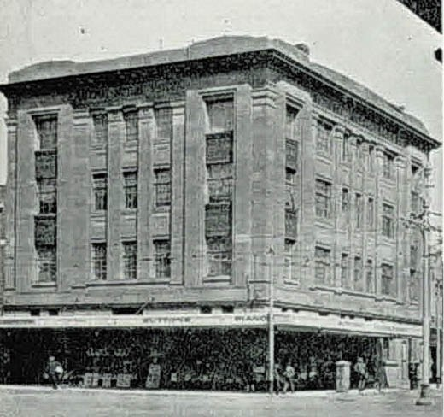
Figure 5.176: National Mutual Building, 54 Malop Street (corner Moorabool Street), 1930. Source: Geelong: its advantages and opportunities, Geelong Publicity Council, Geelong, 1930, p.71.

NATIONAL MUTUAL BUILDING, 54 MALOP STREET, GEELONG
At 54 Malop Street (south-west corner of Moorabool Street), the National Mutual Life Association of Australasia constructed between 1924 and 1926 was to become a
key landmark in central Geelong.1253 Designed by Gibbs, Finlay and Morsley architects of Melbourne and built by Arthur Phillips, the four storey Neo-Grecian styled edifice (Figure 5.176) was considered to be perhaps without a rival in the Western District.1254 The building was constructed of brick and concrete, the principal facades clad in Pyrmont stone from Sydney.1255 Internally, imported Sicilian marble was used in the stairways, with Buchan marble skirtings, rails and styles used in addition to French polished Queensland maple paneling. The building provided for ground floor shops and a one set of offices, the first, second and third floors allowing for 21 offices.1256 On the roof top, a tiled caretaker’s apartment was also constructed, being described as palatial and lofty in the Geelong Advertiser in 1926.1257
The National Mutual Life Association was established in 1869. Trade or profit as a life insurer was not sought, the balance after expenses paid being used to reduce the charges placed on its members.1258

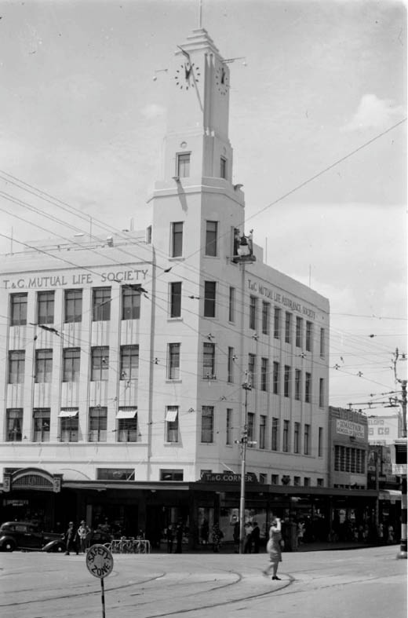
Figure 5.177: T & G Building, 157-161 Moorabool Street (corner Ryrie Street), c.1954. Source: accession. H32492/5203, State Library of Victoria.

T & G BUILDING, 157-161 MOORABOOL STREET, GEELONG
In 1901, the Australian Temperance and General (T & G) Mutual Life Assurance Society advertised for agents in Geelong.1259 By 1911, they had an office in the Library building in Moorabool Street.1260 In 1919, W.H. Cleverden, architect, designed a two storey office for the Society at the north-east corner of Moorabool and Ryrie Street.1261 In 1934, this structure was replaced with the existing four storey rendered brick building1262 (Figure 5.177). The scale of the development, with its clocktower, was to rival that of the National Mutual Life building further north. The Melbourne architects, A. and K. Henderson designed the modern Renaissance styled building (with Art Deco overtones) as part of a suit of commercial office buildings in the 1920s
and 1930s for the T & G including Melbourne (head office, 1928), Brisbane (1929), Geelong (1933-34), Perth (1937), as well as in Adelaide, Albury, Bendigo, Hobart, Horsham, Rockhampton, Shepparton, Sydney, Townsville, Wagga Wagga, Warragul, and Warrnambool in Australia, and possibly in Auckland, Christchurch, Dunedin, Palmerston
North and Napier in New Zealand.1263 Costing £30,000,1264 the building was constructed of a steel frame, reinforced concrete floors, brick external walls and terra cotta internal walls, providing a ‘fireproof’ structure. A notable urban design and functional feature of the building was the clocktower, the clock being manufactured by Ingram Brothers Pty Ltd, the mechanical work being designed and supplied by W.E.J. Harrison.1265 Mechanised figurines projected on a platform beyond the south elevation of the tower on the hour and became an
iconic feature.
The Temperance and General Mutual Life Assurance Society operated in Australia and New Zealand, having been founded in Victoria in 1876.1266 It emerged from an Assurance branch of the Independent Order of Rechabites with 132 policies.1267 Based on principles of temperance (see Theme 8), the Society had grown to become the largest life society based solely in Australia and New Zealand by 1930.1268

LEGAL SECTOR
Important to the administration of justice, and business, property and other contracts and conveyances, was the legal profession. The first solicitor to establish a legal practice in Geelong was Henry Tyssen (c.1813-1842) of Hatford Hall, County of Norfolk, England,1269 who advertised his services in late November 1840:
To the Gentry, Settlers, and Inhabitants of Geelong & its environs. GENTLEMEN—I take this opportunity of
introducing my-self to your notice, and beg to inform you that I shall have much pleasure in drawing Deeds and Conveyances for such of you as may require my services. I beg to state to you that I am a Member of all the Courts of Law in England, and it is my intention to be admitted
in the Supreme Court, at Sydney, with as little delay as possible.1270
Intending to establish a business partnership with Charles Sladen, solicitor, Tyssen died prematurely in Geelong in 1842.1271 His Estate (although administered by Sladen) formed the early beginnings of the well-known and enduring firm, Harwood and Pincott, a partnership established by Thomas Charles Harwood (1825-1912) and Frederic Rupert Pincott (1846-1920) in 1872.1272 Of Camberwell, London, Harwood commenced legal practice in 1846 and upon arrival in Geelong in late 1850, he obtained employment as a law clerk with J.A. Gregory, solicitor.1273 After a time at the Ballarat diggings where he found sufficient gold to start his own legal practice, he commenced on his own account in Geelong in early 1853.1274 In subsequent years, he admitted a number of partners, including Charles Woolley in 1858.1275
F.R. Pincott served his articles with the firm and he was admitted as a partner in 1872, the practice being known as Harwood and Pincott.1276 This business merged with Andrews Backhouse in 1992 and it continues in Geelong under the name Harwood Andrews.1277
By 1856, eighteen solicitors were listed as practicing in Geelong (see Appendix 5.1). In 1882-83, there were
eleven solicitors and in addition to Harwood and Pincott, they included some well-known local citizens including John Longmore Price, William Higgins and Thomas
Napier Whyte.1278 The latter’s practice was taken up by Aurel Victor Jung Just and Frederick William Drumond Moore in 1896, the firm being known as Whyte Just and Moore.1279 In 1904, they purchased the former leather warehouse and office of Edward Frank Haworth (see earlier subsection) built as
a single storey brick building in c.1860 and extended with a second storey shortly after 1875.1280 Whyte Just and Moore continue to practice from this building at 27 Malop Street

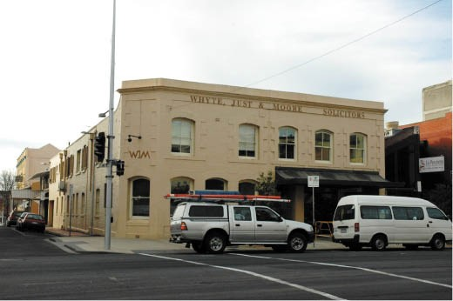
Figure 5.178: Whyte Just & Moore Solicitors building, 27 Malop Street, 2005. Source: Wendy Jacobs.
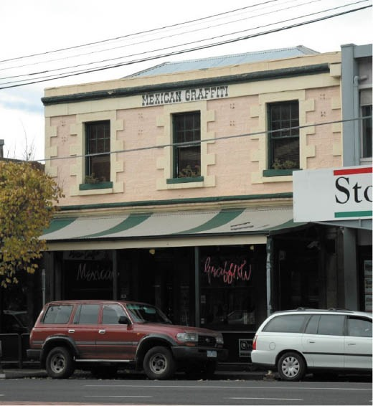
Figure 5.179: Former Solicitors’ Row building, 43 Yarra Street, Geelong, 2005. Source: Wendy Jacobs.

today (Figure 5.178).
By 1925, there were fifteen solicitors and legal practices operating in Geelong.1281 Two known purpose-built buildings for solicitors are situated at 33 and 43 Yarra Street respectively.

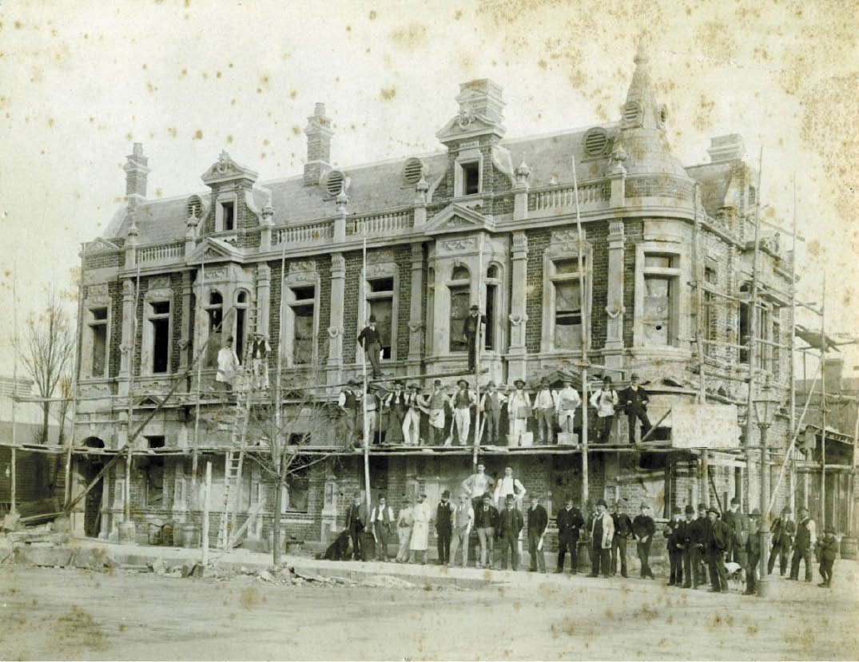
Figure 5.180: Corio Chambers building nearing completion, 33 Yarra Street, Geelong, 1890. Source: GRS 2009/03681, Geelong Heritage Centre collection.

SOLICITORS’ ROW, 43 YARRA STREET, GEELONG
The two storey, rendered masonry Victorian Regency storey building at 43 Yarra Street (Figure 5.179) was constructed in 1854 to a design by Snell and Kawerau for John Alexander Gregory (1814-1887).1282 He had arrived in Geelong a number of years earlier, commencing his legal practice in 1848. He soon entered into a partnership with Charles Sladen until August 1849.1283 In addition to his legal work, Gregory was secretary of the Geelong Rifle Corps and he also took a deep interest in horticulture, having given a lecture on the subject at the Geelong Mechanics Institute in 1849 and having
served as acting secretary of the Geelong Botanic Gardens in 1854.1284 In 1855, Gregory went into partnership with Allan
Fraser.1285 This was dissolved in 1856.1286 By the end of 1858, Gregory had become insolvent.1287 He left the colony and returned in 1860 when he was re-certified to practice law in Melbourne but he was again insolvent in 1864.1288 In 1866 he relocated to Bowen, Queensland, practicing there until his death in 1887.1289

FORMER CORIO CHAMBERS (CRESSY BUILDING), 33 YARRA STREET
At 33 Yarra Street, Messrs Robinson and Douglass, solicitors constructed Corio Chambers in 1891 to a design by E.M. Blake and W.A. Tombs, architects.1290 It was designed in a Queen Anne style and built by A.W. Marr. In August 1891, the Geelong Advertiser described the building as being:
Constructed of Northcote bricks, 150,000 in number, which rest upon a foundation of cement concrete
4 feet 6 inches wide, and 2 feet in depth, above which is bluestone base of 18 inch dressed stone, which appears above the pavement level and forms a plinth. The cement work has been stained by a warm wash of sepia tint,
and the whole brickwork of the two frontages has been tuckpointed.1291
A picturesque outline was created by the newly-completed building, with a corner turret, Flemish gabled parapets (with a steeply-pitched hipped slate roof behind) and projecting oriel bays on the first floor (Figures 5.180-181).
On 1 October 1891, Corio Chambers was formally opened.1292 The legal firm of Robinson and Douglass occupied the ground floor.1293 Richard Robinson (1862-1905) was born in Geelong, the son of Reynolds Holmes Robinson (flour mill proprietor
– see earlier subsection) and Johanna (nee Anthony) Robinson.1294 Following his education, Richard Robinson was articled as a clerk in the office of Harwood and Pincott.1295 In 1886, he passed his law examinations, enabling him to be placed on the roll as a solicitor.1296 Henry Percival Douglass (1859-1927) was born in London and came to Victoria as
an infant with his father, Alfred Douglass, proprietor of the Geelong Advertiser (see earlier subsection), and Elizabeth Douglass (nee DeLittle).1297 Educated at the Geelong Grammar School,1298 Douglass was admitted as a solicitor to the Supreme Court of Victoria in 1885.1299 In May 1888, he entered into a partnership with Richard Robinson to form the firm of Robinson and Douglass.1300 The partnership came to an abrupt end with the premature death of Robinson while playing cards at the Princess of Wales Hotel in 1905.1301

MARGARET FARGIE (1930-1982)
One of the first females to practice law in Geelong from the late 20th century was Margaret Fargie (Figure 5.182). She was born at Windwarra Private Hospital, Toorak, on 11 July 1930, the daughter of Dr Eric I. Fargie, a medical practitioner of Ardleton, NSW., and Edna Swallow of Caulfield.1302 Margaret Fargie contracted poliomyelitis at the age of seven but this did not prevent her being awarded Dux of Morongo Presbyterian Girls’ College in 1948.1303 At this time, she lived with her parents at ‘Park Villa’, 234 Latrobe Terrace, Geelong West.1304 In 1949, Margaret entered the University

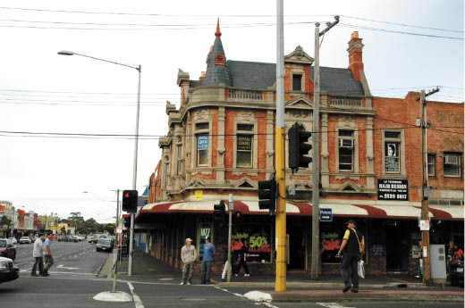
Figure 5.181: Former Corio Chambers building, 33 Yarra Street, Geelong, 2005. Source: Wendy Jacobs.
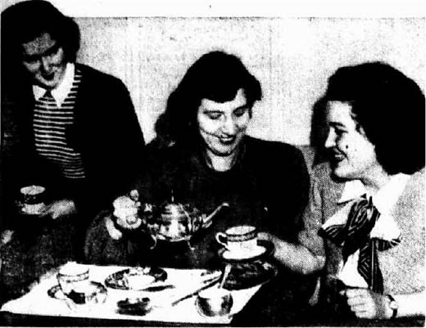
Figure 5.182: Sonia Douglas (left), Miss Roper and Margaret Fargie (right), 1949. Source: The Argus, 1 July 1949, p.10.

Women’s College at the University of Melbourne and in 1952 she was conferred a Bachelor of Arts degree.1035 Margaret subsequently entered the workforce as a law clerk until 1956 when she accompanied her parents to London, England, for seven months.1306 Continuing her work in the legal profession following her return to Geelong, she was conferred a Bachelor of Laws with Honours in 1974.1307 This was the year she became a partner in the firm, Wighton and McDonald.1308
She later became one of the first women in Victoria to chair a building society (The Barwon Permanent Building Society, Geelong). She died in Geelong in 1982.1309

HOSPITALITY SECTOR
Central to Geelong’s early progress following European colonization and for development of community life was the hospitality sector. From the early 19th century, it was especially identified in the numerous hotels constructed, several of which survive today. Boarding houses were also built to provide accommodation. With seaside resorts such as Ocean Grove becoming a tourist destination from the late 19th century, and the popularity of Eastern Beach from the early 20th century, guest houses were also an important part of the local economy.
Fewer examples are known to survive today of early cafes, tea houses and restaurants, being a more specific extension for the provision of food, drink and entertainment also provided by the hotel and coffee palace industries. Most of these businesses appear to have developed from the early 20th century following the arrival of Italian immigrants (see Theme 2). One of the landmark enterprises in Moorabool Street from 1913 was the A.B.C. Café (Figure 5.183). Designed by the local architects Laird and Buchan, this was the second A.B.C. Café to have operated from Moorabool Street.1310 On opening day in December 1913, the café hosted three mayors of the Geelong area: Alderman Gurr, Lt. Col. Strong and Cr. D’Helin, being testament of the importance of the business.1311 The Geelong Advertiser gave a description of the new edifice:
… it is sufficient to say that the façade is an acquisition to Moorabool-street, while the arrangement of glittering curved windows is both unique and delightful. It is
satisfactory to record that with the exception of the carved hat racks and towering palm stands, the whole furnishings were supplied through Geelong hands. Everything matches from the entertaining embroideries to the hues
in the axminster carpet runners. There is a Lipp piano used in the afternoon, when Signor Arcaro’s orchestra will greet patrons. The roof café is not yet ready. An electric automatic lift connects the culinary department with all floors.1312
While the A.B.C. Café has been demolished, some legacies of early 20th century café culture survive elsewhere in Moorabool Street. In 1904, Arthur Preston opened the ‘Paris Café’ at 166 Moorabool Street in a two storey building (Figure 5.184) owned by Samuel Thompson, a farmer from Carisbrook.1313 At 140 Moorabool Street, the existing two storey building (albeit altered) was built in 1918 and opened as Joseph Costa’s Savoia Café.1314 Like the A.B.C. Café, it
became well known for its musical entertainments as much as for its food and beverage (see Theme 2 for further details).

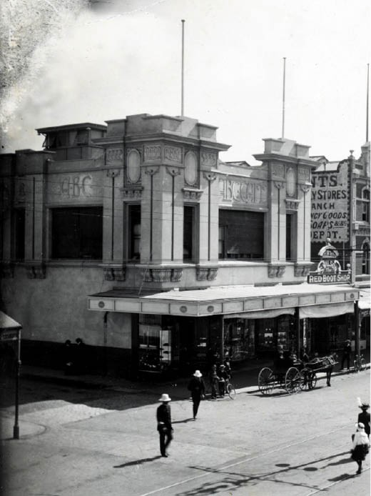
Figure 5.183: J. Lockwood Studios, A.B.C. Café, Moorabool Street (north-west corner Little Malop Street), 18 March 1933. Source: accession H19163, State Library of Victoria.
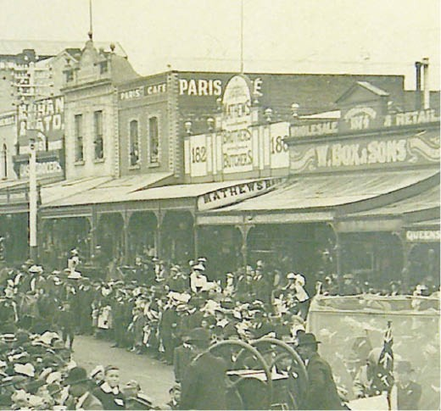
Figure 5.184: Paris Café, Moorabool Street, 1909.
Source: GRS 2009/1221, Geelong Heritage Centre collection.

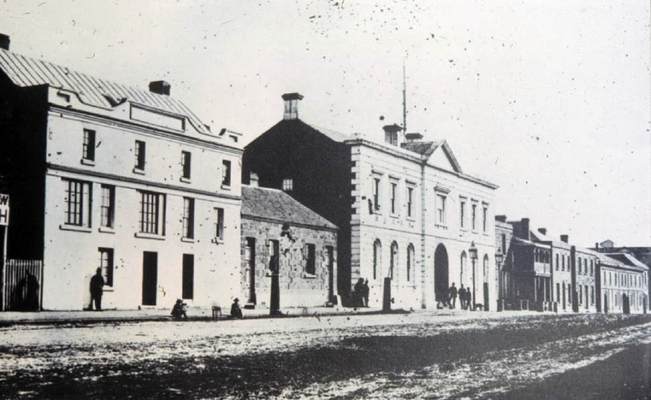
Figure 5.185: Mack’s Hotel (circled), Corio Terrace (Brougham Street), n.d. [c.1860s). Source: Wynd collection, Authentic Heritage Services.

HOTELS IN GREATER GEELONG
In addition to providing necessary beverage, food and accommodation, hotels were the earlier public centres for social gatherings, political meetings, club meetings, church services, and concerts. The earliest hotel in Geelong was the Woolpack Hotel in Corio Terrace (Brougham Street), erected in 1839.1315 The first licensees were A. Macnaughton and
W. Porter.1316 It became more well known as Mack’s Hotel (Figure 5.185), named after its next owner, J.G. Mack, who had a two storey bluestone edifice constructed in 1846 (now demolished) (see Theme 6). A plaque in the pavement near the corner of Moorabool and Brougham Street marks the location of Mack’s Hotel today.
The early beginnings of hotel life in Greater Geelong in the 1840s are however reflected in some existing buildings. The earliest is the old Swan Inn, 4 Hamilton Highway, Fyansford, situated at the ford crossing of the Moorabool River, and built for John Atkins in 1842 (see Themes 4 and 6). In 1847, John Day opened the Shearer’s Arms Hotel at 202 Aberdeen Street (Figure 5.186), advertising that Travelers and general Customers will meet with every accommodation.’1317 The following year, 1848, the single storey brick Harp Inn was opened by Michael Loughan at 22 Pakington Street, Geelong

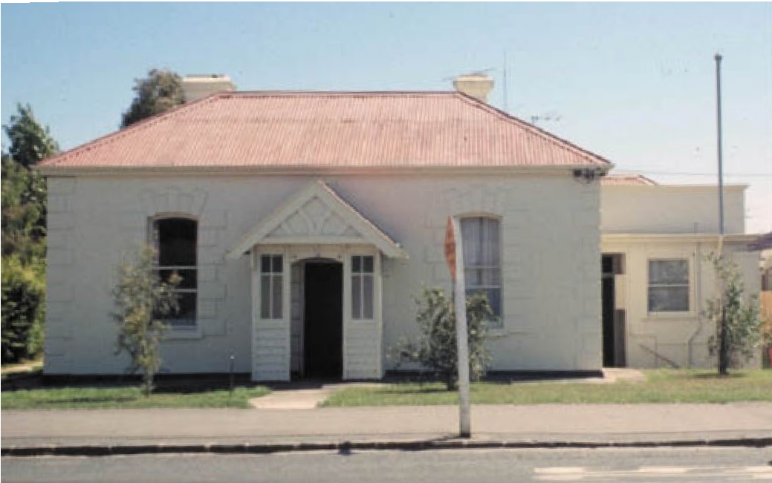
Figure 5.186: Shearer’s Arms, 202 Aberdeen Street, Geelong West, 1972. Source: Wynd collection, Authentic Heritage Services.

West,1318 while in central Geelong at 99 Corio Street, John Sutherland commenced the two storey Scottish Chiefs’ Inn.1319

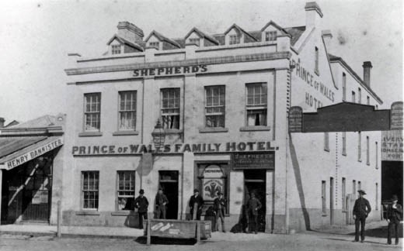
Figure 5.187: Prince of Wales Hotel, Little Malop Street, c.1880. Source: GRS 2009/00937, Geelong Heritage Centre collection.
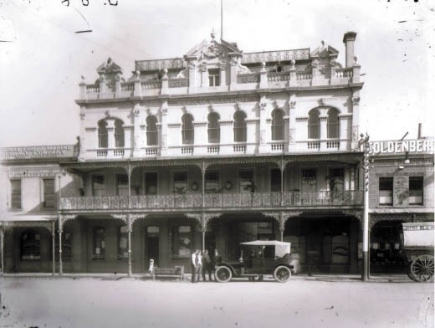
Figure 5.188: Prince of Wales Hotel, Little Malop Street, c.1930. Source: D Davies collection, Lorraine Huddle.
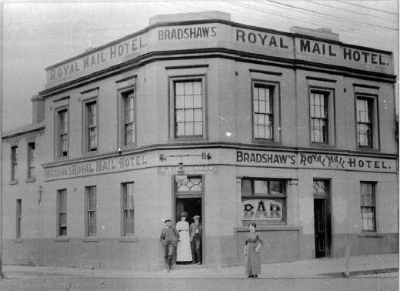

Figure 5.189: Royal Mail Hotel, 17 Yarra Street, c.1902-07. Source: Wynd collection, Authentic Heritage Services.

19TH CENTURY HOTELS
By 1854, the Greater Geelong area boasted at least 70 hotels (see Appendix 5.1). These buildings were strategically situated along the main thoroughfares into and out of Geelong and outlying townships and centres; at river and ford crossings; and at seaside resorts. A noteworthy hotel with
its central location overlooking Market Square in Little Malop Street was the Prince of Wales (Figure 5.187). It was first commenced in 18481320 by Alexander McGillivray (who had been in Greater Geelong since 1843) and was extended into a two storey gabled masonry building in 1857 for Charles Bowie Dawson.1321 Transformative were the changes designed by
J.S. Jackson, architect, in 1889, which included a third storey and a Boom style main façade.1322 In 1891, an elaborate
cast iron verandah and balcony was constructed (Figure 5.188) for the then owner, James Wilson of St. Alban’s Stud (see Theme 4),1323 the hotel being one of only around nine 19th century hotels to feature a projecting front first floor balcony.1324 This landmark hotel was demolished in the late 20th century.
While the Prince of Wales Hotel might have met its demise, several 1850s hotels are extant. At 17 Yarra Street (corner Corio Street), the Royal Mail Hotel (Figure 5.189) was built in 1851 for Joseph Lewis.1325 At the east end of Corio Street in 1853, William R. Mills constructed the Belle Vue Hotel
at 10 Bellerine Street by December 1853 (this building was transformed to become the Ritz see later subsection).
At the northern entrance to Geelong in Mercer Street, several hotels were built in the 1850s. They included the three storey Terminus Hotel at 96 Mercer Street designed by Snell and Kawerau for Charles P. Bassert;1326 and the Western (later Bay View) Hotel at 2-4 Mercer Street, built in 1853-54 for Henry Rourke1327 (Figure 5.190). The distinctive Classically-derived brick building was one of at least five local hotels designed by the architect, John Young, in the 1850s. The others included the Steam Coach Hotel, 49 Mercer Street in 1854 for Jeremiah Holly;1328 Golden Age (now The Max) Hotel at 2-4 Gheringhap Street built in 1854 for Martin Ryan (who also had Young design a two storey shop and dwelling at 245-247 Malop Street in 1854);1329 and the Argyle (now Murphy’s) Hotel, 30 Aberdeen Street, built in 1855 (this was to become the first home of the Geelong Football Club in 1860 – see Theme 8).1330
In Moorabool Street, hotels were erected in central Geelong and further south. At 208 Moorabool Street, John Hurley (who previously ran a boarding house in the 1840s) had erected
the Brian Boru Hotel in c.1851.1331 It survives in a parlous state today. On the south side of the hill at 310 Moorabool Street, the George and Dragon Hotel was built in 1855 for Henry Billing to a design by architect, Thomas Yabsley.1332 Nearby further east at 77 Maud Street, Geelong, the brick two storey Rosemary Branch Hotel was built in 1855, the first

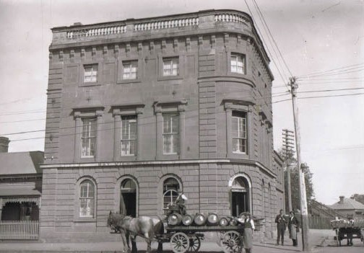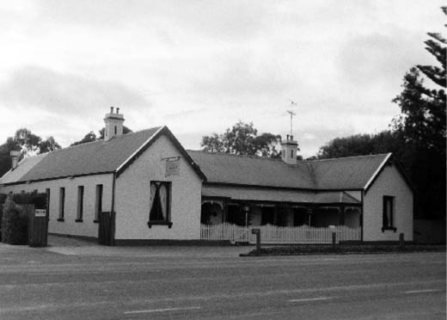

Figure 5.190: Bay View Hotel, 2-4 Mercer Street, Geelong, c.1910. Source: D. Davies collection, c/o Lorraine Huddle.
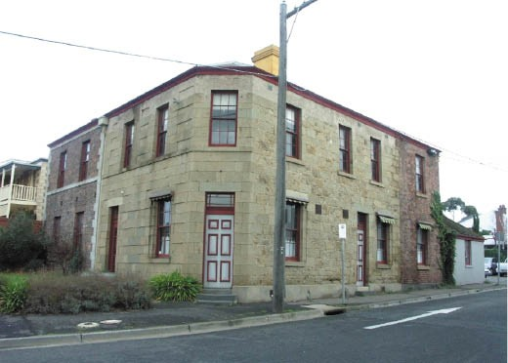
Figure 5.191: Former Culloden Castle, 226 Latrobe Terrace, Geelong West, 2010. Source: David Rowe.

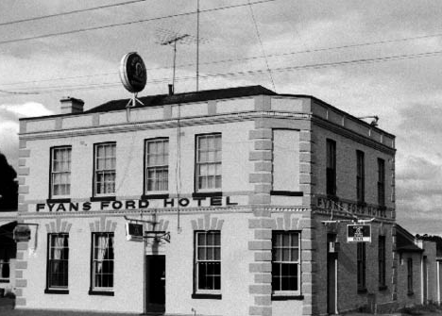
Figure 5.192: Fyansford Hotel, 1998. Source: David Rowe.
Figure 5.193: Former Balmoral Hotel, 1998. Source: David Rowe.

publican being Thomas Mackie.1333 At 212 Pakington Street, Geelong West, the contextually substantial, two storey St. George Hotel was built in stages from 1853 for George F.W. Lindau.1334 It was also in 1853 when the Culloden Castle, 226 Latrobe Terrace, Geelong West, was constructed in Barrabool stone for Alexander Forbes.1335 Brick additions designed by Joseph Watts, architect, were carried out in 18841336 (Figure 5.191).
Further afield enroute to the Ballarat goldfields at 77 Church Street, Geelong West, Walter Ferrier designed the Geelong and Ballarat (now Saleyards) Hotel in 1854.1337 At Fyansford, the Fyansford Hotel (Figure 5.192) and former Balmoral Hotel (Figure 5.193) both built in 1854 are a physical legacy of the need for accommodation and beverages at Fyansford enroute to Ballarat and the Western District.1338
To the east of central Geelong in 1854, Charles Savage opened the two storey Black Swan Hotel on the west side of the Geelong Town Corporation boundary at 169 Boundary Road, Whittington.1339 At 120 Forest Road South, Lara, is the only known surviving mid-19th century rural hotel complex in the City of Greater Geelong. Known as the Lake Bank Hotel (Figure 5.194), the earliest buildings appear to date from c.1859 when four-roomed and two-roomed stone cottages and a stone dairy had been built as part of Cheddar Farm.1340 The original buildings were substantially extended in 1869 for James Henderson to include the hotel at the south- east
corner.1341 At Portarlington, Duncan McKenzie’s Portarlington Hotel was erected at the corner of Newcombe and Harding Streets in 1860.1342 Its more substantial and opulent neighbor was the Grand Hotel built in 1887 (see Theme 6 for further details).
Towards the end of the 19th century, the Elephant and Castle Hotel (Figure 5.195) was constructed at 158 McKillop Street. The first portion of the brick two storey hotel was constructed in 1891-92 to a design by Watts and Durran.1343

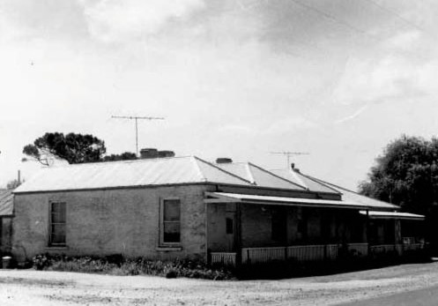
Figure 5.194 J.T. Collins, Lake Bank Hotel, 120 Forest Road South, Lara, 5 December 1975 - 12 February 1976.
Source: Accession no. H97.250/2306.
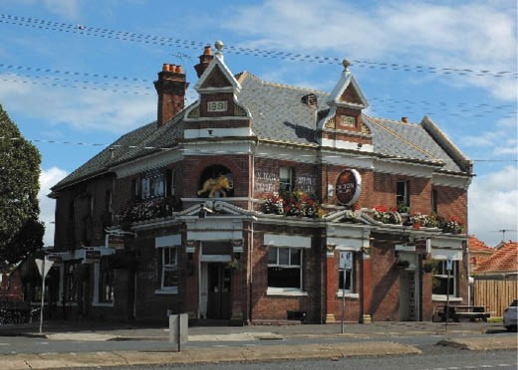
Figure 5.195: Elephant & Castle Hotel, 158 McKillop Street, Geelong, 2019. Source: David Rowe.
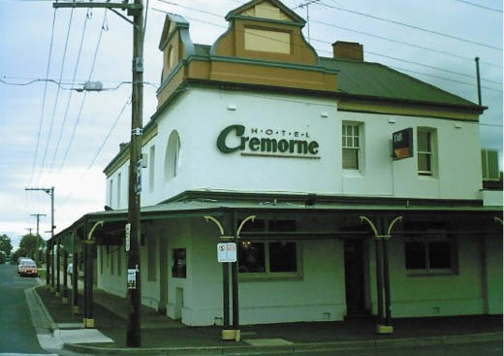

Figure 5.196: Cremorne Hotel, 336 Pakington Street, Newtown, 2008. Source: David Rowe.

It was extended in 1895, the work of W.H. Cleverdon.1344 The hotel represented one of the earliest examples of Queen Anne design in Greater Geelong. It was followed by the rebuilding of the Cremorne at 336 Pakington Street,
Newtown (Figure 5.196) in 1894 to a design by Watts, Tombs and Durran.1345

EARLY-MID 20TH CENTURY HOTELS
Like the Lake Bank Hotel, several 19th century hotels were altered throughout the 20th century. This was initially due (in part) to the appointment of the Licenses Reduction Board in 1907 to oversee the systematic and orderly reduction of hotel licenses in Victoria. 1346 The Board would determine which premises in each of the statutory districts that would close. From 1917, local option pools took effect, where triennial option pools were held to determine where further hotel reduction should be considered.1347 Upgrades or total rebuilding were some of the ways that the favour of the local community and the Licences Reduction Board were sought.
In central Geelong, numerous hotels were upgraded and new premises constructed. In 1925, a new Lord Nelson Hotel at
7-21 Bellerine Street was opened.1348 It was followed by the re-opening of the Sir Charles Hotham Hotel at 3 Brougham Street in 1927.1349 It was also in 1927 when the Phoenix (now Wool Exchange) Hotel was built to a design by Laird and
Buchan architects.1350 In 1937, the Carlton Hotel of distinctive Moderne-styled design (Figure 5.197) by Norman Schefferle at 13-19 Malop Street, replaced the Union Club hotel that had been on this site.1351 Only the Malop Street and Clare Street facades remain today. Similarly, a late interwar Modern functionalist façade transformed the National Hotel at 193-195 Moorabool Street in 1944 (Figure 5.198), having first been built for Timothy Hardyman in 1855-56.1352
In the 1920s, the local architect, W.H. Cleverdon designed
fa ade alterations for at least two central Geelong hotels: De La Ville at 54 Little Myers Street (in 1923) and the Preston at 175-177 Ryrie Street (in 1924).1353 In partnership with Dugald McLaughlin, Cleverdon was to design other hotel facades
as well as new hotel buildings in the 1920s in suburban areas. Known as Cleverdon and McLaughlin, they designed the: Great Western at 177 Aberdeen Street (1925) (Figure 5.199), Telegraph Hotel at 2 Pakington Street (1926) and
the Clarendon Hotel, 378 Latrobe Terrace (1928) (for further details on the earlier hotel on the site of the Clarendon,
see Theme 6).1354 Other hotels that were transformed or replaced in the 20th century in suburban Geelong and in the outer regions included the Lord of the Isles (originally Gold Diggers), 3 West Fyans Street, Newtown (1903 to a design by Laird and Barlow for the Volum Brewery Co.),1355 Sawyers
Arms at 2 Noble Street, Newtown, (1907 and 1924, to designs by Laird and Barlow and Laird and Buchan)1356 (Figure

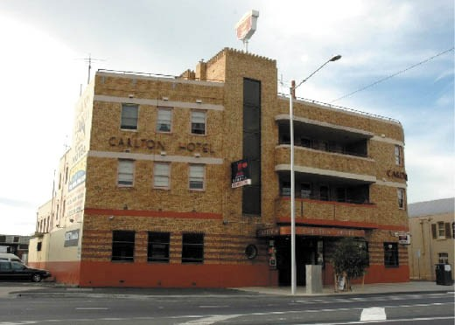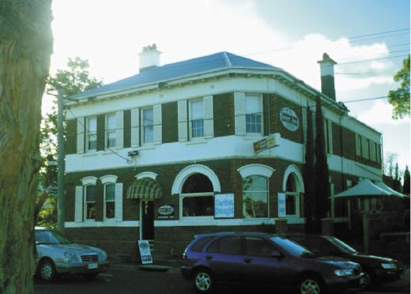

Figure 5.197: Former Carlton Hotel, 13-19 Malop Street, prior to recent redevelopment, 2005. Source: Wendy Jacobs.
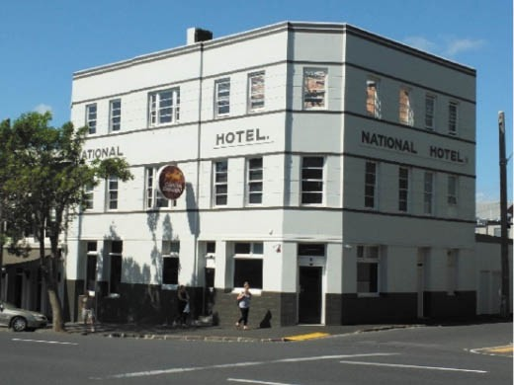
Figure 5.198: National Hotel, 193-195 Moorabool Street, 2017. Source: David Rowe.
Figure 5.200: Sawyers Arms Hotel, 2 Noble Street, Newtown, 2008. Source: Kevin Krastins.
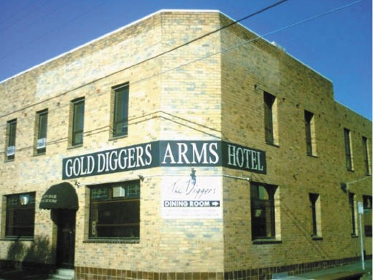
Figure 2.201: Gold Diggers Hotel, 87 Skene Street, Newtown, 2008. Source: Kevin Krastins.

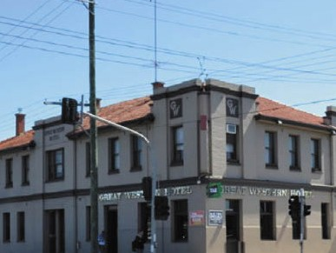
Figure 5.199: Great Western Hotel, 177 Aberdeen Street, Newtown, 2015. Source: Wendy Jacobs.
5.200), Barwon Club at 509 Moorabool Street, South Geelong 1910),1357 Gold Diggers at 87 Skene Street, Newtown (1958)1358 (Figure 5.201), Grovedale Hotel, 236-257 Torquay Road, Grovedale (1913 and later 20th century),1359 and the Belmont Hotel, 77 High Street, Belmont (1940).1360 Replacement
hotels on the sites of much earlier hotels in the outer regions included the Derwent at 700 Midland Highway, Batesford (1936),1361 Barwon Heads Hotel, 1 Bridge Road, Barwon Heads (1933),1362 and the Drysdale Hotel, 8-14 Collins Street, Drysdale (1934).1363

HOUSES OF ILL REPUTE
By 1848, there were ‘several houses of disreputable character in Geelong ,1364 the locations of another form of hospitality: prostitution. Mr. Wills, the Chief Police Constable had reported that the number of disreputable females has also increased in a short period. Profligacy and debauchery with the crimes that beset them, have obtained certain footings
in our town and suburbs, beyond the power of the law to remove. 1365 Under the Town Police Clauses Act 1847, it was an offence for a prostitute to solicit or importune in a public place for the purpose of prostitution although it was the laws on vagrancy, contagious diseases and crime that regulated this aspect of the hospitality sector.1366
These brothels were largely established in hotels and houses. By the mid-19th century, the Duke of York hotel in Malop Street (later known as the Manchester Arms) was one notorious house of ill repute in Geelong. In 1857, the licensee, James Beard, was charged ‘with harbouring and encouraging prostitutes and persons of bad character. 1367
His night license was cancelled.1368 Similarly, Lewis Rolland who operated a coffee, lemonade and ginger beer saloon in Corio Street was charged in 1858 for allowing up to twelve prostitutes to assemble.1369 However, the Police Constable could not possibly ascertain whether every girl who came to the door had a card of virtue about her. 1370 In 1870, another licensee who was charged was James Connelly of the Thistle Inn, Corio Street.1371 The Police Constable had ‘found five
of the most notorious girls in the town at his establishment. While admitting to the charge, Connelly claimed that ‘he had unfortunately left the back door open, and the girls had got in. 1372
The hospitality provided by male hotel licensees and female ‘madams’ exploited the plight of women, several of whom had fallen on hard times by virtue of alcoholism, financial ruin or marital breakdown.1373 Without the support of a social service network, a number of these women were forced into prostitution. Around 35 females were known to have been charged for prostitution in Geelong between the 1840s and 1870.1374 One of the earliest local ‘ladies of the night’ from the mid 1840s was Susan Cooper. She was first charged with obscene language in August 1850 when it was reported that:
An unfortunate female who although young has been following a course of profligacy in Geelong for more than 4 years past. Efforts were made by the Rev. Tuckfield to save the girl from misery and ruin and he took her under his roof in the capacity of a servant, but the girl left his family and returned to her abandoned courses. To show how little punishment is the infliction of a pecuniary fine on these women, it is only necessary to state that the girl’s fine was paid immediately yesterday by one of her

paramours, which has been done in the case of every other prostitute in every instance of the kind, within our knowledge.1375
Prostitution was regulated in Victoria in 1986 through the passing of the Prostitution Regulation Act 1986.1376 Brothels and escort services continue to operate in Geelong to the present day.

COFFEE PALACES
The Temperance Movement was a pervasive force throughout 19th century Geelong, as it was in Britain and America
(see Theme 8 for further details). In Britain, long after the initial establishment of the Coffee House, cafes and later tearooms had become a popular alternative to the bars and hotels that sold liquor.1377 They had resulted from a reaction against liquor by the Temperance Movement. In Victoria this Movement had lobbied hard for the 1885 Licensing Act.1378 These Coffee Palaces provided accommodation and non- alcoholic refreshment for ordinary, non-affluent citizens.1379

FORMER BAY VIEW TEMPERANCE HOTEL (RITZ), 10 BELLERINE STREET, GEELONG
One of the earliest surviving buildings in Geelong associated with the Temperance Movement was Field s Temperance Hotel, 10 Bellerine Street, from 1868.1380 This two storey building had first opened as the Belle Vue Hotel in December 1853 (see earlier subsection). In 1883, the building was purchased by J.K. Rawson had ran it as
Rawson’s Temperance Hotel until it was acquired by Robert Ellis Oldfield (c.1837-1910)1381 in 1889 who had the original building transformed. The changes were reported in the Geelong Advertiser:
Mr Oldfield incurred an expenditure of about £1,000 in improving the old Temperance Hotel boarding establishment, which now presents a handsome
appearance to the locality. The ugly copying of the old type of builders architecture has been removed, and in its place an ornamental balustrading along the Bellerine and Corio-street frontages has been substituted. Wherever necessary Mr Oldfield has had the outward aspect of the popular premises renovated and pleasingly painted.1382

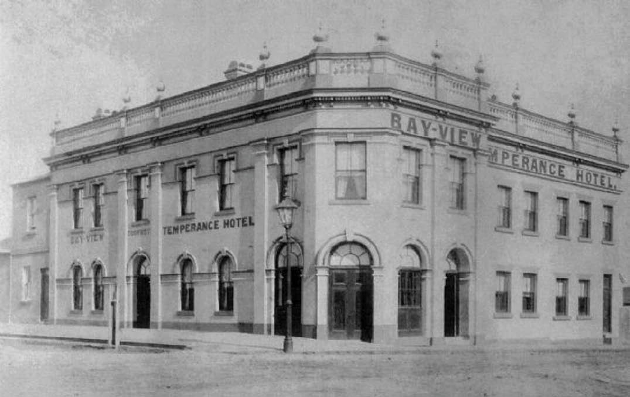

Figure 5.202: Bay-View Temperance Hotel, 10 Bellerine Street, c.1889. Source: Geelong Advertiser.

Expressing a modest version of Late Victorian Boom style architecture, it was at this time when the building became known as the Bay-View Temperance Hotel (Figure 5.202). The building continued as a temperance boarding house throughout the early 20th century, being known as Bay View House, and then the Ozone Coffee Palace from 1915, and from 1931, as the Ritz Coffee Palace.1383 It became the Ritz Flats in 19451384 and from the late 20th century until 2018 it fell into disrepair. In late 2019, work began on the construction of a nine storey apartment development. It included the retention and repair of the principal facades of the former Ritz Hotel building.

OTHER COFFEE PALACES IN GEELONG
Other Coffee Palaces were either purpose-built or earlier hotel buildings redeveloped in Geelong. They included the Albert Coffee Palace at the north-west corner of Yarra and Malop Streets (established in 1877)1385 and the Grand Coffee Palace, Brougham Street (established 1886), the building having first opened as Mack’s Hotel in 1846, and which became a local landmark.1386 Both of these buildings no long exist.

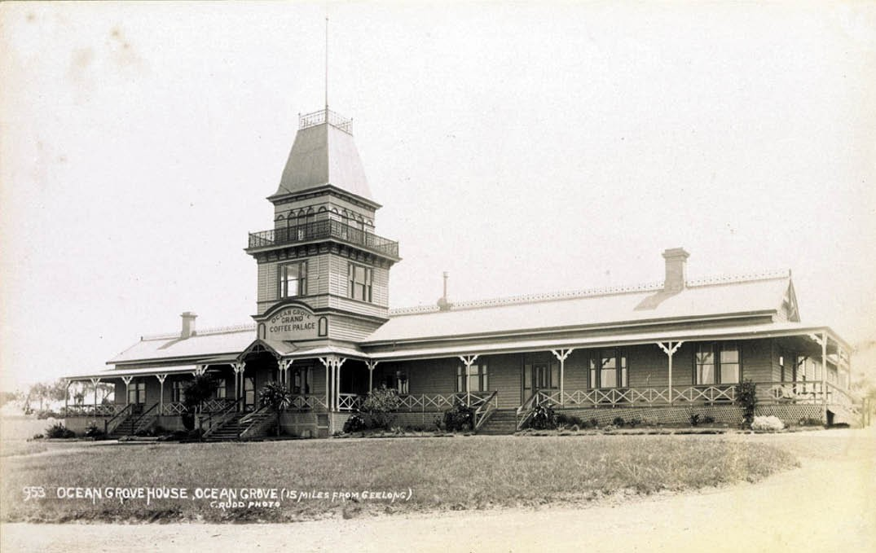
Figure 5.203: C. Rudd, Ocean Grove Grand Coffee Palace, 1892-1902. Source: accession H39358/19, State Library of Victoria

COFFEE PALACES AT TOURIST RESORTS
Four coffee palaces were constructed at Ocean Grove, Barwon Heads, Portarlington and St. Leonards in 1887, 1888, 1889-90 and 1908 respectively to cater for the tourist market. Although none of these buildings survive, they were the result of the efforts of members of the Wesleyan Methodist Church and the Temperance Movement. At Ocean Grove, the coffee palace (Figure 5.203) formed part of unique township development lead by a consortium of Victoria s Wesleyan Methodist Church (see Theme 6). The Coffee Palace was owned by the Coffee Palace Company Ltd. ‘whose desire was to give all the advantages of a first-class seaside residence without the extravagances so often indulged in at some of the summer resorts.’ In the early years, the Ocean Grove edifice
was even a focus for visitors with the full intention of weaning themselves’ from their ‘drinking habits.’1387 Joseph Ingamells (1824-1891) was the first manager between 1887 and 18891388 (see Theme 8). The building was destroyed by fire in 1969.1389
At Barwon Heads, the Coffee Palace (Figure 6.232 Theme 6) was central to the Barwon Heads Estate Company’s development of the Barwon Heads township (see Theme
6). The directors of this company which included William
Higgins (chair), Hon. C.E. Jones, William Humble, H.F. Richardson and James Strong were either members of the Wesleyan Methodist or Baptist Churches, or advocates of the Temperance Movement.1390 By 1906, the Barwon Heads Coffee Palace had been renamed as the Mt Colite Hotel,1391 bringing an end to the coffee palace era at Barwon Heads.
In 1889, the Geelong Advertiser announced that a coffee palace was about to be erected in Fenwick Street,
Portarlington.1392 Owned by W.N. Richardson, the establishment was first operated by Patrick O’Sullivan.1393 Such was the success of the enterprise that additional rooms were built a few months after its opening in 1890.1394 Yet,
just three years later in February 1893, the coffee palace was totally destroyed by fire.1395 Almost 20 years elapsed
before a new coffee palace was erected in 1911 in Newcombe Street.1396 Mrs W. Woolnough was the coffee palace keeper.1397
At St. Leonards, William Holden erected his Coffee Palace in 19081398 at the corner of Bluff and Murradoc Roads.1399 This building was a considerably more modest and rudimentary structure compared to those erected at Ocean Grove and Barwon Heads. It operated throughout the early 20th century but by 1950 it had been closed and demolished.1400

GUEST HOUSES AND BOARDING HOUSES
Guest houses and boarding houses (which did not also serve as hotels) also played a role with the hospitality sector in Greater Geelong from the 19th century. By 1854, there were 22 boarding house keepers in central Geelong.1401 There were at least four similar establishments in 1882-83 operated by Miss Carpenter at Eastern Beach Road, Mrs Everett and Miss Carpenter in Latrobe Terrace (Myrtle Cottage), Mrs Hamilton in Yuille Street and Mrs Golding in Ryrie Street.1402 Most of these businesses appear to have taken over existing buildings. From the late 19th century, in addition to Geelong, boarding and guest houses were located in the tourist townships of Barwon Heads, Ocean Grove, Portarlington and other parts of the Bellarine Peninsula.
One of the earliest physical legacies of a guest and boarding house in Geelong is the former Dysart s , 9-13 Pevensey Crescent, Geelong (Figure 5.204). It was commenced by Mrs. Annie Myring in the former residence of William Bell
at 9 Pevensey Crescent, in 1893.1403 On the site of ‘Bell’s cottages’, Bell had engaged the Geelong architect, Joseph Watts, to design a terrace of three, two storey buildings in October 1889.1404 Four terrace dwellings were eventually to be created. Prior to his death in 1894, Bell had leased his residence at 9 Pevensey Crescent to Annie Myring which was known as ‘Dysart’.1405 It was at this time when Mrs. Myring advertised her ‘refined home for gentlemen.’1406 By c.1912, when managed by Bertha Meigs, the ‘Dysart’ boarding
and guest house had been extended into the neighbouring terraces at 11 and 13 Pevensey Crescent.1407
By 1916, the ‘Dysart’ guest house was managed by a
Miss Cosgrave.1408 The business relocated to the south wing of the old Geelong Grammar School building at 55 Maud Street (Figure 5.205) in January 1917.1409 Representing the School s former dining hall and Principal s residence which opened in 1858 (see Theme 8), the Dysart guest house continued until 1961.1410
Several private residences were offered as boarding and guest houses in Ocean Grove from the late 19th century. In 1893 for example, the Tourist s Guide to Geelong and Southern Watering Places described and advertised a
number of residences available as holiday accommodation. They included M.L. Hutchinson’s ‘Hopeville’, Rev. T. Grove’s ‘Elsielea’, John Bound’s ‘Barwon Cottage’, Mr Bruche’s ‘Wilhelmsruhe’, George Vear’s ‘Strawberry House on President’s Avenue’, John Armstrong’s ‘Sea View’, T. Pescott’s ‘The Manners’ and Mrs Ingamells’ ‘Friskney’.1411 The latter is the only surviving dwelling associated with the late 19th century guest house era. She had the dwelling built in 1889-90 with her late husband and manager of the nearby Coffee Palace, Joseph Ingamells (see Theme 6 for further
details). In 1893, Mrs Ingamells charged 30 shillings per week

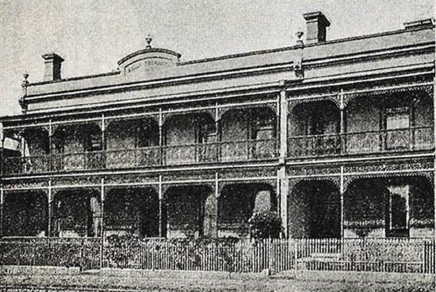

Figure 5.204: ‘Dysart’ Guest House, Pevensey Crescent, Geelong, 1908. Source: G.H. Brownhill, Illustrated Guide to Geelong and District, 2nd edn., (facs. edn.), Deakin University Library, Geelong, 1990, p.117, originally published in 1908 by the Geelong Progress Association.
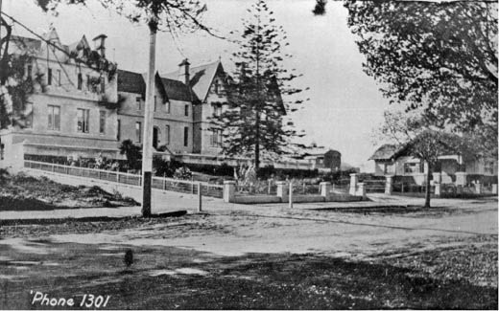
Figure 5.205: Dysart Guest House, 55 Maud Street, Geelong, 1918. Source: Geelong for Business, Health, Pleasure.

for adults, in conjunction with the following advertisement: Mrs. Ingamells (Widow of the late Mr. Joseph Ingamells)
Desires to inform her friends and those seeking a rest and change of air at the Seaside, that she has decided to continue to receive visitors at the above address as
heretofore. In conjunction with the Misses Ingamells, it is believed that such comfort and accommodation can be assured as will leaving nothing to be desired.
“FRISKENY” is one of the most favourably and picturesquely situated places to be met with at this now favourite and popular seaside resort, commanding a good view of both Ocean and Lake.1412
Another landmark guest house at Ocean Grove commenced in 1890 as Connewarre House. Built in 1889, the first operator

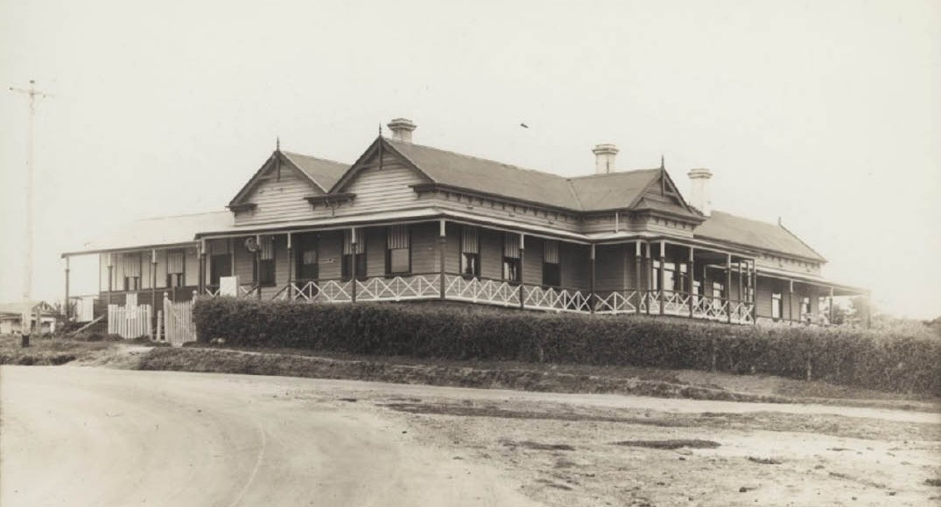
Figure 5.206: Embla House, Ocean Grove, c.1935-44. Source: accession H88.45/42, State Library of Victoria.

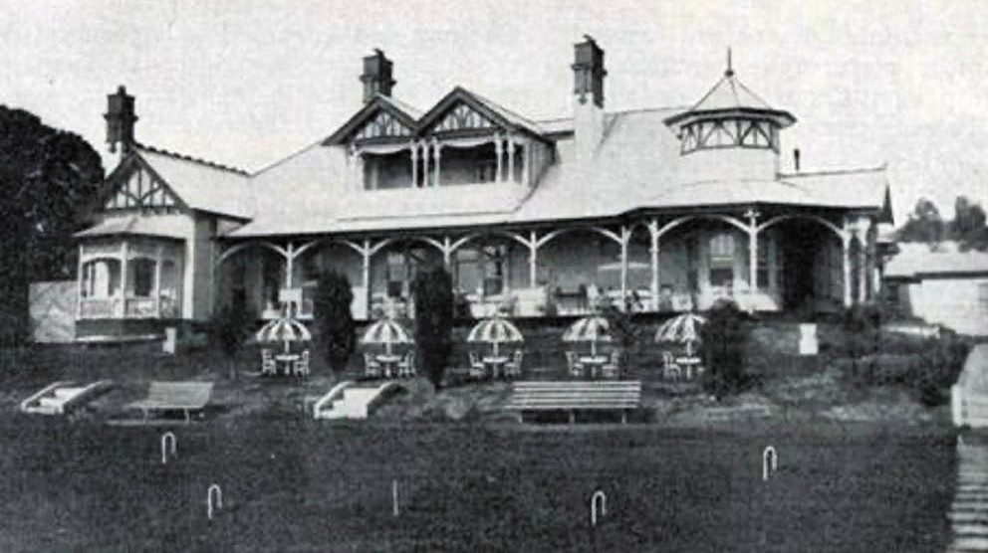

Figure 5.207: Embassy Lodge, 64-66 Eastern Beach Road, Geelong, 1947-48. Source: The Country Hotel & Guest House Guide Where to Go in Victoria, The Victorian Railways, 1947-48, Special Collections, Deakin University Library.

being Francis Brown,1413 the timber building was beautifully situated on the next block to the Coffee Palace’ and commanded a most charming view of the ocean, the entrance to the Barwon and the Lake.’1414 The first superintendent
was Mrs Frederick Brown.1415 In 1900, Connewarre House was sold to Alexander Miller, prominent draper and staunch Methodist of Geelong (see earlier subsection). He had the building relocated in two parts to an acre of land bound by Dare, Hodgson and Orton Streets. Although Miller’s intention was that the relocated boarding house would reopen as a rest sanatorium for Methodist clergy, known as Mafeking Palace. Never realizing its fullest potential, it later became a holiday guest house managed by Frederick James Menzies until 1920.1416 Having been bequeathed to the Methodist Church by the late Alexander Miller, the property was sold in 1920.1417 In 1935, Mafeking Palace reopened as Embla House (Figure 5.206) by Mrs Nellie Elizabeth Menzies, second wife
of F.J. Menzies.1418 By 1944, Embla House had been renamed Cathkin House1419 and it continued as a seaside guest house until its demolition in 1982.1420
At Barwon Heads in 1916, the widow, Mrs. E.M. Garlick, purchased the seaside residence, Monomeeth , 33 Flinders Parade, and established a guest house there (Figure
6.233 Theme 6).1421 The house had been built in 1891 for
H.F. Richardson and when purchased by George Hague, woolbroker, in 1893, extensive alterations and additions were carried out.1422 Only part of the dwelling remains today, a consequence of a fire that destroyed the kitchen and some bedrooms in the early 1920s.1423
At Portarlington, rooms and facilities in several private guest and boarding houses were advertised for occupation. In 1901, they included Mrs Hocking’s ‘St. Elmo’, Mrs. Willey’s, of ‘Wiraroa’, Mrs. Banks’ ‘Belvie House’, Mrs Hill’s ‘Rose Villa , and the dwellings of Mrs Woods and Mrs Webber.1424 In 1911, a Mr Thraves had taken over ‘Laura Villa’ (built in 1875-76) at 17 Drysdale Street (see Theme 6) and opened
a fashionable boarding house there1425 (Figure 6.269 Theme 6). Another surviving legacy of the boarding house era of the early 20th century is at 118 Newcombe Street. It was operated by Mrs Dalton.1426 Nearby Portarlington at St.
Leonard’s ‘Thalatta’ at 89 Bluff Road (built c.1874) exists as a legacy of early holiday house development by Frank Gilbert (see Theme 6). This was one of two houses he built to attract tourists to the area. 1427
In 1926, the semi-detached two storey brick residence, ‘Benton’, 34 Eastern Beach Road, was used as a guest house for gentleman boarders .1428 Built in 1890 for Ward Nicholson of Humble and Nicholson iron foundry (see earlier subsection), the semi-detached dwellings had been designed by E.M. Blake, architect.1429 In 1927, ‘Benton’ was advertised for sale, bringing an end to its guest house function.1430

Further east at 64-66 Eastern Beach was the substantial guest house, ‘Embassy Lodge’ (Figure 5.207), which was opened by George G. Anthony in 1945.1431 It was strategically located opposite the Eastern Beach swimming pool and boasted spacious grounds.1432 The guest house had been first constructed in 1907 to a design by Tombs and Durran
for W.H. Lloyd as an investment property.1433 It was soon known as ‘Comara’.1434 As the ‘Embassy Lodge’ guest house, the original dwelling had been extended to provide 30 rooms and by the early 1950s it was one of Geelong s leading
guest houses.1435 ‘Embassy Lodge’ was destroyed by fire in 1952.1436

FISHMONGERS AND FISH AND CHIP SHOPS
The marine environment of the Greater Geelong area provided commercial opportunities for the selling of fish and other seafood, and in later years, cafes for the consumption of fried fish, leading to the local evolution of fish and chip shops. By 1856, there were three fishmonger operations in Geelong largely centred around Market Square: John Baker and the Deep Sea Fishing Company (both in Malop Street), and E. Hall, Moorabool Street.1437 Lock and Maul also operated an oyster shop in Malop Street at this time.1438 By 1866, only two fishmongers advertised in Steven’s Geelong, Western District and Squatters’ Directory. One was C. Roffey of Malop Street East, the other being George Hiscox (c.1822-1884), a former seaman with the British Navy, of Moorabool Street.1439 Like several fishmongers in the 19th century, Hiscox’s business doubled as a poultry supplier, offering for sale good fat rabbits in 1869.1440 Hiscox also boasted his fresh supply of Murray Cod and Perch ‘direct from the Murray’,1441 indicating that seafood was sourced more widely than just from the local Greater Geelong area.
Another substantial fishmongery operation established in 1863 was the Ballarat-based Queenscliff, Geelong and Ballarat United Fishing Company. Impetus for the new venture came from the high demand for fish in Ballarat, with 200 tons consumed there annually, with the waters
off Queenscliff being the source of the seafood.1442 By 1866, the business was known as the Queenscliff Fishing Company.
It was at this time when ‘the largest haul of fish taken by a single party for some years was netted off Queenscliff and consisted mainly of trout and salmon. A portion was sent to Ballarat and the balance was initially intended for the Melbourne market but the strong wind prevented safe
boating. Instead, the fish ‘were sold to the Chinamen here who follow the curing business. 1443 Although the Queenscliff Fishing Company went insolvent in 1875,1444 it continued
to trade in Ryrie Street in 1882-83 and had relocated to 156 Moorabool Street by 18901445 (Figure 5.208). At this time, the Geelong Advertiser gave a report of the Christmas

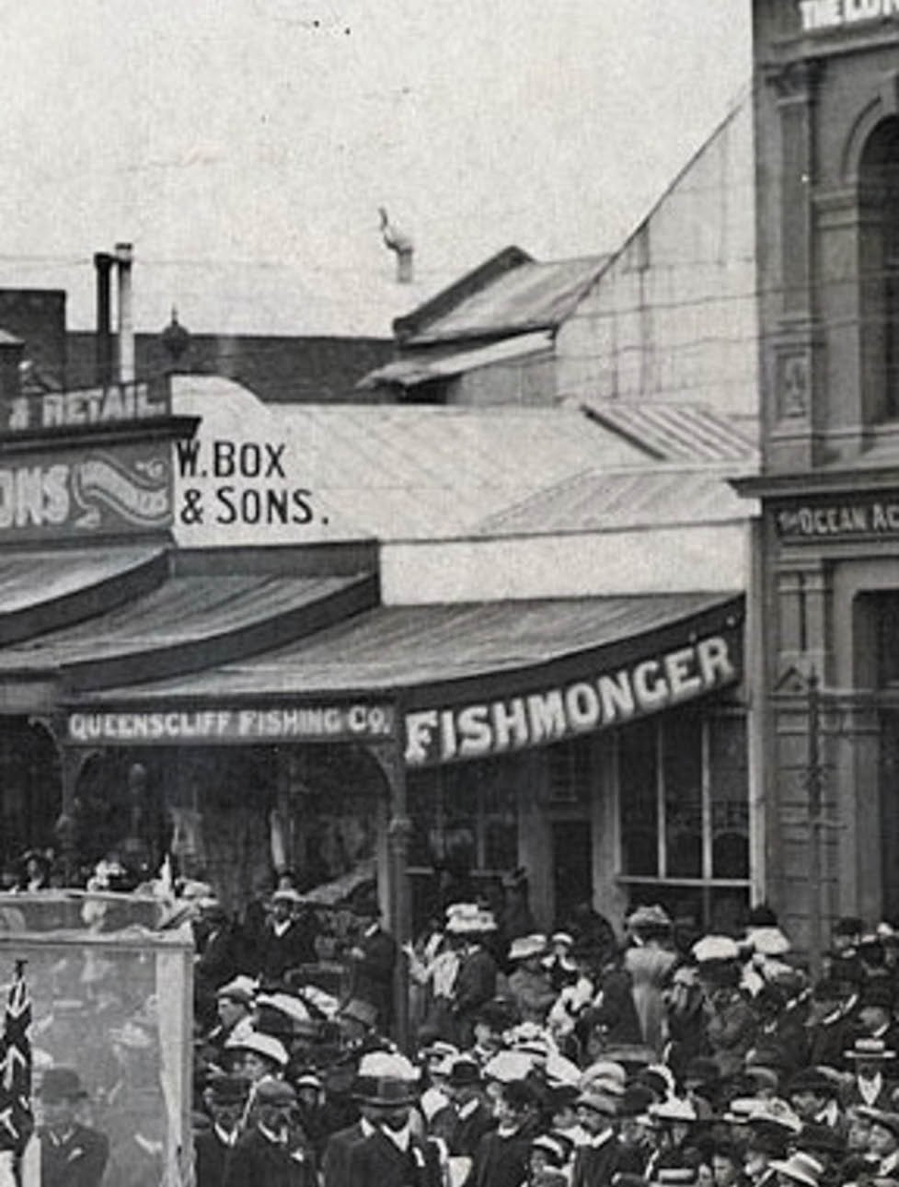
Figure 5.208: Queenscliff Fishing Company, 156 Moorabool Street, 1909. Source: News of the Week, 25 April, 1909, p.14, GRS 1221b, Geelong Heritage Centre collection.

decorations of the local poulters and fishmongers which provided an insight into the poultry and seafood available:
The poulterer’s and fishmonger’s establishment of
Mr J.S. Bayley, in Ryrie-street, presented an attractively gay appearance last night, superior in every respect
to anything yet made in the shop. The show window, two large tables in the centre of the shop, and the two
side tables were covered with splendidly dressed turkeys, geese, ducks and fowls. The display represented 150 pairs of tame fowl and 140 pair of game, whilst the walls the shop were covered with undressed wild duck and
teal to the number of about 100 pairs. The window devoted the display of fish was well filled with excellent specimens of garfish, flounders, and trevalla. The whole of the shop and the windows were prettily adorned by festoons of green leaves, bright colored flowers and bouquets, a highly effective show being made. The shop of the Queenscliff Fish Company, together with Mr Kelly’s poultry section, in Moorabool- street, also presented a very pleasing sight last night. There was an abundance of all descriptions of deep sea fish, and a plentiful supply of dressed and undressed poultry, and a capital exhibition of wild fowl.1446
By 1905, there were at least four fishmongers in Geelong (see Appendix 5.1). An enduring family business established at 70 Moorabool Street, Geelong, in 1911 was Blackney and Son’s ‘up-to-date fish shop and oyster saloon.’1447 William Blackney (1841-1924) had come to Geelong by 18561448 and in subsequent years became a fisherman. By 1919, Blackney was President of the Geelong Fishermen’s Association.1449 His son, William George Blackney (1867-1940) appears
to have first been in business with his father from 1911. Another son, Edward Albert Blackney (1876-1957) was also a fishmonger. W.G. Blackney’s sons, Frank (1892-1969) and Sydney George (1899-1980), and E.A. Blackney’s son, Charles Albert (Bert) (1900-1996), also worked as fishermen and fishmongers.1450 By 1962, Charles Blackney’s business was known as Blackney’s Fish Supply.1451
By 1944-45, there were 12 fishmongers and fish shop proprietors listed in Sands and McDougall s Directory of Victoria (Appendix 5.1). This number had expanded further by 1960 (Appendix 5.1) and included post World War Two immigrants (see Theme 2).
Evolving from the fishmonger businesses in the very early 20th century were fish and chip shops. The earliest specific reference to fried fish in the Geelong Advertiser was in 1902, when L. Mardiros of the Commonwealth Oyster Saloon in Malop street advertised that he engaged F. Carpenter as manager whose fried fish ‘were not be equaled.’1452 It was also at this same time when D. Hands (a previous employee of the local fishmonger and poulter, J.S. Bayley, for 12 years)

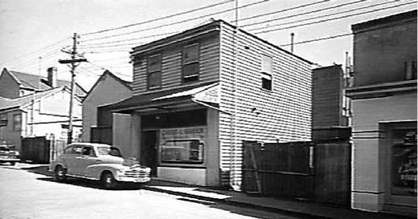
Figure 5.209: Cream and Green’s Fish and Chip Shop, 12 Union Street, Geelong, 1945. Source: Item MM 11457, Museums Victoria collection.

established a new fishmongery at the corner of Corio and Moorabool Streets where fried fish and fresh oysters were a specialty. 1453 One of the earliest references to a ‘fried fish and chip potato shop’ was in 1907 when James Kelly, fishmonger, advertised for a manager at his premises at 57 Malop Street.1454 Yet, there was a stigma associated with fried fish establishments, both from a health perspective and in the proliferation of anti-social behavior. In 1901, the
Geelong Advertiser reported on a serious outbreak of enteric fever in South London which medial investigation showed
‘to be due to the eating of fried fish purchased at shops.’1455
Closer to home, the Geelong West Council’s inspector,
J.W. Smith, declared fish and chip shops to be a ‘curse on the municipality’ as ‘drunks and near drunks’ ‘bought fish and chips and wandered about in the early hours
of the morning. 1456
Notwithstanding the negative stigma applied to fish and chip shops, they became ubiquitous throughout Geelong in the 20th century (see Appendix 5.1). By 1944-45, this included Cream and Green’s shop at 12 Union Street (Figure 5.209), although the post World War 2 period witnessed a number of Greek immigrants as operators of these establishments (see Theme 2).

5.10 UTILITIES SECTOR
Fundamental to the progress and prosperity of the Greater Geelong region from the early 10th century was need for utilities: for the lighting of streets and later the powering of homes, businesses and infrastructure. These utilities were another source of employment.

GEELONG GAS COMPANY AND GAS WORKS
The first effort to establish a gas company in which to create an industry to light Geelong s streets was in 1854.1457 Nothing eventuated from the newly-formed Geelong Gas and Coke Company. Three years later in 1857, a meeting was held
in order to form a company for the supply of gas to the town.1458 On 18 June 1858, the company was formed, the inaugural chairman of the Board of Directors being Charles Kernot. Other directors were William Bell, Hugh McPhillimy, Henry Marsh, Richard Porter, Henry Coll, Christopher Porter, Thomas Bracy and John Headrick. Samuel Richard Scoltock (1830-1872) was appointed Secretary and Engineer.1459 Born in London, Scoltock appears to have come to Geelong with considerable engineering experience as he was responsible for designing and engineering the Gas Company’s works in 1859 and also that of Adelaide Gas Works in 1861-62.1460 By 1866, he had taken employment with the Williamstown Gas Works and he died prematurely in 1872.1461
A site for a gas works was subsequently selected at the north end of Bellerine Street.1462 However, the location was opposed by the local Member of the Legislative Council, H.F. Strachan, claiming that the works should not be situated within the city area. Parliament subsequently passed a Bill for the right to supply gas within a radius of 5 miles from the Geelong Post Office on the condition that the works would be established outside the city area.1463 Although a site near the botanical gardens was favoured, in 1859 the Geelong
Gas Company secured land from the Geelong and Melbourne Railway Company in Victoria Street, North Geelong (then West Geelong), immediately west of the railway line.1464
Tenders were called for the erection of the gas works in November 1859.1465 The contract was awarded to Charles Ross, Phillip Kemp, H. Spears and Co., W. and J. Jones and Co. and D.K. Goodhall was Clerk of Works.1466 The foundation stone was officially laid on 10 February 1860 by
the then chairman, Richard Parker, following the presentation of a silver trowel manufactured by Henry Over of Moorabool Street.1467 Following British precedents, gas at the North Geelong site was to be manufactured from coal that arrived by rail. The buildings included a brick retort house and gasometer (Figure 5.210). Town gas was first supplied on the birthday of Princess Victoria on 24 May 1860 (see Theme 6 for details on the installation of street lamps).1468 The event was described in the Geelong Advertiser:

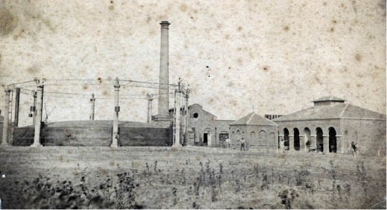
Figure 5.210: Geelong Gas Works, North Geelong, 1865. Source: GRS 2009/00184b, Geelong Heritage Centre collection.
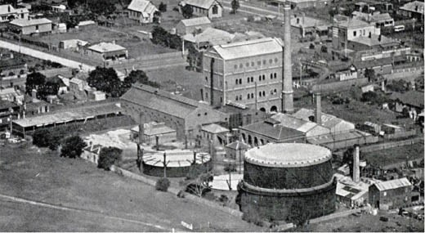
Figure 5.211: Geelong Gas Works, North Geelong, 1930. Source:
Geelong: Its Advantages and Opportunities, p.33.

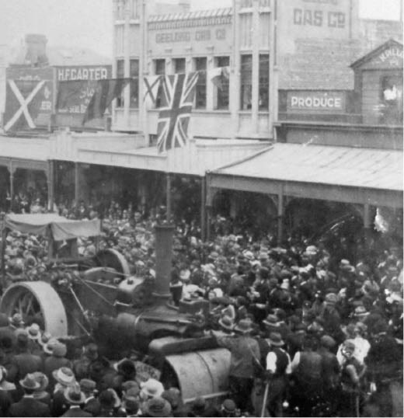
Figure 5.212: Geelong Gas Company Building, 161 Ryrie Street, Geelong, c.1912-20. Source: GRS 2009/1586/163, Geelong Heritage Centre collection.

Yesterday evening, the introduction of gaslight into the town of Geelong was formally celebrated. As soon as the shades of evening began to fall over our streets, the gas supply was turned on, and the use which was made of it was sufficiently lavish, and the effect more than sufficiently brilliant, to prove that, under the auspices of the engineer, Mr Scoltock, the Geelong Gas Company is a great success. The places which were illuminated in
various parts of the town were the offices of the Company. The design consisted of the initials V.R,. a crown, a star,
a Maltese cross, with a row of jets underneath, the effect of the whole being extremely brilliant. The Black Bull Hotel was also gaily illuminated. … The shops of Messrs Parker, Thomas, Watts, Over and Bright and Hitchcocks were also illuminated Mine hosts of the Princes of Wales and the Geelong Hotel expressed their fancies in a specially loyal fashion, the design in the former case being a transparency with a motto referring to England s future king … The Theatre was perhaps the chief centre of attraction and admiration. The design on the front consisted of the initials V.R., a crown and a star. Within,
the house was gaily lit by a sun burner in the centre of the ceiling, and, for the first time the theatre looked, in point of brilliance, as a theatre ought to do. The Market-square was made the scene of a pyrotechnic display, which was kept up with spirit until a late hour.1469
By the early 1920s, the gas works were outdated and struggled to meet the demand of the growing City.
Extensions and new plant and equipment was subsequently installed which was opened in March 19251470 (Figure 5.211).
Throughout the 20th century, the Geelong Gas Company and the gasworks continued to operate until 1971 when Geelong was converted to natural gas and the company was taken over by the Gas and Fuel Corporation of Victoria.1471
At this time, the Geelong Gas Company was one of just two remaining private gas companies in the State.1472 The gas works were demolished in September 1972, the only physical evidence of this enduring important utility being the concrete foundations of the gasometer,1473 and possibly archaeological remnants.

GEELONG GAS COMPANY BUILDING
The administrative offices of the Geelong Gas Company were first situated at 13 Malop Street, and soon after in new offices at 112 Moorabool Street.1474 In 1870, the Geelong Gas Company offices relocated to the premises of James Henty and Co. at 20 Brougham Street.1475 The Gas Company remained at this location until 1919.1476
At this time, the company engaged the local architectural firm of Laird and Buchan to design a new two storey office and showroom at 161 Ryrie Street.1477 Opening in 1920, the

rendered brick building (Figure 5.212) was distinguished by its projecting oriel bay windows which extended to form stylised prismatic pinnacles.

ELECTRIC LIGHTING AND TRACTION COMPANY & STATE ELECTRICITY COMMISSION
In 1896, application was made for the formation of the Geelong Electric Supply Company ‘to supply the town and district of Geelong with electricity for light and motive purposes. 1478 Three years elapsed before any meaningful development was made following the Geelong Town
Council’s consent to transfer authority for Geelong’s electrical supply to the Electric Lighting and Traction Company of Australia under the Electric Light and Power Act.1479 John Alexander Dawson (1863-1930) was appointed manager and resident engineer of the company.1480 A timber Federation Queen Anne styled dwelling was constructed for him in 1900- 01 by the Electric Lighting and Traction Company at 343 Ryrie Street, Geelong, to a design by the local architects, Hendy and Apted.1481 Dawson had lived in Geelong for some years and in 1889 he was agent for buggy lights in Ryrie Street.1482 He also contributed to community life as secretary of the Transvaal Square War Memorial Committee in 1900, the same year he was elected to the Geelong Town Council for the Villamanta Ward.1483
The architects Hendy and Apted also designed the central power station on the selected site at the south-west corner of Yarra and Brougham Streets, Geelong in 1899.1484 Tenders were called in January and February 1900 and the contract was let to J.C. Taylor and Sons.1485 Featuring a landmark brick chimney stack upon completion, the building was distinguished by its polychrome brick construction including the two storey pilasters and semi-circular arches with cream brick voussoirs, and in the applied glazed coloured tiles (Figure 5.213). The first test in the production of electric
light at the new station was carried out in April 1901.1486 The Geelong Advertiser declared that the light produced was perfectly brilliant , the glare through the windows attracted ‘the attention of many passersby, who had no difficulty in distinguishing the superior light as that of electricity. 1487 On 3 May 1901, the electricity supply was turned on at an official ceremony at the power station. Current was officially turned
on by the respective Mayoresses of the inner Geelong region: Mrs Carr (Geelong), Mrs Cairns (Newtown and Chilwell)
and Mrs Bannister (Geelong West), while Mrs Clement, wife of the general manager of the Electric Light and Traction Company, and Kelvin Dawson, son of J.A. Dawson, switched on the current for the Villamanta ward and East Geelong respectively.1488
In 1904, just three years after the official switching on of electrical current, extensive alterations were made to the

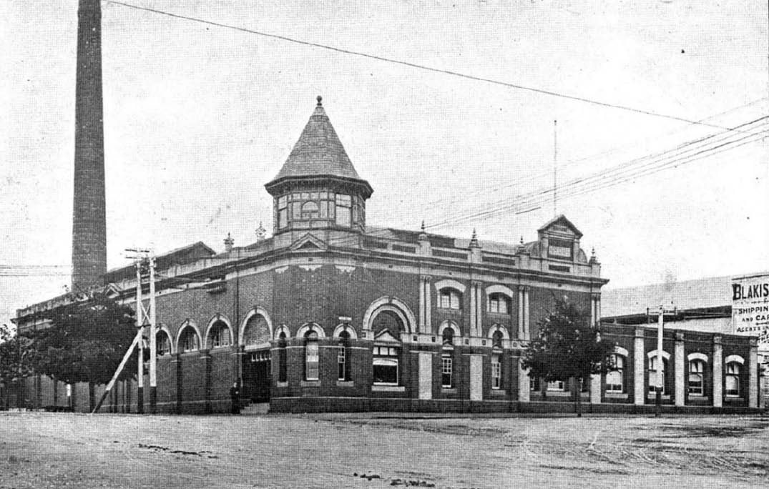
Figure 5.213: Geelong Electric Lighting and Traction Company Power Station ‘A’, corner Brougham & Yarra Streets, Geelong, 1911. Source:
News of the Week, 7 December 1911, GRS 2121, Geelong Heritage Centre collection.

power station. As outlined in Geelong Advertiser:
The chief improvement is the installation of a new accumulator storage battery in place of the original- battery, which has proved too small for the demands made upon it. The new battery will contain 242 cells, which,
have recently been landed from the continent, and when its erection is completed the capacity of the station will be largely increased. When fully charged the battery will be capable of supplying 4000 sixteen candle-power lights at the one time. Since the old battery was dismantled
the generating machinery has been kept going night and day to furnish a supply, and it is expected that the new apparatus will be available for use in about a month s time. A third large boiler has also been erected to increase the efficiency of
the plant.1489
In 1908, the name of the electricity company was changed to the Melbourne Electric Supply Company Ltd.1490 A further storey was added to the power station in 1919.1491 These works were in preparation for the installation of a new power station with modern electric generating plant comprising turbo-alternators supplied by high pressure steam from
water-tube boilers, together with the necessary auxiliary equipment,1492 (Figure 5.214). The new system provided three-phase high-tension electrical supply, and apart from small portions converted to direct current for use in the City centre and for operating the adjoining tramways, it was transmitted at 6000 volts to area substations where it was distributed in a low tension network for domestic consumers, larger power consumers being supplied from transformer centres at their factories.1493
On 1 September 1930, the Melbourne Electric Supply Company was purchased by the State Electricity Commission of Victoria (SEC) (established in 1921 to supply electricity across Victoria).1494 The Geelong area was connected to the state electrical grid in 1934.1495
In 1952, the SEC announced the construction of the Geelong ‘B’ Power Station at North Geelong.1496 This station was to provide 30,000 kilowatt steam-electric power to supplement the existing power station at the corner of Yarra and Brougham Streets (then known as Geelong ‘A’ Power Station).1497 The Geelong ‘B’ Station was officially opened on 8 October 1954,1498 and for a time it was the largest power station in Victoria, being originally fired by brown coal.1499

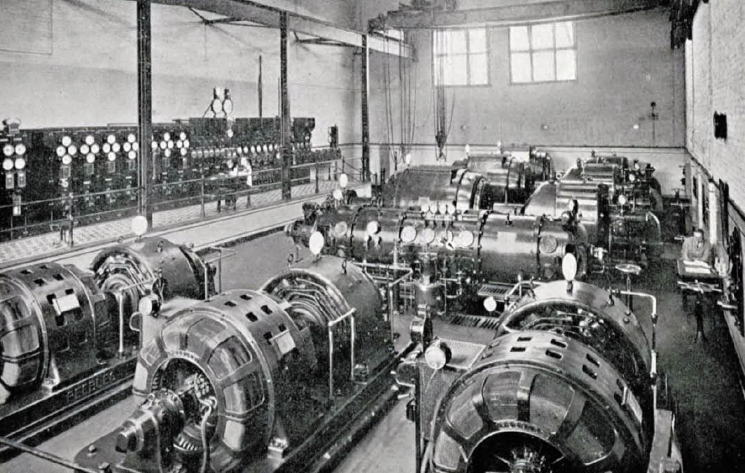
Figure 5.214: Turbine Room, Geelong Power Station ‘A’ building, corner Brougham & Yarra Streets, Geelong, 1930. Source: Geelong: Its Advantages and Opportunities, p.33.
Later, it was fueled by briquettes transported from the Latrobe Valley. By the 1960s, the Geelong ‘A’ Power Station had closed and the Geelong ‘B’ Station ran only intermittently when there was high demand in the State grid.1500 Geelong ‘B’ Station was closed in 1970 when the major stations in
the Latrobe Valley came into operation, bringing an end to a major local utility.1501

ENDNOTES

- L. Lane, ‘The Wathaurung: Geelong’s earliest inhabitants’, text of an address to the Geelong Historical Society, 22 March 1988, public reading room shelves, Geelong Heritage Centre (GHC), L. Lane, ‘The Wathurungs’,
Investigator, vol. 23, no. 3, September 1988, p.100 & L. Lane, ‘The Inhabitants of Terra Nullius’, Investigator: Magazine of the Geelong Historical Society, vol. 29, no. 4, December 1994, p.138. See also A.W. Howitt, The Native Tribes of South-East Australia, Macmillan & Co., Ltd., London, 1904, p.514.
- Lane, ‘The Wathaurungs’, op.cit., p.107, Ochre: Two years on, Learning together, working together, walking together, Aboriginal Affairs, NSW, September 2015, p.2
- W.R. Brownhill & I. Wynd, The History of Geelong and Corio Bay with postscript 1955-1990, The Geelong Advertiser, Geelong, 1990, p.314.
- Melbourne Argus, 15 June 1847, p.2, Geelong Advertiser, 19 April 1848, p.1.
- W.J. Smith, Sand, Fireworks & Boxthorn: The History of Breakwater and Area, William Joseph Smith, Geelong, 2009, p.54.
6 Ibid., p.56.
7 Ibid., p.40.
- The Argus, 2 March 1852, p.3 & Geelong Town Council Rate Book, 1852, GHC.
- L. Clarke, Plan of Allotments in the Parish of Conewarre on the right bank of the Barwon River below the Breakwater, 1849, VPRS 8168/P5, Sydney Plans C 6: Conewarre, Public Record Office Victoria (PROV).
- See Appendix 5.1.
- Geelong Advertiser, 6 July 1876, p.2.
- J. Smith (ed.), The Cyclopedia of Victoria, Cyclopedia Company, Melbourne, vol.2, 1903, p.460. Munday continued to lease the Barwonside Tannery in 1882 - see South Barwon Rate Books, Barwon Riding, 1882-85, GHC.
- Geelong Advertiser, 6 October 1875, p.4.
- E.A. Vidler, The Book of Geelong: Its People, Places, Industries and Amusements, Edward A. Vidler, Geelong, 1897, p.29.
- ‘Australian agricultural and rural life: Riding on the sheep’s back, State Library of N.S.W. online at
https://www.sl.nsw.gov.au/stories/ australian%E2%80%90agricultural%E2%80%90and%E2%80%90 rural%E2%80%90life/australian%E2%80%90wool
- See Appendix 5.1.
- Ibid.
- Ibid.
- Geelong Town Council Rate Book, 1855-56, op.cit.
- Smith, op.cit., p.64.
- Geelong Advertiser, 29 June 1866, p.3.
- Ibid., 2 September 1867, p.3.
- Ibid.
- Smith, op.cit., p.66.
- Geelong Advertiser, 15 March 1901, p.3 & D. Rowe & L. Huddle, ‘City of Greater Geelong Outer Areas Heritage Study Stage 2’, prepared for the City of Greater Geelong, vol.3, 2000.
- Geelong Advertiser, 12 October 1895, p.4.
- The Leader, 3 June 1899, p.16.
- Geelong Advertiser, 29 May 1911, p.3.
- Nominal List of Exiles per the ship, Anna Maria, 23 June 1848, PROV at Ancestry online, https://www.ancestry.com.au/
- I. Wynd, The Pentonvillans, Geelong, 1996, p.62.
- Ibid.
- Ibid.
- Nominal List of Exiles per the ship, Anna Maria, op.cit. & Geelong Advertiser, 1 July 1848, p.2.
- Wynd, op.cit., p.62.
- Geelong Advertiser & Intelligencer, 7 November 1853, p.1.
- Geelong Town Council Rate Book, Barwon Ward, entry 1088, 1855-56, op.cit.
- Geelong Advertiser, 18 September 1860, p.2.
- Ibid.
- Leader, 6 February 1864, p.3.
- Ibid.
- Geelong Advertiser, 20 February 1864, p.1.
- Ibid., 24 September 1869, p.3. 43 Ibid, 22 July 1869, p.3.
44 Ibid.
45 Ibid., 18 May 1872, p.3.
46 Ibid., 17 December 1875, p.2, 8 July 1881, p.3 & 29 May 1911, p.3,
- Rowe & Huddle, op.cit., vol.13.
- Ibid.
- Ibid.
- Geelong Town Council Rate Books, Barwon Ward, 1850-51, 1865-68, op.cit.
51 Ibid., 1860-61.
52 Ibid., 1882-83.
53 Geelong Advertiser, 26 March 1890, p.4.
54 Ibid., 31 August 1895, p.4, 14 January 1896, p.3, 30 January 1896, p.3 & 25
April 1896, p.4.
- E.F. Haworth, Will, Probate Administration files, 1895, VPRS 7591/P2, Unit 252 PROV.
- Ibid.
- M. Tayler, ‘Corio’ [at the Breakwater], sketch plan, 29 November 1879, VPRS 5357 Unit 364 PROV.
- J. Haworth, Probate Administration files, 1903, VPRS 28/P2 Unit 666 PROV.
- Geelong Council Rate Book, 1905, op.cit. 60 Ibid., 1908, 1910.
61 Ibid., 1912-1935.
- Herald, 29 January 1938, p.3, Geelong Council Rate Books, 1938-60, op.cit.
- This name was not given the property during the ownership of the Haworth family.
- Geelong Advertiser, 8 July 1895, p.4. 65 Ibid., 31 August 1895, p.4.
- D. Rowe, ‘Geelong City C Citations Project’, prepared for the City of Greater Geelong, 2002.
- Ibid.
- Geelong Advertiser, 6 August 1900. 69 Ibid., 9 May 1908, p.4.
- Ibid.
- Ibid.
- D. Rowe, ‘Riversdale Woolscouring & Carbonising Mill’, Heritage Report & Guidelines, prepared for E.P. Robinson Pty Ltd, March 1998.
- ‘Wilms, Herman Emil’ in Who s Who in Australia, 1927, p.884, Ancestry online, op.cit.
- Geelong Advertiser, 13 February 1920.
- Rowe, op.cit.
- Ibid.
- Ibid. & Jim Robinson, E.P. Robinson Pty Ltd, to the author, 6 August 2019
- Ibid.
- Geelong Advertiser, 9 July 1919, p.1, 12 September, 1928 & Rowe, ‘Geelong C Citations’, op.cit.
- Ibid.
- Context Pty Ltd, B. Stafford, R. Peterson & C. Kellaway, ‘City of Newtown Urban Conservation Study’, vol. 3, prepared for the City of Newtown, 1991.
- C.S. Walker (comp.), Earlier Days of Newtown and Chilwell, Henwood &

Dancey, Geelong, 1958, p.21.
- Geelong Advertiser, 31 October 1919, p.3.
- The Age, 14 January, 1921, p.8.
- G. Seaton, Model Borough: an introduction to old Newtown and Chilwell,
City of Newtown, Newtown, 1983, p.95.
- Walker, op.cit.
- Geelong Advertiser, 16 July 1928, p.5.
- Ibid.
- Sydney Morning Herald, 17 July 1928, p.7.
- Ibid.
- Geelong Advertiser, op.cit.
- Ibid.
- Sydney Morning Herald, op.cit.
- Ibid.
- The Age, 25 January 1868, p.7.
- See Appendix 5.1.
- Ibid.
- Ibid.
- J.A. Horne, ‘Currie, John Lang (1818-1898)’, Australian Dictionary of Biography, National Centre of Biography, Australian National University, http:// adb.anu.edu.au/biography/currie-john-lang-33004/text5031, published first in hardcopy 1969, accessed online 11 May 2019.
- D. Rowe, ‘Architecture of Geelong 1860-1900’, B.Arch. thesis, Deakin University, 1991, p.106.
- Geelong Register, 26 August 1865.
- Geelong Advertiser, 1 January 1867, p.2.
- Ibid.
- Ibid.
- Ibid., 20 January 1867, p.2.
- The Age, 25 January 1868, p.7.
- Geelong Advertiser, 19 August 1873, p.2. 108 Ibid., 4 June 1874, p.2.
109 Ibid., 14 May 1874, p.3.
- Dover Castle Passenger List, 5 December 1866, PROV and at Ancestry online, op.cit.
- Geelong Advertiser, 6 March 1875, p.2.
- Ibid.
113 Ibid., 14 May 1874, p.3.
114 Ibid., 6 March 1875, p.2.
115 Ibid., 8 January 1892, p.2.
116 Ibid., 14 May 1874, p.3, 24 December 1874, p.2.
- Leader, 3 June 1899, p.14.
- Ibid.
- Rowe, ‘Architecture of Geelong’, op.cit., p.106.
- News of the Week, 24 February 1916 & Geelong Advertiser, 16 February 1917, p.3.
- ‘About Godfrey Hirst’, Godfrey Hirst Carpets online at https://www.godfreyhirst.com/au/carpet/about-us-godfrey-hirst-au
- England Census, St. Bartholomews, Meltham, 1861 at Ancestry online, op.cit.
- Leader, 8 June 1899, p.14.
- Orient Passenger List, 29 May 1884, PROV & Ancestry online, op.cit. Of interest, the Orient Passenger list had Hirst’s occupation as a mason rather than a woollen mill worker.
- Geelong Advertiser, 16 February 1917, p.3.
- Ibid.
- Ibid.
- Rowe & Huddle, ‘Greater Geelong Outer Areas Heritage Study’, op.cit.

- Geelong Advertiser, 13 December 1875, p.2 & 4 January 1913, p.4.
- L. & P. Jones, The Flour Mills of Victoria 1840-1890: An Historical Record, The Flour Millers’ Council of Vitoria, 1990, p.112 & Geelong Advertiser, 28 December 1847, p.1.
- Ibid., 10 December 1869, p.3. 132 Ibid., 16 May 1870, p.2.
133 Ibid., 14 May 1870, p.3.
- Ibid., 6 September 1878, p.2.
- Ibid., 4 January 1913, p.4.
- Ibid.
- Ibid.
- Ibid.
- Ibid.
- Context et.al., op.cit.
- See Geelong Advertiser 14 August 1860, p.3, when the property was advertised for sale. See also Newtown & Chilwell Council Rate Books, 1860- 64, GHC.
- Geelong Town Council Rate Books, 1853-55, op.cit. & Newtown & Chilwell Council Rate Books, 1870-72, op.cit.
- Geelong Advertiser, 4 January 1913, p.4. 144 Ibid., 15 April 1874, p.3, 14 May 1874, p.3.
145 Ibid.
146 Ibid., 21 May 1875, p.3.
- Ibid., 25 December 1877, p.2, Victorian Births, Deaths & Marriages Indexes,
Births Deaths & Marriages Victoria online at https://www.bdm.vic.gov.au/
- Geelong Advertiser, op.cit.
- Ibid.
- Ibid., 4 August 1890, p.2.
- Ibid.
- G. Shomally & H. George, ‘Conservation Analysis & Plan for ‘Lismore’, 126 Kilgour Street, Geelong’, School of Architecture & Building, Deakin University, October 1992, p.3.
- See Laird & Barlow Contract Books 1895-1908, GRS 210, books 1-3, GHC.
154 Ibid., 22 November 1910, p.147.
- Geelong Advertiser, 13 September 1913, p.2.
- Rowe, Riversdale , op.cit.
- Seaton, op.cit., p.93.
- Context et.al., op.cit.
- ‘Former Federal Woollen Mills, 13 Mackey Street, North Geelong’, Victorian Heritage Register H1938, Victorian Heritage Database (VHD) online at https:// vhd.heritagecouncil.vic.gov.au/
- Geelong Advertiser, 27 December 1912, p.4.
- Ibid., 22 December 1915, p.3.
- Ibid., 29 December 1914, p.2.
- Ibid.
- Ibid., 22 December 1915, p.3.
- Ibid.
- I. Hjorth, ‘James Smail’ in Hjorth Family Tree, & Scotland Census 1901, Ancestry, op.cit.
- The Age, 16 September 1946, p.2.
- Ibid.
- Geelong Advertiser, 4 February 1920, p.3.
- The Age, 16 September 1946, p.2.
- Ibid.
- Ibid., 25 September 1919, p.10.
- Guthrie, James Francis (1872-1958) , The Biographical Dictionary of the Australian Senate, online edn.,

http://biography.senate.gov.au/guthrie-james-francis/
- Border Watch (Mt. Gambier), 5 January 1935, p.4.
- The Argus, 16 July 1937, p.12.
- Ibid., 4 February 1938, p.2.
- Geelong Advertiser, 2 June 1923, p.2.
- Former Federal Woollen Mills , op.cit.
- G. Moylan, ‘Valley Worsted Mills Ltd: Heritage Guidelines for Future Development’, prepared for Godfrey Hirst Australia Pty Ltd, Geelong, December 1997, p.4.
- Ibid.
- Ibid.
- Smith s Weekly, Sydney, N.S.W., 14 June 1924, p.18.
- The Herald, 10 June 1922, p.23.
- Geelong Advertiser, 17 May 1924, p.3.
185 Ibid., 7 March 1924, p.2. 186 Ibid., 28 March 1925, p.9.
- Ibid.
- Lithgow Mercury, N.S.W., 6 February 1946, p.2.
- Ibid.
- The Herald, 18 July 1931.
- Gippsland Times, 24 September 1930, p.22, Argus, 7 February 1946, p.7.
- Moylan, op.cit., p.6.
- Ibid.
- Geelong Advertiser, 7 November 1916, p.3.
- News of the Week, 18 January 1917.
- Geelong Advertiser, 1 April 1920, p.3.
197 Ibid., 10 April 1920, p.2, 30 October 1920, p.3.
198 Ibid., 10 April 1920, p.2.
- Ibid.
- Ibid., 7 December 1921, p.1, 28 October 1924, p.6.
- Ibid., 16 February 1922, p.3.
- Ibid., 20 January 1923, p.4.
- Ibid.
- Ibid., 28 October 1924, p.6.
- Ibid.
206 Ibid., 1 June 1925, p.4.
207 Ibid., 14 August 1926, p.8. 208 Ibid., 13 June 1927, p.1.
- Ibid., 10 December 1928, p.1.
- Context et.al., op.cit.
- Jones & Whitehead Pty Ltd, ‘Johnstone Park Conservation Management Plan’, prepared for the City of Greater Geelong, January 2005, p.33.
- Ibid.
- Context et.al., op.cit.
214 Argus, 27 May 1930, p.10.
- The Herald, 6 June 1934, p.21.
- Context et.al., op.cit.
- Ibid.
- Geelong Advertiser, 12 March 1921, p.3.
- Ibid., 21 January 1881, p.2.
- W.R. Lang, The Boss, Hendan, Geelong, 1982.
- Geelong Advertiser, 23 February 1921, p.2. 222 Ibid., 21 March 1921, p.3.
- Lang, op.cit.
- Ibid.

- Ibid.
- Ibid.
- Ibid.
- Ibid.
- L. & P. Jones, op.cit., p.109.
- Geelong Advertiser, 29 August 1844, p.2.
- Ibid., 19 February 1845, p.2. 232 Ibid., 25 June 1845, p.2.
- Ibid., 28 December 1847, p.1., Jones, op.cit., p.112.
- The Argus, 4 May 1847, p.3, Jones, op.cit., pp.109-120, Australasian, 27 October 1928, p.6.
235 Jones, op.cit., pp.122-124.
- I. Wynd, So Fine a Country: A History of the Shire of Corio, Shire of Corio, 1981, p.133, I. Wynd, Balla-wein: A History of the Shire of Bellarine to 1992, 2nd edn., Bellarine On-Line for Bellarine Historical Society, 2005, pp.27-28, Geelong Town Council Rate Books, 1855, op.cit. & Geelong Advertiser & Intelligencer, 28 April 1854, p.1 & 15 June 1854, p.2.
- Sands & McDougall s Directory of Victoria, 1905, State Library of Victoria (SLV).
- See Appendix 5.1.
- Sands & McDougall s Directory of Victoria, 1960, op.cit.
- Geelong Advertiser, 9 January 1851, p.2.
- L. Clarke, Plan of Allotments marked at the Reserve in the Parish of Barrarbool near the confluence of the Moorarbool and Barwon Rivers, 1849, VPRS 8168/ P5, Sydney plans, B40 Barrarbool, PROV.
- Geelong Advertiser & Intelligencer, 21 October 1854, p.4.
- Geelong Advertiser, 21 July 1860, p.4.
- Ibid., 11 February 1863, p.2.
- J.A. Hone, ‘Highett, John (1810-1867)’, Australian Dictionary of Biography, op.cit.,
http://adb.anu.edu.au/biography/highett-john-3913/text5937, published first in hardcopy, 1972, accessed 11 May 2019.
- Ibid.
- Ibid.
- Ibid.
- Ibid.
- Ibid.
- Geelong Advertiser, 25 December 1869, p.2.
- Ibid., 18 February 1871, p.2.
- Ibid., 24 November 1887, p.2. 254 Age, 290 April 1889, p.7.
- Ibid., 24 November 1887, p.2.
- Ibid., 25 October 1889, mp.4.
- Ibid.
258 Age, 20 April 1889, p.7.
259 F. Price, ‘John Evan Price Family History’, manuscript & historical information, n.d., kindly provided by Sally Beers, Statutory Planning Department, City of Greater Geelong
260 The Age., 23 July 1866, p.3. 261 Ibid., 19 June 1897, p.4.
262 Ibid., 12 April 1900, p.2, 14 April 1900, p.2.
263 Ibid., 19 April 1900, p.3.
- D. Rowe & W. Jacobs, ‘Newtown West Heritage Review’, prepared for the City of Greater Geelong, vol.4, October 2016 & Geelong Advertiser, 22 October 1900, p.1.
- Price, op.cit.
- Price Family History Research Notes, n.d., kindly provided by Sally Beers. See also S. McCallum-Turner, ‘John Evan Price’, McCallum Family Tree, Ancestry online, op.cit.
- See Petrell Passenger List (from New York), 21 February 1859, PROV &

Ancestry, op.cit.
- Leader, 7 January 1888, mp.32.
- Price, ‘John Evan Price Family History’, op.cit.
- Victoria Government Gazette, 13 March 1874, p.554.
- A. Sutherland, Victoria and Its Metropolis: Past and Present, McCarron Bird & Co., Melbourne, 1887, vol.2, p.573.
- Ibid.
- Ibid.
- Ibid.
- Geelong Town Council Rate Books, 1883-84, op.cit.
- Geelong Advertiser, 29 December 1886, p.3.
- Ibid.
- Sutherland, op.cit.
- Victoria Government Gazette, 23 October 1885, p.2954.
- Geelong Advertiser, op.cit.
- Geelong Town Council Rate Books, 1889, op.cit.
- Geelong West Borough Rate Book, 1884-85, GHC. 283 Ibid., 1891.
284 Ibid., 1903-04.
- F. Price, op.cit.
- Ibid.
- Ibid.
- Geelong Advertiser, 12 September 1902, p.2.
289 Ibid., 27 October 1928, p.11.
- Ibid., 15 September 1904, p.2.
- See Geelong Council Rate Books, Villamanta Ward, 1904-08, op.cit.
- Ibid., 1909-10 & Geelong Advertiser, 24 April 1908 & 11 November 1908.
- Ibid., 12 November 1909, p.2.
- The location was given in the Geelong Waterworks & Sewerage Trust Detail Plan No. 34, Barwon Water.
- Wynd, Bella-wein, op.cit., p.27.
- Ibid. & Australasian, 27 October 1928, p.6.
- Wynd, op.cit.
- Ibid.
- The Argus, 16 December 1864.
- Ibid., 20 September 1856, p.1.
- It was listed in the Mount Alexander Mail, 3 April 1857, p.3.
- The Argus, 16 December 1864.
- Ballarat Star, 19 December 1865, p.2.
- C. Woods, ‘Fry, James (1821-1903)’, Australian Dictionary of Biography, op.cit.,
http://adb.anu.edu.au/biography/fry-james-3579/text5541, published first in hardcopy 1972, accessed online 11 May 2019.
- Ibid.
- Ibid.
- Star (Ballarat), 25 May 1857, p.3, being the first reference to Widdicombe’s associations with Fry.
- The first reference to the Paignton Steam Flour Mill at Portarlington is given in the Geelong Advertiser, 27 February 1866, p.1.
- See Theme 4 & Bellarine Shire Rate Books, 1871-1874, Bellarine Historical Society Inc. collection (BHS).
- See Theme 4.
- Geelong Advertiser, 24 December 1901, p.4 & 21 January 2907.
- R. Riss, ‘Thomas Henry Widdicombe’, in Barter-Waters Family Tree, Ancestry, op.cit.
- Sybella Passenger List, 1854, PROV & Ancestry, op.cit.
- The Argus, 27 July 1855, p.1.

- William Nicholl Passenger List, 9 February 1842, PROV & Ancestry, op.cit.
- Geelong Advertiser, 7 March 1848, p.2.
- Ibid.
- Geelong Advertiser & Intelligencer, 30 May 1854, p.5. 319 Ibid., 10 June 1854, p.4.
- The Argus, 5 May 1856, p.5 & The Age, 9 April 1860, p.5.
- The Argus, 18 December 1856, p.7.
- Star (Ballarat), 4 February 1858, p.3.
- Geelong Advertiser, 27 November 1861, p.2.
- Ibid., 21 March 1861, p.2 & ‘Fairfield Hall’, National Trust of Australia (Victoria) classification, VHD online, op.cit.
- By 1856, 31 blacksmiths were listed in the Electoral Roll. See Ancestry, op.cit.
- See Appendix 5.1.
- Geelong Advertiser, 21 August 1866, p.3.
- Ibid.
- Ibid.
- Ibid., 28 February 1917, p.3.
- Ibid., 21 August 1866.
- Vidler, op.cit., p.51.
- Ibid.
- Ibid.
- ‘Ferrier’s Lever Wool Press, Serial No. 1831, made by Humble & Sons, Geelong, c.1912’, object information, National Museum of Australia online at http://collectionsearch.nma.gov.au/object/8387, Vidler, op.cit. & The Age, 31 August 1894, p.7.
- The Argus, 29 November 1892, p.8 & The Age, 1 August 1894, p.7.
- The Herald, 4 August 1926, p.19.
- Geelong West Rate Books, op.cit., entry 1457, 1890, entry 1539, 1891 & G. Seaton, The Ashby Story: A History of Geelong West, Geelong West City Council, 1978, p.112-118.
- Geelong Advertiser, 3 February 1896, p.2.
- Weekly Times, 16 February 1895, p.28.
- Geelong Advertiser, 1 December 1906, p.4 & F.J. Newberry, ‘Improvements for cast iron frames for washing coppers , 16 May 1908. Patent application no. 11,505/08, IP Australia online,
https://www.ipaustralia.gov.au/
- Otago Witness, 9 September 1908.
- McIvor Times & Rodney Advertiser, 27 August 1908, p.8.
- See for examples, Otago Witness, 4 December 1907, New Zealand Tablet, 28 December 1916, Otago Daily Times, 17 November 1930 & Evening Star, 22 February 1940.
- Geelong Advertiser, op.cit.
- Ibid.
- Ibid., 21 October 1913, p.3.
- Seaton, op.cit.
- The Age, 28 November 1912, p.7.
- Geelong Advertiser, 21 October 1913, p.3.
- G. Howard, ‘Enamel Sign Manufacturers, Australian makers of old enamel and tin signs’, Old Sydney Signs, 2009, https://www.yumpu.com/en/document/view/51763025/enamel-sign- manufacturers-australian-old-sydney-signs
- Glassmetal Industries Pty Ltd at https://www.glassmetal.com.au/about/history
- G. Brown, ‘Francis John Newberry’ in Jenkins Family Tree, Ancestry, op.cit., VBDM Indexes, op.cit. & The Age, 26 August 1939, p.35.
- The Age, op.cit.
- Brown, op.cit.
- The Age, op.cit.
- Ibid.

- Ibid.
- Ibid.
- Ibid.
- Ibid.
- VBDM Indexes, op.cit.
- See Appendix 5.1.
- Massey Ferguson, Wikipedia online at https://en.wikipedia.org/wiki/Massey_Ferguson.
- See Appendix 5.1.
- Warrnambool Standard, 7 July 1914, p.3 & Geelong Council Rate Books, 1914-15, op.cit.
- Certificate of Title vol. 3806 fol. 107.
- Warrnambool Standard, op.cit.
- Geelong Advertiser, 29 May 1915, p.1.
- Ibid., 13 March 1919, p.6. This was the description given of the site in the sale notice at this time
- See Anderson’s axonometric drawing of 1920 which showed the existing buildings. See also aerial images of the c.1920s by C. Pratt, accession nos. H91.160/887 & H91.160/1547
- Labor Call (Melbourne), 8 March 1951, p.7.
- Ibid.
- Ibid.
- Ibid.
- Wynd, So Fine a Country, op.cit., p.105, 107 & Brownhill & Wynd, op.cit., p.703.
- Geelong Advertiser, 1 March 1875, p.2, 14 January 1884, p.3 & the Australasian, 27 April 1878, p.19. Ducker was managing agent for the mill in 1884.
- Ibid., 24 November 1876, p.2.
- ‘Barwon Paper Mill Complex, 42-52 & 100 Lower Paper Mills Road, Fyansford’, VHR H0743, VHD online, op.cit.
- Geelong Advertiser 2 February 1877, p.3. 381 Ibid., 16 April 1877, p.2.
382 Ibid., 4 July 1877, p.3.
- Ibid.
- Ibid., 7 January 1878, p.2.
385 Ibid., 12 August 1878, p.2.
- Ibid., 31 October 1889, p.4.
- Ibid.
- Helen Lardner Conservation & Design Pty Ltd, ‘The Barwon Paper Mills, Fyansford: Preliminary Conservation Analysis & Management Plan’, March 2000.
- Geelong Advertiser, 20 December 1878, p.4.
- ‘Barwon Paper Mill Complex’, op.cit.
- Geelong Advertiser, 19 March 1878, p.2.
- Ibid., 20 October 1888, p.2.
- Context, et.al., op.cit.
- Ibid.
- Geelong Advertiser, 2 October 1890, p.2.
- Lardner, op.cit.
- ‘Barwon Bank, 35-43 Riversdale Road, Newtown’, VHR H0245, VHD online, op.cit.
- Geelong Advertiser, 24 February 1891, p.2. 399 Ibid., 9 June 1893, p.2.
- News of the Week, 23 May 1915.
- Context, et.al., op.cit.
- See Appendix 5.1.
- Geelong Advertiser, 28 August 1877, p.3.

- Land Application 31459, General Law Library, Laverton.
- Geelong Advertiser, 20 November 1893.
- Land Application, 47577, op.cit.
- Ibid.
- VBDM Indexes, op.cit. & Geelong Advertiser, 28 August 1877.
- Ibid.
- Ibid.
411 Ibid. & 16 July 1868, 21 May 1870.
412 VBDM Indexes, op.cit., Christ Church Baptismal Registers, GHC.
413 Ibid. & Geelong Advertiser, 28 August 1877.
414 Ibid., 27 November 1872, & 27 July 1874.
- Ibid., 11 March 1892 & 4 September 1923, p.6.
- R. Hill, ‘Dr . Shaw’s Clonard’, Investigator, vol.24, no. 96, September 1989,
p.101.
- Ibid. & A. Willingham, Geelong Region Historic Buildings & Objects Study, vol.3, Geelong Regional Commission, 1986, sheet 276.
- Ibid.
- Hill, op.cit.
- Geelong Advertiser, 18 January 1868, p.3. 421 Ibid., 26 April 1872, p.2.
- Ibid., 12 September 1872, p.3.
- Willingham, op.cit., vol.1, sheet 221.
- Ibid.
- ‘Former Scottish Chiefs Hotel, 99 Corio Street, Geelong’, VHR H0662, VHD online, op.cit.
- Geelong Advertiser, 9 April 1927, p.9.
427 Ibid., 2 April 1927, p.9.
428 Ibid. & 9 April 1927, p.9.
- Ibid.
- Ibid.
- Ibid., 4 January 1928, p.4.
- The Age, 29 April 1929, p.13.
- Geelong Advertiser, 20 March 1929 & 22 March 1929.
- Ibid.
- Ibid.
- The Herald, 21 March 1929, p.2.
- I. Wynd, ‘Corio: The Final Years’, unpublished manuscript, Geelong Heritage Centre, pp.4-5.
- Ibid.
- Seaton, The Ashby Story, op.cit., p.118.
- C. Craig, ‘Michael Donaghy Snr’, Cherie Anne Craig-nee Colbourne Family Tree, Ancestry, op.cit.
- Geelong Advertiser, 19 April 1872, p.3.
- Ibid.
- Seaton, op.cit. & L. Honman, L. Huddle & R. Aitken, ‘City of Geelong West Urban Conservation Study’, vol.3, prepared for the City of Geelong West, 1986.
- Ibid.
445 Leader, 3 June 1899, p.19..
- Seaton, op.cit. & Honman, et.al., op.cit.
- Leader, op.cit.
- Ibid.
- Seaton, op.cit., also stated that ‘the freezing works and the wheat stacks in North Geelong, and the railway, might also have vied for that title, but if the order of importance could be debated, Geelong West’s significant degree of dependence on the rope industry could not.
- D. Rowe & W. Jacobs, ‘Ashby Heritage Review Stage 2’, prepared for the City of Greater Geelong, vols. 4-7, 2009 (adopted 2010).

- Ibid.
- Geelong Advertiser, 1 September 1874, p.3.
- The Argus, 9 March 1875, p.6. 454 Ibid., 1 May 1879, p.2.
455 Ibid., 10 May 1879, p.2.
456 Bendigo Advertiser, 3 January 1880, p.1.
457 Geelong Advertiser, 17 July 1883, p.4. 458 Ibid., 11 July 1919, p.2.
- Certificates of Title, vol. 3806, fol. 107 & vol. 3831, fol. 174.
- Geelong Advertiser, op.cit.
- Certificates of Title, op.cit. & Geelong Advertiser, 31 January 1920, p.1.
- Ibid.
- Ibid., 5 October 1920, p.4.
- Ibid.
- Certificates of Title, op.cit.
- Geelong Advertiser, 16 August 1923, p.11.
- The Argus, 11 July 1936, p.20.
- ‘Pilkington’, Wikipedia online at https://en.wikipedia.org/wiki/Pilkington
- The Argus, op.cit.
- Rowe & Huddle, ‘Greater Geelong Outer Areas Heritage Study Stage 2’, op.cit.
- R. Boyd, Victorian Modern, Architectural Students’ Society of the Royal Victorian Institute of Architects, Melbourne, July 1947, p.20.
- The Herald, 30 June 1937, p.22.
- Ibid.
- Rowe & Huddle, op.cit.
- Ibid.
- S. Bolton, ‘Pilkington workers protest threat to jobs’, Green Left weekly, issue 637, 10 August 2005.
- Rowe & Huddle, op.cit.
- English Census, Ardwich, Manchester, 1861, Ancestry, op.cit.
- Inscription on Cheetham Memorial, Geelong East Cemetery.
- P. Huddle, ‘Richard Cheetham, Huddle Family Tree, Ancestry, op.cit.
- Geelong Advertiser, 16 July 1900, p.3 & ‘Cheetham Saltworks, 11-129 Portarlington Road & 68 Portarlington Road & 70-72 Portarlington Road, Newcomb, & 45-131 Point Henry Road, Moolap’, VHR H1157, VHD, op.cit.
- Geelong Advertiser, 18 November 1895, p.3. 483 Ibid., 30 April, 1891, p.2.
484 Ibid., 18 November 1895, p.3, 16 July 1900, p.3.
- ‘Cheetham Saltworks’, op.cit.
- Ibid.
- Ibid.
- Ibid.
- Geelong Advertiser, 31 March 1900.
490 Ibid., 23 May 1921, p.3, 23 September 1922, p.7, 17 July 1923, p.7.
491 W.B. McCann, History of descendants of Peter McCann who landed in Australia in 1799 and the establishment of the cement industry and its development in Victoria, W.B. McCann, Geelong, 1943, p.34.
492 Ibid., p.35.
- The Argus, 3 March 1890, p.11.
- The Colac Herald, 30 August 1892, p.2.
- McCann, op.cit., p.37.
- Ibid.
- Geelong Advertiser, 18 June 1902, p.2.
- McCann, op.cit.
499 Ibid., p.38.
- Ibid. & Rowe & Huddle, op.cit.
- Ibid.

- The Age, 7 January 1924, p.5.
- Ibid.
- Ibid.
- The Herald, 16 August 1926, p.7. Wilson left the Australian Portland Cement Company in 1926 after eleven years as chief mechanical and electrical engineer.
- Rowe & Huddle, op.cit.
- Geelong Advertiser, 13 July 1925, p.5.
- The Argus, 2 August 1927, p.16, Geelong Advertiser, 15 August 1927, p.4, 3 November 1927, p.7.
- Rowe & Huddle, op.cit.
- Geelong Advertiser, 3 October 1881, p.3.
- Ibid.
- Ibid.
- The Argus, 20 September 1875, p.1.
- Ibid.
- The Age, 3 October 1876, p.2, The Argus, 28 February 1877, p.2.
- Geelong Advertiser, 11 March 1882, p.4.
- Camperdown Chronicle, 2 June 1888, p.3, Geelong Advertiser, 18 April 1889, p.2.
- Ibid.
519 Ibid., 20 March 1888, p.4.
520 Ibid., 18 April 1889, p.2.
- ‘Friedrich Krebbs’ “Lithofracteur” at Deer Park’, in Technology in Australia 1788-1988 at http://www.austehc.unimelb.edu.au/tia/609.html
- Geelong Advertiser, 5 December 1893, p.3.
- The date c.1896 was given for Figures 5.62 and 5.63.
- Geelong Advertiser, 12 September 1925, p.9.
- Ibid.
- Victoria Government Gazette, 21 January 1903, p.164.
- Festina lente’, Wikipedia at https://en.wikipedia.org/wiki/Festina_lente
- ‘A Posse Ad Esse’, Latin Is Simple online at https://www.latin-is-simple.com/en/vocabulary/phrase/154/
- Geelong Advertiser, op.cit.
- Ibid.
- R.J. Fletcher Research Scholarship , University of Melbourne online at https:// scholarships.unimelb.edu.au/awards/the-rj-fletcher-research-scholarship
- See Ian Luk at Linked In, https://au.linkedin.com/in/ian-luk-54946ba0
- Victoria Government Gazette, 6 January 1965, p.2.
- Geelong Advertiser, 7 April 1887, p.2. 535 Ibid., 13 June 1888, p.4.
536 Ibid., 1 October 1890, p.4 & 4 June 1881, p.4.
- Milk and Dairy Supervision Act 1928, no. 3736, Parliament of Victoria, Melbourne, p.701.
- See ‘Dairy and Milk Bar (Former), 136A Nicholson street, Brunswick East,’ Victorian Heritage Database online, op.cit.
- R. Peterson & D. Catrice, ‘Bacchus Marsh Heritage Study Environmental History’, prepared for the Shire of Bacchus Marsh, 1995, p.21.
- K.T.H. Farrer, ‘Wilson, David (1830?-1899), Australian Dictionary of Biography, vol.12, Melbourne University Press, 1990, pp.519-520.
- Ibid. & Huggins, J. Huggins, ‘David Wilson 1831-1899: Dairy Expert to the Victorian Government , in The Settler: Official Quarterly Newsletter of the Ballan Shire Historical Society, vol.4, no.7, March 1997, pp.3-4. For further details on the De Laval cream separator, see N. Godfold, Victoria Cream of the Country: A History of Victorian Dairying, Dairy Industry Association Australia, Victorian Division, Hawthorn, 1989,
p.15, 55-56.
- Farrer op.cit. & Huggins, op.cit.
- Ibid.
- Ibid.

- Ibid.
- Sands & McDougall’s Directory of Victoria, 1905, SLV. See Appendix 5.1.
- Wynd, op.cit., p.133.
- The Argus, 2 September 1892, p.5.
- Geelong Advertiser, 29 August 1904, p.3.
- Part of City of Geelong Plan, reproduced by the Dept. Lands & Surveyor, Melbourne, n.d., VPRS 16171, PROV.
- Geelong Advertiser, 15 February 1894, p.4, 31 August 1894, p.4.
- The Ballarat Star, 29 November 1909, p.6.
- Geelong Advertiser, 14 January 1921, p.2. 554 Ibid., 25 April 1923, p.2.
555 City of Geelong Rate Books, op.cit., 1925-27. 556 Age, 11 March 1941, p.10.
557 Ibid., 22 March 1947, p.16.
- Ibid.
- Ibid.
- J. Pescott, South Barwon 1857-1985, City of South Barwon, Belmont, 1985, p.49.
- R. Southern, ‘The last ‘milkie’’, Roger Southern Research online, 2016 at https://rogersouthernresearch.wordpress.com/2016/06/11/the-last-milkie/
- The occupations of milk vendors, dairymen and milkmen at these locations were listed in the Bellarine Shire Rate Book, Moolap Riding, op.cit., 1926 and the South Barwon Shire Rate Book, op.cit., 1926.
- The Age, 23 October 1890, p.6.
- Geelong Advertiser, 15 May 1912, p.1.
- G.H. Knibbs, Official Year Book of the Commonwealth of Australia, containing authoritative statistics for the period 1901-199 and corrected statistics for the period 1788 to 1900, no. 13, Albert J. Mullett, Government Printer, Melbourne, p.1038.
- An Act to make further and better provision of the Supply of Milk and to amend the Dairy Supervision Act 1915, Parliament of Victoria, no. 3226, 14 December 1922, p.205.
- Bellarine Shire Rate Book, op.cit. & South Barwon Shire Rate Book, op.cit.
- Ibid.
- Bellarine Shire Rate Books, op.cit., 1917-1918, Geelong Advertiser, 6 June 1918, p.3, 10 March 1922, p.5 & Victoria Government Gazette, op.cit.
- C. Helweig, ‘Days of the dairy’, Grove History, 4-17 May 2011.
- Ibid.
- Ibid.
- Victoria Government Gazette, op.cit.
- City of Geelong Building Permit Register, entry 175, September 1955, p.61, Building Department, City of Greater Geelong.
- Geelong Advertiser, 28 November 1911, p.4, 26 December 1911, p.3, 30 September 1926, p.9 & The Herald, 4 October 1933, p.16.
- City of Geelong Rate Books, op.cit., 1940-50.
- This was the earliest freezing works in the northern part of Geelong.
- The other being Cresco Fertiliser at Corio Quay in 1923, which no longer exists. See Wynd, So Fine a Country, op.cit., p.104.
- Geelong Advertiser, 30 November 1922, p.2, 7 March 1924, p.2. 580 Ibid., 12 May 1919, p.5.
581 Ibid., 18 September 1926, p.1.
582 Ibid., 17 May 1924, p.8, 24 May 1924, p.4.
583 Ibid., 30 August 1924, p.7.
- Ibid., 18 September 1926, p.1.
- Ibid.
- Ibid.
- Ibid.
- Ibid., 20 October 1926, p.4.

- Ibid., 7 February 1927, p.4.
- Rowe & Huddle, op.cit.
- ‘Cotton On Group’ at
http://cottonongroup.com.au/contact-us/global-headquarters/
- ‘Carbon Revolution’ at http://www.carbonrev.com/about-us
- Brownhill & Wynd, op.cit., p.117.
- Ibid.
595 Ibid., pp.117-118.
- See Appendix 5.1.
- G. Butler & Associates, ‘City of Geelong Urban Conservation Study Locally Significant Sites’, prepared for the City of Geelong, 1991.
- P.L. Brown, ‘Strachan, James Ford (1810-1875), Australian Dictionary of Biography, op.cit., http://adb.anu.edu.au/biography/strachan-james-
ford-2708/text3803, published first in hardcopy 1967, accessed online 11 May 2019.
- Ibid.
- Ibid.
- Ibid.
- Ibid.
- R.M. Hartwell, ‘Dalgety, Frederick Gonnerman (1817-1894)’, Australian Dictionary of Biography, op.cit., http://adb.anu.edu.au/biography/dalgety- frederick-gonnerman-283/text5051, published first in hardcopy 1972, accessed online 11 May 2019.
- Ibid.
- Ibid.
- Ibid.
- F. Strachan, ‘Dennys, Charles John (1818-1898)’, Australian Dictionary of Biography, op.cit.,
http://adb.anu.edu.au/biography/dennys-charles-john-306/text5149, published first in hardcopy 1972, accessed online 11 May 2019.
- Ibid.
- Ibid.
- Ibid.
- Ibid.
- Ibid.
- Ibid.
- Ibid.
- Ibid.
- ‘Shannon, Charles (1841-1922)’, The Geelong College: Heritage Guide to the Geelong College online at http://gnet.geelongcollege.vic.edu.au:8080/wiki/ SHANNON-Charles-c-1842-1922.ashx
- Geelong Advertiser, 10 April 1922, p.6.
618 Ibid. & 8 April 1922, p.5.
619 Ibid. & R. Hill, Investigator, vol.20, no.1, March 1985, p.22. 620 Ibid.
- Ibid.
- Ibid.
- Ibid.
- Ibid.
- Ibid.
- P.L. Brown, ‘Austin, Edward Arthur (1875-1940)’, Australian Dictionary of Biography, op.cit.,
http://adb.anu.edu.au/biography/austin-edward-arthur-5601/text8481, published first in hardcopy 1979, accessed online 11 May 2019 & ‘Edward Arthur Austin’, Re-member Database, Parliament of Victoria, https://www. parliament.vic.gov.au/about/people-in-parliament/re-member/details/24/998
- Ibid.
- Ibid.
- Geelong Advertiser, 28 May 1910, p.2.
- Ibid.

- M. Lewis, ‘E.G. Stone and the Considere System’, Exedra: The Journal of the School of Architecture, Deakin University, vol.2, no.1, Winter 1990, pp.16-21.
- Geelong Advertiser, op.cit.
- J.L. van der Molen & L. Huddle, ‘The death of a building’, The Age, 15 June 1990.
- The Argus, 16 December 1948, p.13.
- Ibid., 5 October 1951, p.1.
- See Index to the drawings and specification of Buchan Laird and Buchan architects, GHC.
- Ibid.
- Rowe, ‘Geelong City C Citations’, op.cit.
- VBDM Indexes, op.cit. & P.L. Brown, Dennys, Lascelles Limited Centenary Review 1957: Historical Summary, historical booklet,
1957, GHC.
- M. Page, An Architectural Apex, Buchan Laird International Pty Ltd, South Yarra, 1990, p.46.
- The Horsham Times, 16 June 1954, p.4.
- The Argus, 10 March 1956, p.17.
- Geelong Advertiser, 18 July 1872, p.3.
- Ibid.
- D. Rowe, ‘Former Dennys Lascelles Woolstore, 20 Brougham street, Geelong: Heritage Assessment’, prepared for the City of Greater Geelong, May 2017 (updated September 2018).
- Ibid.
- Geelong Advertiser, 27 December 1850, p.1.
- Ibid., 2 November 1868, p.2.
- The Argus, 19 October 1876, p.7.
- See for example, The Argus, 7 December 1876, p.6. 652 Geelong Advertiser, 24 May 1892, p.2.
653 Ibid.
654 Ibid., 15 October 1892, p.3.
655 Ibid., 18 October 1928, p.1.
656 Rowe, ‘Geelong City C Citations’, op.cit. 657 Geelong Advertiser, 11 October 1924.
658 Rowe, ‘Former Dennys Lascelles Woolstore’, op.cit. 659 Ibid.
- Ibid.
- Ibid.
- Ibid.
- Ibid.
- Certificates of Title vol. 3806, fol. 107, vol. 3831, fol. 174 & Geelong Council Building Permit Register, 1952, Building Department, City of Greater Geelong.
- F. Proeschel, Map of Geelong and its suburbs, showing the division of the wards, boundaries of the suburbs, Campbell & Fergusson, 1855, SLV. Both of these businesses had been listed in the Geelong Directory and Almanac for 1854 (see Appendix 5.1).
- See Appendix 5.1.
- Butler, op.cit.
- G.M. McKenzie, Tracing Reserve for Hay and Corn Market, Geelong, 22 March 1854, Surveyor General’s Office, G7, PROV.
- Geelong Advertiser & Intelligencer, 18 June 1856, p.2. 670 See Geelong Advertiser articles throughout the 1890s.
- D. Rowe & W. Jacobs, ‘Geelong Sale Yards, Weddell Road, North Geelong’, Conservation Management Plan prepared for the City of Greater Geelong, September 2007.
- Ibid.
- Ibid.
- Ibid.
- Ibid.

- Ibid.
- Ibid.
- Ibid.
- Ibid.
- Ibid.
- Ibid.
- Ibid.
- Brownhill & Wynd, op.cit., p.338.
- See J.H. Taylor, Map of Geelong, Surveyor-General’s Department, Melbourne, 1854, VPRS 8168/P2, Unit 5416, item Roll 39 Geelong, PROV.
- Geelong Advertiser, 11 May 1889, p.3.
- Ibid., 20 November 1905, p.2.
- Ibid., 2 October 1891, p.2.
- Ibid.
- Investigator, vol.17, no.66, 1982, p.3.
- Ibid. & Geelong Advertiser, 2 October 1891, p.2.
- VBDM Indexes, op.cit. & Geelong Advertiser, 30 October 1908, p.4. 692 Investigator, op.cit.
- Geelong Advertiser, 2 October 1918, p.3.
- Ibid.
- VBDM Indexes, op.cit.
- Geelong Advertiser, op.cit.
- VBDM Indexes, op.cit., Geelong Advertiser, 13 April 19010, p.1. 698 Geelong Rate Books, op.cit., Barwon Ward, entry 11, 1910.
699 Ibid., entry 12, 1896. The entry listed Jane Brown as owner of an empty shop.
The entry for 1893 (entry 10) listed a weatherboard shop owned by Henry Penrose.
700 Geelong Advertiser, 29 April 1910, p.6.
701 Ibid., 5 July 1927, p.6, 10.
702 Ibid., 29 April 1910, p.6.
703 Lannan was listed as a clerk in Melbourne in The Age, 16 November 1934, p.1. The Argus, 7 July 1947, p.4, stated that Kerley conducted the business up to the time of his death.
704 The Age, 20 February 2020, p.13.
705 VBDM Indexes, op.cit. & James Kerley, Probate Administration files, 28 July 1895, VPRS 28/P0 Unit 750, PROV.
706 Mrs Kerley called tenders for erecting a street verandah and paint shop and residence in Geelong Advertiser, 22 September 1896, p.3. This was in anticipation of J.T. Kerley s occupation as a grocer later that year. See Geelong Advertiser, 13 December 1896, p.4.
707 Ibid., 19 March 1904, p.2.
708 Ibid, 6 September 1916, p.4, 29 October 1919, p.4.
709 The Advocate, 16 July 1947, p.23.
710 Geelong Advertiser, 14 January 1916, p.4.
711 Ibid., 1 July 1915, p.2.
- Ibid.
- Ibid.
- Ibid., 14 January 1916, p.4.
- Ibid.
- P.& L. Jones, op.cit., p.112.
- Rowe, ‘Former Dennys Lascelles Woolstore’, op.cit. 718 Ibid.
- Ibid.
- Ibid.
- Geelong Advertiser, 5 March 1919, p.3.
- Ibid., 1 April 1919.
- Ibid.
724 Ibid., 16 April 1919, p.3.

- Ibid.
- O. Gawler, Victorian Year Book 1940-41, issue 61, 11 January 1943, H.E. Daw, Government Printer, Melbourne, p.393.
- The Age, 23 July 1936, p.7.
- The Argus, 20 August 1936, p.7 & The Herald, 3 May 1938, p.12.
- The Riverine Herald, N.S.W., 8 September 1936, p.2.
- The Argus, 8 September 1936, p.5.
- Ibid., 22 September 1937, p.14 & The Herald, 3 May 1938, p.12.
- Ibid.
- Gawler, op.cit.
- See Appendix 5.1.
- Ibid.
- Geelong Town Council Rate Book, Villamanta Ward, 1854, GHC. The suggestion that the building was constructed at this time is supported by the Collector’s Report of 8 December 1854 which stated that the building was never occupied and is still empty.
737 Ibid., 1850.
- T. & P. Brown, ‘John Dunlop’, in To Our Family History Home Page, updated 29 August 2014 at http://trevorbrown.100webcustomers.com/index.html
- Ibid.
- Ibid.
- Ibid.
- Ibid.
- Ibid.
- Geelong West Borough Rate Books, 1887-88, 1914-15, op.cit.
- Geelong Town Council Rate Books, Kardinia Ward, 1855-56, op.cit. 746 Ibid.
747 Geelong Advertiser, 19 February 1861, p.2.
748 Ibid., 5 February 1874, p.2, 18 October 1870, p.2.
749 Geelong Town Council Rate Books, 1886, 1887, op.cit. & Geelong Advertiser
14 April 1887, p.3.
750 T. Hunt, Probate Administration files, 1907, VPRS 28/P2 Unit 826 PROV. 751 Geelong Advertiser, 23 September 1907, p.4.
752 Geelong Town Council Rate Books, Kardinia Ward, 1855-56, 1856-57, op.cit. 753 Geelong Advertiser, 20 June 1885, p.3.
- The name, Uxbridge House, and the date, 1895, feature on the parapet of the building today, the outward appearance of the building being typical for late 19th century design.
- Context, et.al., op.cit.

- D. Rowe, ‘Pakington Street Urban Design Framework: Heritage Report’, prepared for the City of Greater Geelong, 2019.
- Ibid.
- Ibid.
- Geelong Advertiser, 25 October 1882, p.3.
- Geelong Town Council Rate Book, Barwon Ward, 1855, op.cit. 761 Geelong Advertiser, 17 October 1860, p.1.
762 Ibid., 9 May 1898, p.2.
763 See Hibernia Passenger List, PROV & Ancestry, op.cit. 764 Geelong Council Rate Books, 1903-1940, op.cit.
765 Geelong Advertiser, 26 November 1892, p.4 (which gave a tender notice for the construction of the building) and 25 September 1894, p.1 (which announced Newbury’s death).
766 Ibid., 8 May 1893, p.3.
- Ibid., 25 September 1894, p.1.
- Geelong Town Council Rate Books, 1896-1913, op.cit. & Geelong Advertiser, 1897, p.4.
- Ibid. The bake house was listed as ‘unfinished’ in 1891 and ‘empty’ with a net annual value of £20 in 1892. In 1893, the net annual value at increased to £40 when Feazey occupied the building.
- See ‘Johnson Family Tree’, Ancestry, op.cit. Jonas Feazey was first referenced as being in South Australia as a baker in the Kapunda Herald, 8 July 1884, p.3.
- Geelong Town Rate Book, op.cit., 1895 & H. Potter, Probate Administration files, 1903, VPRS 28/P2 Unit 655, PROV.
- See Appendix 5.1.
- Ibid.
- Ibid.
- Ibid.
- ‘Edmund Lyons & Elizabeth Wash Ashley’, English Ancestry online at http:// darkfyre.bigpondhosting.com/elyons.html, & Geelong Advertiser, 5 January 1887, p.3. See also Geelong Town Council Rate Books, 1884-1898, op.cit. The rate books listed both the Maud Street and Bellerine Street buildings as being empty in 1893, and Mrs Lyons as owner of a 7 roomed weatherboard shop and office in Bellerine Street in 1896, the Maud Street building then being occupied by Alfred Clarke, bootmaker.
- Ibid., 8 September 1887, p.4.
- Geelong Town Council Rate Books, 1884-85, op.cit.
- Ibid., 1893, 1896. The two storey weatherboard building of 7 rooms listed in earlier years was replaced with a 7 roomed weatherboard shop and office in 1896. The design of the building is reflective of 1890s construction.
- E. Lyons, Will, 1904, VPRS 7591/P2 Unit 3587, PROV.
- Geelong Advertiser, 7 October 1913, p.3.
- Earlier photographs confirm that the shop and dwelling were located at the corner of Bellerine and Maud Streets as part of the Rosemary Branch Hotel in Maud Street was shown in the background. Figure 5.101 showed the shop and dwelling next to another commercial building with a front verandah over the footpath, indicating that a different location to the corner site the building had previously been situated.
- See Geelong Council Rate Books, 1938, op.cit.
- R. Harding, ‘William Mathew’ and ‘James Mathew’, Harding-Davis Family Tree, Ancestry, op.cit. & Laird & Buchan Contractor Book, op.cit., 1910,p.112.
- Geelong Advertiser, 3 February 1859, p.3.
786 Ibid., 28 April 1860, p.3.
- Geelong Town Council Rate Books, 1872, 1873, op.cit.
- See Victoria Government Gazette, 1 April 1914, p.1590 & Geelong Advertiser, 31 August 1920, p.2.
- Rowe, ‘Geelong City C Citations’, op.cit.
- M. De Grieve, ‘Michael McCartin’, De Grieve Family History, Ancestry, op.cit.
- McCartin family history kindly provided by Dr Helen Doyle, 5 September 2019..

- Geelong Town Council Rate Book, 1902, op.cit. 793 Geelong Advertiser, 5 March 1912, p.1.
794 Ibid.
795 Geelong Council Rate Books, 1920-1933, op.cit. 796 Geelong Advertiser, 16 August 1924, p.8.
797 Rowe, ‘Pakington Street Urban Design Framework’, op.cit. 798 Ibid.
799 C. Robinson, ‘Craven Boocock’, Robinson Family Tree, Ancestry, op.cit. 800 Geelong Advertiser, 14 October 1921, 14 June 1923, p.7.
801 Rowe & Jacobs, ‘Newtown West Heritage Review’, op.cit. 802 Ibid.
- Ibid.
- Ibid.
- Ibid.
- Ibid.
- See Appendix 5.1.
- Ibid.
- Ibid.
- Ibid.
- Butler, op.cit.
- Geelong Advertiser, 19 December 1879, p.2.
- Ibid.
- Sutherland, op.cit., p.156. 815 Ibid.
816 Geelong Advertiser, 19 December 1879, p.2.
817 M. Munday, ‘William Pierce aka Russell Singleton Family Tree, Ancestry, op.cit.
818 Geelong Advertiser, 18 April 1861, p.2.
819 Ibid., 20 June 1874, p.2.
820 Victoria Government Gazette, 27 August 1880, p.2176.
821 Ibid.
822 VBDM Indexes, op.cit. 823 Sutherland, op.cit.
824 Vidler, op.cit., p.65.
825 Geelong Advertiser 16 June 1890 & 2 July 1890.
826 J. Strong, Probate Administration files, 1894, VPRS 28/P0, Unit 729 PROV.
827 Laird & Buchan Contract Book, op.cit., 1897, p.132. 828 See Appendix 5.1.
829 The business was not listed in Sands & McDougall s Directory of Victoria in 1944, SLV.
830 Geelong Advertiser, 14 October 1873, p.2.
831 Geelong Town Rate Book, Villamanta Ward, 1859-60, GHC. This was the first listing for Beattie.
832 Geelong Advertiser, 5 March 1873. 833 VBDM Indexes, op.cit.
834 Geelong Advertiser, 22 January 1895, p, 4 & 22 January 1907, p.2. 835 Rowe, ‘Pakington Street Urban Design Framework’, op.cit.
- Ibid.
- See Appendix 5.1.
- Ibid.
- Ibid.
- Ibid.
- Ibid.

- Geelong Town Rate Books, Kardinia Ward, 1873, 1874. The listing for 1874 included the note in course of erection.
- Bride of the Sea Passenger List, 11 August 1854, PROV & Ancestry, op.cit.
- Electoral Roll, 1856, Ancestry, op.cit.
- Advertisements for James Monro as an undertaker gave the date established as 1854. See for example, Geelong Advertiser, 27 August 1897, p.1.
- Geelong Town Rate Books, 1858-59 & 1859-60, op.cit.
- Geelong Times, 6 April 1888.
- Geelong Advertiser, 11 March 1897, p.1.
- VBDM Indexes, op.cit. & Rowe, ‘Geelong City C Citations’, op.cit. 850 See photograph in Vidler, op.cit.
851 Rowe, ‘Geelong City C Citations’, op.cit. 852 Geelong Advertiser, 29 July 1899, p.3.
- Geelong Town Rate Books, 1887, 1888, 1890, op.cit.
- Geelong Advertiser, 22 August 1896, p.2.
- D. Langmore, ‘Miller, Alexander (1842-1914)’, Australian Dictionary of Biography, op.cit.,
http://adb.anu.edu.au/biography/miller-alexander-7579/text13231, published first in hardcopy 1986, accessed online 11 May 2019 & W.R. Lang, ‘Alexander Miller , Investigator, vol.20, no.4, December 1985, pp.125-129.
- Ibid.
- Ibid.
- Ibid.
- See Geelong Town Council Rate Books, op.cit., 1870-71 & Geelong Advertiser, 12 October 1870, p.2.
- Geelong Town Council Rate Book, op.cit., 1884 & Geelong Advertiser, 4 January 1884, p.2.
- Langmore, op.cit. & Lang, op.cit.
- Geelong Town Council Rate Book, op.cit., 1906.
- Ibid., 1907. See also Laird & Barlow, Contract Book 1907, GRS 210, book 3, Geelong Heritage Centre collection & Geelong Advertiser, 25 September 1908, p.5.
- Geelong Advertiser, 15 June 1889, p.2.
- Langmore, op.cit.
- Geelong Advertiser, 21 January 1911, p.5.
- Ibid., 13 October 1911, p.3.
- Ibid.
- ‘William MacRow’, McGill Family Tree, Ancestry, op.cit. & The Age, 8 November 1946, p.2.
- Ibid.
- Ibid.
- Geelong Council Rate Book, 1916, 1917, op.cit. The factory was destroyed by fire in 1925 – see Geelong Advertiser, 3 September 1925.
- Geelong Council Rate Book, 1917, op.cit.
- Rowe & Jacobs, ‘Ashby Heritage Review’, op.cit. 875 Ibid.
- Ibid.
- Ibid.
- Ibid.
- Ibid.
- Ibid.
- Ibid.
- Ibid.
- Ibid.
- Ibid.
- Ibid.
- Ibid.
- See Appendix 5.1.

- Ibid.
- Ibid.
- Ibid.
- Ibid.
- A. Pannie, ‘William Black Smith’ family tree, Ancestry, op.cit. 893 Ibid.
894 Ibid. & VBDMs, op.cit. 895 VBDMs, op.cit.
896 Rowe, ‘Geelong City C Citations’, op.cit 897 Ibid.
- See Appendix 5.1.
- Geelong Advertiser, 25 November 1863, p.2 & Geelong West Rate Book, op.cit., 189.
- Geelong Advertiser, 22 January 1894, p.1 & 3 November 1894, p.3.
- See photograph of cars outside Molyneux’s Café and Garage, Torquay, Victoria, c.1920 at Museums Victoria online, item MM7219.
- Geelong West Rate Book, op.cit., 1904 & see Appendix 3.1. 903 See Appendix 5.1.
- Ibid.
- Vidler, op.cit., p.47, & A. Burton, ‘Donald Scott’, in Burton Family Tree, Ancestry, op.cit.
- Vidler, op.cit.
- Ibid.
- Geelong Town Council Rate Books, 1869-69, op.cit. 909 Ibid.
910 Ibid., 1881-1890, Geelong Advertiser 3 September 1877, p.3, 1 June 1881, p.2,
6 May 1889, p.3, 17 August 1921, p.3, 2 November 1921, p.7 & ‘George Martin’ in Re-Member database, Parliament of
Victoria, op.cit.
911 Rowe, ‘Geelong City C Citations’, op.cit.
912 Geelong Advertiser, 3 September 1877, p.3. Martin s arrival in Geelong appears to have been later than 1837 as according to K. Martin in
Boyle Coghlan Martin’ Family Tree, Ancestry op.cit., Martin’s son, William, was born in Hobart Tasmania in 1838 while George Martin
was in Collingwood in 1848, with daughter Teresa Martin born in Geelong in 1850.
913 Geelong Advertiser, 17 May 1906, p.4.
914 Ibid., 17 August 1921, p.3.
915 Ibid.
916 Ibid.
917 Ibid., 17 May 1906, p.4.
918 Ibid., 6 November 1900, p.3, 26 October 1905, p.3.
919 Ibid., 17 May 1906.
- Ibid.
- Ibid., 24 October 1906, p.4.
- These were the occupations listed in the Chalmers Passenger List for Fagg brothers in November 1852 – see PROV & Ancestry, op.cit.
- R. Fagg, The Fagg Story , Investigator, vol.20, no.4, December 1985, p.131.
- Ibid.
- Mercury (Hobart), 17 December 1887, p.2.
- Fagg, op.cit.
- Geelong Advertiser & Intelligencer, 11 October 1854, p.1.
- See Geelong Town Rate Books, 1862-63, 1863-64, 1864-65 & Geelong
Advertiser 11 June 1875, p.3.
- Ibid., 8 December 1869, p.4.
930 Ibid., 11 June 1875, p.3, 21 February 1880, p.4.
931 See Appendix 5.1 & W. Fagg, Probate Administration files, 1902, VPRS 28/P2 Unit 613 & Will, VPRS 7591/P2, Unit 333, PROV.

932 Geelong Advertiser, 21 January 191, p.2 & S.H. Fagg, Probate Administration files, 1909, VPRS 28/P3 Unit 84 & Will, 1909, VPRS 7591/P2, Unit 440, PROV.
933 The property was part of Samuel Fagg s estate on his death in 1909. 934 Fagg, op.cit.
- Geelong Advertiser, 7 February 1914, p.3.
- Rowe, ‘Pakington Street Urban Design Framework’, op.cit.
- ‘Fagg’s Mitre 10 – Our History’ at http://www.faggs.com.au/about-us/our- history
- Ibid.
- Ibid.
- Geelong Advertiser, 3 September 1859, p.3.
- See Appendix 5.1.
- Geelong Town Rate Book, Villamanta Ward, 1861-92, op.cit.
- Port Phillip Patriot & Melbourne Advertiser, 27 October 1842, p.1. 944 Melbourne Times, 27 October 1843, p.3.
945 Geelong Advertiser & Squatters Advocate, 20 August 1847, p.3, Geelong Town Rate Book, Barwon Ward, 1850, op.cit.
946 Leader,12 May 1900.
947 Ibid.
948 Geelong Town Rate Books, Villamanta Ward, 1852, 1853, op.cit. 949 Geelong Advertiser, 10 May 1884, p.3.
- Shalimar Passenger List, February 1855, PROV & Ancestry, op.cit., VBDM Indexes, op.cit. & Geelong Town Rate Books, Kardinia Ward, op.cit., 1857-58 & 1858-59.
- Geelong Town Rate Books, op.cit., 1862-63 & Geelong Advertiser, 19 October 1863, p.4
- Geelong Town Rate Books, op.cit., 1863-64 & Geelong Advertiser, 2 July 1864, p.3.
- Geelong Town Rate Books, op.cit., 1863-64 & 1866-67 & Geelong Advertiser, 10 October 1866, p.1.
- Geelong Advertiser, 29 June 1874, p.4.
- Ibid., 24 January 1877, p.2.
- Ibid., 2 August 1902, p.2.
- Ibid., 22 February 1888, p.4.
958 Ibid., 11 May 1889, p.3.
959 New South Wales Registry of Births, Deaths & Marriages online at https:// www.bdm.nsw.gov.au/Pages/family-history-research/family-history-search. aspx
960 Geelong Advertiser, 14 February 1850, p.3.
961 Geelong Advertiser & Intelligencer, 7 February 1854, p.3. 962 Geelong Town Rate Book, Kardinia Ward, 1864-65, op.cit. 963 VBDM Indexes, op.cit.
964 Geelong Town Rate Book, Kardinia Ward, 1884, op.cit., was the first entry for Baldock’s villa.
965 See Geelong Town Rate Books, 1885-1888, op.cit. 966 Geelong Advertiser, 25 July 1892, p.1.
967 Queen of England Passenger List, December 1852, PROV & Ancestry, op.cit. 968 Geelong Advertiser, 2 March 1854, p.3.
969 Geelong Advertiser & Intelligencer, 30 July 1856, p.3. 970 Geelong Advertiser, 1 May 1867, p.2.
971 Rowe, ‘Architecture of Geelong 1860-1900’, op.cit. The building had been designed by Davidson and Co., architects.
972 Geelong Advertiser, 21 May 1889, p.4.
973 Ibid., 4 July 1890, p.3, 4 July 1893, p.3.

974 | Ibid., 27 November 1894, p.3, Helen Lardner Conservation & Design, ‘Geelong  City Urban Conservation Study’, vol. 4a, prepared for the City of Greater
 | Geelong, 1995.
975 | Geelong Advertiser, 27 November 1894, p.3.
976 | Ibid., 24 October 1924, p.5 & Casino & Kyogle Courier & North Coast Advertiser (NSW), 20 October 1923, p.4.
977 | Geelong Advertiser, 14 November 1928, p.9, 28 December 1928, p.5.
978 | Sands and McDougall s Directory of Victoria, SLV, listed Hawkes Bros. in 1965 but not in 1970, suggesting that the business had closed during this time.
979 | See Geelong Town Rate Book, Kardinia Ward, 1883, op.cit., Geelong Advertiser, 9 April 1883, p.2.
980 | Ibid., 9 April 1883, p.2.
981 | Ibid.
982 | Ibid., 11 April 1883, p.2, 24 September 1883, p.2.
983 | Ibid., 2 July 1887., p.2 & 2 November 1888, p.2.
984 | Ibid., 19 November 1888, p.4.
985 | Ibid., 2 November 1888, p.1.
986 | Ibid., 25 February 1904, p.2.
987 | Ibid., 14 December 1910, p.5, 12 January 1911, p.2.
988 | Ibid., 3 July 1911, p.2.
989 | Horsham Times, 14 July 1931, p.1.
990 | Rowe, ‘Geelong City C Citations’, op.cit.
991 | See Appendix 5.1.
992 | Ibid.
993 | Geelong Advertiser, 4 January 1901, p.2, 20 October 1924, p.1.
994 | Ibid., 17 April 1926, p.7.
995 | Rowe, ‘Pakington Street Urban Design Framework’, op.cit.
996 | Ibid.
997 | Geelong Town Council Rate Books, Thomson Ward, 1870-71-1875, op.cit. & Lang, op.cit., p.126.
998 | Rowe, op.cit.
999 | Ibid.
1000 | Geelong Advertiser, 2 March 1903, p.1, 19 April 1917, p.4, Geelong West Borough Council Rate Book, 1879-80, op.cit.
1001 | Seaton, The Ashby Story, op.cit.
1002 | Geelong Town Council Rate Books, Villamanta Ward, 1850-51, 1864-65, op.cit.
1003 | Geelong Advertiser, 23 December 1902, p.4.
1004 | Ibid., 29 July 1908, p.2.
1005 | Ibid., 18 January 1913, p.3.
1006 | Ibid.
1007 | Ibid., 7 September 1914, p.1.
1008 | Ibid., 1 August 1925, p.8.
1009 | Ibid., 20 August 1925, p.6.
1010 | Ibid.
1011 | Ibid.
1012 | ‘Griffiths Booksellers, Collins Point Cook Close’, Books & Publishing: Inside the Australian and New Zealand Book Industry, 9 February 2010 at https://www.booksandpublishing.com.au/articles/2010/02/09/14794/griffiths- booksellers-collins-point-cook-close/
1013 | J. Smith, ‘William, Joseph Griffiths’ in de Groot Family Tree, Ancestry, op.cit. & VBDM Indexes, op.cit.
1014 | Electoral Roll, 1856, Ancestry, op.cit.
1015 | Geelong Advertiser, 9 December 1911, p.3.
1016 | The Age, 18 September 1946, p.2.
1017 | Geelong Town Council Rate Books, Barwon Ward, 1883-86, op.cit.
1018 | Geelong Advertiser, 25 March 1905, p.8.
1019 | Ibid.
1020 | R. Hay & G.A. McLean, Business and Industry, Geelong: A History of

the Geelong Chamber of Commerce, 1853-2005, Geelong Chamber of
Commerce, Geelong, 2006, p.24.
1021 | Ibid.
1022 | L. Huddle, ‘Architects of Geelong 1840-1860’, Humanities Research Report, vol.1, University of Melbourne, 1979, p.86.
1023 | See Appendix 5.1.
1024 | Dover Castle Passenger List, 18 January 1863, PROV & Ancestry, op.cit.
1025 | K. Hooper, Hooper Family Tree, Ancestry, op.cit.
1026 | VDBMs, op.cit.
1027 | Geelong Advertiser, 23 March 1868, p.3.
1028 | Newtown & Chilwell Council Rate Book, 1870, op.cit.
1029 | Geelong Advertiser, 16 December 1874, p.2.
1030 | Ibid., 11 January 1875, p.2.
1031 | Ibid., 11 June 1885, p.2.
1032 | Ibid.
1033 | Ibid., 19 May 1905, p.3.
1034 | Geelong Town Council Rate Books, 1910-15, op.cit.
1035 | Geelong Advertiser, 20 September 1913, p.2.
1036 | Ibid., 20 July 1926, p.4.
1037 | The Argus, 17 May 1939, p.11.
1038 | Geelong Town Council Rate Books, Kardinia Ward, 1916-18, op.cit.
1039 | The Argus, op.cit.
1040 | Geelong Advertiser, 27 November 1916, p.3.
1041 | Geelong Town Council Rate Books, Villamanta Ward, 1894, 1895, op.cit.
1042 | Ibid., 1925.
1043 | Ibid., 1904, 1905.
1044 | Rowe, ‘Pakington Street Urban Design Framework’, op.cit.
1045 | Ibid.
1046 | Geelong Advertiser, 28 September 1925, p.1.
1047 | W. Yates, ‘Harry Hooper Residence’, Conservation Analysis Report, Deakin University, 1991 & VBDM Indexes, op.cit.
1048 | The Age, 28 December 1951, p.2 & Yates, op.cit.
1049 | J. O’Connell, A Timeline of Australian Food, 2018, p.53.
1050 | ‘Coles, Arthur William (1892-1982)’, Heritage Guide to the Geelong College, op.cit. at http://gnet.geelongcollege.vic.edu.au:8080/wiki/Coles%20Sir%20Arthur%20 William.ashx?HL=coles
1051 | Yates, op.cit.
1052 | See List of Supermarket Chains in Oceania, Wikipedia online at https://en.wikipedia.org/wiki/List_of_supermarket_chains_in_Oceania for details of SSW supermarkets.
1053 | Geelong Advertiser, 26 June 1878, p.3.
1054 | Ibid., 5 July 1878, p.2.
1055 | Ibid., 26 November 1878, p.1, where the former premises for Messrs. R. Clarke and Co. were to be available for lease from 1 January 1879, suggesting that the grocery business was to have relocated to its new premises by this time.
1056 | Extracts from the Diary of Caroline Mary Ann Clarke in ‘Richard Clarke’, Wembridge Family Tree, Ancestry, op.cit.
1057 | Ibid.
1058 | Geelong Advertiser & Intelligencer, 1 December 1853, p.1.
1059 | ‘Richard Clarke’, op.cit.
1060 | Vidler, op.cit., p.46.
1061 | Ibid.
1062 | Ibid.
1063 | Ibid.
1064 | Geelong Advertiser, 5 February 1872, p.2.
1065 | Ibid., 14 July 1882, p.3.
1066 | Geelong Town Council Rate Book, Kardinia Ward, 1900, op.cit.

1067 | Geelong Advertiser, 5 February 1923, p.1, advertised under this name for the  first time.
1068 | Ibid., 16 December 1922, p.7.
1069 | Ibid., 6 September 1923, p.1.
1070 | British Empire Passenger List, 8 March 1853, PROV & Ancestry, op.cit., Honman, et.al., op.cit., Geelong Town Council Rate Books, op.cit., Villamanta Ward, 1858-59, & Geelong Advertiser, 29 April 1865, p.2.
1071 | Ibid., 29 Septmeber 1884, p.2. Charlotte Oddy died at her residence, Elizabeth Street, in 1901. See Geelong Advertiser, 1 July 1902, p.1.
1072 | K. Krastins, ‘Newtown Heritage Study’, prepared for the City of Greater Geelong, 2008 (adopted 2009).
1073 | D. Rowe, ‘Belmont Heritage Review’, vol.3, prepared for the City of Greater Geelong, August 2008.
1074 | Ibid.
1075 | Rowe & Huddle, ‘Greater Geelong Outer Areas Heritage Study’, op.cit. & Geelong Football Club Past Players & Officials online at https://www.geelongpastplayers.com.au/wp-content/uploads/2015/02/Life- member-Jennings.pdf
1076 | Rowe & Huddle, op.cit.
1077 | Ibid.
1078 | Ibid.
1079 | Ibid.
1080 | See Appendix 5.1.
1081 | Ibid.
1082 | Ibid.
1083 | Ibid.
1084 | News (Adelaide), 26 January 1950, p.10.
1085 | Geelong Advertiser, 18 June 1850, p.1.
1086 | See Geelong Town Rate Books, 1850, 1851, op.cit.
1087 | Ibid.
1088 | A. Romanov-Hughes, Reconstructed Passenger List, Amity Hall, arrived 11 May 1950 (departed 13 December 1849), in Passengers to Port Phillip from Southern England & Ireland, 1849-1851, https://www.portphillipdistrict.info/SE_and_I_Passenger_Lists_1849-51_255. htm
1089 | Ibid.
1090 | Geelong Advertiser, 13 June 1850, p.3.
1091 | Ibid.
1092 | Geelong Advertiser & Intelligencer, 27 October 1853, p.2.
1093 | Ibid., 27 October 1853, p.2.
1094 | The first advertisement under the name of Bright and Hitchcock’s was in shipping intelligence, The Argus, 15 May 1858, p.4.
1095 | Geelong Advertiser, 17 May 1865, p.3.
1096 | Ibid., 8 February 1879, p.3.
1097 | See D. McIntosh, ‘Greystanes: A Conservation Analysis’, Architectural Thesis, School of Architecture, Deakin University, 1989.
1098 | Geelong Advertiser, 12 January 1875, p.2.
1099 | N. Gunson, ‘Hitchcock, George Michelmore (1831-1912)’, Australian Dictionary of Biography, op.cit.,  http://adb.anu.edu.au/biography/hitchcock-george-michelmore-3771/text5953,  published first in hardcopy 1972, accessed online 11 May 2019.
1100 | Ibid.

1101 | See I. Wynd, ‘Hitchcock, Howard (1866-1932)’, Australian Dictionary of Biography, op.cit., http://adb.anu.edu.au/biography/hitchcock-howard-6685/ text11529, published first in hardcopy 1983, accessed online 11 May 2019 &  N. Lewis, ‘Former Bright and Hitchcocks Building, Moorabool Street Geelong: Conservation Management Plan’, commissioned by K.H. Edelstein Pty Ltd  architects, 29 November 2004.
1102 | Ibid.
1103 | Geelong Advertiser, 8 February 1879, p.3.
1104 | Ibid. & 14 May 1930.
1105 | Ibid., 21 January 1879, p.4.
1106 | Ibid.
1107 | Ibid., 18 September 1921, p.5.
1108 | Ibid., 18 October 1913, p.3.
1109 | Lewis, op.cit., p.9.
1110 | Geelong Advertiser, 11 August 1932.
1111 | Lewis, op.cit., p.11.
1112 | Ibid., p.13.
1113 | Ibid.
1114 | Ibid.
1115 | Ibid.
1116 | Ibid.
1117 | Gunson, op.cit. & Wynd, op.cit.
1118 | Ibid.
1119 | Ibid.
1120 | Ibid.
1121 | Geelong Advertiser, 27 October 1909, p.2.
1122 | The Argus, 8 March 1910, p.10.
1123 | Geelong Advertiser, 20 October 1909, p.2.
1124 | Ibid., 9 December 1911, p.3.
1125 | Ibid.
1126 | Ibid., 23 February 1912, p.2, 24 February 1912, p.2.
1127 | Ibid., 17 April 1913, p.3.
1128 | Ibid., 16 April 1913, p.3.
1129 | VBDM Indexes, op.cit.
1130 | The Australasian, 15 July 1933, p.9.
1131 | VBDM Indexes, op.cit.
1132 | The Australasian, op.cit.
1133 | Ibid.
1134 | The Argus, 2 March 1953, p.25.
1135 | Geelong Advertiser, 21 May 1985, p.3.
1136 | Ibid.
1137 | Ibid.
1138 | Ibid.
1139 | Geelong Advertiser, 14 August 1926, p.1 & VBDM Indexes, op.cit.
1140 | Geelong Advertiser, op.cit.
1141 | VBDM Indexes, op.cit & The Argus, 4 September 1901, p.1, Geelong West Borough Rate Books, 1900-01, op.cit, & J. Crawcour, Probate Administration files, 1901, VPRS 28/P0 Unit 1029, PROV.
1142 | Geelong West Borough Rate Books, 1915-16, op.cit.
1143 | Geelong Advertiser, 9 August 1927, p.4, was one of the earliest advertisements of the Crawcours’ at 184-192 Pakington Street following the construction of the new building.
1144 | Herald, 26 February 1954, p.6.
1145 | See Rowe, ‘Pakington Street Urban Design Framework’, op.cit. & Geelong Advertiser, 11 April 1923, pp.2-3 & 13 June 1928, p.9.

1146 | Geelong Advertiser, 1 December 1926, p.9 & ’90 Years Young for Iconic Aussie Brand’, Target media release, August 2016 at https://www.target.com.au/medias/marketing/corporate/PDF/media- release/90-years-young-for-iconic-Aussie-brand_EMBARGO.PDF See also  Geelong City Rate Book, Bellarine Ward, 1926-1934, op.cit.
1147 | ’90 Years Young for Iconic Aussie Brand’, op.cit.
1148 | ‘Geoffrey & Betty Betts Family Fund’, Geelong Community Foundation, 22 August 2018 at  https://www.geelongfoundation.org/?donor=geoffrey-betty-betts-family-fund
1149 | Ibid.
1150 | Ibid.
1151 | Ibid.
1152 | O. Shying, ‘Target’s Final Blow’, Geelong Advertiser, 23 May 2020, p.1.
1153 | Ibid. & D. Powell, ‘Littleproud takes aim at Target after stores axed’, The Age, 23 May 2020, p.2.
1154 | S.J. Butlin, Foundations of the Australian Monetary System 1788-1851, Sydney University Press, 1968.
1155 | Ibid.
1156 | Australasian, 25 September 1937, p.44.
1157 | Butlin, op.cit.
1158 | Geelong Advertiser, 5 December 1840, p.3.
1159 | Ibid., 10 April 1841, p.3.
1160 | Butlin, op.cit.
1161 | Geelong Advertiser, 20 September 1841, p.3.
1162 | Butlin, op.cit.
1163 | Port Phillip Patriot & Melbourne Advertiser, 4 April 1842, p.2, Port Phillip Gazette, 6 April 1842, p.3.
1164 | Geelong Advertiser, 16May 1842, p.2, 21 March 1844, p.1.
1165 | See Appendix 5.1.
1166 | Geelong Advertiser, 1 October 1866, p.3.
1167 | See Appendix 5.1.
1168 | Geelong Advertiser & Squatters Advocate, 20 May 1846, p.2.
1169 | See Geelong Advertiser, 29 July 1848, p.2, 23 September 1848, p.1.
1170 | Alexander Davidson and Co., architects, called tenders for the erection of a billiard and assembling room ‘with other additions’ at the Bush Inn – see Geelong Advertiser, 22 May 1878, p.4.
1171 | Geelong Advertiser & Squatters Advocate, 30 May 1846, p.2.
1172 | Launceston Examiner, 23 April 1863, p.4, Courier (Hobart), 19 July 1858, p.2.
1173 | The Port Phillip Patriot & Morning Advertiser, 11 January 1847, p.2, The Melbourne Argus, 6 July 1847, p.3.
1174 | Ibid.
1175 | M. Donchi, ‘The Union Bank of Australia, Geelong’, Architecture Research Thesis, School of Architecture & Building, Deakin University, 1991, p.66.
1176 | Geelong Advertiser & Squatters Advocate, 24 December 1845, p.2, Leader  22 July 1882, p.1.
1177 | Leader, op.cit.
1178 | Ibid.
1179 | Donchi, op.cit.
1180 | The Argus, 5 August 1856, p.6.
1181 | Ibid., 26 September 1856, p.6.
1182 | ‘Trustees Chambers, 8 Malop Street, Geelong’, VHR H0190, VHD, op.cit.
1183 | 1851 Scotland Census, Ancestry, op.cit.
1184 | Geelong Advertiser, 13 October 1856, 21 July 1857, 30 March 1860, Star  (Ballarat), 16 October 1856, p.2.
1185 | Geelong Advertiser, 17 December 1859, p.2.

1186 | J. Deans, G. Jigalin, B. Mooney, C. Watson, ‘9 Malop Street, Geelong:  Conservation Analysis Report & Measured Drawings’, School of Architecture,
 | Deakin University, 1988, p.25.
1187 | Geelong Advertiser, 22 May 1860, p.2.
1188 | Ibid.
1189 | B. Trethowan, ‘A Study of Banks in Victoria, 1851-1939’, for the Historic Buildings Preservation Council, Melbourne, December 1976, p.133.
1190 | D. Crouch, D. McIntosh, S. Spencer, ‘2 Malop Street, Geelong: Conservation Analysis Report & Measured Drawings’, School of Architecture, Deakin University, 1988, p.11.
1191 | Geelong Advertiser, 17 May 1860, p.3.
1192 | Crouch, et.al., op.cit.
1193 | Geelong Advertiser, 8 April 1853, p.2.
1194 | Ibid., 16 September 1872, p.2.
1195 | Ibid., 18 October 1872, p.2.
1196 | Crouch, et.al., op.cit., p.13.
1197 | Ibid.
1198 | Rowe, ‘Architecture of Geelong 1860-1900’, op.cit., p.115.
1199 | Geelong Advertiser, 31 March 1880, p.2.
1200 | Ibid., 1 April 1880, p.3, 7 October 1880, p.3.
1201 | Ibid., 15 June 1876, p.2.
1202 | Ibid., 15 June 1889, p.4.
1203 | Ibid., 24 April 1889, p.2.
1204 | Ibid., 27 September 1890, p.2, 11 February 1885, p.4 & Weekly Times, 24  December 1877, p.2.
1205 | Geelong Advertiser, 28 September 1887, p.4.
1206 | Ibid.
1207 | J. Frost, ‘Samuel Christie Mitchelhill’ James Frost Family Tree, Ancestry online, op.cit., & Geelong Advertiser, 21 Mar 1911, p.5.
1208 | Ibid.
1209 | Rowe, op.cit., p.123.
1210 | Ibid.
1211 | Geelong Advertiser, 2 May 1889, p.3.
1212 | Ibid., 7 October 1892, p.2.
1213 | Ibid., 27 April 1896, p.2.
1214 | Bairnsdale Advertiser & Tambo & Omeo Chronicle, 5 February 1901, p.2.
1215 | Geelong Advertiser, 8 March 1902, p.6.
1216 | See Appendix 5.1.
1217 | Geelong Advertiser, 1 November 1922, p.5.
1218 | Ibid.
1219 | Argus, 15 March 1922, p.17.
1220 | Herald, 3 March 1918, p.9.
1221 | Geelong Advertiser, 12 January 1926, p.4.
1222 | Ibid., 30 March 1925, p.1.
1223 | Ibid., 12 January 1926, p.4.
1224 | Electoral Roll, 1903, Ancestry, op.cit.
1225 | D. Krueger, ’Thomas James Victor Paull, Family Tree, Ancestry, op.cit.
1226 | Border Chronicle, South Australia, 22 October 1915, p.6, 27 July 1917, p.2 &  Geelong Advertiser, 21 October 1927.
1227 | Ibid., 11 September 1925, p.4.
1228 | Ibid., 21 October 1927, p.6.
1229 | Butler, op.cit.
1230 | Geelong Advertiser, 31 July 1926, p.1.
1231 | Ibid., 2 January 1919, p.3.
1232 | Age, 13 May 1931, p.14.
1233 | VBDM Indexes, op.cit.
1234 | Rowe, ‘Geelong City C Citations’, op.cit.

1235 | Ibid.
1236 | Ibid.
1237 | Ibid.
1238 | Ibid.
1239 | The Argus, 19 August 1943, p.2.
1240 | Geelong Advertiser, 9 September 1850, p.1.
1241 | Geelong Cemeteries Trust ‘Deceased Search’ database online at http://www.gct.net.au/deceased-search/, Geelong Advertiser, 3 September 1850 & ‘Red Family Tree’, Ancestry, op.cit.
1242 | Geelong Advertiser & Intelligencer, 26 December 1851, p.3.
1243 | Ibid.
1244 | See Appendix 5.1.
1245 | Rowe, ‘Geelong City C Citations’, op.cit.
1246 | Geelong Advertiser, 11 September 1925, p.4.
1247 | Ibid., 25 March 1926, p.5.
1248 | Ibid., 26 October 1927, p.1.
1249 | Ibid.
1250 | ‘Colonial Mutual’, Wikipedia online at https://en.wikipedia.org/wiki/Colonial_Mutual
1251 | Ibid.
1252 | Ibid.
1253 | Geelong Advertiser, 17 April 1926, p.7.
1254 | Ibid.
1255 | Ibid.
1256 | Ibid.
1257 | Ibid.
1258 | The Herald, 12 June 1869, p.2.
1259 | Geelong Advertiser, 6 June 1901, p.3.
1260 | Ibid., 5 December 1911, p.1.
1261 | Ibid., 22 May 1919, p.1, 26 August 1919, p.3.
1262 | The Age, 11 January 1934, p.10.
1263 | D. Rowe, ‘T & G Building, Geelong: Conservation Management Plan (Interior)’, prepared for Purchase 4 Investment Group Pty Ltd, 2002.
1264 | The Herald, 6 June 1934, p.21.
1265 | W.A.S., ‘Telling Geelong the Time: An Ingenious bit of Mechanism’, in The Australian Home Beautiful, 1 September 1934, p.48.
1266 | ‘T & G Mutual Life Assurance Society’, Wikipedia online at https://en.wikipedia.org/wiki/T_%26_G_Mutual_Life_Assurance_Society
1267 | Ibid.
1268 | Ibid.
1269 | See headstone inscription, Geelong Eastern Cemetery.
1270 | Geelong Advertiser, 28 November 1840, p.3.
1271 | Ibid., 7 March 1842, p.2.
1272 | Geelong Cemeteries Trust, op.cit.
1273 | V. Hill, ‘Harwood, Thomas Charles (1825-1912)’, Geelong Biographical Register, Geelong Historical Society Inc., September 2002.
1274 | Ibid.
1275 | Ibid.
1276 | Ibid.
1277 | Ibid.
1278 | See Appendix 5.1.
1279 | Rowe, ‘Geelong City C Citations’, op.cit.
1280 | Ibid.
1281 | See Appendix 5.1.
1282 | Geelong Advertiser, 24 April 1854, p.3.
1283 | Ibid., 23 November 1848, 7 August 1849, p.3.
1284 | Ibid., 1 September 1849, 23 May 1854, p.3, 11 November 1906, p.6.

1285 | Geelong Advertiser & Intelligencer, 18 April 1855, p.3.
1286 | Ibid., 26 April 1856, p.4.
1287 | Age, 20 August 1864, p.6, 8 July 1859, p.6.
1288 | Ibid., 20 August 1864.
1289 | Brisbane Courier, 15 May 1866, p.1, 22 November 1866, p.1 & Bowen General Cemetery online at Find A Grave, ps//www.findagrave.com/ memorial/179167795/j-a-gregory/
1290 | Geelong Advertiser, 12 August 1891, p.4.
1291 | Ibid.
1292 | Ibid., 2 October 1891, p.2.
1293 | Ibid.
1294 | VBDM Indexes, op.cit.
1295 | Geelong Advertiser, 18 August 1886, p.2.
1296 | Ibid.
1297 | P. Chomley,’Henry Percival Douglass’, Chomley Family Tree, Ancestry, op.cit. & Geelong Advertiser, 12 November 1885, p.2.
1298 | Ibid., 18 May 1927, p.1.
1299 | Ibid., 3 December 1885, p.2.
1300 | Ibid., 10 May 1888, p.2.
1301 | Age, 20 July 1905, p.6.
1302 | VBDMs, op.cit., The Prahran Telegraph, 16 December 1927, p.8, The Argus, 19 July 1930, p.13.
1303 | The Argus, 11 December 1948, p.6.
1304 | See Electoral Roll, 1949, Ancestry, op.cit. This Roll listed Dr and Mrs Fargie, and Margaret Fargie at 238 Latrobe Terrace, Geelong West, but other Electoral Rolls this the Fargie family s address as 234  Latrobe Terrace.
1305 | The Argus, 1 July 1949, p.10, The Herald, 1 September 1952, p.9.
1306 | See Ss. Strathnaver Incoming Passenger List, London, 23 May 1926, Ancestry, op.cit.
1307 | The University of Melbourne, Degrees and Diplomas Conferred, 13 March 1974 online, 11 September 2019 at  https://digitised-collections.unimelb.edu.au/bitstream/ handle/11343/23422/109374_UMC197525_Part%202%20Degrees%20and%20  Diplomas%20Conferred.pdf?sequence=26
1308 | See ‘Geelong Lawyers Collection’, 1890-1952, manuscripts, Special Collections, Deakin University Library & ‘Geelong Women’s Herstory’ online, 13 March 2012 at  http://geelongherstory.blogspot.com/2012/03/first-female-lawyer-practices-in.  html
1309 | ‘Margaret Fargie’, Find A Grave online, accessed 11 September 2019 at https:// www.findagrave.com/memorial/96288219/margaret-fargie
1310 | Geelong Advertiser, 14 June 1913, p.2, 21 November 1913, p.2.
1311 | Ibid.
1312 | Ibid., 17 December 1913, p.4.
1313 | Ibid., 1 November 1904, p.3, Geelong Town Council Rate Book, op.cit., Kardinia Ward, 1905.
1314 | See Theme 2.
1315 | W.J. Morrow & I. Wynd, Geelong Hotels and Their Licensees, Geelong Historical Society, 1996.
1316 | Ibid. & & Port Phillip Gazette, 22 January 1840, p.1.
1317 | Geelong Advertiser & Squatters Advocate, 20 July 1847, p.2.
1318 | Morrow & Wynd, op.cit., p.31.
1319 | Geelong Advertiser, 13 July 1848, p.3.
1320 | The year 1848 was the date displayed on the parapet of the building as shown in historical photographs, although I. Wynd, ‘More Hotels of the Forties , Investigator, vol. 11, no. 45, December 1976, pp.142-143, stated that it commenced in 1849.
1321 | Ibid.
1322 | Geelong Advertiser, 5 October 1889, p.3.
1323 | Ibid. 10 November 1891, p.2.

1324 | D. Rowe & W. Jacobs, ‘Geelong Verandah Study’, prepared for the City of  Greater Geelong, August 2006.
1325 | Morrow & Wynd, op.cit., p.51.
1326 | Ibid., p.59 & ‘Terminus Hotel, 96 Mercer Street, Geelong’, VHR H1162, VHD, op.cit.
1327 | Huddle, op.cit.
1328 | Geelong Advertiser, 29 November 1853, p.5.
1329 | Huddle, op.cit., Morrow & Wynd, op.cit., p.29.
1330 | Huddle, pp.19-20, Morrow & Wynd, op.cit.
1331 | Rowe, ‘Geelong City C Citations’, op.cit.
1332 | Morrow & Wynd, op.cit., p.26 & ‘George and Dragon Hotel, 310 Moorabool Street, Geelong’, VHR H1163, VHD, op.cit.
1333 | Helen Lardner Conservation & Design, op.cit.
1334 | Rowe, ‘Pakington Street Urban Design Framework’, op.cit., p.14.
1335 | R. Aitken & B. O’Toole, ‘Culloden Castle’, Investigator, vol.12, no.46, March 1977, p.24.
1336 | Geelong Advertiser, 19 July 1884, p.4.
1337 | Huddle, op.cit., p.56.
1338 | ‘Fyansford Hotel, 67 Hyland Street, Fyansford’, VHR H0744, VHD, op.cit. & Willingham, op.cit., vol.1, sheet 121.
1339 | L. Huddle, R. Howe. R. Lewis & K. Francis, ‘Bellarine Heritage Study’, vol. 3, prepared for the Australian Heritage Commission, City of Greater Geelong & Heritage Victoria, June 1996 & Morrow & Wynd, op.cit., p.4.
1340 | D. Rowe & W. Jacobs, ‘Lara Heritage Review Phase 2’, prepared for the City of Greater Geelong, August 2013 (revised May 2016).
1341 | Ibid.
1342 | Huddle, et.al., op.cit.
1343 | Butler, op.cit.
1344 | Ibid.
1345 | K. Krastins, ‘Newtown Heritage Study Review 2008’, prepared for the City of Greater Geelong, July 2009.
1346 | Rowe & Jacobs, ‘Newtown West Heritage Review’, vol.1, op.cit.
1347 | Ibid.
1348 | Ibid.
1349 | Ibid.
1350 | Ibid.
1351 | Butler, op.cit.
1352 | Helen Lardner Conservation & Design, op.cit. & Geelong Town Council Rate Books, 1855-56, op.cit.
1353 | Rowe & Jacobs, ‘Newtown West Heritage Review’, op.cit.
1354 | Ibid.
1355 | Cazalys Contractor Reporter, 13 May 1903, p.79, SLV.
1356 | Krastins, op.cit., p.77.
1357 | Helen Lardner Conservation & Design, op.cit.
1358 | Newtown & Chilwell Council Building Permit Register, 1958, Building Department, City of Greater Geelong.
1359 | See Theme 6.
1360 | The Age, 12 October 1940, p.24.
1361 | Rowe & Huddle, ‘Greater Geelong Outer Areas Heritage Study’, op.cit.
1362 | See Theme 6.
1363 | Wynd, Bella-wein, op.cit., p.152.
1364 | P. Jennings, Wild and Wondrous Women of Geelong, Bellarine On-Line, Ocean Grove, 2004.
1365 | Geelong Advertiser, 11 February 1848, p.3.
1366 | Jennings, op.cit.
1367 | Ibid.
1368 | Ibid.
1369 | Ibid.

1370 | Ibid.
1371 | Ibid.
1372 | Geelong Advertiser, 4 October 1870, p.3.
1373 | Jennings, op.cit.
1374 | Ibid.
1375 | Ibid.
1376 | ‘Prostitution in Australia’, Wikipedia online, accessed 4 September 2019, at https://en.wikipedia.org/wiki/Prostitution_in_Australia#History_8
1377 | P. Kinchin, Tea & Taste, sourced in E. Laurier, A. Whyte & K. Buckner, ‘An ethnography of a neighbourhood café: informality, table arrangements and background noise’, Journal of Mundane Behaviour, vol. 2, no.2, June 2001, p.224.
1378 | ‘Queen Bess Row, 72-76 Thoman Street, East Melbourne’, VHR H602, VHD, op.cit.
1379 | G. Wilson & P. Sands, Building a City: 100 Years of Melbourne Architecture, Oxford University Press, Melbourne, 1981, p.90.
1380 | Geelong Town Council Rate Book, 1868, op.cit.
1381 | Geelong Cemeteries Trust, op.cit. See also ‘Robert Ellis Oldfield’, Find A Grave at  https://www.findagrave.com/memorial/165181228/robert-e_-oldfield
1382 | Geelong Advertiser, 11 May 1889.
1383 | Geelong Town Council Rate Books, 1893-1945, op.cit., Illustrated Guide to Geelong and District, issued by The Committee of the Geelong Progress Association, 1909, Geelong Advertiser, 1922, p.8 & Geelong Telephone Book, 1931, GHC.
1384 | Butler, op.cit.
1385 | Geelong Advertiser, 1 March 1888, p.4.
1386 | Ibid., 3 May 1886, p.1, 20 December 1889, p.4.
1387 | North Melbourne Advertiser, 12 December 1890, p.3.
1388 | Geelong Advertiser, 28 December 1887, p.2 & 18 December 1889, p.4.
1389 | N. Mills, ‘The beach resort with no beer: How Ocean Grove began as an alcohol-free Methodist camp’, ABC News, ABC Radio Melbourne online at https://www.abc.net.au/news/2018-07-08/beach-resort-with-no-beer-ocean- grove-began-as-alcohol-free-town/9920568
1390 | Spectator & Methodist Chronicle (Melbourne), 28 March 1917, p.354, Geelong Advertiser, 29 November 1888, p.2, 2 February 1890, p.4, 5 July 1894, p.3, ‘Charles Edwin Jones’ & ‘Horace Frank Richardson’, in Re-Member Database, Parliament of Victoria, op.cit. & ‘Richardson, Hon. Horace Frank’, in Who s Who in Australia, 1933-34, p.265.
1391 | Geelong Advertiser, 7 June 1906, p.3.
1392 | Ibid., 11 September 1889, p.4.
1393 | Bellarine Shire Rate Books, 1889-90, BHS.
1394 | Geelong Advertiser, 31 October 1890, p.4.
1395 | Herald, 10 February 1893, p.1.
1396 | Ibid., 18 October 1911, p.6.
1397 | Ibid., 18 September 1915, p.7.
1398 | Ibid., 22 May 1908, p.4.
1399 | P. Munster, Little of Interest? A History of St. Leonards, Victoria, 2nd edn., St. Leonards Progress Association, St. Leonards, 2013, p.32.
1400 | Ibid., p.33.
1401 | See Appendix 5.1.
1402 | Ibid.
1403 | Geelong Advertiser, 28 November 1893, p.3.
1404 | Ibid., 22 October 1889, p.3.
1405 | A trustee of Bell’s Estate, John Longmore Price, solicitor, was listed as owner of the terrace in the Geelong Town Council Rate Book, Bellarine Ward, 1896, op.cit., while William Bell’s Probate did not list the terrace as part of his real estate. See W. Bell, Probate Administration files, 1895, VPRS 28/P2, Unit 398, PROV.
1406 | Geelong Advertiser, 9 February 1894, p.3.

1407 | Context Pty Ltd, ’15 Pevensey Crescent, Geelong: Conservation Management Plan’, August 2013, p.8, Statutory Planning Department, City of Greater  Geelong.
1408 | The Argus, 5 December 1916, p.12.
1409 | Ibid., 29 January 1917, p.12.
1410 | L. Kraus, ‘A Chronology of the former Geelong Grammar School 1855-2001’, manuscript, August 2001, p.4, Authentic Heritage  Services collection.
1411 | A.J. Campbell, The Tourists Guide to Geelong and the Southern Watering Places on the Bay and Coast and Popular Holiday Resorts, M.L. Hutchinson, Melbourne, 1893.
1412 | Ibid.
1413 | Geelong Advertiser, 18 December 1889, p.4.
1414 | Bendigo Advertiser, 1 November 1890, p.6.
1415 | Ibid.
1416 | Ballarat Star, 7 October 1920, p.6.
1417 | Ibid.
1418 | The Argus, 9 September 1935, p.15.
1419 | The Age, 8 July 1944, p.7.
1420 | Bellarine Peninsula Echo, 25 August 1982, BHS.
1421 | Geelong Advertiser, 7 February 1916, p.3.
1422 | Rowe & Huddle, ‘Greater Geelong Outer Areas Heritage Study’, op.cit.
1423 | Ibid.
1424 | Age, 30 January 1901, p.12, 23 March 1901.
1425 | Geelong Advertiser, 18 October 1911, p.6.
1426 | Huddle, et.al., ‘Bellarine Heritage Study’, op.cit.
1427 | Munster, op.cit., pp.34-35.
1428 | Geelong Advertiser, 16 June 1926, p.12.
1429 | Ibid., 8 August 1890, p.4.
1430 | Ibid., 22 March 1927, p.5.
1431 | The Argus, 22 September 1945, p.30.
1432 | Ibid.
1433 | Geelong Advertiser, 1 June 1907, p.1.
1434 | See Geelong Waterworks & Sewerage Trust Detail Plan No. 1, c.1912, Barwon Water.
1435 | Herald, 21 January 1951, p.1.
1436 | Ibid.
1437 | See Appendix 5.1.
1438 | Ibid.
1439 | Geelong Advertiser, 22 January 1884, p.2.
1440 | Ibid., 12 June 1869, p.2.
1441 | Ibid., 30 October 1868, p.4.
1442 | Ibid., 7 December 1863, p.2.
1443 | Ibid., 23 October 1866, p.3.
1444 | Victoria Government Gazette, 5 March 1875, p.443.
1445 | Geelong Advertiser, 24 December 1890, p.2.
1446 | Ibid.
1447 | Ibid., 15 June 1911, p.3.
1448 | Blackney’s step-father, George, was listed as a gold digger, Hope Street, Geelong West, in the Electoral Roll for 1856. See Ancestry, op.cit.
1449 | Report of the Royal Commission on Victorian Fisheries and Fisheries Industries, Albert J. Mullett, Government Printer, Melbourne, 1919, p.3.
1450 | For biographic details on the Blackney family, see J. Clarke, ‘William George Blackney’ (1841-1924), Bennett Clarke Family Tree at Ancestry, op.cit. See also Appendix 5.1.
1451 | Victoria Government Gazette, 9 May 1962, p.1553.
1452 | Geelong Advertiser, 10 March 1902, p.3.
1453 | Ibid.
1454 | Ibid., 16 March 1907, p.7.

1455 | Ibid., 25 June 1901, p.3.
1456 | The Herald, 18 June 1925, p.6.
1457 | ‘Short History of the Geelong Gas Company’, manuscript, n.d. [c.1958], VPRS 18293/P1, Unit 1, PROV.
1458 | Brownhill & Wynd, op.cit., p.585.
1459 | ‘Short of History of the Geelong Gas Company’, op.cit.
1460 | Geelong Advertiser, 27 September 1858, 24 November 1859, South Australian Register, 1 August 1981, p.3, South Australian Advertiser, 22 January 1862, p.2.
1461 | Argus, 27 May 1872, p.8.
1462 | ‘Short History of the Geelong Gas Company’, op.cit.
1463 | Ibid.
1464 | Ibid. & Brownbill, op.cit.
1465 | Geelong Advertiser, 24 November 1859.
1466 | Ibid., 11 February 1860, p.2.
1467 | Ibid.
1468 | ‘Short History of the Geelong Gas Company’, op.cit.
1469 | Geelong Advertiser, 25 May 1860, p.2.
1470 | Ibid., 26 February 1925, p.8.
1471 | ‘Geelong Gas Company’, Wikipedia online at https://en.wikipedia.org/wiki/Geelong_Gas_Company
1472 | ‘Gas and Fuel Corporation of Victoria’, Wikipedia online at https://en.wikipedia.org/wiki/Gas_and_Fuel_Corporation_of_Victoria
1473 | ‘Geelong Gas Company’, op.cit.
1474 | ‘Short History of the Geelong Gas Company’, op.cit.
1475 | Geelong Advertiser, 2 August 1870, p.4.
1476 | Rowe, ‘Dennys Lascelles Woolstore’, op.cit.
1477 | Geelong Advertiser, 9 June 1919, p.2, 27 October 1919, p.2.
1478 | Ibid., 21 April 1896, p.3.
1479 | Ibid., 14 November 1899, p.2.
1480 | Ibid., 8 February 1900, p.4.
1481 | Rowe, ‘Geelong City C Citations’, op.cit.
1482 | Geelong Advertiser, 5 July 1889, p.3.
1483 | Ibid., 17 November 1900, p.4, 22 November 1900, p.4.
1484 | Ibid., 18 December 1899, p.2.
1485 | Ibid., 3 January 1900, p.3, 8 February 1900, p.4.
1486 | Ibid., 13 April 1901, p.3.
1487 | Ibid.
1488 | Ibid., 4 May 1901, p.3.
1489 | Ibid., 26 February 1904, p.2.
1490 | Ibid., 26 November 1908, p.6.
1491 | Ibid., 18 January 1919, p.1.
1492 | Geelong: Its Advantages and Opportunities, Geelong Publicity Council, Geelong, 1930, p.30.
1493 | Ibid.
1494 | M. Stevenson, ‘State Electricity Commission of Victoria (SECV) Collection’, Museums Victoria, https://collections.museumvictoria.com.au/articles/3519, 2010, accessed 12 May 2019.
1495 | ‘Geelong Power Station’, Wikipedia at https://en.wikipedia.org/wiki/Geelong_Power_Station
1496 | Wodonga & Towong Sentinel, 22 August 1952, p.2.
1497 | Ibid.
1498 | See VPRS 9675/P1 Unit 57, PROV.
1499 | ‘Geelong B Power Station’, Lost Collective at https://lostcollective.com/gallery/geelong-b-power-station/
1500 | Ibid.
1501 | Ibid.

