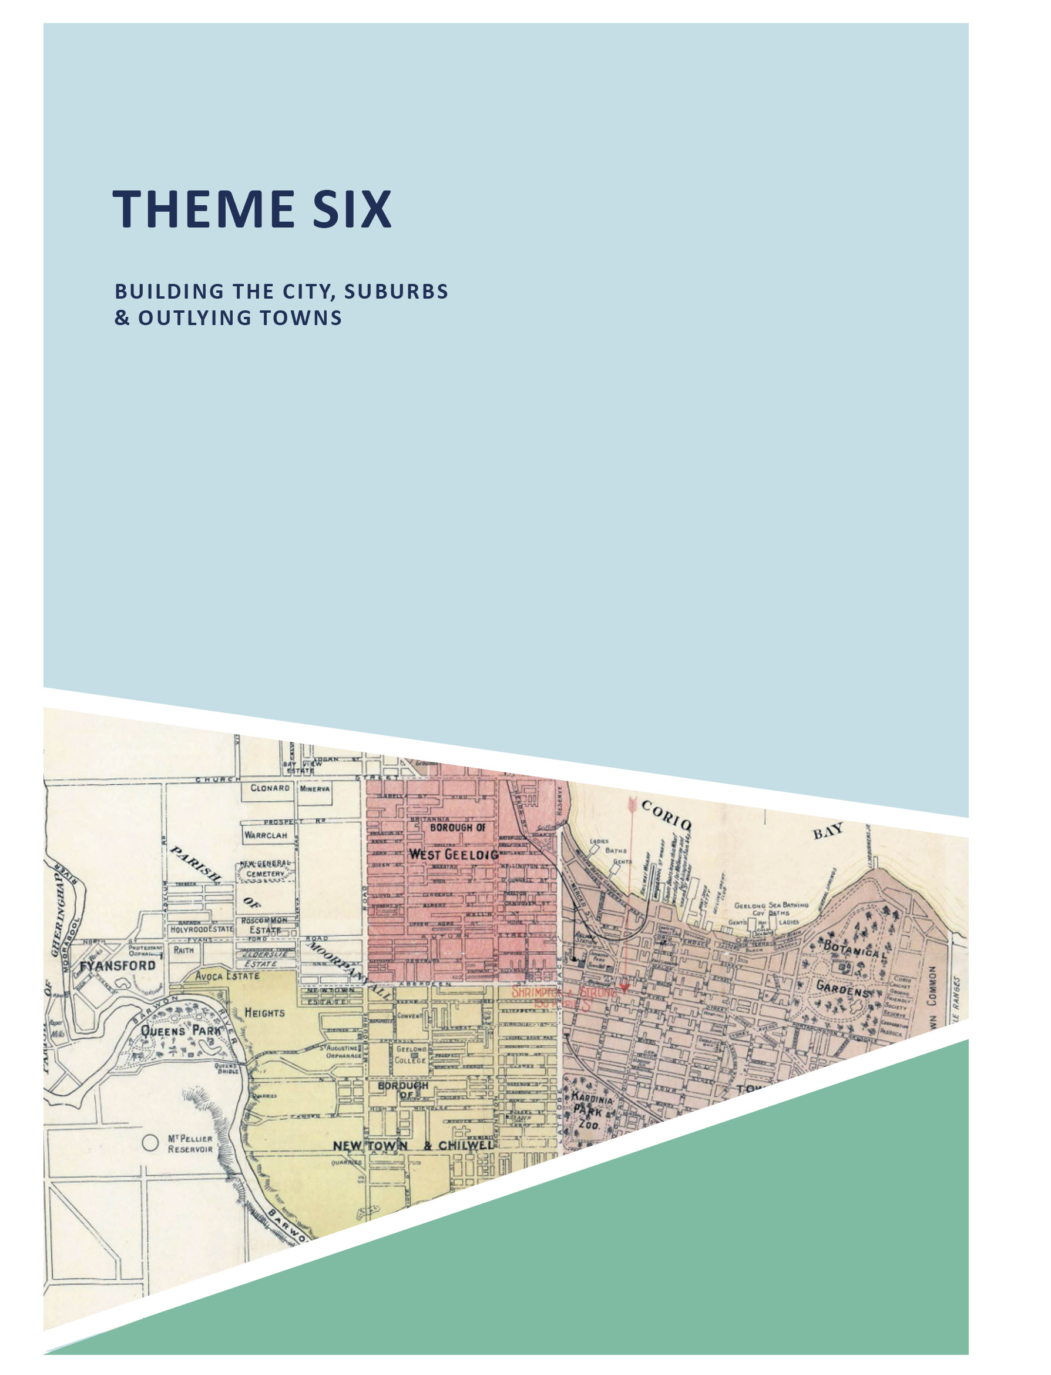
ABOUT CORAYO: A THEMATIC HISTORY OF GREATER GEELONG 654

  - INTRODUCTION
This theme begins with a brief overview of the boundaries of the Traditional Owners of Greater Geelong Country.
The theme also explores the structures of the Wadawurrung: the home shelters called mia mias
that were erected in close proximity to water and which were purposely ephemeral.
The order and way of life of the Wadawurrung was changed forever with the arrival of Europeans at Point Henry in the mid-1830s. A key aspect of this theme is an analysis of the selection of a site for the Township of Geelong, together with the surveying of the town by H.W.H. Smythe on orders (and planning principles) of Robert Hoddle, Government Surveyor, in 1838. The eventual plan provided for a grid layout similar to that designed for Melbourne (but with improvements governed by miasmic theory). An appreciation of the origins of the town name, Geelong and several streets - based
on Wadawurrung meanings - is given. This provides the initial basis of a chronological overview of the evolution and development of Geelong as a regional city from the 1830s until the present day, including land sales, provision of infrastructure (street construction, kerb and channelling,
footpaths, street lighting and later traffic lights and car parking metres) and the construction of buildings that have defined the City at different periods.
An overview is then given of the suburban communities in Geelong that were first shown on a plan of the area by
H.W.H. Smythe in 1839. The suburbs and centres of Point Henry, Newtown and Chilwell, Geelong West, North Geelong, Rippleside, Drumcondra (as the Lunan and Drumcondra Estates), Fyansford, Herne Hill, Manifold Heights, Hamlyn Heights, Bell Post Hill, Bell Park, Belmont and Cowies Creek (Corio) are explored. Their chronological development
is outlined through subdivision layouts (including some distinctive subdivision plans based on planning principles at different periods in history), cultural and environmental influences, building construction, infrastructure and landscaping.
Similarly, the other suburbs and settlements outside the early plan of 1839 are also outlined. They are detailed through
five regions: Northern and North Western Region (Anakie, Balliang, Batesford, Corio, Lara, Lovely Banks, Norlane, North Shore, Little River (including Rothwell and Ascot), Staughton Vale and Sutherlands Creek); Southern Region (Connewarre, Grovedale, Marshall (including the area now known as Charlemont) and Mount Duneed); Eastern Region (East Geelong, Breakwater, Newcomb, St. Albans Park
and Whittington); Far Eastern and South- Eastern Regions (including Barwon Heads, Breamlea, Curlewis, Drysdale, Leopold, Mannerim, Marcus Hill, Moolap, Murradoc, Newington, Wallington, Clifton Springs, Indented Head, Ocean Grove, Portarlington and St. Leonards); and the Western and South-Western Regions (Ceres, Barrabool Hills, Highton and Waurn Ponds).

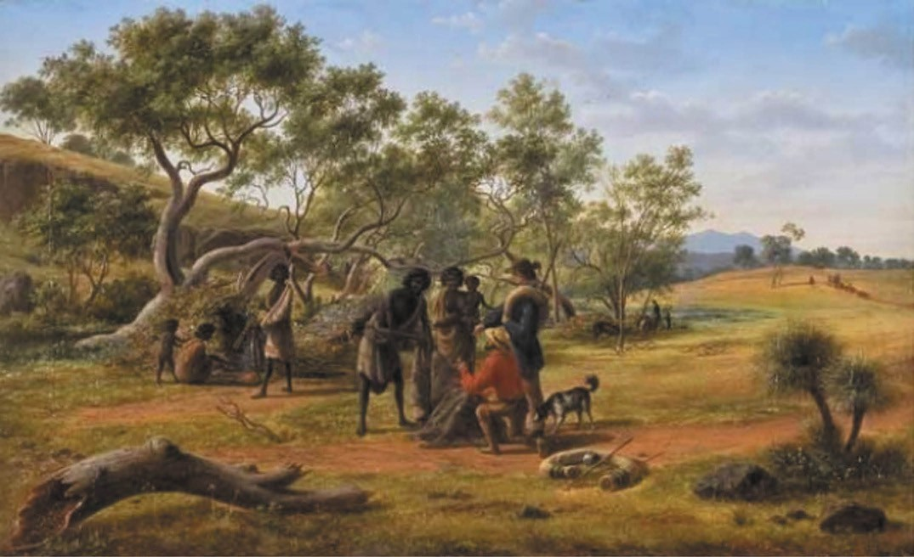
Figure 6.01: Eugene Von Guerard, Aborigines met on the road to the diggings , oil on canvas. Collection Geelong Gallery. Gift of W. Max Bell & Norman Belcher, 1923, accession 1923.2.

THE WADAWURRUNG: LIVING AND BUILDING ON COUNTRY

WADAWURRUNG CLAN BOUNDARIES IN GREATER GEELONG
The City of Greater Geelong forms a portion of Wadawurrung Country. The whole boundary extended from the Werribee River to Painkalac Creek, Aireys Inlet on the coastline of Bass Strait (and included the Bellarine Peninsula), and inland to the Barwon River, Winchelsea and north-west to Ballarat.1
A strong, influential and proud people, the Wadawurrung comprised a cluster 25 clans across its boundary2 (see Theme 2 for further details).
The sub-boundaries of the various clans of Wadawurrung were partly akin to suburbs that form a planning framework of the City of Greater Geelong today. These sub-boundaries were planned, sophisticated and governed by the cultural beliefs of the Wadawurrung, and seasonal changes that gave
opportunities for a range of food sources at select locations at different times of the year.3

STRUCTURES OF THE WADAWURRUNG HOME SHELTERS
Few natural shelters of the Wadawurrung are publicly known.
At Point Lonsdale outside the City of Greater Geelong a coastal cliff cave is known as Buckley s Cave , reputedly inhabited at times by William Buckley following his escape from the Sorrento colony in 1803.4 Other similar caves and rock overhangs were used by the Wadawurrung.5
Through the necessities of warmth and ailment, the clan council chose the locations where purpose-built home shelters were to be erected. Called mia mias, these were situated in close proximity of water and sheltered as much as possible from prevailing winds. According to William Buckley, these shelters were merely branches of trees thrown across each other, with slips of tea-tree and pieces of
bark placed over as an additional shelter. 6 On his expedition in 1802, Captain Matthew Flinders noted the huts of the ‘Indians’ (Wadawurrung), including ‘a hut with a fire in it’,7
but no further description was given. However, Flinders comment revealed that the designs of the mia mias of the Wadawurrung were sophisticated in allowing fires for warmth in addition to shelter from the weather. The next earliest

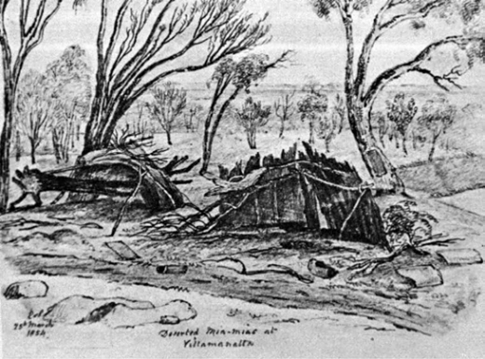
Figure 6.02: Emma von Stieglitz, Deserted Mia Mias at Villamanatta, 25 March 1854. Source: E. von Steiglitz
(K. R. von Stieglitz ed.), Her Port Phillip & Victorian Album, K.R. von Stieglitz, Hobart, 1964.
European description of Wadawurrung home shelters of the Bengalit balug clan was given by John Batman on his
landing at St. Leonards in 1835. He noted a village of huts or gunyahs , which had been used as the clan s marine villas .8
Given the purposely ephemeral nature of the Wadawurrung s mia mias, no physical evidence survives of them today. The earliest illustrations include Eugene von Guerard s painting entitled Aborigines met on the road to the diggings , 1854, showing mia mias in the background (Figure 6.01), and Emma von Stieglitz s sketch of deserted mia mias at Villamanatta (near the You Yangs) (Figure 6.02) also of 1854.

THE MIRNIONGS
Ubiquitous throughout the clan locations of the Wadawurrung prior to European colonisation were mirniongs . These were dome-like earth mounds used for cooking and which marked the locations of the semi-permanent settlements of the clans and became an integral part of the landscape only after generations of the People had camped, periodically, in one particular and favourable spot for many decades. 9 Located in groups of two or three, the mirniongs were situated near fresh water, and particularly near the confluence of two streams, where rivers entered or flowed from a lake, and in places close to flora and fauna for harvesting.10 They were situated on elevated ground so that the occupiers had a clear overview
of the surroundings lest they were approached by human enemies; also far enough from the water so that the insects did not eat them alive. 11
The mirniongs represented the more enduring structures of the Wadawurrung given their function and construction, and because they partially extended below the ground surface. Lou Lane gave a detailed description of these once ubiquitous structures:

If possible, Aboriginal cooks chose clay-soil for their heir cooking-hearths. Mound-soil which contained a large proportion of sand also sufficed. [They were sometimes lined with cobblestones as a cooking element.]
Into this material they excavated a hollow with digging- sticks and wooden scoops, just large enough to accommodate the carcase they were about to cook.
A skilfully-built fire heated whatever cooking elements they chose to place in the pit –shards of rock or cobble-stones of a convenient size to be handled when red-hot or, perhaps, chunks of termite-mound or baked balls of
clay –all of which were capable of being heated until incandescent.
A variety of insulating material was available to envelope the flesh so that it would not scorch – feathers, grass, leaves or bark all doused with water.
There is not a shred of doubt that Aboriginal chefs understood the principles of cooking with superheated steam, for they habitually introduced more water into the oven during the cooking process. Hot sand and ashes and glowing embers were heaped on the lid of bark or clay laid over the pit in a cordon bleu style
a la braise.12
Some murniongs, also known as middens, are identified in coastal areas of Greater Geelong. They reveal discarded concentrations of shell, ash, bone and botanical remains, providing evidence of past Wadawurrung food processing activities (Figure 6.03).

WURDI YOUANG STONE ARRANGEMENT
The most intact, sophisticated, highly significant and enduring purpose-built structure of the Wadawurrung in Greater Geelong is the stone arrangement at Wurdi Youang near
Little River (Figure 8.01). Built thousands of years ago, the egg-shaped circle, marks astronomical and solar alignments, and is likely to have been an important ceremonial place, being a seasonal calendar and a keystone for local law and culture13 (see also Theme 8).
At Wurdi Youang today, in addition to the stone arrangement, is a round stone hut, a relatively recent replica of the Indigenous stone huts erected by Traditional Owners along the volcanic plains in south- western Victoria.14

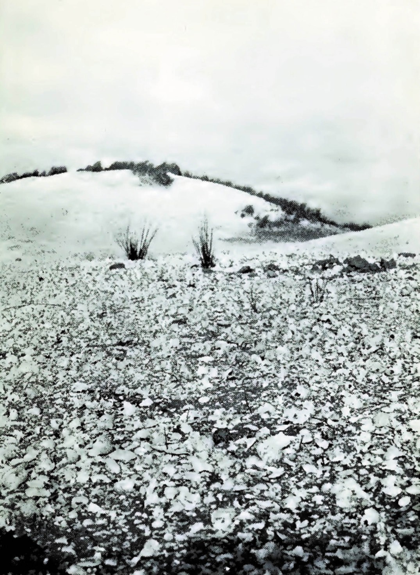
Figure 6.03: Midden in the sand dunes at Breamlea, c.1914. Source: C.F. Belcher, The Birds of the District of Geelong, 1914, p.50a.

GEELONG THE REGIONAL CITY

TOWN SITE SELECTION
In March 1837, the Governor of the Colony of New South Wales, Sir Richard Bourke visited the area that was to become known as Geelong given that a settlement had been established by European settlers in 1836.15 The aim of his visit was to ascertain the possibility of formalising a town there. Impressed by the locality, describing it as
a gentleman s park that ought to be the capital of the province ,16 he remarked that the ‘beautiful flat behind Corroia [Corio Bay] would answer well for a Township if fresh water could be obtained. 17 Having encamped adjacent to David Fisher s house near the northern bank of the Barwon River (this being claimed as the first European house in Geelong, built of timber weatherboards from Tasmania),18 the Governor s favoured location however, was Point Henry, the place of disembarkation and the location of a small number of European settlers.19 The Government Surveyor, Robert Hoddle, also came to Geelong at the same time in order to
gain an appreciation of the place in readiness for the layout of a town.20
Further investigations into the location of a township did not eventuate until the appointment of Captain Foster Fyans
as Police Magistrate on 5 September 1837.21 In addition to affording police protection Fyans was charged with exploring a suitable site for a town. By November 1837, he reported
on five locations: Point Henry (which had ‘great advantages’ given the good ground and excellent anchorage for ships but the water was of the very worst kind); Indented Head (which boasted the finest country Fyans had seen but water was extremely scarce ); Barwon River close to Mr Fisher s house (the location was considered a most eligible site
for a town’ with ‘fine fresh water’ for eight months of the year and only a mile and a quarter from Corio Bay); the Moorabool River (where one or two sites were considered to be good but the water bad from salt springs during many
months) and a site higher on the Moorabool River (where the water was always fresh but the location being more than three miles from the Bay , with steep and lofty Hills to pass over ).22 These locations were generally shown on a Map of the Geelong District by A.J. Skene eight years later in 1845 (Figure 6.04). Ultimately, Fyans suggested either this Upper Moorabool River site, or a site between Corio Bay and the Barwon River near Mr Fisher s house.23 This house had a frontage to Barwon Terrace between Moorabool and Yarra Streets.24

Following Fyans report, Hoddle was instructed to visit Geelong again to determine whether the Governor s wishes for a settlement at Point Henry could be met. In March 1838 he first examined Point Henry with Charles Grimes’ map at hand which described the area as swamps (see Theme 2). Hoddle found no fresh water whatever .25 He then examined the neighbourhood of Corio (Geelong) and the inner harbour (Corio Bay) where there is a bar of 19 feet at high water mark and where vessels frequently unload. 26 Hoddle concurred with Fyans advice that this be the location of the township of Geelong.

LAYOUT OF THE GEELONG TOWNSHIP
The earliest town plan of Geelong appears to have been a sketch prepared by Hoddle during his visit. Comprising two distinct areas based on a rectangular grid layout,
the southern-most area, subdivided into eight sections (allotments 1-8), was to be the main residential section beside the fresh water source of the Barwon River (Figure 6.05). The commercial section was to front Corio Bay and comprising three sections (allotments 9-11), therefore enabling persons to erect stores at Corio. 27 A main road, Bellerine Street, was to link what was initially to become known as North and South Geelong.
Hoddle subsequently directed Assistant Surveyor,
Henry Wilson Hutchinson Smythe to survey the proposed township at Geelong as well as reserve land for a village at Fyansford. This was to ensure that there was a fresh
water supply all year round (given that fresh water was only available at Geelong for 8-9 months of the year).28
On 21 August 1837, Smythe s initial plan for Geelong
was furnished to the Deputy Surveyor-General in Sydney.29 It formalised Hoddle s original sketch. The plan was further developed and reviewed by Hoddle by May 1838, with the rectangular allotments between north and south Geelong surveyed and included in the town plan that extended from Corio Bay to the Barwon River, and Swanston Street to Gheringhap Street (Figure 6.06).
Precedent for the grid layout of the Geelong township lay with Hoddle s plan for Melbourne in 1837, and more broadly, planning regulations published by Governor Darling in
New South Wales in 1829.30 In relation to the latter, new towns were to conform to a rectangular grid pattern to ensure uniformity , although the natural terrain permitted modifications when the grid would
be impracticable:
Each Allotment will consist, as early as the nature of the ground and other accidental circumstances will permit, of Half an Acre of Land. Those on the Main Streets will
have a Frontage of One Chain and a Depth of Five Chains;

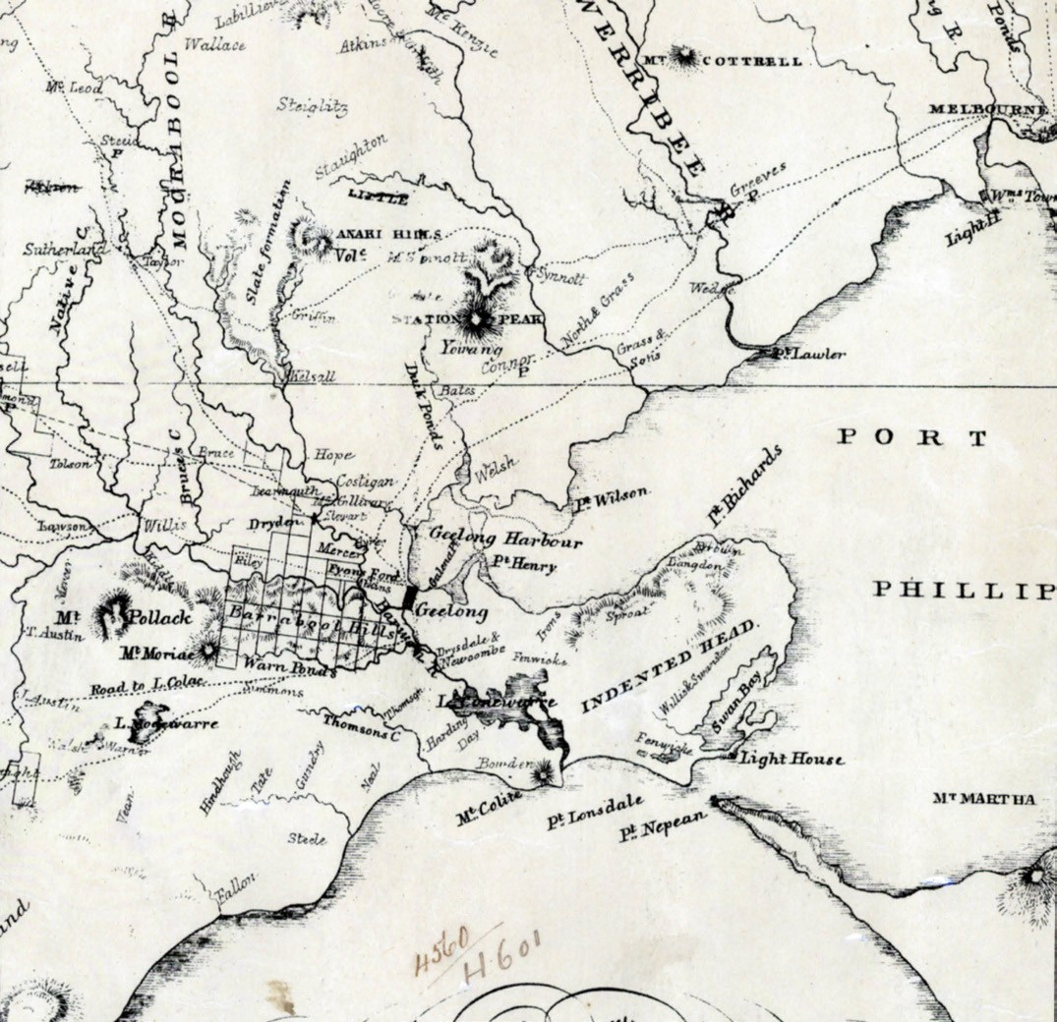
Figure 6.04: A.J. Skene, Portion of Map of Geelong & District, James Harrison, Advertiser Office, Geelong, 1845. Source: State Library of Victoria.

those in the cross or inferior streets a Front of Two and a Half Chains and A Depth of Two Chains. The distance, therefore between the main Streets will be Ten Chains.31
The Geelong plan was originally devised on half acre allotments but it was similar to the Melbourne grid in that lanes were included to provide rear access following a directive of Governor Bourke. As Hoddle advocated good ventilation in towns and due to the contemporary miasmatic
theory of disease, he ensured that the street widths were generous.32 However, the Geelong plan went further than Melbourne s in the provision of cross lanes to the corner allotments. This was favourably reported in 1841:
The allotments are laid out upon a plan which is an improvement upon the Melbourne scale; there being cross lanes into the corner allotments, which in Melbourne have no frontage except to the wide street.33

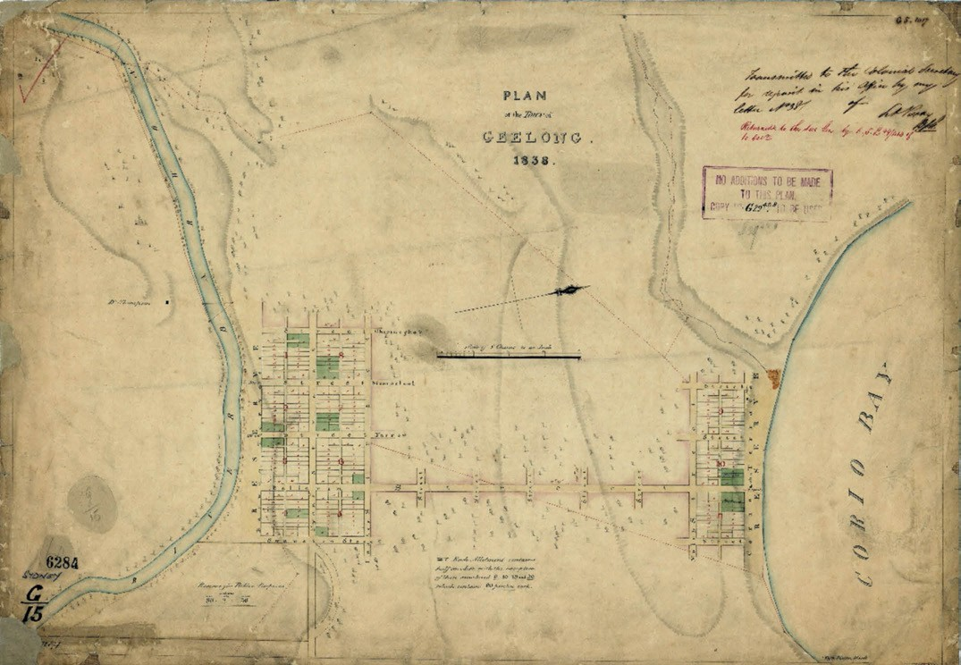
Figure 6.05: H.W.H. Smythe, Plan of the Town of Geelong, 1838. Source: VPRS 8168/P5, item Sydney G15: Geelong, Public Record Office Victoria.

Another key feature of Hoddle s plan for Geelong was
the provision of reserves for government purposes. Hoddle directed Smythe to include reserves for customs and other government purposes opposite Rucker s store fronting Corio Bay at North Geelong, and for reserves for public buildings including a school, hospital, church, parsonage and market square. At South Geelong, provision was also made for a court house, gaol, watch house, and separate barracks for soldiers and prisoners, and a cattle market. In the south-east corner, the Geelong plan also included a reserve for public purposes, the northern perimeter accentuated by a crescent.34 Burial grounds were reserved beyond the Town reserve to the east (Figure 6.06).
As directed by Governor Sir George Gipps, the name of the new township was to be adopted from that already used by the natives, and to avoid the use of names already
appropriated in other Countries. 35 Geelong was bestowed upon the township as a derivation of the Wadawurrung name, Djilang (meaning tongue, the whole of the land of
the Bellarine Peninsula that is in the shape of a tongue),36 although in the initial years at least, the name Corio was given to the northern portion of the town reserve.37 The Wadawurrung, Coriayo (Corio) meant salt water or sandy.38 The names of several of the original streets also derived from Wadawurrung language and meanings including Malop (the spear-head, corrupted from Moola , the tribal name of Point Henry where shell fish were gathered), Gheringehap (Gheringhap) (golden wattle), Moorabool (a place of ghosts or curlews), Yarrow (Yarra) (a lively stream), and Bellerin (Bellerine) (resting on an elbow).39 Other streets were named after prominent Europeans: Kilgour Street (after Dr James Kilgour, local surgeon between 1853 and 1859); Lonsdale Street (after William Lonsdale, soldier and administrator and first Police Magistrate at Port Phillip from 1836); Latrobe Terrace (after Charles La Trobe, first Superintendent of
Port Phillip and later first Lieutenant-Governor of Victoria); McKillop Street (possibly after Alexander McKillop, a Catholic from Scotland with strong links to Geelong pioneer,

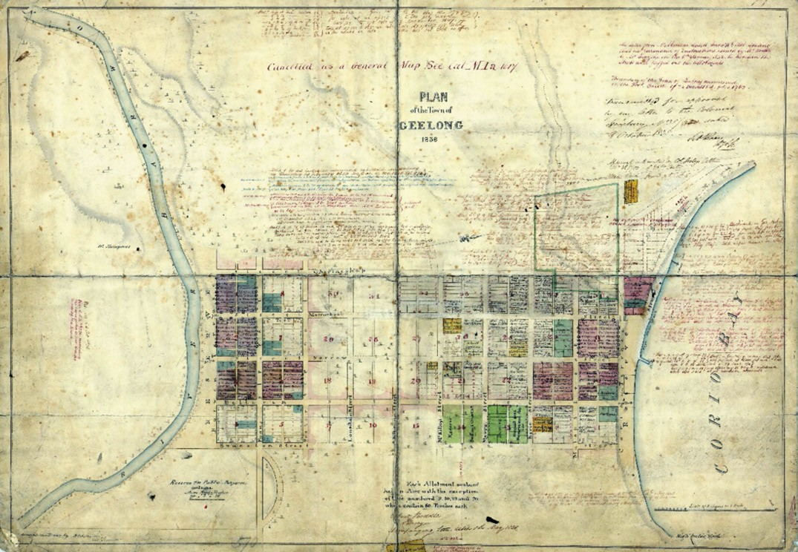
Figure 6.06: H.W.H. Smythe, Plan of the Town of Geelong, May 1838 (with handwritten additions added later). Source: VPRS 8168/P5, item FEAT 570: Geelong Town, Public Record Office Victoria.

Charles Swanston –and father of Sister Mary McKillop); Myers Street ( possibly after Dr George Myers, personal physician to Charles La Trobe); Ryrie Street (after the Ryrie Pastoral family, either Stewart or possibly his son, William, who was a notable sportsman and associated with surveyor
H.W.H. Smythe in the fledgling years of the Melbourne Club); and Swanston Street (English banker and merchant, and very early merchant and pastoralist in Geelong and district).40

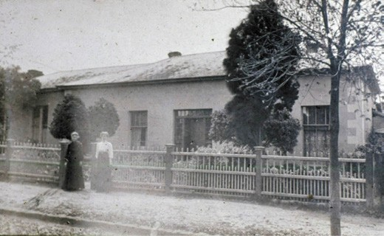
Figure 6.07: House, Barwon Terrace (between Moorabool & Yarra Streets), n.d., occupied by Edward Willis in the 1840s
(and owned by David Fisher). Source: Ian Wynd collection, Authentic Heritage Services Pty Ltd.

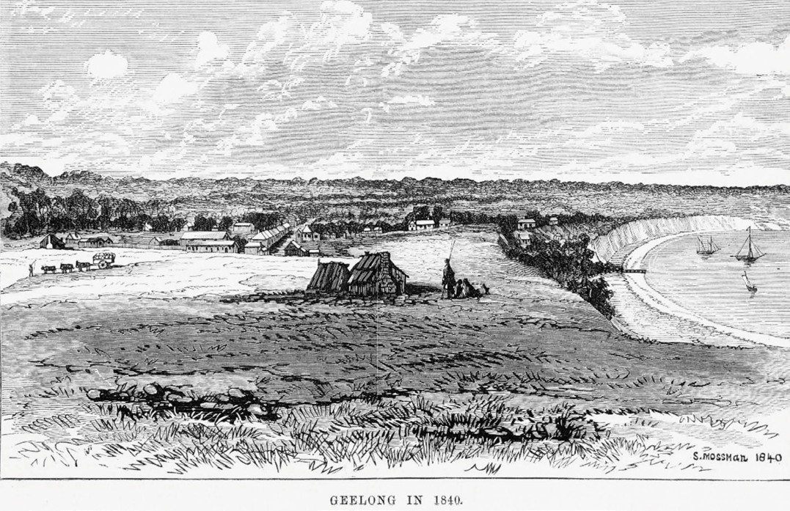
Figure 6.08: S. Mossman, Geelong in 1840 , Hugh George for Wilson and Mackinnon, Melbourne, 10 June 1876. Corio Street, with a row of buildings, is shown in the middle ground. Source: accession A/S10/06/76/45, State Library of Victoria.

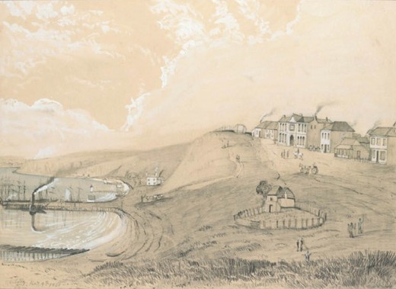
Figure 6.09: L.E.W. (unknown pupil of George Alexander Gilbert), Geelong Feb 9th 1850 , showing the Geelong waterfront. The large building (centre) in the middle ground was Mack s Hotel, Brougham Street. Source: accession H41.805, State Library of Victoria.

EARLY PROGRESS
Even before the first land sales, industrial progress had commenced with Patrick Melville working a lime quarry at Limeburner s Point, adjacent to Eastern Park, from 1838.41
The first land sales were held in February 1839 when 53 lots were offered in three blocks, two in South Geelong and one in North Geelong.42 A further sale occurred in 1840 when another 53 lots were offered.43 This sale brought about a frenzy of building activity in the fledgling township, with
two thirds of the town then consisting of buildings under construction.44 Commercial development was largely confined to the northern portion of the Geelong township, with some government structures and houses built at South Geelong.45 At this location, David Fisher s house was occupied by Edward Willis, son in law of Charles Swanston
of the Derwent Company.46 A new substantial brick dwelling (Figure 6.07) was constructed and occupied by Willis
and his family between 1843 and 1850.47 Other building

improvements in the southern parts included G.H. Rose s bricklaying and plastering establishment, Griffin’s Geelong Retreat Inn, Thomas Skinner s brickmaking works and Oliver Adams
Barwon Brewery.48

BUILDING DEVELOPMENTS IN ‘NORTH’ GEELONG
In 1840-41 and until 1850 in the northern portion of the newly- formed township reserve, building development was first centred along Corio Street (then known as Corio Terrace) (Figure 6.08). The small settlement could not be seen from Corio Bay because of the steep cliffs and sloping land to
the foreshore.49 There were at least 17 businesses in the fledgling thoroughfare at this time, including T.H. Bolger’s Corio Hotel, Dr Shaw s medical rooms, W. Gray s General Store, J. Moore s bakery, Miss St. John s millinery and dressmaking establishment, Robert Robinson s Commercial Hotel, Harding s ironmongery, Cashmore and Co. s merchant store and J and G. Myles grocery.50 The central or principal street was soon to become Yarra Street. At its northern end, access could be gained to the foreshore by a steeply- sloping track (Figure 6.09).
An insight into building progress at this time was given in the
Port Phillip Gazette:
Building goes on steadily; the houses are mostly of brick, and inhabited even before they are plastered. Mr. Strachan s new house, which is a handsome piece of masonry, is now finished, and is an ornament to the
beautiful bay. The new police court, the fruit of Sir George Gipps visit, is rising rapidly; it is half way between the two Corios [north- east corner of Yarra and McKillop Streets], opposite the Presbyterian church, with a good foundation and altogether well planned and situated. The new watchhouse, at South Corio, is finished and inhabited.
The Presbyterian church had the novelty of possessing six sides; two were under the necessity of being rebuilt; this task is however now accomplished, and the roof will soon rest on its walls, it is to be hoped, in safety. We hear of, but do not see any other place of worship rising into consistency; the Episcopalian church looks very well
on paper. Education holds its steady way; Mr. Stewart s school has done well at North Corio; there is to be one at South Corio shortly for girls.51

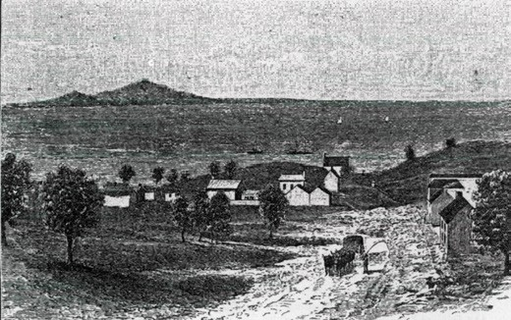
Figure 6.10: Yarra Street, looking north to Corio Bay, 1842. Source:
A. Henderson, Victoria & Its Metropolis, Past and Present, vol.1, p. 163.

OTHER DEVELOPMENTS
A key development from the 1840s was the establishment of the wool trade in Geelong, given the town s close proximity to the sheep grazing region of the Western District. Woolstores and warehouses were soon erected in Corio Terrace (Brougham Street) for the recently-arrived woolbrokers included F.J. Strachan and Co., Swanston Willis and Co., and Dalgety Ibbotson and Co. (see Theme 5).
Until 1842, the northern and south portions of the Geelong township reserve remained divided and linked only by a track. Samuel Mossman described his experience of traversing between the two settlements:
As to the traversing the track to the south side, it was a slippery walk then, especially at night, when pedestrians were apt to get astray, or bogged in the swamp in the Market Square.52
In 1842, trees were cleared in Yarra Street (Figure 6.10) which the Geelong Advertiser reported in glowing terms:
The clearing of Yarra Street from trees is one of the most striking improvements that have lately been
made in the town. Not only has a splendid view been opened up, but the road between North and South Geelong will be shortened one half, in appearance if not in reality.53
An obstacle for travel to Belmont and further afield was the Barwon River. By 1842, a punt had been established immediately east of the south end of Moorabool Street.54 It
was replaced in 1848 by a timber bridge known as the Barwon Bridge (and sometimes the Kardinia Bridge) (Figure 3.21, see

Theme 3) erected by Henry Harrison under the guidance of Superintendent of Bridges, David Lennox.55 The bridge was later swept away in 1852 and punts re-established, forming a pontoon in 1853. The pontoon was replaced with an iron bridge in 1855-56 (see Theme 3 for further details).56
Notwithstanding the challenges of the river crossing, progress continued in central Geelong at a steady pace in the 1840s and 1850s. In 1845, the population of the town (and suburbs) was 3,810, with 406 houses.57 One of Geelong s tallest buildings built in 1854 for John Jackson was Clarence Tavern Inn in Gheringhap Street.58 (Figure 6.11). Later known as Jackson s Folly given Jackson s sanguine anticipation of a booming future for Geelong at the height of the Victorian goldrush (which was never realised),59 it served as the Geelong Corporation Chambers in 1855 and was converted into a Sub-Treasury building in 1862. The building has subsequently been demolished (see also Theme 7).60 Another landmark erected in Corio Terrace overlooking Corio Bay between Moorabool and Yarra Street was the Wool Pack Inn (later known as Mack s Hotel), a two storey bluestone structure built in 1846 (now demolished).61 A plaque marks the location of the former Mack s Hotel in Brougham Street, adjacent to the Westfield Shopping Centre. Confidence in the town came through additional land sales and leases. In 1848, 11 allotments in Section 37 (between Moorabool and Gheringhap Streets, and Corio Street and the Corio Bay foreshore) were surveyed. Two lots were reserved for the Government where the Western Gully traversed the land.62
It was also in 1848 when a timber jetty was erected on the
foreshore at the northern end of Moorabool Street.63 A roadway was formed in 1852 through a cut in Yarra-street to provide improved access to the foreshore.64
The year 1848 also witnessed the reservation of 59 acres for ornamental gardens between Ryrie Street and Brougham Place (east of Latrobe Terrace).65 It was later to be called Johnstone Park (see Theme 9). An even more substantial reserve for a botanic garden and park was reserved a few years later in 1851, east of the town reserve in Garden Street (see Theme 9).
Industries were established along the river at this time and they included a steam flour mill in 1845 by W.H. Collins at South Geelong. Other flour mills followed in the ensuing years, as did Michael Donaghy s rope works business at Chilwell in 1852 (the business relocated to Geelong West in 1878)66 (see Theme 5).
In December 1850, Robert Hoddle prepared a plan for multiple allotments to the north-west of the town reserve comprising sections 38 and 39. These lots were bound by Victoria Terrace (now Western Beach Road), Gheringhap Street to
the east, Mercer Street to the west and Brougham Place to the south. It resulted in the formation of Cavendish Street,

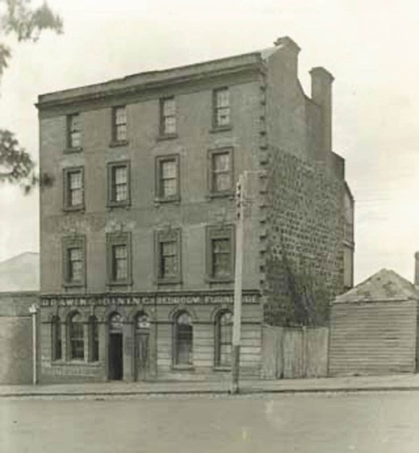
Figure 6.11: Jackson s Folly , Gheringhap Street, c.1900, one of Geelong s tallest buildings in the 19th century.
Source: GRS 6391/0, Geelong Heritage Centre collection.

Smythe Street and George Street (now known as Malone Street), the land taking up the entire southern frontage of this street having been reserved for the Catholic Church.67
In 1853, J.B. Hutton advertised the lease of 14 half an acre lots by public competition extending from Corio Terrace
to Corio Street (Figure 6.12). The land was described as Splendid Town Allotments fronting Corio Terrace, near Mack s hotel (and in Corio-street), unquestionably the most Valuable Building Sites in the town of Geelong. 68
The early 1850s witnessed shortages of building materials and labour as a consequence of the Victorian gold rush. This led to the importation of prefabricated buildings. A most notable and enduring legacy of this early prefabrication building solution is Corio Villa, 56- 58 Eastern Beach Road (Figure 6.13). One of the most elaborate prefabricated cast iron houses in Australia, the dwelling was manufactured by the Scottish iorn founders, Robertson and Lister, to a design by Bell and Miller.69 Originally purchased by William Nairn Gray, Commissioner of Crown Lands for the Portland Bay district between 1851 and 1854, it was purchased by Alfred Douglass after pieces remained unclaimed at Cunningham Pier due to Gray s death.70 It was erected on its current site in 1856, the form not directly following the original prototype given its erection without plans.71

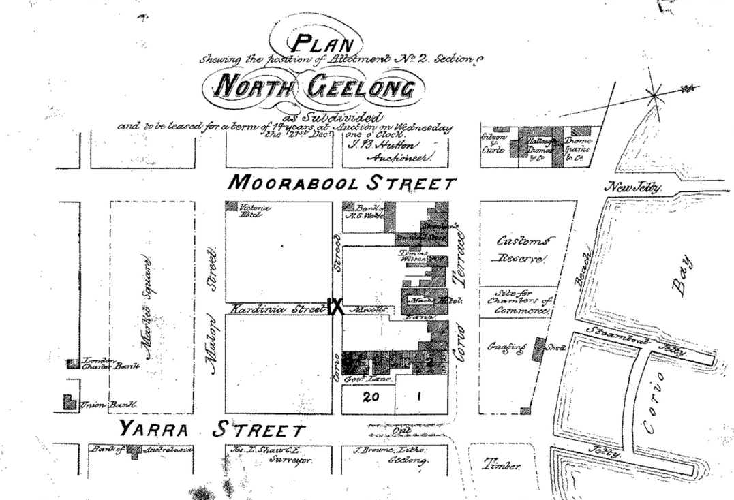
Figure 6.12: J.L. Shaw, Plan shewing the position of Allotment No. 2 Section 9, North Geelong. Source: map N44, Geelong Heritage Centre collection.
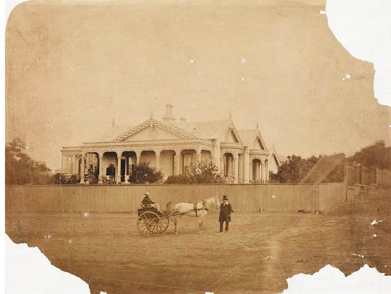

Figure 6.13: Corio Villa, Eastern Beach Road (then Victoria Terrace), c.1861. Source: accession H2177, State Library
of Victoria.

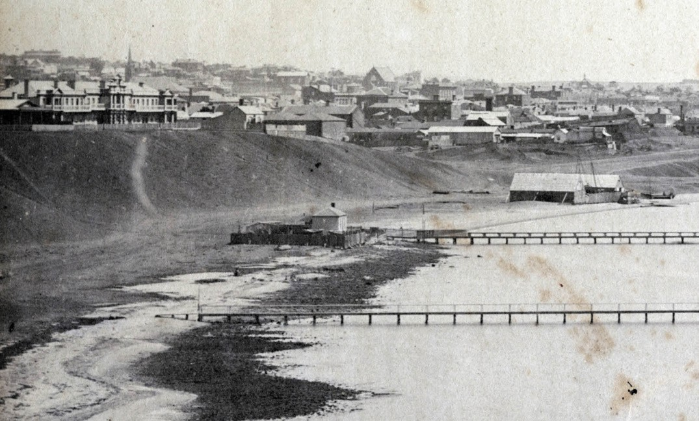

Figure 6.14: Geelong Harbour (Eastern baths) showing Singapore Terrace (circled), n.d., pre 1862. Source: GRS 2009/1232, Geelong Heritage Centre collection.

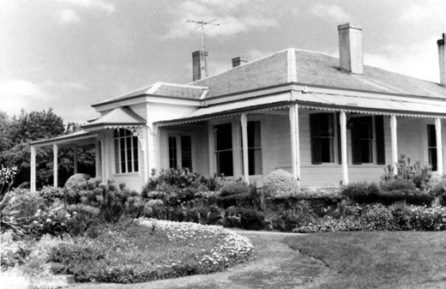
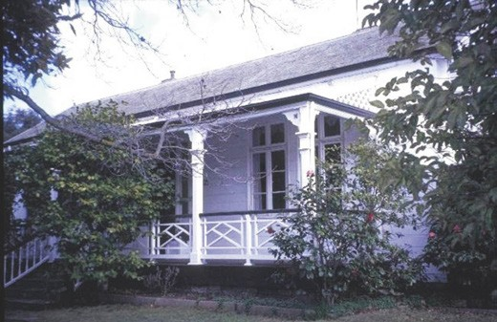

Figure 6.15: J.T. Collins, The Heights, Aphrasia St, 7 November 1975. Source: accession H96.210/4759, State Library of Victoria.
Figure 6.16: Keyham , 275 Pakington Street, Newtown, 2003. Source: Heritage Victoria, Victorian Heritage Database online.

Other imported prefabricated dwellings were of timber construction, many by the Scottish entrepreneur, Alexander Fyfe. In 1853 while enroute to Edinburgh, Fyfe went to Singapore.72 He had realised that timber and other building products, and labour, were scarce in Victoria and so he embarked on a large mercantile speculation, chartering
three vessels from Singapore direct to Geelong with building materials (including Singapore cedar) and prefabricated houses.73 Fyfe had numerous Chinese labourers emigrate to erect the houses which he sold and in some cases, let.
His most substantial prefabricated house construction was Singapore Terrace (Figure 6.14), claimed as Geelong s

greatest ornament of the Esplanade overlooking the Eastern Beach. 74 The row of two storey terrace houses were located immediately west of Swanston Street with a
frontage overlooking Corio Bay. They were destroyed by fire in 1862.75 However, nearby in Swanston Street, Fyfe also erected a two storey prefabricated dwelling built of Singapore cedar. It may have been identical in design to those houses used to form Singapore Terrace. Originally known as
Fyfe House it was built in 1854-5576 and survives today, albeit with introduced wall cladding. While the dwelling may not be aesthetically pleasing, it is a unique and very rare two storey example of Fyfe s imported Singapore houses in inner Geelong.
A number of prefabricated timber dwellings were also imported from Germany. In 1854, the German importer and ironmonger of Ryrie Street, Friedrich Bauer, advertised the sale of twelve, four-roomed wooden houses from Hamburg that had recently arrived on the Amethyst.77 Bauer s own house, Raith , Newtown, may have comprised one of these dwelling as it was erected in September of that year (see later subsection for further details).
A notable and surviving of example of a German imported dwelling is The Heights , Newtown (Figure 6.15), erected in 1854 for Charles Ibbotson.78 The work was supervised by the architect, Edward Prowse, who also designed and had
constructed three-four additional rooms (including a nursery). Further extended at different times, The Heights (as the property as later named) remained under the ownership of Ibbotson until his death in 1886. Born about 1815 to Samuel Ibbotson and Martha Hyde,79 in c.1834 Charles Ibbotson emigrated to the Australian Colonies and worked in Sydney as a Clerk. It was there in 1837 where he married Mary Anne Dickins (c.1815-1882).80 By 1 July 1852, Ibbotson was in partnership with F.G. Dalgety and they formed the pastoral company, Dalgety, Ibbotson and Co.81
The house is constructed of Swiss oak and was first put together in Switzerland, and then sent out in sections from that country. All the boards in it have numbers on them, and the nails used in its construction were made by hand. When the materials for the house arrived, the plans, which had been sent out with them, could not be found, and it was not until some 6 months had elapsed that they were discovered in the Custom House shed.84
Buckland had emigrated from England to Sydney in before c.1819.85 It was at this time in India when he married
Miss Clarissa Soby Smith.86 They relocated to India where two of their children were born. By 1830, they had returned to Sydney.87 In 1848, they relocated to Geelong where their son, John Jeffreys Buckland, became a customs officer (see Theme 7). They lived Elswick Cottage in Skene Street, Newtown and offered it for sale in early 1854 when they

returned home to England.88 It was on their return to Geelong in October 1857 when the surviving prefabricated timber Swiss cottage appears to have been erected.89 Named Keyham (Figure 6.16) after a place in Leicestershire,90 Buckland sold the property to his son, Stephen Vines Buckland (1831-1886) in 1859.91 S.V. Buckland had entered the legal office of Charles Sladen and a Mr Martyr, solicitors and was admitted to practice as an attorney in 1855.92
He took over the legal firm with others under the name Taylor, Buckland, and Gates.93 For 14 years, Buckland was Mayor of the Newtown and Chilwell Council.94
By 1857, the population in Geelong had increased to 23,314 and there were 6,008 houses.95 At least 17 architects were resident in Geelong and Ashby by this time, along with a small number of surveyors and importantly, hundreds of tradesmen, including builders, bricklayers, slaters, carpenters, plumbers, stonemasons, painters and plasterers. A list of those resident at this time is included as Appendix 6.1.96
A basis for Geelong s expansion may have been the opening of the Geelong and Melbourne Railway line on 25 June 1857, providing greater ease of travel between the Victorian capital and Geelong97 (see Theme 3). Telegraph communications were improved at this time with the building of a new Telegraph Station in Ryrie Street. The increase in population brought about further expansion of the town reserve. In 1850, Robert Hoddle laid out an extension on the west side (Figure 6.17). The wedge-shaped layout included multiple
allotments between Gheringhap Street and Latrobe Terrace, a northern portion having previously been reserved in 1848 for ornamental gardens (Johnstone Park –see Theme 9).98
A more dynamic plan was prepared in 1854 for an eastern extension of the town reserve by Edward Bage, under instruction from the Surveyor-General, Andrew Clarke99 (Figure 6.18). The provision of crescents and gardens, allowing a balance between development and public
open space, reflected Clarke’s desire to continue Hoddle’s quest for integrating public reserves in town plans.
Such a scheme was contemporaneous with St. Vincent Place,
South Melbourne, and reflected the growing confidence and prosperity brought about by Victoria s goldrush.100 The emphasis on crescent layouts (for Pevensey Crescent,
Bourke Street [now Bourke Crescent] and Richmond Place), and the St. Andrew s cross layout for Sydney Place North, South, East and West –now Sydney Avenue and Sydney Place) and Fitzroy Street, lacked the orderliness of the
St. Vincent Place design but was nonetheless appealing for its gardenesque layout also based on British urban precedents and particularly planned square developments in London.101 The street names: Pevensey, Richmond, Bourke and Fitzroy, were all derived from English places and names from the Norman period (1066-1485).102

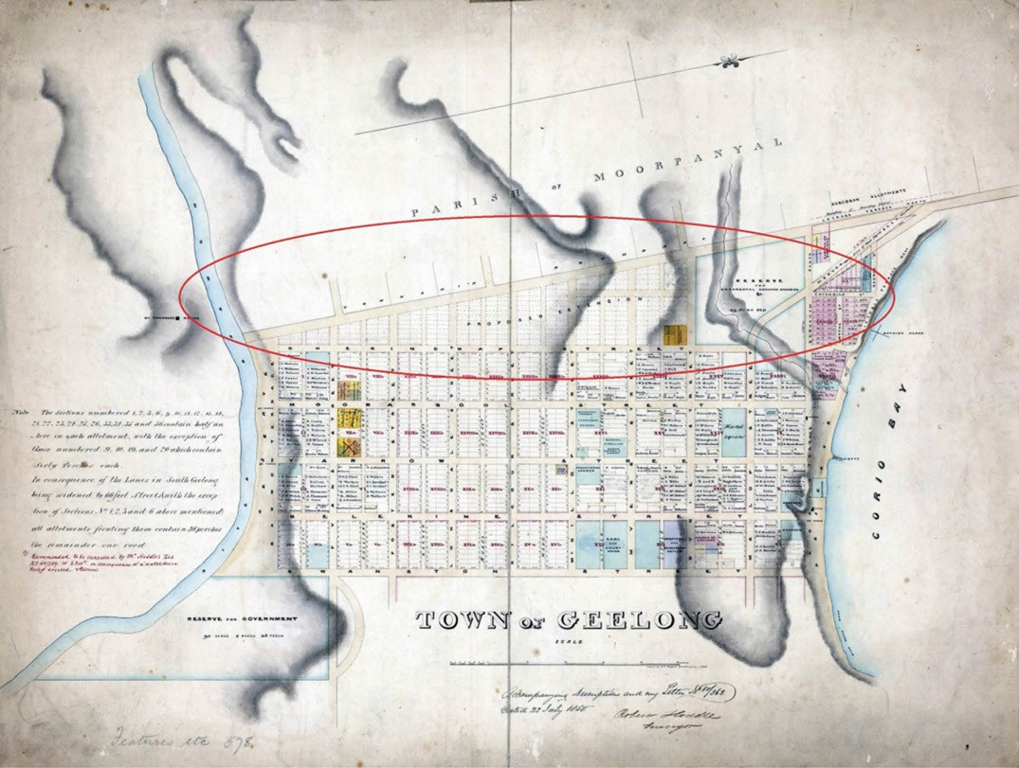
Figure 6.17: R. Hoddle, Town of Geelong showing proposed extension, 23 July 1850. Source: VPRS 8168/P5 item FEAT 578: Geelong Proposed Extension, Public Record Office Victoria.

Several dwellings were constructed in the eastern extension from the 1850s. A large and notable surviving example
is Merchiston Hall , 2a Garden Street (Figure 6.19). The rendered brick Victorian Georgian mansion was built in 1856 for James Cowie, European squatter, pioneer and businessman, to a design by the early Geelong architects, Backhouse and Reynolds.103
Commercial confidence came with the construction of grand bank buildings at the western end of Malop Street in the late 1850s (see Theme 5).
Cultural life progressed throughout this period through the establishment of several social services, and other institutions and organisations, including the Geelong Benevolent Society (1843 –this led to the building of the Geelong Hospital in Ryrie Street in 1850), Chamber of
Commerce in Moorabool Street (1858), Agricultural Society (1855), and the Comunn na Feinne Society (1856) (see Theme 2). Also known as the Fingalian Society, the Comunn na Feinne had a vision for creating an inclusive, harmonious and just environment.’ Significantly, and unlike other European societies in Geelong, this vision included the local Wadawurrung peoples from 1857, through charitable works and encouraging their active participation in the sporting competitions at the annual Highland gatherings.104 From 1858, the Wadawurrung performed Welcome to Country ceremonies through the staging of Corroborees on the eve
of the Highland Games (in the presence of members of the Society and local townspeople), being one of the earliest

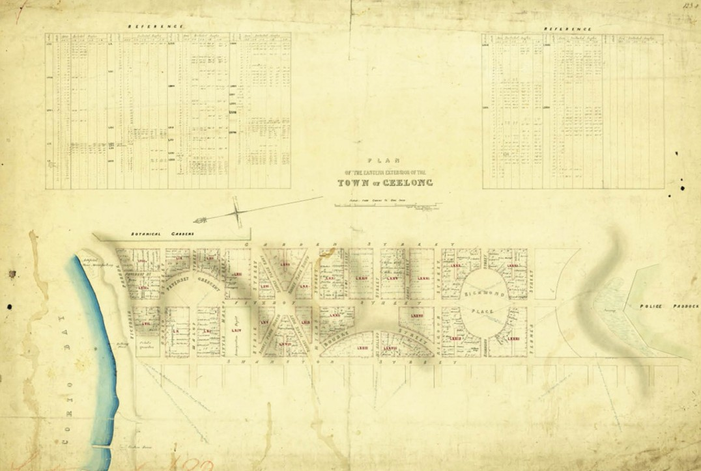
Figure 6.18: E. Bage, Plan of the Eastern Extension of the Town of Geelong, 5 August 1854. Source: VPRS 8168/P5 item FEAT 582: Geelong Eastern Extension, Public Record Office Victoria.

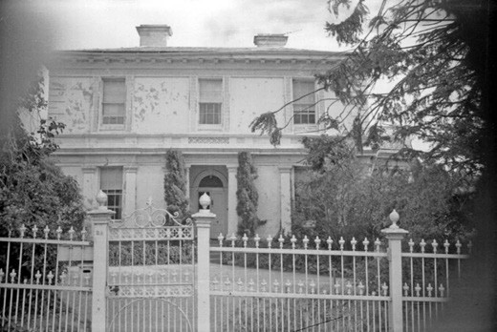

Figure 6.19: Merchiston Hall, 2A Garden St, n.d.
Source: Wynd collection, Authentic Heritage Services Pty Ltd.
recorded regular European events that recognised and respected local Indigenous culture105 (see Theme 2 for further details). Other community organisations that were a key to Geelong s cultural and social life followed in later years (see Theme 2).
Religious life advanced in central Geelong from the earliest beginnings of colonisation. In addition to the construction of St. Andrew s Presbyterian Church in Yarra Street in 1841 and Christ Church Anglican Church at the corner of Moorabool and McKillop Streets in 1843-47,106 other mid-19th century churches were founded in Geelong. They included St
Mary s of the Angels Catholic Church in Yarra Street (built in 1842 and replaced in 1846 with a freestone building prior to the building of the existing Basilica, erected in stages from 1854),107 Wesleyan Methodist Church in Yarra Street (built in 1844 having replaced a temporary chapel erected in 1842),108 St. Paul s Anglican Church, Latrobe Terrace (built in 1850),109 Jewish Synagogue, corner of McKillop and Yarra
Streets (built in 1854),110 Free Presbyterian Chapel, corner of

Myers Street and Latrobe Terrace (built in 1859 with services previously held in the school house built in 1854)111 and the Ryrie Street United Presbyterian Church built in 1857.112 Other Churches followed in later years (see Theme 8).
Education was first available for the town’s new inhabitants from 1841 when Miss Kate Fulloon opened a Day School
in Yarra Street (see Theme 8). Other parochial and denominational schools followed, including the Geelong Grammar School which opened in 1855 (the first purpose- built school for the Grammar School, built in 1857- 58, survives at 55 Maud Street).113 Flinders School (now Matthew Flinders Girls School), Myers Street, was built as a national school in 1856.114 Other public, state and private schools followed –see Theme 8 for further details.

STREETSCAPE AND ENGINEERING INFRASTRUCTURE
Several notable streetscape and other infrastructure improvements were made to the central township area in the 1850s. Following the incorporation of the Geelong Town Council in 1849, a substantial list of streetscape and other improvements to the central township area was prepared
in the following year, 1850. Estimated to cost £750,000, the works proposed included a public cemetery, improving the breakwater, improvements and repairs to the streets,
street lighting and the erection of municipal and government buildings and a hospital.115 The program of public works was considered essential to keep pace with the rapidly growing town.116 One of the first initiatives in 1849 was the construction of another stone jetty at Corio Bay, this time at
the northern end of Moorabool Street.117 Works were delayed and it was not until 1854 when the jetty –and the approach from the foot of Moorabool Street –was completed.118 The jetty, later known as a pier, was extended in 1856 (it was demolished in 1949 as part of the Port Development Scheme by the Geelong Harbour Trust).119 A plaque in the pavement in the foreshore at the north end of Moorabool Street commemorates the site of the original jetty.
In 1854, a loan of £200,000 –accepted by a Bill by the Legislative Council –was taken out with A. Gabrielli, who acted on behalf of overseas financers, Samuel Moreton Peto and Company.120 At South Geelong, the upper part of the hill had been lowered to the bridge at Moorabool Street, the
Grey s engine house and works that conveyed water from the Barwon River to a tank in Market Square had been completed (see Theme 4 for further details), and the proliferation of buildings in Mercer Street, Corio Terrace and other streets were notable.121 A cricket ground was laid out at South Geelong in 1854 which was first known as Corio Cricket Ground and was later renamed Kardinia Park.
Between McKillop Street and South Geelong, several streets were formed and buildings erected. A large project

in progress was the excavation of the northern end of Yarra Street, lowering the ground to sea level to provide
an accessible approach to the wharfs (completed in 1855).122 Reserves were laid out for customs and the docks along
the altered shore line.
Further improvements carried out at this time included the formation of bluestone kerbing and channelling, and the thickly metalling of streets and footpaths.123 Road forming and kerbing works were first carried out in Corio, Malop, Mercer, Ryrie and Yarra Streets124 (Figure 6.20). Improvements to Yarra Street were particularly costly.
As early as 1852, a roadway was formed through the gully
in the limestone cliffs at the north end of Yarra Street. Gravel from the excavation was used to improve the road to the steam boat wharf at the north end of Moorabool Street.125
By 1855, improvements had also been made to Moorabool, Little Malop, Ryrie, Little Ryrie, Myers, Little Myers and Brougham Streets, Eastern Beach Road (then known as Corio Terrace) and Latrobe Terrace.126 The transformation to the town s streets was marked, as described in the Geelong Advertiser and Intelligencer in 1855:
Miles upon miles of street which a year ago were quagmires are now beautifully formed and thickly metalled. Where the winter rain stagnated in pools of liquid mud, we have paved granite channel.127
Improvements were made to footpaths at this time.
Earlier described as mud banks, washed into miniature gullies at their outer edges ,128 the footpaths were initially gravelled and in 1855 there were complaints to the Geelong Town Corporation given its contractors were destroying Eastern Beach. Deep holes had been excavated on the beach and the sand was carted and bound to supply for the town footpaths according to contract. 129 In addition to the damage caused
to the Eastern Beach foreshore, it was commented that white sand and shells were not gravel,130 and therefore provided an unsatisfactory result.
Geelong s rapid increase in development resulted (in part) because of its proximity to the burgeoning goldfields at Steiglitz and particularly Ballarat. Point Henry was a popular place of disembarkation for gold seekers as Geelong was closer than Melbourne to these goldfields. Threatened by the growing confidence of Geelong, a false map (Figure 6.21) was produced by Melbourne merchants showing Melbourne closer to the western Victorian goldfields than Geelong. As reported in the Geelong Advertiser and Intelligencer:
A lie may be acted as well as spoken. A lie may be depicted as well as written. A lie may be lithographed, and disseminated far and wide, by surveyor s lines. A wantonly distorted map is a typographical lie, and of such lie certain parties in Melbourne are guilty of publication. We have

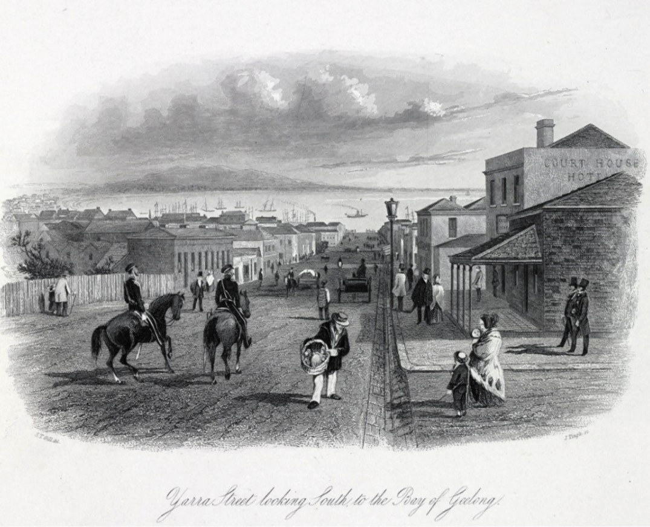

Figure 6.20: S.T. Gill, Yarra Street looking South, to the Bay of Geelong , Sands & Kenny, Melbourne, 1857. Note that the thoroughfare of Yarra Street had been completed, with the gully excavated at the north end. Source: Victoria Illustrated, State Library of Victoria.

before us an Annual Circular, , dated Melbourne, Victoria, Saturday, 27th May, 1854, printed in order to be sent “per Madras and Overland Mail, via Marseillas [sic]” Of this spurious production three sides folio consist of printed matter, the fourth side is filled with a lithographic, lying map, the object of which is to create false impressions of the geographical position of Melbourne, and the Victoria Gold Fields. To attain this object these malefactors of maps have disrupted nature, and made
of the mercantile community of Melbourne propagandi of deceit and falsehood, and of the basest injuries to their fellow colonists.131

MAPPING GEELONG’S DEVELOPMENT IN THE MID-19TH CENTURY
The extent of development in central Geelong by the early 1850s is shown in J.H. Taylor s Map of Geelong of 1854 (surveyed in 1853-54) (Figure 6.22). Much of the development was in the northern part of Geelong, centred around Market Square in Malop, Moorabool and Yarra Street, but also extending eastwards in the eastern extension , to the west (largely to Gheringhap Street) and to the south, the largest concentrations of buildings extending as far as McKillop Street. Development extended further south in far lesser numbers to Lonsdale Street, with buildings within the original town reserve not then connecting to South Geelong, where the largest concentration of building stock was in the sections bound by Foster, Fyans, Bellerine and Yarra Street, and with a lesser population between Fyans Street and Barwon Terrace.

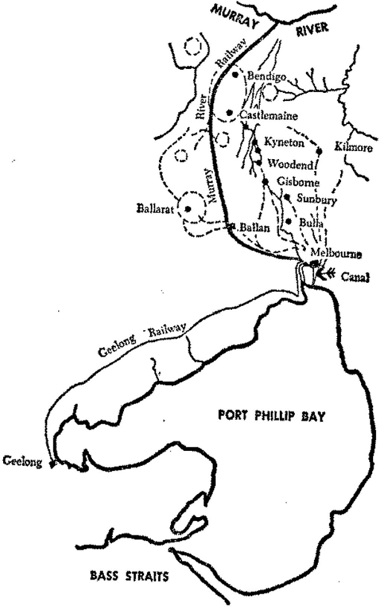

Figure 6.21: The False map. Source: I. Wynd, Geelong The Pivot, 2nd end., Geelong Historical Society, Newtown, 1986.

The inner suburbs of Newtown and Geelong West (Ashby) had also progressed (see later subsection). Overall, at least 217 businesses had been established by 1855. The greatest numbers included land agents, auctioneers, drapers, grocers, insurance agents, merchants and surgeons (see Figure 7.90) the majority being a service industry for the thousands of gold seekers passing through from Point Henry to the goldfields.132 These developments and the growth in rate base in part led to Geelong being proclaimed a Town in 1858.133
Today, the tangible physical legacy of the earliest years of colonisation of the central Geelong township includes the grid layout of the city, street and lane names, and several early buildings. The original prefabricated timber customs house (erected in 1838), now stands in the Geelong Botanic Gardens (see Theme 9). The earliest surviving masonry building is St. John s Lutheran Church (originally St.

Andrew s Presbyterian Church) (Figure 6.23), 165 Yarra Street, built in 1841-42 (see also Theme 8). Other places of worship of the 1840s and 1850s have survived, along with educational institutions including Matthew Flinders School, Myers Street (Figure 8.48), and the former Geelong Grammar School, Maud Street (Figure 8.49). At 58 Corio Street, a portion of the Bush Inn Hotel appears have been first built
as the Bank of Australasia134 while a contextually substantial Union Bank erected two years later in 1848 survives at 76 Yarra Street135 (see also Theme 5). The dwelling at 409 Yarra Street (Figure 6.24), built c.1850-51 for the Wesleyan Church and occupied by the Rev. F. Lewis, is the earliest surviving house in South Geelong.136
In the northern part of central Geelong, the stretch of Corio Street between Bellerine and Swanston Streets, and some of the secondary thoroughfares off Corio Street, give a snapshot of early inner-city residential development. One of the earliest extant dwellings is at 150 Corio Street (Figure 6.25), built
in 1851 for Roger Kelsall, former Lieutenant Colonel with the Royal Engineers in Tasmania.137 It was followed by two dwellings in 1852: a weatherboard house at 146 Corio Street owned by Samuel Wilson, timber merchant; and a brick
cottage at 6 McCann Place (earlier known as Hotham Place), owned by Patrick Hede (who had acquired the land in 1848).138 At 1 Veitch Place, the small timber cottage appears to have been erected by 1853- 55.139 Other dwellings in this early residential area were erected in later years, including those at 148 Corio Street (built in 1876-77 for William Hodgson of the National Hotel, Moorabool Street), 154 Corio Street (built in 1889 for James Norris) and 158 Corio Street (built in 1882 for John Blackney, fisherman).140 The terrace of three dwellings at 147-151 Corio Street were erected in 1886-87 as the last of three complexes of terraces on the north side of the street.141 A brick row of three dwellings at 159-163 Corio Street (built in 1853- 54) and a timber row of three dwellings at 153-157 (built in 1854) have subsequently been replaced with later 20th century two storey terraces.
A legacy of the streetscape infrastructure is the surviving intact bluestone kerbs and channels in parts of Fitzroy Street and in some other streets in central Geelong, although much of the original kerbing has been rebuilt.

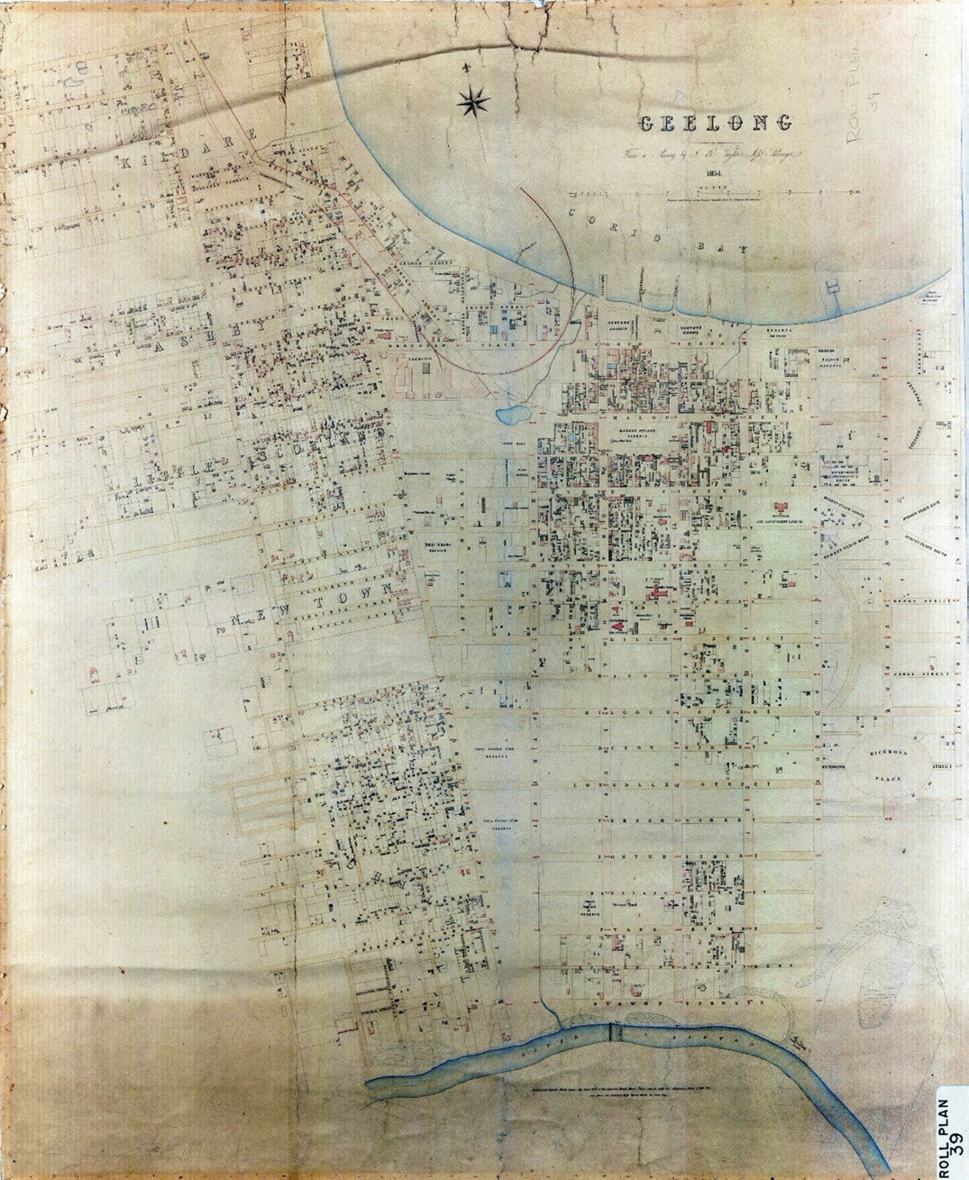
Figure 6.22: J.H. Taylor, Map of Geelong, Surveyor-General s Department, Melbourne, 1854. Source: VPRS 8168/P2, Unit 5416, item Roll 39 Geelong, Public Record Office Victoria.

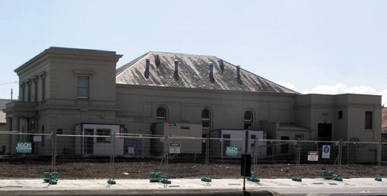
Figure 6.23: St. John s Lutheran Church, 165 Yarra St, south elevation. The central hipped portion represents the original St. Andrew s Presbyterian Church. Source: David Rowe, 2013.

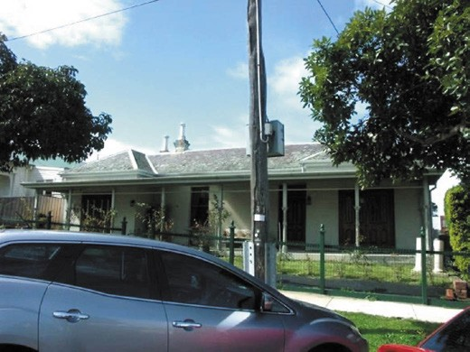
Figure 6.24: Former Wesleyan Manse, 409 Yarra St. Source: David Rowe, 2010.

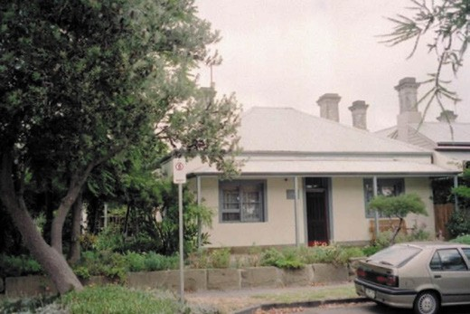
Figure 6.25: Dwelling, 150 Corio St, built for Roger Kelsall. Source: David Rowe, 2002.

GEELONG: ‘THE SLEEPY HOLLOW’ 1860-1900

BUILDING DEVELOPMENT
The rapid progress made in the Geelong township in the 1840s and 1850s was not to continue at the same pace during the second half of the 19th century. A major obstacle was the sandbar at Point Henry which prohibited large
ships from entering Corio Bay, slowing Geelong s trading development.142 The population of 25,000 reached in 1859 largely stayed constant until the mid-1890s.143 The population of Melbourne in 1861 was 125,000 and the new goldfields towns of Ballarat and Bendigo developed significantly and were declared cities 40 years before Geelong was given this title. This led to Geelong to be unceremoniously labelled a sleepy hollow by newspaper editors and politicians alike.
Although North and South Geelong still remained divided by open paddocks in 1864 (Figure 6.26),144 there was progress in Geelong during the second half of the 19th century,
albeit slowly. Doctors, bankers, brokers, pastoralists and developers gradually settled in the area and made their mark on the town. A large number of architects with diverse backgrounds, together with builders and engineers, also had an impact. Between 1860 and 1900, there were at least 550 buildings erected in Geelong and surrounding districts, mainly in-house construction although the streetscapes of central Geelong were also transformed during these years (Figure 6.27). The development of brick companies and iron foundries gave greater access to brick and cast iron in the construction of houses and public buildings.145 In 1889, the Geelong Advertiser gave a number of reports on the New Geelong , including the following:
The evidences of steady progress in this town and suburbs, arising partly from the galvanic action of the land boom, which swept over the district about ten months since, but more particularly from the steady development of our material interest, are everywhere noticeable.
For years past, there has been a gradual –if slow – improvement in all parts of Geelong, and this increase in general prosperity has been, perhaps, most observable, during the past eighteen months.146
Landmark buildings erected during this period included the monumentally-scaled, Victorian Classical Free Library building in Moorabool Street in 1876 (now demolished)147 (Theme 8), YMCA Hall (later Hibernian Club Hall) at
72-76 Ryrie Street (built in 1892)148 (Theme 8), Richard Clarke and Co. grocery premises at 86 Ryrie Street (built in 1878)149 (Theme 5) and the Mercantile Bank at the south-west corner of Moorabool and Ryrie Streets (built in 1888)150 (Figure 6.28) (Theme 5). Other notable commercial buildings included the

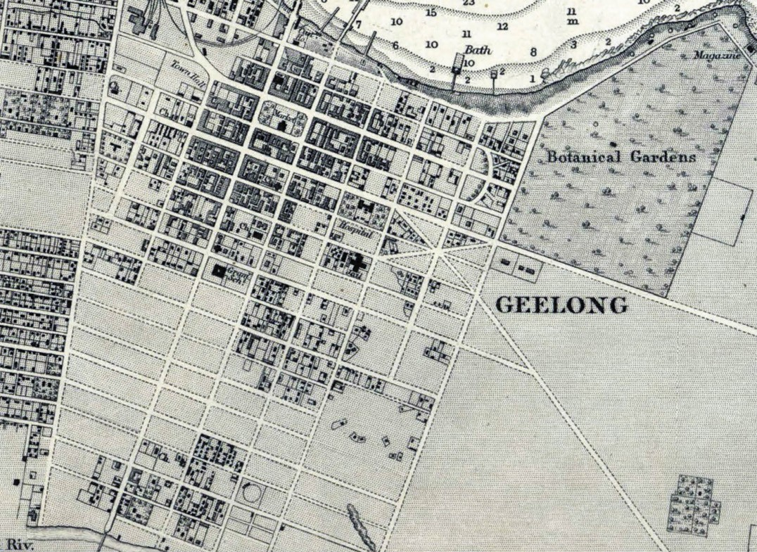
Figure 6.26: H.L. Cox, Portion of Survey of Geelong Harbour, 1864 (published at the Admiralty, London, 26 March 1865). Source: VPRS 8168/P5, item MCS 76, Public Record Office Victoria.

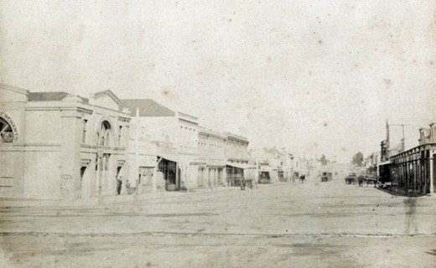
Figure 6.27: J. Norton, Ryrie Street looking east from
Gheringhap Street, 1879. Source: GRS 2170/37 Geelong Heritage Centre collection.
Boom style two storey shops for W. Brown, grocer, and J. Wadelton, chemist at 112-121 Ryrie Street built in 1889 to a design by Joseph Watts,151 and the two storey shops at 152- 154 Ryrie Street, also designed by Joseph Watts in 1887-88 for William Baldock, ironmonger152 (Theme 5). The latter building was of particular interest for the front Late Victorian fa ade being constructed entirely of timber.
Of the several dwellings constructed, distinctive were the designs of the more successful architects. Belleville ,
350 Ryrie Street (built 1870-71 with a billiard room extension in 1874, for Dr David Boswell Reid)153 (Figure 8.103) (Themes 8 & 9); dwelling at 6 Ryrie Street (built in 1877 for Dr George Glendinning) (Figure 6.29) and Waverley , 94 Western Beach Road (built in 1871 and extended in 1874 for Davidson and Henderson architects)154 (Theme 5) were the designs of
the Scottish architects, Alexander Davidson and George Henderson.

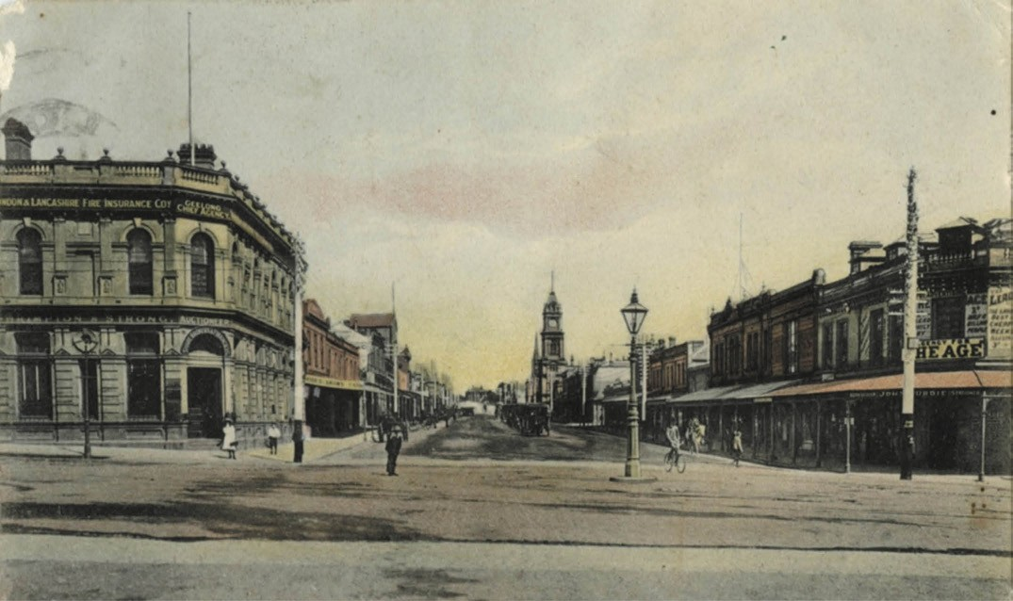
Figure 6.28: Ryrie Street (intersection with Moorabool Street), looking west, c.1905. The former Mercantile Bank building in on the left. Source: GRS 2009/00512, Geelong Heritage Centre collection.

Other prolific architects for the period were Joseph Watts and John Stuart Jackson. Singularly or in partnership, they were responsible for several Victorian Italianate villas, including Czergm , 28 Fitzroy Street, (built in 1882 for George Martin, timber merchant, Geelong Town Councillor and Vice Consul for Norway)155 (Figure 5.120, see Theme 5), and the dwelling at 8 Garden Street (built in 1885 for Miss Isabella Cameron).156 Watts was also responsible for some of the grand terrace houses erected in Geelong, including Wellwood Terrace at the corner of Gheringhap and Myers Street (erected in 1887 for Samuel Wellwood)157 and Bells Terrace (Figure 5.204, see Theme 5), corner of Pevensey Crescent and Myers Street (built in 1889-90 following major alterations to an earlier terrace built for William Bell, pioneer pastoralist and Geelong businessman).158 However, the majority of the designs by Watts and Watts and Jackson were more modest in scale
and included a brick cottage for Thomas Mallett in 1883 at 34 Fitzroy Street.159 All of these designs feature typical traits of the architects work in the Rinceau pattern detailing of the cast iron verandahs.160
Equally prolific was Albert Derrick. Associated with the Wesleyan Church, he enjoyed the patronage of the Wesleyan Methodist Church and its members. He had served his articles with Joseph Watts between 1879 and 1883, and subsequently establishing his own practice, he executed
the largest number of designs in the Geelong area in the late 19th century.161 Examples of his domestic work include the houses at 349-349a Ryrie Street (built in 1885) (Figure 6.30), 27 Swanston Street (built in 1888), 64 Sydney Parade (built in 1885)162 and Blandford , 53 McKillop Street (built in 1890).163 Derrick s brick designs are especially notable for
their polychromatic decoration, while all of his house designs featured elaborate cast iron verandahs.
During the second half of the 19th century, Geelong consolidated itself as the wool capital of Victoria, with further progress in the construction of woolstores, and in agricultural and grazing export trade164 (see Theme 5 for further details).
Other industries were established on the Barwon River during this period. They included woollen mills (such as the Victorian Woollen Mill in 1865 and the Albion Woollen Mill in 1869) and the Australian Paper Mill at Fyansford (built in 1877-78)165 (see Theme 5).

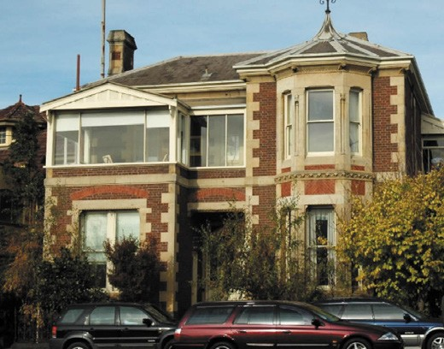

Figure 6.29: Dwelling, 6 Ryrie Street, Geelong. Source: Wendy Jacobs, 2005.

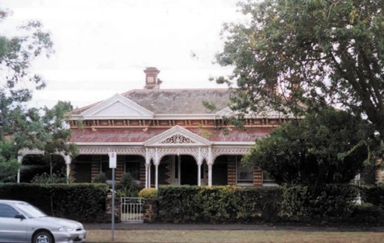
Figure 6.30: Dwelling, 349-349A Ryrie St, 2002. Source: David Rowe.

STREETSCAPE INFRASTRUCTURE
A major development in central Geelong from 1860 was the installation of street lights. Although some street lamps were erected privately outside hotels in earlier years and two street lamps had been installed near La Trobe s dam
in Gheringhap Street by the Geelong Town Corporation in 1852,166 the Geelong Gas Company was established in 1857 to provide gas to light the town.167 In 1859, a Mr S.R. Scoltock won the tender for supplying cast iron lamp stands for the gas-fired lights.168 With a delay caused by the cast iron
posts not having arrived from England, wooden posts were to be temporarily installed in 1860.169 In July 1861, the much anticipated cast iron posts arrived –126 in total.170 Tenders were called by the Geelong Town Council in August 1861 for painting the new lamp posts.171 By 1866, the Geelong Town Council was in dispute with the Gas Company and so the

Figure 6.31: Early cast iron street lamp outside the Corio Hotel, 69 Yarra St, 2005. Source: David Rowe.

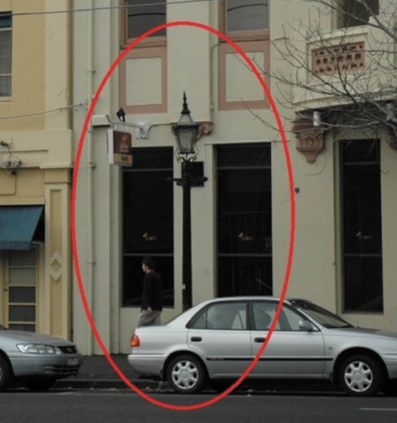
town was lit by kerosene. Apparently, the light from kerosene was not as bright as that from gas, causing the following criticism:
Notwithstanding the calmness of the evening, many were put out by the currents of air, and those that were not wholly extinguished shed such feeble rays of light that but for the moon s brightness the streets would have been almost in utter darkness.172
A Mr McGlashlan was awarded the contract for lighting the kerosene street lamps in 1866-67 and the Council publicly credited him for the manner in which he carried out the contract.173 New street lamps were installed in 1868 and they were considered to be great boons for wayfarers. 174
By 1872 however, street illumination by gas was considered as almost a necessity of town life. 175 This form of street lighting was enduring and remained in use well into the early 20th century after the onset of electricity. One surviving example of gas street lighting is a cast iron lamp stand previously located outside the former Corio Hotel at 69 Yarra Street176 (Figure 6.31).
Further street works improvements were also carried out in the 1860s and 1870s. As early as 1863, the Geelong
Advertiser called for improvements to the footpaths following changes to legislation:

The improvement of the town should proceed rapidly, if the councillors to be elected under the new act should be of the right sort, and should enter upon the performance of their duties with no other object in view than the welfare of their constituents.
The clauses of the new act which refer to the paving of the footpaths will (enable the Council to give facilities to those burgesses who are desirous of making the pavement in front of their premises permanently passable, as well as to compel those proprietors who selfishly act the part of obstructives in maintaining each his own special slough bounded by the improvements of his neighbours, to act fairly towards their fellow-townsmen. The Town Council must, however, take care that they do not in their over- zeal make the new law in this respect an instrument of oppression. In the streets running north and south, both sides of which receive the benefit of sunshine every day, the only thing calling for immediate interference is the filling up of gaps in the existing pavements. These bad pieces of the pathways are not only to be deprecated on their own account, but as reservoirs wherefrom the really good parts of the road are supplied with mud. The east and west streets are in a different predicament, for the north sides of them never get a glimpse of the sun during the six winter months, while their southern sides receive the whole of the sunshine, dry rapidly, and are seldom in a bad state for many days running. Each of these streets has during the winter a clean and dirty side, and it is obvious that the latter should receive primary attention.
The north or dirty side of the market square was quite
impassable without wading during the past winter, and it will be to the interest of the Town Council and of the property-holders in that neighbourhood to set about the work of paving it without more than a month s delay. We
perceive that the path is now being repaired with gravel a needless and wasteful work. The gravel is not required
in the summer, and it becomes mud in the winter. Stone flagging is the material that will be found cheapest in such situations, and nothing else will induce people to walk on the sunless side of the street during the wet months. What is true of the dirty side of the square is, although perhaps in a lesser degree, true of the same side of the rest of Malop street between Gheringhap and Bellerine streets, and of Ryrie-street within the same limits. These call for the earliest but not exclusive attention; the wishes of the burgesses should in all cases be complied with.177
By 1863, Barrabool stone flagstones had been laid in Malop Street under the supervision of the Town Surveyor, Robert Balding.178 Similar flagstones were soon laid in Moorabool Street and elsewhere in 1864-65.179 The only surviving evidence of this type of footpath are the remnant Barrabool

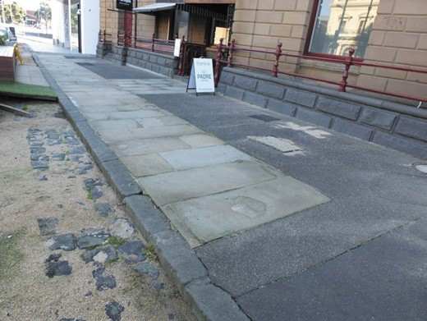
Figure 6.32: Remnant Barrabool flagstone footpath outside 9-11 Malop St, 2018. Source: David Rowe.
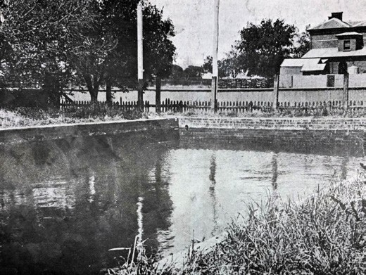
Figure 6.33: Saltwater Reservoir, Haymarket Reserve, 1912. Source: News of the Week, 18 April 1912, GRS 2121/3, Geelong Heritage Centre collection.

flagstones that have been re-laid as part of a paving finish on the north side of Malop Street, outside 9-11 Malop Street (Figure 6.32),180 and also remnant pavers in Gheringhap Street.
In 1871, the Geelong Town Council experimented with tar paving the footpaths. Under the direction of Robert Balding, Town Surveyor, and a Mr Warren, foreman of the Geelong Gas Company, a portion of paving was laid as an experiment near the General Market.181 In 1875, the Council contracted the Patent Composition Paving Company to lay of sample of its paving at the intersection of Myers and Yarra Streets. A considerable amount of tar paving was also laid in Mercer Street by the Geelong Gas Company at this time.182

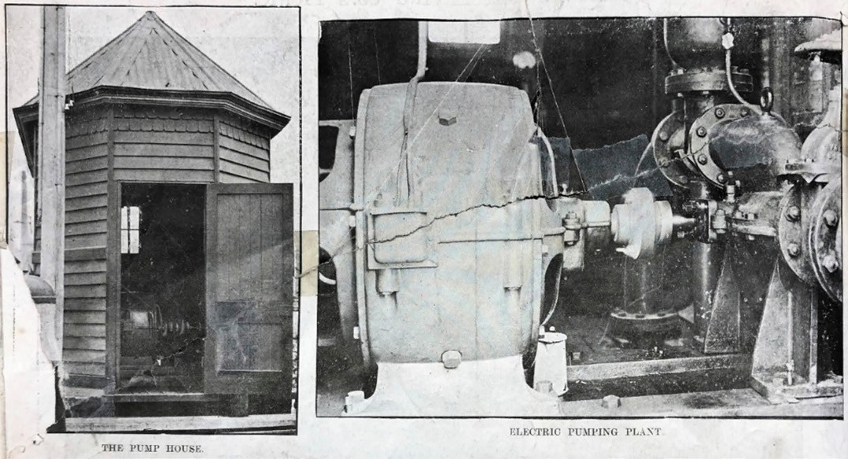
Figure 6.34: Pump House & Electric Pumping Plant, 1912. Source: News of the Week, 18 April 1912, GRS 2121/3, Geelong Heritage Centre collection.

While tar paving was laid in an effort to reduce dust and debris in the main streets, in 1896, the Public Works Committee of the Geelong Town Council decided to build a saltwater cistern reservoir of brick and concrete in the south- east corner of the Haymarket Reserve in Myers Street.183 The contract was let to Mr L. Bourke.184 A pipe was laid from the bay up Moorabool Street to the reservoir in the Haymarket Reserve (Figure 6.33), along with reticulation pipes through the central streets. A pump was installed in a small timber pump house (Figure 6.34) and in November 1896 operations commenced. As reported in the Geelong Advertiser:
Pumping operations were commenced on Saturday afternoon at the town pump on the bay frontage between Yarra-street and Moorabool-street wharves. The desire of the corporation is to force the salt water up the main pipe in Moorabool-street and into the cistern reservoir in the hay market reserve, off Myers-street, from which place it is to be distributed, along reticulation pipes in the various streets within a prescribed area, and used in flushing the channels and watering the streets. The pumps worked well, and very speedily forced the water up to Ryrie-street, but it burst open the fire-plugs attached to the mains and escaped in flooded streams on to the streets and into the channels. Regular water-spouts were observable at the corner of the beach road and Moorabool-street, at the corner of Moorabool and Corio-street near the lockup, in
front of Messrs Bright and Hitchcock s shop in Moorabool- street, and in James-street, off Ryrie street, near Mr J.S. Bayley s shop. Owing to the escape of the water the cistern was not reached for a considerable time, and it is expected that as soon as a remedy has been applied the pumping will be resumed. The cistern was half filled with water when pumping operations ceased. 185
Another substantial streetscape improvement in the late 19th century and particularly from late 1871 was the filling in of the Western gully at Gheringhap Street, extension of Gheringhap Street to the bay frontage, and the cutting and lowering of the western end of Victoria Terrace (Eastern Beach Road).
Soil from Victoria Terrace was used in the earthworks of the Western gully at Gheringhap Street. The works were reported in the Geelong Advertiser on 7 November 1871, where it was stated that: ‘It is intended, when the slopes of the [Victoria] terrace have been neatly formed, to sow them with grass, and plant them with elms. 186

OTHER DEVELOPMENTS
Additional schools were built in the 1870s and which are extant today. At Swanston Street, State School No. 1094 was opened in 1871 while in Yarra Street, the South Geelong State School No. 2143 was opened in 1870187 (Theme 8). Only the latter continues to serve its original school purpose. Other private schools were also established in the town reserve
in the second half of the 19th century although most were not enduring. In 1870, Queen s College was opened at Merchiston Hall, 2A Garden Street by Mr and Mrs Lupton.188 It closed in 1872.189
Beautification of central Geelong through the reservation of additional reserves and parks also occurred in the 1870s and 1880s. In 1878, Pevensey Gardens in Pevensey Crescent were established in two parts. In 1885, Harding and Austin Parks in Bellerine Street were also gazetted (see Theme 9).
Further progress came with the construction of a new polychromatic brick police court house in Gheringhap Street in 1883190 (Figure 7.51, see Theme 7). This building served Geelong until it was extensively remodelled and extended in 1938 as a court house and public offices191 (Theme 7).
Overall, the improvement and further development of Geelong were recognised in 1887. As described by Alexander Sutherland in Victoria and Its Metropolis:
Geelong is an important municipal town, one of the oldest in the colony. It was at one time intended for the metropolis, but owing, probably, principally to the bar, which to some extent impeded navigation, and to the then scarcity of good water, shipmasters preferred anchoring in Hobson s Bay. Still, in the early days of the colony, and especially during the early days of the goldfields, it was largely used as a port of debarkation, and even now, although Melbourne is of course the principal shipping port of Victoria, the increased facilities afforded for shipping direct from the wharves cause Geelong to get
a considerable share of the shipment of wool and other produce from the Western district, as a saving both of time and freight charges is thus effected.
Geelong proper has an area of 3012 acres, a population of about 10,000 persons, or with its suburbs of not less than 25,000. It has 1967 ratepayers on the roll, and an annual value of rateable property of £73,242. Geelong is picturesquely situated; it stretches back from the usually placid waters of Corio Bay, standing on the two slopes and the crown of a gentle hill, reaching on the further side to the Barwon river. It possesses a pure and salubrious atmosphere, is well lighted with gas, and is
plentifully supplied with water from the storage capacity of 278,000,000 gallons, and drainage area of 6591 acres.
The town is well laid out, and in its streets are numerous

handsome and commodious shops and business premises of all kinds. A striking object in the centre of the place is the town clock tower, which stands in the Market Square 192
A boost to educational life at this time in 1887 was the opening of the Gordon Technical College in Fenwick Street. This institute provided State technical and industrial training to support the burgeoning manufacturing, agricultural and building sectors (see Theme 8). Two years later in 1889, the status of Geelong as Victoria s second-largest town was
endorsed with the construction of a new substantial post and telegraph office at the corner of Ryrie and Gheringhap Streets (Theme 3) (Figure 3.187).193
One of the most significant developments in the late
19th century in Geelong was the opening of a new shipping channel in 1893 (see also Theme 3). For the first time, large ships were able to directly arrive at the town s foreshore rather than anchoring at Point Henry. Named in honour of Lord Hopetoun, Governor of Victoria, The Age newspaper reported the important event:
Geelong is, or should be, happy now. It has got the one thing upon which it has set its heart ever since it became a town of any dimensions, viz., a channel direct from Port Phillip Bay to the town which can be navigated by vessels of respectable tonnage.
The oldest inhabitant will tell you that the objectionable sandbar at the entrance to the harbor has always been the stumbling block in the path of the progress of the town, and of course there are some who have always insisted with vehemence that if the water hereabouts had been made navigable by large vessels in the early days of the colony, Geelong would certainly have been the capital of Victoria.
This is merely a local hypothesis, which it is scarcely worth disputing; but there can be no dispute that this obstacle in the way of navigation has seriously retarded the expansion of trade at the southern port.194
At this time, the Geelong township was favourably described in The Tourists Guide to Geelong and Southern Watering Places:
The picturesque town of Geelong occupies a commanding position on the prettiest part of the Western coast line, and is built upon sloping country, affording excellent natural drainage facilities to Corio Bay on the north side, and to the ever-flowing Barwon River on the southern side. It
is one of the healthiest towns in Victoria, a fact which is being steadily recognised by persons seeking temporary and permanent residence by the sea-side Geelong itself is strikingly pretty, its clean, broad streets, wide and

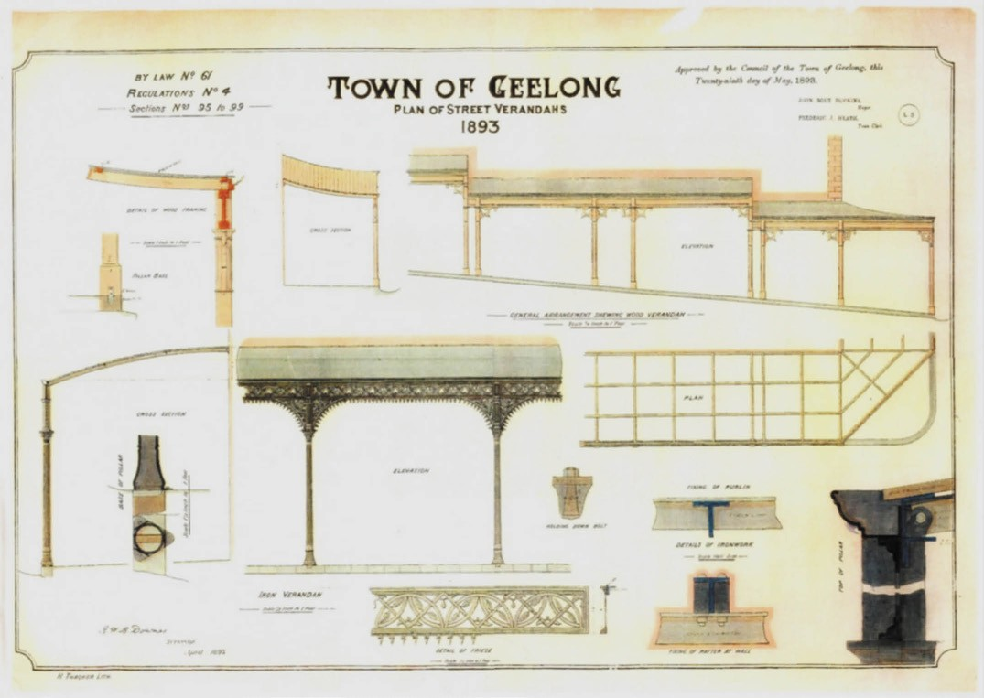
Figure 6.35: R.H.B Downes, Plan of Street Verandahs, Town of Geelong, By-Law No. 61, 29 May 1893. Source: Statutory Planning Department, City of Greater Geelong.

well paved footpaths, with the lines of forest trees which, before long, will cover them with their graceful shadow; the beautiful beach slopes running east and west, in addition to its many handsome residences and large commodious business premises, all give an effective and inviting appearance. 195
An improvement to the central city area from 1893 was the standardisation of commercial verandahs, following By-Law No. 61 passed by the Geelong Town Council.
Two designs were prepared by the Geelong Town Surveyor,
R.H.B. Downes, a cast iron version and timber version (Figure 6.35). These verandahs were to transform the streets in central Geelong (Figure 6.36). The timber type featured at Derry s basket making store at 105-107 Moorabool Street (Figure 5.138, see Theme 5), while numerous buildings were adorned with cast iron versions, including McCartin s butcher shop at 233 Moorabool Street (Figures 5.104, (see Theme 5),
6.36) and the Scott Hamilton and Co. ironmongery building
at 126 Ryrie Street (Figure 5.132, see Theme 5). The cast iron version prescribed the cast iron pattern for the valances and brackets, and the type of fluted cast iron columns (which were hollow to allow the columns also act as downpipes)196
Further housing development occurred in the 1880s and 1890s, including housing in the Little streets such as Little Ryrie and Little Myers Street. Other
subdivisions were offered including the Grammar School Hill Estate in 1896 which comprised 6 Grand Frontages to Moorabool Street. 197

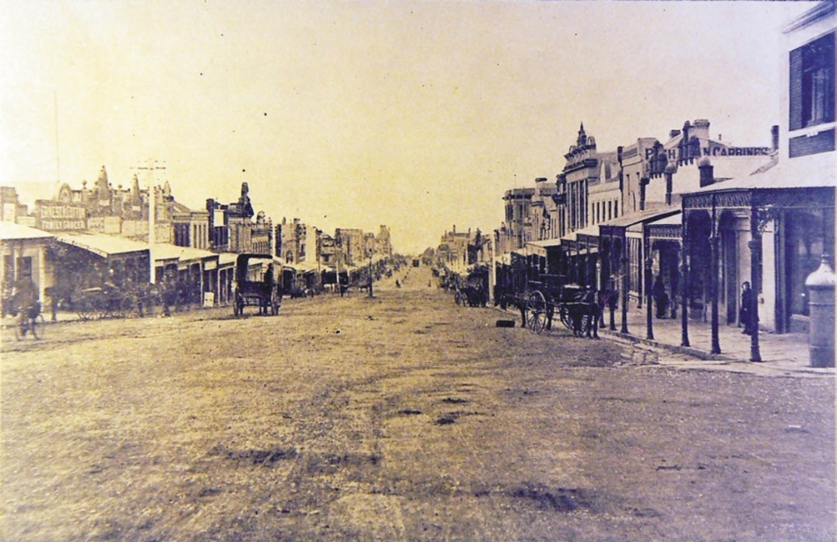
Figure 6.36: Moorabool St, looking north from Lt Ryrie St, c.1890s, showing notable number of standard cast iron verandahs consistent with By- Law No. 61. Source: GRS 2497/68, Geelong Heritage Centre collection.

GEELONG: A PERIOD OF PROGRESS 1900-2000

BUILDING DEVELOPMENTS
The opening of the Hopetoun Channel gave greater promise for Geelong s longer term commercial and cultural prosperity, and the confidence for the further establishment
of infrastructure, new businesses and building developments.
As early as 1900, this was
noted in The Age newspaper (and re-reported in the Geelong Advertiser):
The visitor to Geelong, instead of discovering a peaceful Village of Sleepy Hollow, sees everywhere the signs of industry and pushfulness. It has been said of Birmingham that it suffers less from bad trade, of from scarcity or abundance in any line of commerce, than any other commercial centre, for its industries are so varied that it always has something to do. Geelong is like Birmingham, on a reduced scale, in the variety of its resources. Unlike many Australian towns, it does not largely depend upon one industry. Neither mining nor agriculture is its sole
support. The great grazing and agricultural lands of the Western district may be the backbone of Geelong s export trade, and the handling of wheat and wool and the by- products of stock raising may furnish much employment; but the district has immense manufacturing interests that serve to give the town a distinct character as a go- ahead and enterprising depot Not only is there abundant evidence in Geelong s material progress in factories and workshops, warehouses and wharves, but the records of actual business done show a very remarkable advance.198
Such advances resulted in part due to the new superior port facilities erected at Cowies Creek and North Shore in 1894.
Impetus came from the establishment of freezing works by the Meat Freezing Company for the shipment of frozen meat overseas.199 The Oriental Timber Works Company
also established a base at Cowies Creek. Their operations included log ponds (Figure 6.38). A port was later created at Cowies Creek by the Victorian Public Works Department at North Shore.200 This began Geelong s association throughout the 20th century as an enduring regional port for the
handling of grain and as a manufacturing centre (see Theme 5). Control of the port and foreshore lands were vested in

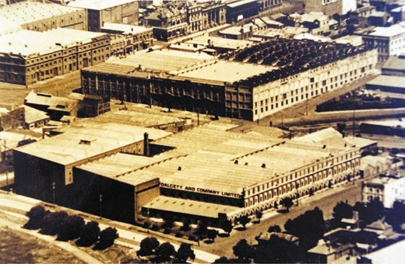
Figure 6.37: Woolstores near the Geelong waterfront, n.d. In the foreground is Dalgety and Co. s woolstore (now the waterfront campus of Deakin University). Source: GRS 2352/59, Geelong Heritage Centre collection.

the Geelong Harbour Trust from 1905.201 Other industries were soon established in the northern suburbs in the early 20th century, including the Federal Woollen Mill (1913), Ford Motor Company (1924), and Corio Distillery (1928) (see Theme 5). Other heavy industries soon followed including
International Harvester (1939) (see Theme 5) and the Shell Oil Refinery (1953) (see Themes 2 & 5). In the second half of the 20th century at Point Henry, other industries were established including the Alcoa Aluminium Smelter in 1961.
Further progress was experienced with Geelong s wool trade. New woolstores and several additions to existing woolstores in the north-western portion of the town reserve were built (Figure 6.37). This had a dramatic impact on the character and function of the city (see Theme 5). The town s reputation as the wool capital of Victoria was bolstered in 1928 with the construction of a new wool exchange at 44 Corio Street. The unprecedented boom in wool values following World War Two also played a key role in the advancement of Geelong s wool trade and the expansion of wool storage facilities in central Geelong (see Theme 5).
The confidence brought about by improved port facilities, the wool trade and manufacturing gave stimulus for further growth and advancement in the City centre. It also helped to bring about Geelong being proclaimed a City on 8 December 1910.202 The promise of Geelong as a regional city was reflected in a ‘Plan of Geelong and Suburbs’ issued by the Geelong Progress Association at this time. It showed the residential suburbs, as well as industries, parks, cemeteries, golf links and even the State Aquarium and Fish Hatcheries at Osborne House (Figure 6.38) (see Theme 9 for further details):
Tangible evidence of central Geelong s Federation era growth today is the several surviving major commercial

buildings including Covent Garden , 174 Moorabool Street in 1901203 (Figure 2.56, see Theme 2), building for Scott Hamilton in Ryrie Street in 1911204 (Figure 5.132, see Theme 5); Solomon s Building, 95-135A Moorabool Street, in 1912205 (Figure 5.157, see Theme 5) and Harvey Dann’s offices (later Griffith’s Bookstore), 96-98 Ryrie Street, in 1915206 (Figures
5.92 & 5.137, see Theme 5). Cantilevered verandahs were introduced on some commercial buildings during this period, the earliest known being the verandah for Macrow s Furniture Arcade, 85- 87 Ryrie Street, designed by local architects, Tombs and Durran207 (Figure 5.115, see Theme 5). Another unique landmark was additions to Bright and Hitchcock s store at 115-139 Moorabool Street, and particularly the bandstand erected in 1915 (Figure 5.155, see Theme 5).208
Several important institutional buildings were erected too. A new Fire Station at the north-west corner of Yarra and McKillops was built in 1908 (replacing an earlier station behind the Geelong Town Hall in Little Malop Street) (now demolished)209 (Figure 8.145, see Theme 8).
The Geelong Waterworks and Sewerage Trusts’ office (now demolished) in Ryrie Street opened in 1913 (following the enactment of the Geelong Waterworks and Sewerage Trust in 1910)210 (Figure 4.124, see Theme 4). The Geelong Art Gallery building, fronting Johnstone Park, opened in 1915 (Figure 9.46, see Theme 9), the same year the Geelong High School was built in the south-west corner of Eastern Park in
Ryrie Street, Geelong’s first State secondary school211 (Figure 8.78, see Theme 8). The original design of the Geelong Town Hall was finally realised with the building of main east portico and hall in 1917212 (Figure 7.11, see Theme 7).
In addition, improvements were made to near the waterfront and the foreshore. In 1900, Transvaal Square near the foreshore frontage was established.213 A major transformation was the development of the Eastern Beach foreshore to the north-east of the original town reserve (see Theme 9). Rotundas were erected in 1904 and 1916-18 at
the western end of Eastern Beach, while in 1912 the Joy Ark Pleasure Hall opened (the same year as the Geelong Cinema in Ryrie Street)214 (see Theme 9).

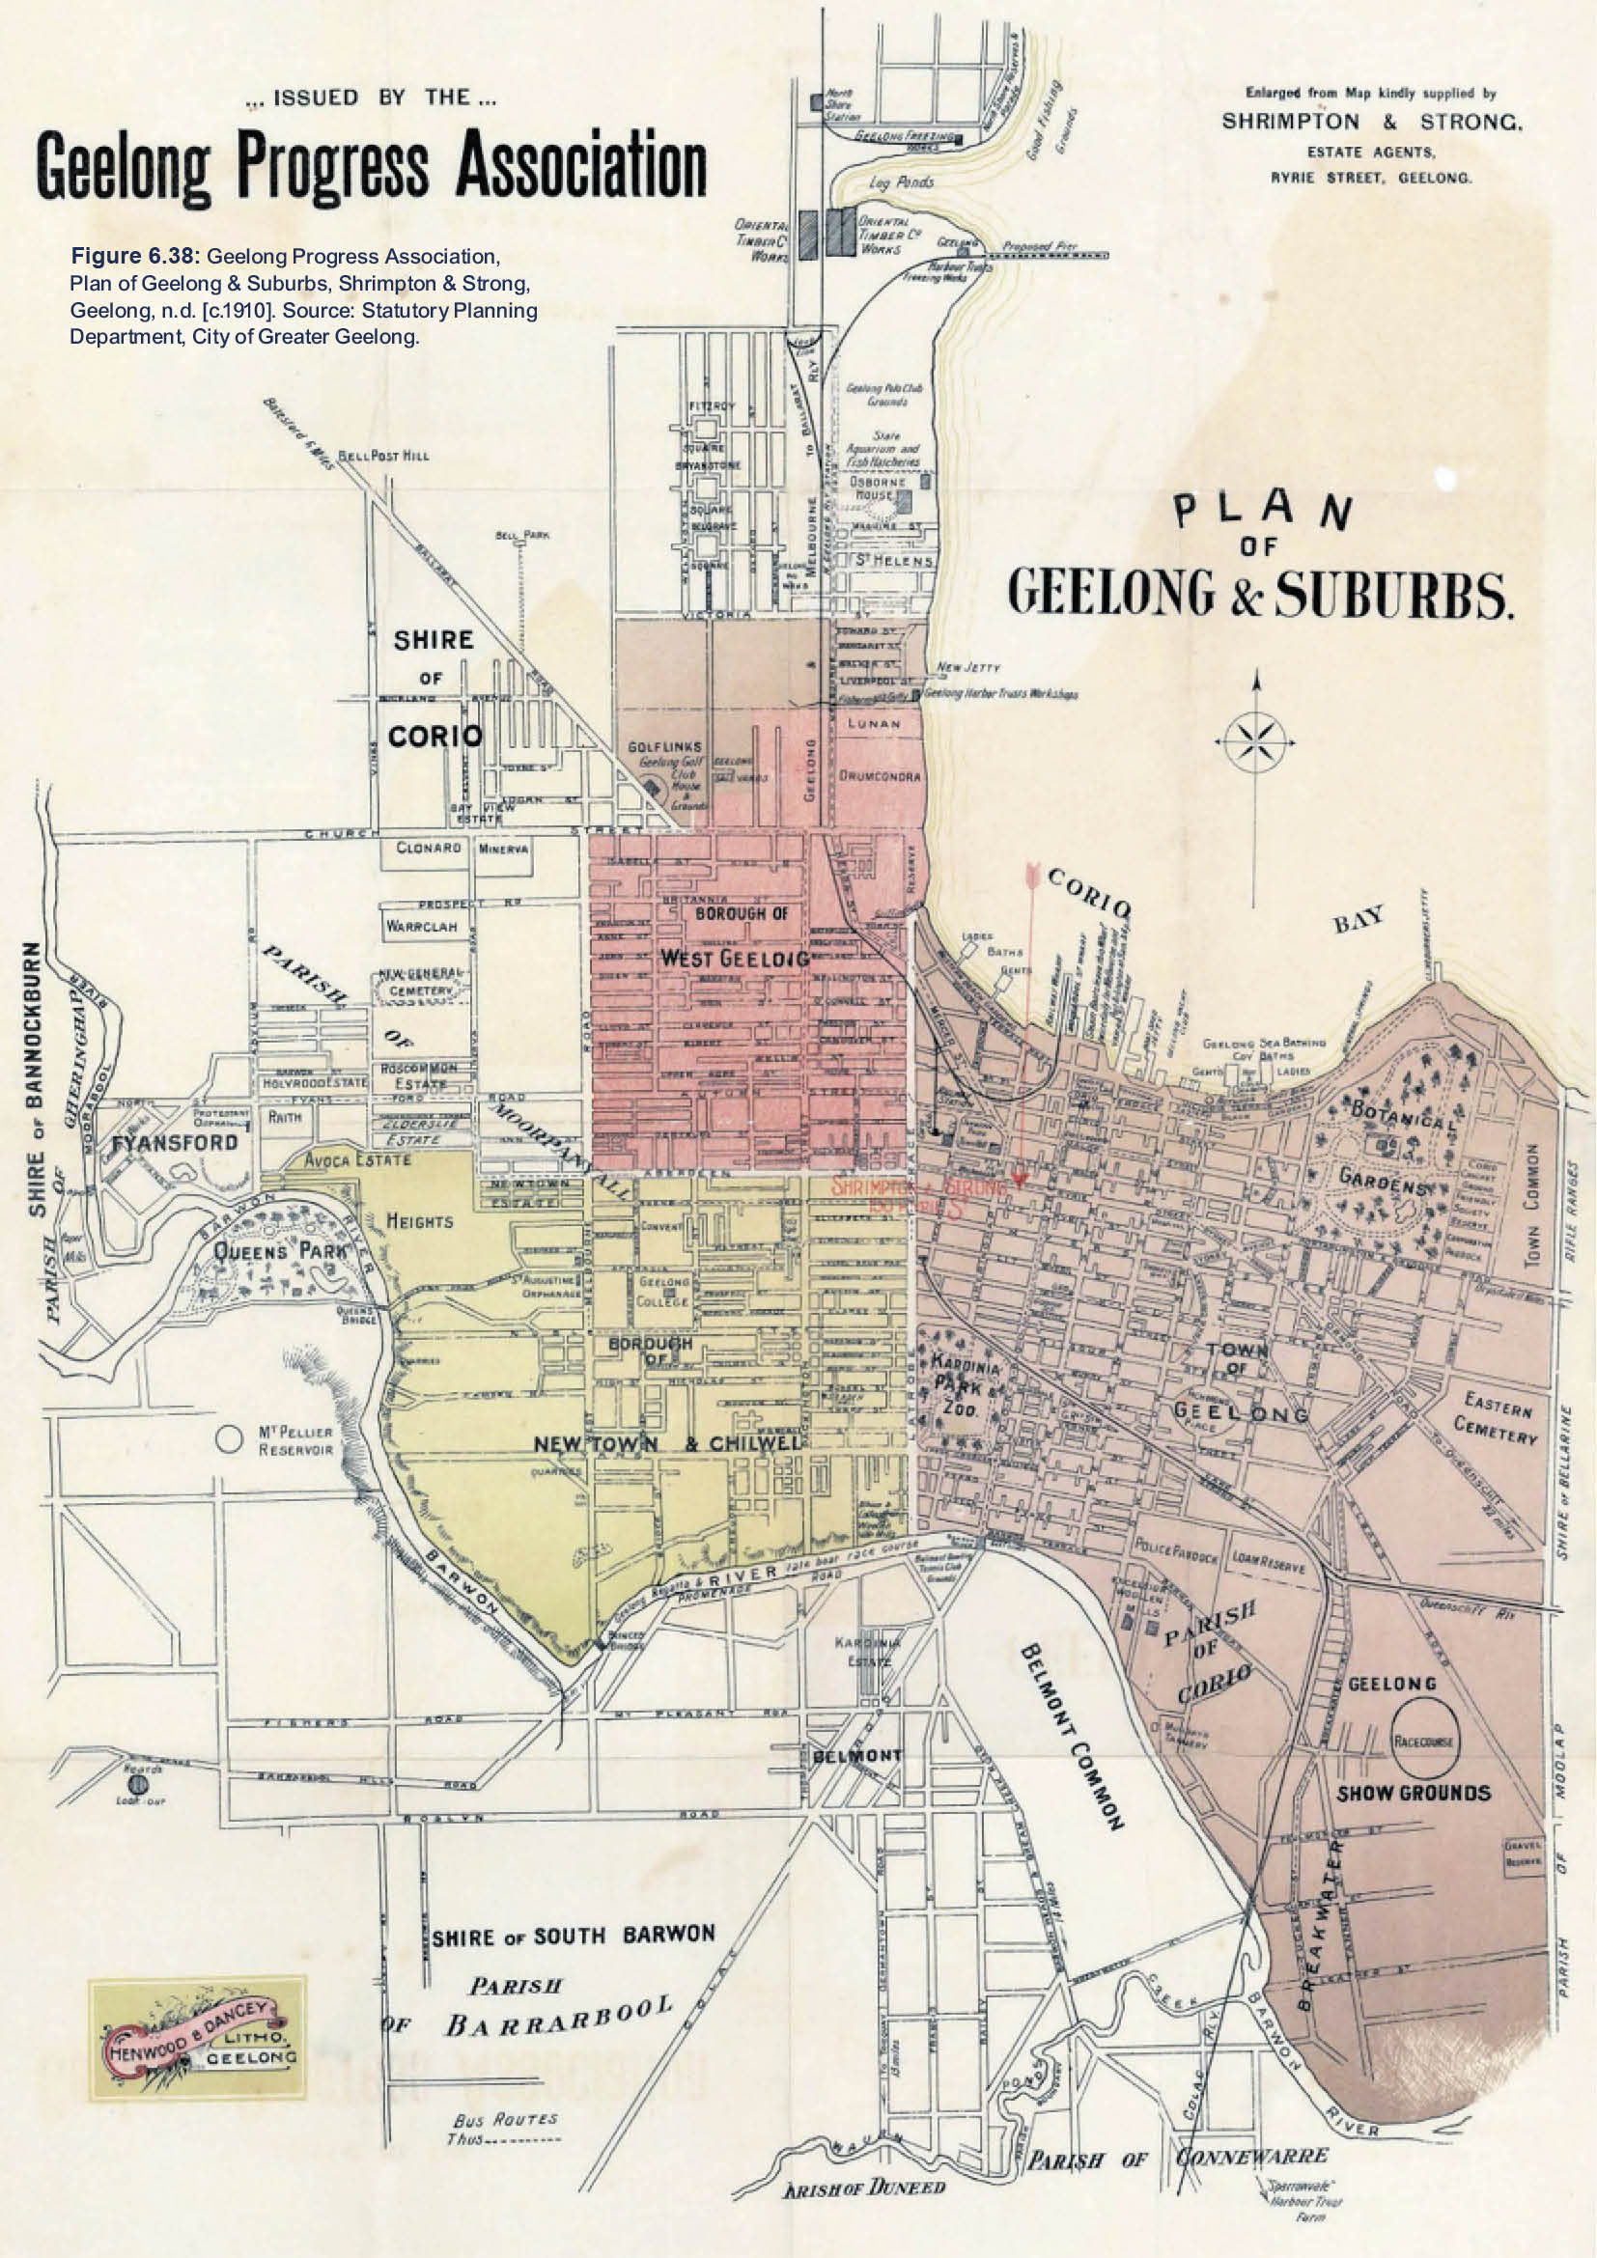
.,. ISSUED BY THE ...
Geelong Progress Association

£,,t,,vo,j lloa ,, lindl1 .. pplle<I .,
SHRIMPTO & STRONC.
ESTATE AGE TS0 RYRIE STREET. 0£ELO 0.

Figure 6.38: Geelong Progress Association, Plan of Geelong & Suburbs, Shrimpton & Strong, Geelong, n.d. [c.1910]. Source: Statutory Planning Department, City of Greater Geelong.

\l LAN
OF
GEEIONG & SUBURBS.

SHIRE oF SOUTH BARWON

.PABJSff
'F B RR R»ooJ;

Bus 1/ovru
TliuJ • •••••

STREETSCAPE INFRASTRUCTURE
The early 20th century also witnessed several improvements in infrastructure. In 1900, the Electric Lighting and Traction Company building was constructed215 and the company commenced power generation in the city in May the following year216 (Theme 3). The generation of electricity was to transform the city streetscape beyond lighting. Tram services commenced operations from 1912217 (Theme 3).
Further streetscape improvements occurred in the early 20th century. From 1911, experiments were carried out with tar spraying the Moorabool and Ryrie Streets to prevent dust nuisance. 218 Further tar spraying was carried out in other parts of Moorabool Street and other streets in central Geelong in the ensuing years.219 This began the sealing of the City s streets.
In 1926, the Geelong City Council decided to commence the construction of concrete footpaths in the form of flags.220 Streets including Balliang Street (between Swanston and Bellerine Streets) and a section of Moorabool Street (on the east side between Ryrie and Little Ryrie Streets) were paved with concrete to replace the asphalt surface laid in earlier years. Although the concrete paving would cost 75 percent more than asphalt, the City Surveyor argued that upkeep would be practically minimal. 221 The quality of the concrete flags came under scrutiny in 1928.222
By 1939, with the advent of the motor car in earlier years, traffic in the city centre had increased to such an extent that the Chief Commissioner of Police had recommended to the Geelong City Council the adoption of traffic lights ‘at busy intersections. 223 Neon bar traffic lights, mounted on the tram pole network, were subsequently installed at the intersection of Malop and Moorabool Streets (Figure 6.39) following a neon bar prototype developed by the City Council s Engineer,
I. McDonald:
A device by means of which Neon light bars provide traffic direction signals, devised by the Geelong city engineer (Mr. I. McDonald), in collaboration with an electrical firm, will be installed at the corner of Malop and Moorabool streets on Thursday for a month s trial. The device will be a unit of four sides. On each side are twelve Neon bars
–six red and six green, and the bars of each color switch off each five sections, permitting half-minute intervals of traffic each way.224
By 1954, the Victorian Government reported that the series of red and green neon bars’ for traffic lights ‘should not be used’ given the danger created between red and green signals.225 Following the demise of trams in 1956, traffic lights were subsequently replaced.

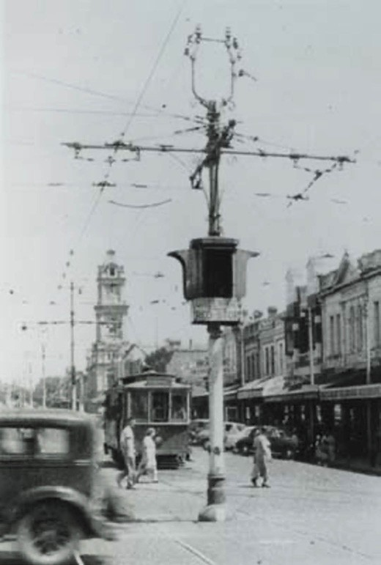
Figure 6.39: Neon bar traffic signal, corner Moorabool & Ryrie Streets, c.1940. Source: GRS 7528/0, Geelong Heritage Centre collection.

THE INTERWAR YEARS
The interwar (c.1919-39) period witnessed further building progress in central Geelong. In 1922, the Geelong Advertiser gave a glowing report:
Building in and around Geelong at the present time is very brisk. A number of extensive buildings are in course of construction, while preparations are being
made for a number of others at an early date. Although only a few days have elapsed since a start was made to remove the shops which have stood in Moorabool-street for over half a century, and where up-to-date premises are to be erected for Bright and Hitchcocks Proprietary, practically the whole of the demolition work has now been completed and a commencement will be made within
a week or so with the excavations for the foundations. When completed, the buildings will be amongst the most up-to-date in the city and fitted with all the latest
furnishings. Messrs. W. G. Hearne and Co. are extending

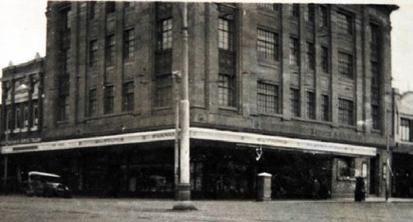

Figure 6.40: National Mutual Life Building, corner Moorabool & Ryrie Streets, c.1930. Source Holmes collection, Authentic Heritage Services.

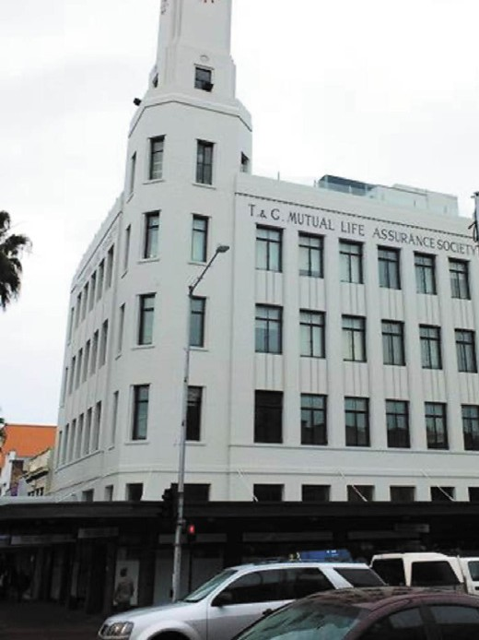
Figure 6.41: T & G Building, corner Moorabool & Ryrie Streets, 2016. Source: David Rowe.

their business place, and are spending about £5,000 in remodelling the extensive brick building for many years carried on by the late Mr. W. Lawry as a chaff and grain store at the western end of Ryrie-street. provision has been made for offices and laboratory on the ground floor. The second storey is to be devoted to workrooms and factory, whilst another portion of the building is to have a storeroom Another extensive work to be put in hand is

Figure 6.42: CML Building, corner Malop & Jacob Streets (Market Square), c.1920s. Source: Wynd collection, Authentic Heritage Services Pty Ltd.
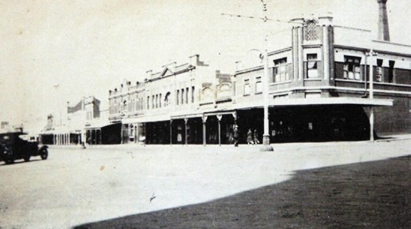
Figure 6.43: Ryrie Street (corner Gheringhap Street) looking south- east showing Leggo s grocery store at the corner, c.1932. Source: Holmes collection, Authentic Heritage Services Pty Ltd.

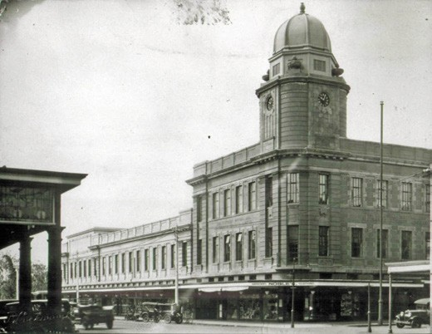
additional offices for Henry Thacker Pty …226
Transformation of the Geelong streetscapes during the interwar period was especially pronounced at the prominent intersections of Moorabool and Malop Streets, and Moorabool and Ryrie Streets. Key buildings erected at these major corners included the Commonwealth Bank building (1924) (now demolished),227 National Bank (1927- 28),228 National Mutual Life Building (1924-26)229 (Figure 6.40), Belcher s Corner shops and offices (1926) (now demolished),230 the
T & G building (1933-34)231 (Figure 6.41) and the Bank of New South Wales (1937-38)232 (see Theme 5). Further west at 285 Ryrie Street, Kitchener House was opened in 1931 opposite the Geelong Hospital as a Nurse s Home233 (see Theme 8). Other major commercial developments included the building of the C.M.L. Insurance Building at 74 Malop
Street in 1925-27234 (Figure 6.42), Carlton Hotel at 13-19 Malop Street in 1936235 (Theme 5), new telephone exchange building

in Gheringhap Street in 1939236 (Theme 3) and new facades to the National Hotel at 193- 195 Moorabool Street in c.1944237 (Theme 5). There were also several smaller commercial buildings erected during this period, including Leggo s Grocery store in 1922 at 88 Ryrie Street to a design by Laird and Buchan238 (Figure 6.43, see also Theme 5).

THE POSTWAR YEARS
The Second World War brought about an intensification of Geelong s industrial importance as local industries assisted in the war effort.239 While austerity measures largely halted commercial building progress, substantial improvements were made to the Geelong Hospital. Construction commenced in 1939 on the Infectious Diseases Hospital
(it was named Bellerine House and it opened in 1943).240 In 1940, Kardinia House, an intermediate hospital, was opened241 (see Theme 8).
A noticeable change to the central Geelong streetscapes during the war was the construction of air raid shelters (Figure 6.44). In late 1941, the State Government hosted a conference of all metropolitan municipalities and Geelong to discuss the Government s plan for trench shelters.242
The Geelong Football Club s home ground in the playing of Australian Rules Football was relocated from Corio Oval at Eastern Park to Kardinia Park, South Geelong, in 1941 (Theme 9). This began an enduring association with the Football Club which continues to the current day.
The postwar years brought about further promise and progress. In 1949, Geelong was regarded as a thriving vigorous city, brought on by the establishment of manufacturing industries 30 years earlier, the handling of Victoria s wool clip with the construction of new and extended woolstores, and the construction of a modern grain elevator (at North Geelong).243 Boasting 55,000 residents, the city was favourably (albeit romantically) reported:
Although 114 years old, Geelong is a fresh, clean city, which has grown up on a diet of proper planning. Industry is dispersed, homes are modern and well designed, old buildings have received face-lifting treatment, and there are no slums –the rotten heart which often breeds in an industrial centre.244
In 1954, a visit by Queen Elizabeth II was not the only overseas visitor to Geelong.245 Since the end of the Second World War, Geelong s population had increased as a consequence of Australia s post-war immigration policy of accepting European immigrants.246 The arrival of immigrants was essential for the longer term sustainability of Geelong s thriving manufacturing industries. In central Geelong, the most profound changes came with the construction of additional woolstores and extensions to existing woolstores

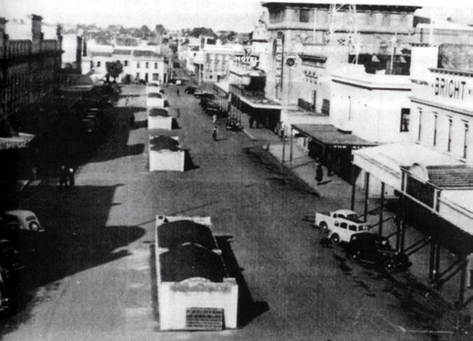
Figure 6.44: Air raid shelters in the centre of Little Malop Street at Market Square, c.1940s. Source: McDonald collection, Authentic Heritage Services Pty Ltd.

following the wool boom (Theme 5). In 1954, high wool prices were considered to have had the effect of advertising the importance of the produce and have also given publicity to the outstanding position of Geelong as a selling centre. 247
The expanding industrial and wool-selling sectors also translated into further commercial and other building development in central Geelong from the 1950s. Landmarks built at this time which reflected Geelong’s growth were
the Modern designs for the Textile College at the Gordon Technical College in Fenwick Street in 1949 (Themes 8 & 9) and the four-storied Baxter House maternity hospital at the corner of Ryrie and Bellerine Streets in 1954248 (Theme 8). In Moorabool Street between 1953 and 1955, Bright and
Hitchcock s celebrated its centenary with a major rebuilding scheme which included a distinctive and innovative postwar Modern Functionalist western fa ade on the Moorabool Street frontage249 (Figure 5.156). This marked a new epoch for commercial and office building design in Geelong (Theme 5). At 199- 203 Moorabool Street (corner Little Ryrie Street), a five storeyed office building was erected in 1956 for Mutual Life and Citizens Assurance Co. Ltd, extending the scale
of commercial buildings in the city.250 A similarly- designed public building during this period was the construction of the Geelong Regional Library in Little Malop Street which opened in 1959251 (Themes 7 & 8).

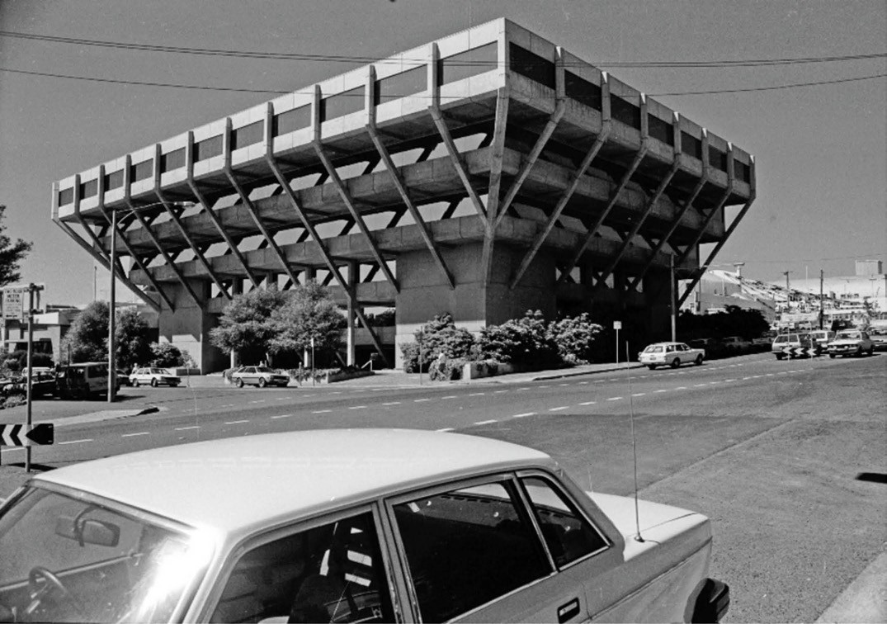
Figure 6.45: I. Wynd, State Government Offices building, corner Fenwick & Little Malop Streets, c.1980. Source: Wynd collection, Authentic Heritage Services Pty Ltd.

THE LATER 20TH CENTURY
Other transformative developments followed in the 1960s and 1970s. A significant change was made in Brougham Street, on an elevated site east of the Customs Houses overlooking Corio Bay. In 1957, the Geelong Harbor Trust erected a three storey office building252 (Theme 3). It was followed by a four storey Commonwealth Offices building next door in 1964- 65253 In Myers Street (between Moorabool and Gheringhap Streets), the four storied Holy Cross Hospital opened
in 1965254 (Theme 8). At 34-36 Malop Street, two storey commercial offices were constructed in 1961-62.255 In 1977, the Geelong Waterworks and Sewerage Trust moved into a new pre-cast concrete, cuboid, five storey building on the site of its former office256 (Theme 4). Having taken two years to build, the conservative Brutalist design was a forerunner for the more substantial and dynamic State Government Offices building erected in the 1970s at the south-east corner of Fenwick and Little Malop Streets (Figure 6.45). Designed by the Public Works Department and local architectural
firm Buchan Laird and Buchan,257 the five storey inverted
pyramid of pre-cast concrete construction, was soon dubbed Geelong s upside down building. However, it became the city s best example of Brutalist design. Other similarly- designed and constructed buildings followed, including the Geelong Performing Arts Centre in Little Malop Street in 1981 (next to the State Government Offices, now demolished), and a six-storeyed commercial office building in 1980-81 at 49-51 Malop Street.258
The most dramatic changes to Geelong s commercial heart and foreshore came from the 1980s. In 1981, the Geelong Regional Commission, in consultation with the City of Geelong, released the City By the Bay Plan (see also Theme 7). It proposed the total redevelopment of the city centre, foreshore and Corio Bay. 259 Approximately $1 million was soon spent on beautifying the parkland between Cunningham and Yarra Street piers, and the American landscape
architect, Eldon Beck, was engaged to complete a study on the entire Corio Bay foreshore.260 Building developments also resulted from the City By The Plan. The Geelong Regional Commission acquired the Sailors Rest building at

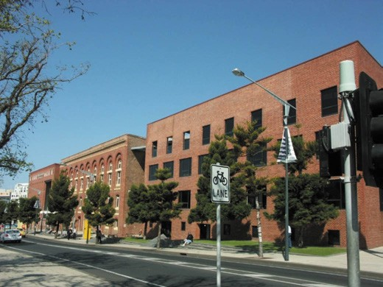

Figure 6.46: Waterfront campus, Deakin University, Western Beach frontage, 2011. Source: David Rowe.

2 Moorabool Street and the adjacent Commonwealth Offices building to develop as tourist venues.261 A major initiative was the redevelopment of the central city buildings in Market Square into a major, enclosed shopping complex following an American retail strategy model. Early buildings including Solomon s, the Block Buildings, Corio Theatre and CML Building fronting Moorabool, Little Malop and Malop Streets were incorporated into the new building complex which opened in 1985.262 A second retail strategy outlined in the City By the Plan was the redevelopment of the woolstores, former Electric Lighting and Traction Company building and
individual stores in the city block bound by Malop, Brougham, Moorabool and Yarra Streets. Only the facades of the historic brick woolstores and lighting company buildings were retained and the shopping complex – first known as Bay City Plaza - opened in 1988.263
Changing economic circumstances and technology resulted in the demise of many of the local woollen mills and the
sale of wool in central Geelong, industries that had been bedrocks of the Geelong economy since the 1860s.264 Of the woolstores, most were adapted into other uses, including the former Dennys Lascelles Woolstores into the National Wool Museum (which opened in 1988) at the south-west corner of Moorabool and Brougham Streets.265
Other major developments for the period included additions to the hospital buildings. At the Geelong Hospital, a new wing –named the Patricia Heath Wing –opened in 1986.266 It was followed two years later in 1988 by additions to St.
John of God Hospital (earlier known as Holy Cross).267 Some key developments occurred in the 1990s. In 1991, a new Law Court and Police Station complex opened at the corner of Mercer Street and Railway Terrace.268 In January 1996, The Waterfront campus of Deakin University opened in the

converted Dalgety s Woolstore complex269 (Figure 6.46) (see Theme 8).

STREETSCAPE INFRASTRUCTURE
Throughout the postwar period, the City of Geelong continued its progress of concreting the City s footpaths. As early as 1946, several works had been approved but were delayed until 1954 owing to shortages of concrete and in particular, the ban on the use of cement for purposes other than home building. 270
With the replacement of the Geelong tramway system with motorised buses in 1956 came changes to Geelong s streets. By 1957, tram rails had been removed, along with some centrally-located electrical poles, although several remained.
The removal of the poles was a recommendation in 1956 by the American traffic consultant, Ralph Dorsey. He also advised that owner onus be introduced and that parking meters be installed. 271
Meters were subsequently introduced in 1961.272
Possibly one of the most profound changes to the central Geelong streetscapes by the 1960s was the removal of the standard post-supported front verandahs. Ten years earlier in May 1951, the Legislative Committee of the Geelong City Council had approved and recommended a
By-Law prohibiting the erection of verandahs other than the Cantilever type. 273 The new By-Law gave owners 10 years to remove the post-supported verandahs.274 In 1961, an amendment was made whereby an additional clause gave opportunity for a 6 month extension for the post-supported
verandahs to be removed, on written application.275 Ironically, the By-Law was repealed within 20 years, with post-supported verandahs again in favour by the City of Geelong in 1984.276 One of the earliest verandah reconstructions was the cast iron verandah at 160-162 Moorabool Street, in 1998. Some others followed, leading to the preparation of the Geelong Verandah Study for the City of Greater Geelong in 2006.
Other changes were made to the City s streets. In 1995 along the waterfront, the City of Greater Geelong, with support from the Victorian State Government, the foreshore area between Bellerine and Moorabool Streets was transformed and 100 bollards installed from Limeburner s Point to Rippleside Park (Figure 6.47). These bollards gave a history of Geelong, the work of local artist, Jan Mitchell277 (Theme 9).

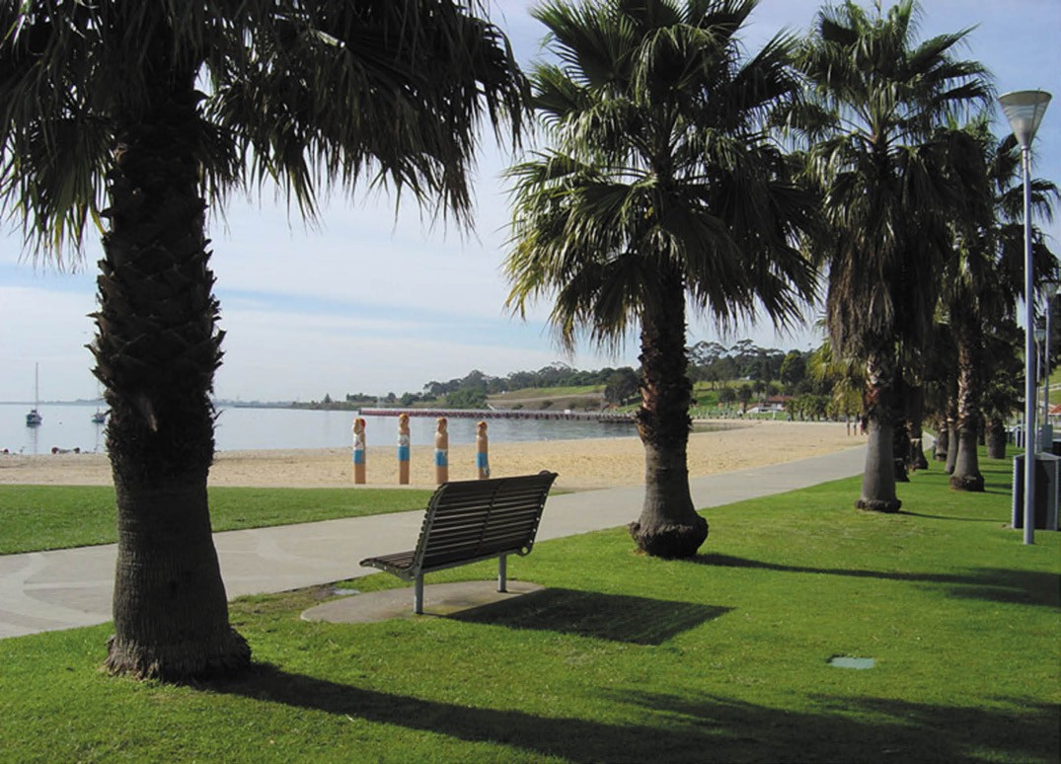
Figure 6.47: Waterfront near Eastern Beach (east of Bellerine St), showing row of palm trees and life saver bollards in the background, c.2011. Source: City of Greater Geelong.

  - FROM MANUFACTURING
TO HEALTH, EDUCATIONAL AND INSURANCE SERVICE SECTORS: GEELONG IN THE EARLY
21ST CENTURY

BUILDING DEVELOPMENTS
By 2010, Geelong s urban population reached 136,500.278 Victoria s second largest city was experiencing substantial change as the dominance of the manufacturing sector
–which had been in decline in the late 20th century – dramatically increased. Hundreds of jobs disappeared with the closure of maintenance hangars at Avalon airport by Qantas in 2014, closure of Alcoa in 2014 and the closure of the Ford Motor Company in 2016.279 Geelong in these early years of the 21st century was a city not in decline but in transition. Deakin University was rapidly expanding, bringing
research and development opportunities for innovation and technology industries. In 2009, the Transport Accident
Commission opened a new multi- storey building in Brougham Street, following its relocation from Melbourne.280 This
began another key driver of Geelong s new economy. In 2015, the new Geelong Library and Heritage Centre opened in Little Malop Street, to a design by ARM Architecture
of Melbourne (see Theme 8). The healthcare and insurance sector further progressed with the construction of major multi-storey buildings in Malop Street. In 2016, work began on the construction of the 14 storey Worksafe building at
1-7 Malop Street.281 Once completed in 2018, it was claimed to be Geelong s tallest and greenest building. 282 Principal facades of the former Dalgety and Co. Ltd. two-storied office building (constructed in 1924- 25 and ironically described as ‘an imposing edifice at the main entrance to the city proper’283) were retained. Two facades were also retained of the nearby former Carlton Hotel building at 21 Malop Street in 2017- 18
as part of the erection of the six-storied head office for the

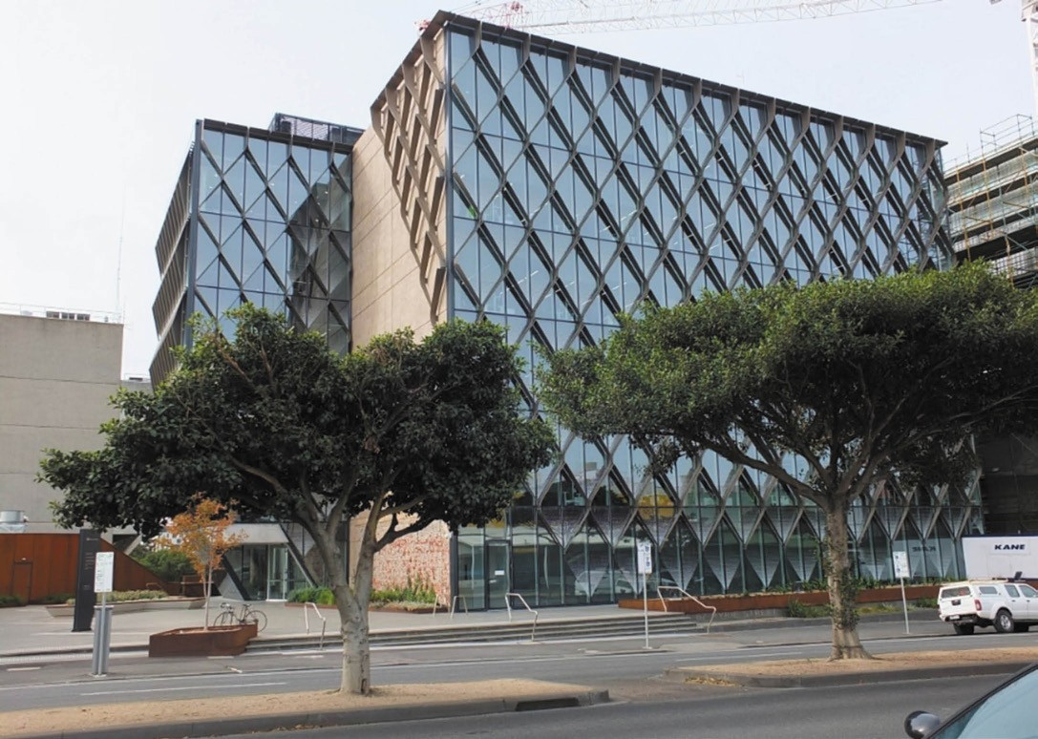
Figure 6.48: Barwon Water building, 55-67 Ryrie Street, 2019. Source: David Rowe.

National Disability Service Insurance Scheme. At 55- 67 Ryrie Street, the Brutalist concrete office building of the Barwon Region Water Authority experienced a major transformation to a design by GHD Woodhead architects284 (Figure 6.48). In 2018 the project won the Harry Seidler Award for Commercial Architecture at the Australian Institute of Architects National Architecture Awards as an innovative and sustainable design outcome.285

STREETSCAPE INFRASTRUCTURE
Major change was also experienced in Geelong s streets in the early 21st century. Footpaths were removed and replaced with wider footpaths paved in brick in the central streets.
Early bluestone kerb and channelling was removed and replaced with contemporary interpretations. Median strips were introduced in Ryrie Street and 132 palm trees planted in Moorabool Street.
The planting of palm trees in Moorabool Street commenced a major program of re-landscaping parts of central Geelong. In 2013, the City of Greater Geelong released a Central Geelong Action Plan to provide a 15- year strategy for the revitalisation of the central city area. A distinctive and enduring network of green spines and spaces that support living, working and walking, commencing with the greening of Malop Street ,
was included in the strategy.286 Up to 150 trees were to be planted in the Green Spine plan for Malop Street, spanning from Yarra Street to the east to Johnstone Park to the west.287 Work commenced in 2017 and was completed in 2018. Other works were also carried out in Little Malop Street between Moorabool and Gheringhap Street, included further tree planting. A painted image of the late Willem Baa Nip (also known as Billy Gore and King Billy of the Wadawurrung was created on a shop wall in Dennys Place (near Little Malop Street) by artist, Cam Scale288 (see also Theme 9).

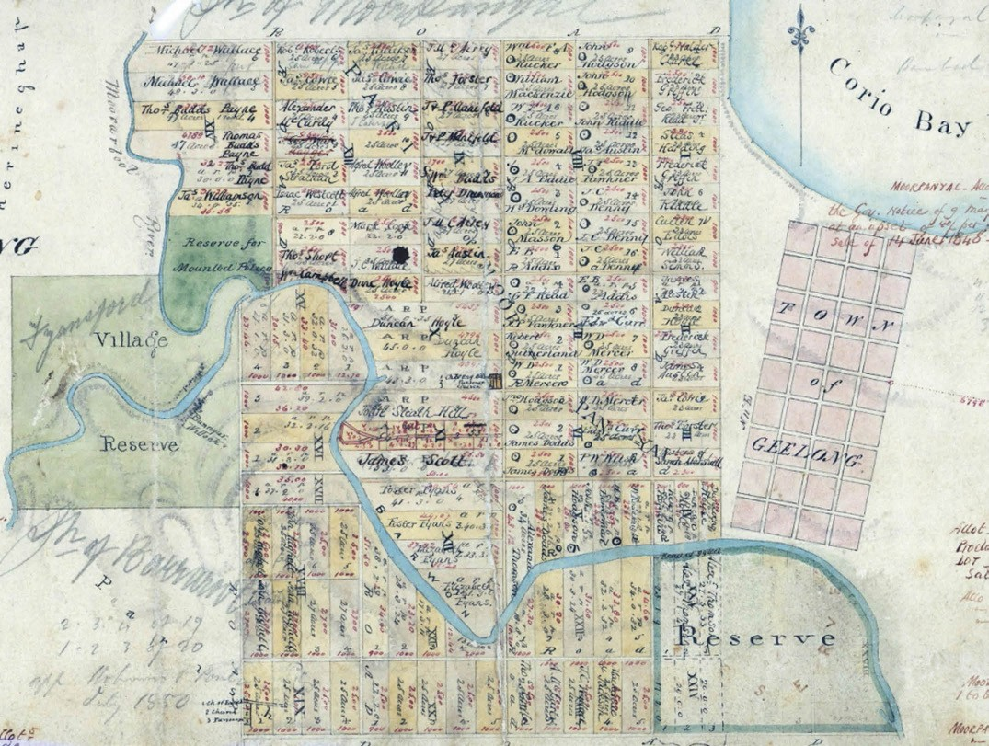
Figure 6.49: H.W.H. Smythe, Plan of Suburban Allotments in the Neighbourhood of Geelong, 10 February 1839, VPRS 8168/P5, item Sydney B39A, Public Record Office Victoria.

SUBURBAN COMMUNITIES

INTRODUCTION
Due to the sandbar that prevented large ships entering Corio Bay, Point Henry was initially a European arrival station distant from the Geelong Town Reserve. This was the earliest suburban European settlement in Geelong.
In 1839, a year after the completion of the survey of the Geelong Town reserve in 1838, assistant surveyor H.W.H. Smythe laid out largely regular 25 acre suburban allotments on the north and south sides of the Barwon River, west of the Town reserve289 (Figure 6.49). Lots immediately north and south of the river banks were irregular (given the topography of the land and the natural river course), with some being larger. The Fyansford Village Reserve and a reserve for Mounted Police had been created to the west of the proposed suburban areas, while on the south of the Barwon River Dr
Alexander Thomson offered for private sale allotments as the village of Belmont. The first land sale of these “suburban allotments was on 3 October 1839.290 The initial intention was for them to be sold for agriculture and cultivation291 although the influx of European settlers in the 1840s brought about further subdivisions. It was from this original survey that the earliest suburbs were created: Newtown, Geelong West, North Geelong, Rippleside, Drumcondra and Belmont.

POINT HENRY
Prior to European colonisation, Point Henry was known as Moola (and Anglicised to Moolap) by the Wadawurrung, given that this peninsula was in the shape of a spear head.292 It has also been claimed to be named after the location where the Wadawurrung gathered shell fish.293 As the location of saltwater swamps in 1803, no fresh water was found at Point Henry (Figure 6.50) soon after the arrival of Europeans in 1835.294

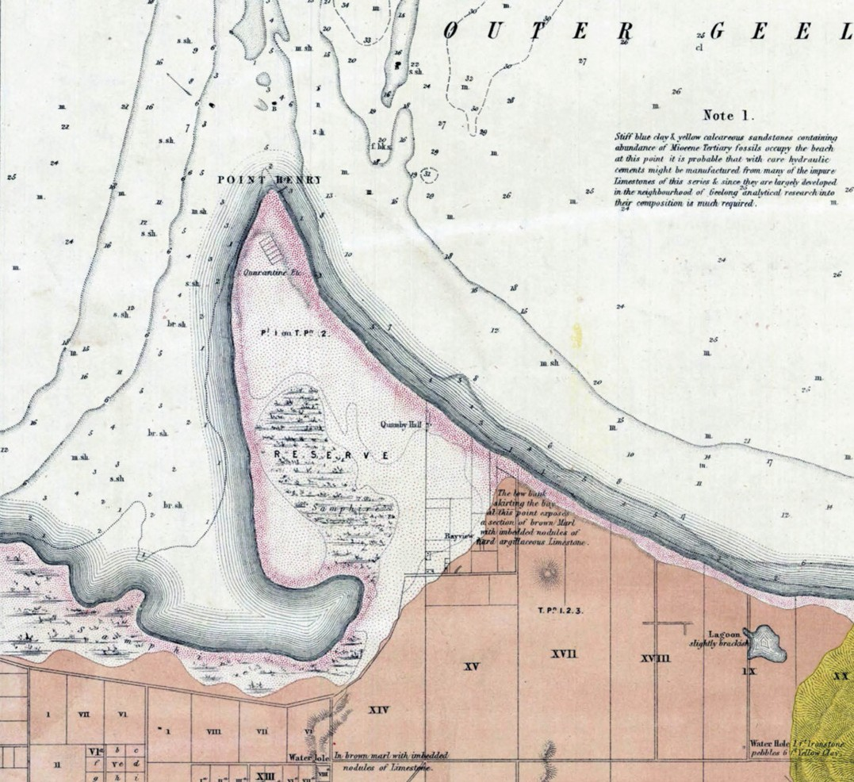
Figure 6.50: A.R.C. Selwyn, Part of Plan of Moolap, Bellarine, Point Henry: Geological Survey of Victoria no. 23, 1862, VPRS 8168/P5, item MD23C, Public Record Office Victoria.

The official name of this earliest European settlement in Geelong, Point Henry, appears to have derived from the brig Henry, sailed by Captain Whiting, which stopped there with an expedition party in 1836.295 In 1842, the Surveyor General had been instructed to bring forward some land for sale as soon as possible’ given the influx of European arrivals and livestock.296 By June 1843, 13 portions of land were offered at Point Henry with only one lot of 234 acres being sold.297 By 1849 however, up to 20 families lived at Point Henry which
led to the construction of a church and two schools.298 Most of the Point was reserved, with five rectangular allotments
laid out near the jetty for a quarantine station and possibly stores.299 It was also in 1849 when Tea Gardens were created at Point Henry.300 The Melbourne architects, Hyndman and Bates designed a two storey Bellarine Hotel in 1890, while a recreation hall was also part of the new summer resort. 301 Hundreds of trees had been planted in the gardens302.
For much of the 19th and early 20th centuries, Point Henry was largely a rural, farming area. In 1863, several allotments were surveyed and made available for purchase.303 Most
of the allotments ranged in size from 16 to 23 acres, with frontages to both the Outer and Inner Harbours. Only two

, ....

aa , .:
,' I • •,; •··
\ .t'

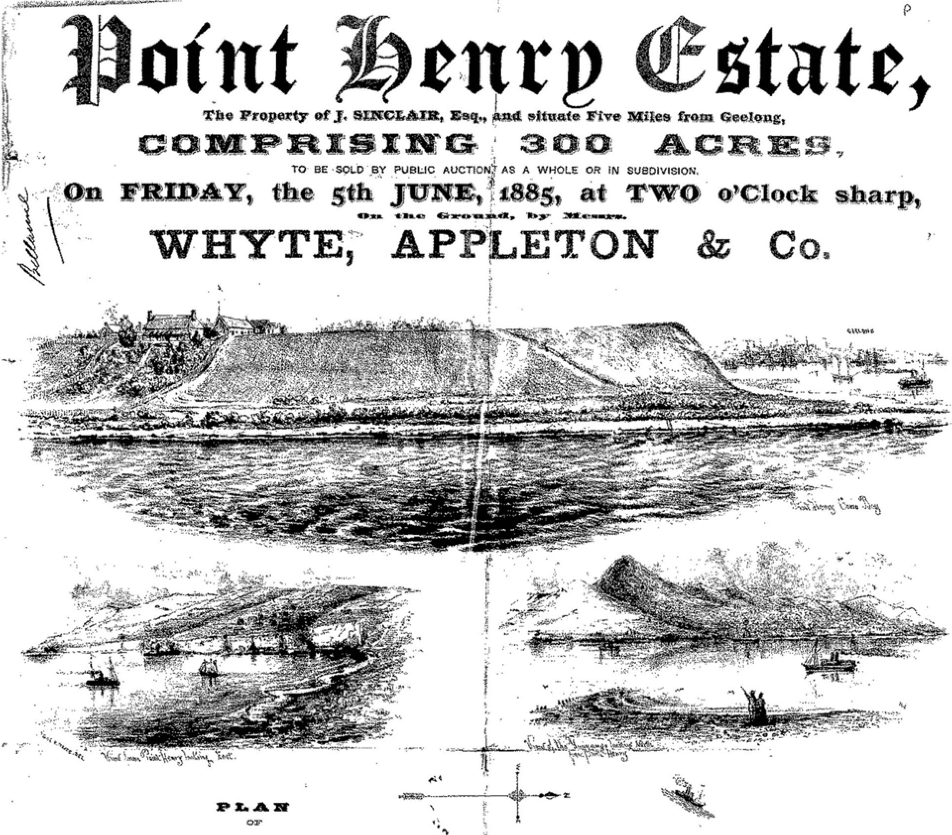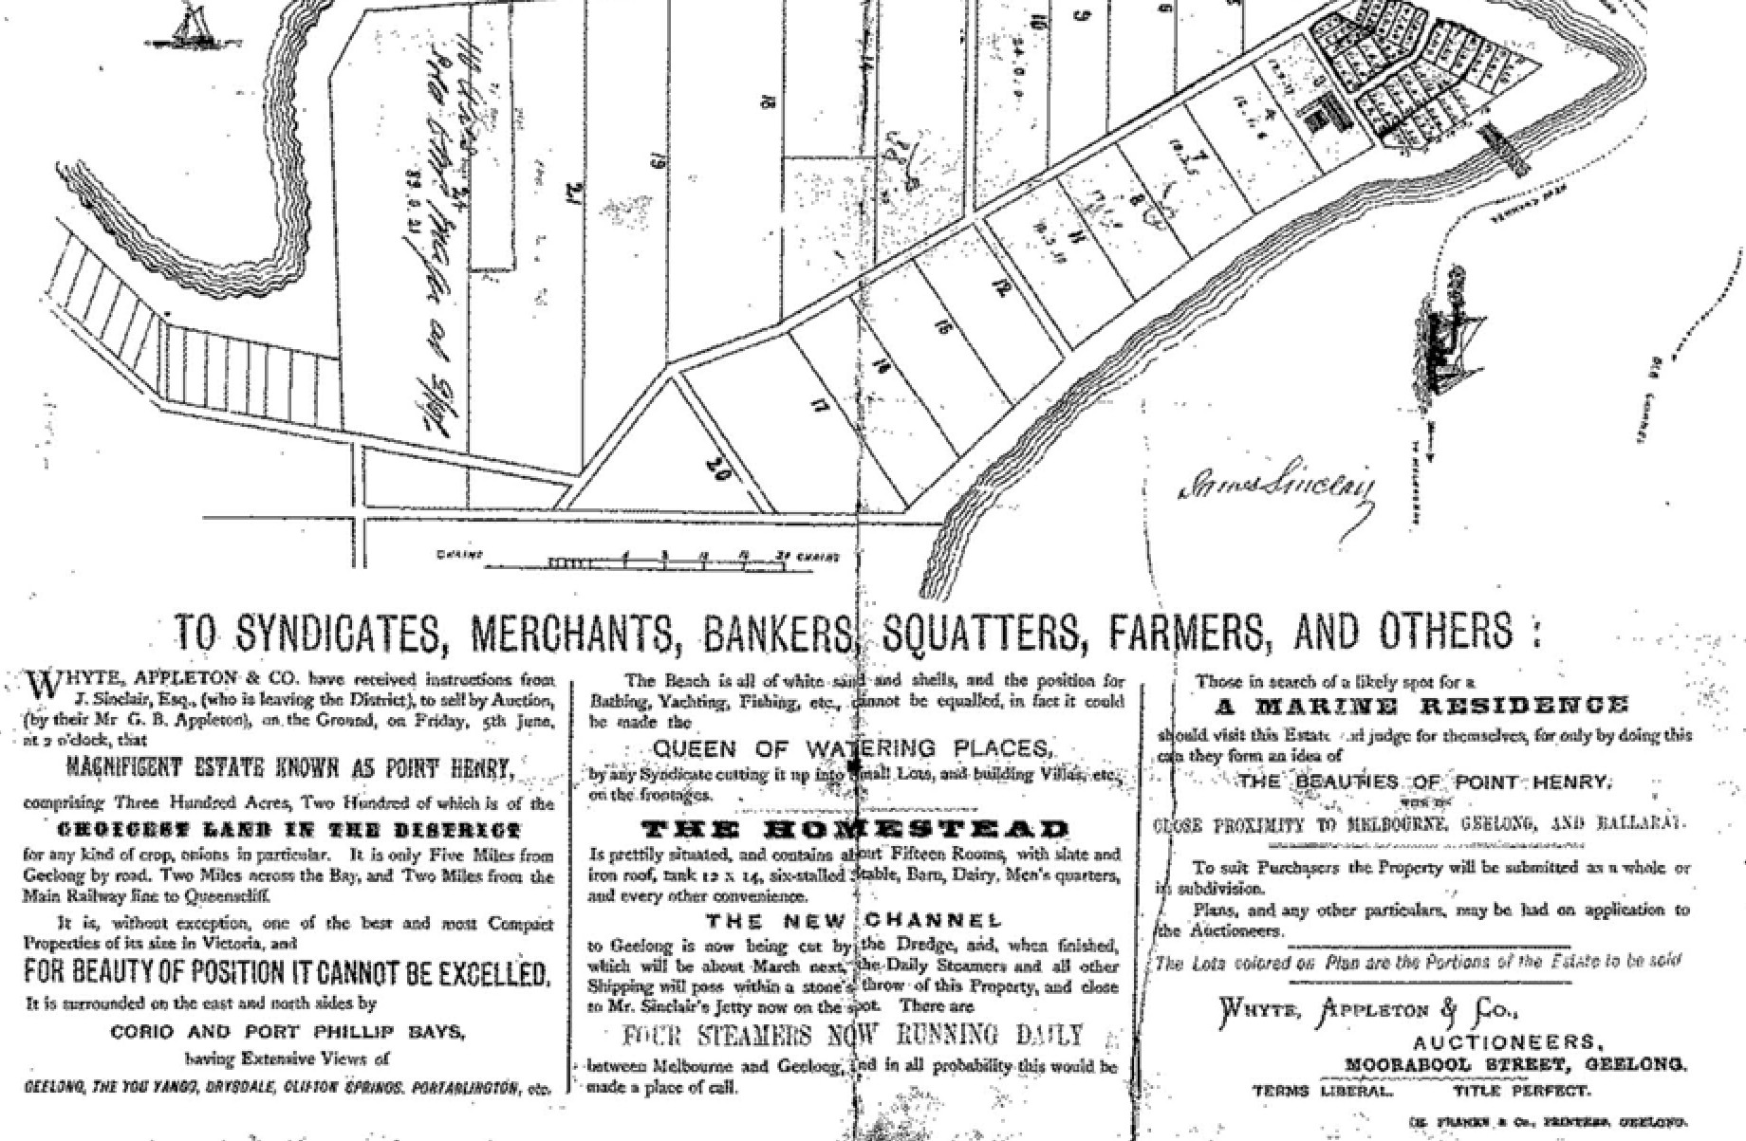..
..
t /·
......
THE POINT HENRY ESTATE.
1nikf
··
1·.
)

Figure 6.51: Point Henry Estate Auction Notice, 5 June 1885. Source: GRS 2030/Map P59/001, Geelong Heritage Centre collection.

_69L5 ABOUT CORAYO: A THEMATIC HISTORY OF GREATER GEELONG

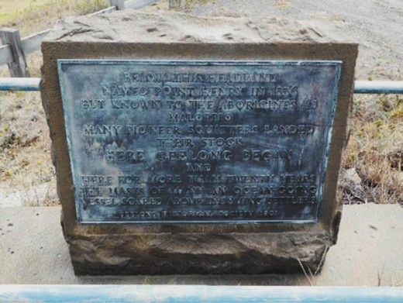
Figure 6.52: Plaque at Point Henry, 2015. Source: David Rowe.

allotments were developed and in subsequent years the 300 acres of subdivided land was acquired by J. Sinclair. He offered his homestead, jetty and land as the Point Henry Estate in 1885 (Figure 6.51). It was sold to the Point Henry Land Company.304
For much of the 19th century, Point Henry continued to serve as Geelong s principal port. In 1892 a tramway and track were erected on the east long pier for unloading goods.305
Following the opening of the Hopetoun Channel in 1893, enabling ships to enter Corio Bay, the importance of Point Henry as the centre of Geelong s shipping waned, as did associated industries and businesses. The promise of a thriving maritime, residential, and tourist centre was replaced with more agricultural pursuits. A Signal Station was built in 1939 to control shipping traffic. It was designed by the local architect, Norman Schefferle306 (see Theme 3).
In 1951, the Geelong Historical Society recognised the historical importance of Point Henry as a landing station for many European squatters. A plaque was unveiled at Point Henry on 11 November 1951 by John Manifold, descendant of the Manifold pioneers of 1836 (Figure 6.52). It was manufactured by William Bedford Ltd.307
The second half of the 20th century witnessed a substantial transformation of this area with the opening of the Alcoa Aluminium Smelter in 1961, followed by other heavy industries (see Theme 5 for further details).308

NEWTOWN
The elevated ground to the south-west of the Geelong Town reserve, and bound by Aberdeen and Pakington Streets, Shannon Avenue and the Barwon River, became the suburban settlements of Newtown (originally known as New Town)
and Chilwell. One of the earliest residents of Chilwell was
William Roadknight who secured his river frontage allotment where had had been occupying prior to Smythe s survey.309 Some allotments were re-sold reasonably quickly, the interest in purchasing at Newtown being the cheaper land prices
than those in the Geelong reserve, and privacy.310 In 1842, Newtown was still not recognised under its own name. The surveyor, A.J. Skene, was listed as residing in the Suburbans , and William Roadknight at Barwon Cottage. Captain Foster Fyans were also listed along with a few others.311 A few
years later at the south-east corner of Pakington and Austin Streets, Dr J. Clerke, Government Surgeon and first resident surgeon in Geelong, built a dwelling in 1849. The sloping topography stretching from Noble Street to Austin Street between Pakington Street and Latrobe Terrace was to be known colloquially as Clarke’s [sic.] Hill.312 Other parts of Newtown and Chilwell were also to given more localised names. Irishtown situated from Belfast Street to Pakington Street north of Fyans Street, was known by this name in the census of 1857. The name of the street, Belfast, survives today as a legacy of this early settlement. Outlying land to the west of Shannon Avenue, on Noble Street was known as Emerald Hill.313
It was not until the 1850s when more considerable suburban subdivision occurred in Newtown and Chilwell. In 1853, John Jackson offered a portion of the Ellerslie Estate situated on the rising ground above the Shearer s Arms in Aberdeen Street314 A more substantial subdivision was Mr Willis Avoca Estate near Herne Hill in 1853. The sale notice read:
The Extraordinary Shape of this Announcement is merely intended more strongly to impress upon the minds of the public the rare chance now offered in the shape of some of the most lovely allotments of Land, a portion of the exquisitely beautiful AVOCA ESTATE, which commands a view in front of the Bay and Shipping, and at the back, all that sweet inland scenery, the Vale of Avoca, where the
waters of the Barwon and Moorabool meet, which pleasing prospect, from the elevated situation of the Land, can never be excluded from the admiring gaze of its fortunate possessor.315
Further east on Aberdeen Street in 1853-54, the Baptists built a Barrabool stone church (it continued this function until the
neighbouring polychrome brick church was erected in 1876).316
In 1854, J.H. Taylor s Map of Geelong (Figure 6.53) showed a large concentration of dwellings and other buildings fronting regularly laid out streets adjoining Latrobe Terrace at Chilwell. The map included the original Cremorne Hotel (south-east corner of Pakington and Russell Streets) built in 1849-50.317 Closer to Latrobe Terrace, the original Gold Diggers Arms Hotel on the north side of Noble Street was built in 1850318
and the construction of the nearby Noble Street Wesleyan Methodist Church in 1854319 (Theme 8). Further commercial

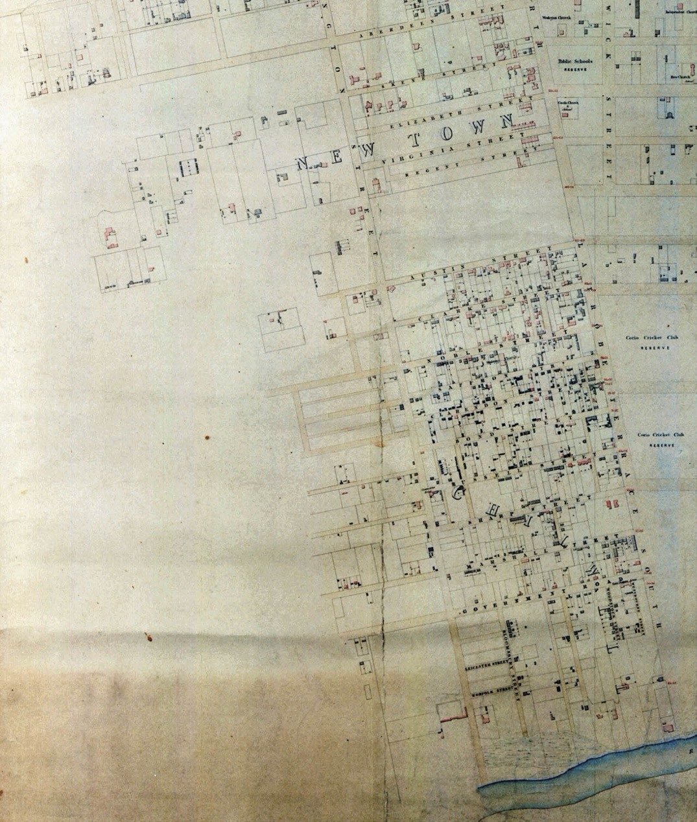
Figure 6.53: J.H. Taylor, Part of Map of Geelong showing Newtown, Surveyor-General s Department, Melbourne, 1854. Source: VPRS 8168/P2, Unit 5416, item Roll 39 Geelong, Public Record Office Victoria.

activity was fronted onto Latrobe Terrace. This included Edward Martin s Cricket Club Hotel at the corner of Latrobe Terrace and Clarendon Street (opposite the Corio Cricket Club ground now known as Kardinia Park –see Theme 9) established in 1854,320 and a timber hawker s shop appears to have been erected for Richard Asling at 402 Latrobe Terrace.321 By the middle of the 1865, the building had been extended to include Charles Browning s bootmakers shop.322 Other businesses followed including W.H. Kernot s Chilwell Dispensary by 1866, on the southern side of the large corner allotment at 348 Latrobe Terrace.323 Today, the earliest surviving shop in this part of Newtown is Herbert Pile s
painter s shop at 402 Latrobe Terrace. The adjoining dwelling appears to have been built by 1860-61 and the shop added later in the 19th century.324
An insight into residential, commercial and industrial life at Chilwell at this time was given in the Geelong Advertiser in 1911:
Dwellers in Chilwell in the very early days were mostly teamsters, who travelled to the diggings and other places. Hay and corn stores and blacksmith s shops were here in great numbers. Horse feed was realising £20 a ton, flour £5 a bag, while beef was 6d. a pound. The rent, for
a two-roomed cottage was £1 a week, borrowed- money realised interest at 15 per cent., and land having frontage to Latrobe-terrace realised £5 a foot; but wages were high. In 1869 the Albion Woollen Mills were started by their present owner, and three years following the Union Mills were put in motion; both only half their present size. At the top of Fyans-street was Donaghy s Rope Works.
This industry was lost to Chilwell (as many others) through the owner not being able to obtain half an acre of land for a rope walk. Tanneries to the number of ten were situated along the banks of the Barwon, and near Campden-road was a slaughter yard. Near this yard an hotel was built called the Eagle and Hawk, but no license was granted
the house. Taking everything into consideration, Chilwell was the busiest part of Geelong. The “Gabilila” [sic.] loan,” floated to raise money necessary for the formation and making of roads, and other sums amounting in all to
£10,000, were raised for making asphalt walks and kerbing the gutters. Russell- street was nothing but a sand bank, which became of great use to builders, and load after load was carted away The names of the streets of Chilwell were derived from those of old residents, and Chilwell in the early days was the most aristocratic part of Geelong, as the beautiful residences on the banks of the Barwon will testify. Among the early residents we may mention Sir Chas. Sladen, Dr. Reid and Mr. Chadwick. What was the first chemist shop in Chilwell, kept by the late Mr. Kernot, is now a small cottage in Bond street near Latrobe-terrace. That Chilwell was a busy centre is shown by the number

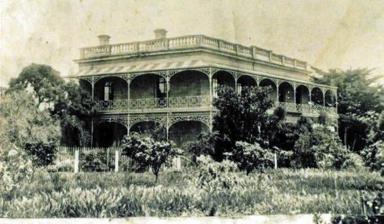
Figure 6.54: ‘The Hermitage’, Pakington Street, n.d. [c.1900]. Source: GRS 137/0, Geelong Heritage Centre collection.
of old shops in the different streets of the suburb.325
Equally affluent residential properties were established at Newtown, including George Armitage s substantial
Hermitage in Pakington Street (1858) (Figure 6.54) (see also Theme 7), James Austin s Priory in Pakington Street (1850) (now demolished), Joseph William Belcher s Sunville in Skene Street (1850) (now demolished), Charles Ibbotson s imported prefabricated German villa, The Heights at the western end of Aphrasia Street (1854) (Figure 6.15), Joseph Lewis Woolmers (now Newtown Brae ) in Stephen Street (c.1851) and architect Benjamin Backhouse s Coronal
in the far north-west portion of Newtown near Herne Hill (1854-55).326 Other properties were also established from this time in Noble, Aphrasia and Skene Streets, including the dwelling at 2 Skene Street in 1853-54. It was designed by Edward Snell as his own residence.327 Confidence to build in this locality may also have emanated by the creation of the Borough of Newtown and Chilwell in 1858,328 as well as the need for housing employees for the newly-established industries along the Barwon River.
There were also other important developments that contributed to cultural life in Newtown in the 1850s. In 1854, St. Peter s Church of England church building was constructed in bluestone at 25 Percy Street.329 A few years later in 1859-60, the Sisters of Mercy acquired J.W. Belcher s Sunville estate where they established the Sacred Heart Convent (now Sacred Heart College)330
(see Theme 8).
By 1864, several additional residential estates had been offered for sale. Shown on a Map of the Town of Geelong and Boroughs of South Barwon and Newtown and Chilwell by Robert Balding (Figures 6.55-56) the estates north of the Barwon River included the Westbourne, Riversdale and Marnock Vale Estates. At Chilwell, they included the Lake View and Dursley Estates. At Newtown, the elevated land
between Elizabeth (Roebuck) and Virginia Streets was sold as the Laurel Bank Estate, while further north between Aberdeen

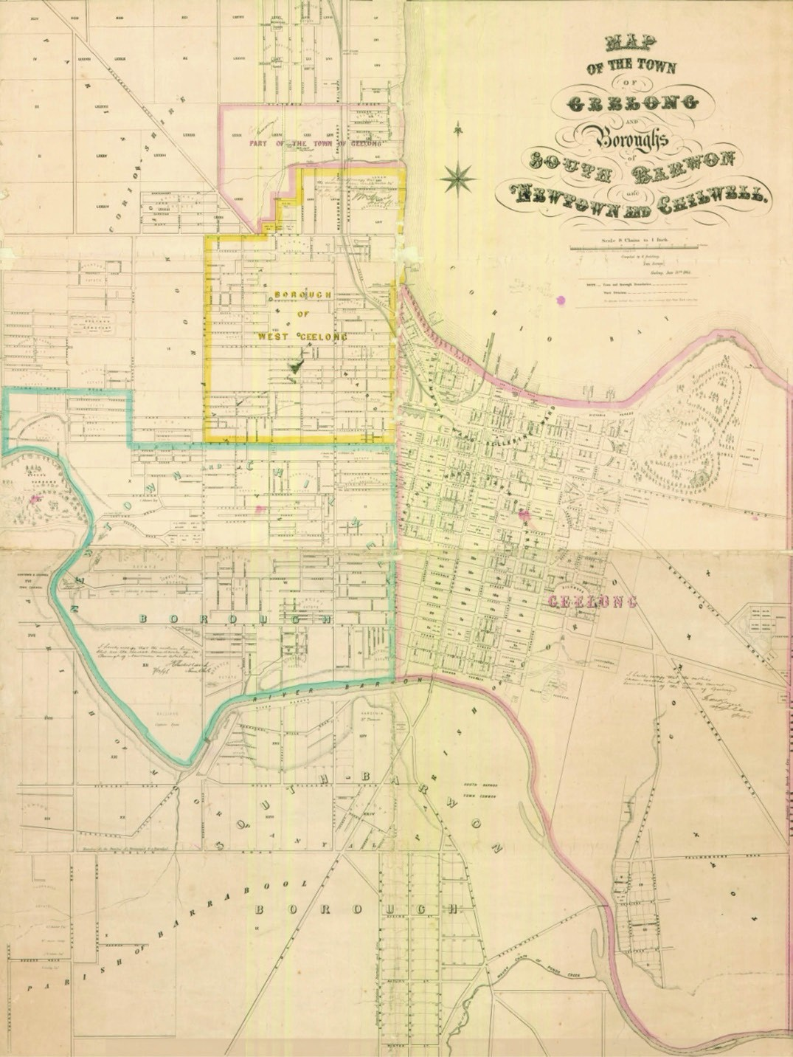
Figure 6.55: R. Balding Map of the Town of Geelong and Boroughs of South Barwon and Newtown and Chilwell, 30 June 1864. Source: Statutory Planning Department, City of Greater Geelong.

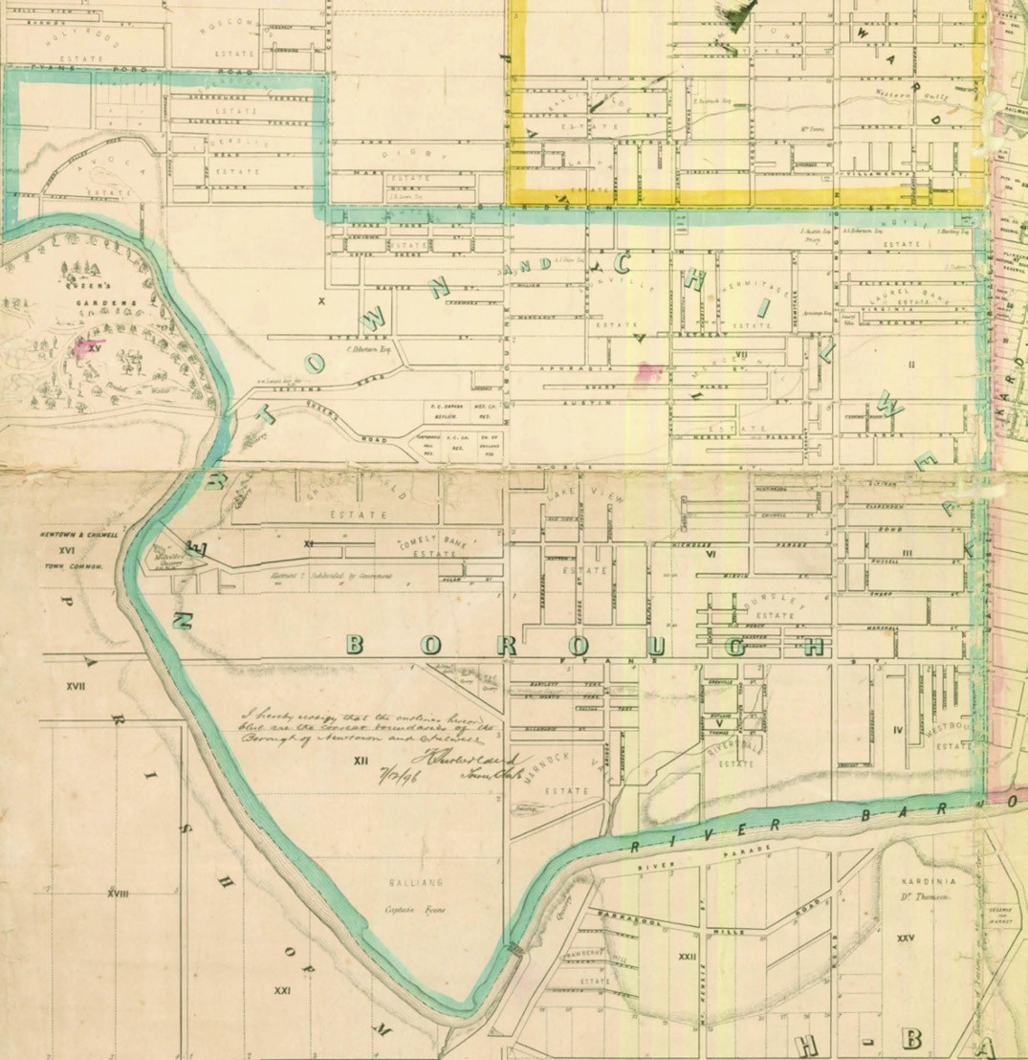
Figure 6.56: R. Balding Newtown portion of Map of the Town of Geelong and Boroughs of South Barwon and Newtown and Chilwell, 30 June 1864. Source: Statutory Planning Department, City of Greater Geelong.

and Skene Streets (immediately west of Latrobe Terrace) land was offered as the Hoyle Estate. George Armitage s surplus land was sold as the Hermitage Estate west of Hermitage Road (between Skene Street and Retreat Road). At Emerald Hill, substantial allotments were offered as part of the Chesterfield Estate which was nearby the previously established quarries above the east bank of the Barwon River. With the growth in population came the need for more churches. The Church of England established All Saints at the corner of Noble and Talbot Streets in 1862.331

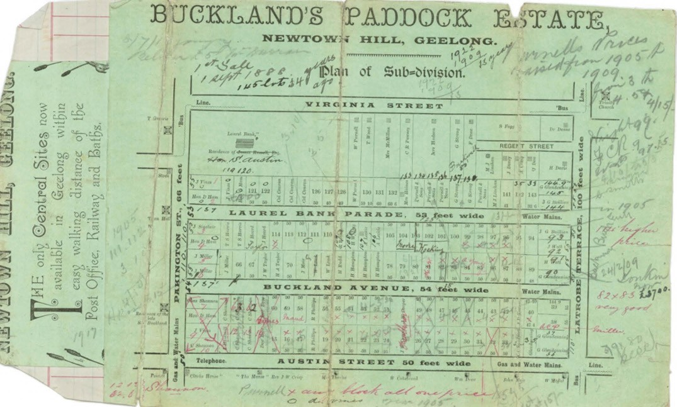
Figure 6.57: Plan of Subdivision of Buckland s Paddock Estate, Newtown Hill, 1888. Source: GRS 2030/Map B41D, Geelong Heritage Centre collection.

Further land was made available in the 19th and early 20th centuries. In 1871, the Laurel Bank Estate offered several allotments in Elizabeth (Roebuck) and Virginia Streets.332 In 1875, the Mercer s Hill Estate, following an unsuccessful gold mining venture (see Theme 4) was offered in small
rectangular allotments to the north and south sides of Noble Street, Mercers Parade, Prospect Road, Huntington Street and Chilwell Street (now Fairview Avenue).333 Further subdivision of this Estate occurred in 1885.334
By 1887, Newtown was regarded as the principal suburb of Geelong where the ground was elevated and an excellent view of the town and bay may be obtained. 335
A more detailed description of Newtown and Chilwell was given in Alexander Sutherland s Victoria and Its Metropolis in 1888:
These two places together constitute a borough in the county of Grant, South-Western Province, and electoral district of Geelong. Municipally they are governed by
a council, divided into three wards The borough has an area of 1422 acres, a population of 4700 persons, and an annual value of rateable property of £22,946.
Practically speaking Newtown and Chilwell form a suburb of Geelong, although in themselves independent. It is
partly a manufacturing and partly an agricultural place, containing many of the factories, &c., already mentioned as belong to Geelong generally In the borough are two State schools, a Catholic orphanage and school for boys, an orphanage for girls in connection with the Convent conducted by the Sisters of Mercy, a reading room, enlarged through the liberality of Mr. T. Austin, of Barwon Park, Winchelsea, with a good supply of books and papers for the use of working men and boys. Jeffrey s celebrated Fernery, with its look-out tower, is also here, and grand views of the surrounding scenery may be had from that
or from the top of Herne Hill. There are several quarries on the north bank of the Barwon, within the borough.
The Geelong railway station is about two miles distant, and cars run throughout the day. In these suburbs there has been of late a great extension of buildings, creating entirely new neighbourhoods.336
It was from this time that large parts of undeveloped land were made available for housing. In 1888, the Newtown Hillside Estate offered ’62 Magnificent Villa Sites’ with ‘Splendid Frontages to Fyans Street, West Melbourne Road [Shannon Avenue], George Street, Neiley Street, and Daisy Street.337 In this same year at the east end of Newtown Hill, Buckland s Paddock, (comprising the land between Pakington Street

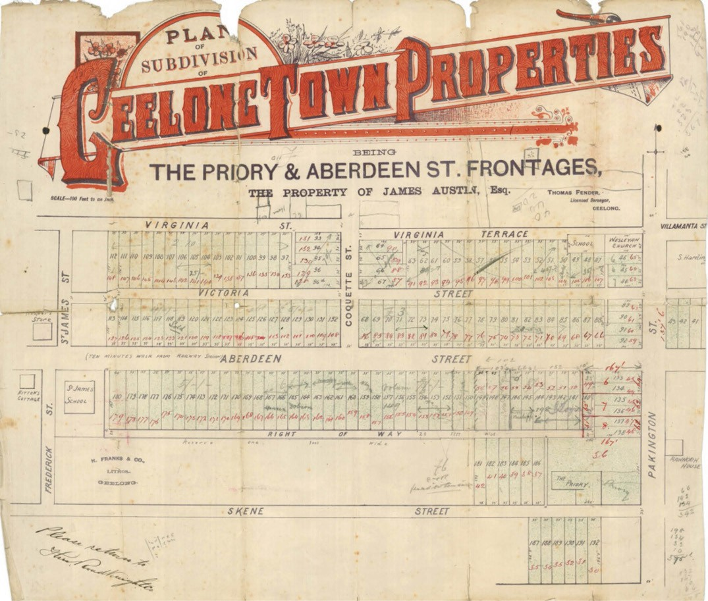
Figure 6.58: Plan of Subdivision of Geelong Town Properties being The Priory and Aberdeen Street frontage, n.d. [c.1889]. Source: GRS 2030/Map G15, Geelong Heritage Centre collection.

and Latrobe Terrace, and north of Austin Street), was first offered in 1888 as 145 allotments338 (Figure 6.57). Only 51 lots sold and the unsold allotments were again offered in c.1890.339 The sale of land in this subdivision continued into the early 20th century.
In c.1889, James Austin offered his Priory estate (Figure 6.58). Land fronting both sides Aberdeen Street (and further north in Geelong West) was sold in 180 allotments.340 One notable example was Ardoch , 298 Latrobe Terrace (Figure 9.112). Built in 1909-10, it reflects the work of the successful local architects for the period, Laird and Barlow,341 with its complex hipped and gabled slate roofs with corner attic, and Art Nouveau inspired timber brackets.
Numerous other dwellings were erected at Buckland s Paddock and in nearby estates in Newtown in the late 19th century. They included Kirrewur Court , 77 Prospect Road, built in brick in 1891 for Charles Shannon, wool broker, to
a distinctive Queen Anne design by the Ballarat architect, Charles Douglas Figgis342 (Figure 6.59). Substantial extensions were also made to Newtown Brae (earlier known as Woolmers ), 15 Stephen Street, in 1885 for Alexander David to a design by the Western District architect, Alexander Hamilton343 (Figure 6.60).
Several more modest dwellings were also built throughout Newtown during this period. A small yet distinctive number were erected by the pioneer building firm, Purnell and Sons, the patriarch being William Purnell (1831-1904).344 He arrived

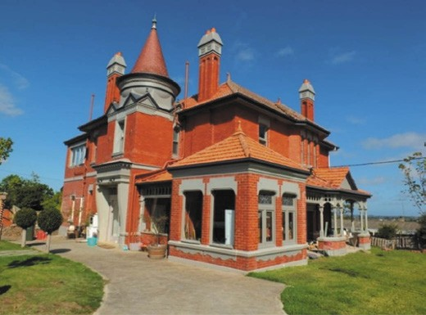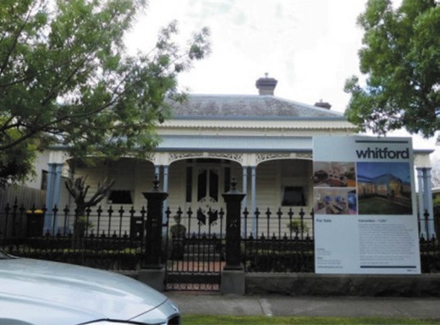

Figure 6.59: Kirrerwur Court , Prospect Rd, 2017. Source: David Rowe.

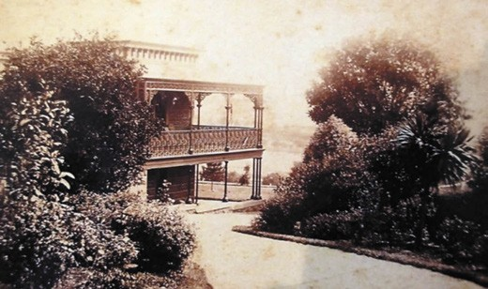
Figure 6.60: Newtown Brae , Stephen St, c.1900. Source: Jan Phelan, Welshpool.

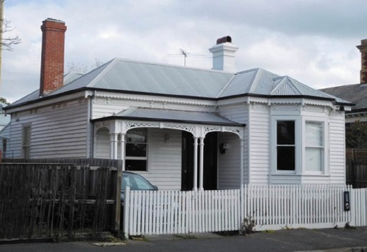
Figure 6.61: Dwelling, 22 Virginia St, 2015. Source: David Rowe.
Figure 6.62: Dwelling, 33 Roebuck St prior to alterations & additions, 2015. Source: David Rowe.
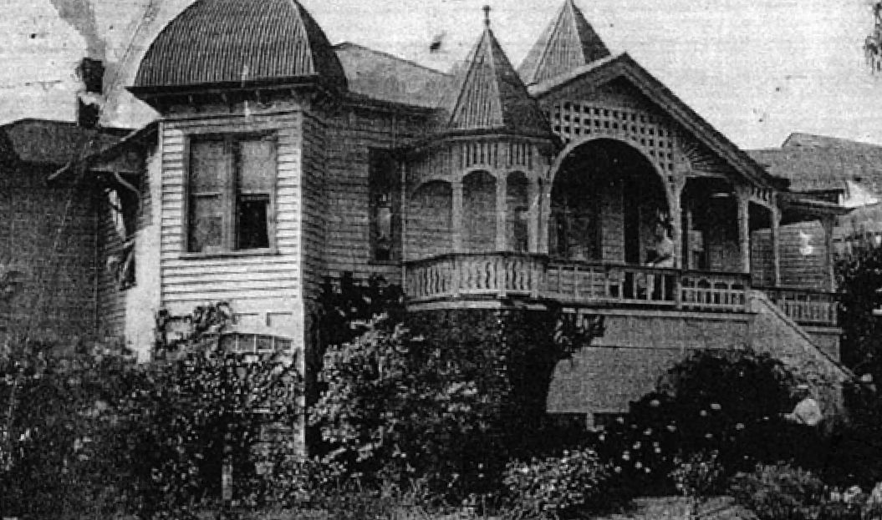
Figure 6.63: Strathcona , 2-4 Ascot St, c.1930. Source: Authentic Heritage Services Pty Ltd.

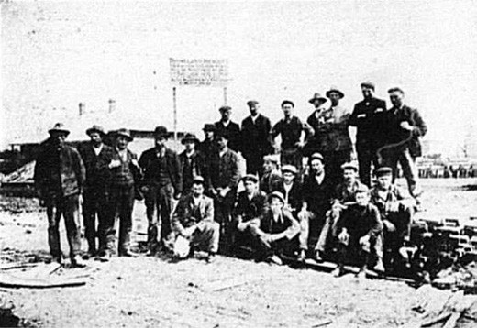
Figure 6.64: Construction workers at the Rhineland Estate, 1911. Noske & Messy-Rhine would appear to be standing (two from left). Source: News of the Week, 19 October 1910, GRS 2121, Geelong Heritage Centre collection.

in Melbourne in 1851 and later travelled to Geelong where his brother, Joseph, had settled.345 Having trained as a carpenter, William Purnell formed a building firm in partnership with
A.C.S. Clutterbuck, and when this partnership dissolved in 1876, the building firm of Purnell and Sons was established.346 The houses in Newtown built by the Purnell firm in the 1870s and 1880s included a timber dwelling at 22 Virginia Street (built in 1876 for Rev. Bunning)347 (Figure 6.61), William Purnell s own home at 39 Virginia Street (built 1884),348 the dwelling at 42 Virginia Street (built in 1884 for Archibald McArthur Campbell)349 and the dwelling at 33 Roebuck
Street (built in 1884) which William Purnell initially leased to Catherine Wallis350 (Figure 6.62). Characteristic of these Victorian Italianate styled dwellings was the composition of
the hipped roofs, and particularly the timber eaves decoration including turned drops, and the verandah details including the paired timber posts and cast iron shield motif verandah valances.
The firm of Purnell and Sons were also responsible for other distinctive Late Victorian and Edwardian Queen Ann designs constructed in timber. They include the dwellings at 16 Austin Street (built 1911-12) and 62 Austin Street (built 1890-95).351 Possibly the more distinctive is Strathcona , 2-4 Ascot Street (Figure 6.63). Built in 1900,352 it originally had a frontage to Noble Street and is notable for its picturesque roof forms
and timber verandah decoration. The dwelling provided prospective clients of Purnell and Sons the opportunity to inspect the roof forms and architectural details available at that time.
Aside for residential subdivisions and house construction, the year 1889 also witnessed the opening of the Salvation Army Hall at 18 Marshall Street, Chilwell.353 The Baptists had also opened a chapel in Saffron Street before 1890354 and they and the Wesleyans built additional churches in the area in later years (see Theme 8 for further details).
By 1905, following the laying out of new streets and streetscape infrastructure, construction of many new houses, maturation of the settings of longstanding mansions and modest cottages (albeit reduced as part of residential subdivisions), prospering Geelong College and the newly- opened The Hermitage Church of England Girls Grammar School (the former property of George Armytage), Newtown was described as the Toorak of Geelong. 355 This led in part to greater demand for housing allotments. In 1908, another 43 lots were made available in Fairview Avenue and Nicholas
Street as part of the Newtown Hill Estate.356 This was followed by an additional 31 blocks, mainly on the south side of Fairview Avenue.
In 1912, the Newtown Brae Estate fronting Stephen and Nantes Street and Punt (now Ruthven) Street were offered in 18 allotments.357 In this same year, 10 lots were sold as
the Devon Estate between Stephen and Aphrasia Streets, and another 10 allotments at the western end of Upper Skene Street as the Newtown Tram Estate .
Of particular interest was the Rhineland Estate in the far northern part of Newtown (also earlier known as Herne Hill) in 1911-12.358 This proposed housing estate of 35 dwellings was a development by T.J. Noske, Chairman of the nearby Australian Portland Cement, and the recently arrived entrepreneurial German engineer and forward-thinking planner (and employee of Australian Portland Cement), Laurel Messy-Rhine.359 The concrete and timber residence of Messy-Rhine, Rhineland , (built 1911-12)360 was situated at the far western end of the estate. A unique aspect of this estate was that the cottages were erected as part of the estate to house workers at the nearby cement works. They appear to have been the designs of Messy-Rhine who called tenders for plastering, painting and fencing 16 cottages
in August 1911361 (Figure 6.64). The distinctly-designed, modest timber Edwardian cottages (which were available either detached or as duplexes) were designed with hipped or gambrel roof forms and front verandahs, and presented a homogenous appearance to the small neighbourhood.
Adjoining the Estate with a frontage to Minerva Road was the residence of W.B. McCann,362 director and manager of the Australian Portland Cement company (see Theme 5). The house (Figure 6.65) was built in 1912,363 the similarity of the design with the neighbouring cottages of the Rhineland Estate suggesting that it may also have been designed by Messy-Rhine.
Further commercial progress was made in Latrobe Terrace during the Federation period. This included Charles Usher s timber corner store at 388 Latrobe Terrace in 1910,364 and
a shop duplex in 1911 for Thomas Horward at 364-366 Latrobe Terrace (it appears these shops were single storey and two storey additions were carried out in 1917)365 (Figure 6.66). Both shops remain today. A commercial building of the period that no longer survives was a brick shop built in 1911 for the plumber, James Herd.366 It had a frontage to Latrobe Terrace and was near the corner of Russell Street. Frank Coles also had a brick shop built in 1913-14.367 It was situated at the north-west corner of Latrobe Terrace and Clarendon Street and was first occupied by Percy Waylen, confectioner.368

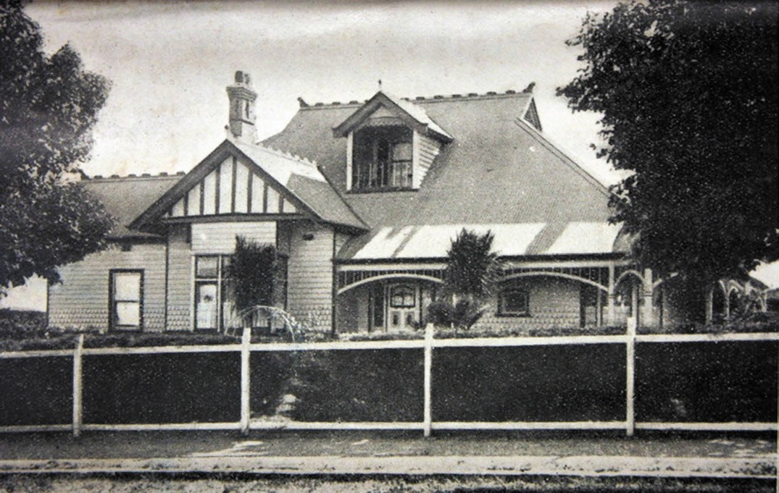

Figure 6.65: W.B. McCann s residence (then the property of A.W. Rotheram), south-west corner Minerva Rd & Autumn St, 1924 (now demolished). Source: Autumn Heights Estate plan, 1924, Authentic Heritage Services Pty Ltd.

Other subdivisions followed in the 1920s, mainly as a consequence of the reduction of large 19th century estates. They included the Bareena Estate in 1922, adjoining the western boundary of the Bareena Bowling Club and taking in lots in Huntington Street and Fairview Avenue.369 The estate was advertised as being the closest area of land to Geelong Post Office, available at prices which will be right.’370 Other subdivisions included the Fernery Hotel in Aphrasia Street in 1922, Brooklyn Estate in Stephen Street and Aphrasia Street in 1923, The Palmer Estate, Margaret and George Streets,
in 1927, and the McQueen Estate in Upper Skene Street in 1928.371
Numerous houses were built on these and other estates in Newtown during the period, many being standard hipped and mainly gabled Bungalows. A distinctive example of the more modest type is the dwelling at 18A Laurel Bank Parade (Figure 6.67), built in 1922 by J.C. Taylor and Sons, local builders, for Morriss Taylor, mechanic.372 A more radical
example of interwar domestic design in Newtown was the two storey house built for George Laird in 1935 at 22 Roebuck Street to a design by his brother, Ewen373 (Figures 6.68-69). The functionalist cuboid dwelling reflected the influences
of The Dutch Architectural School in Holland, led by Willem Dudok, with Ewen Laird having recently-returned from European and who believed this house was his best work.374
By 1925, commercial activity had been established in Pakington Street, Chilwell, between Noble and Fyans Streets. The Geelong Advertiser declared that Pakington Street, in Chilwell, is considered by many to be destined to become
the leading business centre in the locality. There are already several shops in the street 375 Commercial progress in Pakington Street (between Noble and West Fyans Streets) did continue in the ensuing years. In 1926, construction commenced for three shops at 361-361B Pakington for W. Dobson.376 This was followed in 1927 by a corner shop being erected at the front of Ernest Dew s Edwardian dwelling at 312 Pakington Street.377 It originally served as Mr Dew s newsagency. In 1928-29, a confectioner s shop was constructed at 331 Pakington Street for James McDonald.
However, the most substantial development in 1928- 29
was the construction of six brick shops at 356-362 Pakington Street for Messrs. Ritchie and Sutherland of Colac.378 They were designed by the local architects, Cleverdon and McLaughlin.379 In 1934-35, a confectionary store was built at

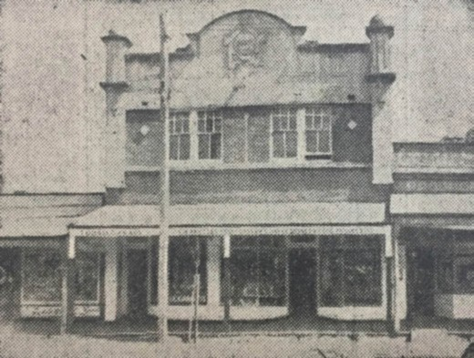

Figure 6.66: Shops at 364-366 Latrobe Terrace, 1936. Source: Geelong Advertiser, 10 October 1936, GRS 2050/197, Geelong Heritage Centre collection.

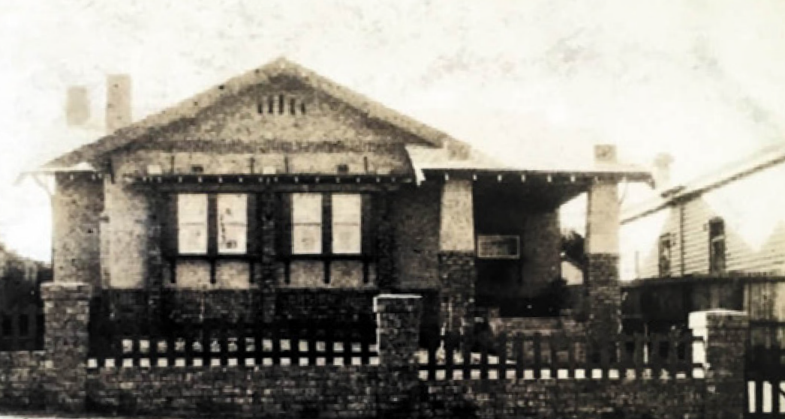
Figure 6.67: Dwelling, 18A Laurel Bank Pde, n.d. [c.1930]. Source: Statutory Planning Department, City of Greater Geelong.

313 Pakington Street.380 All of these commercial buildings in this part of Pakington Street survive today.
Further commercial development was witnessed in Latrobe Terrace in the 1920s. In 1927, Charles Usher had four new shops erected at 390-394 Latrobe Terrace. This development was reported in the Geelong Advertiser:
For the first time for many years Chilwell is to have a chemist s shop. It will be one of the four now being erected in Latrobe Terrace by Mr C. Usher One of the new shops, which will be opened early this month, will be occupied by the E.S. and A. Bank which established a branch in Chilwell last year. Latrobe Terrace promises to become a busy shopping centre in the near future. The two other shops have been built on the Russell Street corner, and it is believed that the erection of others is contemplated.381

Figure 6.68: E. Laird, Elevation & section drawings for residence, Elizabeth [Roebuck] St, Newtown, for G.A. Laird, 30 May 1935’.
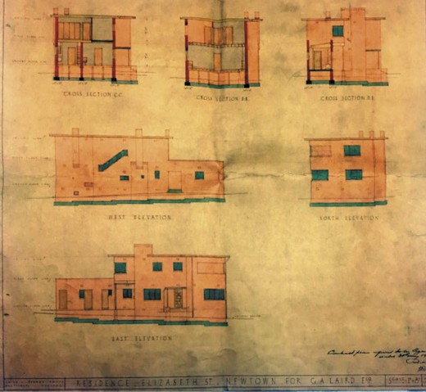
Source: Buchan Laird & Buchan Architectural Drawings GRS01401/ L04/03, Geelong Heritage Centre collection.
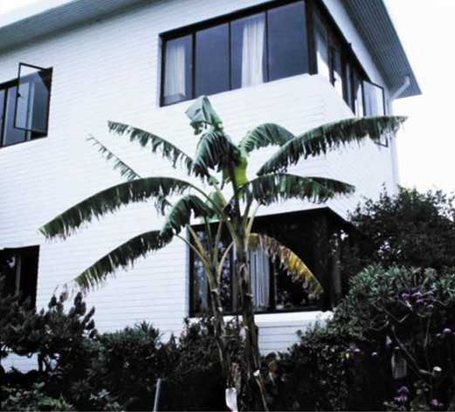
Figure 6.69: George Laird s house, 22 Roebuck St, c.1996. Source: Lorraine Huddle.

The other shops referred to that were built in 1927 are located at 404 and 408 Latrobe Terrace. One of the more substantial developments came in 1928 when the old Cricket Club Hotel was demolished and replaced with the existing two storey brick hotel. Named the Clarendon Hotel, it was designed by Cleverdon and McLaughlin for the Carlton Brewery.382

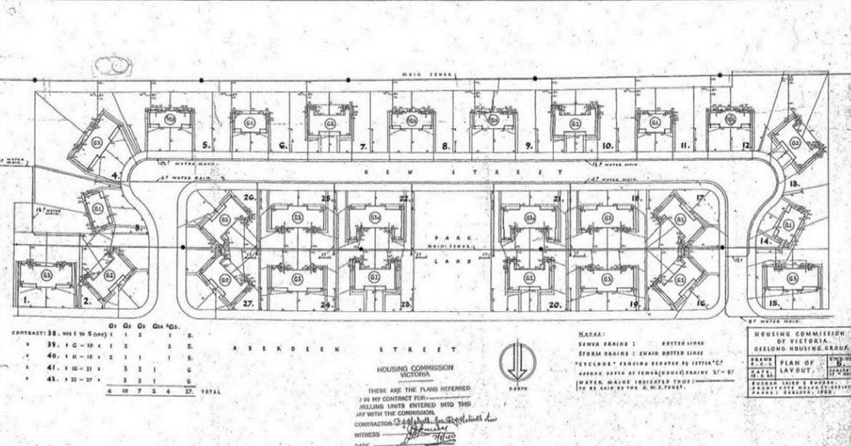
Figure 6.70: Buchan Laird & Buchan, Site Plan of the proposed Newtown Housing Commission Estate, 18 June 1940. Source: Property & Asset Services Branch, Department of Health & Human Services. State of Victoria.
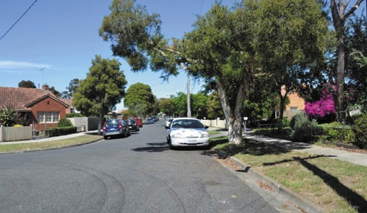
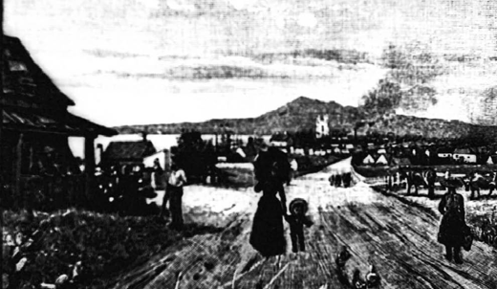

Figure 6.71: View looking east along Churchill Avenue, 2015. Source: Wendy Jacobs.

The late interwar and early postwar years witnessed the opening up of more land for residential purposes, mainly on the outer fringes. Ten lots were offered for sale in 1938 as the Fyans Estate, with frontages to Fyans Street and Percy Street.383 In 1939, the Fernery Grove Estate, comprising 12 allotments accessed from the south side of Aphrasia Street
(and behind properties fronting Shannon Avenue) was offered for sale.384 In this same year, seven lots were made available as the Croker Estate having frontages to Austin, Pakington and Clarke Streets.385
Figure 6.72: Lithograph of Geelong near the Ashby Village, n.d. [c.1840s]. Source: Wynd collection, Authentic Heritage
Services Pty Ltd.

A notable residential development off Aberdeen Street (west of the Great Western Hotel) was the laying out of the first provincial Housing Commission Estate in Victoria in 1940-41 by the local architectural firm, Buchan Laird and Buchan.386 They prepared a subdivision based on Garden City ideals, the plan layout having a principal thoroughfare comprising
a U layout (Figure 6.70). The estate also included a central public playground, grassed nature strips and generous front gardens. Five one and two storey, semi-detached brick design types formed the basis of the estate (Figure 6.71).

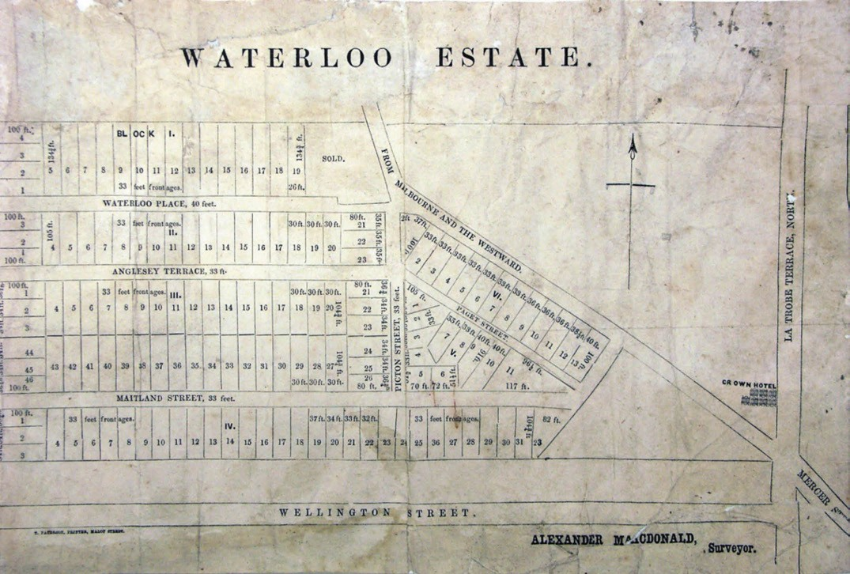
Figure 6.73: Waterloo Estate Subdivision Plan, 1850. Source: GRS 2030/Map W49/2, Geelong Heritage Centre collection.

In 1941, the substantial mansion, Edgecombe , which had extended from Skene Street to Aberdeen Street,
was subdivided into 5 lots, the dwelling being retained on
a much smaller allotment with a frontage to Skene Street387. More substantial subdivisions included the Queens Park View Estate in 1955 and the Windmill Estate in 1956.388

GEELONG WEST
The earliest building developments in Geelong West occurred from 1841. It was known as the Ashby village and comprised approximately 50 acres of land immediately west of Pakington Street on allotments 10 and 11 of Section 8 in the Parish of Moorpanyal389 (Figure 6.72). Between 1843 and 1848 the village of Little Scotland was established on rising ground to the south-west of Ashby.390 It was located between Latrobe Terrace and Pakington, Aberdeen and Hope Streets.391 A third area of development west of the Ashby village was the Kildare estate. Building blocks were first offered for
sale in 1848.392
More substantial progress of these three discrete areas came following the subdivision of the 25-acre allotments from 1850.
The Waterloo Estate subdivision offered several allotments between Pakington Street and Latrobe Terrace, with frontages to Maitland Street, Anglesea Terrace, Waterloos Street, Picton Street and Paget Street393 (Figure 6.73).
The Milton Estate subdivision (Figure 6.74) comprising allotment 14, shows approximately 300 house lots available for purchase in c.1854 in Weller, Yuille, Autumn and Pakington Streets.394 Around the same time, land comprising Crown Allotment 13 immediately north of the Milton Estate was advertised for sale in Clarence and Albert Streets, although a portion of this Crown Allotment comprising 12 house blocks in Clarence Street were offered for sale by E. Davidson in 1852.395 On 18 December 1854, the Kilkenny Estate provided numerous allotments in the former Crown Allotment 5, with frontages to Queen (now Waratah) Street, Shannon Avenue, Catherine Street and Charles (now Askew) Street. The fourth major subdivision was of Crown Allotment 4, comprising numerous allotments in Robert (now Albert) and Lloyd (now Clarence) Streets to Shannon Avenue.396 Two streets were given Wadawurrung names: Villamanta (meaning a place where the heights let me see all round , relating to the

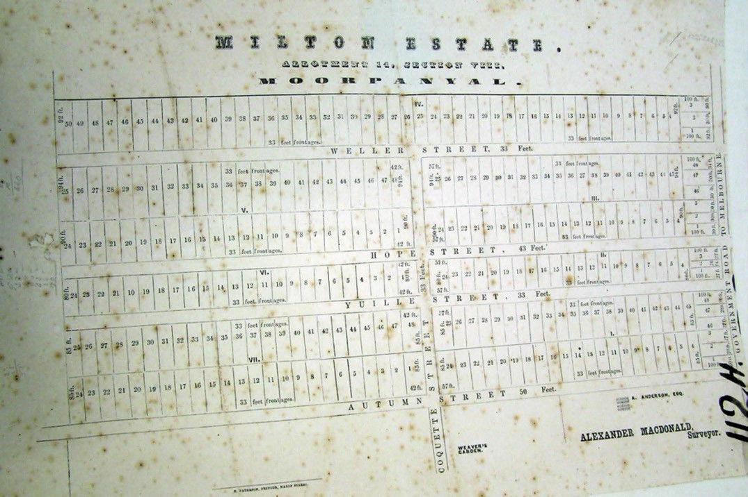
Figure 6.74: Milton Estate Plan, c.1854. Source: GRS 2030/Map 112H, Geelong Heritage Centre collection.

You Yangs) and Little Bunyip (after the feared mythological creature –this street has been renamed McNicol Street).397
J.H. Taylor s Map of 1854 (Figure 6.75) showed the locations and clusters of dwellings and other buildings in Geelong West at this time. Not surprisingly, most development was centred around the Ashby village and between Pakington Street and Latrobe Terrace in Ashby and Little Scotland where the early subdivisions had been carried out. The area west of Pakington Street, apart from the western portion of Little Scotland, was largely rural, where farming merged with domestic residences which had orchards or large
gardens, and were, in effect, little subsistence farms, possibly not completely self-sufficient, but not characteristic town houses. 398 While Weller, Hope and Yuille Streets had yet
to be laid out, a cluster of dwellings on contextually small allotments were located north of Albert Street (and including Clarence Street), immediately west of Pakington Street.
There was also a line of houses on the north side of Autumn Street, being more closely spaced at the eastern end, near Pakington Street.
Few of these earliest dwellings constructed in Geelong West survive today. At 26-28 Albert Street are two semi-detached brick cottages built in c.1850,399 while a more intact example of a stone dwelling survives at 23 O Connell Street (built c.1859) (Figure 6.76).400 The brick construction of these early dwellings appears to be physical legacy of Ashby’s brickfields
- the largest and most well-established in Geelong in the late 1840s (see Theme 4). Yet, a large number of affordable rudimentary timber cottages were also built, including a grouping of three gabled timber dwellings at 10-14 Weller Street401 (Figure 6.77) Also of interest was the erection of prefabricated Singapore dwellings imported by Alexander
Fyfe in the mid-1850s.402 These dwellings, including those at 7 Wellington Street (Figure 6.78) and 127 Elizabeth Street403 are distinctive with their steeply- pitched hipped roofs and wide timber wall cladding.

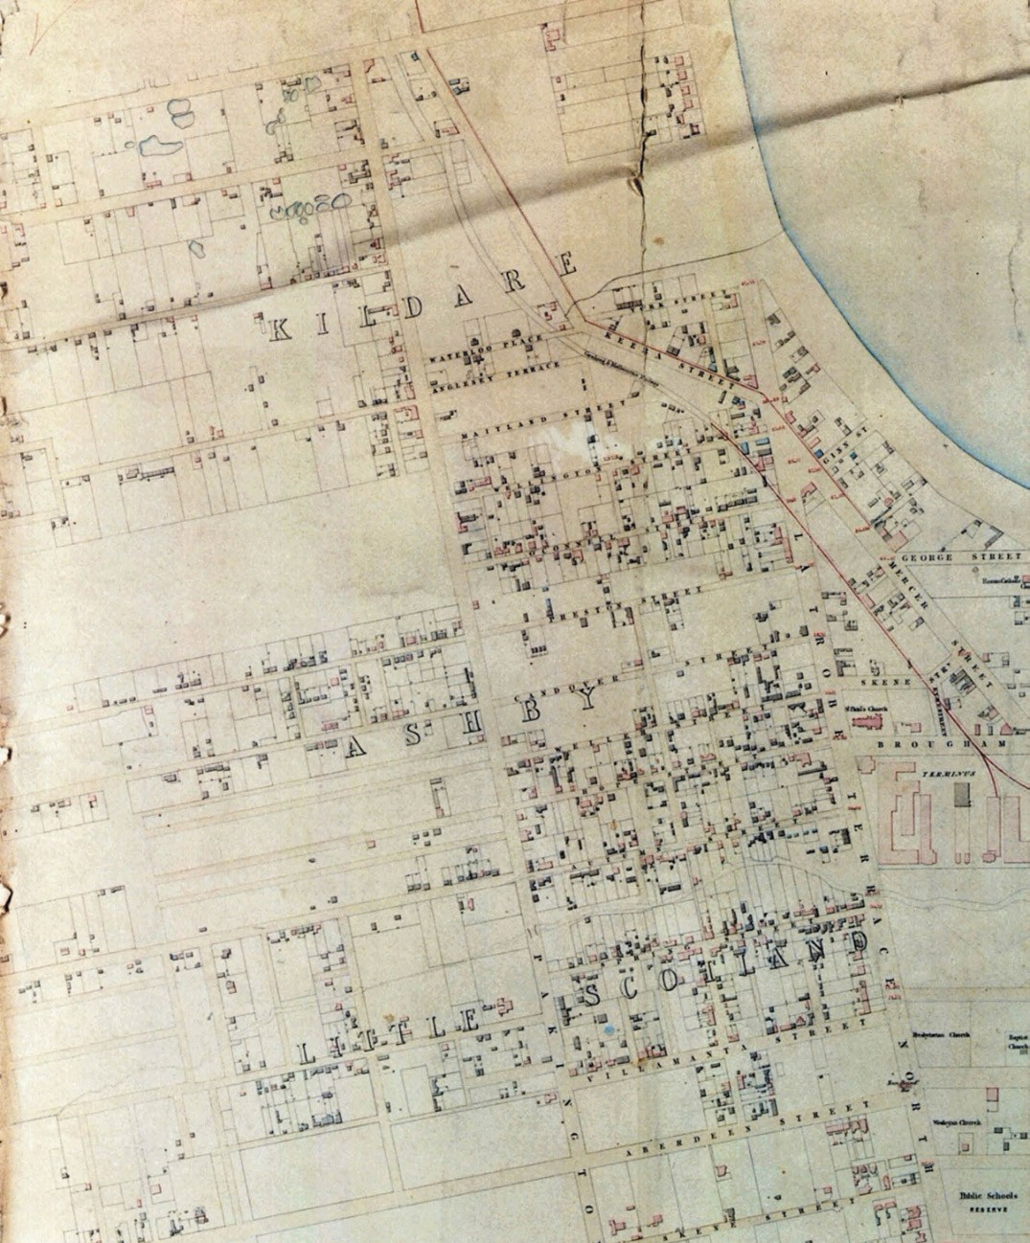
Figure 6.75: J.H. Taylor, Portion of Map of Geelong showing Geelong West (Little Scotland, Ashby & Kildare) Surveyor-General s Department, Melbourne, 1854. Source: VPRS 8168/P2, Unit 5416, item Roll 39 Geelong, Public Record Office Victoria.

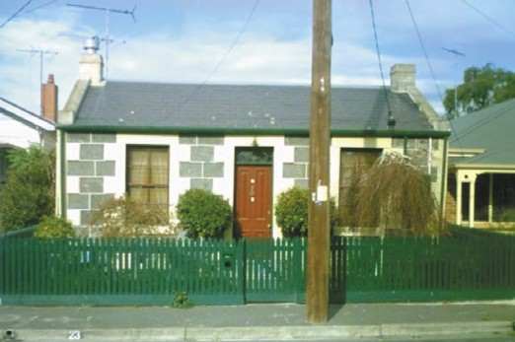
Figure 6.76: Dwelling 23 Candover St, 2009. Source: David Rowe.

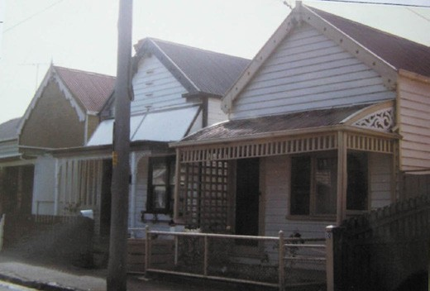

Figure 6.77: Three dwellings, 10-14 Weller St, 1986. Source: Honman, et.al., City of Geelong West Urban Conservation Study .

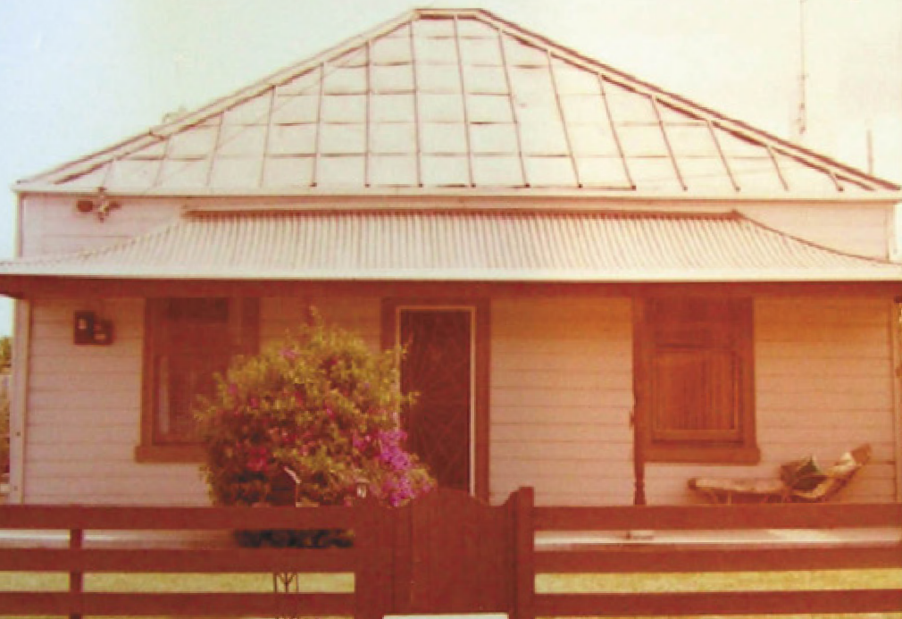
Figure 6.78: Prefabricated Singapore dwelling, 7 Wellington St, 1986. Note the original Morewood & Rogers sheet metal roof tiles (now replaced). Source: Honman, et.al., City of Geelong West Urban Conservation Study .

From the early 1850s, Pakington Street was developed as a commercial centre in Geelong West. It remained unnamed in the earliest years of settlement. It was known as the road to Bates Ford in 1849 before being named Pakington Street by December 1853.404 One of the earliest buildings was the St. George Hotel, 212 Pakington Street (east side of the street). This substantial two storey building was built in stages from 1853 for George F.W. Lindau, publican. It was followed by
a two-storey brick and stone draper s store further south at 220 Pakington Street in 1856-57 (Figure 6.79). Additional commercial development occurred in Elizabeth Street where in 1858 Oddy s General Store was erected. Several years later in 1873, Michael Donaghy relocated his Fairview Ropeworks factory from a shed at Marnock Vale to a seven- acre site in Pakington Street (see Theme 5).
More substantial housing development occurred Geelong West in the 1880s and 1890s, and especially during the Federation era of the 1910s. Unsold allotments in the estates of the mid 1850s were again offered for sale, including the Milton Estate in c.1880.405 One hundred and twenty splendid building and residential sites with extensive frontages
to Weller, Hope, Yuille, Autumn & Coquette Sts. were proudly advertised, the roads being formed, metalled and channelled , and ground being on high land with a beautiful outlook, sea breeze, no dust [and] free from hot winds.’406 Similarly in July 1884, a market garden and building sites in the Kilkenny Estate were for sale.407 A further ’75 magnificent villa sites in the Kilkenny Estate with frontages to Catherine, McDougall, Queen (Waratah) and Charles (Askew) Streets occurred on 11 December 1886,408 with identical descriptions of the roads and land as the 1880s Milton Estate subdivision being given. The sale of the revived Kilkenny Estate was soon followed by the availability of another 56 allotments fronting Elizabeth, Avon and Hope Streets (immediately east of Shannon Avenue), known as the Rugby Estate, on 24 December 1886.409 Two years later on 20 October 1888, 8 lots
on the southern side of Clarence Street were offered as house sites between the properties of Mr Howards and Mr Baxter.410 A few weeks later on 3 November 1888, 45 superb villa sites were offered as the Fairview Estate in McDougall, Catherine and Charles (Askew) Streets, the land being described as
the pick of Geelong West, the scenery unsurpassed 411
(Figure 6.80).
Further subdivisions continued into the 1890s and early 20th century, bringing with them the most prolific period of building development in the area.412 The estate of the Hon. Francis Ormond was offered for sale on 20 February 1890 and it included two lots fronting Coquette Street between
Yuille and Autumn Streets.413 Another sale of Ormond s land (including his own house at 186 Autumn Street) - and known as the Ormond Estate - occurred on 18 October 1890.414 It included 15 allotments and the residence, and a 10 feet wide

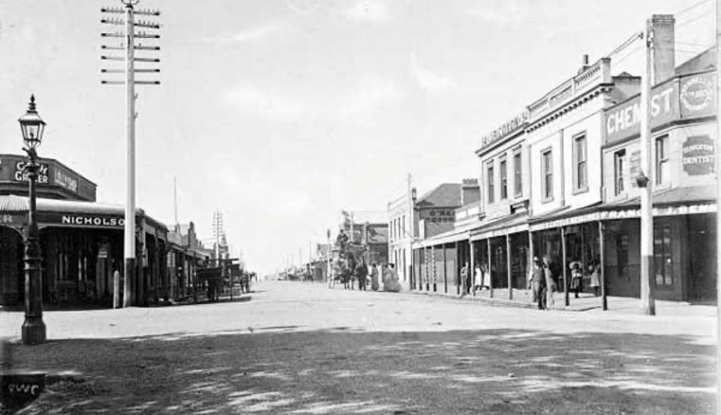

Figure 6.79: Pakington St near the Autumn Street intersection, looking north, c.1910-17. The two storey buildings on the right in
the middle ground and background include the St. George Hotel and the draper s store. Source: accession H90.160/563, State Library of Victoria.

right of way with access from Autumn and Elizabeth Streets. The allotments had frontages to Autumn, Elizabeth and Hope Streets. In 1891, the 18 allotments were offered as part of the Eton Estate. These lots fronted Autumn and Hope Streets, and Shannon Avenue, and also included two cottages.415 In 1893, 42 building sites were made available as part of the Westbourne Estate which included allotments fronting Weller, Hope and Elizabeth Streets.416
In 1911, 20 building blocks, a brick house and stables were offered in Catherine, Elizabeth and Lloyd (Clarence) Streets and Shannon Avenue.417 On 25 May 1912, the Horne Estate was advertised with a further ‘8 magnificent building sites’ with frontages to Autumn and Hope Streets, immediately west of Elizabeth Street.418 During World War One, a further 12 building allotments in Hope and Autumn Streets (west of Elizabeth Street) were sold as the
Watts Estate.419
Most of the dwellings built between the 1880s and 1910s were not grand or substantial, but modest in scale, being single storey and constructed mainly in timber. By far the majority were built during the 1890s and 1910s for the working classes: for tradespeople (carpenters, contractors, builders, painters, plasterers, labourers, ropemakers and bricklayers);

for railway employees (engine drivers, signalmen, gangers and shunters); and for blacksmiths, shop employees, drapers, storemen and women whose occupations were described in the Geelong West Rate Books as being domestic duties .420 In 1911, several timber dwellings were relocated from Ballarat to Waratah Street for employees of the ropeworks421 (Figure 5.49)
(see also Theme 5). Fewer houses were built for managers, public servants, engineers, accountants, retirees and gentlemen .
While a notable number of houses were built in the 1880s,422 over 300 were constructed between the 1890s until the 1910s.423 Notable Victorian and Late Victorian styled examples of the dwellings include those at 134 Autumn Street and Rosebank , 28 Lawton Avenue (Figure 6.81). Some
of the notable Federation era dwellings include those at 76 Albert Street, 22 Askew Street, 116 Autumn Street and 23 Wellington Street (Figure 6.82).
At 4-8 Avon Street three identical Edwardian styled timber dwellings appear to have been speculatively built in 1914-15.424
Modest progress in commercial building development in Pakington Street occurred during the Federation

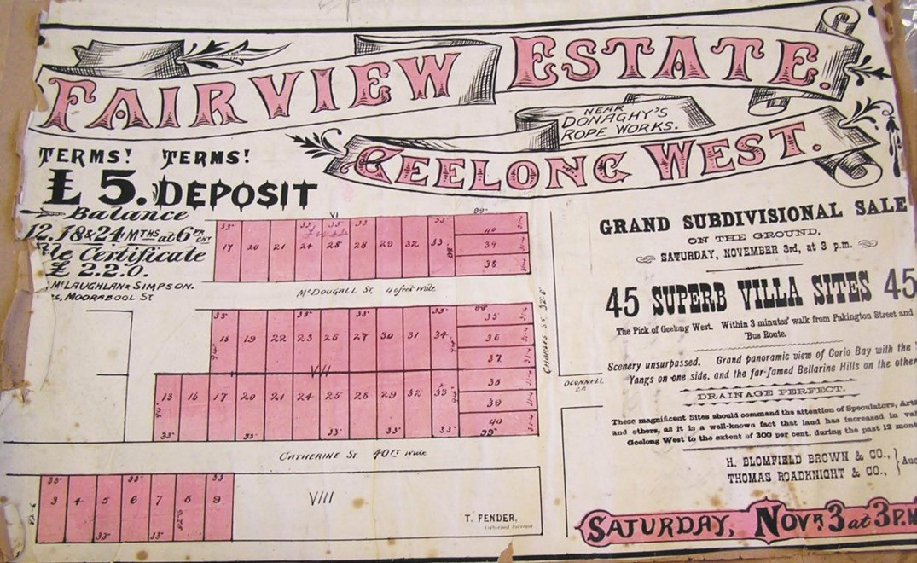
Figure 6.80: Fairview Estate, Geelong West, 3 November [c.1888] Source: GRS 2030/F29, Geelong Heritage Centre collection.

(c.1895- 1918) period. Mostly shops, they included a butcher s shop for William Dolley in 1900 at 137A Pakington Street; a two storey brick shop for Daniel O Meara in 1904 at
208A Pakington Street; a grocery store for the Austin Brothers in 1912-13 at 159 Pakington Street; the Queen of the West Hotel at 126 Pakington Street in 1913, and a complex of five shops at 168-176 Pakington Street in 1914 for Lloyd Hooper425 (Figure 6.83). A small number of commercial buildings were also erected in Elizabeth Street during this period. Of more unorthodox design was the former fruit shop built for Edward Naylor in 1917-18 at 41 Elizabeth Street.426 Another shop constructed during the Edwardian period was at 194 Autumn Street (corner of Elizabeth Street), built in 1912-13 with a dwelling attached.427
After the First World War in the 1920s, there was steady growth in Geelong West with many households established.428 By the late 1920s, the suburb was a built-up residential
area, as shown in the aerial photograph by Charles Pratt (Figure 6.84). By far the majority of subdivision and housing development occurred in the western portion of Geelong West, west of Elizabeth Street, although there were older houses demolished and replaced with interwar Bungalows in other parts of the suburb.429 The unsold blocks in the remaining portions of the oldest subdivision estates were
once again offered for sale, including the Ormond Estate around Hope Street and the Eton Estate (house blocks west of Elizabeth Street in Hope and Avon Streets).430 Other subdivisions included the Ann Street Estate in 1922, where 24 lots were offered (Figure 8.46), and Donaghy s Subdivision in 1925, where 57 lots were offered, including four in Waratah Street, 13 on the southern side of John Street and 3 blocks in Elizabeth Street between John and Waratah Streets.431
Considerable transformation occurred in Pakington Street following the First World War. Confidence in the
transformation of the commercial streetscape in Pakington Street during the interwar period may have emanated from the construction of a new Town Hall in 1923-24 on the site of the earlier building.432 Some earlier buildings were remodelled (such as the shops at 201-205 and 224 Pakington Street in 1925),433 while others either filled vacant land or replaced dilapidated structures. Built between 1920 and 1928, they included the buildings at 106-116 Pakington Street (built 1922), State Savings Bank at 135A Pakington Street (built 1922), three shops at 138-140 Pakington Street) built 1921-
22), three shops at 142-144 Pakington Street (built 1921- 22), Hooper s Building at 143-147 Pakington Street (built 1925), fishmongery at 148 Pakington Street (Built 1924- 25),
Rushbrook s at 149 Pakington Street (built 1927-28), Shirley s

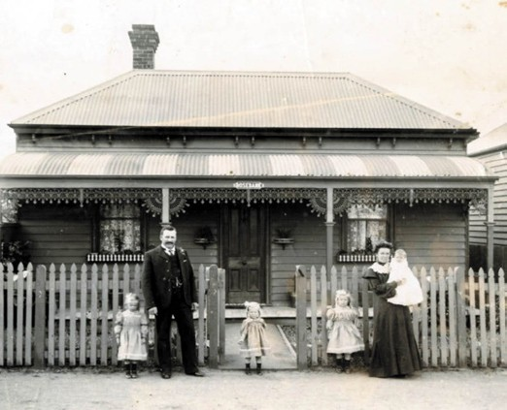

Figure 6.81: ‘Rosebank’, 28 Lawton Ave, n.d. [c.1900]. Source: Emerald Museum.

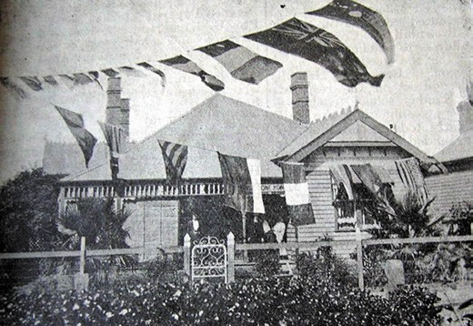
Figure 6.82: Armagh , 27 Wellington Street, 1919. Source: News of the Week, 1919, GRS 2121, Geelong Heritage Centre collection.

Bootmaker s Building at 151A Pakington Street, fruit shop at 156 Pakington Street (built 1924), tailor s shop at 163
Pakington Street (built c.1920), grocery shop at 165 Pakington Street (built c.1920), produce store at 167A-171 Pakington Street (built 1920-23), draper s shop at 167 Pakington Street (built 1922), clothing shop at 173 Pakington Street (built 1921), bootmaker s shop at 175-177 Pakington Street (built 1920), mercer and clothing emporium at 184-192 Pakington Street (built 1926), two shops at 197-199 Pakington Street (built 1921), three shops at 200-202 Pakington Street (built 1924), three shops at 204-206 Pakington Street (built 1927) and the Bee Hive building at 214-216 Pakington Street (built 1923-24)434 (Figure 6.85) (see also Theme 5).

Figure 6.83: Five shops at 168-176 Pakington St, 1922.
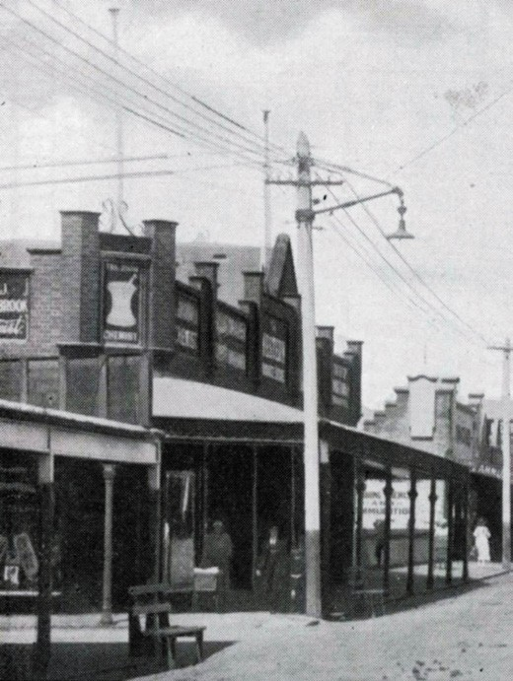
Source: Souvenir booklet. Geelong West, Proclaimed a Town, March 22nd 1922, Authentic Heritage Services Pty Ltd.

Soon after the Second World War in 1948, Geelong West was still considered to be a developing area. It had more houses newly-connected to the sewer mains than any other municipality.435 The 1950s witnessed the gradual extension of housing development where there was available land, over
100 years since the first houses were built in the area.436 Over 40 buildings were constructed during the postwar period.437 They included the brick houses at 178A Autumn Street, 26 Clarence Street and 186 Hope Street (built between 1951
and 1955). Another notable postwar building was the former bicycle shop at 27 Elizabeth Street, constructed in 1954-55 for Eric Radford.438

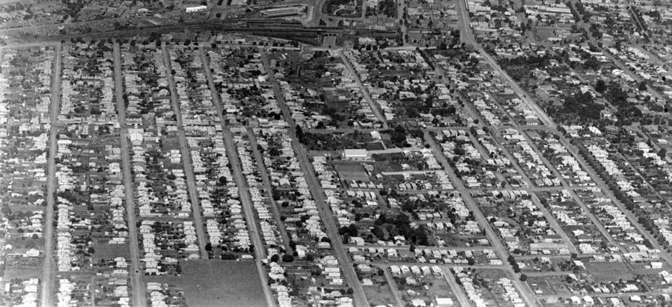
Figure 6.84: Aerial view of Geelong West looking east, c.1926-27. Source: c. Pratt, accession H91.160/809, State Library of Victoria.

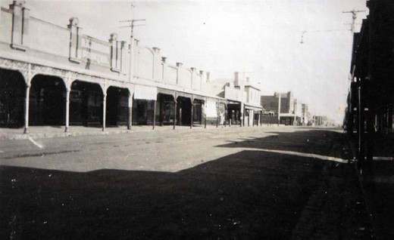
Figure 6.85: Shops, 210-224 Pakington Street, c.1930. Source: Holmes collection, Authentic Heritage Services Pty Ltd.

NORTH GEELONG
The suburban lands surveyed by H.W.H. Smythe in 1839 extended as far north as today s North Geelong. In 1847, Robert Hoddle carried out another survey and prepared a Plan of Allotments marked at Cowies Creek and Corio Bay 439 (see Figure 6.99). The available 72 allotments took in the foreshore land on the western side of Corio Bay, including the suburbs now known as Rippleside, North Geelong,
Corio, Norlane and North Shore. The boundaries for this northern suburb –and its name –changed several times in the 19th century. The earliest subdivisions were created on the north of Victoria Street, west of the Melbourne Road (and later, the railway line). The area was then known as
West Geelong (given today s Geelong West being originally
known as Ashby, Little Scotland and Kildare). The first subdivisions were the Rothschild and Windsor Estates, as shown on Balding s Plan (Figure 6.86). The western half of the subdivision in 1853 took on British precedents as it
included two formal squares: Bryanstone and Belgrave. The layout and names of the squares as part of the development gave promise for the construction of many houses, and the Geelong West railway station was erected by 1857 as part of the Geelong to Melbourne railway line in anticipation of a high demand (the station was originally further north than its current location).440 The Nugget Hotel opened at the north- west corner of Melbourne Road and Victoria Street in 1854 by Robert Sommerville (a former Vice President of the Total Abstinence Society)441 in anticipation of the major housing development. However, apart from cottages lining the Melbourne Road near the railway station, few houses appear to have been built.442 This was possibly due to the close proximity of the Geelong Gas Works that was established in
1857.443 In c.1910, the subdivision layout was still shown in a Plan of Geelong and Suburbs and it included a third square: Fitzroy, again suggesting that the area was to be transformed by houses that never eventuated (see Figure 6.38). An industrial estate today, several of the existing streets and
the street names Victoria and Douro, are a legacy of this early subdivisional development.
The eastern portion of North Geelong (between the Melbourne Road and Corio Bay) originally comprised the substantial marine estates of two wealthy European arrivals. Land north of today s Swinburne Street was acquired by the pastoralist, Robert Muirhead, who had the mansion, Osborne

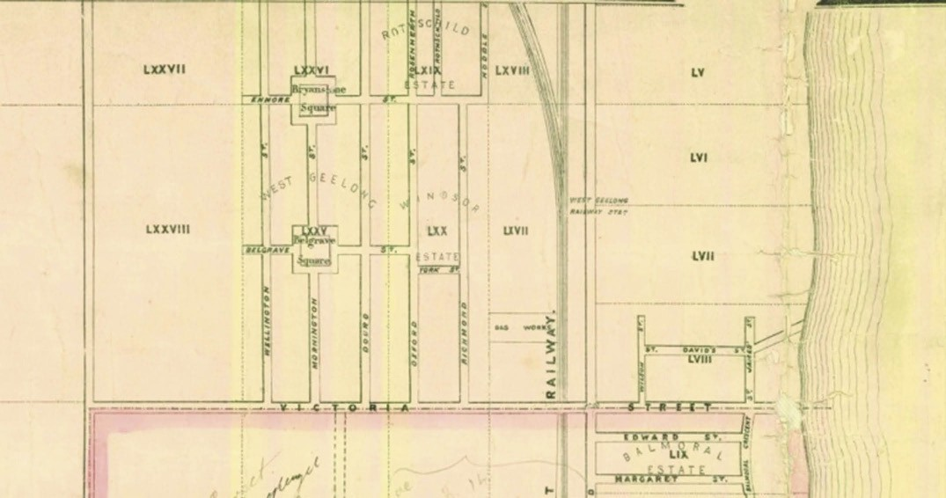
Figure 6.86: R. Balding, Map of the Town of Geelong showing Rothschild, Windsor & West Geelong Estates, 1864. Source: Statutory Planning Department, City of Greater Geelong.
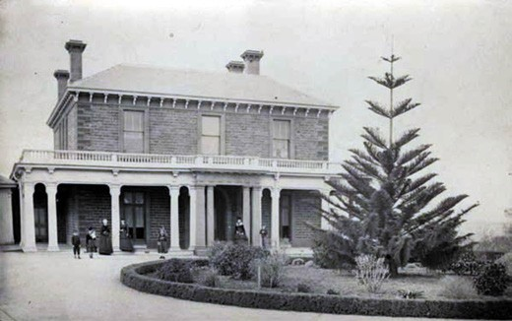
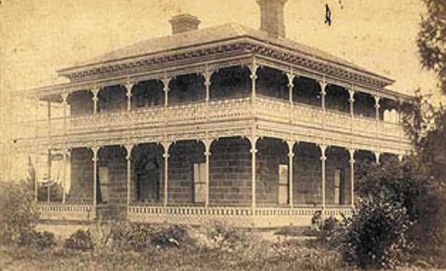

Figure 6.87: Osborne House, c.1890. Source: GRS 6678/0, Geelong Heritage Centre collection.
Figure 6.88: St. Helen s, 1910. Source: Roadknight collection, GRS 2009-574, Geelong Heritage Centre collection.

House, built in 1857444 (Figure 6.87) (see also Themes 2 & 7). An earlier mansion near the Corio Bay foreshore was erected south of Swinburne Street in 1848 for the pioneer squatter,
G.F. Read445 (Figure 6.88). It was named St. Helen s (see also Theme 7).
In 1888, the expansive St. Helen s property was subdivided into 146 allotments and sold as a residential development known as the St. Helen s Estate446 (Figure 6.89). The original mansion house was retained on a larger allotment. Streets were laid out perpendicular to the Melbourne Road. Only sixteen houses (including the surviving dwellings at 2
Swinburne Street and 1 St. David Street), a Congregational church (corner Melbourne Road and Vautier Street), and approximately five shops were constructed on the subdivided sites prior to 1910.447 This might have been due to the world- wide economic depression of 1890. The St. Helens Estate was advertised as the ‘flower of Geelong’, and promoted as the healthiest place of residence in Australia. 448
From the turn of the century, there was further building progress with the construction of housing, commercial buildings, a Temperance Hall, several churches, and a State School.449 The earliest houses erected during this period

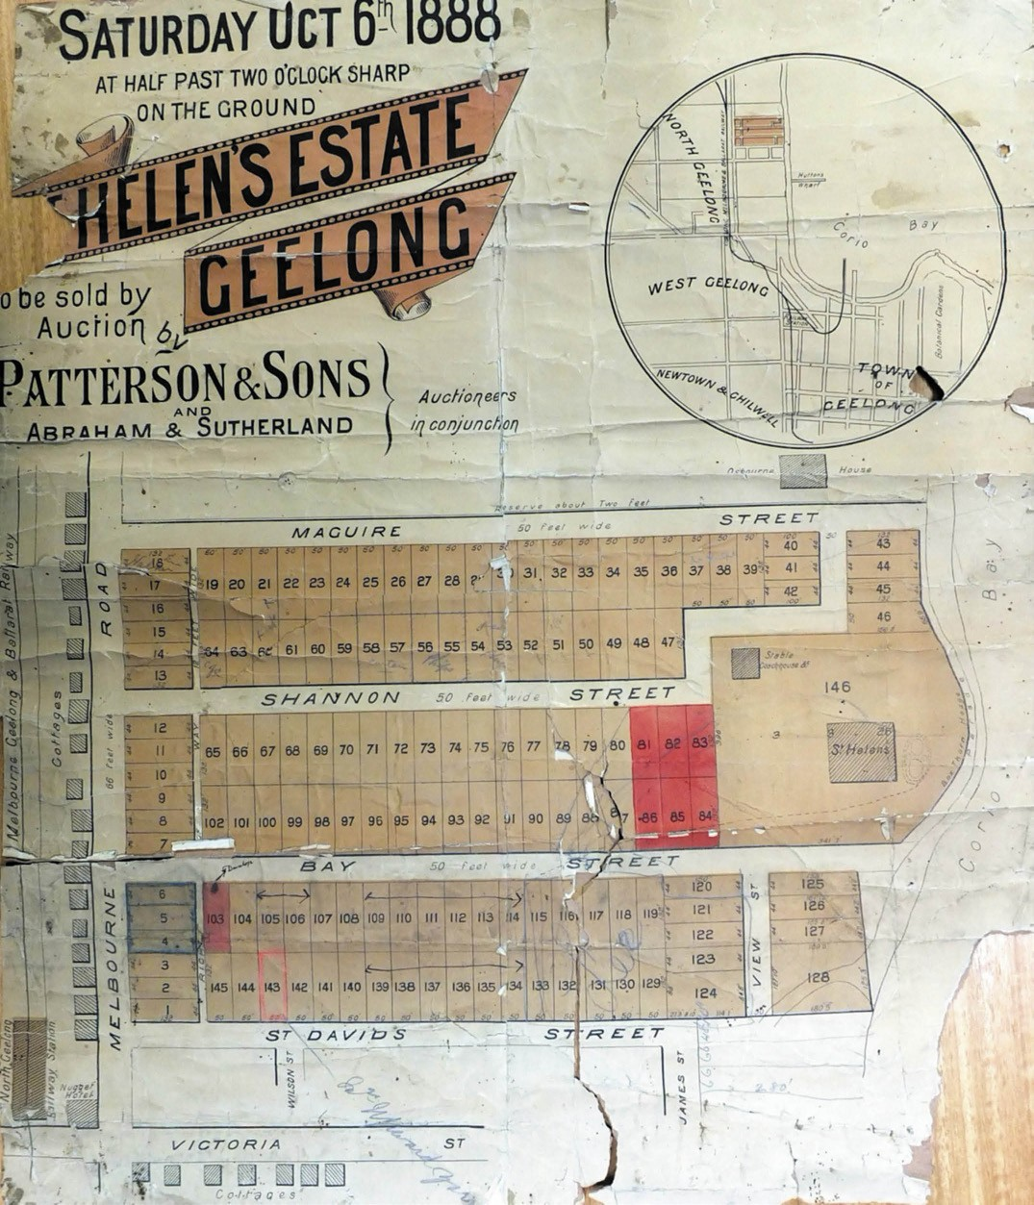
Figure 6.89: St. Helen s Estate subdivision plan, 6 October 1888. Source: Special Collections, Deakin University Library.

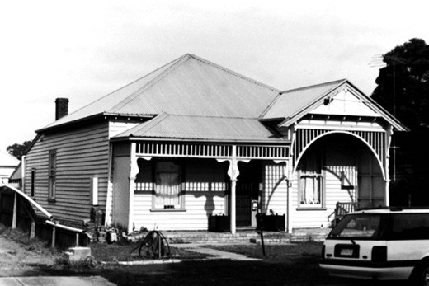
Figure 6.90: Dwelling, 8 Swinburne St, 1998. Source: David Rowe.

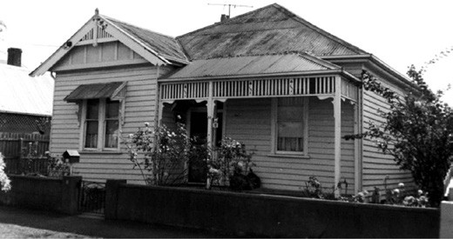
Figure 6.91: 11 St. David St, 1998. Source: David Rowe.

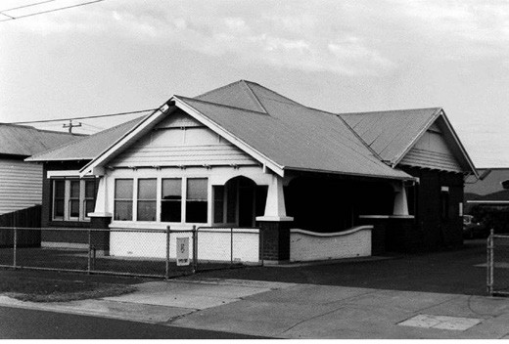

Figure 6.92: Dwelling, 2 St. David St, North Geelong, 1998. Source: David Rowe.

included the dwelling at 13 Vautier Street. The Ocean Road Hotel, Melbourne Road, was rebuilt in 1904 to a design
by Tombs and Durran.450 In 1917, St. Helens subdivision was modified to provide a park although it was not until 1927 when it opened to the public.451 Several Edwardian dwellings were constructed in the area from 1910 prior to the First World War, including those at 6 and 8 Swinburne Street (Figure 6.90), and 11 and 17 St. David Street452 (Figure 6.91). A few shops were also erected with frontages to the Melbourne Road. They included the corner timber store and dwelling at 169 Melbourne Road (built c.1910), two timber shops at 205 Melbourne Road (built c.1910) and a brick shop on the Melbourne Road in 1919 designed by
I.G. Anderson.453 Another development that was proposed for the period included St. Silas Anglican School to a design by W.H. Cleverdon.454
The interwar years witnessed the most profound residential development in the St. Helen s Estate. Thirty-four houses were erected in the 1920s, including the Bungalows at 1, 3, 19, 21 and 23 Victoria Street, 10, 14, 16, and 18 Swinburne Street.455 A noteworthy example was the dwelling at
2 St. David Street built in c.1927456 (Figure 6.92). In the 1930s, a further 10 houses were erected.457 They included the dwellings at 10 Bay Street and 3 St. David Street.

RIPPLESIDE
The area between Victoria Street and Bell Parade, and the Melbourne Road and Corio Bay now known as Rippleside was originally part of North Geelong. It was first sold as two, 21 acre lots to W. Walker (lot 60) and S and T. Austin (lot 61).458 In 1853-54, John Donnelly acquired the land and valley of Fisherman s Gully which led to the Corio Bay foreshore.459 There, he established a slaughterhouse and a brick, six- roomed dwelling and garden460 (Figure 6.93). The dwelling overlooked Corio Bay and was situated in the north-east corner. By 1881, the property was owned by J.L. Best and he appears to have named it Ripple Side .461 It was from this property that the suburb of Rippleside derives its name.
Between 1852 and 1853, this elevated open area overlooking Corio Bay was subdivided as two residential estates: Balmoral (1852) and St. Andrew s on the Bay (1853).462 The Scottish names bestowed the estates might have emanated from the Queen Victoria s Scottish retreat, Balmoral Castle (which was under construction) and St. Andrew s, a seaside town north- east of Edinburgh.463 Streets were to be laid out in a rectangular pattern as part of the Balmoral Estate (between Victoria and Walker Streets) and St. Andrew s on the Bay (between Walker and Liverpool Streets), and linked by Balmoral Crescent and St. Andrew s Crescent (now Balmoral Crescent) behind allotments having bay frontages (Figure 6.94). The Balmoral Estate offered 124 large allotments

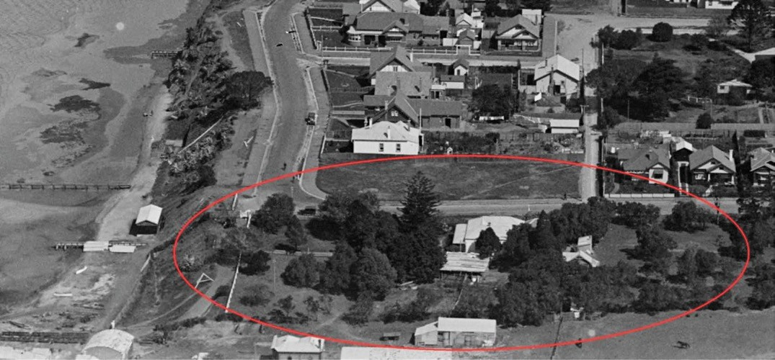
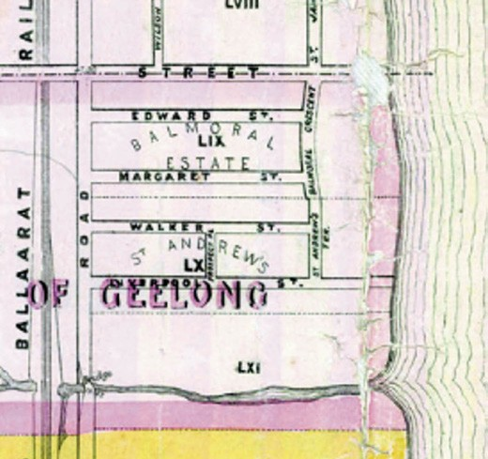
Figure 6.93: Ripple Side , near corner of The Esplanade & Bell Parade, 27 September 1927. Source: C. Pratt, accession H91.160/801, State Library of Victoria.
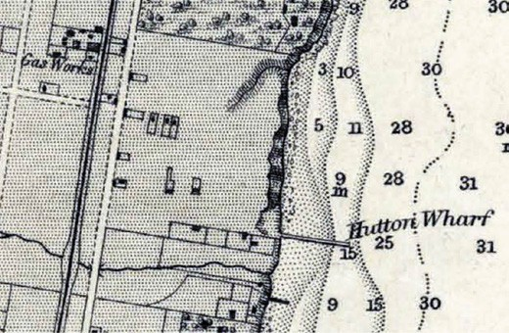
Figure 6.95: R.L. Cox, Portion of Survey of Geelong Harbour, 1864, showing few dwellings on the Balmoral & St. Andrew s Estate
(published at the Admiralty, London, 26 March 1865). Source: VPRS 8168/P5, item MCS 76, Public Record
Office Victoria.

Figure 6.94: R. Balding, Map of the Town of Geelong showing Balmoral & St Andrews Estates, 1864. Source: Statutory Planning Department, City of Greater Geelong.

which was favourably described as an enchanting spot. 464 The St. Andrew s on the Bay Estate465 was offered soon after and described as extending from the Bay or Harbour of Geelong (where there are most invaluable water frontages for Mercantile premises and wharves), back to the Melbourne Road, near the residence of J.F. Strachan, Esq. 466 The
auctioneer, J.B. Hutton was responsible for auctioning both estates in October 1853.467 He had built a hut and wharf on the foreshore in 1854-55 for the discharging of timber and ballasting of ships.468 In 1855, he had erected steam saw mills as part of his foreshore operations.469
Although there was such promise in the sale of the Balmoral and St. Andrew s on the Bay Estates, very few allotments progressed to house construction. By 1864, there were only a few scattered dwellings as shown in the Survey
of Geelong Harbour470 (Figure 6.95). Little progress was

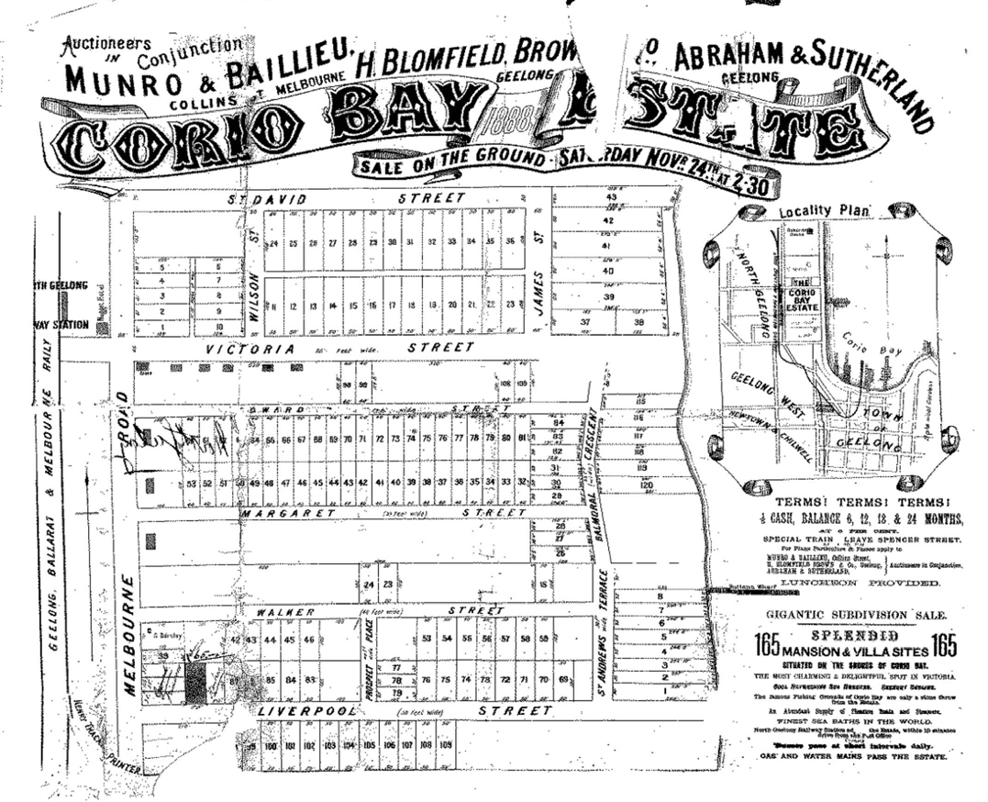
Figure 6.96: Plan of Corio Bay Estate, 24 November 1888. Source: GRS 2030/Map C29/01, Geelong Heritage Centre collection.

made in the ensuing years as in 1888 there were only five dwellings and a store in Victoria Street, and three dwellings fronting the Melbourne Road.471 This led to the remarketing of the Balmoral and St. Andrew s on the Bay Estates as the Corio Bay Estate in 1888 (Figure 6.96). It was advertised as a gigantic subdivision sale of 165 splendid mansion and villa sites situated on the shores of Corio Bay. 472 The advertisement further declared the estate to be the most charming and delightful spot in Victoria’ with the ‘finest sea
baths in the world. This led to several allotments being sold on the south side of Edward Street and north side of Margaret Street, and a notable number in Walker Street. By 1891, additional houses had been constructed in Margaret, Walker and Liverpool Streets. One Late Victorian timber dwelling erected at this time was at 13 Liverpool Street, possibly as part of a speculative development by Lloyd Hooper.473 In
1893, the first owner appears to have been Nicholas Treweek. It had been designed by the fledgling architectural practice of Laird and Barlow.474 Another hipped roofed timber dwelling was built at 51 Walker Street in 1891 for Samuel Hembrow. A gable extension was added in 1894 to a design by Thomas Seeley, architect and building surveyor, for John Toyne, slaughterman and lessee of the Geelong Saleyards and Abatoirs.475 The house was named Boston Villa (Figure 6.97).
In 1893, there was a second sale of 61 allotments of the Corio Bay Estate.476 This instigated further house construction
as by 1895, several houses had been erected in Walker and Margaret Streets. In Walker Street, there were ten buildings including two shops at the west end owned by Samuel Ponsford and Thomas Spence.477 In Margaret Street, there

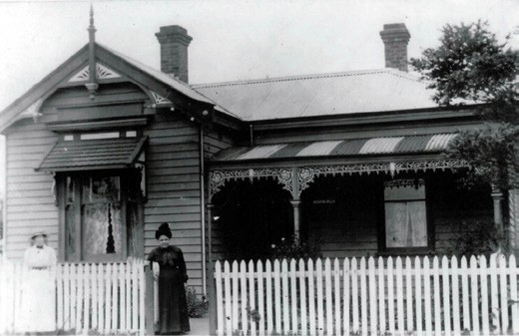
Figure 6.97: Boston Villa , 51 Walker St, c.1914. Source: Previous owner (supplied to David Rowe).

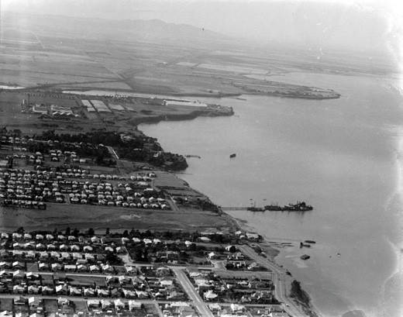
were 13 houses at this time.

Figure 6.98: Aerial view of Drumcondra (foreground) & Rippleside (middle ground), c.1925-30. Source: C. Pratt, accession no.
H91.160/781, State Library of Victoria.

West) was established at the corner of Melbourne Road and Liverpool Street in 1919, following the relocation of the former North Geelong Congregational Church at the corner of Melbourne Road and Vautier Street.483 With the widening of the Melbourne Road in the 1920s, the church, manse (built in 1905 at 127 Melbourne Road and acquired by the Presbyterians after 1915) and hall (now situated to
Lethbridge) were relocated to their present site at 60 Victoria Street in 1929.484 The growth in the local Presbyterian Church and the importance of remaining in the locality reflected
in part the increase in the population in the area during the interwar period as a consequence of the employment
opportunities at the nearby factories (see Theme 5). Further houses were built on the south side of Victoria Street in the ensuing years and it was especially in the 1920s-30s that Bungalows were erected in Edward Street (Figure 6.98), the demand for housing from the early 20th century emanating from the establishment of industries in North Geelong and the abattoirs.485 This led to additional commercial development including distinctive two storey brick shops at 157-159A Melbourne Road built in 1928 for W. Bennett.486 By the 1920s, the valley under the control of the Geelong Harbor Trust
was an open grassed area bound by perimeter landscaping, including the setting of Ripple Side 487 (Figure 6.98).

DRUMCONDRA
The suburb, Drumcondra, derived from bay front allotments 62-64 of Robert Hoddle s Plan of Allotments marked at Cowies Creek and Corio Bay in 1847488 (Figure 6.99). Lot 62 was subsequently acquired by James Ford Strachan (1910- 1875), merchant, woolbroker and politician.489 Lots 63 and 64 were purchased by the Western District squatters, John (1811-1877) and Peter Manifold.490 Two residential estates were to eventuate at Drumcondra: Lunan and Drumcondra.

In 1905, the Geelong Harbour Trust acquired the
Ripple Side property at Fishermen s Gully (which was then owned by Archibald Hutchinson)478 and took control of the Rippleside foreshore and Hutton s wharf.479 In 1907, the
sea frontage and the land comprising the deep valley of Fishermen s Gully (now Rippleside Park) were redeveloped and workshops erected, with the foreshore reclaimed as part of a permanent berthage for the repair of vessels480. These developments might have been impetus for the houses that were reputedly relocated to Rippleside about this time.481
By 1914, much of Liverpool, Walker and Margaret Streets had been developed for housing.482 The John Knox Presbyterian Church (a branch of the Presbyterian Church at Geelong

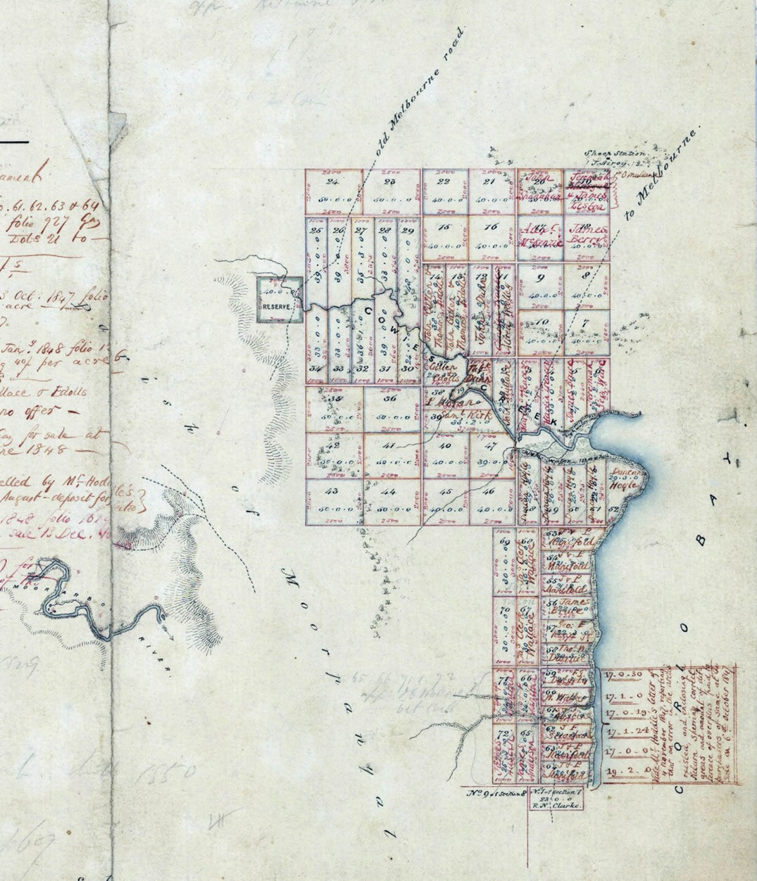
Figure 6.99: R. Hoddle, Plan of Allotments marked at Cowies Creek & Corio Bay (part), 13 April 1847. Source: VPRS 8168/P5, item Sydney C14, Public Record Office Victoria.

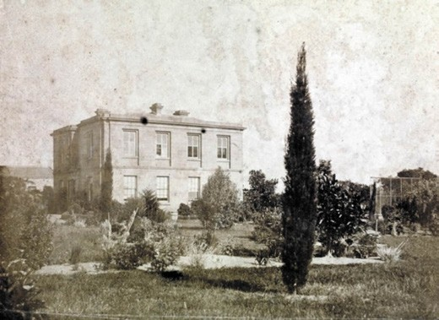
Figure 6.100: Lunan , c.1861. Source: accession H2178, State Library of Victoria.

LUNAN ESTATE
In 1849, J.F. Strachan engaged the early Geelong architect, Charles Laing, to design a substantial two storey Georgian stone mansion, Lunan on allotment 62491 (Figure 6.100).
Constructed of Barrabool stone, it was named after the Muir of Lunan near Montrose, Scotland, Strachan s birthplace.492 The dwelling remains one the earliest surviving private houses in Greater Geelong. It was set on substantial grounds with a driveway that led to the Melbourne Road. In addition to the construction of a gate house, elaborate iron gates marked the entrance to the property on the Melbourne Road.493
Lunan remained part of J.F. Strachan s estate well after his death in 1875. The Strachan family sold the property in 1904 to Annie Carstairs Bell, daughter of George Russell of Golf Hill.494
In 1911, the Lunan property was subdivided into 71 allotments and advertised for sale as the Lunan Estate (Figure 6.101) with a Handsome Gentleman s Residence & 2 acres , Including Beautiful Bay Frontages, Frontages to Melbourne Road, Lunan Avenue, Bell Parade. 495 At this time, Latrobe Terrace extended as far north as Church Street, with this part of Latrobe Terrace having earlier been known as the northern end of Victoria Terrace. Church Street was later renamed Glenleith Avenue following the subdivision of land on the southern side of Church Street from 1909.496 Bell Parade had also been laid out, together with Lunan Avenue and rear and side lanes. Southern access from Lunan Avenue was from the newly- created thoroughfare, Beach Parade, which had been laid out as part of the adjoining Drumcondra Estate. A small number of modest timber Edwardian dwellings were soon erected in Lunan Avenue.497 They survive today at 13, 19, 21 and 23 Lunan Avenue (Figure 6.98).

DRUMCONDRA ESTATE
Allotments 63 and 64 acquired by John and Peter Manifold remained vacant in the ensuing years following their acquisition of the land in 1847.498 In 1854-55, the local architect, Christopher Porter (who had arrived in Geelong from London in 1853) was engaged to design a 6 roomed brick dwelling with verandah overlooking Corio Bay.499 The dwelling, named Drumcondra (presumably after Drumcondra in Ireland) was first occupied by George Synnot, brother in law of John and Peter Manifold.500 It was set on 30 acres of land. Centrally located on the northern boundary, Synnot had erected stockyards. In 1855 he commenced business as a Commission Agent at his Yards, on the Geelong Bay, next the residence of J.F. Strachan, Esq., M.L.C. There, he had a constant supply of fat stock that were offered for sale in any numbers. 501 Synnot continued business at his Drumcondra stockyards (as well as operating a successful woolbroking business) until his untimely death in London in 1871.502
Throughout the 1860s, Synnot s Drumcondra paddock was the location of several sporting events. It was the home of the West End Cricket team from 1863 and a regular home venue for the Geelong Seconds Australian Rules Football team from 1876.503 The paddock also played host to hurling matches
in the 1860s and in later years as a practice ground by the Geelong Polo Club.504 The property was at the northern end of Latrobe Terrace, also known as Victoria Terrace (Figure 6.102).
Ownership of Drumcondra reverted to John and
Peter Manifold in 1871. It was later sold to J.J. Buckland in the 1870s. By the late 1880s, it was owned by Alfred Roadknight. By the 1890s, Drumcondra was the home
of Thomas Holden and family505 (Figure 6.103). The Holden family resided there until 1910 when the property was sold to a local syndicate. The dwelling was offered for removal and described as follows:
Large and substantial w.b. and brick residence with iron roof, large summer house, with flag pole, good glass conservatory, stabling, buggy sheds, cow sheds, fencing etc., etc., in lots to suit purchasers.506
The land was subdivided into 159 rectangular allotments and with new streets and lanes laid out. It was described as the ‘finest residential land available in Geelong.’507 Like the Lunan Estate, the Drumcondra Estate offered five prized allotments overlooking Corio Bay.
Lot 27 was acquired by William Reid, estate agent.
He engaged the local architect, Thomas Slevin, to design
a distinctive Federation era two storey dwelling on the site in 1911.508 The property was sold to Oswald Hearne in 1919 (Figure 6.105) and he had an organ loft added in

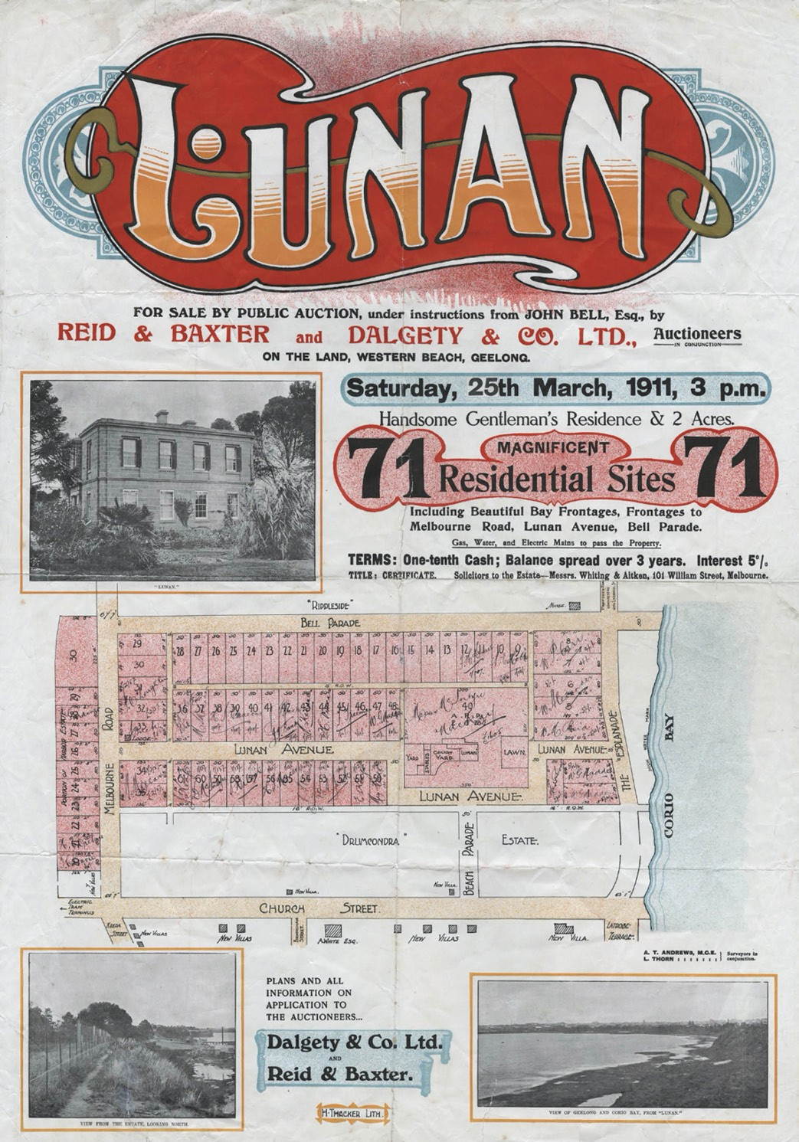
Figure 6.101: Lunan Subdivision Plan, 25 March 1911. Source: GRS 2030/L31, Geelong Heritage Centre collection.

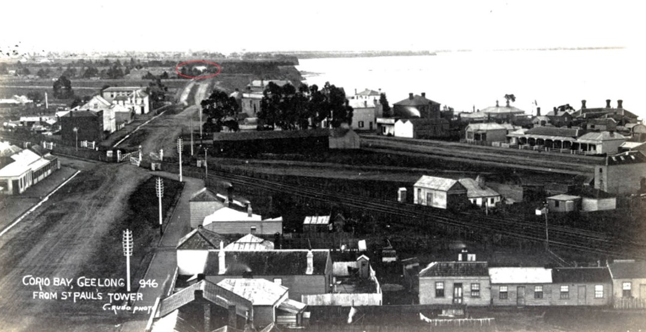
Figure 6.102: F. Kruger, Corio Bay, Geelong from St. Paul s Tower , Latrobe Terrace, looking north showing Drumcondra (circled green), c.1882. Source: accession 39358/92, State Library of Victoria.

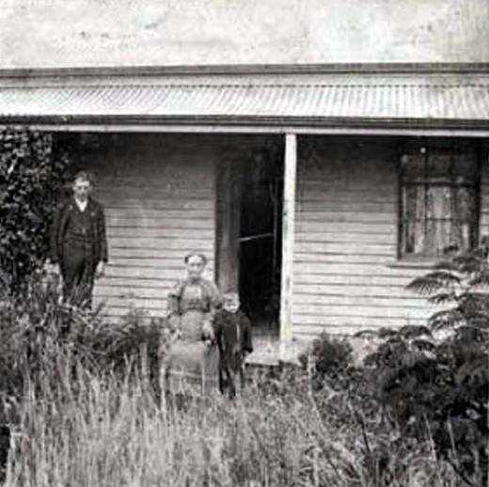
Figure 6.103: Holden family members at Drumcondra , c.1890. Source: GRS 7252/0, Geelong Heritage Centre collection.
1928 to a design by Fred Purnell.509 This dwelling was one of several substantial house erected on The Esplanade in the early 20th century.
By 1916, several Edwardian houses had been built in Beach Parade, Wattletree Road and Glenleith Avenue
with fewer in number in Drumcondra Avenue (Figure 6.106). Largely of timber construction, a number of these dwellings were designed by the local architects, Laird and Buchan, and Seeley, King and Everett and reflect the era for residential design and attributes of the local architectural firms.510 Examples include the dwelling at 5 Glenleith Avenue (Figure 6.107) and 21 Beach Parade.
A second sale of the Drumcondra Estate was offered for the remaining 76 allotments in 1916. The First World War appears to have stalled further building development until the 1920s when several interwar Bungalows were erected. The majority of these dwellings survive today,
including the gabled Bungalow at 11 Drumcondra Avenue (albeit with replacement front verandah posts and piers). By c.1927, most of the estate had been developed, creating an homogenous neighbourhood of hipped and gabled dwellings (see Figure 6.98). Like the Lunan Estate, more substantial dwellings were built overlooking Corio Bay with frontages
to The Esplanade (Figure 6.108). A small number of other dwellings were constructed in the ensuing years in the few available allotments.

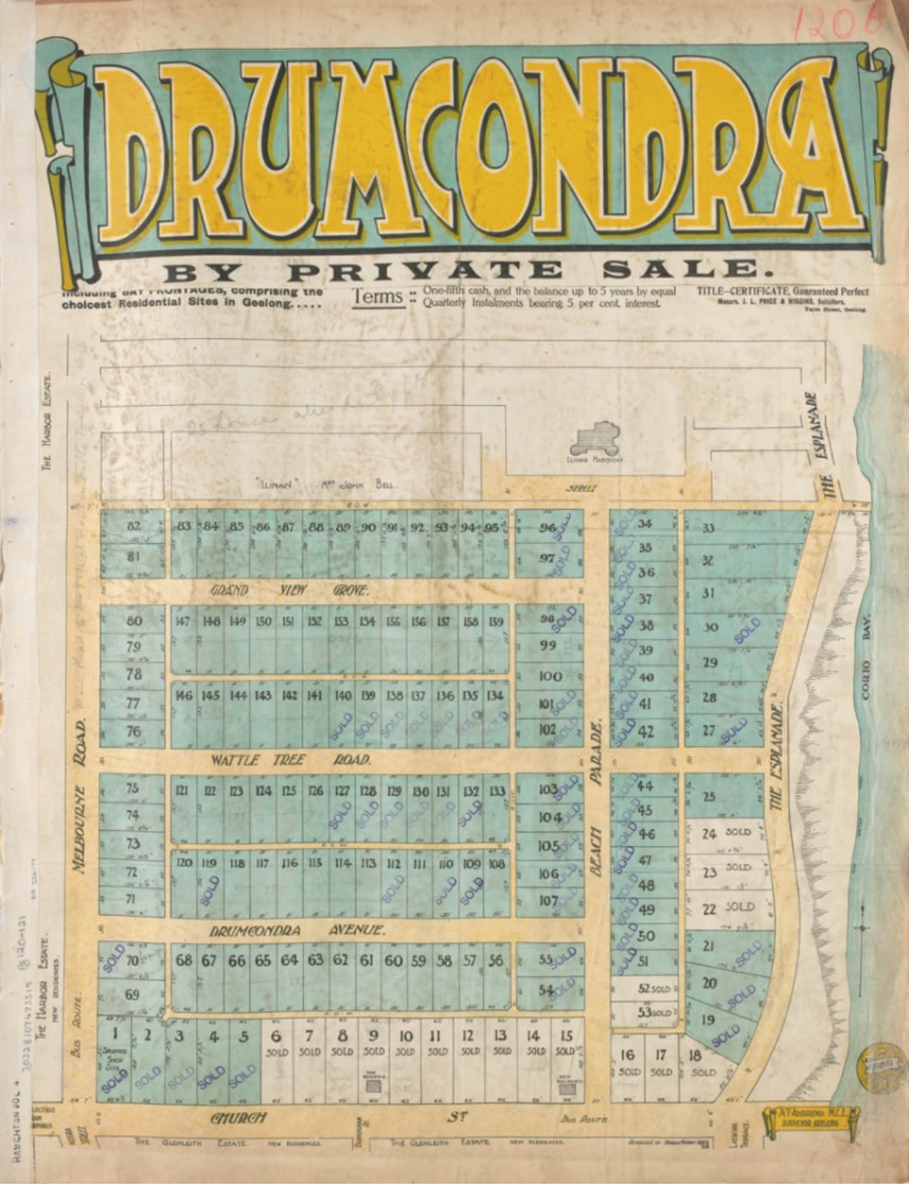
Figure 6.104: Plan of the Drumcondra Estate, c.1911. Source: State Library of Victoria.

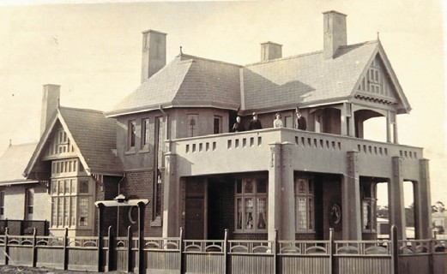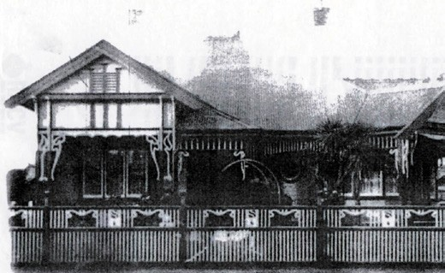

Figure 6.105: Montana , 53 The Esplanade, with Oswald Hearne & family on the balcony, 1919. Source: Allan Glover collection, Authentic Heritage Services Pty Ltd.

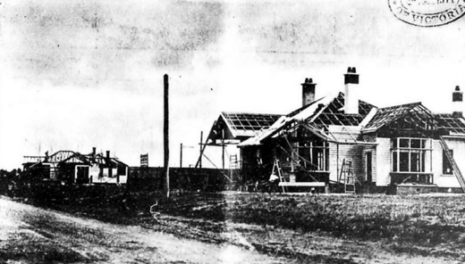

Figure 6.106: Houses under construction in Drumcondra (possibly Glenleith Avenue), 1911. Source: News of the Week,
2 March 1911, GRS 2121, Geelong Heritage Centre collection.
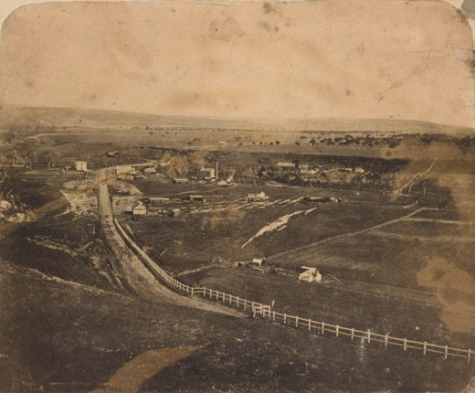
Figure 6.109: T. Hannay, Fyansford, c.1859. View from Herne Hill looking west. The Swan Inn is circled on the far right in the middle ground. Source: accession H2013.345/69, State Library of Victoria.
Figure 6.107: Dwelling at 5 Glenleith Ave, n.d. [c.1920]. Source: Lorraine Huddle.
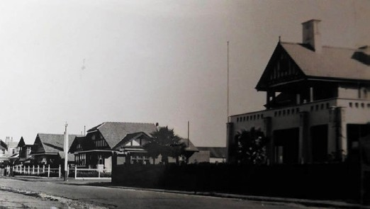
Figure 6.108: The Esplanade, Drumcondra, outside Montana looking south, c.1930s. Source: Allan Glover collection, Authentic Heritage Services.

FYANSFORD
Fyansford was reserved as a village as early as 1838 to provide a guaranteed supply of freshwater from the Moorabool River.511 Known by the Wadawurrung as
Bukar Bulok (land between two rivers)512 Fyansford was the location where Captain Foster Fyans first settled as the Police Magistrate. Set within a naturally beautiful river valley where the Barwon and Moorabool Rivers joined, Fyans described the site of his settlement as one of the most beautiful valleys in the world, ever after known as Fyans Ford. 513 To the Wadawurrung, the Barwon River meant the great stream flowing from the mountains [Otway Ranges] to the sea [Bass Strait]). The Moorabool River was a place of ghosts (or curlews). 514
Having arrived at Fyansford in 1837, the earliest European buildings were Foster Fyans huts near the Moorabool River.515 A reserve for Mounted Police was created and a ford over the river was built. From this time following the arrival
of European squatters to Point Henry, Fyansford became an important crossing place and stopping point enroute to

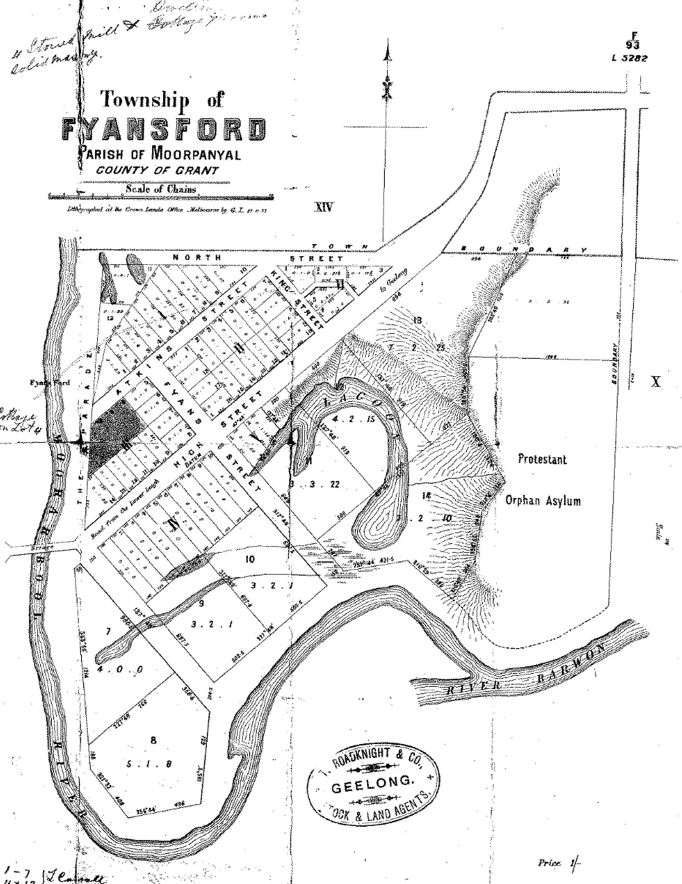
Figure 6.110: Plan of the Township of Fyansford, lithographed at the crown Lands Office, Melbourne, 27 November 1877. Source: GRS 2030/F26/001, Geelong Heritage Centre collection.

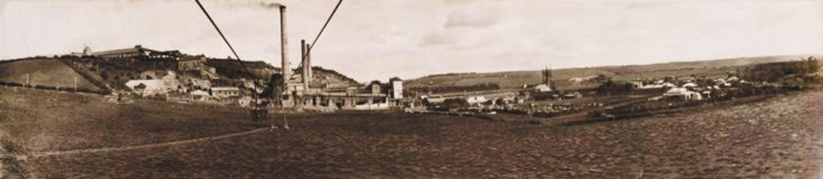
Figure 6.111: J. Lockwood, Cement Works, Fyansford, c.1912-20. Source: accession H83.378/1, State Library of Victoria.

the Western District.516 In 1842, the Swan Inn was erected for John Atkins to a design by Alexander Skene on the western bank of the Moorabool River517 (Figure 6.109). The
Launceston Examiner gave a description of the proposed Inn in October 1842:
To make a beginning, Mr. Atkins has entered into a speculation as bold as we hope it will be successful, by setting about the erection of an inn, on a scale of grandeur that will eclipse any thing of the kind in the country. The cost of the building alone will be about £3000, although the stone will be quarried upon the spot. The whole will, it is anticipated, be completed within three months.518
The building survives (in part) as the earliest physical legacy of commercial life in Greater Geelong. By 1843, the Geelong Advertiser reported that several country lots have also changed hands during the week at fair prices, especially
at Fyansford, where a number of tradesmen are locating themselves. 519 Two years later in 1844, Henry Collins established a Flour Mill on the east bank of the Moorabool River.520
By 1854, land on the east side of the Moorabool River had been surveyed and the Fyansford township established following a lineal grid layout beside the river (Figure 6.110). Town lots were offered for sale in June of that year. 521 A timber bridge was erected over the Moorabool River in 1854 given the influx of gold diggers enroute to the Victorian goldfields.522 This led to the further development of the fledgling township at this time: a water mill for John Highett (for grinding wheat); eight hotels including the surviving Fyansford Hotel and Balmoral Hotel fronting Hyland Road east of the bridge (see Figure 3.31, see Theme 3); churches523 and schools (including the surviving former Fyansford State School No. 1691 on elevated land west of the township reserve, built in 1875);524 other businesses including stores, butchers , wine makers, wheelwrights and blacksmiths shops; and dwellings. In 1855, a Protestant Orphan Asylum was built on the escarpment overlooking the township (it survives today).525
The promise of an enduring thriving settlement at Fyansford
was to be short-lived. By 1861, the population had decreased to 230 people (occupying 30 dwellings).526 Further decline was experienced in the ensuing years and by 1891 there were only 98 people resident in the town.527 However, progress was made in the establishment of a mixture of industrial
and agricultural enterprises, including vineyards, orchards, nurseries, market gardens and dairy farms. Garden and vineyard sites had been laid out by J.L. Shaw, architect and surveyor, on the northern bank of the Barwon River
in 1853.528 Further west, Charles Wyatt established the Frogmore Nursery in 1859, while by 1863 George and Henry King had created Fairview Gardens (see Theme 4 for further details).529
The industrialisation of Fyansford was to dramatically change the township. On the hillside overlooking Fyansford at Herne Hill, the architect Christopher Porter established a brick and pottery making business in 1856.530 More substantial was the construction of the Barwon Paper Mill on the Barwon River
in 1877-78.531 However, the most dramatic change came with Peter McCann s founding of the Australian Portland Cement Company in 1890 with the building of kilns in the escarpment below Herne Hill and other factory buildings (Figure 6.111), quarrying of shale on the Moorabool River flats, and the establishment of a quarry at nearby Batesford (1888).532 Numerous infrastructure and factory buildings were built in the ensuing years (see Theme 5 for further details).
The closure of the cement works in 2001 was to bring further dramatic change to the Fyansford landscape. This was the impetus for the Gen Fyansford housing project presented to the City of Greater Geelong in 2001, which led to the commencement of a large housing estate
from 2015.533

HERNE HILL
Immediately north-west of Newtown was Herne Hill. Named after the district in south London, England,534 this elevated land overlooked the Barwon and Moorabool River valleys at Fyansford to the west, and extended as far east as Shannon Avenue north of Aberdeen Street. To the north it took in the land to the south of the Ballarat Road. From 1849, original European landholders included several early pioneers and Squatters such as John and Peter Manifold, Thomas Austin, George Urquhart, Charles Ebden, J.F. Strachan, James Cowie, and Niel McLean.535 The extent of this early suburb has been altered and reduced over time with a southern portion now included in Newtown and other suburbs having been created including Manifold Heights and Hamlyn Heights. In 1852, part of Herne Hill was subdivided as the Herne
Hill Estate when it was described as rising ground beyond Newtown, and commanding one of the most extensive and enchanting views in the district. 536 For a short time, the area was also colloquially known as Fyans Hill and Fyansford Hill.537 In 1855, a 25 acre allotment (comprising lot 10 of Section 13) was reserved as a cemetery (it was gazetted in 1856 –Theme 8 for further details). For many years it fronted a road that took its name –Cemetery Road –but this was later changed to Minerva Road by 1911.538
A notable very early development at Herne Hill was the establishment of a vineyard in 1849 on low-lying land on the east bank of the Moorabool River by the Manifold Brothers.539 Although they had taken up the Purrumbete Run near Camperdown, the Geelong Advertiser reported on land now trenching for a vineyard by Messrs. Manifold at Herne Hill (this comprised allotment two in the Parish of Moorpanyal).540 This part of Herne Hill was to become known as Manifold s Vineyards for several years.
Numerous residential estates were laid out at Herne Hill in the early 1850s including the Norwood Estate, Sherbourne Estate, Holyrood Estate, Roscommon Estate, Mount Pleasant Estate, Elderslie Estate and Avoca Estate541 (Figure 6.112, see also Figure 6.38). Although most early residential developments within and nearby these estates were modest,
some more substantial houses have endured since the 1850s. They include Coronal at 7 Coronal Avenue, built in 1854-55 to a design by Benjamin Backhouse as his own residence, Clonard at 225 Church Street, built in 1855 for Dr Forster Shaw to a design by his brother, Joseph (now part of Clonard Girls Catholic College); Karooma , 48 Heytesbury Street (Figure 6.113), built in 1858 to a design by Christopher Porter as his own residence (Porter had a pottery works nearby); and Wimmera House (earlier known as Tamar ) (Figure 6.114), 356 Aberdeen Street, built in 1858-59 for J.C. Down, hotel keeper, to a design by Backhouse and Reynolds.542

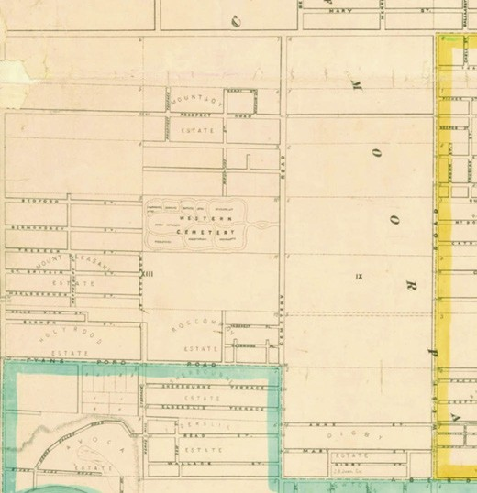
Figure 6.112: R. Balding, Map of the Town of Geelong showing Mountjoy, Mount Pleasant & Holyrood Estates, 1864. Source: Statutory Planning Department, City of Greater Geelong.

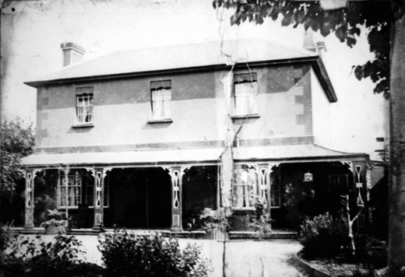
Figure 6.113: Karooma , 48 Heytsesbury St, n.d. Source: Wynd collection, Authentic Heritage Services Pty Ltd.

Another substantial surviving residential estate the original Herne Hill area is Raith (previously known as Malboona and Atlantis Heights ) at 2 Raith Terrace (Figure 6.115). It was built in stages, initially in 1854 for Frederick Bauer, possibly as a prefabricated German cottage.543 Construction was supervised by Snell and Prowse.544 In 1881, the architect Joseph Watts designed alterations and additions including
a cast iron verandah, for J.H. Grey, solicitor and nine times Mayor of Newtown and Chilwell.545

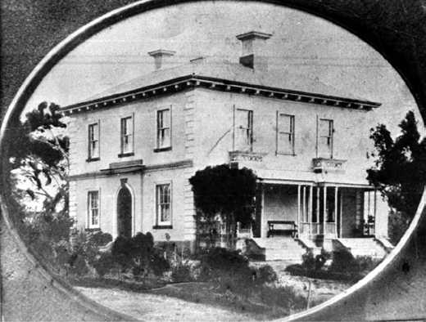
Figure 6.114: Wimmera , 356 Aberdeen St, n.d.
Source: Wynd collection, Authentic Heritage Services Pty Ltd.

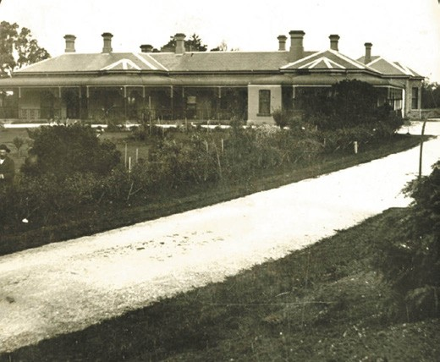

Figure 6.115: Cortous, Raith , 2 Raith Tce, c.1900.
Source: GRS 2009/1350a, Geelong Heritage Centre collection.

Other more modest house construction followed in the later 19th century. At 302 Autumn Street, Belhaven House was built in 1889 for Alfred Hanson, teacher at Flinders School, Geelong, to a design by the prolific local architect, Albert Derrick.546 Between 1888 and 1892, John McCurdy, farmer, replaced a roughly constructed timber dwelling at 334 Church Street with the existing timber Late Victorian house, ‘Oakfield’.547 It seems that a dwelling had been built on the site as early as c. 1850. It had been occupied by John and Kate McCurdy following their marriage in 1870 and owned by Robert Wallace until it sold to John McCurdy following Wallace s death in 1882.
Several of the large 19th century estates were subdivided into multiple residential allotments in the early 20th century.
In 1910, for example, Raith was offered as the Atlantis Heights Estate, with 38 choice villa sites available.548 The Raith property was again offered for sale in 1920, giving more opportunity for residential subdivision.549 Another substantial subdivision of a once large rural estate was ‘Corryallock’, a dairy property on the river flats immediately north of Fyansford.550
It was from 1911 and throughout the 20th century when Herne Hill was transformed from a rural outpost into a
residential suburb. The German engineer and planner, Laurel Messy-Rhine (who had been responsible for laying out and constructing the neighbouring Rhineland Estate), publicly advocated for a well-planned Herne Hill district in February 1912 based on City Beautiful and Garden City planning principles551 (Figure 6.116). At the central core of Messy- Rhine s plan was the Western Cemetery, with a small park and residential streets to radiate from it at the east end. The Geelong Advertiser heralded Messy- Rhine s suggestion in a report in February 1912:
The boldest part of Mr. Messy-Rhine s plan is that which sets out that Geelong, like Vienna and other Continental cities, should proceed in rings, and that each ring should have its tram circle In the drawing of the streets for the Herne Hill Toorak, Mr. Messy- Rhine has made the contour of the land, convenient intersections, artistic alignment and frontage, the dominant factors Only when some such plan as we are considering has been adopted by
the whole of the municipalities and had the confirmation of the Public Works Department and become the key to a country s development can we hope to have natural
advantages conserved, the City Beautiful nurtured, and all the necessary reserves made.552
The great potential for housing development in the area brought about local government debate regarding the annexation of Herne Hill from the Corio Shire to neighbouring municipalities including Geelong, Newtown and Chilwell
and Geelong West.553 In any case, the extent of residential progress led to the renaming of parts of old Herne Hill to the fledgling suburbs of Manifold Heights and Hamlyn Heights.
Messy-Rhine s proposed subdivision of the Herne Hill District was to become part of an even more remarkable and yet unrealised scheme. He proposed a Plan of Greater Geelong in 1912 that was to cater for the considerable growth of the Geelong region554 (Figure 6.117). His concept had been borne out of the beginnings of the Greater Geelong Movement from 1910 (when the Victorian Government had proposed the amalgamation of municipalities in the Geelong area) (Themes 7 & 9). This had brought on more holistic, broader focus of Greater Geelong s infrastructure and planning. Entitled A Forecast of the Development of Greater Geelong by a Town Planner who has Faith in its Future , his plan was almost

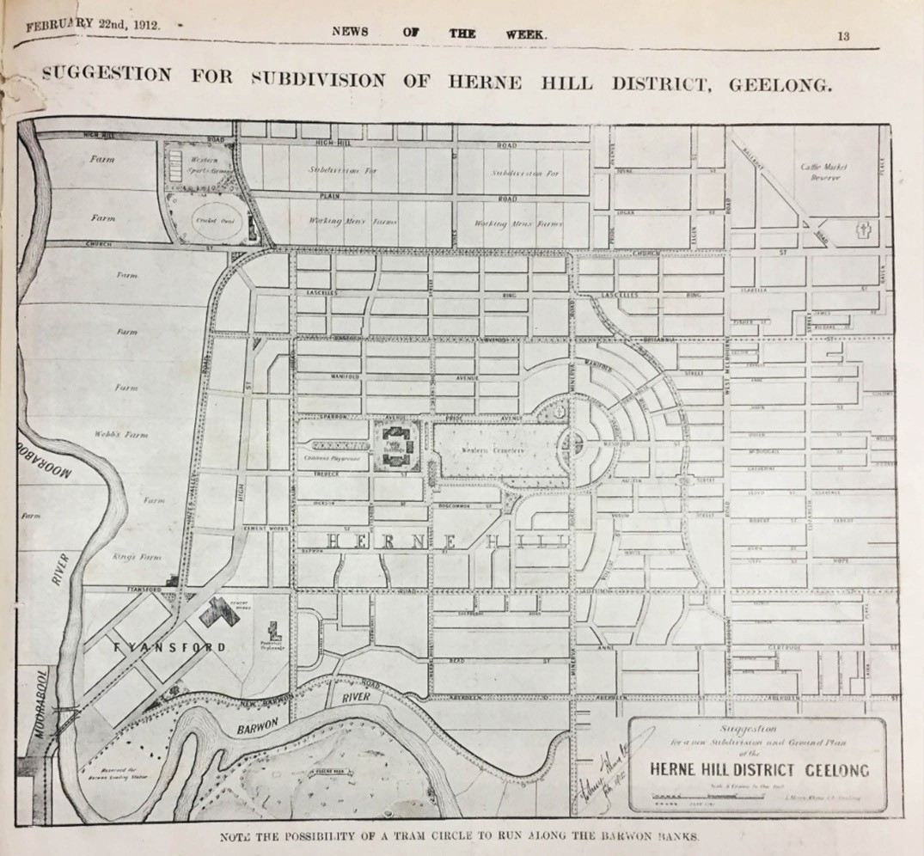
Figure 6.116: L. Messy-Rhine, Suggestion for Subdivision of Herne Hill District, Geelong , 1912. Source: News of the Week, 22 February 1912, GRS 2121/3, Geelong Heritage Centre collection.

prophetic. It included a concentric rail network, ferry line connecting Point Henry to Avalon, and new settlements at Mount Duneed and Connewarre in the vicinity of the newly- created Armstrong Creek residential suburb.

MANIFOLD HEIGHTS
The eastern portion of the old Herne Hill district (between Shannon Avenue and Minerva Road) was to
become known as Manifold Heights. It was named after the pioneer European brothers, Peter and John Manifold, original Crown grant owners who established Manifolds vineyard.555 Developed at the height of the Garden City concept of town planning, the area is distinctive in the layouts of some of
the estates. In 1911, the Manifold Heights Estate plan was offered in 275 lots following a traditional grid layout556 (Figure

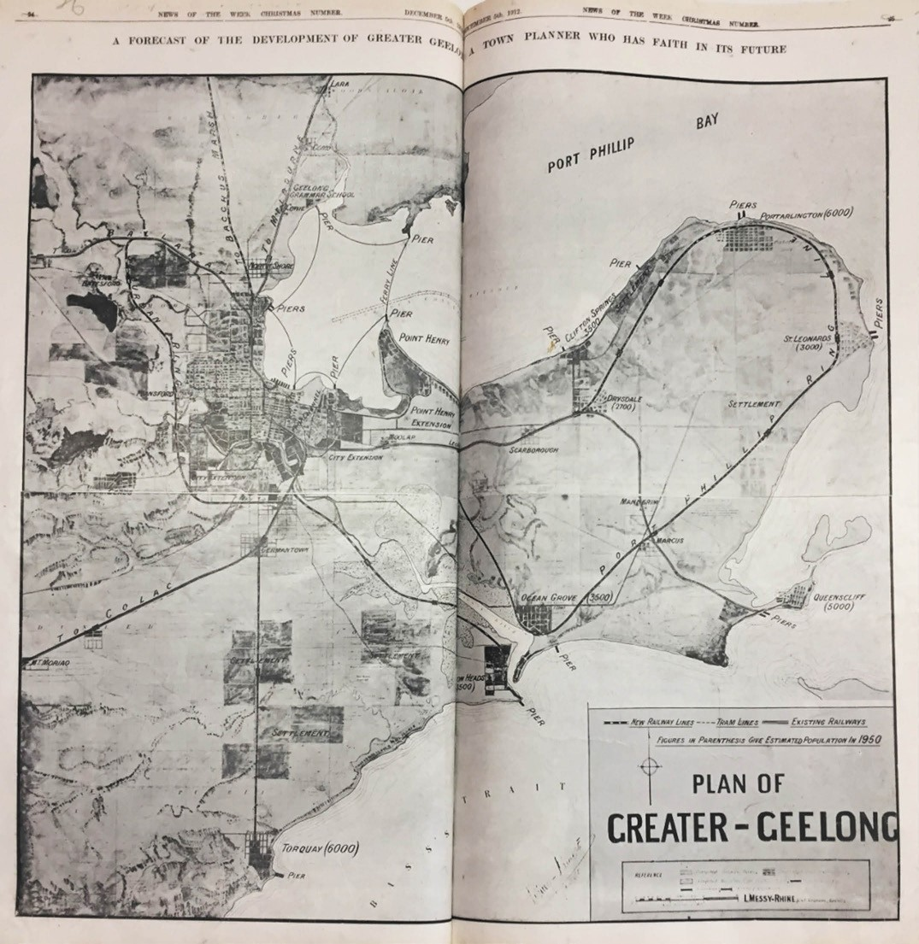
Figure 6.117: L. Messy-Rhine, Plan of Greater-Geelong , 1912. Source: News of the Week, 5 December 1912, GRS 2121/3, Geelong Heritage Centre collection.

6.118). Apart from the southern portion where lots had been sold, much of the plan was rejected in 1912 in favour of a more dynamic City Beautiful and Garden City design
inspired by Laurel Messy- Rhine, whereby 300 lots were made available having frontages to radiating streets557 (Figure 6.119).
A small park (now named the Peter Lowe Reserve) was set aside as a focal point and trees were to line the streets.558 Although not as refined as Messy-Rhine’s original plan, the whole concept considered healthy living as much as the topography of the area.

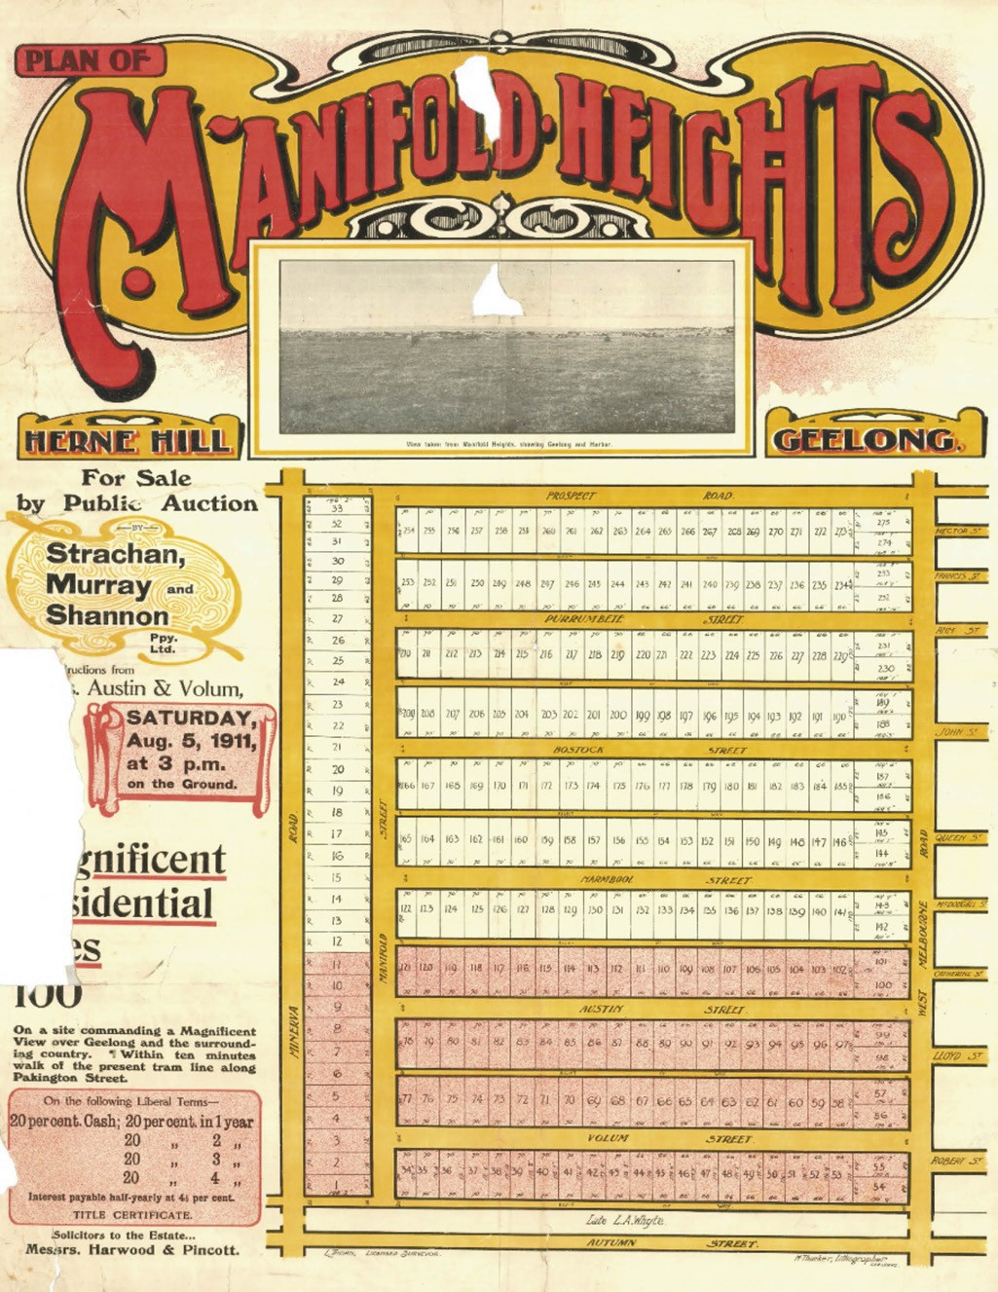
Figure 6.118: Manifold Heights Estate Plan, 1911. Source: GRS 2030/M59, Geelong Heritage Centre collection.

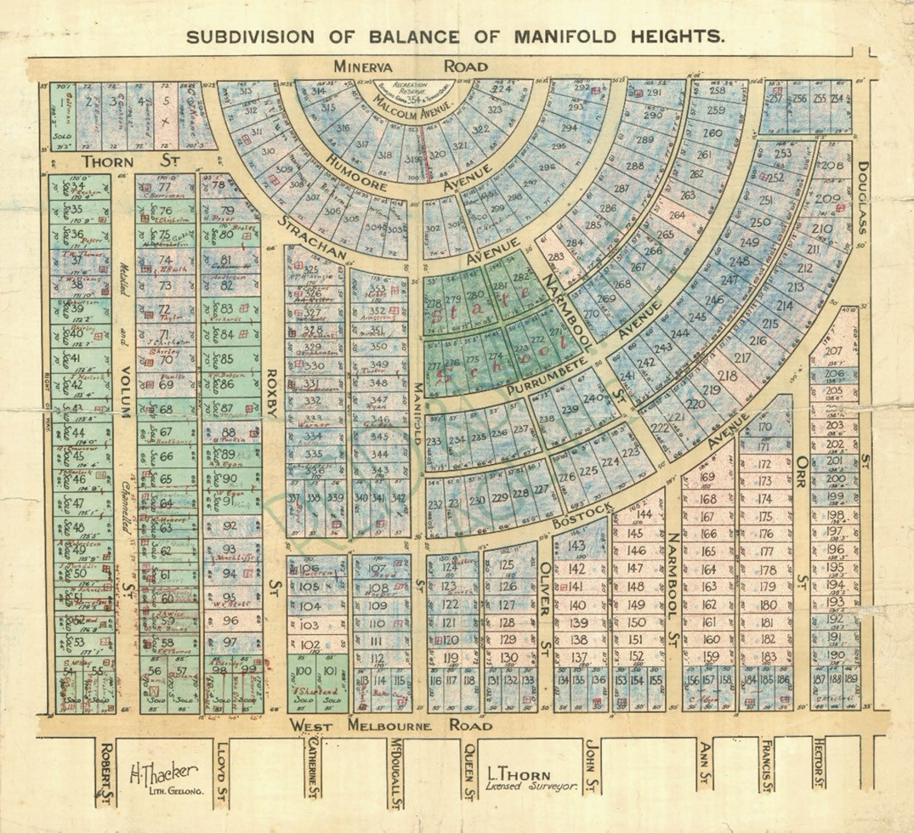
Figure 6.119: Revised Subdivision of Manifold Heights Estate, 1912. Source: GRS 2030/M15, Geelong Heritage Centre collection.

World War One curtailed much residential development, although interwar Bungalows were soon built in the 1920s, including the dwelling at 37 Roxby Street, built in 1925 by Robert Coombs for Les and Dorothy Purnell559
(Figure 6.120).
Adjoining the southern boundary of the Manifold Estate was the Autumn Estate (Figure 6.121), laid out in 1924.560 It provided 123 allotments and featured two diagonal
thoroughfares, Malvern Grove and Merton Grove, the town plan being tempered by the topography.561 Modest triangular parks were reserved in central locations. A smaller number of allotments, sold as the Bell-Vue Estate, were also made
available in 1924 on the north side of Douglass Street (taking in Philip Street and Evelyn Street), west of Shannon Avenue.562
A more distinctive public park was provided in the Minerva Estate in 1924 (Figure 6.122), it forming the central core to the principal thoroughfare, Girton Crescent.563 The design of the Estate was influenced by the Garden City principles advocated by the Geelong Town Planning Association
(see Theme 9) and the growing popularity of the motor car, as outlined in the Geelong Advertiser:

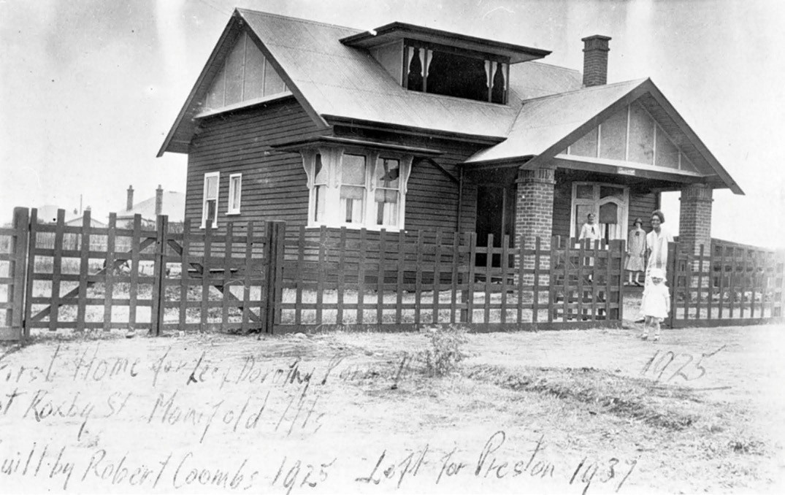
Figure 6.120: Bungalow at 37 Roxby St, 1925. Source: Accession 765470, Museums Victoria.

The influence or the Town Planners’ Association is making itself felt amongst those who deal in land subdivisions on a large scale. This is particularly noticeable in the scheme adopted for subdivided Minerva Estate at Herne Hill. Right in the centre of the block a large piece of land has been set apart for a recreation reserve Another town planning feature is the curving of all corners and the provision of a fine sweep at each end of Central Avenue so that motor cars will experience no difficulty in turning. Ann Street, which bounds the estate on the north is to be increased from 40 to 50 feet wide. The four main thoroughfares have been named respectively, Airey Street, Girton Crescent, Central Avenue and Longview Avenue. Airey is the name of the
original owners of the estate, Girton is in recognition of the fact that the Presbyterian Girls College is to be erected
in the immediate vicinity, Central because it is midway in the estate and Longview because of the long view obtainable.564
The establishment of a Presbyterian Girls College in the immediate area did not eventuate. Instead, the College acquired John Calvert s substantial property at Bell Post Hill, becoming Morongo Girls College and is now Kardinia International College.
Several modestly-scaled Bungalows were soon erected in the Minerva Estate. They included house built as part of the State Savings Bank of Victoria’s financial, design and construction scheme. Operated by the Bank in the 1920s and 1930s,
the scheme provided a range of cottage types and plans designed by Melbourne architect, G. Burridge Leith.565 He created 56 standard timber designs in Victoria, generally of five main rooms.566 The Bank s scheme involved the lending of a high percentage of the finance required for erecting homes for low income earners, in accordance with certain conditions. Under Victoria s Housing Act of 1920, the Credit Foncier System enabled housing loans to be more widely available. Loans were made on houses and shops based
on the security of title of the land.567 Examples include the houses at 11 and 33 Girton Crescent568 (Figures 6.123-124).
Another notable development at Manifold Heights in the 1920s was the establishment of a State School. Situated within the radial town plan in Strachan Avenue, the land was reserved in 1924 and the school built soon after (see Theme 8).569 Churches soon followed, with the
Spanish Mission Revival styled Holy Spirit Catholic Church built in 1932 in Bostock Avenue.570 Further north in Bostock Avenue in 1936, the Methodists rebuilt their former Church originally situated in Wellington Street, Geelong West, first

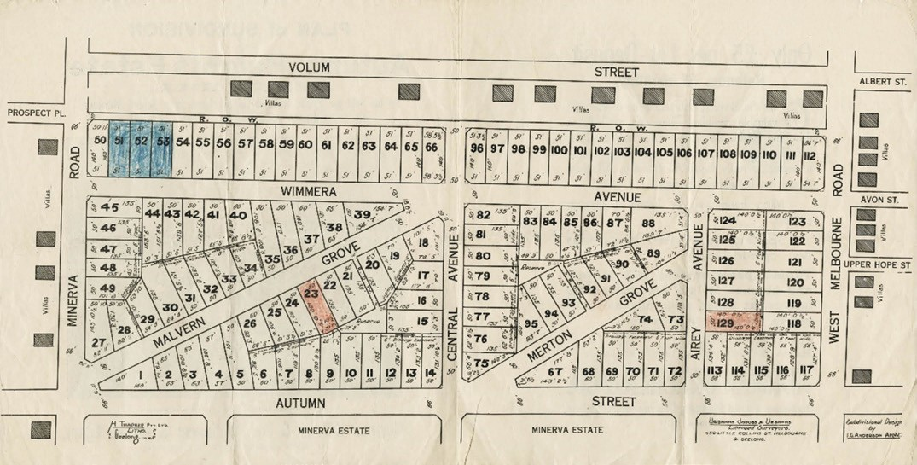
Figure 6.121: Plan of Subdivision of Autumn Heights Estate, Herne Hill, 26 April 1924. Source: GRS 2030/A13, Geelong Heritage Centre collection.

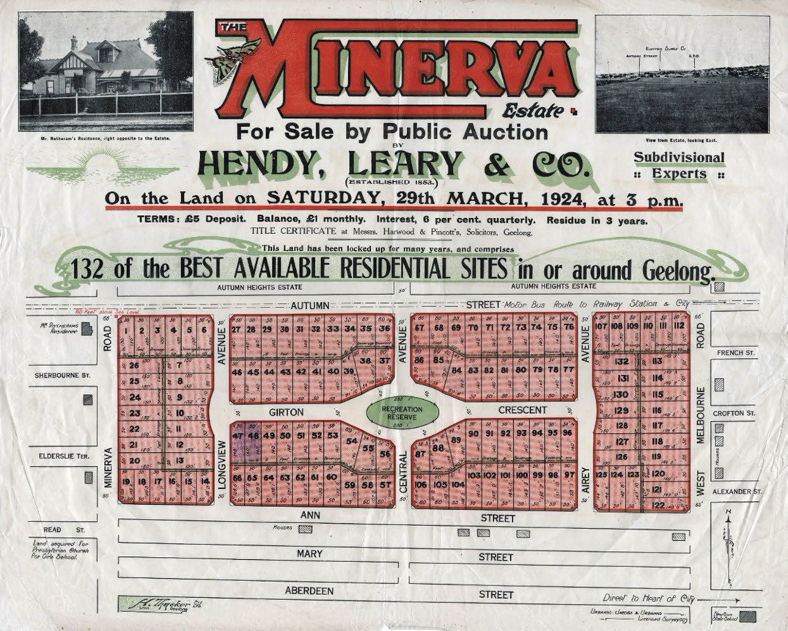
Figure 6.122: The Minerva Estate Plan, 29 March 1924. Source: GRS 2030/M3, Geelong Heritage Centre collection.

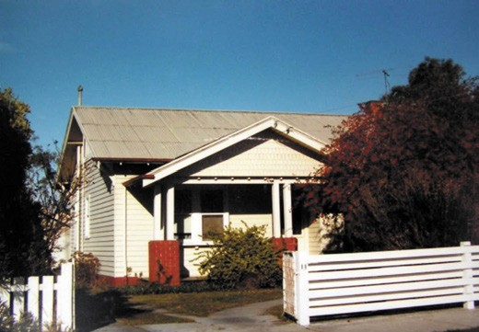

Figure 6.123: Bungalow, 11 Girton Cresc., 1986. Source: Honman, et.al., City of Geelong West Urban Conservation Study .

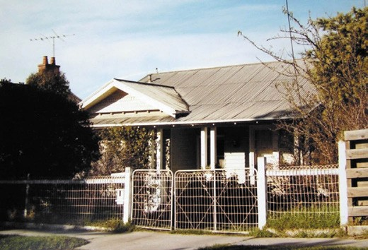
Figure 6.124: Bungalow, 33 Girton Cres., 1986. Source: Honman, et.al., City of Geelong West Urban Conservation Study .

constructed in 1858 (in 2000 it was acquired by the Islamic Society of Geelong and converted into a Mosque) (see Theme 8).571 Another major non- residential development was the opening of the Geelong West Technical School in Minerva Road in 1954.572 This complex later became the Western Heights Secondary College and is now the Westcourt campus of St. Joseph s College.

Figure 6.125: R. Balding, Map of the Town of Geelong showing much of the Hamlyn Heights area, including the Ballarat Estate (lower right), 1864. Source: Statutory Planning Department, City of Greater Geelong.

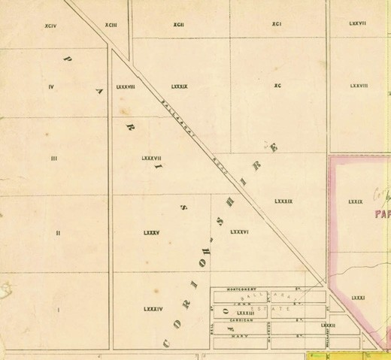
HAMLYN HEIGHTS
The large triangular portion of land comprising allotments 82-88, together with lots 1-4 in the Parish of Moorpanyal north of Church Street and between the Ballarat Road and the Moorabool River was to be renamed Hamlyn Heights (Figure 6.125). The suburb appears to have been named after Sydney Hamlyn, dairy farmer, who had acquired the historic ‘Oakfield’ property at 334 Church Street by 1950573 (Figure 6.126). Suburban allotments were made available in the eastern portion of Hamlyn Heights as the Ballarat Estate in 1854.574 Having a rectangular layout, this estate took in Crown allotment 83 and part of lot 82. William Fynney acquired some of this land. Further west in an area traditionally part of Bell Post Hill (and now within Hamlyn Heights), David Coghill owned a substantial portion of land. In 1859, he engaged the Geelong architect, J.L. Shaw, to design a substantial Picturesque Gothic styled brick villa.575 Known as Glenpanyall , it is situated at 22 Glengate Road (Figure 6.127).
More substantial subdivisions in Hamlyn Heights occurred in the late 19th century. In September 1886, Manifolds Paddocks between the Moorabool River and the Ballarat Road were offered as the Normanhurst Estate.576 Little residential progress appears to have been made at this time. On 20 October, 1888, William Fynney offered his land for sale as the Fynney s Paddock subdivision.577 Fynney s land stretched between Church Street, Lily Street and the Ballarat

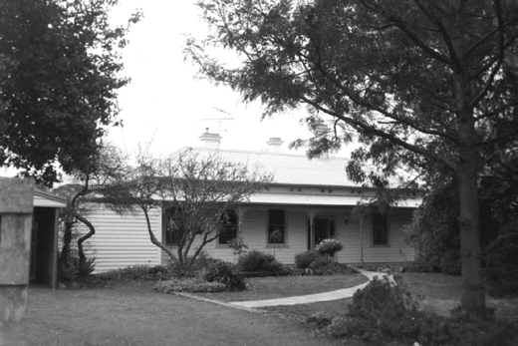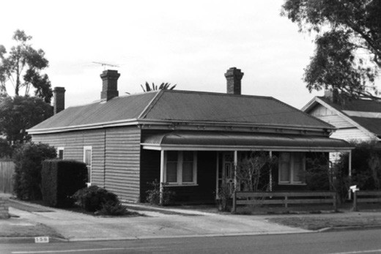
Figure 6.126: ‘Oakfield’, 334 Church St1998. Source: David Rowe. Figure 6.128: Dwelling, 156 Church St, 1998. Source: David Rowe.

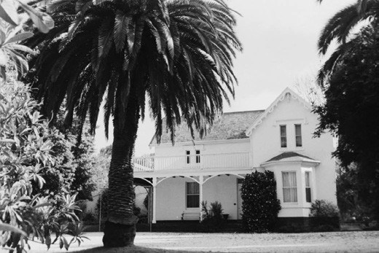
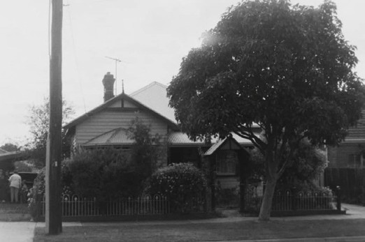

Figure 6.127: Glenpanyall , 22 Glengate St, 1998. Source: David Rowe.
Figure 6.129: Dwelling, 31 Logan St, 1998. Source: David Rowe.

Road, and between Pride Avenue and Kendall Close. David Gallelly, a mechanic, built a timber dwelling at 156 Church Street in 1888-89 following the subdivision of Fynney s Paddock578 (Figure 6.128). Another timber house was built at 31 Logan Street in 1891- 92 for James Fielding, a whip maker579 (Figure 6.129).
On 15 December, 1923, and again in c.1928, unsold parts of the Fynney s Paddock estate were offered for sale.580 There were other land sales and subdivisions in the Hamlyn Heights throughout the 1920s. A substantial sale occurred in April 1923 with the Corio Heights Estate (Figure 6.130) at the west end of Church Street (west of Vines Road). Comprising much of the former Normanhurst Estate, 14 large blocks following
a rectangular grid were made available with the potential for 150 residential lots.581 The Estate was advertised as having a ‘panorama view, with a magnificent outlook over the City and Suburbs, Corio Bay, Point Henry, Bellarine Hills, and You Yangs and each block was to be splendidly
drained. 582 Streets were to be named after European pioneers. The original layout of the Estate was to be only partially realised in the formation of Sladen, Belcher and Drysdale Streets. Further subdivisions in this part of Hamlyn Heights occurred in later years.
The Logan estate was offered for sale on 27 October, 1923, by H.F. Richardson, which was the area of land bounded by Shannon Avenue, Coral Close and Logan Street.583 In the late 1920s, the Elgin Heights estate was subdivided by Illingworth, Gibbons Pty Ltd, and this area encompassed
parts of the north side of Church Street, each side of Shannon Avenue, together with the south- eastern section of Logan Street.584 Also in the late 1920s was the subdivision known as the Pleasant View estate offered by W.M. Reid Pty Ltd which stretched along the north-western parts of Shannon Avenue and included allotments in Woorayl and Lily Streets.585

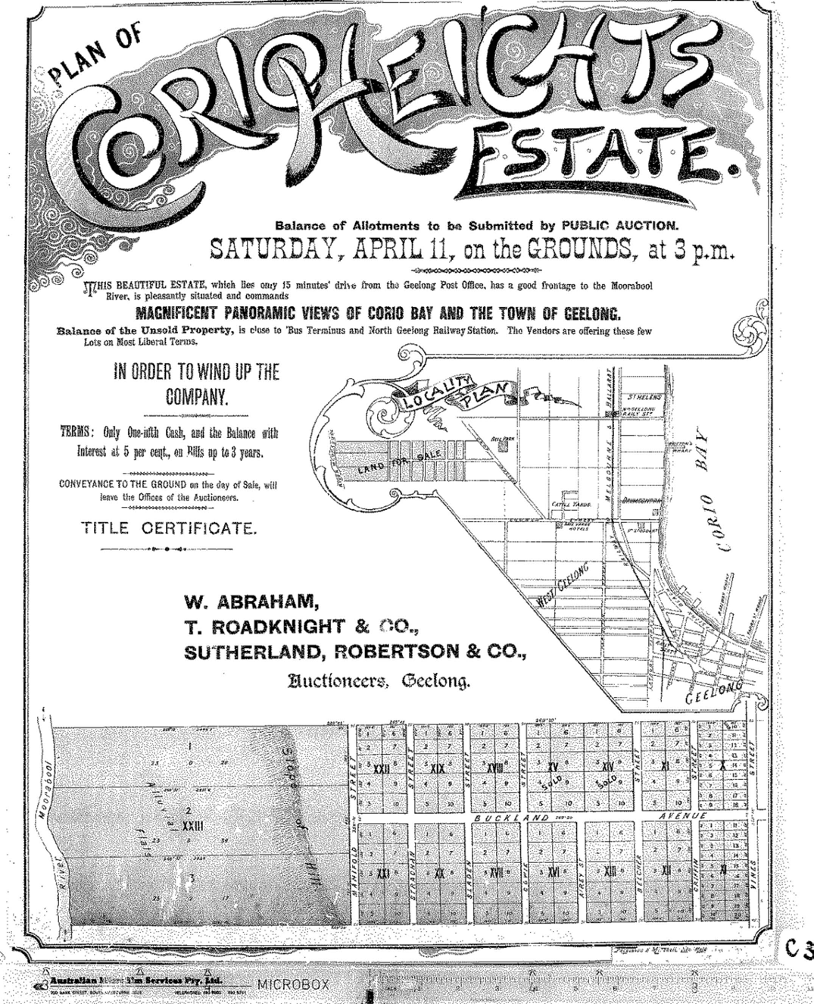
Figure 6.130: Plan of Corio Heights Estate, 1 April 1923. Source: GRS 2030/Map C31/001, Geelong Heritage Centre collection.

These sales catered for the growing middle-class population, a result of the expanding manufacturing industries in the northern parts of Geelong. Several gabled timber Bungalows were erected along Church Street in the 1920s, including
the intact grouping between 114 and 128 Church Street586 (Figures 6.131-132). A small number of Bungalows of this
era also survive in Logan Street. These interwar era housing developments also led to the establishment of some stores. At 130 Church Street, Reginald Walsh opened a butcher shop in 1929-30 while nearby at 132 Church Street a grocery store was built for A.W. Drecker in 1928-30.587 Both of these buildings here survive on the eastern and western corners of

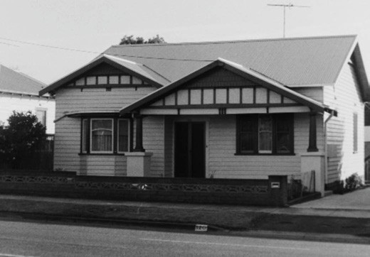
Figure 6.131: Bungalow, 120 Church St, 1998. Source: David Rowe.

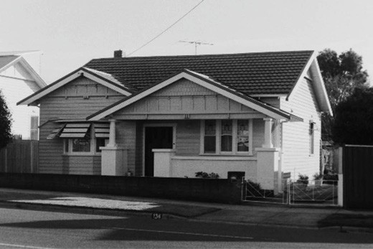
Figure 6.132: Bungalow, 124 Church St, 1998. Source: David Rowe.

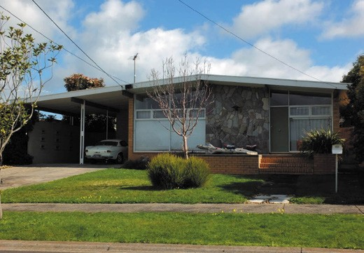
Figure 6.133: Dwelling, 4 Kirriemuir Street, Hamlyn Heights, 2019. Source: David Rowe.

Coral Close. During the Second World War, to cater for the growth in residential development that brought young families to the area, the Herne Hill State School No. 4681 opened in Church Street in 1943.588
In the early 1950s, the Lynch estate was offered for sale by Homebuilders Pty Ltd.589 This land sale offered 7 allotments in Toyne Avenue, 3 lots in Pride Avenue and 6 blocks in Lily Street. Other developments also occurred from the mid- 20th century to cater for the growing population. In 1950, The Geelong Teachers College and the Bell Post Hill State School No. 4804 (later renamed Hamlyn Heights Primary School) both officially opened in Vines Road.590 They were followed by the Herne Hill State School in 1954, at the corner of Church Street and Minerva Road, and the Bell Park High School adjacent to the Geelong Teachers College in Vines Road in 1959.591 Post war migration from this period also led
to the construction of churches. In 1962, St. Peter s Lutheran Church opened at 60 Ballarat Road while in 1964 a Serbian Orthodox Church was built at 122 Ballarat Road (see Theme 8 for further details).592
Other subdivisions and house construction occurred in Hamlyn Heights during the postwar period and in the late 20th century. The shallow-gabled brick veneer dwelling at 4 Kirriemuir Street (Figure 6.133), built in 1962-63 by Bell and Fulton for E.E. Johnston was a notable example.593
It celebrated the hallmarks of the new mode of house design and was based on the ‘Pan Pacific’ prototype offered by Lend Lease in Sydney and designed by the architect, Nono
Sydney.594 These new modern architectural features included a streamlined composition and detailing, brick construction augmented with crazy stone features, incorporation of a carport under the main roof, floor to ceiling windows, open- planned living and a sunken living room.

BELL POST HILL
In March 1836, the European squatters, John Cowie
and David Stead landed their flocks at Cowies Creek. On the western side of Bell Post Hill, they soon established their camp on the low lying ground on the Moorabool River. Their sheep grazed over the Bell Post Hill and the Moorabool River flats.595 The name of the suburb derives from the bell post erected by Cowie and Stead. According to Sidney Vere Stead (David Stead s son) in 1901, the bell post was actually a
long forked tree , the bell was only to be used to call in the shepherds if an attack of the Wadawurrung was imminent.596 The purpose of the bell (which had been purchased by Stead in Hobart) continues to be debated. Alternative theories are that the bell was used to call station hands to meals, and
to alert the neighbours of Cowie and Stead on stations for ten miles around Geelong of a supply vessel in Corio Bay (given the uninterrupted view of the bay from the hill).597

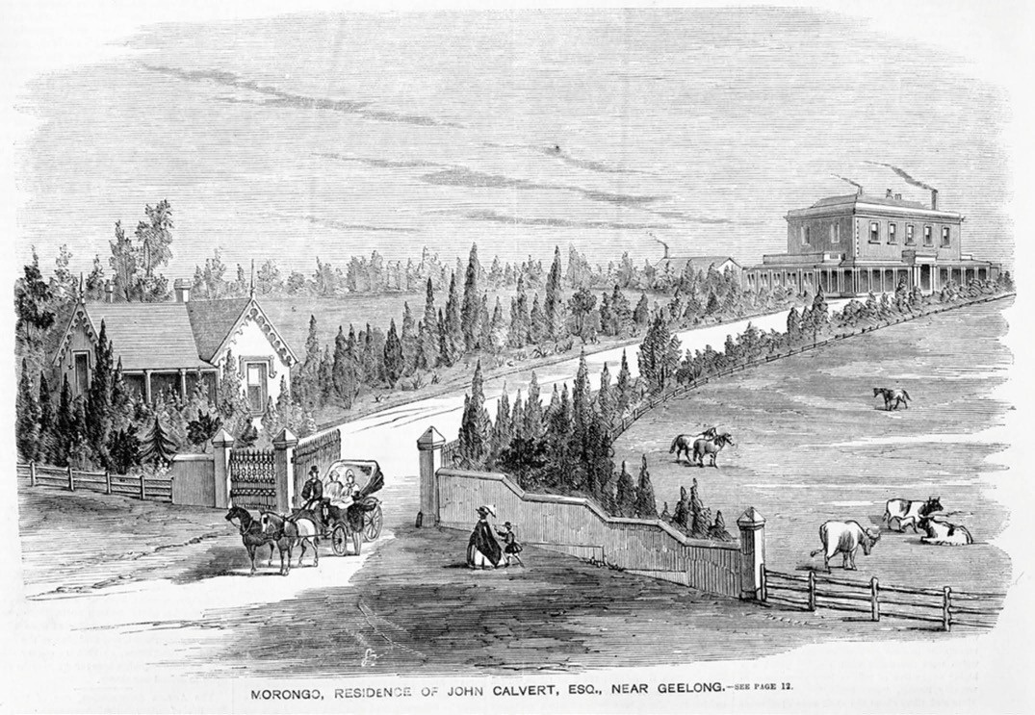
Figure 6.134: S. Calvert, Morongo, residence of John Calvert, Esq., near Geelong , 25 November 1863. Source: accession IMP25/1/63/5, State Library of Victoria.

In November 1849, the sheep station that Cowie and Stead had squatted on was subdivided and offered at a Government land sale. Around 10 allotments ranging between 88 and
135 acres were available and were initially acquired by John and Peter Manifold, John Pascoe Fawkner, G.W. Goodman, and L. Webster and E. McDonald.598 For the next 70 years, the area remained largely as substantial rural estates. In 1859-60, John Calvert had built an imposing two storey Victorian Georgian bluestone mansion house, together
with a Picturesque Gothic style gate house and bluestone entrance gates, on his 135 acre site off the Ballarat Road599 (Figure 6.134). Situated on the eastern slope of Bell Post Hill at the location of the apparent bell post and bell , Calvert did not purchase the freehold to his property –which he named Morongo - until 1868. The name derives from
the Wadawurrung, meaning underground fungus called the Blackfellow s bread . 600 In 1926, the property was acquired by the Presbyterian Church and redeveloped as Morongo Presbyterian Girls School,601 following on from a neighbouring boarding school that was first opened by William Ross as Bell Vue House.602 The gatehouse was
subsequently demolished. In 1994, Morongo was acquired by Japanese businessman, Mr Katsumato and further developed as the Kardinia International College.603 The original bluestone gateway was dismantled and reconstructed in the early 2000s due to the widening of the Ballarat Road.
In addition to Morongo and nearby Glenpanyall
(south of Morongo ) other rural houses were erected at Bell Post Hill in the 19th century. Those surviving today included John Sloan s 100 acres at 149 Rollins Road. There, he had built a stone and brick dwelling by 1860.604 Several years later in c.1892, a timber dwelling was built as part of Frank Rollins farm at 205 Rollins Road. Originally named Rosebank , the land had been acquired by Frank Rollins father, George.605 Rollins Road is named after the Rollins family, and in particular in honour of Frank Rollins who was prominent in community affairs during World War One.606
Early estates were sold and subdivided into the early 20th century. In 1899, the late Josiah Mager s farm, Hawk Hill , comprising 193 acres and fronting the Anakie Road and south of the Geelong to Ballarat Railway line,

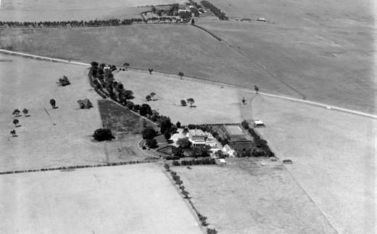
Figure 6.135: C. Pratt, Aerial view of Bell Post Hill looking south showing Morongo in foreground and Glenpanyall in background, c.1927. Source: accession H91.160/556, State Library of Victoria.

was offered in 7 lots, ranging from 5 to 41 acres, including Mager s house (which possibly dated to 1884-85).607 Much of the land was purchased by Alfred McDonald. He may have constructed a timber Federation villa in what was to become Corinella Street in the ensuing years.608 Although this dwelling no longer survives, a physical legacy of development in the early 20th century is the Federation dwelling built in 1909-
10 for John Pettitt, merchant and Councillor of the Shire of Corio.609 In 1958, Pettitt s home was the location of a Roman Catholic School founded by the Marist Fathers known as Chanel College for boys (it relocated to Lovely Banks in 1963).610 Pettitt s property was acquired by the Corio Shire Council in 1972 and it now forms a public park, the house offered as a public facility.611
Bell Post Hill remained a rural outpost into the 1920s. Morongo and Glenpanyall remained surrounded by open farmland and paddocks (Figure 6.135). Transformation of this area into a residential suburb began in the later 1920s with the subdivision of farms and the creation of streets. The earliest was the Excelsior Heights Estate in 1926 (Figure 6.136). Taking in the land south of John Pettitt s property and between the Anakie Road and Rollins Road, new streets were created (Fairy Street, Ward Street, Corinella Street,
Neil Street, Ruhamah Street, Central Avenue and Stanley Avenue) to provide access to the 493 allotments offered. The new subdivision was claimed to be the Toorak of North Geelong. 612 To the north of Pettit s property from Wolseley Grove to Edison Grove, further residential allotments were made available in September 1926.613
Further subdivisions north of Pettitt s property and to Edison Road were offered in later years. Although these subdivisions gave promise of the construction of Bungalows in the 1920s and 1930s, few houses were constructed. In 1928, six houses

had been erected as a speculative development by a local builder. Further construction of the anticipated 50 homes was shelved due to the lack of travelling facilities. 614 It was not until after World War Two and the late 20th century when many dwellings were constructed, with several to
accommodate European immigrants who arrived after the war (see Theme 2). Facilities were erected during this later period to provide services for the increased population, including
a Maternal and Child Health Centre in Hosie Avenue, Kindergarten in Ernest Street, and Rollins Primary School in Ernest Street.
In 2017, another residential estate was proposed at Bell Post Hill. Named Hill 104 after the elevated ground above the Australian National Memorial at Villers-Bretonneux, France.615 The main thoroughfare was named Karl Street, in honour of Private Karl Rollins, only son of George and Agnes Rollins, who was killed in action at Bullecourt on 11 April 1917.616

BELL PARK
Prior to European colonization, the area now known as Bell Park was thickly timbered, the trees so dense that when European settlers arrived, they could become lost.617 Acreages ranging from 40 to 100 acres were taken up by
pioneer settlers including James Austin, T.P. Bingley, Robert Sutherland and Cullen and Edols in 1849 and 1850.618 The most substantial early development was the estate, Bell Park (Figure 6.137), from which the suburb took its name. It was established by John Bell, nephew of John Calvert of nearby Morongo .619 It was built in 1853 in a Victorian Picturesque Gothic style to a design by the early Geelong architect, John Young.620 The mansion house was extended in 1861 with a billiard room annex designed by Joseph Shaw, architect.621 All that remains of Bell Park is this annex. The property was substantially subdivided in 1944 and the house and smaller acreage was donated by the Misses McKellar for use as a retirement home.622 While the house was demolished, the annex of 1861 was retained and converted into a chapel as part of Grace McKellar House in 1964.623
Other developments also occurred in Bell Park including a golf course in c.1897624 (see Figure 6.38 & see Theme 9). In 2013, part of the links was transformed into a housing development known as the Geelong Golf Club Residential Estate.625
Land was also offered for residential development in the early 20th century. In 1926, 232 lots were offered between Anakie Road and McClelland Street, the new thoroughfares named after Australian Prime Ministers: Barton, Curtin, Bruce and Deakin.626 Immediately south, the Links Estate between the Anakie Road and the railway line (north of Ballarat Road) was offered in 1928. These 180 lots were advertised as being

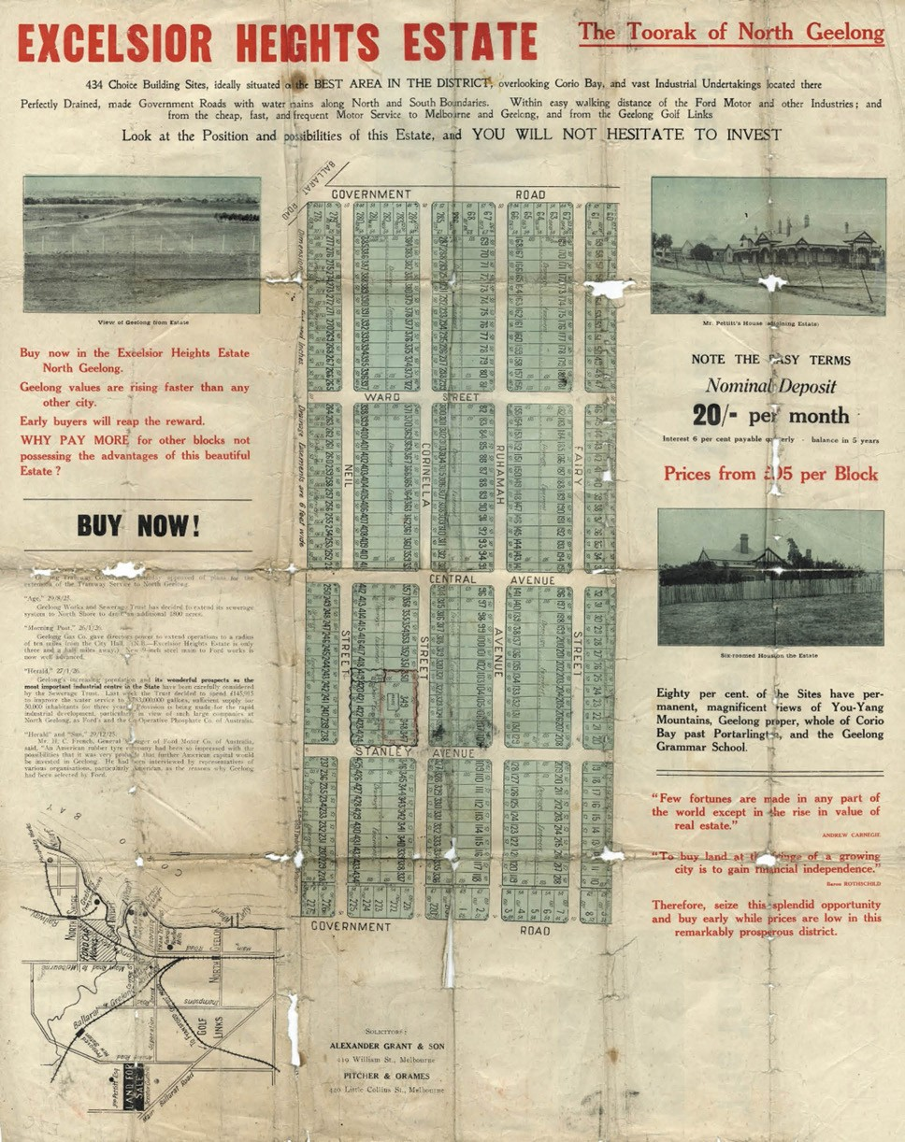

Figure 6.136: Plan of the Excelsior Heights Estate, 1926. Source: GRS 2030/E36, Geelong Heritage Centre collection.

situated in a beautiful position overlooking Corio Bay. 627
Although it was claimed in 1928 that all the property with the exception of Bell Park and the golf links had been subdivided for building purposes ,628 few houses were built until the post war immigration boom in the 1950s. The influx of immigrants from eastern European states was especially reflected
in church construction: Our Lady s Ukrainian Catholic Church at 43 Banfield Street (built 1956) (Figure 2.79, see Theme 2); Russian Orthodox Church at 15 Yaraan Street
(built c.1960) and the Ukrainian Autocephalic Orthodox Church at 14 Alder Crescent (built c.1978) (see Themes 2 and 8).629 The increased population also brought about the need for additional subdivisions and schools. In 1968, the Bell Park North Primary in Barton Street and the Bell Park Technical School (now North Geelong Secondary College) in Separation Street both opened in 1968.630

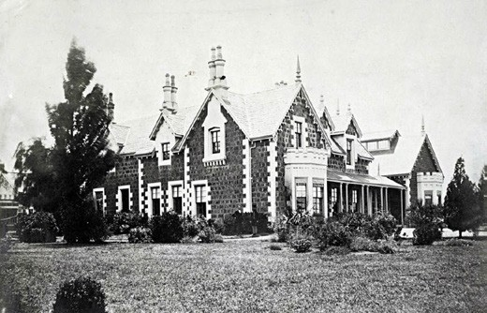

Figure 6.137: J. Norton, Bell Park , 1857-91. Source: accession H9311, State Library of Victoria.

BELMONT
In 1849, progress was also made on the southern side of the Barwon River within the original suburban allotment plan
of 1839. Crown allotments were made available in the area between Mount Pleasant and Roslyn Roads (Figure 3.138, see Theme 3). Described as Mount Pleasant , the land sold as 25 acre vineyard sites.631 By 1851, dwellings had been constructed by Thomas Towle and A. McLarty.632
In 1850, Alexander Thomson offered 93 allotments as the Township of Belmont (Figure 6.139). An early landmark was the Race Course Hotel at the south-east corner of High Street and Mount Pleasant Road.633 By 1851, small 2-6 acre allotments had been sold fronting the Promenade
on the south bank of the Barwon River, and with frontages to Barrabool and Mount Pleasant Roads. A hut had been built and a lime kiln established at William Week s allotment comprising lot 14.634 In 1852, the western portion of Section 22 overlooking the Barwon River was offered as the Township of Strawberry Hill with the following description: The extraordinary beauty of this property and its rich soil, together with it being so near town, must recommend it to both the old and the new aristocracy of Victoria. 635
By 1854 Belmont had a blacksmith s shop and a general store although there were only nine private residences listed in the directory of 1861.636 The national school was opened in Mt. Pleasant Road in 1856 although the Catholic school had already opened (see Theme 8). The national school was replaced by the present primary school at the corner
of Thomson Street and Mt. Pleasant Road in 1886 (see Theme 8).
In 1861, the township of Belmont was proclaimed.637 It was also in that year when the Belmont Common on the Barwon River flats to the east of the township was proclaimed, whereby the Town Clerk gave notice in the Government

Gazette that the Common was for use of its inhabitants as a place to graze cattle and horses 638 (in the early 20th century the Common was associated with aviation –see Theme 3).
By 1865 the population had risen to 428.639 Further residential subdivision had been established to the south- west of the town reserve.640 Some vineyards were created in this area (see Theme 4). However, progress in Belmont was slow and even in 1914 the population had only reached 450.641 The township area was surrounded by small farms and in 1890 it was described in the directory as agricultural .642
One property, built in c.1851, was J.C. Wallace s Elderslie Homestead (now demolished)643 (Figure 6.140).
In 1857, Belmont had acquired some significance as the centre of the South Barwon Shire which came
into existence as a road board in 1857.644 In 1863 it became a borough and when it merged with neighbouring Connewarre in 1875 it became the Shire of South Barwon.645
Throughout the mid-late 19th century, the Churches established themselves in Belmont. The Catholic Church appears to have been the first. The Baptists operated a Sunday School in 1865 and it was not until 1901 before they built their first church in Mt. Pleasant Road.646 The Methodists built their first Church in High Street in 1891 and they moved to Regent Street in 1922.647 A brick Church was erected in 1954 and it now serves as the Geelong Masonic Centre (see Theme 8).648
Further subdivisions occurred in Belmont from the late 19th century. In 1886, the Waverley Estate as offered, comprising allotments between the Mt Colite (Barwon Heads) Road
and Francis Street649 (Figure 6.141). A small plantation was set aside in the triangular reserve between Mt Colite Road, Francis Street and Mt Pleasant Road. This later became known as Alsop Park, the earliest known park in Belmont (see theme 9 for further details).650
In 1889, the Mount Pleasant Estate offered 79 housing lots between Roslyn Road and Corio Street, and included the creation of Evans Street.651 In 1890 the Kardinia Estate Company offered 250 lots of what had been Alexander Thomson s original purchase, and adjacent to his home overlooking the Barwon River, Kardinia House (built 1850- 55)652 (Figure 6.142). Additional subdivisions, known as the Kardinia Estate, occurred in the
following years.
Physical evidence of these late 19th century subdivisions is a small number of extant dwellings. They include the houses at 48 Riverview Terrace (built c.1892-93), 20 Mt Pleasant Road (built 1891-92), Glenelg at 26 Mt Pleasant Road (built 1894- 95) and Wanalta at 52 Mt Pleasant Road (built 1892) (Figure 6.143). This dwelling was designed by the local architects, Laird and Barlow, and was earlier known as Buninyong .653

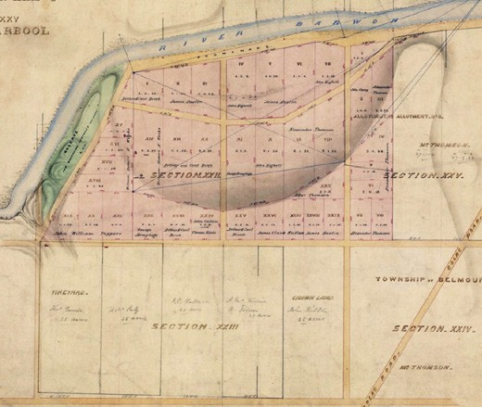

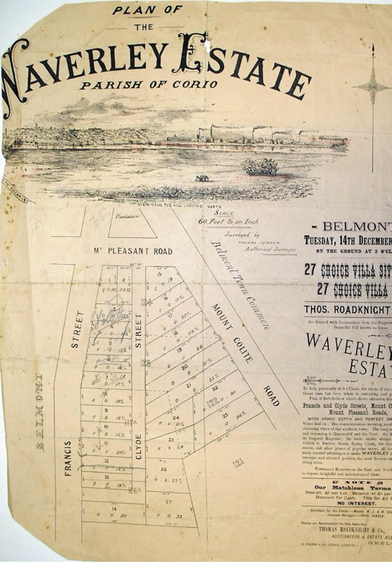
Figure 6.138: R. Hoddle, Portion of Plan of the Subdivision of Section XXII and Allotment No. 1 Section XXV, Parish of Barrabool County of Grant, 21 March 1851. Source: VPRS 8168/P5 item FEAT 543, Public Record Office Victoria
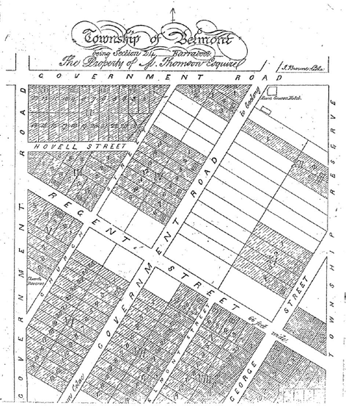
Figure 6.139: Plan of the Township of Belmont, 1850. Source: GRS 2030/Map B148/001, Geelong Heritage Centre collection.
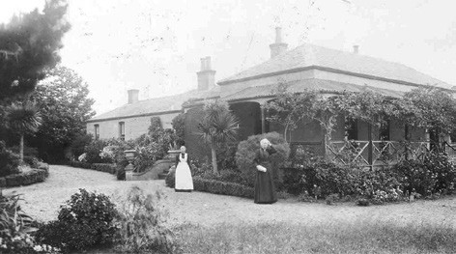
Figure 6.140: Elderslie Homestead with Mrs Margaret Mickle and her maid, 1906. Source: GRS 610A, Geelong Heritage Centre collection.

Figure 6.141: Plan of the Waverley Estate, 14 December 1886. Source: GRS 2030/Map W14/1, Geelong Heritage Centre collection.

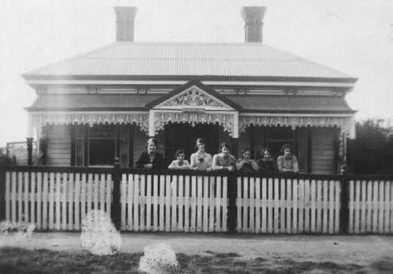
Figure 6.143: Wanalta , 52 Mt Pleasant Rd, c.1920s. Source: Jim Duff, Melbourne.

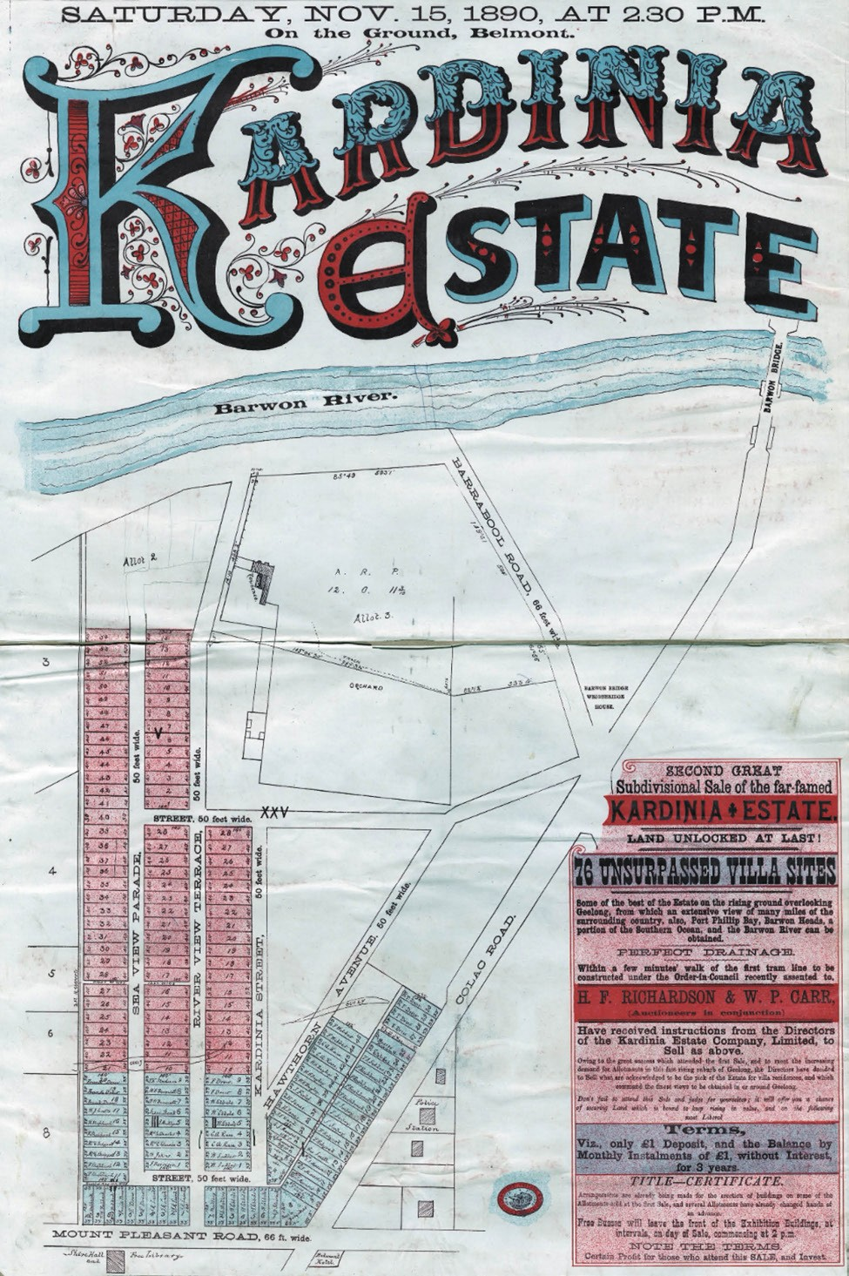

Figure 6.142: Kardinia Estate Plan, 15 November 1890. Source: GRS 2065/03/068, Geelong Heritage Centre collection.

Additional residential subdivision occurred in Belmont in the early 20th century. In 1910, the Geelong Grammar School acquired several acres of land to the north of Roslyn Road, west of Thomson Street. The first sod was turned in October 1910 for the commencement of a new, elite school complex.654 The promise of the new School soon faded in 1911, when
W.P. Carr and Son advertised the auction of the Belmont Hill Estate, immediately south of Roslyn Road.655
An anathema to the rural atmosphere desired by the Geelong Grammar School, the Belmont Hill Estate promoted the idea of an outer, lower-middle class suburb. The School sold
its land which in 1913 was subdivided into 86 residential allotments as the Belmont Heights Estate656 (Figure 6.144). This Estate was described as the choicest building area in this part of the district , with unsurpassed views and perfect drainage. 657 Street names commemorated the well-known Polar explorers: Shackleton, Peary and Amundsen.
The onset of the First World War thwarted the realization of a substantial residential suburb, with the late 19th and early 20th century subdivisions were largely retained as open grassed paddocks. Only 55 Federation era dwellings were erected from the hundreds of allotments available.658 Surviving examples include the houses at 45 Riverview Terrace (built 1911) (Figure 6.145), 21 Francis Street (built
1919), 44 Mt Pleasant Road (built 1911-12) (Figure 6.146), Kooringa , 48 Mt Pleasant Road (built 1911-12) and the house at 10 Evans Street (built 1913-14).659
The immediate years after the First World in the early 1920s witnessed slow progress in residential building development in Belmont. However, there were further subdivisions that occurred during the 1920s. In 1923, Elderslie Homestead was subdivided as the
Elderslie Estate.660
A few years later, a more substantial residential subdivision was the Jacobs Estate (Figure 6.147), the former vineyard of Morris Jacobs between Mt Pleasant and Roslyn Roads.661
The rural nature of Belmont is further revealed in the photographs that formed part of Elderslie and Jacobs Estate auction notices. They showed views along Mt Pleasant Road (Figure 6.148) and Roslyn Road (Figure 6.149), showing open paddocks, unmade roads and few houses.
Considerable urbanisation of these and the earlier subdivisions occurred in Belmont from the late 1920s and into the postwar era. The population of Belmont dramatically increased from 450 in 1911 to 2,300 in the 1920s.662 An impetus for the residential growth in the area was the construction of a new bridge over the Barwon River in 1926 and the extension of the Geelong tramway system in 1927.663 The auctioneers of the Belmont Estate subdivision of 1924 used a drawing of the bridge (then under construction) as part

of sale notice (Figure 6.150):
Apart from some managers and investors, the population in the Belmont area was largely working class, being comprised of mechanics, butchers, and fruiterers, together with tradespeople: builders, carpenters, painters and decorators, labourers, electricians, draftsmen –the occupations that drew their business from the growing community.664
The considerable residential expansion of Belmont from the 1920s is physically manifested in the large number of surviving interwar and postwar dwellings. Modest in scale,
they especially characterised several streetscapes in Belmont and include the Bungalow in Scott Street (built c.1923)665 (Figure 6.151). Others survive in an altered state, such as the late interwar Bungalow at 8 Corio Street (built 1927)666 (Figure 6.152). A particularly intact streetscape of late interwar and postwar brick dwellings is Culbin Avenue, where the houses were built between 1936 and 1950.667 In the 1950s additional land to the south of the original Belmont township was opened up to meet further housing demand throughout the second half of the 20th century.
Many of the houses built in Belmont from the 1930s were the work of local builder, Eric Lyons. He made a significant
contribution to the built environment and social life of Belmont for the rest of the 20th century.668 Commencing business with his brother, Allan, in 1929 with a contract to build a Closer Settlement farmhouse at Patho West, near Echuca, local business began with the construction of a timber home for George McKenzie at 1 Sommers Street, Belmont, in 1934 (Figure 6.153). From this time, Eric Lyons worked on his own account, and employed 12 carpenters between 1935 and 1938. Several houses were built under the State Bank finance schemes, with the Bank’s plans and specifications adapted by Eric to suit his clients. The business became E.J. Lyons and Son Master Builders in 1959 and to E.J. Lyons and Sons Pty Ltd Master Builders in 1973. Known in 2018 as Lyons Constructions, a legacy of the fledgling years of this enduring local building business is evident in several Bungalows in Belmont. They include those at 51 Roslyn Road (built in 1938), 14 Oxford Street (built in 1933-34), 3 Wimmera Street
(built in 1937-38),
8 Prospect Avenue (built in 1939), 26 Amundsen Street (built c.1937) (Figure 6.154), 221 High Street (built in 1938), 39 Oxford Street (built in 1938) and 19 Peary Street (built in c.1936).
The interwar years also witnessed some commercial and other developments in Belmont. Of interest in 1927 were five shops designed and built in High Street (at the
Roslyn Road intersection) (Figure 6.155) by local resident,
F.W. Brand, in consultation with A.B. Long, engineer.669 They were built of reinforced concrete and were reported by the Geelong Advertiser as being handsome and an imposing

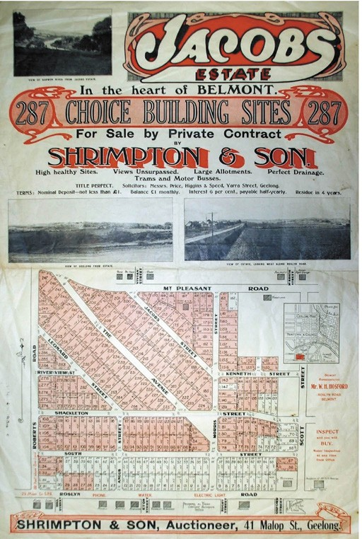

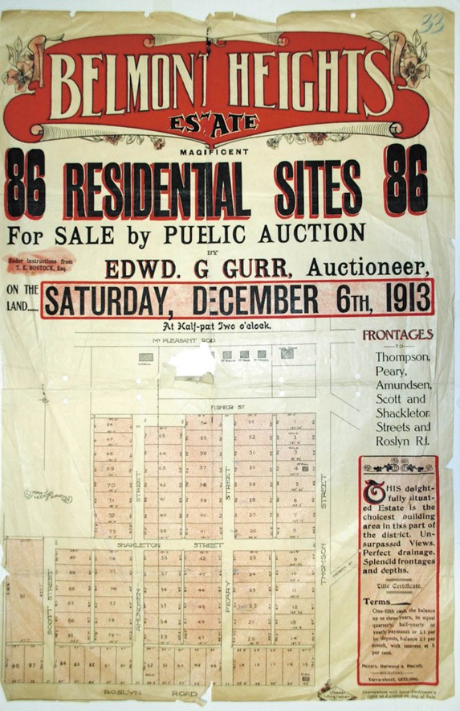
Figure 6.144: Belmont Heights Estate Plan, 6 December 1913. Source: GRS 2030/Map B91/1, Geelong Heritage Centre collection.
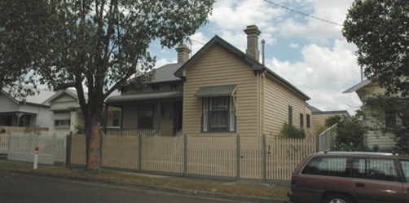
Figure 6.145: Dwelling, 45 Riverview Tce, 2007. Source: David Rowe.
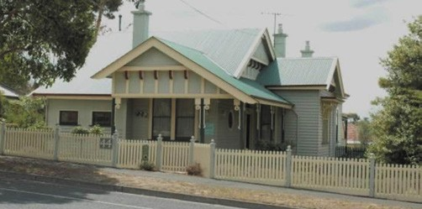
Figure 6.146: Dwelling, 44 Mt Pleasant Rd, 2007. Source: David Rowe.
Figure 6.147: Jacobs Estate Plan, n.d. [c.1925].
Source: GRS 2030/Map J5/01, Geelong Heritage Centre collection.
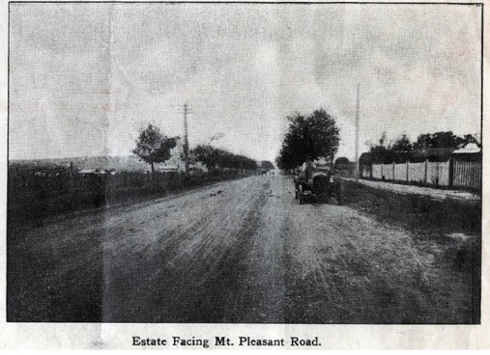
Figure 6.148: Mt Pleasant Rd looking east (outside 67 Mt Pleasant Rd), 1923. Source: Elderslie Estate Subdivision Plan, 1923, GRS 2030/E25, Geelong Heritage Centre collection.
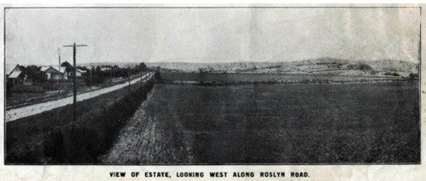
Figure 6.149: Roslyn Road looking west, c.1925.
Source: Jacobs Estate Plan, n.d. [c.1925], GRS 2030/J5, Geelong Heritage Centre collection.

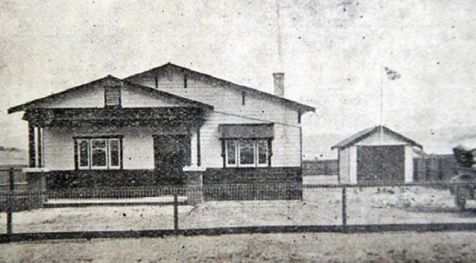

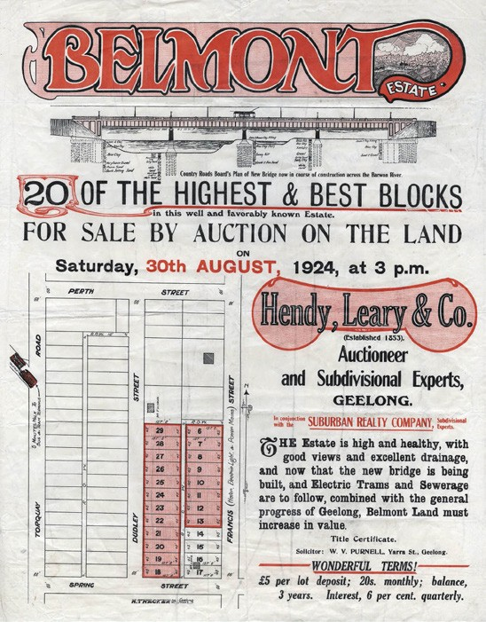
Figure 6.150: Plan of the Belmont Estate, 30 August 1924. Source: GRS 2030/B30, Geelong Heritage Centre collection.
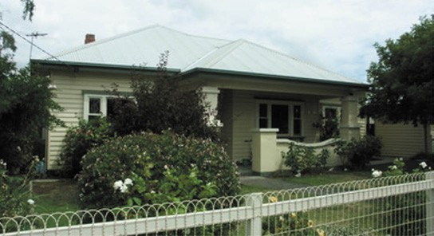
Figure 6.153: House, 1 Sommers St, 2007. Source: David Rowe.
Figure 6.151: House, Scott St, 1923. Source: Hilltop Estate Subdivision plan, 28 April 1923, GRS 2030/Map H27/01, Geelong Heritage Centre collection.
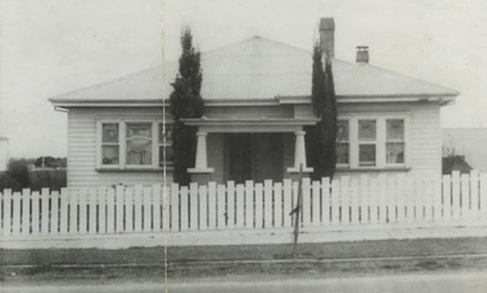
Figure 6.152: House, 8 Corio St, c.1950.
Source: B. Chappell, Authentic Heritage Services Pty Ltd.
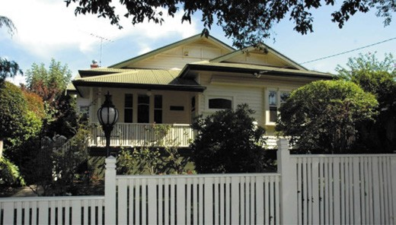
Figure 6.154: House, 26 Amundsen St, 2006. Source: David Rowe.

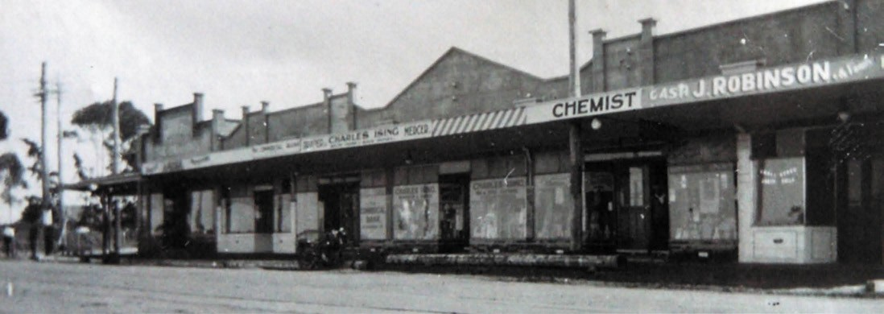
Figure 6.155: Five shops, High St, c.1930. Source: T.T. Holmes collection, Authentic Heritage Services Pty Ltd.

structure.670 These shops survive in an altered state. Further north at the corner of High and Regent Streets, a notable development was the construction of semi-detached two storey shops in 1928.671 They were distinctive for their Spanish Mission Revival design, the work of the local architect, Norman Schefferle.672

COWIES CREEK
From the beginning of European colonization, a vague district, centred along Cowies Creek had been established by pioneer squatter, Anthony Cowie, in partnership with David Stead. From the mouth of the Creek, the district extended beyond Corio towards Batesford.673 The first shipment of wool from Geelong was loaded at the Corio Bay foreshore at Cowies Creek in 1839674 (this location was later to become Geelong s shipping port known as Corio Quay). Most of
the surrounding land had been sold by 1849 and a Catholic Denominational School was established in 1854 on the east side of Thompson Road (immediately south of the creek).675 In 1855, an Anglican school opened but it closed in 1858.676 Political infighting amongst different community factions resulted in the opening of the Cowies Creek School No. 124, between today s Plantation and Purnell Roads (a substantial distance from the creek).677 Commercial life included the opening of the Ocean Child Hotel on the Melbourne Road
in 1851 and the Fountain of Friendship Hotel on the Lower Anakie Road, which opened in 1856.678 It closed in 1869 and ruins and a commemorative plaque mark its location adjacent to the Corio Leisuretime Centre, Anakie Road, Bell Park.679 Cultural life included the opening of the Cowies Creek Congregational Mission in 1865.680 No evidence survives of this church today.

OTHER SUBURBS & SETTLEMENTS
Beyond the initial suburban allotments surveyed by
H.W.H. Smythe in 1839, other suburbs and settlements were created well beyond the Geelong Town Reserve. These developments reflected the growth in population and industrial and commercial development, and the need for further housing and community infrastructure.

NORTHERN AND NORTH WESTERN REGION ANAKIE
The rural area of Anakie derives its name from the
Wadawurrung name, Anakie Youang comprising elevated land with three hills. These hills are known as the Three Sisters , the Wadawurrung names being documented in a Plan of the Anakie Yeoyang Run in 1851 as Coranguilook , Baccheriburt and Woollerbeeh. 681 European occupation of the land began in 1841 when Thomas Woolley established his pastoral run Anakie Yeoyang .682 Woolley s occupation was short-lived as the Run was taken up by Frederick Griffin in September 1842 and it remained under his occupation until the area was subdivided into smaller farms at a Government land sale in 1855.683 Adjoining Griffin’s Run was the
Mowyong Run of George Synnot which he took up in 1840.684
Physical evidence of early European occupation following the land sales of 1855 includes the Victorian Vernacular stone cottage at 370 Mount Road built in c.1855 for Maurice Troy (Figure 6.156). He appears to have operated a store from this location.685 Nearby is Lumeah Homestead , 205 Mount Road, where James Beveridge Murdoch established a farm in c.1855. A stone outbuilding on the property may be
associated with the initial years of Murdoch s occupation, the existing timber Victorian homestead possibly being erected following the death of the second owner, James Lyle, in 1887.686 A more substantial surviving homestead is Narada , 130 Mount Road (Figure 6.157) built initially in 1864 for John Browne, with two storey additions and cast iron verandah added in 1873 to a design by Joseph Watts.687
By 1865 Anakie was described as a postal village, with a hotel, two schools and two blacksmiths forges; the
population was reckoned as about 500 who were engaged in pastoral and agricultural pursuits. In 1866, a Presbyterian Church was constructed.688 In 1872, an increase in the population in the district increased following the opening of a Sugar Beet mill at Simon Staughton s property, Staughton Vale (see following subsection).689 St. Brigid s Catholic Church at 2439 Ballan Road was also built at this time. In 1874 a new State School replaced two earlier schools (this building was demolished and a new School erected in 1925).690 By 1879 the population had decreased to 200.691

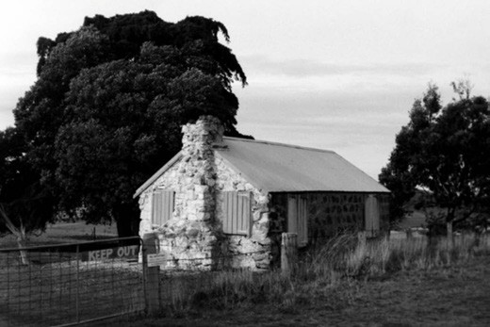
Figure 6.156: Stone cottage, 370 Mount Rd, 1998. Source: David Rowe.
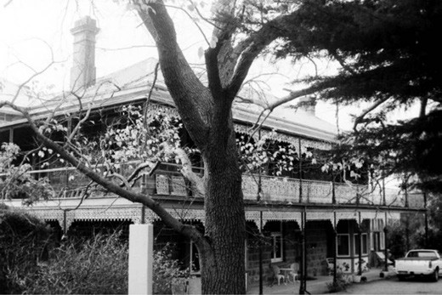
Figure 6.157: Narada , 130 Mount Road, 1998. Source: David Rowe.

Residents introduced dairying at Anakie in the late
19th century and a creamery was established by 1901.692 Some other early estates were also subdivided including Griffin’s Estate in 1915.693 Houses were built throughout this late 19th and early 20th century period as a consequence of changing farming practices and the availability of land. They included the dwellings at 2320 Ballan Road (possibly for John Edward Smith), 70 O Neil s Road (for Charles Tucker junior), and 255 Staughton Vale Road (for James Reale)694 (Figure 6.158).
A major development at Anakie in the 20th century was the opening for Fairy Park, a fairytale theme park, in December 1959 (see Theme 9).695

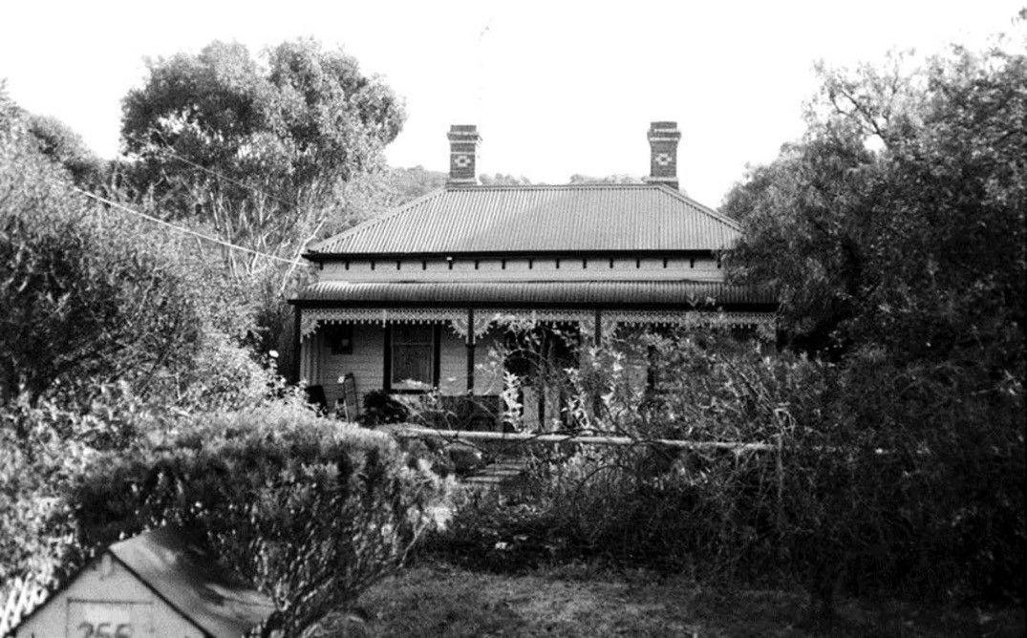
Figure 6.158: Dwelling, 255 Staughton Vale Rd, 1998. Source: David Rowe.

BALLIANG
The rural locality, Balliang, is situated in the Parishes of Balliang and Lara. The locality and Parish may have been named after the Wadawurrung word, Bal: Liang meaning bulrushes,696 suggesting tall reeds were part of the
local landscape.
Balliang takes in the northern-most portion of the City of Greater Geelong and is nearby Staughton Vale and Anakie. Much of the land was first taken up by George Synnot as the Mowyang Run in 1840 and Simon Staughton as the Brisbane Ranges Run in 1842, being north of the Anakie Youang.697 It was broken up and sold as smaller allotments in 1855.698 A village known as Ripley straddled both sides of the river by 1860. A township was laid out on the south side of the river
in 1863 and was punctuated by the Bacchus Marsh Road699 (Figure 6.159). It never developed. In 1908, 780 acres of the Staughton Vale Estate on the south side of the Little River was acquired by the Government under the Closer Settlement Act of 1904 and subdivided into smaller farm lots.700 A small Balliang Township (Figure 6.160) was reserved on the north side of the Little River at this time, making provision for State
School, Public Hall and Recreation Reserves, as well as land for the Church of England and private dwellings.701
In 1911, three years after the establishment of the township, the Leader newspaper gave the following description of Balliang:
Balliang is a postal township in the centre of the old Staughton Vale run, now subdivided into farms. Of the original 18,000 acres of this property, 9000 acres have been resumed by the Government for agricultural subdivision at £6/10 per acre, and the Board, to which has been relegated the details of this settlement work, with characteristic absence of practical knowledge of the business, could only see its way to purchase one-half
of the property, although it could have had the whole at the same figure. That was within the past three years. A private syndicate immediately picked up the remaining half, and as the settlers have some in and shown what the land under modern agricultural methods is capable of, prices during the three years have steadily gone up And yet this is in a district where settlers cannot get to a
railway station near on the average than 15 miles, and with roads whose character in the winter time can compete in

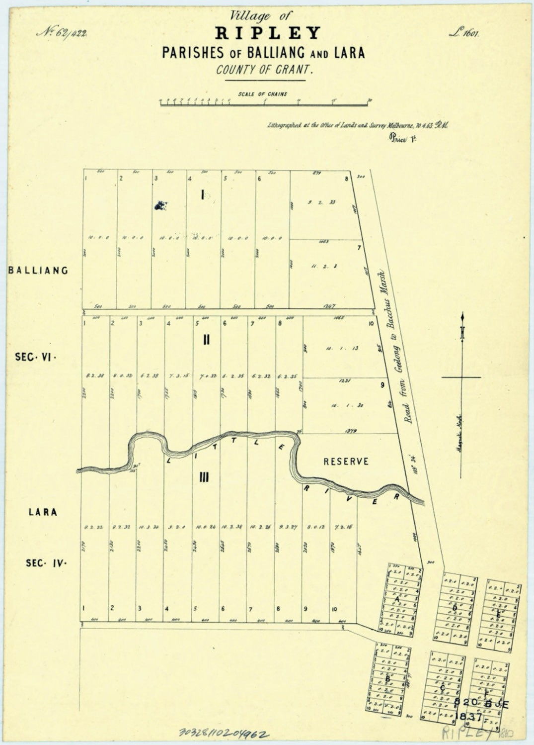
Figure 6.159: Plan of the Village of Ripley, Parishes of Balliang and Lara, 1863. Source: State Library of Victoria.

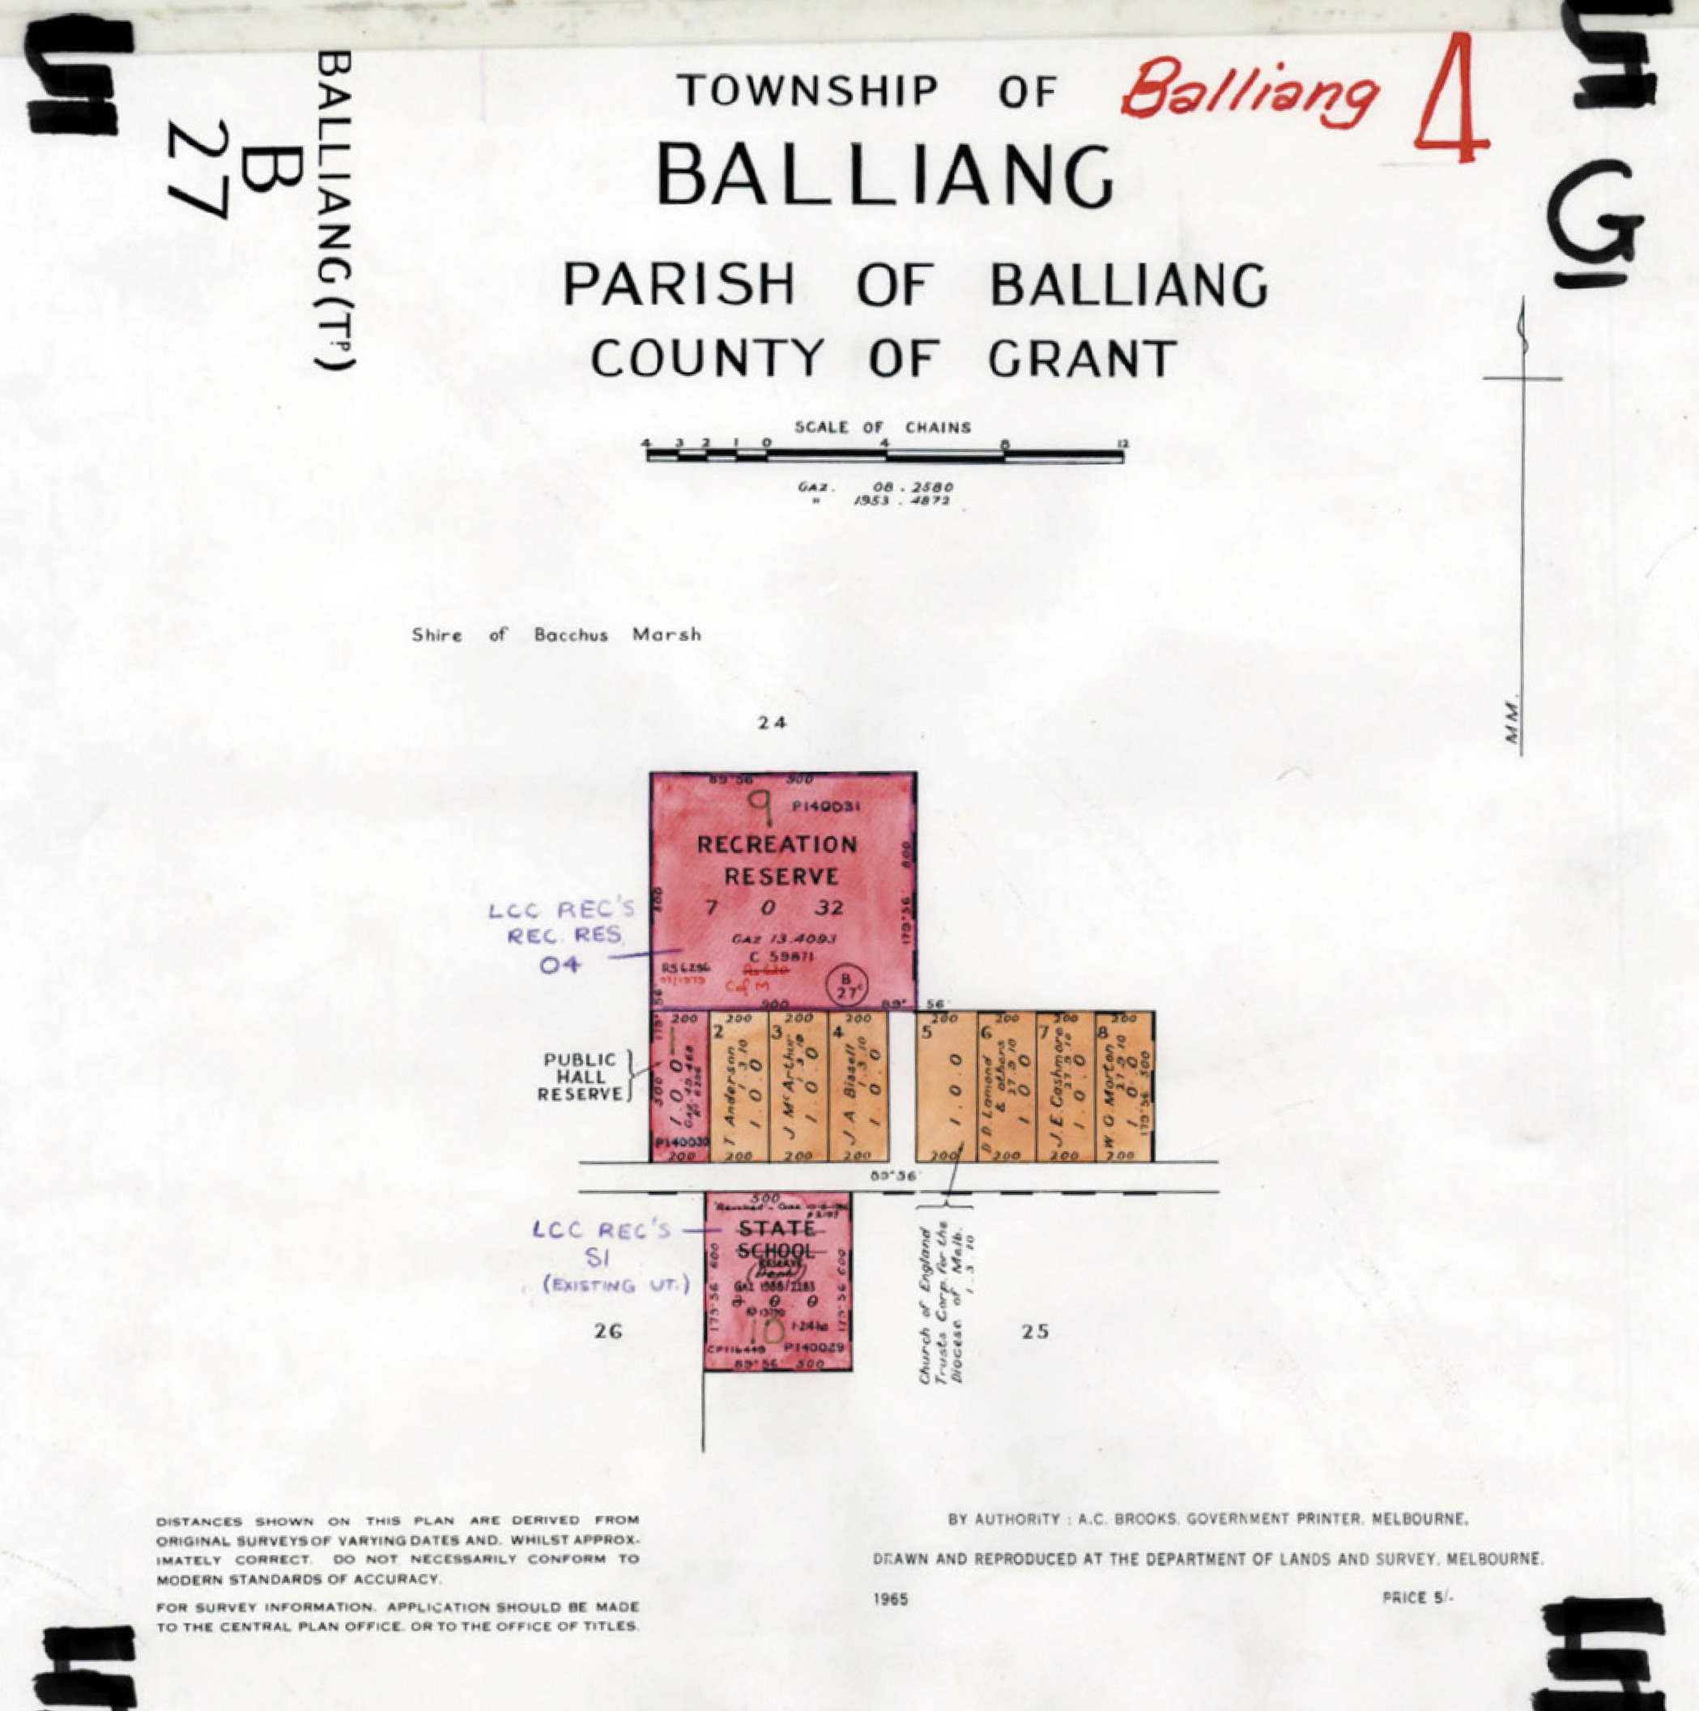
Figure 6.160: Township of Balliang Plan, Department of Lands & Survey, Melbourne, 1965. Source: VPRS 16171/P1 item A-Bl, record Balliang 5003, Public Record Office Victoria.

badness with the worst in Gippsland It is the quality of the soil, however, together with a permanent rainfall, that explains the value. The settlers here are a particularly good class, and probably there is no other Government purchased land in any part of the State that compares more favourably with respect to the workmanlike manner in which the land is being handled, and the excellent character of the building, fencing and other improvements
already made upon the farms702.
Physical legacies of 19th century development following the opening up the land, and following the smaller farm allotments made available under the Closer Settlement Act
include the former Ripley Park woolshed at 75 Gilmores Road (built c.1870 for Joseph Love, farmer), Ripley Park workers cottage, blacksmith s shop, stables, piggery and dairy at 90

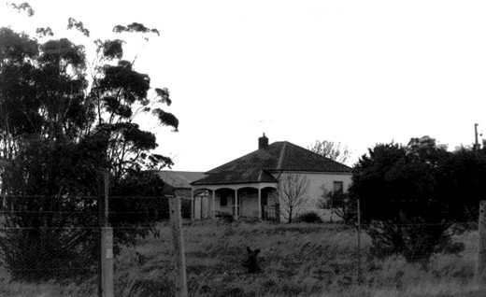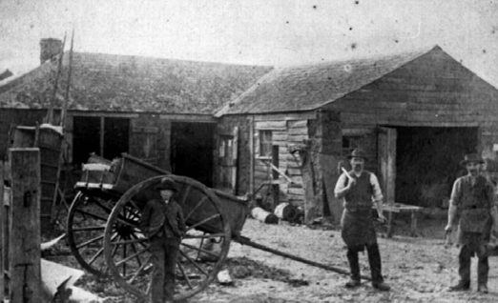
Figure 6.161: Dwelling, 230 Birds Rd, 1998. Source: David Rowe. Figure 6.162: McAdam s Blacksmith s Shop, 1880.
Source: Wynd collection, Authentic Heritage Services Pty Ltd.

Gilmores Road (built c.1870-1900), dwelling at 2525 Bacchus Marsh Road (built c.1890 for Samuel Jones), and the dwelling at 230 Birds Road (built c.1910 by R.B. Chirnside-Bilban
and first occupied by W.M. Wade, farmer)703 (Figure 6.161). Further developments occurred in the early 20th century, including the dwelling, Jenner in c.1920 at 305 Box Forest Road for Leila and James Chirnside, who were also the owners of the homestead at 165 Buftons Road built about the same time.704

BATESFORD
European occupation at Batesford began in 1836 on the west side of the Moorabool River when John and Peter Manifold temporarily grazed 340 sheep.705 The location at the crossing of the river was then known as Manifold s Ford.706 By 1838, Alfred and John Bates (who, with their father Thomas, had taken up the Wooringhalook Run at Duck Ponds, Lara in early 1837) commenced farming on the east bank of the Moorabool River.707 It was from this time when the crossing and the locality was known as Bates Ford (and later Batesford).708
In 1843, Charles Ruffle opened the Marrabool Inn above the east bank of the Moorabool River. This began commercial progress at Batesford.709 As a river crossing settlement, difficulties emerged during river floods and in 1848 a bridge was erected downstream from the original ford (this bridge was replaced with the existing bluestone bridge in 1859).710
In 1846, much of the land taken up by the Bates brothers was acquired by George Hope. In 1850, he subdivided the area near the river and established the village of Batesford and the estate of Hopetoun. Allotments were centred around Bridge, River, Cross and Hope Streets.711 The Argus described the proposed village:
The above village is laid out in convenient building lots, with frontages to the road from the Bridge at Batesford to Geelong, and having cultivation lots in the rear.
The Estate of Hopeton is surveyed in compact farms, fronting to the above mentioned road, and to a government road dividing this property from the valuable purchase of Messrs. Webster and McDonald.
The reserves for churches and schools of the different denominations are placed in central positions.
The very advantageous position of the ground as regards traffic and convenient access to town, combined with proximity to wood, water, and building material,
is well known to the residents of the district. But the auctioneer for the information of strangers, and those who have recently arrived in the colony, begs to remark that this Estate is situated on the never failing River Moorabool, embracing the site of the bridge over which all the fat stock and wool of the rich Western District, must pass in progress to market, being also the direct road to Buninyong and the Pyrenees, affording the fortunate holders of this land unlimited opportunities of trade, whether Inn and Storekeepers, or Artisans, while Batesford Bridge being a well-known and recognised
stage, many roads converging at this point offers a golden opportunity to the agriculturist for disposal of his hay crop without the usual heavy expense of cartage, as well as
a handsome remuneration for the use of his stubble and grass paddocks.712
Land sales soon transformed Batesford as by 1861 it had
a population of 254.713 Four hotels (including the Moorabool that had been renamed the Derwent), three storekeepers, William McAdam, wheelwright and blacksmith (Figure 6.162), two shoemakers, a boarding house operated by Abraham Leek, a post office and Catholic and Anglican schools.714 James Hope had also established a water-powered flour mill in 1859 at the property of his brother, Dr. Robert Culbertson Hope, Lynnburn , built in c.1857.715 The flour mill was not a longstanding success.

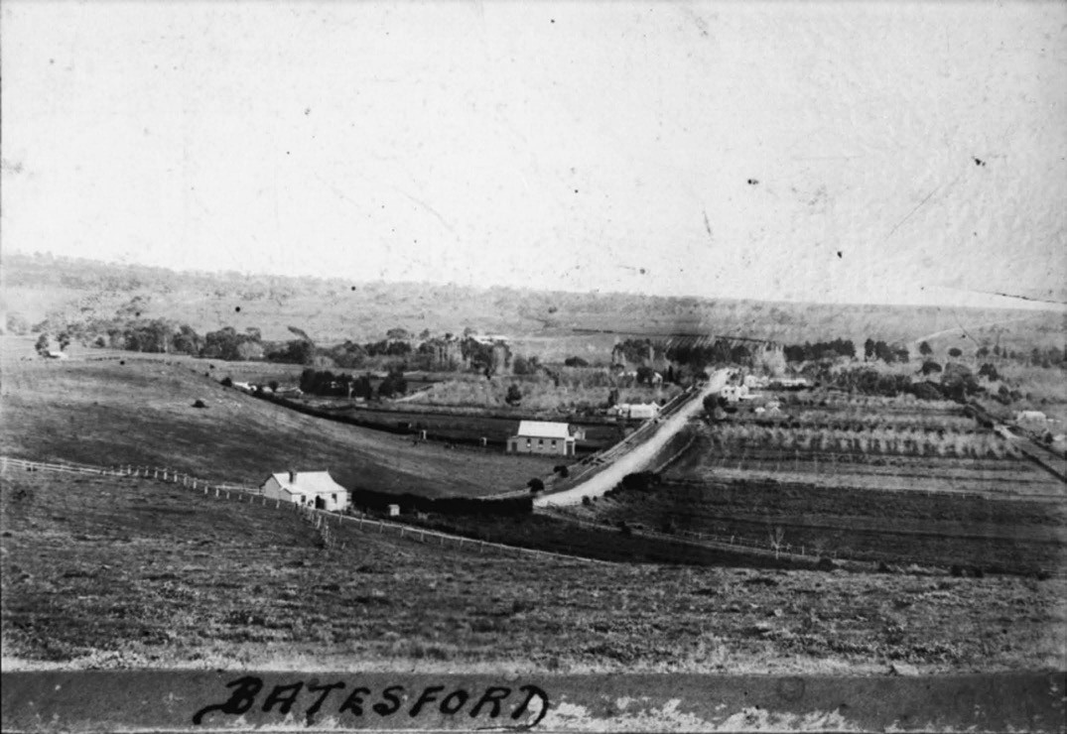
Figure 6.163: Batesford (from the east looking west to the township, vineyards & orchards), c.1880. Source: Wynd collection, Authentic Heritage Services Pty Ltd.

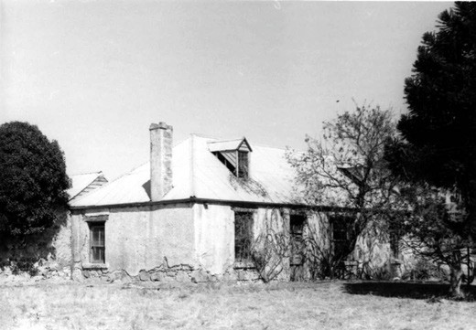

Figure 6.164: Travellers Rest Inn, 20 February 1966. Source: J.T. Collins, accession H90.100/1190, State Library of Victoria.
It was also from the early 1860s when Batesford became well known for its vineyards and orchards (Figure 6.163). Of
particular importance was James Dardel s Paradise vineyard above the west bank of the Moorabool River, and Dr Hope s vineyard at Lynnburn (see Theme 4). Dardel s stone house (originally built in 1853 as a police station) and homestead setting survive today (the property now being located in
the Golden Plains Shire).716 Within the Batesford township, Drumgold homestead at 70 Bridge Road is a physical legacy of the 19th century vineyard era, the northern paddocks having been associated with Hunt s vineyard. The existing house, built c.1893, appears to have replaced an earlier dwelling and was built in stages by the Madden family.717
Other surviving places at Batesford are physical legacies of its early beginnings. One of the earliest is the Travellers Rest Inn near the bridge at 750 Midland Highway (Figure 6.164).
It was built in 1849 for John Primrose and in c.1865 it was converted into a dwelling for Jacob Hamerli who also acquired the nearby Paradise 4 vineyard.718 Another early

building is Innisfail at 45 Cross Street, built in 1859-60 as two semi- detached dwellings by James Ballantyne and Thomas Scott, stonemasons employed on the construction of the Geelong to Ballarat Railway line.719 The wives of contractors were sisters,720 hence the semi-detached composition in addition to a more economical method
of building. Ballantyne and Scott also built the Batesford Presbyterian Church at 35 Cross Street in 1860 that had been designed by Joseph Shaw.721 He had also designed a nearby stone Manse in 1857.722 It was demolished in 1910 and replaced by a Federation dwelling, the stone of the earlier dwelling being used to construct the Church vestry at this time.723 In 1877, the existing State School was erected at 25 Old Ballarat Road on land donated by Dr Hope of Lynnburn .724 At 700 Midland Highway, the Derwent Hotel stands in the location of the original Marrabool Inn, the existing building erected in 1936 following the original hotel being destroyed by fire in 1930.725
In 2018, the City of Greater Geelong released the Western Geelong Growth Area Framework Plan as part of an Urban Structure Plan.726 The Plan proposed different land uses for this largely rural and agricultural Batesford, the majority to be made available for housing with the central portion of Batesford to offer rural living.

CORIO
The increasing industrialisation of North Geelong in the 1920s as well as the development of the shipping port at Corio Quay brought with it the need for additional housing.
Like the new estates at Manifold Heights, an emphasis on Garden City planning was given to the design by local
architect, I.G. Anderson, for the Garden Suburb of Corio in 1924.727 Laid out on behalf of the Melbourne Subdivisions Company, the futuristic plan offered residential, industrial and commercial areas. The new area was renamed the Grandjean Park Estate in 1925 in honour of P.WS. Grandjean. He had selected Geelong as the headquarters of the Ford operations in Australia728 (Figure 6.165). Straddling the Melbourne
Road north of Purnell Road, the promise of the new suburb soon faded as less than a quarter of the 32,555 allotments offered were sold.729 Only six houses were built by 1931.730 The estate was largely undeveloped until the Housing Commission of Victoria acquired part of the land in 1955 and by 1958 219 dwellings had been erected with further housing built in later years (Figure 6.166).731

LARA
Lara was the result of three subdivisions of land earlier held by squatters and pastoralists. In 1853, J.E. Bates offered Section 15 A of the parish of Moranghurk in lots varying from one to three acres as the village of Lara to the south of

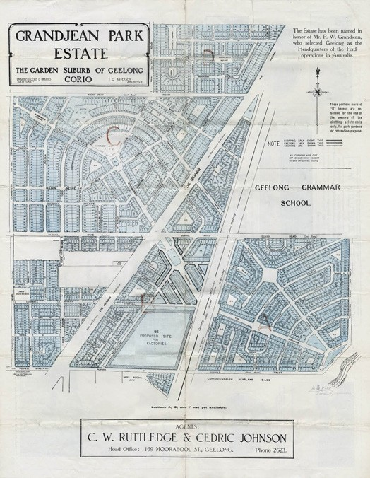
Figure 6.165: I.G. Anderson, Plan of the Grandjean Park Estate: The Garden Suburb of Geelong –Corio, 1925. Source: GRS 2030/G47, Geelong Heritage Centre collection.

the Duck Ponds (Figure 6.167). A centre piece of the village layout was the Lara Lake, comprising 39.5 acres of fresh water. An advertisment by J.B. Hutton for this subdivision stressed its closeness to the proposed railway station, the abundance of water and building materials (stone and lime), and concluded there is not a more fravoured locality in the colony for a township . 732
Simultaneous to the Lara Village subdivision was the sale by James Austin of the Cheddar Farms and Cheddar Township to the west (Figure 6.168) while on the east John Highett
had created the township of Swindon, the streets of which were named for famous scientists and engineers. This flurry of subdivisional activity was prompted by the fact that the Geelong-Melbourne railway was to run through the area and both Bates and Highett s plans show a railway station, though in different locations. Thus there were three names for the locality which was already known as Duck Ponds (from Duck Ponds Creek - today s Hovells Creek). It was not until 1874 that the name Lara was officially proclaimed and
the boundaries of the town laid down. The early commercial settlement at the corner of Forest Road South and Patullos

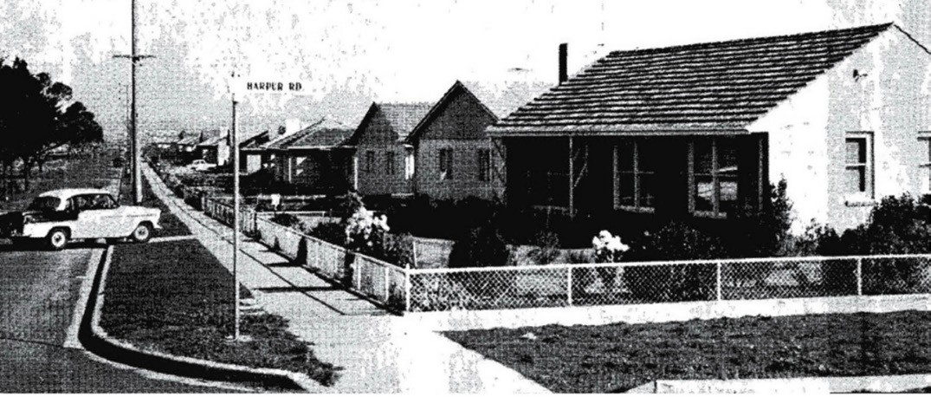
Figure 6.166: Housing Commission Estate houses, Corio, c.1960. Source: Twenty-second Annual Report of the Housing Commission of Victoria, no. 12, 1960-61, Parliament of Victoria collection. Reproduced by permission of the Speaker of the Legislative Assembly, Victoria, Australia.

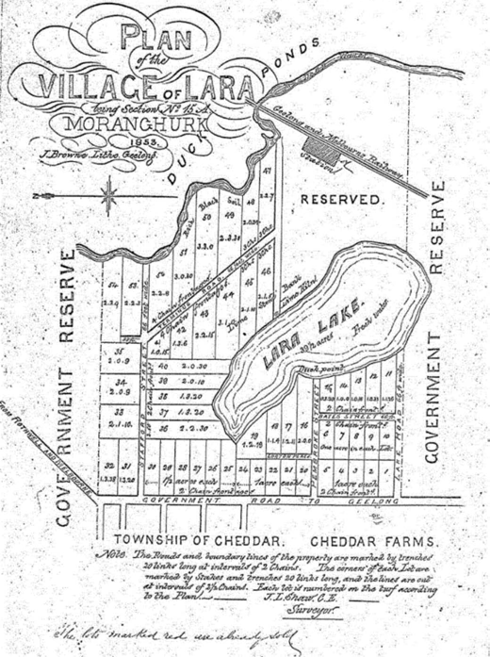

Figure 6.167: J.L. Shaw, Plan of the Village of Lara, 1853.
Source: GRS 2030/Map L86/01, Geelong Heritage Centre collection.
Road was outside the newly-proclaimed town boundary. Derived from separate private subdivisions, this caused two disparate town settlements to form. This was reflected in the substantial geographical distance between the first Post Office in Forest Road South on the west side of Hovells Creek and the Railway Station that had been located to the north-east on the east side of the Creek. It was also reflected in the differing names of these key infrastructure buildings: the Post Office was known as Hovells Creek and the station as Duck Ponds. Even Bailliere s Victorian Gazette for 1879 described Lara as a postal township with a railway station and yet with adjoining small villages of Cheddar, Swindham [sic.] and Gheringhap to which there are horse tracks only. 733
The first buildings in Lara appear to have been hotels. The Robin Hood described as being at Duck Ponds but situated in James Austin s subdivision of Lanercost on the Melbourne Road, was opened in 1858 by William Grass but closed after two years. Longer lasting was the You Yangs Hotel, built
by William Bragg to take advantage of the opening of the Geelong-Melbourne railway in 1857. He catered for picnic parties and ran horse races on a course adjoining the hotel. In 1861 the Lakebank Hotel was opened and continued in business until 1908.734
By 1882 Lara had a state school, three churches and a population of about 200.735 The first church was built by the Primitive Methodists in 1854 in Forest Road, north of Hovells Creek. When the centre of population moved further south down Forest Road, a new church was erected in 1868; it still stands next to the Lara Lake school but is no longer in use as a church.736 Although they had been active in the area from the 1850s, Anglicans did not build a church until 1877 when

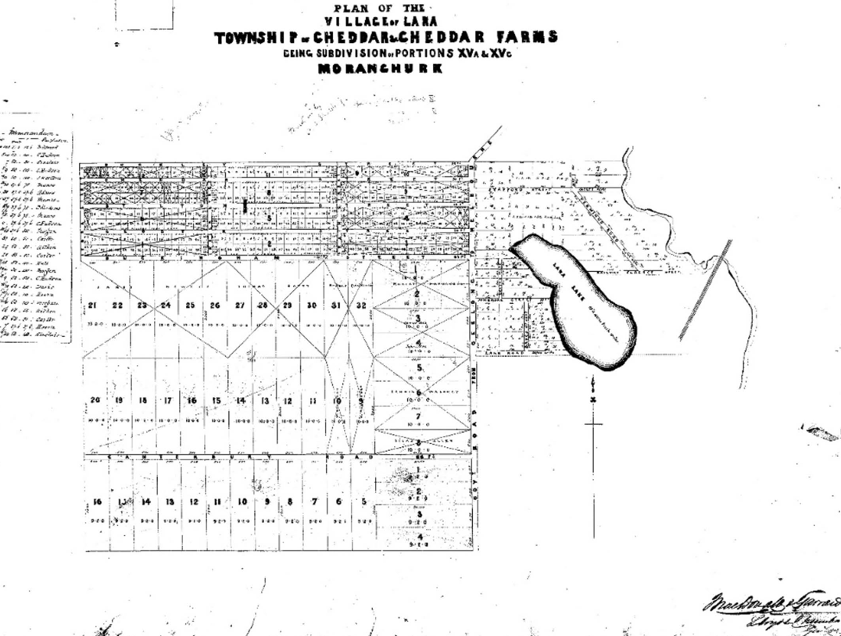
Figure 6.168: Plan of the Village of Lara, Township of Cheddar & Cheddar Farms, c.1855. Source: GRS 2030/Map 031/1, Geelong Heritage Centre collection.

Holy Trinity was constructed. This building was destroyed in the 1969 bushfires but part of it has been retained as a memorial.737
The first recorded school in Lara township was established at Lara Lake in 1864. Apparently it was already operating in a stone building 12 feet by 13 by 8 when a committee successfully obtained Government assistance. A school to hold forty pupils was erected immediately and a residence for the teacher followed in 1871.738 In 1873 brick additions allowed the school to accommodate 120. The school too was destroyed in the 1969 bushfires.739 While first in the town, the school was not the first in the district. In 1855 a school was established at the You Yangs by the Anglicans; it was variously known as Station Peak, Duck Ponds and Flinders Peak. When the Common School system was introduced in 1862, it became No. 188 Duck Ponds.740 After the 1872 Education Act the building was rented to the
Education Department and still used for services on Sundays.
Eventually the Department bought the building which became State School No. 2107.741
Lara had one significant advantage over other settlements in that it became the headquarters for local government. In 1863, while still a road board, it was decided to build offices on two acres of land near the Duck Ponds station.742 In 1937 the shire moved its headquarters to Osborne House, North Geelong; the old building eventually became the headquarters of Lara RSL.743 The presence of the shire headquarters lent a stability and solidity to Lara which is evident in the growth of community organizations. In 1865 there was a You Yangs Lodge of Oddfellows; by 1873 the temperance society had built its own hall (today s Uniting
Church) which also doubled as the Duck Ponds Free Library; in 1879 there was a Reform and Protection League; in 1873 the formation of the Duck Ponds Cricket Club showed that the days of life being a grim struggle for existence had passed; in 1880 some 17 acres were reserved for recreational purposes

followed in 1885 by the reservation near the railway station of the 12 acres of Austin Park; tennis made its appearance in the early days of this century. Further progress was made in Lara in the early 20th century. There was a police presence
from 1907 (an indication of a law-abiding community) and two additional churches were built –the Presbyterians in 1909 and the Catholics in 1912.744
Lara s progress was steady, if not spectacular. A romantic description of the town and surrounding farmland was given in the Bacchus Marsh Express in 1896:
Lara and the You Yangs
There is a placid English landscape appearance about these urban outposts of Geelong which is more marked in relation to all the country surrounding that town than in any other part of the colony. Geelong was the original capital of the colony, and still remains the natural one.
It was never much disturbed by gold-fields noise and flashness, nor disfigured by Melbourne suburban squalor. An ancient air of solidity and peaceful repose has grown up since 1840 or thereabouts in all the relation within 15 miles of Geelong, and is very noticeable on a calm Autumn day such as Wednesday last was, with the cheering effect of wayside pools of crystal water and sprouting crops and glistening grass with light clouds breaking away after the unwonted fall of two inches of rain the previous night. The roadside hedge rows and plantations, the low range of hills to the far westward of Lara, with patches of ploughed land on the slopes of the Elcho estate, the towering You Yangs to the northward, the park-like middle distance,
with the sun lighting up the thin smoke wreathes drifting over the white lime-kilns and the small cluster of buildings forming the village, all made up a picture of Westmoreland like picturesqueness, the imagination in that respect being aided by the fact that the Fairbairn mansion, just discernible from the main road, is called Windermere.745
Although a small rural village, residential development at Lara was diverse. It included the substantial homesteads for the wealthy pastoralists including Wooloomanata for Frederick Armytage in c.1860-63 (to a design by the Melbourne architect, Leonard Terry), Elcho on the Bacchus Marsh Road erected in 1864 for John Galletly (also to a design by Leonard Terry) and Pirra, Windermere Road, built in the 1860 for George Fairbairn (see Theme 4). A second two storey mansion was built at Pirra in 1880-82 to a design by Alexander Davidson and Company746 (Themes 4 & 9).
More prevalent throughout the Lara area, particularly during the second half of the 19th century were smaller-scaled homes both within the Lara township and in the surrounding farmland. These dwellings are largely Victorian vernacular in design, mainly having gabled forms and front verandahs. They are

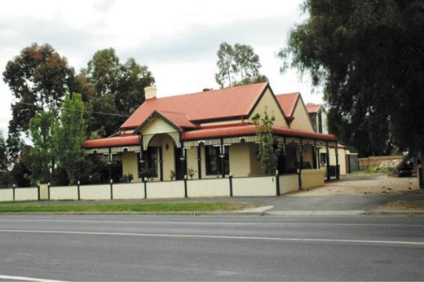
Figure 6.169: Limella cottage, 31 Flinders Road South, 2012. Source: David Rowe.
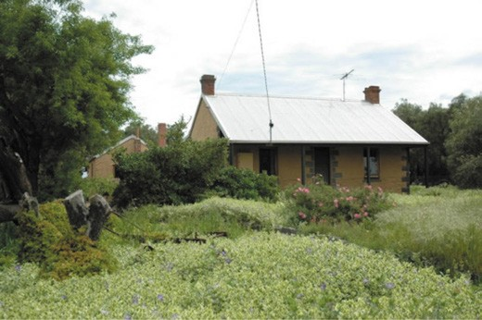
Figure 6.170: Cottage, 85 Curletts Rd, 2012. Source: David Rowe.

also vernacular in construction, with most having been built of local materials close to the source. Examples include the ruins of James English s farmhouse at 130 Branch Road (that was built in granite in c.1859),747 John McGillivray s house at
60 Branch Road (built of granite in 1871),748 and Maxwell Bell s cottage and outbuildings at 120 Duggans Lane (of bluestone construction possibly built in c.1864-84).749 However, most of the vernacular dwellings were built of limestone between 1860 and 1900. They included Limella Cottage, 31-435 Forest Road South, built in 1872-73 for John Spalding, pioneer of Lara (Figure 6.169), Laurence Park at 125 Buckingham Street in 1873-74 for David McHarry, farmer and lime burner, and the dwelling at 85 Curletts Road, built by William Harding in 1869 as his own dwelling750 (Figure 6.170).
More homesteads and houses were built during the Federation era. They included Tallaranie Homestead, 170 Peak School Road in 1907 for Archibald Shannon, and the Corio Shire

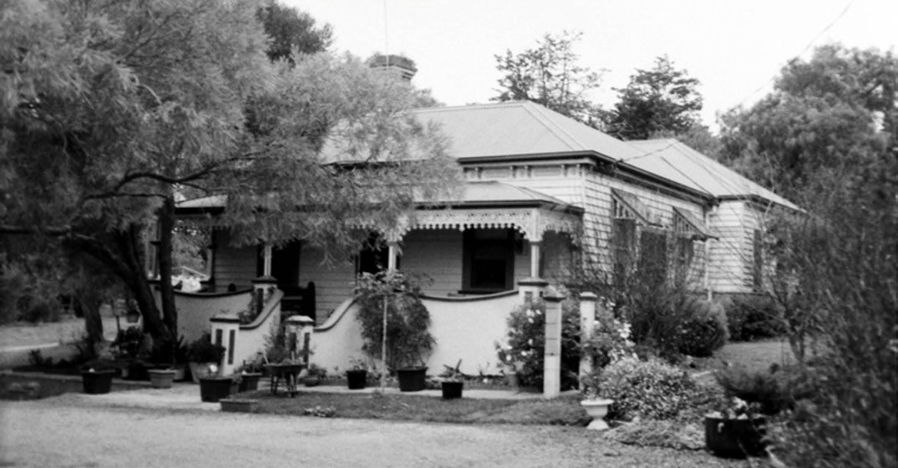
Figure 6.171: Dwelling, 225 Bluestone Bridge Rd, 1998. Source: David Rowe.

Engineer s residence, 8 Rennie Street in 1911.751 Both these dwellings were designed by the Geelong architects, Laird and Buchan.
From 1950, Lara experienced rapid expansion into a dormitory suburb for both Geelong and Melbourne. This expansion increased markedly to the north, south and west of the central township area in the later 20th and early 21st centuries.

LOVELY BANKS
The outlying area to the north-west of Geelong was sold at Government land sales from the 1850s. It remained an agricultural area throughout the 19th and much of the 20th centuries. One of the earliest European properties
established at Lovely Banks was Daniel Thompson s farm and vineyard at 225 Bluestone Bridge Road from c.1856.752 A stone dwelling and outbuilding were soon erected. Following Thompson s death in 1888, the existing timber dwelling was erected (Figure 6.171), possibly by his
son, Samuel.753
More substantial in size was James and William Mathews property, located on the west side of the Bacchus Marsh Road. Although now addressed as Corio, the site at 245 Bacchus Marsh Road was the location of the Mathew s Brothers slaughterhouse in 1872.754 By 1883, the butchers and sheep and cattle dealers had built three timber cottages,
as well as stables, piggeries and other infrastructure for their major enterprise that comprised over 900 acres.755 Much of the property was put up for auction as the Lovely Banks Farms in 1914 but the war curtailed its sale. It was again advertised in 1918.756 Nothing survives of the original
dwellings and slaughterhouse, although the use continues as the site is the location of M.C. Herd Meat Wholesalers.
A notable 19th century development at Lovely Banks was the construction of the water reservoirs and associated brick structures, and a timber cottage for the Geelong Water Company in 1869.757 The reservoirs and complex of structures remain at 600 Anakie Road (see Theme 4). However, nothing survives of other 19th century buildings associated with the early development of Lovely Banks, including the United Methodist Church that was built by
1871 at the south west corner of Bluestone Bridge Road and Valleyside Drive (it was destroyed by fire in the early 21st century) and the State School built in 1877 (it closed in 1996 and merged with Hamlyn Heights Primary School).758
More notable development occurred from the mid 20th century. A Monastery for the Congregation of Missionary of Oblates of the Blessed Virgin Mary was built in 1945 (see Theme 8).759 Increased residential development began in 1967 with the sale of 5 acre blocks as the Corio Heights with the allotments fronting Bluestone Bridge Road (then Rollins

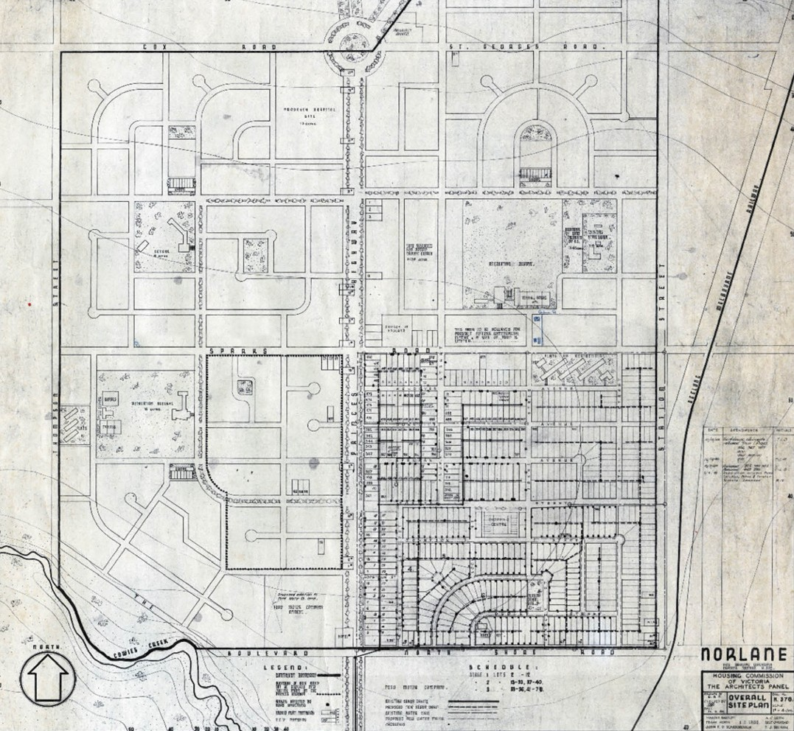
Figure 6.172: Housing Commission of Victoria Architects Panel, Plan of the Norlane Estate, 1948. Source: GRS 2030/N55, Geelong Heritage Centre collection.

Road), Lovely Banks Road (then Purnell Road), Duisberg Drive and Asher Road.760 Additional large acre allotments were made available in ensuing years. The City of Greater Geelong s Western Geelong Growth
Area Framework proposed further residential land use in 2018.761

NORLANE
Following the opening of the Ford Motor Company s factory on the Melbourne Road in 1925, there was a frenzy of subdivision activity in the area that was to become Norlane to meet the housing demand brought about by the rapidly increased factory worker population. This led to several businessmen forming a company known as Ford Estates Pty Ltd which acquired land to the north of the factory complex, offering housing lots as the Bayview Estate and the Ford Estates in 1925.762 While some streets were laid out (including Sparks Road, Wendover, Donnelly and Spruhan Avenues, and Forster Street between the Melbourne Road and Station Street), the anticipated large housing suburbs
were not immediately realised. Residential development was largely confined to Donnelly Avenue (then known as North Shore), and several dwellings survive today. More notable include the Bungalows at 1, 15 and 35 Donnelly Avenue, built between 1929 and 1931.763 They are examples of the State Savings Bank of Victoria’s financial, design and construction scheme (see houses in the Minerva Estate, Manifold Heights, for further details).764 Another development at this time was the relocation of a Baptist Church at 4 Spruhan Avenue in 1938.765 The Carpenter Gothic building had been erected in 1874 as the Hope Particular Baptist Church in Saffron Street, Chilwell.766
The promise of new large estate quickly being realised in the Ford Estates soon failed. Possibly as a consequence of the Great Depression in the early 1930s, the Ford Estate Pty Ltd company went into liquidation.767
The undeveloped land comprising the former Ford Estates was to be compulsorily acquired in 1947 by the Housing Commission of Victoria.768 Demand for housing nearby the industries at North Geelong, Corio and North Shore rapidly increased following the end of World War Two. Recently married returned servicemen with growing families had been forced to live in temporary accommodation.769 Exacerbating the crisis was the expanding immigrant population, raising the need for public housing. In 1948, a revised layout for
the new Housing Commission area was developed following Garden Suburb town planning principles770 (Figure 6.172).
It was prepared under the guidance of the Commission s Architects Panel comprising Harold Bartlett, A.C. Leigh, Frank Heath, E.C. Laird (of Geelong), Best Overend,
John F.D. Scarborough and T.J. Buchan (of Geelong).771 The first stage involved integrating the existing thoroughfares of Wendover, Donnelly and Spruhan Avenues into a larger and more dynamic scheme which included curved avenues and cul-de-sacs between Melbourne Road and Station Street,

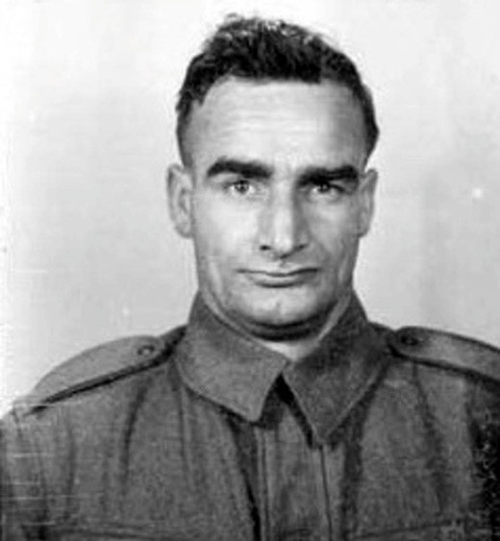
Figure 6.173: Norman Lane, 1940. Source: NAA: Attestation Form, Army no. VX44963, National Archives of Australia.

and Sparks Road and North Shore Road. A central focus was a proposed shopping centre. Later stages to the north of Sparks Road and west of the Melbourne were to continue the same Garden City ideology, with recreation reserves, school sites and even a site for a hospital was proposed.772
The new suburb was to be named Norlane, in honour of Norman Lane (Figure 6.173), the first servicemen of the area to succumb while serving in the Second World War.773 Born in 1908, Lane was a panel beater and lived at 2 Donnelly Avenue. He died of pneumonia while a prisoner of war in Malaya.774
From 1949, construction began in the first section of the Norlane estate. From this time until 1957, over 2000
timber, concrete, cement sheet and masonry houses were erected.775 The lightweight dwellings were prefabricated from Germany, Austria, France and Holland (Figure 6.174), the concrete dwellings manufactured by Holmsglen using a standard prototype of precast concrete panels.

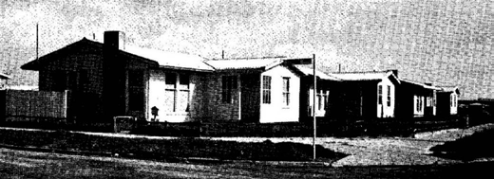
Figure 6.174: Prefabricated timber homes, Norlane, 1955-56. Source: Seventeenth Annual Report of the Housing Commission of Victoria 1955-56, Parliament of Victoria collection. Reproduced by permission of the Speaker of the Legislative Assembly, Victoria, Australia.

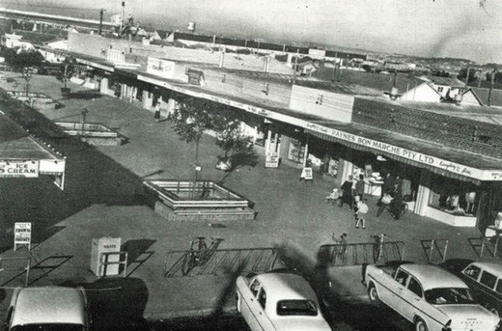
Figure 6.175: Shops, Labuan Square, c.1960. Source: Wynd,
So Fine a Country, op.cit., p.201.

In 1954, five shops had been constructed and another
13 shop sites sold in the shopping centre square (which had earlier been a swamp)776 (Figure 6.175). This commercial square was named Labuan Square, the name deriving from Labuan Island Malaysia. George Park, an Engineer of the Shire of Corio, proposed the name for the square as he and
A.C. Thoms (whose firm undertook subdivisional work in the area) had both been involved in the landing on Labuan Island, assisting in the establishment of an aerodrome and major bombing dump.777
The rapid increase in the population at Norlane also brought about the establishment of a Methodist Church at 12-14 Wendover Avenue. In 1950, a small gabled building, clad
in horizontally-aligned galvanised ripple iron sheets, was opened as a Church building.778 It had been relocated from Nhill (and is no longer extant).779 In the late 1970s, a more substantial church was required and the former Wilson Memorial Presbyterian Church (built in the 1890s) was relocated from 377 Pakington Street, Chilwell.780 It continues to serve as a Uniting Church.

NORTH SHORE
Land that what was later to be become North Shore was sold in 5-7 acre allotments to several European pioneers of Geelong in 1857 including M.J. Cummins, J.F. Strachan,
J.G. Carr, J.W. Thomas, J. Cowie and J. Hendy.781 In 1888, the agents, Abraham and Sutherland, urged the Geelong Town Council not to continue the lease of the
old slaughterhouse paddock , Cowies Creek, as a piggery because the locality about the North shore promised shortly to become a suburban settlement. 782 It was from this time that the area became known as North Shore. Two years later in 1890, Messrs A.D. Price and H.M. Sutherland supported a proposal by the Australasia Sugar Refinery Company Limited to establish a refinery at North Shore,
either at the Corporation Reserve (the former slaughterhouse paddock) or on land owned by Price and others.783 By March 1891, the North Shore Improvement Association had been established and its members, J.H. Connor junior, H.M. Sutherland and A. Smith again advised the Council of their intention of creating ‘a flourishing residential suburb on the foreshore. 784 This came to fruition on 23 December 1890 when W. Abraham, and Sutherland, Robertson and Company advertised 30 choice allotments as part of the Esplanade Estate. Situated in the northern portion of the area, it was claimed that there were no other Frontages available nearer town except at high prices. 785 A second sale was held on
8 January 1891 and a third of the remaining 16 allotments on 18 February 1893.786
The Geelong architectural firm of Watts and Durran were responsible for the designs of some of the earliest dwellings fronting The Esplanade. At 53 The Esplanade, they designed a timber villa in 1891 for H.M Sutherland, member of the Improvement Association (Figure 6.176). Nearby, they
also designed Hazelhurst for J.R. Hurst at the north-west corner of The Esplanade and Sea Breeze Parade in 1892 and Craigroy in 893 for Captain James Cook, retired navigator787 (Figure 6.177). Only the dwelling at 53 The Esplanade and the former stables of Craigroy at the rear of 61 The Esplanade (Figure 6.178) survive today.
Another very early development was the laying out of Moorpanyal Park (originally known as Armitage Park)788 on the foreshore in 1892. It was reported in the Geelong Advertiser:
With the view of adding to the natural advantages of the situation, the North Shore Improvement Association arranged to have the reserve on the side of the hill, a quarter of a mile in length, and forming the Esplanade, fenced off with a four wire fence and an avenue planted with a variety of quick growing, hardy trees. The idea was readily approved of by many persons residing in the district as well as by residents of Geelong, with the result

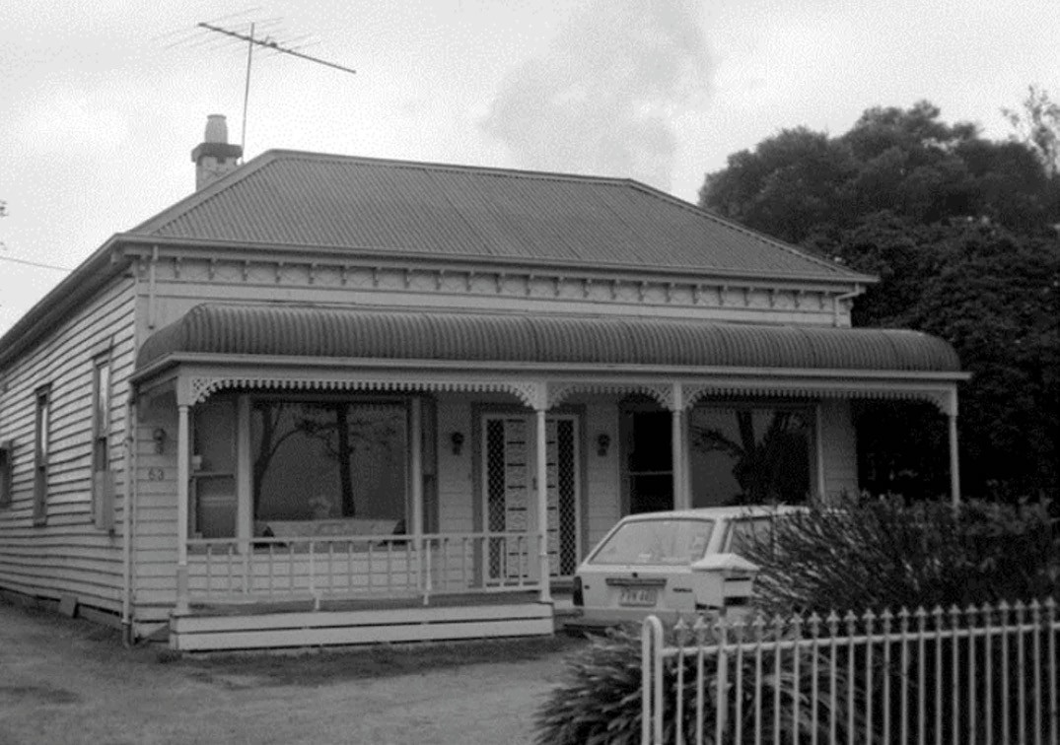
Figure 6.176: Late Victorian dwelling, 53 The Esplanade, 1998. Source: David Rowe.
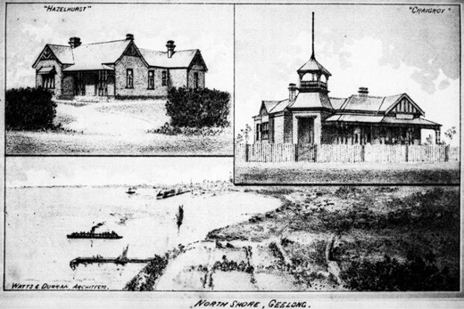
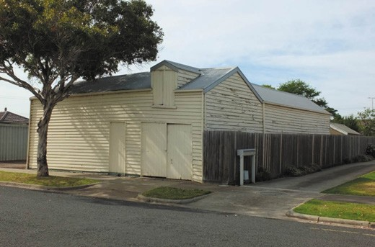

Figure 6.177: Watts & Durran architects, advertisement of dwelling designs at North Shore, 1893. Source: A.J. Campbell, The Tourists Guide to Geelong and the Southern Watering Places on the Bay and Coast and Popular Holiday Resorts, M.L. Hutchinson, Melbourne, 1893.
Figure 6.178: Stables, rear of 61 The Esplanade, North Shore, 2018. Source: David Rowe.

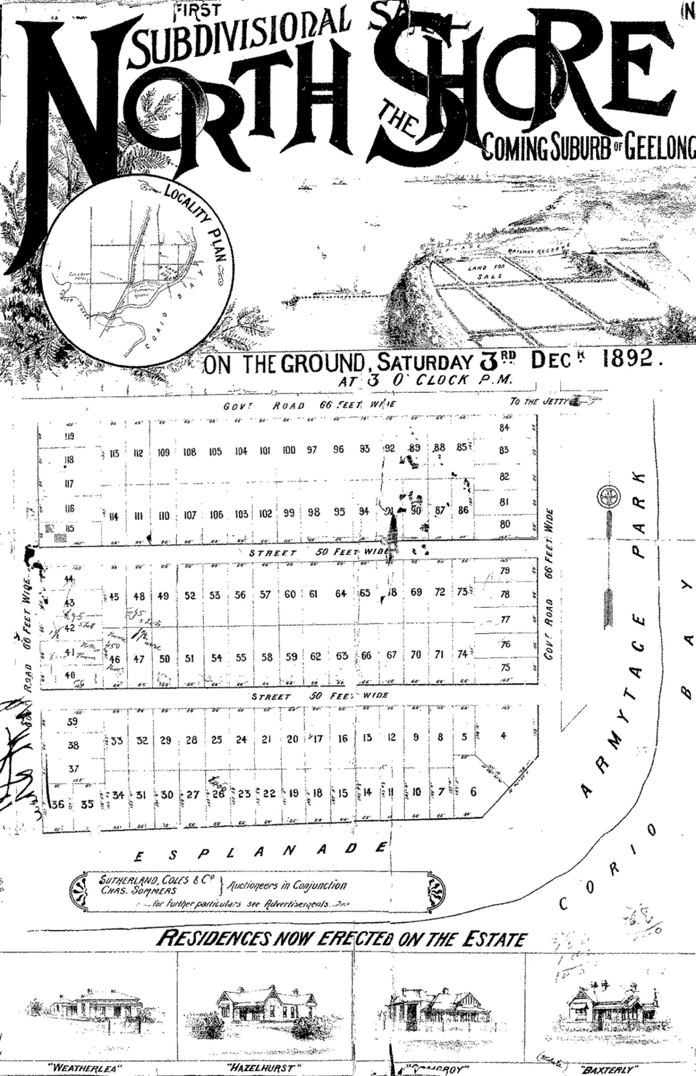

Figure 6.179: North Shore Subdivision Plan, 3 December 1892. Source: GRS 2030/Map N17/01, Geelong Heritage Centre collection.

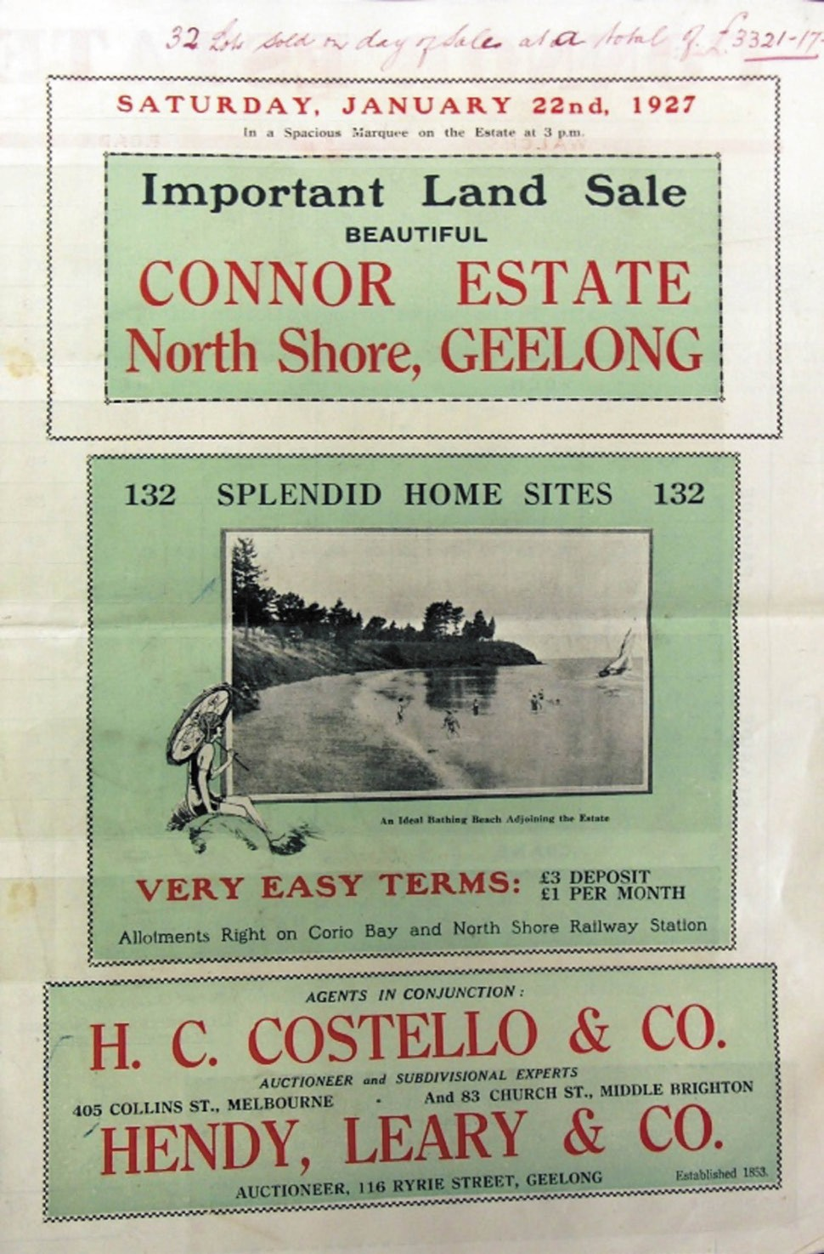

Figure 6.180: Connor Estate Auction Notice, 1927. Source: Special Collections, Deakin University Library.

that an Arbor Day was fixed to be observed yesterday, with the view of giving all interested an opportunity of taking part in a general plantation of the cliff overlooking Corio Bay.789
Other improvements near the Park were a jetty and bathing enclosure. They were shown in another subdivisional sale called the North Shore (Figure 6.179)
in 1892:
Although there was some further residential progress during the Federation era (such as the construction of a timber villa in c.1910 at 31 The Esplanade –demolished in 2013),790 it was not until the 1920s when North Shore experienced its next major developments. In 1923, the Australian Phosphate Company acquired a considerable portion of the northern section of North Shore as the site for its new works. A wharf to service the phosphate works was also proposed.791 The new industrial complex reached completion in September
1926.792 It was at this time when a new school was opened as well as St. Columbia s Presbyterian Church (to a Carpenter Gothic design by Laird and Buchan at 22 Seabeach Parade).793 The new school and church were built to cater for the growing population brought on by the new industry.794
The opening of the phosphate works was impetus for another subdivisional sale at North Shore. In 1927, the Connor Estate offered 132 splendid home sites , the advertisement highlighting the ideal bathing beach adjoining the estate. 795 (Figure 6.180). Several houses were built
in North Shore during the 1920s. Some were associated with the neighbouring industries, such as the substantial Californian Bungalow at 57 The Esplanade built in 1927 for the Phosphate Company of Australia796 (Figure 6.181)
Another notable Californian Bungalow was also built in 1927 at 25 The Esplanade for P. Maloney using timber imported from California, U.S.A., by the Oriental Timber Company (that was kept at their adjacent lagoon)797 (Figure 6.182).
Several more modest Bungalows also reflected the majority of the population at North Shore –the workers of the nearby industries. They include: 6 Myrtle Grove (built in 1939 for S.E. Thompson); 27 Myrtle Grove (built in 1927-28 for Haywood and Sons); 29 Myrtle Grove (built in 1927-28 for H. Gowlay);
3 Phosphate Road (built in 1926-28 for James Allen); 9 Pine Avenue (built in 1928 for W.B. Quayle); 1 Seabeach Parade (built in 1936 with shop for J.C. Hinksman); 33 Seabreeze Parade (built in 1929 for F.L. Nicholls); and 27 The Esplanade (built in 1928 for M.L. Brookenshire).798 Other houses followed in subsequent decades of the 20th century, mainly for workers of the neighbouring industries. By the early

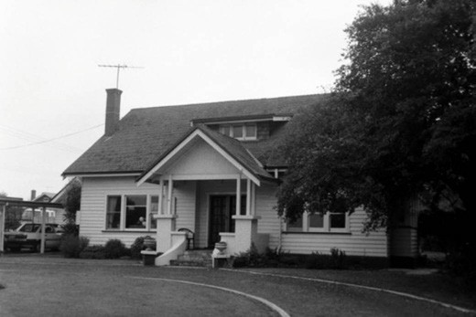
Figure 6.181: Bungalow, 25 The Esplanade, 2012. Source: David Rowe.
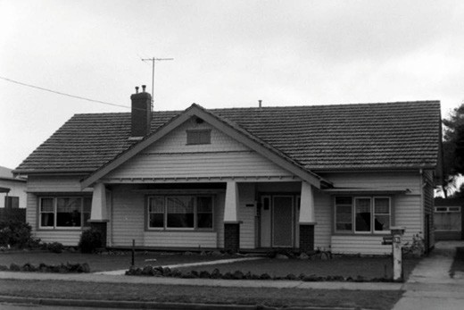
Figure 6.182: Bungalow, 57 The Esplanade, 2012. Source: David Rowe.
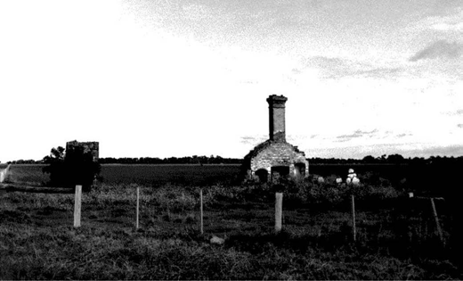
Figure 6.183: Rothwell Inn Ruins, 685 Old Melbourne Rd, 1998. Source: David Rowe.

21st century, the transformation of the residential portion of the area had begun with earlier dwellings replaced with more substantial houses.

LITTLE RIVER – ROTHWELL AND ARGYLE
In 1839, the Traveller s Rest Hotel was established near the crossing of the Little River.799 This constituted the
only building in the settlement of Little River along the route between Melbourne and Geelong. The building
was destroyed by fire in 1852 and replaced with a new building by William Perrin in 1853.800 It was from this time that the hotel was known as the Rothwell Inn. All that survives today are ruins at 685 Old Melbourne Road801 (Figure 6.183).
In February 1852 the township of Rothwell was proclaimed and town lots and large blocks –which had been laid out in a grid –were sold802 (Figure 6.184). The impending Geelong to Melbourne railway enhanced the prospects for steady development given the announcement that the railway line would follow the line of the road and a station would be established at Rothwell. 803 However, due to engineering considerations, the railway was built approximately half a mile further north, with the station building on the northern side of the river. Settlement gradually moved to the north and the proposed Rothwell township never eventuated.804 In 1861 with all the railway construction activities in the vicinity of Rothwell, the area boasted a population of two males
and two females and one inhabited dwelling.805 Physical evidence of the lost Rothwell township is the ruins of Perrin s Rothwell Inn (which was situated on lot 11 of Section 2 in the township), stone cottage ruins at 70 Wilson Road (being the early dwelling of Philip Rees, farmer, from the early 1860s),806 and the cemetery at the corner of Hughes and Calvert Roads (see Theme 8 for further details).
Just months after the proclamation of the Township of Rothwell, a consortium advertised the sale of allotments
of the Township of Ascot in December 1852 (Figure 6.185), to the immediate north-east of Rothwell. As the Rothwell township was one mile from the main line of road from Geelong to Melbourne , the new town of Ascot was claimed to be situate upon the direct road to Melbourne and cannot fail to be more convenient, more useful –and consequently more valuable than the Township at present reserved in

this locality. 807 Allotments for agricultural purposes were made available with a frontage to the Little River, as well as providing a delightful view of the surrounding country. 808
Like Rothwell, the promise of a thriving Ascot township never eventuated. However, one of the earliest to build in the
newly-created township in the 1850s was John Rees, a farmer from Bristol, who had a stone cottage erected near the Little River.809 He also built a ford on the river. By 1864, Rees had sold the stone cottage and 45 acres, and he had built a new seven-roomed timber dwelling further south on his land.810
He named the property Lower Knowle after his birth place in Bristol).811 He was elected an MLA for the electorate of Grant in 1877. The timber dwelling, Lower Knowle (albeit altered and extended in c.1895)812 survives (Figure 6.186) but there are only ruins of Rees original stone cottage and the ford (Figure 6.187).

STAUGHTON VALE
The name of Staughton Vale derived from the European squatter, Simon Staughton, who established his Brisbane Range Station in this locality in 1842 (see Themes 2 & 4).813

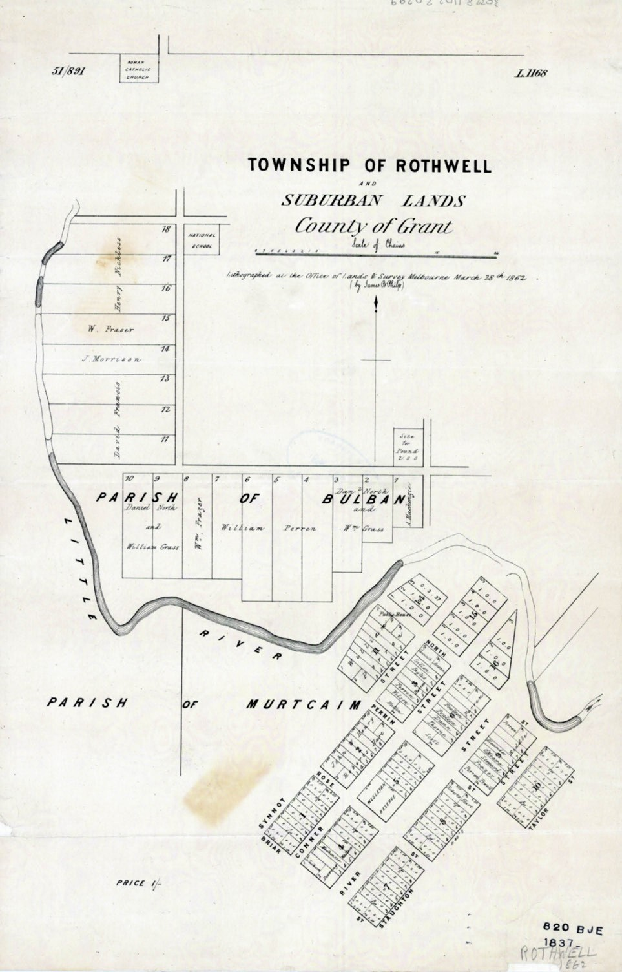
Figure 6.184: Plan of the Township of Rothwell & Suburban Lands, 28 March 1862. Source: State Library of Victoria.

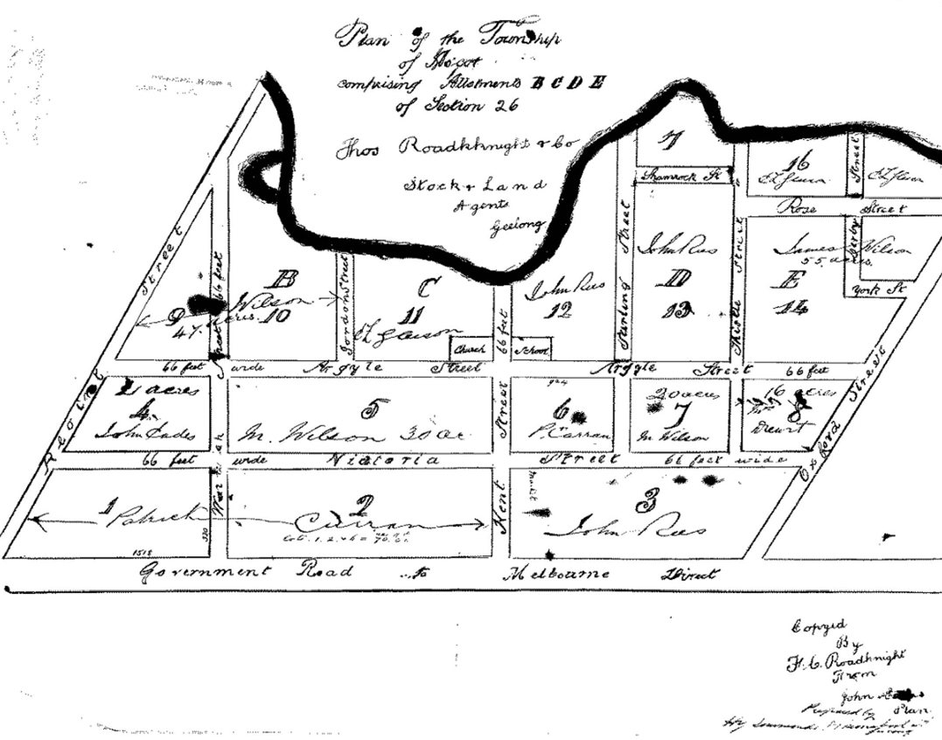
Figure 6.185: F.C. Roadknight, Plan of the Township of Ascot, 1852. Source: GRS 2030/Map A26/1, Geelong Heritage Centre collection.

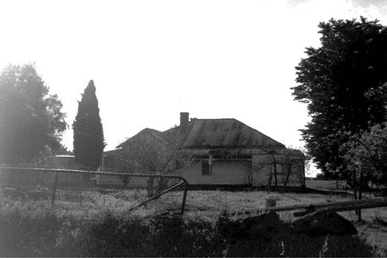
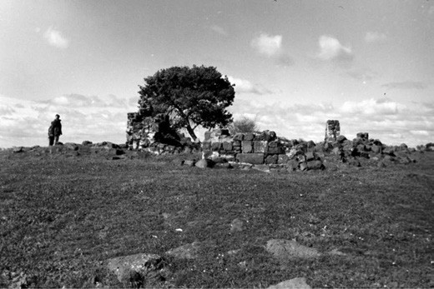

Figure 6.186: Lower Knowle , 125 Argyle St, 1998. Source: David Rowe.
Figure 6.187: Ruins of Ree s stone cottage, 145 Argyle St, 1999. Source: Ian Clark.

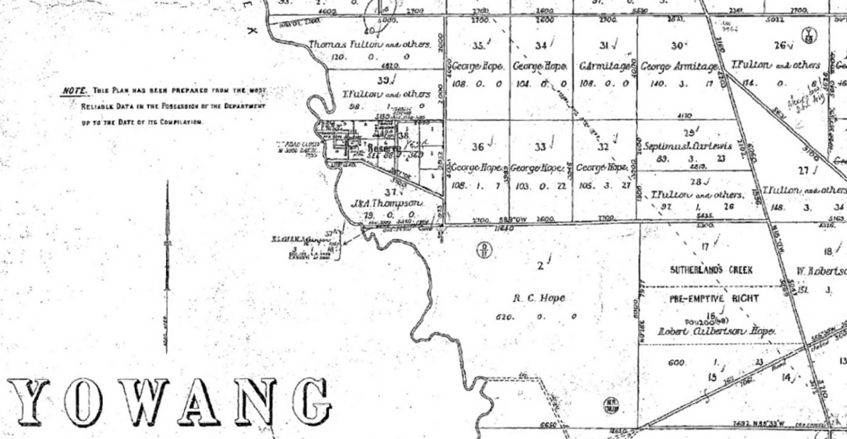
Figure 6.188: Portion of Put-Away Plan of the Parish of Yowang in the locality of Sutherlands Creek, 1978. Source: Put-away plans, Yowang, Y69(2)/1, Landata, State of Victoria.

SUTHERLANDS CREEK
In 1842-43, Joseph and Robert Sutherland were the first European squatters to occupy land adjacent to the creek north of Batesford which fed off the Moorabool River.814 It was from these brothers where the Sutherlands Creek named derived. The Sutherlands Creek Pre-emptive Right was taken up by Dr Robert Culbertson Hope with his brothers, Robert and James.815 The Hope brothers, and particularly Dr Hope, were some of the first viticulturists in the Western District (see Theme 4).816 Hope s bluestone homestead (built in 1856), along with a wine-making house, are extant and known today as Darriwill (see Theme 4).817
In 1854, much of the earlier sheep run was subdivided and made available for purchase at a Government land sale.818 Original freehold owners included Dr Hope s brother, George, as well as James Holden, J. Gray and W. Nimmo, George Armitage, Thomas Fulton and Archibald Colquhoun.819 A large allotment beside Sutherlands Creek (comprising Section 38) was reserved by the Crown (Figure 6.188). This land
was adjacent to the crossing over the creek where a bridge was built in 1858 to service the influx of gold diggers enroute to the Steiglitz goldfields.820 Within the reserve, smaller reservations were made for the Presbyterian Church (which opened as a Denominational School in 1857), cemetery in 1862821 and the State School in 1873822 (the Denominational School being relocated to the nearby new site.823 A Catholic

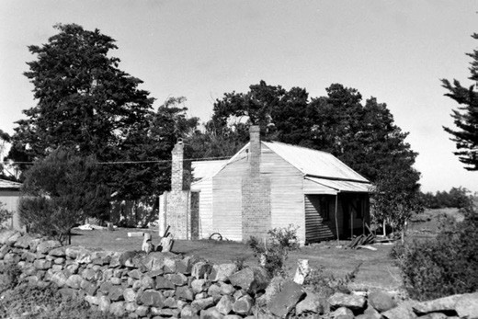
Figure 6.189: Glen Moidart , 555 Robbs Rd, 1998. Source: David Rowe.

Church was also constructed of Maude quartzite further along Robbs Road in 1858 (it was removed and rebuilt as the chapel at the Waurn Ponds campus of Deakin University in 1986).824
Today, a physical legacy of this small agricultural settlement is manifested in the stone cottage at 380 Robbs Road built in c.1861 for James Holden, mid-19th century cottage ruins at 335 Sutherlands Creek Road and in the timber cottage, Glen Moidart , 555 Robbs Road (Figure 6.189). This latter dwelling may have been built in c.1869 (or relocated) for Alexander McDonald. He took up a grazing lease under Section 47 of

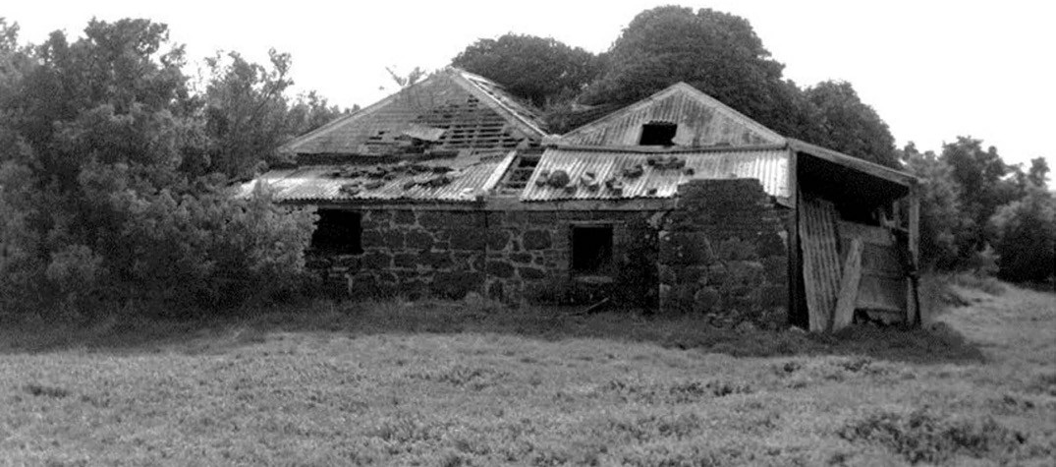
Figure 6.190: Bluestone cottage ruins, 421 Lower Duneed Road, 1998. Source: David Rowe.

the Land Act.825 The license was cancelled in 1886 and the freehold was acquired in 1889 by Alex McDonald s relative, Donald McDonald, and he named the property Reserve after the Government reserve upon which it was located.826
The most distinctive tangible evidence of mid-19th century European occupation at Sutherlands Creek is the surviving drystone walls at Glen Moidart and 380 Robbs Road, and elsewhere, and the Sutherlands Creek cemetery (which also has some surviving graves).

SOUTHERN REGION CONNEWARRE
A rural locality, the Parish for the area also took this name.
The first Europeans to colonise the area in the southern and western shores of Lake Connewarre behind Barwon Heads to Marshall by 1840 were Alexander Thomson (near what was to be named Thomsons Creek), Elias Harding south
of Lake Connewarre, with E.H. Bowden at Buckley s Well , Breamlea.827 They first established sheep runs and were soon followed by John Day on the southern shores of Lake Connewarre.828 Pre-emptive rights were taken up on parts of the area by Harding and others (Figure 2.14, see Theme 2).
Much of the land comprising Connewarre was made available for purchase at a Government sale from 1854.829 Farms were
established by early European pioneers, including James Noble, who in 1855 built Charlemont to a design by the local architect, Andrew McWilliams.830 The property took its name from the Earl of Charlemont that was wrecked off the Bluff (Mount Colite) at Barwon Heads in 1853. Noble contributed much to community life, being the foundation President of the Connewarre Roads Board.831 Although the Claremont property no longer surives, the bluestone cottage ruins and horse works at 421 Lower Duneed Road (Figure 6.190) are a physical legacy of early European colonisation and farm life at Connewarre. Built in c.1855 with a double hipped roof, the floor boards were apparently from the deck of the Bancoora sailing ship that was wrecked off Bancoora Beach, to the south of the property.832 The property was first owned by James Mitchell who was also employed by the Connewarre Roads Board in the 1860s.833 On the southern boundary are the unmarked graves to two of Mitchell s children. A new timber house was built further south-west fronting Lower Duneed Road in later years. Another early farm dwelling was built in the c.1850s for John Bogan at 125 Groves Road.834
Other farm properties were established in the latter years of the 19th century. They included John Polley s timber
dwelling and outbuilding at 462 Lake Road in the c.1870s, and Christopher Underwood s timber house, Oaklands , at 570 Bluestone School Road, also constructed about this time.835
In 1888-89, John Cameron, Scottish immigrant and pioneer

of Connewarre, built a new timber dwelling at 405 Bluestone School Road.836 In 1891-92, William Middleton appears to have built a dwelling in Belchers Lane (now 127 Staceys Road) known as South Bank .837
Other farms and houses were built in the early 20th century after the subdivision of mid 19th century farms, including Underwood s Oaklands Estate subdivision in 1907. One house built during this era was the timber Edwardian dwelling in 1904-05 for Andrew Miller, farmer, at 1392 Barwon Heads Road.838 It is now ruinous.
With the small but increasing rural population at Connewarre, churches and schools were established. The earliest was
St. Dunstan s Church of England church and school in Dans Road in 1858 (now in the Surf Coast Shire).839 The stone building was to become Connewarre Common School and
a timber dwelling was built for the teacher840 (Figure 6.191). Renamed the Connewarre State School from 1873, it closed in 1878 and was replaced with a new bluestone school nearby.841 The school was later demolished and replaced with a timber building on the same site. A lasting legacy of the former school is the name of the road, Bluestone School Road. At Connewarre East, the Presbyterians established
a school in 1864.842 It became a State School in 1874 but closed the following year.843 In 1885, a new timber school was erected at the south-west corner of Barwon Heads Road and Lings Lane.844 When a new school was built in 1925, the timber school of 1885 was relocated to 57 Seaview Avenue, Barwon Heads, where it remains a a dwelling today.845
In 1915, the Presbyterians built a new timber church at
the north-east corner of Barwon Heads and Lake Roads. It was converted into the Geelong Aero Clubrooms in c.1978.846
Nearby Lake Connewarre also played host to fishing and hunting following European colonisation in the 1850s. It was also the location for other recrestional and sporting events, including the first regatta in March 1864, when a four mile course was created, the advantages for a yacht race at this location being that the position of the boats for nearly the whole time was plainly visible to the spectator. 847 From 1922, community events and other recreational activities were held at the newly built Connewarre District Memorial Hall, designed by the local architects, Laird and Buchan.848 Situated on Lot 2 of Section 20, the building was later relocated to 1280 Barwon Heads Road and used as an art studio.
By 2013, the rural character of the western part of Connewarre was to change dramatically when one of the largest residential development in Greater Geelong was first established (along with parts of Mount Duneed). The name of this part of Connewarre was also changed to Armstrong Creek.849

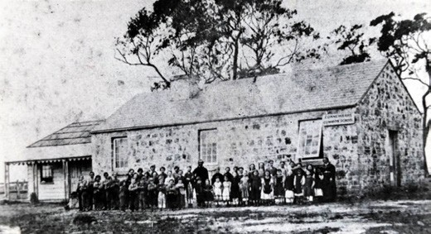
Figure 6.191: Connewarre Common School & Teacher s Dwelling, n.d., [pre 1873]. Source: Russell Matthews, Highton.

GROVEDALE
At the time of European colonisation in the 1830s, much of the land to the south of the Waurn Ponds Creek had been taken up by Dr Alexander Thompson.850 In 1842, Assistant Surveyor H.W.H. Smythe surveyed a part of the Parish of Duneed, immediately south of the Waurn Chain of Ponds851 (Figure 6.192). Some of the earliest Crown purchasers were Alexander Pannell (1847) and C.J. Dennys, Bryan Downey and Thomas Powell (1849).852
A physical legacy of this very early period is the former farm house of Alexander Pannell at 231 Grove Road, now known as Cobbin Farm. Born in Ireland in c.1815, he emigrated
to Port Phillip with his wife, Margaret, in November 1841.853 Initially, the Pannells built a slab hut, barn and stabling at their farm where they established a vineyard and orchard.854 It appears that the existing brick portion of the dwelling at Cobbin Farm was built in 1854.855 By 1856, the farm property was well established and Alexander Pannell offered it for sale. It was described has having well and tastefully laid out gardens well-stocked with almost every variety of very superior fruit trees, vines, shrubs, various descriptions of flowers, and many other valuable plants.’856 The property also included milking sheds, stock yard, enclosed stables, substantial barn, dwelling house (Figure 6.193), gardener s hut, men s hut, shed, duck house, piggeries, extensive dairy and every convenience for slaughtering. 857 The sale of
the Pannell farm was in preparation of Alexander Pannell s departure for New Zealand. He appears to have married Eliza Phillipa Jennings in Geelong in 1850-51, where their son, Robert, was born in 1850.858 In New Zealand, Pannell established an orchard.859 No sale ensued of the property at Waurn Ponds and ownership seems to have been transferred to Alexander’s first wife, Margaret Pannell. She remained there until 1879 when she offered the property –then known as Garden Hill –for sale.860 It was acquired by the German orchardists, August and Albert Hartwick. Today, the farm

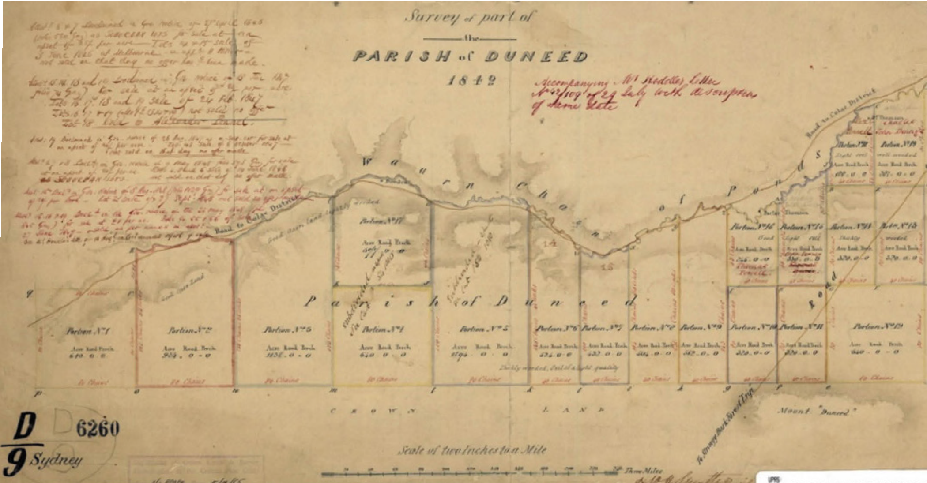
Figure 6.192: H.W.H. Smythe, Portion of Survey of Part of the Parish of Duneed, 1842. Source: VPRS 8168/P5, item Sydney DUNEED D9, Public Record Office Victoria.

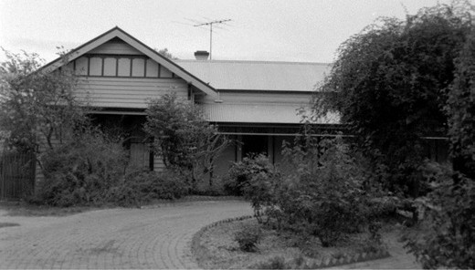
Figure 6.193: Cobbin Farm, 231 Grove Road, 1998. Source: David Rowe.

house remains. Neighbouring it is the former St. Cuthbert s Church, relocated from Marshall.
Equally important in the development of Grovedale from the mid-19th century were German vigneron immigrants who relocated to Australia because of religious and political persecution.861 In 1849, the successful Melbourne
businessman, William Westgarth, led the establishment of the German Immigration Committee.862 Dr Alexander Thomson and a Mr Hope led a local branch of the Committee.863 Journeys were organised with the shipping firm of J.C. Godeffroy and Son, of Hamburg, Germany, and emigration agent, Eduard Delius, of Bremen.864 On 19 December 1849,
the Emmy arrived at Port Phillip with German immigrants destined for the agricultural area south of the Waurn Ponds Creek that soon became known as Germantown. As outlined in The Argus:
The Government Immigration Board visited the Emmy yesterday, for the purpose of inspecting the vine-dressers, consisting of ten families, numbering thirty-seven individuals, who had been imported by Dr. Thomsom [sic.], of Geelong, under the regulations promulgated
by the colonial government about two years ago. The immigrants will be landed to-day and lodged in the Immigration Barracks, but they will not be open for engagement until Monday morning. The Committee have engaged the services of a Secretary, who speaks both German and English, for the purpose of facilitating the engagement of the immigrants, most of whom are unable to speak any language but German.865
On 31 December, 1849, the Melbourne Daily News reported that Dr. Thomson intends to make an effort to establish
a German village in the neighbourhood of the town [of Geelong] 866 (Figure 6.194). This subsequently eventuated, and the layout of roads and the name Germantown featured in a plan of the area in 1863.867 Also influential was Charles John Dennys, early European landowner in the area, who offered employment to the newly-arrived immigrants and later sold them land

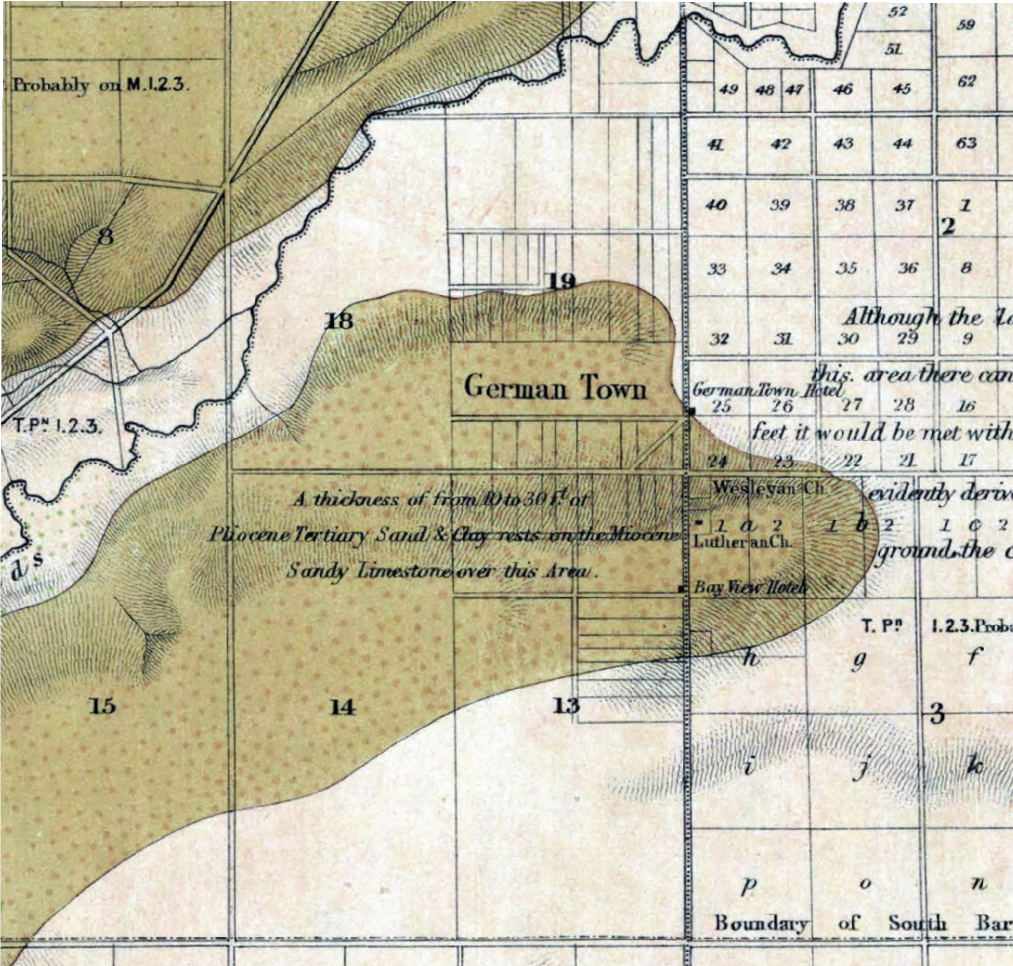

Figure 6.194: R. Daintree, Plan of Duneed, Barrarbool, Conewarre & Puebla Parishes: Geological Survey of Victoria no. 29, 1863, showing location of German Town & the Wesleyan Church, Lutheran Church & Bay View Hotel. Source: VPRS 8168/P5, item MD28A, Public Record Office Victoria.

(see Theme 2).868
In 1854, a mud brick Lutheran Denominational School was established and it served until 1868 when a two roomed brick building was constructed869 (Figure 6.195). This school
eventually became the Grovedale State (later Primary) School in another location.870 The importance of the Lutheran faith also manifested in the construction of a bluestone church (Holy Trinity) on the Torquay Road in 1859.871 A second
church was built on the opposite side of Torquay Road in 1871.872 The Wesleyans also established a bluestone chapel further down the hill on the Torquay Road in 1869.873 Two hotels were erected in Germantown in the 1850s: the Bay View Hotel on the west side of the Torquay Road (opened
in 1855 and became the Lutheran Manse in 1872) and the German Town Hotel on the east side of Torquay Road.874 It was established in 1859 and was destroyed by fire in

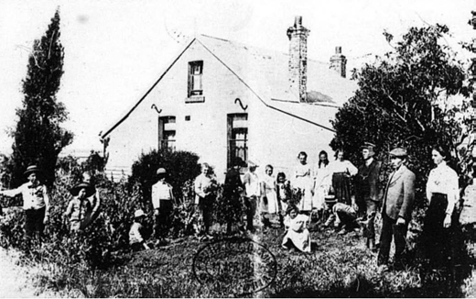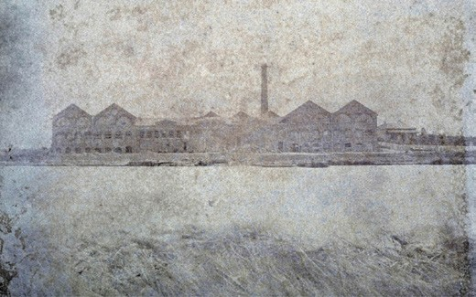

Figure 6.195: German School , Germantown, 1912. Source: News of the Week, 11 April 1912, GRS 2121, Geelong Heritage Centre collection.

1913. The replacement building forms the core of the larger Grovedale Hotel today.875
Following the onset of World War One, the South Barwon Shire Council, along with some locals, sought to change the Germanic name of the area given that Australia and the Empire was at war with Germany. At its meeting on
2 July 1915, the South Barwon Shire Council deliberated on alternative names for the area including Cornwall,
Marlborough, Grovedale and Dennys.876 A petition was presented by Cr Winter that had been signed by 52 ratepayers seeking the name Dennys in honour of one of the first European settlers in Germantown. Approximately 90 percent of the local residents attended the meeting where there
was practically a unanimous desire that either Cornwall or Marlborough should be selected, the first one for
preference. 877 President Blyth s personal preference was for the area to be named Grovedale, the name of the Grovedale estate of former Councillor J.E. Matthews.878 Although
the name Cornwall was unanimously carried, the area ended up being called Grovedale, after the Matthews family farm property which neighboured the former Pannell farm property.879
The 20th century also brought about the massive urbanisation of Grovedale from a rural agricultural area to a largely southern suburb of Geelong. Houses were erected during the interwar era but especially following the postwar period from the 1950s. Many warehouses and other commercial building, along with substantial residential estates, were established
in the late 20th century. This development continued into the early 21st century.
Today, there are few places which are a tangible legacy of the early beginnings of Grovedale, and particularly its Germanic background (see Themes 2 & 4 for further details).
Figure 6.196: J. Norton, Brearleys Australian Tannery on the Barwon River, c.1870. Source: GRS 2009/02212, Geelong Heritage Centre collection.

The Grovedale Public Cemetery, Church Street, was the location of the original mud brick Lutheran Church built in 1854.880 (see Theme 8) The former Wesleyan Church survives at 272 Torquay Road as does St. Paul s Lutheran Church at 301 Torquay Road (see Theme 8).881

MARSHALL – CHARLEMONT
Once known by Europeans as Breakwater and Connewarre, and Marshalltown, this locality was an important industrial area from the mid-19th century given its close proximity to the Barwon River. It was here that the Brearley Brothers established their Australian Tannery by 1855 (see Theme 5) (Figure 6.196). It became the largest tannery in the southern hemisphere and had a work force of 50.882 The ruins survive near the southern bank of the Barwon River while the original mid-19th century manager s house –now named Greenbank , remains at 40 Jendes Lane883 (see Theme 5).
It was followed by Gardiner s and Victoria tanneries and Barwonside fellmongery884 (see Theme 5). In 1890 Marshall had a population of 225. Brearleys closed in 1925 and the Victoria in 1929, ending Marshall s association with tanning.885
From 1886 the area had been served by a railway siding which was first known as Connewarre but was renamed Marshall in 1907 - it closed in 1964886 (see Theme 3).
There had also been a branch line to serve the neighbouring Geelong Racecourse from 1878 to 1906 when the course was shifted to its present site (see Theme 8). The branch railway was then dismantled in 1909.887 The racecourse land was handed over to the Geelong Harbor Trust, formed in 1905, which developed it as Sparrovale Farm888 (see Themes 4 & 7).
In 1856, Michael Murnane opened the Breakwater Hotel at Marshall.889 At this time the location was given as
Connewarre. This hotel continued until at least 1872 and a second hotel, the Racecourse opened at Marshall in 1886 and survived into the post-World War Two.890 The site of this

hotel is now occupied by Rice Village, a Catholic retirement scheme. A denominational school was established by the Church of England in 1851 and it also served as a church from 1852 until the separate St. Cuthbert s opened in 1871.891 The school was replaced by a vicarage in 1904 (it was destroyed by fire in 1938) and a new church was built in 1911; the old church was demolished eleven years later and a new Sunday School was built.892 St. Cuthbert s was sold in 1978 and in 1987 the Church building was relocated to Cobbin Farm, Grovedale; the Church land being sold to the City of South Barwon on the condition that it be transformed and retained as a play park.893 In 1988, it was named the J.F. Field Play Park in memory of James Frederick Field (c.1910-1972), a long serving and well-respected member of the former St.
Cuthbert s Church.894 The Field family home, built in 1904-05 survives opposite the park at 19 Mornane Road.895
Marshall s second school was opened as State School No. 3917 Ash s Hill in 1915.896 This might have been due to
the opening of a temporary pipe factory at Marshall for the manufacture of ovoid reinforced concrete pipes used in the major ocean outfall scheme of the Geelong Waterworks and Sewerage Trust897 (see Theme 4). An aqueduct of similar inventive construction by E.G. Stone and E.J. Siddeley was also built over the Barwon River at Marshall at this time898 (Theme 4). In 1922 the School was renamed Marshall; in 1940 it was destroyed by fire and a new building erected
in the following year899 (Figure 6.197). It closed in 1948, an indication of the declining population in the area at this time.900 In recent years, parts of Marshall have witnessed substantial suburban residential development and the
construction of a railway station off Marshalltown Road which opened in 2004.901
A physical legacy of the 19th and early 20th century development of the Marshall and Charlemont area included several dwellings. They included Sunnyside , 128 Tannery Road (originally addressed as Marshalltown Road) (Figure 6.198). By 1868, Thomas Vaughan, previously of Dowling Forest near Ballarat, was resident there with his family, it being a 12-roomed brick and stone dwelling with garden
set in 80 acres by 1897.902 At 375 Barwon Heads Road, is a Victorian styled bluestone cottage (Figure 6.199) built in
c.1866 for Francis and Catherine McAteer, farmers.903 Other dwellings were built in later years including Iolanthe, 61 Tannery Road, in 1896 for William Tozer904 (Figure 6.200) and the Late Victorian styled timber house at 28 Marshalltown Road built in c.1889-90 for J.A. Quinn.905

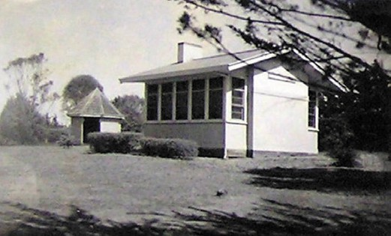
Figure 6.197: Marshall State School soon after completion, Public Works Department photograph c.1941.
Source: VPRS 10516/P3 Unit 16, Public Record Office Victoria.
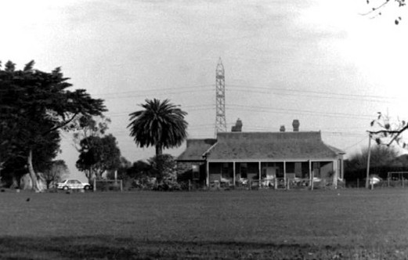
Figure 6.198: Sunnyside , 128 Tannery Rd, 1998. Source: David Rowe.

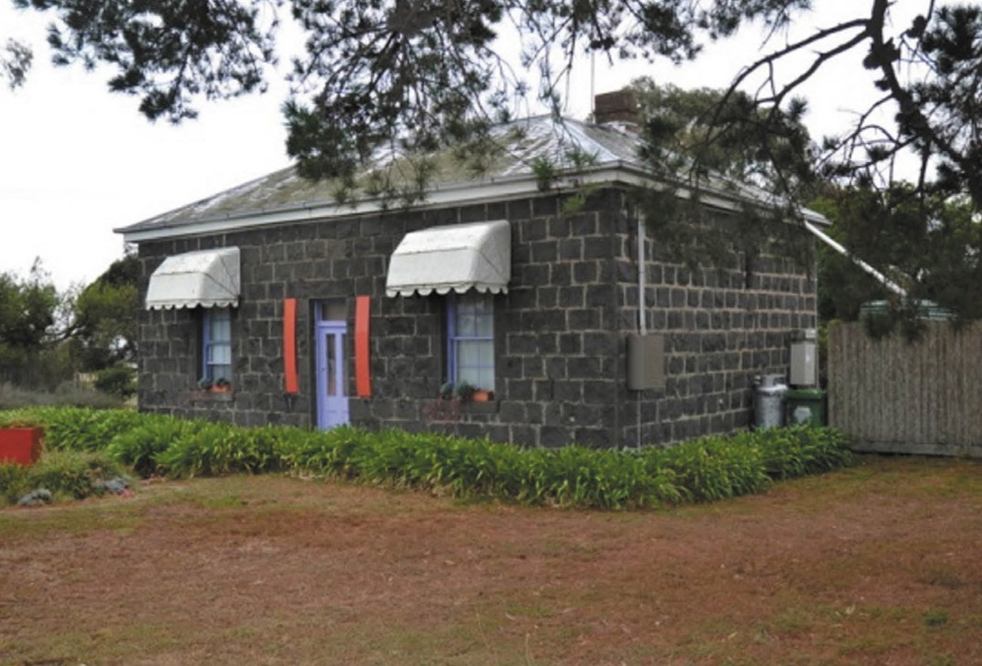
Figure 6.199: Bluestone cottage, 375 Barwon Heads Rd, 2013. Source: David Rowe.

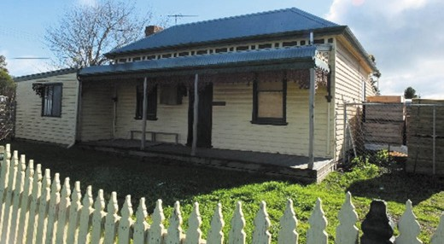

Figure 6.200: Iolanthe , 61 Tannery Rd, 2019. Source: David Rowe.
In May 2008, the City of Greater Geelong adopted the Armstrong Creek Urban Growth Plan. Amended in 2010, this Plan provided a framework for the major transformation of parts of Marshall, Connewarre and Mount Duneed
into Greater Geelong’s first and largest master planned residential community.906 Providing housing for 55,000- 65,000 people, land sales commenced in late 2010.907 On 1 March 2012, Armstrong Creek (formerly part of Mount
Duneed and Connewarre) and Charlemont (formerly part of Marshall and Connewarre) were officially adopted as names of the new suburbs, although lots were initially sold as part of the Warralily and Armstrong Village estates.908

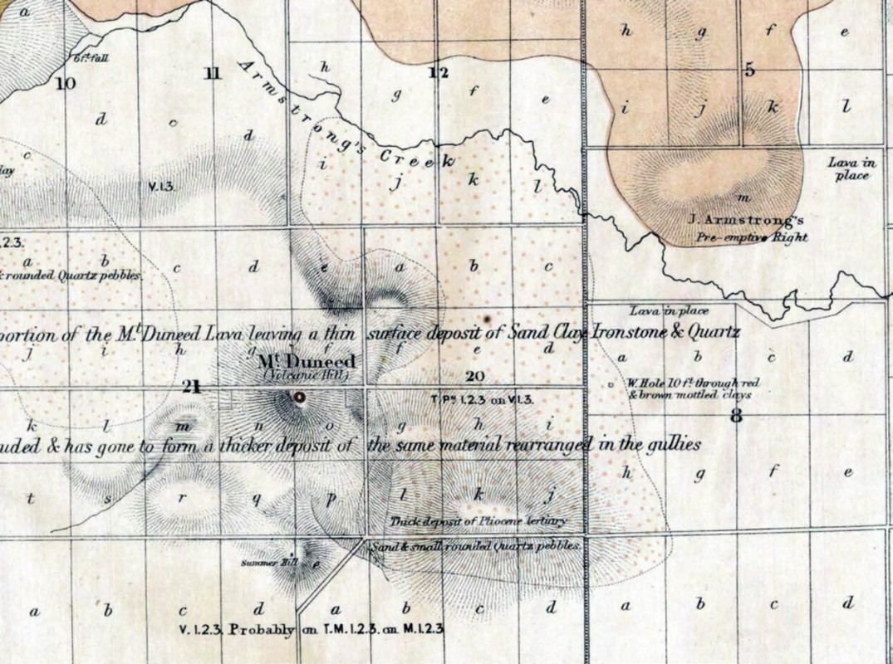
Figure 6.201: A.R.C. Selwyn, Plan of Duneed, Barrarbool, Conewarre & Puebla Parishes: Geological Survey of Victoria no. 29, 1863, showing the Mount Duneed locality, including Armstrong s Pre-emptive Right (top right) and the location of Summer Hill (bottom, centre). Source: VPRS 8168/ P5, item MD28A, Public Record Office Victoria.

MOUNT DUNEED
Punctuated by the Surf Coast Highway with part of the area within the Surf Coast Shire, the northern slopes of the eminence, Mount Duneed (also originally called Mount
Direction by Europeans),909 and along the Armstrong Creek, was the land of the Watha wurrung balug clan. Situated
in the rain shadow of Mount Duneed along the creek was the winter settlement of the clan.910 The name of the Mount, Duneed , was a Wadawurrung term and taken up
by Europeans from 1839 as the name of the Parish for the area.911 European colonisation of this area first began with Alexander Thompson s vast sheep run that extended from Geelong to Barwon Heads and Torquay from the mid-late 1830s.912 In 1855, there was a Government land sale. The
first building in the Mount Duneed district was apparently the Connewarre Flour Mill, a three storey building erected by John Armstrong on his pre-emptive right on the north side of Armstrong Creek (Figure 6.201). It was later sold to John Stewart who had emigrated to Sydney under contract by the New South Wales Government as a stonemason in 1836. The Stewart family arrived in Geelong in 1851 and John Stewart acquired farmland at Mount Duneed in 1856913 where he built a brick dwelling, Dooliebeal (Figure 6.202).
He purchased the Connewarre Flour Mill in 1861 and worked it until 1892 (he died on 2 February 1894).914 Also along this road is the Dooliebeal or Stewart Reserve the location of the Watha wurrung balug clan s settlement following their forced removed from their winter estate further west (see Theme 2).

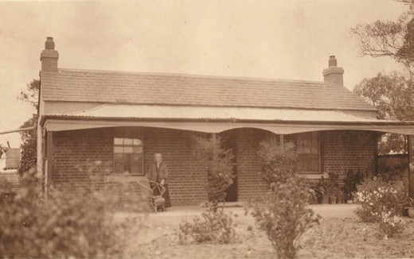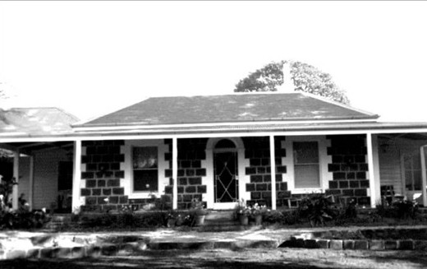

Figure 6.202: Dooliebeal , Mount Duneed, n.d., with Mrs Mary Stewart (nee Webb) (wife of John Stewart junior) standing on the front verandah. Source: John Stewart, Torquay.

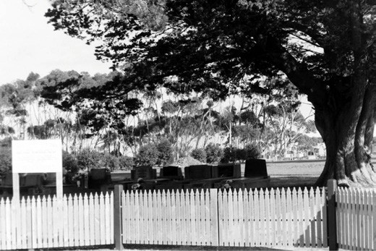
Figure 6.203: Mt Duneed Cemetery, 110 Williams Rd, 1998. Source: David Rowe.
Figure 6.204: Calder Park, 20 Mt Duneed Rd, 1998. Source: David Rowe.

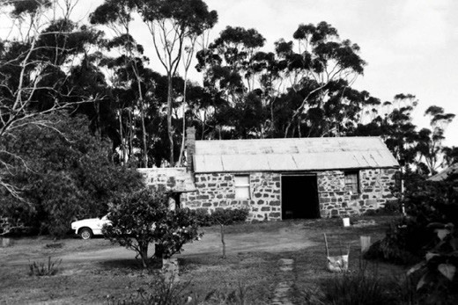
Figure 6.205: Stone stable/outbuilding, 30 Williams Rd, 1998. Source: David Rowe.

The presence of workers cottages at the mill (see Theme 5) possibly induced George Dodd to open the Yarborough Inn in 1858 at the corner of Stewarts and Torquay Roads. The passing trade was not sufficient to keep it going and it closed in 1864.915
More successful was the Church of England school set up in a private house in 1862.916 Its success led to the
establishment of a permanent stone school in 1863.917 It was known as No. 107 Bream Creek but the name was changed to Mount Duneed in 1865.918 There was also a Presbyterian school which may also have begun in 1863. The new Education Act of 1872 saw the demise of both schools and the opening of a new school in 1877.919 This was destroyed in the 1944 bushfires along with its neighbour, St. Wilfrid’s Church of England (both were replaced).920 A Methodist Church was also destroyed but was not rebuilt.921 By 1890 Mount Duneed was described as a postal hamlet, boasting
a post office and a store, with a population of 155.922 The hamlet also included a cemetery that was laid out in 1864 when trustees were appointed (see Theme 8) (Figure 6.203).923
From the mid-19th century and for much of the 20th century, agriculture at Mount Duneed continued the main occupations were farming and grazing. Legacies of these agricultural traditions are identified in the surviving farm houses and outbuildings, several of which were built of bluestone (a quarry is extant at 170 Mount Duneed Road). An early notable example is Calder Park, 20 Mount Duneed Road (Figure 6.204), built of bluestone in c.1858 for William Owen, gentleman.924 Further east at 50 Whites Road is Oak Trade (Figure 4.68, see Theme 4), a gabled bluestone Victorian vernacular farm dwelling built in c.1857 for European pioneers, Joseph and Elizabeth Rainford, who had a vineyard there925 (see Theme 4). At 10-40 Williams Road, Alexander

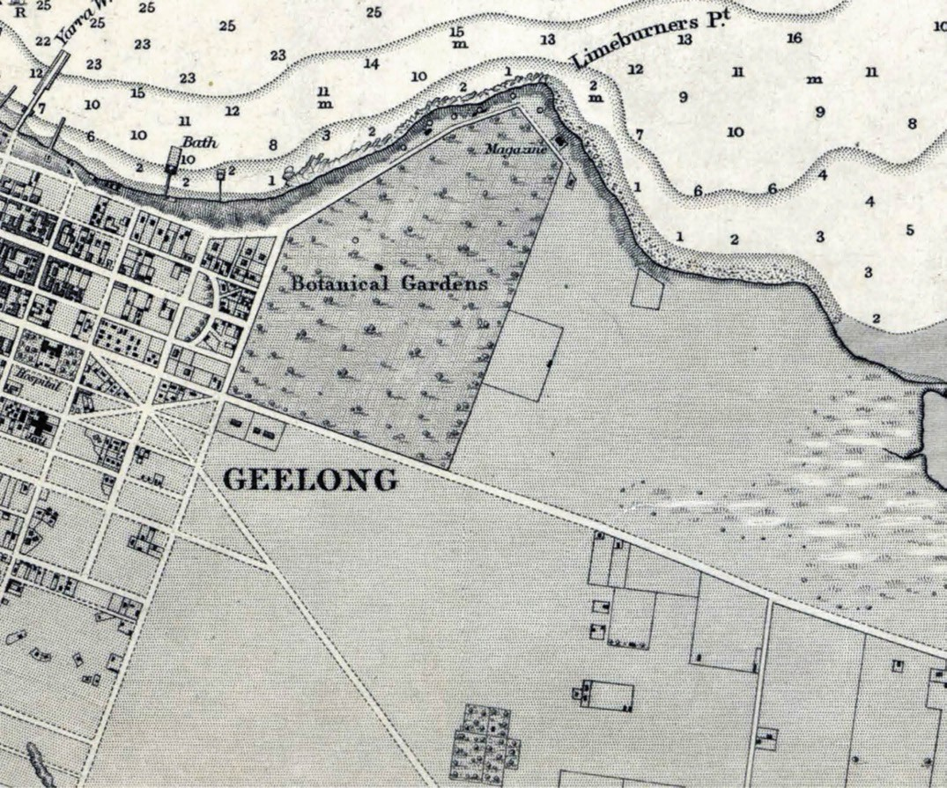
Figure 6.206: H.L. Cox, Portion of Survey of Geelong Harbour showing the East Geelong are (centre & right), 1864 (published at the Admiralty, London, 26 March 1865). Source: VPRS 8168/P5, item MCS 76, Public Record Office Victoria.

Fyfe, the Scottish entrepreneur who in earlier years in the 1850s imported timber houses, timber, other products and workers from Singapore to Geelong,926 had his Victorian eclectic styled bluestone Hillside Homestead erected before 1858.927 The dwelling was substantially altered in c.1900 but the stone stable and outbuilding appears to be largely intact (Figure 6.205).
From 2010-11, much of the agricultural land of Mount Duneed was dramatically transformed as part of the Armstrong Creek residential estate (see Marshall subsection for further details). From 2012, part of Mount Duneed was renamed Armstrong Creek although lots were initially sold as part of the Warralily and Armstrong Village estates.928 Public art installations
were subsequently created for the area. Initially based on
knowledge from Aunty Marlene Gilson, Wadawurrung Elder, the narrative for the work was the portrayal of significant untold stories of the past, present and future.929 In 2016, their latest installation, Murrup dja , was unveiled. It was named by Wadawurrung Elder, Uncle Bryon Powell, with murrup meaning spirit and dja meaning land/earth, which together form the spirit of the land.930

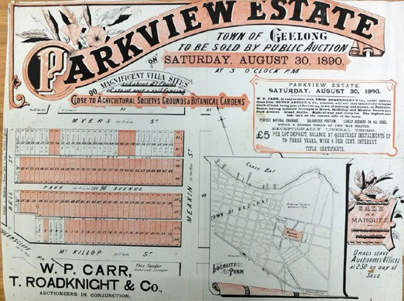

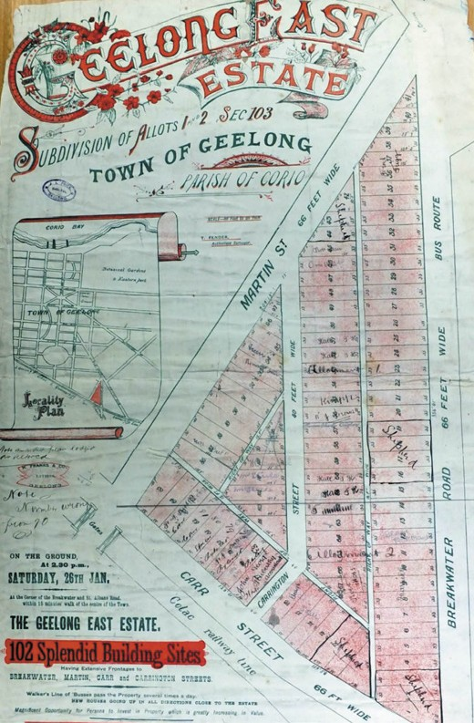
Figure 6.207: Plan of the Geelong East Estate, 18 July 1891. Source: Special Collections, Deakin University Library.

EASTERN REGION EAST GEELONG
The expansive region to the east of the Geelong Town
Reserve remained a rural area for several years following the establishment of the township in 1838. Apart from the laying out of the Geelong Eastern Cemetery, the one notable development was the establishment of the five acre showgrounds of the Geelong and Western District
Agricultural and Horticultural Society in 1856.931 Situated at the south-east corner of Garden and Ryrie Streets (opposite the Geelong Botanic Gardens), the land was fenced and buildings erected.932 By 1864, there were only large, sporadic, farm properties to the east of the Geelong Eastern Cemetery933 (Figure 6.206). This continued in the following years, the area being described in 1887
as follows:
Figure 6.208: Plan of the Parkview Estate, 30 August 1890. Source: Special Collections, Deakin University Library.

Geelong East lies two and a half miles south of Geelong, on the main road between that place and Queenscliff.
The district is an agricultural one, with three bone mills, and three tanneries. The country is flat and rocky, and produces excellent stone for road-making purposes.934
Large tracts of the rural land of East Geelong were unlocked for residential development from 1886. The Carrington Estate, surveyed in a grid layout by Thomas Fender, was first offered to the east of St. Alban s Road, with 30 allotments created that also had frontages on the south side of Darling Street and north side of Loch Terrace (now Loch Street).935 It was soon followed in 1887 by the Frankfort Estate that took in allotments on the south side of Loch Street and north side of Clare Street (now Anderson Street).936 This subdivision was extended as the Kilgour Street Estate when 22 villa sites were offered in 1889.937 Allotments fronting the Queenscliff Road (now Ormond Road) had already been sold by this time.
A more extensive subdivision was the Geelong East Estate in 1889.938 This area was bound by Martin Street, Carr Street and Breakwater Road, with Carrington Street created as part of the area where 102 splendid building sites were offered. A second subdivision of this estate took place in 1891, comprising 31 allotments on the west side of Martin Street and south side of Victoria Street (now McDonald Street)939 (Figure 6.207). The north side of Victoria Street, including 21 allotments on the south side of Verner Street and eight lots on the west side of Martin Street had earlier been offered in 1890. These estates had also been laid out by the surveyor, Thomas Fender, who in 1890 also designed the Parkview Estate (housing allotments in Myers, McKillop and Meakin Streets) (Figure 6.208) and the Eurella Estate (which took
in Richmond, Grey and Verner Streets, a portion of Garden Street and a portion of St. Albans Road).940

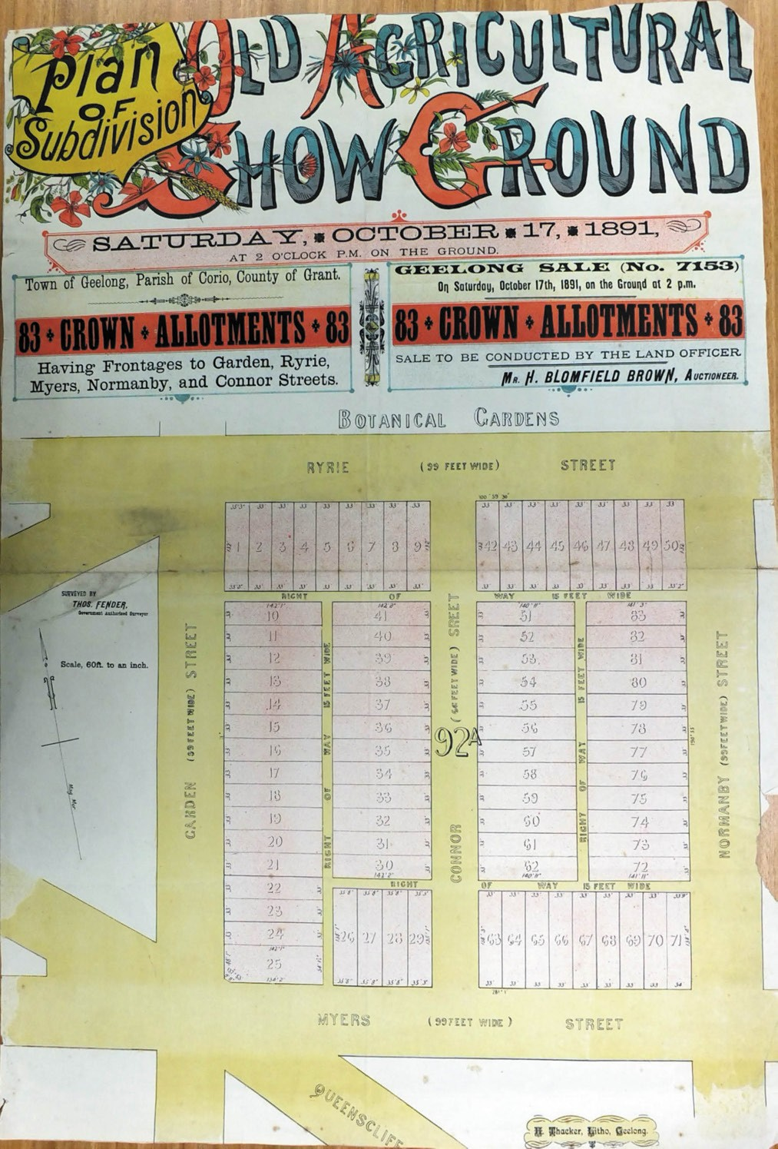

Figure 6.209: Plan of Subdivision of Old Agricultural Show Ground, 17 October 1891. Source: Special Collections, Deakin University Library.

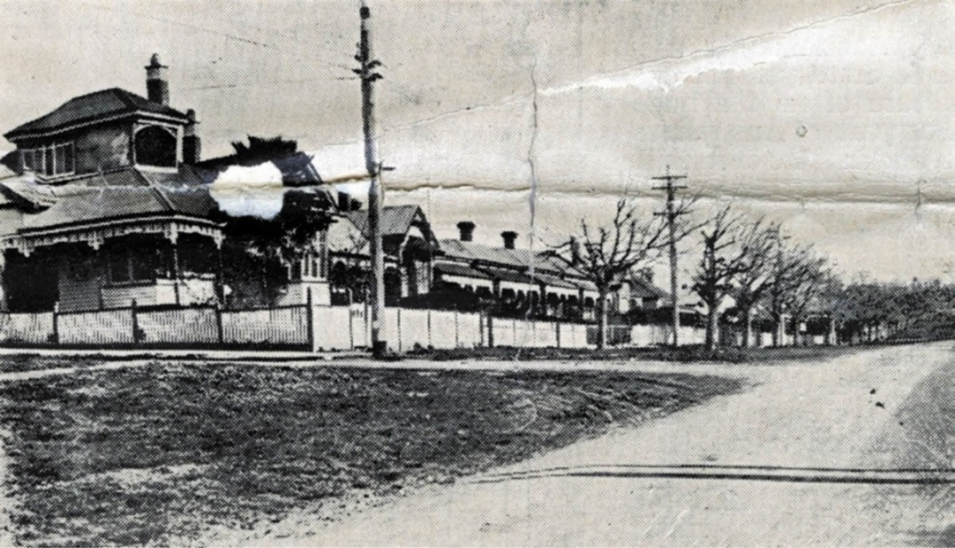
Figure 6.210: Ryrie Street (south side) from Meakin St corner showing two Edwardian dwellings & a series of Late Victorian hipped roofed dwellings, c.1925-26. Source: Parkview Estate, East Geelong Sale Notice, c.1925-26, GRS 2030/P54, Geelong Heritage
Centre collection.

Other major subdivisions were also laid out in the early 1890s. In 1891, they included 31 lots comprising the Ryrie Street Estate (which had frontages to Ryrie, Orchard, Myers and Frederick Streets), the Old Agricultural Show Ground Estate (comprising 83 lots with frontages to Ryrie, Garden, Myers, Connor and Normanby Streets) (Figure 6.209) and the Ellimatta Estate (taking in 31 villa sites with frontages to Tully Street, Richmond Place, Kilgour Street and St. Albans Road).941
The existing street layouts and names of these subdivisions of the 1880s and early 1890s are a tangible legacy of the boom era. Auction notices declared opportunities for unlimited credit and heralded the rise of newly-built timber villas as ‘first class residences.’942 The world-wide financial crash from 1890943 resulted in fewer houses being erected in these East Geelong estates than had been anticipated.
Most were modest in scale, single storey, with hipped roofs and timber weatherboard construction. They included a row of dwellings at the east end of Ryrie Street (west of Meakin Street) (Figure 6.210) in the Parkview Estate and the dwelling at 3 Connor Street (Figure 6.211), which was situated in the Old Showgrounds Estate.944
The housing estates of the 1880s and 1890s, whilst slow to develop, brought on cultural opportunities. In 1890,

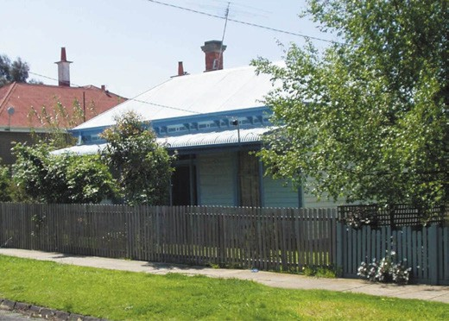
Figure 6.211: Dwelling, 3 Connor St, 2003. Source: David Rowe.

St. Matthew s Anglican Chapel of Ease was opened at the corner of McKillop and Normanby Streets (see Theme 8).945 Other church reservations were made at the eastern extremity of East Geelong (the boundary being Boundary Road) with two acre sites being set aside for the Wesleyans in 1889 (north-west corner of Boundary and Queenscliff Roads),
Church of England in 1899 (fronting Boundary Road, south of Queenscliff Road and the Catholics in 1908 (east of the

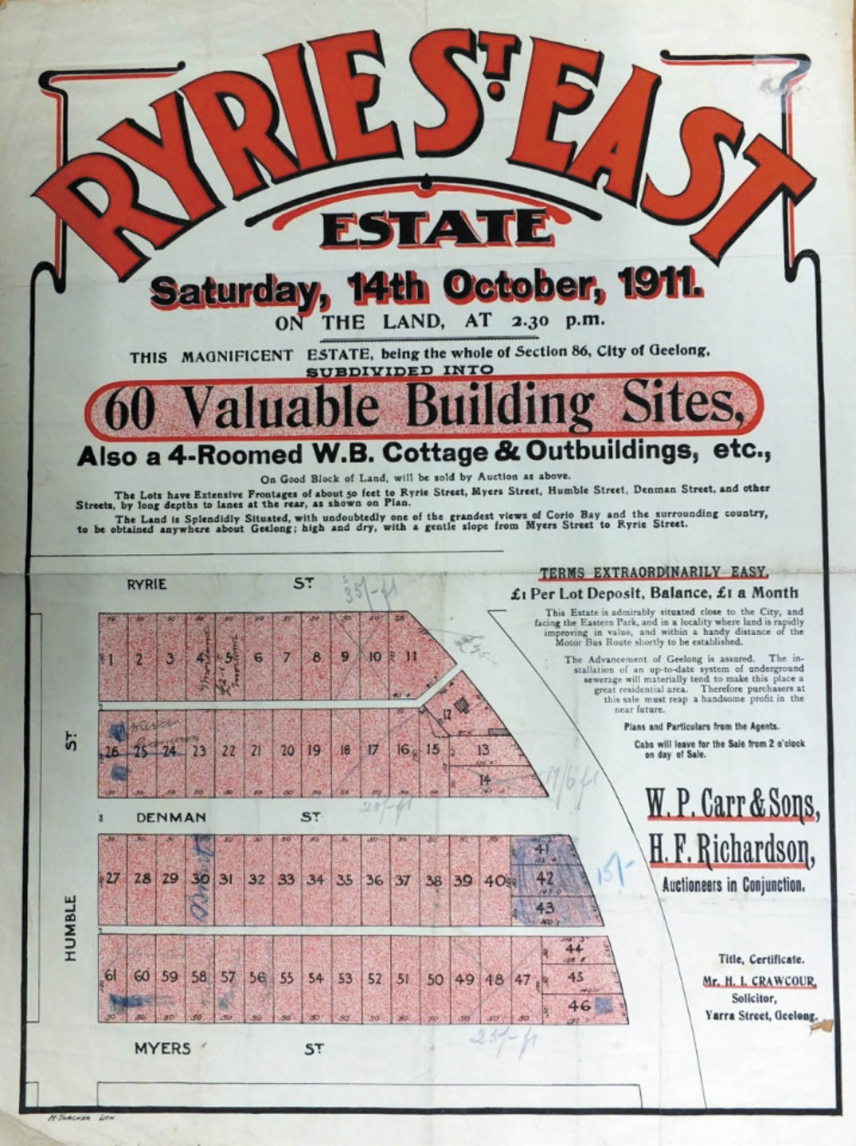
Figure 6.212: Plan of the Ryrie Street Estate, 14 October 1911. Source: Special Collections, Deakin University Library.

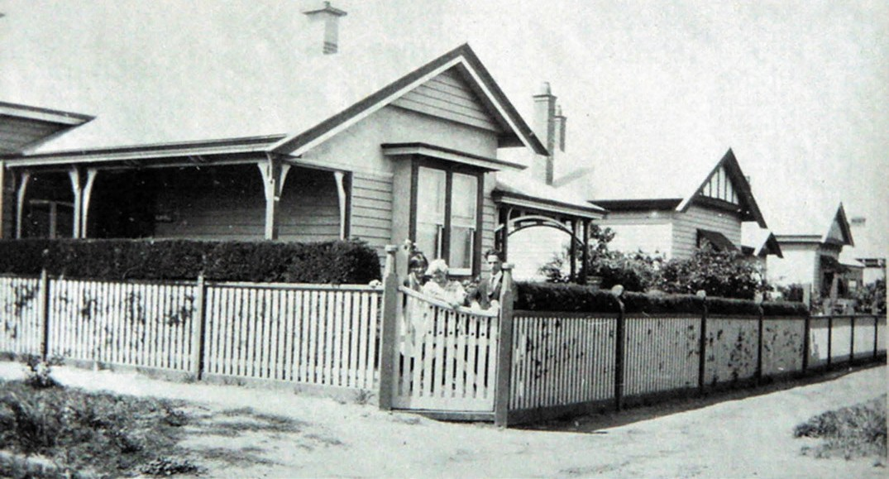

Figure 6.213: Yowong , 277 Myers St & neighbouring similarly-designed Edwardian houses, c.1930. Source: Holmes collection, Authentic Heritage Services Pty Ltd.

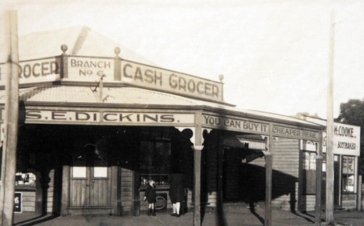
Wesleyan reservation fronting Queenscliff Road).946 Only the Wesleyans were to build a church many years later in 1958 (an Army Hut had served the purpose from 1955).947
Further commercial advancements were made in East Geelong in the late 19th century. In 1895, E. Watson opened a butcher shop at the corner of Garden Street and Ormond Road,948 while in 1896 a timber shop had been completed at the corner of Ormond Road and McKillop Street.949 Other stores soon followed.
More substantial housing progress was made during the Federation period prior to World War Two in 1914. Federation and Edwardian dwellings, mostly single storey and of

timber construction, were built in several of the Estates first advertised in the 1880s and 1890s.950 Other estates were also opened up including the Ryrie Street East estate in 1911951 (Figure 6.212). It included 60 valuable building sites fronting Ryrie, Humble, Myers, Denman and Walter Streets. Houses in these areas noticeably transformed the once rural East Geelong district into a thriving residential
suburb. Several homogenous streetscapes of timber houses with neat front gardens and picket fencing soon replaced the earlier agricultural character, such as Yowong , 277 Myers Street (Figure 6.213) and neighbouring houses in the Old Agricultural Show Ground Estate.
Figure 6.214: Dickins Grocery Store, north-east corner Garden & Myers Sts, c.1925. Source: Holmes collection, Authentic Heritage Services Pty Ltd.

Further cultural and commercial buildings were established to cater for the increased population. In McKillop Street in 1907, a public hall and library was opened (see Theme 8).952 It was in this same year that a tennis court was established on the same site by the East Geelong tennis club.953 At
the north-west corner of Garden and Myers Streets, Walter Herd, bootmaker, had a grocer s shop built in 1907-08
(it later became Dickins, grocery store)954 (Figure 6.214).
A Congregational Church held its first services in the public hall in 1910 before opening its own church building in Garden

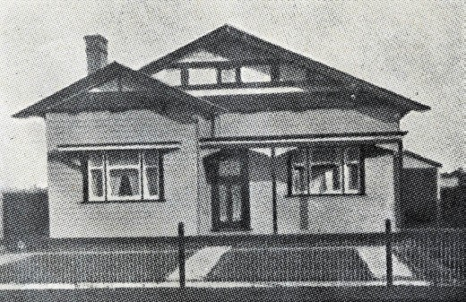

Figure 6.215: Newly-completed Bungalow in the Parkview Estate, East Geelong, c.1925-26. Source: Parkview Estate, East Geelong Sale Notice, c.1925-26, GRS 2030/P54, Geelong Heritage Centre collection.

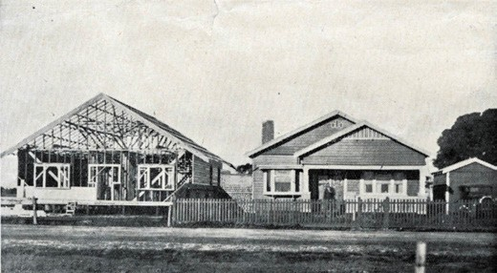

Figure 6.216: Bungalow under construction neighbouring a newly- completed dwelling in the Parkview Estate (possibly Gurr Street), East Geelong, c.1925-26. Source: Parkview Estate, East Geelong Sale Notice, c.1925-26, GRS 2030/P54, Geelong Heritage Centre collection.

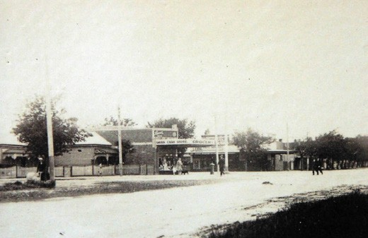
Figure 6.217: Myers Street looking north-east to corner of Garden Streets, showing Gray s Grocery Store (centre), c.1930. Source: Holmes collection, Authentic Heritage Services Pty Ltd.

Street in 1914.955 Another major development for the East Geelong area a year later in 1915 was the opening of the Geelong High School in Ryrie Street in the south- west corner of Eastern Park956 (see Theme 8).
House construction stalled in East Geelong as a consequence of the ravages of World War One. Following the war years there was rapid progress in building development in existing housing estates and in new estates including the Connor Estate in 1925 (a triangular portion of land fronting Ormond Road, McKillop Street and Meakin Street) and
the Garden Street Estate in 1927 (an area of 85 allotments fronting Carr, Garden, John, Campbell, Helen and Martin Streets).957 Numerous modestly-scaled, Bungalows were built, being mainly gabled in form and of timber construction, including those in Gurr and Meakin Streets in the Parkview Estate (Figures 6.215-216).
Shops were also built at strategic intersections (such as Gray s Grocery store at the north-west corner of Garden and Myers Streets) (Figure 6.217) and in Garden Street and Ormond Road.
The growing population at the eastern end of East Geelong also led to the reservation of 4 acres of land for a State School in 1924.958
A landmark building erected in East Geelong during the interwar period was St. Matthew s Anglican Church in McKillop Street. It was built of brick in 1928 to a design by the well-known Melbourne architect, Louis Williams
(see Theme 8).959
Further building progress occurred in East Geelong in postwar years of the 1940s and 1950s. This was confined to new dwellings in existing estates, and to the development of major Housing Commission Estates. The earliest was to be located between the Queenscliff Highway, Boundary Road, Carr Street and St. Albans Road. A dynamic Garden City- inspired plan (Figure 6.218) was prepared by Buchan Laird and Buchan architects between 1944 and 1946, with curved streets and crescents, streetscape garden features and ample recreation spaces. It also provided for a shopping centre fronting the Queenscliff Highway.960 The Estate was named Thomson after the European pioneer to Geelong,
Dr Alexander Thomson 961
Over 400 hipped and gabled timber and brick dwellings of over 30 different design types were prepared for
construction962 (Figures 6.21-220). Two storey flats of sawn limestone block construction were also erected within the Estate, as were a row of shops to service the residents (Figures 6.221-222). The substantial size of the Estate required additional infrastructure to meet the cultural and recreational needs of the local community. A church was relocated to 15 Fagg Street in 1949 and from 1950 it served

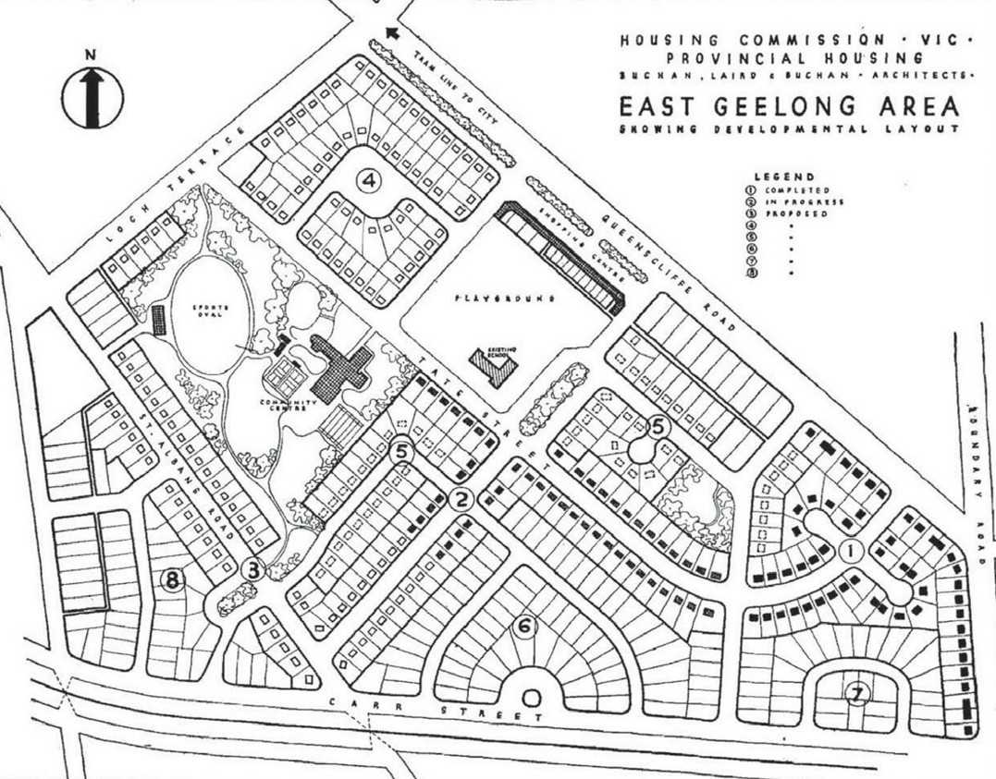
Figure 6.218: Buchan Laird & Buchan Architects, Plan of Housing Commission Estate, East Geelong Area,1944-46. Source: Seventh and Eighth Reports of the Housing Commission of Victoria 1944-47, Parliament of Victoria collection. Reproduced by permission of the Speaker of the Legislative Assembly, Victoria, Australia.
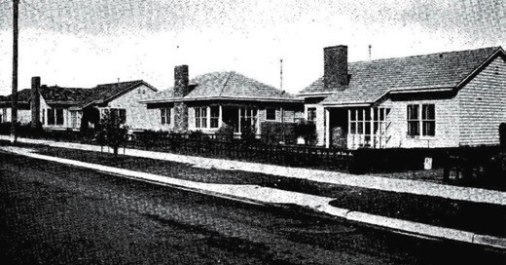
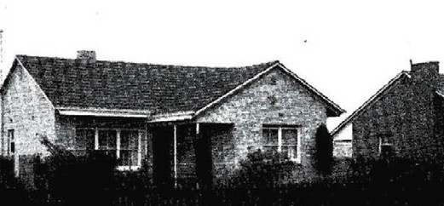

Figure 6.219: Street (possibly Barnfather St) of timber dwellings, Thomson, 1955-56. Source: Seventeenth Report of the Housing Commission of Victoria, op.cit., no. 26, 1955-56, Parliament of Victoria collection. Reproduced by permission of the Speaker of the Legislative Assembly, Victoria, Australia.
Figure 6.220: Cream brick dwelling, Thomson, 1955-56.
Source: Sixteenth Report of the Housing Commission of Victoria, no. 20, 1955-56, Parliament of Victoria collection. Reproduced by permission of the Speaker of the Legislative Assembly,
Victoria, Australia.

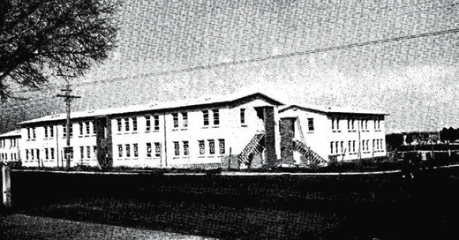

Figure 6.221: Two storey flats of sawn limestone block construction, Thomson, 1955-56. Source: Seventeenth Report of the Housing Commission of Victoria, no. 26, 1955-56, Parliament of Victoria collection. Reproduced by permission of the Speaker of the Legislative Assembly, Victoria, Australia.

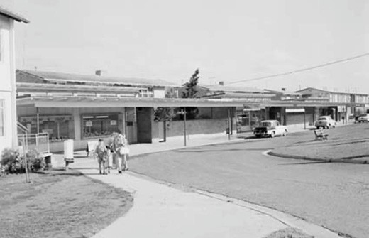
Figure 6.222: Shopping centre fronting Queenscliff Highway, 1960.
Source: NAA: A1200, L36057, National Archives of Australia.

as St. Phillip s Anglican Church.963 In 1954, a reservation was created for a recreation ground, infant welfare centre, and pre-school centre, while in 1956 land was set aside at the
north-east corner of Lomond Terrace and Godfrey Street for a police station.964
Other infrastructure buildings were erected, including
St. Margaret s Catholic School in St. Albans Road in 1949.965 Equally expansive was house construction of the Housing Commission south of Carr Street (between Boundary and St. Albans Roads) in the 1960s. Another major development
was the construction of St. Margaret s Catholic Church at the corner of St. Albans Road and Lomond Terrace in 1963.966
It was also from 1963 when the Housing Commission commenced the construction of several standardised, brick veneer dwellings of a new Estate to the south of Thomson.967 The area was south of the Geelong and Queenscliff railway line, and bound between Boundary Road and St. Albans Road.

BREAKWATER
A small industrial settlement at Breakwater, south-east of the Geelong Town Reserve, was established on the banks of the Barwon River in the 1840s following the construction of a breakwater (see Theme 3). The earliest industry was the
Barwon Steam Tallow Establishment of Willis and Lloyd at the breakwater in 1844.968 It was soon followed by C.J. Denny s boiling down establishment below the breakwater in 1847.969 Other similar establishments followed after several allotments were created from a survey plan by L. Clarke in 1849,970 including the Sunnyside Wool Scour by Edmund Haworth
in 1866- 67 which was an important source of employment (Figure 6.223). The existing factory complex on the southern bank of the Barwon River is a tangible legacy of this early development (see Theme 5).
By 1854, Breakwater was also the location of quarry sites for kerbing and road metal.971 State School No. 49 had opened (it operated until 1863) as the Breakwater School although
it was located a few miles away at Marshall.972 A further subdivision in the 1860s provided land for the increasing population. By 1861, the population was 136 and it had doubled to 312 by 1871.973 From 1854 with the establishment of Alfred Douglass Barwonside Wool Scouring Works,974 Breakwater included a Chinese population.975 From as early as 1848, scarcity of labourers had forced European settlers and businessmen in Geelong to seek Indian, Chinese and Malay workers from the British Colonial outpost, Singapore976 (see Theme 2). The goldrush from 1851 at Buninyong also witnessed ‘great numbers’ leaving Geelong for the goldfields, which further depleted the local workforce.977 A Chinese garden was soon established at the western end of Tanner Street although there is no evidence of it today.978
A number of houses, both substantial and modest, were erected for owners and workers of the adjacent industries. In c.1856, Isaac Reeves, wool scour operator, built the first stage of his brick dwelling at 108 Tanner Street.979 Richard Bayldon and George Fisher, Geelong soap and candle makers, had seven, two-roomed timber cottages erected in Tucker Street in the 1860s or 1870s. An example survives at 53 Tucker Street.980 At 116 Tanner Street overlooking the Barwon
River in 1869, Frank Haworth junior had built a distinctive Victorian Picturesque Gothic stuccoed brick villa called Rosendale House 981 (Figure 6.224). It was described in the Geelong Advertiser:

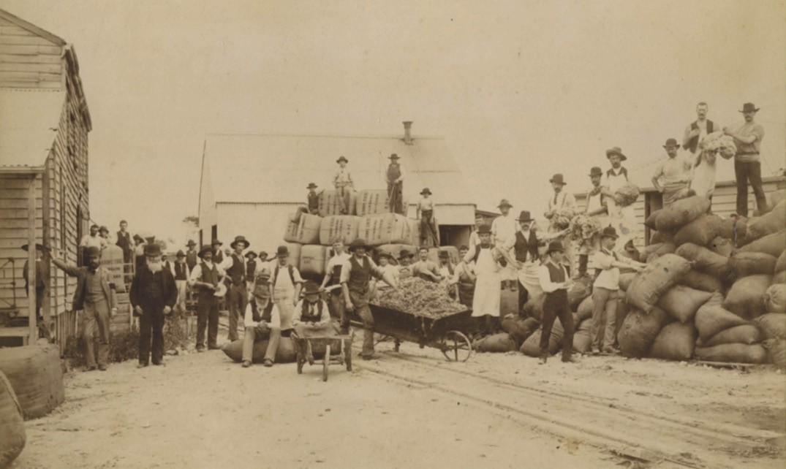
Figure 6.223: Workers at Sunnyside Wool Scour, c.1890. Source: GRS 2009/01598, Geelong Heritage Centre collection.

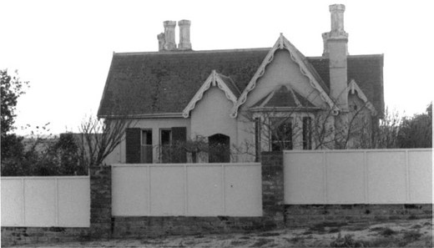
Some Church denominations also reserved land at Breakwater in the early years. The earliest was the Church of England which had two lots set apart immediately above the breakwater (on the east side of the river) in 1854.983 The Anglicans appear not have established a church there, although the road to the north of the original site is known today as Church Street. Similarly, the Wesleyans reserved one acre at the south-east corner of Tanner and Currier Streets but no chapel appears to have been constructed
(a church at nearby St. Albans was erected in 1869 instead).984 At the height of its industrial progress, the Baptists took
up land in Tanner Street. Although no longer serving their

Figure 6.224: Rosendale , 116 Tanner St, 25 September 1976.
Source: J.T. Collins, accession H91.210/1640, State Library of Victoria.

A fine new private residence is being built by Mr Frank Haworth, junr., at the Breakwater. The house is of brick, with a bluestone foundation, and will have nine large rooms, beside, underground cellars and other conveniences. The cost will probably be about £900.
The style is far superior to that of the box-like buildings so often put up, and the structure will combine convenience and comfort with elegance. Mr Grundy is the architect.982
original purpose, the modest bluestone Victorian Gothic Revival styled Baptist Sabbath School (Figure 6.225) built in 1868-69 and the bluestone Victorian Italianate manse built in 1869 at 45-47 Tanner Street are tangible reminders of their witness at Breakwater.985
Few businesses were successful in Breakwater. James and Ellen Tucker opened a shop in 1859 but it was closed by 1861. Other shops were also not to endure.986
The growing population also required the presence of
a policeman and a post office. Both a police station and a post office opened in 1867.987 No physical evidence survives of these buildings today. More successful were the hotels. The first was the Tanners’ and Fellmongers’ Arms opened by

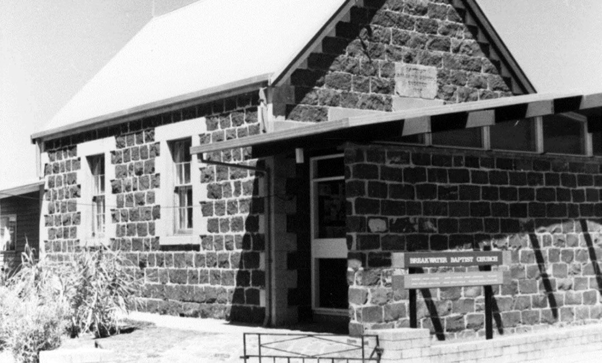
Figure 6.225: Former Baptist Sabbath School, 45-47 Tanner St, 12 February 1976. Source: J.T. Collins, accession H91.210/373, State Library of Victoria.

Robert Gidney in 1859.988 In 1865, Thomas Fowler opened a hotel which in 1868 was named the All Nations.989 Now known as the Breakwater Hotel, this business survives today at 57 Tucker Street. A third hotel to open was the Wool Pack in 1866 by Patrick Gooley.990
In 1869 four acres of land were reserved as the home ground of the Breakwater Cricket Club. It was situated on low lying ground at the eastern end of Tucker Street, east of Leather Street.991 The location proved unsatisfactory and in 1872 another four acre site was taken up at the east end of Tanner Street.992 In 1891, this site became a gravel reserve.993
A substantial development in 1891 was the reservation of 30 acres for new showgrounds for the Geelong Agricultural and Horticultural Society on the north side of the Geelong and Queenscliff Railway line, diagonally opposite the racecourse reserve (between St. Albans and Queenscliff Roads994 (Figure 6.226, see also Theme 8). Even more substantial was the reservation of 136 acres in 1906 as a racecourse and agricultural showgrounds reserve between Breakwater Road and St. Albans Road (south of the Geelong to Queenscliff
Railway line) (the Agricultural Society being forced to relocate from its site of 1891 and the Racing Club relocating from its course at Marshalltown995) (Figure 6.226, see also Figure 6.38)
Much of the eastern parts of Breakwater remained undeveloped until the 20th century, apart from, for example, a sand reserve at the north-east corner of Tanner and Leather Streets, and a gravel reserve at the south-west corner of Fellmongers and Boundary Roads (Figure 6.38). This land was acquired by the Geelong Harbor Trust in 1905.996 In the 1960s the area between Fellmongers Road and Leather Street was subdivided and this began further industrial expansion. Land was taken up by Brintons Limited Carpets (1960),
Huyck Australia Pty Ltd (1965), Textured Yarn (1965) and John Sackville and Sons Limited (1969).997 From the late 20th century, further industrial expansion was experienced in the construction of numerous factories and warehouses in this area.
Houses were also built in Breakwater during the second half of the 20th century. In particular, a 37-acre triangular portion of land between St. Albans Road, Fellmongers Road and the showgrounds and racecourse reservation was made available to the Housing Commission of Victoria in early 1967 and several brick dwellings of standardised design types were soon erected.998

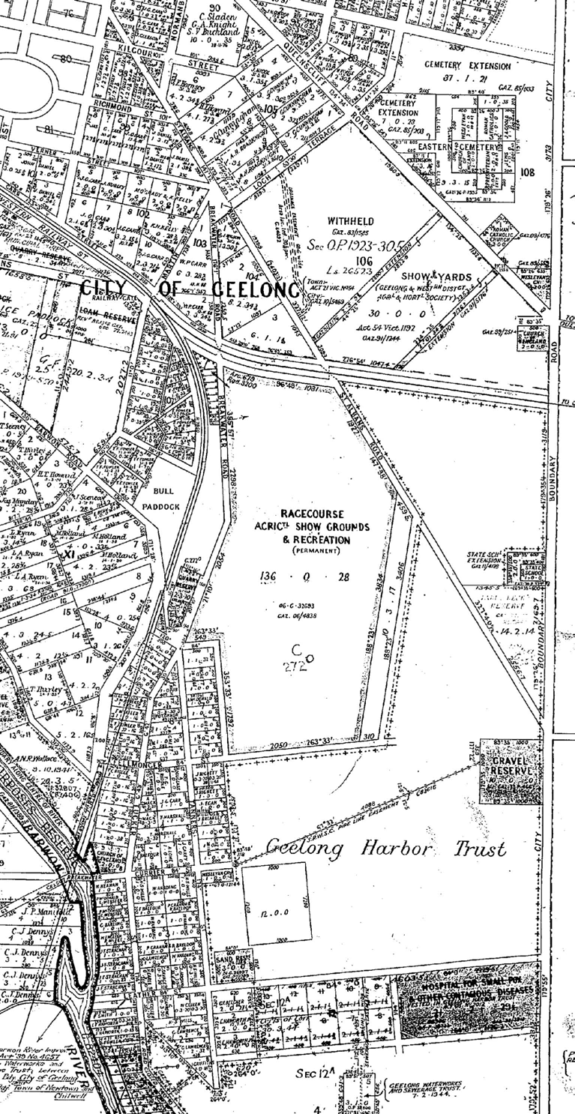
Figure 6.226: Part of Corio Parish Put Away Plan showing second showgrounds location (circled) 22 January 1919 and later third showgrounds location. Source: Plan C272(4)/1, Landata, State of Victoria.

NEWCOMB
Land at Newcomb, at the top of the hill from Boundary Road to Coppards Road, and the Portarlington Road to the Bellarine Highway was first made available in agricultural lots of 4 to 48 acres for European occupation in 1847.999 The area largely remained rural until after 1950 (Figure 6.227). Surviving early development includes the Late Victorian timber dwelling at
68 Portarlington Road, built in 1900 to a design by Geelong architects, Seeley and King as the manager s house for the neighbouring Cheetham Saltworks, Moolap.1000 Nearby at 70-72 Portarlington Road are the former A.W. Cunningham Memorial Hall (built in 1921) and A.H. Cunningham Memorial
Library (built in 1922 to a design by architect Fred Purnell).1001 Both buildings were erected in memory of Alexander W. Cunningham, Director and Financier, and his son, Andrew Hassell Cunningham, Managing Director of Cheetham Salt.1002 In 2017-18, the buildings were converted into an Early Learning Centre (Figure 6.228).
It was not until the postwar period when the agricultural area then known as West Moolap was transformed into a residential suburb. In 1951, the Ivanhoe Estate offered 160
fine home sites’ on the land bound by Boundary, Watson and Wilson Roads1003 (Figure 6.229). The subdivision included cul-de-sacs and courts. It was also in 1951 when the West Moolap Progress Association formed and it lobbied the Bellarine Shire Council for improvements to the newly-formed streets.1004 In 1954, the Association was dissatisfied with the name West Moolap and petitioned the Council to change it to either Newcomb, Glenville or Gleneast.1005 Two years were
to elapse before the Association s efforts to be renamed the after Newcomb were realised.1006 It was named in honour of Miss Caroline Newcombe (1812-1874) (Themes 2, 4 & 7), who with Miss Ann Drysdale was a pioneer female squatter
who first took up the nearby Boronggoop Run on the Barwon River in 1840.1007 Further subdivisions and many houses were constructed in the ensuing years. In the late 20th century, the shopping strip erected in Watsons Road in previous years was supplemented with a supermarket. Other supermarkets, shops and fast food outlets followed.

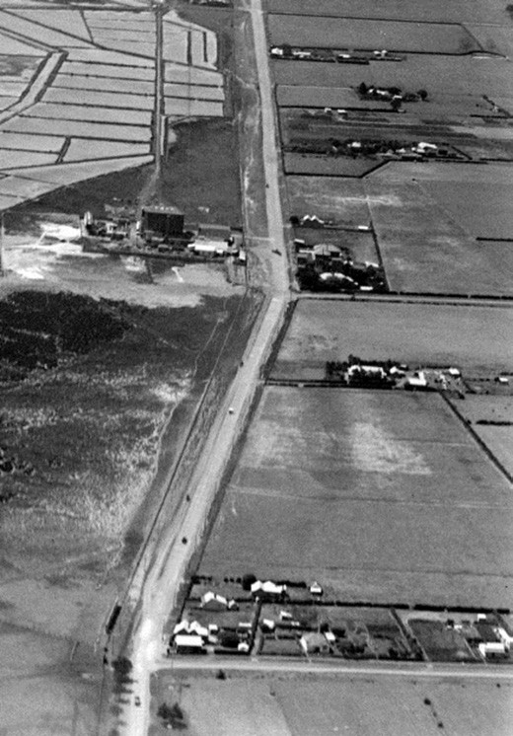
Figure 6.227: Aerial view showing northern portion of Newcomb, c.1927. The Portarlington Road is shown on the left, as is a portion of the Cheetham Saltworks. Source: C. Pratt, accession H91.160/963, State Library of Victoria.
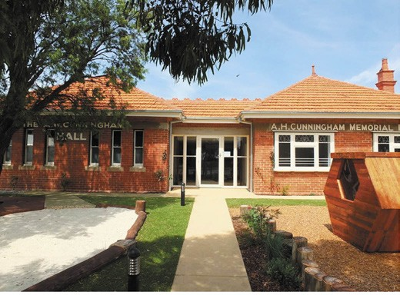

Figure 6.228: Early Learning Centre (former Cunningham Memorial Hall & Library), 70-72 Portarlington Rd, 2018.
Source: David Rowe.

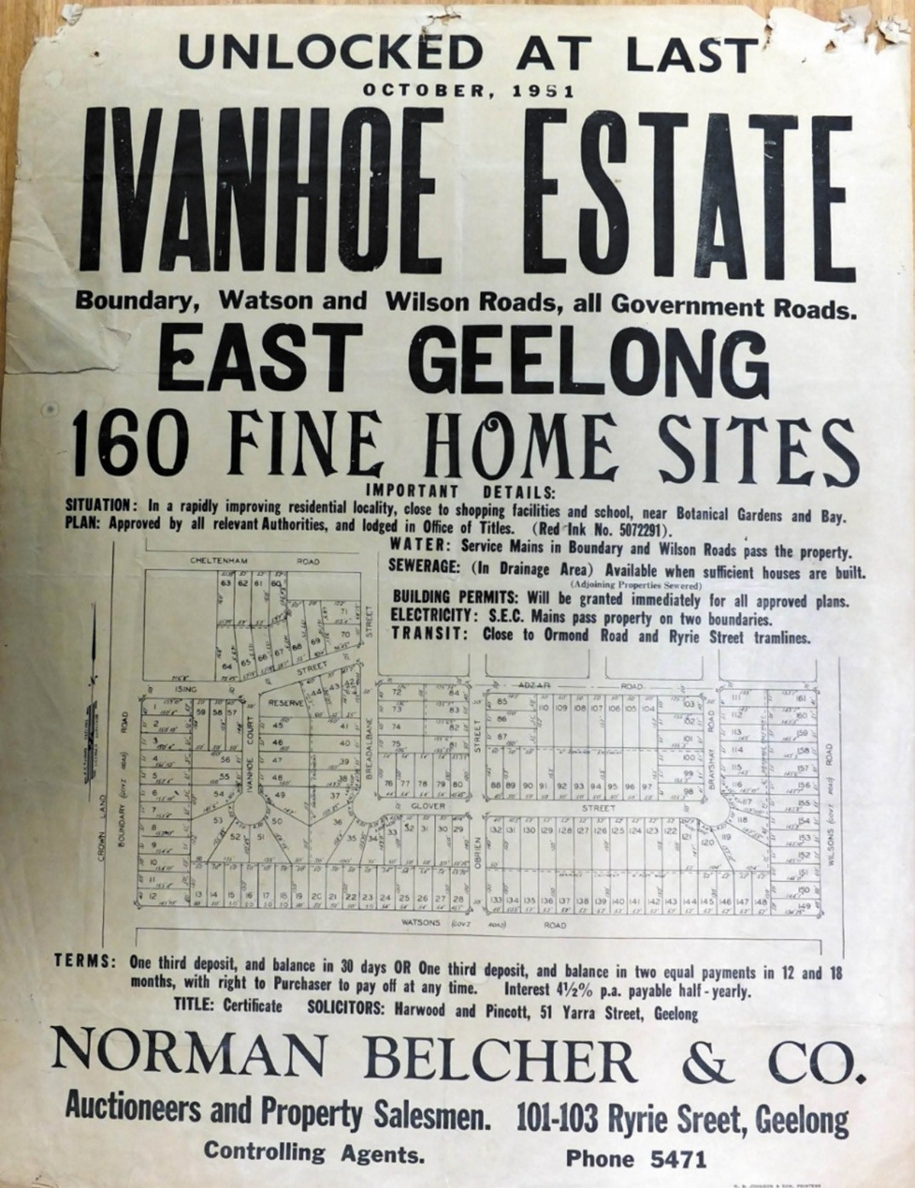
Figure 6.229: Plan of the Ivanhoe Estate, October 1951. Source: Special Collections, Deakin University Library.

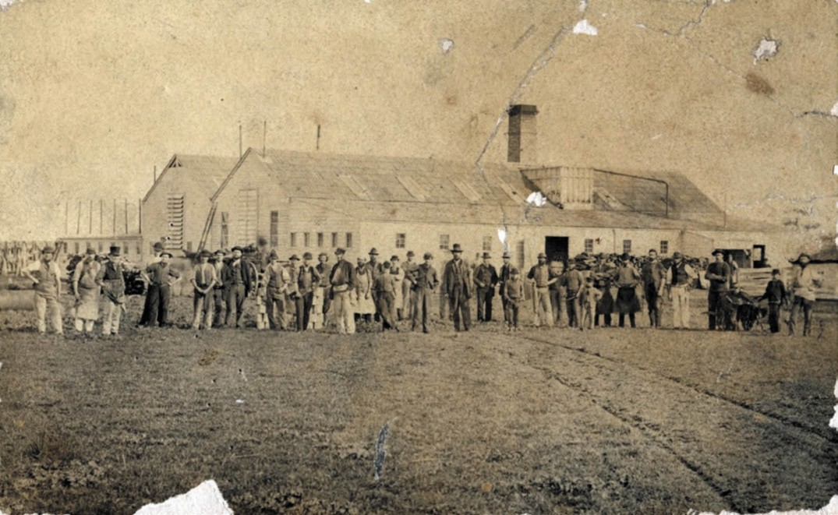
Figure 6.230: Geelong Meat Preserving Company, Boronggoop (St. Albans), 1871. Source: GRS 2009/00136, Geelong Heritage Centre collection.

ST. ALBANS PARK - WHITTINGTON
The areas known as St. Albans Park and Whittington originally formed part of the Boronggoop Run of Misses Newcombe and Drysdale. This run extended from the Bellarine Highway to the Barwon River, and from Boundary Road to Reedy Lake.1008 In 1849, the area was broken up into several agricultural allotments which were sold in the 1850s and 1860s, the area then being known as Boronggoop.1009
The location of the land beside the Barwon River was exploited in the late 1860s by Edwin Lowe who had acquired his late father s land from 1867. He established a boiling down works that was to produce 270 casks of tallow from 15,000 sheep.1010 Another important industrial development was the establishment of the Geelong Meat Preserving Company in 1871 on another part of the late James Lowe s land (Figure 6.230). Gabled timber buildings on raised foundations were erected, as were offices and three cottages built for the superintendents.1011 A year after the meat preserving establishment began, the St. Albans Bone Mills factory commenced but its operations were short-lived as it
had relied on the success of the meat preserving company for its raw material. The meat preserving company was offered for sale in 1876 and the steam bone mill a year later.1012
By the 1860s, the rural and industrial area of Boronggoop had been renamed St. Albans. This was the name used for the recently-erected bluestone Gothic styled Wesleyan Methodist Church in 1869 on land donated by J.G. Carr1013 (Theme 8).
The second Wesleyan church to be built in the area (the first at Hampstead at the eastern end of Lake Road in 1858), it was testimony to the large number of Wesleyans living in this agricultural community, with 131 of the 312 population being of that denomination.1014 Many comprised the Whittington family (or relatives of the Whittington family), having first settled in the area in the 1850s.1015 In 1871, J.G. Carr also made available building lots near the church.1016
The purchaser of the meat preserving company was James Wilson, a horse trainer. He had located himself at St. Albans by 1870 where had had set up a training establishment that was to become well-known (see Theme 4).1017

The strong Wesleyan population at St. Albans led to the establishment of the Concord Division of the Sons of Temperance which had its own hall by 1878 (see Theme 8).1018 An Anglican Church was erected at the corner of Townsend and Wilson Roads in 1898. Built in timber, St. Paul s
Church was designed by the local architects, Laird and Barlow.1019 In 1901, John Whittington established a Post Office in Westmoreland Street.1020 He erected a new post office in Westmoreland Street in 1915 which was called the Whittington Post Office.1021 By 1921, the name of the
locality was changed to Whittington, presumably after John Whittington’s Post Office.1022 A basis for the change was the confusion with the postal service given two localities under the name St. Albans in Victoria (the other being a suburb
of Melbourne).
The rural settlement of Whittington experienced substantial transformation from c.1980 with much of the former
St. Albans Stud Estate subdivided for housing. From this time until the early 21st century, many streets were laid out and hundreds of houses constructed. By 1999, all the area south of Townsend Road was renamed St. Albans Park.

FAR EASTERN AND SOUTH-EASTERN REGIONS (INCLUDING BELLARINE PENINSULA)

BARWON HEADS
Until the turn of the 19th century, Barwon Heads was largely an open, treed land with a frontage to the Barwon River. From European colonisation, it was also known as Mount Colite, denoting the elevated cliff face at the mouth of the Barwon River. To the Wadawurrung, this was known as Kolo: Et , meaning salty and fresh water –the place where the waters mingled. 1023
By 28 January 1865, Alexander Cameron McDonald had purchased four acres comprising crown allotment 16.1024 By May, 1870, he had sold this land to John Middlemiss, of Prospect Road, Newtown.1025 He subsequently owned
8 acres with a Barwon River frontage. This land was sold to Frederick Challis, a farmer in January, 1876.1026
In 1888, allotment 14 of Challis s land had been sold to the Barwon Heads Estate Company.1027 This land formed a large subdivision (Figure 6.231) that had a frontage along the Barwon River, and also stretched as far west as Hitchcock Avenue (then known as Barwon Avenue).
Another key initiative of the Barwon Heads Estate Company was the construction of a Coffee Palace. Opening in April 1889, the timber building was to become a landmark at
the newly-formed seaside resort, although the outward appearance as described as useful rather than ornamental 1028 (Figure 6.232) (see also Theme 5).

In 1892, Challis and other early landowners within and outside this precinct area, including a Mr Johnstone, had sold their landholdings either to private buyers or the Barwon Heads Estate Company Limited. This company advertised its Great Subdivisional Sale on 30 March, 1891, which included land along Flinders Parade, Ewing Blythe Drive, Grand View Parade and Ozone Road.1029
Some of the purchasers of allotments at Barwon Heads in the late 19th century and early 1900s developed substantial seaside homes and were themselves prominent citizens of Geelong and/or the Western District. These people included
H.F. Richardson, whose house and land fronting Flinders Parade was sold to George Hague in the 1890s and which later became known as Monomeeth guesthouse at 33 Flinders Parade, built in 18911030 (Figure 6.233). John Daniel s property neighbouring property at 39 Flinders Parade also dates back to the early 1890s, and was purchased and substantially extended by Dr A. Sheppard Grimwade in 1911- 12.1031 Other significant landowners who built holiday houses in the late 19th and early 20th centuries included Colonel Albert Garrard, bursar of the Geelong Grammar School
(he had a large timber Bungalow constructed in 1913-14 at 2 Carr Street);1032 Howard Hitchcock, a Geelong Mayor and Director of the firm of Bright and Hitchcock’s (his house, Bernarty , 18 Ewing Blyth Drive, was built in late 1889 for
Miss Julia Anderson and acquired by Hitchcock s father, G.M.
Hitchcock in 1892);1033 Alan Belcher (his house, Bringagee at 3 Flinders Parade was built in 1913 to a design by Tombs
and Durran architects)1034 (Figure 6.234); Mrs Amuri Russell, a member of the prominent Western District family of Wurrook Rokewood (the Russell family built Wurrook at 7 Flinders Parade in 1904-05)1035 (Figure 6.234); Mrs Edith Roadknight, relative of Thomas Roadknight, auctioneer and estate agent, who was responsible for carrying out several subdivisions in Barwon Heads in the early 1900s (Edith Roadknight owned the dwelling at 27 Flinders Parade, built in 1912-13)1036 and Arthur Collins, joint manager with his brother, Basil, of Collins Bros. Pty Ltd Woollen Mills in Newtown (he had the dwelling at 6 Henley Street built to a design by Laird and Buchan and
P.E. Everett in 1925).1037
Barwon Heads also has a strong historical association with public reserves, structures and the Barwon River foreshore: the elements that largely characterise the eastern parts of the town today. The Barwon Heads Park Trust was established in 1889 to manage the Park (the present day caravan park and the Frank Ellis Reserve to the west of Flinders Parade fronting the foreshore –all of which appears to have been gazetted
as a public reserve from c.1850).1038 The Trust instigated several improvements including the planting of numerous exotic trees (most now removed), dance hall, rotundas, kiosk and importantly, the development of the camping reserve that

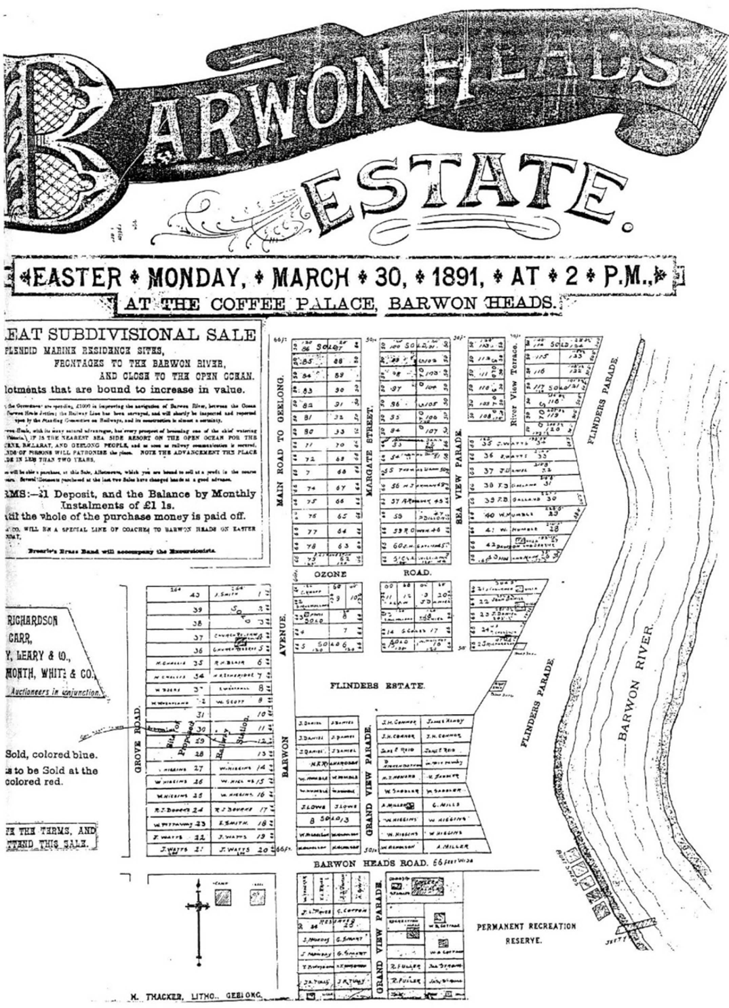

Figure 6.231: Barwon Heads Estate Plan, 30 March 1891. Source: GRS 2065/folio 3, map 73, Geelong Heritage Centre collection.

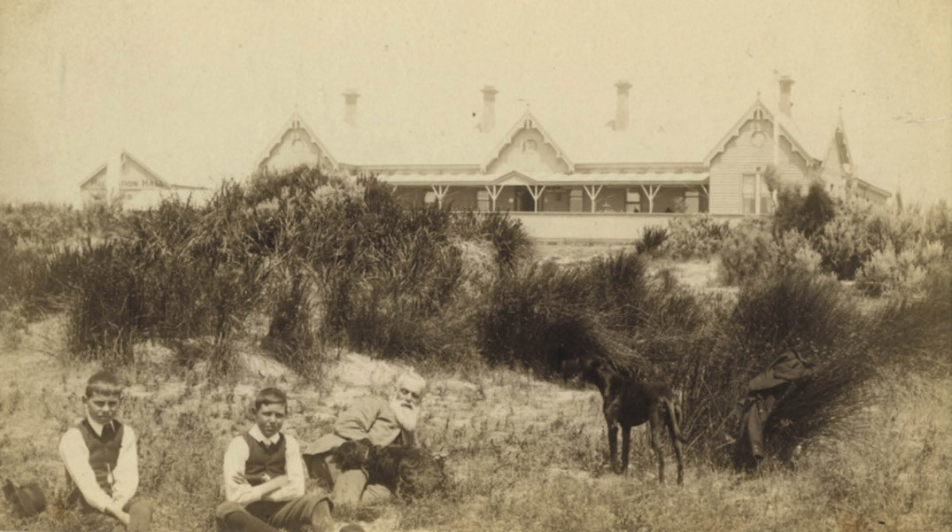
Figure 6.232: Barwon Heads Coffee Palace, c.1900. Source: GRS 2009/00018, Geelong Heritage Centre collection.

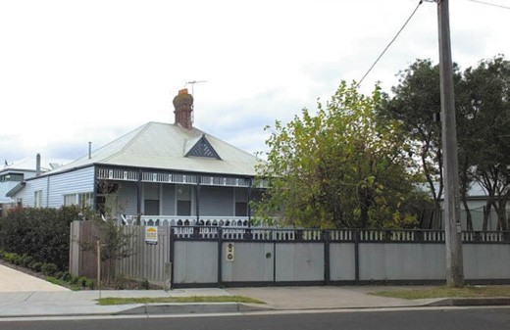
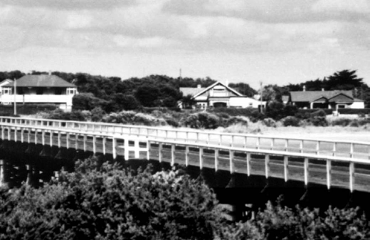

Figure 6.233: Monomeeth , 33 Flinders Pde, 2013. Source: David Rowe.

greatly assisted in evolving the reputation of Barwon Heads as a tourist attraction, particularly from the late nineteenth century.1039 Throughout the years, this reputation has continued to grow, and Barwon Heads is now a well-known tourist attraction in Victoria.
There was also the development of public amenities and infrastructure within the precinct. The jetties along the north and south flanks of the Barwon Heads foreshore were reconstructed or built in the early 1900s, while the bridge linking Ocean Grove to Barwon Heads was constructed in
Figure 6.234: View from Ocean Grove looking to properties fronting Flinders Pde, n.d. [c.1930], including ‘Bringagee’, 3 Flinders Pde (left) & Wurrook , 7 Flinders Pde (centre).
Source: Martin Klabbers, Barwon Heads.

1927.1040 It had been proposed by Howard Hitchcock in 1913 as the gateway to the Great Ocean Road. In 1933, the Barwon Heads Hotel was constructed (Figure 6.235), replacing the earlier Mt Colite Hotel (original Coffee Palace) that had been destroyed by fire. The Geelong Harbour Trust boat shed
toilet block on the Frank Ellis Reserve on the north-west side of Flinders Parade, together with the former boat sheds (now houses) in Flinders Parade and Ewing Blythe Drive are legacies of the lengthy row of boat sheds that were once

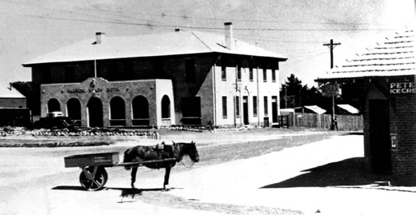
Figure 6.235: Barwon Heads Hotel, n.d. [c.1935]. Source: Martin Klabbers, Barwon Heads.
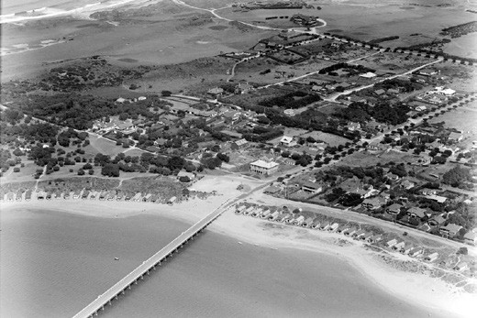
Figure 6.236: Aerial view of Barwon Heads, showing bridge, line of boat sheds on the foreshore, hotel (centre) & several dwellings, 1936.
Source: C. Pratt, accession H91.160/598, State Library of Victoria.

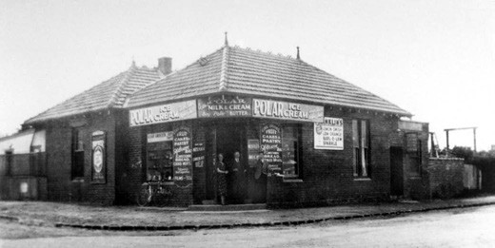
Figure 6.237: The Kiosk , 1 Flinders Pde, c.1940. Source: Martin Klabbers, Barwon Heads.

situated on the Barwon River foreshore until 1936 (Figure 6.236) (see also Theme 9). The bluestone retaining wall that replaced the boatsheds formed part of the changing character of the area, having been constructed in stages from 1953 to 1967.1041

Another existing focal point and local landmark is the corner store at 1 Flinders Parade, built in 1934 for George Golightly and is the last refreshment kiosk (Figure 6.237) built near the Barwon Heads foreshore to accommodate the increased tourist trade.1042
Another important development was the establishment of the Barwon Heads Golf Club who laid out a links course on 166 acres of land previously part of the Hopgood family farm.
A substantial timber Bungalow Club house was erected in 1923 to a design by Klingender and Hamilton, Melbourne architects1043 (see Theme 9).

BREAMLEA
An important locality of the Monmart clan of the Wadawurrung known to them as Maamaart ,1044 and a semi-permanent settlement of William Buckley, the sandy coastal hills at Thompsons (Bream) Creek (known today as Breamlea) remained largely unsettled by Europeans apart from camping during the summer season as a popular marine resort.
Known as Picnic Point in the 1860s and then Bancoora after the SS. Bancoora which ran aground there 18911045 (Figure 6.238), it was called Bream Creek by 1908.1046 The following description gives an appreciation of the importance of Breamlea as a holiday location at that time:
Bream Creek - the nearest to Geelong of the southern watering places - has up to the present escaped the influences of civilisation, so far as residential matters are concerned. This does not, however, mean that it
is unpopular. On the contrary, it is a favorite rendezvous for a day s outing; whilst during the Christmas and
New Year holidays, its peculiar merits as a camping ground are largely availed of, tents of every conceivable shape and size peeping out in all directions from under the ti-tree.1047
In 1941, the name of the locality was changed from Bream Creek to Breamlea, so as to avoid confusion with another Bream Creek in Australia. 1048 At this time it was surveyed and proclaimed a town, with 120 allotments created1049 (Figure 6.239). Streets were laid out and named after European pioneers or regular holiday-makers, including Blyth, Challis, Vagg and Whittington. Most lots were sold in 1942. A recreation and public hall reserve was also gazetted at this time and another in 1969.1050 A hall was built on the reserve set aside in 1942 and it served as a school between 1952 and 1955.1051.

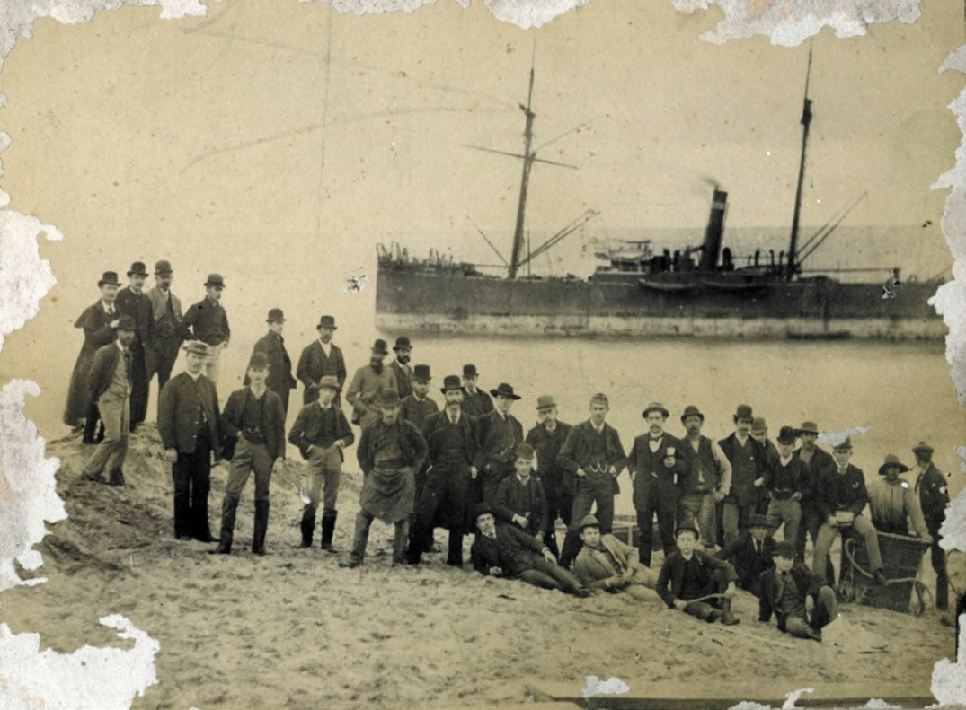

Figure 6.238: ‘Ss. Bancoora’ at Bream Creek [Breamlea], 1891. Source: GRS 499/8/0, Geelong Heritage Centre collection.

AGRICULTURAL DISTRICTS
Throughout the Bellarine Peninsula are several agricultural and pastoral districts established by Europeans for farming from the mid-19th century including Curlewis, Murradoc, Mannerim, Marcus Hill, Bellarine, Newington and Wallington.

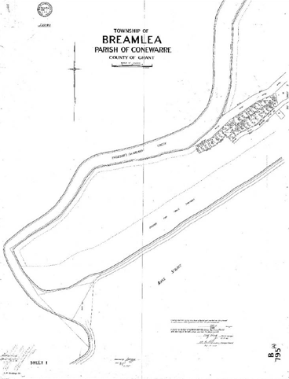
Figure 6.239: Plan of the Township of Breamlea, 1941. Source: Map B795A/1, Landata, State of Victoria.

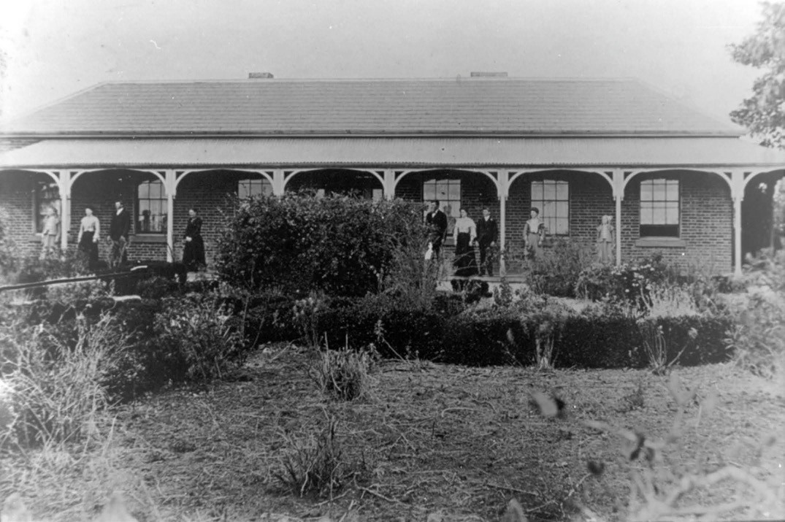
Figure 6.240: ‘Derry Hall’, Curlewis (now demolished), n.d. [c.1900]. Source: Image 517, Bellarine Historical Society.

CURLEWIS
Curlewis is situated between Moolap and Drysdale on the foreshore of the outer harbour of Corio Bay. In 1845, George Curlewis took up Sections 23 and 24 in the Moolap Parish.1052 He died in 1847 and his brother, Septimus, built Hermsley soon after where he cared for Curlewis children and property until George s sons were of age to take over the property in their own right in 1866.1053 Nothing survives of Hermsley today. Similarly, another early property that is no longer extant is Derry Hall (Figure 6.240), which was situated off the Portarlington Highway. The brick homestead was built
in 1858 for Anthony Devine to a design by Joseph Shaw, architect.1054 The only 19th century landmark that remains at Curlewis (and which is now addressed as Leopold) is the former St. Francis Catholic Church, 2030 Portarlington Highway (see Theme 8).
Today, Curlewis is known for its 18-hole golf course at 1345 Portarlington Road (see Theme 9). Curlewis is also recognised as the location of several wineries.

DRYSDALE
Originally known to the Bengalat balug clan of the Wadawurrung as Bella-Wein (meaning the place where your rest upon your elbow near the fire’),1055 Drysdale was a highly significant and substantial itinerant settlement and ceremonial ground near the reedy billabongs (McLeod s Waterholes).
It was the location of the Yerai: oo , the place for rejoicing where corroborees were held and which therefore required several mirniongs (earth mounds used for cooking).1056
Following European colonisation, Drysdale was known as Bellarine, a postal and agricultural township which began with the opening of Duncan McKenzie s Buck s Head hotel in 1852, at the road junction now High, Collins, Clifton Springs and Murrudoc Roads.1057 Given its central location for
coach and railway transportation, the town was formalised in 1857 and was laid out by surveyor, Francis Gilbert1058 (Figure 6.241). Established on a grid plan, streets and lots were formed from the apex of the road junction at the north end. Outer allotments were created to the west of McLeod s waterholes (three lakes first called Sproat’s waterholes

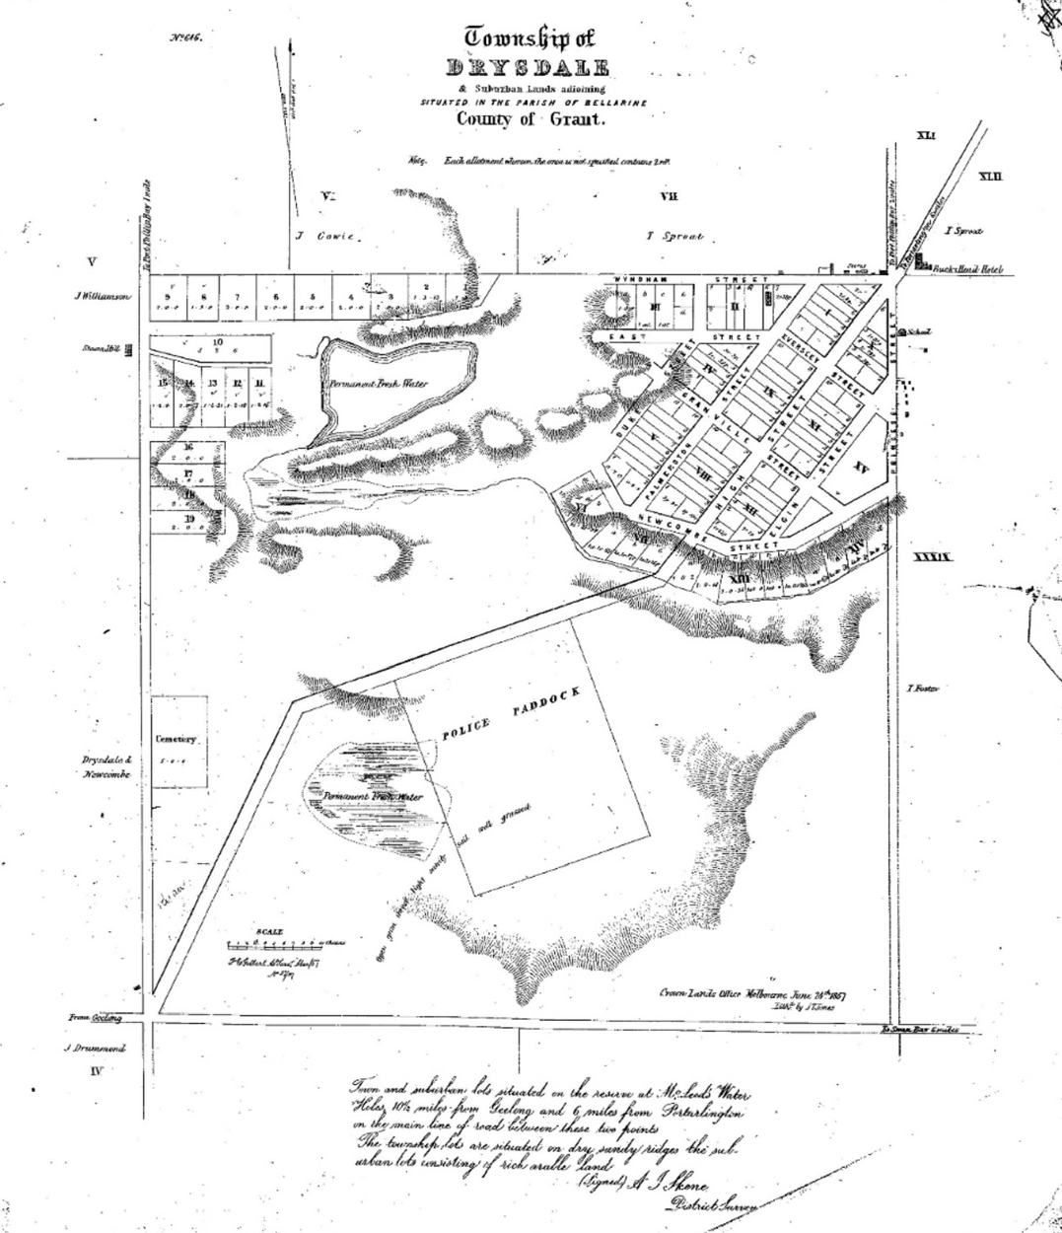
Figure 6.241: F. Gilbert, Plan of the Township of Drysdale and suburban lands, 1857. Source: GRS 2065/Map folio 1 plan 6, Geelong Heritage Centre collection.

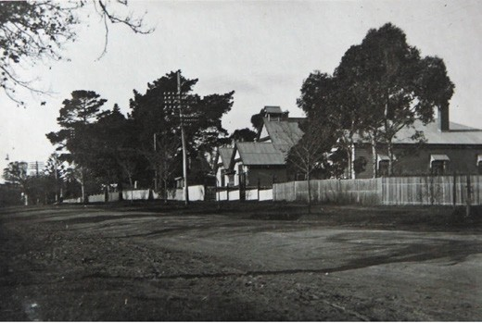
Figure 6.242: High St, Drysdale, with the Methodist Sunday School in the middle ground, 19 May 1928. Source: Holmes collection, Authentic Heritage Services Pty Ltd.

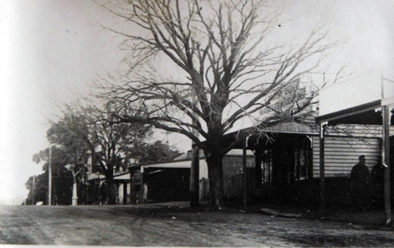
Figure 6.243: Wyndham St, Drysdale, looking towards war memorial, 19 May 1928. Source: Holmes collection, Authentic Heritage Services Pty Ltd.

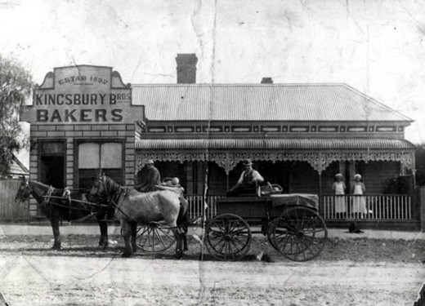

Figure 6.244: Kingsbury Bros. Bakery, 23 Clifton Springs Rd, n.d. [c.1920]. Source: Image 1028, Bellarine Historical Society.

after an early European landowner and later after Dr Angus McLeod, M.D. and pastoralist at Portarlington by 1853 who took an active interest in community affairs).1059 A police paddock and a cemetery were reserved to the south-west, beyond Lake Lorne (one of the three lakes, with the name of this lake changed from McLeods to Lake Lorne in 1872, in honour of the then Victorian Governor).1060 Gilbert s plan showed the presence of a school in Princess Street, south of Murradoc Road. This was the second Presbyterian School at Drysdale, built in 1853 and is now the local R.S.L.
Clubrooms.1061 Gilbert s plan also showed a steam mill to the west of the town reservation in Jetty Road. It was built in 1853 and destroyed by fire in 1861 (it was not rebuilt).1062
The town was named after Miss Ann Drysdale, pioneer squatter of nearby Coriyule built in 1849 as part of the sheep run she occupied with Miss Caroline Newcomb1063 (Themes 2 & 4). Throughout the 19th century, the town progressed to become the commercial and civic hub on the Bellarine Peninsula, and particularly for the onion, potato and corn farms that were established immediately surrounding the town.1064 This gave rise to the building of more churches, including St. James Church of England in Collins Street in 1872 (a vicarage was erected opposite the church in 1889), and a Methodist Church (now Uniting) at 22 High Street in 1887 (a Sunday School building followed on the opposite side of the street in c.1910)1065 (Figure 6.242) (see also Theme 8). Civic, public and commercial buildings were also erected, including a Shire Hall, Court House (Theme 7) and Colonial Bank of Australasia in 1880 (Theme 5), and a Free Library in 1881 (Theme 8). Only the old Shire Hall has been
demolished. Further south-west of the town, a railway station was erected in 1879.1066
Other physical legacies of the early progress of Drysdale are identified in the surviving commercial, infrastructure and residential buildings (Figure 6.243). They include the former
bakery at 23 Clifton Springs Road with the baker s oven (built in 1881) and the existing former shop dwelling (erected in 1892 for Alfred Allpress and later occupied by Kingsbury brothers) (Figure 6.244); the Victorian styled villas at 19 Princess Street (built 1891-92 by Albert Chiller, carpenter,
as his own residence); 21 Princess Street (built 1881-82 for Joseph Searl, butcher and later valuer and rate collector for the Bellarine Shire) (Figure 6.245); 25 Princess Street (built 1892 for Herbert Litchfield, solicitor) and 43 Princess Street (built c.1872 by William Butler, builder, as his own
residence).1067 Additional development occurred in the early 20th century, including the construction of the Federation styled timber dwelling at 11 Princess Street in 1912-13 for
W.J. Davey, teacher1068 (Figure 6.246); interwar Bungalows (including the dwelling at 9 Princess Street built in the 1920s for Mrs Bennett);1069 a new post office at the north end of the town in 19271070 and the replacement of the Buck s Head Hotel

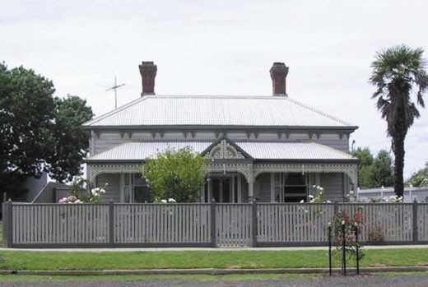
Figure 6.245: Dwelling, 21 Princess St, 2012. Source: Pam Jennings.

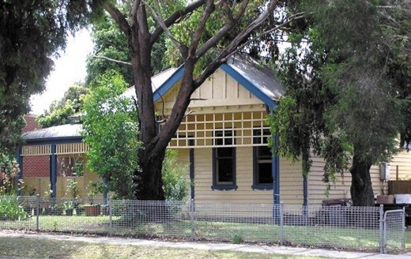
Figure 6.246: Dwelling, 11 Princess St, 2012. Source: Pam Jennings.

with a two storey brick hotel (Drysdale Hotel) built in 1934 for the Volum Brewing Company to a design by Laird and Buchan architects.1071

LEOPOLD
By 1854, several Europeans that had earlier settled at Geelong returned from the Ballarat goldfields, and with other European immigrants, they trebled the population of Geelong.1072 Original freeholders including James Austin capitalised on the demand for land on the rise of Kensington
Hill and the low lands from Lake Connewarre to the Corio Bay, between Moolap and Curlewis.1073 The Connewarre Estate subdivision was first offered in March 1842 on the western side of Melaluka Road.1074 It was followed by another 1300 acres made available as the Kensington Estate.1075 It was from this Estate that Leopold first took the name, Kensington. Next was the Doneraile Estate, with 204 lots available to the new aristocracy –gold diggers. 1076 Sales were limited and so the Doneraile Estate was renamed Rochetown, in honour of

Edmond Roche, Geelong publican in the 1840s and original Crown purchaser of the land.1077
Some of the earliest properties were centred on the picturesque banks of Lake Connewarre following the subdivisions of the 1850s. Others were situated on the Kensington Hill, along with other buildings that formed part of community life. In 1893, Dr. A.J. Campbell in the Tourists Guide to Geelong and Southern Watering Places gave
the following description of Leopold (and the basis for the renaming of the locality from Kensington) at this time:
But we must now cross over the railway to the Queenscliff road, where we come among a cluster of cottages on Kensington Hill, among which Mrs. Moller s holds the patriarchal place. There are two churches, Mechanics and Temperance halls, State school, and a Post Office.
To this office letters from Melbourne use to come in about a week via Kensington, although this latter was not a
post office at all. The authorities were then asked to alter it, and they named it Leopold Hill. But the Postmaster- General, with unexpected good sense, erased the hill, on a second required and left Leopold to stand alone
in memory of the Prince, whose beautiful life, just then ended, it was meant to commemorate. This sensible postmaster was the Hon. James Campbell. The house on the crown of the hill, built by Mr. George Allen, he called Allan-vale, partly in honor of himself, and partly of a beautiful selection in the Tamar Valley, which he took up in 1823. On his death it was purchased by Mr.
G.F. Belcher, who, although now residing in Geelong, continues to take a warm Christian interest in the higher welfare of the people. Away to the left, we come upon a little Primitive Methodist chapel Going a little further, we find ourselves at last on the banks of Lake Connewarre, as picturesque a sheet of water (Says Dr. Lang) as ever I beheld. Naturally it attracted a good many early settlers.
The first I believe was Mr. O’Farrell, who built a house on the headland which separates the upper from the lower arm of the lake [‘Malaleuka’]. It was enlarged and
occupied by Mr. A.M. Campbell, and is now in possession of Mr. Howard.
Next to Malaleuka come Constantia and Como, , both now belonging to the Rutherford family. Mr. Andrew Rutherford was one of Dr. Lang s emigrants, who received a Government grant of land near Colac, and afterwards came to the lake. He is a J.P., and has done good service as a Protector of Fisheries. Next comes The Crib, put up by Captain McLean, of the Coastal and New Zealand Service; then Mr. Ryland s property, which I (under the compulsory provisions of a bequest) purchased as a permanent home for my family. It has been untenanted for several years when I got it, and was densely covered

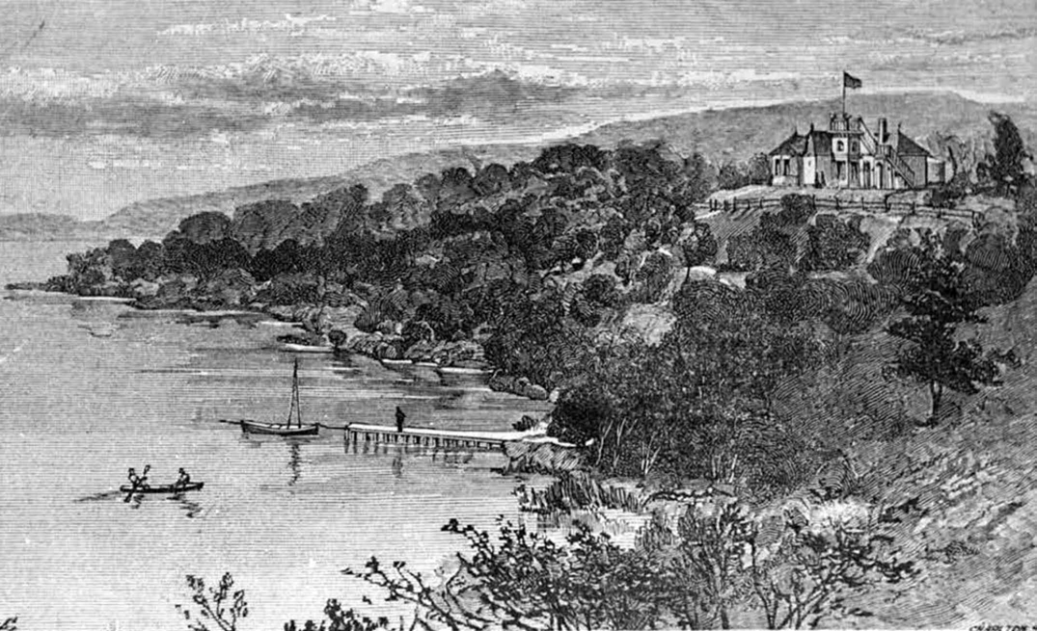
Figure 6.247: Toorang on Lake Connewarre , c.1893. Source: A.J. Campbell, The Tourists Guide to Geelong and the Southern Watering Places on the Bay and Coast and Popular Holiday Resorts, M.L. Hutchinson, Melbourne, 1893, p.21.

with the gold wattle, a fact which is commemorated in its name, Toorang –the wattle tree. The house is built with boulders, gathered from the surface, and as it was easier to build than to break them, the partition walls were all made 19 inches thick, which gives the house an unusual coolness. The view from the look-out spreads over a richly diversified landscape of wood and water and green earth, with Mount Colite upon the one side, and Mount Buninyong, on the utmost limit of the horizon on the other. The property on the right hand belonged to my old friend, Mrs. Gundry, of Geelong, but after sundry changes, has been cut up for Garden Homes. On the further side of the lake there are a few farms, the best belonging to
Mr. Brinsmead, which lies in a sheltered bend of the hill. The gully behind it bears the name of the first squatter in the district, Mr. Fenwick.
I have often wondered how it is that the banks of the lake have not been peopled with a larger number of summer residences. It possesses in an eminent degree what busy men ought to covet, entire seclusion. Its banks (at least on the western side) have been so disposed with green knolls, bays and promontories, as to give a splendid opportunity for that most delightful of all recreations,
embellishing the face of nature with its own magnificent productions.1078
Several of the properties described by Campbell, as well as others built in the 19th century, remain in 2018. They include: Toorang (Figure 6.247), 401-419 Melaluka Road (built in c.1854 to a Victorian Italianate design for English widow, Priscilla Ryland and later owned by the
Rev. A.J. Campbell);1079; Melaleuka , 221-229 Matthews Road (a Victorian Regency styled dwelling built for William Noble to a design by Snell and Prowse, architects)1080 (Figure 6.248); Lake View , 202-230 Matthews Road (built in c.1863-64, having replaced a timber dwelling constructed after 1856
and known as The Crib for Duncan McLean);1081 Burnham Lodge (now Toongabbie ), and 122-160 Mollers Lane (built in c.1860 for Charles Samuel Friend, solicitor).1082
Other infrastructure was established at the rural locality of Kensington in the 19th century. This included a cemetery in Kensington Road and a post office. It was in 1886 when the name of the locality was changed from Kensington to Leopold.1083 Further subdivisions consisting small farm and
house allotments lots ensued in subsequent years, including the Kensington Hills Estate (between the Portarlington Road and Bellarine Highway) in 1889,1084 and the Como Hills Estate

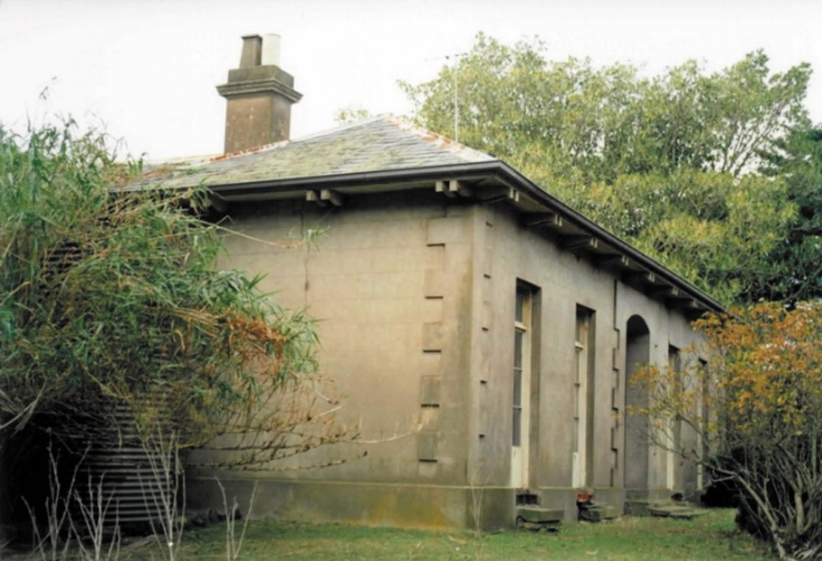
Figure 6.248: Melaleuka , 221-229 Matthews Rd, 1991. Source: David Rowe.

in 1890 (on the north shore of Lake Connewarre).1085 In 1900, the Victorian Municipal Directory described Leopold:
Small village 52 miles S.W. of Melbourne, 7 miles
E. of Geelong and 15 miles W. of Queenscliff, with Lake Connewarre 2 miles S. District well-suited for fruit-growing. Three churches, State school and post office. Station on Queenscliff line … Sarah Reynolds, postmistress. Population, 100.1086
Leopold experienced considerable urban expansion from the 1950s. Estates including Athlon Heights (1956-58), Allanvale Slopes (1959-60) and Leopold Heights (1965) were some of the earliest subdivisions that brought about numerous house constructions in the 20th century.1087 This has continued to the present day (2018), with open paddocks transformed into housing estates and a large satellite shopping centre.

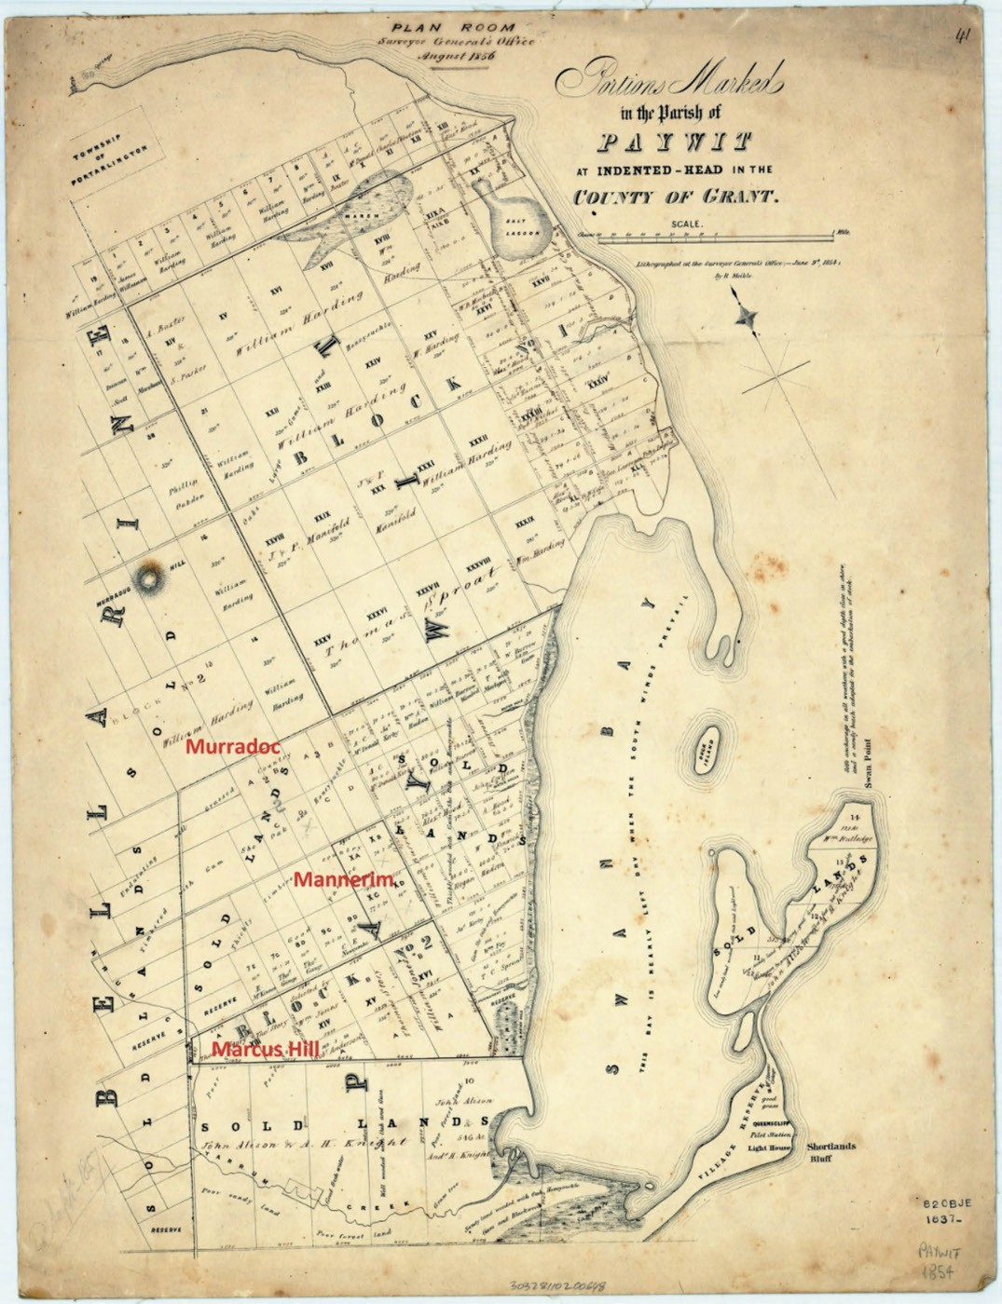
Figure 6.249: R. Miekle, Portion of Plan of the Paywit Parish at Indented Head showing the locations of Murradoc, Mannerim & Marcus Hill, 9 June 1854. Source: State Library of Victoria.

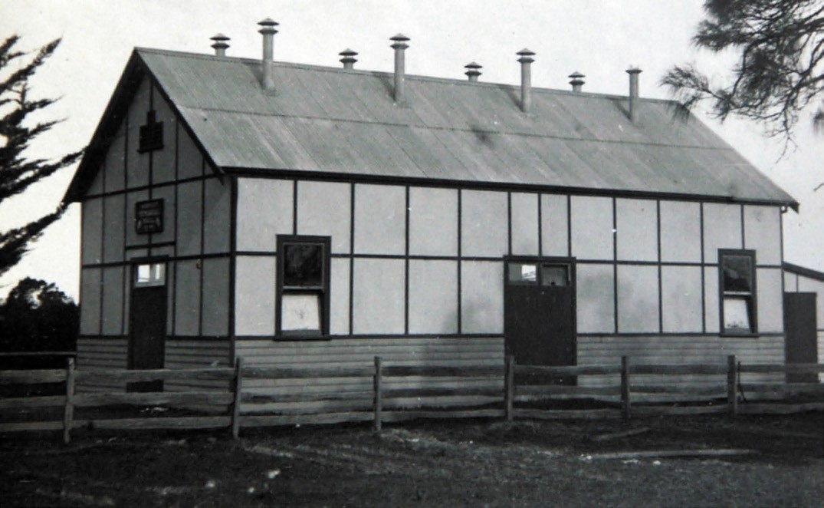
Figure 6.250: Mannerim Soldiers Memorial Hall, c.1928. Source: Holmes collection, Authentic Heritage Services Pty Ltd.

MANNERIM
Mannerim is located to the east of Wallington and south of Drysdale (Figure 6.249). Closer settlement began in
December 1853 when land was made available for sale.1088 The area was first known as Frankfort-on-the Sea.1089 It was not until 1911 when the Mannerim name was applied to the area. It had been taken from the substantial property of this name established in the district by 1862 by William Arabin Smith.1090 His life was cut short in 1867 and the following his wife advertised the property for sale. It was described in the following year as follows:
Mannerim , situated on the Queenscliff Road, and comprising 507 acres, well watered good pasture and agricultural land, the whole being securely fenced. The Villa, Approached from a lodge on the Queenscliff road and over a well-designed drive, is a tastefully built and commodious residence, with balcony, from which a view of the Heads, Bass Straits, &c., is obtained, and verandah on two sides, and contains large drawing and dining rooms, six bedrooms, dressing-room, house- keeper s room, kitchen, and servants apartments, store
room, pantries, cellar, numerous out-offices, in fact every essential for the convenience and comfort of a family
of position. There is a detached verandah cottage of 2
rooms, stables, coach-house, shearing sheds and dip, complete, piggeries, &c. &c. A beautifully laid out flower garden, shrubbery, 3 acres vines in full bearing, and
a well cultivated kitchen garden, 2 orchards, &c, fully stocked with the choicest fruit trees, orange, &c.,: the whole forming in every way a most enviable and desirable family residence, embracing all the healthful, invigorating elements of a marine residence, with the additional advantage of a country estate.1091
The property name, Mannerim , derived from the Wadawurrung name, Maan (hand): Nerim (long) , meaning the grasping hand. 1092 It was also situated in the Paywit Parish, the name, Paywit having derived from Wadawurrung word, Peewit , meaning the magpie lark. 1093
In 1891, there was sufficient population to open a timber school at 900 Swan Bay Road, then known as Paywit South (it was renamed the Mannerim School in 1906) while two years later in 1893 a post office was opened (it closed in 1975).1094
In March 1919, construction commenced on a Memorial Hall1095 (Figure 6.250). A Methodist Church was built in c.1878 in Banks Road (this being the second Methodist Church at Paywit , the earlier church having been built at a different location in 1860).1096 Only the school and a ford over Knights Road (immediately east of Banks Road) are the surviving

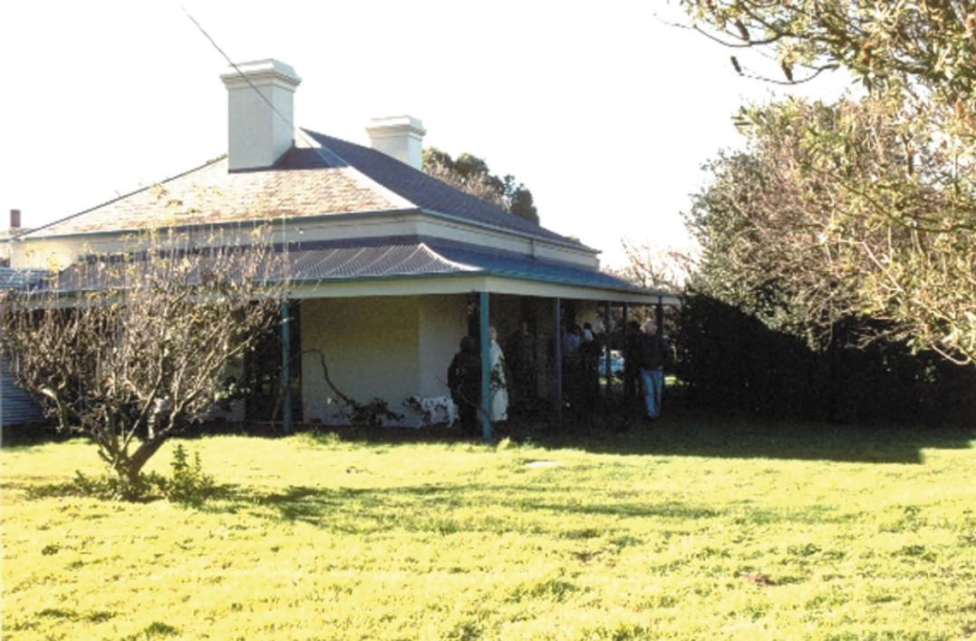
Figure 6.251: Carlyle , 2041 Bellarine Hwy, 1997. Source: Susie Zada.

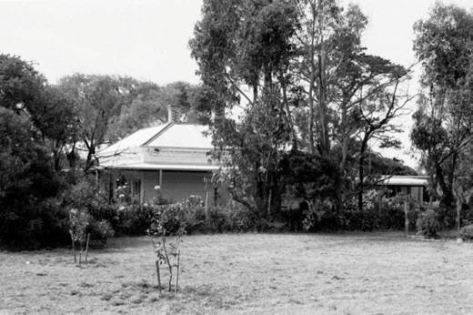
Figure 6.252: Former Marcus Hill Post Office, 60 Cresswell Rd, 1996. Source: Huddle, Howe, et.al., Bellarine Heritage
Study , 1996.
legacies 19th century development in the area.

MARCUS HILL
The elevated area to the west of Queenscliff was first described as the Marcus Hill Estate in November 1853 when about three hundred acres of choice land was subdivided into superior convenient lots. 1097 In April 1854, Marcus Hill, along with the township of Kennilworth, and Frankfort on the Sea , were described as superior sites.1098 It was at this time when agricultural land was subdivided and made available at Government land sales.1099 The name of the area may have derived from Lord Marcus Hill (Arthur Marcus Cecil Sandys, third Baron Sandys, known as Lord Marcus Hill until 1860, a British Whig politician) who in December 1853 was reported in the Illustrated London News as the proposed successor
to Charles La Trobe, Governor of Victoria.1100
There are only three surviving 19th century dwellings at Marcus Hill. At 2041 Bellarine Highway, Carlyle
(Figure 6.251), a brick Victorian Regency homestead appears to have been built for George Bryant, pioneer grazier in c.1855.1101 At 60 Cresswell Road, the weatherboard Victorian dwelling (Figure 6.252) appears to have been built in 1882- 83 for Charles Harding junior in readiness for his marriage
to Miss Bridget Madden in 1884.1102 The Marcus Hill Post

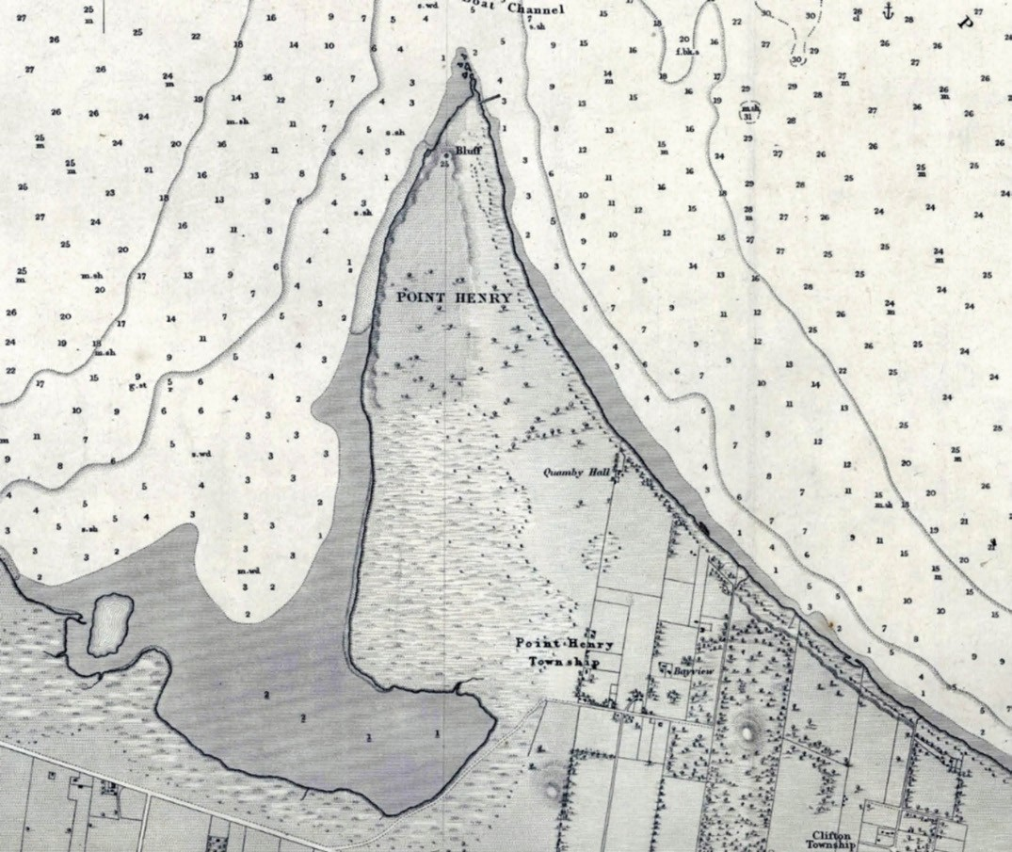
Figure 6.253: H.L. Cox, Portion of Survey of Geelong Harbour showing Moolap, including the Point Henry & Clifton Townships, 1864 (published at the Admiralty, London, 26 March 1865). Source: VPRS 8168/P5, item MCS 76, Public Record Office Victoria.

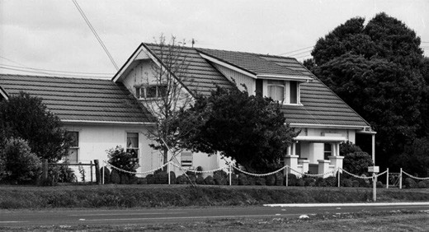
Figure 6.254: Altered former Moolap Inn, 350 Bellarine Hwy, 1988. Source: Bellarine Shire collection, photo 1026B, sheet 56, image 07, Bellarine Historical Society.
Office opened there in 1883 (it closed in 1978).1103 In 1996, a palm tree marked the location of the former Marcus Hill School at 1880 Bellarine Highway (corner Banks Road).1104 The first school (known as the Marcus Hill Rural School No.
45) opened in 1870 and it was replaced with Marcus Hill State School No. 1370. In 1878, the Marcus Hill State School No. 2029 opened at this location and in 1968 a new two-roomed building opened. It closed in 1993.1105 Nothing survives of the railway station that was constructed at Marcus Hill in 1882, save for the vestiges of the railway line.1106

MOOLAP
From European colonisation Moolap was largely an agricultural district. The area takes in Point Henry (see earlier subsection) and is situated to the south-east of Geelong, adjoining the suburbs of Newcomb and Whittington on the west side (Figure 6.253). The name of the area derives
from the Wadawurrung name, the spear-head, corrupted from ‘Moola’, the name of Point Henry where shell fish were gathered.1107 Land to the south and east of Point Henry sold as early as 1845. Early landowners included Tom Wills, J. Clarke, W. Easy and H. Anderson.1108 Four years later in 1849, James Austin subdivided his land at Moolap that faced the outer harbour of Corio Bay (and east of Point Henry)
as the Clifton Township.1109 The township was not a success and the only remnant of this lost township today is the thoroughfare, Clifton Avenue.
In 1882, there were just 16 occupants of properties at Moolap, a time when their attention was focussed on retaining their rights to the grazing and water of Reedy Lake (also known
as Moolap Common).1110 No farms associated with initial European colonisation of Malop survive. However, the site of the former Malop Inn, 350 Bellarine Highway (corner Moolap Station Road) is a legacy of the three hotels established in the area by 18551111 (Figure 3.254). The Inn experienced major alterations and additions in the early 20th century. The most substantial legacy of European development of the area
is the saltern on the shores of Corio and Stingaree Bays, established by Richard Cheetham in 1888 (see Theme 5 for further details).1112 Further industrialisation of part of Moolap occurred in the late 20th century, on the south side of the Portarlington Highway, east of Coppards Road.

MURRADOC
Murradoc is characterised by a flat plain of agricultural land and the Murradoc Hill. It is situated between the east of Drysdale and the west of St. Leonards. The name of the area derives from the Wadawurrung term given by Europeans
for the local hill.1113 It seems to have been named after the Ngar: Wi: It (chieftain of the Bengalit clan), Murradoc (or Murridunnuck).1114 The Wadawurrung meaning appears to be ‘dark earth’ (derived from Moo: Du), reflecting the dark grey top soil of the area.1115 European colonists described
Murrindunnuck as King Murradok .1116 In 1852, the Murraduc Estate , comprising 480 acres of farmland, was offered for sale.1117 Two years later in 1854, Alderman Burrow offered another 750 acres in 20 acre farm allotments as the Murraduc Farms Estate, it being described as ‘fine agricultural land
on the fertile banks of Swan Bay. 1118 A Church of England School opened at Murradoc in 1860 until 1881 when construction began on a new timber State School on an adjacent site.1119 The school closed in 1931.1120

WALLINGTON AND NEWINGTON
Located between Leopold, Marcus Hill and Ocean Road, the agricultural districts of Wallington and Newington began in 1853 following the subdivision of part of Fairfax Fenwick s property which fronted the Queenscliff Road.1121 Fenwick named the subdivision, Wallington, after Wallington in Hertfordshire, England.1122 On his retained portion, Fenwick built his homestead, Chevy , in c.1853.1123 In 1885, following the death of then then owner, William Weekes, over 4000 acres were offered in multiple allotments as the Chevy Estate.1124 The land included leased dwellings, vineyards and other farming properties between Lake Connewarre and Curlewis as well as Wallington.1125 A second sale of 3000 acres occurred in 1886.1126 One purchaser was David Rhind, experimental farm in cultivator, stockbreeder and dairy
farmer. 1127 (see Theme 4). Two hotels were established (both named the Wallington), with the Hotel on the Queenscliff Road (Bellarine Highway) capitalising on the famous fruit grown in the area. In 1887, the licensee of the Queenscliff Road hotel advertised his strawberry gardens and that strawberries and cream were on offer.1128
In 1893, Wallington was favourably described in the Tourist Guide to Geelong and the Southern
Watering Places:
A favourite resort for excursionists, either from Geelong or Ocean Grove, is the fertile valley of Wallington. There is a hotel, store, and post office in one, and for many it has been found a centre of attraction as a wayside house.
The principal place of interest is, however, the famous Wallington Gardens, justly popular for the enormous quantity of strawberries, and other fruits. Picnic parties find this a pleasant resort in the season, and being within six miles of Ocean Grove it forms a very agreeable outing for an afternoon. Some very beautiful views of the Lakes are obtained from this locality. Cobb & Co. supply
vehicles of every description at moderate prices, from the cosy two-seated buggy to the heavy American coaches, suitable for parties from six to thirty in number. The usual way in making up such gatherings is to fix the day before who is to go, and gentlemen are generally found staying at the Coffee Palace [Ocean Grove] who willingly make all necessary arrangements whether the destination be Wallington, Drysdale Springs, Point Lonsdale, or boating on the lakes.1129
Surviving legacies of 19th and early 20th century European development at Wallington include the dwelling,
Willow Bank (now Carinya ), 20 Rhinds Road (built in brick between 1855 and 1863-64 on land initially owned by James and Thomas Magarey of South Australia and occupied after 1856 by Arthur Douse who established a vineyard and fruit garden);1130 former Newington Wesleyan Methodist Church

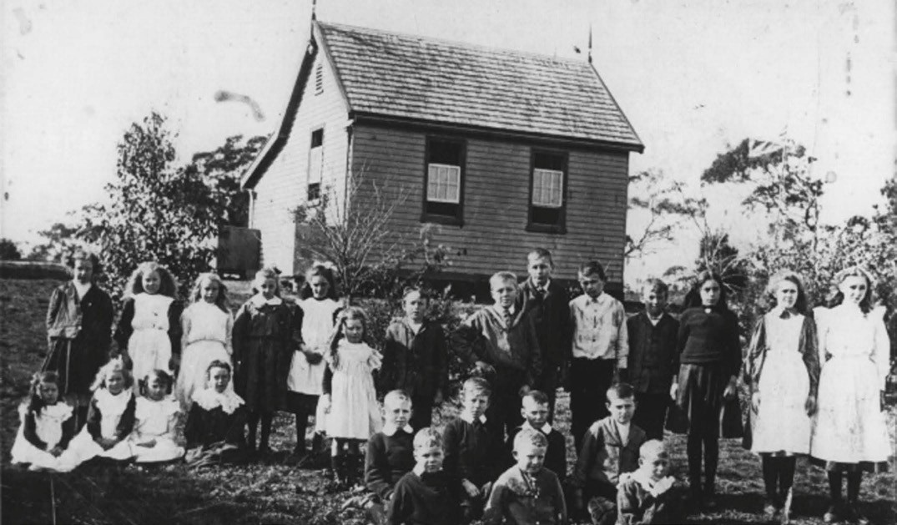
Figure 6.255: Wallington State School, 1914. Source: Photo 518, Bellarine Historical Society.

at 376 Wallington Road (built in 1888 to a design by Albert Derrick, architect)1131 (see also Theme 8); and the Edwardian dwelling and farm at 580 Wallington Road, established in c.1902 by Allen James Atkins, farmer,1132 as occupier. The Wallington Primary School on the Wallington Road (Figure 6.255) has associations with education in the local area since February 1866 when the Wallington State School
No. 868 opened.1133 It was not until 1900 when land was purchased from H. Chambers (known as Chalk Hill ) and the weatherboard Newington School (which had opened further south in 1875) was relocated there.1134 This building
(now demolished) was relocated in c.1956-57 to a property in Belcher s Road, Drysdale, following the construction of the existing building.1135

OTHER COASTAL SETTLEMENTS CLIFTON SPRINGS
In 1865, Thomas Bates, son of the pioneer squatter at Lara,
relocated to 500 acres of land fronting Corio Bay at what was then known as Drysdale.1136 He named his farming property, Clifton .1137 In 1870, a number of mineral springs were discovered on Bates property. They were named the Clifton Springs and it was from this time when the area known as The Dell (Figure 9.84, see Theme 9) became a popular marine tourist resort (see Theme 9 for further details).
In 1875, Bates capitalised on the success of the mineral springs and sold 80 acres of his property as the South Clifton Estate.1138 A second section of the Estate was sold in 1876.1139 The continued popularity of the mineral springs throughout the 1880s led to the construction of a new substantial Clifton Springs Hotel in 18881140 (Theme 9).
In 1888 146 valuable marine mansion and residential sites were made available as The Clifton Springs on the Bay Estate1141 (Figure 6.256). Situated beyond the jetty and the springs, several streets were laid out, with access to The Esplanade, Springs Street and Glenholme Road.
The economic crash of 1890 appears to have permanently halted the promise of an affluent bayside suburb and the only remnants of The Clifton Springs on the Bay Estate today

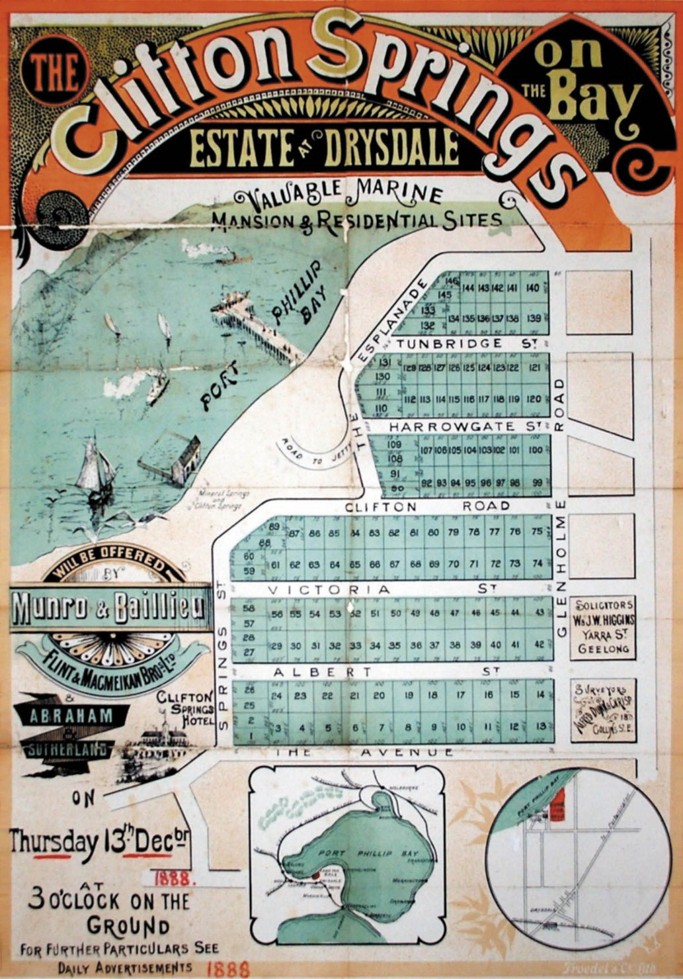
Figure 6.256: Plan of The Clifton Springs on the Bay Estate at Drysdale, 13 December 1888. Source: Map 7, Bellarine Historical Society.

include parts of Clifton Street and Clear Water Drive, and the layout of Country Club Drive and Beacon Point Road. The substantial hotel was destroyed by fire in 1921.1142
Clifton Springs remained a rural locality after World War Two. Between 1951 and 1967 it witnessed substantial expansion as a satellite suburb.1143 Between 1959 and 1977, the developers Willmore and Randall also commenced a real estate development around the golf course which they then owned.1144 Both of these residential subdivisions were the catalyst for additional residential development in later years.

INDENTED HEAD
The Crown Land adjoining the Batman Park foreshore was first offered for sale in 1857. The southern-most allotment adjacent to the Indented Head was purchased by Captain George Ward Cole, the founder of the St. Leonard s township.1145 Much of the land neighbouring the Batman Park foreshore was first owned by Alexander Hood. It comprised allotment 13 in the Parish of Paywit, amounting to 100 acres, together with the adjoining northern allotments (lots 40-45 in the Township of Portarlington) of 98 acres. Hood was born
at Antrim, near Belfast, Ireland, in c.1826.1146 He emigrated to Port Phillip with his parents, James and Margaret and four siblings, in 1844.1147 After working as a station hand, limeburner at Queenscliffe and a carter in the Western District, and after trying his luck at the Ballarat and Forest Creek goldfields, Hood came to Indented Head. There, he served as a member of the Portarlington/Indented Head Road Board in 1859, 1864 and 1865.1148 It was opposite Batman Park where Hood settled on his farm with his wife, Ann and three sons, George Alexander, Joseph Latrobe and Daniel James.1149
In 1886, Christina Miles Cox (nee Horn) appears to have acquired part of Hood s property (being part of lot 45, comprising 22 acres, 3 roods and 38 perches) with buildings.1150 This was five years after she had married
Charles William Cox (1858-1940) in 1881.1151 The dwelling had a hipped roof and front verandah, with a gabled addition at the rear (Figure 6.257).
The farmlands that met the foreshore at Indented Head were characterised by open paddocks and treed foreshore embankments, with a gravel track denoting the boundaries of private property and Crown land. They were later to be subdivided and taken up by fishermen and holiday- makers.
Several dwellings were erected on The Esplanade, the owners leasing boat sheds on the foreshore at Batman Park).1152 One of these dwellings included Lydford , 333 The Esplanade, built in c.1920 by Herbert and Alice Lewis who established
a farm (Figure 6.258).1153 From 1925, a Committee of Management had been appointed to manage, protect and

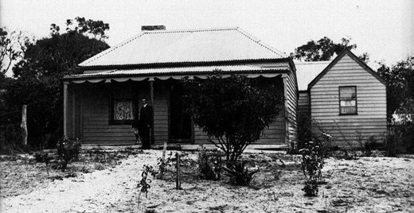
Figure 6.257: Cox family home, Indented Head, n.d. [c.1900]. Source: Bellarine Shire collection, sheet 39 image 23, Bellarine Historical Society.
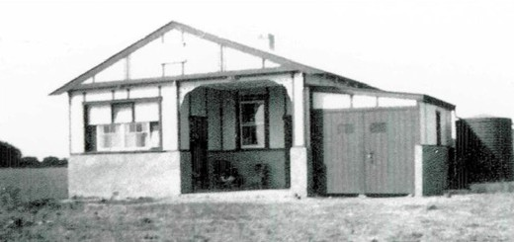

Figure 6.258: Lydford , Indented Head, 1931 Source: Marian Vessey, Indented Head.

care for this narrow coastal reserve, the park having been named in honour of the explorer, John Batman (Figure 6.259) (see Theme 9).1154 Throughout the second half of the
20th century, several holiday homes were built at Indented Head, and further residential development has occurred in the early 21st century for permanent home makers.

OCEAN GROVE

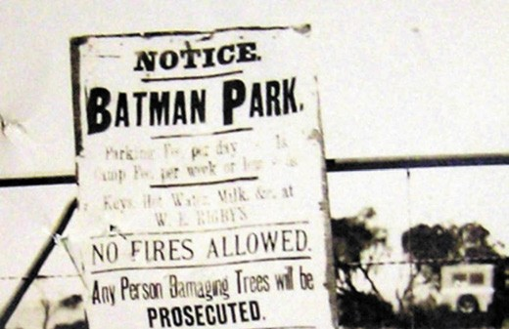
Figure 6.259: Batman Park Gate notice, 6 February 1929. Source: Crown Land file Rs 5154, Department of Environment, Land, Water & Planning, State of Victoria.

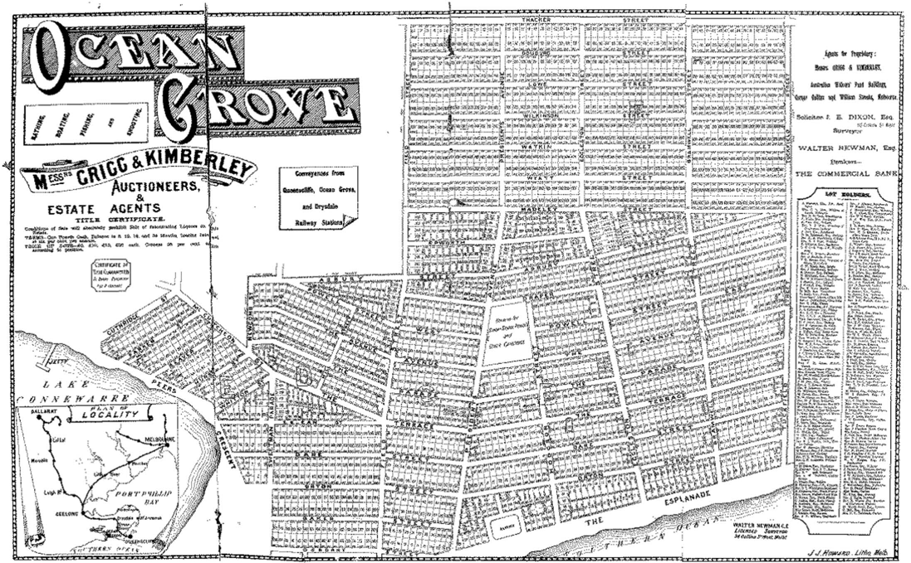
Figure 6.260: Plan of Ocean Grove subdivision, 1887. Source: GRS 2030/Map O6/01, Geelong Heritage Centre collection.

In 1854, William Bonsey bought the land upon which Ocean Grove is now situated, which consisted of 629 acres.1155 He subdivided the area as Kingston on the Sea.1156 A small community of fishermen and farmers formed the population of the Newington and Ocean Grove areas from the 1860s and 1870s.1157 Around this time a jetty was constructed
at the end of Guthridge Street, and ten or twelve fishing boats operated from this location1158 for the next 50 years. A small weatherboard shed was also built at the end of the jetty. By 1879, the jetty was named after the Blackwells, an early fishing family, and was met by a road, now known as Guthridge Street.1159
In 1887, the Ocean Grove area was re-subdivided as a unique development based on the precepts of the Methodist Episcopal Church (Figure 6.260). Auctioned by the
estate agents Grigg and Kimberley,1160 the Ocean Grove township was formed according to the ideals espoused by the American Methodist clergy, who came to Victoria and conducted tent missions.1161 A consortium of Victoria s Wesleyan Methodist Church clergy and businessmen were persuaded to support the American s plan for establishing a summer settlement around a camp meeting site similar to
the Ocean Grove settlement in New Jersey, U.S.A.1162 About
2,500 blocks of land were offered for sale, with roads and streets named after Victorian Methodist ministers or places associated with Methodism.1163 Like the covenant imposed upon the settlement in New Jersey, alcoholic, intoxicating, spirituous or vinous liquors were prohibited from sale and manufacture in the proposed Ocean Grove Methodist resort town.1164 A Coffee Palace (Figure 5.203) was also constructed as part of the settlement, although it was part of a proprietary limited company and not completely controlled by the Methodist consortium (it no longer survives)1165 (see Theme 5). The onset of the depression of the 1890s witnessed
the end of a truly Methodist-inspired settlement at Ocean Grove, as the clergy and businessmen who had invested in the venture suffered in the financial collapse at the time.1166 However, the land subdivision and infrastructure established by the Grigg and Kimberley plan remains to the present day, with several street names named after the Methodist clergy and businessman that had been involved, including Asbury, Baker, Beaver, Butters, Dare, Draper, Field, Hill, Hodgson, Hurst, Inskip, Lowe, Madeley, McCutcheon, Orton, Osborn, Parker, Peers, Powell, Sweetman, Thacker, Tuckfield, Watkin, Whitton, Wilkinson and Wyatt Streets, and Grubb Road.1167

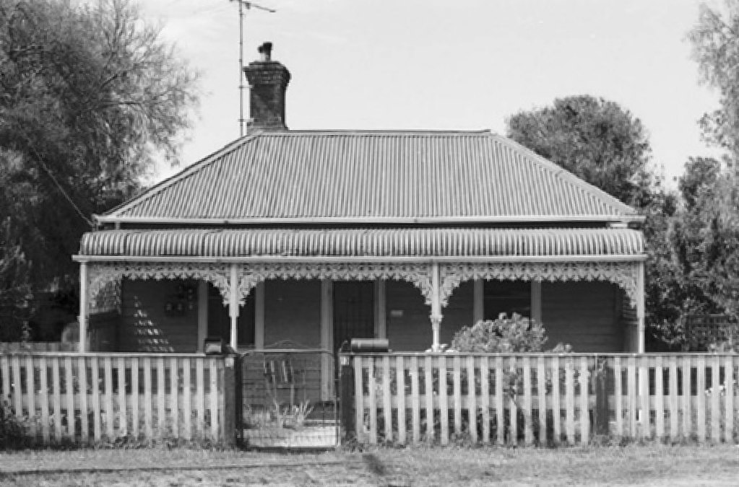

Figure 6.261: Dwelling, 13 Powell St West, 1996. Source: Huddle, et.al., Bellarine Heritage Study , 1996.

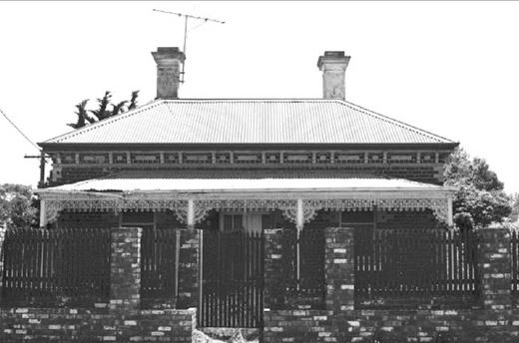
Figure 6.262: Dwelling, 111 The Avenue, 1996. Source: Huddle, et.al., Bellarine Heritage Study , 1996.

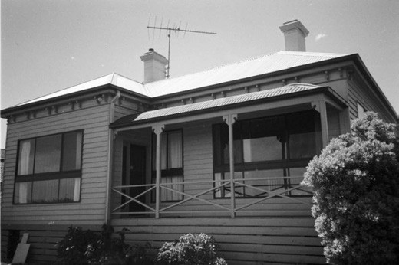
Figure 6.263: Almora , 56 The Parade, 1996.
Source: Huddle, et.al., Bellarine Heritage Study , 1996.

Today, few of the buildings and structures associated with
the early development of Ocean Grove remain. Those that survive provide an insight in into the life and development of the seaside resort in the 19th and early 20th centuries. Of note is the Victorian Carpenter Gothic styled Wesleyan (now Uniting) Church at 100 Eggleston Street. The religious hub of the early Methodist community, it was built in 1888 to a design by the Geelong Methodist architect, Albert Derrick.1168 Although traditionally a Methodist locality, an Anglican Church known as St. Peter s as built in 1896 at 33 Draper Street.1169 It continues as the Anglican Church hall today. It
was also in the late 19th century when the Ocean Grove State (now Primary) School opened at 33 Draper Street in 1892.1170 The school building had earlier served as the Steiglitz State School and was relocated to Ocean Grove at this time.1171
Little physical evidence remains of the early commercial life at Ocean Grove. Although altered, the corner store at 82 The Terrace has associations with Martin Guille, a contractor who erected and operated the store from 1892- 93.1172 By 1935, the store and adjoining dwelling were altered and extended, the roof being replaced with the existing gabled form which included an attic.1173 The store was operated by Frederick Menzies at this time.1174
Some early dwellings survive in Ocean Grove. At
13 Powell Street West, the house was built in 1890-91
for Joan Blackwell, wife of Thomas Blackwell, a fisherman1175 (Figure 6.261). The dwelling at 111 The Avenue, built in 1891, represents the first house in Ocean Grove constructed in brick (Figure 6.262). It was built by George Neilson as
the seaside retirement home for John Glew (1822-1893), pioneering and highly successful brickmaker of Brunswick.1176 Upon completion the origins of the bricks used in the construction of Glew s dwelling at Ocean Grove were described in the Geelong Advertiser:
The bricks used in the construction of Mr Glew s house were made by Mr Neilson and his men from a valuable deposit of red clay discovered with the syndicate s territory [Ocean Grove subdivision], the ornamentation in white brick being effected with bricks made at Brunswick.1177
Although altered, the dwelling Almora (originally called Friskney ) at 56 The Parade (Figure 6.263) provides the only remaining link to the now demolished Ocean Grove Coffee Palace. The dwelling was erected in 1889-90 by Messrs.
Nielson and Guille (who built many houses in Ocean Grove at this time) as the retirement home of Joseph Ingamells, recent manager of the Coffee Palace.1178 Another legacy of Ingamells contribution to Ocean Grove is Ingamells Park, Hodgson Street.1179

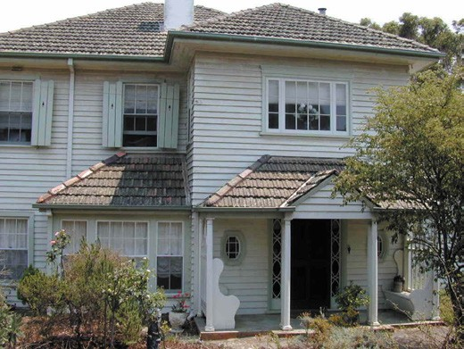
Figure 6.264: Broome Cottage , 3 The Avenue, 2003. Source: David Rowe.

Throughout the early 20th century, Ocean Grove became the retirement location of some wealthy pastoralists. In 1932, a substantial brick and timber residence was built at 63 Tuckfield Street for Thomas McKellar of the South Shadwell Estate near Mortlake.1180 Named Kingston , McKellar s dwelling at Ocean Grove was the design of Robert Bell Hamilton, Melbourne architect.1181 It was also at this time when Hamilton designed a large timber residence called Broome Cottage at 3 The Avenue, Ocean Grove, for Miss (Margaret) Gladys Bell (Figure 6.264). The works involved the partial demolition and major alterations and two storey additions to an earlier dwelling, Imbool , built in c.1894 as the holiday house of Thomas Hawkes.1182 Numerous houses built in the second half of the 20th century and in more recent years have transformed the holiday resort into a satellite suburb of Greater Geelong.

PORTARLINGTON
Originally called Drayton, the township of Portarlington was first laid out following a grid plan on the southern shores of Port Phillip Bay in 1850 (Figure 6.265), the location of William Harding s former sheep station.1183 Harding s Beach on
the foreshore at the north end of Simson Street marks the location of Harding s former station.1184 In 1851, the name of the township was changed to Portarlington, possibly in recognition the Earl of Portarlington (given that Marcus Hill was also named after British aristocracy at this time).1185 Streets were originally named after the early European squatters: Batman, Newcomb, Drysdale, Fairfax, Fenwick, Harding, Langdon, Simson, Mercer, Fisher and Gellibrand.

Situated on the northern-most point of the Bellarine Peninsula, Portarlington developed as a seaside resort and a port town (as a supplier for the rural farming hinterland). A flour mill was built near the foreshore to the north-west of the town in 1857 to service the surrounding wheat farms.1186 A public jetty was also built in 1859 for the conveyance of other farm produce including potatoes and onions.1187 The early growth of the fledgling township led to further land sales and subdivisions from the late 1850s to the late 1880s.1188 In 1870, T.D. Widdicombe began a brickworks factory, manufacturing red and white bricks, patent bond bricks, floor tiles, drain pipes and garden edging tiles.1189 This further enhanced the local economy.
However, it was the picturesque marine setting that gave impetus for Portarlington to become a marine resort for holiday makers. In 1882-83, it was described as a healthy watering place and being situated on a slope facing
Port Phillip Bay, within view of the surrounding shores, unfolds scenery of remarkable beauty. 1190 Much of the early development centred on Newcombe Street, with residences behind on the elevated land to the south (Figure 6.266). Hotels and other accommodation houses were soon built. The first hotel was the Bay View in 1858 (subsequently demolished).1191 It was followed by Duncan McKenzie s Portarlington Hotel at the corner of Newcombe and Harding Streets in 1860 (and extended in 1878 when operating as John Calhoun s Family Hotel).1192 In 1887, an ambitious proposal was made by Samuel Davies, a cordial manufacturer, to erect a substantial hotel.1193 Opening in
1888,1194 the three storey Boom style building designed by the Melbourne architect, William Wolf,1195 included projecting cast iron balconies and central tower (Figure 6.267), reflecting the wealth and opulence favoured by Melbourne s nouveau-riche (see also Theme 5).
To service the tourists, a bathing house was built on the foreshore in 1868 (and replaced in 1878).1196 The central foreshore area at Portarlington was permanently reserved for recreation and camping as early as the 1870s and 1880s. This included the establishment of Eastern and Western
Parks (see Theme 9 for further details). In 1891, an octagonal band rotunda was erected in timber to a design by the
Shire Engineer and architect, Andrew McWilliams.1197 It was located at the entrance to Eastern Park (Portarlington Park) and was relocated slightly north- west in the early 21st century.

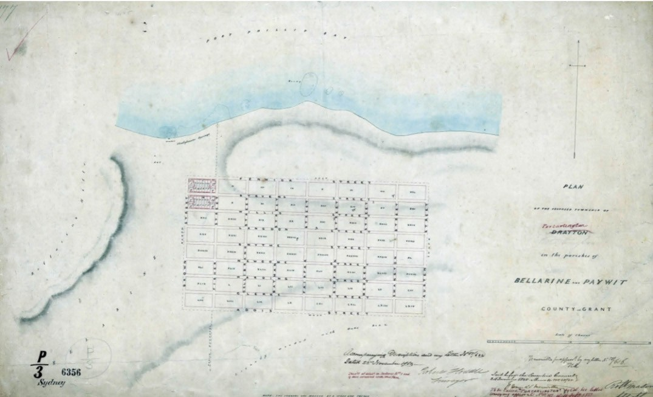
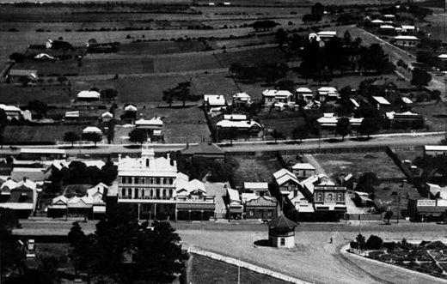
Figure 6.265: R. Mason, Plan of the Proposed Township of Drayton in the Parishes of Bellarine and Paywit, 22 November 1850. Source: VPRS 8168/P5, item SYDNEY P3, Public Record Office Victoria.

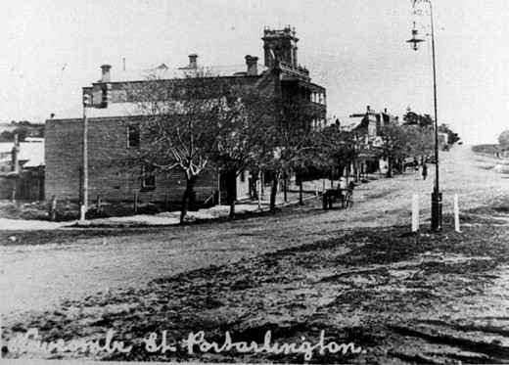

Figure 6.266: Aerial view of Portarlington, showing Newcombe St in the foreground, including the band stand, n.d. Source: Bellarine Shire
collection, photo 550, sheet 29, image 30, Bellarine Historical Society. Figure 6.267: Newcombe St, Portarlington, looking west to Grand
Hotel & neighbouring stores, c.1905. Source: Bellarine Shire collection, photo 447, sheet 24, image 6, Bellarine
Historical Society.

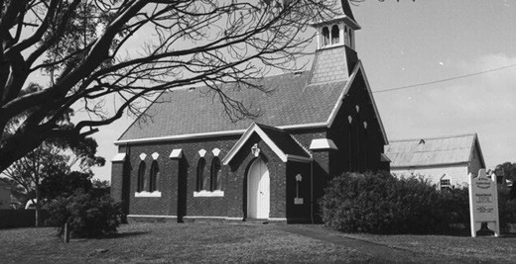

Figure 6.268: St. John s Anglican Church, 11 Brown St, n.d. Source: Bellarine Shire collection, photo 1035A, sheet 61, image A12, Bellarine Historical Society.

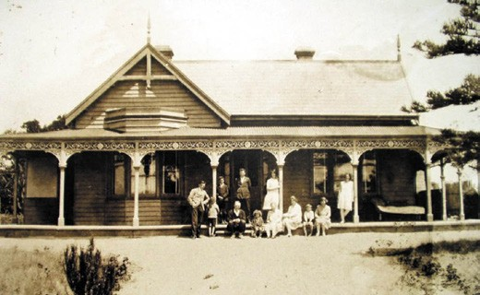

Figure 6.269: Claremont (earlier known as Laura Villa ), 17 Drysdale St, c.1905. Source: Photo 2647, Bellarine Historical Society.

Stores and other commercial and public infrastructure buildings were also erected. Only a small number of these places of the 19th and early 20th centuries survive, including the former bakery at 48 Newcombe Street (possibly built in the 1880s);1198 former Post Office at 1 Harding Street (built in 1888);1199 former Colonial Bank of Australasia at 8 Harding Street (built in 1888);1200 and the former Sinclair s produce store at 62 Newcombe Street (built in 1900).1201
Churches, school and other community buildings were also erected. They included St. John s Anglican Church, 11 Brown Street (built in 1883) (Figure 6.268); Sons of Temperance Hall, 28 Brown Street (built in 1874); former Methodist Church,
27-29 Harding Street (built in c.1872); and the Portarlington State School, 100 Newcombe Street (built in 1880)1202 (see also Theme 8).
Several 19th and early 20th century dwellings survive of residential life at Portarlington. The earliest remaining appears to be Carrick at 30 The Esplanade, built in c.1854 for Alexander Cameron MacDonald).1203 At 6 Drysdale Street, the late Victorian timber dwelling, Mansell Lodge , was built in 1889 as the Presbyterian Manse to a design

by Geelong architect, Albert Derrick.1204 At 17 Drysdale Street, Claremont (Figure 6.269) was built in 1875-76 as the retirement home of Frederick Willey and his wife, Eliza.1205 It was originally known as Laura Villa . Further east at 82-86 Drysdale Street, Messrs. Purnell and Sons, Geelong builders, erected a brick bungalow for local merchant, Thomas Brown.1206 The Geelong Advertiser was praiseworthy of the new villa (now known as Tarina ) and declared it an ornament to Portarlington. 1207
There are numerous other dwellings in Portarlington built in the latter 19th and early 20th centuries (based on their appearance). These places are also directly associated with residential life during the development of Portarlington as a port town and tourist resort and they are yet to be fully assessed. They include the dwellings at 31 and 34 Clarke Street, 26, 29, 40, 42, 44, 62 and 68 Fenwick Street, 15 and
21 Fisher Street, 26, 28, 39, 40 and 46 Harding Street, 64 Langdon Street, and the dwelling at 30 Willis Street.1208 In recent years, Portarlington has experienced considerable residential expansion.

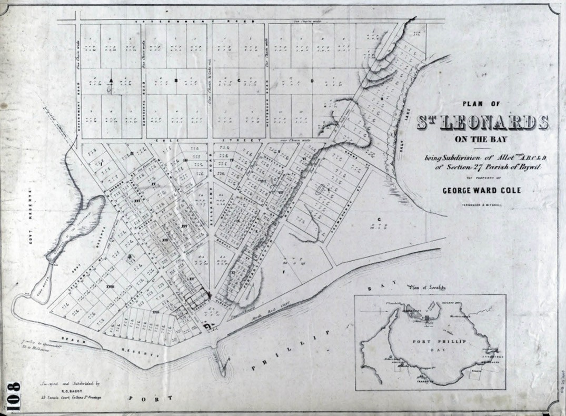

Figure 6.270: Plan of St. Leonards on the Bay being subdivision of Allotments A, B, C & D, Section 27, Parish of Paywit, Fergusson & Mitchell, Melbourne, c.1857. Source: State Library of Victoria.

ST. LEONARDS
Originally the location of the marine villas of the Bengalata balug clan of the Wadawurrung, the encampment of John Batman in 1835 and then the sheep run, Ellendale of Captain James Conway Langdon from 1843,1209 a village reservation for the Township of St. Leonards was created in 1853.1210
It comprised Block 1 of lot 34 in the Parish of Paywit.1211 Captain J.C. Langdon had been involved with the selection of the village reserve with the Commissioner of Lands, E.B. Addis, a year earlier (1852).1212 Langdon described the reserve as having a frontage of half a mile to the Bay and running about a quarter of a mile from the Cliff, each side
of the Weatherboard House, forming the Homestead of the Station called Ellendale. 1213
In 1857 at a Government land sale, George Ward Cole, a Naval Captain, merchant, sheep grazier and steamer
operator, purchased 830 acres of land immediately north and south of the salt lagoon on the eastern-most portion of
the Bellarine Peninsula.1214 There, he established a firewood trade, built a pier of unsawn logs (brought from Mount Martha) and sank a small vessel to provide a breakwater1215 (see Theme 4 for further details on the firewood trade). He was to become known as the father of St. Leonards.1216
It was also in c.1857 when Cole subdivided much of his land immediately south of the salt lagoon as the St. Leonards on the Bay Estate. Numerous residential and farming lots were laid out in a unique triangular plan, the apex being Cole s jetty on the shores of Port Phillip Bay1217 (Figure 6.270).
By 1858, Cole had built a hotel, store and six houses as part of his company town.1218 The hotel –built near the jetty – opened in 1860 and it became a landmark and the centre of social life in the town until it was destroyed by fire in 1906 (it was subsequently replaced with a broad hipped roofed hotel with return verandah, before another hotel was constructed after 1956-57).1219 The houses were erected for Cole s workers. Others of Cole s workers were situated within the

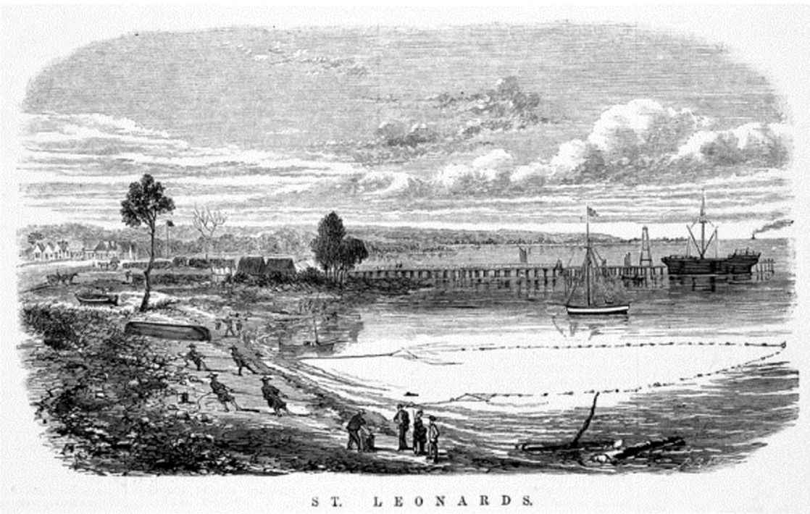

Figure 6.271: A.C. Cooke, St. Leonards , 1870. Source: Illustrated Australian News, 31 January 1870, accession IAN31/01/70/28, State Library of Victoria.

hinterland, being wood cutters that supplied the firewood by small craft to Melbourne.1220 From the early years, St.
Leonards also developed as a small fishing village, with eight fishermen resident in 1875 (five being Chinese).1221 A broad description of St. Leonards on the Bay was given in Bailliere s Victorian Gazetteer in 1870.1222 It was identified as a ‘postal town and watering place , situated on a small nameless creek and a freshwater hole. The description continued is a similar, less-than-positive manner:
The hotel is the St. Leonards. The bathing accommodation is very superior, the fittings under the jetty being adapted for bathers of both sexes at all states of the tide. The country is low, and the soil good only in small patches near the W. boundary of the parish, being cold and poor in most places; it is partly occupied for agricultural but chiefly for grazing purpose, being mostly covered with inferior brush forest; the pasturage is only second or third class, agreeing but with horse
stock. The only staple is firewood, shipped for Melbourne, Williamstown, and Sandridge, and conveyed thither in small bay craft of from 15 to 70 tons burthen. There is a pier and flagstaff in St. Leonards. The population consists of a few families only; the surrounding bush is inhabited
by a numerous body of wood cutters and carters. There is a salt lagoon, about half a mile in extent, surrounded by swamp, on the N. of the township; it is dry in summer.1223
An engraving of St. Leonard s in 1870 (Figure 6.271) also gave an appreciation of the small village at this time.
The work of A.C. Cooke (and engraved by Robert Bruce),1224 it showed Cole s jetty as a dominant feature of the foreshore (with a small crafted berthed there), the gabled hotel, stores and dwellings in the middle ground to the left, and Chinese fishermen hauling in their net on the foreshore.
Allotments in the Government s town reserve for St. Leonards were first sold in 1872, with E. Harvey acquiring five, and
W. Sievers lot one of block four.1225 In 1884, George Holden purchased four allotments in the township reserve while in 1888 (a year after the proclamation of St. Leonards as a town in 1887)1226 his brother, William, acquired two lots.1227 The nephews of Alexander Hood who had acquired a considerable portion of freehold land in 1857, with their mother, Margaret, George and William initially settled on 80 acres of land beside the creek near the township.1228 In 1872, William Holden acquired a small farm in St. Leonards.1229 He later established a coffee palace opposite the hotel at the corner of Bluff

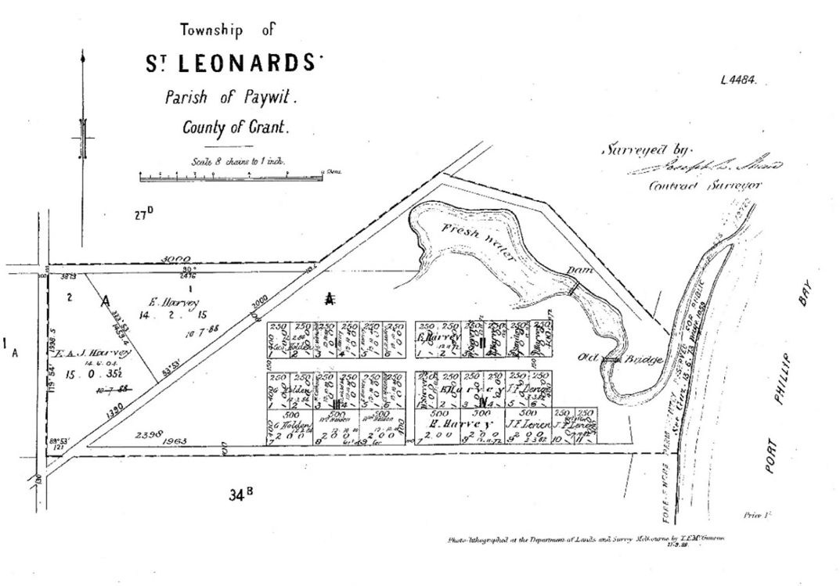
Figure 6.272: J.L. Shaw, Plan of the Township of St. Leonards, lithographed at the Dept of Lands & Survey, Melbourne, 27 September 1888. Source: St. Leonards Put-Away Plan, S449(1)/1, Landata, State of Victoria.

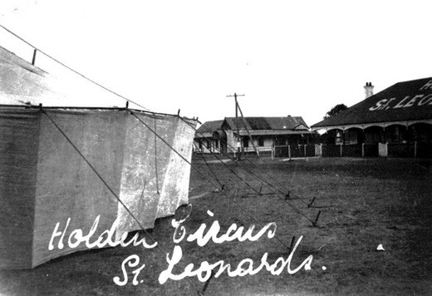
Figure 6.273: Holdens Circus tent, St. Leonards, c.1927 with the St. Leonards Hotel & Holden s store in the background. Source: Bellarine Shire collection, photo 620, sheet 33, image 23, Bellarine Historical Society.
and Murradoc Roads in 1908.1230 The nephew of George and William Holden, Adolphus Holden, founded the Holden Brothers Circus in Melbourne in 1892.1231 From about this time and into the early 20th century, the Holden Brothers Circus animals were wintered on William Holden s paddock at St. Leonards1232 (Figure 6.272). In the summer months,
a circus tent was erected on the village green opposite the hotel and coffee palace where the flying springboard performers, triple and double bar artists, aerial performers,
wire performers, and trick horses, ponies, dogs, donkeys and monkeys entertained the locals1233 (Figure 6.273).
From as early as 1857, St. Leonards became a popular marine resort.1234 In particular, the open foreshore reserve to the south of the St. Leonards pier (Figure 6.274) was a favourite picnic site for residents and visitors. In 1920, the St. Leonards Progress Association was formed and an application made for the area to be reserved for public purposes.1235 On 9
June 1921, the area was officially opened as Harvey Park, in honour of Kate Harvey, pioneer of St. Leonards, and

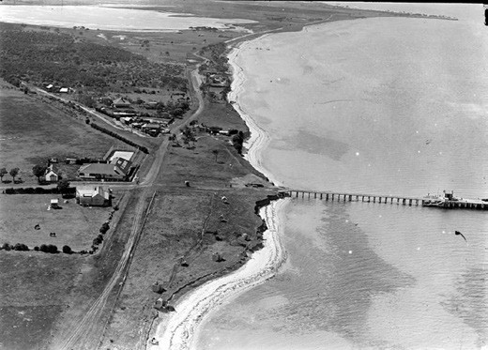
Figure 6.274: Aerial view of St. Leonards, including foreshore area popular with holiday makers, c.1925-40. Source: C. Pratt, accession H91.160/1652, State Library of Victoria.

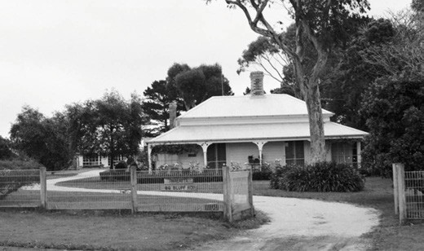
Figure 6.275: Thalatta , 89 Bluff Rd, 1995. Source: Huddle, et.al., Bellarine Heritage Study , 1996.

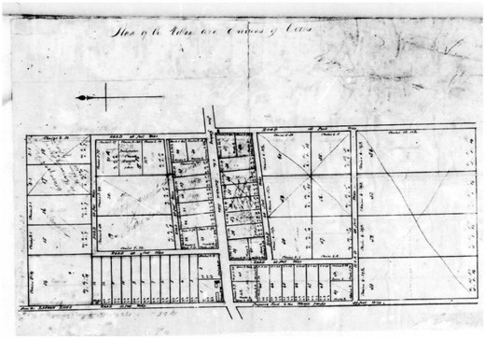
Figure 6.276: Fisher s subdivision plan of the Ceres Village, 1850. Source: GRS 2065/Map 17/60, Geelong Heritage
Centre collection.
mother of Cr. Edward Harvey who had been influential in gaining permission for the reservation.1236 The popularity of St. Leonards for summer holidays continued in the ensuing years, and in 1927 for example, the Geelong Advertiser reported that tents were pitched in every suitable place, transforming St. Leonards into a canvas township. 1237
Today, a number of dwellings and other surviving buildings are a legacy of the progress and development of St. Leonards in the 19th and early 20th centuries. One of the earliest and more intact dwellings is Thalatta , 89 Bluff Road (Figure 6.275), built in c.1874 as one of two identical houses erected by Frank Gilbert to attract tourists to the area. 1238 Another
is the dwelling at 30 Willis Street which also appears to have been built in the 1870s.1239
At 1339 Murradoc Road, the St. Leonards Primary School was built in 1910, replacing an earlier one-roomed timber school building erected in 1874 on land donated by George Ward Cole.1240 The Edwardian era also witnessed the relocation of the Church of England church building from East Bellarine to 8-12 Dudley Parade, St. Leonards, in 1914.1241 Having originally been erected in the 1860s from ballast on
a ship from England to Geelong, it was renamed St. Paul s and dedicated in 1915.1242 The St. Leonards postal service originally operated from the St. Leonards Hotel until its destruction in 1906.1243 A new timber Edwardian styled post office and dwelling was erected on the hill near the foreshore before being relocated to its current address at 1350 Murradoc Road1244 (in recent times it has been repaired and extended). Several other buildings at St. Leonards that have direct associations with its early development are yet to be fully assessed.

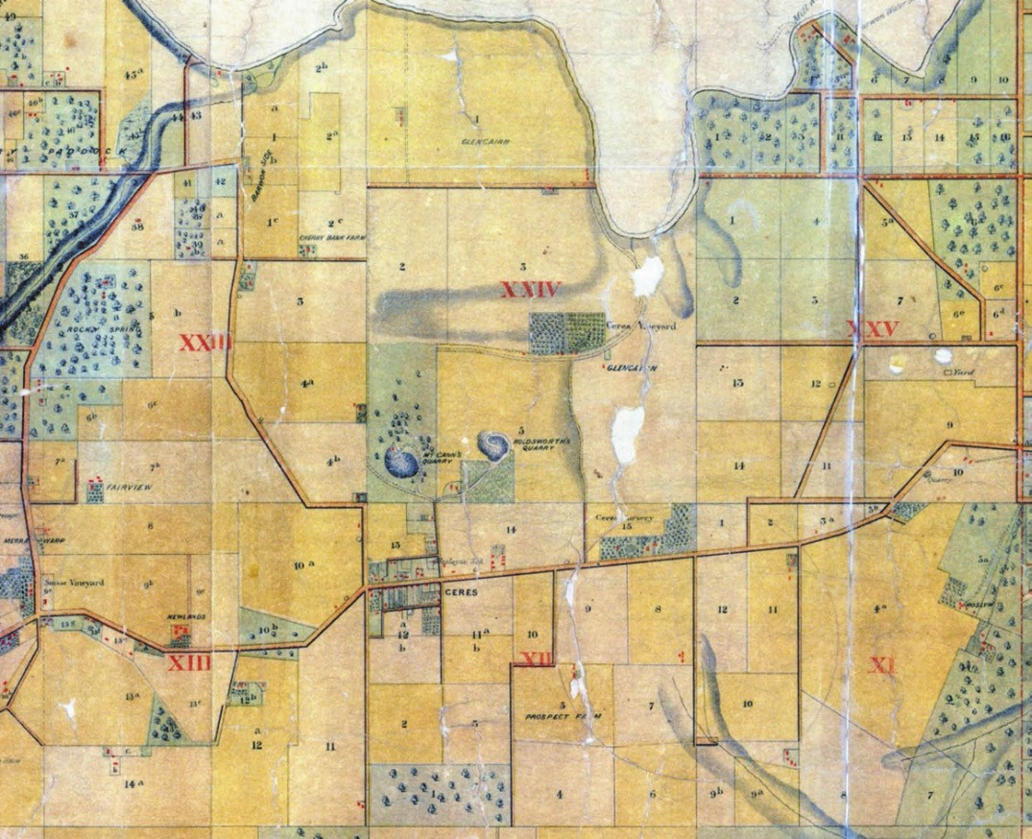
Figure 6.277: A. McWilliams, Part of Map of the Parish of Barrabool, 1861. Source: Jennifer Bantow, Geelong.
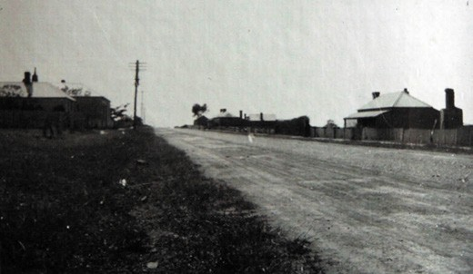
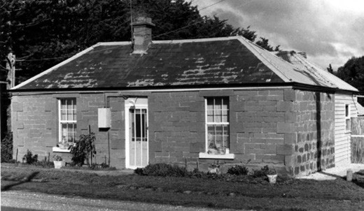

Figure 6.278: Barrabool Road, Ceres, looking north-west, c.1930. The Wheatsheaf Hotel is in the background (right).
Source: Holmes collection, Authentic Heritage Services Pty Ltd.
Figure 6.279: Cottage, 539 Barrabool Rd, 14 June 1970. Source: J.T. Collins, accession no. H94.200/633.

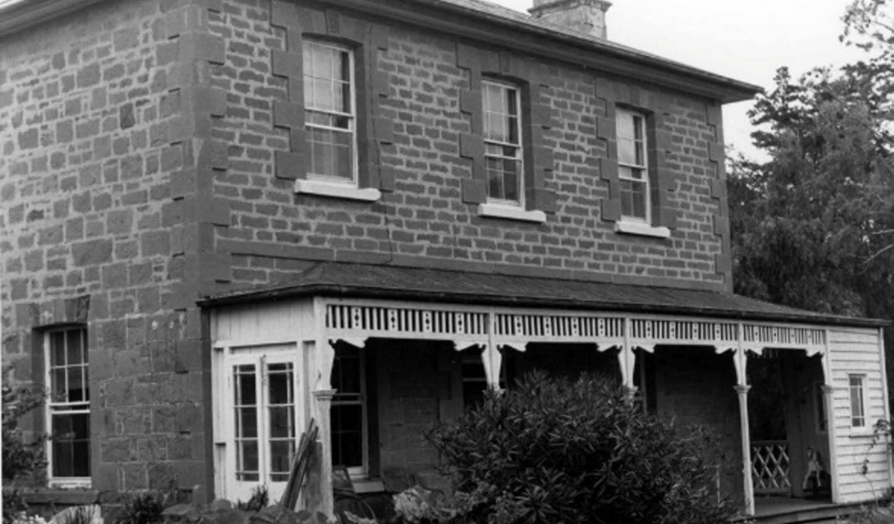
Figure 6.280: Merrawarp , 50 Honeys Rd, 14 June 1970. Source: J.T. Collins, accession no. H94.200/657.

WESTERN AND SOUTH-WESTERN REGIONS CERES AND THE BARRABOOL HILLS
By 1839, the Barrabool Hills had been surveyed as part of
the Barrabool Parish.1245 Barrabool was the name imposed on the Wathawurrung balug clan by European colonists, their name for the place being Barro: Abil (place of rounded hills). This clan was colloquially known by Europeans as the Barrarbool tribe.1246 Large acreages were made available
at a Government land sale in late 1839.1247 In February 1840, much of the Barrabool Hills was acquired by Charles McLachlan, a wealthy Scottish businessman of Tasmania, and his business partner, Captain Charles Swanston, English banker and merchant of Tasmania and member of the Port Phillip Association1248 who purchased Sections 2-3, 13-16, and 20-23 as his vast 4,480 acre Strathlachlan sheep estate.1249 In 1850, Sections 22 and 23 and parts of Sections
13 and 14 of the Strathlachlan Estate (Barrabool Parish) were subdivided into 65 farms centred on a village of 45 building sites as the Merrawarp Estate.1250 By 1861, there were only 10 owner residents in the Estate, with four fifths still being tenant farmers.1251 At this time, the Barrabool Hills were considered to be the granary of the colony, 1252 the location of sheep grazing and crop farms, and vineyards.
Another successful purchaser in February 1840 was
William Robertson, Port Phillip Association member. He acquired Sections 5, 11 and 12.1253 Two days after his purchase, Robertson sold Sections 11 and 12
to David Fisher, manager of the Derwent Company (successor to the Port Phillip Association). He named his estate Roslin which he subdivided into farms that were leased to various tenants.1254 In 1850, Fisher created the village of Ceres as a private subdivision of 58 allotments in part of Section 12 (Figure 6.276).1255 The small settlement was soon to become the centre of the agricultural district where the neighbouring properties farmed crops, grazed sheep and established noteworthy vineyards (Figure 6.277).
Early settlement was concentrated on the Barrabool Road (Figure 6.278). One of the earliest developments in the Village of Ceres was the construction of the Wheatsheaf Hotel by Stephen Thomas, an English stonemason. It was managed by his wife, Ann, from the mid-1850s, during which time she was described as a buxom hostess known locally as Mother Thomas. 1256 In 1855 in McCann Street, a Wesleyan Church was built of Barrabool stone and it
served as a denominational school until 1875 (see Theme 8). Although no longer serving its original purpose, the former church remains today, unlike the Sunday School hall (built c.1864 and extended in 1884 with the relocation of the former Devon Wesleyan Church) which was demolished in 2017.1257 Opposite the former church, the Temperance Hall (also of

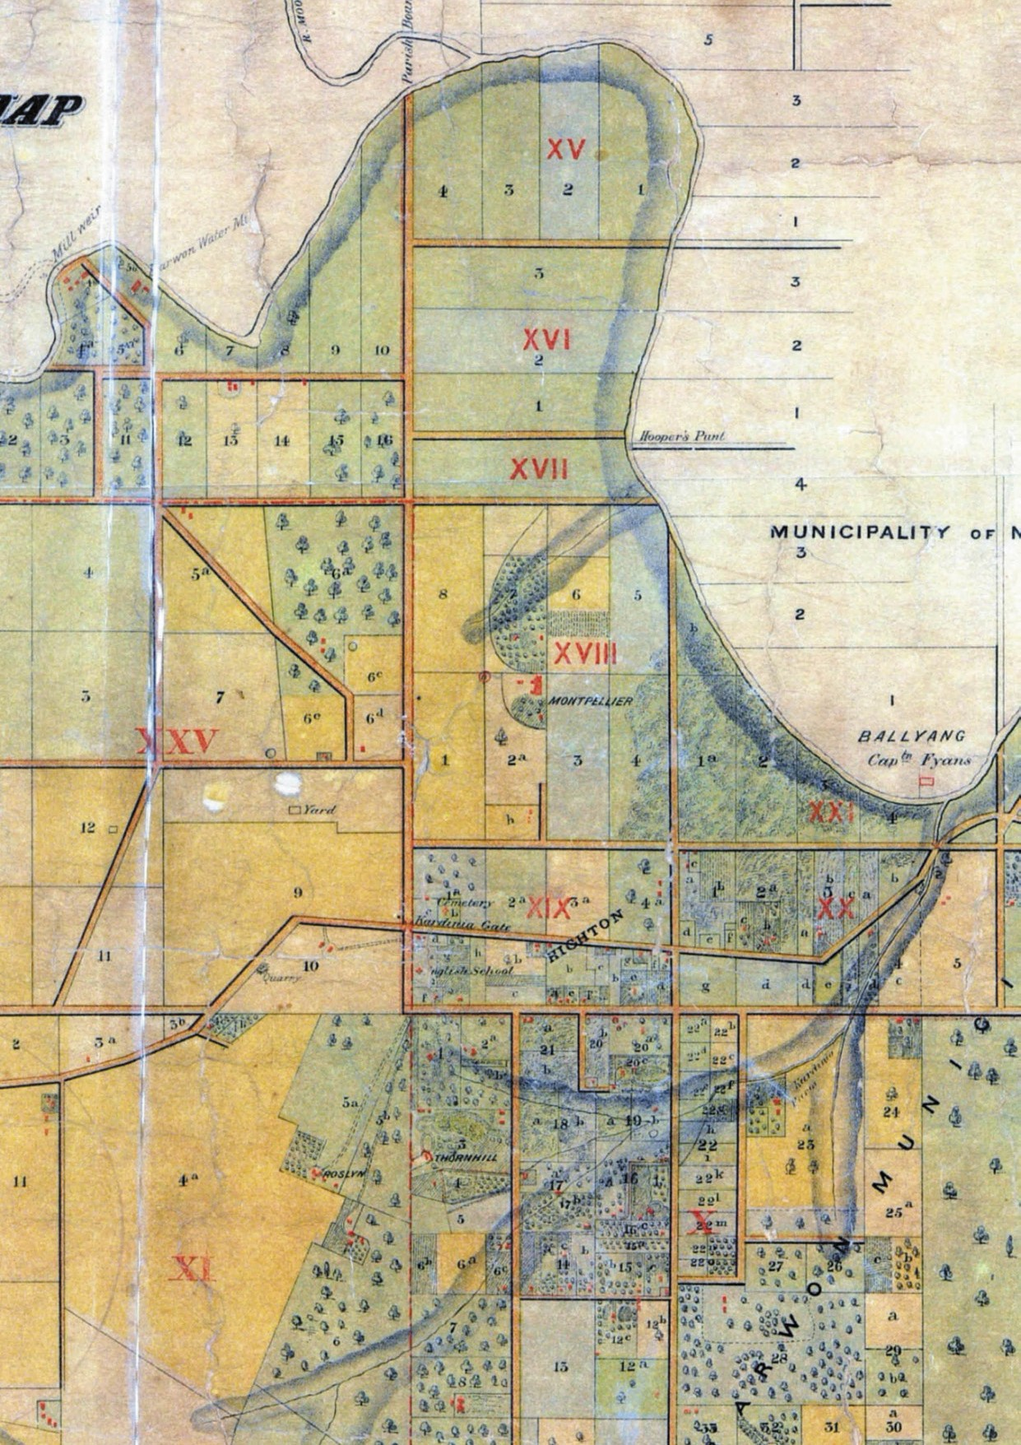

Figure 6.281: A. McWilliams, Part of Map of the Parish of Barrabool, 1861. Source: Jennifer Bantow, Geelong.

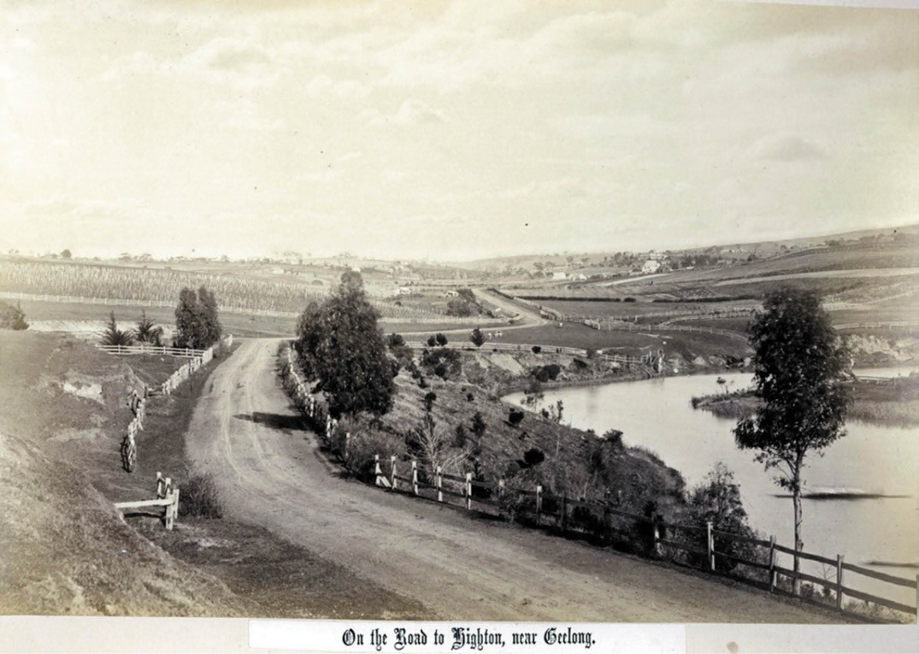
Figure 6.282: On the Road to Highton, near Geelong , 1880 (with Highton the background). Source: F. Kruger, accession H2006.123/135, State Library of Victoria.

Barrabool stone construction) survives, having been built for the Abstinence Society in 18611258 (see Theme 8).
At least 15 Victorian dwellings survive in the locality.
While there are variations in the designs (scale, roof forms, verandahs and other detailing), they are distinctive in reflecting the very early development of this rural area. Collectively,
they embody a recognisable architectural vernacular type (as a consequence of their scale, stone wall construction, slate roof cladding and siting) within the landscape of the Barrabool Hills that is peculiar to the area and rare in Victoria.1259 They include Barwonside ruins, 240 Gully Road, Ceres, built in 1850-53; former duplex, 5-7 Heal Street, built c.1850s; cottage, 539 Barrabool Road, Ceres, built before 1856 (Figure 6.279); cottage (former Post Office), 523 Barrabool Road, built 1850s; Merrawarp , 50 Honeys Road, built 1855 (Figure 6.280); Newlands 670 Homestead, Barrabool Road, built 1853;
Prospect Homestead, 50 Prospect Road, built 1861; Tasman , 755 Barrabool Road, built early 1850s; and the cottage at 517 Barrabool Road, built c.1867.1260

HIGHTON
Between 1847-49, the pastoralist from Dorset, England, John Highett, took up allotments in Section 18 of the Parish of Barrabool that had been reserved from 1839 for small settlers , like the land at Ceres in the Barrabool Hills to
the west.1261 Immediately south of Highett s landholdings, Alexander Thomson took up Section 10 and William Robertson Sections 11 and 12 respectively, each section comprising 640 acres.1262 Two days after his acquisition, Robertson sold Sections 11 and 12 to David Fisher, manager of the Derwent Company (successor to the Port Phillip Association –see Theme 2).1263 He named his estate Roslin , situated on the south-east of Highett s landholdings.1264 Nothing survives of this estate today but associations
endure in the name of Roslyn Road in Belmont and Highton. Similarly, nothing remains of Charles Nuttall Thorne s estate, Thornhill that was situated immediately east of Roslin from the late 1840s.1265 Thornhill Road, Highton, is the only legacy of Charles Thorne s associations with the area.

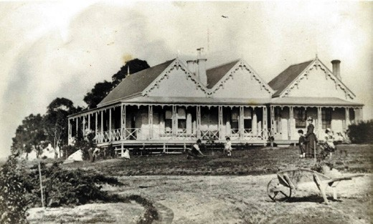
Figure 6.283: Shoubra , Highton, c.1870. Source: Current owner, Highton.

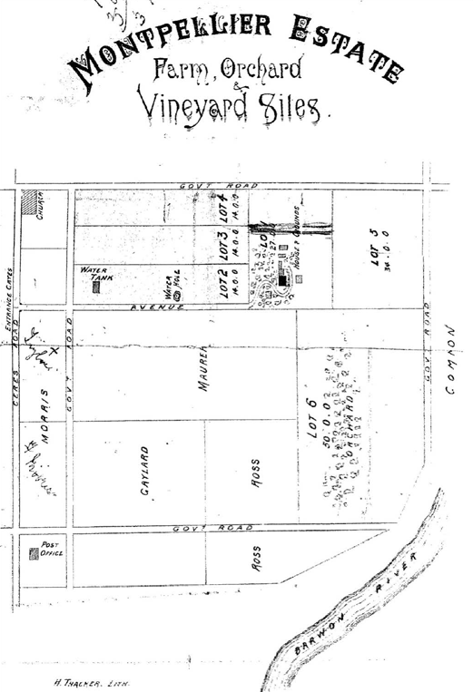
Figure 6.284: Montpellier Estate Auction notice, 28 July 1892. Source: GRS 2030/Map M30, Geelong Heritage Centre collection.

The two storey Italianate villa, Highton , built for John Highett in 1850-51 (see Theme 4) formed basis of the name of the suburb of Highton. At this time, Highett offered 57 allotments as the new village at the foot of the Barrabool Hills. 1266 It was described as:
About 20 acres of land, subdivided into convenient Lots, of about half an acre each; beautifully situated in one or the fertile valleys among the Barrabool Hills.1267
The village was initially called Highetton and was soon changed to Highton .1268 Highett s subdivision was the impetus for further subdivisions, and farm and building developments, and particularly the establishment of vineyards and nurseries in the ensuing years. This is illustrated in Andrew McWilliams Barrabool Parish Plan of 1861 (Figure 6.281). Of particular interest was Evan Lewis nursery off Barrabool, and Thomas Adcock s Kardinia Nursery, off Thornhill Road, both established in the 1850s (see Theme 4).1269 The rural setting of Highton, with its sloping topography, farms and vineyards, was also captured in a photograph by Frederick Kruger in 1880 (Figure 6.282).
At the top of McWilliams map was shown the Barwon Water Mill on the Barwon River near Buckleys Falls (see Theme 5). It was built by John Highett in 1851 to a design by Sheridan and Wright, architects.1270 The five storey stone building ground flour for the farmers of the neighbouring Barrabool Hills.1271 The site was later subdivided as the Riverfalls Estate.1272
McWilliams map also showed an English School in Highett s Highton Village. A freestone building, it was erected in 1854 as a Church of England school.1273 This school served the area until 1875 when the building was leased to the Education Department.1274 In 1879 a block of land was bought in Roslyn Road for a new school. The school building from Gnarwarre (which had closed) was relocated to this and it served until 1890 when a brick school was erected.1275 This building survives today.
Tangible legacies of the early beginnings of the Highton village from the 1850s are identified in a small number of dwellings that were part of the rural estates of notable
members of the Geelong community. They included Amanda Lodge , 5 Aringa Avenue, built in a Victorian Georgian style
in 1856 for George Southey;1276 Greystanes (formerly Herman Lodge),2 Brassey Avenue, built in 1853-54 to a Victorian Georgian design for William Bright, partner of the well-known and enduring emporium, Bright and Hitchcock s of Moorabool Street;1277 Adzar , 10 Brassey Avenue, built
in a Victorian design in c.1857 for George Belcher, sub- treasurer and gold receiver of Geelong;1278 Shoubra , 6a Keram Crescent (Figure 6.283), built in c.1857 in a Victorian Picturesque style for A. Chambers, secretary of the recently

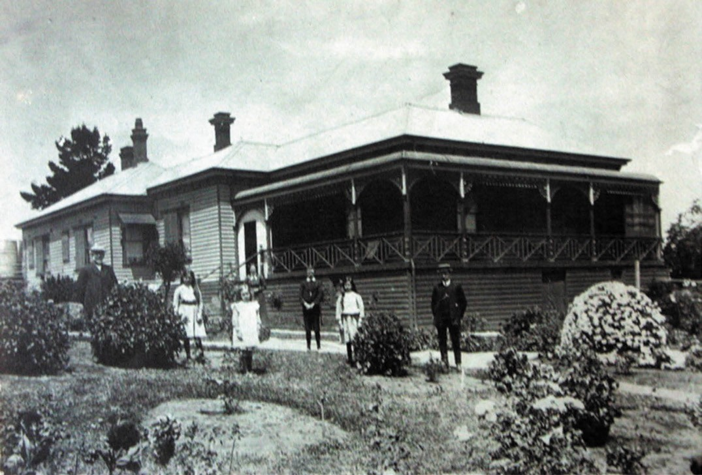
Figure 6.285: Thornbury Grange , Brassey Ave, c.1915. Source: Heather Lyons, Highton.

established Geelong Gas Company;1279 and Barrabool
House , 13 Pepperdine Way, built in 1854-55 for W.H. Bonsey, Geelong Police Magistrate.1280
There were also more modest dwellings erected for the working classes. They included Bonsey Cottage , a gabled vernacular dwelling first known as ‘Holmbush’ and built in 1854-55 by and for William Smith, a carpenter,1281 and the Victorian vernacular styled Mount Pleasant Cottage at 217 Mount Pleasant Road, built of Barrabool stone in the 1860s for Philip Hoskin, a Cornish farmer employed at Highton House in c.1855.1282
The original school also served as a church from 1858 until 1867 when the present St. John s was built at the south-east corner of South Valley and Roslyn Roads.1283 Wesleyan Methodists had conducted services in private homes early in the 1850s before building a church in 1855 opposite the Anglican church/school and next to the Barrabool cemetery which was gazetted about the same time.1284 The present St.

Luke’s was built in 1868 and the first church was demolished in 1872. St. Luke s too suffered in the 1926 tornado but was restored in the following year.1285 In 1974 it became St. Luke s Uniting Church and was extended in 1983.1286
Highton remained a rural village into the late 19th and early 20th centuries. Larger estates were subdivided during
this period and some further dwellings were constructed. A notable example in 1892 was the subdivision of the Montpellier Estate into 6 allotments (Figure 6.284). It was described as follows:
This beautiful Estate is situated upon a prominent spur of the far-famed Barrabool Hills. The spacious, substantial and stately residence, is one of the most conspicuous objects which catches the eye of an observer glancing in the direction of the beautiful village of Highton, from any of the more elevated sites in Geelong.
Having attained the eminence, one of the most magnificent views in Victoria presents itself to the eye

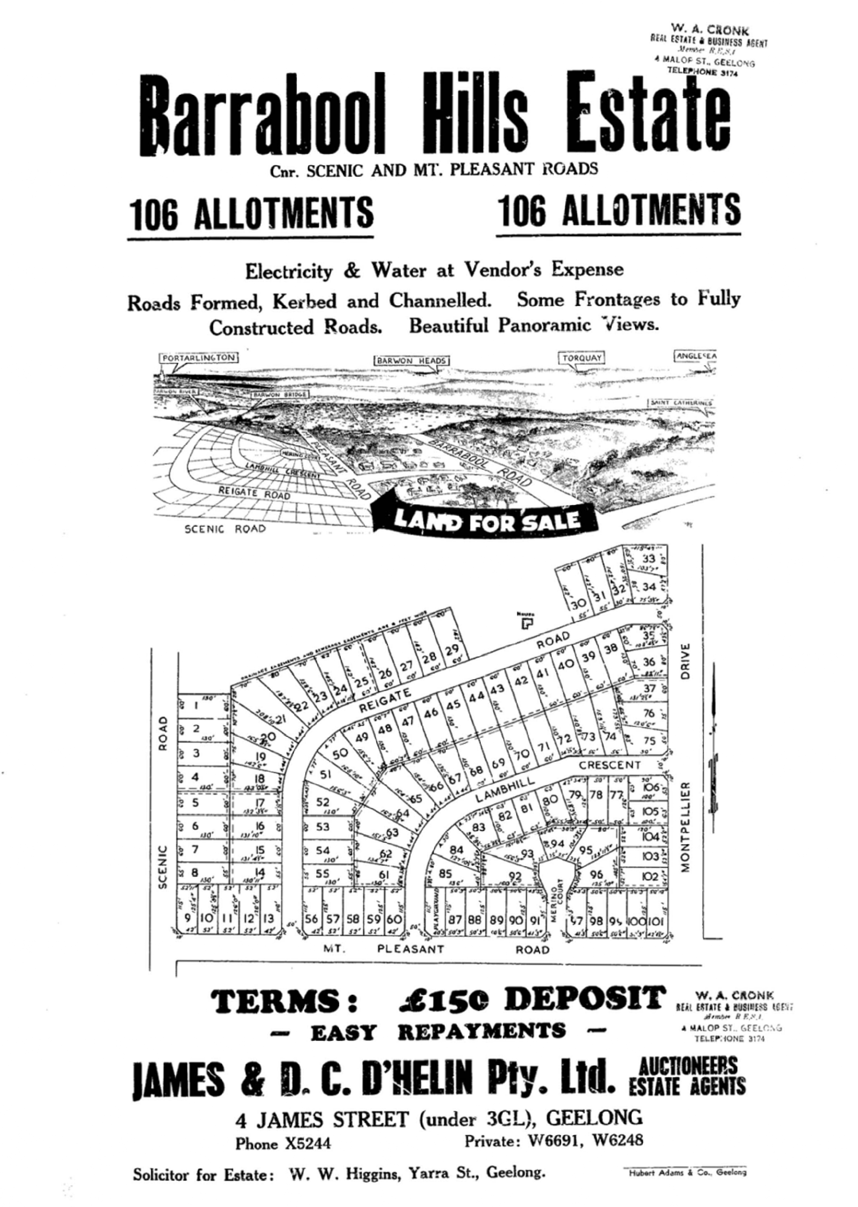

Figure 6.286: Barrabool Hills Estate Auction Notice, n.d. [c.1961]. Source: GRS 2030/Map B6/001, Geelong Heritage Centre collection.

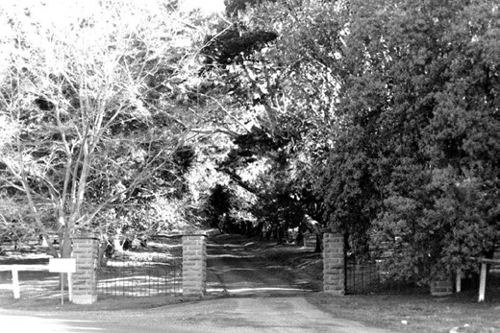
Figure 6.287: Entrance to Highview from Barrabool Rd before redevelopment & residential subdivision, 1998.
Source: David Rowe.

of the delighted observer. The site having been well chosen, a perfect panorama of all that makes a landscape charming is seen from the ample verandah.
The soil is all of the richest quality, being the pick of the far-famed Barrabool Hills, and nearly all virgin soil. The Lots subdivided are admirably adapted for cultivation, orchard, and vineyard sites. Water is laid on to the Estate from the mains, besides which there are several dams.1287
The subdivision of Adcock s Kardinia Nursey led to the construction of Thornbury Grange , 13 Brassey Avenue, in 1905 for Councillor Edward and Mrs Blanche Phillpott1288 (Figure 6.285). In 1912 there was a three-lot subdivision
of the Shoubra estate.1289 An example of Federation era development in Highton is the dwelling at 29 North Valley Road, built in c.1908 for Frederick Morriss, farmer.1290
Unlike other parts of Geelong, development in Highton during the interwar period of the 1920s and 1930s was not as substantial. The Geelong Advertiser gave a romantic description of the area in 1927:
A truly pleasant village, a village with a certain old world charm and atmosphere of its own. Set on its sloping valley, it offered on a fine day as convincing a picture of happy peace as an observant traveller could anywhere discover.1291

Examples of housing development in Highton during this period include Ferndale at 188 Mount Pleasant Road (built in the c.1920s for Stanley Harrison), Lochgoin , 72 North Valley Road (built c.1930 for Jack Whitfield) and the dwelling at 106 South Valley Road (built in 1931-32 for Arthur Wilby, farmer).1292 However, the most substantial development
in Highton during this period was the construction of St. Augustine s Orphanage, 187 Burdekin Drive, in 1936-39. It was designed by the Catholic architect, Cyril Kelly and built by his father, William.1293
The rural character of Highton changed dramatically after World War Two from the 1950s and throughout the remainder of the 20th century. Housing estates were established and numerous dwellings constructed. They included (but were not limited to) the Barrabool Hills Estate in 1961 (being 106 allotments north of Mt Pleasant Road between Scenic Road and Montpellier Drive, and taking in Lambhill Crescent, Merino Court and the southern portion of Reigate Road) (Figure 6.286); and the Ghyll Estate in 1962 (between Montpellier Drive and North Valley Road and taking in the northern portions of Reigate Road and Lambhill Crescent,
as well as Cheam Walk and the southern portion of Culzean Crescent).1294 Numerous brick houses were built in these estates between the 1960s and 1980s.
In the early years of the 21st century, the McCann family property, Highview on the north side of Barrabool Road (west of Scenic Road)1295 (Figure 6.287) was subdivided into several residential estates. Construction of substantial homes in this area continues in 2019.

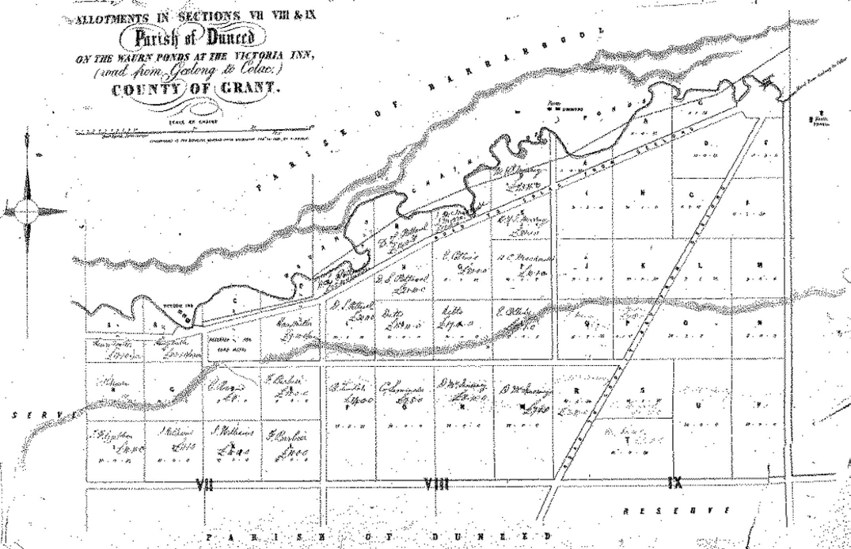
Figure 6.288: F. Byerley, Plan of Allotments in Sections VII, VII & IX Parish of Duneed on the Waurn Ponds at the Victoria Inn (from Geelong to Colac), Country of Grant, 13 February 1855. Source: GRS 2065/folio 19 map 40, Geelong Heritage Centre collection.

WAURN PONDS
The earliest European occupation of Waurn Ponds was the the establishment of an inn by Martin Priest on the north bank of Waurn Ponds Creek in 1846.1296 This was replaced in 1849 by a new building known as the Victoria Inn.1297 In 1855, several 10 acre allotments were made available for purchase on the south side of the Waurn Chain of Ponds1298 (Figure 6.288). The Inn closed in 1860 due in part of the laying out
of a new road to Colac on the south side of the creek and the advent of the new Waurn Ponds Inn in 1856.1299 The brick stables associated with the Inn are extant at 20 Marendaz Road.1300
Further European development came in 1848 when David Pettavel, a poineer vigneron, established
the Victoria Vineyard on his purchase of 300 acres
(see Theme 4)1301 About this time the land south of the creek was sold in 10 to 20 acre lots and in half acre lots along the Colac Road. The area was already served by denominational schools: a Church of England school and church was established on David Pettavel s vineyard in 1849; and it was
also at this time when a local Catholic school opened.1302 In 1859 a national school was built at the corner of Hams and Anglesea Roads and continued until 1866.1303 In 1870,
State School No. 1040 was erected of local stone but it was replaced in 1922 by a new school further distant from blasting operations at McCann s Quarry1304 (see Theme 4).
In 1863 a Wesleyan church was built; it opened in the following year and provided services in French for the local Swiss vignerons.1305 A Sunday School was added in 1892 but was relocated to Belmont where it was renovated as a church on the 1920s.1306 The Sunday School also served as a forum for the Literary and Debating Society in the late 1890s.1307 Dwindling attendances forced the closure of the
church in 1958 and its sale to the Belmont Church of England which moved it to Settlement Road where it was used both as church and day centre for the Grace McKellar nursing home.1308
In 1886 Waurn Ponds was described as a prettily situated postal township with one church and a state school.1309 Up to 1880 it had been sustained by the viticulture industry, being

made famous particularly by Pettavel s Victoria and Albert Vineyards1310 (Theme 4).
The other industry which maintained commercial viability at Waurn Ponds was quarrying (see Theme 4). Benjamin Holdsworth quarried for stone (from 1869) and Nicholas McCann for lime (from 1881). Today, these industries are
gone but archaeological evidence of the lime kiln is situated at 110 Lemins Road.1311
While Waurn Ponds remained a farming area throughout the first half of the 20th century, the beginnings of a major transformation into a suburb of Geelong began with the educational developments in Pigdons Road. In 1961, the Highton campus of the Church of England Girls Grammar School opened and it was followed by Marcus Oldham Farm Management College in 1962.1312 In 1970, the Gordon Institute of Technology relocated part of its operations to Pigdons Road in 1970 and this formed the nucleus for the Waurn Ponds campus of Deakin University in 1977.1313 Further north in Pigdons Road, the $270 million Epworth Hospital opened in 2016.1314 By this time, Waurn Ponds had
experienced substantial change, with the Geelong Ring Road providing more direct access to Melbourne. Major shopping centres had been built on the south side of the Princes Highway and hundreds of dwellings constructed following numerous subdivisions of previous rural allotments.

ENDNOTES

- I.D. Clarke, Aboriginal Languages and Clans: An Historical Atlas of Western and Central Victoria, 1800-1900, Monash Publications in Geography No. 37, Department of Geography & Environmental Science, Monash University, Melbourne, 1990, p. 311. The area was further refined with assistance from Corrina Eccles, Wadawurrung, 2018.
- Ibid.
- See for example, L. Lane, Fauna and Flora of Toolim: Beal , manuscript, supplied by Lane to author, 1998 & P. Munster, Little of Interest? A History of St. Leonards, Victoria, 2nd edn., St. Leonards Progress Association, St. Leonards, 2013, p.1., Lane (ed.), History with some Echoes of a lost local language, Abeng: An Aboriginese-English Lexicon compiled 1970-1999 from Ethnographic Literature –Part, unpublished, supplied for use to the City of Greater Geelong by Lane in 2002, p.239, Lane, The Bengali Hearth Group of the Wathaurung Tribe , manuscript no. 8, 1988, p.18, Special Collections, Deakin University Library, Geelong Advertiser, 29 September 1906, p.6 & Lane, Willem Barniip , manuscript, no. 66, 1992, Special Collections, Deakin University Library.
- Illustrated Australian News for Home Readers, Melbourne, 23 April 1872, p.96.
- Lane, The Bengali Hearth-Group , no.8, op.cit.
- Morgan, op.cit., p.29.
- M. Flinders, A Voyage to Terra Australis: undertaken for the purpose of completing the discovery of that vast country, and prosecuted in the years 1801, 1802, and 1803, in His Majesty s Ship the Investigator, and subsequently in the armed vessel Porpoise and Cumberland
schooner, with an account of the shipwreck of the Porpoise, arrival of the Cumberland at Mauritius, and imprisonment of the commander during Six Years and a Half in That Island, Libraries Board of South Australia, Adelaide, 1966, p.214, 217.
- J. Batman, The Settlement of John Batman in Port Phillip: from his own journal, Literary Dramatic Society, George Slater, Melbourne, 1856, p.11. The definition of a ‘gunyah in the English Oxford Living Dictionary online I An Aboriginal bush hut, typically made of sheets of bark and branches. See https://en.oxforddictionaries.com/definition/gunyah
- L. Lane, A Mirrnyong What s That , manuscript, no.3, 1982, p.1, Special Collections, Deakin University Library, & Lane, History with some Echoes of a lost local language’, op.cit., part 2, p.132, identified the ‘mirrnyong’ as mirniong .
- Lane, A Mirrnyong , op.cit., p.3.
- Lane, The Wathaurung: Geelong s earliest inhabitants , op.cit.
- Ibid. & Lane, A Mirrnyong , op.cit., p.2.
- Wurdi Youang Business Plan Summary, Wurdi Youang Proposed Indigenous Protected Area, Wathaurong Aboriginal Co-operative, 2018. This report states that the stone arrangement was built over 7000 years ago. However,
R. Norris in Case Study 4.3: Wurdi Youang, Australia in Heritage Sites of Astronomy and Archeoastronomy in the Context of the World Heritage Convention: A Thematic Study, International Council on Monuments & Sites (ICOMOS) and International Astronomical Union (IAU), 2010, p.77, claims the stone arrangement could date anywhere in the range c.25000BC to about 1835AD. Further information on the stone arrangement was given by Reg Abrahams Wathaurong Co-operative Ltd, to K. Krastins, J. Chalmers & D. Rowe, City of Greater Geelong, 2 May 2018.
- Abrahams, op.cit.
- D. Fisher, Letter, Roslin , Geelong, 21 September 1853 in T.F. Bride (ed.), Letters from Victorian Pioneers: Being A Series of Papers on the Early Occupation of the Colony, the Aborigines, Etc., Trustees of the Public Library, Melbourne, 1897, p.16.
- W.R. Brownhill & I. Wynd, The History of Geelong and Corio Bay with postscript 1955-1990, The Geelong Advertiser, Geelong, 1990, p.10.
17 Ibid., p.11.
- Bacchus Marsh Express, 13 June 1903, p.3 & Fisher, op.cit. Fisher s claim of having the first European house in Geelong was contradicted by Dr Alexander Thomson who claimed that he built his dwelling, Kardinia at Belmont in 1837 and he built a house for the Derwent Company, occupied afterwards by Mr. Fisher. See D. Thomson in Bride (ed.)., op.cit., p.251.
- Brownhill & Wynd, op.cit., & M. Cannon & I. Macfarlane (eds.), Historical Records of Victoria Foundations Series: Surveyors Problems and
Achievements, 1836-1839, Public Record Office Victoria, Melbourne, 1988,
p.161.
- Brownhill & Wynd, op.cit., p.10.
- Colonist (Sydney), 14 September 1837, p.3.
- I. Wynd, In the Beginning –1 , Investigator, vol. 20, no. 3, September 1985, pp.100-101.
- Ibid.
- See H.W.H. Smythe, Plan of the Town of Geelong 1838, VRPS 8168/P5 item FEAT, record 570, Public Record Office Victoria (PROV).
- Cannon et.al., op.cit., p.171.
- Ibid.
27 Ibid., p.170.
28 Ibid., p.171.
- Wynd, In the Beginning , op.cit., p.102.
- D.N. Jeans, Town Planning in New South Wales 1829-1842 , Australian Planning Institute Journal, October 1965.
- Ibid.
- M. Lewis, Grid Plan, eMelbourne: the city past & present, accessed April 2018, at http://www.emelbourne.net.au/biogs/EM00677b.htm
- Australian Chronicle (Sydney), 23 January 1841, p.2.
- Smythe, op.cit.
- D. Thomson, Colonial Secretary’s Office, Sydney, to the Police Magistrate, Melbourne, Port Phillip, 5 April 1838, VPRS 4/P0, Unit 4, folder 75, PROV.
- L. Lane, An Enquiry into the Origin and Spelling of Yarra (or Yarrow) Street , manuscript no.9, 1989, Special Collections, Deakin University Library.
- See for example, Port Phillip Gazette, 25 December 1841, p.3.
- Lane, History with some Echoes of a lost local language , op.cit., part, 1, p.55.
- Ibid. & Lane, An Enquiry , op.cit. Slightly different derivations are given in Cannon, et.al., op.cit., pp.176-177, including the meaning of Malop as being a place where shellfish are gathered.
- See W. Morrow, Streets of Geelong , n.d. unpublished, Geelong Heritage Centre collection, Medical Pioneers of Victoria Index online, accessed April 2018, R. Harcourt, ‘Melbourne’s Mystery Man [McKillop]’ in As I Understand It Essays Relating to the Founding of Melbourne , Port Phillip Pioneers Group n.d., accessed April 2018 at http://www.portphillippioneersgroup.org. au/pppg5es.htm & Swanston, Charles (1789-1850), Australian Dictionary of Biography vol. 2, Melbourne University Press, Carlton, 1967.
- J. Harrington, An Archaeological and Historical Overview of Limeburning in Victoria, Victorian Heritage Council, 2000, p.32.
- Wynd, In the Beginning , op.cit., pp.103-104.
- Ibid.
- The Courier (Hobart), 12 February 1841, p.4.
- Wynd, In the Beginning , op.cit., p.104.
- J.A. Hone, Willis, Edward (1816-1895) , Australian Dictionary of Biography, National Centre of Biography, Australian National University, http://adb.anu. edu.au/biography/willis-edward-4860/text8119, published first in hardcopy, 1976, accessed online 28 August 2019.
- Fisher advertised the sale of his dwelling at South Geelong in 1842 –See Geelong Advertiser, 29 August 1842, p.1. It seems the property did not sell and he retained ownership and the property was occupied by Willis
–see Geelong Advertiser & Squatters Advocate, 27 March 1843, which p.1, which first gave Willis’ address as Barwon Terrace. The Geelong Advertiser, 16 September 1850, p.3, advertised the sale or the property, it being described as lately being in the occupation of E. Willis, Esq., and consisting of 14 rooms, with larder, laundry, dairy, bake-house, cellars, and servant s rooms complete , indicating that the substantial rendered brick dwelling shown in Figure 6.07 had been built by this time.

- Geelong Advertiser, 20 January 1841, p.3, 4 September 1841, p.3, 24 April 1841, p.3, 13 December 1841, p.3.
- Geelong in 1840: Reminiscences by Samuel Mossman in Geelong Advertiser, 19 December 1879, p.3.
- Geelong Advertiser, 13 March 1841, p.3, 24 April 1841, p.3, 8 May 1841, p.3, 15 May 1841, p.3, 5 June 1841, p.3, 26 June 1841, p.3, 31 July 1841, p.3, 25 October 1841, p.3, 19 June 1841, p.3, 4 September 1841, p.3, 13 December 1841, p.3 & 20 December 1841, p.3,
15 April 1922, p.3.
- Port Phillip Gazette, 25 December 1841, p.3.
- Mossman, op.cit.
- Geelong Advertiser, 6 June 1842, p.2.
- The Port Phillip Patriot & Melbourne Advertiser, 12 May 1842, p.4, mentioned the punt on the Barwon , but not further details were given. For the location of the punt, see F. Proeschel, Map of Geelong and its suburbs, showing the division of the wards, boundaries of the suburbs, Campbell & Fergusson, 1855, State Library of Victoria (SLV).
- Brownhill & Wynd, op.cit., pp.592-593.
- The Argus, 5 June 1855, p.6, 1 November 1856, p.4.
- L. Huddle, Architects in Geelong 1840-1860 , Humanities Research Report, School of Architecture & Building, University of Melbourne, 1979, vol.1, p.1.
- Geelong Advertiser & Intelligencer, 7 November 1854, p.7 & 1 December 1855, p.2.
- Corian , In Old Geelong: An Attempt to Recapture the Past –Before we Forget’, ‘The “Official” Artery’, no. 16, Geelong Times, 1921-22, typescript, Geelong Family History Group.
- Geelong Advertiser, 22 March 1855, p.2 & Geelong Advertiser, 14 April 1862, p.4.
- S. Zada, ‘Mack’s Hotel [originally the Wool Pack Inn’, Geelong and District … covering local and family history in the greater Barwon region online, 8 May 2010, accessed May 2018 at http://zades.com.au/gandd/index.php/geelong/ pppluck/348-ppplmack
- R. Hoddle, Plan of Allotments in North Geelong, County of Grant, 26 February 1848, VPRS 8168/P5, item Sydney G12, PROV.
- Geelong Advertiser, 7 March 1848, p.2.
- Geelong Advertiser & Intelligencer, 10 March 1852, p.2. .
- See Tracing prepared from the Original Survey Cat R29.1013 for the purpose of Record shewing the Reserve for Ornamental Grounds: Gardens &c., 1848, VPRS 8168/P5, item SYDNEY, record G18, PROV & R. Hoddle, Plan of Geelong of Geelong: Proposed Extension, 23 October 1850, VPRS 8168/P5, item FEAT 578, PROV.
- Brownhill & Wynd, op.cit., p.324.
- R. Hoddle, Plan of Sections Nos. XXXVIII, XXXIX & XL Township of Geelong, 19 December 1850, VPRS 8168/P5, item Sydney G19, PROV.
- Geelong Advertiser & Intelligencer, 20 December 1853, p.7 7 J.L. Shaw, Plan shewing the position of Allotment No. 2 Section 9 North Geelong as subdivided and to be leased for a term of 14 years at Auction on Wednesday 21st Decr. At one o clock, maps & plans collection, N44, GHC.
- M. Lewis, Robertson & Lister , manuscript, January 2020, supplied to the author.
- Ibid.
- Ibid.
- Alexander Fyfe , Remember Database, Parliament of Victoria online, 13 October 2017, accessed May 2018 at https://www.parliament.vic.gov.au/ about/people-in-parliament/re-member/details/24/630
- M. Lewis, The Asian Trade in Portable Buildings , Asia-Australasia SAHANZ Conference Paper, Geelong, 1992, pp.5-6, referencing P. Alsop, prefabricated Buildings of the Nineteenth Century, with special reference to Geelong (typescript, 1968) & personal communication 29 June 1992. See also Geelong Advertiser & Intelligencer, 3 June 1853, p.2, 24 November 1853, p.3, 3 February 1854, p.4, 22 February 1854, p.4, 4 March 1854, P.6, 13 March 1854, p.8, 15 April 1854, p.6, 8 May 1854, p.2, 24 June 1854, p.2.
- Geelong Advertiser, 10 March 1862, p.2.
- Ibid. & J.H. Taylor, Map of Geelong, County of Grant, 1853-54, State Library of Victoria.

- Geelong Town Council Rate Books, Bellarine Ward, 1853-60, GHC, Geelong Advertiser, 29 September 1860, p.1, 28 October 1872, p.3.
- Geelong Advertiser & Intelligencer, 20 May 1854, p.3.
- L. Huddle, The Heights : Conservation Analysis Report , prepared for the National Trust of Australia (Victoria), February 1985.
- S. Zada, Biographical Family Report for Charles Ibbotson, typescript, August 2010
- Ibid.
- Huddle, op.cit.
- Geelong Advertiser & Intelligencer, 24 March 1853, p.2.
- Ibid., 8 November 1855, p.1.
- J.H. Bottrell, Newtown Hill and Roundabout , Geelong Advertiser, 19 January 1929.
- The Argus, 12 August 1873, p.6.
- E. Veitch, John Buckland in Friend Family Tree, Ancestry online, December 2018 at
https://www.ancestry.com.au/family-tree/person/tree/13209775/ person/27356806070/facts
- Ibid.
- Geelong Advertiser & Intelligencer, 17 February 1854, p.3, 3 March 1854, p.4.
- The Age, 22 Oct 1847, 4, included Mr and Mrs Buckland and servant as passengers arriving on the Kent.
- Leicestershire was the birth place of Clarissa Buckland. See Veitch, op.cit.
- Bottrell, op.cit.
- Geelong Advertiser, 28 October 1886, p.3.
- Ibid.
- G. Seaton, Model Borough: An Introduction to old Newtown and Chilwell, City of Newtown, 1983, p.106.
- Huddle, op.cit.
- The list is compiled from the Electoral Roll, 1856, for the Ashby, Barwon, North Geelong and South-West Province Divisions, Ancestry online, accessed May 2018.
- The Argus, 26 June 1857, p.4.
- Brownhill & Wynd, op.cit., pp.129-130.
- E. Bage, Plan of the Eastern Extension of the Town of Geelong, 28 February 1854, VPRS 8168/P5, item FEAT 482, PROV.
- St Vincent Place Precinct, Albert Park , Victorian Heritage Database online, 12 May 1999, accessed June 2018 at http://vhd.heritagecouncil.vic.gov.au/ places/1750
- Ibid.
- See Pevensey castle , Wikipedia, https://en.wikipedia.org/wiki/Pevensey_ Castle, House of Bourke Wikipedia, https://en.wikipedia.org/wiki/House_ of_Burke, Earls of Richmond , Wikipedia, https://en.wikipedia.org/wiki/ Earl_of_Richmond, Fitzroy , Wikipedia, https://en.wikipedia.org/wiki/Fitzroy
- Merchiston Hall, 2a Garden Street, Geelong , Victorian Heritage Database online, 13 June 2007, accessed June 2018 at http://vhd.heritagecouncil.vic. gov.au/places/524
- K. Cardell, C. Cummin & R. Bakker, Comunn na Feinne 1856-1946: More than a Pub Name (The History of the Geelong Highland Society and its activities 1856-1946), Peter Higgins, 2018.
- Ibid.
- Huddle, op.cit.
- Ibid.
- W.L. Blamire & J.S. Smith, The Early Story of the Wesleyan Methodist Church in Victoria, Wesleyan Book Depot, Melbourne, 1886.
- Huddle, op.cit., p.11.
110 Ibid., p.19.
111 Ibid., p.20, also known as the Gaelic schoolhouse.
112 Ibid., p.21.
113 Huddle, op.cit., p.66.

114 Ibid., p.65.
- Brownhill & Wynd, op.cit., p.87.
- Ibid.
- Geelong Advertiser, 29 December 1840, p.4, 30 March 1850, p.4.
- The Banner, 7 October 1853, p.9, Geelong Advertiser & Intelligencer, 1 February 1853, p.l1, 18 August 1854, p.4.
- Geelong Advertiser, 7 June 1856, p.5 & A. Willington, Geelong Region Historic Buildings & Objects Study, vol.2, Geelong Regional Commission, Geelong, 1986, sheet 244.
- Brownhill & Wynd, op.cit., p.88 & Geelong Advertiser & Intelligencer, 22 May 1854, p.4.
- Banner, 24 March 1854, p.9.
- Geelong Advertiser & Intelligencer, 25 January 1855, p.5. 123 Ibid., 17 April 1855, p.2.
- Brownhill & Wynd, op.cit., p.88.
- Geelong Advertiser & Intelligencer, 10 March 1852, p.2. 126 Ibid., 17 April 1855, p.2.
- Ibid.
- Ibid.
- Ibid., 10 January 1855, p.2.
- Ibid.
131 Ibid., 14 June 1854, p.4.
- See Proeschel, op.cit., for a list of some of the businesses in Geelong at this time.
- Geelong (Town 1849-1910); City (1910-1993), Agency notes, Agency VA 2431, PROV.
- Geelong Advertiser & Squatters Advocate, 30 May 1846, p.2.
- M. Donchi, The Union Bank Geelong , Architecture Research Thesis, School of Architecture & Building, Deakin University, Geelong, 1991.
- Smythe, Plan of the Town of Geelong 1838, op.cit., Geelong Town Council Rate Books 1849-53, GHC.
- D. Rowe, C Citations Heritage Study , prepared for the City of Greater Geelong, 2002.
- See Geelong Council Rate Books, 1851-1855, op.cit. The C Citations Heritage Study erroneously states that the house at 146 Corio Street might have been relocated to the site from elsewhere but the Rate Books suggest it was built on the site by 1852.
- A dwelling in the location of the existing cottage at 1 Veitch Place today was shown on Taylor s Map of Geelong, 1853-55, op.cit.
- Geelong Council Rate Books, 1875-1890, op.cit. & William Hodgson, Probate Administration files, 1884, VPRS 28/P2 Unit 164, PROV.
- Geelong Rate Books, 1852-1888. The C Citations Heritage Study erroneously states that the terraces at 147-151 Corio Street were built in 1854-55 instead of 1886-87. It appears that there was been confusion with the neighbouring terraces then existing at 153-157 and 159-163 Corio street.
- D. Rowe, Architecture of Geelong 1860-1900 , Architecture Research Thesis, vol.1, School of Architecture & Building, Deakin University, 1991, p.1.
- Ibid.
- See H.L. Cox, Survey of Geelong Harbour, 1864 (published at the Admiralty, London, 26 March 1865), VPRS 8168/P5, item MCS 76, PROV.
- Rowe, op.cit., p.34.
- Geelong Advertiser, 29 April 1889, p.3.
147 Ibid., 30 August 1876, p.2.
148 Ibid., 23 July 1892, p.4, 26 July 1892, p.4.
149 Rowe, op.cit., p.171. 150 Ibid., p.123.
- Geelong Town Council Rate Book, entry 174, 1889-90, GHC & Geelong Advertiser, 11 May 1889, p.3.
- Ibid.
- Rowe, op.cit., p.38.

- A. Willingham, Geelong Region Historic Buildings & Objects Study, op.cit., sheets 205 & 254.
- George Martin in Re-Member, Parliament of Victoria website, op.cit., January 2017, Geelong Town Council Rate Books, 1881-1890, Geelong Library & Heritage Centre, Geelong Advertiser, 3 September 1877, p.3, 1 June 1881, p.2, 6 May 1889, p.3, 17 August 1921, p.3 & 2 November 1921, p.7.
- Rowe, C Citations Heritage Study , op.cit.
- Rowe, Architecture of Geelong , op.cit., p.50.
- Geelong Advertiser, 22 October 1898, 1 May 1890 & Willingham, Geelong Region Historic Buildings & Objects Study, op.cit., sheet 157.
- Rowe, op.cit., p.45. 160 Ibid., pp.13-14.
- Ibid., p.7.
- Rowe, C Citations Heritage Study , op.cit.
- Geelong Advertiser, 16 June & 2 July 1890, Investigator, vol. 25, no.1, 1990, p.9, The Argus, 12 May 1892, p.2 and Strong, James, Probate Administration files, 1894, VPSR 28/P0, Unit 729, PROV.
- Geelong Advertiser, 21 June 1900, p.2.
- Rowe, Architecture of Geelong , op.cit., pp.106-107.
- Willingham, Geelong Region Historic Buildings & Objects Study, op.cit., vol.1, sheet 14.
- The Age, 19 October 1857, p.6.
- Geelong Advertiser, 27 December 1859, p.3. 169 Ibid., 1 May 1860, p.2.
170 Ibid., 10 July 1861, p.2.
171 Ibid., 19 August 1861, p.4.
- The Australasian, 29 December 1866, p.21.
- Geelong Advertiser, 30 October 1867, p.3.
174 Ibid., 22 August 1868, p.2.
- Ibid., 9 January 1872, p.3.
- The lamp is now reputedly stored in the depot at the City of Greater Geelong, although the heritage overlay (HO190) still applies to its earlier location in Yarra Street.
- Geelong Advertiser, 28 October 1863, p.2. 178 Ibid., 21 July 1855, p.3.
- Ibid., 9 January 1855, p.2.
- These flagstones were proposed to form part of another landscape treatment in this part of Malop Street in late 2019.
- Geelong Advertiser, 20 May 1875, p.3.
- Ibid.
- Ibid., 9 June 1896, p.3. The location of the cistern reservoir in the Haymarket Reserve was shown in the Geelong Waterworks & Sewerage Trust Detail Plan No. 19, revised November 1912 and July 1914, Barwon Water & City of Greater Geelong.
184 Ibid., 13 July 1896, p.2
- Ibid., 30 November 1896, p.2.
- Ibid, 7 November 1871, p.2.
- M. Cramp, Centenary 1871-1971: Swanston Street Primary School No. 1094, Hilltop Press, Newtown, 1971 & G. Butler & Associates, City of Geelong Urban Conservation Study Locally Significant Sites’, prepared for the City of Geelong, 1991.
- Geelong Advertiser, 27 August 1870, p.2.
- Ibid., 3 October 1872, p.3.
- Rowe, Architecture of Geelong , op.cit., p.87.
- Butler, et.al., op.cit.
- A. Sutherland, Victoria and Its Metropolis: Past and Present, McCarron Bird & Co., Melbourne, 1887, vol.2, p.150.
- ‘Former Geelong Post Office, 83 Ryrie Street, Geelong’, Victorian Heritage Database online, 4 May 1999, accessed June 2018 at http://vhd.heritagecouncil.vic.gov.au/places/4699

- The Age, 21 December 1893, p.5.
- A.J. Campbell, The Tourists Guide to Geelong and the Southern Watering Places on the Bay and Coast and Popular Holiday Resorts, M.L. Hutchinson, Melbourne, 1893, p.22.
- D. Rowe & W. Jacobs, Geelong Verandah Study , prepared for the City of Greater Geelong, Geelong, August 2006, p.10.
- Geelong Grammar School Hill Estate Plan, 31 October 1895, maps & plans collection, G45-01, GHC.
- Geelong Advertiser, 21 June 1900, p.2.
199 Ibid., 23 August 1894, p.2.
- Royal Commission on the Geelong Harbor Trust Final Report, presented to both Houses of Parliament, Parliament of Victoria, Melbourne, no. 18, 1912.
- Ibid.
202 Geelong (Town 1849-1910); City (1910-1993), op.cit.
- Geelong Advertiser, 25 June 1901.
- Rowe, C Citations Heritage Study , op.cit.
- R. Aitken, Edwardian Geelong; An Architectural Introduction , research report, Architecture Division, Deakin University 1979, pp.44-45.
206 Ibid., p.43.
207 Ibid., p.44.
- N. Lewis, Former Bright and Hitchcocks Building Moorabool Street
Geelong , Conservation Management Plan, commissioned by K.H. Edelstein Architects Pty Ltd, November 2004.
- News of the Week, 18 July 1908.
- Geelong Advertiser, 21 July 1913, p.2, L. Edmonds, Living By Water: a history of Barwon Water and its predecessors, Barwon Water, Geelong, 2005, p.77.
- Aitken, op.cit., p.53.
- News of the Week, 21 June 1917.
- The Leader, 17 November 1900.
- R. Aitken, Leisure and Pleasure Buildings of Geelong , Bachelor of Architecture Thesis, Deakin University, October 1980.
- Geelong Advertiser, 31 March 1900, p.4. The Electric Lighting and Traction Company was later taken over the by the Melbourne Electric Supply Company. On 1 September 1930, the State Electricity Commission took up control of Geelong s electrical supply and tramway system. See The Age 27 February 1930, p.14. See Theme 3 for
further details.
- Geelong Advertiser, 4 May 1901, p.3. 217 Ibid., 16 March 1912, p.7.
218 Ibid., 6 February 1911, p.2, 8 November 1911, p.2.
219 Ibid., 8 January 1914, p.2, 16 March 1914, p.3, 23 November 1915, p.3.
220 Ibid., 24 March 1925. 221 Ibid., 24 March 1926, p.7. 222 Ibid., 20 June 1928, p.6.
223 The Age, 19 May 1939, p.16.
- Ibid., 13 July 1939, p.16. By early 1940 it was found that a danger period as only green bar was shown when entering the intersection. A second or two was suggested ‘to enable traffic in the intersection to get clear.’ See The Age, 24 January 1940, p.12.
- The Herald, 5 August 1954, p.7.
- Geelong Advertiser, 12 August 1922, p.10. 227 Ibid., 3 July 1924, p.4.
- Butler, et.al., op.cit.
- Helen Lardner Conservation & Design, City of Geelong Urban Conservation Study Locally Significant Sites’, prepared for the City of Greater Geelong, May 1995.
- Rowe, C Citations Heritage Study , op.cit.
- D. Rowe, Former T & G Building, Geelong , Conservation Management Plan (Interior), prepared for Purchase 4 Investment Group, 2001-02.
- Rowe, C Citation Heritage Study , op.cit.

- Butler, et.al., op.cit.
- Willingham, Geelong Region Historic Buildings & Objects Study, op.cit., sheet 165.
- Lardner, op.cit.
- Rowe, op.cit.
- See Geelong City Council Rate Books, 1941-60, GHC, and aerial photographs of Geelong by Charles Pratt in 1939 and 1948 (accession nos. H91.160/634 & H91.160/323 SLV) which show the changes in the facades.
- Geelong Advertiser, 16 December 1922.
- Brownhill & Wynd, op.cit., p.654.
- Herald, 9 December 1939, p.15 & The Geelong Hospital (previously known as Geelong Hospital 1923-1924; and Geelong and District Hospital 1924-1966), agency notes, VPRS 4805, PROV.
- The Argus, 13 September 1940, p.10.
- The Argus, 25 December 1941, p.3.
- B. Carlton, From Sleepy Hollow to First Provincial City , The Argus, 24 September 1949, p.6.
- Ibid.
- Brownhill & Wynd, op.cit., p.654. 246 Ibid., p.701.
- The Horsham Times, 16 June 1954, p.4.
- The Argus, 5 august 1954.
- Lewis, op.cit.
- Geelong Waterworks & Sewerage Trust (GWST)Plan of Drainage no GT661, 13 September 1956, City of Greater Geelong.
- Brownhill & Wynd, op.cit., p.711.
- See photograph of the Geelong Harbor Trust building under construction, dated 1957, GRS 2009/02156, GHC.
- Alterations and additions were made in 1986. See Commonwealth Office building, Geelong, series B6295, National Archives of
Australia (NAA).
- New Hospital in Geelong , The Age, 30 July 1965, p.9.
- GWST Plan of Drainage no. G1390, 17 April 1962, City of Greater Geelong.
- Edmonds, op.cit.
- M. Page, An Architectural Apex, Buchan Laird International, South Yarra, 1990, p.167.
- Planning permits 734/1999 & 1019/1981, Statutory Planning Department, City of Greater Geelong.
- Geelong Advertiser, 21 May 1985, p.2.
- Ibid.
- Ibid.
- Ibid., 27 November 1985.
- Brownhill & Wynd, op.cit., p.711, 723. 264 Ibid., p.703, 712.
- Dennys Lascelles Woolstores, 26 Moorabool Street, Geelong , Victorian Heritage Database online, 20 September 2007, accessed May 2018, at http:// vhd.heritagecouncil.vic.gov.au/places/536
- The Geelong Hospital, op.cit.
- Brownhill & Wynd, op.cit., pp.726-727.
- Hassell, Geelong City Transit Precinct Urban Design Framework, prepared for Department of Infrastructure, July 2008, p.8.
- Rowe, C Citations Heritage Study , op.cit.
- The Argus, 25 August 1954, p.7. 271 Ibid., 5 May 1956, p.6.
- Brownhill & Wynd, op.cit., p.705.
- Rowe & Jacobs, op.cit., pp.13-14.
- Ibid.
- Ibid.
- Ibid.

- The Waterfront Story , City of Greater Geelong, 2008, at https://www.geelongaustralia.com.au/armstrongcreek/armstrong/article/ item/8cfafd49ea31e3f.aspx & Geelong Bollard Trail Walk , City of Greater Geelong, accessed 25 October 2016, at http://www.geelongaustralia.com.au/bollards/article/item/8d250a1f01e3425. aspx.
- Victoria s Regional Centres: A Generation of Change –Geelong, Department of Planning & Community Development, 2010.
- The Age, 19 February 2014, Australian Financial Review, 28 February 2014,
C. Jacobs, Ford closes its Australian factories after more than 90 years of car-making , ABC news online, 8 October 2016, accessed May 2018 at http:// www.abc.net.au/news/2016-10-07/ford-closes-its-australian-factories-after- more-than-90-years/7909836
- Transport Accident Commission Media Release, 26 February 2009.
- Geelong Advertiser, 6 June 2016.
282 Ibid., 19 June 2017.
- Ibid.
- Australian Institute of Architects National Architecture Awards 2018, Awarding Winning Projects at https://wp.architecture.com.au/awards-2018/ winners/#commercial & Barwon Water building brings national prize
to Geelong , Barwon Region Water Authority online at https://www. barwonwater.vic.gov.au/about-us/news-and-events/news/barwon-water- building-brings-national-prize-to-geelong
- Ibid.
- Central Geelong Action Plan online, Central Geelong Taskforce, City of Greater Geelong, December 2013, accessed June 2018 at https://www.geelongaustralia.com.au/common/public/documents/ amendments/8d2d0901dd9c6bb-CentralGeelongActionPlan.pdf
- Geelong Advertiser, 29 April 2016.
- Ibid., 6 December 2015.
- H.W.H. Smythe, Plan of Suburban Allotments in the Neighbourhood of Geelong, 10 February 1839, VPRS 8168/P5, item Sydney B39A, PROV.
- Port Phillip Gazette, 31 August 1839, p.4.
- G. Seaton, The Ashby Story: A History of Geelong West, Geelong West City Council, 1978, p.17.
- Lane, An Enquiry into the Origin and Spelling of Yarra (or Yarrow) Street , op.cit.
- Cannon, et.al., op.cit., p.176.
- C. Grimes, Map of Port Phillip, 1803, lithographed 1879, SLV (Figure 2.06) showed swamps at Point Henry. See also Cannon, et.al.,
op.cit., p.171.
- Sydney Herald, 16 June 1836, p.2. See also I. Wynd, Balla-wein: A History of the Shire of Bellarine to 1992, 2nd edn., Bellarine On-Line for Bellarine Historical Society, 2005, p.199 & Mossman, op.cit.
- Colonial Secretary to C.J. Latrobe, 1 October 1842, VPRS 19/P1 Unit 42 item 1646, PROV.
- South Australian Register, 10 June 1843, p.2.
- Wynd, op.cit., p.22.
- See A.R.C. Selwyn, Plan of Moolap, Bellarine, Point Henry: Geological Survey of Victoria no. 23, 1862, VPRS 8168/P5, item MD23C, PROV.
- Brownhill & Wynd, op.cit., p.222.
- Building & Engineering Journal, 27 December 1890.
- Brownhill & Wynd, op.cit., pp.223-224.
- Parish of Moolap, County of Grant, Schedule of Allotments, Sheet 3153, Landata.
- See Point Henry Estate Auction Notice, 5 June 1885, P59-001 & subdivision plan of Point Henry, 1888, P10, maps & plans
collection, GHC.
- Point Henry Maritime Heritage Precinct , Victorian Heritage Database online, 28 April 2004, accessed May 2018 at http://vhd.heritagecouncil.vic. gov.au/places/111689
- L. Huddle, R. Howe. R. Lewis & K. Francis, Bellarine Heritage Study , vol. 3, prepared for the Australian Heritage Commission, City of Greater Geelong & Heritage Victoria, June 1996.

- Willingham, Geelong Region Buildings & Objects Study, op.cit., sheet 101.
- C. Kellaway & D. Rowe, Farmland, Forest & Surf: Environmental History, Surf Coast Shire, 2009, p. 21, Wynd, Balla-wein, op.cit., p.166.
- Seaton, Model Borough, op.cit., p.13.
- Ibid.
- Ibid.
- K. Krastins, Newtown Heritage Study , prepared for the City of Greater Geelong, 2008 (adopted 2009), p.180.
- See Geelong Town Rate Books, 1854, Geelong Heritage Centre.
- Geelong Advertiser & Intelligencer, 2 September 1853, p.3.
- Ibid.
- Former Baptist Church, 3 Aberdeen Street, Newtown , Victorian Heritage Database online, 25 June 2004, accessed May 2018 at http://vhd.heritagecouncil.vic.gov.au/places/878 & Rowe, Architecture of Geelong , op.cit., p.21.
- Krastins, op.cit.
- Seaton, Model Borough, op.cit., p.20.
- Noble Street Uniting Church, Hall & Kindergarten, 35 Noble Street, Newtown , Victorian Heritage Database online, 6 May 1999, accessed June 2018 at http://vhd.heritagecouncil.vic.gov.au/places/2014
- W.J. Morrow & I. Wynd, Geelong Hotels and Their Licensees, Geelong Historical Society, 1996, p.16 & Taylor, op.cit. The Corio Cricket Oval is now Kardinia Park.
- Context Pty Ltd, B. Stafford, R. Peterson & C. Kellaway, City of Newtown Urban Conservation Study , vol.3, prepared for the City of Newtown, 1991. The study claims the dwelling to have been built in c.1861 but it seems to be shown on Taylor s Map of Geelong
(Figure 6.22).
- Context, op.cit.
- Geelong Advertiser, 2 March 1866, p.2 & GWST Plan of Drainage No. 67, c.1914, GHC.
- Context, op.cit.
- Geelong Advertiser, 28 October 1911, p.10.
- M. Matthews, Armytage House: A Conservation Management Plan , School of Architecture & Building, Deakin University, 1995, p.20, Huddle, op.cit, p.64, 104, L. Huddle, The Heights Conservation Analysis Report, prepared for the National Trust of Australia (Victoria), 1985, & D. Rowe & W. Jacobs, Newtown Heritage Review , vol.2, 2016.
- L. Honman, A Conservation Plan for 2 Skene Street, Newtown , n.d., heritage library, Statutory Planning Department, City of
Greater Geelong.
- Seaton, Model Borough, op.cit., p.105.
- Willingham, op.cit., vol. 3, sheet 344.
- D. Rowe & W. Jacobs, Sacred Heart College, Newtown , Conservation Management Plan, prepared for Sacred Heart College, 2009.
- Willingham, op.cit., sheet 294.
- J.L. Shaw, Plan of the Laurel Bank Estate, Newtown, October 1871, map L70, GHC.
- J.L. Shaw, Plan of Mercer s Hill Estate, Belgravia, 1871, map M102, GHC. The Mercer’s Hill Estate was first offered in 1854 to a plan laid out by Shaw
–see Plan of Mercer s Hill Estate: The Village of New Chilwell, 4 February 1854, map M98, GHC.
- See Mercer s Hill subdivision plans, M106 & M107, GHC.
- The Advocate, 21 May 1887.
- Sutherland, op.cit., p.151.
- See Plan and Brochure for Newtown Hillside Estate, 10 November 1888, maps N3A-B, GHC.
- Plan of Subdivision of Buckland s Paddock Estate, Newtown Hill, 1888 map B41D, GHC.
- Buckland s Paddock Estate sales brochure, 29 November 1890, map B41B, GHC.
- Plan of Subdivision of Geelong Town Properties being The Priory and

Aberdeen Street frontage, n.d. [c.1889], map G15 GHC.
- R. Peterson, City of Newtown Urban Conservation Study C Citations prepared for the City of Greater Geelong, 1997.
- Geelong Advertiser, 25 August 1891, p.3.
- D. Rowe & W. Jacobs, Newtown West Heritage Review , prepared for the City of Greater Geelong, 2016.
- From the Geelong Advertiser about William Purnell and His Family , manuscript, GHC & L.A. Purnell, The Purnell Family History, Les Purnell, Geelong, 1990.
- Ibid.
- Ibid.
- Peterson, op.cit.
- Information taken from Newtown & Chilwell Council Rate Books 1874-75, 1883, 1884 & 1895-96, GHC, Purnell, op.cit., Certificate of Titles vol. 361, fol. 170 & vol. 1244, fol. 656, Purnell, William, Probate Administration files, 1904, VPRS 28/P0 Unit 688 Public Record Office Victoria, & J. Smith (ed.), The Cyclopedia of Victoria, Cyclopedia Company, Melbourne, 1903.
- See Plan of Allotments for Virginia, Elizabeth & Pakington Street, n.d. map G1, GHC, Geelong Advertiser, 7 April 1891, p.2 & Campbell, A.M., Probate Administration files, 1897, VPRS 28/P0 Unit 456 PROV.
- Peterson, op.cit.
- Krastins, op.cit.
- Context, op.cit.
- Krastins, op.cit.
- Geelong Advertiser, 19 July 1890, p.3.
- The Age, 31 August 1905, p.6.
- Plan of Subdivision of Newtownhill Estate, 9 May 1908, map N24, GHC.
- Rowe & Jacobs, Newtown Heritage Review , op.cit.
- Geelong Advertiser, 22 August 1911, p.2.
- Ibid.
- Newtown & Chilwell Rate Books, 1911-14, GHC. The then unusual use of concrete in the construction of the dwelling, Rhineland , was due to
Messy-Rhine s employment as engineer of the Geelong Portland Cement Works at Fyansford. See D. Watson, Starting a Structural Revolution: was Siemen’s warehouse Brisbane’s first reinforced concrete framed building?’, Queensland History Journal, vol. 22, no.3,
November 2013, p.237.
- Geelong Advertiser, 17 August 1911, p.1.
- Newtown & Chilwell Rate Books, op.cit., 1911-12
- Ibid.
- Context, op.cit.
- Krastins, op.cit.
- Geelong Advertiser, 17 October 1911, p.2, 8 January 1916, p.8 & Newtown & Chilwell Rate Books, 1911-13, GHC.
- Newtown & Chilwell Rate Books, op.cit., 1911-16. 368 Ibid., 1913-14.
- Plan of Newtown Bareena Estate, 28 October 1922, map B93, GHC.
- Geelong Advertiser, 21 October 1922, p.8.
- See Rowe & Jacobs, op.cit. & Krastins, op.cit.
- Newtown & Chilwell Council Building Permit Register, 22 February 1922, Building Department, City of Greater Geelong (COGG), & Certificate of Title vol. 4526 fol. 1010.
- L. Huddle, heritage consultant, architectural research data supplied to author, 26 June 2011.
- Ibid.
- Geelong Advertiser, 23 November 1925.
- Newtown & Chilwell Council Building Permit Register, 10 August 1926, GWST Plan of Drainage no. N6367, 14 March 1927, COGG.
- Krastins, op.cit.
- Geelong Advertiser, 1 September 1928, p.1 & Newtown & Chilwell Building Permit Register, 4 September 1928, COGG.

- Ibid.
- Krastins, op.cit.
- Geelong Advertiser, 28 March 1927, p.1. 382 Ibid., 28 March 1928, p.5.
- The Fyans Estate Subdivision Plan, 14 May 1938, Authentic Heritage Services (AHS) collection.
- Plan of Fernery Grove Estate Newtown, 15 July 1939, AHS.
- The Croker Estate Newtown Subdivision Plan, 21 June 1939, map C4, GHC.
- Rowe & Jacobs, Newtown Heritage Review , op.cit., vol.4.
- Plan of Subdivision of Edgecombe, Newtown, 26 February 1941, map E45, GHC.
- Plan of Queens Park View Estate, 1955, map P53 & Plan of Windmill Estate, 1956, map W44, GHC.
- Seaton, The Ashby Story, op.cit., pp.36-37.
- L. Honman, L. Huddle & R. Aitken, City of Geelong West Urban Conservation Study , vol.3, prepared for the City of Geelong West, 1986.
- Seaton, The Ashby Story, op.cit.
- Ibid., & Honman, et.al., op.cit.
- D. Rowe & W. Jacobs, Ashby Heritage Review Stage 2 , prepared for the City of Greater Geelong, 2010.
- No date was shown on the Milton estate subdivision plan, however it appears to be dated 1854 as the surveyor, Alexander Macdonald, was not practicing on his own until c.1852 and the date 1854 corresponds with the known date of the adjoining Kilkenny Estate subdivision.
- Rowe & Jacobs, Ashby Heritage Review , op.cit.
- Ibid.
- Lane, History with some Echoes of a lost local language , op.cit., part 1, p.46 & 197.
- Rowe & Jacobs, op.cit.
- Homan, et.al., op.cit.
- Ibid. & Borough of Geelong West Rate Books, 1854-89, GHC.
- Honman, et.al., op.cit.
- Ibid. & additional historical research into newspaper & Rate Books by the author.
- Until recent years, the dwelling at 127 Elizabeth Street was originally situated at 25 Candover Street.
- Geelong Advertiser, 5 December 1849, p.1 & Geelong Advertiser & Intelligencer, 6 December 1853, p.2.
- Rowe & Jacobs, op.cit. No year was listed on the Milton Estate notice, but the day and date of Saturday 11 December were given. It is assumed that the notice was dated 1880 because it was in this year when the Milton Estate was first listed in the Geelong West Borough Rate Books.
- Ibid.
- Seaton, The Ashby Story, op.cit., p.121.
- Rowe & Jacobs, Ashby Heritage Review , op.cit.
- Ibid.
- Ibid.
- Ibid. It is assumed that the Fairview Estate plan is dated 1888.
- Ibid.
- Ibid. & Geelong West Borough Rate Books, 1890-1919, GHC.
- Rowe & Jacobs, op.cit.
- Ibid.
- Ibid.
- Ibid.
- Ibid.
- Ibid.
- Ibid.
- Ibid.
- Ibid.

- Ibid.
- Ibid.
- Ibid.
- Geelong West Borough Rate Books, 1917-18, GHC. 427 Ibid., 1912-13.
- Seaton, op.cit., p.181.
- Rowe & Jacobs, op.cit.
- Seaton, op.cit., p.183.
- Rowe & Jacobs, op.cit.
- D. Rowe, Geelong West Town Hall Heritage Report , prepared for the Geelong Ethnic Communities Council, August-September 2001.
- D. Rowe, Pakington Street Urban Design Framework Interim Heritage Report , prepared for the City of Greater Geelong, February 2018.
- Ibid.
- Seaton, op.cit., p.212. 436 Ibid., p.223.
- Rowe, Pakington Street Urban Design Framework , op.cit.
- Ibid.
- R. Hoddle, Plan of Allotments marked at Cowies Creek & Corio Bay, 13 April 1847, VPRS 8168/P5, item Sydney C14, PROV.
- I. Wynd, So Fine a Country: A History of the Shire of Corio, Shire of Corio, 1981, p.175 & Balding, op.cit.
- Geelong Advertiser, 8 February 1845, p.4, 5 April 1854, p.4.
- Plan of St. Helen s Estate Geelong, 6 October 1888, map 112, Special Collections, Deakin University Library.
- Few dwellings, mostly interwar Bungalows, are shown in Charles Pratt s aerial view of Geelong Gas Works, North Geelong, dated c.1925, accession no. N91.160/1026, SLV.
- Lovell Chen Pty Ltd, Osborne House & Stables North Geelong, Victoria , Conservation Management Plan, prepared for the City of Greater Geelong, September 2009.
- Willingham, op.cit., sheet 130.
- Plan of St. Helen s Estate Geelong, op.cit.
- Wynd, So Fine a Country, op.cit., p.188. 448 Ibid., p.184.
- Ibid.
- Cazalys Contractor Reporter, 19 April 1904, SLV.
- Rowe & Huddle, op.cit.
- Ibid.
- Cazalys Contractor Reporter, 27 May 1919, SLV. 454 Ibid., 18 July 1911, 29 August 1911.
- Rowe & Huddle, op.cit.
- Ibid.
- Ibid.
- Hoddle, Plan of Allotments marked at Cowies Creek & Corio Bay, op.cit.
- Town of Geelong Rate Book, entry 1278, 1853-54, GHC.
- Geelong Advertiser & Intelligencer, 28 December 1854, p.5. Photographic evidence suggests that the dwelling was also constructed of timber.
- Mrs J.L. Best advertised for a servant, her address being Ripple Side, West Geelong. See Geelong Advertiser, 8 October 1881, p.3.
- Balding, op.cit.
- Banner, 27 December 1853, p.8, reported on Balmoral Castle, Scotland, under construction.
- Geelong Advertiser & Intelligencer, 20 October 1852, p.3. 465 Ibid., 31 March 1853, p.2.
- Ibid., 17 October 1853, p.2.
- Ibid.
- Geelong Town Rate Book, 1894, GHC.
- Geelong Advertiser & Intelligencer, 7 May 1855, p.3.

- Cox, op.cit.
- Plan of Corio Bay Estate, 24 November 1888, map C29, GHC.
- Ibid.
- Geelong Advertiser, 12 October 1891, p.3. Lloyd Hooper was listed in the Geelong Town Council Rate Books 1890-92 as the owner of numerous allotments, including that at 13 Liverpool Street.
- Ibid. The dwelling appears to be largely intact today, apart from the introduced front bay window.
- Certificate of Title vol. 2329, fol. 493, Geelong Town Council Rate Book, entry 456, 1891, GHC. See also Geelong Advertiser,
25 August 1894, p.5.
- Plan of Corio Bay Estate, 1892, map 082, GHC.
- Butler, et.al., op.cit.
- Geelong Advertiser, 23 November 1904, p.1.
- Butler, et.al., op.cit., p.3-17.
- Geelong Advertiser, 17 September 1907, p.2 & Royal Commission on the Geelong Harbor Trust Final Report, op.cit.
- Butler, et.al., op.cit.
- Commonwealth Section Imperial General Staff, Plan of Geelong, Commonwealth Department of Defence, 1914, VPRS 8168/P5, item MS DEF 54, PROV.
- Rowe, C Citations Heritage Study , op.cit.
- Ibid.
- Butler, et.al., op.cit., p.3-18.
- Geelong Advertiser, 13 June 1928, p.9.
- See C. Pratt, Pratt, Aerial photograph of Geelong looking south from Rippleside Park, 27 Sept 1927, accession H91.160/801, SLV.
- Hoddle, Plan of Allotments marked at Cowies Creek & Corio Bay, op.cit.
- James Ford Strachan , Remember database online, op.cit.
- Hoddle, op.cit. See also John Manifold and Peter Manifold, family history, Ancestry online, accessed May 2018 at https://www.ancestry.com.au/family-tree/person/tree/8372417/ person/24083057446/facts
- Lunan House , 24 Lunan Avenue, Drumcondra , Victorian Heritage Database online, 29 July 1999, accessed May 2018 at http://vhd.heritagecouncil.vic.gov.au/places/546
- Lunan , op.cit.
- A. Willingham, Lunan A Conservation Analysis , 1987. The gates are now situated at the Geelong Grammar School, Corio. See Huddle & Rowe, op.cit.
- Ibid.
- Lunan Subdivision Plan, 25 March 1911, map GRS2030/L31, GHC.
- See Plan of Esplanade Estate, North Geelong, 23 December 1890, map E10, Plan of Glenleith Estate, 19 March 1909, map folio 5, plan 173 & Drumcondra Estate Plan, n.d. [c.1920], map D20, GHC.
- See Honman, et.al., op.cit. & Pratt, op.cit.
- Put-Away Plan of the Parish of Moorpanyal, M199, Landata.
- See Geelong Town Council Rate Book, 1854-55, GHC, where Porter is listed at this site.
- Ibid.
- Geelong Advertiser, 6 August 1855, p.1.
- Synnot had relocated to Fernside, Highton, as his principal residence in 1866. See George Synnot at Wikipedia, https://en.wikipedia.org/wiki/George_Synnot
- Geelong Advertiser, 17 January 1863, p.2, 24 May 1876, p.2.
- Ibid., 25 May 1864, p.3, The Argus, 29 January 1910, p.8.
- See Geelong Advertiser, 25 April 1879, p.3, 21 November 1900, p.2.
- Ibid., 15 October 1910, p.6.
- Ibid.
- Allan Glover (son in law of the late Oswald Hearne) to David Rowe, February 2014.
- Ibid.

- Honman, et.al., op.cit.
- See Cannon, et.al., op.cit. & Plan of Suburban Allotments in the Neighbourhood of Geelong, op.cit.
- Lane, History with some Echoes of a lost local language , op.cit., part 1, p.39.
- P.L. Brown, Memoirs recorded at Geelong, Victoria, Australia by Captain Foster Fyans (1790-1870), The Geelong Advertiser Pty Ltd, Geelong, 1986.
- Lane, Legend of the Min: Dii , op.cit, p.9 & Lane, An Enquiry into the Origin and Spelling of Yarra (or Yarrow) Street , op.cit.
- Rowe & Huddle, op.cit.
- Old Swan Inn, 4 Hamilton Highway, Fyansford , Victorian Heritage Database online, 4 June 1999, accessed May 2018 at http://vhd.heritagecouncil.vic.gov.au/places/511
- Ibid.
- Launceston Examiner (Tasmania), 1 October 1842, p.6.
- Geelong Advertiser, 13 March 1843, p.2.
- Rowe & Huddle, op.cit.
- Geelong Advertiser & Intelligencer, 3 June 1854, p.3.
- Rowe & Huddle, op.cit.
- Ibid.
- F. O Neill, Heritage, Building Services Agency, to G. Bowley, Natural Resources & Environment, Geelong, Memorandum, 13 March 1997, held by the COGG.
- Authentic Heritage Services Pty Ltd, Geelong Cement Site, McCurdy Road, Fyansford: Heritage Report & Guidelines for Future Development , prepared for GHD Pty Ltd, 2000.
- Rowe & Huddle, op.cit.
- Ibid.
- J.L. Shaw, Garden and Vineyard Sites, Subdivision of Allotment 10 Section X Moorpanyal, 10 March 1854, map F43, GHC.
- Frogmore, 425-465 Hamilton Highway, Fyansford , Victorian Heritage Database online, 28 June 2005, accessed May 2018 at http://vhd. heritagecouncil.vic.gov.au/places/512, Geelong Advertiser, 29 January 1863, 8 June 1880, p.2.
- The Age, 8 October 1856, p.6.
- Rowe & Huddle, op.cit.
- W.B. McCann, History of descendants of Peter McCann who landed in Australia in 1799 and the establishment of the cement industry and its development in Victoria, W.B. McCann, 1943 & J. McNeill, A Journey to Destiny: 100 Years of Cement Manufacturing at Fyansford by Australian Cement Limited, Australian Cement Limited, 1990.
- N. Murphy, Geelong Indy, 7 July 2015 & Geelong Advertiser, 21 November 2015.
- See City of Greater Geelong Community Profile, ID Community Demographic Resource at https://profile.id.com.au/geelong/about?WebID=240
- Moorpanyal Parish Plan, VPRS16171, PROV.
- Geelong Advertiser & Intelligencer, 15 September 1852, p.2.
- See Geelong Town Council Rate Books, Villamanta Ward, 1852-57, GHC.
- See Manifold Heights Estate Plan, 5 August 1911, map M59, GHC.
- Moorpanyal Parish Plan, op.cit.
- Ibid. & Geelong Advertiser, 26 April 1849, p.3.
- Balding, op.cit.
- Huddle, op.cit.
- Bauer advertised the sale of twelve cottages from Hamburg in 1854 –see earlier subsection. Huddle, The Heights , op.cit., makes reference to Raith as a prefabricated German cottage.
- Geelong Advertiser & Intelligencer, 18 September 1854, p.3.
- Willingham, op.cit., sheet 328.
- A. Shultz & B. McKenzie, Conservation Analysis Report: 302 Autumn Street, Herne Hill , Deakin University, 1988.

- Geelong Town Council Rate Books, 1870-1892, GHC, gave a substantial increase in the net annual value for the property during these years suggesting that the existing house was built at this time. See also Wallace, Robert, Probate Administration files, 1882, VPRS 289/P2 Unit 130, PROV. It seems that a dwelling had been built on the site as early as c.1850. It had been occupied by John and Kate McCurdy following their marriage in 1870 and owned by Robert Wallace until it was sold to John McCurdy following Wallace s death in 1882. See Rowe & Huddle, op.cit. & Geelong Advertiser, 6 September 1870 & 27 July 1883, p.3.
- Plan of Atlantis Heights Estate, 30 November 1910, map 75, GHC.
- Raith Auction Notice, 25 March 1920, map 200, GHC.
- Corryallock Auction Notice, 19 November 1919, map C38, GHC.
- News of the Week, 22 February 1912, p.2.
- Ibid.
- Geelong Advertiser, 25 January 1913, p.77, 15 April 1913, p.3.
- News of the Week, 5 December 1912.
- Moorpanyal Parish Plan, op.cit.
- Manifold Heights Estate Plan, op.cit.
- Plan of Subdivision of Balance of Manifold Heights, n.d., map M15, GHC.
- Geelong Advertiser, 23 February 1912, p.3.
- Museum Victoria collection, image M765470.
- Plan of Subdivision of Autumn Heights Estate, Herne Hill, 26 April 1924, map A13, GHC.
- Ibid.
- Plan of Bell-vue Estate, 10 May 1924, map B92, GHC.
- The Minerva Estate Plan, 29 March 1925, map M3, GHC.
- Geelong Advertiser, 8 March 1924, p.4.
- See The State Savings Bank of Victoria Design Book: Timber-Framed Dwellings Containing 56 Standard Types, March 1929, VPRS8933/P0437, Units 2 and 3, Public Record Office Victoria, P. Cuffley, Australian Houses of the 20s and 30s, The Five Mile Press, 1989, pp. 14-20 and G. Butler, The Californian Bungalow in Australia, Lothian Books,
1992, pp. 31-46.
- Ibid.
- Ibid.
- Honman, et.al., op.cit., vol.1, p.29.
- Geelong Advertiser, 7 July 1924, p.4.
- Holy Spirit Church, 25-31 Bostock Avenue, Manifold Heights , Victorian Heritage Database online, 5 May 1999, accessed May 2018 at http://vhd.heritagecouncil.vic.gov.au/places/3240
- Honman, et.al., op.cit., vol.2.
- Seaton, The Ashby Story, op.cit., p.213.
- Rowe & Huddle, op.cit., vol.11.
- Plan of the Estate of Ballarat, 1854, map B124, GHC.
- Geelong Advertiser, 18 November 1859, p.1.
- Plan of the Subdivision of the Normanhurst Estate known as Manifolds Paddocks, 22 September 1886, map N16, GHC.
- Fynney s Paddock Subdivision Plan, 20 October 1888, map 3/7, GHC.
- Rowe & Huddle, op.cit.
- Ibid.
- Fynney s Paddock Subdivision Plan, 15 December 1923, map F21, GHC.
- Plan of Corio Heights Estate, 11 April 1923, map C31, GHC.
- Geelong Advertiser, 19 March 1923, p.6.
- Logan Estate Subdivision Plan, 27 October 1923, map L40, GHC.
- Plan of the Elgin Heights Estate, n.d. [c.1928], map E1, GHC.
- See Shire of Corio Rate Books, 1927-30, GHC.
- Huddle & Rowe, op.cit.
- Ibid.
- L.J. Blake (ed.), Vision & Realisation: a centenary history of state education in Victoria, vol.2, Education Department of Victoria, Melbourne,

1973. See also Herne Hill State School at VPRS 795/P0 Unit 30978, PROV.
- Lynch Estate Subdivision Plan, n.d. [c.1952], map L44, GHC.
- Blake, op.cit., p.1063 & Geelong Teachers College historical overview online, Deakin University, accessed June 2018 at https://deakin-governance. deakin.edu.au/CR/Handbooks.nsf/WebGTeach
- See VPRS 3916/P0 Unit 14, PROV.
- Rowe & Huddle, op.cit.
- Corio Shire Building Permit Register, entry 542, 13 September 1962, Building Department, City of Greater Geelong.
- T. Ross, The Mid Century Project –Kirriemuir House by Studio 101, Geelong, Vic , Man About The House, December 2018 at https:// themanaboutthehouse.net/gallery/
- Wynd, So Fine a Country, op.cit., p.18.
- S.V. Stead, The Bell Post Hill Bell: Its Earliest History , Geelong Advertiser, 17 June 1901, p.4.
- ‘Bell – Morongo Girls’ Presbyterian College’, classification B3275, National Trust of Victoria in the Victorian Heritage Database online & Wynd, op.cit., pp.22-23.
- Moorpanyal Parish Plan, op.cit. & Moorpanyal Parish Plan Sheet 3179, Landata.
- Huddle, op.cit.
- Lane, History with some Echoes of a lost local language , op.cit., part 1, p.136.
- Huddle & Rowe, op.cit., vol.5. 602 Wynd, op.cit., p.215.
603 Huddle & Rowe, op.cit.
604 Ibid. & Geelong Advertiser, 16 May 1860, p.4.
605 Geelong Advertiser, 13 August 1912, p.3 & Huddle & Rowe, op.cit.
606 W.J. Morrow, Streets of Geelong , n.d., unpublished manuscript, GHC. 607 Bell Post Hill Farms Auction Notice, 2 March 1889. See also Mager
Josiah, Probate Administration files, 1898 VPRS 28/P2, Unit 501, PROV, & Geelong Advertiser, 8 November 1886, p.3, which listed Mager as second prize winner in the recent spring show for Class E sow over 12 months , suggesting that his dwelling had been built at least as early as 1885.
608 The house (Federation style) appears to be shown in the Plan of the Excelsior Heights Estate, 1926, map E36, GHC.
609 Huddle & Rowe, op.cit.
610 Chanel College (Geelong), Wikipedia, accessed June 2018 at https://en.wikipedia.org/wiki/Chanel_College_(Geelong)
611 Certificate of Title vol 3435 fol. 9146 & Huddle & Rowe, op.cit. 612 Plan of the Excelsior Heights Estate, op.cit.
613 Plan of Subdivision, LP11719, City of Greater Geelong. 614 Geelong Advertiser, 19 June 1928, p.1.
615 P. Farago, ‘Bell Post Hill estate remembers sacrifice of WWI soldier’,
Geelong Advertiser, 12 September 2017.
616 Ibid.
617 Wynd, op.cit., p.22.
618 Moorpanyal Parish Plan Sheet 3179, op.cit. 619 Bell Park and Morongo at
http://bellarmstrong.kihlstrom.com.au/pages/bell_park,_molongo.htm 620 Huddle, Architects in Geelong , op.cit, p.111.
621 Willingham, op.cit., vol.1, sheet 124.
622 Ibid., p.29.
623 Willingham, op.cit. & Huddle & Rowe, op.cit. 624 Geelong Advertiser, 5 August 1892, p.2.
625 Geelong Golf Club Wikipedia, accessed June 2018 at https://en.wikipedia.org/wiki/Geelong_Golf_Club
626 Plan of Subdivision LP11705, COGG. 627 Links Estate Plan, 1928, map L28, GHC. 628 Geelong Advertiser, 19 June 1928, p.1.

- Huddle & Rowe, op.cit.
- Blake, op.cit. & Bell Park and Morongo , op.cit.
- I. Wynd, City of Greater Geelong Outer Areas Heritage Study Thematic History ( Thematic History ), prepared for the City of Greater Geelong, 2000 & R. Hoddle, Plan of the Subdivision of Section XXII and Allotment No. 1 Section XXV, Parish of Barrabool County of Grant, 21 March 1851, VPRS 8168/P5 item FEAT 543, PROV.
- Ibid.
- See Township of Belmont Plan, c.1850, map B148, GHC. 634 Hoddle, Plan of the Subdivision of Section XXII, op.cit. 635 Geelong Advertiser & Intelligencer, 20 October 1852, p.3. 636 Wynd, op.cit.
- Ibid.
- Ibid.
- Ibid.
- Balding, op.cit.
- Wynd, op.cit.
- Ibid.
- Geelong Advertiser & Intelligencer, 28 September 1852, described the Elderslie Estate, the late property of J.C. Wallace, Esq., indicating that the homestead had been built by this time.
- Wynd, op.cit.
- Ibid.
- Ibid.
- Ibid.
- D. Rowe & W. Jacobs, Belmont Heritage Review , prepared for the City of Greater Geelong, vol.3, August 2008.
- Plan of the Waverley Estate, 14 December 1886, map W14, GHC. 650 Rowe & Jacobs, Belmont Heritage Review , op.cit.
651 Mount Pleasant Estate Plan, 21 December 1889, map B5, GHC. 652 Kardinia Estate Plan, n.d. [c.1890], GRS map B3/68, GHC.
653 Rowe & Jacobs, op.cit. & for 52 Mt Pleasant Rd, additional information kindly provided in 2015 by Jim Duff, grandson of the early owner of the property, Michael Duff, to the author.
654 Rowe & Jacobs, op.cit.
655 The Belmont Hill Estate Plan, 19 August 1911, map B34, GHC.
656 Belmont Heights Estate Plan, 6 December 1913, GRS map B91/1, GHC. 657 Ibid.
658 Rowe & Jacobs, op.cit. 659 Ibid.
660 Elderslie Estate Plan, 1 December 1923, map E25, GHC. 661 Jacobs Estate Plan, n.d. [c.1925], map J5, GHC.
662 Rowe & Jacobs, op.cit. 663 Ibid.
664 Ibid.
665 Hilltop Estate Subdivision plan, 28 April 1923, GRS map H27/01, GHC. 666 GWST Plan of Drainage no. SB4220, COGG.
- Rowe & Jacobs, op.cit.
- Information taken from Huddle & Rowe, op.cit., interviews with the late Eric Lyons by the author in 1998, D. Rowe, Submission to Panel for Amendment C49 to the Greater Geelong Planning Scheme, 2006, & W. Pomroy & P. Naughtin, Eric J. Lyons Master Builder, Patsey Pacific Publications, Belmont, 2004.
- Geelong Advertiser, 15 January 1927, p.6.
- Ibid.
- Rowe & Jacobs, op.cit.
- Geelong Advertiser, 5 September 1928, p.8. 673 Wynd, Thematic History, op.cit.
674 Ibid.

- Ibid.
- Ibid.
- Ibid.
- Ibid.
- Ibid.
- Ibid.
- Anakie Run Plan, 1851, VPRS 8168/P5, item Pastoral Runs, RUN 444, PROV.
- R.V. Billis & A.S. Kenyon, Pastoral Pioneers of Port Phillip, Macmillan and Co., Melbourne, 1932, p.143.
- Parish of Anakie Record Plan Sheet 2014, Landata.
- Billis & Kenyon, op.cit., p.128 & A.J. Skene, Mowyong Run Plan, 26 July 1848, VPRS 81638/P5, item Pastoral Papers, RUN 982, PROV.
- Anakie Parish Record Plan no. 2014, Landata; Geelong Advertiser & Intelligencer, 15 May 1856, p.6 (which listed Troy as a farmer at Anakie) & Geelong Advertiser, 19 July 1870, p.3, which mentioned Troy s store. Huddle & Rowe, op.cit., incorrectly attribute ownership of the cottage to Charles Tucker, and a construction date of c.1845.
- Lyle, James, Probate Administration files, 1887, VPRS 28/P0, Unit 414, PROV. Huddle & Rowe, op.cit., state that the dwelling was built between 1870 and 1880, but Lyle s Probate of 1887 described a house of wood and stone, very old and out of repair , suggesting the exiting dwelling was constructed following his death. The sale notice for the property in 1910
listed a capital dwelling of 8 rooms , indicating that the original dwelling had been repaired or extended, or a new dwelling constructed. See Geelong Advertiser, 10 September 1910, p.6.
- Willingham, op.cit., vol.1, sheet 109. 688 Wynd, op.cit. & Huddle & Rowe, op.cit. 689 Ibid.
690 Wynd, op.cit.
691 Ibid. & Huddle & Rowe, op.cit.
692 Geelong Advertiser, 5 September 1901, p.4.
693 Ibid., 11 December 1915, p.2. 694 Huddle & Rowe, op.cit., vol.3.
- Fairy Park , Wikipedia, accessed June 2018 at https://en.wikipedia.org/wiki/Fairy_Park
- Lane, History with some Echoes of a lost local language , op.cit., part 1, p.9. See also Lane, The Wathaurung –Geelong s earliest inhabitants , op.cit. & Gilson, op.cit.
- Billis & Kenyon, op.cit., p.124, 128. Staughton had simultaneously taken up the Exford Run north of the Brisbane Ranges Run near Melton at this time.
- Anakie Parish Record Plan Sheet 2014, Landata.
- Plan of the Village of Ripley, Parishes of Balliang and Lara, 1863, SLV.
- Staughton Vale Estate Closer Settlement Plan, 17 June 1908, VPRS 16171/ P2, PROV. See also Wynd, So Fine a Country, op.cit., p.219.
- Township of Balliang Plan, Department of Lands & Survey, Melbourne, 1965, VPRS 16171/P1 item A-Bl, record Balliang 5003, PROV.
- Leader, 11 November 1911, p.6. 703 Huddle & Rowe, op.cit.
704 Ibid.
705 Wynd, So Fine a Country, op.cit., p.25. 706 Ibid.
707 Ibid., p.29.
708 Ibid. & H.W.H. Smythe, Plan of the Parish of Gherineghap, 1838, VPRS 8168/ P5, item FEAT 487: Moorarbool & Barwon Rivers, PROV.
709 Wynd, op.cit., pp.130-131. 710 Ibid., p.131.
711 Ibid., p.133.
712 The Argus, 16 July 1850, p.3.
713 Wynd, op.cit.
714 Ibid.

715 Ibid. & Willingham, op.cit., vol.1, sheet 118. 716 Ibid., sheet 7.
717 Geelong Advertiser, 18 May 1889, p.2 & Huddle & Rowe, op.cit., vol.5. The first reference to Drumgold is in the Geelong Advertiser, 26 October 1893.
718 Willingham, op.cit., sheet 10. 719 Rowe & Huddle, op.cit.
720 B. Blackall, The Moorabool Viaduct , Investigator, vol. 36, no.4, December 2001, pp.127-129.
721 Ibid., p.129.
- Geelong Advertiser, 24 June 1857.
- Ibid., 10 September 1910, p.3, Rowe & Huddle, op.cit. & Willingham, op.cit., sheet 119.
- Ibid., sheet 120.
- Huddle & Rowe, op.cit.
- Draft Western Geelong Growth Area Framework Plan, 28 March 2018, City of Greater Geelong.
727 Wynd, op.cit., pp.195-197.
- I.G. Anderson, Plan of the Grandjean Park Estate: The Garden Suburb of Geelong –Corio, 1925, GRS 2030/E36, GHC.
- Wynd, op.cit.
- Ibid.
- Victoria Government Gazette (VGG), 13 July 1955, p.3693 & Twentieth Annual Report of the Housing Commission of Victoria 1957-1958, Parliament of Victoria, Melbourne.
- Wynd, op.cit., p.147.
- Lara Through Pioneer s Eyes , newspaper cutting (newspaper and date unknown), sourcing Ballierre s Victorian Gazetteer, 1879, GHC collection.
- D. Rowe & W. Jacobs, Lara Heritage Review Phase 2 , vol.3, prepared for the City of Greater Geelong, 2013 (revised 2016).
- D. Rowe, Lara Heritage Review Thematic History , vol.2, prepared for the City of Greater Geelong, 2013 (revised 2016), p.38
- Ibid.
- Ibid.
- Wynd, Thematic History , op.cit., p.12. 739 Ibid.
740 Ibid.
741 Ibid.
742 Rowe & Jacobs, op.cit. 743 Ibid.
744 Rowe, Lara Heritage Review Thematic History , op.cit., pp.38-39. 745 Bacchus Marsh Express, 25 April 1896, p.3.
746 Rowe, op.cit.
747 P. Jennings, Family Group Record for James English, November 2012, sourcing Victorian Birth Deaths and Marriages Indexes & Geelong Cemeteries Trust Database, lists English s second son, James, as having been born at Duck Ponds in November 1859. Sutherland, op.cit., p.163, stated that English had emigrated from England to Sydney, N.S.W. in 1857 before relocated to Lara after a short time.
748 J. McGillivray, Land Application under Clause 42 of the amended Land Act, VPRS 627, Unit 270, Public Record Office Victoria. See also Corio Shire Rate Books, 1870, 1875, 1879-80, 1890-91, 1891-92, GHC, & Wynd, So Fine a
Country, op.cit., p.155.
749 Corio Shire Rate Books, 1866-67, 1871-82, 1876-882, 1883-84,
1884-86, GHC.
750 Rowe, Lara Heritage Review Thematic History , op.cit. 751 Ibid.
752 Huddle & Rowe, op.cit., vol.13, claim that the existing dwelling was built in c.1885 but it was not listed in the Real Estate Assets in Daniel Thompson s Probate in 1888. See Thompson, Daniel, Probate Administration files, 1888, VPRS 285/P2 Unit 246, PROV.
753 Huddle & Rowe, op.cit.

- Geelong Advertiser, 8 March 1872, p.3.
- Mathews, William, Probate Administration files, 1883-84, VPRS 28/P0 Unit 315, PROV.
- Plan of Lovely Banks Farms Subdivisional Sale, `5 November 1918, map L8, GHC.
- Huddle & Rowe, op.cit.
- Wynd, Thematic History , op.cit. 759 Huddle & Rowe, op.cit.
760 Plan of Corio Heights Subdivision, 10 May 1967, map C95, GHC. 761 Draft Western Geelong Growth Area Framework Plan, op.cit.
762 Plan of Bay View Estate, Melbourne Road, North Geelong, 1925, Special Collections, Deakin University Library & Plan of Ford Estates, Geelong, 1925, maps F8-9, GHC. See also Certificate of Title vol. 5084 fol. 763.
763 GWST Plans of Drainage, S297, S276, S278, COGG. 764 Ibid.
- Huddle & Rowe, op.cit., vol. 14, M. Frewin & L. Phelan, Churches of Geelong & District, vol.1, Geelong Family History Group Inc., Geelong, 2002, p.8 & Baptist Church Norlane , North Shore and Norlane Stories online, accessed May 2018 at http://www.northshoreandnorlanestories.com/ b630fa42-69e8-477f-9e02-9daa181587b6.aspx The church building was purchased by the Baptist Church in 1937.
- Frewin & Phelan, op.cit.
- See Certificate of Title vol. 5084 fol. 763.
- Ninth Annual Report of the Housing Commission of Victoria, 1949, op.cit., p.8.
- Wynd, So Fine a Country, op.cit. & Huddle & Rowe, op.cit.
- Ninth Annual Report of the Housing Commission of Victoria, op.cit. & Overall Site Plan of Norlane, prepared for the Housing Commission of Victoria Architects Panel, 15 September 1948, map N55, GHC.
- Ibid.
- Ibid.
- Huddle & Rowe, op.cit.
- Lane, Norman, Service Record VX44963, series B883, National Archives of Australia.
- Wynd, So Fine a Country, op.cit., p.19.
- Sixteenth Annual Report of the Housing Commission of Victoria, 1955-56, op.cit., p.33 & Labuan Square Community Shopping Centre , Facebook, accessed May 2018 at
https://www.facebook.com/Labuan-Square-Community-Shopping- Center-406705842855688/
- Ibid.
- Huddle & Rowe, op.cit. 779 Ibid.
780 Frewin & Phelan, op.cit., p.106.
781 Moorpanyal Parish Plan Record Sheet 3179, Landata. 782 Geelong Advertiser, 20 December 1888, p.3.
- Ibid., 15 April, 1890, p.3 7 The Esplanade Estate Plan, 1890, map E10, GHC.
- Wynd, op.cit., p.185.
- The Esplanade Estate Plan, op.cit.
- See Esplanade Estate Plan, 8 January 1891, map E9 & North Shore Esplanade Estate Plan, 18 February, 1893, map E8, GHC.
- Advertisement by Watts & Durran in Campbell, op.cit. For details on ownership by Cook, see Geelong Advertiser, 5 December 1892, p.2, 4 September 1893, p.4. Cook sold the property in 1894 to H.M. Sutherland and Craigroy was occupied by Mrs Jane Fairbairn until 1900. The property was purchased by W.H. Higgins in 1904. See Geelong Advertiser, 8 October 1904, p.8, 16 October 1908, p.4.
- Campbell, op.cit., p.28.
- Geelong Advertiser, 30 July 1892, p.2.
- Huddle & Rowe, vol. 16.

- Geelong Advertiser, 18 September 1923, p.2.
- Ibid., 18 September 1926, p.1. 793 Huddle & Rowe, op.cit.
794 Wynd, op.cit., p.187.
795 Connor Estate North, Geelong, Auction Notice, 22 January 1927, AHS collection.
796 Huddle & Rowe, op.cit. 797 Ibid.
- Ibid.
- F.W. Shaw, Little River: A Place to Remember, Little River Historical Society, Little River, 2009, pp.6-8 & Wynd, op.cit., p.123.
- Ibid.
- Ibid.
- Wynd, op.cit., p.125. 803 Ibid.
804 Ibid.
805 Ibid., p.126.
806 Huddle & Rowe, op.cit., vol.13.
807 Geelong Advertiser & Intelligencer, 11 December 1852, p.3. 808 Ibid.
- See Plan of the Township of Ascot, n.d., map A26, GHC & Huddle & Rowe, op.cit.
- Ibid.
- Ibid. See also Reres, John, Probate Administration files, 1917, VPRS 28/P3 Unit 736, PROV & John Rees , Remember Database , op.cit.
- Huddle & Rowe, op.cit.
- Billis & Kenyon, op.cit., p.124. 814 Ibid. p.127.
815 Ibid. p.70.
816 Willingham, op.cit., sheet 38.
817 Ibid.
818 See Yowang Parish Plan & Record Sheet 4000, Landata. 819 Ibid.
820 VGG 24 December 1858, p.2598.
821 Ibid., 28 January 1862, p.176.
822 Ibid., 23 September 1870, p.3185.
823 Wynd, Thematic History , op.cit., p.18. 824 Huddle & Rowe, op.cit., vol.16.
- Geelong Advertiser, 25 March 1916, p.2, VGG 26 March 1886, p.846.
- Donald McDonald may have been a cousin of Alexander McDonald, but this has not been confirmed. Donald McDonald was the brother of John McDonald, of Batesford, and son of Angus and Mary McDonald. See Ancestry online, VGG 26 March 1886, p.846, Yowang Parish Plan Record
Sheet 4000, op.cit., & McDonald, Donald, Will, 1909, VPRS 7591/P2 Unit 431, PROV.
- Thomson, Harding and Bowden were very few squatters in the vicinity of Connewarre shown in A.J. Skene, Map of the District of Geelong, James Harrison ‘Advertiser Office, Geelong, 1845, SLV. See also Billis & Kenyon, op.cit., p.19.
- Ibid.
- Connewarre Parish Record Plan Sheet 2421, Landata.
- J. Pescott, South Barwon 1857-1985, Neptune Press & City of South Barwon, Geelong, 1985, p.130.
- Ibid.
- Huddle & Rowe, op.cit. vol.10. 833 Ibid.
834 Ibid.
835 Ibid.
836 Ibid.

837 Ibid.
838 Huddle & Rowe, op.cit. 839 Pescott, op.cit., p.134.
840 The timber dwelling is shown in an historic photograph of the school, n.d., Holmes collection, AHS.
841 Wynd, Thematic History , op.cit., p.20. 842 Ibid.
843 Pescott, op.cit., p.134. 844 Ibid.
845 Huddle & Rowe, op.cit., vol. 9. 846 Ibid., vol. 10.
847 Geelong Advertiser, 26 March 1864, p.2. 848 Huddle & Rowe, op.cit., vol. 10.
- Armstrong Creek –Whole of growth area City of Greater Geelong online, accessed May 2018 at https://www.geelongaustralia.com.au/armstrongcreek/armstrong/article/ item/8cfafd49ea31e3f.aspx
- See earlier subsection for further details.
- H.W.H. Smythe, Survey of Part of the Parish of Duneed, 1842, VPRS 8168/P5, item Sydney DUNEED D9, PROV.
- Ibid.
- Allan Kerr Passenger List, Pannell, Alexander, 30 November 1841, PROV. 854 See Geelong Town Council Rate Book, Kardinia Ward, entry 556,
1851, GHC.
855 Ibid., entry 89, 1854. The gabled wing and verandah appear to date from 1902-03. See Huddle & Rowe, op.cit., vol. 10.
856 Geelong Advertiser & Intelligencer, 30 January 1856, p.3. 857 Ibid.
- Pannell, Alexander, family history details including marriage to Elizabeth Jennings, 1850-51, at Ancestry online, accessed November 2017. Their son, Robert, was born in c.1850 according to Ancestry.
- See New Zealand Herald, 30 September 1942, which gave an obituary for Alexander Pannell s son, George and included the following: Mr. Pannill s [sic.] father, Mr. Alexander Pannill, settled at Lucas’ Creek, as Albany was then known, in 1854, and the father and son carted on bullock wagons the timber required for the first State school in
the district.
- Geelong Advertiser, 20 February 1879, p.1.
- Golden Oldies: Excursion to Germantown now Grovedale , Szene, April 1980, online, accessed May 2018 at http://www.agtv.vic.edu.au/files/Grovedale%20formerly%20German%20 Town.pdf
- D. Nutting, German Immigration in Victoria in the 19th Century –Overview online, 2001, accessed May 2018 at http://www.germanaustralia.com/e/victoria.htm
- Geelong Advertiser, 21 December 1849, p.2.
- Nutting, op.cit.
- The Argus, 22 December 1849, p.2.
- Melbourne Daily News, 31 December 1849, p.2.
- See R. Daintree, Plan of Duneed, Barrarbool, Connewarre & Puebla: Geological Survey of Victoria no. 28, 1869, VPRS 8168/P5, item MD28A, PROV.
- T.A. Darrah & R.N. Wuchatsch, From Hamburg to Hobsons Bay; German Emigration to Port Phillip (Australia Felix 1848-51), T.A. Darragh, R.N. Wuchatsch in association with the Wendish Heritage Society Australia, 1999, p.120.
- Wynd, Thematic History , op.cit. 870 Ibid.
871 Ibid.
872 Ibid.
873 Ibid.

874 Ibid.
875 Ibid.
876 Geelong Advertiser, 3 July 1915, p.2.
877 Ibid., 3 July 1915, p.6.
878 Ibid.
879 Ibid., 28 February 1889, p.2, gave details on the sale of J.E. Matthews farm, Grovedale .
880 Huddle & Rowe, op.cit. 881 Ibid.
882 Wynd, Thematic History , op.cit. 883 Huddle & Rowe, op.cit., vol. 13. 884 Ibid.
885 Wynd, op.cit.
886 Ibid. See also D. Rowe & W. Jacobs, Armstrong Creek Urban Growth Area: Marshall & Western Employment Precincts Post Contact Cultural Heritage Assessments , prepared for the City of Greater Geelong,
2013-14.
887 Wynd, op.cit.
888 Huddle & Rowe, op.cit. 889 Wynd, op.cit.
890 Ibid.
891 Ibid.
892 Rowe & Jacob s, op.cit. 893 Ibid.
894 Ibid.
895 Ibid.
896 Wynd, op.cit.
897 Rowe & Jacobs, op.cit. 898 Ibid.
- Wynd, op.cit.
- Ibid.
- Marshall Railway Station , Wikipedia online, accessed June 2018 at https:// en.wikipedia.org/wiki/Marshall_railway_station
- Vaughan was resident at Marshalltown by 1868 as he was encouraged to stand for the South Barwon Borough Council at this time - see Geelong Advertiser, 29 December 1868, p.2. See also South Barwon Rate Book, 1869, GHC & T. Vaughan, Probate Administration files, 1897, VPRS, 28/P2 Unit 462 PROV.
- Rowe & Jacobs, op.cit.
- Certificate of Title, vol. 1615, fol. 999 & South Barwon Shire Rate Books, Barwon Riding, 1894, 1896, GHC.
- Rowe & Jacobs, op.cit.
- Armstrong Creek Urban Growth Plan, vol.1, City of Greater Geelong, May 2008 (amended May 2010).
- Armstrong Creek –Whole of growth area , op.cit.
- Armstrong Creek Growth Area , Wikipedia online, accessed June 2018 at https://en.wikipedia.org/wiki/Armstrong_Creek_Growth_Area
- Geelong Advertiser & Squatters Advocate, 9 May 1846, p.2. 910 Lane, Willem Barniip , op.cit, p.5.
911 As identified earlier in this theme, place and street names (including names for Parishes), were based on indigenous names as directed by the Governor, Sir George Gipps in 1838. The Wadawurrung meaning for Duneed is unclear but it is known to be a Wadawurrung name as reported in The Geelong Advertiser & Squatters Advocate, op.cit.
912 See early subsection for further details.
913 Details taken from Geelong Advertiser, 29 December 1873, p.2, 7 October
1875, p.2, 23 June 1876, p.2, 14 May 1877, p.3, 17 September 1881, 23 April
1889, p.2, 3 April 1894, p.1, 7 February 1894, p.4, Wyalong Star & Temora & Barmedman Advertiser (NSW), 3 November 1899, p.2, Australian Town & Country Journal (Sydney), 20 March 1880, p.38, Wagga Wagga Advertiser (NSW), 27 February 1886, p.3, Pescott, op.cit., p.132, 146, South Barwon

Rate Book 1879, GHC, Wynd, Thematic History , op.cit., p.17. & information kindly provided by John Stewart, Torquay, August 2018, descendant of the Stewart family, citing family history research and Old Law Title, Coneware, per M. of (Section 5) & Allotments B.C. & D, Section 8.
- Ibid.
- Wynd, op.cit.
- Ibid.
- Ibid.
- Ibid.
- Ibid.
- Ibid.
- Ibid.
- Ibid.
- VGG 19 February 1864, p.389.
- Huddle & Rowe, op.cit. 925 Ibid.
926 See earlier details on Fyfe in this theme.
927 Fyfe sought to let or sell his house and land at Mount Duneed from 1858 (see Ballarat Star, 15 September 1858, p.2). The dwelling was described in 1859 as being a well finished stone house with ‘seven very large lofty rooms. See Geelong Advertiser, 25 July 1859, p.1 p
928 Armstrong Creek Growth Area , op.cit. 929 Warralily News, May 2013.
930 J. Millard, Sculpting History , The Weekly Review, 25 February, 2016. 931 Geelong Advertiser & Intelligencer, 2 February 1856, p.4.
932 Ibid. & Cox, op.cit.
933 Ibid.
934 Sutherland, op.cit., p.151.
935 Plan of the Carrington Estate, n.d. [1886], map C21, GHC. 936 Plan of Frankfort Estate, n.d. [1887], map F6, GHC.
- Plan of the Kilgour Street Estate, 26 October 1889, Special Collections, Deakin University Library.
- T. Fender, Plan of the Geelong East Estate, 26 January 1889, Special Collections, Deakin University Library.
- Plan of the Geelong East Estate, 18 July 1891, Special Collections, Deakin University Library.
- See, Butler, et.al., op.cit. & Plan of the Parkview Estate, 30 August 1890 & Plan of The Eurella Estate, 13 September 1890, Special Collections, Deakin University Library.
- Plan of the Ryrie Street Estate, 6 June 1891, Plan of Subdivision of Old Agricultural Show Ground, 17 October 1891 & Plan of the
Ellimatta Estate, 28 November 1891, Special Collections, Deakin University Library.
- Butler, etl.al., op.cit., vol. 3, p.3-13.
- Barings Crisis , Wikipedia online, accessed June 2018 at https://en.wikipedia.org/wiki/Baring_crisis
- Butler, op.cit., vol. 5.
- Rowe, C Citations Heritage Study , op.cit. 946 Corio Parish Plan 2454, VPRS 16171, PROV.
947 East Geelong Uniting Church History online, accessed May 2018 at http:// eastgeelong.unitingchurch.org.au/about-us/history/
948 Geelong Advertiser, 23 July 1895, p.4.
949 Ibid., 16 November 1896, p.2. 950 Butler, et.al., op.cit., pp.3/12-15.
- Plan of the Ryrie Street Estate, 14 October 1911, Special Collections, Deakin University Library.
- Geelong Advertiser, 6 February 1907, p.2.
- See photograph of the opening of the East Geelong tennis court, 1907, GRS 7387/0, GHC.
- Geelong Town Council Rate Book, 1907-08, GHC.

- Butler, et.al., op.cit.
- Geelong High School: Our History online, accessed May 2018 at http://www.geelonghigh.vic.edu.au/about-history
- The Connor Estate Plan, 24 October 1925 & The Garden Street Estate Plan, 5 March 1927, Special Collections, Deakin University Library.
- Allotments City of Geelong Plan G25W1, Landata. 959 Rowe, C Citations Heritage Study , op.cit.
- Seventh and Eighth Reports of the Housing Commission of Victoria 1944- 47, Parliament of Victoria, Melbourne.
- See Herald (Melbourne), 1 February 1950, p.9 & The Age, 26 July 1950, p.6.
- Seventh and Eighth Reports of the Housing Commission, op.cit.
- City of Geelong Building Permit Register, 14 September 1949 & GWST Plan of Drainage no. G292, 18 October 1950, COGG. The site was acquired by the Church of England on 3 May 1948. See Certificate of Title, vol. 6671 fol. 054.
- City of Geelong Record Plan Sheet 1 of 5311, Landata.
- The Argus, 15 January 1949, p.8, Advocate, 13 July 1950, p.7.
- D. Rowe & W. Jacobs, St. Patrick s College, 1431 Sturt Street, Ballarat , Conservation Management Plan prepared for St. Patrick s College, November 2015, p.68.
- Corio Parish Plan, n.d., VPRS 1651/1/P1, PROV. 968 Brownhill & Wynd, op.cit., p.314.
969 Melbourne Argus, 15 June 1847, p.2, Geelong Advertiser, 19 April 1848, p.1.
970 L. Clarke, Plan of Allotments marked within the Township Boundary of Geelong on the Barwon River below the Breakwater, 21 April 1849, VPSR 8168/P5, item SYDNEY: G17: GEELONG, PROV.
971 Plan of Subdivision of a Portion of the Parish of Corio, 30 March 1854, C270, Landata.
972 A.B. Watson, Lost & almost forgotten towns of colonial Victoria: a comprehensive analysis of census results for Victoria, 1841-1901, Angus
B. Watson & Andrew McMillan Art & Design, Blackburn, 2003, p. 54. 973 Wikipedia, using census populations.
974 Geelong Advertiser & Intelligencer, 16 February 1854, p.4. 975 Geelong Advertiser, 27 December 1859, p.3.
976 The Argus, 26 December 1848, p.2.
977 Geelong Advertiser, 14 August 1851, p.2, 8 October 1851, p.2.
978 W.J. Smith, Sand, Fireworks & Boxthorn: The History of Breakwater and Area, William Joseph Smith, Geelong, 2009.
979 Butler, et.al., op.cit. 980 Ibid.
- Geelong Advertiser, 1 February 1872, p.3.
- Ibid., 9 January 1869, p.2.
- VGG 23 September 1870, p.1399.
- See Corio Parish Plan, op.cit. & Smith, op.cit.
- Willingham, op.cit., vol. 2, sheet 143 & Rowe, Architecture of Geelong 1860- 1900 , op.cit., p.67.
- Smith, op.cit.
- Ibid.
- Wynd & Morrow, op.cit. & Geelong Advertiser, 25 August 1868, p.4. 989 Wynd & Morrow, op.cit. & Geelong Advertiser, 20 August 1868, p.2. 990 Ibid., 27 March 1866, p.3.
- J.W. Shaw, Allotments at the Breakwater, 31 December 1869, Landata.
- Sketch of Acre Allotments near Breakwater, Geelong, Parish of Corio, C271- 001, Landata.
- VGG 25 September 1891, p.3999.
- Geelong Advertiser, 20 February 1891, p.4, Corio Parish Put-away Plan, C272-3-3, Landata.
- Ibid. See also Rowe & Jacobs, Armstrong Creek Urban Growth Area:

Marshall & Western Employment Precincts Post Contact Cultural Heritage
Assessments , op.cit.
996 | Corio Parish Plan, op.cit.
997 | Ibid.
998 | Ibid.
999 | Moolap Parish Record Plan 3153 & Record Sheet 3153, Landata.
1000 | Rowe, Architecture of Geelong , op.cit., vol.2, sheet 351.
1001 | Geelong Advertiser, 23 May 1921, p.3, 23 September 1922, p.7,  17 July 1923, p.67.
1002 | Ibid.
1003 | Plan of the Ivanhoe Estate, October 1951, Special Collections, Deakin University Library.
1004 | Wynd, Balla-wein, op.cit., p.160.
1005 | Ibid., p.161.
1006 | The Argus, 15 March 1956, p.7.
1007 | Billis & Kenyon, op.cit., p.48. The name Boronggook is given but I. Wynd, Bella-wein: A history of the Shire of Bellarine to 1993, 2nd edn., Bellarine On-Line for the Bellarine Historical Society, Drysdale, 2005, has Boronggoop .
1008 | B. Roberts (ed.), Miss D & Miss N an extraordinary partnership: The Diary of Anne Drysdale, Australian Scholarly Publishing, North Melbourne, 2009, pp.68-69 & Wynd, op.cit.
1009 | Moolap Parish Plan and Moolap Parish Record Sheet 2265, Landata. See also Geelong Advertiser, 17 June 1844, p.1 & Geelong Advertiser & Intelligencer, 4 January 1854, p.2.
1010 | Wynd, op.cit., p.89.
1011 | Rowe, Architecture of Geelong , vol. 1, p.108.
1012 | Wynd, op.cit., p.90.
1013 | Rowe, op.cit., p.70.
1014 | D.R. Seller, Children of Zion: The Story of the Whittington Family in the Isle of Wight and Victoria 1724-1963, Osiris Genealogical Services, Geelong, 1996, p.57.
1015 | Ibid., pp.48-57.
1016 | Geelong Advertiser, 17 December 1869, p.3.
1017 | Ibid., 1 October 1870, p.3, 23 July 1873, p.3.
1018 | Wynd, op.cit., p.92.
1019 | Rowe, op.cit., p.76.
1020 | See Certificate of Tile, vol. 2495, fol. 826 & Whittington Post Office and Relative History, series B5846, National Archives of Australia.
1021 | Geelong Advertiser, 24 March 1915, p.2.
1022 | Ibid., 25 October 1921, p.10.
1023 | Lane, Legend of the Min: Dii , op.cit.
1024 | Heritage Victoria file no. 60513, which provides an early title history on the property at 7 Flinders Parade, and neighbouring properties.
1025 | Ibid.
1026 | Ibid.
1027 | See Barwon Heads Estate Company Limited Subdivision Plan, 30 March 1891, folio 3, map 73, GHC
1028 | Geelong Advertiser, 15 April 1889, p.4.
1029 | Barwon Heads Estate Company Limited Subdivision Plan, op.cit.
1030 | Huddle & Rowe, op.cit., vol. 4.
1031 | Ibid.
1032 | Ibid. See also Geelong Advertiser, 21 November 1913, p.2.
1033 | See Certificate of Title vol. 2225, fol. 888 & South Barwon Shire Rate Book, Connewarre Riding, 1892-93 (entry 127) which listed G.M. Hitchcock (late Anderson). The house was built by Messrs Cart and Dixon, builders and contractors of Ryrie Street, Geelong and was described in the Geelong Advertiser, 14 December 1889, p.2 as being of four rooms and a kitchen , of good dimensions with neat and commodious verandahs, front and back , being situated on the line of the reserve facing the bluff known as Mount Colite or Barwon Heads. The name of the house, Bernarty is given in the

 | Geelong Advertiser, 7 April 1891, p.2.
1034 | Ibid., 16 September 1913, p.7, 9 January 1919.
1035 | Huddle & Rowe, op.cit.
1036 | Ibid.
1037 | Ibid. See also Geelong Advertiser, 13 August 1925, p.5.
1038 | Huddle & Rowe, op.cit.
1039 | D. Rowe, The Pleasure Grounds of the Barwon Coast: A History, Barwon Coast Committee of Management Barwon Heads, 2002, p.11.
1040 | Ibid., pp.43-45, 157, 159.
1041 | Ibid., p.39.
1042 | D. Rowe, Heritage Assessment, 1 Flinders Parade, Barwon Heads , expert witness report prepared for the City of Greater Geelong, December 2003.
1043 | Huddle & Rowe, op.cit.
1044 | Lane, History with some Echoes of a lost local language , op.cit.
1045 | Geelong Advertiser, 17 July 1891, p.3.
1046 | Wynd, Thematic History, op.cit., p.19.
1047 | Ibid.
1048 | The Argus, 17 October 1941, p.3.
1049 | Breamlea Township Put-away Plans, V795, Landata.
1050 | Township of Breamlea Plan, 1972, VPRS 16171/P1 item Breamlea, 5107, PROV.
1051 | G.H. Brownhill, Illustrated Guide to Geelong and District, Geelong, 1908,  p.84 & Pescott, op.cit., p. 135, 146.
1052 | Moolap Parish Plan and Moolap Parish Record Sheet 2265, op.cit.
1053 | Wynd, Balla-wein, op.cit., p.172.
1054 | Huddle, Architects in Geelong 1840-1860 , op.cit.
1055 | Lane, The Bengali Hearth-group of the Wathaurung Tribe , text of an address to the Bellarine Historical Society, op.cit., pp.1-17.
1056 | Ibid.
1057 | Wynd, op.cit., p.59.
1058 | F. Gilbert, Plan of the Township of Drysdale & Suburban Lands adjoining, March 1857, folio 1 plan 6, GHC.
1059 | Angus McLeod, Australian Pioneers Medical database, op.cit. & L. Willey, The Waterholes A History of Drysdale on the Bellarine, Bellarine Historical Society, Drysdale, 2010, p.9.
1060 | Ibid.
1061 | R.S. Ward, Sidelights on Bellarine Presbyterianism , Investigator, vol. 26, no. 1, March 1991, p.19. The first Presbyterian School began at Drysdale on land given by a Mr Williamson in 1849. This site was on the west side of Jetty Road opposite Wyndham Street. See Ward, pp.17-18.
1062 | File on the steam mill held by the Bellarine Historical Society.
1063 | Coriyule Homestead, 1-69 McDermott Road, Curlewis , Victorian Heritage Database online, 16 April 2004, accessed June 2018 at http://vhd. heritagecouncil.vic.gov.au/places/342
1064 | Municipal Directory of Victoria, 1900.
1065 | Huddle, Howe, et.al., op.cit., vol. 3.
1066 | Ibid.
1067 | Bellarine Shire Valuation Books, Bellarine ward, entry 267, 1872-73; entry 251, 1873-74; entry 298a, 1881-82; entries 442A & 444A, 1891-92; & entries  440 & 443, 1892, Bellarine Historical Society, & Geelong Advertiser, 19 July  1913, p.7.
1068 | Bellarine Shire Valuation Book, op.cit., entry 1040, 1912-13.
1069 | Huddle, Howe, et.al., op.cit.
1070 | Ibid.
1071 | The Age, 8 May 1934, p.5.
1072 | Wynd, op.cit., p.24.
1073 | Ibid.
1074 | Ibid.
1075 | Ibid.
1076 | Ibid.

1077 | Ibid.
1078 | Campbell, op.cit., pp.19-20.
1079 | The dwelling had been built by 1854 as it was mentioned in the Geelong Advertiser & Intelligencer, 16 May 1854, p.7. See also S. Zada, Finding Laurence Ryland or not! , Ancestor, vol. 29, no. 6, June 2009, pp.13-14 &  S. Zada, Just do it! , Ancestor, vol. 30, no. 8, December 2009, p.17.
1080 | Huddle, Architects in Geelong , op.cit., p.52.
1081 | The earliest listing of McLean at Lake Connewarre is in a description for the Audley Estate, 27 October 1863, p.3. McLean did not appear in the Electoral Roll for 1856 in the area. The earliest mention of McLean in the Bellarine Shire Rate Books is 1863-64, Bellarine Historical Society collection, when he was listed as the owner of a five roomed wooden house and garden.
1082 | According to the Geelong Advertiser, 13 January 1854, Friend was resident at Marcus Hill at this time as his fourth daughter, Helen Ann, died there on 10 January of that year. Friend and his family were resident at Leopold by 1864 as the Geelong Advertiser, 27 May 1864 listed the death of his father in law, Thomas Burnham.
1083 | Geelong Advertiser, 2 June 1886, p.4, reported that the Bellarine Shire Council had requested the Railway Commissioners to change the name of the station from Kensington to Leopold. The name of the cemetery was also changed in 1893 –see VGG 24 February 1893, p.1032.
1084 | Plan of Kensington Hills Estate, 22 March 1889, folio 5, map 11, GHC.
1085 | Plan of Como Hills Estate, 10 November 1890, folio 3, map 61, GHC.
1086 | Municipal Directory of Victoria, 1900.
1087 | See Plans of Athlon Heights Estate, maps A5, A8, A15-16, Plans of Allanvale Slopes, map A2-4, & Plan of Leopold Heights Estate,  map L41, GHC.
1088 | Paywit Parish Record Plan & Record Sheet 33082, Landata.
1089 | Geelong Advertiser & Intelligencer, 30 January 1854, p.7.
1090 | Geelong Advertiser, 26 August 1872, p.2.
1091 | Ibid., 14 November 1868, p.3.
1092 | Lane, History with some Echoes of a lost local language , op.cit., p.124.
1093 | Ibid, p.169.
1094 | Huddle, Howe, et.al., op.cit. & Mannerim Post Office opening & closure dates online, Post Office List – Premier Postal, accessed June 2018 at https://www.premierpostal.com
1095 | Geelong Advertiser, 29 March 1919, p.7.
1096 | Frewin & Phelan, op.cit., vol. 2, p.80.
1097 | Geelong Advertiser & Intelligencer, 21 November 1853, p.2.
1098 | Ibid., 24 April 1854, p.4.
1099 | See Bellarine Parish Plan, sheet 2, VPRS 16171/P1, PROV.
1100 | Marcus Sandys, 3rd Baron Sandys , at Wikipedia, accessed May 2018 at https://en.wikipedia.org/wiki/Marcus_Sandys,_3rd_Baron_Sandys & The Argus, 2 December 1853, p.4.
1101 | Messrs. Haines and Bryant acquired Title to Carlyle in 1855. The homestead had definitely been built by 1863 was it was then described as an excellent brick dwelling house . See Geelong Advertiser & Intelligencer, 8 May 1855, p.2 & Geelong Advertiser,  14 December 1863, p.3.
1102 | Bellarine Shire Valuation Books, Bellarine Riding, 1868-83, Bellarine Historical Society collection & marriage listing for Charles Harding and Bridge Madden in Victorian Births, Deaths & Marriages Indexes online, accessed June 2018 at https://online.justice.vic.gov.au/bdm/indexsearch.doj
1103 | Geelong Advertiser, 14 May 1883, p.2 & Marcus Hill Post Office opening & closure dates online, Post Office List, op.cit.
1104 | Huddle, Howe, et.al., op.cit.
1105 | Blake, op.cit., vol. 2, p.1031, 1046.
1106 | Wynd, op.cit., p.110.
1107 | Lane, An Enquiry into the Origin and Spelling of Yarra (or Yarrow) Street , op.cit.
1108 | See Moolap Parish Record Plan 3153 & Record Sheet 3153, op.cit.
1109 | Wynd, op.cit., p.22.

1110 | Ibid., p.98.
1111 | Ibid., p.96.
1112 | Campbell, op.cit., p.8.
1113 | R. Miekle, Plan of Portions Marked in the Parish of Paywit at Indented Head in the County of Grant, 9 June 1854, SLV. His spelling for the hill was Murradug .
1114 | Lane, History with some Echoes of a lost local language , part, 2, op.cit.,  p.257 & Munster, op.cit., p.3.
1115 | Lane, op.cit., part 1, p.65, 167. She stated that MOOR: GAL means Dark of the Night , with a reference given to Curr who had this abbreviated to MOO . Lane, p.9, further stated that DU means The Earth , and that the letter C is really redundant. For an analysis of the soil at Murradoc and the dark grey top soil, see Agriculture Victoria: Victorian Resources Online: Corangamite, CLRS04, Location: Murradoc, accessed May 2018 at http://vro.agriculture.vic.gov.au/dpi/vro/coranregn.nsf/pages/soil_landform_ soil_pits_clra4
1116 | Fisher, op.cit.
1117 | Geelong Advertiser & Intelligencer, 4 June 1852, p.3.
1118 | Ibid., 1 April 1854, p.2.
1119 | Geelong Advertiser, 24 December 1881, p.1.
1120 | Blake, op.cit., p.1015.
1121 | Wynd, op.cit., p.105.
1122 | P. Jennings (comp.), Wallington at War 1914-1918, Bellarine Historical Society, Drysdale, 2016.
1123 | Ibid.
1124 | Wynd, op.cit.
1125 | Sale Plan of the Chevy Estate, 4204 Acres Near Geelong, 9 December 1885, folio 3, map 74, GHC.
1126 | Plan of Portion of the Chevy Estate, 21 December 1886, folio 3, map 57, GHC.
1127 | Weekly Times, 11 June 1904, p.38 & Geelong Advertiser, 16 June 1886, p.2.
1128 | Ibid., 10 January 1887, p.3.
1129 | Campbell, op.cit.
1130 | Geelong Advertiser & Intelligencer, 7 September 1855, p.3, Geelong Advertiser, 23 September 1861, p.4, 7 March 1862, p.2, Bellarine Shire  Valuation Books 1863-66, Bellarine Historical Society, Electoral Roll for 1856, Ancestry online, op.cit. & Will of James Magarey, 21 January 1853, VPRS  7591/P001, Unit 8, PROV.
1131 | Rowe, Architecture of Geelong , op.cit., vol. 2, sheet 89.
1132 | Bellarine Shire Valuation Books, entry 1178, 1900-01 & entry 1183, 190-  02. Miss Atkins was listed as owner and A.J. Aitken [sic.] as occupier. Certificate of Title vol. 2966 fol. 174 was issued to Allen James Atkins on 9 December 1903. The property was acquired by Leonard P. Lomas on 4 April 1944.
1133 | Jennings, op.cit. & Blake, op.cit., p.1053.
1134 | Ibid.
1135 | Ibid.
1136 | Wynd, op.cit., p.170.
1137 | Geelong Advertiser, 25 March 1865, p.2, gave the birth notice at Clifton , of the arrival of a daughter to Mrs Thomas Bates.
1138 | Ibid., 20 December 1875, p.2.
1139 | Ibid., 15 January 1876, p.2.
1140 | Ibid., 27 August 1888, p.4.
1141 | Plan of The Clifton Springs on the Bay Estate at Drysdale, 13 December 1888, map 7, Bellarine Historical Society.
1142 | Geelong Advertiser, 4 May 1921, p.3.
1143 | See Royal Australian Survey Corps, Corio (special) maps, Australian Army, 1951 & 1967, SLV.
1144 | History of the Clifton Springs Golf Club online, accessed May 2018 at http:// cliftonspringsgolfclub.com.au/history
1145 | E. McLeod, Portarlington Indented Head St. Leonards: History and

Reminiscences, 4th edn., Bellarine On-Line, Ocean Grove, 2001,
pp.35-37.
1146 | Alexander Hood in Geneagraphie –Families all over the world online at http://geneagraphie.com/getperson.php?personID=I456249&tree=1.
1147 | Wynd, op.cit., p.173.
1148 | Ibid., p.173 & 196.
1149 | Will of Alexander Hood, 29 June 1888, VPRS 7591 P2/137, PROV.
1150 | Family tree information of Christina Miles Horn kindly provided by Cr Lindsay Ellis, City of Greater Geelong, 26 July 2013.
1151 | Ibid. & Cox, Charles William , biographical details, Bellarine Historical Society.
1152 | D. Rowe & W. Jacobs, Batman Park Heritage Review , prepared for the City of Greater Geelong, 2013.
1153 | Ibid.
1154 | Ibid.
1155 | Ocean Grove –A Brief History , compiled by the Shire of Bellarine Historical Research Team, 1987.
1156 | Wynd, op.cit., p.107.
1157 | G. McKeown, The Grove That Grew: The History of Ocean Grove, Paxton Press, Ocean Grove, 1987, p.24, & Susie Zada, personal comment, Ocean Grove, 23 May 2000.
1158 | McKeown, Ibid.
1159 | Geelong Advertiser, 5 September 1879.
1160 | Plan of Ocean Grove subdivision, 1887, map O6, GHC.
1161 | Huddle, Howe, Lewis & Francis, Environmental History: Bellarine Heritage Study , vol.2, June 1996, p.20.
1162 | Ibid.
1163 | See Plan of Ocean Grove, op.cit.
1164 | A. Townsend, These Friendly Shores: A personal history of Ocean Grove,  A. Townsend, Ocean Grove, 1988, p.9.
1165 | Ocean Grove –A Brief History , op.cit.
1166 | Huddle, Howe, et.al., op.cit.
1167 | S. Zada, Ocean Grove: Street Names , online, 4 October 2014, accessed May 2018 at http://zades.com.au/gandd/index.php/bellpen/towns2/ogrove/ogstreet
1168 | Geelong Advertiser, 28 July 1888, p.1.
1169 | Huddle, Howe, et.al., op.cit.
1170 | Ibid.
1171 | Ibid.
1172 | S. Zada, Ocean Grove: Corner Store , Bellarine Historical Society Inc. online, accessed May 2018 at http://zades.com.au/gandd/index.php/bellpen/towns2/ogrove/ogstore
1173 | Ibid.
1174 | Huddle, Howe, et.al., op.cit.
1175 | S. Zada, Database of old Ocean Grove Land titles , online, 20 September 2014, accessed May 2018 at https://geelonganddistrict.com/2014/09/30/update-of-ocean-grove-land- titles/ & Bellarine Shire Valuation Books, Bellarine Ward, 1890-91, Bellarine Historical Society.
1176 | Glew, John 1822-1893 , in Victorian Heritage Bricks, Brick Makers and Brick Works online, 20 December 2013, accessed June 2018 at http://rameking2.blogspot.com/2013/12/glew.html
1177 | Geelong Advertiser, 16 November 1891, p.4.
1178 | Ibid., 18 December 1889, p.4.
1179 | Huddle, Howe, et.al., op.cit.
1180 | The Age, 16 January 1932, p.9 & A. Henderson, Henderson s Australian Families: A Genealogical and Biographical Record, McCarron Bird, Melbourne, 1941, p.123.
1181 | The Age, op.cit.
1182 | D. Rowe, Heritage Assessment: 1-5 The Avenue, Ocean Grove , prepared for the City of Greater Geelong, 2003. Robert Bell Hamilton, architect,

published a tender notice in The Age, 10 December 1932, p.22, for alterations and additions, and additional story, general remodelling &c., to large timber residence at Ocean Grove, near Geelong , which was very likely
the works to Broome Cottage .
1183 | R. Mason, Plan of the Proposed Township of Drayton in the Parishes of Bellarine and Paywit, 22 November 1850, VPRS 8168/P5, item SYDNEY P3, PROV.
1184 | Ibid.
1185 | Alternative possibilities for the naming of Portarlington are given in L. Stokes, Discovering Portarlington s history: A driving trail, Portarlington History Group, Portarlington, 2007, p.2, including that the name originated from Scotland by the MacLeans of Ardgour, early European landholders at Bellarine; or after Port Arlington, named in 1851 the new version of  Portarlington, the market town of Leix and Offaly, counties in Ireland on the  River Barrow.
1186 | Wynd, op.cit., p.75.
1187 | Ibid.
1188 | Ibid. & Plan of Subdivision of Suburban Allotments, Township of Portarlington, Parish of Bellarine, 16 May 1889, map 8, Bellarine Historical Society.
1189 | Wynd, op.cit.
1190 | Ibid., p.87.
1191 | Ibid.
1192 | Ibid.
1193 | Geelong Advertiser, 8 August 1887, p.4 & T. Angus, B. Benson, D. Fletcher & P. Woolard, Grand Hotel, Portarlington, restoration report , Deakin University, vol. 1, 1990.
1194 | Geelong Advertiser, 14 February 1888, p.4.
1195 | Angus, et.al., op.cit. & Geelong Advertiser, 14 February 1888, p.4.
1196 | Rowe & Jacobs, Batman Park Heritage Review , op.cit., p.79.
1197 | Huddle, Howe, et.al., op.cit. McWilliams was Shire Engineer from 1859 until his death in 1899 –see Geelong Advertiser, 1 November 1899, p.1.
1198 | Huddle, Howe, et.al., op.cit.
1199 | Ibid.
1200 | Ibid.
1201 | Cazalys Contractor Reporter, 17 July 1900, SLV.
1202 | Huddle, Howe, et.al., op.cit.
1203 | Stokes, op.cit., p.38.
1204 | Huddle, Howe, et.al., op.cit.
1205 | Bellarine Shire Valuation Books, 1875, 1876, Bellarine Historical Society, Willey, Frederick, Probate Administration files, 1900, VPRS 28/P2 Unit 542, PROV, Geelong Advertiser, 9 June 1876, 7 September 1889, 7 June 1894. The dwelling was originally called Laura Villa .
1206 | Geelong Advertiser, 16 July 1898, p.4.
1207 | Ibid.
1208 | Huddle, Howe, et.al., op.cit., Record Sheets on D Listed Places.
1209 | D. Rowe & W. Jacobs, Spray Farm, 2261 Portarlington Road, Bellarine, Conservation Analysis, January 2011.
1210 | VGG 22 June 1852, p.895.
1211 | See Miekle, op.cit.
1212 | J.C. Langdon to E.B. Addis, 23 August 1852, Pastoral Run Papers, Ellendale Run, No. 387, PROV.
1213 | Ibid.
1214 | Paywit Parish Record Plan & Record Sheet 33802, op.cit. & Munster, op.cit., pp.20-23.
1215 | Wynd, op.cit., p.115.
1216 | Munster, op.cit., p.21.
1217 | Plan of St. Leonards on the Bay being subdivision of Allotments A, B, C & D, Section 27, Parish of Paywit, Fergusson & Mitchell, Melbourne, c.1857, SLV.
1218 | Wynd, op.cit.
1219 | Munster, op.cit., p.27, 49-50.

1220 | Wynd, op.cit., p.116.
1221 | Ibid.
1222 | R.P. Whitworth (comp.), Bailliere s Victorian Gazetteer and road guide, containing the most recent and accurate information as to every place in the colony, F.F. Bailliere, Melbourne, 2nd edn., 1870, p.356.
1223 | Ibid.
1224 | A.C. Cooke, St. Leonards print (wood engraving), 31 January 1870, accession IAN31/01/70/28/ SLV.
1225 | Township of St. Leonards Record Plan S4494, drawn & reproduced at the Department of Lands and Survey, Melbourne, 1965, Landata.
1226 | VGG 13 May 1887, p.1271.
1227 | Township of St. Leonards Record Plan, op.cit.
1228 | Munster, op.cit., p.31.
1229 | Ibid., p.32.
1230 | Ibid. The coffee palace was under construction in 1908. See Geelong Advertiser, 22 May 1908, p.4.
1231 | Holden Brothers Circus, Museum Victoria online, accessed May 2018 at https://collections.museumvictoria.com.au/articles/3678
1232 | Munster, op.cit.
1233 | Portland Guardian, 25 November 1926, p.2, gave an account of the performers involved.
1234 | The Argus, 26 September 1857, p.1. G.W. Cole advertised his steamer service from Melbourne to St. Leonards on the Bay at this time.
1235 | Wynd, op.cit.
1236 | Rowe & Jacobs, op.cit., p.80 & Geelong Advertiser, 11 June 1921, p.7.
1237 | Ibid., 18 January 1927, p.2.
1238 | Munster, op.cit., pp.34-35.
1239 | Huddle, Howe, et.al op.cit., vol. 3.
1240 | Ibid.
1241 | Ibid.
1242 | Ibid.
1243 | Ibid.
1244 | Ibid.
1245 | Barrabool Parish Plan, VPRS 16171/P1 PROV.
1246 | Lane, History with some Echoes of a lost local language , op.cit., part 1, p.16.
1247 | Port Phillip Patriot & Melbourne Advertiser, 9 December 1839, p.3.
1248 | D.S. Macmillan & J.R. Morris, McLachlan, Charles (1795-18550 Australian Dictionary of Biography, National Centre of Biography, Australian National University, http://adb.anu.edu.au/biography/mclachlanh-charles-2411/ text3191, published first in hardcopy, 1967, accessed online 20 January 2017 & C. Swanston, Swanston, Charles (1789-1850), Australian Dictionary of Biography, National Centre of Biography, Australian National University, http://abd.anu.edu.au/biography.swanston-charles-2713/textext3815, published first in hardcopy 1967, accessed online 20 January 2017.
1249 | Barrabool Parish Plan, op.cit. & I. Wynd, Barrabool, Land of the Magpie, Barrabool Shire Council, Torquay, 1992, p.43.
1250 | Ibid., p.22.
1251 | Ibid.
1252 | Geelong Advertiser, 14 September 1874, p.2.
1253 | Barrabool Parish Plan, op.cit.
1254 | Wynd, op.cit., p.208.
1255 | Fisher s Ceres Village Subdivision Plan, 1850, folio 17 map 60, GHC.
1256 | D. Rowe & W. Jacobs, Ceres Heritage Review , prepared for the City of Greater Geelong, 2017.
1257 | Ibid.
1258 | Ibid.
1259 | As a recognisable collection of mid-19th century largely vernacular stone buildings in rural Victoria, there are few known comparable examples. Possibly a comparable group; are the distinctive rural dwellings and farm buildings built from the 1850s by the Swiss-Italian Gervasoni brothers and

Jack Guippore, Battistia Nani and Ambrogio Inverness in the Yandoit Hills of Victoria. See W. Jacobs, P. Taylor, R. Ballinger, V. Johnson & D. Rowe, Shire of Mount Alexander (former) Shire of Newstead Heritage Study Stage 2 , prepared for the Shire of Mount Alexander, 2004.
1260 Rowe & Jacobs, op.cit.
1261 H.W.H. Smythe, Barrarbool Parish Plan, 1839, VPRS 8168/P5 item SYDNEY B38 BARRARBOOL, PROV.
1262 Ibid.
1263 Pescott, op.cit., p.77. 1264 Ibid.
1265 Ibid.
1266 Ibid., 17 September 1850, p.2.
1267 Ibid.
1268 Ibid., 6 August 1912, p.65.
1269 Pescott, op.cit., p.75 & The Early Days of Highton & Belmont, op.cit., p.37.
1270 Geelong Advertiser, 9 January 1851, p.2.
1271 Stainsby, op.cit.
1272 Ibid.
1273 Wynd, Thematic History , op.cit. 1274 Ibid.
1275 Ibid.
1276 J. Littlefield, ‘Amanda Villa, Highton’, Conservation project, Deakin University, 1990.
1277 D. McIntosh, Greystanes: A Conservation Analysis , Deakin University, 1990.
1278 Willingham, op.cit., vol. 3, sheet 398.
1279 Ibid., sheet 395.
1280 Geelong Town Council Rate Books, Kardinia Ward, did not list Bonsey in the Barrabool Hills in 1853, but he was listed as the owner of a brick dwelling in the 1854-55 Rate Book (Kardinia Ward no. 2155). No rooms were listed for the dwelling and no net annual value was given, suggesting that the dwelling was under construction at this time. The Rate Book for 1855-56, Kardinia Ward no. 2278, listed Bonsey with a 9 roomed brick dwelling, stable and shed on three acres in the Barrabool Hills with a net annual value of £150, indicating that the dwelling had been completed by this time. Bonsey had arrived in Geelong from London in 1852 –see Marlborough Unassisted Passenger List, 4 November 1852, PROV.
1281 Geelong Town Council Rate Books, Kardinia Ward, 1853-1856, op.cit.
There was no listing for William Smith in the Kardinia Ward in 1854 (he was resident in Austin Street, Newtown –see Geelong Town Council Rate Book, Kardinia Ward no. 684). Smith was first listed in the Kardinia Ward in 1854- 55 as the owner of a three roomed weatherboard dwelling on 2.5 acres in the Barrabool Hills. In 1855-56, the property was described as being a three roomed weatherboard dwelling with cellar and wash house. In the Electoral Roll for 1856, Ancestry online, op.cit., Smith was listed as a carpenter, his abode being the Barrabool Hills although his address was given as Austin Street at a property owned by Edward Stamp, of H.M. Customs Department. The original name of the property, Holmbush , was given in the death notice for William Smith s wife, Miriam, in the Geelong Advertiser, 30 April 1861, p.2.
1282 Early Days of Highton & Belmont, op.cit., p.24 & Geelong Town Rate Books, op.cit., 1855-57 & South Barwon Rate Books, 1857-62 & 1873. Hoskin was listed with a tent in 1855-56 and a one-roomed weatherboard dwelling in 1856-57. In 1873, he was listed as the owner of a house. A search of the South Barwon Rate Books (Barrabool Division) in the 1860s might confirm the date of construction of the dwelling.
1283 Wynd, Thematic History , op.cit.
1284 Ibid.
1285 Ibid.
1286 Ibid.
1287 Montpellier Estate Auction notice, 28 July 1892, map M30, GHC. 1288 Rowe & Jacobs, Ceres Heritage Review , op.cit.
1289 Shoubra Estate Auction Notice, 21 March 1912, Special Collections, Deakin

 | University Library.
1290 | Huddle & Rowe, op.cit.
1291 | Geelong Advertiser, 21 July 1927, p.6.
1292 | Huddle & Rowe, op.cit. & Notes on Lochgoin , 72 North Valley Road, n.d., AHS collection.
1293 | Huddle & Rowe, op.cit.
1294 | Barrabool Hills Estate Auction Notice, n.d. [c.1961], map B6/001 & Ghyll Estate Auction Notice, n.d. [1962], map G5/001, GHC.
1295 | Huddle & Rowe, op.cit.
1296 | Wynd, Thematic History , op.cit.
1297 | Ibid.
1298 | F. Byerley, Plan of Allotments in Sections VII, VII & IX Parish of Duneed on the Waurn Ponds at the Victoria Inn (from Geelong to Colac), Country of Grant, 13 February 1855, folio 19 map 40, GHC.
1299 | Wynd, op.cit.
1300 | Rowe & Huddle, op.cit., vol. 16.
1301 | J. Tetaz, From Boudry to the Barrabool Hills: The Swiss Vignerons of Geelong, Australian Scholarly Publishing, Kew, 1995, p.35.
1302 | Wynd, op.cit.
1303 | Ibid.
1304 | Ibid.
1305 | Ibid.
1306 | Ibid.
1307 | Ibid.
1308 | Ibid.
1309 | Ibid.
1310 | Ibid.
1311 | Ibid.
1312 | Ibid.
1313 | Ibid.
1314 | Geelong Advertiser, 3 July 2016.

