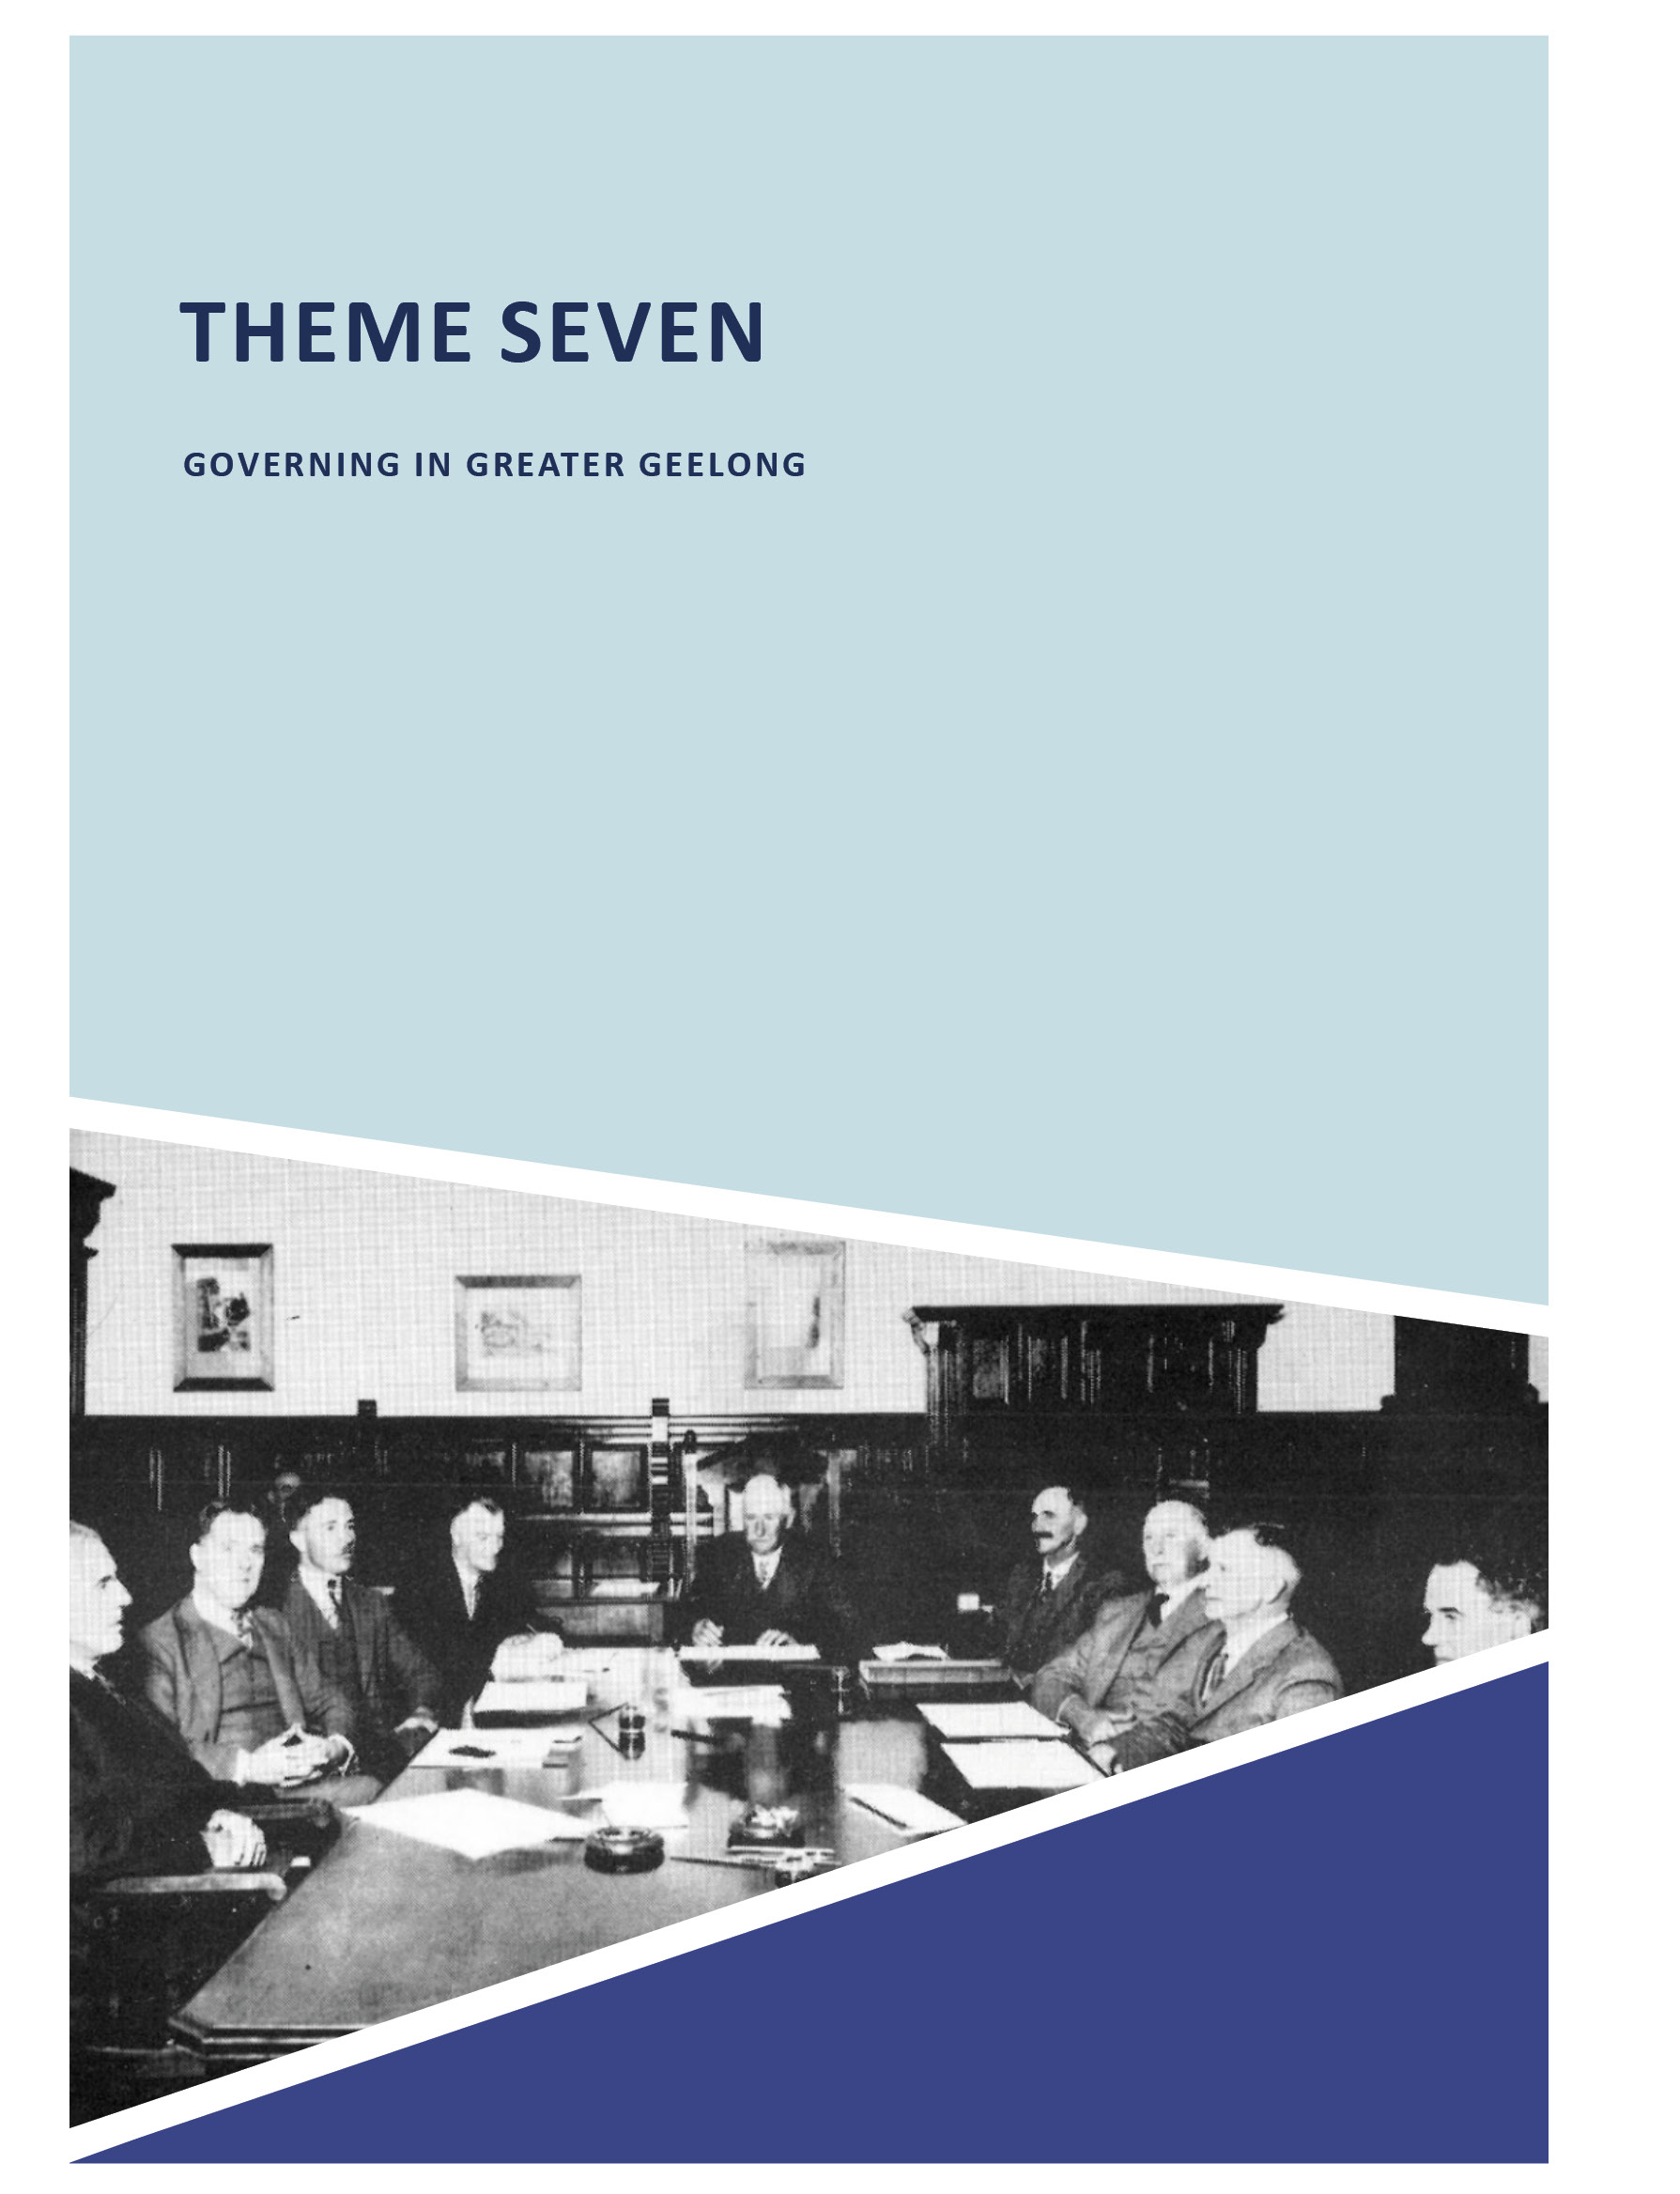

THEME SEVEN

GOVERNING IN GREATER GEELONG

854
ABOUT CORAYO: A THEMATIC HISTORY OF GREATER GEELONG

  - INTRODUCTION
The first government in Greater Geelong was that of the Elders of the Wadawurrung peoples before European colonisation. Since then, governing in Greater Geelong has taken many forms: from the provision of local governments (including the people elected to govern in different parts
of the Greater Geelong community, and the construction of associated infrastructure); establishment of bodies to administer the law (including the police force and supreme
and police courts, and construction of police quarters, court houses and goals); managing the waterways (initially by water police and later by the Geelong Harbor Trust and Port of Geelong Authority); establishment of local volunteer defence corps and installations to defend Greater Geelong in times
of war; creation of the Country Roads Board to administer the management of major roads in the municipality; and the enactment of building and town planning regulations to provide safe and considered measures for building and
planning in Greater Geelong. This theme explores all of these forms of government and provides tangible and intangible examples of their importance to the Greater Geelong area.

THE WADAWURRUNG: THE FIRST LOCAL GOVERNMENT IN GREATER
GEELONG

THE CREATION OF LORES
Government in Greater Geelong for over 45,000 years prior to European colonisation formed the cultural, spiritual, social, economic and environmentally sustainable basis for daily life of the Wadawurrung peoples in Greater Geelong.
The essential core to government were the lores as it was considered that ‘to obey the law was a soul-satisfying experience.’1 Underlying the creation stories for the Wadawurrung were the ancestral beings: Bundjil (the Eagle) and Waa (the Crow), who ‘promulgated the laws by which the clanspeople would live’ prior to them ‘retiring to their place of origin’2 (see also Theme 8).
Governance of each clan was by a Council of elders, the clan head being known as the ngar:weit. Meetings between the clan heads were known as the by: err.3

EVOLUTION OF EUROPEAN LOCAL GOVERNMENT IN GREATER GEELONG
Following European colonisation, Geelong was first governed by the New South Wales Government. With the early development of the Geelong township came a desire by local residents for local self-government. Initially, local government was considered the best way to provide status and financial support from Colonial Governments, and especially to improve and construct roads, streets, bridges, footpaths
and other infrastructure. From the 1840s until the current day, the roles and services offered by local government has changed and increased dramatically. As local governments became more financially viable and as a consequence of social reforms, they were able to offer additional services
to the community, including welfare, sport and recreational facilities, and cultural outlets. By the early 20th century, the statutory role of local governments included building permit requirements and by the mid-20th century, town planning became a key statutory role. Today, the City of Greater Geelong is one of the municipality’s larger employers and provides numerous statutory and community services. It is also legacy of the substantial contribution made by a large number of community representatives. A list of Mayors, Commissioners and Administrators associated with the City of Greater Geelong (and its predecessors) is given
as Appendix 7.1.

THE DISTRICT COUNCIL OF GRANT
In early April 1842, James Harrison of the Geelong Advertiser published an article on the ‘extraordinary growth’ of the Geelong township and that it was incumbent upon local citizens to consider the steps required for self-government.4 This article was in anticipation of the passing of the Municipal Corporation Bill by the New South Wales Legislative Council. Harrison continued:
The New Zealand Government has acknowledged the expediency of granting corporate privileges to every town containing 2000 inhabitants. We by no means approve
of the principle of fixing any limit; yet we will not find fault with our legislators if they show an equal degree of liberality with the legislators of New Zealand. Although the population of the township was only 450 at the time
when the census was taken, twelve months ago, we have no hesitation in saying that it will considerably exceed two thousand before the Corporation Bill passes into a law. The assertion of our right to share in the benefits
of that measure cannot therefore be looked upon as unreasonable
or premature.5

A memorial to be presented to the Legislative Council was subsequently prepared for signature at Mack’s Hotel, Geelong. It read in part:
That your Memorialists, being the Inhabitants of a township containing a population of two thousand souls, situated in the centre of a fertile and extensive district (having shipped 5200 bales of wool for the London market, direct from this port, during the present season), are desirous that the proposed act should be so framed as to admit your memorialists to a participation in its advantages.6
On 21 July 1843, Governor George Gipps signed a charter which established the District Council of Grant. The area of the newly-formed municipality was extensive, stretching well beyond the fledgling Geelong district, as described in the charter:
Bounded on the east by the Western boundary of the County of Bourke; on the north by the 37th parallel of South Latitude; on the west by the River Hopkins from the sea to its principal source, and then by a line drawn due north and south to the said parallel; and on the south and south-east by the sea and the waters of
Port Phillip.7
The vastness in area of the District Council of Grant’s jurisdiction was illustrated in the Map of the District of Geelong in 1845 by Alexander Skene (1820-1894)
(Figure 7.01). He had been appointed Surveyor to the District Council in 1843, having graduated with a Master of Arts from the University of Aberdeen, Scotland, in 1838, and having designed St. Andrew’s Presbyterian Church in Yarra Street a year later in 1839.8
Governor Gipps appointed Richard Gilbert Talbot of ‘Ballanclea’, Barrabool, as Warden of the District, and fixed the number of Councillors to six. Nicholas Alexander
Fenwick, David Fisher, James Austin, William Charles Haines, John Atkins and Robert Stevenson Dunsford were nominated as the first Councillors.9 Annual elections on the first Tuesday in May were to be convened where Councillors did not complete their three year terms.10 The first meeting of Council was on 19 October 1843, presided by the Warden. Charles John Dennys was appointed Secretary and Edward Bell Treasurer, in addition to Skene’s appointment as Surveyor.
Their salary was fixed at £150 per annum.11

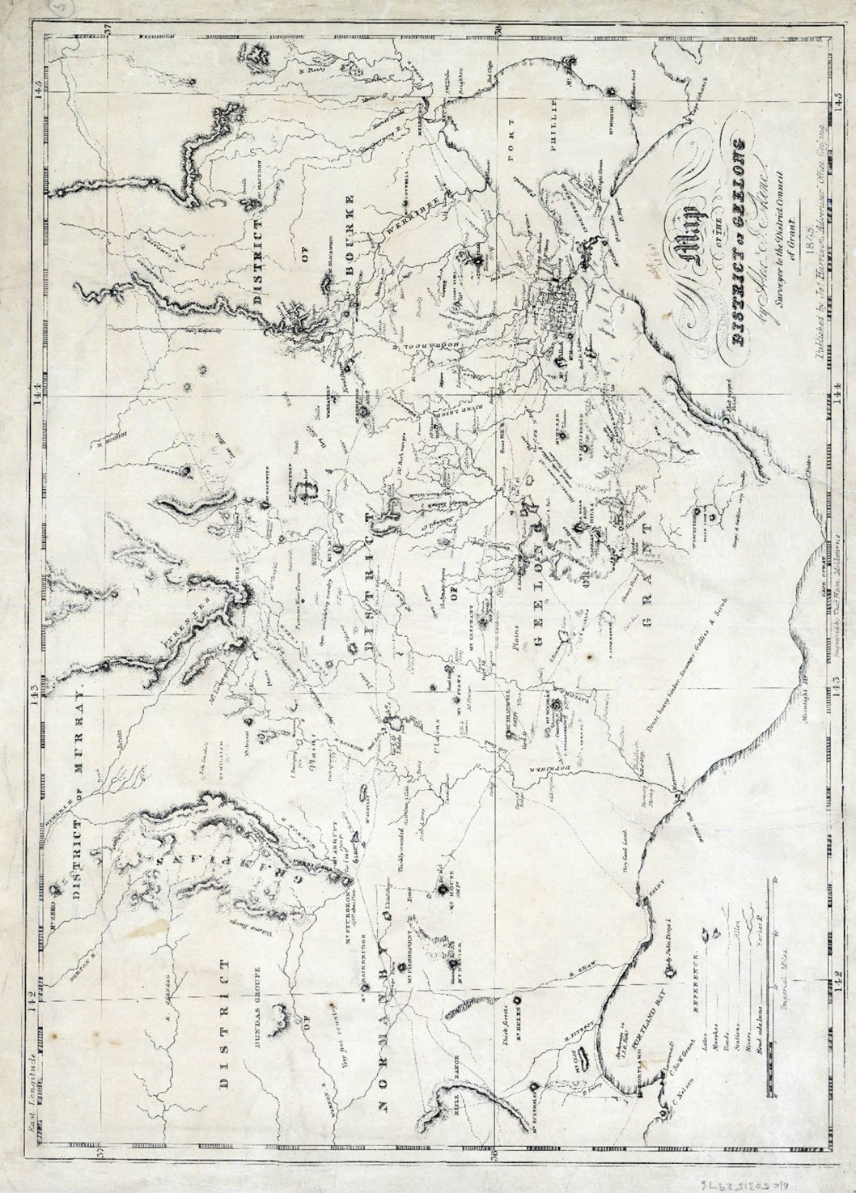
Figure 7.01: A.J. Skene, Map of the District of Geelong, James Harrison, Geelong, 1845. Source: State Library of Victoria.

The Warden, Richard Gilbert Talbot (1810-1879) was the son of James Talbot, third Baronet of Malahide, Ireland, and Ann Sarah (nee Rodbard).12 Educated at Manchester Grammar School, England, he was induced to emigrate by his Uncle in Tasmania, William Talbot.13 By 1842, he had acquired a farming property in the Barrabool Hills,14 which he called ‘Ballanclea’ after the Talbot de Malahide family home at Killiney, Ireland, called ‘Ballinclea House’.15
Nicholas Alexander Fenwick (1806-1863) was the eldest son of Charles Fenwick, British Consul-General to Denmark, and Susannah (nee de Berner), an old family of Northumberland, England, who lost its Baronetcy in 1697 when Sir John Fenwick of Fenwick and Wallington was executed for high treason.16 Nicholas was appointed
Vice-consul at Elsinore in 1827, and between 1831 and 1839 he was Vice-consul at Copenhagen. In June 1839, Fenwick was appointed Police Magistrate in New South Wales, and from January 1840, he was appointed Police Magistrate at Port Phillip, succeeding the incumbent, Captain Foster Fyans.
David Fisher (1801-1879) was the son of William Fisher,
a factor (type of trader) and Mary Fisher17. Early in the 1830s he emigrated to Tasmania and worked for the Mercer family. Following favourable accounts of Port Phillip, he sent two cargoes of sheep there in 1835. On 9 February 1836, with other Geelong pioneers, George Russell, J.F. Strachan
and Alexander Thomson, Fisher relocated to Port Phillip, becoming the manager of the Derwent Company. He built the first house in Geelong overlooking Barwon Terrace, South Geelong (see Theme 6 for further details). It was there from 1838- 39 where his woolshed was used for the first Presbyterian and Methodist Church services in Geelong (see
Theme 8 for further details). In 1842, following the dissolution of the Derwent Company, Fisher acquired 1280 acres in the Barrabool Hills and established the property, ‘Roslin’, named after his birth place.
James Austin (1810-1896) was the son of John Austin, villager at Baltonsborough, Somerset, England.18 With his parents and siblings, James emigrated to Tasmania to be with his convict pioneer Uncle, James Austin, who died before he arrived in Hobart (but benefited from his Will).
Although James’ parents returned to England, he and his brother, Thomas, remained in Tasmania. In 1837, they took up a grazing run at Winchelsea. Five years later in 1842, James Austin married Rebecca Savage, one year before his appointment to the District Council of Grant.

William Clark Haines (1810-1866) was born at Hampstead,
England, the son of John Haines, physician, and Jane
(nee Bliss).19 Educated at Charterhouse and Caius College, Cambridge, and after practising surgery in England, he emigrated to Victoria in 1842 and took up land near Geelong with John Highett. It was during this partnership when Haines was appointed a District Councillor.
John Atkins was the first licensee of the Swan Inn (originally known as the Fyansford Inn), on the west bank of the Moorabool River, Fyansford, in 1842.20
Robert Stevenson Dunsford (c.1817-1853) was the brother in law of J.B. Were, stockbroker, importer, exporter and agent for shipping, land, cattle, sheep and wool.21 Dunsford came to Victoria in November 1839 and he first lived in Melbourne before being resident in Geelong by June 1843.22
Although the District Council comprised several distinguished and successful Councillors from business, the professions and farming, the Council was to be short-lived. From its inception, James Harrison of the Geelong Advertiser had
not looked favourably upon the District Council’s warden. In September 1843 he went so far as to highlight his displeasure in the ‘Lost, Stolen, or Strayed’ section of the Geelong
Advertiser:
Lost, Stolen, or Strayed.
Whereas, the Warden of the District of Geelong has been missing ever since he received his appointment, fears are entertained that the sudden accession of greatness has turned his head, and that he is now wool-gathering in
some remote part of the bush. Any information respecting the said Warden will be gratefully received by his widowed Council and his disconsolate children, and should this meet his own eye he is requested to return home to receive their forgiveness.23
By 1844 the District Council had amounted a debt of £600 and debate ensued as to the extent of its powers to raise funds from property rates and stock assessments.24 According
to W.R. Brownhill, the Council also ‘owned no premises; the meetings were held in the Court-house, which was still almost in the bush.’25 Further exacerbating the demise of the District Council was a growing demand for a new Corporation of Geelong.26 By 1849, this became a reality.

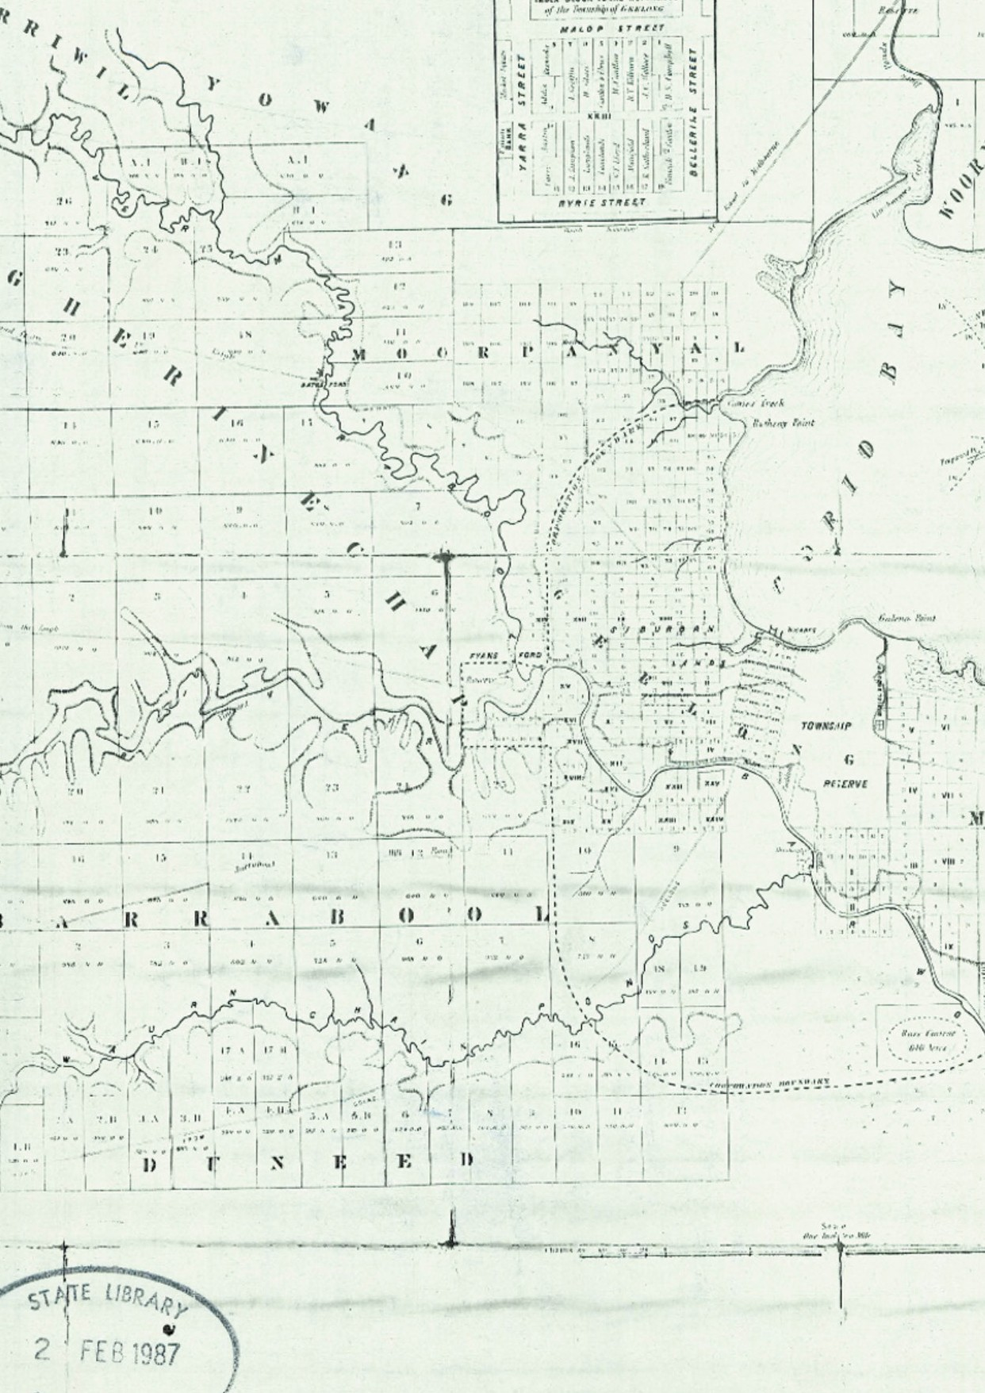

ABOUT CORAYO: A THEMATIC HISTORY OF GREATER GEELONG
858

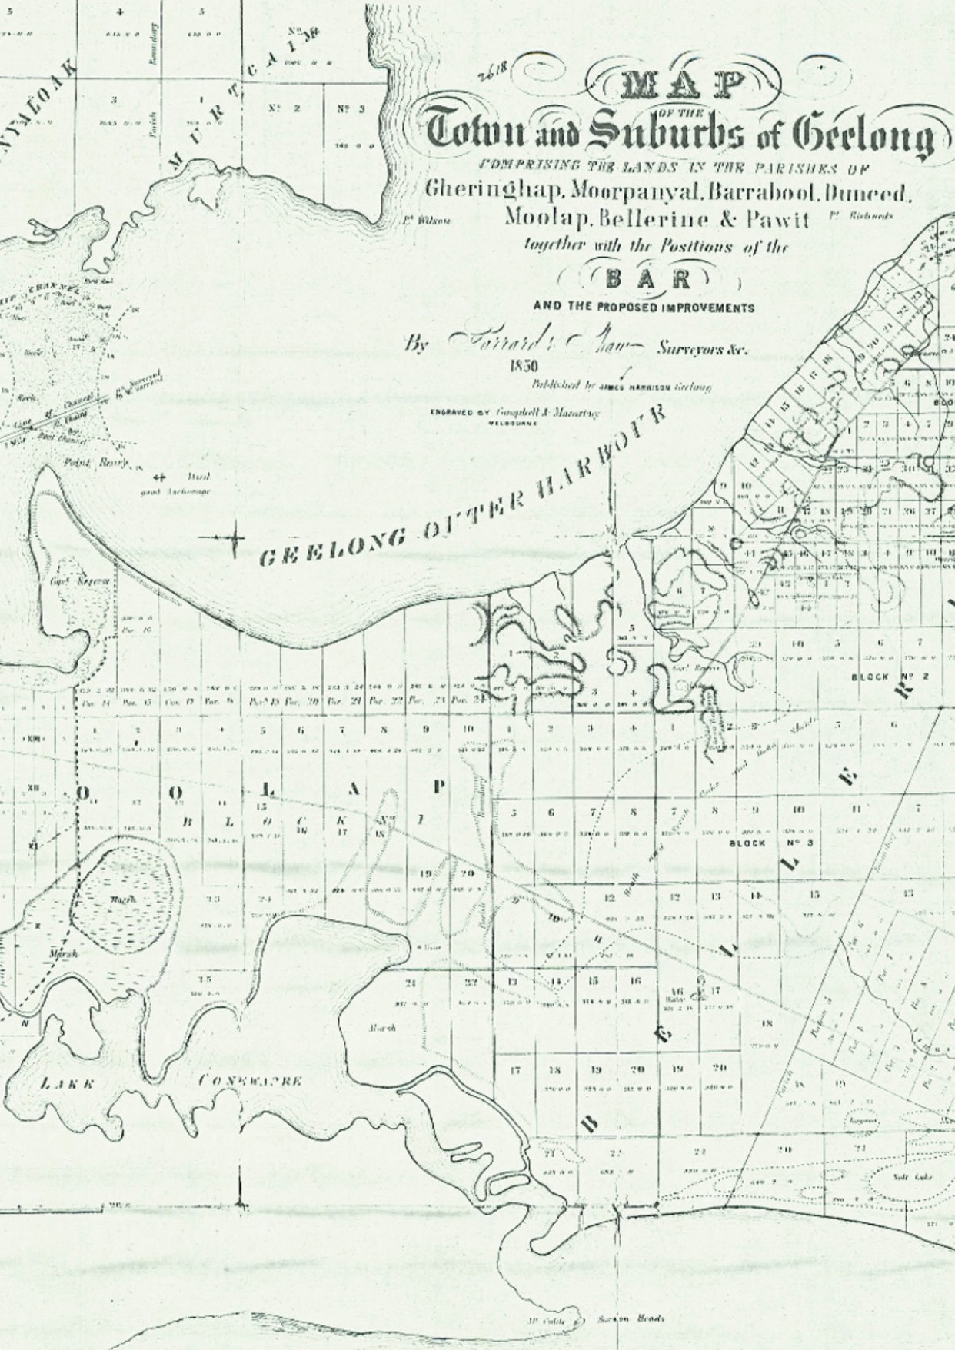

Figure 7.02: Garrard & Shaw, Map of the Town and Suburbs of Geelong, James Harrison, Geelong, 1850 (the extent of the Geelong Corporation was shown in the broken lines in the central portion of the map). Source: State Library of Victoria.

ABOUT CORAYO: A THEMATIC HISTORY OF GREATER GEELONG
859

THE TOWN AND CITY OF GEELONG

THE BEGINNINGS OF THE CORPORATION OF GEELONG
On 23 April 1849, a public meeting was held in the long room of Elmes’ Royal Hotel, Malop Street, ‘for the purpose of “adopting such measures as might be considered most
desirable for the future local government of the town.”’27 The meeting was chaired by Captain Foster Fyans.28 A second public meeting was held, with Dr John Dickson presiding and afterwards the system of Government that was recommended was for a Corporation ‘composed of a Mayor, Aldermen
and Councillors, to be elected by and from the resident ratepayers.’29 Those involved in these early beginnings of self-government for Geelong had ruled out a system with a directly-elected Mayor. As detailed in the Geelong Advertiser:
The principal point upon which a difference of opinion exist with respect to the incorporation of Geelong, is, as to the appointment of the Mayor or head of the Corporate body. In Melbourne and Sydney, the Mayors are elected annually by the votes of the members of the town council. This plan has worked badly, because it has caused disunion in the town council; and in effect, instead of the election of the Mayor being in the hands of the people, it has invariably been in the hands of a clique. The question to be considered, therefore, in Geelong, is, not so much whether the Mayor should be elective, but rather, whether preventive measures should not be taken to keep the council from being the arena of discreditable feuds. The annual removal of the head of a corporation, too, appears to be an absurd and needless rule, especially when viewed in connexion with the fact than an alderman, in certain circumstances, can hold his seat for six years.30
On 23 September 1849, the Legislative Council of New South Wales passed the Bill ‘to incorporate the inhabitants of the town of Geelong and to extend and apply the laws now in force for the regulation of the Corporation of Melbourne.’ It was enacted into law on 12 October 1849.31 The boundaries of the Corporation (Figure 7.02) were defined in a Schedule to the Act as follows:
Bounded by a line drawn from a point on the Eastern shores of Corio Bay near Point Henry, at a distance of two miles from the North-East corner of the township of Geelong, as a centre bearing Southerly to a point
bearing East from the said corner; thence by a line South crossing a small portion of Corio Bay, parallel with and at a distance of two miles from the Eastern boundary of the said township to a point bearing East from the South- East corner of the said township of Geelong; thence by
a line drawn Westerly at a distance of two miles from the Southern boundary of the said township, crossing the Barwon river and Waurn Chain of Ponds to a point two miles West of the South-West corner of the said township; thence by a line bearing North parallel with and at a distance of two miles from the Western boundary of the said township of Geelong to a point bearing West, from the North-West corner of the said township; thence by a line drawn at a distance of two miles from the North-West corner of the said township as a centre to the Western shore of Corio Bay, near Cowie’s Creek; and also to include the remaining portion of the reserve at Point Henry, and the reserve at the junction of the Moorabool with the Barwon river.32
The Town of Geelong was also to be divided into four wards, established by:
… the drawing of the two following lines, intersecting each other at right angles, namely: Lines drawn along the centres of the two streets named Moorabool-street
and Ryrie-street, and intersecting each other at the points where Moorabool-street crosses Ryrie-street, and by the prolongation of the said lines until such prolonged lines reach the boundaries of the town; and the said wards shall be respectively called the North- East or Bellerine ward, the North-West or Villamanta ward, the South-East or Barwon ward, and the South-West or Kardinia ward.33
The new Act also disassociated the Geelong Town Incorporation from the District Council of Grant. In November 1849, Superintendent Charles La Trobe appointed the following to hold office until an election was held: Captain Foster Fyans as Mayor; Edward Brown Addis as Alderman for the Villamanta Ward; Jonathan Clerke as Alderman for the Bellerine Ward; Robert Culbertson Hope as Alderman for the Kardinia Ward; and Lesley Alexander Moody as Alderman for the Barwon Ward.34

GEELONG BOUNDARIES ACT 1858
On 4 June 1858, the Geelong Boundaries Act was passed.35 In addition to ratifying the four wards (Barwon, Bellerine, Kardinia and Villamanta), it fixed the boundaries of the Town of Geelong. This led to the Geelong Corporation erecting boundary posts to comply with the provisions of the Act.36 The ‘beating the bounds’ was carried out every three years by the Mayor, Aldermen and Councillors. The Geelong Advertiser gave a description of the perambulation of the boundaries in 1866:
At half past nine these gentlemen met at the Town Hall, and from the thence, in cabs, buggies, and on horseback, proceeded to the boundary post, near the rifle butts. A halt was then made, and our civic dignitaries partook of

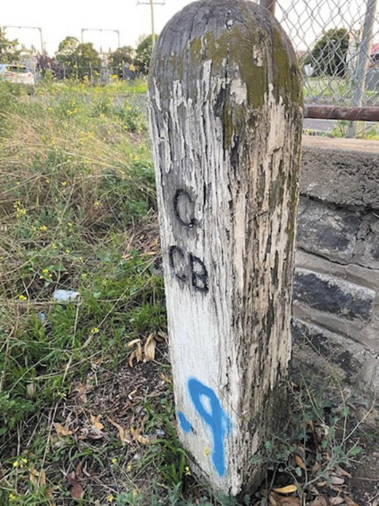
Figure 7.03: Former Geelong Town Corporation & Corio Road Board Boundary Marker, Ballarat Road, North Geelong, 2020. Source: Kevin Krastins.

refreshments. Down to the Barwon was then the line of march, and at Brearley’s Punt the cortege was met by Sharp Brearley, Esq., the Mayor of South Barwon, who, with his usual courtesy, invited one and all to cross the river to partake of his hospitality and inspect his extensive establishment. Soon again, another start was ordered, and after skirting the river, thee Councillors visited the spot on which the woollen factory is to be built, half way across the Barwon bridge and back again, and the cry was forward to the Shearer’s Arms, where a luncheon, provided at the expense of his Worship the Mayor, was done ample justice to. From thence, the Councillors proceeded to Mr Down’s, where, in his magnificent garden they enjoyed all fruits in season. The final resting point
as the boundary post, near Hutton’s Wharf, and they day’s proceedings were here wound up by libations of champagne, and then the whole party returned to town.37
The boundary posts were repaired and painted following the Council visit, and in 1869 new posts replaced dilapidated old ones.38

The ‘beating the bounds’ continued into the 20th century. In 1919, about 30 posts were visited.39 Today, a very rare legacy of the Geelong Boundaries Act is a surviving timber boundary marker on the north side of the Ballarat Road at North Geelong (Figure 7.03). Situated to the -south-east of intersection with Thompson Road, it marks the south-west boundary of the northern annexed portion of the Geelong Town Corporation (Figure 7.04). This was originally the intersection of the Ballarat Road, Montgomery Street and
Ballarat (now Ebden) Street. The incised letters “G” and “CB” denoted the boundary of Geelong and the Corio Road Board.
While the provenance of the post is not known, it continues to mark the original boundary in the 1860s of these former municipalities.

THE FIRST ELECTED COUNCILLORS
The appointment of the first Geelong Corporation Council was only temporary. An election was held on 4 February 1850 with James Austin, Walter Hobson and Silas Harding elected for the Bellerine Ward; Robert Robinson, Richard Forrest and George Thomas Lloyd for the Barwon Ward; James Cowie, Charles Nantes and Thomas Sheppard for the Villamanta Ward; and James Harrison, William Gray and Alexander Thomson for the Kardinia Ward.40 A few days later on 9 February 1850, the first Council meeting was held at the Royal Hotel, Malop Street. Dr Alexander Thomson was elected the first Mayor of Geelong, with Councillors Austin, Thomson, Cowie and Lloyd elected as Aldermen.41
Dr Alexander Thomson (1800-1866) (Figure 7.05) was the son of Alexander Thomson, a ship owner of Aberdeen,
Scotland.42 In 1831, with his wife, Barbara (whom he’d married in 1824) and three year old daughter, Jane, Thomson emigrated to Tasmania where he took up 2560 acres on the Break O’Day Plains. In September 1835, he shipped 50 cattle to Port Phillip and he followed with his family in March 1836. After a 12 month appointment as catechist to the Port Phillip Association and medical officer to the European settlement, he relocated to Geelong in 1837 where he took up his first run at Buckley’s Falls on the southern bank of the Barwon River, before taking up the River Station later that year and built the original Kardinia House on the southern side of the river at Belmont.
From this time, Thomson became heavily involved in the development of the fledgling Town of Geelong through different commercial and civic activities. In 1845, he became bankrupt and returned to the medical profession.
He established the suburb of Belmont in 1850. He held numerous positions as a bank director and office with several community organisations including the Mechanics’ Institute,
Irish-Scottish Relief Fund, Presbyterian Church and he was influential in the improvement of customs and harbour facilities in Geelong.

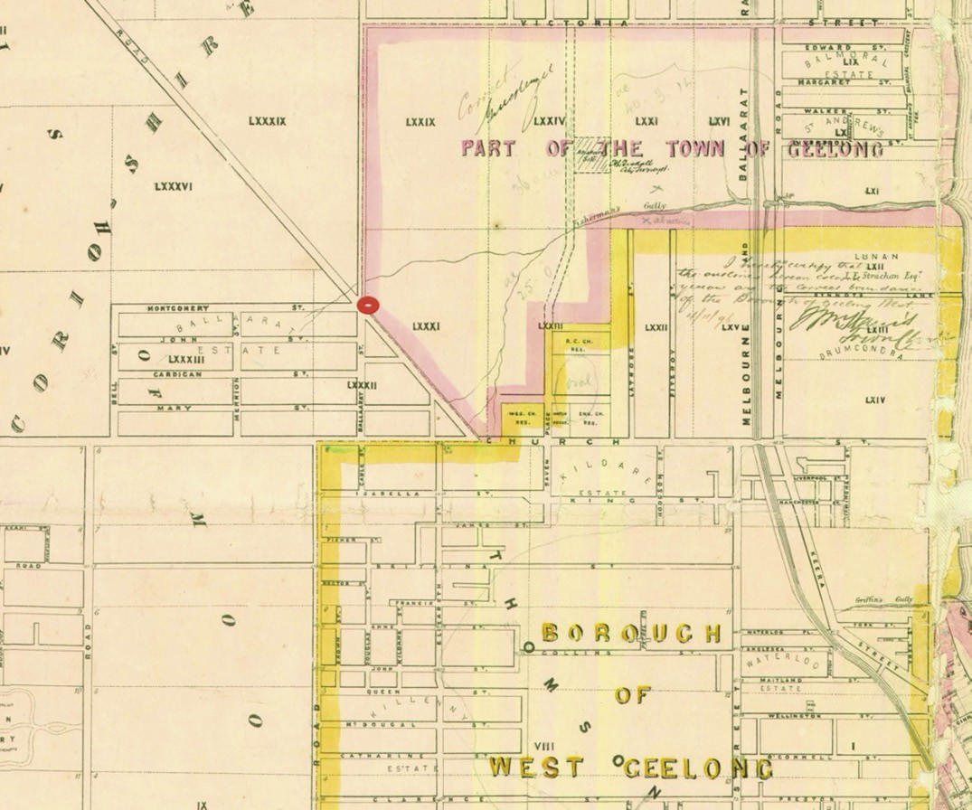

Figure 7.04: R. Balding Part of Map of the Town of Geelong and Boroughs of South Barwon and Newtown and Chilwell showing the location of the Geelong Town Corporation & Corio Road Board boundary maker (circled red), 30 June 1864. Source: Statutory Planning Department, City of Greater Geelong.

James Austin (1810-1896), inaugural Councillor for the Bellerine Ward, was one of the few Geelong Corporation Councillors who had previously served on the District Council for Grant (see earlier subsection for further details). He became Geelong’s second elected Mayor in 1851 but in 1853 he commenced the sale of his Geelong properties and in 1856 he retired to Somerset, England.43
Walter Hobson (1786-1865), inaugural Councillor for the Bellerine Ward, was born in Leeds Yorkshire, England.
He arrived in Hobart Tasmania in 1834.44 A carpenter,
he may have worked his trade before crossing Bass Strait to Melbourne in c.1843, following the death of his second wife, Emma. In 1844, he married Bridget Ryan and their daughter
was born in that year. In Melbourne, Hobson continued working as a carpenter before taking up the Bridge Inn in Flinders Lane. By 1848, with his family he had relocated to Geelong, taking up the license of the Builders’ Arms Hotel in Malop Street. In 1850, he was the licensee of the Freemason’s Tavern in Malop Street. Hobson represented ‘the working classes’ and was elected for a two year term.
Silas Harding (c.1817-1894), inaugural Councillor for the Bellerine Ward, was born in Devonshire, England.45 He emigrated to Port Phillip in 1841 where he opened an
ironmongery in Geelong. The following year in 1842 he went into partnership with Thomas Towle and by 1846 Harding opened a timber yard. His business progressed following

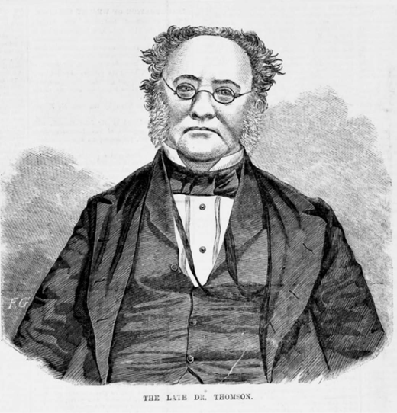
Figure 7.05: Dr. Alexander Thomson. Source: F. Grosse (engraver), The Australian News for Home Readers, Ebenezer & David Syme, Melbourne, 20 January 1866, accession IAN20/02/66/8 State Library of Victoria.

its relocation to Market Square in 1849. Following the gold rush in the early 1850s, he became a gold buyer but he soon returned to ironmongery with Richard Parker in the late 1850s. It was also in the 1850s when Harding became a squatter, taking up the Linlithgow Plains run near Dunkeld and also a run with John Armstrong near Mount Duneed.
Harding’s involvement with the Geelong Corporation was less productive, being fined £1 for non-attendance. He did not stand for re-election.
Robert Robinson (1812-1852), inaugural Councillor for the Barwon Ward, was born in Tandragee, County Armagh,
Ireland.46 He arrived in Geelong in 1839 and between 1841 and 1845 he held the license to the Commercial Hotel in Corio. It was at this time when he purchased land at the first auction of Geelong town allotments. At the time of the Geelong Council election, he was described as ‘a wealthy store- keeper.’ In 1851, he was elected to the district of Geelong in the first Victorian Legislative Council, his term cut short by his untimely death in 1852.
Richard Forrest (1815-1854), inaugural Councillor for the Barwon Ward, was born in County Cork, Ireland.47
He emigrated to Melbourne in 1839, marrying August Maria Julia Suffield in December of that year. An accountant, his office was in Queen Street. Forrest was also a partner with Henry Lake Worsley in a wine and spirit store. By 1849,
he was proprietor of the Corio Chronicle and in 1850 he

was described as a Government Auctioneer. Following his election to the Geelong Council, he was later disqualified in November 1851 for failing to comply with Section 5 of the
New South Wales Act No. 5 in declaring that he was a public accountant, given his role as Government Auctioneer. He died prematurely in 1854, leaving his widow and children destitute.
George Thomas Lloyd (1810-1871), inaugural Councillor for the Barwon Ward, was born in Surrey, England, and was brought to Tasmania by his Uncle, Lieutenant Charles Jeffreys, R.N. retired, in 1820.48 Following the arrival of Lloyd’s brother, Arthur, they left Tasmania and took up the Kerangemorrah Run west of Lake Colac in 1837. In 1840, George Lloyd married Miss Helen Young of Lake River, Tasmania. In 1838, he gave up pastoral pursuits and established a business in Geelong as a commission agent and auctioneer. In 1843, he was a partner in the first tallow works in the Geelong District and in the follow year he became a wool broker with Dunsford and Company.
James Cowie (1809-1892), inaugural Councillor for the Villamanta Ward, was born in Falkirk, Stirlingshire, Scotland, the son of a wealthy brewer of the same name.49 Apprenticed as a saddler and harness marker in London, Cowie emigrated to Tasmania via Port Phillip in 1840. By 1841, he had established a saddlery in Geelong which prospered. By 1847, he had established a wine, sprit and cordial business and was also influential in the establishment of the original fleet of steamers in the Geelong shipping trade, and subsequently opening a shipping company. His property interests soon extended beyond Geelong, with Cowie opening a store at Elephant Bridge (Darlington), with his brother, William, as manager. In 1852, Cowie was elected the second Mayor
of Geelong, and it was also at this time when he was appointed a Justice of the Peace. His interest in community affairs extended to other causes, membership of the Anti- transportation League, provisional Committee of the Geelong and Melbourne Railway Company, and the Geelong Chamber of Commerce. In 1853, Cowie was elected to the Victorian Legislative Council.

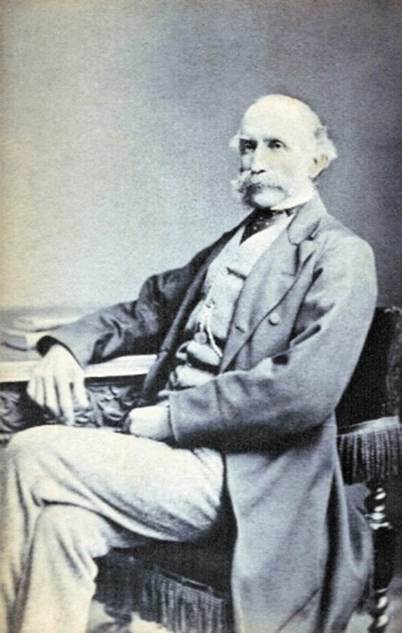
Figure 7.06: Charles James Nantes, 1875. Source: Peter Watts, Queensland.

Charles James Nantes (1817-1877), inaugural Councillor for the Villamanta Ward, was born at Bideford, Devon, England, the son of retired merchant of London, Henry William Nantes (Wilhelm Heinrich Nantes), and his third wife, Patty (nee Benson).50 In 1835, Charles Nantes (Figure 7.06) was appointed clerk to the Colonial Secretary, Robert Gouger, under the South Australian Colonisation Committee, emigrating to South Australia in 1836 on the Africaine. Secretary to Colonel William Light, Surveyor- General of South Australia, Nantes administrated Light’s naming of the streets for the new city of Adelaide in 1837, which eventuated in controversy. Nantes transferred to the
office of the Accountant General in 1838 an economic crisis in South Australia brought about an economic depression in 1841. At this time, Nantes and his wife, Helen (nee Smith) (whom he had married in 1839), relocated to Melbourne in 1841 and by 1844 he had commenced a livery stable and produce business at Peel River (Flemington). By 1847 he

had moved to Geelong. In partnership with D.S. Campbell, he purchased the wine and spirit business of Alfred Woolley in Moorabool street. Nantes and Campbell also became commission agents, specialising in the sale of land and buildings. Nantes married Miss Helen Smith of Melbourne in 1848. The following year, 1849, Nantes passed a resolution for the establishment of municipal government in Geelong. In addition to civic affairs, Nantes playing an important role in other facets of community life: as a trustee of St. Paul’s Church of England, founding President of the Newtown Mechanics’ Institute; and member of the Geelong and Melbourne Railway Company, Land and Building Society, Geelong and Western District Fire and Marine Insurance
Company, Geelong Savings Bank, Geelong Steam Navigation Company, Independent Order of Oddfellows, and the Geelong Lodge of Unity and Prudence. Nantes was also the inaugural Chairman of the Borough of Newtown, elected in 1858.
Thomas Sheppard (c.1810-1873) inaugural Councillor for the Villamanta Ward, came to Victoria in 1840. By 1842, he had established a store in Geelong.51 In the late 1840s, he took an interest in a possible coal field at Lorne. His time as Councillor for the Villamanta Ward was to be brief as he resigned in February 1851. He remained in Geelong (where he had involvement in the Geelong Benefit Buildings and Savings Investment Society and Chamber of Commerce, and where he was appointed a Justice of the Peace in 1854)
until 1855 when he relocated to Buninyong and established a brewery.
James Harrison (1816-1893), inaugural Councillor for the Kardinia Ward, was born at Bonhill, Dumbartonshire, Scotland, the son of William (a salmon fisherman) and
Margaret (nee McGregor) Harrison.52 See Themes 3 and 9 for further biographical details. He was apprenticed as a printer at an early age, during which time he became self-taught
in Gaelic, and undertook evening classes at Anderson’s ‘University’ which gave instruction for sons of mechanics and tradesmen. After attending the Glasgow Mechanics’ Institution during his employment with Edward Khull, topographical printer, he went to London and worked at Valpey’s printer and publishing business. He emigrated to Sydney in 1837 and was employed by the printer, James Tegg. He later was appointed foreman for the Monitor
and was then employed by the Sydney Morning Herald. Harrison relocated to Melbourne in 1839 and was employed as a compositor for J.P. Fawkner’s Port Phillip Patriot, later becoming editor and general factotum. In 1840, Fawkner suggested Harrison establish a newspaper at Geelong, where the first issue of the Geelong Advertiser was published on
21 November 1840. The Advertiser was to break the news of the discovering of gold at Clunes in 1851. Of particular significance was Harrison’s experiments in refrigeration
which initially brought him financial ruin in 1861, necessitating

the sale of the Geelong Advertiser (he was retained in an editorial capacity) and other business interests (see Theme 5 for further details on Harrison’s refrigeration inventions).
William Gray (1810-1891), inaugural Councillor for the Kardinia Ward, arrived in Geelong in 1839, having initially emigrated from Scotland to Tasmania.53 He opened a store in a tent at the northern end of Yarra Street until a shop was erected in Corio Street. He also acted as George Russell’s Geelong agent, collecting mail, cashing remittance and supplying household goods. In the late 1840s, Gray built two flour mills: in Gheringhap Street north and on the Barwon River. Following his importation of iron pipes from Hobart
in 1849, he began the construction of his water supply to Geelong through a pumping station near his mill which took the water to tank on the top of the Moorabool Street hill at the north-west corner with McKillop Street (see Theme 4 for further details).

THE FIRST COUNCIL OFFICERS
Although there were 2,750 employees at the City of Greater Geelong in 2017-18,54 the number of staff appointed by the Geelong Corporation in 1850 were considerably more humble.
In January 1850, A.J. Eyre, the clerk of Petty Sessions at the Geelong Police Court, was appointed the acting Town Clerk prior to a permanent appointment being made by the Council.55 Eyre had been appointed to the bench in Geelong in March 1840, having earlier officiated in Sydney.56 Well known in Geelong, Eyre died at his residence in Newtown on 20 July 1856 at the age of 41.57
The first permanent Town Clerk of the Geelong Corporation was William Weire (1803-1884)58 (Figure 7.07). Born in Dublin, Ireland, the son of Hugh and Ann (nee Kinnaird) Weir of Argyllshire, Scotland. Weir (as his surname appears to have originally been spelt) had relocated to London in later years where he worked as Groom and Valet for Judge Fox, and had been employed at the London Docks.59 He married a milliner and they lived in Stephen Street, London, until Weire was convicted of stealing in 1836.60 His sentence was
transportation to Tasmania for seven years.61 Weire arrived in Hobart on the convict ship, Governor Ready, in July 1827.62 He served the majority of his sentence assigned to Thomas Cookson Simpson, who held interests in mercantile and trading businesses.63 Following a few years assigned to public works in 1830-32 (a consequence of neglect of duty under Simpson’s employment), he was again assigned to T.C. Simpson.64
On 25 April 1833, Weir was awarded his free certificate65 and it appears to have been at this time when he changed his name to Weire to distinguish himself from his past life. It was also in

1833 when he married Miss Helen McDonald at the Parish of St. John, Launceston.66
Weire was reported as a Clerk to Henry Jennings, solicitor, in a notice in the Cornwall Chronicle, 10 March 1835
and it would appear that he remained in the employment of Jennings for a number of years as William Weire c/-,
Mr Jennings, Charles Street Launceston advertised ‘a near new rosewood pianoforte’ for sale from his permanent residence in the Cornwall Chronicle 14 August 1841.67
Weire married Marianne Matilda Catherine Huggett in 1847 and it was during this same year when they relocated to Geelong.68 Tragically, in March 1848, their son was still born and Marianne Weire also died a few days later.69 From 1850, Weire was elected as Town Clerk and he witnessed the early transformation of the fledgling European settlement into a township.70 It was in Geelong where Weire was to marry on another two occasions: to Elizabeth Mary Batman (1829- 1864) in 1853 (daughter of John Batman, European explorer and founder of European colonisation in Victoria); and Mary Ann Prowse (nee South), in 1869.71 William Weire died in 1884 having held the most senior administrative position as Town Clerk of Geelong for 34 years until his death at age
81.72 Perhaps the most ironic twist in the life of former convict William Weire took place in front of a huge public audience in 1867, when as part of his civic duties as Geelong Town Clerk he read the formal welcome address to the visiting the Duke of Edinburgh and Princess Alexandra – the first royal visitors to come to Geelong.73 The Geelong Advertiser gave the following obituary:
We regret to have to record the death of Mr Wm. Weire, the town clerk of Geelong, which took place yesterday evening at 6.45. at his residence in Marshall street, Chilwell. His death does not come unexpectedly, for the genial old gentleman had been prostrated for some week’s past. In March of last year he was seized with what may be justly termed the only illness he had ever known, and for months he was confined to his bed, at
his then residence in Moorabool street south. His strong constitution, assisted by the medical treatment of Dr. Wm. Shaw, enabled the popular town clerk to again get on his feet, and after a brief residence on the coast of Hobson’s Bay he returned to Geelong and resumed his duties at the Town Hall, but his failing health, arising mainly from the accumulation of years, necessitated his relinquishing all active office work. He did not do so of his own accord however, as his well-earned retirement into private life was thrust upon him by the Town Council, who about
six months since superannuated Mr Weire, voting him a retiring allowance of £200 per annum. He, however, retained the nominal position of town clerk of Geelong,
and almost up to the time of his death took a great interest

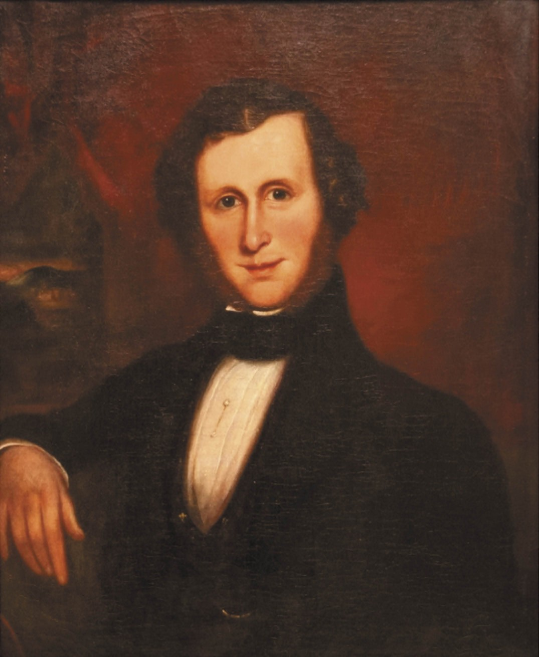
Figure 7.07: Portrait of William Weire, c.1842, first Town Clerk of Geelong 1840-1884. Source: GRS1500/53 CAC 53, Geelong Heritage Centre collection.

in all that concerned the municipal government of this town.74
The first Town Surveyor for the Geelong Corporation was William Robert Howe Weekes (c.1797-1885).75 The earliest reference to Weekes in Victoria was in July 1844 when he was appointed Acting Town Surveyor of the Melbourne Town Corporation.76 In this role, he superintended the construction of a bridge over the Yarra River at the southern end of Swanston Street.77 By January 1845, Weekes had relocated to Geelong where he was elected one of eight auditors for
the Geelong Corporation.78 In these early years in Geelong, Weekes practised as an architect and surveyor.79 In 1848, he called tenders for a house at Batesford and in 1849 for the erection of a school house at Ashby.80 It was also in 1849 when Weekes was initially awarded the commission to design the Geelong Hospital,81 although ultimately this building was designed by Charles Laing.82 By early 1854, Weekes had built a stone cottage at 124 McKillop street where he first lived
with this wife, Jane.83 Through much of the second half of the 19th century, Weekes acquired several landholdings at North Geelong, Polwarth and in 1864, ‘Chevy’ homestead at Wallington (see Themes 4 and 6 further details).84 Weekes contributed to community life as a member of the United Grand Lodge of England in 1848, Vice President of the Geelong Mechanics Institute in 1849, and as a Magistrate for the Geelong General Sessions Court from 1869.85 Weekes’ death in 1885 was noted in the Geelong Advertiser:
The flag at the Corporation staff was flying half-mast high yesterday as a mark of respect to the memory of the late Mr W R. H. Weekes, who was formerly the town surveyor. The deceased gentleman was esteemed by all
who knew him, and his death evoked the regret of his very many friends.86
The first Treasurer of the Geelong Corporation was James Louis Willis (c.1815-1873).87 By 1835, Willis had emigrated to Hobart, Tasmania, where he established a Commercial House under the firm of Messrs. Willis, Garrett and Co.88 He relocated to Port Phillip in 1846 and by 1848 he was resident in Geelong where he married Miss Marian Carver.89 In 1850, he applied for the appointment of Registrar of Deeds, and of Births, Deaths and Marriages at Geelong and in April 1850 he
was elected the Town Treasurer by a majority of one vote over the other candidate, John Heath Hill.90 His salary was fixed at
£150 per annum.91 By late October 1852, Willis had resigned as Town Treasurer, having established an auctioneering business with Percival Graham.92 In 1860, he was appointed Assistant Clerk of Petty Sessions at Kyneton and as Clerk
of Petty Sessions at Woodend, appointments he held until 1869.93 He died at his residence, ‘Euroa Cottage’, Punt Road, South Yarra on 28 May 1873.94

The first Messenger was Daniel F. Crowly95. He appears to
have emigrated from Cork, Ireland, with his wife, Catherine (nee Mahoney) and children Patrick, Dennis, Mary and Daniel on the Bussorah Merchant, arriving in Hobart, Tasmania,
in December 1837.96 They remained in Tasmania until 1843 when the family relocated to Geelong.97 In August 1850, Daniel Crowly was appointed agent in Geelong for the Melbourne Daily News but this commission was short-lived as he resigned a month later.98 This was due to the Crowly family’s relocation to Harkaway, Berwick, where Crowly took up land as farmer.99 It was there were Catherine Crowly died in 1854.100 Daniel Crowly died in 1866.

BUILDING OF THE TOWN HALL BEFORE THE TOWN HALL
The fledgling Geelong Corporation first met at the
Royal Hotel, Malop Street, owned by Henry Elmes.101 On 27 February 1850, the Council accepted the offer of Frederick Champion for the use of his premises in Corio Street (east of Yarra Street) as a Council Chamber for 12 months.102 This six- roomed building was leased at a cost of £50.103 In April 1851, the Council relocated to a building owned by Captain Foster Fyans in Yarra Street, near Market Square.104 By March 1854, the Council Chambers were in disrepair and improvements were estimated at a cost of £400.105 This outlay was staunchly opposed by Councillor Bean who declared that ‘had they hauled up the Sacramento hulk into the Market- square, it would have been found more suitable.’106 In any case, the Council was not ‘in a position to continue the lease of the
late building belonging to Captain Fyans’, causing it ‘great “inconveniences”.’107 By April 1854, the Council had relocated to Malop Street.108 In March 1855, the Corporation resolved ‘to lease certain premises of Mr. Jackson’s in Gheringhap- street’ at £525 per annum.109 Jackson’s premises was the commodious four storey stone building constructed in 1854 and first known as the Clarence Family Hotel (see Theme 6).

THE ORIGINAL DESIGN & EARLY WING OF THE TOWN HALL
The inconvenience caused to the Geelong Corporation by having to remove from Fyans’ building in early 1854 highlighted the need for a purpose-built Town Hall. The
Council had written to the Victorian Government ‘requesting an early answer on the application for two acres of land abutting upon Gheringhap-street, to build the Town Hall.’110 By May 1854, the Council had resolved to construct ‘only one wing or elevation of the town hall, which would not entail an expense of more than £10,000.’111 A design competition was held, with architects from Victoria and Tasmania invited to submit their proposed for a three storey building, with two months given for the completion of entries.112 The design with the motto “Vox” was awarded the £100 first prize, this

being the work of the eminent Melbourne architect, Joseph Reed. Second prize of £50 was awarded to the local architect, Edward Campbell.113 Reed’s design provided for a two storey building (and not the three storey edifice outlined in the competition brief).
Tenders were called for the construction of the building in December 1854 and again in January 1855.114 In February 1855, the tender of Messrs. Joseph Bradshaw and Co. of Melbourne had been accepted for the first portion of the building at a cost of £12,300.115 The works involved the construction of the first portion of the Town Hall, including excavations and laying foundations, brick and stone work, carpenters’, joiners and slater’s work, plumbing, painting and glazing, and plastering.116 Construction had hardly progressed when fresh tenders were called in March 1855 ‘in consequence of Mr. Joseph Bradshaw having failed in completing his contract.’117 The new tender was awarded to Messrs. Allen and Cakebread for £17,200.118 Works
sufficiently progressed for the official laying of the foundation stone ceremony on 9 April 1855. It was reported in the Geelong Advertiser and Intelligencer:
Yesterday the auspicious event of laying the first or foundation stone of the projected Town Hall for this town took place at one p.m. Precisely at the hour, everything being in readiness, His Worship the Mayor, with the four Aldermen, in full costume, accompanied by the twelve counsellors [sic.] of the various wards, approached the destined building, the officers of the corporation bringing up the rear. The Town Clerk then placed in the hands of the Mayor a parchment roll or record commemorative of the occasion. This memorial specified the object in view and enumerated the whole of the municipal Council of the town of Geelong, officers inclusive. The record then, together with one of every coin of the realm, placed in
a bottle and hermetically sealed. The record also bore the Corporation Seal. His Worship then proceeded to lay the bottle with its contents in the interstice of the basement stone, made for that purpose, which being
afterwards covered over with sheet lead, the corner stone was lowered to its destination, and the Mayor having ascertained by the plumb that all was square, he struck the head stone three times with a silver trowel declaring that such was the foundation stone of the Town Hall of Geelong. Three cheers succeeded this, with one for His Worship and the Corporation, when Dr. Baylie observed that he could hardly express the pleasure and delight he felt in being instrumental in laying the foundation stone
of a building which was deemed to be as ornamental as useful to this town, as any public building therein.119
In August 1855, the Geelong Advertiser and Intelligencer
gave an illustrated description of the Town Hall design and

the progress of construction:
The north [sic. South] front (that to the left in the engraving) is now nearly finished, as is also the great hall in the centre, which is of magnificent proportions and surmounted by a dome. The east or principal front and the north wing have not yet been commenced, and as the portion already erected will amply suffice for the present requirements of the town, it may be some time before
the whole is completed. The portion already contracted for, and now nearly finished, will cost £17,500, exclusive of furniture and fittings. The remaining portion of the building will not cost less than £20,000. The interior walls are chiefly built of a hard whinstone, honeycombed, but very durable; the exterior walls of Barrabool freestone, a stone of the finest description imaginable for architectural or statuary purposes.120
A more detailed description was given by the Geelong Advertiser and Intelligencer in the following month of September 1855 (Figure 7.08):
This edifice is situated in Gheringhap-street, near the Dam, a site by no means favourable, but at some future time when the adjoining gully is filled up, this defect will be partially remedied. It is in the Roman Ionic style of architecture, the proportions as well as the details
having evidently been the object of much study. It may be remarked, that although the order here carried out is both in feeling and genuineness of character unmistakably Roman, yet in Rome itself there are only two existing examples of this order, viz: the Temple of Fortuna Virilis, and ‘the Temple of Concord, both in very impure taste.
The order here presented is very different from either of those examples, or from the Greek order. It is similar to that composed by the celebrated Vignola, who in
chasteness amid purity of detail has been rarely equalled. We can but admire the cold purity of the ancient Greek architecture, but we confess we think it quite unfitted to modern wants. We admire it when used, as it is to be seen at Athens, but our taste would not lead us to repeat it except for very particular purposes, and then only with the greatest discretion.
The Roman Order more than gains in magnificence what it loses in severity, and in point of practical utility takes precedence of the Greek; but, in matters of pure taste, they must be content to yield priority to the Greeks. The Order here used will be carried out on three fronts of the building - on the east, or principal front, is an hexastyle portico, with a pediment, in the tympan of which are the Town Arms. The portico is backed-up with pilasters, and an attic is seen rising above it. Each side is flanked with a pleasing arrangement of coupled pilasters.

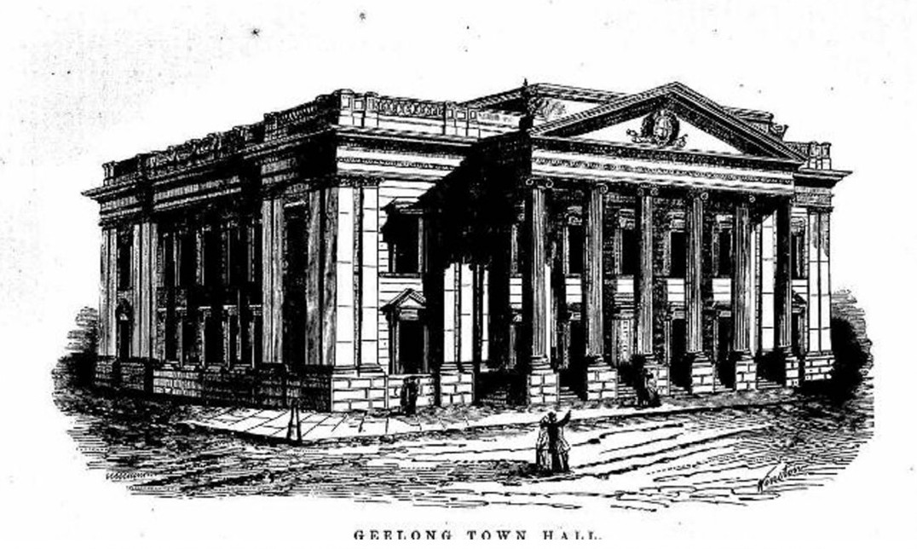
Figure 7.08: J. Reed, Proposed Geelong Town Hall. Source: Geelong Advertiser & Intelligencer, 21 August 1855, p.1.

The South Front (now in course of erection) has a recessed portico of six three quarter columns, surmounted by the cornice, flanked; also, by coupled pilasters. The window openings are enriched with moulded architraves, panelled pilasters, and carved trusses, surmounted by a cornice, or pediment.
The North Front has a similar arrangement, but with pilasters only. The whole Order stands on a bold rusticated basement, and is surmounted by a handsome attic, agreeably broken by ballusters [sic.], piers, and other appropriate architectural details, the whole carried out in very fine free-stone, obtained from the Barrabool Hills, near Geelong. The interior arrangement we think quite in character with the architectural appearance of the building. The architect having evidently kept in view that architectural desideratum, convenience and appearance. The building is entered by an enriched doorway of large dimensions, under the portico which opens into a corridor, and that again into the vestibule; on the right of which is the grand staircase, leading to the galleries around the vestibule, from thence to the corridors and offices on the principal floor. The vestibule and staircase are decorated with Scamozzi Ionic columns and pilasters. The ceilings are all deeply panelled, and the whole admirably lighted
with a lantern light of large proportions, rising from the entablature of the columns, also by three windows looking out upon the
north front.
The Council Room is a noble apartment, sixty feet long, forty feet wide by twenty-five feet high, decorated with Ionic pilasters, standing on a moulded pedestal; the ceiling is deeply panelled, and in the centre is a large octagonal cove, from which rises a handsome lantern for lighting the room. There are three doorways to this room, all decorated with pilasters, trusses, pediments, &e. The one at the west end, leading into the lobby of public entrance, the others to the vestibule and corridor. On the ground floor are the Mayor’s robing and private rooms, committee rooms, offices for the Town Surveyor, Rate Collectors &e.; on the first floor are offices for the Town Clerk, Town Treasurer and their assistants, also committee and waiting rooms, &c., &c. On the second floor are twelve large rooms lighted by windows at the back, and approached by staircases on the north and south sides. Ample security has also been provided for the valuable documents of the Corporation, there being no less than four fire proof rooms in the building, two on the ground and two on the first floor. The walls of these

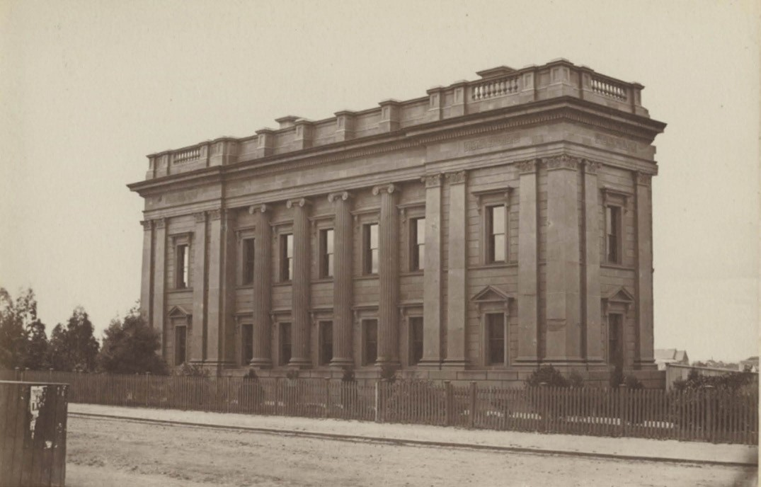
Figure 7.09: E. De Balk, Geelong Town Hall, 1866. Source: GRS 2009/147/0 Geelong Heritage Centre collection.

rooms are of blue stone 30 inches thick, with the rooms arched over at top and bottom with bricks and cement, the entrances closed by stout wrought iron doors. Over
these rooms will be fixed a large rain water tank capable of holding 6500 gallons, to receive the water from the roofs. This is a most valuable arrangement, as pipes may be connected with the tank so as to convey the water to any part of the building, and in case of fire, or for any other purpose, a supply of water would always be
at hand.121
The south wing and chamber hall of the Town Hall (Figures 7.09-10) was opened on 13 November 1855 with a
charity fair in the building in aid of the Geelong Hospital and Benevolent Asylum.122 The main entrance to the south wing was at the west end, from Little Malop Street. The chamber hall was situated to the north-west of the south wing, being rudimentary in appearance and constructed of squared, coursed bluestone. It was surmounted by an arcaded monitor light. There was a separate entrance portico to the hall at
the west end. Internally, the hall was more reflective of its civic function, with a hardplastered coffered ceiling and
hardplastered walls punctuated by Ionic pilasters and window and door pediments, carrying the Classical appearance of the south wing into the hall interior.

THE COMPLETION OF THE TOWN HALL
Minor alterations were carried out to the Town Hall in the early 1860s. This involved some changes to the Council chamber in 1861123 and alterations to the doors ‘at the main and south entrance.’124 However, 42 years were to elapse for Reed’s complete design of the Geelong Town Hall was realised. By May 1915, the local architect, Thomas Slevin, was appointed by the City Hall Building Sub-committee to prepare plans and specifications for the completion of the Town Hall ‘without delay’.125 Tenders were called and in late June fourteen
were received. They and the cost of the construction were debated by the Council overnight until 4 am the next morning.
Eventually, the motion was carried to accept the tender
of the local building firm of W.J. Kelly at a cost of £10,533, which included local sub-contractors: J.C. Taylor and Sons (carpentry), J. Kew (plastering), Nash and Sons (painting) and Hugh Reid (plumbing).126 A reason for the lengthy debate

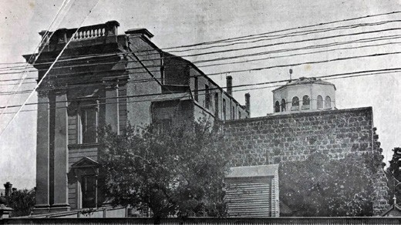
Figure 7.10: Geelong Town Hall from Gheringhap Street showing bluestone chamber hall (right), 1911. Source: News of the Week, 30 March 1911, p.14, GRS 2121/3, Geelong Heritage Centre collection.

was the controversy surrounding the Council’s previous purchase of the former Geelong Grammar School complex in McKillop, Moorabool and Maud Streets. Ratepayers had
objected to the conversion of the School into a Town Hall at a cost of £20,000.127 However, debate ensued about the central location ‘on top of the hill’ as the ‘centre of a Greater Geelong’ as opposed to the completion of the existing Town Hall building fronting Johnstone Park.128
In December 1915, a ‘show stone’ was laid for the additions of the building, but with little fanfare. This was in part due to the construction being carried out at the height of World War One, but more so the political divide that existed. As quipped by the Geelong Advertiser:
Peace has come after a storm of two years, old sores must not be re-opened, and the stone modestly engraved: “these municipal buildings were commenced in 1855, and completed in 1915” quietly snuggled into its bed on the Gheringhap-street front with the mason’s benediction but nobody’s cheer.129
While the bulk of the brickwork was expected to be completed by the end of January 1916, World War One appears to have curtailed building progress.130 Work was completed and the building opened by the Premier of Victoria, Sir Alexander Peacock on 7 June 1917.131 Externally, the building largely reflected Reed’s original design (Figure 7.11) but the interior was more contemporary with timberwork and other detailing reflecting the influence of the Arts and Crafts movement
and the plasterwork the influence of the Edwardian Baroque (albeit in a conservative way). The Council involved the staff and former students of the Gordon Technical College in designing the applied art work,132 including timber carvings by a Mr Raynor, staff member of the Gordon College. Arthur
S. Pittock was responsible for the design and construction
of a large stained glass window in the stair hall (Figure 7.12) which was described as ‘a special feature’ in the new building, the leaded glass work using ‘the motif throughout in Greek form, of admirable colour.’133 Overall, the improvements to the Town Hall were glowingly reported by the
Geelong Advertiser:
Messrs J. C. Taylor and Sons, contractors for the new City Hall, have almost completed the interior fittings and furnishings. These are composed entirely of Queensland maple, and are fine examples of the beauty and utility of Australian timbers. In the town clerk’s room, immediately to the left of the main entrance, a bookcase and lockers extend across one side. There are seven cupboards, and one locker contains a nest of eight drawers. All the doors are flush panelled at the back. The town clerk’s desk is very neatly constructed. It contains eight drawers, and the top is covered with specially selected hide. Opposite the main entrance the circular enquiry counter attracts attention, being bent out of solid timber. There are three very superior tables in the building—one in the Mayor’s
room 11ft, x 4ft., another in the councillors’ room 6ft. x 3ft., and the third in the Council Chamber. A massive piece
of furniture (of horseshoe shape, with accommodation and drawers for 15 councillors). The inside of the curve is panelled. Messrs. J. C. Taylor and Sons are particularly proud of the dais, which occupies a space of about
12ft. x 8ft. The 9ft. high backing shows the maple to great advantage, being beautifully panelled and carrying the city arms, surrounded by wattle leaves. This work, together with the carving on the front, was carried out by Mr. Raynor, of the Gordon College staff. A reporters’ desk, 16 lockers, and a writing table in the councillors’ room, together with the framing in the doors, still further emphasise the beauty of the maple. Perhaps the best example of this wood is to be found in one of the three
12ft. seats. It is exquisitely marked, and it is surprising that it was not kept for veneer work. Most of the timber was specially selected.134

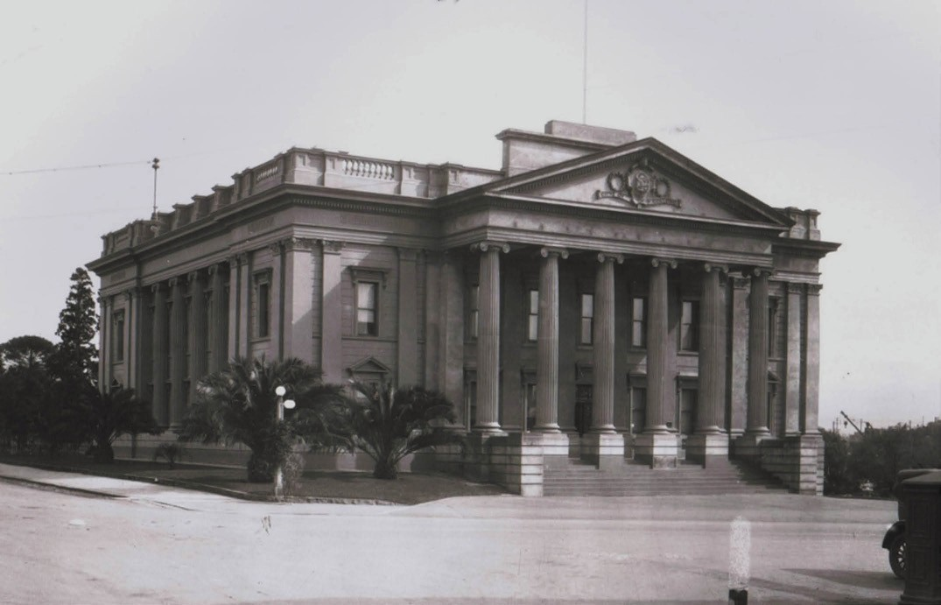
Figure 7.11: Geelong City Hall, n.d. [c.1925]. Source: Lorraine Huddle, Davies collection.

THE TOWN HALL LIONS
In 1935 two large bronze lions (Figures 7.13-14) were proposed in front of the City Hall (on the existing raised plinths that projected at the end of the portico) to mark the centenary of the creation of Geelong as a municipality in 1937.135 Weighing more than half a ton each, they were the work of William Leslie Bowles (1885-1954), sculptor, who had trained under the Art Nouveau teacher at the Brisbane Technical College, Lewis J. Harvey, and Sir E. Bertram Mackennal in England.136 The lions were donated by Florence Clarke (1875-1966) in memory of her parents and early pioneers of Victoria, Thomas and Agnes (nee Fisher) Clarke; and Mrs Alberta Bessie McDonald (nee Elliot (1877-1941) in memory of her husband, Alderman Edward Allen McDonald (1984-1937), O.B.E., and her son, Edward Colin McDonald (1906-1935).137 The lions were unveiled by the Mayor of Geelong (Alderman Brown) on 25 January 1938.138

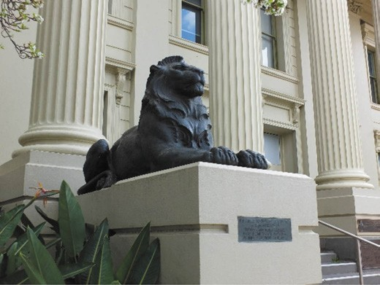

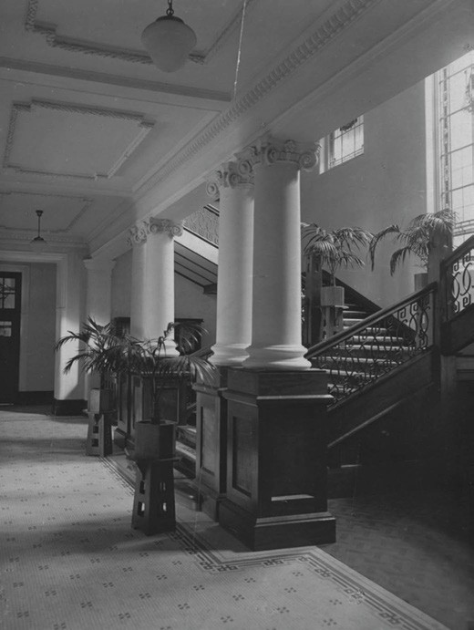
Figure 7.12: Geelong City Hall interior, 1917 showing stair hall, & the large stained glass stair hall window by A.S. Pittock. Source: GRS 2009/0079 Geelong Heritage Centre collection.

OTHER ALTERATIONS
Numerous alterations and additions have been carried out to the City Hall from the second half of the 20th century. In 1968- 69, the hall chamber was demolished and replaced with a large community meeting space, supper room and kitchen.139 This formed part of an addition that was constructed at the rear (west) of the Town Hall. The stylised Stripped Classical cuboid form included a portico with vestigial colonnade
and a large glazed entrance foyer on the Little Malop Street (southern) frontage. Internally, a Modernist curving staircase replaced the stairs of 1917 in the main foyer. Internal changes were later made in 1997, 2007 and 2017, including the replacement of the original fittings and fixtures (of 1917) in the main entrance foyer.140

COUNCIL HERALDRY
In April 1924, the Geelong Town Corporation adopted a coat of arms in the field of a shield. It has been described as follows:
Figure 7.13: Clarke Memorial Lion, 2019. Source: David Rowe.
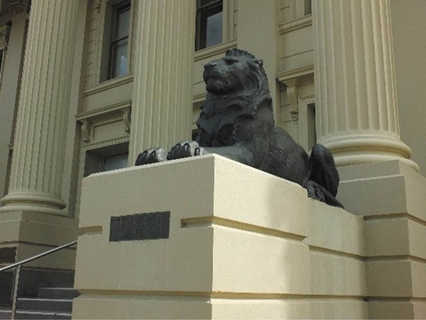
Figure 7.14: McDonald Memorial Lion, 2019. Source: David Rowe.

The arms showed the field quartered by a perpendicular and a horizontal line crossing each other at the centre of the field, thus dividing it into four equal parts for a sheep, garb, ship and grapes, all emblematical of established industries. Centred on the field was a kangaroo, emblematical of Australia. The supporters were two laurel wreaths representing honour, whilst the rose, thistle and shamrock were included as the floral emblems of England, Scotland and Ireland. The crest was a rising sun. The motto was “By the right use of God’s gifts.”141
The original shield was illustrated in the Herald newspaper in 1937 at this time the Geelong City Council had registered a patent for the design following its non-civic use by the public for Christmas cards, crockery and souvenirs in previous years.142

The coat of arms had earlier featured on Mayoral chairs. The first Mayoral Chair in the Town Hall, constructed for thepurpose in 1861 was built of colonial blackwood. The crown of the back of the chair was ‘elaborately surrounding the insignia of the Corporation; the arms of the chair terminating in the mythical head of the Griffin.’143 A second chair was installed in 1911, the work of the artist, John Thorne.144
The coat of arms was also centrally placed in the main stained glass window in the stair hall as part of the improvements to the Town Hall in 1915-17.
On 18 March 1981, a new coat of arms was granted. These arms have been described as follows:
Much of the City’s previous insignia is incorporated in the arms. The stag’s head is taken from the Scottish family
of Thomson to perpetuate the memory of Geelong’s first mayor, Dr Alexander Thomson. The sheep, wheat and grapes as symbols of local industries, were major
elements in the old insignia. The patriotic Lion of England and Unicorn of Scotland have been transformed into sea- creatures, with mural crowns referring to the City status and the anchors to its role as a port.145

COUNCIL PROCLAMATIONS
On 8 December 1910, Geelong a proclaimed a City.
On 24 August 1939, the offices of Aldermen in Geelong were abolished.146

OTHER EARLY MUNICIPALITIES
The proclamation of the Geelong Town Corporation in 1849 soon brought about succession movements by suburban and rural ratepayers. The loss of Geelong as the earlier known ‘capital’ of the District Council of Grant weakened the ability of concerned citizens and ratepayers to petition for improved roads, paths and other necessary infrastructure,147 as much of the outlying parts of the now City of Greater Geelong were outside the Corporation. Its boundaries extended only as far as Point Henry to the east, the Barwon River to the south, and the Moorabool River to the west.148
It was from the mid-1850s when separate Roads Boards and Boroughs were established in these suburban and outlying areas. With increases in population and the need for greater infrastructure, like the Geelong Town Council,
greater demands were placed on these municipalities. From fledgling Roads Boards, some amalgamated and eventually their status was elevated through their proclamations as Shires following the District Councils Bill 1862 which gave opportunity for a Road Board to petition for conversion to a Shire when it reached a certain level of rate revenue and was 260m square kilometres in size.149 Some municipalities were
later elevated to City status.

BARRABOOL
The Barrarbool Road District, the second in the colony of Victoria, was proclaimed on 24 December 1853.150
The boundaries were published in the Victoria Government Gazette:
Commencing at a point on the River Barwon, being the north-east corner of the parish of Barrarbool, and bounded on the north by the River Barwon upwards to the north- west corner of the parish of Gnarwarre; on the west by a line bearing south five miles thirty-nine and a half chains; on the south by a line bearing east five miles; again on the west by a line bearing south four miles thirty-six chains
to the head of Thomson’s Creek; again on the south by Thomson’s Creek; and on the east by a line bearing north to the commencing point on the Barwon River.151
The Barrarbool Road District took in the parishes of Barrarbool, Gnarwarre and Duneed.152
It was not until February 1854 when David Fisher, Alexander McKenzie, Edward Willis, Charles Lambert Swanston, William Kiddle, John Belperroud, Stephen Thomas, John Gray, John Leigh and John Fallen petitioned the Geelong magistrate,
W.H. Bonsey, to convene a meeting for the established of a Road Board.153 Held at the Wheat Sheaf Inn, Ceres on 4 March 1854, Alexander McKenzie was elected Chairman,
with other elected Road Board members being Dr. Coombe,
C.J. Dennys, David Fisher, Captain Coltish, William Middle, Laurence Thesean, Thomas Fleming, and John Heard.154 The Argus gave an account of the first meeting and the method proposed for raising revenue:
Although the new Board considered it more advisable to raise revenue by a system of tolls, they finally agreed to levy the maximum rate of assessment allowed by the Act under which they held their power.155
On 5 June 1865, the Shire of Barrabool was constituted, replacing the former Barrarbool Road District and Board.156

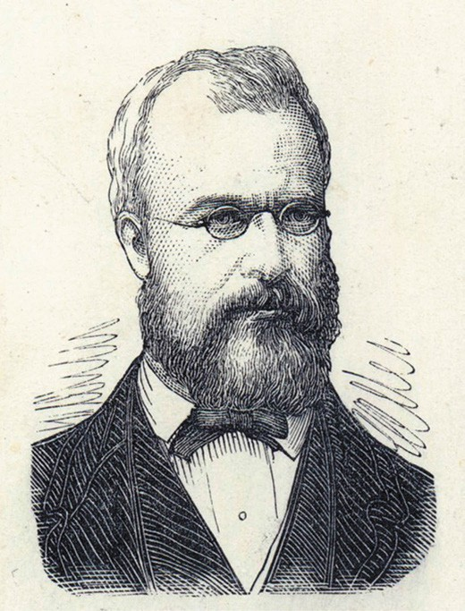
Figure 7.15: E. Gilks, John Rout Hopkins, 1874. Source: accession H31555/69, State Library of Victoria.

THE FIRST BARRABOOL COUNCILLORS
The first Council was J.R. Hopkins (Shire President), J. Piper,
M. Dwyer, T. Smale, A.T. Moran, S. Riches, J. Gundry, J. McKenzie and Dr Heath.157
John Rout Hopkins (1828-1897) (Figure 7.15) was born in Hobart, Tasmania, the son of Henry and Sarah (nee Rout) Hopkins.158 He went to England as a child and returned to Tasmania before commencing sheep breeding in 1845 as manager of Murdeduke near Winchelsea, one of his father’s Western District Runs. Soon after, Hopkins acquired nearby Wormbete station and in the 1850s he obtained freehold of 20,000 acres. The inaugural President of the Barrabool Shire, Hopkins was simultaneously the Member in the Victorian Legislative Assembly for South Grant from November 1864. Hopkins later served as a Councillor with the Winchelsea Shire Council for 32 years, and was Mayor of Geelong in
1892-93.
James Piper (1818-1911) was one of the early European colonists to the Barrabool Hills.159 A labourer, he married Elizabeth Greenway, a housemaid, in Cornwall. On his death in 1911, The Age gave the following obituary:

Mr. James Piper, of Barrabool Hills, who died in Geelong on 26th inst., at the advanced age of 93, is the last survivor of the early group of pioneers from Devonshire who first started farming on the Barrabool Hills. As
seen from their ship at Point Henry, on its arrival in 1841, the hills reminded them of their native Devonshire. He was one of the first members of the old Road Board, and since that time had held leading places in the shire
council, the old Board of Agriculture (which preceded the present department), the Ceres Agricultural Society and other local associations. His name is a notable one in connection with progressive agriculture. He was the first to offer a prize of £10 for best ploughing, under condition that the winner should be a native born Australian. He was one of the earliest Church of England trustees, and at the jubilee was presented with a framed picture of the guardians, including those who with himself started a school and church in 1846. … Throughout his lengthened career he exercised a great influence as the result of his
character. He helped the late Peter Lalor, as a young man, to his first seat in Parliament, and remained his staunch friend throughout. Mr. Piper was of a cheerful, large- hearted disposition, which commanded the respect and affection of all who knew him. While latterly rather feeble physically, he was mentally vigorous up to the end.160
Matthew Dwyer (c.1822-1874) was the son of Matthew and Fanny (nee Condon) Dwyer of Tipperary, Ireland.161 A labourer, he appears to have arrived in Victoria on the Gilmore in 1841. In 1853, he purchased land in the
Government land sale at Gnarwarre and established a farm. Dwyer was a member of the Barrarbool Road Board in 1858, continuing as a Councillor with the Barrabool Shire Council until 1871. In 1873, he relocated to Birregurra where he died in the following year.
Thomas Smale, J.P. (1820-1883) was the son of Thomas and Grace (nee Shaplin) Smale of North Tamerton, Cornwall, England.162 A mason, Smale married Eliza Semels in 1844. By 1856, Thomas and Elizabeth Smale and their children had relocated to the Barrabool Hills where Thomas leased
farmland. He was to farm Edgecombe and continue as a local builder/mason. His untimely death in 1883 was reported in the Geelong Advertiser, which gave the following obituary:
The deceased gentleman was a native of North Tamerton, Devon, England, and died at the age of 60 years. He came to the colony at an early period, and was a resident of the Barrabool Hills district for fully 30 years. As a farmer he was most successful on the old Barrabool Hills, where
he held a leading position for many years. In his social life he was extremely well liked, and for a considerable period occupied the position of a member of the Barrabool Shire Council, both at the time the district was under the

old road board system, and since the Shires Act came into force. He was a staunch tee-totaller, and a leading member of the Bible Christian Church. In all political movements he took a great interest, and he was one
of the most energetic agitators for a better system of immigration, which he thought would be of vast benefit to the farmers of the colony.163
Andrew Thomas Moran (1833-1901) was born in County Wexford, Ireland, the son of John Joseph and Elizabeth (nee Maceachearn) Moran.164 By the 1850s, he had emigrated to Victoria as in 1858 he married Elizabeth Yates. In 1861, he was appointed Engineer to the Winchelsea Shire Council and he had also taken up the position of Surveyor with the Council soon after. By 1863, Moran had also been appointed Electoral Registrar for Modewarre. He served as a Councillor with the Barrabool Shire Council until 1896.
Samuel Riches (1817-1898) emigrated from Southampton, England, to Victoria in 1853.165 After some years at Mount Moriac, Riches relocated to Hamilton. His death in 1898 was reported in the Hamilton Spectator:
It is with much regret that we record the death of Mr. Samuel Riches, an old identity of Hamilton, who passed away last evening at the advanced age of
82 years. The deceased gentleman had spent nearly half a century in Australia, having arrived here in the early fifties. He first commenced business in this colony as a butcher at Mount Moriac, near Geelong, where he soon established himself as a prominent figure in all form
of field sports, being also an adept at cricket. While in that locality he was elected member of the Barrabool Shire Council, which office he filled with great credit for a considerable period. After a lengthened residence at
Mount Moriac, Mr. Riches about 30 years ago took up his abode in Hamilton, where he continued in the same line of business for several years and enjoyed a fair share
of prosperity. For a long time he occupied a seat in the Borough Council and frequently refused to accept the position of mayor, though urged to do so by numerous friends. Owing to increasing age and consequent infirmity he retired from active duty a few years ago and passed his remaining time in comparative quietude.166

Joseph Gundry (1809-1878) was born at Lopen, Somerset, England, the son of John and Mary (nee Masters) Gundry.167 He emigrated to Tasmania in 1832, leaving behind his wife, Grace (who died in Cornwall in 1835), and son, Joseph. In 1844, Gundry took up Iron Bark Station at Jan Juc (Bellbrae), where he resided for the remainder of his life. He served as a Barrabool Shire Councillor until his death in 1878.
John Lorne Stuart McKenzie (c.1828-1906) first went to India to manage a tea merchant’s business but by 1855 he had emigrated to Australia where he purchased 600 acres at Freshwater Creek, his property known as Ghazeepore.168
An inaugural Councillor with the Barrabool Shire Council, he threatened to resign in 1870 in protest over the sacking of John Elkington, Shire Secretary, although he is not known to have resigned until 1874.
Dr Richard Heath (1809-1888) was born in Bishop’s Stortford, Hertfordshire, England, and qualified as a Licentiate of the Society of Apothecaries, London, in 1830 and as a Member of the Royal College of Surgeons, Edinburgh, in 1850.169 He set sail from Gravesend for Melbourne in 1857 although his ship, Windsor, was wrecked off the Cape Verde Islands and he returned to England. He arrived in Melbourne from Liverpool on the Sir William Eyre in 1858. Following a period in Ballarat, Geelong and Sydney in 1858 and 1859,
a year in Melbourne in 1863, Heath was at Mount Duneed between 1864 and 1868.

FIRST OFFICERS OF BARRABOOL SHIRE
The first Secretary of the Barrabool Shire Council was John Elkington (1818-1897).170 He served as Secretary from 1865 until 1869 and played a highly important role in the administration of several municipalities in the Geelong district. He prepared autobiographical details that were published following his death in 1897:
In August of the year 1848, I embarked with my wife and five children in London for South Australia, arriving at Adelaide the following November, but left there in a few weeks afterwards for Port Phillip, where we landed on the 9th January and then betook ourselves to Geelong almost immediately. Duly housed there, not more than three days had elapsed ere I found employment under Mr W. H. R. Weekes, architect and surveyor. Laying out allotments in Chilwell and Newtown, drawing plans, etc., was the chief part of my work for a couple of months. I then worked at Mr Strachan’s store, amongst the wool, and had for my mate, James Blair (at present secretary of Corio shire), afterwards at Bayldon’s establishment at the Breakwater, sorting and classing wool. My next move was to James Cleah Wallace’s office, where I did the lawyer’s clerk

business (to my mind) first rate, there I was superseded by a real limb of the law, our mutual friend, Mr T. C. Harwood, newly-arrived from England. I was not sorry for it, as I
was more anxious to get into mercantile employment, and did not have to wait more than a fortnight, when I found myself duly installed as clerk and manager for Mr Thomas Sheppard (now deceased): I was indeed then both happy and proud of my position. This happened on the 6th August, 1849, (a quarter of a century has since passed, during which I have encountered all sorts of perplexities and reverses, with occasional bits of good luck, but never became disheartened under any circumstances). Well, I continued in Mr Sheppard’s employ until he left Geelong for the old country, on the never-to-be-forgotten Black Thursday, 6th February, 1851. After winding up accounts for my late employer, I went into business on my own account, and undertook the agency of the old Aphrasia steamer, lighters and other craft, and did very well as times went, until in an un-lucky hour I consented to join in a mercantile partnership with poor Robert Robinson, then
M.L.A. for Geelong in the first Parliament after separation from New South Wales … I resolved to try store-keeping business at Queenscliff, then proclaimed a township, early in the year 1854. Shortly after settling there,
Mr Harrison, of the “ Geelong Advertiser,” engaged me as shipping reporter and correspondent at £150 a year. This arrangement continued until the latter part of 1855, when the establishment of telegraphic communication between Geelong and Queenscliff rendered my vocation no
longer necessary in the shipping line. At the close of that year I found that store-keeping, on such a limited scale, would not meet the heavy expenses of house keeping, be it ever so carefully managed. We were then “ eleven
“ strong in family, so bent our course for Melbourne, where we resided with indifferent luck-not as to the amount of work I found myself actually engaged in, but the miserable remuneration given in face of extortionate prices for all necessaries of life. House rent dreadfully high. After dwelling in the suburbs of Melbourne nearly 18 months, I returned to Geelong, and very shortly obtained the position of secretary to the Barrabool-road Board, somewhere about the month of May, 1857. Of all my doings in connection with the Board of that road district up to the time of my official severance in October, 1869, my exertions in the establishment of the Winchelsea-road district in November, 1860, and similar results with respect to the birth of the Bannockburn Road Board, I need not enlarge upon, as you have pretty correct know-ledge of
all that has taken place as far as I have been concerned officially with the three local bodies just mentioned. That I carried out my duties assiduously and faithfully I will

always maintain, but without doubt I did not please every member whom I had to serve. Keeping to the subject as far as it bears upon the question of local government,
I must go back some 14 years, to mark the period when I was appointed the representative for both Barrabool and Winchelsea Road Board at the first conference on
municipal self-government held in Melbourne; again on a similar mission in 1851, besides using many opportunities I had at the period of drawing the attention of leading men in Parliament to the more important sections and provisions in the measure which ultimately became law in 1863.171
Andrew McWilliams (1818-1899) was the first Shire Engineer for the Barrabool Shire Council.172 Born in Newtown, Limavady near Londonderry, Ireland, and although his training in architecture and surveying is not known,
he was appointed civil assistant to the Ordinance Survey of Ireland between 1836 and 1840. He then transferred to the English survey office until 1845 and in 1846-47 he was
assistant engineer to the Irish Board of Works. Establishing a private practice as an architect and engineer, he worked in the counties of Tipperary, Clare and Limerick until 1853 when he emigrated to Geelong, arriving in 1853.
In December 1853 he entered into a partnership with a
Mr Harvey as an architectural and civil engineer, the practice being short-lived as by 1854 McWilliams worked on his own account. In 1858, McWilliams expanded his work with his appointment as engineer to the Barrarbool Road Board, a role he continued following the constitution of the Barrabool Shire in 1865 (he resigned in 1869). Between 1859 and until his death in 1899, McWilliam was also Shire Engineer to the Bellarine Shire Council, to the Borough of Queenscliffe from 1863 and the Borough of Geelong West in 1880. He had been elected a councillor to the Geelong Town Council in 1860
and between 1861 and 1891 he was Clerk of Petty Session at Drysdale. Heavily influenced with the Anglican Church, he was a lay representative of the Drysdale and District Anglican Church Assembly for 20 years.

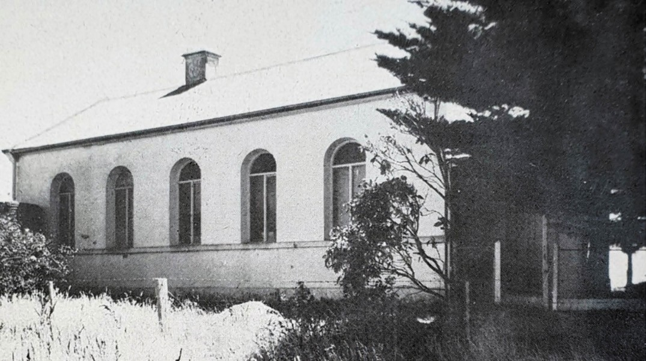
Figure 7.16: Barrabool Shire Hall, Mount Moriac, c.1965. Source: Shire of Barrabool 1865-1965 Centenary Souvenir.

THE BARRABOOL SHIRE HALLS & OFFICES
Initially, from 1854, the Barrarbool Road Board met outside the fledgling municipality in the Central Road Board office in Geelong.173 Following the completion of the Chamber of Commerce in Moorabool Street in 1858, the Road Board leased an office there. In 1861, the Road Board relocated to the former Bank of Victoria at the south-east corner of Moorabool and Ryrie Streets.174 No physical evidence survives of these buildings today.
In 1862, it was decided that the Barrarbool Road Board should meet in its own municipality and so a new office was leased at Mount Moriac (outside the boundaries of the existing City of Greater Geelong).175 This served until the Road Board erected its own building in Hendy Main Road at Mount Moriac (Figure 7.16) that had been designed by Andrew McWilliams.176 This gabled rendered brick building
became the Shire Office in 1865 when a porch was added and stables and fencing constructed.177 Repairs were carried out to the building in 1925 and 1938.178 By 1949, the Shire office was dilapidated and so the administration of the Barrabool Shire Council relocated to two rooms in the Geelong and Cressy Building at the south-east corner of Yarra and Malop Streets.179 Council meetings continued to be held at Mount Moriac until 1976.180
In 1959, the Barrabool Shire Council purchased the former Temperance Hall at 441 Moorabool Street, South Geelong (built in 1884).181 The building was altered and extended and converted into municipal offices that were opened in April 1961.182 Further extensions were carried out in
1985 as a temporary measure until a new Council office was erected in Grossmans Road, Torquay, in 1988 at a
cost of $1.5M.183

SOUTH BARWON

THE EARLY ROAD BOARDS
Two Road Boards – Conewarre and South Barwon - were to comprise what was later to become the South Barwon Shire.
On 8 October 1856, the Conewarre Road District was proclaimed. The boundaries of the new Road District were:
Commencing at the north-east corner of the parish of Duneed at a stake on the south side of the Waurn chain of ponds; bounded on the west by the parish boundary line bearing south four hundred and fifty-four chains eighty- nine links to Thomson’s Creek; thence by that creek south-easterly to the sea coast; by the sea coast north- easterly and eastly to the mouth of the Barwon River; by

the Barwon River, the southern and part of the eastern shores of Lake Conewarre; and again by the Barwon River north-westerly to the junction of the Waurn chain of ponds; and by the said ponds south-westerly to the point of commencement.184
Measures had also been put in place for the establishment of a Road Board prior to the proclamation of the Conewarre Road District. A meeting was held on 26 June 1856 at the
Prince of Wales Hotel, Geelong, chaired by John McKenzie.185 It was agreed that J. Noble, J. R. Baylie, J. Armstrong, D. Urquhart, J. McVean, J. Munroe, S. Price and H. McKinnon be members of the Board.186 James Noble was to become the inaugural Chairman.187
An effort to establish the South Barwon Road District began in January 1857. As published in The Age:
South Barwon. — The inhabitants of the district of South Barwon, within the Municipality of Geelong, have
petitioned his Excellency, the Governor, for separation into a distinct Municipality to be termed ‘The South Barwon Municipality.’ The grounds assigned are the neglect of the Corporation of Geelong to keep the roads in proper order, and the fact that the area of the land south of the Barwon and within the corporate boundaries of Geelong, is less than nine square miles , and contains upwards of three hundred householders, and that no point in such area
is distant six miles from any other point. The petition is signed by 218 householders, whose names are given with the petition in the Government Gazette.188
Six months elapsed before the South Barwon Road District was proclaimed on 2 June 1857. The Victoria Government Gazette detailed the boundaries of the newly-formed Road District as follows:
Commencing at a point on the eastern bank of the River Barwon, being the south-west angle of allotment 1, north of section 25, parish of Barrarbool; thence by the southern banks of the said river to the eastern boundary of the Race Course; thence by the eastern and southern boundaries of the Race Course to a point one chain due north and of the north-east angle of allotment J, section 4, parish of Conewarre; thence by a line bearing south to the south- east angle of allotment K, section 4, in the same parish; thence by a line bearing west to the south-west angle of portion 16, parish of Duneed; thence by a line bearing north to the north-west angle of allotment 8, section 18, parish of Moorpanyal; thence by a line bearing west, being the northern boundary of section 25, parish of Barrarbool, to the River Barwon; and thence by the eastern bank of that river to the commencing point.189

A meeting was held at the Racecourse Hotel, Belmont to nominate members for the South Barwon Road Board. Those elected members of the Board were Alexander Mackenzie, Charles John Dennys, Samuel Bradley Corrigan, William Gilbert McKellar, Charles Huttall Thorne, Robert Smith Tuffs and William Darly Dodds. The first meeting of the Road Board was held on 20 July 1857 and William McKellar was elected Chairman.190

MUNICIPAL PROCLAMATIONS AND AMALGAMATIONS
In October 1863, the South Barwon Road Board was elevated to the status of a municipal Borough.191 In 1864, a meeting was held with approximately 60 ratepayers in relation to the possibility of amalgamating with the Conewarre Road District to form a United Road Board District.192 However, over ten years were to elapse before this was realised. The resolution to create a combined Council was passed at a meeting of ratepayers at the Belmont Hotel on 19 December1874.193
On 20 January 1875, members of the South Barwon Borough Council and the Conewarre Road Board held
their first amalgamated meeting at the South Barwon Council Chambers, Belmont. Councillor William Higgins was elected President for the first year, while John Richardson was appointed Secretary until tenders were called for this position (Richardson ultimately remained Secretary until 1876). R.S. Tuffs was appointed Surveyor.194

FIRST COUNCILLORS OF THE SHIRE OF SOUTH BARWON
The first South Barwon Shire Council was an amalgamation of serving Councillors of the South Barwon Borough Council and the Conewarre Road Board.
William Higgins (1833-1892) (Figure 7.17) was the first South Barwon Shire President.195 He was the son of William and Frances (nee Hart) Higgins of Southminster, London, England. William junior emigrated to Victoria with his father on the Larpent, arriving at Point Henry in 1849. It was at this time he was employed as a clerk to Joseph Belcher, an Irish solicitor of English descent and father of local pioneer, G.F. Belcher. By 1856, Higgin was resident in Pakington Street,
Ashby. Following the completion of his articles, he was admitted as a solicitor in 1858. Higgins served as a Councillor with the Borough of South Barwon from 1871 until Council amalgamations, continuing as a Councillor until his death
in 1892. He was Mayor of the Borough of South Barwon in 1871-83 and Shire President from 1874 until 1876, and was

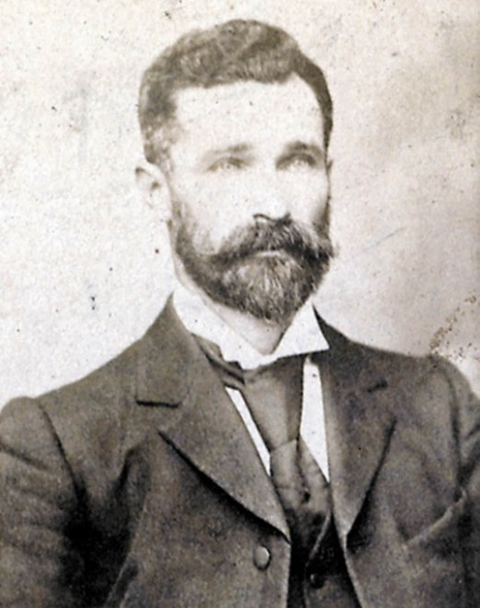

Figure 7.17: William Higgins, n.d. Source: W. Watts, South Barwon Shire Council, c.1900. Source: accession H38330, State Library
of Victoria.

President three other times in the 1880s. For some years, Higgins was returning officer for the Geelong electorate for the Legislative Assembly and was also a Justice of the Peace.
Thomas Adcock (1820-1900) was the son of John and Sarah (nee Brill) Adcock of Winerton, Lincolnshire,
England.196 Thomas, along with his two brothers, Edward and Henry, took up his father’s occupation as a nurseryman at Edlington, Lincolnshire. Thomas Adcock emigrated to Victoria on the Larpent in 1849, arriving at Point Henry on 28 June of that year. Adcock married Martha Port of Chersey, Surrey in Geelong in 1851 and they settled at Highton where Thomas established the Kardinia Nursey. He was joined
by his brother, Henry, by 1856, as he was listed as being employed by Thomas at this time. In 1860, Thomas became the inaugural chairman of the Horticultural Improvement Association of the Western District and in 1867 he was also chairman of the Geelong and Western District Agricultural and Horticultural Society. Adcock was also a foundation member of the Congregational Church at Highton (from 1854), a trustee of the Highton Cemetery, a magistrate from 1871, and a member of the Ryrie Street Presbyterian Church, Wesleyan Methodist Missionary Society and Geelong and Western

District Fish Acclimatisation Society (which he chaired in 1877).
Thomas Adcock served as a Councillor with the Borough (and later Shire) of South Barwon from 1866 until 1879, serving as Mayor of the Borough in 1868-69 and President of the Shire
in 1876-77. In 1897, Thomas transferred the Kardinia Nursey to his brother, Edward. He retired to Edward’s residence
in Laurel Bank Parade, Newtown, where he died on 23 May 1900.
Alexander Reid (c.1818-1879) was the son of Peter and Rebecca (nee Stewart) of Dundee, Scotland.197 A clerk, Alexander Reid married Helen Robertson and in 1852 they emigrated on the Kohinoor with their four children to
Victoria arriving on 21 July of that year. After a short time in Richmond, Melbourne, the Reid family relocated to the corner of Pakington and Bendigo Streets, Ashby, with Alexander continuing his occupation as a clerk. He later had established a business as a produce merchant in Ryrie Street. In 1858
at a cost of £5000, he had built the Belmont Flour Mill on the Mount Colite (Barwon Heads) Road. The mill was destroyed by fire in 1874 and Reid established the Geelong Flour Mill
in Little Malop Street in 1875. Reid was first elected as a Councillor with the Borough of South Barwon in 1867 and he served until 1875, including two terms as Mayor in 1870-71 and 1873- 74. Tragically, Reid’s life was cut short in 1879 after a fracture to the leg turned gangrenous.
John Peake Foster (1825-1882) was the son of John Valentine and Mary Ann (nee Tucker) Foster of Deal, Kent, England.198 A retailer of beer, J.P. Foster married Elizabeth Arnold at Stepney, England, in 1849. With Elizabeth Foster’s parents, William Burville and Hannah Arnold, and her brothers Charles, Henry, George, William Burville junior
and other members of the Arnold family, J.P. and Elizabeth Foster and their children emigrated on the Lady Flora to Port Adelaide, South Australia, arriving on 30 October 1851. By 1853, they were resident at Barraport (between Swan Hill and Bendigo). A year later, they had settled in Geelong as J.P. Foster and W.B. Arnold senior had established a nursery and lime business near the Barwon River in the Barrabool Hills by 1854. By 1859, Foster and Arnold were selling nursery goods but by 1864 Foster was working a 14 acre garden on his own account, on the property of Charles Kernot. By 1867, Foster had purchased the Lansdowne Nursery at Highton, which he worked until his death in 1882. He had served as a Councillor with the Borough of South Barwon from
1871 until 1874.
James Noble (1821-1897) was the son of William and Jane (nee Gray) Noble of Newtown Stewart, County Tyrone, Ireland.199 A farm servant, James emigrated to Victoria on the Ferguson, arriving on 15 January 1841. He soon established a grocery business in Corio Street, Geelong, as he advertised

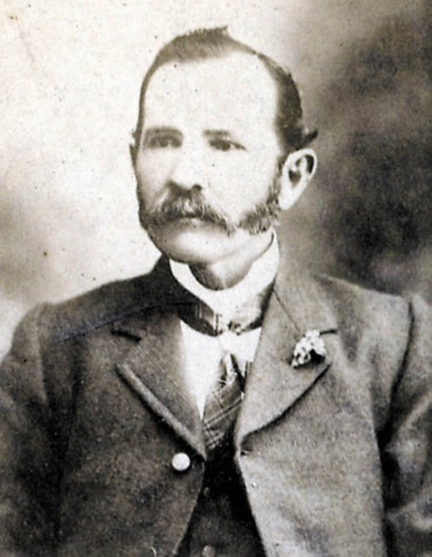

Figure 7.18: George Gardiner, n.d. Source: W. Watts, South Barwon Shire Council, c.1900, accession H38330, State Library
of Victoria.

the sale of bran, flour, tea, sugar, coffee and other goods in 1843, and was awarded a confectioner’s license in 1844. It was also in 1844 when he married Sarah Jane Caldwell. With his financial gains from his grocery business, Noble purchased land at Connewarre at the Crown Land sales
in 1855 and 1856. He acquired additional land in 1864. At Connewarre in 1855 he built his family home to a design by Andrew McWilliams. It was named Charlemont after the Earl of Charlemont that was wrecked off Barwon Heads in 1853. An inaugural member and Chairman of the Conewarre Road Board in 1856, Noble was to be a local Councillor for 30 years, from 1856 until 1859 and as a South Barwon Shire Councillor from 1874 until 1885. After many years filling public positions, including returning officer for the original South Grant electoral and later the South Western Province, honorary auditor to the Town of Geelong, Noble retired in 1885 due to failing health. He took up residence at ‘Locksley’
in Fenwick Street, Geelong, where he died in 1897.
Ewing Blyth (Bligh) (c.1832-1925) was the son of Kemnel and Frances (nee Ewing) Bligh, of Norwich, Norfolk, England.200
A farmer, Ewing Blyth hastily decided to emigrate to Sydney, New South Wales, on the Earl of Charlemont in 1853 as he

feared being convicted and transported as a convict following him being accused of shooting the squire’s bullock. The Earl of Charlemont was wrecked off Barwon Heads and Blyth
was forced again to shoot a bullock (owned by European pioneer of Connewarre, James Tait) to feed the survivors of the wrecked ship. Blyth married Tait’s daughter, Agnes, in 1859. They lived locally for the remainder of their lives, with Ewing working as a farmer. He served as a South Barwon Shire Councillor between 1874 and 1874. Ewing Blyth died at his residence, corner Lower Duneed Road and Winklers Lane, Connewarre (now Armstrong Creek) in 1925.
George Gardiner (c.1846-1911) (Figure 7.18) was the son of George and Mary (nee Purcell) Gardiner of Bathurst, New South Wales.201 He arrived at Marshalltown in 1873 and established a glue and oil manufactory on the southern banks of the Barwon River. In 1882, he married Mary Ann Jeffries but tragically she died of burns five years later in 1887. Gardiner’s glue factory was destroyed by fire in 1894. He rebuilt the following year with the building of the Victoria Tannery, oil and glue works and bone mills (see Theme 5). Gardiner purchased ‘Sunnyside’ at Marshalltown in 1897, the former property of the Vaughan family (see following biographical details). In 1904, Gardiner married Emma Elizabeth Figg although the marriage was cut short by
Gardiner’s death in 1911. Gardiner had served his community as a Councillor from 1874 until 1881 and between 1895 and 1910.
Thomas Vaughan (c.1830-1897) was the son of Thomas and Susannah (nee Went) Vaughan.202 He appears to have emigrated from Liverpool to Melbourne on the Mobile, arriving in October 1852. Vaughan married Miss Kate Perdue at Christ Church, Geelong, in 1855 and their first child was born at Ballarat in 1856. At this time he advertised the sale of the Unicorn Hotel in Sturt Street, Ballarat, where he had been in partnership as a hotel keeper with Thomas Bath.
In 1859, Vaughan purchased 70 acres at Dowling Forest, outside Ballarat, and established Spring Bank Farm. In the early 1860s he held mining shares at Miners Rest and
Ballarat. He relocated to Geelong in 1866 following the sale of Spring Bank Farm203 and soon settled at ‘Sunnyside’, Marshalltown (now Charlemont) (see Theme 6). In 1868, Vaughan was encouraged to nominate as a candidate for the vacancy caused by the retirement of his neighbour, Sharp Brearley. The Geelong Advertiser described Vaughan as ‘a man of wealth and standing in the borough; who had ‘plenty of leisure and was ‘in every aspect competent to fill the office of councillor in a manner calculated to advance the
interests of the borough.’ He was elected a Councillor for the South Barwon Borough Council in 1869 and continued as a Councillor of the South Barwon Shire until 1875. He died at ‘Sunnyside’ in 1897.

Albert Benari (1820-1886) was born in Hildburghausen, Thuringia, Germany and emigrated to Victoria on the Harbanire, arriving in 1853.204 In late 1854 and early 1855, Benari had built a toy shop in Moorabool Street, in
partnership with a Mr Stern. Benari married Bridget Hackett in 1858 and they had seven children before 1869. Being German, Benari was also associated with the German community at Germantown from the 1850s. By 1859, he had established the German Town Hotel at Germantown (now Grovedale), and it was there where the first post office at Grovedale was operated with Benari being postmaster. He served as a Councillor between 1861 and 1875, and as Mayor between 1866 and 1867.
He died at Germantown in 1886.
Alfred Firmin (also known as Firman) was born in London, England in c.1826, the son of Joseph and Hannah (nee Porter) Firmin.205 He emigrated to Victoria on the Windermere with his wife, Elizabeth, and brother, George, arriving in Victoria
in 1852. By March 1854, he had purchased a lime kiln and its site at Strawberry Hill, Belmont, where he made and sold lime (see Theme 4). Before 1856, he leased farmland at Barrabool as well as purchasing land that he leased to his relative, James Firmin. Between 1862 and 1871, Alfred
Firmin was licensee of the Kardinia Hotel, south-west corner of Barrabool and Valley Roads, Highton. During this time from 1864 until 1871, Firmin was a Councillor for the Borough of South Barwon, and was re-elected in 1874, and serving
as a Councillor of the Shire of South Barwon from 1875 until 1876. It was at this time when Firmin sold his properties and returned to England with his wife, Elizabeth, where they lived at 24 Antill Road, London. Alfred Firmin died in London in 1913.
William Batten (1816-1896) was the son of John and Mary (nee Bone) Batten of Saltash, St. Stephen’s, Cornwall, England.206 He married his cousin, Annie Batten (c.1813-1905), daughter of Henry and Ann Batten, in 1850.
It was about this time they arrived in Geelong, presumably with Ann’s brother, William Roberts Batten, as both William Batten and William Roberts Batten had taken up farmland at Connewarre in 1855. Batten was first elected Councillor for South Barwon in 1862 and continued until 1871 and was re- elected in 1874-1877 and 1881-1886. He was Mayor in 1867-
68. In 1886, a banquet was held in the Shire Hall at Belmont to honour Batten’s distinguished and enduring service the South Barwon municipality. By this time, he had relocated to ‘Skene House’, Skene Street, Newtown, where he died in 1896.
John Edward Matthews (c.1837-1892) was the son of John and Ann (nee Weedon) Matthews of England.207 The family emigrated to Victoria in 1852, arriving at Point Henry on the Blackwall in November 1855. A merchant, John Matthews

senior appears to have taken up farmland near the Waurn Ponds Creek (now Grovedale) as a John Matthews, farmer, was listed as owning freehold there in 1856. It was at this time when he seems to have been elected a Councillor with the South Barwon Road Board, his term ending in 1862. He was appointed an auditor of the Borough of South Barwon for 1863. John Edward Matthews established a store at the Moorabool Viaduct, and a post office in 1859. After little success, he briefly went to England with his father, and following his return he settled at a farm property in Francis
Street, Grovedale, by 1861-62. In 1862, J.E. Matthews married Sarah Ann McCure in Sydney. It was following his marriage to Sarah when J.E. Matthews took over his father’s property in Grove Road, which was named ‘Grove Farm’. Like his father, J.E. Matthews took an active interest in municipal affairs, having been elected a Councillor with the Borough
of South Barwon in 1864-1875, serving as Mayor in 1869-
70. An inaugural Councillor with the South Barwon Shire Council in 1875, he was re-elected from 1879 until 1889. In 1882, he was proprietor of a coaching company in Market Square and in 1889 he was granted a stage carriage license to run between Geelong and Portarlington. It was also in 1889, when Matthews sold his ‘Grove Farm’ property (which had been renamed ‘Grovedale’ farm by this time) and relocated
to ‘Manifold House’, Colac, where he worked as a Rabbit Inspector. He died there in 1892.
James Stewart (1845-1899) was born in Parramatta, New South Wales, the youngest son of John Stewart early
European pioneer of Mount Duneed208 (see Theme 6). James Stewart appears to have combined flour milling and farming.
He was elected a Member of the Conewarre Road Board and served as Chairman in 1873-74 and was an inaugural Councillor of the Shire of South Barwon from 1874-1875. It was in 1875 when Stewart married Miss Jessie Wilson, daughter of Samuel Wilson, J.P. They lived at “Hill Side”,
Mount Duneed (the former residence of Alexander Fyfe – see Theme 6) which they leased from James Henty of Melbourne and where their daughter and son were born in 1876 and 1877 respectively. While “Hill Side” was situated outside the Conewarre Road Board District, Stewart was a ratepayer of this District. “Hill Side” was sold to Andrew White in 1878 and by early 1881 James Stewart had relocated to New South Wales where he managed Lake Cowal Station that had been purchased by his father in law, Samuel Wilson, in 1880.
Stewart was followed by his wife, Jessie, after the birth of their daughter in Geelong in September 1881. James Stewart became part owner of Lake Cowal Station by 1886. He died there in 1899.
William Underwood (1815-1891) was the son of William and Catherine (nee Lynch) Underwood of Launceston, Tasmania.209 A labourer, William Underwood junior arrived in Geelong in 1836 and by 1854 he was resident in Foster

Street, South Geelong. It was in this year when he married Miss Sarah Robinson. By 1856, they had settled on farm property at Connewarre where they lived for next 35 years. Underwood served as a Councillor with the South Barwon Shire from 1874 until 1887. On his death in 1891, the Geelong Advertiser gave the following obituary:
The relentless reaper so busy of late has removed from our midst another very old colonist in the person of Mr William Underwood, of Connewarre, who died yesterday at the advanced age of 80 years. Deceased, who has been for fully 40 years a resident of this district, was
a pioneer of pluck and endurance, and was one of the first who had the hardihood to essay the difficult and dangerous overland journey from Sydney to Geelong. He settled down in this district as a grazier, and continued his calling with success for a great number of years. In the progress of the district he took a deep interest, and took
a prominent part in municipal government, having been a member of the old Connewarre road board, and later on of the South Barwon shire council, with which he was identified until four or five years ago. He was a zealous member and committeeman of the Geelong Agricultural Society, and until his health became seriously impaired a couple of years ago, he was never to be missed from the annual shows of the society. The picture of health and robust manhood in his prime, he continued hale and
hearty until seized with an attack of paralysis, since which he has been an invalid. His death has been expected daily during several months, and the final event is therefore not a surprise to his friends. He leaves a widow and grown-up family.210
John Lowe Hobbs (1829-1886), the son of Henry and Elizabeth (nee Lowe) Hobbs of Astwood, Buckinghamshire, England.211 In 1847, he married Anne Phoebe Jane Austin. A labourer, Hobbs, his wife, two children and sister emigrated to Melbourne on the Lady Kennaway, arriving in 1853. By
1854, he had acquired freehold land at Waurn Ponds where he established Bixley Farm. Hobbs served as a Councillor with the South Barwon Borough (and later Shire) from 1873 until 1885. He died at Bixley Farm in 1886.
James Jackson (c.1839-1900) was the son of David and Nancy (nee Brearley) Jackson of Birstall, Yorkshire, England.212 A dyer, James married Lucy Mabel Lumb in
Yorkshire in 1862. Three years later in 1865, James and Lucy Jackson, together with their infant son, Frank, and James’ brother, Robert emigrated on the Great Britain to Melbourne in 1865. James was encouraged to come to Marshalltown
by his Uncles, Sharp and John Brearley, proprietors of the Australian Tannery where James took up the position of manager. Jackson became involved in municipal affairs, being elected a Councillor with the Borough of South Barwon

between 1871 and 1874. He was also Secretary of the Church of England at Marshalltown in the 1870s. In 1875 with his Uncle, he relocated to Bairnsdale and established a tannery. At Bairnsdale, Jackson contributed to community life as a Councillor with the Bairnsdale Shire, as well as other community and charitable organisations. In1896, Jackson travelled to England for a brief visit before returning to Bairnsdale where he died in 1900.

FIRST OFFICERS OF THE SHIRE OF SOUTH BARWON
Although there were municipal clerks, engineers and surveyors appointed by the earlier Boards and the Borough of South Barwon, the first Clerk and Engineer of the South Barwon Shire were John Richardson and Robert Smith Tuffs respectively.
John Richardson (1819-1876) (Figure 7.19) was the son of James and Mary (nee Mannington) Richardson of Tunbridge Wells, Kent, England.213 He trained as a chemist and druggist at the Totteridge College, Kent before joining the East India Company where he was promoted from midshipman to
first officer. He returned to England following his father’s death and it was there where he married Emily Lidbetter at St Mary’s Parish Church, Speldhurst, Tunbridge Wells, in 1844. Following the birth of their second son in 1848, John and Emily Richardson emigrated to Geelong on the Larpent, arriving in 1849. Tragically, their infant son, William, died a few weeks after their arrival, and Emily Richardson in July
1849. Four months later in October 1849, Richardson married Annie Sarah Matthews. At the corner of Little Malop and Union Streets, Geelong, he leased a store where he opened
a chemist and druggist business. By 1857- 58, Richardson had taken up farmland at Connewarre due to failing health. Richardson was active in municipal life. He initially he served as a member of the Geelong Town Council. In 1859, was appointed Clerk to the South Barwon Road Board, a position he held after the creation of the Borough of South Barwon in 1863 and the Shire of South Barwon in 1874. He also served as a Member of the Legislative Assembly in the Victorian Parliament from 1861 until 1876. His Parliamentary term and role as South Barwon Shire clerk were cut short by his death in March 1876.
Robert Smith Tuffs (c.1828-1890) was the son of William and Martha (nee Smith) Tuffs of Docking, Norfolk, England.214 A journeyman and bricklayer, he married Elizabeth Barley in 1849. They emigrated to Geelong with their son, Robert, on the Maria Hay, arriving in 1854. Tuffs was elected a member of the South Barwon Road Board in 1857, and served until 1860. He was appointed Municipal Engineer to South Barwon in 1860, a position he held until 1890. In addition to this role, Tuffs was Surveyor for the Newtown and Chilwell Council for

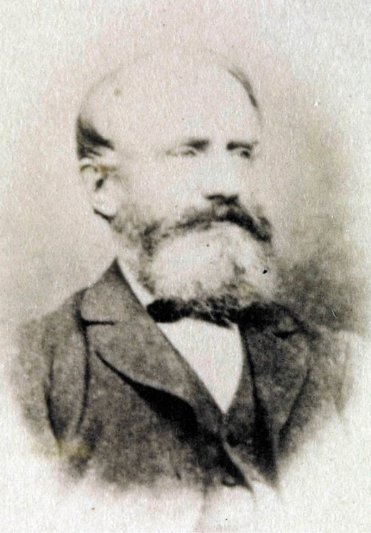
Figure 7.19: John Richardson, 1896. Source: G.L. Massingham (George Leake), Australian pioneers (Geelong Section), accession H11608/80, State Library of Victoria.

25 years and was also a member of the Belmont and Newtown and Chilwell School Boards of Advice. He designed several buildings in the Geelong district, including the Grovedale Wesleyan Methodist Church, St. Paul’s Lutheran Church, Grovedale, Corio Tannery, Geelong, and the Newtown and Chilwell Fire Station. Tuffs was also a member of the Ancient Order of Forester and at one time he served as District Chief Ruler. On his death in 1890, the Geelong Advertiser described him as ‘a quiet, amiable-natured man and a good neighbour.’

MUNICIPAL ACCOMMODATION EARLY PREMISES
Initially, meetings of the South Barwon Borough Council were
held at the Racecourse Hotel. 215 In c.1860, Council meetings were held in the newly-completed Court House (Figure 7.20) that was built at the then eastern extremity of Mount Pleasant Road, neighbouring the Belmont Hotel (see later subsection for further details).216

THE SHIRE HALL
In early 1883, the South Barwon Shire Council had resolved to erect new municipal offices on land in Mount Pleasant Road, west of High Street (then known as Colac Road).
Designed by the Shire’s Surveyor, R.S. Tuffs, the Council invited the Belmont Library Committee to consider ‘them to join in erecting their room as a wing to the new Shire Hall.’217 Tenders were called for the shire hall, offices, free library and reading room in April 1884.218 To be constructed at a cost of
£1400, a ceremony for laying the foundation stone was held on 5 July 1884, with a chased silver trowel handed by Colonel Conran to the President of the Shire, William Higgins, to perform the lowering of the stone.219 A bottle, which included the Council’s seal, was placed in a cavity under the stone.220
The single storey, hipped roofed building of brick construction with a slate roof (Figure 7.21) was officially opened on 3 February 1885 by the Shire President,
William Higgins.221 Trees were soon planted around the new building.222
In the 1960s, cream brick extensions were constructed to the front and sides of the building (Figure 7.22). In 1970, an alternative Council Chamber was acquired in Thomson
Street.223 Additional office space was gained by the purchase of an adjoining house in Mount Pleasant Road in 1971.224 The building ceased operations as the Shire Hall and Office in 1978 when a new complex was constructed in Reynolds Road to a design by D. Graeme Williams and Associates225. The old Shire offices was the home of the Geelong Adult Training Centre in the late 20th and early 21st centuries.226

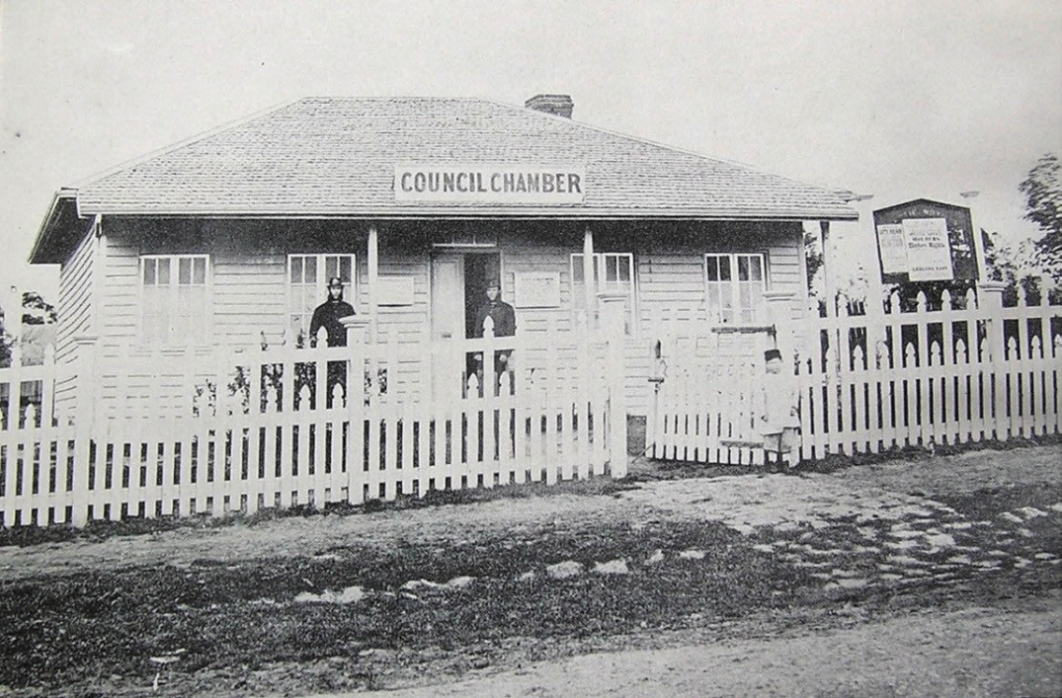
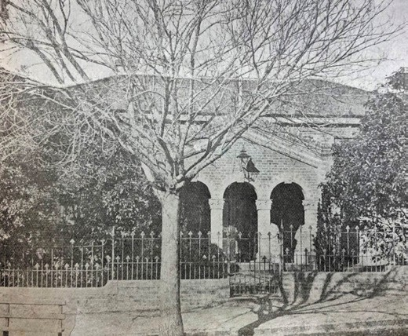
Figure 7.20: South Barwon Shire Council Chamber & Police Court House, 1866. Source: Shire of South Barwon: A Brief History, South Barwon Shire Council, Geelong, 1974.
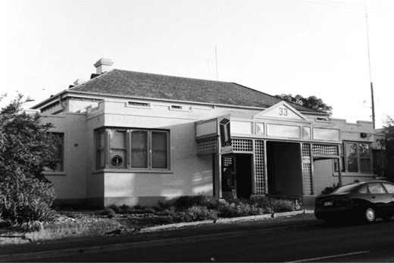
Figure 7.22: Former South Barwon Shire Hall, Mt Pleasant Road, Belmont, 1998. Source: David Rowe.

Figure 7.21: South Barwon Shire Hall, Mt Pleasant Road, Belmont, 1910. Source: News of the Week, 11 August 1910, p.13, GRS 2121/2, Geelong Heritage Centre collection.

NEWTOWN AND CHILWELL

THE ESTABLISHMENT OF THE BOROUGH OF NEWTOWN AND CHILWELL
Lead by Charles Nantes, agitation for severance of Newtown and Chilwell from the Geelong Corporation began in 1857.227 On 22 August 1857, a meeting of ratepayers was held at the Duke of Wellington Hotel
where a petition was prepared, the basis being that over a fourth of the total rate revenue was collected by the Geelong Corporation from Newtown and Chilwell ratepayers and yet this sum was not reflected on expenditure in these areas.228
On 9 March 1858, the Borough of Newtown and Chilwell was proclaimed. The municipal area was described in the Victoria Government Gazette:
Commencing at a point on the north bank of the river Barwon, being the centre of La Trobe terrace; thence north by a line passing through the centre of La Trobe terrace to Aberdeen street; thence west by a line passing through the centre of Aberdeen street to a government road forming the western boundary of portions 1 and 2, section 9, parish of Moorpanyal; thence north by a line passing through
the centre of that road to a government road forming the northern boundary of portions 7 and 8, section 133, in the said parish; thence west by a line passing through the centre of that road to a government road forming the
western boundary of portions, 8, 9 and 10, section 13, in the parish aforesaid; thence south by a line passing through the centre of the stream; thence southward and eastward by a line passing through the centre of the river to a point due south of La Trobe terrace; and thence by a line bearing north to the commencing point.229

THE TOWN AND LATER CITY OF NEWTOWN AND CHILWELL
On 10 April 1924, municipality of Newtown and Chilwell was declared a Town and on 7 October 1949 it was proclaimed a City.230

THE FIRST COUNCILLORS
The first Council of the Borough of Newtown and Chilwell was elected on 9 April 1858. Polling was carried out in a tent next to the Duke of Wellington Hotel.231 For the seven positions available there were 22 candidates. Those elected
were James Stevens Paul, William Fordham, Charles Nantes, Neville Butler Headland, Duncan Scott, William Siddall, and Sanders Trotman.232 At the first Council meeting a few days later, Councillor Charles Nantes was elected the inaugural Chairman.

Charles Nantes (1817-1877) (Figure 7.06) had been an inaugural Councillor with the Geelong Town Corporation for the Villamanta Ward. See earlier subsection for biographical details.
James Stevens Paul (1811-1882) was born in Somerset, England, the son of John and Mary (nee Sperrin) Paul.233 In 1832, he married Anna Chalker at Bath. A painter and journeyman, Paul and his wife had emigrated to the U.S.A.
as it was there where their first son and daughter, Frederick and Arabella were born in c.1836 and 1837 respectively. The family returned to Somerset before 1851 and soon after, they emigrated to Geelong on the Isabella, arriving in November 1852. They resided in Marshall Street, Chilwell, where Paul continued his painting trade. Paul served as a Councillor with the Borough of Newtown and Chilwell in 1858-59 and from April 1860 until September 1863, including a year as Chairman in 1860-61, automatically bestowing him the responsibility
of a Justice of the Peace. This was met with staunch resistance by some ratepayers of the municipality, arguing that ‘being scarcely able to do more than sign his name, and otherwise without more than the most common education, is totally unfit to be entrusted with the responsibility of a Justice of the Peace, accruing to him by virtue of the Municipal Act.’
William Fordham (1821-1877) was born in London, the son of John and Maria Fordham.234 He married Miss
Jane Rhodes and they emigrated to Geelong in the 1840s. William Fordham’s life ended in tragic circumstances when he drowned near the Eastern Baths (Eastern Beach) in 1877. The Geelong Advertiser reported on his death and contribution to Geelong:
Mr Fordham came to Geelong about thirty years ago, and pursued his occupation as a plasterer for some time. He afterwards remained for nineteen years a proprietor of the Sawyers’ Arms Hotel, Chilwell; and, on leaving that place, took the Royal George Hotel, at Ballarat, where he remained for five years. During his long residence here
Mr Fordham was well-known as a member of the Newtown and Chilwell Borough Council and of the Fire Brigade in that Borough. He left Ballarat and came to Geelong three weeks ago, having been compelled to relinquish business through financial difficulties. He was stopping for some time at the Black Bull Hotel, Malop-street, and also at the Cosmopolitan Hotel, Moorabool-street, but his movements since leaving the latter placed are unknown at present.
The deceased has been drinking heavily since his wife’s death, which occurred about 12 months ago, and he
has several times threatened in a jocular way to destroy his life, but this family never thought that he seriously intended doing so.235

Neville Butler Headland (c.1827-1888) as born at Hampton, St. Mary, England, the son of George Welch Headland and Charlotte (nee Butler) Headland.236 Following the death of his mother in 1844, Neville, his father and some of his siblings emigrated to Australia. By 1856, Neville Headland was resident in Elizabeth Street, Ashby (Geelong West), where he worked as a builder. His father, George, died at his residence in this same year. Neville Butler’s tenure with the Newtown and Chilwell Council was not to be enduring. By early 1862, he had relocated to Gordon where he continued working as
a carpenter. He was declared insolvent in November of that year, and by 1868 he had been appointment Valuator, Rate Collector and Revenue Officer for the Ballan Shire Council. In 1873, he was also agent for the owner of the Pyke’s Flat Hotel. In subsequent years he relocated to Brisbane, continuing business as a builder. He died at New Farm, Brisbane, in 1888.
Duncan Scott (1803-1879) appears to have been born at Roxborough, Scotland.237 He was an early resident of
Geelong, having arrived there by 1842 where he established a slaughter house in South Geelong. A few years later
he relocated to the west end of Russell Street, Chilwell. He married Jane Dawson in Geelong in 1844. Scott was a Councillor with the Borough of Newtown and Chilwell
between 1858 and 1861, and from 1864 until early 1866. He subsequently relocated to Lethbridge where he was elected manager of the Town Common by the Bannockburn Shire Council. He remained in this position until 1869. Scott also established a slaughter house at Lethbridge in 1869 but was insolvent by 1870.
William Siddall (c.1825-1891) appears to have emigrated on the Ottillia from England to Port Phillip, Victoria, with his wife, Ellen and son, George, arriving in October 1852.238 Both drapers, they established the Yorkshire Store in Bond
Street, Chilwell, which they operated until it was sold in 1859. William Siddall subsequently seems to have established a paper bag manufactory in Little Malop Street. He resigned as a Councillor of the Borough of Newtown and Chilwell in 1863 and relocated to Ballarat where he continued business as a bag manufacturer in Mair Street until 1890. Known to be ‘highly esteemed in a wide circle of acquaintances, he died in Ballarat in 1891.

Sanders Trotman (1825-1911) as born in London, the son of Sanders and Frances (nee Brind) Trotman.239 He trained as a carpenter emigrating to Geelong on the Tasman with his wife, Mary, and daughter Mary Ann, in 1849. On his death in 1911, the Geelong Advertiser gave a
detailed obituary:
The death of Mr. Sanders Trotman, one of the oldest residents of this district, occurred yesterday at his residence in Newtown, where he has lived continuously for more than 60 years. He was a native of England, and came to Geelong in 1849 in the same vessel as
the late Mr. Chas. Read, with whom he became closely associated in connection with Parliamentary and municipal contests. Before he left the Homeland, Mr. Trotman took a prominent part in the work of the London City Mission. In the early days he was an officer for the Geelong Town Council, and was also for a brief period a member of that body. With others, he actively engaged in the campaign for the separation of Newtown, and when the movement succeeded he was elected as one of the first members of the new council. When [sic.] the jubilee of the borough council a couple of years ago he was the only member of the first council then living … Soon after arrival in Geelong he made for the Ballarat goldfields, and was fairly successful there. Gifted with a remarkable memory, and being wonderfully well-read, he was able to recount events and anecdotes hour after hour. Many of his original compositions appeared in early issues of the “Advertiser.” The deceased gentleman, who was nearing 90 years of age, came of family noted for longevity. His only surviving brother, who lives in England, is about 90 years of age. Mr. Trotman leaves a son and daughter.240

THE FIRST OFFICERS OF THE BOROUGH OF NEWTOWN AND CHILWELL
The first Clerk of the municipality was Daniel Sherrin (1828- 1859). He was born in London to John and Christina (nee Williamson) Sherrin.241 A merchant, Daniel Sherrin emigrated to Victoria on the Walmer Castle, arriving on 16 May 1853.
242 His wife to be, Mary Picken, arrived two months later on the Roxburgh Castle. 243 They married in 1855. 244 Sheerin’s appointment as Borough Clerk was to be short-lived as he died ‘of disease of the heart’ at the Newtown Council Chamber on 21 June 1859. 245 He was ‘much respected for his diligence and many other good qualities.’ 246

The first Surveyor for the municipality was Edward Prowse
(1824-1862). He was born in Bristol, England, the son of James Prowse, surgeon, and Mary Ann (nee Philpott)
Prowse. 247 Following his education, Edward Prowse trained as an architect and engineer and by 1841 he was an engineer’s apprentice. 248 In 1849, Edward emigrated to
Adelaide, South Australia, sharing a cabin on the Bolton with his engineer friend, Edward Snell. 249 In 1851, he married Mary Ann South (nee Carbin), estranged wife of Thomas Carbin.
250 Soon after, Edward and Mary relocated to Geelong where Edward went into partnership with Edward Snell in 1854. 251 The partnership was dissolved in 1855 and Prowse practised on his own account. 252 In addition to his appointment as Town Surveyor for Newtown and Chilwell, Prowse was
the inaugural Engineer of the Corio Road Board in 1861. 253 Prowse’s life was cut short in early 1862 following ‘a fatal attack of apoplexy.’ 254
The first Municipal Rate Collector, Inspector and Messenger was William Whitfield (1830-1907). He was born in Dublin, Ireland, the son of Thomas and Elizabeth (nee Anderson) Whitefield. 255 William Whitfield had emigrated to Geelong by 1854 as it was at this time when he married Miss Arabella Paul, daughter of James Stevens Paul (inaugural Borough
Councillor).256 They lived in Montpellier Street, Newtown, with William working as an agent until his municipal appointment.
257 By June 1862, William and Arabella had removed to South Australia as it was there where their fourth child was born at this time. 258 William Whitefield died at Exeter, South Australia on 10 April 1877. 259

THE MUNICIPAL BUILDINGS

THE FIRST MUNICIPAL CHAMBER & OFFICES
During the first two years, the Borough of Newtown and Chilwell met at the Duke of Wellington Hotel and in rented premises for its meetings. 260 However, in September 1859, the Council purchased the Rev. Andrew Love’s stone house in Pakington Street, Newtown, as the permanent home for conducting municipal business and administration. 261
The parapeted, single storey stone building (Figure 7.23) featured a hipped roof crowned with a monitor light. A projecting wing to the front represented the Town Surveyor’s office which appears to have comprised some of the alterations and addition of late 1859 or early 1860. 262 Another addition, seamless with the Surveyor’s office, is the Newtown and Chilwell Fire Brigade Station. Further to its role as a municipal chamber and office, the building also served as the police court in the early years. 263
Alterations and additions in the later 19th century included the removal of the fire brigade station addition, replacement

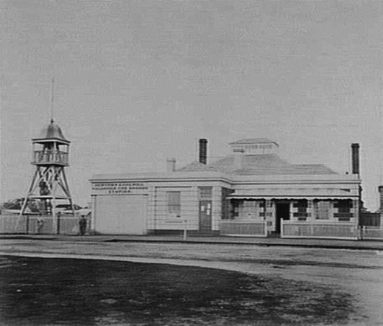
Figure 7.23: Newtown & Chilwell Municipal Chambers (right) and Newtown Fire Station attached to front (left), Pakington Street, 1866.
Source: J. Norton, accession H1248 State Library of Victoria.

of the original front verandah with a bullnosed verandah and a gabled monitor light above the north wing (Figure 7.24).

SECOND NEWTOWN & CHILWELL CITY CHAMBER
By 1915, the old municipal chambers building was inadequate for the purpose of the Borough and alterations and repairs were considered to be cost prohibitive, and a new building was proposed. As reported in the
Geelong Advertiser:
It was unanimously decided by the Newtown and Chilwell Council, at a meeting of the Public Works committee, held on Saturday night, with Cr. Collins in the chair, to erect a new two storey brick building as a Town Hall and quarters on the site of the present municipal chambers and quarters in Pakington street south. The estimated cost is £2000. Provision is made for a Hall 25’ x 41’, having a superficial area of 1066 square feet and to seat 200 people comfortably; town clerk’s office and public
inquiry counter, and an ante-room on the ground floor; the living and sleeping rooms are upstairs. This scheme was recommended by a sub-committee, which has had it under consideration for some time, and also by the architects, Messrs. Laird and Buchan.
In 1911 the architects, after thoroughly inspecting the buildings, advised the council against expending any large sum in alterations. The walls were damp in different parts. Alterations at a cost of £350 were carried out, principally to make the quarters somewhat more habitable. The expenditure was so designed that it would not be

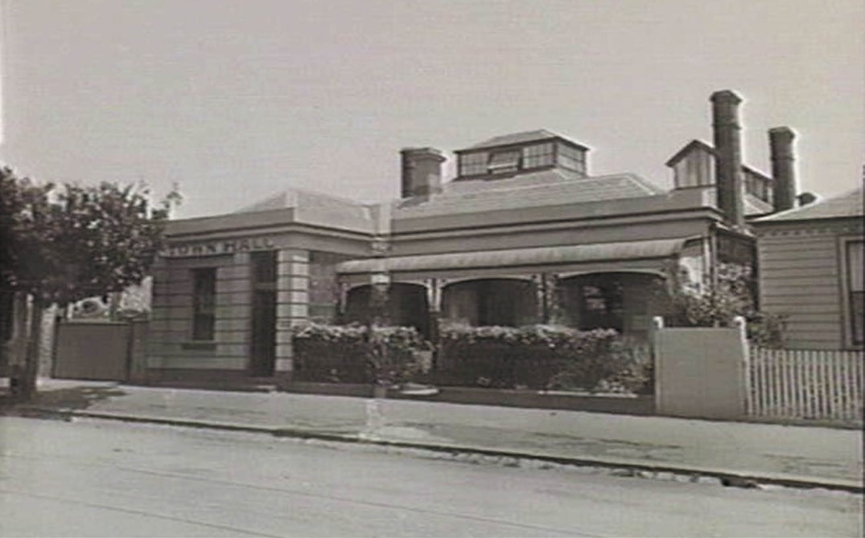
Figure 7.24: Newtown & Chilwell Municipal Chambers, Pakington Street, 1915. Source: J. Lockwood, accession H19523, State Library of Victoria.

wasted if the council decided later to rebuild : and the material then laid out is incorporated in the new scheme. However, the dampness was not overcome, and latterly it has become very bad. In June last the borough health officer, Dr. Grimwade, reported that it was injurious to health to live in the buildings. The architects also stated that it would be a sheer waste of money to attempt, to patch up the buildings.
These reports led the council to the opinion that the most economic way out of the difficulty was to rebuild.
However, before coming to any decision, prices were obtained of buildings in the borough deemed suitable for a Town Hall, and this phase was considered in conjunction with the building scheme.
Having induced many property owners in the borough to improve their buildings or pull them down where they were considered beyond repair, the council decided that it should set an example, and this was another reason that influenced the members in coming to an unanimous decision.
They were averse to securing quarters for the town clerk away front the offices on the ground that the present
quarters would be wasted, and furthermore an office assistant would have to be engaged; now the town clerk is assisted by the members of his family living on the premises. The annual cost of the assistant, it. was
estimated, would exceed the annual interest on the capital involved in the building, without any corresponding public benefits. The council summarised its conclusions as under:
- The now town hall will afford greater public facilities than could be obtained from any other scheme considered.
- The property will be a more valuable asset, and will be more adaptable to the possibilities of the future, either for expanding for municipal purposes for the conversion to other use; no longer required for municipal business.
The plans are open for inspection at the borough
Town Hall. The architects have been instructed to prepare specifications and invite tenders.264
The Geelong architects, Laird and Buchan, called tenders for ‘alterations and additions’ to the Town Hall for the Newtown and Chilwell Council on 9 December 1915.265, p.5. The last meeting in the original building was on 22 December 1915.

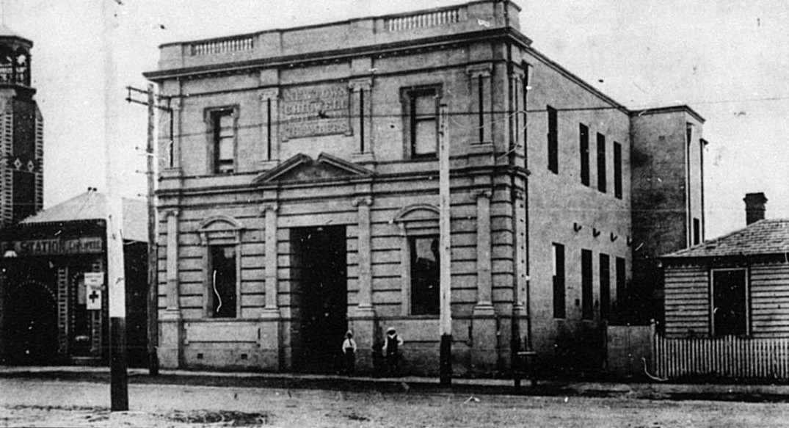
Figure 7.25: Newtown & Chilwell Municipal Chambers, Pakington Street, 1916. Source: News of the Week, 21 December 1916, p.13, GRS 2121, Geelong Heritage Centre collection.

The Geelong Advertiser gave the following account:
Newtown and Chilwell Council met for the last time yesterday evening in the building in Pakington street, which has served as the administrative offices of the municipality since 1858. Prior to this was used as a school for many years. The building is to be pulled down to make way for a modern two storey structure with hall and offices on the latest plan. The council last evening accepted the tender of Messrs. Dew Bros, and Ebbels at
£1990 for the new building, and that of Mr. J. T. Jewell for
£20/15 - for pulling down and removing the old offices. The pulling down is to be completed by the third week in January when the contractors will commence the new buildings. With the addition, of such extras as lighting, asphalting and fencing, the contract price is below the architect’s estimates. During the six months occupied
in rebuilding, the borough offices will be at the corner of Latrobe-terrace and Laurel Bank-parade in a private
residence temporarily leased by the council. After Friday the present offices will be closed, and their dismantling will commence immediately.266
The two storey rendered brick building (Figure 7.25), designed in a distinctive Renaissance Revival style, was opened on 13
December 1916 on the original site at 271 Pakington Street. It accommodated a council chamber, town clerk’s room,
public office, committee room, cloak room and lavatory on the ground floor, and five-roomed private quarters upstairs. Red pine was used for the fittings and ceiling in the front portion, the ceiling of the council chamber being fibrous cement. 267
The Newtown and Chilwell Municipal Chambers building served as the headquarters of the council until 1974. 268 The former municipal building was later the location of the Barwon Region Child Health Centre before it was sold and converted into a dwelling in 2003-04. 269

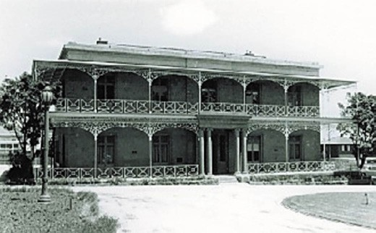
Figure 7.26: Newtown & Chilwell Municipal Chambers, Armytage House, Pakington Street, 1976. Source: J.T. Collins, National Trust of Australia (Victoria), Victorian Heritage Database online.

ARMYTAGE HOUSE
Built in 1858 for George Armytage to a design by
Edward Prowse, Armytage House (see Theme 6) was officially opened as the headquarters of the Newtown and Chilwell
City Council on 18 December 1974. 270 The acquisition of the property at a cost of $56,862 was to provide the Council with increased accommodation and to ensure the preservation of one of the municipality’s most significant heritage assets.
271 Repairs and alterations were carried out prior to the opening under the supervision of the Geelong architects, Buchan Laird and Buchan. 272 A condition of the sale of the property was that the original name ‘The Hermitage’, not be used and so the property was renamed Armytage House. 273 The building (Figure 7.26) served as the offices of the City of Newtown and Chilwell until Council amalgamations in 1993. 274

BELLARINE

THE EARLY ROAD DISTRICTS
Like other parts of the Geelong District, the need for satisfactory roads on the Bellarine Peninsula was essential for safe travel and transporting harvests and stock to market. The proclamation of the Act for making and improving Roads in the Colony of Victoria in 1853 gave impetus for the establishment of Road Districts in the Bellarine area.275 The first to be proclaimed was the Portarlington Road District on
December 1853. 276 The District boundaries were described in the Victoria Government Gazette:

On the East by part of the Eastern Boundary of the parish of Bellarine, commencing at Port Phillip Bay, bearing south five miles sixty chains, and by a divisional line between portions 3 and 4 of block 2, parish of Paywit, bearing south one mile; on the South by a line bearing west seven miles to the Eastern Boundary of the parish of Moolap, and thence by a line bearing north 820 west, five miles and three chains to the Corporation Boundary of the town of Geelong; on the West by the Corporation Boundary bearing northwards to Port Phillip Bay; and
on the North by the waters of Port Phillip Bay to the commencing point. 277
It was not until a meeting at the Buck’s Head Inn, Bellarine, in June 1854 when the seven-member Portarlington Road Board was elected. 278 J.C. Langdon of Spray Farm, J. Armstrong,
J. Webb junior, T. Shanklin, J. Wylie, Thomas Gange and Caroline Newcomb of Coriyule became the first Portarlington Road Board members. James Conway Langdon was subsequently elected the first Chairman, and Caroline Newcomb the first Secretary. 279
Miss Caroline Elizabeth Newcomb (1812-1874) (Figure 7.27) was one of the earliest elected female representatives to the initial form of local government in Victoria, and possibly Australia.280 She was born in London in 1812, the daughter of Samuel Newcomb, British Commissioner in Spain. 281 Following her father’s death, Caroline was raised by her grandmother and she emigrated to Tasmania in 1833 for health reasons. 282 In April 1836, she accompanied the Batman family to Port Phillip as a governess. 283 After her arrival in Melbourne, she met Dr. Alexander Thomson and his family in 1837 she visited them in Geelong. At ‘Kardinia’ (Thomson’s house) and in David Fisher’s barn, she became a committed member of the Wesleyan Methodist cause. 284 It was through Dr Thomson that Newcomb came to know Miss Ann Drysdale (1792-1853) who from 1840 held the license to the Boronggoop Run near the boundary of the Geelong Town Reserve in the Moolap Parish. 285 With Drysdale, Newcomb took up the ‘Lap Lap ‘ Run on Reedy Lake before Drysdale established ‘Coriyule’ at Indented Head (now Drysdale)
and Newcomb joined her. 286 There, they established a thriving pastoral and farming business where Newcomb ‘was often more practically involved in farming operations.’
287 After Anne Drysdale’s death in 1853, Newcomb inherited Coriyule where she remained until 1861 when, ‘to universal astonishment’, she ‘married a Methodist minister, James Davy Dodgson, twelve years her junior and spent the remaining years of her life in various parts of Victoria where her husband was posted.’ 288 Newcomb’s significant contribution to local

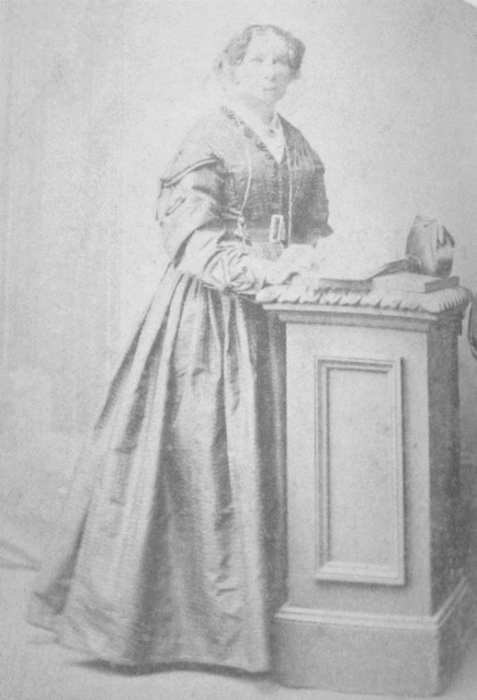
Figure 7.27: Caroline Newcomb. Source: Bellarine Historical Society Inc.

community life was given in The Age and Ballarat Star
following her death in 1874:
She presided over the first meeting of the road board established in Bellarine, and proved herself a useful and energetic representative of the ratepayers … She was the originator of the Geelong Ladies’ Benevolent
Association. She convened the first meeting of ladies, or, as she designated them, ‘the women of Geelong and the Western district,’ which was held on the 23rd June, 1855
… Miss Newcombe was unanimously elected as the first president of the society, and for many years devoted her best energies to the furtherance of its objects.289

ROAD BOARD ACCOMMODATION & CHANGES TO DISTRICT BOUNDARIES & NAME
A modest Road Board office was erected in Drysdale in 1855, to a design by Charles Rowand, Central Road Board engineer in Geelong (see Theme 3 for biographic details). It was completed late in that year.290
The boundaries of the Portarlington Road Board were extended in 1859. Its jurisdiction then included the area of Point Henry (to the Geelong Corporation Boundary).291
On 29 October 1860, the Portarlington Road District was replaced with the Indented Heads Road District.292 It took in an expanded area with the southern portion of the Bellarine Peninsula, extending to the Ocean Grove foreshore and immediately west of Point Lonsdale and Queenscliff, being included in its jurisdiction.293 In 1861, the southern portion of the Moolap Parish also came under the control of the Indented Heads Road Board.294

THE BELLARINE SHIRE COUNCIL
Following the enactment of the Local Government Act in 1863, the Indented Heads Road Board was replaced with the Bellarine Shire Council. Proclaimed on 28 September 1865, the Shire area was greater than one hundred square miles and the rate revenue was over one thousand pounds, therefore making it eligible for Shire Council status.295 The municipal area of the newly-formed Bellarine Shire largely reflected that of the previous Indented Heads Road Board, taking in most of the Bellarine Peninsula.
On 12 December 1989, the Rural City of Bellarine was proclaimed, the first in Victoria under the new Local Government Act 1989.296

THE FIRST COUNCILLORS
Archibald McArthur Campbell (1817-1897) (Figure 7.28) was born on the Isle of Mull, England, the son of the Rev. and Mrs Neil Campbell.297 Following his emigration to Victoria at the age of 25, he worked at Mount Greenwood in the Victorian Pyrenees before taking up the Gannawarra Run on the Murray River near Koondrook in 1844. In 1855, he relinquished the Gannawarra Run and took up land at Lexington near Ararat, and property at Ellingarrin on the Leigh River. It was there where Campbell’s first wife, Emma (nee Clow), died. He married Miss Mary Rae of Lexington in 1857 in Geelong.
In c.1860, Archibald and Mary Campbell relocated to ‘Melaluka’ on the shores of Lake Connewarre (see Theme 6).
It was from this time when Archibald took an interest in local affairs and he chaired a meeting for the formation of a Kensington Road Board which eventuated in a southern

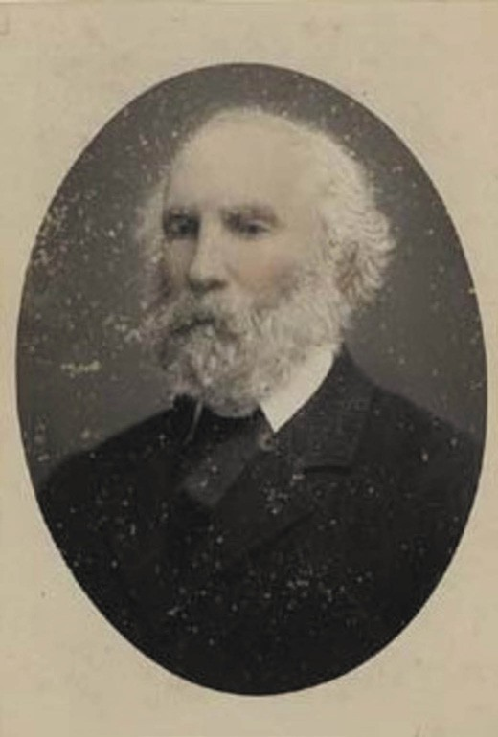
Figure 7.28: Archibald Campbell, c.1890. Source: A.H. Harvey, GRS 0691/42 Geelong Heritage Centre collection.

extension of the Indented Heads Road Board. The inaugural President of the Bellarine Shire Council, Campbell served
as a councillor until 1874. In addition to public life, Campbell took an interest in homeopathy and the plight of the Indigenous peoples, and he was described as ‘a kind and gentle man.’ In 1884, he sold ‘Melaluka’ and relocated to Virginia Street, Newtown, where he died on 1 February 1897.
John Bourke (c.1816-1900) was born in County Limerick, Ireland. A blacksmith, in 1838 he was convicted for the theft of a bayonet and administering an unlawful oath.298 With his friend, Patrick Crofts, he was sentenced to seven years hard labour and was transported to Norfolk Island on the Augusta Jessie on 5 March 1839, arriving on 11 November 1839. On 3 March 1844, he was transferred to Hobart, Tasmania, where his application to marry Miss Maria Little (a free person) was approved and they married at St. Joseph’s Catholic Church, Hobart on 23 September 1845. Upon receipt of his Free Certificate on 7 March 1846, the couple relocated to Geelong

where their first child, William, was born in 1847. The family subsequently removed to the Barrabool Hills and then to Indented Head by 1851. There, he established a farm at Bellarine where the Bourke family remained until 1875. After ten years as a Councillor with the Bellarine Shire, Bourke was given a testimonial dinner prior to his relocation to Echuca, which was reported in the Geelong Advertiser:
After a residence in the Bellarine district, extending over nearly a quarter of a century, and having during the greater portion of that time represented the rate-payers
of the Shire, Cr. Bourke being about to take his departure for the fertile plains of the river Murray, was yesterday presented with a testimonial by a number of his friends and municipal colleagues. The presentation took place at the Buck’s Head Hotel, Drysdale, immediately after the rising of the shire council, at whose meeting Cr.
Bourke took part for the last time. About thirty persons, comprising councillors, tradesmen, and old contractors, assembled to do honor to the occasion, and Mr George Henderson, President of the shire, occupied the chair. The chairman remarked that he had a pleasing yet also painful duty to perform. It was with regret he had to bid good-bye to an old and valued friend, with whom he had been intimate for about twenty years, and who with himself had beheld the rise and progress of their district and its municipal and other institutions. (Hear, hear.)
As a public man Cr. Bourke had been identified with the district and had ever taken an active and prominent part in public proceedings. He was pleased to find that the ratepayers, for whom Cr. Bourke had done so much, had taken the opportunity of showing in a tangible manner their appreciation of his worth. (Hear, hear.) He felt unable to do justice to the occasion, but he trusted Cr. Bourke would take the will for the deed. Cr. Bourke had served the ratepayers for sixteen years as their representative, and he had had their support and confidence during that long period simply because he had always pursued an honest, independent, and disinterested course. … As a colleague at the council table he could personally express his esteem and high opinion of Mr Bourke because, of his integrity, his love of justice, and his unflinching support of what was fair and right in principle.299
Bourke died at Tungamah on 21 June 1900.300

John Clery (c.1818-1891) was born in County Cork, Ireland.301 By 1844, he had emigrated to Geelong where he married Miss Margaret Ann Black. A squatter, Clery established a farm at Moolap after 1845. In 1862, he was a member of the Indented Head Road Board and in the following year, a member of
the Indented Head Farmers’ Association. He served as a Bellarine Shire Councillor for the Paywit Ward between 1865 and 1875. In April 1891, he advertised the sale of his brick, stone and timber residence and 146 acres at Connewarre due to ill-health. He died at Connewarre a month later on 23 May 1891.
Anthony Devine (1815-1879) was born in Londonderry, Ireland, the son of Hugh and Margaret (nee Curran) Devine.302 He emigrated to Port Phillip in 1841 and initially settled in Colac for 12 months prior to taking up land and commencing a grocery business at the corner of Moorabool and Little Ryrie Streets, Geelong. By 1856, he had purchased 300 acres of land at Connewarre, and it was around this time he went to the gold diggings but soon return to his grocery business
for another 10 years. In 1858, he built ‘Derry Hall’ off the Queenscliff Road at Moolap. In 1878, Devine was appointed a Justice of the Peace. Devine served as a Bellarine Shire
Councillor from 1865 until 1879. Devine died on 10 September 1879 at Derry Hall. The Geelong Advertiser recognised his passing and contribution to business and community life
in the Geelong district:
Mr Devine, who was 64 years of age, has resided in Geelong and the district for thirty-eight years. For a long time he kept a store at South Geelong, and having invested his money in town property before gold was discovered at Ballarat he rapidly acquired wealth during the gold fever. After giving up the store, Mr Devine
followed the pursuit of a farmer successfully, and speedily combined sheep breeding with that occupation. For 19 years Mr Devine was a member of the Bellarine Shire Council, and as president of that body he made many friends. He resigned his position in the Council six months ago.303
John Thomas Mitchell Gange (1809-1868) was born at Earldoms, Landford, Wiltshire, England, the son of James and Susanna (nee Mitchell) Gange, subsistence farmers.304 J.T.M. Gange followed his parents in farming and on 3 December 1830 a warrant was issued for Gange ‘on the oaths of Timothy Rumboll, with having riotously and tumultuously assembled with other persons and burnt and destroyed a threshing machine.’305 Gange had been part of the ‘Swing Riots’ in this part of England, the result of an uprising by farmers caused by changed agricultural practices brought about (in part) by farm machinery306 (see Theme 4 for further details). On 27 December 1830, Gange was sentenced to transportation for

seven years.307 A petition to the Earl of Radnor (in the hope it would be forwarded to Lord Melbourne) proved fruitless. Gange was transported on the Eliza hulk on 2 February 1831,
arriving in Tasmania on 29 May 1831.308 In 1835, he was given a ticket of leave and later in that year he sought permission
to marry Margaret Robinson.309 J.T.M. Gange took on work as a labourer in Launceston where their first son, James Thomas Gange, was born in 1837.310 By 1844, Gange had
been engaged by Misses Newcombe and Drysdale to manage ‘Coriyule’ near Drysdale. By 1852, J.T.M. and Margaret Gange had acquired land from Misses Newcombe and Drysdale where they established their ‘Garrangill’ farm.311 In addition
to being an inaugural Bellarine Shire Councillor, J.T.M. Gange was a founding member of the Farmers’ Association and
the Road Board.312 He died at Garrangill on 2 June 1868 and was buried in the family’s private burial ground atop Mount Mitchell at Garrangill (see Theme 8 for further details).313
Alexander Hood (c.1826-1888) was born at Antrim, near Belfast, Ireland, in c.1826.314 He emigrated to Port Phillip with his parents, James and Margaret and four siblings, in 1844.315 After working as a station hand, limeburner at Queenscliffe and a carter in the Western District, and after trying his luck at the Ballarat and Forest Creek goldfields, Hood came
to Indented Head. There, he served as a member of the Portarlington/Indented Head Road Board in 1859, 1864 and 1865.316 It was opposite Batman Park where Hood settled on his farm with his wife, Ann and three sons, George Alexander, Joseph Latrobe and Daniel James.317 Hood died on 29 May 1888.
James Henry Matthews (c.1816-1896) was born in County Down, Northern Ireland, the son of William and Margaret (nee Finlay) Matthews, a farmer and dairy woman respectively.318 With his parents and siblings, James Matthews emigrated to Australia on the Garrow, arriving in Sydney in March 1839. A month later, they had disembarked at Port Phillip. Between 1851 and 1853, Matthews had taken up 120 acres of land at Moolap where he established the Glenmore Inn at the corner of Coppards and Portarlington Roads. He also farmed his property which later became known as ‘Glenmore Farm’.
Matthews was a committee member of the Indented Head Farmers’ Association and Indented Head Road Board from 1860. He died at his property on 10 September 1896.
Thomas Savage (1813-1870) was born at Attenborough, Nottinghamshire, England, the son of Thomas and Rebecca Savage.319 He married Mary Towlson at Shardlow, Nottinghamshire, in December 1837 and by 1850 they had emigrated to Melbourne as it was here at this time when their daughter, Mary Anne Savage, was born. Before 1856, he took up farming at Bellarine, his property being called ‘Prospect Farm’. Savage served on the Portarlington (and

later Indented Head) Road Board from 1856. He was also a foundation member of the Farmers’ Association, serving as treasurer for five years. Related by marriage to the
well-known squatting brothers, James and Thomas Austin, Savage died at his property on 14 February 1870.
John Wiggins (1830-1918) was born in Launceston, Tasmania, the son of John and Sarah (nee Hodge) Wiggins, convicts.320 With his parents and four brothers, John Wiggins had relocated to Portland before 1843. In 1854, John Wiggins took up the license of the Royal Hotel in Malop Street until 1856 when he became licensee of the Bucks Head Hotel, Drysdale. He retained the license until 1864, as well as having taken up the licence of the Mount Shadwell Hotel
at Mortlake with his brother, William. At Bellarine Wiggins was a member of the Portarlington Road Board and served as Chairman of the Indented Head Road Board in 1863. He
purchased the Leura Hotel at Camperdown in 1865 which was initially managed by his brother, William, until 1868, when John Wiggins took over. He had resigned as a Councillor
of the Bellarine Shire Council in 1867. Wiggins died in East Melbourne in 1918.

THE FIRST COUNCIL OFFICER
The first joint Secretary and Treasurer of the Bellarine Shire Council was Andrew McWilliams (1818-1899). See subsection of the Barrabool Shire Council for biographical details.

THE SHIRE BUILDINGS

THE ORIGINAL BUILDING
Sometime after the establishment of the Portarlington Road Board in the early-mid 1850s, a timber Road Board Office was erected at Drysdale. By 1859, this building also served as
a Court of Petty Sessions.321 In 1867, after the proclamation of the Bellarine Shire Council, the Secretary, Andrew McWilliams, was instructed to design a ten stall stable
and lock-up.322 A proposed small brick addition was also proposed but the only tender was not accepted.323 Criticism of the Shire Office mounted as it was not considered worthy and more particularly it was lamented at being ‘in anything but a good condition, and is inconvenient in the extreme.’324

BELLARINE SHIRE HALL AND COURT OF PETTY SESSIONS
In 1879, the Public Works Department approved the design of a new Shire Hall that was to also serve as the local Court of Petty Sessions. It was designed by the Shire Engineer (and architect), Andrew McWilliams on a triangular reserve at the junction of High and Princess Streets. The building was initially to front onto the intersection, but this proposal was later changed and the structure erected with a frontage to High Street.325 The external appearance as described as ‘plain’ but ‘substantial’, with ‘the only attempt in the way of ornament being a porch upheld by four Doric columns.’326 The single storey building was to be constructed with a gabled roof clad in slate, the walls of brick on a bluestone foundation.
Works began on 4 August 1880 with a ceremony for laying the foundation stone. Officiated by Cr Henderson, ‘he gave the orthodox taps with the mallet and tried it with the level, [and] after having assisted in spreading the mortar … he then declared the stone to be well and truly laid.’327 The formal
opening of the building (Figure 7.29) took place on 27 October 1880. As reported in the Geelong Advertiser:
The formal opening of the new hall at Drysdale, intended as the meeting chamber of the Bellarine Shire Council and the Court of Petty Sessions, took place last evening, the celebration being in the form of a supper. There
were about 130 persons present, including quite a gay gathering of ladies, mostly there by invitation from the Shire Council. The hall was magnificently decorated with evergreens and wreaths of flowers, the walls being overspread with flags borrowed from the vessels lying in Corio Bay. A few words with regard to the building which was opened will not be out of place. The hall is a very
creditable ornament to the township, the only error being that it is not large enough for the public meetings that are sometimes held at Drysdale.
The building is of red brick, resting on bluestone foundations, the front forming an arcade facing the main street of the township. It contains, besides the shire hall, which is to be used as the Council chamber and also the courthouse, four offices. The hall is 38ft. by 22ft. 6in. in dimensions, the magistrate’s and shire secretary’s rooms being 17ft. by 12ft., whilst the offices for the clerk of petty sessions and shire inspector are each 12ft. by 12 ft. The hall is a high one, and the walls are nicely stuccoed, whilst those in the offices are rough plastered. There are two
fire-places in the hall, and one in each of the offices. The building is roofed with slate over wood. Messrs Baxter and Son were the contractors, the contract price being £971

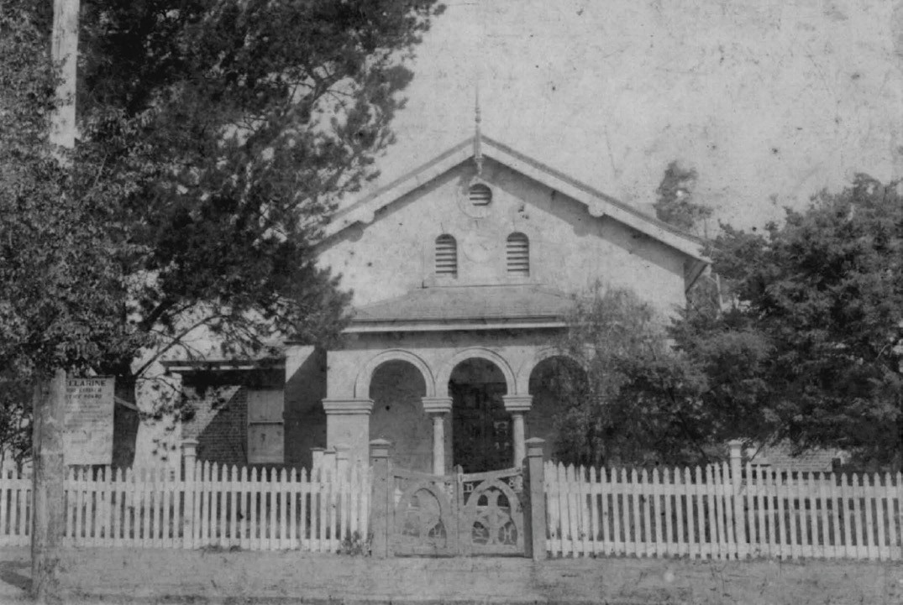
Figure 7.29: Bellarine Shire Hall & Drysdale Court House, n.d. Source: image 1110, Bellarine Historical Society.

14s. but with extras necessary during the erection of the building the total cost will exceed £1000. The contract was signed on the 2nd June last, and the building was finished at the end of last week.
A ball was afterwards held in the large room of the Shire Hall.328
The Shire Hall continued to be the centre of municipal business until 1962. It remained in use by the Law Department until 1971, during which time it also served as a home for the local Senior Citizens’ Club when court was not in session.329 On 11 June 1976, the old Shire Hall became the headquarters of the Bellarine Historical Society and museum.330 The building remains occupied by the Bellarine Historical Society.

LATER SHIRE OFFICES
In 1954, a suggestion was made from the Drysdale Assembly Hall Committee for the construction of a community house to accommodate the shire offices, baby health centre, library, public hall, caretaker’s flat and conveniences.331 The basis for the new building was in part the expanding activities of the Shire Council and the growing demand for public facilities.
Although other alternatives were considered, including the building of new offices at Newcomb or Leopold, 3.5 acres of land were acquired by the Bellarine Shire Council in Collins Street for a new building. A design was prepared by Brown and Bunbury and the building was constructed by Len Bell and Sons at a cost of £22,285.332 The building (Figure 7.30) opened in 1962 and at the first Council meeting, the President,
N.W.H. Atkins moved:
\That this Council of the Shire of Bellarine places on record its gratitude that the prosperity of the Municipality warranted the erection of these new Municipal Chambers in which the Council is meeting today for the first time.
The Council also records its gratitude to the pioneers of the past who provided

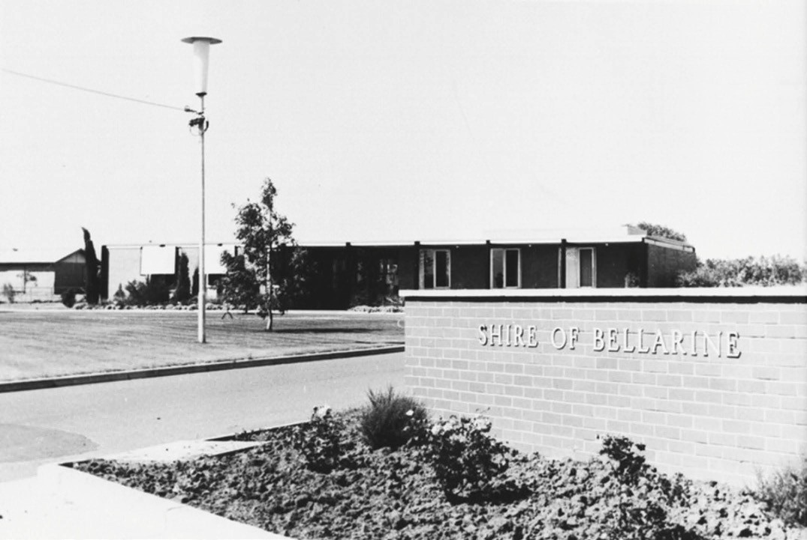
Figure 7.30: Bellarine Shire Offices, n.d. [c.1960s]. Source: Bellarine Shire collection, image s36An06, Bellarine Historical Society.

the Municipal headquarters which served the Shire since its early days, until today, estimated to be at
least 80 years.333
Just 10 years later in 1972, extensions were made to the Municipal offices to meet the demand for additional offices.334 Further extensions were carried out in 1983
and 1987. The building served the Bellarine Shire until Council amalgamations in 1993. Two years later in 1995, it was acquired by the Geelong Christian Geelong as its Bellarine Campus.335

CORIO

CORIO ROAD BOARD
As early as 1851 a Select Committee of the new Victorian Legislative Council investigated the state of the Colony’s roads and bridges. It found that the location and condition of these roads were defective, constituting no more than a track in a number of instances. The Committee’s recommendations led to the formation in 1853 of the Central Road Board whose aims ‘were to commence the formation of macadamised roads in the towns and extend them into the exterior.’336 Importantly, the Act of Parliament which led to the formation of the Central Road Board also proclaimed the establishment of local road districts managed by district boards that were ultimately controlled by the Central Board.337
On 25 April 1861 a meeting was held at Bragg’s Yowang Hotel, Duck Ponds, where the Corio Road Board was formed.338
The meeting, presided by John Myles, J.P., M.L.A., elected Michael J. Cummins, John Thomson, John Nixon, James

Campbell, Thomas Abbey, John Spalding and Thomas Bates junior as the first representatives of the seven member Board.339 Cummins was elected the first Chairman. Most
of these members were farmers with comparatively small landholdings, with Bates being the only representative of the squatting interests of earlier years.340 Bates, Nixon and Abbey only lasted 12 months on the Board.
The jurisdiction of the newly-established Board was the Parishes of Moranghurk, Yowang, Woornyalook, Murtcaim, Wurdiyouang, Lara, and the portion of Moorpanyal outside the Corporation of Geelong. The northern boundary was the Little River.341 The first premises of the Board were located well outside the Board’s boundaries, it had rented offices at 13 Great Malop Street in Geelong.342
Fundamental to the successful management of the Corio Road Board was the establishment of bye-laws and the appointment of a Secretary and Engineer. As Ian Wynd in So Fine a Country states:
[The Board] … laid down the duties of the secretary:
he was to attend to the duties of the Board from 2.00 pm to 5.00 pm on weekdays, and from 10.00 am to 6 pm
on Saturdays, to attend all meetings of the Board, and be paid £100 per annum. The Board adopted 27 bye- laws, including one that money was to be spent in strict
proportion to the amount of rates levied in each parish.343
The services of a suitable Secretary proved difficult in the initial years. T. Halliwell was the first Secretary in 1861, although by September of that year there were ‘complaints about the secretary’s laxity in attending to his duties.’344 Halliwell argued that his son had substituted but he was forced to resign once the Board declared that this could not be continued. The second secretary, D. O’Niel, provided the lowest tender for the position. However, he too resigned – in writing – after the Board discovered that his ‘experience
in writing was not sufficient to enable him to take down the minutes of the meeting.’345 The appointment of James Blair in 1862 brought with it reliability, stability and loyalty.
Edward Prowse was the Board’s first Engineer. His tenure was short-lived due to his death in 1861.346 He was replaced in by J.V. Bartlett and in 1862 J.L. Shaw, local Geelong architect, engineer and surveyor became Engineer. In 1863, he was replaced with D.K. Goodall.347

CORIO SHIRE COUNCIL
On 13 June 1864, the Corio Road Board was replaced with the Corio Shire Council.348 The boundaries of the new Shire reflected those proclaimed as part of the altered boundaries of the Corio Road District in 1863:
Commencing at a point on Corio Bay, bearing north fifty links from the north-east angle of allotment 59, parish of Moorpanyal; thence following the coast line north-easterly at ordinary low-water mark to a point in the centre of the Little River at its mouth; thence north-westerly by the centre line of the said river to the junction of the Balliang Creek; thence north-westerly by the said creek to the north-east corner of the parish of Balliang; thence west by the northern and south by the western boundaries of the said parish to the Little River; thence by the Little River south-easterly to the north-west corner of the parish of Lara; thence south along the western boundary of the said parish to its south-west corner; thence west along the northern boundary of the parish of Yowang to its north- west corner; thence southerly by the western boundary of the said parish to the western boundary of the parish of Moorpanyal; thence by the western, southern, and eastern boundaries of the said parish to the commencing point – excepting the municipality of Newtown and Chilwell, and such portions of the corporate town of Geelong as falls within the above- described boundaries.349

THE FIRST COUNCILLORS
The first Councillors to the Shire were W. Cooper,
J. Thomson, J.T. Kirk, T. Morris, J. Spalding, F. Beech and
R. Coverdale.350 Eventually, after much controversy and deliberation by the Attorney General, Thomson was elected the Shire’s first president.351 The newly-formed municipality was divided into three ridings: Peak, Moorpanyal and Lara.352
John Thomson (c.1810-1896) was the first president of the Corio Shire Council353 (but not without controversy). He appears to have emigrated from Scotland with his wife,
Anne (nee Mathews) prior to 1844, as it was at this time when their son, Samuel, was born in Geelong.354 Before 1856, Thomson took up land at Cowies Creek which he farmed until his death in 1896.355 The Geelong Advertiser recognised his passing:
The very many friends of Mr. John Thomson, of Cowies Creek, will regret to learn of his death, which occurred yesterday afternoon. The late Mr Thomson, who
had attained to the age of 86 years, was well-known throughout the Geelong district. He was elected a member of the Corio Shire Road Board when it was first established in April 1861, and he remained a member
of the shire council from June 1864, until August 1892,

when he retired. The deceased gentleman was several times elected president of the Road Board and the shire council.356
William Cooper (c.1818-1874) was the son of Robert and Ann (Annison) Cooper of Norfolk, England.357 A farm labourer, William Cooper emigrated to Victoria with his wife, Marianne, son William and daughter Marianne on the Andromache, arriving at Point Henry in 1849. In the early 1850s, Cooper tried his luck as a miner at Steiglitz but by 1856 he was resident in Church Street, Geelong West.
He later took up farm land at Lovely Banks and he served as a Councillor with the Corio Shire Council between
1864 and 1867.
Joseph Thomas Kirk was born in England in c.1828.358
A farm labourer, he emigrated on the Mahomed Schah from Plymouth, arriving in Victoria in 1848. Kirk married Miss Mary Maddigan in 1849. Kirk had taken up farm land in the Parish of Murtcaim (Little River area) by 1856, but he also appears
to have been occupied with road construction in the following years. He served as a Councillor with the Corio Shire from 1864 until 1867, and following his Presidency of the Lara Football Club in 1882, Joseph and Mary Kirk had relocated
to Granville, Sydney where he was president of the Granville branch of the Navies and General Labourers’ Union.
Thomas Morris (c.1805-1877) was the son of Thomas and Martha (nee Lewis) Morris.359 He was also the first cousin of Captain W. Lewis of the East India Company’s service and Major J. Lewis of the 23rd Royal Welsh Fusiliers.
An agricultural labourer, he emigrated from Liverpool to Point Henry with his wife, Hannah and children Charlotte, Ruth and Lydia on the James Brown in 1852, arriving on 5 January 1853. By 1856, Morris had taken up farm land at Little River. In 1859, he was nominated as a Trustee of the Little River Cemetery Trust and in 1862 he was Chairman of the Duck Ponds and Little River Farmers’ Association and a manager of the Little River Farmers’ Common. He served as a Councillor with the Corio Shire until 1867. He subsequently relocated to ‘The Hermitage’, Mount Buninyong, where he died in 1877.
John Spalding (c.1822-1893) was the son of James and Sarah (nee Hennills) Spalding of Market Weston, Suffolk, England.360 Prior to Spalding’s emigration from England, he was a bootmaker and a gravedigger as well as a Lay Preacher for the Methodist Church. It was there where he married Sarah Peake (c.1820-1909). Spalding borrowed £17
from a friend to emigrate to Australia. With his wife and three children, Spalding set sail on the Joshua, landing at Point Henry in 1854. They settled at Lara as employment with Mr Bates at “Melrose” had been prearranged before leaving England (Spalding had written to Rev Watts, Methodist Minister in Geelong and he arranged for Spalding to carry out fencing at “Melrose”). In 1855 Spalding opened the

town’s first store and butcher’s shop as well as farming his land. From 1858, he was the local postmaster and from
an early time he was the proprietor of lime kilns. In 1888 it was recorded that he had been “very successful therein, his sales for 1866 being 52,887 bags.” From c.1874-75, the Lara Lime Works at 45 Forest Road North was established
and it operated as a family business. James Spalding (John Spalding’s son and an ordained Minister in the Church of England), took over the business upon his father’s death.
John Spalding contributed much to community life in Lara. He served as an inaugural member of the Corio Road Board between 1861-1864 and an inaugural Councillor with the Corio Shire Council from 1864 until 1867 and then from 1876 until 1893. Spalding also served a term as Shire President. He was a justice of the peace and attended “the Geelong court every Monday.” Spalding served as Secretary of the Lara Lake State School Committee when it was established in 1864. A Lay Preacher of the Primitive Methodist Church (the first service in Lara being held in his home in 1854),
he purchased the Temperance Hall in 1886 and leased it to the Sons of Temperance where he appears to have been a member. In 1891 with the demise of the Sons of Temperance Society, Spalding gave the Temperance Hall to the Primitive Methodist Church. John Spalding died on 22 May 1893, his death being reported in The Argus:
An old resident of Lara, named John Spalding, 71 years of age, died suddenly at his residence late last night. He went out to the stables at the rear of his house to look
after his horses just before going to bed, and not returning within a reasonable time, search was made for him, and his body was found in the yard close to the stables. The deceased was much esteemed by all classes in the district.361
Francis Beech (c.1818-1884) was the son of Thomas and Elizabeth (nee Cooke) Beech.362 Serving in the 11th
North Devonshire Regiment of the British, Beech arrived in Sydney in 1844. Following his discharge from the Army, he came to Geelong in 1849 where he carted stone for Messrs. Holdsworth and Firth of the Barrabool Hills quarry. He married Jane Swinney in 1854. He subsequently took up horse dealing and in 1861 he entered into farming partnership with Daniel Dean at Lethbridge. This partnership was
short-lived but Beech remained at Lethbridge until 1863. Subsequently leasing land from John Live at Lara, Beech was appointed manager of the Little River and Duck Ponds Farmers’ Common in 1864, the same year he was elected to the Corio Shire Council. He served as a Councillor until 1867. By 1868, Francis and Jane Beech had relocated to Leopold, and then to Hendra’s Farm at Moorabool. In 1881, he took up a slaughtering licence, having acquired land near the Pettavel
Road station. It was there in 1884 when he was murdered, the

offender never being apprehended.
Richard Coverdale (1810-1837) was the son of John and Elizabeth (nee Tomlinson) Coverdale, farmers at Easingwold, Yorkshire, England.363 Educated at King’s School, Easingwold, Coverdale emigrated to Melbourne in 1840 and to Geelong soon after. He married Susannah Johnstone in 1844, the daughter of an Edinburgh merchant. Coverdale served as a Councillor with the Corio Shire Council between 1864 and 1872. On his death in 1897, the Geelong Advertiser gave the following obituary:
On the 21st inst., at his residence, Cowie’s Creek, there passed away in the person of Mr Richard Coverdale, one of the oldest of Victorian pioneers. Arriving in the colony from England in 1840, when Melbourne, where he first landed, was little more than a bush township, he made his way to Geelong about twelve months later,
where for many years he held the position of manager in Mr G. T. Lloyd’s wool store, one of the first wool stores in Geelong, and which stood where Messrs Humble and Nicholson’s foundry now stands. Later, he was manager of a wholesale warehouse for Mr Lloyd, and often told
anecdotes of the difficulties he had in getting his cargoes warehoused during the rush to the diggings when blackfellows were more plentiful in the streets of Geelong than white men. He took part in the movement for the
separation of this colony from New South Wales, and to him was entrusted the work of writing the final copy of the petition that went from the Geelong district. After leaving Geelong he engaged in agricultural pursuits in the district; and in the early sixties he was elected one of the first members of the Corio Shire Council, in which he held a seat for many years. Retiring from active life over twenty years ago, he spent the remainder of his days in the Geelong district, passing away at the ripe age of 87 years. For fifty-seven years the late Mr Coverdale was a colonist of Victoria and his reminiscences of the early days were very interesting. He saw the colony develop from the almost unknown settlement of Port Phillip, through the wild rush of the diggings and the present depression to the present position it occupies as an important centre
of civilisation. And so they pass away, the sturdy old pioneers to whom we owe so much; but the country they have made will remain as an enduring monument to their courage and energy when all others shall have passed away.364

THE FIRST COUNCIL OFFICERS
Like the era of the Corio Road Board, officers were again appointed to manage Council affairs.
The first Shire secretary was James Blair (1818-1907) (Figure 7.31), who had continued the role first taken up with the Road Board. Blair was a long-serving officer of Council whose tenure lasted 38 years until 1902. He was born on 5 March 1818 in County Monaghan, Ireland, the son of Captain Thomas Blair who had fought under Wellington at Waterloo.365 James Blair arrived in Melbourne on 17 July 1841366 and removed to Geelong where he stayed for 7 years, working
for the woolbroker, J.F. Strachan.367 It was in Geelong in 1851 when he married Grace Rock (they had seven children). James and Grace Blair soon left for the Ballarat diggings, moving onto Castlemaine and Bendigo where they had
reasonable success.368 He relocated to Lara in 1854 where he took up 80 acres of land at the corner of Peak School Road and Flinders Avenue.369 In 1868, he purchased 29 acres at
25 Blairs Road and built his stone dwelling, ‘Blairgowrie’.370 With James Blair’s appointment as Secretary to the Road Board in 1862, the ‘Blairgowrie’ dairy farm was managed by Grace Blair with hired help.371
In 1896, the Bacchus Marsh Express gave a glowing account of James Blair in his role as Shire Secretary:
THE PATRIARCH OF THE LARA DISTRICT, and the
Warden of all its interests, is Mr James Blair, the remarkably active and clear-headed Secretary to the Shire of Corio, a position he has held from a time to which the memory of man (local man) runneth not to the contrary, and with most paternal solicitude has he watched all local interests and advanced them too.
The old brigade of Shire Secretaries is thinning, and
Mr. Blair must be the senior municipal officer in Victoria, or nearly so. Present day officials, and Councillors, are free from and forget the old responsibilities of launching local governing bodies and combatting such matters as rival boundaries or responsibilities for Gabrielli loans, and obtaining special grants of various kinds; but the ratepayers of the Corio Shire should take a pride in showing perennial gratitude for the remainder of the life of their old leader (we cannot call him servant) for the services (municipal and extra-municipal) he has rendered them in the past and is still fully capable of continuing to give for many years to come, notwithstanding that he is getting well advanced into his eighth decade.372
Blair also held the positions of Electoral Registrar and Registrar of Births, Deaths and Marriages.373 His retirement as Shire Secretary in 1902 was marked by a celebratory

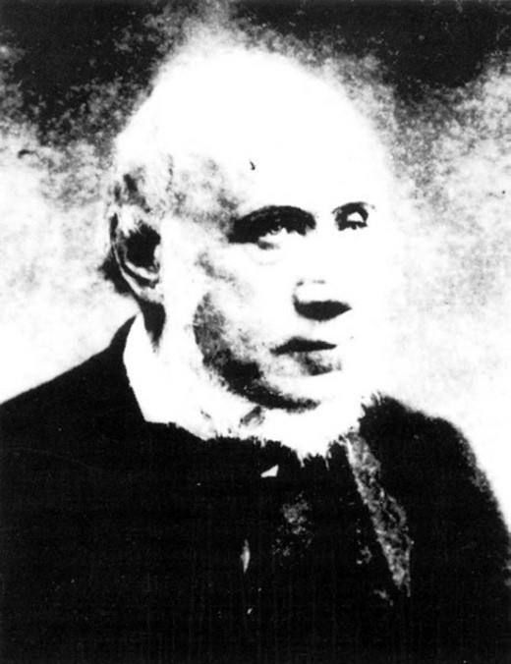
Figure 7.31: James Blair. Source: Wynd, So Fine a Country, p.59.

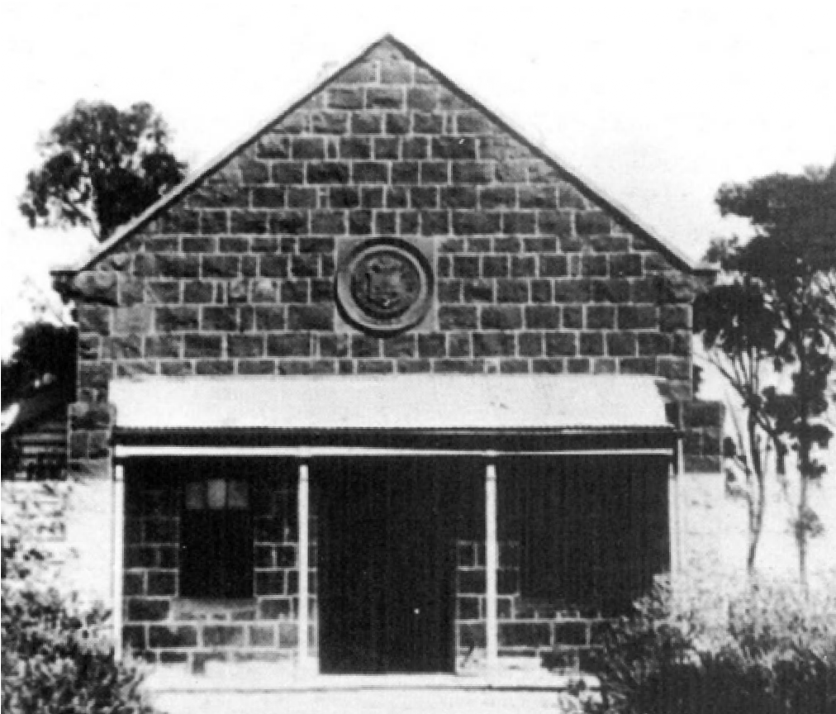
Figure 7.32: Corio Shire Hall before 1926. Source: M. Budd, C. Delaney,
J. Grainger (eds.), From Duck Ponds to Lara: A Collection of Memories, Lara Heritage Festival Inc., Lara, 2004, p.19.

cricket match of Councillors of the Bannockburn and Corio Shires.374 Upon his death in September 1907, the Bacchus Marsh Express gave details of his memorial service:
Rev A Caffin, of Ascot Vale, conducted a memorial service at Lara on the Sunday, and considered them to be the founders of the beautiful Holy Trinity church, Lara. Mr Blair had only missed 16 Sundays during the preacher’s 12 years term at Lara. Mr & Mrs Blair were by birth Presbyterians, but as there were so few of that denomination in the early days, the Church of England
being the majority, they gave assistance to the latter.375
Between 1864 and 1965, fifteen Engineers had been appointed to Council. The first was Daniel Knight Goodall (c.1803-1895).376 He was the son of William and Jane E.
(nee Knight) Goodall of Hollighton, Derbyshire, England.377
D.K. Goodall married Miss Maria Carr at St. Marylebone, Westminster, London, in 1824.378 In 1851, they were living at Limehouse, Middlesex, England, with their four children. At this time Goodall’s occupation was ‘proprietor of houses’.379 The Goodall family had emigrated to Geelong by 1852380 and Goodall soon established ‘Fairview Farm’ at Newtown, as well as leasing farm land at Rothwell and Ascot, Little River.381 In 1862, Goodall was appointed the Town Surveyor of the Borough of Newtown and Chilwell.382 His tenure in this position was only brief as he had resigned by May 1863 and in September of that year he took up the appointment as Engineer with the Corio Road Board.383 In 1864, Goodall became the first Shire Engineer in 1864 and remained in the position until 1868.384 He died in Fitzroy South in 1895.385

MUNICIPAL ACCOMMODATION

THE EARLY TEMPORARY ROAD BOARD OFFICE
The first premises of the Board were located well outside the Board’s boundaries, it had rented offices at 13 Great Malop Street in Geelong.386

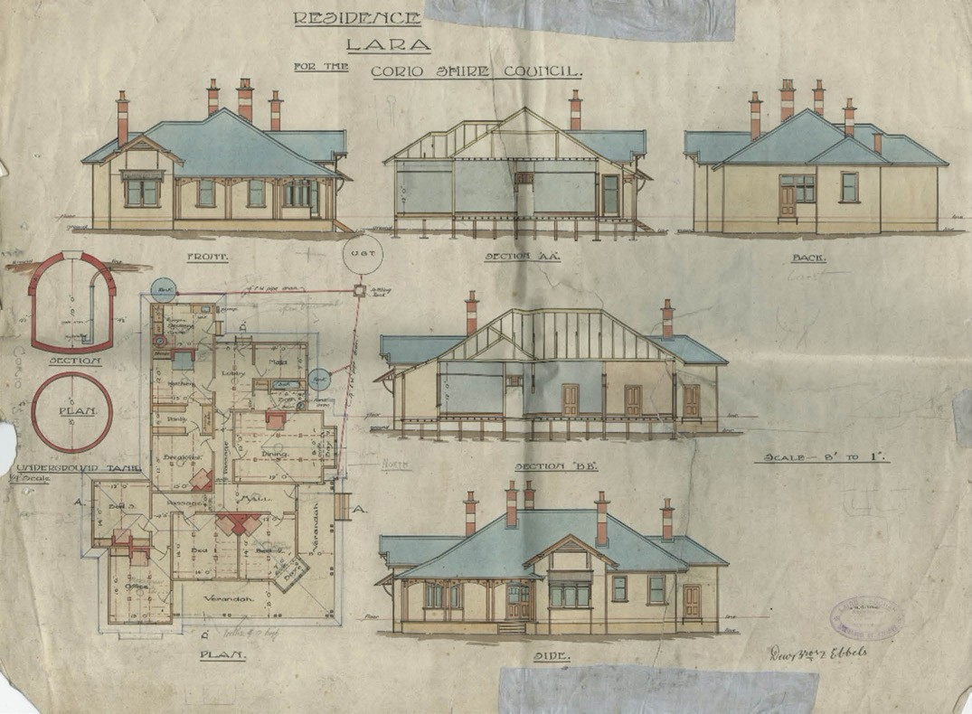
Figure 7.33: Laird & Barlow, ‘Residence in Lara for Corio Shire Council’, n.d. Source: GRS 401/S7/2, Geelong Heritage Centre collection.

CORIO SHIRE OFFICES THE OLD SHIRE HALL
Physical evidence of the Corio Shire Council survives in the
former Corio municipal area in three buildings. The earliest is the central bluestone gabled wing of the former Corio Shire Hall at 2 Rennie Street that was built by Clement Nash in 1864 to a design by the Shire Engineer, D.K. Goodall387 (Figure 7.32). The presence of the shire headquarters at Lara lent a stability and solidity to the rural township, with other organisations and community facilities established in the ensuing years including the You Yangs Lodge of Oddfellows (1865), Reform and Protection League (1873) and the Duck Ponds Cricket Club (1873).388

Additions were made to the hall in 1911 and more substantially in 1926, when parapeted brick wings were constructed.389 Both additions had been designed by the Geelong architects, Laird and Buchan. The building served the centre of local government administration until the end of 1937. Four rooms of the old building were subsequently occupied by the Ranger, McKellar,
as caretaker.390

FORMER SHIRE ENGINEER’S RESIDENCE
In conjunction with designing additions to the Shire hall in 1911, Laird and Buchan had also been commissioned to design a residence for the Shire Engineer at 8 Rennie Street391 (Figure 7.33). The timber weatherboard Federation styled house survives largely intact today.

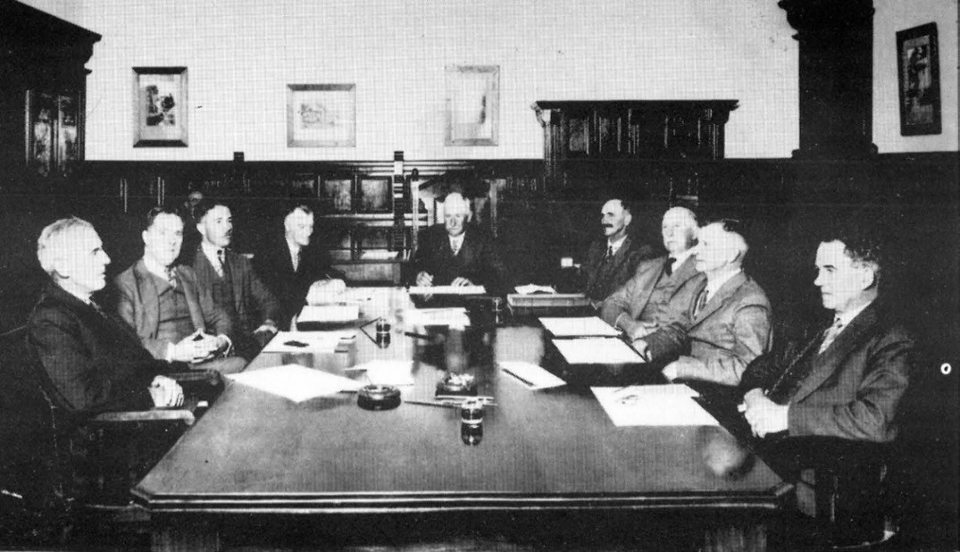
Figure 7.34: First meeting of Corio Shire Council at Osborne House, 26 January 1938. From left to right: J.I. Chirnside, F. Austin, D.W. Hope, R.A. Simmons (Secretary-Engineer), J. Pettitt I(President), F.V. Leigh, W.G. Browne, A.E. Cozens and A.A. McClelland. Source: Corio Shire collection in
I. Wynd, So Fine a Country, p.228.

OSBORNE HOUSE, NORTH GEELONG
On 22 December 1937, the last meeting of the Corio Shire Council was held at the old Shire Hall at Lara. The Council had purchased Osborne House in Swinburne Street, North Geelong (excluding the stables and coach house) from
the then owners, the Geelong Harbour Trust, at a cost of
£4,500.392 The early coach house and stables were acquired by the Shire in 1947. The substantial two storey bluestone mansion house which had been the marine residence of Scottish-born pastoralist, Robert Muirhead in 1858 (see Theme 6) had also served the Geelong Harbour Trust and Defence Department (see later subsections for further details). The first meeting of the Corio Shire Council at Osborne House was on 26 January 1938.393 Present were J.I. Chirnside, F. Austin, D.W. Hope, R.A. Simmons (Secretary- Engineer), J. Pettitt (President), F.V. Leigh, W.G. Browne, A.E. Cozens and A.A. McClelland394 (Figure 7.34).
With the onset of the Second World War, Osborne House was compulsorily acquired by the Defence Department for use as an Army Service Corps Training School.395 The Corio Shire relocated to temporary premises in the former Bank of New
South Wales in Malop Street. The Shire returned to Osborne House in December 1945.396
Several alterations and additions were made to Osborne House to accommodate the changing needs and requirements of the Shire’s administration. In 1964, an illuminated circular fountain was installed to the east of the original house to celebrate the centenary of the Corio Shire.397 In 1966, the local architects, Buchan Laird and Buchan designed a single storey east addition that was linked to an 1890s addition by a glazed lobby.398 Extensive remodelling was carried out in the 1890s addition at this time and central heating was also installed, the total cost of the work being
$264,000.399 The remodelled building (Figure 7.35) was officially opened by the Victorian Governor, Sir Rohan Delacombe, on 30 November 1967.400
Further one and two storey alterations and additions
were designed by Buchan Laird and Buchan in 1975-76. They included a new meeting/reception space, kitchen facilities, offices and an entrance at the north end of Osborne House.401

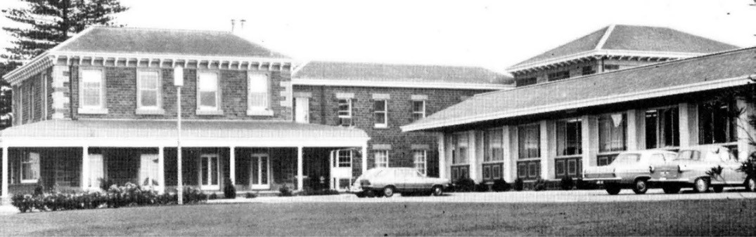
Figure 7.35: Osborne House, showing additions opened in 1967 on the right. Source: Corio Shire collection in I. Wynd, So Fine a Country, p.227.

GEELONG WEST

TOWARDS A SEPARATE MUNICIPALITY
The roots of a separate municipality for Geelong West began in 1854 when the Ashby and Kildare Wharf Association called a meeting to petition for the procuring of a wharf or jetty for the inhabitants of Ashby and Kildare.402 Contrary
to the wishes of these inhabitants, the Mayor of the Town of Geelong preferred the formation of a Harbor Trust and
dismissed the idea of building a wharf.403 Consequently, the ratepayers of the Geelong West area and the local committee resolved to ‘divide the present extensive Villamanta Ward into two sections.’404
It was not until 1860 when the movement to separate the Villamanta Ward of the Geelong Town Council into two wards gained further momentum. A new Thomson ward (to be named in honour of Dr Alexander Thomson) was proposed to provide fairer representation to the constituents of the western portion of the Council.405 Ultimately, the name of
the Villamanta ward was retained for the eastern portion at Latrobe Terrace, the area of the old ward to the west being proclaimed the Thomson ward on 4 April 1861.406 The first Alderman of the new ward was Councillor Charles Kernot.407

FORMATION OF THE BOROUGH OF GEELONG WEST
The solution in the provision of the separate Thomson ward for ratepayers of the Geelong Town Council in the west was to be short-lived. On 19 February 1863 in Kelly’s Crown Assembly Room, a separation committee was formed and a resolution was passed that the Thomson ward should be created into a separate municipality.408 Several more years
were to elapse before the resolution was finally realised. On
28 May 1875, an Order in Council was passed constituting the Borough of Geelong West.409 The boundaries of the newly- formed municipality were outlined in the Victoria Government Gazette:
Commencing at a point in the centre of LaTrobe [sic.] terrace, being the north-east angle of the Borough of Newtown and Chilwell; thence west by a line passing along the centre of Aberdeen street to a point in the centre of the West Melbourne Road; thence north by a line passing along the centre of the West Melbourne road to a point in the centre of Church street; thence east by a line passing along the centre of Church street to a point bearing south from the south-west angle of the Wesleyan Church Reserve; thence by a line bearing north to that angle; thence by the cattle Market Reserve bearing north, east, and north to the south boundaries of allotments 71, 66 and 61 to the shore of Corio Bay; thence southwards along the shore of Corio Bay to Griffin’s Gully; thence westerly along the southern bank of Griffin’s Gully to a point in the centre of LaTrobe terrace; and thence south by a line passing along the centre of LaTrobe terrace to the point of commencement.410
Financially, the newly-formed Borough of Geelong West was also required to pay the Town of Geelong ‘the principal and interest of the amount expended out of the 1869 loan in Thomson Ward, viz., £1658; together with interest at six per cent. per annum.’ 411

THE TOWN AND LATER CITY OF GEELONG WEST
On 14 March 1922, the Borough of Geelong West was declared a Town.412 A civic reception was held on 22 March 1922 in the presence of the Governor of Victoria.413
By early 1929, the revenue of the Town of Geelong West had exceeded £20,000.414 This gave impetus under the provision of the Local Government Act 1915 for the Geelong West municipal to be proclaimed a City on
8 April 1929.415

THE FIRST COUNCILLORS
The constitution for the Borough of Geelong West included the provision of nine members.416 The first Councillors were A. Amiet, I. Boynton, J.J. Buckland, W. Doery, G. Hall, S. Hobbs,
J. Ince, J. Nixon, D. O’Brien, and T. Stoneman, who was also elected the inaugural Mayor.417
Thomas Stoneman (c.1822-1887) (Figure 7.36) was the son of Henry and Ann (nee Jennings) Stoneman of Barnstaple, England.418 A coach smith, Thomas married Ann Bennett and in 1852-53 they emigrated to Victoria with their two infant children. In Latrobe Terrace, Geelong West, Stoneman established a coach building business between 1852 and 1853 which he expanded into a highly successful business in the ensuing years. In 1866, he went into partnership
with Messrs. Meigs and Anderson and Joshua Vines, mail contractors in the Western Stage Company. Based at Warrnambool, the new company was the contractor for
mails across the colonies. Stoneman retained an interest in this company until 1877. He served as a Councillor with the Borough of Geelong West between 1875 and 1878, including his term as Mayor in the three years of existence of the municipality. Having amassed a considerable fortune from his coach building and mail service businesses, Stoneman retired to Queenscliff where he continued to be actively involved in municipal life, being elected Mayor of Queenscliffe in 1880-82 and 1884-87. He died in 1887 while on a visit
to Melbourne.
Alfred Amiet (1855-1915) was born at Batesford, the son of Jean Francois (John Francis and Elenora (Laura) (nee Bieske) Amiet, vignerons.419 They both emigrated (separately) from Boudry, Neuchatel, Switzerland, and Schollen Bei Zullichau, Brandenbur, Pressen, Deutschland, respectively. Alfred Amiet served his apprenticeship in ironwork.
In 1879, he married Louisa Chamberlain. A year later, he established his own blacksmithing business in Pakington Street, Geelong West as well as a branch at Morwell where his parents and other family members had relocated.
Soon after, Amiet went into a partnership with Abner Hadfield in Pakington Street, Geelong West, but this was dissolved in 1888 and Amiet continued on his own account.

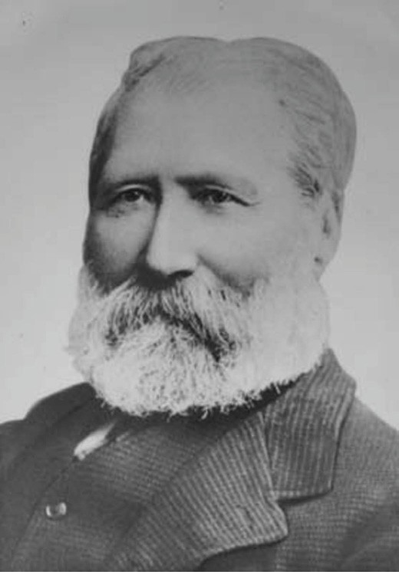
Figure 7.36: Thomas Stoneman, c.1875. Source: GRS 1160/01/001 Geelong Heritage Centre collection.

This was to be only for a short period as in 1891 Amiet offered his properties in Geelong West for sale given that he had relinquished his blacksmith business to take up the occupation as a commission and estate agent and wood
merchant. Amiet served as a Councillor with the Borough of Geelong West from 1875 until 1891. He had been instrumental in the establishment of the local fire brigade in addition to contributing to local business and municipal life. No details have been ascertained of Amiet’s removal from Geelong although an Alfred Amiet was resident in Newnham Road, Lambeth, London, so he and Louisa may have emigrated there in the early 1890s.
Isaac Boynton (c.1812-1887) was the son of Thomas Boynton of Yorkshire.420 A builder and mason, Isaac Boynton married Mary Ann Glen, and with their daughter, Elizabeth, they emigrated to Geelong on the Joshua, arriving in 1854.
The family were initially resident in Chilwell. By 1859, Boynton had entered into partnership with Harry Conway, a stonemason who Boynton appears to have met on the Joshua, Conway (from Leicester) enroute for Geelong.

They operated under the name of Boynton and Conway contractors. They built several substantial buildings in Barrabool stone, including the Geelong Advertiser Office in Malop Street, Chamber of Commerce in Moorabool Street in 1858 and the London Chartered Bank in Malop Street in 1859- 60, Colonial Bank of Australasia in Lydiard Street, Ballarat in 1860 and works at the Geelong Gaol in 1861. The efficiency and quality of their work raised Boynton’s reputation so that in 1862 he was proposed by William Noble to represent the Thomson ward of the Geelong Town Council, observing that Boynton ‘had been resident in the ward for many years, and was too well known by the burgesses to require a character at his hands. He was a thorough practical business man … ‘ In 1866, Boynton represented the Thomson ward as Alderman. A resident of Upper Autumn Street, Boynton served as a Councillor with the Geelong West Borough from 1875 until 1881, including a term as Mayor in 1878. He died at his residence in 1887.
John Jeffreys Buckland (1830-1905) was the son of John and Clarrissa Buckland of New South Wales.421 By 1854, he was resident in Geelong as it was at this time he married Mary Anne Gibson. A customs house agent, they lived at Laurel Bank, Barrabool Hills, in 1856. In 1871, Buckland gained his auctioneer’s license and it was at this time
when he entered into partnership with W.T. Y. Burnett of Peak Downs, Queensland, as stock and station agents and woolbrokers. During the 1870s he became involved in various sporting clubs and activities, including the Barwon
Regatta Committee, Corio Cricket Club, Grant and Polwarth Coursing Club, Geelong West Football Club and the Geelong Racing Club. During the 1870s Buckland was resident at ‘Drumcondra’ (see Theme 6) which he was forced to sell in 1880 due to becoming insolvent. Buckland was a Councillor with the Borough of Geelong West from 1875 until 1880.
Following the demise of is business, he relocated to Sydney where he had taken up a position in
a woolstore. He died at Woodside, Bundanoon, N.S.W. in 1905.
William Clifford Doery (c.1810-1905) was the son of Thomas Doery of Derbyshire, England.422 In 1851, he married Emma Meakin at St. Werburgh, Derby. In 1854, they emigrated on the Albatross to Victoria and settled at Sandhurst (Bendigo), where William established a market garden. By 1868,
the Doery family had relocated to Ashby where William established a boot manufactory in one of Edwin Hopton’s buildings in Pakington Street. In c.1882, he had acquired sufficient funds to build his own two storey bootmaker’s shop at 226 Pakington Street (south-west corner of Pakington
and Autumn Streets). Doery was heavily involved with the Aberdeen Street Baptist Church and he was also a member of the Geelong West Free Library. He served as a Councillor with the Geelong West Borough from 1875 until 1881. In the

mid-1890s, he relocated to Canterbury where he died in 1905.
George Hall (c.1826-1904) was educated at Rivington Grammar School, South Lancashire, and at Battersea College where by 1850 he had completed his training as a teacher.423 After a few years’ experience as a schoolmaster, Hall emigrated on the Lady Kennaway to Victoria, arriving in 1853 (wife, Emily Frances (nee Butterworth) Hall, appears to have emigrated to Victoria in 1858 with their daughter,
Emily. In 1854, Hall was appointed headteacher at St. Paul’s Denominational School, Ashby. He continued as headteacher at St. Paul’s until his resignation in 1869 and afterwards became a bank clerk. Hall was elected a Councillor for the Geelong West Borough in 1875 and served until 1878. He died at his residence, ‘Grassmere’, Auburn, in 1901.
William Sydney Hobbs (c.1828-1886) was the son of Timothy and Catherine (nee Tyler) Hobbs of London, England.424 By 1856, Hobbs had emigrated to Geelong and had taken up freehold land in Candover Street, Ashby, and established a butcher’s shop. It was also in 1856 when he married Eliza Carson. Hobbs was heavily involved with St. Paul’s Church of England, as a member of the choir, parish vestry and teacher and treasurer of the Sunday School.
Hobbs was a Councillor with the Borough of Geelong West from 1875 until 1886, and served a term as Mayor in 1883. He died at his butcher’s shop, Candover Street, in 1886.
John Ince (c.1832-1897) was the son of Robert and Mary (nee Barret) Ince of Ballynolan, Queens County, Ireland.425 A farm labourer, he emigrated on the Sea with his two brothers, Robert and Joseph, and sister, Mary, arriving in 1849. By 1856, Ince had relocated to Ashby where he opened a store in Aberdeen Street known as the Great Western Store. It was in 1856 when he married Frances Harvey of Newtown who was also a storekeeper. Ince was also to become a stock dealer in the ensuing years. Ince made a significant contribution to public life, as a Geelong West Borough Councillor from 1875- 1878 and 1881-1890 (including two terms as Mayor in 1884 and 1888) and as a Member of the Legislative for Barwon in the Victorian Parliament between 1877 and 1880. He died in 1897.
John Nixon (c.1814-1891) was the son of Joseph and Hannah (or Emma) (nee Willock) Nixon of Stockport, Cheshire, England.426 A cabinet maker, he married Martha Candelet in the Parish of St. John’s, Manchester, Lancashire, England in 1836. Between 1840 and 1843, the Nixon family emigrated
to Tasmania where John took up a position as overseer at Probation Road Station, Lovely Banks, Oatlands. By 1845, the family had relocated to Tea Tree, Hobart, where John had taken up farming. By 1856, the Nixon family was resident in Isabella Street, Ashby, Geelong, with John being a carter.
In 1861, he was appointed Treasurer to the Corio District Road Board and subsequently became a Councillor for the

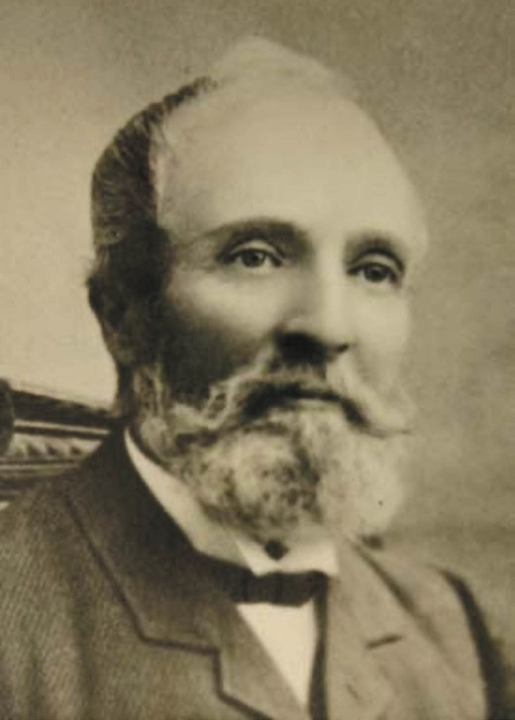
Figure 7.37: Edwin Hopton, c.1881. Source: GRS 1160/01/005 Geelong Heritage Centre collection.

Villamanta Ward for the Geelong Town Council until 1864. He was elected a member of the local board of St. John’s Church of England School, Kildare, in 1865. He served as a Borough Councillor for Geelong West between 1875 and
1886. By the 1870s, Nixon had opened a store and butcher’s shop at the corner of Elizabeth and Isabella Streets. In 1878, he placed his business and property on the market and relocated to Congupna near Shepparton. He then relocated to Yarrawonga where he died in 1891.
Denis O’Brien (c.1828-1901) was the son of William and Margaret (nee Ryan) O’Brien of Limerick, Ireland.427 By 1855, he had emigrated to Geelong as it was at this time when he married Mary Ann O’Regan. A carter, O’Brien had acquired property in Anderson Street (now Pizer Street), Ashby. From 1870 until 1900, O’Brien held the licence for the Argyle Hotel, Aberdeen Street, Geelong West (the licence being taken over by Mary O’Brien after that time). O’Brien was a Councillor with the Geelong West Borough from 1875 until 1886, serving as Mayor in 1880. He was President of the Argyle Cricket Club in 1877 and Secretary of the Irish Relief Fund in 1880.

O’Brien was a member of St. Mary’s Catholic Church and also held a prominent position with St. Patrick’s Hibernian Australasian Catholic Benefit Society. He died in 1901.

THE FIRST COUNCIL OFFICERS
The first Clerk for the Borough of Geelong West was Edwin Hopton (1822-1909) (Figure 7.37), the son of John and Martha (nee Lancashire) Hopton of Westbury on Trym, Bristol, Gloucestershire, England.428 In 1854, he married Elizabeth Barrell at Paddington St John, England. With their two young children, Edwin and Elizabeth Hopton emigrated to Victoria on the Sydenham, arriving at Port Phillip Bay
in 1857. In 1861, Hopton took up ownership of J.T. King’s substantial draper’s store at 220 Pakington Street, Geelong West, renaming it Union Jack House. He was appointed Clerk for the municipality in 1875 and served a two year tenure. On his death in 1909, the Geelong Advertiser gave the following obituary:
The death Mr Edwin Hopton which was chronicled in Tuesday’s “Advertiser”, reveals an interesting personality, as for many years the deceased (who had reached the advanced age of 87) was closely identified with municipal matters in Geelong and Geelong West, where he owned a good deal of shop property. He was one of those who fought for and brought about the separation of Geelong West from the town proper in 1875. Geelong West had previously been known as Thomson ward. Mr. Hopton was appointed town clerk of the new borough, and he held the position for some time. In 1878 he was returned as a member of the Geelong West council. In 1881 he was elevated mayor of the borough. A few years later he left the council and for a time lived at Swan Gardens at
Fyansford where he had a vineyard and the government of the day appointed him as Inspector of Vineyards. Hopton took a keen interest in politics, and amongst others he worked hard on behalf of Sir Graham Berry. At one time
he carried on a drapery business in the central portion of the town, and he occupied premises in Pakington street, Geelong West. He was well and favorably liked by many of the elder residents and out of respect to his memory the flag at the Geelong West town hall was flown at half- mast.429
The first municipal engineer was Thomas Morton Goodwin (1825-1889), the son of John and Jemima (nee Shackshare) Goodwin of Kent, England.430 By 1856, he had emigrated to Victoria as he was listed as a storekeeper in Nelson Street, Windsor. Before 1865 he had married Elizabeth Hooker as their son, Walter Morton Goodwin was born at this time. By 1860, Goodwin had been appointed the municipal surveyor of the Prahran Council. In 1868, Goodwin took up the position of municipal engineer to the Corio Shire Council, a position he

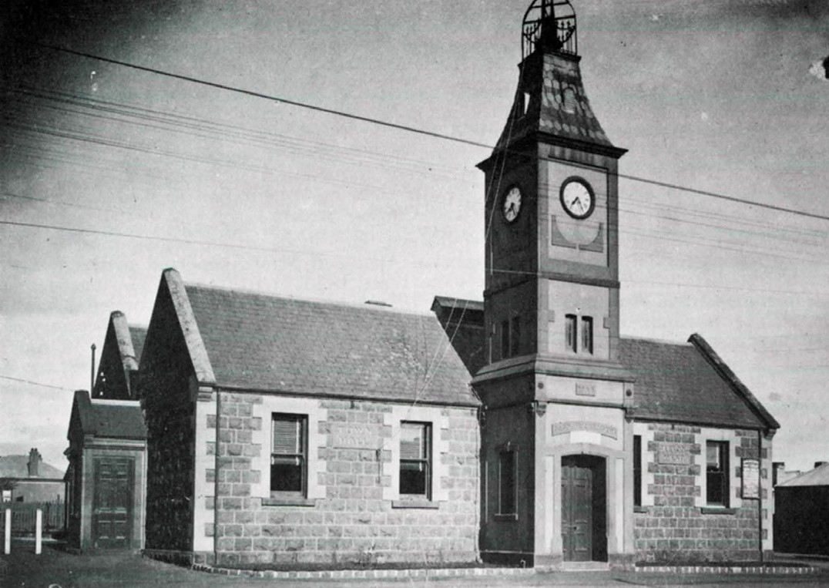
Figure 7.38: Geelong West Town Hall (Former Ashby Common School), n.d. [before 1922]. Source: G. Seaton, The Ashby Story, p.45.

held until 1877, during which time he was also appointed the first engineer and surveyor to the Borough of Geelong West from 1875 until 1877. Throughout these years the Goodwin family were resident at Western Beach. In 1877, Goodwin resigned as Geelong West Borough engineer and surveyor over a dispute about his salary and accepted a position as the surveyor at the Glenelg Shire. He was later Shire Engineer
at Kyneton, Creswick and Numurkah. He died at Prahran in 1889.

COUNCIL ACCOMMODATION THE FIRST TOWN HALL
In 1876, the newly-formed Borough of Geelong West
purchased the Ashby Common School at the corner of Pakington and Albert Streets, which had been erected in 1867.431 At this time, the Geelong Advertiser declared that ‘the old Ashby School is to be no longer known by that name, but by the more dignified appellation of the Town Hall …’432 By 1884, the Town Hall had become ‘less dignified’ and several improvements were carried out. The proposed works that were ultimately realised were outlined in the Geelong Advertiser in April 1884:
An effort is now being made to improve the unsightly appearance of the borough council chambers, or rather town hall, in Pakington-street. Outwardly, it is to be adorned by three porches, the main entrance being from Pakington-street through an ornamented porch, above which will be a clock tower 26 ft from the ground. The

other two porches will be finished off with neat cut stone coping. The old meeting room of the council will be formed into a public reading room or free library, 22 ft by 18 ft, entrance to which will be through a porchway facing Albert-street. In connection with the reading room there is to be a book room for the library, 10ft by 18ft. Among the additions being effected to the town hall building
are rooms for the mayor, town clerk, and surveyor, and a fireproof cemented brick safe. The present public meeting room is to be made the council chamber, the interior being ornamented with cornice and mouldings, the walls picked off so as to give the appearance of cut stone blocks, the front windows to be large- sized panes of glass, the floor to be entirely new, and proper gas jets
to furnish illuminated power at night. The alterations and improvements are being rapidly carried out in accordance with plans prepared by the borough surveyor, Mr Andrew McWilliams, who is superintending the work. The contract was let to Mr John Carmichael, the price being £608.433
Upon completion, the centrally-located central porch and clock tower became a landmark in Pakington Street
(Figure 7.38). The double-gabled, single storey bluestone building was setback from the Pakington Street frontage.

THE SECOND TOWN HALL
In 1923, the Geelong West Town Council resolved to erect a new Town Hall building on the site of the old structure that was to be demolished. The local architect, I.G. Anderson, was commissioned to design the building. The successful contractor was J. Dew and Co, the tender being accepted on 15 June 1923 at a cost of £12,734.434 The Geelong Advertiser gave an illustrated description of the proposed building (Figure 7.39):
The design is in Classic Renaissance style. The building is set back from Pakington Street at a distance of
about 106 feet forming a Civic Plaza laid out as shown. The height of the tower will be about 70 feet. The planning provides for a Public Library 35 ft x 25 ft, approached from the main central hall 14 feet wide, and on the opposite side of this hall are set out the civic offices including the Town Clerk’s office, attendant’s office, and stenographer’s department and also engineer’s, foreman’s and inspector’s rooms. The main Concert Hall is to seat 750
persons, and is approached through the centre of the main building. The up-stairs apartments are council chamber, size 35 ft x 20 ft., Mayor’s room, 19 ft 6 in. x 13 ft 3 in.,
lodge room, 41 ft 3 in. x 20 ft., with ante-room, 14 ft x 10 ft., all entered through small corridors off the large upper stair hall. The balcony for use of proclamation is provided
over the front portico and entered from the Mayor’s Room. The concert hall is to have a stage, size 25 ft x 19 ft, with dressing rooms adjoining. The main materials to be used

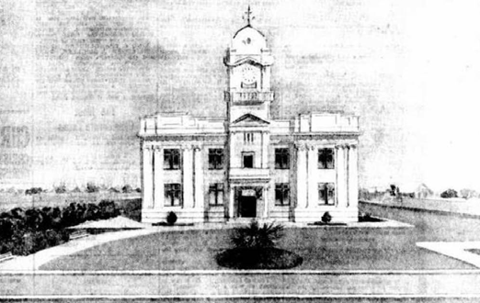

Figure 7.39: I.G. Anderson, Elevation drawing of proposed Geelong West Town Hall. Source: Geelong Advertiser, 19 May 1923, p.13.

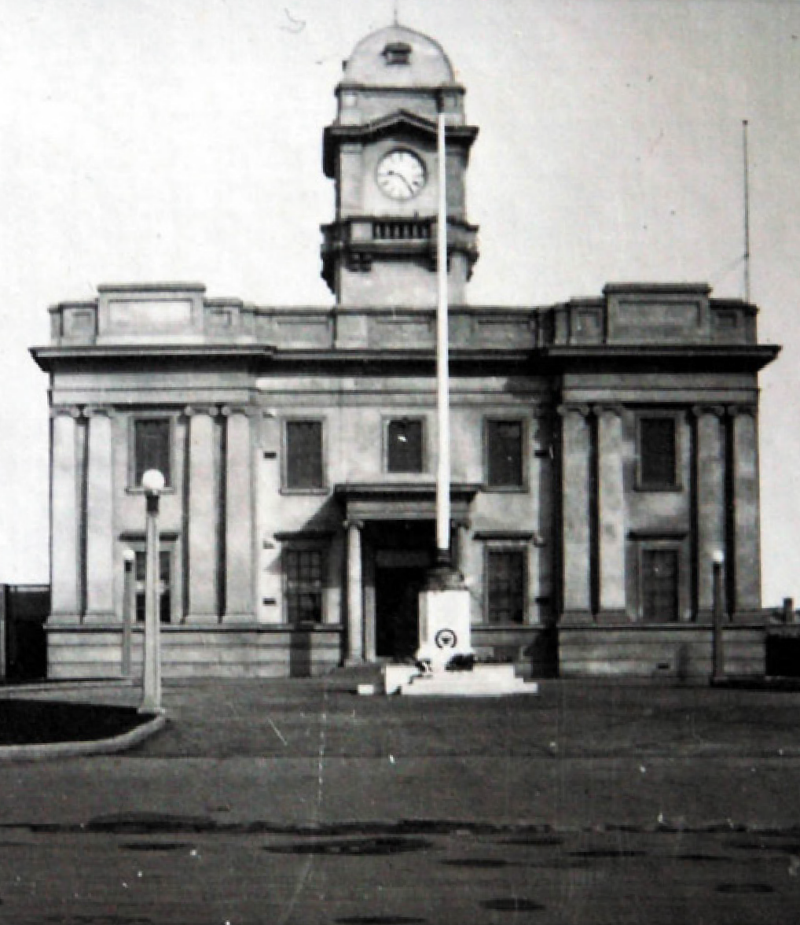
Figure 7.40: Geelong West Town Hall & War Memorial, c.1932. Source: T.T. Holmes collection, Authentic Heritage Services.

in the construction are concrete and brick. All inside fittings are to be in polished Tasmanian oak.435
Apart from some minor changes in the detailing of the clock tower, the building was constructed to Anderson’s design, including the provision of a forecourt (Figure 7.40). It was opened on 22 December 1924.436 A number of alterations and additions were carried out in the c.1940s, later 20th century and in more recent times in order for the building to meet different requirements.437

CITY OF GREATER GEELONG
The concept of an amalgamation of municipalities in the Geelong area has its roots in 1910 when the Victorian Government proposed to bring on a Bill in Parliament to compel three Councils to amalgamate.438 While this was not to eventuate at this time, it was the genesis for the
Greater Geelong Movement involving a range of promotional campaigns about Geelong and district (see Theme 9).

In 1993, the Victorian State Government introduced legislation to combine more than 200 small local Councils into 78 larger Councils.439 On 18 May 1993, Geelong was the first region where earlier local Councils were amalgamated under the City of Greater Geelong Act.440 It comprised the previous Bellarine Rural City Council, Corio Shire Council, Geelong City Council, Geelong West City Council, Newtown City Council, South Barwon City Council and a part of the Barrabool Council.441
For two years between 1993 and 1995, the City of Greater Geelong was governed by four Commissioners. They were Bill Dix (Chairman), Glyn Jenkins (Deputy Chairman),
Frank Wilkes and Toni McCormack. Their role was to provide a smooth transition during the amalgamation process.442
The first election was held in March 1995 when 12 Councillors were elected, with each Councillor representing one ward.443 The first Councillors were Anthony Aitken, Dennis Blake, Keith Broadbent, Michael Crutchfield, Adrienne Edgar, Kevin Edwards, Ian Howard, Margaret Lewis, Dorothy McWhinney, Hayden Shell, Gerrard Smith (who was also first Mayor) and Ian Stacey.444
A further restructure of the ward system reduced the number of wards to nine in late 1997. Five District Councillors were elected by the whole of the Greater Geelong community, with four Ward Councillors elected by people in a particular area of the municipality. This changed again in 2001 when the Council reverted to the 12 ward system.445
In 2012, the popularly-elected Mayor model was introduced following an amendment to the City of Greater Geelong Act.446 Councillor Keith Fagg was elected the first popularly-elected Mayor.
In 2013, the City of Greater Geelong Council passed a resolution to fly the Aboriginal flag on City Hall and other Council buildings alongside the Australian flag.447 This represented a symbolic act towards reconciliation and cultural awareness with the Wadawurrung (the Traditional Owners of the land) and the City’s Aboriginal and Torres Strait Islander population.448
In 2016, the Victorian State Government dismissed the Greater Geelong City Council following a Commission of

Inquiry into council’s government, administration and culture. Impetus had come from the findings of a Workplace Culture Review by Susan Halliday in 2015.449 Three Commissioners were subsequently appointed to address recommendations in the Commission of Inquiry Report and administer the Council.
It was also in 2016 when a Citizens’ Jury was established to give advice on the future design of the City of Greater Geelong.450
In 2017, the City of Greater Geelong Amendment Bill was passed by the Victorian Parliament. Following the
recommendations by the Citizens’ Jury, the Council structure comprised 11 Councillors including the Mayor and Deputy Mayor, these positions being elected by the Councillors for two year terms.451 A four-ward system was established,
with three Councillors representing the Brownbill, Bellarine and Kardinia Wards, and two Councillors for the Windemere Ward (which included Norlane, Corio and Lara). Following an election 28 October 2017, the 11 Councillors were sworn in at a Special Council Meeting on 14 November 2017.452
In 2017, the City of Greater Geelong was one of the largest employers in the Geelong region, with 2,750 staff.453 It provided 126 services454 including waste and recycling, sport, recreation and leisure, aged and disability, tourism, marketing, events and economic development, local laws, health and animals, roads, footpaths and drainage, parks, gardens and environment, arts, culture and libraries, building and planning and capital works.455

FOUNDING OF COLONIAL AND STATE GOVERNMENTS IN VICTORIA:
ASSOCIATIONS WITH GREATER GEELONG
Although Melbourne was to become the capital of the Colony of Victoria, its separation from the Colony of New South Wales on 1 July 1851 was to have a profound effect on the Greater Geelong area. The new Colonial Government had the legislative authority over the local municipalities, and this continued when the Colonies Federated in 1901 and Victoria became a state of the Commonwealth of Australia. The most profound effects of the State Government’s authority over Greater Geelong resulted from the provision of building, planning and other controls under the legislation of the State Government, the amalgamation of former municipalities and the ability to dismiss the local council
as occurred in 2017.
Possibly one of the most notable early civic events in the European history of Greater Geelong in the mid-19th century was the celebration that marked the impending separation of Victoria from New South Wales in 1850.456 A public holiday was observed on 18 November 1850 and numerous ‘public schools of every denomination’ other public bodies, community groups and councillors came together to form a procession from the Market Square to the Corio Cricket Ground (now Kardinia Park) for sports, music and refreshments.457 The coming together with the townspeople was a key celebratory event, and the Traditional Owners were not forgotten. Although it involved
the provision of blankets for those Wadawurrung (and other Language groups) that attended – emphasising their demise caused by European colonisation in the first instance – it also involved a corroboree.458 This appears to have been one of the earliest forms of integrating (in part) Wadawurrung culture into an organised European celebration. To take place after the celebratory banquet (in the case of the Wadawurrung, a bullock was to be roasted on a spit), the corroboree was anticipated to be a key part of the celebrations. As reported in the Geelong Advertiser:
After the banquet the grand corroboree will be held, and we believe this will turn out to be the most pleasing and interesting spectacle of the whole day’s proceedings.459
Although initiatives were proposed as tangible forms of the celebration (such as a clock in market square or a shipping channel at Point Henry),460 no enduring physical marker was realised for the separation celebration, or the Federation of the Australian Colonies. It was not until 1951 when these key European events were commemorated and a plaque unveiled on the Geelong waterfront (between Moorabool and Yarra

Streets). An enduring physical legacy that survives today, the plaque read:
On 12 November, 1850, here in front of Mack’s Hotel settlers met the first ships to use the steam packet wharf and learnt that the Act to establish the Colony of Victoria had been passed.461
A more substantial memorial befitting this significant event and the 50 years since Federation was a proposed sound shell. With a Central Jubilee Commemoration Fund Committee appointed in 1951, an appeal was established to raise funds for ‘the erection of a permanent feature.’462 The concept was promoted on the front page of the Official Programme of the Geelong Centenary Jubilee Celebrations in 1951.463 Although the proposed sound shell fund raised £13,606 by 1954, it became mired in controversy.464 In 1955, the Chairman of the Fund Committee, Cr B.E. Purnell, refused to vacate his office and by 1960 the Victorian Attorney-General (following advice from the Crown Law office), and Mr Justice Dean of the Supreme Court became involved.465 This led to the appointment of new Trustees which included the former Chair, B.E. Purnell. Justice Dean ordered that the collected funds ‘should be held in trust until the citizens of Geelong had decided what form of permanent feature should be erected.’466 Five local municipalities support the construction of a sound shell while the remaining two Councils gave no objection. Although the Geelong City Council proposed a site in Eastern Park, the Corio Shire sought the structure to be located at Rippleside Park while the City of Newtown proposed that it should be built at the Windmill quarry at the western end of Noble Street. 467
With no consensus, a new committee was formed and it suggested three proposals: a sound shell, historic records centre or a new wing at Grace McKellar House, Bell Park.468 Further delays and debate ensued, the matter being referred to the Supreme Court by the Attorney-General. In 1970,
Mr Justice Lush ordered that the Jubilee Funds ‘be applied towards the construction of an Historical Records Centre in the form of a first floor addition to the Geelong Regional Library’
in Little Malop Street.469 As further funds were required, the memorial marking the century of the separation of Victoria from New South Wales, and the half-century of the Federation of the Australian Colonies was not opened until 16 November 1979
in the presence of Mr Austin, Minister for Public Works and Sir Roy Fidge (a long-serving supporter of the establishment of the Centre).470 The physical legacy of the jubilee memorial
- the Geelong Library and Geelong Historical Records Centre
- ceased with the demolition of the building in 2013 to make way for the new $45M Geelong Library and Heritage Centre.471 The memorial continues to endure in an intangible way through the ongoing original and intended function of the Geelong Historical Records Centre at the new Heritage Centre.

LAW AND ORDER IN
GREATER GEELONG

THE EARLY YEARS 1838-39

APPOINTMENT OF CAPTAIN FOSTER FYANS & THE ARRIVAL OF THE POLICE
On 8 June 1837, European settlers, alarmed by the growing hostility by the Traditional Owners whose land they had seized, petitioned the Governor, Sir Richard Bourke to appoint a police magistrate in Geelong ‘with a small body of mounted police under his control, to protect their lives and property.’472 With a willingness to fund the police
establishment, among those who signed the memorial were Thomas, John and Peter Manifold, Thomas and William Learmonth, Thomas Austin, John and Robert Stieglitz, Charles, Swanston, R.E.A. Fisher, W.C. Yuille, James Clarke,
J.A. Cowie and Dr Alexander Thomson.473
In September 1837, the Governor appointed Captain Foster Fyans (1790-1870) (Figure 7.41) as police magistrate at Geelong.474 He was a friend of Governor Bourke’s, having been a fellow officer in the 4th (King’s Own) Regiment.475 The son of John and Margaret Fyans, an Irish Anglican of Clontarf Dublin, Ireland, he joined the 67th Regiment at Portsmouth after which he was part of the 2nd Battalion at Cadiz and following the Peninsular war, he returned to England.476 In 1818, he served with the 1st Battalion in India and in 1833 he joined the 4th Regiment at Sydney and was posted to Norfolk Island as a captain of the guard. After rising to the position
of commandant at Moreton Bay, he sold out of the Army and sailed for Port Phillip to take up the position as first police magistrate of Geelong.477 In addition to his role as police magistrate, Fyans was influential on the selection of the site of the Geelong township construction of a breakwater at Breakwater.478 In 1840, he was appointed Commissioner of Crown Lands for the Portland Bay District as his position as police magistrate had been offered to Nicholas Fenwick (see earlier subsection for further details).479
A police station was erected adjacent to Fyans’ ford over the Moorabool River that was first staffed by Charles Wentworth, clerk; and three foot policemen - Patrick McKeever, district constable (and Fyans’ former batman); and Owen Finnagan and Joshua Clarke, constables.480
In January 1838, Fyans was also issued with a party of mounted troopers.481 They consisted of infantrymen from the 80th British Regiment and served under military discipline.482 They were charged with ‘doing duty in the country of Port Phillip’483 and ‘to police the aborigines in the Western District.’484 By April 1838, Fyans had selected a paddock of approximately 25 acres to be transformed into the barracks for the mounted police.485 A hut had also been built by August
1838 – presumably by the 12 convict labourers that had been assigned to him – for the impending arrival of ‘the detachment of soldiers.’486 By April 1839, the mounted police had arrived at Fyansford. They were Corporal Patrick Bannon, Trooper Thomas King, Trooper Patrick Ewing and Dismounted Trooper Thomas Lamburn.487
The reserve for mounted police took in the low-lying and steeply-sloping land to the north and east of the Moorabool River, at the junction of the Barwon and Moorabool Rivers (see Figure 6.49 Theme 6). No physical evidence survives of the mounted police barracks, police hut or Fyans’ hut, the area becoming the location of Henry Collins’ Flour Mill on the east bank of the Moorabool River in 1844, the township of Fyansford in 1854 and later also the Australian Portland Cement Company works (see Theme 6). However, a legacy of Fyans’ very early contribution to European law and order
at Geelong are remnants of the ford over the Moorabool River (near the junction with the Barwon River) and the naming of the township (and now suburb), Fyansford.
Assisting Fyans with the administration of the court in Geelong was Henry Hesketh. Fyans had possibly known Hesketh through the military and had recommended him for the role as Clerk of the Bench, to which Hesketh was appointed in August 1839.488 Hesketh had emigrated from
England to Tasmania in 1835 and with his friends, Gillies and Leake, undertook a survey of the coast of southern Australia from Kangaroo Island to Spencer’s Gulf, Gulf of St. Vincent, and Lake Alexandrina.489 Hesketh’s previous life experience was outlined in the South Australian Gazette and Colonial Register in 1836:
Mr. Hesketh, who before his departure for Van Diemen’s Land was attached to the South Australian colony
in London, is a gentleman of the most active and enterprising character, having served as a volunteer with Lord Cochrane in South America, and Lord Byron in
Greece. He has also visited many other parts of the world, has the qualifications of a good artillery officer, and is now carrying into execution a plan carefully laid by himself and Mr. Gilles.490
Hesketh’s role as Clerk of the Bench was to be short-lived. He resigned in October 1839 and was replaced by Alfred J. Eyre (see earlier subsection).491

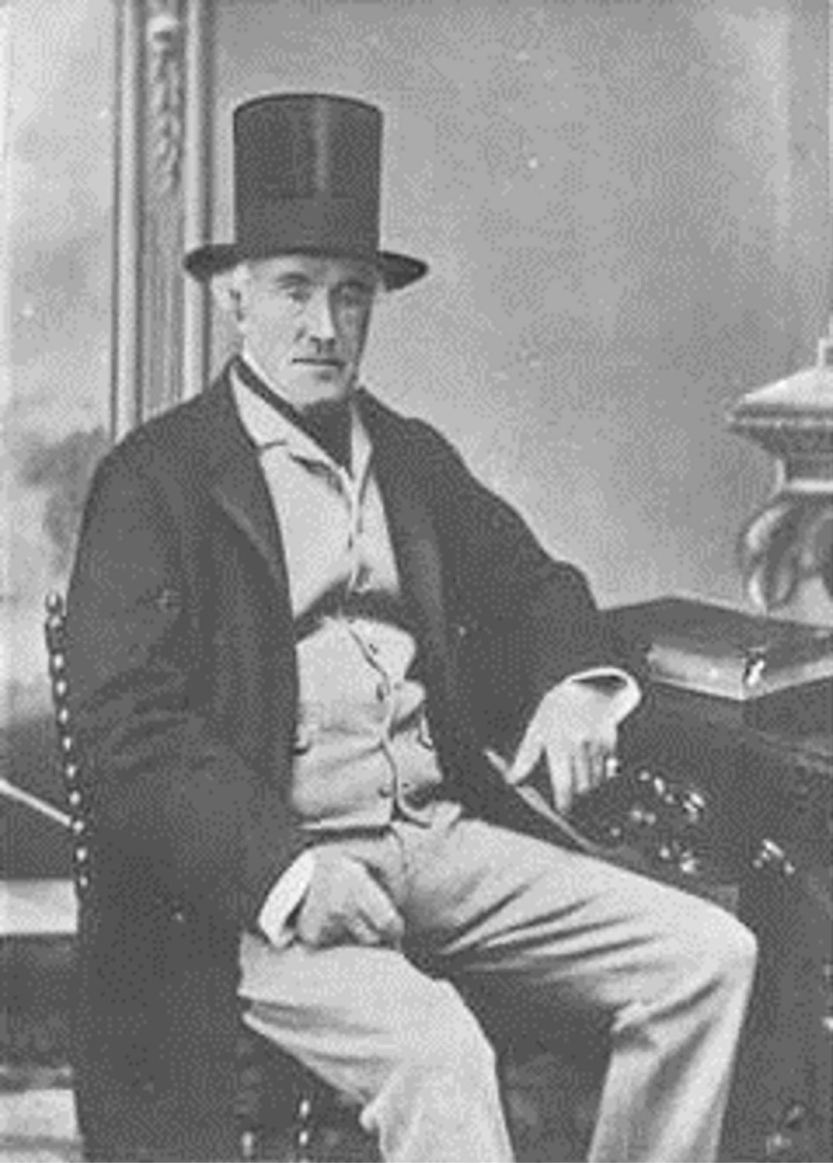
Figure 7.41: Captain Foster Fyans, 1866. Source: G.C. Wilmot, GRS 2009/02056, Geelong Heritage Centre collection.

BORDER AND ‘NATIVE’ POLICE
When Fyans was appointed Commissioner of Crown Lands in 1840, he was provided with a Border Force that was stationed at the mounted police barracks at Fyansford. They replaced the mounted police, having been claimed to be a more economical solution to policing and the Border Police were a mounted force of armed convicts under Fyans’ command.492
An unofficial member of Fyan’s Border Police was Bonjon (Punjon, Bon Jon) of the Wathawurrung balug clan in the Barrabool Hills.493 In addition to the establishment of the Border Police, the New South Wales Government legislated the formation of Native Police Corps. Between 1840 and 1844,494 Fyans employed Bonjon as a guide and protector: to give direction throughout the Western District and to protect him while travelling through other clan estates.495 While other members of the Wadawurrung had worked as guides in
earlier years (see Theme 2), Fred Cahir in ‘The Wathawurrung People’s Encounters with Outside Forces 1797-1849: A History of Conciliation and Conflict’ gave an account of Bonjon’s role:
He was often armed and effectively acted as a member of Fyan’s Border Police force which was stationed on the Moorabool River. Fyans attested that Bonjon always attended him in the bush, and was often with him for three or four months at a time visiting stations in foreign country west of Wathawurrung. He would accompany Fyans and detachments of the Border Police when they were pursing groups of Aborigines that had attacked
Europeans, performing duties as a ‘black tracker’. At one point, had Bonjon not intervened, Fyans might well have been killed.496
In 1841, Bonjon was charged with the murder of Yammowing of the Gulidjan people.497 A witness in the case, the
Rev. Francis Tuckfield, claimed that Bonjon had had more European contact than any other member of the Wadawurrung given that he was a volunteer member of Native Police. It was alleged that Bonjon had fatally shot Yammowing in the head.498 The case was eventually
abandoned and Bonjon discharged. The case later became ‘notable for the legal question of whether the colonial courts had jurisdiction over offences committed by Aboriginal people interse, that is, by one Aboriginal person against another, and the legal situation as to the British acquisition of sovereignty over Australia, and its consequences for the Aboriginal people.’499

THE ABORIGINAL PROTECTORATE & THE WADAWURRUNG AS ‘NATIVE POLICE’
In 1839, the New South Wales Government established the Aboriginal Protectorate. This system was to ‘protect’ the Traditional Owners on their land and to ‘civilise’ them to minimise ‘collisions’ between European settlers and the Wadawurrung (see Theme 2 for further details).500 In June 1839, the Assistant Protector appointed for Geelong and the Western District was Charles Sievwright. His role
was to protect the Wadawurrung and other Aboriginal language groups in the Western District of Victoria ‘from any encroachments on their property and from acts of cruelty, oppression or injustice.’501 A hut was provided
by Foster Fyans on the banks of the Barwon River at Fyansford.502
Part of the Aboriginal Protectorate system involved the ‘Native Police’ Corps. The rules established for the appointment of ‘native constables’ were that they had to be members of the one Aboriginal language group; stationed a considerable distance from Melbourne; and that they were expeditiously ‘Europeanised’.503 In October 1839, Sievwright appointed
five Wathawurrung balug clansmen of the Barrabool Hills, following consent from
the clan head, Billeyang (who was one of the appointments.)504 The tenure as ‘native constables’ of these Wadawurrung men was brief as it lapsed in June 1840 because, as claimed by Sievwright, he prohibited them access to firearms.505
No physical evidence exists of Sievright’s tenure as Assistant Aboriginal Protector in Geelong and the roles as ‘native constables’ of the five men of the Wathawurrung balug clan. While it is possible that in 1843 Fyans named his residence, ‘Bellbird Balyang’506 amongst the reeds on the bank of the Barwon River at Newtown, after the Wadawurrung name for bull rushes,507 a tenuous connection might be a legacy of Fyans’ associations
with the clan head, Billeyang/Balyang. Fyans’ high regard for Balyang was noted in a letter to Governor Charles
La Trobe in 1853:
The life of the aborigines cannot be of long duration; and I am of opinion longevity is unknown. Balyang was held up to be more respected than any native in this place; he was remarkable for his good conduct, decency, and good order; he was very polite, constantly sending presents
of oysters and bustards. He was a particular friend of mine.508

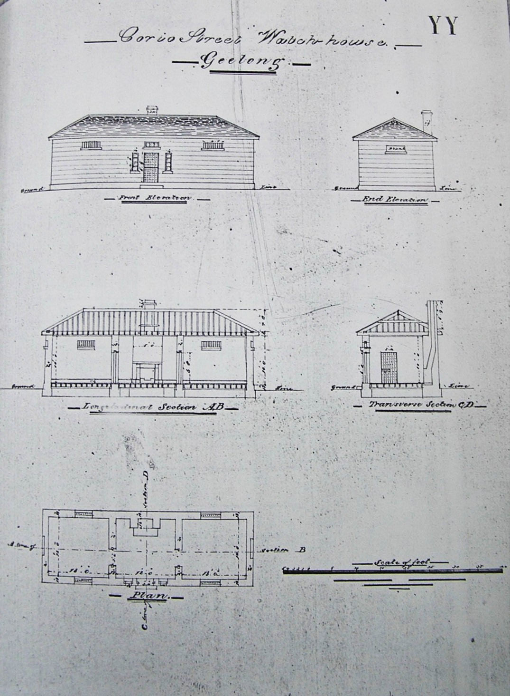
Figure 7.42: H. Ginn, Drawing of Corio Street, Watch House, n.d. [c.1840s]. Source: Book of Plans by Clerk of Works Henry Ginn, VPRS 4107/P1 Unit 1, Public Record Office Victoria.

EARLY BUILDING OF LAW AND ORDER IN THE GEELONG TOWNSHIPS
In the first few years of Geelong’s European existence, convicts were engaged in the construction of the breakwater and other structures under Foster Fyans’ command. Those carrying out the building of the breakwater were housed in huts near the construction
site on the Barwon River.509
Smyth’s Plan of Geelong in 1838 proposed the location
of the town’s court house, gaol and soldiers’ and prisoners’ barracks at South Geelong (see Theme 6). By 1839, a court house had been erected (in association with a watch house and a gaol for prisoners) at South Geelong, although not in the locations anticipated by Smyth. The earliest buildings were outlined by Samuel Mossman in 1879 when recollecting his experience in Geelong in 1840:
The Court-house was situated at South Corio, on the slope near the Barwon. It was the usual weatherboard style of building, facing the river, with strong slab-built cells and outhouses, forming a gaol for prisoners, the whole enclosed within a high strong fence.510
Another watch house was built at ‘North Geelong’ following funds having been made available by the
NSW Government.511
The original watch houses (and court house cells) were replaced with ‘handsome stone’ watch houses on reserved sites at ‘North Geelong’ in late 1840 (Corio Street, south-east corner Moorabool Street) and at ‘South Geelong’ in Yarra Street (west side, between Balliang and Fyans Streets) in 1841512 (Figures 7.42-43). Comprising standard designs by James Rattenbury, Clerk of Works under Governor Gipps, both watch houses comprised a central keeper’s room with fireplace and flanking cells.513 The building of two separate watch houses raised the satirical ire of editor of the Geelong Advertiser in 1841:
In this township, there is a stockade of some fifteen or twenty men, which had better be removed at once, as it does more harm than good; there is a handsome stone watch-house, four slab buildings occupied as a
watch-house, and court-house, a stone watch-house and temporary court house with solitary cells in course of erection, and a splendid court house about to
be commenced.514
Rattenbury’s design of the watch house at North Geelong appears to have been varied or the building altered by 1900 (Figure 7.44).

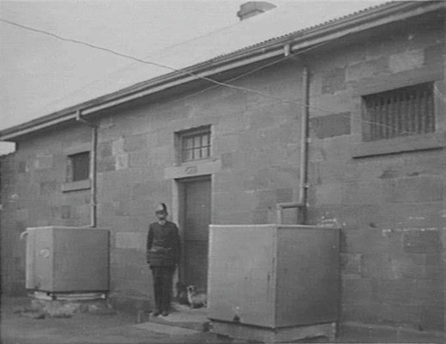
Figure 7.43: Former Watch House, South Geelong, 1905 (reproduced 24 November 1933). Source: S. Bowyer, accession H20532, State Library of Victoria.
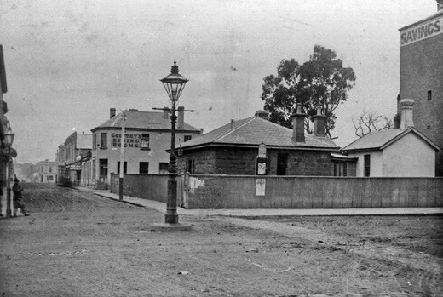
Figure 7.44: Watch House/Police Station, corner Moorabool & Corio Street, n.d. [c.1900]. Source: Wynd collection, image p64r03f04, Authentic Heritage Services Pty Ltd.

In 1849, Henry Ginn designed additions to the watch house
at South Geelong, including a kitchen, care taker’s room, six cells and a high masonry wall515 (Figure 7.45-46). Following the erection of these alterations and additions,516 the NSW Government Gazette proclaimed in 1850 that the watch house was to be ‘a public Gaol, Prison, and House
of Correction.’517
The appointment of Geelong’s second Police Magistrate, Nicholas Fenwick, in January 1840518 appears to have brought about the reservation of a site for police offices at the south- east corner of McKillop and Yarra Streets at this time.519 The provision of a police court at this site – originally known as
a Court of Requests – resulted as an amendment to the Act for the better regulating the Courts of Requests by the New South Wales Government.520 Replacing the original timber

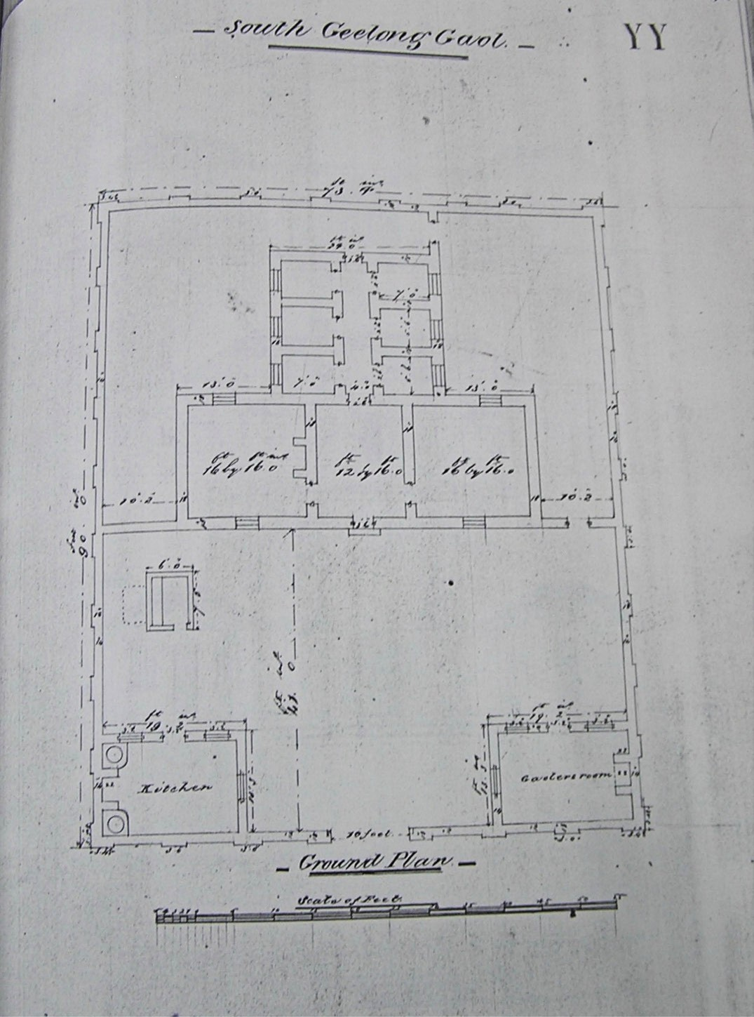
Figure 7.45: H. Ginn, Plan of proposed additions to South Geelong Watch House, n.d. [c.1849]. Source: Book of Plans by Clerk of Works Henry Ginn, VPRS 4107/P1 Unit 1, Public Record Office Victoria.

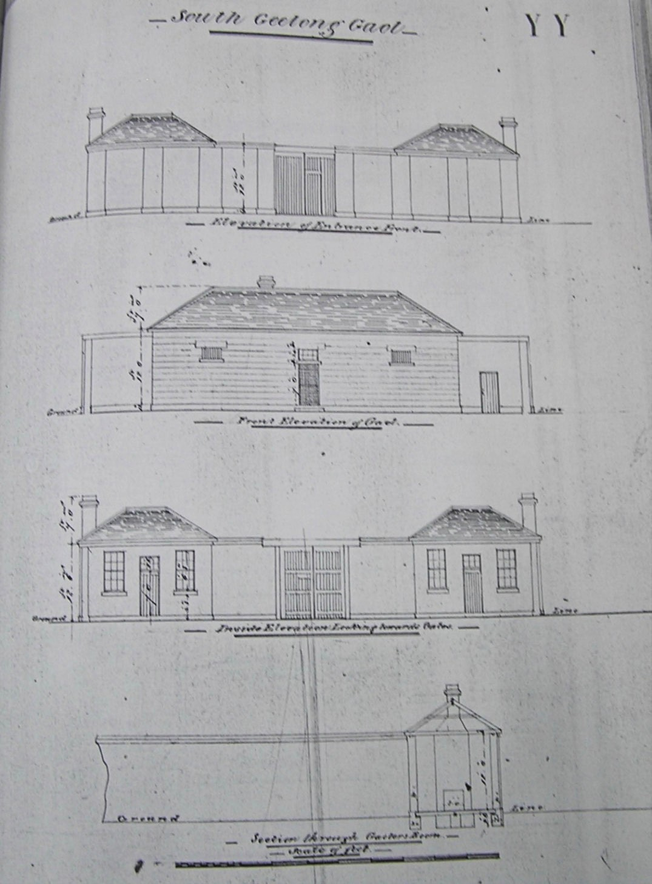
Figure 7.46: H. Ginn, Elevation & Section drawings of proposed additions to South Geelong Watch House, n.d. [c.1849]. Source: Book of Plans by Clerk of Works Henry Ginn, VPRS 4107/P1 Unit 1, Public Record Office Victoria.

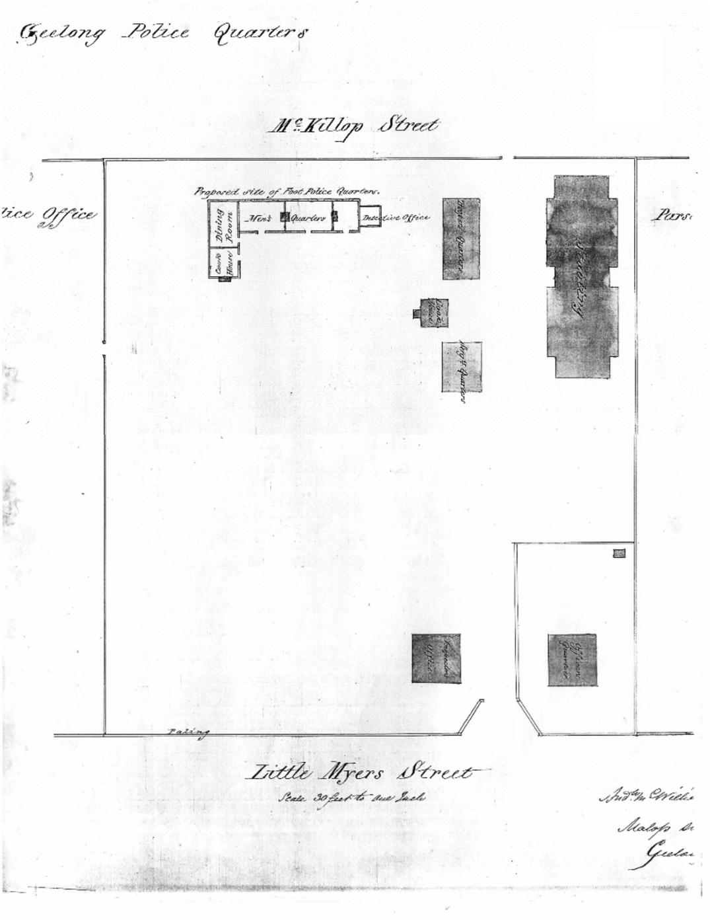

Figure 7.47: A. McWilliams, ‘Geelong Police Quarters’ site plan showing proposed site of foot police quarters, c.1859. Source: Victoria Police Museum.

court house at South Geelong, a permanent police court was built on this elevated site between the ‘two Geelongs’ in 1841-42 to a design by James Rattenbury, Clerk of Works.521 ‘Various’ police buildings of timber construction were
also built on the site in 1852 to designs by Henry Ginn, Colonial Architect.522
In 1852, tenders were called for ‘carpenters and others’ for ‘various Police Buildings erected of wood’.523 It is likely that this involved the construction officers’ quarters and an inspector’s office (fronting Little Myers Street) and stables at the McKillop Street police barracks.524 In January 1854, the Victorian Parliament passed an amount of £7000 being
expended on the additional buildings at the police barracks.525 Further accommodation was much-needed as it was at
this time when vacant space was sought ‘to erect tents for married men in Force.’526 The new buildings appear to have been involved the erection of troopers’ quarters, sergeant’s quarters and a cook house.527 In 1859, a building to accommodate foot police and a detective office was designed by Andrew McWilliams and erected by Andrew Halpin.528 This and the buildings comprising the police barracks were shown in a site plan by McWilliams (Figure 7.47).
The foot police quarters building was superseded by a new police station in 1879 (see later subsection). In 1899, the remaining timber buildings comprising the old police barracks were condemned.529 They were demolished in subsequent years although it was not until 1913 when the stables – described by the Geelong Advertiser as being ‘unique in design’ and ‘remarkable for their well-preserved wooden block floors’ – were proposed to be replaced with new stables.530
None of the earliest police and court buildings of the 1840s and 1850s survive. The watch house at the corner of Moorabool and Corio Streets was demolished following the building of a new watch house and keeper’s quarters in Little Malop Street in 1901-02.531 The watch house at South
Geelong was anticipated to be demolished in 1903, the stone lintel about the doorway which bore the date, 1841, was proposed ‘to be presented to the Kardinia Park committee, to be placed amongst its proposed museum
of curios.’532

BUILDING THE OLD GEELONG GAOL, MYERS STREET
The growing population of Geelong – which by the late 1840s rivalled Melbourne in size – necessitated the need for a larger gaol than that erected at South Geelong, it having been extended and afforded the title of gaol as a temporary measure. Initially designed in 1849 by Henry Ginn, Clerk of Works (and later Colonial Architect) at Port Phillip, tenders
were called in June of that year for the foundation works for a bluestone prison situated at the south-west corner of Myers and Swanston Streets.533 (reserved for this purpose as part of Smythe’s survey of the Geelong township -see Figures 6.05- 06). By December 1849, the Geelong Advertiser reported that work was ‘progressing as fast as can be expected’ and that:
The Governor’s house and the offices are receiving their third course, and the second course of those cells
which it is intended to erect at present is finished. When the projected building is entirely completed it will be a stupendous structure; the Governor’s house will form the centre of the building, from which will diverge in the shape of a cross three suits of cells and one of offices, but one department of cells only will be for the present erected.534
In 1852, tenders were called for roofing the new gaol and for the erection of gaoler and turnkey’s quarters.535 Works continued after the gaol was opened. In 1854, it was reported that ‘additions to the Geelong Gaol are going on as
a permanent structure’536 but they were not to be realised for several years.
Delays were due to the large cost of the work and change in bureaucracy and the philosophy of prison design and function. In Victoria, John Giles Price, Inspector-General of Penal Settlements, had been charged with the planning and
administration of gaols in the 1850s.537 He had shown scant interest in improving prison conditions and the latest in prison design from Britain and America.538 Loud criticisms of the prison system and design and construction of new gaols were published in the contemporary newspapers. Consequently, in December 1856, the Victorian Parliament appointed a Select Committee ‘to take evidence, and to report upon the most advisable scheme of Penal Discipline.’539 Included on the 13 member Committee was Captain Pasley, Inspector- General of Works, J.B. Humffray, M.L.A. for Ballarat North, and Charles Forster, recently- appointed Governor of the Ballarat Gaol.540 Evidence was given by eight witnesses over several months in 1857.541 One of these witnesses in the early months of 1857 was John Price.542 He subsequently met his demise on 26 March 1857 by being murdered by convicts while he was inspecting one of the penal hulks stationed at Williamstown.543

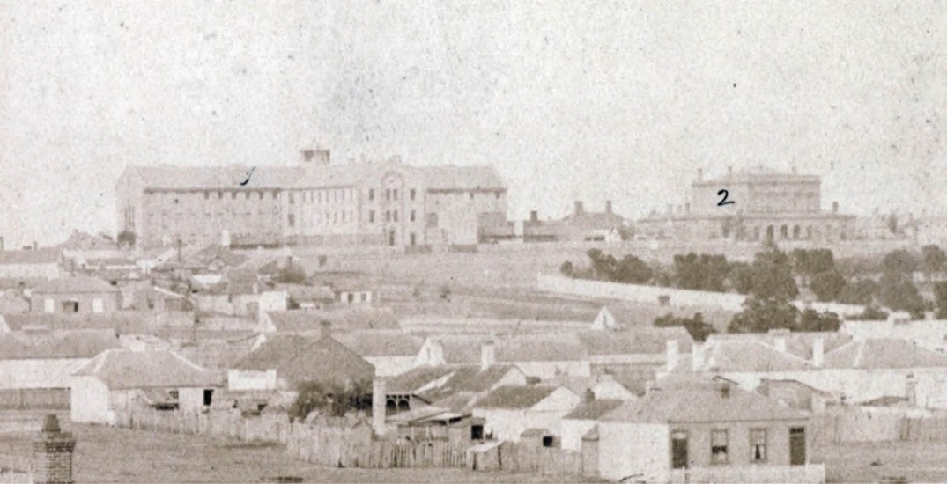
Figure 7.48: Geelong Gaol (left) & Supreme Court Building, 1861, prior to the completion of the Governor’s quarters, boundary walls & watch towers. Source: accession H2170, State Library of Victoria.

Another witness was Price’s successor, Colonel William Champ, who was appointed Inspector-General of Penal Establishments in Victoria in late April 1857.544 Champ had entered the civil service in Tasmania in the 1830s and was later the first Premier of the colony in November 1856.545. His Premiership was to be short-lived as he relinquished office
in February 1857.546 As the newly- appointed Inspector- General of Penal Establishments in Victoria, Champ soon championed the ‘separate system’ of prison philosophy, management and design. A model of this system was the radial plan of Pentonville Prison, north of London. Built between 1840 and 1842 by Joshua Jebb, Royal Engineer, it was conceived as a model prison for the English Home
Office.547 Under Champ’s tenure, the penal system in Victoria was dramatically transformed through an enduring program of prison development that was the most concentrated program of gaol construction in Australia’s history548.
While Ginn’s original concept for the Geelong Gaol appears to have followed the principles of Pentonville, arguably influential on its redesign of the Geelong Gaol was the design of the proposed gaol at Ballarat in 1857 by the architects,
Coote and Andrews, and Charles Forster, Governor of the Ballarat Gaol.549 They were successful in changing the design philosophy for prisons by the Victorian Public
Works Department.550 Forster was a member of the Select Committee (who had the ear of the Member of Parliament, J.B. Humffray) and a former Governor of Bedford Prison, England.
At Bedford, the old gaol of 1798-1801 formed the nucleus of a new substantial gaol building program in 1849-51 551
following the separate system and radial plan of Pentonville. The works included a new gaol following a T-plan, with cell blocks radiating from a central hall, provision of a chapel and symmetrically arranged structures on the front boundary: a governor’s house, porter’s lodge and gateway, and warder’s quarters. Designed by the former Bedfordshire Surveyor, Thomas Smith,552 the Bedford Gaol was completed in time for Charles Forster’s appointment as Governor at Ballarat.
He had experienced first-hand the design of the Bedford Gaol and had extensive experience in the ‘separate system.’ The continuation of the T form plan (albeit altered to a cruciform), and the provision of a symmetrical arrangement of official quarters either side of the main gateway, together with the establishment of a prison garden at Geelong were most likely to have emanated from the gaol concept for Ballarat.553

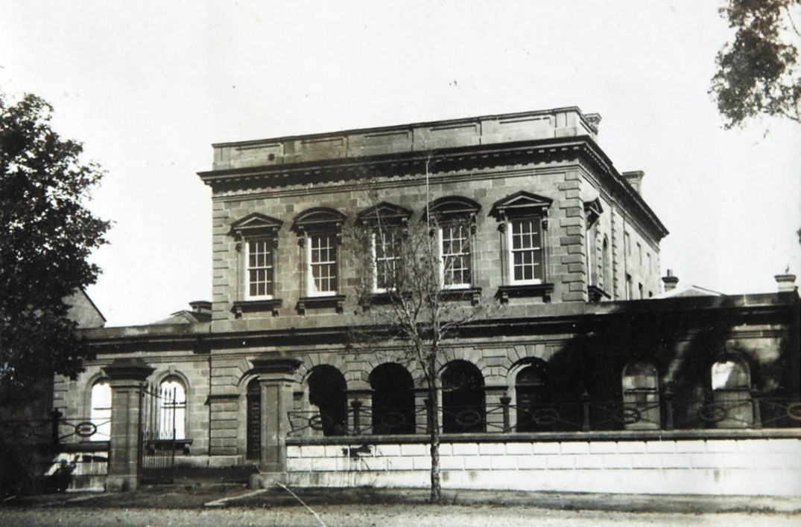
Figure 7.49: Supreme Court building, Myers Street, 1933. Source: T.T. Holmes collection, Authentic Heritage Services Pty Ltd.

The Geelong Gaol (Figure 7.48) was completed between 1858 and 1865, with the construction of the east wing (1859-60), south wing (including kitchens and infirmary (1860-61), north wing (including offices accommodation and the first floor chapel) (1863-64) and the construction of the Governor’s quarters, north courtyard, north and south gateways and some boundary walls, guard towers and catwalks (1864-65).554 In 1877, the gaol complex included a hospital gaol and in 1942 a military detention barracks.555 It was converted to a training prison in 1956 and continued this use until it closed in 1991.556 In 1994, the old Gaol complex was acquired by the City of Greater Geelong from the Victorian State Government.557 Used by the Geelong Rotary Club and other community groups, the City of Greater Geelong unsuccessfully proposed the sale of the Gaol by tender in 2014.558 Despite opposition from the National Trust of Australia (Victoria) and other groups, a second sale by expression of interest ensued in 2017.559 In 2018, the Gaol complex was sold to Montgomery International Pty Ltd, a private company who proposed
to maintain the historic buildings and use the site as its administration offices and lease other parts of the site.560

THE SUPREME COURT, MYERS STREET
Following the creation of the colony of Victoria in 1851, the Supreme Court of Victoria was founded with the first sitting in Melbourne by Judges William a’ Beckett and Redmond Barry on 10 February 1852.561 It became the superior court of common law and equity in Victoria.562 Although the Supreme Court of New South Wales had first sat in Geelong in 1841,563 by the 1850s Geelong had grown substantially.
In November 1854, tenders were called for the construction of a Supreme Court House in Myers Street, Geelong, next to the Gaol complex.564 The first large public building designed by John James Clark, architect with the Victorian Public Works Department who was to design numerous notable public buildings throughout Australia.565 The contextually substantial two storey Barrabool stone building had been designed in a Palladian Regency Revival style, and provided the town with a sophisticated and eloquent court building566 (Figure 7.49). Officially opened on 12 October 1856, The Age gave the following report:

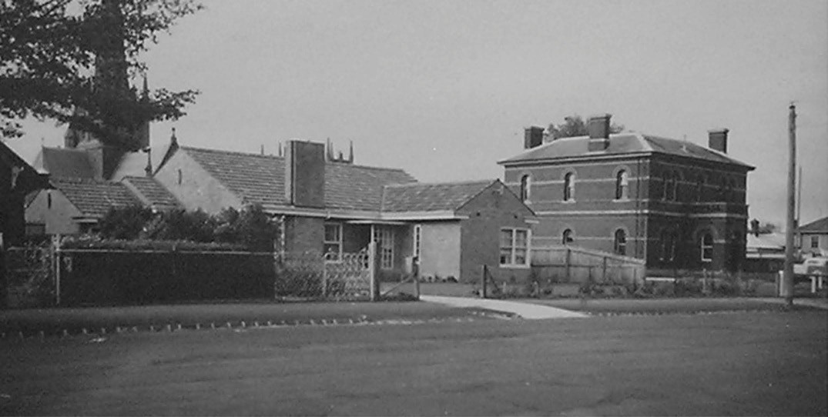
Figure 7.50: Geelong Police Station (later Country Roads Board Office) (right) & Country Roads Board residence (left), Public Works Department photograph, 14 September 1949. Source: VPRS 10516/P3 it 11, Public Record Office Victoria.

At a few minutes before one o’clock, a chaise drove up containing Mr Justice Williams, Mr Crown Solicitor Gurner, and the Judge’s Advocate, who turned to the
right side of the building. A few minutes afterwards, Dr Alexander Thompson [sic.] made his appearance and gave instructions for the front doors to be thrown open, an order which was promptly obeyed, and ingress effected by the public.567
By 1905, the police court also sat in the Supreme Court building. The Geelong Advertiser gave an account of the external condition and additions to the court building at this time:
Though the old Supreme Court building, which is now used for police court purposes, is a relic of the forties, it seems to answer the purpose fairly well, without
making too great a strain on all concerned. The earliest portion of the building, which was constructed of a pale brown freestone, is gradually decaying, but will be safe for some years to come, whilst the wooden section, which was erected to meet the demand for additional accommodation, is also in good preservation.568
In 1924, internal repairs were made to the building, although the exterior retained its ‘old drab appearance.’569 By 1939, part of the building became the offices for police members attached to the Transport Board and Country Roads Board.570 At this time, the Victorian Government proposed its demolition and this was carried out in 1940.571

NEW POLICE STATION, 1879
In early 1879, approval was given for the construction of a new police station fronting McKillop Street on the western portion of the police site. Drawings were prepared by George Watson, architect with the Public Works Department and signed off by William Steel, Inspector- General, and C. Barrett, Chief Architect, on 4 February 1879.572 Costing £1250, tenders were called in September of that year and the building was formally opened on 26 May 1880 as reported in the Geelong Advertiser:
The new police barracks in McKillop-street were formally opened for business yesterday. The superintendent’s office, together with what was known as the detective office in Little Myers-street, have been removed to the new and commodious brick building. The old weatherboard buildings, which have for many years done duty as the barracks, will no doubt be removed. Every convenience has been added to the new structure, and the mounted and foot constables will have very comfortable quarters.573
The design of the symmetrical, Victorian styled, two storey brick building with a hipped roof and centrally-located and projecting entrance portico (Figure 7.50) was based on the prototype established by the Public Works Department for the Carlton Police Station in 1877.574
By 1907, the police station was considered too remote and a suggestion was put to the Chief Commissioner of Police that

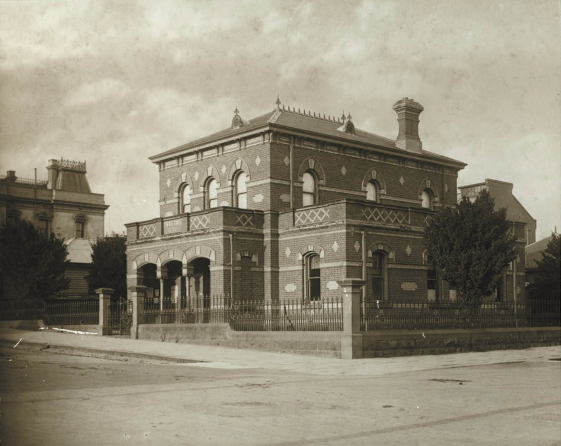
Figure 7.51: Geelong Police Court House, Gheringhap Street, c.1915. Source: GRS 2009/01311, Geelong Heritage Centre collection.

new building shown be erected in the Geelong township.575 In 1916, another proposal was the transfer of the Geelong police headquarters from McKillop Street to the Geelong Town Hall, with the old fire station adjoining the civic building suggested as police men’s quarters.576 In 1921, a further suggestion was the transferral of the police offices to the watch house and police quarters in Little Malop Street, adjoining the Police Court (see following subsection).577 This watch house had been erected in 1902 after removal from the watch house at the corner of Moorabool and Corio Streets.578 Further years were to pass before the police station was integrated in the Court building, along with other public offices (see following subsection).

NEW POLICE COURT, GHERINGHAP STREET, 1883
In May 1880, the Commissioner of Public Works, Thomas Bent, visited Geelong ‘for the purpose of making a personal inspection of various places within the town boundary where work may be provided for the unemployed, and also for improving the town.’579 He inspected the Police Court House in Yarra Street (corner McKillop Street), where the Mayor and other Geelong Town Councillors urged for the construction of a new building given the rapid decay in the existing structure. 580 By early 1882, a site at the south-west corner of Gheringhap and Little Malop Streets had been selected. J.R. Brown, Assistant Draftsman of the Public Works Department completed the drawings for the building in March 1882, under the supervision of C. Barrett, Chief Architect.581 Tenders were subsequently called and the contract of Keown and Ebbels at a cost of £2240/7/0 was accepted.582 Construction

was completed by February 1882 and the Victorian Italianate styled building, of polychrome brick construction comprising a two storey central court and flanking single storey offices (Figure 7.51), was officially opened on 19 March 1883.583
As reported in the Geelong Advertiser, a noticeable defect discovered during the first court proceedings was the ‘bad acoustic properties.’584

GEELONG COURT HOUSE AND PUBLIC OFFICES, GHERINGHAP STREET, 1938
With the growth in population and the need for centralised public services by the 1930s came a need for a new court house and public offices building. It was decided to transform the existing police court at the corner of Gheringhap and Little Malop Streets into a new central legal and bureaucratic hub. In 1936, the proposed concept – designed by the Geelong- born Chief Architect of the Public Works Department, Percy Everett, was illustrated in the Geelong Advertiser. The accompanying article gave a description of the anticipated edifice (Figure 7.52):
The imposing building, in which will be concentrated branches of several Government departments, chambers for the Supreme Court and the Court of Petty Sessions, and a new police station with lock-up cells and officers’ quarters, is to be erected by the Public Works department in Geelong’s civic centre. The old [Supreme] court house adjoining the gaol, which is remotely located and dilapidated, will be abandoned on the completion of the
new building. This will be built opposite the town hall, and the elevation will receive modern Romanesque treatment. The public offices, which will be entered from Gheringhap- street, will be in the left wing of the building. The court houses will have a central entrance in Little Malop-street, and the police station will be entered from a new roadway on the right wing of the group … [The new building] will
be surrounded by lawns and plantations similar to those flanking the town hall on the opposite corner.585
In February 1937, the tender of A. Douglas of Melbourne at a cost of £22,775 was accepted for the new building.586 The works involved the retention of parts of the earlier court building as part of the major development. A further nod to past court buildings was the remodelling of cedar furniture and fittings from the old Supreme Court House in Myers Street in the new coroner’s court.587 By early May 1938, most of the building (Figure 7.53) had been completed and the Geelong City police (including watch house and motor registration officers), superintendent of police and staff,
Lands officer and staff, and Agricultural Department staff relocated to the new building.588 Costing £30,000, the building was officially opened on 18 May 1938 by the Premier, Mr.
Dunstan on 18 May 1938.589 However, the clerk of courts and

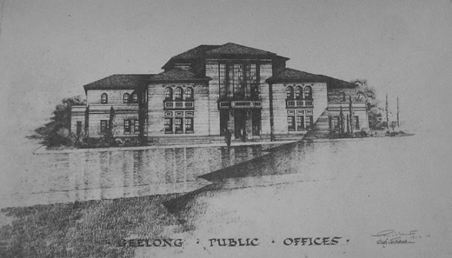
Figure 7.52: P. Everett, Chief Architect, Geelong Public Offices, perspective drawing, Public Works Department, 19 March 1937. Source: VPRS10516/P3 Unit 11 Public Record Office Victoria.
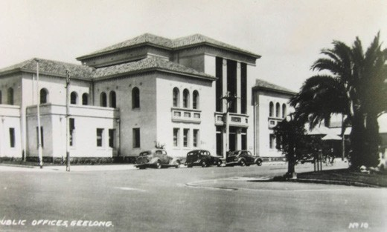
Figure 7.53: Geelong Court House & Public Offices, 1940. Source: GRS 1954/71, Geelong Heritage Centre collection.

other court staff, and State Rivers and Water Supply staff, did not relocate to the new public offices until after the formal opening.590
The building operated as a court and public office
until 1991-92, when a new court and police station complex was opened at the corner of Railway Terrace and Mercer Street.591 The old court house building in Gheringhap Street was purchased by the City of Greater Geelong Council in 1994 for use as a youth arts and
culture centre.592

HM BARWON PRISON AND MARNGONEET CORRECTIONAL CENTRE⁵⁹³
In January 1990, after local controversy, HM Barwon Prison opened in Bacchus Marsh Road. It has served as a
maximum security prison. Five years later on adjoining land, the medium security Marngoneet Correctional Centre was constructed. It opened on 3 March 2006.

THE KOORI COURT
In 2016, the Victorian State Government introduced the Koori Court to Geelong.594 First established in Victoria in 2002 ‘to reduce the over-representation of Aboriginal Victorians in the criminal justice system’, the aim of the Koori Court was to ensure offenders were ‘sentenced in a more culturally appropriate manner’ and were ‘able to discuss the underlying life issues that contribute to their behaviour.’595 Aunty Fay Muir, an Elder and Traditional Owner of Boon Wurrung Country, was one of the first of eight people to sit on the local Koori Court. In 2017, a sculpture of ‘Bundgil’ the eagle, representing an ancestral being of the Wadawurrung (and which had been prepared by Brett Smith and students from the Gordon Institute of TAFE), formed part of the ceremonial sitting of the opening of the legal year at the Geelong Court complex, which also included an Indigenous art exhibition.596

EVOLUTION OF LAW AND ORDER IN THE SUBURBS AND TOWNS
The creation of Road Board Districts and Boroughs in the suburban and township areas of Greater Geelong, together with increased populations in some rural centres brought with it the need for police stations, lock ups and police courts. The Victorian Government s Act for making and improving Roads in the Colony of Victoria in early 1853 included the need to request a Justice of the Peace to convene a meeting of ratepayers for the election of the District Road Board members and that notification was to be ‘affixed on the door of one or more Police Offices or Courts of Petty Sessions other Public Buildings within such Road District.’597 This gave impetus for the establishment of buildings for law
and order in these Road Board Districts and Boroughs. In particular, Police Courts or Courts of Petty Sessions, the lowest form of court in Victoria, ‘exercised a number of miscellaneous functions’ closely aligned with some of the activities of the Road Boards and Boroughs.598 These Courts granted licences (for stage carriages, slaughterhouses, liquor and estate agents, for example) and reviewed electoral lists.599 These courts also ‘heard charges of drunkenness, street offences, minor assaults and breaches of by-laws or regulations.’600 While Police Magistrates sat in the court of petty sessions, usually two or more Justices of the Peace were necessary to constitute the court (known as honorary

judges).601 Not surprisingly, given that appointments of Justices of the Peace were typically community
representatives of good stature, they were sometimes elected Road Board Members and Councillors.
While the provision of a Police Court gave status to a town and district, local residents often petitioned for their construction ‘as an opportunity to obtain a public building at no local expense.’602 These court buildings then served
other public purposes, including the location of the municipal chambers and public library. This was the case with the Newtown and Chilwell Council Chambers in Pakington
Street from 1859-60 (which was purpose-built as a municipal building); Bellarine Shire Hall and Police Court in 1880; and the South Barwon police court in Mount Pleasant Road
built next to the Race Course Hotel in c.1860,603 the home of the South Barwon Road Board (and later South Barwon
Borough)604 (Figure 7.20). When a new Council Chamber for the South Barwon Council was proposed in 1883, the original intention was that it would also be a Police Court but the Police Magistrate for the district declared that a Court ‘was not necessary at Belmont, owing to its contiguity to Geelong.’605
This was not the case at Geelong West, with the court house being built next to the Town Hall in Pakington Street in 1889. The Victorian styled building was designed in 1887 by G.B.H. Austin, Assistant Architect in the Victorian Public Works Department (who had designed the Geelong West Post Office a year earlier – see Theme 3),606 the building was opened by the Mayor of the Borough of Geelong West, John Ince, on
27 June 1889 and was described as being ‘substantially built of brick’ and possessed ‘every necessary requisite for the carrying on of public business.’607 The building continued
to function for court business until it closed in 1938 and was acquired by the Geelong West Council for use as a public library.608 This building and the former shire office and court house at Drysdale are the only surviving court buildings in suburban and rural Greater Geelong.

POLICE STATIONS AND LOCK UPS
Further inducement for the establishment of police courts throughout the outer areas of the Greater Geelong municipality was the establishment of the Victoria Police Force in January 1853. The Victorian Parliament passed an Act for the Regulation of the Police Force, whereby a Chief Commissioner of Police was appointed, along with
police inspectors, sub-inspectors, constables, sergeants and cadets and other officers to be stationed in police districts directed by the Lieutenant-Governor.609 By 1858, there were over 200 police in Victoria.610 In addition to their regular police roles, they were engaged as clerks of petty sessions, treasury guards, inspectors of distilleries, crown land rangers, inspectors of slaughter yards, registrars of births, deaths and

marriages, and court house cleaners.611 Another key task was that of Clerk of Petty Sessions.612 Hence, not surprisingly, the police station – together with the police stables, lock up and paddock – was often located adjacent to or nearby the police court.613 The convenient location of the police and court buildings enabled the duplication of the police officers’ tasks and to afford protection of court officials.614
In the area now known as the City of Greater Geelong, the Geelong Police District was created in 1852.615 In 1878, it was known as the South West District and from 1882 the Southern District.616 A local police presence was established in the suburbs: at Belmont (first known as South Barwon) (c.1860), Breakwater (1866) East Geelong (1898), Kildare (Geelong West) (1854), Newtown (1859), and South Barwon (Belmont) (1859).617 In the outlying areas, a police presence was established at Batesford (1853), Barwon Heads (temporarily in 1912 and permanently in 1938), Drysdale (1858), Duneed (1861 (relocated to Mount Moriac in 1868), Point Henry (before 1854 as a water police force), and Portarlington (1875).618 A police presence at Lara and North Geelong developed later in 1907 and 1908 respectively.619

POLICE STATIONS
Police stations were either purpose-built (following standard designs by the Public Works Department) or private properties were leased. In the 19th century, a police office was often erected next to the residence or incorporated within the front verandah. These small structures persisted into the early 20th century. By the 1930s, as the administration and responsibilities of the local police became more complex, the police office was incorporated in the design of the purpose-built police station.
At South Barwon (Belmont), a police residence was erected next to the South Barwon Police Court in c.1860.620 The police station closed in 1895 and was relocated to South Geelong.621 A police presence was re-established in 1924 with a station opened by Constable W.C. Rapkins in Church Street.622 In 1948, Percy Everett, Chief Architect of the Public Works Department, designed a new brick police residence and detached police office and garage623 (Figure 7.54). It was
built in Regent Street in 1949 (and has subsequently been demolished).624
At Drysdale, a site for a police paddock was first proposed at McLeod’s water holes on the north side of High Street in 1856, although by 1857 the paddock had been reserved
on the south side of the street.625 A police station had been built by 1858.626 By 1867, the police station was considered too remote and it was relocated to a new one acre site at the intersection of High and Eversley Streets.627 The earlier police paddock, comprising 50 acres, was retained and temporarily

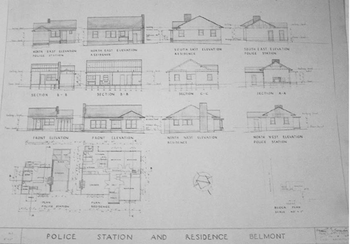
Figure 7.54: P. Everett, Chief Architect, Proposed Police Station and Residence, Belmont, Plan, Elevation & Section Drawings, Public
Works Department, 1948. Source: VPRS10516/P3 Unit 3 Public Record Office Victoria.
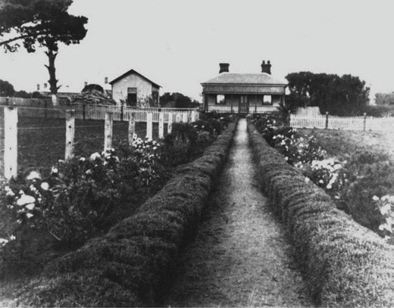
Figure 7.55: Drysdale Police Residence (centre) and station (left),
n.d. Source: Image 0335, Bellarine Historical Society.

reserved at this time.628 In late 1877, the Geelong Advertiser
reported that the police station was ‘about to be replaced by a more substantial and modern building.’629 A timber Victorian dwelling was subsequently erected. A detached
gabled timber outbuilding served as the police office (Figure 7.55). This office was replaced by 1956 with a new skillion building630 (Figure 7.56).
At Kildare, a stone station with shingled roof was built fronting Church Street (Ballarat Road) on the route to the Ballarat goldfields in 1853-54.631 It lasted for 22 years before it was decided to lease buildings as police stations rather than building them. This allowed for police officers to be relocated into improved and more centralised accommodation over time as the suburbs and centres developed. The Kildare station was relocated to a more central location in Geelong West in

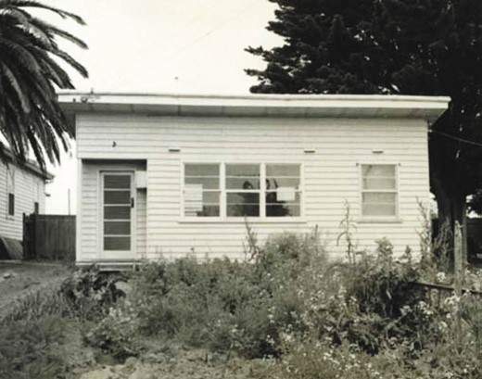
Figure 7.56: Drysdale Police Station, 27 November 1956. Source: GRS 2020/12, Geelong Heritage Centre collection.

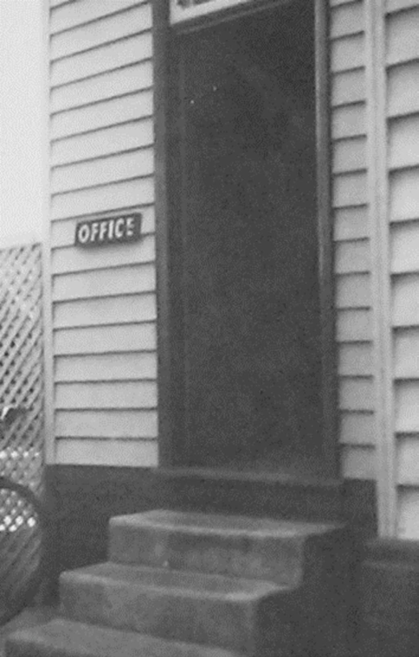
Figure 7.57: Newtown Police Office at the rear of the residence, Public Works Department photograph, c.1949.
Source: VPRS 10516/P3 Unit 11, Public Record Office Victoria.

1876.632 By 1885, the station was situated in Wellington Street before it was relocated to a property in Candover Street.633
In 1925, the police station was situated at 25 Clarence Street (now demolished) and in 1928 it moved to 6 Clarence Street (now demolished).634
In Newtown, a brick dwelling in Prospect Road became the first police station in 1859 before the station was relocated to a rear outbuilding in Aphrasia Street by 1909 (Figure 7.57), and in 1958, to a new purpose-built station at 304 Pakington Street (now demolished).635 At East Geelong, the station was situated behind a timber Victorian dwelling (Figure 7.58) while at Portarlington an early 20th century dwelling formed the station (the earliest station having been established several years earlier in 1875).636 At Lara, the former Corio Shire Engineer’s residence at 8 Rennie Street (built in 1911) became the police station from the 1940s until 1963 (and continued
as accommodation for police officers until c.1984).637 Similarly at North Geelong, a station was established in new premises in St David Street in 1913.638 This had followed the formation of a police presence at North Geelong in 1908, as a consequence of a ‘crop of outrages in the locality’ and the provision of temporary accommodation.639 In 1949, a new brick police station was built at 213 Melbourne Road, Rippleside640 (Figure 7.59) (now demolished) and it was followed by a station at Norlane in 1956.641
Other police stations were established in the Greater Geelong region in the 20th century. One of the earliest at a Late Victorian dwelling (built in 1892) at 16 Foster Street,
South Geelong, in 1903, following the impending demolition of the watch house in Yarra Street.642 At Barwon Heads, a small skillion fibro cement office was built in 1938 next to an existing timber Bungalow at the north- west corner of Hitchcock Avenue and Ozone Road (Figure 7.60), following
an annual temporary police presence there from late 1912.643 At Ocean Grove, the Bellarine Police Station was built in recent years. While there had been notable police presence in the Greater Geelong area from the 1850s with several police stations built or dwellings leased as stations, only
the surviving building is at 8 Rennie Street, Lara is the only known surviving legacy.

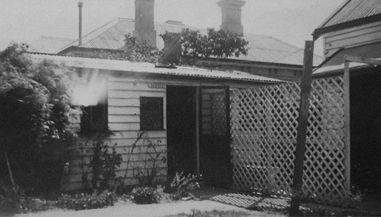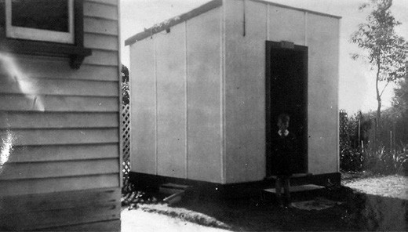

Figure 7.58: East Geelong Police Residence & Station, Public Works Department photograph, c.1949. Source: VPRS 10516/P3 Unit 10, Public Record Office Victoria.

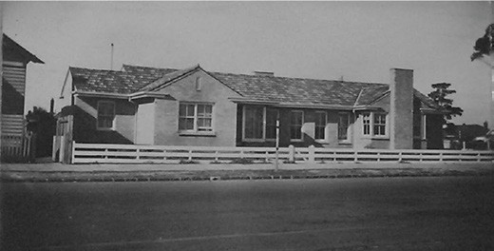
Figure 7.59: North Geelong Police Station & Residence, 213 Melbourne Road, Rippleside, Public Works Department photograph, 15 September 1950. Source: VPRS 10516/P3 Unit 11, Public Record Office Victoria.
Figure 7.60: Barwon Heads Police Office, Public Works Department photograph, c.1950. Source: VPRS 10516/P3 Unit 11, Public Record Office Victoria.
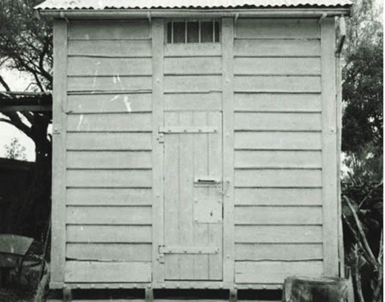
Figure 7.61: Lock Up, Drysdale, 27 November 1956. Source: GRS 2020/12 Geelong Heritage Centre collection.

LOCK UPS
Given the role of the Victoria Police Force, lock ups were required to temporarily house those arrested until there were transferred to the nearest gaol. Lock ups were therefore constructed adjacent to the police station from the 1850s.
They were of standardised designs and most in the Greater Geelong region were portable. At Drysdale, for example, the lock up reflected a portable timber prototype first established in 1856 by the Commission of Public Works, Captain Pasley.644 They were manufactured for the Victoria Police Force until 1885, but relocated to different police sites for several years later.645 The lock up at Drysdale (Figure 7.61) was retained at the police site until the late 20th century when it was relocated and used as a farm store.646
Only two lock ups are known to survive in the Greater Geelong region. The earliest is the former Meredith lock up,

a portable iron building with a barrel-vaulted roof erected in 1855647 (Figure 7.62). The building had been converted into a smoke house at Meredith in later years before being
relocated to the Anakie Depot of Parks Victoria.648 The other surviving lock up is at Craigton Homestead, 770 Ballan Road, Moorabool (see Theme 5 for further details). Of bluestone construction (Figure 7.63), it was built in 1858 by Victorian railway contractors as part of the infrastructure for building the nearby Moorabool railway viaduct.649 It is now used as a farm outbuilding.650

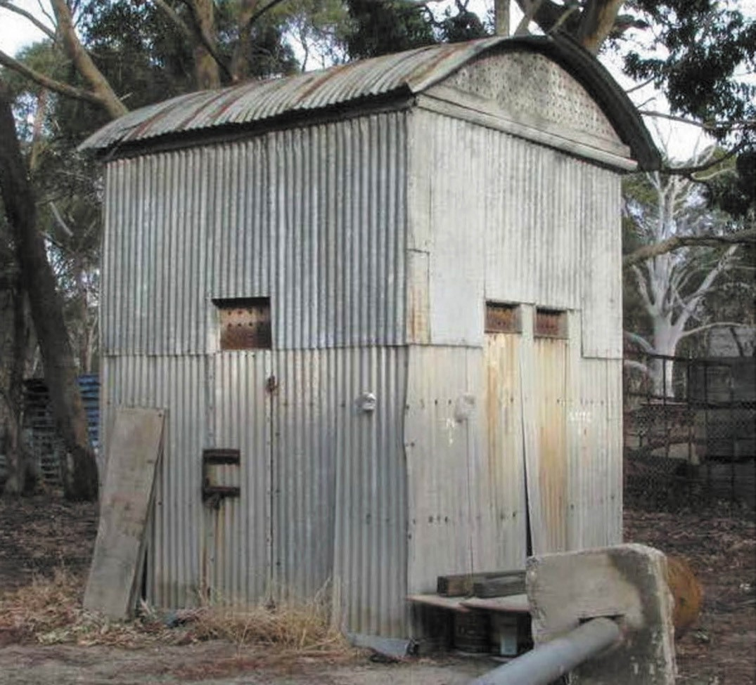
Figure 7.62: Former Meredith Lock Up, Parks Victoria, Anakie Depot, c.2017. Source: Colin Cook.
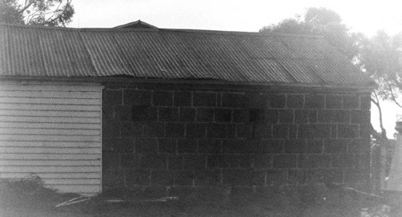
Figure 7.63: Former Viaduct Lock Up, ‘Craigton’, Moorabool, 1998. Source: David Rowe.

GOVERNING THE WATERWAYS

CUSTOMS
In 1839, New South Wales Governor, Sir George Gipps, introduced An Act to Provide for the General Regulation of the Revenue of Customs in New South Wales.651 Customs duties on trade, and the regulation of immigration, was necessary to provide revenue for the Colonial authorities.652 This was further elaborated in the Port Phillip Gazette in outlining the Customs, Collector and Treasury Department of the fledgling Port Phillip District in May 1839 when it declared that ‘it is virtually the machine by which the taxes indirectly paid by us in support of the Crown’s authority are disposed of and applied.’653
In August 1839, the Port Phillip Patriot and Melbourne Advertiser reported that a customs officer and office had been established at Geelong.654 A small, square, timber weatherboard building with a thatched roof claimed to have been prefabricated in Sydney was despatched to Geelong in anticipation of the Customs service in 1838.655 Situated on the Corio Bay foreshore adjacent to the wharf below the steep limestone cliff at the northern end of Yarra Street, the little building acted as a bureau for the coastwaiter, with
all customs business, including the payment of duties, transacted in Melbourne until 1845.656 With the role of superintending the landing and shipping of goods at the Geelong port, the first permanent coastwaiter was John McKenny on 27 August 1840.657 His tenure was cut short by his untimely death in September 1841 at the age of 26.658 The small timber customs office, used as a telegraph office in 1854- 55,659 is now at the Geelong Botanic Gardens and is the earliest- known surviving building in Geelong today.
In February 1840, Dr Alexander Thomson and several other pioneer European settlers at Geelong petitioned the Superintendent for Port Phillip, Charles LaTrobe, for the need of a more substantial customs house, where customs business could be transacted.660 By mid-1844, a budget for a new building had been include in the estimates of
the Legislative Council of New South Wales. A design was commenced by James Rattenbury, Clerk of Works,
following LaTrobe’s instructions for a gabled two storey stone building.661 Rattenbury called tenders for the construction of this building in September of that year.662 Costs increased
as there was difficulty achieving a stable foundation on the bay frontage. Upon completion, the ground floor functioned as the Custom (Queen’s) store with the upper floor used as the long room and office.663 The location of the building, including the original coastwaiter’s office and the picket boundary fencing, were shown on J.H. Taylor’s Map of Geelong in 1855 (see Figure 6.22 Theme 6).664 The building was to the east of the customs reserve on part of what is now

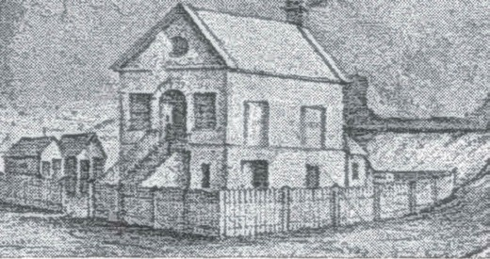
Figure 7.64: Custom House, 1845. Source: J.A. Henry, Do
you remember? Early Geelong, vol.1, Solomons Pty Ltd, Geelong, 1944.

known as Transvaal Square. A drawing of the building was also published (Figure 7.64).
In 1853, the former immigration barracks (built in 1848)665 at the north-east corner of Eastern Beach Road and Moorabool Street (see Theme 2) was converted into a gauging shed
for the Customs department for spirits gauging and duty assessment.666 Situated at the north- east corner of Eastern Beach Road and Moorabool Street (Figures 7.65-66), it survived until 4 March 1929 when it was removed by the Geelong Harbor Trust.667
Taylor’s map of 1855 also showed a second Customs reserve further west on what was then called Corio Terrace (now Brougham Street). The rapid growth of Geelong in the 1840s and early 1850s brought with it the need for a new custom house. In April 1854, the Victorian Legislative Council appropriated £10,000 for the erection of the new building.668 Although the Acting Colonial Architect Charles
Pasley had requested the Clerk of Works of Geelong, Edward Davidson, to prepare a plan for the new custom building,
he was preoccupied with drawings for the Supreme Court building.669 John James Clark (architect of the Supreme Court) had the responsibility of preparing the design of the customs house.670 To be constructed of Barrabool stone with a bluestone base, the proposed Victorian Georgian styled edifice was described in
The Age in 1854:
A New Custom House is to be erected at Geelong, to be situated at the corner of Corio Terrace and Moorabool Street. The portico will front Corio [Brougham] Street, and the rear faces the bay. The edifice will measure on the basement 85 x 52 feet. The plans, however, have been
so arranged as to admit of additional wings, which can be attached at option at any future period. The Queen’s warehouse is on the basement; and on the principal floor are the Long Room, 40 feet x 20; the Custom House Agent’s Office, 33 x 15; the Collector’s Room, 16 x 15;

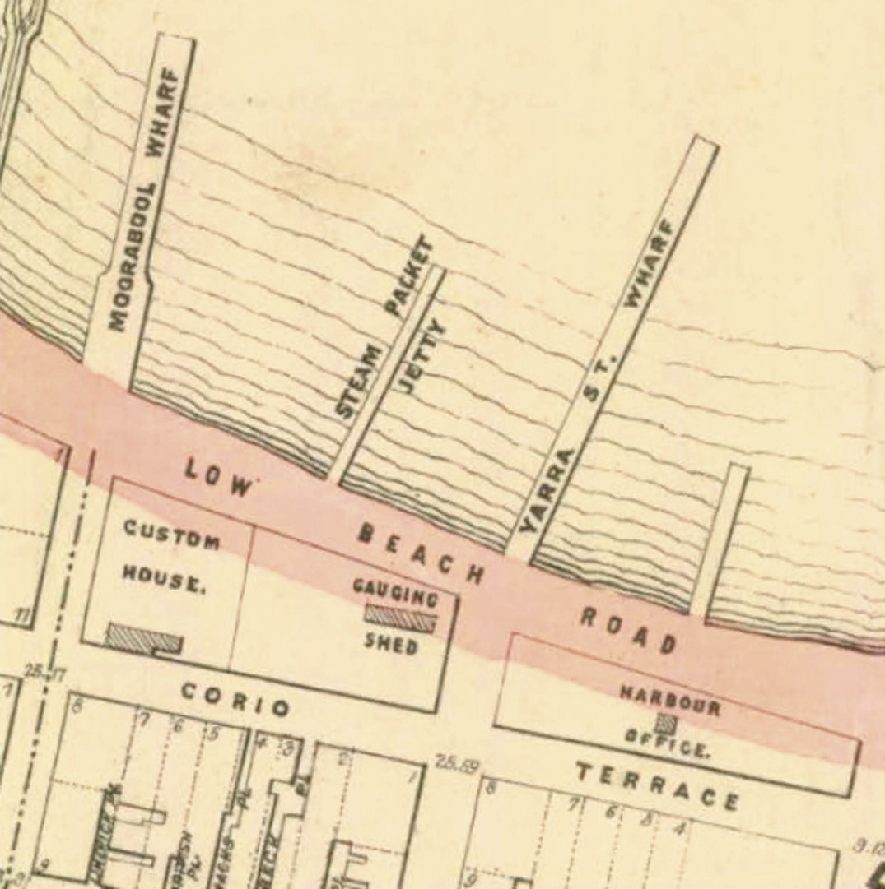
Figure 7.65: R. Balding Part of Map of the Town of Geelong and Boroughs of South Barwon and Newtown and Chilwell showing the gauging shed, 30 June 1864. Source: Statutory Planning Department, City of Greater Geelong.

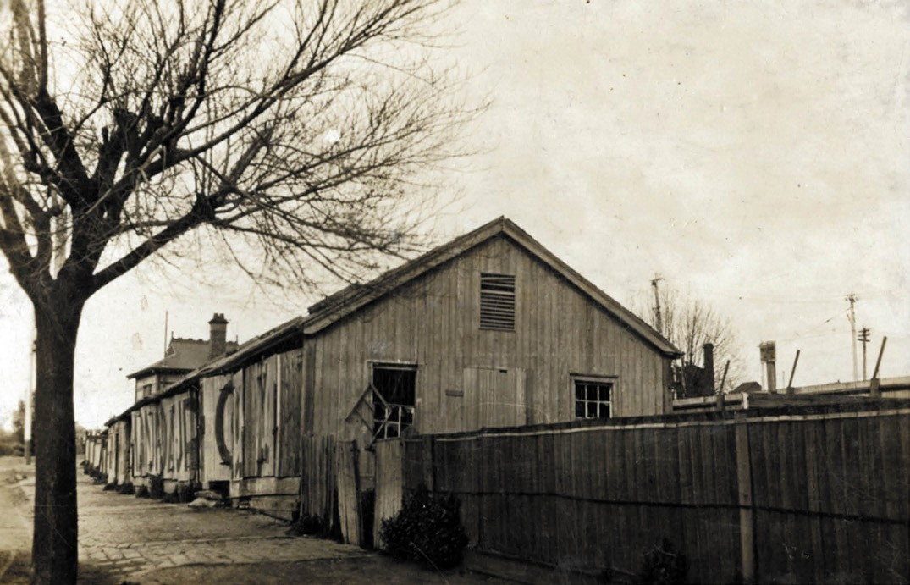
Figure 7.66: Customs Gauging Shed, corner Moorabool Street & Eastern Beach Road, c.1920. Source: GRS 2009/00280 Geelong Heritage Centre collection.

the Landing Waiter’s Office, 13 x 16 feet. The building is not yet commenced, but its construction will soon be submitted to public tender. It is estimated that the undertaking will cost £50,000, if not more.671
Over 12 months elapsed before tenders were called for the building in December 1854.672 The contract was awarded to
W.C. Cornish for £12,000 in April 1855 but construction did not commence until late 1855.673 Rapid progress was made as by the end of January 1856, Alfred Scurry, Clerk of Works, reported that the:
building is on the bay front and each end ten feet high above the ground floor joists, on the front it is six foot high above ditto. The working bases of the Portico Pilasters has delayed this front a little, the Iron Columns are fixed, the roof is being framed and the joiners works in course of preparation, the area wall is to its full height of bluestone.674
A contract for fittings was advertised in July 1856675 and the building (Figure 7.67) opened soon after. In 1999, the Custom House and its site were acquired by the City of Greater Geelong.676

POLICING THE WATERWAYS
In 1841, Governor Gipps extended the Water Police Act to the Port Phillip District.677 The purpose of the Water Police
- which combined as Harbour Master at Geelong – was to provide security of the harbour and operation of the customs office, through the enforcement of the harbour regulations, including the safe navigation in Port Phillip, Hobsons and Corio Bays. The first Harbour Master and Water Police Officer appointed to Geelong was Captain Charles Ferguson (1813-1868). He had previously been master of the barque,
Rajah.678 Ferguson remained at Geelong for 12 months before transferring to Williamstown.679
A water police station was erected on Victoria Terrace East (now 42 Eastern Beach Road).680 It survived until October 1884 when it was sold and the land purchased by G.F. Belcher in 1885.681
After the completion of the new custom house in 1856, the previous custom house (built in 1844-45) on the Corio Bay foreshore was used as the harbour master’s office.682 With the redevelopment of this foreshore site a memorial park called Transvaal Square (see Theme 9), the harbour office

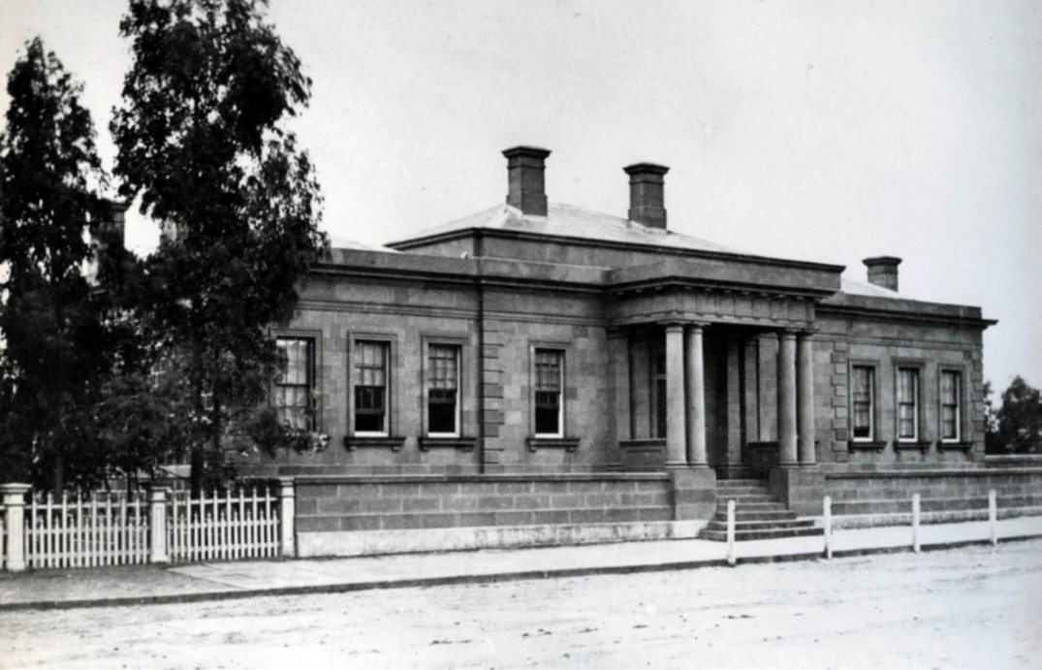
Figure 7.67: Geelong Custom House, Brougham Street, c.1880. Source: GRS 15969/04/335, Geelong Heritage Centre collection.

was removed in 1903.683 The landmark appearance of this early building was recognised in the Geelong Advertiser:
The demolition of the old harbor office on the
Transvaal- square site has begun, and with the removal of the building will disappear one of the oldest landmarks on the shore of Corio Bay. The office originally did service as a Custom house nearly 60 years ago, and with the erection of more commodious premises for Customs business, it was handed over to the harbormaster. It was placed in the hands of the Transvaal-square committee when a new harbor office as erected in Yarra-street, and was recently disposed of by the committee for £25.684

GEELONG HARBOUR TRUST

TOWARDS THE ESTABLISHMENT OF THE GEELONG HARBOR TRUST
Maintenance and control of the Port of Geelong remained under the Public Works Department throughout the 19th century, notwithstanding the Colonial Government being petitioned as early as 1855 for a local Harbor Trust (see Theme 3 for further details). Harbour facilities and deepening of the shipping channel was the responsibility of the Government. There was no local co-ordination to the proper management and regulation of the Port. This led to private, ad-hoc port facilities, such as a pier constructed by a meat freezing company at North
Shore, and pier on the Geelong waterfront erected by the Victorian Railway Commissioners, and several private jetties.685

ESTABLISHMENT OF THE GEELONG HARBOR TRUST
In 1905, the Victorian Premier, Sir Thomas Bent, ‘recognising the value of the Geelong Harbor as one means for realizing some measure of decentralisation’ made an inspection of the Geelong harbor and surrounds.686 Subsequently, the Geelong Harbor Trust Act 1905 (no. 2012) was enacted and the Geelong Harbor Trust established.687 Immediate action taken by the Bent State Government was the purchase of 195 acres of outlying land of Phillip Russell’s Osborne House property at North Shore to facilitate wheat exports and for the provision of a new port for Geelong at Corio Quay. Government funds were also made available at this time for the deepening of the Hopetoun Channel in Corio Bay (see Theme 3).688

GEELONG HARBOR TRUST JURISDICTION AND COMMISSIONERS
The area given for Harbor Trust control consisted of sea- frontage lands in Corio and Port Phillip Bay, and the Barwon River as well as swamp and low-lying lands beside the river (such as Lake Connewarre).689
The creation of the Geelong Harbor Trust Act deviated from the Melbourne Harbor Trust Act (following English models) in that the Commission was not elected but established as a body corporate of three members appointed (and removable) by the Governor in Council. Each of the Commissioners
was remunerated by fixed salaries. Ultimate control of the Trust however resided by with the Victorian Government.690 The three Commissioners that were appointed in December 1905 were George Frederick Holden (1868-1934), M.L.A. and produce merchant of Wallace; Edward Harewood Lascelles (1847-1917), woolbroker; and Alexander Parker McMillan (1862-1907), financial and commission agent691. The first meeting of the Harbor Trust occurred at its office in Brougham Place (Street) in January 1906.692 This stone two storey building had been erected 1857 and by 1900 it was owned
by G.F. Holden’s father, Thomas, a produce merchant.693 Thomas Holden leased the building to the Geelong Harbor Trust (it was demolished in 1985).694

WORK OF THE HARBOR TRUST
In addition to facilitating the development of a port of export at Corio Quay and the excavation of the Hopetoun Channel, during its first six years of management the Geelong Harbor Trust constructed berths for vessels, erected freezing works (and a power house to power the freezing works) at Corio Quay (see Theme 3), reclaimed low-lying land and acquired property for the establishment of an irrigated and dairy farm known as Sparrovale at Connewarre (now Charlemont) (see Theme 4), acquired ‘Rippleside’ on the western foreshore of Corio Bay, and established workshops for the maintenance
and repair of its dredges and other machinery (see Theme

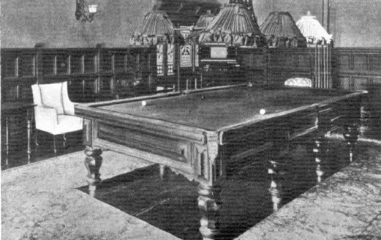
Figure 7.68: Billiard Room, Osborne House., 1909. Source: Punch (Melbourne), 4 November 1909, p.18.
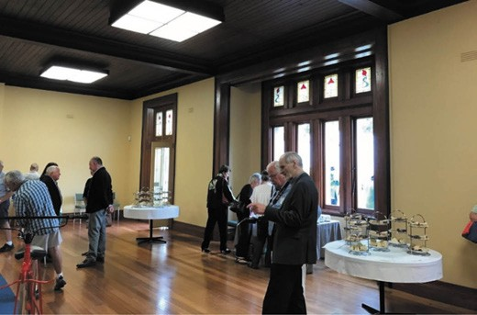
Figure 7.69: Re-opening of ball room, Australia Day, 2017. Source: David Rowe.

3).695 One of the earliest dredges acquired by the State Government on behalf of the Geelong Harbor Trust in 1907 was named the Thomas Bent, after the Premier.696
In 1909, the Geelong Harbor Trust negotiated (albeit reluctantly) with the State Government for the purchase of Osborne House and its surrounding 40 acres of land.697 The property had been acquired from Phillip Russell by the Bent Government in 1900 as the Governor’s country residence
(a use that lasted a month in 1906 as a property at Macedon was preferred).698 Between 1909 and 1911, a dining room and new bedrooms were added to Osborne House for the Geelong Harbor Trust to a design by local architect, Percy Everett.699 These rooms complemented those built in earlier years, including the billiard room (Figure 7.68). The property had been leased as a guest house to Mrs H.R. Parrington,
who also operated a similar guest house known as ‘The Oaks’ in South Yarra.700 The new work featured in The Punch in October 1910:

Some charming alterations have just been completed at “Osborne House”, Geelong. The new dining-room, which can also be used as a ballroom, is artistically decorated, and measures 50ft. in length. Eight new bedrooms have also been built, and are beautiful in colour. “Osborne House,” under the management of Mrs. Parrington, is
an ideal residence, with its large billiard-room, spacious garage, and many conveniences.701
In the later 20th century, the dining room (also known as the ballroom) was repaired and largely returned to its early appearance in 2016 by the Osborne House Association (Figure 7.69). It was intended to be made available for community exhibition and events although the closure of Osborne House by the City of Greater Geelong in 2017 (the result of mould) curtailed this initiative.

PORT OF GEELONG AUTHORITY
In 1912, A Royal Commission was appointed by the Victorian Government to consider the affairs of the Geelong Harbor Trust. The Royal Commission concluded that ‘the office is a thoroughly efficient one, and that the zeal and energy of the officers have had not a little to do with the with the activity which has marked the career of the Trust during the six years of its existence.’702 It recommended that the establishment of a Port Authority for Port Phillip waters ‘so that the revenue
derived from imports may be available for the development of the Geelong Harbor as a national work.’703
From the small maritime authority established in 1905, the Geelong Harbour Trust had expanded substantially by the mid-20th century. In 1957, it erected a new three
storey building in Brougham Street (see Theme 6 for further historical context).
While recommended as early as 1912, it was not until 1981 when the Geelong Harbor Trust Commission was reconstituted as the Port of Geelong Authority under the
provisions of the Port of Geelong Authority Act (no. 9658).704 The basis for the change was to align the name of the authority with contemporary practice throughout the world.705 The Authority therefore continued the work of the former Geelong Harbor Trust, including the regulation of the trade
of the port with responsibilities for the landing or shipping of merchandise, arrivals and departures of vessels, and wharfage rate collection) and the management the port facilities (including wharves, piers, jetties, docks, ships, lights, buoys, beacons, moorings, tugs, workshops, water police and land adjacent to waterways.706

DEFENDING GREATER GEELONG

GEELONG VOLUNTEER RIFLE CORPS & ROYAL VICTORIA VOLUNTEER ARTILLERY CORPS
With the appointment as the first police magistrate to
Port Phillip in Melbourne in 1836, Captain William Lonsdale of the 4th (King’s Own) Regiment brought about the first official regiment in Victoria.707 The outbreak of the Crimean War in 1853 led to the formation of a citizen force ‘to help defend
the colonies from expected raids by Russian ships.’708 Local concern was highlighted by the wealth being created by the Victorian goldfields and a lack of defence in the event of
an attack.709 The Geelong Volunteer Rifle Corps – the first volunteer unit raised in Victoria – was established in 1854.710 As reported in the Geelong Advertiser and Intelligencer:
Appended will be found the decision of the Government with regard to the establishment of a Geelong Rifle Corps. It will be seen that such body is open to ALL; the colony is to be protected, and the Government looks to Colonists for support – it is not a CLASS movement, but a GENERAL ONE, and all who would enrol themselves as defenders of their country are invited to come forward. We submit the reply of the Government, and anticipate numerous accessions to the Rifle Corps now that its nature and functions are defined. Every man who is earnest, will enrol himself a member.711
In 1855, the Lieutenant Governor made appointments for the newly-established Geelong Volunteer Rifle Corps. They were: William Hingston Baylie – Major; Louis Kitz and Charles Wolff
- Captains, Frederick Kawerau, James Sayers, Creed Royal and Benjamin Robert Brenton – Lieutenants; Charles Peron and Samuel James Clark – Second Lieutenants; John Colcott St. Quentin – Adjutant and James Lawrence – Surgeon.712 The Rules and Regulations of the Rifle Corps were approved and confirmed on 8 January 1855.713 It appears that the artillery site at the south-east corner of Ryrie and Fenwick Streets (which extended to Little Malop Street) (Figure 7.70) had been temporarily or informally reserved by 1856 as it was at this time when it also appears to have served as a
gymnasium by 1856 under the management of Serjeant-Major of the Volunteer Rifle Corps.714
The Crimean concern also led to the development of Fort Queenscliff at Queenscliff (outside the City of Greater Geelong) from 1860.715 More relevant to Greater Geelong was the reorganisation of the Geelong Volunteer Rifle Regiment into the 2nd Brigade of the Royal Victoria Volunteer Artillery Corps in 1862 at the Ryrie Street Artillery Reserve.716 The parade ground previously used by the Volunteer Rifle Corps in Ryrie Street was provided to the Artillery Corps, the
two acres of land being set aside for this purpose at this

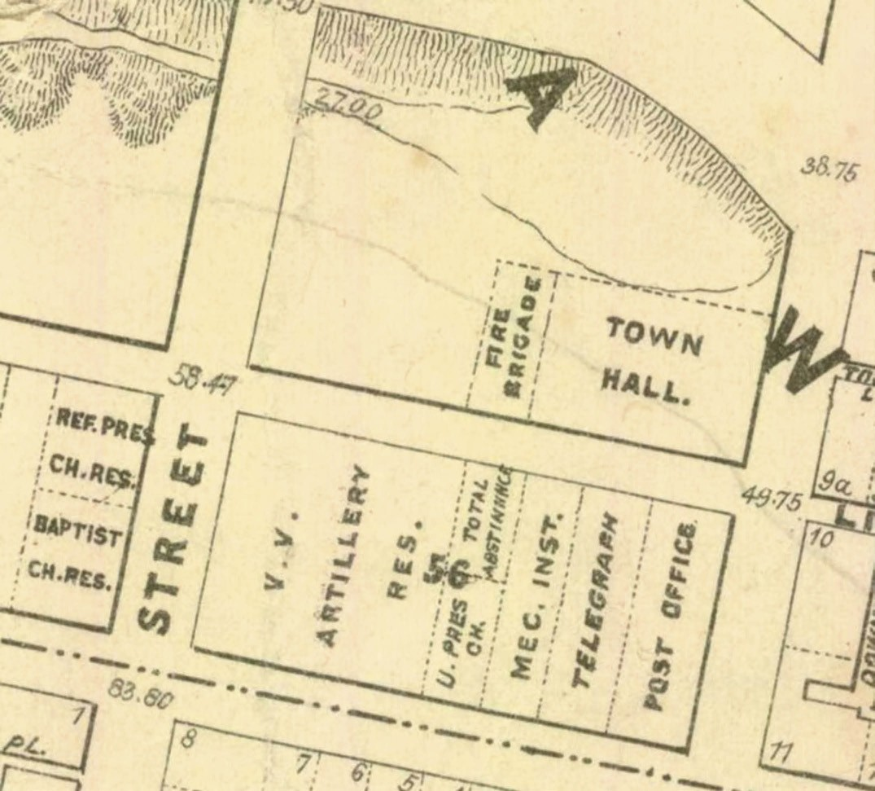

Figure 7.70: R. Balding Part of Map of the Town of Geelong and Boroughs of South Barwon and Newtown and Chilwell showing the Artillery Reservation, 30 June 1864. Source: Statutory Planning Department, City of Greater Geelong.

time.717 In May 1862, the Volunteer Rifle Corps ‘celebrated the opening of their fine new Orderly Room’ which had replaced the earlier building.718 This new building was a prefabricated iron structure manufactured by Robertson and Lister of Glasgow, and consisted of eight bays of cast iron stanchions and horizontal 5 inch pitch corrugated iron infill panels.719 It was also in 1862 when platforms were erected on the Eastern beach at the north end of Bellerine street for the mounting of two 32-pounder guns that were used for practice for the Volunteer Rifle Corps as part of the colonial defence network.720 Known as the ‘Beach Battery’, the guns were fired from this location until 1870 when a site the Corio
Bay foreshore at the Eastern Park became the new practice battery location.721 All that might survive of both batteries today is archaeological evidence. The guns (including a 68 pounder that had been added to the Beach Battery in 1871) were gifted to the Geelong, Geelong West, and Newtown and Chilwell Councils in 1898 and placed in the Geelong Botanic Gardens, Kardinia Park and on the clifftop at Western Beach (the area then becoming known as Cannon Hill)722 (Figure 7.71).
In 1873, the Geelong Volunteer Artillery Corps was reconstituted to become the Geelong Corps of the Royal

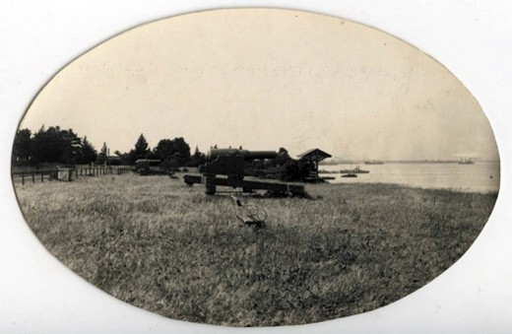
Figure 7.71: ‘Cannon Hill’, Western Beach, 1917.
Source: GRS 2009/00230 Geelong Heritage Centre collection.

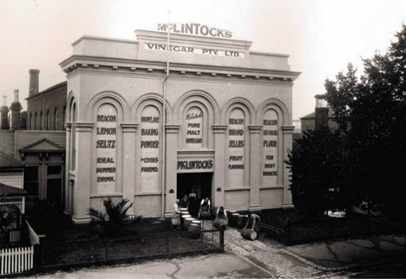
Figure 7.72: Former Geelong Volunteer Artillery Corps Orderly Room (original Congregational Church), McKillop Street, n.d. [c.1920s].
Source: Lorraine Huddle, Davies collection.

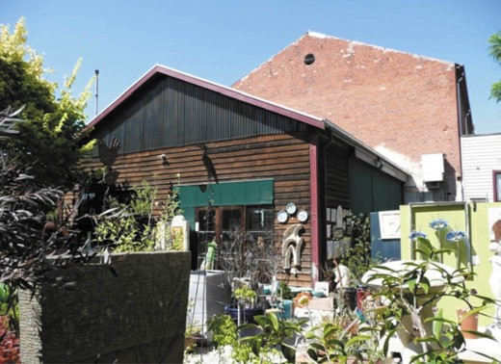
Figure 7.73: Former Prefabricated iron Orderly Room at rear of former Congregational Church, c.2008. Source: ‘Wintergarden, 51 McKillop Street, Geelong’, Victorian Heritage Register H1173, VHD http://vhd.heritagecouncil.vic.gov.au/places/3397

Victorian Volunteer Artillery.723 Six years later in 1879, the Artillery Corps relocated to the more commodious former Congregational Church in McKillop Street (Figure 7.72). As outlined in the Geelong Advertiser:
The Geelong Volunteer Artillery Corps must certainly feel highly pleased with the new orderly-room in McKillop- street. It is a handsome and comfortable building, and being situated on the corner of the hill in the street named, it is in every way convenient for the members living in various parts of the town and suburbs. The old corrugated iron structure in Little Malop-street, used for over twenty years, was a barn compared with the new edifice, and the present orderly-room is a credit to the town. All residents of Geelong are, of course, aware that it was formerly
used as a church by the Congregational denomination, and was purchased by the corps for the sum of £1000. The building, having been dismantled of its church fittings, has been thoroughly cleaned, repaired, and painted, and former worshippers will scarcely recognise it in its new garb. The room is 84ft. in length and 46 ft. in breadth, and for general military drill it presents facilities and accommodation not afforded by any other room
in the colony used for volunteer purposes. It is a brick building, and therefore substantial, the interior walls being plastered and handsomely painted. From floor to ceiling it is 26ft. in height, and at night the room will be lit up
with two sun-lights each containing sixteen gas jets, and fourteen side gas jets. Seats have been arranged along the sides of the room, which will afford accommodation for about 150 persons. Entrance to the orderly-room
is obtained from McKillop-street, and just above the doorway, after passing through the porch, an orchestra has been constructed, access to which is obtained up a narrow and rather steep staircase. On one side of the
orchestra is a committee-room, and on the other a store- room; the latter, however, is to be eventually turned into a reading-room and library. The office and officers’ rooms are situated to the right, and the sergeants’ room to the left of the entrance. Each room is provided with tables and chairs, and lighted at night with gas. The painting and coloring has been capitally executed by Mr Nott,
the woodwork by Mr Heath, a sergeant in the corps, and Messrs Humble and Nicholson supplied the ornamental ironwork used for the orchestra. …. The guns from the old orderly-room have been placed at the rear of the new one, and as the old structure is being pulled down, it will be re-erected at the rear of the new quarters, and used as a gunroom for gun drill purposes.724
The Orderly Room (former Congregational Church) and
the prefabricated iron gun room (Figure 7.73) are extant at 51 McKillop Street and are included on the Victorian Heritage Register.

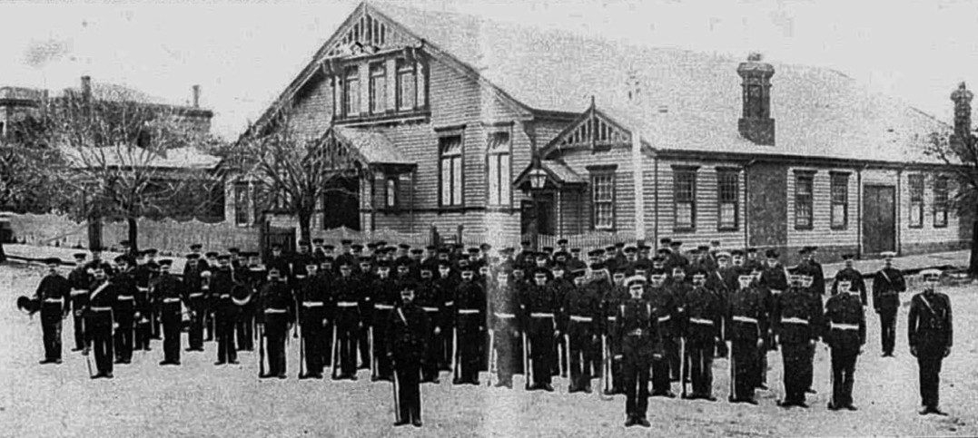
Figure 7.74: Geelong Garrison Artillery outside Drill Hall, Myers Street, 1911. Source: News of the Week, 25 May 1911, GRS 2121, Geelong Heritage Centre collection.

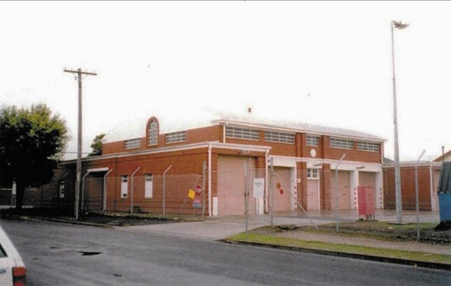
Figure 7.75: Brick Drill Hall, Myers Street, Geelong, 2000. Source: David Rowe.

By the late 1890s, the once substantial orderly room in McKillop street proved inadequate for the expanding Artillery Corps. In 1898, The Royal Victorian Volunteer Artillery made application for the Geelong Town Council’s approval of the use of vacant land in Myers Street, west of the Supreme Court building.725 After some opposition the land was granted for the erection of a drill hall. William Davidson of the Public Works Department designed the building, having probably been influenced by Samuel Bindley who had been the architect for a number of these halls years earlier.726 In 1900, the tender of H. Henningham was accepted for the construction of the gabled timber building and neighbouring timber Sergeant Major’s residence at a cost of £3886/5/8727 (Figure 7.74).
Throughout the first 35 years of the 20th century the drill hall accommodated units of two coast artillery brigades and the area office of the 23rd Battalion.728 The building was
transferred to the Navy in May 1929 but was soon re-acquired by the Army later that year.729 Between 1935 and 1939,
there was a substantial increase in defence expenditure by the Commonwealth Government in preparation for World War Two.730 Much of this expenditure concentrated on
the construction of new brick drill halls designed by the Commonwealth Architect, George Hallendal.731 A brick
barrel-vaulted drill hall (Figure 7.75) was designed by him and constructed in 1939 at the rear of the timber drill hall.732 It was to accommodate the No. 4 Anti-Aircraft Battery, a reformation in 1938 of the Royal Victoria Volunteer Artillery Regiment.733

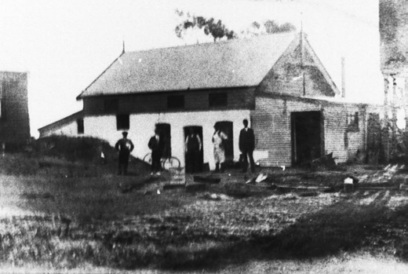
Figure 7.76: Former Drill Hall (Bellarine Dairy Co. Butter Factory), c.1930s. Source: Bellarine Historical Society image s24m29, Bellarine Historical Society.

DRYSDALE DETACHMENT, GEELONG VOLUNTEER ARTILLERY CORPS
In 1867, a detachment of the Geelong Volunteer Artillery Corps was raised at Drysdale.734 It seems that the Artillery first met at the Mechanics Institute at Drysdale.735 A new orderly room was completed in 1873.736 Its usefulness was short-lived as in 1884 a new site for the drill hall was selected at the corner of Princess and Newcombe Streets
and a timber gabled drill hall was erected there to a design by
J.H. Marsden, architect of the Public Works Department.737 The onset of World War One in 1914 brought an increase in infantry and cadet enrolments, necessitating additions to the drill hall.738 A military reorganisation in 1922 brought to an end the citizen forces and cadets at the Drysdale.739 Between 1930 and 1938, the drill hall and its site was leased to the Bellarine Dairy Company, the drill hall being used as a butter factory740 (Figure 7.76).
Following the liquidation of the Bellarine Dairy Company
in 1938,741 the drill hall appears to have been either removed from the site or demolished. In 1940, the drill hall site was offered for lease as a grazing paddock for 5 years.742 In 1946, the Commonwealth Disposals Commission sold the site to G. Golden who intended to establish an olive oil factory.743

SCHOOL CADETS
In the 1880s, the concerns of 30 years past by Victorian colonists over the Crimean War were reignited by a confrontation between British and Russian forces.
The boom years of this period following the gold rushes had accentuated a sense of vulnerability for the prosperous colony.744 While physical training and sports were part of the public and private educational curriculum, physical
training and particularly military drill offered ‘a male citizenry capable of defending’ the colony and the ‘home country’ (Britain).745 This led to the Victorian Government passing The Volunteer (Cadet) Act in 1884 and Regulations for Volunteer Cadet Corps in early 1885.746 Major William Henry Snee was appointed Commanding Officer of the Victorian Volunteer Cadet Corps.747 In Greater Geelong, Corps were raised at several schools and colleges, including Geelong Grammar School (1884); Flinders State School no. 260 (now Matthew Flinders Girls’ College) (1885); South Geelong State School no. 2143 (1885); Geelong College (1885) (Figure
7.77) Gordon Institute (1886); Swanston Street State School no. 1094 (1894); Ashby State School No. 1492 (1899);
and St. Joseph’s, St. Augustine’s and St. Mary’s Catholic Schools (1908).748 Regular encampments, parades and rifle competitions were held between the schools throughout the 19th and early 20th centuries.
In 1912, a Cadet Encouragement Committee was formed to initiate a military competition of junior and senior cadets at the Corio Oval ground of the Geelong Football Club749 (Figure 7.78). The inaugural winner of the Cadet Encouragement Day shield (which had been executed by Frederick Band, Geelong jeweller) was the Geelong College Company.750 While there was promise of the Encouragement Day competition and parade having a lengthy future, World War One appears to have curtailed much activity (although ‘some good was done’ during
this period), the Cadet Encouragement Committee became defunct in 1921 and the £12 in its possession
was distributed equally between the Naval and Military Cadets.751
Several of the school cadet corps endured into the
20th century, including those at Geelong College (ceased in the late 1970s), St. Joseph’s (ceased in 1981), and Geelong Grammar (possibly ceased c. late 1970s).752 Today, a physical legacy of the school cadet movement are items including photographs, competition medals (Figure 7.79), and trophies held in archives, including those at Geelong College.

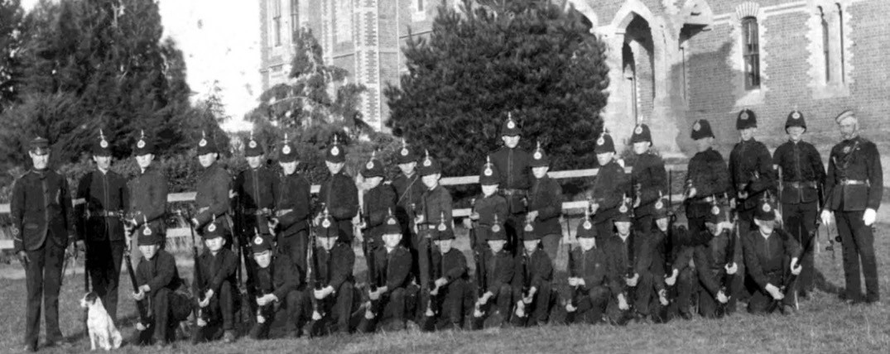
Figure 7.77: Geelong College Cadets, Newtown, 1886. Source: The Geelong College.
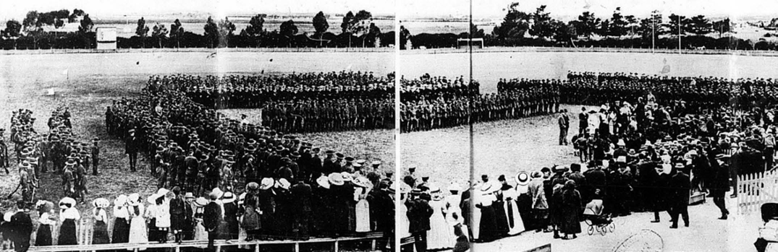
Figure 7.78: Cadet Encouragement Day, Corio Oval, Eastern Park, presentation of shield to Geelong College Company, 1912. Source: News of the Week, 21 November 1912, pp.14-15, GRS 2121, Geelong Heritage Centre collection.
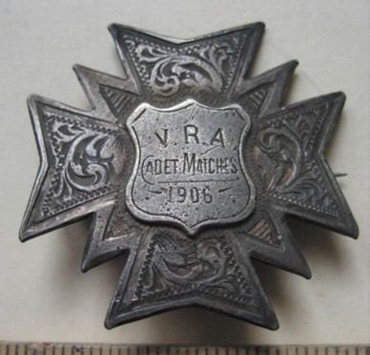
Figure 7.79: VRA Cadet Matches Field Firing Medal, 1906, awarded to J.H. Urbanhs, Geelong College.
Source: The Geelong College.

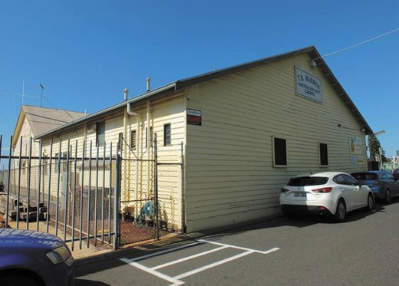
Figure 7.80: T.S. Barwon Australian Navy Cadets Drill Hall, 2018. Source: David Rowe.

NAVAL CADETS
In 1907, the Geelong Advertiser reported of a Commonwealth Defence proposal to establish naval cadet corps. The article declared that ‘Geelong should have a good chance for recognition and that:
Some years ago, the establishment of a Geelong branch of the Victorian Naval Brigade was mooted, but the project failed through lack of earnestness on the part of the Government. Considering the facilities of the harbor affords for nautical work, and the number of boys who would jump at the chance of a naval cadetship, a first class corps should be established in Geelong without any difficulty.753
Optimism for a naval cadet corps did not immediately eventuate into reality.754 It was not until 1912 when a Naval Cadet Corps was formed, following a recruitment of 100 boys.755 Drill was carried out at the temporary drill room, being the old customs shed (gauging shed) at the corner of Eastern Beach Road and Moorabool Street.756
In 1932, the Naval Reserve Cadets of the T.S. Barwon was raised following a desire of Senior District Naval Officer for Geelong during the First World War, W.O. H.C. Harris, RAN., who enlisted assistance from Lieutenant Roy Fidge (later Sir Roy Fidge, Mayor of Geelong).757 The purpose of the Naval Reserve Cadets was to introduced young boys to seamanship, telegraphy and sailing.758 Training began in a drill hall on the Moorabool Street pier offered by the Geelong Harbor Trust.759 A new drill hall was built by the
Naval Cadets at Western Beach, east of the Corio Bay Rowing Club, by 1938760 (Figure 7.80). It was extended in 1940 to a design by students of the Gordon Institute of Technology and

constructed under the supervision of J.C. Taylor and Sons. It opened on 18 December 1940 and the building continues to be used for its original purpose by the TS Barwon Naval Reserve Cadets.761

ROYAL AUSTRALIAN NAVAL COLLEGE, OSBORNE HOUSE
In 1912, with a war in Europe looming, the Australian Navy sought to train its cadets in Australia rather than having them sent to Britain for officer training.762 The Navy requisitioned Osborne House from the Geelong Harbor Trust, and the nearby St. Helen’s mansion, as the first Australian Naval College in Australia.763 Agreement had been reached with the Harbor Trust that the Navy could use the building rent free if solely for Naval purposes.764 The College at Osborne House was to be temporary until a purpose-built college
was completed at Jervis Bay in the following years.765 Upwards of £10,000 was spent on alterations and additions to the mansion house, including a single storey wing on the west side, and two storey wing on the north side. A timber classroom and a complex of petty officers’ and seamen’s quarters were erected to the north of the stables building766 (Figure 7.81). The College was officially opened on 1 March 1913 by the Governor General, Lord Thomas Denman, in the presence of the Prime Minster, Andrew Fisher.767
The nearby St. Helen’s mansion was commandeered as the Commandant’s residence of the Royal Australian Naval College768 (Figure 7.82). The Commandant was Captain
B.M. Chambers, a British Naval Officer.769 He had come to Australia as Second Member of the Australian Navy Board in 1911 and was then commissioned as Captain of H.M.A.S.
Encounter in 1912, before taking up the Commandant position of the Naval College.770 He returned to England in 1914.771
In 1915, the Naval College transferred to H.M.A.S. Creswell, Jervis Bay.772 Osborne House subsequently served as a Naval Convalescent Hospital operated by the Australian Red Cross until 1924 (see Theme 8).773 Between 1919 and 1924, the Osborne House property was also the home of Australia’s first submarine fleet, the mansion house being used as accommodation for officer and crew (which brought about further alterations and additions included an extension of the kitchen and the partitioning of two large rooms).774 The pier was extended and fitted with a torpedo store and workshop, and a bathing shed was erected nearby775 (Figure 7.83).
Little physical evidence now survives of the Naval College occupation at Osborne House.776

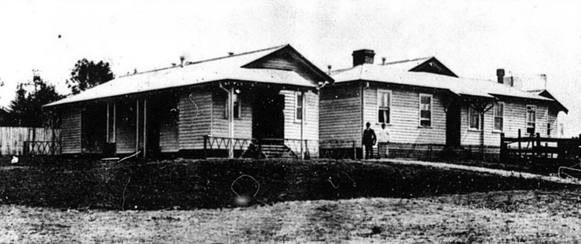
Figure 7.81: Petty Officers’ & Seamen’s Quarters, Osborne House, 1913. Source: News of the Week, 27 February 1913, p.13, GRS 2121, Geelong Heritage Centre collection.

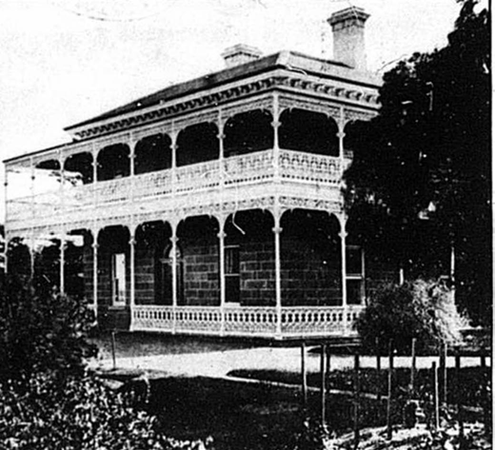

Figure 7.82: St. Helen’s – Commandant’s Residence, 1913. Source: News of the Week, 27 February 1913, p.13, GRS 2121, Geelong Heritage Centre collection.

UNIVERSAL MILITARY TRAINING
The paranoia over possible Russian invasion in the
19th century extended beyond the creation of the Volunteer (Cadet) Act of 1884 with the fledgling Commonwealth Government introducing compulsory military training in 1911.777 In 1911, The Defence Act 1909 was passed into
law. It required Australian males aged between 18 and 60 to perform military service within Australia and its territories.778
Compulsory training extended throughout and beyond World War One until 1929.
Such training required facilities and in addition to existing drill halls and sites, further drill halls were erected. They not only played hosted to militia training for adult males, but also for cadets (the Geelong region was divided into cadet districts). During the world wars, some of these orderly rooms held further importance as attestation stations.779 One example
in Greater Geelong was the reservation of a parade ground and construction of a drill hall off Pescott (then Park) Street (between Retreat Road and Skene Street in 1914).780 Having been requested by the Cadet Encouragement Committee, it became the drill hall for cadets of the 69B area, and for the 29th Light Horse and 70th Infantry.781 Special accommodation was set aside for each of these sections as well as two rooms for the officers.782 By 1916, the drill hall was an attestation station for men enrolling to serve in World War One783 (Figure 7.84). The building was demolished later in the 20th century and the parade ground is now known as Kenwith Park.784

OSBORNE HOUSE IN WORLD WAR TWO
In 1940, Osborne House was again requisitioned for defence purposes given the outbreak of World War Two in 1939.
The property served as the Army Service Corps Training School.785 The property reverted to its former purpose as the Council chambers and offices of the Corio Shire Council following the end of the war in 1945.786

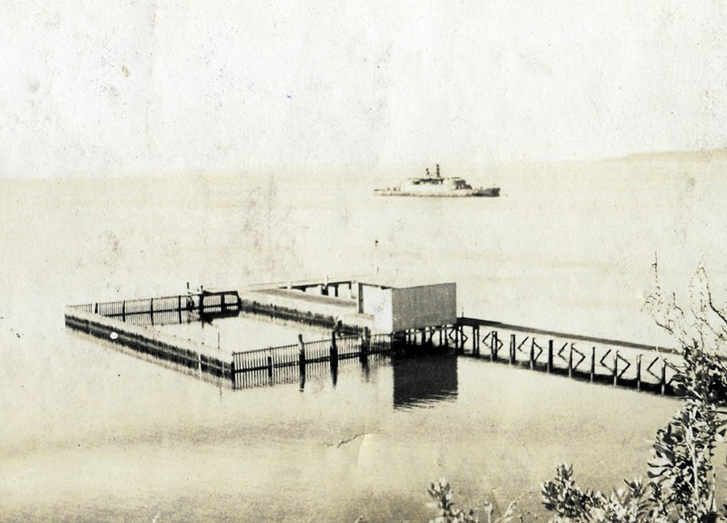

Figure 7.83: Extended pier, Osborne House, for submarine fleet, with HMVS Cerberus in the background, c.1920-22. Source: GRS 1262/1/30, Geelong Heritage Centre collection.
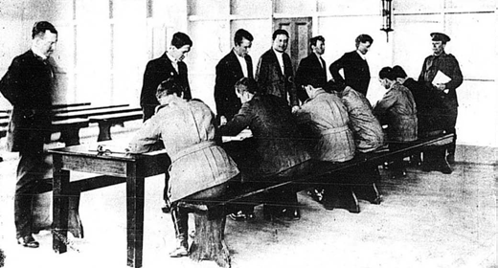
Figure 7.84: Attesting inside Newtown Drill Hall, 1916. Source: News of the Week, 12 October 1916, p.18, GRS 2121, Geelong Heritage Centre collection.

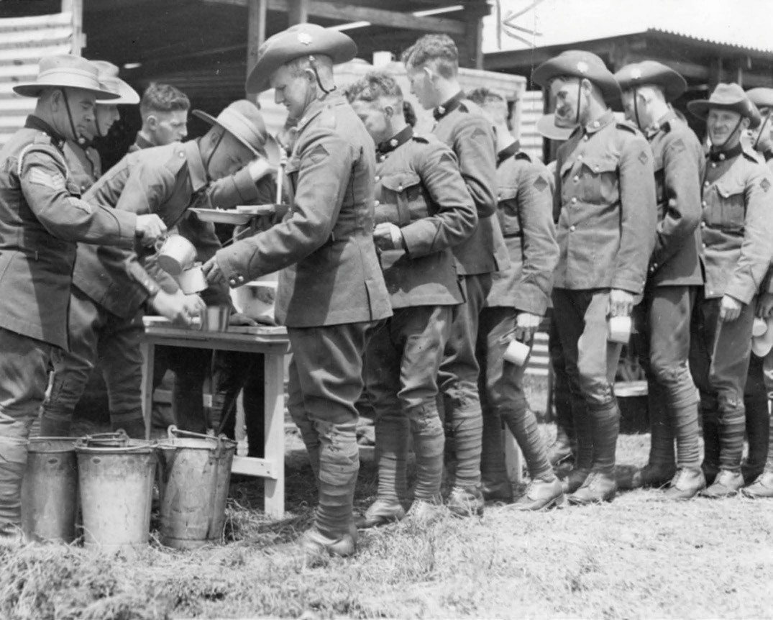
Figure 7.85: 23/21 Battalion at camp at Ocean Grove, 1939. Source: accession H99.201/452 State Library of Victoria.

COASTAL TRAINING AND DEFENCE AT OCEAN GROVE AND BARWON HEADS DURING WORLD WAR TWO
Ocean Grove and Barwon Heads became locations for training of the 23/21 Infantry Battalion of the 2nd Australian Imperial Force and Citizen Military Forces, 6th Field Company and the 15th Field Brigade during World War Two.787 Initially, Ocean Grove was chosen as one of the training camps in September 1939 (Figure 7.85). As reported in The Age:
Camps of continuous training of one month’s duration will begin for Victorian Militia Units on October 9. Camps will continue at intervals until the last units go in on November
27. Camp sites are spread over the length and breadth of the state.788
The 23/21 Battalion also held Battalion parades, memorial services and training drills at Highton, Ceres, Breamlea,
Connewarre and Torquay during the war.789
In October 1940, the need to provide sufficient defence for Victoria’s coastline was heightened following the sinking of the British cargo ship, the SS Cambridge off Wilsons Promontory and the American vessel, the City of Rayville
off Cape Otway.790 Both ships had hit mines of the 40 laid in Bass Strait off Wilsons Promontory and Cape Otway by the German Nazis in the Passat (this vessel was a Norwegian tanker named Storstad that had been captured on 7 October 1940 and renamed Passat).791 Militia battle stations were established on the coast defences of Port Phillip Bay and the Bass Strait coastline, including Ocean Grove and Barwon Heads.792 The perceived threat to Australian security further increased in 1942 following the fall of Malaya and Singapore to the Japanese, who also had bombed Darwin.793 A defensive arc from Maryborough in Queensland to Portland

in Victoria was prepared by the Commonwealth, Queensland,
N.S.W. and Victorian State Governments. At Barwon Heads, this included the boring of explosive charges in the bridge to be detonated if required to thwart easy enemy access of the river crossing.794
Camping by citizens at Ocean Grove and Barwon Heads was prohibited during much of the war as camping areas and other sites were taken up by military personnel. At Ocean Grove:
… army tanks tore up the tracks and dug trenches and sites for ammunition dumps. There were Bren guns behind the Church of England, every campsite was occupied and every available seaside cottage
commandeered for Army personnel. Temporary sewerage blocks were provided and water mains connected to service the outlying camps north and east of the township. The beach, deserted by the normal holiday visitors,
was closely guarded and protected with barbed wire entanglements.795
At Barwon Heads, the camping ground was first occupied by the military for two weeks in February 1940.796 It was then
commandeered between 1 December 1941 and 30 November
1942.797
Today, physical evidence survives in the ruinous gun emplacements in the sand dunes in the Buckley Park Foreshore Reserve at Ocean Grove (Figure 7.86) and Point Impossible. Installed with Vickers machine guns by the 23/21 Battalion,798 these emplacements were strategically positioned along the open foreshore between Ocean Grove and Torquay. While they may have served important military training and defence purposes, they later caused
a destabilisation of the dunes between Barwon Heads and Torquay, causing a number of blowouts and sand drifts along the Ocean Road between Barwon Heads and Black Rock.799

VOLUNTEER DEFENCE CORPS AT THE YOU YANGS
During World War Two, a volunteer defence corps was established that involved 25-30 local men.800 Lectures were given in the local hall by Army officers from Geelong.801
The former Corio Shire Hall was also used by the Volunteer Defence Corps during the war.802

VOLUNTEER AIR OBSERVERS’ CORPS, LARA
An ancillary service of value to the war effort in Victoria during the Second World War from 1941 was the inauguration of
the Volunteer Air Observers’ Corps.803 Critical to the home defence system, a network of observation posts was arranged in a uniform pattern to cover the coastal belt and the industrial areas of the country. According to Douglas Gillison in Royal Australian Air Force, ‘the telephone system, with direct lines

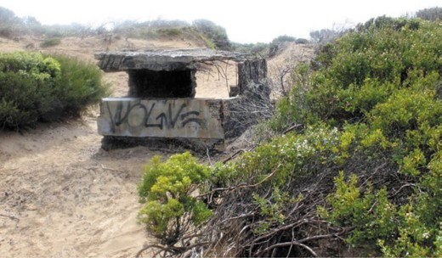
Figure 7.86: Gun emplacement ruins at Buckley Foreshore Reserve, Ocean Grove, 2018. Source: Greg Newman.

when necessary, was used to link observation and control posts, and teleradio sets were installed at control posts to provide continuous communication between these points and the main controls posts.’804
A counterpart of the English civilian organization known as the Royal Observer Corps, the functions of the Volunteer Air Observers’ Corps (V.A.O.C.) were to: Report aircraft, and if possible, identify hostile aircraft passing over observation points; and transmit aircraft sighting reports to an appropriate central control post for warning to Defence Services and to the Air Raids Precaution authorities in
each State.805
Air observation posts were manned on a volunteer basis, with volunteers having to be 45-60 years of age.806 By the end of the war, around 34,000 volunteers had participated in the V.A.O.C. At Lara, an air spotters’ hut was erected on the south side of Station Lake Road, between Forest Road and
Hovells Creek.807 No physical evidence of this hut is known to survive today.

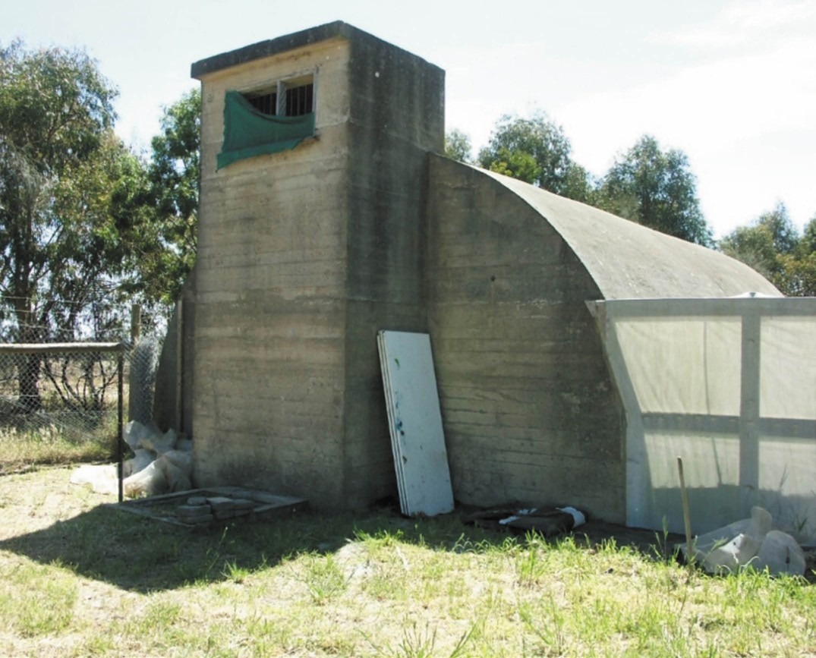
Figure 7.87: RAAF Radar Igloo, Drysdale, 2006. Source: David Rowe.

RAAF TRAINING SCHOOL AT WOOLOOMANATA
It was also during World War Two when Wooloomanata Homestead at Lara was the location of a temporary RAAF airfield and Training School. The property was the Estate of the late J.V. Fairbairn, former Minister of Air, who was killed in an aircraft accident near Canberra on 13 August 1940.808 During its occupation, Wooloomanata accommodated the 79
Squadron that had been formed at Laverton RAAF base on 26 April 1943 with Mark VC Spitfires.809 Secret training for plant operators was then carried out at Wooloomanta.810 Ian Wynd in So Fine a Country gives an account of the training:
… instruction in the use of all types of earth-moving equipment was provided. Two projects carried out during the training were the Griffin’s Hill deviation of the Geelong-Ballan Road, west of Staughton Vale Road, and the formation of Clarkes Road, south of De Motts Road. Once trained, the men joined RAAF Airfield Construction Squadrons which built many airfields in the south-west Pacific.811

RAAF RADAR STATION DRYSDALE
In late 1941, the RAAF was responsible for ground-based early warning radar operations.812 Until the end of World War Two, 142 ground radar units were established throughout the country. British Wing Commander Albert Pither was given responsibility for the RAAF’s operations. According to the Royal Australian Air Force Association:
He developed a plan to surround Australia with a ‘home chain’ of radar stations of nine ‘Advanced Chain Overseas (CO) radar stations established on mainland Australia using British imported ACO radar.813
At Drysdale, land off Belchers Road was acquired and a RAAF radar station established. It served to detect
enemy airborne threats during the war.814 While a number of prefabricated huts were erected on the site, the principal building was a semi-cylindrical concrete ‘igloo’815 (Figure 7.87). It was built to a standard British design originally intended as an underground bunker.816 After the
war in 1945, the Commonwealth Disposals Commission sold 11 portable huts.817 Several were considered suitable for conversion into homes given the materials shortage following the war.818 However, the radar station igloo has been retained and one of a number in Victoria (others mostly being located in the Sale area), and one of a contextually small number extant in Australia.819

ROYAL AUSTRALIAN NAVY MINE DEPOTS, FYANSFORD & NORTH GEELONG
In 1921, the former fort at Swan Island (outside the City of Greater Geelong) was transformed into a mine depot for the Royal Australian Navy.820 Following the onset of World War Two in 1939, the depot at Swan Hall was re-established.821 During the war, it was supplemented by subsidiary depots at the Barwon Paper Mill complex, Fyansford and on a site opposite the Ford Motor Company annexe in the Boulevard, Norlane.822

MANAGING THE ROADS
In 1913, the Country Roads Board was established as a centralised agency in government road management (see also Theme ). It had its origins in the formation of the Central Road Board in 1853 which was abolished in 1857.823 The new authority conducted a two-year investigation of Victoria’s roads. Apart from them being ‘anything but satisfactory’, it devised a system of declared main roads and a program of liaising with local governments (given that they were to be operation and financial partners in building and maintaining main roads).824
The Roads Board had ‘devoted its attention to Geelong’ and Corio by September 1913.825 By 1939, it had established a Geelong Divisional office in the old Supreme Court building in Myers Street.826 A brick dwelling for the district engineer, Basil Richard Abery (1903- 1986) was built by the Public Works Department to a design by the Chief Architect, Percy Everett, in 1947827 (Figure 7.88). The residence had been completed by 1948 (see Figure 7.50). It was situated on
the site of the old Police Station in McKillop Street. This former police building was acquired as a divisional office of the Country Roads Board in 1949, as outlined in its Annual Report:
The whole of the former police building in McKillop-street has been taken over by the Board as a divisional office and the necessary alterations to adapt it to requirements are in hand. Residences which have been completed are occupied by the Divisional Traffic Officer and an office clerk; further residences to be occupied by the Divisional Accountant and an Assistant Engineer are in course of construction. The workshop and storeyard personnel are now 6.828
After 1955 (and before 1969), the Country Roads Board Office was partially demolished and extended at the rear on two occasions.829 In 1983, the Country Roads Board changed
its name to the Road Construction Authority and in 1989, this Authority and the Road Traffic Authority merged to form the Roads Corporation that traded as VicRoads.830 The former Country Roads Board site was sold to the Catholic Trusts Corporation for use as part of the adjoining St. Mary’s Catholic School in 2003.831 The Country Roads Board
office was demolished in August 2008 (Figure 7.89) and the residence in 2010.832

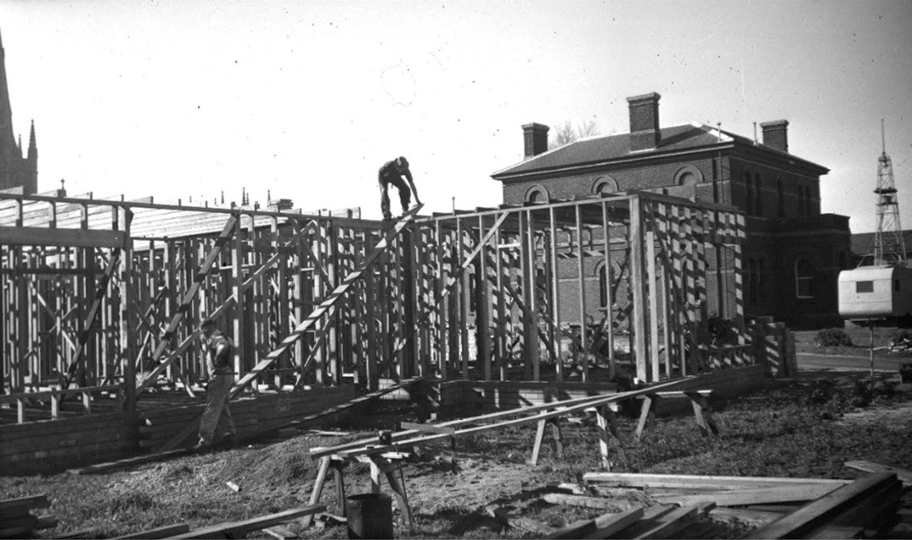
Figure 7.88: Dwelling for the District Engineer of the Country Roads Board under construction next to the old Police Station, McKillop Street, 1947. Source: VPRS 17684/P3 item 45/04448 Public Record Office Victoria.

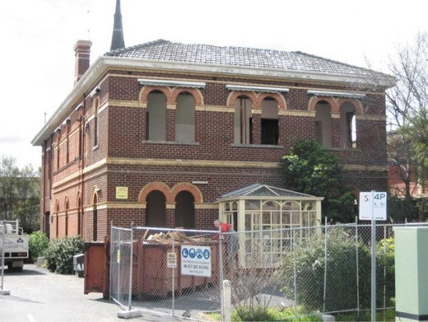
Figure 7.89: Former Country Roads Board Building (Police Station), at time of demolition, August 2008. Source: Jennifer Bantow, Geelong.

REGULATING BUILDING
AND TOWN PLANNING IN GREATER GEELONG

HOUSE NUMBERS IN THE 1850S
In 1853, Governor Charles La Trobe proclaimed An Act to provide for the Management of Towns and other places in Victoria.833 Colloquially known as the Country Towns Police Act, it was again proclaimed by Governor Charles Hotham in 1854.834 The Act had first been introduced by the New South Wales Colonial Government ‘for the maintenance of the public peace and good order, and for the prosecution of certain offences committed within the towns of Parramatta, Windsor, Maitland, Bathurst and such other towns in the Colony of
New South Wales as shall be declared by His Excellency the Governor.’835
The Act included the regulation of street names and house numbers. As early as 1849, the Geelong Advertiser had made comment on the powers of the Police Magistrate being able to:

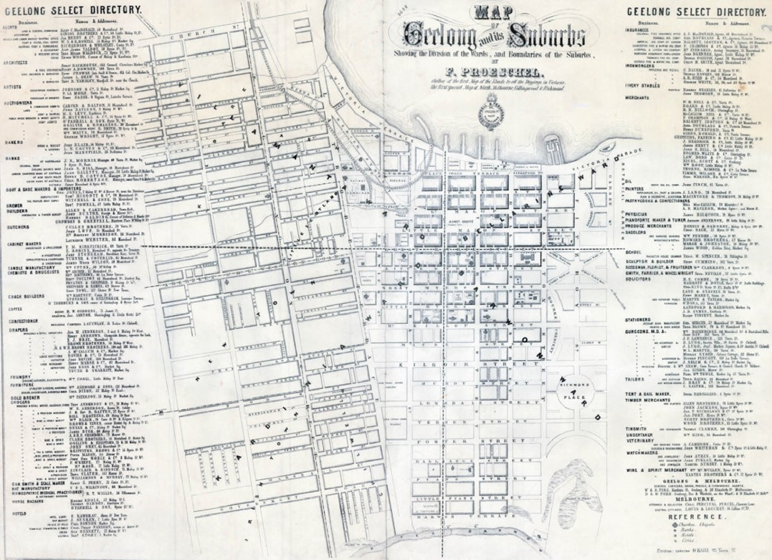
Figure 7.90: F. Proeschel, Map of Geelong and its Suburbs, Campbell & Fergusson, Melbourne, 1855. Source: State Library of Victoria.

… affix name of street, &c., to any house, and allot number to each house, which number the owner or occupier is required to paint or affix in legible characters on the door, within fourteen days after written notice, and every person refusing or neglecting to paint or affix such number after notice, on conviction, to pay ten shillings, and the like sum for every week during the continuance of such refusal
or neglect.836
The Act of 1853 gave the Geelong Corporation the power to regulate house numbers. In March 1853, Councillor Myles put forward the following motion:
That tenders be invited to paint the numbers on the several houses within the town boundary, and in Spring, Hope, Autumn, O’Connell, and Wellington-streets, in the suburbs.837
Debate ensued about the Corporation taking on the cost of the works and it was not until December 1854 when Frederick Proeschel, a recently-arrived French map-maker and geographer, sought permission to number houses in
Geelong.838 Permission was granted in early January 1855, the Geelong Advertiser and Intelligencer reporting on Proeschel’s work:
NUMBERING THE HOUSES IN GEELONG. – This is at
least to be effected. Mr F. Proeschel having obtained permission from the Corporation, will this day begin his labours by affixing a number plate to every house, for which his charge will be half-a-crown. When it is considered that Mr Proeschel has taken the trouble to
measure and map out all of the streets for the purpose of numbering, it is to be hoped that no one will begrudge the small charge for such a great benefit.839
The basis of the numbering of properties in Geelong was therefore Proeschel’s Map of Geelong and its Suburbs published in September 1855840 (Figure 7.90). It received a glowing account in The Age which declared that it was ‘as accurate, perspicuous and carefully prepared as the plans’ for Collingwood, Richmond and North Melbourne by Proeschel.841 Some errors were noted, whereby ‘the

respective positions of Ashby, Geelong, and Kildare’ as set down … do not accord with popular tradition,’ and Cavendish Street remained unnamed.842 However, the map was also well received locally, the Geelong Advertiser declaring Proeschel to be ‘the most persevering of all map-makers and Geelong owes him a debt of gratitude for his exertions in that way,
and still more for his numbering the houses in town and suburbs.’843 The Map was provided gratuitously with costs covered through a business directory on the margins.844
Proeschel’s house numbering in Geelong began at the north end (for streets on a north-south axis) and the west end (for streets on an east-west axis), with odd numbers on the east side and even numbers on the west (for north- south streets) and odd numbers on the north side and even numbers on the south (for east-west streets). For streets on a north-south axis at least, this was the opposite of the house numbering system he adopted in Collingwood (which was based on a similar system in Paris),845 possibly due to a greater number of buildings and dwellings at the northern and western parts of the central Geelong township area.
Frederick Proeschel (1809-1870) was born in Colmar,
Haut Rhin, France and was initially a tapissier (upholsterer) and mattress-maker he but soon progressed into other endeavours, including a method to preserve buildings from the effects of moisture that he presented to the Committee of Chemical Arts of the Société d’Encouragement pour l’Industrie Nationale in Paris in 1841.846 He emigrated to
America in 1852 before arriving in Melbourne in December of that year where he turned his hand to cartography and map publishing.847 By May 1853, he had lithographed a map of Melbourne, the first of many maps he produced of Victoria, Hobart, Launceston, New South Wales, South Australia and Queensland, culminating in his Atlas of Australasia in 1863.848 Proeschel’s time in Geelong was only brief. By 1856, he
had relocated to Melbourne849 before emigrating to London in 1864 and then returning to Paris where he died in 1870.850 In addition to his Map of Geelong, Proeschel’s enduring legacy is the street numbering in central Geelong. While the actual numbers of individual properties might have changed, Proeschel’s numerical address system survives.

EVOLUTION OF BUILDING REGULATIONS
The regulation of building construction in Greater Geelong began in early 1893 when the Geelong Town Council passed Building Regulations in pursuance of power conferred to the municipality by the provisions of the Local Government Act of 1890.851 The main provisions of the regulations (introduced as by-laws) were that:
No building of any kind can be built unless of masonry or brickwork within the area bounded by the northern town boundary, McKillop-street, Bellerine-street and Latrobe-

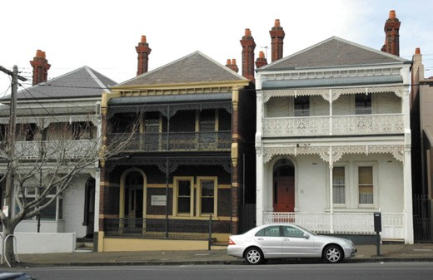
Figure 7.91: Dwellings, 89-91 Yarra Street, 9 June 2005. Source: Wendy Jacobs.

terrace; particulars with regard to height and dimensions, also isolation for fire prevention of buildings throughout and dimensions, also isolation for fire prevention of buildings throughout the town, verandahs and balconies within and without the above mentioned boundaries;
and the fees to be paid to the corporation for all classes of building and repairs. Architects and builders are also required to submit plans and specifications of all works for the approval of the surveyor seven days before it is intended to commence work, and the fees must be paid and a building permit taken out before the work
is commenced.852
Some of the earliest known surviving buildings that were subject to the new building regulations were four double storey Late Victorian brick dwellings at 87, 89, 81 and 119 Yarra Street (Figure 7.91). They were built in 1895-96 for Daniel Fowler, a tanner, who lived in one of them and leased the others.853
Not surprisingly, the operation of the Building Regulations brought about controversy. A number of fines were issued by the town surveyor soon after the regulations were introduced. In January 1894, Messrs. Hendy, Leary and Co. made application for the remission of a fine of £1 imposed by the Town surveyor ‘in respect of the unauthorised erection of a chimney to a house within the area prescribed by the building regulations.’854 The matter was deliberated at a Council meeting and reported in the Geelong Advertiser:
Cr Howard moved to the effect that the fine be remitted, and said that the council never intended the building regulations to be read with such strictness.
Cr Martin seconded the motion, and said that the surveyor was going out of his way in making unnecessary fines.
The building trade was being hampered by the surveyor too rigidly enforcing the regulations, which were never intended to be so severe. Cr Carr said that complaints

were everywhere rife against the regulations, and it was not right to harass the ratepayers. Ald Meakin endorsed the remarks of previous speakers. Cr Robinson said
that it was most singular to hear gentlemen who had been so eager to pass building regulations to prevent shanties being constructed in the town now turn round and denounce the surveyor for carrying out the regulations they had passed. He did not see why the fine should
not be enforced, although he knew the council had previously remitted similar fines. If fined for infringing the regulations, people would soon make themselves acquainted with the provisions of those regulations. The Mayor said that it was utterly absurd for the council to blame their officer for carrying out the regulations which the council and passed and instructed him to see
observed. If they remitted the fine in one case they would have to do it in all. Crs Martin and Carr said that they would get the regulations altered, and Cr Robinson said that under the circumstances they should repeal them altogether if they did not carry them out. After further discussion, it was agreed that the fine was excessive, and the motion was withdrawn, a resolution reducing the fine to 10s, moved by Ald Richardson and seconded by Cr Carr, being carried instead.855
Another challenge for the Council also came in January 1894 when a ‘novel application’ was made to the Public Works Committee for the construction of ‘a small building on wheels.’856 Perplexed by the application, members of the Committee ‘did not know exactly how to deal with the application in view of the stringent building regulations adopted by the council.’857 Eventually, as reported in the Geelong Advertiser:
It was vaguely hinted in the council chamber that the difficulty might be easily overcome by the construction of the house on wheels in an adjoining borough, and afterwards drawn by horse or other power to the site in Myers-street.858
Amendments were made to the Building Regulations in the Town of Geelong in subsequent years, and similar regulations enacted in surrounding and rural municipalities.859 The number of building permits issued had also increased substantially by 1926. For the first six months of that year, there were 209 permits issued for the City of Geelong, with 128 permits issued by the Newtown and Chilwell Council and 196 by the Borough of Geelong West.860

In 1940, the Victorian Government introduced the Local Government (Building Regulations) Act, which applied to the Cities of Melbourne and Geelong.861 A Building Regulations Commission was constituted. The objects of the Commission were to:
- Investigate and report to the Minister as to how the said objects can be best attained.
- Prepare and submit to the Minister draft regulations on any matter in respect of which regulations may be made by the Governor in Council under this Act.
- Inquire into and report to the Minister upon any matter relating to buildings or the construction thereof
referred to the Commission by the Minister for inquiry; and
- Exercise or perform any powers or duties conferred or imposed on the Commission by or under this or any other Act.862
Five years later in 1945, the Government introduced uniform Building Regulations. These Regulations related to the ‘regulating, restricting, restraining or prohibiting the construction, pulling down and removal of buildings and any matters connected therewith.’863 Updated Uniform Building Regulations were introduced in 1959 and in 1961,
consolidating and replacing earlier Regulations.864 Following the provision of the Local Government Act 1958, new Uniform Building Regulations were introduced in 1974.865
Significant reforms were made in the 1990s following the establishment of the Building Act 1993. It was modelled on the national Model Building Act and was introduced ‘to
provide for the regulation of building and building standards reflecting best practice and innovation.’866 This brought about substantial change, most notably de-regulation, where by the traditional role of the surveyor working in local government
to administer the provisions of the Building Act and the Building Regulations was altered and expanded. It gave opportunity for private building surveyors to provide expert advice to architects, builders and other clients relating to the regulations and Building Code of Australia.867
By 2017-18, the residential building approvals within the City of Greater Geelong totalled 3062,868 a far cry from
the early years of the 1890s when building permits were first introduced.

REGULATING TOWN PLANNING

THE EARLY YEARS OF TOWN PLANNING 19TH CENTURY
In the 19th century in Geelong, planned urban improvements
were largely confined to private subdivisions (beyond the Geelong Town plan grid), streetscape engineering
infrastructure (see Theme 6) and tree planting. Of the latter, one of the more notable improvements came in 1868 when the Mayor of Geelong, Cr Robert de Bruce Johnstone advocated an enterprising street tree planting program on both sides
of Moorabool Street. Trees were to be funded by private subscription in honour of Queen Victoria’s birthday.869 As reported in the Geelong Advertiser:
The mayor intimated that he had been endeavouring to get the rows of tree, from Moorabool street to the Barwon, planted by private subscription. The conditions were that each person subscribing 15s would have the privilege of allowing his children to plant a tree. To plant the whole street the number of trees required would be seventy on one side and sixty on the other. Seventy had already been subscribed for, so that only sixty remained.870
The planting of pine trees871 commenced in Moorabool Street ‘from the Church of England Grammar School to the Barwon Bridge’ on 25 May 1868 when a member of each subscriber’s families planted a tree, a record of the event being kept in the Town Hall as a commemorative measure872 (Figure 7.92). The pines appear to have been replaced with elms in 1885 and they were removed
in c.1963.873
A similar initiative was established on the west side
of Yarra Street in 1872 (albeit in a less grandiose manner) when 48 elm trees were planted.874 The trees had been sourced from the Johnstone Park nursery. The first
tree was planted by Francis Ducker, son of the Mayor,
W.F. Ducker.875
Other street tree programs were funded by the local councils. In 1881, the Geelong Town Council voted on £50 being made available for tree planting in Moorabool Street, and £25 in Corio and Little Myers Streets.876 Another 60-80 trees were planted in Mercer Street under the supervision of John Raddenberry, curator of the Geelong Botanic Gardens (see Theme 9).877 Oak trees were planted in Gheringhap Street and other parts of the City in the early-mid 1880s, on the advice

in 1880 from William Guilfoyle, curator of the Melbourne Botanic Gardens.878 A survivor of this tree planting program is the Oak tree outside the former Telephone Exchange in Gheringhap Street (see Figure 3.199 Theme 3). In 1890, the curator of the Botanic Gardens received Council support for the planting of Elm trees on the north side of Barwon Terrace at South Geelong.879 A row of Elms
remain along this thoroughfare between Swanston and Yarra Streets.
Street trees were also planted in the suburban parts of Geelong from the early 1880s. They included Elm trees
in Mount Pleasant Road in 1880 and most likely in 1881 (east and west of High Street).880

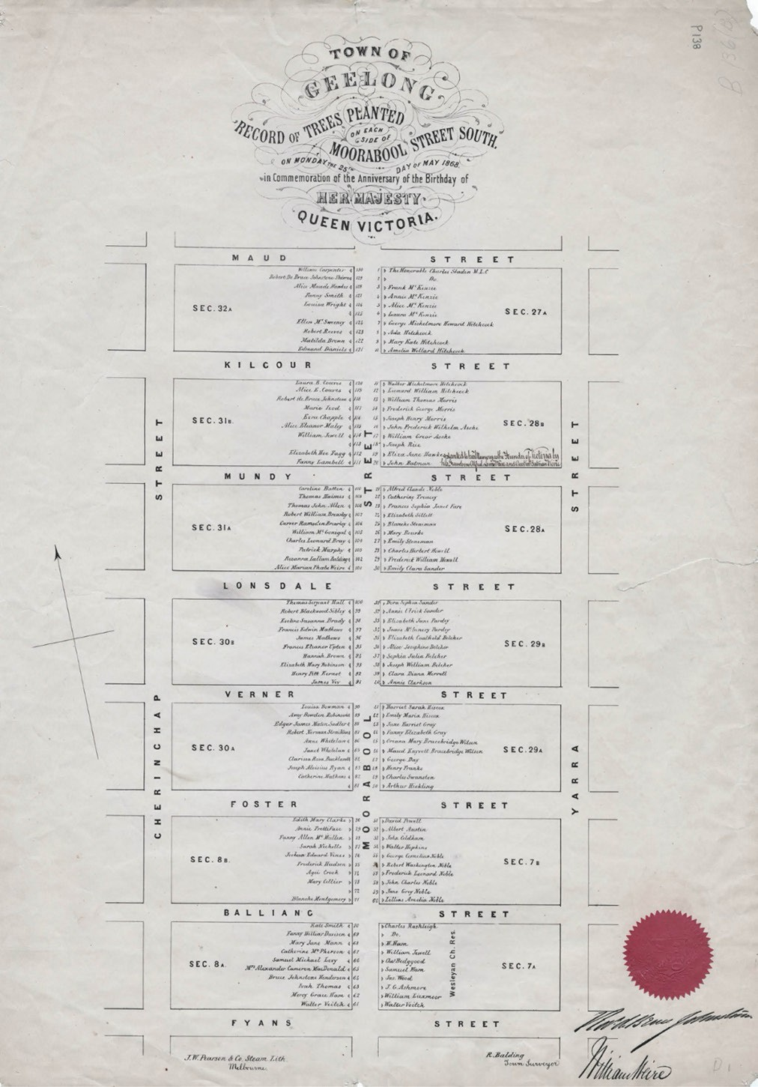
Figure 7.92: R. Balding, ‘Geelong: Record of Trees Planted on each side of Moorabool Street in commemoration of the Birthday of Her Majesty Queens Victoria, 1868.’ The names shown marked the locations of the trees funded by each subscriber. Source: J.W. Pearson & Co., Melbourne, 1868, GRS 2031/P138, Geelong Heritage Centre collection.

EARLY 20TH CENTURY
Impetus for better planned streets and suburbs came with the publication of the proposed plan of ‘Greater Geelong in 1912 by the German Engineer, Laurel Messy-Rhine (Figure 6.117 Theme 6). His plan for ‘Greater Geelong’ was a more holistic response to town planning in the broader Geelong and district area, and was in response to the Greater Geelong Movement from 1910 (see Theme 9). At the heart of Messy-Rhine’s concept were the principles of the European and English Garden City movements, where town planning considered the local environment and provided for healthy living. As Messy- Rhine stated:
Every community must daily become more interested in the laying out of suburbs, tracks, roads and estates.
… Cities in Europe smaller than Geelong, after having a contour plan made, arrange competitions for designing street plans for suburban districts. They pay high prices for such plans, adopt them, and make landowners lay out their streets accordingly.
… Streets should not be laid out like a chessboard with “T” squares and triangles, in equal and similar parallelograms. We must protect ourselves from that
misconception by showing that we nowadays work out our plans upon the actual contour lines, with every regard to variations in relief, etc., so that each city extension should have its individual and unique quality like that which characterises all the great cities of the past. Wherever it is possible the main streets should converge to the business centre, as for instance in London many streets enter Piccadilly Circus. It is unwise to lay out lots for people to live on in a sandy, windy hole with no hygienic or artistic advantages. Therefore town extension is a business question and should be dealt with on business lines. Red tape or hot air is fatal.
… Wise town planning will increase, not diminish, the liberty of the subject. The suggestion for a general subdivision plan of the Herne Hill district has not been made entirely independent of the existing roads, and houses. Roughly speaking, Asylum-road forms a ridge towards Fyansford, and on the north-east towards the bay. The new roads that have been planned are not hacked-out traffic ways of ordinary estate development, but are wide, firm and satisfying, have charming turns and sweeps among trees, and are more in the character of country lanes than of regular roadways. The roads will be businesslike in site and enterprise, and each owner will be not less or more considered than his neighbour.

Sport and park grounds are sufficiently provided, and if care is taken by municipal ordinances that the houses are built at a certain distance from the road, posterity in 50 or 100 years from now will have no complaints to make as everything that is modern and practical is assured in the suggestion.881
Although Messy-Rhine’s vision of ‘Greater Geelong’ was not realised, his town planning ideas were influential in the laying out of some ‘Garden suburbs’ at Manifold Heights including a redesign of the Manifold Heights Estate (see Theme 6).
Equally influential in 1914 was a lecture in Geelong entitled ‘The Message of Garden Cities and Town Planning’ by the eminent town planner, Charles Compton Reade.882 He was a New Zealander who had become an expert in Garden City town planning following time in London, and as the acting secretary of the Garden Cities and Town Planning
Association of Great Britain as well as being its acting editor of its magazine, Garden Cities and Town Planning.883 The Geelong Advertiser gave an outline of Reade’s intended lecture:
Pictures to be screened during the free lantern lecture at the Mechanics’ Hall to-morrow night will tell a wonderful story of progress in the beautifying of cities and towns of England and Europe. The people will see the best of 1000 lantern slides, showing remarkable contrasts between slums and garden suburbs; between bad and good town planning. Many wonderful advances have been made
by French, German and Italian cities in recent years. Diagrams and pictures show these things and make clear how they can be applied to Australian towns.884
In Geelong, the provision of garden areas and street-lined streets following Garden City ideology and those ideals were adopted by the City of Geelong. It began with a small landscape project at the intersections of Sydney Parade and
Sydney Avenue in 1914. Two rockeries were laid out, with one situated ‘opposite Mr T. Wray’s villa’ and it was hoped that ‘a set of four garden plots at this spot would eventuate.’885
A key figure in the City’s tree planting scheme was Cr. Robert Purnell (1855-1937), shipping agent, life member of the Geelong Horticultural Society, and Member of the Victorian Legislative Assembly.886 Purnell, along with Dr Frederick Moreton (1861-1948), were influential in the formation of
the Geelong Town Planning Association in 1924.887 This Association was based on the Victorian Town Planning and Parks Associations established in Melbourne in 1914 whose objects were ‘to give the town a bit of the country, and the country a bit of the town, to secure better housing, to protect existing parks, to safeguard native animals and plantings and erect memorials to explorers.’888 The inaugural president of

the Town Planning and Parks Association, Sir W.J. Barrett, gave an address at the opening of the Geelong branch and espoused the contemporary attitude to planning:
Real work of the Association was “so vast that the protection of birds, planning of streets, and the problems of afforestation were merely units in a comprehensive scheme making only for beauty and general utility but especially for health.
… The worst enemy to progress in the required direction was the land speculation, who would cut up perhaps
38 paddocks with the one object of getting all possible frontages.
… Another highly successful instance of town planning might be cited in connection with the houses built by the United States Government for people working in the zone of the Panama Canal. The roads and the sewerage were always in existence before the houses were put up.
… Letchworth’s Example: From such considerations turn to the beautiful garden city of Letchworth, in England, surrounded by an agricultural belt that allowed the production of milk for infants within a few hundred yards of their dwellings. In this city it allowed for factories
in healthy surroundings, roads were of three types: residential, business and arterial.889
Elected as the inaugural committee of the Geelong Branch of the Victorian Town Planning Association were Dr.
Moreton (President);890 Patrons: Mayors of City, Town and Borough, and Presidents of District Shires, Hon. Sec. Mr Geo Hope, Vice-Presidents: Cr Purnell, Alderman Hitchcock, Senator Guthrie, Mr. W. Plain, General Committee: Messrs.
F.D. Wilcox, H. P. Douglas, H. Purnell, Spencer Nall, A.F. Anderson, W. Day, McCabe Doyle, G.R. King, A.J. Laird,
R. Vincent, L. Fallaw, J. Scott Halliday, D.F. Griffiths, T.J. Buchan, H.I. Tisdale, with two representatives of the Geelong and district architects, and two engineers, and two Town Clerks and Shire secretaries.891
Some of the earliest initiatives of the Geelong Town Planning Association were street tree planting along the Melbourne Road and along the banks of the Barwon River (between Moorabool Street and Latrobe Terrace).892 In 1919, Normanby Street, East Geelong, was planted with a row of palms (Figure 7.93), the first street as part of the City of Geelong’s street garden scheme initiated in 1917 that appears to have been influenced by the Geelong Town Planning Association.893 It was followed by a row of palms being planted in the centre
of Mercer Street, near the intersection with Railway Terrace (Figure 7.94).

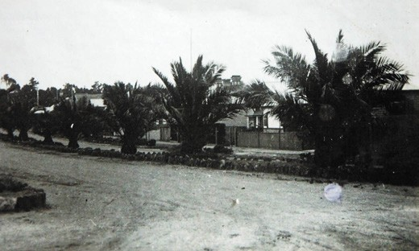
Figure 7.93: Normanby Street, East Geelong, showing row of Palm trees and rockery borders, c.1932. Source: T.T. Holmes collection, Authentic Heritage Services Pty Ltd.
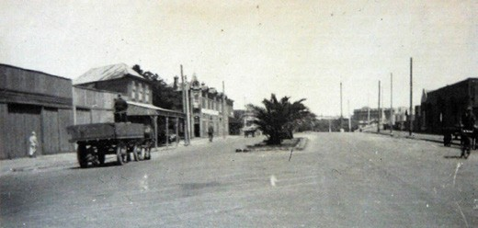
Figure 7.94: Mercer Street (looking south from Brougham Street), showing row of Palm trees in the centre of the street, c.1932. Source: T.T. Holmes collection, Authentic Heritage Services Pty Ltd.

The Town Planning Association was also influential in the design and layout of some suburbs, including the Minerva Estate in Manifold Heights in 1924 (see Theme 6).

FORMALISING TOWN PLANNING
Formalised, regulated town planning in Greater Geelong has its origins with the Town and Country Planning Board that was constituted under the Town and Country Planning Act 1944.894 The Board commenced operation in 1946
and comprised three members appointed by the Governor in Council: J.S. Gawler (Chairman), F.C. Cook and A.N.
Kemsley; and a secretary, J.D. McNamara.895 A key responsibility of the Board was to report on the development of planning schemes by individual or joint municipalities and submitted to the Minister for approval.896 The aim
of the Board was to ‘ensure the orderly and co-ordinated development of a community having regard to its natural environment.’897
Locally, advocates for the development of statutory planning schemes were John Buchan and his son, Thomas (Tom), architects at the firm of Buchan Laird and Buchan.898 In May 1945, Tom Buchan had written to the Newtown and Chilwell Council, declaring that ‘the time had come to plan for the post-war expansion for the whole Geelong area, and that the various municipal councils, with the help of town-planning experts such as Buchan Laird and Buchan, should work together for the future of Greater Geelong.’899
In 1946, a Geelong and District Town Planning Committee was formed, the first joint committee in Victoria under the Town and Country Planning Act.900 The Committee comprised 20 municipal representatives (including councillors) from the City of Geelong, Shire of Corio, Shire of South Barwon, City
of Geelong West, City of Newtown and Chilwell, Shire of Bellarine, Shire of Barrabool and Shire of Bannockburn.901 This led to the Town and Country Planning Regulations being amended to including ‘joint committees.’902
In late 1946, the Geelong and District Town Planning Committee advertised in Australia and England for a town planner to prepare a plan of the Greater Geelong area comprising 100 square miles.903 In October 1947, the Committee appointed Ewen Laird, John Buchan and Arthur Collins as joint town planners to prepare a plan for Greater Geelong within four years.904 The appointments were positively received by the Geelong Advertiser which declared that the three planners possessed ‘excellent credentials to encourage the belief that their difficult task will be capably undertaken.’905 Ewen Laird had recently returned from
Britain and Europe inspecting prefabricated houses for the Housing Commission of Victoria and witnessed first-hand town planning developments there.906 Arthur C. Collins, an employee of Buchan Laird and Buchan, had experienced the latest in Garden City planning in England in the early 1930s while employed with the Middlesex County Council.907 During

the preparation of the scheme, Laird, Buchan and Collins were also able to take expert advice from the eminent English planner, Sir Patrick Abercrombie, who visited Geelong in 1948.908 He outlined that:
In a district such as Geelong they should avoid the enormous spread which was so much in evidence in Melbourne. They should decide a maximum of
development in an area, and then have a green belt before starting another area. Valuable land for market gardening should not be resumed.909
Progress on the scheme ensued in the following years. By 1949, an existing conditions plan had been prepared and the Geelong and District Town Planning Committee had agreed on ‘many major planning proposals.’910 These proposals included ‘the matter of the siting of the abattoirs and cattle sale yards to serve the future Geelong, and the provision of a modern bus terminal in conjunction with railway facilities.’911 A new civic area was proposed by the widening of Little Malop Street to the west of the Court House, with Fenwick Street closed through the construction of an auditorium
in which a vista over a sweep of lawn could be gained, as well as bringing the southern side of Little Malop Street into civic use. A traffic roundabout (Figure 7.95) was proposed at the junction of Mercer Street and Railway Terrace, based
on a similar traffic island at Piccadilly Circus in London (it was constructed in 1952-53 and appears to have been the second in Victoria, after the building of a roundabout in Balwyn,
Melbourne in 1951).912 A third phase in central Geelong was a continuation of a widened Brougham Street subway under Mercer Street.913 A major feature of the plan for the outer
parts of the district were ring roads. One bypass was to ‘cater for industrial traffic to the North and provide a through road
to the Western District’, a western ring road as a long term project, a subway under the Melbourne to Geelong railway line at Separation Street, construction of a high level bridge at the southern end of Latrobe Terrace over the Barwon River to link with Barwon Heads Road. The Town and Country Planning Board highly commended the plans and the
Geelong Advertiser declared that it ‘stirred the imagination.’914
It was not until 1959 when the Geelong Planning Scheme
- based on the work of Laird, Buchan and Collins – was gazetted.915 It divided the Geelong district into zones, with each zone having sub-zones: agricultural (sub-zones A, B, C, D, E), residential (sub-zones A, B), commercial (sub-zones, A, B, C), industrial (sub-zones A, B, C, D, E) and special uses (reservation of land for public open space and for public purposes) (Figures 7.96-97).916 Regulations were prepared for each of the zones and sub-zones.917

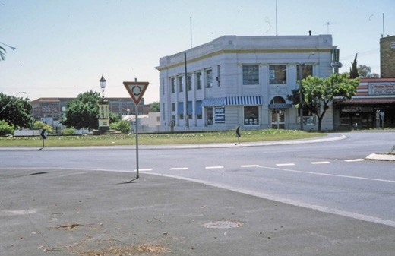

Figure 7.95: Round-about, corner Gheringhap & Malop Streets (removed early 21st century), 1995. Source: Wynd Collection, Authentic Heritage Services.

After 12 months of the gazettal of the planning scheme, the Geelong and District Town Planning Committee was disbanded and the respective municipalities became responsible for implementing the plan.918
Amendments were made to the Town and Country Planning Act in 1961 and 1968. The latter amendment brought additional functions of the Town and Country Board.919 It was empowered to prepare Statements of Planning Policy to facilitate the co-ordination of the Act. Strategic planning also became a key part of the Board’s function, with four regional planning authorities established which the Board controlled. In the Greater Geelong area, this included the Geelong Regional Planning Authority.920
In 1977, the Geelong Regional Commission was established and the powers of the Town and Country Planning Board were transferred to this new authority.921 The functions of the new local Commission included ‘the planning, management, integration and coordination of development in the region, including the protection of areas of natural beauty of special significance …922’
In 1981, the Victorian Government approved the Geelong Regional Planning Scheme which was administered by the Geelong Regional Commission.923 It replaced 17 planning schemes that had previously applied across the area and was ‘the only regional planning scheme in Victoria that was fully delegated to municipal councils and was one of only two statutory regional schemes operating in the State.’924 The Commission’s statutory planning responsibilities included ‘recommending the rezoning of land to allow for residential subdivisions; implementing rezoning outcomes of structure

plans; introducing outdoor advertising controls; implementing the adopted recommendations
of major studies, providing controls for the preservation
of historic buildings and areas and objects of natural beauty of interest, [and] introducing detailed urban conservation controls … 925
Impetus for the protection of buildings and areas of heritage significance under the Geelong Regional Planning Scheme came from two sources: local community groups and ideas of the Town and Country Planning Board.
The Town and Country Planning Board had also noted the importance of preserving the character of historic towns in its 23rd Annual Report of 1968-69:
… the preservation of character in towns by statutory planning could well be considered as new. In the United Kingdom the preservation of areas by planning control is widely practiced. It is interesting to note that some local councils are beginning to recognize their powers under the planning legislation and are considering taking action to preserve particular areas within their municipalities.
This does not mean that new development would be prohibited but rather that it would be expected to be in harmony with its surroundings.926
The community’s desire to protect its heritage assets, together with support from the Town and Country Planning Board, formed a basis for the statutory listing of heritage places in the City of Greater Geelong. In 2018, there were over 12,000 properties included in heritage overlays.927

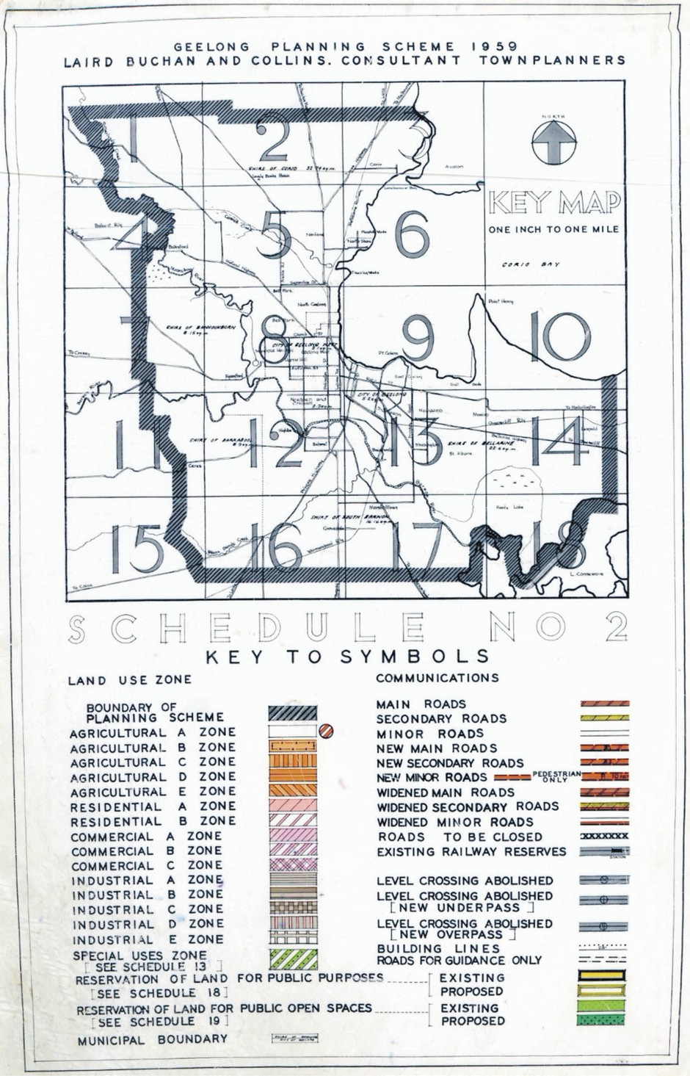
Figure 7.96: Laird Buchan & Collins, Consultant Town Planners, Geelong Planning Scheme Key Map 1959. Source: Strategic Planning Department, City of Greater Geelong.

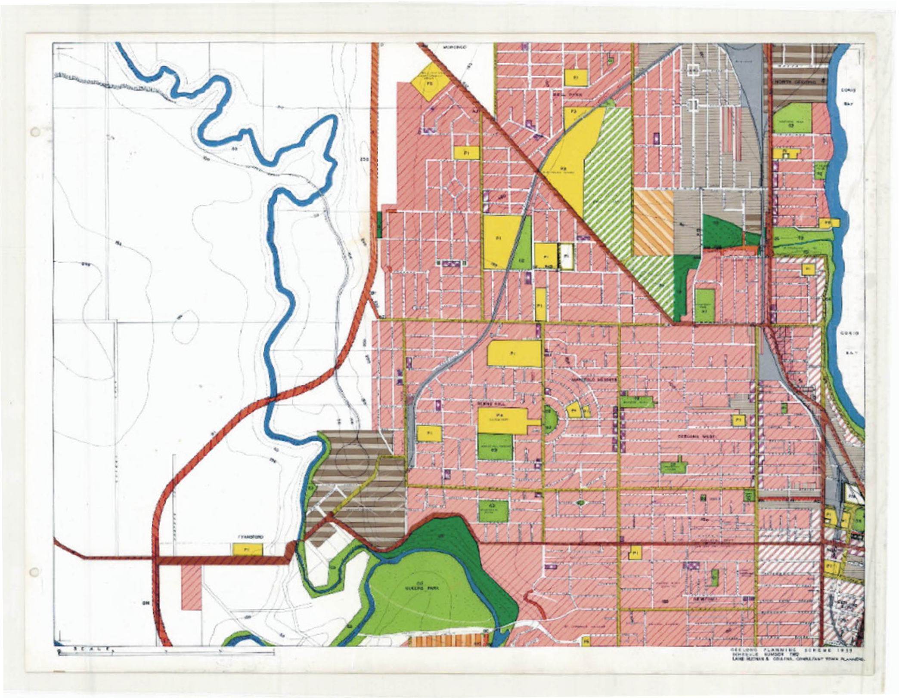
Figure 7.97: Laird Buchan & Collins, Consultant Town Planners, Geelong Planning Scheme Schedule Two, 1959, showing portions of Geelong City, Newtown, North Geelong & Rippleside, Herne Hill, Manifold Heights, Geelong West & Bell Park. Source: Strategic Planning Department, City of Greater Geelong.

Further major changes to town planning legislation came in 1987 when the Town and Country Planning Act 1961 was replaced with the Planning and Environment Act 1987.928
It came into operation on 16 February 1988.929 In July 2000, the new format Planning Scheme was gazetted for managing town planning in the City of Greater Geelong, following standard Victoria Planning Provisions and as well as objectives and policies specific to the local area.
From the fledgling beginnings of street planting programs from 1917, in 2018 the City of Greater Geelong undertook, coordinated and managed the delivery of key strategic planning projects in addition to its legislative responsibilities in statutory planning. Projects in 2018 included a hospital precinct plan, Pakington Street Urban Design Framework, Retail Strategy, Avalon Corridor Strategy, Settlement Strategy, Highton Urban Design Framework, Northern and Western Growth Areas and Environmentally Sustainable Design.930

ENDNOTES

- L. Lane, ‘The Inhabitants of Terra Nullius’, Investigator: Magazine of the Geelong Historical Society, vol. 29, no. 4, December 1994, p.141.
- Ibid.
- L. Lane, ‘Bunjil: Dowang: Un’, manuscript no. 35, 1991, p.6, Special Collections, Deakin University Library & L. Lane, ‘The Wathaurung: Geelong’s earliest inhabitants’, text of an address to the Geelong Historical Society, 22 March 1988, public reading room shelves, Geelong Heritage Centre collection (GHC).
- Geelong Advertiser & Intelligencer, 11 April 1842, p.2.
- Ibid.
- Geelong Advertiser, 25 April 1842, p.2.
- Geelong Advertiser, 11 September 1843, p.2.
- D. Rowe & W. Jacobs, ‘St. John’s Lutheran Church, Yarra Street’, Conservation Management Plan, prepared for St. John’s Lutheran Church, 2003, p.21.
- Geelong Advertiser, op.cit.
- Ibid.
- Melbourne Times, 24 October 1843, p.2.
- Richard Gilbert Talbot family tree, Ancestry online, at https://www.ancestry.com.au/
- R. Hill, ‘Talbot, Hon. Richard Gilbert (1810-1879)’, Geelong Biographical Register, Geelong Historical Society Inc.
- Geelong Advertiser, 9 January 1843, p.1.
- Killiney, Wikipedia online at https://en.wikipedia.org/wiki/Killiney
- All biographical details on Fenwick taken from D. Wight, ‘Fenwick, Nicholas Alexander (1806-1863), Geelong Biographical Register, op.cit.
- R. Hill, all biographical details on Fisher taken from ‘Fisher, David (1801- 1879), Geelong Biographical Register, op.cit.
- All biographical details on Austin taken from P.L. Brown, ‘Austin, James (1810-1896)’, Australian Dictionary of Biography, National Centre of Biography, Australian National University, http://adb.anu.edu.au/Biography/austin-james-1520/text1897, published first in hardcopy, 1966, accessed online July 2018.
- All biographical details on Haines taken from B. Malone, ‘Haines, William Clark (1810-1866)’, Australian Dictionary of Biography, op.cit., http://adb. anu.edu.au/Biography/hianes-william-clark-3688/text5769, published first in hardcopy, 1872, accessed online July 2018.
- ‘Old Swan Inn, 4 Hamilton Highway Fyansford’, Victorian Heritage Register, Victorian Heritage Database online at http://vhd.heritagecouncil.vic.gov.au/places/511
- W. Bate, ‘Were, Jonathan Binns (1809-1885)’, Australian Dictionary of Biography, National Centre of Biography, Australian National University, http://adb.anu.edu.au/Biography/were-jonathan-binns-2783/text3963, published first in hardcopy, 1967, accessed online July 2018 & D. Duncan &
H. Dwan, ‘Victoria before 1848’, online at http://www.oocities.org/vic1847/d/ d21.html?201822
- Port Phillip Herald, 8 October 1842 & 27 June 1843.
- Geelong Advertiser, 18 September 1843, p.3.
- W.R. Brownhill & I. Wynd, The History of Geelong and Corio Bay with postscript 1955-1990, The Geelong Advertiser, Geelong, 1990, p.40.
- Ibid. The court house was situated at the north-west corner of Yarra and McKillop Streets.
- Ibid.
- Geelong Advertiser, 24 April 1849, p.2.
- Ibid.
29 Ibid., 10 May 1849, p.1.
30 Ibid., 24 April 1849, p.2.
- Ibid., 13 October 1849, p.1.
- Ibid., 2 October 1849, p.2.
- Ibid.
- Ibid., 20 November 1849, p.2.
- Geelong Boundaries Act, no. 54, 4 June 1858, Parliament of Victoria, Melbourne.
- Geelong Advertiser, 9 February 1860, p.3.
- Ibid., 31 January 1866, p.2.
38 Ibid., 10 February 1866, p.2, 27 January 1869, p.3.
- Ibid., 16 January 1919, p.2.
- Brownhill & Wynd, op.cit., p.43.
- Geelong Advertiser, 27 February 1850, p.2.
- All biographical details on Thomson taken from I. Wynd, ‘Thomson, Alexander (1800-1866)’, Geelong Biographical Register, op.cit.
- Brown, op.cit.
- Biographical details taken from W. Lascelles, Walter Hobson Family Tree, Ancestry online, op.cit., The Argus 7 February 1850, p.2 & W.J. Morrow &
  - Wynd, Geelong Hotels and Their Licensees, Geelong Historical Society, 1996, p.23.
- All biographical details on Harding taken from R. Hill, ‘Harding, Silas (1918 or 1821-1894)’, Geelong Biographical Register, op.cit.
- Biographical details taken from ‘Robert Robinson (1812-1852), Re-member (Former Members) Database, Parliament of Victoria online at https://www. parliament.vic.gov.au/about/people-in-parliament/re-member/details/24/929 & The Argus 7 February 1850, p.2.
- Biographical details taken from C.J. Lloyd, ‘Richard Forrest Family Tree’, Ancestry online, op.cit., The Argus 7 February 1850, p.2, Geelong Advertiser 28 August 1849, 22 August 1850, 18 November 1851 & Geelong Advertiser & Intelligencer, 19 June 1854.
- Biographical details taken from A. Lloyd, ‘George Thomas Lloyd Family Tree’, Ancestry online, op.cit. & Geelong Advertiser, 23 March 1871.
- All biographical details on Cowie taken from I. Wynd, ‘Cowie, James (1809- 1892)’, Geelong Biographical Register, op.cit.
- Biographical details taken from P. Watts, ‘Henry William Nantes (Heinrich Wilhelm)’ Life Story and ‘Charles James Nantes’ Life Story, Ancestry, op.cit.,
M. Howard, ‘Nantes, Charles (1817-1877)’, Geelong Biographical Register, op.cit. & C.S. Walker (comp.), Earlier Days of Newtown and Chilwell, Henwood & Dancey, Geelong, 1958, p.11.
- Biographical details from Victorian Births, Deaths and Marriages (VDBMs) Indexes, Department of Justice online at https://online.justice.vic.gov.au/bdm/indexsearch.doj, Geelong Advertiser, 31 October 1842, 8 April 1844, 7 May 1850, 1 February 1850, 19 February 1851, 13 June 1853, 4 April 1854, 16 June 1855, 27 January 1873, The Star (Ballarat), 28 April 1857 & Ballarat Courier,
28 January 1873.
- All biographical information on Harrison taken from I. Wynd, ‘Harrison, James (1816-1893)’, Geelong Biographical Register, op.cit.
- R. Hill, Gray, William (1811-1891)’, Geelong Biographical Register, op.ci.
- City of Greater Geelong Annual Report 2017-18.
- See Geelong Advertiser, 15 January 1850, p.2.
- The Hobart Courier & Van Diemen s Land Gazette, 6 March 1840, p.4.
- Geelong Advertiser & Intelligencer, 21 July 1856, p.3.
- R. Lake, Queen Victoria Museum & Gallery, Launceston, Tasmania, historical research on William Weire, citing Tasmanian convict and Old Bailey records online, kindly provided by Mark Beasley, Geelong Heritage Centre.
- Ibid.
- Ibid.
- Weir, William, 6 April 1826, The Proceedings of the Old Bailey online at https://www.oldbaileyonline.org/browse.jsp?div=t18260406-85
- Weir, William, Convict Record, voyage nu. 50, Governor Ready, CON31/10/45, Libraries Tasmania online at https://talis.ent.sirsidynix.net.au/client/en_AU/names/search/ results?qu=william&qu=weir
- Lake, op.cit.
- Ibid.
- Ibid.

- St. John’s Parish, Launceston, Marriage Register, 11 June 1833, Libraries Tasmania online, op.cit.
- The 1842 Census entry also identified Weire as occupier and proprietor of a wood house in George Street, Launceston, and this was the same stated address for widower – William Weire, Accountant and Marianne Matilda Katherine Haggitt on the birth of then unnamed male son on 11 May 1846. See Libraries Tasmania online, op.cit., TAHO, RGD 33/1/23 no 1298.
- Port Phillip Patriot & Morning Advertiser, 11 December 1847, p.2.
- Geelong Advertiser, 12 March 1848, p.2.
- ‘Long-standing mystery solved’, News & Blog, Geelong Regional Libraries online at
http://www.grlc.vic.gov.au/news/long-standing-mystery-solv
- Geelong Advertiser, 18 August 1884.
- ‘Long-standing mystery solved’, op.cit. & Mark Beasley, op.cit.
- Geelong Advertiser, op.cit.
- VDBMs Indexes, op.cit.
- Melbourne Weekly Courier, 27 July 1844, p.2.
- Ibid., 2 November 1844, p.2.
- Geelong Advertiser, 31 January 1845.
- United Grand Lodge of England Membership Register, 1848, at Ancestry online, op.cit.
- Geelong Advertiser, 25 November 1848, p.2 & 13 September 1849, p.2.
- Ibid., 25 October 1849.
- L. Huddle, ‘Architects in Geelong 1840-1850s’, Humanities Research Report, School of Architect & Building, University of Melbourne, 1979, vol.1, p.11.
- G. Butler & Associates, ‘Geelong City Urban Conservation Study’, prepared for the City of Geelong, 1991.
- Geelong Advertiser, 24 May 1850, 29 November 1865 & 8 October 1864, p.2. Weekes was resident in Brisbane when he purchased ‘Chevy’.
- United Grand Lodge Membership Register, op.cit. & Geelong Advertiser, 24 July 1849 & 13 April 1869.
86 Ibid., 29 August 1885, p.2.
- VBDMs Indexes online, op.cit.
- Hobart Town Courier, 16 October 1835, p.1.
- Geelong Advertiser, 24 June 1848, p.2.
- Cornwall Chronicle (Tasmania), 1 May 1850, p.276.
- Geelong Advertiser, 11 November 1850, p.1.
- Geelong Advertiser & Intelligencer, 20 October 1852, p.1, 28 October 1852, p.1.
- The Age, 19 December 1860, p.7 & Geelong Advertiser, 7 January 1869, p.2.
- The Argus, 29 May 1873, p.4.
- Ibid., 27 February 1850, p.2.
- See Crowly, Daniel, Arrivals, Libraries Tasmania online, op.cit & Hobart Town Courier, 5 January 1838, p.2.
- See Van Diemen’s Land Census for 1843, Libraries Tasmania online, op.cit.
- The Melbourne Daily, 2 September 1850, p.1 & 11 September 1850, p.3.
- Electoral Roll for the Evelyn District, 1856, Ancestry online, op.cit.
- The Argus, 28 July 1854, p.4.
- VBDMS Indexes, op.cit.
- Geelong Advertiser, 10 May 1849, p.2.
- Ibid., 27 February 1850, p.2.
- Ibid. & Geelong Town Council Rate Book, entry 207, 1850, GHC.
- Geelong Advertiser, 3 April 1851, p.2 & Geelong Advertiser & Intelligencer, 12 April 1854, p.4.
106 Ibid., 16 March 1854, p.4.
107 Ibid.
108 Ibid., 12 April 1854, p.4.
109 Ibid., 22 March 1855, p.2.

110 Ibid., 16 March 1854, p.4.
111 Ibid., 10 May 1854, p.4.
112 Ibid. & 10 August 1854, p.4.
113 Ibid.
114 Ibid., 13 December 1854, p.5 & 15 January 1855, p.3.
- Ibid., 23 February 1855, p.2.
- Ibid., 15 January 1855, p.3. 117 Ibid., 16 March 1855, p.3. 118 Ibid., 26 March 1855, p.2.
119 Ibid.
120 Ibid., 10 April 1855, p.2.
- Ibid., 12 September 1855, p.3.
- Ibid.
- Geelong Advertiser, 19 July 1861, p.2. 124 Ibid., 22 June 1864, p.2.
125 Ibid., 19 May 1915, p.2.
126 Ibid., 28 June 1915, p.2.
127 Ibid., 25 June 1912, p.3.
128 Ibid., 1 July 1915, p.4.
- Ibid., 4 December 1915, p.2.
- Ibid.
131 Ibid., 13 June 1917, p.2.
132 Ibid., 8 June 1917, p.4.
133 Ibid.
134 Ibid., 30 April 1917, p.3.
- The Age, 27 March 1935, p.16 & The Argus, 15 January 1938, p.10.
- N.D.H. Underhill, ‘Bowles, William Leslie (1885-1954)’, Australian Dictionary of Biography, National Centre of Biography, Australian National University, http://adb.anu.edu.au/Biography/bowles-william-leslie-5313/text8971, published first in hardcopy, 1979, accessed online July 2018.
- Biographical research notes kindly provided by Mrs Jennifer Bantow, Geelong.
- The Argus, 26 January 1938, p.14.
- City of Geelong Building Permit 1644/1978.
- City of Greater Geelong Building Permits 111/1997., 476/2007 & 3189/2017.
- Brownhill & Wynd, op.cit., p.44.
- The Herald, 30 November 1927, p.1 & 25 February 1937, p.4.
- Geelong Advertiser, 19 July 1861, p.2.
- Geelong Advertiser, 29 July 1911, p.9.
- ‘Geelong: Heraldry of the World, Civic Heraldry of Australia’ online at http://www.ngw.nl/heraldrywiki/index.php?title=Geelong
- Geelong (Town) 1849-1910; City (1910-1993), Agency VA 2431, Public Record Office Victoria (PROV) & The Argus, 15 August 1939, p.3.
- G. Seaton, Model Borough: an introduction to old Newtown and Chilwell,
City of Newtown, Newtown, 1983, p.105.
- Geelong Advertiser, 20 November 1849, p.2.
- ‘Local government in Victoria’, Wikipedia online at https://en.wikipedia.org/wiki/Local_government_in_Victoria & Ballarat Star, 22 November 1862, p.3.
- Victoria Government Gazette, 28 December 1853, p.2018.
- Ibid.
- Ibid.
- Geelong Advertiser & Intelligencer, 16 March 1854, p.4.
- The Argus, 17 March 1854, p.5.
- Ibid.
- Victoria Government Gazette, 13 June 1865, p.1314.
- I. Wynd, Barrabool: Land of the Magpie, Barrabool Shire, Torquay, 1992, p.234.

- Biographical details taken from Wynd, op.cit., p.212 & ‘John Rout Hopkins’, at Re-member Database online, op.cit.
- Westminster Assisted Passenger List, 1841, PROV.
- The Age, 28 December 1911, p.5.
- Biographical details taken from VBDMs Indexes, op.cit., Wynd, op.cit., pp.207-208, & Geelong Advertiser, 1 August 1873, p.3 & 7 October 1874, p.3.
- Biographical details taken from ‘Thomas Smale Family Tree’ at Ancestry, op.cit., England Census, Stock Demerel, Devon, 1851, Ancestry online, op.cit., Electoral Roll, Mt Moriac Subdistrict, South Grant District, 1856, Ancestry, op.cit. & Wynd, op.cit., p.223.
- Geelong Advertiser, 25 May 1883, p.3.
- Biographical details taken from T. Dowling, ‘Andrew Thomas Moran Family Tree’, Ancestry, op. cit., E.B. Gregory, M.L. Gregory & W.L. Koenig, Coast to Country: Winchelsea, A History of the Shire, Shire of Winchelsea in conjunction with Hargreen Publishing Company, North Melbourne, 1984, p.234, Geelong Advertiser, 2 August 1867, p.3, The Age 15 July 1863, p.7 & Wynd, op.cit., p.218.
- Harpley, Assisted & Unassisted Passenger List, 17 July 1853, PROV at Ancestry, op.cit.
- Hamilton Spectator, 15 October 1898, p.2.
- Biographical details taken from ‘Joseph Gundry Family Tree’, Ancestry, op.cit. & Wynd, op.cit., p.219.
- Wynd, op.cit., p.219.
- ‘Richard Heath (1809-1888), Australian Medical Pioneers Index online at http://www.medicalpioneers.com/cgi-bin/index.cgi?detail=1&id=124
- Wynd, op.cit., p.208.
- Geelong Advertiser, 20 November 1897, p.6.
- D. Rowe, ‘Architecture of Geelong 1860-1900’, B. Arch. Thesis, School of Architecture & Building, Deakin University, 1991, p.19 & Geelong Advertiser, 1 November 1899, p.1.
- Wynd, op.cit., p.1256. 174 Ibid., pp.125-136.
- Geelong Advertiser, 3 June 1862, p.2.
- Wynd, op.cit., p.126.
- Geelong Advertiser, 29 August 1865, p.3.
- Wynd, op.cit., p.195.
- Ibid.
- Ibid.
- Ibid.
- Ibid.
- Ibid.
- Victoria Government Gazette, 10 October 1856, p.1702.
- Geelong Advertiser & Intelligencer, 27 June 1862, p.2.
- Ibid.
- J. Pescott, South Barwon 1857-1985, City of South Barwon, Belmont, 1985, p.19.
- The Age, 21 January 1857, p.4.
- Victoria Government Gazette, 2 June 1857, p.972.
- Pescott, op.cit., pp.16-17.
191 Ibid., p.19.
- Geelong Advertiser, 20 December 1864, p.2.
- Ibid.
- Ibid., 21 January 1875, p.3.

- Biographical details taken from A. Sutherland, Victoria & Its Metropolis Past and Present, McCarron Bird & Co., Melbourne, 1888, vol. 2, p.153, Electoral Roll, Ashby District of Geelong, 1856, Ancestry, op.cit., P.L. Brown, ‘Belcher, George Frederick (1823-1909)’, Australian Dictionary of Biography, National Centre of Biography, Australian National University, http://adb.anu. edu.au/Biography/belcher-george-frederick-2966/text4319, published first in hardcopy, 1969, accessed online July 2018, Pescott, op.cit., pp.195-197 & The Argus, 5 May 1892, p.6.
- Biographical details taken from VBDMs Indexes, op.cit., Larpent, Assisted & Unassisted Passenger List, 1849, PROV at Ancestry, op.cit., Electoral Roll, Geelong District, 1856, Ancestry, op.cit., Geelong Advertiser, 6 November 1867, p.3, 14 July 1873, p.4, 15 September 1874, 28 September 1874, 9 August 1882, p.2 & 24 May 1900, p.1, Leader, 23 December 1871, p.13, C. Mawson, ‘Thomas Adcock Family Tree’, Ancestry, op.cit., M.L. Stainsby, Steadfast through change: a history of the Wesleyan-Methodist-Uniting Church in Highton 1853 to 2006, St. Luke’s Uniting Church, Highton, 2008,
p.19 & G. Jones, Growing Together: A gardening history extending to Colac and Camperdown, George Samuel Jones, Belmont, 1984, p.287 & Pescott, op.cit., pp.195-197..
- Biographical details taken from VBDMs Indexes, op.cit., Electoral Roll, Ashby, Geelong District, 1856, Ancestry, op.cit., Geelong Advertiser 13 July 1860, p.1, 28 March 1867, p.3, 15 August 1874, p.3 & 26 March 1875, The Age, 17 November 1870, p.3, Ballarat Star, 6 March 1879, p.2 & Pescott, op.cit.
- Biographical details taken from J. Anderson, ‘John Peake Foster Family Tree’, Ancestry, op.cit., England Census, Mile End Old Town Lower, Middlesex, 1851 & Marriage Register, Ancestry, op.cit., Lady Flora Passengers in History online, South Australian Maritime Museum at http:// passengersinhistory.sa.gov.au/node/946656, ‘Rillwater Family Tree’, Ancestry, op.cit., Geelong Advertiser & Intelligencer 10 June 1854, p.3, Geelong Advertiser 20 June 1859, p.2, 13 May 1867, p.3, 6 December 1882, p.3, South Barwon Rate Book, 1864, GHC & Pescott, op.cit., p.196.
- Biographical details taken from P. Mouritz, ‘James Noble Family Tree’, Ancestry, op.cit., Ferguson Assisted & Unassisted Passenger List, 1841, PROV on Ancestry, op.cit., St. Andrew’s Presbyterian Church Marriage Register, GHC, Conewarre Parish Record Sheet 2421, Landata online at https://www.landata.vic.gov.au/, Geelong Advertiser, 30 November 1843, p.2, 15 April 1844, p.2, 18 November 1885, p.2 & 10 May 1897, p.2, Geelong Advertiser & Intelligencer, 24 July 1855, & Pescott, op.cit., p.130 & 150.
- Biographical details taken from VBDMs Indexes, op.cit., St. Andrew’s Marriage Register, op.cit., Pescott, op.cit., p.197, B. Latter, Breaker s Ahead Wreck of the Earl of Charlemont, Brian Latter, Leopold, 2002, 70 & 74. Latter states that Ewing and Agnes Blyth ‘spent all their lives in Lake Road on the banks of the Barwon River’ although the Probate Administration files for Ewing Blyth in 1925 listed his real estate as Lot E, Section 10, Parish of Connewarre, which equates with the address given. See Blyth, E., Probate Administration files, 1925, VPRS 28/P3
Unit 1555 PROV.
- Biographical details taken from VBDMs Indexes, op.cit., Pescott, op.cit., Geelong Advertiser, 24 June 1873, p.3, 17 may 1887, p.3, 29 September 1897, 11 April 1898, p.4, 29 April 1911, p.4, Leader, 3 June 1899, p.16. Thomas and Durran architects called tenders for ‘the erection of additions and building tan pits at tannery, Marshalltown for G. Gardiners, Esq.,’ in October 1895 – see Geelong Advertiser 11 October 1895, p.4.
- Biographical details taken from VBDMs Indexes, op.cit., Pescott, op.cit., pp.196-197, Mobile Assisted & Unassisted Passenger List, 12 October 1852, PROV at Ancestry, op.cit., The Star (Ballarat), 19 July 1856, p.1, 18 May 1859 & 19 March 1866, Victoria Government Gazette, 23 September 1861, 4 February 1863, 19 September 1864, 5 September 1864, 14 December 1869, & Geelong Advertiser, 29 December 1868, p.2 & 14 May 1897, p.2.
- Ballarat Star, 19 March 1866, p.3.

- Biographical details taken from A. Benari Naturalisation Papers, series A712, National Archives of Australia (NAA) online, VBDMs Indexes, op.cit., Pescott, op.cit., pp.195-197. Benari and Stern sought a slater in 1855 in Moorabool street (see Geelong Advertiser & Intelligencer, 23 January 1855, p.4). See also Geelong Advertiser, 22 April 1869, Morrow & Wynd, op.cit., pp.26-27, J. Waghorn, Victorian Postmasters & Postmistresses 1837-1901,
J.F. Waghorn, Thomastown, 1987 & The Age 13 March 1855, p.7.
205 The birth date for Alfred Firmin is taken from his age given in the Unassisted Passenger List for the Windermere in 1852 – see PROV on Ancestry, op.cit. See also Electoral Rolls for the Mt Moriac and Queenscliff Divisions, 1856, Ancestry, op.cit., Geelong Advertiser & Intelligencer, 16 May 1856, p.3, Geelong Advertiser, 8 February 1876, 30 March 1876, & 22 November 1882,
p.2 (the latter gave Firmin’s address on the death of his wife, Elizabeth), Morrow & Wynd, op.cit, Electoral Registers, London, 1870-1889, England Census, London, 1911 & England & Wales Civil Registration Death Index, 1913, Mile End Old Town District, London, Ancestry, op.cit.
- Biographic details taken from C. Mackinnon, ‘William Batten Family Tree’, Ancestry, op.cit., ‘1891 Women Petitioners – Geelong & District’, Zades online at http://zades.com.au/gandd/index.php/geelong/people/gdwomen, Pescott, op.cit., pp.197-198, Geelong Advertiser & Intelligencer, 24 July 1855, p.2 & 30 July 1855, p.2, Electoral Roll for Connewarre, 1856, Ancestry, op.cit., Geelong Advertiser 14 April 1881, p.2, 7 August 1886, p.2, 22 September 1886, p.3 & 20 May 1896, p.3.
- John Matthews senior appears to have taken up farmland near the Waurn Ponds Creek (now Grovedale) as a John Matthews, farmer, was listed as owning freehold there in 1856 – see Electoral Roll 1856, Ancestry, op.cit. See also Geelong Advertiser, 4 March 1859, p.5, 24 May 1862, p.1, 2 May 1863, p.2, 3 October 1863, p.2, 7 January 1889, p.3, 4 March 1889, p.3, Matthews, John, Probate Administration files, 1892, VPRS 28/P0 Unit 629 PROV, South Barwon Rate Books, 1861-82 & 1862-63, GHC, Colac Herald, 24 May 1892, p.2. The Colac Herald claimed that John Matthews senior was an architect, but no corroborating evidence has been found – he was
listed as a merchant in the Passenger List for the Blackwall in 1855, PROV at Ancestry, op.cit.
- Biographical details taken from Geelong Advertiser, 29 December 1873, p.2, 7 October 1875, p.2, 23 June 1876, p.2, 14 May 1877, p.3, 17 September 1881, 23 April 1889, p.2, 3 April 1894, p.1, 7 February 1894, p.4, Wyalong Star & Temora & Barmedman Advertiser (NSW), 3 November 1899, p.2, Australian Town & Country Journal (Sydney), 20 March 1880, p.38, Wagga
Wagga Advertiser (NSW), 27 February 1886, p.3, Pescott, op.cit., p.132, 146, South Barwon Rate Book 1879, GHC & information kindly provided by John Stewart, Torquay, August 2018, descendant of the Stewart family, citing family history research and Old Law Title, Coneware, per M. of (Section 5) & Allotments B.C. & D, Section 8.
- Biographical information taken from Baptismal Register, Parish of St. John’s Launceston, 1820, Libraries Tasmania online, op.cit., Massingham Pioneer Photographic Board, GHC, G. Threlfall, ‘William Underwood’, Mount Duneed History Group, 25 Jan 2017 at
https://mdpa.weebly.com/blog/william-underwood, Geelong Corporation Rate Books, Barwon Ward, 1854, GHC, St. Andrew’s Marriage Register, op.cit., Electoral Roll, Queenscliff Division, 1856 at Ancestry, op.cit., Pescott, op.cit., p.197.
- Geelong Advertiser, 3 October 1891, p.2.
- Biographical information taken from A. Stewart Keys, ‘John Lowe Hobbs Family Tree’, Ancestry, op.cit., Lady Kennaway Assisted & Unassisted Passenger List, 1853, PROV on Ancestry, op.cit., VBDMs Indexes, op.cit., Electoral Roll, Mt Moriac Subdistrict, 1856, Ancestry, op.cit., Pescott, op.cit.,
p.197. The name of the property, Bixley Farm, was given in Hobbs’ death notice in the 12 August 1886, p.2.
- Biographical information taken from England Census, Liversidge, Yorkshire, 1861, Ancestry, op.cit., Great Britain Unassisted Immigrants Passenger
List, 1865, PROV, Sutherland, op.cit., p.363, Pescott, op.cit., p.196, Geelong Advertiser, 27 October 1875, p.4, Bairnsdale Advertiser & Tambo & Omeo Chronicle, 27 July 1882, p.2, 23 July 1889, p.2, 8 August 1889, p.2, 24
September 1889, p.4 5 August 1890, p.2, 7 August 1890, p.2, 9 April 1896,
  - & the Australasian, 7 July 1900, p.55.
- Biographical information taken from ‘John Richardson (1819-1876)’, Re- member Database, op.cit., VBDMs Indexes, op.cit., Electoral Roll, North Geelong Subdistrict, 1856, Ancestry, op.cit., Pescott, op.cit., p.199, Geelong

Advertiser, 13 March 1876, p.8, South Barwon Rate Books, 1857-58, GHC, Larpent Assisted & Unassisted Passenger List, 1849, PROV at Ancestry, op.cit., ‘Richardson Family Tree’, Ancestry, op.cit., Weekly Times 18 March 1876, p.2.
- Biographical information taken from, M. Clapham, ‘Robert Smith Tuffs Family Tree’, Ancestry, op.cit., England Census, Lambeth Church First, Lambeth, Surrey, England, 1851, Ancestry, op.cit., Maria Hay Assisted & Unassisted Passenger List, 1854, PROV at Ancestry, op.cit., Pescott, op.cit., pp.197-199, Rowe, op.cit., p.20 & Geelong Advertiser, 30 July 1890, p.4.
- Pescott, op.cit., p.15.
- ‘Court House, Police Quarters and Lock Up, South Barwon’, 1859, Crown Reserve Correspondence, VPRS 242/31 PROV.
- Geelong Advertiser, 5 May 1883, p.3. 218 Ibid., 29 April 1884, p.1.
219 Ibid., 7 July 1884, p.3.
- Ibid.
- Ibid., 4 February 1885, p.3.
- Ibid.
- D. Rowe & W. Jacobs, ‘Belmont Heritage Review’, prepared for the City of Greater Geelong, vol.3, August 2008.
- Ibid.
- Ibid.
- Ibid.
- Walker, op.cit., p.11.
- Ibid.
- Victoria Government Gazette, 9 March 1858, p.455.
- Walker, op.cit., p.12.
- The Age, 10 April 1858, p.6.
- Ibid.
- Biographical information taken from ‘James Stevens Paul Family Tree’, Ancestry, op.cit., England Census, Somerset, 1851, Ancestry, op.cit., Electoral Roll, Geelong District, 1856, Ancestry, op.cit., Seaton, op.cit., pp.121-122, Geelong Advertiser & Intelligencer, 26 November 1852, p. & Geelong Advertiser, 21 April 1860, p.2.
- Biographical information taken from VBDMs Indexes, op.cit., Fordham, William in Baptismal Register, London, 1821, Ancestry, op.cit. & Geelong Advertiser, 29 October 1877, p.3.
- Ibid.
- Biographical details taken from B. Dickson, ‘George Welch Headland Family Tree’, Ancestry, op.cit., Electoral Roll, Ashby, Geelong District, 1856, Ancestry, op.cit., Geelong Advertiser & Intelligencer 2 April 1856, The Star (Ballarat), 5 March 1862, p.2, Bacchus Marsh Express, 29 March 1873, p.3 & 31 January 1874, p.4 & The Telegraph (Brisbane),
4 June 1888.
- Biographical details taken from VBDMs Indexes, op.cit., Geelong Advertiser, 14 March 1842, p.3, 18 December 1843, p.1, 23 March 1947, p.4, 21 February 1866, p.3, 19 November 1869, p.3, 10 February 1869, p.3, 28 January 1870,
  - & Seaton, op.cit., p.122.
- Biographical information taken from VBDMs Indexes, op.cit., Ottillia Assisted & Unassisted Passenger List, 19 October 1852, PROV at Ancestry, op.cit., Seaton, op.cit., Electoral Rolls, Chilwell, Geelong Subdistrict, 1856, Ancestry, op.cit., Ballarat Star, 20 September 1890, 25 June 1891, p.2 & Geelong Advertiser, 27 July 1859, p.3.
- Biographical information taken from VBDMs Indexes, op.cit., Tasman
Assisted & Unassisted Passenger List, 1849 PROV at Ancestry, op.cit.
- Geelong Advertiser, 6 June 1911, p.3.
- ‘Daniel Sheerin Family Tree’, Ancestry, op.cit.
- Walmer Castle Assisted & Unassisted Passenger List, 1853, PROV at Ancestry, op.cit.
- Ibid.
- VBDMs Indexes, op.cit.
- Geelong Advertiser, 15 July 1859, p.3. 246 Ibid., 15 July 1859, p.3.

  - Huddle, op.cit., p.49.
  - England Census, Bristol, 1841, Ancestry, op.cit.
  - Immigration details, Edward Snell, 29 September 1849, Ancestry, op.cit.
  - R. Waust, ‘Mary Ann South Family Tree’, Ancestry, op.cit.
  - Huddle, op.cit.
  - Ibid.
  - Ibid.
  - Geelong Advertiser, 3 January 1862, p.2.
  - J. Scott ‘Whitfield Family Tree’, Ancestry, op.cit.
  - VBDMs Indexes, op.cit.
  - Electoral Roll, Ashby Subdistrict, Geelong district, 1856, Ancestry, op.cit.
  - Scott, op.cit.
  - Chronicle (Adelaide), 20 April 1907, p.31.
  - Walker, op.cit.
  - Geelong Advertiser, 14 September 1859, p.2 & 21 September 1859, p.2.
  - The Council had discussed the Public Works Committee’s recommendation for alteration to the new Council Chambers in November 1859. See Geelong Advertiser, 29 November 1859, p.2.
  - Walker, op.cit.
  - Geelong Advertiser, 29 November 1915, p.3.
  - Ibid., 9 December 1915, p.5.
  - Ibid., 23 December 1915, p.2.
  - Ibid., 14 December 1916, p.4.
  - M. Matthews, ‘Armytage House: A Conservation Plan’, School of Architecture & Building, Deakin University, 1995, p.35.
  - R. Peterson with Context Pty Ltd, ‘Newtown Urban Conservation Study’, prepared for the City of Newtown, 1991, pp.1187-2003.
  - Matthews, op.cit., pp.33-35.
  - Ibid.
272 Ibid., p.35.
273 Ibid., p.33.
274 Ibid., p.36.
275 Victoria Government Gazette, 16 March 1853, p.393. 276 Ibid., 14 December 1853, p.1925.
277 Ibid., pp.1925-1926.
- Geelong Advertiser & Intelligencer, 23 June 1854, p.5.
- Wynd, Balla-wein: A history of the Shire of Bellarine to 1993, 2nd edn., Bellarine On-Line for the Bellarine Historical Society, Drysdale,
2005, p.30.
- Mary Catherine Rogers (1872-1874) has been claimed as the first women Councillor in Victoria, being elected to the Richmond City Council in 1920, and second female councillor in Australia after Susan Benny (1872-1944). See C. Cunneen & K. Torney, ‘Rogers, Mary Catherine (1872-1932)’ Australian Dictionary of Biography, National Centre of Biography, Australian National University,
http://adb.anu.edu.au/Biography/rogers-mary-catherine-13173/text23845, published first in hardcopy, 2005, accessed online July 2018 & S. Edgar, ‘Benny, Susan Grace (1872-1932)’, Australian Dictionary of Biography, National Centre of Biography, Australian National University, http://adb. anu.edu.au/Biography/benny=-susan-grace-5213/text8775, published first in hardcopy, 1979, accessed online July 2018. Yet, Caroline Newcomb was elected to serve the Portarlington Road District almost 50 years earlier. As stated by W.H. Archer in The Progress of Victoria: A Statistical Essay, Intercolonial Exhibition Essays, 1886, Blundel & Co., Melbourne, 1867, p.61, ‘there are two modes of local self-government existing in Victoria, both of which are legalised and regulated by Acts of Parliament – the one by municipalities or boroughs, the other by shires or road districts. The
Portarlington Road Board was a regulated form of early local government in Victoria. The claim that Newcomb was possibly the earliest elected female in local government in Victoria is also supported in B. Roberts, A Black Apron View of History: Anne Drysdale & Caroline Newcomb, Victoria ‘lady squatters’ in La Trobeana: Journal of the C.J. La Trobe Society Inc., vol.9, no. 3, November 2010, p.6.

- R. Hill, ‘Newcomb, Caroline Elizabeth (1812-1874)’, Geelong Biographical Register, op.cit.
- Ibid.
- Ballarat Star, 10 October 1874, p.4.
- Ibid., Roberts, op.cit., Hill, op.cit.
- Hill, op.cit. & Wynd, op.cit., p.14. 286 Ibid., pp.14-15.
- Roberts, op.cit., p.5.
- Ibid., p.6.
- Ballarat Star, 10 October 1874, po.4.
- Wynd, op.cit., p.31.
291 Ibid., p.37.
- Victoria Government Gazette, 6 November 1860, p.2110.
- Wynd, op.cit.
- Ibid.
- Victoria Government Gazette, 26 September 1865, p.2194.
- Wynd, op.cit., p.191.
- All biographical information taken from R. Hill, ‘Campbell, Archibald McArthur (1817-1897)’, Geelong Biographical Register, op.cit.
- Biographical information taken from Limerick Chronicle, 6 March 1838, typescript by K. Carroll, John Bourke Story’, Ancestry, op.cit., John Bourke, Marriage Register, 1845, Libraries Tasmania online, op.cit., Bourke, John, Convict Muster, 1846, NSW Public Record Office at Ancestry, op.cit., Augusta Jessie Convict List, 1840, NSW PRO, Ancestry, op.cit, Electoral Roll, Queenscliff Division, 1856, Ancestry, op.cit. & Geelong Advertiser 8 July 1875.
- Ibid.
- Ovens & Murray Advertiser, 4 August 1900.
- Biographical information taken from VBDMs Indexes, op.cit., St. Pauls Anglican Circuit, Drysdale, Baptismal Register, GHC, Wynd, op.cit., p.200, Geelong Advertiser, 23 July 1862, 23 April 1963, 16 April 1891 & 25 May 1891.
- Biographical information taken from VBDMs Indexes, op.cit., Victoria Government Gazette, 15 November 1878, p.2893, & Electoral Roll, Queenscliff Division, 1856, Ancestry, op.cit.
- Geelong Advertiser, 10 September 1879, p.2.
- A. McHugh, ‘Gange Family Tree’, Ancestry, op.cit.
- J. Chambers, Wiltshire Machine Breakers, J. Chambers, Letchworth, England, vol.2, c.1993.
- ‘Swing Riots’, Wikipedia online at https://en.wikipedia.org/wiki/Swing_Riots & B.W. Brown, ‘The Machine
Breaker Convicts from the Proteus and The Eliza,’ M.A. Thesis, University of Tasmania, April 2004.
- Ibid.
- Eliza Convict Records, 831 at https://convictrecords.com.au/convicts/gange/thomas/113961
- The Hobart Courier, 5 June 1835, p.4, Marriage Petitions, 1835, Libraries Tasmania online, op.cit.
- Parish of St. John’s, Launceston, Tasmania, Baptismal Register, 29 September 1838, Libraries Tasmania, op.cit.
- Bellarine Historical Society Family files & The first reference to Garrangill in the Geelong Advertiser & Intelligencer was 28 September 1852, p.1.
- Bellarine Historical Society Family files.
- Geelong Advertiser, 3 June 1868, p.8 & see Theme 8.
- ‘Alexander Hood’ in Geneagraphie – Families all over the world online at http://geneagraphie.com/getperson.php?personID=I456249&tree=1.
- Wynd, op.cit., p.173. 316 Ibid., p.173 & 196.
- Will of Alexander Hood, 29 June 1888, VPRS 7591 P2/137, Public Record Office Victoria.
- Biographical information taken from VBDMs Indexes, op.cit., Garrow

Assisted Passenger List, 1839, NSW PRO at Ancestry, op.cit., Wynd, op.cit., p.196, 197, Electoral Roll, Barwon Division, Geelong District, 1856, Ancestry, op.cit. The Geelong Advertiser, 4 September 1851, did not list Matthews in the List of Electors, but he was identified in seeking a rate reduction in the Geelong Advertiser & Intelligencer, 16 February 1853, p.1. See also Geelong Advertiser, 12 September 1896.
- Biographical information taken from VBDMs Indexes, op.cit., England & Wales Civil Registration Marriage Index, December 1837, Ancestry, op.cit., Electoral Roll, Queenscliff District, 1856, Ancestry, op.cit., Wynd, op.cit.,
p.177 & Geelong Advertiser, 21 February 1870.
- Biographical information taken from NSW & Tasmania Convict Musters 1806-1846 at Ancestry, op.cit., St. John’s Parish, Launceston, Marriage Register, 1827, Libraries Tasmania, op.cit., VBDMs Indexes, op.cit., Western District Families at
https://westerndistrictfamilies.com/tag/wiggins, Geelong Advertiser & Intelligencer, 6 December 1854, p.5 & Camperdown Chronicle, 19 September 1918.
- Geelong Advertiser, 25 April 1859, p.2.
- Wynd, op.cit, p.123.
- Ibid. Wynd stated that the room, 12 x 12 feet and built of brick, to accommodate the new safe’ was erected, but the Geelong Advertiser, 12 June 1868, p.3, reported on the tender not being accepted.
- Geelong Advertiser, 5 October 1865, p.2.
- Ibid., 5 August 1880, p.3.
- Ibid., 4 August 1879, p.3.
- Ibid., 5 August 1880, p.3.
- Ibid., 28 October 1880, p.2.
- Wynd, op.cit., p.162.
- Ibid.
331 Ibid., p.161.
332 Ibid., p.162.
- Ibid.
- Ibid.
- L. Willey, The waterholes: a history of Drysdale on the Bellarine, Bellarine Historical Society, Drysdale, 2010.
- P.M. Griffiths, Three Times Blest: A History of Buninyong and District 1837- 1901, Buninyong & District Historical Society, Buninyong,
1988, p.40.
337 Ibid., p.42.
- I. Wynd, So Fine A Country: A History of the Shire of Corio, Shire of Corio, 1981, p.55.
- Ibid.
- Ibid.
341 Ibid., pp.56-57.
342 Ibid., p.57.
343 Ibid.
344 Ibid., p.58.
345 Ibid.
346 Ibid., p.272.
- Ibid.
- Victoria Government Gazette, 21 June 1864, pp.1339-1340.
- Ibid., 2 September 1863, p.1944.
- Wynd, So Fine A Country, op.cit., p.273.
351 Ibid., p.61.
352 Ibid., pp.61-63.
- The matter of first president required the deliberation of the Attorney General. See Wynd, So Fine A Country, op.cit., p.61.
- Biographical information taken from VBDMs Indexes, op.cit.,
- Electoral Roll, Geelong Division, 1856, Ancestry, op.cit., Geelong Advertiser, 29 April 1881, p.2 & 14 July 1896, p.2.
- Ibid.

- Biographical information taken from VBDMs Indexes, op.cit., Andromache Assisted Passenger List, 24 December 1859, PROV at Ancestry, op.cit., Wynd, So Fine A Country, op.cit., p.273, Geelong Advertiser 29 February 1860, p.2, 14 November 1868, p.2 &
23 May 1868, p.3.
- Biographical information taken from Mahomed Schah Assisted & Unassisted Passenger List, 5 July 1858, PROV at Ancestry, op.cit., VBDMs Indexes, op.cit., Electoral Roll, Ashby Division, Geelong District, 1856, Ancestry, op.cit., Australian Workman (Sydney),
21 February 1891, p.2.
- Biographical information taken from VBDMs Indexes, op.cit., James Brown Assisted & Unassisted Passenger List, 1853, PROV at Ancestry, op.cit., Electoral Roll, Little River, 1856, Ancestry, op.cit., Geelong Advertiser, 21 April 1859, p.26, 26 February 1862, p.2, 21 July 1862, August 1877, p.3 & Wynd, So Fine A Country, op.cit., p.273.
- D. Rowe & W. Jacobs, ‘Lara Heritage Review’, vols. 2 & 3, prepared for the City of Greater Geelong, August 2013 (revised May 2016).
- Ibid.
- Biographical information taken from VBDMs Indexes, op.cit., C. Williams, ‘Francis Beech’, Geelong Advertiser Reports, manuscript, GHC, Geelong Advertiser, 24 January 1884, p.3 & Wynd, So Fine A Country,
op.cit., p.273.
- Information taken from M. Howard, ‘Coverdale, Richard (1810-1837)’, Geelong Biographical Register, op.cit.
- Geelong Advertiser, 31 May 1897.
- Bacchus Marsh Express, 21 September 1907 & ‘Blair, David’, Re-Member Database online, Parliament of Victoria at http://www.parliament.vic.gov.au/re-member/bioregfull.cfm?mid=229.
- M. Budd, C. Delaney, J. Grainger (eds.), From Duck Ponds to Lara: A Collection of Memories, Lara Heritage Festival Inc., Lara, 2004, p.30.
- Ibid.
- Ibid.
- Ibid.
- Ibid.
- Ibid.
- Bacchus Marsh Express, 25 April 1896.
- Ibid., 21 September 1907.
- Wynd, op.cit., p.59.
- Bacchus Marsh Express, op.cit. 376 Ibid., p.273.
- ‘Daniel Knight Goodall Family Tree’, Ancestry, op.cit.
- London, England, Marriages and Banns, 25 July 1824, Ancestry, op.cit.
- Ibid.
- G. Sefton published a noticed in the Geelong Advertiser & Intelligencer, 20 October 1852, p.2, about Daniel Goodall, Chilwell, not paying for the land and that if payment was not made the land would be sold.
- Geelong Advertiser & Intelligencer, 27 May 1856, p.3.
- Geelong Advertiser, 19 February 1862, p.2.
383 Ibid., 6 May 1863, p.3 & 16 September 1863, p.3.
- Wynd, So Fine A Country, op.cit., p.273.
- VBDMs Indexes, op.cit.
- Wynd, So Fine A Country, op.cit., p.57.
- A. Willingham, Geelong Region Historic Buildings and Objects Study, Geelong Regional Commission, Geelong, 1986, vol.1, sheet 133.
- See D. Rowe, ‘Lara Heritage Review Thematic History’, vol.2, prepared for the City of Greater Geelong, August 2013 (revised May 2016).
- Ibid. & Laird and Buchan Architects Contractors’ Book, 1907-1911, GRS 210, GHC.
- Wynd, So Fine A Country, op.cit., p.227.
- Laird and Buchan Architects Contactors’ Book, op.cit.
- Wynd, op.cit & Lovell Chen, ‘Osborne House and Stables, North Geelong, Victoria, Conservation Management Plan’, prepared for the City of Greater

Geelong, September 2009, p.10.
- Wynd, op.cit., p.228.
- Ibid.
- The Herald, 13 July 1940, p.5.
- Wynd, op.cit., p.227.
- Ibid.
- Lovell Chen, op.cit.
- Ibid.
- Wynd, op.cit
- Lovell Chen, op.cit.
- L. Keavy, ‘Formation of the Borough of Geelong West’, Investigator, vol.5, no.3, August 1970, pp.191-192.
403 Ibid., p.195.
404 Ibid., pp.195-196.
- Brownhill & Wynd, op.cit., pp.106-107.
- Victoria Government Gazette, 10 April 1861, p.741.
- Geelong Advertiser, 20 August 1861, p.2.
- Souvenir Geelong West: Proclaimed a Town, 22 March 1922, Town of Geelong West booklet.
- Victoria Government Gazette, 29 may 1875, p.1077. 410 Ibid., pp.1077-1078.
411 Ibid.
412 Ibid., 22 March 1922, p.838.
413 Souvenir Geelong West, op.cit.
414 Victoria Government Gazette, 27 February 1929, p.932. 415 Ibid. & 17 April 1929, p.1281.
416 Ibid., 29 May 1875, p.1078.
- G. Seaton, The Ashby Story: a history of Geelong West, Geelong West City Council, Geelong West, 1978, pp. 242-244.
- Biographical information taken from VBDMs Indexes, op.cit., England Census, Parish of Bridgewater, 1851, Ancestry, op.cit., Geelong Advertiser 30 January 1854, p.5, 21 September 1877, 28 March 1887, p.3, The Argus, 8 January 1867, p.5, 19 August 1879 & Borough of Queenscliffe History of Council online at
http://www.queenscliffe.vic.gov.au/council/your-council/history-of-council
- Biographical information taken from VBDMs Indexes, op.cit., M.A. Gunn, ‘Amiet Family Tree’, Ancestry, op.cit., E. Kranjc & L. Phelan (eds.), The Geelong Swiss: a record of some 19th century families, Geelong Family History Group, 2010, Sutherland, op.cit., p.152, Geelong Advertiser, 17 & 18 May 1888, 8 June 1891, p.3, 7 October 1891, p.3, Seaton, The Ashby Story, op.cit., p.242 & Electoral Register, Lambeth, London, England, 1919 Ancestry, op.cit.
- Biographical information taken from Joshua Assisted Passenger List, 1854, PROV, Seaton, The Ashby Story, op.cit., p.242, 244, Geelong Advertiser, 23 February 1859, p.2, 3 May 1860, p.3, 3 November 1862, p.2 & 5 July 1887, Herald, 23 February 1861, p.7, Steven’s Geelong & Western District Directory 1866-67 & J. Bantow & R. Lewis, Barro-abil, Our Beautiful Barrabool Stone: History and Use of Barrabool Sandstone, Jennifer Bantow & Ros Lewis, Geelong, 2017, p.447.
- Biographical information taken from Electoral Roll, Geelong District, 1856, Ancestry, op.cit., Seaton, The Ashby Story, op.cit., p.65, 242, Victoria Police Gazette, 14 February 1871, p.41, Geelong Advertiser, 13 April 1871, p.2, 22 July 1871, p.2, 23 July 1877, p.2, 3 April 1878, 9 August 1881, Robertson Advocate (NSWS), 6 October 1905, p.2 & Buckland Insolvency Papers, VPRS 815/P0 Unit 111 PROV.

- Biographical information taken from VBDMs Indexes, op.cit., ‘William Clifford Doery Family Tree’, Ancestry, op.cit., Albatross Unassisted Passengers List, 1854, PROV, Seaton, The Ashby Story, op.cit., p.98, 243,
D. Rowe, ‘Pakington Street Urban Design Framework Heritage Report, draft, 2018, Geelong Advertiser, 13 January 1863, p.3, 16 February 1885, 29 January 1889 & 21 February 1889 & Weekly Times, 29 July 1905, p.19.
- Biographical information taken from Young America Assisted & Unassisted Passenger List, 1853 & Lady Kennaway Assisted & Unassisted Passenger List, 1853, PROV at Ancestry, op.cit., Hall, George, Teacher Records No. 2916, VPRS 13579/1, PROV, S. Costello, Schools of Geelong & District, Geelong Family History Group, 2010 & Hall, G., Will, 1901, VPSR 7591/P2 Unit 316 PROV.
- Biographical information taken from Christ Church Marriage Register, GHC, Electoral Roll, Geelong District, Ashby Division, 1856, Ancestry, op.cit., The Age, 11 January 1886, po.6, Seaton, op.cit., pop.243-344 & Geelong Advertiser, 21 January 1871, p.3 & 13 January 1886, p.4.
- Biographical information taken from Christ Church Marriage Register, 1856, GHC, Sea Assisted & Unassisted Passenger List, 1849, Ancestry, op.cit., Electoral Roll, Geelong District, Ashby Division, 1856, Ancestry, op.cit., ‘John Ince’, Re-member Database online, op.cit., VBDMs Indexes, op.cit. & Geelong Advertiser, 13 July 1853, p.1 & 17 May 1897, p.2.
- Biographical information taken from ‘John Nixon Family Tree’, Ancestry, op.cit., Manchester, England, Church of England Marriages & Banns, 1836, Manchester Libraries at Ancestry, op.cit., Register of Births in the District of Oatlands, 1843, RGD33/1/28/no.228, & 1845, RGD33/1/2/no. 1346, Libraries Tasmania, op.cit., Seaton, op.cit., p.243, Electoral Roll, Geelong District, Ashby Division, 1856, Ancestry, op.cit., Geelong Advertiser, 2 November 1864, p.2, 27 January 1865, p.2 & 30 December 1891, p.2.
- Biographical information taken from St. Mary’s Marriage Register, 1 855, GHC, Morrow & Wynd, op.cit., Pescott, op.cit., p.243, 244,
Geelong Advertiser, 14 September 1877, p.2, 8 January 1880, 6 February
1901, p.2.
- Biographical information taken from B.L. McFarlane, ‘Edwin Hopton Family Tree’, Ancestry, op.cit., Sydenham Assisted & Unassisted Passenger List, 1857, PROV at Ancestry, op.cit., Seaton, op.cit., p.244, Rowe, ‘Pakington Street Urban Design Framework Heritage
Report’, op.cit.
- Geelong Advertiser, 21 July 1909, p.3.
- Biographical information taken from VBDMs Indexes, op.cit., ‘Thomas Morton Goodwin Family Tree’, Ancestry, op.cit., Electoral Roll, Windsor Division, 1856, Ancestry, op.cit., The Argus, 1 November 1860, p.5, 23 August 1889, p.1, Seaton, op.cit., p.244, Wynd, So Fine A Country, op.cit., p.273, Geelong Advertiser, 13 November 1877, 6 December 1877, p.2, Ballarat Star, 5 September 1885, p.4, Telegraph, St. Kilda, Prahran & South Yarra Guardian, 23 April 1881, p.3.
- Geelong Advertiser, 13 August 1867, p.2, 2 February 1876, p.2.
- Ibid.
433 Ibid., 21 April 1884, p.4.
434 Ibid., 19 May 1923, p.13.
- Ibid.
- D. Rowe, ‘Geelong West Town Hall & Surroundings Heritage Report’, prepared for the Geelong Ethnic Communities Council, Geelong West, August-September 2001.
- Ibid.
- Geelong Advertiser, 1 July 1910, p.3.
- ‘History of Council, City of Greater Geelong, at Geelong Australia online, https://www.geelongaustralia.com.au/council/article/item/8cbc3a413e4406f. aspx The number of Councils has increased to 79.
- Ibid.
- Ibid.
- Ibid.
- Ibid.
- See List of Mayors and Councillors, GHC.
- ‘History of Council’, op.cit.
- Ibid.

- Karreenga Aboriginal Action Plan 2014-2017, City of Greater Geelong, 2014.
- Ibid.
- ‘History of Council’, op.cit.
- Ibid.
- Ibid.
- Ibid.
- City of Greater Geelong Annual Report 2017-18. 454 Ibid., 2016-17, p.55.
455 Ibid., p.13.
- Brownhill & Wynd, op.cit., p.510.
- Geelong Advertiser, 18 November 1850, p.2.
- Ibid.
- Ibid., 16 November 1850, p.2. Cultural meaning was lost on the Europeans that attended the spectacle, as outlined in the Geelong Advertiser, 21 November 1850, p.2.
- Brownhill & Wynd, op.cit.
- Geelong Centenary Jubilee Celebrations Official Programme, Geelong, 1951.
- S. Zada, ‘Geelong Heritage Centre – in the beginning’, Geelong & District online, 1 April 2016 at
https://geelonganddistrict.com/2016/04/01/geelong-heritage-centre-in-the- beginning/
- Geelong Centenary Jubilee Celebrations, op.cit.
- Zada, op.cit.
- Ibid.
- Ibid.
- Ibid.
- Ibid.
- Investigator, vol. 15, no.1, 1980, p.2.
- Ibid., p.1.
- ‘Works Begin on $45 Million Geelong Library Site’, G21 Geelong Region Alliance online, 9 July 2013.
- The Argus, 27 August 1932, p.9.
- Ibid.
- P.L. Brown, ‘Fyans, Foster (1790-1870)’, Australian Dictionary of Biography, National Centre of Biography, Australian National University, http://adb.anu. edu.au/Biography/fyans-foster-2075/text2595, published first in hardcopy, 1966, accessed online July 2018.
- The Argus, op.cit.
- Brown, op.cit.
- Ibid.
- Ibid
- I. Wynd, ‘Fyans, Foster (1790-1870)’, Geelong Biographical Register, op.cit.
- Ibid.
- M. Cannon & I. MacFarlane, The Crown, The Land and the Squatter, Historical Records of Victoria Foundation Series, Melbourne University Press, Melbourne, vol.6, 1991, p.205.
- Ibid. & F. O’Neill, ‘Police Buildings in Victoria: A Survey of Building Types’, Building Services Agency, 1997, p.2.
- Cannon, et.al., op.cit.
- The Argus, op.cit.
- Cannon, et.al., op.cit., pp.207-208. 486 Ibid., p.212.
487 Ibid., p.217.

- W. Harington to Police Magistrate, Melbourne, 21 August 1839, VPRS 4/P0 Unit 7 PROV.
- South Australian Gazette & Colonial Register, 18 June 1836, p.6.
- Ibid.
- D. Thomson, Colonial Secretary’s Office, to C. La Trobe, Superintendent of Port Phillip, 4 October 1839, VPRS 19/P1 item 39/148 PROV.
- ‘Australian Native Police’, Wikipedia online at https://en.wikipedia.org/wiki/Australian_native_police
- D.F. Cahir, ‘The Wathawurrung People’s Encounters with Outside Forces 1797-1849: A History of Conciliation and Conflict’, M.A. Thesis, School of Behavioural & Social Sciences & Humanities, University of Ballarat, October 2001, p.86. See also F. Cahir, My Country All Gone, The White Men Have Stolen It: The Invasion of Wadawurrung Country 1800-1870, Australian History Matters, Ballarat, 2019, p.84.
- ‘Australian Native Police’, op.cit.
- Cahir, ‘The Wathawurrung People’s Encounters’, op.cit. & My Country All Gone, op.cit.
- Cahir, ‘The Wathawurrung People’s Encounters’, op.cit., p.87.
- Port Phillip Patriot, 16 September 1841.
- Ibid.
- ‘Wathaurong’, Wikipedia online at
https://en.wikipedia.org/wiki/Wathaurong and ‘R v Bonjon’, Wikipedia online, accessed August 2018, https://en.wikipedia.org/wiki/R_v_Bonjon
- See M. Cannon & I. MacFarlane, The Aborigines of Port Phillip 1835-1839, Historical Records of Victoria Foundation Series, Victorian Government Printing Office, Melbourne, vol.2A, 1982 & L. Arkley, ‘Sievwright, Charles Wightman (1800-1855)’, Australian Dictionary of Biography, National Centre of Biography, Australian National University, http://adb.anu.edu.au/ Biography/sievwright-charles-wightman-13194/text23887, published first in hardcopy, 2008, accessed online August 2018.
- M. Cannon & I. MacFarlane, The Aborigines and Protectors 1838-1839, Historical Records of Victoria Foundation Series, Victorian Government Printing Office, Melbourne, vol.2B, 1983, p.378.
- Cahir, op.cit., p.204.
- Cannon, et.al., The Aborigines of Port Phillip, op.cit., pp.240-241 & ‘Australian Native Police’, op.cit.
- See Cahir, op.cit., p.212 & Cannon, et.al., The Aborigines and Protectors, op.cit., p.496.
- Cahir, op.cit., p.213.
- Wynd, ‘Fyans, Foster (179-1870)’, op.cit.
- L. Lane (ed.), ‘History with some Echoes of a lost local language, Abeng: An Aboriginese-English Lexicon compiled 1970-1999 from Ethnographic Literature – Part, unpublished, supplied for use to the City of Greater Geelong by Lane in 2002, pp.9-10.
- F. Fyans to C. La Trobe, Geelong, 22 August 1853 in T.F. Bride (ed.), Letters from Victorian Pioneers: Being A Series of Papers on the Early Occupation of the Colony, the Aborigines, Etc., Trustees of the Public Library, Melbourne, 1897, p.121.
- Geelong Advertiser, 2 January 1841, p.2.
- S. Mossman, ‘Geelong in 1840’, Geelong Advertiser,
18 December 1879, p.3.
- Ibid., New South Wales Government Gazette, 30 October 1839, p.1210, 7 December 1839, p.1398 & G. Tibbits & A. Roennfeldt, Port Phillip Colonial 1801-1851: early government buildings and surveys in Victoria, George Tibbits, Clifton Hill, 1989, p.56.
- Approval of a second watch house was given by the Superintendent of Port Phillip, Charles La Trobe in January 1841, following a proposal by the Colonial Secretary, Sydney, on 27 December 1840. See Inward Registered Correspondence to Charles La Trobe, VPRS 19/1, item 40/103 PROV.
- Tibbits & Roennfeldt, op.cit., p.57. The original drawing of the watch house in Corio Street is given.
- Geelong Advertiser, 24 April 1841, p.4.
- H. Ginn, ‘South Geelong Gaol’, Ground Plan, Elevation & Section Drawings,
n.d. [c.1849] in Book of Plans by Clerk of Works, Henry Ginn, VPRS 4107/P1 Unit 1, PROV.

- New South Wales Government Gazette, 21 March 1849, p.223.
517 Ibid., 13 February 1850, p.148.
- Ibid., 1 January 1840, p.1.
- H.W.H. Smythe, Plan of the Town of Geelong, May 1838, VPRS 8168/P5, item FEAT 570: GEELONG TOWN, PROV. The plan is overwritten with the gazettal of the reservation in 1840.
- New South Wales Government Gazette, 5 January 1841, p.2.
- Port Phillip Gazette, 25 December 1841, p.3 & ‘Melbourne Mechanics Institute – 1st Committee of Management 1839’, Melbourne Athenaeum Inc. history website at http://www.mahistory.org.au/images/Website/pdf/earlyyears/firstcommittee_ lonsdale.pdf
- Victoria Government Gazette, 12 May 1852, p.475.
- Ibid.
- These appear to be the only buildings shown on J.H. Taylor’s Map of Geelong in 1854.
- Geelong Advertiser & Intelligencer, 11 January 1854, p.4.
- Victoria Police Inwards Registered Correspondence, Geelong Police District, 1854, VPRS 937/P0, item 212 Bundle 1 PROV at ‘Geelong District: Vic Police Inward Correspondence 1852-1894’ online, http://zades.com.au/gandd/index.php/databases/potpourri/ppindexes/258- ppgdpolice
- See A. McWilliams, ‘Geelong Police Quarters’ site plan, c.1859, Victoria Police Museum collection, Docklands, Melbourne.
- Ibid.& Victoria Police Contract Book, 1859, contract 59/78, VPRS 977, PROV.
- Geelong Advertiser, 17 March 1899, p.2.
530 Ibid., 8 January 1913, p.3, 18 August 1913, p.3.
531 Ibid., 12 June 1901, p.4, 4 March 1902, p.2.
- Ibid., 19 December 1903, p.2.
- New South Wales Government Gazette, 27 June 1849, p.449.
- Geelong Advertiser, 29 December 1849, p.2.
- Victoria Government Gazette, 16 June 1852, p.582, 28 July 1852, p.757.
- Geelong Advertiser & Intelligencer, 25 April 1854, p.4.
- J.V. Barry, ‘Price, John Giles (1808-1857), Australian Dictionary of Biography, National Centre of Biography, National Centre of Biography, Australian National University,
http://adb.anu.edu.au/Biography/price-john-giles-2563/text3497, published first in hardcopy 1967,accessed online 12 August 2016.
- RBA Architects & Conservation Consultants in association with B. Raworth, ‘Former H.M. Training Prison, Geelong’, Conservation Analysis & Management Plan, prepared for Heritage Victoria, April 1997, p.7.
- Parliament of Victoria, Report from the Select Committee upon Penal Discipline, together with the Proceedings of the Committee, Minutes of Evidence, and Appendices, 11 September 1857.
- W.B. Withers, ‘Ballarat Chronicles and Pictures’, in the Ballarat Star, 29 October 1888, p.3, claims that Forster sat on the commission ‘to enquire and report on the whole question of gaol construction, the outcome of which was the existing radiating prisons of the colony.’ The Parliamentary Report from the Select Committee, op.cit., has Forster’s surname misspelt at Foster. Given Withers’ claims, it is clear that the Mr Foster who was a member of the Select Committee was Charles Forster, Governor of the Ballarat Gaol, and not the Hon. John Fitzgerald Leslie Foster, M.L.A. for the Electorate of Williamstown from 1 November until 1 November 1857 (see ‘Re-member Database’, Parliament of Victoria online, August 2016).
- Report from the Select Committee, op.cit.
- Ibid.

- Barry, op.cit. Barry stated that ‘on 26 March 1857 he [Price] visited Williamstown to investigate complaints about rations by convicts from the hulks employed there on public works. While he was listening to some grievances a party of convicts gathered around him. Missiles were thrown and one struck him heavily; as he turned away he was knocked down and severely battered about the head and body. On the next afternoon he died from his injuries.’
- Star (Ballarat), 28 April 1857, p.3.
- J.V. Barry, ‘Champ, William Thomas Napier (1808-1892)’, Australian Dictionary of Biography, National Centre of Biography, National Centre of Biography, Australian National University, http://adb.anu.edu/Biography/champ-william-thomas-napier-3191/text4789, published first in hardcopy 1969, accessed online
12 August 2016.
- Ibid.
- J.S. Kerr, Out of Sight, Out of Mind: Australian Places of Confinement, 1788- 1988, S.H. Ervin Gallery, National Trust of Australia (N.S.W.),
1988, p.62.
- Kerr, op.cit., p.76.
- D. Rowe & W. Jacobs, ‘Federation University Australia – School of Mines Campus: Conservation Management Plan’, prepared for Federation, University Australia, Ballarat, May 2017.
- Ibid.
- ‘The County Gaol’, ‘Bedfordshire Archives Service catalogue online, reference QG.
- Smith had previously been the Surveyor at Hertfordshire. He was appointed by the Bedfordshire Magistrates after they had seen his gaol design at Hertford in 1848. See ‘Bedford’s Gaol Buildings: History of Bedford’s Gaol Buildings’ online, Bedford Borough Council online, http://www.bedfordshire.gov.uk/CommunityAndLiving/ ArchivesAndRecordOffice/GuidesToCollections/BedfordsGaolBuildings. aspx
- Rowe & Jacobs, op.cit.
- ‘Geelong Gaol’, Public Works Department Contract Summary Book, 1858- 1877, VPRS 972/P1 item 49, PROV & RBA Architects et.al., op.cit.
- Ibid.
- City of Greater Geelong Council Minutes, Section B: Reports, 10 June 2014.
- Ibid.
- Ibid.
- Geelong Advertiser, 23 August 2017.
560 Ibid., 24 July 2018.
- Ibid., 24 February 1851, p.2, The Argus, 29 July 1851 & ‘Our History: Supreme Court of Victoria’ online at https://www.supremecourt.vic.gov.au/our-history
- ‘Supreme Court of Victoria’, Wikipedia online at https://en.wikipedia.org/wiki/Supreme_Court_of_Victoria
- Justice Clyde Croft, Opening of the Legal Year – Geelong – 2011, p.5, online at
http://www5.austlii.edu.au/au/journals/VicJSchol/2011/1.pdf
- Geelong Advertiser, 9 November 1854, p.4.
- J. Fowler, ‘Gold Rush to “Black Wednesday”: The Melbourne Treasury and John James Clark’s Public Works Department Career from 1852 to 1878’,
M.A. Thesis, Department of Visual Arts, Monash University, vol.1, 1992,
p.45. See also A. Dodd, J.J. Clark Architect of the Australian Renaissance, New South Publishing, University of New South Wales Press Ltd, Sydney, 2012, p.28.
- Fowler, op.cit.
- The Age, 13 October 1856, p.6.
- Geelong Advertiser, 4 August 1905, p.1. 569 Ibid., 21 March 1924, p.2.
570 The Age, 27 November 1939.

- Ibid. & ‘Former Supreme Court Building’, Victorian Heritage Inventory no. H7721-0088, Victorian Heritage Database online at http://vhd.heritagecouncil.vic.gov.au/places/12703/download-report
- B. Trethowan, ‘The Public Works Department 1851-1900: An Architectural History in Two Volumes’, Research Report, vol.2, Appendix 3, Department of Architecture and Building, University of Melbourne, 1975, p.141.
- Geelong Advertiser, 27 May 1880, p.2.
- Trethowan, op.cit. See also ‘Police Station, 334-344 Drummond Street, Carlton’, Victorian Heritage Register H1543, Victorian Heritage Database online at http://vhd.heritagecouncil.vic.gov.au/places/215
- Geelong Advertiser, 21 December 1907, p.2. 576 Ibid., 20 April 1916, p.2.
577 Ibid., 7 February 1921, p.2.
578 Ibid., 4 March 1902, p.2. 579 Ibid., 4 May 1880, p.3.
580 Ibid.
581 Trethowan, op.cit., p.111, listed Brown’s initials as those on the original drawings.
582 Geelong Advertiser, 17 March 1882, p.2.
583 Ibid., 16 February 1883, p.3, 20 March 1883, p.3.
584 Ibid.
585 The Age, 12 September 1936, p.26.
586 Ibid., 16 February 1937, p.10. 587 Ibid., 20 June 1938, p.15. 588 Ibid., 11 May 1938, p.18.
589 Ibid., 31 May 1938, p.12.
590 Ibid. & 11 May 1938, p.18.
- See Theme 6.
- ‘Courthouse Youth Arts’ online at https://www.courthouse.org.au/about-us/
- ‘Lara, Victoria’ at Wikipedia, http://en.wikipedia.org/wiki/Lara,_Victoria.
- ‘Geelong Koori Court Up and Running in June’, Victorian State Government Media Release: Attorney-General, 31 March 2016 at https://www.premier. vic.gov.au/geelong-koori-court-up-and-running-in-june/
- Ibid.
- ‘Opening of the Legal Year in Geelong’ online at https://www.supremecourt.vic.gov.au/contact-us/news/opening-of-the-legal- year-in-geelong
- Victoria Government Gazette, 9 February 1853, pp.2-3.
- M. Challinger, Historic court houses of Victoria, Palisade Press, Ringwood, 2001, p.16.
- Ibid.
600 Ibid., p.15.
- ‘Magistrates’ Court of Victoria, Court History’ online at https://www.magistratescourt.vic.gov.au/about-us/about-court/court-history
- Challinger, op.cit., p.18.
- The Race Course Hotel is now the location of the Belmont Hotel.
- ‘South Barwon Court House’, Crown Reserves correspondence, 1859-60, VPRS 242/P0 Unit 31 PROV. A building for a Court of Petty Sessions had been leased in Belmont for 29 August 1859. The surveyor, A.J. Skene, proposed a new court house, police quarters and lock up on the site in Mount Pleasant Road. See also Victoria Government Gazette, 2 September 1859, p.1871.
- Geelong Advertiser, 6 November 883, p.2. 606 Trethowan, op.cit., vol.1, p.113.
- The Argus, 28 June 1889, p.6, Geelong Advertiser 28 June 1889, p.4.
- The Age, 31 December 1938, p.22.
- Victoria Government Gazette, 19 January 1853, pp.1-2.
- O’Neill, op.cit.
- Ibid., p.9.

612 Ibid., p.11.
- Ibid.
- Ibid.
- John Sundius Stamp was appointed the first Registrar of the Court of Requests for the Police District of Geelong in 1852. See Victoria Government Gazette, 14 April 1852, p.340.
- See Victoria Police, ‘Police Stations Victoria 1836-1935’, manuscript presented to State Archives, PROV (north Melbourne.
- Ibid., Victoria Police Inward Registered Correspondence, op.cit., & W.J. Smith, Sand, Fireworks & Boxthorn: The History of Breakwater and Area, William Joseph Smith, Geelong, 2009.
- Ibid. & Geelong Advertiser & Intelligencer 8 September 1853, p.2, Geelong Advertiser, 21 December 1912, p.3 & The Argus, 5 September 1938, p.10.
- Geelong Advertiser, 5 January 1907, p.2, 11 April 1908, p.2 & Rowe, ‘Lara Heritage Review Thematic History’, op.cit., p.51.
- See ‘Police for South Barwon’ file, 1858, VPRS 937/P0 Unit 212, bundle 5, ‘South Barwon Police Court’ correspondence, op.cit. & The Star (Ballarat), 20 September 1858, p.2.
- Victoria Police, ‘Police Stations Victoria’, op.cit.
- Geelong Advertiser, 23 June 1924, p.4 & Sands & McDougall Directory, 1924, GHC.
- P. Everett, Drawing of Proposed Belmont Police Station, March 1948, VPRS 10516/P3 PROV.
- Ibid. & The Age, 10 December 1948, p.6.
- See ‘Proposed Police Paddock and Station at McLeods Waterholes, Indented Head’, Crown Reserves correspondence, 1856, VPRS 242/P0 Unit 3 PROV & F. Gilbert, Plan of the Township of Drysdale & Suburban Lands adjoining, March 1857, folio 1 plan 6, GHC.
- The Geelong Advertiser, 17 November 1877, p.2, claimed that the police station had ‘seen twenty-four years’ service’, suggesting that it had been erected at Drysdale in 1853, before the reservation of a police site. However, the Geelong Advertiser, 25 April 1859, p.2, reported on the Bellerine [sic.] Farmers’ Association annual meeting of April 1859 and the Association’s annual report ‘for the past twelve months’ stated (in part): ‘In the first place your Committee have to congratulate you on the establishment of a Police Station and Force at Drysdale, which have already afforded protection to
the inhabitants …’ This confirms that there was not a police presence at Drysdale until 1858.
- Victoria Government Gazette, 12 March 1867, p.521.
- Ibid.
- Geelong Advertiser, 17 November 1877, p.2.
- ‘Drysdale Police Station and Office’, photographs, 27 November 1956, GRS 2020/12, GHC.
- Seaton, The Ashby Story, op.cit., pp.44-45 & Victoria Police, ‘Victoria Police Stations’, op.cit.
- Geelong Advertiser, 11 February 1862, p.2, 29 April 1876, p.2.
633 Ibid., 18 April 1885, p.2, 11 June 1928, p.1.
634 Ibid.
635 Victoria Police, ‘Victoria Police Stations’, op.cit., p.33, J.H. Bottrell, ‘Early Homes of Newtown’ in Geelong Advertiser, 19 January 1929, p.9 & Walker, op.cit.
636 Geelong Times, 13 January 1875.
637 Rowe & Jacobs, ‘Lara Heritage Review’, op.cit., vol.3. 638 Geelong Advertiser, 1 August 1913, p.3.
639 Ibid., 11 April 1908, p.2, 28 November 1908, p.3.
640 Geelong Waterworks & Sewerage Trust Plan of Drainage S562, first dated 19 August 1949, City of Greater Geelong Statutory Planning Department.
641 Victoria Police, ‘Victoria Police Stations’, op.cit., p.34.

- Geelong Town Council Rate Books, 1891-92, Geelong Heritage Centre, Geelong Waterworks & Sewerage Trust Plan of Drainage no. 47, c.1914, Barwon Water, & Geelong Advertiser, 15 September 1928, p.11.
- Geelong Advertiser, 21 December 1912, p.3.
- M. Lewis, ‘Portable Buildings in Victoria’ online, 2016, at http://www.mileslewis.net/research-database.html
- Ibid.
- Pam Jennings, Bellarine Historical Society, personal comment, August 2018.
- Sub Inspector, R. McCulloch, Geelong, 13 July 1855 to the Acting Chief Commissioner of Police, Melbourne, VPRS 397/P0 Unit 212 PROV, kindly provided by Colin Cook.
- Information provided by Colin Cook to David Rowe, 2016.
- B. Blackall, Moorabool Viaduct, vol.2, 1996 cited in D. Rowe & L. Huddle, Authentic Heritage Services Pty Ltd, ‘City of Greater Geelong Outer Areas Heritage Study’, prepared for the City of Greater Geelong, vol. 13, 1998- 2000.
- Ibid.
- New South Wales Government Gazette, 7 August 1839, p.879.
- H. King, ‘Problems of Police Administration in New South Wales 1825-1851’, Royal Australian Historical Society Journal of Proceedings, vol. 44, part
2, 1958, pp.50-51 & ‘Customs History’, Museums Victoria online at https:// museumsvictoria.com.au/longform/customs-house/
- Port Phillip Gazette, 22 May 1839, p.2.
- Port Phillip Patriot & Melbourne Advertiser, 19 August 1839, p.6.
- Tibbits & Roennfeldt, op.cit., p.57, which state that ‘drawings for small Customs buildings exist in the archives …’
- Geelong Advertiser, 3 November 1934. This was also supported by Tibbits & Roennfeldt, op.cit., who stated that ‘the little huts seem to have been placed at strategic points from which shipping movements could be observed.’
- Registered Inwards Correspondence to Charles La Trobe, 27 August 1840, VPRS 19/P1, PROV.
- Port Phillip Patriot & Melbourne Advertiser, 17 September 1840, Port Phillip Gazette, 22 September 1841, VBDMs Indexes, op.cit.
- Geelong Advertiser, 9 December 1854, 23 April 1855.
- Registered Inwards Correspondence to Charles La Trobe, 1 February 1840, VPRS 19/P1, no. 40/103 PROV.
- Tibbits & Roennfeldt, op.cit.
- New South Wales Government Gazette, 10 September 1844, p.136. 663 Tibbitts & Roennfeldt, op.cit., p.58.
664 J.H. Taylor, Map of Geelong, 1855 (Figure 6.22). 665 Tibbits & Roennfeldt, op.cit., p.59.
666 Description given for photograph of Gauging Shed, GRS 2009/00280 GHC.
667 Ibid. The shed was acquired by the Geelong Harbor Trust in 1912. 668 Geelong Advertiser & Intelligencer, 11 April 1854, p.5.
- T. Sawyer, Works Victoria, ‘Geelong Customs House Conservation Management Plan’, prepared for Australian Estate Management, Canberra, 1996, p.9.
- Ibid. & Fowler, op.cit., p.51. While Fowler indicated that Clark designed the building in 1855-56, a description in The Age in October 1854 indicated that Clark had completed the initial concept by this time. See The Age, 19 October 1854, p.6.
- Ibid.
- The Argus, 30 December 1854, p.7.
- Sawyer, op.cit.
- Ibid.
- Victoria Government Gazette, 22 July 1856, p.1194. 676 Sawyer, op.cit., p.113.
677 New South Wales Government Gazette, 26 January 1841, p.139.

678 ‘Ferguson, Captain Charles (1813-1868)’, Letters of Charles Joseph La Trobe: Notes on the Letters, La Trobe Society online at http://www.latrobesociety.org.au/documents/LettersNotes.pdf
679 Ibid.
680 Police Inwards Correspondence, 1 April 1861, VPSR 242/P1 PROV. 681 Ibid., VPRS 937/P0/451 bundle 2, PROV at ‘Geelong District: Vic Police
Inward Correspondence 1852-1894’ online, op.cit. & Plan of the City of Geelong, VPRS 16171 PROV.
682 Tibbits & Roennfeldt, op.cit.
683 Geelong Advertiser, 23 March 1903.
684 Ibid., 5 May 1903, p.2.
- Royal Commission on the Geelong Harbor Trust Final Report, presented to both Houses of Parliament, Melbourne, 1912, p.iv.
- Ibid. See also Geelong Harbor Trust: abridged general history of the port prior to and since the incorporation of the Trust in 1959, Port of Geelong Authority, Geelong, 1959.
- Port of Geelong Authority (known as Geelong Harbor Trust Commissioners, (1905-1981), VA 1425, PROV.
- Royal Commission on the Geelong Harbor Trust, op.cit.
- Ibid.
- Ibid.
- Brownhill & Wynd, op.cit., p.291.
- Geelong Advertiser, 16 January 1906, p.2.
- D. Rowe & W. Jacobs, ‘West Moorabool Heritage Study Stage 2’, prepared for the Moorabool Shire Council, vol.5, 2016.
- See Geelong Council Rate Book, 1907, Villamanta Ward, entry 400 GHC & National Trust of Australia (Victoria) classification sheet, Victorian Heritage Database online at
http://vhd.heritagecouncil.vic.gov.au/places/113055
- Royal Commission on the Geelong Harbor Trust, op.cit, p.xvii. 696 Ibid.
697 Ibid., p.xxv, Geelong Advertiser, 10 May 1909, p.2.
698 Geelong Advertiser, 24 January 1906, p.2, The Herald, 24 November 1937, p.10.
699 Geelong Advertiser, 11 July 1910, p.4, Lovell Chen, op.cit., p.8. 700 Punch (Melbourne), 4 November 1909, p.18.
701 Ibid., 27 October 1910, p.31.
702 Royal Commission on the Geelong Harbor Trust, op.cit., p.xxxix. 703 Ibid.
704 Port of Geelong Authority, op.cit. 705 Ibid.
706 Ibid.
707 P. Miller, Australian Construction Services, ‘Thematic History of Defence in Victoria’, vol.1, prepared for the Australian Heritage Commission, Canberra, 1994, p.14.
708 Ibid., p.21.
709 Ibid.
710 Ibid., p.25.
711 Geelong Advertiser & Intelligencer, 23 May 1854, p.3.
712 Victoria Government Gazette, 9 January 1855, p.76.
713 Ibid., 12 January 1855, p.98.
714 The Argus, 2 September 1856, p.5.
715 ‘Fort Queenscliff’, War Heritage Inventory, Victorian Heritage Database online at http://vhd.heritagecouncil.vic.gov.au/places/125980/download-report
716 Geelong Advertiser, 23 September 1862, p.3. 717 Brownhill & Wynd, op.cit., p.638.
718 Geelong Advertiser, 24 May 1862, p.2.

- Ibid., 8 July 1879, p.3. The Geelong Advertiser stated that ‘the old corrugated iron structure in Little Malop-street’ was ‘used for over twenty years’ but
the article of 24 May 1862 clearly described the opening of a “new” orderly room. A second drill hall in Yarra Street also opened at this time for the Geelong Mounted Rifles of the Volunteer Artillery – see Geelong Advertiser 9 September 1862, p.2. Information also from M. Lewis, ‘Robertson & Lister’, manuscript, January 2020, supplied to the author.
- Geelong Advertiser, 15 January 1862, p.3, 26 May 1862, p.2.
- ‘Site for Defence Purposes, Town of Geelong’, Crown Reserves correspondence, 1870, VPRS 242/P0 Unit 2, PROV.
- Brownhill & Wynd, op.cit.
- The Argus, 26 February 1873, p.6.
- Geelong Advertiser, 8 July 1879, p.3.
- Rowe, ‘Architecture of Geelong 1860-1900’, op.cit., p.98 & Geelong Advertiser 19 November 1900, p.3.
- Ibid.
- Ibid.
- ‘Geelong Army Drill Hall, Bellerine St, Geelong’, 2003, Register of the National Estate, Australian Heritage Database online at http:// www.environment.gov.au/cgi-bin/ahdb/search.pl?mode=place_
detail;search=town%3Dgeelong%3Bkeyword_PD%3Don%3Bkeyword_ SS%3Don%3Bkeyword_
- Ibid.
- Ibid.
- D. Rowe, ‘Former Traralgon Drill Hall: Heritage Report & Guidelines’, prepared for the Defence Estate Organisation, Canberra, 2000.
- ‘Geelong Army Drill Hall’, op.cit.
- ‘2nd/10th Field regiment, Royal Australian Artillery’, Wikipedia online at https://en.wikipedia.org/wiki/2nd/10th_Field_Regiment,_Royal_Australian_ Artillery
- See Herald, 6 April 1867, p.3 & Bell’s Life in Victoria and Sporting Chronicle, 4 May 1867, p.4, which gave the first references to the Drysdale detachment.
- Ibid.
- Geelong Advertiser, 28 July 1873, p.3.
- ‘Plan of permanent reservation for defence purposes’ 1885, in ‘Drill Hall, Drysdale’, Crown reserve correspondence, VPRS 13944/P1 Unit 4 PROV & Geelong Advertiser, 17 September 1884, p.3.
738 Ibid., 15 July 1914, p.4, `0 August, 1914, p.6, 21 October 1914, p.5.
739 Ibid., 12 June 1922, p.5.
740 Bellarine Dairying Co., 1930=-1938, Series A6074, P0724, NAA. 741 The Age, 17 February 1938, p.16.
742 Ibid., 15 June 1940, p.25.
743 Weekly Times, 20 November 1946, p.14.
744 D.S. Bird, ‘The Adventures of Military Life : A Century of the Camberwell Grammar Cadets 1888-1988, Camberwell Grammar School Monographs, 1988, pp.14-15.
745 J. Wright, ‘Corporeal education in Australia: 1870-1910’, Faculty of Education, Faculty of Social Sciences, University of Wollongong, in P. Scharagrodsky (eds), La invencion del “homo gymnasticus”: Fragmentos historicos sobre
la educacion de los cuerpos en movimento en Occidente, Prometeo Libros, Buenos Aires, 2011, p.4.
746 The Volunteer (Cadet) Act 1884 online at http://www.austlii.edu.au/au/legis/ vic/hist_act/tva1884202.pdf & Victoria Government Gazette, 13 February 1885, p.583.
747 Ibid., 10 July 1885, p.1938.
748 Victoria Government Gazettes, 6 March 1885, p.710, 22 May 1885, p.1309,
29 October 1886, p.3048, 25 August 1899, p.3340, The Corian, vol. 14, no.1, May 1916 p.40, ‘Cadet Corps: Heritage Guide to the Geelong College online at http://gnet.geelongcollege.vic.edu.au:8080/wiki/CADET-CORPS.ashx, Geelong Advertiser, 29 June 1908, p.2 & W. Bate, Light Blue Down Under: The History of the Geelong Grammar School, Oxford University Press, Melbourne, 1990, p.125.
749 Geelong Advertiser, 26 August 1912, p.3.
750 News of the Week, 21 November 1912. For biographical details for Frederick Band, see D. Rowe & W. Jacobs, ‘Ashby Heritage Review’, prepared for the
City of Greater Geelong, vol.1, 2010, pp.354-355.
751 Geelong Advertiser, 4 June 1921, p.2.
752 ‘St. Joseph’s College History Timeline’, online at file:///C:/Users/ pcuseDownloads/SJC_Timeline.pdf
753 Geelong Advertiser, 11 February 1907, p.2.
754 Ibid., 7 July 1908, p.2
755 Ibid., 23 January 1912, p.3, 2 July 1912, p.2.
756 Ibid., 29 June 1912, p.3, 2 July 1912, p.2.
757 Navy League of Australia Victoria Division, ‘TS Barwon History Notes’ online at
http://navyleag.customer.netspace.net.au/sd_05eh1.htm
758 B. Duncan, ‘Maritime Infrastructure Heritage Project’, prepared for Heritage Victoria, 2005 (updated 2006).
759 Navy League of Australia, op.cit. 760 Duncan, op.cit.
- Ibid.
- ‘Centenary of the Royal Australian Naval College established at Osborne House’, Military History and Heritage Victoria Inc., online at http://www.mhhv. org.au/?p=3244
- See Osborne House, Geelong, Royal Australian Naval College papers, 1911- 1919, MP472/1, 18/20/1013 & ‘St. Helens, Geelong – lease of by Commanding Officer of RAN College, Geelong, 1912-1920, MP472/1, 18/19/11291, NAA.
- Ibid.
- ‘Centenary of the Royal Australian Naval College’, op.cit. 766 Lovell Chen, op.cit., p.8.
767 ‘Centenary of the Royal Australian Naval College’, op.cit.
768 See St. Helens, Geelong – lease of by the Commanding Officer’, op.cit. 769 Herald, 30 April 1917, p.5.
770 Ibid.
771 Ibid.
772 ‘Centenary of the Royal Australian Naval College’, op.cit. 773 Ibid.
774 Lovell Chen, op.cit., p.9. 775 Ibid.
776 Ibid.
777 Miller, op.cit., p.37.
778 ‘Fact Sheet 160: Universal military training in Australia, 1911-29’, NAA at http://www.naa.gov.au/collection/fact-sheets/fs160.aspx
779 See for example, Geelong Advertiser, 28 July 1915, p.3. 780 Ibid., 5 June 1914.
781 Ibid.
782 Ibid., 20 May 1915, p.3.
783 News of the Week, 10 December 1916.
784 K. Krastins, ‘Newtown Heritage Study Review’, prepared for the City of Greater Geelong, vol.1, 2009, p.55.
785 The Herald, 13 July 1940, p.5. 786 Wynd, So Fine A Country, op.cit.
- The Age, 28 September 1939, p.6, Herald, 5 July 1940, p.6. See also 2nd Australian Imperial Force and Commonwealth Military Forces Unit War Diaries, 23/21 Infantry Battalion, 1939-45, SWM52, item 8/3/61, Australian War Memorial.
- The Age, 28 September 1939, p.6.
- Commonwealth Military Forces Unit War Diaries, op.cit.
- ‘M.V. City of Rayville’, Victorian Heritage Register S126, Victorian Heritage Database online at http://vhd.heritagecouncil.vic.gov.au/shipwrecks/126/ download-report
- Ibid.
- The Age, 27 December 1941, p.6.
- M. Day, ‘Australia prepared a secret plan to repel a Japanese invasion’, The Australian, 18 May 2017.

- Ibid. & D. Beauchamp, ‘Barwon Heads Bridge: History or Heritage?’, Australian Journal of Multi-Disciplinary Engineering, vol.6, issue 1, 2011, pp.11-21.
- A. Townsend, These Friendly Shores: A personal history of Ocean Grove, A. Townsend, Ocean Grove, 1988, p.20, citing Jean Hose.
- Dr. Rowe, The Pleasure Grounds of the Barwon Coast: A History, Barwon Coast Committee of Management, Barwon Heads, 2002, p.51.
- Ibid.
- P. Alsop, ‘Coastal Sand Dune Stabilisation Work along the Barwon Heads Torquay Road, between Barwon Heads and Black Rock in the City of South Barwon’, paper delivered at the Soil Conservation Authority Coastal Foreshore Course, August 1975, p.2. Alsop stated that these guns were installed between Barwon Heads and Torquay, and given the physical
evidence at Ocean Grove, it is assumed that they were installed there at this time too. A possible alternative is that they were associated with defence at Fort Queenscliff.
- Ibid.
- A.W. Mathieson, My Reflections on 77 Years in Lara, Lara Heritage Festival, 1985, p.15.
- Ibid.
- Budd, et.al., op.cit., p.19
- D. Gillison, Royal Australian Air Force 1939-1942, Australian War Memorial, Canberra, 1962, pp.492-493.
- Ibid.
- Series notes for Series AWM191, referenced in the National Archives of Australia website.
- Ibid.
- Mathieson, op.cit., p.35. 808 Budd, et.al., op.cit., p.136. 809 Ibid.
- Ibid.
- Wynd, So Fine A Country, op.cit., p.256.
- ‘Radar at War in the RAAF WWII 1939-1945: “The Pither Report”, RAAF Association online at file:///D:/AHS_Documents/COGG%20Heritage%20 Advisor/THEMATIC%20HISTORY/Theme%207/Defence%20WW2/RAAF%20 Radar%20Association%20-%20WWII%201939%20-1945.pdf
- Ibid.
- ‘No. 131 Radar Station, Ash Island, NSW’, NSW State Heritage Register online at
https://www.environment.nsw.gov.au/heritageapp/ViewHeritageItemDetails. aspx?ID=5060999. See also ‘No.1 131 Radar Station RAAF, Ash Island, NSW, Wikipedia online at https://en.wikipedia.org/wiki/No._131_Radar_ Station_RAAF
- Ibid.
- Ibid.
817 The Age, 10 May 1945, p.5.
- Ibid.
- For those in the Sale area, see ‘Gippsland History’ on Facebook at https://www.facebook.com/groups/1755971574632862/
permalink/2389214501308563/ Known other extant examples are in NSW and Queensland. See ‘No. 131 Radar Station’, op.cit., ‘Charlies Hill Radar Station, Queensland, Wikipedia online at
https://en.wikipedia.org/wiki/Radar_Station,_Charlie%27s_Hill The Ram: The Magazine by and for Serving & Ex-RAAF People & Others, vol.57, p.10, online at http://www.radschool.org.au/magazines/Vol57/Page10.htm
- RAN Armament Deports, RAN Mine Depot Swan Island, 19 March 2016 at http://users.tpg.com.au/borclaud/ranad/about_swanisland.html
- Ibid.
- Ibid. & Wynd, So Fine a Country, op.cit., p.256.
- Victoria Government Gazette, 16 March 1853, p.393 & ‘VicRoads – First 100 years’, online at https://www.vicroads.vic.gov.au/about-vicroads/our-history/ first-100-years
- Ibid.

- Weekly Times, 6 September 1913, p.33.
- The Age, 27 November 1939, p.7.
- VBDMs Indexes, op.cit., The Age 14 May 1943, p.4, Geelong City Rate Book, 1948, entry 948, GHC. The design of the dwelling was very similar to several cream brick Bungalows designed by Percy Everett for the Public Works Department, including the former Belmont Police Station that was located in Regent Street.
- Country Roads Board Thirty-Sixth Annual Report, J.J. Gourley, Government Printer, Melbourne, 1949.
- The Argus, 17 February 1955, p.6, reported on the ‘urgent need for more space of Government offices in Geelong’ and the Country Roads Board site was one location considered. The GWST Detail Plan No. 19, dated 1964 and 1969, showed the extensions at the rear of a retained original front portion of the building.
- ‘VicRoads – First 100 years’, op.cit. See also Roads Corporation (also known as VicRoads), VA2982, PROV.
- Certificate of Title, vol. 10749 fol. 832.
- Photographs kindly provided by Jennifer Bantow show the former Country Roads Board office undergoing demolition in August 2008, while NearMap imagery indicates that the dwelling was demolished between January 2010 (it being shown extant) and July 2010) the aerial image showing a cleared site).
- Victoria Government Gazette, 2 March 1853, p.313.
834 Ibid., 29 December 1854, p.3089.
- NSW Government Gazette, 25 August 1838, p.655.
- Geelong Advertiser, 19 April 1849, p.4.
- Geelong Advertiser & Intelligencer, 16 March 1853, p.2.
- Ibid., 20 December 1854, p.2.
- Ibid., 4 January 1855, p.2.
- The Age, 26 September 1855, p.5.
- Ibid. & 19 May 1855, p.5 & T.A. Darragh, ‘Proeschel, Frederick (1809-
1870)’, op.cit., http://adb.anu.edu.au/biography/proeschel-frederick-13159/ text23801, published first in hardcopy 2005, accessed online 10 August 2019.
- Geelong Advertiser & Intelligencer, 29 October 1855, p.2.
- Ibid.
- Ibid.
- T.A. Darragh, ‘Frederick Proeschel, Colonial Map Maker’, Bibliographical Society of Australia and New Zealand Bulletin, vol. 15, nos. 3-4, 3rd & 4th quarters, 1991 (issued March 1992), p.162, footnote 34.
- Ibid. & Darragh, Australian Dictionary of Biography, op.cit.
- Ibid.
- Ibid.
- Ibid.
- Ibid.
- Geelong Advertiser, 2 May 1893, p.2.
- Ibid.
- Ibid., 7 August 1895, p.2, Geelong City Council Rate Book, Barwon Ward, 1896, GHC, Helen Lardner Conservation & Design, ‘City of Geelong Urban Conservation Study Locally Significant Sites’, prepared for the City of Greater Geelong, March 1995.
- Geelong Advertiser, 16 January 1894, p.2
- Ibid.
- Ibid., 24 January 1894, p.2.
- Ibid.
- Ibid.
- Building Regulations were introduced at South Barwon in 1913 (for Torquay and Barwon Heads), Borough of Geelong West in 1916, Corio Shire in 1918, and Borough of Newtown and Chilwell in 1919. It was not until 1926 when building regulations were sort for Anglesea in the Barrabool Shire. See Geelong Advertiser, 10 November 1913, p.5, 7 September 1916, p.2, 12 June
1919, p.4, & 9 November 1926, p.5 & Weekly Times, 27 March 1926, p.8.
- Geelong Advertiser, 6 July 1926, p.4.

- Local Government (Building Regulations) Act 1940, no. 4796, Parliament of Victoria.
- Ibid.
- Victoria Government Gazette, 28 June 1945, p.1651.
- Ibid., 26 April 1961.
- ‘Victorian Building Regulations’, State Library of Victoria online at https://guides.slv.vic.gov.au/standards/BuildingRegs
- ‘Building Regulations’, Research Data Australian online at https://researchdata.ands.org.au/building-regulation/490086
- ‘The Role of the Building Surveyor’, Red Textas Consulting Building Surveyors online at http://redtextas.com.au/role-building-surveyor/
- Australian Bureau of Statistics, Building Approvals, Australia 8731.1. 869 Geelong Advertiser, 11 May 1868, p.3.
- Ibid.
- The species of trees planted was not described in 1868 but in 1885 the Geelong Town Council Gardens Committee recommended that ‘the pines planted in Moorabool-street south, from Myers-street to Fyans-street,
be removed, and that elm trees be planted in lieu thereof.’ See Geelong Advertiser, 21 April 1885, p.3.
- Geelong Advertiser, 15 May 1868, p.3.
- Ibid., 21 April 1885, p.3 & Investigator, vol.3, no.1, February 1958, p.1.
- Geelong Advertiser, 22 August 1872, p.2 & Brownhill & Wynd, op.cit., p.112. 875 Ibid.
876 Ibid., 19 July 1881, p.3.
877 Ibid., 21 June 1881, p.2.
878 Ibid., 2 June 1880, p.2, 1 February 1886, p.3.
879 Ibid., 17 June 1890, p.2.
880 Ibid., 29 June 1880, p.3, 7 June 1881, p.3.
881 Ibid., 22 February 1912.
882 Ibid., 5 October 1914, p.4.
883 J.M. Tregenza, ‘Reade, Charles Compton (1880-1933)’, Australian Dictionary of Biography, op.cit., http://adb.anu.edu.au/biography/reade-charles- compton-8166/text14275, published first in hardcopy 1988, accessed online 10 August 2019.
884 Geelong Advertiser, op.cit. 885 Ibid., 4 September 1914, p.3.
- VBDMs Indexes, op.cit. & ‘Purnell, Robert’, Re-member Database online, op.cit.
- Geelong Advertiser, 29 March 1924, p.3 & 15 May 1924, p.5.
- ‘Town and Country Planning Association – About Us’, Pandora Archive, 2002, National Library of Australia online at http://pandora.nla.gov.au/ pan/23666/20020313-0000/home.vicnet.net.au/_tcpa/index.html
- Geelong Advertiser, 4 March 1924, pp.3-4.
- On Moreton’s death in 1948, The Age described him as ‘the founder of the Geelong Town Planning Association.’ See The Age, 23 December 1948, p.12.
- Geelong Advertiser, op.cit.
892 Ibid., 19 June 1924, 2 July 1934, p.6.
893 Ibid., 7 August 1917, p.2, 18 May 1918, p., 12 May 1919, p.2.
894 Second Annual Report of the Town and Country Planning Board 1946-1947,
Parliament of Victoria.
895 Ibid.
896 ‘Town and Country Planning Board’, Description of Agency VA 516, PROV 897 Sixteenth Annual Report of the Town and Country Planning Board, op.cit.,
1960-1961.
898 M. Page, An Architectural Apex, Buchan Laird International Pty Ltd, South Yarra, 1990, pp.78-79.
899 Ibid.
900 The Herald, 9 December 1946, p.4.
901 Ibid. & D.M. Osbourne & R.B. Scott, ‘Town Planning Geelong’, Gordon

Institute of Technology research manuscript, n.d., p.2, GHC.
902 Second Annual Report of the Town and Country Planning Board, op.cit., p.7. 903 The Herald, op.cit.
904 The Argus, 15 October 1947, p.3. 905 Page, op.cit., p.81.
906 Ibid., pp.80-81.
- Ibid., p.57. Page claims that Collins was an English architect. In any case, Collins was resident at 2 Cumberland Street, East Geelong, in 1919 when aged 14. He served in the local military cadets – see National Archives of Australia, cadet training no. 876, 1919-1921. Collins trained in architecture at the Gordon Technical College – see Geelong Advertiser, 6 February 1923, p.5. He was elected an Associate of the Royal Victorian Institute
of Architects on 8 July 1929, being at draftsman with the Department of Public Works. He had also worked with J. and H.G. Kirkpatrick, architects, Melbourne. It was also in 1929 when Collins won the Tite Prize of the Royal Institute of British Architects, comprising a course of architectural study in Italy. He left on his study tour in 1931 and he was subsequently employed by the Middlesex County Council where he specialised in hospital work. In 1937, he was appointed the Acting Government Architect at Dar-es-salaam, Tanganyika, Tanzania, eastern Africa, which was then under indirect British Rule. The onset of the Second World War probably caused Collins’ return to Geelong, and his employment with Buchan Laird and Buchan. See Royal Victorian Institute of Architects Journal, July 1929, pp.61-62, November 1929, p.120, March 1930, p.14 & July 1937, p.130, Geelong Advertiser, 15 August 1930, The Age, 30 April 1935, p.13 & ‘Dar es Salaam’, Wikipedia at https://en.wikipedia.org/wiki/Dar_es_Salaam
- Fourth Annual Report of the Town and Country Planning Board, op.cit.,
1948-49, p.7.
- The Age, 20 October 1948, p.2.
- Sixth Annual Report of the Town and Country Planning Board, op.cit., 1950- 1951, p.12.
- Ibid.
- The Argus, 22 October 1952, p.20 & The Herald, 27 July 1951, p.5. The first roundabout in Geelong was removed in the early 21st century.
- Geelong Advertiser, 11 October 1949, p.8.
- Ibid.
- Osbourne & Scott, op.cit., p.3. 916 Ibid.
917 Ibid.
918 Ibid., p.2.
919 ‘Town and Country Planning Board’, op.cit. 920 Ibid.
921 Ibid.
922 G.A. McLean, ‘History of the Geelong Regional Commission’, PhD thesis, Deakin University, 2005, p.120.
923 Ibid., p.188.
- Ibid.
- Ibid.
- Twenty Third Annual Report of the Town and Country Planning Board of Victoria, op.cit., 1968-69, p.12.
- Figures taken from HERMES database administered by Heritage Victoria.
- ‘History of the Act’, Planning, Department of the Environment, Land, Water and Planning online at
https://www.planning.vic.gov.au/legislation-regulations-and-fees/planning- legislation
- Ibid.
- ‘Strategic Planning’, City of Greater Geelong online at
https://www.geelongaustralia.com.au/strategicplanning/article/ item/8cddde433ae57f6.aspx
791 Ibid.
792 The Age, 27 December 1941, p.6.
793 M. Day, ‘Australia prepared a secret plan to repel a Japanese invasion’, The

Australian, 18 May 2017.
- Ibid. & D. Beauchamp, ‘Barwon Heads Bridge: History or Heritage?’, Australian Journal of Multi-Disciplinary Engineering, vol.6, issue 1, 2011, pp.11-21.
- A. Townsend, These Friendly Shores: A personal history of Ocean Grove,
A. Townsend, Ocean Grove, 1988, p.20, citing Jean Hose.
- Dr. Rowe, The Pleasure Grounds of the Barwon Coast: A History, Barwon Coast Committee of Management, Barwon Heads, 2002, p.51.
- Ibid.
- P. Alsop, ‘Coastal Sand Dune Stabilisation Work along the Barwon Heads Torquay Road, between Barwon Heads and Black Rock in the City of South Barwon’, paper delivered at the Soil Conservation Authority Coastal Foreshore Course, August 1975, p.2. Alsop stated that these guns were installed between Barwon Heads and Torquay, and given the physical
evidence at Ocean Grove, it is assumed that they were installed there at this time too. A possible alternative is that they were associated with defence at Fort Queenscliff.
- Ibid.
- A.W. Mathieson, My Reflections on 77 Years in Lara, Lara Heritage Festival, 1985, p.15.
- Ibid.
- Budd, et.al., op.cit., p.19.
- D. Gillison, Royal Australian Air Force 1939-1942, Australian War Memorial, Canberra, 1962, pp.492-493.
- Ibid.
- Series notes for Series AWM191, referenced in the National Archives of Australia website.
- Ibid.
- Mathieson, op.cit., p.35. 808 Budd, et.al., op.cit., p.136. 809 Ibid.
- Ibid.
- Wynd, So Fine A Country, op.cit., p.256.
- ‘Radar at War in the RAAF WWII 1939-1945: “The Pither Report”, RAAF Association online at file:///D:/AHS_Documents/COGG%20Heritage%20 Advisor/THEMATIC%20HISTORY/Theme%207/Defence%20WW2/RAAF%20 Radar%20Association%20-%20WWII%201939%20-1945.pdf
- Ibid.
- ‘No. 131 Radar Station, Ash Island, NSW’, NSW State Heritage Register online at https://www.environment.nsw.gov.au/heritageapp/ViewHeritageItemDetails. aspx?ID=5060999. See also ‘No.1 131 Radar Station RAAF, Ash Island, NSW, Wikipedia online at https://en.wikipedia.org/wiki/No._131_Radar_Station_RAAF
- Ibid.
- Ibid.
817 The Age, 10 May 1945, p.5.
- Ibid.
- For those in the Sale area, see ‘Gippsland History’ on Facebook at https://www.facebook.com/groups/1755971574632862/
permalink/2389214501308563/ Known other extant examples are in NSW and Queensland. See ‘No. 131 Radar Station’, op.cit., ‘Charlies Hill Radar Station, Queensland, Wikipedia online at https://en.wikipedia.org/wiki/Radar_Station,_Charlie%27s_Hill The Ram: The Magazine by and for Serving & Ex-RAAF People & Others, vol.57, p.10,
online at http://www.radschool.org.au/magazines/Vol57/Page10.htm
- RAN Armament Deports, RAN Mine Depot Swan Island, 19 March 2016 at http://users.tpg.com.au/borclaud/ranad/about_swanisland.html
- Ibid.
- Ibid. & Wynd, So Fine a Country, op.cit., p.256.
- Victoria Government Gazette, 16 March 1853, p.393 & ‘VicRoads – First 100 years’, online at https://www.vicroads.vic.gov.au/about-vicroads/our-history/ first-100-years
- Ibid.
- Weekly Times, 6 September 1913, p.33.

- The Age, 27 November 1939, p.7.
- VBDMs Indexes, op.cit., The Age 14 May 1943, p.4, Geelong City Rate Book, 1948, entry 948, GHC. The design of the dwelling was very similar to several cream brick Bungalows designed by Percy Everett for the Public Works Department, including the former Belmont Police Station that was located in Regent Street.
- Country Roads Board Thirty-Sixth Annual Report, J.J. Gourley, Government Printer, Melbourne, 1949.
- The Argus, 17 February 1955, p.6, reported on the ‘urgent need for more space of Government offices in Geelong’ and the Country Roads Board site was one location considered. The GWST Detail Plan No. 19, dated 1964 and 1969, showed the extensions at the rear of a retained original front portion of the building.
- ‘VicRoads – First 100 years’, op.cit. See also Roads Corporation (also known as VicRoads), VA2982, PROV.
- Certificate of Title, vol. 10749 fol. 832.
- Photographs kindly provided by Jennifer Bantow show the former Country Roads Board office undergoing demolition in August 2008, while NearMap imagery indicates that the dwelling was demolished between January 2010 (it being shown extant) and July 2010) the aerial image showing a cleared site).
- Victoria Government Gazette, 2 March 1853, p.313.
834 Ibid., 29 December 1854, p.3089.
835 NSW Government Gazette, 25 August 1838, p.655.
836 Geelong Advertiser, 19 April 1849, p.4.
837 Geelong Advertiser & Intelligencer, 16 March 1853, p.2. 838 Ibid., 20 December 1854, p.2.
839 Ibid., 4 January 1855, p.2.
840 The Age, 26 September 1855, p.5.
841 Ibid. & 19 May 1855, p.5 & T.A. Darragh, ‘Proeschel, Frederick (1809-
1870)’, op.cit., http://adb.anu.edu.au/biography/proeschel-frederick-13159/ text23801, published first in hardcopy 2005, accessed online 10 August 2019.
842 Geelong Advertiser & Intelligencer, 29 October 1855, p.2. 843 Ibid.
- Ibid.
- T.A. Darragh, ‘Frederick Proeschel, Colonial Map Maker’, Bibliographical Society of Australia and New Zealand Bulletin, vol. 15, nos. 3-4, 3rd & 4th quarters, 1991 (issued March 1992), p.162, footnote 34.

- Ibid. & Darragh, Australian Dictionary of Biography, op.cit.
- Ibid.
- Ibid.

- Darragh, Australian Dictionary of Biography, op.cit.
- Geelong Advertiser, 2 May 1893, p.2.
- Ibid.
- Ibid., 7 August 1895, p.2, Geelong City Council Rate Book, Barwon Ward, 1896, GHC, Helen Lardner Conservation & Design, ‘City of Geelong Urban Conservation Study Locally Significant Sites’, prepared for the City of Greater Geelong, March 1995,.
- Geelong Advertiser, 16 January 1894, p.2
- Ibid.
- Ibid., 24 January 1894, p.2.
- Ibid.
- Ibid.
- Building Regulations were introduced at South Barwon in 1913 (for Torquay and Barwon Heads), Borough of Geelong West in 1916, Corio Shire in 1918, and Borough of Newtown and Chilwell in 1919. It was not until 1926 when building regulations were sort for Anglesea in the Barrabool Shire. See Geelong Advertiser 10 November 1913, p.5, 7 September 1916, p.2, 12 June
1919, p.4, & 9 November 1926, p.5 & Weekly Times 27 March 1926, p.8
- Geelong Advertiser, 6 July 1926, p.4.
- Local Government (Building Regulations) Act 1940, no. 4796, Parliament of Victoria.
- Ibid.

- Victoria Government Gazette, 28 June 1945, p.1651.
- Ibid., 26 April 1961.
- ‘Victorian Building Regulations’, State Library of Victoria online at
https://guides.slv.vic.gov.au/standards/BuildingRegs
- ‘Building Regulations’, Research Data Australian online at https://researchdata.ands.org.au/building-regulation/490086
- ‘The Role of the Building Surveyor’, Red Textas Consulting Building
Surveyors online at http://redtextas.com.au/role-building-surveyor/ 868 Australian Bureau of Statistics, Building Approvals, Australia 8731.1. 869 Geelong Advertiser, 11 May 1868, p.3.
- Ibid.
- The species of trees planted was not described in 1868 but in 1885 the Geelong Town Council Gardens Committee recommended that ‘the pines planted in Moorabool-street south, from Myers-street to Fyans-street,
be removed, and that elm trees be planted in lieu thereof.’ See Geelong Advertiser, 21 April 1885, p.3.
- Geelong Advertiser, 15 May 1868, p.3.
- Ibid., 21 April 1885, p.3 & Investigator, vol.3, no.1, February 1958, p.1.
- Geelong Advertiser, 22 August 1872, p.2 & Brownhill & Wynd, op.cit., p.112. 875 Ibid.
876 Ibid., 19 July 1881, p.3.
877 Ibid., 21 June 1881, p.2.
878 Ibid., 2 June 1880, p.2, 1 February 1886, p.3.
879 Ibid., 17 June 1890, p.2.
880 Ibid., 29 June 1880, p.3, 7 June 1881, p.3.
881 Ibid., 22 February 1912.
882 Ibid., 5 October 1914, p.4.
883 J.M. Tregenza, ‘Reade, Charles Compton (1880-1933)’, Australian Dictionary of Biography, op.cit., http://adb.anu.edu.au/biography/reade- charles-compton-8166/text14275, published first in hardcopy 1988, accessed online 10 August 2019.
884 Geelong Advertiser, op.cit. 885 Ibid., 4 September 1914, p.3.
- VBDMs Indexes, op.cit. & ‘Purnell, Robert’, Re-member Database online,
op.cit.
- Geelong Advertiser, 29 March 1924, p.3 & 15 May 1924, p.5.
- ‘Town and Country Planning Association – About Us’, Pandora Archive, 2002, National Library of Australia online at http://pandora.nla.gov.au/ pan/23666/20020313-0000/home.vicnet.net.au/_tcpa/index.html
- Geelong Advertiser, 4 March 1924, pp.3-4.
- On Moreton’s death in 1948, The Age described him as ‘the founder of the Geelong Town Planning Association.’ See The Age, 23 December 1948, p.12.
- Geelong Advertiser, op.cit.
892 Ibid., 19 June 1924, 2 July 1934, p.6.
893 Ibid., 7 August 1917, p.2, 18 May 1918, p., 12 May 1919, p.2.
894 Second Annual Report of the Town and Country Planning Board 1946- 1947, Parliament of Victoria.
895 Ibid.
896 ‘Town and Country Planning Board’, Description of Agency VA 516, PROV 897 Sixteenth Annual Report of the Town and Country Planning Board, op.cit.,
1960-1961.
- M. Page, An Architectural Apex, Buchan Laird International Pty Ltd, South Yarra, 1990, pp.78-79.
- Ibid.
- The Herald, 9 December 1946, p.4.
- Ibid. & D.M. Osbourne & R.B. Scott, ‘Town Planning Geelong’, Gordon Institute of Technology research manuscript, n.d., p.2, GHC.
- Second Annual Report of the Town and Country Planning Board, op.cit., p.7.
- The Herald, op.cit.

- The Argus, 15 October 1947, p.3. 905 Page, op.cit., p.81.
906 Ibid., pp.80-81.
- Ibid., p.57. Page claims that Collins was an English architect. In any case, Collins was resident at 2 Cumberland Street, East Geelong, in 1919 when aged 14. He served in the local military cadets – see National Archives of Australia, cadet training no. 876, 1919-1921. Collins trained in architecture at the Gordon Technical College – see Geelong Advertiser, 6 February 1923, p.5. He was elected an Associate of the Royal Victorian Institute
of Architects on 8 July 1929, being at draftsman with the Department of Public Works. He had also worked with J. and H.G. Kirkpatrick, architects, Melbourne. It was also in 1929 when Collins won the Tite Prize of the Royal Institute of British Architects, comprising a course of architectural study in Italy. He left on his study tour in 1931 and he was subsequently employed by the Middlesex County Council where he specialised in hospital work. In 1937, he was appointed the Acting Government Architect at Dar-es-salaam, Tanganyika, Tanzania, eastern Africa, which was then under indirect British Rule. The onset of the Second World War probably caused Collins’ return to Geelong, and his employment with Buchan Laird and Buchan. See Royal Victorian Institute of Architects Journal, July 1929, pp.61-62, November 1929, p.120, March 1930, p.14 & July 1937, p.130, Geelong Advertiser, 15 August 1930, The Age, 30 April 1935, p.13 & ‘Dar es Salaam’, Wikipedia at https://en.wikipedia.org/wiki/Dar_es_Salaam
- Fourth Annual Report of the Town and Country Planning Board, op.cit., 1948-49, p.7.
- The Age, 20 October 1948, p.2.
- Sixth Annual Report of the Town and Country Planning Board, op.cit., 1950-1951, p.12.
- Ibid.
- The Argus, 22 October 1952, p.20 & The Herald, 27 July 1951, p.5. The first roundabout in Geelong was removed in the early 21st century.
- Geelong Advertiser, 11 October 1949, p.8.
- Ibid.
- Osbourne & Scott, op.cit., p.3. 916 Ibid.
917 Ibid.
918 Ibid., p.2.
919 ‘Town and Country Planning Board’, op.cit. 920 Ibid.
921 Ibid.
922 G.A. McLean, ‘History of the Geelong Regional Commission’, PhD thesis, Deakin University, 2005, p.120.
923 Ibid., p.188.
- Ibid.
- Ibid.
- Twenty Third Annual Report of the Town and Country Planning Board of Victoria, op.cit., 1968-69, p.12.
- Figures taken from HERMES database administered by Heritage Victoria.
- ‘History of the Act’, Planning, Department of the Environment, Land, Water and Planning online at https://www.planning.vic.gov.au/legislation- regulations-and-fees/planning-legislation
- Ibid.
- ‘Strategic Planning’, City of Greater Geelong.

