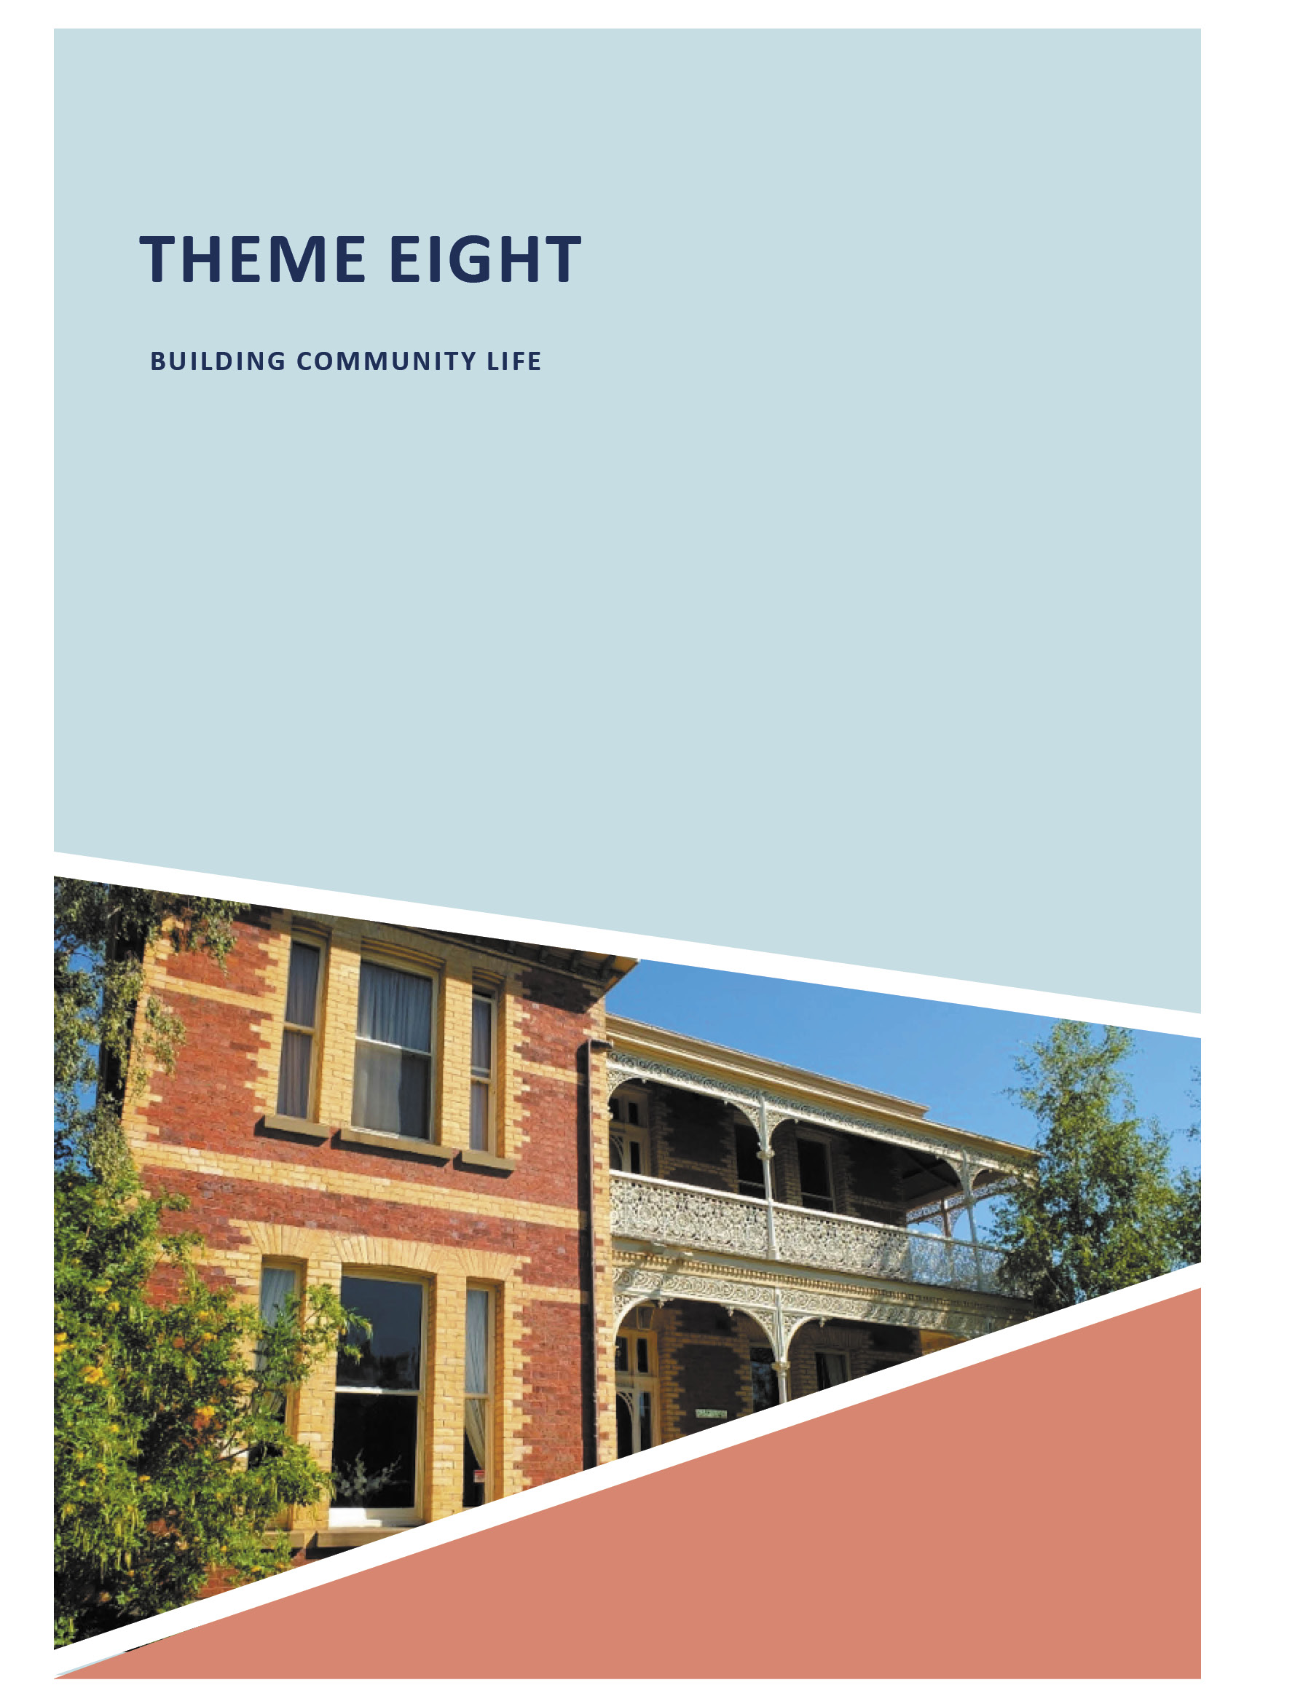
ABOUT CORAYO: A THEMATIC HISTORY OF GREATER GEELONG 977

THEME EIGHT

BUILDING COMMUNITY LIFE

  - INTRODUCTION
Community life in Greater Geelong has taken many forms. Fundamental to the Wadawurrung has been and continues to be spiritual life. This theme begins with a basic overview the importance of the animist belief systems and creation stories of Greater Geelong s First Nation people: the importance
of Bundjil (ancestral being), and physical evidence of this spirituality. The theme then explores European belief systems, principally the Catholic and Protestant
denominations (and to a lesser degree, other creeds) and key personnel involved, that were highly influential in
Geelong and which are physically manifested in the surviving churches and other places of worship throughout the municipality today. Building European spiritual life began with St. John s Lutheran Church, 165 Yarra Street, Geelong (formerly St. Andrew s Presbyterian Church), in 1841-42, the oldest surviving Presbyterian church building in Victoria.
Critical to the enduring and successful development
of Greater Geelong has been education. This subsection starts with a succinct acknowledgement of the importance of the environment and climate in the education of Wadawurrung children. The education of children of European descent
from the late 1830s until the 21st century is discussed, largely through the tangible legacies of the initial private schools, evolution and development of a regulated school system (through the establishment of national, denominational, common and state schools), kindergartens, secondary education (beginning with Central College in Skene Street
led by Miss Annie Elisabeth Clanchy who made a significant contribution to secondary education in Victoria), and tertiary education (focusing on the Gordon Technical College the home of the first School of Architecture in Victoria – and Deakin University). Yet, education was also provided
to the community in more informal ways, including the establishment of Mechanics Institutes and libraries, and an overview of their importance is given.
Health and welfare have featured prominently throughout Greater Geelong s history. This subtheme provides a snapshot into the medical practices by the Wadawurrung in Geelong, and the first local medical practitioners – the
Aboriginal healers. European health and welfare is outlined through the earliest medical practitioners resident in Geelong following European colonization; development of the Geelong Hospital from 1852 (and the key personnel involved), construction of Baxter House as Geelong s purpose-built maternity hospital in 1954; evolution of private hospitals, leading to St. John of God, Myers Street, and the Epworth Hospital, Pigdons Road, which operate as Greater Geelong s key private hospitals today; influential doctors and medical practices from the 19th century (and the legacies of their local
contributions, including that of pioneer female obstetrician, Dr Mary De Garis (1881-1963); development of nursing and nurse training; establishment of convalescent accommodation
and the Geelong branch of the Red Cross; formation of an ambulance service; the early years of the dental profession; the role and evolution of chemists and druggists in Geelong, and the far-reaching role some local chemists played (including W.G. Hearne and his bronchitis cure from 1888); the beginning of the first aged care homes and retirement villages; the establishment of orphanages, children s homes, refuges and industrial schools culminating in the Apology
by the Australian Parliament to the Forgotten Australians
in 2009; and the development of welfare homes (through the efforts of key local organisations and individuals including the Geelong and Western District Ladies Benevolent Association, Mrs Elizabeth Austin, Mrs Annie Hitchcock and Mrs Fanny Brownbill).
Numerous community organisations have also shaped community life in Greater Geelong. This theme explores a small number of key bodies including the fire brigades, service clubs, fraternal and friendly organisations, Temperance Orders and Friendly Societies, the
Union Movement, and history and heritage societies (including the Geelong Historical Society and the National Trust of Australia) and surviving physical evidence associated with the cultural importance of each group.
The theme concludes with the different facets of commemoration in Greater Geelong: the public cemeteries (including the Eastern Cemetery, East Geelong established in 1839 and Victoria s oldest working public cemetery; and the Western Cemetery, Herne Hill, established in 1857 as possibly the earliest gardenesque cemetery in Australia); private burial grounds; war-related commemoration (monuments and landscapes); and commemorative monuments associated with European explorers, British monarchs, maritime, and prominent locals.

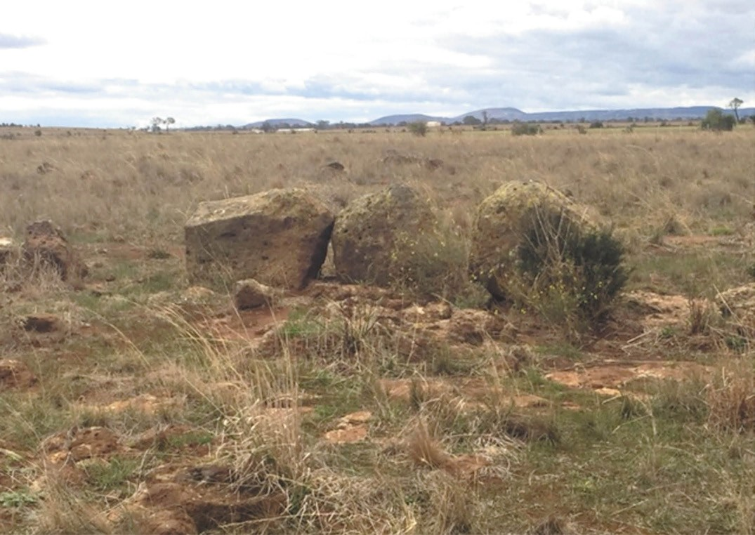
Figure 8.01: Detail of three large stones as part of westernmost portion of the stone arrangement, showing the Three Sisters at Anakie Youang in the background, 2016. Source: Kevin Krastins, City of Greater Geelong.

SPIRITUAL LIFE

BELIEF SYSTEMS OF THE WADAWURRUNG
Central to the beliefs of the Wadawurrung people is the all-powerful Bundjil spirit, an ancestral being which takes
the form of an eagle.1 Another ancestral being significant in the belief system of the Kulin was Waa (the Crow).2 Bundjil and Waa form the principal Moieties (or Balluk) of the Wadawurrung people: the patrilineal system of inheritance.3
Astronomy is an important part of Wadawurrung culture.4 Since at least 1857, Europeans have recognised the deep connection of astronomy and mythology to Aboriginal peoples in Victoria.5 By 1925, the connections between astronomy and Aboriginal culture had become more widely known, and the Geelong Advertiser gave a report on Aboriginal Astronomy: The Legends of the Stars which included:
From a time too remote to be known the heavens have been divided into fabulous groups of stars recording the laws, religions, symbols and passions of the people who named them. Our [European] story of the heavens comes to us from the Greeks, but their fables mostly relate to the stars of the northern hemisphere. The Greeks embellish the traditions brought to them from other ages and other peoples
So, in aboriginal astronomy, the animals, birds, humans, etc., grouped as constellations, are familiar objects to the natives of to-day, and the aborigines may be said to have founded their now Australian zodiac.
There is no aboriginal generic term for Zodiac other than the dialectic equivalents for road or track. And as all native and animal tracks are winding ones throughout Australia, the aboriginal zodiac winds here and there amongst the myriad of heavenly bodies. Each tribe possesses legends connected with the stars within its

range of vision, and starry legends of other tribes far north, or east, or south, or west, will be learned at initiation gatherings, and will be remembered according to the frequency or otherwise of the narrator.6
In Greater Geelong, the stone arrangement at Wurdi Youang (near the You Yangs and Little River) (Figure 8.01) is likely to have been an important place for astronomy and ceremony.7 In 1918, E. Cooper wrote that in the early days the You Yangs Range was a general corroboree ground for tribes as far as the Yarra. 8

POST-CONTACT EUROPEAN RELIGIONS AND SURVIVING PLACES OF WORSHIP
Central to community life in the Greater Geelong area since European colonization has been the establishment of places of worship. Catholic and Protestant denominations formed the foundation of spiritual life. Underpinning their growth and development was the State. In 1836, the year the first sheep were disembarked at Point Henry (see Theme 2),
the New South Wales Legislative Council passed An Act to promote the building of Churches and Chapels, and to
provide for the maintenance of Ministers of Religion in New South Wales (to which Greater Geelong belonged at the time).9 While conditions applied in the acquisition of treasury funds, the local Protestant denominations benefitted from the granting of land in Geelong.10 Land was first granted to the Presbyterian Church in Yarra Street in 1843, while land for an Episcopalian Church and a Wesleyan Church were granted in 1846.11 The Presbyterian Church was the first to build its edifice at 165 Yarra Street in 1841 (see following subsection). The foundation stone had been laid in March of that year, the Geelong Advertiser also reporting at this time that:
the Church of England have displayed a praiseworthy liberality on this occasion which we hope will not be forgotten at the proper time for a reciprocal display. Other sec s [sic.] are beginning to bestir themselves, and in the absence of qualified clergymen one or two lay preachers officiate. On the whole, religion promises to keep pace with the other elements of prosperity in Corio [Geelong].12
Such promise was realised with the Roman Catholic,13 Church of England and Wesleyan denominations taking up land and erecting chapels later in 1841 and in 1842.14 Other non-conformist denominations soon followed, including the Free Presbyterians, Primitive Methodists, United Methodists, Congregationalists, Baptists, as well as the Jewish community (see Appendix 8.1 for a list of surviving places of worship today).
Impetus for the continued growth in religious institutions in Greater Geelong followed the passing in the Victorian Legislative Council of An Act more effectually to promote

the erection of Buildings for Public Worship and to provide for the maintenance of Ministers of Religion on the Colony of Victoria . Assent to the Act was given on 18 January 1853.15 Locally, the Church of England at Geelong (Christ Church), Newtown, Ashby (Geelong West), Barrabool and Bellarine; Presbyterian Church at Geelong; Wesleyan Church at Geelong and the Roman Catholic Church at Geelong and Ashby first benefitted in 1854-55 with the provision of stipends for the clergy. The Wesleyan Church in Yarra Street was also given a £400 grant in aid for the construction of
a parsonage.16 Across Victoria, the Wesleyans with 305 churches and chapels, benefitted most from the grant in aid at this time. They were followed by the Church of England (with 190 churches and chapels), the Presbyterians (with 184 churches and chapels) and the Roman Catholics (with 133 churches and chapels).17 Today, physical legacies of these denominations reflect similar statistics, the largest number of church and chapel buildings being associated with the Wesleyan and Presbyterian (now largely Uniting) Churches, followed by the Anglicans (Church of England) and the Catholics (see Appendix 8.1). The following gives a broad outline of these physical legacies today.18

SECTARIAN DIVIDE
Government funding of places of worship and the proposed abolition of State grants for such institutions in the early 1850s further exacerbated the sectarian divide that existed between Catholic and Protestant denominations.19 It extended beyond the debate surrounding religious creeds and controversial separations established in Britain many years earlier. The sectarian divide extended into all facets
of community life and continued until at least the mid 20th century. Such was the concern for sectarianism that a luncheon was hosted by the Freemasons as part of the Protestant Alliance at the Prince of Wales to denounce it. In attendance was the Mayor of Newtown and Chilwell and the Mayor of Geelong West. The extent to which sectarianism infiltrated community life – and yet the ironic manner in which sectarianism was denounced was outlined in a speech
by Bro. John Callaghan, the grand secretary:
It appeared to him that the general meaning of sectarianism was Protestantism. Every time sectarianism was mentioned it was used in a derogatory manner in regard
to Protestantism, even by so-called Protestants he was sorry to say. They found Parliamentarians who did not care to be mixed up in a society of militant Protestant nature; it was a pity it was so. He hoped the day was not far distant when Protestants would assert their position. They had a fair right to their representation and influence. In connection with their society there was not one word in the constitution offensive to any section of the community; The only words that could be construed were those in

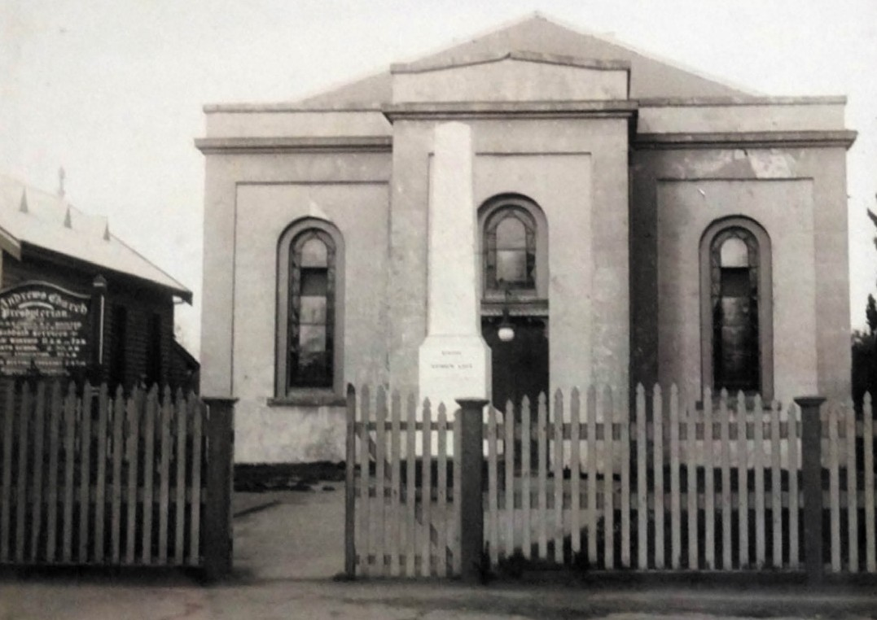
Figure 8.02: St. Andrew s Presbyterian Church (with monument to Andrew Love out front), 165 Yarra Street, Geelong, n.d. [c.1900]. Source: St. Andrew s Uniting Church, Sydney Parade, Geelong.

the obligation when members promised not to marry Roman Catholics. On the other hand, the Hibernian Society, the antithesis of the Protestant Alliance, had a rule to the same effect. Any member of the Hibernian Society who married a Protestant laid himself open to expulsion.
It was a good thing on both sides, for mixed marriages were a curse at any time. There was nothing offensive, therefore, in any line in their constitution. As far as friendly society work was concerned, they worked side by side with the Hibernian Society. He could bear testimony to the splendid work being done by the leading officers of the
two societies working hand in hand. He hoped that would continue for all time.20

PRESBYTERIAN CHURCH
On 10 October 1837, the first Presbyterian service in Victoria conducted by an ordained preacher was held in a shed
on the southern bank of the Barwon River at Dr Alexander Thomson s Kardinia station. The service was led by the Rev.
James Clow, the first ordained Presbyterian Minister to settle in Melbourne.

FIRST CHURCH IN GEELONG – ST. ANDREW’S (NOW ST. JOHN’S LUTHERAN CHURCH),
165 YARRA STREET
Presbyterian Church services continued to be held in
Dr Thomson s shed, including services conducted by the Rev. James Forbes throughout the late 1830s.21 He was also partially responsible for the arrival of the Rev. Andrew Love (1798-1867) and his family on 9 April 1840, having written
to the General Assembly of Scotland seeking a suitable preacher for the Geelong Area.22 The first resident Presbyterian Minister in Geelong, Love witnessed the construction of the brick Presbyterian church building from early March 1841. Designed by A.J. Skene, one of Geelong s first surveyors (see Theme 7), it was erected by R. Somerville and R.H. Marr.23 However, delays ensued due to the builder s eye affected with an unfortunate squint, and the walls not

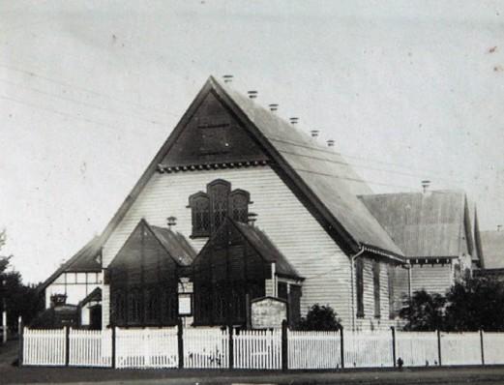
Figure 8.03: St. Andrew s Presbyterian Church, 70 Sydney Parade, Geelong, c.1930. Note the Love monument to the right.
Source: T.T. Holmes collection, Authentic Heritage Services Pty Ltd.

being plumb , required rebuilding. The church was completed and opened for Divine Service on 3 July 1842, the substantial financial difficulties caused by the building delays having brought on the risk of the congregation being shut out of their own building. Finance was subsequently garnered from a bank in Hobart, Tasmania.24 The Church was first known as the Presbyterian Church, then Scots Church, before being named St. Andrew s in 1858.25 Today, it is the oldest surviving Presbyterian church in Victoria.26
The Colonial Georgian styled church building (Figure 8.02) provided for a simple rectangular preaching hall accessed by a central front porch with a pediment-like parapet.
The outward Classical expression of the Presbyterian edifice reflected the attitudes and philosophies of English and Scottish Non-Conformist Church design in the early- mid 19th century in Britain. There, the repeal of the Corporation and Test Act in 1828 gave the vote to many
Nonconformist citizens which removed some of the influential social barriers previously in place that had given greater control to the Established Church (Church of England)
in England.27 The major non-conformist denominations included the Congregationalists, Unitarians, Wesleyans, Methodists, Primitive Methodists and the Presbyterians.28 The Presbyterian Church in Geelong followed the
non-conformist design principles of a basic preaching hall or meeting house with a simple front porch. The underlying outward Classical expression also emphasised the doctrinal and architectural contrasts between the Established Roman Catholic and Anglican Churches whose places of worship were decidedly pointed as hallmarks of Gothic Revival design.29
The Rev. Andrew Love remained the incumbent at St. Andrew s Church for 27 years until his death in
1867. He had contributed much to the life and witness of Presbyterianism during this time. On his death, the Geelong Advertiser gave the following insight:
Mr Love s ministerial efforts reached back to within a few years of the first settlement of the colony. Looking to what the country had since become, and what it was then, it showed what resolution Mr Love must have possessed, and how severe and arduous his duties must have been at the first. Howe many sacrifices he had to make, and how he delighted in his work. How worthily he had borne his part, and not only in that locality, but in the colony at large. As a citizen he was of a lively and affectionate disposition; and he was always particularly active in promoting the interests of the charitable and educational institutions. He fervently loved his church, which he had the privilege of watching over in its infancy, and it was mainly attributable to his aid that it had fostered into strength. He was the second minister of the Presbyterian Church in the colony, and for a short time was the only one. He had seen the church grow up until it now numbered over a hundred congregations. His natural talents were of a high order, and these he cultivated with great diligence and success. His attainments in literature and science, especially literature, were varied and extensive. As a preacher, he was always conscientious and unsparing. His discourses were clear, solid, and able, and often really eloquent and thrilling. As a ruler of the Church, he was ever assiduous, and ever attentive to its duties; in its counsels he was ever exerting his weight and influence. As a pastor, he was earnestly pressing in his efforts; he was always earnest
in inculcating the necessity of personal and practical
Godliness as essential.30
Soon after Love s death, a marble obelisk was erected at the front of St. Andrew s Church to his memory.31
While Love laid the foundations to Presbyterianism in Geelong, his legacy at the Yarra Street Church was not to endure. By 1907, congregational numbers had fallen to such a low that St. Andrew s was relegated to mission
status, carrying on as an independent church with an exit student for twelve months.32 While the church was reinstated as a full-charge church in 1909, the close proximity of
other Presbyterian Churches (including the High Church, Gheringhap Street, St. George s Church, Latrobe Terrace; Ryrie Street Church; and the Reformed Presbyterian Church, Fenwick Street)33 led to the sale of St. Andrew s Church in Yarra Street in 1911-12. A new St. Andrew s Presbyterian Church was built at 70 Sydney Parade, Geelong, to a design by Geelong architects, Laird and Buchan34 (Figure 8.03). The

Love obelisk monument was relocated to the new church property in 1912.35 In 1977, the Uniting Church of Australia was formed, with St. Andrew s amalgamating as part of this new church denomination. The church at 70 Sydney Parade continues to function for its original purpose.

OTHER SURVIVING PRESBYTERIAN CHURCH BUILDINGS

ST. GEORGE’S, 245 LATROBE TERRACE, GEELONG
The former St. Andrew s Church at 165 Yarra Street comprises one of at least 12 Presbyterian Church buildings recognised by heritage overlays in Greater Geelong today. One of the more substantial is St. George s Presbyterian Church, 245 Latrobe Terrace, Geelong, the site having been set aside by the Government for Presbyterian Church purposes in 1855.36 It was built in bluestone (with sandstone dressings) in 1860
in a Gothic Revival style designed by the architect, Nathaniel Billing (Figure 8.04). A landmark in this part of Geelong,
the Gothic design reflected the changed attitudes towards Gothic architecture by the non-conformist churches by this time. Equally importantly, the contextually substantial scale illustrated the wealth of several of its foundation patrons of the congregation (although the south porch was not built until 1889, the vestibule and transept until 1909 and the tower and spire until 1936)37 (Figure 8.05).
The first incumbent at St. George’s was the Rev. Alexander Campbell (1815-1909). Born in Edinburgh, Scotland, Campbell studied Arts and Law at the University of Edinburgh. A committed Christian with a particular interest in theological and ecclesiastical struggles occurring in Scotland, he subsequently studied Theology at the University of Edinburgh and was later inducted as the first Free Church minister in Melrose in the Scottish borders.38 Due to his
wife s ill-health, Campbell and his six children emigrated to Australia in 1859. They came to Geelong where Campbell was assistant to the Rev. Andrew Love at St. Andrew s.39
In addition to working for his congregation at St. George s from February 1861, Campbell devoted himself to the wider Presbyterian cause, as a member of five General Assembly committees, as a progenitor in the founding Geelong College, Newtown, as Moderator of the Presbyterian Church of Victoria (in 1867 and 1893), as a representative of the church at the Pan-Presbyterian Council in Edinburgh in 1877, and as a progenitor in the formation of Ormond College, a Presbyterian College at the University of Melbourne.40 In 1878, Campbell was awarded an honorary Doctorate of Divinity from
Queen s College, Kingston, Ontario, Canada.41 A legacy of £700 enabled Campbell to purchase a residential retreat overlooking Lake Connewarre at Leopold called Toorang (Theme 6). Campbell featured the property in a chapter he
authored in The Tourists guide to Geelong and the southern

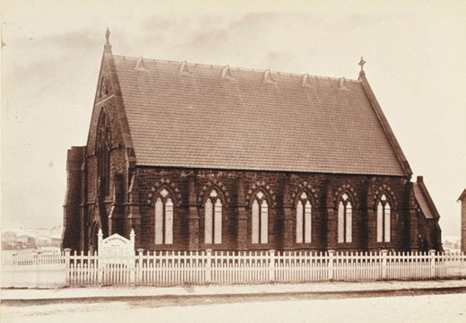
Figure 8.04: E. de Balk, St. George s Presbyterian Church, 1866. Source: figure FL985553, Mitchell Library, State Library of NSW.
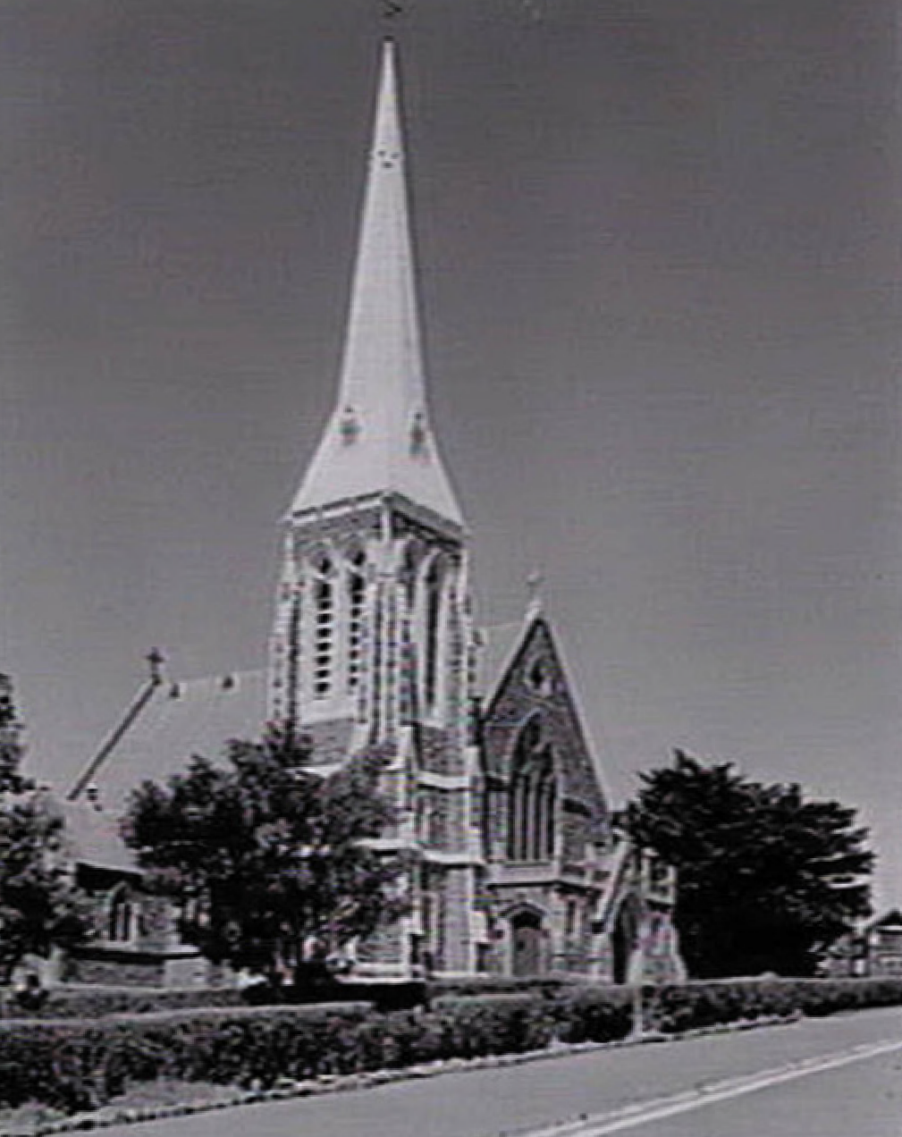
Figure 8.05: L. Fowler, St. George s Presbyterian Church, 1937. Source: Accession H92.20/129, State Library of Victoria.

watering places in 1893 (see Theme 6). Campbell remained at St. George s until 1883.42
St. George s continued to operate as a Presbyterian Church until recent years.

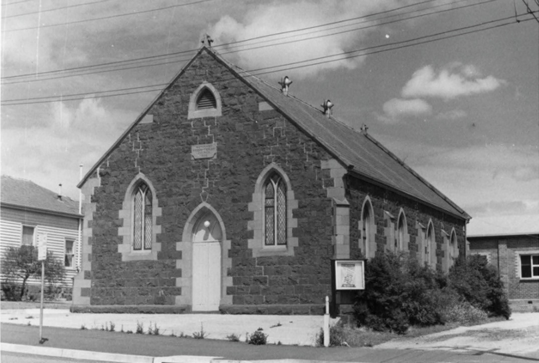
Figure 8.06: J.T. Collins, Reformed Presbyterian Church, Fenwick Street, 17 December 1967. Source: accession H96.210/392, State Library of Victoria.

REFORMED PRESBYTERIAN CHURCH, 10 FENWICK STREET, GEELONG
Independent from the established Church of Scotland was the Reformed Presbyterian Church, a communion of Presbyterians originating from 1690.43 This denomination established a permanent place of worship at 10 Fenwick
Street, Geelong, in 1862 with the construction of the existing Primitive Gothic Revival styled church which was described soon after its opening as a neat structure of bluestone with freestone dressings44 (Figure 8.06). The first minister was the Rev. Alexander McIlwaine Moore (1819-1897). Born in County Down, Ireland, he took up teaching at Newtonards before going to Belfast and opening a school there.45 In 1910, he relocated to Scotland, teaching at Renfrew and Glasgow and he later studied a Master of Arts at the University of Glasgow, his degree being conferred on him in 1852.46 After studying Theology, he was called to the Reformed Presbyterian Church and offered himself for ministry in the Colonies.47 Arriving in 1857, he commenced preaching in the parlour of a Mr Wright,
before obtaining the use of the St. Giles school house in Gheringhap Street, and later the Fire Brigade hall and the Temperance Hall respectively prior to the construction of the church at 10 Fenwick Street.48 He remained incumbent there with a rare steadfastness and courage until his death in 1897.49
The Reformed Presbyterian Church continues to serve the local community and in the early 21st century major internal alterations were carried out to accommodate the expanding congregation.

ST. DAVID’S PRESBYTERIAN (NOW UNITING) CHURCH, 43 APHRASIA STREET, NEWTOWN
The rationalization that brought about the relocation of St. Andrew s Church from Yarra Street to Sydney Parade in 1912 also witnessed the closure of the Ryrie Street Presbyterian Church at 73 Ryrie Street (built in 1856 which survives in an altered state without its steeple and which has recently been integrated into a new Performing Arts Centre building see Theme 9). This congregation relocated to a new Presbyterian Church at 43 Aphrasia Street, Newtown, in 1914.50 The Federation Gothic styled brick church was built by Dew Brothers and Ebbels to a design by the prominent local architects, Laird and Buchan.51

CHURCH OF ENGLAND CHURCH
In February 1841, subscriptions were collected for an Episcopalian Church at Geelong.52 On 12 July of that year, at the office of Henry Tyssen, solicitor, the inaugural trustees of the Episcopalian Church were elected: E.B. Addis, W. Roadknight, N.A. Fenwick, F. Champion and Henry Tyssen.53 A two acre site at the north-east corner of Moorabool and Fisher (McKillop) Streets was subsequently purchased
with the promised Crown Grant (which was realised on 11 November 1846).54

CHRIST CHURCH, 275 MOORABOOL STREET, GEELONG
Throughout the years of 1841 and 1842, a general depression reduced the ability to establish a church building as sufficient subscriptions did not materialise.55 Instead, the Trustees resolved to construct a school house (to be have the initial combined functions as school and temporary
place of worship until a church was built) and a parsonage. The local surveyor and architect, A.J. Skene, was instead commissioned to design the buildings, the school room being 40 feet by 25 feet.56 Alterations to the design of the parsonage were made following Bishop Broughton s appointment of
the Rev. J.C. Grylls as the first Vicar of the Church, the
Rev. Grylls having a large family.57 Disappointment afflicted the Trustees in February 1843 when Grylls declined his appointment because he found that the emoluments of the parish would not come up to his expectations. Tenders for bricklayers for the parsonage and for building the rubble stone walls of the school room were called in May 1843.58 These buildings were subsequently completed a few months later, the school house having a steeply-pitched gabled roof with ‘low walls’ and it was fitted up for temporary worship in September of that year.59 The two storey Picturesque Gothic styled parsonage (Figure 8.07) was more substantial and was situated near the north-west corner of the church site.

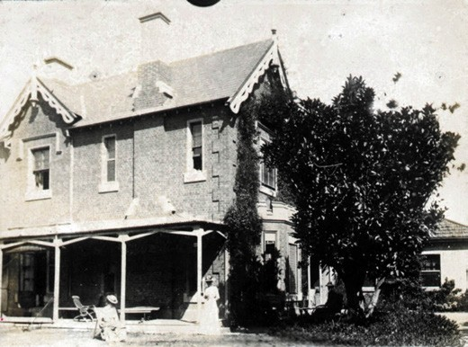
Figure 8.07: First Church Christ Parsonage, c.1880. Source: GRS 2009/04785/014, Geelong Heritage Centre collection.

The foundation stone for an Episcopalian Church at the corner of Moorabool and McKillop Streets was laid by Bishop Brougham on 26 September 1843.60 This was in anticipation that a design would be finalised and the building erected. The initial basis of the design was recorded by Charles Sladen following the laying of the foundation stone:
Broughton took from his pocket a letter on the back of which he sketched a small Church similar to that which was in the first instance erected; and as it was approved by the Trustees he promised to engage the services of Mr. Blacket, the eminent ecclesiastical architect, in drawing out the plan and necessary specifications.61
Disgruntled by Bishop Broughton s sketched proposal, Blacket lacked enthusiasm for the Geelong church project. John Gill, a Melbourne architect, supervised the erection of the Blacket plan, which proceeded between 1843 and 1847.62 The contactors were Robert Varey (walls), Thomson and McCann (windows and tracery), Robert Sunderland (roof), Candy and Marris (paving and gallery) and Sam Halfpenny (glazier).63 The Church was opened and consecrated on
27 June 1847 by Bishop Charles Perry, first Bishop to the Diocese of Melbourne. Constructed of Barrabool stone, the building did not fully reflect Blacket’s design, the spire and pinnacles not being built due to a lack of funds.64 Just two years later in 1849, the Christ Church congregation had
outgrown its church and so William Surplice, a local architect, was engaged to design a new chancel and transepts. Blacket distanced himself from the extensions, claiming that it it would be cheaper to rebuild it altogether. 65 A stone laying ceremony for the additions was held in May 1849.66 Various delays ensued, but Nicholas McCann progressed with
the building of the stone walls throughout 1851 and 1852

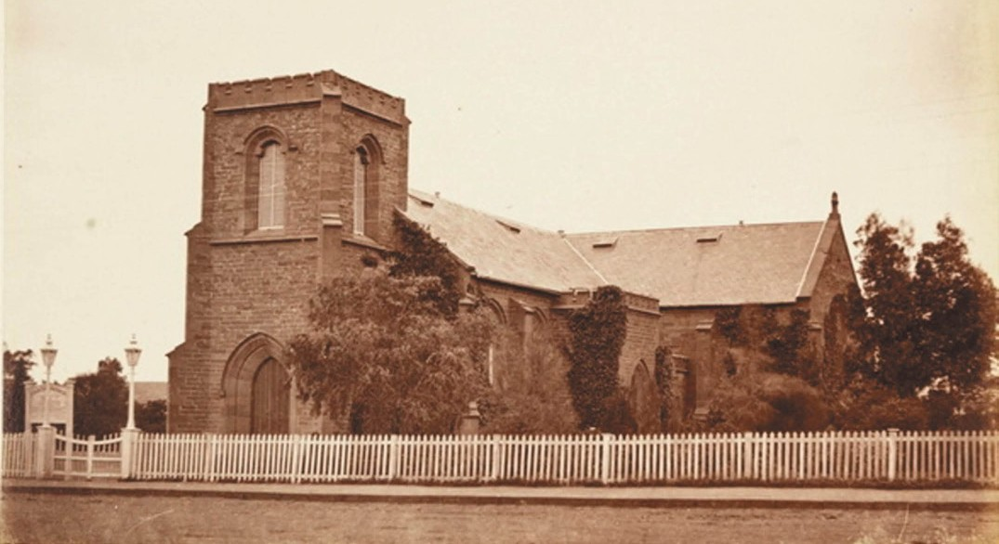
Figure 8.08: E. de Balk, Christ Church, 1866. Source: figure SL985553, Mitchell Library, State Library of NSW.

following further funds being made available through the philanthropy of James Gattie Carr. A new contract had been drawn up for McCann and the architectural firm of Snell, Kawerau and Prowse was commissioned to complete the design, which eventuated in 185567 (Figure 8.08).
The first incumbent of Christ Church in 1846 was the
Rev. Ebenezer Collins. He had been the Rector of Dunkeswell near Wellington, East Devon, England, and was a former missionary in South Africa.68 He remained at Christ Church until 1852.69
Collins successor was the Rev. Theodore Carlos Benoni Stretch (1817-1899). Born in Worcester, England, he was the son of John Cliffe Stretch, rector of St. Swithin s, and his wife, Elizabeth, nee Long.70 Following his education at Worcester College, Oxford, he was appointed a deacon in 1841 and ordained a priest in the following year. He arrived in Victoria in 1852 and was soon appointed by Bishop Perry to Geelong as minister of Christ Church.71 In 1854, he was collated as archdeacon of Geelong which included the responsibility for the visitation and oversight of the Ballarat goldfields.‘ At this time Stretch was also the incumbent at St. Paul s Anglican Church, Latrobe Terrace, and in 1855 he was solely at St.
Paul s.72 Stretch was publicly known for his geniality and dry humour, but a family history associated with his daughter, Elizabeth, claimed that he was a strong minded man spoilt by his mother and not improved by his wife. 73

OTHER CONTINUING HERITAGE-LISTED ANGLICAN CHURCHES IN GREATER GEELONG

ST. PAUL’S CHURCH, 171-177 LATROBE TERRACE, GEELONG
A two acre site in Latrobe Terrace Geelong (this area was then known as Ashby) was set aside for another Anglican Church in Geelong in 1849 74 and a school house was soon constructed.75 The first Trustees were Charles Nantes, Edward Willis, William Timms and John Sleath Hill. The local architect, Charles Laing, was commissioned to design a brick church and the foundation stone was laid in December 1850.76 The Victorian goldrush and limited funds halted construction beyond the completion of the walls. It was not until 1854 when the building was completed, although it was not until 1865-66 when the tower was completed and bells installed (Figure 8.09). The chancel was extended in 1877.77

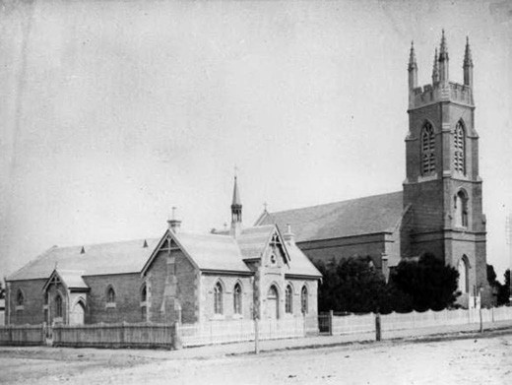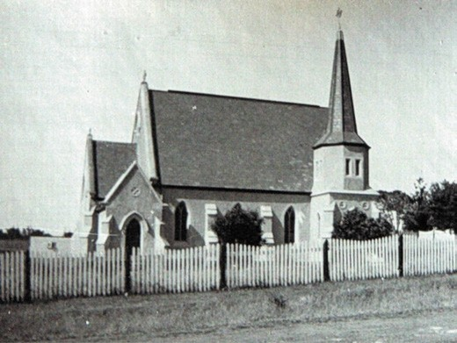

Figure 8.09: F. Kruger, St. Paul s Church & Sunday School, 1880. Source: accession H24837, State Library of Victoria.
Figure 8.11: St. John s Anglican Church, Highton, c.1930.
Source: T.T. Holmes collection, Authentic Heritage Services Pty Ltd.

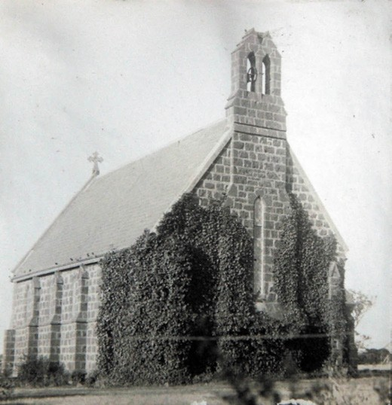
Figure 8.10: St. Mark s Anglican Church, Leopold, c.1930.
Source: T.T. Holmes collection, Authentic Heritage Services Pty Ltd.

The first incumbent to St. Paul’s was the Rev. Dr. Hussey Burgh Macartney (1799-1894) who had been appointed Archdeacon of Geelong in 1848.78 Macartney was the youngest son of Sir John Macartney, baronet and Catherine Macartney, daughter of Walter Hussey Burgh, lord chief baron of the exchequer.79 Following his education at Trinity College, Dublin, he was appointed a deacon in 1822 and was ordained as a priest in 1823. After Bishop Perry s appeal for
clergy, Macartney immigrated to Melbourne in 1848 and took charge of the Heidelberg Parish prior arriving in Geelong.80 Macartney was succeeded by Archdeacon Stretch.
In 1853, a school house was opened at Leopold (then known as Kensington) and five years later in 1859 the foundation stone was laid for St. Mark s Church, Bellarine Highway81 (Figure 8.10). It was designed by the local architect, Edward Prowse and built of bluestone by J. Saffron and W. Martin,82 and opened in 1862.83
In Newtown, All Saints Church was built in 1862 at the corner of Talbot and Noble Streets to link St. James at the corner of Aberdeen and Frederick Streets, Newtown and St. Peter s, Chilwell (both of which no longer operate).84 Designed by Joseph Shaw, the nave of All Saints was built by Foyle, Laidlaw and Company.85 The first Vicar was the Rev. Francis Hopkins.86
Nearby at Highton, Anglican services were held in the Day School opposite the cemetery in Barrabool Road from 1858.87 The existing St. John s Church at 269 Roslyn Road was opened on 1 January 1867.88 The Early English Gothic styled building (Figure 8.11) was designed by Joseph Shaw. It was extensively damaged by a tornado in 1926 and rebuilt and a spire added.89 The first vicar of the new church in 1867 was the Rev. H.J. Edwards who had commenced at Highton a year earlier.90
At Drysdale, an Anglican presence had been felt since 1853 although St. James Anglican Church was not built until 1871- 72 to a design by Andrew McWilliams.91 It was constructed of Widdicombe s bricks from Portarlington92 (see Theme 4). The first Vicar of the new church was the Rev. J. Firth who had been incumbent for the Bellarine Peninsula since 1865.93

In 1877 at Lara, the Holy Trinity Church was constructed to a design by architect Joseph Watts.94 It was described in the Mercury and Weekly Courier in 1882 as follows:
About half a mile from the railway station, looking to the right, this land-mark stands out in bold prominence, being the exceedingly pretty village church of Lara,
substantially built of bluestone, with freestone dressings round doors, windows, tower and spire pointing to the skies, a very sermon in stones to every beholder
It consists of nave, chancel tower and spire; the side walls being pierced on each side by four dual arched windows between each buttress; the glassing being the church-like diamond panes. The chancel has windows in its three walls, as also has the front gable. The chancel has a side door, where it is intended to erect a vestry or room suitable for meetings or school. It is very prettily finished inside, the pews being of a rather ornamental class of white pine, varnished; reading desk and pulpit on either side of chancel, in front of which is a white stone baptismal font. The choir and cabinet organ are in the centre of the west end of the nave. The whole is well lighted for evening service by very handsome kerosene lamp chandeliers and side brackets, with ornamental globes and chimneys.95
The first incumbent was the Rev. Alfred Caffin.96 On
9 January 1969, the Holy Trinity Church was substantially destroyed by Lara’s most disastrous bushfire.97 Only the tower could be saved which was incorporated in a new church building designed by Schefferle, Chomley and Associates, architects of Newtown in 1971. A plaque to commemorate
the centenary of the dedication of the first Holy Trinity Church was unveiled on the surviving bluestone tower by the Governor of Victoria, Sir Henry Winneke, on 4 December 1977.98
At East Geelong, St. Matthew’s Anglican Church was first built to a design by Joseph Watts on the north-east corner of Fitzroy and Matthew (now Walls) Street, Geelong, and was officially opened in February 1890.99 A building fund for a new church was commenced early in the ministry of Rev.
J.W.P. Oates, incumbent between 1918 and 1929, and Louis Williams, eminent architect of Melbourne was commissioned to prepare the design.100 A.E. Orme built the new brick church in 1928, and on 22 September 1928, the foundation stone was laid by Bishop A.V. Green, who later dedicated the church
on 23 March 1929.101 The building was partially financed by parishioners and partly by a bank loan, while each item of furniture was a personal gift of some parishioner or family. Due to the depression of the early 1930s and then World

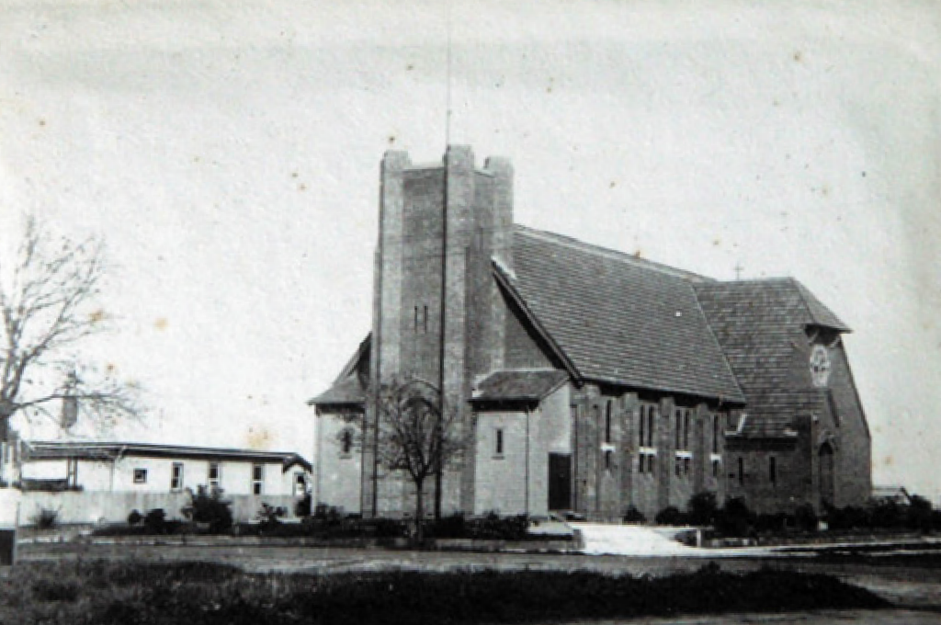

Figure 8.12: St. Matthew s Anglican Church, East Geelong, 9 May 1931. Source: T.T. Holmes collection, Authentic Heritage Services Pty Ltd.

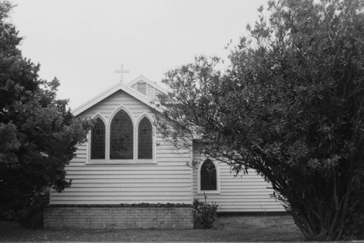
Figure 8.13: All Saints Anglican Church, Barwon Heads, 1998. Source: David Rowe.

War Two, it was not possible to fully complete the architect s original 1928 design, the projected tower - planned to rise an additional 35 feet to house a belfry - was shortened and the planned porches omitted, replaced by temporary wooden entrance porches until 1962102 (Figure 8.12).

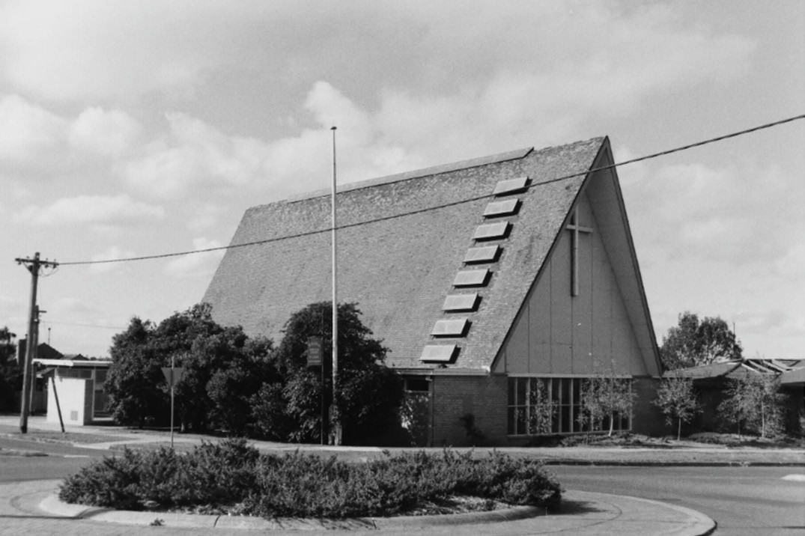
Figure 8.14: St. Stephen s Anglican Church, Belmont, 1998. Source: David Rowe.

In the late 19th and early 20th centuries, timber churches dedicated to St. Paul were provided at Whittington and St. Leonards. St. Paul s, Whittington was built in 1898 to
a design by Laird and Barlow architects.103 At St. Leonards, the former Christ Church building from the corner of Church Road and the Geelong-Portarlington Road (which had been built from ballast) was relocated to the present site at 10 Dudley Parade and re-dedicated in 1915.104
It was in the 1920s when action was taken to provide an Anglican Church in Barwon Heads, which was at the time meeting in the (former) Mt. Colite Public Hall.105 With the arrival of the Reverend D.D. Carruthers to the Marshall Parish in 1935 came a major development in building the church.106 On one of his visits to Sparrovale Farm at Marshall, the home of his friend Mr Stradbroke Fowler, he saw the possibility afforded by Mr Fowler s wondering what to do with his old woolshed, now that the farm was going over to dairying, and the next meeting agreed that Mr Carruthers purchase the building for £105. 107 Built in c.1907, the woolshed (which may have been another stable building instead) (see Theme 4) was
moved to the Barwon Heads site soon after, where it was left for some months and only used for the occasional meeting.108 Much of the early restructuring of the Sparrovale building into a Church was carried out by the local builder, Harold Leach.109 He arranged for his men to use any spare time they had between other jobs on reconstructing the building.110 They constructed a porch, introduced ventilation, remodelled the windows into Gothic pointed arches (Figure 8.13), lined the room with masonite and remodelled the west end into an altar.111 On 24 December, 1937, the Church was in use.
A later example of Anglican Church life in the suburbs was the construction of St. Stephen s at 42 Regent Street, Belmont, in 1958-59.112 Designed by the local architect, Allan Collier, the new church (Figure 8.14) replaced an earlier Anglican Church building had had been built in 1906 on a site in High Street (and relocated to the existing site in 1923).113

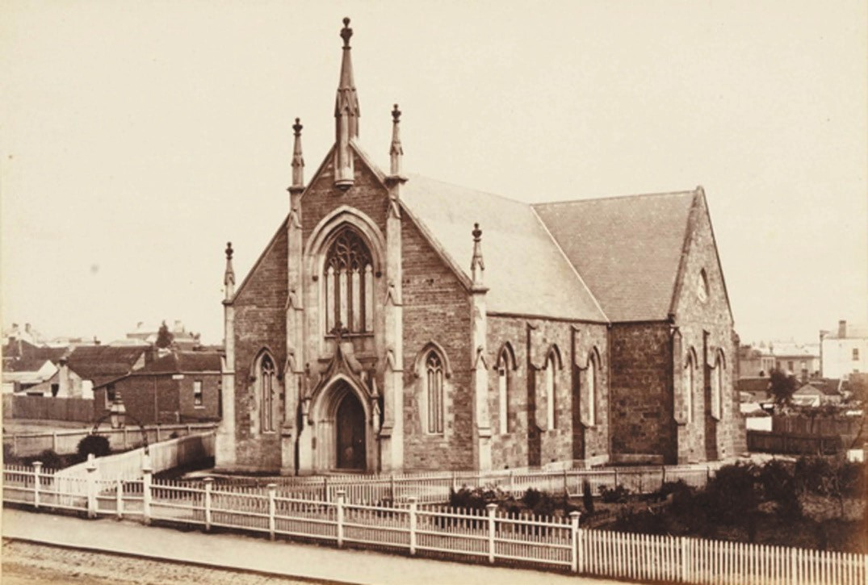
Figure 8.15: E. de Balk, Wesley Church, Yarra Street, 1866. Source: figure SL985553, Mitchell Library, State Library of NSW.

WESLEYAN METHODIST CHURCH EARLY BEGINNINGS
The Wesleyan Church was established in the Port
Phillip District in 1838 with William B. Boyce as General Superintendent.114 The Rev. Francis Tuckfield and
the Rev. Benjamin Hurst (1811-1857) were selected as missionaries to the Aboriginals in the district115 (see Theme 2). On 28 July 1838, the Rev. Tuckfield preached the first Wesleyan sermon in Geelong.116 The Rev. Hurst followed in 1839. The first ‘class’ meetings were held by the Rev. James Smith in 1841.117
The Rev. Francis Tuckfield (1808-1865) was born in Cornwell, England and converted to the Wesleyan Methodist faith at the age of 18 years.118 It was from this time when he became an active local preacher and in 1835 commenced training at the Theological Institution, Hoxton.119 With the Rev. Hurst, he was
selected to become a missionary to the Aboriginals at Port Phillip (see Theme 2). Following the selection of a site for the Buntingdale Aboriginal Mission near Birregurra, Tuckfield
commenced his mission work there from 1838 until its closure in 1850.120

AMALGAMATION OF METHODIST CHURCH WITH OTHER NON-CONFORMIST CHURCHES
Wesleyan Methodism continued in Greater Geelong (and elsewhere throughout the country) until 1977.
At this time, the Methodist Church amalgamated with other non-conformist church denominations, including the Congregational Church and a number of Presbyterian Churches to form the Uniting Church of Australia.

WESLEY CHURCH, 96 YARRA STREET, GEELONG
On 20 February 1842, the first Wesleyan Chapel and Schoolroom was opened on Wesleyan Church land in
Yarra Street. This relocated two storey timber store became the centre of the Geelong Wesleyan Circuit.121 It was replaced with a more substantial and enduring gabled Barrabool stone church building in 1846122 (Figure 8.15). Known as Wesley Church, 96 Yarra Street, Geelong, it is Victoria s oldest surviving Wesleyan Church, but it has been substantially altered and extended, including major additions in 1859, internal alterations in 1893 and throughout the 20th century, narthex and chapels at the eastern end in 1932 and later additions of the 20th century in the north-west corner.123

OTHER FUNCTIONING FORMER WESLEYAN CHURCHES IN GREATER GEELONG
By 1849, the Wesleyan Church had made steady progress at Port Phillip with a total membership of 500 people.124 In 1850, a new District of the Church was created and the Rev. William Butters was appointed as Chairman.125 Significant expansion of the Wesleyan cause came after the demise of the Buntingdale Mission near Birregurra in 1850 (see Theme 2), when efforts were concentrated on expanding Wesleyanism in the Geelong area.126 This followed the arrival of additional Ministers to Geelong in 1853 who resided at the Mission House , 1 Little Ryrie Street (Figure 8.16). It was also the result of the Rev. Isaac Harding who was claimed to have had an ardent appetite for Chapel building. 127 This is highlighted in a letter by Harding on 1 June 1855:
At South Geelong, a brick Chapel has been erected and paid for at a cost of £1400. At Chilwell one has also been built at a cost of £2,200, with a debt of £850.
A brick Chapel is also completed at Tuckfield [Drysdale] to a considerable degree through the liberality of Miss Newcombe. A stone Chapel is also in course of erection at Ceres, amidst the corn fields of the Barrabool Hills, which will cost £500, and at Highton a neat little brick Chapel was opened the other day. These, beside five other Chapels of wood, have been erected during the past year, while five Day schools have been established. So that the Geelong Circuit now comprises twelve places of worship and eight Day schools affording accommodation for 2,300 souls, and daily instruction given (gratiously when necessary) to 510 children, with at least an equal number of Sabbath schools, which are conducted with as much zeal and ability as similar institutions at home.128

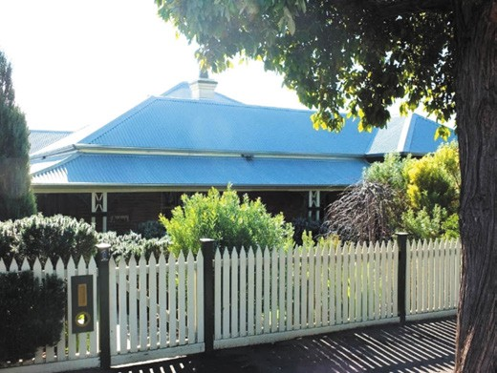
Figure 8.16: Avona (former Wesleyan Mission House), 1 Lt Ryrie Street, 2019. Source: David Rowe.
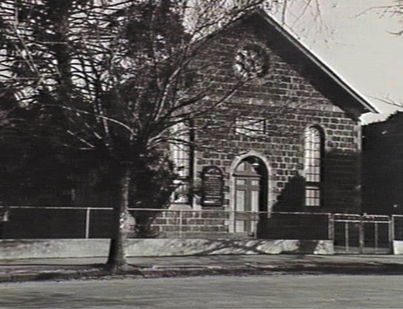
Figure 8.17: C. Fox, Noble Street Methodist Church, Chilwell, 27 August 1934. Source: accession H19473, State Library of Victoria.

The chapel referred to by Harding in 1855 in Chilwell was the Noble Street Wesleyan (now Uniting) Church at 35 Noble Street, Newtown. (Figure 8.17). It was built in in 1854 of bluestone from the Marnockvale quarries (see Theme 4)
in 1854 by Pile and Brimblecombe (replacing an earlier structure), the transepts being added in 1876.129 The Classically-derived design reflected the non-conformist Wesleyan philosophy of the temple preaching hall, eschewing all references to Gothic Revival design. The church initially formed part of the Yarra Street circuit, the first Minister being Isaac Harding.130

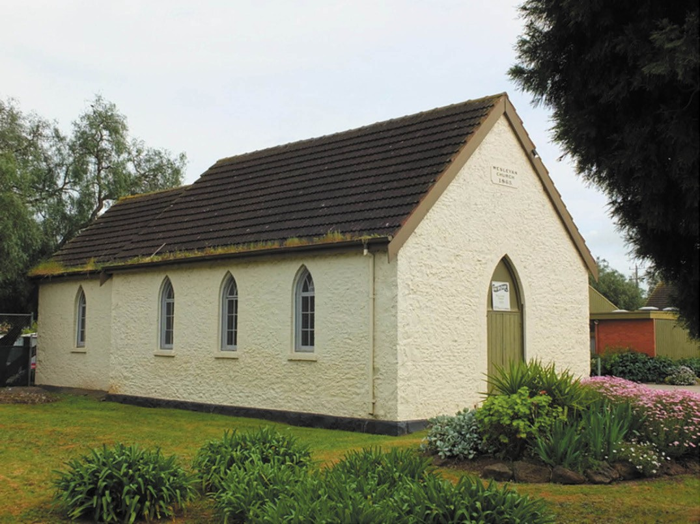
Figure 8.18: Lara Uniting (former Wesleyan) Church, 2012. Source: David Rowe.

In 1865, the foundation stone was laid for the Primitive Gothic limestone chapel at Sixways Corner, Lara131 (Figure 8.18).
This followed the earliest presence of Primitive Methodists in this northern rural locality when the first service was conducted in the home of John Spalding.132
At 170 Barrabool Road, Highton, in 1867, the foundation stone was laid for a Wesleyan Church by the Rev. James Bickford, the building having been designed by Robert Balding, architect responsible for a number of Wesleyan churches
at this time.133 Opened in 1868, the building was largely destroyed by a tornado in 1926 (Theme 1). It was rebuilt the following year and served until the construction of the existing church in 1983.134
In 1869, the St. Albans Methodist Church was opened
in Wilsons Road, St. Albans Park, having replaced a small chapel in Lake Road, Hampstead and a second chapel in Chapel Street, Whittington.135 Designed in a Gothic Revival style by well-known Wesleyan architects, Crouch and Wilson
and constructed of bluestone with limestone dressings, the contextually elaborate building was especially characterised by a bellcast profile spire
(Figure 8.19).
In contrast to St. Albans but built at the same time in 1869 was the Wesleyan Methodist Church at 272 Torquay Road, Grovedale.136 It was also built of bluestone but in a decidedly Victorian Georgian mode, reflective of the Classically-derived Wesleyan designs prior to the popularity of the Gothic Revival style from the late 1850s.
Other Wesleyan Methodist Churches were built in Greater Geelong in the 1880s, several to designs by the prolific local architect, Albert J. Derrick. He had strong connections to the Wesleyan Methodist cause and in the early 1890s he was encouraged by the Rev. A.J. Edgar to help establish the Methodist Central Mission in Melbourne.137 In Greater Geelong, he designed the Drysdale Methodist (now Uniting) Church at 22 High Street, Drysdale in 1887. Opened in

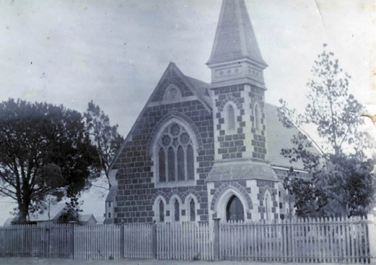
Figure 8.19: St Albans Methodist Church, n.d. [c.1900]. Source: St. Albans Uniting Church.
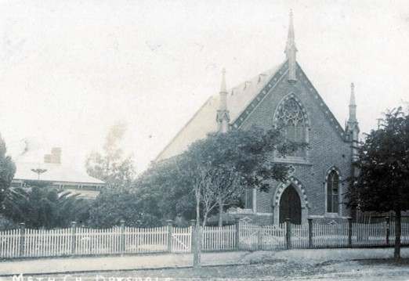
Figure 8.20: Drysdale Methodist Church & Manse, n.d. c.1900. Source: Bellarine Historical Society collection, image 3994/63.

1888,138 the church was distinctive for its polychrome brick construction and picturesque pinnacles surmounting the gable end (Figure 8.20). It was also in 1888 when Derrick designed two Victorian Carpenter Gothic styled churches at Wallington and Ocean Grove.139

CATHOLIC CHURCH
On 11 May 1839, the Catholics of Melbourne made an appeal for financial aid to provide for a Catholic Church at Geelong given the anticipated arrival of a priest to take charge in the fledgling township.140 Subscriptions could be made at the office of Messrs. Strachan and Co., wool brokers.141 The first Mass was reputedly in O’Connell Street, Geelong West (then known as the Western Shore), at the residence of James Harrison, inaugural editor of the Geelong Advertiser, before the end of 1839.142 Father Horatio Geoghegan
from Melbourne initially officiated at Masses in Geelong until they were carried on by the Rev. Fr. Richard Walsh,

a second Catholic clergyman without Government aid to visit Geelong.143 In September 1841, the Rev. Michael Ryan, settled in Geelong as the town’s first resident Priest.144
He only remained a month as in October 1841 Ryan was called to another congregation.145 By this time, according to the Port Phillip Herald, there was considered a sufficient number of Catholics in Geelong to entitle a clergyman to a Government salary. 146 Father Michael Stephens took over as a visiting priest in Melbourne from 1842 and he was soon the only Catholic clergyman in Port Phillip.147 The return of Father Geoghegan to Melbourne in late 1842 brought about the formation of Geelong as headquarters of a new Catholic Parish for the Western District.148 Father Stephens was appointed first pastor and Mass was celebrated in a house in South Geelong. A small timber church was subsequently
erected, the first Mass being held in January 1843.149 At this time, the Geelong Advertiser reported that:
We understand a memorial has been forwarded to the Governor, in the hope that his Excellency will, on the consideration of the number of Roman Catholics in this district, grant assistance towards the support of the pastor, and the erection of a sufficiently commodious place of worship, in order that so large a body of professing Christians may not be totally excluded from the ordinance of religion.150
In 1846, Father Stephens was replaced with the Rev. Richard Walsh who had been Geelong’s first visiting priest five years earlier.151

THE FIRST PERMANENT CHURCH – ST. MARY’S OF THE ANGELS, YARRA STREET, GEELONG
In June 1846, just six months after the Geelong Advertiser agitated for a more commodious Catholic Church building, the Australasian Chronicle announced that the Rev.
P.B. Geoghegan was to make arrangements for the immediate commencement of a new Catholic church at Geelong, to be called by the very beautiful title of St. Mary of Angels,’ the first Catholic Church in Victoria to be dedicated to St. Mary.152 A site at 136-148 Yarra Street was selected.153 Designed by Samuel Jackson, architect of Melbourne,154 it was not until 19 August 1846 when the foundation stone of the new church was laid. The Government had provided
£1000 towards the cost of the building and by the end of 1847 the nave (built of Barrabool stone by Daniel Rooney, a builder of Melbourne) had been completed.155 By this time,
Father Walsh had been succeeded by the Rev. John Kenny.156
By 1854, the rapidly increasing Catholic congregation had outgrown its church. Archbishop Goold subsequently held a design competition for a new church building at the location of the church built in 1846-47. The Melbourne architects157
of Dowden and Ross were awarded first prize.158 On 16 June

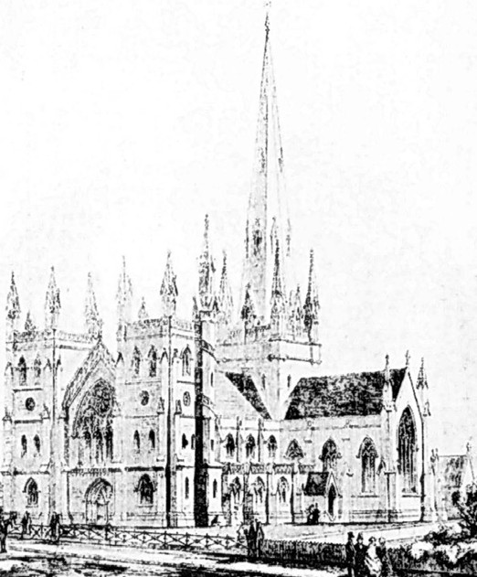
Figure 8.21: Shaw & Dowden, Original sketch of proposed St. Mary s Church, 1855. Source: News of the Week, 23 November 1911, GRS 2121, Geelong Heritage Centre collection.

1854, Archbishop Goold laid the foundation stone for the building amid an immense concourse of Catholics. 159 The church was to be erected by Mr. Pettigrew.160 The Argus gave a description of the proposed edifice:
The site of the new church is the same as that occupied by the present one: this appears strange, but it admits of easy explanation. The present church will be built completed over by the new one, and then be taken down. The new church will be two hundred feet long, and one hundred and thirty feet wide, and will accommodate between two and three thousand persons. The edifice when completed will be a magnificent structure, perhaps inferior to no building of the kind south of the equator. The estimated cost is £75,000. The foundation will be the common blue basaltic rock, the base course Williamstown bluestone, and the rest of the building colonial sandstone.161

The proposed church was to be surmounted by a crowning spire at the west end, with towers flanking the entrance to the nave at the east end (Figure 8.21). Transepts were to project from the north and south sides.
In 1856, due to financial constraints, Archbishop Goold halted construction of the new church when the walls had risen
6 metres around the original church building.162 Fourteen years elapsed before work began on a modified design by the Melbourne architect, T.A. Kelly. His scheme was to accommodate 1000 people.163 The work was carried out by Mr Nash, general contractor.164 On 4 February 1872, the opening ceremony of the church was performed by His
Lordship Bishop Goold. Defined as ‘St. Mary’s Cathedral’ by the Geelong Advertiser, a detailed description was given of the Victorian Decorated Gothic styled building (Figure 8.22):
The church stands on a considerable eminence at the top of Yarra-street, and is therefore, one of, if not the most conspicuous object in the town. From the position of the site the principle of orientation which generally guides the Roman Catholics in the building of their churches
has been departed from, the altar being found in the western in place of the eastern end. We now turn to a description of the building externally, but in its present unfinished state a very poor idea can be furnished of the comprehensive and magnificent plan of which the present building is but the index. We will begin at the east or Yarra-street end: At each angle rises a tower about 20ft square, and pierced by windows similar to those of the aisle on the ground floor, quatrefoils on the next stage, and arcaded on the upper floor, rising to a height of 55ft., but which, when completed will terminate at a total elevation of nearly 1440 ft. Between these
towers rises the nave gable, with its deeply recessed and richly moulded double doors, and its magnificent wheel window, 12 feet diameter. This window is filled in with flowing tracery, slightly French in its idea, and glazed with stained glass, intended as a memorial to the late Ven Dean Hayes, the subjects represented being the Blessed Virgin, St. Joseph, St. Patrick, St. Bridget, St. Augustine, and St. Francis Xavier, with their corresponding symbols. The summit of this gable is crowned by an elaborately carved cross, about 8ft high. The walls of the aisles are relieved by projecting weathered buttresses, capped by freestone pinnacles and pierced parapet. The walls of both clearstory and aisles are constructed of bluestone,

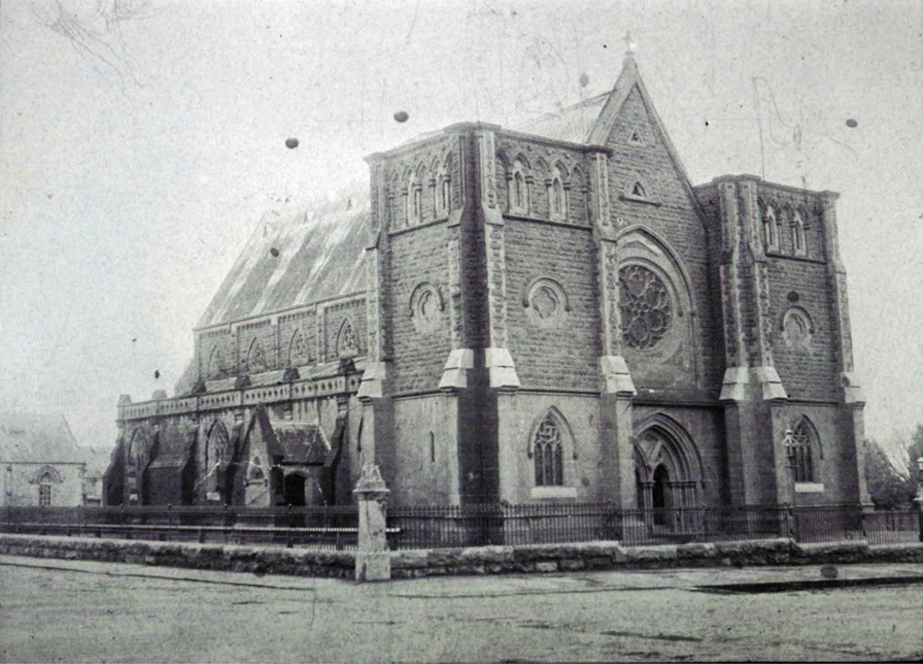
Figure 8.22: St. Mary s Catholic Church, Yarra Street, n.d. [c.1900]. Source: Wynd collection, Authentic Heritage Services.

in irregular courses, relieved by fine axed quoins and freestone dressings. The walls of the clearstory are capped by a projecting, moulded dressed bluestone coping, resting on moulded corbels. The slating has been arranged in colored bands of cut slates, and is pierced by ornamental projecting ventilators. Covered porches, one to each aisle, gives access thereto, and the external doors, both here and to the front, have wrought iron hinges of great beauty, while the brass hinges to the internal doors display the same taste.165
It was not until 1930, under the direction of Monsignor Benson, that T.A. Kelly s design for St. Mary s Church was to be realised. Costing between £80,000 and £100,000,166
the architectural firm of Hennessy and Hennessy and Co. of Sydney and Melbourne were commissioned to fulfill the initial design concept. Built by W. Kelly Pty Ltd of Geelong,167 the work included a Continental (rather than English) version of Gothic architecture and involved major work at the west end of the nave, including a raised sanctuary, ambulatory, chevet apsidal end with five chapels, and transepts. Pinnacles were added to the towers at the east end and the crowning element, a central tower with a bluestone spire,168 ensured that St.
Mary s of the Angels Church was to dominate the central Geelong skyline until the early 21st century.
In 2004, St. Mary s of the Angels Church received the rank of minor basilica, one of just five in Australia.169

OTHER FUNCTIONING HERITAGE CATHOLIC CHURCHES

SS. PETER AND PAUL’S, CORNER MERCER AND MALONE STREETS, GEELONG
In 1851, Geelong s Catholic Priest, Father Dunne, successfully applied for a block of land extending along the south side of Malone Street, Geelong, and taking in the adjoining allotment fronting Mercer Street.170 A number of years elapsed
before the church was constructed. William Wilkinson Wardell, architect of St. Patrick s Cathedral, Melbourne, was commissioned to design the building, the foundation stone being laid on 17 January 1864 by the Bishop,
Rev. Dr. Goold.171 Dedicated to Ss. Peter and St. Paul, it was constructed by Clement Nash, with J.A. Denny as
superintending architect. Described as a miniature cathedral and a unique building , it was opened on 1 July 1866.172
The Geelong Advertiser gave an account of the new edifice:
The church is in the style of the thirteenth century, and the mouldings and ornaments are in strict accordance with that period. There is a nave and aisles, a chancel, and two side chapels, with an inner and outer sacristy and a porch at the northern entrance. The nave and aisles are 65 by 48 feet, the chancel 22 by 30 feet. The two
side chapels are each 16 by 12 feet. The side of the nave to the apex of the roof is 48 feet. The clear storey rises above the aisle with five quatre-foiled windows on each side. The entrance to the western front is surmounted by a bell-gable, terminated by a carved cross. The walls are of bluestone, with Barrabool Hills stone-dressings
to doors and windows. The columns and arches are of Hobart Town freestone. The stained window over the altar was designed and executed by Messrs Ferguson and Weir of North Melbourne. The window is in the history; the ecclesiastic symbols, combined with the figures of the saints, are in severe taste, and the adjuncts in selection consistent.173

SUBURBAN AND REGIONAL CATHOLIC CHURCHES
Several smaller Catholic Churches were erected in the suburbs and outlying areas throughout the 19th and
20th centuries. Most of those opened in the 19th century no longer serve their original purpose. While not all continue to serve their original purpose, those that survive include St. Francis Church at 1022-1030 Portarlington Road, Leopold (previously part of Curlewis), built in 1873 with a belfry and bell added in 1878174 (Figure 8.23). It was followed in 1874 by St. Brigid s Catholic Church at 2439 Ballan Road, Anakie.175

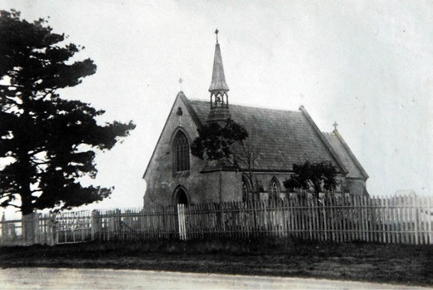
Figure 8.24: St. Francis Catholic Church, Leopold, c.1928.
Source: T.T. Holmes collection, Authentic Heritage Services Pty Ltd.

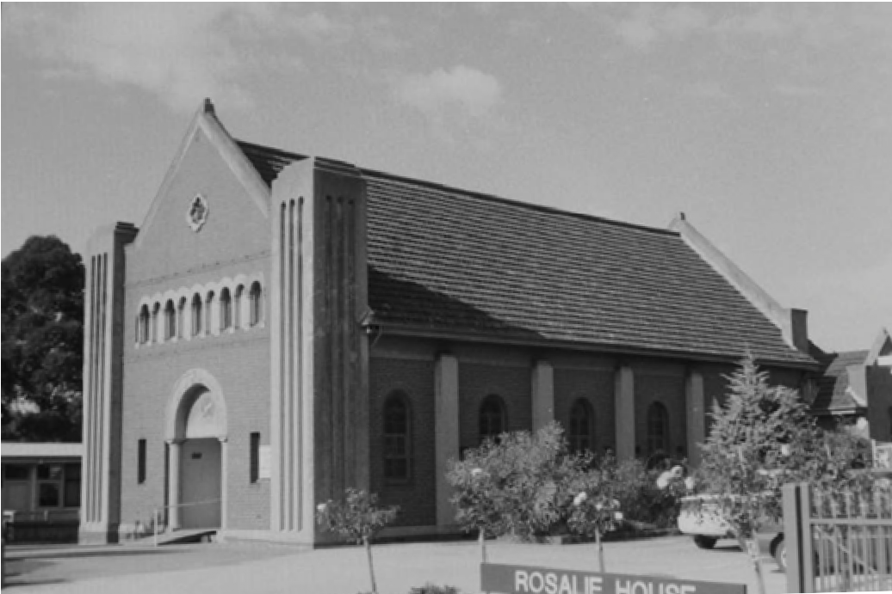

Figure 8.25: St. John the Evangelist Catholic Church, St. David Street, North Geelong, 1998. Source: David Rowe.

Some distinctive Catholic Church designs in the 1930s were the work of Catholic architect, Cyril Kelly. He had a sound Catholic building upbringing, his father, William Kelly, having the patronage of the Catholic Church for several buildings, including the completion of St. Mary s Basilica in the 1930s.176 Two of Kelly s designs were in a Spanish Mission Revival style: Holy Family Church at 25-31 Bostock Avenue, Manifold Heights (built in 1932) and St. John The Evangelist Church, 28-34 St. David Street, North Geelong (Figure 8.25).177 The basis of these designs was, his own [Kelly s] belief that most churches derived from the Gothic style are dark and sombre and that it was desirable to introduce more light, colour and fresh air into new churches. 178 Kelly also adopted a cruciform plan with a semi-circular apse for both of these designs.179

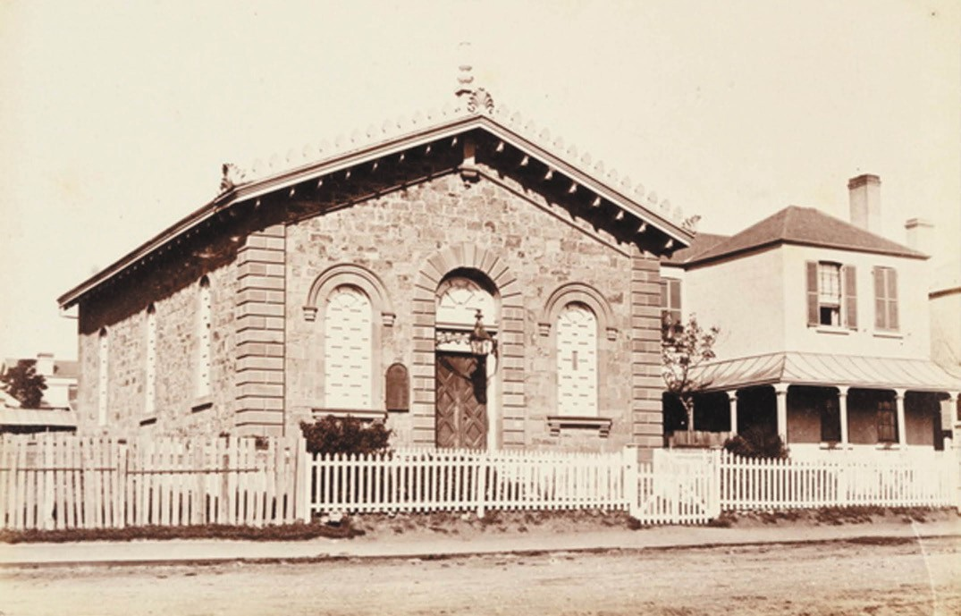
Figure 8.26: E. de Balk, Aberdeen Street Baptist Chapel, 1866. Source: figure SL985553, Mitchell Library, State Library of NSW.

One of Kelly s church designs of timber construction was the Holy Family Church at 101 Hitchcock Avenue, built in 1939 by
B. Murphy.180 A later example of his Catholic Church work was St. Margaret s, corner of St. Albans Road and Lomond Terrace in 1963.181
The influence of postwar migration also contributes to the life and witness of the Catholic Church in Geelong with the
opening of Our Lady’s Ukrainian Catholic Church, 43 Banfield Street, Bell Park, in 1958 (see Theme 2).

BAPTIST CHURCH
A presence in Geelong of the Baptist Church began in 1849 when S. Trotman commenced duties in Father Matthews Temperance Hall.182 A brick hall off Corio Street was purchased in late 1849 but the congregation soon suffered a decline due to the Victorian goldrush. The remaining Baptists established the Particular Baptist Church of Jesus Christ, meeting in a chapel off Yarra Street.183 On 8 February 1852, the Church was officially constituted and the Rev. Samuel Hewlett appointed.184
The Rev. Samuel Hewlett (1795-1874) was born in Sherbourne, Dorset, England, the son of James Hewlett and his wife, Ann.185 Samuel Hewlett became a Baptist Church pastor, serving at Essex, Berkshire and Westminster before he emigrated to Sydney in 1839.186 He worked as a bush preacher throughout New South Wales and South Australia before taking up a call at Hobart, Tasmania, where he was resident at the Baptist Mission House.187 It there where his wife, Catherine, died in 1847.188 He came to Melbourne later that year to minister at the Baptist Church, Collins Street during the absence of the Rev. Ham. Following a brief return to Launceston, he came back to Melbourne where he
married Mrs Mary Hamilton in February 1848.189 Following his appointment to the Baptist Church in Geelong, he remained the incumbent until 1858 and passed away in Austin Street, Newtown,
in 1874.190

ABERDEEN STREET BAPTIST CHURCHES, 3 & 7 ABERDEEN STREET, NEWTOWN
Following the constitution of the newly-formed Baptist Church, land for a church building was donated by George Board and John Matthews.191 An Italianate styled church of Barrabool stone was built in 1853-54 to a design by the local architect, John Young (Figure 8.26). It served as the
Aberdeen Street Baptist Church until 1876 when it became a Sunday School.192
It was in 1876 when a new church was built on the Baptist Church site at 7 Aberdeen Street to a design by the Melbourne architect, Thomas Watts.193 Designed in a distinctive Romanesque style with some Gothic detailing, it was built of polychrome brick construction.

NORLANE BAPTIST CHURCH, 4 SPRUHAN AVENUE, NORLANE
The only other functioning heritage Baptist Church in Greater Geelong is that at Norlane. The Victorian Carpenter Gothic styled building opened in 1938 having been built in 1874
as the Hope Particular Baptist Church in Saffron Street, Newtown, and relocated to its current site (see Theme 6).

LUTHERAN CHURCH
The arrival of German immigrants on the Emmy in 1849 (having been sponsored by the German Immigration Committee led locally by Dr Alexander Thomson) (see Theme 2) was impetus for the development of the Lutheran Church at Grovedale, first known as Germantown since European colonisation. Services were first held in homes until a
school was built in 1854 on the site of the existing Grovedale Cemetery (see later subsection). In 1858 a new stone church dedicated as Trinity Church was constructed on the east side of Torquay Road, south of the Reserve Road.194 It opened
in 1859 with J.G. Haussmann as the first resident pastor. The building was demolished in 1986.195

ST. PAUL’S LUTHERAN CHURCH, 301 TORQUAY ROAD
After the resignation of Pastoral Haussmann in 1861 came a divide in the congregation and some members separated to form St. Paul s Lutheran Church at 301 Torquay Road diagonally opposite Trinity Church.196 In 1870, the local architect and surveyor, Robert S. Tuffs, designed a Gothic Revival styled Church that was built in polychrome brick by
James Pile and Son197 (Figure 8.27). It was officially opened by Rev. Herlitz on 26 March 1871.198

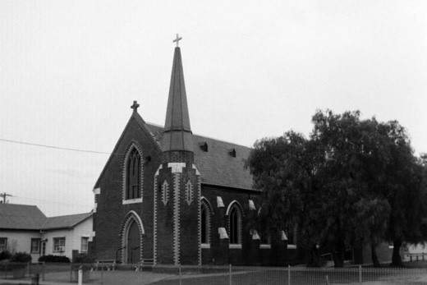
Figure 8.27: St. Paul s Lutheran Church, Grovedale, 1998. Source: David Rowe.

ST. JOHN’S LUTHERAN CHURCH, 165 YARRA STREET, GEELONG
The Lutheran Church commenced in Geelong in 1902
with services held monthly by Pastor G. Heyer of St. Paul s Evangelical Lutheran Immanuel Synod, Germantown
(later Grovedale).199 These services were mostly held at Mrs Hartwick’s place for five German widows who could not get to Germantown.200 In 1908 Pastor L.G. Schulze, who was at the Trinity Church, Evangelical Lutheran Synod of Australia (E.L.S.A.), Germantown, commenced services in Geelong. These services were held once a month in a house in McKillop Street, usually on Sunday afternoons in the German language.201
During the period 1908-1912 the services for E.L.S.A. members were transferred from the McKillop Street house to the Sailor s Rest building, Moorabool Street, until the start of World War One during which services were held in the houses of Messrs. Grotte and Stromhabel.202 Pastor R. Graebner was at Trinity Church, Grovedale, and he continued to hold the services in Geelong.203 After the war, the church moved to the Central Hall where services were held in a small upstairs room.204 Later the services were held in the Fish room or Lecture room at the rear of the Central Hall by Pastor Theo Harms of Grovedale Trinity Church.205
On 18 February 1923 at a meeting at the Grovedale
Trinity Church, it was decided to form a branch congregation in Geelong.206 Peaceful dismissal was granted by the Grovedale Trinity Church to members of the branch congregation on 19 March 1925.207 It was at this time when
a new self-governing Lutheran Church began in Geelong, known as St. John s Lutheran Church.

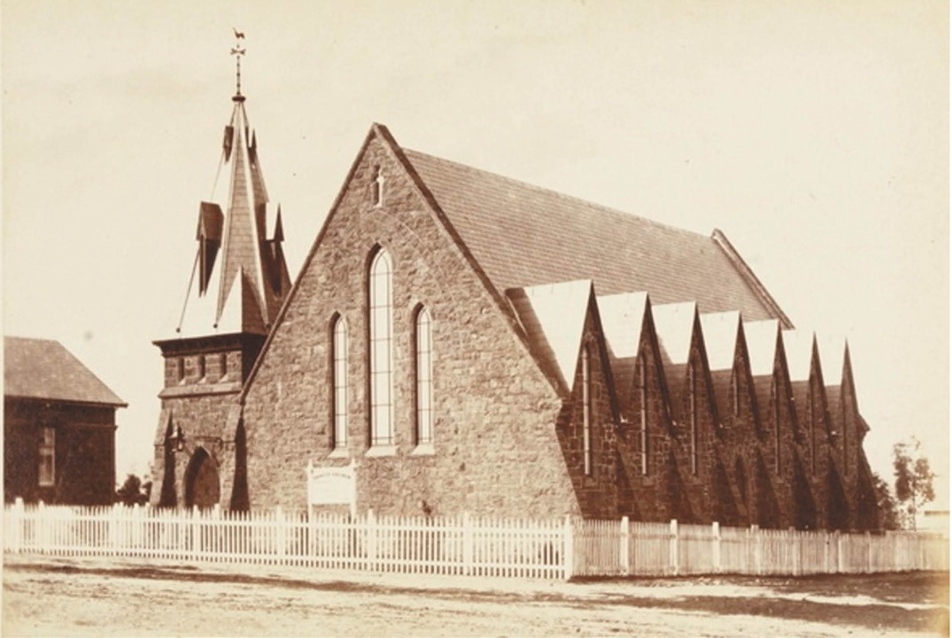
Figure 8.28: E. de Balk, Holy Trinity Church (later Church of Christ), Latrobe Terrace, 1866. Source: figure SL985553, Mitchell Library, State Library of NSW.

On 4 June 1925, the first two elders were appointed:
W. Hoffmann and E. Keonig.208 Between 1925 and 1946, St. John s Church held services and annual meetings at the Central Hall.
The first Lutheran Church service in the Yarra Street church (formerly St. Andrew s Presbyterian Church and the Comunn na Feinne hall) (Figure 8.02) was held on 25 August 1946, in the presence of a large congregation. The first Pastor was
F.H. Schulze of the Grovedale congregation.209

OTHER NON-CONFORMIST CHURCHES
Most of the other non-conformist denominations established in Geelong in the 19th century no longer serve their original purpose. One denomination that maintains a presence
in Geelong (in 2019) is the Christ of Christ at 275 Latrobe Terrace, Geelong. Its bluestone church building (Figure 8.28) was constructed in 1858 for the Free Church of England (Holy Trinity) by Fullager, Habery and Co. to a design by the local architects, Backhouse and Reynolds.210 The Early English
Gothic styled building is distinctive for its transverse gables along the sides and its simple broach-form spire.211 The Church of Christ leased the Holy Trinity Church from 1907 before acquiring it in 1914.212

JEWISH COMMUNITY
The first Jewish family resident in Geelong appears to have been Benjamin Goldsmid Levien (1806-1890), his wife, Eliza (nee Lindo) (1804-1887) and his children from 1846 when Levien commenced operating his punt on the Barwon River (see Theme 3). With Godfrey Alexander and Emanuel Ackman in 1849, Levien was appointed a trustee of a burial ground for the Members of the Jewish Church
at the Geelong Eastern Cemetery (see following subsection for further details).213
In April 1851, the Victorian Government gave a grant of 2 roods of land at the south-east corner of McKillop and Yarra Streets as a site for a Jewish Synagogue.214 It took three years for the Jewish community to raise sufficient funds for

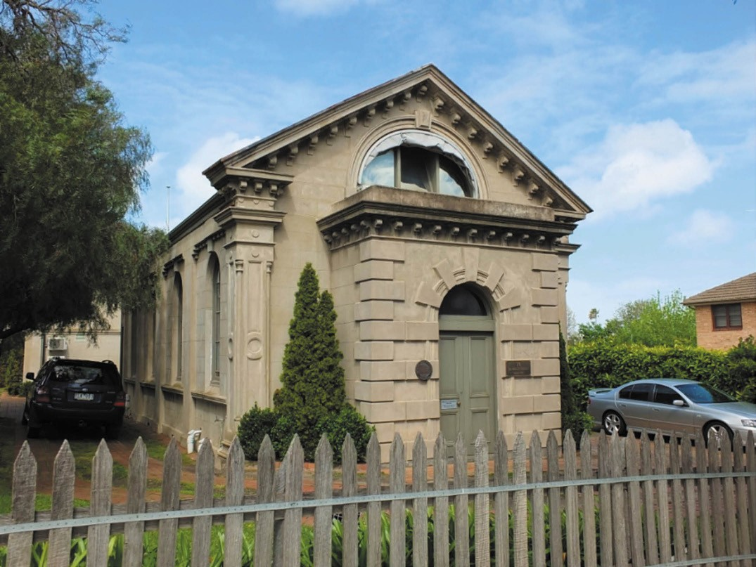
Figure 8.29: Former Jewish Synagogue, Yarra Street, 2019. Source: David Rowe.

the construction of a temporary synagogue designed by local architect John Young in early 1854.215 The building was constructed in June of that year.216
This building served the congregation until 1861 when Young and Honey architects designed a new permanent synagogue.217 The foundation stone was laid in June of that year by Benjamin Levien, president of the Geelong Jewish Congregation.218 Designed in an idiosyncratic Italianate style, the building was consecrated on 1 December 1861 and was described as a handsome, though unpretending, brick structure 219 (Figure 8.29).
The synagogue at 74-78 McKillop Street served the Geelong Jewish congregation until the late 20th century.
Throughout the life and witness of the synagogue, it had a small but well-known congregation. Several members contributed much to local community life. This included
Morris Jacobs (c.1825-1927) (Figure 8.30), successful draper.
Born in London, he arrived in Geelong with his parents in 1852, and later established a draper business in Yarra Street.220 This formed the foundation of his well-known
emporium in Malop Street (see Theme 5). In the early 1920s, Jacobs was described at the Grand Old Man of Geelong and he died in 1927 aged 102 years.221
Another prominent local associated with the Jewish congregation was Priscilla (Zillah) Crawcour (nee Levy) (1899- 1977) (Figure 8.31). The daughter of Abraham and Minnie (nee Goldreich) Levy, she was born in Ballarat where her grandfather, Rabbi Goldreich, was the first rabbi of Ballarat.222 Zillah was exposed to public life through her father, Abraham Levy, who served as a local Councillor with the Ballarat East Council (and amalgamated Ballarat City Council) from 1902,223 including three terms as mayor. It was during Levy s third term in 1924-25 when Zillah acted as Mayoress following
the death of her mother, Minnie, in 1918.224 In 1929 at the Ballarat Synagogue, Zillah married Harold Samuel Crawcour

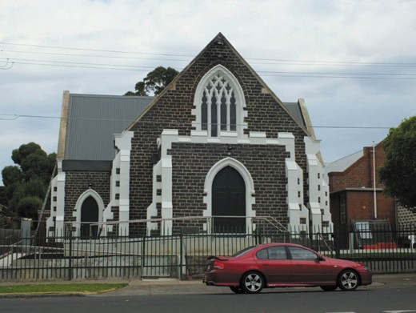

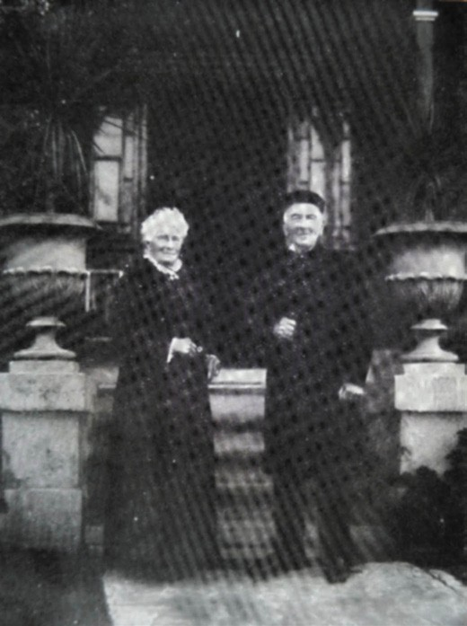
Figure 8.30: Morris Jacobs (aged 97) and his wife, Emma (Burnett) Jacobs (aged 94), 1922. Source: Expansion of Geelong in Australian Home Builder, 1922.
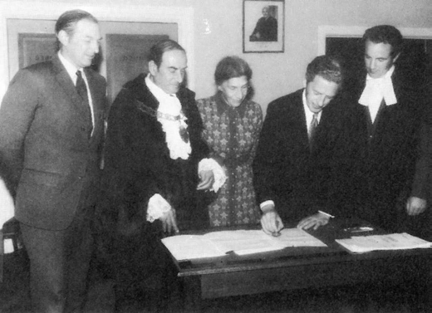
Figure 8.31: Cr. Zillah Crawcour, with (from left to right), M Crow, Mayor J. Lakis, B. Crow and J.D. Backwell (town clerk, Newtown & Chilwell Council), 30 August 1972. Source: G. Seaton, Model Borough: An Introduction to old Newtown & Chilwell, City of Newtown, 1983, p.119.
Figure 8.32: Geelong Mosque, Bostock Avenue, Manifold Heights, 2018. Source: David Rowe.

(1882-1945) of Crawcour Bros. Emporium, Pakington Street, Geelong West (see Theme 5). It was after Harold s death when Zillah entered local politics in 1957, serving as a councillor of the Newtown and Chilwell Council, including three terms as Mayor in 1964-65, 1968 and in 1976-77.225 Zillah was the first female mayor for the Barwon Region.226 She was a foundation member of the Victorian Branch of the Australian Local Government Women s Association which formed in 1963. The Association was inspired by the belief that more women should be involved in local government partly because this arm of government was especially relevant to housewives and mothers. 227 In 1969, she was appointed an O.B.E. The following year in 1970, Zillah was a speaker at the 7th Annual Conference of the Australian Women s Association held in the Camberwell Civic Centre. She also chaired the second and third sessions and planted a tree outside the centre known as the Zillah Crawcour tree.228 It was removed during the redevelopment of the City of Boroondara offices in 2012.229 Zillah Crawcour died in office as Mayor of Newtown and Chilwell Council in 1977. 230 Her significant contribution to Geelong was commemorated in the naming of the Zillah Crawcour Hall at the Matthew Flinders Girls High School and in a park on the north side of the Barwon River (opposite Queen s Park).231

MUSLIM COMMUNITY

In 2000, The Islamic Society of Geelong acquired the former Uniting Church at 45-47 Bostock Avenue, Manifold Heights,232 the Victorian Gothic Revival styled church building becoming Geelong’s only Mosque. The building had first been constructed in Wellington Street, Geelong West, in 1858 to a design by a Mr Grundy, who was also the builder.233 In 1939, the stone church was dismantled and rebuilt at its current

site.234 An arson attack in May 2016 destroyed the Mosque.235 The bluestone walls and tracery windows in the gable ends were saved, and a steel portal frame constructed to support the walls and new roof (Figure 8.32). The Mosque re-opened amid considerable celebrations led by Imam Mohammad Ramzan in 2018.236

LATER 20TH CENTURY CHURCHES REVIVAL CENTRES CHURCH
In 1958, the Revival Centres of Australia led by Noel Hollins
and Lloyd Longfield began from its predecessor, the Commonwealth Revival Crusade. The original founders split into two separate entities with Noel Hollins forming the Geelong Revival Centres.237 Today, this Pentecostal church
has locations at the Geelong Revival Centre, Norlane, and the Revival Centres Church Bellarine at Newcomb.238 Another is the Geelong Revival Fellowship at Grovedale.239

OTHER CHURCHES
Other more recently-established churches in Greater Geelong include the New Apostolic Church (Western Pacific District), Geelong West; Christian Science Church, Geelong West; and Seventh-day Adventist Church, Geelong; and the Christian Reformed Church, Geelong West. The latter is situated in the former Newtown Methodist Church, built in 1876 of Barrabool stone with limestone dressings to a highly distinctive, elaborately detailed Victorian Gothic Revival design (Figure 8.33) by the architectural firm of Davidson and Henderson.240
Another more contemporary contributor to spiritual life in Greater Geelong is the One Hope Baptist Church, with campuses at Moolap and Barrabool Hills (Highton).

OTHER CHURCH-RELATED HERITAGE PLACES CHURCH HALLS & ASSOCIATED BUILDINGS
Spiritual life throughout Greater Geelong is also physically
manifested in a number of halls. These buildings played host to meetings, social activities and celebrations.
For the Protestant denominations, they also had the dual purpose of Sunday Schools where religious education was given on Sundays. In 1867 at Breakwater, a Sabbath School was established as a branch of the Aberdeen Street Baptist Church.241 A year later, the Geelong Advertiser reported that the Breakwater school had prospered and had been the means of doing much good in that neglected district , there being three teachers and 41 scholars.242 This was impetus for the construction of a gabled bluestone Sabbath School building at 45-47 Tanner Street in 1869 (Figure 8.34).

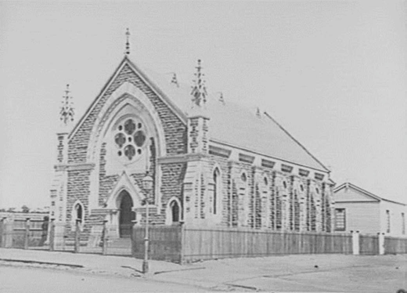
Figure 8.33: F. Kruger, Newtown Methodist Church (now Christian Reformed Church), Pakington Street, Geelong West, 1880. Source: accession H24835, State Library of Victoria.

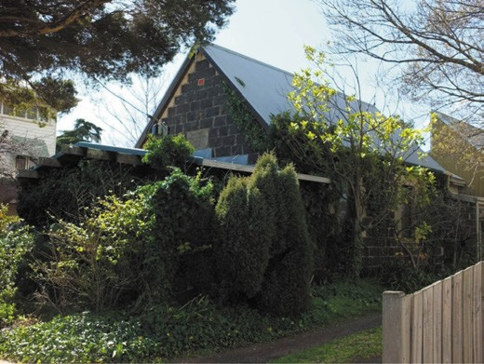
Figure 8.34: Former Baptist Church Sabbath School, Tanner Street, 2019. Source: David Rowe.

Church halls associated with functioning churches include the St. Paul s Anglican Parish Hall, 171-177 Latrobe Terrace, Geelong, built in 1880 in a Picturesque Gothic Revival design by the firm of Alexander Davidson and Company243
(Figure 8.09). Another brick hall to serve as the Infant School was constructed in 1884 towards the rear of the Parish Hall.244 In 1891, a timber hall was built for the St. Paul s Church Union to a design by Laird and Barlow. It was originally situated
to the east of St. Paul s Church but was relocated after the Victorian Railways Department acquired the eastern portion of the church site (see Theme 3).245

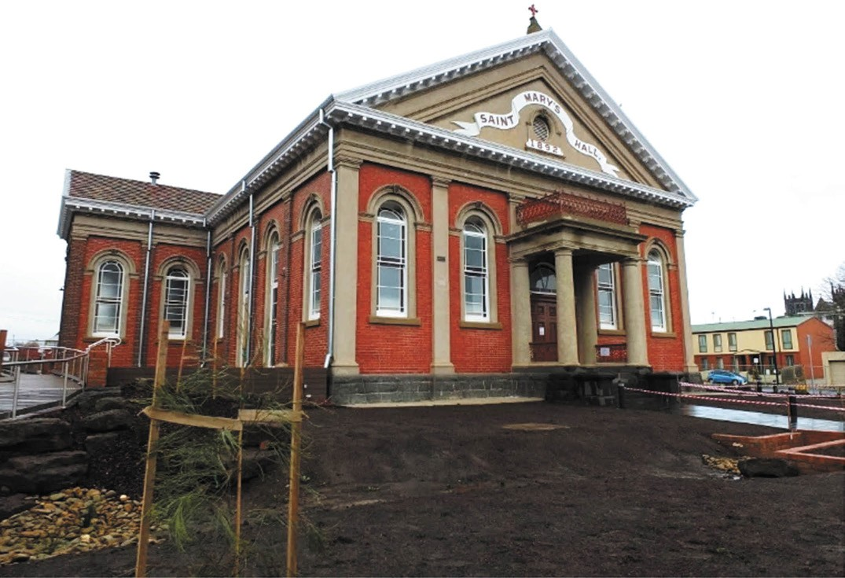
Figure 8.35: Former St. Mary s Parish Hall, Myers Street, 2016. Source: David Rowe.

In 1890, a new Sunday School Hall was built at the Noble Street Wesleyan Church. It was followed by a kindergarten in 1915.246
In Myers Street in in 1891-92, a commodious brick late Victorian Classical Revival styled Parish Hall (Figure 8.35) was built for St. Mary s Catholic Church to a design by the local architects, Watts and Durran.247 It was built to provide much-wanted accommodation for those of Catholic faith following hostilities engendered by the Irish Home Rule question which led to the Catholic Church being denied access to other local halls.248 Between 2015 and 2016, the former Parish Hall was innovatively adapted into a library for Barwon Health.
At Drysdale, a new timber hall was built at St. James Church of England in 1906 to a design by Ward and Carleton, Melbourne architects.249 It featured decorative timberwork in

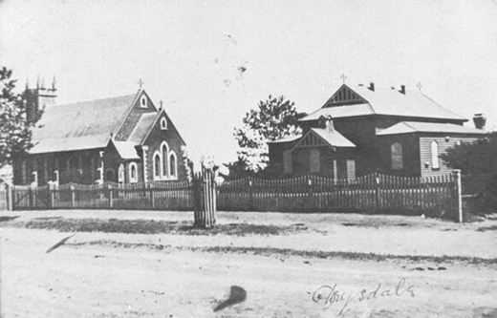
Figure 8.36: St. James Parish Hall (right), c.1915. Source: Bellarine Shire collection, image 60/21, Bellarine Historical Society.

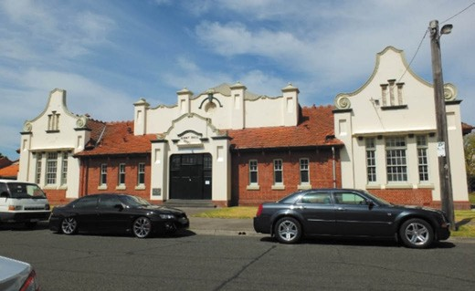
Figure 8.37: Ashby Hall, Malone Street, 2014. Source: David Rowe.
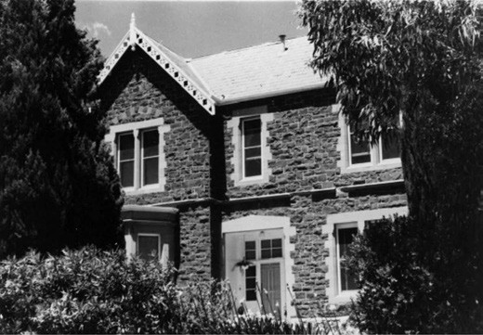
Figure 8.38: J.T. Collins, St. George s Presbyterian Manse, Ryrie Street, 10 December 1976. Source: accession H93.210/388, State Library of Victoria.

the gable ends to the main gambrel roof and the front porch gable, together with decorative finials (in the form of crosses) on the main roof and a tapered ventilator surmounted the porch roof (Figure 8.36).
In 1911, the Geelong architects Tombs and Durran designed a commodious brick Hall that was built to replace an earlier building at Christ Church, Moorabool Street.250 It was constructed as a memorial to Canon Goodman s 51- year ministry at Christ Church.251
In this same year, 1911, during the ministry of Brother Gifford Gordon, the Church of Christ at 275 Latrobe Terrace, Geelong built a hall to serve as a Sunday School. The rudimentary Federation Gothic Revival building was constructed of stuccoed brick with a steeply-pitched gabled roof clad in slate.252

In 1914, Herbert Black and T.D. Slevin designed a distinctive Dutch colonial Baroque Revival styled hall for Ss. Peter and Paul s (known as Ashby Hall) in Malone Street253 (Figure 8.37). In was opened by the Mayor Geelong, Councillor W. Brownbill, in January 1915, the Geelong Advertiser describing it as follows:
It is a brick building with cement dressings and tile roof designed in the Dutch manner: there is large entrance vestibule, cloak rooms, supper room, societies hall, and the hall proper, 88 feet by 40 feet. The walls and ceilings are finished in plaster, with a fumed oak dado; and the floor is of specially selected New Zealand kauri.254

RESIDENCES FOR THE CLERGY
Numerous dwellings specifically built as accommodation for the clergy of the various religious denominations were built throughout Greater Geelong in the 19th and 20th centuries. Most were erected adjacent to the church building, the incumbent acting as caretaker of the church property. The earliest surviving minister s residence is the former Wesleyan Mission House, 1 Little Ryrie, originally built as a four roomed dwelling in 1854 to a design by Backhouse and Reynolds, architects.255 This dwelling (known today as Avona ) was erected in anticipation of a chapel being constructed next door with a frontage to either Ryrie Street or Latrobe Terrace (Figure 8.16). This never eventuated, the only other legacy
of the Wesleyan cause near this locality being the name of a thoroughfare: Wesley Place.
Nearby at 1 Skene Street, Newtown, a dwelling was built in 1852-53 by John Matthews, architect/builder and later
purchased by the Free Presbyterian Church as a residence for the Rev. John Tait.256 Different arms of the Presbyterian Church built manses in the 1860s, including the Victorian styled dwelling at 12 Fenwick Street in 1862 for the Reformed Presbyterians and the bluestone Victorian Picturesque Gothic styled manse at 13 Ryrie Street in 1864 for St. George s257 (Figure 8.38).
At Breakwater, a Victorian Italianate dwelling was built in 1869 as the residence for the superintendent of the adjoining Sabbath School in Tanner Street.258 The school was a preaching station for the Aberdeen Street Baptist Church (see earlier). The first superintendent was a Mr Langhorne who was assisted by two teachers from Geelong.
In 1886, a new Presbytery was built at St. Mary of the Angels Church in Yarra Street (Figure 8.39). The elaborate two storey Victorian villa was the design of the prolific local architect, Joseph Watts and it replaced an earlier presbytery on the site.259 A more modest timber vicarage was erected in Collins Street, Drysdale, opposite St. James Church, in 1889.260

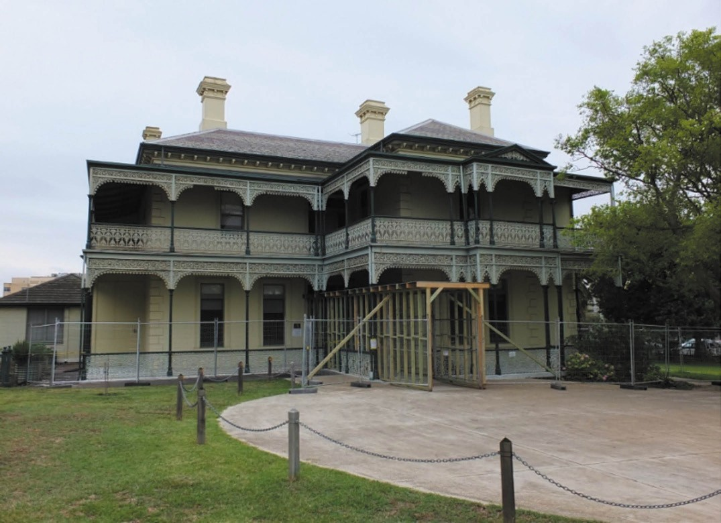
Figure 8.39: Former St. Mary s Presbytery, Yarra Street, 2016. Source: David Rowe.

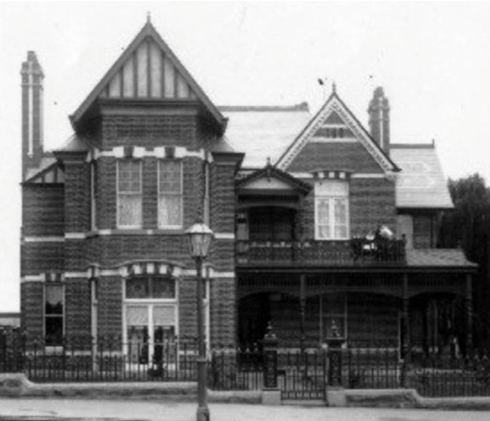
Figure 8.40: Wesleyan Manse, Yarra Street, c.1915. Source: Lorraine Huddle.
Of similar design and grand scale was the construction of the brick two storey United Presbyterian Manse at 32 Myers Street, Geelong, built in 1888 to a design by Joseph Watts.261 Associated with the ‘Steeple Church’ in Ryrie Street, the first to occupy the new manse was the Rev. Arthur Davidson.
He remained there with his wife, Helen Allen Davidson (nee Pritchard), until it was acquired for a Y.W.C.A. girls hostel in 1915 (see later subsection for further details).262
At the Wesley Church, Yarra Street, in 1891, the Melbourne architects Butler and Ussher designed a commodious Late Victorian Picturesque brick manse263 (Figure 8.40). Also at this time, an equally substantial Late Victorian manse was built
for the Aberdeen Street Baptist Church, 1 Aberdeen Street, to a design by A.J. Derrick.264 A few years later in 1895, the
Anglicans built a more modest timber parsonage at St. Mark s, Leopold, in 1895. It was designed by Laird and Barlow.265

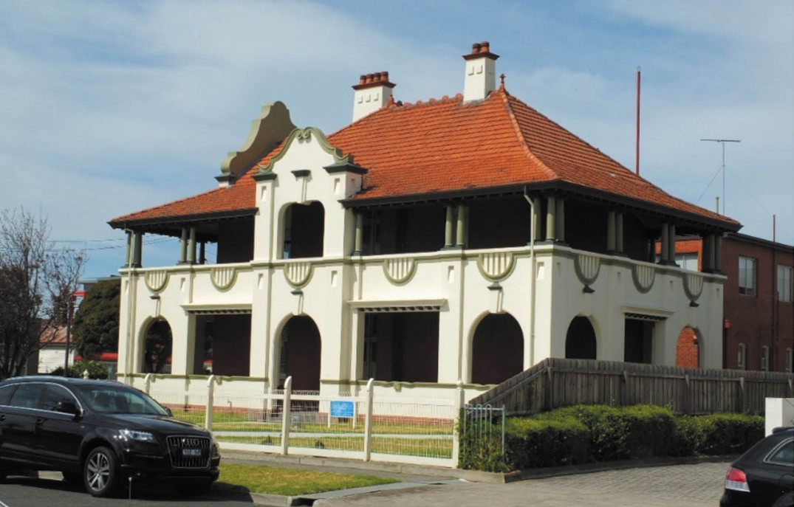

Figure 8.41: Ashby Presbytery, 1 Malone Street, 2014. Source: David Rowe.

During the early 20th century, the Methodists built Federation styled timber manses, including the dwellings at 375-377
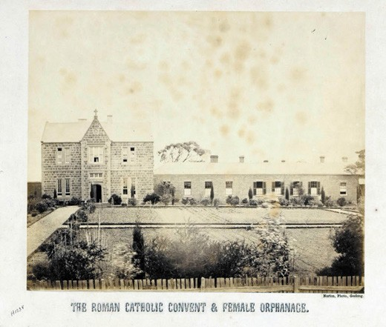
Ryrie Street in 1909 for the Shenton Methodist Church and Wesley House at 233 Pakington Street in 1912-13 for the Newtown Methodist Church.266 Yet, the most substantial and distinguished was the Ashby Presbytery built for Saints.
Peter and Paul s Catholic Church at 1 Malone Street, Geelong in 1914-15.267 It was designed in a similar Dutch colonial Baroque style as the neighbouring Parish Hall by Black
and Slevin268 (Figure 8.41). It was followed by St. Thomas Presbytery, 43 Wyndham Street, Drysdale, in 1918, a brick dwelling designed by A.A. Fritsch, architect of Melbourne.269 In recent years, the Presbytery has been adapted into an administration office as part of an Aged Care facility (with the former St. Thomas Church, built in 1856, being integrated into the development as a chapel).270

Figure 8.42: J. Norton, Sisters of Mercy Convent and Orphanage, Newtown, 1866. Source: accession H1238,
State Library of Victoria.

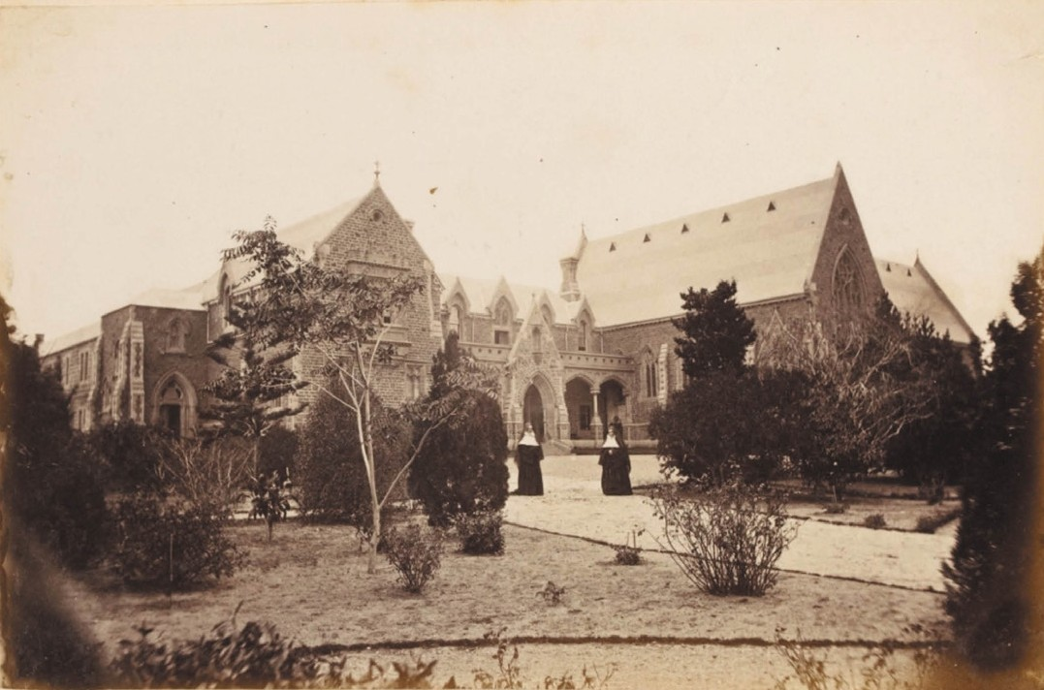
Figure 8.43: F. Kruger, Convent of Mercy, Newtown (north wing & chapel), 1880-81. Source: accession H33802/36, State Library of Victoria.

In the 1920s, the Anglicans erected new vicarages. This included a timber Bungalow at St. Matthew s, 230 McKillop Street, East Geelong, in 1921.271 More notable was a new brick Vicarage built in 1924 at Christ Church, McKillop Street, Geelong, to a design by Laird and Buchan architects. Completed in 1925, Rev. Schweiger and family were the first to occupy it.272

CONVENTS AND MONASTERIES

SISTERS OF MERCY CATHOLIC CONVENT, RETREAT ROAD, NEWTOWN
In 1855, the Rev. J.B. Hayes, Dean of the Roman Catholic Diocese of Melbourne, made on offer for the purchase of Sunville , Newtown, for a convent of the Sisters of Mercy.273 Sunville had been built in 1850 for Joseph William Belcher, solicitor. A number of years elapsed before the sale to the Catholic Church was realised in early 1860 and reported in The Argus:
The house and grounds known as Sunville, on Mercer s Hill, have been purchased for a convent by the
Catholic clergymen here. There are about 12 acres of pleasure-grounds attached to the mansion, which is in every respect well adapted for the purpose. Six ladies of the Order of Mercy, who were sent out from the parent house in Dublin by Mrs. Cecilia Zavier [sic.] McGuire, have arrived in Geelong, for the purpose of establishing this new institution They will attend to the poor, the maimed, the sick, and the dying at their own houses, and in the public hospitals, and will superintend a boarding and day school to be attached to the institution The house and grounds of Sunville are beautifully situated for the purpose for which they have been bought.274
While no fabric of Sunville exists today, the early evolution and development of the Sisters of Mercy Convent is identified in the notable two storey masonry buildings forming a quadrangle as part of Sacred Heart Girl s College. This complex of buildings reflects Mother Xavier’s vision to

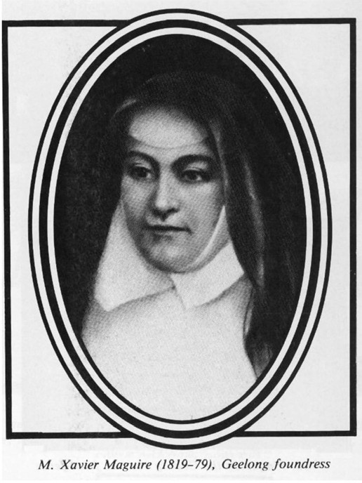
Figure 8.44: Mother Xavier Maguire, n.d. Source: Sacred Heart College.

permanently build a substantial convent within three years of occupation. It seems that an east wing was constructed in c.1861 (Figure 8.42), followed by the building of a south wing in 1863-64 to a design by Joseph Shaw.275 The east wing was remodelled with two storey additions in 1869 and in 1871 it was extended on the north side to a design by T.A. Kelly276 (Figure 8.43). He also designed the north wing and the
main north convent portico.277 Significantly, Kelly – who had prepared a revised design of St. Mary of the Angels Church, Geelong, was also responsible for the design of the convent chapel in 1873-74 where a sanctuary window was installed in 1874 (it had been designed by D.R. Drape).278 Five years
later in 1879, Alexander Davidson and Co. designed the north portion west wing and this was followed by the south portion of this wing in 1881.279
Mother Mary Xavier Cecilia Maguire (Figure 8.44) was born in 1819, the daughter of Richard Maguire of Newgrange, County Meath, Ireland.280 She has been claimed as one of the most notable nuns of early Australia. 281 In 1879, The Advocate

gave the following details of Mother Maguire s life:
Having, from an early age, determined to consecrate herself to God, she entered the Baggot-street Convent, Dublin, in May 1843, and, after the customary novitiate, was professed in November, 1845. She was for some time superioress of the Baggot-street Convent, and in that capacity helped to establish the now famous Mater Misericordiae Hospital in Dublin, the foundation-stone of which was laid by her own hands. Another institution, not perhaps so well known as the one just mentioned,
owes its existence to the deceased lady, viz., the Joseph- street Hospital, Dublin. To show this ardent devotion and enthusiasm with which Sister Mary Xavier, as she was then, prosecuted her mission of charity, it may be
mentioned that she spent a year in France for the express purpose of making herself practically acquainted with
the best mode of nursing and relieving the sick. But her vigorous mind was not content with merely working one department of Christian labour. To rescue the degraded of her own sex from a life of infamy and win them back to virtue, was another object to which she devoted her energies, and, in the furtherance of that object, she established the reformatory for abandoned women at Golden Bridge, near Dublin. It was from the midst of this busy life of Christian charity and benevolence that an
invitation from His Lordship the Bishop of Melbourne was addressed to the Baggot-street community. Dr. Goold expressed a desire to have a branch of the order (Sisters of Mercy) established in Geelong, and the desire was
at once acceded to, Sister Mary Xavier being appointed Superioress of the new community to be founded at
the antipodes Her character may be summed up in one sentence an inherent capacity for government, possessing an almost masculine strength of mind, ever giving a bright example of virtue and piety, whilst
carefully attentive to the smallest details incidental to the management of the community under her charge.282
Claimed to be a tall and correspondingly well-built woman, Mother Xavier died on 30 August 1879.283

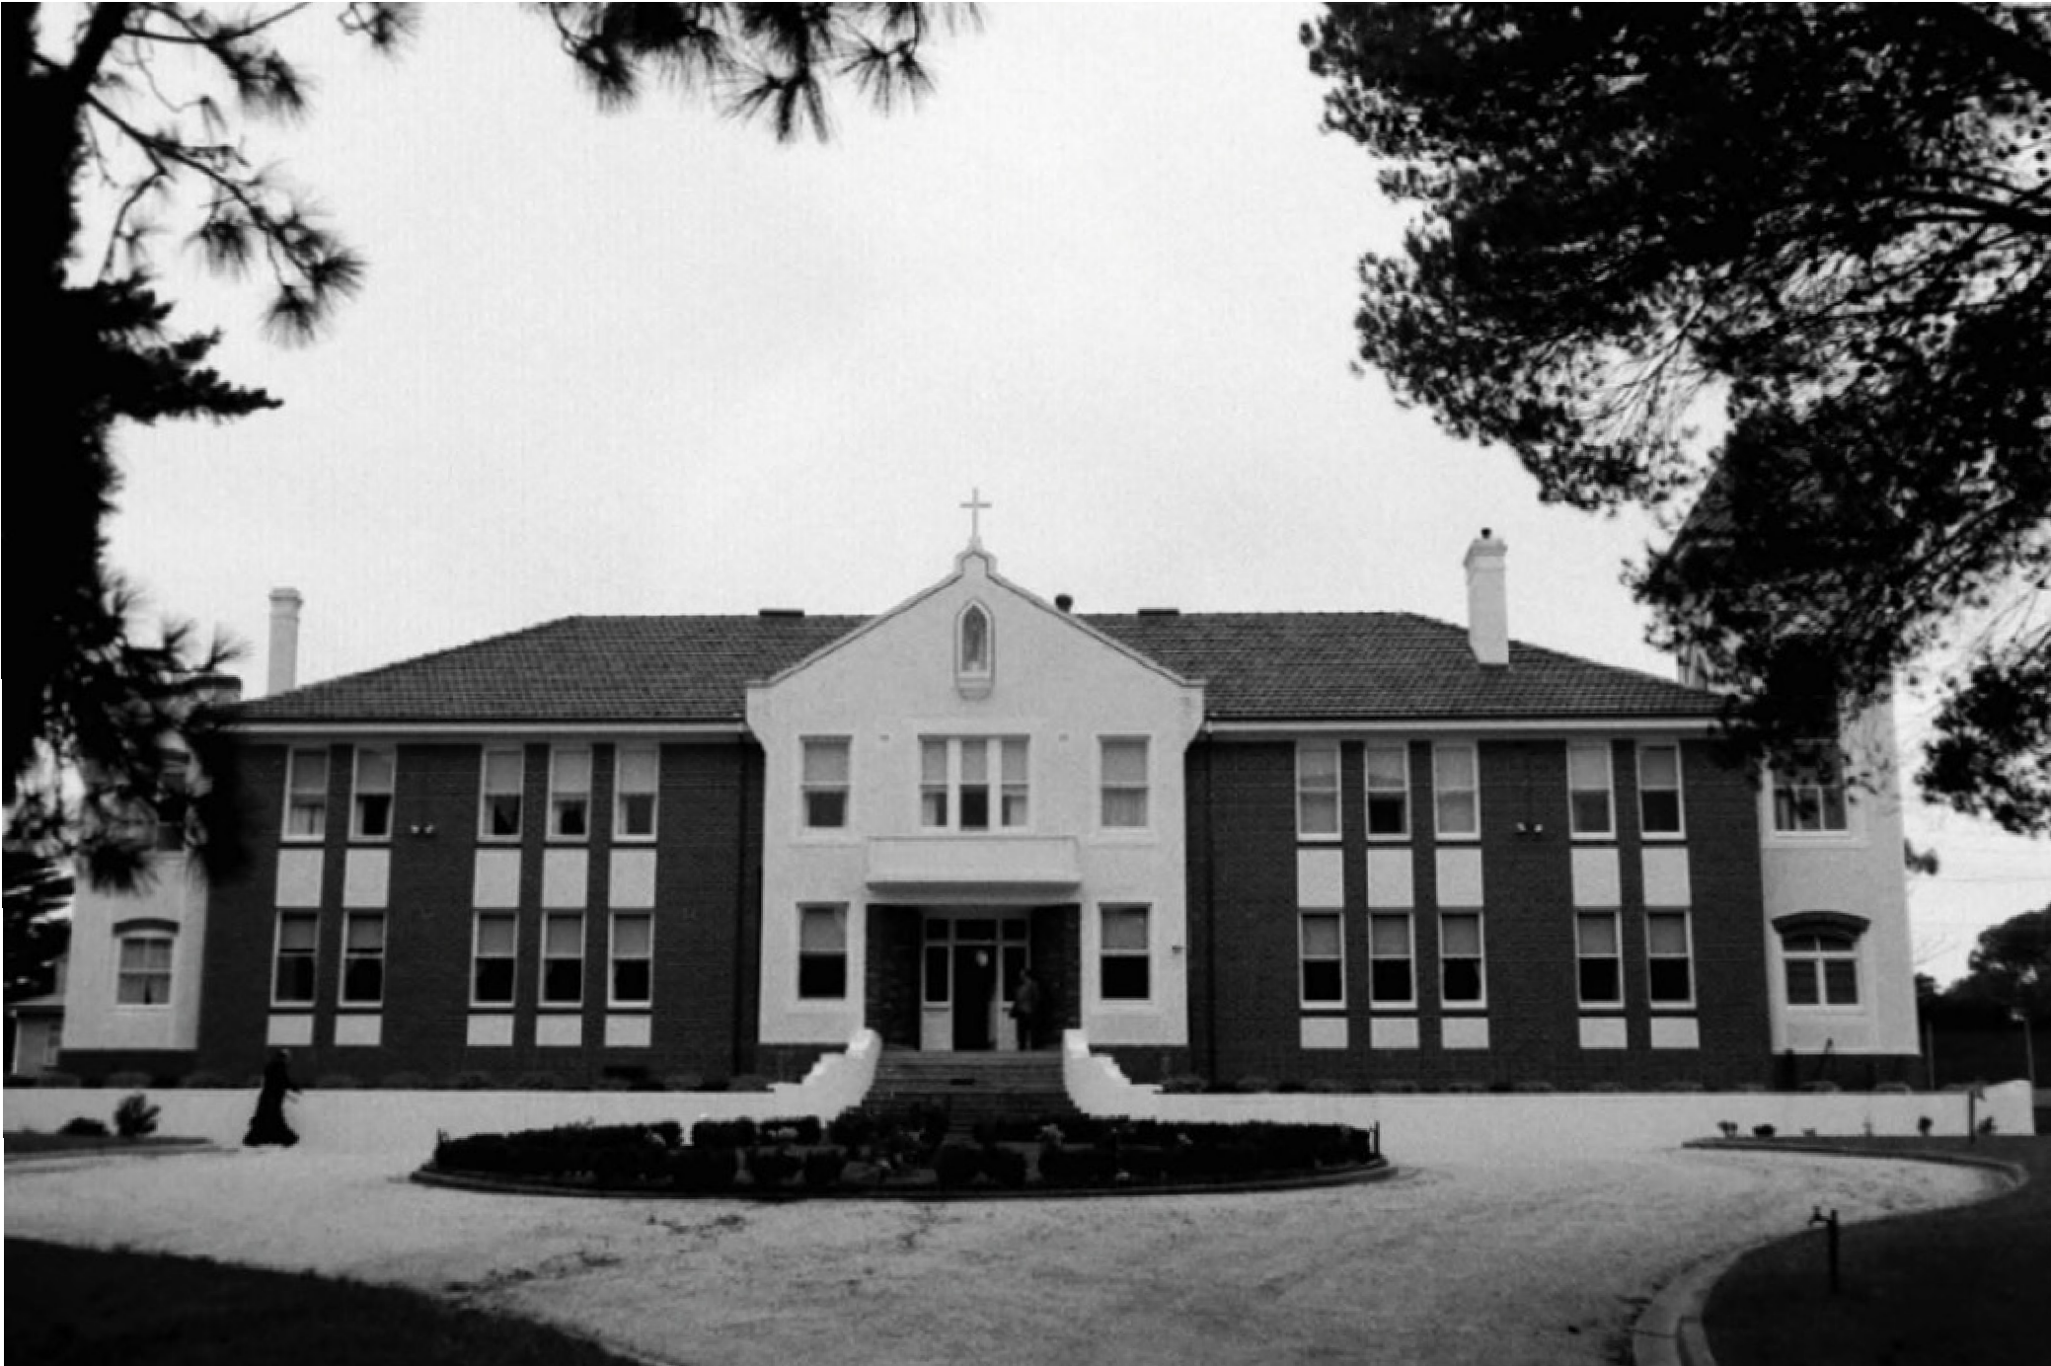

Figure 8.45: Panagia Gorgoepikoos Monastery, Lovely Banks, 1998. Source: David Rowe.

PANAGIA GORGOEPIKOOS MONASTERY, 31-43 MONASTERY ROAD, LOVELY BANKS
In 1934, a Novitiate for the Oblate Fathers was proposed on farmland at Lovely Banks that had been bequeathed by the late Thomas and James D Arcy.284 The Novitiate was to accommodate the Missionary Oblates of Mary Immaculate, a congregation of priests and brothers first founded in 1816 by Saint Eugene de Maxenod, a French priest.285 Architect
G. Vanheems of Melbourne was commissioned to design the building and a contract was awarded to W.J. Kelly Pty Ltd, local builders at a cost of £10,000.286 The symmetrical, two storey hipped roofed interwar Mission Revival styled building featured a rendered, central parapeted gable entrance portico and flanking rendered pavilions (Figure 8.45). In the north- east corner of the site, a cemetery was established. The Rev. Thomas Hayes of the Oblate House, Sorrento was appointed the inaugurate superior of the Novitiate in January 1935.287
In May 1993, the property was acquired by the Greek Orthodox Archdiocese of Australia to serve as the Panagia Gorgoepikoos Monastery (meaning She who is Quick
to Hear ).288 Since that time it has been the location of a monastic community for women, the abbess being Mother Kallistheni.289 In 1998, the Panagia Gorgoepikoos Monastery proposed the construction of a church on its site.290
Delays ensued and the brick neo Romanesque building surmounted by four domes was not completed until 2015.291

EDUCATION

WADAWURRUNG EDUCATION
The importance of the environment and climate formed the essential basis in the education of Wadawurrung birrah-lee (children).292 From a young age, they were taught about plants: those that were sources of food and those with medicinal benefits; tinder and firewood; and raw materials that were used in the production of objects. Climatic variations – which influenced the locations of food and encampments during the seasons also formed part of the educational process.293
An integral part in the education of the Wadawurrung children also came from storytelling from the clan historian. This important person imparted knowledge about the legends of the Ancestors around camp fires, and through music and drama. The ways of hunting, foraging, correct behavior and other key elements of Wadawurrung lifestyle formed part of these activities.294 The art of tracking, including knowledge of the footprints of the clans people, and how to cover tracks by dragging leafy branches behind, was taught by the Elders. More advanced art of tracking was taught to trainee hunters after the first initiation as teenagers.295
Initiation ceremonies were performed as rites of passage for adolescent boys and girls mainly between the ages of 10 and 16 years of age.296 These celebrations were for adolescent children who had successfully proven their attainment of sufficient knowledge worthy of the mental and physical responsibility of adulthood.297 Body art and ornaments formed an important part of these ceremonies where additional special knowledge and skills were passed on.298

EDUCATION FOLLOWING EUROPEAN COLONISATION

TOWARDS A FUNDED & REGULATED FREE SCHOOL SYSTEM
The earliest school established in Geelong following European colonisation appears to have been that of a
Miss Kate Jane Fulloon in late March 1841. Miss Fulloon was the fourth daughter the Rev. John L. Fulloon of Westmead, Ireland.299 Her Day School for young ladies was situated in Yarra Street and offered a curriculum that included reading, writing, spelling, arithmetic, English grammar, history, geography and needlework. She also provided teaching for boys under eight, teaching Latin grammar and syntax.300 Miss Fulloon s school had closed by 1845 as it was at this time when she married John Veitch of Buninyong.301
Fulloon s school for young ladies was followed by a school ‘in the Rooms adjoining the Printing Office, North

Corio [Geelong] , from August 1841.302 This school offered education for a broader number of children and youth. John Stanley Stewart who had been educated at the principal schools in Scotland, and had subsequently been actively engaged in the various duties of both public teacher and private tutor, 303 offered day classes between the hours of 10 am and 1pm, and 2 pm and 4 pm, and
an evening class between 7 pm and 9pm five nights per week.304
While both of these schools (and others established in later years)305 gave opportunities for receiving an education in the fledging Geelong township, it was only available to those with sufficient wealth to pay for it.306 Recently- established churches were also relied upon to provide an education role
for the children of congregations but there was no opportunity for general education at the public expense.307 This serious deficiency in school education was not only confined to Geelong, but to the Australian Colonies as a whole. In
1844, a Select Committee of the N.S.W. Legislative Council was appointed to enquire into, and report upon the state of education in this Colony, and to devise the means of placing the education of youth upon a basis suited to the wants and wishes of the community. 308 The Committee was critical of the high cost of educating children, attributing:
this largely to the strictly denominational character of the public schools the very essence of a denominational system is to leave the majority
uneducated, in order to imbue the minority with peculiar tenets wherever one school is founded, two or three others will arise, not because they are wanted, but because it is feared that proselytes will
be made. 309
The Committee considered two rival systems, the British and Foreign school Society system, and Lord Stanley s system of National Education of 1828 in Ireland.310 The latter was considered to be ‘the only plan sufficiently comprehensive
to include both Protestant and Catholic , and yet without neglecting religious instruction.311 Before the completion of the Committee s Report, it received 74 petitions about the possible changes, with 50 opposing the National system of education favoured by the Committee and for a continuation of a denominational system instead.312 Approximately
100 signatures was included on the petition from the Heads of Families resident in Geelong.313 They were in favour of the proposed education model as outlined in the petition:
That your petitioners, considering the evils every inseparable from ignorance on the one hand, and the unspeakable advantages, both to individuals and
communities, arising from sound knowledge on the other, and taking into view the rapid increase of the population

of the colony, with the lamentable deficiency of the means of education experienced throughout the whole territory, would beg to call the attention of your honorable House, to this most important subject, in the hope that such means may be speedily adopted as will place within the reach of all, that amount of education, which will rescue the rising generation from the evils to which they are at present greatly exposed, as well as lay the ground work for the formation of a virtuous and happy people.
That your petitioners have been led to this expression of their opinion, from the conviction that the present denominational system, is utterly inadequate to the circumstances of a people so widely scattered, and so widely and variously differing in religious opinion, as may be seen in the condition of every town and village throughout the land; and therefore respectfully beg, that your honorable Council would be graciously pleased
to adopt some general and comprehensive system of education to meet the wants of the colony.314
In 1848, a compromise system for the provision of funds was implemented with the appointment of a Board of National Education for national (or state) schools; and a Denominational Schools Board to continue to financially support denominational schools associated with the Church of England, Roman Catholic, Presbyterian, Methodist and church denominations.315
In 1851 following separation from New South Wales, the Victorian Legislature established the Board of National Education for the Colony of Victoria (commonly known as the National School Board). It was also at this time when a Select Committee was appointed to enquire into and report upon the Working of the present Systems for the Instruction of Youth
in this Colony receiving Support from the Public Revenue, with the power to take evidence thereon, and to recommend, if found requisite, a plan of Education better adapted to
the wants of the community. 316 The Select Committee recommended a scheme similar to that of the Committee of Privy Council on Education where only requirements necessary to obtain support for a school be its efficiency in
imparting sound literary and moral education and the absence of any rules requiring compulsory religious instruction ,
with all school to be known as public schools administered by a single Board of four laymen.317 This brought about considerable debate and the dual system of publicly funded National and Denominational Schools continued for a further 10 years.318
While debate might have ensued about the plan of education in Victoria, the teaching profession from both National and Denominational Schools came together in Geelong in the late 1850s to form the Geelong Branch of the Educational

Institute of Victoria.319 This Institute had been established in Melbourne in 1856 by a committee of teachers of public schools. The Age gave details of this newly-formed establishment:
The objects of the Educational Institute will be, the promotion of popular education and the development of the means by which this object will be most readily and surely attained; the elevation of the social position of teachers as a class, and their intellectual improvement, by series of lectures, essays, and debates on various branches of science and literature, and the practice of school-keeping; the improvement, and the reduction to the form of a science, of the method of teaching, that it
may be studied and learned as any other science is, with a view to prevent persons from entering on the profession of primary instructor who have not duly qualified themselves for the discharge
of their duties.320

NATIONAL SCHOOLS
The inaugural Commissioners to the National School Board in late 1851 were J.F. Palmer (chairman), C.H. Ebden, Hugh C.E. Childers, Thomas H. Power and W. Westgarth321. They established rules and regulations for funding towards the building of school house and for support to schools. National Schools were considered as two classes: Elementary Schools and Schools of Industry, with most funding provided to the former.322 Schools for females fell into the Elementary School system, but they were required to give instruction
in sewing, knitting, and other works suited to Females. 323 Teachers were appointed by the Board of Commissioners, with training offered at a Model and Training School for the National School Board built in East Melbourne in 1853-54.324 Three teachers from the National Education Board in Ireland, and two Infant School teachers from the Council of Education in England were appointed as inaugural instructors.325 Inspectors were also appointed to ensure that the integrity of the Board s rules and regulations were upheld.326 In relation to religious instruction, the patrons of schools had the right to determine the extent given, either during or after school hours, although Scripture lessons were prohibited from being read during the time of secular or literary instruction. 327 The curriculum reading, writing and arithmetic - was originally based on school books sanctioned by the Commissioners of National Education in Ireland.328 It also included history and geography, geometry and mensuration, Latin, Greek, French, German, natural philosophy, political economy, book keeping and singing.329 As for the school building, the cost was to be the number of children anticipated to attend, with an area of six square feet to be allowed for each children. The buildings were to be ten feet high to the wall plate. 330

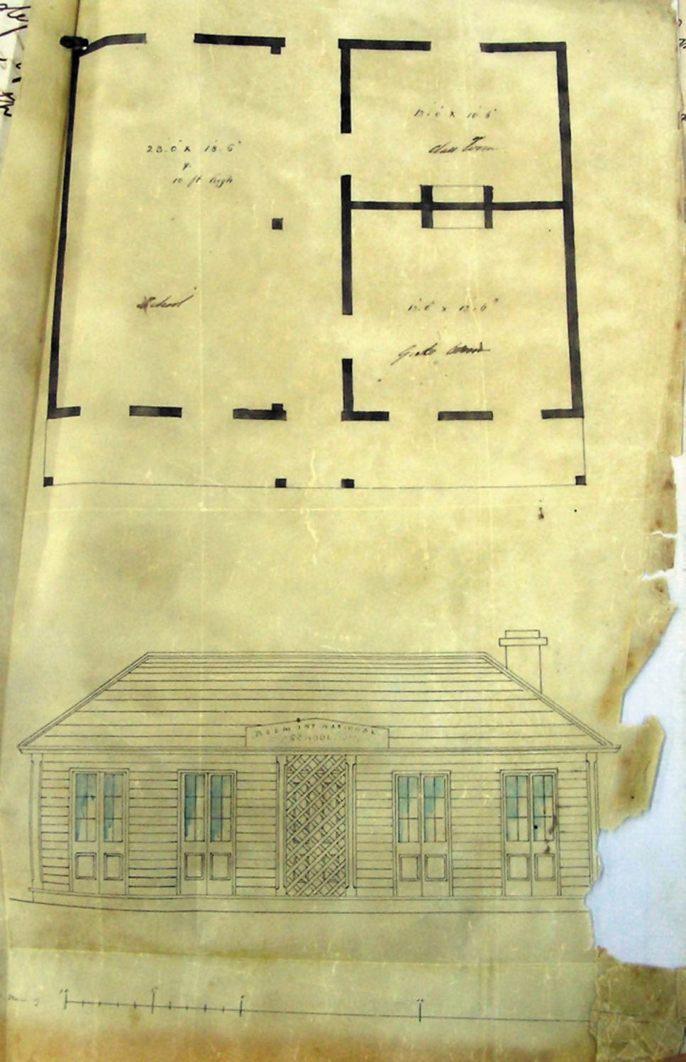
Figure 8.46: Floor plan & elevation of proposed Belmont National School, 1856. Source: Belmont National School file, VPRS 800/ P0 Unit 3, Public Record Office Victoria (Public Record Office Victoria).

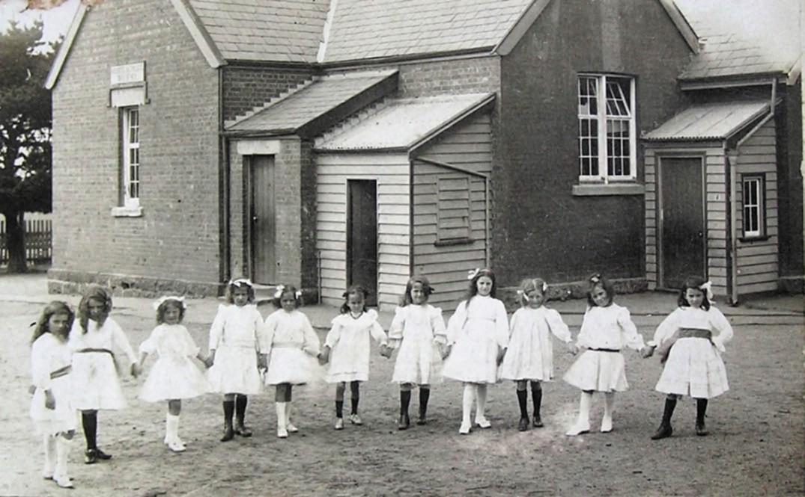
Figure 8.47: East Geelong State School (formerly National School), Boundary Road, East Geelong, c.1910. Source: Ken Grinter collection, Geelong Heritage Centre collection.

In Greater Geelong, the National School Board system
is associated with three schools: Belmont Primary School, Geelong East Primary School and Matthew Flinders Girls Secondary College.331

BELMONT NATIONAL SCHOOL, MOUNT PLEASANT ROAD, BELMONT
Residents in the Barrabool Hills met at the Race Course Hotel, Belmont, in October 1856 for the purpose of establishing a National School.332 The Mayor of Geelong and progenitor
of the Belmont township, Alexander Thomson, was elected chairman of the school committee.333 The honorary secretary, Alexander Mackenzie, wrote to the secretary of the National Board of Education stating that the Roman Catholics
already have a school here but we are anxious to establish another for the children of the protestant inhabitants on the National system of education. 334 The school committee treasurer, J.E. Thomas, had purchased a good, substantial 4 roomed Singapore House that was suitably situated on the main Barrabool Hills Road [Mount Pleasant Road] this possibly being near the existing school building335 (Figure 8.46). A carpenter was engaged to remove a partition wall and other necessary alterations , and to make forms and
desks.336 By December 1856, the Belmont National School had been opened, the first vested school in Geelong.337
In 1863, the school became Belmont Common School No.26 with John Quinton as head teacher.338 It was later to become Belmont State School No. 26. In 1885, the South Barwon Shire Council petitioned the Minister of Education for the construction of a new school building.339 Land comprising part of the Estate of the late John Kiddle comprising a portion of Crown allotment 5, Section 23 in in the Parish of Barrabool with a frontage to 51 Mount Pleasant Road was subsequently acquired and a brick school room constructed in 1886.340 This school building forms the front brick wing of the Belmont Primary School today.

GEELONG EAST NATIONAL SCHOOL, BOUNDARY ROAD, EAST GEELONG
On 1 August 1857, a vested School was opened in Boundary Road, East Geelong, to serve the fledgling neighbouring community of St. Albans (now Whittington and St. Albans Park). It was among the first to receive State aid.341 The design of the one-roomed brick school building342 with a steeply-pitched gabled roof was a basic precursor of the standardised single-roomed Common and State school designs in future years. While not officially appearing in the Reports of the Commissioner, the Geelong East school was vested and as a consequence, was considered a National School.343 After the Common School system was introduced, the school became the Geelong East Common School No.
541. It was during the Common School era when the original design of Geelong East was completed.344 The school was later known as the Geelong East State School and then
the Geelong East Primary School. Several alterations and additions have been carried out over the years (Figure 8.47).
The first Head Teacher of the Geelong East School was Charles John Prosser (1821-1884). Born in London, Prosser was educated as a teacher and in 1847 with his sister, Caroline, he arrived in Adelaide on The David Malcolm.345 By 1853 he had relocated to Victoria, taking up the position of Head Teacher at Breakwater, Geelong, at this time.346 Following his appointed at Geelong East School in 1857, he remained for three years until 1863 when he established a Common Presbyterian School at Sutherlands Creek.347 By
1869 he was head teacher at Connewarre East and in 1875 he was appointed head teacher at Barwon Heads.348 He died in 1884.349

FLINDERS NATIONAL SCHOOL (MATTHEW FLINDERS GIRLS’ SECONDARY COLLEGE), LITTLE RYRIE STREET, GEELONG
In 1854, a group of prominent citizens of Geelong sought to provide a non-secular school for children. A block of land bound by Latrobe Terrace and Myers, Fenwick and Little Ryrie Streets was granted by the Government. Fundraising commenced by a National School committee which included Dr Alexander Thomson.350 The local architects Backhouse and Reynolds were commissioned to design the building with tenders called in August 1856.351 On 7 December 1856, the foundation stone was laid by Acting Lieutenant-Governor, Major-General Macarthur.352 To be known as the Geelong National School, the Governor requested the name to be changed to the Flinders National School,353 in honour of the European explorer to Geelong, Captain Matthew Flinders.
The school opened for boys only on 18 January 1858, with girls given opportunity to enrol from 1864.354 A contextually

substantial building which was a physical manifestation of the National School Board s model school aims,355 the Victorian Italianate building was originally symmetrical and featured
a dominant central tower with bell cast roof (Figure 8.48). Several alterations and additions have been carried out throughout the 20th and early 21st centuries. The school continues to the current day as the Matthew Flinders Girls Secondary College.
The first head teacher was Gilbert Wilson Brown
(1832-1918).356 Born in London, he completed a Master of Arts at Cambridge University before emigrating to Victoria in 1853.357 Following his departure from Flinders National
School after only 12 months, Brown was appointed Inspector of Schools to the Board of Education.358 In 1873, he became the first Inspector General for the Education Department, rising to the position of Secretary for Education.359
At the Flinders National School, Brown s replacement from 1859 was George Morrison.360 He remained until 1861361 and his substantial contribution to education in Geelong was to come with this establishment of the Geelong College (see following subsection).

DENOMINATIONAL SCHOOLS
While there were three National Board Schools in operation in Victoria in 1852 with 342 children in attendance,362 by far the majority of schools with the largest attendances were the Denominational Board Schools. In 1851, the Denomination School Board boasted 74 schools with an attendance of 4999 pupils.363 Such a large number of Denominational Schools was due to their established by Ministers of Religion in previous years, who personally superintended their evolution and development following exertions by the congregations that fueled the formation of the churches through financial and political means.364 Initially, the Denominational School Board conducted the business relating to National Schools until the National School Board Commissioners were appointed.365 The inaugural chairman of the Denominational School Board following Separation was Robert Williams Pohlman, with David Ogilvy, Robert Smith, Henry Jennings and John Sullivan compromising the remainder of the Board.366 Colin Campbell was the Acting Secretary.367 The principal difference between the two Boards was the need
for the Denominational School Board to have a the religious element. 368 The motives of the Board were expressed
in 1851:
Education, however, appears to be the very field on which this ought to meet in friendly co-operation [mutual support of the State, the people, and the Ministers of religion], and yet with a constitutional restraint upon each other. If the religious element expressed in the term denominational

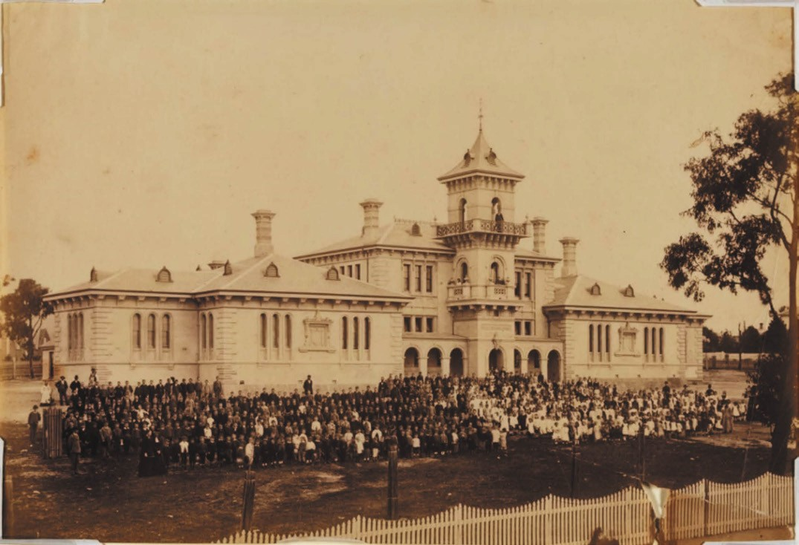
Figure 8.48: F. Kruger, Flinders State School no.260, Little Ryrie Street (originally Flinders National School), c.1880. Source: accession PH324- 1979, National Gallery of Victoria, Melbourne. Gift of Mrs Beryl M. Curl, 1979.

were altogether to prevail, the Schools could not be conducted with efficiency, and if the Secular element were unduly to predominate, that part of Education which most concerns man as an immortal being, might be sacrificed to utilitarian views.369
The Board s religious element included the major Christian denominations established in Victoria in the 1850s: Church of England, Roman Catholic, Presbyterian and other Protestant Denominations. 370 In 1851 in Victoria, the Church of England Denominational Schools had the greatest number of pupils attending, with a total of 2202 children. This was followed
by the Roman Catholics with 1394, the Wesleyans with 692, the Presbyterians with 404, the Independents with 247 and the Free Presbyterians with 60.371 In Geelong at this time, the Church of England Denominational Schools were at Christ Church (including a school for infants), South Geelong, Ashby (St. Paul s) and Newtown.372 Additional Church of England Schools had opened at Point Henry, Barrabool Hills, Breakwater and Batesford by 1852.373 Other Denominational Schools in Geelong in 1851 included one Presbyterian
School in Geelong, two Wesleyan Schools (Geelong and Newtown), and Roman Catholic Schools at Geelong and Ashby.374 By 1852, the Roman Catholics had also opened a second school in Ashby, together with schools at Point Henry and Fyansford.375 The Free Presbyterians also had another school at Bellarine.376
Today, there are small number of former denominational school buildings built in the 1850s that are a physical legacy of this early educational system. They are the former Gaelic Church School House, 271 Latrobe Terrace, Geelong (built in 1854). St. Giles Free Church School House and 72-80 Gheringhap Street, Geelong (built 1854).377
Prominent in the formation of the Gaelic School House at 271 Latrobe Terrace were foundation members of the Comunn na Feinne Society established a few years later in 1856 (see Theme 9 for further details). This included
Archibald Douglas, inaugural Comunn na Feinne President, who keenly promoted education through the Comunn na Feinne educational competitions with a view to raising the

standards of teaching and of the curriculum in schools. 378 Educational competitions were held by the Comunn na Feinne Society from 1858, initially has part of the highland gathering to improve the reading and writing in Gaelic of its members.379 Annual examinations were subsequently held by the Comunn na Feinne Society in support of its object on the education of local children.380 Judges included qualified teachers, including Thomas I Erson and Edmund Sasse in the early 1860s (see later subsections for details about these teachers).381

EXISTING SCHOOLS & COLLEGES ORIGINATING FROM THE DENOMINATIONAL SCHOOL SYSTEM

GEELONG GRAMMAR SCHOOL, BIDDICOMBE AVENUE, CORIO
As early as August 1853, a meeting was held at the Masonic Hall, Union Street, Geelong to consider the establishment of a Grammar School in the growing township.382 The meeting was chaired by the Rev. Andrew Love, Presbyterian Minister. In attendance was the Rev. Theodore Stretch, Church of England Minister at Christ Church, whose opinion was that
a Free Grammar School should be established instead of a Proprietary (for- profit) School. This appears to have been the genesis of the establishment of a really good Grammar
School by Archdeacon Stretch in August 1855.383 The school opened in temporary premises in Villamanta Street, Geelong West, a month later. The new school (which included boarding) was not free but fee- paying, the terms (payable in advance) for day scholars being £3/3 per quarter, £6/6 for day boarders per quarter, and £21 per quarter for boarders.384
The first head teacher was George Oakley Vance (1828-1910), the son of the Rev. William Ford Vance, vicar of Coseley, Staffordshire, England, and Ann Arabella Atterbury nee Oakley. George Vance was educated at the Islington proprietary school, then at St. Paul s School, Southsea, and at King s College School, London.385 He headed the opening scholarships to Lincoln College, Oxford, in 1846, where he completed a Bachelor of Arts. Arriving in Melbourne in 1852, he was ordained a Deacon in 1853 and appointed a curate at St. James Melbourne soon after.386 Vance transferred to St. Paul s, Geelong, in 1854, and thus began further progress towards the opening of the Grammar School.387
Established along English Grammar School lines offering an academic education to local boys (and later the sons of pioneer pastoralists), the fledgling Grammar School initially
boasted an enrolment of 13 boys, two of whom being the sons of Archdeacon Stretch.388 By the end of 1856, over 50 boys were on the roll which consequently required the School to obtain larger premises at the former hotel, Knowle House,

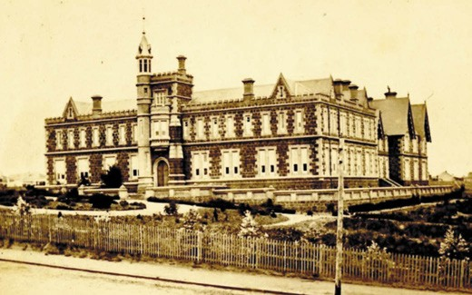
Figure 8.49: Geelong Grammar School from Moorabool Street, 1863. Source: Geelong Grammar School archives.

Skene Street, Newtown.389
It was also in August 1856 when a decision was made to construct a commodious, purpose-built school.390 Land was acquired on the south side of McKillop Street (bound on the west by Moorabool Street and on the south by Maud Street). The Geelong architects Backhouse and Reynolds were commissioned to design the school complex, which by late 1857 was beginning to take shape. The Geelong Advertiser gave the following description:
The building is quadrangular in form, 147 feet 6 inches long by 118 feet wide. It is designed in the late Gothic style, which is chaste and simple, and combines those two great essentials adaptability for all purposes required, and economy in cost An open quadrangle is in the centre of the range and this can be used as a
gymnasium and playground, particularly in rough weather. No windows will look out on this quadrangle except those necessary for light, which are all placed high all the closets and out-offices being accessible therefrom. The fall of the ground has been made to assist materially
in effecting all the arrangements. On the north side (McKillop Street) the first floor is only a few feet above the level of the ground, which falls as much as one in four towards the south side; this give ample room (without excavating) for a ground story on the lower side. In
this story are the kitchen, servants hall, housekeeper s room, store, pantry, cellars, stable, etc; and to preserve a uniformity in the exterior appearance of the building
a terrace-wall will run round from the principal entrance along the south side, and the area thus formed will afford sufficient light to those lower apartments, while at the same time the ground will be shut off from communication therein.

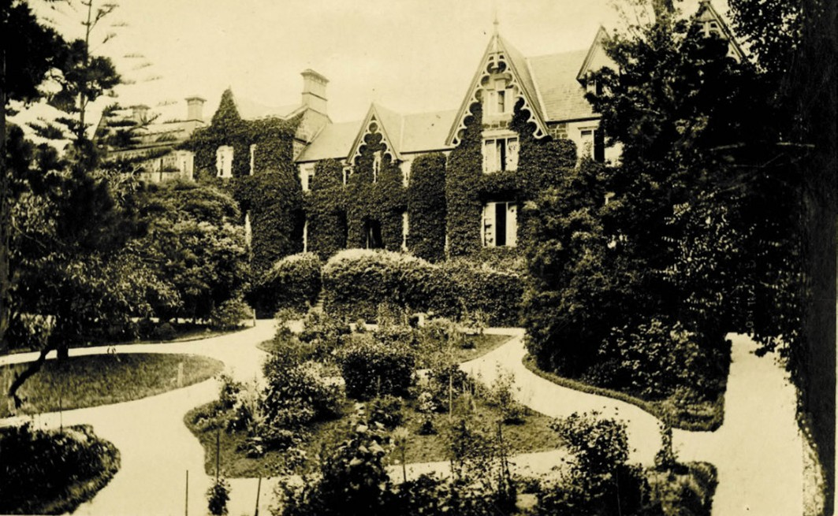
Figure 8.50: Master s Residence (the surviving wing today) fronting 55 Maud Street, 1908. Source: Geelong Grammar School archives.

On the north side is the general entrance; there is a spacious hall, from which ascends the staircase to the visitors gallery in the principal schoolroom and there are also hat and cloak rooms. The schoolroom is 67 feet long by 27 feet wide, and affords room for two hundred boys, allowing eight feet superficial for each; beyond this a corridor runs the whole length of the building, on the inner side, by which access to the classrooms and out-offices can be obtained without causing any interruption in the schoolroom. The writing and drawing room is on the other side of the hall, and is 36 feet 6 inches long by 18 feet 3 inches wide next the French and music classes room, 14 feet by 18 feet 3 inches; and then the junior classroom, which is somewhat larger than the last-named.
The corridor continues to the grand entrance [Moorabool Street frontage to the west], between which and the junior classroom, the library, 26 feet by 17 feet inches,
is situated. There is a flight of steps before the principal entrance, and these terminate on the terrace from thence the vestibule and hall are entered, and the principal stair case. The porter s room is on the right hand, and a hall leading to the head master s sitting room; the remaining
space is occupied by seven small apartments, which are to be set apart as private studies for the more advanced pupils. The dining room is entered next to the sitting room, there being a clear passage by the corridor for the schoolroom, and is 48 feet long by 27 feet wide; it may also be entered from the quadrangle.
The principal s or private entrance is on this [the south] side, and his quarters may be distinguished from any other portion of the building by the wall falling back a few feet. On this side the garden will be laid out, for which there is ample space of land. The principal s study, drawing room, and dining room on the right of the hall and after them, in the north-east corner, is a room designated as the nursery ; there is also a back staircase for the use of the domestics only.
The eastern or back part of the premises will be only one story high, and being over the cellar story, will comprise a covered yard, lavatories, hay loft, male servants sleeping room, etc., and, at the upper corner, an entrance wide enough to admit a carriage to the quadrangle. The whole of the upper story will be divided into dormitories; there will be accommodation for eighty boys, with a separate

ABOUT CORAYO: A THEMATIC HISTORY OF GREATER GEELONG
1017

apartment for each exclusive of the masters and tutors apartments. As there will be a tower and turret over the principal entrance, by a judicious arrangement the sick room will be in the tower.
For such a purpose this is the quietest and most retired part of the building. The turret would answer admirably as an observatory.
The structure when completed will have a very imposing appearance. It is built of blue honeycomb stone, which is very hard and durable; the door and window cornices to be of white stone, smoothly cut and rubbed. A half parapet wall surmounted with iron railings, will enclose the garden and grounds, which it is understood, will be laid out in very ornamental style, and will give a completeness to the whole that cannot fail to be attractive.391
The new school complex (Figures 8.49-50) was officially opened on 24 June 1858.392 The promise of a long history in the grand building was to be short-lived. Due to substantial debts and low enrolments to service the debts (following the opening of the Flinders National School), George Vance resigned in 1860 and the school subsequently closed.393
The Geelong Grammar School reopened at its Moorabool Street campus in early 1863 under the direction of new headmaster, John Bracebridge Wilson (1828-1895).394 Born in England, he was the son of the Rev. Edward Wilson, rector and artist of Topcroft, Norfolk, and Lucretia, nee King.395 Wilson had matriculated in 1848 to St. John s College, Cambridge and graduated with a Bachelor of Arts in 1852.
Arriving in Melbourne in 1857, Wilson was appointed Third Master of the Geelong Grammar School in 1858. When the school closed in 1863, he took on the education of 60 day boys as part of a private educational venture, the Geelong High School in Pakington Street.396 A good manager, Wilson reshaped the Geelong Grammar School by the introduction of university standard teaching, religion with toleration, athletics for enjoyment and character-building; discipline, based upon trust, justice and kindness, expectant truth and obedience. 397 Wilson was a sound classical scholar, mathematician and linguist , he also took an interest in natural science and practical affairs and development links with the University of Melbourne where, in 1876, he was conferred with a Master
of Arts.398 Bracebridge Wilson died in 1895 having been headmaster at Geelong Grammar for over 30 years.399
Throughout Bracebridge Wilson s tenure, educational life continued at the Maud Street campus. This came to an end in the early 20th century. In 1909, the Grammar School Council purchased land bound by Thomson, Regent and
Scott Streets, and Roslyn Road, Belmont as the site for a new school.400 W.T. Manifold turned the first sod on 21 October 1910 in anticipation for construction of a school building.

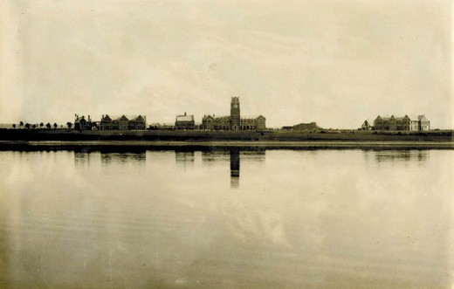
Figure 8.51: Geelong Grammar School, Corio Campus, view from lagoon, 1914. Source: Geelong Grammar School archives.
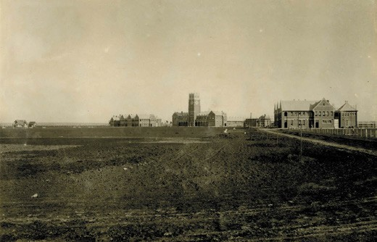
Figure 8.52: Geelong Grammar School, Corio Campus, view from north-east, 1914. Source: Geelong Grammar School archives.
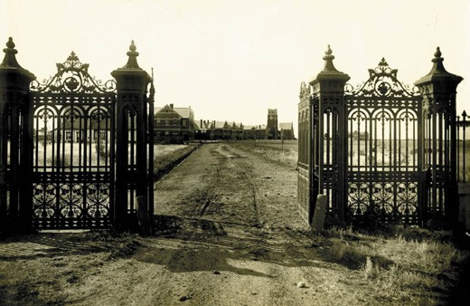
Figure 8.53: Lunan gates at entrance to Geelong Grammar School, Corio Campus, c.1923. Source: Geelong Grammar School archives.

An architectural competition was held with the design by the Melbourne architects, Wight and Hudson, being favoured by the Grammar School Council.401 Yet, the promise of an elite Grammar School in Belmont soon faded by August 1911 when adjoining rural land was offered for sale as the Belmont Hill Estate.402 The lack of future expansion and the anathema of lower-middle class adjoining residential development brought a halt to the development of the Grammar School in Belmont.403
Instead, 262 acres of land with a bay frontage at Corio
was acquired in 1911.404 Wight and Hudson s design scheme for the Belmont school was amended to accord with the new marine site. The main crescent of buildings was to front onto the sports ovals to the south by the Corio Bay foreshore.
Designed in a picturesque Medieval Revival style, the first of the gabled red brick buildings built in 1912-13 included the Perry, Manifold, Cuthbertson and Junior Houses, and the Principal s Residence405 (Figures 8.51-52). A landmark was the clocktower to the centrally located Perry Building. The massive iron gates formerly marking the entry to Lunan House, Drumcondra (Theme 6), having been donated by Johnnie Bell in 1911 for use in connection with the new school at Belmont, were also re-erected at the entrance to the Corio campus406 (Figure 8.53). The chapel was built in 1914 and consecrated in 1915.407
In 1970, female students from the Church of England Girls Grammar School attended classes at Geelong Grammar School, Corio, for the first time.408 This school was established in August 1905 with Sidney Austin as inaugural Chairman of the school council. The school acquired George Armytage s Hermitage mansion in Pakington Street, Newtown, as its school campus.409
The mansion still exists today and is known as Armytage House (see Themes 6 & 7). The first Headmistress was Miss Elsie Morres, a graduate in Arts and Theology with Honours in Mathematics, Exhibition and Final Honours in natural Philosophy and Exhibition from Ormond College, Melbourne.410 The gates to the former middle school (Highton) Campus of the Church of England Girls Grammar School in Pigdons Road, Waurn Ponds ( Krome House ),411 are a memorial to Miss Morres.412 In 1976 the Church of England Girls Grammar School amalgamated with Geelong Grammar School and Clyde School, continuing today as the Geelong Grammar School.413 Since its early beginnings at the Corio campus, numerous school buildings have been erected and the Geelong Grammar School has become one of the most prestigious in the country, its alumni including some notable Australians including the late John Gorton, former Prime Minister, the late billionaire businessman Kerry Packer and media mogul Rupert Murdoch.414

SACRED HEART COLLEGE, RETREAT ROAD, NEWTOWN
A day school for Roman Catholic girls commenced at Sunville , the convent of the Sisters of Mercy, Retreat Road, Newtown, in March 1860 (see earlier subsection for details of the convent). The education of girls formed a mission of the Sisters at Newtown (the other missions being the welfare of orphans and training of postulants and novices).415 It
was also from this time when the Sisters were prepared to receive a limited number of children as boarders. 416 Classes were held in the new building complex from the 1860s.417 In 1869, the school had an enrolment of 86 girls occupying three classes: elder girls, medium aged girls and young girls.418 The expansion of the convent buildings also led to an increase in student numbers and classroom and boarding accommodation.
By the late 19th century, the girls school at the Convent in Newtown was exclusively for boarders. The school and
convent had realised Mother Xavier Maguire s vision with its complex of buildings around a courtyard (Figure 8.54).
In 1899, the Sisters established St. Agnes College, a day school in rented accommodation in Fenwick Street, Geelong (a day school had been located at the former sub-Treasury building, Gheringhap Street see Figure 6.11).419 A purpose- built college was constructed at 22 Myers Street in 1902,
the brick Federation Gothic styled building being designed by local architects, Laird and Barlow.420 Described by the Geelong Advertiser as being of a handsome design , St. Agnes College opened in 1903 under the tutelage of Sisters Gonzaga, Ignatius and Gabriel.421 In 1943, the College was
sold to the Dean of St. Mary s and it became St. Mary s Senior School of Domestic Arts. It was later Goold College before being acquired by Matthew Flinders Secondary College.
In 1908, all the Mercy Convents in the Diocese were amalgamated, a consequence (in part) of the Victorian Government s School s Registration Act of 1905 which brought about the State-sanctioned registration of schools and teachers.422 This brought on an exodus of personnel from the Newtown Convent and consequently in 1910 the boarding and day schools were united.423 It was from this time when the name of the educational arm of the Convent became Sacred Heart College. The curriculum offered was outlined in The Advocate:
The School Courses ranges from the most elementary teaching to preparation for Commercial, Junior and Senior University, and includes, besides the ordinary studies, Languages, Botany, Music, Painting, Drawing, Plain and fancy Needlework, Elocution, Typewriting, and Shorthand. Students are also prepared for the Music Exams, in connection with the Royal Academy and the Royal College

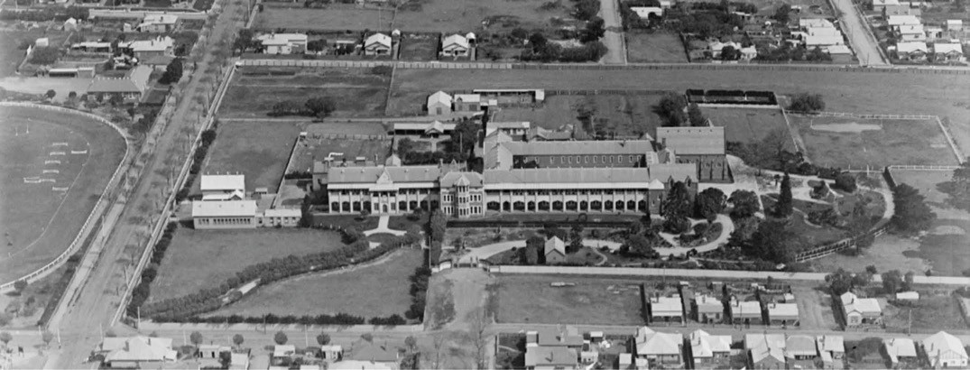
Figure 8.54: C. Pratt, Aerial view of Sacred Heart College looking west, October 1927. Source: accession H91.160/911, State Library of Victoria.

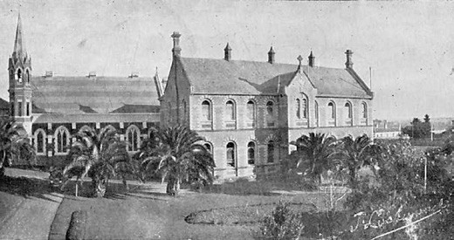
Figure 8.55: J. Lockwood, St. Joseph s College & Chapel, 1935. Source: St. Joseph s College Yearbook 1935.

of Music, Trinity College, London and the Melbourne Universities.424
Sacred Heart College further evolved and developed throughout the 20th century to become one of Geelong s exclusive girls secondary colleges.

ST. JOSEPH’S COLLEGE, 135 APHRASIA STREET, NEWTOWN
St. Joseph s College for boys was founded by the Christian Brothers in 1890, on the site of St. Augustine s Roman Catholic Orphanage established in 1857 (see following subsection).425 The Christian Brothers had taken over the management of the orphanage in 1878, with Brother P.C. Butler appointed as director.426 He has been attributed with raising the education standard of the establishment and was a man of expansive ideas that led to the formation of St. Joseph s College.427 A separate two storey brick building for boarders erected in 1885 and 1887 respectively to designs by Joseph Watt - was situated near the northern (Aphrasia Street) boundary of the site428 (Figure 8.55). The chapel, earliest known as St. Augustine s, was designed by
Laird and Barlow and blessed and opened by the Archbishop of Melbourne, Dr. Carr, in 1904.429 Numerous educational buildings have been built throughout the 20th and early
21st centuries, the site being solely that of the college from 1939 when St. Augustine s Orphanage relocated to Highton (see later subsection). Today, St. Joseph s College is the boys only secondary school in Geelong.430

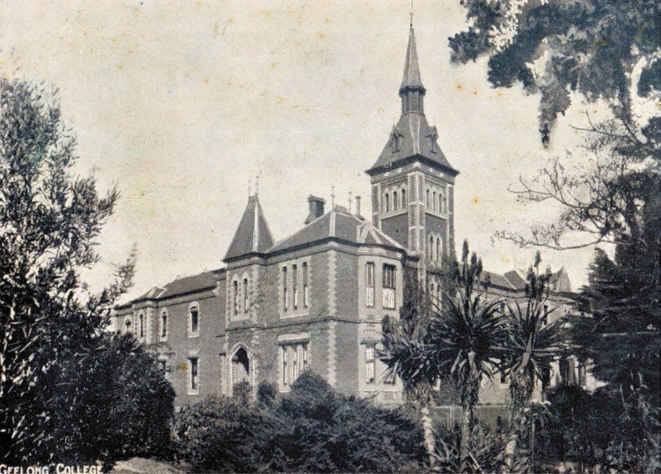
Figure 8.56: Geelong College, Newtown, c.1904. Source: accession H42644/51, State Library of Victoria.

GEELONG COLLEGE, TALBOT STREET, NEWTOWN
The closure of the Geelong Grammar School in 1860 was impetus for the founding a college in Geelong by the
Presbyterian Church of Victoria in 1861.431 The Rev. Andrew Love, Rev. A.J. Campbell and T. McK. Frazer were appointed representatives by the Presbytery of Geelong to the inaugural committee of management.432 A constitution was established whereby the institution was to be known as The Geelong College in connection with the Presbyterian Church of Victoria to provide ‘first class education, so as to prepare
its pupils for mercantile pursuits, and for entering the University. 433 The Geelong College was formally instituted on 8 July 1861 with a ceremony at Knowle House, Skene street, Newtown.434 This was to be the location of the college for the next ten years.435 In 1862, the school opened with
62 boys and throughout the year enrolments had risen
to 70 (including 19 resident boarders, 6 day boarders and 45 day boys).436 Financial struggles and a lack of success
in gaining Government support for land for a school led to the disbandment of the college committee in 1864 when it became a private school and remained so for 45 years.437
The Geelong College was acquired by its first headmaster, George Morrison (1830-1898). From Morayshire, Scotland, the son of Donald Morrison, farmer and his wife, Catherine, nee Fraser, he attended the Elgin Academy where he won a scholarship to the University of Aberdeen.438 A highly talented student of the classics, mathematics and natural philosophy, he graduated with a masters degree.439 Following graduation, Morrison was mathematics master at the Naval and Military Academy, Gosport, England, and was afterwards a teacher
at the Dollar Academy, Scotland.440 In 1858, he followed his brother, Alexander, to Australia were he was appointed mathematics master at Scotch College, Melbourne.441
In 1860, Morrison took up the position as head teacher of the Flinders National School, Geelong. After the college was assigned to his ownership, Morrison worked towards the

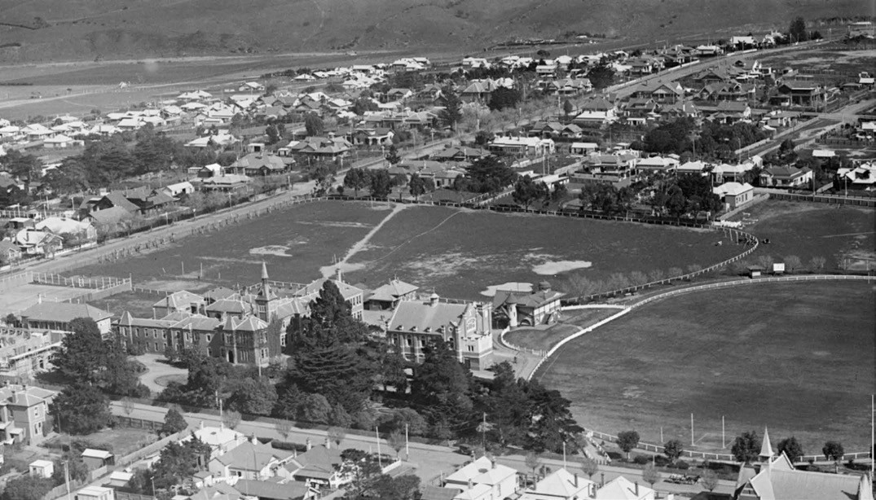
Figure 8.57: C. Pratt, Aerial view of Geelong College, Newtown, looking south-west, c.1936. Source: Accession H91.160/915, State Library of Victoria.

building of a new school complex that reflected his ideology of an educational establishment together with attracting more students.442
By 1870, Morrison had purchased a large block of land bound by Talbot, Noble and Aphrasia Streets, and Claremont Avenue, as a site for a new school. It was later claimed to almost rival that of its English Prototype which crowns the summit of Harrow-on-the-Hill, in Middlesex, England.443 Morrison engaged the fledgling architectural firm of Davidson and Henderson to design the new educational institution.
Their work had been elevated following the construction Davidson s design of the Presbyterian Church at Rokewood in 1865-66 where Davidson s Uncle, the Rev. John Cooper, had been incumbent between 1859 and 1866.444 Construction had commenced by May 1870, the Geelong Advertiser giving a description of the anticipated edifice (Figure 8.56):
The buildings just commenced on that commanding site recently purchased by Mr Morrison which lies to the north of All Saints Church, Newtown Hill, and contains over five acres, will, when completed, form the chief attraction to visitors in the neighborhood. The buildings are in the collegiate style of architecture now so much admired at home. The plan is arranged to economise
space as much as possible. The principal s residence a
mansion complete in itself faces Talbot street, and the class-rooms and dormitories for the use of the students front the bay. The dining-hall, with its open timber roof and uniquely arranged Gothic windows, is connected with the kitchen and class- rooms. It encloses a private court-yard for the use of the house, with the kitchen at the south end, so as to meet the requirements of both the large dining-hall and the principal s residence.
Owing to the slope on the ground from south to north, the principal fronts will look to Talbot-street and the bay, and will have a very effective appearance, rising out of a fine terrace which will be carried all round. The outline is broken and picturesque, and a beautiful tower and spire, in keeping with the style of the building, will rise to a height of 80 or 90 feet. It divides the principal s residence from the students class-rooms, &c. The
principal s entrance faces Talbot-street and the students the north, through an arcade. The roofs are carried up at different levels, capped with ornamental iron ridging and finials, which gives the building an airy appearance. The red bricks will be relieved with moulded white bricks from Melbourne, and the cut work out of freestone from
Warn-ponds quarries. Mr Morrison deserved great praise for his enterprise. The building, when completed, will cost over £5000, and it is to be hoped that he will be amply

compensated for the outlay.445
Further buildings were constructed to designs by Davidson and Henderson in the ensuing years, including a timber cottage at the south-west corner of the site in 1870.446
In 1891, a Junior School was established which took in young students until they reached secondary school age.447 In February 1898, George Morrison died suddenly after teaching a class.448 Morrison s widow, Rebecca, became legal owner of the College but a clause in his Will allowed his
son, Norman, to lease it and take over as Principal.449 Norman Morrison continued the school on the lines which my father followed and no opportunity will be neglected to introduce what is most desirable in modern educational methods. 450 Further expansion subsequently occurred to uphold this statement with the an extension to the boarding wing, new oval and new classrooms.451
In 1907, the Morrison family sold The Geelong College to the Presbyterian Church of Victoria.452 This enabled the school to meet the requirements of the School s Registration Act 1905 and to resource further expansion. The extent of the college complex by c.1936 is shown in Figure 8.57. In 1960, a Preparatory School was built in Aberdeen Street.453 In 1974, the college became co-educational.454 With the formation
of the Uniting Church of Australia, the college became associated with it and in 2011 the Geelong College celebrated 150 years of continuous operation.455 It remains one of Geelong s most prestigious school colleges.

KARDINIA INTERNATIONAL COLLEGE (FORMERLY MORONGO PRESBYTERIAN GIRLS’ COLLEGE), BALLARAT ROAD, BELL POST HILL
The Japanese businessman, Mr Katsumato, purchased the long-standing Morongo Presbyterian Girls College at Bell Post Hill and opened a new school, Kardinia
International College, in 1996.456 An independent (rather than denominational) school, the College has witnessed significant expansion in student numbers and state-of-the-art educational facilities.
Morongo Presbyterian Girls College had begun in 1919 when a committee of Presbyterian Ministers of Geelong, together with J. Pettitt, C. Channon, J. McPhillimy, J.A. Laird, M.B. Bigg, W. Robertson, J.T. Leary, W. Griffiths and W. Anderson acquired Roslyn in Latrobe Terrace, Newtown (the home
of Howard Hitchcock, Mayor of Geelong) and Miss Annie Harris Newtown Ladies College in Roebuck (then Elizabeth) Street as key centres of the Presbyterian Girls School.457 These properties and other cottages in between formed part of the House system, where no more than 30 girls were to be accommodated in each house .458 The first headmistress was Miss Gertrude Pratt, M.A., Dip. Ed. (London), then headmistress of Girton Church of England Girls Grammar

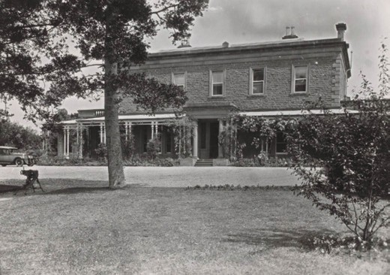
Figure 8.58: J. Lockwood, Morongo Presbyterian Girls College, Bell Post Hill, 16 November 1939. Source: accession H195345, State Library of Victoria.
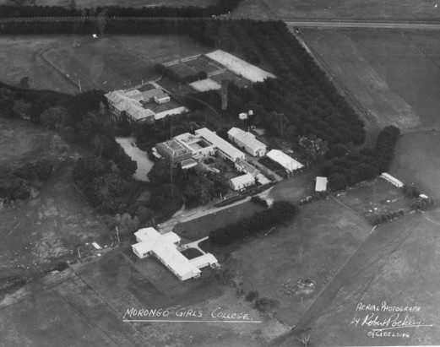
Figure 8.59: R. Pockley, Aerial view of Morongo Girls College, c.1940-54. Source: accession H2007.25/15, State Library
of Victoria.

School in Bendigo.459
By 1923, the Presbyterian Girls College acquired a new site in Manifold Heights on which to build a new school.460 This never eventuated (although Girton Crescent in the Minerva Estate subdivision is a vestige of the anticipated adjoining college see Theme 6). Instead, in 1926 the College purchased Morongo , the substantial Victorian Georgian home built in 1859-60 for the late Senator, John Calvert (Theme 6). The school was officially opened in October 1927 and renamed Morongo Presbyterian Girls School461 (Figure 8.58). Several school buildings and landscaping were carried out in subsequent years
(Figure 8.59).

CLONARD, 225 CHURCH STREET, HERNE HILL
In 1956, the Brigidine Community took possession of Clonard , a two storey mansion house (Figure 8.92) built in 1855-56 for Dr Forster Shaw to a design by his brother, Joseph Lowe Shaw (see following subsection for further details on Dr Shaw).462 Father Tressider of Holy Spirit
Catholic Church in Manifold Heights had seen the need for a convent and small school given the population growth in the western and northern suburbs of Geelong.463 The stables, store room and coach house was converted into school rooms, with the laundry used for singing and an office being the location of music classes as part of the new secondary school for girls.464 Classes began by a group of founding sisters, including Sister Lelia Grant, the enrolments totaling 40 girls.465 It was not until 9 February 1958 when Clonard College was officially blessed. The first full time lay principal was John Shannon, appointed in 1983.466 Major building programs have witnessed the transformation of the college since its opening in the 1950s.467

CATHOLIC PRIMARY SCHOOLS
Throughout the early 20th century, the Catholic Church began a building program of primary schools throughout Geelong. In some instances, they replaced earlier Catholic Schools such as those built in Cavendish Street in 1854- 56 and St. Patrick s School, Church Street, Geelong West in 1857.468 One of the earliest during this expansionist era was St. Patrick s School, Petrel Street, Geelong West. Designed by Kennedy and Slevin architects, the Petrel Street School replaced the Cavendish and Church Street Schools, the foundation stone being laid on 10 December 1911.469 A chapel was built to the north of the original school building in 1962.470 This school continues to operate to the current day.
The local architect, Thomas Slevin, was also responsible for the design of St. Mary s School in Myers Street (Figure 8.60), opposite the drill hall, in 1919.471 It was built as a girls
school for the Sisters of Mercy and opened in 1920, around the time of the Christian Brothers College for boys (now demolished)472. The Sisters later relinquished control of the school and it became a Catholic Primary School until its closure in 2013.
In the latter years of the interwar period, St. Robert s School was built in Nicholas Street, Newtown, in 1942, to a design Cyril Kelly.473 It was followed by St. Margaret s, St. Albans Road, East Geelong, in 1949.474 Both of these schools continue to operate.

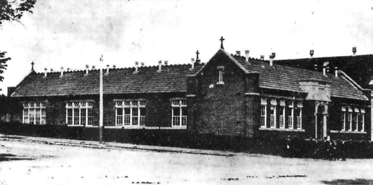
Figure 8.60: St. Mary s Catholic Girls School, Myers Street, 1919. Source: News of the Week, 12 December 1919, GRS 2121, Geelong Heritage Centre collection.

ST. JOHN’S LUTHERAN SCHOOL, 31-61 ABERDEEN STREET, NEWTOWN
St. John s Lutheran School, 31-61 Aberdeen Street, Newtown, commenced in 1962,475 following a long tradition of Lutheran education that commenced at Germantown (Grovedale) in 1854 with the building of a mud brick Lutheran Denominational School (see Theme 6). The Newtown campus had first been established in 1926 with the construction of a brick interwar school building for the Geelong Grammar Preparatory School. This school had
begun in the Christ Church Hall, Moorabool Street, in 1924 as a response to a strong demand by members of the Anglican community to re-establish a school presence in Geelong (given that the main campus was at Corio).476 The school was incorporated with the larger Grammar School body in 1933, the original building being named Bostock House in memory of the well- known school benefactor, T.E. Bostock.477 Today, the original school forms part of a larger complex of buildings serving St. John s as a kindergarten and primary school.478
St. John s expanded with the opening of a secondary college known as the Geelong Lutheran College in Burvilles Road, Armstrong Creek, in 2009.479

CHRISTIAN COLLEGE GEELONG
Christian College Geelong began in 1980 when a wing at St. Augustine s Orphanage, 18 Burdekin Drive, Highton (see later subsection for further details), was leased to provide accommodation for 60 students attending classes from prep to year 10.480 Increased enrolments led to the purchase of the former St. Augustine s Orphanage in 1987 as the College s Middle School.481 The College further expanded in the 1990s with the acquisition of the former Glastonbury Children s Home at 37 Broughton Avenue, Highton (see later subsection for further details). This formed the College s Junior School. A Senior School was established in 2000 when the College purchased the former Geelong Grammar School complex in Pigdons Road. Further campuses were opened in 2017 and 2018 at Torquay.482

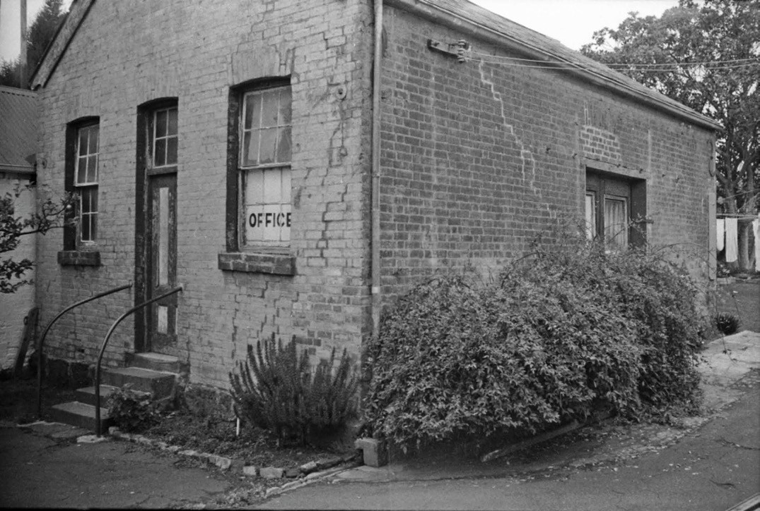
Figure 8.61: Former School Room, rear of 3 Skene Street, Newtown, n.d. [c.1980s]. Source: Wynd collection, Authentic Heritage Services Pty. Ltd.

EARLY PRIVATE SCHOOLS
Private proprietary schools proliferated in the Geelong area in the 19th century. By 1869, there were 21 private schools in the Town of Geelong; eleven in the municipality of Newtown and Chilwell; two in the Borough of South Barwon, three in the Bellarine Shire and one in the Barrabool Shire.483 In 1887, the private schools in the Town of Geelong had reduced
to 14 but three had been established in the Borough of Geelong West, the number of private schools in the other municipalities remain the same as 1869.484 Apart from the private denominational schools, the number of operational private schools greatly diminished in the early 20th century following the introduction of the Schools Registration Act in 1905. Of the numerous private schools which operated from the 19th century, few exist today and only one is known to have been purpose-built as a school building. This and other former private schools are as follows:

FORMER SCHOOL HOUSE, 3 SKENE STREET, NEWTOWN
In c.1861, a gabled brick school house (Figure 8.61) was built for Thomas William I erson (1812-1902) at 3 Skene street, Geelong, who conducted a music school there.485 The only known surviving purpose-built private school in Greater Geelong, I erson s music school operated until
late 1869.486
Thomas William I erson, from Southwick, Surrey, England, had trained as a lawyer and completed his articles to please his father, although he aimed at carrying out missionary work. Relinquishing his opportunity to join the legal profession,
he took up music-teaching which he combined with drawing instruction.487 With his wife, Phoebe, and daughter, Charlotte, he emigrated to Victoria, arriving in December 1854.488 He took up a position with the Government to teach singing
in the schools in Geelong.489 Throughout the 1850s, he contributed much to educational life there and with his friend and art and drawing teacher colleague, Edmund Sasse,
I erson was honoured with a testimonial in 1859.490 In 1863,

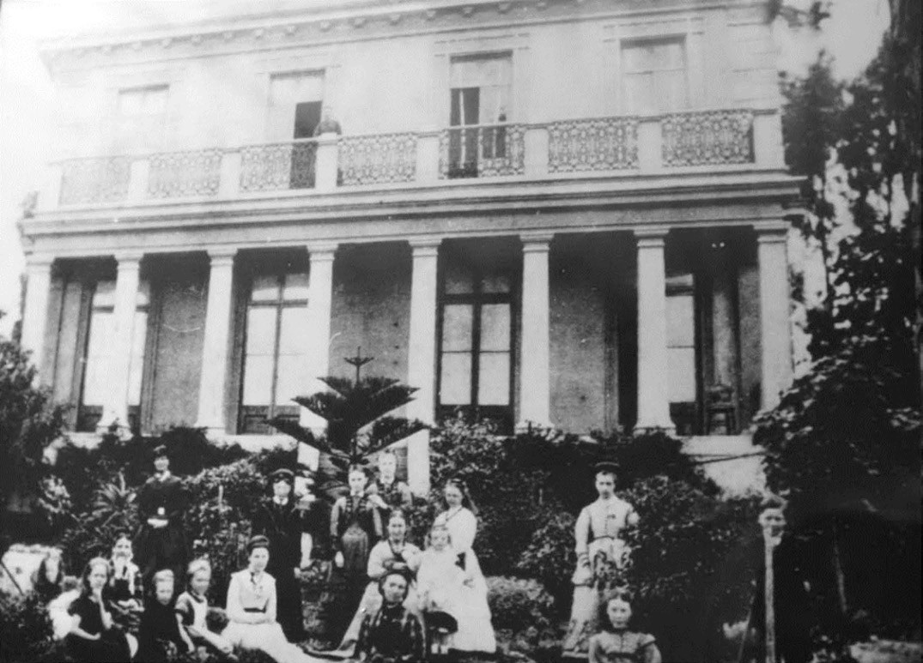
Figure 8.62: Teachers & pupils in the garden at Queen s College (Merchiston Hall), Garden Street, Geelong, c.1870-72. Source: Morphy family.

I erson assisted Sasse with the annual Comunn na Feinne educational competition.491 Following the death of his wife in 1869, he sold his school and relocated to Rockhampton, England, to be near his daughter.492 At Rockhampton, he became a Baptist Church minister and taught free-hand drawing at the Rockhampton Technical Collee until 1901. He died in 1902.493

QUEEN’S COLLEGE (MERCHISTON HALL), 2A GARDEN STREET, GEELONG
In 1870, George Lupton (1836-1913) and his wife,
Mary Georgina Lupton (nee Gould) (c.1841-1900) opened Queen s College at Merchiston Hall, Garden Street
(Figure 8.62). This two storey mansion house had been built in 1856 for James Cowie (see Theme 6), who leased it to the Luptons. They advertised the new school in the Geelong Advertiser:
The business of the above College will be commenced on the 3rd of October at Merchiston Hall (the property of James Cowie, Esq.) situated on the Eastern Beach, adjoining the Botanical Gardens. The house, which commands a beautiful view of the Bay, and surrounding
country, is too well known to need description. It stands on two acres of ground, beautifully laid out in flower and fruit gardens, and is conveniently removed from the noise of the town.

The pupils will receive instruction in French and English, including Reading and Composition (Elocution Class), Writing, Arithmetic, Geography, Grammar, History, Botany, Geology and the use of the Globes.494
The son of the Rev. James Lupton, minor Canon of St. Paul s Cathedral and Westminster Abbey, London,495 George Lupton emigrated to Victoria in 1859.496 He married Mary Gould in Richmond, Melbourne, in 1861.497 George Lupton was a noted elocution teacher and in the 1860s in Geelong had taught at Geelong Grammar, Scotch College and the Ladies College and in 1869 he commenced an evening
class at the Flinders National School.498 Meanwhile, Mary Lupton taught French and Italian, and the harp and piano.499 Their credentials were not to ensure an enduring tenure
at Merchiston Hall as Queen s College closed in 1872 following eviction by James Cowie.500 George Lupton was subsequently appointed lecturer in elocution to the teachers and trainers of the Geelong State Schools, and a teacher in elocution at the Gordon Technical College.501

VICTORIA PREPARATORY COLLEGE (EUMERALLA), 35 SKENE STREET, NEWTOWN
In 1884, the Geelong Advertiser announced that the Victoria Preparatory School was to be opened in February 1885 at the premises of James Simson, Skene Street502 (Figure 8.63). Known today as ‘Eumeralla’, Simson had first built a four roomed brick dwelling in 1854 (which was extended in 1858 to a design by local architectural firm Shaw and Dowden).503 The principals of the Victoria Preparatory College were Huntly Simson (son of James Simson) and Albert Sach.
Both had been Masters of the Ipswich Grammar at School in Queensland, with Simson having trained at Melbourne University and Sach at Battersea College, London.504 The Victoria Preparatory College provided a standard education as well as extra classes in drawing, gymnastics, singing and experimental chemistry without extra charge. 505
The College also provided younger and backward boys a core foundation and training in all subjects forming a
liberal education. 506 By 1887, Huntly Simson was the sole Principal.507 He had a school rooms erected in 1890 and by this time a school museum and library were making rapid progress.508 The College also offered accommodation for boarders. The success of the College soon faded and it had closed by 1894.509

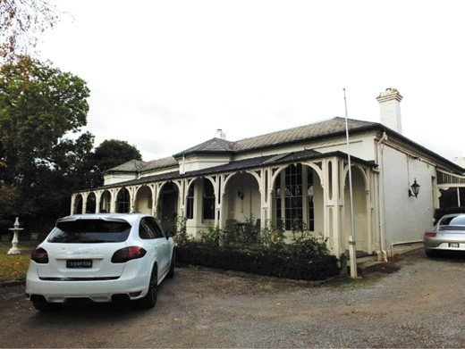
Figure 8.63: Eumeralla , 35 Skene Street, Newtown, 2013. Source: David Rowe.

COMMON SCHOOLS
On 1 September 1862, the Common Schools Act was enforced which abolished the National and Denominational Boards for the Victorian Board of Education.510 This was intended to amalgamate schools and particularly to reduce denominational influence.511 Common Schools were all publicly owned and from 1863, they were afforded official numbers.512 Designs for new schools were specifically prescribed, although almost none were funded until 1864. The Board had looked to England for ideas, and particularly towards the implementation of the English Privy Council system of school organisation including the shape and layout of school buildings.513 The English Committee of Council of Education established standardised plans in 1851, and it was from these designs where the Victorian Board
of Education found ideas to form the standard schemes in Victoria in the 19th century.514 The Fifth Report of the Board of Education in 1866 gave further impetus to the standard
one-room school plans, which basically provided for a steeply pitched gabled roof form and gabled porch, in either 40,
60, 80, 100 and 150 types.515 The actual size of the school building was dependent on the number of pupils that were estimated to attend, hence the 40 type for 40 children and the 60 type for 60 children.
Two purpose-built Common School buildings in existence today are the Corio Primary School (former Cowies Creek No. 124), Hendy Street, Corio (Figure 8.64), and the former Swanston Street State School (former Geelong East New Vested School No. 1094), Swanston Street, Geelong.516 The Corio Primary School epitomised the one-room school plan philosophy of the Board of Education. Constructed in

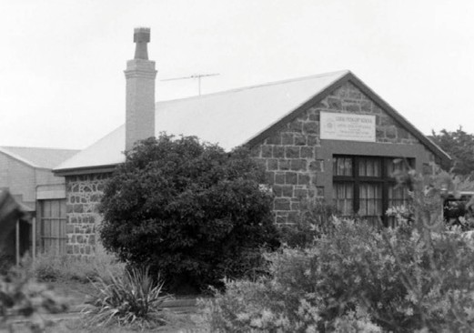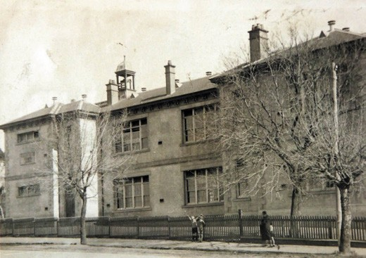

Figure 8.64: Corio Primary School, Hendy Street, 1998. Source: David Rowe.
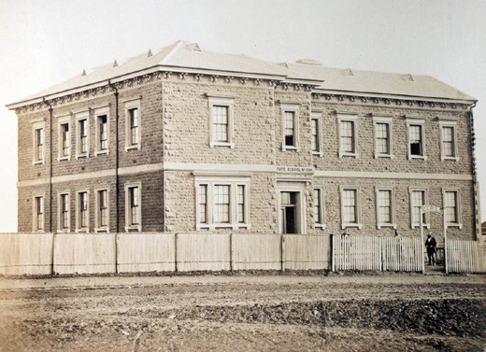
bluestone with a gabled roof, it was built in 1864 and had

Figure 8.65: Harvey & Dunden, Swanston Street State School No. 1094, 1890. Source: Education Department of Victoria, photograph album of state schools in Victoria designed by H.R. Bastow, VPRS 1396/P0, vol.4, Public Record Office Victoria.

an initial attendance of 21 boys, 15 girls and 62 infants under eight.517 The first head teacher was Thomas Halliwell who had previous run a church school at Chilwell and who had intended to establish a National School prior to the establishment of the Commonwealth Schools Act.518 The school closed in 1948 but reopened in 1950 following the influx of families associated with the new industries in the area.519
The foundation stone of the two-roomed Geelong East Vested Common School in Swanston street was laid by the Hon. John Cumming, M.L.C., in December 1870.520
The asymmetrical, two storey hipped roofed stone building (Figure 8.65) was opened in 1871 with William Calder as head
Figure 8.66: Swanston Street State School, c.1930.
Source: T.T. Holmes collection, Authentic Heritage Services Pty Ltd.

teacher.521 The school underwent alterations and additions in 1913 with the construction of a second storey hipped wing at the north end, the rendering of stone facades and changes to fenestration (Figure 8.66). It was reopened on 29 May 1914.522

DEPARTMENT OF EDUCATION STATE SCHOOLS
In 1873, the Education Department was established which brought about the disbandment of the Board of Education.523 From this time, education became free,
compulsory and secular (except in schools fully funded by their denominations).524 The standard one-room school plans developed by the previous Department became the foundation of school design until the turn of the century.525 It was also the Education Department that standardised the
exteriors, under the design guidance of Henry Robert Bastow, head of the architectural branch of the Department.526
Henry Robert Bastow (1829-1920) emigrated to Australia from Bridport, Dorset, England in c.1862 and first advertised as
an architect and surveyor in Tasmania in 1863.527 By 1873, Bastow became the head of the new Architecture Branch in the Department of Education.528 Initially, his attention was confined to the designing of smaller rural Victorian schools. His first design was for a school at Tarnagulla in
1873.529 Throughout the 1870s and 1880s, Bastow produced numerous urban and rural school buildings of various
sizes using a fixed repertoire of designs.530 In addition to the single-roomed types, Bastow also produced a range of other school designs in Picturesque Gothic modes featuring gabled, hipped and jerkin-head roof forms, gabled porches, crowning turrets, timber finials, gable ventilators, moulded
bargeboard and for brick schools, coloured polychrome brick construction.

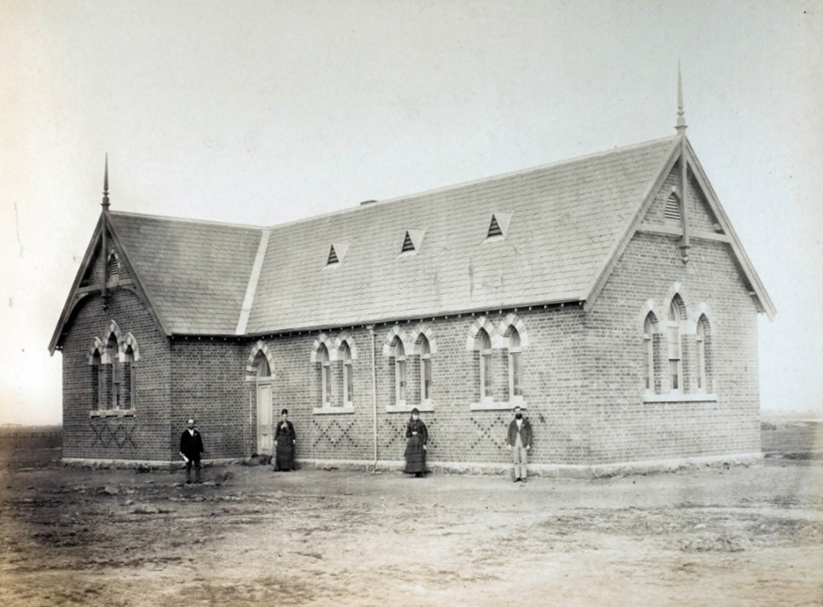
Figure 8.67: Paterson Bros., Drysdale State School No. 1645, 1890. Source: Education Department of Victoria, photograph album of state schools in Victoria designed by H.R. Bastow, VPRS 1396/P0, vol.4, Public Record Office Victoria.

In 1885, Bastow was appointed Senior Architect of the Public Works Department.531 He worked in this position until the worldwide economic depression of the early 1890s brought about heavy retrenchment in government spending and ultimately, Bastow s position. With his services dispensed with from 30 April 1894, Bastow retired to his property at Harcourt where he lived and worked as an orchardist until his death in 1920.532
These Department of Education Schools under the design control of Henry Bastow were by far the more prolific educational institutes to be established throughout Greater Geelong from the 1870s (see Appendix 8.1 for a list of existing State Schools in Greater Geelong).

ONE & TWO ROOMED SCHOOLS
One of the earliest Department of Education schools to be constructed in Greater Geelong was at Drysdale in 1873.533 It consisted of a single gabled school room, together with an infant s room and a gallery (Figure 8.67). The building was remodeled in 1914.534
At Ceres in 1875 a State School was built of Barrabool stone on the south side of Barrabool Road west of the small township. It was designed as an 80-type to accommodate 80 children.535 The first head teacher was John Matthew Hartshorn, formerly head teacher of the Barrabool State School on the Merrawarp Road from 1867.536 The school
was substantially remodeled in 1950 to a design by the Chief Architect of the Public Works Department, Percy Everett.537

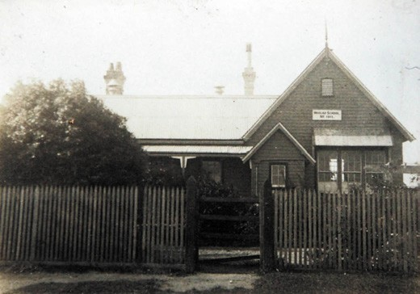
Figure 8.68: Moolap State School No. 1911, c.1928.
Source: T.T. Holmes collection, Authentic Heritage Services Pty Ltd.
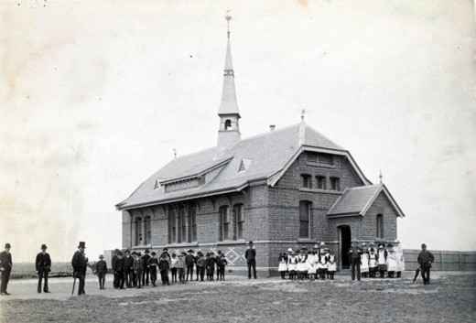
Figure 8.69: Portarlington State School No. 2455, c.1900. Source: accession H4486, State Library of Victoria.
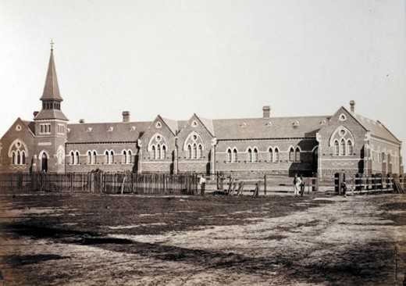
Figure 8.70: Harvey & Dunden, Ashby State School No. 1492, 1890. Source: Education Department of Victoria, photograph album of state schools in Victoria designed by H.R. Bastow, VPRS 1396/P0, vol.4, Public Record Office Victoria.

At Fyansford, a State School No. 1691 was built in bluestone in 1875 and opened in 1876 with an enrolment of 82 children.538 The gabled 100-type two-roomed building was designed to accommodate 100 children.539 The first head teacher was Frederick Hobbs.540 It was built of locally- manufactured bricks.
Other more modest single-roomed schools were built at Batesford in 1876-87541 and at Moolap in 1877.542 The latter was constructed with an attached teacher s residence (Figure 8.68). Later modestly-scaled and gabled school buildings included those at Ocean Grove (built in 1892) and St.
Leonard s (built in 1910).543

RURAL PICTURESQUE GOTHIC SCHOOLS
More elaborate Picturesque Gothic schools built by the Department of Education in rural parts of Greater
Geelong included the Portarlington State School No. 2455 (Figure 8.69), built in 1881 and opened in April 1882.544 The newly-opened school was described in the Geelong Advertiser:
The new school building, if not handsome in appearance, is certainly very substantial. It has only one large
room, 50 feet by 20 feet in dimensions, but is capable of accommodating 120 children. The building is of red brick, the front portion, which faces the north, being relieved
by a design in white bricks. The roofing is of slate, and the ceiling is of deal wood, nicely stained and varnished, whilst the walls are colored. In the centre of the roof there is a small tower with a spire to it, on the apex of which the cardinal points of the compass are affixed. The tower is a wooden one, the outside casing being of corrugated iron, whilst the school bell is hung in the centre, the rope falling into the school-room below. The interior of the room is well fitted up for the scholars, a sloping platform being built for the various classes. At the east end of the room there is a gallery, which is to be devoted to the infants class. The room is well ventilated on Tobin s principle, and the entrances are from the east and west ends, but so sheltered as to be free from draughts. There is a fireplace in the centre of the room, which in winter, will, no doubt, be the means of comforting the scholars.545
The first head teacher of the new school was Thomas Brown (1849-1904).546 Born in Gloucestershire, England, he came to Victoria with his parents in 1856. He was school master of the Steiglitz Common School in the early 1870s.547 In 1873, Brown opened Portarlington State School No. 1251
in rented accommodation until 1875 when a purpose-built school building was erected. This building was replaced by the existing State School No. 2455.548 Brown transferred to Box Hill State School No. 2838 in 1893.549 His brother, William

(1857-1896), took over as head teacher at Portarlington for 12 months in 1895.550

URBAN GOTHIC SCHOOLS
Four substantial Victorian Gothic styled brick State school buildings exist in the early suburbs of Newtown and Chilwell, and Geelong West. They reflect the population growth and prosperity of these early suburban parts of the municipality. The earliest was Ashby State School No. 1492 (Figure 8.70), Lawton Avenue, Geelong West, built in 1875.551 The head teacher of the new school was Joseph D. Mowbray (c.1827- 1905). He had first began teaching in 1855 at the Preston Street School associated with the Methodist Church.552 He became the first head teacher of the Ashby Common School in Pakington Street (the existing location of the Town Hall see Figure 7.38)
in 1867.553 Mowbray remained head teacher of the Ashby State School until 1884, after almost 30 years in Geelong.554
In Newtown, the Newtown State School No. 1887 opened in Aberdeen Street in 1877. To accommodate 467 children, the newly-completed building (Figure 8.71) was described as:
… an imposing edifice – built in the modern Gothic style of dark red brick, with Waurn Ponds freestone facings, the basement being of bluestone. Rising over the porch, or entrance hall, is a bell turret with spire, 77ft. 6in. high from the ground line to the top. The roof of the building is of Bangor slates, and there are cast iron ornamental crestings on the ridge of the roof, with finals at the apex of each hip. The building has two wings, to be used as school rooms; they are 53ft and 60ft in length, and 20ft in breadth. At the left- hand side of the hall is a room for the Board of Advice, 16ft 6in by 19ft 6in., whilst there is a class-room on the right 19ft by 20ft. The corridor leading to each wing is 5ft wide. Upstairs there are two class- rooms one 30ft. by 19ft, the other 22 ft by 16 ft. The staircase is 8 ft wide.555
The first head teacher of the new school of W. Calder.556 He had previously been teacher of St. James School House No. 455, Aberdeen street, established in 1858.557 In 1928, a
Junior School was opened to the west of the State School to accommodate the junior classes.558 The single storey hipped roofed interwar school building is the only known surviving example of its type in Greater Geelong.559
In Pakington Street, Chilwell (Newtown) in February 1878, the foundation stone was laid for a new State School.560 The
single storey brick building with a slate roof featured a central steeply-pitched entrance wing surmounted by a bell turret and with a projecting faceted bay window at the front (Figure 8.72). This bay was flanked by gabled wings to comprise a
symmetrical composition. The Chilwell State School No. 2061

opened in August 1879 with Joseph Ingamells (1824-1891) as head teacher.561 Ingamells was previous head teacher of the Chilwell Common School from 1867 (the institution
having begun as a Wesleyan School established in 1853).562 Born in Lincolnshire, England, he emigrated to Victoria in 1862 with his wife, Catherine, and their 10 children.563 He was first appointed head teacher of the Northcote Common
School where he remained until he took up the head teacher s position at Dean in 1863.564 In 1866, he transferred to Creswick before taking up the tenure at Chilwell in 1867.565
He remained head teacher of the Chilwell State School
No. 2061 until his appointment at the Swanston Street State School in 1884.566 He retired in December 1885 and took up the position as manager of the Ocean Grove Coffee Palace in 1887, retiring in 1889 (see Theme 6). He died at his home, Friskney , Ocean Grove, in 1891.567
In 1879, State School No. 2143 opened at South Geelong, bounded by Kilgour, Yarra and Mundy Streets.568 In the style between Gothic and Elizabethan , the almost-complete
building (Figure 5.73) was reported in the Geelong Advertiser:
It will, when finished, be the landmark of that dreary-looking locality. Entering the main door of the building, which looks south, on the left is the
principal’s office, an apartment 13ft by 8ft. 6in., and 10ft. high, with a staircase in immediate proximity leading
to the upper building. Then there is the main rooms of the lower building, 53ft. by 20ft., and 20ft by 20ft.
respectively. There are two lavatories, 7ft. by 10ft and 6 ft. by 6ft., containing four and three basins. The caretaker s quarters, also on the ground floor, on the north side,
are 10ft. 6 in. by 10ft., and 9ft. by 10ft. The 53ft. room contains two galleries, and the 20ft. room one. Upstairs, the main room is 46ft. by 20ft., well ventilated with Tobin s ventilators in the ceiling and walls. The ceilings are
lined, and stained with varnish. The whole of the upper storey is 46ft. long, and both storeys 14ft. high, but the lower building is 16ft. high from floor to ceiling, the ceiling being coved, thus making the walls 14ft. high. There is
a verandah projecting 7ft. over the eave. The whole is surmounted by a bell tower 13ft. high On the south side there is a projecting verandah, 40ft., long, to shade the windows a very wise element in the construction.569
With 411 students enrolled at the time of the opening, Charles Watson was the head teacher.570 Born in England, he came to Victoria in the 1850s and had served as a teacher at Sebastopol, Ballarat and Ashby (Geelong West) prior to his appointment at South Geelong.571 He was subsequently transferred to the Swanston Street State School but was still fondly regarded years after his death in 1907.572 As reported in the Geelong Advertiser:

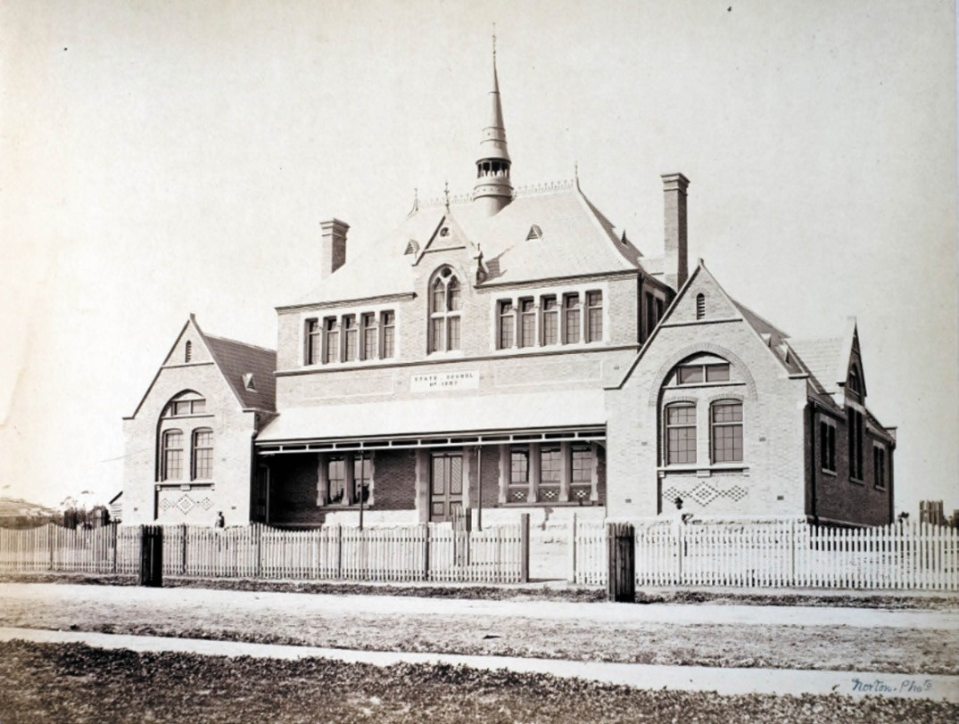
Figure 8.71: J. Norton, Newtown State School No. 1887, 1890. Source: Education Department of Victoria, photograph album of state schools in Victoria designed by H.R. Bastow, VPRS 1396/P0, vol.4, Public Record Office Victoria.
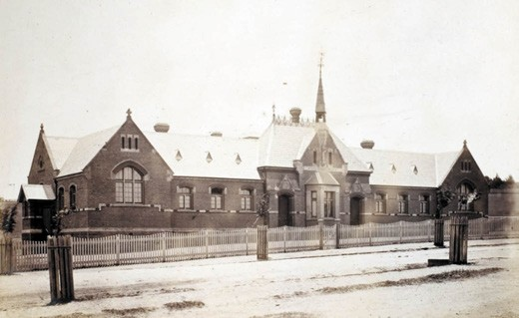
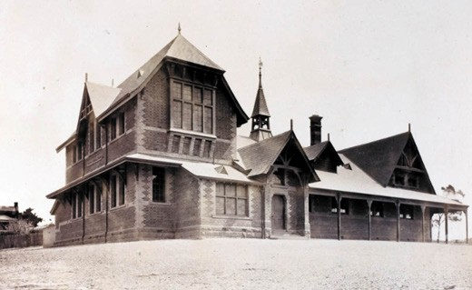

Figure 8.72: Chilwell State School No. 2061, 1890.
Source: Education Department of Victoria, photograph album of state schools in Victoria designed by H.R. Bastow, VPRS 1396/P0, vol.4, Public Record Office Victoria.
Figure 8.73: South Geelong State School No. 2143, 1890. Source: Education Department of Victoria, photograph album of state schools in Victoria designed by H.R. Bastow, VPRS 1396/P0, vol.4, Public Record Office Victoria.

Many will remember how he would take in hand the backward boy or girl and give them special tuition to help them through examinations. Even after they
had left school, many attended the school to acquire further knowledge in certain subjects. The late
Mr. Watson spent many of his evenings in teaching classes for working boys. In those days, when fathers or large families were in many cases earning 30/-weekly, Mr. Watson would himself help defray the expense of the poorer parents. His great teaching was integrity in life
573

In 1928, a memorial tablet in his honour was proposed to be erected by old scholars and a Charles Watson scholarship be established.574

EARLY 20TH CENTURY SCHOOLS
With further population growth in the early 20th century, and aging school building requiring replacement, a number of State School buildings were erected. One of the more substantial was the North Geelong State School which
opened at 209 Melbourne Road in 1915, having replaced the West Geelong State School No. 1889 in Separation Street (built in 1877).575 This was a time of rapid industrial expansion in North Geelong, the new school building on the Melbourne Road being south of the Commonwealth Woollen Mills which also opened in 1915 (see Theme 5). The two storey North Geelong State School was built of brick with cream brick banding, hipped terra cotta roofs and banks of multi-paned timber framed windows. The design of the North Geelong School (Figure 8.74) was the work of the district Architect (Western District) of the Public Works Department, Henry James Kerr,576 and it seems to have formed a prototype for his technical school designs at the Ballarat School of Mines and at Brighton in subsequent years.577
The tenure of the first head teacher of the North Geelong State School, Michael Clancy, was to be brief. He was replaced two months later by Wilfred Barlow who was appointed in a temporary capacity (he was later killed
in action in World War One).578
In 1923, a consequence of a number of residential subdivisions being carried out previously, and the overcrowding of the Ashby State School, it was proposed to acquire land in Manifold Heights for a new school.579 The design of the brick single storey building with terra cotta
tile hipped roofs and parapeted entrance portico have been overseen by Edwin Evan Smith, Chief Architect of the Public Works Department.580 Construction was delayed due to what the Geelong Advertiser called a brick famine. 581 The school opened in 1926 with Hector Macdonald of the Swanston

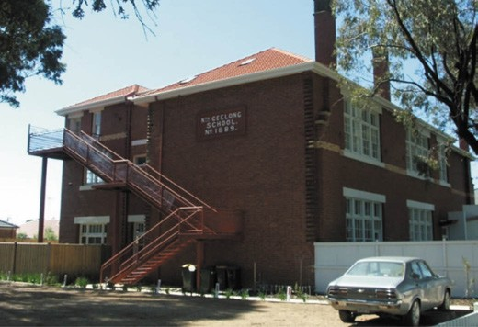
Figure 8.74: Former North Geelong State School No. 1889, 2006. Source: David Rowe.
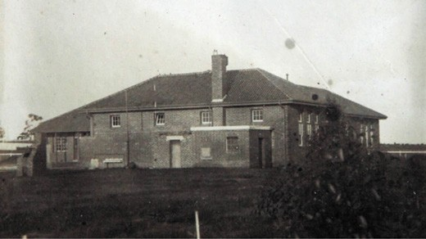

Figure 8.75: Geelong (Tate Street) State School No. 4398, 1930. Source: T.T. Holmes collection, Authentic Heritage Services Pty Ltd.

Street State School as interim head teacher.582 By October of that year, the school had an attendance of 94 children, the building only being designed to hold 50.583
As far afield as Anakie, school facilities were wanting in the 1920s. The earlier Anakie State School No. 1910, opened in 1877, could not cope with the increased student numbers.584 The present building No. 910 was opened in February 1926.585
Similar school expansion was witnessed at East Geelong with the opening of the Queenscliff Road School (Figure 8.75) in 1929 with 256 students. The name was change to Geelong (Tate Street) No. 4398 due to mail going to Queenscliff.586

KINDERGARTENS

KINDERGARTENS IN THE 19TH CENTURY
A specific type of education for young children under the age of 5 years reached Geelong in the 19th century. It had first been mooted by Thomas I Erson as early as 1860 when he gave an address entitled Infant Education to the Geelong Educational Institute at the Geelong Mechanics Institute. It was reported by the Geelong Advertiser:
Mt I’Erson first gave a very concise definition of the subject, namely, their development of the faculties, and pointed out in a very lucid manner in what the development should consist, and in what it should not consist, and very suitably enforced the simple couplet
not a creature, tame or wild, Is half so helpless as a child.
He then observed that little time should be occupied in teaching infants to read, that their memories should not be taxed with long terms, that there should be frequent intervals, much singing, methodical marching, and even noise well regulated, and that all their exercises should be made amusing as well as instructive. Mr I Erson here proceeded to show the mind of knowledge that should be conveyed to infants., but giving numerous very apt illustrations of how the faculties of perception, reflection, comparison, reason, judgement, &c, may
be developed in infant schools, which the meeting much applauded.587
It was not until 1881 when the earliest known kindergarten (as known by this term) was established in Geelong. Derived from the German term, children s garden , Miss Annie Norman of Nottingham, England,588 commenced the kindergarten in the school house formerly owned by Thomas I Erson at 3 Skene Street, Newtown (and lately David Carlier s Junior Grammar School).589 Open for children between three and eight years, Miss Norman promoted her curriculum of
toy-teaching and play-learning that was new to Victoria but had been established in England in 1854 based on a
kindergarten system created by Dr Froebel in Germany. Just months prior to Annie Norman opening her kindergarten, The Argus gave a detailed outline of the new educational system:
The distinguishing feature of the system is that books are dispensed with, and the teaching consists of a series of object lessons conveyed by means of toys. The
most natural occupation for a child of tender years (say between the ages of four and seven) doubtless is to play, and it is upon this principle of the Kinder Garten system is based. The children are not made to ponder for long weary hours over books in the effort to acquire lessons

by rote, every word of which they will probably forget four and twenty hours afterwards, but they are allowed to play, and taught how to play so as to derive instruction from their amusements, and by childish toys and methods
to develop their own ideas, and prepare their minds for the reception of others. Toys are given them of the
simplest character, and they are taught how to use them in such a way that, without any suspicion that they are doing anything but amusing themselves, they may learn lessons in modelling, geometrical drawing, architecture, arithmetic, fancy needlework, &c. Combined with this are songs and games. Not the least merit of the system is that it affords scope for the development of the physical as well as of the intellectual faculties. The children are not kept all day in a sedentary position, but are freely exercised in marching and drilling.590
Organist for the junior choir at St. Paul s Church of England, Latrobe Terrace, Annie Norman left Geelong for Melbourne in 1886, 591 bringing an end her association with the earliest- known kindergarten in Geelong.592
Annie Norman s competition from 1883 was Fraulein Flora Rosenhiem, who had arrived from Berlin with a large assortment of kindergarten toys.593 Her kindergarten was located on the south side of Ryrie Street, second cottage
from Latrobe Terrace (the kindergarten no longer exists)594.
In 1890, Miss Blanche Saddler re-established a kindergarten at Miss Norman s old school house premises in Skene Street.595 It operated for 6 years.596
In 1896, Miss Alerina Weber began kindergarten classes at Helvetia , 18 Laurel Bank Parade, Newtown.597 This dwelling was built in 1891 for Miss Weber s mother, Jessie Weber.598 Miss Weber had first offered piano and harmony tuition at Helvetia soon after its completion in February 1892.599

FREE KINDERGARTEN UNION KINDERGARTENS
In 1908, the Free Kindergarten Union of Victoria was established to maintain high standards of supervision, with the provision of trained kindergarten teachers deemed
essential. 600 A training course was developed by Professor John Smyth, Principal of Victoria s Training College in Melbourne, and Ellen Pye of the Victorian Education Department.601 The Union was granted registration by
the Council of Public Instruction as a training centre for kindergarten teachers.602
It was not until February 1920 when Mrs Charlotte Hitchcock, Mayoress of Geelong, proposed the establishment of a Free Kindergarten Union in Geelong, with members of a sub- committee to be formed from the various boroughs. 603 Mrs Hitchcock was the inaugural president and the new local Union became affiliated with the Free Kindergarten Union in Melbourne.604 In May1920, Mrs Hitchcock gave an inspiring address in support of the local Free Kindergarten movement:
The boys have done their part in saving Australia, and it is women s part to assist in building up the nation, and the only sure way of doing this is by establishing Free Kindergartens, whereby children, lacking other opportunities, will learn good citizenship.605
Charlotte Louisa Turnbull Hitchcock (1865-1933) (nee Royce) was born at New Norfolk, Tasmania, the daughter of the Rev. James Stephen Hambrook Royce, a Methodist Minister,
and Elizabeth Jenkins Royce (nee Berry).606 She married the Geelong draper, Howard Hitchcock (1866-1932) in 1890 (see Theme 5 for details on Howard Hitchcock). They had no children and instead Mrs Hitchcock devoted her time
to several philanthropic and Methodist Church causes, particularly those associated with children, including serving as District Commissioner of the Girl Guides.607

GEELONG WEST FREE KINDERGARTEN, 46-54 O’CONNELL STREET, GEELONG WEST
The first Free Kindergarten in Geelong opened in Scot’s Church, Pakington Street, Geelong West, on 3 May 1920.608 In 1921, Mr and Mrs Hitchcock donated land in O Connell Street to the newly-formed Geelong West Free Kindergarten Trustees for the construction of a new purpose-built kindergarten buildings.609 Angus Laird of Laird and Buchan architects designed the Bungalow based on the house system’ and was ‘claimed amongst the finest of the kind in the Commonwealth. 610 Completed in March 1922, the new
building (Figure 8.76) was detailed in the Geelong Advertiser:
In designing the place, the architects have had in mind the future welfare of the children who are to be catered for, and have made very provision for them and their

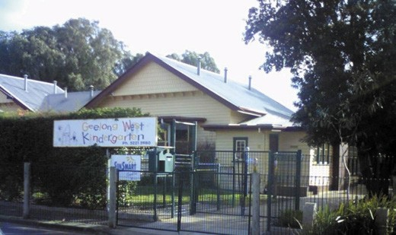
Figure 8.76: Geelong West Kindergarten, 2008. Source: David Rowe.

instructors comfort. There is a main hall for classes and assemblies, 32ft. x 26ft., together with four other rooms which will be utilized as occasion demands: two class rooms, each 14ft. x 17ft.; kitchen and cloak room and hall, each having a space of 14ft. x 8ft. A sun verandah is one of the features of the building. It has an eastern aspect covering a space of 30ft. x 12ft. A seat has been placed all round for the use of the children. As everyone knows, young children delight in playing with sand and provision has been made for them by the construction of a 10ft. x 10ft. sand tray on the north side of the building. The tray is covered and the sand is laid on asphalt. So that there may be no contamination the sand for the tray is to be brought from the ocean beach at Queenscliff.
The interiors of the rooms are attractively set out and are well ventilated, and lit. Ceilings are of fibre-plaster panels enclosed with red Californian pine and beams. The walls are 12ft. high and are shown off three feet of fibro-plaster six feet of three ply, and three feet of hyloplate. In the hall are built-in cupboards and the window openings, corners and fittings are of oiled redwood, whilst the class rooms have hyloplate blackboards and cupboards built in for use by the children. It is the intention of the instructors to train the children in cleanliness and to give them some idea as to housekeeping.611
The Geelong West Free Kindergarten was officially opened by the Governor of Victoria, Lord Stradbroke, on 20 March 1922.612 The first director was Miss Olga Maria Leschen (1896-1973) of Claremont, West Australia. She trained at the Kindergarten College, Pier Street, Perth and sat her junior public examinations at the Adelaide University Western Australian Centre in 1913.613 Leschen arrived in Geelong
in April 1920614 and helped establish the initial kindergarten at Scot s Church. She remained director at Geelong West for many years. In 1951, Leschen was appointed by the Commonwealth Immigration Department to assist Miss

Gladys Pendred, Federal officer of the Australian Association for Pre-School Child Development in the preparation of a survey of the migrant-holding centres throughout Australia, with ultimate aim of establishing pre-school centres to cater for the newly-arrived children to accepted standards of the Australian Association for Pre-school Child Development.615 As a result of her survey work, Leschen was offered a position as Chief Pre-School Officer for all kindergarten activities of the Department of Immigration in 1952, with an office in Canberra.616 She died in 1973.
The Geelong West Free Kindergarten continues to operate to the present day.

NEWTOWN AND CHILWELL FREE KINDERGARTEN, 25 BOND STREET, NEWTOWN
A second branch of the Geelong Free Kindergarten Union was formed in 1920 for the exertions of Mayoress, Mrs Charlotte Hitchcock.617 The Noble Street Methodist
Church offered its kindergarten room as temporary premises for the fledgling Newtown and Chilwell Free Kindergarten.618 By March 1924, a site had been acquired and a design prepared for a new purpose-built kindergarten building to a design by local architect, I.G. Anderson.619
On 26 November 1925, the Newtown and Chilwell Free Kindergarten was officially opened by Her Excellency, Lady Stonehaven.620 To be occupied by 52 children,621 the building cost £2000.622 It was described as follows:
It is brick and terra cotta lined with concrete and is of a most attractive design. A feature is the splendid
ventilation and light, which are indispensable in buildings of the kindergarten type. The big assembly hall is capable of seating 200 children, and there is a babies room, which will hold 50, a staff room, a store room, a cloak room, and kitchen and scullery. There is ample space in the grounds for recreation.623
The first Director of the Newtown and Chilwell Free Kindergarten was Miss Norah Goode of Adelaide.624 Her tenure was brief as she had returned to Adelaide by 1927.625
Other kindergartens followed in subsequent years, including the Whittington War Memorial Kindergarten
(see later subsection).

SECONDARY EDUCATION CENTRAL COLLEGE
In 1895, the Geelong Advertiser announced that Miss Annie
Elizabeth Clanchy (1864-1945) was about to open Central College for boys and girls at Knowle House, Skene Street, Newtown, the home of her parents, Michael and Mary (nee Thompson) Clanchy.626 Miss Clanchy had matriculated from the University of Melbourne (at Flinders State School, Geelong) in in 1878.627 She was appointed a Probationary
Teacher at Flinders School in 1882 and in 1884 Miss Clanchy passed the first class Certificate of Competency.628 By 1892 it was remarked that she taught upper class exceptionally well and was very intelligent. 629 At the time of the opening of the Central College in 1895, Miss Clancy had passed
65 Matriculation candidates. 630
Annie Clanchy was joined at the Central College by her sisters, Bridget Adeline Clanchy (1870-1938) (Figure 8.77) who graduated from the University of Melbourne with a Bachelor of Arts in 1892, and Isabella Josephine Clanchy (1875-1967), also a student of the University of Melbourne, and a staff of competent visiting teachers. 631 At the Central College, Annie Clanchy established secondary and
preparatory schools and created two distinct playgrounds to separate the boys and girls , with the strictest supervision exercised. 632
The Central College closed in 1923633 and Annie Clanchy and her sister, Bridget, built Owaissa , an interwar Bungalow at 18 Nantes Street, Newtown, in 1926.634 On Annie Clanchy s death in 1945, her significant contribution to secondary education in Victoria was acknowledged in The Advocate:
With the death of Miss A. Clanchy in Melbourne on August 15, one of Geelong s most colourful personalities and a pioneer of secondary education in the State has passed.
It was as collaborator with the late Mr. G.F. Link, founder of Link s private school - later to become Flinders S.S. and now Matthew Flinders Girls School - that Madam Clanchy became one of the prime movers in the introduction of secondary education as we now know it in Victoria.635

TOWARDS A STATE SECONDARY SCHOOL SYSTEM
In 1910, the Victorian Government passed the Education Act 1910 that was assented on 4 January 1911.636
This Act transformed State education in Victoria. It provided a much-needed educational bridge between State and Tertiary schooling. The work of the Director of Education, Frank Tate, a two-tiered secondary schooling system was established
to cater for two different community sectors. A High School

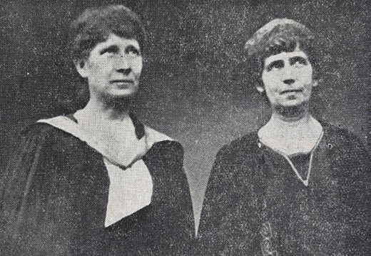
Figure 8.77: Clanchy sisters, 1923. Source: Geelong Advertiser, 18 December 1923, p.3, GRS 2050/1545, Geelong Heritage Centre collection.

education was established for students seeking a general education or entry into university. The second sector provided educational opportunities through the Junior Technical School, giving a pathway into the trades and/or further studies at Senior Technical Colleges, Colleges of Domestic Arts or Agricultural Colleges.637

HIGH SCHOOLS
The provision of High Schools (earliest known as District High Schools) under the Education Act was restricted for students for the teaching service and the holders of
scholarships. Candidates required a Certificate of Merit to qualify for enrolment at the age of twelve years.638 In addition to District High Schools, Agricultural High Schools, were also established. The aim of these schools was given in a report by the Minister of Public Instruction for the year 1910-11:
The object of the high schools is to provide the boy of fourteen, who has passed beyond the curriculum of the elementary school, whose parents wish him to get some knowledge of agriculture, and to keep him learning until ready for agricultural college. In short, the high school is a secondary school with an agricultural bias, and a link between the rural school and the agricultural college. It is also a preliminary stage in the education of boys and girls who wish to become teachers and eventually graduate in the State Training College and the University.639
The first District and Agricultural High School established in Geelong was Geelong High School in 1910 by Dr J.A. Leach in rooms in the Gordon Technical College. The first head master was John William Gray (1873-1961) who appointed a staff of eight teachers for the 89 pupils enrolled.640 Gray was appointed head teacher and had completed a Bachelor of Arts

at the University of Melbourne in 1900 before being appointed to the Toolern Vale State School. In 1902, he was elected
to the Victorian School Teachers Union, representing the Metropolitan province.641 He served as Vice-President of the Union in 1906.642 In 1910, he was appointed as Headmaster at the Geelong Agricultural High School.643 His tenure at Geelong was brief as in 1911 he was promoted to the position of Inspector of State Schools in Victoria.644 In 1934, Gray was appointed Assistant Chief Inspector of Primary Schools and was promoted to Chief Inspector in 1936.645
The prospect of a purpose-built Agricultural High School was met with enthusiasm by George King, Principal of the Gordon Technical College, and E. Watson, President of the Geelong Agricultural and Pastoral Society.646 In 1914, a four- acre site in the south-west corner of the Eastern Park at 385 Ryrie Street, East Geelong, was selected for the new school. Designed by H.J. Kerr, District Architect of the Public Works Department, to accommodate 250 children, the building
was erected by J. and W.S. Souter.647 The foundation stone for the brick school buildings with terra cotta roofs (Figure 8.78) was laid in April 1915. They were laid out around a central quadrangle, there being two main entrance from Ryrie Street, the central front wing being surmounted by turret. The school included an art room, physical laboratory, chemical laboratory, ladies and male teachers rooms, principal s rooms, large classroom (with a central partition for subdividing into two rooms).648
While the school opened for classed in late September 1915, it was not until 25 November that it was officially opened by the Governor Victoria, Sir Arthur Stanley.649
To meet growing demand, numerous expansionary building developments have occurred since 1915. One of the more notable was a two storey front wing completed in 1947.650 The modernist, stepped, cuboid forms appear to have been the work of Percy Everett, Chief Architect of the Public Works Department, who developed a modern progressive design approach for high and technical school buildings prior to and after World War Two.651 This two storey wing has recently be altered as part of major building upgrades at the school.
The Geelong High School has distinguished alumni. Notable former students included W.H. Frederick, who became
a Professor of Education at the University of Melbourne; Sir Roy Fidge, Chairman of the Geelong Harbor Trust and a Mayor Geelong; Marie Collier and John Brownlee,
internationally renowned opera singers; Dr Phillip Garth Law, Antarctic explorer, former Director of the Antarctic Division, and Vice-President of the Victoria Institute of Colleges; and Brigadier P. Jackson, Principal of R.M.I.T.652

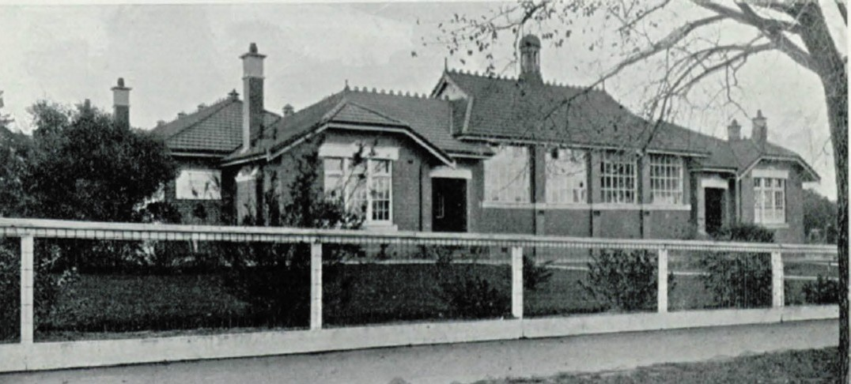

Figure 8.78: Geelong High School, 1930. Source: Geelong: Its Advantages and Opportunities, 1930, p.63.

Other high schools were established throughout
Greater Geelong after World War Two. They included those at Newcomb (1969), Norlane (1957), and Oberon (Belmont, 1965).653

TECHNICAL SCHOOLS
The educational reform of 1910 included the fields of technical education and apprenticeship training, with ultimate control
in the practical application of art and the trades (including carpentry, engineering, and fitting and turning) resting with the Education Department.654 Initially, the new secondary school institutions to provide the curriculum were known as Junior Technical Schools.
In Geelong in February 1913, the first Junior Technical School at the campus of the Gordon Technical College, its parent school (see following subsection for details on this College).655 The first classes for the initial of 52 students were located
in the Physical Culture Centre, and in church buildings.656 The first head master of the Junior Technical School was Frederick Matthew Wharington (1876-1964). He was born in
Wolverhampton, Staffordshire, England, and came to Victoria with his parents in 1886.657 In 1892, Wharington was appointed a probationary teacher at Newport State School No. 113.658 He passed his science examinations in 1897 while a probationary teacher at Morri Morri State School in the Wimmera.659 His
first appointment as head teacher was in 1899 at the Kinglake State School.660 In 1904, he transferred to Yarrambat State School and in February 1906 he took a temporary position
at the Faraday Street State School, Carlton, before taking up the head teacher position in May of that year at the Gre Gre State School.661 He transferred to Garvoc State School in 1908 before becoming head teacher at Nicholl s Point State School in the Mallee, until his appointment at the Geelong Junior Technical School in 1913.662 He remained at the Junior Technical School until 1916.663
By 1925, a site had been selected in Moorabool Street
(the western block between Maud and McKillop Streets) for the construction of a purpose-built junior technical school. Drawings were prepared by Edwin Evan Smith, Chief Architect of the Public Works Department. Built by James Brockie and Sons of East Malvern at a cost of £18,498, the foundation stone was laid on 19 March 1926 by the Minister of Public Instruction, Sir Alexander Peacock.664 The first classes were held in the new building in the same year. The new building was officially opened by the incoming Minister for Public Instruction, John Lemmon on 22 July 1927.665
The symmetrically composed, two storey hipped roofed interwar Georgian Revival styled brick building featured
a classically-derived, rendered entrance portico supported by Ionic columns and the main roof was surmounted by a bell turret (Figure 8.79). The ultimate goal of the design was

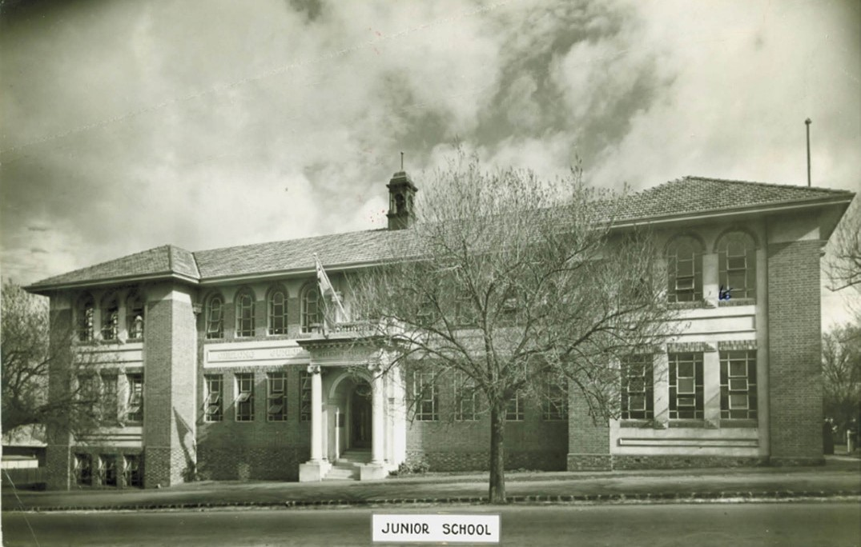
Figure 8.79: Geelong (Gordon) Junior Technical School, Moorabool Street, 1927. Source: G. Long, The Gordon: A Century of Influence, p.144.

outlined by the architect, E.E. Smith at the opening:
it had been the desire of the Department he represented to give the people something in the nature of a technical school that would educate their tastes. It was a pleasing feature that a draughtsman that had been engaged on the work was Geelong boy. In fact, he was able to testify to the fact that many of the men in the department had been trained in Geelong
by Mr King.666
The first head master of the new school was Thomas Arthur David (1896-1961). He had been appointed in 1919.667 David was born at Beaufort, the son of John David, teacher.668 Educated at Geelong College, Thomas David was first appointed a junior teacher to the Rosedale State School No. 770 in 1902 as a probationary teacher.669 In 1908 he was transferred temporarily to the Ashby State School No. 1492 (Geelong West) and was soon transferred to Flinders State

School No. 260 (Geelong) in the same year.670 In 1911, he qualified to teach military drill, having had experience as a cadet at Geelong College.671 It was also in 1911 when he was appointed a teacher at the Carlton High School No. 112. He was promoted to second master of the Eastern Suburbs Junior Technical School in 1913 before enlisting as a
Lieutenant in the Australian Infantry Forces during World War One in 1915, serving at the front in Europe.672 David served as head master of the Geelong Junior Technical School from 1919 until 1930, when he entered into private business.673
Distinguished alumni of the Geelong Junior Technical School included G.T. Chinchen, member of the Queensland Parliament; Hammer De Robert, later President of Nauru (attended in the late 1930s); and Stuart Devlin, Senior Prefect in 1945 and later designer of the Australian decimal currency (see Theme 9).674

TERTIARY EDUCATION
Opportunities for achieving a higher education beyond primary and secondary schooling has its roots in 1869, emanating in the establishment of the Gordon Technological School and culminating in the formation of Deakin University. Greater Geelong s connections to rural life were also recognised in the later 20th century with the establishment of the Marcus Oldham Agricultural College.

GORDON TECHNICAL COLLEGE, 6 FENWICK STREET, GEELONG
The genesis of the Gordon Technical College was the opening of a Technological School (soon known as the Geelong School of Art) at the Christ Church school room in 1869. This school had emanated from informal technical education offered by the Geelong Mechanics Institute
in the 1850s. The Technological School was principally formed for young employees in the building and engineering trades, with night classes offered for the initial 10 pupils by William Pye, Edmund Sasse (artist), G. Kirkland and John Young (architect).675 In 1873, Sasse supplemented the curriculum with art classes for girls known as the Ladies School of Design. It appears to have been at this time
when Sasse prepared a certificate that artistically outlined the Technological School, Commission appointed by
the Governor in Council for Technological and Industrial Instruction, and the Ladies School of Design (Figure 8.80).
Sasse later carried on the Technological School as a School of Design from his studios at 63 Myers Street, Geelong.676 Subsidised by the Government but locally controlled, this management method was to later form the enduring basis for the successful operation of the Gordon Technical College.
Impetus for the establishment of an art school appears to have emanated from a Technological Commission in 1869 whose labours were mainly applied to the formation of Schools of Art in the Colonies.677 The Commissioners deemed these schools to be of considerable public
importance in assisting with the advancement of practical knowledge for the industrial progress of the colony.678 In particular, the Commissioners:
desired to establish classes for instruction in mechanical drawing, and the use of instruments designed for accurately laying down on paper the details of construction of buildings, machines, or any mechanical object requiring precise working drawings prior to their construction. To decorators, carvers, and ornamental workers of other trades, it was explained that the Commissioners intended to form classes in which competent masters should give instruction in the different branches of drawing, each pupil being taught the branch most suitable to his or her special requirements, thereby

improving at one and the same time the hand, the eye, and the taste of the young workman, and so enhancing both the elegance and the intrinsic value of all the finer mechanics products of the colony, including embroidery and other artistic work for females.679
By 1886, the School of Art was still situated at Sasse s art studio in Myers Street. It was led by a committee of management of nine members, with J.H. Connor,
M.P., chairman, and Edmund Sasse as secretary and teacher.680 There, on Saturday mornings, Sasse taught geometric, architectural, mechanical and freehand and model drawing.681
Edmund Sasse (1819-1904) was born in Brussels, Belgium, the son of James Sasse, artist, who founded Sasse s Academy, south Kensington, London. He lived 27 years in France and on the Continent, and seven years in England, and was there during the Chartists riots, and was one of the special constables on the same beat with Louis Napoleon, then an exile. During the London Exhibition of 1851-52 Sasse was appointed cicerone to Prince Albert (husband of Queen Victoria).682 Sasse came to Melbourne with his brother in 1852 and went to the gold fields. A friend of Governor
La Trobe, Sasse worked in the Treasury for a time being appointed drawing master under the national system for the Geelong district, arriving in 1853.683 Soon after, Sasse commenced private art classes. He became an art teacher
in most of the local schools including the Geelong Grammar School, Geelong College and Queen s College.684
The death of General Charles Gordon at Khartoum in 1885, coupled with Gordon s philanthropy for underprivileged boys and the use of his house as a school, hospital and almshouse elevated his status in society, instigated a local desire that he be fittingly commemorated. A meeting of 500 Geelong citizens on 1 July 1885 resolved that a memorial to commemorate the late General Gordon be a building to be called the Geelong Gordon Memorial School of Arts. 685
A subsequent meeting resolved to change the name to the Gordon Technical College.686 Railway land was acquired between the railway line and Fenwick Street, formerly taking in the tree-lined Maidens Walk once part of Johnstone Park (see Theme 9). The Geelong architect, Alexander
Davidson, called tenders for a brick College hall in May 1887. A ceremony to lay a memorial stone was held on 20 June 1887.687 The formal opening of the building on 14 November of that year was marked by an exhibition of drawings and paintings by the Geelong Technological School (School of Art).688 The first Council of the Gordon Technical College associated with the purpose-built hall consisted of Henry Meakin (Mayor of Geelong (President), George Hitchcock and George Martin (Vice Presidents), Alexander Purnell (Secretary), William Humble (Treasurer) and Councillors

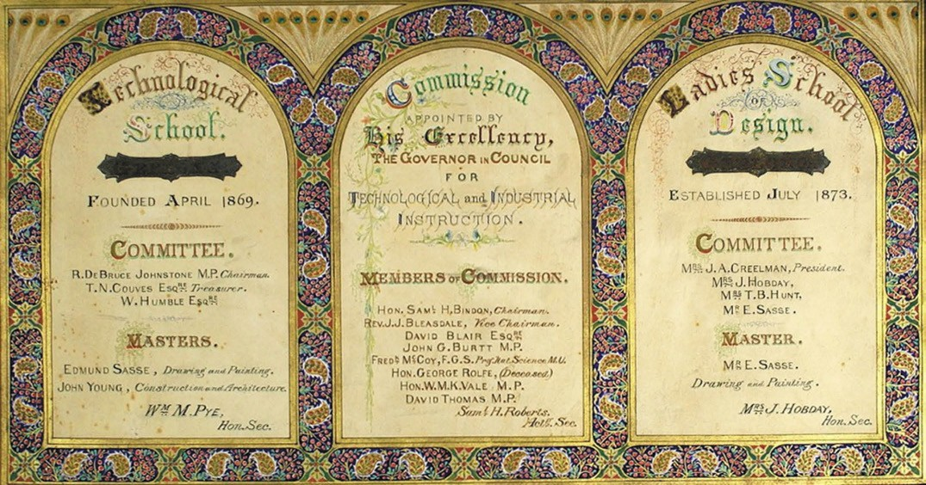
Figure 8.80: Edmund Sasse, Certificate of the Gordon Technological School, Commissioners & Ladies’ Design School, c.1873. Source: Dale Kent, Records Manager, Quality & Compliance, The Gordon TAFE.

Charles Andrews, John Donaghy, James Munro, W. Bradley,
J.C. Brown, G. Link, J. Connor, William Pye, J.C. Taylor, R. Aitchison, R. Davey, W. Sommers, J. Strong, H. Roebuck and
H. Richardson.689 In 1920, the first Gordon Technical College building was named Davidson Hall, in memory of Captain
F. Stanley Davidson, a former architectural student of the Gordon who was killed in action in France in 1918.690
Edmund Sasse substantial contribution to local artistic education had also included his involvement at the Gordon Technical College. He was one of the first instructors of the College between 1888 and 1895.691 With 63 students enrolled, the subjects initially offered were: mechanical
drawing, telegraphy, architecture, book-keeping, short-hand, chemistry, navigation, mathematics, science,
and languages.692
It was not until 1892 when William Arthur Hargreaves (1866- 1959) was appointed first Director of the Gordon Technical College. He taught chemistry and physics and supervised all classes.693 Hargreaves was born in Ipswich, Queensland, the son of Ebenezer Hargreaves, an ironmonger, and
Sarah Hargreaves (nee Horne).694 Following an education at Ipswich Grammar School, Hargreaves attended the
University of Melbourne.695 While enrolled there, he was part time instructor in geology and mineralogy at the Working Men s College, Melbourne, in 1889-91, during which time
he completed his Bachelor of Arts and a Bachelor of Civil
Engineering.696 After two years as Director of the Gordon Technical College, Hargreaves returned to Queensland where in 1897 he was appointed assistant Government Analysist in the Queensland Mines Department.697 He relocated to South Australia in 1899, taking up the position as Government Analyst and Chief Inspector of Explosives, rising to the position as Director of the South Australian Department of Chemistry in 1916.698 He died in 1959.699
Enrolment demand and an expanding curriculum necessitated the construction of several College buildings from the late 19th century to the present day. These buildings reflect
the work and architectural fashions of different architects throughout this period. In 1888, the first of three buildings marking the administration offices was constructed in brick to a design by Alexander Davidson. This two storey brick building was distinctive for its Scots Jacobean revival design derived from Davidson s former master, David Cousens of Edinburgh.700 A three storey flamboyant interpretation of Davidson s design was carried out by E.M. Blake, architect of New Zealand (while resident in Geelong) in 1891 and this was followed by a three storey north wing in 1916 designed by
Seeley and King architects, providing a balanced composition for each stage of the administrative complex (Figure 8.81).
Other distinguished buildings reflective of the College’s progress and the curriculum offered at different stages include the chemical laboratory (built in c.1889 to a design by

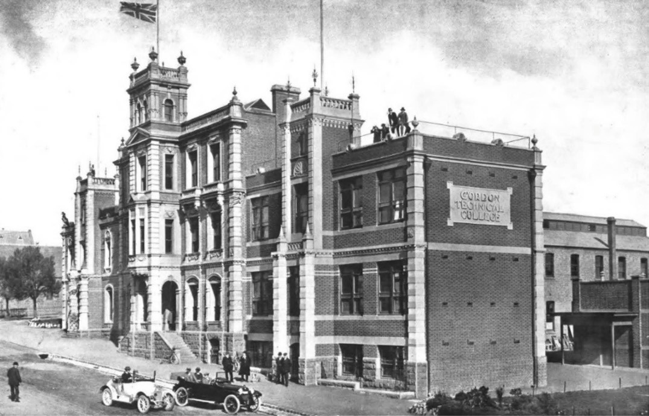
Figure 8.81: Gordon Technical College, Fenwick Street, 1918. Source: Geelong For Business, Health, Pleasure, 1918.

Alexander Davidson); plumbing, carpentry and art modelling building (built in 1890 to a design by E.M. Blake); Lascelles Chemical Laboratory and Bostock Memorial building (built in 1921 and 1928 respectively in a late Beaux Arts style by local architects Laird and Buchan) (Figure 8.82); wool school (built in 1936 to a design by Percy Everett) and the textile college (built between 1944 and 1951 in a highly distinctive Modern Functionalist, vertically-oriented design by Percy Everett).701 This substantial building at the northern end of the Gordon College site reflected the importance of textile training to meet the needs of Geelong’s significant textile industry.702
In 1921, the Gordon Technical College became the Gordon Institute of Technology,703 the first of its type in Australia.704 This was the culmination of separate departments
in Engineering, Architecture, Art, Wool, Commerce, Dressmaking and Workshop Practice having been created from 1912.705 By 1918, Associate Diplomas in Municipal, Hydraulic Engineering and Surveying; Mechanical and Electrical Engineering; and Architecture were offered.706
It was not until 1939 when the Council of the Gordon Institute of Technology recognised the need for specialised training for females, not only for household arts and crafts, but in
the higher education of women for institutional management
and other careers and this brought about the formation of the Domestic Economy group. A two storey building was officially opened on 14 June that year for the training of girls and women.707
Highly influential in the early life and development of the Gordon Technical College was George Raymond King (1872-1950).708 Born in Ballarat to George Joseph King, an Irish blacksmith, and Annie King (nee Mercer) of Scotland, he attended Mowbray s Ashby School in Geelong West following the death of his father.709 He was later articled to the prolific Geelong architect, Albert J. Derrick where he received a solid grounding in design and organisational
skills.710 With Derrick s departure for Melbourne around 1893, King was employed by Thomas Seeley, a builder who in 1871 graduated from the Geelong Technological School with the distinction of producing the best five architectural drawings in Victoria.711 George King was made a partner in 1895, the firm trading as Seeley and King, and from 1910, Seeley, King and Everett (with Percy Everett entering as a partner).
In 1898, George King was appointed part time Secretary
of the Gordon Technical College. A year later in 1899 he was in control of the day to day operations of the College, such

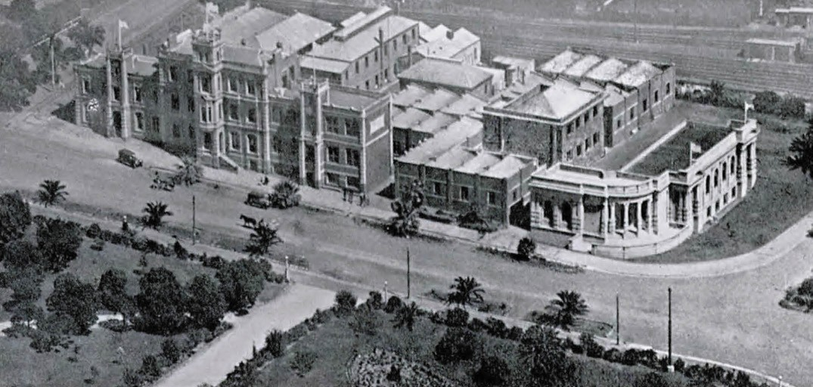
Figure 8.82: Aerial view of the Gordon Institute of Technology, 1930. The Lascelles Chemical Laboratory & Bostock Memorial building are to the right. Source: Geelong: Its Advantages and Opportunities, 1930, p.59.

control he was to hold for 37 years.712 In 1908, King took a six month tour of England and Europe on behalf of the Gordon Technical College to review the latest in technical training which was financed by the public. 713
On his return, he was appointed Principal of the College in 1909, as well as the head of the architectural section.714 It was from this time when King founded and fostered the first School of Architecture’ in Victoria.715 King was made
inaugural secretary of the Faculty of Architecture established 1923.716
Renowned as a conspicuous, controversial, forthright character who was unorthodox, argumentative, flamboyant and dramatic ,717 George King retired in 1934, citing
ill-health.718 His retirement was recognised and celebrated by numerous past and present architectural students
who revered their mentor, several of whom had become successful and prominent architects in their own right. The group (Figure 8.83) also included a small number of female architects.
Bestowed an Order of the British Empire (O.B.E.) in 1935 as one of Victoria’s most enduring, influential and successful educators, King s contribution to Geelong and architectural education was glowingly (and romantically) documented by renowned architect and author, Robin Boyd, in 1947:
In spite of its limited numbers [of population], and whereas Ballarat and Bendigo, inland cities of comparable size, have produced very few architects and no architecture, Geelong is proportionately ahead of Melbourne. In
the small area of its newer residential districts there is probably a higher concentration of good design than in any similar area in Melbourne. Furthermore, the number of prominent Melbourne architects born and
trained in Geelong is out of all proportion. This number includes Arthur Baldwinson, Harold Bartlett, Max Deans, Percy Everett, John and Tom Freeman, Keith Mackay, John Mockridge, Tom O Mahony, Hugh Pedditt and Ronald J. Wilson. This is not to mention the principals and most of the considerable staff of the firm of Buchan, Laird & Buchan.
There is nothing very coincidental about the architectural prolificness of Geelong. The good designs are almost
all from the last mentioned firm, and the quantity of talent was almost entirely inspired, not to say in same cases diverted, to architecture by the one man: G.R. King.
G.R. King loves architecture; and naturally he likes to have lots of people around him loving it. At the Gordon institute he came in contact with several generations of youth vacillating in search of a career.
A number who otherwise might never have considered Architecture were swayed by his enthusiasm. All who took the course were constantly invigorated by his infectious interest.
His conservatism equalled his enthusiasm. He has always believed in the impertinence of any departure from the classical styles. He planned the course and supervised the building of the students, Order by Order,

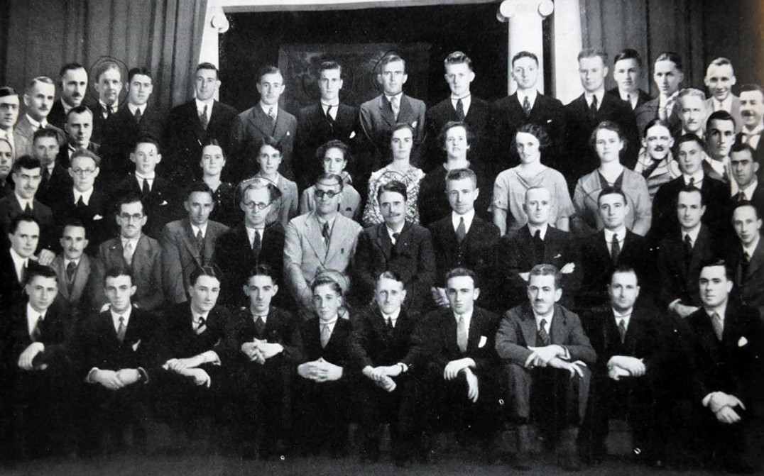
Figure 8.83: Past and current architecture students of the Gordon Institute of Technology at the retirement of George King (centre, seated, second row), 1936. Seated immediately beside him was Percy Everett (left) and Norman Schefferle (right). Third from the left in this same row was Ewen Laird, while fifth from the left was Harold Bartlett. Standing in the second back row (third from left) was Harold Trigg. Source: Journal of the Royal Victorian Institute of Architects, vol. 34, no. 4, September 1936, p.134.

to this design. But somehow he never succeeded in producing many conservative architects. A great majority of his cares became leading Moderns. Today he shakes his head in disgust at this reflection, but he is none
the less immensely proud of them. And though they revoked those parts of this teachings which dealt with its practical application, his ex- students regard him with an affectionate respect that would astonish some school teachers.719
King died in 1950, aged 63 years.720 The G.R. King Memorial Committee was subsequently formed to raised funds for a suitable tribute to Geelong s educational doyen.721 Former students, William Wallace and John Freeman designed a plaque and bronze bust and granite memorial respectively.
In 1958, the plaque was installed in the main entrance of the Gordon Institute of Technology, while the granite memorial was placed in Johnstone Park, opposite the Gordon Institute (Figure 8.84). Sourced from the Dog Rocks,722 the greenstone had been a prized grinding stone of the Wadawurrung and been placed vertically as the King memorial (rather than
its original horizontal position).723 Below the 15 ton stone was a lead casket containing a resume of King s career, photographs, and copies of the Geelong Advertiser.724

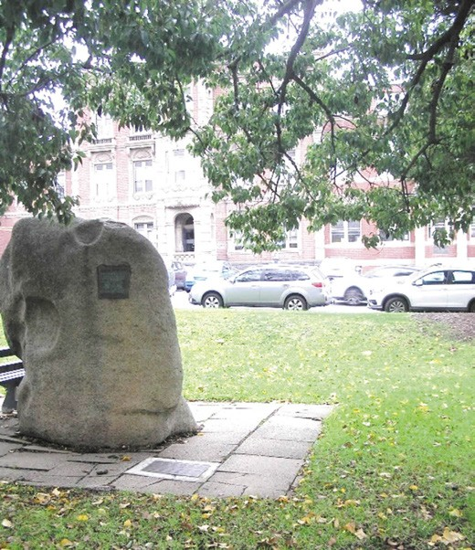
Figure 8.84: George King Memorial in Johnstone Park (showing the Gordon TAFE in Fenwick Street in the background), 2019. Source: Pam Jennings.

DEAKIN UNIVERSITY, WAURN PONDS AND WATERFRONT
In 1965, the Gordon Institute of Technology became a College of Advanced Education. In 1968, land at Pigdons Road, Waurn Ponds, was acquired for the construction of a building to initially accommodate the School of Applied Sciences.725 The foundation stone was officially laid by the Premier of Victoria, Henry Bolte, in 1970 and was officially opened a
year later in 1971 by the Governor of Victoria, Sir Rohan Delacombe.726 In 1972, the Minister of Education established two Committees: The Geelong Tertiary Education Committee and the Gordon General Committee Proposed Fourth University.727 Both Committees collaborated which resulted in the establishment of a local university in 1974. Named Deakin University after Australia s second Prime Minister, Alfred Deakin, the new tertiary institution was an amalgamation of the State College of Victoria, Geelong (formerly the Geelong Teachers College) and the tertiary programs offered by the Gordon Institute of Technology.728 The University took over the Waurn Ponds campus of the Gordon College of Advanced Education, the first students being enrolled in 1977. The inaugural Vice Chancellor was Frederic Raphael Jevons (1929-2012).729 Born in Austria, he survived the Holocaust

having been sponsored by a family in England to attend a boarding school in Norfolk.730 Jevons subsequently attended King s College, Cambridge, and was to become a British Professor of Biochemistry prior to his appointment as Vice Chancellor at Deakin University.731
Since its opening in 1977 as Victoria fourth University,
it later became the first Australian university to specialise in distance education.732 In May 1993, a national architectural competition was held for the adaptation of the former Dalgety and Co. Pty Ltd woolstores complex on the central Geelong waterfront, which had ceased operations in the mid-1980s.733 The Geelong architectural firm of McGlashan Everist Architects was awarded the project. The Great
Hall was completed on 1 April 1996 and the campus (Figure 6.46, see Theme 6) was officially opened two days later on 3 April.734 The campus initially accommodated the
University chancellery, School of Architecture and Building, branch library, and a cafeteria.735 The conversion into
a university campus not only gave a sustainable future to the historic woolstores complex but it was a catalyst for the transformation of the central Geelong waterfront.

MARCUS OLDHAM AGRICULTURAL COLLEGE
In 1962, Marcus Oldham College opened in Pigdons Road, Waurn Ponds.736 It was established by a Trust from the Estate of Marcus William Oldham of Point Piper, Sydney, who died in 1939. The Trustee was to establish and maintain a training school of Protestant boys for farming and agricultural education.737 Marcus Oldham College shared some of
its facilities with the adjoining Geelong Girls Grammar School middle school campus in the 1970s,738 and a legacy of this is the Elsie Morres memorial entrance gates at the Pigdons Road entrance.739 Today, Marcus Oldham College is Australia s only independent agricultural and equine business management college. 740

LIBRARIES AND MECHANICS’ INSTITUTES
In the early 19th century in Britain, large numbers of scientific and cultural societies emerged to cater for a growing interest in modern technological developments.741 These included the Royal Institution in London, book clubs and mutual improvement societies, and Mechanics Institutes.742 By 1826 there were over one hundred Mechanics Institutes
in existence.743 They provided lectures and classes to promote proficiency in reading, writing, and arithmetic, and sometimes geography, chemistry, French, and history.744 They also maintained reference libraries, with the limited aim of providing knowledge to help the Mechanic in the exercise of his art , Mechanic referring not only to machine operatives but to manual workers and artisans.745 In general, Mechanics

Institutes were initially provided by the middle classes to create a more efficient and capable workforce.746
In Geelong, Mechanics Institutes and Free Libraries were established with similar aims as their British predecessors. Also, like Britain, mutual improvement societies formed to help with the informal education of locals, the earliest known in Victoria being the Geelong Essay and Discussion Society which met in the Scotch Church school room from August 1850.747

FORMER GEELONG MECHANICS’ INSTITUTE, 77 RYRIE STREET
The Geelong Mechanics Institute opened on 28 December 1846 as a Mechanics Institute and Reading Room in the Temperance Hall off Malop Street.748 A purpose-built timber Mechanics Institute was built in 1855-56 at 77 Ryrie Street.749 A concert hall was added in 1857 while in 1860 the classically- derived Institute building was extended and altered, including the cementing of the exteriors750 (Figure 8.85). A second storey was added in 1876751 (Figure 8.86). By 1897, the Geelong Mechanics Institute was claimed to be the oldest of its kind in Victoria. 752
By 1926, the Mechanics Institute library boasted 20,000 volumes.753 This library was saved when a fire destroyed the concert hall in 1926.754 A new hall, library, meeting rooms and shops were subsequently constructed in
1927 in a Spanish Mission Revival design by I.G. Anderson, architect. Built by J.C. Taylor and Sons, the anticipated building (Figure 8.87) was described in the Geelong Advertiser:
It provides for an auditorium measuring about 76 ft. by 50ft., stage being 56ft. by 26ft. and 50ft. high. The capacity of the hall will be about the same as that of the last about 900 seating accommodation 225 in the gallery and 650 in the main body of the hall.
The new library upstairs will measure 48ft. by 32ft. and will be on the south-western corner of the building. On the other side reading, chess, club and meeting rooms will be provided … On the ground floor at the front will be five shops.755
In 1981, the Mechanics Institute auditorium was subsumed as part of the Geelong Performing Arts Centre development fronting onto Little Malop Street, the Geelong Performing Arts Association having taken over the Mechanics Institute in the mid-1950s.756 In 2018, surviving vestiges of the former Mechanics Institute, including the front two storey Spanish Revival styled pavilion, were demolished to make way for a redevelopment of the Geelong Performing Arts Centre (see Theme 9).

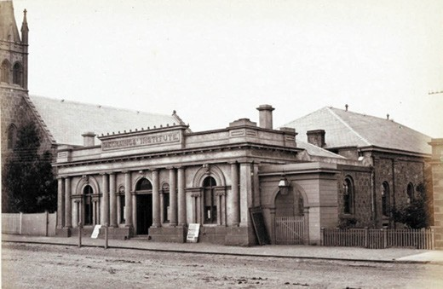
Figure 8.85: E. de Balk, Geelong Mechanics Institute, Ryrie Street, 1866. Source: figure SL985553, Mitchell Library, State Library of NSW.

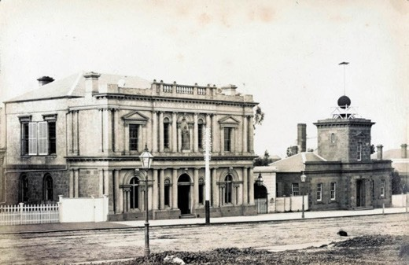
Figure 8.86: F. Kruger, Geelong Mechanics Institute (left) (Telegraph Office on the right), c.1882. Source: accession H39614/52, State Library of Victoria.
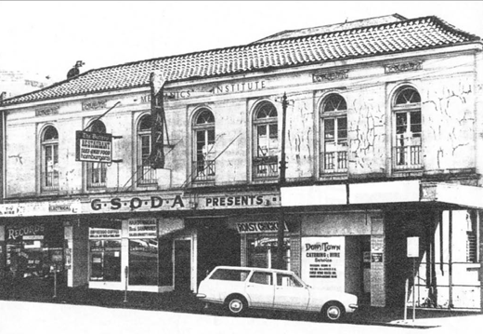
Figure 8.87: Geelong Mechanics Institute front Spanish Mission Revival pavilion, October 1975 Source: National Trust of Australia (Victoria).

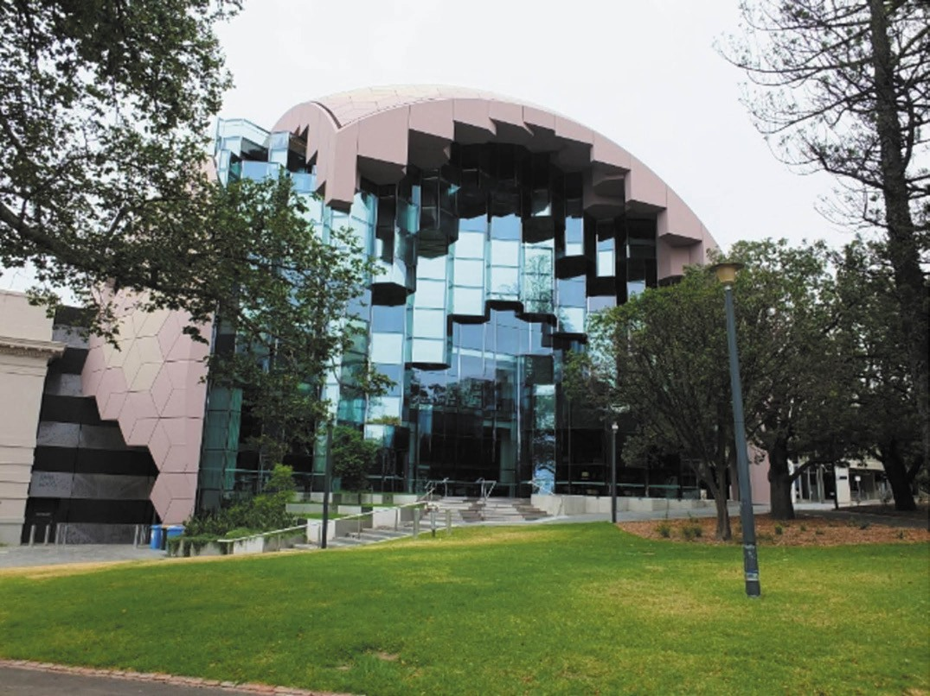
Figure 8.88: Geelong Library and Heritage Centre, Little Malop Street, 2018. Source: David Rowe.

GEELONG LIBRARY
In 1874, J.H. Connor, M.L.A. and Mayor of Geelong, obtained the cooperation of a number of prominent citizens including
G.F. Belcher, the Hon. Graham Berry and W. Stitt Jenkins to lobby for the formation of a Geelong Free Library.757 This came to fruition in 1876 when the Chamber of Commerce building (constructed in 1858-59) was acquired and was
formally opened on 15 September of that year.758 This grand building served as the City s public library until 1955 when the library relocated to temporary premises while a new library was built adjoining the Art Gallery in Little Malop Street. It opened in 1959 while the old library, like other grand buildings in this part of Moorabool Street, was demolished.759 The postwar library was the location of the Geelong Regional Library and Geelong Historical Records Centre until it was replaced with the existing Geelong Library and Heritage
Centre building in 2015 to a design by ARM Architecture of Melbourne (see Theme 7). The landmark building is
characterised by a geodesic dome and is constructed of glass and reinforced concrete (Figure 8.88).

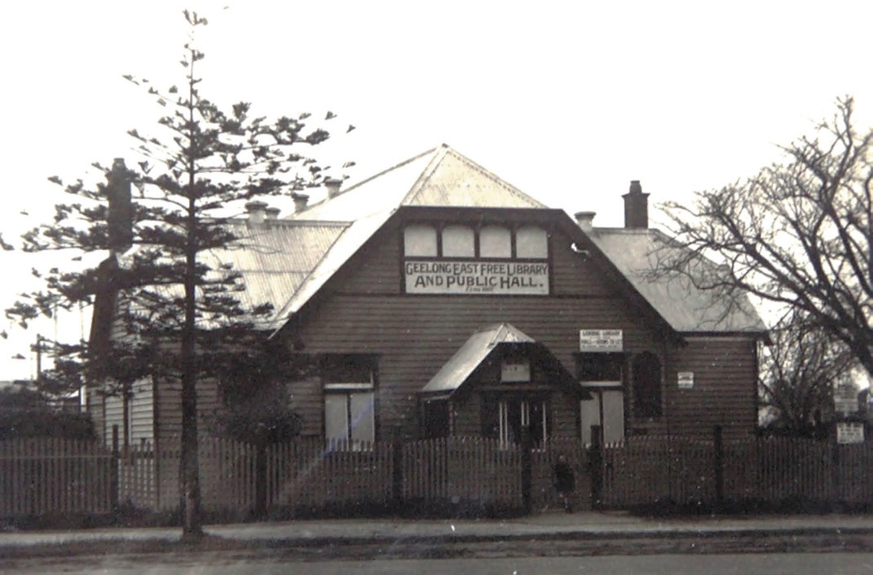
Figure 8.89: Geelong East Free Library & Public Hall, McKillop Street, c.1930 (demolished). Source: T.T. Holmes collection, Authentic Heritage Services Pty Ltd.

SUBURBAN AND RURAL MECHANICS’ INSTITUTES AND FREE LIBRARIES
Throughout suburban and rural Greater Geelong, libraries were established either in association with the Mechanic s Institute, as separately functioning institutions or combined with a public hall. The aim was to aid the education of its citizens. Many of these institutions or their early buildings have long disappeared, including the Portarlington Mechanics Institute (established in 1858);760 Viaduct Literary Institute
and Reading Room, Moorabool (established in 1859)761; Portarlington Free Library (established in 1883)762; Highton Free Library (established in 1910)763; East Geelong Public Library and Hall (established in 1907 on the newly-reserved recreation reserve in Bourke Crescent, on the north side
of McKillop Street764 (Figure 8.89) and the Ocean Grove Free Library (established in 1911).765 Some of these library institutions have transferred to later buildings, including the libraries at Portarlington and Ocean Grove.
Other early buildings survive in Greater Geelong with direct
associations with Mechanics Institutes and/or Public Libraries. The earliest is the former Drysdale Free Library, 18-20 High Street, Drysdale (Figure 8.90). It was built in 1881 to a design by Andrew McWilliams, architect and surveyor.766 Opened with a tea and concert on 6 October of that year, the Geelong Times gave a report on the celebration:
At the tea some 150 persons sat down, and the good things were thoroughly enjoyed. At the concert Mr Allnutt presided, in the absence of Mr Levien, the state of whose health would not permit of his being exposed to the night air The Committee expect to net from the tea and concert a sum of £20 towards paying off the debt upon the new building, which is really a very pretty and commodious structure such as any town might be proud
of. Messrs Cuddy, Hebbard, and others have labored with much assiduity to make the affair a success, and they may take the credit to themselves of the success which has resulted.767

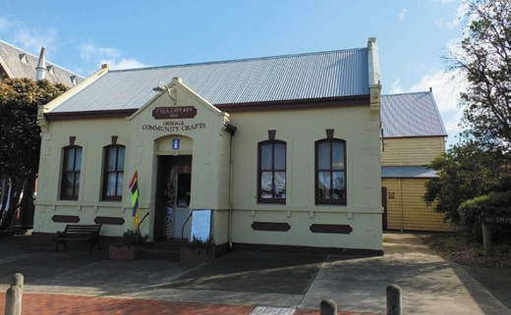

Figure 8.90: Former Drysdale Free Library & Hall, High Street, Drysdale, 2013. Source: David Rowe.
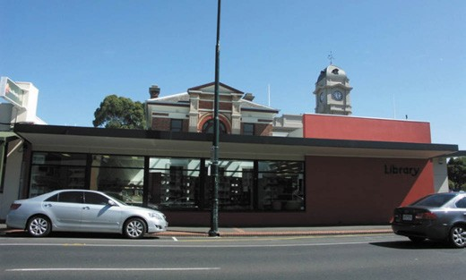

Figure 8.91: Geelong West Library, Pakington Street, 2010. Source: David Rowe.

A timber hall was built at the rear of the library in 1884.768
A free library was also officially opened by S.V. Buckland at 51 Russell Street, Chilwell (Newtown), in 1881.769 A public hall, named Sladen Hall in honor of Sir Charles Sladen, was built in 1888-89 in the library grounds (it was destroyed by fire in 1957).770 Masonry veneer additions were constructed to the original library building which was opened on 16 July 1958 by the Mayor of Newtown and Chilwell, Cr Henry Jacobs J.P.771 This building continues to operate today and is the only purpose-built library continuing on its original site in the City of Greater Geelong.
At Leopold in 1882, the Kensington, Moolap and Curlewis Free Library was formed at the local State school, with £50 granted from the Chief Secretary of Lands Department for the purpose.772 In May of that year, the Library Committee resolved to erect or purchase a building for library purposes.773 G.F. Belcher subsequently donated land at the top of the Kensington Hill on the north side of the Queenscliff

Road for a library building.774 Joseph Watts designed a library and hall for the site which was built by Mr Purnell in 1883.775 The building was destroyed by fire and a second hall and library was designed by Watts Tombs and Durran in 1893.776
It opened in September of that year.777
In 1894, the Free Library held 306 books. The hall associated with the library became a focus for community life: for cultural, educational, religious, political, sporting, patriotic and private use.778 The library closed in 1985 after serving the Leopold community for 103 years.779 The hall continues to be enjoyed by the public for dances and other social activities.
A free library was built as part of the South Barwon Shire Hall, 33 Mt Pleasant Road, Belmont, in 1884 (Figure 7.21, see Theme 7). The building opened on 3 February 1885,780 the library being described as follows:
The Free Library is situated at the rear of the shire hall, and is approached from Mount Pleasant road by a separate side entrance through a lobby. The library or reading room is 15ft by 30ft, and the chess room 15ft by 12 ft, both of course being under the same roof as the shire hall, but divided by a brick partition. The rooms are well furnished and handsomely adorned.781
At 55 Staughton Vale Road, Anakie, the Anakie and Staughton Vale Mechanics Institute built a hall in 1906 which was opened by the Premier of Victoria, Thomas Bent.782 A grand plain and fancy dress ball was held as a community celebration.783 During World War One, the Mechanics Institute Hall was used by the Anakie Red Cross for raising funds for the French Red Cross.784 With the original and succeeding members of the Mechanics Institute having passed away by the 1960s, management of the hall was passed to the Shire of Corio.785
At 329 Shannon Avenue, Newtown, a cream brick library with a butterfly roof was opened on 30 March 1954 by the Mayor of Newtown and Chilwell, Cr. W.T. Wiggs, to serve the
growing community in the western parts of Newtown.786 Miss
I.J. Meredith was the Chief Librarian for this and the Chilwell Library, and she had a staff of ‘five lady assistants.’787 In 2007, the library building was taken over and upgraded as the St. Joseph s College Archives.788
At 153A Pakington Street, Geelong West, in 1939, the Court House was converted into a public library.789 Major alterations and additions were made to the building in subsequent years. More recently, further changes being carried out to improve the library and expose (through fenestration) the old court house to public view from Pakington Street (Figure 8.91).

ANGUS LAIRD LIBRARY, GORDON INSTITUTE OF TECHNOLOGY
In 1927, John Angus Laird, an architect who had made an extraordinary contribution to Geelong s building and town planning landscape, and to the community more
generally, donated his substantial architectural library to the Gordon Institute of Technology.790 J.A. Laird was born on 25 May 1862 at Eddington Station in the Western District of Victoria.791 The son of John Laird (who arrived in Victoria
in 1852) and Maria Nash,792 Laird was educated by a tutor until he was fifteen and on his parent’s removal to South Australia he was articled to the Geelong architect, Joseph Watts.793 In 1891, Laird was admitted as a member of the Royal Victorian Institute of Architects,794 the same year he established his own practice, taking into partnership Fred
J. Barlow of New Zealand.795 This began one of Geelong s most successful and enduring architectural practices later known as Laird and Buchan, Buchan Laird and Buchan, and following a succession of other names, The Buchan Group, whose offices are now located in Melbourne, Sydney, Perth, Brisbane, Gold Coast, London, Auckland and Christ Church in New Zealand, London in England and Shanghai in China.796 From an early period, J.A. Laird had been a supporter of the Gordon Technical College (and later Gordon Institute of Technology).797 In 1903, he was appointed a member of the Gordon College Council,798 a role he held for many years. In addition, Laird became an Instructor in architecture and in 1923, he was made a life governor
of the College.799
It was also in 1923 when impetus for the Angus Laird Library came following J.A. Laird s donation of £100 for the
creation of an architectural reference library.800 He had been prompted to make his gift because of the work of a student, in regard to the £250,000 war memorial competition. 801 The Angus Laird Architectural Library was opened in December

1927 and included the works of architecture that were among the most widely read references in the world. The library began from the philanthropy of J.A. Laird, which was reported in the Geelong Advertiser:
Mr Geo. R. King added his congratulations to his old friend, Mr Angus Laird, for his valuable donation, which gave the Gordon over 1500 volumes and over
2000 illustrations of most of the world s best architectural gems. He also expressed appreciation of the donations that had been given periodically by the Hon. Howard Hitchcock.802
On Laird s death in 1936, he was lauded as the oldest practitioner in Geelong, and amongst the oldest in the state , and his interests in the students of the Gordon Institute of Technology were best shown in his presentation to the Institute his valuable library on architecture.803 The value of the Angus Laird Library was appreciated long after his death. In 1938 in a letter to the Royal Victorian Institute of Architects, a representative of the Gordon Institute of Technology declared that the library has been very liberally supported
by practicing Architects, Patrons of the School, and Ex- students. 804

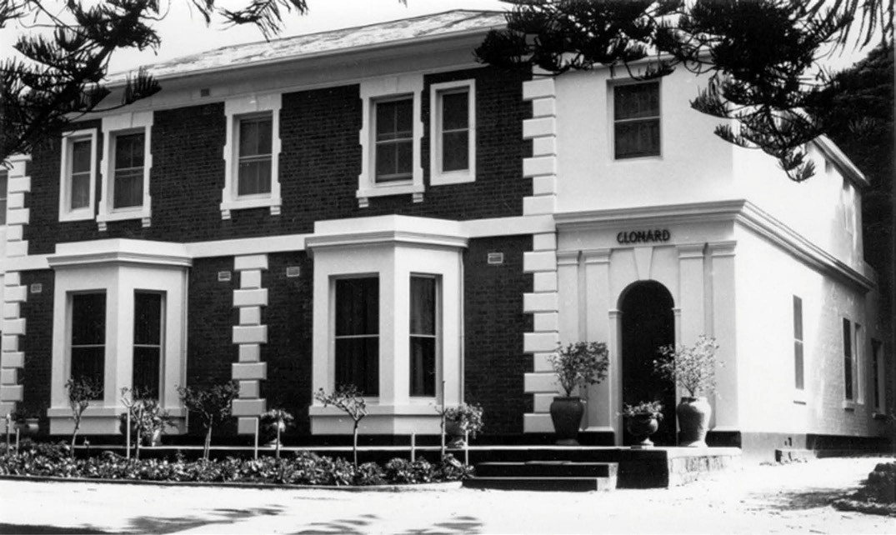
Figure 8.92: Clonard, Church Street, Herne Hill, c.1979. Source: Lorraine Huddle.

HEALTH AND WELFARE

WADAWURRUNG HEALING AND PHARMACOPEIA
The first medical practitioners in the Greater Geelong area are the Aboriginal healers also known as the medicine men of the Wadawurrung peoples.805 These healers
are considered to have the ability to see into the body of their patients. They deal with emotional problems as well as physical ones. 806 The treatment was first to attend to the patient s spirit as the protection of the spirit was considered fundamental to their health.807 As further outlined by Philip Clarke in Aboriginal healing practices and Australian bush medicine:
In Aboriginal Australia the healer s job is to diagnose problems, advise on remedies, suggest and perform ritualized healing procedures, explore the impact of community social and cultural issues upon the illness, and to reassure their patients that they ca be cured. Most recognised healers are men, although people of both genders have a wide general knowledge of efficacious healing plants. While the healers focus upon treating sick individuals, women specialize in performing ceremonies that promote the general health and wellbeing of their
whole family healers were considered to have special access to spiritual powers and assistance.808

EUROPEAN HEALTH AND WELFARE

TOWARDS A HEALTH SYSTEM IN GEELONG
A medical service in Geelong had humble beginnings with the arrival of Dr Jonathan Clerke (c.1804-1869) in 1838.809 Born in Skibbereen, County Cork, Ireland, he completed his MRCSL in 1828, the same year he boarded the Letitia with his brother,
Alexander, and sister in law, bound for New South Wales until it was wrecked off St. Jasgo, Cape De Verde Islands.
810 Destitute and ill ,811 Clerke returned to Ireland. 812 In 1832 he emigrated to Hobart, Tasmania where he was appointed Assistant Colonial Surgeon at Westbury.813 He remained in this position until 1834 when he became the catechist and postmaster in that town.814 In 1836, he turned to his attention to being a pastoralist in Victoria, as station manager for Joseph Tice Gellibrand and was a member of the search party following Gellibrand s mysterious disappearance in 1837.815
In 1838, Jonathan Clerke married Sarah Rawson in Melbourne.816 In 1839, he was appointed Colonial Assistant Surgeon and resided in Geelong until 1853, during which

time he was appointed Health Officer to the Port and Harbour of Geelong (1849, the year he was Alderman of Geelong), Medical Officer to the Geelong Gaol (1851) and Colonial Assistant Surgeon (1852, reappointment). In 1853, he returned home permanently to Ireland with his wife, and son (born 1846), there being no mention of William Clerke, a Wadawurrung boy raised by Dr Clerke (see Theme 2).817
Dr Clerke was soon followed by Dr Forster Shaw (1809-1883) in late 1840.818 Born in Dublin, Ireland, Shaw graduated at Trinity College and took a diploma at the College of Surgeons, Dublin. He commenced medical practice in Geelong on his arrival, establishing a private hospital in the suburbans. 819
In 1850, he was appointed coroner (replacing Dr R.C. Hope), continuing in this role until 1878.820 It was also in 1850 when he took the position of magistrate of the Geelong district.821 In 1860, he became Honorary Surgeon at the Geelong Hospital, and was Health Officer for Geelong from 1872.822 He died at his residence in Corio Terrace, opposite the Custom House , in 1883.823 Physical evidence of Shaw s time in Geelong
is the mansion house designed for him by his brother, Joseph: Clonard , 226 Church Street, Hamlyn Heights (built 1855-56 and named after his late workplace as Medical Superintendent of Clonard and Kinnegad Dispensaries, Ireland)824 (Figure 8.92).

PUBLIC HOSPITALS GEELONG HOSPITAL
In February 1849, a public meeting was called by the Trustees
of the Irish and Scotch Relief Fund at the Theatre Royal, Malop Street, Geelong, to deliberate on the necessary measures required to be taken to build a public hospital in Geelong. 825 The meeting resolved to establish a Benevolent Asylum.826 In May 1849, a temporary hospital was established by the Friendly Brothers Society in a house in Limerick Place. The dwelling had been thoroughly cleaned and white-washed throughout , and new stretchers provided with an adequate supply of sheets and bed covering. 827
By August 1849, a Committee was formed to fundraise for and manage the construction of what was first to be known as the Geelong Infirmary and Benevolent Asylum.828 E.B. Addis was Treasurer. It was to house patients as well as benevolents: destitute men, women and children unable to support themselves.829 An architectural competition was advertised for architects to submit plans for the proposed building to be erected of stone, with slated roof, and capable of accommodating about twenty Hospital, and twenty “Benevolent” Patients, with the usual offices.’830 The
announcement was a relief to the Committee of the Melbourne

Hospital who had bitterly complained of cramped conditions due to the absence of a public hospital in Geelong.831
The recently-arrived architect and surveyor, W.R.H. Weekes (Theme 7) won the competition for the new hospital and infirmary building. According to the former Tasmanian Government architect, J. Blackburn, Weekes design was an avowed copy of a building in Hobart Town. 832 The
Government Overseer, W.V. Akehurst, was asked to comment on the practicability of the design and his unfavorable assessment led to the dismissal as architect for the project although he remained the winner of the architectural competition.833 This raised the ire of Weekes who declared that a Government Overseer in whose architectural and practical knowledge no confidence is placed even by his employers a person in a subordinate position, who is
not entrusted with a shadow of power for the most trivial occasion should be consulted.834 The architect, Charles Laing (1809-) was appointed and he paid the £20 prize money to Weekes.835 Laing was Melbourne’s first Building Surveyor from 1843 and he also ran his own architectural practice.836 Laing s design for the hospital was in a Georgian style, and was to front Ryrie Street, with land having been set aside for the purpose between Bellerine and Swanston Streets.
The foundation stone for the Barrabool stone building (Figure 8.93) was laid on 1 May 1850 and it opened in 1852 with
its first patient being admitted on 23 April of that year.837 A few months later on 18 December 1851, a Committee of Management was elected. The inaugural president was the Lieutenant-Governor of Victoria, Charles La Trobe, the vice president being Captain Foster Fyans. James Ford Strachan was the first treasurer (although he was succeeded by W.M. Roope 6 months later), the inaugural secretary being the Rev. Francis Sherlock.838 Other Committee members were George Armytage, Thomas Bray, J.G. Carr, Rev. Ebenezer Collins, James Cowie, Thomas Curle, Rev. Benjamin Cuzens, Thomas Roster, Silas Harding, James Harrison, R.C. Hope, Thomas Kerr, Rev. F. Lewis, F.T. Lloyd, J.G. Macmillan, L.A. Moody, John Myles, Charles Nantes, A.R. Reed, Charles Sladen, John Spencer, Alexander Thomson, C.N. Thorne, Martin Treacey, and the Rev. G.A. Ward.839 The Trustees were the Rev. Alexander Love, Captain E.B. Addis, James Austin, Edward Willis and James Ford Strachan.840 The inaugural medical staff were W.H. Baylie, John Day, F.W. Tawle and Ronald Gunn.841
The first Resident Surgeon of the new hospital was Dr Henry Thomas, with his wife, Sophia, appointed the inaugural Matron.842 Thomas had emigrated to Tasmania by 1830, where he practiced as a medical practitioner in Sorell Town, Pittwater.843 Between 1831 and 1834, he lived in Richmond

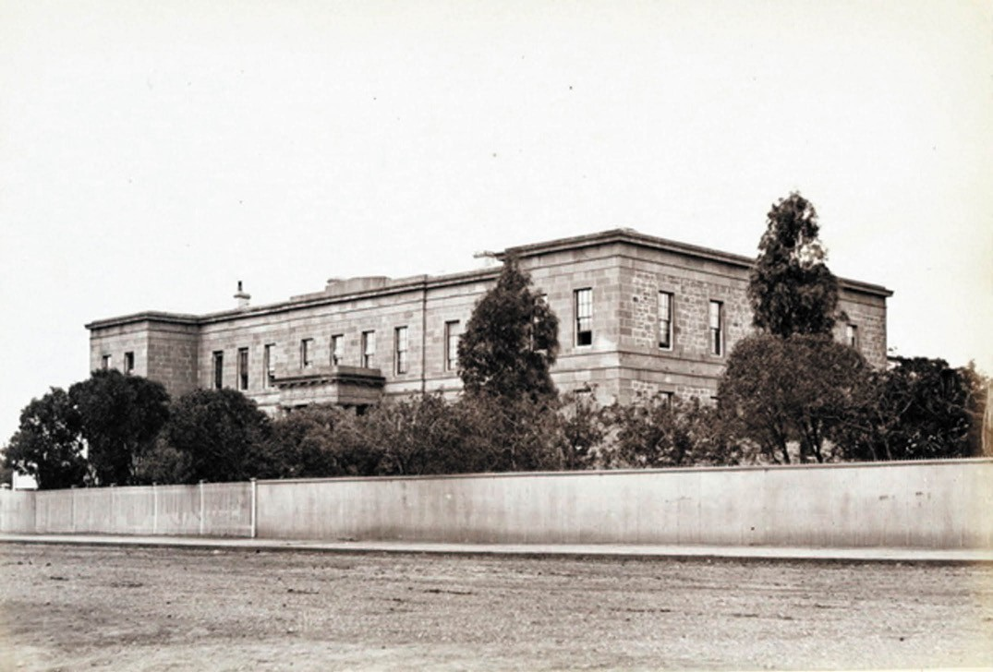
Figure 8.93: E. de Balk, Geelong Infirmary & Benevolent Asylum, Ryrie Street, 1866. Source: figure SL985553, Mitchell Library, State Library of NSW.

where his first wife, Sarah, died in 1833 having ‘poisoned herself in a fit of temporary derangement.’844 In 1834, he was appointed District Assistant Surgeon at Richmond, Tasmania.845 He married Miss Sophia McCarty in 1835.846 Thomas succeeded Dr Jonathan Clerk as Resident Surgeon at Geelong in 1852 but his tenure was cut short by his untimely death in October of that year.847 He was replaced
a few weeks later by Dr James Barlas (c.1813-1871) who married Mrs Sophia Thomas in 1853.848 Barlas resigned in 1857 to take over the practice of Dr Dimock at St. Kilda.849
The construction of the original infirmary and benevolent asylum building in 1850-51 was the beginning of numerous expansionary developments from the 19th century to the present day. In 1895, Watts and Durran architects designed a new operating theatre that was a detached single storey building to the west of the main hospital (Figure 8.94).
This building was part of a suite a new buildings that also included two wards (each containing two beds), doctors and instrument rooms, and a scullery.850
An infectious diseases ward was designed by Tombs and Durran in 1905, in the south-west corner (corner of Bellerine and Myers Streets) of the now enlarged hospital site. Four separate, single storey hipped roofed pavilions of corrugated metal wall cladding were connected by covered ways formed the basis of the design (Figure 8.95). It was considered to be a most complete and modern hospital , and based on the latest sanitary and hygienic principles of construction and was completed in 1907.851
Yet the most notable change of the early 20th century came from 1916 when a movement was formed to promote the building of a new hospital.852 In 1922, the
Melbourne architects A. and K. Henderson and Alsop were commissioned to design a new hospital as a replacement of the original building (causing the relocation of benevolents to Ballarat after 71 years and providing welfare and accommodation for 8,960 people).853 Based on the pavilion principle of separate and detached wards to provide fresh air and sunlight and limit the spread of disease, the complex

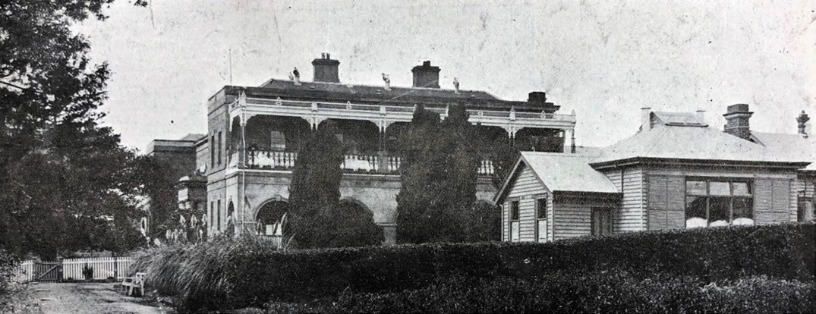

Figure 8.94: Geelong Hospital with detached operating theatre building (right), 1913. Source: News of the Week, 4 December 1913, p.37, GRS 2121/4, Geelong Heritage Centre collection.

involved a symmetrical layout of elevated hipped roofed wards (children s, medical, surgical and midwifery) built in 1923, and a central four storey administration block built in 1924854 (Figure 8.95). The Spanish Mission design approach by the architects both in terms of the pavilion layout principle and outward architectural expression - was popular at this time and was influenced (in part) by the growing popularity of southern Californian hotel designs in the United States.855 The pavilion model for the new hospital complex had also been advocated by the well-known and respected resident medical practitioner, Dr Mary De Garis (see later subsection), and her lengthy letter to the Geelong Times, outlining the efficient, modern principles associated with the pavilion layout, might have been influential on the design approach taken.856 The hospital was also renamed during these years to the Geelong and District Kitchener Memorial Hospital, in honour of the fallen British Army Officer of World War One, Horatio Herbert Kitchen, first Earl Kitchener.857
Construction commenced in 1939 on the new Infectious Diseases Hospital (it was named Bellerine House and it opened in 1943).858 In 1940, Kardinia House, an intermediate hospital, was opened.859 It had been designed by the
well-known hospital architectural firm of Stephenson and Turner, in association with local firm, Laird and Buchan.860 Other notable developments included the renaming of
the hospital to The Geelong Hospital in 1966; completion of the south wing of a new multi-storey hospital in 1970; the commencement of the Roy Birdsey Wing in 1974; and the affiliation with Monash University for medical under-
graduate teaching in 1984.861 It was also that year when the Geelong Hospital ‘became the first hospital in Australia to be accredited by the Australian Council on Hospital Standards,
a national program of hospital accreditation involving surveys by a team of professionals in the health field.’862
Significant developments continued throughout the late 20th and early 21st centuries. In 1979, E.C. Dax House (psychiatric unit) was constructed; in 1986, the Andrew Love
Centre (for cancer treatment) in 1992; the Patricia Heath Wing opened in 1998, the Geelong Hospital, amalgamated with the Grace McKellar Centre, and city and suburban community health centres to form Barwon Health;863 in 2009 a new four level building comprising a new emergency department,
MRI, hospital administration and other spaces was opened (replacing the central administration block of 1924);864 in 2011 a $126 million major upgrade of the hospital facilities was carried out;865 in 2014, the Geelong Hospital was renamed the University Hospital Geelong to reflect Barwon Health’s partnership as a teaching facility with Deakin University 866

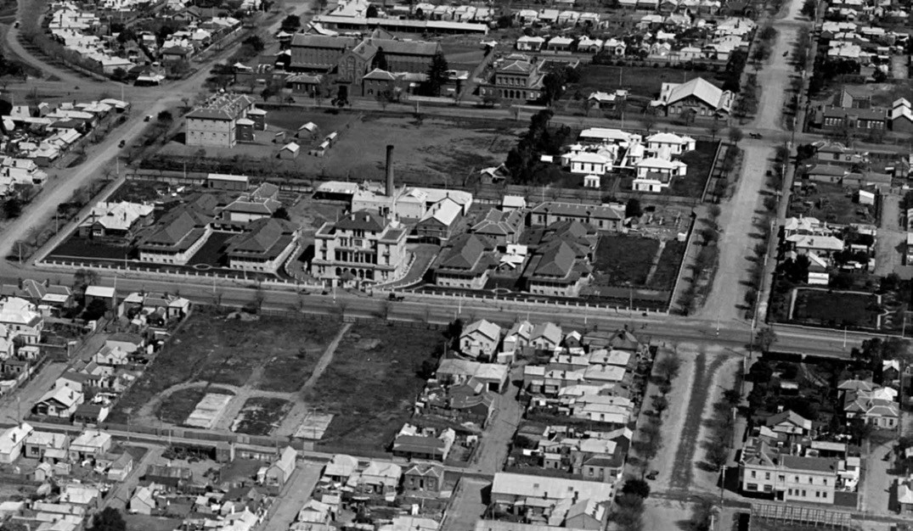

Figure 8.95: C. Pratt, Aerial view of the Geelong Hospital (middle ground), 12 January 1926- 7 October 1927. The infectious diseases ward is in the top-right of the hospital site. The nurses quarters (Harding House) is to the bottom left of the hospital site. Centred in the foreground is the vacant land that was to become Kitchener House. Source: accession H91.160/887.

FORMER BAXTER HOUSE, 56-58 BELLERINE STREET, GEELONG
While significant developments had been made in the provision of hospital accommodation at the Geelong Hospital, including the midwifery wing in 1924 (although it was not opened until 1931),867 by 1950 Geelong was in urgent need
of a standalone maternity hospital.868 The long-serving obstetrician, Dr Mary De Garis, continued in her quest to reduce maternal and infant mortality through the improvement of medical facilities, just as she had done so in 1920. 869
In 1951, the Premier of Victoria launched an appeal for a new wing at the Kitchener Memorial Hospital to provide accommodation for 93 public and private patients, and a pre-
natal clinic for public patients.870 The four-storied cream brick Modern Functionalist hospital was subsequently built at the south- west corner of Ryrie and Bellerine Streets (opposite the Kitchener Memorial Hospital), a site donated by prominent local philanthropists, Mr and Mrs J.P.H. Baxter, and after whom the hospital was named when it was opened by Lady Brooks, wife of the Victorian Governor, on 4 August 1954871 (Figure 8.96). The maternity hospital continued for its original purpose until it closed in the late 1990s and relocated to E.C. Dax House (which was renamed the Bellarine Centre).872 The

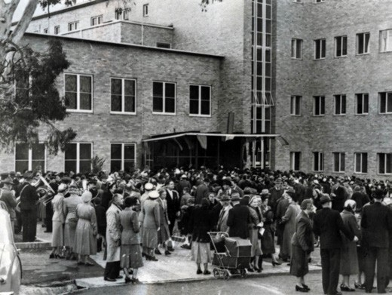
Figure 8.96: Opening of Baxter House, 4 August 1954.
Source: GRS 2009/02534/821, Geelong Heritage Centre collection.

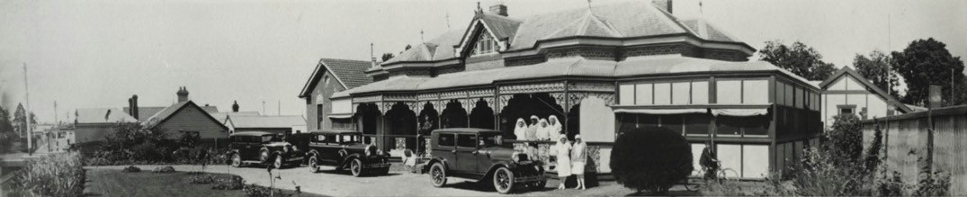
Figure 8.97: Kintail/Cambrai Private Hospital, Pakington Street, Geelong West c.1920. Source: GRS 1599/09/004, Geelong Heritage Centre collection.

four storey hospital at the corner of Ryrie Street and Bellerine Street became a private hospital before being acquired by Barwon Health. In early 2020, it was set aside in readiness for patients requiring hospitalisation from coronavirus (COVID-19).

PRIVATE HOSPITALS
While the Geelong Hospital has been the principal centre for medical care since 1852, more ubiquitous since that time was the establishment of private hospitals. Beginning with Dr Forster Shaw s hospital situated within half a mile of the town, on the road leading to Fyans Ford in 1842,873 other
private hospitals were soon established to meet the needs of the community. In 1849, Dr Hazlette had opened a hospital in Britannia Street, Geelong West, as had the Christian Brothers at Bellerine Street, ‘near Ruffin’s Corner’, Geelong.874
Between the late 1880s and 1900, at least four private hospitals had been established. By this time, they were commonly operated by female nurses, and sometimes
also served as trained nurses homes. By 1912, the number of private hospitals under the management of nurses
in Geelong had expanded to 21 (see Appendix 8.2).875
One reason for the larger number of private facilities was the over-stretched Geelong Infirmary and Benevolent Asylum, and the need for maternity services.

‘KINTAIL’/’CAMBRAI’, 258 PAKINGTON STREET, GEELONG WEST
One of the hospitals established during this period was Kintail , 258 Pakington Street, Geelong West, by Miss Annie Craig in 1908876 (Figure 8.97). This hospital had originally been built in 1889-90 as the home of Alexander Mackenzie to a design by Alexander Davidson.877 Miss Craig (c.1864-
1928) purchased the property in 1915 and ran her medical and maternity hospital from this location until early 1928.878 The hospital was renamed Cambrai in 1928 by Sisters Whytcross and Jackson and they had an operating theatre built at the hospital to a design by Norman Schefferle in June of that year879 and in 1949 it was acquired by the Geelong Hospital
Committee, following the closure of a number of private hospitals in Geelong in the previous two years.880 It continued to operate as a hospital until after 1968,881 and later became Berkley Lodge, reception centre.

‘BELLARIA’, 35 VIRGINIA STREET, NEWTOWN
In 1914, there were at least 16 private hospitals in Geelong (see Appendix 8.2). One established at this time was Bellaria , 35 Virginia Street, Newtown (Figure 8.98), in 1914 by nursing sisters, Octavia Kate Mackenzie (1867- 1947) and Mary Letitia Mackenzie (c.1878-1950), daughters of Arthur Roden and Octavia Katherine (nee Dawson) Mackenzie.882 Bellaria had been built as a two storey mansion house in 1890-91 for Jessie McMillan to a design by Joseph Watts.883 They also ran Riviera private hospital in Myers Street, Geelong, which they had acquired in 1911, and Plym House
Maternity Hospital and Trained Nurses Homes, Myers Street, from 1912.884 Bellaria Private Hospital was continued to be run by nurses Mackenzie until 1921 when Nurse Emily Stone took over operations.885 Bellaria remained a private hospital until at least 1949.886

PRIVATE HOSPITALS FROM THE 1920S
The number of private hospitals increased after World War One. In 1919, the Geelong Advertiser reported that:
The licensing of still another private hospital in Geelong is a sign of the growing preference for special rather than
home treatment. Mothers who used to be attended in their own homes now always go for accouchement to a private hospital, and the large middle class, which cannot get
the benefit of treatment at the infirmary, is being forced to patronize such institutions as Riviera. 887
In 1920, at least 20 private hospitals were operating, and this number remained fairly constant for the remainder of the decade (see Appendix 8.2).888

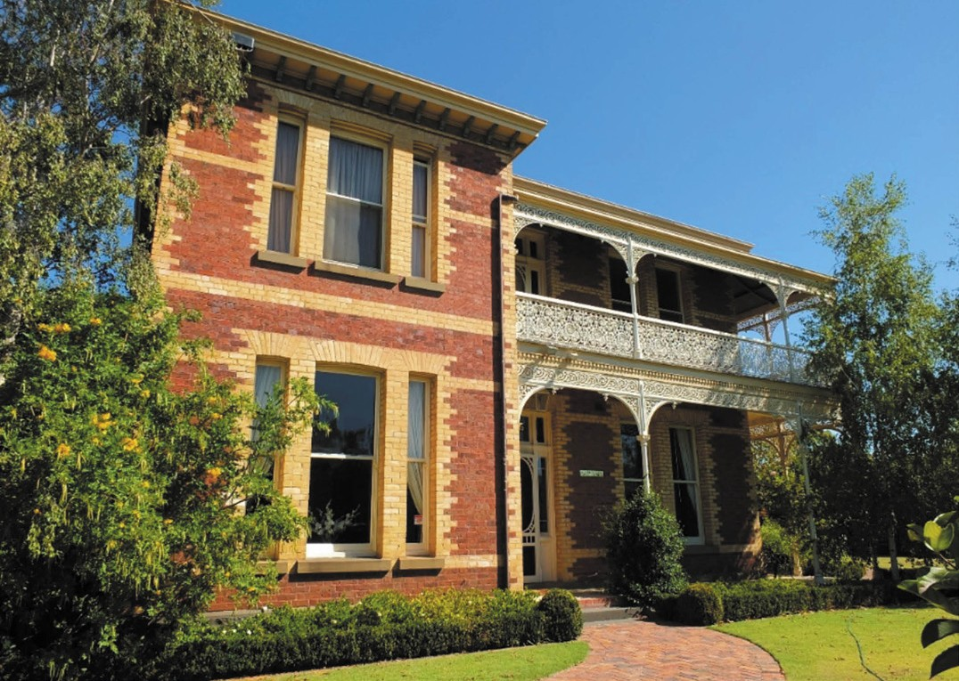
Figure 8.98: Bellaria , 35-37 Virginia Street, Newtown, 2013. Source: David Rowe.to Andrew Love out front), 165 Yarra Street, Geelong, n.d.

‘CASSIFORD HOUSE’/’ST. MARGARET’S’, 325-327 RYRIE STREET, GEELONG
One of the hospitals established in the 1920s was Sister Catherine Eliza Dowling s Cassiford House , 325-327 Ryrie Street, Geelong, where she united two semi-detached brick dwellings erected in 1885 for Mrs Clausen to a design by A.J. Derrick.889 In 1920, the Geelong Advertiser announced Sister Catherine Eliza Dowling s new hospital premises and the improvements she had made:
It is an ideal building for the purposes of a private hospital. Owing to recent regulations and requirements, insisted upon for private hospitals by the Public Board of Health, numerous additions and alterations had to be effected. All the rooms are large and lofty, and electric light installed throughout. Special sewerage connections have also been made, thus making this new addition to the private hospitals of Geelong one of the most up to date in the city.890
Sister Dowling sold her private hospital to Sisters Marquardt and Trebilco in 1922 and they renamed it St. Margaret s Private Hospital.891 They were certified for medical, surgical, gynecological and obstetric practice in Women s Hospitals, Melbourne and Sydney,892 and had recently returned home after serving overseas in the A.I.F. (the name given to
their hospital possibly emanating from English custom experienced during their service in the United Kingdom).893 Together with a competent staff, they conducted a very well regarded private hospital, embracing midwifery, general medicine and a good range of surgery and accident work for the next 25 years.894 With more stringent regulations introduced after World War Two, St. Margaret s Hospital closed and it reverted to residential accommodation until
it was purchased by the Geelong Hospital committee in June 1959. It initially served as staff accommodation before becoming the location for lectures and training for the Victorian State

Ambulance Service, and subsequently as an annex to the Geelong Hospital Nurses Training School (see
later subsection).895

ST. JOHN OF GOD HOSPITAL, MYERS STREET
St. John of God Hospital began in 1948 when the Missionary Sisters of the Sacred Heart took over the two storey mansion house built in 1858-59 for George Millward.896 The dwelling had had a succession of owners and uses, most notably
as Riveria private hospital established by Nurse Agnes Murray in 1905, and continued by the Misses Mackenzie and others until the Missionary Sisters commenced there as the Holy Cross Hospital, the third to be opened by the Melbourne Catholic diocese by 1948.897 The two storey
mansion was replaced in 1965 with a four storied Holy Cross Hospital designed by Buchan Laird and Buchan.898 In 1988, the hospital was extended, by which time it was known as St. John of God Hospital.899 In 2012, work commenced on a major redevelopment of the hospital to provide an additional 64 beds, emergency department, operating theatres, oncology, palliative care and orthopaedic services facilities and a training centre. It was completed in 2014 while a new intensive care unit was opened in 2017.900

EPWORTH HOSPITAL, PIGDONS ROAD, WAURN PONDS
The Epworth Hospital at Pigdons Road, Waurn Ponds, opened in 2016.901 Costing $277 million, the new facility provided an addition 170 beds to the Geelong region, with neurosurgery being available in Geelong for the first time.902

DOCTORS AND MEDICAL PRACTICES
The arrival of Dr Jonathan Clerke in 1838, Dr Forster Shaw in 1840 and Dr Robert Culbertson Hope in 1847 (he became Geelong’s first coroner in 1848 – see Theme 4 for other biographic details)903 was the nucleus for the evolution
and development of medical practices in Greater Geelong in subsequent years. As outlined in Appendix 8.2, by the mid-1850s, there were at least 12 doctors and surgeons in Geelong. This number had dropped to twelve by 1882- 83, remaining constant until after World War One but by 1925 there were 25 physicians and surgeons resident in the Geelong, Newtown, Geelong West, Portarlington, and
Drysdale areas. By 1960, there were 39 medical practitioners in Geelong and one at Portarlington.
The associations with past medical practitioners are largely physically manifested in several early doctors residences (some integrated with private surgeries) that still exist today. A selection of those medical professionals and their dwellings is as follows.

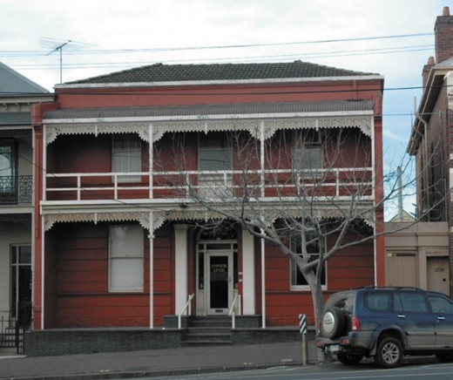
Figure 8.99: Dr Day s former residence, 117 Yarra Street, 2005. Source: David Rowe.
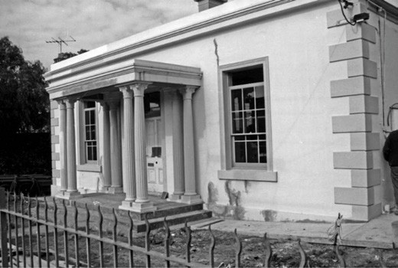

Figure 8.100: Dr Kilgour s former residence, 16 Myers Street, n.d. Source: Wynd collection, Authentic Heritage Services Pty Ltd.

DR JOHN DAY, 117 YARRA STREET, GEELONG
By 1856, there were 12 medical practitioners and surgeons in Geelong (see Appendix 8.2). One was Dr John Day (c.1817- 1881) who arrived in Geelong with his wife, Hannah Connell, around early 1850 as he had commenced practice in a residence, Yarra Street, Market- square, nearly opposite the Union Bank of Australia. 904 He had previously being house surgeon to the Middlesex Hospital, London.905 In 1853, he had a two storey brick dwelling erected at 117 Yarra Street (Figure 8.99) to a design by architects, Snell and Kawerau.906 Dr
Day commenced practice at his new residence, Yarra Street, nearly opposite the Wesleyan Chapel, in February 1854.907 At the opening of the Geelong Infirmary and Benevolent Asylum in 1852, Day was appointed honorary Medical Officer.908

During his practice in Geelong, Day contributed much to the advancement of medical science. Of particular significance was his experiments with the guaiacum process used to demonstrate the presence of blood. Known as the Antozone test, Dr Day had succeeded in detecting very slight traces of blood under circumstances of great difficulty.909 It related to a murder at Scarsdale near Ballarat on 19 October 1866 when a Chinese miner was arrested on suspicion of the crime.910 The defendant s trousers had been washed but Day s Antozone test had discovered traces of blood under a microscope.911 Day sent his results to Professor Taylor, a leading authority of forensic medicine in London who was struck by the importance of Dr Day s discovery that he made it the subject of an article.912 This article attracted the attention of a well- known French medical jurisprudence, Dr Louis Penard.913 He translated it into French and in 1871 read it before the Soci t de M decine L gale.914 There, Day s experiments were made with warm approval915. Today s Day s guaiacum process
is used as a method of detecting occupant blood in human faeces, an important indicator of bowel cancer.916
In 1876, Day was elected president of the Medical Society of Victoria.917 He died after a short illness at his residence in Yarra Street on 11 January 1881.918

DR JAMES KILGOUR, 16 MYERS STREET, GEELONG
A contemporary of Dr Day s was Dr James Kilgour
(1812-1897). Born in Musselburgh, East Lothian, Scotland, he qualified with a Doctor of Medicine from Edinburgh University in 1838 and was admitted as a Licentiate of the Royal College of Surgeons (Edinburgh) in the same year. Between 1839 and 1845, Kilgour entered into pastoral pursuits at Tarrone station, near Koroit.919 It was there in 1842 that Aborigines were poisoned with arsenic which had been disguised in flour.920 Kilgour returned to the Britain in 1845 and was later appointed Clinical Physician to the Royal Infirmary of Edinburgh.921 He arrived in Geelong in 1853 and entered a partnership with Dr Forster Shaw in a house in Corio Terrace.922 In 1855, he published a book entitled Effect of the climate of Australia upon the European constitution
in health and disease.923 Kilgour was appointed secretary of the Flinders National School in 1856 and a year later, 1857, he relocated to a stone Victorian Georgian dwelling at 16 Myers Street, Geelong924 (Figure 8.100). In 1860, following a court case in which he was named, Kilgour relocated to New Zealand where he died in 1897.925

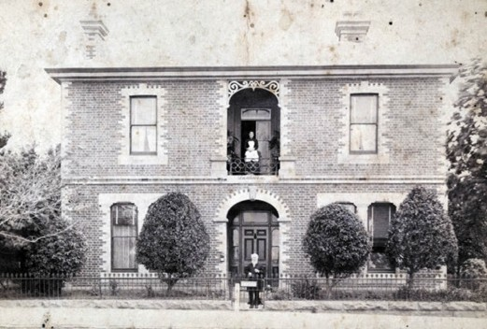
Figure 8.101: Dunlavin , 274 Latrobe Terrace, Newtown, with Dr William Shaw at the front gate, n.d. [c.1880]. Source: GRS 2009/1586/161, Geelong Heritage Centre collection.

DR WILLIAM SHAW, ‘DUNLAVIN/ALLINGTON’, 274 LATROBE TERRACE, NEWTOWN
The brother of Dr Forster Shaw, Dr William Shaw
(c.1812-1890) was Physician to the Dunlavin Dispensary and the Poor Law Institution, Ireland, prior to his emigration to Geelong in 1855.926 The following year, 1856, he commenced medical practice here following his legal qualification to do so.927 He contributed much to the community as a general practitioner, as health officer for the Shires of South Barwon and Barrabool, and medical officer for the Protestant Orphan Asylum, and public vaccinator.928 In 1871, he acquired the site at 274 Latrobe Terrace, Newtown, and engaged his architect brother, Joseph Shaw, to design a handsome
two storey brick villa in 1872929 (Figure 8.101). Named Dunlavin 930 (after the Irish village in County Wicklow), Shaw had medical rooms at his residence. He retired from practice in 1889 but continued as a director of the Geelong Gas Company until his death in January 1890.931 In subsequent years, the mansion was renamed Allington .

DR CHARLES TRAVERS MACKIN, 256 LATROBE TERRACE, NEWTOWN
Another resident medical practitioner in Geelong from
the 1850s was Dr Charles Travers Mackin (1817-1884). Born in Dublin, Ireland, he qualified as a Member of the Royal College of Surgeons (Edinburgh) in 1840, completed his Doctor of Medicine (Glasgow) in 1841 and was received
as a Licentiate of Apothecaries Hall, Dublin in this same year.932 In 1851, he was appointed a Licentiate of the Society of Apothecaries, London.933 The following year, 1852, he emigrated to Melbourne before arriving in Geelong and established his practice at Gaywood Cottage , Myers Street, in October 1854.934

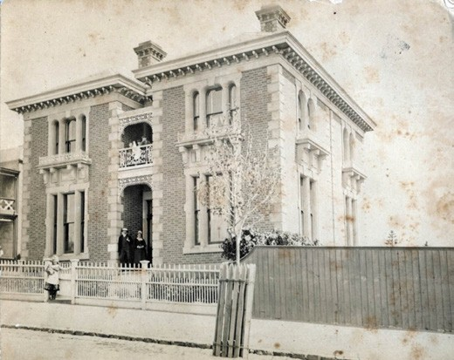
Figure 8.102: Dr Kilgour s former residence, 256 Latrobe Terrace, Newtown, c.1880. Source: GRS 2009/0076, Geelong Heritage Centre collection.

In 1860, Mackin was appointed District Surgeon and in the following year he married Sarah Shaw (1830-1914).935 Mackin published a number of works, including a paper on sunstroke in the first issue of the new Australian Medical Journal in 1856, problems with public health in Geelong (also in 1856) and his Popular Treatise on nervous disorders. 936 His contribution to Geelong include the positions as Medical Officers for the Geelong Gaol and Industrial School, and Ashby and Geelong Yearly Provident Society, and from 1861, District Vaccinator.937 Dr Mackin was also a prolific artist, his work now giving glimpses of local scenes in the 19th century (see Theme 9). In March 1872, Mackin had a substantial two storey villa residence built at 256 Latrobe Terrace to a design by Joseph Watts938 (Figure 8.102). He resided there until his death in 1884.

DR DAVID BOSWELL REID, ‘BELLEVILLE’, 350 RYRIE STREET, GEELONG
In 1859, Dr David Boswell Reid (1835-1913) arrived in Geelong, having previously served as Surgeon to the University College Hospital, and demonstrator in anatomy to the University College, London.939 Born in Edinburgh, Scotland, it was there where he qualified as a Member of the Royal College of Surgeons.940 Reid was appointed Resident
Surgeon at the Geelong Infirmary in 1860 and after just a few months his skill was especially noted:
The resident surgeon, David Boswell Reid, a young man of only 25 years of age, seems to be rapidly reaching the pinnacle of his profession. He has earned for himself, during his short stay here, a reputation that any medical man may well be proud of, and many are the blessings asked for him by those who have had the good fortune to be placed under his treatment in time. No man who ever visited the town has so rapidly or more deservedly
risen in public favour, and all connected with the Geelong Infirmary have good cause to be thankful they have obtained such a treasure.941
Reid married Miss Mary Jane Cumberland, daughter of George Synnot, wool merchant (Themes 5 & 6) in 1863.942 In 1870, he engaged the prolific local architects, Davidson
and Henderson, to design a substantial two storey mansion, Belleville at 350 Ryrie Street943 (Figure 8.103). A billiard room wing was added to a design by the same architects in 1874.944 It was in this same year that Mary Reid died. Two years later in 1876, Dr Reid married his late wife s sister, Jane Elizabeth Synnot.945
By 1903, Dr and Mrs Reid had relocated to London where he established a lucrative practice. 946 In this same year he gave evidence to a Select Committee of the House of
Commons relating to the ventilation of Westminster Houses of Parliament, and referred to Parliament House, Melbourne, and the Geelong Hospital in his evidence.947
A blunt, plain-spoken man, but perfectly kind-hearted, and both as society doctor and friend of the poor, Dr Reid died in London in 1913.948

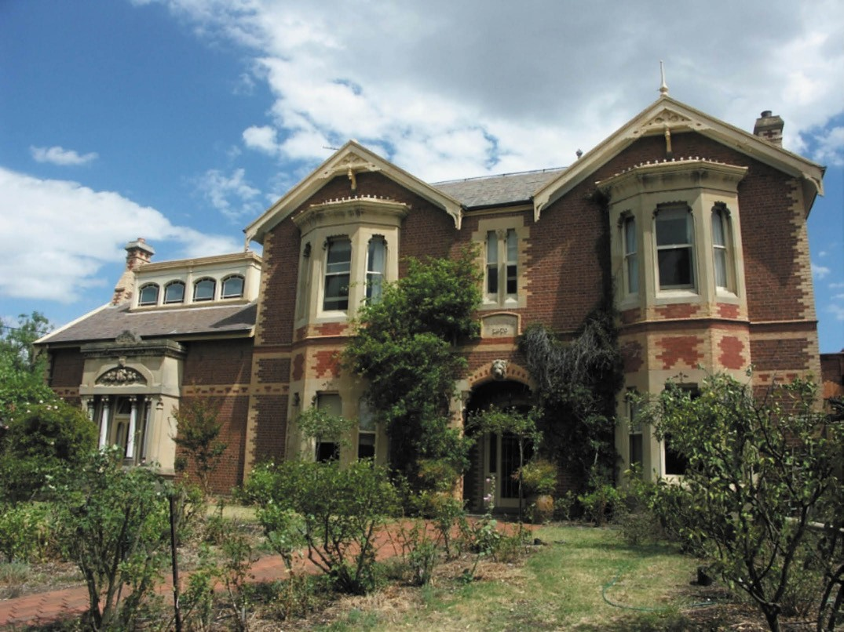
Figure 8.103: Belleville , former residence of Dr Reid, 350 Ryrie Street, Geelong, 2012. Source: David Rowe.

DR STEPHEN MABERLY SMITH & DR MARY DE GARIS, ‘MARY DE GARIS HOUSE’, 60 BELLERINE STREET,
GEELONG
In February 1881, Dr Stephen Maberly Smith (1854-1910) arrived in Geelong to take over the practice of the late John Day at 117 Yarra Street.949 Born in North Melbourne in 1854 to Henry Smith, a silverplate manufacturer, and Rosa Sophia Smith (nee Knaggs),950 Dr Smith trained at Westminster, graduating at St. Batholomew s Hospital, London, with
the degrees of Member of the Royal College of Surgeons, LRCP and LM.951 Returning to Melbourne, he was appointed resident surgeon of the Women s Hospital. In Geelong, Dr Smith also served as an Honorary Medical Officer of the Geelong Hospital until 1888.952 In early 1892, he engaged the Melbourne architects, Wight and Lucas, to design a brick two storey Queen Anne styled residence at the south-west corner of Ryrie and Bellerine Streets.953 Dr Smith s life was cut short from pneumonia in 1910. The Geelong Advertiser gave the
following obituary:
During the past thirty years he practiced his profession in Geelong: he was particularly skilled in women s ailments, and built up an extensive practice. His services were frequently sought in consultation, and he enjoyed the respect and confidence of his confreres and the esteem of the public. He took a keen interest in swimming, and was one of the hon.
Medical advisers to the Geelong Swimming Club for many years.954
Dr Smith s home was purchased by Dr Alfred Sheppard Grimwade, it being known as Keerie Kara .955 On his death in 1941, the property was acquired by Mr and Mrs J.P.H Baxter who donated it to the Geelong Hospital as a maternity annexe. It was renamed Baxter House in 1942 in their honour.956

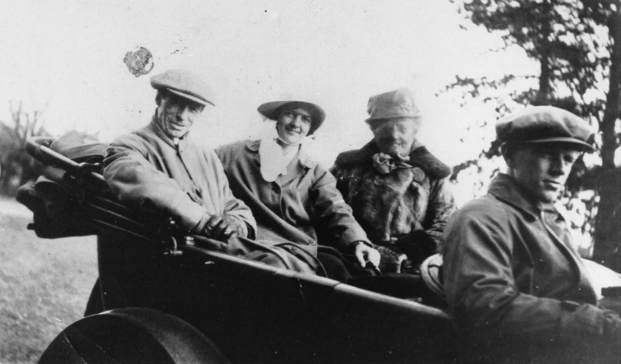
Figure 8.104: Dr Mary De Garis (centre) in father s car , 1919. Source: John Oxley Library, Queensland.

With the new, purpose-built four-storied hospital in front of the former residence being named Baxter House at its opening
in 1954, the former mansion house was renamed Mary De Garis House’ in honour of Geelong’ first, long-standing, and trail-blazing female medical practitioner, Dr Mary Clementina De Garis (1881-1963)957 (Figure 8.104). Born in Charlton, Victoria to Elisha De Garis, a local Methodist minister and irrigationalist, and Elizabeth De Garis (nee
Buncle), a nurse and midwife,958 Mary De Garis was educated at Methodist Ladies College where she was Dux in 1898.
She subsequently graduated with honours in Medicine at the University of Melbourne and in 1907 she became only the second woman in Victoria to be awarded a Doctorate of Medicine.959 Dr De Garis had worked as Residential Medical Officer at the Melbourne Hospital for one year in 1905 and as a resident at the Women s Hospital for nine months in 1906-07.960 She then worked as a medical officer in outback Australia until the outbreak of World War One.961 Following the death of her fiancé in the war, Dr De Garis served for 15 months with the Scottish Women s Hospital and in 1918 was decorated with the Order of St. Sava by His Majesty Peter
I, King of Serbia.962 She consequently took postgraduate studies abroad.963
From 1919, Dr De Garis was resident in Geelong where she established a medical practice with distinction as an obstetrician.964 She first lived at ‘Oberon’, the former home of William Bell (and later Dysart s Guest House) as part
of Bell s Terrace , 9 Pevensey Crescent.965 In 1922, she purchased Sarnia a Victorian Picturesque Gothic duplex at 266 Latrobe Terrace built in 1854.966 She lived in one of the dwellings and her brother, Lucas, in the other. Dr De Garis also authored several articles and a book entitled The
Theory of Obstetrics, which countered claims of other medical professionals in 1931.967 In particular, she introduced theories of painless childbirth by proper management of the prenatal period as well as diet and the eradication of infection.968 In
its review of the publication, The Journal of the American Medical Association (which had inaccurately assumed that Dr De Garis was a male) declared the publication to be unusual and that its most interesting section was a detailed analysis of 100 consecutive obstetric cases occurring in general practice.969
Dr De Garis work included pioneering and advancing
women s rights, especially in medical practice, which became her enduring legacy in Geelong.970 De Garis also contributed to local architectural discourse with her forthright views about

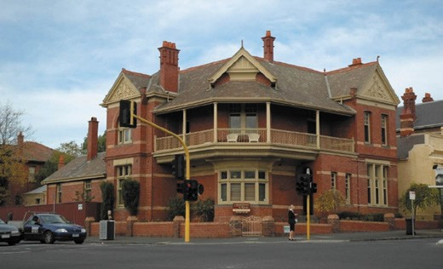
Figure 8.105: Former residence of Dr Croker, 83 Yarra Street, 2005. Source: David Rowe.
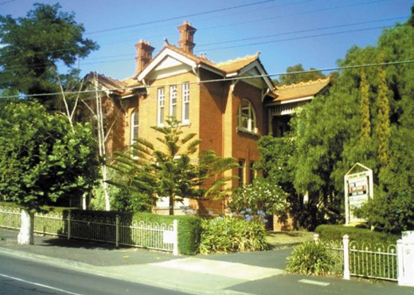
Figure 8.106: Currabeg House , former residence of Dr Kennedy, 2008. Source: David Rowe.

the design of the proposed Kitchener Memorial Hospital in 1920 (see earlier subsection) and had earlier lectured in 1919 to architecture students about the most appropriate way of designing a dwelling, in relation to hygiene and the practical working of the house :
In an interesting and illustrative manner the doctor spoke of the necessity for arranging the rooms and their furniture in such a way as to ensure the minimum of labor and
of inconvenience to the lady of the house. She dealt particularly with the kitchen and dining-room. Adequate lighting, ventilation, bedroom space, cold water service, and the advisability of hot water and cooling devices, were matters which were touched upon.971
Ultimately, Dr Mary De Garis was an institution rather than an individual, to a wide range of women , being wise and indefatigable, a forerunner. 972

DR CROKER’S RESIDENCE, 83 YARRA STREET, GEELONG
In 1897, Dr Patrick Croker (1852-1925) engaged Tombs and Durran to design a substantial red brick two storey Queen Anne residence (with consulting rooms) at 83 Yarra Street (south-east corner of Ryrie Street, the former monumental mason s yard of Joseph Smith see Theme 9)973 (Figure 8.105). The new home had been completed by March 1898.974 Dr Patrick Alfred Croker was born in Quebec, Canada, and came to Victoria at a young age. He attended St. Patrick s College and later the University of Melbourne, before going
to Glasgow where he qualified with a Bachelor of Medicine and a Master of Surgery. He subsequently visited hospitals in London and Europe before coming to Geelong in 1878 and going into partnership in a medical practice in Ryrie Street with Dr E.J. Walshe.975 From the late 1880s, Dr Croker was consulting surgeon to the Geelong Infirmary and he was later appointed Government medical officer to the Geelong goal and orphanages in Geelong. He took a keen interest in music, and was president of the Geelong Liedertafel in the early 1900s.976

DR THOMAS KENNEDY, ‘CURRABEG HOUSE’, 248 LATROBE TERRACE, GEELONG WEST
Dr Thomas John Moore Kennedy (1867-1938) was born in Glennamaddy, Galway, Ireland, the son of Rev. Robert Kennedy, a Presbyterian Minister, and Elizabeth Kennedy (nee Moore). Thomas Kennedy came to Victoria with his parents at 6 months of age, arriving in December 1867.977
They came with the Rev. William Hunt and family, as William Hunt and Robert Kennedy were to serve as Presbyterian missionaries on the Victorian goldfields, with Creswick being the first place where the Kennedy family was stationed.978
The Rev. Kennedy was later to become Principal of Clarendon Ladies College, Ballarat.979 Thomas Kennedy first attended Wesley College before entering the University of Melbourne in 1884 to study medicine.980 He took a temporary appointment with the Women s Hospital, Melbourne in 1889 before commencing as resident medical officer at the Geelong Infirmary in 1890, a position he held until 1897 when he went into private practice in Ryrie Street.981 In 1902, Dr Kennedy had a substantial two storey Queen Anne style residence
and consulting rooms erected on the former site of the Corio Club982 (Figure 8.106). He named it Currabeg House ,983 presumably after Currabeg, County Kerry, Ireland.

DR JAMES PIPER, 240 LATROBE TERRACE, GEELONG WEST
Dr James Piper (1884-1949) graduated as a medical practitioner from Ormond College, University of Melbourne, in 1912.984 He was placed in charge of a local Tuberculosis Clinic and then between 1914 and 1916 he became the
Honorary Pathologist at the Geelong Hospital.985 Piper played Victorian League Football for the Geelong Football Club in 1905 and then for 34 years he was the Club’s medical officer.
986

As a medical practitioner and particularly as the medical officer for the Geelong West Council during the interwar years, Piper contributed much to the improvement of the health of local residents. In particular, he campaigned for tree planting schemes and the creation of parks, declaring that the crowding together of people in enclosed buildings is the means by which most diseases are spread. 987 He
seems to have influenced the development of Baker’s Oval off Shannon Avenue and Sparrow Park at the north-east corner of Hope and Elizabeth Streets between the late 1920s and mid 1930s.988
As well as being the medical officer in Geelong West, Piper had held this position for St. Augustine s and St. Catherine s Orphanages, and in the 1940s he took up the same position for the Shire of Corio.989 There he advocated similar healthful Garden City principles as those he campaigned for at Geelong West: the creation of parks, gardens and reserves to cater for 200 years into the future as well as a hospital
and cemetery. 990 Locally in Geelong West, Piper also led an immunisation program against diphtheria in 1936.991
Outside his medical work, Piper held a number of honorary positions. He was a Churchwarden and Vestryman for
34 years at St. Paul s Anglican Church in Latrobe Terrace, and he was President of the Geelong Football Club for four terms between 1923 and 1926.992 Married to Nora,
he engaged the young architect, Harold C. Trigg, to design a substantial brick residence at 240 Latrobe Terrace, Geelong West, in 1926 (Figure 8.107) and he lived there until his death in 1949.993

DR FREDERICK WALLACE, ‘CHIPCHASE’, 8 RYRIE STREET, GEELONG
Chipchase at 8 Ryrie Street, Geelong (Figure 8.108), was built in 1930 for Dr Frederick Hilton Wallace (1893-1982) to a design by the local architect, Frederick Purnell.994 The
dwelling included a number of ground floor rooms associated with Dr Wallace s medical practise as he initially had no practising rights at the Geelong Hospital.995 These rooms included a practising room, surgical room, waiting room
and an extensive bathroom. Born in Orange, New South

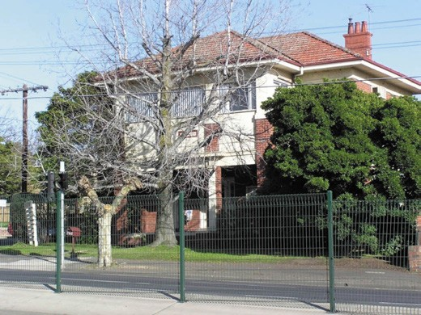
Figure 8.107: Former residence of Dr Piper, 240 Latrobe Terrace, Geelong West, 2008. Source: David Rowe.
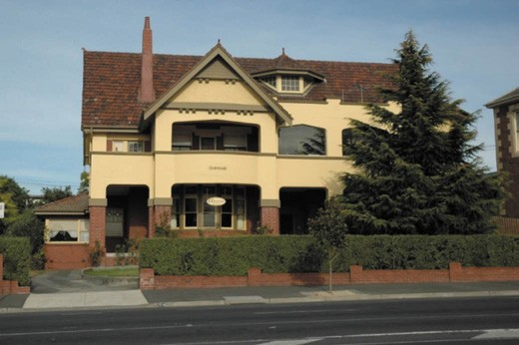
Figure 8.108: Chipchase , former residence of Dr Wallace, 8-10 Ryrie Street, 2005. Source: David Rowe.
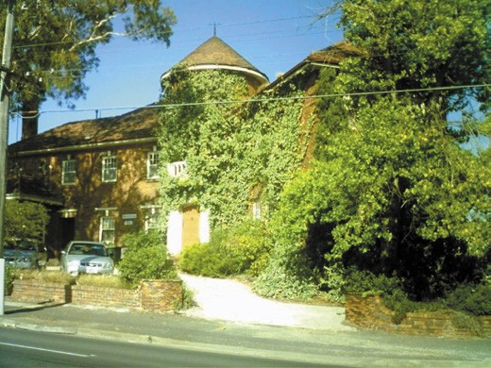

Figure 8.109: Narbethong , former residence of Dr Hyett, 242 Latrobe Terrace, Geelong West, 2008. Source: David Rowe.

Wales, and following his training as a medical practitioner, Wallace served with the Australian Medical Corps in Egypt and Palestine in World War One.996 In Geelong by 1924,997 he married Miss Bessie Milburn in 1925.998 Dr Wallace contributed much to local community and civic life. During
World War 1, he was a Captain in the Medical Corps but more locally Dr Wallace was Mayor of Geelong for 3 years between 1942 and 1945, long-time Governor of the Geelong Harbour Trust, founder of the East Geelong Golf Club and also the founder of the Grace McKellar Centre at Bell Park.999 He was awarded an OBE for his civic duties. Dr Wallace resided at Chipchase until the 1980s.1000

DR HAROLD HYETT, ‘NARBETHONG’, 242 LATROBE TERRACE, GEELONG WEST
Narbethong at 242 Latrobe Terrace, Geelong West (Figure 8.109), was built for Dr Harold Rupert Hyett and his wife, Lois, in 1934, in a distinctive interwar Old English style by the Melbourne architect, Marcus Barlow.1001
Dr Harold Rupert Hyett (known as Rupert) (1873-1973)
was born in Bendigo, the son of Barkly Hyett, lawyer.1002 By 1922, Hyett (who married Lois Chandler about this time) was residing in Aberdeen Street and practising medicine in
Geelong.1003 In 1925 he was appointed the Geelong Hospital s first and only Honorary Ear, Eye, Nose and Throat Specialist, a position he held until 1966.1004 He was also one of just
two Geelong practitioners to become a Fellow of the Royal Australasian College of Surgeons.1005
Dr Hyett s wife, Lois, was also born in Bendigo and educated in Ballarat where she attended art school. According to Gladys Seaton in The Ashby Story, Lois Hyett was a pupil
of Harold Herbert in Ballarat. Chandler s interest in the arts may have emanated from her father, William Henry Chandler, Ballarat architect.1006 From 1896, Chandler designed extensive alterations and additions to Barkly Hyett s home, The Eyrie , in Bendigo,1007 and it may have been from this commission where Rupert Hyett and Lois Chandler were brought together. With her husband, Rupert, Lois came to Geelong in c.1922. There, she became a member of the Red Cross and a member of the Geelong Free Kindergarten, being President in 1933 and 1935.1008 In the 1950s and 1960s, she attended painting schools in Cornwall, England.1009

NURSING

EARLY NURSING IN GEELONG
Little is known of the first nurses to have arrived in Geelong. Official records give details of the appointments of matrons to the key institutions from the 1850s (see Appendix 8.2). From this information, all were female (being typical for the nursing profession throughout the 19th and 20th centuries). Mrs Sophia Thomas (1816-1889) was the first matron appointed
in Geelong, at the Geelong Hospital (see earlier subsection). Other inaugural matrons included Catherine Smith (appointed to the Geelong Gaol in 1853); Mrs Maria Mills (appointed to the Immigration Depot in 1853); Miss Part (appointed to the Industrial Schools in 1867); Mrs Coxon (appointed to the Protestant Orphanage in 1868), Mrs Bailey (appointed to the Western Bathing House in 1871); Mrs Rigney (appointed
to the Geelong Eastern Sea Baths in 1873); Mrs Ridley (appointed to the Geelong Female Refuge in 1877) and Mrs Orr (appointed to the Salvation Army Rescued Sisters Home in 1884).1010 By the 1860s with the establishment of private hospitals, numerous nurses came to Geelong to operate them (see Appendix 8.2 and earlier subsection). This included Jane Docharty in Spring Street and Mrs Stephen Drummond in Candover Street, Geelong West, in 1866-67.1011

GEELONG HOSPITAL AND THE NURSES’ TRAINING SCHOOL
In 1893, a school for the training of your women as nurses was mooted by the committee of the Geelong Infirmary and Benevolent Asylum.1012 This initiative was considered beneficial to the institution in ‘saving the expense in the
nursing staff as well as providing vocational opportunities for young local women who otherwise had to go to Melbourne to train as nurses.1013
In 1896, the committee agreed with the suggestion of the superintendent, Alliott Hopkins, that a training school for nurses be established as part of the Geelong Infirmary and Benevolent Asylum.1014 The resident surgeon outlined the regulations for probationary nurses:
Must be between 20 and 35 years of age, with good personal references. Length of training, three years; first three months with no salary on probation, after that they must sign an agreement to remain for three years, when the payment should be as follows: First year, at the rate of £12 a year for the nine months during which they receive salary; second year, £15; third year, £20. The training to consist of systematic courses of lectures on anatomy, physiology, and nursing, both general and
surgical. The first two courses of lectures to be delivered by the resident surgeon, the others by the honorary
staff and resident surgeon. Examinations to be held by

the staff after completion of the course of lectures, and these examinations must be satisfactorily passed before certificates can be granted.1015
A nurses training school and home was subsequently constructed in March 1896 in the south-east corner of the Infirmary site (corner of Ryrie and Swanston Streets).
The timber dwelling (Figure 8.110) was designed by Tombs and Durran architects to accommodate the school facilities and accommodation for up to eight trainees.1016 The cost of facility known as Harding Home - £400 had been generously met by Mrs Silas Harding, late of Geelong but then living in Toorak.1017
In 1901, the Victorian Branch of the Australian Nursing Federation was constituted as the Victorian Trained Nurses Association (VRTNA). The purpose of the Association was to register nurses, introduce a uniform curriculum of training and examination and to establish a
benefit scheme for nurses.’1018 The organisation became the Royal Victorian Trained Nurses Association in 1904. This took the responsibility for setting the curriculum for trainee nurses away from the Geelong Infirmary.1019
On 1 July 1924, the Nurses Board was established following the proclamation of the Nurses Registration Act 1923. The board were responsible for the registration of midwives in 1929, registration of mental health nurses in 1950, and to regulate compulsory training and registration for nurses.1020 However, practical instruction was given at the Geelong Hospital for each trainee nurse after six weeks of preliminary school. This instruction was imparted by ward sisters, with second and third year nurses also receiving lectures from the doctors in the different specialities.

NURSES’ HOMES IN THE EARLY 20TH CENTURY KITCHENER HOUSE, 285 RYRIE STREET
Throughout the early 20th century, Harding Home became
insufficient to meet the demand for accommodating nurses at the Geelong Hospital. In April 1925, an appeal was launched to raise fund for building a new nurses home at the Kitchener Memorial Hospital.1021 By 1928, a vacant site opposite the hospital in Ryrie Street had been acquired and the Melbourne architects, A. and K. Henderson, commissioned to design a commodious two storey building. It was initially proposed
to follow the American model of connecting the nurses quarters to the hospital complex by a subway.1022 The brick building was surmounted with a terra cotta tiled hipped roof and featured an arcaded portico (Figure 8.111) with a balcony above, the whole carried out in an interwar Georgian Revival design and was opened by the Premier of Victoria, Mr Hogan, on 12 March 1931. The celebration was noted in The Herald:

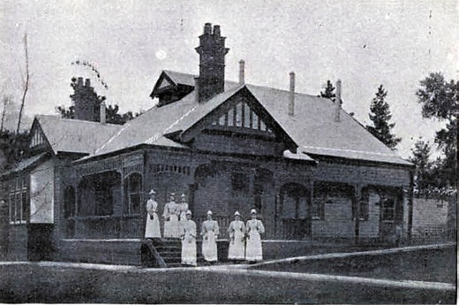
Figure 8.110: Nurses Training School (Harding House), Ryrie Street, Geelong, 1897. Source: E.A. Vidler, The Book of Geelong: Its People, Places, Industries and Amusements, p.84.

The new home is probably the finest building of its type in the Southern Hemisphere. With accommodation
for a staff of 60, it has cost £26,000. Each nurse has a separate room fitted with built-in wardrobe, dressing table, secretaire, and an arm chair.
Complete suites are provided for the matron and sister in charge of the home, and a study for the nurses.1023
The new building was named Kitchener House, in memory of Earl Kitchener, and in keeping with the Kitchener Memorial Hospital of which it was associated. An addition was opened in 1940 and named the Josephine Kenny wing1024 and in 1950 the Oswald C. Hearne wing
was added.1025

INFECTIOUS DISEASES WARD NURSES’ HOME, CORNER BELLERINE AND MYERS STREETS
In 1943, the Charities Board approved the construction of a nurses home associated with the Infectious Diseases Ward (Bellarine House), to be built at the conclusion of World War Two.1026 The building of the new nurses home in 19491027 involved the demolition of the infectious diseases ward built in 1905. The gabled two storey cream brick quarters had been completed by September 1950.1028

CONVALESCENT ACCOMMODATION FOR NURSES & THE RED CROSS
In August 1914 following the onset of World War One, Lady Helen Munro Ferguson, wife of the Governor-General, wrote to the Australian press urging the establishment of an Australian branch of the British Red Cross Society. She invited all women to do their best to provide ambulance aid
for soldiers. 1029 Local branches of the Australian Red Cross were soon formed, with Geelong s established in September

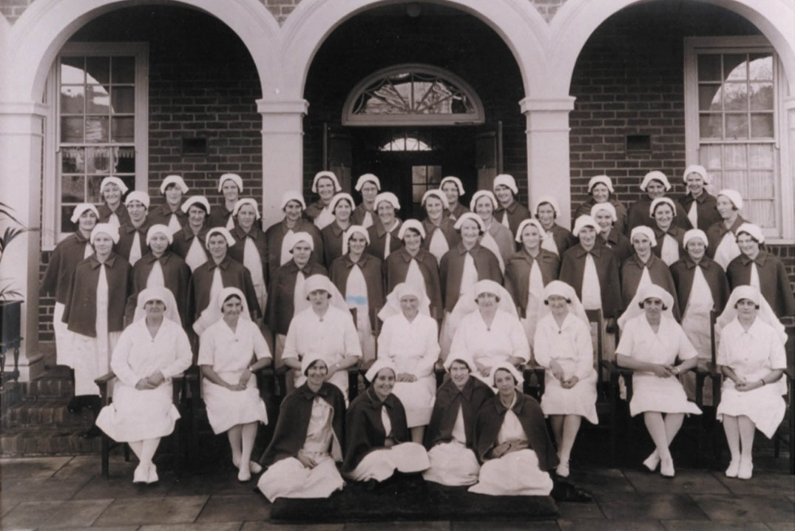

Figure 8.111: Nurses outside the main entrance to Kitchener House, n.d. Source: GRS 2009/2573/07, Geelong Heritage Centre collection.

1914 at Minapre , Virginia Street, Newtown, the home of Mrs E.H. Lascelles (who was elected inaugural president, with Mrs. Enid Mary Douglass being vice president).1030 The establishment of the Australian branch of the Red Cross Society at the beginning of the war was also a catalyst
for Australian nurses to join the British Red Cross or the Australian Army Nursing Service to contribute their services at the front.1031
The work of the Australian Red Cross expanded during and towards the end of the war to provide convalescent hospitals for returned sick nurses in each state of the country.
Osborne House (Themes 6 and 7) was acquired as Victoria s first Red Cross rest home of returned nurses in 1917. It had previously served as a convalescent hospital for returned invalid soldiers from 1915.1032 Matron Marguerite (Made) Hayes (1882-1980) was placed in charge of the facility.1033

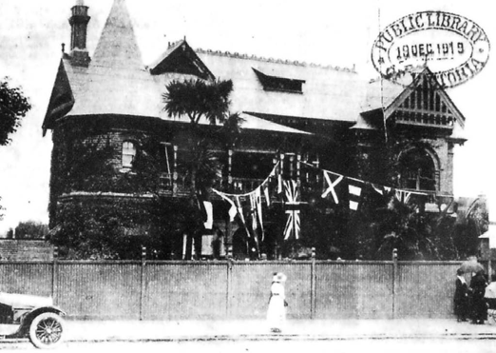
Figure 8.112: Wyuna , Western Beach Road, 1919 (demolished). Source: News of the Week, 18 December 1919, GRS 2121, Geelong Heritage Centre collection.

In November 1919, Wyuna (Figure 8.112), a picturesque two storey Queen Anne mansion house on Western Beach
Road, Geelong (east of Cavendish Street, now the location of the Deakin University carpark), opened as Geelong s second rest home for nurses, given the impending closure of the Osborne House facility in January 1920.1034 The property (it had been built in 1891-92 and designed by Blake and Tombs), was owned by Frederic Montagu Douglass, brother in law of Mrs Enid Douglass, stalwart member of the Australian Red Cross involved with the Osborne House facility (see following for further details on Mrs Douglass).1035 Sister E.H. Everard was appointed Matron at Wyuna .1036 The hospital closed in 1921.1037
The work of the Australian Red Cross might have galvanised former nurses trained at ‘Harding Home’, Geelong Infirmary, to seek to launch an association for the welfare of local nurses in 1926.1038 Nothing seems to have eventuated
until the formation of the Geelong Hospital Nurses League in 1934.1039 The objects of the league were to: create a permanent bond of union between past and present nurse of the Geelong and District Hospital (Kitchener Memorial) ; cement the link between the nurses and their training
school ; promote the interests of the nursing profession and initiate and foster discussion on matters of general interest to nurses 1040 Since its inception the league has advocated for the improved accommodation for sick nurses and the formation of a chapel.1041
The Geelong branch of the Red Cross re-formed in 1939 following the onset of World War Two. Mrs Alice Thear, Mayoress of the Geelong City Council, was the first president, and Mr J. Neilson was Secretary.1042 Five rooms were provided at the Geelong City Hall for the work of the Red Cross which included the making and packing of garments.1043 A portable hut was later acquired and placed in the grounds of the Geelong Hospital in Bellerine Street.1044 In 1951, Buchan Laird and Buchan architects designed a purpose-built branch of the Red Cross that was erected in 1952 at the south-west corner of Bellerine and Little Ryrie Streets.1045 The Red Cross remained there until recent years when it relocated to Mercer Street, Geelong.
A legacy from the early years of the Geelong branch of the Red Cross has been the annual Gala Day carnival and the parade through the City s streets, a community event that continues to the present day in aid of funds for the Geelong Hospital. It began in 1916 when the Geelong Council Mayor, Alderman A.J. Holden, convened a public meeting of Red Cross workers at the Geelong Town Hall in order to arrange a gala to fundraise for the Red Cross whose funds were
low during World War One.1046 The first gala carnival and parade was a huge success, with hundreds flocking to the

City centre for the event on 3 November 1916 (Figure 8.113). The Geelong Advertiser gave a glowing account:
Geelong District s Gala yesterday was the biggest fete the city has ever seen, the most perfectly planned function, the gayest spectacle, and the most successful in raising money, for the highest patriotic purpose the succor of the sick and wounded soldiers. We made a record in our help to the Belgians; the Geelong Red Cross Branch is honored in Melbourne for the promptitude with which it has met all hurry calls, whether for thousands of socks or pyjamas or lint; and now another record has been added
a record in giving, in the number of stalls, in the variety of goods, in the marvelous efficiency of the management, in the proof afforded that the solidity of the district, by the amazing number of motors of all descriptions from the lordly Limousine to the modest Ford; and, not least, is the evidence that when Charity calls urgently, all the people in the whole area we term Greater Geelong, and beyond, to Colac and Queenscliff and Bannockburn, are ready to
amalgamate their zeal and give generously in produce and service and cash. There may have been processions where the advertising element was better displayed,
but it is doubtful where there has ever been a more brilliant and varied display than that which moved down Moorabool- street at 1 o clock. Seen from Ryrie-street the procession was a very riot of rich colors. Streets were bedecked with bunting and strings of flags flew across the roadways. Verandah posts were festooned with greenery and art muslin and Malop-street was a shady arbor. Heralded by the St. Augustine s Band, the stalls on wheels and the gaily-decorated motor cars quickly left the starting point at McKillop-street, and the happy onlookers
were amazed with the quick succession of passing colors. Here a stall would go by covered with the pale wisteria, following a car which had been transformed into a moving garden of pink roses, and at the head a white swan. Then the art of the caterer would be seen in a stall containing a huge and perfectly made wedding cake, and the next sight would be an ordinary jinker, converted by a few artistic touches into a bower of greenery.1047

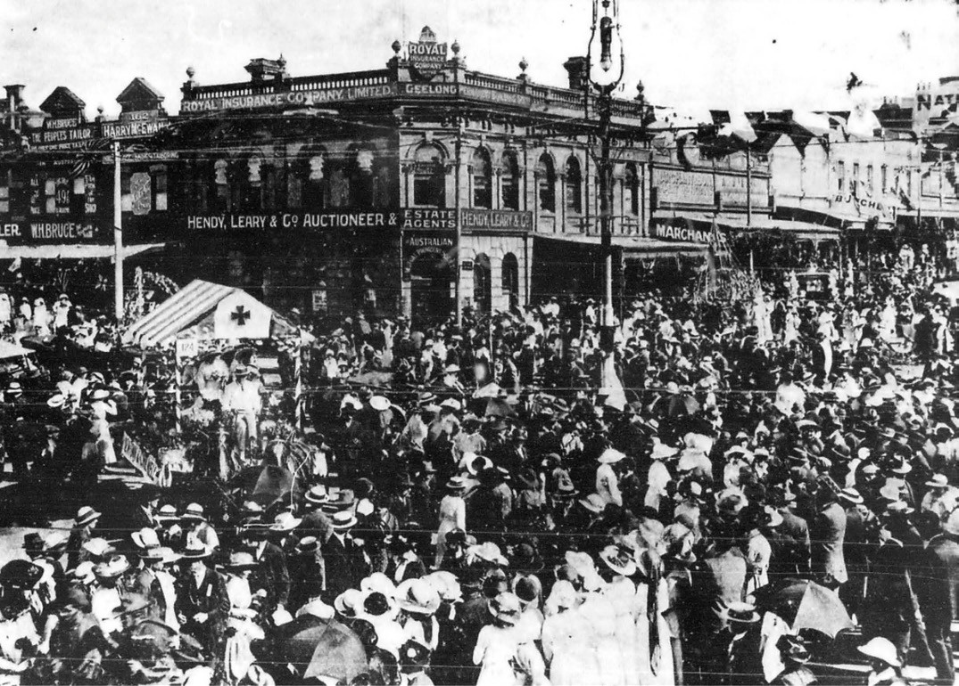
Figure 8.113: Gala Day procession at the intersection of Moorabool & Ryrie Streets, 1916. Source: News of the Week, 9 November 1916, GRS 2121, Geelong Heritage Centre collection.

EPIDEMICS

NINETEENTH CENTURY
Greater Geelong has not been immune from the ravages of a number of viral and other diseases since the European colonization. As early as 1839, the Port Phillip Patriot and
Melbourne Advertiser highlighted the plight of the Indigenous peoples where ‘fever, influenzas and dysentery’ were ‘making sad havoc amongst them. 1048 At this time, the influenza was especially fatal amongst the Aborginal women, including those of the Watha wurrung
Balug clan.1049
In 1847, avian (bird) influenza was particularly destructive on parts of the Victorian population, and not surprisingly, birds, the Melbourne Argus noting that this epidemic has not confined its ravages to the human species; the feathered tribe have particularly been subjected to its fatal effects, as
numerous dead carcasses of fowls lying in almost every thoroughfare in the town of Melbourne will amply testify. 1050
By May 1848, many children had been especially effected in Geelong and the influenza epidemic was especially prevalent there throughout 1849.1051
Such destruction on the health of the population led (in part) to the passing of An Act for promoting the Public health in Populous Places in the Colony of Victoria in December 1854, and the appointment of a Central Board of Health in February 1855.1052 The Board prepared quarantine regulations, and
in the early years through its superintending inspectors, it made a concerted effort to ensure that disease was reduced through improvements to public thoroughfares,
such as metaling streets, pitching channels, wood kerbing footpaths and gravelling footpaths in the Municipalities of Geelong, Newtown and Chilwell, and South Barwon.1053 It also regulated the sanitary condition of butcher shops and

slaughtering houses (and provision of appropriate drainage of waste from these premises), registration of lodging houses with regulations placed on accommodation space, investigating nuisances such as odors, offensive drainage from mills and other factories, inspecting cemeteries, and reporting on the provision of public amenities (including the botanic gardens and public baths).1054 In 1864, the Board advocated the public revaccinate against small pox.1055
Such measures by the Board did not prevent further outbreaks of disease. In 1887, Geelong was gripped by typhoid fever.1056 A serious outbreak was especially reported at the Church of England Grammar School which in late May of that year brought forward its ordinary midwinter holidays by a month.1057 In this case, the cause of the disease was traced to a supply of infected milk.1058
In 1891, the Geelong area experienced one of the worst outbreaks of ‘pneumonia, pneunio-influenza [sic.] and simple influenza’ since European colonisation. Forty-four people succumbed between April 1891 and January 1892.1059 The virus spread so rapidly that doctors struggled to keep pace with the demand on their services and one doctor at least, Dr. Small, found it necessary to obtain an assistant from Melbourne.1060 Even the Mayors of Geelong and Newtown and Chilwell were not immune from catching the disease, but were soon able to resume active Mayoral duties.1061

SPANISH INFLUENZA IN THE EARLY 20TH CENTURY
In 1918 as World War One was nearing an end, an influenza epidemic infected one third of the world s population in just 18 months.1062 It was known as H1N1 virus (a type A strain of influenza), but more commonly as Spanish Flu given that strict wartime censorship meant the only in neutral Spain could the press speak freely about what was happening and it was from this media coverage that the disease took its nickname. 1063 It has been cited as the most devastating epidemic then recorded in world history.1064 Although Epidemiologists have disputed the exact origins of the Spanish Flu, there has been some consensus it was the
result of a genetic mutation. 1065 The first recorded cases were in the United States of America and the virus spread rapidly across the globe as soldiers returned home from active service.1066
By October 1918, the influenza epidemic had reached Geelong. Numerous businesses, including Humble and Sons foundry and Hawkes Brothers store were left short-staffed while nearly every member of the Police Force had been off duty through it. 1067 Dr E. Robertson, chairman of the Board of Health, pinned his faith on a vaccination program to prevent the spread of the virus.1068 A vaccine was manufactured at the Commonwealth Serum Laboratory in Royal Park, Melbourne,

given its reputed beneficial effect in treating pneumonic symptoms in South Africa.1069 However, the director of the South African Institute of Medical Research disputed these effects as he was unaware that the use of vaccine was ‘authoritatively recommended for any epidemic of influenza in any country in the world.1070 The Australian Commonwealth Government pressed on with the production of a special vaccine made by the agency of germs found in the lung passage of patients suffering from influenza.’1071 Inoculations began in the Greater Geelong area in November 1918.1072
H.G. Beardsmore, a Tasmanian Bacteriologist, claimed that the vaccine did not guarantee complete immunity but limited its spread. In particular, he claimed that only approximately seven in a hundred people inoculated contracted the Spanish Flu, compared to 70% of those that were not inoculated.1073 Yet, this was contradicted by Dr. G.W. McCoy, Director
of the Hygienic Laboratory of the Public Health Service in Washington who declared there was no serum that prevented or cured the virus.1074 He argued that the outbreak in Australia might have been less virulent than the extreme outbreaks in America due:
to the fact that we have had practically no food restrictions here and that the nervous strain caused by the war has been almost the only way that the vitality of Australians has been affected.1075
While greater local resistance to the virus (compared to other parts of the world) was hypothesised,1076 the pandemic was a major demographic and social tragedy in Australia.1077 In
a short time, hospitals were overwhelmed.1078 Other more draconian measures were enforced to limit the spread of the virus. In December 1918, an amendment to the Victorian Health Act 1915 included the Regulation for the Prevention or Mitigation of Influenza. With 14 regulations in total, people with influenza or symptoms of influenza were:
to report the occurrence, in writing, to the clerk of the municipal district in which such house is situate, and such report shall include the name, age, and sex of the person suffering from such symptoms, and the exact location of the house.1079
Those diagnosed with influenza were instructed to isolate in their homes or at any special place provided for the purpose. 1080 Those in contact with the sick were to be investigated with their names and addresses given and were also to be isolated in their homes.1081 The regulations
banned those suffering from influenza from entering a public building.1082 Every municipal Council and its officers were authorised, required and directed to:
Superintend and see to the execution of these Regulations, and to provide for the supply of medicines and other substances for the prevention or cure, and

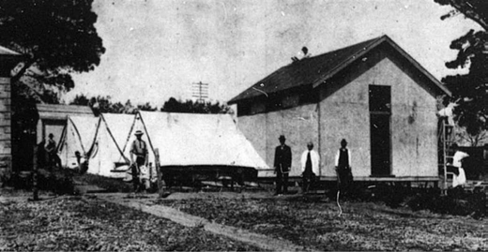
Figure 8.114: Night Nurse s sleeping quarters (tents), dining room tent (background) and bathroom, 1919. Source: News of the Week, 20 February 1919, Geelong Heritage Centre collection.
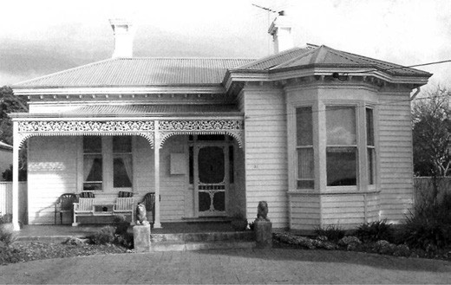
Figure 8.115: Bayville Villa, 31 The Esplanade, Portarlington, c.2007. Source: L. Stokes, Discovering Portarlington s history: A driving trail, Portarlington History Group, Portarlington, 2007 (with permission).

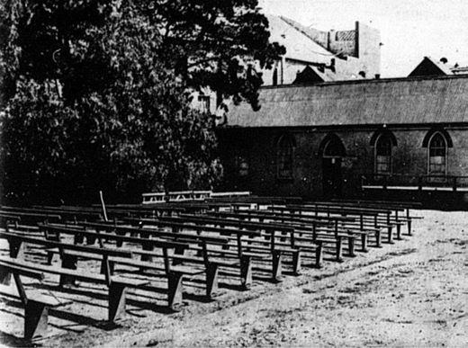
Figure 8.116: Pews laid out for an open-air service, Wesley Methodist Church, Yarra Street, 1919. Source: News of the Week, 20 February 1919, Geelong Heritage Centre collection.

for affording to persons afflicted by or threatened with influenza such medical or other aid as may be required.1083
At the Geelong Hospital, 70 beds had initially been made available in anticipation of the influx of patients although it was lamented that there was a shortage of doctors and
nurses.1084 Yet by February 1919, 140 beds had been made available.1085 A temporary bathroom, large dining tent, and smaller tents for sleeping accommodation were erected
for the night nurses at the hospital1086 (Figure 8.114). At Portarlington, the Victorian Italianate styled Bayville Villa, 31 The Esplanade (Figure 8.115), built in c.1889, was requisitioned by the Bellarine Shire Council and converted into hospital.1087
The first fatal case in Geelong from the influenza was Phillip St. John, aged 42 of 127 Melbourne Road, North Geelong, who died on 6 February 1919.1088 Married with five children, St. John was manager for the Albion Quarrying Company works at North Geelong.1089 Tighter restrictions on public gatherings came into force. Schools, law courts, hotels, and some mills and factories and other businesses were
closed, public gatherings were limited to 10 people, horse and trotting race meetings were prohibited and excursion trains to Melbourne and country stations were cancelled.1090 Church services continued provided that masks were worn and
not more than 20 persons were admitted to each service.1091 An exception were open air services such as those held
by the Yarra Street Methodists1092 (Figure 8.116).

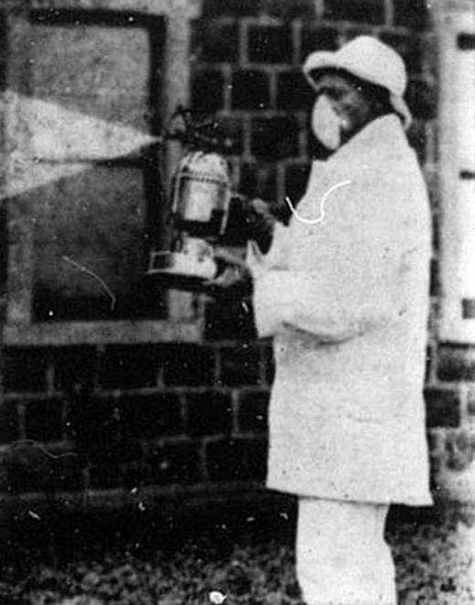
Figure 8.117: Inspector Smith of the Borough of Geelong West carrying out fumigation, 1919. Source: News of the Week, 6 March 1919, Geelong Heritage Centre collection.

In an effort to mitigate the effects of the influenza, municipal inspectors fumigated with disinfectant known places where those with influenza symptoms resided or frequented1093 (Figure 8.117).
By late February 1919, railway traffic was resumed ‘as normal’ as the population infected by the virus initially eased.1094 On
8 March 1919, the Geelong Advertiser reported that Geelong is “Clean” To-Day’, although influenza staff were not to be demobilised.1095 Schools, businesses and daily life was recommenced but there was another outbreak soon after.
However, in September 1919 it was reported that the influenza ward at the Geelong Hospital was to be closed given that the six remaining patients in the ward had almost recovered.1096 Between January and September 1919, there had been
430 influenza patients at the hospital, with 50 cases being fatal.1097

COVID-19 INFLUENZA IN THE EARLY 21ST CENTURY
In December 2019, a mysterious illness was reported in Wuhan, China.1098 It was found to be a new type of
coronavirus which the World Health Organisation officially named COVID-19.1099 This Organisation declared the outbreak a pandemic on 11 March 2020. The most common symptoms of the virus were a fever, dry cough and tiredness, with mild cases also including a sore threat, the most severe cases being fatal following breathing difficulties and organ failure.1100 The virus rapidly spread through Wuhan to northern Italy, Spain and South Korea, before afflicting the entire world.
The Victorian Government issued a State of Emergency on 16 March 2020 to help combat COVID-19.1101 With the major spread of the virus, schools, non-essential businesses, theatres, and sports facilities were closed, and most other forms of routine daily life were prohibited, with the population forced into isolation. Along with the rest of the world, the health, financial and social costs on the Greater Geelong community were far-reaching and unprecedented.

GEELONG DISTRICT NURSING SOCIETY AND BABY HEALTH CENTRES
In 1907, the Geelong District Nursing Society was established to nurse the sick poor in their own homes , the Society s work being funded by public donations.1102 The inaugural chairwoman was the Mayoress, Mrs T.E. Bostock.1103 Miss Janet Clarke Edwards (1869- 1958) was appointed District Nurse with a suitable room secured for her at No. 5 Wellwood Terrace, 82 Gheringhap Street, Geelong (erected in 1887 to a design by Joseph Watts).1104 Nurse Clark had considerable experience in the same work in Melbourne prior to her arrival in Geelong.1105 This held her in good stead with the District Nursing Society as the first five months she had received 40 cases requiring her attention.1106 Nurse Edwards remained with the Society until 1911.1107
The work of the Geelong District Nursing Society was supported by the Australian Red Cross, Geelong Ladies Benevolent Society and the Alexander Miller Homes Trust. A keen inaugural member of the Geelong District Nursing Association and of the Geelong branch of the
Australian Red Cross, and a valued member of the Geelong Ladies Benevolent Society, was Mrs Enid Mary Douglass (nee Webster) of Corio Villa , Eastern Beach Road. The wife of Henry Percival Douglass, solicitor (Theme 5), Enid Douglass was particularly committed to these causes during World War One, when her second son was killed at Kemmel, Belgium.1108 As part of her determination for local nursing services was the founding of the baby health centres, the first being established by the Geelong District Nursing Society in

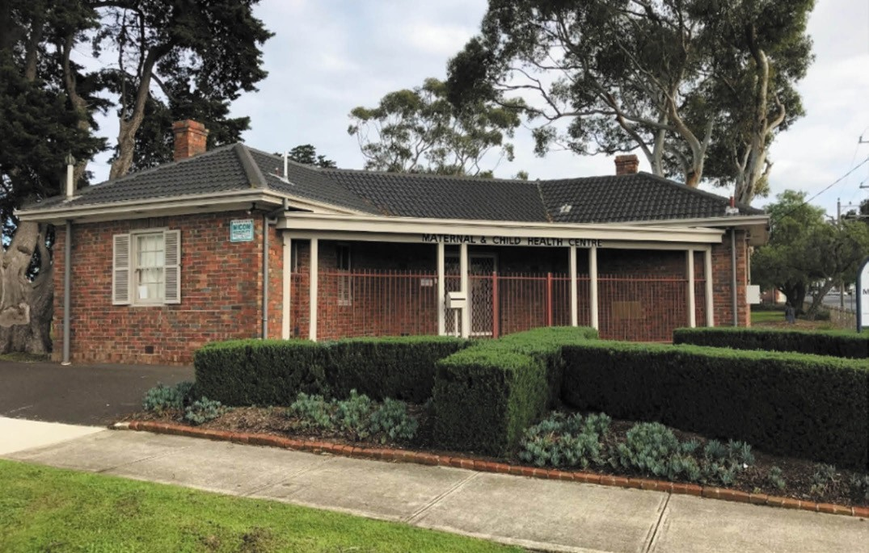
Figure 8.118: Geelong Maternal & Child Health Centre (Baby Health Centre), corner McKillop & Fitzroy Streets, Geelong, 2019. Source: David Rowe.

1917 when Mrs Douglass was president.1109 The clinic was situated in the Benevolent Homes, Marshall Street, Chilwell (see later subsection) in an effort to reduce infant mortality.1110 This was the same year the first Baby Health Centre was established in Richmond, Melbourne1111, and it was part of a Victorian Baby Health Centre movement whereby the State Government gave a subsidy of £250.1112 In 1918, a second clinic was opened in the Miller Homes, Pakington Street, Geelong West (see later subsection) and within 12 months 546 mothers had visited with their babies.1113 These were the only baby health centres established in a provincial city of Victoria at the time.1114
In 1922, the management of the Baby Health Centres was taken over by a Geelong Branch of the Victorian Baby Centres Association. This Association remained closely associated with the nursing profession, with the Association s model centre being opened in 1920 in South Melbourne
that embraced a training school for nurses. 1115 In Geelong, additional baby health centres were opened in the 1920s, including those at the Haimes Homes, corner of McKillop and Bellerine Streets, and in the old Court House, Pakington Street, Geelong West.1116
Today, purpose-built Baby Health Centres exist as a legacy of this highly important district nursing initiative. Some are also war memorials associated with the First and Second World Wars. Only, the Newtown Maternal and Child Health Service Centre, 51 Russell Street, Newtown, built in 1927-28, continues to operate for its original purpose. Others include the former Geelong Baby Health Centre in Hopetoun Park, corner of McKillop and Fitzroy Streets, Geelong, built in 1930 to a design by Laird and Buchan (Figure 8.118); former Newtown Infant Welfare Centre, Ruthven Street, Newtown, built in 1951-52 (as a World War Two memorial); and the former Whittington War Memorial Baby Health Centre, 17 Townsend Road, Whittington, built in 1955 by the local Whittington community on land donated by Robert (Jack) Maxwell in 1947.1117

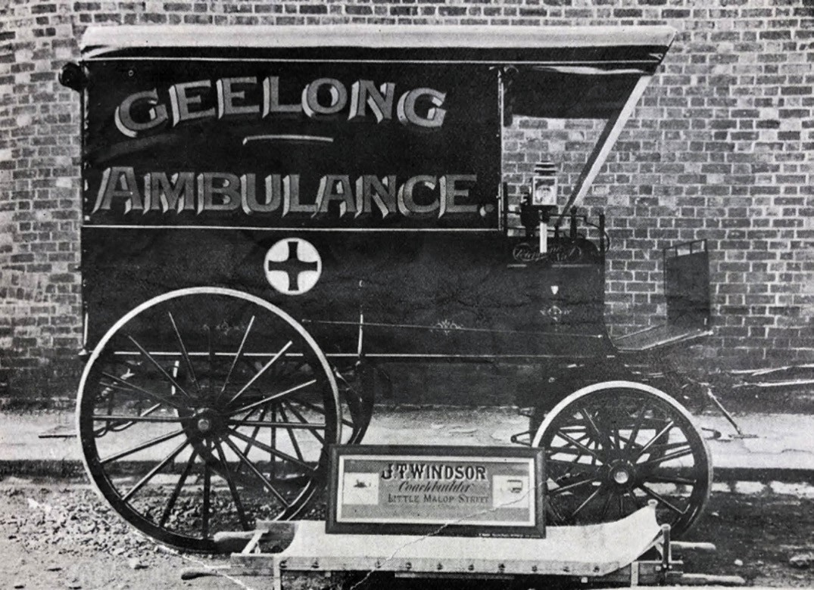
Figure 8.119: First Geelong Ambulance wagon, 1907. Source: News of the Week, 15 August 1907, p.15, GRS 2121/1, Geelong Heritage Centre collection.

BUSH NURSING, FORMER CENTRE, 15 PRINCESS STREET, DRYSDALE
The Victorian Bush Nursing Association was established in 1910 following a failed attempt by Lady Dudley, wife
of the Governor-General to form a Federal Association.1118 The purpose of the Association was to have trained nurses with a General and a Midwifery Certificate available in country districts.1119 All medical cases (except those that were infectious) were treated by the nurse.1120 The first nurse was stationed at Beech Forest, her salary being met by the Committee of the Association.1121 Dr Sir James Barrett was the first honorary secretary. A co-operative system was introduced in 1913 whereby the public subscribed to the service.1122 By 1932, there were 63 Bush Nursing Centres in Victoria, and the Association was the largest employer of trained Nurses in Australia. 1123
In Greater Geelong, a Bush Nursing service commenced in Drysdale in November 1922.1124 Nurse Deliah Ann Whytcross (1886-1964) was appointed the first district nurse.1125 Born at Colac to John George Whytcross and Teresa A. Whytcross (nee Selwood), Deliah subsequently trained as a nurse at the Colac Hospital.1126 In 1916 Deliah Whytcross she successfully passed the half yearly examined held by the Royal Victorian Trained Nurses Association.1127 Between 1922 and 1928, Deliah Whytcross served as the district nurse for the Bush Nursing service at Drysdale.1128 From 1928, Deliah, together with Sisters Jackson and Lindsay, was in charge at Cambrai private hospital 258 Pakington Street, Geelong West (see earlier subsection).
In 1939, Councillor G. Wisby of the Bellarine Shire Council and president of the Drysdale Bush Nursing Centre, donated a site for a permanent bush nursing home.1129 With a grant from the King George V memorial fund to the Bellarine

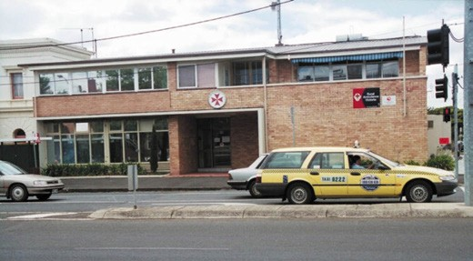
Figure 8.120: Geelong Ambulance Station, north-east corner of Yarra & McKillop Streets, n.d. [c.1990]. Source: Wynd collection, Authentic Heritage Services Pty Ltd.

Council, a timber Bungalow was subsequently relocated from Mr Ibbotson s property on the Queenscliff-Portarlington Road to the new site at 15 Princess Street, Drysdale.1130 The service continued until it was changed to the Drysdale and District Community Health Centre in November 1987.1131

AMBULANCE SERVICE
In 1885, the Geelong Health Society proposed to form a branch of the St. John s Ambulance Society.1132 St. John Victoria had first formed in Melbourne in 1883 to teach public first aid classes.1133 In 1896, the need for an ambulance
cart for conveying patients to the Geelong Infirmary was highlighted with the difficulty of transporting an elderly ill patient to the hospital by stretcher by a police constable with assistance from the public.1134 It was not until 1907 when the first ambulance cart was built for Geelong1135 (Figure 8.119). Its completion was announced in the Geelong Advertiser:
The ambulance wagon for the use of the town has been completed by Mr. J. T. Windsor, and Dr. Small has written to the mayor, Cr. T.E. Bostock, stating that the work has been well done. The doctor states that Mr A.N. Vines is prepared to store the wagon at Cobb and Co. s stables in Moorabool-street, and he further mentions that there is a balance due on the wagon which he trusts the public will speedily liquidate.1136
In 1914, a new Motor Ambulance Committee was elected with the Mayor of Geelong as its president.1137 A pressing need was the procurement of a motor ambulance, and an earlier committee had raised £30 for the purpose.1138 With support from the Geelong Harbor Trust, the new motor ambulance was presented to the Geelong Ambulance Committee when its chair was James Hill, in 1916.1139 A new motor ambulance was purchased in 1921 and in October 1926 it had been used on 30 occasions in a month.1140

In 1949, Dr James Piper (see earlier subsection), then president of the Geelong Ambulance Service, was elected a life member, having been with the organisation since 1914.1141 It was also in 1949 when a two storey brick veneer ambulance station, designed by Buchan Laird and Buchan architects was proposed at the north-east corner of McKillop and Yarra Streets at a cost of £15,000.1142 It was to house ten vehicles accessed from McKillop Street, with an administration wing fronting Yarra Street. Upstairs was to be a six-roomed flat as accommodation for the superintendent. The building (Figure 8.120) was opened in 1952, costing over double the initial estimate but it was claimed by the Horsham Times as one
of the most modern in Australia and perhaps the Southern Hemisphere. 1143 Slightly less claims were made by The Age who declared the new station to be ‘the first of its kind outside the metropolis. 1144
In 1954, the Geelong Ambulance Service became known as the Geelong and District Ambulance Service, following the opening of a branch station at Werribee under its management.1145 In 2008, the Geelong and District Ambulance Service amalgamated with other ambulance
services in Victoria to become Ambulance Victoria, an agency of the Victorian Department of Health and Human Services.1146 In 2013, the old ambulance station was demolished and replaced with a new station that was completed in December 2014.1147

DENTISTS
Another important medical service provided during Geelong s formative years was dentistry. The first dental surgery in Geelong was operated by Monsieur I.A. Beurteaux, dentist from Paris in 1847. He made regular visits from Tasmania, being in attendance at Mack s Hotel until at least December 1848.1148
The first permanent dentist in Geelong was Dr William Keatinge Huston (c.1827-1863) who had emigrated from London to Adelaide in early 1849.1149 He first advertised in Geelong from November that year, his practice being situated in Little Malop Street (corner of Bellerine Street). Keating had completed his study of medicine and surgery in the Royal College of Surgeons, Ireland and City of Dublin Hospital, he boasted of his celebrated Mineral Marmoraium for restoring decayed teeth, however large or small the cavity. Claimed
to be applied without pain, heat, or pressure, the procedure made it unnecessary to extract teeth.1150

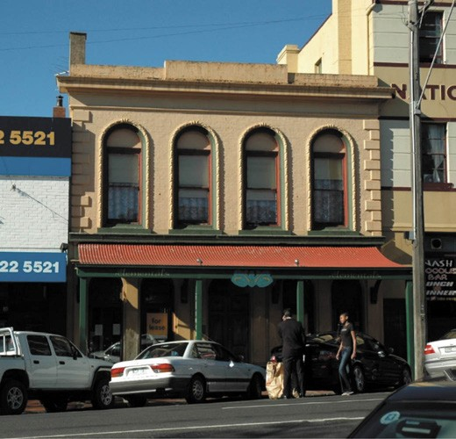
Figure 8.121: Mawson s former dental practice, 189 Moorabool Street, 2005. Source: David Rowe.
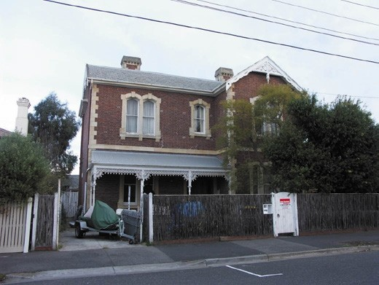
Figure 8.122: Kanimbula , 31 Roebuck Street, Newtown, former residence of Dr Roebuck, 2010. Source: David Rowe.

MAWSON FAMILY, MOORABOOL STREET, GEELONG
In December 1867, Joseph Mawson (c.1818-1886) first advertised his dental practice in Moorabool street next to Mr Burke, produce merchant (now Geelong Covent Garden, 174 Moorabool Street).1151 The son of Robert and Hannah (nee Wood) Mawson, Joseph Mawson was part of the family business known as Mawson Brothers which claimed to
be the most extensive dental practitioners in the British Empire. 1152 The family business cast a wide net, the parent establishment being led by Joseph s brother, Samuel,

from Bolton, Manchester, England.1153 Other branch dental practices were operated by John Mawson (Liverpool) and Sutherland Mawson (Keighley, Yorkshire), while Samuel Robinson, brother in law of the Mawson brothers was also a partner at Bradford, Yorkshire.1154
In Geelong, Joseph Mawson offered surgical and mechanical dentistry, using gold, platinum, and vulcanite- coral, as
a base for artificial mineral teeth.’1155 In 1871, Mawson announced that he had removed to the opposite side of Moorabool street, next National Hotel. 1156 This new location was as three storey building and appears to have been part of the National Hotel.1157 By this time, Joseph Mawson appears to have been joined by his son, Frederick Sunderland Wood Mawson (1842-1916) and 1876 Joseph Mawson s other
son, John Longbottom Dobson Mawson, had arrived from England with the most improved appliances, enabling the practice to complete a set of teeth at one day s notice. 1158 Joseph Mawson subsequently relocated to Melbourne where he died in 1886.1159 The dental practice was continued by
F.S.W. Mawson and his son, Samuel Robert Joseph Mawson (1870-1933) (the latter having been educated at the Geelong Grammar School).1160 In 1892, Samuel Mawson took over
his father s practice and in November 1904 he purchased the two storey building (Figure 8.121) then owned by Beatrice King, daughter of the undertaker, William King.1161 The building was immediately north of the National Hotel at
189 Moorabool Street (this building had been constructed in 1879 and was first occupied by Messrs. Murphy and Butler, grocers).1162 Initially, Mawson leased his new premises to George McGillivray, a chemist, while continuing to occupy part of the National Hotel.1163 He relocated to the building
at 189 Moorabool Street in 1906 and continued his dental practice there until his death in 1933.1164

DR HENRY GILSON ROEBUCK, 31 ROEBUCK STREET, NEWTOWN
Dr Henry Gilson Roebuck was born at sea enroute from England to Port Henry on the Larpent in 1849, the son of Henry Roebuck, former solicitor and a church minister who became the Geelong Town Treasurer, and Sarah Roebuck (nee Naylor).1165 He was named after his father, his middle name after William Hailey Gilson, captain of the Larpent who was afforded a testimonial and publicly praised by the Rev. Roebuck upon arrival in Geelong.1166 Educated in Geelong,
H.G. Roebuck was later articled to Richard Heath, a local dentist. In 1872, Roebuck commenced his own dental practice and in 1873 he married Miss Catherine Jane Clarke, daughter of Richard Clarke, grocer of Ryrie Street (Theme 5).1167
In 1877, Roebuck engaged the local architectural firm of Alexander Davidson and Co. to design a two storey mansion house at 31 Elizabeth (now Roebuck Street),

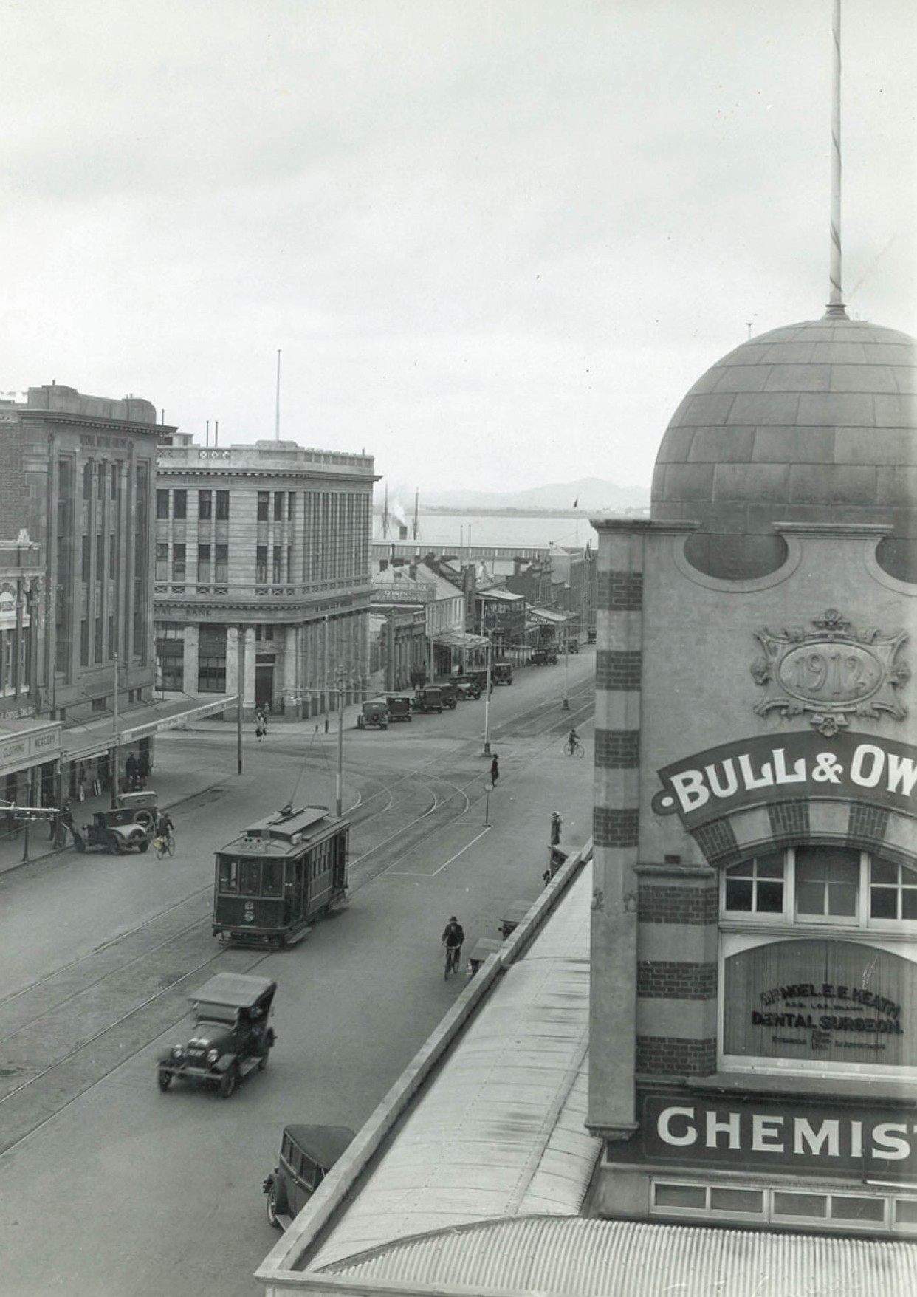

Figure 8.123: Bull & Owen Chemists in portion of the Solomon s Buildings, Market Square (right), n.d. [c.1930]. Source: GRS 2009/0358,
Geelong Heritage Centre collection.

ABOUT CORAYO: A THEMATIC HISTORY OF GREATER GEELONG
1077

Newtown.1168 The detailing of the dwelling was distinctive in its interpretation of French Romanesque design. Known as Kanimbula (Figure 8.122), the house survives as a legacy of Roebuck’s success as a dentist. His influence on the locality is also shown in Roebuck Street being named after him (following the renaming of Elizabeth Street) between 1965 and 1970.1169
Roebuck’s influence and success as a dentist was also measured in the contributions he made to his profession.
In 1909 for example, he presented his method of inlaying apparently hopeless teeth with aluminium.1170 He developed a machine that was worked by steam generated from an asbestos pad soaked in water , together with a blow-pipe to melt the aluminum.1171
Roebuck also contributed to community life as a member of the Gordon Technical College and president of the Amateur Photographic Association.1172 He died in 1946.1173

CHEMISTS & DRUGGISTS
Fundamental to the provision of cures and dispensing prescriptions by medical practitioners were chemists and druggists. In January 1854, there were 10 operating in Geelong. By 1856, this number had increased to 15
(see Appendix 8.2). They included some notable names such as Charles Kernot (Moorabool Street), Robert McDonald (Ryrie Street), William Pardy (Myers Street), and J.T. Thomas, Saffron Street, Newtown.

BULL AND OWEN, MALOP STREET (AND LATER MARKET SQUARE), GEELONG
In 1859, W.J. Bull took over the chemist shop of John Thomas then located in Yarra Street. On Bull s death in 1872, John Thomas assistant, Alfred John Owen, became a partner
with Bull’s widow, the firm being known as Bull and Owen. Situated in Malop Street, adjoining Morris Jacobs drapery, Owen s work was detailed by E.A. Vidler in 1897:
Mr. Owen conducts a general pharmaceutical business, devoting himself specially to perfecting the details
of dispensing, so as to secure perfect accuracy and purity. Connected with the Pharmacy is a well-furnished laboratory, where pharmaceutical preparations are carefully prepared and tested as to strength and quality.
He is manufacturer of a number of household remedies and requirements, amongst which the Concentrated Sweet Essence of Rennet may be specially mentioned.1174
A.J. Owen was elected a member of the Pharmacy Board in 1880 and he served on several committees including the Mechanics institute, Y.M.C.A. and Free Library, and he was a local correspondent to the Board of Advice for State
Schools.1175 He died in 1908, the business having been taken
over by his son., A.H. Owen. He relocated the shop to the new Solomon s Buildings, Market Square, in 1913 (Figure 8.123) and throughout the 20th century the business of Bull and Owen became a local institution. A.H. Owen also contributed to his profession, being regarded as a leader in pharmaceutical matters in Victoria and he played an
important part in analytical chemistry. 1176 He died at Torquay in 1938.1177

GEELONG HOMEOPATHIC DISPENSARY, RYRIE STREET
The Geelong Homeopathic Dispensary was established in Ryrie Street ‘almost opposite the post office’ in 1863 as Geelong’s first co-operative dispensary. Funded by the ‘sufficiently numerous and respectable homeopathists’
in Geelong and by public subscription, the co-operative dispensary was to serve the poorer classes of Geelong and its neighborhood. 1178 Comprising members of the Protestant community, the inaugural committee included the Revs.
T. McK. Fraser, James Henderson and A.M. Moore, and Messrs. A.M. Campbell, John Dennis, Silas Harding, George
M. Hitchcock, T.M. Hill, T. B. Hunt, W.L. Lees, H. Speed. T.P. Teague, W.J. Thomas and James Wood.1179 By 1867, the dispensary had distributed 1968 prescriptions as medical relief to 285 of Geelong s poor.1180 In 1879, the Homeopathic Dispensary was relocated three doors east to John Owen s two storey pharmacy at 78 Ryrie Street (built for him in 1875) (Figure 8.124).1181 Owen had been appointed Secretary
of the Geelong Homeopathic Dispensary by 1869.1182
He continued operating from this establishment until 1909,1183 the competition of the recently-established United Friendly Societies Dispensary across the road possibly causing the closure of his business.
The establishment of the Geelong Homeopathic Dispensary came at the height of influence of homeopathy in Europe and the United States, a time when medical practice was reliant on ineffective and sometimes dangerous treatments.1184 Based on the doctrine of Samuel Hahnemann in 1796, homeopathic remedies were dilutions of animal, plant ,mineral and synthetic substances.1185 In Geelong, Archibald McArthur Campbell (c.1816-1897), one of the first Homeopathic Dispensary committee members, especially advocated the value of alternative medicine. From 1869, he wrote several letters to the editor of the Geelong Advertiser on the subject, promoting the benefits of homeopathic treatment.1186 He also lobbied for homeopathic treatment to be given at the Infirmary and in 1869 he was ruled out of order for this suggestion on the basis that he had not yet paid up his subscription for the present year. 1187 By 1891, Campbell, who was locally known as the Professor for his wide study of homeopathy, had expanded his work from humans to plants. Resident at 42

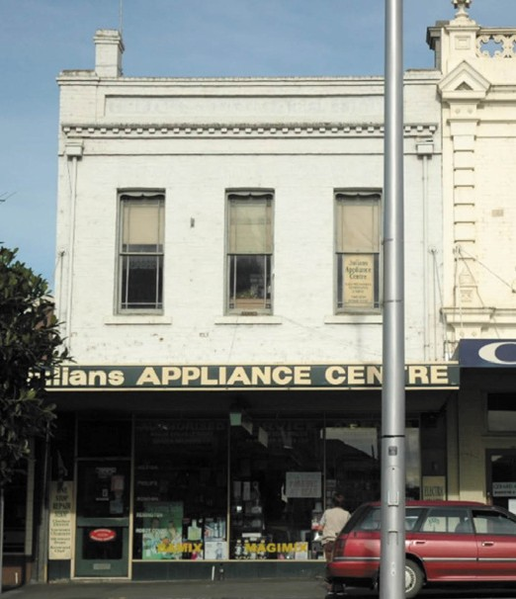
Figure 8.124: Former Geelong Homeopathic Dispensary building, 78 Ryrie Street, 2005. Source: David Rowe.
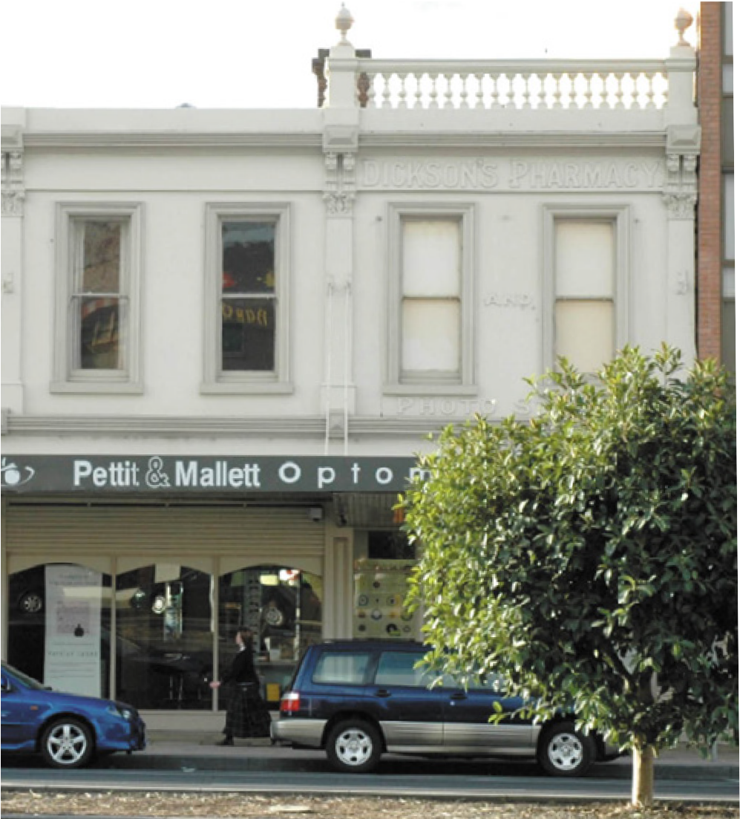
Figure 8.125: Former Dickson s Pharmacy building (right), 121 Ryrie Street, 2005. Source: David Rowe.

Virginia Street, Newtown, it was at this time he commenced experimentation with John Raddenberry, curator of the Geelong Botanic Gardens (see Theme 9) on a ‘specific’, which the Geelong Advertiser noted:
The specific is a white powder, and a very small quantity of it was inserted beneath the bark of several blight stricken apple trees. This season the trees operated
on show perfect freedom from the blight, whilst other trees not so treated exhibit signs of being affected by the disease. At the time the specific was used Mr
Raddenberry was doubtful as to the power of the remedy, and did not attached much importance to it, but this year he proposes making a complete test of the efficacy of the powder, which Mr Campbell says is not inexpensive.1188
Nothing further was reported by Raddenberry on Campbell s miracle cure, its demise preceding that of
the Homeopathic Dispensary itself, the last reference to its operations being in 1901 (it being eclipsed by the United Friendly Societies Dispensary, the new co-operative institution which prescribed medical and other remedies).1189

WADELTON’S CHEMIST STORE (LATER DICKSON’S PHARMACY), 121 RYRIE STREET, GEELONG
In 1880, John Wadelton (c.1846-1926), for 18 years assistant to Robert McDonald, announced that he had purchased
his former employer s Drug Hall in Great Ryrie Street and trusted that by strict attention to business, and moderation in charges, to merit a continuation of the patronage so liberally bestowed on his predecessor. 1190 In 1888, with a Mr Brown, Wadelton engaged the well-known local architect, Joseph Watts, to design a two storey duplex of shops.1191 Immediately prior to construction in May 1889, the proposed building was described in the Geelong Advertiser: They
are to be built of brick, on stone foundations, and when completed with have neat cement fronts. 1192
Wadelton sold the business and building to Thomas Andrew Dickson in 1918.1193 He had previously commenced business in 1893 in the former pharmacy of B.G. Wilkins in Moorabool Street.1194 At 121 Ryrie Street, Dickenson immediately carried out alterations and additions (Figure 8.125). The Geelong Advertiser gave the following details:
With the move Mr Dickson has taken the opportunity to remodel the Wadelton shop by extending it 40 feet to the rear, making it one of the largest chemist s shops in the city, with 75 feet of counter space in a straight run. The fittings from the old shop have been removed to the new and embodied into the general arrangement which is very up-to-date and convenient. Across the new shop

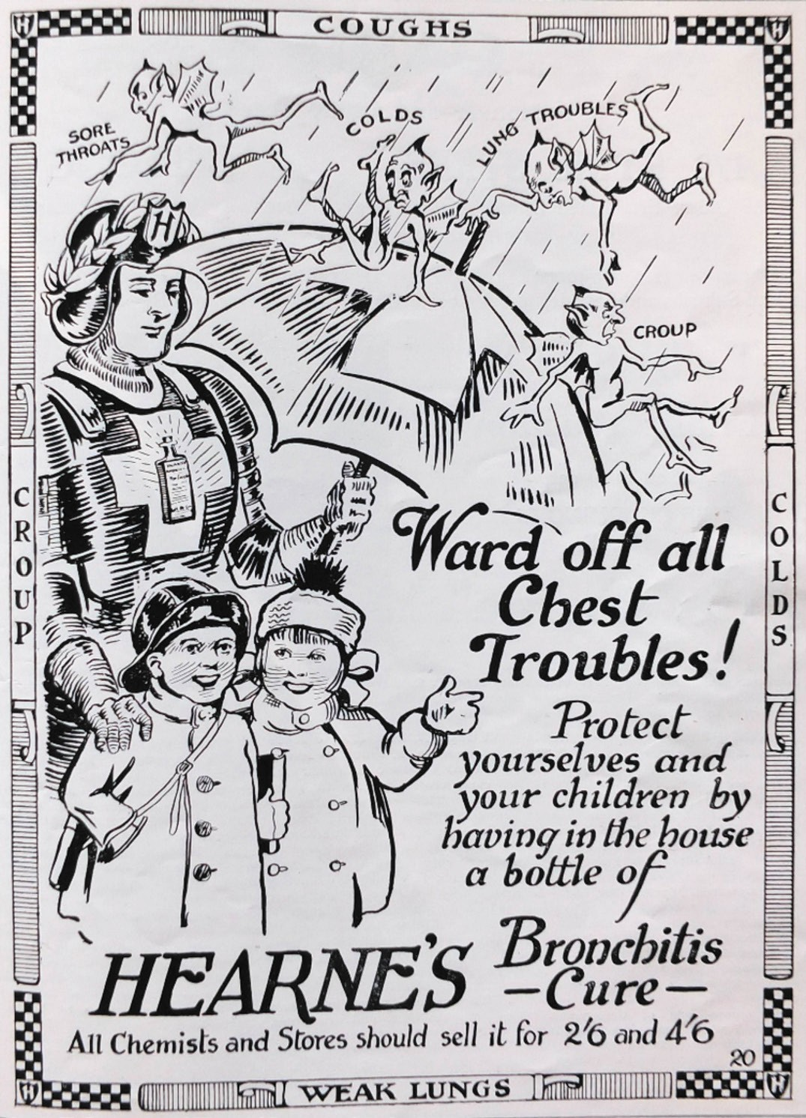
Figure 8.126: Hearne s Bronchitis Cure advertisement. Source: Australian Home Builder, 1922.

about half way a large leaded glass sign has been placed bearing the words, Dickson s Pharmacy, in gold. The shop front is of the deeply recessed pattern, finished in brass, with ah overmantle brass grill along the street line. The windows consist of two deep Ls with an island show case. Mr. Dickson proposed to raise the verandah several feet, and had a leaded glass facia sign designed to be visible from across the road. Difficulty, however, arose with the City Council s building regulations, and the raising of the verandah was forbidden. The matter is
now under consideration by the Mayor, town clerk and city engineer.1195

GEORGE WALTON, 224 PAKINGTON STREET, GEELONG WEST
George Walton appears to have commenced business as a chemist and druggist in Collins Street East, Melbourne, in the 1850s.1196 He went insolvent in 1860 which appears to have been the impetus to relocate to Geelong where he
had established a store in Little Ryrie Street by 1861.1197 By 1866-67, he had relocated to Skene Street, Newtown, before leasing a two storey shop at 224 Pakington Street, Geelong West, from Edwin Hopton. This building (which still survives) was built as a single storey shop before 1854 and extended in 1858 and again in 1861.1198 Walton died while operating his shop in 1877.1199

W.G. HEARNE AND CO.,
16-18 RYRIE STREET, GEELONG
George William Goodall Hearne (1846-1921) was born in Sydney, the son of James and Ann (nee Parry) Hearne.1200 He married Amelia Louisa Sykes in Sydney in 18671201
In 1878 W.G. Hearne opened a large establishment in Ryrie Street, opposite the sale yards. 1202 He advertised as a Pharmaceutical and Dispensing Chemist and offered a heavily stocked patent medicine department including a
range of pills and remedies, ‘fine healthy leeches’, and teeth extraction with or without the aid of the anesthetic spray. 1203 In June 1888, Hearne focused on the production of medicinal cures for pleurisy, croup, epilepsy, eczema, headache and bronchitis.1204 His bronchitis cure (Figure 8.126) became nationally successful. It was described in 1897:
Hearne s bronchitis cure is one of these medicines, and it is no exaggeration to say that it is selling by thousands, and its popularity is phenomenal, its sales having more than doubled regularly every year reaching further and further afield.1205
W.G. Hearne died in 1921, his name practically a household word throughout Australia by reason of the fact that he was the original manufacturer of Hearne s Bronchitis Cure. 1206

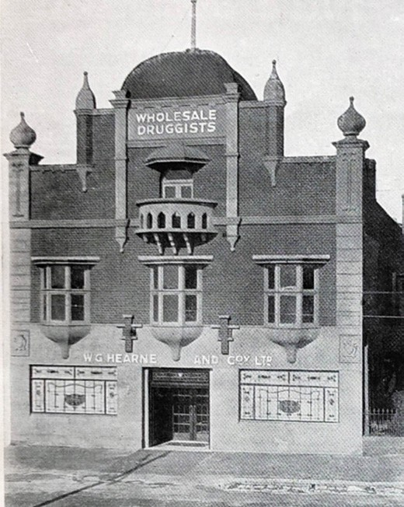
Figure 8.127: Hearne s Wholesale Druggist building, 16-18 Ryrie Street. Source: Australian Home Builder, 1922.

His company was taken over by his son, Oswald Hearne, who lived at Montana , 53 The Esplanade, Drumcondra (Theme 6). In 1921, Hearne purchased the former warehouse occupied by the Beacon Trading Company at 16-18 Ryrie Street (Theme 5).1207 There, extensive alterations and brick
additions were carried out in 1922 to a design by Fred Purnell, local architect,1208 transforming the utilitarian building into a distinctive Moghul-like landmark (Figure 8.127).

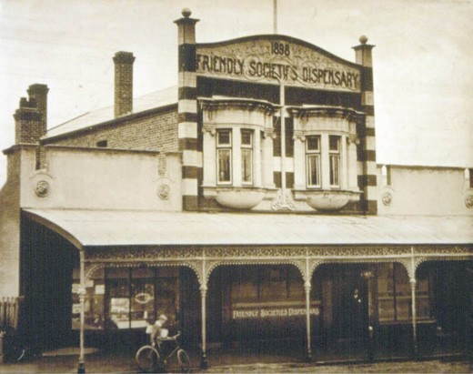
Figure 8.128: United Friendly Societies Dispensary, 45 Ryrie Street,
n.d. Source: Wynd collection, Authentic Heritage Services Pty Ltd.

UNITED FRIENDLY SOCIETIES’ DISPENSARY, 45 RYRIE STREET, GEELONG
In 1898, it was announced that the Australian Natives Association, Sons of Temperance, Ancient Order of Foresters, and St. Patrick s Society which had a combined membership of 2000-3000 people proposed the
establishment of a United Friendly Societies Dispensary.1209 The matter was to be discussed at a forthcoming conference, it being known that similar dispensaries in Melbourne, Bendigo and Ballarat were successful financially. The perceived advantage of the dispensary system was it greatly increased benefits and privileges that the lodges connected were able to provide to their members without increasing weekly subscriptions.1210 The dispensary system also offered a substantially greater number of medicines of proprietary and patent types then excluded in the then present system based on the British Pharmacopeia.1211
In January 1900, the United Friendly Societies Dispensary opened in Moorabool Street, near the National Hotel.1212 The inaugural president was Joseph Smith, the first dispenser to be appointed being Mr McGillivray. The premises were well stocked with all articles requisite for medicinal purposes, and a waiting room for members was ‘fitted up on a comfortable fashion. 1213
In 1904, the local architectural firm of Laird and Barlow, most likely in association with the eminent Melbourne architect, Robert Haddon,1214 designed a two storey rendered brick dispensary building to be constructed at 45 Ryrie Street (Figure 8.128). The building was especially distinguished by its applied Art Nouveau decoration and lettering, and oriel first floor windows. The new complex also included flanking

single storey shops that were leased to provided additional income. The dispensary (and ownership by the United Friendly Societies Dispensary) continued until 1993.1215

AGED CARE HOMES & RETIREMENT VILLAGES

TOWARDS AGE CARE FACILITIES AND RETIREMENT VILLAGES IN GREATER GEELONG
The closure of the original Geelong Infirmary and Benevolent Asylum in Ryrie Street, Geelong, in 1923 to make way for
the construction of the Kitchener Memorial Hospital, brought with it and end of facilities to care for the aged and destitute. Elderly residents and benevolents without family to care for them were transferred to the Ballarat Benevolent Asylum (later known as the Queen Elizabeth Centre).1216 The goldrush city s population had been in decline and so its Asylum
was considered to have sufficient accommodation to meet Geelong s needs as much as its own.1217 Yet, population growth in Ballarat, and particularly Geelong, from the 1930s led an accommodation crisis by the 1950s.1218
By the late 1950s, an aged care home and a retirement village had been established at Bell Park and Lara respectively. This began a new mode of health care and accommodation for the elderly that continues to the present day.

GRACE MCKELLAR CENTRE, 45-95 BALLARAT ROAD, BELL PARK
In late 1943, Cr F.W. Wallace, Mayor of Geelong and former Regimental Medical Officer with the Australian Light Horse in Palestine in World War One,1219 commenced a movement towards the establishment of an old folks home in Geelong. Discussions had been held with the Charities Board to facilitate any available funds. Support for the movement was given by the Geelong Trades Hall Council and all the municipalities in the Geelong district.1220 The growing problem was evident in the elderly taking up local hospital beds or being isolated from their families in Ballarat and led to the formation of the Old Folks Home Committee to raise the £50,0000 estimated for the facility.1221 The public desire for the aged care home was evident in the sum of £58,000 having been raised in just seven months.1222 Even more remarkable was the gift of the 41 acre historic property, Bell Park homestead (built in 1853 for John Bell Theme 6), Ballarat Road, Bell Park by Misses Ernestine and Catharine McKellar.1223 The Herald reported on the highly generous gift declaring that it assures that this historic landmark will be preserved and the dignified old 16-roomed bluestone and brick dwelling in good order will probably be the manager s quarters 1224
While a laundry and boiler house were built in 1946 there were delays in the construction of the hospital accommodation

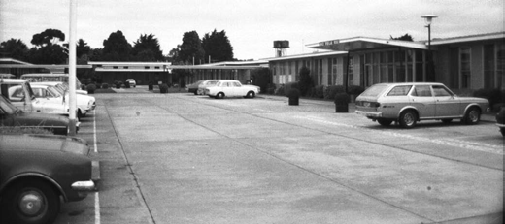
Figure 8.129: Grace McKellar House, Bell Park, c.1970s. Source: Wynd collection, Authentic Heritage Services.
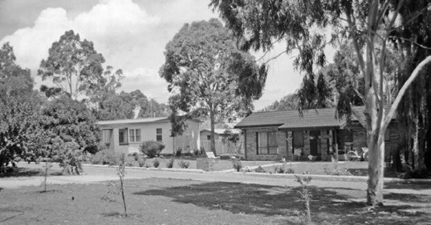
Figure 8.130: St. Laurence Park, Lara, n.d. [c.1980s]. Source: Wynd collection, Authentic Heritage Services Pty Ltd.

until 1956.1225 The lengthy duration in the commencement of the building of the facility was controversial, as was the demolition of all except the dining room of the original Bell
Park homestead (it was converted into the Catharine McKellar Memorial Chapel).1226 The initial design scheme was revised and in 1959, the facility named the Grace McKellar House Geelong (Figure 8.129) in honour of the mother of the donors
was opened.1227 The inaugural manager-secretary was Alfred Ormond De Forest who had extensive experienced in Institutional management, including the 700 bed Mount Royal Hospital.1228 The first Matron was Miss G. Mandeville Halls who had been educated at Kinross Ladies College,
Toorak, trained as a Voluntary Aid Detachment to providing nursing care during World War One. Matron Mandeville Halls subsequently trained at the Royal Melbourne Hospital and later joined the Melbourne District Nursing Society before being appointed to the Australian Inland Mission and then as Matron-Bursar of the Melbourne University Women s College, and Matron of the Ballarat and District Benevolent Home.1229 Since its beginnings, the Grace McKellar Centre expanded into providing other medical and health services and is now under the control of Barwon Health and offers community health services, residential aged care accommodation, rehabilitation services, and palliative care services.1230

ST. LAURENCE PARK RETIREMENT VILLAGE, LARA
In 1959, 42 acres of land in Lara were purchased by the Brotherhood of St. Laurence under the direction of its founder, Father Gerard Kennedy Tucker (1885-1974), O.B.E., for the purpose of developing a retirement village.1231 The first four cottages were subsequently erected and they were officially opened by the Governor of Victoria, Sir Dallas Brookes, on 3 October 1959.1232 There were a number of benefactors that assisted financially in the establishment of St. Laurence Park and these early cottages were named in their honour. Those original cottages that survive today are the Spalding, Wills and Hallows cottages.1233
Four years later in 1963, the first stage of Father Tucker’s support care building, Tucker Court, was officially opened by Lieutenant-General, the Hon. Sir Edmund Herring and Dame Mary Herring.1234 An additional 23 acres of land were acquired on the western side of Hovells Creek in 1967 and in 1973, Richard Austin, in the presence of Sir James Darling, officially opened the next stage of the village, Hume Court.1235 Further development of St. Laurence Park (Figure 8.130) occurred in the ensuring years, including the opening of Flinders Lodge Nursing Home in 1982, opening of the Eric Hart Activities Centre in 1985, and the Costa Aged Care Facility in 2001.1236

ORPHANAGES, CHILDREN’S HOME, REFUGES AND INDUSTRIAL SCHOOLS
From the earliest years of European colonization in Greater Geelong, neglected children were cared for by religious and other charitable institutions in orphanages, children s homes, and industrial schools. In addition to the formation of the Geelong Orphanage Asylum at Fyansford, St. Augustine s Catholic Orphanage at Newtown and Our Lady s Orphanage at Newtown in the mid 1850s and early 1860s, part of the need to help improve the lives of impoverished children and women, rested with groups of ladies and the clergy. This
included the Geelong and Western District Ladies Benevolent Asylum established in 1855 (see later subsection), and the Geelong Ragged School Association. This association opened Ragged Schools in Geelong, the first in Corio Street in 1864, following by another in O Connell street, and later,
in 1876, the Mission School in Yarra Street, adjoining the Mission Hall where the Chinese were also to be educated (see Theme 2).1237 According to Shurlee Swain, the ragged schools followed a similar pattern:
They were free and their supporters actively sought out the poor and neglected children of the inner city, recognising that the child needed to be fed and clothed
adequately if he were to get any benefit from education. Teaching was basic, concentrating on reading, writing and arithmetic with a heavy emphasis on biblical instruction.

The aim was to inculcate habits of order, cleanliness and industry and boys were given some trade instruction while their sisters were taught knitting, plain needlework, mending and darning and trained in the habits of household industry. 1238
Also established was the Geelong Bible Women s Agency in 1865, under the Geelong Ragged School Association.1239 This agency was the domain of philanthropic women, as outlined in the Geelong Advertiser:
No doubt many of our readers are familiar with a little work entitled The Missing Link, and have read with interest of the great work accomplished by the Bible-women in the city of London. Truly this is woman s missions to seek the poor and the sick in their homes, giving them words of encouragement and sympathy, and, it be, helping many
a despairing one to renew with fresh energy the battle of life, feeling that they are not altogether uncared for by their fellow creatures.1240
In 1864, the Neglected and Criminal Children s Act came into operation and gave definitions on what constituted a neglected child which included those found begging,
wandering, residing in a brothel , together whose parents were unable to control the child. 1241 In 1886, the Victorian Government passed the Aborigines Protection Act and so all part-aborigines aged 3-4 and younger were to leave the
stations and their families and were transferred to the care of the Department for Neglected Children.1242 Stolen children therefore came to Geelong, and to the orphanages separately managed but partly funded by the State (see Theme 2).
The Neglected and Criminal Children s Act gave powers for the care of destitute children to be placed in the care of the superintendent appointed by the Victorian Government. Such care was made manifest in the establishment of Industrial Schools which operated in parallel with reform schools (penal institutions) for criminal juveniles.1243 The Geelong Industrial School opened in the former Immigration Depot, corner of Ryrie and Swanston Streets (Figure 9.121), on 9 August
1865. Its first intake was 160 infants (children under 6 years of age).1244 In 1866, three further dormitories were added to the Geelong Industrial School to provide for an addition 150 children.1245 As all the children at the Geelong school were very young, they were given an infant school training.1246 Religious instruction was also given at the Sabbath Schools every Sunday.1247
The Industrial School also enjoyed public support. In 1866, George W. Duncan, Inspector of Industrial Schools, gave a report on the philanthropy afforded the Geelong school:
I may here mention that to all the schools, but particularly to the Geelong schools, visits have been paid by ladies and gentlemen on week days, who have addressed the

children, exhibited magic lanterns for their amusement, and in other ways have endeavored to interest and instruct them, occasionally providing for them feasts, and supplying toys and books.1248
The Geelong Industrial School closed in 1873.1249
By far the larger number of neglected children from the mid- 19th and throughout the 20th centuries were placed in one of Geelong s orphanages, depending on their religious creed (or lack of). Orphanage life contrasted domestic life. This was reflected in the regimented routine of daily life, including military drill and the constant surveillance with restrictions on food, play, clothing and daily routine, and forced religious
instruction. The emotional and physical punitive institutional regimes that were established was ubiquitous throughout the colonies as much as it was in Geelong.1250 Yet, Geelong had the greatest number of orphanages in Australia outside the capital cities.1251 The detrimental impacts caused to children placed in orphanages in Geelong continue to be felt by the survivors to the present day.
Official recognition of the negative effects caused by institutional care were recognised in a Senate Community Affairs References Committee Report to the Australian Parliament in 2004 entitled Forgotten Australians. This culminated with a National Apology by the Australian Government on 16 November 2009:
The Apology acknowledged that what happened in the past was both real and wrong. The Apology has helped to ensure that a largely invisible part of our history is put firmly on the record and serves as a reminder of what happened to many children the loss of family, the loss of identity, and, in the case of Former Child Migrants, the loss of their country.1252
The following is not intended to give a detailed social overview on the institutions where children were placed from the 19th century (as this is beyond the scope), but to provide a chronological overview of this part of community life in Greater Geelong through the physical legacies that exist today. None of these institutions still operate, and some of the buildings have also disappeared (including the Home of Hope for Destitute Children, Ocean Grove, opened in 1891 by the Rev. C.M. Cherbury; and St. Catherine s Orphanage, Highton, opened 1928).1253

PROTESTANT ORPHAN ASYLUM AND COMMON SCHOOL, MCCURDY ROAD, FYANSFORD
The idea of establishing an orphanage in Geelong began in the early 1850s.1254 The Mayor of Geelong, William Hingston Baylie (1839-1867), enthusiastically resolved to ensure that this idea progressed into action.1255 As Magistrate, he had first-hand experience with the plight of orphans, which the

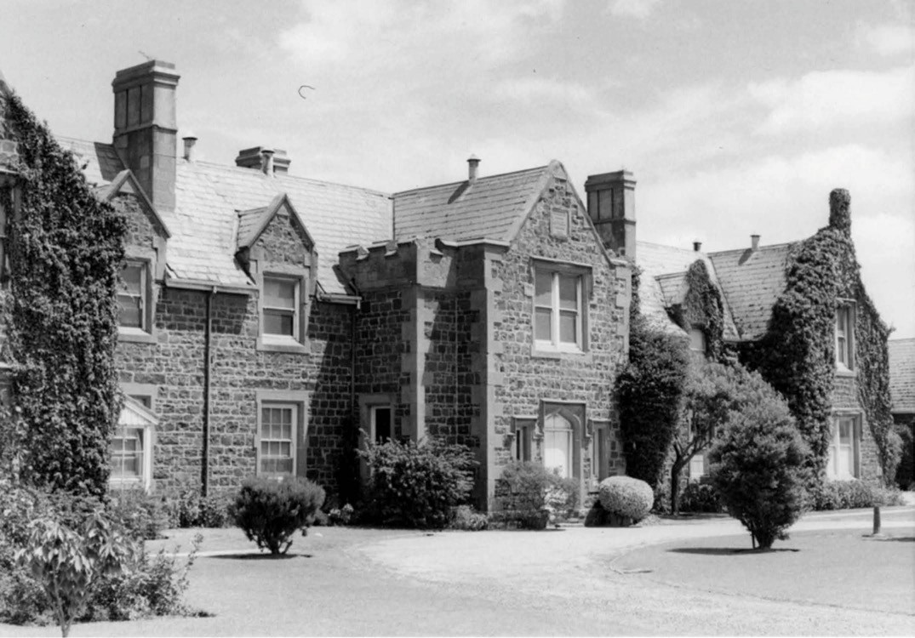
Figure 8.131: J.T. Collins, Protestant Orphanage, McCurdy Road, Fyansford, 1967. Source: accession H91.2310/428, State Library of Victoria.

Geelong Advertiser reported:
That it was needed, he had instances daily before him; and that morning there were no less than five orphans before the Bench left desolate and unprotected, and he had no hesitation in saying that there were at least fifty children in Geelong, reduced to the same extremities, utterly destitute, or relying upon casual support from private charity, living in filth, disease, and exposure to crime, to which poverty and neglect often led. It was the duty of those placed in affluent circumstances, or possessed of comfortable means of livelihood, to save these children from misery and destruction. Religion, morality, humanity, made that claim upon them, to preserve society from being contaminated by future ills, which it now was in their power to prevent by the establishment of an institution like the one proposed, where unfortunate children, thrown loose upon society, might be housed, fed, clothed and instructed until they arrived at an age to gain a livelihood for themselves.1256
A public meeting was held on 7 May, 1854 and soon after it was announced that donations and subscriptions had totalled
£4400.1257 One affluent member of the local community to immediately support the fundraising campaign was James Austin (see Theme 4) who donated £500. He lamented the many orphans were children that had been abandoned by their parents or whose parents were in prison, and he believed that the Orphan Asylum was an institution much
needed. 1258 Although he returned home to England before the orphanage was built, Austin became its patron.1259
An architectural competition was developed soon after, with the commission being awarded to Andrew McWilliams.1260 On 14 March, 1855, the foundation stone was laid. It was a ceremonious occasion, whereby Councillor George Wright
led a procession of riflemen, firemen, councilors, Oddfellows, the Committee of the Orphan Asylum and bandsmen around the streets of Geelong to the Herne Hill site.1261
It was later in 1855 when the Asylum opened under the name Geelong Orphan Asylum1262 (Figure 8.131). William Packer

Carden Kent (c.1813-1884),1263 an Irish farmer, was appointed Master and his wife, Esther Kent (nee Sharpley), became
the inaugural Matron.1264 They had arrived on the Euphemus from London in 1853, with William employed on board ship as Constable No. 4, and Esther, as Matron. They remained at the Orphanage until 1859 when they took up farming pursuits at Freshwater Creek and later at the Springfield Estate, Moolap.1265
At the orphanage in 1855 there were nine children, but 20 children had been selected by the committee from a longer list compiled by subscribers.1266 In 1857, a wing was added in an effort to accommodate the growing numbers of children.1267 By 1860, there were 84 children resident at the orphanage.1268
In March 1862, a special meeting was held to change the name of the asylum to the Geelong Protestant Orphan Asylum.1269 This change was instigated because of the establishment of the Catholic orphanage, St. Augustine s in Newtown, and distinguished between the two differing denominational institutions.1270
Three years later in 1865, the architect Joseph Shaw provided a design for a Common School.1271 It was constructed immediately north of the Asylum and in 1873 it was extended with two playrooms being added.1272 The education of the children extended beyond the textbook and involved the learning of practical skills. Boys learnt gardening, stone breaking and making roads (the carriage drive established
in 1873 and several pathways, as well as the fine ornamental and produce gardens were the work of the boys) while the girls learnt cooking, laundry, waiting at table and sewing.1273
In 1933, the Orphanage and School at Fyansford closed and the institution relocated to the newly-built Glastonbury home in Belmont (see later subsection).

ST. AUGUSTINE’S ORPHANAGE, NEWTOWN AND HIGHTON
Prior to 1855, the Catholic Friendly Brothers in Geelong were informally supporting more than 20 children.1274 On 15 September 1855, three acres of land in Aphrasia Street,
Newtown, were set aside for a Catholic orphanage adjacent to St. Augustine s church school. This was in part a reaction to the opening of the Geelong Orphan Asylum earlier that year, where the denominational divide on the education of orphans was especially apparent. As the Friendly Brothers explained:
That whilst we are most anxious to unite with our fellow townsmen in every good undertaking, we deeply regret that there is one subject, the education of our children, on which they cannot make common cause, and this solely on conscientious grounds. The Catholics of Geelong, however, feel sure that their brethren of other denominations will freely extend to them that right which they claim for themselves the right of being accountable to God alone in matters of conscience; and they further feel assured that their separated brethren will not prove themselves less liberal than the Catholics who subscribed so largely to the establishment of the
orphanage already in existence, even when they felt they could not on conscientious grounds avail themselves of its advantages.1275
In addition to the Friendly Brothers, Father Patrick Dunne (one of two priests stationed at Geelong from 1854) also took an interest in the welfare of orphan children. He made representation for the establishment of permanent security for the orphans through ecclesiastical authority. 1276 With Father Dunne s transfer to Port Fairy in 1856, it was the Rev. James B Hayes of the Order of St. Augustine that realised the aim of having a Catholic orphanage established.1277 In 1857, the local architectural firm of Shaw and Dowden was
commissioned to design the orphanage buildings for boys.1278 On 15 March 1857, the foundation stone was laid by the Right Rev. Dr Goold and the first stage was opened in May 1858 to accommodate about 20 boys and 15 girls.1279 This was the beginning of a staged development of buildings.1280 Joseph Shaw also designed additions to complete St. Augustine s Orphanage near the southern boundary to Queens Road in 1868,1281 the institution (Figure 8.132) being described in the Geelong Advertiser the following year:
The building is a substantial blue stone one, relieved here and there with brick and freestone facings. Until very lately there was only one wing of the original design erected, but the main portion of the building has just been finished, and the cause of our visit yesterday was

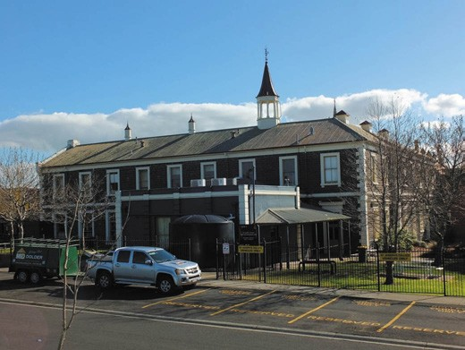
Figure 8.132: Former St. Augustine s Orphanage (now St. Joseph s College), Newtown, 2019. Source: David Rowe.

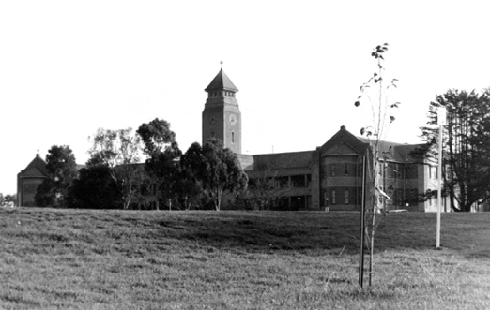
Figure 8.133: Former St. Augustine s Orphanage (now Christian College), Burdekin Drive, Highton, 1998. Source: David Rowe.

primarily to inspect these additions. The main portion of the structure, which as we have said, has just been completed, has cost £1400 or thereabouts, but it is money well and judiciously laid out, inasmuch as the additions are fitted up with all the conveniences found to work best on the continent in similar institutions, after centuries of experience. On the ground floor is situated the dining- room, a spacious apartment, 48 feet by 24 feet and 14 feet high, and a scullery attached with every convenience.
The walls are 2 feet 6 inches in thickness, so that the room is very cool and comfortable. Ventilation is undoubtedly
a great consideration in buildings where a large number of persons, whether young or old, are to be collected together, and we are glad to see that this feature has been
looked after with scrupulous attention. The dining room

is fitted up in the style that has been found to answer best in the largest European institutions of a similar character. On a platform raised about six inches from the level of the floor are fixed white deal tables all round the room, at such a distance from the walls as to allow the children to sit behind. In the centre are two or three long tables on which bright tea urns were standing, given at once a cue to the use of the apartment The whole effect of the dining room, with its excellent appointments and varnished deal ceiling, is excellent, and it leaves nothing to be desired.
The upstairs portion of the new building is taken up by a large dormitory, sixty feet by twenty-five feet, and twenty feet high. This room is indeed the perfection of neatness, cleanliness, and convenience. There are thirty beds ranged along the sides of the room, fifteen on each side.
In the centre of the room are three tables containing in all thirty block tin hand-basins, corresponding with the beds so that each boy has his own washing apparatus
and there is no waiting for one another The whole room shows that not only is economy considered, but that comfort is also recognised as a consideration in building a home even for poor orphans. In one corner partitioned off is a small room where the attendant sleeps, and by means of eye holes through the wood partition he can
at any time see every boy in the dormitory without their knowing that they are observed. There are several smaller dormitories in it, including one for new arrivals. There is another dormitory for the younger children, the beds in which are so made to prevent the little things from falling out. Attached to this room is a small apartment where the children are washed, those sleeping here being too young to preform that necessary office for themselves.
Bathrooms are also provided, but the supply of water is not at present so large as to allow them to be used as much as might be desired. The old dining room, a
comparatively small and inconvenient apartment, is now used as a storeroom, and the old storeroom is transferred into a workroom, where a sewing mistress is continually employed in mending, patching, and making clothes. The clothes room is a spacious apartment, where a large array of all articles of male attire in miniature are ranged round the walls. There are also the matron s apartments, and other rooms in the old building. The kitchen, washhouse, drying and ironing, and other rooms, used in connected with these departments of the work, are situated at the rear, and possess every convenience. The hospital ward is contained in a small building quite apart from the other portion of the institution. It is like the new structure, well ventilated, but is small, although more than sufficient for all requirements. … There is a fine ball alley, a small playground nicely graveled, and also a larger playground

of over four acres, largely obtained by the energy of the Very Rev. Dean Downing, from, the Government.
The education of the boys is also well attended to. On the other side of the road from the orphanage is the St. Augustine s common school. The children of the
orphanage are taught here, and there are also some forty or fifty other children sent there from people who live in the vicinity. Mr O Connor is the head teacher, and Mr.
Molony the assistant master. … The number of officers employed in the establishment is comparatively small, consisting only of Miss Martin, the matron; Mr O Driscoll, the general manager and storekeeper; Mr O Connor, the schoolmaster, who received part of his salary from the Board of Education; Mr Nooling , the assistant-teacher, who has also charge of the orphanage boys after school times; and five domestic servants.1282
Following the death of the orphanage superintendent,
D. O Driscoll, in 1878, the administration of the institution was taken over by four Christian Brothers.1283
In 1927, the first move towards a new orphanage was made when Brother Molloy purchased two farm sites in Highton.1284 In late 1935, the Archbishop of Melbourne, Rev. Dr. Daniel Mannix, approved the design by the Catholic architect, Cyril Kelly for the new buildings.1285 Kelly was raised in a devout Catholic family and enjoyed the patronage of the Catholic Church with several architectural commissions, as did his builder father, William Kelly, was responsible for a number of Catholic buildings, the most substantial being St. Augustine s Orphanage.1286 Estimated to cost £60,000, William Kelly, carried out preliminary work in the last days of April, 1936, and the first brick was laid on 1 June, 1936.1287 On All Saints day, the Rev. Dr Mannix laid the foundation stone.1288 By the time the building work was completed, the cost for the project had increased to £87,000.1289 With all finances expended (including a £21,000 bequest), the Fund Appeal Committee made a deputation to the Premier of Victoria, Mr Dunstan, in August 1936.1290 The Committee was successful in obtaining the funds from the Government, together with the cost of sewerage works.1291
Designed in an eclectic neo-Romanesque mode, the proposed complex was anticipated as one of the most up-to- date and serviceable institutions of its kind in Australia. 1292 While the complex was under construction in 1938, The

Advocate declared:
The building will be a two-storied structure, the keynote of which is simplicity and utility, combined with the latest improvements for institutional planning. The building will be on the open courtyard principle, with the Chapel of St. Augustine, Patron Saint of the Orphanage, the central feature of the courtyard. The chapel will have accommodation for four hundred persons.1293
St. Augustine s Orphanage (Figure 8.133) opened in 1939 and was lauded by Senator Keane as the biggest institution of its kind in Australia. 1294 By 1979, one wing of the St.
Augustine s Orphanage was leased to the Geelong Christian College (see earlier subsection). The year 1987 witnessed the end of an era for St. Augustine s.1295 The buildings were sold to the Geelong Christian College for $1.7 million, with St. Augustine s Orphanage moving to a new site in Oxford Street, Whittington.1296

ST. JOSEPH’S GIRLS’ ORPHANAGE, SISTERS OF MERCY, RETREAT ROAD, NEWTOWN
An orphanage was first established by the Sisters of Mercy at Sunville , Newtown in 1860, as part of the convent (see earlier subsection). A purpose-built orphanage came when the local architect, Joseph Watts, designed a two storey building at the convent in 1885.1297 To be known as St. Joseph s orphanage for girls.1298 The Advocate gave the following description during its construction on 15 May 1886:
The new building at the Convent, which is intended for a Domestic Servants Training Institute, and also to extend accommodation for the female orphans who are at present overcrowded in the building originally erected for them
is progressing rapidly. The structure is composed of brick, with freestone dressing on a concrete foundation. The building has been urgently required for some time past, and when completed, the good nuns will thereby be enabled to extend their sphere of usefulness.
By 1887, the building had been completed and it served its original purpose until 1928 when the orphanage (then known as St. Catherine s) relocated to Highton.1299

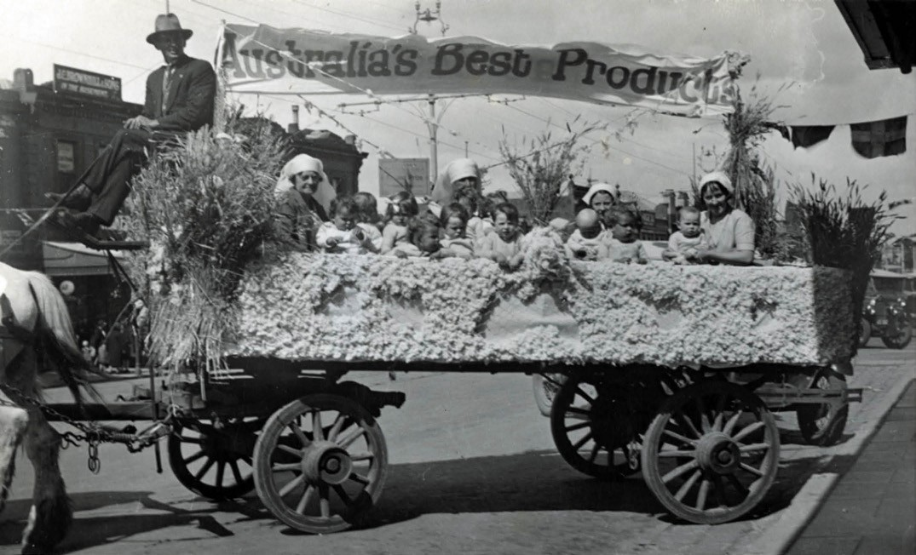
Figure 8.134: Bethany Babies Home Float, Gala Day, 1932. Miss Blakiston, Matron Erwood, Nurses Knight and Harvey, and some of the children. Source: GRS 2003/03921, Geelong Heritage Centre collection.

GEELONG FEMALE REFUGE AND BETHANY BABIES’ HOME, BALLARAT ROAD, NORTH GEELONG
In 1867, the Ladies committee of the Geelong Ragged Schools Association sought the establishment of a female refuge in Geelong.1300 Several Protestant Ministers and prominent citizens were appointed to a committee to assist in its formation. They were the Revs. James Bickford, A.J. Campbell, Astley Cooper, J.W. Crisp, Thomas McK Frazer, George Goodman, F.R. Hopkins, W.B. Landells, A.M. Moore, Frederic Strickland; and Messrs James Campbell, Richard Clarke, Alfred Crook, Robert Gillespie (treasurer), G.M. Hitchcock, Joseph Holdsworth, T.B. Hunt, Neil McCallum, George Morrison, J.P. Nicholson, R. O Connor, J.D. Robinson, Charles Sach, Joseph L. Shaw, James Wood and Alfred R. Reed.1301 Rules and regulations were approved
at subsequent meeting: the institution (to be conducted on Protestant principals) was to be called the Geelong Female Refuge; and the objectives included the provision of a refuge
for females who have fallen into vice, and who are desirous to return to the paths of virtue; to reclaim them for their evil course, and fit them to become useful members of society; and to assist in procuring them situations, or otherwise providing for them on leaving the Institution.1302
Premises in Kildare (North Geelong) were purchased on the Ballarat Road in 1868. The Geelong Advertiser gave the following description:
The building, which is of brick, and consists of six rooms, is admirably suited for the purposes required being in a healthy position, and commanding a good view. Four of the apartments are set apart as bedrooms, one as a dining and general sitting room, and the other as a kitchen. The building when purchased was in a somewhat dilapidated condition, but the committee have made the necessary repairs and painted it inside and out, and papered the rooms, so that the house is now exceedingly comfortable; indeed fit for anybody to reside in.1303

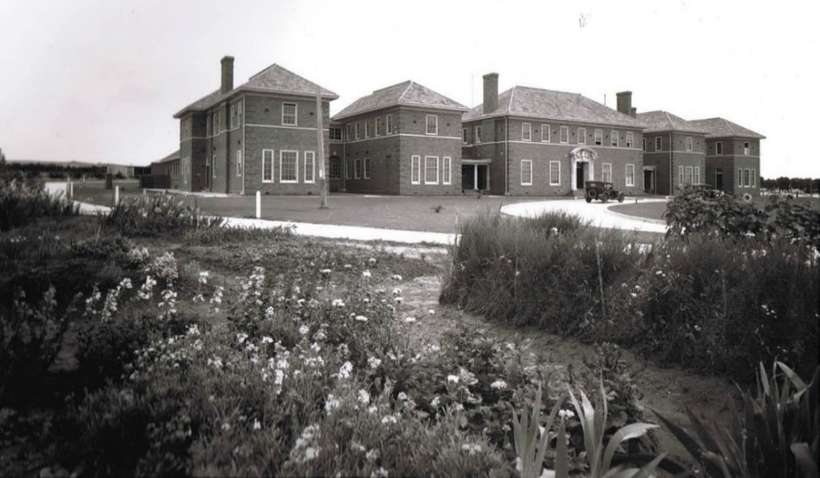
Figure 8.135: Glastonbury Children s Home (now Geelong Christian College), Broughton Drive, Belmont, n.d. [c.1933]. Source: Davies collection, Lorraine Huddle.

The Geelong Female Refuge was officially opened on 1 May 1868. The first Matron was Miss Treloar.1304 She soon won respect, the Geelong Advertiser declaring in 1871 that she was a kind and motherly woman and had received letters from former inmates, expressing their gratitude at having been reclaimed from a life of sin, and put into the way of gaining an honest livelihood. 1305 Matron Treloar resigned in 1874 to take a similar position at the Ballarat Female Refuge where her reputation continued to be elevated, the Ballarat Courier in 1876 stating that she had attended to her duties in a manner so satisfactory as to deserve commendation and encouragement. 1306
By 1881, the relatively isolated location of the refuge caused the committee to investigate alternative sites within the
city area, including the former immigration depot in Ryrie Street and land at the rear of the Geelong Gaol in Little Ryrie Street.1307 Opposition from local residences neighbouring both of the proposed sites forced the committee to reconsider their objective.1308 Instead, timber buildings from the Geelong Industrial School associated with the immigration depot in Ryrie Street were relocated to form new buildings for the female refuge at its original site, the earlier buildings (save the brick matron s cottage) being demolished.1309
In November 1927, the Geelong Advertiser announced that the babies were to be cared for at the Geelong Female Refuge. A verandah was rebuilt so that it will be suitable as a sleep-out for the accommodation of babies. 1310
The name of the institution was also changed at this time to Bethany Babies Home.1311 The Home had a float in the Gala Day procession in 1932 (Figure 8.134). Further
transformation came in 1935 when a new two storey building was constructed to a design by local architect, Norman Schefferle.1312
Today, support services are still offered at the original female refuge site at 16 Ballarat Road, North Geelong by an independent not-for-profit community services organisation known as Bethany Community Support Inc. These services are offered for women, men, children and families and
include: children and family services; whole-of-family violence services; disability support services; financial counselling and support, gambler s help, housing services and emergency relief.1313 Bethany is accommodated in more recent buildings which have replaced the structures of the earlier institutions.

GLASTONBURY CHILDREN’S HOME, 37 BROUGHTON DRIVE, BELMONT
The building complex at 37 Broughton Drive (Figure 8.135) was built in 1933 to designs by Geelong architects Laird and Buchan as the Geelong and Western District Protestant Orphanage.1314 This was the second location of the home, which had operated as the Protestant Orphan Asylum and
Common School in McCurdy Road, Fyansford, from 1855.1315 The idea of a new Home in Belmont originated in 1929, when the Glastonbury Committee launched an appeal to raise the then massive sum of £30,000 required to build the Home on 30 acres of land.1316 On 24 February, 1929, Cr. S. Jacobs, Mayor of Geelong, presided over a large public meeting,
the result being that a large committee of local mayors and shire representatives be appointed to manage the appeal. Fundraising was carried out by several organisations, including the Freemasons of Geelong and District, Geelong Churches, and the State Government contributed to the cost.1317 The Glastonbury Committee had initially decided to hold an architectural competition for a suitable design for the Home, but on receiving the conditions for the competition from the Institute of Architects in September, 1929, they decided to appoint Laird and Buchan, architects, instead.1318 This firm was the Honorary Architects for the Glastonbury organisation for over 25 years.1319 Prior to the commencement of building works, the access road was started and the exotic trees (including Lambertianas) and sugar gums were planted.1320 The seedlings originated from
the government nursery, as well as from the local nursery in Newtown, Stintons .1321
The new children’s home was officially opened by E.A. Austin, descendent of the original patron and benefactor of the Protestant Orphan Asylum, Fyansford, James Austin. In 1955, the institution was renamed the Glastonbury Children s Home, in honour of the English estate of the late James Austin.1322 The complex is now a campus of the Geelong Christian College.

PIRRA GIRL’S HOME, WINDERMERE ROAD, LARA
Pirra Girls’ Home was officially opened on 20 June 1961 by the Director-General of Social Welfare, A.R. Whatmore1323 in the two storey rural mansion house at Lara first built by
George Fairbairn senior in 1880 (see Theme 2). Other official guests at the opening included the Minister for Shipping
and Transport, Mr Opperman, President of the Legislative Council, Sir Gordon McArthur, and assistant Chief Secretary,
L.H.S. Thompson.1324
It was at this time when the property was first named “Pirra”, an aboriginal word for moon, being a symbol of happiness.1325

Pirra was one of 16 homes in operation at the time, and was not regarded as an institution but a home .1326 Pirra was
a home for orphans, semi-orphans and victims of broken homes. It was supervised initially by Miss C. Ross Morrison and later by Miss N. McDonald.1327 In 1963, Miss McDonald described the lives of the children at Pirra:
Their lives are as normal as we can make them. They are not prisoners and they are not criminals We allow them as much freedom as they would get in normal family
life the girls who are old enough can go to dances on Saturday night, wear make-up and keep up with the fashions. They go on outings to the beach and attend things such as the Geelong Show and Gala Mrs
McDonald says that the children there are 25 girls and three little boys ranged from three years to 17 attend schools throughout Geelong and district.1328

WELFARE HOMES

HOMES MANAGED BY THE GEELONG AND WESTERN DISTRICT LADIES BENEVOLENT ASSOCIATION
On 23 June 1855, the Geelong and Western District Ladies Benevolent Association was founded by Miss Caroline Elizabeth Newcomb, pioneer pastoralist, and inaugural Portarlington Road Board Member and Secretary (Themes 2 & 7).1329 Established initially to help the Geelong Hospital and Benevolent Asylum,1330 the women of Geelong and district banded together to attempt to meet part of the welfare need.
The first meetings were held in the Christ Church Schoolroom, Geelong.1331 Miss Newcomb was made the Association’s first President.1332 In 1862, the Government granted the former Telegraph Station in McKillop Street at a weekly nominal rent of 1/- for the use of the Association.1333 It was soon occupied by destitute families and individuals needing emergency accommodation.1334 In 1891, the Government reserved the property for a Home for Aged Females and it was given to the Association for that purpose.1335
The Association played a key role in providing welfare and support services, and managing welfare housing, to those in need, particularly females. From 1858 until the inception of the Old Age Pension in the mid 20th century, the Association was given a Government Compassionate Allowance (initially from the Victorian State Government, until the administration of this allowance was taken over by the Commonwealth Government in 1911).1336 It also relied on grants from the municipalities in Geelong and district, and philanthropic businesses and individuals.1337 Annual grants from 1859

amounted to £300.1338 By 1880, the annual Government grant had increased to £1,250,1339 which clearly indicated the substantial rise in the Association s work in relieving the
distress of females in need. Such assistance helped fund the attendance of honorary doctors and chemists when one of the residents was ill.1340
The Association had a membership of active and influential women whose actions and benefactions were far-reaching. In addition to Miss Newcomb, a significant figure was Mrs Elizabeth Phillips Austin (nee Harding).1341 Born at Middle Chinnock, Somersetshire, England, in 1821, she emigrated to Victoria on her 20th birthday with her eldest brother, William Harding.1342 She initially resided at Murdeduke, near Winchelsea, until her marriage in 1945 to Thomas Austin of Barwon Park, Winchelsea.1343 The mother of eleven children, Elizabeth Austin continued to reside at Barwon Park after the death of her husband in 1871.1344 However, it was not as the widow of Thomas Austin that Elizabeth Austin was most famously recognised, but as a most substantial benefactor to the poor and suffering in Victoria.1345 In 1888, Alexander Sutherland in Victoria and Its Metropolis gave the following glowing account of Mrs Austin s philanthropy:
Few, indeed, are there throughout the length and breadth of Australia who have not heard of that inestimable institution, the Austin Hospital for Incurables, and who do not revere the name of the generous and single-minded woman who was its founder, and whose gracious name
it bears. This admirable hospital came about thus:- An old servant having been dismissed from the Geelong Hospital as incurable, it entered the mind of Mrs. Austin that Christian charity demanded that some provision should be made for such, saddest of all unfortunates. To see the need was, with her, to supply it, and in July, 1881, the Marquis of Normanby, then Governor of Victoria, laid the foundation-stone of the Austin Hospital for Incurables, at Heidelberg. The work went rapidly on, and on 14th August, 1882, the institution was opened by Mr. C.J.
Ham, Mayor of Melbourne, and it now stands a handsome structure, and a lasting memorial of the benevolence
of the lady to whom it owes its existence. But this one institution does not exhaust the benefactions of Mrs. Austin. She has built reading-rooms in Chilwell and Geelong, which were opened by the late Sir C. Sladen. She also gave the sum of £800 towards the Servants Training Institute, Yarra Park. In such wise, Mrs. Austin has nobly fulfilled her share of those “duties” which, no less than its privileges, are assumed to be an attribute to wealth.1346
Mrs Annie Hitchcock (nee Lowe) (1843-1917) was born in Sydney, N.S.W., the daughter of John Lowe and Ellen,

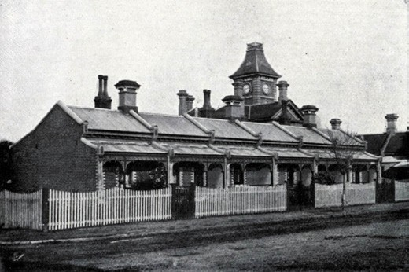
Figure 8.136: Austin cottages, Mundy Street (north side), June 1907. Source: GRS 201, Geelong Heritage Centre collection.

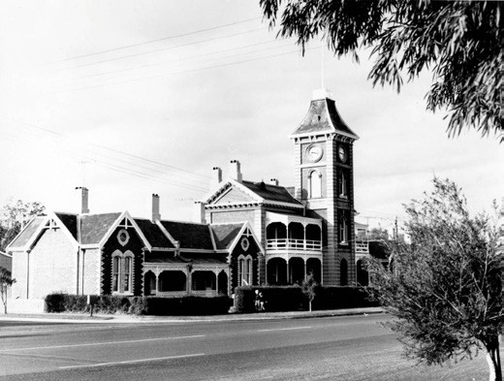
Figure 8.137: Austin Hall and cottages, Yarra Street, n.d, [post 1964]. Source: GRS 203, Geelong Heritage Centre collection.

staunch Wesleyans.1347 She was the wife and mother of prominent businessmen and philanthropists, George and Howard Hitchcock (see Theme 5). Her charitable work to the community was substantial. She was president of the
Geelong and Western District Ladies Benevolent Association for 46 years until her death in 1917; member of the Ragged School Committee which she helped transform into the
Free Kindergarten, and she was the founder of the Mission School in Yarra Street that was one of her special projects.1348 Annie Hitchcock was influential in the establishment of ‘The Cottage by the Sea at Queenscliff (a seaside retreat for underprivileged children), an ardent supporter of the boy scout movement and a tireless worker and benefactor of the Yarra Street Methodist Church.1349 She also contributed to the beautification of the Barwon Heads Park during her time at the family s marine residence.1350 It was at Barwon Heads where

Lambertiana pines were planted in the main street, which was renamed Hitchcock Avenue in her memory.1351
Fanny Eileen Brownbill (nee Alford) (1890-1948) was another prominent member of the Association. The daughter of James and Ann (nee Abbott) Alford, she married William Brownbill in 1920. Fanny was president of the Matthew Flinders Girls school Council and the Geelong and Western District Orphanage Ladies Auxiliary, Belmont; member of the Geelong Young Women s Christian Association, committee member of the Old Folks Home, Justice of the Peace, worked for the Red Cross Australian Comforts Fund and an active member of the Christ of Christ in Latrobe Terrace. She made history in 1938 as the first member of the Australian Labor Party to enter the Parliament of Victoria, succeeding her husband who had died in office.1352
Physical legacies of the important work of the Geelong
and Western District Ladies Benevolent Association are in the surviving 19th and 20th century welfare homes that it was endowed and/or managed.1353 These include the following.

AUSTIN HOMES, 215-221 YARRA STREET, GEELONG
Between 1886 and 1889 Elizabeth Austin used her substantial wealth to fund the construction of two terraces, two pairs
of semi-detached cottages (originally known as Jubilee Terrace) and Austin Hall (originally known as Jubilee Hall) in Yarra Street, Geelong.1354 They were built as endowment homes for aged females at a cost of over £7000 to designs by Joseph Watts.1355 The extraordinary philanthropy of Mrs Austin eclipsed her history-making benefaction of £6000 in 1881 for the building of the Austin Hospital for incurables in Heidelberg.1356
The earliest dwellings were constructed as terraces (each comprising six cottages) fronting Mundy and Carr Streets, built for elderly women of the labouring class
in 18861357 (Figure 8.136). The cottages fronting Yarra Street were built in 1888 (and completed in 1889) and were defined by two sets of semi-detached dwellings flanking Austin Hall, also built in 1888. The cottages were built for educated women in reduced circumstances .1358
The imposing two storey Austin Hall building (Figure 8.137) was especially characterised by a clock tower (originally named Victoria tower), which became a local landmark in South Geelong. Austin Hall was originally built as committee and meeting rooms, but in 1895 these rooms were converted into four dwellings.1359
Mrs Austin bestowed the management of the Austin Homes to the Geelong and Western District Ladies Benevolent Association in 1889-90.1360 Until 2001, the Association tended

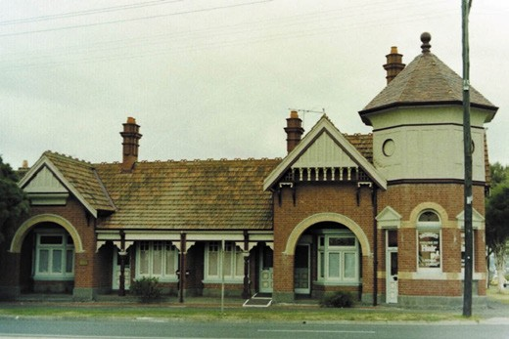
Figure 8.138: Former Haimes Memorial Homes, McKillop Street, Geelong, 1991. Source: David Rowe.

to the upkeep of the homes and the welfare of the occupants. From 2001, both the legal responsibilities for the site and the management of the homes (continuing their original function as endowment homes for females) was vested with St.
Laurence Community Services (Barwon) Inc. as Trustee.1361

HAIMES HOMES, GEELONG
In 1891, the Association received the first instalment of a bequest of the late Captain John Haimes of Mamre ,
Camperdown.1362 On 4 February 1896, after sufficient funds from the bequest (known as the Mamre Homes Fund)
had been gained, the foundation stone was laid by Lady Brassey for the construction of ten cottages on the site of the former Telegraph Office.1363 The subject of an architectural competition, the proposed brick building was designed by local architects, Tombs and Durran,1364 the design being questioned as too elaborate for its purpose.1365 However,
the architects pointed out that the ornamental effect gained by the adoption of the Queen Anne style of architecture is of no jimcrack order, whiles the outlay upon it represents a very inconsiderable item in the total expenditure upon the structure. 1366 The building was opened in December 1896 and officially known as Haimes Memorial Homes1367 (Figure 8.138). Towards the end of the 20th century, the Haimes
Homes were sold to a private owner and were initially leased as flats.1368

BAXTER HOMES, BELMONT
In 1962, Hubert Opperman, Minister for Shipping and Transport, officially opened 16 cream brick single bedroom units in McKenzie Street, overlooking the Barwon Valley.1369 For single or widowed elderly ladies, they formed a later legacy of the work of the Geelong and Western District Ladies Benevolent Association.

ALEXANDER MILLER TRUST AND THE ALEXANDER MILLER HOMES
The successful local draper, Alexander Miller (Theme 5) was one of Geelong s most important benefactors whose legacy continues to endure to the present day. Influenced by the Rev. A.R. Edgar, Miller was committed to using his wealth in a Christian way.1370 This was first realised in the building of almshouses including those that still exist at 111 Pakington Street, Geelong West in 1909-10 (to a Queen Anne design by William Cleverdon, now altered into shops), and 324-332 Ryrie Street, Geelong, in 1913-14 (in a Federation Free style design by Laird and Buchan architects).1371
Much of Miller s considerable £172,000 Estate on his death in 1914 was committed to the building and endowing of welfare homes for the poor, known as the Alexander Miller Homes.1372 These included the gabled brick Bungalows laid out along Garden City principles at 73 McKillop Street, Geelong, in 1919, and 22A Park Street, Geelong, in 1922-241373 (Figure 8.139). In Belmont, semi-detached brick cottages were laid out following a lineal alignment in Culbin Avenue, Belmont,
in 1928. They had panoramic views over the Barwon River valley.1374 A more dynamic town planning methodology was implemented for the laying out of interwar Bungalows in a semi-circle in a landscaped setting at Malvern Grove, Manifold Heights in 1929.1375

WELFARE HOMES FOR WAR VETERANS

UNITED SERVICE HOME, 1 CRIMEA STREET, DRYSDALE
The year 1889 marked the arrival of Major General Alexander Bruce Tulloch (1838-1920) as Commandant of the Victorian Military Forces.1376 While his posting was to form, train and equip the new Victorian Military units, he was made aware of the plight of British veterans of the Imperial Forces who had reached the end of their service life, and without family or finances to return to England, retired in Victoria. A number had become homeless and destitute.1377 On 14 June 1890 Tulloch wrote a letter in The Argus suggesting a committee be formed to with a view that money be given to deserving old soldiers or blue jackets in Victoria. 1378 This led to a groundswell of support for the establishment of a veterans home for elderly soldiers of the Imperial navy and army,
the lack of such a facility (compared to overseas) being highlighted by Edward Hart:

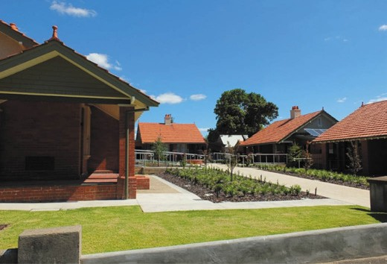

Figure 8.139: Miller Homes, 22A Park Street, Geelong, 2019. Source: David Rowe.
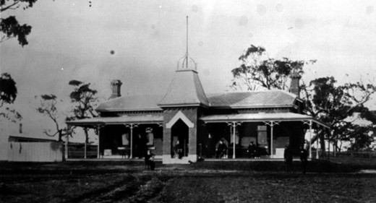
Figure 8.140: United Service Home, Drysdale, n.d. [c.1900]. Source: image 0316, Bellarine Historical Society.
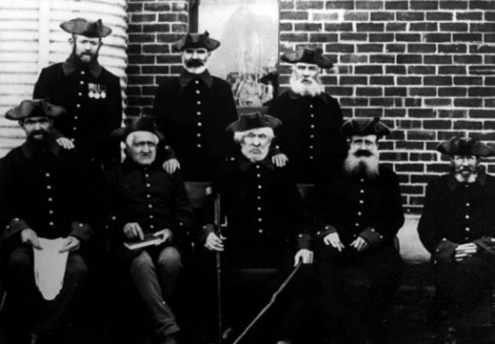
Figure 8.141: War Veterans resident at the United Service Home, Drysdale, n.d. [c.1900] Source: image 0879, Bellarine
Historical Society.

In England the veterans may look forward to Chelsea, where the destitute and decrepit campaigner may at last come to peaceful anchorage; in France, they have the Invalides; most European and American nations maintain a home for their ancient warriors; and in the colonies,
in Victoria, in Melbourne they have what? Well, I understand that some of those who have spent the best years of their lives in voluntarily serving their Queen and country, have found refuge in the Benevolent Asylum.
Others I know of as being inmates of the Immigrants Home, while I hear of yet others who are to be found in Pentridge, charged with no crime save the elastic one of having no visible means of support, who in different words are sent to a common prison by the justices out of charity, and in order to save them starving of the winter s cold.1379
A committee was duly appointed with the Governor of Victoria and Mayor of Melbourne being patrons. Major Albert Purchase, formerly of the Army offered to provide architectural services as honorary architect. To be a small- sized version of the Chelsea and Greenwich facilities in England for pensioners, the initial thinking was for a small but picturesque wooden cottage yet Purchas plan provided for a more substantially built brick but chaste design
noted for its squat tower and pointed arched windows and doors.1380 A site adjacent to the lighthouse at Queenscliff was initially considered, but it was vehemently opposed by the Queenscliffe municipality. Swan Island was also mooted, but it was unsuitable given that the residents would be isolated from the mainland. 1381 Ultimately, the Bellarine Shire Council offered a 6 acre site in picturesque surrounds at Drysdale.1382
The building of the Home soon commenced. The foundation stone was laid by the Governor of Victoria, the Earl of Hopetoun, on 25 March 18911383 and just a little over three months later on 1 July the United Service Home (Figure 8.140) was officially opened by Major-General Tulloch.1384 Eight veterans were selected as the first residents (Figure 8.141).
Jack Alexander Hicks was the first Superintendent.1386 By 1912, over 100 veterans had been resident at the Home but only a few Imperial veterans remained as suitable applicants. During World War One, the Home took in some returning soldiers as a convalescent facility1387 but this ceased in 1917 and with only three residents, the Home closed.1388 In 1926, Richard Grigg leased the property and with his brother, Norman (Theme 2), established a flax mill on the site.1389
It was not to serve its original purpose again.

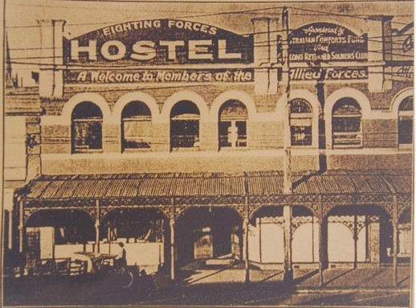
Figure 8.142: Fighting Forces Hostel, 166-176 Ryrie Street, c.1942. Source: GRS 2352/0042, Geelong Heritage Centre collection.

FIGHTING FORCES HOSTEL, 166-176 RYRIE STREET, GEELONG
In June 1942, the Mayor of Geelong, R.C. Theatre, officially opened a Fighting Forces Hostel at 166-176 Ryrie Street (Figure 8.142), following on from the opening of a similar hostel at Toc H, Collins Street, Melbourne, in 1940.1390 The Geelong hostel had been built in 1918 (to a design by Laird and Buchan) as Edward O Connell s Corio Grocery store.1391 Connected with the Yarra Street Methodist Church, and sponsored by the Australian Comforts Fund and supported by the Geelong Returned Soldiers Club, a committee of volunteers had formed during World War Two to provide meals and sleeping accommodation for serving soldiers on leave. Within 16 months of the hostel opening, 21,057 beds had been occupied.1392 Around 1300 volunteers ensured a non-stop service. The hostel closed after the war in June 1946.1393

COMMUNITY ORGANISATIONS

COMMUNITY SERVICES ORGANISATIONS
Fundamental to the development of cultural life in Greater Geelong has been the evolution of variations service organisations, fraternal clubs, charitable institutions and other bodies that left indelible marks on the social fabric of local society in the 19th and 20th centuries. Many
of these organisations have long since disappeared
(such as the Geelong and Western District Ladies Benevolent Association) but there are buildings, landscapes and structures are reminders today of the important roles they played. The following is a snapshot of some of \these organisations.

FIRE BRIGADES

THE INSURANCE COMPANIES FIRE BRIGADE
Prior to the establishment of the fire brigade, informal ‘bucket brigades’ were used to fight fires. This usually proved totally inadequate, although it was successful in the first reported case of a major fire in Geelong in 1842:
On Wednesday evening last, we are sorry to say, the first appearance of that dreadful calamity (from which we hoped to have been exempt for a longer period), the destruction of property by fire, occurred in this township
A number of inhabitants soon assembled, and a supply of buckets and water was procured as quickly as possible
The raging element was subdued much quicker than was anticipated by any of the spectators.1394
Following British precedents, the first Geelong Fire Brigade and the necessary equipment and engine was funded by Fire Insurance Companies. In June 1849, the Melbourne Insurance Company had a ‘first rate, well manufactured fire engine procured for Geelong. The engine included all its appurtenance complete, consisting of hose, canvas and
leather buckets, tomahawks, axes, &c. 1395 It was stationed at the watch house yard at the south-east corner of Moorabool and Corio Streets (see Theme 7).1396 It was in this same article when the Geelong Advertiser reported on the appointment
of Police Constable Frederick Carman as Inspector of the Brigade.1397 Carman had been transported for life from London to Tasmania in 1828 but received a full pardon in 1835.1398 By 1842 he was a District Constable in Geelong where he had developed a virtuous reputation until he was charged for being drunk and disorderly, and assaulting the watch house keeper. He remained a Police Constable in the proceeding years although by 1854 he was a publican in Yarra Street.1399 Other officers were also appointed to
privately-funded brigade including: Thomas Beech (foreman), James Kirby, William Lloyd, Francis Coy, George Wellbank,

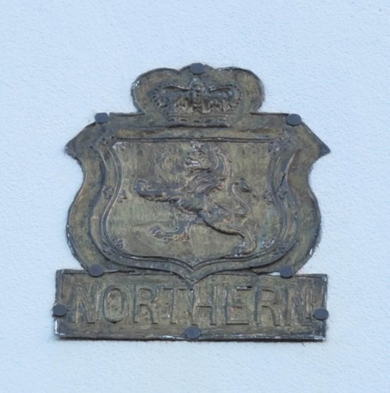
Figure 8.143: Northern Assurance Company Ltd Fire Mark, Gheringhap Street, 2019. Source: David Rowe.

Henry Jiles, Nathaniel Rolffe and William Miller. They were offered £4 per annum (with Carmen receiving £20 per annum and Beech £8 per annum).1400 In addition, each officer was given a belt made to contain a tomahawk and a coil of
rope and a very stout leather helmet to protect the head from falling bricks or other material. 1401 Water carters were given an allowance of £1.10s for the first load, £1.5s for the
second load, 15s. for the third load and 2s. 6d. for succeeding loads.1402
Also following British precedents was the badging of properties with fire marks to identify those with fire insurance policies and the fire insurer. A property was not insured until the fire mark was fixed to the building. Any call out of the brigade to a building without the mark shown resulted in the brigade unable to provide assistance.1403 Today, fire marks in Geelong are very rare, with only one known to survive on a dwelling in Gheringhap Street (Figure 8.143). This two
storey rendered brick dwelling was built in 1858 for Edward R. Morris.1404 The copper fire mark on the front façade displays the Northern Assurance Company Limited, established in 1836 and which commenced business in Victoria in 1855.
The fire mark in Gheringhap Street reflected the company’s third mark type manufactured by Heaton in Birmingham, England.1405

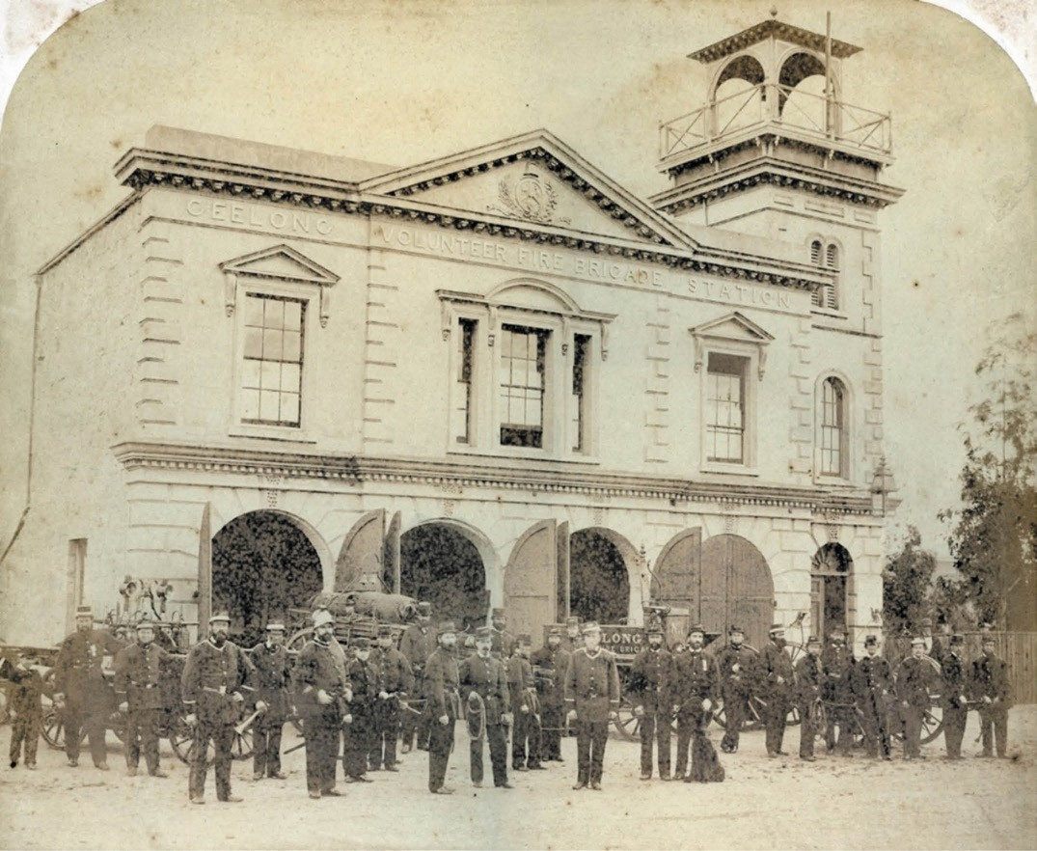
Figure 8.144: J. Norton, Geelong Volunteer Fire Brigade Station, Little Malop Street, 1872. Source: GRS 2009/02200, Geelong Heritage Centre collection.

VOLUNTEER FIRE BRIGADES
Physical legacies of the volunteer fire brigades also exist, either in the current organisations or historic buildings.
In March 1854, the Mayor of Geelong, W.H. Baylie, called
a public meeting for the purpose of forming a volunteer fire brigade.1406 He received unanimous support from those who attended, including J.R. Bailey a former member of the New York Fire Brigade who declared that it became the burden duty of the community to take steps to establish a brigade given the paucity of funds in the Corporation , whilst the paucity of means of the Insurance Companies left the town defenceless. 1407 Rules and regulations were established.
These included the brigade being known as Engineer No.
Company; that the brigade would consist of a foreman, deputy foremen, secretary, engine keeper and not less than 30 or more than 100 Men Volunteers, that every male Citizen shall be eligible to serve as a Volunteer in this Company who is 18 years of age; that every member shall provide himself with the uniform and equipment adopted by the Company; that every member shall assemble at the engine-house within fifteen minutes after the signal of fire has been given at the central station1408 J.R. Bailey was elected the first foreman and George Wright the deputy foreman. Their tenures were short-lived as by November 1854 both had resigned on account of living a distance from the town, precluding them from attending the duties as they would wish. 1409

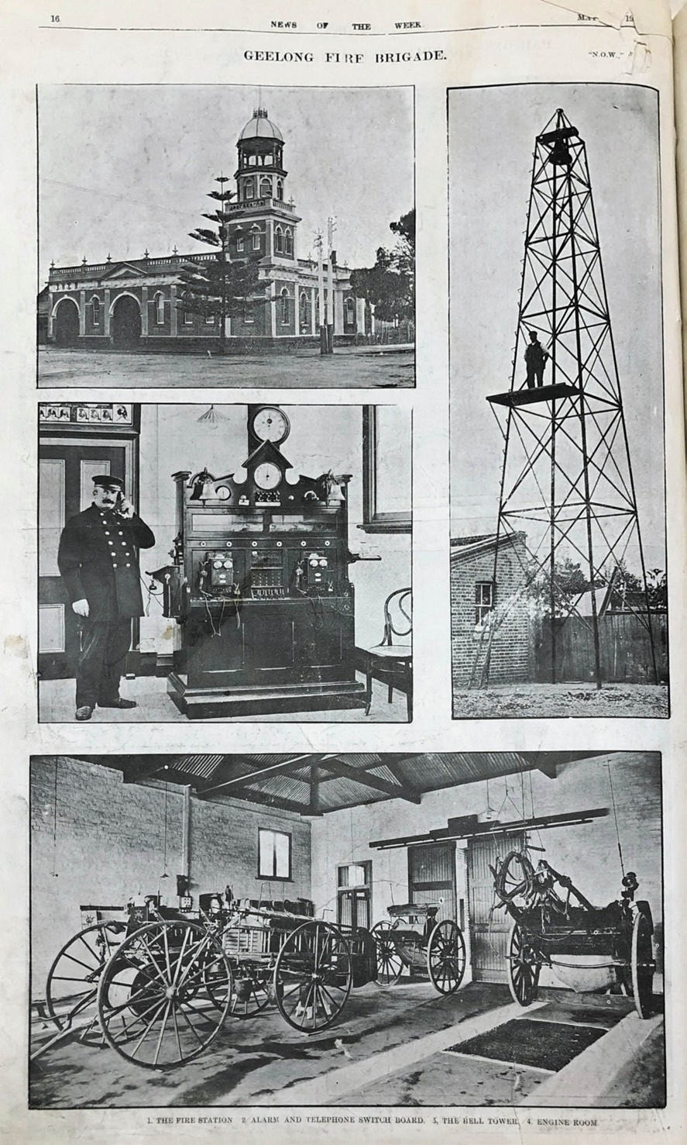
Figure 8.145: Geelong Fire Station, corner McKillop & Yarra Streets, alarm & telephone switchboard, bell
tower & engine room, 1910. Source: News of the Week, 19 May 1910, p.16, GRS 2121/2, Geelong Heritage Centre collection.

In 1855, the Brigade procured an engine from London.1410 In the following year, 1856, local architect Christopher Porter prepared drawings for a new fire station but they were superseded in 1857 with a design by Edward Prowse.1411 This classically-derived two storey building with recessed bell tower (Figure 8.144) was built in Johnstone Park, west of the Town Hall, with a frontage to Little Malop Street.1412
With vandals interfering with the work of the Brigade, including the looting of damaged sites, a Volunteer Salvage Corps was established in 1873 to support the work of the Brigade. The Salvage Corps provided salvage services of property and the protection of life at fires.1413
In 1875, a reel house was erected in Pakington Street, Geelong West, on land provided by Mr Donaghy adjoining his ropeworks. Designed by Mr Ashmore, the small galvanised iron structure housed a reel and was surmounted by a bell alarm, where the alarm could raised and the reel procured closer to the location of the fire than the central station in Little Malop Street.1414 A second reel house was erected in the police reserve ( location of the old police court see Theme 7) fronting McKillop Street.1415
The passing of the Fire Brigades Act in 1890 resulted in the establishment of the Country Fire Brigades Board which had control and responsibility of all fire brigades outside Melbourne.1416 This materially altered the original voluntary, localised brigade system and mandated that only the responsible brigade attend a fire in its district (there being the Geelong, Geelong West and Newtown and Chilwell districts).1417 Property was transferred to the Country Fire Brigades Board and firemen received payment for service at 1s 6d per hour, but the local brigade essentially remained a volunteer organisation.1418
In 1897, the former Geelong Trades Hall site and building at the corner of Yarra and McKillop Streets was transferred to the Country Fire Brigades Board as the location of a new station for the Geelong Brigade.1419 The local architectural firm of Laird and Barlow won a design competition for the new building in 1899 but construction of the conservative
Classical design (which incorporated the earlier Trades Hall building) was delayed for eight years.1420 Described in 1907 as a handsome and substantial brick station to feature a corner bell tower,1421 the station was formally opened on
21 April 1909, by the president of the Country Fire Brigades Board, R. Wallace. He declared that the new building (Figure 8.145) was a sign of the forward march of Geelong to its distinction as the chief seaport town of Victoria.1422
In 1911, fundraising began for the purchase of a new fire engine of the latest type at a cost of £500.1423 Interrupted by the war, it took six years before the new engine

arrived from Ballarat in 1917. It was described by the Geelong Advertiser:
It is small and compact, painted red, with brass fittings, and can seat ten men. The appliances, which are of the latest model, comprise chemical extinguishers, electric lights, and emergency oil lamps, small extension ladder, first-aid cabinet, and sliding drawers to carry 1000 feet of hose. An attachable two-wheel trailer for carrying extra hose completes the outfit. The engine is self-starting, and can be set going at high speed in a few seconds. It will
be used for ordinary fires in place of the horse and cart, which will probably be sent to another station. The old engine at the fire station is big for ordinary fire work, and is seldom used.1424
Between December 1928 and January 1939, bushfires devastated approximately two million hectares across Victoria, destroying over 650 buildings.1425 A recommendation of a subsequent Royal Commission that inquired into measures to be taken to prevent bush fires in May 1939 recommended the formation of a paramount fire authority
for Victoria.1426 This led to the formation of the Country Fire Authority in 1945.1427
On 28 July 1966, a new fire station was officially opened by the Acting Premier, A.G. Rylah. It had replaced the station opened in 1909.1428 This station was also replaced with the existing building complex in 2009-2010.1429

SUBURBAN STATIONS
From the mid-19th century suburban fire brigades were established to meet the demands of a growing population. Regional and rural brigades were also formed in later years in most outlying centres. The following gives an account of
some of the suburban brigades where purpose-built buildings survive, although they no longer serve their original purposes.

NEWTOWN AND CHILWELL
The Newtown and Chilwell Brigade was formed following a public meeting at the Sawyer s Arms Hotel, Noble Street,
in May 1859.1430 Charles Nantes was the first president and there was an initial membership of 30 men.1431 A station
for an engine was attached to the Municipal Chambers in Pakington Street and a detached bell tower was erected (Figure 7.23, see Theme 7). This structure was replaced with a commodious polychrome brick station with landmark bell tower in 1884, the Lombardic Romanesque design being
the work of the Geelong architect, R.S. Tuffs.1432 The new building was well-received, the Geelong Advertiser reporting:
The residents of Newtown and Chilwell can congratulate themselves on the fact that they are the possessors of a

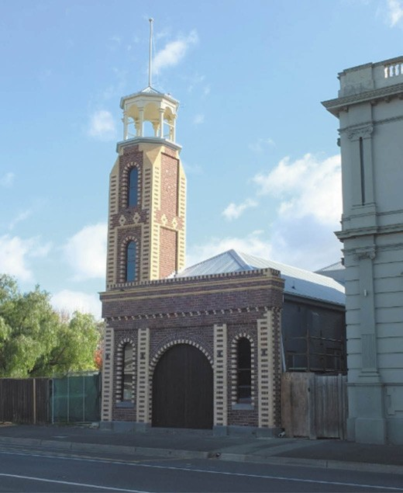
Figure 8.146: Former Newtown & Chilwell Fire Station, 271A Pakington Street, Newtown, 2016. Source: David Rowe.

very handsome Fire Brigade Station in the place of the old building, which was in use for so many years. With the co-operation of the Council, fire brigade members made
a house to house canvas of ratepayers and succeeded in raising a sufficient sum of money to erect a substantial station as well as a bell tower, which commands an
excellent view of the whole town and outlying districts. The station is composed of brick with white facings, the height of the tower is about 45 feet. A new bell has also been hung. The floor is to be asphalted. The building is decidedly attractive and quite an ornament to the borough.1433
In later years of the 20th century, the fire station experienced notable alterations. A larger vehicular opening was added to accommodate the more substantial motorised fire engines and the polychrome brick walls were overpainted. In 2015- 16, the building was carefully restored and the front façade reconstructed to its original design (Figure 8.146).
In addition to the station buildings erected from 1859, the Newtown and Chilwell Fire Brigade also erected reel houses. They were located at Kardinia Park, Geelong; Russell Street, Chilwell; and Aberdeen Street near the Great Western Hotel (the latter was relocated to the front of 23 Margaret Street, Newtown, in 1915, before being decommissioned to the

Protestant Orphanage grounds in 1919).1434

GEELONG WEST
The reel house constructed adjoining Donaghy s ropeworks in 1875 served only as a temporary measure to assist fire services in Geelong West. In 1884, a Geelong West Fire Brigade was formed.1435 Joseph Watts designed a two storey gabled timber station with bell tower in 1886 following an earlier design by Andrew McWilliams in 1885. It was built by Trevena and Gubby in Yuille Street.1436
In 1917-18, a new single storey brick fire station with double arched vehicular openings (Figure 8.147) was constructed at 95 Autumn Street, Geelong West by Dunlop and Hunt Pty Ltd, builders.1437 It is possible that the building was designed by William Tombs (previously of Tombs and Durran architects) as he was in charge of construction branch of Dunlop
and Hunt at this time.1438 Larger motorised fire engines necessitated the removal of the original double arched openings in the 20th century. In 2013 the fire station was sold1439 and in 2019 it was proposed to be used as a caf .

BELMONT
A public meeting was held in Belmont in August 1902 seeking support for the establishment of a fire brigade.1440 Further time elapsed until 1909 when a local brigade was approved by the Country Fire Brigades Board on the proviso that the council or ratepayers provide a serviceable reel house, a
reel and the necessary fittings,’ after which the Board would take over the plant and appoint a detachment of the Geelong Brigade to preform fire duties.’1441 Additional negotiations with the Country Fire Brigades Board led to the formation
of the Belmont Fire Brigade in December 1910 with E. Buck appointed captain, T. McKim appointed lieutenant, C.
Grenfell, foreman and J.J. Abrahams, secretary.1442 A timber station opened in 1911.
In 1930, the existing brick fire station (now a restaurant) was constructed by the local builder, Jack Freeland1443 (Figure 8.148). A dinner, attended by prominent residents, was held to celebrate its completion, with a ball afterwards. The brigade served the community from this station over around
60 years until it was sold by the Country Fire Authority in the early 1990s.1444

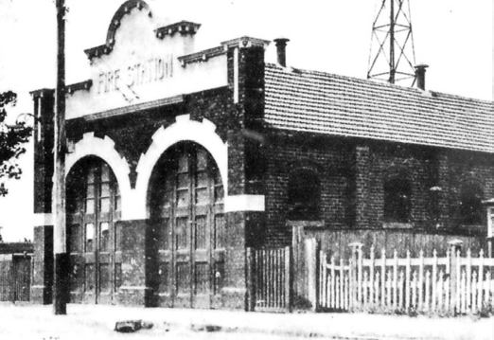
Figure 8.147: Geelong West Fire Station, 95 Autumn Street, Geelong West, 1919. Source: News of the Week, 25 December 1919, GRS 2121, Geelong Heritage Centre collection.

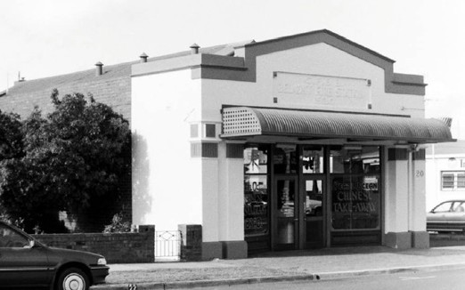
Figure 8.148: Former Belmont Fire Station, Regent Street, Belmont, 1998. Source: David Rowe.

EARLY PROFESSIONAL ORGANISATIONS

GEELONG SOCIETY OF ARCHITECTS, CIVIL ENGINEERS AND SURVEYORS
In 1855, the Geelong Society of Architects, Civil Engineers and Surveyors was formed.1445 The objects of the association were:
The diffusion of Architectural and Scientific knowledge, the promotion of friendly intercourse amongst its members, the establishment as far as may be practicable, of uniform rates of professional charges, and, generally, the maintenance of the dignity and interests of the profession.1446
At that time, most architects were also civil engineers and surveyors, but each field was considered a separate profession. Ordinary members of the association were

persons in regular practice in one of the professions while associates were professional men not in regular practice and honorary members and were persons as may be elected by the Society. 1447
The inaugural committee and membership comprised the all of the local architectural fraternity responsible for the designs of most of Greater Geelong s buildings and structures from the 1840s and in the case of Joseph Lowe Shaw, into the 1890s. The inaugural president was the architect, John Young (who was responsible for the designs of several distinctive brick hotels see Theme 5), with H.M. Garrard, surveyor, as vice president.1448
The honorary secretary was Benjamin Backhouse, who had designed the Wesleyan Mission House at 1 Little Ryrie Street in 1853 (see earlier) and in partnership with William Reynolds, designed the Flinders National School in 1856 (see earlier), Merchiston Hall at 2a Garden Street in 1856 (Themes 6 & 8), former Geelong Grammar School, 55 Maud Street in 1857 (Theme 8) and Trinity Free Church of England (subsequently Church of Christ), Latrobe Terrace, Geelong, in 1858 (see earlier).1449
The balance of the committee included Edward Prowse (who had been in partnership of Edward Snell, engineer in 1854- 55 and who later became the Town Surveyor for Newtown and Chilwell and inaugural Engineer of the Corio Road Board in 1861 Theme 7); Joseph Lowe Shaw (who enjoyed the patronage of the Catholic Church for several design commissions, including St. Mary s Basilica (with Richard Dowden), St. Joseph s Orphanage, Newtown; and Sisters
of Mercy Convent, Newtown (Theme 8); and Walter Ferrier, architect (who designed the Sale Yards Hotel in Church Street, North Geelong in 1853 and the Balmoral Hotel, Fyansford in 1854).1450
The ordinary members were Edward Snell, A.C. Macdonald,
A. McWilliams, Francis B. Bell, Matthew Biddle, F.F. Kawerau, Hector McLean, R.A. Dowden, John Young, B. Backhouse,
E. Prowse, Joseph L. Shaw and W.H. Ferrier, C. Rowand, Alexander Skene, J.H. Taylor, J.R. Shaw, W. Weston, H. Byerly, E. Bage, R. Scott and T.H. Duncan were made honorary members. The associates were A. Murdock, C. Tiffin, F.F. Honey, E. Bryson and J. Robertson.1451
While the Geelong Society was not to endure, its objective of developing an architectural library for the advancement of knowledge by its members1452 was precursor to the Angus
Laird Architectural Library established at the Gordon Institute of Technology in 1927 (see earlier subsection). Moreover, it was from its membership where the most enduring physical legacy continues to exist in the buildings designed in Greater Geelong in the mid 1850s.

GEELONG MASTER BUILDERS’ ASSOCIATION
In 1872, the builders and contractors of Geelong met at the Australian Hotel with the aim of forming an Association.1453 The purpose of the organisation named the Geelong Builders and Contractors Association was to protect the interests of the trade.1454 The first president of the association was Alexander Dick, with William Pepper Emberson as
vice president, Alexander Penaluna as secretary and David Pescott as treasurer. The association began with 14 members.1455 The association appears to have disbanded after the world-wide economic crash of 1890 before re-
forming in 1901 as a consequence of the impending Factories Act and Wages Board which legislated a half-day holiday
for Saturday afternoons and minimum wages.1456 Impetus for reviving the association has especially come from the objection of local builders and contractors to the 25 percent increase in wages legislated by the Wages Board.1457
J.C. Taylor was the inaugural president of the revived association.1458 By 1906, the organisation had become the Geelong Master Builders Association1459

SERVICE CLUBS
Other community organised with a focus towards community service were founded from the 19th century.
A selection of those that endured or where physical evidence of their contribution includes the following.

YOUNG MEN’S CHRISTIAN ASSOCIATION (YMCA), 72-76 RYRIE STREET, GEELONG
In 1847, the first secretary of the London branch of the YMCA, John C. Symons, came to South Australia to serve his probation for the Methodist Church ministry. He went first to South Australia and subsequently to Geelong where he was ordained as a full minister at a District Conference in 1853.1460 During his tenure as minister of the Geelong Circuit between 1850 and 1860, Symons spoke publicly of his involvement in the founding of the YMCA in London.1461 Yet, it was not until 1868 when the Geelong Young Men s Association formed with Robert de Bruce Johnstone as its first president.1462 This Association busied itself giving readings to inmates at the Benevolent Asylum, arranging concerts for charity, providing lectures and holding intellectual discussions, as well as study amongst members.1463 In 1875, the Young Men s Association amalgamated with the Mutual Improvement and Debating Society of the Aberdeen Street Baptist Church to form the Young Men s Christian Association (YMCA) following a meeting at the Gaelic school house convened by the Rev.
Charles Sickerson Yahrah Price, Independent Church Minister.1464 The inaugural president was Robert Gillespie, with C.J. Richardson as secretary.1465

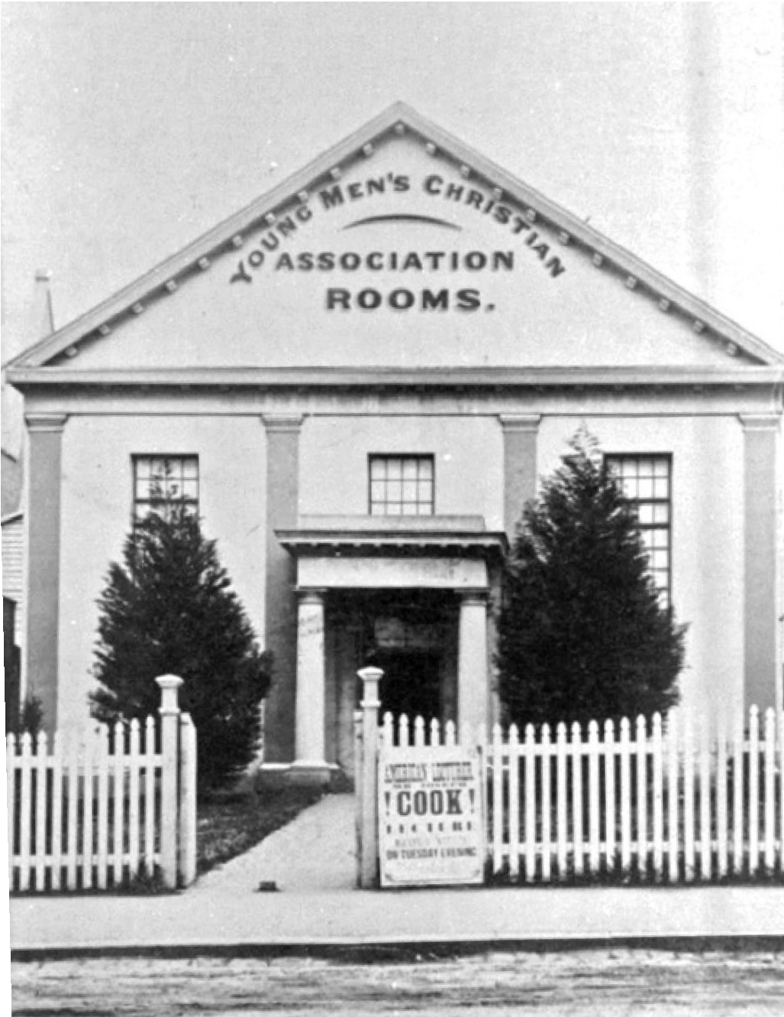

Figure 8.149: YMCA Rooms, 72-76 Ryrie Street, Geelong, n.d. [1875- 1890]. Source: Wynd collection, Authentic Heritage Services Pty Ltd.

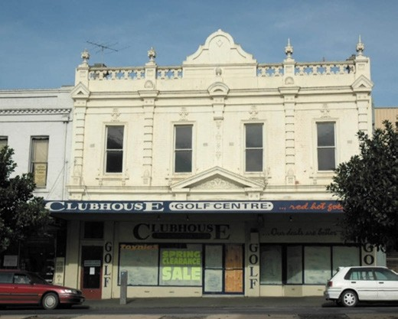
In late 1875, the YMCA acquired the former Independent

Figure 8.150: Former YMCA Building, 72-76 Ryrie Street, 2005. Source: David Rowe.

Church at 72-76 Ryrie Street, Geelong, no doubt with the assistance of the Rev. Price.1466 This church building (Figure 8.149) was to become the centre of the activities for the organisation. Significantly, the YMCA organiser and author of its history, J.T. Massey, claimed that ‘this was the first building in Australia specially constructed or altered for the
Y.M.C.A. in Australia specially constructed or altered for the
Y.M.C.A. programme. 1467 Set back from the front of the site, in 1890 the YMCA commissioned the local architect, A.J. Derrick, to design a commodious and elaborate two storey shops and an entrance for the converted church building1468 (Figure 8.150). A new hall (that was to be named Federal Hall) was erected at the rear of the two storey pavilion in 1892 to a design by Blake and Tombs.1469
The YMCA soon ran into financial difficulties and it closed, selling its building to the Hibernian Club.1470 The hall was converted to the Sun Picture Theatre and later The Strand Theatre.1471 Between 1942 and 1960, the property was leased to the YWCA.1472
Meanwhile, the YMCA was revived in 1953 with the purchase of the former Union Bank at 76 Yarra Street (Theme 5) from the then owner, the Return Sailors and Soldiers Association as the location for its new headquarters.1473 The sale included the adjoining Hall of Honor built by the RSSA (see following subsection). The YMCA held these premises until the early 21st century.

YOUNG WOMEN’S CHRISTIAN ASSOCIATION (YWCA), 32 MYERS STREET, GEELONG
The beginning of the Young Women s Christian Association commenced in 1875 when the Rev. C.S.Y. Price called on
a secretary to be appointed for the newly-formed YMCA so that he could be free to organise the Geelong Young Women s Christian Association. 1474 This was the first
YWCA established in Australasia.1475 The Association gave a donation towards the YMCA building fund in 1879 and
it seems to have carried on quietly in subsequent years until it was reorganised in September 1886 through the instrumentality of R. Race-Lewis.1476
In 1906, the YWCA opened a boarding house in Corio Terrace (Brougham Street) overlooking Corio Bay.1477 There, they accommodated twelve boarders who were educated, with cookery classes being held in the winter months. Other activities included Sunday Bible class, employment agency services, weekly meetings at the Benevolent Asylum, monthly meetings at the female refuge and occasional sewing meetings (for the making of garments for the hospital and the African Industrial Mission).1478
In 1915, the United Presbyterian Manse at 32 Myers Street was purchased as a YWCA girls hostel (see earlier

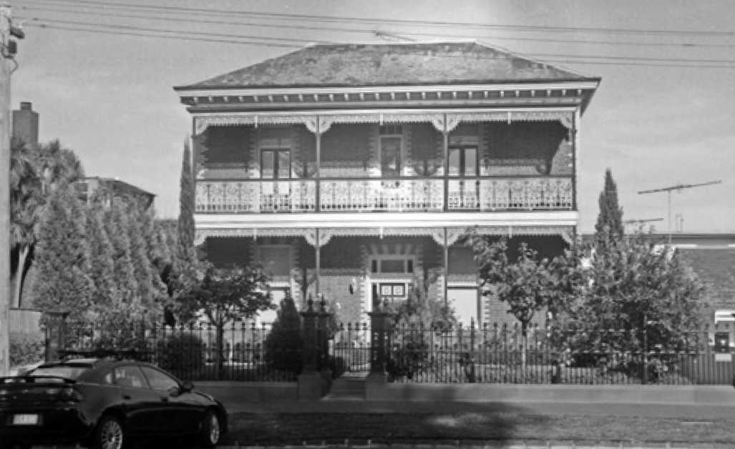

Figure 8.151: Former United Presbyterian Church Manse & YWCA Hostel, 32 Myers Street, c.1990. Source: Wynd collection, Authentic Heritage Services Pty Ltd.
subsection for historical details on the manse)1479
(Figure 8.151). Mrs Davidson was a staunch advocate for females in unfortunate circumstances, having served as president of the Geelong Biblewomen s Association and Female Refuge in 1881, and a campaigner for the reopening of the refuge at North Geelong at this time.1480 The former manse remained a YWCA hostel until 1973.1481 The YWCA Geelong branch continues to the present day, working in mentoring, education, children and women s housing. 1482
Throughout the 20th century, the YWCA occupied rooms at the Hibernian Club at 72-76 Ryrie Street. By 1961, it had built new premises at 19 Aberdeen Street, Newtown.1483

NATIONAL COUNCIL OF WOMEN OF VICTORIA (GEELONG BRANCH) & OTHER WOMEN’S
ORGANISATIONS
In 1901, the Tocsin newspaper in Melbourne reported on the question of granting voting rights for women in the Victorian State Parliament.1484 The fledgling Commonwealth Government had enacted the Commonwealth Bill that prevented the restriction of the franchise already existing
in any Australian State. Women in South Australia and Western Australia already had the right to vote, but they were excluded in New South Wales, Queensland, Tasmania and Victoria.1485 This gave impetus for a meeting to be held in the drawing room at Cliveden , East Melbourne, the residence
of Lady Janet Clarke for the purpose of forming a branch of the International Council of Women in 1902. The Council had been first established in the Chicago, U.S.A., in 18941486 and it was an association representing all other associations with which women are connected. 1487 The objective of the Victorian branch reflected those of the English body: to
establish a bond between various affiliated societies; advance the interests of women, children and humanity in general; and confer on questions that related to the welfare of family, state

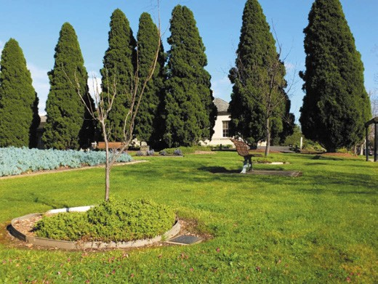
Figure 8.152: Commemorative trees (foreground & middleground) in Moorak Park, Newtown, marking the 40th & 60th anniversaries of the Geelong branch of the National Council of Women, 2019. Source: David Rowe.
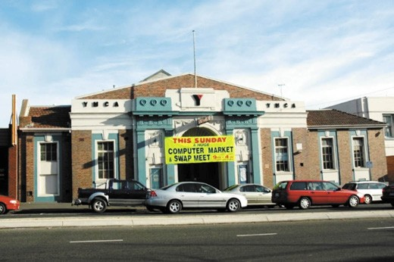
Figure 8.153: Former Hall of Honor, Yarra Street, 2005. Source: David Rowe.

and commonwealth.1488 It was not until 1944 when a branch of the Council was established in Geelong and it continues to the present day.1489 In Moorak Park, Noble Street, Newtown, two trees planted in 1984 and 1994 mark the 40th and 60th anniversaries of the Geelong branch (Figure 8.152).
Other associations were established Geelong specifically for women before a branch of the National Council of Women was formed. They included the Geelong branch of the Women s National League in 1903 with Mrs Enid Mary Douglass (nee Webster) elected the inaugural president.1490 This League was founded to protect the interests of employers in opposition to state interference
with private enterprise, or any other form of socialism. 1491 It was anticipated that the League would be influential once women were entitled to vote in 1908. A more enduring and

philanthropic organisation formed in 1928 was the Country Women s Association (CWA) of Victoria.1492 A branch in Geelong was established in 1933 with Mrs Kelly the first president; Miss Grice, vice president; Miss White secretary; and Miss R. Purnell, treasurer.1493 After the death of Robert Thear, former Councillor and Mayor of Geelong in 1962, the CWA Geelong branch acquired his Edwardian residence, Kainga , 67 Aberdeen Street, Newtown (built in 1904) as its clubrooms.1494 The CWA had occupied Kainga by 1965 as it was listed in Sands & McDougall s Directory of Victoria at this time.1495 The CWA remained at 67 Aberdeen Street until 2002 when the property was sold and the Association moved to
the former Church of Christ church, 174-176 Boundary Road, Thomson (built in 1964) where it continues to the present day.1496

RETURNED SERVICES LEAGUE, GEELONG
The Returned Sailors and Soldiers Imperial League of Australia (RSSILA) as it was originally called has played a fundamental role in honouring the memory of the fallen and establishing welfare services for sick and wounded returned servicemen and their dependants.1497 Created in June 1916 by troops returning from the First World War at a conference of representatives from across Australia,1498 its principle aim was to preserve the spirit of mateship formed amidst the carnage and horror of battle , together with honouring the fallen and assisting those in need.1499 A Geelong branch was formed on 15 August 1916 with Lieutenant G. Sandford as the first chairman and V. Palmer as secretary.1500 A clubroom was opened at 21 Moorabool Street in September of that year.1501
In 1917, the RSSILA Geelong branch purchased the former Union Bank at 76 Yarra Street. While a substantial building, the former bank did not possess a large hall space for large meetings and social events to be held for its members. In 1929, the local architects, Norman Schefferle and J.G. Williams designed a brick, interwar Classical styled Hall of Honor1502 (Figure 8.153), the central bay and entrance portico being derived from Menin Gate War Memorial in Ypres, Belgium, unveiled on 24 July 1927 in dedication to the British and Commonwealth soldiers killed in the Ypres Salient in World War One.1503 Construction was delayed due to construction costs and the Great Depression, the Hall of Honor being officially opened on 6 June 1933 by E.J. Fairnie.1504
The Hall of Honor and former Union Bank remained the headquarters of the Geelong branch until the RSL sold the properties to the YMCA in 1953.1505 The branch reformed as an RSL Recreation Club, taking over the old lawn tennis
courts of the Geelong Lawn Tennis Club in Brougham Street, becoming the home of the RSL s bowling greens. Today, the Geelong RSL is situated in late 20th century premises at 50 Barwon Heads Road, Belmont.

Other early buildings associated with RSL sub-branches include the Drysdale RSL at 13 Princess Street (located in the former Presbyterian School house built in 1853) (Theme 6); Lara RSL, 2 Rennie Street (situated in the former Corio Shire Hall built in 1864 (Theme 7) and the Portarlington/
St. Leonards RSL, 8 Harding Street (located in the former Colonial Bank of Australasia built in 1888) (Theme 5).
Other RSL sub-branches include those at Ocean Grove/ Barwon Heads and Norlane.
Another active service organisation is the Geelong and District Vietnam Veterans Association established after the cessation of the Vietnam War in 1975.1506 The aim was to retain the camaraderie returned soldiers had experienced in Vietnam, and to enable marches independent of other service groups at ANZAC Day services.1507 This was a time when the sacrifices of the Vietnam veterans was not fully appreciated and respected.1508 The Association has a Vietnam Veterans Centre at the rear of Osborne House, Swinburne Street, North, Geelong, which includes an office and museum.1509

APEX CLUB, GEELONG
On 10 March 1931, the Geelong Young Business Men s Club was founded by John Buchan and Ewen Laird of the
architectural firm of Buchan Laird and Buchan, and Langham Proud.1510 It was a movement for young men to provide community service in response to the Great Depression that had deeply effected the financial, physical and psychological well-being of many citizens.1511 Impetus came from the limitations of the local Rotary Club which allowed only one representative from each business, professional body and community organisation for membership.1512 The new Apex Club only limited membership to 100 male persons between the ages of 18 and 35 (later change to between the ages of 18 and 40 years).1513 Aligned with the constitution of the Rotary Club, several Geelong Rotary members also joined the Geelong Young Business Men s Club.1514 This resulted in the name of the organisation being changed to Apex
Club, the close associations with the Rotary Club remaining, with Apex Club members often becoming members of Rotary once reaching the age beyond allowable Apex
Club membership.1515
The work of the Apex Club involved tree planting for City beautification, sponsoring migrants to Australia after World War Two, supporting medical research, and more localised projects including constructing playgrounds and mowing lawns.1516 The Club also had an enduring commitment to the Bethany Babies Home in tidying the grounds and assisting with the building of a kindergarten in 1952.1517
By the 1980s, the Apex Club had reached its peak, having grown to over 800 clubs with 18,000 members throughout

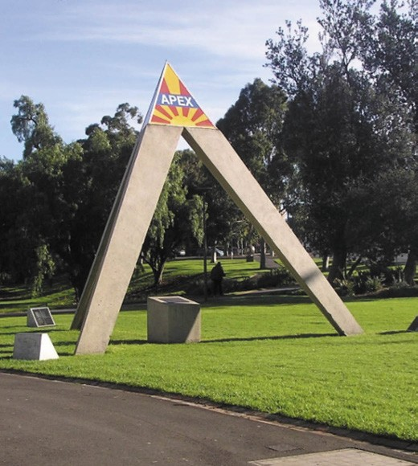
Figure 8.154: Apex monument, Johnstone Park, 2019. Source: Pam Jennings.

Australia, as well as branches in India, Fiji and South East Asia.1518 In 1981, the Geelong Apex Club was known as Club 1, District 1, Zone 1, member of the World Council
of Young Men s Service Clubs. 1519 The Club held its Jubilee Convention in Geelong that was opened by the Prince of Wales.1520 On 7 March 1981, a plaque was unveiled by the Mayor of Geelong, D.J. Podbury in the presence of the Apex founders, Sir John Buchan, C.M.G., Ewen Laird, C.B.E. and Langham Proud, C.B.E. The plaque was associated with
an Apex monument (Figure 8.154) erected in the north-east corner of Johnstone Park. The triangular form reflected the Apex Club s symbol, and represented service, fellowship and citizenship. It incorporated the rays of the rising sun to depict young men willing to rise up and help others.1521

FRATERNAL, SOCIAL FRIENDLY ORGANISATIONS
Prolific in Geelong from the mid-19th century were fraternal and friendly societies following British precedents, being arranged and named as Orders. Fraternal orders involved male organisations, and often included religious, chivalric orders, guilds or secret societies. Friendly societies often included men and women. They included freemasonry, temperance and mutual benefit societies. They were highly influential as part of local community
life, providing intellectual, philosophical and social direction in people’s lives, with mutually beneficial and charitable aims.1522
FREEMASONRY¹⁵²³
An equally popular secret men s society established in Geelong from the early 19th century was freemasonry.
It formed part of a long freemasonic history that stretched back thousands of years. In the medieval age, operative masons belonged to a trade and craft organisation that had their special mythical history which emphasised the importance of their craft. Initially, they met in a lean-to workshop on the construction site, but this in time became
a separate room or building known as the Lodge. This early period of Masonry contributed important aspects of later, speculative forms of the Craft (as it was called), including social welfare (benevolence), social events, religious and political tolerance and the necessity for high moral standards. Freemasonry was initially based on the Old Charges, being the Constitutions of Masonry - the historical and regulatory manual of the Craft. They prescribed the seven liberal sciences (Grammar, Rhetoric, Logic, Arithmetic, Geometry,
Music and Astronomy) as critical to the development of the Craft. Geometry was especially significant, because it
was equated with Freemasonry. The Old Charges provided numerous theories about the origins of masonic-geometric legend. The most recognised was from the Cooke MSS, which claimed that the Craft was founded by the sons of Lamech mentioned in Genesis in the Bible. Lamech s eldest son Jabal supposedly founded geometry and he
and his brothers scribed their findings on pillars of stone (known as Jachin and Boaz), to withstand fire and flood. One was later thought to have been discovered by Pythagoras, the other by Noah s grandson, Hermes Trismegistus. From these pillars Pythagoras and Hermes educated humankind and
so Freemasonry-geometry was spread to other lands, and especially to Egypt where Euclid became the master of all the sciences. Masons believed that in later years in Jerusalem, King David and his son Solomon had masons build
Solomon s Temple. Legend was that Masons from around the world were involved in the Temple s construction and it became recognised as the first true Lodge of Freemasonry. By the 16th century, Freemasonic organisations accepted

honorary members who did not practice the Craft in the physical sense. Speculative Freemasonry was thus established, which continues to the present day.

THE GEELONG LODGES
Two masonic lodges were formed in Geelong in the 19th century: Unity and Prudence No. 801 constituted by the Grand Lodge in London in 1847, and the United Tradesmen s Lodge No. 366, established in 1853 and register with the Grand Lodge of Scotland.1524 The Foundation Master of this latter lodge was George Selth Coppin (1819-1906), an actor who had a theatre company in Geelong and was elected a Member for the Legislative Council from 1858 until 1863.1525 This Lodge closed in 1880 and a number of members joined the Unity and Prudence Lodge until 1890 when the St.
Andrew s in The South Lodge No. 149 was consecrated. This Lodge erected a new Federation Classical Revival styled Hall (Figure 8.155) at 20 Little Ryrie Street in 1902, to a design by local architect and Lodge member, Bro. J.A. Laird.1526
It served the Lodge for most of the 20th century until the Lodge acquired the Uniting Church at 25 Regent
Street, Belmont, in 1999, it becoming the Geelong Masonic Centre.1527
Other Lodges were established in Geelong in the ensuing years: Arlington Lodge No. 182, Portarlington (1899); Corio Lodge No. 193 (1904); Kardinia Lodge No. 253 (1919); Bareena Lodge No. 398, Newtown (1925); Moorabool Lodge No. 4121 (1926); Moorpanyal Lodge (1929); and Lara Lodge
No. 834 (1963).1528

GEELONG UNITY AND PRUDENCE LODGE
The most enduring Lodge in Geelong has been the Unity and Prudence. Its gestation began in 1847 when twelve Freemasons of Geelong petitioned the Grand Lodge in London to form a Lodge.1529 The petition was led by Richard Forrest, an auctioneer from Ireland who reverted to his former occupation as an accountant on arrival in Geelong,
before taking the appointment as Government Auctioneer.1530 Also listed on the petition were William Timms, Abraham Levy, T.W. Downie, Rev. Andrew Love, W.F. Hillyard, R.D. Shepherd, Henry Lawler, Josiah Austin, W.C. Haines, John Shepperd and P. Philips.1531 A warrant declaring Unity and Prudence Lodge No. 801 was subsequently issued and the first meeting of the Lodge occurred at the Royal Hotel (now the former Royal Mail Hotel), 17 Yarra Street, on 26 October 1848.1532 Forrest was installed as the inaugural chair.1533
In 1850, a Masonic Hall had been established in Union Street when Bro. Faircloth, a banker was installed as Worshipful Master for the second time.1534 The Unity and Prudence Lodge which shared the Hall with the United Tradesmen s Lodge - relocated to the rear portion of the former office of

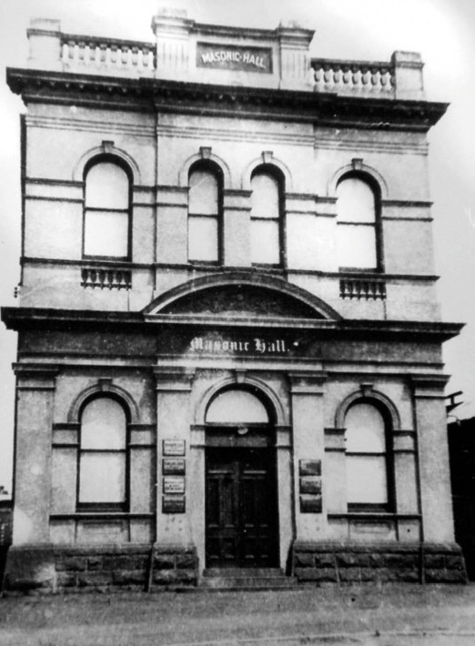
Figure 8.155: St. Andrew s in the South Masonic Lodge, 20 Lt Ryrie Street, n.d. (now substantially altered). Source: Authentic Heritage Services Pty Ltd.

the Geelong Advertiser and Register west of Clare Street in 1871. The new Lodge Room had been prepared for the United Tradesmen s Lodge (with both lodges continuing to share accommodation) and was dedicated in February 1872.1535
By the 1880s, the Unity and Prudence Lodge had prospered and boasted a substantial membership.1536 Some notable figures initiated into the Lodge included Thomas Austin of Barwon Park, Winchelsea; Charles Brownlow, Victorian Football League administrator, Geelong (Theme 9); Alexander Fyfe, entrepreneur, Mount Duneed (Themes
2 & 6); George Gardiner, tannery owner, Marshalltown (Theme 5); John Alexander Gregory, solicitor (Theme 5); James Harrison, newspaper proprietor, Geelong (Themes 3 & 9); William Humble, iron foundry owner and inventor
(Themes 3 & 5); Frederick Kawerau, architect (Themes 3 & 6); John Angus Laird, founder of Laird and Barlow architects, Geelong; Alexander Parker, ironmonger, Geelong (Theme
5); Ward Nicholson, iron foundry owner, Geelong (Theme 5), Frederic Pincott, solicitor (Theme 5), Dr Forster Shaw,

medical practitioner, Geelong (Theme 8), Joseph L. Shaw, architect, Geelong; Edward Snell, engineer, Geelong (Theme 3); William Stott, jeweler, Geelong (Theme 5); John Wadelton, chemist, Geelong; James Wilson, horse trainer, St. Albans (Theme 4) and John Young, architect, Geelong.
The expanded membership resulted in the need for a more commodious Masonic Hall. In 1887, most of the Lodge members formed a Limited Liability Company and purchased a three storey Renaissance Revival styled building in Yarra Street (built in 1853 by Edward Davidson) and alterations were made.1537 This remained the home of the Unity and Prudence Lodge for the next 40 years.
In 1888, the Worshipful Masters and Past Masters of the Lodges under English, Irish and Scottish Constitutions met in Melbourne and resolved to form a United Grand Lodge of Victoria.1538 This transpired and the Geelong Unity and Prudence registered as No. 5 Lodge.1539
For several years, the brethren of the Unity and Prudence Lodge desired more comfortable and appropriately ventilated premises. Two of the Lodge s architect members, Bro.
J.A. Laird and Bro. Percy Everett were request to prepared designs and estimates for alterations to the existing masonic hall in Yarra Street, and a second scheme for a completely new hall.1540 A report was presented in 1920 and a decision was made to alter the existing premises.
Nothing eventuated and in 1925, land at 78 Gheringhap Street, Geelong, was purchased as the site for a new temple.
Designs were carried out by the three architect members in conjunction, Laird, Everett and young architect, Harold Trigg.1541 The foundation stone was laid on 30 November
1926 by the Worshipful Master, Bro. William Herbert Smith.1542 The Geelong Advertiser gave a detailed description of the proposed edifice:
The new building being erected at the top of the hill in Gheringhap street, for the Geelong Lodge of Unity and Prudence, promises to embody features which have not been introduced in previous structures for similar
purposes. The main façade will be three stories in height, the details being in classic style, with a central entrance porchway in Roman Doric, surmounted by a large arched window with an enriched curved cornice above. The usual stuccoed exterior has been discarded in favour of
a special manganese face brick with cement ornament in keeping with the symbolic proportions of the Temple.1543
The new masonic hall (Figure 8.156) had opened by 1928.
The design of the temple reflected the architects’ intellectual understanding of the freemasonic doctrine. John Angus Laird (1862-1936) had enjoyed the patronage of some of
the Freemasonic fraternity for many years. In addition to

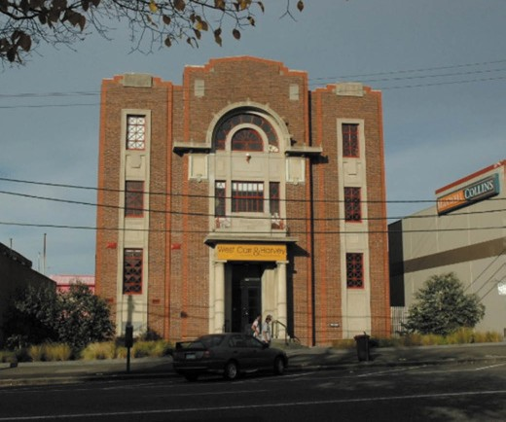
Figure 8.156: Former Unity & Prudence Masonic Lodge, 79 Gheringhap St, 2005. Source: David Rowe.

being commissioned by the St. Andrews in the South Lodge to design the masonic hall in Little Ryrie Street in 1902, at least 18% of the work of the architectural firm of Laird and Barlow during the formative years of this practice (1890-1911) emanated from his freemasonic brethren.1544 Percy Edgar Everett (1888-1967) was the son of the blacksmith and coach builder, Joseph Everett. Percy Everett trained in architecture at the Gordon Technical College and in 1934 was appointed Chief Architect of the Victorian Public Works Department.1545 The youngest of the architectural trio, Harold Trigg trained
in architecture at the Gordon Technical College until the outbreak of war when he served in the A.I.F. On his return he was briefly appointed a lecturer at the Gordon but he soon went to Sydney to work with the architect, Major-General Sir Charles Rosenthal, former Geelong local, freemason and recently-returned commander of the Second Division of the A.I.F.1546 Trigg returned to Geelong and sat the examination for admission to the Royal Institute of British Architects, the first Geelong architect to do so.1547 He worked for the firm of
Laird and Buchan architects before taking up the appointment as Associated Chief Architect of the Public Works Department in West Australia in 1928.1548
The Geelong Unity and Prudence Lodge remained at its Gheringhap Street temple until 1999 when it was sold and the Lodge relocated to the Geelong Masonic Centre in Belmont.1549

TEMPERANCE ORDERS AND FRIENDLY SOCIETIES
The European colonisation of Geelong in the mid 1830s came at a time of proud social and economic transformation as a result of the industrial revolution. A sober and disciplined workforce was required if the fledgling outpost in the Colony of New South Wales was to thrive. Evangelists helped to increase the moralistic arguments against drunkenness.1550 Emanating from the United States with the Massachusetts Society for the Suppression of Intemperance being established as the first society opposed to drunkenness in 1813, the movement soon spread to Britain and its colonies through the positive evangelical doctrine of salvation.1551 Societies were formed and members pledged to abstain from spirits.1552
The temperance movement was especially active in Geelong from the early 1840s, one of the more prominent being the Corio Total Abstinence Society founded in 1844.1553 The founder was George Wright1554 who went into partnership with the architect/builder, Walter Sheridan in 1850, and together they design a temperance hall and school house at the
rear of St. Mary s Catholic Church, Yarra Street, in 1851.1555 The growing enthusiasm for the virtues of a temperance life led to the building a temperance hall for the Geelong
Total Abstinence Society in Little Malop Street in 1858 (now demolished). Its president was Charles Read.1556
By 1879, the temperance and friendly societies in Geelong were in abundance. The Independent Order of Good Templars was represented by the Geelong United Lodge (Geelong) and the Pride of the Valley Lodge (Chilwell).
The Corio Lodge of the Australian Total Abstinence Alliance had continued, with meetings in the People s Church , Yarra Street.1557 The benefit societies were represented by the Independent Order of Oddfellows, Ancient Order of Foresters, Manchester Unity Independent Order of Oddfellows, Geelong Lodge of the Order of St. Andrew, St. Patrick s Society and the Independent Order of Rechabites.1558
Today, the temperance and friendly society movement has long disappeared but physical legacies remain in the former coffee palaces and some of the temperance and friendly society insurance buildings that are landmarks in central Geelong (Theme 5). Physical evidence also especially exists in purpose-built former temperance and unity halls
alternatives for bars and hubs for social activities that promoted good temperance. The earliest was the former Barrabool stone temperance hall in McCann Street, Ceres, built for the Barrabool Total Abstinence Society in 18611559 (Figure 8.157). It was closely associated with the Wesleyan Church across the road, with both organisations following

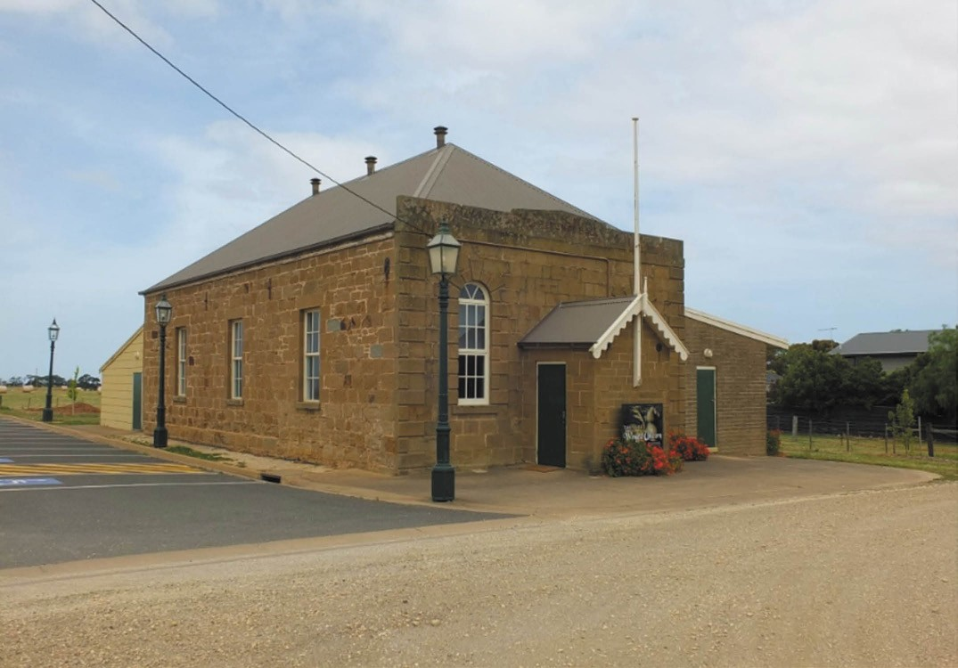
Figure 8.157: Former Temperance Hall, McCann Street, Ceres, 2016. Source: David Rowe.

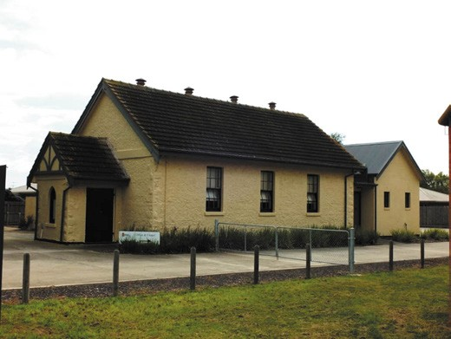
Figure 8.158: Former Temperance Hall, 1B Flinders Avenue (Forest Road North), 2012. Source: David Rowe.
the precepts laid out in the Wesleyan Chronicle and Victorian Miscellany Journal in 1857:
you can choose good companions and shun the bad; or you can refuse the good, and choose the evil.
You can easily foster habits of intemperance and irreligion or you can avoid the hotel, and repair to the House of
God.1560
In 1868, a gabled timber temperance hall was built for the Corio Division of the Sons of Temperance in Fenwick Street, Geelong (on an allotment at the corner of Fenwick and Ryrie Streets).1561 It served for 10 years until a commodious new hall was constructed in 1878.1562 The building was considered to be more substantial and prettier than the one in Fenwick- street. 1563 It was erected by one of the temperance sons ,
Br. Pittock.1564
At Lara, the You Yangs No. 21 Division of the Sons of Temperance built a limestone hall in 1869 at 1B Flinders Avenue (now part of the Uniting Church complex)

(Figure 8.158). Formed in 1865, the first Trustees were James English, James Blair, Charles Olive, William McClelland and Joseph Kirk.1565 Until 1886, the temperance hall also served as a community hub.1566
In 1874, the Portarlington Division of the Sons of Temperance opened a brick hall at 28 Brown Street. It was the earliest temperance hall built on the Bellarine Peninsula. Since 1899, it has been used by the Arlington Masonic Lodge.1567
In 1878, the old temperance hall of the Corio Division of the Sons of Temperance in Fenwick Street was relocated to Westmoreland Street, St. Albans Park, as the hall of the Concord Division of the Sons of Temperance. It was
described as being 40 feet by 24 feet in dimensions, 16 feet high, and has a slate roof. 1568

MANCHESTER UNITY FRIENDLY SOCIETY
In April 1846, Stephen Duggan of the Commercial Inn, Geelong, announced that a meeting of the Independent Order of Oddfellows (IOOF) of the Manchester Unity was to be held at his hotel for the purpose of opening a new lodge, as the Grand Master is here for that purpose. 1569 Dr Augustus Frederick Adolphus Greeves had recently been appointed the first Grand Master of the Manchester Unity IOOF in Melbourne.1570 This fraternal Order was founded in
Manchester, England, in 1810, a response to the elimination of trade Guilds that once provided social and financial support for the working classes.1571 The IOOF Manchester Unity resulted in a separation from the old Grand United Order.1572 In addition to its similar rules and traditions as the temperance Lodges, the IOOF society was a centre
for social life and also provided other benefits.1573 They were the predecessors of the trade unions, and the co-
operative system of subscriptions provided different financial benefits.1574 This included doctor’s fees and sick benefits, and later subsidies on medical prescriptions (which led to the establishment of the United Friendly Societies Dispensary) and in the provision of insurance policies in later years.
The first meeting of the Loyal Geelong Lodge occurred
on 22 June 1846 at the Commercial Inn. The first presiding officer and chief agent was Simeon Price (c.1808-1896) who maintained almost throughout the 58 years of its existence the liveliest interest in its progress. 1575 Four men were initiated into the Lodge at this time: Bros. Winstanley,
Hughes, Phillips and Duggan.1576 By 1847, the Loyal Geelong Lodge boasted 50 members and was about to form Lodge No. 2.1577
Physical evidence of the IOOF Manchester Unity survives in the contextually elaborate, two storey, Free Classical

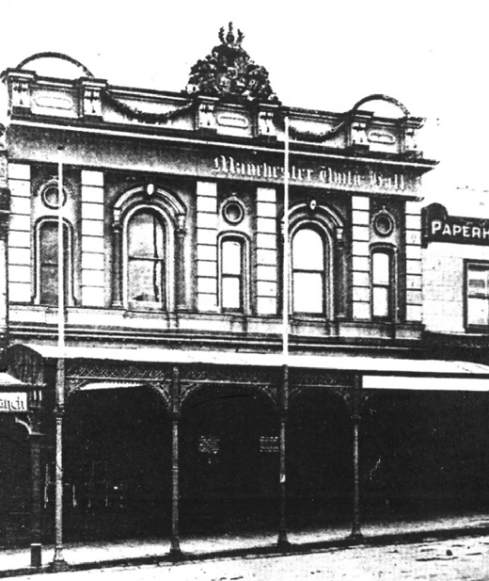
Figure 8.159: Manchester Unity Hall, 215-217 Moorabool Street, c.1910. Source: News of the Week in G. Butler & Associates, City of Geelong Urban Conservation Study: Significant Sites’.

Revival former Manchester Unity Hall at 215-217 Moorabool Street. Reflecting the height of the financial success of the organisation, the southern portion was built as a substantial alteration and addition to an earlier wine and spirit store
in 1868 to a design by little-known local architect, William Grundy.1578 The northern portion was built in 1893 in a seamless design similar to the original building by Laird and Barlow (Figure 8.159), following a fire in an earlier building on this portion of the site which also damaged the original IOOF Lodge Room.1579 The IOOF Manchester Unity maintained ownership of this building until 1921 when it was sold to the Church Missionary Society.1580

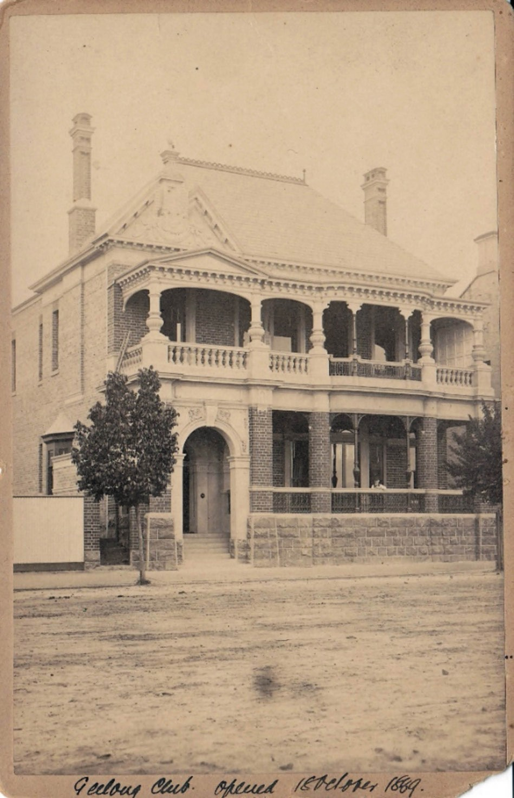

Figure 8.160: Geelong Club, Brougham Street, n.d. Source: Norman Houghton, archivist, Geelong Club.

THE GEELONG CLUB, BROUGHAM STREET, GEELONG
In 1858, Geelong wool brokers and their Western District clients and legal advisors considered the establishment of a social club for Geelong and Western District gentlemen.1581 To be known as the Western Club, its purpose was the advancement of social interaction amongst the gentlemen of Geelong and the Western District. The Club began in February 1859 following a meeting at Mack s Hotel.1582 The
inaugural president was James Ford Strachan, M.L.C. (Theme 6) and its first members were notable figures of Geelong
and district including Joseph de Little, Donald Bell, Robert Reed, John Calvert and Charles Sladen.1583 Premises were subsequently leased at 72 Yarra Street for the provision
of reading, dining, billiard, smoking and sleeping rooms.1584 The initial enthusiasm for the Club soon waned and it was wound up in the 1860s before being revived in 1881 due
to the influence and direction of E.H. Lascelles (Theme 5). Meetings were held at the Geelong Coffee Palace (formerly Mack s Hotel) in Corio Terrace (now Brougham Street) before acquiring a site in Corio Terrace on which to build a clubhouse.1585 The following year, 1888, the Club engaged
the Ballarat architect, Charles Figgis, to design the two storey building (Figure 8.160) and while under construction in 1889 it was considered to be a pretty one and safely be inferred
that the structure will be an ornament to the town, and present a very handsome front to the foreshore of Corio Bay. 1586 The selection of Figgis as architect for the design was most likely the result of the Ballarat architect having prepared the design of the Ballarat Club at 203 Dana Street, Ballarat, in 1872.1587 The building was officially opened on 18 October 1889.

UNION MOVEMENT
The Separation of Victoria from New South Wales in 1851 brought on the need for new infrastructure. The gold rush that began soon after led to a building boom requiring skilled workers.1588 This was a progenitor for the formation of several trade associations and operative societies that as collectives, aimed to protect the interests of their colleagues along similar lines as the IOOF Manchester Unity and the temperance Lodges. Financed by subscriptions, workers were to receive financial support when sick and for funeral costs. One of the earliest established in Geelong was the Operative Bakers of Geelong in 1854. They announced in the Geelong Advertiser and Intelligencer the following:

To Bakers
The Operative Bakers of Geelong wish to notify to their employers that having long felt the want of a House of Coal on the same principle as those established in the old country which have provided so beneficial to master and man, they have therefore formed themselves into an Association for that purpose; and Employers will save themselves much trouble and inconvenience by applying at the Society House, where a slate will be kept at the Bar, with the names and residences of all men out of employment; and none but good and steady workmen will in future be admitted, and the Rules will be strictly observed for the good of all.1589
More profound and enduring was the Operative Stonemasons Society of Geelong, inaugurated on 21 April 1856.1590 Unlike the Speculative masons
(of freemasonry), the Operative Masons were working stonemasons. Within two weeks, the Geelong Society proposed the amalgamation of its similar Society in Melbourne to provide greater weight to what was called the Eight Hours Movement. Similar Societies had formed in Portland, Bendigo, Ballarat and Adelaide.1591 The campaign for an eight hour working day had begun in Melbourne two months earlier by James Stephens and James Galloway, both experienced unionists from the United Kingdom with
exposure to social reforms there led by Robert Owen, a Welsh manufacturer who coined the slogan of eight hours labour, eight hours recreation, eight hours rest. 1592 Success came with the official sanctioning of the eight hour working day for the Operative stonemasons after striking in the construction of the Victorian Parliament House, Melbourne.1593 This major industrial reform was celebrated with a procession between the Carlton Gardens and the gardens in Richmond.1594 This began the popular annual event, extending beyond Melbourne to Geelong from 1881, with celebratory processions through the streets of Geelong and along Ryrie Street (Figure 8.161) to the cricket and football ground in Eastern Park.1595
The success of the eight-hour day movement gave an elite status to the Operative Stonemasons Society of Geelong. The first 27 members were: Edward Booth, Robert Bruce, William Cadgar, Robert Cummins, James Davie, William Dew, William Foyle, Joseph Fletcher, Richard Greaves, William Hall, Patrick Haffey, John Jenkinson, Thomas Kerr, Robert Kitchen, William McKenzie, David Lyall, William Myers, Walter Ovens, Henry Pather, William Patterson, John Rodgers, Edward Saffron, J. Stanway, Alexander Taylor, Samuel Thompson, Charles Wilcox and Henry Wilton.1596
Following the success of the Operative Stonemasons, other building trade workers also sought the eight-hour working

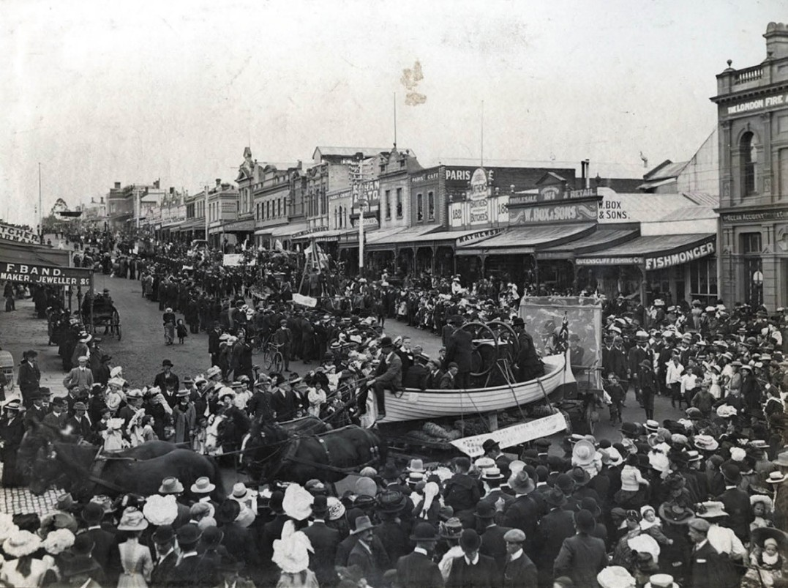
Figure 8.161: Geelong Eight Hour Day Procession, corner Moorabool & Ryrie Streets, 1909. Source: News of the Week, 25 April, 1909, p.14, GRS 1221b, Geelong Heritage Centre collection.

day, although each trade had to make its own case with employers, and not all were successful. In Geelong, some other trade unions that were formed in the 19th and early 20th centuries included the Operative Saddlers and Harness
Makers; Geelong Society of Carpenters and Joiners; Victorian United Journeymen Coachmakers Society(re-established
as a Trade Union in the late 1890s see Theme 3); Geelong State School Teachers Union; Operative Bakers Union; Cabmen s Union; Railway Employees Mutual Service Association; Tanners and Curriers Union, Wharf Labourers Union; Painters and Decorators Society (later known as Painters Union); Fellmongers Union; Rope Workers Union; Woollen Trade Operatives Union; Geelong Branch of the Stage Employees Association; Carters and Drivers Union; Storemen and Packers Union; and the Musicians Employees Union.1597
Although it was originally proposed by the Masons Central Committee of the Operative Stonemasons Society in 1856 that the Geelong branch enjoy a room in any Trades Hall built in Melbourne,1598 it was not until 1890 when the first purpose-built Trades Hall building was constructed in Geelong on the site of the old court house at north-west corner of Yarra and McKillop Streets. This was instigated by the fledgling Geelong Trades Hall Council which appointed five trustees: Tim Leary, Henry Christopher, Charles Reid, John Wallace and George Cawkill. William Shepherd was elected secretary and John Wallace, president. His term was short-lived as he left Geelong and was replaced by George Cawkill (c.1854- 1940).1599 Born in East London, Cawkill was in Victoria by the early 1880s as he was reported as a new member of the Geelong Volunteer Fire Brigade.1600 In 1889,
he was elected chairman of the Geelong Branch of the Millers

Union and a year later he was also secretary of the Geelong Eight Hours Anniversary Committee.1601 Cawkill was later employed at the Cheetham Saltworks, Moolap (Theme 5), and was foreman by 1919.1602
The new Trades Hall was designed by local architect, Albert Derrick.1603 The foundation stone was laid on 26 April 1890 by John Hancock, President of the Melbourne Trades Hall Council, and secretary of the Melbourne Typographical Society.1604 The proposed building (Figure 8.162) was described in the Geelong Advertiser:
The new building, the walls of which are already almost completed, is 41ft. by 26ft., made substantially of brick with heavy bluestone foundations. The walls vary in thickness from 11 in. to 14 in., and the parapet has a uniform height of 23ft. On the front of the structure, facing Yarra-street, is to be erected a porch, with an interior measurement of 6ft. 6in. by 6ft. and paved with ornamental tiles. The external angles of the building when completed are to be stuccoed. The present structure, the contractors for which are Messrs Wm. McRorie and Son, of Weller- street, Geelong West, will involve a cost of about £800. It is intended, as funds become available, to make additions to the hall, so that probably before many years elapse
one of the most imposing edifices in Geelong will be the institution used by the united trades.1605
On 13 December 1890, the Geelong Trades Hall was officially opened by the Victorian Premier, James Munro.1606 While
the newly-completed building offered promise for a long and successful tenure, Trade Unionism influence waned following the world-wide depression in the early 1890s. The local Eight Hours Committee held its last demonstration in 1893, the Geelong Advertiser declaring that it was as successful as it was possible for it to be, in the view of the general depression so seriously affecting workers throughout the Australian community. 1607 In 1897, the Geelong Trades Hall site and building were transferred to the Country Fire Brigades
Board as the location for a new station building (see earlier subsection).1608
By 1908, after a 15-year absence, the Eight Hours Committee was revived.1609 This gave impetus for the re- establishment of the Geelong Trades and Labor Council, the inaugural meeting being held on 12 January 1909.1610 In attendance was the leader of the Australian Labor Party (ALP) in the Victorian Parliament, G.M. Prendegast, newly-elected member for Geelong, William Plain, the Federal Member
for Darling in N.S.W., W.G. Spence (the latter having been general secretary of the Amalgamated Miners Union and the founding member of the Amalgamated Shearers Union in 1886).1611 The first president of the newly-formed Geelong

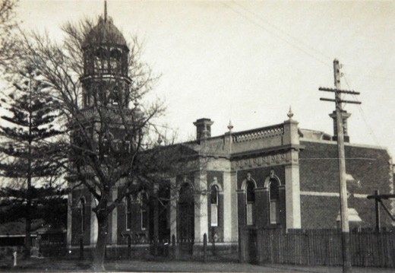
Figure 8.162: Geelong Fire Station, Yarra Street, c.1930. The northern (right) portion of this building, including the projecting entrance portico, appears to have been the original Geelong Trades Hall building. Source: T.T. Holmes collection, Authentic Heritage Services Pty Ltd.

Trades and Labour Council (comprising 30 delegates and office bearers)1612 was William Massey (1874-1903). Born in Geelong, Massy was secretary of the Geelong Waterside Federation until it amalgamated with the Port
Phillip Stevedores Association, and was the secretary of the Geelong Trades Hall.1613
The growth in the union movement heralded the need for a new purpose-built Trades Hall. On 1 December 1928, the foundation stone of a new building at 127 Myers Street, Geelong, was laid by E.J. Hogan, leader of the Labor Opposition in the Victorian Parliament. He declared that the new Trades Hall would result in the closer bringing together of political and industrial Labor. 1614 The Geelong Advertiser gave an insight into the design and scale of the anticipated building (Figure 8.163):
The new Trades Hall, which is situated in Myers street, as designed and carried out by its architect, Mr T.D. Slevin, is an excellent adaptation of a modern building of classic design to a difficult site, and its Roman Corinthian façade is a marked addition to the architecture of the city. Its modelling and workmanship are extremely refined, and the unions will have a dignified structure wherein
to transact their various duties. The façade is finished in light-colored cement on grey terrazzo base. The position of the flagpole is unique, the pole extending to
the footpath level, permitting the hoisting of flags from the ground. The whole has been constructed of brickwork
in cement and steel, reinforced concrete being used only for the floors where necessary. All floors are of jarrah, fire-proofed beneath with asbestos cement. Beside the

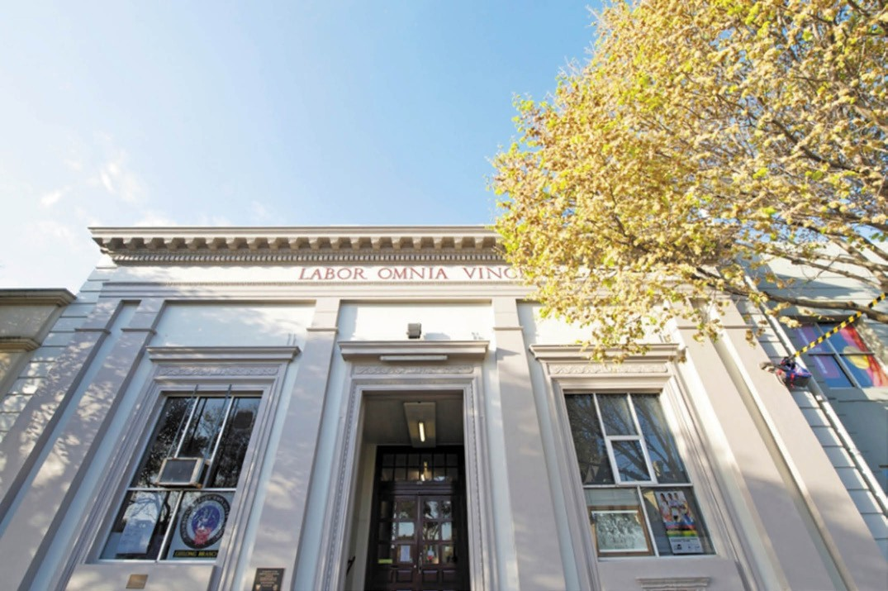
Figure 8.163: Geelong Trades Hall, 127 Myers Street, 2011. Source: David Rowe.

meeting rooms for the unions, the building contains a beautiful council chamber to seat 100 delegates, complete with raised dais, with a separate entrance for the president and officials, and a strong room for the archives. There is also a social hall, depending for its decoration with a paneled frieze in which are fixed modelled lions’ heads containing rings, so that decorations can be put up at short notice without damage to the walls. The whole
of the interior is furnished in bull-colored stucco with a textured finish. The windows are all steel casements simply glazed, and all internal joinery and fittings are in polished oak specifically designed. The work has been carried out by day labor, and the whole of the materials have been secured through local business houses.1615
The first meeting in the Trades Hall occurred in March 1929.1616 The building continues to be the centre of the union movement in Geelong to the present day.

HISTORY AND HERITAGE

GEELONG HISTORICAL SOCIETY
In 1912, W.M. Hitchcock publicly declared that he hoped Geelong would soon have an Historical Society similar to the Historical Society of Victoria that was formed in Melbourne in 1909.1617 In particular, Hitchcock declared that such a Society in Geelong would do much to save from loss or destruction records and buildings. 1618 Attempts to form an historical society in the following years came with the formation of committees to establish historical exhibitions and to record and preserve historical records, buildings and relics. The first manifestation of an historical society came in the form of an historical exhibition at the Geelong City Hall in 1921.1619 A committee had been created to exhibit historical records and relics in Geelong in aid of the Kitchener Memorial Hospital Fund. Its president was the Mayor, Howard Hitchcock.1620
In 1922, the society was quipped by the Geelong Advertiser to be an hysterical one, with headquarters in Yarra St. 1621 Frustration had mounted by those with an interest in the relics

collected for the exhibition of 1921 that they should form part of a permanent exhibition under the auspices of a Geelong Relic Society.1622 This organisation never eventuated.
The following year in 1923 it was announced that an historical society was to be formed by architects and artists associated with the Faculty of Architecture at the Gordon Institute
of Technology1623. It was affiliated with the Melbourne Historical Society to preserve architecture, monuments and tablets of historical interest. 1624 Present at the meeting to form the society were J.A. Laird, chairman of the Faculty of Architecture, together with T.F. Seeley, T.J. Buchan, I.G. Anderson, E.H. Bucknole, H.C. Trigg, N.E. Schefferle, Paul
R. Montford, George King and Miss Heard (recorder).1625 The new society was led by Angus Laird who, at the time of the formation of the organisation stated that:
… Geelong had a historical significance in relation to its early settlement, and the association of a number of pioneers amongst its early residents. He knew that in many churches in the district there were fine mural tablets, church furnishings, leaded windows as well as statuary and other memorials of more than passing
interest. By co-operation with the Melbourne Historical Society, information concerning these memorials could be recorded, and where desirable, photographs secured of same for preservation in the records. The influence of such a movement would no doubt be beneficial in
preserving the fine monuments already existing in the city and would prevent, also, the desecration of some of our finer architectural features, such as was done in the case of an abnormal sign announcement on one of our principal banks.1626
The society was duly formed as a sectional effort of the Faculty , its aims and objects being the recording and preservation of local memorials and public and other buildings of special architectural merit. 1627 Norman Schefferle became the honorary secretary. The society s initial tasks were the attempt to co-opt representatives from the City Council, Town of Geelong West, Borough of Newtown
and Chilwell, Faculty of Engineering, Public Library and Museum, Art Gallery, Photographic Club and the Gordon Art Department, together with a representative from the District State School Teachers Association.1628 In addition, George King urged that ‘the fine portico in front of the Geelong Hospital, which will be demolished at an early date, should be re-erected in the Botanical Gardens. 1629 While the society had high expectations for the recording and preservation
of records and buildings, nothing further seems to have eventuated.

In 1938, George King formed a new society and was its president, with Miss N. McDonald as secretary.1630 It seems to have been established as a short-lived organisation
in conjunction with the Public Library of Victoria and the Historical Society of Victoria. This organisation arranged an exhibition of historical objects in the Historical Museum at the National Gallery, Melbourne, to commemorate the centenary of the European founding of the town of Geelong at that time.1631 The exhibition included John Batman s so-called agreement with the Indigenous peoples of 1835; original plans of the township of Geelong in 1838; and a number
of pen drawings by Eugene von Guerard, including a fine panoramic view of Geelong from the Barrabool Hills, drawn in 1859. 1632
The quest for an enduring historical society began on 19 May 1943 when the Geelong City Council resolved that it make representations to the Free Library committee in relation
to the desirability of having a permanent record of historic items associated with the City of Geelong. 1633 The Free Library appointed five members of its committee to form the nucleus of the Historic Section, and subsequently called a public meeting led by Edward Fairnie O.B.E. for the purpose of supporting this new venture. 1634 On 8 June 1943, Edward Fairnie addressed a public meeting where it was resolved that the Geelong Free Library be asked to open an historical section.1635 The Historical Society of Geelong was therefore established. Its inaugural chairman was E.J. Fairnie with Miss D. Nesby-Fraser as honorary secretary assisted by Miss E. Gurr.1636 The Committee comprised another 40 members included W.W. Bottrell, W.R. Brownhill, David Davies and George King.1637 The collation of the original historical material held by the library was sorted and curated by the librarian of the Geelong Grammar School.1638 E.J. Fairnie was elected the inaugural chairman of the society and it held its first exhibition at the Free Library in February 1944. More than 400 souvenirs, photographs and relics were on display.1639 This collection of the Historical Society soon increased and it formed the basis of the repository of the Geelong Historical Records Centre which opened above the Geelong Library in Little Malop Street in 1979 (Theme
7). Much of the Society s material, together with a plethora
of information about the history of the Greater Geelong area has been captured in the Society s magazine, Investigator, first published in 1965. The Geelong Historical Society
and its magazine continue to form an important role in
the dissemination of local history to the present day. Much of the Society s collection now forms part of the Geelong Heritage Centre (Theme 7).

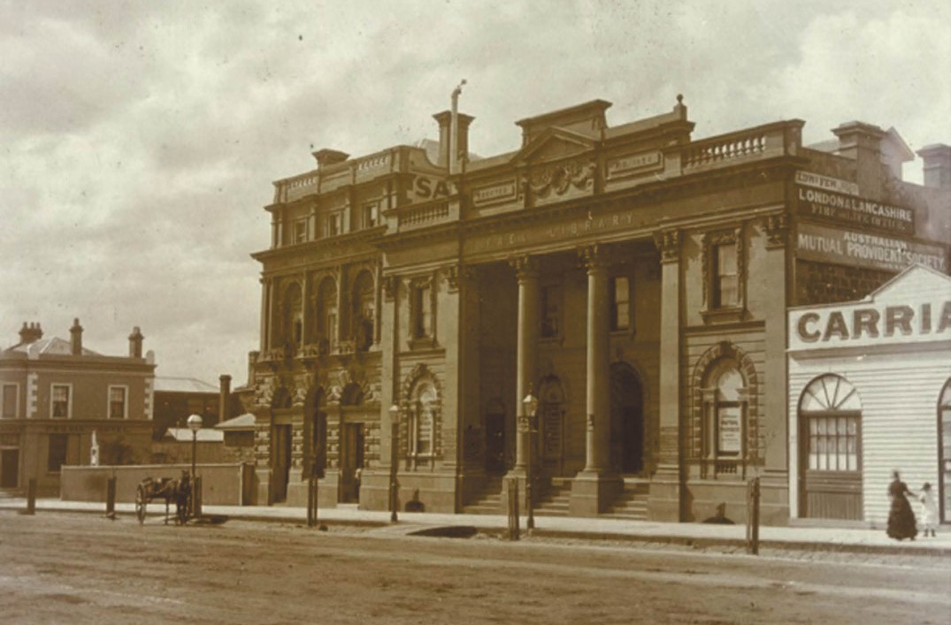
Figure 8.164: J.H. Harvey, Free Library & Savings Bank Buildings, Moorabool Street (east side between Malop & Corio Sts), c.1875. Source: accession H2009.100/186, State Library of Victoria.

NATIONAL TRUST OF AUSTRALIA (VICTORIA), GEELONG & REGION BRANCH
The wholesale demolition of historic houses in Sydney led to the formation of the National Trust of Australia in 1947.1640 In 1949, the eminent architectural writer, Robin Boyd, brought Victorian readers to the intention of the New South Wales State Government to legislate to ensure the immunity from demolition of the buildings contained in a list prepared by the National Trust.1641 Boyd s article was insightful and also prophetic in its message:
If a building is to be retained, it must be maintained with paint and patches intelligently administered. Some New South Wales relics required many hundreds of pounds of restoration work.
Who will put up the hundreds? Most of the buildings are privately owned. Many of the owners, unimpressed by the knowledge that they possess a solid slice of the nation s history, are not prepared to throw away money on a poor economic investment.
To them, in several cases, the historic structure is not more than one of a string of semi-slum tenements. These owners can never be expected to return the building to its original elegance.
Sydney architects believe that public interest in the beginnings of building in Australia must lead to better homes today.
There is no suggestion that the Georgian style of those days should be imitated. It is suggested rather that consciousness of an established culture will bring to every home builder a sense of greater responsibility to the community in which he builds.
There has never been a move to preserve our old homes, and public awareness of our architectural heritage is non-existent. But there were good buildings before the boom spread thick late-Victorian filigree over our State.
One by one our old homes in their now expensive lands are being destroyed. If no move is made to save them we could become a community without a history.1642

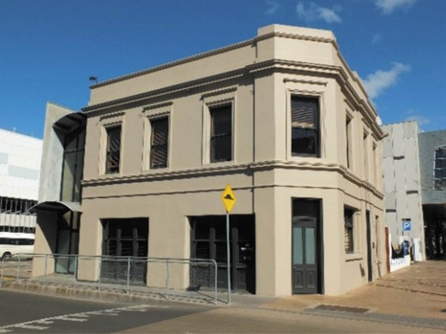
Figure 8.165: Former Royal Mail Hotel, 2018. Source: David Rowe.

Interest in the preservation of buildings of special interest gathered in Melbourne and in 1956 a Victorian branch of the National Trust of Australia was formed with Sir Daryl Lindsay as its chairman.1643
Locally, the demolition of a number of important historic buildings such the Public Library, Savings Bank and State Savings Bank in Moorabool Street (Figures 8.164), and the Davidson building in Yarra Street led to the formation the Geelong and Region Branch of the National Trust of Australia (Victoria) in 1972.1644 Since that time the Geelong and Region branch has campaigned for heritage conservation with private and public owners and managers particularly with local government. 1645 In the 1980s it worked with the then Historic Buildings Rescue Group to petition against the loss of part of the City s community identity. This included the retention of the former Royal Mail Hotel (built in 1851)1646 at the corner of Yarra and Corio Streets (Figures 8.165), and many properties in Latrobe Terrace that were under threat
of removal for the proposed road duplication.1647 Locally the National Trust also continues to manage four historic properties: Barwon Grange, Newtown; Barwon Park,
Winchelsea; Portarlington Mill and The Heights, Newtown.1648

COMMEMORATION

CEMETERIES

EARLIEST CEMETERIES IN GEELONG
Ceremony and ritual formed key elements in Wadawurrung society following the death of a clansperson.1649 Interments were either cremations or burials. Of the latter, the grave was located near streams or banks of lakes and swamps, and lined with bark or leaves.1650 Wadawurrung culture is that the spirit of the deceased is reborn as part of the afterlife and hence the avoidance of mentioning names or keeping illustrations of the departed.1651 Burials were often of single individuals near where they died1652, but group internments in coastal areas was also common (for cultural reasons, locations of the burials of the Wadawurrung are deliberately and respectfully
not disclosed).

CEMETERIES & MEMORIAL PARKS AFTER EUROPEAN COLONISATION

PUBLIC CEMETERIES
In 1837, the provision of a burial ground formed part of the initial survey instructions for the Geelong township.
In particular, the Deputy Surveyor General, S.A. Perry, had requested that at a distance not less than a mile from the town you will select and report upon a suitable place for a burial ground. 1653 Perry s instructions did not provide for a burial ground before the first recorded death of a European in Geelong in December 1838 when the Rev. Waterfield,
a visiting Anglican minister, had visited a sick man who died the next day. 1654 However, the burial ground had been surveyed and set aside by 1839 as it was shown in a Plan of Suburban Allotments in the Neighbourhood of Geelong by
H.W.H. Smythe at this time.
The provision and laying out of the cemetery were based on French and British precedents. St. James Cemetery,
Liverpool – one of Britain’s first cities to establish a dedicated cemetery in 1825-29 broke the tradition of churchyard burial grounds and catacombs.1655 Yet, especially influential was the reformative measures instigated in the state cemeteries in France in the 19th century that led to the creation of Pere- Lachaise, on Mont-Louis, Paris in 1804. For the first time,
the cemetery was laid out in a garden setting, and coupled with contemporary interest in the study of antiquities, these resting places were adorned with monuments and crosses and stones reflecting the mediaeval age, the celebration
of death, and the social position and status of the recently deceased.1656 The garden cemetery concept was soon realised in non-sectarian British cemeteries including Kensal

Green, Highgate and Norwood in London, and the Necropolis, Glasgow.1657 Particularly important as part of the garden cemetery movement was the eminent Scottish architectural writer, J.C. Loudon, who declared that cemeteries ought to be in an elevated and airy situation, open to the north [south], but with a south [north] aspect, where the surface would be moist during the winter months. 1658 Of the layout, Loudon stated:
In laying out the interior, the system of roads and walks, the drainage, the situation of the chapel or chapels, and the arrangement of the graves, and of the marks which in large cemeteries, as at present laid out, are necessary at angles of the squares, require to be take simultaneously, and also separately, into consideration. There ought to be at least one main road, as to allow of a hearse having ready access to every part of the grounds; and from this road there ought to be gravel walks into the interior of the compartments formed by the roads, walks ,and the
boundary wall; and, from these gravel paths, ramifications of narrow grass paths, so as to admit of examining the graves in every part of the grounds, without walking over any of them, and thus insure respect for the dead.1659
By the early 1850s, the ordered and solemn cemetery design advocated by Loudon was overlaid by a romantic and picturesque landscaped ideology: of serpentine walks and numerous plantings; Picturesque Gothic gate houses and chapels; and ornamental monuments.1660
The layered approach of regular rectangular, denominational sections and rows of grave plots with picturesque serpentine walks in treed settings formed a basis to the design of several of Greater Geelong s early cemeteries in the 1850s that emanated from the office of Captain Andrew Clarke, Surveyor-General of the Department of Lands and Survey.1661 These gardenesque plans were a small-scale version of his dynamic town plans denoted by crescents and public parks, as realised in the east extension to the Geelong Town Plan in 1854 (see Theme 6). Locally, a number of the gardenesque cemetery layouts were surveyed by the local Government contract surveyor, F.E. Gilbert, under the supervision of district surveyor, A.J. Skene.1662
By the late 20th century, around 200 cremations were being carried out outside Geelong at Altona or Ballarat given the absence of a local crematorium. The cultural shift towards cremation emanated from a decrease in burial sites; burial costs and social change.1663 In 1988, Geelong’s first crematorium, Geelong Memorial Park
at Armstrong Creek, was opened by the Minister for Health.1664

GEELONG EASTERN CEMETERY, ORMOND ROAD, EAST GEELONG
Set aside as a burial ground as part of the survey of the Town of Geelong in 1838, the first burial took place in 1839
following the death of Hugh Niven as a result of a horse riding accident.1665 Other burials followed but it was not until 1843 when land was consecrated by the Church of England and the Roman Catholics.1666
The location of a burial was therefore determined by the religious affiliation, denomination or creed of the deceased. Each of the main denominations: Anglican, Wesleyan, Presbyterian and Roman Catholic, managed its own plot at the cemetery, although it was not until 1846 when Deeds of Grant were issued by the Colonial Secretary’s Office allowing denominational trustees to manage their plot in perpetuity.
The original plan of the burial ground was rectangular in form and provided for 2-acre plots for each of the main denominations. The Roman Catholics were the first to receive its Deed in 1846, followed by the Presbyterians and Wesleyans in 1847, and the Church of England in 1849.1667 Other denominations and creeds without Deeds relied on the goodwill of those that did.1668
With the growth of Geelong and its population also came more deaths and with it the demands on the cemetery. The Colonial Secretary’s Office was subsequently petitioned for the release of further Deeds. The Jewish community was successful in gaining a 1 acre reservation immediately east of the Presbyterians in 1849, and the Presbyterians
applied to extend their plot in 1860 while additional land was permanently reserved for cemetery purposes in 1876.1669
The ascension of An Act for the Establishment and Management of Cemeteries in the Colony of Victoria in March 1854 brought about major change to the Eastern Cemetery.1670 Government-appointed Trustees, representing all the major denominations were to regulate the cemetery:
The Trustees of any such Cemetery shall have power to enclose any land so to be granted or conveyed as
aforesaid with property and sufficient walls, rails, fences or palisades and to erect suitable gates and entrances and to lay out and ornament such Cemetery in such manner as may be most convenient and suitable for the burial of the dead and to embellish the same with such walks, avenues, roads and shrubs as may to them seem fitting and proper and to preserve, maintain and keep in a cleanly and orderly state and condition and cause to be so maintained and kept the whole of any such Cemetery and its walls and fences and all monuments, tombstones, enclosures, buildings, erections, walks and shrubberies therein and belonging thereto and shall lay out and expend 1671

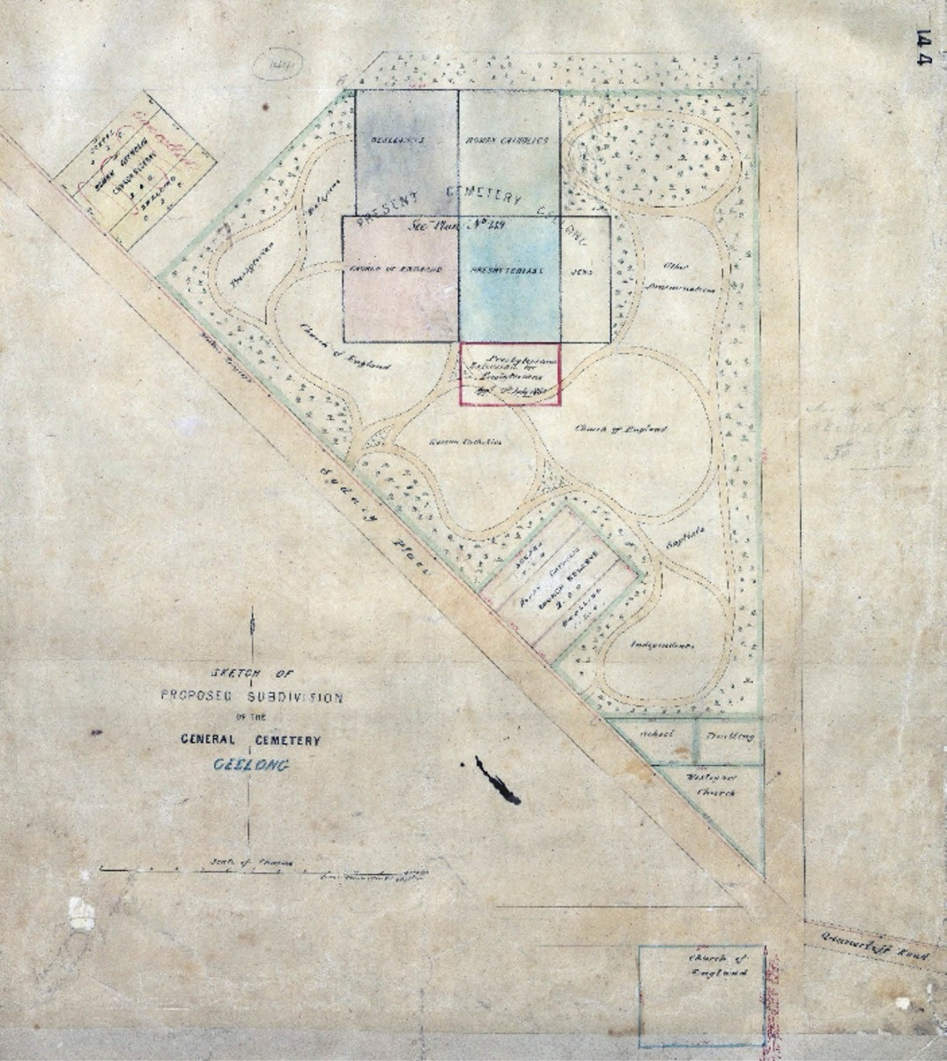
Figure 8.166: Surveyor-General s Department, Sketch of the Proposed Subdivision of the General Cemetery, Geelong , 31 August 1855. Source: VPRS 8168/P5, item CEM 144, Public Record Office Victoria.

The inaugural Trustees appointed to the Geelong Eastern Cemetery (then called the Public Cemetery) as a result of the Act were Frederick Champion, William Bright, Charles Kernot, Benjamin Boulton, George Board, Henry Andrews, Martin Treacey, Daniel Ryan, John Guthrie, David Forsyth Main, Godfrey Alexander, Emanuel Ackman, Thomas Foster and John Buxton.1672
It was from this time when the Eastern Cemetery was proposed to be transformed into a garden cemetery following the precepts for good cemetery design advocated by influential figures such as J.C. Loudon in On the Laying Out, Planting, and Managing of Cemeteries (1843). A dynamic sketch plan (Figure 8.166) was prepared (probably by F.E. Gilbert) in August 1855, showing the then existing rectangular burial ground overlaid with serpentine walks surrounded by
a treed landscape. It was to unify the 10 acre burial ground segregated by the different denominational plots, but it was never to be realised.
The first major improvement to the cemetery was in 1859 when the Catholic Church decided to erect a Gothic monumental chapel to mark the place of interment of the late Rev. P. O Brien. 1673 Designed by the local architects, Backhouse and Reynolds, the stone and brick chapel1674 was completed by mid-1860 and was described as a graceful little structure being a beautiful and enduring testimony of the respect in which the memory of the Rev. Father is held by his
Church in Geelong. 1675 Only the Catholic Church was to erect such edifices in the cemetery.
The Church of England section was beautified with the planting of trees and shrubs, including pines, in the 1860s, the donation of Daniel Bunce, first curator of the Geelong Botanic Gardens (he was later buried in the cemetery in 1872 with his four children, under the shade of Norfolk Island Pine trees he had previously planted and which would grow into living obelisks. ).1676
In 1869, Archdeacon Downing acquired an additional acre of land as an extension of the Roman Catholic section at the cemetery. Consecrated by Archbishop Goold on 8 March 1869, the cemetery setting and the need for further improvements and management were highlighted in the Geelong Advertiser:
The Archdeacon not satisfied with presenting the ground to the church, but also bearing the expense of fencing it in; it was also nicely planted with trees, but these owing to the long continued drought did not prosper so well as anticipated, and it is intended when the proper season comes round to plant fresh trees, this done the cemetery

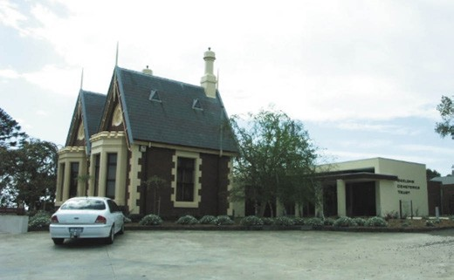
Figure 8.167: Gate Lodge, Eastern Cemetery, 2006. Source: David Rowe.
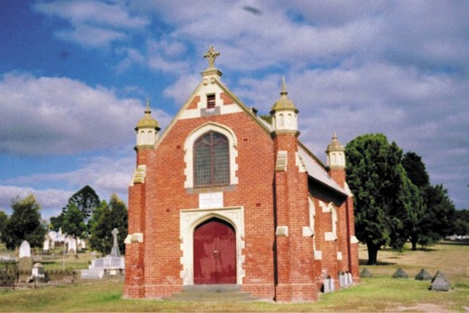
Figure 8.168: Catholic Chapel, Eastern Cemetery, 2002.
Source: David Rowe

will be a pretty spot if the relatives of the sacred dead will only do their share of the ornamentation, a duty too often neglected in this colony. During the past twelve months no less than £350 has been laid out in the improvement of the reserve, but much remains to be done before it will at all vie in appearance with the beautiful cemeteries that are to be seen at home and abroad, it must be confessed,
however, that the Roman Catholic reserve is quite equal to those belonging to other denominations, but what we want to see is well kept graves and plantations of shrubs and flowers.1677
Work began on a long term plan to improve the layout of the cemetery from 1876 due to the efforts of trustees, George Belcher and Robert de Bruce Johnstone.1678
These improvements were augmented by the construction of a gate house in 1889 to a design by the local architect,

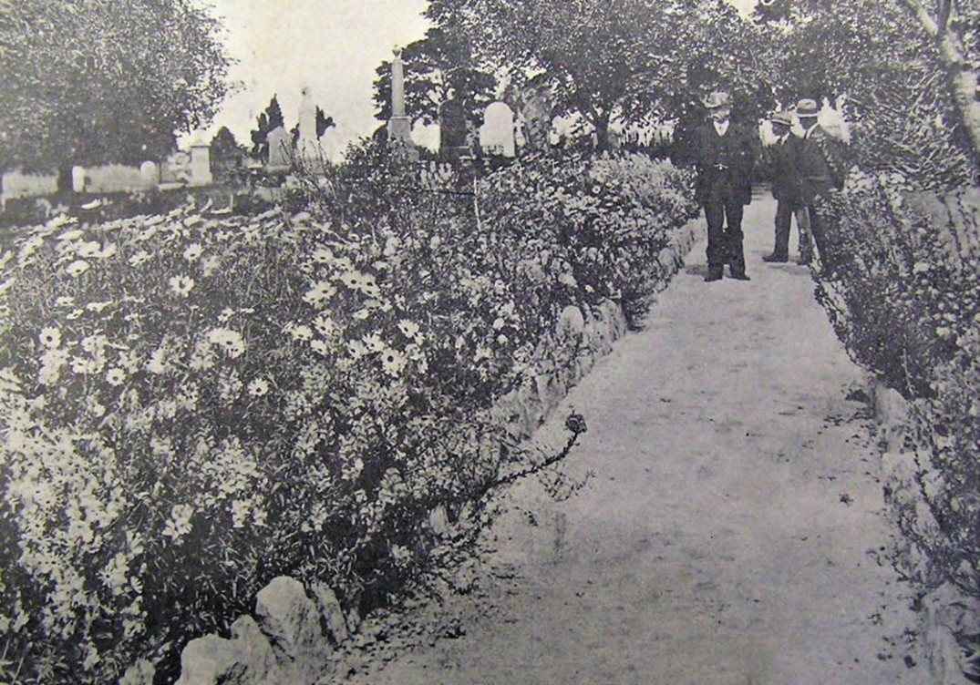
Figure 8.169: Gravelled walk with rockery borders and a landscape of flowers and trees at the Eastern Cemetery, 1916. Source: News of the Week, 21 December 1916, GRS 2121, Geelong Heritage Centre collection.

Joseph Watts. His Picturesque Gothic lodge provided a fitting expression of entry for such a large scale cemetery.1679 Watt s gate house design (Figure 8.167) was the second attempt for the building of a gate lodge, the first design by Davidson and Henderson in 1873 never being realised.1680
In 1903, the Catholic Church proposed the construction of a new chapel in the cemetery as a fitting memorial to honour the life and work of Archdeacon P.J. Slattery. The earlier chapel that marked the place of interment of Rev. P. O Brien was considered beyond repair. A design for a brick chapel featuring domed hexagonal pinnacles was prepared by William Tombs of the local architectural firm, Tombs and Durran. Described in the Geelong Advertiser as larger and more pretentious than the old building , the new chapel (Figure 8.168) was dedicated on 21 June 1904.1681
By 1916, the cemetery partially reflected the gardenesque ideology of the Surveyor-General 50 years earlier. Gravelled walks with rockery borders provided access to graves and
monuments surrounded by displays of flowers between maturing trees (Figure 8.169).
In 1962, the first burial was carried out in the new Lawn Section of the cemetery. It came over 100 years after
the first lawn cemetery at Spring Grove, Cincinnati, U.S.A. in 1855, when Adolph Strach, a German-born horticulturist and landscape gardener sought a more open, integrated
cemetery landscape, where the individual plot-holdings were subordinated to the grand sweep of the whole setting. 1682
The transformation of the Eastern Cemetery from the 19th century came from its ever-increasing need to bury Geelong s dead from which developed an antiquarian landscape. The sepulchral monuments and other cemetery architecture became genealogical signposts in portraying the biographies, family connections, religion and status of residents past.
They included associations with several of the eminent European colonists such as: Dr Alexander Thomson (limestone altar monument); George Armytage and family

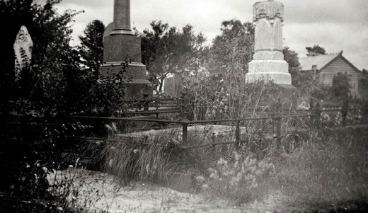

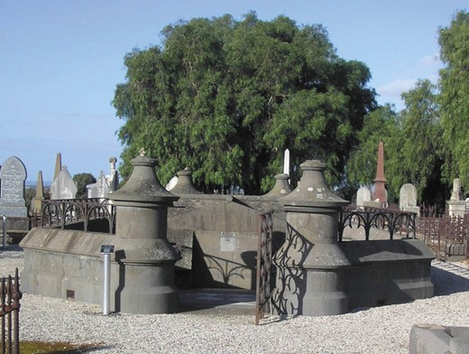
Figure 8.170: Armytage family vault, Eastern Cemetery, 2019. Source: Pam Jennings.

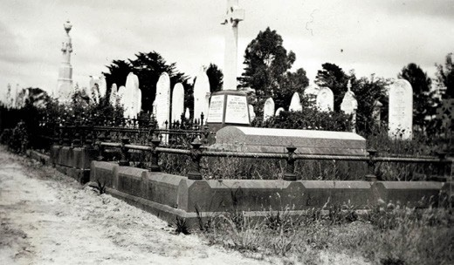
Figure 8.171: M.K. Moir, Grave of Sir Charles Sladen (foreground), Eastern Cemetery, 1933-34. Source: accession H8257, State Library of Victoria.
Figure 8.172: M.K. Moir, Grave of Ann Drysdale, Caroline Dodgson (Newcomb) and James Dodgson, 1933-34.
Source: accession H8257, State Library of Victoria.
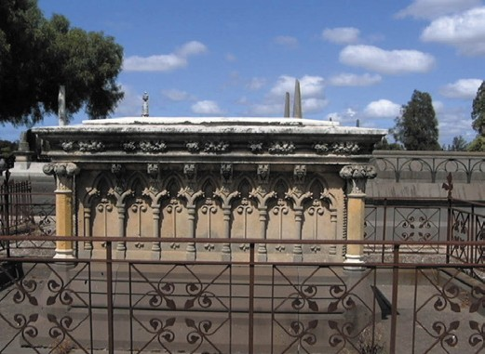
Figure 8.173: Austin family vault, Eastern Cemetery, 2019. Source: Pam Jennings.

(substantial bluestone mausoleum erected to hold many family members)1683 (Figure 8.170); Foster Fyans (Barrabool stone obelisk surmounted by a Celtic cross), Austin family (Thomas and Elizabeth) (elaborately carved French Gothic styled altar monument of Waurn Ponds stone, Batesford limestone pilasters and marble bases); Sir Charles Sladen (sandstone body stone)1684 (Figure 8.171); Ann Drysdale, Caroline Dodgson (nee Newcomb) and Rev James Dodgson (rudimentary low altar monument surmounted by a flat table (Figure 8.172).1685 The design quality of the monuments reflected the skill and craftsmanship of the 19th century designers, sculptors and monumental stonemasons. The Austin family vault was one of the few-known monuments designed by the architects, Davidson and Henderson,1686 the detailing being reflective of their eclectic French Gothic and Romanesque oeuvre (Figure 8.173). The work for this vault was executed by Benjamin Brain (1816-1877), sculptor, as
well as the well-known monument mason, Nathaniel Brown (1815-1906) (see Theme 9). The monuments throughout the cemetery are also characteristic of the work of other local monumental masons including Charles Wilcox (1828-1893), Joseph Smith (1861-1915) and Clement Nash (1820-1910) (see Theme 9 for further details).
The prolific local architects, Laird and Barlow, also designed several sepulchral monuments in the late 19th and early 20th century for other local residents, and which were the work of the local monumental masons outlined. They included the Gardiner tomb (in memory of Barbara and William Gardiner who died in 1894 and 1910 respectively, owners of Belleville, Ryrie Street after Dr Boswell Reid see earlier subsection); Hooper memorial erected in in 1908 for Margaret Hooper by Lloyd Hooper, grocer (Theme 5) (Lloyd Hooper subsequently interred there in 1927); and the gravesite of Jessie, James, and Andrew McMillan of 1908.1687

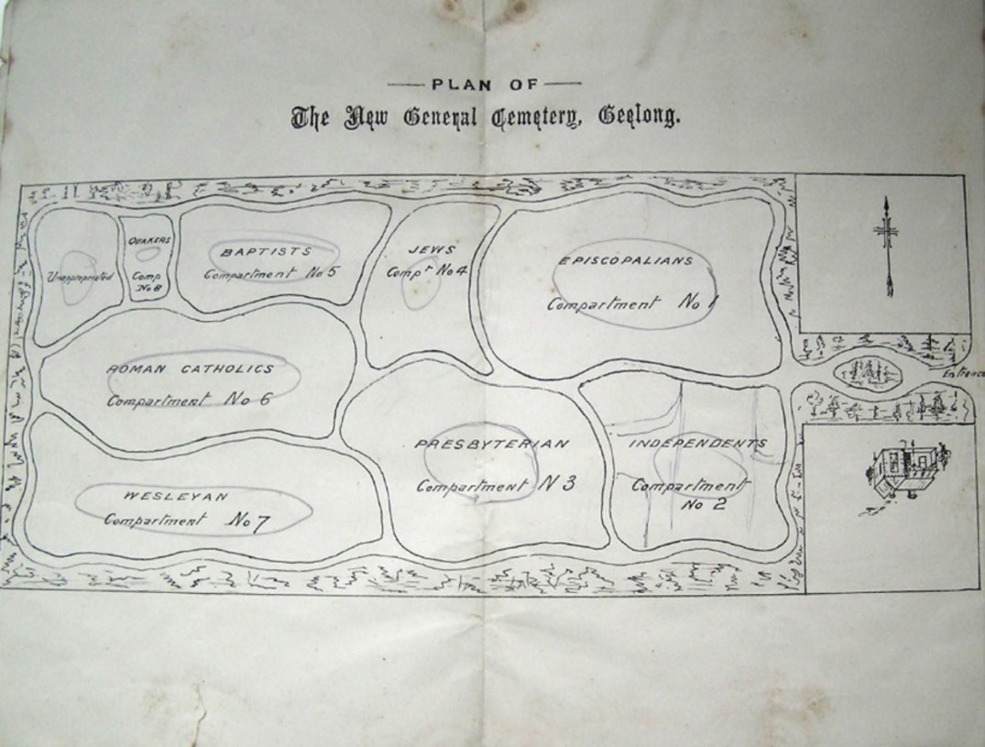
Figure 8.174: Plan of the New General Cemetery [Western Cemetery], Geelong . Source: New General Cemetery Herne Hill. Rules and Regulations, Authorized Charges and Extracts from Acts of Parliament, Bearing Thereon, H. Franks & Co., Geelong, 1888.

GEELONG WESTERN CEMETERY, MINERVA ROAD, HERNE HILL
The population growth in Geelong in the early 1850s brought about a heavy demand on the old burial ground at East Geelong. With the considerable development of Ashby (Geelong West) and outlying areas including Fyansford, a second cemetery was required. By December 1856, 21 acres of land fronting the Government Road (Minerva Road) at Herne Hill had been surveyed by F.E. Gilbert for the District Surveyor, A.M. Mason. Provision was also made for two-acre reservations each for the construction of Catholic and Church of England churches fronting Minerva Road.1688
The first trustees had been appointed in September 1856. Some were also trustees of the Eastern Cemetery. They were: James Guthrie, George Board, J.F. Strachan, Benjamin Poulton, T.W. Allen, D. Ryan, B.D. Levien, H. Hart, Thomas Foster, William Bright, Henry Andrews and J. Buxton.1689 During 1857, the cemetery was laid out. It has been claimed that the cemetery design was the work of local architect Christopher Porter, but the scheme presented all the hallmarks of Andrew Clarke s gardenesque design approach of the Department of Lands and Survey. F.E. Gilbert s known involvement in the broad survey of the cemetery might suggest that he had a hand its layout.1690 Known as the New General Cemetery, the plan provided for a true, purpose- built garden cemetery, with graveled serpentine walks and landscaped borders (Figure 8.174), two years before the
establishment of the Boroondara (Kew) Cemetery, Melbourne, in 1859 which has been claimed to be the first garden cemetery in Australia.1691 The intended park-like setting at

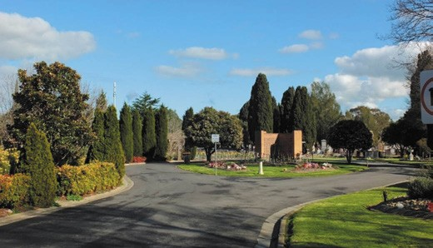
Figure 8.175: View of gardenesque setting of the Western Cemetery from the front entrance gates, 2019.
Source: David Rowe.

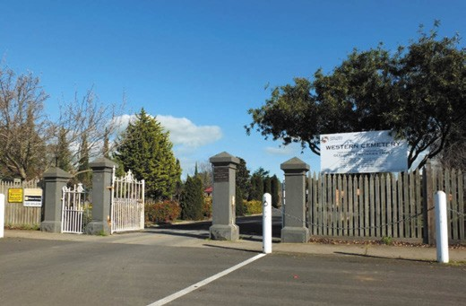
Figure 8.176: Entrance Gates, Western Cemetery, 2019. Source: David Rowe.

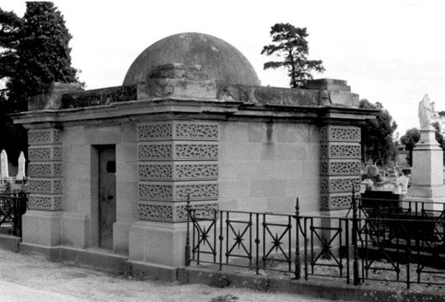
Figure 8.177: J.T. Collins, Strachan family mausoleum, Western Cemetery, 27 April 1978. Source: accession H63.210/356, State Library of Victoria.

Herne Hill (Figure 8.175) was realised with the planting of 250 shrubs gifted by Ferdinand von Mueller, Curator of the Melbourne Botanic Gardens.1692 He and Daniel Bunce would later donate additional plants for the cemetery.1693
In September 1857, David Ricketts was appointed the first curator. A Sexton s Lodge had been built on the Church of England school site at the front of the cemetery in 1857
to a design by Christopher Porter.1694 He also designed the entrance gates and fences at this time.1695
The first burial at the new cemetery was in January 1858 when Rose Eliza Harris was buried in the Independent Church section.1696 A notable burial site included the Strachan
family mausoleum, one of the most prominent features in the cemetery, erected in 1865 to a design by John Pitman, architect for the Hon. J.F. Strachan1697 (Figure 8.177). The Grecian Revival stone structure had been built after the
death of the Hon. J.F. Strachan s daughter, Lillias, in 1861.1698 Another especially significant site was the construction of the tomb of the last local Wadawurrung people in 1868. It had been funded by Robert de Bruce Johnstone following the death of Dan Nook and William Baa Nip, Jumbo Mooranook, Timboo, Jemmy Nelson, Harry Gore and Ellen was later interred there (Theme 2).
In 1911, the original sexton s lodge was replaced with a timber Edwardian styled dwelling built by Frank Apted.1699 This lodge remained for over 100 years until it was removed in 2003.1700

OTHER SUBURBAN AND RURAL PUBLIC CEMETERIES
At Grovedale, land was provided 1854 by Samuel Roche in Church Street as the site for a school building for the German immigrants who had settled in this area from 1849 (Theme 2). The school was subsequently erected (Theme 6) which also functioned as a church. Common in Europe but unusual in Greater Geelong, the school site also became a cemetery. It operated as a public cemetery (Figure 8.178) from 1861, the earliest portion being the German section. Burials at this time included those of Johan Gottfried Bohm and Johan George Winter.1701
Other public cemeteries were surveyed and trustees appointed in suburban and outer areas of the Greater Municipality. They included Barrabool Hills, Highton (1855); Bellarine, Drysdale (1856); Kensington, Leopold (1859); Rothwell, Little River (1859); Anakie (1861); Sutherlands Creek (1861) (Figures 8.179-180);1702 Duneed, Mount Duneed (1864); and Portarlington (1873).1703
The Barrabool cemetery was the only other known burial ground proposed to be laid out with striking serpentine walks and landscaped areas overlaid with rows of graves in denominational order (Figure 8.181). The gardenesque
design intent was revealed by Andrew McWilliams, surveyor, in 1869 when he declared that Captain Clarke was particularly anxious that the walks and roads of cemeteries should have graceful curves. 1704 Surveyed by F.E. Gilbert in 1855, apart from the front entrance and associated forked drives at the south end, the series curved paths never eventuated. The rows of graves began in 1856 when Agnes Dodd and William Drew were buried there1705 (Figure 8.182).
A more geometric layout was provided for the Rothwell Cemetery at Little River in 1860. Drawn by A.J. Skene, the square plan was subdivided into a hexagon by graveled walks and a central circular garden bed (Figures 8.183-184), the segregation providing for the necessary denominational plots.1706 This cemetery design came after the first burial
of Gordon Cameron on 29 October 1859. Residents of Lara were buried at the Rothwell Cemetery from this time, including members of the Bates, Beardsell, Berry, Blair, Branch, Calvert, Curlett, Duggan, Fairbairn, Frisch, Frost, Gebbie, Gillespie, Gillett, Grass, Grills, Groves, Harding,
Hawksford, Hedges, Mathieson, McGillivray, Oakley, Perkins, Spalding, Teesdale and Walker families.1707

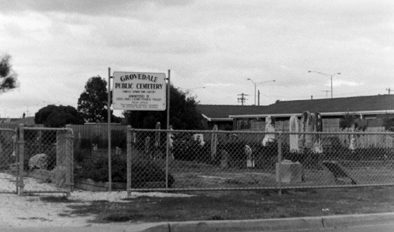
Figure 8.178: Grovedale Public Cemetery, 1998. Source: David Rowe.
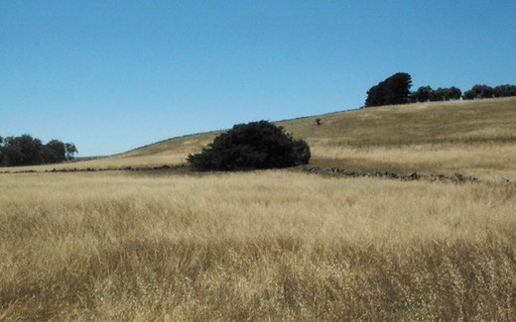
Figure 8.179: Sutherlands Creek (Yowang) Cemetery neighbouring and under the tree in the middleground, 2000. Source: Dianne Hughes, Teesdale.

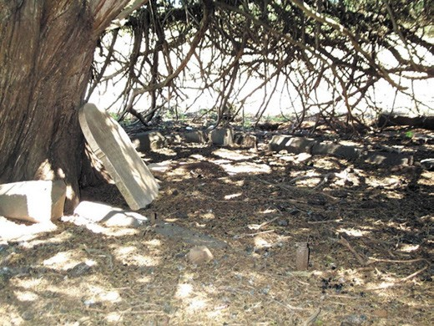

Figure 8.180: Remnants of the headstones at the Sutherlands Creek (Yowang) Cemetery, 2000.
Source: Dianne Hughes, Teesdale.

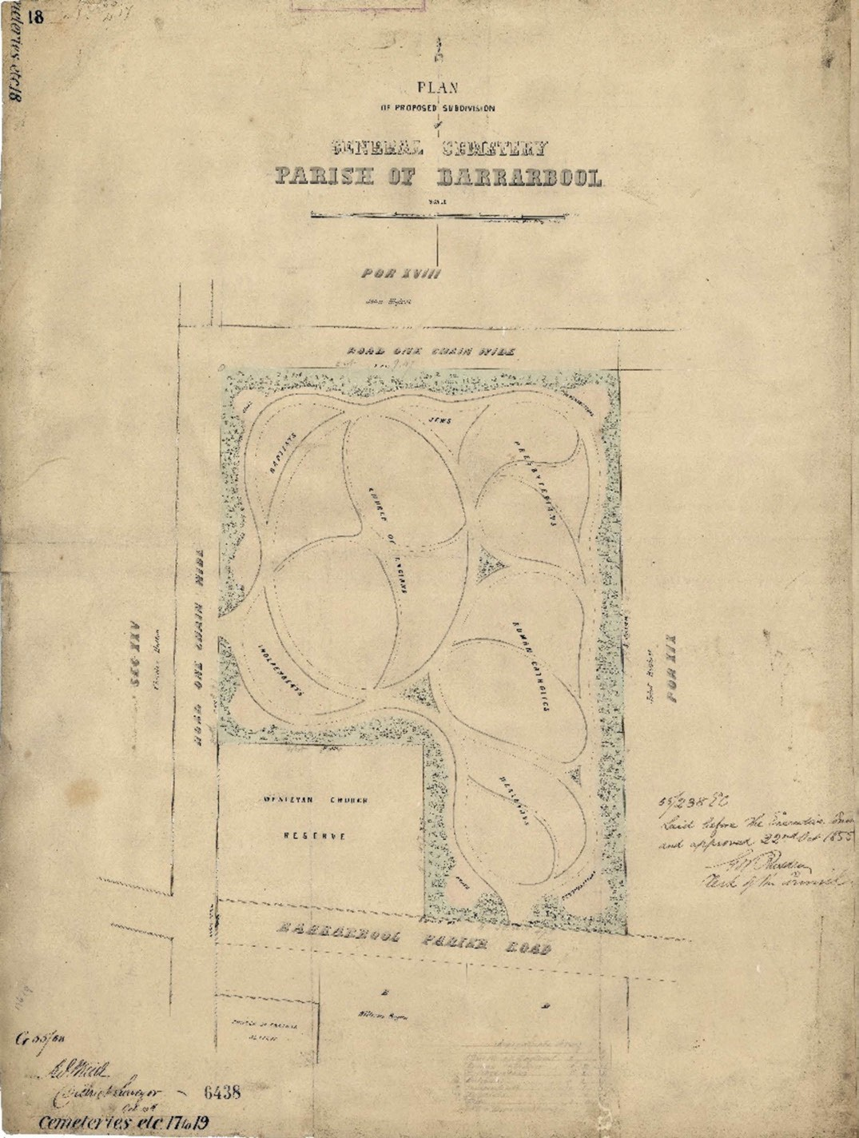
Figure 8.181: F.L. Gilbert (with A.J. Skene), Plan of Proposed Subdivision of General Cemetery, Parish of Barrarbool , 1855. Source: VPRS 8168/ P5, item CEM 18 Barrarbool, Public Record Office Victoria.

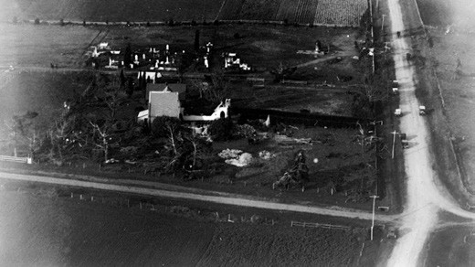
Figure 8.182: C. Pratt, Aerial view showing Barrabool Cemetery (top) & remnants of the neighbouring Methodist Church substantially damaged by a tornado, 1926. Source: accession H91.160/1214.

LATER CEMETERIES AND MEMORIAL PARKS
In 1984, the Geelong Cemeteries Trust was established to manage the Eastern Cemetery, Western Cemetery, and the Barrabool Cemetery.1708 In 1988 it opened Geelong s first crematorium as part of the Geelong Memorial Park at Armstrong Creek.1709 In 1993, the control of the Leopold, Drysdale and Portarlington cemeteries devolved to the
Geelong Cemeteries Trust and this was followed by Mount Duneed cemetery.1710
In 2002, Flinders Memorial Park, situated on a 24 hectare site on Forest Road South, Lara was opened to meet the needs of the large population in Greater Geelong s north- west.1711 To the south-east on the Bellarine Peninsula in 2014, the 40 hectare Marcus Hill cemetery was established to meet the demand in this part of the municipality as well as provide for long term strategic requirements.1712 It is yet to open.

PRIVATE BURIAL GROUNDS
Less defined and regulated were private burials, mainly in rural parts of the municipality, several which are now
unmarked and unidentified. They represent the final resting places of laborers, their wives and children working on rural properties.1713 Two unmarked graves at 421 Lower Duneed Road, Connewarre, include those of children of James Mitchell, early colonist.1714 At Coriyule , Curlewis, the body of the pioneer squatter, Miss Ann Drysdale was laid to rest in a private vault on the property. She was accompanied
by the body of her good friend, Mrs Caroline Dodgson (nee Newcomb) following her death in 1873 until both remains were subsequently reinterred in the Eastern Cemetery.1715 Other private burial grounds include the following.

NEWINGTON BURIAL GROUND, 41-99 ISLAND ROAD, WALLINGTON
Unmarked is the private burial ground 41-99 Island Road, Newington (now Wallington). In 1854, Edmond Faress (later spelt Ferris), farmer and fisherman, purchased part of portion 17, block 4, in the Parish of Bellarine, on the south slope of the hill overlooking Lake Connewarre.1716
A widower, Faress married Mrs Susan (Susanna) Chambers, a widow and mother of 11 children, in 1863.1717 Her late husband, Joseph Chambers, had been a friend of Emond Faress.1718 He died in 1862 and was buried in the ground of Edmund Farris, Newington. 1719 Another confirmed burial at Faress Newington property was that of the infant, Priscilla Luckow in 1885, when Faress was a witness to her burial at Newington.1720

GANGE FAMILY BURIAL GROUND, 9A GANGE PLACE, DRYSDALE
There is physical above-ground evidence of the Gange Family burial ground at 9a Gange Place, Drysdale. This land had formed part of the Coriyule Estate of Misses Drysdale and Newcomb from 1848. In 1851, they sold 168 acres of their property to John Thomas Mitchell Gange (1809-1868) and his wife, Margaret (1809-1882).1721 A convict that had been transported to Tasmania for his involvement in the Swing Riots in England in 1830 (see Theme 7), Gange
was later manager of Coriyule.1722 At his property named Garrangill House , Gange built a four roomed timber house and kitchen.1723 John Thomas and Margaret Gange had ten children including Thomas, James Thomas, William,
Daniel Bacchus, George Mitchell, Robert John and Frederick William, Kezia Frances, Kerenhappuch Margaret and Jemima Susanna.1724 On 2 June 1868, J.T. Gange died at Garrangill aged 59 years.1725 It appears that J.T. Gange
was buried at the nearby Bellarine Cemetery although early documentation held by the Gange family claims that he was buried at Garrangill . However, Margaret Gange had
erected a sandstone headstone prepared by Nathaniel Brown, monumental mason,1726 on elevated land at the Garrangill property known as Mt. Mitchell (Figures 8.185-186). The headstone was erected in memory of her husband as well three of her sons, James Thomas (died 1849), Thomas James and Daniel Bacchus (died 1855). Of these deaths, Daniel Bacchus Gange was likely to have been buried in the family burial ground at Mt. Mitchell.1727
Margaret Gange died in 1882 and was buried at Mt. Mitchell.1728 Her Will stipulated:

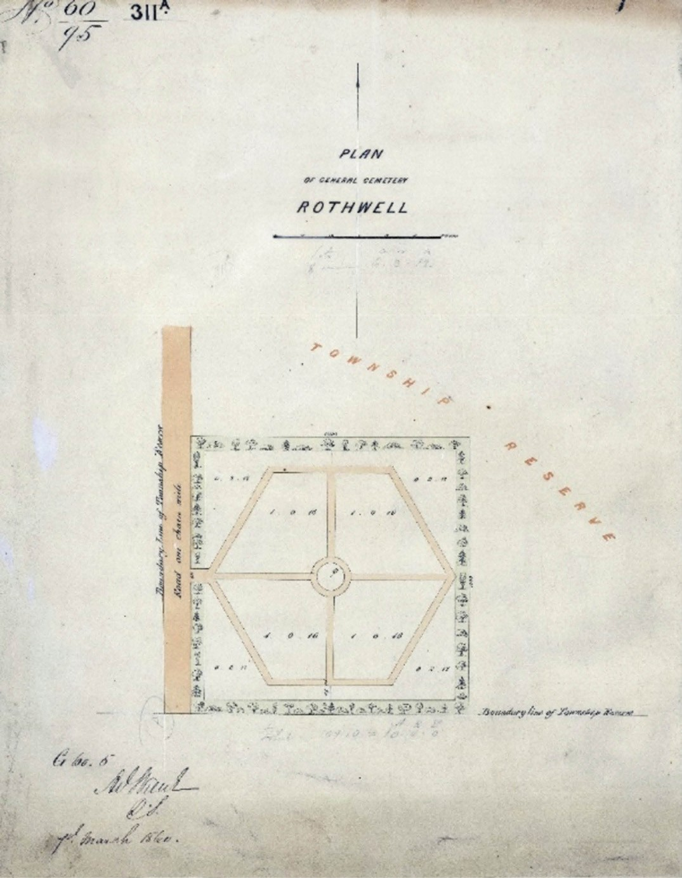
Figure 8.183: A.J. Skene, Plan of General Cemetery Rothwell , 7 March 1860. Source: VPRS 8168/P5, item CEM 308 Rothwell, Public Record Office Victoria.

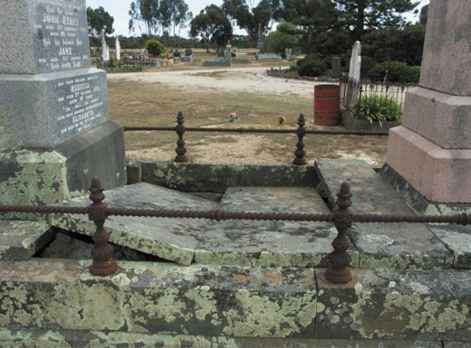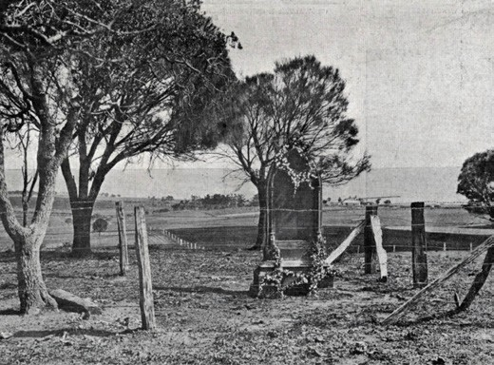

Figure 8.184: Rothwell Cemetery, view through grave to central landscaped garden surrounded by a gravelled drive, 2009. Source: David Rowe.
Figure 8.186: Gange burial ground, Mt Mitchell, Drysdale, 1912. Source: News of the Week, 5 December 1912, p.39, GRS 2121, Geelong Heritage Centre collection.

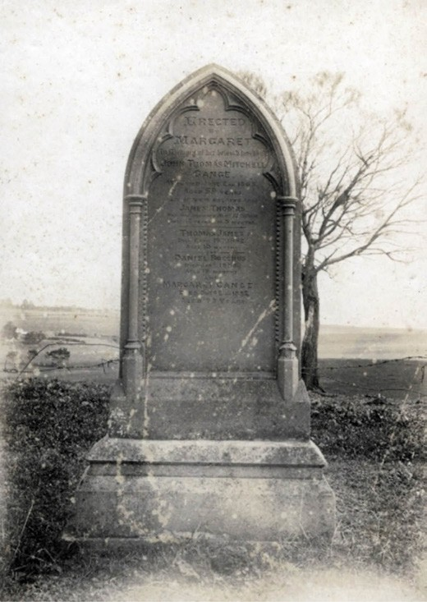
Figure 8.185: Headstone, Gange burial ground, n.d.
Source: GRS 2009/00297, Geelong Heritage Centre collection.
And whereas there is set apart upon the said Crown Portion Eleven half an acre or thereabouts as a burial ground for myself and the members of my family I declare my wish to be that the child whose portion of the said land shall contain the said burial ground shall preserve the same for such purposes as aforesaid and shall give and grant to his or her brothers and sisters a right of entry to the said burial ground from the South Eastern boundary of the said Crown Portion Eleven.1729
While surrounded by later residential development, the elevated open burial ground continues to be marked by the pointed arched stone memorial to the Gange family.

SISTERS OF MERCY CEMETERY, SACRED HEART COLLEGE, RETREAT ROAD, NEWTOWN
A convent cemetery was established by the Sisters of Mercy at their Newtown property by 1878. It was described nine years later in 1887 in The Advocate as:
The convent cemetery stands with the square of the building, and is protected from the gaze of passers-by by a high wall. Though a cemetery cannot, under any circumstances, be considered a cheerful place, this little
enclosure, with its green closely-clipped sward, and small Celtic crosses at the head of each of the seven graves,
is so suggestive of peace and rest that one is disposed to exclaim, in the words of the German poet:- A holy quietude is here .1730
The burial of Sister Patrick Tarrant in 1888 brought about the disapproval of residents of Newtown about a private cemetery in the neighbourhood.1731 They expressed their concern to the Geelong Town Council but no definite immediate ruling

was made. Yet in 1886, an Order in Council had been passed prohibiting further burials in the convent cemetery.1732 The issue came to a head in 1892 when Mother Margaret Sherlock permitted a burial and was subsequently prosecuted in the Geelong Police Court. As outlined by The Advocate:
On Saturday morning the rev. mother superior [sic.] of the Convent of Mercy at Newtown (Margaret Sherlock) was (the Argus says) prosecuted in the Geelong Police Court for having permitted a body to be buried in the convent ground. For many years it was the custom to bury deceased nuns in the small cemetery within the convent enclosure, but in 1886 an Order in Council was passed prohibiting any further burials in the convent cemetery. Recently one of the nuns at the convent died, and in compliance with her wish her body was interred in the private burial ground, alongside the graves of other deceased sisters. When the Public Health Board was informed of the fact they directed that a prosecution
should be instituted, but did not press for a heavy penalty. To-day it was admitted that the law had been broken, but the nominal fine of 1s. was inflicted by the magistrates.1733
Ironically in 1897, permission was given by the Geelong City Council and the Chief Secretary of the Victorian Parliament for the interment of the Reverend Mother herself in the convent cemetery.1734 This again was protested by disgruntled citizens, but the editor of the Geelong Advertiser reported
that the burial had taken place with the permission of the Chief Secretary. 1735 Another 50 years were to transpire before the cemetery was used as a burial ground again. The large memorial in the centre of the cemetery was gifted by Mary Anne Mansfield, an early boarder.1736 In 1911, the cemetery was enlarged and crosses erected on the graves.1737 Further expansion was carried in 1965 and it was at this time
when the crosses were replaced by metal plaques1738 (Figure 8.187).

WAR-RELATED COMMEMORATION
The concept of the war memorial has its origins in ancient Egypt, where pharaohs had obelisks erected to proclaim triumph over enemies. 1739 In Geelong, war memorials and other commemorative structures, landscapes and objects symbolised the human cost of war. These memorials often became the substitutes for graves of fallen soldiers buried in far off lands (where known), providing a physical symbol of the ultimate price paid, and a location for public expressions of grief and reflection. Legacies of the major conflicts involving local residences are as follows.

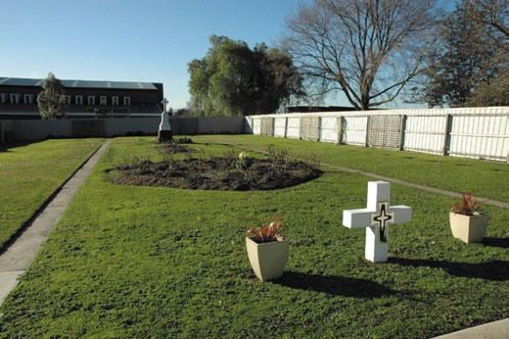

Figure 8.187: Sisters of Mercy Convent Cemetery, Sacred Heart College, 2009. Source: Wendy Jacobs.

BOER WAR MEMORIALS
In 1899, the Dutch-Afrikaner settlers in South Africa known as Boers attacked the British colonists in order to quell what they considered as an impending British conquest. This began was became known as the Boer War. As part of the British Empire, the Australian colonies offered troops and
at least 12,000 Australian served in contingents during the conflict which ended in 1902.1740 Four soldiers of Geelong and District lost their lives. The first was A.T. Pickinson of the Thorneycroft Mounted Infantry, who died at Fickburg on 17 March 1900 of enteric fever. Pickinson had grown up in Geelong and had worked as a steward on the S.S.
Excelsior.1741 Two other soldiers also succumbed to enteric fever: Corporate Eric Wilson attached to Methuen s Mounted Infantry (died at Pretoria on 27 December 1900) and Francis James (died at Harrismith on 7 January 1902). Wilson was born in Geelong in 1878 and was a member of the Geelong Garrison Artillery.1742 James had lived in Geelong for a time and at the time of his death his mother was resident there.1743 The only soldier to lose his life in battle was Trooper Walter Ernest Clarke of the Victorian Second Contingent of Mounted Rifles. He was killed at Dinaarspoort on 5 July 1900.1744

MEMORIAL OBELISK, KILGOUR PLACE, GEELONG
The loss of lives in the Boer War was impetus for the Mayor of Newtown and Chilwell, Cr. J. Cairns to preside over a public meeting at the Chilwell Free Library on 16 July 1902 to discuss the erection of a memorial to commemorate the
sacrifice that had been made.1745 The Kardinia Park Memorial Committee was formed, the proposal being that a memorial be placed at the Kilgour Street entrance to Kardinia Park.
A public appeal was established for the construction of an

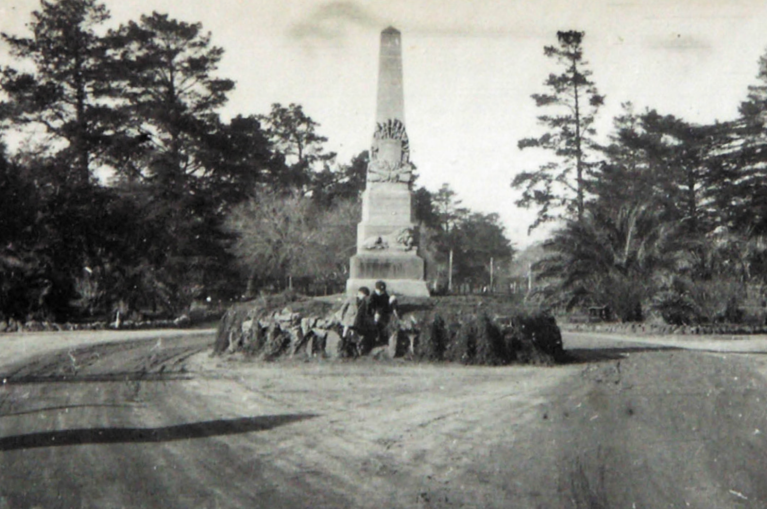
Figure 8.188: Boer War Memorial at the entrance to Kardinia Park, c.1930. Source: T.T. Holmes collection, Authentic Heritage Services.

obelisk memorial (Figure 8.188) and competitive designs were sought from Geelong s three monumental masons: Wilcox Brothers, Clement Nash and Joseph Smith; and the project was awarded to Nash.1746
Unveiled at a solemn ceremony on 20 December 1902, the Geelong Advertiser gave the following report:
The movement initiated in Chilwell having for its object the erection of a memorial by which Geelong s quota in human life towards the glory of the Empire, might be remembered by present and future generations, was
consummated on Saturday afternoon in Kardinia park, in the presence of a large gathering of spectators, when a handsome obelisk, the cost of which was borne by public subscriptions, was unveiled. The ceremony was most impressive, and passed off successfully. The Geelong Garrison Artillery, under Captain Strong, were in attendance, and formed a square round the obelisk
and platform. Upon the latter were seated the parents and immediate relatives of the dead soldiers, with the
officers and committee who organised and carried out the undertaking. The scene was most effective and striking. The Geelong Artillery band, conducted by Bandmaster Graves, rendered several selections, and during the unveiling of the monument played the Dead March with due solemnity.
The obelisk commands a prominent position inside the park gates at the Latrobe Tce. entrance. The names of W.
E. Clark and Eric Wilson, with the dates of their deaths, appear on the side facing the entrance, and on the side to the left and right are inscribed the names of Francis James and Alston Dickinson. The unveiling ceremony was given into the hands of Colonel J. L. Price, as senior military officer of the district, though now on the retired list, who made an effective and appropriate speech. Two or three returned soldiers were also present.1747

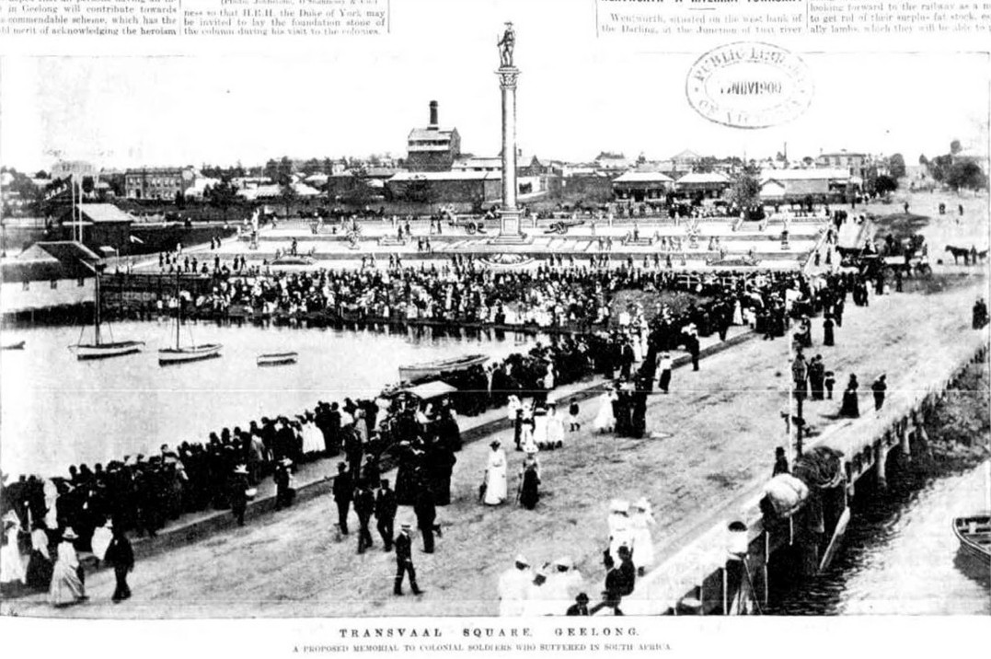
Figure 8.189: Proposed Transvaal Square, Geelong, 1900. Source: Leader, 17 November 1900, p.33.

TRANSVAAL SQUARE, EASTERN BEACH ROAD, GEELONG
Transvaal Square was initiated on 20 June 1900 by the Peace Celebration Committee with J.A. Dawson, local engineer and electrician as its honorary secretary.1748 He suggested to the newly-formed Peace Celebrations Committee that the site west of the old harbor master s house (old customs house see Theme 3) on the north side of Brougham Street (between Bellerine and Yarra Streets) be transformed into a memorial reserve.1749 The Lands Department subsequently temporarily reserved the site for this purpose.1750 Dawson s original
plan for Transvaal Square for a terraced square based on Trafalgar Square in London. It was described and illustrated in The Leader newspaper on 17 November 1900 as follows (Figure 8.189):
The scheme comprises the forming of an upper and a lower terrace, each 25 feet wide, and between these a square 100 feet wide and 400 feet long, the walls being of masonry and the areas asphalted. In the centre of the square a Corinthian column of local stone about 50 feet
high is to be erected, and this is to be surmounted by a typical Australian soldier in the same stone column is to be flanked on either side of our brothers who have ‘won our spurs for us and of greatly improving a very pleasant seaside resort.
A Transvaal Square Committee was formed but the death of Queen Victoria in January 1901 caused a change of plans. Another body known as the Queens Statue Committee was established and it initially worked with the Transvaal Square committee for the building of a memorial statue to the late Queen Victoria to take the place of the War Memorial column in Transvaal Square.1751 George Belcher objected to a memorial being situated in the proposed Transvaal Square as it would be in close proximity to the morgue (built in 1883 on the north side of Eastern Beach Road, east of the harbor master s boat house).1752 Yet, work proceeded and in 1903 Geelong Advertiser gave a description of progress:

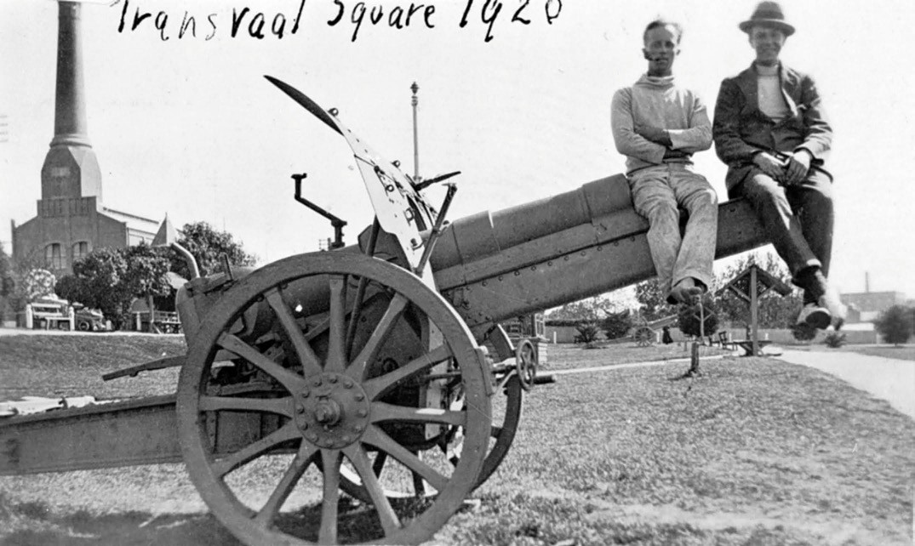
Figure 8.190: Two men sitting on a captured German field gun in Transvaal Square, 1920. Source: Museums Victoria MM 6763.

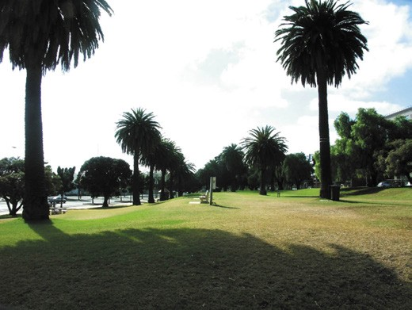
Figure 8.191: Transvaal Square, looking east, 2008. Source: David Rowe.

The land handed over by the Government to the Transvaal Square committee for ornamental purposes, is now being transformed from the unsightly tip into a plateau with two terraces, and in course of time will form an attractive and pleasant rendezvous for visitors to Geelong, as well as to residents of the town. The little cottage, which has occupied the site at the corner
of Yarra-street for the past 50 years is in course of removal, and when this is completed the contractor will be enabled to finish the fencing which will encompass the whole area, extending from Bellerine- street to
Yarra-street. The public have been enabled to claim the ornamental posts according to the special contributions of 5/- made by them for that purposes, and this has been so readily responded to that it is anticipated that within a few weeks of their erection each post will have an individual claimant, who will place a high value of his
own on the preference given to him on some future date, when the square will be looked upon from an historical standpoint. The posts, when placed in position, are to be threaded with a chain, now in the possession of the Town Council, and will give the whole square a pleasant appearance. The slopes have been planted with buffalo grass, which is now firmly rooted, and as water is laid on to the square, and a full length of hose having been generously donated by Mr Thom. Hawkes, there will be plenty of opportunity to keep the grass in good order; and as the land has been handed over to the citizens of Geelong for their sole benefit as a pleasure reserve, no doubt that it will be sufficiently valued by the inhabitants to see that the grass plots are well protected until fully developed The Transvaal committee have in view

the transformation of the old harbor office, which is in the centre, into a band stand, by removing the roof and substituting a more ornamental canopy, and, to complete the original scheme, it is intended to have a
fountain playing one side of the plateau, and a prominent column, mounted with the typical Australian soldier, to commemorate the brave deeds of some of our citizens who did not hesitate to help the mother land, even at
the risk of their lives, immediately they knew that their service would be accepted.1753
Soon after, it was decided to remove the harbor master s office ‘and erect a substantial ornamental structure, which will not only serve the purpose of a band stand, but will also be useful for shelter from the weather, and for picnic parties. 1754 This amendment was one of several that changed the original formal urban plaza concept envisaged by Dawson into a more park-like setting. The planting of
buffalo grass which suffered from wandering cows making such depredations upon it was another variation.1755 The towering column that was to become the landmark of the square was ultimately abandoned, replaced by a central avenue of Canary Island Palm (Phoenix canariensis) trees, possibly in acknowledgement of the prevalence of the
giant palm trees between Johannesburg and Pretoria in South Africa, as noted in the Geelong Advertiser in 1897.1756 Monterey Cypress (Cypressus macrocarpa) and Bhutan Cypress (Cupressus torulosa) and Moonah (Melaleuca lanceolata) trees augmented the palms and in 1904 pepper trees were planted along the Brougham Street boundary.1757 It was also at this time when walks had been laid out and decommissioned war guns were installed in the square
(the guns were later relocated to the cliff top above Western Beach). Covered and open seats were also installed (including a Shetland seat donated by Mrs G.E. England), and a 70 foot flagstaff constructed (having been donated by Howard Smith and Co.).1758 Other major improvements were made in 1912. The bandstand erected in Market Square
in 1904 to a design by W.H. Cleverdon was relocated to the square in 1912 (its roof was removed in 1914 and the whole structure demolished in 1932) (Theme 9), and a stone
drinking fountain was erected by Wilcox Brothers on behalf of the Geelong Progress Association.1759
In 1925, a 16-pounder military gun at Drysdale was offered by the Defence Department for display in Transvaal Square1760
to supplement a captured German field gun already in the reserve (Figure 8.190). The German gun was situated near the Yarra Street end. Today, Transvaal Square is one of the largest and rarest Boer War Memorials in Victoria1761 (Figure 8.191).

FIRST WORLD WAR MEMORIALS
In August 1914, Britain went to war with Germany, and this commenced World War One, also known as the Great
War.1762 As part of the British Empire, Australia immediately formed part of the war effort. On 25 April 1915, members
of the Australian Imperial Force (AIF), together with troops from New Zealand and France, landed at Gallipoli, Turkey.1763 In December 1915, troops were evacuated following the carnage of the allied forces. Further heavy losses came in 1916 and 1917 on the Western Front in France but in 1918 the Australians ‘reach the peak of their fighting performance in the battle of Hamel on 4 July. 1764 In the Middle East, Australian troops had also participated in the defence of the Suez Canal.1765 By 1918, the Australian people expected peace, and yearned for it. 1766 Peace came on 11 November 1918 when Germany signed an armistice. 1767
It was prior to the cessation of hostilities when the first war memorials associated with the Great War were erected throughout Victoria. They were built as part of the recruiting rally’ to influence men not yet in uniform.1768 Memorials of numerous types were erected during the First World War and are more common in Australia than in any other belligerent country.1769 Most commonly of a monumental type, these memorials also included Avenues of Honour. Avenues were often planted in response to official initiatives of the Victorian State Recruiting Committee which wrote to all municipalities and shires in 1917 recommending that an assurance should be given to every intending recruit that his name will be memorialised in an AVENUE OF HONOUR . 1770
To facilitate suitable designs for war memorials, a
War Memorials Advisory Committee was established at a meeting of the Royal Victorian Institute of Architects in December 1918 with the Victorian Governor, Sir Arthur Stanley, in attendance.1771 While a resolution from the meeting urged that single national memorials were
advisable rather than numerous local memorials , this did not reflect the weight of public opinion. The meeting however also involved discussion on the types of memorials that should be established, with suggestions from the Royal Academy of London being placed before the members.1772 These suggestions were slightly modified and the Committee called for: war memorial designs obtained by a competent expert or by competition; special attention to be paid to the site for the memorial as any odd place would not do and that competent advice was to be sought as to the suitability of the site before designs were obtained; sculptural or architectural memorials required consideration of material
in bronze, marble, stone or wood or other suitable local durable materials (in preference to imported materials); the setting and its approaches and immediate surroundings to be carefully considered to avoid the effect of the memorial from

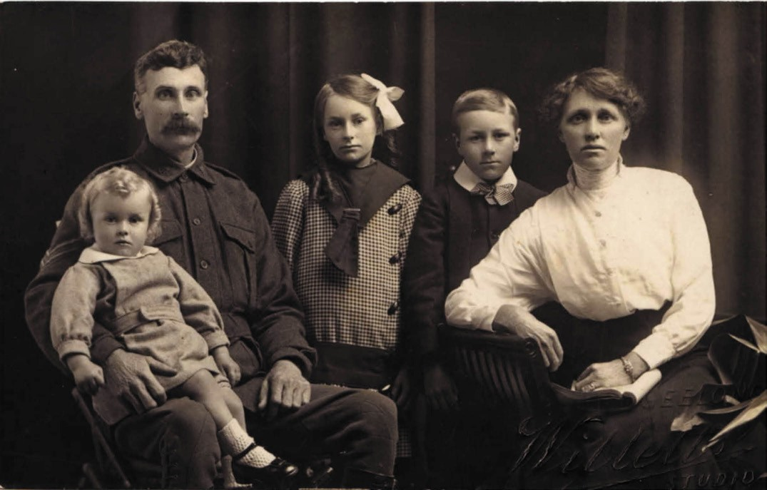
Figure 8.192: John & Sarah McIldowie & family, 1915. Source: Pam Sell.

being entirely destroyed by the want of a careful laying out of the site ; regard being given to the scale and character of memorial buildings (and any adjacent monument); lettering of all inscriptions were to be carefully studied and
be legible, with a bold Roman type, or the Italian lettering of the sixteenth century based on the Roman, generally being the most suitable; and for all memorials, simplicity, scale and proportion was to be aimed at rather than profusion of detail or excessive costliness of material. 1773
The chair of the War Memorials Advisory Committee was Sir Baldwin Spencer, foundation professor of biology at the University of Melbourne and heavily involved in the National Museum of Victoria and the National Gallery of Victoria.1774 The Vice Presidents were the Hon. Arthur Robinson, (Minister of Public Works), Arthur Peck (President of the Royal Victorian Institute of Architects) and L. Bernard Hall
(Director of the National Gallery). Committee members were architects, artists and sculptors, including George King
as the Geelong representative. Other members were S.C. Brittingham (architect), W.R. Butler (architect), J.R. Tranthim Fryer (sculptor), W. Montgomery (artist), J.C. Morrell (architect), C. Douglas Richardson (artist and sculptor),
P.M. Carew Smyth (artist), Frank Stapley (architect), Rev. J. Crookston (Bendigo representative, Presbyterian Minister) and H.H. Smith (Ballarat representative, Principal, Art School).1775

FIRST WORLD WAR MEMORIALS IN GREATER GEELONG

PEACE MEMORIAL, JOHNSTONE PARK
In 1919 soon after the cessation of the war, the Geelong City Council resolved to erect a war memorial to honour the 3000 people who served in World War One,1776 and commemorate those who died.1777 On 26 March 1919, a public meeting resolved that: a fund be established as a suitable Memorial to the Geelong and District Fallen Sailors and Soldiers to be called the Peace Memorial ; and that a committee be formed comprising the Mayors of the respective municipalities, together with Members of Parliament and distinguished locals.1778 After several deliberations and community input, the Committee recommended the memorial take the form of: homes for widows of Geelong and district fallen sailors and soldiers; and some work of art.1779

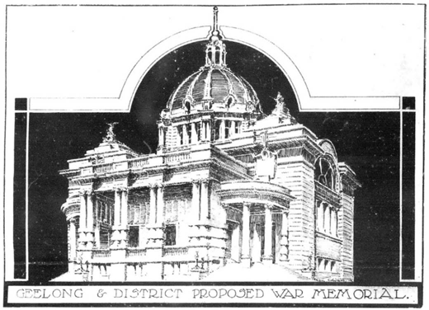

Figure 8.193: Laird & Buchan, & Percy Everett, Proposed Geelong & District Peace Memorial, 1919. Source: News of
the Week, 7 August 1919, GRS 2121, Geelong Heritage Centre collection.
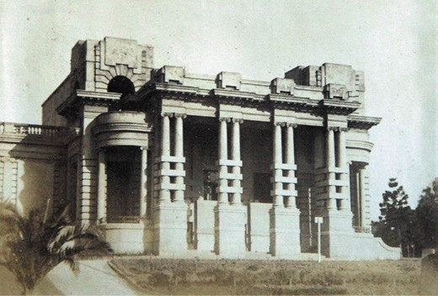
Figure 8.194: Geelong Peace Memorial, Johnstone Park, c.1930. Source: T.T. Holmes collection, Authentic Heritage Services Pty Ltd.

The priority memorial of providing homes of widows was carefully pursued and found to be unworkable. Some of the widows did not want a new home (they owned a home but sought relief with the mortgage) and the matter became complex. It was eventually resolved that 22 selected
applicants would receive £350 each.1780 One of the successful recipients was Mrs Sarah McIldowie (1877- 1949) (Figure 8.192). Her husband, John, was killed in action at Ypres on 1 October 1917 and was buried at the Ypres Reservoir Cemetery, Belgium.1781 A bootmaker, John McIldowie had built a timber dwelling in c.1909 at 18 Verner Street, Geelong.1782 In 1920, the house was valued at £500 and there was £100 owing on
it, together with £50 for the installation of sewerage. Mrs McIlldowie’s weekly income was just £2.18 and so the financial

relief was much-needed.1783
It was also decided that the work of art , take the form of a foyer to a civic hall (to be built at a later stage) and to be
known as the Peace Memorial foyer. In accordance with the recommendations of the War Memorials Advisory Committee, an architectural competition resulted in a joint design by Laird and Buchan and Percy Everett being selected in 1919.1784 The proposed design (Figure 8.193) was featured in News of the Week in 1919 and showed a contextually elaborate building to be crowned by an imposing dome (which never eventuated).1785 The outward expression was Edwardian Baroque the Baroque of the British Empire.1786
The tender of £12,000 by local builder, W.J. Kelly Ltd, was accepted for the work, and was assisted by other Geelong firms, including the monumental masons: Wilcox Brothers, Joseph Smith, and Clement Nash.1787 Other firms involved included Thoms (painting), McEwans (locks), Freeman (plumbing), Charles Marshall (steelwork), Palmer (plasterer), Hakes (Yale door check), Australian War Memorial and Margaret Kerr (bronze tablet) and Tunbridge (oxidised ornaments).1788 The Mayor of Geelong, Howard Hitchcock, laid the foundation stone on 30 December 1922, but the building (Figure 8.194) was not completed until 1926.1789
Nearing the completion of the memorial building in 1925, the Peace Memorial Committee established guidelines for the names of those who fought and died to be inscribed in
granite tablets within the interior. The criteria included sailors, soldiers and nurses that had enlisted and were attested by the Defence Department and who: gave their place of residence as Geelong or any place within a radius of six miles of the Geelong Post Office’; and ‘whose regular or usual home was within the said radius. 1790 One of those who applied was the family of Albert Edward Jennings (Figure 8.195). He was
born in Bellerine Street, South Geelong, in 1896 and enlisted in September 1914, the son of Stephen and Elizabeth (Price) Jennings.1791 Another successful applicant was Muriel
Mary Baker of McDonald Street, Belmont, a nurse of three years training at the Geelong Hospital prior to joining the Australian Nursing Services of the Australian Army Medical Corps in 1917. She served at Salonika until her return home in December 1918.1792
By the time of the opening of the memorial, 3,500 names had been inscribed on the panels.1793

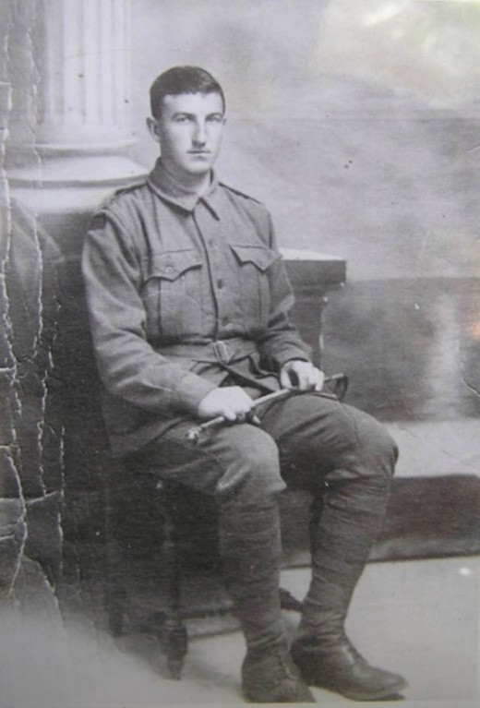
Figure 8.195: Albert Edward Jennings, c.1914. Source: Pam Jennings.

OTHER WORLD WAR ONE MEMORIALS
While the Peace Memorial in Johnstone Park provided a substantial, central monument to honour the fallen of Geelong and district, it was not the only memorial to be erected. In July 1920, Miss Carine Pennefather, recently returned
from six years in London where she devoted her time to entertaining Australian soldiers with lunch picnics on the banks of the Thames, theatre evenings and other recreational pursuits,1794 supported the concept of the Peace Memorial.
Yet, she pleaded for a simple column sacred to the memory of the young lives that were given. 1795 Such a column had been unveiled as a memorial to fallen oarsmen of the Barwon Rowing Club in March of that year,1796 and an obelisk was also in the process of construction by the RSSILA Geelong branch. Following the War Memorials Advisory Committee suggestions, the RSSILA monument was the result of competitive designs, with the work of Wilcox Brothers being awarded the project.1797 The memorial was unveiled in the grounds of the RSSILA Club at the old Union Bank, corner

of Yarra and Little Malop Streets in 1922 (Figure 8.196) (it was later relocated to the north-west corner of Yarra and Brougham Streets, outside the RSL s bowling greens that were opened in 1952 see Theme 9, before being removed to 50-54 Barwon Heads Road, Belmont, in 1990).1798 Another obelisk had earlier been unveiled at Drysdale in 1921.1799
It too had followed the Advisory Committee process and was the result of ‘several designs and specifications from metropolitan firms’ having been submitted to the Drysdale Fallen Soldiers Memorial Fund Committee.1800
A more substantial and elaborate scheme was established at St. Albans by the East Geelong and District Soldiers Memorial Reserve Committee from 1918. Initially, an avenue of honour was proposed but it was subsequently agreed that the memorial be useful as well as ornamental. 1801 A large hall then became the focus before the Committee adopted the concept of a memorial reserve in which an avenue of honor and hall could be located. Land was procured from the Geelong Harbor Trust bound by Boundary and St.
Albans Roads,1802 and from 1919 ploughing began to create the recreation reserve.1803 A cricket club was formed and
a concrete pitch laid down, and the reserve boundaries were planted with 500 trees.1804 At the apex of the large wedge-shaped site was to be erected a monument to the fallen. The honorary secretary of the East Geelong and District Soldiers Memorial Reserve Committee visited the
rooms of the War Memorial Advisory Committee in Melbourne to inspect designs of war memorials received by the Advisory Committee and was thoroughly disappointed with what
he saw.1805 A young Geelong architect was interviewed about a suitable design, the outcome being the construction of a memorial comprising four granite columns supported on a substantial concrete base, the columns surmounted
by a marble figure of an Australian bugler sounding the Last Post1806 (Figure 8.197). The St. Alban s memorial was unveiled on 12 November 1921.1807
Recreation reserves also formed the basis for the construction of other war memorials. Prior to the conclusion of the war in 1917, Neil Campbell donated a piece of his land off Barwon Terrace, Barwon Heads, to the Geelong College in memory of his son, Neil, who had fallen in battle. The
site became known as Neil s Acre.1808 At Portarlington, H.B. Corben and Sons of Clifton Hill were awarded the tender (from 40 drawings and specifications received from city firms) in 1919 for the erection of a granite monument in Canon Reserve comprising four slender columns supported by a raised base and surmounted by a mansard topped with a munition shell1809 (Figure 8.198). It was also at this time when a memorial reserve and avenue of honour was established at Waurn Ponds. Memorial gates were erected to mark the entrances to the Lara and Barrabool Recreation Reserves.
Those at Lara were unveiled by the Governor of Victoria in

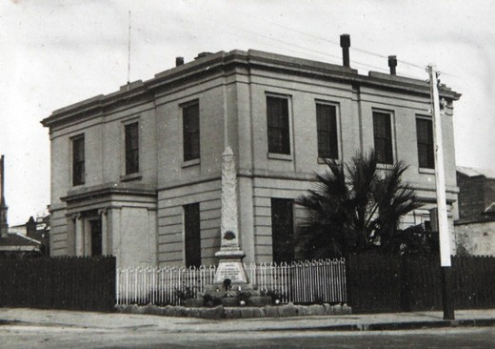
Figure 8.196: War Memorial outside RSSILA Club Rooms (former Union Bank), corner Yarra & Little Malop Streets, c.1930.
Source: T.T. Holmes collection, Authentic Heritage Services Pty Ltd.
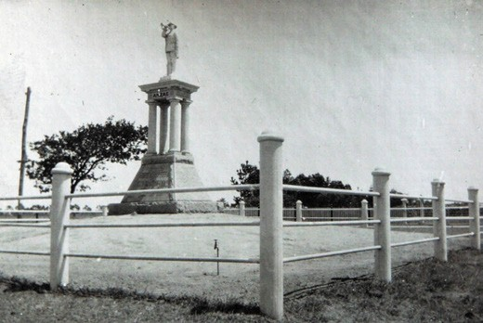
Figure 8.197: St. Albans War Memorial (with memorial reserve in the background), c.1930. Source: T.T. Holmes collection, Authentic Heritage Services Pty Ltd.
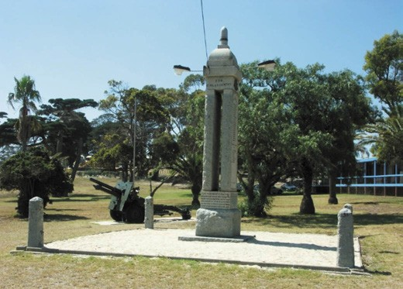
Figure 8.198: Portarlington War Memorial, 2008. Source: David Rowe.

19271810 (Figure 8.199) and gates to the Barrabool Reserve at Ceres were erected in 1937 (Figure 8.200), punctuating memorial trees planted around the boundaries to the reserve by school children on Arbor Day 1916 to commemorate Earl
Kitchener as well as honour and commemorate local soldiers serving and killed in action in the First World War.1811
More modest but no less significant in honouring those who fought and died was the constructions of memorial gates at the entrance to the Belmont State School in c.1934. They were unveiled by T.K. Maltby, M.L.A.1812
More functional was the construction of memorial halls and other buildings. The first was a timber hall built in 1919 at Mannerim (now demolished).1813 In 1922, Laird and Buchan architects design a gabled timber hall as the soldiers memorial at Connewarre.1814 It was following by a hall at St. Leonard s in 1926.1815 In Russell Street, Chilwell, in 1928,
a Baby Health Centre was opened as a war memorial (see earlier subsection).1816
Memorial cloisters were adopted by two private schools. At Geelong Grammar School, Corio, the architect, Harold
Desbrowe Annear was commissioned to design cloisters to link the chapel to Perry House, and honour former students killed in action1817 (Figure 8.201). It was to form a Gothic inspired backdrop laid out in a crescent, to a monument designed by the war artist, George Lambert.1818 Surmounting an elongated and elaborate stone pedestal was a bronze sculpture comprising two figures: an Australian infantryman in France, the other representing a soldier of the Australian Light Horse in Palestine. Both bent over in weariness, their shoulders supported a great bird combining the attributes of an eagle and those of a vulture, and symbolising the German purpose in the Great War and menace that sought to destroy the brightest things in a civilisation that existed as
a result of human effort.1819 The war memorial was unveiled on the School s 70th anniversary on 24 June 1927 by the Governor- General, Lord Stonehaven, and dedicated by
the Anglican Archbishop of Melbourne, the Most Reverend Harrington C. Lees.1820
At Geelong College, the cloister was commenced by the Principal, Sir Francis Roland, in the 1930s following a design by architect, Philip Hudson. It was completed in the 1950s with the construction of the Memorial Wing and Tower and honored former students who fought in World Wars 1, 2 and the Vietnam War.1821

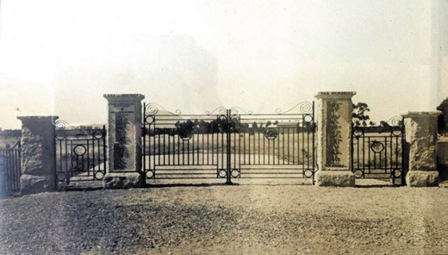
Figure 8.199: Lara Memorial Gates at the entrance to the recreation reserve, 1928. Source: Bruce Challoner, Lara RSL
Sub-branch.
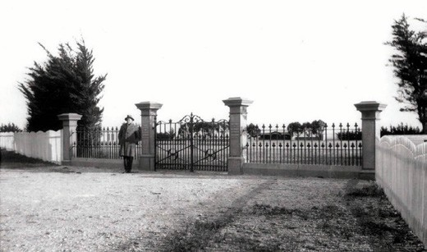
Figure 8.200: Ceres Memorial Gates, 1937, with Alfred Beaumont Mont McDowall standing. Source: David Jirik, Ceres Community Association.
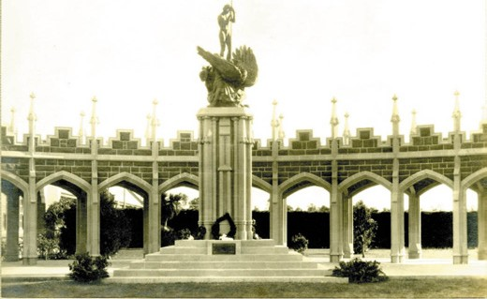
Figure 8.201: Geelong Grammar School Memorial Cloister & Monument, c.1929. Source: Geelong Grammar School archives.

OTHER WAR MEMORIALS IN GREATER GEELONG
The conclusion of the Second World War (1939-1945) brought with it a proposed community centre peace memorial in 1945 as part of the Housing Commission estate at East Geelong (Thomson) (Theme 6).1822 Embracing a five-storey community hall to accommodate a 1250 seat theatre, library, gymnasium, kindergarten, lecture rooms, together with a park, tennis courts, bowling and croquet greens, and a football ground,1823 the ambitious scheme attracted nation-wide interest but it was never realised.1824 Instead, names of those who fought and died were added to the interior of the Peace Memorial and other existing World War One memorials.
Other local memorials were also erected. A traditional obelisk graced St. Helen s Park, North Geelong from 1946 (it was relocated nearby to the grounds of Osborne House,
Swinburne Street, in 1992).1825 Gates were erected at the entrance to the South Barwon Reserve, Barwon Heads Road, Belmont in 1947 in joint memory of Michael H. Duff, long- serving trustee, and of those men and women who served in the war.1826 Similarly at Anakie, memorial gates were erected as a tribute to those who served in both World Wars. 1827 Both of these gate memorials were replaced with different masonry structures in subsequent years.
Less elaborate but especially functional was the construction of the Newtown Memorial Baby Health Centre, Ruthven Street, in 1951-52 (see earlier subsection). In Townsend Road, Whittington, a Baby Health Centre (Figure 8.202) was constructed by locals as a war memorial in 1955, following land having been donated by Robert (Jack) Maxwell, a World War One veteran. This memorial had previously begun
when Frank Pinder senior planted a Snow Gum on the site in 1947. The Baby Health Centre was extended in 1961 with a kindergarten. It closed for this purpose in 2012.1828 Equally functional in 1948 was the relocation of a timber hall from North Shore to the recreation reserve in Reserve Road, Grovedale, as a United Services Memorial Hall.1829 In 1955, a Victorian Regency styled building at 113 Noble Street was commemorated by the All Saints Anglican Church as the All Saints Peace Memorial.1830
In St. Helen s Park in 1946, an avenue of honor was planted. It was followed two years later in 1948 with an expansive avenue of honor planted along Walkers Road, Lara, and extending to the First World War memorial gates.1831
Physical legacies of the sacrifice of other locals who served in later wars are also manifested throughout Greater Geelong. They include the circular layout bluestone Korean War Memorial, Bell Parade, Rippleside; Malay, Singapore and Borneo War Memorial (curved masonry wall, brick piers and rotunda) at St. Helen s Park, Rippleside; and the Vietnam
War Memorial and Avenue of Honor, Melbourne Road, North

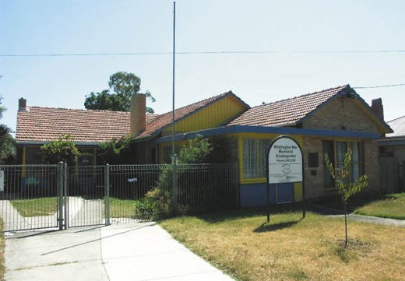

Figure 8.202: Whittington War Memorial Baby Health Centre & Kindergarten, 2008. Source: David Rowe.
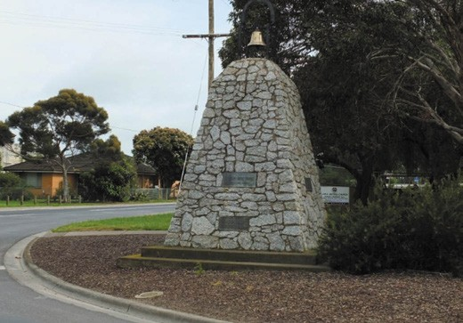
Figure 8.203: Pioneers & Matthew Flinders Memorial,
1B Flinders Avenue (Six Ways), Lara, 2013. Source: David Rowe.

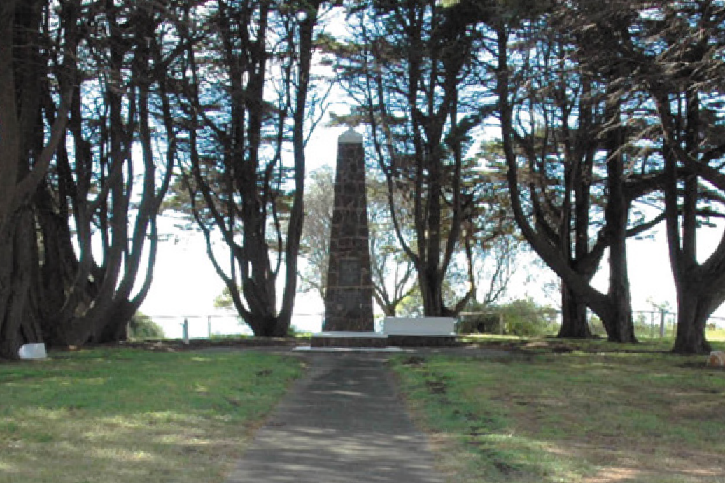
Figure 8.204: Batman commemorative cairn, Batman Park, Indented Head, 2012. Source: Wendy Jacobs.

Geelong, first opened in 1995.1832 Of the latter, the original planting of Plane trees were replaced in 1999- 2000 with 135 Eucalyptus sideroxylon (ironbark) trees, and today the Vietnam Veterans Avenue of Honor is one of only three known roadside Vietnam Veterans memorial avenues in Victoria.1833
More esoteric and yet equally important for their cultural and commemorative values to fallen soldiers in different conflicts was the naming of places and streets (see Appendix 8.3 for a more list of some of the commemorative street names).
Askew Street, Geelong West, for example, was named in honour of Alfred William Askew, 3rd Division of the 1st AIF, killed in Belgium on 25 December 1918.1834 He was the son of Michael Askew, line repairer and gatekeeper, North Geelong, and Caroline Askew (Theme 3). Storrer Street, Geelong, as named after Sergeant Charles Murray Storrer (killed 1915) and his brother, Captain Henry Haigh Storrer (killed 1917).1835 They were the sons of Henry Storrer, grocer (Theme 5).
Similarly, Saywell Street, North Geelong, was named after Private Charles William Saywell, 5th Battalion, AIF, who had been killed at Gallipoli on 1 July 1915, was subsequently named in his honor.1836 The suburb, Norlane, was named
in commemoration of Norman Lane, first servicemen of the area to be killed in World War Two (Theme 6). Nearby,
Stubbs Avenue, North Geelong, was named to commemorate Maxwell Roy Stubbs of 2/22nd Battalion, one of several local servicemen taken prisoner at Rabaul during World War Two and the only soldier to die on the ill-fated Montevideo Maru on 1 July 1942.1837 New residential estates in Greater Geelong are also proposed to honour other service people who lost their lives in World Wars One and Two, and in other conflicts.

OTHER COMMEMORATIVE MONUMENTS
Other commemorative monuments mark the importance of events and figures in the history of Geelong since the 19th century. Most are associated with European explorers, British Monarchs, maritime history and notable people to the municipality.

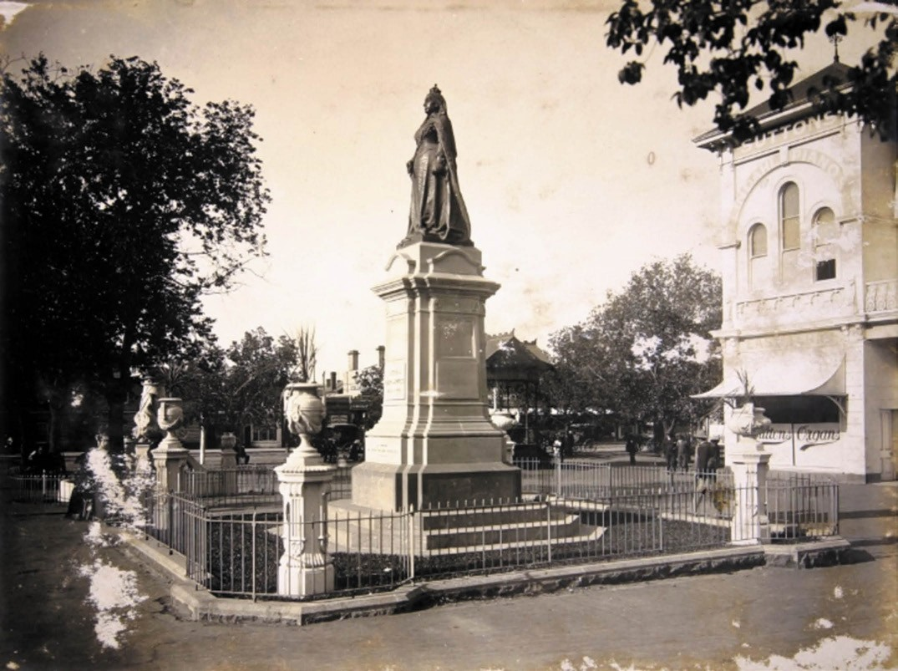
Figure 8.205: W.H. Watts, Queen Victoria statue, Market Square, Geelong, 1905. Source: GRS 2076/13, Geelong Heritage Centre collection.

EXPLORERS’ MONUMENTS
A small number of monuments commemorate Captain Matthew Flinders, R.N., who charted part of Indented Head in 1802 and crossed Corio Bay and climbed the You Yangs (Theme 2). A memorial plaque at Flinders Peak, You Yangs (unveiled in 1912 and replaced in 1974 now missing), stone cairn off the Princes Freeway, Avalon (unveiled in 1977), a plaque affixed to the Pioneers’ Memorial, 1 Flinders Avenue (Six Ways), Lara (1974) (Figure 8.203) and an anchor off The
Esplanade at Portarlington (unveiled 1974) commemorate his visit.1838
The visit to Geelong of Hamilton Hume and William Hovell to the north shores of Corio Bay (the southern-most point of
their overland expedition from Lake George, N.S.W., in 1824) was commemorated 100 years later in 1924 with the unveiling of a granite obelisk designed by the sculptor, Paul Montford atop the Melbourne Hill near the Melbourne Road, Lara (it
was later relocated to its current position in 1955) (Theme 2). At The Esplanade, Indented Head in December 1931, an ironstone cairn (Figure 8.204) was erected by Herbert Lewis on behalf of the Batman Park Committee to commemorate the landing of John Batman and his party nearby at St.
Leonards.1839 This brought about European colonisation of Victoria, initially by the Port Phillip Association, and the so- called treaty with the Wadawurrung (Theme 2).

COMMEMORATIONS OF MONARCHS
The death of Queen Victoria in 1901 was marked by national mourning which in 1904 translated into the unveiling of a bronze statue on a masonry pedestal in Market Square.1840 The pedestal was the work of local monumental mason, Clement Nash (having been selected from a committee of experts in Melbourne),1841 the bronze cast being the work
of J.S. Davie.1842 The bronze sculpture was cast in the workshops of Alessandro Parlanti in London.1843 The statue

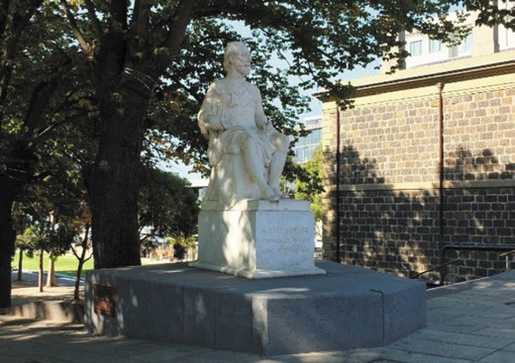
Figure 8.206: King Edward VII statue, corner Moorabool & Brougham Streets, 2015. Source: David Rowe.
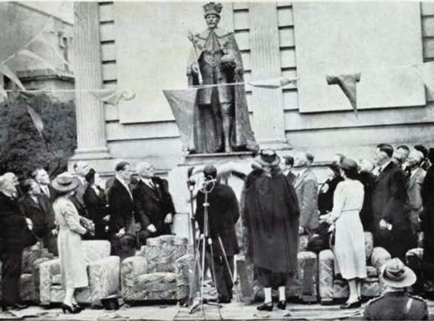
Figure 8.207: Unveiling of King George V statue by Lord Huntingfield, Governor of Victoria, 26 October 1938. Source: A Souvenir of Geelong Centenary Celebrations: 1938 Centenary Illustrated, Geelong Advertiser, 1938, p.9.
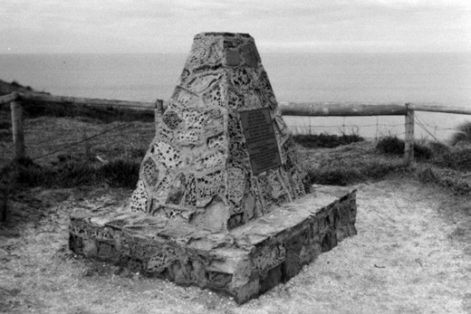
Figure 8.208: Earl of Charlemont Cairn, The Bluff, Barwon Heads, 1998. Source: David Rowe.

provided a suitable method of commemorating the revered, long-serving monarch (Figure 8.205). In 1912, the statue was relocated to western entrance to Eastern Park where
it remains today.1844
The death of King Edward VII in 1910 heralded three memorials being established to his memory. They were the installation of the Post Office tower clock, corner of Ryrie and Gheringhap Streets in 1911 (Theme 3), opening of the Sailors Rest building, corner Moorabool Street and Eastern Beach Road in 1912 (Theme 3) and a statue carved in 1877 by Charles Summers, sculptor and founding member of the Victorian Society of Fine Arts. Then Prince Albert Edward, the statue was a suite of four commissioned by Sir William John Clarke for the people of Victoria.1845 Instigated by Percy Everett, Chief Architect of the Public Works Department,
the National Gallery of Victoria gifted the statue to the people of Geelong in 1939 and it was sited on the Geelong waterfront near the King Edward Sailors Rest.1846 With the redevelopment of the waterfront, and following vandalism (with the removal of the head and part of the arm), the statue languished in the Greater Geelong Council s depot for several years. In 2013, the City of Greater Geelong, with the
generous financial support of Frank Costa OAM, commenced a project to fully restore and return the statue of Prince Albert Edward to the people of Geelong. Sculptor, Jane Valentine was commissioned to carve a new head, arm and toe from matching white marble sourced from Carrara, Italy (the location where Summers had originally sourced the stone
for the statue).1847 In 2014, the restored statue was sited on the north-east corner of Moorabool and Brougham Streets1848 (Figure 8.206).
The death King George V in 1936, who had ruled since 1910, was marked by the erection of a bronze statue, the work of Wallace Anderson, Melbourne sculptor, following approval of the King George V memorial committee.1849 The statue was unveiled near the north-east corner of the Geelong Art Gallery in Johnstone Park 26 October 1938 by
Lord Huntingfield, Governor of Victoria (Figure 8.207). This marked the centenary since the declaration of Geelong as a municipality.1850

MARITIME MONUMENTS
In 1953, a rudimentary stone cairn (Figure 8.208) was erected on the top of the Bluff at Barwon Heads to mark the centenary since the wreck of the Earl of Charlemont 100 years earlier in 1853 (Theme 2), and particularly the pioneering spirit of the survivors. 1851 Eighty descendants of Josiah Bean who had survived the wreck, attended the unveiling.1852 The anchor of the Earl of Charlemont lay dormant on the Charlemont Reef until it was raised by the Barwon Grove Skindivers on 25 June 1972 and placed in the Barwon Heads Park.1853

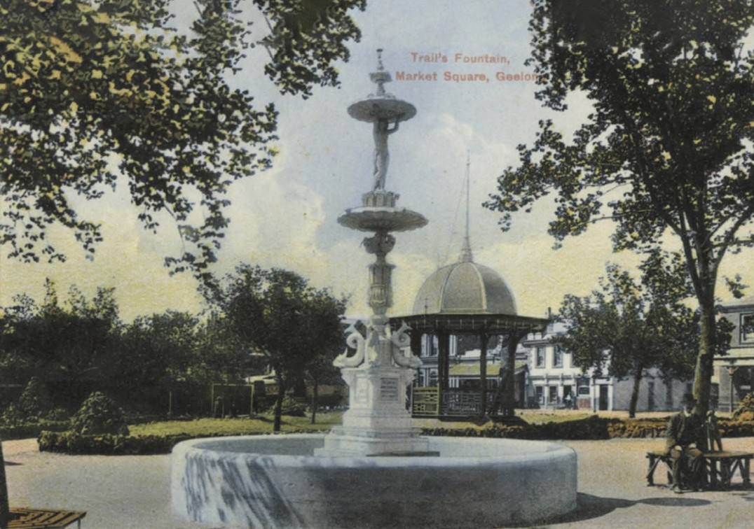
Figure 8.209: Trail s Fountain, Market Square, c.1905. Source: GRS 2009/00689, Geelong Heritage Centre collection.

The secondary anchor of the SS. Orungal was placed in nearby the Earl of Charlemont anchor by the 1990s. Built in Glasgow, Scotland, in 1923, the Orungal struck the Formby Reef, east of the Bluff at Barwon Heads in thick fog on 19 November 1940. A local fisherman, Clive Stephens, reached the vessel when it first grounded and later ferried workmen to the ship for salvaging operations. All passengers and crew were landed safely. On 13 December, a fire broke out on
the ship and it was damaged beyond repair. It was sold to Whelan the Wrecker soon after, for £1175.1854

MONUMENTS TO PROMINENT LOCALS
Numerous monuments to prominent or highly regarded locals of Greater Geelong provide a tangible legacy of the significant contributions they played. The Hitchcock name features on multiple monuments, including the Belcher and Traill fountains in Eastern Park (named after G.M. Hitchcock and John Traill who funded their construction in Market Square in 1904 (Figure 8.209), and subsequently relocated to Eastern Park in 1912).1855 The main Art Gallery building
fronting Johnstone Park was built as a memorial to George M. Hitchcock in 1915 (Theme 9), while the Hitchcock Bandstand in Johnstone Park, erected in 1919 to a design by Percy Everett, was named in memory of Mrs Annie Hitchcock, wife of the late G.M. Hitchcock, and mother of the then Mayor Howard Hitchcock (Theme 9). A number of parks were also

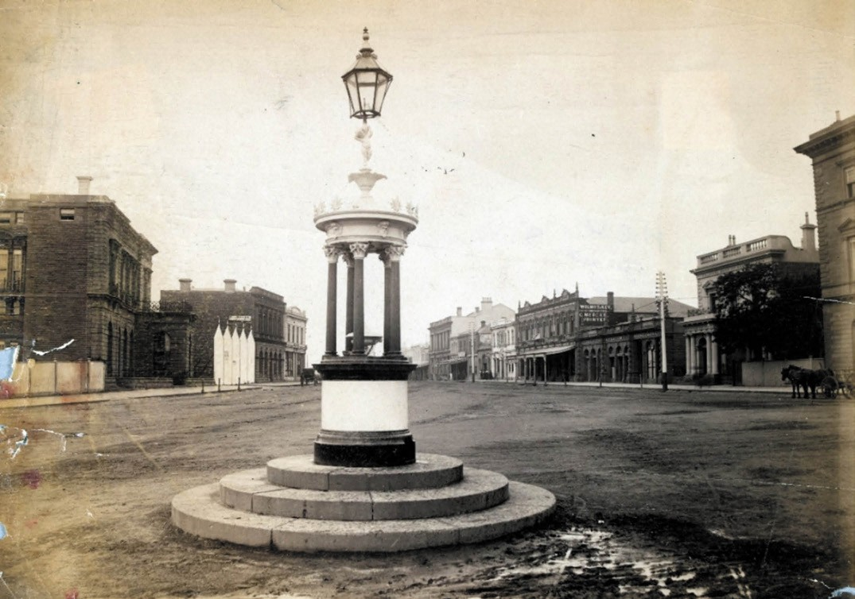
Figure 8.210: Belcher Fountain at east end of Malop Street, c.1900. Source: accession H13263, State Library of Victoria.

named after local mayors and shire presidents, including Johnstone Park, Geelong (after Robert de Bruce Johnstone, Mayor of Geelong), Austin Park, Geelong (after Geelong s second mayor, James Austin), and Alsop Park, Belmont (after South Barwon Shire President, Joseph Alsop) (Theme 9).
A rare and notable monument in central Geelong is the Belcher drinking fountain (Figure 8.210) in the road reserve at the west end of Malop street. It was presented to the Town of Geelong in 1874 by the retiring Mayor, George Frederick Belcher (1829-1909), European pioneer, pastoralist, sub- treasurer in Geelong from 1855 and later a financial broker and land agent.1856 Belcher was also vice-consul for Norway and Sweden from 1872, and for Denmark from 1881.1857 The fountain was imported from Andrew Handyside, and Co., iron founders in England. Comprising of a cylindrical structure
surrounded by Corinthian columns and topped with a cupid figure and lantern, the Belcher fountain is one of just four of Handyside and Co. s fountains of this prototype known
to survive, the others being in Alexandra Park, Manchester, United Kingdom; Gardens of St. Pancreas Old Church, London; and a park in Saratoga Springs, New York, U.S.A.1858

ENDNOTES

- The Kulin People of Victoria , brochure at http:/www.parkweb.vic.gov.au/resources/04_1391.pdf & Kulin , Wikipedia online at https://en.wikipedia.org/wiki/Kulin See also G. Presland, Aboriginal Melbourne: The Lost Land of the Kulin People, Penguin Books, Ringwood, 1994.
- L. Lane, The Wathaurung: Geelong s earliest inhabitants , text of an address to the Geelong Historical Society, 22 March 1988, public reading room shelves, Geelong Heritage Centre (GHC).
- Lane, The Inhabitants , op.cit. & Lane, The Wathurungs , Investigator, vol. 23, no. 3, September 1988, p.99.
- Wadawurrung Elder, Aunty Marlene Gilson, interview on SBS NTIV Radio, 21 July 2017 online, accessed June 2018 at https://www.sbs.com.au/yourlanguAge/aboriginal/en/audiotrack/cultural- history-southern-cross-wadawurrung-people-kulin-nation
- In 1857 for example, William Edward Stanbridge of Wombat, Victoria, recorded the celestial views of the Boorong people. His findings were first recorded
in W.E. Stanbridge, Art XVI On the Astronomy and Mythology of the Aborigines of Victoria , Proceedings of the Philosophical Institute of Victoria, Melbourne, 30 September 1857, pp.137-140.
- Geelong Advertiser, 19 January 1925, p.10.
- L. Lane, Eagle and Crow Bannockburn Land utilization , manuscript no. 13, 1990, Special Collections, Deakin University Library, described Wurdi Youang as the ritual stone circle.
- E. Cooper, The Aboriginal: Evidences of his Ingenuity , in the Ballarat Star, 20 July 1918, p.9.
- NSW Government Gazette (NSWGG), Sydney, 17 August 1836, p.609.
- Plan of the City of Geelong, Parish of Corio, County of Grant, VPRS 16171/P1 Public Record Office Victoria (PROV).
- Ibid. No grant (or date of grant) was shown on the plan for the Roman Catholic Church land in Yarra Street.
- Geelong Advertiser, 27 March 1841, p.2.
- This was the name given to the Catholic Church by the Geelong Advertiser
throughout the 19th and 20th centuries. See for example, Geelong Advertiser, 11 October 1841, p.2.
- Ibid., 11 July 1842, p.2 & D. Rowe & W. Jacobs, Ceres Heritage Citations Project , prepared for the City of Greater Geelong, May 2017 (updated September 2018).
- Act of the Victorian Legislative Council, 6, Victoria, no. 28, Parliament of Victoria, 18 January 1853.
- Public Worship Expenditure, no. A14, Parliament of Victoria, 1854-55, https:// www.parliament.vic.gov.au
- Ibid.
- This outline does not give a definitive history of all places of worship in Greater Geelong.
- See Geelong Advertiser & Intelligencer, 23 November 1852, p.1, 31 December 1852, p.1.
- Geelong Advertiser, 26 May 1910, p.4.
- W.R. Brownhill & I. Wynd, The History of Geelong and Corio Bay with postscript 1955-1900, The Geelong Advertiser, Geelong, 1990, p.145.
- D. Davies, Early Churches in the Geelong District, manuscript, 1988, GHC.
- D. Rowe & W. Jacobs, St. John s Lutheran Church, Yarra Street , Conservation Management Plan, prepared for St. John s Lutheran Church, 2003.
- Rev. Andrew Love Presbyterian Minister, Geelong, Port Phillip Pioneers Group, https://portphillippioneersgroup.org.au/pppg5ey.htm
- Rowe & Jacobs, op.cit.
- St. John s Lutheran Church, 165 Yarra Street, Geelong , VHR 0656, Victorian Heritage Database (VHD) online, at
https://vhd.Heritagecouncil.vic.gov.au
- R. Dixon & S. Muthesius, Victorian Architecture, 2nd edn., Thames & Hudson, London, 1988, pp.182-185.
- H.-R. Hitchcock, Early Victorian Architecture in Britain, Yale University Press, New Haven, 1972, p.114.
- Rowe & Jacobs, op.cit.
- Geelong Advertiser, 29 April 1867, p.3.
- Rowe & Jacobs, op.cit.
- Ibid.
- Visitors illustrated guide to Geelong, with a brief description of Lorne, Henry Franks, Geelong, 1879, p.32.
- Geelong Advertiser, 12 December 1911, p.3.
- Geelong Advertiser, 9 May 1912, p.2.
- A. & M. Harman, Proclaiming the Faith: St. George s Presbyterian Church, Geelong 1860-2010, St. George s Presbyterian Church, Geelong, 2010, p.6.
- Ibid., p.22, Geelong Advertiser 11 May 1889, p.3, The Argus, 25 January 1936, p.26 & A. Willingham, Geelong Region Historic Buildings and Objects Study, vol.2, Geelong Regional Commission, Geelong, 1986, sheet 211.
- Harman, op.cit., p.6.
- Ibid., Geelong Advertiser, 21 October 1909, p.2 & Rowe & Jacobs, op.cit.,
p.11.
- Harman, op.cit., pp.12-14. 41 Ibid., p.13.
42 Ibid., p.17.
- Reformed Presbyterian Churches , Wikipedia online at https://en.wikipedia.org/wiki/Reformed_Presbyterian_churches
- Geelong Advertiser, 25 August 1862, p.2 & 9 August 1862, p.2. 45 Ibid., 1 March 1897, p.4.
- Ibid.
- Ibid.
48 Ibid., 13 August 1862, p.3.
49 Ibid., 1 March 1897, p.4.
- Cazalys Contractor Reporter, 28 October 1913 & Laird & Buchan Contract Book, 1913, GRS 210, GHC.
- Ibid.
- D. Rowe, The Vicarage , Christ Church, Geelong , conservation project, School of Architecture & Building, Deakin University, 1990, p.2.
- Geelong Advertiser, 23 June 1897, p.4.
- See City of Geelong Plan, op.cit.
- Rowe, The Vicarage, op.cit., pp.5-6.
- Ibid.
- Ibid.
- Geelong Advertiser, 22 May 1843, p.3. 59 Ibid., 23 June 1897, p.4.
- Rowe, op.cit., p.2.
- Ibid.
- Ibid., p.3.
- Ibid.
- Ibid.
- Ibid.
- Port Phillip Gazette & Settlers Journal, 3 May 1849, p.2.
- Rowe, op.cit., p.4.
- Geelong Advertiser, 9 October 1893, p.2.
- Geelong Advertiser & Intelligencer, 22 December 1852, p.1.
- J. Grant, Stretch, Theodor Carlos Benoni (1817-1899) , Australian Dictionary of Biography, National Centre of Biography, Australian National University http://adb.anu.edu.au/biography/stretch-theodore-carlos-benoni-4655/ texet7691, published first in hardcopy 1976, accessed online 9 August 2019.
- Ibid.
- Ibid.
- The Rowe Family of Naringal , manuscript, n.d., GHC.
- A. de Q. Robin, Anglicans in Geelong 1842-1990, Geelong Historical Society, 1991, p.19.
- Geelong Advertiser, 11 September 1849, p.3.
- Ibid.
- David Young, Heritage Conservation Consultant, to the author, 5 April 2019.

ABOUT CORAYO: A THEMATIC HISTORY OF GREATER GEELONG
1146

- Geelong Advetiser, op.cit.
- A. de Q. Robin, Macartney, Hussey Burgh (1799-1894) , Australian Dictionary of Biography, op.cit.,
http://adb.anu.edu.au/biography/macartney-hussey-burgh-4062/text6471
- Ibid.
- Geelong Advertiser, 3 February 1859, p.2.
- De Q. Robin, Anglicans in Geelong, op.cit., p.55.
- St. Mark s on the Hill, 715-729 Bellarine Highway, Leopold , VHR H0766, VHD, op.cit.
- Geelong Advertiser, 20 June 1862, p.3.
- Ibid.
- De Q. Robin, op.cit., p.23.
- M. Frewin & L. Phelan, Churches of Geelong & District, vol.1, Geelong Family History Group Inc., Geelong, 2002, p.36.
- Geelong Advertiser, 19 September 1867, p.3.
- Willingham, op.cit., vol. 1, sheet 396.
- De Q. Robin, op.cit., p.50.
- Geelong Advertiser, 19 October 1871, p.3.
- Ibid.
- De Q. Robin, op.cit., p.43, 45.
- D. Rowe & W. Jacobs, Lara Heritage Review Phase 2 , vol.3, prepared for the City of Greater Geelong, 2013 (revised 2016).
- Mercury & Weekly Courier, 7 October 1882, p.3.
- De Q. Robin, op.cit., p.53.
- Rowe & Jacobs, op.cit.
- Ibid.
- Geelong Advertiser, 8 February 1890, p.2.
- D. Rowe, Geelong City C Citations Project , prepared for the City of Greater Geelong, 2002.
- Ibid.
- Ibid.
- D. Rowe, Architecture of Geelong 1860-1900 , architecture thesis, School of Architecture & Building, Deakin University, vol.2, 1991.
- L. Huddle, R. Howe. R. Lewis & K. Francis, Bellarine Heritage Study , vol. 3, prepared for the Australian Heritage Commission, City of Greater Geelong & Heritage Victoria, June 1996.
- All Saints Barwon Heads: Sixty Years of Worship, 2nd edition, Barwon Heads.
- Ibid.
- Ibid.
- Ibid.
- Ibid.
- Ibid.
- Ibid.
- D. Rowe & L. Huddle, City of Greater Geelong Outer Areas Heritage Study Stage 2 , prepared for the City of Greater Geelong, 2000.
- De Q. Robin, op.cit., p.39.
- W. Phillips, The Denominations , in M. Lewis (ed.), Victorian Churches: Their origins, their story and their architecture, National Trust of Australia (Victoria), Melbourne, 1991, p.8.
- C.A. McCallam, ‘Tuckfield, Francis (1908-1865), Australian Dictionary of Biography, op.cit.,
http://adb.anu.edu.au/biography/tuckfield-francis-2747/text 3887, published
first in hardcopy 1967, accessed online 7 February 2017.
- W.L. Blamire & J.S. Smith, The Early Story of the Wesleyan Methodist Church in Victoria, Wesleyan Book Depot, Melbourne, 1886.
- Ibid.
- McCallam, op.cit.
- Ibid.
- Ibid.
- Blamire & Smith, op.cit.
- Lewis, op.cit., p.124.
- Ibid.
- R. Howe, The Wesleyan Church in Victoria, 1855-1901: Its Ministry and Membership , M.A., School of History, University of Melbourne,
1965, p.1.
- G. Butler & Associates, City of Geelong Urban Conservation Study: Significant Sites’, prepared for the City of Greater Geelong, 1991-1995.
- H. Le Griffon, Campfires at the Cross: An account of the Bunting Dale Aboriginal Mission at Birregurra, near Colac, Victoria 1839-1851, p.270.
- Blamire & Smith, op.cit.
- Ibid.
- Noble Street Uniting Church Hall and Kindergarten, 35 Noble Street, Newtown , VHR H1158, VHD, op.cit.
- Frewin & Phelan, op.cit., p.87.
- Rowe & Jacobs, Lara Heritage Review , op.cit.
- Ibid.
- Rowe & Huddle, op.cit.
- Frewin & Phelan, op.cit., p.77.
- St. Alban s Uniting Church & Sunday School 125th Anniversary Booklet , St. Alban s Uniting Church, St. Albans Park, 1983.
- Rowe, Architecture of Geelong , op.cit.
- Ibid.
- Ibid., p.7.
- Huddle, et.al., op.cit.
- Geelong Advertiser, 1 September 1928, p.5.
- Ibid.
- Ibid. The article claims Harrison was married to Miss Hanrahan before the end of the year 1839. Yet, I. Wynd, Harrison, James (1816-1893) , Geelong Biographical Register, Geelong Historical Society, did not identify a Miss Hanrahan as one of Harrison s three wives.
- Ibid.
- Ibid., 11 September 1841, p.2.
145 Ibid., 11 Octoer 1841, p.2.
- Ibid., 1 September 1928, p.5.
- Ibid.
- Ibid.
- Ibid. & Australasian Chronicle, Sydney, 3 January 1843, p.4.
- Geelong Advertiser reported in the Australasian, Sydney, 3 January 1843, mp.4.
- Geelong Advertiser, 1 September 1928, p.5.
- Australasian Chronicle, Sydney, 27 June 1843, p.2 & the Advocate, 10 June 1854, p.12.
- Australasian Chronicle, 27 June 1843, p.2.
- L. Huddle, Architects in Geelong 1840-1860], Humanities Research Report, School of Architecture, The University of Melbourne,
vol.1, 1979, p.2.
- Geelong Advertiser, 1 September 1928, p.5 & 16 May 1846, p.2.
- Ibid., 1 September 1928, p.5.
- They soon opened a Geelong office.
- Geelong Advertiser & Intelligencer, 18 April 1854, p.6.
- The Argus, 17 June 1854, p.5.
- Ibid.
- Ibid.
- Huddle, op.cit., p.41.
- Advocate, 19 February 1870, p.6.
- Geelong Advertiser, 5 February 1872, p.3.
- Ibid.
166 The Age, 21 June 1937, p.12.
- Advocate, 30 November 1933, p.22.
- Sydney Morning Herald, 25 Noember 1930, p.6.

- C. Skehurst, Kairos Catholic Journal, 1 October 2013 in Melbourne Cathholic at
https://melbournecatholic.org.au/Archive/Features/basilica-of-st-mary-of-the- angels-geelong
- A. Preston Hornsey, Roman Catholic Church in Geelong: History of its Development No. 2 in Geelong Advertiser, 8 September 1928, p.13.
- Roman Catholic Church in Geelong: History of its Development No. 3 in
Geelong Advertiser, 15 September 1928, p.10.
172 Ibid., 27 July 1866, p.3.
- Ibid.
- I. Wynd, Bella-wein: A history of the Shire of Bellarine to 1993, 2nd edn., Bellarine On-Line for the Bellarine Historical Society, Drysdale, 2005, p.102.
- Rowe & Huddle, op.cit.
- Ibid., including an interview by Lorraine Huddle with Cyril Kelly in 1986.
- Ibid.
- Ibid.
- D. Rowe & W. Jacobs, St. Patrick s College, 1431 Sturt Street, Ballarat , conservation management plan, prepared for St. Patrick s College, November 2015, p.68.
- Rowe & Huddle, op.cit.
- Rowe & Jacobs, op.cit.
- Frewin & Phelan, op.cit., p.2.
- Ibid.
- Ibid.
- Rev. Samuel Hewlett , Company of Angels online at http://companyofangels.net/hewletts.html
- Ibid.
- Ibid. & Clarence & Richmond Examiner & New England Advertiser, NSW, 25 August 1874, p.6.
- Colonial Times, 2 March 1847, p.3.
- Rev. Samuel Hewlett , op.cit.
- Ibid.
- Frewin & Phelan, op.cit., p.2.
- Former Baptist Church, 3 Aberdeen Street, Newtown , VHR H0426, VHD, op.cit.
- Ibid., Baptist Church, 7 Aberdeen Street, Newtown , VHR H0427.
- Frewin & Phelan, op.cit., p.59.
- Ibid.
- Ibid.
- Rowe & Huddle, op.cit.
- Ibid.
- Rowe & Jacobs, St. John s Lutheran Church , op.cit.
- Ibid.
- Ibid.
- Ibid.
- Ibid.
- Ibid.
- Ibid.
- Ibid.
- Ibid.
- Ibid.
- Ibid.
- Church of Christ, 275 Latrobe Terrace, Geelong , VHR H1123, VHD, op.cit.
- Ibid.
- Geelong Advertiser 14 October 1907, p.3 & Frewin & Phelan,
op.cit., p.30.
- NSWGG, 31 August 1849.
- Victoria Government Gazette (VGG), 23 April 1851, p.399.
- Geelong Advertiser & Intelligencer, 17 March 1854.

216 Ibid., 2 June 1854, p.4.
217 Geelong Advertiser, 25 June 1861, p.1. 218 Ibid., 23 June 1861, p.2.
- Ibid., 24 December 1861, p.1.
- Ibid., 20 December 1927, p.5.
- Ibid. & Australian Home Builder, c.1922, cuttings in the collection of the late Allan Glover, Newtown, provided to the author, February 2014.
- Victorian Births, Deaths & Marriages Victoria (VBDMs) online, https://www.bdm.vic.gov.au/ & Table Talk, 31 October 1919, p.59.
- Ballarat Star, 17 December 1902, p.2.
- List of Mayors of Ballarat, Wikipedia online at https://en.wikipedia.org/wiki/List_of_mayors_of_Ballarat
- Crawcour, Priscilla (-1977) , The Australian Women s Register, Australian Women s Archives Project, The National Foundation of Austrlaian Women (NFAW) in conjunction with The University of Melbourne online at http://www. womenaustralia.info/biogs/AWE4522b.htm
- Priscilla Pescott, daughter of the late Zillah Crawcour, Priscilla Zillah Crawcour , in Geelong Women s Herstory online, 29 January 2012 at http:// geelongherstory.blogspot.com/2011/03/priscilla-zillah-crawcour.html
- Australian Local Government Women s Association Victorian Branch (1963-
) , The Australian Women s Register, op.cit.
- Zillah Crawcour Tree , at http://coblocalhistory.pbworks.com/w/pAge/39870787/Zillah%20 Crawcour%20Tree
- Ibid.
- Pescott, op.cit.
- Ibid. & Crawcour, Priscilla , op.cit.
- This is the date hand-written on the Heritage citation in L. Honman, L. Huddle & R. Aitken, City of Geelong West Urban Conservation Study , vol.3, prepared for the City of Geelong West, 1986. Certificate Title vol 10075 fol. 713 is dated 2002.
- Honman, et.al., op.cit.
- Ibid.
- Geelong Advertiser, 19 July 2017, p.8.
- G. Boreham, Geelong s historic mosque reopens two years after deliberately- lit fire’, SBS News online, 24 March 2018 at https://www.sbs.com.au/news/ geelong-s-historic-mosque-reopens-two-years-after-deliberately-lit-fire
- Revival Centres International , Wikipedia online at https://en.wikipedia.org/wiki/Revival_Centres_International
- Revival Centres Church Bellarine at http://www.revivalcentres.org/bellarine/
- Geelong Revival Fellowship , https://www.facebook.com/pg/trfgeelong/about/?ref=page_internal
- Reformed Church of Geelong, 233 Pakington Street, Geelong West , VHR H1145, VHD, op.cit.
- Geelong Advertiser, 23 October 1867, p.3.
- Ibid., 14 October 1868, p.3.
- D. Rowe, Heritage Assessment of St. Paul s Anglican Church & Halls, Latrobe Terrace, Geelong , prepared for the National Trust of Australia (Victoria), November 2006.
- Ibid.
- Ibid.
- Noble Street Uniting Church Hall and Kindergarten , op.cit.
- The Advocate, 5 March 1892, p.9.
- St. Mary s Hall, 162-190 Myer Streets, Geelong , VHR H1109, VHD, op.cit.
- Ward & Carleton, Weatherboard Schoolroom Drysdale for St. James Church of England , drawings, 4 July 1906 (contract date), State Library of Victoria (SLV), accession no. LTAD 34.
- Geelong Advertiser, 12 September 1911, p.3.
- Rowe, The Vicarage, op.cit., p.5.
- Rowe, Geelong C Citations , op.cit.
- Geelong Advertiser, 2 January 1915, p.4.
- Ibid.

- Geelong Town Council Rate Books, Villamanta Ward, 1853-54, GHC &
Geelong Advertiser, 10 October 1853.
- The Hawthornes , 1 Skene Street, Newtown, National Trust citation, VHD, op.cit.
- Rowe, Geelong C Citations , op.cit. & Willingham, op.cit., vol.2, sheet 211.
- Willingham, op.cit., vol.2, sheet 143.
- Rowe, Architecture of Geelong , op.cit.
- Huddle, et.al., op.cit.
- Butler, op.cit., vol.4, p.101.
- Geelong Advertiser, 15 June 1915, p.3. 263 Ibid., 23 April 1891, p.3.
- Rowe, Architecture of Geelong 1860-1900 , op.cit.
- Laird & Barlow Contract Books, op.cit., 9 August 9 December 1896.
- Rowe, Geelong C Citations , op.cit. & D. Rowe & W. Jacobs, Ashby Heritage Review Stage 2 , prepared for the City of Greater
Geelong, 2010.
- Ashby Presbytery of St. Peter & St. Paul, 1 Malone Street, Geelong , VHR H1112, VHD, op.cit.
- Ibid.
- Advocate, 15 December 1917, p.25.
- Huddle, et.al., op.cit.
- Rowe, Geelong C Citations , op.cit.
- Rowe, The Vicarage , op.cit.
- D. Rowe & W. Jacobs, Sacred Heart College, Newtown , Conservation Management Plan, prepared for Sacred Heart College, 2009.
- The Argus, 17 February 1860, p.5.
- Rowe & Jacobs, op.cit.
- Ibid.
- Ibid.
- Ibid.
- Ibid.
- Advocate, 6 September 1879.
- M. Ignatius, The Wheel of Time: A brief survey of the ninety-six years work of the Sisters of Mercy in Victoria, 1857-1953, The Sisters of Mercy, 1953, pp.106-107.
- Ibid.
- Advocate, 6 September 1879, p.7. 284 Ibid., 12 July 1934, p.23.
285 Ibid., December 1934, p.9. 286 Ibid., 16 August 1934, p.22.
287 Ibid., 31 January 1935, p.16.
- Panagia Gorgoepikoos Monastery at http://www.gorgoepikoos.org.au/
- Ibid.
- City of Greater Geelong Planning Permit 1262/1998.
- NearMap, sourced at the City of Greater Geelong, 2009-2016.
- L. Lane, To be a Child in Aboriginal-Society, Aborigines, Australia-Victoria, Geelong Region, Social Life & Culture , manuscript, Special Collections, Deakin University Library, p.1.
- Ibid.
- Ibid., p.5.
- Ibid., p.8.
- Aboriginal Initiation Ceremonies , Indigenous Australia online at http://www.indigenousaustralia.info/culture/initiation-ceremonies.html
- Ibid.
- Ibid.
- Geelong Advertiser & Squatters Advocate, 29 November 1845, p.3.
- Geelong Advertiser, 27 March 1841, p.3.
- Geelong Advertiser & Squatters Advocate, op.cit.
- Geelong Advertiser, 28 August 1841, p.3.

- Ibid.
- Ibid.
- See Appendix 8.1.
- Geelong Advertiser, op.cit.
- R.F. Doust (comp.)., New South Wales Legislative Council 1824-1856, The Select Committees: 1844/ 17 - Committee on Education, New South Wales Parliamentary Library, 2011, p.116.
308 Ibid., p.118.
309 Ibid., pp.118-119.
- Ibid.
- Ibid.
312 Ibid., p.119.
- Geelong Advertiser, 4 September 1844, p.2.
- Ibid., 5 September 1844, p.2.
- Doust, op.cit.
- Votes and Proceedings of the Legislative Council, no.4, 2 July 1852, Parliament of Victoria, John Ferres, Melbourne, 1852-53.
- Denominational School Board , Description of Agency VA 703, PROV.
- Ibid.
- The Geelong branch was in existence by 1850 -see Geelong Advertiser 22 February 1859, p.2.
- The Age, 11 December 1856, p.5.
- National Education: Rules and Regulations of the Commissioners of National Education for the Colony of Victoria, and Directions for making application for aid towards the building of School-houses, or for the support of Schools, Parliament of Victoria, John Ferres, Melbourne, 29 October 1852, p.3.
- Ibid.
- Ibid.
- The First Report of the Commissioners of National Education for the Colony of Victoria for the Year 1852, Parliament of Victoria, John Ferres, Melbourne, 1853, p.6.
- Ibid., p.7.
- Third Report of the Commissioners of National Education, op.cit., 1855-56, p.10.
- National Education, op.cit.
- Ibid., p.7.
- Third Report of the Commissioners of National Education, op.cit., 26-34, 39.
- National Education, op.cit., p.5.
- Fourth Report of the Commissioners of National Education, op.cit., 1856-57, p.6.
- The Age, 22 October 1856, p.5.
- A.M. Mackenzie to secretary of the National Board of Education, 9 October 1856, VPRS 882/P0, Unit 3, PROV.
- Ibid.
- Ibid., 28 October 1856.
- Ibid.
- L.J. Blake (ed.), Vision & Realisation: a centenary history of state education in Victoria, vol.2, Education Department of Victoria, Melbourne, 1973, p.1003.
- Ibid.
- Geelong Advertiser, 10 September 1885, p.3.
- The Argus, 12 February 1886, p.7.
- One Hundred and Twenty Five Years 1857-1982: Primary School No. 541, Geelong East, anniversary booklet, Rowick Printers Pty Ltd, Belmont, 1982, p.10.
- Ibid.
- See Reports of the Commissioners of National Education, op.cit., reports 1-4 and Geelong Advertiser, 2 July 1872, which referred to Geelong East as St. Albans vested school.
- Geelong Advertiser, 22 May 1872, p.2.

- Passengers in History online, http://passengersinhistory.sa.gov.au/node/654366
- Charles John Prosser , teacher record no. 1705, VPRS 13579/P1, PROV.
- Ibid. & Geelong Advertiser, 1 November 1866, p.2.
- Charles John Prosser, op.cit.
- VBDMs, op.cit.
- Matthew Flinders School No. 8022, 15 Myers Street, Geelong , VHR H1645, VHD.
- Geelong Advertiser, 14 August 1856 & L. Huddle, Architects of Early Geelong 6 , Investigator, vol. 18, no.4, December 1983, p.122.
- The Age, 8 December 1856, p.5.
- Ibid.
- Matthew Flinders School , op.cit. & L. Burchell, Victorian Schools: A Study in Colonial Government Architecture 1837-1900, Melbourne University Press in association with the Victorian Education Department, Melbourne, 1980, p.44.
- Ibid.
- Geelong Advertiser, 25 March 1912, p.3, The Argus, 20 April 1918, p.16 & Gilbert Wilson Brown teacher record, VPRS 13579/P1 PROV.
- Ibid.
- Ibid.
- Ibid.
- George Morrison teacher record, VPRS 13579/P1 PROV.
- Ibid.
- First Report of the Commissioners of National Education, op.cit., p.3.
- Report from the Denominational School Board, from 1st January, to 31st December, 1851, Parliament of Victoria, John Ferres, Melbourne, 1852, p.3.
- Ibid., p.7.
365 VGG, 29 October 1851, p.675.
- Report of the Denominational School Board, op.cit. and Second Report of the Denominational School Board for the Year 1852, op.cit., p.15.
- Ibid.
- Ibid.
- Report of the Denominational School Board, op.cit., 1852., p.8.
- Ibid., p.6.
371 Ibid., p.11.
372 Ibid., p.15.
- Second Report of the Denominational School Board, op.cit., p.10.
- Report of the Denominational School Board, op.cit., 1852, pp.15-16.
375 Ibid., p.19.
376 Ibid., p.18.
- Former St. Giles Church and Free Church School, 72-80 Gheringhap Street, Geelong , VHR H0633, VHD, op.cit.
- K. Cardell, C. Cummin & R. Bakker, Douglas, Archibald (1816-1891), Appendix 3 (b) Brief Biographies of some members, and others, associated with the Comunn na Feinne , Comunn na Feinne: The History of the Geelong Highland Society and its activities 1856-1946, Pete Diggins publisher online at
https://comunnnafeinne.wordpress.com/

- Cardell, Cummin & Bakker, Appendix 1 Comunn na Feinne and Gaelic Education , op.cit.
- Geelong Advertiser, 3 January 1860, p.2.
- Ibid., 2 December 1862, p.3.
- Geelong Advertiser & Intelligencer, 26August 1853, p.1.
- Ibid., 3 August 1855, p.3.
- Ibid., 29 September 1855, p.4.
- J. Grant, Vance, George Oakley (1828-1910), Australian Dictionary of Biography, op.cit., p
http://adb.anu.edu.au/biography/vance-george-oakley-4771/text7933,
published first in hardcopy 1976, accessed online 9 August 2019.
- Ibid.
- Ibid.
- W. Bate, Light Blue Down Under: The History of Geelong Grammar School, Oxford University Press, 1990, Melbourne, p.1, 7.
- Ibid., p.7.
- Ibid.
- Geelong Advertiser, 14 November 1857.
- The Age, 26June 1858.
- Grant, op.cit.
- P.L. Brown, Wilson, John Bracebridge (1828-1895), Australian Dictionary of Biography, op.cit.,
http://adb.anu.edu.au/biography/wilson-john-bracebridge-4869/text8139,
published first in hardcopy 1976, accessed online 9 August 2019.
- Ibid.
- Ibid.
- Ibid.
- Ibid.
- Geelong Advertiser, 25 October 1895, p .4. 400 Ibid., 18 July 1911, p.3.
- D. Rowe & W. Jacobs, Belmont Heritage Review , prepared for the City of
Greater Geelong, vol.3, August 2008.
- Ibid.
- Ibid.
- Bate, op.cit., p.134.
- Ibid.
- Geelong Advertiser, 27 February 1911, p.2.
- Timeline: A Chronology of the History of Geelong Grammar School online, https://www.ggs.vic.edu.au/School/Our-School/Our-History/Timeline
- M. Matthews, Armytage House: A Conservation Plan , School of Architecture & Building, Deakin University, 1995, p.23.
- Ibid.
- Ibid.
- Light Blue Geelong Grammar School, issue 98, September 2016, p.2 & Rowe & Huddle, op.cit.
- Matthews, op.cit., p.23 & Rowe & Huddle, Greater Geelong Outer Areas Heritage Study , op.cit.
- Matthews, op.cit.
- Geelong Grammar School Wikipedia online at https://en.wikipedia.org/wiki/ Geelong_Grammar_School
- Rowe & Jacobs, Sacred Heart College , op.cit., p.14.
- Geelong Advertiser, 10 March 1860, p.4.
- Rowe & Jacobs, op.cit.
- Advocate, 13 February 1869.
- Rowe & Jacobs, op.cit.
- Geelong Advertiser, 30 October 1902, p.2.

- J. Watts, G. Turnbull & K. Walsh, Mercy Girls: The Story of Sacred Heart College Geelong 1860-2010, Scared Heart College, Newtown, 2010, p.48. In 1943, the College was sold to the Dean of St. Mary s and it became St. Mary s Senior School of Domestic Arts. It was later Goold College before being acquired by Matthew Flinders Secondary College.
- H. Penrose, The Way of the Stars: 150 Years of The Geelong College, Australian Scholarly Publishing, North Melbourne, 2011, p.29.
- Rowe & Jacobs, op.cit., p.45.
- The Advocate, 24 December 1910.
- V.J. Hackett, St. Augustine s Orphanage , Investigator, vol.7, no.4, December 1972, p.115.
- Ibid.
- Ibid.
- Geelong Advertiser, 20 August 1885, 16 August 1887, p.3. 429 Ibid., 2 May 1904, p.3.
- St. Joseph s College: Our Story ,
https://www.sjc.vic.edu.au/new/about-sjc/principal.html
- G. McLeod Redmond, Geelong College. History, Register and Records, Jubilee, Sands & McDougall, Melbourne, 1911.
- Ibid.
- Ibid.
- Ibid.
- Ibid.
- Ibid.
- Ibid.
- B.R. Keith, Morrison, George (1830-1898) , Australian Dictionary of Biography, op.cit.,
http://adb.anu.edu.au/biography/morrison-george-4256/text6879, published
first in hardcopy 1974, accessed online 9 August 2019.
- Ibid.
- Ibid.
- Ibid.
- Ibid.
- J. Smith (ed.)., Cyclopedia of Victoria, Cyclopedia Co., Melbourne, 1904, p.450.
- D. Rowe, Golden Plains Shire Heritage Assessment for Amendment C53 , prepared for the Golden Plains Shire, Bannockburn, 2012 & R. Hamilton, A Jubilee History of the Presbyterian Church of Victoria, or, The Rise and Progress of Presbyterianism from the Foundation of the Colony to 1888,
M.L. Hutchinson, Melbourne, 1888, p.107, 249.
- Geelong Advertiser, 30 May 1870, p.2.
- A. Willingham, Two Scots in Victoria: The Architecture of Davidson and Henderson , Master of Architecture Thesis, University of Melbourne, 1983, p.310.
- Penrose, op.cit., p.24.
448 Ibid., p.26.
449 Ibid.
450 Ibid.
451 Ibid., pp.26-27.
452 Ibid., p.31.
- Geelong College, Heritage Guide to The Geelong College online, http://gnet.geelongcollege.vic.edu.au:8080/wiki/HISTORY-OF-THE- GEELONG-COLLEGE.ashx
- Ibid.
- Ibid.
- Rowe & Huddle, op.cit.
- D. Cowperthwaite, Morongo: A History of the Presbyterian Girls College Geelong, Victoria, Australia 1920-1970, The Council of Morongo College, Melbourne, 1969, pp.8-10.
- Ibid.
- Ibid., p.9.
- Geelong Advertiser, 8 March 1924, p.4.

- Cowperthwaite, op.cit., p.15.
- R. Hill, Dr. Shaw s Clonard , Investigator, vol.24, September 1989,
p.98 & 109.
463 Ibid., p.109.
- Clonard Crosslinks, 2010, p.1.
- Conard College: History , Clonard College online at http://clonard.melb.catholic.edu.au/About/history.htm
- Ibid.
- Ibid.
- Huddle, et.al., op.cit.
- Ibid.
- Ibid.
- D. Rowe, St. Mary s Roman Catholic Primary School , City of Greater Geelong C Citations, March 2008.
- Ibid.
- Newtown & Chilwell Council Building Permit Register, January 1942, Building Department, City of Greater Geelong.
- The Argus, 15 January 1949, p.8, Advocate, 13 July 1950, p.7.
- K. Krastins, Newtown Heritage Study , prepared for the City of Greater Geelong, 2008 (adopted 2009).
- Ibid.
- Ibid.
- St. John s Lutheran School History online , https://stjohns.vic.edu.au/welcome/history/
- Geelong Lutheran College: College History online , https://www.glc.vic.edu.au/welcome/college-history/
- Christian College Geelong Our History , https://www.christiancollege.vic.edu.au/about-us/our-college/our-history.html
- Ibid.
- Ibid.
- Statistics of The Colony of Victoria for the Year 1869, Part VIII: Religious, Moral, and Intellectual Progress, Parliament of Victoria, John Ferres, Melbourne, 1870.
- Statistical Register of The Colony of Victoria for the Year 1887,
Part IX: Social Condition, Parliament of Victoria, Robert S. Brain, Melbourne, 1889.
- Newtown & Chilwell Rate Books, 1860-61, GHC.
- Geelong Advertiser, 22 October 1869, p.3.
- Capricornian, 26 July 1902, p.43.
- Sussex Passenger List, December 1854, PROB & Ancestry online, https:// www.ancestry.com.au, & 1851 Census, Islington, Middlesex, England, Ancestry online, op.cit.
- Capricornian, op.cit.
- Geelong Advertiser, 13 June 1859, p.3.
- Ibid., 3 November 1863, p.3.
- Capricornian, op.cit. & Queensland Times, Ipswich Herald & General Advertiser, 28 June 1902, p.6.
- Ibid.
- Geelong Advertiser, 10 November 1870, p.4.
- Bendigo Advertiser, 4 October 1913, p.10.
- Zobaoh Passenger List, 23 August 1859, PROV & Ancestry online, op.cit.
- The Argus, 25 April 1861, p.4.
- Geelong Advertiser, 13 May 1869, p.2.
499 Ibid., 30 January 1869, p.4 & 17 February 1869, p.4.
500 Ibid., 25 October 1872, p.2.
501 Ibid., 9 February 1880, p.2 & 21 April 1889, p.2.
502 Ibid., 16 December 1884, p.3.
503 Geelong Town Council Rate Book, Villamanta Ward, 1854-55, GHC & Geelong Advertiser & Intelligencer, 29 May 1858.
504 Geelong Advertiser, 16 December 1884, p.3. 505 Ibid., 2 May 1885, p.1.

- Camperdown Chronicle, 1 January 1887, p.2.
- Ibid.
- Australasian, 4 January 1890, p.39.
- Newtown & Chilwell Borough Council Rate Book, 1894, GHC. Joseph Hurst, a broker of the local firm of George Hague and Co., Pty Ltd, was listed ass the owner of the property from this time. He named it Eumeralla -see Geelong Advertiser, 5 August 1924, p.9.
- R. Peterson, Historic Government Schools: A Comparative Study , prepared for the Heritage Management Branch, Building Division, Department of Planning & Development, June 1993, p.2.
- Ibid.
- Ibid.
- Burchell, op.cit., pp.13-17, 75.
- Ibid.
515 Ibid., p.72.
516 Blake, op.cit., p.1004, 1006.
- Ibid.
- Ibid.
- Rowe & Huddle, op.cit.
- Geelong Advertiser, 8 December 1870, p.2.
- Blake, op.cit., p.1025.
- Geelong Advertiser, 30 May 1914, p.3.
- Peterson, op.cit., p.3.
- Ibid.
- Ibid., p.4.
- Burchell, op.cit., p.113.
- Peterson, op.cit., Burchell, op.cit. & C. Milburn, Bastow the builders enduring legacy , in The Age, 4 October 2010, p.19.
- Ibid.
- Ibid.
- Ibid.
- Ibid.
- Ibid.
- Rowe & Jacobs, Ceres Heritage Citations Project , op.cit.
- Blake, op.cit., p.1038.
- Rowe & Jacobs, op.cit.
- Ibid.
- Ibid.
- Blake, op.cit., p.1039.
- F. O Neill, Building Services Agency, Melbourne, Fyansford Primary School No. 1691 , Memorandum, 13 March 1997, to G. Bowley, NRE, Geelong (copy held with the Statutory Planning Department, City of Greater Geelong).
- Blake, op.cit.
- Willingham, Geelong Region Historic Building and Objects Study, op.cit.
- Huddle, et.al., op.cit.
- Ibid.
- Geelong Advertiser, 28 April 1882, p.3.
- Ibid.
- D. Brown, Thomas Brown (1849-1904) Family Tree, Ancestry, op.cit.
- Ibid.
- Blake, op.cit., p.1029.
- Brown, Thomas , teacher record, VPRS 13579/P1 PROV.
- Ibid.
- Blake, op.cit., p.1035.
- Ibid.
- Geelong Advertiser, 13 August 1867, p.2. 554 Ibid., 31 July 1884, p.3.
- Ibid., 1 October 1877, p.3.

- Ibid., 14 January 1878, p.3.
- Blake, op.cit., p.1041.
- Geelong Advertiser, 13 July 1928, p.4.
- The Junior School at Chilwell Primary School was of almost identical design. It was demolished in the early 21st century.
- Geelong Advertiser, 23 February 1878, p.3.
- Blake, op.cit., p.1047.
- Ibid.
- Prince of Wales Passenger List, 14 October 1862, PROV & Ancestry, op.cit.
- Ingamells, Joseph , teacher record, VPSR 13579/P1 PROV.
- Ibid.
- Ibid.
- Ibid.
- Geelong Advertiser, 29 April 1879, p.2.
- Ibid.
- Blake, op.cit., p.1049.
- Geelong Advertiser, 14 June 1928, p.4.
- Ibid.
- Ibid.
- Ibid.
- L. Huddle, North Geelong Primary School No. 1889, Bay Street, North Geelong: Assessment of Cultural Significance’, prepared for the City of Greater Geelong, May 1997.
- Ibid.
- D. Rowe & W. Jacobs, Federation University Australia School of Mines Campus, 107 Lydiard Street South, Ballarat , conservation Management plan, prepared for Federation University Australia, May 2017.
- Barlow, Wilfred , teacher record, VPRS 13579/P1 PROV. See also The Argus, 21 May 1915, p.8.
- Geelong Advertiser, 25 June 1923, p.4.
- Ibid., 19 November 1925, p.6.
- Ibid.
582 Ibid., 1 May 1926, p.6.
583 Ibid., 20 October 1926, p.4.
584 Blake, op.cit., p.1043.
585 Ibid.
586 Ibid., p.1058.
- Geelong Advertiser, 14 February 1860, p.2.
- Leader, 22 January 1887, p.42.
- Geelong Advertiser, 10 April 1878, p.1 & 30 July 1881.
- The Argus, 20 January 1881, p.9.
- Geelong Advertiser, 13 January 1886, p.3.
- Annie Norman married Alexander Macpherson, an experimental gardener of Queensland, at South Melbourne in 1887. She died in East Brisbane in 1899. See Leader, 22 January 1887, p.42, Memoirs of the Queensland Museum: Cultural Heritage Studies, vol. 1, part 2b, State of Queensland (Queensland Museum), South Brisbane, 1990, p.219 & Brisbane Courier, 5 December 1899, p.4.
- Geelong Advertiser, 4 April 1883, p.3.
- Ibid.
- Ibid., 1 February 1890, p.2.
- The final advertisement for Miss Sadler’s kindergarten was in the Geelong Advertiser, 5 February 1896, p.1.
597 Ibid., 31 July 1896, p.1.
- Newtown & Chilwell Rate Book, op.cit., 1892.
- Geelong Advertiser, 29 February 1892, p.3.
- Free Kindergarten Union of Victoria (1908-), Australian Women s Register, op.cit.
- Ibid. & A. Spaull, Smyth, John (1864-1927) , Australian Dictionary of

Biography, op.cit.,
http://adb.anu.edu.au/biography/smyth-john-8566/text14951, published first in hardcopy 1990, accessed online 9 August 2019.
- Free Kindergarten Union of Victoria, op.cit. 603 Geelong Advertiser, 14 February 1920, p.4.
604 Ibid., 29 July 1921, p.7.
605 Ibid., 12 May 1920, p.3.
606 See The Argus, 1 November 1933, p.7 & Wynd, Hitchcock, Howard (1866- 1932) , Australian Dictionary of Biography, op.cit., http://adb.anu.edu.au/biography/hitchcock-howard-6685/text11529, published first in hardcopy 1983, accessed online 11 May 2019 & L. Royce, ‘Rev. James Stephen Hambrook Royce , Family Tree, Ancestry, op.cit.
607 Ibid.
608 Geelong Advertiser, 29 July 1921, p.7.
609 Ibid.
610 Ibid., 20 March 1922, p.5.
611 Ibid.
612 Ibid., 21 March 1922, p.6.
613 Ibid., 28 April 1920, p.3.
614 Ibid.
615 The Advertiser (Adelaide), 9 March 1951, p.11.
616 The West Australian (Perth), 16 December 1953, p.14.
617 Geelong Advertiser, 11 May 1920, p.3.
618 Ibid., 29 July 1921, p.7, 2 November 1925, p.1.
619 Ibid., 28 March 1924, p.2.
- Ibid., 27 November 1925, p.1.
- Ibid., 2 November 1925, p.2.
- Ibid., 27 November 1925, p.1.
- Ibid.
- Ibid., 2 November 1925, p.1.
- News (Adelaide), 11 August 1927, p.9.
- Geelong Advertiser, 28 January 1895, p.2 & The Argus, 29 July 1896, p.1.
- Ibid. & Annie Elizabeth McClanchy , teacher record 9790, VPRS 13579/1 PROV.
- Ibid.
- Ibid.
- Geelong Advertiser, 5 February 1895, p.1.
- Ibid., 28 June 1895, p.2, VBDMs & Deceased Search , Geelong Cemeteries Trust database online at
https://www.gct.net.au/deceased-search/ 632 Geelong Advertiser, 28 January 1895, p.2.
- Ibid., 18 December 1923.
- D. Rowe & W. Jacobs, Newtown West Heritage Review , prepared for the City of Greater Geelong, vol.4, October 2016.
- The Advocate, 22 August 1945, p.22.
- W. Perry, The School of Mines and Industries Ballarat; A History of its First One Hundred and Twelve Years, 1870-1982, The School and Mines and Industries Ballarat Limited, Ballarat, 1984.
- Bastow Legacy Part 4: Mess to Mass , at Bastow Institute Blog online http:// www.bastow.vic.edu.au/blog/bastow-legacy-part-4-mess-to-mass
- Report of the Minister of Public Instruction for the Year 1910-11, Parliament of Victoria, Melbourne, 1912, p.28.
- Ibid.
- Blake, op.cit., p.1068 & J.W. Gray , teacher record 12831, VPRS 13579/P1 PROV.
641 Age 5 April, 1902, p.13.
- Ballarat Star, 20 April 1906, p.2.
- Age 6 August 1910, p.2.
- Geelong Advertiser, 14 March 1911, p.3.

- Argus, 18 December 1934, p.8 & Herald, 30 October 1936, p.3.
- Geelong Advertiser, 2 June 1911, p.3.
- Ibid., 3 February 1915, p.2.
- Ibid.
- Ibid., 26 November 1915, p.2.
- Helen Lardner Conservation & Design, City of Geelong Urban Conservation Study Locally Significant Sites’, prepared for the City of Greater Geelong, May 1995.
- See Rowe & Jacobs, Federation University Australia School of Mines Campus , op.cit.
- Blake, op.cit., p.1068. 653 Ibid., pp.1070-1072.
654 Perry, op.cit., p.211.
655 Geelong Advertiser, 1 February 1913, p.2 & 11 February 1913, p.2. 656 Blake, op.cit., p.1073.
- Matthew Frederick Wharington , Mussen Family Tree, Ancestry online op.cit.
& Ellora Passenger List, 5 December 1886, PROV & Ancestry, op.cit.
- Frederick Matthew Wharington teacher record 12861, VPRS 13579/P1 PROV.
- Ibid.
- Ibid.
- Ibid.
- Ibid. & Mildura Cultivator, 5 July 1913, p.11.
- Geelong Advertiser, 19 February 1916, p.3.
664 Ibid., 20 March 1926, p.1.
665 Ibid., 23 July 1927, p.7.
- Ibid.
- Ibid., 13 December 1919, p.4.
- T.A. David , World War One War service records, B2455, National Archives of Australia (NAA).
- Ibid. & Thomas Arthur David teacher record 14852, VPRS 13579/P1 PROV.
- Ibid.
- Ibid.
- Ibid. & Hawthorne, Kew & Camberwell Citizen, 5 April 1918, p.2. 673 Thomas Arthur David teacher record, op.cit. & Age
15 March 1930, p.22.
674 Blake, op.cit., pp.1073-1074.
- G. Long, The Gordon: A Century of Influence, Gordon Technical College, Geelong, 1987, p.2 & E. Sasse, Decorative display of the Technological School, Technological and Industrial Instruction & Ladies School of Design,
n.d. [c.1875], The Gordon TAFE archives, Geelong.
- Gordon Institute of Technology Geelong Victoria 1887 to 1947: Diamond Jubilee Souvenir Brochure, Gordon Institute of Technology, Geelong, 1947, p.1 & Technological and Industrial Instruction: Report of the Royal Commission for Promoting Technological and Industrial Instruction, Parliament of Victoria, John Ferres, Melbourne, 1886, p.13.
- Ibid., p.4.
- Ibid.
- Ibid.
680 Ibid., p.13.
681 Ibid., Appendix C, p.21.
682 Geelong Advertiser, 20 May 1904, p.2.
683 Geelong Advertiser & Intelligencer, 19 December 1853, p.6. 684 Geelong Advertiser, 20 May 1904, p.2.
- Long, op.cit., pp.3-5.
- Report of the Royal Commission for Promoting Technological and Industrial Instruction, op.cit., p.16.
- Geelong Advertiser, 21 June 1887, p.3.
- Ibid., 14 November 1887, p.2.

- Long, op.cit., p.6. 690 Ibid., p.9.
- Ibid., p.2.
- Ibid., p.7.
- Ibid.
- L. Farrall, Hargreaves, William Arthur (1866-1959) , Australian Dictionary of Biography,
http://adb.anu.edu.au/biography/hargreaves-william-arthur-6564/text11289,
published first in hardcopy, 1983, accessed online 10 August 2019.
- Ibid.
- Ibid.
- Ibid.
- Ibid. & Papers and photographs of W.A. Hargreaves 1866-1959, PRG 64 series list, State Library of South Australia.
- Farrall, op.cit.
- Gordon Technical College, 6 Fenwick Street, Geelong , VHR H1019, VHD, op.cit.
- Ibid.
- Gordon Institute of Technology Jubilee Souvenir Brochure, op.cit.
- Geelong Advertiser, 22 January 1921, p.4. 704 Long, op.cit., p.22.
705 Blake, op.cit., p.1076. 706 Long, op.cit.
707 Gordon Institute of Technology Jubilee Souvenir Brochure, op.cit.
708 K. Sillcock, King, George Raymond (1872-1950) , Australian Dictionary of Biography, op.cit.,
http://adb.anu.edu.au/biography/king-george-raymond-6958/text12085,
published first in hardcopy, 1983, accessed online 10 August 2019.
709 Ibid.
710 Rowe, Architecture of Geelong 1860-1900 , op.cit., p.10. 711 Ibid., pp.7-10.
712 R. Everist, The Gordon: an illustrated history, BestShot Publications, Torquay, 2012, pp.40-41.
713 Geelong Advertiser, 20 October 1908, p.3 & Gordon Institute of Technology Jubilee Souvenir Brochure, op.cit.
714 Sillcock, op.cit.
715 The claim that the first School of Architecture emanated from the Gordon Institute of Technology is given in The School of Architecture of the Gordon Institute of Technology , Journal of the Royal Victorian Institute of Architects, vol.34, no.4, September 1936, p.134. It is recognised that architecture subjects were first offered at the University of Melbourne as early as 1861, but they were part of the Engineering School. Architecture was taught as a science within the Engineering School at the University of Melbourne between 1902 and 1914. It was in 1919 when Rodney Alsop established the Melbourne University Architectural Atelier. See Melbourne School of Design: Our History, The University of Melbourne online at
https://msd.unimelb.edu.au/about/history 716 Geelong Advertiser, 2 February 1923, p.4.
- W.R. Brownhill, The History of Geelong and Corio Bay With Postscript 1955- 1990, Geelong Advertiser, 1990, pp.253-254.
- Sillcock, op.cit.
- R. Boyd, Victorian Modern: One hundred and eleven years of modern architecture in Victoria, Australia, Architectural Students Society of the Royal Victorian Institute of Architects, Melbourne, July 1947, pp.20-21.
- Sillcock, op.cit.
- Geelong Advertiser, 29 November 1958.
- Ibid.
- Melinda Kennedy, Wadawurrung (Wathaurong Corporation) to the author, 2018.
- Geelong Advertiser, op.cit.
- Blake, op.cit., p.1076. 726 Long, op.cit., p.56. 727 Ibid., p.59.

- Deakin University, Wikpedia online at https://en.wikipedia.org/wiki/Deakin_University
- Frederic Jevons , Wikipedia online at https://en.wikipedia.org/wiki/Frederic_Jevons
- Ibid.
- Ibid.
- Deakin University History online at https://www.deakin.edu.au/about-deakin/reputation/history
- Rowe, Geelong City C Citations Project , op.cit. 734 Ibid.
735 Ibid.
736 Marcus Oldham College online at https://marcusoldham.vic.edu.au/about-us/about/welcome
737 The Argus, 27 September 1939, p.8 & The Herald, 26 September 1939, p.3.
738 Light Blue Geelong Grammar School, issue 98, September 2016, p.2. 739 The former Girls Grammar School is now the senior school campus of
Geelong Christian College, having recently been the campus of the Reformed Christian College.
740 Marcus Oldham College, op.cit.
741 M. Askew, The Diffusion of Useful Knowledge: mechanic s institutes in nineteenth century Victoria , Master of Arts thesis, Monash University, Clayton, 1982, pp.1-3.
742 Ibid., pp.2-3.
743 Ibid., p.2.
744 Ibid.
745 Cited in Ibid., p.6. 746 Ibid.
747 K. Hames, Victoria s Mutual Improvement Societies, Ken James, Camberwell, 2016, p.1.
748 Investigator, vol. 26, no. 4, December 1991, p.148.
749 Geelong Advertiser, 1 March 1855, Huddle, Architects in Geelong , op.cit., vol.3, p.106 & Brownhill & Wynd, op.cit., p.4987.
750 Huddle, op.cit., p.111. 751 Ibid.
- Investigator, op.cit.
- Geelong Advertiser, 6 July 1927.
- Ibid.
- Ibid.
- See Theme 6 & P. Baragwanath & K. James, These Walls Speak Volumes: A History of Mechanics Institutes in Victoria, Ken James, Camberwell, 2015, p.246.
- Geelong Advertiser, 13 July 1874, p.3 & 14 July 1874, pp.2-3.
- Ibid., 16 September 1876, p.2. 759 Brownhill & Wynd, op.cit., p.711.
760 Baragwanath & James, op.cit., p.468. 761 Age, 4 March 1859, p.5.
762 Geelong Advertiser, 3 August 1883, p.4.
763 Ibid., 24 August 1910, p.4.
764 Ibid., 6 February 1907, p.2.
765 Ibid., 28 April 1911, p.4.
766 Geelong Times, 12 February 1881.
767 Ibid., 7 October 1881.
768 Queenscliff Sentinel, 22 November 1884, p.4.
769 C.S. Walker (comp.), Earlier Days of Newtown and Chilwell, Henwood & Dancey, Geelong, 1958, p.44.
770 Ibid., p.46.
771 Chilwell Library , Geelong Regional Libraries online at https://www.grlc.vic.gov.au/locate/chilwell-library
772 Geelong Advertiser, 23 March 1882, p.3.

773 Ibid., 17 May 1882, p.2.
774 Baragwanath & James, op.cit., p.338.
775 Geelong Advertiser, 30 November 1883, p.3.
776 Ibid.,28 April 1893, p.3.
777 Ibid., 23 September 1893, p.2. 778 Baragwanath & James, op.cit. 779 Ibid.
- Geelong Advertiser, 4 February 1885, p.3.
- Ibid., 3 February 1885, p.3.
- Baragwanath & James, op.cit., p.27.
- Geelong Advertiser, 10 September 1906, p.3.
- Ibid., 14 September 1916, p.5. 785 Baragwanath & James, op.cit. 786 Walker, op.cit., p.46.
787 Ibid.
788 St. Joseph s College: Our History College Timeline online at http://www.sjc.vic.edu.au/new/about-sjc/history.html
789 Honman, et.al., op.cit.
790 Geelong Advertiser, 9 December 1927. 791 Rowe, Architecture of Geelong , op.cit. 792 VBDMs, op.cit.
793 Rowe, op.cit.
794 The Age, 13 April 1936, p.10.
795 Rowe, op.cit.
796 See Buchan Group online at https://buchangroup.com.au/team/ 797 Geelong Advertiser, 28 April 1905, p.2.
798 Ibid., 18 July 1903, p.2, was the first reference of J.A. Laird as a Councillor of the Gordon Technical College.
799 Long, op.cit., p.24 & Geelong Advertiser, 5 July 1923, p.2. 800 Ibid.
- Ibid.
- Ibid., 2 December 1927.
- The Age, 1 April 1936, p.10.
- Gordon Institute of Technology to the Royal Victorian Institute of Architects, 10 October 1938, records of the Gordon TAFE kindly provided by Dale Kent, Records Manager, Quality and Compliance. According to Kristen Thornton, Special Collection Librarian, Deakin University Library, 10 July 2019, the J.A. Laird Library appears to have been subsumed into the Deakin University Library.
- P. Clarke, South Australian Museum, Aboriginal healing practices and Australian bush medicine , Journal of Anthropological Society of South Australia, vol.33, 2008, p.9.
- Ibid.
- Ibid., p.5.
808 Ibid., 9-10.
809 Dr Jonathan Clerke , Australian Medical Pioneers Index online at http://www.medicalpioneers.com/
810 J.R. Briscoe, A sense of duty: The Clerkes An Anglo Irish Family in Colonial Tasmania , Master of Humanities (Tasmanian History) thesis, University of Tasmania, June 1996, pp.16-17, 20.
811 Ibid., p.20.
812 Ibid.
813 Ibid., p.21.
814 Ibid., pp.23-24.
815 Ibid., p.25.
816 Dr Jonathan Clerke , op.cit.
817 Courier (Hobart), 3 January 1853, p.2.
818 Dr Forster Shaw , Australian Medical Pioneers Index online, op.cit. 819 Geelong Advertiser, 23 January 1843, p.2.
- NSW Government Gazette, 18 October 1850, p.1622 & Geelong Advertiser,

12 November 1883, p.2.
- Ibid.
- Dr Forster Shaw , op.cit.
- Ibid.
- Hill, Dr. Shaw s Clonard , op.cit., p.98 & 109, & Port Phillip Patriot & Melbourne Advertiser, 20 August 1840, p.3.
- ‘Geelong Infirmary and Benevolent Asylum 1852 – cont.’, Agency VA 4805, PROV.
- Ibid.
- Geelong Advertiser, 19 May 1849, p.2.
828 Ibid., 25 August 1849, p.1.
829 Ibid.
830 Ibid.
831 The Melbourne Daily, 24 August 1849, p.2.
832 Huddle, Architects in Geelong , op.cit., pp.105-106. 833 Ibid.
834 Ibid.
835 Ibid.
836 Ibid., p.10.
- ‘Geelong Infirmary and Benevolent Asylum 1852 – cont.’, op.cit.
- The First Annual Report of the Committee of Management of the Geelong Infirmary and Benevolent Asylum, with the Financial Statement, List of Subscriptions & Lists of Diseases, &c., Treated During the Year 1852: also The General Rules, and the Internal Regulations of the Institution, J. Harrison, Advertiser, Office,
Geelong, 1852, SLV.
- Ibid.
- Ibid.
- Ibid.
- Ibid.
- Dr Henry Thomas , Australian Medical Pioneers Index online, op.cit. 844 Ibid. & Hobart Town Courier, 20 August 1833.
845 Dr Henry Thomas , op.cit.
846 Marriage Register, Libraries Tasmania online at https://libraries.tas.gov.au/PAges/Home.aspx
847 Geelong Advertiser & Intelligencer, 11 November 1852, p.2. 848 Ibid., 14 May 1853.
849 The Argus, 14 September 1857.
850 Geelong Advertiser, 3August 1895, p.3.
851 Ibid., 22 May 1905, p.3 & 14 February 1907, p.4.
852 Ibid., 23 April 1925, p.6.
- Ibid., 20 September 1923, p.4, ‘Geelong Infirmary and Benevolent Asylum 1852 cont. , op.cit. & J. Pescott, The McKellar Story: The First 25 Years, Neptune Press, Newtown, 1984, 36.
- The Age, 22 February 1923, p.10.
- Geelong: Its Advantages and Opportunities, Geelong Publicity Council, Geelong, 1930, p.68 & D. Rowe, Building a National Image: The Architecture of John Smith Murdoch, Australia s First Commonwealth Government Architect , PhD (Arch.), thesis, Deakin University,
1997, p.218.
- Geelong Times, 3 August 1920.
- Herbert Kitchener, 1st Earl Kitchener , Wikipedia online at https://en.wikipedia.org/wiki/Herbert_Kitchener,_1st_Earl_Kitchener
- Herald, 9 December 1939, p.15 & The Geelong Hospital (previously known as Geelong Hospital 1923-1924; and Geelong and District Hospital 1924-1966), Agency notes, VPRS 4805, PROV.
- The Argus, 13 September 1940, p.10.
- The Age, 17 August 1939, p.14. 861 The Geelong Hospital , op.cit. 862 Ibid.
- Ibid. & Barwon Health Cancer Services About Us ,

https://www.barwonhealth.org.au/cancer-services/about-us
- Geelong Hospital Emergency Department , Kane Constructions online at https://www.kane.com.au/project/geelong-hospital-emergency-department
- University Hospital Geelong, Major Upgrade Works , Kane Constructions online at
https://www.kane.com.au/project/university-hospital-geelong-major-upgrade- works
- History , Barwon Health online at https://www.barwonhealth.org.au/about-us/history
- R.L. Lee, Woman War Doctor: The Life of Mary De Garis, Australian Scholarly Publishing, North Melbourne, 2014, p.122.
868 The Age, 29 May 1950, p.2.
869 Lee, op.cit.
870 The Age, 8 March 1951, p.2.
871 The Argus, 5 August 1954, p.5. 872 The Geelong Hospital , op.cit.
873 Geelong Advertiser, 17 January 1842, p.1.
874 Ibid., 20 November 1913.
875 Sands & McDougall s Directory of Victoria, 1912, SLV. 876 Geelong West Rate Books, 1907-08, GHC.
877 Geelong Advertiser, 22 July 1889, mp.3.
878 VBDMs, op.cit. & Geelong Advertiser, 16 June 1928, p.5. 879 Ibid.
880 The Age, 21 July 1949.
881 Geelong Telephone Directory, 1968, GHC.
882 W. Lareem, Arthur Roden Mackenzie Family Tree, Ancestry, op.cit. 883 Geelong Advertiser, 18 July 1890, p.3.
884 Ibid., 14 November 1911, p.1 & 9 November 1912, p.1. 885 Newtown & Chilwell Rate Book, op.cit., 1922.
886 Sands & McDougall s Directory of Victoria, op.cit., 1949. 887 Geelong Advertiser, 23 June 1919, p.2.
888 Sands & McDougall s Directories of Victoria, op.cit., 1920 & 1928. 889 Geelong Advertiser, 6 February 1885, p.1.
890 Ibid., 6 September 1920, p.3.
891 Ibid., 5 December 1922, p.1.
892 Ibid.
893 N. Cust, Investigator, vol.13, no.1, March 1978, p.30. 894 Ibid.
895 Ibid.
896 Geelong Town Council Rate Book, 1857-58, GHC.
897 Geelong Council Rate Books, op.cit., 1904-1948, Geelong Advertiser, 1 February 1905, p.2 & Advocate, 26 February 1948, p.7.
898 New Hospital in Geelong , The Age, 30 July 1965, p.9. 899 Brownhill & Wynd, op.cit., pp.726-727.
900 St. John of God Geelong Hospital , Wikipedia online at
https://en.wikipedia.org/wiki/St_John_of_God_Geelong_Hospital 901 Geelong Advertiser, 3 July 2016.
- ‘Epworth Geelong takes first patients on opening day, 7 July 2016’, https://
www.epworth.org.au/About-Us/News/Pages/epworth-geelong-takes-first- patients-on-opening-day.aspx
- Geelong Advertiser, 3 March 1848, p.2.
- Ibid, 19 August 1850, p.4.
- Ibid.
- Geelong Advertiser & Intelligencer, 10 Jan 1853, p.1 & Geelong Town Council Rate Book, op.cit., Barwon Ward, 1853-54.
- Geelong Advertiser & Intelligencer, 9 February 1854, p.1.
- S. Due., Some Early Geelong Doctors and Their Publications , Investigator, vol.29, no.1, March 1944, p.14.
- A.S. Taylor, On the Guaiacum Process for the Detection of Blood in Medico- Legal Cases. The Antozone Test , Royal College of Physicians of London,

London, 1868, p.1.
- Ibid.
- Ibid.
- Ibid.
- Geelong Advertiser, 24 July 1871, p.2.
- Ibid.
- Ibid.
- Due, op.cit. p.16. 917 Ibid., p;.14.
918 Geelong Advertiser, 18 January 1881, p.3.
919 Dr James Kilgour , Australian Medical Pioneers Index, op.cit. 920 Ibid.
921 Ibid. & Geelong Advertiser & Intelligencer, 7 April 1853, p.1. 922 Ibid.
923 Ibid.
924 Geelong Advertiser 1 August 1857 & Geelong Town Council Rate Book, Kardinia Ward, op.cit., 1857-58.
925 Geelong Advertiser, 16 June 1859, p.3 & The Argus, 21 September 1897, p.5. 926 Dr William Shaw , Australian Medical Pioneers Index, op.cit.
927 VGG, 18 January 1856, p.106.
928 Dr William Shaw , op.cit. & Geelong Advertiser, 14 January 1890, p.3. 929 Rowe, Architecture of Geelong , op.cit.
930 W. Shaw, Probate Administration files, 10 March 1890, included an inventory of furniture and effects of Dr William Shaw, the property being named Dunlavin . See VPRS 28/P0 Unit 515, PROV.
931 Geelong Advertiser, op.cit.
932 Dr Charles Travers Mackin , Australian Medical Pioneers Index, op.cit. 933 Ibid.
934 Geelong Advertiser & Intelligencer, 24 October 1854, p.1. 935 Due, op.cit., p.16.
- Ibid.
- Dr Charles Travers Mackin , op.cit.
- Geelong Advertiser, 14 March 1872, p.1.
- Dr David Boswell Reid , Australian Medical Pioneers Index, op.cit. & Geelong Advertiser, 10 June 1913, p.3.
- Ibid.
- The Argus, 8 November 1860, p.7. 942 Geelong Advertiser, op.cit.
943 Ibid., 12 October 1870, [.4.
944 Ibid., 4 August 1874, p.3.
945 Ibid., 10 June 1913, p.3.
946 Ibid., 7 September 1903, p.2.
947 Geelong Advertiser, 7 September 1903, p.2.
948 Ibid., 10 June 1913, p.3.
949 Ibid., 26 February 1881, p.2.
950 Henry Maberly Smith Family Tree, Ancestry, op.cit. 951 Geelong Advertiser, 30 November 1910, p.3.
952 Geelong Advertiser, 12 January 1888, p.1.
953 Ibid., 9 April 1892, p.3.
- Ibid., 30 November 1910, p.3.
- The Herald, 24 September 1941, p.5.
- The Argus, 23 July 1942, p.3.
- W.R. Lang, A Remarkable Woman, Investigator, vol.19, no.3, September 1984, p.104.
- Ibid., p.103 & Lee, op.cit., p.3. 959 Lang, op.cit.
960 Lee, op.cit., pp.30-31.

961 De Garis, Mary Clementina (1881-1963) , Encyclopedia of Australian Science
1002 | VBDMs, op.cit. & P. Jennings, Hyett & Chandler Family Trees , research
 | notes, Authentic Heritage Services, March 2009.
1003 | Geelong West Borough Council Building Permit Register, 20 April 1922, Building Department, City of Greater Geelong.
1004 | McClelland, op.cit., p.79, 81, 153.
1005 | Ibid., p.79.
1006 | Jennings, op.cit.
1007 | The Eyrie, 18 Reginal Street, Quarry Hill, Bendigo , VHR H556, VHD, op.cit.
1008 | It is known that Mrs Hyett was a volunteer with the Red Cross during the
 | Second World War, as she was identified in the Geelong Advertiser on 28
 | September 1843. See P. Begg, Geelong The First 150 Years, The Geelong Advertiser Pty Ltd, Geelong, 1990. Mrs Hyett was also President of the
 | Geelong Free Kindergarten see Geelong Advertiser, 23 September 1933 & 3 August 1935.
1009 | Seaton, op.cit.
1010 | See Appendix 8.2.
1011 | Stevens Geelong, Western District and Squatters Directory of Victoria,
 | combined with Mount Gambier, Port Macdonnell, and Penola, in the South-
 | Eastern District of South Australia, 1866-67, George Stevens, Melbourne, 1866.
1012 | Geelong Advertiser, 28 July 1893, p.4.
1013 | Ibid., 13 February 1896, p.4.
1014 | Ibid., 16 February 1896, p.5.
1015 | Ibid., 13 February 1896, p.4.
1016 | Ibid., 24 February 1898, p.4 & E.A. Vidler, The Book of Geelong: Its People,
 | Places, Industries and Amusements, Edward A. Vidler, Geelong, 1897, p.81.
1017 | Geelong Advertiser, 31 July 1896, p.4 & 26 February 1926, p.4.
1018 | Royal Victorian Trained Nurses Association Nurses , Series 16407, Description, PROV.
1019 | Ibid.
1020 | Nurses Board Agency , VA 3144, PROV.
1021 | Geelong Advertiser, 6 April 1925, p.4.
1022 | Ibid., 1 March 1928, p.6.
1023 | The Herald, 12 March 1931, p.27.
1024 | The Argus, 12 April 1940, p.2.
1025 | The Geelong Hospital , op.cit.
1026 | The Herald, 18 November 1943, p.5.
1027 | Ibid., 25 June 1949, p.2.
1028 | McClelland, op.cit.
1029 | Geelong Advertiser, 10 August 1914, p.4.
1030 | Ibid., 23 September 1914, p.2.
1031 | C. Scott, War Worn and Weary: The Convalescent Nurses of Osborne
 | House, Geelong 1917-1919, Osborne Park Association Inc., Geelong, 2018, p.29.
1032 | Geelong Advertiser, 2 March 1915, p.2, 27 July 1917, p.2 & 17 November 1919, p.2.
1033 | Scott, op.cit., p.44.
1034 | Geelong Advertiser, 17 November 1919, p.2.
1035 | Ibid., 23 September 1891, p.4 & 29 August 1919, p.3.
1036 | Ibid., 2 December 1919, p.2.
1037 | Ibid., 11 March 1921, p.2.
1038 | Ibid., 26 February 1926, p.4.
1039 | The Geelong Hospital Nurses League: A History of the First Fifty Years
 | 1934-84, Geelong Hospital Nurses League, Newtown, 1984, p.11.
1040 | Ibid., p.13.
1041 | Ibid., p.14.

online at http://www.eoas.info/biogs/P002056b.htm
962 Lang, op.cit.
963 Ibid.
964 Ibid.
965 Ibid., p.104.
966 Newtown & Chilwell Council Rate Book, op.cit., entry 41, 1922. 967 Smith s Weekly, Sydney, 27 June 1931, p.22.
968 The Journal of the American Medical Association, vol. 97, no.2, 11 July 1931, p.197.
969 Ibid.
970 Lang, op.cit., p.104.
971 Geelong Advertiser, 13 November 1919, p.2. 972 Lang, op.cit., p.105.
973 Geelong Advertiser, 16 August 1897, p.3.
974 Ibid., 29 March 1898, p.2.
975 Ibid., 22 June 1878, p.1.
976 Smith, op.cit., vol.2, p.442.
977 Glendower Passenger List, 12 December 1867, PROV & Ancestry, op.cit. 978 Ibid. & The Age, 30 September 1896, p.6.
- The Herald, 29 September 1896, p.1.
- N. Cust, Currabeg House , Investigator, vol.24, no.4, December 1989, p.133.
Kennedy passed his 2nd year in 1885 see The Age,
3 December 1885.
- Cust, op.cit.
- Geelong Advertiser, 31 July 1918, p.6 & Geelong West Borough Rate Books, op.cit., 1901, 1902.
- Geelong Advertiser, 18 December 1907, p.3.
- C.F. Hutchinson (comp.), Cat s tales: the Geelong Football Club, 1897-1983, Geelong Advertiser, Geelong, 1984 & Geelong Advertiser, 1 August 1912.
- J.E. McClelland, From infirmary to hospital: Geelong and District Hospital (Kitchener Memorial) 1924 to 1966, The Geelong Hospital, Geelong, 1966, p.79.
- Hutchinson, op.cit. & Geelong Advertiser, op.cit.
- G. Seaton, The Ashby Story: A History of Geelong West, Geelong West City Council, 1978, p.207.
- Geelong West City Council Minutes, 15 January 1936, GRS 757, GHC.
- I. Wynd, So Fine a Country: A History of th Shire of Corio, Shire of Corio, North Geelong, 1981, p.79.
- Ibid.
- Seaton, op.cit.
- Hutchinson, op.cit.
- VBDMs, op.cit. & Geelong West Town Council Rate Book, op.cit., 1926-27.
- Steen Anderson, grandson of Dr Frederick Wallace, to the author, 2011. 995 Ibid.
996 Wallace, Frederick Hilton , AIF Attestation papers, World War One Service
Record, series B2455, NAA.
997 Geelong West Town Council Rate Book, okp.cit., 1924-25. 998 VBDMs, op.cit.
999 Anderson, op.cit.
1000 Ibid.
1001 Barlow advertised for tenders for the construction of Narbethong in the Geelong Advertiser on 26 May 1934. The size of the proposed dwelling was described in the Geelong West City Council Rate Books, op.cit.

1042 | Red Cross in Geelong 1914-1985 , manuscript attached to E. Grech, Geelong Red Cross Centre , architectural conservation report, School of Architecture  & Building, Deakin University, n.d. [c.1991]. This manuscript mistook Alice
Thear s name for Mrs Fear . See VBDMs, op.cit., Argus, 18 December 1941,
p.4 and Mayors and Councillors database, GHC.
1043 | Ibid.
1044 | Ibid.
1045 | Grech, op.cit.
1046 | Geelong Advertiser, 25 September 1916, p.2 & 29 September 1916, p.3.
1047 | Ibid., 4 November 1916, p.3.
1048 | Port Phillip Patriot & Melbourne Advertiser, 13 May 1839, p.4.
1049 | Geelong Advertiser, 7 March 1844, p.3.
1050 | Melbourne Argus, 15 October 1857, p.2.
1051 | Argus, 1 October 1849, p.2.
1052 | Central Board of Health, First Annual Report, Parliament of Victoria, John Ferres, Melbourne, 26 February 1856, pp.48-49, 54, 56.
1053 | Ibid.
1054 | Ibid., 1862.
1055 | Geelong Advertiser, 16 December 1864, p.2.
1056 | Ibid., 28 May 1887, p.3.
1057 | Ibid.
1058 | Ibid.
1059 | Ibid., 11 February 1919, p.3.
1060 | Ibid., 1 October 1891, p.2.
1061 | Ibid.
1062 | T. Saul, Inside the Swift, Deadly History of the Spanish Flu Pandemic ,
 | National Geographic online, 2018, https://www.nationalgeographic.com/history/magazine/2018/03-04/history- spanish-flu-pandemic/
1063 | Ibid.
1064 | ‘The Influenza Pandemic of 1918’, Standford University online at https://virus.stanford.edu/uda/.
1065 | Saul, op.cit.
1066 | Ibid.
1067 | Geelong Advertiser, 3 October 1918, p.2.
1068 | Herald, 22 October 1918, p.2.
1069 | Leader, 26 October 1918, p.38.
1070 | Ibid.
1071 | Herald, 16 November 1918, p.16.
1072 | Geelong Advertiser, 21 November1918, p.2, 26 November 1918, p.2.
1073 | Daily Mercury (Queensland), 19 February 1919, p.4.
1074 | Table Talk, 8 May 1919, p.2.
1075 | Ibid.
1076 | Ibid.
1077 | P. Curson & K. McCracken, An Australian Perspective of the 1918-1919
 | Influenza Pandemic’, NSW Public Health Bulletin, vol. 17, no. 7-8, 2006, p.103.
1078 | Ibid., p.106.
1079 | VGG, 2 December 1918, p.3417.
1080 | Ibid.
1081 | Ibid.
1082 | Ibid.
1083 | Ibid.
1084 | Geelong Advertiser, 14 November 1918, p.4.
1085 | Ibid., 7 February 1919, p.3.
1086 | News of the Week, 20 February 1919, p.3.
1087 | Geelong Advertiser, 6 February 1919, p.4 & Bellarine Rate Book, 1889, Geelong Heritage Centre collection.

1088 | Geelong Advertiser, 7 February 1919, p.3.
1089 | Ibid.
1090 | Ibid. & 8 February 1919, p.3.
1091 | Ibid.
1092 | Ibid.
1093 | Ibid., 17 February 1919, p.3.
1094 | Ibid., 24 February 1919, p.2.
1095 | Ibid., 8 March 1919, p.3.
1096 | Ibid., 10 September 1919, p.2.
1097 | Ibid.
1098 | Covid-19 , NewScientist, New Scientist Ltd, March 2020 at https://www.newscientist.com/term/covid-19/
1099 | Ibid.
1100 | Ibid.
1101 | B. Sutton, Chief Health Officer, ‘State Of Emergency Declared in Victoria Over COVID-10 , media release, 16 March 2020 at https://www.premier.vic.gov.au/state-of-emergency-declared-in-victoria-  over-covid-19/
1102 | Geelong Advertiser, 2 February 1907, p.8.
1103 | Ibid., p.3.
1104 | Ibid., 2 February 1907, p.8 & Rowe, Architecture of Geelong , op.cit.
1105 | Geelong Advertiser, 23 July 1907, p.4.
1106 | The Age, 23 July 1907, p.6.
1107 | Geelong Advertiser, 5 August 1911, p.7.
1108 | The Argus, 18 August 1938, p.11.
1109 | Ibid., & Geelong Advertiser, 14 December 1917, p.2.
1110 | Ibid.
1111 | H. Sheard, Victoria s Baby Health Centres: A History 1917-1950, How did a statewide system of Baby Health Centres grow from the efforts of a small  group of concerned women in 1917? , Master of Education thesis, Faculty of Education, University of Melbourne, 2005, p.34.
1112 | The Age, 12 July 1919, p.21.
1113 | Geelong Advertiser, 8 April 1918, p.3 & 1 August 1919, p.3.
1114 | Ibid., October 1919, p.2.
1115 | The Australasian, 23 October 1920, p.46.
1116 | Geelong Advertiser, 14 April 1927, p.3.
1117 | Authentic Heritage Services Pty Ltd, Survey of Victoria s Veteran- Related Heritage, prepared for the Department of Planning & Community  Development, Melbourne, August 2007, & Tom Welsh to Cr Sarah Mansfield, City of Greater Geelong, 3 January 2018, & Noel Thompson to Lisa Neville, M.L.A., 10 June 2014, City of Greater Geelong files.
1118 | S. Priestley, Bush Nursing in Victoria 1910-1985: The First 75 Years, Victorian Bush Nursing Association in conjunction with Lothian, Melbourne, 1986,  pp.17-18.
1119 | J.W. Barrett, Outline History of the Victorian Nursing Association, Victorian Bush Nursing Association, Melbourne, 1943, pp.1-2.
1120 | Geelong Advertiser, 18 September 1926, p.5.
1121 | Barrett, op.cit., p.2.
1122 | Ibid., p.3.
1123 | Ibid., p.1.
1124 | Geelong Advertiser, 21 November 1922, p.7.
1125 | Ibid.
1126 | VBDMs, op.cit. & Ballarat Star, 28 December 1916, p.4.
1127 | Ibid.
1128 | Argus, 28 November 1922, p.13 & Geelong Advertiser, 16 June 1928, p.5.
1129 | Priestley, op.cit., pp.186-187 & The Argus, 22 November 1939, p.7.
1130 | Priestley, op.cit., p.187 & S. Zada, Golden Thread of Care: A History of
 | the Bellarine Peninsula Community Health Service, Bellarine Peninsular Community Health Service Inc., Point Lonsdale, 2002, p.22.
1131 | Ibid., p.26.

1132 | Geelong Advertiser, 30 April 1885, p.3.
1133 | History of St. John Ambulance (Victoria) at https://www.stjohnvic.com.au/history-st-john.asp
1134 | Geelong Advertiser 9 November 1896, p.2.
1135 | Age, 10 August 1907, p.14.
1136 | Geelong Advertiser, 10 August 1907, p.2.
1137 | Ibid., 15 July 1914, p.2.
1138 | Ibid.
1139 | News of the Week, 9 March 1916.
1140 | Ballarat Star, 17 November 1921, p.6 & the Age, 13 October 1926, p.14.
1141 | Ibid., 14 January 1949, p.2.
1142 | Argus, 22 August 1949 & Buchan Laird and Buchan Architects, Ambulance Station drawings 1950-54, GRS 104/A28/1-25, GHC.
1143 | Horsham Times, 24 June 1952, p.3.
1144 | The Age, 20 June 1952, p.4.
1145 | Argus, 23 March 1954, p.7.
1146 | Ambulance Victoria , Wikipedia online at https://en.wikipedia.org/wiki/Ambulance_Victoria
1147 | Cordell Connect at https://www.cordellconnect.com.au/public/project/ProjectDetails. aspx?uid=1621489
1148 | Geelong Advertiser, 12 December 1848, p.2.
1149 | Dr William Keating Huston , Find A Grave online at https://www.findagrave.com/memorial/174682022/william-keating-huston, South Australian Gazette & Minting Journal, 12 May 1849, p.2 & Creswick & Clunes Advertiser, 8 May 1863.
1150 | Geelong Advertiser, 15 November 1849, p.4.
1151 | Ibid., 21 December 1867, p.2.
1152 | VBDMs, op.cit. & Geelong Advertiser, 29 February 1868, p.3.
1153 | Ibid.
1154 | Ibid.
1155 | Ibid., 21 December 1867, p.2.
1156 | Ibid., 6 April 1871, p.2.
1157 | See Geelong Town Council Rate Books, op.cit., 1871-1915.
1158 | Geelong Advertiser, 9 December 1876, p.4.
1159 | VBDMs, op.cit.
1160 | Smith, op.cit., p.446 & Certificate of Title vol 2818, fol. 549.
1161 | Ibid. & vol. 2723, fol. 427. See also VBDMs, op.cit.
1162 | See Geelong Town Council Rate Books, op.cit., 1904 & 1905, & Geelong
 | Advertiser, 15 November 1879, p.2.
1163 | Geelong Town Council Rate Books, op.cit.
1164 | Ibid., 1906-1933 & The Age, 3 October 1933, p.5.
1165 | VBDMs, op.cit., Geelong Advertiser, 5 July 1859, p.1 & Smith, op.cit.
1166 | Geelong Advertiser, op.cit.
1167 | VBDMs, op.cit.
1168 | Geelong Advertiser, 24 September 1877, p.3.
1169 | The Sands and McDougall s Directory of Victoria in 1965 listed Elizabeth
 | Street but by 1970 the Directory listed Roebuck Street. See Sands and
 | McDougall s Directories, SLV.
1170 | Geelong Advertiser, 30 October 1909, p.3.
1171 | Ibid.
1172 | Smith, op.cit.
1173 | VBDMs, op.cit.
1174 | Vidler, op.cit., p.31.
1175 | Ibid.
1176 | Shepparton Advertiser, 7 October 1938, p.15.
1177 | Ibid.
1178 | Geelong Advertiser, 1 October 1863, p.2.
1179 | Ibid., 5 December 1914, p.8.

1180 | Ibid., 15 June 1867, p.1.
1181 | Ibid., 27 November 1879, p.3.
1182 | Ibid., 15 January 1870, p.3.
1183 | The last reference to Owen s pharmacy in operation was in 1909 See
 | Geelong Advertiser 23 March 1909, p.2.
1184 | Homeopathy , Wikipedia at https://en.wikipedia.org/wiki/Homeopathy
1185 | Ibid.
1186 | Geelong Advertiser, 3 March 1869, p.3 & 25 August 1869, p.3.
1187 | Ibid., 27 January 1869, p.2.
1188 | Ibid., 7 April 1891, p.2.
1189 | Ibid., 3 August 1901, p.3.
1190 | Ibid., 10 January 1880, p.4.
1191 | Rowe, Geelong City C Citations Project , op.cit.
1192 | Geelong Advertiser, 11 May 1889, p.3.
1193 | Rowe, op.cit.
1194 | Vidler, op.cit., p.37.
1195 | Geelong Advertiser, 23 August 1918, p.3.
1196 | He was reported as being burgled from this address in 1855. See The Argus, 17 September 1855, p.5.
1197 | Age, 12 December 1860, p.6 & Christ Church Baptisms Register, September 1861, GHC.
1198 | D. Rowe, Pakington Street Urban Design Framework: Heritage Report , prepared for the City of Greater Geelong, February 2018.
1199 | The Geelong West Borough Rate Books, op.cit., listed Walton as occupier in 1876-77, but Mrs Walton (widow) in 1877-78.
1200 | B. Hearne, George William Goodall Hearne Family Tree, Ancestry, op.cit.
1201 | Ibid.
1202 | Geelong Advertiser, 9 April 1878, p.2.
1203 | Ibid., 6 April 1878, p.4.
1204 | Ibid., 11 June 1888, p.3.
1205 | Vidler, op.cit., p.45.
1206 | Geelong Advertiser, 28 July 1921, p.3.
1207 | Geelong City Council Rate Book, op.cit., Kardinia Ward, entry 270, 1921.
1208 | Geelong Advertiser, 5 July 1922, p.1.
1209 | Geelong Advertiser, 17 June 1898, p.4.
1210 | Ibid.
1211 | Ibid.
1212 | Ibid., 31 December 1898, p.2.
1213 | Ibid.
1214 | Butler, op.cit.
1215 | I. Wynd, Geelong United Friendly Societies Dispensary Centenary, Geelong United Friendly Socities Dispensary Friendly Society, Geelong, 1998, pp.41- 42.
1216 | Pescott, op.cit., pp.43-44 & H.W. Kinloch, Ballarat & Its Benevolent Asylum: A Nineteenth Century Model of Christian Duty, Civic Progress & Social Reform , PhD thesis, School of Behavioural & Social Sciences & Humanities, University of Ballarat, 2004, p.123.
1217 | Pescott, op.cit.
1218 | Ibid., p.44.
1219 | Ibid., p.45.
1220 | The Age, 9 December 1943, p.4 & Gippsland Times, 15 June 1944, p.6.
1221 | Ibid. & The Herald, 26 October 1944, p.6.
1222 | Ibid., 19 February 1945, p.6.
1223 | Ibid.
1224 | Ibid.
1225 | The Argus, 17 May 1956, p.7 & Pescott, op.cit., p.19.
1226 | Ibid., p.19, 74.
1227 | Ibid., p.52.

1228 | Ibid., p.58.
1229 | Ibid., pp.60-63.
1230 | McKellar Centre , Barwon Health online at https://www.barwonhealth.org.au/ patients-visitors/our-sites/mckellar-centre
1231 | D. Daley, St. Laurence Park Retirement Village Fiftieth Anniversary, D. Daley, 2009.
1232 | Ibid.
1233 | Ibid.
1234 | Ibid.
1235 | Ibid.
1236 | Ibid.
1237 | S. Swain, A Refuge at Kildare: The History of the Geelong Female Refuge
 | and Bethany Babies Home, Bethany Child & Family Support, North Geelong,
 | 1985, p.10 & Investigator, vol. 11, no.1, March 1976, p.7.
1238 | Swain, op.cit.
1239 | Geelong Advertiser, 11 September 1865, p.2.
1240 | Ibid.
1241 | Forgotten Australians: A report on Australians who experienced
 | institutional or out-of-home care as children, Commonwealth of Australia, August 2004, p.31.
1242 | D. Rowe, Heritage Assessment of the Former Ballarat Orphanage, 200 Victoria Street, Ballarat East , prepared for the City of Ballarat Council, February 2012, p.16.
1243 | G.W. Duncan, Industrial Schools: Report of the Inspector for the Year 1866, Parliament of Victoria, John Ferres, Melbourne,  13 February 1867, p.3
1244 | Ibid. & E. Kranjc & P. Jennings (comps.), The Geelong Industrial Schools, Geelong Family History Group, Geelong, 2008, p.9.
1245 | Duncan, op.cit., p.4.
1246 | Ibid., p.5.
1247 | Ibid.
1248 | Ibid.
1249 | Geelong Advertiser, 3 July 1873, p.2.
1250 | Forgotten Australians, op.cit., p.17.
1251 | Leonie Sheedy, CLAN co-founder & Chief Executive, in C. Zagon, Care
 | Leavers Museum: Orphans celebrated , Geelong Advertiser, 19 October 2019, p.6.
1252 | Apology to the Forgotten Australians and Former Child Migrants, Australian Government, Department of Social Services Families and Children, 7 March 2018 at  https://www.dss.gov.au/our-responsibilities/families-and-children/programs- services/apology-to-the-forgotten-australians-and-former-child-migrants
1253 | Geelong Advertiser, 27 November 1891, p.4 & 10 November 1928, p.1.
1254 | D. Rowe, Geelong Cement Site, McCurdy Road, Fyansford: Heritage Report & Guidelines for Future Development , prepared for GHD Pty Ltd, March 2000.
1255 | Ibid.
1256 | Geelong Advertiser & Intelligencer, 8 May 1854, p.4.
1257 | Brownhill & Wynd, op.cit., p.273.
1258 | Geelong Advertiser & Intelligencer, 1 March 1854, p.4.
1259 | D. & C. Jaggs, Advancing This Good Work: A History of Glastonbury Child &
 | Family Services, Glastonbury Child and Family Services, Belmont, 1988, p.2.
1260 | Ibid.
1261 | P. Begg (comp.). A necessary evil for early Geelong s homeless kids ,
 | Geelong Advertiser, 19990.
1262 | Former Protestant Orphan Asylum & Common School, VHR 1096, Heritage Victoria file (accessed 2000).
1263 | Geelong Advertiser, 4 June 1884, p.2.
1264 | Jaggs & Jaggs, op.cit., p.8 & Euphemia Passenger List, PROV & Ancestry op.cit. & Electoral Roll, 1856, Ancestry, op.cit.
1265 | Geelong Advertiser, op.cit. & P. Jennings, Esther Lloyd (Sharpley) Kent 1825-1783 , family research notes, n.d.
1266 | Former Protestant Orphan Asylum & Common School, op.cit.

1267 | Ibid.
1268 | J. Cook, Where Did the Children Go? The Early History of the Geelong
 | Protestant Orphanage at Herne Hill Part 1 , Investigator, vol.40, no.4, December 2005, p.159.
1269 | Former Protestant Orphan Asylum & Common School, op.cit.
1270 | Ibid.
1271 | Ibid.
1272 | Ibid.
1273 | Cook, op.cit., pp. 152-153.
1274 | Ibid., p.156.
1275 | Geelong Advertiser & Intelligencer, 5 December 1855, p.4.
1276 | V.J. Hackett, St. Augustine s Orphanage , Investigator, vol.7, no.4, December 1972, p.113.
1277 | Ibid.
1278 | The Age, 26 May 1858, p.5.
1279 | Ibid.
1280 | Ibid.
1281 | Geelong Advertiser, 8 October 1868, p.1.
1282 | Ibid., 6 January 1869, p.3.
1283 | Ibid., 16 October 1878, p.2.
1284 | Hackett, op.cit., p.118.
1285 | St. Augustine s, Geelong 1857-1957 , manuscript, GHC.
1286 | J.J. Ham & G.I. Ewart, St. Augustine s Orphanage, Highton: A Conservation Study , School of Architecture, Deakin University, 1991.
1287 | St. Augustine s, Geelong 1857-1957, op.cit.
1288 | Ibid.
1289 | Ibid.
1290 | Ibid.
1291 | Ibid.
1292 | The Advocate, 25 February 1937, p.14.
1293 | Ibid., 27 January 1938, p.23.
1294 | Ibid., 19 October 1939, p.5.
1295 | P. Chapman, St. Augustine s and the Christian Brothers: An Archival
 | History, St. Augustine s Community, Whittington, 1993.
1296 | Ibid.
1297 | L. McMaster, Foundation, Growth & Development , The Chapel 1874 Onwards , manuscript, n.d., pp.3-4, Sisters of Mercy Archives, Alphington,
 | vol.52, box 28 & Geelong Advertiser, 7 October 1885.
1298 | Ibid.
1299 | See Watts, et.al., op.cit., for reference of the balcony being converted to dormitory accommodation. The closure of the St. Joseph s Orphanage was instigated by the opening of St. Catherine s Orphanage, Highton. The opening
 | of St. Catherine s was outlined in The Advocate, 15 November 1928.
1300 | Geelong Advertiser, 18 November 1867, p.3.
1301 | Ibid.,
1302 | Ibid.
1303 | Ibid., 2 May 1838, p.2.
1304 | Ibid.
1305 | Ibid., 1 June 1871, p.3.
1306 | The Ballarat Courier, 5 August 18745, p.3 & 6 September 1876, p.4.
1307 | ‘Geelong Female Refuge’, correspondence file, 1881, VPRS 242/P0 Unit 129 PROV.
1308 | Ibid.
1309 | Geelong Advertiser, 1 June 1881, p.2
1310 | Ibid., 1 November 1927, p.4.
1311 | Ibid., 2 February 1928, p.6.
1312 | The Age, 16 December 1935, p.12.
1313 | Bethany Community Support: At a glance , https://www.bethany.org.au/at-a-glance/

1314 | Jaggs & Jaggs, op.cit.
1315 | Ibid.
1316 | Ibid.
1317 | Ibid.
1318 | Ibid.
1319 | Ibid.
1320 | Ibid.
1321 | Ibid.
1322 | Ibid., pp.42-43.
1323 | I. Wynd, So Fine a Country: A History of the Shire of Corio, Shire of Corio, 1981, p.236.
1324 | Lara Inebriate Retreat 1907-1937 , VA 2879, Summary Guide, 2001, PROV.
1325 | Ibid.
1326 | Ibid.
1327 | Ibid.
1328 | A. Mathieson, My Reflections on 77 Years in Lara, Geelong Historical Records Centre, pp.8-9.
1329 | Geelong & Western District Ladies Benevolent Association
 | (GWDLBA) Annual Report, June 1955, St. Laurence Community Services Inc. collection,
1330 | Ibid. & Brownhill & Wynd, op.cit., pp.279-280.
1331 | GWDLBA Annual Report, op.cit.
1332 | Ibid.
1333 | Ibid.
1334 | Ibid.
1335 | Ibid.
1336 | Ibid.
1337 | See GWDLBA Annual Reports, op.cit., 1887-2001.
1338 | Ibid., 1955.
1339 | Ibid.
1340 | Ibid.
1341 | A. Sutherland, Victoria & Its Metropolis: Past & Present, vol.1, McCarron Bird & Co., Melbourne, 1888 [CD edn. 2006], pp.384-385, A. Henderson,
 | Henderson s Australian Families: A Genealogical & Biographical Record, vol.1, facs. edn., The Genealogical Society of Victoria Inc., Melbourne, 2004, originally published by A. Henderson, Melbourne, 1941, pp.92-93 & D. Rowe & W. Jacobs, Elizabeth Austin Homes Conservation Management Plan, prepared for St. Laurence Community Services Inc., September 2007, pp.19- 20.
1342 | Ibid.
1343 | Ibid.
1344 | Ibid.
1345 | Ibid.
1346 | Sutherland, op.cit.
1347 | VBDMs, op.cit.
1348 | Geelong Advertiser, 28 February 1917, p.4.
1349 | Ibid.
1350 | D. Rowe, The Pleasure Grounds of the Barwon Coast: A History, Barwon Coast Committee of Management Barwon Heads, 2002.
1351 | Geelong Advertiser, 21 September 1917, p.2.
1352 | Fanny Eileen Brownbill , Re-Member Database, Parliament of Victoria online at  https://www.parliament.vic.gov.au/about/people-in-parliament/re-member/  details/24/228

1353 | The Association was also endowed other dwellings, including three brick semi-detached cottages and a timber dwelling in Isabella Street (then King Street), Geelong West, that were named the Jubilee Homes; and four brick cottages in Marshall Street, Chilwell, that were named the Federal Homes.  Both sets of properties were endowed by William Fagg (Theme 5). See
 | Geelong Advertiser, 17 July 1899, p.3 & 14 February 1900, p.2.
1354 | D. Rowe & W. Jacobs, Elizabeth Austin Homes op.cit.
1355 | Ibid.
1356 | Ibid.
1357 | Ibid.
1358 | Ibid.
1359 | Ibid.
1360 | Ibid.
1361 | Ibid.
1362 | GWDLBA Annual Report, op.cit., June 1955.
1363 | Ibid.
1364 | Geelong Advertiser, 5 February 1896, p.3.
1365 | Ibid.
1366 | Ibid., 8 December 1896, p.4.
1367 | Ibid. & 25 September 1897, p.2.
1368 | Willingham, op.cit., vol.2, sheet 189.
1369 | J. Pescott, South Barwon 1857-1985, Neptune Press & City of South Barwon, Geelong, 1985, p.52.
1370 | D. Langmore, Miller, Alexander (1842-1914) , Australian Dictionary of
Biography, op.cit.
http://adb.anu.edu.au/biography/miller-alexander-7579/text13231, published first in hardcopy 1986, accessed online 9 August 2019
1371 | Honman, et.al., op.cit. & Alexander Miller Memorial Homes, 324-332 Ryrie Street, Geelong , VHR H1184, VHD, op.cit.
1372 | Langmore, op.cit.
1373 | Alexander Miller Memorial Homes, 22A Park Street, Geelong , VHR H1182, VHD, op.cit.
1374 | Rowe & Jacobs, Belmont Heritage Review , op.cit.
1375 | Honman, et.al., op.cit.
1376 | P. Mennel, Tulloch, Major-General Alexander Bruce , The Dictionary of
 | Australasian Biography, Hutchinson & Co., London, 1892 via Wikisource online at https://en.wikisource.org/wiki/The_Dictionary_of_Australasian_Biography/ Tulloch,_Major-General_Alexander_Bruce
1377 | F.C. Hourn, United Services Home : A Drysdale Romance, F.C. Hourn, Indented Head, 1991, pp.8-9.
1378 | The Argus, 16 June 1890, p.7.
1379 | E.J. Hart, A Veterans Home , The Argus, 2 August 1890, p.13.
1380 | Ibid. & Geelong Advertiser, 26 March 1891, p.2.
1381 | The Argus, op.cit.
1382 | Hourn, op.cit., p.10.
1383 | The Argus, 26 March 1891, p.5.
1384 | Geelong Advertiser, 2 July 1891, p.3.
1385 | Ibid.
1386 | Hourn, op.cit., p.33.
1387 | Ibid., pp.33-334.
1388 | Ibid., p.34.
1389 | Ibid., p.35.
1390 | The Age, 21 December 1940, p.27.
1391 | Laird & Buchan Contract Book, op.cit., 1918, Geelong Advertiser, 14 August 1918, p.2 & Geelong City Council Rate Book, op.cit., Barwon Ward, 1919, listed  E.L. Julien as owner.
1392 | The Age, 14 October 1943, p.4.
1393 | Ibid., 8 June 1946, p.3.
1394 | Geelong Advertiser, 19 September 1842, p.2.

1395 | Ibid., 28 June 1849, p.2.
1396 | Ibid.
1397 | Ibid.
1398 | See Carman, Frederick , convict record, Libraries Tasmania online, op.cit.
1399 | Ibid. & Geelong Advertiser, 30 May 1842, 20 February 1854.
1400 | Geelong Advertiser, 7 July 1849, p.2.
1401 | Ibid., 28 August 1849, p.2.
1402 | Ibid., 7 July 1849, p.2.
1403 | A. Chitty, Fire Insurance Offices and “Fire-Marks” in Australasia, The Southland Press, Melbourne, 1925, p.3.
1404 | Rowe, Geelong City C Citations Project , op.cit.
1405 | Chitty, op.cit., p.13.
1406 | Geelong Advertiser, 4 March 1854, p.4.
1407 | Ibid.
1408 | Ibid., 13 March 1854, p.4.
1409 | Ibid., 17 November 1854, p.4.
1410 | Geelong Advertiser & Intelligencer, 13 June 1855, p.2.
1411 | Huddle, Architects in Geelong , op.cit.
1412 | Ibid.
1413 | Geelong Advertiser, 11 January 1873, p.3.
1414 | Ibid., 18 June 1875, p.2.
1415 | Ibid., 16 August 1876, p.2.
1416 | Ibid., 6 January 1891, p.3. See also History Snapshot of CFA online at https:// www.cfa.vic.gov.au/about/history-timeline
1417 | Geelong Advertiser, 20 October 1891.
1418 | Ibid., 21 August 1891, p.4.
1419 | Ibid., 16 September 1897, p.4.
1420 | Cazalys Contractor Reporter, 4 July 1899, SLV & Geelong Advertiser, 16 September 1897, p.2.
1421 | Ibid., 12 August 1907, p.2 & News of the Week, 11 March 1920.
1422 | Geelong Advertiser, 22 April 1909, p.4.
1423 | Ibid., 28 August 1911, p.2 & 7 October 1911, p.2.
1424 | Ibid., 10 May 1917, p.2.
1425 | ‘Bushfires in Victoria’, PROV Guide at https://guides.slv.vic.gov.au/ bushfires/1939
1426 | Report of the Royal Commission to Inquire into The Causes of and
 | Measures Taken to Prevent the Bush Fires of January, 1939 and to Protect
 | Life and Property and The Measures to be Taken to Prevent Bush Fires in
 | Victoria and Protect Life and Property in the Event of Future Bush Fires, Parliament of Victoria, 1939, at https://www.parliament.vic.gov.au/papers/govpub/VPARL1939No2.pdf
1427 | Weekly Times, 10 January 1945, p.6.
1428 | Brownhill & Wynd, op.cit., p.730.
1429 | CFA Annual Report, 2010, p.19.
1430 | Walker, op.cit., p.35.
1431 | Ibid.
1432 | Geelong Advertiser, 21 January 1884, p.3.
1433 | Ibid., 22 April 1884.
1434 | Ibid., 11 August 1886, p.2, 2 November 1915, p.3, 22 October 1919, p.3 & 17  May 1926, p.1.
1435 | Ibid., 7 April 1884.
1436 | Rowe, Architecture of Geelong 1860-1900 , op.cit.
1437 | Geelong Advertiser, 29 June 1918, p.3.
1438 | Ibid., 27 January 1917, p.7.
1439 | Ibid., 9 December 2013.
1440 | Ibid., 26 August 1902, p.2.
1441 | Ibid., 31 July 1909, p.3.
1442 | Ibid., 16 December 1910, po.3.
1443 | Rowe & Jacobs, Belmont Heritage Review , op.cit.

1444 | Ibid.
1445 | The Geelong Society of Architects, Civil Engineers & Surveyors: Rules and
 | Regulations, Heath & Cordell, Geelong, 1855, GHC.
1446 | Ibid.
1447 | Ibid.
1448 | Ibid.
1449 | Huddle, op.cit., vol.1, pp.63-67.
1450 | Ibid., p.98.
1451 | The Geelong Society of Architects, op.cit.
1452 | Ibid.
1453 | Geelong Advertiser, 14 August 1872, p.2.
1454 | Ibid., 15 August 1872, p.2.
1455 | Ibid.
1456 | Ibid., 1 October 1903, p.1 & 28 October 1903, p.4.
1457 | Ibid., 2 May 1901, p.3.
1458 | Ibid., 30 April 1902, p.3.
1459 | Ibid., 17 November 1906, p.4.
1460 | W.R. Lang, The History of the YMCA of Geelong (1875 March 1973), manuscript, p.2, GHC.
1461 | Ibid.
1462 | Ibid.
1463 | Ibid., pp.2-3.
1464 | Ibid., p.3, W.R. Lang, YMCA Geelong , Investigator, vol.18, no.1, March 1983,
 | p.22 & Examiner (Launceston), 14 October 1914, p.5.
1465 | Lang, The History of the YMCA of Geelong , op.cit.
1466 | Ibid. & Geelong Advertiser, 21 December 1875, p.3.
1467 | Lang, YMCA Geelong , op.cit.
1468 | Geelong Advertiser, 19 July 1890, p.3.
1469 | Ibid., 20 May 1892, p.3, 25 July 1892, p.3 & M. Jones (with M. Walkowksi,
 | cont.), YWCA “Without a Blaze of Trumpets” A History of Geelong YWCA
 | 1886-1986, Newton & Rowan, Geelong, 1987, p.79.
1470 | Ibid.
1471 | Butler, et.al., op.cit., vol.4, p.127.
1472 | Jones, et.al., op.cit., p.1.
1473 | M. Donchie, The Union Bank of Australasia, Geelong , Architecture Research thesis, School of Architecture & Building, Deakin University, 1991, p.66.
1474 | Geelong Advertiser, 1 October 1875, p.3.
1475 | Geelong YWCA , Investigator, vol. 12, no. 4, June 1977, p.50.
1476 | Geelong Advertiser, 5 June 1879, p.3. The Geelong Advertiser, 15 October 1886, p.3, made mention of a Gospel service in connection with the Young Women s Christian Association, suggesting that it was still partially active.
 | See also Geelong YWCA , op.cit & Geelong Advertiser, 27 August 1886, p.2.
1477 | Geelong YWCA , op.cit., p.51.
1478 | Ibid.
1479 | Geelong Advertiser, 15 June 1915, p.3.
1480 | Swain, op.cit., p.172 & Butler, et.al., op.cit.
1481 | Geelong Women s Herstory, 13 March 2012 at http://geelongherstory.blogspot.com/2012/03/geelong-buildings-of- significance-to.html
1482 | YWCA Victoria: Past Mean Girls in Geelong! online at http://www.ywca.net/ news/events/past-mean-girls-in-geelong
1483 | YWCA 74th Annual Report, 1960-61, GHC.
1484 | The Tocsin, 6 June 1901, p.5.
1485 | Ibid.
1486 | The Age, 22 November 1901, p.4.
1487 | Ibid.
1488 | P. Penrose, Nine Decades 1909-1991: National Council of Women of Victoria s Marvellous History , n.d., online at http://ncwvic.org.au/files/History%20of%20NCWV.pdf
1489 | National Council of Women Victoria online at

 | https://www.ncwvic.org.au/contact.html
1490 | Geelong Advertiser, 10 October 1903, p.8.
1491 | Ibid.
1492 | CWA online at https://cwaofvic.org.au/
1493 | Age, 14 November 1933, p.7.
1494 | VBDMs, op.cit. & Laird & Buchan Contract Book, op.cit., 1907.
1495 | See Sands & McDougall s Directory of Victoria, 1965, SLV.
1496 | City of Greater Geelong Planning Permit 923/2002 & GWST Plan of Drainage, G1656, 2 July 1964, Statutory Planning Department, City of Greater Geelong.
1497 | See RSL Victoria online at http://www.rslvic.com.au/
1498 | Geelong Advertiser, 7 June 1916, p.4.
1499 | RSL Victoria online, op.cit.
1500 | Geelong Advertiser, 12 August 1916, p.3 & 16 August 1916, p.4.
1501 | Ibid., 4 September 1916, p.2.
1502 | S. Francis, Hall of Honor, Geelong, conservation analysis report, School of Architecture & Building, Deakin University, 1991, p.3.
1503 | Menin Gate , Wikipedia online at https://en.wikipedia.org/wiki/Menin_Gate
1504 | Francis, op.cit., p.6.
1505 | Donchi, op.cit., p.66.
1506 | Vietnam Veterans Association of Australia, Geelong sub-branch online at
 | https://geelongvietnamvets.com/?pAge_id=4
1507 | Ibid.
1508 | Ibid.
1509 | Ibid.
1510 | M. Page, An Architectural Apex, Buchan Laird International, South Yarra, 1990, pp. 24-25.
1511 | Ibid.
1512 | Ibid., p.25.
1513 | Ibid., p.26.
1514 | Ibid.
1515 | Ibid.
1516 | Ibid. & H. Lardner, A monument to our recent past: The 1981 Apex monument, Geelong, 20th Century Heritage: Our Recent Cultural Legacy, conference paper, International Council on Monuments and Sites (ICOMOS) conference, Adelaide, 2001.
1517 | Page op.cit., p.32.
1518 | Lardner, op.cit.
1519 | Ibid.
1520 | Ibid.
1521 | Ibid.
1522 | Fraternal Order , Wikipedia online at https://en.wikipedia.org/wiki/Fraternal_order
1523 | The following introductory information is taken from D. Rowe, Building a National Image: The Architecture of John Smith Murdoch, Australia s First Commonwealth Government Architect , PhD (Architecture) Thesis, Deakin
 | University, 1997 & J.S. Curl, The Art and Architecture of Freemasonry: An
 | Introductory Study, B.T. Batsford Ltd., London, 1991.
1524 | Sesquicentenary of Freemasonry in Geelong 1848-1998: Geelong Lodge of
 | Unity and Prudence No.5, Geelong Lodge of Unity and Prudence, Geelong, 26 October 1998, pp.13-19.
1525 | Ibid. & George Selth Coppin , Re-Member database, op.cit.
1526 | The Building, Engineering and Mining Journal, 15 November 1902, p.338.
1527 | Rowe & Huddle, City of Greater Geelong Outer Areas Heritage Study Stage 2 , op.cit.
1528 | Sesquicentenary of Freemasonry, op.cit., p.29-38 & Lara Masonic Lodge No. 834 online at  https://www.larafreemasons.org.au/
1529 | Geelong Lodge of Unity and Prudence No. 5, 1848-1973 , history booklet, 1973, p.3., held by Authentic Heritage Services Pty Ltd.
1530 | Sesquicentenary of Freemasonry, op.cit., p.58.

1531 | Geelong Lodge of Unity and Prudence , op.cit., p.3.
1532 | Ibid., p.4.
1533 | Ibid., p.5.
1534 | Sesquicentenary of Freemasonry, op.cit., p.17.
1535 | Ibid., p.19.
1536 | See The Geelong Lodge of Unity and Prudence Register, 1848-1888 at Ancestry, op.cit.
1537 | History of The Geelong Lodge of Unity and Prudence, being No.5 on the Register of the United Grand Lodge of Victoria , history booklet, n.d. in Geelong Lodge of Unity and Prudence Minute Book, 1926-1940, GRS 1505/4,
 | GHC, Sesquicentenary of Freemasonry, op.cit., pp.22-23 and Geelong Town Council Rate Books, op.cit., Barwon Ward, 1885-1890.
1538 | Sesquicentenary of Freemasonry, op.cit., p.23.
1539 | Ibid.
1540 | History of The Geelong Lodge of Unity and Prudence, being No.5 on the Register of the United Grand Lodge of Victoria , op.cit.
1541 | Ibid.
1542 | Ibid.
1543 | Geelong Advertiser, 20 November 1926, p.1.
1544 | Statistics taken from L. Huddle, John Angus Laird s Architecture From 1890 , research database, in the collection of Authentic Heritage Services Pty Ltd.
1545 | F. O Neill , Everett, Percy Edgar (1888-1967) , Australian Dictionary of
Biography, op.cit.,
http://adb.anu.edu.au/briography/everett-percy-edgar-10136/text17897, published first in hardcopy 1996, accessed online 20 July 2016.
1546 | A.J. Hill, Rosenthal, Sir Charles (1875-1954) , Australian Dictionary of
Biography, op.cit.,
http://adb.anu.edu.au/biography/rosenthal-sir-charles-8268/text14483, published first in hardcopy 1988, accessed online 13 August 2019 & K. Henderson, Masonic Musings: The Masonic Education Newsletter of Lodge Epicurcan No. 906 and Lodge Amalthea No. 914, issue 13, February 2014, p.3.
1547 | D. Rowe & W. Jacobs, Newtown West Heritage Review , prepared for the City of Greater Geelong, 2016.
1548 | Ibid.
1549 | Rowe & Huddle, Greater Geelong Outer Areas Heritage Study , op.cit.
1550 | For an overview of the early history of the temperance movement in Australia, see M. Allen, The Temperance Shift: Drunkenness, Responsibility and the Regulation of Alcohol in NSW, 1788-1856, PhD thesis, University of Sydney, 2013, p.153.
1551 | Ibid.
1552 | Ibid., p.154.
1553 | Geelong Advertiser 4 March 1844, p.2.
1554 | Ibid., 22 April 1844, p.4.
1555 | Huddle, Architects in Geelong , op.cit., p.102.
1556 | Brownhill & Wynd, op.cit., p.392.
1557 | Visitors Illustrated Guide to Geelong, op.cit., pp.33-35.
1558 | Ibid.
1559 | Geelong Advertiser, 13 May 1861, p.2.
1560 | Wesleyan Chronicle and Victorian Miscellany, vol. 1, no. 3, September 1857, p.41, SLV.
1561 | Geelong Advertiser, 3 August 1868, p.3. Tenders were called for painting the new temperance hall, Fenwick Street.
1562 | Ibid., 4 September 1878, p.2.
1563 | Ibid., 18 April 1878, p.2.
1564 | Ibid.
1565 | Rowe & Jacobs, Lara Heritage Review Phase 2 , op.cit.
1566 | Ibid.
1567 | Huddle, et.al., op.cit.

1568 | Geelong Advertiser, 24 July 1878, p.2. This article incorrectly suggested that the hall was built in 1858 instead of 1868.
1569 | Geelong Advertiser & Squatters Advocate, 11 April 1846, p.3.
1570 | Australian Unity: Overview Friendly Society History online at https://www.australianunity.com.au/about-us/our-history
1571 | Independent Order of Oddfellows Manchester Unity , Wikipedia online at https://en.wikipedia.org/wiki/Independent_Order_of_Oddfellows_Manchester_ Unity#cite_note-AusUnityHist-23
1572 | Ibid.
1573 | Ibid.
1574 | Ibid.
1575 | Geelong Advertiser, 23 June 1896, p.3 & 28 July 1904, p.3.
1576 | Ibid., 23 June 1896, p.3.
1577 | Geelong Advertiser & Squatters Advocate, 10 September 1847, p.2.
1578 | Geelong Advertiser, 14 May 1868, p.1 & Investigator, vol. 3, no.1 1968, p.9.
1579 | Geelong Advertiser, 13 December 1892, p.2 & 6 February 1893, p.3.
1580 | Ibid., 5 September 1921, p.5.
1581 | N. Houghton, The Club Antecedents to The Geelong Club, 1859-1875 ,
 | Investigator, vol. 41, no. 3, 2006, p.104.
1582 | Geelong Advertiser, 14 February 1859, p.3.
1583 | G.K. Smith, The Sweet Spot: One Hundred Years of Life and Tennis in
 | Geelong: A Centenary History of the Geelong Lawn Tennis Club, Hyland House, Melbourne, 1982.
1584 | Ibid.
1585 | Ibid.
1586 | Geelong Advertiser, 29 April 1888, p.2.
1587 | Rowe, Architecture of Geelong , op.cit., p.93.
1588 | The Origins of the Eight-Hour Day in Victoria , Heritage Note, no. 1, May 2017, pp.1-2, Parliamentary Library & Information Service, Department of Parliamentary Service, Parliament of Victoria online, op.cit.
1589 | Geelong Advertiser & Intelligencer, 21 June 1854, p.5.
1590 | The Argus, 1 May 1856, p.4.
1591 | Ibid.
1592 | The Origins of the Eight-Hour Day in Victoria , op.cit., p.2.
1593 | Ibid., p.3.
1594 | Ibid., p.4.
1595 | Geelong Advertiser, 23 April 1888, p.3 & 19 April 1893, p.2.
1596 | J. Bantow & R. Lewis, Barro-abil: Our Beautiful Barrabool Stone: History and
 | use of Barrabool Sandstone, Jennifer Bantow & Ros Lewis, Geelong, 2017, pp.144-147.
1597 | Geelong Advertiser & Intelligencer, 28 March 1856, p.3, Geelong Advertiser, 3 February 1874, p.2, 1 September 1879, p.3, 17 December 1883, p.3, 4  January 1886, p.3, 5 January 1886, p.4, 9 March 1889, p.2, 3 June 1890, p.2,  18 July 1890, p.3, 9 June 1902, p.2, 17 February 1904, p.4, 12 October 1908,
 | p.2, 17 Oct 1911, p.3, 27 January 1913, p.4, Herald, 18 August 1886, p.3, News
 | of the Week, 28 & 29 October 1909 & Victorian Railways Union (1911-1921) , Australian Trade Union Archives online at http://www.atua.org.au/biogs/ALE0926b.htm. For a more detailed overview
 | of the development of the different unions, see A. Sargent, 100 Years of
 | Struggle: The History of Geelong Trades Hall Council 1909-2009, Book Pal, 2009.
1598 | The Argus, 1 May 1856, p.4.
1599 | Geelong Advertiser, 27 January 1890, p.2.
1600 | Ibid., 22 November 1884, p.2.
1601 | Ibid., 23 September 18898, p.3 & 21 January 1890, p.3.
1602 | Ibid., 14 August 1915, p.8 & 23 December 1919, p.4.
1603 | Ibid., 30 January 1890, p.3.
1604 | Ibid., 28 April 1890, p.3.
1605 | Ibid.
1606 | Ibid., 15 December 1890, p.2.
1607 | Geelong Advertiser, 22 April 1893, p.2.

1608 | Ibid., 16 September 1897, p.2.
1609 | Ibid., 23 January 1908, p.2.
1610 | Ibid., 14 January 1909, p.2.
1611 | Ibid., 13 January 1909, p.3.
1612 | Ibid., 14 January 1909, p.17.
1613 | Herald, 17 November 1930, p.7.
1614 | Geelong Advertiser, 3 December 1928, p.11.
1615 | Ibid.
1616 | Meetings were still held at the old Trades Hall in Yarra Street in
 | February 1929 see Geelong Advertiser 26 February 1929, p.5. The new
 | Trades Hall building in Myers Street had opened in March 1929 as the Argus, 22 March 1929, p.8, reported on a presidential chair, modelled on the lines of a chair in use in the British House of Commons , having been presented to the Geelong Trades Hall Council by the Victorian branch of the Furnishing Trade Society to mark the opening of the new trades at Geelong.
1617 | Geelong Advertiser, 11 August 1909, p.2 & 17 February 1912, p.9.
1618 | Ibid.
1619 | Ibid., 22 October 1921, p.4.
1620 | Ibid. & 11 July 1922, p.5.
1621 | Ibid., 9 September 1922, p.5.
1622 | Ibid., 6 May 1922, p.4 & 4 October 1922, p.4.
1623 | Ibid., 10 November 1923, p.5.
1624 | The Age, 9 November 1923, p.7.
1625 | Geelong Advertiser, 10 November 1923, p.5.
1626 | Ibid., 10 November 1923, p.5.
1627 | Ibid.
1628 | Ibid.
1629 | Ibid.
1630 | Age, 24 August 1938, p.16.
1631 | The Argus, 8 October 1938, p.4.
1632 | The Argus, 8 October 1938, p.4.
1633 | A Guide to the Historical Exhibition of Records, Pictures, Relics, Etc. of Early Geelong in the Lecture Hall, Geelong Free Library, Feb 19th to Feb 20th, 1944 , exhibition booklet, SLV.
1634 | Ibid.
1635 | Ibid. & E.J. Fairnie, Edward John Fairnie (1885-1967): A Biography , The Pivot
 | Tree, July 2019.
1636 | A Guide to the Historical Exhibition , op.cit.
1637 | Ibid.
1638 | Fairnie, op.cit.
1639 | Herald, 19 February 1944, p.3.
1640 | Construction (Sydney, NSW), 12 November, 1947, p.2.
1641 | The Age, 5 October 1949, p.4.
1642 | Ibid.
1643 | The Argus, 10 September 1956, p.11.
1644 | J. Bantow, Geelong & Regional Branch National Trust to Phil Honeywood, Chairman, Victorian Environment Assessment Council, 22 December 2015.
1645 | Ibid.
1646 | Geelong Advertiser, 17 December 1851.
1647 | Brownhill & Wynd, op.cit., p.712.
1648 | Bantow, op.cit.
1649 | G. Presland, Aboriginal Mortuary Practices in Victoria in G. Hutchinson, In
 | Memoriam: A Guide to the History and Heritage of Victoria s Cemeteries, Hardie Grant Books in conjunction with State of Victoria, Department of Health, 2014, p.12.

1650 | L. Lane, Sepulchre & Mortuary Customs of the Aborigines , text of an address  to the Solace Group, Ballarat, 1989, Special Collections, Deakin University
 | Library, pp.10-16.
1651 | Ibid.
1652 | Presland, op.cit.
1653 | M. Cannon & I. Macfarlane (eds.), Historical Records of Victoria Foundation
 | Series: Surveyors Problems and Achievements, 1836-1839, Public Record Office Victoria, Melbourne, 1988, p.162.
1654 | M. Cannon & I. Macfarlane (eds.), Historical Records of Victoria Foundations
 | Series: The Early Development of Melbourne, Victorian Government Printing Office, Melbourne, 1984 p.547.
1655 | J.S. Curl, The Architecture and Planning of the 19th Century Cemetery ,
 | Garden History, vol. 3, no.3, Summer, 1975, pp.19.
1656 | Ibid., p.13, 15.
1657 | C. Sagazio, Cemeteries, Our Heritage, National Trust of Australia (Victoria),
 | Melbourne, 1995, p.7 & Curle, op.cit., p.23.
1658 | J.C. Loudon, On the Laying Out, Planting, and Managing of Cemeteries;
 | and on the Improvement of Churchyards, with Sixty Engravings, Longman, Brown, Green & Longmans, London, 1843, p.14.
1659 | Ibid., p.15.
1660 | M. Devine, The Garden of Mourning: The Necropolis at Rookwood ,
 | Australian Garden History: Journal of the Australian Garden History
 | Society, vol. 12, no. 2, September-October 2000, pp.6-10.
1661 | See for example, Geelong Advertiser, 28 June 1869, p.3. The Melton, Warncoort, Bannockburn and Mt. Moriac Cemeteries, signed by different surveyors, all reflected Clarke’s gardenesque cemetery design approach- see cemetery plans, historic plan collection, VPRS 15899, PROV.
1662 | See for example, Duneed Cemetery plan (CEM 96) and Barrarbool Cemetery plan (CEM 18), VPR 15899, PROV.
1663 | P. Mansfield, Barwon Cemeteries, Geelong Historical Society & Geelong Cemeteries Trust, Geelong, 2016, p.89.
1664 | Ibid.
1665 | Ibid., p.1.
1666 | Ibid., p.2.
1667 | R. Hoddle, Plan shewing the Burial Ground at Geelong, 1841, VPRS 8168/P5 item CEM 142, PROV. See also NSW GG, 21 July 1847, p.216.
1668 | Mansfield, op.cit., p.3.
1669 | J.H. Tayler, Plan of the Cemetery Reserve sheweing the connection of the Point Henry and Queenscliff Road with the Town of Geelong, 7 May 1855, VPRS 8168/P5, item CEM 149, PROV.
1670 | No. 12: An Act for the Establishment and Management of Cemeteries in the
 | Colony of Victoria, Ascension to 23 March 1854, supplement to the Victoria
 | Government Gazette, 31 March 1854.
1671 | Ibid., p.2.
1672 | VGG 23 October 1853, p.2866.
1673 | Geelong Advertiser, 17 December 1859, p.2.
1674 | Ibid.
1675 | Ibid., 31 May 1860, p.2.
1676 | P. Fox, Clearings: Six Colonial Gardeners and Their Landscapes, The Meigunyah Press, Carlton, 2005, p.86, 97.
1677 | Geelong Advertiser, 9 March 1869, p.3.
1678 | Mansfield, op.cit., p.27.
1679 | Rowe, Architecture of Geelong , op.cit., p.92.
1680 | Ibid.
1681 | Rowe, Geelong City C Citations Project , op.cit.
1682 | K. Worpole, Last Landscapes: The Architecture of the Cemetery in the West, Reaktion Books Ltd, London, 2003, pp.142-143.
1683 | Bantow & Lewis, op.cit., p.179.
1684 | A body stone takes the form of a coffin. Some of these graves do not feature a footstone (headstone) at one end.

1685 | The remains of Ann Drysdale and Caroline Dodgson had been exhumed  from Coriyule and reinterred at the Eastern Cemetery. N. McDonald & R.
 | Doble, Early Stonemasonry in Geelong: The Works of Nathaniel Brown, Geelong Family History Group, Inc., Geelong, 2008 & P.L. Brown & E.J.
 | Martin, Newcomb, Caroline Elizabeth (1712-1872), Australian Dictionary of
Biography,
http://adb.anu.edu.au/biography/newcomb-caroline-elizabeth-2238/text2441, published first in hardcopy 1966, accessed online 13 August 2019.
1686 | Geelong Advertiser, 22 November 1872, p.2.
1687 | J.A. Juhasz, Laird and Barlow Architects, Eastern Cemetery Commissions , research project, School of Architecture & Building, Deakin University, 1994.
1688 | F.E. Gilbert, Plan of General Cemetery Allot 10 Sec XIII, Parish of Moorpanyal, Grant, 28 November 1856, VPRS 8168/P5, item CEM 204 Moorpanyal, PROV.
1689 | Mansfield, op.cit., p.15.
1690 | Honman, et.al., op.cit., vol.1, p.50. C. McConville in Provincial Cemeteries;
 | Geelong West in C. Sagazio (ed)., Cemeteries Our Heritage, National Trust of Australia (Victoria), Melbourne, 1995, p.70 attributed Christopher Porter as
 | the design of the cemetery layout, although The Argus, 21 December 1859, p.5, in publishing earlier developments of the cemetery, only referred to the Surveyor.
1691 | S.K. Martin, Monuments in the garden: the garden cemetery in Australia ,
 | Postcolonial Studies, vol. 7, no. 3, p.333.
1692 | McConville, op.cit.
1693 | Honman, et.al., op.cit.
1694 | Ibid.
1695 | Huddle, Architects in Geelong , op.cit.
1696 | McConville, op.cit., p.69.
1697 | Geelong Advertiser, 17 June 1865, p.4.
1698 | Ibid., 17 April 1865, p.2.
1699 | Honman, et.al., op.cit., vol. 2.
1700 | Pre-application advice of the author as Heritage Advisor, City of Greater Geelong, 29 September 2003, Statutory Planning Department, City of Greater Geelong.
1701 | Rowe & Huddle, City of Greater Geelong Outer Areas Heritage Study , op.cit.
1702 | Ibid.
1703 | Ibid., Geelong Advertiser & Intelligencer, 10 October 1855, p.3, 23 January
1864, p.3, 1 December 1873, p.2, VGG, 30 June 1856, p.969, 21 July 1859, & 17
May 1861, p.963 & P. Jennings, Notes of Kensington Cemetery , manuscript, n.d.
1704 | Geelong Advertiser, 28 June 1869, p.3.
1705 | Rowe & Huddle, City of Greater Geelong Outer Areas Heritage Study , op.cit.
1706 | A.J. Skene, Plan of General Cemetery Rothwell, 7 March 1860, VPRS 8168/P5 item CEMT 308 Rothwell, PROV.
1707 | D. Rowe, Lara Thematic History , vol.2, prepared for the City of Greater Geelong, 2016, p.70.
1708 | Geelong Cemeteries Trust online at https://www.gct.net.au/about-us/
1709 | Ibid.
1710 | Ibid.
1711 | Ibid.
1712 | Geelong Advertiser, 12 February 2014.
1713 | Mansfield, op.cit., p.101.
1714 | Rowe & Huddle, Greater Geelong Outer Areas Heritage Study , op.cit.
1715 | Geelong Advertiser & Intelligencer, 13 May 1853, p.2, Geelong Advertier, 8 October 1874, p.2 & The Herald, 4 March 1939, p.32.
1716 | Land Application No. 69756C, General Law Library, Land Information Centre, Laverton.
1717 | S. Zada, Newington Cemetery: Pacey s Hill, beside the Wallington Road, overlooking Barwon Heads , unpublished manuscript, Bellarine Historical Society, & Farres E. & Chambers S., Marriage Certificate, 463, 24 February 1863, VBDMs, op.cit.
1718 | Zada, op.cit.
1719 | J. Chambers death certificate, entry 47, 24 August 1862, VBDMs, op.cit.

1720 | P. Luckow, entry 418, 11 March 1885, VBDMs, op.cit.
1721 | Land Transfers of the Gange Burial Ground/ Garrangill , manuscript provided by Heritage Victoria, 10 November 2005, when the Gange Burial ground was added to the Victorian Heritage Inventory.
1722 | I. Wynd, Balla-wein: A History of the Shire of Bellarine to 1992, 2nd edn., Bellarine On-Line for Bellarine Historical Society, 2005, p.172.
1723 | M. Gange, Probate & Statement of Assets, 1882, VPRS 28/P2 Unit 143, PROV.
1724 | See the Will of Margaret Gange, 1881, VPRS7591/P2, Unit 79, PROV.
1725 | Geelong Advertiser, 2 June 1868.
1726 | Brown s name is inscribed on the bottom right corner of the headstone.
1727 | S. Zada, Bellarine Cemeteries, Bellarine On-Line, CD.
1728 | Land Transfers of the Gange Burial Ground, op.cit & M. May, Manager, Victorian Heritage & Regional Presence Projects, Victorian Registry of Births, Deaths & Marriages, email to Pam Jennings, 27 September 2013.
1729 | Will of Margaret Gange, op.cit.
1730 | The Advocate, 21 May 1887.
1731 | McMaster, op.cit., p.34.
1732 | The Advocate, 10 September 1892.
1733 | Ibid.
1734 | McMaster, Foundation, Growth & Development , part 2, op.cit., p.1.
1735 | Ibid.
1736 | Ibid.
1737 | Ibid.
1738 | Ibid., p.17.
1739 | K. Inglis, Sacred Places: War Memorials in the Australian Landscape, Melbourne University Press, Carlton, 2005, p.12.
1740 | See Australian War Memorial online at https://www.awm.gov.au/atwar/boer.htm
1741 | Geelong Advertiser, 22 December 1902, p.4.
1742 | Ibid.
1743 | Ibid.
1744 | See plaques on the memorial, P. Taylor, Pro deo et patria: a survey of Victoria s Boer War memorials , special research project, M.A. in Public History thesis, Monash University, 1997 & N. Houghton, From the Archives ,
 | Investigator, vol. 16, no. 1, March 1981.
1745 | Ibid., p.30.
1746 | Ibid., p.39.
1747 | Geelong Advertiser, 22 December 1902, p.4.
1748 | Ibid., 17 November 1900, p.2.
1749 | Ibid., 21 June 1900, p.2.
1750 | Ibid., 16 November 1900.
1751 | Ibid., 9 February 1901, p.2.
1752 | Ibid., 13 September 1881, p.3, 17 January 1883, p.4 &  14 February 1901, p.4.
1753 | Ibid., 22 January 1903.
1754 | Ibid., 21 March 1903.
1755 | Ibid.
1756 | Ibid., 6 March 1897, p.5 stated that Coming from Johannesburg to Pretoria is a treat, for it is there that we saw trees of every kind growing. The giant palm tree is there, towering lily trees, mangroves and passion fruit; this is owing to the over- abundance of water they have got.
1757 | Geelong Council Minutes, Public Works Committee, 20 June 1904, GRS 1183, GHC.
1758 | Ibid., 19 July 1904, 10 December 1904.
1759 | Geelong Advertiser, 27 January 1912 & 18 April 1912.
1760 | Ibid., 21 July 1925, p.2.
1761 | Phil Taylor (author of Pro deo et patria: a survey of Victoria s Boer War memorials ) to David Rowe, 2012.
1762 | See Australian War Memorial online at http://www.awm.gov.au/atwar/index/ww1.asp
1763 | Ibid.

1764 | Ibid.
1765 | Ibid.
1766 | M. McKernan, The Australian People and the Great War, William Collins Pty Ltd, Sydney, 1984, p.203.
1767 | Ibid., pp.203-204.
1768 | Inglis, op.cit., p.120.
1769 | Ibid.
1770 | Ibid., p.156.
1771 | The Age, 20 July 1921, p.12.
1772 | Ibid., 13 December 1918, p.8.
1773 | War Memorials Advisory Committee for Victoria, proforma, n.d. [c.1920] in Peace Memorial Minute Book, GRS 2968, GHC.
1774 | C. Nunn & V. Kowalski, Saving Sir Walter Baldwin Spencer: The conservation of a 20th century painting , University of Melbourne Collections, issue 4, June 2009, p.51.
1775 | War Memorials Advisory Committee, op.cit.
1776 | Geelong Advertiser, 31 October 1922, p.5.
1777 | Rowe, Geelong City C Citations Project , op. cit.
1778 | A.L. Wallace, letter to 21 invited citizens to form a Peace Memorial Committee, 31 March 1919, in Minute book, GRS 298, Unit 1, GHC.
1779 | Howard Hitchcock, Chairman, Report of the Peace Memorial Committee, 24 April 1919, GRS 298, Unit 1, GHC.
1780 | N. Houghton, From the Archives , Investigator, vol. 22, no. 2, June 1987, p.62.
1781 | John McIldowie, War service records, B2455, NAA & Pam Sell, Sell Family Tree , Ancestry, op.cit.
1782 | Ibid. & Geelong City Council Rate Books, op.cit., Barwon Ward, 1908-09.
1783 | Report of Sub Committee Appointed to Ascertain the Requirements of Applicants for Homes, Peace Memorial minutes, 1920, GRS 298,  Unit 1, GHC.
1784 | Rowe, Geelong City C Citations Project , op.cit. & News of the Week, 7 April 1919, p.12.
1785 | Ibid., 7 August 1919, p.12.
1786 | Rowe, Building a National Image , op.cit.
1787 | Rowe, Geelong City C Citations Project , op.cit.
1788 | Geelong Peace Memorial, Final Statement to 12 November 1926, in Peace Memorial Minutes, GRS 298, Unit 1, GHC.
1789 | Rowe, op.cit.
1790 | See Declaration by those eligible to have their Names Inscribed on the Walls of Geelong s Peace Memorial, 1925, GRS 298, Unit 1, GHC.
1791 | VBDMs, op.cit., Albert Edward Jennings, War service records, B2455, NAA.
1792 | M.M. Baker, War service records, series B2455, NAA.
1793 | Rowe, op.cit.
1794 | Examiner (Tasmania), 12 March 1920, p.6.
1795 | Geelong Advertiser, 5 June 1920, p.4.
1796 | Ibid., 1 March 1920, p.3.
1797 | Ibid., 25 February 1922, p.4.
1798 | Ibid., 26 April 1922, p.2.
1799 | Ibid., 14 November 1921, p.4.
1800 | Ibid., 11 September 1920, p.8.
1801 | Ibid., 14 November 1921, p.5.
1802 | Ibid.
1803 | News of the Week, 17 April 1919, p.12.
1804 | Geelong Advertiser, op.cit.
1805 | Ibid., 9 February 1920, p.4.
1806 | Ibid., 14 November 1921, p.5.
1807 | Ibid.
1808 | Rowe & Huddle, op.cit.
1809 | Geelong Advertiser, 19 March 1919, p.5.
1810 | Rowe & Jacobs, Lara Heritage Review Phase 2 , op.cit.

1811 | Rowe & Jacobs, Ceres Heritage Citations Project , op.cit.
1812 | Rowe & Huddle, op.cit.
1813 | Geelong Advertiser, 29 March 1919, p.7, 14 June 1919, p.7.
1814 | Rowe & Huddle, op.cit.
1815 | Authentic Heritage Services Pty Ltd, Survey of Victoria s Veteran-Related Heritage , op.cit.
1816 | Ibid.
1817 | Bate, op.cit., pp.166-167.
1818 | Ibid.
1819 | Geelong Advertiser, 25 June 1927, p.1.
1820 | Ibid.
1821 | The Geelong College, Heritage Guide to the Geelong College: Cloister online at http://gnet.geelongcollege.vic.edu.au:8080/wiki/Cloisters.ashx
1822 | The Age, 23 June 1945, p.4.
1823 | Ibid.
1824 | Guinea Gold (Papua New Guinea), 26 June 1945, p.2.
1825 | Rowe & Huddle, op.cit.
1826 | Jim Duff, grandson of Michael Duff, to David Rowe, 2015.
1827 | Rowe & Huddle, op.cit.
1828 | Noel Thompson to Lisa Neville MP., 10 June 2014, City of Greater Geelong & Sale of Former War Memorial Kindergarten 17 Townsend Road, Whittington , Greater Geelong City Council Minutes of Ordinary Meeting, 11 November 2014.
1829 | The Age, 23 April 1948, p.3.
1830 | Authentic Heritage Services, op.cit.
1831 | Ibid.
1832 | Ibid. & Geelong Advertiser, 3 October 1995.
1833 | K. Krastins, Vietnam Veterans Memorial and Avenue of Honour , Heritage assessment prepared for the City of Greater Geelong 2015 (reviewed 2016).
1834 | Alfred William Askew, War Service records, series B2455, NAA.
1835 | Charles Murray Storrer & Henry Haigh Storrer, War service records, series B2455, NAA.
1836 | Charles William Saywell, War service records, series B2455, NAA.
1837 | Maxwell Roy Stubbs, War service records, series B883, VX47681, NAA.
1838 | See Theme 2.
1839 | D. Rowe & W. Jacobs, Batman Park Heritage Review , prepared for the City of Greater Geelong, 2013.
1840 | Geelong Advertiser, 25 May 1904, p.3.
1841 | Ibid., 7 June 1902, p.2.
1842 | Ibid., 28 February 1903, p.4.
1843 | Ibid., 16 February 1904, p.2.
1844 | Ibid., 31 January 1912, p.3.
1845 | Leader, 23 September 1876, p.1.
1846 | The Age, 19 April 1939, p.19 & 25 May 1939, p.14.
1847 | D. Rowe, National Trust and City of Greater Geelong Heritage Awards notes, prepared for annual awards evening, 2015, Statutory Planning Department, City of Greater Geelong.
1848 | Ibid.
1849 | The Argus, 2 July 1937, p.4.
1850 | Age, 3 September 1938, p.26 & 27 October 1938, p.17.
1851 | World s News (Sydney), 6 February 1954, p.29.
1852 | Ibid.
1853 | Rowe & Huddle, op.cit.
1854 | Ibid.
1855 | Geelong Advertiser, 25 November 1904, p.2, 11 June 1904, p.2 & 30 May 1912, p.2.
1856 | Belcher Drinking Fountain, Malop Street, Geelong , VHR H116, VHD, op.cit.
1857 | P.L. Brown, Belcher, George Frederick (1823-1909) , Australian Dictionary
 | of Biography, op.cit., http://adb.anu.edu.au/Biography/belcher-george-

frederick-2966/text4319, published first in hardcopy, 1969, accessed online July 2018
1858 Andrew Handyside and Co. , Friar Gate Bridge blogspot at friargatebridge. blogspot.co.uk/ and email enquiry to the author relating to the reconstruction of the fountain in Saratoga Springs, New York, from Phil Steffen, U.S.A., 21 February 2018.

