
ABOUT CORAYO: A THEMATIC HISTORY OF GREATER GEELONG 1168

THEME NINE

SHAPING CULTURAL & CREATIVE LIFE

  - INTRODUCTION
Cultural and creative life in Greater Geelong has been shaped by a combination of sporting endeavours; public parks and reserves for recreation and cultural pursuits; architectural and interior design, fine arts and performing arts achievements; nationally-recognised exhibitions and promotions; and inventions and innovations, the latter having underpinned the City s recent designation as a UNESCO City of Design.
Popular in Greater Geelong from 1840 was the game of cricket. It led to the formation of the South Geelong and Corio Cricket Clubs, and other clubs, a temporary cricket ground overlooking Corio Bay in 1848 and later the Corio Cricket Ground (now Kardinia Park) in 1851, and Corio Oval at Eastern Park in 1862 following a match from a visiting All- England Eleven team. Asphalt and matting cricket pitches were the order of the day from the 1870s until the formation of the Geelong Cricket Association in 1896 and the installation of turf wickets.
Almost simultaneous to the establishment of cricket in Geelong was the running of horse races from 1841 on a two-mile track at Fyansford. A purpose-built racecourse
was surveyed in 1851 at Marshall (now Charlemont) near the Barwon River. This remained the location for horse racing in Geelong until the existing racecourse at Breakwater was
laid out in 1907. Another equine sport established in 1888 on Phillip Russell s Osborne Park estate at North Geelong was polo. It only continued until World War One.
Highly significant from 1857 was the annual Highland Games of the Comunn na Feinne Society held at South Geelong.
Hundreds of townspeople flocked to the sporting event where the Wadawurrung people were included as equals: in the regular procession and in the sporting events offered. This theme gives an account of the Comunn na Feinne Society and its role in the welfare and respect for the Wadawurrung people.
A most well-known, enduring and consistently well-attended sport in Greater Geelong has been Australian Rules Football. A likely hybrid of the Indigenous game, marngrook, and English rugby, one of its pioneers was a founder of the Geelong Football Club, Thomas Wentworth Wills (1835- 1880). The Geelong Football Club –initially nick-named
the Pivitonians –was established in 1859 as the country s second-oldest club. The first football match was held near the Corio Cricket ground (then situated at the north east corner
of Garden Street and Ormond Road, East Geelong), in July 1859 before a permanent home was established at the Argyle Ground in Geelong West, next to the Argyle (now Murphy s) Hotel in 1860. Between 1878 and 1941, the club s home ground was Corio Oval before Kardinia Park became the home base where the club continues to play to the present
day. One of its players and administrators was Charles Brownlow (1861-1924) and the Australian Football League s best and fairest medal, the Brownlow Medal, is named after him.
In addition to these early sports, this theme gives an overview of other sports that have shaped the cultural life of the municipality. They include sailing and rowing (the first regatta involving yachts and row boats being in 1844); cycle racing (from 1869); motorcycle racing (from 1925); golf clubs and courses (from 1864); tennis (from 1865); croquet and bowls (from 1876); athletics (from 1849); greyhound racing (from 1873); skating (from 1886) and basketball and netball (from 1910).
Fundamental to recreational life has been the formation of public parks and reserves. This theme explores the early development of the key public landscapes in the
City and suburbs, including Market Square, Geelong (1845); Johnstone Park, Geelong (1848); Geelong Botanic Gardens and Eastern Park, Geelong (1851); Kardinia Park, Geelong (1851-53); Pevensey Gardens, Geelong (1863); Austin
Park, Geelong (1885); Harding Park (1885 but sold in 1999 for private development); Richmond Park, Geelong (1878); Public Hall, Free Library and Recreation Reserve, McKillop Street and Bourke Crescent, Geelong (1890); Hopetoun Park, Geelong (1890); Queen s Park, Highton (1857); and other suburban parks.
Underpinning recreational life given the City s natural bay and coastal location has been marine recreation. This theme gives an account of early sea baths on the Geelong foreshore, leading towards a more detailed overview of Eastern Beach that was first improved from 1917 and which was transformed into the people s playground from 1928 and has become
one of the most intact, purpose-built interwar Art Deco beach complexes in Australia. In addition to natural sea baths was the construction of numerous public swimming pools. This theme provides a basic overview from the first at Lara -that was opened as the Abe and Jane McClelland Pool in 1963. Fundamental to Geelong s coastal region as a tourist destination has been the establishment of pleasure
grounds. One of the earliest was The Dell at Clifton Spring in 1870 when visitors flocked to the mineral springs for health and holiday. Several camping reserves were also set aside and this theme explores their development: Batman Park, Indented Head (1925); Portarlington Caravan Park (1873); St. Leonards Caravan Park (1921); Barwon Heads Park (1889); Ocean Grove reserves and caravan park (c.1890); and the Breamlea Caravan Park (1959).
Fundamental to the creative life of Greater Geelong has been various forms of the arts. It began with the weapons, baskets, objects and stone implements crafted with sophistication

by the Wadawurrung peoples and was continued after European colonisation. An emphasis is given to architecture and interior design: the architects and interior and industrial designers that either shaped the City s architectural
identity, or were born or trained here and made significant contributions elsewhere. The theme provides an overview of the fine arts in Geelong: the importance and influence of pioneer artists including Edmund Sasse (1819-1904) and
J.W. Sayer (1847-1914), the latter playing a key role in the formation of the Geelong Art Gallery in 1896 and whose purpose-built gallery building in Johnstone Park was opened in 1915 as a memorial to G.M. Hitchcock, the Grand Old Man of Geelong. The theme also gives an outline of some of Geelong s local artists whose works feature at the Art Gallery including William Duke (c.1815-1853), Dr Charles Mackin (1814-1884), Helen Peters (1866-1923), and Ludwig Hirschfeld-Mack (1893-1965). The latter was particularly highly accomplished and of international renown, having trained at the Bauhaus in Germany and who provided a radical technique to all forms of art as a teacher at the Geelong Grammar School. Another notable local artist to the present day who is also acknowledged is Robert Ingpen.
Historically, scant exploration and recognition of Geelong s local sculptors and monumental masons and their works has been given, and yet their work is ubiquitous throughout the municipality in the various memorial tablets, monuments and cemetery architecture. A brief biographical overview is given of the key 19th and early 20th century sculptors in Geelong, supplemented with examples of their works. They include Clement Nash (c.1829-1910), Charles Wilcox and Sons, Nathaniel Brown (1815-1906), Benjamin Brain (1816-1877) and Joseph Smith (1861-1915).
The work and artistic contributions of other local art galleries and organisations is also briefly explored. Of note is Wathaurong Glass and Arts, a not for profit business that celebrates Aboriginal art in glass. Numerous forms of more recent public art are also outlined, including the trail of 100 bollards on Geelong s waterfront by the artist Jan Mitchell in 1995, to the painted wall mural of Willem Baa Nip in Dennys Place by Cam Scale in 2015.
Important to Geelong s cultural development has been the performing arts. From Geelong’s first theatre that opened in 1843, this theme gives an account of the various theatres, and dramatic societies and companies that have helped to shape the performing arts scene and which has been the springboard for some prominent, internally-recognised artists. Few physical legacies of Geelong s early performing arts years remain, with one particularly notable survivor being the Palais Royal Dance Hall and Theatre at 299 Moorabool Street, Geelong, built in 1926 using the roof structure of the

former Joy Ark Theatre that had been built on the foreshore at Eastern Beach in 1912. The Palais witnessed the cultural shift from dances to live bands as the progenitor of Geelong s nightclub scene from the late 1970s and particularly the 1980s, and while still part of the City s nightlife, has been augmented by numerous smaller live music venues and bars. Another form of the performing arts that is also explored is the evolution and development of numerous brass bands in the 19th and early 20th centuries, the remaining bandstands being signposts of a former popular culture. They include
the rotundas at Portarlington (1910), Bright and Hitchcock s Department Store, Moorabool Street, Geelong (1913) (Theme 5), and the Hitchcock Memorial Bandstand, Johnstone Park, Geelong (1920).
Another enduring form of local entertainment which continues to the present day has been the picture theatre. The Geelong Theatre at 198-204 Ryrie Street, which opened to a capacity audience in 1913, is the only local purpose-built early 20th century picture theatre that is still in local use. The theme also gives an overview of the evolution of picture theatres in Geelong, and makes mention of the Regent Theatre, Little Malop Street, built in 1922 as an elaborate two storey building and which survives albeit defaced as a retail outlet today that has been altered and is about to be redeveloped.
A further element of Greater Geelong s artistic life has been literature. This theme provides an appreciation of some
of Geelong s early European poets and authors, including William Stitt Jenkins (1812-1878) (who frequently contributed his work to the Geelong Advertiser) and David Hughes
(1821-1885) (who exploited his poetry as a marketing tool for his boot and shoe advertisements). James Hogan (1855-1924) was to become a well-known author and the
first former resident of Geelong to be elected into the House of Commons, London. Daniel Bunce (1812-1872), the first curator of the Geelong Botanical Gardens, prepared several horticultural catalogues, although his most important work was his publication of Aboriginal languages, a gesture of his insightful concern for a culture in decline during his years in Geelong from 1857 until his death in 1872. While only briefly a Geelong local but buried with her husband at the Eastern Cemetery was Ellen Davitt (nee Heseltine) (1808-1860).
She was Australia’s first murder mystery novelist with her publication, Force and Fraud in 1865. The concentration on literature concludes with brief biographies of James Morgan Walsh (1897-1952) (born in Geelong and one of Australia s most prolific 20th century authors, producing at least 65 novels) and Helen Garner (1942-), born in Geelong and
award-winning writer from the 1980s to the early 21st century.
Creative life is also explored in this theme through the numerous shows, exhibitions and promotions in Greater

Geelong. Its formal, organised beginning was the formation of the Geelong and Western District Agricultural and Horticultural Society in 1855. The Society s annual shows (now the Royal Geelong Show) continues to be a recognised fixture on the Geelong calendar, and the only local 19th century organised show (with exhibits) still in local existence. Objects and other significant items survive of other Geelong exhibitions, its most notable being the Industrial and Juvenile Exhibition of 1879-80. An Exhibition Hall was built for the purpose in Market Square (it later served as a theatre). One rare surviving exhibit from this show is a book of ferns by John Raddenberry, curator of the Geelong Botanical Gardens. Highly significant objects also survive of former museums in Geelong. In particular, The Gordon TAFE holds a collection of Egyptian antiquities dating to 2000BC that formed part of its now defunct museum from 1895. It was also the Gordon Technical College that established a wool museum in 1905 which continued into the mid-20th century. It was surpassed by the National Wool Museum which opened in the former Dennys Lascelles woolstore, 26 Moorabool Street, Geelong, in 1988 (and which had been the location of wool exhibits
at the Made in Geelong exhibitions in 1928 and 1938).
Population growth and tourism in Geelong was also influenced by several promotional campaigns. The more successful were organised by community groups first led by the Geelong Progress League in 1895. The illustrated guides of the Geelong Progress Association in 1903 are an enlightening record of Geelong’s cultural life in the first
years of the 20th century and were impetus for farmers of the Wimmera and Mallee to retire and holiday here. After World War One, the Geelong Publicity Council celebrated all that was good about Geelong, highlighted in the Greater Geelong publicity song by Lance Fallaw, illustrated guidebooks, and promotional artistic posters including a scene of Eastern Beach by James Northfield, a prominent artist and alumni of the Gordon Institute of Technology in the 1930s.
The theme concludes with science, technology and innovation. Geelong s recent designation as a UNESCO City of Design is underpinned by its long and illustrious history
of innovation with at least 60 inventions emanating from the municipality. Some of these were world-firsts, including James Harrison s invention of the compression refrigerator in 1851, the Repco self-twist wool spinner in the 1960s, haptic control apparatus in 2007, and the Formflow metal bending innovation in 2016. In addition to these inventions,
Geelong has been a leader in wool education, research and technology, beginning at Gordon Technical College in 1891 (it had become the finest education centre for wool in

the southern Hemisphere by 1924), and including CSIRO s wool textile research laboratory in Belmont in 1949 (now demolished) and the Australian Future Fibre Research and Innovation Centre as part of the Institute for frontier Materials, Deakin University, established in 2013. Supplementing these scientific advancements has been the Australian Animal Health Laboratory at Newcomb (established in 1985 and where the Equivac HEV: Hendra virus vaccine was invented in 2012), and other research and innovation centres at Waurn Ponds including Carbon Nexus (opened 2014), and Institute for Intelligent Systems Research and Innovation (opened 2000). These cutting-edge centres have contributed to new innovative manufacturing paradigm in the Greater Geelong area that has also included the production of titanium-framed bicycles (Baum Cycles), and light, high-performing ballistic helmets (The Smart Think), further enhancing Geelong s clever and creative culture.

SPORT
Several of the organised sports in Greater Geelong emanating in the 19th were imported from Britain, including cricket, horse racing, Highland games, horse racing, croquet, golf, cycling and tennis. An important game in which Geelong played a very early role in helping shape was Australian Rules Football. Many other sports formed part of the cultural life of Greater Geelong too numerous to mention.

CRICKET
As early as November 1840, the Geelong Advertiser declared that two cricket clubs were in the course of formation for the practice of this noble game. 1 The South Geelong Cricket Club was established at Mr Griffin’s, South Geelong, on 7 December 1840 while in 1847 Charles Sladen was influential in the formation of the Corio Cricket Club.2 This new club played a match against Melbourne on the Melbourne ground in 1848, the same year it applied to Superintendent La Trobe for permission to fence in land used as a cricket ground overlooking Corio Bay between Bellerine and Swanston Streets.3 The cricketers complained of bullock drivers and carters taking their vehicles across this part of the common, and causing the ground to be intersected with deep ruts. 4 This made the ground unfit for summer practice.5
By 1851, the temporary cricket ground was no longer suitable for cricket matches and the Corio Cricket Club petitioned the Geelong Town Council for ‘about five acres’ of ground at South Geelong near Woodstock House that was ‘unfitted for building purposes being a dead flat.’6 Known as Chilwell Flat, this land was later to become known as Kardinia Park (see later subsection).7 The land was duly reserved in two large sections between Latrobe Terrace and Moorabool Street, south of Kilgour Street and north of Foster Street8 (Figure 9.01)
The third move of the Corio Cricket Club came in the late 1850s when a new cricket club reserve was laid out at the north-east corner of Garden Street and Ormond Road (then known as the road and telegraph to Queenscliff –see Figure 1.05), adjoining the Geelong and Western District Agricultural Society s reserve.9 It seems that Chilwell Flat was no longer considered fit for cricket purposes although it appears to have remained the officially reserved ground for the Corio Cricket Club.
The reserve at the north-east corner of Garden Street and Ormond Road also did not provide a long term home for the Corio Cricket Club as in 1862, 12 acres of land east of the Botanic Gardens and Eastern Park were made available
by permissive occupancy, in lieu of the old ground on the Chilwell Flat. 10 A temporary cricket ground had previously

been laid out at this location in 1861 given that there was no suitable ground on which to play a match between the
players of Geelong and a visiting All-England Eleven.11 It was from the 1860s when this ground became known as Corio Oval (see later subsection). Other teams also played there, including a match between the Foot and Mounted Rifles in April 1862.12
The popularity of cricket led to the formation of other clubs. By 1857 they included the Geelong, Moorabool and Newtown Clubs as well as the Geelong Grammar School Club.13 One of the earliest outer clubs was the Portarlington Cricket
Club which sought a grant of land for a cricket ground in 1859. Others established in subsequent years including those in the Geelong District Church Cricket Association in 1893 (comprising Christ Church, St. Paul s, All Saints, Ceres Church of England, Chilwell, Newtown Wesleyan and Highton Wesleyan churches);14 Junior Church Hard-wicket Cricket Association in 1895;15 the Geelong Half-Holiday Cricket Association representing the grocers, drapers, jewellers, ironmongers, booksellers, butchers, hairdressers, and boot dealers of the area.16
Cricket pitches were either made of asphalt (as was the case in the early 1890s at Kardinia Park) or matting. The latter grew in popularity in the late 1870s. In 1878, for example, coir matting was used between the wickets for the Bellarine versus Queenscliff match at Queenscliff in 1878, and it was claimed to have played as well as the best turf wickets (being the traditional pitch used in England). 17 Two years later in 1880, the first match of the season between Bellarine and Queenscliff (at the Queenscliff ground) involved a pitch of coconut matting that was not at all suitable for Bellarine bowling. 18 Matting cricket competition continued into the 20th century. In 1933-34 for example, the Geelong Senior
Matting Cricket Association team won the premiership, having played the Provincial Cities Matting Cricket Association team at Bendigo (Figure 9.02).
As a reaction to hard wicket and matting pitches, the Geelong (turf) Cricket Association was formed in 1896. The reasons for the fledgling association and the inaugural clubs involved was outlined in the Geelong Advertiser in October of that year:
An effort is being made in Geelong to bring cricket to a higher standard this season than has been attained in past years. With that object in view a movement was started for the formation of a new cricket association to arrange matches to be played on turf wickets, and though some difficulty was experienced in finding suitable playing grounds, it has been decided by half-a- dozen clubs to
fall in with the object of the promoters and the fixtures

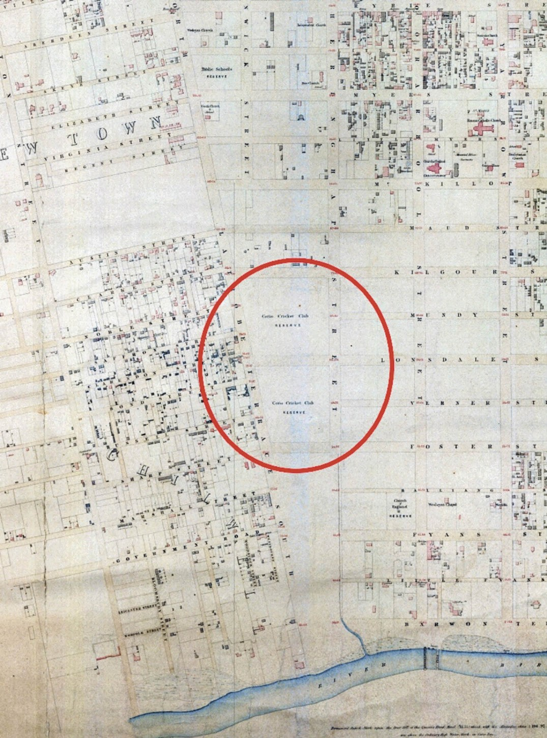
Figure 9.01: J.H. Taylor, Part Map of Geelong showing Corio Cricket Club Reserve (circled), Surveyor-General s Department, Melbourne, 1854. Source: VPRS 8168/P2, Unit 5416, item Roll 39 Geelong, Public Record Office Victoria.

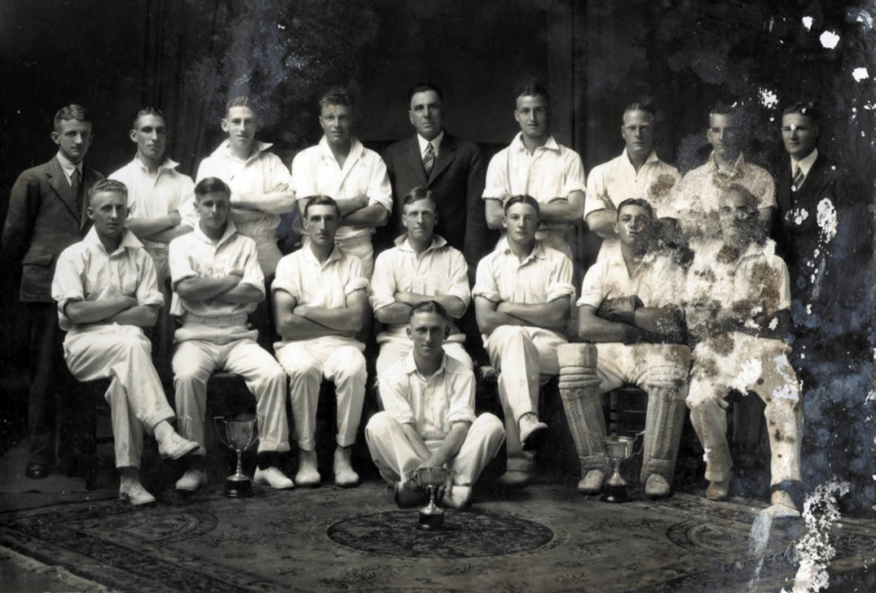
Figure 9.02: Geelong Senior Matting Cricket Association Premiers, 1933-34. Standing (left to right): W.H. Austin (Hon. Sec.), C. Robertson, V. McKeegan, J. O Toole, H.D. Tomlinson (President), T. McKay, R. Beseler, K. Smith & S. McAdam (Scorer).
Sitting (left to right): F. Kelly, M. Kelly, F. Barnett (Vice Captain), H.J. Britter (Captain), N. Tucker, W. Hurley & E. Russell. Sitting on floor: A. Maurer, GRS 2009/01556, Geelong Heritage Centre collection.

for the first round of matches … The clubs entered for the competition area: - Capulets, Clarendon, Geelong, Magpies, Nondescripts [Figure 9.03], and Yarra-street,
and the playing grounds at present available are Osborne, Geelong and Friendly Societies Reserve. The Clarendon Club have obtained permission from the Newtown and Chilwell Council to prepare a turf pitch in Kardinia Park, on the west side, and the council has agreed to bear
the expense of having the water laid to the locality. The ground has already been ploughed and the asphalt pitch broken up, and it is anticipated that the new pitch will be in playing order by about Christmas time.19

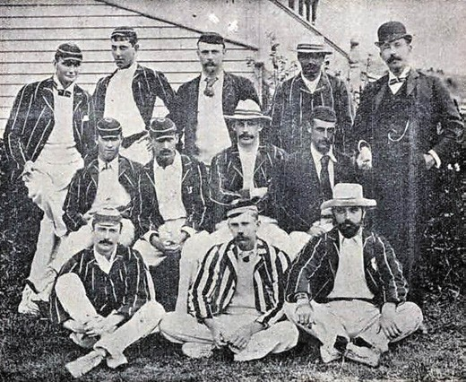
Figure 9.03: Non-Descripts Cricket Team, 1897.
Source: E.A. Vidler, The Book of Geelong: Its People, Places, Industries and Amusements, p.97.

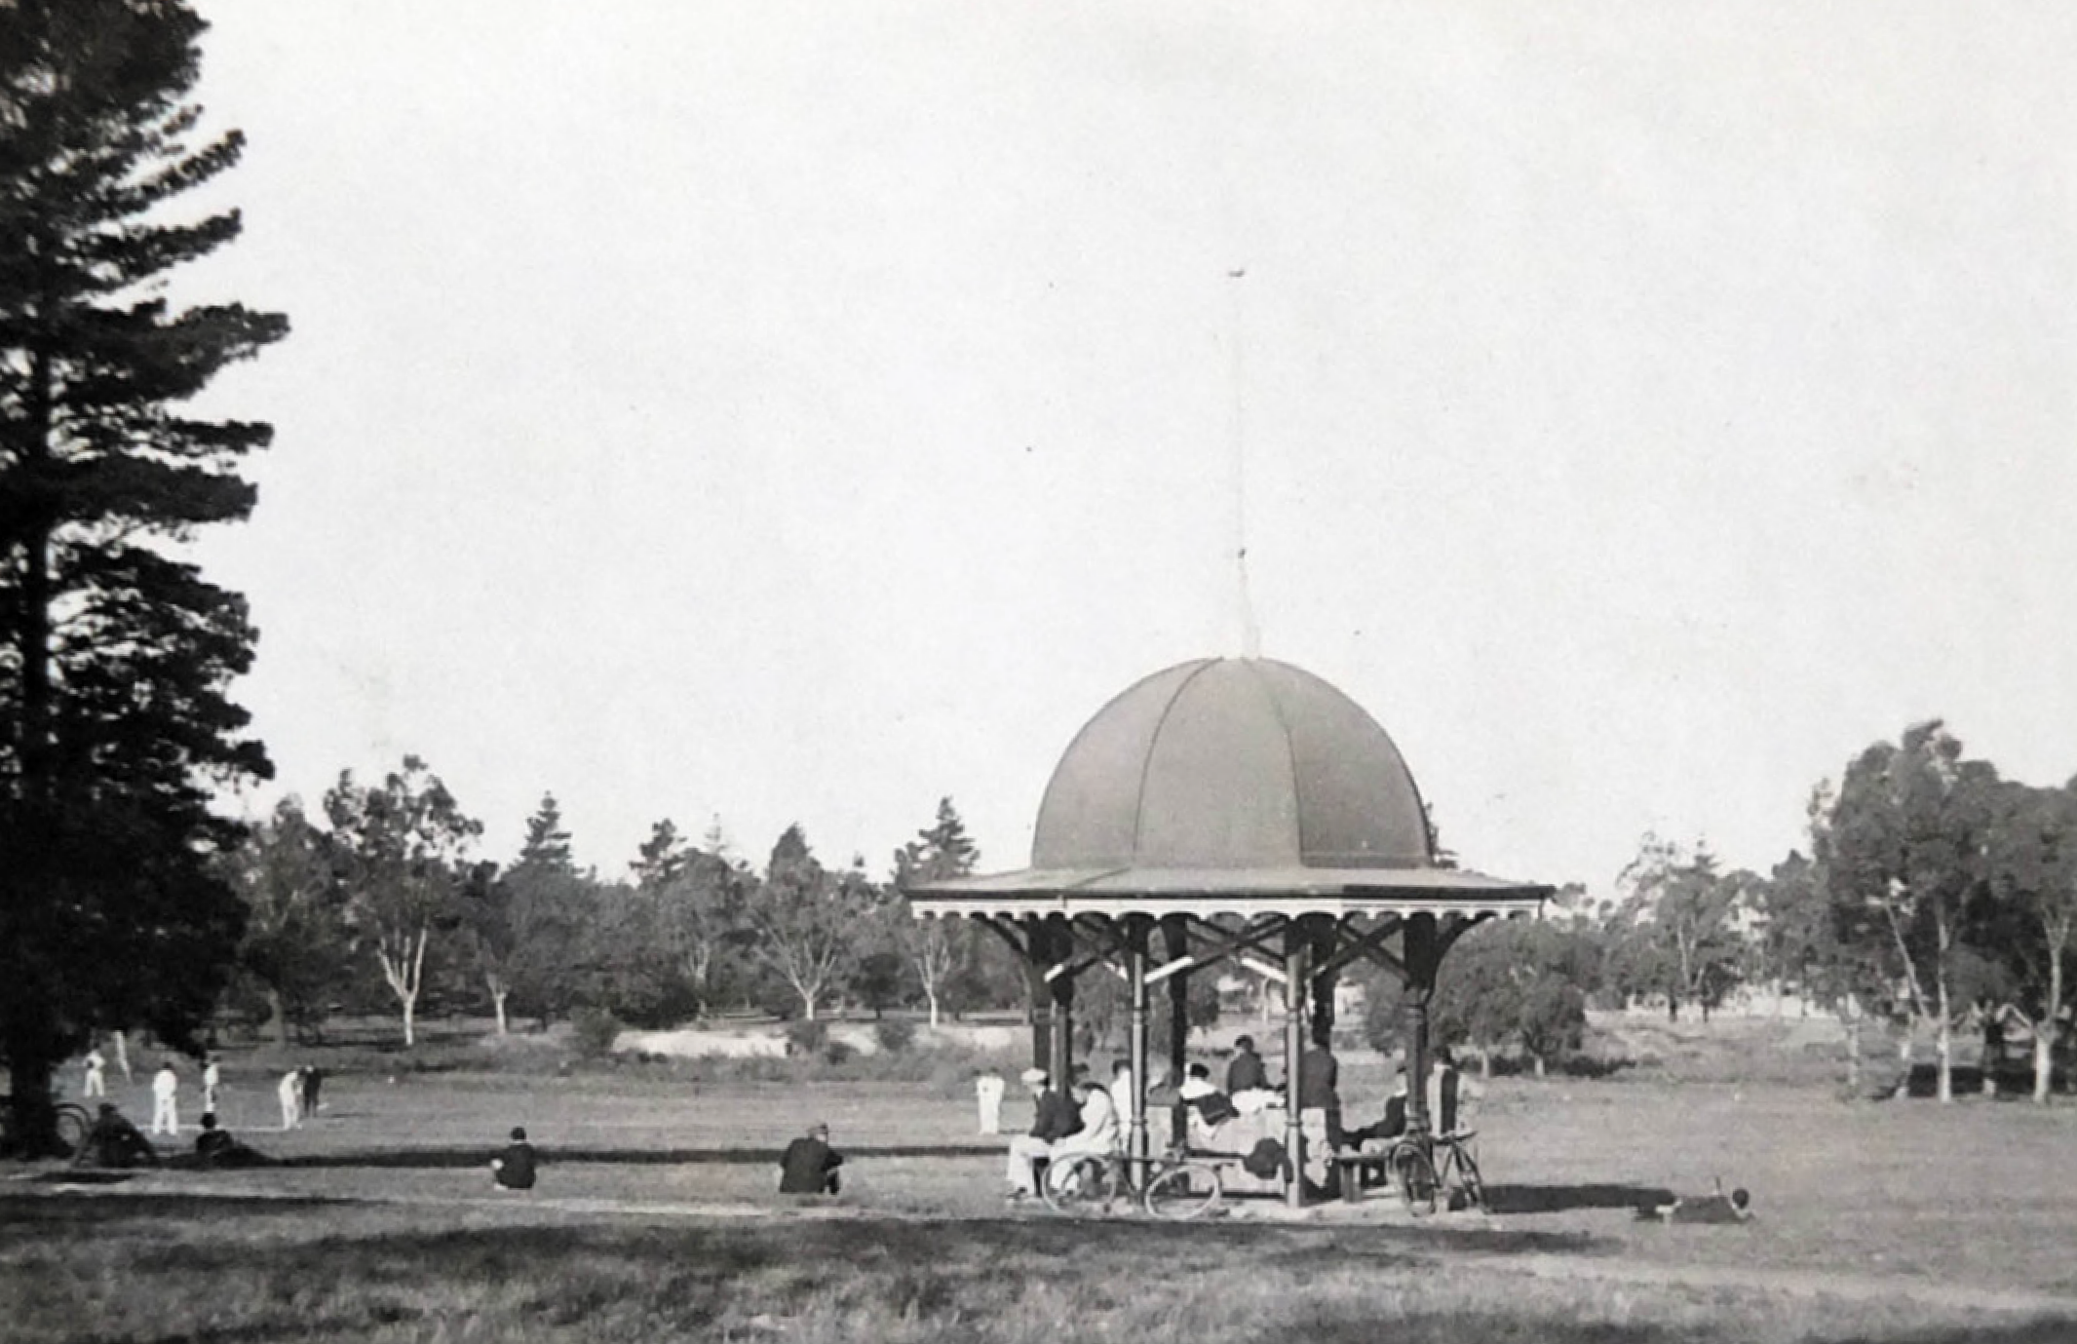

Figure 9.04: Cricket match in Eastern Park, 1930. Note the Ladies Kiosk in the foreground that was originally situated in Market Square (see later subsection). Source: T.T. Holmes collection, Authentic Heritage Services Pty Ltd.

The Geelong Turf Cricket Association later disbanded in 1913 but reformed in 1928 with six new clubs: East Geelong, Geelong City Cricket and Football Club, Geelong West, Newtown and Chilwell, North Geelong and South Geelong.20 Further clubs were established throughout Greater Geelong in subsequent years.
Concrete pitches were also popular in the early 20th century. In 1920, the Naval cadets were given permission to lay down a concrete pitch near the old pond in the southern portion
of Eastern Park21 (Figure 9.04). Cricket matches have been played there ever since.

HORSE RACING
In May 1841, the Geelong Advertiser printed a short article on the Geelong horse races, the first in the locality, quipping determined not to let the Melbournians have all the fun
to themselves, a few of the spirited settlers of this district, having casually met at Corio [Geelong], made up several matches on Saturday last. 22 The first two-mile race was won by T. Wright s mare, Juliet. 23 This began Geelong s interest and passion for horse racing. Other races soon followed,
including hurdle races and a hack stakes and pony race to mark the opening of John Atkins Fyansford Inn (Old Swan Inn) at Fyansford in 184324 (Themes 4 & 6). Atkins was the treasurer of a committee chaired by George Mercer to get up the Geelong Races. 25 The race was likely to have been at Airey s Flat, north of Atkins Inn, beside the Moorabool River.26 James Harrison, editor of the Geelong Advertiser, was the first secretary 27 of the Race Committee which held regular races at Airey s Flat for the duration of the 1840s.28
In 1851, Alexander Skene surveyed 634 acres at Marshall (now Charlemont) on the west side of the Barwon River as the location for a new race course29 (Figure 9.05). It was subsequently laid out and races were held there by 1853.30
The site of the race course was not officially temporarily reserved until 1 August 1864,31 following a hiatus of the Geelong Racing Club in the 1850s. The reservation of the new course might have been impetus for the reformation of the Racing Club at the Bridge Hotel in June 1865, when John Haimes was elected president, with G.R. Rippon,
secretary and F. Griffith, treasurer.32 The stewards included some influential pastoralists: Thomas Austin of Barwon

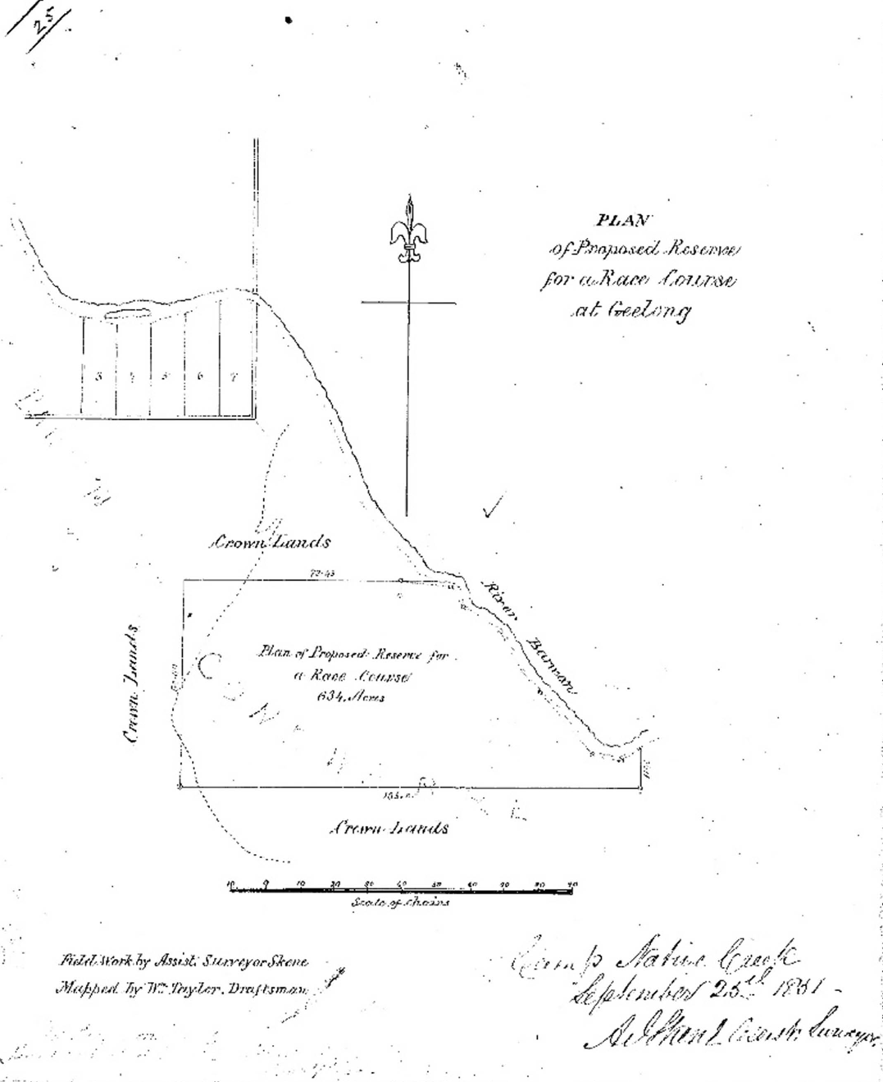
Figure 9.05: A.J. Skene, Plan of Proposed Reserve for a Race Course at Geelong , 25 September 1851. Source: Put-away plan, G21/1, Landata, State of Victoria.

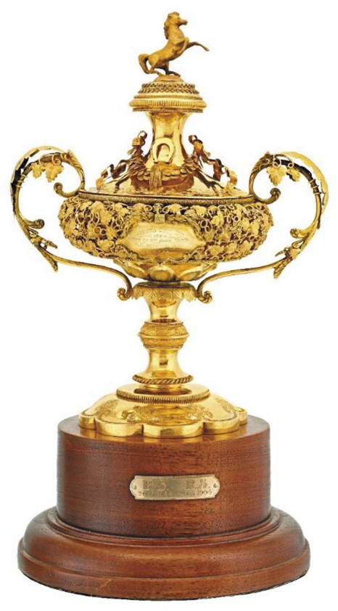

Figure 9.06: E. Fischer, Geelong Gold Cup, 1874. Gold and ebonised wood. Collection Geelong Gallery. Purchased through the Dorothy McAllister Bequest Fund with the assistance of the Geelong Racing Club, 2018, accession no. 2018.52.

Park, Winchelsea;33 Andrew Spencer Chirnside of Werribee Park, Werribee;34 John Dickson Wyselaskie (1818-1883)
of Narrapumelap, Wickliffe,35 John Dickson (1818-1883),36 Thomas Maidment (1829-1903) of James Austins Avalon Homestead, Lara,37 and Charles Samuel Morrow (c.1815- 1901) of Kenwith House, Geelong and Bungal Station near Mt Egerton38 A grandstand was erected in 1872 to a design by Alexander Davidson of Davidson and Henderson architects, with trees planted behind it and flanking the main avenue into the course (with five rows of trees of various kinds).39 In an effort to attract larger crowds, a branch railway line from the Geelong to Colac line was opened in 1878 (Theme 3).
The first Geelong Cup was run on the second day of the annual two-day carnival on 23 February 1872. A two-mile race, it replaced the Geelong Criterion Handicap previously run over three miles from 1864 until 1871. The inaugural Cup was won by Flying Scud, a horse trained by the well- known trainer, James Wilson, at his nearby St. Albans Stud (Themes 4 & 6).40 Between 1873 and 1890, the Geelong Racing Club commissioned one of Australia s leading silversmiths, Edward Fischer of Moorabool Street, Geelong, to manufacture the first of what has been regarded as ‘an
outstanding series of gold cups. 41 The designs differed each year and emphasised Fischer s skills as a master goldsmith. Edward Francis Antoine (Gunter) Fischer (1828-1911) had emigrated from Vienna to Australia in 1853, and established his jewellery and watchmaking business in Geelong.42 The first gold cup made by Fischer was commissioned in 1873 and it is a physical legacy of his skill and the affluence and status afforded the Geelong Cup race at this time. Now part of the Geelong Gallery collection, it was based on a design by the local artist, Frederick Woodhouse (1829- 1909) and was topped with the horse rampant on the lid (Figure 9.06). One of a small number of Victorian artists that specialised in animal painting (and particularly horses), Woodhouse was sought after to paint portraits of horses by their owners.43
The cup was won by McCallum Mohr and presented to the owner, John Tait in 1874.44 Fischer s reputation for making the handsomest racing trophy given by any racing club
in Australia for open competition 45 was impetus for him to manufacture the first Australian-made trophy for the
Melbourne Cup in 1876, won by Briseis who also was trained by James Wilson of St. Albans Stud.46
Following the establishment of the Geelong Harbor Trust in 1905, the race course reserve was transformed into irrigation paddocks as part of the Trust s Sparrovale Farm (Theme
4). In 1907, the Geelong Racing Club relocated to a new 136 acre reserve at Breakwater, which it shared with the Geelong Agricultural and Pastoral Society (see later subsection). The reserve was managed by six trustees, with three representing the Geelong Racing Club.47 By July 1907, very satisfactory progress and been made with the completion of the new racecourse, it having taken ‘definite form’ and was ‘very favourably spoken of by racing men. 48 The new course had been designed by James Wilson junior (Theme 4).49 The showgrounds grandstand had been relocated to the site (see following subsection) and an embankment formed in front of it for the convenience of spectators.50 The first race meeting on the new course was held in 190851 and the Geelong Racing Club continues to occupy the site and hold race meetings to the present day.

HORSE RACING AT LARA
Horse racing became an important sporting activity in Lara in the 19th century. The earliest reference to horse racing was in 1876, when the Geelong Advertiser reported Henry Williams as Honorary Secretary of the Duck Ponds Race Club, the course being on Gillott s and Dancy s land. 52 Yet, a year later in 1877, the Geelong Advertiser claimed that a racing club was being formed at Duck Ponds with the first meeting being held on Boxing Day of that year.53 This Race Club appears to have been short-lived as in 1887 a new Lara Racing Club was formed with F. Austin as President and F. Armytage as Vice President. Land was made available by
F. Austin free of charge behind the Lara Railway Station.54 By the early 20th century, races were held in a paddock on the south-west corner of Forest Road South and Canterbury Road, opposite the Lake
Bank Hotel.55

GEELONG POLO CLUB
In 1888, the affluent pastoralist who specialised in the breeding of merino sheep, Phillip Russell, acquired the Osborne House estate at North Geelong.56 In 1891 with the formation of the Geelong Polo Club, Russell offered his land to the north of the mansion house as a polo ground57 (Figure 9.07). The inaugural president of the new club was
S. Austin, M.L.C., with T. Skene and E.H. Lascelles as vice presidents; Phillip Russell as captain; J.S.B. Orr as secretary treasurer; and Drs. Hope and Small, and Mr McArthur as other committee members.58 Several tournaments were played
at the Osborne House ground with clubs from Melbourne, Camperdown, Caramut, Colac, Lismore and Girgaree until the onset of World War One.59 From 1952, the former Osborne House polo ground was the location of the State Electricity Commission s Geelong B Power Station (Theme 5).

COMUNN NA FEINNE SOCIETY & THE HIGHLAND GAMES
While the early race meetings of the Geelong Racing Committee at Marshall attracted notable crowds, by far the largest attendances were at the annual highland gatherings offered by the Comunn na Feinne Society from 1 January 1857.60 The Society had begun in 1856 when a meeting was held at the Gaelic School house for the purpose of organising a kind of Highland Society . To be known as the Comunn na Feinne (derived from the Ossianic legends of Finn and his band of warriors all committed to each other as one body),61 the objects of the society were the culture and preservation of: Gaelic language and Highland nationality; morality, philanthropy; and archaeology.62 The formation of the Society reflected the comparatively large number of immigrant Scots in Geelong in the 1850s.

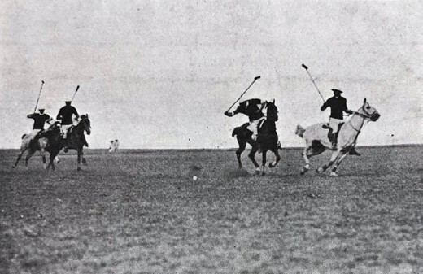
Figure 9.07: Polo match at the Osborne House grounds, 1910. Source: News of the Week, 10 February 1910, p.16, GRS 2121/1, Geelong Heritage Centre collection.

The first Highland gathering was held on ‘the plain at South Geelong near the Barwon River’ and involved field sports (such as tossing the caber, throwing the heavy hammer, putting the heavy stone, running high leap and men s
and boys footraces) and Highland dancing events.63 The Highland gathering at the Society s grounds (reserved in 1861 at the north-east corner of Fyans and Bellerine Streets, South Geelong)64 became a major drawcard (Figure 9.08). Hundreds of local townspeople and visitors flocked to the annual sporting event, the 700-seat grandstand being full and other spectators (ranged three and four deep) circled the arena.65
Each gathering began with a procession down Gheringhap Street, along Malop street, round the Market Square, up Moorabool Street, continuing to the Society s ground.66 Highly significant from the second procession and gathering in 1858 was the inclusion of Wadawurrung people as equals, the only public formal event following European colonisation where this occurred in Greater Geelong. As outlined in Comunn na Feinne 1856-1946: More Than a Pub Name:
The Aborigines, from 1858, took their place in the yearly procession to the sports ground at South Geelong. They were identified as a distinct ‘national presence, along with the other national group [the Scots] taking part.
Aborigines, who had been invited to take part in the Procession and the Games, were appropriately dressed in plaid donated by the Society, and their presence along with the other variously dressed organisations and individuals who took part in the march, duly added to the festival air of the day. They attended not only as
spectators and some of them joined in certain of sporting contests held on the day, as well as in competitions involving their own native skills.

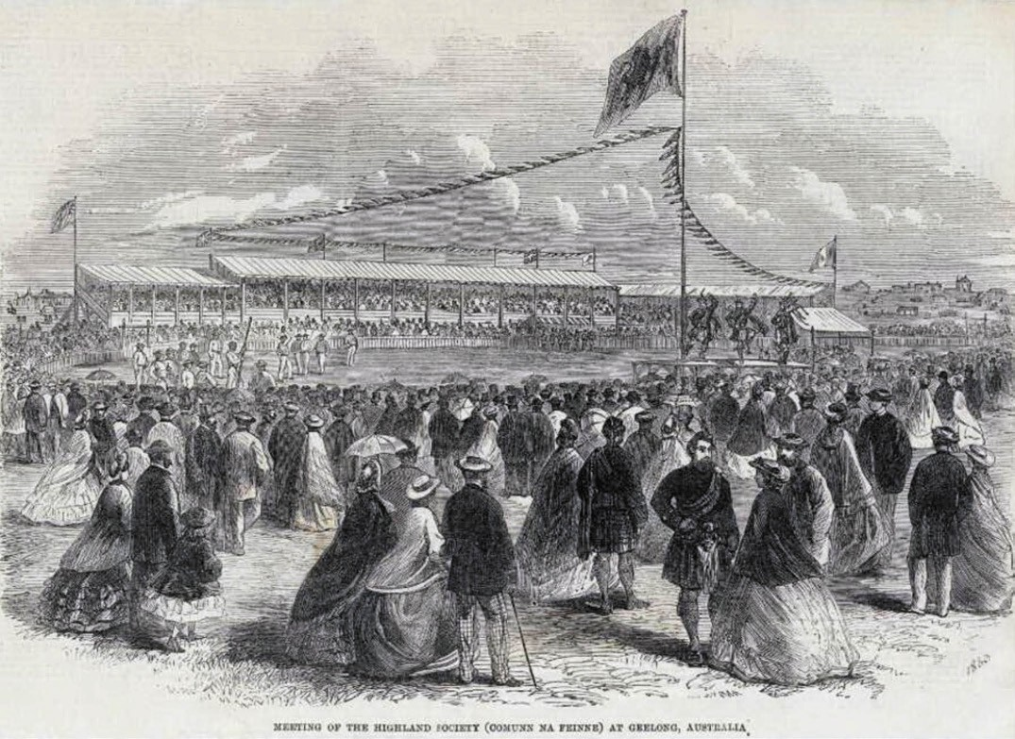
Figure 9.08: Meeting of the Highland Society (Comunn na Feinne) at Geelong, Australia, 1863. Source: Rex Nan Kivell collection, NK4182/132, Bib ID 1519347, National Library of Australia.

Although it is possible to ascribe Comunn na Feinne s willingness to embrace the local Aborigines simply to notions of nineteenth century Victorian paternalism, the length to which the Society went in order to be involved with the Aboriginal peoples seems to suggest that a deeper concern motivated it. As already noted, the Society s membership card displayed on one side a representation of a Highlander and that of an Aborigine [Figure 2.24]. The presence of Gaelic slogans, when
translated, denoted that there was a representation of the two peoples traditional warriors, equally worthy, equally matched and equally respected.67
While no evidence of the Comunn na Feinne s Society s grounds at South Geelong survive today, the medal for best runner awarded to Dan Dan Nook (Jerry) in 1860 forms part of the collection of the Geelong Heritage Centre (Theme 2).
Other physical legacies of the Comunn na Feinne Society also exist, including the front two storey pavilion at St. John s Lutheran Church, 165 Yarra Street, Geelong (Figure 9.09). In 1912, the Society acquired the property (then St. Andrew s Presbyterian Church) where it established its headquarters.
The Society commissioned the Geelong architects, Laird and Buchan, to design alterations and additions. A new front pavilion (completed 1914) was initially proposed in a Greek Revival design but it was revised into the existing Renaissance Revival styled wing that dominates the front of the site today. Together with the former church, the new pavilion was used for meetings and various forms
of entertainment, including musical and elocutionary competitions. It was also the location of aspiring singers, one of which becoming internationally renowned:
Marjorie Lawrence, then a promising young singer and in the years afterwards a world-renowned principal in opera

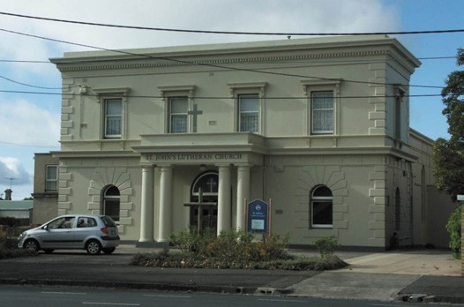
Figure 9.09: Former Comunn na Feinne Society pavilion (in front of original St. Andrew s Presbyterian Church), 2011.
Source: David Rowe.

and other musical works, made her first Geelong public appearances on the Comunn na Feinne competition, she won several singing events, including the aria from grand opera.68
Between the two world wars, the Society began to struggle in maintaining satisfactory membership levels and public interest in events. Further disinterest brought about the end of the Comunn na Feinne Society after World War Two in 1945.69
Today, the name of the Society continues to endure at 209 Bellerine Street (corner Kilgour Street), Geelong, with the Comunn na Fienne Hotel. It was opened in 1860 by Samuel Hubbard, an early member of the Society.70
AUSTRALIAN RULES FOOTBALL
& THE GEELONG FOOTBALL CLUB

MARNGROOK: INDIGENOUS FOOTBALL
As early as the 1840s, the Assistant Protector and Guardian of Aboriginals , William Thomas (1793-1867) noted a ball game known as marngrook played by Indigenous people, this being one of the earliest documented hybrids of football in Australia.71 Thomas later recalled this game of ball to Robert Brough Smyth who published it in The Aborigines of Victoria in 1878:
The man and boys joyfully assemble when this game is to be played. One makes a ball of opossum skin, or the like, of good size, somewhat elastic, but firm and strong. It is given to the foremost player or to some one of mark who is chosen to commence the game. He does not throw it as a white man might do, but drops it and at the same time kicks it with his foot, using the instep for that purpose. It

is thrown high into the air, and there is a rush to secure it
–such a rush as it is seen commonly at foot-ball matches amongst our own people. The tallest men, and those who are able to spring to a great height, have the best chances in this game. Some of them will leap as high as five feet or more from the ground to catch the ball. The person who secures the ball kicks it again; and again a scramble ensues. This continues for hours, and the natives never seem to tire of the exercise.72
Smyth himself had also watched Indigenous people at Corranderk amusing themselves in this manner , noting their skill and activity were surprising and declaring that it was truly a native game. 73
In the Swan Hill area, Peter Beveridge, pastoralist at Tyntyndyer homestead between 1852 and 1866, and the Honorary Correspondent of the Central Board for the Protection of Aborigines between 1863 and 1867, also gave a description of Indigenous football in this part of Victoria which largely reflected that noted by Thomas:
Ball playing is another game to which they [the Indigenous people] are exceedingly partial. They make it much
more boisterous and noisy than are the wrestling bouts, although it results in much fewer serious mishaps. The women participate in this game as well as the men. We have seen as many as two hundred –including sexes – engaged in it at one time.
The ball is composed of old opossum skins, tightly rolled up, and covered over with a fresh and strong piece of skin, nicely and firmly sewn together with opossum tail sinews. Before they begin to play they arrange sides, each side having a captain, whose place it is to guide his often times unruly squad.
When all is in order, a Lyoore (woman) starts off with the ball in her hand. She walks a little way out from her own side, and towards that of her opponents, drops the ball with seeming carelessness, but ere it has time to reach the ground, she gives a dexterous, and by no means gentle kick, which being correctly aimed, sends the ball spinning high into the air. Thereupon the fun begins to downright earnest. Such screaming, jumping, and frothing at the mouth, we are certain was never seen at any other game outside the walls of Bedlam; … They have not any goal
to which the ball has to be driven the whole of the play is merely to keep the ball in motion, and to prevent its coming to the ground; whilst the struggles of the game consist in trying which side can retain the ball longest in possession. Those holding the ball throw it from one to another, and it is during such flights that the opposing
side vigorously run and jump with the view to its capture.

As the eyes of the players are never by any chance bent on the ground, tumbles during a game are numerous, and in many cases indecorous enough, more especially when one goes down, and so becoming a stumbling, block, over which a dozen or more come toppling in a heap.
These incidents, however, add mirth to the game, without creating the least ill temper.74
Possibly the most revealing account of marngrook came from a personal recollection of a Mukjarrawaint man, Johnny Connolly, recalling his experiences at Framlingham:
In playing a game at ball which they kicked about, the different totems present two different sides and there were men and women in each side …75
Connolly also recalled that he, his mother, and her mother all played on the same side at ball. His cousin George played with the Wurant in the other side. 76
The totemic associations with marngrook were also outlined by the ethnographer, A.W. Howitt, which he called mangurt :
This game of ball-playing was also practised among the Kurnai, the Wolgal, the Wotjoballuk as well as by the Woiworung, and was probably known to most tribes of south eastern Australia. The Kurnai made the ball from the scrotum of an old man kargaroo [sic.], the
Woiworung made it of tightly rolled up pieces of opossum skin. It was called by them mangurt. In this tribe the two exogamous divisions, Bunjil and Waa played on opposite sides. The Wotjoballuk also played this game, with Krokitch on one side and Gamutch on the other. The mangurt was sent as a token of friendship from one to another.77

AUSTRALIAN RULES FOOTBALL: A HYBRID OF MARNGROOK AND ENGLISH RUGBY
In a letter to the editor of Bell s Life in Victoria and Sporting Chronicle on 10 July 1858, Thomas Wentworth Wills (1835- 1880), son of Horatio Spencer Wills, M.L.A. and farmer of Belle Vue , Point Henry (and previously holder of Lexington (near Mount William), La Rose, Mokepilly and Swanwater South Runs in the Western District and Wimmera),78 sought the formation of a football club as winter practice for cricketers.79 Wills had returned from schooling in England in 1856 where he was football captain of Rugby School in
addition to being a highly talented cricketer.80 Wills letter was a catalyst for the formation of Australian Rules Football as known today.81
Wills intention to establish football in Victoria was not to have been the direct transplantation of English rugby.
On the contrary, it seems to have been a hybrid of rugby and marngrook. Although there has been debate whether

Australian Rules Football originated from marngrook, Wills exposure to the Indigenous game, and his close relationship to Mukjarrawaint people in the Grampians region has
been analysed by a number of scholars and authors. The connections were first brought to public attention in the 1980s by historian, Jim Poulter,82 culminating in Marngrook: our original national football game in 2009.83 More recent work by Jenny Hocking and Nell Reidy in Marngrook, Tom Wills and the Continuing Denial of Indigenous History in Meanjin Quarterly in 2016 further confirmed and clarified the connection between Wills and marngrook with additional research, declaring that:
The contestation over marngrook and its relationship with Australian football has crystallised around three key elements: marngrook, Australian football, and between them the figure of Tom Wills, seen as the pivot between two communities, two cultures and two games. Wills was an exceptional athlete, possessed of transcendent
sporting achievements. He had excelled at rugby, which he had played as a pupil at Rugby School, and equally
at cricket, which he played again at Rugby School and then for Cambridge University, where he enrolled simply in order to play for the university team. Wills had also, most unusually, grown up in the Gariwerd (Grampians) region where the Mukjarrawaint people lived and where marngrook was also played. Wills occupied what Judd terms a position of cultural hybridity between settler and Indigenous peoples in the Western district a position that, while not uncommon, is rarely acknowledged. Tom Wills is not only the bridge between two cultures and two games, he is the bridge between the opposing views in this debate. For it is a rare point of agreement that if the argued link between marngrook and Australian football is to be found, it will be found in the story of Tom Wills.84
Revealing is that Tom Wills interacted with the Mukjarrawaint, learnt their language and made childhood friendships with Mukjarrawaint children.85 This was at a time when Johnny Connolly was taking part in marngrook and worked as a stockman on the Ledcourt Run that adjoined the Lexington Run of Tom Wills father, Horatio.86 He described the activities of the Mukarranwaint in his diary, declaring the having been for some considerable time back an area of general rendezvous which Hocking and Reidy described as a place where corroborees, games and other entertainments were traditionally held including football. 87 W.A. Cawthorne, artist and teacher who studied and illustrated the manners, habits and customs
of Aboriginal people,88 had also experienced the game of marngrook, and connected it to the koorobery [corroboree].89 It seems that 19th century cultural practices were a likely reason for Wills silence on the origins of Australian rules football and his lack of reference to marngrook.90

GEELONG FOOTBALL CLUB
In Geelong, while Wills played a key role in the introduction of the new mode of football, others attempted to establish a club and to organise games. In April 1859, William Stitt Jenkins, a temperance advocate and inaugural member of the Comunn na Feinne Society91 attempted to establish a club, promoting the new sport of football as one of the healthiest and easiest that could be adopted by persons cramped during the week by desk or counter service and standing in need of a little bracing exercise. 92 This was followed by an advertisement on 16 July 1859 by Alexander McKenzie Mason, a field draftsman of the Public Lands Department, seeking admirers of football to meet at the Victoria Hotel on 18 July in an
effort to form a club. 93 Those involved in the first match on 23 July 1859 were the progenitors in the establishment of the Geelong Football Club, the event being lauded by the Geelong Advertiser:
The species of inaugural football match which came off on Saturday afternoon, near the Corio Cricket ground [north- east corner of Ryrie and Garden], was a great success – which means there was plenty of fun, with no end of spills, and just enough barking of shins to give an extra twinge
of excitement to the day s sport. The sides were chosen by Messrs Mason and Fraser respectively, and the result after a hotly contested match was in favour of the latter. The kicking was no doubt characterised by more energy than skill, but this could hardly help being the case, considering the want of practice. From the style in which many of the players laid their legs to it, there can be no manner of question that they felt themselves considerably out of joint the next day. At all events the excitement and genuine fun of the hour left no room for a doubt that the Geelong Football Club will ripen into an institution, and fully answer the purpose of which it has been formed.94
A paddock between the Argyle Hotel and Pakington Street, jointly owned by James Austin and Silas Harding, was the location of the first local Australian Rules Football match between Geelong and Melbourne teams on 1 September 1860.95 The Argyle Ground became the headquarters of the Geelong Football Club (then nicknamed the Pivotanians) and the ground was often the scene of exciting football in the years that followed. All the leading metropolitan teams
played there against Geelong96 but the games were only once a season as there were no home and away matches until 1878.97 These early years of football were described in the Geelong Advertiser in Victorian Football League Jubilee Year, 1908:
The principal Melbourne clubs used to come here to play once in the season, and there were two senior teams here –Geelong and Barwon. The matches between them

were always close and exciting, usually ending in a draw. The Geelong team were holders of the Western District Challenge Cup, and after one of these desperate struggles George Day, who was then captain, roused the Barwon barrackers to frenzy by waving the Challenge Cup out of the top window of the Argyle Hotel.98
A member of the Geelong Football team in 1872 was Albert ‘Pompey’ Austin (c.1846-1889), the first Indigenous player of Australian Rules Football. He was of the Djarguard wurrung community whose territory at Lake Purrumbete had been taken over by the Manifold brothers in 1836 (Theme 2). Although it has been claimed that Austin s initial poor skills as a footballer tended to refute the idea that the game was derived from marn grook ,99 he was highly likely to have been exposed to marngrook at Framlingham Aboriginal
Station, Warrnambool, given the first-hand account of Johnny Connolly. Austin was to play only one match for Geelong, which was not his best, and worse still, was the focus of amusement to the spectators. 100 Austin continued to play football from Framlingham and in a match between the Warrnambool club and the Framlingham Station team in 1877 he was reported as being very active. 101
The use of the Argyle Ground by the Geelong Football Club came to an end in 1878. As W.R. Brownhill in the History of Geelong and Corio Bay described:
A little quarrel, or misunderstanding, between the Geelong Football Club and Silas Harding, over the question of
the payment of rates, drove the footballers off their long-established Argyle ground. Portion of the land
was owned by Harding, and the other portion was in the estate of James Austin. The Club had been paying the rates, but during the Secretary s absence in England arrears accumulated. Notice was served on Harding for the payment of the amount overdue. He was furious. He told the Football Club to remove the goal posts, otherwise he would have them cut down! A few days later –on
10th August, 1878 –the area belonging to Harding was ploughed up. This development effectually disposed of the prospect of playing any more football there during that season. The Corio ground was the natural resort for the senior players in the emergency.102
From 1878, the Corio Oval east of the Geelong Botanic Gardens and Eastern Park was to be the home of the Geelong Football Club (Figure 9.10) for the next 63 years. In 1885,
a grandstand was constructed and fencing around the oval erected to designs by local architect, Albert Derrick.103
In July 1903 the structure was described as a spacious grandstand and was crammed with spectators, the Geelong Advertiser declaring that the ladies reserve and reserve proper were thronged with people. 104 By 1912, the News of

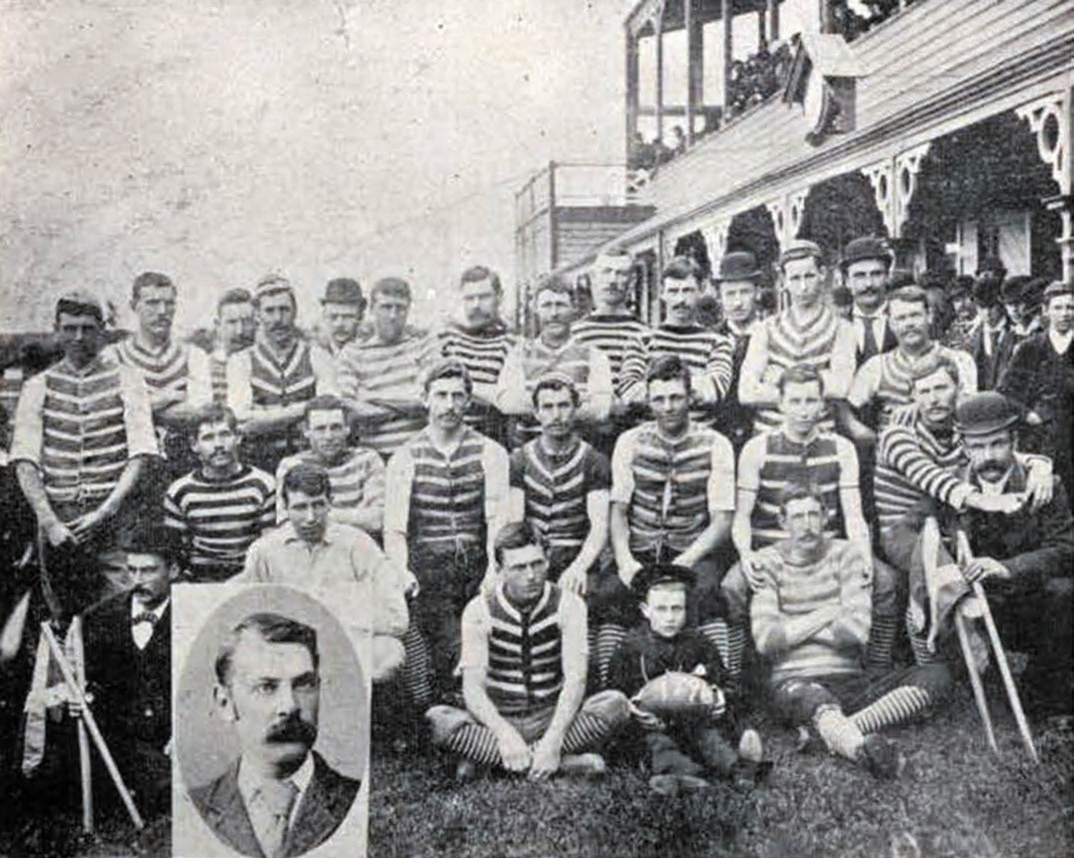
Figure 9.10: Geelong Football Club team at Corio Oval, 1896 (with portrait of Charles Brownlow in foreground). Source: E.A. Vidler, The Book of Geelong: Its People, Places, Industries and Amusements, p.98.

the Week claimed that Corio Oval was the prettiest football ground in Victoria 105 (Figure 9.11).
In 1923, the club was nicknamed the Cats following a string of losses. As satirically described under the title The Inevitable , the Geelong Advertiser declared in September 1923:
Geelong seems inseparably bound up with black cats. In reality, or in effigy, they meet one everywhere. There is no escaping them. One looked in at the window of a Geelong football man on the morning of a match (which
Geelong lost); another was fed with garfish by a supporter of the Blue-and-White Brigade on the morning of the Richmond game in Melbourne (which Geelong won); still another travelled as a passenger on the Edina lately (this one had no connection with football, so far as could
be ascertained); and even at the fire which broke out in Harvey Dann and Coy s fodder store yesterday the
inevitable black tabby had to make its appearance. It was found inside the Corio street wall of the building, about eight feet down in the hay, whence it had wormed its way in its effort to flee from the wrath to come. It is still alive and kicking; in fact, in remarkably good trim, and not at all put out by the stress of the occasion. It was a handsome animal, too; and it had at least one point on all the other black cats –it proved its own best mascot. Having exhibited its mascot qualities so well in an emergency, it might be worth while finding out if it would be any good
in relation to the affairs of the Geelong Football Club – although it is perhaps rather late in the day, or rather in the season.106

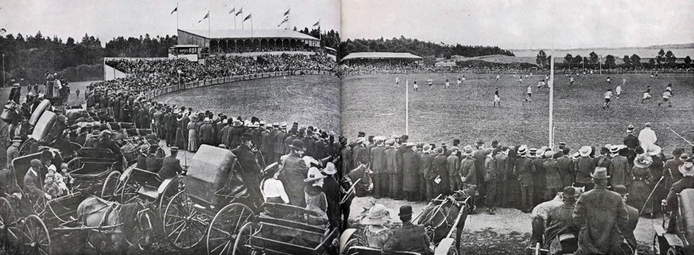
Figure 9.11: Football match at Corio Oval, 1912. Source: News of the Week, 5 December 1912, pp.30-31, GRS 2121/3, Geelong Heritage Centre collection.

The new mascot worked as the club won its first Victorian Football League premiership in 1925, the year Laird and Buchan architects designed a new grandstand at Corio Oval.107 It was built as a memorial stand to Henry Young and Charles Brownlow, long-serving players, captains and committeemen, the contribution of the latter to Australian Rules Football being nationally recognised by the league s annual best and fairest award, the Brownlow Medal.
Tragically, the memorial stand, together with the club s photographs, trophies and honor boards, were destroyed in a fire in 1928.108 It was rebuilt a few months later to a new design by Laird and Barlow.
The high esteem given to Henry Tracker Young
(1873-1923)109 that resulted in his memory being honoured in the Brownlow-Young grandstand was given in the Australasian on his death in 1923. His considerable contribution was recognised in the following obituary:
The sad news of the death of Henry Young, the Geelong footballer and all-round sportsman, came as a great shock to those who were unaware that he been under special treatment for heart trouble during the last four months. Young, although not a prominent cricketer, was a splendid athlete, one of the greatest and most versatile that this State has ever produced, being prominent in football, cricket, sculling, rowing, boxing, swimming, racing, and coursing circles. He played with the Geelong Football Club for 21 years, and for 12 years of the term was captain and coach. He was a mighty power on the football field. Who that has seen him will ever forget his strength and absolute fairness when in the ruck? He was a man of splendid physique and magnificent proportions, about 6ft. 2in. in height, and built proportionately. Yet, with all his glorious strength and determination, he was
never guilty of an act on the field unbecoming of a man. He was literally and figurately head and shoulders over his generation as a player in the Geelong ranks, was a splendid mark and kick, one of the game s champions, especially in the chase work, and was admired and respected by everybody. He was a fine leader, setting his men an example of unselfishness, power, and pluck that made them a terribly hard team to beat when led on by Henry Young. Such a dominating figure and personality was he in the football world that in interstate games he was always chosen unanimously as captain by the other members of the team, in recognition of his ability, length of service, and outstanding generalship. He was only 50 years of age, and when one remembers that mighty man of power and physique literally ploughing his way through the ranks of the enemy, it is hard to realise that he did so young, and that the motive power inside that wonderful frame was affected. It was evidently a case of an athlete s heart, from which so many strong men have suffered.110
More well known to the present day has been Charles Brownlow (1861-1924) (Figure 9.12). Born in Geelong to Charles and Eliza Brownlow (nee Whitaker), Charles
Brownlow junior married Matilda Barber in 1886, five years after he had joined the Geelong Football Club in 1881. In 1884 due to work commitments, he resigned as a player and captain, but he did play occasionally until 1890. Between 1884 and 1887 Brownlow was a Club committeeman. He was appointed Club Secretary in 1885, a role he held for
36 years.111 Brownlow was also a Geelong Football Club Victorian League delegate for 26 years, serving as acting League President during 1918- 19.112 A skilled watchmaker, jeweller and silversmith, Brownlow was employed by Edward Fischer, the well-known goldsmith, prior to going into

business on his own account.113 Brownlow and family lived at 14 Sydney Avenue, Geelong from 1904 until his death in
1924.114 It was following his death when the Victorian Football League (and later Australian Football League) recognised
his significant contribution to football with a memorial medal in his name awarded to the best and fairest player of the competition adjudicated by the umpires.115 Fittingly, the first Brownlow medal was awarded to Edward Cargie Greaves of Geelong (who was to have the Geelong Football Club s best and fairest medal named in his honour).116 In addition to the Brownlow medal, recognition of Brownlow s contribution to football is displayed in a freestanding interpretive plaque in the front garden of his late home, 14 Sydney Avenue.
In 1941, due to military occupation of Corio Oval, the Geelong Football Club relocated to Kardinia Park (see later subsection for further details).117 In April 1946 following the end of World War Two, the Sporting Globe reported that Kardinia Park
was to be the permanent home of the football club. It had a number of advantages over the old Corio Oval, including
close proximity to the railway to Melbourne, and direct access to the Geelong tram network. Yet, the Sporting Globe noted one drawback: the narrowness of the ground but it claimed that this could easily be overcome. 118 Kardinia Park has remained the home of the Geelong Football Club to the present day, the ground and facilities having undergone a vast transformation in the late 20th and early 21st centuries (see later subsection on Kardinia Park).
Although Pompey Austin might have been the first Indigenous player to play Australian Rules Football in 1872, the Geelong Football Club boasted another Indigenous champion in the 20th century whose impact on the game was to be substantial. A Noongar man, Graham Vivian Polly Farmer (1935-2019) was born in Western Australia and
taken from his mother and raised in a church orphanage.119 Having suffered poliomyelitis which left him with one leg shorter than the other,120 Farmer became a trailblazer for Indigenous players in Australian sport , playing 356 games between 1963 and 1971 in the Western Australian Football League (WAFL) and VFL for East Perth, Geelong and West Perth.121 At Geelong, he revolutionised the game with his athleticism, precise ruckwork, booming handballing and unmatched professionalism which helped guide Geelong to a premiership in 1963.122 He later coached the Geelong team between 1973 and 1976, the first Indigenous coach of Australian Rules Football.123 Farmer was also the first Australian footballer to be
named a Member of the British Empire (MBE) and he was one of the original twelve Legends inducted into the Australian Football Hall of Fame in 1996.124 He died on 14 August 2019.

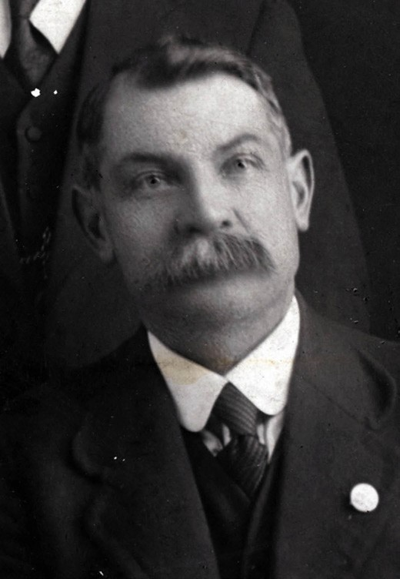
Figure 9.12: Charles Brownlow, 1916.
Source: RS 2009/01237, Geelong Heritage Centre collection.

The second-oldest club in the Australian Football League, the Geelong Football Club has won seven Victorian Football Association premierships (1878, 1879, 1880, 1882, 1883,, 1884 and 1886) and nine Victorian Football League and Australian Rules Football League premierships (1925, 1931, 1937, 1951, 1952, 1963, 2007, 2009 and 2011).125
In addition to the Geelong Football Club, local football associations were established and the national game has prospered throughout the municipality to the present day.

J.J. TRAIT, ‘THE PRINCE OF UMPIRES’
John Joseph Trait (1859-1906) (Figure 9.13), made a significant contribution to umpiring during the fledgling years of Australian Rules Football. Born in Geelong to Keeran
and Mary (nee Nolan) Trait,126 he was closely associated with the Catholic Church from boyhood, and was later a prominent member of the St. Patrick s Society, manager of bazaars and fetes for the St. Patrick s Day demonstrations, and district president of the Hibernian Order in Victoria.127 He married Sara Clark in 1888 and they were to live at 10 Bourke Crescent, Geelong.128 An aerated drinks and cordial manufacturer with his brothers in Malop Street, Trait was for a time president of the Geelong Senior Football Association.
Yet it was as an umpire that he was widely known and regarded as The Prince of Victorian Umpires. 129 His umpiring went beyond the Corio Oval to different parts of Victoria
and the country. While several players from different clubs were very much devoted to him ,130 this, not surprisingly, did not extend to spectators. One incident between Trait and a spectator was reported in The Herald in 1892:
No man was more abused than J.J. Trait, the central umpire. A man –clearly an Essendon supporter – accosted him in the pavilion as he was making his way to the dressing-room, and in a most abusive and insulting manner told him that he had acted unfairly towards the Essendon team. Several bystanders remonstrated with the man, and advised the umpire to take no heed of
him. Trait proceeded on his way to the dressing-room of the Essendon players, but had scarcely had time to strip before the excited individual referred to rushed into the room behind him and recommenced his unmanly
utterances to the umpire. He was so thoroughly insulting that Trait had to order him away, accompanying it with the hint that if the discontent did not move he would call in a constable and have him ejected from the room and the ground. This had a beneficial effect coupled with the manly interference of Alex. Dick, the Essendon captain, who very plainly told the fellow to hold his tongue. He did, and retired crestfallen. Trait says that it was a great game, but altogether too rough. He cautioned two of
the Carlton players frequently, but without effect, and he has resolved to report them to the association for unduly rough play. He thinks Essendon the better team by a little bit.131
On his premature death in 1906, the Geelong Advertiser gave the following glowing obituary:
As a football umpire he stood alone in Victoria, and his services in that capacity were frequently sought after not only in Victoria but in other States. His decisions were

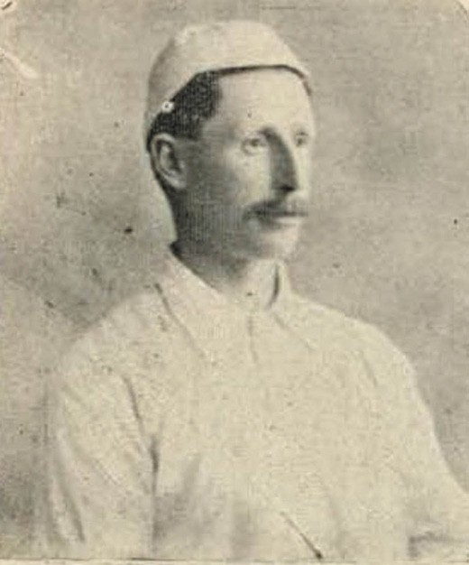
Figure 9.13: J.J. Trait, Prince of Umpires , 1896.
Source: E.A. Vidler, The Book of Geelong: Its People, Places, Industries and Amusements, p.98.

always prompt, and he was quick to detect breaches of the rules.132
The elevated status afforded Trait lived on many years after his death. In 1925, he was still regarded as the fairest umpire that Australian football has known. 133

AFLW
In 2019, the Geelong Football Club fielded a team in the Australian Rules Football League s women s competition (known as AFLW) for the first time.134 The women s competition was inaugurated in 2017 with eight teams.135 Melissa Hickey was the first Geelong captain.136 From Red Cliffs, Victoria, her grandfather s cousin was Reg Hickey, a Geelong legend and Australian Hall of Fame Inductee.137
Vice Captain of the Geelong team was Rebecca Goring who was born in Geelong and who graduated from the Melbourne Conservatorium of Music in 2016.138

SAILING
The first Corio Bay Regatta was held on 23 March 1844, the Geelong Advertiser declared that although it was not
anticipated that the display would equal the older established Regattas in the colony, still, from the spirited manner in which the arrangements were planned and executed, the various races went off in a manner which called forth the admiration of the assembled spectators. 139 Such was the success of the regatta that it was proposed that another be held in twelve months time.140 Yet, nothing eventuated and in 1847 the Geelong Advertiser lamented that while it only required a few active, leading men to take charge, the Geelong townspeople were ‘so modest – so afflicted with mauvaise honte –that
no one can screw his courage up to call a meeting or take any forward step in the matter. 141 Three years elapsed before efforts were made in 1852 to provide a prize of no less than £100 , with a cup to be made of Ballarat and Mount Alexander gold.142 A Regatta Committee was formed at a meeting at Mr Dutch s in Malop Street, which resolved that John Main was to be appointed paid secretary; the captains of all the vessels off Point Henry or in the harbour be invited to become honorary committee members; that Mr Carver be chair; Captain Addis be appointed judge and Thomas Curle as honorary treasurer (with John Donnelly sub-treasurer); the committee members include Messrs Henry Ryan Gosling, Henry Deering, William Marnell, Mr Patterson, Joseph Lewis, John Donnelly, William Leahy, Henry Elmes, James Brown, John Dutch, Mr Smith, Hobson and Olive; and that any surplus funds at the conclusion of the regatta be handed over to the Friendly Brothers Society.143 The regatta was spruiked in the Geelong Advertiser and Intelligencer which declared that there are more boats in our bay than on any other previous occasion, and it would be indeed a folly if so healthful and beneficial a sport as boat-racing should not have its annual celebration.144
While the annual regattas were a success, they involved whaleboat races, rowing matches and dinghy races,145 in addition to sailing. Of the latter, the Geelong Regatta

Committee resolved that:
The sailing boats should start from the west of the Western Jetty, and proceed along the eastern coast of the Bay to Limeburner s Point, round a buoy moored off that point, returning round the Gazelle, (Flag Ship) thence proceed round the masts of the Margaret, and a buoy moored off Cullen and Edols’ slaughter-house, and finally repassing the flag-ship as the winning point.146
The success of the regattas, and particularly the sailing events, led to the formation of the Geelong Yacht Club
in March 1859.147 A separate organisation to the Geelong Regatta Committee,148 the rules of the Yacht Club were laid out at a meeting at Mack s Hotel in June of that year. Captain Daniel L. McPherson, harbor master, was the inaugural Commodore.149 H.C. Campbell was appointed Vice-Commodore; Martin Sholl (secretary of the Geelong
and Melbourne Railway Company), treasurer; and Archibald Craig, secretary.150 While there was anticipation that the Geelong Yacht Club would be successful, it only lasted until 1864 and in 1869 an effort was made for it to be reformed.151
In 1880, the yacht club was revived (in part) in the formation of the Geelong Sailing Club at a meeting at the Victoria Hotel. Impetus came from one of Geelong s boat-builders on the Eastern Beach, Clement Blunt, the Geelong Advertiser giving the following outline:
We understand that an effort is about to be made to establish a sailing club in Geelong. The project is in the hands of Mr C. Blunt, who has now four first-class boats, which would afford accommodation for 50 or 60 persons desirous of enjoying the pleasures of a sail. The number of boats would, of course, be increased as occasion required; and it is thought that the establishment of such a club as is suggested would lead ere long to the formation of a more pretentious yacht club. That the town, with its natural advantages for indulging in such a pastime, and whose inhabitants take so great an interest in boating affairs, should have remained for so long without an organisation of this kind is a mystery. Mr Blunt, the projector of the Sailing Club, is one whose energy has done much to forward boating interests, and his success as a builder has been frequently attested, one of his latest works being the turning out of a centreboard canoe for
Mr Arthur Speed.152
Clement Blunt (1824-1899) was born in Cambridge, England, and at the age of 14 years he was apprenticed to Thomas Woolf, tailor, but he soon changed trades and joined his brother, George, as an apprentice boat builder. By 1851, Clement Blunt had emigrated to Victoria as it was at this time when he married Sarah Emerson.153 By 1855, he was resident

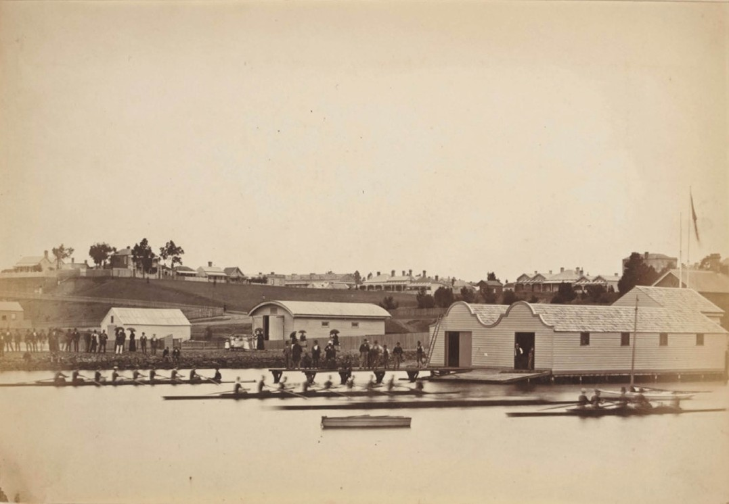
Figure 9.14: F. Kruger, Geelong Yacht Club shed (left), Geelong Harbor Trust workshops (centre) & Corio Bay Rowing Club (right), 1880. Source: accession H33802/10, State Library of Victoria.

in Corio Street and working as a carpenter.154 In 1859, he advertised as a boat builder on the Eastern Beach and it was he developed a solid reputation for his craft.155 The quality of his work was highlighted in the Geelong Advertiser in 1883:
As a builder of both rowing and sailing boats, Mr C. Blunt, of the eastern beach, has for many years made himself famous. Of late, a number of very fine specimens of the boat builders art have been constructed at the workshops of the builder named. There is an art in boat-building,
just as there is in other kinds of professions, and Mr Blunt possesses it and turns it to good account.156
The recreational nature of the Geelong Sailing Club changed in 1881 when members participated in yacht races. It was
at this time when the name of the organisation was changed to the Geelong Yacht Club. 157 In 1890, the Yacht Club was successful in obtaining a site on the Corio Bay foreshore from the Lands Department under permissive occupancy.158
Blunt initially provided three yachts for use of members and
his boat shed on the Eastern Beach (near the end of Bellerine Street) was leased to the club159 (Figure 9.14). Situated next to Blunt s boat house and workshop just west of the north end of Bellerine Street,160 there in 1892- 93, the Yacht Club erected a purpose-built clubhouse to the design of local architect, George W.E. Broome. A description of the proposed building was given as follows:
The club intend erecting their house on the Eastern beach foreshore between the Morgue and Messrs McGregor and Buchanan s boathouse. It is to be a two- storied building, consisting of a large storage shed and dressing room on the ground floor, whilst the club’s meeting room will be situated in the upstairs portion of the house. The structure is to be built of wood with an iron roof, and the ground floor, which is to be 30ft by 30ft in dimensions, is
designed to be of octagonal shape, the dressing room and storage shed to be 15ft in the clear, and having what is architectural known as an open roof. … The club house, or meeting room, is to be fitted up after the style of a

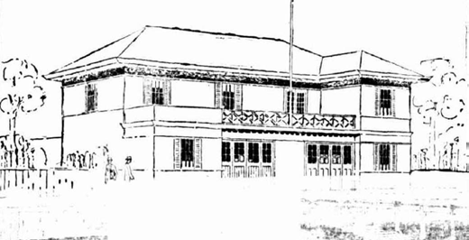
Figure 9.15: H. Trigg, Sketch of proposed Geelong Yacht Club house, 1928. Source: Geelong Advertiser, 26 November 1928.

ship’s cabin, the flagstaff passing from the ground floor right through the meeting room and to a certain extent representing the mast of a vessel. The mast is to be 47ft 6in in length and the upstairs room is to be reached by way of a circular iron staircase, springing from the
centre of the storage shed beneath. … Outwardly the new building promises to be an ornamental one on the beach, and to give effect to it the top of the roof is to be finished off in small iron balustrading, with the letter G.Y.C, prominently interwoven.161
In 1924, the Geelong Yacht Club was granted an Admiralty warrant to fly the blue ensign and adopted the title, Royal, to its name.162 Three years later, the club commissioned Harold Trigg, architect, to design a new two storey hipped roofed clubhouse that was opened in February 1928163 (Figure 9.15).
The next major development came in 1959 when the Yacht Club took out a lease of further Geelong Harbor Trust land immediately west of its existing site. This new site contained a slipway (built in 1937) and Richard Gibson and Alan Taylor of the Yacht Club took charge of designing a new clubhouse to be erected over the
slipway.164 In 1966, club member Tom Hawkes prepared a plan for the reclamation of land in front of the clubhouse (to provide deep water to just outside the clubhouse), as well as reclamation to the east for hard standing some of the yachts and as a rigging area for small craft.165 Alterations and additions to the clubhouse were carried out in 1971 to a design by honorary architect, Alex. Chomley.166 Further alterations to the building occurred in 1973 and it was followed by a new jetty in 1977, which formed the basis for the construction of a marina in 1987.167 The marina concept
had featured in the City by the Bay masterplan prepared by the Geelong Regional Commission years earlier (Theme 6). In 2019, a Geelong Water Safe Harbour Precinct masterplan was released to enlarge the marina and improve the facilities of the Geelong Yacht Club and environs.168

The annual regattas on Corio Bay since 1844, and subsequently supported by the Geelong Yacht Club, remained well-attended events by locals and visitors
who flocked to the foreshore each year since the late 19th century.
In 1997, the Geelong Waterfront Festival merged with the Royal Geelong Yacht Club s annual regatta to form the Festival of Sails, a Victorian Major Event. Staged in late January each year, the Festival of Sails remains the largest annual yachting regatta in the Southern Hemisphere and is the foremost competitive keelboat regatta in Australia.169
In 1987, the Victorian Sailing School opened on Eastern Beach, east of the Geelong Yacht Club on land previously known as Hi-Lite Park (see later subsection).170 The facility was funded by the Geelong Regional Commission, Victoria s 150th Anniversary Committee, Department of Conservation and Natural Resources, Royal Geelong Yacht Club, City of Greater Geelong and the Department of Sport and Recreation. It is a unique aquatic educational resource for schools and the general community across Victoria.171

ROWING
The first organised rowing regatta was held on 23 March 1844 as part of the Corio Bay Regatta
(see earlier subsection). In 1849, the Geelong Aquatic Club formed following Captain Ogilvie s procurement of a boat from Hobart. With no other club in existence
for four-oared crew competitions, a scratch race between whaleboats occurred instead.172 Ten years later in 1859, Clement Blunt had built three gigs that were regularly seen on Corio Bay.173 While rowing clubs had been established in Melbourne and Ballarat, it was not until 1862 when the Geelong Rowing Club was formed at the Victoria Hotel under the chairmanship of J.A. Gregory, solicitor.174 With rules prepared soon after, the inaugural committee included
J.A. Gregory (president), Holding (treasurer), Higgott junior (secretary), Haworth (captain) and Holding, Robins,
Haworth, Morgan, C. and J. Higgott, F. Ibbotson, Green and Wilson.175 While Corio Bay formed the initial location for regattas, others looked to the advantages of the Barwon River and Lake Connewarre where meetings were held in 1864 and 1867 respectively.176 Regattas on the Barwon led to the formation of the Barwon Boating Club in 1864 which proposed the erection of a shed on the Barwon River bank near the bridge.177 At Eastern Beach in 1865, the Corio Amateur Rowing Club was formed and it continued for three years.178 Like other clubs before it, the Corio Amateur Club met its demise.179
From uncertain beginnings, two rowing clubs that formed in subsequent years still exist to the current day. In 1870,

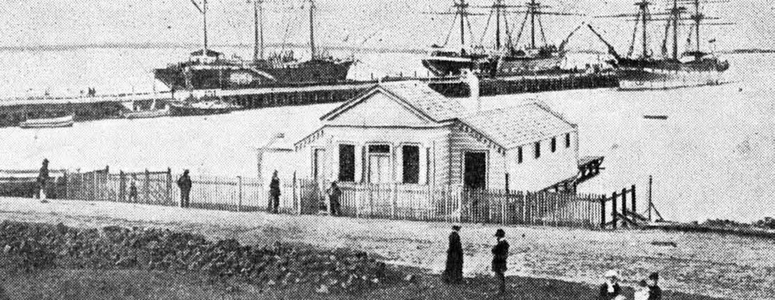
Figure 9.16: Corio Bay Rowing Club house (south elevation), n.d. [c.1880]. Source: J.A. Henry & N.J. Collie (comps.), Do You Remember? Pictures and Stories of Early Geelong, vol. 2, Henry Thacker, Geelong, December 1945, p.16.

Edward Lascelles, wool broker (Theme 5), called a meeting at Mack s Hotel for the purpose of forming a rowing club on the Barwon River.180 The outcome was reported in the Geelong Advertiser the following day: the club was to be named
the Barwon Rowing Club with the inaugural committee consisting of E.H. Lascelles (hon. Secretary), C.E. Farrell (treasurer), and Messrs. E.R. Lennon, Charles Shannon, F.R. Pincott, J. Arthur and F.R. Shaw. James Wilson enrolled himself as a life member.181 Permissive occupancy for a
boat shed on the north bank of the Barwon River, east of the Barwon bridge, was granted a few months later and a boatshed was completed by August 1870 to a design by Davidson and Henderson (it was rebuilt a month later following substantial damage caused by a flood).182 The
first race meeting occurred in November 1870 and the event of scratch-fours was won by Charles Shannon (str.), J.E. Pounds, J. Highett and P.W. Rose.183 It was six years later in April 1876 when the first regatta was held on the Barwon
River. Crowds flocked to the banks of the river, the mile and a quarter course finished at the foot of Bellerine Street.184 This began regular rowing regattas on the Barwon that continue to the present day.
Local competition for the Barwon Rowing Club came in 1873 with the formation of the Corio Bay Rowing Club on Corio Bay. The first committee comprised George Frederick Belcher (president), A.J. Owen (secretary), J. Fare (captain)
and Messrs. McNab, Scott, Sommers and Brown.185 Clement Blunt supplied boats for the club.186 A site for a boat house was provided at the Eastern Beach near the custom house wharf (Theme 3) by the Lands Department in 1878.187 By May of that year, the local architect, Joseph Watts, had prepared
a design for boat shed on the new foreshore site.188 Tenders were called a month later.189 Considered an ornament in the vicinity of the Yarra-street pier nearing its completion,190 the gabled single storey building with skillion wings to
accommodate 80 boats was officially opened on 28 November 1879, and following finishing touches, the Club Captain, G. Upward, proudly declared that the Club ‘would have the finest and best house in the colony 191 (Figure 9.16).
By 1920, race meetings and regattas on the Barwon River had grown in status, the Henley-on-the Barwon carnival (which began in 1910 on the instigation of the Barwon Rowing Club)192 attracting large crowds, and generating funds sufficient to be equally split between the Barwon and Corio Bay Clubs, and the Geelong Council (for expending on the beautification of the river banks).193 This gave impetus for
the Corio Bay Rowing Club to relocate to the Barwon River. In 1921, the club s boathouse was relocated from the Corio Bay foreshore to the river bank, the greater portion being in its new position by 10 August.194 A gabled two storey addition was constructed. The Club s anticipated success did not materialise and recognising that it had greater value as a rowing club on the bay, it again proposed to relocate
its clubhouse to a new site on the Western Beach in 1932.195 The relocation did not occur immediately as the shed on the Barwon River –with gabled two storey addition –was shown in a photograph by T.T. Holmes in 1933 (Figure 9.17) but was shown in an aerial image by Charles Pratt at Western Beach until November 1938.196
By the late 1950s, the Club returned to the Barwon River, leaving behind its boatshed that was taken over the Western Beach Club (a less affluent version of the Geelong

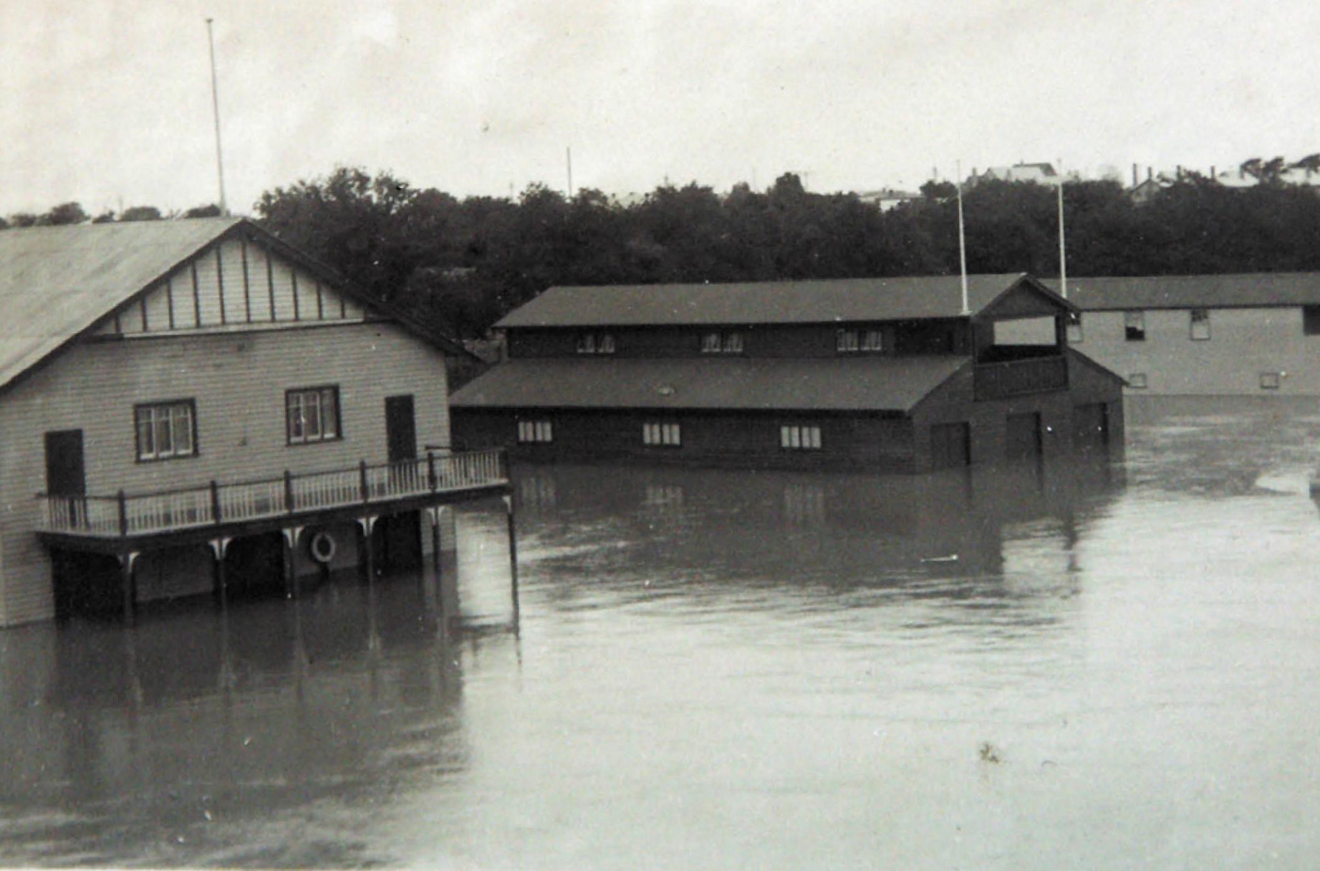

Figure 9.17: Barwon River in flood, 1933, showing Barwon Rowing Club house (right). Source: T.T. Holmes collection, Authentic Heritage Services Pty Ltd.

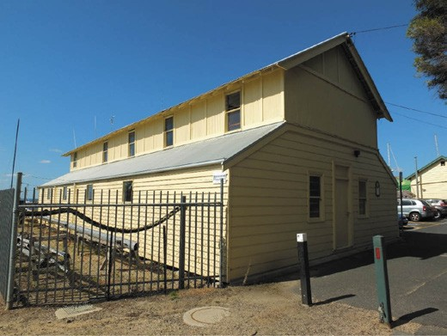
Figure 9.18: Corio Bay Rowing Club house/boat shed, Western Beach, 2018. Source: David Rowe.
Yacht Club, established in 1955).197 Today, the boatshed (Figure 9.18) is the earliest built legacy of the rowing clubs established in Geelong in the 19th century.

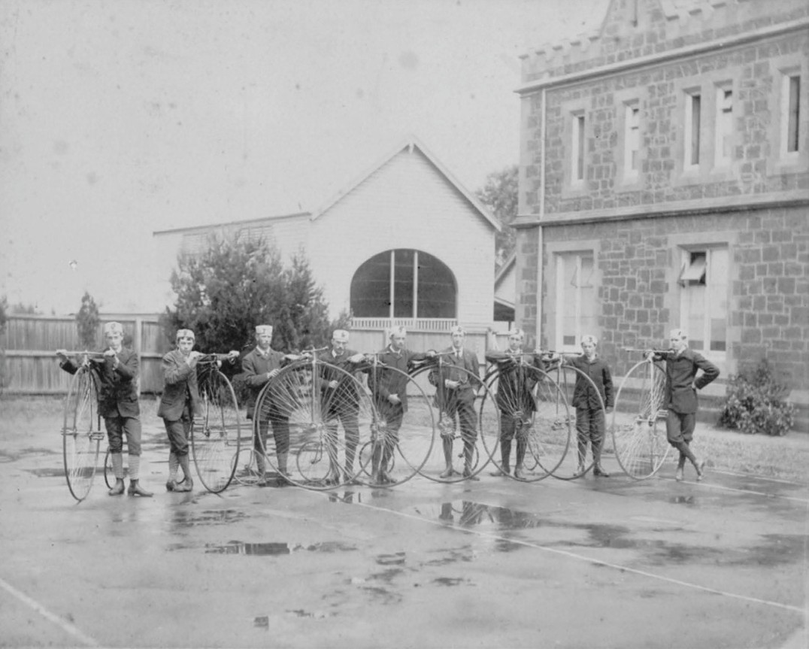
Figure 9.19: Bicycle Club, Geelong Grammar School, Geelong, 1881. Source: Geelong Grammar School Archives, Corio.

CYCLING

BICYCLE CLUBS
In addition to the recreational pursuit of cycling, as early as July 1869, velocipedes were used in sporting races in Melbourne and Geelong.198 This brought about an entertaining and soon-to-be popular and enduring sport.
On 17 July 1869, a velocipede race featured at the Highton mid-winter Athletic Sports carnival.199 The Melbourne Bicycle Club was established in 1878 and the Geelong Bicycle Club followed in 1881.200 The inaugural committee comprised James Wilson of St. Albans Stud (President), Messrs. Sharpe Brearley and A. Crook (Vice Presidents), W. Hall (Captain),
A. Kirk (Vice Captain), and J.H. Hobday (Secretary and Treasurer). Other original members included C. Garrard, W.
Buckland, R. Scott, J. Webb, W. Wilson and W. Thacker. 201
In 1883, the Geelong Church of England Grammar School had inaugurated a Bicycle Club. A collection of Penny Farthings was acquired for the enjoyment of the pupils (Figure 9.19).
Other community clubs formed in the following years, including the Newtown and Chilwell Bicycle Club in
1884, the Pivot Cycling Club in 1885.202 These early clubs declined and reformed as merged clubs in following years.203 In 1892, the Geelong Cycling Club was re-formed before declining in 1893 and was re-established at the peak in local popularity in 1895.204 Two years later in
1897, The Pivot Cycling Club was re-established.205
The dawn of a new century brought with it the formation of new cycling clubs (Figure 9.20). By 1900, the Portarlington

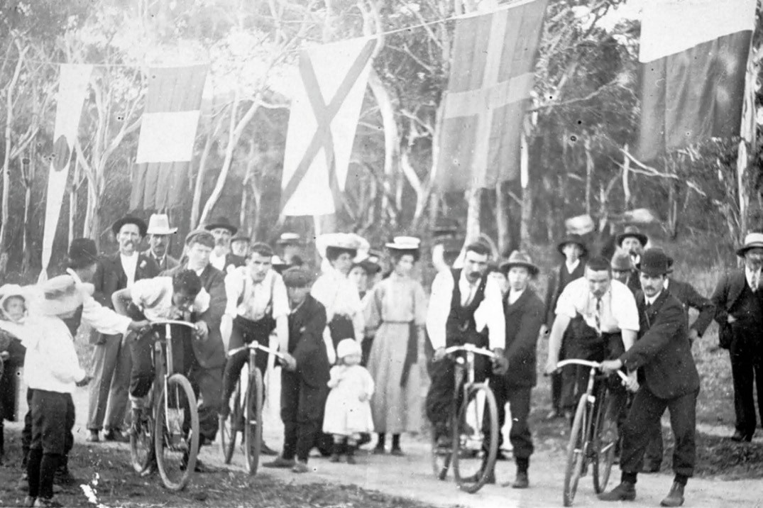
Figure 9.20: Cycling race meeting, possibly Geelong district, 1906. Source: Item MM3725 Museums Victoria.

and District Cycling Club had been formed, with F. Rich as the honorary secretary.206 In 1908, the B.W. and R. Cycling Club was created, probably by Bennett, Wood and Roche of the cycle agency Edward Clarke who operated the biggest agency in Geelong at that time.207 In 1911, the Geelong West
Cycling Club and Chilwell Cycling Clubs were formed.208 They were followed by the Belmont Cycling and Athletic Club in 1918.209
The various cycling clubs that formed throughout Geelong provided organised track, road and touring race events, often involving races with clubs throughout Victoria and further afield.
Two local cyclists have performed on the international stage. The first, Edward “Russell” Mockridge (1928-1958), was born in Melbourne to Robert Glover Mockridge, an engineer and Aileen Claire Mockridge (nee Riley).210 The Mockridge family relocated from Laverton to Geelong in 1931 where Russell Mockridge attended the Geelong College.211 After gaining his Leaving Certificate, he joined the Geelong Advertiser as a cadet journalist.212 His first success as a cyclist came in 1946 when he won a 24 mile race as member of the Geelong
Amateur Cycling Club.213 He very quickly became an elite road cyclist, being selected for the Victorian team in the Australian championships in 1947.214 Competing in the Olympic Games in London in 1948, a tyre puncture thwarted his initial success but by 1950 at the Empire Games in Auckland, New Zealand, Mockridge was Australia s premier cyclist.215 He then retired from the sport to join the Anglican ministry and after matriculating through Taylor s Coaching College, he commenced an Arts Degree at the University
of Melbourne.216 This was cut short by his return to cycling where he won the Grand Prix de Paris open sprint race in 1952, the same year he won gold at the Helsinki Olympics.217 His life was tragically cut short when he was killed while riding in a road race in 1958, witnessed by his wife following behind in a car with their two year old daughter.218 In 2018, the recently-completed Belmont Criterium Cycling Track was named the Russell Mockridge Pavilion, in honour of Geelong s supreme cyclist.219
A more recent international cyclist to reside locally is
Cadel Evans. Born in Katherine, Northern Territory, in 1977, he began his cycling career as a champion mountain biker, winning the World Cup in 1998 and 1999. A four-time

Olympian, Evans focussed on road cycling from 2001, finishing second in the Tours de France in 2007 and 2008 before winning this race in 2011, being one of just two
non-Europeans to have officially won the Tour and the only Australian.220 A resident of Barwon Heads, Evans instigated the Cadel Evans Great Ocean Road Race in 2015 as his farewell race, which has become an annual professional road bicycle race for men and women throughout Geelong and the Surf Coast, finishing in Geelong.221
Geelong also has associations with another of Australia s international cyclists, Sir Hubert Opperman (1904-1996).222 He won the Australian national road race title four times in 1924, 1926, 1927 and 1929, and the Bol d Or 24-hour classic on a 500m velodrome in Paris in 1928.223 He had success
in the 1166 km Paris-Brest-Paris race in 1931 which he considered to be his greatest win.224 His connections to Geelong came after his cycling career in 1949 when he was elected the member for the electorate of Corio for the Liberal Party of Australia, a seat he held for 17 years.225 He was made an Officer of the Order of the British Empire in 1953 and Knighted in 1968 for his services as High Commissioner to Malta, a position he held for five years from 1967.226 He died in 1996.227

MOTORCYCLE, BICYCLE AND FOOT RACES AT KARDINIA PARK
In 1925 Michael Hede and Eugene Cowley formed a partnership to promote cycling races at Kardinia Park during the summer period. In 1926, M.J. Hede sold his cycle shop in Ryrie Street228 (Theme 3) and established a partnership with Eugene Cowley (1872-1959),229 cycle agent, as promoters of cycle and foot races during the summer months at Kardinia Park (which was to become known as the Geelong Drome). According to M.J. Hede s son, John, Gene Cowley was a more flamboyant type and used to dress in light colored suits, usually with a light hat; this was a complete contrast to the conservative greys and blues of Mick Hede. 230 The joint venture between Hede and Cowley lasted ten years
The Geelong Advertiser gave an insight of the Cowley and Hede venture, and their anticipated aims:
Kardinia Oval will in future take on an additional title, probably the Geelong Drome. This is because it has been leased by the Kardinia Park Committee to Messrs.
E. J. Cowley and M.J. Hede, well known cycle traders of Geelong. The lessees, who have taken the oval for a
term of eight years but whose period of occupation will be confined to summer months, intend to promote all kinds of sports and entertainments, not only in the day time, but also at night by the aid of a brilliant lighting system. The
promoters are enthusiastic with regard to their project, and state that they hope to place foot- running and cycle-racing

on a high plane in Geelong. Their aim is to surpass the great Stawell Easter Gift, and to inaugurate an endurance track cycle race similar to those in England, America, and Sydney, and on the Continent.
It is proposed to remove the arena fence back as far as the embankment so that where the people now stand a bitumen track will be laid down. This will cover a wide area from the football boundary line to the top of the embankment, and will be used for cycle and light motor cycle racing. Inside this hard track two turf cycle tracks are to be specially prepared. Grass tracks are considered to be ideal for cycle racing, and have become popular in recent years. The two tracks, being side by side, will make a double track having a width of 40 feet.
The promoters intend to cater elaborately for all kinds of amateur and professional sport. As far as concerns
cycling, it is proposed to conduct endurance road races, Kardinia Oval being the starting point of a 400 miles distance. It is intended to hold a six days cycle race on the bitumen track, riders to be called upon to perform for eight hours a day. It is also intended to conduct each year a big cycle race, something like the old Austral Race, in which prizes will aggregate £1000.
Mr. Cowley is the founder of the recently formed Geelong Amateur Cycling Club. It is proposed by
the promoters to form a Geelong Professional Cycling Club.
A special sprinting turf track will be installed for foot- runners. Harriers, both amateur and professional, are to be catered for on a large scale. The ambition of the promoters is to conduct a yearly race on the lines of the
Stawell Gift. They state that what Stawell can do, Geelong can do. Each Easter between 40,000 and 50,000 people visit Stawell, and there is no reason why large crowds should not be attracted to Geelong. Messrs. Cowley and Hede will try to eclipse the Stawell event.
Wrestling and boxing in the open air is also to be programmed, while in front of the grandstand open air roller skating will be the vogue. Open air picture shows at night are also to be featured.
The lessees will take possession on November 1. and relinquish it on April 30 each year. They state that the whole of their proposals cannot be effected at once. These will have to come gradually. But they expressed the hope that they would be able to make Kardinia Oval an attractive place for the people. They would like to make Geelong the premier cycle and foot-running centre in Australia. The promoters have been promised the

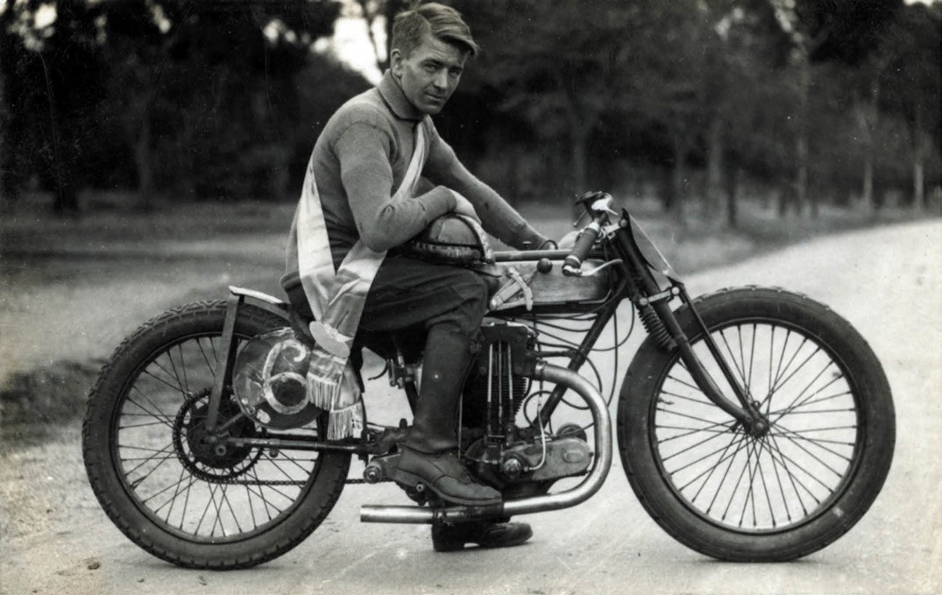

Figure 9.21: C.V. Bland, Billy Pilgrim on his motorcycle, Geelong Drome, Kardinia Park, 1926. Source: GRS 2009/00408, Geelong Heritage Centre collection.

patronage of leading Melbourne cycle traders, and hope to attract Continental and interstate competitors. The oval will be prepared for the scheme directly football
is finished. From November 1 to April 30 next year, the series of events will be staged.231
At the first cycling challenge in December 1926, over 3000 spectators watched Billy Pilgrim (Figure 9.21) win the fifteen-lap solo motorcycle handicap.232 He was to become beyond all doubt the most consistent rider at the Geelong Drome . 233

GEELONG MOTORCYCLE CLUB
The regular motorcycle races at the Geelong Drome, Kardinia Park, from 1926 had their roots in the formation of the first Geelong Motorcycle Club by motorcycle enthusiasts at
the Geelong Post Office in Ryrie Street in 1913234 (Figure 9.22). Its first activities were reliability trials with later events including hill-climbing contests.235 There was also a Harley Davidson Motorcycle Club active in Geelong in the late 1920s.236
The popularity of motorcycle racing at Kardinia Park lead to the formation of a new Geelong Motorcycle Club in 1932.237 It was formed in the motorcycle shop of L.F. (Frank) Pratt, former aviator, at 245a Moorabool Street (Theme 3).238 The
foundation members were Robert Anderson, Bert Blair, Percy Coleman (President), Bert Dickins, Peter Griffiths, Colin Rankin, Harry Shoebridge, Alick Smith, Dave Walter, Ron Walter, Eric Williams and Frank Pratt (Secretary/Treasurer). An early event was a reliability trial that commenced at Hamlyn Heights, the route taking in Lovely Banks, You Yangs, Anakie, Meredith, Steiglitz, and Darriwell before returning to the service station at Hamlyn Heights.239

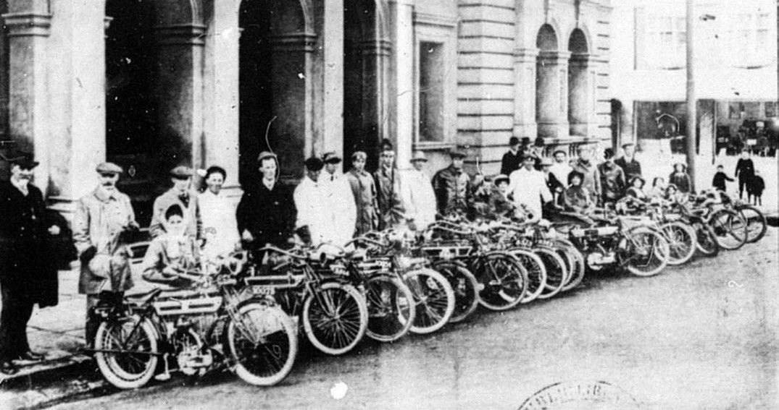
Figure 9.22: Geelong Motorcycle Club gathering outside the Geelong Post Office for a club run to Portarlington, 1918. Source: News of the Week, 3 July 1913, GRS 2297/88, Geelong Heritage Centre collection.

GOLF
In 1864, the Geelong Golf Club was formed at Mack s Hotel, Geelong, at a meeting of gentlemen desirous of introducing the old Scotch game to local residents.240 The laws of the game as played at St. Andrew s, Scotland, were introduced but with some slight modifications.241 The inaugural president of the club was Captain John Bell of Bell Park , with Mr
Miller as captain, Mr Fulton as secretary and treasurer, and Messrs Rennie and Anderson as ordinary members of the committee.242 The Club initially played on Ormond s paddocks at Geelong West and twelve complete sets of clubs had been imported, with efforts made for having others locally manufactured.243 Yet, it was not until 1872
when the first club match was played between Geelong and Queenscliff.244 The club appears not to have endured as a new Geelong Golf Club was established in 1892 with Charles Shannon as president, R.A.A. Balfour, captain; T.A. Whyte as honorary secretary and treasurer, and Messrs. J.M. Dobie, R. Miller, J.S.B. Orr and D. Strachan making up the balance of the committee.245 Practice matches were held at links formed above the bank of the Barwon River, near Princes Bridge.246 By 1897, the Club had relocated to new links at Bell Park, outlying land once part of John Bell s estate (Theme 6). A professional match between Scot, of the Royal Sydney Golf Club and Taylor, of the Royal Melbourne Club, was played there in October of that year.247 The course was also enjoyed by Geelong s Mayor, Thomas Edward Bostock (Figure
9.23). The course at Bell Park remained until 2013 when it was reduced nine holes as part of a residential development known as the Geelong Golf Club Residential Estate, incorporating 350 houses. 248
A Ladies Golf Club – affiliated to the Geelong Golf Club – was formed in 1893.249 It produced some outstanding players, with four having won the Australian Ladies Golf Championship: Miss Eleanor Austin (later Mrs Wright) (1909, 1925, 1928); Mrs Elizabeth Harding Newtown Lees (nee Austin) (1924); Miss Betty Kernot (1937 and 1938) and Miss Joan Lewis (later Mrs Fisher) (1939, 1947 and 1952).250
The most elite Club formed in Geelong was at Barwon Heads from 1901 when the Geelong Advertiser reported that picturesquely situated golf links at Barwon Heads had been opened with mixed foursomes, the winners being Mr. N.
Campbell and Miss K. Hope.251 The first links were situated on a 58 acre site to the north of the fledgling tourist township, on part of Fred Challis farm that was initially leased prior to purchase in 1909.252 In 1920, the Club purchased coastal land to the west of the town previously the farm of the Hopgood family. It acquired the services of Vic East, golf professional at the Royal Melbourne Golf Club, to lay out the course.253 His concept exploited the natural topography and characteristics of the treeless and barren coastal land by providing a links course design based on the links by the ocean found in Scotland.254 By November, 1920, the whole of the links had

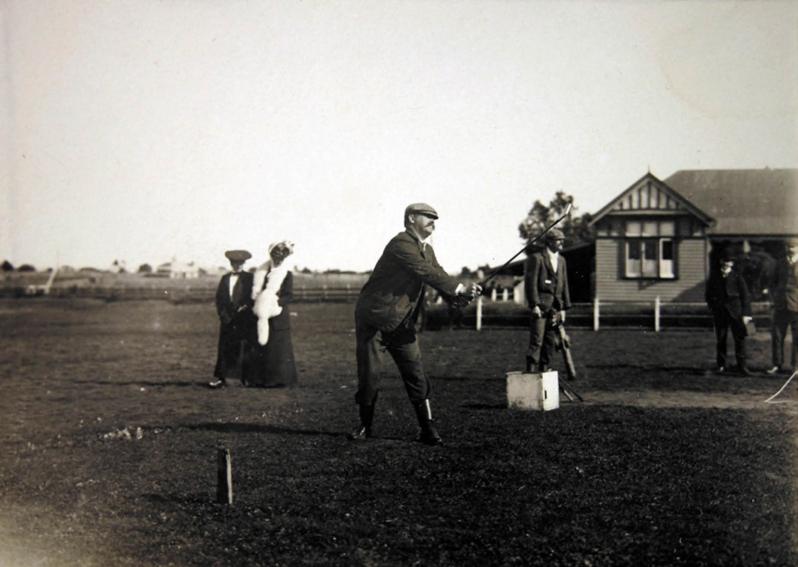
Figure 9.23: Mayor Bostock starting a round at the Geelong Golf Club, 21 August 1906. Source: GRS 0160/2/16, Geelong Heritage Centre collection.

been hand-planted with couch grass stripped and carted from the Sandringham Golf Course.255 The extensive planting of cypress trees and marram grass (in the rough areas) had been initiated, and in the autumn of 1921 English grasses were successfully introduced and a game on nine holes
was possible by November of that year, when Messrs T.E. Bostock (president), L. Sprague, R. Vincent and J.H. Thornton played the first round.256 The rapidity of the progress of the new course was in part due to the availability of water from the underground tanks throughout the area.257 A clubhouse was designed by the prolific architects of Melbourne, Klingender and Hamilton, in 1922.258 The local architects, Laird and Buchan supervised the work carried out by John Smith and J.C. Taylor and Sons from September 1923.259
The club and course (Figure 9.24) remain one of the more exclusive in Victoria today.
It was also in 1923 when permissive occupancy of land in Eastern Park was sought by the newly-formed East Geelong Golf Club for the laying out of a golf links.260 This club continues to the present day.
In 1926, the Clifton Springs Seaside Golf House (Figure 9.25) was erected on the site of the former Clifton Springs Hotel (Theme 6) to a design by Arthur W. Purnell, Melbourne architect and director of Clifton Springs Seaside Golf House Limited.261 It was built on 116 acres comprising the former Clifton Springs on the Bay Estate that had later been acquired by John Richards.262 The development also included an 18-hole golf course laid out under the supervision of Dick Banks, well-known golf architect.263 A putting green, two tennis courts, a croquet lawn and bowling green were also constructed.264 The promise of the development was revealed in the Geelong Advertiser:

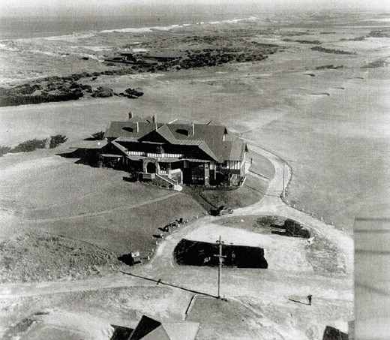
Figure 9.24: Aerial view, Barwon Heads Golf Club house and course, 1937. Source: Barwon Heads Golf Club.

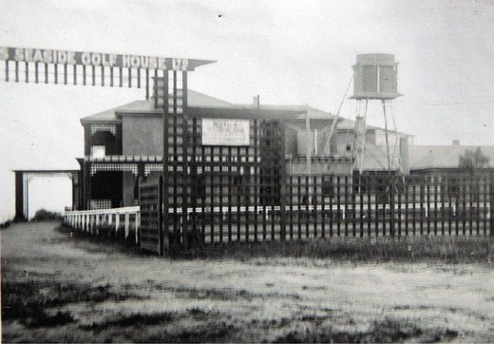
Figure 9.25: Clifton Spring Golf Club house, c.1930.
Source: T.T. Holmes collection, Authentic Heritage Services Pty Ltd.

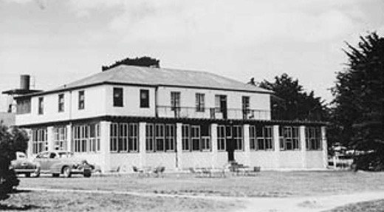
Figure 9.26: Clifton Springs Golf House, n.d. [c.1950].
Source: Bellarine Shire collection, photo 371, sheet 17, image 29, Bellarine Historical Society.

Clifton Springs, it is hoped, will become one of the finest holiday resorts in the Commonwealth. It should mean much to the people of Melbourne and Geelong –
perhaps more especially the latter – to find so pleasantly accessible a golf house by the sea, with such natural and acquired advantages.265
In 1937, the Clifton Springs Golf House (Figure 9.26) was
re-registered as the Clifton Springs Hotel and the 18-hole golf course was reopened in September of that year.266 The newly- formed company for the hotel and golf enterprise also entered into negotiations with an aeroplane company to provide a regular transport service to the course, a convenient landing ground and hangars for the use of private planes was also intended.267
Between 1959 and 1977, the developers Willmore and Randall commenced a real estate development around the golf course which they then owned.268 The course was also redesigned by Sam Berriman, a leading golf course architect.269 The establishment of houses around the course led to the formation of the Clifton Springs Golf Club in 1964 and the opened on the Clifton Springs Country Club in 1970.270
Other golf courses were laid out in the ensuing years, including the links at Queen s Park (1934) and Curlewis (1970).271 The latter was developed on 60 hectares of land acquired by the East Geelong Golf Club in 1947 but not officially opened as the home of the Curlewis Golf Club until 1970.272 These were only two of other golf courses laid in the Greater Geelong area. Others included those at
Newtown (Barwon Valley and Balyang), Lara (Elcho Park) and Thirteenth Beach.

TENNIS
A Tennis Court Club had been formed in Geelong by early 1865, with the Crown Hotel being central to the administration of the fledgling organisation and for play.273 As outlined in the Geelong Advertiser:
The tennis court at the Crown Hotel is becoming quite a fashionable place of resort on Saturdays, hardly one
passing but that it is crowded with players, good, bad, and indifferent. Is there no club in Melbourne with which a match could be played, as we think that Geelong would be able to make a fair show? 274
The court at the Crown Hotel was one of five in Geelong, another being at the Phoenix Hotel in Moorabool Street.275
It would appear that in competition with the Tennis Court Club was the Geelong Quoit Club, the champions of quoit competition being Messrs McMullen and Hawkes.276
In relation to tennis at least, the club seems to have dissolved as the Geelong Advertiser was quiet in reporting any matches and meetings throughout the 1870s. This might have been

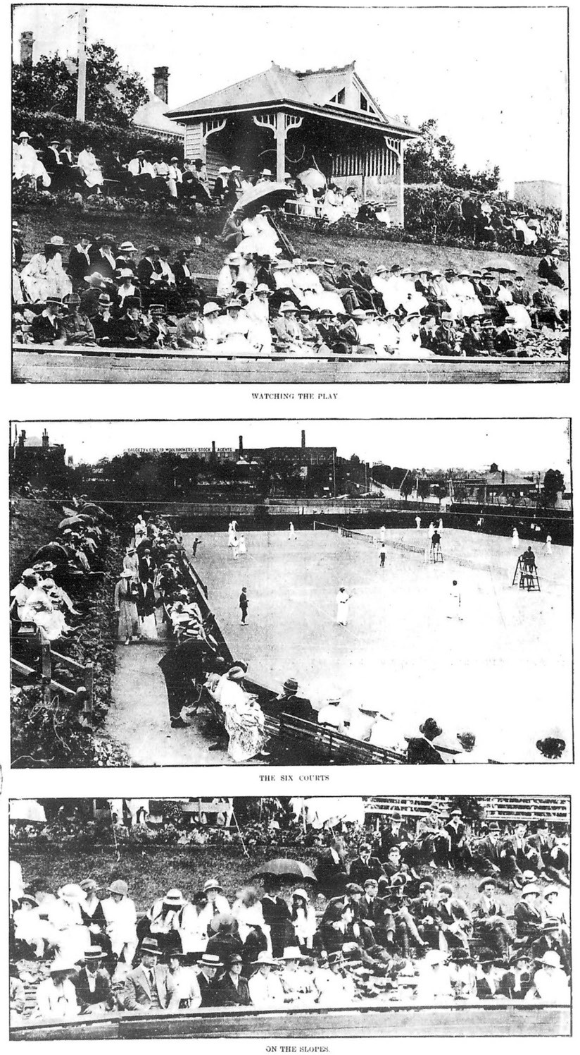
Figure 9.27: Easter tournament at the Geelong Lawn Tennis courts, 1919.
Source: News of the Week, 24 April 1919, GRS 2121, Geelong Heritage Centre collection.

due to the formation of the Recreation Club by Sir Charles Sladen, Charles Ibbotson, George Alexander Stephenson, Hugh Murray Strachan and Vincent Vine Buckland in 1876 at the north-west corner of Latrobe Terrace and Aberdeen Street where social tennis was offered.277
Impetus for the formation of the Geelong Lawn Tennis Club in 1882 came from the Geelong Club whose presidents
and vice presidents throughout these years also took up membership of the Tennis Club.278 By October 1882, a site in the Custom House reserve on the west side of Yarra Street (between Brougham Street and Eastern Beach Road) had been acquired and a lawn tennis rink, 200 feet square was
in process of being formed and fenced, and an ornamental pavilion was about to be built.279 Soon after the opening of the courts, James Strong and brothers (see Theme 5) began promoting the sale of lawn tennis shoes .280 The Easter Tournament at the Geelong courts (Figure 9.27) immediately became an important sporting and social event.281 This
was due to leading players from Melbourne and other parts coming to compete against some of Geelong’s early fine players, including A.D. Kearney.282 However, it was another early Geelong player, Jack Bailey Hawkes (Figure 9.28), who became a successful tennis player. He was the son of Tom H.S. Hawkes (who died in an earthquake in Japan in 1923) and grandson of Thomas Southam Hawkes senior, founder of Hawkes Brothers Hardware and Ironmongery business (see Theme 5). J.B. Hawkes won the Australian Open in 1926, reached the Wimbledon doubles in 1928, and played Davis Cup for Australia between 1921 and 1925.283
In 1948, the Geelong Lawn Tennis Club relocated to new courts at the Belmont bowling and tennis club grounds near the south bank of the Barwon River.284 It is one of the pre- eminent lawn tennis court facilities in Victoria, and in 2012 it hosted the Davis Cup tie between Australia and China.285 The Geelong Lawn Tennis Club remains one of the oldest tennis clubs in Australia.286
Other suburban, college and church tennis associations and clubs formed in subsequent years. The earliest appear to have been Yorick, Geelong West (1882), Drysdale (1890), Little River (1895) and Portarlington (1896). There was a surge in new suburban clubs following Federation in the early 20th century including those at Corio (1901), Belmont (1906), Newtown (1906), Mt. Duneed (1906), Barrabool (1907), East
Geelong (1907), Fyansford (1907), Lara ()1908), Chilwell
(1911), Geelong West (1912),
Ceres (1912), Princess Alice Lodge (1912), Highton (1914), Bareena, Newtown (1914), South Geelong (1915), Batesford (1916), North Geelong (1916) and Leopold (1918).287
The Churches association initially seems to have involved St. Matthew s Anglican (1908); Noble Street Methodist (1907);

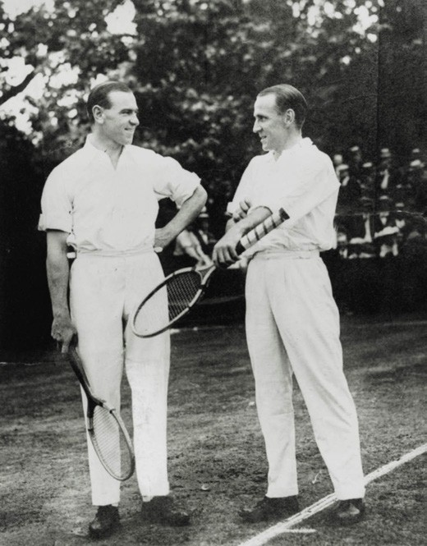
Figure 9.28: Gerald Patterson & J.B. Hawkes, 1925. Source: accession H2001.70/17, State Library of Victoria.

Yarra Street Methodist (1907); All Saints Anglican (1907); St. Andrew s Presbyterian (1908); Christ Church Anglican (1908); St. Cuthbert s Anglican (1908); South Geelong Methodist (1915); Hibernian Society (1916); North Geelong Methodist (1917) and St. Agnes Catholic (1919).288

CROQUET AND BOWLING CLUBS
Croquet and bowls appear to have been informally played on private grounds throughout Geelong since European colonisation. The Yorick Club, established in 1876 at the north-west corner of Latrobe Terrace and Aberdeen Street boasted a croquet ground, skittle alley, bowling green and quoit rink at its inception.289 In many instances, the Croquet
and Bowling Clubs were indelibly associated with each other, or with a tennis club, sharing the costs and management of greens. This was the case at the Yorick Club where branch Croquet Bowling Clubs were formed. The relocation of the Yorick Club (then named the Geelong Recreation Club) in 1890 brought about the laying out of a new bowling green, croquet lawn and tennis court on an L-shaped site on the north side of Little Malop Street and east side of Latrobe Terrace.290 The local architect, Joseph Watts, had been

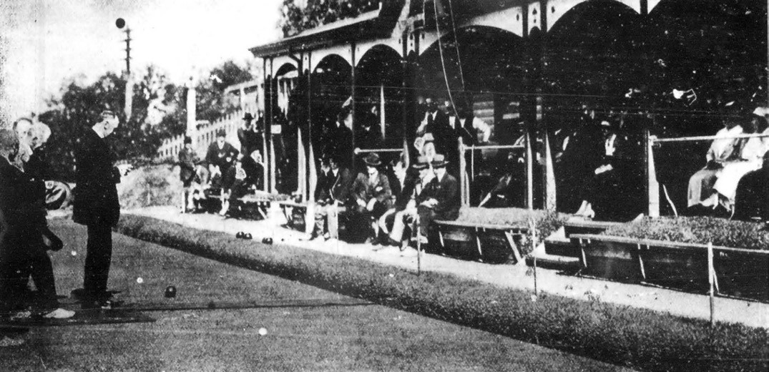

Figure 9.29: Opening of the season of the Corio Club Bowling & Croquet Greens, 1920. Source: News of the Week, 14 October 1920, p.13, GRS 2121, Geelong Heritage Centre collection.

responsible for the design of the new tennis court and bowling green, and he also supervised the relocation of the old Yorick Club buildings to the new site.291 This site might have previously been the location of the croquet ground established when part of a larger Johnstone Park area in 1871.292 The Geelong Recreation Club was renamed the Corio Club in 1901 and its bowling and croquet greens were updated by its curator and opened by the Mayor amid a crowd of 250 spectators.293 Crowds also flocked to tournaments
in subsequent years (Figure 9.29). In 1933, the Corio Club suffered the loss of its pavilion in a fire and again in 1947.294 In 1957, the Club relocated to a new site in Villamanta Street (on the site of the former Chinese Mission Church –see Theme 2) following the acquisition of its land in Little Malop Street and Latrobe Terrace by the Education Department
for expansion of the Gordon Institute of Technology.295
At its new site, the Corio Club laid out a new bowling green and constructed two squash courts and a clubhouse.296
It remained there until 1999-2000 when the Villamanta Street site was sold and the Corio Club dissolved.297 Several of its former members joined the Geelong Bowls Club adjoining the Geelong Lawn Tennis Club at Belmont where the Corio Club Dissolution Trust funded the construction of a synthetic green. It was replaced with a new surface in 2013 and is known as the Corio Club Green. 298
From the early 20th century, like tennis, there was a rise in the number of croquet and especially bowling clubs in Greater
Geelong. It began in 1901, when the Geelong Lawn Tennis Club laid out a croquet lawn which became the scene of several games by tennis club members.299 In 1951, the former tennis courts and croquet green of the Geelong Lawn Tennis Club formed the basis of the bowling for the newly-created RSL Recreation Club. This club officially opened its bowling green on 3 March 1952, the Argus newspaper commenting that with tennis- courts and billiard-tables already in use, it may become one of the best recreation clubs in Victoria. 300 Bowls tournaments and club games were held at the old Geelong Lawn Tennis club greens until the Geelong RSL Bowls Club relocated to 50 Barwon Heads Road, Belmont, in 1990.301
Other bowling and tennis clubs were established in suburban Geelong. In 1906, the Belmont Bowling Club proposed to put down a four rink bowling green and croquet lawn adjacent to the tennis court (now the location the Geelong Lawn Tennis Club and Geelong Bowls Club).302 In early 1912, a tennis court and quoit ground were laid out on land west of the Geelong West Park, corner of Pakington and Autumn Streets. A bowling green was also established at this time for the newly-created Geelong West Bowling Club. A pavilion was built in 1913 to a design by Seeley and King and the green opened in November of that year.303 In recent times, the bowling green and buildings have been removed in readiness for a major residential development.
It was also in 1912 when bowling and croquet greens were laid out on a portion of Eastern Park (fronting Garden Street,

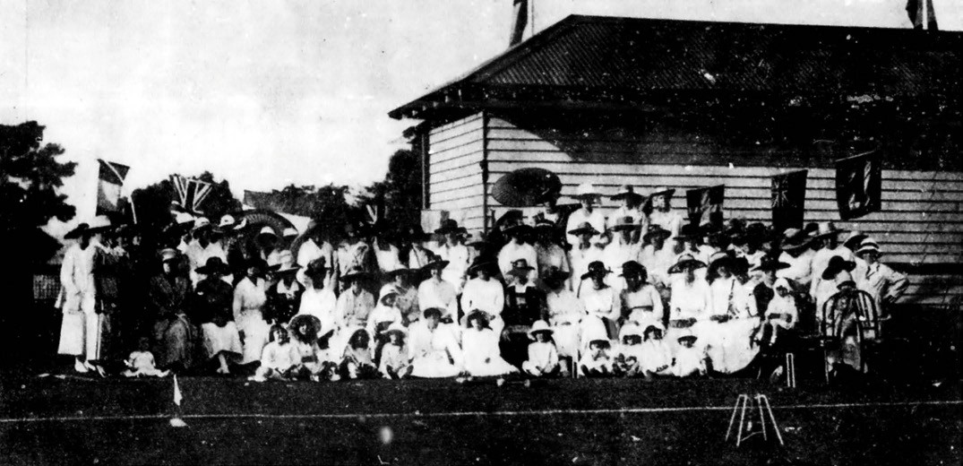

Figure 9.30: Eastern Park Croquet Club, 1920. Source: News of the Week, 18 March 1920, GRS 2121, Geelong Heritage Centre collection.

immediately north of the Geelong High School) for the Eastern Park Bowling Club established at this time.304 A timber bowling pavilion was also erected in 1912305 It was relocated and remodelled on the site in 1919 to a design by
I.G. Anderson, architect.306
A new croquet green was laid out next to the bowling greens following the establishment of a croquet section of the
club in 1920 (Figure 9.30). Mrs Clarice Ritchie was the first president.307 A new gabled timber pavilion was erected for the Eastern Park Croquet Club in 1920308 and it is the earliest surviving croquet clubhouse in Greater Geelong.
The oldest existing bowling club pavilion in Greater Geelong was erected at 89 Noble Street in 1913 on greens established by the newly-formed Bareena Recreation Club. This club was created at a public meeting under the leadership of the Mayor, Colonel G.M. Strong.309 Initially to be known as the Newtown and Chilwell Recreation Club, the name was changed to Bareena at the instigation of Cr. W. Francis.310 Trustees were appointed by the Bareena Recreation Club and were charged with the purchase of a portion of land known as Opie s paddock on the south side of Noble Street on which to lay out a six-rink bowling green.311 The trustees were a combination of local councillors and prominent citizens and comprised Mayor G.M. Strong, Cr. W. Francis, Cr. A. Purnell and R. Collins Hocking, and J. McLeod. It was also the intention of the Recreation Club to construct tennis courts and a croquet lawn.312 In November 1913 the Bareena Recreation Club
committee held a fundraising fair. The Geelong Advertiser
gave the following insight into the works completed:
Considerable liability has already been incurred in procuring the ground, erecting a pavilion, laying out the bowling green, and so on, and there is ample room for tennis also. With the funds raised by the fair, it will be possible to make a start with this section. In a very short time there will be serviceable and attractive recreation grounds, the bowling green should be ready for play early in the new year.313
The architectural firm of Laird and Buchan had been commissioned to design the layout of the bowling green, as well as the design of the pavilion and billiard room.314 The modest timber pavilion featured a hipped roof with a gabled ventilation dormer, and post-supported verandah
and a frontage to the bowling green. The pavilion and green (Figure 9.31) were officially opened on 21 February 1914.
The inaugural president was the Mayor of the Newtown and Chilwell Council, G.M. Strong with W.E. Turner as secretary.315
Notwithstanding World War One, membership of the Bareena Recreation Club steadily increased to a point where additions were needed to the pavilion. In 1919, the Geelong Advertiser gave a detailed description of the improvements (Figure 9.32):
Bareena is a sturdy and prosperous youngster amongst the bowling and social clubs of Geelong. After a very

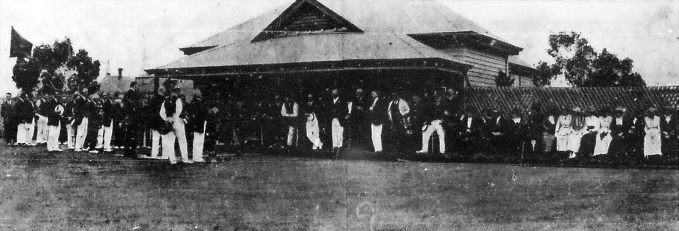
Figure 9.31: Bareena Bowling Club, 1919, showing original wing of club house. Source: News of the Week, 16 October 1919, GRS 2121, Geelong Heritage Centre collection.

few years it has a membership of well over a hundred, with new members being enrolled every week; it has transformed vacant land in Noble-street into a very attractive recreational area, improving the locality considerably; and last Saturday the members showed their faith in the future of the club by accepting tenders for extensive building improvements, the first stages of which will cost £821. The money is not in hand, but Bareena
from its inception has had good friends to meet difficulties, and on this occasion also the scheme is being financed
by a few of the enthusiasts. It was the opening day of the season on Saturday, and members, visitors and lady
friends assembled in large force to take part. The grounds are in excellent order, the green true and ready for the coming tournaments, and the borders of flowers set it off well. On the Noble- street front the slope leading down to the green has been squared off; here the word Bareena
is to be worked in large letters of buffalo, and begonias and other flowers. The tennis section of the club also is prospering … The extension to which it [the Recreation Club] is proposed to carry out, and for which tenders were accepted by the architect (Mr. W.H. Cleverdon) on behalf of the club, include a new billiard room, 45 x 25 feet; canteen, 30 x 17 feet; locker rooms, 25ft 6in. x 13 feet.
There will be a veranda along the front of the buildings, which will cover a frontage of 100 feet. A new full-sized billiard table was purchased recently; two more are to be obtained. The old building will be renovated throughout. In the new billiard room there will be kauri dado, four feet high, and the filling will be of plasteroid, panelled out.
A cove ceiling is to be lined diagonally with kauri. Mr. D.
Pescott s tender for the building was accepted, and Mr.
A.C. Herd has the painting contract. The work is to be completed by December 20th, so that the buildings will be ready for the Christmas carnival of three days bowling tournaments.316
In 1922, local residents of Drumcondra led by Oswald Hearne of Montana (Theme 6) sought to establish a bowling club with bowling greens, tennis courts and a croquet lawn.317 Nothing eventuated until 1948 when a club was formed
and greens laid out in Glenleith Court, Drumcondra.318 The Drumcondra site was sold in 2014 and the club amalgamated with the Geelong West Bowling Club on a new site as the City of Geelong Bowls Club at 7 Ballarat Road, North Geelong, in 2017.319

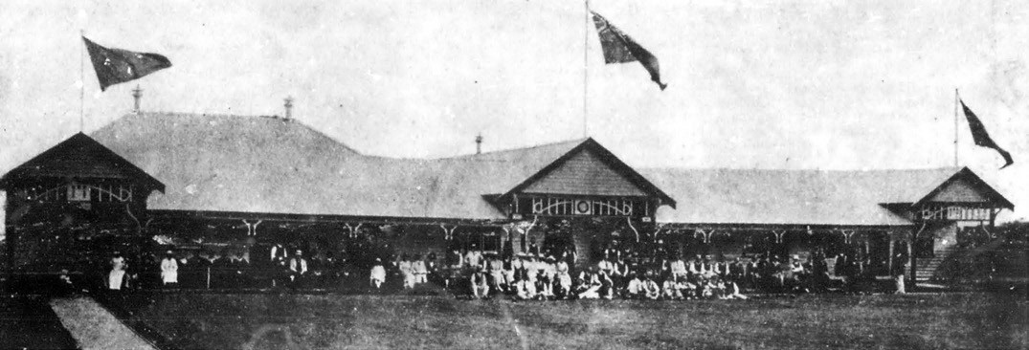
Figure 9.32: Bareena Bowling Club, 1920, following additions to the club house. Source: News of the Week, 12 February 1920, GRS 2121, Geelong Heritage Centre collection.

ATHLETICS
The earliest form of organised athletics was a private affair when Monsieur E.C. Greene, a gentleman of colour and member of the L Ecole Polytechnique, Paris, opened a Dancing, Fencing, Calisthenic and Gymnastic Academy in Corio Street in 1849.320 Emanuel Charles Greene had been born at Bordeaux, France, and had been educated in a military college before serving in the Chasseurs au Cheval during the time of Napoleon Buonaparte in the battles of Leipzig and Waterloo.321 In London in 1828, Greene was convicted for defrauding a Mr Thompson in relation to
the procurement of bedheads.322 He was sentenced to transportation to Tasmania and granted a ticket of leave in 1831 from which time he became a dancing master of noted celebrity.323 He relocated to Sydney in 1839 and then to Melbourne324 prior to his arrival in Geelong.
As part of the celebrations for the separation of Victoria from the Colony of N.S.W., gymnastics games were held in Melbourne in 1850 and again in 1851.325 Yet, it was not until
the formation of the Comunn na Feinne Society in Geelong on 1 January 1857 when the first local annual athletics carnival was held (see earlier subsection). Although a specific society for the cultivation of gymnastics and of athletics generally was proposed in Geelong in 1860, these activities appear
to have been largely confined to the gymnasium as part of the Volunteer Rifle Corps in Ryrie and Fenwick Streets that had been established by 1856 (Theme 7). Similar clubs associated with volunteer military life continued throughout the 19th century, such as the Geelong Battery Social and Athletic Club which was devoted to military sports in 1895.326
Encouragement for engaging young boys up to ten years of age and youths up to 15 years was made by Joseph Carr of the Cricket Club Hotel, Chilwell, in 1861. He offered
a handsome silver cup to the value of eight guineas for the youths and a silver watch for the boys.327 This appears to have been impetus for the formation of an annual Geelong Amateur Athletics Sports carnival at Corio Oval from 1864 which embraced football, flat and hurdle racing and other athletic sports under amateur competition.328
In 1866, the Corio Gymnastics Club was established by a Mr Sidders.329 A private concern known as the Geelong Athletic Club was established by Messrs. English and Price in 1889 for gymnastic instruction, an exhibition at the Exhibition Hall in Market Square attracted 250 spectators.330
More organised amateur clubs began in the 1890s. The first was the Geelong Harriers Club formed in 1892 under the rules of the Victorian Amateur Athletic Association. A male institution, the object of the club was to provide health recreation and encourage honest and straight running, the feature of amateur athletics. 331 The inaugural president was
J.R. Hopkins, M.L.A., with Messrs. P. Russell, F. Hodges and
W. Abraham as vice-presidents; Messrs. Henry Sargeant,
W.R. Wilson and J. Sommers, patrons, Mr O Dwyer, treasurer;
J.C. Warner, secretary, C. Young, captain, H. Young, vice- captain and Messrs. W. Warner, J. Mills and W. Morris comprising the balance of the committee.332 Other clubs that formed in subsequent years included the Geelong Grammar School Harriers (1894); Christ Church Harriers (1900, as a revival of the earlier Christ Church Union); Presbyterian Guild Harriers (St. Gile s, 1908).333

On 13 July 1908, the Geelong Guild Amateur Athletic Club was formed.334 This club boasted some notable members in the 1950s, six of which competed in the 1956 Melbourne Olympics: Ron Blackney, John Chittick, Robert James Bob Joyce, Don MacMillan, John Vernon and John Landy. The latter had joined the Geelong Guild Athletic Club in 1949
while a student at the Geelong Grammar School. He was the second man to break the four-minute mile barrier in the mile run and held the world records for the 1500 metre run and the mile race.335 Impetus for a dedicated athletics facility in Geelong came from a speech Landy gave at a dinner given in his honour by members of the Geelong Guild Athletic Club in 1954. He pleaded for improved facilities for Australian athletes, particularly for cinder tracks similar to those overseas given that at the Vancouver Empire Games earlier that year Australians had gone direct from the grass tracks
–often waterlogged football ovals –to run on the hardest cinder track he had experienced.336 In 1961, land set aside from development on the north bank of the Barwon River opposite what is now the Godfrey Hirst Pty Ltd carpet factory was transformed into the John Landy Athletics Field, named in honour of Landy.337
In 1965, children who sought to participate in an athletics meeting in Geelong were excluded from competing as their age prevented them under the Victorian Amateur Athletics Association. Led by Trevor Billingham, a meeting was subsequently held and a Saturday morning competition for boys and girls, to be known as Little Athletics, began at Landy Field. This led to the establishment of the Victorian Little Athletics Association on 10 March 1967.338
The Corio Athletic Club formed in 1969.339 A new facility, known as the Corio Athletics Stadium (and the Corio Leisuretime Centre today), was opened by the Olympian, Ron Clarke, in 1970,340 being the home of the fledgling Corio Athletic Club.

GREYHOUND RACING & HORSE HARNESS RACING
Greyhound racing began in Geelong as the Grant and Polwarth Coursing Club in 1873 at a meeting at Mack s Hotel, Geelong, at the behest of G.E. Green.341 He was elected honorary treasurer with John Bell as president; A.J.
Robertson and J. Middlemiss as vice presidents, G.R. Rippon as honorary secretary with the other committee members being A. Douglass, J.D. Robinson, B. Hepburn, W. McMullen,
Robert Miller, J.V. Buckland and T. Ashe.342 The first meeting being held at Mr Brown s station at Anakie. Only 24 dogs formed the initial competition.343 The club disbanded in 1880.344 A revival came in 1889 and its first meeting
was held at Avalon Homestead, Avalon, the property of its

inaugural president, Frank Austin.345 From 1909, coursing continued under the name of the Geelong Coursing Club but meetings were postponed during World War One.346 It was revived soon after War s end.
A club specific to the racing of greyhounds and horse harness racing was established in Geelong in 1936 with meetings
at Nelson Park, North Geelong.347 With the formation of the Victorian Trotting Club Control Board in 1956, Hugh
Emmerson, greyhound breeder and trainer, was a progenitor in the establishment of the Geelong Trotting Club, with a track laid out at Corio Oval, Eastern Park, the former home of the Geelong Football Club.348 The inaugural president was Fulton Knowles. In August 1956, the Geelong Trotting Club held its first night meeting, the trotting track (Figure 9.33) having been the first ‘in the southern hemisphere to use an underground lighting cable. 349 Costing £100,000, the renovated track included a white shadow-board fence on the back stretch, so people in the stands could easily follow the horses. 350 The lack of overhead wires also provided higher quality viewing:
A row of lights in front of the stands will illuminate the home straight, and another row of lights, in the paddock, will be focused on the white shadow-board fence, directly opposite the stand on the other side.351
Club officials boasted that the new track would ‘challenge the Showground as Victoria s trotting centre. 352
In 1976, 13 hectares of land at Corio was purchased for the Trotting Club under the guidance of Club president, Ray Beckley, in 1976.353 This $650,000 facility was subsequently named Beckley Park, its opening night being on 7 March 1980.354 Grandstand facilities were upgraded in 1997 and
in March 2008 a new kennel and administrative facility was constructed by the Geelong Greyhound Racing Club (the present name of the former Geelong Trotting Club).355
Beckley Park is also the home of harness racing in Geelong.

SKATING
The popularity of the Corio Gymnastics Club in July 1886 was greatly enhanced a month later when a roller skating rink was installed.356 This was to be the first of several skating rinks
in Geelong that endured into the early 20th century. Others included those at the Artillery Orderly Rooms in Little Malop Street (1875); Geelong Recreation Club, corner Latrobe Terrace and Aberdeen Street (1876 –see earlier subsection for this club); Lawton s Links, Moorabool Street (1876); Columbia Elite Skating Rink, Ryrie Street (1887); Princess Skating Rink, corner Malop and Bellerine Streets (1909); and the Joy Ark rink (later Imperial Rink), Eastern Beach (1918, 1923).357

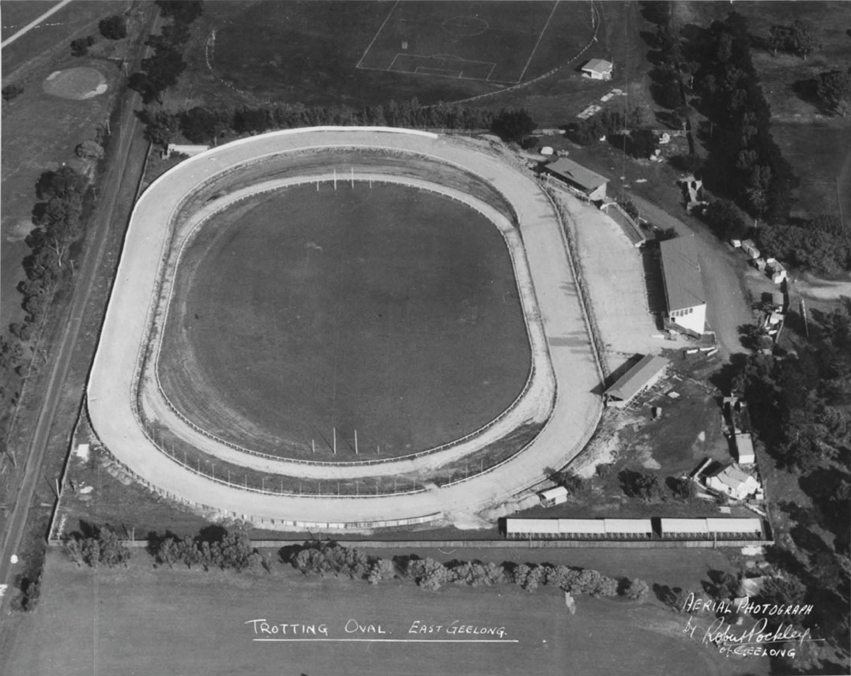
Figure 9.33: R. Pockley, Aerial view Geelong Trotting Track at Corio Oval, c.1956. Note the Friendly Societies Reserve in the background. Source: accession H2007.25/29, State Library of Victoria.

BASKETBALL AND NETBALL
Basketball was founded in America in 1891 by James Naismith, a school teacher, to condition young athletes in the cooler months.358 Consisting of peach baskets and a soccer style ball, Naismith published 13 rules for the game, his class of 18 male students being divided into two teams of nine players.359 The objective of the game was to throw the basketball into the fruit baskets nailed to the lower railing of the gym balcony. The first game was played in Massachusetts on 11 March 1892.360 The popularity of
the sport soon spread throughout the world. In Geelong, one of the earliest basketball teams was formed by the
Presbyterian Guild in 1910 by Messrs. J. Downie, H. Dunt and
W. Brownhill.361 Matches were played at night on land at the side of the Guild Hall in Myers Street.362

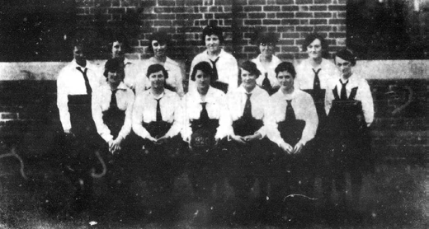
Figure 9.34: Gordon Technical College Basketball Team, 1920. Source: News of the Week, 2 December 1920, GRS 2121, Geelong Heritage Centre collection.

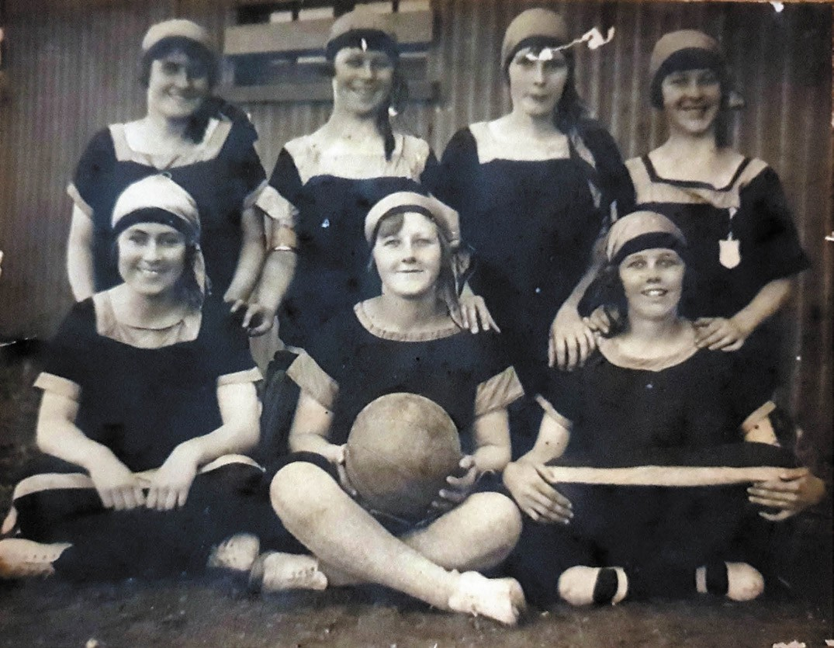
Figure 9.35: Valley Worsted Mills team, 1925. Source: Liz Coles, Secretary, Geelong Central Netball Association.

While first played by males, it soon became a sport for females. The first reference to women’s basketball in the Geelong Advertiser was in 1898 when an article examined the physical condition of thirty girls in a well-known private school in New York. It found that systematic physical culture, under the direction of a thoroughly skilled and conscientious teacher, who aimed to give each girl the exercises especially suited to her individual condition, improved the girls health.363 It also concluded that opinions differed as to the desirability of basket-ball and sculling as maidenly accomplishments. 364
In 1898, Clara Baer, an American gym teacher, established official rules for a female version of basketball that was later to become known as netball. She ‘identified the areas where “female basketball” differed and modified the rules.’365 In Geelong by 1910, basketball had been taken up by students of the Church of England Girls School, Newtown, the
School s end of year report giving a glowing account of the sport:
Basket ball was taken up most enthusiastically this year, and is a splendid winter game for girls. Keen interest was taken in the Form matches, and the enthusiasm, reached a high pitch in the final match to decide the holder for 1911 of the Challenge Cup presented by Mrs. J. McLaughlin.
We were pleased that the donor of this cup was present with us on that day. Basket ball is not so well known as other sports, and we hope next year that any parents or friends of the girls who would care to see this game played will come to witness some of the matches.366

Other school basketball teams were subsequently formed. In 1913, the Geelong High School team was under the charge of Miss White.367 By 1919, the Gordon Technical College team had been formed and it hosted the Colac girls basketball team in Geelong at that time.368 The local team was made up of: L. Smith (captain), L. McGann (vice-captain), Ivy Rawlings,
M. Nicholson, C. Lavery, B. Tournier and C. Stewart.369 In 1920, the Gordon College team (Figure 9.34) hosted the Swinburne Technical College team.370
Female basketball flourished from the 1920s by women mainly employed at the local industries. These women s teams had emanated from the Blue Triangle Community Committee established in 1921 to support the welfare of female workers from the four woollen mills, Donaghy s Ropeworks and the maids of the Geelong Grammar School, Corio.371 The name of the Committee - the Blue Triangle –symbolised comradeship, loyalty and service. 372
Instrumental in the formation of the Blue Triangle Community Committee was the YWCA (see Theme 8) which financed
a Community Worker.373 A key part of the Blue Triangle Community –through the persuasion of its secretary, Miss Elsie Bennett –was the formation of basketball teams from all the mills.374 In 1923, a club was organised at the Collins Union Mill, Newtown. Basil Collins was the inaugural president with Miss Hazel Skelton, secretary, and Miss Hazel Collins, Treasurer.375 The Geelong Advertiser reported on the newly-formed club:
A piece of ground has been given by the management and prepared for use. They have also donated the equipment. The girls, about 30 in number, who have joined up are very keen and enthusiastic. A practice match was held at Swanston street school grounds on Saturday last, when the school ground was generously loaned to them. Their own ground is almost ready, and to-day should see their first practice match on it.376
Other teams formed around this time included those of the Excelsior, Federal Albion and Valley Worsted Mills.377 A court for the Albion Mill team was officially opened by Mrs A. Gray in April 1924.378. In 1924, the Beacon Trading Company formed a club, the Geelong Advertiser
reporting that:
Matches are held regularly and through their means these girls are taught something of true sporting spirit, give
and take, and fair play, which unlike their more fortunate sisters, they have not had the opportunities of absorbing in school years.379
Valley Mills teams were champions in 1925 and 1932 (Figures 9.35-36).
In 1935, the Blue Triangle Association changed its name to the Geelong Girls Unity Club in order to prevent

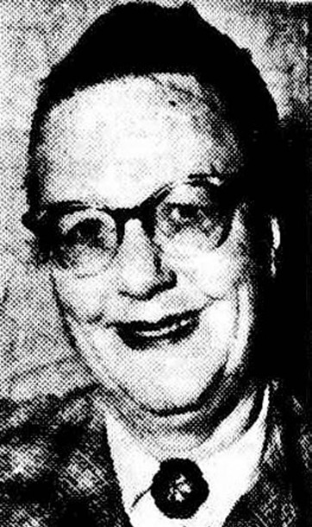
Figure 9.37: Elizabeth Hindell, 1956. Source: The Argus, 19 April 1956, p.10.

conflict with the activities of the Young Women’s Christian Association. 380 From 1941, the secretary of the Geelong Girl s Unity Club was Miss Elizabeth Hindell (1896-1967)381 (Figure 9.37). Born in Geelong, she was the daughter of the local draper, Charles Hindell, and Victoria Sophia Hindell (nee King).382 A music teacher specialising in pianoforte, theory and harmony,383 Hindell augmented female worker participation in basketball between the 1940s and the 1960s. In 1956, the Argus gave a detailed outline of Elizabeth Hindell s substantial contribution to female basketball in Geelong:
In 15 years, merry Miss Elizabeth Hindell has learnt
the secret of keeping young –by working among young people.
And as secretary of the Geelong Girls Unity Club, she does just that.
Each week she comes in contact with hundreds of girls from 14 years up, who attend the club for sporting and social fixtures and handcraft classes.
Many are employed by local industries and the club offers them a haven from the noisy factories in which they work.
Geelong Unity was started 30 years ago, specially for the girls who were brought from England to work in the

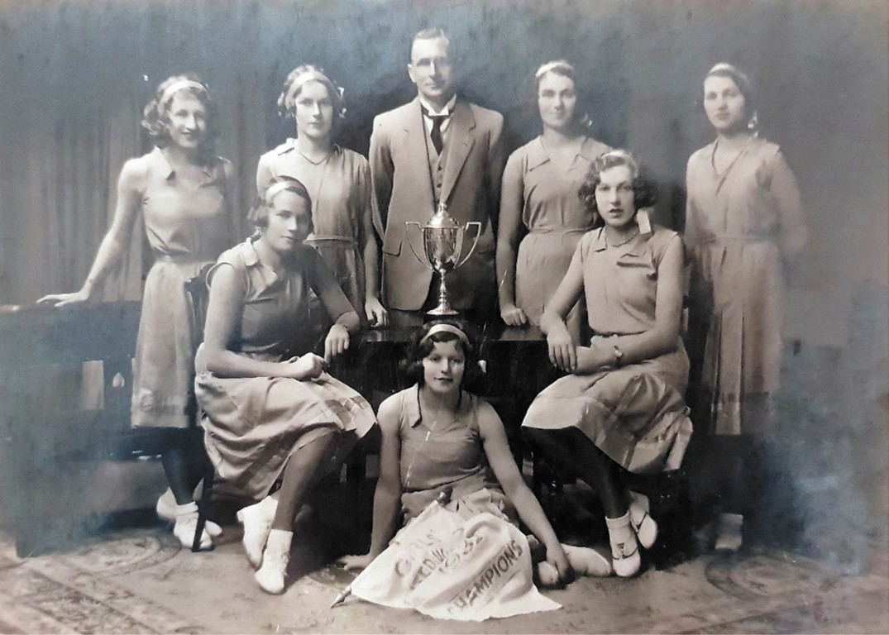
Figure 9.36: Girls United Valley Mills team, 1932. Source: Liz Coles, Secretary, Geelong Central Netball Association.

woollen mills.
Although the club has just on 100 permanent members, it has several more hundreds connected with it through its very active sporting side.
Main sport is basketball, and each Saturday during the winter will find 41 teams competing on the newly-sealed courts at Kardinia Park.
Six years ago Miss Hindell started Geelong s Women s Softball Club and was its president until recently.
But though she s always been intensely interested in sport, her real loyalties lie with music.
Miss Hindell s most arduous job during the week is collecting money from 400 girls who save through the Thrift Collection scheme.
It takes a lot of time and effort, but it gives Miss Hindell a lot of satisfaction, particularly when she knows a
girl has been able to buy the thing for which she has saved.384
After her death in 1967, the netball pavilion at Kardinia Park was named in her memory (see following subsection).
Female basketball became more commonly known as netball in 1970.385 It remains a highly popular local sport, with several netball associations in existence including the Geelong Central Netball Association, Geelong Netball League, South Geelong Netball Association, Bellarine and District Netball Association, Southside Netball Association (YMCA), Corio Netball Association. Nationally in 2018, netball was the most popular team sport for girls.386

RECREATION

PUBLIC PARKS
Highly valued by the Geelong community since European colonisation has been the development and enjoyment of public parks. Today, the municipality boasts over 330 parks and reserves that are available to the public.387 A snapshot of some of the early parks is given as follows.

CITY PARKS
The value given to parks within the Geelong city area was highlighted in 1910 with the controversy surrounding the Council s quest to develop shops in Market Square.
Supporting the proposal was John Murray, Premier of Victoria who quipped that Geelong was one of the most over-lunged places he knew. 388 Considerable debate ensued, and the editor of the Geelong Advertiser advocated the retention of all these healthy spaces and gave an overview of the acreages that had been set
aside for them:
There should be very clear proof that a town is
over- parked before its council is permitted to alienate a single acre set apart for recreation or as breathing spaces. We set out therefore with a strong prejudice against such suggestions as those which have recently been made in our columns that portions of the reserves should be sold for building sites.
… The township has an area all told of 3012 acres and when it is stated that over 400 acres are breathing spaces it will be seen that Mr. Murray was speaking by the book. The Eastern Park contains very nearly the proportion of space which would normally be allocated, to a township of Geelong s size and population. 184 acres then we have the Beach slopes: 30 acres; Johnstone Park, 6; Kardinia, 40; Pevensey Crescent, 3; Austin Gardens, 2: Harding,
2: Transvaal Square, 2; Richmond Crescent, 5; Friendly Societies Reserve, 9; the Cricket Ground, 12; the new Show Grounds, 147; total 414 acres.389
The debate about the importance of Geelong s city parks continued in the following years. In 1915, the Geelong Advertiser again dispelled the myth that Geelong was over- lunged by comparing the parks and reserves set aside in the regional towns of Ballarat and Bendigo:
Reference to the latest published list of Victorian country parks dispels the view that Geelong is over-lunged, Greater Geelong has only seven park enclosures of 371 acres (including Queen s Park,
105 acres), while Greater Ballarat boasts 21 open reserves

of 1244 acres area. Bendigo and Eaglehawk have 16 small public recreation spaces, aggregating 216 acres.390

GEELONG’S MAJOR CITY PARKS AND RESERVE

MARKET SQUARE, MOORABOOL, YARRA, MALOP & LITTLE MALOP STREETS
The earliest public space to be established in central Geelong was Market Square in 1845.391 Laid out as Section 24 as
part of the town grid plan in 1838, the area of Market Square was denoted by a swamp, mature gum trees and wildfowl.392 It was also the birthplace of Willem Baa Nip, the last local member of Wadawurrung following European colonisation (Theme 2). Initially restricted for the use of market purposes, the natural characteristics of the square impeded European progress although the gum trees provided opportunities for stringing clothes lines in 1847:
We noticed, a short time back, an accident which occurred in the Market Square to Mr Byron and another gentleman, through persons attaching their clothes-lines to the trees in the centre of the green. The Commissioner, on a complaint being made to him, gave directions for the tress to be cut down, which was accordingly done. Since then, in the opposite locale, the same practice has commenced, and will, if allowed to continue, be followed by some serious accident. Really these soap and soda ladies should not have the permission to string people in this manner.393
A more acceptable use of the square was William Gray s water tank in 1851 (Theme 4). Yet, the site was regularly criticized and a plan was sought for the square to be improved and occupied by the public for market purposes in 1853.394 This led to the following satirical report in the Geelong Advertiser and Intelligencer:
This cheerful looking spot is doomed –noted for its consumptive gum trees, and defunct stumps of the same genus, sticking up in melancholy posture from the native mud. No doubt the change will be looked upon with regret by melancholy temperaments and lovers of the picturesque. To our minds any change must be for the better. The Market Square has been a blot on the fair aspect of the Town. We have laughed at it, joked
at it –reasoned against such a vacuum in the heart of Geelong, and are prepared to entertain favorably
anything that will intrench against such a morass. It has been an impracticable spot, devoted to discomfort and uselessness, darkness and dirt. It has been a place to be avoided after sunset, requiring a town cart to steer through; and, in the absence of lights, imperiling the safety of burghers and burgesses. Beyond hillocks,

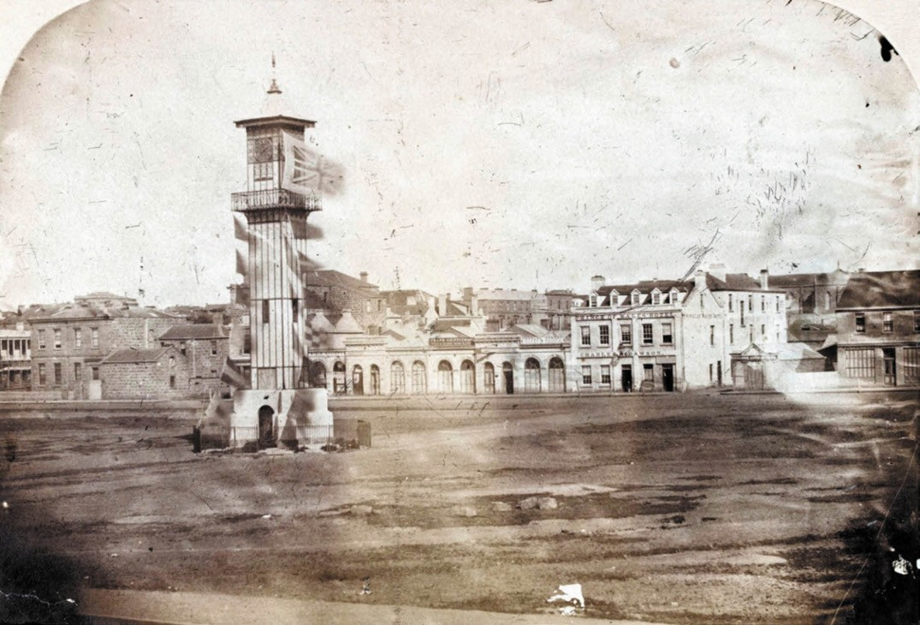
Figure 9.38: Market Square showing clocktower & barren landscape, 1857. Source: accession H3401, State Library of Victoria.

heaps of stone, and desolateness, it has had nothing, and if the Corporation can people such a wilderness, even by creating a rockery, it deserves credit, and the mayor, for opening up such a land of promise and source of revenue, ought to be considered as a modern D Israeli, and a Moses the Second.395
The first major improvement to Market Square – and Geelong’s first public landmark – was the erection of clocktower in the centre of the square in 1856. It housed a clock donated by James Austin. Both the tower and the clock (Figure 9.38) were described in the Illustrated London News when proposed in 1854:
Nothing like iron would seem to be an industrial maxim of the present times, which may, indeed, be designated iron-seval. Distinguished above other nations for the exuberance and cheapness of our supply of iron, we have, of late years, greatly multiplied its uses. We build leviathan ships and mansion-like houses of iron; and, in the instance before us, we have the ready adaptation
of this material to the immediate wants of a rapidly- rising
community, whose want of public building is no sooner known in the mother-country, than it is provided and shipped for her golden colony. Poets have sung of the iron tongue of midnight –which, by the way, we are just now forcibly reminded.
The height of the Tower, including the nave and base, is about sixty feet; and the width of the shaft about seven feet. It is formed of a frame-work of iron; between the framings are inserted stout tiles, made by Minton, of a neat drab or stone colour; each tile is about fourteen inches by eleven inches. As they approach the gallery they become ornamental, and proceed thus to the Clock face, and around it, giving a very pleasing ornamental finish. The balustrades and footway of the gallery are of iron-work, of elegant design. The doorway at the base is in the Moorish style. The Tower can only be used for the one purpose –viz., for the Clock, as a good space will be occupied by the weights, &c. From the base project four lamps.

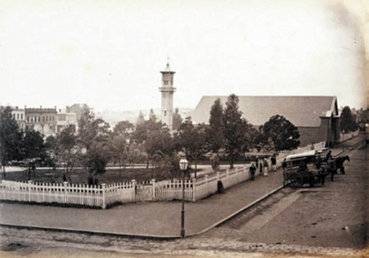
Figure 9.39: E. de Balk, Market Square showing clocktower, market building, landscaping & timber picket perimeter fencing, 1866. Source: figure FL985553, State Library of NSW (SLNSW).

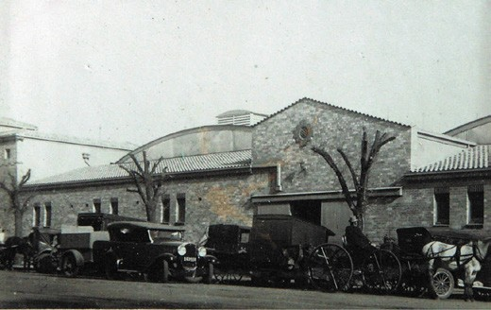
Figure 9.40: Geelong Market Building, east end of Market Square, 1 August 1931. Source: T.T. Holmes collection, Authentic Heritage Services Pty Ltd.

The iron work has been executed from the design of Mr. James Edmeston, architect, by Messrs. Silvester and Co., of Great Russell-street, Bloomsbury. The Clock has four illuminated dials, and has been constructed by Messrs.
Moore, of Clerkenwell-close. It is a gift to the town from Mr. James Austin, the second Mayor of Geelong.
In this Tower, the first structure of its kind, the combination of iron framing and tiles, or slabs of burnt earth, offers infinite opportunities for variety of
ornamentation … In setting out the town of Geelong, the Liverpool of Australia, a square of eight acres was wisely preserved by the Governor, Sir George Gipps, with the humane view of promoting the health of the place, we regret to learn that this sanitary measure is likely to be nullified by the cupidity and narrow-minded policy of certain members of the Town-council, who are desirous of converting this fine area into a fish and cabbage-market.396

The Council s quest for the provision of market facilities came in 1860 when a market building, designed by Young and Honey architects, was constructed.397 While a gable roofed utilitarian structure was incongruously situated adjacent
to the ornamental clocktower, they were considered to be a suitable and commodious building for the transaction of
business for town and country traders.398 Yet, the year 1860 also witnessed the beautification of Market Square with the laying out of walks, construction of perimeter timber picket fencing, installation of a Barrabool stone water fountain, and the planting of lime, pine and cypress trees399 (Figure 9.39).
Market Square as an ornamental garden (in part) was not to endure. The construction of the Exhibition Building in 1879 (see later subsection) was the beginning of other building developments in the square that were leased by the Geelong City Council, most notably from the early 20th century with the erection of Solomon s Buildings fronting Moorabool Street (1913) (Theme 5), CML and Tait buildings
fronting Malop Street (1925-26); The Block Buildings behind Solomon s Buildings fronting Little Malop Street (a row of two storey shops designed by I.G. Anderson and built 1925-27); Market building, south- west corner of Yarra and Little Malop Streets (designed in an interwar Spanish Mission mode by
I.G. Anderson in 1926) (Figure 9.40); Hawkes Brothers Motors Pty Ltd two storey show room at the south-east corner of Malop and Yarra Streets (built in 1930 and extending along McCann Street); and the Corio Theatre, immediately west of the Market Building with a frontage to Little Malop Street (built in 1937-38 to a design by C.N. Hollinshed of Melbourne).400 Any remnant 19th century landscaping in Market Square
was replaced by a car park to accommodate 350 cars. It was operated by Hawkes Bros. Motor Pty Ltd.401 The emphasis on cars continued in 1936 when the rear portion of the old Exhibition building (lately His Majesty s Theatre –see later subsection) became the large garage and service station
of J.A. Cowley.402
It was not just the landscape that met its demise. The front elaborate portion of the Exhibition Building was removed in 1912 to make way for the Solomon s Building (the large central fanlight was incorporated into the summer house in the garden at Riversdale, 6 Bendigo Street, Geelong West).403 In 1923, the landmark cast iron clock tower was
lassoed about two-thirds of the way up with chains and a steel cable, and a steam roller pulled it over with a great crash. 404 This provoked a public outcry.405 The clock was saved and installed in the tower of the adjoining CML building fronting Malop Street (Theme 5).
In 1904, Market Square became the repository of memorial fountains and sculptures, and rotundas, the result of
the efforts of the Queen s Statue and Improvements Committee.406 The adornments included the Traill and

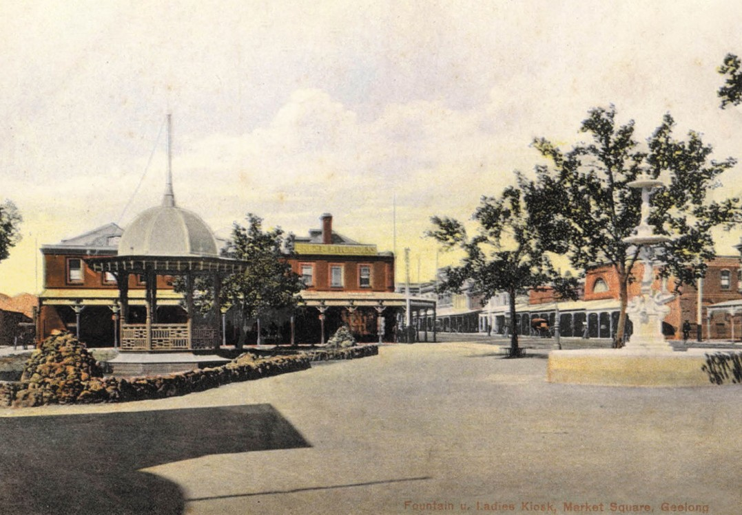
Figure 9.41: Market Square (west side looking south), with Ladies Kiosk & Traill fountain, c.1906. Source: accession H96.90/55, State Library of Victoria.

Hitchcock fountains fronting Moorabool Street (1904) (Theme 5); Queen Victoria statue fronting Moorabool Street and flanked by the memorial fountains (Theme 5); a bandstand in the north-west corner fronting Moorabool and Malop streets (built in 1904 to a design by Tombs and Durran architects following inspiration from the rotunda at Beaufort) and a Ladies Kiosk situated at the south-west
corner fronting Moorabool and Little Malop Streets (built in 1904)407 (Figure 9.41). All of these monuments and structures were relocated in 1912 prior to the construction of Solomon s Buildings. The Queen Victoria statue and the Traill and Hitchcock fountains were removed to the Geelong Botanic Gardens and Eastern Park (Theme 5); the
bandstand at the corner of Moorabool and Malop Street was relocated to Transvaal Square (its roof was removed in 1914 and the whole structure demolished in 1932); and the Ladies Kiosk was re-sited in Market Square to the corner of Yarra and Little Malop Streets until it was transported to Eastern Park in 1930.408
Market Square experienced further change in the second half of the 20th century. In 1961, the last remaining portion of the Exhibition Building (which had served as Cowley s motor garage) was demolished and replaced with a three level concrete car park.409 The most dramatic change came in 1984 when all the buildings within Market Square except
for the former Solomon s Buildings and the corner clocktower portion of the old CML building were demolished to make way for the Market Square Shopping Centre (Theme 5).

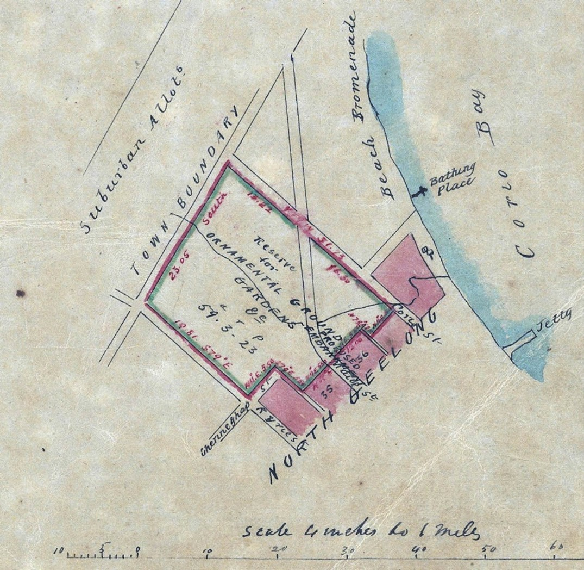
Figure 9.42: Tracing prepared from the original Survey Cat. R29.1013 for the purpose of Record shewing the Reserve for Ornamental Grounds, Gardens &c.’, 1848. Source: VPRS 8168/P5, item Sydney G18, Public Record Office Victoria.

JOHNSTONE PARK, GHERINGHAP, FENWICK & LITTLE MALOP STREETS & RAILWAY TERRACE
Geelong s earliest substantial public park was Johnstone Park, with frontages to Latrobe Terrace, Ryrie Street, Corio Street and parts of Gheringhap Street, immediately north-west of the original town plan surveyed by Smythe in 1838. The
59 acres of undulating land bisected by the Western Gully -
and where a dam was constructed at the east end - had been set aside by Charles Latrobe on a visit to Geelong in 1848410 (Figure 9.42). While a select committee of the Geelong Town Council suggested that a botanic garden be established at the Limeburner s Point, it also recommended that a reserve be developed each side of the Western Gully above the dam. 411
In the proceeding years, the original extent of the reserve was

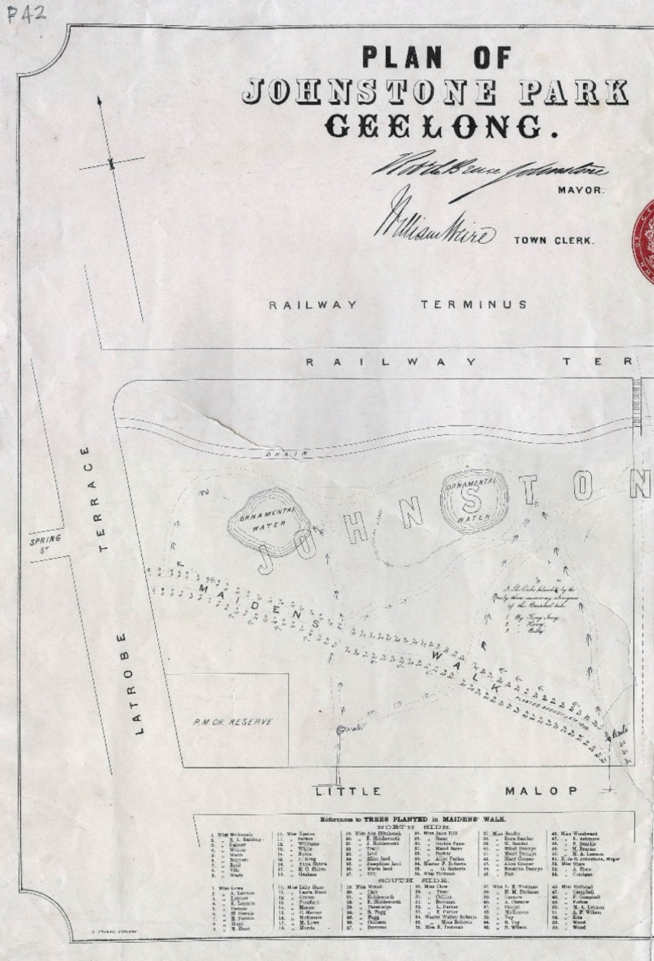

Figure 9.43: R. Balding, Plan of Johnstone Park Geelong , lithograph, Henry Franks, 1867. Source: GRS 2031/P0042, Geelong Heritage Centre collection.

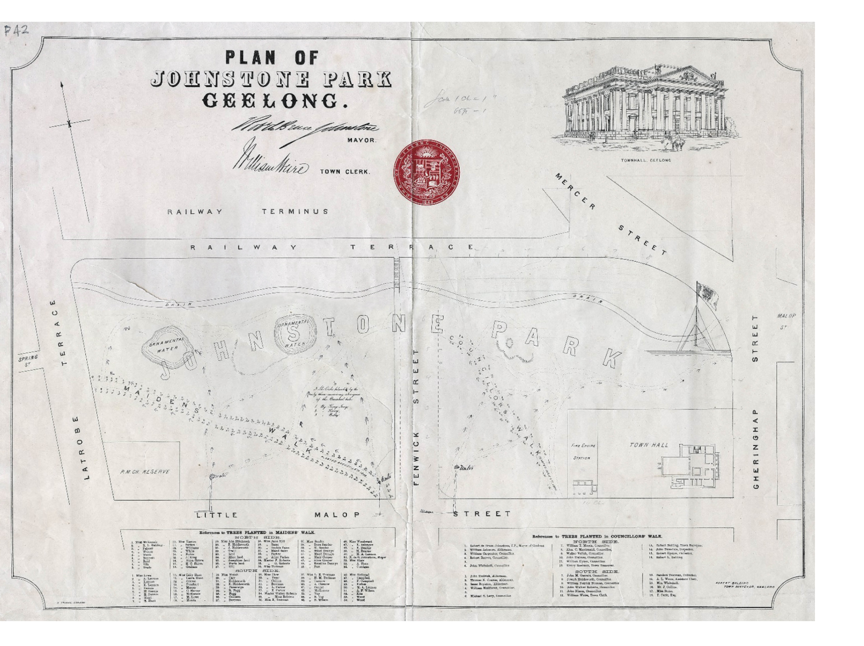

==============-===-===-===--=============---====-= \
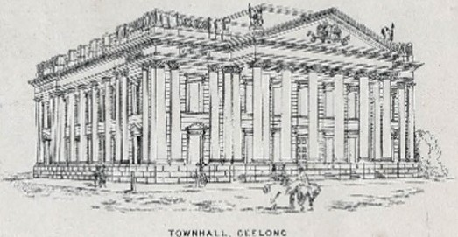
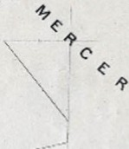
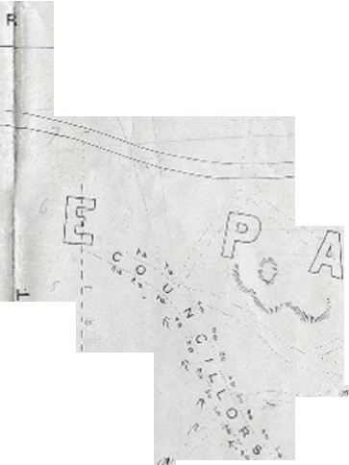
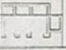
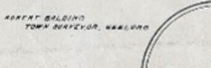
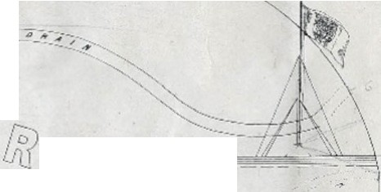
'--1

v:.. IC!{ -:: /
k;z- /

A C E

_. ... .....-
_
-·--

w
w
----

'l?
t
. I

... MAI/II'
w .;•
w 0:: I-
(/)

7

a:
1-
(/)

z

w
i...
I

'•

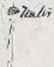

TREE.T
..,. ,.
)'
=e+

'z..'
'1 -, ".
'• <
4"'-1-: )-;..
.,;\ \
.
0
I •,;..
.. ., ,,

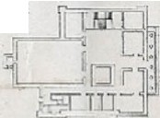
TOiJ,11 HALL

0..
<
:c
(!)
z

a::
w.

:c
t!)

I
I
1
I

S-.o- lo'l'IUIU PJ.t.1ft7.I) I• COOJ«ITT.LQRB' WALL
?ll'O:S-::X ar;o».

-.....,- l.J' Jli...,,•N I.Jnh•I'
Wit"--
..tnea.... O. -'
,. 11.b... ••"\e..
l
•· Ma t"' I•
J.,...................
.. ,...,_.,.. Al.411, •.\
......... ,......u;._.,...
" ..........._,_, .. w.
L
- ,,-r.
rim-.1.X....,,..(A.-..Jl.c.
,..lk&,(!.
t-'11" Te'd: Cr•
lftll' r,t'. .._ ••
11 tt.t, ,.,. L -..--
...
1r1...,. ,.,.
,,...........,
,.... 90o.1..r'wT, X aJ:DZ.
Ill , """"
o. r.-.
-
..
um..-.-

l .. e.,w...,..._, .•..,..,..
... ........ ,. "fl,_,.-."lt10h'
1 .,...,_....... .....
II J ).
,
II.•..._..--._rw,,_(l,d\_
"· ""- ,, h"•,e,.,...._
IL J ""--'"'-#f\C,,...,. ,
.. ....
,u, ..._.......,.......,..,...

ll.&.,l,.tr..._,...,.._..u_.,.,

1-.,,,10...,
,, r""""_,,c

reduced, with the alienation of a portion of land to the north- west for the Geelong Railway Station terminus, sites for a post office and telegraph station fronting Ryrie Street and the creation of Little Malop Street in the 1850s, a portion of land fronting Gheringhap Street for the Geelong Town Hall in 1855 as well as a site for a fire station fronting Little Malop Street in 1856 (Themes 3, 7 & 8). It was also bisected by an extension of Fenwick Street.
The reserve (initially called the Railway Reserve) remained desolate throughout the 1850s and early 1860s until improvements were made in 1866 when one of two walks were laid out by Daniel Bunce, curator of the Geelong Botanic Gardens (Figure 9.43). The Geelong Advertiser gave the following report:
Yesterday initiatory proceedings were taken to reclaim the railway reserve and to ornament the Slough of Despond, dear to the memory of the oldest inhabitants as Latrobe s Dam. Under the auspices of his Worship the Mayor of Geelong, and the Mayor of Queenscliff, the Curator of the Botanical Gardens laid out an undulating walk from the junction of Malop street and Gheringhap street, under the superintendence of the Town Surveyor [Robert Balding], to Little Malop street, at the site intersected by Fenwick street. From the last mentioned point another walk
is projected to communicate with the Railway Terrace. These alterations will metamorphosize the scene, and with ulterior improvements suggested, will make an ornamental reserve out of what is now an eye sore and a nuisance, and which, to strangers arriving in Geelong by rail, is calculated to produce an unfavorable impression.412
The first trees to be planted were along Maiden’s Walk in the western portion of the reserve on 24 August 1866.413 The avenue of major elms and pines was the result of a special list of subscriptions consisting of young ladies only, who upon payment of one shilling and sixpence each , were entitled to plant a tree, and thus immortalize themselves as long as the trees shall remain. 414 Miss McKenzie planted the first tree on the north side, while Miss Lowe was given the honour of planting the first southern tree.415
A month later, Mayor Robert de Bruce Johnstone –whose concern for the wellbeing of the Wadawurrung was enduring (see Theme 2) - coaxed three surviving Wadawurrung men: Dan Dan Nook (King Jerry), Harry Gore and Willem Baa Nip (Billy) to plant three sheoaks as a measure of keeping alive the memory of the fast-disappearing Traditional Owners.416 Planted in the western portion of the site north of the Maidens Walk, the reluctance of the Wadawurrung representatives was due to their belief that the planting of the trees was ominous of impending evil. 417 Their superstitions proved correct as

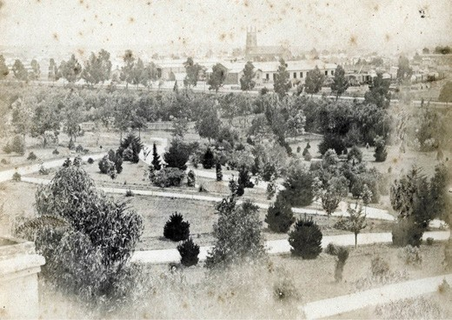
Figure 9.44: Harvey & Dunden, Johnstone Park from the Town Hall looking north-west, c.1875. Source: GRS 2009/00214, Geelong Heritage Centre collection.

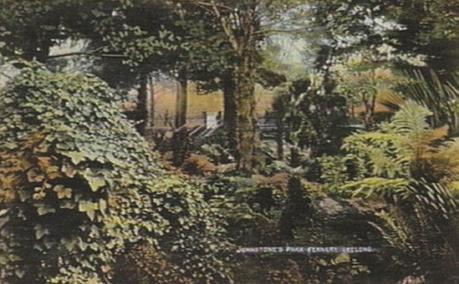
Figure 9.45: Fernery, Johnstone Park, c.1906. Source: accession H91.160/628, State Library of Victoria.

by 1872 only Willem Baa Nip was still alive and the Geelong Advertiser reported that one tree had perished and the two others had drooped and languished amidst the groves of sturdy pines and cypresses planted by those of European descent.418
The planting of Councillors Walk with pines and cypresses immediately west of the fire station occurred on 1 July 1867. The Mayor of Geelong, Robert de Bruce Johnstone, was awarded the honour of planting the first tree, ‘a specimen
of the Auricaria Excelsior 419 This occasion also marked the naming of the reserve as Johnstone Park as a more
substantial gesture in recognising the services of the Mayor to his community.420
The park was formally opened on 11 March 1872.421 Plaudits were awarded to Daniel Bunce, the curator, and

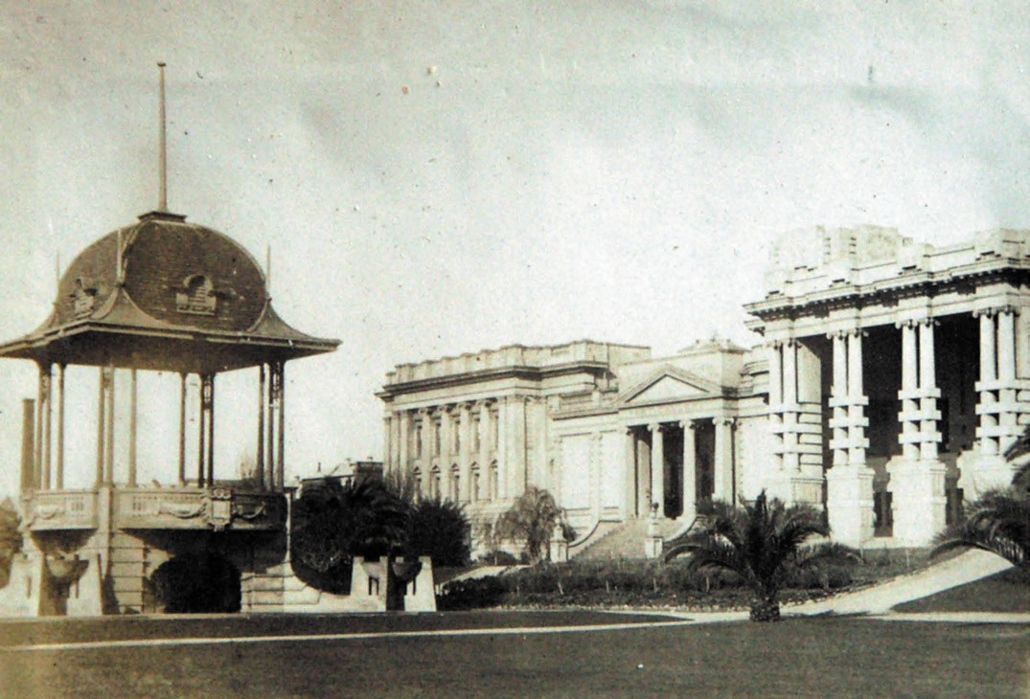
Figure 9.46: Johnstone Park, c.1925, with Hitchcock Bandstand (left) with City Hall, Art Gallery & Peace Memorial forming the southern City Beautiful background to the park. Source: T.T. Holmes collection, Authentic Heritage Services Pty Ltd.

Robert Balding, the Town surveyor, for ‘their scientific and artistic labors in transforming the barren wilderness into seventeen acres of pleasure-ground 422 (Figure 9.44). Other improvements came in the ensuring years, including the construction of a band rotunda in 1873 while Mrs John Bell presented two Medici Vases for the new entrance steps
on the Gheringhap Street frontage which she unveiled at a moonlight promenade in November of that year.423 The cast iron vases were the work of Andrew Handyside and Co., the same English iron foundry that manufactured the Belcher fountain (Theme 5).424
The construction of the railway tunnel in 1874 brought about the need for a wooden footbridge over the cutting so that the Maiden s Walk should not be divided. 425 These trees met the same fate as the She-oaks of the Wadawurrung with the acquisition of this part of the Park for the development of the Gordon Technical College in 1886 (Theme 8).
It was also in 1886 when a portion of the park behind City Hall was transported into an open-air fernery (Figure 9.45).
Designed by John Raddenberry, second curator of the Geelong Botanic Gardens, the Geelong Advertiser described the new improvement:
The new fernery in Johnstone Park has now been completed. The excellent manner in which it has been laid out, and the novel design will, no doubt, prove a source of attraction. To visitors from a distance, as well as the residents of the town and suburbs, the fernery will be found an agreeable place of resort. Seats have been placed in various parts for the accommodation of the promenaders, commanding glimpses of portions of the fernery which at no very remote period promise to be
highly gratifying to the eye. Fountains in the centre add to the general attractiveness of the
pretty locality.426

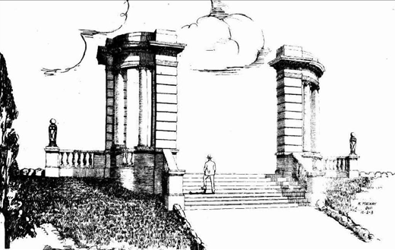

Figure 9.47: K. Mackay, Proposed Hitchcock Memorial Gateway, Johnstone Park, 12 February 1923. Source: Geelong Advertiser, 21 April 1923, p.11.

In 1915, at the behest of the recently-elected City Councillor,
Howard Hitchcock (Theme 5), a public competition was held for the beautification of Johnstone Park. Chairing a
subcommittee, the £50 prize was awarded to Percy Everett in association with Laird and Buchan architects in 1916.427 The City Beautiful-inspired scheme was to transform Johnstone Park. Its backdrop was the Classically-derived Town Hall and recently-opened Geelong Art Gallery (see later subsection) together with other proposed civic buildings (one being a replacement of Raddenberry s fernery), the centerpiece being a bandstand surrounded by an ornamental lake and radiating garden beds. The Geelong Advertiser gave a glowing description in May 1916:
Wealthy citizens who, Cr. Hitchcock hopes, will assist in the transformation of Johnstone Park into a model garden, are invited to inspect the prize design in Bright and Hitchcock s Little Malop-street window. The bird s-
eye view shows Fenwick, Malop and Gheringhap-streets studded with rockeries to set off the main scheme of beautification. The rise to the new city buildings is squared off to front Hitchcock [Art] Gallery, and a city hall with glass dome, and a new Free Library. In the vacant corner towards the Gordon College a circular playground for children is plotted with sand ponds,
see-seas, swings and a gymnasium. The main touch of beauty is concentrated in the park flat. Radiating the
shape of a fan are separate concert lawns, with two outer sections carrying a refreshment kiosk and flagstaff. The bandstand at the handle of the fan will face the rear of the old fire station and is set in a miniature lake studded with pergolas, and is approached from the main boulevard by a set of circular steps. It is an imposing scheme.428
The realised scheme was modified to provide for a principal avenue (Princes Walk) as a straight terrace across the park

on an east-west axis, further development of Classical buildings to the south, and the transformation of the gardens to the north429 (Figure 9.46). The existing sunken landform to the north-east was retained and planted amongst expansive lawns. Much of the transformation was largely completed in 1919-20, following the opening of the new centerpiece, the bandstand designed by Percy Everett in association with Laird and Buchan. Funded by the Mayor, Howard Hitchcock, as a memorial to his mother, Mrs Annie Hitchcock (Theme 8), it was opened on the evening of 1 March 1920 in the presence of 6000 people.430 Recently, the eastern portion of the park was again transformed with the opening
of a rainwater garden, an initiative of the Victorian State Government.
In 1925, the substantial contribution made by Howard Hitchcock was recognised in the construction of the Hitchcock gateway at the northern entrance to the park. Designed by the local rising young architect , Keith Mackay (in association with Laird and Buchan) in 1923, the piazza structure was described and illustrated in the Geelong Advertiser (Figure 9.47):
The Classic style of the design has been expressed in the use of Ionic columns which, though not exorbitant, give that dignity and grace to necessary in an Architectural feature of this character. The flight of bluestone steps enclosed with side balustrades, ascends to a reception piazza which is paved with black and white marble, and flanked on each side by a columnar pylon of quadrantal plan. Further balustrading on each side of the entrance, replacing the now formed rockery, gives an open and inviting appearance to the whole scheme.431

GEELONG BOTANIC GARDENS & EASTERN PARK, GARDEN & RYRIE STREETS
In August 1850, the Geelong Town Council accepted a report by a select committee appointed to report on the establishment of a botanic garden in Geelong. The report recommended that an application be made to the Lands Department for a 200 acre reserve at the Limeburner s Point to the east of the town reserve.432 By April 1851, it had
been announced that the substantial site east of the town reserve at Limeburners Point had been set aside by the Government as a town park and public gardens.433 The land was subsequently surveyed by the Assistant Surveyor, A.J. Skene434 (Figure 9.48).
Work soon commenced on fencing in the large reserve.
In August 1851, the first committee of management was appointed by Charles La Trobe and comprised Dr Alexander Thomson, Mayor of Geelong; E.B. Addis, Police Magistrate;
J.F. Strachan; W. Timms; James Austin; J.A. Gregory; David

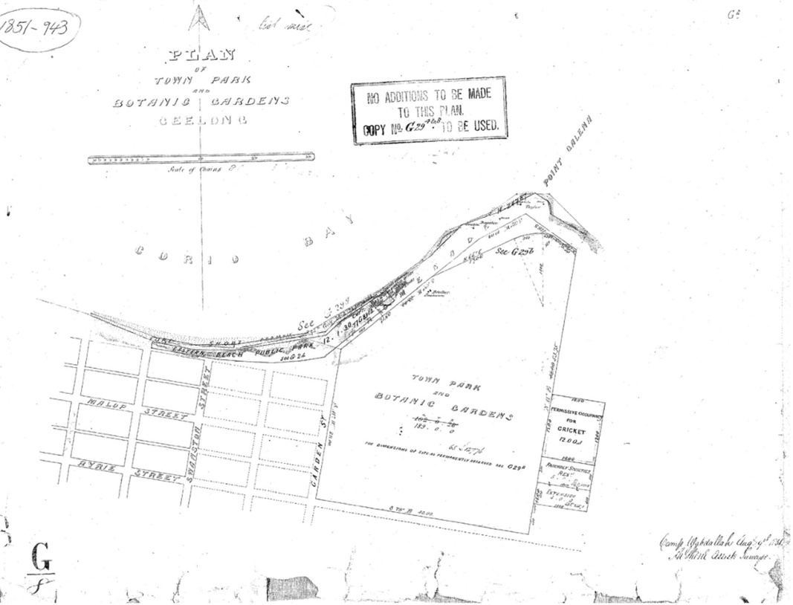

Figure 9.48: A.J. Skene, Plan of Town Park & Botanic Gardens Geelong , 9 August 1851 (the cricket & other reserves to the east (right) were added to the plan at a later date). Source: Put-away plan G8/1, Landata, State of Victoria.

Fisher and Charles Nantes who was appointed inaugural secretary.435 In 1853, construction commenced on a cottage in the gardens reserve (tenders were also sought in 1855
for alterations and additions to this building).436 To be the residence of the future curator of the Botanic Gardens, the dwelling was first occupied by the Keeper of the nearby powder magazine near Limeburner s Point.437 It was also in 1853 when a proposal was considered to extend Malop
Street through the gardens reserve.438 The southern portion of the site was also to be excised but a similar area added to the east.439 The proposal was rejected by the Geelong Town Council.
The proposed Malop Street extension may have been impetus for the Surveys Department to survey the proposed drives throughout the reserve in 1854. The work was carried out by Henry Byron Moore, assisted by Maurice Weston, under the direction of A.J. Skene.440 The curved layout of the drives was
the suggestion of the Surveyor-General, Andrew Clark.441 On 1 April 1856, the committee of management advertised for a working bailiff with a knowledge of landscape gardening. 442 A few month later, a nursery had been established and
seeds and plants were received by donation.443 Trees had been planted on the northern side of the reserve and
around the drives, and gates installed given the completion of the perimeter paling fence to the smaller, central reserve comprising the botanic gardens.444 Walks within the gardens were laid out in early 1857 and young plants from the nursery planted and lawns sown.445
In August 1857, the first curator of the Geelong Botanic Gardens and Eastern Park (as it was to be named), Daniel Bunce (1812-1872), arrived in Geelong. He immediately commenced transforming the bleak undulating tract of land, very partially clothed with scrubby native timber into
beautiful gardens. 446 While Charles Pasley, Commissioner of

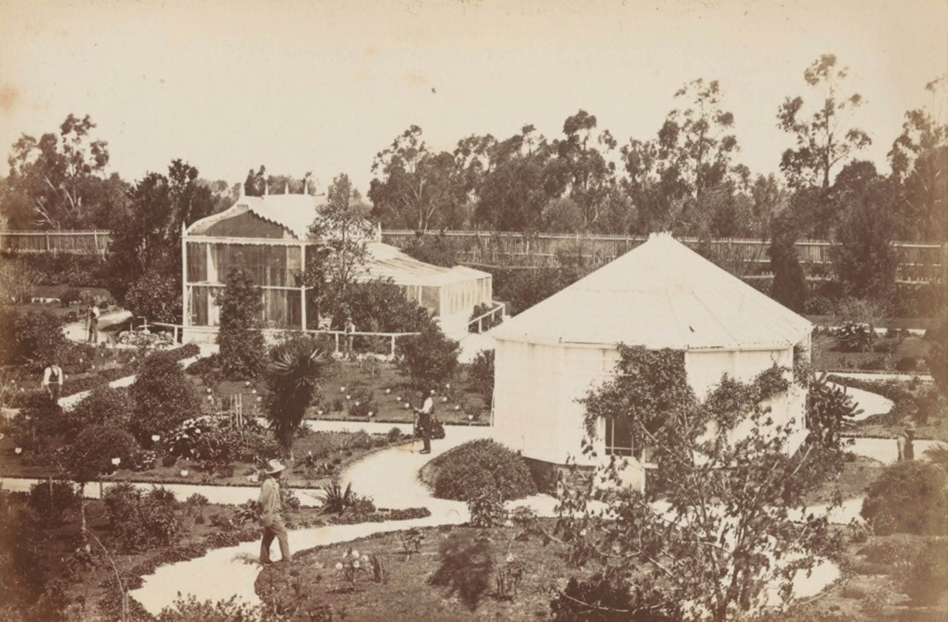
Figure 9.49: F. Kruger, Geelong Botanic Gardens, c.1882. Source: accession H39614/57, State Library of Victoria.

Public Works declared that the site for the Geelong Botanical Gardens was altogether unsuitable for gardens and a waste of money , he was proven to be incorrect.447 Bunce had immediately set to work in the planting of conifers as an arboretum in the Eastern Park, constructing a lake towards
the south-east corner (1862), improving the reserve pathways and laying out the paths and beds of the nursery448 (Figure 9.49). Within eight years of his arrival, the extent of his labors was highlighted in The Ballarat
Star in 1865:
In their present admirable condition the grounds may be described as comprising an arboretum or park land, public gardens and pleasures grounds, and a systematically conducted nursery containing a large supply of plants, including all the newest and rarest kinds of florist’s flowers, as well as shrubs and plants of general interest for supplying public institutions in the Western District.
In each of these capacities the grounds are entitled to marked distinction, for the curator has brought large abilities as a scientific botanist and horticulturist and skilled landscape gardener to bear upon the conversion of what was once a treeless, naked, and bleak headland, into
a favorite public resort. … Within the pleasures grounds the carriage drives are bold and wide, and many miles in extent, while the intervening area is occupied by an
indefinitely large number of walks traversing shrubberies with wide turf margins. The borders are well kept, and stocked with exotic and native flowers and shrubs, while at the back are large reaches of turf or grass-land neatly cut, and presenting all the characteristics of a first-class English park and shrubbery. The whole area has in fact been laid out in accordance with the most approved principles of landscape gardening … A great variety
of coniferous trees have been planted over the more prominent portions of the area which will superseded the indigenous gums and wattles raised partly to give immediate interest to the grounds, but chiefly to afford shelter to the exotic forest trees. Mr Bunce informed us that he first step taken by him to afford shelter, was to get the entire boundary ploughed to a depth of form three to four inches, whereupon the Cape wattle and other trees likely to accommodate themselves to that
shallow depth were sown. The next process consisted in ploughing detached tracts on the more exposed faces of the higher elevations within the reserve, for the purpose

of raising belts and clumps of the same hardy and swift- growing vegetation as shelter for better kinds of trees subsequently planted. The former have served the double purpose of clothing the hitherto naked land and nourishing their more highly-prized successors, while the latter have now made such progress that the curator is every year enabled to cut away large masses of a vegetation which has well served its purpose so far, but to retain longer
is unnecessary, and might prove impoverishing. The nursery occupies an area of five acres in a sheltered hollow immediately below the tall wooded hill on the summit of which is placed the curator s well-sheltered residence. The selection of the site of the nursery shows great judgement, and the large number of hedges planted at equal distances transversely throughout the ground procure for the young cuttings and plants in course of propagation, something very nearly approaching the climate of a conservatory. These five acres contain a general collection of plants from all parts of the world – two or three of each as stock plants. … The elegantly constructed aviary, already containing many of the most highly prized exotic birds, is the property of a body of gentlemen designating themselves the Geelong branch of the Acclimatisation Society of Victoria. Near at hand were some young emus, also a pair of turtles from Queensland. In the hot-house and forcing department we saw immense numbers of conifers and other trees in course of striking. The material used is crushed quartz from Ballarat.
The forcing house is upon a novel and economical principle, and requires but little fuel to heat it. Connected with this is an arrangement successively to harden the young plants as they are struck and taken out of the stove, until they can be placed in the shelter- shed. This, a neatly designed building covered with a profusion of climbers, contains many thousands of plants for the service of the Geelong gardens, and for distribution in the month of May next throughout the Western District. At the lowest point of the grounds has been formed an ornamental sheet of water, with numerous islands. The banks are shaded with weeping willows and other suitable trees, affording shelter to numerous wild fowl, while the reservoir itself is stock with golden carp. This water, with the exception of a small tank in the nursery, is the sole source whence the grounds are supplied, and has proved amply sufficient …449
Other developments within Eastern Park during Bunce s tenure included the laying out of the Corio Cricket Ground in 1862 (the ground having been ploughed and sown with wattle seed)450 and the adjacent Friendly Societies Reserve in 1867 (this reserve was extended further southwards in 1870).451
Daniel Bunce s extraordinary contribution to the botanical progress of the Geelong Botanical Gardens and Eastern Park also spread to other parts of Victoria. Born in Rickmansworth,

England, he emigrated to Tasmania in 1833.452 While his education and training in botany and horticulture is unclear, he commenced work as a nurseryman in Hobart soon after his arrival. In 1836, he had prepared a nursery catalogue which included Australian plants, being unusual for the period.453 By 1837, he had written a Manual of Practical Gardening Adapted to the Climate of Van Diemen s Land.454 Bankrupt in 1839, Bunce escaped Tasmania for Victoria,455 where he was able to further fulfill his quest for scientific knowledge and adventure. This included his first interaction with Indigenous Australians in the garden of John Batman when he met and was deeply impressed by Benbow, who Bunce declared a really worthy fellow. 456 This began Bunce s life-long interest in the study
of indigenous plants and names –and the amelioration of the First Nations people. It culminated in his publication entitled Language of the Aborigines in 1859 (see Theme 2). The book was the result of Bunce s expedition across Australia with Ludwig Leichardt in 1846, and soon afterwards, his own journey following the course of the Murray River to the sea.457 Bunce died in Geelong in 1872, his funeral being one of the largest gatherings of really old colonists that has been seen in the district. Prominent among the mourners was Billy [Willem Baa Nip], the sole representative of the aboriginal race which formerly owned the district. 458
Daniel Bunce s successor was John Raddenberry
(1829-1898) (Figure 9.50). It was during his tenure in 1874 when the Geelong Town Council took over the formal control of Eastern Park and the gardens on behalf of the Victorian Government.459
Improvements made while Raddenberry was curator included new entrance gates erected at the Malop Street entrance to a design by the Town Surveyor, Robert Balding;460 although the most noticeable changes were the simplification of pathways, concentration of the nursery area of the gardens, and the continued planting of conifers.461 The broad changes were outlined in the Geelong Advertiser in 1875:
The Eastern Park or what is better known as the Botanical Garden, at the present time looks beautifully green from the effects of the late rains. Lately, since it has come under the control of the Corporation [Council], several important alterations have been made; the blue gum
trees with which the land was so thickly studded have been considerably thinned, and by the side of the walks, notably the one from the beach gate, English trees have been planted in their stead, making it appear already more a park than a garden. The walks have been lessened and considerably altered; some are at present undergoing alterations and being covered with sea shells.462
An octagonal rotunda was also built in 1875463 but it was the construction of a fernery (in three sections) in 1885-86 (Figure 9.51) that was particularly noteworthy during Raddenberry s

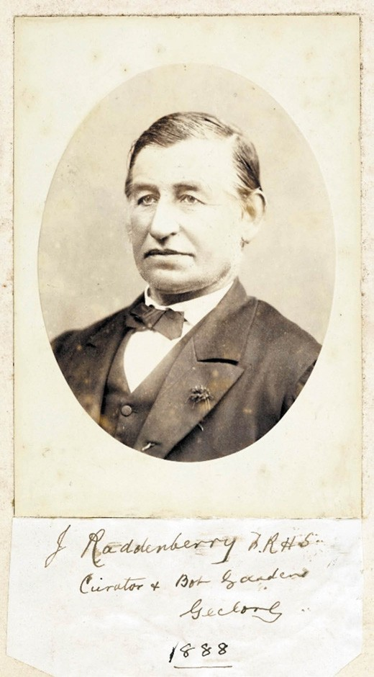
Figure 9.50: J. Raddenberry, Curator, Botanic Gardens, Geelong, 1888. Source: J. Raddenberry, Book of Ferns, 1888, GRS 2080/1, Geelong Heritage Centre collection.

Eastern Park (Mr John Raddenberry) is entitled to the credit. The design, which forms a semi-circle, with an octagon in the centre of what eventually will be the whole length of the building, is a particularly pleasing one, viewed from various parts of the park, but the interior is
a picture of grandeur, the equal of which, as far as art is concerned, does not exist in the colonies. The fernery is situated in the centre of the nursery, and extends a length of 220ft., having a width of 60ft., but is intended next
year to add 80ft. to the length of the building, so that the remarkably pretty octagon will stand in the centre, 150ft. each way464.
Not everyone was pleased with the fernery project. Stone for the fernery had been procured by Raddenberry from the Bluff at Barwon Heads, to which the Trustees of the Barwon Heads Park complained to the Secretary for Lands that he had very much defaced the Mount in the process. 465
Other changes were made in the late 19th and early
20th centuries. This included the planting of an avenue of Ulmus minor Variegata (Variegated Elm) trees in 1897 to mark the Silver Jubilee of Queen Victoria (and which is now the earliest known planting of this cultivar in Victoria); erection and relocation of fountains, statues and rotundas (including several from Market Square from 1912 –see earlier), and excision of land in the south-west corner of the park for the Geelong High School in 1914 (Theme 8).466 It was also during the early 20th century when Eastern Park became a popular camping area when tourists flocked to Eastern Beach. In January 1928, the Geelong Advertiser boasted that thousands of picnic parties, including many visitors from Melbourne, Ballarat and surround districts enjoyed the ideal sun made bathing conditions, some of whom were camped under the shady trees in Eastern Park 467 (Figure 9.52).

tenure. He took an interest in ferns and prepared a highly valuable book on the subject for the Industrial and Juvenile Exhibition in Market Square in 1879-80 (see later subsection). In addition to the Botanical Gardens fernery, Raddenberry had designed the open-air botanical exhibit in Johnstone Park in 1886 (see earlier). In Eastern Park, the Geelong Advertiser was praiseworthy of Raddenberry s creation:
The town of Geelong may certainly lay claim to the possession of one of the best (if not the very best) ferneries in the colony, and for which the curator of the

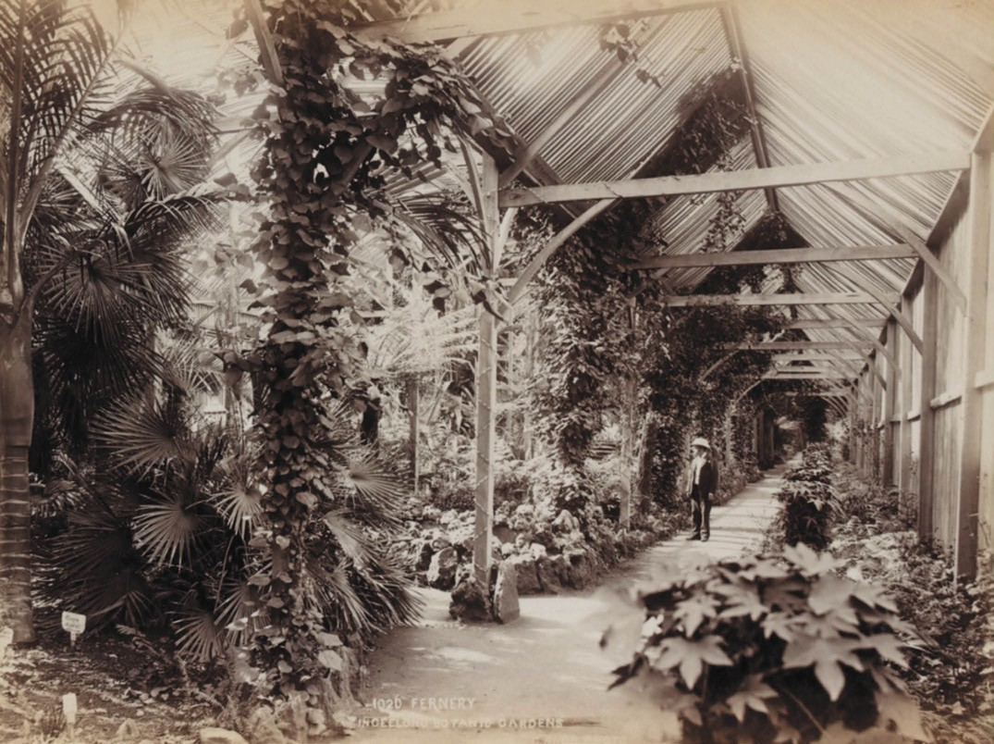
Figure 9.51: C. Rudd, Fernery, Geelong Botanic Gardens, c.1892-1902. Source: accession H39358/27, State Library of Victoria.
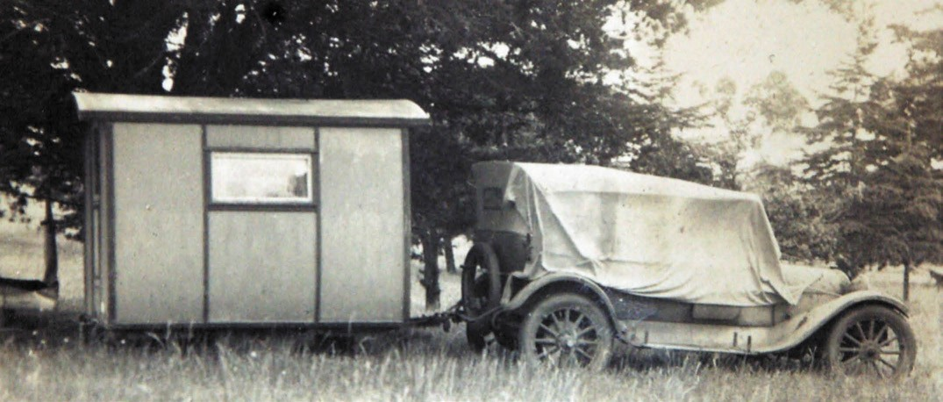
Figure 9.52: Caravan hitched to car in Eastern Park, 1926. Source: T.T. Holmes collection, Authentic Heritage Services Pty Ltd.

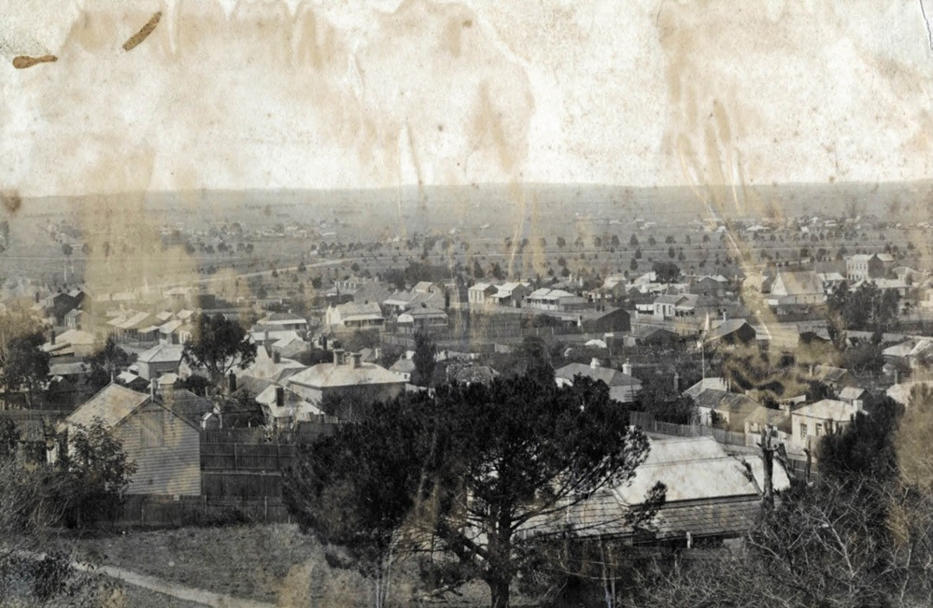
Figure 9.53: View of Chilwell from Clarke House with the recently laid out and planted Kardinia Park in the background, c.1872. Source: GRS 2009/04095/1, Geelong Heritage Centre collection.

KARDINIA PARK, MOORABOOL & KILGOUR STREETS, LATROBE TERRACE & PARK
CRESCENT, GEELONG
While Kardinia Park had been the unofficial home of the Corio Cricket Club from 1851, it was not until 1853 when the Geelong Town Council was successful in having 21 acres of
low lying land between Latrobe Terrace and Moorabool Street (south of Kilgour Street) reserved for the purpose of cricket and mainly recreation. 468 No major improvements were made in the first two years and Alderman James Noble lamented that it was going to destruction, being cut up or sunk into ruts by the passage of carts and the operation of traffic in general across it. He proposed the land be fenced with rows of trees planted (native or otherwise), the ground sown with English grass seeds and promenade made in addition to a cricket ground, believing that the expenditure would be recouped through the rentals preferred by the cricket clubs. 469 Noble s suggestion was not supported by his fellow Councillors, the ground had already been offered to the Corio Cricket Club and there was no money to create the terrestrial paradise. 470 Twelve years later –long after the Corio Cricket Club had relocated to Corio Oval at Eastern Park – the Chilwell flat was
still described as a dreary waste 471 with any grass that made an effort to spring constantly swallowed up by the goats, sheep, horses, and cattle that rambled at large. 472
Improvements to Chilwell Flat did not begin until 1872 when the reserve was named Kardinia Park, presumably after the municipal ward within which it was located, which in turn was a derivation of the Wadawurrung name meaning sunrise.473
A Park Committee was established and jointly comprised Councillors of the City of Geelong and Borough of Newtown and Chilwell.474 Subscriptions were called in aid of the works which began in July 1872 with fencing, although this was delayed due to a scarcity of red gum posts.475 By November 1872, curved walks and numerous road drives had been
laid out, rows of 2000 trees planted, artificial reservoirs and islands constructed from the natural creeks and chasms
(to the north-east and south-east), and a cricket ground laid out on the western side476 (Figure 9.53). The work was initially supervised by the Geelong Town Surveyor, Robert Balding before the head gardener for the park, Mr. Roper, took charge.477 Cricket and football were the main sports played at the ground over the ensuing years.

Thirty years later in 1902, part of Kardinia Park underwent another transformation with the formation of a zoological garden near the north-east portion the reserve. Two large ponds were fenced in and a good collection of animals, birds, etc., to tenant the reserves had been procured, including
an emu and several wombats.478 A kangaroo previously at Eastern Park became one of the greatest attractions.
Additions to the fauna at the zoo included two white ducks presented by Mrs Rowden of Fyans Street, Chilwell, a
pair of quail, the gift of Mr J. Shaw, also of Fyans Street, Chilwell, while R.V. Dennis of Tarndwarncoort Homestead, Warncoort (near Birregurra) donated pairs of Cape Barren geese, mountain duck, wood duck and black duck, as well as an emu.479 An aviary was added in 1903 and by 1904 the collection also included monkeys, wild birds, guinea pigs, and a handsome stag , which was regarded as the most
admired occupant of the enclosures 480 (Figure 9.54). In 1906, the transfer of the emu to the deer enclosure was not without incident:
The curator of Kardinia Park undertook the task on Monday morning of transferring the emu to new quarters in portion of the deer enclosure, and, as could be well imagined, the exercise of no small amount of strategy was required. The worst of the task was when the
bird approached the gate of its new adobe, and very carefully the caretaker worked around the emu to direct it to the narrow opening. The maneuvering reached a stage when the driver had to back away in keeping with the movements of his charge, and unconscious of the fact that a carpenter had left his tool bag close by, the curator gracefully fell over it. The emu continued on its
course, and as it passed almost over him, the curator had the opportunity seldom enjoyed by men, of examining
the under-structure of an emu s foot. He was uninjured in the incident, and with the aid of a lasso and some workmen the bird was safely quartered in the enclosure.481
By 1914, Kardinia Park boasted principal graveled drives around its perimeter and a crossing through its centre, the sports oval to the west, three rotundas, ornamental reservoirs and ponds and a fenced-in zoo (Figure 9.55). At the main entrance in the north-west corner (at the convergence of three of the principal drives) was situated the Boer War memorial (unveiled in 1902 –see Theme 8) while immediately west of the main gates was the caretaker s cottage known as The Lodge , built in 1907 to a design by William Tombs, architect.482
World War One brought with it the question of the future of the zoo, possibly as a consequence of the death of the
park s long-serving caretaker, Michael Graham (1846-1915). At this time, the Kardinia Park Committee s revenue was ‘scarcely sufficient to pay caretaking expenses and the feed of the animals and birds. 483 Born at Werribee to parents, Patrick and Ellen (nee Rowan) Graham, Michael Graham

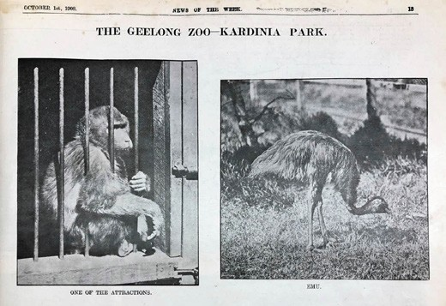
Figure 9.54: Monkey and emu in the Kardinia Park zoo, 1908. Source: News of the Week, 1 October 1908, p.13, GRS 2121/1, Geelong Heritage Centre collection.

was appointed the caretaker of Kardinia Park during the early transformation of 1872. Graham and his family appear to have resided in a cottage at Kardinia Park until 1891 as by 1892 they were resident in Foster Place off Little Ryrie Street until the new caretakers cottage was built at the main entrance to Kardinia Park in 1907.484 On his death in 1915,
the cortege left The Lodge , Kardinia Park, for a well-attended service at the mortuary chapel, Eastern Cemetery, where he was subsequently interred in the Catholic section.485
At Kardinia Park, working bees were held in mid 1917 which involved the planting of two beds of 40 trees each, together with six palms, 20 magnolias, eight Prunus Munes and six weeping peaches.486 The beautification program was carried out with zoo remnants and animals still resident in the park but the zoo s heady days as a popular zoological garden had come to an end.487 The Kardinia Park Committee had difficulty in dispensing with the remaining deer. One proposal in 1918 was that they be taken over by Geelong butchers and sold as venison on Gala Day but that was not considered favourably by a leading butcher (not because the public may have had
a previous fondness for them on visits to the zoo but as a consequence the public not knowing much about venison).488 In 1922, the Geelong Advertiser reported that:
In the near future it is probably that what is known as the Zoo at Kardinia Park will be removed. The odd assortment of birds and animals has become more an object of levity than interest or instruction, and in view of the difficulty in keeping the cages and enclosures clean, it was suggested at Thursday s meeting of the Park committee that the birds and the monkeys –such as they are –should be removed. The kangaroos may be allowed to remain, but the removal of the bulk of the Zoo is being strongly advocated. A Park Zoo had outlived its usefulness, and there was really no room for it now that there were two ovals in the park.489

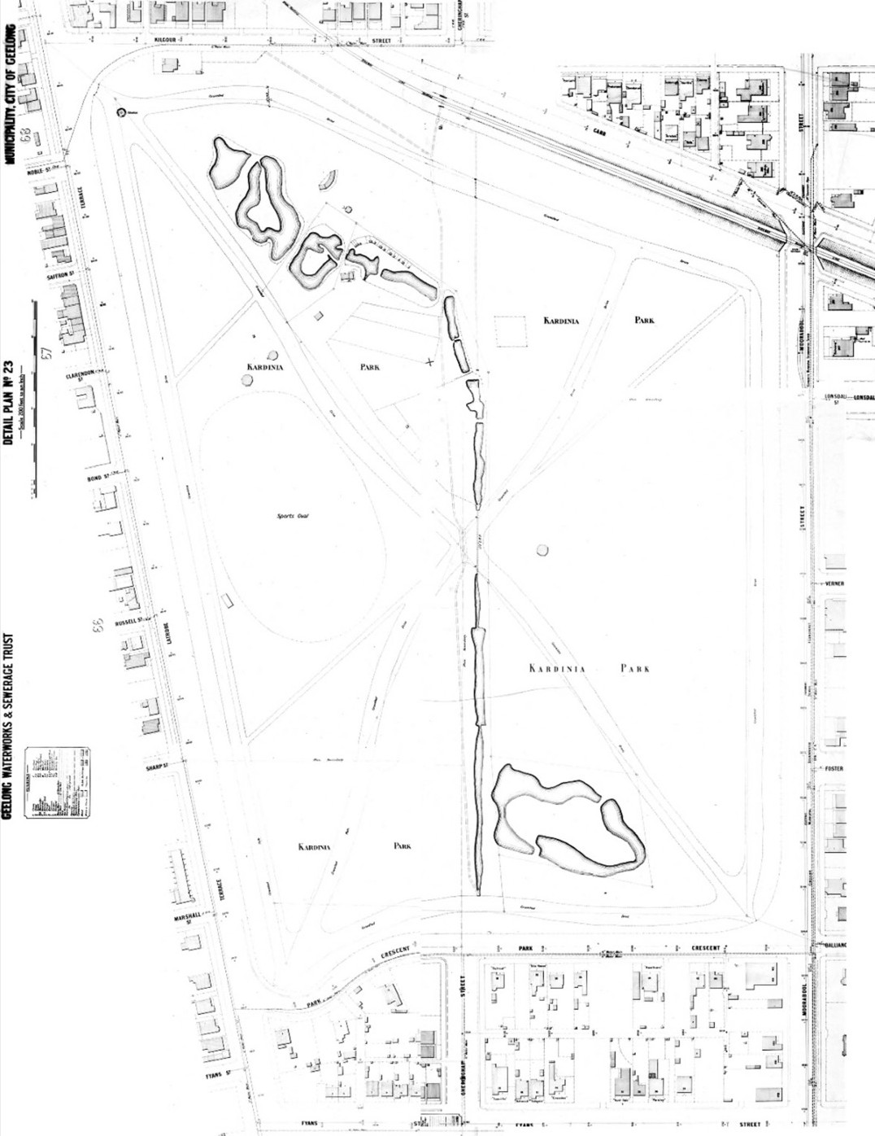
Figure 9.55: Kardinia Park, Geelong Waterworks & Sewerage Trust Plan Nos. 17, 23, 48 & 49, c.1914. Source: Barwon Water.

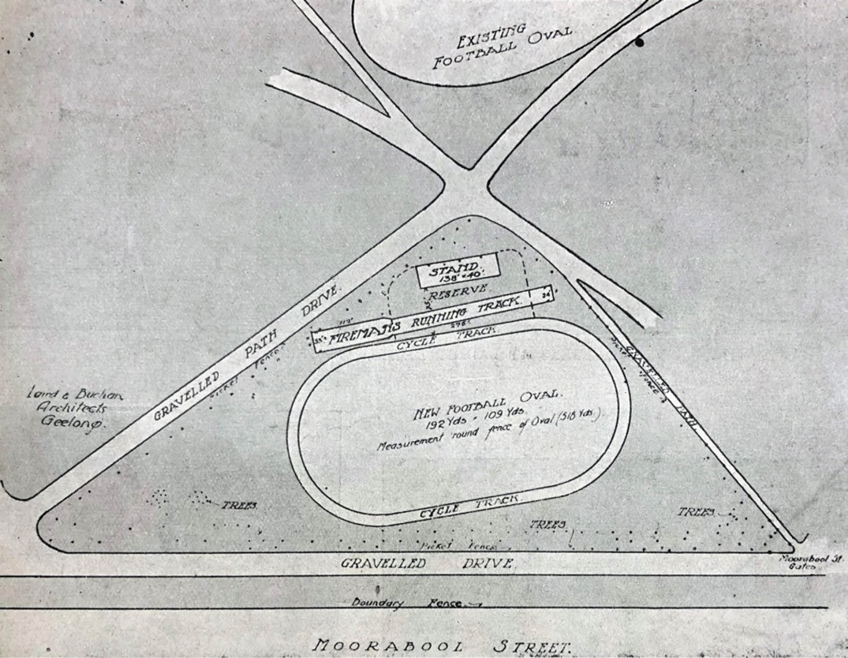

Figure 9.56: Laird & Buchan, Proposed Sports Ground, Kardinia Park, 1919. Source: News of the Week, 22 May 1919, p.13, GRS 2121/4, Geelong Heritage Centre collection.

Meanwhile, the immediate improvements to Kardinia Park after World War One were the beginning of the most profound and major developments in the reserve as a sports ground into the early 21st century. In 1919, a deputation waited on the Kardinia Park Committee at the Geelong Town Hall for the conversion of the eastern half of the reserve into an up-to- date sports ground. Although the existing Corio Oval and Friendly Societies ground at Eastern Park were not criticised as sporting venues, it was the lack of a central ground that brought about the need for a new facility.490 The proposed scheme was to include the construction of a boundary fence with gates and ticket boxes; an arena fence; a grandstand
to seat 1200 people; laying out of firemen’s track; laying on water mains; provision of a cycle track; and the provision of electric light.491 The scheme was favourably considered by the Committee and the local architects, Laird and Buchan were commissioned to design the layout of the arena and
the grandstand492 (Figure 9.56). The new sports ground was opened by the Mayor of Geelong, Howard Hitchcock, in July 1920, the event marked by a football match between the Barwon and East Geelong teams.493
The foundation stone of the new grandstand was laid by the Premier of Victoria, S.W. Lawson, on 17 September 1920.494 This was to become the first of many grandstands to be built at the new sports ground over the next 98 years. The new ground was opened by the Mayor, Howard Hitchcock, in July 1920, prior to a football match between the East Geelong and Barwon Clubs (Figures 9.57-58). From this time, the venue (Figure 9.59) played host to football and cricket games, and other sporting events, including cycling races during the summer months from 1926 (see earlier subsection).
It was from 1941 when the Geelong Football Club made the eastern oval at Kardinia Park its home that ensured the

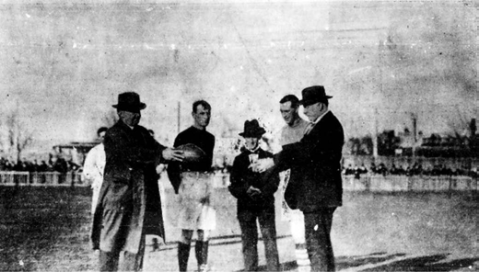

Figure 9.57: Official opening of new Kardinia Park ground. Mr. Galbraith handing ball to the Mayor, Ald. H. Hitchcock, to open the game between Barwon & East Geelong. Watching on are the two captains: F. James (East Geelong, left) & H. Marsham (Barwon, right), 1920. Source: News of the Week, 15 July 1920, p.12, GRS 2121, Geelong Heritage Centre collection.

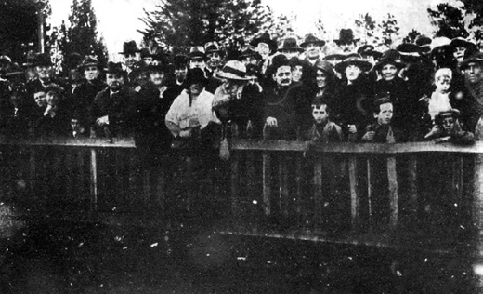
Figure 9.58: Spectators at the official opening of new Kardinia Park ground to watch the Barwon & East Geelong match, 1920. Source: News of the Week, 15 July 1920, p.13, GRS 2121, Geelong Heritage Centre collection.

long-term future of the ground. Major redevelopments of the ground have been completed after the 1920s and into the early 21st century, the once rural sports grounds and ornamental and zoological gardens into an AFL standard facility presently known as GMBHA Stadium. From 2016, all of the facilities at the sporting reserve have been managed under the authority of the Kardinia Park
Stadium Trust.495
Yet, Kardinia Park also experienced other changes in the 20th century. In 1933, four tennis and basketball courts were added at the southern end of the park, the YWCA having use of two courts.496 In 1953, they were upgraded with six new basketball courts at the north end of the park.497 By 1969, a brick pavilion had been constructed498 (Figure 9.60). It was

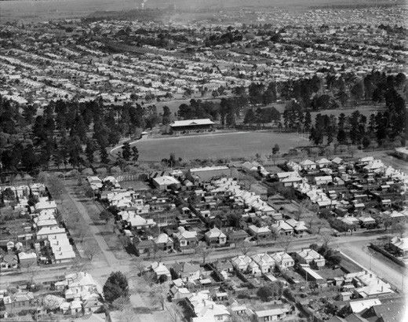
Figure 9.59: C. Pratt, Aerial view showing Kardinia Park with grandstand, September 1937. Source: accession H91.160/814, State Library of Victoria.

named in memory of Elizabeth Hindell499 whose contribution to women s basketball from the early 1940s in Geelong was substantial (see earlier subsection). In subsequent years, there were twelve basketball courts available for competition in Kardinia Park. In 2010, they were redeveloped into nine new competition courts, including a feature show court.500 The Elizabeth Hindell Memorial Pavilion has also been upgraded and extended.
In 1967, the Geelong and District Memorial Swimming Pool opened in the south-east portion of the reserve501 (see later subsection for further details). A senior citizen s centre had also been constructed to the south- east. In later years, a cricket ground was laid out north of the main football ground, playground facilities were established and a plaza erected outside the main entrance into the football stadium.502

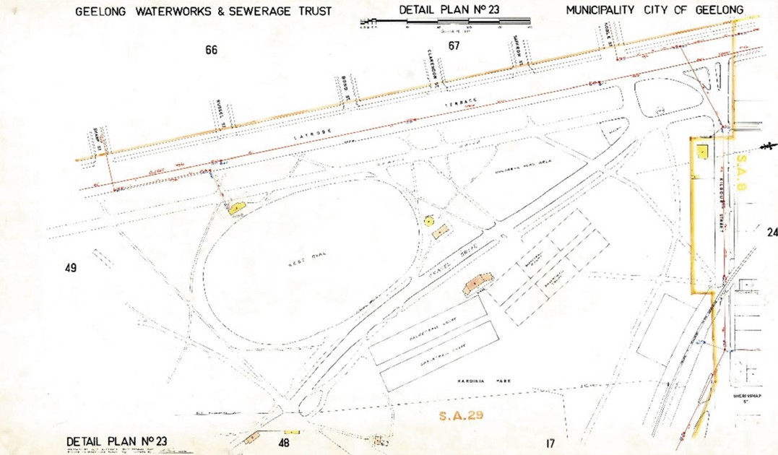
Figure 9.60: G.E. Althoff, GWST Detail Plan no. 23, 20 March 1969, showing northern portion of Kardinia Park including the basketball courts & pavilion. Source: Barwon Water.

SMALLER CITY PARKS AND RESERVES
Several small city parks and reserves were also set aside and landscaped from the 19th century. They included
the following.

PEVENSEY GARDENS
The dynamic layout afforded the eastern extension to the Geelong Town Plan under the leadership of Andrew Clarke, Surveyor-General of the Department of Lands and Survey in 1854, included Pevensey Crescent, and two centrally-located adjoining spaces for public recreation (see Theme 6). In 1863, chain fencing appears to have been erected to enclose at least the northern space.503 Elm trees were also planted.504 In 1874, under the management of John Raddenberry, plane trees were planted. As described in the Geelong Advertiser:
Pevensey Crescent has also been adorned by the planting of various kinds of trees [Figure 9.61]. Along Fitzroy- street –the base of the semi-circle –a double row of Oriental planes have been planted, and in this sheltered positions they ought to thrive. The trees are protected by neat picket fences …505
One of the public reserves was also the location of informal football games, including a moonlight match of noisy youths in 1873, their presence disturbing the peace. Two of the participants ended up in the watch house on a charge
of using obscene language in a public space. 506 More acceptable were the cricket matches played on the reserve from 1874 with one of the earliest games there being between the Alliance Second Eleven and the Fitzroy Cricket Club. 507 By 1913 the reserve had been relegated to a practice wicket but competition cricket seems to have ended during World War One.508 In 1919, the reserve was considered a valuable playground for children and a proposal to building 20 cottages for soldiers widows in this location was met with resistance which proved successful.509
No improvements appear to have been made to the reserves in the ensuing years as in 1926 it was lamented that they cannot be said to be attractive but that they could be made so without any very large expenditure. 510 Beautification came to the southern reserve around 55 years later in the mid 1970s-early 1980s when a rose garden was laid out in honor of Ronald Hendry Robertson, Geelong City Councillor from 1958 until 1966, and 1972-1989.511 A manufacturer s

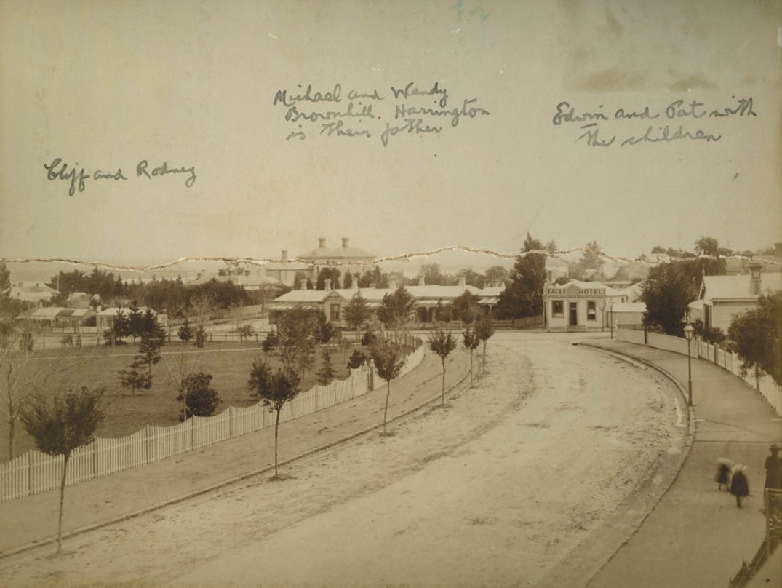
Figure 9.61: Pevensey Crescent (looking north from near Malop St) showing Pevensey Gardens, c.1890. Source: GRS768/5/0, Geelong Heritage Centre collection.

agent, he was also a member of the Board of the Geelong Waterworks and Sewerage Trust in the 1960s.512 He died in office in 1989.513

AUSTIN PARK
In 1885, land originally set aside as a Customs Reserve at the corner of Bellerine Street and Victoria Terrace (Eastern Beach Road) was permanently reserved for a public park.514 It
was not until 1889 when the reserve was formally opened as Austin Park. The event was reported in the Geelong Advertiser:
Yesterday afternoon Mr James Austin, who was the second Mayor of Geelong, formally performed the ceremony of planting the first tree – a very healthy specimen of the Moreton Bay pine –in the centre of the above park. The land which is now being formed into a park, is situated on the east side of Bellerine street north, near the beach. Some months since it was decided by the members of the Geelong Town Council to fence in

the allotment of land, which for years past has been the resort of cows and goats, and very often during the winter season of rough and noisy football players. Seizing the opportunity Messrs J.M. Anderson and Naples, residents of Corio street east, and whose residences overlook the allotment, considered that the name should be given to the place, and they suggested as an appropriate one that of The James Austin Park. … the park which would be open to the public …515

HARDING PARK
A site at the south-west corner of Bellerine and Brougham Streets, Geelong was permanently reserved for a public park in 1885.516 The Geelong Town Council, on the resolution of Alderman Price, named the reserve Harding Park in 1890
in honour of Silas Harding as a consequence of him being one of the earliest aldermen of the town and because the town had benefitted from him ‘erecting valuable buildings.’517 A secondary motive was the hope that Harding would fund improvements to the park.518 This did not eventuate until after Harding s death in 1895 when his widow, Mrs Louisa Harding ‘donated a large sum of money’ for the park’s beautification. She appointed J.M. Anderson, R.E. Oldfield and
Charles Naples to supervise its expenditure and procure a design that was carried out under the management of
Joseph Nairn, landscape gardener employed at the Eastern Park and Geelong Botanical Gardens.519 Described as the plague spot that was an eyesore and a menace to the health of persons residing in the vicinity of it, the realised landscape design (Figure 9.62) included a central circular flower bed from which cross footpaths radiated. Rockeries were laid out at the four entrances to the park, the granite having been brought by ships from Rio Janeiro as ballast.
Half moon flower beds were created in the centres of each pathway. Six large plots of grassed areas, perimeter hedging and pepper trees had also been planted.520 While the park was considered to form a most attraction to the addition to the pleasure enclosures within the town of Geelong, the permanent reservation was revoked under the Land Act
1995 and the site sold under controversial circumstances for private development in 1999.521

RICHMOND PARK
Laid out as part of the eastern extension to the Geelong town plan in 1854, football matches were earliest played on the reserve then known as Richmond Crescent in 1878 when
the Clarendon team played Railway.522 In 1879, the reserve became the home of the East Geelong Football Club (later East Geelong Football and Netball Club), the first home

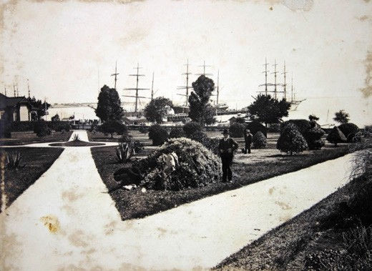
Figure 9.62: Harding Park looking north-west, c.1910. Source: 2076/38, Geelong Heritage Centre collection.

match being played against Chilwell on 23 August 1879.523 In the following summer season, cricket matches were also played at the reserve, the first being between Breakwater and Factories (second eleven) in March 1879.524 While football and cricket continued to be played each year for the remainder of the 19th century, the reserve remained a desolate open space. 525
Impetus for change came in 1912 with the reserve –then called Richmond Place or Richmond Park –was temporarily reserved as a site for public gardens and recreation.526 The Geelong Council began an improvement scheme including the construction of a perimeter fence and a double row of trees right around the crescent. 527 It was anticipated that
a comfortable public reserve and games ground would eventuate.528 In June 1912, acacia trees were planted on Arbor Day by 400 school children.529 The auspicious event involved the planting of the first tree by the Mayor of Geelong, Cr Williams530 (Figure 9.63). In February 1913, the ground (known by this time as Richmond Park as well as Richmond Crescent) was levelled following a working bee of young
men in order that football matches could be played in the forthcoming season.531 An additional 25 varieties of acacias were also planted, a donation of the newly-formed Geelong Wattle League in 1913.532
Cricket continued to be played at Richmond Crescent during World War One.533 It was also the location of a Win-The- War demonstration in February 1917.534 A concrete wicket was laid down in the reserve in 1920.535 Yet, the continued sports games and landscape improvements of the 1910s
did not ensure a picturesque feature for Richmond Park. In 1922, Cr Wallis called for called for action to be taken for

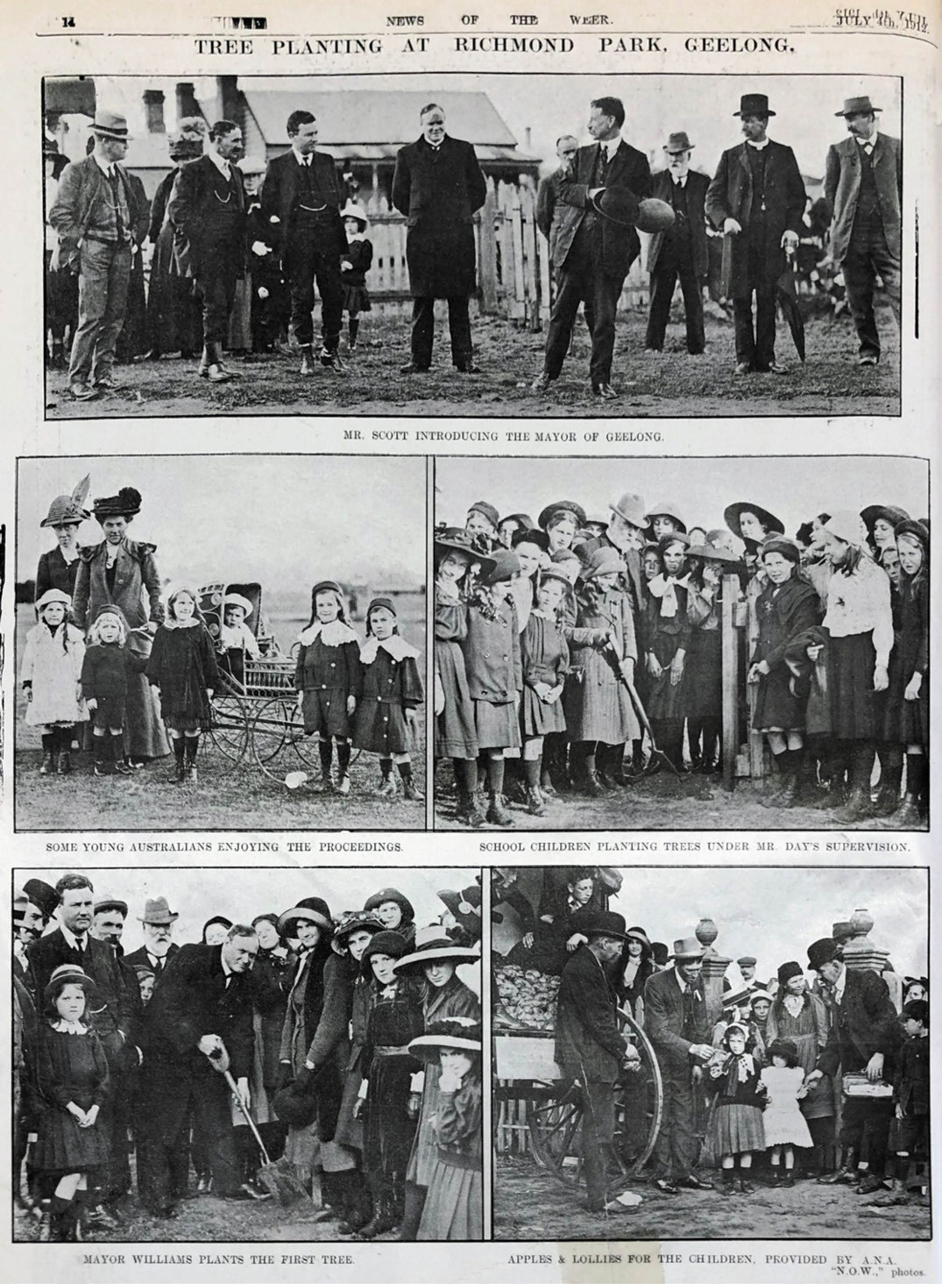

Figure 9.63: Tree planting at Richmond Park, 1912. Source: News of the Week, 4 July 1912, p.14, GRS 2121/3, Geelong Heritage Centre collection.

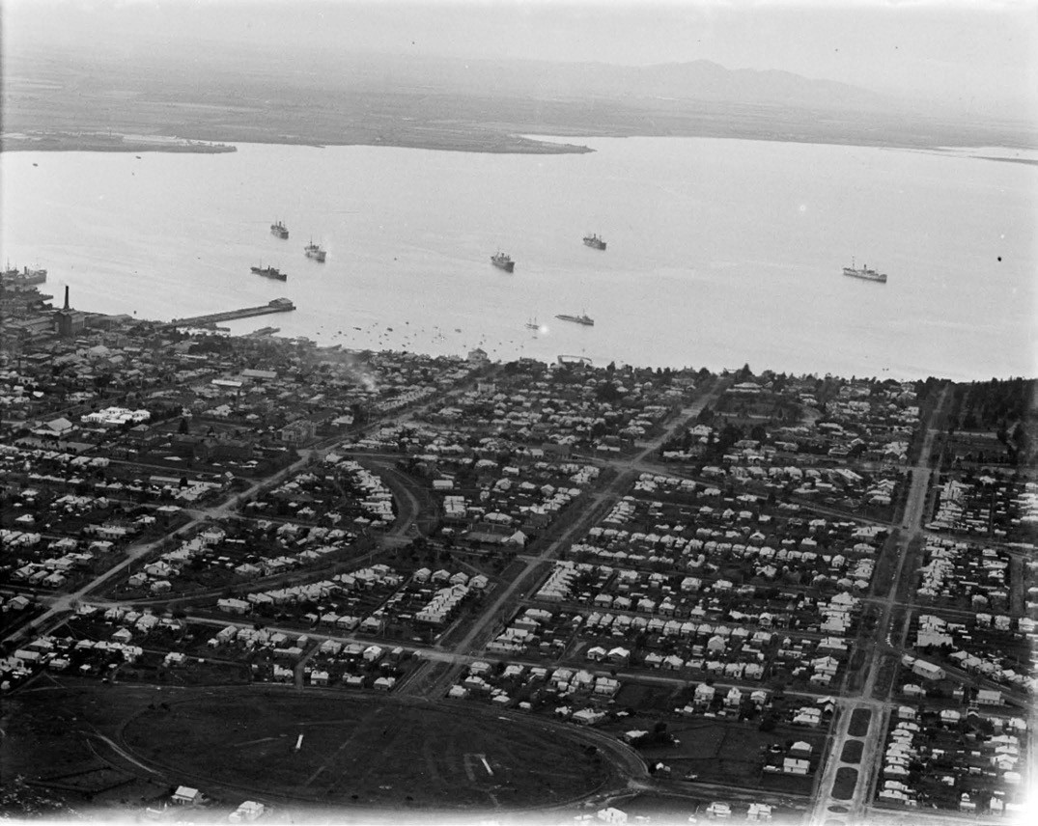
Figure 9.64: C. Pratt, aerial view of Geelong looking north to Corio Bay, c.1930-40. Richmond Park is in the foreground. Source: accession H91.160/843, State Library of Victoria.

improvements given that it was lying idle in 1922,536 By 1926, the curator of the Geelong Botanical Gardens, J.P. Day, complained that while over 100 trees had been planted at Richmond Crescent in preceding years, only twelve struggling shoots survived to show a reward for his enterprise. 537
The East Geelong Progress Association led working bees for improvements to the reserve (Figure 9.64) in 1926 and
1927.538 In 1928, the Geelong City Cricket Club was formed following the revival of the Geelong Turf Cricket Association in that year. The Association initially allotted Corio Oval at Eastern Park its home ground, the club later transferring to Richmond Crescent as its home base.539

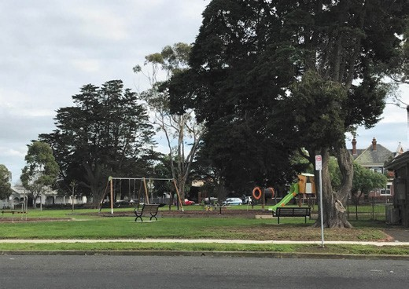

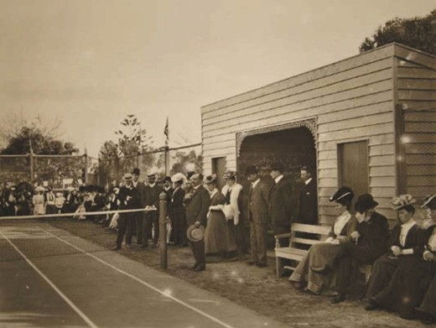
Figure 9.65: Opening of the East Geelong tennis court at the recreation reserve by Mayor Bostock, 29 May 1907.
Source: GRS 0160/3/17a, Geelong Heritage Centre collection.

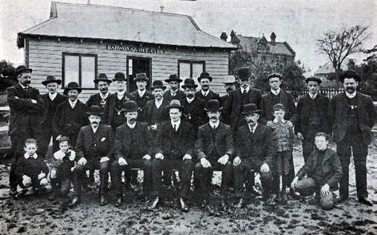
Figure 9.66: Barwon Quoit Club outside new pavilion in the East Geelong recreation reserve, 1909. Source: Lockwood Studios, News of the Week, 29 July 1909, p.13, GRS 2121/1, Geelong Heritage Centre collection.

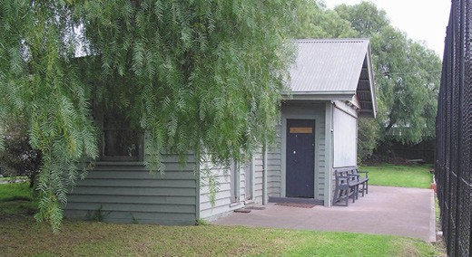
Figure 9.67: East Geelong Tennis Club pavilion, 2019. Source: Pam Jennings.
Figure 9.68: Hopetoun Park from Fitzroy Street looking west towards Bourke Crescent, 2019. Source: David Rowe.

PUBLIC HALL, FREE LIBRARY & RECREATION RESERVE, MCKILLOP, FITZROY & STORRER STREETS & BOURKE
CRESCENT
The eastern extension to the Geelong Town Plan in 1854 also provided for two smaller reserves west of Bourke Crescent and separated by McKillop Street. The site was fenced in, dug-up and set with pepper, elm, and other trees in 1890.540 The first reference to formalised sport to be played in this northern reserve was in 1898 when the Barwon Quoit Club was granted permission to use the reserve near the Elephant and Castle Hotel. 541 A ground was laid out, and in 1899 a small pavilion was erected but it was destroyed by fire two years later.542
Other improvements to the reserve had come in 1907 when a Free Library was built in the south-east corner (Theme
8) and the East Geelong Tennis Club opened a court (see earlier subsection) (Figure 9.65). A new quoit pavilion (with a gambrel roof) (Figure 9.66) was built in June 1909 by Messrs. Armour Brothers and was considered a great improvement to the ground, being splendidly ventilated and one of the largest of its kind in the State. 543 Today, it is the only known surviving early 20th century purpose-built quoit club pavilion in Greater Geelong. A timber tennis pavilion (Figure 9.67)
was built for the club in 1926 to a design by the local architect, Harold Trigg.544

HOPETOUN PARK, MCKILLOP, FITZROY & WALLS STREETS & BOURKE CRESCENT
Hopetoun Park (Figure 9.68) on Bourke Crescent to the south of McKillop Street appears to have largely remained unimproved throughout much of the 19th century. In 1890, old palings which had first served as tree guards in Eastern Park were used to construct a perimeter fence at Hopetoun

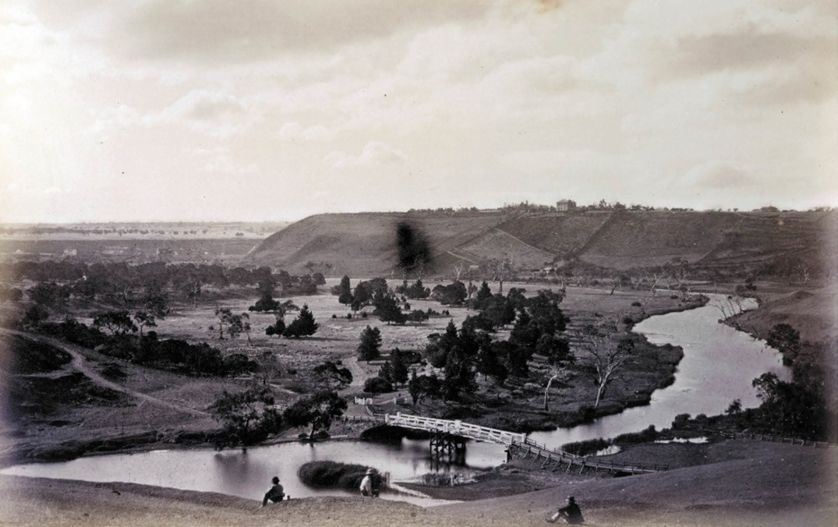
Figure 9.69: F. Kruger, Queens Park, 1880. Source: accession H2006.123/31, State Library of Victoria.

Park, the ground was dug up and pepper, elm and pine trees planted.545 It might have been following the Federation of the Australian Colonies when the reserve was named Hopetoun Park, after Australia’s first Governor-General appointed at this time, John Adrian Louis Hope, 7th Earl of Hopetoun.546 Eight years elapsed before of the reserve was formally set aside a site for an ornamental plantation in 1909.547 While trees had been planted in the reserve, it was the scene of junior competition cricket matches. In April 1909, St. Mary s School played Chilwell State School there.548 These games had come to an end by 1917 when the ground was ploughed and new grass and trees planted, and flower beds laid out, transforming the reserve into a children s playground.549 The next major change was the construction of the Baby Health Centre in the north-east corner of the park in 1930 (Theme 8).

SOME EARLY SUBURBAN PARKS AND RESERVES QUEEN’S PARK, HIGHTON
In 1857, Queen s Gardens, comprising 105 acres, was
opened beside the Barwon River at Highton.550 It was located adjacent to Bunnyar Willock on the opposite bank of the former Aboriginal mission station established by Charles Seivwright in 1840 and the location of a conflict between
the Wadawurrung and Guilidjan peoples (Theme 2). The reservation was to be managed by the Newtown and Chilwell and South Barwon Councils, the first meeting of the trustees being on 11 March 1861 when the site was to be named Queen s Gardens (it was changed to Queen s Park in 1867).551 Trees were donated by Ferdinand von Mueller, curator of the Melbourne Botanical Gardens,552 Daniel Bunce of the Geelong Botanic Gardens and James Wyatt of the nearby Frogmore Nursery (Theme 4). By 1879, considerable improvements had been made to the park, including the planting of an additional 200 trees, construction of a pathway along the slope of rising ground at the entrance flanked by pine trees; a cricket reserve (also known as the oval mound), laying out of a 50 feet wide carriage drive, building of a lodge and the erection of two

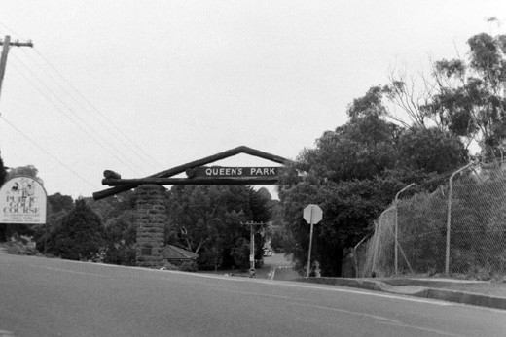
Figure 9.70: F.W. Stinton Memorial Gateway, Queens Park, 1998 (the timber pediment structure has subsequently been removed). Source: David Rowe.

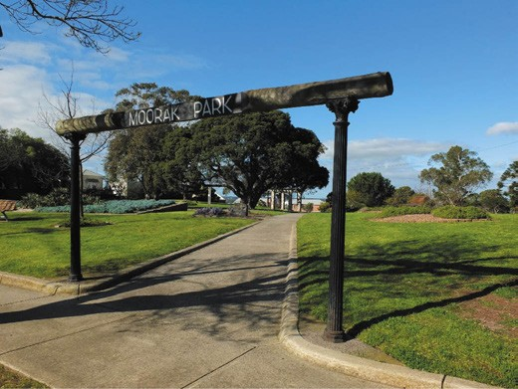
Figure 9.71: Moorak Park, Noble Street, Newtown, 2019. Source: David Rowe.

rotundas553 (Figure 9.69). The works were supervised by Thomas Jeffrey of Jeffrey s Fernery Hotel, north-west corner of Aphrasia Street and Shannon Avenue (established in 1855- 56).554 Further improvements were made in the 20th century, including the provision of a second sports oval, and the laying out of the golf course in 1934 (see earlier subsection). In 1960, an entrance way constructed of stone piers surmounted by an open timbered pediment (Figure 9.70) was unveiled
by Mrs. Eveleen Stinton in memory of her late husband,
Cr. Frederick William Stinton, who had served as a Councillor for Newtown and Chilwell for 26 years.555

OTHER EARLY SUBURBAN PARKS AND RESERVES
Numerous parks and reserves were established from the late 19th century. They include Osborne Park, North Geelong (which began in 1893 on Phillip Russell s Osborne House grounds but was not gazetted as a reserve for recreation
and public purposes until 1932); Cannon Hill foreshore reserve (Figure 7.71), opposite Glenleith Avenue, Western Beach (the small park was noted for its gun dismantled from the H.M.S. Nelson and two eighty pounder guns from Swan Island in 1898 –the guns had dilapidated by 1928 and were removed); Geelong West Park, Geelong West (opened in 1911 when W.J. Reid sold a northern portion of his Pineville Estate to the Geelong West Borough Council); St. Helen s Park, Rippleside (initially laid out in 1918 to a design by Percy Everett in association with Laird and Buchan, the anticipated central lake was never realised although improvements were made in 1927 and again in 1964); Moorak Park, Noble Street, Newtown (established in 1920 by the Newtown and Chilwell Council, the park s name a suggestion of Mrs M.C. Collins, a Wadawurrung name meaning hill556) (Figure 9.71); Sparrow Park, corner Hope and Elizabeth Streets, Geelong West (established in 1936 on E.R. Sparrow s former paddock that had been purchased by the Geelong West City Council); and Alsop Park, 2 Mount Pleasant Road, Belmont (originally set aside in 1880 for road purposes, then proposed as a plantation in 1886 before being improved with Canary Island Palms and other landscaping in 1941 when it was opened in memory of the late Joseph Alsop, past president of the South Barwon Shire).557

MARINE RECREATION IN GEELONG SEA BATHING
EARLY SEA BATHS ON THE GEELONG FORESHORE
Geelong’s first sea bath was built by W. Rea, cabinet maker, in 1844 at Eastern Beach. Season s tickets
at Rea s Baths cost 10 shillings with a charge of sixpence for non -subscribers. There were different hours for male and female bathing.558

THE GEELONG SEA BATHING COMPANY
The first substantial sea baths at Eastern Beach, however, dated from the early 1850s. Although there was a great deal of commercial and maritime activity along the main foreshore, there was very little residential or commercial/maritime development east of Swanston Street –apart from Blunt s dwelling and boat workshop establishment - where there
was an unclaimed beach area. It was in this location in 1853 when the newly- formed Geelong Sea Bathing Company

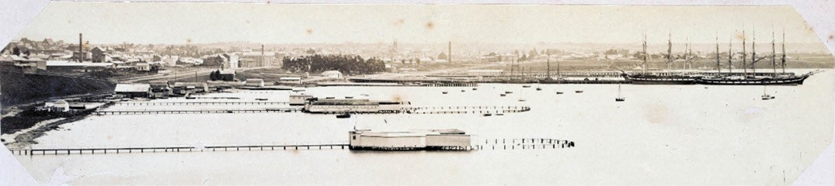
Figure 9.72: Eastern Beach Baths, c.1872-82. Source: accession H83.429, State Library of Victoria.
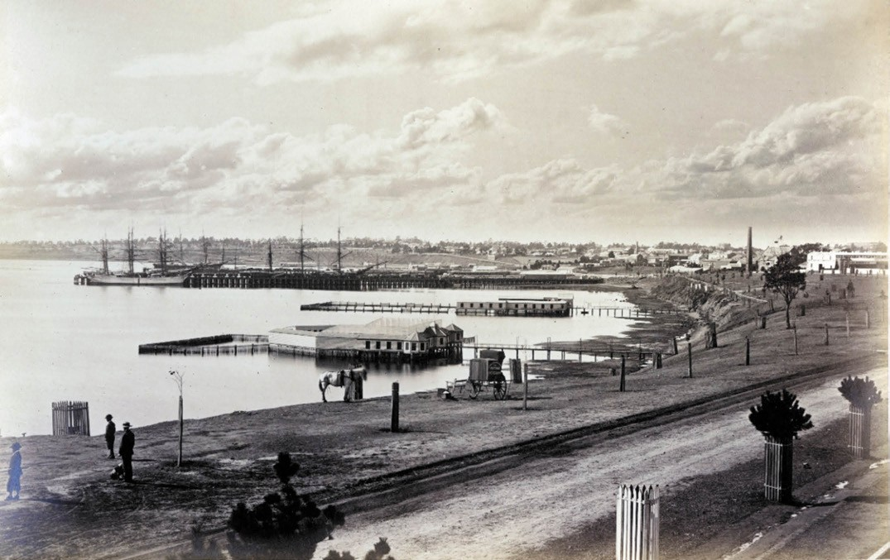
Figure 9.73: F. Kruger, Western Beach Baths, 1880. Source: accession H2006.123/3, State Library of Victoria.

proposed to establish sea baths for ladies and gentlemen. In a letter to Governor La Trobe, dated 16 August 1853, the company spoke of the necessity of properly regulated
Bathing Establishments whereby the health of the Inhabitants of Geelong may be preserved and due attention paid to public decency . The new baths were to be located to the eastward of the present piers, so as not to interfere with any further extension of wharf accommodation, and so far separated as to render them entirely private . Permissive occupancy of the foreshore for the establishment of a Gentlemen s Baths was given in 1853 and for Ladies Baths in 1854.559 The baths were completed in 1854 and 1855.560
The Gentlemen s Baths were located just to the east of the Swanston Street intersection with Victoria Parade
(now Eastern Beach Road) and extended some 800 feet from the shoreline to the Bay. The Ladies Baths, slightly shorter (700 feet), were to the east of these baths. The baths were replaced with new facilities in 1872561 (Figure 9.72).
These baths became popular and it was claimed in 1873 that the present bathing accommodation was adequate even during last season when large excursion trains from Ballarat and elsewhere brought down hundreds who used the baths .562 The issue of tenure was raised during the 1870s. As a result,

the Minister revoked the company s permissive occupancy and stipulated the payment of a licence, renewable annually.563
The Geelong Sea Bathing Company continued to operate at Eastern Beach for another 50 years until the 1920s, when questions about the need for improvements to the Bay s foreshore became a major consideration for the Geelong Council, the Geelong Harbour Trust and the public.

WESTERN BEACH BATHS
Richard Parker, ironmonger (Theme 5), commenced the Geelong Public Bathing House at Western Beach 1848.564 A more substantial proposal came in 1855 when the Western Beach Sea Bathing Company was established and funded by public subscription. Located near Griffin’s Gully, the local architects, Backhouse and Reynolds, were commissioned to design the baths in 1856.565
Further east in 1870 was the construction of the Victoria Baths at the end of Cavendish Street for Henry Fitzgerald. Built by Mr Holdsworth in the Florentine style , they were to accommodate at least 300 gentlemen. 566 Fitzgerald s venture amalgamated with the Western Beach Sea Bathing
Company in 1873, with Fitzgerald s baths reserved for males and the company s baths converted for females (the original female baths being demolished)567 (Figure 9.73). In 1916, the Western Beach Sea Bathing Company Limited wound up operations.568

EASTERN BEACH

EASTERN BEACH PUBLIC PARK
On 8 February 1878 the Crown Land of the Eastern Beach foreshore behind the Ladies and Gentlemen s Baths (previously the location of Hayes Patent Stone Manufactory in the 1850s –Theme 4), was gazetted as a temporary reservation after its nomination by the Geelong Town Council. It covered an area of about 12 acres and extended from Bellerine Street to about the Springs and was bounded by Victoria Parade (now Eastern Beach Road) and a Foreshore Road Reservation up to Garden Street.569 The Eastern Beach Public Park, as it was known, was permanently reserved
and gazetted on 6 February 1885.570 However, despite the Council s wishes, the Minister refused to transfer the administration of the area over to that body.

IMPROVEMENT AND BEAUTIFICATION OF EASTERN BEACH

THE FIRST IMPROVEMENT
A rotunda was constructed on the site in 1904 for the Geelong Progress Association by honorary architect Angus Laird of Laird & Barlow architects. It was situated between Blunt s boat sheds and the Eastern baths.571 It was octagonal in
plan with a timber structure supporting a hipped terracotta shingled roof.

IMPROVEMENT AND
BEAUTIFICATION COMMITTEE
A change in social behaviour on the beaches during the First World War included the end of restrictions on mixed bathing and Sunday bathing in 1917, which followed public outcry and the increasingly difficult task of
policing them .572
In 1917, Geelong Council appointed a permanent body titled the ‘Improvement and Beautification Committee,’ which
was particularly concerned about the state of the Corio Bay foreshore. Contemporary accounts described Eastern Beach as most unattractive, especially at low tide. The accumulation of seaweed was also a problem, and it was said that there were few areas of sandy seabed .573 The Improvement Committee set about clearing overgrown
vegetation. The local architect T.D. Slevin submitted a design for a rough cast gabled chalet flanked by pergolas that
was proposed for the beach in the vicinity of the Eastern Baths 574 (Figure 9.74). A year later in 1919 Percy Everett architect prepared a masterplan for possible foreshore improvements.575 Both Slevin s and Everett s proposals were never realised.
A key initiative of the Improvement Committee was the erection of three additional rotundas along the western end of Eastern Beach in 1917 and 1918, together with stone retaining walls and grass plots576 (Figure 9.75).
The return of a sergeant of infantry from the Front in France was also to prove influential on the development of Eastern Beach in future years. In 1918, the unnamed sergeant presented a series of postcards of the beach at Durban, South Africa, to the Geelong Advertiser that were published in News of the Week577 (Figure 9.76). The sergeant had seen the beach improvements at Durban first hand given that
the city was a stopover for military ships between Australia and England. The aim of presenting the photographs
was to inspire Geelong citizens into imagining a similar beautification of Eastern Beach.578

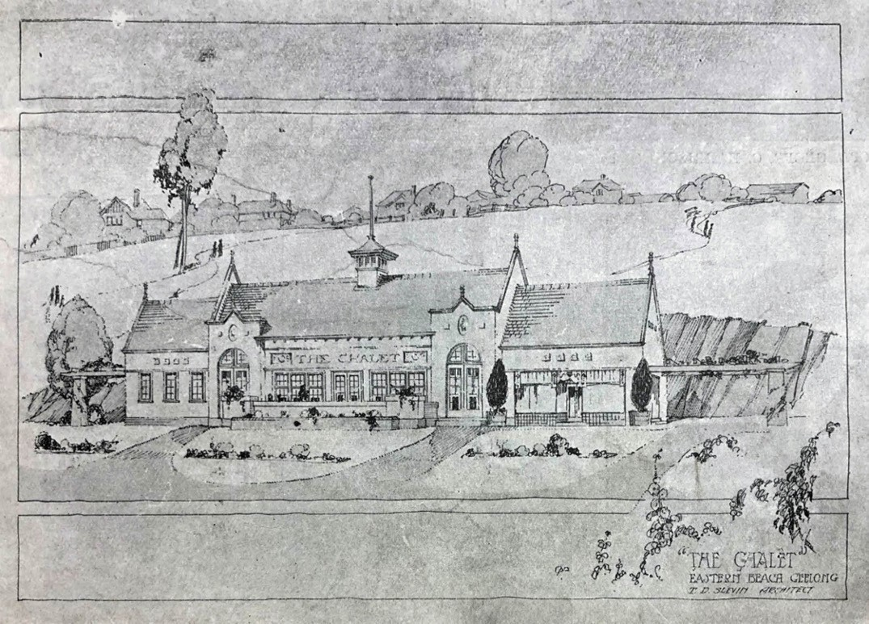
Figure 9.74: T.D. Slevin, Proposed Chalet, Eastern Beach, 1918. Source: News of the Week, 15 August 1918, p.13, GRS 2121/4, Geelong Heritage Centre collection.

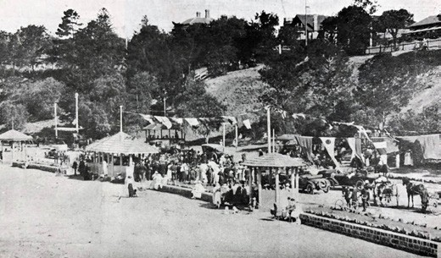
Figure 9.75: Opening of Eastern Beach improvements showing three rotundas & stone retaining walls, 1918. Source: News of the Week, 23 December 1918, p.11, GRS 2121/4, Geelong Heritage Centre collection.

IMPROVEMENTS IN THE EARLY 1920S
During the early 1920s, as tourism boomed throughout Victoria, there were a number of proposals for improving Eastern Beach s slopes and foreshore. Shrubs and trees were planted and seats and small summer houses erected. The Geelong Council and its Mayor, Howard Hitchcock, were prominent in these moves for civic improvement. In November 1921, Hitchcock told a group of visiting politicians
that, ‘…they intended putting in a retaining wall from Bellerine Street to a point east of the Ladies Baths, erecting kiosks, putting down lawns etc. and generally beautifying the foreshore. 579
The Harbour Trust s control of the foreshore (since 1905) was raised as an obstacle to these schemes, along with the lack of sufficient funding. In 1926, a newly established Eastern Beach Improvement League asked the government to cede that slice of foreshore land adjacent to the beach from the Harbour Trust to Geelong Council so that the improvements

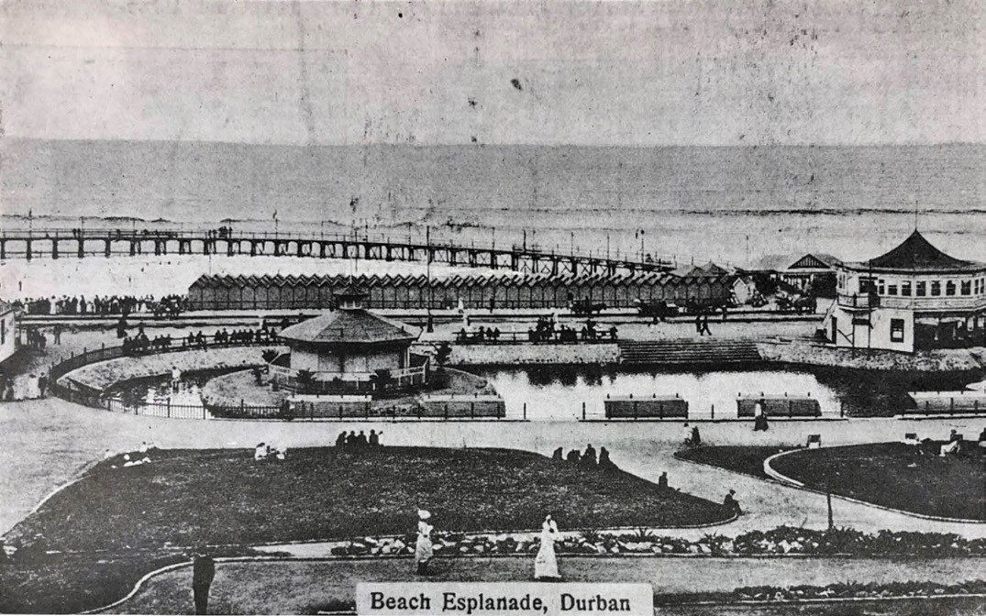
Figure 9.76: Beach improvements at Durban, South Africa, 1917. Source: News of the Week, 5 April 1917, p.16, GRS 2121/4, Geelong Heritage Centre collection.

carried out may be of a permanent and substantial nature . The League wanted to improve the surroundings so that Open Sea Bathing may become one of Geelong s most popular recreations .580 The area was subsequently handed over to the Geelong City Council.
The Harbour Trust’s response at first was to refuse to give up control, declaring that ‘the first duty of the Trust is to provide for the more utilitarian purpose –the improvement of the
port for commercial purposes . In fact, the want of storage accommodation along the foreshore has been acute… (and) it is intended to carry the work still Eastward…’ However, the Trust agreed that the area around the Eastern Beach baths might be the best location for an improvement programme,
due to its abutting upon a Public Reserve which itself abuts upon the Eastern Park, the foreshore east of Garden Street offers a convenient and a more suitable site for public reasons for the improvements to the foreshore…’581

THE 1925 COMPETITION
In July 1925 there was a meeting of the Beach Improvement Committee with architects J.A. Laird and F.C. Purnell of the Royal Victorian Institute of Architects (RVIA) to discuss an open competition for a design for the improvement of Eastern Beach, which was to be developed for safe swimming and recreational activities. Provision was made for prizes to be awarded. The assessors were to be three professional men, two architects and an engineer. Subsequently, the architects
F. Stapley and A.M. Blackett were appointed as assessors on behalf of the RVIA to work in conjunction with H.L. Tisdall, the Geelong City Engineer.582
It was announced in January 1926 that the winning design was by the firm of Henry Hare, architects and consulting engineers of Melbourne. They received prize money of £125, the second and third prize winners each receiving £30.583

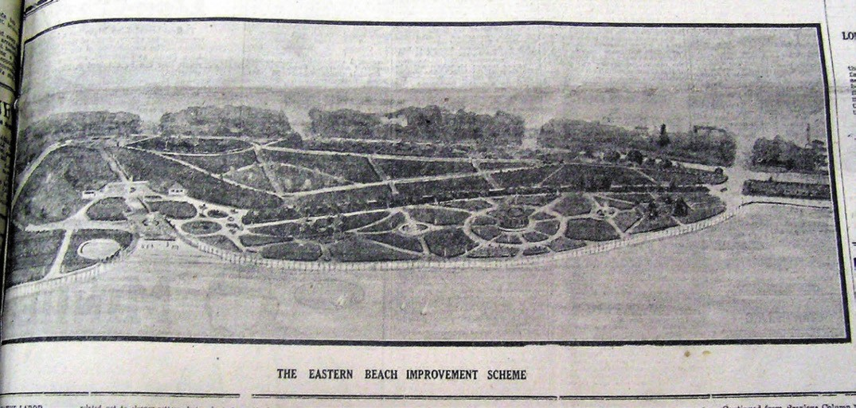
Figure 9.77: Hare s sketch for Eastern Beach, 1927. Source: Geelong Advertiser, 29 October 1927.

HARRY HARE (1890-1929)⁵⁸⁴
Harold Henry (Harry) Hare, structural engineer and architect, was born in Melbourne, and was number eight of a family
of ten. Hare qualified as both a structural engineer and architect. He was first in partnership with architect Cedric Ballantyne. This firm produced many large-scale designs including working throughout Australia for the Hoyts cinema chain, silos at Corio (Theme 4), and several dwellings in Melbourne suburbs. In 1927, Hare formed his own firm of Henry Hare and Hare with Messrs. Alder, Peck and Lacey as associates. This was an architectural firm with Hare doubled as consulting engineer. In September 1927, he toured Europe, the United Kingdom and America, sponsored by Foy and Gibson Ltd., Melbourne, who had commissioned him
as architect for a proposed new building. Hare died in April 1929, aged only 39 years, before his design for Eastern Beach was realised.
Hare’s design for the beautification of the Eastern Beach included the reclamation of 10 acres of sea frontage, the creation of a seawall and esplanade, gardens, formal walkways, avenues, and impressive terraces of steps leading from the main roadway down the slopes. The plans also incorporated dressing rotundas, a bandstand and paddling pools. The landscaping included ‘a fine avenue, planted with Phoenix palms, plane and vergilla trees and interior lawns
planted with shrubs and palms giving abundance of shade and open spaces for recreation purposes . Existing trees were to be preserved but the park would be ‘beautified by planting native trees, lawns and ground creepers . The whole design would give the park a garden effect . The estimated cost of the work was £50,000.585
An article in the Geelong Advertiser of 21 July 1927 revealed that Hare s design plan extended beyond the site of the Eastern Beach baths towards Limeburners Point. The esplanade would enable people eventually to promenade entirely round the area involved in the scheme. Across Corio Bay there was a magnificent vista, and it was intended to make the most of it . The third section of Hare s scheme, the extension westward, it was thought, would be developed over a number of years. Hare was particularly concerned about a future design for a swimming pool, which he thought should be constructed in concrete, be large in size, and of original design, and cater for 3,000 people.586
A sketch of Hare s winning Improvement Scheme, published in the Geelong press in October 1927 (Figure 9.77), showed its dramatic circular design and indicated strong Art Deco influences behind Hare’s original concept for the complex.587

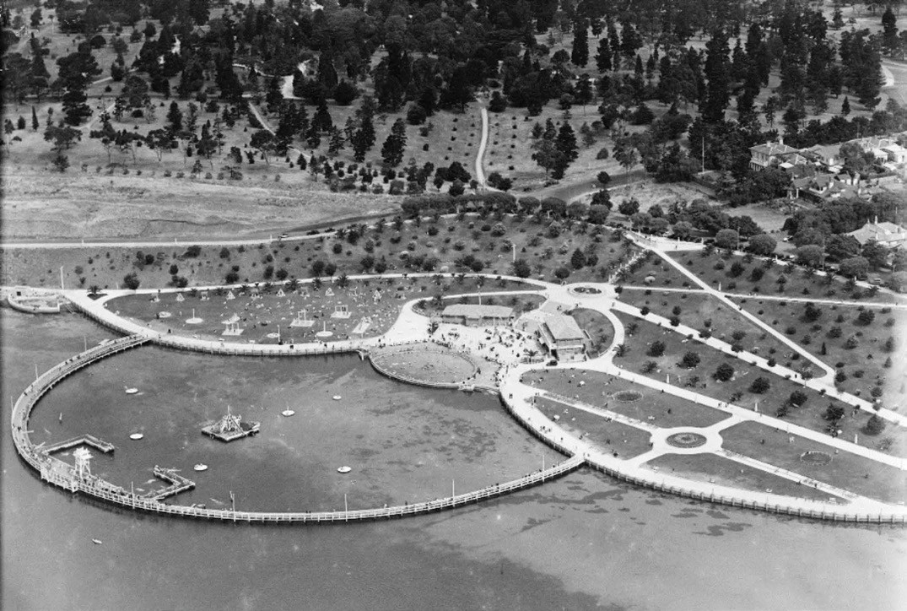
Figure 9.78: C. Pratt, Eastern Beach, 1939. Source: accession H91.160/710, State Library of Victoria.

WORK ON THE HARE PLANS
The first part of Hare’s winning design was put into effect in 1928 when work began on land reclamation, the laying out of paths, and the commencement of construction of the dressing sheds from original drawings dated August 1927. This work was carried out as part of the State Labour Government s unemployment relief programme and provided work for 150 unemployed.588 It included a children s pool on the foreshore, and a fountain decorated with models of tortoises and storks (Figure 9.79). These decorative objects had been imported
by James Wilson, owner of St. Albans Stud at St. Albans Park (Theme 4). They were later relocated to the Geelong Botanic Gardens. The red brick dressing shed (completed in 1931) stood beyond the fountain and, beyond that, there was a landscaped playground area, encircled by a promenade walkway. The old sea baths still stretched out to the bay,
a lingering reminder of the earlier mariner recreational practices. By March 1934, Eastern Beach had become a popular tourist destination, attracting large crowds.589

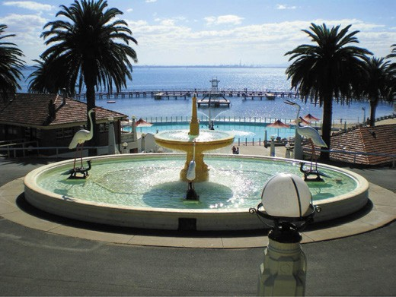
Figure 9.79: Fountain with tortoises & storks, kiosk and dressing pavilion (middle ground) & children s pool & two-tiered semi-circular promenade (background), 2006. Source: City of
Greater Geelong.

COMPLETION OF THE PEOPLE’S PLAYGROUND
It was decided in 1937 to construct a new open sea pool as a monument to Geelong s pioneers in the approaching centenary year of 1938.590 Plans were drawn up by Ian McDonald, City Engineer, which involved a circular design
complementary to the circular design of the earlier foreshore improvements.591 The broad concept was similar to the beach facilities at Durban, South Africa, illustrated in the News of the Week almost 20 years earlier, and quite possibly visited by McDonald himself enroute or returning from the war.
Closer to home however, McDonald declared in 1933 that the enclosed swimming and bathing pool was something on the lines as is contemplated for Mordialloc. 592 The cost of the Middle Brighton Baths, Melbourne, erected in 1936, had informed the design and cost of the Eastern Beach sea bath.593

IAN D. MCDONALD & THE EASTERN BEACH PROJECT
The new Council Engineer and Surveyor received his early education at the Gordon Institute of Technology before joining the Army.594 On his return from three years active service with the AIF, he became attached in 1919 to the Albury Sewerage Authority as a draughtsman.595 After passing the Municipal Engineer’s Certificate, McDonald joined the Albury Council
in 1925 as an assistant engineer.596 A year later he was appointed engineer to the Shire of Marong (Bendigo area) and, in 1927, was appointed engineer and building surveyor at Geelong West.597
Tenders were called in early June 1938 for a shark-proof bathing enclosure and a children s pool. On 21 June 1938,
C.E. Patience of Melbourne was accepted as the successful tenderer. McDonald s plans included an outer promenade deck and a lower or swimmer s deck.598 There was a central island with chutes and other sports gear and a children s pool built of stone and concrete.
At the end of March 1939, the new Eastern Beach Sea Baths were opened by Geelong s Mayor, Cr. S. Jacobs. An article in the local press titled Eastern Beach now the People s Playground reported the Mayor s comments. He described the new pool as unique in character and unsurpassed
in the world .599 The entire improvement scheme had cost
£40,000.600
The completed Eastern Beach Bathing Complex
(Figures 9.78-79) comprised the two-tiered timber promenade with bronze shark-proofing bars, the stone and concrete children s pool, the concrete sea wall, the brick changing pavilions, and surrounding landscaping elements including steps, fountain, lawns and plantings.

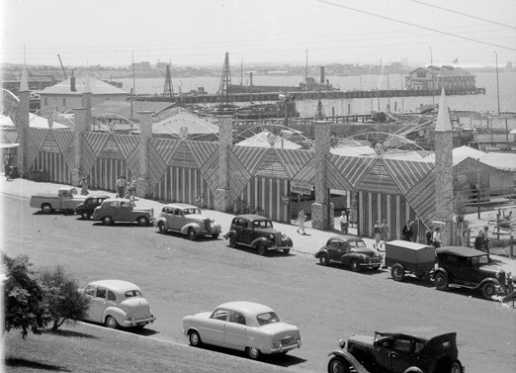

Figure 9.80: Rose Stereograph Co., Hy-Lite Amusement Park, Eastern Beach, c.1920-54. Source: accession 32492/8653, State Library of Victoria.

The pool was the last major enclosed sea bathing facility to be built on Port Phillip Bay and, as such, represented the culmination of that built form.601 It was the only structure that survived of the sea baths that once dominated the Bay s foreshore.

HY-LITE AMUSEMENT PARK
In 1953, Emile Verfurth established an amusement park known as Hy-Lite Park on the foreshore at the western end of Eastern Beach (Figure 9.80). The site was leased by the City of Geelong.602 In December 1956, he staged a grand opening for the summer season.603 From the mid-20th century, Verfurth s carnival included a range of amusement rides including Merry Go Round, Rotar, Gee Wiz, Octypus, Horsey Plane, Ferris Wheel, Aeroplane and Train Rides and Crazy Golf. 604 Hy-Lite Park appears to have been Geelong s equivalent to the Luna Parks in Melbourne and Sydney. It closed in 1985 and the site was cleared, allowing for the construction of a Victorian Sailing School on the eastern portion of the land (see earlier subsection).605

OTHER CITY FORESHORE BEACHES
Other foreshore beaches on Corio Bay were established in Geelong s suburbs in the early 20th century. The establishment of the St. Helen s Park Improvement Committee in 1927 was charged with improvements to
the foreshore in addition to the beautification of the park.606 The works included the construction of dressing sheds, and concrete walls and ramps, while the Geelong Harbor Trust erected a new jetty607 (Figure 9.81). Other major works were carried out from 1964, including new retaining walls and jetty improvements.

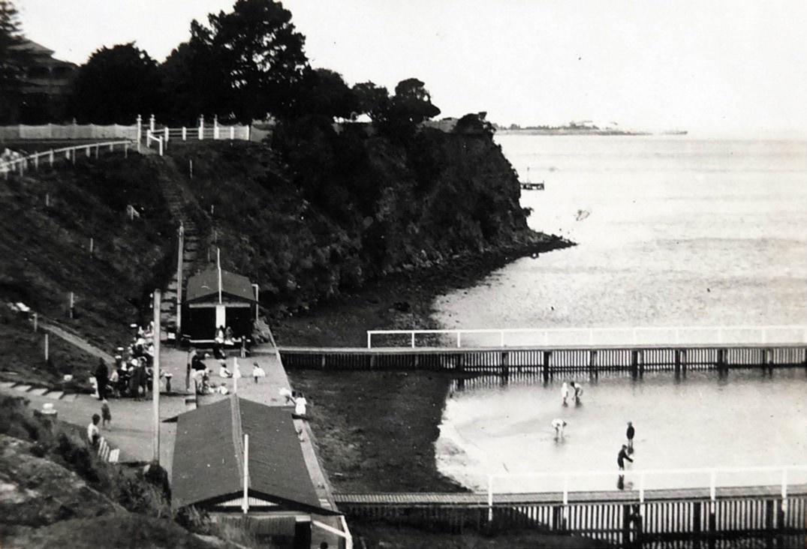
Figure 9.81: St. Helen s Beach, 3 January 1931. Source: T.T. Holmes collection, Authentic Heritage Services Pty Ltd.

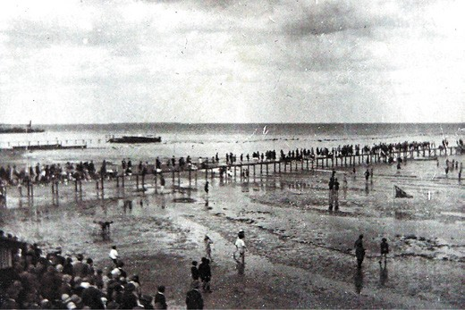
Figure 9.82: Opening day, Rippleside Beach, 3 December 1927. Source: T.T. Holmes collection, Authentic Heritage Services Pty Ltd.
At Rippleside, the Drumcondra and Western Beach
Improvement Association was influential in having beach improvements made there in the 1920s. The Association had engaged the local architect, Norman Schefferle, to prepare an improvements scheme that included two dressing sheds, a promenade space between the buildings, and a pier with a kiosk as the shore end that may be used as a band stand. 608
The pier, dressing sheds and promenade had been completed for the official opening on 3 December 1927 when over 1000 beach-goers flocked to the new swimming facilities609 (Figure 9.82).

PUBLIC SWIMMING POOLS
A popular alternative to sea bathing from the 1960s in Greater Geelong was the construction of public swimming pools. The first was at Lara when the Abe and Jean McClelland Pool (Figure 9.83) was officially opened on 9 March 1963 in Forest Road South, at the site of the water bore in Forest Road South first used in 1887. The pool was named after Abe and Jean McClelland who had donated the land.610 As the first municipal pool in the Geelong region, it attracted huge popularity with 13,500 visitors in the first six weeks of its opening.611

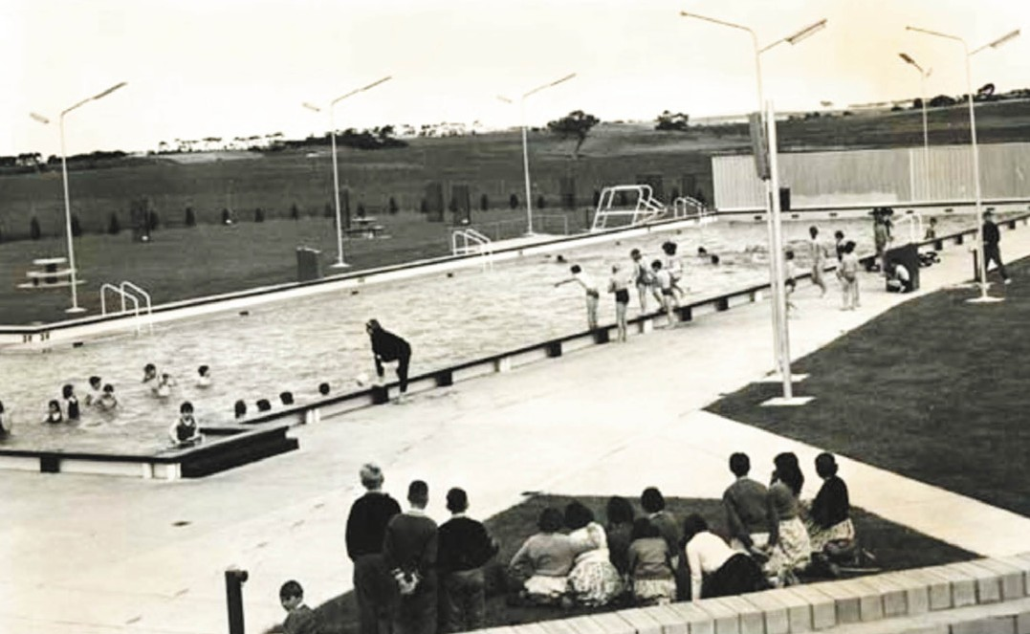

Figure 9.83: McClelland Memorial Swimming Pool, Lara, c.1963. Source: GRS 1263/06/213, Geelong Heritage Centre collection.

The McClelland pool was followed by the Norlane Olympic Pool that opened in November 1965 (after substantial upgrades in later years the pool complex has been replaced with the Northern Art, Creation and Community Health and Wellbeing Hub in recent times).612 In Geelong at Kardinia Park, the Geelong and District Memorial Swimming Centre was opened in December 1967 (a memorial those who served and fought in World Wars One and Two). In addition to being a public facility, the Geelong and District Memorial Swimming Centre became the home of the Geelong Swimming Club that had formed on 7 December 1882 as the Geelong Western Swimming Club.613
Other public pools established included the South Barwon Swimming Centre, Reynolds Road, Belmont (1980); Splashdown Leisure Centre, Coppards Road, Moolap (1987); and the Bellarine Aquatic and Sport Centre, Shell Road, Ocean Grove (2008).614

TOURIST PLEASURE GROUNDS
Bayside and coastal tourist pleasure grounds were established in Greater Geelong from the 1870s and particularly in the late 19th and early 20th centuries. This was a consequence of the mineral springs at Clifton Springs and sea bathing at Portarlington, Indented Head and St.
Leonards, and the coastal towns of Barwon Heads and Ocean Grove offering opportunities to practice personal hygiene, with the submerging into sea water and the inhaling of fresh sea air being promoted as therapies for a range of ills.615 Equally importantly, the picturesque marine settings in close proximity to Melbourne enhanced the quest for personal enjoyment.

THE DELL, CLIFTON SPRINGS
The rediscovery of a number of mineral springs by Thomas Bates on his 500 acre farming property called Clifton fronting Corio Bay in 1870 prompted the beginning of a resort called The Dell on the foreshore of what was to
become known as Clifton Springs.616 Bates had had the water tested by Dr Bleasdale and Mr Panton whose favourable conclusions were that the effect will become valuable as
an article of commerce. 617 Two crocks were placed in the

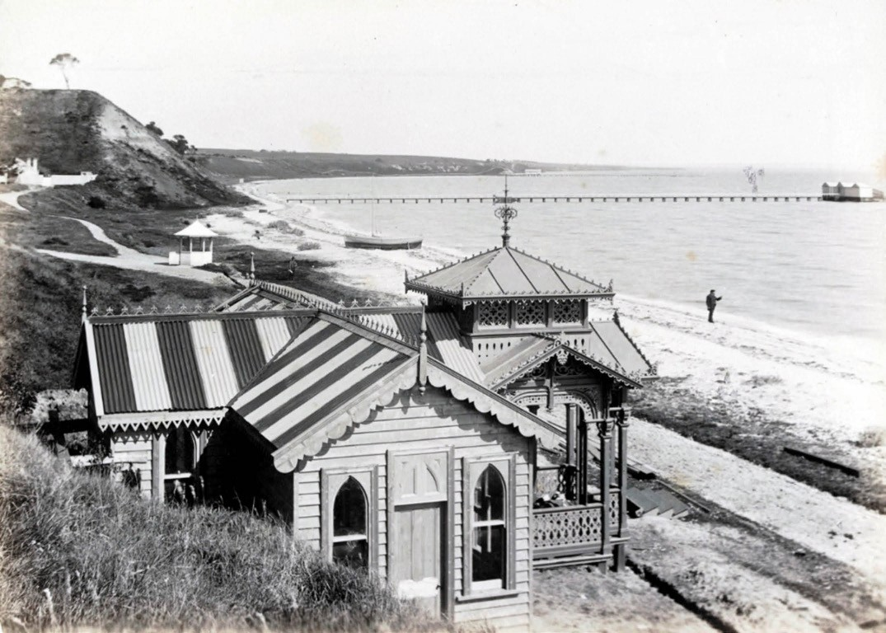
Figure 9.84: The Dell, Clifton Springs, 1891. Source: accession H42199/6, State Library of Victoria.

ground to provide clear water for the twelve springs.618 With his neighbour, S.L. Allnutt, Bates opened the springs at one of the prettiest [locations] in Port Phillip Bay, being at the bottom of the cliffs which form a small amphitheatre on the Geelong outer harbour. 619
In 1875, Bates capitalised on the success of the mineral springs and sold 80 acres of his property as the South Clifton Estate.620 Commercial bottling of the springs soon began and by 1880 over 5000 bottles were sold each year.621 This had necessitated the construction of a bottling house roadway along the beach and a manager s cottage.622 In 1887, the Geelong Advertiser reported on impending improvements (that were subsequently carried out) (Figure 9.84):
This very delightful and healthful resort is bidding well for public patronage, and we are glad to note that the public interest in it is daily increasing. … We also had to chronicle the visit of lordship the Bishop of Melbourne, who spoke in terms of praise both of the wares and the charming surroundings, confidently predicant a great future for Clifton as a health and recreation resort.
On Wednesday evening the directors of the company held a meeting, when many matters of importance were discussed and resolutions passed authorising the manager to carry out the several works. These will embrace completion of the carriage drive and grand promenade –which is nearly three quarters of a mile in length, and fifteen feet in width – construction of tennis lawn, erection of a sea bathing house, purchase of a boat, erection of swings, etc. … Fair progress is being made with the building, which is to be a handsome and
commodious structure –an ornament to the shores of the bay and a credit to the whole district. It will be a striking object- viewed from the passing steamers.623
Also striking was the construction of a new substantial Clifton Springs Hotel in 1888624 (Figure 9.85). Costing over £5,000
it was nearly ready for occupation in August 1888.625 It had been designed by the Ballarat architect, Charles Douglas Figgis626 and featured steeply-pitched hipped roofs, a squat tower at one end, widow s walk capturing views of the bay surmounting the main roof and return cast iron balconies and

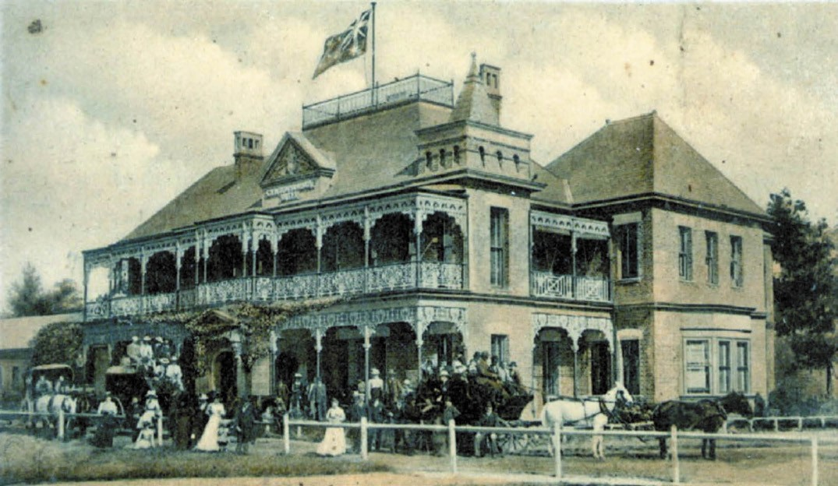
Figure 9.85: Clifton Springs Hotel, n.d. [c.1900]. Source: Photo 1690, Bellarine Historical Society.

verandahs. Grand in scale, it presented a plain but pleasing front to Corio Bay. 627
A new jetty was built in 1890.628 Today, only archaeological remains survive of this once thriving marine resort.

OTHER BAYSIDE PLEASURE GROUNDS
Along the northern foreshore of Port Phillip Bay on the Bellarine Peninsula, camping grounds were established at Indented Head, Portarlington and St. Leonards. From 1873 when a narrow foreshore strip of land was permanently reserved for public purposes,629 these and neighbouring reserves have been popular bayside pleasure grounds for visitors and holiday-makers ever since.

BATMAN PARK, INDENTED HEAD⁶³⁰
In 1925, a Committee of Management was officially appointed to manage, protect and care for the narrow coastal reserve at Indented Head (Figure 9.86). The area was named Batman Park in honour of the explorer,
John Batman, who established an encampment nearby the Park in 1835. The Committee s inaugural chairman was Stephen Wrathall (1859-1940), who was responsible for directing much of the initial tree planting in the reserve. The transformation of the reserve began in the 1920s and continued throughout the 20th century, and in addition to
many major tree planting programs, was the construction of fencing and amenities blocks, and installation of water tanks, and the provision other infrastructure for the benefit of picnickers and campers. Batman Park benefited from the patronage of neighbouring local landholders who served on the Committee. Some of the members who contributed much to the development of the Park included
W.R. Anderson Junior, the Committee s longest-serving Secretary, W.H. Warden, Albert Johnson, Ernest Taylor and Herbert Lewis. The latter was a local farmer and he was responsible for the construction of a number of the boat sheds that lined the Batman Park foreshore from c.1924-25. It was also in 1925 when the paddle steamer [P.S.] Ozone and Dominion hulks were wrecked in Half Moon Bay to form a breakwater (Figure 9.87) (see also Theme 3).
Between the 1920s and 1950s, Batman Park became popular as a camping ground for beach recreation and fishing. From 1925, the Foreshore Committee prepared Regulations for
the care, management and use of the Park. It was especially from the 1950s when Batman Park played host to hundreds of campers each year. The need for improved infrastructure and amenities constantly taxed the Foreshore Committee, as did deputations from campers and disputes between campers.
In 1954, camp sites were more formally laid out along similar lines as those at the Torquay Caravan Park.

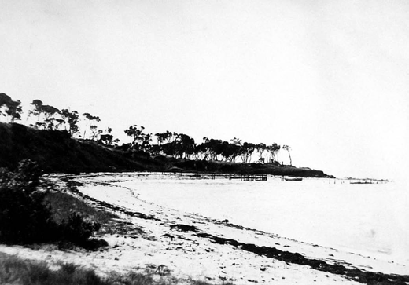
Figure 9.86: Western end of Batman Park foreshore, c.1934. Source:
T.T. Holmes collection, Authentic Heritage Services Pty Ltd.

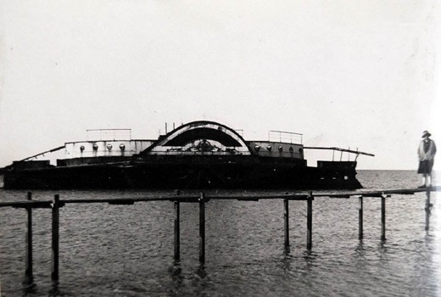
Figure 9.87: Ozone wreck, Half Moon Bay off Batman Park foreshore, c.1934. Source: T.T. Holmes collection, Authentic Heritage Services Pty Ltd.

Local landholders regularly sort permission to erect boat sheds on the foreshore. Some of the earliest built in the 1930s were constructed of in-situ reinforced concrete by the local farmer, Herbert Lewis, while others were built of
lightweight materials including cement sheet and corrugated steel. Norman Wray built one of the lightweight sheds in c.1937-38 (Figure 9.88) and it became a popular holiday destination for his family. From 1973 until 1986, it was also the location for Wray s boat hire business.
With changing Government policy and increased pressures on the foreshore as a consequence of a growing number of private boat sheds, and particularly as a result of a public meeting in 1950, no further private sheds on new sites were permitted from this time. Recommendations from the public meeting gained momentum, including the construction
of a Boat Club and Hall building that could accommodate

a number of boat compartments as well as serve as the clubhouse of the Boat Club and a community hub. Designed by L.H. Vernon and Associates, architects, the Indented Head Boat Club and Hall building was completed in 1954 and it
was claimed to be a model for other bayside locations in Port Phillip Bay. A slipway near the Boat Shed was constructed in 1965.
Other important developments occurred in the 1950s and 1960s. The southern reserve area of the Park had been named Wrathall Reserve and in 1954 a brick shelter was constructed to the memory of the Committee’s first Chairman, Stephen Wrathall. Additional tree planting occurred. The northern-most portion of Batman Park was named Anderson Reserve in 1954, in honour of the Committee s long-serving Secretary, the late W.R. Anderson. In 1963, a portion of the reserve was named the Taylor Reserve after E.J. Taylor, Chairman of the Committee between 1955 and 1962. A brick Administration Building was constructed in 1965. Two years later in 1967, a tennis court was laid out on the west side of Wrathall Reserve, adjacent to the Batman-Flinders Memorial. The idea of a tennis court had first been proposed as early as 1928.
Further developments continued in the 1970s. In 1971, the long awaiting public boat ramp was built at Wrathall Reserve and it was followed by the adjacent timber foot jetty in 1973. A circular car park was also constructed in connection with the boat ramp. In 1978, having been formed as a breakaway organisation to the Boat Club in c.1966-67, the Indented Head Yacht Club building was officially opened.

PORTARLINGTON CARAVAN PARK⁶³¹
Camping at Portarlington began on the central foreshore area adjacent to the jetty, possibly as early as 1873 when the land was permanently reserved. Flanking Harding Street, the eastern reserve was named Eastern Park (Figure 9.89) and the western parcel of land, Western Park. Regulations for the management of Eastern Park (including camping) were gazetted in 1908 but it was not until 1928 when similar
regulations came into force at Western Park. Today, Western Park is known as Henderson Reserve (with the south-eastern corner named S.S. Nash Reserve), while the north-west corner of Eastern Park is known as the W.G. Little Reserve. During the summer holiday season, these reserves became a sea of canvas following the hardship of World War One.
With the growing popularity of Portarlington for camping and the increasing use of caravans, the Portarlington Seaside Resort Caravan Park was established on the former Racecourse Reserve (gazetted in 1886) by the 1950s (Figure 9.90). Located on the west side of Sproat Street on the foreshore, and now known as the Bellarine Holiday Park,
the camping reserve consists of a long lineal arrangement

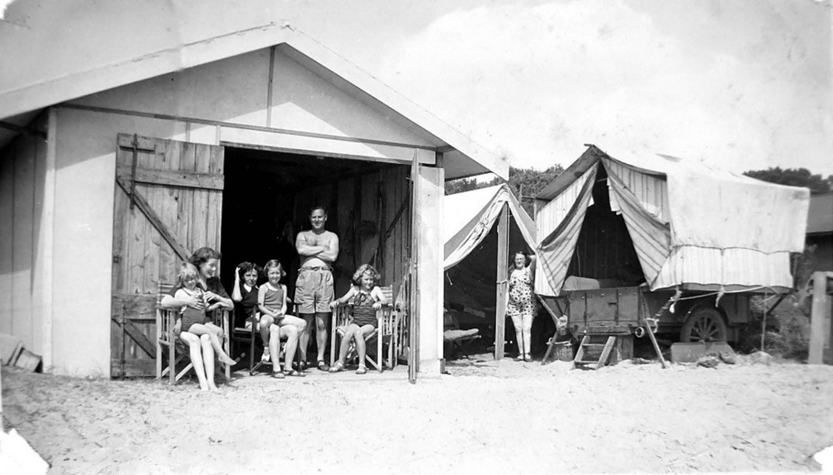
Figure 9.88: Wray family at their boat shed, early 1940s. Source: Lesley Helmer.

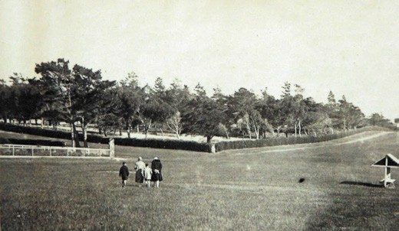
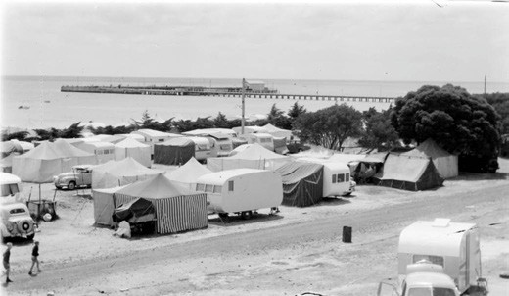

Figure 9.89: North-east corner of Eastern Park, Portarlington, c.1930. Source: T.T. Holmes collection, Authentic Heritage Services Pty Ltd.
Figure 9.90: Rose Stereograph Co., Portarlington Caravan Park, c.1954. Source: accession H32492/7013, State Library of Victoria.

of drives and avenues providing access to a large number of camp sites. The reserve is especially characterised by
long rows of cypress trees. No early boat sheds and bathing boxes are situated on the adjoining foreshore of the Caravan Park.

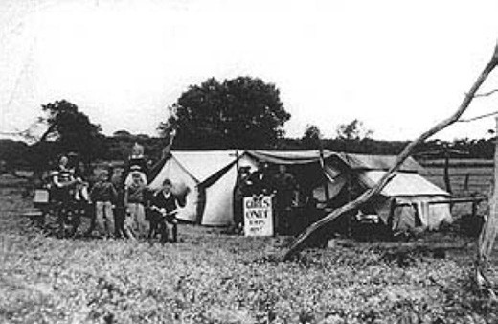
Figure 9.91: Camping at St. Leonard s, c.1934.
Source: image 2316, Bellarine Historical Society collection.

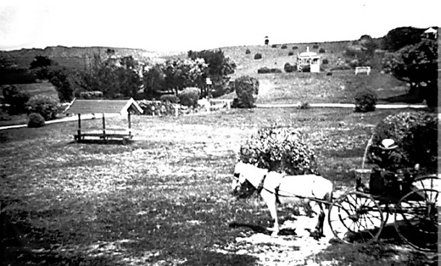

Figure 9.92: Covered seats, shelters, paths and exotic plantings, Barwon Heads Park, c.1895. Source: Martin Klabbers collection, photo quint 103.

ST. LEONARDS CARAVAN PARK⁶³²
The open foreshore reserve to the south of St. Leonards pier became a favourite picnic site for residents and visitors in the 19th century. In 1920, with talk that the reserve was to be leased to private individuals, the St. Leonards Progress Association was formed and an application was made for the area to be reserved for public purposes. With permission granted, the Progress Association took responsibility for erecting fencing and seats. These seats featured gabled shelters. Swings were erected and amenities provided, screened by rudimentary fencing. Influential in gaining permission for the reservation of the reserve was Cr. Edward Harvey. It was officially opened on 9 June 1921 when it was named Harvey Park, in honour of Cr. Harvey s mother, Kate. A Committee of Management was formed and from this time a significant tree planting program of Cypresses and Pines commenced. Foreshore land to the north of the St. Leonards pier was later added to the camping reserve (Figure 9.91).
Today, Harvey Park and the reserved land to the north of the

pier continue to be used as public recreation areas, but no longer for camping. A number of the exotic trees planted in the early 20th century survive. A large sealed car park has also been constructed in the northern reserve area.

COASTAL PLEASURE GROUNDS
A move towards the permanent reservation of coastal land came in 1875 when a deputation of Geelong citizens met with the Minister for Lands, Mr Casey, about providing an Ocean Park Reserve from Point Lonsdale to Point Roadknight.
This eventuated in the gazettal of the coastal land in 1876 to ensure that the popular places at Breamlea, Barwon Heads and Ocean Grove were protected from spoliation, through timber felling and speculative
land selection.633

BARWON HEADS
The Barwon Heads Park first came under the management of the Barwon Heads Park Trust in 1889 when the first trustees were appointed. All staunch: Councillors William Higgins, Peter Smyth and Robert Fuller (representing the Shire of South Barwon), and Messrs. G.M. Hitchcock, James Strong and William Humble (representing the residents of the general public). Humble became the inaugural chairman and H.R. Richardson was appointed to the trust as honorary secretary.634 All except Richardson were members of the
temperance movement. In addition to the Barwon Heads Park (named by the trust in 1892), the trust was responsible for
the care and management of Sea Banks Reserve (the narrow foreshore area west of the Bluff taking in Thirteenth Beach to Breamlea (from 1889) and the Frank Ellis reserve north of the Barwon Heads Park (from 1891 and unofficially named Frank Ellis reserve in more recent times after the former caretaker of the park and operator of a former kiosk in the early 1970s).635 In 1995, the Barwon Heads Park fell under a new committee of management known as the Barwon Coast Committee of Management which took in the foreshore areas at Barwon Heads and Grove Ocean (and environs).636
The original Barwon Heads Trust undertook substantial building developments in the Park from 1889. Timber steps, covered seats , a rotunda and fencing were built637 (Figure 9.92). Amenity blocks –or closet accommodation as they were first called by the Trust – were first built in 1899 although a visit by S.C. Brittingham, Christ Architect of the Public Works Department in 1916 quipped that the
sanitary accommodation is so primitive as to be almost worse than none at all. 638 Numerous amenity blocks were built throughout the 20th and early 21st centuries.
It was the beautification of the park that attracted picnickers as much as the picturesque marine setting. Work began in 1890 when trees were planted between the coffee palace

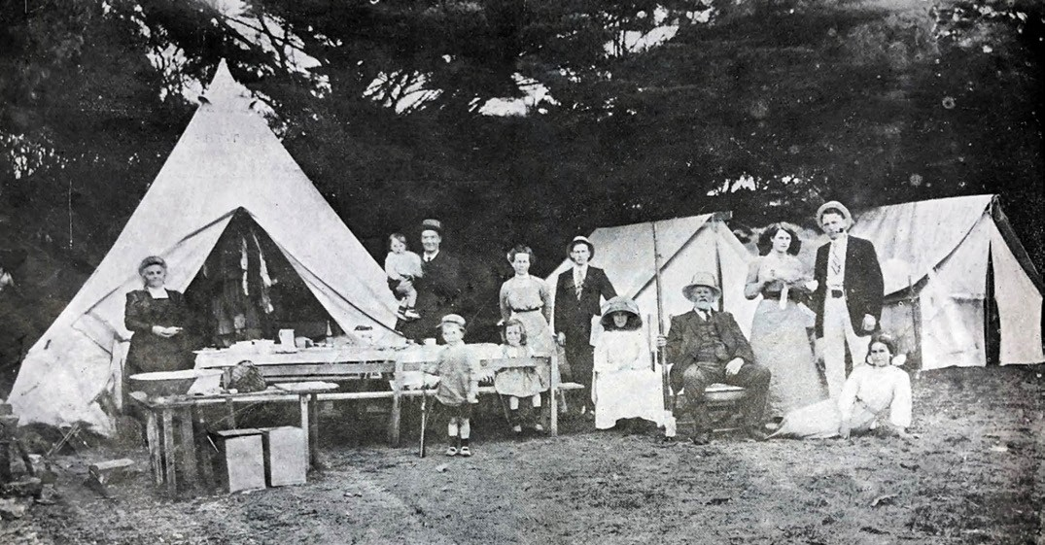
Figure 9.93: Webbe, Camping at Barwon Heads, 1912. Source: News of the Week, 7 March 1912, GRS 2121/3, Geelong Heritage Centre collection.

and the Bluff. A further 375 trees from the Macedon State Forest were planted soon after, under the instigation and guidance of Mrs Annie Hitchcock, wife of George Hitchcock, trustee, whose holiday house was nearby (Theme 8). Further landscaping was carried out in the ensuing years to create more of an English park beside the sea. In 1902, George Hitchcock made application to the Minister of Lands for
a grant of maritime [sic] and plants from the Melbourne Botanical Gardens, for the purpose of covering the sandy patches on the Park and Bluff. W.R. Guilfoyle, director of the botanical gardens, was instructed to select the best suited for the purpose. 639 By the 1980s, there was a concerted effort to return the ecology of the park to its more indigenous setting and over 4,500 native trees were planted and most exotics removed.640
The popularity of the Barwon Heads Park for recreation and camping from the late 19th century has continued to the present day. In May 1889, the Geelong Advertiser gave one of the earliest insights on the activities enjoyed in the park and surrounds at this time:
The attractions for all classes of the community are varied, and it is expected that when they become generally known the improving watering place will speedily induce many persons, at all periods of the year … Sportsmen, with gun and dog, have an excellent field for the enjoyment for the river … Anglers have an extensive choice for the lakes, river and seas … The sandy beach, well strewn at every
tide with all descriptions of shells and seaweed, offers great attractions for families, whole there is just sufficient rock climbing on the coast to make the residence there a source of enjoyment rather than toil, and even this may be avoided by a gentle walk along the footpaths over the public reserve.641
The first official record of camping in the park was in 1910. Applications were made to the caretaker who fixed the location of the site for the tents642 (Figure 9.93).
Caravans first appeared in 1937 when the R.A.C.V. Caravan club occupied the reserved.643 This became the popular mode of holiday accommodation (Figure 9.94) and by the 1960s the number of campers in the park had swelled to 10,000.644 ‘Electrified’ sites began unofficially in 1957 when a Mr Ball was given permission as a medical expedient to run a lead from Ranger’s Office to his camp for electric light and power for fan. 645 Between 1960 and 1983, hundreds of sites were provided with power outlets.646 From 1990, cabins were introduced as more permanent accommodation.647
The provision of refreshments for picnickers and campers at the park began in 1889-90 when a boiler house was erected so that hot water could be sold to picnickers during the summer months.648 A kiosk was erected by 1901, the first
of three to be erected. The third was designed by Laird and Buchan architects at the entrance to the park in 1927 (Figure 9.95). It was later relocated to another site within the reserve

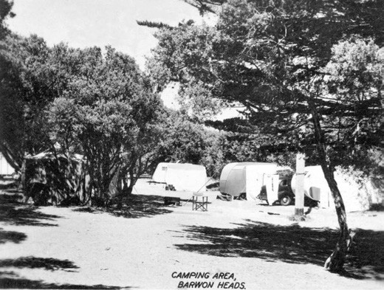
Figure 9.94: Caravans in the Barwon Heads Park, c.1950. Source: Martin Klabbers collection, photo Duthie 02.

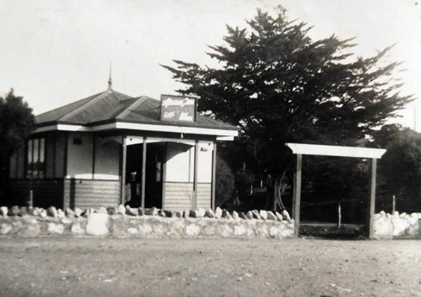
Figure 9.95: Barwon Heads Kiosk at park entrance, 23 August 1931. Source: T.T. Holmes collection, Authentic Heritage Services Pty Ltd.

before being sold to Lawrence Diggins and removed to 55 Hitchcock Avenue where it was integrated into the front of the dwelling, St. Ann Lodge. 649
Boat sheds had first been erected on the river foreshore at Barwon Heads in the 1880s.650 In 1905, the Geelong Harbor Trust commissioned the Geelong architects, Seeley and King to provide a standard design for new boat houses.651 These structures measured 30 feet by 12 feet and these long
gabled timber structures featured front porches.652 They lined the Barwon River foreshore (Figure 9.96) until their forced removal in 1936.

OCEAN GROVE RESERVES AND CARAVAN PARK
The establishment of a Foreshore Committee to manage the coastal reserves on the east side of the Barwon River had an uncertain beginning and was much later the its neighbour at Barwon Heads. From the 1890s, the Ocean Grove
Improvement Association maintained the foreshore for visitors. The association tried to formalise its control of the Foreshore on the West to junction with the Harbor Trust thence East to a point 300 yards from Tuckfield Street.’653 The Bellarine Shire Council accepted the request and in 1928 a Committee was appointed but in 1929 it was replaced with a new Committee
of Management. The inaugural members were: William Bulgin Wilton, J.P. (Shire representative), Gordon Bussell, John Howard, Charles Camp, John Heggie, James Thwaites, John Davies, Frederick Otway and James Blackwell. Bussell
was appointed the committee’s first chairman; Howard vice chairman; Heggie as treasure and Camp as secretary. 654
The extent of foreshore land under the control of the Committee increased over the years. In 1935, in addition to the small stretch of land between Sweetman Parade and Tuckfield Street, and The Esplanade and the coastline, The Spit was brought under its control. In 1938, riverside land
previously held by the Geelong Harbor Trust was transferred to the committee while in 1959 Buckley Park was taken up by the committee followed by the coastal strip to Point Lonsdale in 1980.655
An early task of the committee from 1929 was the construction of additional bathing boxes on the Ocean side foreshore area.656 Men s and women s dressing pavilions were erected near the main beach in 1941 while a rotunda was built in the riverside reserve not far from the Barwon Heads Bridge.657 Amenity blocks were needed by the late 1930s and in 1941 new cement buildings were built. Others followed in the ensuing years.
A major development was the transformation of the sand hill above the main surf beach from 1956-57, with bulldozing operations carried out by John Wynn senior. He was a
past committee member and the operator of the adjacent Wynndean Caravan Park from 1945 that continues to the present day.658 At the main beach, the removed sand hills were replaced with marram grass, a road and car parks.659
A kiosk was first built on the main surf beach in 1931 by Allan Ray.660 Other kiosks followed. A clubhouse was built in 1954 for the Ocean Grove Surf Life Saving Club. Designed by Alex Chomley, the building was located within the sand dunes above the high watermark near the Surf Beach Road.661 It was replaced by a new restaurant and surf club complex in 1994. This building was removed and the current building was completed in June 2019.662

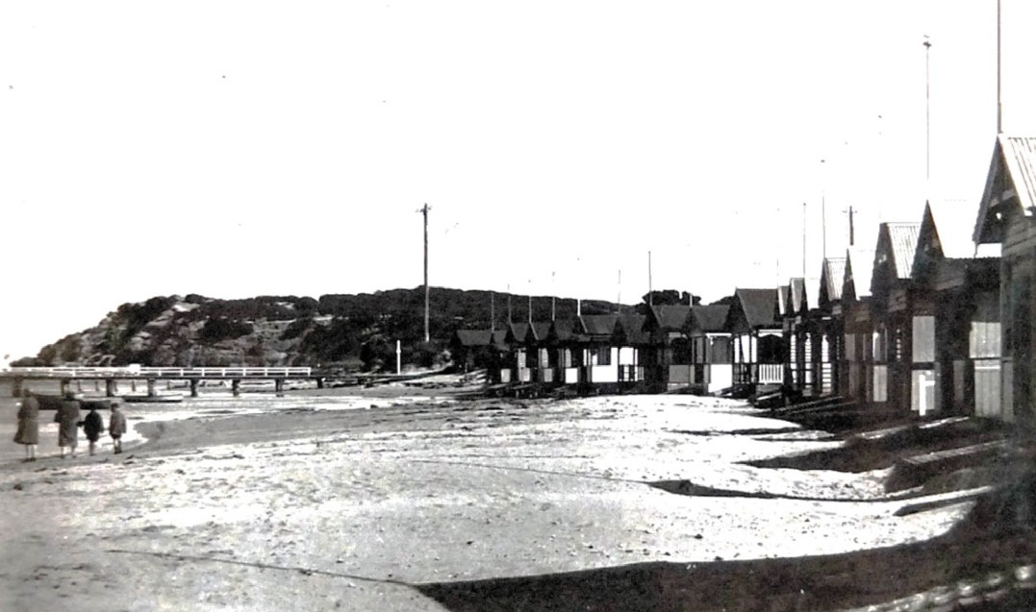
Figure 9.96: Boat sheds on Barwon River foreshore, Barwon Heads, 23 August 1931. Source: T.T. Holmes collection, Authentic Heritage Services Pty Ltd.

From the 1880s, the Ocean Grove foreshore has been the location of picnicking and short stay camping.663
The haphazard nature of camping at Ocean Grove continued well after the formation of the Foreshore Committee in 1929, its Camping Regulations rarely being enforced.664 The initial lack of sanitation and fresh water was managed by the 14 tent camps in 1933 but with the camp sites escalating to 250 in 1939 brought about the construction of amenities and enforcement of regulations.665 Tents and prefabricated units were the popular modes of camping immediately after World War Two (Figure 9.97).
A more formalised caravan park known as Riverview Family Park was established in the late 1960s and early 1970s, with powered sites available from 1969.666 Less formal camping along the Spit reserves continued, but caravans replaced several tents. While a highly popular tourist location, environmental concerns brought about a reduction on the camping reserves on the Spit. In 1978-79, the reserve on the ocean side was closed and in 1981 the area between the car park near the Barwon Heads Bridge and Toilet Block No. 8 on the ocean side was closed.667

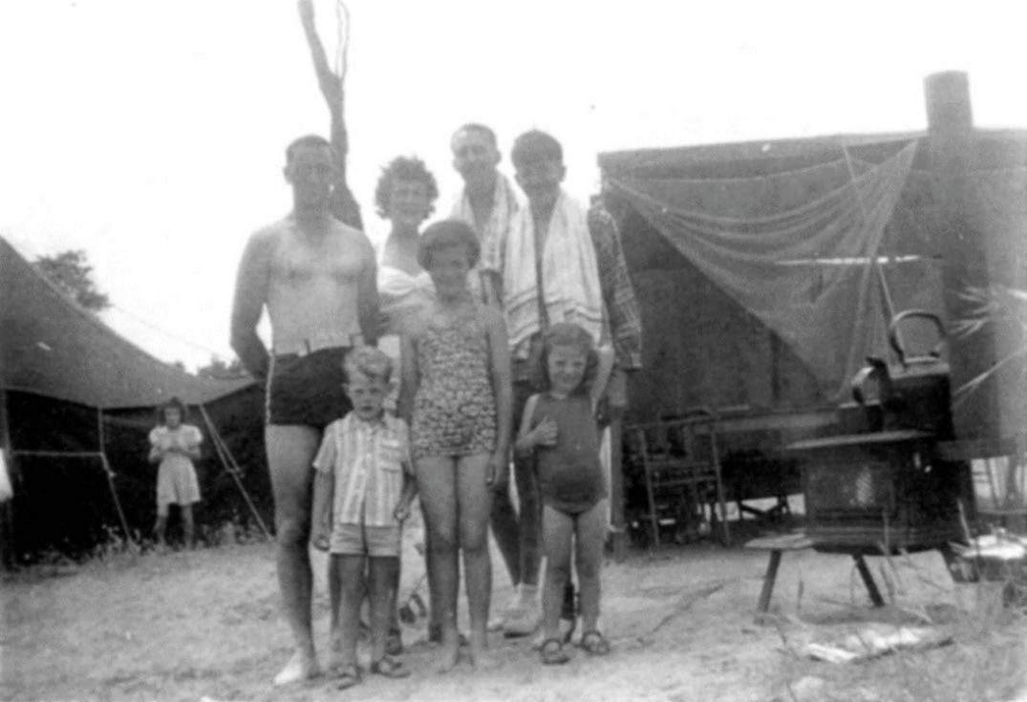
Figure 9.97: Swaine family camp, with an army tent and three-sided prefabricated unit in the background, c.1953. Source: David Rowe, Authentic Heritage Services Pty Ltd Pty Ltd.

BREAMLEA CARAVAN PARK
Earliest known as Picnic Point, the treed sand hills of Breamlea were popular for beach recreation, camping and fishing from the 19th century. Before the mid 1930s, the area was under the control of the Crown Lands Department.668
In 1959, the Breamlea Foreshore and Reserve Committee was appointed669 and it carried on the work of managing the camping sites and the establishment of the Caravan Park at Breamlea today. In 1985, there were 150 camp sites at the Caravan Park.670

CLEVER AND CREATIVE GEELONG
Throughout its history, Greater Geelong has enjoyed creativity across many fields. It began with the Wadawurrung in the making of their weapons, baskets, domestic objects and procurement and shaping of stone for various implements and uses. From the time of European colonisation, creativity was especially manifested in the art of architecture (see earlier Themes). Yet, there are tangible legacies of other forms of visual arts, performing arts and literature that highlight the City s creative history. This is further emphasized in the numerous shows, exhibitions and promotions of the creations of locals and the distinctiveness of the local built and natural environment. It is most
especially highlighted in the City s contribution to science and technology since the 19th century.

ARCHITECTURE AND INTERIOR DESIGN
Greater Geelong s built heritage provides the most explicit and wide-ranging appreciation of its creativity. From the 1840s until the present day, several local architects have helped shaped local architectural discourse. The work and contributions to the community of several of these architects have been explored in earlier themes (and especially Theme 6). In the 1850s, the hotel work was particularly distinctive through its creative expression of classical elements in brickwork such as the Golden Age Hotel at 2 Gheringhap Street (Figure 9.98) and the Argyle Hotel at 30 Aberdeen Street (see Theme 5). It was also in the 1850s, 1860s and early 1870s when Joseph Shaw was responsible for a number of two storey mansion houses (including Allington at 274 Latrobe Terrace, Newtown, in 1872 –Theme 8) and a number of solid, Gothic commissions, mainly for the Catholic Church (including wings of the Sisters of Mercy Convent at Newtown and St. Augustine s Orphanage, Newtown in 1857 –Theme 8).
T.A. Kelly also enjoyed the patronage of the Catholic Church, designing Geelong s more sophisticated Gothic Revival architecture for St. Mary s Basilica, Yarra Street (1856-1930)
–traditionally Geelong s most well-known and prominent built landmark –and the north wing and chapel of the Sisters of Mercy Convent, Newtown (Theme 8).
The period between the late 1860s and early 1880s witnessed the idiosyncratic designs of the Scottish architects, Davidson and Henderson, who cleverly reinterpreted the ten volumes of French Romanesque and Mediaeval architecture in Viollet-le- Duc s Dictionnaire raisonn de l architecture fran aise du XIe au XVIe si cle (published between 1854 and 1893). Examples included Eythorne , 35 Aphrasia Street, Newtown (Theme 6), Belleville , 350 Ryrie Street, Geelong (Theme 8) and Geelong College, Newtown (Theme 8). A later work of Alexander Davidson that celebrated his use of cast iron in addition his eclectic design approach with Henderson included George Fairbairn s Lara House (now Pirra Homestead), Windermere Road, Lara, designed in 1880671 (Figure 9.99). Also striking (but absent of the generous application of cast iron) was Davidson s design of Thomas Dann s residence at the south- east corner of Fenwick and Little Malop Streets in 1889 (now demolished) (Figure 9.100).672 Numerous dwellings and commercial buildings reflect the architecture Joseph Watts,
J.S. Jackson and A.J. Derrick, the domestic work being locally noteworthy for its polychrome brickwork and cast iron decoration, including George Martin s residence, Czergym , Fitzroy Street, Geelong (Watts and Jackson) (Theme 5) and the picturesque Carpenter Gothic churches such as the Newington and Ocean Grove Methodist Churches by Derrick (Theme 8) (Figure 9.101).

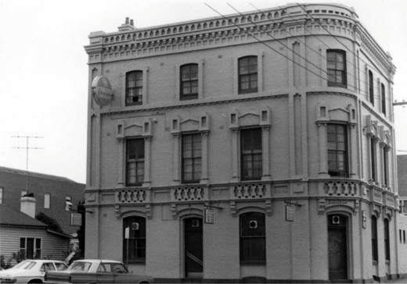
Figure 9.98: J.T. Collins, Golden Age Hotel (now The Deck), 2 Gheringhap Street, 25 September 1976. Source: accession H96.210/436, State Library of Victoria.

The 1890s and 1910s heralded the rise of the distinctive Free style work of Tombs and Durran in a range of commercial buildings including Macrow s Furniture Arcade, Ryrie Street, and Solomon s Buildings, Market Square, the domed towers being a hallmark of the practice (Theme 5). Also noteworthy were their robust dwelling designs including Dr Croker s residence, corner of Yarra and Ryrie Streets (Theme 8). The period also heralded the rise of two architects that were to have a substantial influence on the architectural output in Victoria in different ways. This was George King and Percy Everett who had worked together in the practice of Seeley King and Everett (a landmark example of Everett s early work being the Federation Free style design of Sailors Rest, corner Moorabool Street and Eastern Beach Road –theme 4). From 1909, George King was instrumental in establishing the first School of Architecture in Victoria at the Gordon Technical College,673 and Percy Everett s role as Chief Architect of the Public Works Department provided a distinctive Modernist image for public and civic design across Victoria as celebrated in his vertically-emphasised Textile College at the Gordon Technical College built between 1947 and 1951674 (Figure 9.189).
It was also from the 1890s and throughout much of the 20th century when the practice of Laird and Barlow (later Laird and Buchan, Buchan Laird and Buchan and eventually
the Buchan Group) became Geelong s most enduring and successful architectural practice. Much of their early work met the conservative sentiments of their clients and yet was distinctive. One example was the Federation styled Ardoch at 298 Latrobe Terrace, Newtown, in 1909-10675 (Figure 9.102). The later work from the 1930s –such as the

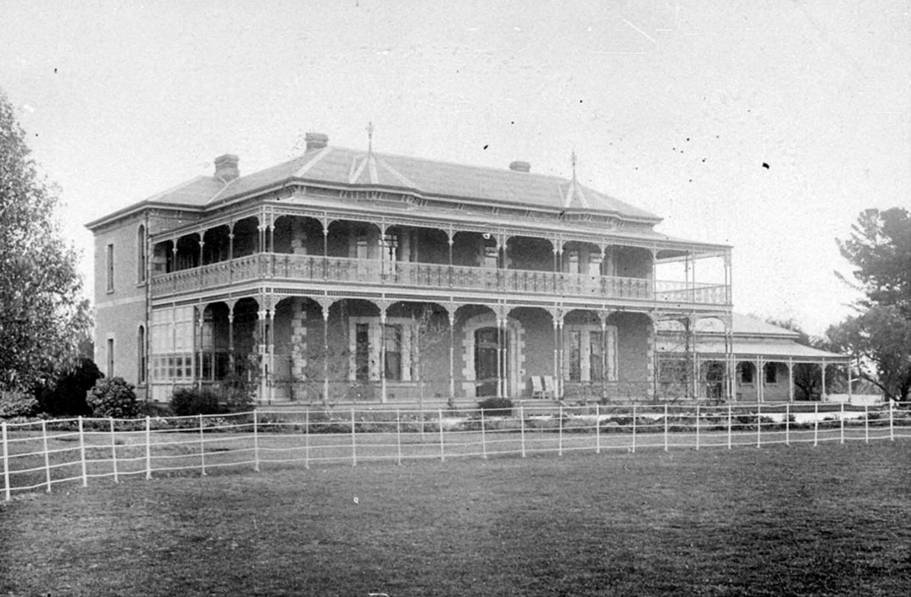
Figure 9.99: Lara House (Pirra Homestead), Lara, n.d. [c.1900]. Source: file FL1667258, State Library NSW.

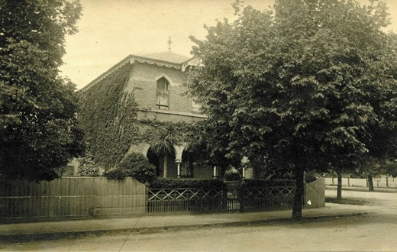
Figure 9.100: Thomas Dann residence, south-east corner Fenwick & Lt Malop Streets, n.d. [c.1934]. Source: Susie Zada.

International styled dwelling at 22 Roebuck Street built in 1935 (Figure 6.68-69) and the Pilkington Glass factory on the Melbourne Road built in 1936 (Figure 5.52) –both the work of Ewen Laird, was when the practice first reached its most architecturally innovative heights.

There were other architects that also made important contributions to Geelong throughout the early 20th century. They included the revivalist Bungalows of the 1920s by Fred Purnell and Harold Trigg (Purnell also designed a number of retail outlets). Another architect who worked in a traditionalist mode for this period was I.G. Anderson. Responsible for
the designs of several dwellings in the 1920s, it was his interwar Renaissance Revival civic and commercial work in the Geelong West Town Hall (1926) and the CML building, Malop Street (1925-26) where his most striking contribution to Greater Geelong s architecture was to be found. Particular creative and eclectic flair came from the work of Norman Schefferle in his commercial, hotel and other work. His design range was considerable, from the more conservative interwar Spanish Revival styled Crawcour Emporium in Pakington Street in 1926 (Theme 5); to his Moderne styled Carlton Hotel in Malop Street in 1937 (Theme 5); and his Modern Functionalist styled Point Henry Signal Station in 1939 (Theme 3).
From the 1930s until the 1960s, the local architect, Cyril Kelly was responsible for several Catholic commissions. Designed

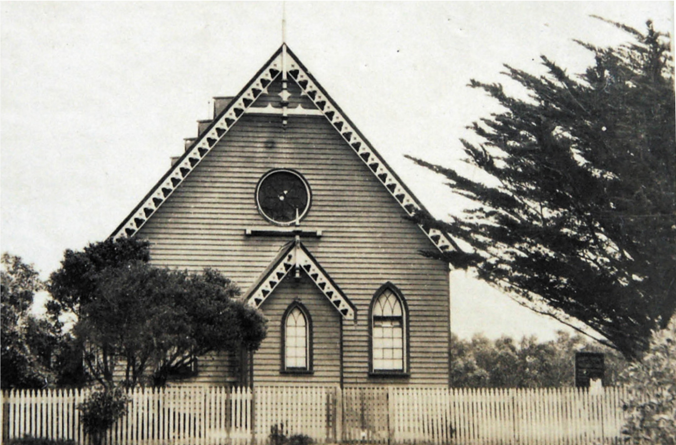
Figure 9.101: Ocean Grove Methodist Church, 1931. Source: T.T. Holmes collection, Authentic Heritage Services Pty Ltd.

in revivalist modes, Kelly s creativity was made manifest in school designs (St. Robert s, Newtown and St. Margaret s East Geelong in the 1940s) (Theme 8) and church architecture (including Holy Spirit, Manifold Heights in a Spanish Mission Revival mode in 1932, and St. Margaret s, East Geelong, in 1963, in a conservative postwar Gothic mode) (Theme 8).
However, Kelly s most noteworthy work was his design of St. Augustine s Orphanage, Highton in a neo-Romanesque mode in 1936 (Theme 8).
The results of George King s architecture program at the Gordon Technical College was especially apparent in the early and mid-20th centuries. In Victorian Modern in 1947, Robin Boyd declared that the great majority of King s students became leading Moderns. 676 However, save for Percy Everett, Ewen Laird, Tom Buchan and Max Deans, the architectural output of King s prodigy - including
Arthur Baldwinson, John and Tom Freeman, Keith Mackay, John Mockridge, Tom O Mahony, Hugh Pedditt and Ronald
J. Wilson677 –was to be realised outside Geelong. One exception was Angarrak Flats , 238 Latrobe Terrace, Geelong West (Figure 9.103), designed in 1935 by A.C. Leith and

Harold Bartlett (the latter a former student of the Gordon).
The shallow-pitched gabled form with widely projecting eaves celebrated European Modernist precedents and the minimum flat’ concept followed Harold Bartlett’s return from extensive experience overseas.678
Two prolific and revered 20th century designers trained and born in Geelong were husband and wife, Oswald
Noel Coulson (1905-1989) and Isabel Fiddes (1904-1998).679 Their practice encompassed architecture, landscape, interior design, soft furnishing and hardware design, the origins
for their unique aesthetic emanating from George King and the Gordon Technical College in the early 1920s. Coulson combined King s classical and conservative design training through an interpretation of traditional forms for modern interiors. 680 Of his early interior and other design work, Catriona Quinn has stated the following:
Gifted and versatile, Coulson was able to earn a living [in the early 1930s] making linocuts, designing
artwork, making and selling Christmas cards and, most significantly, exhibiting and selling his own hand woven fabrics. Given King s interest in textile manufacturing,

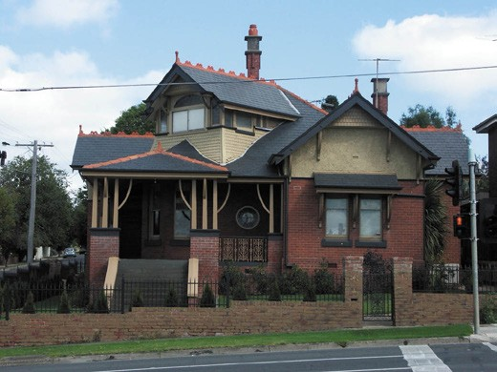
Figure 9.102: Ardoch , 298 Latrobe Terrace, Newtown, 2011. Source: David Rowe.

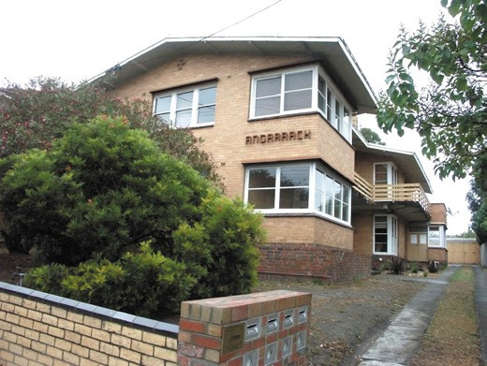
Figure 9.103: Angarrack , 238 Latrobe Terrace, Geelong West, 2009. Source: David Rowe.

Coulson probably learnt to weave at the Gordon Institute. His father built him a loom, a replica of an Elizabeth model and he produced placemats, curtain lengths
and dressmaking fabrics. His biggest client was Lillian Wightman of Le Louvre [Melbourne].681
Isabel Fiddes took up a position with the Semco textile firm at Blackrock near Sandringham following her education at the Gordon Technical College. There, she became head designer. Following her marriage to O.N. Coulson 1935, she became deeply involved with the family interior design business. 682 While the productive and creative lives of
Coulson and Fiddes were largely outside Geelong, Coulson s early work was locally produced and the family business did

take up local commissions.683 The unique contribution to Australian 20th century Modernism in the interior design work of Coulson and Fiddes, with Coulson being one of the busiest and best-known architects in Melbourne, have only recently been recognised.684
Another alumni of the Gordon Technical College whose design output was to be far reaching was Grant Stanley Featherston (1922-1995).685 Born in Geelong to pharmacist, Stanley Ernest Featherston and Eva May Catterall, Grant Featherston attended a private state school in Newtown and subsequently the Geelong Junior Technical School
in Moorabool Street.686 He then studied architecture at the Gordon Institute of Technology in the 1930s.687 At just
sixteen he was apprenticed as a draftsman to the Melbourne glass manufacturer, Oliver-Davey Glass Co. Pty Ltd. and
in 1939 he joined the lighting firm of Newton and Gray Pty Ltd.688 It was there where Featherston s exposure to modern design emanated.689 During World War Two, Featherstone served as a draftsman in the Cartography Company at Army Headquarters in Melbourne and he was later promoted
to corporal. He subsequently studied modernist design (following the ideology of the Bauhaus movement) while employed for the Commonwealth Aircraft Corporation at Fisherman s Bend. 690 After the war, Featherston married Claire Skinner, an artist, and they established a glass jewelry business.691 The success of the jewelry enterprise financed the development of Featherston s designs of furniture which featured in Robin Boyd s House of Tomorrow exhibition at the Royal Exhibition Buildings, Melbourne, in 1949692 (Figure 9.104). There his furniture had been especially designed and made for the purpose. Lightness and strength are the outstanding characteristics of these comfortable modern chairs. 693 This was the beginning of an extraordinary
design output, with Featherston s greatest achievement being the provision of a new order of furniture design that was ‘mobile, flexible, honest and efficiently and easily produced. 694

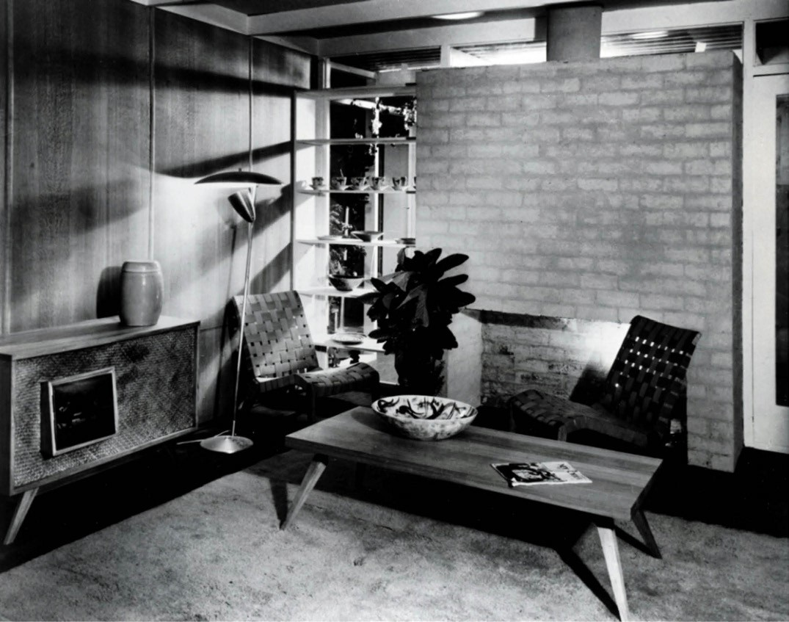
Figure 9.104: W. Sievers, House of Tomorrow exhibition featuring Featherston s furniture designs, 1949. Source: accession H2001.40/264, State Library of Victoria.

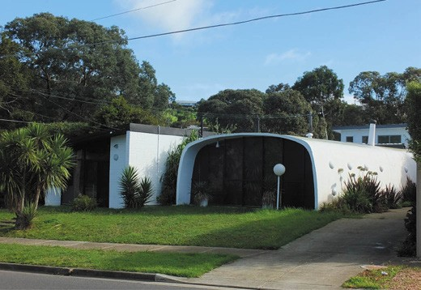
Figure 9.105: Dwelling, 2 Ardlui Drive, Newtown, 2017. Source: David Rowe.
One of the more unique architectural designs of the late 20th century came in 1969 when a modular habitat was built at 2 Ardlui Drive, Newtown, by Monolithic Structures695 (Figure 9.105). Built of brick and Conite, the dwelling was striking for its inverted U-section form, thin shell structure,
Stegbar metal framed glazed wall ends, concrete link and a more conservative, skillion roofed brick wing.696 The
idiosyncratic design reflected the influence of the Australian Modular Association (formed in Canberra in 1959)697 and the latest developments in monolithic construction. The cosmic overtones especially celebrated the major human feat of 1969: the moon landing.

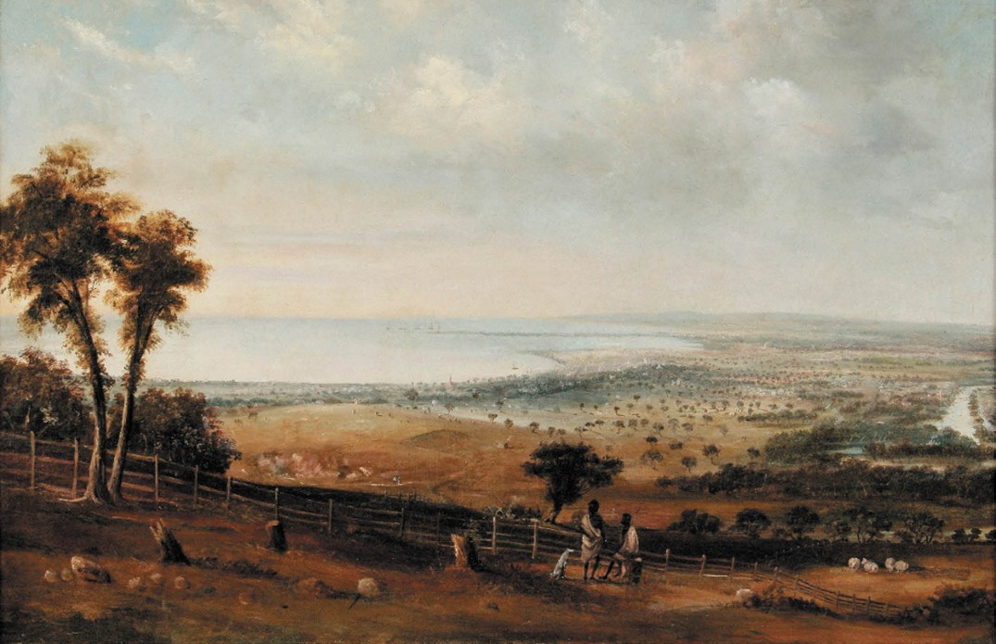
Figure 9.106: William Duke, Geelong from Mr Hiatt s, Barrabool Hills , 1851, accession 1943.2, Geelong Gallery. Gift of the family of Edward John Bechervaise, in his memory, 1943.

FINE ARTS

GEELONG ART GALLERY

TOWARDS THE FORMATION OF THE ART GALLERY
In the early years following European colonisation, Geelong was devoid of a notable number of practicing professional artists and a local gallery. Yet, the landscape artwork of both professional and amateur artists from the 1850s was revealing in giving an understanding through European eyes of the Greater Geelong environment, displacement of the Wadawurrung peoples and urban progress since 1836. One of the earliest Europeans to provide an enduring illustration of Geelong was Samuel Mossman, an accomplished author more than an artist. His Geelong in 1840 lithograph (Figure 6.08, see Theme 6) gave a narrative of the times. Viewed from the elevated ground in the location of today s Pevensey Crescent, the scene depicted two schooners in Corio Bay
–the Devonshire –being the vessel Mossman arrived on (reflecting British arrival); the buildings scattered mainly along Corio Street reflected the beginnings of British transformation
of the waste lands (see Theme 2) while most poignant was the central placement of the Wadawurrung and their mia mia (adjoining a European cottage) in the foreground. While Mossman held ill- informed British attitudes towards the Traditional Owners (a cultural norm for the period), he was indebted to Dan Dan Nook and other Wadawurrung men who saved him from drowning at the time he prepared his Geelong scene (see Theme 2).
Geelong s next artist, William Duke (c.1815-1853) was also to portray a similar narrative but from a different location.
Having arrived in Geelong in 1851 he became popular by the productions of his pencil and the urbanity of his deportment. 698 Duke had been a scene-painter for the
theatre in Tasmania and had also spent time in Sydney.699 Known best for his marine paintings, more unusual was his depiction of Geelong from John Highett s Highton House (later Montpellier), Highton (Themes 4 & 6) in 1851. Entitled Geelong from Mr Hiatt s, Barrabool Hills , the view east showed natural and contrived landscapes, European development, the ships docked at Point Henry,
and symbolically, the Wadawurrung in the foreground (Figure 9.106)

More enduring and influential on the early development of the fine arts in Geelong was the Belgian-born Edmund
Sasse (1819-1904) who came in 1853 to take up a position as drawing master under the national system for the Geelong district and commenced his own private studio and classes (Theme 8).700 His arrival in Geelong was noted in the Geelong Advertiser and Intelligencer for his depiction of the opening of the Geelong to Melbourne Railway, the piece engraved in wood by the local, C.E. Winston (Figure 3.95):
We have just received a wood engraving from Messrs Winston and Sass [sic.] –vividly depicting the ceremony of the Inauguration of the Geelong railway. The artist, a gentleman who has recently arrived, has, undoubtedly, showed wonderful talent in sketching such a concourse of people: but, as the same time, we must not forget complimenting our young engraver, whose name is well known to most residents, and we trust they will both receive the reward they so deservedly merit.701
Sasse s contribution to artistic education in Geelong was to endure throughout the remainder of the 19th century as a pioneer of the Geelong Technological School in 1869, Ladies School of Design from 1873, teacher of the School of Art at his Myers Street studio from 1886, and as one of the first instructors at the Gordon Technical College between 1888 and 1896 (Theme 8).
By 1866-67, six photographic firms were resident in Geelong, being listed as photographic artists.702 They were Wilmot and Key, Moorabool Street; Lionel Ormerod, Moorabool Street; Joseph Turner, Moorabool Street, Edward de Balk, Moorabool Street; Richard Taylor, Ryrie Street; and Robert Barnes, Union Street.703 In 1882- 83, just three professional artists were practicing in Geelong: A.B. Pierce, Malop street;
H.S. Pincott, Moorabool Street; and Alexander Webb, Little Ryrie Street.704
The year 1888 marked the arrival of James Whitley Sayer (1847-1914) as manager of the London Chartered Bank, Malop Street.705 He too was to play an influential role in artistic life in Geelong and particularly the formation of the Geelong Art Gallery. Born in Cornwell, England, he appears to have arrived in Melbourne with his parents and siblings in 1857.706 By 1880, Sayer had combined his employment as
a bank manager with his interest and skill as an artist with a notable piece on the retirement of the manager of the Collins Street, bank, Mr Brett. The Argus declared it the daintiest and most delicate piece of illuminated writing and ornament that has yet been executed in this colony. 707
Sayer was instrumental in the formation of one of the first fine arts organisations in Geelong, the Gordon College Sketching Club and Art Society in 1891.708 He was its inaugural president, the vice president being E.M. Blake,

architect of New Zealand.709 The main aim of the Society was the encouragement of local art.710 It held its first exhibition
in the following year, 1892, which included 93 pictures, with landscape paintings from nature predominating. They included the work of Miss Chassie Cole, a most industrial disciple of art, whose taste for the poetic is betrayed by the appropriate titles of her pictures, with coastal scenery study by Miss Joyce, seascapes by Miss Ewart while Mr A. Ramage hung a creditable exhibit of Lynch s Anakie Gorge.711 E.M. Blake exhibited the only work in the architectural class comprising six water colour drawings while Sayers exquisite skill was displayed in his canvas of the scenery below Buckley s Falls.712
Yet, it was Sayer’s influence on the newly-formed Geelong Progress League in 1895 where the formation of a Geelong Art Gallery was especially manifested.713 Although he advanced the need for an art gallery, and while heavily involved in the Gordon College Sketching Club and Art Society, he deprecated the proposal to locate the art gallery at the Gordon College, which was not favorably situated for the purpose, being too much out of the ordinary course of traffic.’ Sayer ‘strongly urged’ for a central location for the anticipated establishment.714

GEELONG ART GALLERY INITIAL YEARS
On 20 January 1896 at a meeting convened by Mayor H.F.
Richardson in the mayor s room at the Geelong Town Hall, the Geelong Art Gallery was inaugurated. The first gallery committee was appointed with Sayer elected honorary treasurer with Neil Campbell honorary secretary. At the suggestion of Edward Vidler, other committee members to be appointed were J.H. Grey and S. Austin, Ms. L.C., H.F.
Richardson, Henry Sargeant, F.G. Belcher, Charles Shannon, Joshua Vines, G.M. Hitchcock, G.F.Link, M. Conran, H. Speed and H.W. Day.715 The first temporary gallery was at the Geelong Town Hall, the formal opening being carried out by the Mayor on 31 May 1900. According to the Geelong Advertiser:
There are 68 pictures hung from the walls and screens, the latter being set apart chiefly for water colors, and the hall was arranged for the opening function in correct gallery style. The old school of art is represented by
paintings, amongst the latter being several natural gallery favorites, on the right-hand side of the entrance, whilst the modern, or impressionist mode of treatment is kept to itself on the left.716
A number of paintings had been provided on loan from the National Gallery of Victoria, while the more recent style of artistic treatment was represented by works of the Victorian

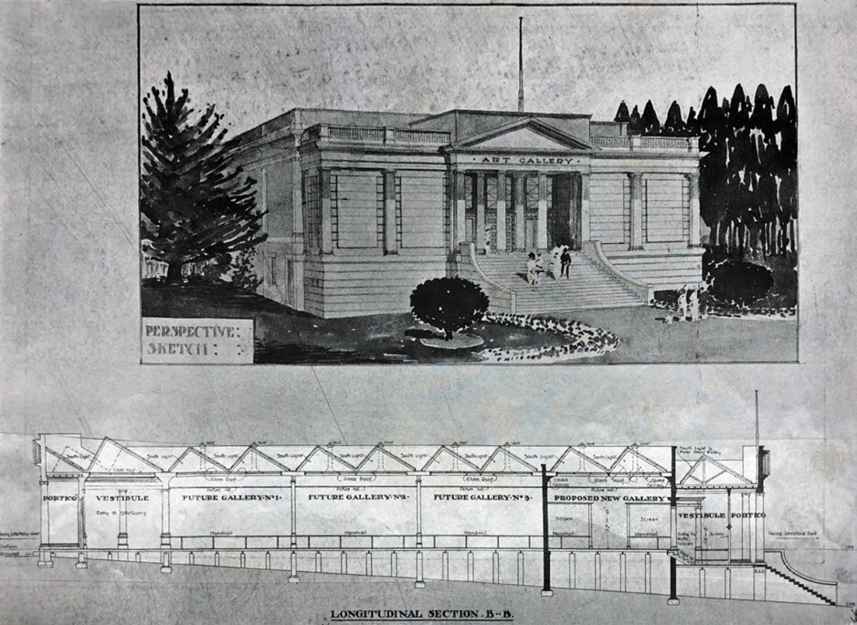
Figure 9.107: Laird & Buchan, Perspective Sketch and Longitudinal Section B-B , proposed Geelong Art Gallery, 1913. Source: News of the Week, 17 April 1913, p.16, GRS 2121/3, Geelong Heritage Centre collection.

Artist Association, the most notable being Frederick McCubbin s A Bush Burial (which continues to be part of the Geelong Art Gallery collection), together with contributions
of J. Mather, Walter Withers, and Arthur Streeton.717 Local artists also featured, including the works of Misses Laura Davey and Helen Peters (see following subsection).
Altogether, the exhibition was curated with assistance from Walter Withers and J. Hal Waugh.718
In December 1900, the gallery relocated to the Geelong Free Library in Moorabool Street (Theme 8) where it remained for the next 15 years.719

PURPOSE-BUILT ART GALLERY
A permanent, dedicated location for the gallery did not eventuate until a design competition was held in 1913 for a new building overlooking Johnstone Park west of the Geelong Town Hall. The outcome of the competition was controversial. Six designs were submitted by five
local architects. Thomas Slevin was initially offered the contract but his proposal (with architects fees) exceeded the stipulated works cost of £3000.720 The Art Gallery Committee subsequently awarded the contract to Laird and Buchan architects who had submitted two designs and who
guaranteed the works would not exceed £3000.721 The design prepared in the architects’ own office was for a round gallery, the alternative and accepted submission was prepared on the firm’s behalf by a Melbourne architect.722
The proposed art gallery featured in News of the Week in April 1913 (Figure 9.107). The symmetrically composed, rendered masonry Federation Classical Revival style building was
to be the first of the early 20th century Classically-derived buildings to front onto Johnstone Park and reflect Geelong’s version of the City Beautiful (see earlier subsection). To feature a central portico supported by columns of the Ionic order to conform with the architecture of the City Hall , the plan allowed for a central vestibule flanked by departments

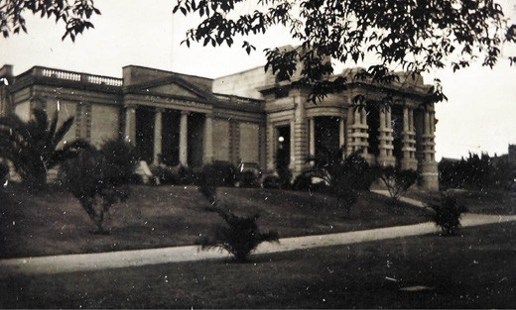
Figure 9.108: Geelong Art Gallery (left) and Peace Memorial (right), c.1930. Source: T.T. Holmes collection, AHS.

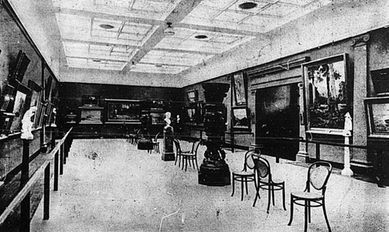
Figure 9.109: The Main Room , Geelong Art Gallery, 1915. Source: News of the Week, 27 November 1915, p.15, GRS 2121, Geelong Heritage Centre collection.

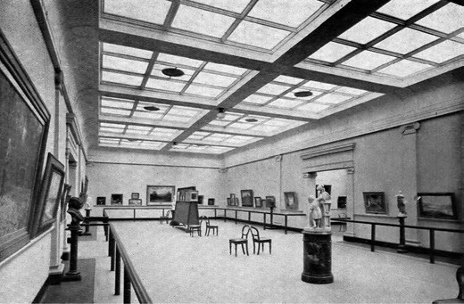

Figure 9.110: Douglas Gallery, Geelong Art Gallery, c.1950, Collection Geelong Gallery, accession 1943.2.

for etchings, water colours and an office, beyond which was to be the main gallery for oils to extend across the building and divided into three pavilions by open-arched screens.
The plan made provision for future additions. Of particular interest in the design was the overhead lighting enabled by the construction of a saw tooth roof, then in vogue at the Sydney Gallery and used in most of the nearby woolstores, several of which having been designed by the architects, Laird and Buchan (Theme 5).723
Built as a memorial to the inaugural Gallery committee member, pioneer draper and Grand Old Man of Geelong , George Michaelmore Hitchcock (who had died in 1912 - see Theme 5), the Art Gallery building (Figures 9.108- 109) was opened by the Chief Secretary, the Hon. J. Murray, M.L.A., on 24 May 1915, in the presence of 300-400 subscribers.724 In 1928, the Henry P. Douglas Gallery was opened725 (Figure 9.110) and it was followed by the H.F. Richardson Gallery in
1937.726 A year later in 1938, the main entrance was relocated to Little Malop Street with the opening of the J.H. McPhillimy Gallery by Prime Minister Joseph Lyons.727 Further expansion and alterations to the Little Malop Street frontage occurred in the 1950s and in 1971.728

SOME WORKS OF LOCAL ARTISTS
In addition to some of the works by Geelong s earliest European artists including William Duke and Edmund Sasse in the collection of over 6,000 works in the Geelong Art Gallery are other drawings and paintings that express the local evolution in artistic talent and the development
of art.729 Noteworthy in volume were the pencil drawings and watercolours of the local medical practitioner, Dr Charles Mackin. His contribution to Geelong went beyond the medical papers he published in the 1850s (Theme 8).
He depicted numerous local scenes, including Industrial School, Geelong in 1867 (Figure 9.111), where he was Medical Officer (the Industrial School having opened in the old Immigration Depot in 1865 at the corner of Ryrie and Swanston Streets (Theme 8).

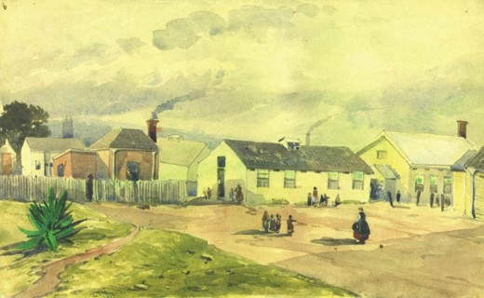
Figure 9.111: Charles Mackin, Industrial School, Geelong , 1867, watercolour, Collection Geelong Gallery. Purchased 1940, accession 1940.1.

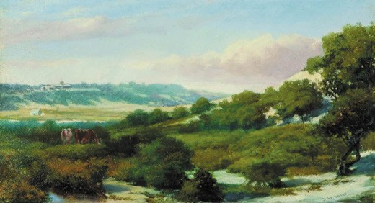
Figure 9.112: James W. Sayer, Ocean Grove , 1902, oil on board, Collection Geelong Gallery. Gift of A.G. Moore, 1991, accession 1991.25.

Works by J.W. Sayer provided a lasting legacy not only of his work but of his contribution to the establishment of the art gallery. An example was Ocean Grove in 1902730 (Figure 9.112). It revealed Sayer s exploration of impressionist techniques in landscape painting.
Other impressionist works by local artists in the Geelong Gallery include those of Miss Helen Peters (1866-1923). Born in Geelong, Peters matriculated from the Flinders School
in 1883 before becoming a student of art under Edmund Sasse at the Gordon Technical College.731 At the Gordon Technical College exhibition of drawings and paintings in 1887, Peters was awarded a special gold medal by William Humble (Themes 3 & 5) for ‘the greatest number of first prizes (six)’ and a special prize for flower painting from nature.732
In 1899 while still studying at the Gordon, she passed with much credit a First Aid St. John Ambulance Association course with an excellent paper and this was followed up with a pass with much credit in a nursing class a few months later. 733 She later studied at the National Gallery and then at the Melbourne Art School under Tudor St. George Tucker.734 An exhibition of 60 of her works was opened at the Gordon

Technical College in 1903, the Geelong Advertiser reporting on her notoriety as a well-known artist:
The artist s reputation is a broad one, and Miss Peters is probably better known in the art centres of Melbourne and Sydney that she is in Geelong. A letter from Mr.
F. McCubbin, the eminent artist, was read by Mr. J.W. Sayer when opening the exhibition, and it paid very high compliment to the lady s ability with the brush. Mr. McCubbin s letter said that Geelong should be proud of Miss Peters work when it was considered that she was
one of the foremost lady artists in Australia. He concluded by congratulating her upon her industry and position in the art world … In a collection of works from the brush of one artist, it is pleasing to find a very large proportion of life studies, in which the utmost skill is displayed, and life work seems to be Miss Peters forte, although land and seascapes, and studies from nature, are numerous and of high order of merit.735
One piece on display was The breadwinners of 1903 (Figure 9.113) which the Geelong Advertiser described as two happy little newsboys at the door of a mansion to dispose of their papers. 736 The subjects were cousins, Victor and Norman Selby, Herald newspaper boys in Geelong and students at Flinders State School who lived near Peters in Elizabeth (now Roebuck) Street, Newtown. The breadwinners was painted for the Victorian Artists Society exhibition in July 1903 and was purchased by the Geelong Art Gallery in 1906.737
The quality and respect for Peters work extended beyond Australia. In 1911, two of her pictures were accepted by the Royal Academy of Arts in London.738
Another highly accomplished and internationally renowned artist was Ludwig Hirschfeld-Mack (1893- 1965)
(Figure 9.114). Born in Frankfort, Germany, his parents soon recognised his inquisitive nature and he was encouraged
to explore it through art.739 Following attendance at the Muster gymnasium in Frankfort, he studied painting and crafts at the Debschitz Schule, Munich, as well as attending lectures in art history at the University of Munich. He served in the German Army during World War One (having been conscripted) and as a lieutenant he won the Iron Cross. It was after the War when Hirschfield-Mack was exposed
to colour theory and printmaking. He enrolled at the
world- renowned Weimar Bauhaus in 1919 and studied under Johannes Itten, Paul Klee and Wassily Kandinsky, and was apprenticed to Lyonel Feininger in the print workshop.740
In 1920 he completed his journeyman s examination and continued to pursue the application of colour theories that led him to his most creative and innovative colour and light works which included the development of a colour modulator and the pedagogical dollhouse.741 He subsequently took
up a number of teaching assignments and after a short

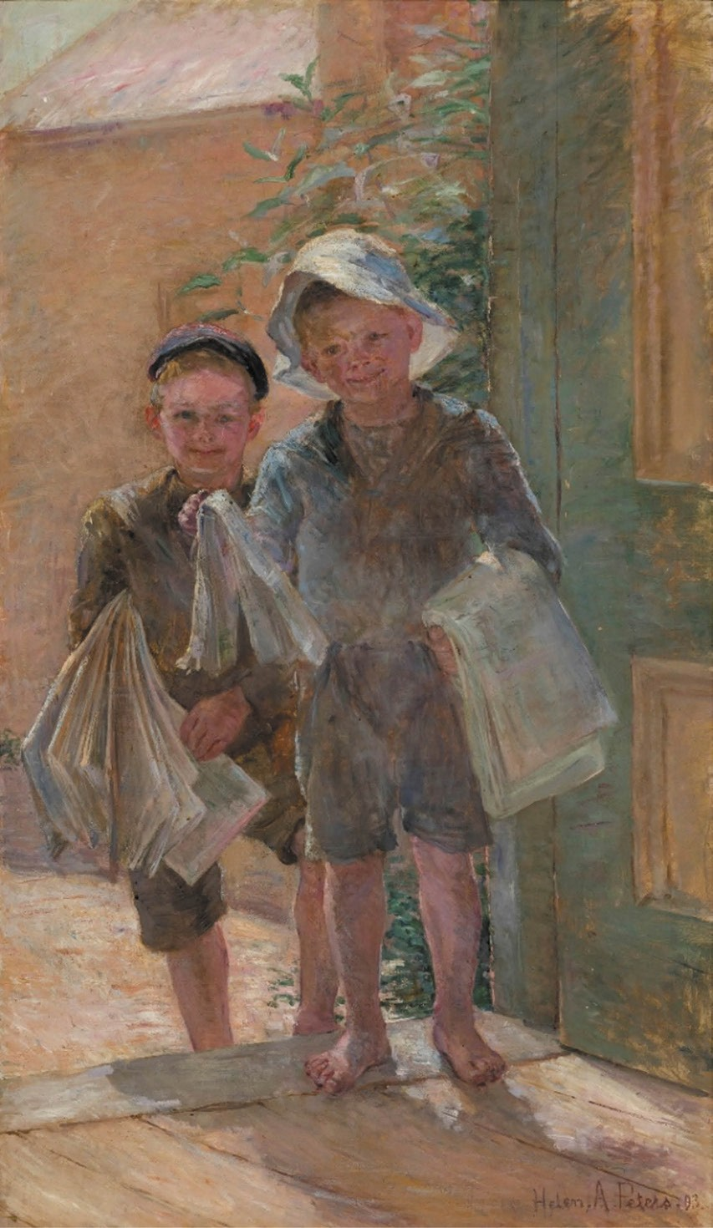
Figure 9.113: Helen Peters, The Breadwinners , 1903, oil on canvas, Collection Geelong Gallery. Purchased 1906, accession 1906.2.

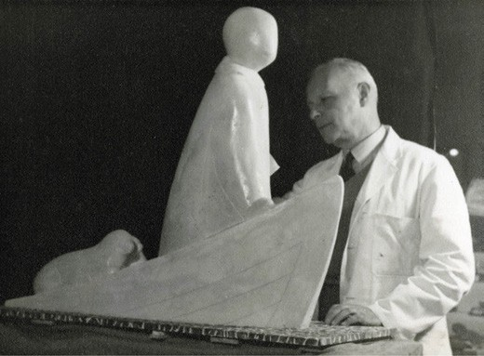
Figure 9.114: Ludwig Hirschfeld-Mack at the Geelong Grammar School, n.d. [c.1950]. Source: Geelong Grammar School archives, image Hirschfeld003.

time in Berlin, he emigrated to England given the rise of the Nazis.742 There, he worked as an art educator.743 In 1940, Hirschfield-Mack was deported to Australia as an enemy alien on the Dunera.744 Interned at Hay and Orange, N.S.W. and at Tatura, Victoria, he was released in 1942 through the sponsorship of Sir James Darling, headmaster of the Geelong Church of England Grammar School at Corio.745 There, Hirschfeld-Mack was appointed art master where
he promoted his pupils self-knowledge, introduced them to avant-garde painting techniques, and encouraged wood-
carving, weaving, musical instrumental- making, leatherwork, and other crafts.746 In 1946, Mack gave an unusual show
at the University of Melbourne of 52 abstract paintings which he declared were constructed upon the inter-weaving of the lines of two-dimensional shapes, and of silhouettes which are so composed in their values that they create
third- dimensional illusions. 747 An early example was his Three Faces of 1936 (Figure 9.115). Retiring to Fern Creek
in the Dandenong Ranges in 1957, Hirschfeld-Mack published The Bauhaus: An Introductory Survey in 1963 and he died two years later.748

ROBERT INGPEN
Born in Geelong in 1936, Robert Roger Ingpen attended Geelong College before graduating with a Diploma of Graphic Art from RMIT in 1958.749 He subsequently began his distinguished carrier as a freelance illustrator and author, published over 100 books on Australian life, history and conservation. The majority of his work has been illustrated children s stories including Storm Boy (with Colin Thiele), his most locally well-known work being The Voyage of the Poppykettle, a folk story that became the focus of an annual school children s festival. In 1986, Ingpen was awarded the
international Hans Christian Andersen Medal as an illustrator of children s literature, the only Australian to receive such an honour.750

SCULPTURE AND DECORATIVE ARTS EARLY SCULPTORS
The majority of working sculptors in Geelong in the 19th
century were monumental masons whose work was largely devoted to cemetery architecture.

CLEMENT NASH
One of the earliest was Clement Nash (c.1820-1910) who arrived in Geelong aboard the Joshua in 1854 with his wife and two sons.751 He had commenced his trade as a
stonemason in Norfolk and during his early years in Geelong was involved in the building of Ss. Peter and Paul s Catholic Church, Mercer Street, in 1864 and subsequently opened
a bluestone quarry at Lethbridge.752 In Geelong, Nash had established a monumental mason s yard at the south-west corner of Ryrie and Gheringhap Streets in 1860753 (Figure 9.116). There, a range of statuary, monumental and marble works were created, including sun dials for the garden of John Cummings, M.L.C. in Toorak in 1873 and J.R. Hopkins,
M.P. of Wormbete near Winchelsea in 1874.754
In 1874, Nash relocated to his property on the Western gully, at the foot of Gheringhap-street (Brougham Street) where he continued his trade.755 A small selection of his monumental masonry included Gothic marble monuments over the graves of the Reverend Mother Xavier Maguire at the Sisters of Mercy Convent, Newtown in 1880, and of Alexander Campbell at the Rothwell Cemetery in 1881 (Figures 9.117-118). In 1891, he executed a large Celtic cross of Aberdeen marble over the grave of the late Hon. Francis Ormond at the Eastern Cemetery in 1891.756 Other more publicly prominent works included the Boer War Memorial obelisk at the entrance to Kardinia Park in 1902 (Theme 8) and the memorial statue of Queen Victoria in Market Square in 1904 (Theme 8).

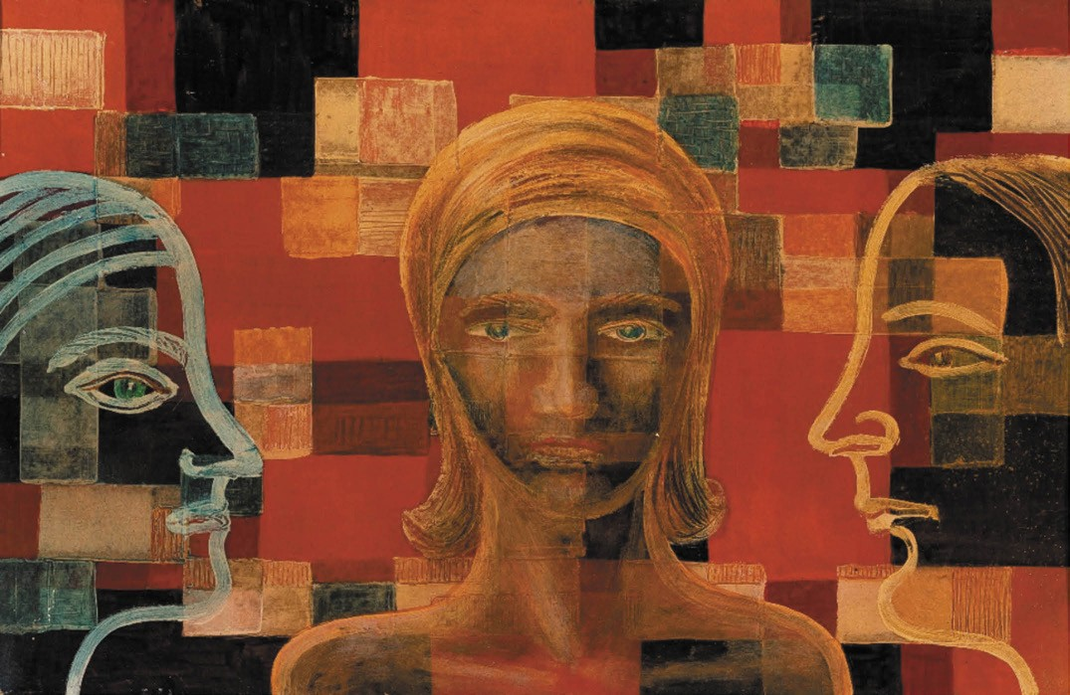
Figure 9.115: Ludwig Hirschfeld-Mack, (Three Faces), 1936, mixed media on cardboard, Collection Geelong Gallery. Gift of Mrs Olive Hirschfeld, 1976, accession 1976.35.

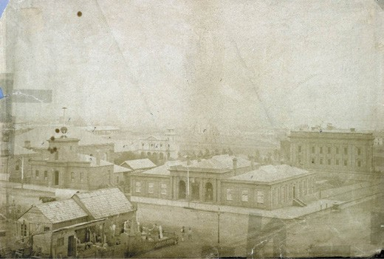
Figure 9.116: Elevated view looking north-west to the Geelong Post Office (middle ground) and Town Hall (background – right), with Nash’s monumental mason s yard in the foreground (south-west corner Ryrie & Gheringhap Streets), 1860. A glimpse of Nathaniel Brown s yard is also shown in the foreground on the left side of the gabled buildings. Source: accession H2168, State Library of Victoria.

CHARLES WILCOX AND SONS
Charles Wilcox (1828-1893) arrived in Geelong aboard the Joshua in 1854 with his wife and infant daughter, the same vessel that had brought out Clement Nash.757 He established a yard in Little Ryrie Street before relocating to the corner
of Moorabool and Myers Streets in the early 1870s.758 Apart from cemetery monuments, work by Wilcox included several memorial tablets, including those at St. Mark s Church, Leopold in 1881 (in memory of Mrs Belcher) and the Geelong Fire Brigade (carved of white marble with a black enameled slate border surmounted by a fireman’s helmet).759 Perhaps Wilcox s most noteworthy work was in association with
John N. Rowe in 1890, the Geelong Advertiser declaring that it was worthy of inspection and criticism and that nothing of the kind has ever been performed in Geelong. 760 It was described as follows:
The work view at Mr Wilcox s establishment is cut out of solid Sicilian marble, and although it has not been executed to order it shows what can be produced here if
support is accorded to enterprise. It is the representation of the crucifixion, the dead Christ being depicted on

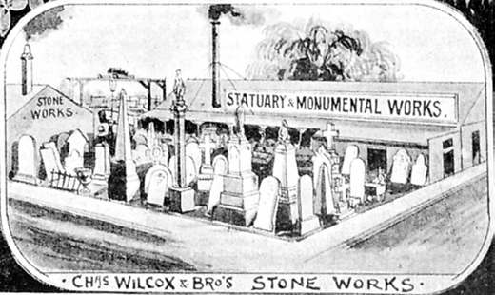

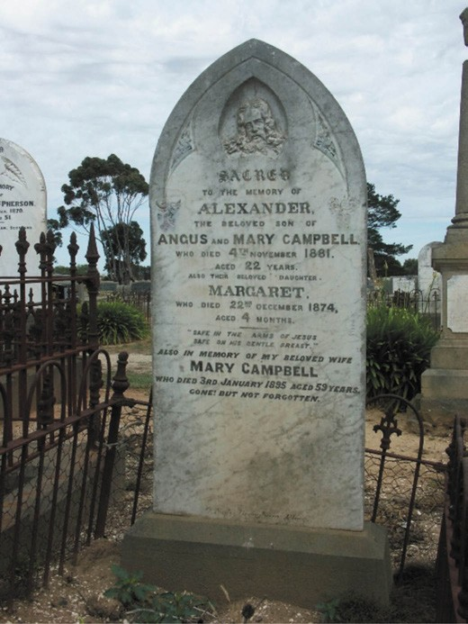
Figure 9.117: C. Nash, Gothic monument over the grave of Alexander Campbell, Rothwell Cemetery, 2008.
Source: David Rowe.

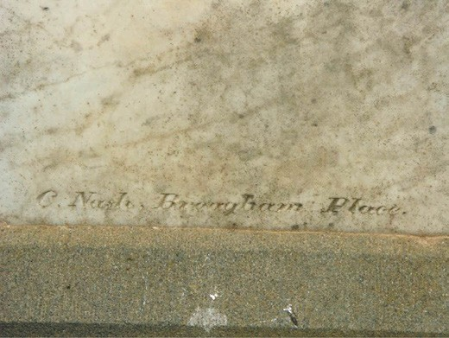
Figure 9.118: Detail of Nash s mason s mark on Campbell s monument, 2008. Source: David Rowe.
Figure 9.119: Charles Wilcox & Bros. Stone Works, corner Moorabool & Myers Streets, Geelong, 1893. Source: Views In and Around Geelong , Illustrated Australian News, David Syme & Co., Melbourne, 1 September 1893, accession IAN01/09/93/12-13b, State Library of Victoria.

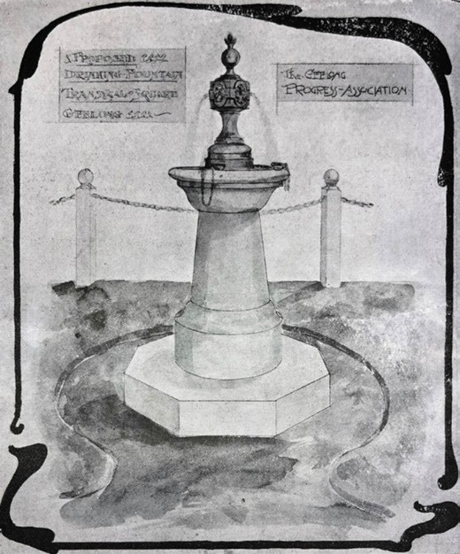
Figure 9.120: Geelong Progress Association, Drawing of the proposed drinking fountain for Transvaal Square, executed by Chas. Wilcox & Bros., 1912. Source: News of the Week, 13 June 1912, p.14, GRS 2121/3, Geelong Heritage Centre collection.

the cross in which is technically known as quarter life size, the cross upon which the figure lies being 3ft. 6in. in length. The cutting and carving, which is in the solid
marble, has been effected upon lines laid down in Michael Angelo s famous painting of the great incident in the life of mankind, and it is so well done that it can stand the closest examination.761
On the death of Charles Wilcox in 1893, the business was taken over by his sons and was known as Charles Wilcox and Brothers762 (Figure 9.119). A far less elaborate example of their work as the stone drinking fountain erected in Transvaal Square in 1912 (Theme 8) (Figure 9.120), a more notable work being the war memorial obelisk constructed in 1922 for the Geelong branch of the RSSILA in 1922 (Theme 8).

NATHANIEL BROWN
One of the most prolific early monumental masons was Nathaniel Brown (1815-1906) who arrived in Geelong in 1854 on the America with his wife, Caroline (who tragically died a year later).763 By 1860-61, he had established a yard in Ryrie Street, opposite the Post Office764 (Figure 9.116) where he produced numerous cemetery architecture, tablets, fonts and other statutory in a range of stones (although Barrabool stone appears to have been his favourite medium).765 Between 1861 and 1905, Brown produced at least 239 cemetery monuments (at the Eastern Cemetery alone) of some of Geelong and district s most prominent citizens.766 Working in collaboration with the sculptor, Benjamin Brain, one of the most elaborate and unique works was the Austin family vault at the Eastern Cemetery designed by Davidson and Henderson in 1872 (Theme 8). Brown also produced numerous sepulchral monuments elsewhere, including the Gange family headstone atop Mount Mitchell, Drysdale (Theme 8) and Sarah Jane Henry s Gothic-inspired granite monument at the Rothwell Cemetery in 1886 (Figures 9.121-122). Brown s skill –and that of his apprentice - was noted in the Geelong Advertiser in 1880:
Mr Nathaniel Brown, the monumental sculptor, of Ryrie street, has just made his collection of Sicilian marble monuments very complete by recent additions received from the best Italian works, and the charges for the new designs are very reasonable. One of the latest pieces of marble architecture is a classical monument standing 120 feet in height, and surmounted by a pretty urn partly concealed by graceful drapery. A second is a broken
column entwined by the wild convolvulus, which rises out of a crevice in the marble, and around the base are oak and laurel leaves, forming a pleasing contrast with the imitation rocks. A third is an elegant figure representing a woman standing over a grave scattering flowers over the mound; the work about this monument is chaste, and

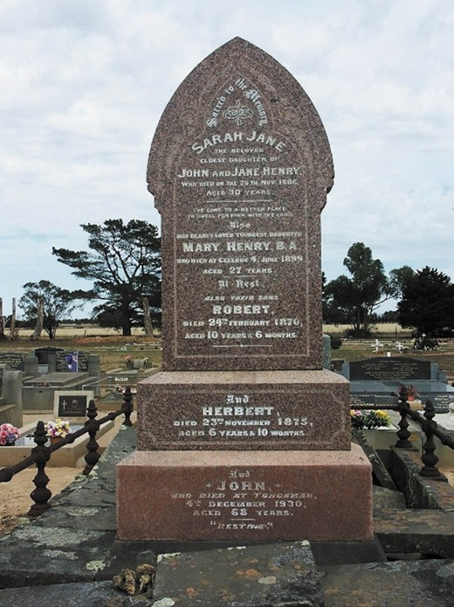
Figure 9.121: N. Brown, Gothic monument over the grave of Sarah Jane Henry, Rothwell Cemetery, 2008. Source: David Rowe.

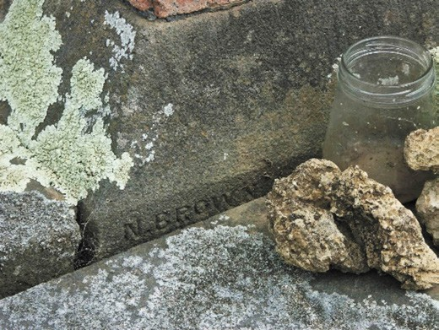
Figure 9.122: Detail of Brown s mason s mark on Sarah Henry s monument, 2008. Source: David Rowe.

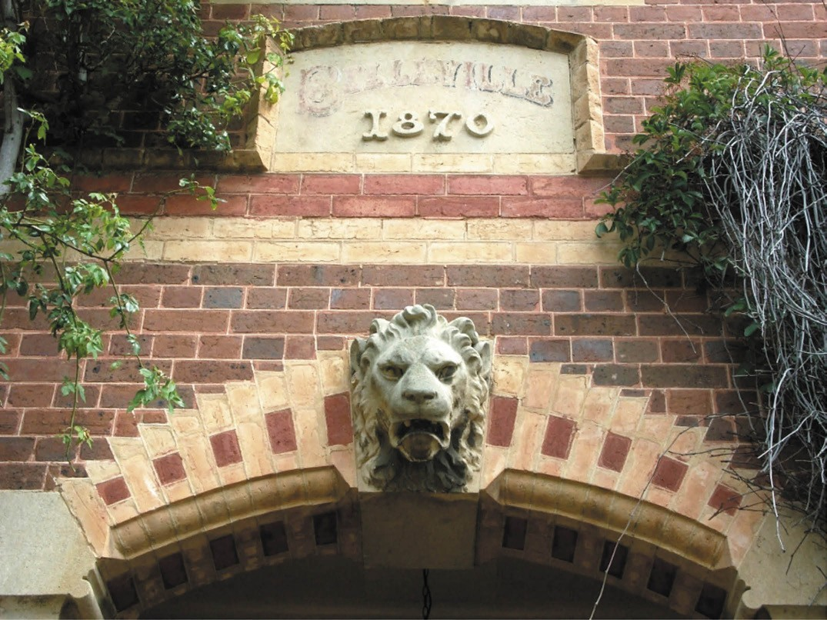
Figure 9.123: B. Brain, detail of lion s mask at Belleville , 350 Ryrie Street, Geelong, 2012. Source: David Rowe.

shows great skill on the part of the sculptor. A fourth is a gothic headstone, made in the early English style, the work of one of Mr Brown s apprentices, who got a gold medal for it at the late Exhibition.767

BENJAMIN BRAIN
Geelong’s prolific sculptor in the late 1860s and early 1870s was Benjamin Brain (1816-1877). Born in Gloucestershire, he later emigrated to Sydney where he established a studio at Paddington. There in 1867, he carved a font for St. Andrew s Cathedral and busts of Captain Cook and Lord Nelson as a display for the arrival of the Duke of Edinburgh.768 During
the Duke s visit, Brain prepared a bust of the Royal visitor and by 1869 when the sculptor was resident in Geelong, it was described in the Geelong Advertiser as remarkably
meritorious. 769 One of his earliest local commissions was a female allegorical statue of Barrabool stone representing the arts and sciences to adorn the front of the Geelong
Mechanics Institute.770 Brain also enjoyed the patronage of
the architects, Davidson and Henderson. For their design of the Barrabool Presbyterian Church, Brain sculpted the ‘caps for the pillars at the entrance’, the new edifice being described as one of the prettiest country churches we have
in the district. 771 For Davidson and Henderson he also carved foliated trusses and a lion s mask keystone for Dr Reid s residence, Belleville at 360 Ryrie Street (Theme 8)772 (Figure 9.123). Similar lions masks were carved for a new building at the corner of Ryrie and Moorabool Streets which the Geelong Advertiser declared are pleasing evidences of the skill of
the artist and the beauty and intrinsic value of the [Waurn Ponds freestone] material. 773 Brain was also responsible for carvings for the Austin family vault in the Eastern Cemetery in 1872 (Theme 8), the same year he prepared a baptismal font for the Church of England at St. Arnaud which the Geelong Advertiser reported:
There is now on view at Mr N. Brown s, in Great
Ryrie-street, a baptismal font, sculptured out of Barrabool

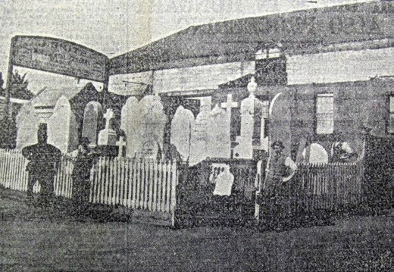

Figure 9.124: Joseph Smith s monumental mason s yard, south- east corner of Yarra & Ryrie Streets, c.1895. From left to right: F. Lee, blacksmith (of Chilwell), W. Poulton, J. Hancock (first apprentice) & Joseph Smith. Source: Geelong Advertiser,
n.d. [c. December 1943], newspaper cutting in collection of Pam Jennings.

free stone by Mr Brain. The shaft is of darker stone than the base and font, and relieves the whole; the patras in the panels are of varied carving, the style is ornamental Gothic, and the font will form a handsome addition to the Church of England, at St. Arnaud, for which it has been
made. It speaks well for our local sculptors that their skills are called into requisition from so great a distance.774
Possibly the last work of Brain in Geelong was a monument to the memory of the late Rev. Dr. Geddie at the Eastern Cemetery in 1876. Carved in a French Gothic manner most pleasing to the eye , it was built of stone from Ballarat and Waurn Ponds.775 Relocating to Ballarat in 1877, he tragically took his own life at the Unicorn Hotel, Sturt Street, in September of that year.776

JOSEPH SMITH
Born at Ashby (Geelong West) in 1861, Joseph Smith became a successful monumental mason following completion
of a modelling and design course at Edmund Sasse s Technological School.777 By the 1890s, his monumental mason yards were situated at the south-east corner of Ryrie and Yarra Streets (Figure 9.124) (later the location of Dr Croker s residence –see Theme 8).778 While much of his monumental masonry emanated from cemetery work,
Smith was noted for his sculptural tablets. Heavily involved in the Manchester Unity Independent Order of Oddfellows in Moorabool Street (to which he was Grand Master for Victoria in 1913), Smith designed a marble tablet for the MUIOOF Geelong branch in 1884 that bore the names
of Past Provincial Grand Masters.779 In 1906, he prepared a handsome memorial tablet to the memory of the late

Figure 9.125: J. Smith, Memorial tablet to the Rev. Francis Tuckfield, Wesley Uniting Church, Yarra Street, 1909. Source: News of the Week, 1 July 1909, p.15, GRS 2121/1, Geelong Heritage Centre collection.

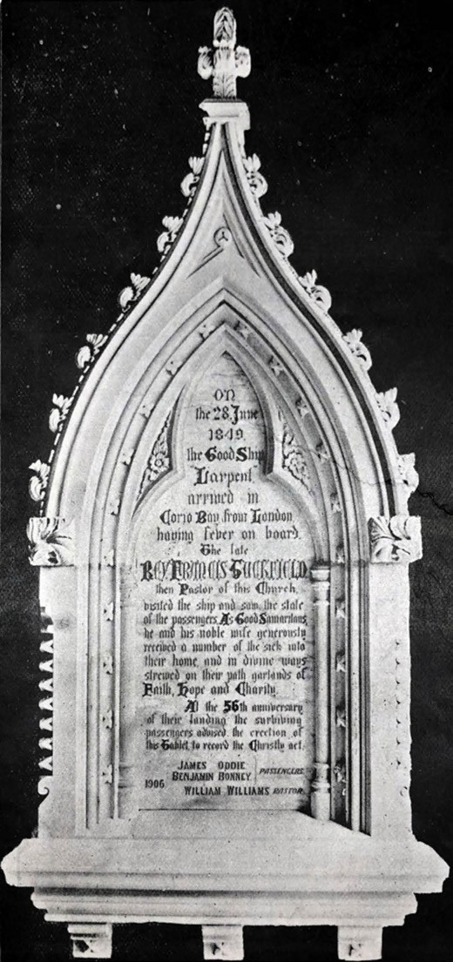
Rev. Francis Tuckfield and his wife’ at the Yarra Street Methodist (now Uniting) Church (Figure 9.125), to the order of the survivors of the Larpent.780 In November 1912, the Geelong Advertiser credited Smith for his beautiful tablet to the memory of the late Rev. C.J. Baird that was unveiled at

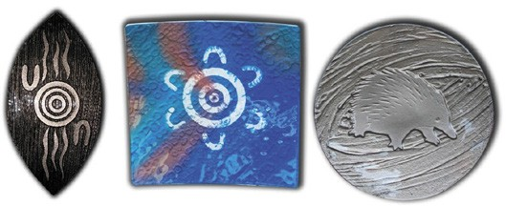

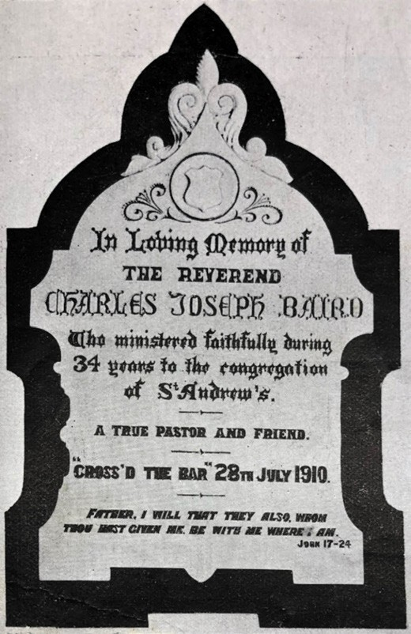
Figure 9.126: J. Smith, Memorial tablet to Rev. Charles Joseph Baird, St. Andrew s Uniting Church, Sydney Avenue, Geelong, 1912. Source: News of the Week, 21 November 1912, p.13, GRS 2121/3, Geelong Heritage Centre collection.

the morning services at St. Andrew s Presbyterian Church, Sydney Avenue781 (Figure 9.126). Smith died at his home, Larra , 29 Candover Street in 1915.782

OTHER LOCAL ART
The work and development of Greater Geelong s artistic community in the 19th century provided a solid foundation for the flourishment of community and commercial galleries. Established from the 20th century included the Shearers
Arms Gallery, 202 Aberdeen Street, Geelong West; Metropolis Gallery, 64 Ryrie Street; Art Is studio and gallery, 64 Little Malop Street; Karingallery established in 1997 at 4 James Street; and Art Unlimited, a professional access studio for artists with intellectual disabilities or special support needs located at the Old Geelong Gaol, corner of Myers and Swanston Streets.783 From the late 1990s, the old Geelong
Figure 9.127: Wathaurong Glass, shield and art pieces. Source: Mark Edwards, Manager, Wathaurong Glass.

Court House at 40 Gheringhap Street (Theme 7) has been the location of a youth arts centre.784 Following a major refurbishment in 2012,785 the former court house building has been the location of art and exhibitions by Courthouse Youth Arts (also see later subsection).

WATHAURONG GLASS AND ARTS
A not for profit business owned by Wathaurong Aboriginal Co-operative Ltd (Theme 2), Wathaurong Glass and Arts was formed in 1998 to express Aboriginal art in glass. 786 The artwork in the glazed art wall panels, plaques, kitchen and bathroom splashbacks, doors and windows, plasters, bowls, corporate gifts and trophies are creations unique to local Indigenous culture787 (Figure 9.127).

THE GEOGLYPHS
In 2006, the internationally-renowned sculptor, Andrew Rogers, created Geelong s geoglyphs at the You Yangs and the north end of Eastern Park. They were gifts from the City of Greater Geelong in celebration of Festival Melbourne 2006, the cultural program of the Melbourne 2006 Commonwealth Games. 788 The first was at Eastern Park overlooking Corio Bay (Figure 9.128). There, Rogers land art creation formed part of his Rhythms of Life project, which, along with other geoglyphs, is the largest contemporary land art undertaking in the world. 789 At Eastern Park, the sculpture was created from limestone and the open structure encourages the circulation of the viewer around it. This geoglyph was Rogers’ first in an urban and marine environment.790
The largest stone points to the You Yangs –the Bunjil geoglyph.791 This granite and limestone sculpture at the You Yangs is a tribute to Bundjil, a wedge tailed eagle and the Creator Spirit of the Wadawurrung (Themes 2 & 6)792 (Figure 9.129). Both geoglyphs provide a continuous link between past and present , the artworks reinforcing the spiritual traces of the Dreamtime, creating sites where links between cultures and senses of spirituality can be contemplated. 793

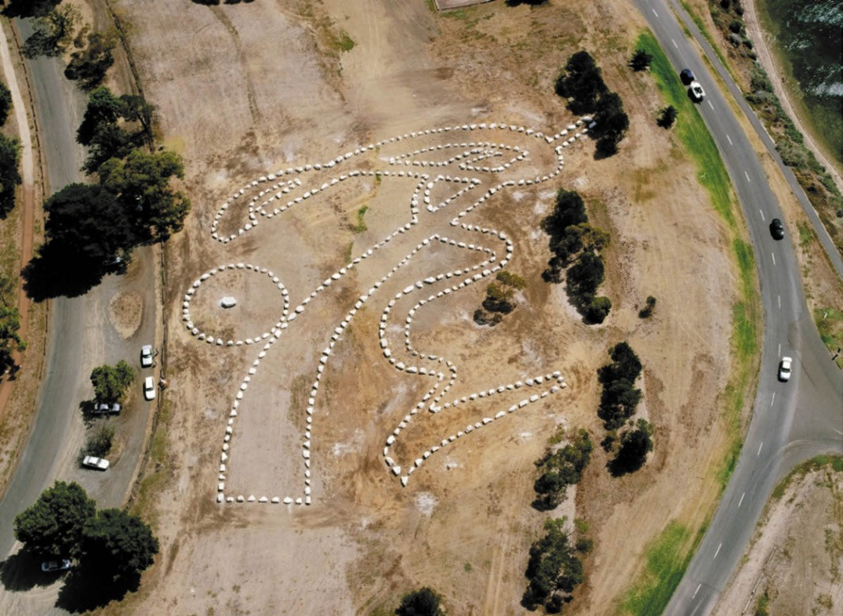
Figure 9.128: Andrew Rogers, Rhythms of Life, Eastern Park, c.2006. Source: Andrew Rogers.

OTHER PUBLIC ART
In addition to the numerous memorials and sculptures initiated for or acquired by the City of Greater Geelong and its predecessors are a range of more recent local creations that have enhanced the cultural life of the City. They include the Waterfront Geelong Bollard Trail of 100 bollards installed along the waterfront from Limeburner s Point to Rippleside Park in 1995, the work of artist Jan Mitchell which reflects
a chronology of Geelong and its character; Kurrajong Seed Pod in Johnstone Park by Vicktor Cebergs, created in 2000 and based on the boat-shaped seedpod of the Kurrajong tree; North (seven randomly placed cement objects resembling sails or fins) at the north end of Moorabool Street on
Geelong s waterfront by Mark Stoner in 2000; paving splats in front of the Carousel on Geelong s Waterfront, Eastern Beach Road, created by Maggie Fooke and Bill Perrin in 2000 as stainless steel with cast inlays depicting imported and locally made objects in the concourse pavement; Looking Forward white-faced heron sculpture by Cinnamon and

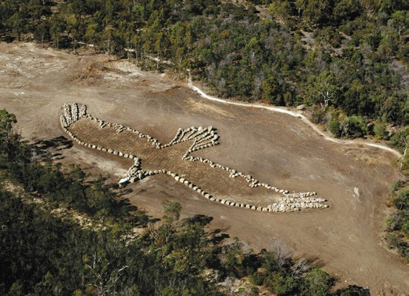
Figure 9.129: Andrew Rogers, Bunjil geoglyph, You Yangs, 2006. Source: Andrew Rogers.

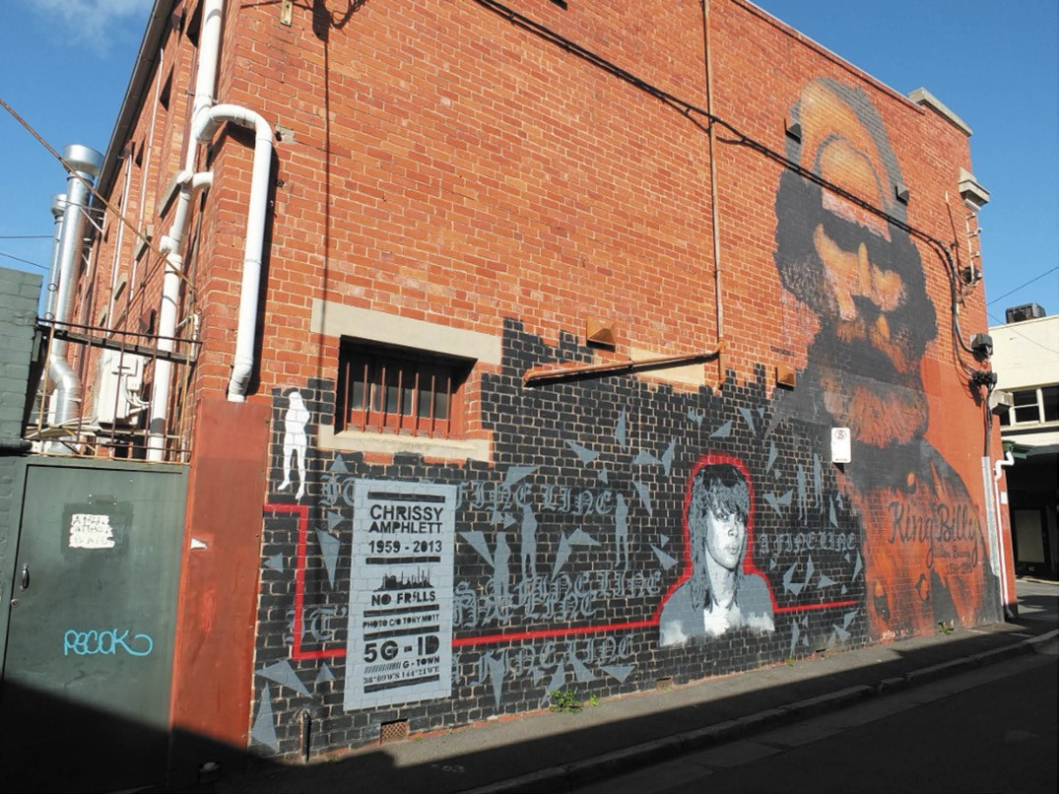
Figure 9.130: Cam Scale, Willem Baa Nip (right) & Glen Smith, Chrissy Amphlett , street art, Dennys Place, Geelong, 2019. Source: David Rowe.

Geo Francis at Western Beach in 2000; Barcode Fountain, Customs House forecourt, Eastern Beach Road, installed in 2000 as a reference to the former Noddy s Soft Drink business previously in Malop Street; Cargo Boxes at the Customs House forecourt, Eastern Beach Road, the work of Maggie Fookes and Bill Perrine in 2000 represented a series of brass and glass boxed containing sculptures and artefacts as a reference to Geelong s 19th century imports; Walk West sculptures by Tania Virgona and Mark Trinham in 2003 at Western Beach, represent grass blades made of stainless steel and marine grade steel; laneway street art in Little Malop Street from 2010 (including murals of Chrissy Amphlett by Glen Smith in 2014 and Willem Baa Nip in Dennys Place by Cam Scale in 2015) (Figure 9.130); and Union Street mural, Union Street (a community art space by the City of Greater Geelong giving opportunities for artists and young people to present their work for 3-5 years).794

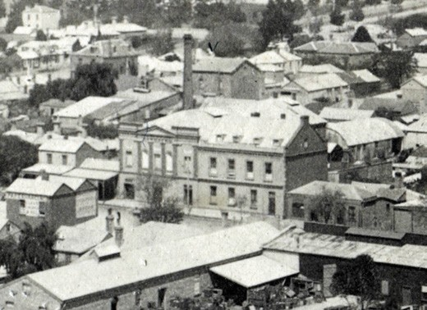
Figure 9.131: Former Royal Theatre (centre), Malop Street, Geelong, 1902. Source: GRS 2009/02021b, Geelong Heritage Centre collection.

PERFORMING ARTS

THE THEATRES, DRAMATIC SOCIETIES AND OTHER PERFORMING ARTS
In 1843, the Geelong Advertiser announced the opening of what was anticipated as Geelong’s first theatre:
To relieve the monotony of the perpetual dullness which shrouds our township, the lovers of rational amusement will be glad to learn that a Theatre will be opened in Geelong during the Race week; that indefatigable and meritorious actor, Mr. Buckingham, being resolved upon given them the treat …795
George Buckingham s application to the Bench of Magistrates was refused and the performance never proceeded.796 More successful was a Mr Boyd, who opened the Albert Theatre in Corio Street in December 1844.797 The lease was taken over by Mrs Murray in 1845 who reopened the building with new decorations and scenery, and who secured the leading talent from theatres in Melbourne, Sydney and Tasmania.798 Other theatres followed, including that of Messrs Cameron and Mereton in 1845,799 but like their predecessors, they were to be short-lived, due in part on the reliance of performers from theatres companies outside Geelong.
More enduring was Henry Elmes Royal Theatre in Malop Street that he built in 1848 in association with the Royal Hotel, with a brewery at the rear.800 The theatre operated for twenty years under different lessees, its success based in part on the rapid growth of Geelong in the mid-19th century, and because it enjoyed the patronage of local drama and production societies. They included the Geelong Histrionic Club, founded in 1858 with James Hodgson as honorary secretary.801 It was followed by the Amateur Dramatic Club

which formed at the Moorabool Viaduct in 1859802 and after a recess it re-formed in 1893 with E.A. Vidler as secretary and promoter.803 Other groups that also performed at the Royal Theatre included the Corio Dramatic Club and the Ashby Dramatic Club.804 The Royal Theatre closed in 1868 and formed part of Hodge s Brewery (Theme 5) and was occupied by the Salvation Army by 1885.805 Performances were again given at the former Royal Theatre (Figure 9.131) by the Ashby Dramatic Club in 1913.806 By the mid-20th century, the theatre had been replaced with a supermarket and is now the location of Officeworks.

EXHIBITION HALL THEATRE, MARKET SQUARE
In December 1881, the Exhibition Hall Theatre in Market Square was all but completed, a conversion of the former Exhibition Building constructed in 1879 for the Juvenile and Industrial Exhibition (see following subtheme).807 The interior was redesigned by the prolific architectural firm of Watts and Jackson,808 the Geelong Advertiser declaring it to be free from the objectionable features noticeable in connection
with the neighborhood of metropolitan theatres. 809 It was the result of the Geelong Town Council leasing the building to a private company for three years.810 Local performance groups took advantage of the new theatre, including the Geelong Liedertafel, a German singing club whose first performance was given in the Geelong Town Hall on 17 December 1888.811 The Geelong Liedertafel s performance of The Mikado featured in E.A. Vidler s Book of Geelong in 1897 (Figure 9.132). Others to perform at the Exhibition Hall included the Geelong Amateur Dramatic Club.812
One young performer at the Exhibition Hall Theatre in 1896 who was to become world renowned was fourteen-year-old Miss Carrie Moore (1882-1956)813 (Figure 9.133). Born in Foundry Lane, Geelong, she was the daughter of Robert Moore from Newfoundland and Mary Wyatt, who had arrived from England in 1854.814 Taught to sing by her mother, Carrie Moore was enraptured by her father s recitations and were enthusiastic members of the Salvation Army songsters.815 Moore performed in various local charitable concerts
before becoming a member of J.C. Williamson s company in Melbourne in her early teenage years.816 Williamson had Australian and New Zealand rights to the Savoy operators and by the age of 20 years Moore had played 25 leading
roles, including most of the Gilbert and Sullivan women. She had earlier been the Prima Donna of the Australian Royal Comic Operatic Company. In England, Moore won the prize as the best principal boy in pantomime in 1883.817 Returning to Australia in 1908, Moore played the part of Sonia in The Merry Widow for J.C. Williamson in Melbourne and later Sydney, resulting in a triumphant season.818 She later married Percy Plantagenet Bigwood, businessman and racehorse owner and they returned to England to live privately.819

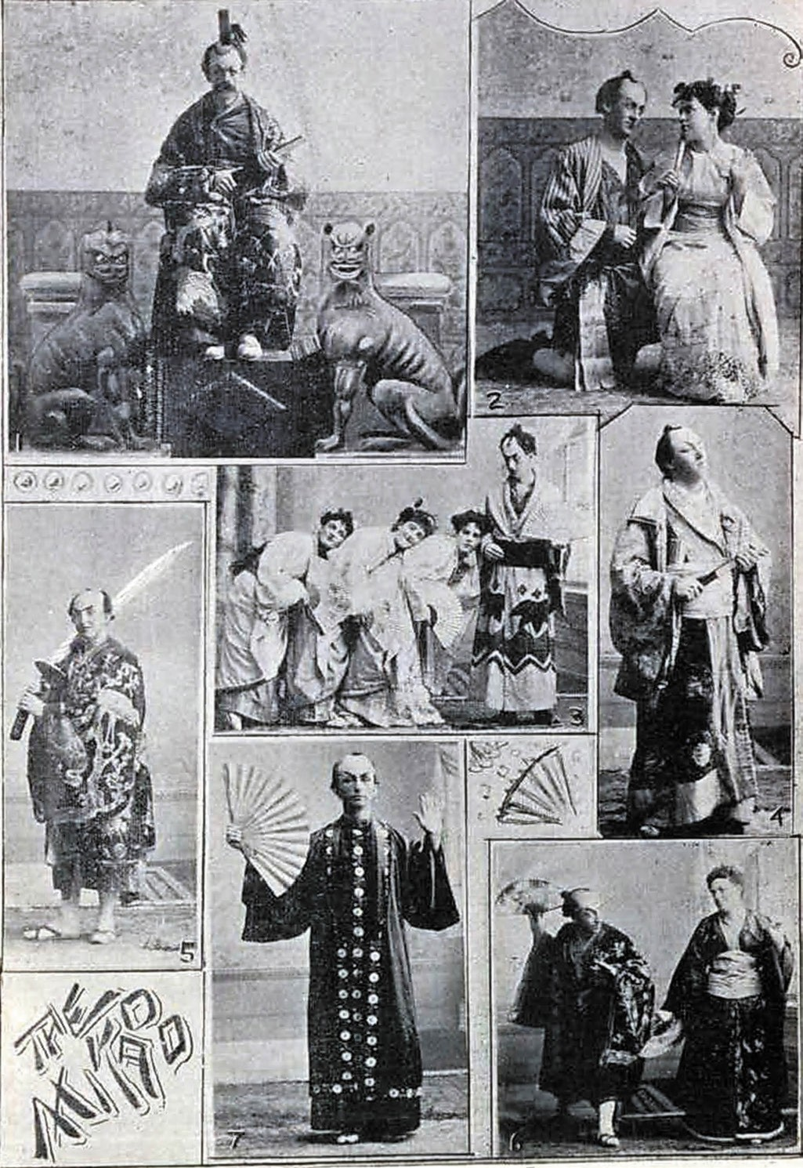
Figure 9.132: W.H. Watts, The Mikado performed by the Geelong Liedertafel, 1897. Source: E.A. Vidler, The Book of Geelong: Its People, Places, Industries and Amusements, p.99.

Following the death of Bigwood during World War One, Moore subsequently married the bookmaker, John Wyatt.820

HIS MAJESTY’S THEATRE, MARKET SQUARE
In 1903, the Exhibition Theatre Hall was re-opened as His Majesty s Theatre (Figure 9.134) in honour of the recently coronated King Edward VII821 (it continued to be a key venue for performances until 1927).822 Initially proposed to be called The Empire Theatre or The Alexandra Theatre, the suggestion of Alderman Solomon Jacobs that it be known as His Majesty s Theatre was resolved at a Council meeting.823 One of the earliest musical attractions came in 1904 when the newly-formed Geelong Operatic824 had its first public appearance with a performance of Gilbert and Sullivan s
The Mikado .825 His Majesty s was also home of the Geelong Comedy Club whose musicals were produced in aid of Geelong charities.826 One of the earliest was a production of The French Maid in 1912,827 in aid of the Geelong Progress Association to enable the beautification of Railway Terrace with rockeries (see Theme 7).
Charitable performances at His Majesty s Theatre were not confined to local amateurs. The revered, internally famous Australian singer of the late 19th and early 20th centuries, Dame Nellie Melba, held a number of performances at the theatre in aid of charities. Following her performance in 1915 for the Red Cross Society, Melba declared the acoustic properties at His Majesty s to be excellent. 828 Although
the theatre building no longer survives, an elaborate gold paperweight (Figure 9.135) designed in 1922 by Mrs Charlotte Hitchcock (wife of Mayor Howard Hitchcock) and crafted
by Messrs. J. Hammerton and Sons, well-known local silversmiths, was presented to Melba in appreciation of her performance at the Grand Presentation Concert at His Majesty s theatre in aid of the Kitchener Memorial Hospital fund (Theme 8).829

CENTRAL HALL & THE GEELONG ASSOCIATION OF MUSIC AND ART
Prominent in the tea-total movement was the Band of Good Hope Union, one of the earliest Children s Temperance Societies established in England in 1847 and by William Stitt Jenkins in Geelong in 1859.830 In 1914, the Geelong Band of Hope acquired the Ryrie Street Presbyterian Church (steeple church) at 73 Ryrie Street, built in 1856 (Theme 8) (Figure 9.136) as its Central Hall.831 Interior improvements were made to the hall in 1920.832 A pavilion of shops and offices were erected at the front of the Central Hall in 1927833 and the landmark steeple was removed (Figure 9.137).
In the mid 1920s, John Arthur Campbell Firth (1871-1945) a solicitor who was born at Moolap, was the local instigator in the formation of a Geelong Repertory Society.834 The local

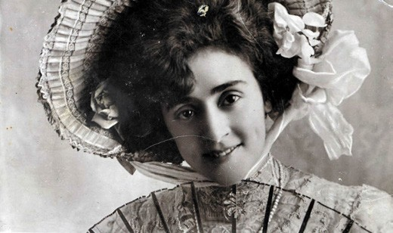
Figure 9.133: Philo Publishing Co., Carrie Moore, c.1900. Source: accession H2014.1013/141, State Library of Victoria.
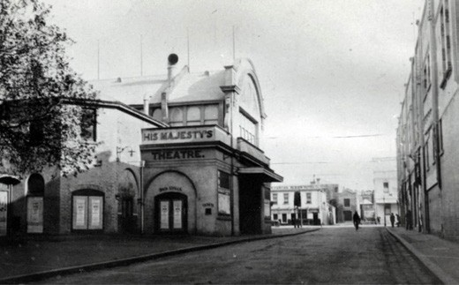
Figure 9.134: His Majesty s Theatre with a frontage to Jacobs Street, Market Square, c.1935. Source: GRS 2009/01704/090, Geelong Heritage Centre collection.

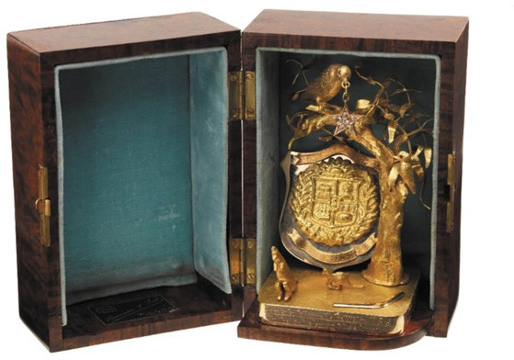

Figure 9.135: Gold paperweight presented to Dame Nellie Melba in appreciation of her performance at the Grand Presentation Concert, His Majesty s Theatre, 1922. Source: Museums Victoria Collections, item H39878.

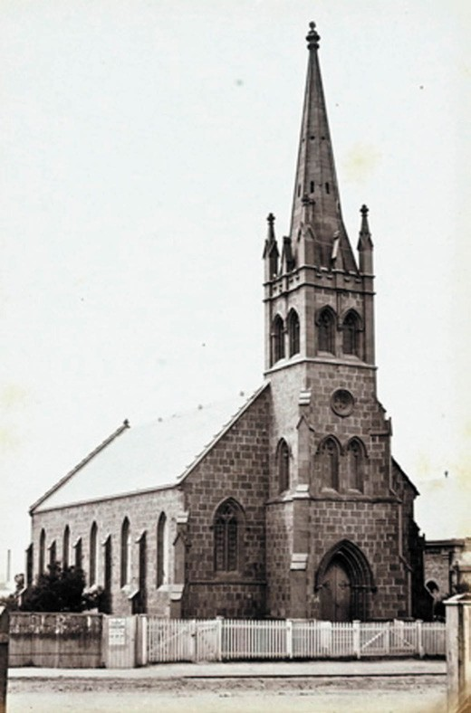

Figure 9.136: E. de Balk, Presbyterian Church, Ryrie Street, 1866. Source: figure FL985553, SLNSW.

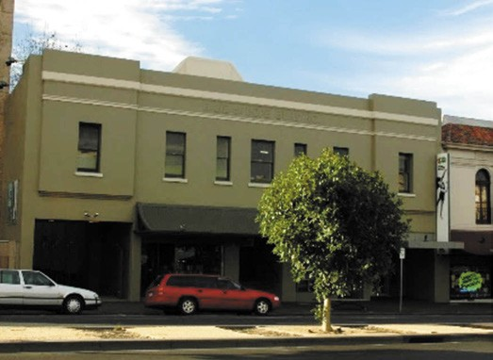
Figure 9.137: Former pavilion of shops, Band of Hope, in front of former steeple church, 2005. Source: Wendy Jacobs.

secretary of the Geelong Centre for Trinity College of Music,
London,835 and a member of the Geelong Musical Society in 1925, Firth chaired a meeting of interested locals in the formation of a Repertory Club . He introduced J. Beresford
Fowler who had been responsible for staging a presentation of Ibsen s A Doll s House at His Majesty s Theatre at Market Square which aroused interest in the repertory movement.836 The Geelong Repertory Club and Arts Society held its first meeting at the Gould Hall, Myers Street, in February 1926. 837 In 1932, a new Geelong Repertory Society was constituted with J.R. Wilson as the inaugural chairman, Mrs A. Meakin as directress and secretary, and R.J. Poynton as treasurer.838 By 1947 performances were regularly held at the GAMA Theatre (the Band of Hope Central Hall).839
The Geelong Association of Music and Art (GAMA) was formed in 1945 by a panel of Geelong business men. 840 It embraced performance and music through affiliations
with other groups including the Geelong Repertory Society, Geelong Choral Society, Symphony Orchestra and the Madrigal Society (the association continues today and comprises three sections: drama –Geelong Repertory Theatre Company; classical choral music –Geelong Chorale; and classical music competitions and awards –The Musical Society of Geelong).841 A principal figure in the early years of GAMA was George Logie-Smith, its honorary conductor.842 He was also was master and musical director of Geelong College.843
In March 1947, the Association leased Central Hall and converted into the GAMA Theatre. As outlined in The Herald:
Many efforts have been made to obtain a municipally- controlled hall or theatre for music and art in Geelong but as there appeared no immediate prospect of this being available, the association had entered into a lease of the Central Hall, formerly the Old Steeple Church, Ryrie Street, which was a landmark of the city.844
In 1953, the GAMA Theatre hosted the Geelong Repertory Society s production of Ring Round The Moon , a play by Jean Anouilh. The charm of the dialogue was matched by a stage set designed and painted by Ludwig
Hirschfeld-Mack.845

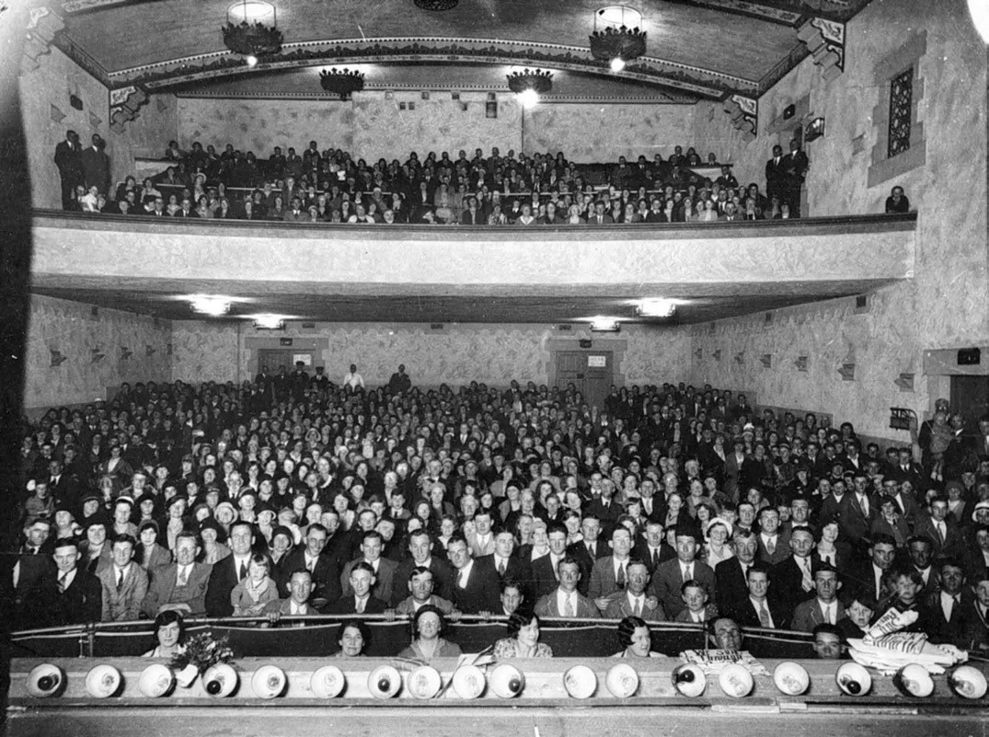
Figure 9.138: C. Bland Studio, Plaza Theatre, c.1932. Source: Museums Victoria Collections, MM 7132.

MECHANICS’ HALL & PLAZA THEATRE, 77 RYRIE STREET
The construction of a concert hall attached to the Geelong Mechanics Institute building at 77 Ryrie Street in 1857 provided another venue for public performances, as well as other events including concerts and exhibitions. Local groups to frequent the Mechanics Hall included the Geelong Liedertafel, Amateur Dramatic Club, Histrionic Club and the Geelong Ethiopian Troupe.846 Overall, the Mechanics Hall was favoured by minstrel companies from the 1870s onwards, but during the course of its lifetime is hosted vaudeville, musical and comedy companies, pantomime, drama (including Shakespeare), opera and moving pictures. 847 A variety of performances continued at the Mechanics Hall following the construction of a new hall in 1927 after fire destroyed the earlier building in 1926 (Theme 8).
In 1932, the Geelong Mechanics Institute leased the hall to a consortium who called it the Plaza Theatre (Figure 9.138).
Around six theatre assistants were employed.848 It played host to a range of performances, wrestling matches and other public events, including literary evenings conducted by the Geelong Mechanics Institute Society.849
A farewell concert was held at the Plaza Theatre in December 1977 in aid of the rebuilding appeal towards a Performing Arts Centre complex on the site.850

GEELONG PERFORMING ARTS CENTRE
The quest of the Geelong Association of Music and Arts for a new public hall in 1946 may have been the initial genesis for the establishment of the Geelong Performing Arts Centre. Momentum for the concept had gathered pace after World
War Two as part of the ambit of the War Memorial Committee. A public meeting in 1949 resolved that the Mechanics Institute buildings be acquired for Geelong s new hall.851 The district s town planners found that the Mechanics Institute site alone was too small and they submitted a proposal

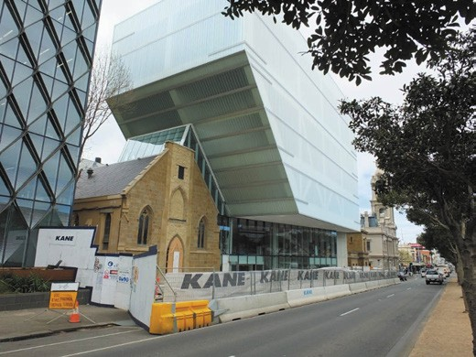
Figure 9.139: Geelong Performing Arts Centre Redevelopment, with former steeple church repaired and adapted, 2019.
Source: David Rowe.

for a civic area fronting a widened Little Malop-street and terminating with a large civic auditorium on the Fenwick-street boundary of Little Malop-street. 852 Debate ensued about the proposal and the extent of land required, which was never resolved.853
While the memorial hall concept was abandoned, the idea of a performing arts complex was not. Although several more years were to elapse, in late 1977 the Mechanics Institute site (including the Plaza Theatre and two storey Spanish Mission Mechanics pavilion fronting Ryrie Street), together with the GAMA Theatre (former steeple church) and associated land was acquired for the construction of the Geelong Performing Arts Centre. Opening in 1981, the complex had enshrined the old Plaza Theatre as the new Ford Theatre, while the former GAMA theatre was retained and altered as a music hall. A second theatre –known as the Blakiston –and a ballet centre were added.854
The new complex hosted other local companies including the Geelong Society of Operatic and Dramatic Arts (GSODA). Its origins came from the Geelong Operatic Society (which was defunct by 1919)855 formed in 1928 as the Geelong Amateur Operatic Company.856 The company was renamed the Geelong Musical Comedy Company in 1941 before
later taking on its current name.857 In 1965, the Geelong Gilbert and Sullivan Opera Company was formed under the umbrella of GSODA, its first production being ‘The Pirates of Penzance .858 It broke away from GSODA in 1974 under the name of the Geelong Gilbert and Sullivan and Light Operatic Company, its first production being ‘HMS Pinafore’.859 The name of the company changed to the Geelong Lyric Theatre Society Inc. in 1982.860 In 2003, the Lyric Youth Theatre was

formed to cater for young members under the age of 21. The first production was Pirates of Penzance.861
In 2019, work began on a major redevelopment of the Performing Arts Centre to a design by Hassell Studio architects.862 The $38.5M project witnessed the demolition of the former Plaza Theatre, Mechanics Pavilion and Band of Hope Pavilion, but retained and exposed the former GAMA theatre (Figure 9.139), the origins of performing arts in this locality. The new work comprised a recessed two-level metal framed and glazed south façade with a five-level cuboid mass above constructed of a translucent skin providing a new landscape in this part of Geelong.

THE PALAIS ROYAL DANCE HALL & THEATRE, 299 MOORABOOL STREET
While dances had been a popular form of social activity throughout the 19th century, in the 1920s, several existing public halls also became known as Dance Halls , including those at Ashby (Geelong West), Corio, North Geelong
and Lara.863
One major purpose-built dance hall in Geelong that was to become a principal local music venue until the late 20th
century was the Palais Royal Dance Hall and Picture Theatre, 299 Moorabool Street, Geelong. In May 1926, the Geelong Advertiser announced that a large and attractive house of entertainment is the aim of those interested in the Palais Royal enterprise. 864 Designed and erected in brick by Howard R. Lawson for a consortium including Fred Slack,865 the building featured the steel roof principals, story posts and bulk of the Dress Circle of the old Joy Ark picture theatre that previously graced the shores of Eastern Beach (see
later subsection).866 The main fa ade (Figure 9.140) was completed in an eclectic Spanish Mission and Art Deco mode, the large dance hall inside featuring a full width dress circle
at the rear, and a grand circle (or promenade) that extended around the balance of the interior.867 The building opened on 3 November 1926.868
A major event at the Palais in 1932 was a home-coming performance by John Brownlee (1900-1969), famous operatic baritone singer. Born in Geelong into a musical family, he briefly attended the Gordon Technical College before taking up employment as a clerk at the hardware firm of Hawkes Bros. (Theme 5) in 1915. Brownlee was also a cornet player in the Geelong Municipal Band but it was his baritone voice that was recognised by the Hawkes family who encouraged him to take professional training. One of Brownlee s earliest appearances was at Sladen Hall, Russell Street, Newtown, in 1917, as a member of the Skylark Comedy Company.869 By 1922, Brownlee s talent had been recognised by Dame Nellie Melba who urged him to travel to Europe for further training.

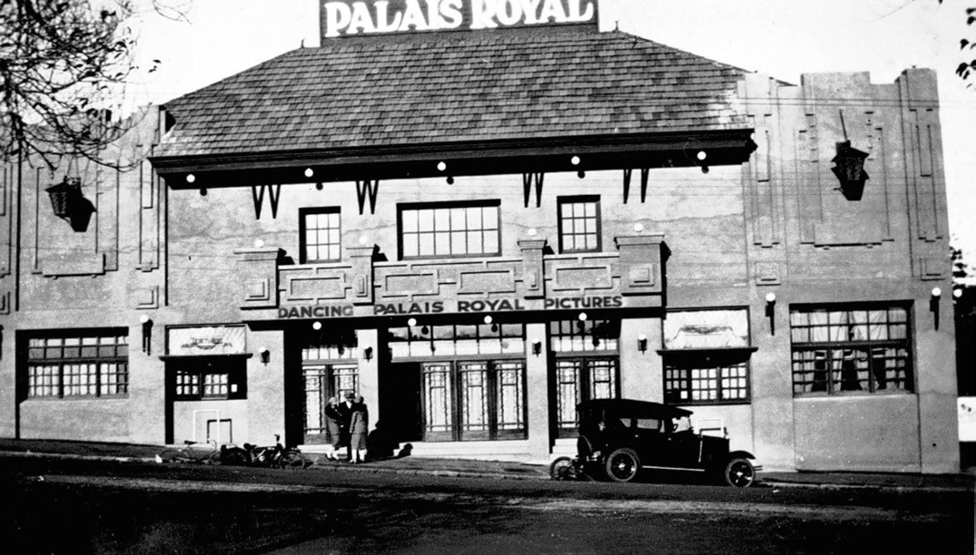
Figure 9.140: Palais Royal Dancing Hall & Picture Theatre, Moorabool Street, c.1926. Source: Museums Victoria Collections, MM 3246.

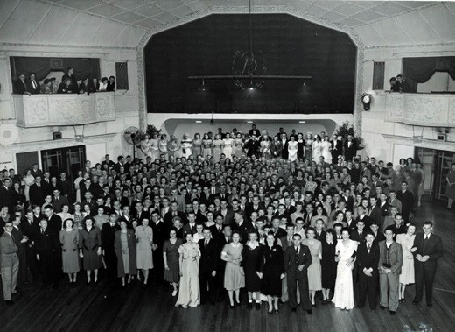
Figure 9.141: Palais Royal performers and dancers, c.1950. Source: GRS 2009/02298, Geelong Heritage Centre collection.
Undertaking extensive studies in Paris, he later appeared with Melba in her Convent Garden farewell in 1926.
He subsequently made a rapid rise as a professional singer, beginning with a sensational debut at the Paris Operate House in Massenet s Thais in 1927. The following year, 1928, he married the former Countess Donna Carla Oddone di Feletto in Paris. They lived in New York, U.S.A. until his death in 1969.870
While a popular location for dancing in the 1950s and 1960s (Figure 9.141), in 1951, the Palais was also the location for the presentation of the Brownlow medal to Bernie Smith by the Victorian Football League president, Dr. W.C. McClelland. The 1951 premiership pennant was also presented to the Geelong Football Club by Dr. McClelland at this event.871
In the 1960s, the Palais was one of few live music venues in Geelong. It was there where the Geelong-born Barry Crocker began his career.872 By the late 20th century, the Palais hosted well-known Australian bands including Cold Chisel in 1983 and INXS in 1984.873

WOODBIN THEATRE & THE LILIAN STOTT GAMA CENTRE, 15 CORONATION STREET, GEELONG WEST
In 1981, GAMA purchased Henry s wood store at 15-17 Coronation Street, Geelong West as its administrative headquarters, and wardrobe, rehearsal, workshop and meeting space for its three sections (see earlier).874
It was called the Lillian Stott Centre in memory of Miss Lillian Stott (1897-1980) whose legacy enabled the purchase
of Henry s site.875 Lillian Ada Elizabeth Stott was born in Geelong, the daughter of William Stott, jeweler of Moorabool Street (Theme 5) and Emma Stott (nee Cox).876 Towards the end of World War One, she was awarded the Geoffrey Syme Scholarship and entered the Melbourne Conservatorium
of Music in Albert Street, Melbourne, where she studied under Miss Anne Williams and had many personal lessons from Dame Nellie Melba who called her the Brahams girl and recommended her for appointment on the staff of the Conservatorium.877 Prior to her appointment she travelled to Europe with Miss Williams, studying all the time with her and had lessons from Mr. Plunkett Greene, principally for interpretation, and has heard all the leading vocal artists
in London and Paris, particularly the Lieder singers. 878 Stott commenced teaching at the Melbourne Conservatorium (later known as the Melba Conservatorium in honour of Nellie Melba) where she taught until around 1958.879 During this
time she occupied a house at 9 Manning Street, Newtown and by 1972 was resident at 36 Alexandra Avenue, Geelong.880
In 1989, the Geelong Repertory Society relocated from the Geelong Performing Arts Centre to the Woodbin Theatre, a converted rehearsal space at the Lillian Stott GAMA Centre and productions continue from this location to the present day.881

THEATRE OF THE WINGED UNICORN, CERES
In 1993, Elaine and Dennis Mitchell created an independent theatre company called Theatre of the Winged Unicorn.882 While the company has a varied program, it favors the 19th century classics including adaptations from Dickens, Eliot, Bronte, Hardy, Austen, and some of the comedies and thrillers by Noel Coward and Agatha Christie of the 1920s.883 Musicals produced by the Theatre of the Winged Unicorn include the Gilbert and Sullivan operas, Pocket Patience , Iolanthe , and The Gondoliers.884 Performances are held in the former Temperance Hall, McCann Street, Ceres (Theme 5) and at The Scarecrow Patch art studio, Wheatsheaf
Street, Ceres.885

OTHER THEATRES AND PERFORMANCE SPACES
A number of other theatres and performance spaces were established throughout Greater Geelong. This included the Corio Theatre (built in 1937-38 –now demolished, see earlier) and theatres largely built to screen moving pictures (see later subsection). One of the more recent is Costa Hall at Deakin University s waterfront campus. Opening in 1996 as the Great Hall as an innovative adaptation of the former Dalgety and Co. Woolstore,886 it was renamed the Costa Hall in 1998 following a significant donation by the Costa family, locally successful produce merchants (Theme 2). The 1500 seat concert auditorium has played host to a broad range of University events as well as theatric and musical performances.887
Of the latter, this has included concerts by the Geelong Symphony Orchestra (founded in 2016), Geelong s second orchestra after Orchestra Geelong Inc. (established as the Geelong Community Orchestra in 1983).888
In Gheringhap Street in 1999, the former Geelong Court House became the home of the Back to Back Theatre Company (established in 1988), a contemporary theatre company with a full-time ensemble of eight actors considered to have an intellectual disability. 889 The company shares the building with Courthouse Youth Arts (see earlier subsection).
Today, Geelong s vibrant performing arts scene also includes a number of private acting studios, several specifically focusing on the education of young people. They include: Music Theatre Company (established in 1988), Screen
Actors Australia (established c.1993), A&B Studio of Music (established in 1995), Grade Acting Studios (established
in 2006 as Mooregrace Acting Studios), and Centre Stage (established c.2000)890

NIGHTCLUBS AND BARS
In Geelong in the 1970s and 1980s, following European and American popular culture, discotheques (colloquially known as discos) were established where DJs would play popular music through powerful PA systems for dancers while alcoholic drinks were available until the early hours of the morning.891 By the 1980s, the term disco was phased out892 and these highly popular all-night music venues became known as nightclubs that were mainly situated in existing hotels. One of the earliest was the Geelong Hotel, south- east corner of Moorabool and Myers Streets, built in 1944 as Geelong s most luxurious, ultra-modern residential hotel
as a replacement for an earlier hotel building constructed in 1853 (Figure 9.142). Nothing remains of the building today. Other hotels that turned into nightclubs included the Eureka at 98 Little Malop Street (built in 1912) and the Queens Head at 97- 99 Ryrie Street (built in 1938).893 Former woolstores were also converted into nightclubs, including Lambys in the basement of the former C.J. Dennys and Co. building at

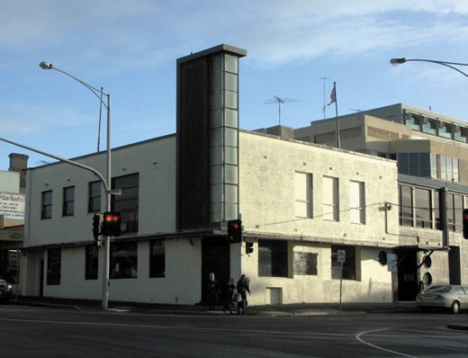
Figure 9.142: Geelong Hotel, south-west corner Moorabool & Myers Streets, 2011 (now demolished). Source: David Rowe.

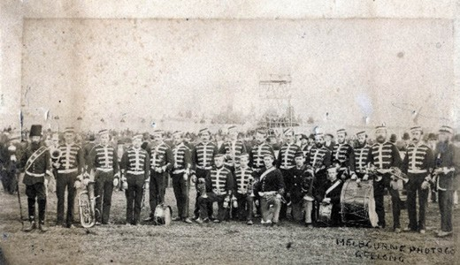
Figure 9.143: Melbourne Photo Co., Geelong Volunteer Artillery Band, 1877. Source: GRS 2009/00213, Geelong Heritage
Centre collection.

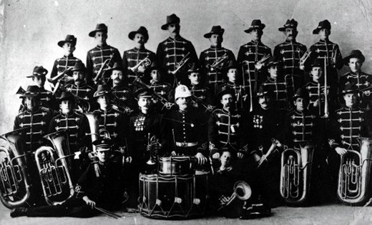
Figure 9.144: Geelong Town Brass Band, c.1905.
Source: GRS 2009/00627, Geelong Heritage Centre collection.

26 Moorabool Street (built in 1872) and Home House in the former E.R. Sparrow Woolstore and Auction Room at 40-42 Moorabool Street (built in 1937 (Theme 5).
A local singer during the nightclub era of the late 20th century who became internationally recognised as the frontwoman
of the Australian rock band, Divinyls, was Christina (Chrissy) Joy Amphlett (1959-2013)894 (Figure 9.130). The cousin of Australian singer, Little Pattie (Patricia Amphlett) Chrissy Amphlett attended Belmont High School before she went overseas.895 In 2001, the Divinyls Science Fiction , written by Amphlett in association with lead guitarist Mark McEntee, was selected by the Australasian Performing Right Association (APRA) as one of the top 20 Australian songs of all time.896 Amphlett died in 2013 after a long battle with breast cancer.897
During the 2010s, Little Malop Street in central Geelong (between Moorabool and Gheringhap Streets) has witnessed a transformation from a quiet shopping strip into a thriving location for live music and bars. In 2019, this narrow street boasted at least 10 venues including The 18th Amendment Bar, Beav s Bar, Geelong Cellar Door, Cabinet Bar Geelong, Piano Bar, Pistol Pete s Food n Blues, Tomodachie Izakaya and Bar, Big Ears and The Workers Club Geelong.

BRASS BANDS AND ROTUNDAS
A key part of musical life in Geelong from the 19th century was the formation of numerous brass bands. They had their roots in the temperance and volunteer movements, churches, orphanages, education sector and the workplace. The earliest formed in Geelong was the Honorable Order of Rechabites and Father Mathew s Total Abstinence Society
Bands in 1847.898 In 1855, the Rifle Corps band formed and it was followed by the Geelong Volunteer Artillery Band (1864) (Figure 9.143), Ceres Rechabite Brass Band (1869), St.
Augustine s Fife and Drum Band (1870), Sons of Temperance Brass Band (1872), St. Patrick s Society Band (1872), Victorian Woollen Factory Brass Band (1873), Temperance Life Band (1874), St. Mary s Society Band (1875), Drysdale Brass Band (c.1877), W.D. Goodall s Band (1879), Protestant Alliance Drum and Fife Band (1883), Salvation Army Band (1884), Chilwell Brass Band (1887), Geelong Garrison Band (1889), Portarlington Brass Band (1889) and the Geelong Town Band (1896)899 (Figure 9.144). John Thomas Tansey (1872- 1949) was Honorary Secretary of the Geelong Artillery Band in 1897 and in 1899 he was appointed Secretary of the Geelong Brass Band.900 His daughter, Hilda Amelia Tansey (born in Geelong in 1900) –who had gained many years experience as a cornetist in her father s band - was to become the inaugural conductor of the Sydney Ladies Brass Band, NSW, in 1934, the first female brass band in Australia.901
More bands formed in Geelong and District in the early 20th century prior to World War One. They included the

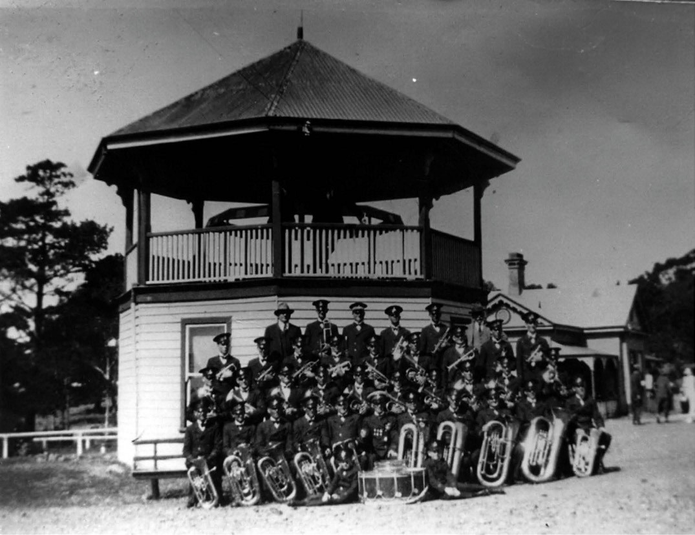
Figure 9.145: Portarlington Brass band outside bandstand, Portarlington, n.d. c.1925. Source: image 2051, Bellarine Historical Society collection.

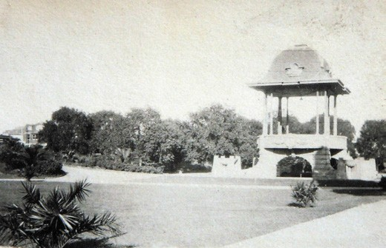
Figure 9.146: Hitchcock Memorial Bandstand, Johnstone Park, c.1930. Source: T.T. Holmes collection, Authentic Heritage Services Pty Ltd.
Portarlington Rifle Club Brass Band (1901), Geelong Harbor Trust Band (1909), Geelong Municipal Band (1911), Junior Municipal Band (earliest known as the Municipal Juvenile Band) (1912) Gordon Technical College Band (1915), Geelong West Band (1911) 902 Today, there are only four community bands in existence. They are the Geelong West Brass Band, Geelong Concert Band (1987), South Barwon Corps Salvation Army Band (1923) and the Geelong Memorial Brass Band (1946).903
A physical legacy of the popular brass band movement in Greater Geelong in the early 20th century are the rotundas. The earliest surviving is the bandstand at Portarlington (Figure 9.145), built in 1910 which had a combined use as a weighbridge office (replacing an earlier structure).904 It was the location of musical entertainments by the Portarlington Brass Band.905

At Bright and Hitchcock s Department store in Moorabool Street, the corner bandstand (erected in 1913) (Figure 5.155, see Theme 5) combined the roles of clever marketing and outward philanthropy to the benefit of public popular culture. The first bands to perform there were those of the Geelong Harbor Trust and the Geelong Municipal Band in 1914.906 The following year the Geelong City Band played the intermezzo, Silver Wedding Bells as a complement to Howard and Charlotte Hitchcock on their silver wedding anniversary.907
The Hitchcock family was also responsible for regular performances in Johnstone Park from 1920, when the Hitchcock Memorial Bandstand (Figure 9.146) was opened in memory of Mrs Annie Hitchcock (see earlier). On the opening night, the Returned Soldiers Band (established 1919),908 Geelong City Band and the Geelong West Band paraded from the top of Moorabool Street to Johnstone Park. The first to perform in the commodious new structure was the Returned Soldiers Band which played the National Anthem followed
by a splendid rendition of Lead, Kindly Light at the request of Mrs Charlotte Hitchcock.909 The Geelong City Band then played Peace with Victoria and the selection, Maritana .910

PICTURE THEATRES
In 1895, the Geelong Advertiser enthusiastically reported on the exhibition of Thomas Edison s invention, the Kinetoscope at the Exhibition Theatre:
The exhibition of Edison’s marvelous scientific toy, the Kinetoscope, which will only be on view here for two days more, was opened at the Theatre yesterday
under the direction of Mr Chas. McMahon. There was a constant succession of visitors during the afternoon and evening to witness the wonderfully effective illustration of the subjects selected for exhibition, and they went away marveling over the genius of the inventor, who
has endowed photography with life and vivacity for the entertainment of humanity. It is not possible to describe the experience of those who, looking through a narrow aperture in a small cabinet, witness a wire- walker
going through a thrilling performance in mid-air, or are fascinated by the graceful movements of the Spanish danseuse. The action is so natural that the visitor forgets that he is looking at a moving picture, and is almost impelled to give expression to his felling with a burst of applause when Carmencita bows
and retires.911
It was not until 1909 when some of the earliest and certainly largest moving pictures were shown at His Majesty s Theatre, Market Square.912 Buffalo Bill , The Buffoon , Rivals and The Man of Many Falls provided amusement to theatre goers.913

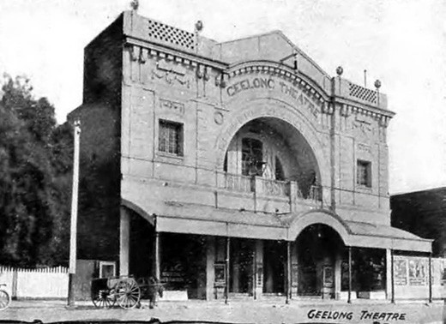
Figure 9.147: Geelong Theatre, Ryrie Street, c.1918. Source: Geelong for Business, Health, Pleasure, The Geelong City Council and Geelong Progress Association, Geelong, 1918, p.47.

The first moving pictures screened in Geelong came in the earliest years of the 20th century. In 1904, the Salvation Army screened the best series of biorama views yet shown in the town at His Majesty s Theatre.914 This was followed by the showing of thousands of feet of moving pictures in the same theatre in 1905, with Melba records given on the gramophone. 915
Theatres and halls –including His Majesty s Theatre, Market Square; Sladen Hall (known as the Embassy Theatre from 1940), Russell Street, Chilwell; Plaza Theatre, Ryrie Street; the Palais Royal, Moorabool Street and the Corio Theatre, Market Square (see earlier subsection) were some of the local movie venues throughout the 20th century. Other theatres that were built to cater for the growing demand included the following.

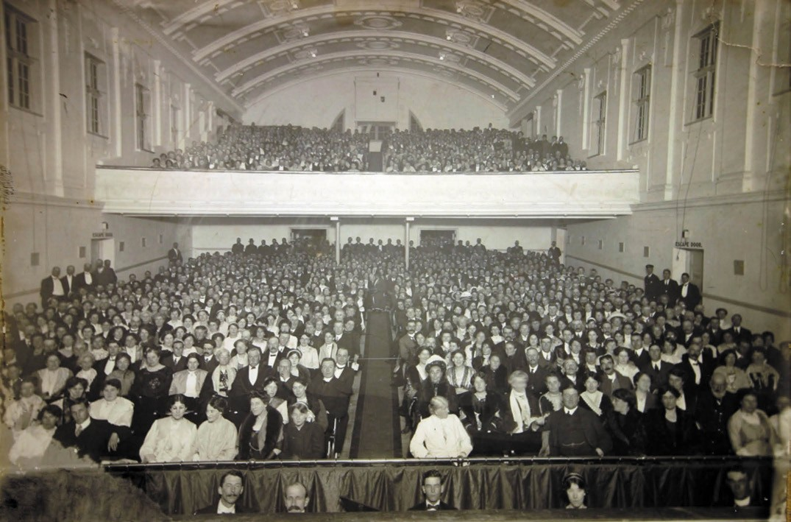
Figure 9.148: Interior, Geelong Theatre, showing capacity crowd at the opening night, 26 May 1913. Source: GRS 2010/58, Geelong Heritage Centre collection.

GEELONG THEATRE, 198-204, RYRIE STREET, GEELONG
The Geelong Theatre was opened to a capacity audience on 26 May 1913 by the Mayor of Geelong, Alderman W.R. Anderson during the interval of Jealousy , Sturla Acrobatic Troupe , The Doctor s Photograph , Timely Rescue , Alkali Ike , and Tigris .916 The theatre had been established by Amalgamated Pictures Co. Ltd., its managing director being
J.H. Tait. He instigated the formation of a new company for the Geelong Theatre, with H.B. Hodges as Chairman of Directors and George F. Wheatland as secretary.917 To accommodate 1750 people, the new theatre was designed
by local architects, Tombs and Durran and based on J. and
N. Tait s theatre on St. Kilda Road, Melbourne.918 The new two storey rendered brick Federation Free style building (Figures 147- 148) made a notable statement in this part of Ryrie Street and is the only purpose-built theatre continuing to serve its original purpose in Geelong today.

JOY ARK FLOATING THEATRE, EASTERN BEACH, GEELONG
In 1912, the Joy Ark (Figure 9.149), representing a large decorated shed, was erected above the sea water on the foreshore immediately west of Eastern Beach.919 From this time, the building offered social enjoyment through dancing, skating and concert activities.920 By 1926, the Joy Ark had closed and some of its building fabric was used to construct the Palais Royal building in Moorabool Street (see earlier).

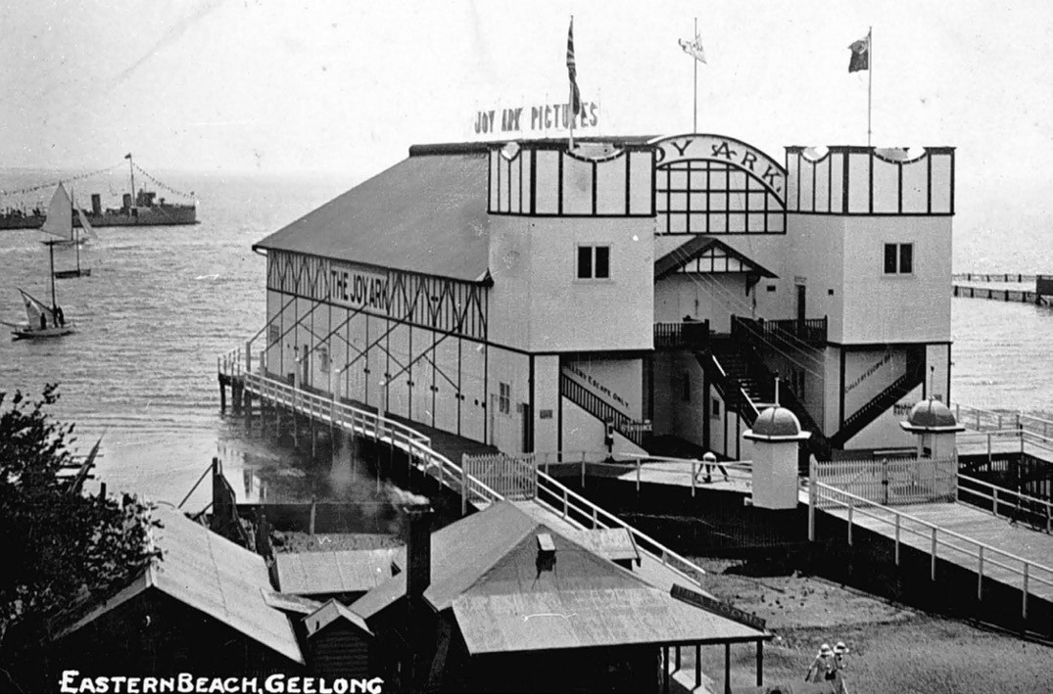
Figure 9.149: Joy Ark Picture Theatre, Eastern Beach, before 1920. Source: Museums Victoria, item MM 2780.

FORMER REGENT THEATRE, LITTLE MALOP STREET, GEELONG
In 1922, Messrs. T.J. and A.E. Fowler announced the beginning of a new venture new as The Regent.
This was the establishment of another picture house
in Geelong under the auspices of a new company called the Regent Theatre Proprietary Limited.921 Designed by Henry White and Gurney, architects and engineers of
Melbourne, Sydney and Auckland, the elaborate three storey building (Figure 9.150) was constructed by Thomas Quyale. The Geelong Advertiser gave a glowing description of the theatre when under construction in June 1922:
In the construction of the new theatre the architects, have followed their usual practice of creating a theatre
atmosphere for picture theatres as well as for full theatres.
This is obtained by departing from the usual square or town hall type of building, and also by attention to the enrichment and the lines of the gallery, ceiling and proscenium front. The front elevation of the building, when completed, will present a bold and simple form

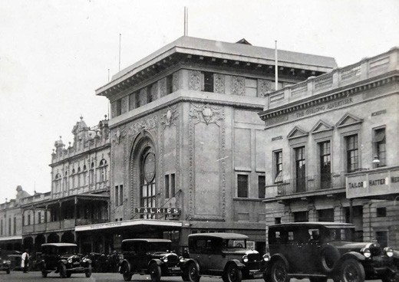
Figure 9.150: Regent Theatre, Little Malop Street (centre), c.1930. Source: T.T. Holmes collection, Authentic Heritage Services Pty Ltd.

of treatment entirely different from any other theatre in Australasia, and this treatment has been returned for a certain distance along Union street.
The main feature in the front elevation will be a large central and circular headed window, recessed and made to stand out as a central feature by suitable mouldings and enrichment, and the whole building will be crowned by a sheet metal cornice, which will stand out some 4ft. from the building line. In addition, the side of the theatre facing Union street will be suitably treated so as hide the ugly brick finished common to so many theatres. At night time the exterior of the building will present a brilliant appearance owing to the arrangement of the electric lights under the cornice on the “flood” system.922
Although the former Regent Theatre building exists today, its unique elaborate elevations been altered. A contemporary interpretation of the original design is currently proposed.

GEELONG WEST
Near the western boundary of the Geelong West Park, an open-air picture theatre was constructed in early 1912. The Geelong Advertiser gave the following report on the proposed building:
It has been decided to erect a stage building in the new park in Geelong West at a cost of £200. At the close of last night s meeting of the borough council, the Mayor, Cr. C.W. Dickins, submitted a sketch plan of the building the front of which is to be the width of the Mechanics stage. Provision is made for four dressing rooms, and a screen can be lowered for the purpose of showing moving pictures. Councillors expressed approval of the plan, and though the erection of such a building to be utilised as an
open air theatre and for bioscope pictures would bring in a good revenue
to the council.923
The picture pavilion (Figure 9.151) was designed by the Geelong architects, Laird and Buchan and comprised a gambrel-roofed structure with a central gabled entrance portico. The screening of the pictures was on the west side of the building.
In 1915, following a heated meeting, the Geelong West Council voted in favour of taking out a loan for the construction of a picture hall (Figure 9.152) adjoining the west side of the picture pavilion. Designed by Laird and Buchan,
it was built by the contractors, Tingate Brothers, for £1005.924 The contextually large gabled building, known as West Park Pictures , was built with a parapeted gabled roof form on an east-west axis. The hall and the pavilion were located near

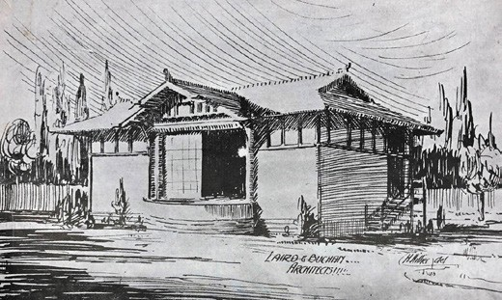
Figure 9.151: Laird & Buchan, Proposed picture pavilion, Geelong West, 1912. Source: News of the Week, 11 January 1912, p.13, GRS 2121/3, Geelong Heritage Centre collection.

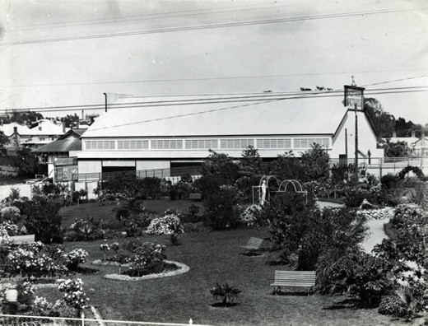
Figure 9.152: West Park Picture hall, Geelong West (looking west from Geelong West Park), c.1920. Source: GRS 2009/01962/046, Geelong Heritage Centre collection.

the end of Pineville Avenue.
By the 1950s, the picture hall had fallen into disrepair. While some remedial work was carried out in 1961, providing opportunity for the continued tenancy of the Geelong Table Tennis Association, the hall and pavilion were removed after 1978.925

FORMER PIX CINEMA, 23 ELIZABETH STREET, GEELONG WEST
In 1952, The Argus announced that the Health Commission had approved the conversion of a brick bakery at 23 Elizabeth Street, Geelong West, into a picture theatre to seat 463 people.926 The bakery had been built in 1924-25 for Lewis Dean, baker, on the site of his weatherboard dwelling that he

had acquired in the previous year.927 Opening in 1953 with the ‘first panoramic screen in Victoria, possibly Australia’, it was the brainchild of Rupert Barras (Bass) Brownbill (1908-1978), the son of bakers, David and Emma (nee Taylor) Brownbill.928 Bass Brownbill s foray into the theatre industry began at Penshurt, Victoria, in 1926, when he ran a show there but the introduction of talkies brought about substantial financial losses.929 After some years as a baker at Coleraine, he relocated to Geelong West in 1935-36 and to his parent s bakery at 23 Elizabeth Street which they had
purchased the previous year.930 There, Brownbill established a small theatrette in the backyard.931 This was the beginning of his picture shows in Geelong and led to him opening a theatre in Belmont.932 At Geelong West, he employed only male ushers because he claimed that girls are too moody. 933 In 1955, alterations and additions to the new Pix Theatre were carried out to a design by the local architects, Schefferle and Davies.934 Movies screened at the Pix for about 30 years.935
In 2017-18, the former theatre was converted into two dwellings.936

DRIVE-INS
From the 1950s, two drive-in theatres became the new method of movie-watching in Geelong given the rise in the popularity of the motor car. In 1954, a 12-acre site at Moolap was approved by the Health Department and the Geelong District and Town Planning Committee.937
Known as The Star Drive-In, it opened in January 1955.
It was followed by Village Drive-In on the Ballarat Road, Bell Post Hill. Increased patronage in video movie rentals in the 1980s brought about the demise of the Drive-Ins, the Star closing in 1984 and the Village before the close of the 20th century.938

LITERATURE
Also contributing to the cultural life of the Greater Geelong area from the 19th century have a number of authors.
Most notable were Geelong s poets. The earliest was by
F.M. Hughan whose works provided a brief chronology of Geelong s European development in the 1850s. In 1856, he penned The Emigrant and other Poems which was followed by On the laying of the Foundation Stone of the Geelong and Melbourne railway and Get Understanding , an account of the laying of the foundation stone of the Geelong Mechanics Institute.939

WILLIAM STITT JENKINS
A particularly prolific poet was William Stitt Jenkins (1812- 1878) (Figure 9.153). Born at Whitehaven, England he arrived in Victoria in the 1850s with Written off Cape Otway being his first poem published in the Geelong Advertiser

and Intelligencer in 1854.940 On his departure to reside in Melbourne in 1876, the Geelong Advertiser gave an insight into Stitt Jenkins contribution to Geelong s literary and social life:
That Geelong s loss will be Collingwood s gain, we have little doubt; for we feel assured that, if Stitt Jenkins
accomplishes one-half for this strict that he has done for Geelong, the people of Collingwood will not let him depart from their midst as apathetically as did the people of the Pivot. … strange to say, although universally known as the Poet of the Pivot, most of Mr Jenkins compositions, for nearly eleven years past, appeared in the columns of this paper; there was a strong congeniality of sentiment between us, for the old Radical spirit of the fatherland
is not yet extinguished in our breasts; and hence his partiality for this journal, to which he has steadfastly adhered ever since the management devolved upon the writer of this brief but sincere welcome to a brother-worker in the cause of political and social progress.941

DAVID HUGHES
On Stitt Jenkins’ death in 1878, another prolific local poet, David Hughes (1821-1895), penned a work entitled In Memoriam of William Stitt Jenkins which read in part:
Another noble, generous heart, From life has passed away;
In doing good, that was his part, While with us he did stay.
Benevolence –such was his creed, Widows they were his care;
The orphan s friend in time of need, Giving when he could space.
A kind word Jenkins had for all, He was the poor man s friend;
Who can forget the Temperance Hall, When he did there attend.
Trying our youths for to reclaim, Form off the streets at night;
His loving heart, no thought of gain, But try them to delight.
His generous soul now rests in peace, Is numbered with the dead;
He is where earthly trouble ceases, Mark, only just ahead.
Still he has left a mark behind, That death cannot erase,
A man of worth and sterling mind, That nothing will replace.

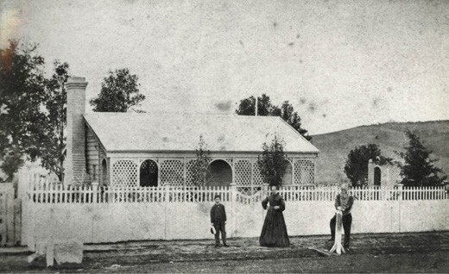

Figure 9.153: William Stitt Jenkins (right) and family outside their home in Noble Street, Newtown, c.1870. Source: GRS 1599/03/255, Geelong Heritage Centre collection.

Stitt Jenkins, honored by thy name, Thy muse was from above;
There was the true poetic flame, Teaching all peace and love.942
Hughes came to Geelong in 1844 where he remained until his death in 1895.943 He was the proprietor of several
business, primarily boot and shoe stores in different locations throughout Geelong, until 1882.944 Between 1869 and 1882, he composed approximately 300 poems, several of which
he exploited as marketing campaigns for his boot and shoe business945 (Figure 9.154).

JAMES FRANCIS HOGAN
A conscientious author was James Francis Hogan
(1855- 1924).946 Born near Nenagh, County Tipperary, he migrated to Geelong with his family in 1856 and was educated at St. Mary s Catholic School, Geelong, and later at St.
Patrick s College, Melbourne.947 He became a teacher, firstly at Anakie, then Flinders school and between 1877 and 1881 was the headmaster of St. Mary s, Geelong.948 Throughout his teaching career, Hogan penned several works that were published in newspapers and journals.949 His literary success was impetus for him to become a professional writer and in 1881 he abandoned teaching to became a sub-editor of the Victorian Review. He later joined the Argus.950 In 1886, he published a biographical sketch of Archbishop James Goold and an anthology of his work entitled An Australian Christmas Collection. Relocating to England in 1887, he published his best-known work, The Irish in Australia.951 In 1893, Hogan was elected unopposed to the House of Commons, London, for the middle division of Tipperary, Ireland, the first former resident of Geelong to have been elected to the Imperial Parliament. 952

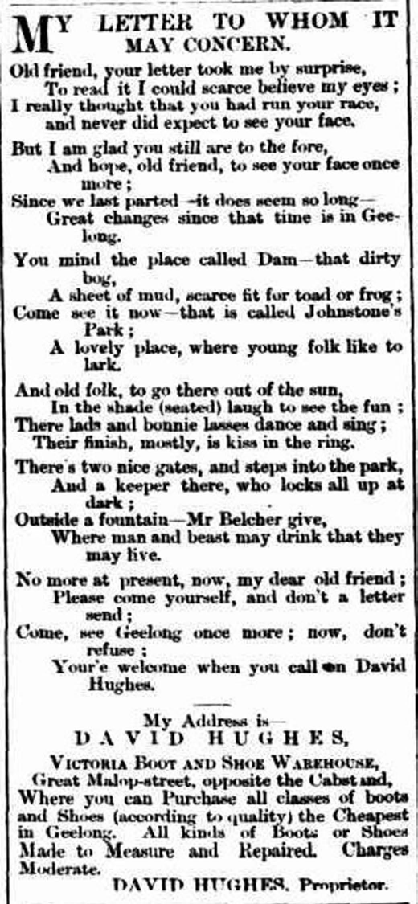
Figure 9.154: David Hughes, Poem used for marketing, 1875. Source: Geelong Advertiser, 28 June 18975, p.4.

DANIEL BUNCE: A WRITER ON INDIGENOUS LANGUAGES AS WELL AS BOTANY
Very few publications were produced in the 19th century which focused on the life and plight of the Wadawurrung. One exception was Daniel Bunce, curator of the Geelong Botanical Gardens from 1857 and author of several
non- fiction catalogues, publications and articles, largely relating to botany but also to the Indigenous peoples. One of Bunce s earliest writings on the First Nation peoples was published in The Argus in 1851. He gave a brief overview of his work on the Aboriginal languages, an insightful and contextually rare outline of the culture of the Indigenous peoples from a European perspective, largely without prejudice. His article read in part:
To treat the habits and customs of the Australian Aborigines in the limited space allotted to the Author, he feels that he shall scarcely be able to do either the subject, or that ill-used race of people the justice to which they are in every way entitled, but which has been so long withheld from them.
The object of the present introduction is to lay before the reader, in a brief a form as possible, the leading features of a very interesting race of people, who are generally supposed to possess but little of the intellectuality with which their more favoured white brethren are gifted. Than such a conclusion nothing could be more unreal in fact, or unjust to those to whom the imputation is implied, few people possessing closer reasoning powers, or having
observing faculties of a higher order. This is not a passing remark of the moment, but the assertion of an individual who has devoted some fifteen years of his life to the subject.953
Bunce s studies of the Aborigines culminated in his publication of the Language of the Aborigines of the colony of Victoria and other Australian Districts in 1851. He prepared
a second edition that was published in 1859. A copy of the book in 1867 featured a portrait of Dan Dan Nook and an inscription of Dan Dan Nook s anticipation presentation of the publication to the Princes of Wales on visit to Geelong in 1867 (the presentation by Dan Dan Nook never eventuated) (see Theme 2).

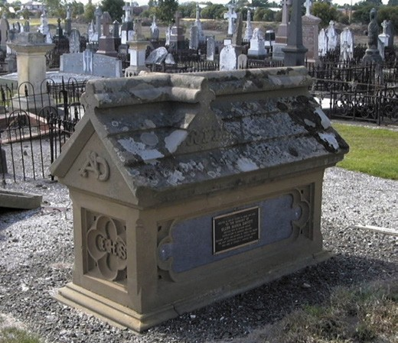
Figure 9.155: Davitt monument, Catholic section, Eastern Cemetery, 2019. Source: Pam Jennings.

ELLEN DAVITT
An author of national prominence who was resident in Geelong for a short period in the 1860s was Mrs Antoinette Helene Leontine (Ellen) Davitt (nee Heseltine).954 She was born in Dublin in 1812. She married Arthur Davitt (1808- 1860) an educationalist, in Jersey in 1845 and they emigrated to Melbourne in 1854 to take up joint appointments with
the National Board of Education.955 Arthur Davitt had been appointed principal of the Model and Norman Schools and Ellen as superintendent of the female pupils and trainees.956 The Davitts’ tenure came to an end in 1859 due to a financial recession that led to the closure of the training institution.957 Ellen Davitt opened the Ladies Institute of Victoria in Carlton while Arthur Davitt was appointed to St. Patrick s College, Melbourne.958 In January 1860, the Davitts relocated to Geelong due to Arthur s ill-health and he died at the National Hotel, Moorabool Street, in January of that year.959 Ellen Davitt remained in Geelong over the coming months and contributed much to artist and literary life. In 1861, she gave a lecture at the Mechanics’ Institute on ‘The Influence of Art’ and The Vixens of Shakespeare. 960 Her portrait of Queen Victoria –which was placed temporarily in the Geelong
Town Hall in November 1861 –was so well received it was purchased by the Town Council.961 Davitt subsequently taught at the Portland State School from August 1862 to September 1863,962 and then resided for a number of years in Castlemaine where she continued to give lectures that were well received.963

It was Davitt s literary skill that was to posthumously bring her high acclaim. Introductory chapters of her Edith Travers and Force and Fraud were published in The Australian Journal
in 1865 when she was resident in Castlemaine and giving inspiration of her tale of the bush in Force and Fraud.964 This novel was the first murder mystery in Australia.965 According to Kate Watson in Women Writing crime Fiction, 1860-1880, Ellen Davitt ‘is one of the most significant contributors, male or female, to Australian criminography despite only writing
for about three years (1865-68).966 Ellen Davitt died in Fitzroy in 1879 and was buried with her husband at the Eastern Cemetery, Geelong, beneath a Gothic-inspired monument she had erected in 1860, probably to her design967 (Figure 9.155).
Davitt s contribution to Australian writing is now recognised in the Sisters in Crime Australia s annual Davitt Awards, launched in 2001 to provide recognition for Australian women crime writers.968

JAMES MORGAN WALSH
Davitt s male equivalent who was born in Geelong in 1897 was James Morgan Walsh.969 The son of Thomas Patrick Walsh, an accountant and Kate Morgan, he attended local Catholic schools before receiving an education at Xavier College, Melbourne.970 On the completion of his schooling he entered his father s stock and station business in Geelong as a clerk and it was there where he first began his writings as a novelist.971 He published his first short story in 1913 and his first novel, Tap Tap Island, in 1921. It was in this year when he moved to Melbourne with his family and in 1923, he became a full-time writer.972 According to Stephen Knight:
One of Australia’s most prolific authors, Walsh produced fifty-eight novels under his own name. As ‘H. Haverstock Hill’ he produced five crime adventures of the Pacific islands, in the genre of Louise Becke and Beatrice Grimshaw. Three others were written under
the pseudonym Jack Carew . References to him as the Australian Oppenheim and the Australian Edgar Wallace indicate both his popular status and the range he covered
… His work was translated into many languages 973
Walsh lived at Weston-super-Mare, Somerset, from the late 1930s where he died in 1952.974

HELEN GARNER
Born in Geelong in 1942, Helen Garner was educated at The Hermitage, Newtown and later the University of Melbourne.975 Entering the teaching profession, she was controversially dismissed from the Fitzroy High School in 1972 for teaching sexual issues and using bad language in the classroom. 976 From the mid 1970s, Garner was associated with the
Women s Theatre group and wrote for several prominent

publications.977 Several of Garner s novels have received awards, including Children s Bach (penned in 1984), winner of the South Australian Premier Festival Award in 1986; and Postcards from Surfers, short story collection written in 1985 and which won the New South Wales Premier s Award in 1986.978 Garner is also highly regarded for her non-fiction work, receiving a Walkley Award for journalism in 1993 and in 2006 she won the Melbourne Prize for Literature.979

SHOWS, EXHIBITIONS AND PROMOTIONS
Since the 1850s, numerous shows, exhibitions, displays and promotions have been held in the Greater Geelong area, some becoming more enduring museum exhibits.
A brief overview of the different exhibitions, shows and early marketing of Greater Geelong is given as follows.

AGRICULTURAL AND PASTORAL SOCIETY & THE GEELONG SHOW
In 1855, the Geelong and Western District Agricultural and Horticultural Society was formed. The objects of the new society were:
… the promotion of the theory and practice of agriculture and horticulture; the collection and dissemination of new and important facts having reference to the capabilities and cultivation of the soil; the theory of crops and general management of agricultural operations; the improvement in the breed stock, and treatment of their disorders; and the gradual perfection of the various operations and implements of husbandry, by the distribution of prizes, and by affording facilities for agricultural and horticultural exhibitions.980
The first office bearers were Horatio Spencer Wills, M.L.C. (president) (father of Thomas Wentworth Wills –see earlier), John Armstrong and David Fisher (vice presidents),
A.C. Macdonald (treasurer), John Middlemiss (honorary secretary), and the banker being the Bank of Victoria.981
The first event of the Society was a ploughing match at Aitkenside, Ceres, in March 1855. It was following by the first exhibition in the drill hall, Myers Street, in October of that year.982 In 1856, five acres were set aside at the south- east corner of Garden and Ryrie Streets as the site for the Society s showgrounds.983 In 1891, the Society relocated to a more commodious 30 acre site in East Geelong,
immediately north of the Geelong to Queenscliff railway line between St. Albans and Queenscliff Roads. In January of that year, the Society s secretary, Charles Craike, advertised an architectural competition for the necessary buildings and improvements on the Society s new reserve fronting
the Queenscliff Road, including fencing, grandstand, shed

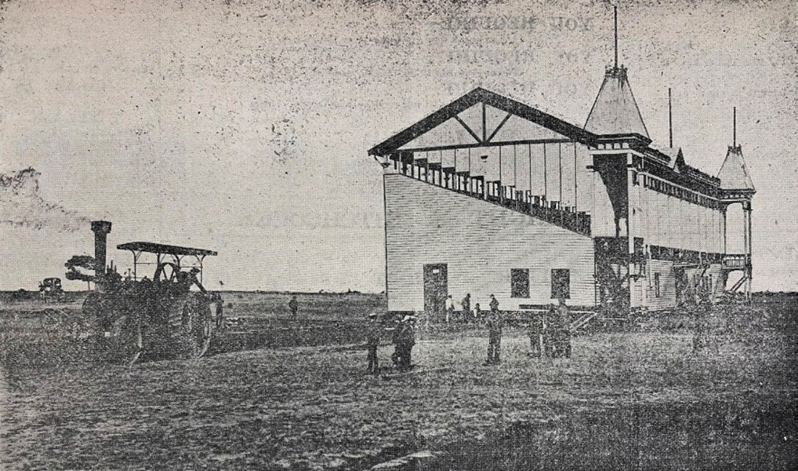
Figure 9.156: Geelong & Western District Agricultural and Horticultural Society grandstand in process of relocation to new site at Breakwater, 1907. Source: Geelong Advertiser, 25 March 1907, p.4, GRS 2050/106, Geelong Heritage Centre collection.

accommodation for stock, judging rings, railway siding, receiving yards, etc. etc. 984 The competition was won by John Angus Laird, young local architect (see Theme 8 for biographic details). With the works nearing completion in August 1891, a detailed description of the showgrounds was given in the Geelong Advertiser which declared that the main attraction was the very commodious grand stand constructed of weatherboard, resting upon a brick and
cement foundation. It was 138 feet in length, 42 feet 6 inches in width, with seats fitted in ‘gallery form’ to accommodate 1500 people. There were four staircases to provide access, the two end stairs emerging into turrets which ornament the structure. 985
In 1906, less than 10 years since establishing its showgrounds, the Society was forced to relocate to the 136-acre reserve diagonally opposite, which it was to share with the Geelong Racing Club. The last show at the East
Geelong site was on 14 September 1906.986 All buildings and infrastructure –including the grandstand –were relocated to the new site. The removal of the grandstand (Figure 9.156) was reported in The Australasian in
May 1907:
The most difficult task in connection with the transfer of the show stand to the new racecourse and showground at East Geelong was successfully accomplished on Sunday, April 14, when the contractor, Messrs. J. McCoy and Sons, removed the large building across the Queenscliff railway line. The contract is the biggest yet undertake in the Commonwealth, the total weight of the stand being slightly over 100 tons while the length is 136 feet. Its great height necessitated the removal of the telegraph lines, and the temporary installation of an undergrounds service. Sunday was the only day on which the crossing
of the line could be attempted, and even then the [Railway]
Department stipulated a penalty of 10 pounds per hour for any block that might occur to traffic when resumed. Happily no contretemps of any kind occurred, and the line was clear for traffic before 5pm. Rollers were used under the stand and the sides were boarded up to prevent sway occurring in the roof.987

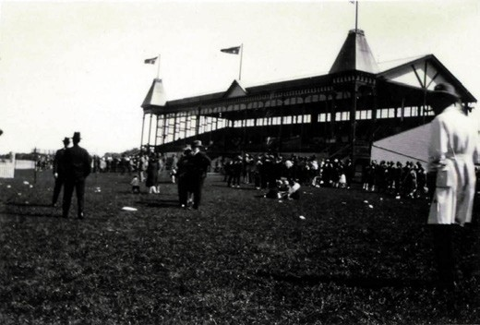
Figure 9.157: Geelong & Western District Agricultural and Horticultural Society grandstand at new showgrounds and race course site at Breakwater, 1927. Source: T.T. Holmes collection, Authentic Heritage Services Pty Ltd.

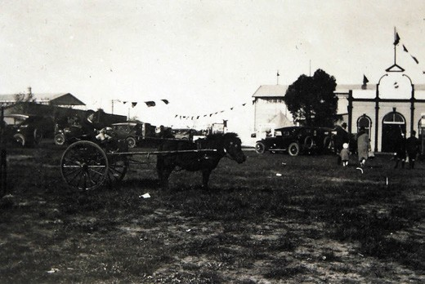

Figure 9.158: Geelong & Western District Agricultural and Horticultural Society pavilion (right), 1927. Source: T.T. Holmes collection, Authentic Heritage Services Pty Ltd.

The grandstand was to be the centerpiece of the new racecourse and showgrounds for many years (Figure 9.157). However, it was not to last another 100 years, being demolished in 2000.988
The most significant event in the Society’s calendar was the annual show. It attracted crowds from across Geelong and the Western District, the events and activities including horse shows, flower, produce, livestock and home industry
exhibitions, food and craft competitions, and amusements.989 Many of these activities were held in the Society s pavilion (Figure 9.158). One of the more unusual competitions
for prizes offered by the Geelong and Western District Agricultural and Horticultural Society in 1890 was for the largest collections of sparrows heads and eggs.990 English sparrows had been donated to the Geelong branch of

the Acclimatisation Society of Victoria at Eastern Park in 1866.991 They were turned loose and others were later bred by Henry Meakin and Thomas Jeffrey of Jeffrey s Fernery, Newtown.992 The sparrows soon became a menace, the Geelong Advertiser reporting in November 1867 that several of the sparrows recently liberated by the Acclimatisation Society have found themselves a home in the steeple of
the High Church, and appear to enjoy their new quarters immensely. 993 For the sparrow competition in 1890, the Society s competition committee had received 45,427 eggs and 5,965 heads. First prize for 1,406 heads and 5,375 eggs collected went to E. Foot of Lara. 994
In 1954, following widespread community support and the raising of over £2000, the Geelong Agricultural and Pastoral Society (as it was then called) relocated to its own ground comprising the northern 30 acres of the original racecourse and showgrounds reserve.995 A pavilion built at the original site in 1891 and removed to the race course site, was again relocated to the fourth showgrounds.996 It was demolished in 1960.997 The key event of the Society remains the annual Geelong Show, which was granted Royal status in 2005. 998

EXHIBITIONS

EARLY EXHIBITIONS
While Europeans had been holding exhibitions for hundreds of years, the tradition of exhibitions in Geelong was especially influenced by the Great Exhibition of the Works of Industry of All Nations held at the Crystal Palace in Hyde Park, London, in 1851. It was the first of several ‘world fairs’ that celebrated culture and industry.999 Geelong’s first industrial exhibition came soon after the Great Exhibition in September 1851.1000 It helped to promote the endeavours and valuable contributions of local citizens, and increase community pride. Prizes
were awarded for the best horses (with Misses Drysdale and Newcomb, Thomas Austin, C.J. Dennys, Mr Mercer and James Austin receiving gold medals).1001 The Geelong Advertiser gave a positive account of the event:
As it was, the show was decidedly attractive, for the room was crowded during the whole day; and we have no doubt of the complete success of future exhibitions.
The following list of prizes awarded will give an idea of the articles exhibited, and render it unnecessary for us to give what would be a mere recapitulation. Among the articles not there mentioned, we particularly noted a box of specimens of marble, polished, of various kinds, from Limeburner s Point, shewn by Mr. A. Ronalds [Theme 4]; several boxes of minerals collected by Dr. Bruhn; a model bird-cage, by Mr. Hardwick. The price of furniture for which Mr Stratford was awarded the gold medal, was a work table, the top of which was made of 291 pieces of

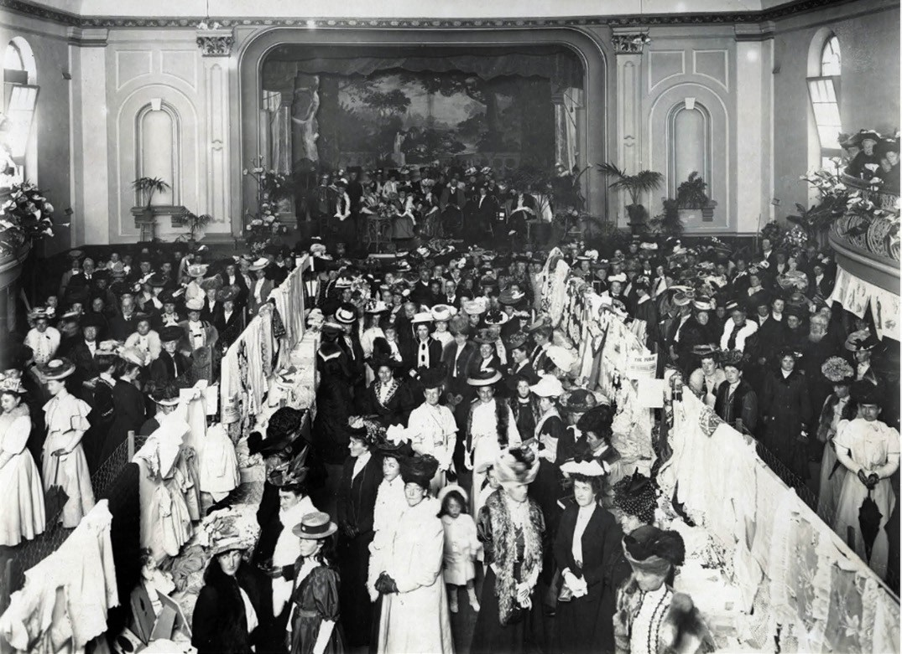
Figure 9.159: Exhibition of Women s work, Geelong Mechanics Hall, 1907. Source: GRS 0160/3/38, Geelong Heritage Centre collection.

colonial woods, 24 sorts, exclusive of the border, which was of colonial myrtle; it was purchased by Mr. Gore, for
£18, and will be sent by him to England.1002
A plethora of local exhibitions followed, mainly by the Geelong Mechanics Institute, to which its honorary secretary, B.W. Wheatland, was involved with all the Institute s exhibitions until the early 20th century.1003 They included the Mechanics Exhibition opened by the Governor of Victoria, Sir Henry Barkly, on 20 March 1857 (complete with 536 exhibits); Exhibition of Art, Science and Industry
at the Mechanics Institute in 1863 and the Fine Arts and Industrial Exhibition in 1876.1004 Exhibitions continued at the Mechanics hall throughout the early 20th century, including a show of Women s Work in 1907 (Figure 9.159).

INDUSTRIAL AND JUVENILE EXHIBITION, EXHIBITION BUILDING, MARKET SQUARE
By far the most substantial exhibition held in Geelong was the Geelong Industrial and Juvenile Exhibition staged from 18 December 1879 until 30 April 1880.1005 It was the genesis of the Geelong and Western District Agricultural and Horticultural Society who had resolved to hold an industrial exhibition. The Society held influence as its
president, J.H. Connor, was also the Mayor of Geelong.1006 A public meeting was called on 7 March 1869 and this eventuated in the construction of a commodious (and yet cumbersome) exhibition hall (Figure 9.160) to a design by the Town Surveyor, Robert Balding. The Victorian Italianate designed brick building had a frontage to Moorabool Street, the front having two storey hipped pavilions that flanked a central large glazed fanlight (an influential hallmark of the
Crystal Palace in London also used in the grander exhibition building) with a projecting balcony supported by cast iron posts. The front hipped towers featured paired round-

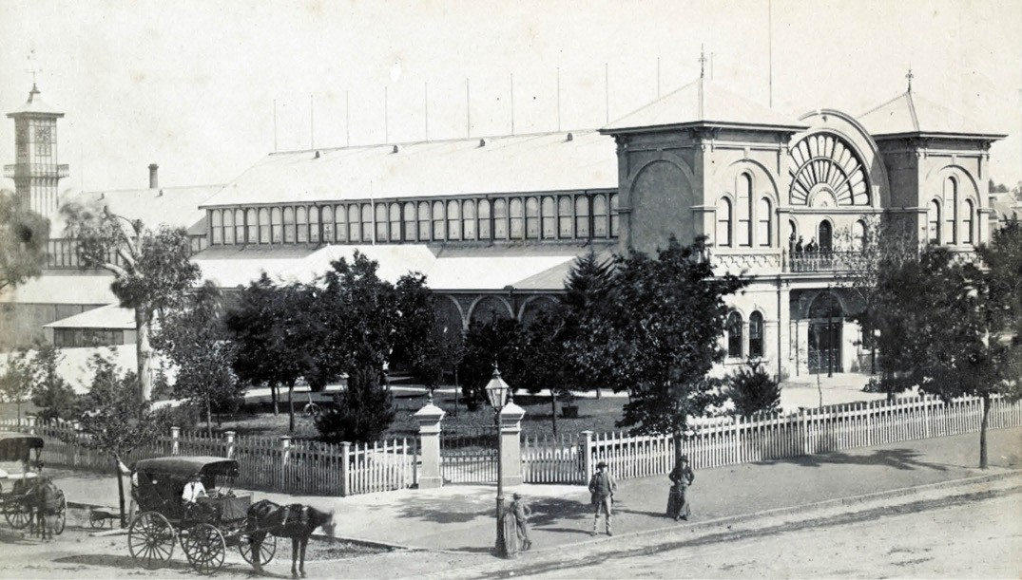
Figure 9.160: F. Kruger, Geelong Exhibition Hall fronting Moorabool Street, Market Square, c.1882. Source: accession H936114/16, State Library of Victoria.

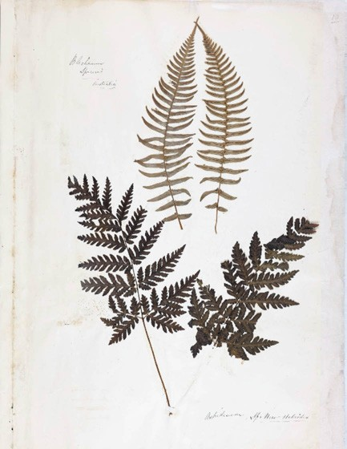

Figure 9.161: J. Raddenberry, Blechnum Species, Australia (top) & Aspidium, Sp. New Hebrides , 1879. Source: J. Raddenberry, Book of Ferns, 1879, GRS 2080/1, Geelong Heritage
Centre collection.
arched windows on the ground floor and Palladian windows on the first floor. The main entrance was centrally located being below the front balcony. The sides of the large hall (measuring 137 feet by 60 feet) were lit by clerestorey windows, there being elongated skillions and with projecting faceted bays on the north and south sides.1007 Internally,
a balcony was constructed immediately above the main entrance doors to accommodate the orchestra. At the rear, a connecting passage was built (lit by a row of side windows) to link the new building to the old market.1008
The exhibition was opened by the Governor of Victoria, His Excellency the Marquis of Normanby on 18 December 1879 and reflected a key public event in the European history
of Geelong.1009 Hundreds of exhibits were on display from locals and others across the state in the adult and juvenile departments. Various classes were assigned to each type of exhibit, with ‘class 1’ being for woollens, shawls, flannels, blankets, clothing and clothing materials, huts, etc., of Australian manufacture.1010 The class 20 category was for the collections and devices in shells, sea-weed, mosses, dried ferns, birds and birds’ eggs, insects, animals, fish &c.’ The local architect, Joseph Watts, exhibited his collection of
50,000 polished shells which the Geelong Advertiser declared was perhaps one of the most interesting exhibits in this department. 1011 A large number of gold and silver medals

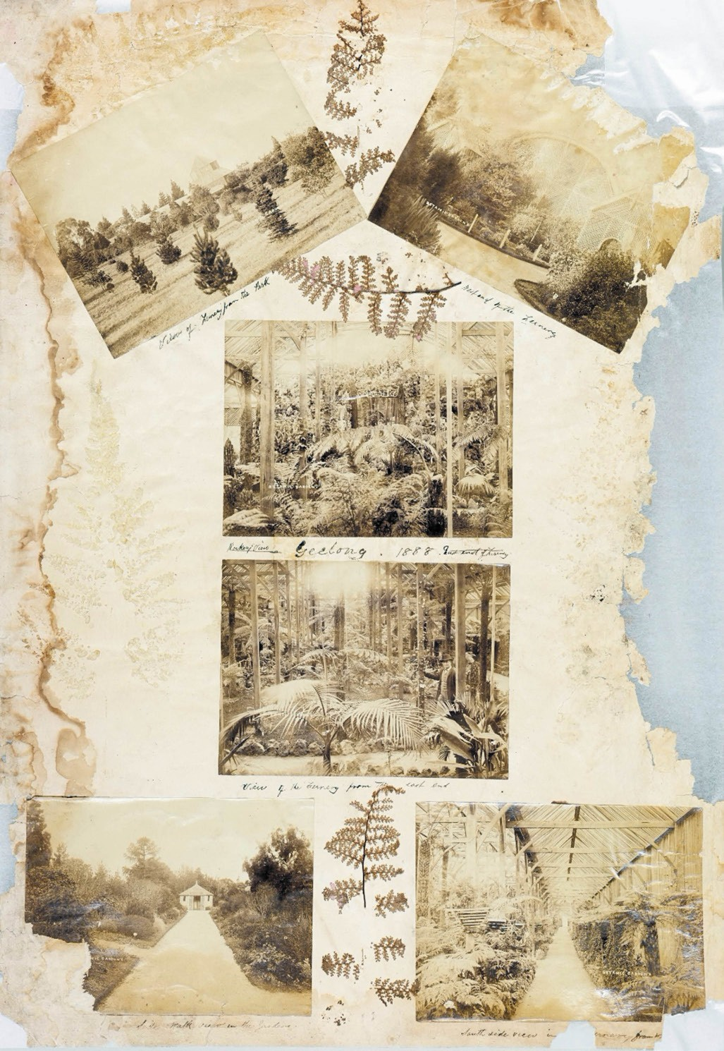

Figure 9.162: J. Raddenberry, View to and within fernery, Geelong Botanic Gardens, 1888. Source: J. Raddenberry, Book of Ferns, 1879 (photographs subsequently added), GRS 2080/1, Geelong Heritage Centre collection.

were awarded to local citizens and businesses (see Appendix 9.1). Little of these valuable exhibits is known to survive today. One gold-winning entry which is now an important item at the Geelong Heritage Centre was a collection of
dried ferns by the curator of the Geelong Botanic Gardens,
John Raddenberry. Comprising 260 varieties of ferns with a catalogue of names, the priceless value of the work
(Figures 9.161-162) was such that it was placed in a locked, glass case.1012 It could be thoroughly inspected when
Mr Raddenberry attended the exhibition.1013
The success of the Industrial and Juvenile Exhibition led to other exhibitions in the Exhibition Hall in the proceeding years. They included a Yarra Street school Flower Show and Industrial Exhibition in 1883, and the Geelong Jubilee and Industrial Exhibition in 1887 to mark the golden jubilee of Queen Victoria.1014 This was the last major exhibition in the building. In 1886, a branch telegraph office opened in part of the building, providing a central location for postal and telegraph services as an adjunct to the post office at the corner of Gheringhap and Ryrie Streets (Theme 7).1015
The Exhibition Theatre continued to operate while a portion of the building was occupied by the telegraph office. In 1901, it appears that an elevated gambrel roofed addition provided a more commodious stage and dressing rooms, being based on similar spaces in theatres in Melbourne and Ballarat.1016 The branch telegraph office closed in 1903 when the front portion of the building was leased to J. Johnson, music warehousemen, who opened showrooms there. The rear portion of the building became His Majesty s Theatre (see earlier). A few months later, Johnston transferred his lease to Sutton s Proprietary Limited who operated a musical supply business. In 1907, Julius Solomon, draper of Talbot (Theme 5), took over the drapery business of Lige Cocking and Co and opened a new store in the former Exhibition Hall.1017 It was called The Colosseum . Solomon remained there until the opening of his substantial Solomon s Store
on the Moorabool Street frontage of Market Square in 1913 (Theme 5). The construction of the new building had necessitated the demolition of the front elaborate portion
of the former Exhibition Hall, together with other alterations and additions which continued to operate as His Majesty s Theatre.1018 A new thoroughfare –Jacob Street –was created to provide front access to the theatre as well as rear access to Solomon s Building.1019

OTHER EXHIBITIONS
The Industrial and Juvenile Exhibition in 1879-80 was the progenitor for several other exhibitions throughout Greater Geelong in the 19th and 20th centuries. In addition to the art and historical exhibitions (see earlier), a Juvenile Industrial Exhibition was held at the Temperance Hall, Ceres, in 1881.1020 In the early 20th century, the Gordon Technical College held nature study exhibitions in Davidson Hall that were open to state schools throughout Victoria. In 1906, the exhibition boasted 563 entries1021 (Figure 9.163).
In 1928, under the auspices of the Made in Australia Council, a Geelong Made in Australia Exhibition was held under the direction of a local committee with W.B. McCann as chairman,
R.W. Dobson as vice chair, E.J. Fairnie as honorary secretary and H. Bechervaise as honorary treasurer1022 (Figure 9.164). The Age gave a glowing report of the exhibition in July 1928:
Occupying 2 acres of floor space of the great showrooms of Dennys, Lascelles, the Made-in-Australia exhibition, opened at Geelong on Saturday, is a revelation. About
75 per cent. of the goods come from manufacturing establishments in Geelong itself, but everything under the roof is the product of Australian enterprise and skill. The visitor is astounded at the enormous range of exhibits;
if he were skeptical before he is equally surprised at the high grade and quality achieved, and must honestly recent any injustice to Australia manufacturers which may have lurked, even unconsciously, in his mind. Nothing so impressive has been seen outside Melbourne or Sydney before.1023
A second Made in Australia exhibition was held in 1938 to celebrate the centenary of the European colonisation of Geelong held at the Dennys Lascelles Woolstore at the corner of Moorabool and Brougham Streets.1024 Although the exhibition covered a range of subjects relating to manufacturing, infrastructure and education, The Age
highlighted the outstanding exhibits of the Geelong woollen mills, declaring that it was to be expected since Geelong leads the State in textile production. 1025
The Dennys Lascelles Woolstore had also been the location of a Geelong Women s Centenary Exhibition of antiques and historical relics to honour the pioneer European women of Victoria.1026 The funds of the exhibition were to go towards the memorial of these pioneering women. In addition to an exhibition of historical and reproduction items, ample scope was given for sections devoted to the work of women in the 1930s. The Australasian gave a description of the proposed exhibits:
There is a large section devoted to every kind of handcraft done, from kindergarten age up to the age of 18, while the

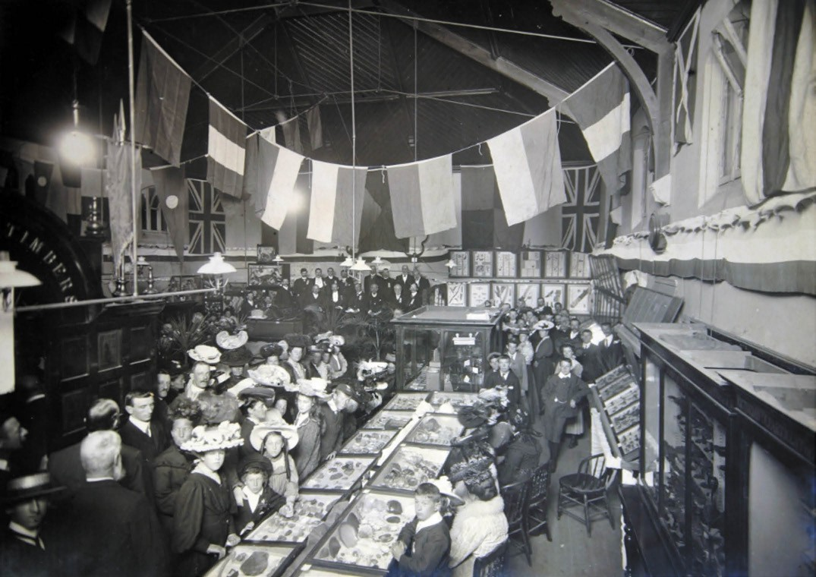
Figure 9.163: Nature Study Exhibition, Davidson Hall, Gordon Technical College, 12 April 1906. Source: GRS 0160/1/42, Geelong Heritage Centre collection.

Girl Guides Association, the V.A.D. s, the students from the Gordon Technical Institute, and the Geelong branch of the Country Women s Association have all been allotted sections to display their
varied activities.1027
An exhibition which reflected further social change in Geelong following the influx of immigrants after World War Two was
a 1000 Years of Poland Exhibition in 1966, organised by the Polish Millennium Committee of Geelong.1028

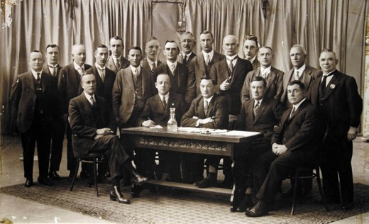

Figure 9.164: J. Lockwood, Geelong Made in Australia Exhibition Committee, 1928. Standing: J. Walker, H. Trigg, W. Austin, P.J. Pratt,
G. Hamilton Lamb MLA, G.A. Robertson & W. Brownbill MLA. Seated:
R.W. Dobson (vice chairman), E.J. Fairnie (hon. Secretary), W.B. McCann (chairman), C.N. Brown & H. Bechervaise (hon. Treasurer). Source: GRS 2009/02098, Geelong Heritage Centre collection.

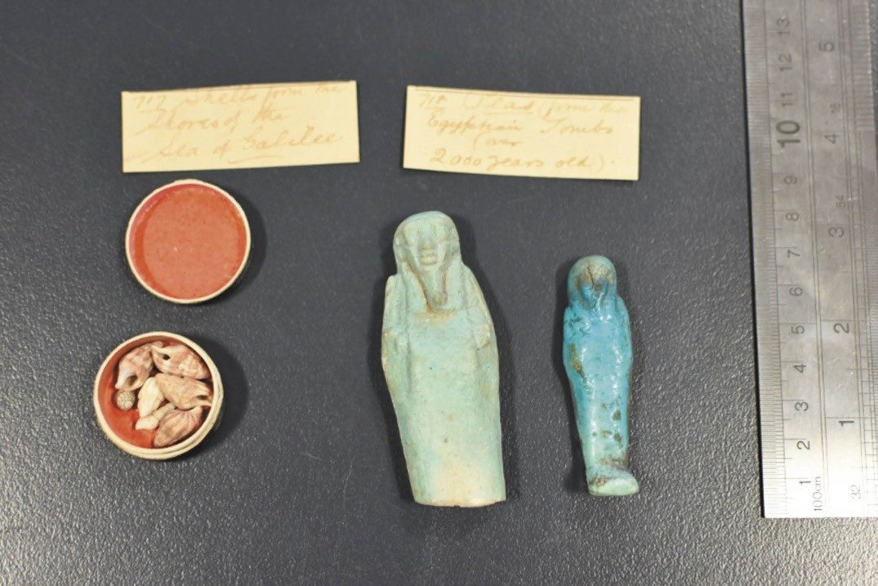
Figure 9.165: Shells from the Sea of Galilee & two unas from tombs (over 2000 years old) once part of the Gordon Technological College Museum. Source: Dale Kent, The Gordon TAFE, 2019.

MUSEUMS

LOST MUSEUMS
Throughout the 19th and 20th centuries, a small number of museums were established to provide repositories for
the valuable exhibits provided by the local community, and to research and curate their provenance and importance to the Geelong. These museums no longer exist, but their collections were highly valuable. They include the following.

GEELONG MUSEUM (AS PART OF THE FREE LIBRARY), MOORABOOL STREET
Geelong’s first museum was opened in 1886 by the Hon. F. Ormond in an upstairs room of the Free Library (opened ten years earlier –Theme 8). According
to the Geelong Advertiser, the room was filled with curious specimens including Aboriginal weapons and attire, obsolete coins, rare treasures in conchology and other interesting and attractive exhibits. 1029 Several of the items were those of A.B. Smith of Batesford who was claimed to ‘possess probably the finest private collection in Australasia. 1030 With such an auspicious start, it was
anticipated that the museum would be enduring and widely patronised. Yet, in 1887 there was discussion about closing it once the Gordon Technical College could take the collection.1031 It remained an ongoing concern but was relegated to a room on the ground floor when the Geelong Art Gallery took occupation of the first floor in 1896.1032 It
survived until the library and museum were officially handed over to the Geelong City Council in July 1949.1033

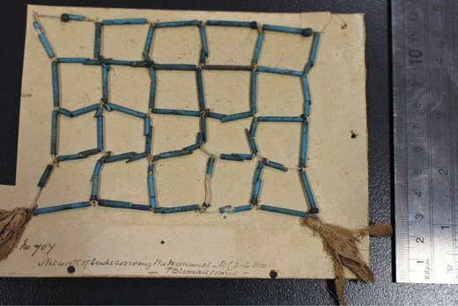
Figure 9.166: Network of beads covering the mummies –BC 2 to 300 –Ptolemaiclimes , one part of the Gordon Technological College Museum. Source: Dale Kent, The Gordon TAFE, 2019.

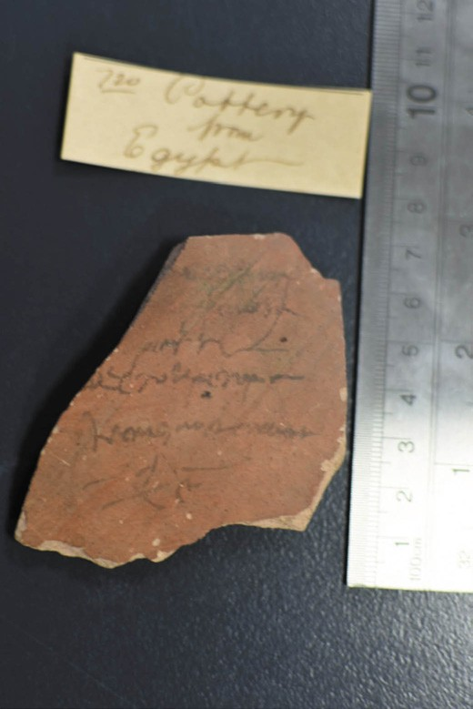
Figure 9.167: Pottery from Egypt , once part of the Gordon Technological College Museum. Source: Dale Kent, The Gordon TAFE, 2019.

GORDON TECHNICAL COLLEGE MUSEUM
A museum was established at the Gordon Technical College at the opening of the institution in 1887.1034 From this time, a collection was soon established, a valuable addition in 1888 being rubies from the McDonnell Ranges, Florence River, Northern Territory, by Adam Adamson of the Ruby Mines Company.1035 In 1895, 196 specimens were donated to the museum. They included a range of fossils and skeletons, eggs, minerals and stone, and even snake-catching apparatus.1036 A highly valuable and unique donation of Egyptian artefacts dating as far back as 2000 BC was also presented by Aquila Dodgson (1830-1919), Egyptologist, secretary of the Leeds Philosophical and Literary Society and Congregational Minister.1037 Dodgson had accompanied and funded an archaeological expedition to Egypt led by Sir William Matthew Flinders Petrie (1853-1942), grandson of the
British explorer to Geelong in 1802, Matthew Flinders (Theme 2).1038 Dodgson acquired several artefacts from this expedition, received from Petrie in recognition of Dodgson’s financial support and because Petrie was keen that the results of his work should be spread as far as Australia. 1039 In July 1892, Dodgson came to Geelong to visit his brother, the Rev. James Dodgson, Wesleyan Minister and Egyptologist (and widower to Caroline Newcomb –Themes 2, 5 & 7). Aquila Dodgson gave a series of lectures on Egypt at the Gordon Technical College and Congregational school room, Gheringhap Street.1040 Of the former, one of his lectures was entitled A recent journey
to the second cataract of the Nile. 1041 The Geelong Advertiser
reported on Dodgson s address:
Numerous lantern views were provided, and a great deal of interesting phases of Egyptian life in ancient and modern times was presented. Whilst some of the information imparted was geographical, some had reference to the interior of royal palaces and specimens of architecture, sculpture, etc., and the whole was interesting.1042
The collection donated to the Gordon by Dodgson included fine linen from Royal Tombs (1200 to 1500 BC), Early Christian textiles, Mummy cloth (1000 years old), sets of beads including network of beads that had covered Mummies (200 BC to 300 BC), pottery, shells from the shores of the Sea of Galilee and two unas from tombs (over 2000 years old).1043 (Figures 9.165-167).
While the Gordon Museum closed in the 20th century, the priceless collection of Egyptian antiquities remained in a box in a store room at the Gordon College until it was
rediscovered by Dale Kent, Records Manager, in 2017.1044 It is now undergoing conservation and analysis at Queens College, the University of Melbourne, where other parts
of Aquila Dodgson s collection are held.

FORMER CEMENT WORKS MUSEUM, MCCURDY ROAD, FYANSFORD
On 27 September 1936, the Protestant Orphanage at
150 McCurdy Road, Fyansford (Theme 8) was purchased by Australian Portland Cement Limited for subsidiary uses to the adjoining cement works.1045 By May 1936, the orphanage and neighbouring school had formed part of the recreational facilities for Australian Portland Cement Ltd employees.1046 In 1976, Fred Dolder approached the Recreation Club Management Committee for the use of vacant rooms at the former orphanage to display various historical items and other material relating to the development of the Cement
Works.1047 By the late 1990s, the museum had grown to such an extent that it encompassed 19 rooms over two storeys and was operated by a team of eight volunteers.1048 The museum closed in recent years.

EXISTING MUSEUMS

NATIONAL WOOL MUSEUM
The first proposal for a wool museum in Geelong came in 1905 when E. Plumridge, instructor of wool sorting at the Gordon Technical College, sort the assistance of the Geelong Agricultural and Pastoral Society to obtain and classify an exhibit of wool for the Government offices in London.1049 David Rhind of the Society supported the concept and went
a step further by asking that exhibitors in the wool section at the Geelong Show donate fleeces ‘for the purpose of forming a wool museum. 1050 David Aitken, a steward of the Society and local manager for Dalgety and Co. Ltd subsequently gave a valuable collection of fleeces as the nucleus of a wool museum.1051 Further prized fleeces from the Geelong
district were donated by Aitken and Dalgety and Co. early the following year.1052 Associated with the wool-sorting class at the Gordon, the museum was then established and in 1907 the New Zealand Loan and Mercantile Company provided a parcel of 26 samples of the best fleeces from the company’s clips.1053 By then, the wool museum collection was extensive. 1054 In 1921, alterations were made to the Gordon College Wool Museum, the Geelong Advertiser giving the following report:
All the show cases are being refitted and are to be filled with representative fleeces of all high-class breeders and woollen mills throughout the State. An attractive exhibit of the process of manufacture has been received from the Lincoln Spinning Mills, Coburg, and is the desire of the College authorities to have all the local mills represented. A number of choice fleeces have arrived as the result of a suggestion put before the chairman of the Geelong Wool Brokers Association (Mr D.P.C. Wilson), Senator Guthrie

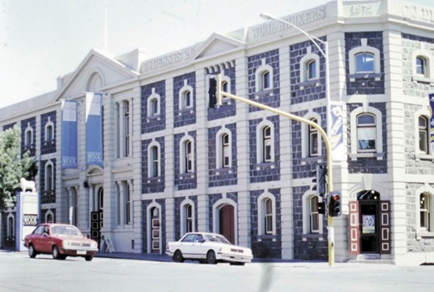
Figure 9.168: National Wool Museum, 26 Moorabool Street, 1991. Source: David Rowe.

who has always been to the fore in assisting in this direction, has again forwarded one of his best Corriedale fleeces, and also two enlarged photographs of the champion Corriedale ram of Australia from his Corriedale Park Estate, Wagga Wagga, New South Wales. Among others represented is the well-known Warrambeen Estate, near Shelford, owned by Mr. Bingley, and also the famous Bleak-house Estate. These exhibits will be placed in the permanent Museum and will not only be instructive to the students, but will be of special interest to the numerous people who visit the wool department annually.1055 A new museum was built as part of the new textile school in 1921 and was operational by 1922.1056
A wool museum that would attract even greater numbers was first mooted by the Geelong Regional Commission in 1979.1057 It acquired the former Dennys Lascelles woolstore at 26 Moorabool Street in 1985 (which was then threatened by demolition) and at a cost of $10.6 million, adapted the building as a National Wool Centre.1058 Sixty years after the building had first hosted the Made in Geelong exhibition, the
National Wool Museum (Figure 9.168) was officially opened in December 1988 by the Minister for Industry and Technology in the former Dennys Lascelles Ltd woolstore (built in 1872 – Theme 5). As one of the most significant bicentenary projects in Victoria, the National Wool Museum became Australia s only comprehensive museum of wool, telling the Australian story of wool, fibre and textiles in addition to contemporary exhibitions, public programs and
special events.1059
Today, the National Wool Museum holds a vast and unique collection. A focal point is the Axminster Carpet Loom (Figures 9.169-170) that was originally built by Brintons
in England in c.1910 and operated in Geelong from 1960.

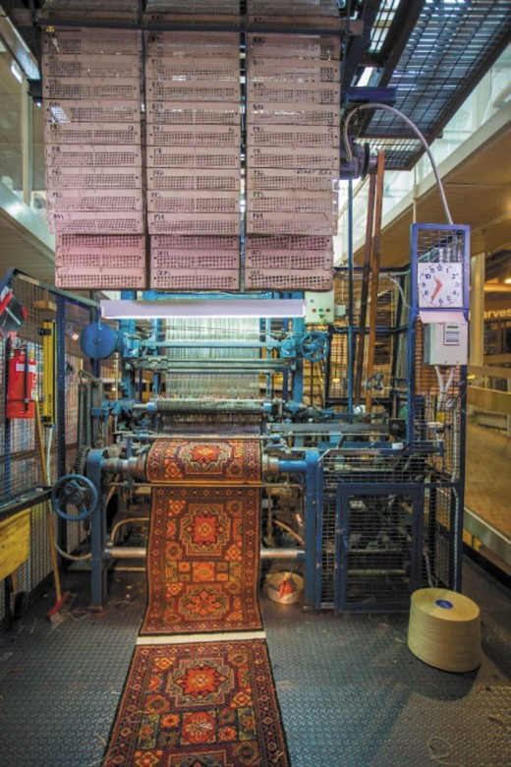

Figure 9.169: Axminster Carpet Loom, National Wool Museum. Source: National Wool Museum, Victorian Collections, object AP2W3105

It became superfluous to industry operations in 1975 and was donated to the Melbourne College of Textiles for weaving training. Subsequently donated to the National Wool Museum, it operated using a gripper, the yarn being gripped and then cut. The loom also uses a jacquard system for weaving colours, a system invented by Joseph Jacquard, a silk weaver from Lyon which revolutionised pattern weaving from 1804.1060
Another valued part of the collection is a portion of the
$1 million wool bale. In January 1995, Michael Crooks, auctioneer, took a world-record breaking bid for a wool bale weighing 116 kilograms which sold for $1,194,800. It was then ‘the finest bale of wool ever produced’, at 13.8 micron.1061 Another significant item includes a cloth sample from an opera cloak made in England in c.1820 from John Macarthur s first wool clip at Camden Park, New South Wales, in 1816.1062 Also at the National Wool Museum is the Zakrezewski Wheel
Figure 9.170: Axminster Carpet Loom, National Wool Museum. Source: National Wool Museum, Victorian Collections, object AP2W3147
collection, a collection of spinning wheels donated by Mr Wlodzimierz Zakrzewskiwho for many years had collected, researched and repaired them from all over the world, including the Nepal and Tibet region.1063

MARITIME MUSEUM, OSBORNE HOUSE STABLES, SWINBURNE STREET, NORTH GEELONG
The Geelong Maritime Museum was founded in c.1989, with former Royal Navy Ldg. Tel, Robert Henry (Bob) Appleton, OAM., as its inaugural honorary curator.1064 In 1992, the Museum relocated to the former Osborne House stables, Osborne House, North Geelong (see Themes 6 & 7).1065 The museum holds numerous historic artefacts and records associated with the maritime history of Geelong and Victoria, including the specific history of the Osborne House site as the first Australian Naval College from 1913 and first home for the J Class submarine of the Royal Australian Navy from 1919 (see Theme 7).

NARANA ABORIGINAL CULTURAL CENTRE, 410 SURF COAST HIGHWAY, GROVEDALE
In 1993, Narana (meaning listening and learning ) began as Narana Creations with a retail outlet in Yarra Street, Geelong where Aboriginal arts and artefacts were sold.1066 Three years later in 1996, 16 acres of former farmland on the Torquay Road at Grovedale were purchased for the transformation of the site into wetlands, cultural display building and art shed which was carried out in 1997-98.1067 In 2000, Narana became a Victorian Tourism Hall of Fame Member and in 2006 the first NaranaFest event was held featuring the Australian singer and song-writer of Torquay, Xavier Rudd.1068 Building improvements were made in 2014-15. Overall, Narana s mission is a destination for cultural education and tourism activities which promote greater understanding of Aboriginal culture and history. 1069

GEELONG MUSEUM OF MOTORING AND INDUSTRY, HAMLYN HEIGHTS
Geelong Museum of Motoring recently reopened in Hamlyn Heights in 2018.1070 The Museum holds an important collection of Geelong s motoring and manufacturing heritage previously displayed at the Ford Discovery Centre, corner of Gheringhap and Brougham Streets, which opened in 1997 and was closed in 2014.1071

AUSTRALIAN ORPHANAGE MUSEUM
In 2000, Care Leavers Australasia Network (CLAN) was established to represent, support and advocate for people who were raised in Australian and New Zealand Orphanages, Children s Homes & Foster Care. 1072 Since that time, CLAN has maintained an Australian Orphanage Museum so that its history is visible to all Australians. 1073 In October 2019, the Australian Orphanage Museum relocated from Sydney to 62 McKillop Street, Geelong. According to Chanel Zagon in the

Geelong Advertiser:
The sombre history of Geelong s 13 former orphanages
–dating to the 1800s [see Theme 8] –has never been publicly recognised in the city until now.
The Australian Orphanage Museum has relocated to McKillop St in Geelong after being in Sydney for the past 19 years, where it held precious items and artefacts from orphanages across the nation.
While Geelong orphanages no longer exist, the memory of abuse care leavers suffered still
lives on today.
Care Leavers Australia [sic.] Network co-founder and chief executive Leonie Sheedy said the museum and its historical objects acted as a physical reminder of the suffering the city s children experienced over
the centuries.1074
A more permanent museum was established at 351 Ryrie Street in 2020.

PROMOTIONS
Since the early 1840s, local individuals, community organisations, commercial enterprises, government departments and local councils have promoted the special natural and creative characteristics of the Greater Geelong area in an effort to attract tourists, economic investment and overall, greater prosperity for the community. The earliest was published by Geelong s inaugural editor of the Geelong Advertiser, James Harrison, and his business partner, John Scramble, and was titled The Geelong almanac for 1842: calculated for the meridian of Corio, and containing a variety of information useful to the settler, the merchant, and the tradesman.
These publications also coupled as commercial and trade directories, and provided advertising opportunities for local businesses. In 1854 two directories and almanacs were published in Geelong: The Geelong Commercial Directory and Almanac by George March and Company, Ryrie Street East, in January 1854; and The Geelong Almanac for 1854 by Comb and Curtis of Kardinia Street. The 23-year-old March had arrived at Point Henry from London in 1849 and was later to be employed as a clerk to the Coroner prior to the establishment of his Geelong Directory business by 1853.1075 In partnership with John Elkington, shipping reporter for the Geelong Advertiser and later first Barrabool Shire Secretary
(see Theme 7), March took legal action in the Supreme Court,
Melbourne, against Comb and Curtis for pirating parts of his publication.1076 Both of these directories and almanacs were followed by The Geelong Almanac for 1855 by Comb

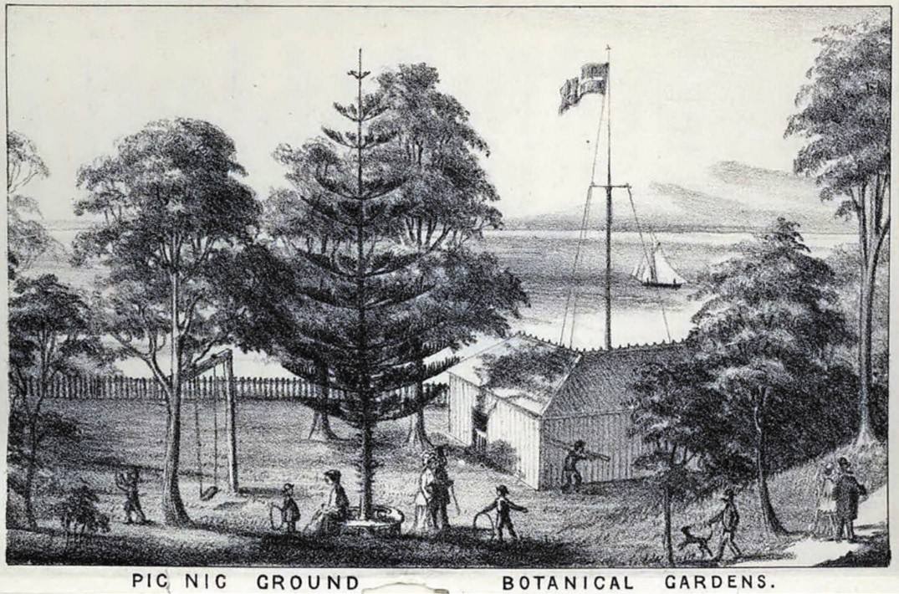
Figure 9.171: Pic Nic Ground [Eastern Park] Botanical Gardens , giving a picturesque setting of Geelong overlooking Corio Bay, 1879. Source:
Visitor s Illustrated Guide to Geelong, 1879.

and Brown, and The Geelong, Ballarat and Creswick s Creek Commercial Directory and Almanac for 1856 With a Map of Geelong by Heath and Cordell, printers, booksellers and publishers of Market Square, Geelong. Others followed, including Stevens Geelong, Western District and Squatters Directory of Victoria
for 1866-67.
In 1879, Visitor s Illustrated Guide to Geelong with a Brief Description of Lorne penned and penciled by R.C.Q. and published by Henry Franks in 1879, in readiness for the Industrial and Juvenile Exhibition. It gave a romantic view of Geelong (Figure 9.171), being described as built upon
a range of hills running east and west, descending on the north to the beautiful sheet of sea-water known as Corio Bay, and on the south to the Barwon River, and is admitted to be one of the healthiest towns in the colony. It continued:
The streets are broad, well paved and lighted, and there are many handsome public buildings, parks and gardens, and the woollen manufactories and tanneries on the River Barwon are the most extensive in Australia. Geelong is the
port of shipment for most of the wool grown in the Western district. 1077 Reporting on the Exhibition in December 1879, the Ovens and Murray Advertiser from Beechworth described the thousands of people attending and that Franks guide (illustrated) to Geelong and suburbs, giving all requisite exhibition particulars as well, is sold by runners in the building. 1078
In 1890, the shipping agents, Huddart and Parker, published a Guide to Geelong and District, with Illustrations and Plan of the Town; including a Short Sketch of Portarlington, in
an effort to boost tourism on its excursion steams that ran daily from Melbourne to Geelong.1079 Written by C.W. Jones, manager of the shipping agency, the Guide was illustrated with picturesque views of Corio Bay and Geelong landmarks, including the Chamber of Commercial Building, Botanic Gardens, churches, Gordon Technical College, bridges, and the Barwon Paper Mill.

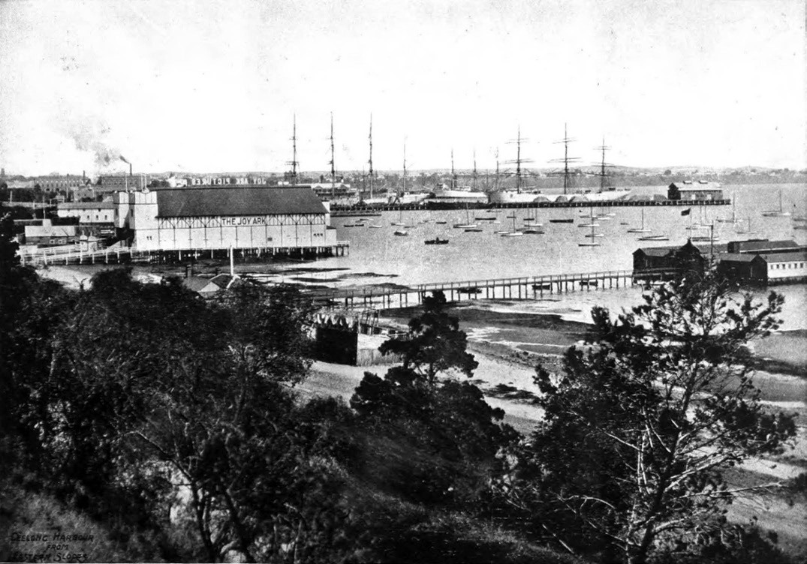
Figure 9.172: Geelong Harbour from the Eastern Slopes , c.1918 giving a picturesque juxtaposition of the importance of Geelong as a shipping port (background) as well as a location for marine recreation (foreground). Source: Geelong for Business, Health, Pleasure, The Geelong City Council and Geelong Progress Association, Geelong, 1918, p.7.

Huddart and Parker s Guide was followed by The Tourists Guide to Geelong and Southern Watering Places in 1893. Its purpose was to entice visitors to Geelong and the Bellarine Peninsula, and particularly to its tourist resorts at Barwon Heads, Ocean Grove, St. Leonards, Portarlington, Wallington and Drysdale:
With the facilities now offered for cheap and expeditious travelling, it seems necessary to put into the hands of the public a Guide Book, pointing out some of the convenient beauty spots of our colony, to which the family man from the country, or the city man needing change and rest can resort, without the expenditure of much time or money in accomplishing this desirable purpose.
The Southern Peninsular, from Spring Creek [Torquay] on the coast to Geelong on Corio Bay, includes a number of such places, and although some portions of this territory were the first occupied by our colonists, there is much to
interest and instruct the visitor or tourist will unexplored. With a view to help in this direction, the following pages have been written, and the publisher returns his best thanks to those gentlemen who have assisted in this work.1080
It was a number of community organisations from the 1890s and into the early 20th century whose promotional campaigns were especially successful in elevating Geelong as a place
to visit, live, and do business. The first was by E.A. Vidler, honorary secretary of the Geelong Progress League. This community organisation was established in 1895 to take up matters which did not come within the ordinary province of municipal bodies although of importance to the wellbeing
of the town and district. 1081 Initial projects were to assist with a scheme for foreshore improvements on the Eastern Beach, shelter shed for the wharf, provision of a municipal band, and the establishment of an Art Gallery.1082 Vidler s publication was entitled The Book of Geelong: Its People,

Places, Industries and Amusements, published in 1897. The introduction read (in part):
By its exceptionally favorable position, both as to its proximity to the larger centres of population and the many attractive and healthy sea-side place within a few miles and an hour s journey by coach, Geelong has become
on the most popular, as it is certainly one of the most beautiful, of the holiday resorts of the Colony of Victoria, in this sunny land of Australia.1083
In 1903, the Geelong Progress League was superseded by the Geelong Progress Association. Its objects were:
To popularise Geelong by means of extensively advertising its many natural beauty spots, its genial climate and healthy surroundings, through the medium of illustrated wall cars, books, or views, well-drawn advertisements in the country and metropolitan press, and the general distribution of literature relating to the many advantages it possesses as the finest and most conveniently-situated watering-place in the state.1084
In its first year, the Association had tried to improve the Eastern Beach foreshore and had erected a rotunda and seats, and had spread many hundred loads of sand at the beach foreshore.1085 Over the summer holiday season of 1904-05, it distributed 2,500 pictorial calendars at all Victorian railway stations for the purpose of advertising Geelong. 1086 In 1908, George H. Brownhill prepared an Illustrated guide
to Geelong and district on behalf of the Geelong Progress Association. It too gave a picturesque and highly positive overview of Geelong. Other initiatives of the Association in subsequent years included the construction of a rockery garden in the north-west corner of Johnstone Park in 1913.
Funded by the Geelong Comedy Club,1087 the purpose of the Progress Association s endeavours was to provide a beautiful and welcoming pedestrian entrance into the Park (and to Geelong) after disembarking from the train at the adjacent railway station. By 1914, the success of the Progress Association was measured in the numbers of farmers of
the Mallee and Wimmera who had retired to Geelong or had sought out the erstwhile Sleepy Hollow for a holiday. 1088 In 1918, the Association was a patron of the City of Geelong s illustrated publication: Geelong for Business Health Pleasure. A series of over 50 photographs formed the basis of the publication which the Geelong Advertiser declared a highly creditable production. 1089 This publication promoted the range of commercial and recreational opportunities in Geelong and district (Figure 9.172).
The years after World War One witnessed further promotions of Geelong, this time under the banner of the Greater Geelong Movement and the Geelong Publicity Council.

The idea of a Greater Geelong movement began in 1910 when the Premier of Victoria, John Murray, announced that the Victorian Government had intended to bring in a Bill
to compel the amalgamation of municipal councils in the Geelong area.1090 Ardent support for the proposal came from the Mayor of Geelong, Alderman Austin, who declared it a farce that a comparatively small area like Geelong should be governed by three municipal bodies. 1091 While this did not eventuate until the 1990s (Theme 7), it led to a movement that promulgated more ideal town planning (Theme 6) and infrastructure, and the positive promotion of the area.1092 The war halted proceedings until 1920 when W. Caffrey, organiser of the Greater Geelong Movement, gathered support from shopkeepers, other business leaders and local government to promoting local industries in a series of films and photographs over 120 nights as an exhibition for a visit by the Prince of Wales.1093 Involved with the provision of aerial footage and photographs was Charles Pratt who had just begun his flying business and aviation school at the Belmont Common (Theme 3).1094
The success of the Greater Geelong Movement in 1920, and the impending Made in Australia Exhibition at the Dennys Lascelles woolstore in 1928, had led to the formation of the Geelong Publicity Campaign Council in July of that year. The aim of the Publicity Council was to the promotion Geelong in other parts of the world in an effort to induce investors and further industries to the City.1095 A driver of the newly-formed Council was H.C. French, general manager of the Ford Motor Company.1096 One of its first initiatives was the holding a design competition for the Publicity Council s symbol and slogan (open to art students and others), and a national song for Geelong, and the production of a ‘publicity film’.1097 While nine entries were received for the best design, slogan and monogram which the Geelong Advertiser claimed to be of a very high standard , no winner was publicly announced.1098 Twenty- two entries were also received for the publicity song.
L. Fallow and W. Sampson were appointed to judge the competition. Ultimately, the song was composed by Lance Fallow, and harmonised and arranged by Percy Jones (Figure 9.173). At the ‘publicity night’ screening of the film at the Geelong Theatre, Ryrie Street, in September 1928, the song was performed by W.S. Sampson to applause by the large audience.1099 The words of the song were:

City of Barwon and Bay! See the whole plan of her, All the wide span of her.
Bright are her fortunes to-day, Brighter her future shall be.
CHORUS-
So through our hearts goes the echoing son Greater thou shalt be, still greater, Geelong. Fair lie thy valleys and hills;
Beauty at heart of them Fills every part of them.
Hums the brisk hive of thy mills, City of wool and of wheat.
CHORUS-
Pivot of South and of West, Who would not stand for her, Lift a true hand for her?
Shall we not cherish her best, We who know best of her worth? CHORUS- 1100
In 1930, the Publicity Council published Geelong: Its Advantages and Opportunities which comprised 80 pages and illustrated the natural and commercial advantages of Geelong. It was also in the 1930s when the Publicity Council joined forces with the Victorian Railways Department for
the preparation and distribution of travel posters promoting Geelong. One poster that was prepared was of Eastern Beach by (Isaac) James Northfield (1887-1973).1101 It gave a colourful portrayal of a sunny day at Eastern Beach,
the stylised lettering boldly declaring the motto: Geelong The City With a Holiday Charm (Figure 9.174). Born at Inverleigh, Northfield had trained under George King at the Gordon Technical College and initially worked for a local lithographic firm before relocating to Melbourne.1102 He became one of the most enduring and celebrated commercial artists in 20th century Australia.1103
In more recent years, the City of Greater Geelong has staged promotional campaigns to attract new residents and economic investment. In 2017, Geelong was designated a UNESCO City of Design. The bid had been led by the City of

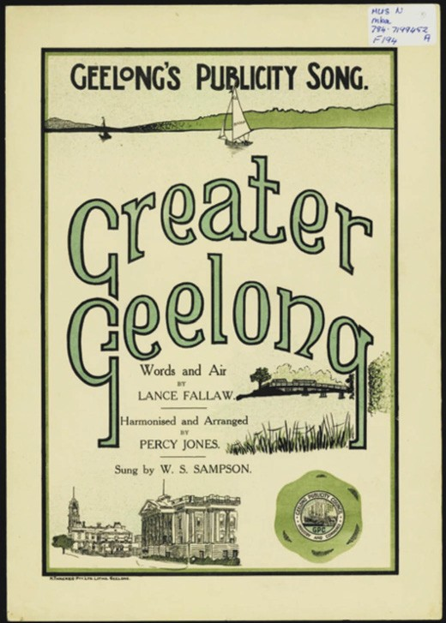
Figure 9.173: Lance Fallow (words & air), Percy Jones (harmony & arrangement), Geelong s Publicity Song: Greater Geelong , Geelong Publicity Council, 1928. Source: State Library of Victoria.

Greater Geelong, in close partnership with Deakin University and the Australian Centre for Innovation and Design. The designation:
… recognizes the design history of Geelong and surrounds, from the region s Aboriginal heritage to its history in textiles and wool production; automotive design and manufacturing to designs that have revolutionised surf culture. It also celebrates innovations currently being made across the region in advanced manufacturing and virtual reality.
The designation placed Geelong amongst other cities
of design around the world as part of UNESCO s Creative Cities network, including Beijing, Montreal, Berlin, Singapore, Dubai, Cape Town, Istanbul and Mexico City.1104

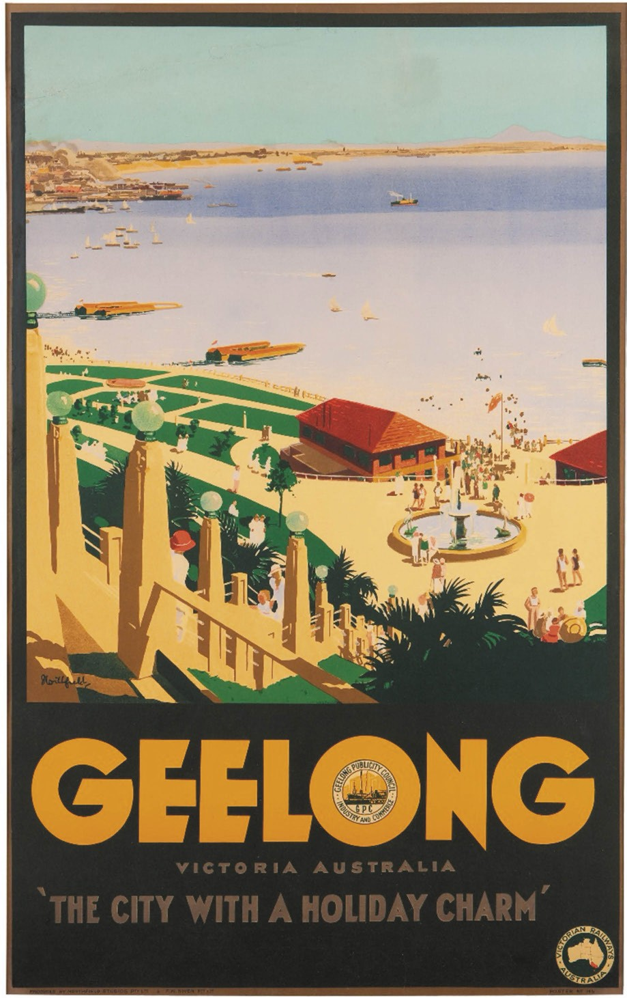
Figure 9.174: James Northfield, ‘Geelong Victoria Australia: “The City with a Holiday Charm”’, c.1930s, colour lithograph on canvas-lined paper, Collection Geelong Gallery. Purchased through donations, 2009, accession no. 2009.28. ©James Northfield Heritage Art Trust (with permission).

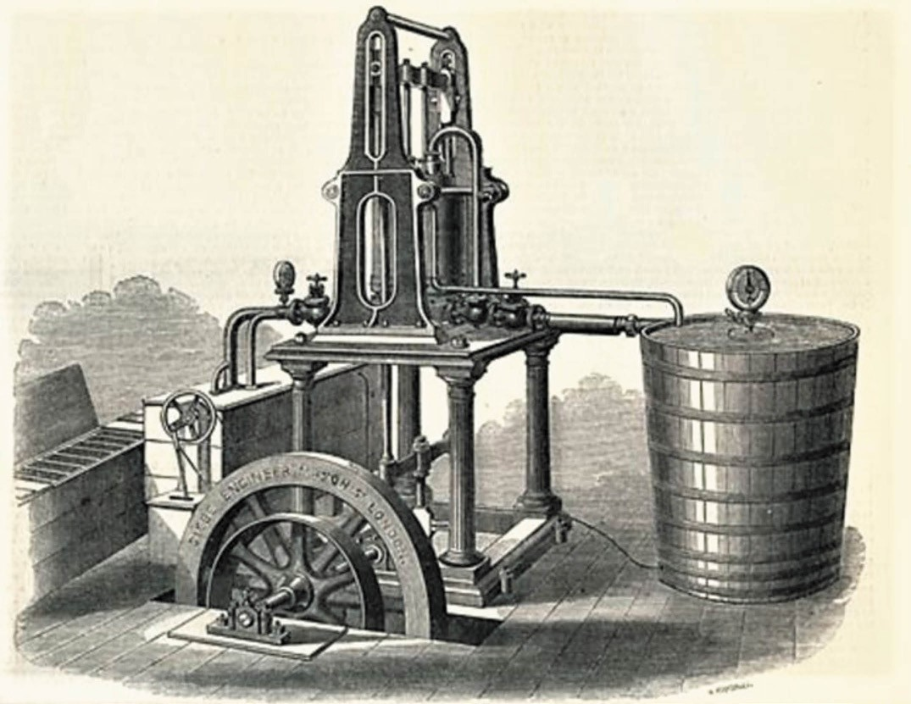

Figure 9.175: Harrison-Siebe Ice-making machine, London, England, 1857-58. Source: Museums Victoria.

SCIENCE, TECHNOLOGY AND INNOVATION NINETEENTH CENTURY INNOVATIONS
Geelong s designation as a UNESCO City of Design
recognised some of the extraordinary number of innovations and inventions that have emanated from the area since the mid-19th century. One of the earliest was a reaping machine by a gentleman extensively engaged in farming operations near Geelong in 1848.1105
Just three years later, in 1851, James Harrison (1816- 1893), editor of the Geelong Advertiser (Themes 3 & 7) , invented the world’s first compression refrigeration machine at his primitive laboratory on the northern bank of the Barwon River, Rocky Point, Marnockvale (Newtown).1106 His interest in refrigeration emanated from him noticing the cooling effect of the evaporation of sulphuric ether while cleaning printer s
ink from type.1107 Harrison had carried out many experiments and experienced a number of delays before he ordered two machines in August 1850 from the engineering firm of P.N. Russell and Co., Sydney.1108 Until then, all previous efforts had been concentrated on the making of ice and none of
the discoveries appear to have been applied to commercial manufacture. 1109 In 1856, he was granted a Victorian patent for an invention of a process and apparatus for refrigerating by the evaporation of volatile liquids in vacuo, their condensation by pressure, and the continued re-evaporation and re- condensation. Harrison went to London in 1857 to apply patents to his invention there, and to form a partnership with the engineering firm of Siebe and Co.1110 It was in
this same year when the first commercial Harrison-Siebe refrigeration machine (Figure 9.175) was sold to a London brewery. By 1861, Harrison s refrigeration machines were so popular that they had spread from London and Europe,

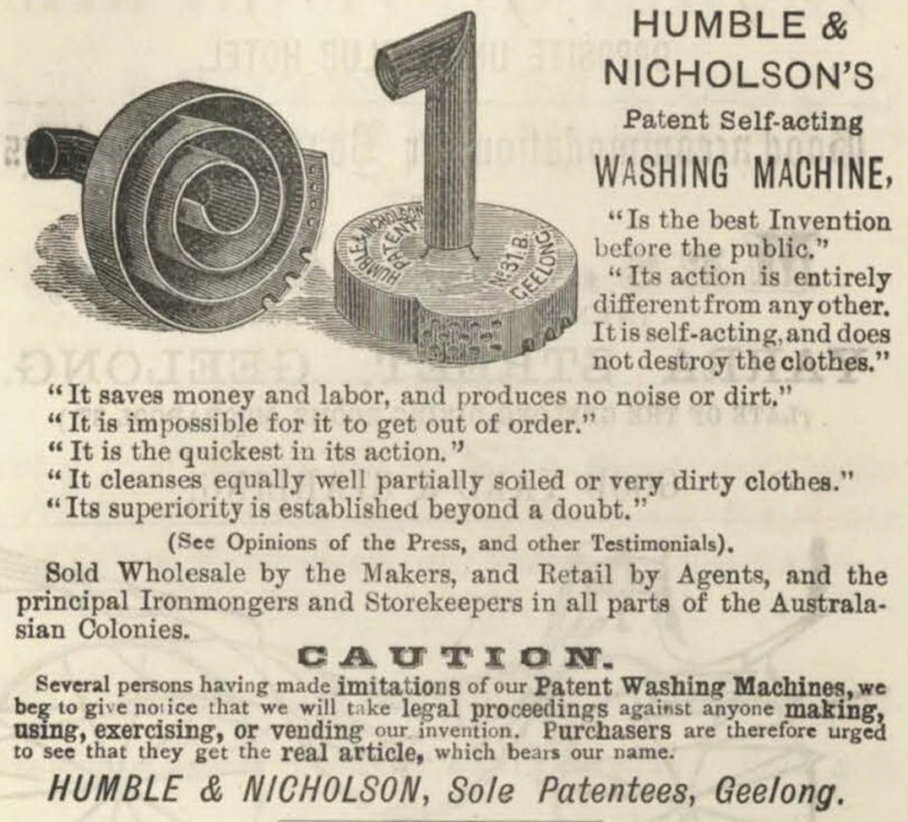
Figure 9.176: Humble & Nicholson s Patent Self-Acting Washing Machine, 1879. Source: Visitor s Illustrated Guide to Geelong, 1879.

to Peru, Argentina, Calcutta and Sydney.1111 Although over 70 of Harrison s refrigerators had been manufactured by the
early 1870s, he never gained financially from this international invention.1112
Numerous innovations by other inventors in the 19th century were largely associated with their trade or profession. In 1851, the Geelong Advertiser announced that Joseph Thomson junior had made a gold-washing machine.1113 This was followed by W. Hunter who had invented a sort of iron for fire-banding or itch-banding stock.’ Made of cast iron, the letters could be made to any size required, being raised
on the face of a small body of metal , which served the purpose of retaining the heat for a considerable time. 1114 In 1868, George Edward Green published an invention for the preservation of animal and vegetable substances. 1115
Several other inventions followed in the 1870s. The first was a clock with the mechanism hidden by the local watchmaker, John Wadelton. As described in the Riverine Herald (Echuca) in 1870:
Imagine a glass dial, similar to that used by Mr. Heller, suspended by a piece of whip-cord, and a single hand
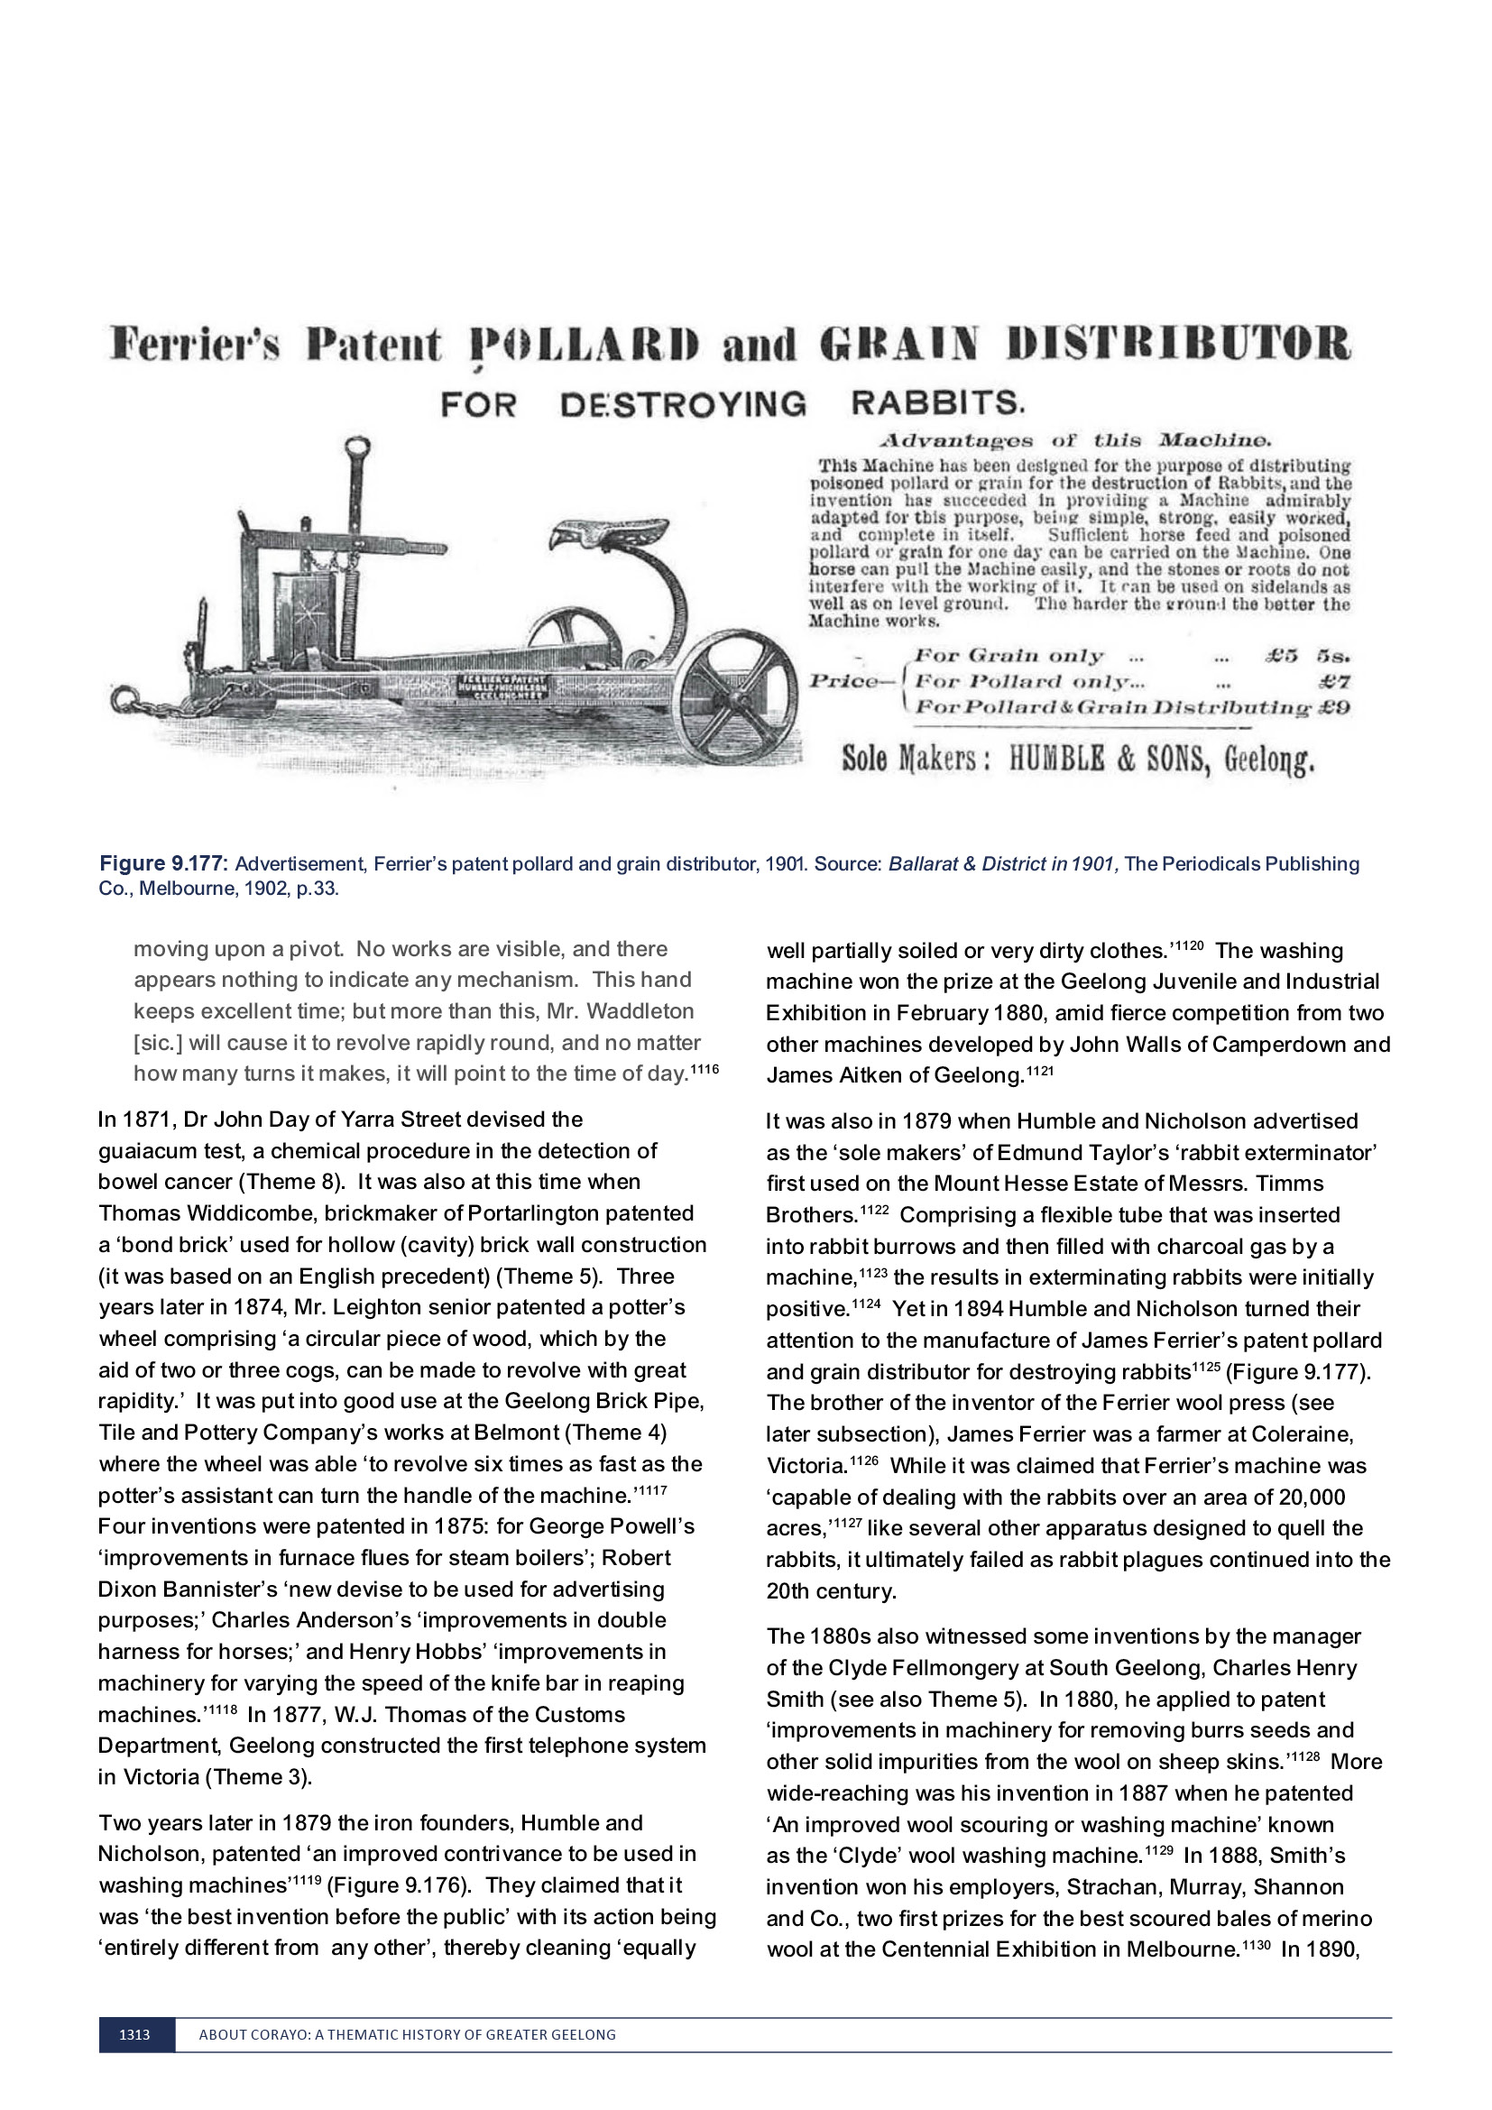

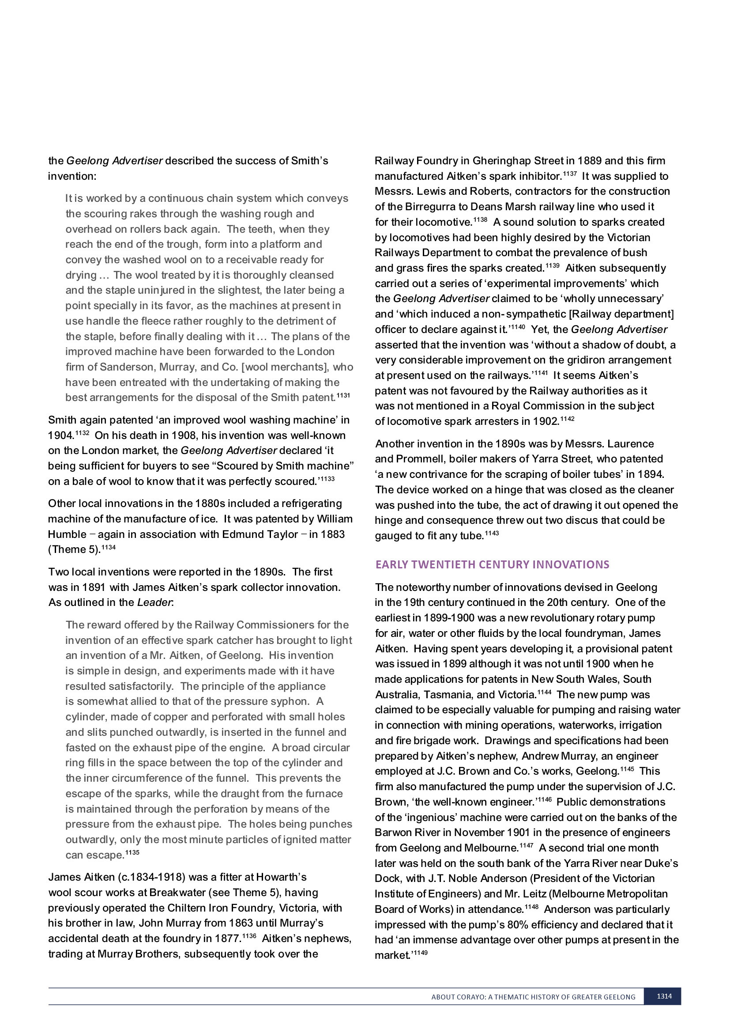

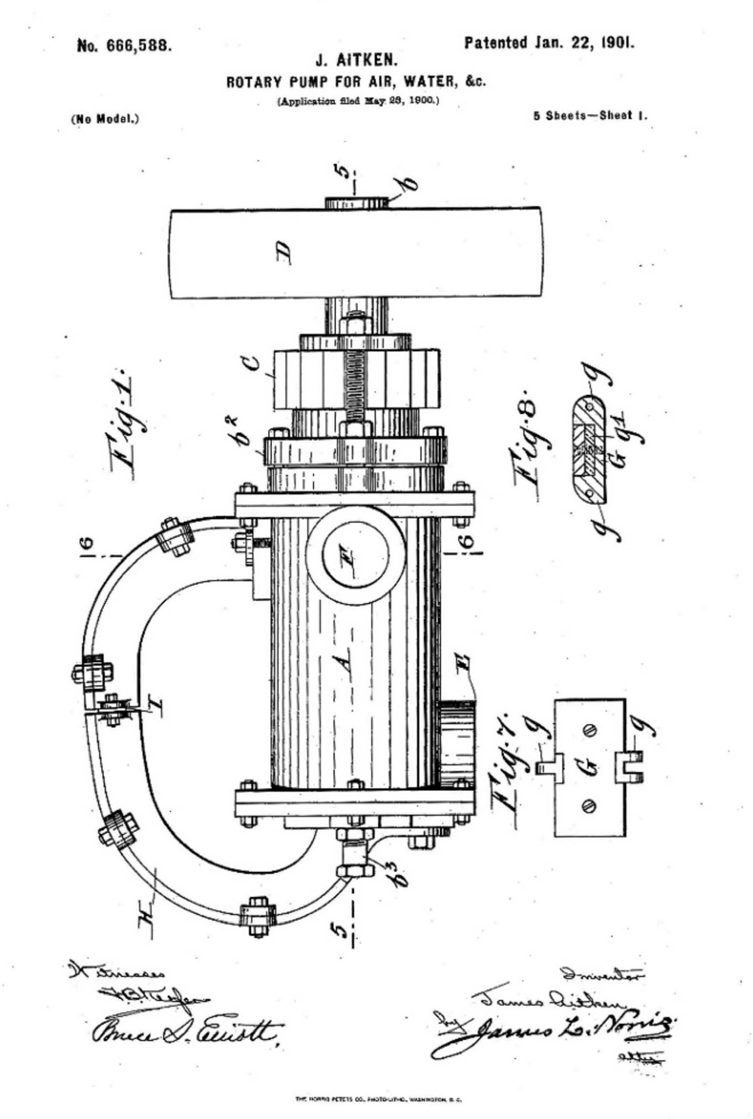
Figure 9.178: J. Aitken, Rotary Pump for Air, Water, &c. , 22 January 1901. Source: Google Patents, US666588A at https://patents.google.com/patent/US666588A/en?q=aitken&q=rotary&q=pump&oq=aitken+rotary+pump

Such was the success of Aitken s pump that it was patented in the United States of America, Canada, Great Britain and Denmark in 19011150 (Figure 9.178). Aitken had shared the interests and rights to his pump patent with Shrimpton and Strong, auctioneers and agents.1151 In May 1902, the Aitken Rotary Pump Syndicate was established to acquire the interests and rights to the Aitken pump. The directors were Solomon Jacobs (Mayor of Geelong), William Sutterby, J.C. Brown (engineer), and J.A. Dawson (Electric Lighting and Traction Company), with G.M. Strong as secretary.1152
Following another successful trial at the works of the Electric Lighting and Traction Company in January 1903, James Aitken and J.A. Dawson travelled to Paris to inspect the electric pump used for fire engines, and to London to
demonstrate the Aitken pump there.1153 By February, Dawson had declared that the Aitken pump can be made to serve a more practical purpose than the fire engine in use in Paris’ and he was ‘satisfied that the pump will commend itself to practical experts in the old country when demonstrations of its utility are given. 1154 In America, the patent was reissued
in 1904.1155 Although the Aitken pump had such promise and received financial and expert engineering backing, the Aitken Rotary Pump Company was dissolved in 1908, the pump not doing as well as the promoters anticipated. 1156
There were also other inventions in Geelong in the first years of the 20th century. In 1902, Robert Wilson Hall and William Andrews of South Geelong invented an attachment for baling presses.1157 More significant in 1903 was William Humble’s manufacture of the first motor bus in Victoria (Theme 3). In 1904, Gunner Trigg invented a new form of disappearing target that was constructed of light iron and worked on roller bearings. Trials at the ranges in Geelong found it to work admirably. 1158 In 1908, C.A. Smith, J.C. Brown, A.R. Smith and A.H. Wills patented docking and castrating apparatus.1159 Francis John Newberry, an iron founder the Victoria Foundry, Virginia Street, Newtown, also patented improvements in cast iron frames for washing coppers in 1908.1160 The following year, W.E. and W.A.E. Curnow of Yarra Street invented an attachment for tyres to prevent skidding and side-slip.1161
Several inventions were published in the 1910s. One of the earliest was R.W. Hill s adjustable mounting for knives of chaffcutters in 1910.1162 In this same year Jorgen Christiansen of Coquette Street, Geelong West,
had taken out patent rights in Australia, America and other countries for a railway signaling apparatus that combined simplicity with effectiveness. 1163 In 1911, M.J. Allan invented a microscopical accessory while in the same year T.P. Walsh and G.W.M. McDonald developed a device to automatically close an elevator shaft at all points except where the elevator itself may at the moment be situated. 1164

Possibly one of the most important inventions in Australia created in Geelong was the rotary clothes hoist by Gilbert Toyne (1888-1983). The son of John Toyne, slaughterman and lessee of the Geelong Sale Yards and Abattoirs (Theme 5), Gilbert Toyne was born at Darriwill, Moorabool, in 1888. With his parents and siblings, he lived at Boston Villa ,
51 Walker Street, Rippleside from 1891 (Theme 6) and it may have as early as 1904 when Gilbert Toyne built his first clothes hoist there in 1904.1165 He had just completed an apprenticeship with James Reid, a blacksmith of North Geelong.1166 It was with Edward Downey in 1911 when he patented the Aeroplane Clothes Hoist.1167 It was displayed at the Geelong Show that year. The Geelong Advertiser reported on the new invention:
Mr G. Toyne of North Geelong, showed his Aeroplane Clothes Hoists. These have been tested with very satisfactory results. After the clothes are hung, the wind causes the hoists to revolve like a windmill, with the result that drying is greatly quickened.1168
The first clothes hoist sold by the Toyne’s and Downey’s Aeroplane Clothes Hoist Company was to Charles Newland, a builder of nearby 6 Swinburne Street, North Geelong.
It featured as a testimonial in a brochure by The Aeroplane Clothes Hoist Company in 19121169 (Figure 9.179).
The anticipated prosperity of the newly formed Aeroplane Clothes Hoist Company was cut short by World War One. Gilbert Toyne enlisted in August 1915 and while he was serving overseas the Company disbanded.1170 Upon his return, and while living at the family home, Boston Villa , he patented a new hoist model in 1923.1171 Another patent was lodged in 19251172 and an example of this patent design
survives in the backyard of a property in West Fyans Street, Newtown, having been relocated from 51 Walker Street, Rippleside1173 (Figure 9.180). Toyne continued his clothes hoist business in Adelaide from 1926 and following the lapse in the patent in 1941, it was taken over by Lance Hill following World War Two and the postwar building boom brought
him considerable economic success for his product, Hill s Hoist. 1174
Geelong was the location of other innovations in the early 20th century. In 1912, Mr Dickeson, a carpenter from Geelong West, developed a system that would greatly improve the condition of leather besides inflicting far less pain on the animals. 1175 A year later in 1913, a mechanical toy was patented by Andrew Anderson and H. Raynor of Geelong which gave a life-like movement to animal forms. 1176 A noteworthy invention in 1914 was a method for sterilising milk by A. Rutter, formerly of the Gordon Technical College. The invention was tested by Dr. Bull, director of the bacteriological laboratory at the university of Melbourne who stated that:

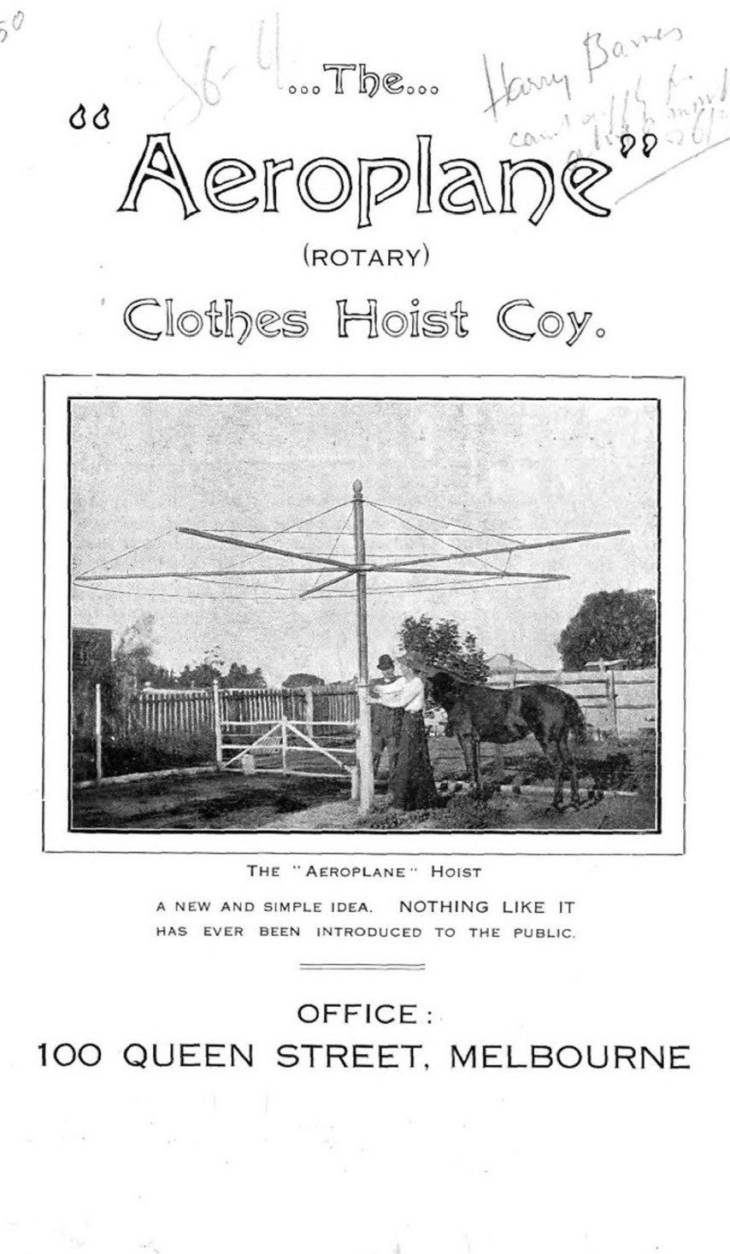
Figure 9.179: The Aeroplane (Rotary) Clothes Hoist Coy. Promotional brochure, The Aeroplane Clothes Hoist Co., Melbourne, 1912. Source: State Library of Victoria.

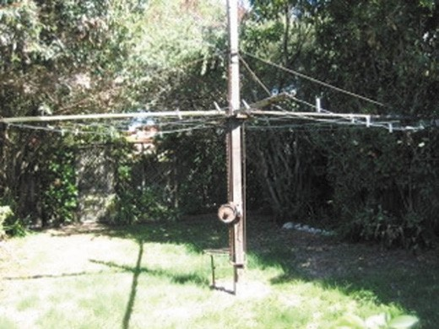
Figure 9.180: Toyne rotary hoist, 51 Walker Street, 2012. Source: Jennifer Bantow.

If milk treated in this manner is exposed to infection in open jugs it will keep sweet for days or weeks, and that harmful bacteria do not multiply in it. He further states that the process does away with the necessity for cool storage, and that its general application would mean the entire stamping out of milk-borne epidemic infective diseases. 1177
In 1915, an invention by Richards Jaques Fletcher, chemical manufacturer of North Geelong to neutralize the effects
of the poisonous gases employed by the Germans was presented to the Defence authorities and referred to the British War Office.1178 Discovered as a result of experiments in his laboratory, Fletcher s invention was tested by Professor Masson at the University, who expressed the opinion that
the theory was scientifically sound and feasible, but decided to make further investigations before advising as to the method of application. 1179 By 1917, Fletcher s solution had been adopted by all the Allies. 1180 As outlined in the Geelong Advertiser:
The counteracting method [to German chlorine poison gas] consists of a hood for the head and covering the shoulders; the tunic buttons over the hood, making it gas-tight. In the front of the hood is a celluloid window; the air is inhaled through a tube or mouthpiece attached to the front of the hood. The air charged with the poison gas passes through a small receptacle containing a mixture of certain chemicals, which deprive the air of the poisonous gas and the purified air thus passes through the mouthpiece and thence into the lunges. The expired breath finds its outlet through a valve in some instance and through a tube in others.1181

While Germany s poisonous gases during World War One subsequently changed, in 1925 Fletcher was recognised for having much to do with neutralising the German gases. 1182
In 1918, the well-known engineers responsible for the Geelong Waterworks and Sewerage Trust s Ocean Outfall Scheme, Stone and Siddeley (Theme 4), had remarkable sales of their new invention: a concrete wash trough. It had many advantages over the ordinary wooden article. 1183
The 1920s brought further local innovations. In 1926,
J. McCulloch, manager of Humble s foundry, designed a hessian bag printing press (Theme 5).1184 It was also in 1926 when H.J. Cross of Candover Street, Geelong West, invented a window frame device dispensing with the use of weights and cords which prevented windows from rattling and kept them in the position they had been raised.1185 In 1927, Mrs Lexie King (nee Cutts), formerly of Newtown, devised a folding portable feeder that could be attached to any chair converting it into a high chair for infants (Figure 9.181). Through her husband, Alexander King, she patented her invention and the portable chair was made available through local business firms.1186 In its Mainly for Women section, the Geelong Advertiser remarked that the contrivance folds into the smallest suitcase, and weighing only two pounds can be taken anywhere. 1187
Noted inventions of the 1930s included a device for testing a golfer s drive which was tested at Luna Park, St. Kilda,
in 1930. It was an invention of the Bowker Brothers of Geelong.1188 In 1931, Geelong’s first, trail-blazing medical practitioner, Dr Mary De Garis, published a book entitled The Theory of Obstetrics, which countered claims of other medical professionals (Theme 8).
Some other inventions in the 1930s were associated with local manufacturing. In 1931, E.J. Fairnie, secretary of the
R.S. and S. Woollen and Worsted Mill at Newtown and later inaugural chairman of the Geelong Historical Society (see Themes 5 and 8), invented an improved travelling rug 1189 (Figure 9.182). It was specially devised for use as a cape or cloak, its special features its uniform shape, it having no
parts or loose strings on its sides which would detract from its appearance. 1190
In 1932 when L.C. Tucker, invented an hydraulic clutch and gearless power transmission mechanism. It was designed to simplify and make more efficient all forms of power transmission. The invention was considered favourably by C.A. Cameron, senior science master at the Geelong Grammar School, and was inspected by the Chief Commissioner of Railways, H. Clapp, for its potential use the follow year.1191

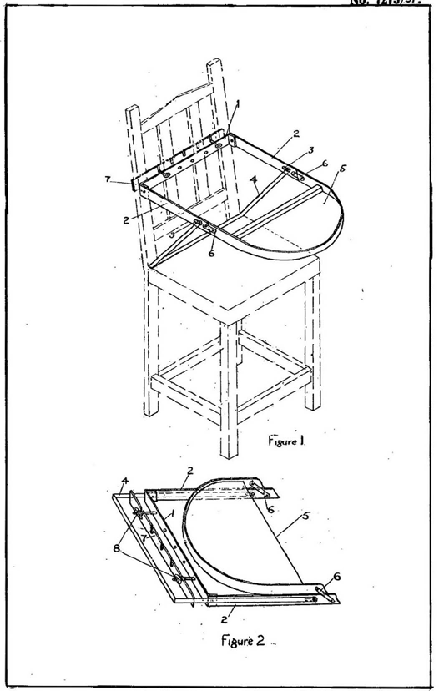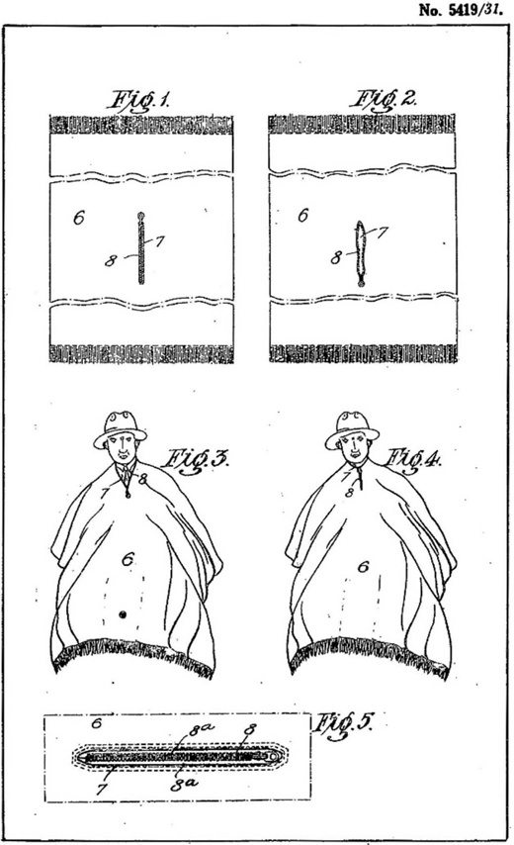

Figure 9.181: A.W. King, Improvements in and Relating to Chairs , 12 May 1927. Source: Patent Application No. 7275/27, IP Australia online at https://www.ipaustralia.gov.au/
Figure 9.182: Geelong R.S. & S. Woollen & Worsted Co-Operative Manufacturing Co. Ltd., An Improved Travelling Rug , 17 December 1931. Source: Patent Application No. 5419/31, IP Australia online at https://www.ipaustralia.gov.au/

Of particular significance in 1934 was the completion of what has been claimed as world’s first utility (ute) (Figure 9.183) at the Ford Motor Company s Geelong assembly plant, the design being the work of employee Lewis Bandt (Theme
3). The idea had emanated from 1932 when the Ford Motor Company received a letter from a farmer s wife who asked why a vehicle could not be manufactured to take farming people to church on a Sunday but also carry her pigs to market.1192 The request reached the local Ford employee Lewis Bandt, who adapted the then existing Ford Coupe into a utility with passenger car comfort in 1933.1193 The design and prototype were approved and by 1934 the
ute was completed at the Geelong assembly plant and available for purchase.1194 While much has been made of the uniqueness of Bandt s design, international design writers
have been less enthusiastic about it being a world first given similar (but not identical) vehicles were available in the U.S.A. since the 1920s.1195
Lewis Thornett Bandt was born in South Australia in 1910.1196 He began a fitting and turning apprenticeship with Duncan and Fraser Ltd in Adelaide in 1924.1197 He commenced his career with the Ford Motor Company in Victoria in 1929 and in 1931 at Geelong he became head of the company s body design department.1198 In 1936, he spent eight months in
the United States gaining experience for the introduction of an all-steel car design.1199 Locally, this all-steel sedan came off the production line in 1937.1200 During World War Two, Bandt was in charge of the body design for 90 vehicle types at Geelong for the Army and Air Force, together with the designs

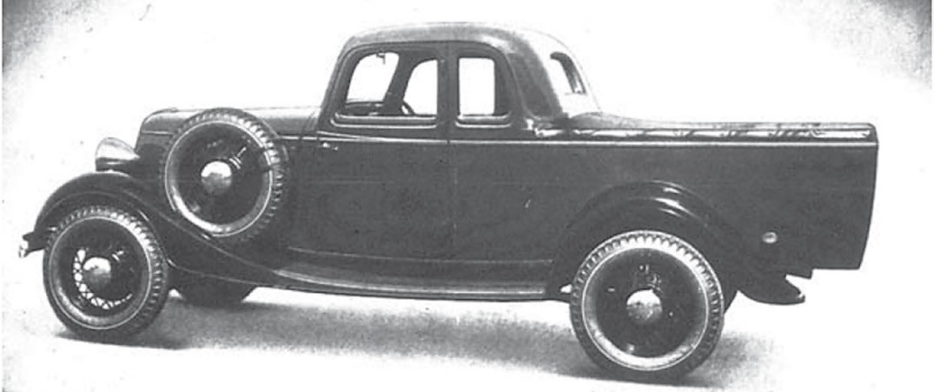

Figure 9.183: Ford Coupe Utility 302, 1934. Source: The Australian Motorist, May 1934.

of barges and 40-foot boats.1201 Bandt retired from the Ford Motor Company in 1975.1202 Tragically, he died in 1987 while driving his original ute when it collided with a sand truck.1203
In 1953, the Geelong Ambulance Superintendent,
Allan Macleay Cumming (1913-1996), developed a prototype for a new ambulance vehicle (Figure 9.184) at the Geelong depot, corner of McKillop and Yarra Streets.1204 The innovation was outlined in the Kilmore Free Press:
An experimental ambulance with radical new features has been approved for general use by Victorian Ambulance Services.
Geelong Ambulance Superintendent, Mr. A.M. Cumming, designed the vehicle and built the first prototype. The completion of the prototype was announced at the end of March.
He has now received approval from the Victorian Health Minister to build the new units for other ambulance services.
Mr. Cumming said that he was now building an annexe at the Geelong ambulance depot to make bodies for the new ambulances. It would be the first time in Australia that ambulance service had done this. He said he could put ambulances on the road at a saving of between £300 and
£800 on present costs.
The Health Minister and officials of the Victorian Hospitals and Charities Commission inspected the prototype and approved it for general use.
Mr. Cumming said the new ambulances were adapted from Ford V-8 Customline sedans and embodied most of the components of the sedan body. He was building them with the cop-operation of Ford Motor Company which prepared Customline chassis in production for his specially planning conversions.
He already employed two body-building specialists to begin work on vehicles for the Echuca Branch of the Shepparton Ambulance Service and for Geelong.
The prototype ambulance had excited intense interest throughout Victoria and many inquiries had been receive from New South Wales and Queensland.
Production was on a co-operative basis, the completed vehicles being built without profile.
Features of the new design were: An all-steel body; low- slung streamline appearance, giving greater safety and better riding qualities; complete dust-proofing.1205
Lacking initial Government recognition for his pioneering therapeutic innovations from the 1957 was Thomas (Tom) Ambrose Bowen (1916-1982).1206 While not formally trained as an osteopath, Bowen recognised the importance of fascia and the profound effect that soft tissue manipulation could have on patients wellbeing. 1207 Bowen established a technique that used a series of gentle hand movements over muscles, tendons, ligaments, joints, nerves and fascia to promote relief from musculoskeletal and related neurological complaints. 1208 From his clinic at 100 Autumn Street, Geelong West, Tom Bowen (an employee of the Geelong

Cement works) and his long-time friend, Rene Horwood (a hairdresser) provided therapy to over 1300 clients a year.1209 Today, Bowen Therapy is practiced across Australia (as part of the Bowen Association of Australia) and internationally, particularly in Europe and especially in the United
Kingdom where the Bowen Therapy Academy of Australia was accepted into the British Complementary Medicine Association.1210 In West Park, Geelong West, is a bronze memorial sculpture, Healing Hands , which commemorates Thomas Bowen and his pioneering work.
One of the most recognised innovations of a Geelong-born person was the designs for Australia s decimal coins by Stuart Devlin. Born in Geelong in 1931, the son of a painter and decorator, he developed a particular aptitude for art, metalwork and geometry at Swanston Street state school. 1211 He spent two years gaining experience as an ecclesiastical brass worker being training as a teacher, teaching art at Wangaratta between 1951 and 1955.1212 He subsequently studied goldsmithing and silversmithing at the Royal Melbourne Technical College (RMIT). After achieving the highest marks ever awarded , he gained a travel scholarship to the Royal College of Art in London. This was followed
by a Harkness fellowship in 1960 to pursue silversmithing and sculpture at Columbia University, New York.1213 After a short time as inspector of arts schools in Victoria, he took up a lecturing position at the University of Melbourne.1214
In 1964, Devlin was commissioned by the Commonwealth Government to prepare reverse designs for Australian decimal coins. He had previously prepared trial designs for an advisory panel on coin design and was selected because of the advantage of having each of the six coins
as a family of designs. 1215 The wildlife theme adopted also provided a link with the two supporters of the Australian coat of arms, the kangaroo and the emu (Figure 9.185). The then Commonwealth Government Treasurer, Harold Holt, declared that ‘Mr. Devlin had done a remarkably fine job in adapting his designs to suit the circular metal shapes of the coins and in making them an integral part of each coin. 1216 The Canberra Times gave an outline of the motifs for the six coins:
One cent –the feather-tailed glider; Two cent –the frilled lizard;
Five cent –the echidna, or spiny ant-eater; Ten cent –the lyrebird;
Twenty cent –the platypus; Fifty cent –coat of arms. 1217
Devlin’s decimal coinage commission sufficiently raised his profile and funded his relocation to London where he opened his own goldsmithing and silversmithing business in 1965.1218 He went on to design coins for 36 other countries including the United Kingdom and Singapore.1219 In 1980, he was appointed CMB, granted a royal warrant in 1982 as Goldsmith

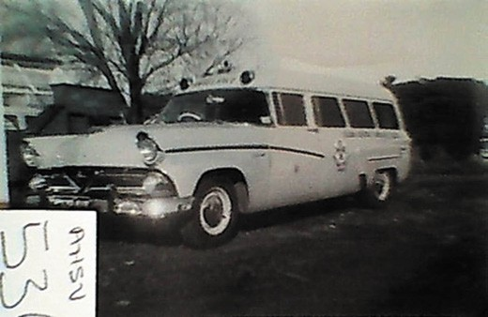
Figure 9.184: Ambulance prototype, Geelong & District Ambulance Service, c.1955. Source: Victorian Collections, Ambulance Victoria Museum, object reg. AHSV536.

and Jeweler to Queen Elizabeth II and between 1996 and 1997 he served as prime warden of the Goldsmith s Company. He died in 2018 and was regarded as one of the most creative and influential goldsmith and silversmiths of his time.’1220

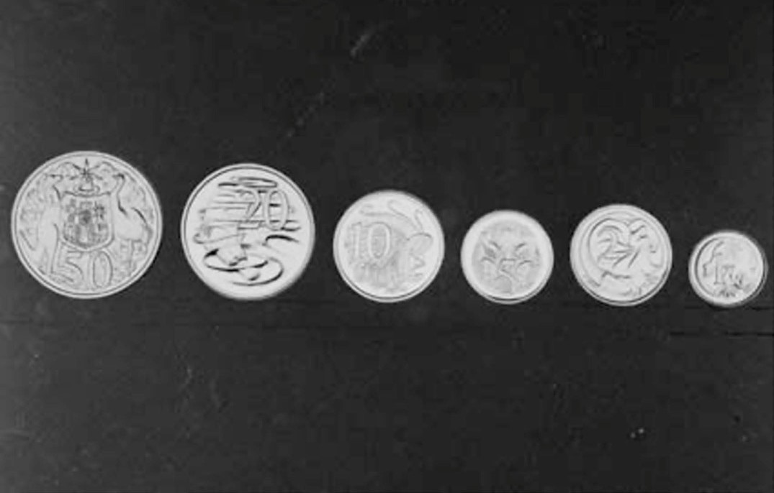

Figure 9.185: Stuart Devlin, Australian decimal coins designs for the reverse sides of the new Australian decimal coins, 1965. Source: Series A1200, L52221B, National Archives of Australia (with permission). Permission also given from the Royal Australian Mint for use of Australian currency coin designs.

WOOL RESEARCH AND INNOVATION
Geelong’s profile as the wool capital of Victoria from the 19th century extended beyond pastoral enterprises, wool broking and wool storage to innovations in wool processing and manufacture. The earliest was in February 1848 when
a novel application of an old invention reached the Geelong Advertiser. It was a most excellent contrivance that facilitated the weighing of wool:
The invention is so simple, and altogether so useful, that it is a matter of wonder something of the kind has not long since been thought of. Instead of the laborious process of taking the weights on and off the scale every time a fresh bale of wool is required to be weighted, the difficulty is obviated by the beam of the scale having a sliding weight attached, with the csts., qrs., and 1lbs. marked, the same as with a common steelyard, the different between the two being that a steelyard is suspended, while this rests near the ground, with a foot-board to receive the bale of wool. By this new method the weighing process goes on with twice the celerity than by the old, and the amount of hand labor required is much less.1221
A more significant and far-reaching 19th century innovation was Ferrier s wool press in 1876 (Figure 9.186). It was manufactured at Humble s Vulcan Foundry Geelong to the design by David Ferrier of Coleraine (who had spent his childhood in Geelong) (Theme 5).1222 The invention –and its advantages of the earlier wool press prototype, were outlined in the Geelong Advertiser:
In the presence of nearly a score of gentlemen connected with the wool trade an improved wool press was tried
at Messrs Humble & Co. s Vulcan Foundry, yesterday morning. It has been manufactured by Messrs Humble & Co. to the design of Mr Ferrier, of Coleraine, whose improved binding machine we noticed a few days
since. Owing to the manufacturers not having protected themselves through the Patent Office, we are not in
a position to describe the improvement. The trial, yesterday, was eminently satisfactory, and the gentlemen present expressed themselves as satisfied that the press would be a great improvement on the old kind, which
Mr Ferrier expects it to be. At the present time two men with an ordinary press on a station turned out about 12

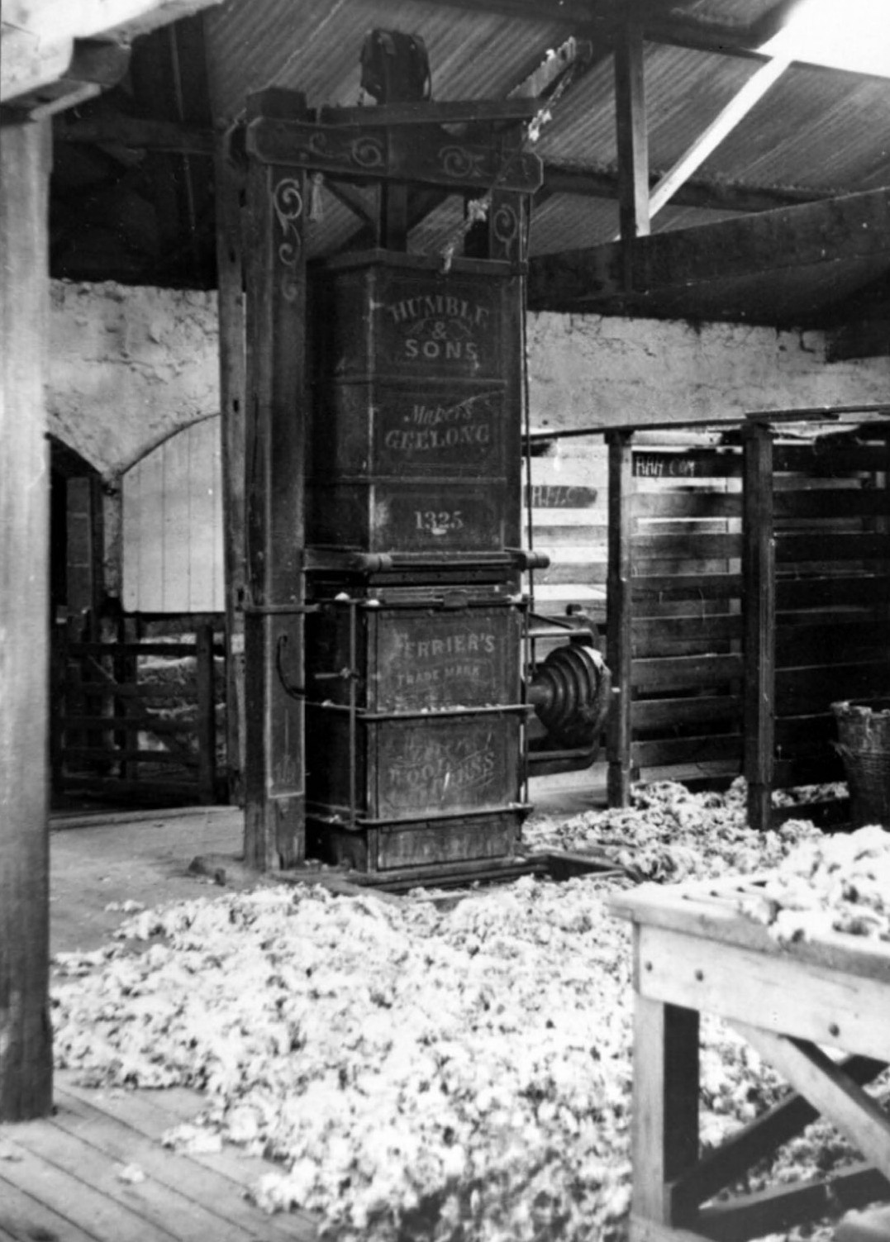
Figure 9.186: Humble & Sons Ferrier Wool Press, The Meadows Wool Shed, Rokewood, c.1930. Source: GRS 2009/1937/96, Geelong Heritage Centre collection.

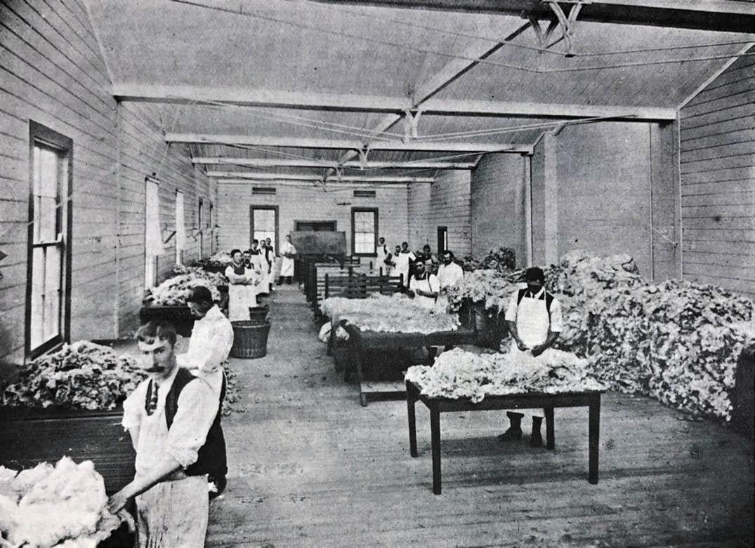
Figure 9.187: J. Lockwood, Wool sorting class, Gordon Technological College, 1909. Source: News of the Week, 14 January 1909, p.15, GRS 2121/1, Geelong Heritage Centre collection.

bales a day, whilst the new machine will double that number per diem. The screw power in the old presses is altogether discarded, the required force being obtained by leverage. The great feature in Mr Ferrier s invention is its great simplicity, and it is to be hope that he will be
financially successful with it, and thus be rewarded for his ingenuity.1223
Ferrier sold his patent rights to the invention to Humble and Sons.1224 The firm of Humble and Nicholson made and distributed the presses throughout the country.1225 They were even seen in woolsheds in Canada.1226
Over thirty years later in 1907, Peter Hughes invented a wool stacking machine. It enabled 140 bales of wool to be stacked four high per hour by a single operator.1227 Hughes had been a storeman at Dalgety and Co. s wool store where the machine was put on display. It was later available for
view at A. Aikman and Co. in Little Malop Street. By 1917, the
machine was in use at Dalgety s and at the Federal Woollen Mills, together with a number of wool stores in Melbourne and other parts of the Commonwealth. 1228 Hughes had also patented a wool- packing clamp and implement for securing the tops of wool bales.1229
Another former employee of Dalgety and Co., Peter Robert Hughes, patented the improved link-hook for fastening bales in 1911. It related to a metallic hook in lieu of sewing.1230

WOOL EDUCATION, RESEARCH & INVENTION
Education associated with wool first began in 1891 when the Gordon Technical College commenced its wool-sorting class.1231 In 1892, Cyrus Glover was appointed instructor of
wool sorting, the year a new room was built especially for his teaching.1232 The Geelong Advertiser made reference to the new class (Figure 9.187), declaring then for those engaged in the woollen trade, or in wool buying, is a class in wool-sorting with every convenience. 1233 In 1900, J. Boyd adopted an innovative method of instruction:
The system to be adopted by Mr J. Boyd in the instruction of the wool-sorting class at the Gordon Technical College is of the most practical and useful kind, being designed
to fit each student to undertake the classification, skirting and rolling of fleeces, and the sorting of skirts or pieces to the best advantage of the grower, and also to suit the demands of the buyers. In furtherance of this object a large supply of wool is kept available, and after being
sorted, etc., this is disposed of and fresh material secured. As the students progress in the practical work, lectures dealing with the subject relating to the growing of wool and its suitability for manufacturing purposes will be given.1234
In 1921, the corner stone was laid for the E.H. Lascelles memorial wool research chemical laboratory at the Gordon Technical College (Theme 8). The imposing Beaux-Arts styled building –designed by Laird and Buchan - fronted railway terrace and reflected Geelong’s reputation as a
pre-eminent centre for wool and textile research (it was augmented by the T.E. Bostock Memorial Wool Lecture Hall at the corner of Railway Terrace and Fenwick Street in 1928, also to a design by Laird and Buchan)1235 (Figure 9.188). Of the Lascelles Memorial laboratory, The Age commented that:
The building itself would not be the sole memorial [to E.H.
Lascelles]. The scientific training to be given within its walls to young men who were in future to play an
important part in the Australian woollen industry was an important phase, and every top, every strand of wool and every web of cloth produced in this country would form portion of the memorial.1236
In 1924, George King, principal of the Gordon Institute of Technology, petitioned the Minister of Education for funds to build a textile college. He quoted Professor Baker of the
University Leeds, England, who had declared that at Geelong there was the finest wool treatment school south of the line [the Equator].1237 Several years elapsed before the wool school was opened at the Gordon Institute in May 1937, it then being regarded as Australia s foremost wool training centre for wool and sheep experts. 1238

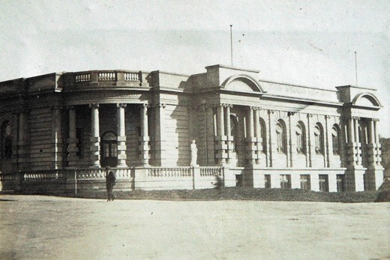
Figure 9.188: T.E. Bostock Memorial Hall (left) & E.H. Lascelles Memorial Laboratory (right), Gordon Technical College, c.1930. Source: T.T. Holmes collection, Authentic Heritage Services
Pty Ltd.

In 1938, William Rawson (Roy) Lang (1909-1996), a graduate of the University of Western Australia, was appointed instructor of wool research at the Gordon.1239 He was born at Kanowna, Western Australia, the son of the Methodist minister, the Rev. W.R. Lang, and May Lang (nee Gibbs).1240
Roy Lang had matriculated from the Perth Modern School and following his graduation at the University of Western Australia he had taught science at Wesley College, Perth and the Perth Technical College, and was resident tutor in physics at St.
George s College at the University of Western Australia.1241 For some time, he had been engaged in this field of research in the department of agriculture of the University.1242 In particular, Lang had been part of a research team led by Dr. Nichols, Professor of Agriculture at the University of Western Australia and a former officer of the Wool Industries Research Association, Leeds, United Kingdom.1243 Lang was to make
a substantial contribution to wool research and innovation. From the time of his arrival in Geelong, he immediately began establishing partnerships with breeders and pastoralists,
and giving numerous public lectures and articles in addition to his scientific research.1244 In 1939, Lang had established a service for wool breeders and pastoralists to improve the quality of wool. He introduced a chart and graph system
that enabled breeders ‘to build up their studs and flocks along lines planned to eliminate coarseness and hairiness and maintain standards which benefit both themselves
and the trade. 1245
In 1946, the Weekly Times announced that a new textile college was to be established at the Gordon Institute
of Technology at a cost of £150,000.1246 It was anticipated to surpass anything of the kind in the southern hemisphere. 1247 Headed by W.R. Lang, two diploma courses were offered

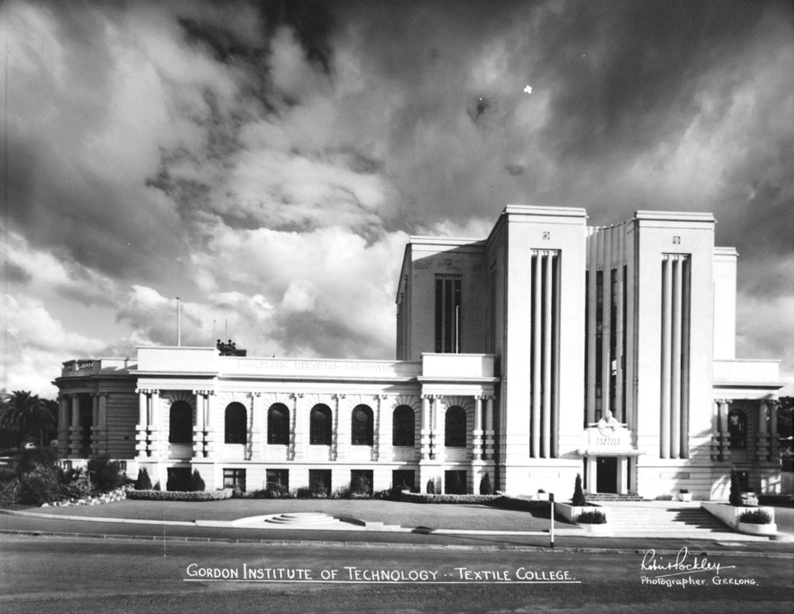
Figure 9.189: R. Pockley, Gordon Institute of Technology Textile College (right) with Bostock & Lascelles Memorial buildings (left), c.1950. Source: accession H2007.25/18, State Library of Victoria.

in textile industries and textile chemistry.1248 A substantial vertically- emphasised Modernist building (Figure 9.189) was designed by Percy Everett in 1949 to accommodate the new college where pilot woollen and worsted and knitting
machinery, cotton plant, machines for dyeing, mills, coursing and carbonising, drawing, carding, weaving and other plant were installed.1249
In 1949, the textile college became Australia’s first centre for higher textile training. Machinery was purchased in the United Kingdom on behalf of the Institute by A. Schofield, managing director of the Returned Soldiers and Sailors Woollen Mill at Chilwell (Theme 5).1250

CSIRO, BELMONT
In 1949, a wool textile research laboratory was established in Henry Street, Belmont, for the Commonwealth Scientific and Industrial Research Organisation (CSIRO).1251 Temporary buildings were erected on the new site while the laboratories at the textile college of the Gordon Institute of Technology were also initially used.1252 A fabric testing machine was the first scientific equipment to be installed at the new research site at Belmont, it having been obtained from England. It enabled scientists to measure gains or losses in strength or the woollen fabric resulting from new methods of processing and new manufacturing techniques. 1253 In 1950, Dr. Menzie (Pip)Lipson was appointed the first officer in charge of the Geelong unit of the CSIRO.1254 An expert in wool research, Lipson had assisted the development the Freney-Lipson

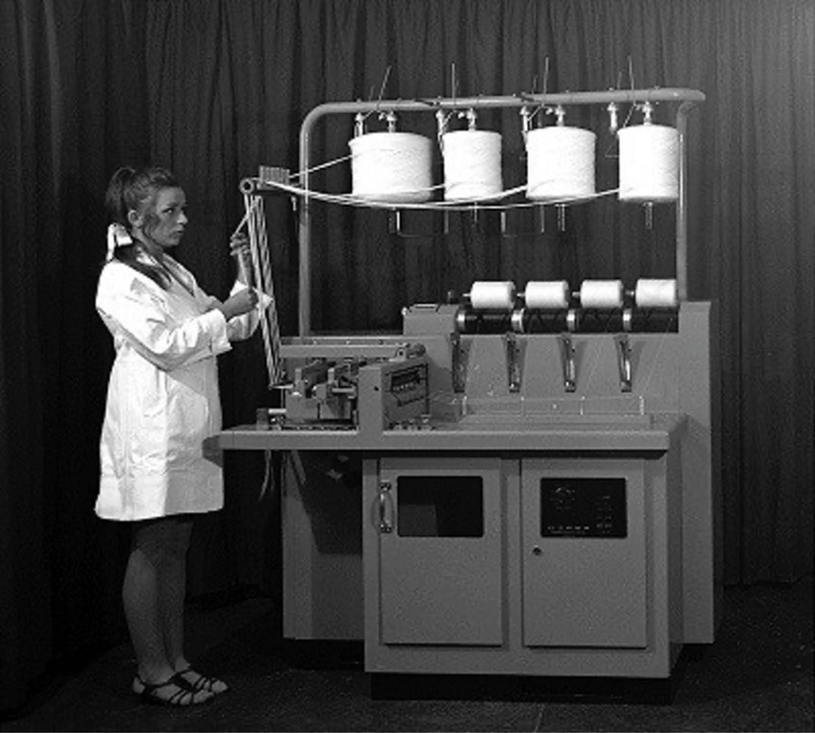
Figure 9.190: The Repco self-twist spinner machine, n.d. [c.1960s]. Source: Self-twist yarn , CSIROpedia online at https://csiropedia.csiro.au/ self-twist-yarn/, CSIRO Australia (with permission).

process for making wool unshrinkable.1255
A number of innovations emanated from the Belmont wool research laboratories during its initial years. One of the earliest was a formula of a new sheep branding fluid (which remained on the sheep for a year and was removed from the wool by normal scouring methods), released in April 1950.1256 It was subsequently marketed in South Africa, New Zealand and Great Britain.1257 By 1954, a wool wax recovery plant that yielded greater recovery rates of lanolin than earlier methods had been developed and was in commercial operation in several Australian mills.1258 It was also at this time when a
jet solvent scouring plant had been developed to produce a solvent that caused less damage and matting of the fibres and was more rapid and efficient and reduced costly carding and combing in the later stages of wool processing.1259 In 1957, a new moth-proofing process was developed known as SI-RO-MOTH .1260 This was also the year a revolutionary process was created: the application of a permanent
knife- edge crease in woollen garments.1261 This was also the period when CSIRO developed new ideas of shrinkage resistance.1262
In 1961, CSIRO scientist in Geelong, David Henshaw

developed a process where lengths of unspun wool would be twisted on themselves, not each other, then paired them up and released, with the energy in their twists triggering them to wrap around each other without breaking. This led to extensive work by Henshaw in developing a sophisticated machine (Figure 9.190). The research was shrouded in secrecy in a remote corner of the crowded red-brick building
that then housed the Division of Textile Industry at CSIRO.1263 This created the patented Repco self-twist spinning machine which won the Prince Philip Prize for industrial design in 1970.1264 By 1976, over 1600 machines worth $15 million
had been exported, bringing enormous benefits to the wool industry.1265
In 2014 after 55 years, the CSIRO s research laboratory at Belmont was closed.1266

LATER 20TH CENTURY INNOVATIONS
In 1947, Charles Henry Malpas, a company director and engineer of 22-24 Little Ryrie Street, Geelong, made application for a patent for improvements in containers. The patent was accepted in 1950 and was described
as follows:
This invention relates to improvements in containers and it refers particularly to closures for containers of that type customarily used for household oil cans, containers for lighter fluids and the like.
The invention has been devised particularly with the object of providing a container having a closure which will also form a pouring nozzle or spout – nozzle –the combination nozzle and closure being of extremely economical construction, sturdy design and convenient to operate. A further object is to provide a closure which will effect a light tight seal between the container and the nozzle.1267
Malpas invention was further improved with subsequent patents in 1951, 1955 and 1956.1268 Later known commercially as ‘Airlesflo’ airtight tap and seal, Malpas’ innovation assisted in the sales success of the ‘bag-in-the- box’ wine cask first adopted by Angoves Pty Ltd in South Australia in 1965.1269

EARLY 21ST CENTURY INNOVATIONS

AUSTRALIAN ANIMAL HEALTH LABORATORY (AAHL), NEWCOMB, GEELONG
In 1985, the CSIRO opened the Australian Animal Health Laboratory (AAHL) at Newcomb at a cost of over $150 million to provide secure laboratories for animal disease research.1270 A lower air pressure was held in the secure area, ensuring that infectious agents were contained

within the laboratory.1271 One of CSIRO s top ten inventions emanated from AAHL, it being the Equivac HeV: Hendra virus vaccine in 2012 (a prototype having been created in 2011).1272

THE AUSTRALIAN FUTURE FIBRES RESEARCH & INNOVATION CENTRE (AFFRIC),
INSTITUTE FOR FRONTIER MATERIALS (IFM), DEAKIN UNIVERSITY
The Australian Future Fibres Research and Innovation Centre as part of the Institute for Frontier Materials (IFM) was
formed at Deakin University in 2013, prior to the closure of the Belmont laboratory of CSIRO. The new centre (which had its roots in the International Fibre Centre that opened in 1999),1273 has increased the research capacity of CSIRO and Deakin
‘to service the fibre, textile, composite, automotive and aerospace industries. 1274 A recent innovation has included a new wool-based insulation textile for car interiors (to assist in a more affordable, sustainable alternative to synthetic, petroleum- based plastics).1275

CARBON NEXUS, WAURN PONDS
Located at Waurn Ponds, Carbon Nexus opened in May 2014 as a research centre with a research focus on high
technology manufacturing and innovation. The purpose- built facility was designed to accommodate the diverse needs of international manufacturing organisation that require the cost- effective resolution of carbon fibre-related projects that are strategic and complex. 1276 Furthermore, the facility provides an environment in which the most innovative manufacturing technologies can be conceived tested, commercialised
and protected. 1277

INSTITUTE FOR INTELLIGENT SYSTEMS RESEARCH AND INNOVATION (IISRI)
Intelligent systems research began at Deakin University in 2000 within the School of Engineering. An Intelligent
Systems Research Lab was established. The Lab came to international prominence in 2007 when Zoran Najdovski, Ben Horan, Asim Bahatti and Saeid Nahavandi patented the method and apparatus for haptic control. 1278 The device used haptics (sense of touch) technology to grasp and
manipulate objects in virtual space.1279 At the time of its public release in 2009, the Centre for Intelligent Stems Research as a Deakin Strategic Research Centre was formed.1280

In March 2016, Deakin University Council approved the
re- designation of the Centre for Intelligent Systems Research (established a few years earlier) into the Institute for Systems Research and Innovation. One of four Institutes at Deakin University, the focus of the Institute is bringing cross- disciplinary research from the laboratories to the real-world, where IISRI will play an important role to help solve complex real-life problems. 1281

THE BEGINNING OF A NEW INNOVATIVE
MANUFACTURING PARADIGM FOR GEELONG
The beginning of Geelong s 21st century manufacturing sector emerged in 2002 when Darren Baum of Baum Cycles, North Shore, manufactured the first titanium- framed bicycles. International orders were taken from 2003, the firm also enjoying the patronage of Cadel Evans (see earlier). Baum Cycles entered into a research partnership with Deakin University in 2010.1282
In 2004, Carbon Revolution had humble beginnings, being established in a garage at Leopold.1283 It registered as
an Australian business in 2007.1284 Since that time, it has successfully innovated, commercialised and industrialised the supply of Carbon Fibre wheels to the global automotive industry (Theme 5).1285 Located at Waurn Ponds, the highly innovative technology has enabled the local firm to become a global leader in light weight wheel technology.1286
In 2016, John Duncan, Matthew Dingle, Ross George and Dylan Mayson of Formflow Pty Ltd, Waurn Ponds, invented apparatus and tool for bending contoured metal sheeting about a fold line. 1287 A patent was granted in 2017 and subsequently updated. A world first, the metal bending innovation allowed the bending of a contoured metal sheet about a selected fold line.1288 It was initially targeted as a metal roof and gutter manufacturing product, and overcame

the need for traditional roof cappings and flashings. It was officially launched on the commercial market in 2018.1289
It was also in 2016 when the Governments of Singapore and Australia agreed to a Comprehensive Strategic Partnership for closer business, trade and defence ties. This began
The Smart Think, a combined Australian and Singaporean venture whose charter is to transform the defence industry through cutting edge technologies to produce state-of-the- art defence products. 1290 With a head office in Singapore, The Smart Think conducts research and development in collaboration with Australia s Defence Materials Technology Centre (DMTC) at the Innovation Centre, Waurn Ponds.1291 In July 2019, the CEO of The Smart Think, Tristan Alexander, was close to commercialising cost effective technologies
for a lighter, higher-performing ballistic helmet.1292 This latest innovation, along with the myriad of other industrial and other design inventions in recent years, has further confirmed Geelong s designation as a UNESCO City of Design. For almost 170 years, Geelong has been a centre for clever and creative technologies since James Harrison s invention of the compression refrigeration machine.

ENDNOTES

1 Geelong Advertiser, 28 November 1840, p.3.
2 Ibid., 12 December 1840, p.3, 29 October 1847, p.2.
3 An indication of the location was given in the Geelong Advertiser, 6 July 1848, p.2 & 6 December 1850, p.3.
4 Ibid., 6 July 1848, p.2.
5 Ibid.
6 Ibid., 7 May 1851, p.2.
7 Ibid., 21 August 1866, p.2.
- J.H. Taylor, Map of Geelong, County of Grant, 1853-54, State Library of Victoria (SLV).
- One of the earliest available references to the ground near the north-east corner of Garden Street and Ormond Road is in the Geelong Advertiser, 27 December 1859, p.2.
- Ibid., 3 June 1864, p.2. No mention was made in this article about the reserve at the north-east corner of Garden Street and Ormond Road.
- Ibid., 23 November 1860, p.2. 12 Ibid., 5 April 1862, p.2.
- W. Fairfax, The Cricketers Guide for Australasia, containing Names of Members, Averages, Analyses, Matches, Clubs, &c., with a Review of the Eason, 1857-58, W. Fairfax & Co., Melbourne, 1858.
- Geelong Advertiser, 30 September 1893, p.3.
- Ibid., 5 October 1895, p.3.
- Ibid., 21 October 1897, p.2.
- Ibid., 24 December 1878, p.3.
- Ibid., 11 February 1880, p.4.
- Ibid., 12 October 1896, p.3.
- Geelong Cricket Association online at http://gca.vic.cricket.com.au/content.aspx?file=2105%7C24424t
- City of Greater Geelong, Eastern Park Chronological History , Submission to the Heritage Council of Victoria Registration Committee Hearing, Eastern Park & Geelong Botanic Gardens, August 2006, AHS collection.
- Geelong Advertiser, 8 May 1841, p.2.
- Ibid.
- Ibid., 23 January 1843, p.1. 25 Ibid., 10 July 1843, p.3.
26 Ibid., 5 October 1843, p.3. 27 Ibid., 10 July 1843, p.3.
- Ibid., 22 January 1844, p.2.
- A.J. Skene, Plan of Proposed Reserve for a Race Course at Geelong , 25 September 1851, Put-away plan, G21, Landata online at https://www.landata.vic.gov.au/
- Geelong Advertiser & Intelligencer, 11 February 1853, p.2.
- Victoria Government Gazette (VGG), 20 June 1890, p.2535.
- Geelong Advertiser, 20 June 1865, p.2.
- P.L. Brown,, Austin, Thomas (1815-1871) , Australian Dictionary of Biog- raphy, National Centre of Biography, Australian National University, http:// adb.anu.edu.au/biography/austin-thomas-1521/text1897, published first in hardcopy, 1966, accessed online 20 August 2019.
- Chirnside, Andrew Spencer (1818-1890) , Obituaries Australia online at http://oa.anu.edu.au/obituary/chirnside-andrew-spencer-1087
- J.A. Hone, Wyselaskie, John Dickson (1818-1883) , Australian Dictionary of Biography, op.cit., http://adb.anu.edu.au/biography/wyselaskie-john-dick- son-4896/text8193, first published in hardcopy 1976, accessed online 20 August 2019.
- P.L. Brown, Austin, James (1810-1896) , Australian Dictionary of Biography, op.cit.,
http://adb.anu.edu.au/biography/austin-james-1520/text1897, first published in hardcopy, 1966, accessed online 20 August 2019.
- Geelong Advertiser, 11 February 1862, p.4, 25 May 1866, p.2.
- Ibid., 24 September 1864, p.3, 28 November 1866, p.3. 39 Ibid., 17 November 1871, p.2, 20 January 1872, p.2,
29 January 1876, p.3.
- Geelong Racecourse online at https://country.racing.com/geelong/about-us/past-cup-winner
- Geelong Gold Cup, Edward Fischer & Fred Woodhouse , Culture Victoria online at
https://cv.vic.gov.au/stories/creative-life/paintings-porcelain-and-photogra- phy/geelong-gold-cup-edward-fischer-fred-woodhouse/
- M. Fischer, Edward Francis Antoine (Gunter) Fischer , Fischer Family Tree,
Ancestry online at
https://www.ancestry.com.au/ See also Emigrant Passenger List, 29 April 1853, PROV & Ancestry, op.cit.
- Geelong Cup Returns Home , Geelong Gallery media release, 20 April 2019.
- Ibid.
- Geelong Advertiser, 22 January 1876, p.3.
- A. Lemon, Icon in the archives , University of Melbourne Collections, issue 9, December 2011, p.40.
- Geelong Advertiser, 21 November 1905, p.2. 48 Ibid., 25 July 1907, p.2.
49 Ibid., 10 December 1908, p.5. 50 Ibid., 25 July 1907, p.2.
51 Ibid., 10 December 1908, p.5. 52 Ibid., 20 July 1876.
- Ibid., 3 October 1877.
- Ibid., 15 April 1877.
- M. Budd, C. Delaney, J. Grainger (eds.), From Duck Ponds to Lara: A Col- lection of Memories, Lara Heritage Festival Inc., Lara, 2004, p.186.
- Lovell Chen, Osborne House and Stables North Geelong, Victoria , conservation management plan, prepared for the City of Greater Geelong, September 2009, p.7.
- Geelong Advertiser, 7 December 1891, p.2.
- Ibid.
- Ibid., 29 September 1921, p.4.
- K. Cardell, C. Cummin & R. Bakker, Comunn na Feinne 1856-1946: More Than a Pub Name (The History of the Geelong Highland Society and its activities 1856-1946), Peter Diggins, 2018, p.21.
- Cliff Cummin to the author, 4 March 2003.
- The Argus, 4 December 1856, p.6.
- Cardell, et.al., op.cit., pp.12-13.
64 VGG, 29 September 1882, p.2370.
- Bell s Life in Victoria & Sporting Chronicle (Melbourne), 7 January 1860, p.2.
- Geelong Advertiser, 3 January 1859, p.2.
- Cardell, et.al., op.cit., p.24.
- W.R. Brownhill & I. Wynd, The History of Geelong and Corio Bay with post- script 1955-1900, The Geelong Advertiser, Geelong,
1990, pp.260-262.
- Ibid.
- Geelong Advertiser, 5 December 1860, p.3. Alterations and additions to the two storey building were made in the late 19th and early 20th centuries. See J. Rice, Conservation Analysis Report of the Comunn na Feinne Hotel , School of Architecture & Building, Deakin University, 1991.
- R.B. Smythe, The Aborigines of Victoria, vol.1, John Ferres, Melbourne, 1878, p.176.
- Ibid.
- Ibid.
- P. Beveridge, The Aborigines of Victoria and Riverina, M.L. Hutchinson, Melbourne, 1889, pp.45-46.

- J. Hocking & N. Reidy, Marngrook, Tom Wills and the Continuing Denial of Indigenous History , Meanjin Quarterly, vol.75, issue 2,
Winter 2016 online at
https://meanjin.com.au/essays/marngrook-tom-wills-and-the-continuing-de- nial-of-indigenous-history/
- Ibid.
- A.W. Howitt, Notes on Australian Message Sticks and Messengers, Harri- son and Sons, London, 1889, footnote 4, p.316.
- I. Wynd, Balla-wein: A History of the Shire of Bellarine to 1992, 2nd edn., Bellarine On-Line for Bellarine Historical Society, 2005, p.178 & R.V. Billis & A.S. Kenyon, Pastoral Pioneers of Port Phillip, Macmillan & Co., Ltd., Melbourne, 1932, p.141.
- Bell s Life in Victoria & Sporting Chronicle, 10 July 1858, p.3.
- W.F. Mandle, Wills, Thomas Wentworth (1835-1880) , Australian Dictionary of Biography, op.cit., http://adb.anu.edu.au/biography/wills-thomas-went- worth-4863/text812
5, published first in hardcopy 1976, accessed online 20 August 2019.
- J. Moore (ed.), We Are Geelong: The Story of the Geelong Football Club founded in 1859, The Slattery Media Group, 2009, p.29.
- M. Flanagan, Searching for marngrook , The Age, 22 May 2011.
- J. Poulter, Marngrook: our original national football game, Red Hen Enter- prises, Templestowe, 2009.
- Hocking & Reidy, op.cit.
- R. Metzenrath, The AFL s Aboriginal Origins , AIATSIS (Australian Institute of Aboriginal and Torres Strait Islander Studies) Blog,
26 May 2017 at
https://aiatsis.gov.au/news-and-events/blog/afls-aboriginal-origins
- Hocking & Reidy claim that Horatio Wills held Ledcourt but this was held by Benjamin Boyd. Wills held Lexington. See the New South Wales Govern- ment Gazette, 19 July 1848, p.277.
- Hocking & Reidy, op.cit.
- Cawthorne, William Anderson (1824-1 897), Design and Art in Australia
online, https://trove.nla.gov.au/people/534555
- Hocking & Reidy, op.cit.
- Ibid.
- K. Cardell, C. Cummin & R. Bakker, Douglas, Archibald (1816-1891), Appen- dix 3 (b) –Brief Biographies of some members, and others, associated with the Comunn na Feinne , Comunn na Feinne: The History of the Geelong Highland Society and its activities 1856-1946, Pete Diggins publisher online at
https://comunnnafeinne.wordpress.com/
- Geelong Advertiser, 21 April 1859, p.2. 93 Ibid., 16 July 1859, p.4.
94 Ibid., 25 July 1859, p.3.
- Brownhill & Wynd, op.cit., p.533.
- Ibid.
- Geelong Advertiser, 21 August, 1908.
- Ibid.
- S. Moody, Pompey Austin earns his place in football history , The Standard News, Warrnambool, 2 November 2013, online at https://www.standard.net.au/story/1881350/pompey-austin-earns-his-place- in-football-history/
- Geelong Advertiser, 27 May 1872, p.3.
- See Weekly Times, 4 August 1877, p.5.
- Brownhill & Wynd, op.cit.
- Geelong Advertiser, 2 April 1885, p.1. 104 Ibid., 23 July 1903, p.2.
- News of the Week, 5 December 1912, p.30.
- Geelong Advertiser, 26 September 1923, p.4. 107 Ibid., 20 April 1925, p.4.
108 Ibid., 30 May 1928, p.7.

- Victorian Births, Deaths & Marriages Victoria (VBDMs) online, https://www.bdm.vic.gov.au/ & Deceased Search , Geelong Cemeteries Trust database online at
https://www.gct.net.au/deceased-search/
- Australasian, 13 January 1923, p.22.
- Geelong Advertiser, 24 January 1924, p.5.
- Charles Brownlow , Wikipedia online at https://en.wikipedia.org/wiki/Chas_Brownlow
- Geelong Advertiser, op.cit.
- The Argus, 24 January 1924.
- The Age, 13 September 1924, p.1.
- Geelong Advertiser, 19 September 1924, p.1.
- The Age, 11February 1941, p.4.
- Sporting Globe, 27 April 1946, p.4.
- Geelong Advertiser, 15August 2019, p.38, Graham Polly Farmer, AFL star and Indigenous trailblazer dies in Perth aged 84 , ABC News online, 14 August 2019 at
https://www.msn.com/en-au/sport/afl/graham-polly-farmer-afl-star-and- indigenous-trailblazer-dies-in-perth-aged-84/ar-AAFLOrO & D. Mark, The power of Graham Polly Farmer changed AFL football and Australia on and off the field’, ABC News, 14 August 2019 online at https://www.abc. net.au/news/2019-08-14/graham-polly-farmer-rocked-afl-on-and-off-the- field/11414352
- Geelong Advertiser, op.cit.
- Ibid. & ABC News, op.cit.
- Geelong Advertiser, op.cit., p.39.
- ABC News, op.cit.
- Ibid.
- Geelong Football Club at Wikipedia online at https://en.wikipedia.org/wiki/Geelong_Football_Club
- VBDMs, op.cit.
- Geelong Advertiser, 3 November 1906, p.2.
- Electoral Roll, 1856 at Ancestry, op.cit.
- Geelong Advertiser, op.cit.
- Sporting Globe, 11 June 1932, p.6.
- The Herald, 4 July 1892, p.3.
- Geelong Advertiser, op.cit.
- Ibid., 17 October 1925, p.5.
- AFL Women s, Wikipedia online, accessed 15 September 2019 at https:// en.wikipedia.org/wiki/AFL_Women%27s
- Ibid.
- Geelong Football Club , op.cit.
- Melissa Hickey , Wikipedia online, accessed 15 September 2019 at https:// en.wikipedia.org/wiki/Melissa_Hickey
- Rebecca Goring , Wikipedia online, accessed 15 September 2019 at https:// en.wikipedia.org/wiki/Rebecca_Goring
- Geelong Advertiser, 25 March 1844, p.2.
- Ibid.
- Ibid., 10 December 1847, p.2.
- Geelong Advertiser & Intelligencer, 9 January 1852, p.2.
- The Argus, 16 January 1852, p.2.
- Geelong Advertiser & Intelligencer, op.cit.
- Ibid., 5 February 1852, p.2.
- Ibid.
- The Argus, 7 March 1859, p.5.
- J. Champ, The Wind is Free, Royal Geelong Yacht Club, Geelong, 1989.
- Geelong Advertiser, 2 June 1859, p.2, 21 September 1891, p.1.
- The Argus, 10 July 1856, p.5, Geelong Advertiser, 7 January 1858, p.6, 9 June 1859, p.2.
151 Ibid., 10 July 1869, p.2, 25 February 1911, p.7.

  - Ibid., 1 September 1880, p.2.
  - Clement Blunt Family Tree at Ancestry, op.cit.
  - Electoral Roll, 1856, op.cit.
  - Geelong Advertiser, 5 February 1859, p.4.
156 Ibid., 4 April 1883, p.3.
- Champ, op.cit.
- Ibid.
- Ibid.
- See Plan of Geelong & Suburbs, issued by the Geelong Progress Associa- tion, 1909, SLV.
- Geelong Advertiser, 2 August 1892, p.2. 162 Ibid., 31 May 1924, p.6.
- Geelong Advertiser, 9 August 1927, p.5, 6 February 1928, p.1.
- B. Duncan, Maritime Infrastructure Heritage Project Stage Two: Geelong , Report to Heritage Victoria, June 2004 (updated May 2006) & Champ, op.cit.
- Ibid.
- Ibid.
- Ibid.
- Terrior Pty Ltd, Geelong Waterfront Safe Harbour Precinct Public Access & Infrastructure Development Project Master Plan , 14 May 2019.
- FOS History, Festival of Sails, Geelong, Est. 1844 online at https://festivalofsails.com.au/about/the-festival/fos-history
- Champ, op.cit.
- Victorian Sailing School –About Us , online at https://www.newcombsc.vic.edu.au/sailing_school/about-us
- Geelong Advertiser, 7 July 1849, p.2, 13 December 1849, p.2.
- Ibid., 25January 1860, p.2.
174 Ibid., 28 August 1862, p.4, 31 October 1862, p.2.
- K. Threlfall, Fair Play and Hard Rowing: A History of the Barwon Rowing Club 1870-1990, Barwon Rowing Club, Geelong, 1993.
- Geelong Advertiser, 8 April 1864, p.2, 20 April 1867, p.2.
- Brownhill & Wynd, op.cit., p.545.
- Geelong Advertiser, 13 May 1865, p.2.
- Brownhill & Wynd, op.cit., p.546. 180 Ibid., 21 June 1870, p.4.
181 Ibid., 23 June 1870, p.2.
- Threlfall, op.cit. & Geelong Advertiser, 23 September 1870, p.2.
- Ibid., 21 November 1870, p.3. 184 Ibid., 18 April 1876, p.3.
185 Ibid., 4 June 1873, p.3.
186 Ibid., 9 July 1873, p.2, 8 January 1874, p.2, 16 October 1874, p.2.
- A Brief History of Corio Bay Rowing Club –Established 1873 , Corio Bay Rowing Club, 2015 at
http://www.coriobayrowing.com/5-2/
- Geelong Advertiser, 9 May 1873, p.3. 189 Ibid., 27 June 1878, p.3.
- Ibid., 11 November 1879, p.2.
- Ibid.
- Ibid., 9 November 1910, p.2.
- Ibid., 14 December 1920, p.3.
194 Ibid., 10 August 1921, p.6.
195 The Age, 1 April 1932, p.11, 25June 1932, p.44.
- See C. Pratt, aerial image of the Geelong waterfront, November 1938, acces- sion H91.160/627, SLV.
- Duncan, op.cit.
- R. Charles, A Whirr of Many Wheels: Cycling in Geelong, A Chronicle from 1869 to 1914, vol. 1, Rod Charles, Manifold Heights, 2013, p.44.
- Ibid.

- Geelong Advertiser, 12 October 1881, p.2.
- Charles, op.cit., p.95.
- R. Charles, A Whirr of Many Wheels: A Chronicle from 1869 to 1980, vol.2, Rod Charles, Manifold Heights, 2015, p.95.
- Ibid.
204 Ibid., p.195, 214, 230.
- Charles, vol. 1, op.cit., p.311.
- Geelong Advertiser, 12 July 1900, p.4.
- Charles, op.cit., p.483. 208 Ibid., p.486.
- Geelong Advertiser, 3 December 1918, p.6.
- C. Hazlehurst & S. Whitehead, Mockridge, Edward Russell (1928-1958) , http://adb.anu.edu.au/biography/mockridge-edward-russell-11141/text19843, Australian Dictionary of Biography, op.cit., published first in hardcopy 2000, accessed online 209 August 2019.
- Ibid.
- Ibid.
- The Age, 24 June 1946, p.9.
- Hazlehurst & Whitehead, op.cit.
- Ibid.
- Ibid.
- Sydney Morning Herald, 8 July 1952, p.8 & The Advertiser (Adelaide), 1 August 1952, p.1.
- The Canberra Times, 15 September 1958, p.10.
- Honour for Geelong cycling great Russell Mockridge , Geelong Advertiser, 12 April 2018.
- Cadel Evans , Wikipedia online at https://en.wikipedia.org/wiki/Cadel_Evans
- Riding buddies hail sensational Cadel , ABC News, 25 July 2011.
- Hubert Opperman , Wikipedia online at https://en.wikipedia.org/wiki/Hubert_Opperman
- Ibid.
- Ibid.
- Ibid.
- Ibid.
- Ibid.
- Herald, 22 September 1926, p.22.
- Eugene Cowley Family Tree, Ancestry online, op.cit.
- J.D. Hede, Dirt Track Memories , Investigator, vol.16, no. 4, December 1981, p.140.
- Geelong Advertiser, 18 August 1926, p.7.
- Ibid., 13 December 1926, p.5.
- Sporting Globe, 1 February 1928, p.10.
- News of the Week, 3 July 1913, p.15.
- See for example, Geelong Advertiser, 24 May 1919, p.7, The Argus, 11 August 1930, p.3.
- Geelong Advertiser, 11 August 1928, p.9.
- W. Berry, L.F. Pratt Motor Cycling Champion , Investigator, vol. 40, no.4, December 2005, pp.145-146.
- Ibid.
- Ibid.
- Geelong Advertiser, 3 December 1864, p.2.
- Ibid.
- Ibid.
- Ibid.
- Ibid., 27 December 1895, p.2.
- Ibid., 5 August 1892, p.2.
- Brownhill & Wynd, op.cit., p.549.

- Geelong Advertiser, 8 October 1897, p.3.
- Geelong Golf Club Wikipedia online at https://en.wikipedia.org/wiki/Geelong_Golf_Club
- Geelong Advertiser, 13 July 1893, p.2.
- Brownhill & Wynd, op.cit., p.550. See also Gatehouse, Eleanor Wright (1886-1973) , The Australian Women s Register, The National Foundation for Australian Women (NFAW) in conjunction with The University of Melbourne, https://www.womenaustralia.info/biogs/AWE2281b.htm, Ballarat Star, 30 November 1912, p.2, Herald, 15 September 1923, p.4, J.E. Senyard, Kernot, Edith Betty (Betty) (1910-1984) , Australian Dictionary of Biography, op.cit., http://adb.anu.edu.au/biography/kernot-edith-betty-betty-12735/text22971, published first in hardcopy 2007, accessed online 20 August 2019 & ‘History of Women s Golf in Australia , Golf Australia online at https://www.golf.org. au/site/_content/document/00007456-source.pdf
- Geelong Advertiser, 12 November 1901, p.3.
- W. Bate, Heads Up You Win!: A History of the Barwon Heads Golf Club, Barwon Heads Golf Club, Barwon Heads, 2007, p.12 & D. Rowe, The Plea- sure Grounds of the Barwon Coast: A History, Barwon Coast Committee of Management Inc., Barwon Heads, 2002, p.21.
- G.C. Adams, History of Barwon Heads Golf Club 1907-1973, Barwon Heads Golf Club, Barwon Heads, 1973, p.3.
- Ibid.
- Ibid.
- Ibid.
- Ibid.
- Ibid.
- Ibid.
- Geelong Advertiser, 10 September 1923, p.2.
- Ibid., 17 November 1926, p.1.
- Ibid.
- Ibid.
- Ibid.
- Ibid.
- The Argus, 17 August 1937, p.6.
- Ibid.
- History of the Clifton Springs Golf Club online at http://cliftonspringsgolfclub.com.au/history
- Ibid.
- Ibid.
- For the beginnings of the Queens Park golf course, see The Herald, 9 August 1934, p.39 & The Argus, 17 August 1934, p.3.
- The Age, 3 April 1947, p.6, Curlewis Golf Club: A proud history –an exciting future online, accessed June 2018 at https://curlewisgolf.com.au/pages/history
- Geelong Advertiser, 16 February 1865, p.3.
274 Ibid., 21 August 1865, p.2. 275 Ibid., 17 April 1865, p.2. 276 Ibid., 31 July 1865, p.2.
- G. Kinross-Smith, The Sweet Spot One Hundred Years of Life and Tennis in Geelong, Hyland House, Melbourne, 1982.
- Ibid.
- Geelong Advertiser, 27 October 1882, p.2.
280 Ibid., 21 August 1883, p.2.
281 See for example, Geelong Advertiser, 4 April 1888, p.3. 282 Ibid., 31 March 1902, p.2.
283 Saturday Extra in The Age, 2 October 1982, p.5.

- The Argus, 28 December 1948, p.11. The location of the Belmont bowling and tennis club ground was shown in Plan of Geelong & Suburbs , 1909, op.cit.
- Kinross-Smith, op.cit. & Sydney Morning Herald, 5 February 2012.
- Our Club, Geelong Lawn Tennis Club online at https://www.geelonglawntc.com.au/about-gltc
- Geelong Advertiser 21 October 1901, p.2, 5 March 1906, p.2, 11 June 1906, p.2, 4 September 1906, p.2, 28 February 1907, p.2, 30 May 1907, p.4, 5 De- cember 1907, p.4, 12 October 1908, p.6, 19 November 1909, p.2, 22 July 1911, p.2, 16 February 1912, p.4, 27 July 1912, p.7, 16 November 1912, p.7, 16 July 1914, p.5, 3 December 1914, p.6, 11 February 1916, p.5, 6 June 1916, p.6, 19 December 1918, p.2,
24 October 1919.
288 Ibid., 21 February 1907, p.2, 28 February 1907, p.2, 13 March 1907, p.2, 14
January 1908, p.4, 24 January 1908, p.4, 14 July 1908, p.4, 21 November
1908, p.4, 18 February 1919, p.3, 18 March 1916, p.7, 16 May 1917, p.4, 23
March 1919, p.2.
289 Ibid., 23 June 1876.
290 Ibid., 13 August 1890, p.2. 291 Ibid., 28 June 1890, p.3.
- Ibid., 13 September 1871, p.3.
- Ibid., 7 October 1901, p.3.,
- Ibid., 18 January 1933, p.10 & N. Murphy, Townhouses set for Corio Club site , Geelong Indy, 15 November 2013.
- Ibid.
- Geelong Squash and Racquetball , Facebook online, 13 September 2017 at https://www.facebook.com/593950317361186/posts/the-old-corio-
club-villamanta-street-geelong-west-many-of-the-older-geelong- squa/1476365099119699/
- Club History , Geelong Bowls Club online at http://www.geelongbowls.com.au/index.php?option=com_content&view=ar- ticle&id=82&Itemid=902
- Ibid.
- Geelong Advertiser, 20 November 1901, p.2.
- The Argus, 28 February 1952, p.10.
- About the RSL in Geelong , Geelong RSL online at https://www.geelongrsl.com.au/about
- Geelong Advertiser, 30 May 1906, p.4.
- D. Rowe & W. Jacobs, Ashby Heritage Review Stage 2 , prepared for the City of Greater Geelong, 2010.
- Geelong Advertiser, 4 June 1912, p.2, 2 July 1912, p.2, 9 July 1912, p.5.
- Ibid., 30 December 1912, p.4.
306 Ibid., 15 June 1918, p.5, 8 April 1919, p.6.
- Ibid., 23 February 1920, p.4, VBDMs, op.cit.
- Geelong Advertiser, 15 March 1920, p.5. 309 Ibid., 11 June 1913, p.2, 24June 1913, p.2.
310 Ibid., 8 August 1913, p.5.
311 Ibid., 25 August 1913, p.2.
312 Ibid., 24 June 1913, p.2, 8 August 1913, p.5.
- Ibid., 17 November 1913, p.3.
- Laird & Buchan Contract Book, 1913, GRS 210, GHC & Geelong Advertiser, 4 October 1913, p.5.
- Ibid., 17 November 1913, p.3.
- Ibid., 13 October 1919, p.6.
- Ibid., 26 October 1922, p.2, 1 November 1922, p.4.
- Drumcondra Bowling Club Inc. , online at http://www.drumcondrabowlingclub.websyte.com.au/
- Sod Turning Ceremony , City of Geelong Bowls Club online, 19 October 2017 at https://cityofgeelongbowlsclub.com.au/give-it-everything/
- Garryowen (N. Swift, comp.), Chronicles of Early Melbourne, Neil Swift, 1964, p.756.

- Public Ledger & Daily Advertiser, (London), 23 October 1828, p.3 in G. Skinner (University of Sydney), A biographical register of Australian colonial musical personnel , 29 July 2019 online at http://sydney.edu.au/paradisec/australharmony/register-G.php
- Ibid.
- Skinner, op.cit.
- Ibid.
- Geelong Advertiser, 18 June 1850, p.2, 30 August 1851, p.2.
- Ibid., 7 August 1895, p.3. 327 Ibid., 19 April 1861, p.2.
328 Ibid., 10 September 1864, p.2. 329 Ibid., 4 July 1866, p.2.
330 Ibid., 15 April 1889, p.3.
331 Ibid., 22 March 1892, p.2.
332 Ibid.
333 Ibid., 16 November 1905, p.2, 10 August 1908, p.6.
334 The Age, 14 July 1933, p.13.
- John Landy , Wikipedia online at https://en.wikipedia.org/wiki/John_Landy
- Newcastle Morning Herald & Miners Advocate, 9 October 1954, p.17.
- Landy Field, Geelong , Wikipedia online at https://en.wikipedia.org/wiki/Landy_Field,_Geelong
- Tout-Smithy, Victorian Amateur Athletics Association in Museums Victoria Collections, 2003 at https://collections.museumvictoria.com.au/articles/2518
- Corio Athletics Club online at www.geelongathletics.org
- I. Wynd, So Fine a Country: A History of the Shire of Corio, Shire of Corio, 1981, p.264.
- Geelong Advertiser, 5 May 1873, p.2. 342 Ibid., 16 May 1873, p.2.
343 Ibid., 4 July 1873, p.2.
344 Ibid., 13 February 1880, p.2. 345 Ibid., 21 March 1889, p.2.
346 Ibid., 28 August 1909, p.6, 26 May 1919, p.3.
- History, Beckley Park Centre online at http://geelong.grv.org.au/about-us/history/
- Ibid.
349 Argus, 21 May 1956, p.8 350 Ibid., 29 March 1856, p.7.
- Ibid.
- Ibid.
- History, Beckley Park Centre , op.cit.
- Ibid.
- Ibid.
- Geelong Advertiser, 4 August 1866, p.2.
357 Ibid., 11 August 1875, p.3, 5 July 1876, p.1, 29 November 1876, p.1, 7 April
1887, p.3, 18 September 1909, p.4, 8 August 1910, p.4, 3 August 1918, p.4, 3
April 1923, p.4.
- History of Basketball , Wikipedia online, accessed 13 September 2019, at https://en.wikipedia.org/wiki/History_of_basketball
- Ibid.
- Ibid.
- Geelong Advertiser, 15 September 1910, p.5.
- Ibid.
363 Ibid., 5 March 1898, p.6.
- Ibid.
- The History of Netball: Roots and Origins , Energetic online, accessed 13 September 2019 at
http://www.energetic.com.au/history-netball-roots-origins/

- Geelong Advertiser, 14 December 1910, p.4. 367 Ibid., 7 June 1913, p.2.
368 Ibid., 23 August 1919, p.5.
- Ibid.
- Ibid., 9 August 1920, p.2.
- Ibid., 17 November 1921, p.4.
- Ibid.
- Ibid.
374 Ibid., 30 July 1924, p.4.
- Ibid., 24 November 1923, p.5.
- Ibid.
377 Ibid., 24 November 1923, p.5, 14 April 1924, p.7 & 24 October 1925, p.4.
378 Ibid.
379 Ibid., 30 July 1924, p.4.
380 Argus, 18 March 1935, p.3. 381 Ibid., 19 April 1956, p.10.
- VBDMs, op.cit
- Geelong Advertiser, 2 July 1924, p.9.
384 Argus, 19 April 1956, p.10.
- Heritage and Traditions , Netball Victoria online, accessed 13 September 2019 at
https://vic.netball.com.au/heritage-and-traditions/
- Netball most popular team sport for girls , Netball Australia online, 1 May 2018 at
https://netball.com.au/news/netball-most-popular-team-sport-girls
- See Parks and Reserves , City of Greater Geelong, Geelong Australia online at https://www.geelongaustralia.com.au/parks/default.aspx
- The Argus, 8 March 1910, p.10.
- Geelong Advertiser, 21 March 1910, p.2.
- Ibid., 22 November 1915, p.2.
- See H.W.H. Smythe, Plan of the Town of Geelong 1838 (with later annota- tions), VPRS 8168/P5 item FEAT, record 570, PROV.
- Geelong Advertiser, 21 December 1847, p.2, 4 July 1879, p.3.
- Ibid., 19 November 1847, p.1.
- Geelong Advertiser & Intelligencer., 6 July 1853, p.2. 395 Ibid., 15 June 1853, p.2.
- Illustrated London News, 30 December 1854, pp.689-690.
- Geelong Advertiser, 17 December 1859, p.2.
- Ibid., 17 February 1860, p.2.
- Ibid., 1 October 1860, p.3, 11 August 1873, p.4 & Brownhill & Wynd, op.cit., p.130.
- Geelong Advertiser 5 September 1925, p.8, 25 March 1926, p.4, The Age, 19 February 1928, p.22, Herald, 29 January 1930, p.13. A theatre was first proposed in the location of the Corio Theatre in 1927 but it was delayed until 1937.
- Herald, 19 March 1930, p.14.
- J.A. Henry & N.J. Collie, Do You Remember? 60 Pictures & Stories of Early Geelong, vol.1, Henry Thacker, Geelong, 1944, p.48.
- R. Aitken, Leisure and Pleasure Buildings of Geelong , Bachelor of Archi- tecture thesis, Deakin University, October 1980, p.61.
- The Argus, 31 October 1923, p.21.
- Solomons, op.cit., p.21.
- Geelong Advertiser, 26 March 1904, p.3.
- Ibid. & 21 July 1904, p.4, Cazalys Contractor Reporter, 10 May 1904, SLV.
- Geelong Advertiser, 13 August 1912, p.3, 14 March 1914, p.2, The Argus, 27 April 1932, p.11.

- Market Square, Geelong , Wikipedia online at https://en.wikipedia.org/wiki/Market_Square,_Geelong
- Tracing prepared from the original Survey Cat. R29.1013 for the purpose of Record shewing the Reserve for Ornamental Grounds, Gardens &c. , 1848, VPRS 8168/P5, item Sydney G18, PROV & Geelong Advertiser, 7 June 1848, p.2.
- Geelong Advertiser, 28 August 1850, p.2. 412 Ibid., 23 May 1866, p.2.
413 Ibid., 23 August 1866, p.2.
414 Ibid., 21 August 1866, p.2.
415 R. Balding, Plan of Johnstone Park Geelong , 1866, GHC.
416 Geelong Advertiser, 27 April 1872, p.2.
417 Ibid.
418 Ibid.
419 Ibid., 2 July 1867, p.2.
420 Ibid.
421 Ibid., 12 March 1872, p.2.
- Ibid.
- Ibid., 5 November 1873, p.3.
- Johnstone Park, 24-28 Gheringhap Street, Geelong , VHR H1114, Victorian Heritage Database (VHD) online at
https://vhd.heritagecouncil.vic.gov.au/
- Geelong Advertiser, 16 December 1874, p.2.
- Ibid., 4 November 1886, p.2.
- Ibid., 10 December 1915, p.3, 10 May 1916, p.2, The Argus, 23 August 1932, p.7.
- Geelong Advertiser, 12 May 1916, p.2.
- Jones & Whitehead Pty Ltd, Johnstone Park conservation management plan, prepared for the City of Greater Geelong, 2005, p.12.
- Geelong Advertiser, 2 March 1920, p.3. 431 Ibid., 21 April 1923, p.11.
432 Ibid., 28 August 1850, p.2. 433 Ibid., 10 April 1851, p.2.
434 A.J. Skene, Survey Plan of Town Park and Public Gardens , 9 August 1851, signed by R. Hoddle, 20 August 1851, Crown Reserve file, Department of Environment, Land, Water & Planning.
435 Geelong Advertiser, 14 August 1851, p.2.
436 VGG, 30 November 1G. Jones, 1853, p.1813, 16 January 1855, p.150.
- G. Jones, Growing together: A gardening history of Geelong extending to Colac and Camperdown, George Jones,
Belmont, 1984, p.29.
- Geelong Advertiser & Intelligencer, 5 December 1853, p.6.
- H. McLean, Plan of Botanic Gardens , October 1853, Crown Reserve file, op.cit.
- Jones, op.cit. & Geelong Advertiser, 16 February 1914, p.2.
- Ibid.
- Geelong Advertiser & Intelligencer, 3 April 1856, p.3. 443 Ibid., 7 July 1856, p.2.
- Ibid.
- Star (Ballarat), 26 July 1858, p.3.
- The Argus, 3 July 1872, p.3.
- Geelong Advertiser & Intelligencer, 24 January 1856, p.2.
- Eastern Park & Geelong Botanical Gardens , VHR H2095, VHD, op.cit.
- The Ballarat Star 12 April 1865, p.3.
- Geelong Advertiser, 3 October 1863, p.3.
451 VGG, 6 August 1867, p.1447, 4 February 1870, p.251.
452 Ballarat Star, op.cit.
453 P. Fox, Clearings: Six Colonial Gardeners and their Landscapes, Mie- gunyah, Carlton, 2004, p.63.

454 Ibid.
455 Ibid.
456 Ibid., p.65.
457 R.H. Holden, Bunce, Daniel (1813-1873) , Australian Dictionary of Biogra- phy, op.cit.,
http://adb.anu.edu.au/biography/bunce-daniel-1847/text2139, published first in hardcopy 1966, accessed online 20 August 2019.
458 Geelong Advertiser, 5 July 1872, p.3. 459 Ibid., 31 March 1874, p.2.
- Ibid., 23 December 1873, p.2, 14 July 1874, p.3 & R. Balding, Proposed Entrance Gates for Botanical Gardens , 1874, maps & plans collection, GRS B311, GHC.
- Eastern Park & Geelong Botanical Gardens , op.cit.
- Geelong Advertiser, 21 May 1875, p.3.
- Ibid., 8 September 1875, p.3.
- Ibid., 2 December 1886, p.4.
- Rowe, op.cit., p.74.
- Eastern Park & Geelong Botanical Gardens , op.cit.
- Geelong Advertiser, 31 January 1928, p.4.
- Geelong Advertiser & Intelligencer, 11 July 1855, p.2.
- Ibid.
- Ibid.
- Geelong Advertiser, 16 April 1867, p.2.
- Ibid., 25 November 1872, p.3.
- This was the meaning given in the Geelong Advertiser, 21 October 1911, p.8, but Lou Lane in History with some Echoes of a lost local language gave two meanings for Kar-dineu: them being morning (which correlates with the Geelong Advertiser in 1911) and the hissing of a snake. See History with some Echoes of a lost local language, Abeng: An Aboriginese-English Lexicon compiled 1970-1999 from Ethnographic Literature –Part, unpub- lished, supplied for use to the City of Greater Geelong by Lane in 2002.
- Geelong Advertiser, 4 July 1872, p.1. 475 Ibid., 17 July 1872, p.2.
476 Ibid., 7 October 1872, p.2, 25 November 1872, p.3.
477 Ibid.
478 Ibid., 11 July 1902, p.2.
479 Ibid., 16 September 1902, p.2, 29 November 1902, p.2, Minutes of the Kardin- ia Park Committee, Geelong, 4 June 1907, GRS 856, GHC.
480 Geelong Advertiser, 18 April 1904, p.3.
481 Ibid., 26 December 1906, p.2.
482 Ibid., 6 May 1907, p.2, 24 May 1907, p.2, 22 September 1915, p.1.
483 Ibid., 9 December 1915, p.2.
484 Ibid., 7 March 1891, p.2, made mention of a caretaker s cottage at Kardinia Park. The Geelong Town Council Rate Books (Barwon Ward), 1892-1907, GHC, listed Michael Graham as occupier.
485 Geelong Advertiser, 27 September 1915, p.6. 486 Ibid., 19 July 1917, p.3.
487 The Herald, 1 July 1948, p.3, reported on the Geelong City Council s refusal of four lions and an aviary because there was no suitable area available and extra labor would be needed.
488 Geelong Advertiser, 15 July 1918, p.2.
489 Ibid., 25 February 1922, p.4. 490 Ibid., 7 May 1919, p.3.
- Ibid.
- Ibid., 16 December 1919, p.2.
- News of the Week, 15 July 1920, p.32.
- Geelong Advertiser, 18 September 1920, p.3.
- About the Trust , Kardinia Park Stadium Trust online at https://www.kardiniapark.vic.gov.au/about-the-trust
- The Argus, 7 November 1933, p.3.

497 Ibid., 25 March 1953, p.11.
  - See G.E. Alhoff, GWST Detail Plan No. 23, revised, 20 March 1969, Barwon Water.
  - B. Tyler, Weekend event explores Geelong s netball history , Geelong Advertiser, 15 October 2014.
  - Kardinia Park Netball Complex, Cordell Connect online, accessed 13 Sep- tember 2019 at https://www.cordellconnect.com.au/public/project/ProjectDetails.aspx-
?uid=1261725
  - Geelong Advertiser, 9 December 1967, p.1 & G.E. Day & D.J. Grinter, Public Swimming Pools in the Geelong Area , Electrical Engineering Department, Gordon Institute of Technology, 1970, GHC.
  - About the Trust , op.cit.
  - Geelong Advertiser, 10 February 1863. The Geelong Advertiser of 17 June 1873 referred to a chain fence having originally been placed round the re- serve by the inhabitants of the locality , although the earlier article referred to the fence having been erected on behalf of the public works committee of the Council.
504 Ibid., 16 June 1874, p.2.
505 Ibid.
506 Ibid., 16 May 1873.
507 Ibid., 30 November 1874, p.3.
508 Ibid., 7 October 1913, p.4.
509 Ibid., 4 March 1919, p.4. 510 Ibid., 6 July 1926, p.4.
511 List of Mayors and Councillors of the City of Greater Geelong , GHC.
512 L. Edmonds, Living By Water: a history of Barwon Water and its predeces- sors, Barwon Region Water Authority, Geelong, 2005, p.407.
513 Geelong Advertiser, 6 September 1989. 514 VGG, 30 January 1885, p.337.
515 Geelong Advertiser, 23 August 1889, p.3.
516 VGG, 6 February 1885, p.532.
517 Geelong Advertiser, 2 December 1890, p.2.
518 Ibid.
519 Ibid., 3 June 1895, p.4.
520 Ibid.
521 Plan of the City of Geelong , VPRS 16171/P1, PROV & Auditor-General of Victoria, Report on Public Sector Agencies: Results of 30 June 2001 Financial Statement Audits, Parliament of Victoria, Government Printer, Melbourne, 2001.
522 Geelong Advertiser, 17 August 1878, p.3.
523 Ibid., 22 August 1879, p.3. 524 Ibid., 15 March 1879, p.3.
525 Ibid., 11 October 1912, p.2.
526 VGG., 18 September 1912, p.3879.
527 Geelong Advertiser, 29 May 1912, p.2, 19 June 1912, p.3.
528 Ibid.
529 Ibid., 27 June 1912, p.3, 4 July 1912, p.3.
530 News of the Week, 4 July 1912, p.14.
531 Geelong Advertiser, 27 February 1913, p.2. 532 Ibid., 27 June 1913, p.2.
- For example, see Geelong Advertiser, 9 April 1915, p.6.
- Ibid., 14 February 1917, p.3.
- Ibid., 23 September 1920, p.4.
- Ibid., 10 October 1922, p.4.
- Ibid., 15 December 1926, p.6.
538 Ibid., 21 December 1926, p.7, 18 January 1927, p.6, 8 February 1927, p.5.
539 Ibid., 28 August 1928, p.5.
540 Ibid., 5 September 1890, p.2.

541 Ibid., 23 August 1898, p.3.
542 Ibid., 24 January 1899, p.2. 543 Ibid., 30 June 1909, p.2. 544 Ibid., 24July 1926, p.7.
545 Ibid., 5 September 1890, p.2, 26 June 1896.
546 The earliest reference to the name Hopetoun Park was in the Geelong Advertiser, 31 October 1901, p.2. For Lord Hopetoun as Australia s First Governor-General, see Former Governor s-General , The Governor-General of the Commonwealth of Australia online, accessed 24 September 2019 at https://www.gg.gov.au/about-governor-general/former-governors-general
547 VGG, 24 March 1909, p.1747.
548 Geelong Advertiser, 2 April 1909, p.6. 549 Ibid., 18 July 1917, p.3.
550 G. Seaton, Model Borough: An Introduction to old Newtown and Chilwell, City of Newtown, 1983, p.110 and Parish of Moorpanyal Put-away plan, M199/C, Landata, op.cit.
551 Geelong Advertiser, 7 June 1867, p.3.
552 Ibid.
553 Ibid., 16 August 1879, p.3.
554 Ibid. & D. Rowe & W. Jacobs, Newtown West Heritage Review , prepared for the City of Greater Geelong, vol.4, October 2016.
555 Geelong Advertiser, 21 March 1960.
556 See D. Bunce, Language of the Aborigines of the Colony of Victoria and other Australian Districts, Thomas Brown, Geelong, 1859, p.21, who refers to hill meaning Morack .
557 Ibid., 18 December 1893, p.3, 24 September 1918, p.2, 5 July 1919, p.2, 1
April 1920, p.2, 14 February 1927, p.4, 25 August 1927, p.4, 2 November
1928, p.9, VGG, 6 Jan 1932, p.34, The Argus 18 September 1941, p.3, Rowe & Jacobs, Ashby Heritage Review , op.cit., vol.1, Wynd, So Fine a Country, op.cit., p.191, Lane, op.cit., part 1, p.142 & D. Rowe, City of Greater Geelong Belmont Heritage Areas Report, vol.3, City of Greater Geelong, 2007.
558 Brownhill & Wynd, op.cit., pp.627, 628.
559 Sec. Geelong Sea Bathing Co. to La Trobe, 16 August 1853 in Reserve File RS 3841, Department of Environment, Land, Water & Planning.
560 Argus 23 Sept. 1854, 11 Dec. 1855.
561 Geelong Advertiser, 24 September 1872, p.2.
562 Office of Geelong Sea Baths to Minister for Lands, 30 Aug. 1873, in RS 3841, op.cit.
563 Ibid., 19 Sept. 1873.
- Geelong Advertiser, 4 November 1848, p.2.
- Investigator, vol. 18, no. 4, 1983, p.121.
- Geelong Advertiser, 27 July 1870, p.2.
- Investigator, op.cit.
- Geelong Advertiser, 29 December 1916, p.3, 28 June 1917, p.2.
- C. Dearnley, The Development of Eastern Beach-Geelong, Geelong, 1997,
p.11.
- Gazetted 6 Feb 1885 recorded in File RS 1589, DEWLP. It was also known as Ormond Park.
- Aitken, op.cit.
- Ibid.
- Dearnley, op.cit., pp.11, 21, 22.
- News of the Week, 15 August 1918. 575 Ibid., 5 June 1919, p.13.
- Ibid., 23 December 1918.
- Geelong Advertiser, 18 December 1918, p.2.
- Ibid.
- G. Butler & Associates, ‘City of Geelong Urban Conservation Study: Signifi- cant Sites , prepared for the City of Greater Geelong, 1991-1995
- Crown Reserve file, RS3841, op.cit.
- Ibid.

- Geelong Advertiser, 3 July 1925, 18 & 28 Aug. 1925, in Dearnley, p.41.
- Geelong Advertiser, 22 January 1926.
- N. Day, Harry Hare. Architect. 1890-1929, Melbourne University Architec- ture School, 1969.
- Geelong Advertiser, 4 February 1926.
- Ibid, 21 July 1927.
- Sketch reproduced in Dearnley, op.cit., p.54.
- Eastern Beach Promenade (Bathing Complex), Geelong , Heritage Victoria, file 852322G, accessed 2002.
- Dearnley, op.cit., p.62.
- D. Rowe, Eastern Beach, Geelong s Aquatic Playground: Its Physical His- tory, Context and Conservation , Australia ICOMOS Historic Environment, vol. 27, no.3, 2015, p.82.
- Ibid.
- Geelong Advertiser, 23 March 1922.
593 Ibid., 22 June 1938.
- Dearnley, op.cit., p.81.
- Ibid.
- Ibid.
- Ibid.
- Ibid.
- Ibid.
- Geelong Advertiser, 29 March 1939. 601 Rowe, op.cit., p.88.
- C. Timbury, Hy-Lite Amusement Park, The Esplanade (Eastern Beach) , unpublished resource book, 2009, GHC.
- Ibid.
- Ibid.
- Geelong News, 22 July 1986.
- Geelong Advertiser, 14 February 1927, p.4.
- Ibid., 4 October 1927, p.1.
- Ibid., 2 October 1927, p.1.
- Ibid., 1 December 1927, p.4. 610 Wynd, op.cit., p.162.
- Ibid. & Budd, et.al., op.cit. The pool had informally opened on 12 December 1962.
- Day & Grinter, op.cit., p.1 & Demise of Geelong Waterworld s Waterslides a Step Toward Northern ARC Health and Wellbeing Centre , Australasian Leisure Management, 18 February 2018 online at https://www.ausleisure. com.au/news/demise-of-geelong-waterworlds-waterslide-at-step-toward- northern-arc-health
- Geelong Swimming Club: Club History online at https://www.geelongswimmingclub.com.au/about-us/club-history-2/
- Geelong Commits to Aquatics and Recreation , Australasian Leisure Man- agement, 30 June 2009 online at https://www.ausleisure.com.au/news/geelong-commits-to-aquatics-and-rec- reation/
- J. Barnard, Jetties and Piers: A background history of maritime infrastruc- ture in Victoria, Heritage Council of Victoria, Melbourne, 2008, p.59.
- Wynd, Balla-wein, op.cit., p.170. 617 Ibid., 28 December 1870, p.2.
618 Ibid.
619 Ibid.
620 Ibid., 20 December 1875, p.2.
621 Former Mineral Springs, Clifton Springs , VHR H2088, VHD, op.cit. 622 Ibid.
623 Geelong Advertiser, 21 December 1887, p.4.
624 Ibid., 27 August 1888, p.4.
625 Ibid.

626 Ibid., 16 October 1888, p.4.
627 Queenscliff Sentinel, Drysdale, Portarlington & Sorrento Advertiser, 15 December 1888, p.1.
628 Geelong Advertiser, 22 April 1890, p.4.
629 VGG, 13 June 1873, p.1059.
630 All from D. Rowe & W. Jacobs, Batman Park Heritage Review , prepared for the City of Greater Geelong, 2013.
631 Ibid.
632 Rowe, Pleasure Grounds of the Barwon Coast, op.cit., p.5. 633 Ibid., p.11.
634 Ibid., pp.19-21.
635 Ibid., p.155.
636 Ibid., pp.25-27.
637 Ibid., p.31.
638 Ibid., p.71.
639 Ibid., p.73.
640 Geelong Advertiser, 24 May 1889. 641 Rowe, op.cit., p.57.
642 Ibid., p.59.
643 Ibid.
644 Ibid.
645 Ibid.
646 Ibid., p.61.
647 Ibid.
648 Ibid., pp.33-35.
649 Ibid., p.29.
650 Ibid.
651 Ibid.
652 Ibid.
653 Ibid., p.94.
654 Ibid., p.101.
655 Ibid., p.105.
656 Ibid.
657 Ibid., p.121.
658 Ibid.
659 Ibid., p.115.
660 Ibid., 109.
661 Ocean Grove Surf Beach Complex Redevelopment , Barwon Coast Commit- tee of Management online at
http://www.barwoncoast.com.au/ocean-grove-surf-beach-complex-redevel- opment
662 Rowe, op.cit., p.125. 663 Ibid., p.127.
664 Ibid.
665 Ibid., pp.128-129.
666 Ibid., p.138.
- Ibid.
- J. Pescott, South Barwon 1857-1985, City of South Barwon, Belmont, 1985, p.146.
- Ibid.
- Ibid.
- Geelong Advertiser, 26 August 1880.
672 Ibid., 15 May 1889, p.3.
673 The claim that the first School of Architecture emanated from the Gordon Institute of Technology is given in The School of Architecture of the Gordon Institute of Technology , Journal of the Royal Victorian Institute of Archi- tects, vol.34, no.4, September 1936, p.134. See Theme 8 for further details.
674 Construction (Sydney), 23 April 1947, p.15 & The Age, 31 July 1951, p.4.

- You Nan Lin, Backwell Residence 298 Latrobe St. Newtown , conservation analysis report, School of Architecture and Building, Deakin University, 1991.
- R. Boyd, Victorian Modern: One hundred and eleven years of modern ar- chitecture in Victoria, Australia, Architectural students Society of the Royal Victorian Institute of Architects, Melbourne, July 1947, p.21.
- Ibid.
- Rowe & Jacobs, Ashby Heritage Review , op.cit.
- C. Quinn, Noel Coulson and the Lipshut House, Toorak, 1959 in RMIT Design Archives Journal, vol. 4, no. 2, 2014, p.15.
680 Ibid., p.17.
681 Ibid.
682 Ibid.
683 Ibid.
684 Ibid., p.22.
- D. Whitehouse, Featherston, Grant Stanley (1922-1995) , Australian Dictio- nary of Biography, op.cit.,
http://adb.anu.edu.au/biography/featherston-grant-stanley-23842/text32716, published online 2019, accessed online 21 August 2019.
- Ibid.
- Ibid.
- Ibid.
- Ibid.
- Ibid.
- Ibid.
- The Herald, 19 October 1949, p.15.
- Ibid.
- The Argus, 21 October 1949, p.13.
- Context Pty Ltd, B. Stafford, R. Peterson & C. Kellaway, City of Newtown Urban Conservation Study , vol.3, prepared for the City of Newtown, 1991.
- Advertisement supplied to the author by relatives to the original owner, Stan- ley Seiffert.
- The Canberra Times, 2 August 1960, p.2.
- The Argus, 19 October 1853, p.5.
- Colonial Times, 15 October 1847, p.3, Courier (Hobart), 26 October 1853,
p.3 & S. Shears, A Guide to the Geelong Art Gallery and its Collections, Geelong Art Gallery, Geelong, 1989, p.
- In addition to Theme 8, also see V. Fulmer, Painters of the Past: Colonial Art and Geelong, Geelong Art Gallery, Geelong, 1991, pp.38-40.
- Geelong Advertiser, 20 September 1853, p.2.
- See Stevens Geelong, Western District and Squatters Directory of Victoria, combined with Mount Gambier, Port Macdonnell, and Penola, in the South-Eastern District of South Australia, 1866-67, George Stevens, Melbourne, 1866.
- For a list of some 19th and early 20th century photographers, see Appendix
5.1 For an extensive list see S. Zada, Photographers , Geelong and District online at http://zades.com.au/gandd/index.php/geelong/people/photographers
- Manning and Bishop s Geelong Suburban and Trade Directory, 1882-83, p.127, GHC.
- Geelong Advertiser, 27 July 1880, p.3.
- David G. Fleming Passenger List, 28 November 1857, PROV & Ancestry, op.cit.
- The Argus, 24 September 1880, p.5.
- Geelong Advertiser, 28 February 1891, p.2.
- Ibid.
- Ibid.
- Ibid., 1 September 1892, p.3.
- Ibid.
- Ibid., 20 November 1895, p.2.
- Ibid.

- Ibid., 21 January 1896, p.2.
716 Ibid., 1 June 1900, p.2.
717 Ibid.
718 Ibid.
719 Ibid., 24 December 1900, p.1.
720 Ibid., 17 June 1913, p.3, 18 June 1913, p.3.
721 Ibid., 15 April 1913, p.3, 17 June 1913, p.3.
722 Ibid.
723 Ibid., 15 April 1913, p.3.
724 Ibid., 25 May 1915, p.4.
725 Ibid., 14 July 1917, p.6.
726 The Herald, 21 March 1936, p.38.
727 Ibid., 9 March 1936, p.3.
728 The Argus, 2 March 1953, p.27 & Brownhill & Wynd, op.cit., p.721. 729 About the Collection , Geelong Gallery online at
https://www.geelonggallery.org.au/collection
- Ibid., J.W. Sayer, Ocean Grove , 1902, accession no. 1991.,25. Gift of A.G. Moore, 1991.
- Geelong Advertiser, 16 November 1887, p.3, Geelong Artist: Helen Peters (1866-1923): Geelong Women s History , 14 March 2012 at Geelong Herstory online at
http://geelongherstory.blogspot.com/2012/03/geelong-artist-helen-pe- ters-1866-1923.html
- Geelong Advertiser, op.cit.
- Gordon Technical College Annual Report, 1899, kindly provided by Dale Kent, The Gordon TAFE.
- Geelong Advertiser, 26 August 1903, p.4.
735 Ibid., 26 August 1903, p.4.
- Ibid.
- Selection of Works by Helen Peters in the Geelong Gallery Collection, kindly provided by Veronica Fulmer, Collections Manager & Registrar, Geelong Art Gallery, 18 July 2019, & Geelong Advertiser, 7 October 1911, p.8.
- Ibid., 21 February 1911, p.3.
- T. Fisher, Hirschfeld-Mack, Ludwig (1893-1965) , Australian Dictionary of Biography, op.cit.,
http://adb.anu.edu.au/biography/hirschfeld-mack-ludwig-10510/text18651, published first in hardcopy 1996, accessed online
21 August 2019.
- Bauhaus centenary –Ludwig Hirschfeld Mack , Geelong Art Gallery, 2019 online at
https://www.geelonggallery.org.au/whats-on/exhibitions/bauhaus-centena- ry-ludwig-hirschfeld-mack
- Ludwig Hirschfeld-Mack 1919-1925 Bauhaus student, 100 Years of Bauhaus online at
https://www.bauhaus100.com/the-bauhaus/people/students/ludwig- hirschfeld-mack/
- Ibid.
- Ibid.
- Fisher, op.cit.
- Ibid.
- Ibid.
- The Herald, 25 March 1946, p.3.
- Fisher, op.cit.
- Robert Ingpen , Wikipedia online at https://en.wikipedia.org/wiki/Robert_Ingpen
- About Robert Ingpen online at http://robertingpen.com/about/
- Joshua Passenger List, September 1854, PROV & Ancestry, op.cit.
- Census, Mountgate, Norfolk, England, 1851, Ancestry, op.cit. & St. Peter and St. Paul Catholic Church, 57-63 Mercer Street, Geelong , VHR H1111, VHD, op.cit.

- The first listed of Nash in the Geelong Town Council Rate Books was 1861- 62 (Kardinia Ward), GHC. However, Figure 9.116 is dated 1860, indicating that Nash had established his yard by this time.
- Geelong Advertiser, 18 January 1873, p.2, 28 October 1874, p.2.
755 Ibid., 4 May 1870, p.2.
756 Ibid., 21 February 1880, p.2, 21 July 1891, p.2. 757 Assisted Inward Passengers Index, PROV.
758 Geelong Advertiser, 4 April 1863, p.4, 11 October 1873, p.1.
759 Ibid., 15 December 1881, p.2, 17 October 1882, p.2.
760 Ibid., 2 September 1890, p.3.
761 Ibid.
762 Ibid., 4 July 1893, p.2.
763 N. McDonald & R. Doble, Early Stonemasonry in Geelong: The Works of Nathaniel Brown, Geelong Family History Group Inc., Geelong, 2008.
764 Geelong Town Council Rate Book, op.cit. 765 McDonald & Doble, op.cit.
766 Ibid., pp.40-44.
767 Geelong Advertiser, 2 June 1880, p.2.
768 Empire, 28 November 1867, p.3, Maitland Mercury & Hunter River General Advertiser, 30 November 1867, p.4.
769 Geelong Advertiser, 5 November 1869, p.2.
770 Ibid., 10 March 1870, p.2.
771 Ibid., 1 May 1920, p.10.
772 Ibid., 24 March 1871, p.2.
- Ibid., 13 September 1872, p.3.
- Ibid., 22 November 1872, p.2.
- Ibid., 26 February 1876, p.2.
- Age, 25 September 1877, p.3.
- Geelong Advertiser, 2 August 1915, p.3.
- Smith s monumental mason s yard was shown in an historical photograph in the Geelong Advertiser (undated clipping, post
December 1943), GHC.
- Geelong Advertiser, 16 August 1884, p.2.
- Ibid., 27 February 1906, p.2.
- Ibid., 18 November 1912, p.4.
782 Ibid., 2 August 1915, p.3 & 4 August 1915, p.6.
- Central Geelong Arts & Culture Walking Trails booklet, n.d., https://www.gee- longaustralia.com.au/common/Public/Documents/8cbe95a3dc5b07f-Cen- tral%20Geelong%20Arts%20and%20Cultural%20Walking%20Trails%20 Booklet.pdf
- Geelong old Courthouse Reopens following $6.5 Million Redevelopment , Australasian Leisure Management online 22 March 2012 at https://www. ausleisure.com.au/news/geelong-old-courthouse-reopens-following-6.5-mil- lion-redevelopment/
- Ibid.
- About Us, Wathaurong Glass & Arts online at https://wathaurongglass.com.au/
- Ibid.
- Central Geelong Arts & Culture Walking Trails booklet, n.d., op.cit.

- Rhythms of Life Project Summary, n.d., & E. Heartney, Essay: Rhythms of Life, Andrew Rogers Geoglyphs Rhythms of Life, Edizioni Chart Milano, 2009, p.179, kindly provided by Andrew Rogers,
September 2019.
- Ibid.
- Central Geelong Arts & Culture Walking Trails booklet, n.d., op.cit.
- Central Geelong Arts & Culture Walking Trails, 4th edn., November 2013. 793 Heartney, op.cit.
- Central Geelong Arts & Culture Walking Trails, 4th edn., op.cit., More Geelong celebrities to feature in city s mural project , Geelong Advertiser, 17 June 2014 & City feeds app-etite for cultural arts tourism , Geelong Indy, 20 February 2015.
- Geelong Advertiser, 21 September 1843, p.2.
- Ibid., 19 October 1843, p.3.
- Ibid., 9 December 1844, p.3.
- Ibid., 22 February 1845, p.3.
- Geelong Advertiser & Squatters Advocate, 24 December 1845, p.5. 800 Geelong Advertiser, 12 August 1848, p.2, 24 May 1848, p.3,
24 June 1862, p.1.
- Ibid., 2 October 1858, Bill Morrow Index, GHC.
- Geelong Advertiser, 16 April 1859, p.2.
- Geelong Advertiser, 16 April 1859, p.2.
- E.A. Vidler, The Book of Geelong: Its People, Places, Industries and Amusements, Edward A. Vidler, Geelong, 1897, p.103.
- Geelong Advertiser, 23 January 1863, p.2, 21 April 1863, p.4,
14 June 1913, p.8.
- Ibid.
- Ibid., 24 December 1881, p.3.
- Ibid.
- Ibid.
- Ibid., 20 December 1881, p.3.
- Ibid., 18 December 1888, p.3. 812 Vidler, op.cit., p.100.
- Moore, Carrie (1882-1956) , Geelong Biographical Register, Geelong Historical Society Inc., n.d.
- Ibid.
- Ibid.
- Ibid.
- Ibid.
- Ibid.
- Ibid.
- Ibid.
- Geelong Advertiser, 21 October 1903, p.2.
- Ibid., 11 January 1929, p.5.
823 Ibid., 11 August 1903, p.2.
824 Ibid., 14 August 1906, p.2.
825 Ibid., 21 September 1904, p.3.
826 Ibid., 8 February 1912, p.3.
827 Ibid., 25 June 1912, p.2.
828 Ibid., 26 February 1915, p.2.
829 Paperweight –Grand Presentation Concert, Dame Nellie Melba, D.B.E., In Aid of The Kitchener Memorial Hospital, Geelong, 15 August 1922 , Muse- ums Victoria Collections online, item HT 39878, https://collections.museumvictoria.com.au/items/2103712
830 M. Stevenson, Band of Hope Union , Museums Victoria Collections online pe Union in Museums Victoria Collections, https://collections.museumvictoria.com.au/articles/2756, Geelong Advertis- er, 7 January 1859, p.2.
831 Ibid., 27 April 1914, p.2.
832 Ibid., 1 November 1920, p.3.

833 Ibid., 3 September 1927, p.8.
834 Firth, John Arthur Campbell (1871-1945) , The University of Melbourne Perpetual Calendar online at https://umpc.esrc.unimelb.edu.au/biogs/E001556b.htm, Geelong Advertiser, 11 May 1922, p.3.
835 Ibid.
836 Ibid., 8 July 1925, p.7.
- Ibid., 16 February 1926, p.4.
- The Age, 29 January 1932, p.10.
- The Herald, 12 November 1947, p.10.
- Ibid., 30 March 1950, p.1, stated that the association formed ‘five years ago’.
- Ibid. & Geelong Repertory Theatre Company online at https://www.geelongrep.com/
- Herald, op.cit.
- The Argus, 11 September 1948, p.22.
- The Herald, 29 March 1947, p.6.
845 Ibid., 14 May 1953, p.16.
846 See Geelong Advertiser, 1960s-1910s.
847 Mechanics Institute [2], Australian Variety Theatre Archive: Popular Culture Entertainment 1850-1930 online at
https://ozvta.com/vic-2/2/
848 The Herald, 21 March 1932, p.1.
849 The Age, 28 May 1935, p.12 & 7 February 1940, p.8. 850 Brownhill & Wynd, op.cit., p.728.
851 The Age, 2 November 1949, p.2.
852 Ibid.
853 The Argus, 26 April 1952, p.5. 854 Brownhill & Wynd, op.cit.
- Geelong Advertiser, 10 May 1919, p.5.
- History, Geelong Society of Operative and Dramatic Arts online at https:// gsoda279335637.wordpress.com/history/
- Ibid.

- Ibid.
- Ibid.
- Ibid.
- About GLTS , Geelong Lyric Theatre Society online at https://www.glts.asn.au/about-glts/
- Geelong Performing Arts Centre (GPAC) , Hassell online at https://www.hassellstudio.com/en/cms-projects/detail/gpac/
- Geelong Advertiser, 8 August 1924, p.1, 10 September 1928, 11 October
1927, p.5, 24 November 1928, p.15.
864 Ibid., 28 May 1926, p.5.
865 Express (Melton), 4 December 1948, p.1.
866 H.R. Lawson to The Secretary, Board of Public Health, Melbourne, 12 May 1926 in ‘Palais Royal’, General Health Branch file, VPRS 7882/P1, Unit 712, PROV.
867 Geelong Advertiser, 28 May 1926, p.5.
868 Ibid., 3 November 1926, p.11.
869 Ibid., 26 October 1917, p.3, 19 November 1928, p.1.
- M.S. Williams, Brownlee, John Donald Mackenzie (1900-1969) , Australian Dictionary of Biography, op.cit., http://adb.anu.edu.au/biography/brownlee-john-donald-mackenzie-5396/
text9139, published first in hardcopy 1979, accessed online 21 August 2019.
- Age, 4 December 1951, p.14.
- P. Begg, Geelong Advertiser, 21 September 2015.
- The Palais s Concert History , Concert Archives online at https://www.concertarchives.org/venues/the-palais--8
- R. Critchlow, History of Geelong Rep , Geelong Repertory Theatre Compa- ny online at

https://www.geelongrep.com/history
- M. Stott, Anglesea, Letter to Editor, Geelong Indy, 16 November 2018, po.17. 876 VBDMs, op.cit.
- Table Talk, 14 August 1924, p.25.
- Ibid.
- B.M. Williams, Lineages of Vocal Pedagogy in Australia, 1850-1950 , vol. 2, PhD thesis, University of Melbourne, September 2002, p.78.
- Electoral Rolls, 1949, 1972, Ancestry, op.cit.
- Critchlow, op.cit.
- The Theatre of the Winged Unicorn online at https://www.theatreofthewingedunicorn.com.au/?page_id=2
- Ibid.
- Ibid.
- Ibid.
- D. Rowe, Geelong City C Citations Project , prepared for the City of Greater Geelong, 2002.
- Ibid.
- G. Strahle, Geelong has a new symphony orchestra , Music Australia News, 1 March 2016 at
https://musicaustralia.org.au/2016/03/geelong-has-a-new-symphony-orches- tra, & Orchestra Geelong online at http://www.orchestrageelong.com/
- Back to Back Theatre online at https://backtobacktheatre.com/about/performance-awards-history/, Back to Back Theatre, City of Greater Geelong , Geelong Australia online at https:// www.geelongaustralia.com.au/directory/item/1827.aspx
- Musicbox Theatre Company online at http://www.musicboxtheatre.com.au/About.html, Screen Actors Australia online at
https://screenactors.com.au/, A&B Studio of Music online at http://www.aandbmusic.com.au/Main.asp?_=school&FormID=5, Grace Acting Studios online at https://www.graceactingstudios.com.au/about/background, Centre Stage online at
https://www.centrestage.org.au/aboutcs
- Nightclub , Wikipedia online at https://en.wikipedia.org/wiki/Nightclub
- Ibid.
- Geelong Advertiser, 25 May 1912, p.2 & Rowe, Geelong City Citations , op.cit.
- Chrissy Amphlett , Wikipedia online at https://en.wikipedia.org/wiki/Chrissy_Amphlett
- Ibid.
- APRA Music Awards Media Release, 2 May 2001, The Songs that Resonate Through the Years: Industry Votes for Top 30 Australian Songs online at https://web.archive.org/web/20080517070044/http://www.debbiekruger.com/ pdfs/aprathirty.pdf
- Chrissy Amphlett , op.cit.
- Geelong Advertiser, 26 November 1847, p.2.
- Argus, 31 January 1855, p.5, Geelong Advertiser, 31 December 1863, p.2,
9 September 1869, p.2, 2 June 1870, p.3, 26 June 1877, p.2, 22 December
1879, p.3, 2 November 1887, p.4, 5 September 1889, p.4, 14 December 1889,
p.16, 17 October 1896, p.3.
- S. Booth, John Thomas Tansey family tree, Ancestry, op.cit. & Geelong Advertiser, 11 March 1897, p.3, 28 September 1899, p.2.
- VBDMs, op.cit. & The Sydney Morning Herald, 28 March 1935, p.9.
- Argus, 20 June 1901, p.8, Geelong Advertiser, 23 April 1909, p.3, 22 July
1911, p.4, 3 December 1912, p.2, 25 August 1915, p.2.

- Ibid., 7 November 1911, p.3, Geelong Memorial Brass Band: Modern Brass, Geelong After Dark , 3 May 2019 online at https://www.geelongafterdark.com.au/2019-schedule/70-geelong-memorial- brass-band-modern-brass
- Geelong Advertiser, 15 June 1910, p.5, 10 August 1910, p.5.
- Ibid. During the completion of the structure, the band requested seats placed around the bandstand and music-stand fixed’ for its use.
- Ibid., 14 November 1914, p.2, 11 December 1914, p.3.
907 Ibid., 17 April 1915, p.2.
908 Ibid., 26 September 1919, p.2.
909 Ibid., 2 March 1920, p.3.
910 Ibid.
911 Ibid., 29 June 1895, p.3.
912 Ibid., 14 September 1909, p.4.
913 Ibid.
914 Ibid., 27 June 1904, p.4.
915 Ibid., 29 July 1905, p.4.
916 Ibid., 28 May 1913, p.4.
917 Ibid., 5 August 1911, p.3, 28 May 1913, p.4.
918 Ibid., 5 August 1911, p.3. 919 Aitken, op.cit., p.29.
920 Ibid.
921 Geelong Advertiser, 17 June 1922, p.3.
922 Ibid.
923 Ibid., 21 December 1911, p.2, 3.
924 Ibid., 27 May 1915, p.4.
925 G. Seaton, The Ashby Story: A History of Geelong West, 1978, p.217. 926 The Argus, 27 August 1952, p.5.
927 Geelong West Council Rate Books, 1923-25, GHC. 928 VBDMs, op.cit.
929 Geelong West Rate Books, op.cit., 1934-36. 930 Ibid.
- The Argus, op.cit.
- Ibid.
- Ibid.
- Schefferle & Davies, Alterations & Additions to Pix Theatre , drawings, 1955, Public Building file, VPRS 7882/P1, PROV.
- N. Mayne, Striking conversion transforms former Pix cinema site online at https://www.news.com.au/finance/real-estate/melbourne-vic/striking-con- version-transforms-former-pix-cinema-site/news-story/4be20ec614fcf5bc- 0847696c996fc542
- Ibid.
- The Herald, 10 June 1954, p.10.
- P. Begg, Picture of the past: Birth and death of Geelong drive-in cinemas ,
Geelong Advertiser, 9 March 2015.
- Geelong Advertiser, 21 April 1917, p.7.
940 Ibid., 15 May 1876, p.3.
- Ibid.
- Ibid.
- C.E. Williams, David Hughes (1821-1895) , unpublished manuscript, 1997, held by Pam Jennings.
- Ibid.
- Ibid.
- J.R. Thompson, Hogan James Francis (1855-1924) , Australian Dictionary of Biography, op.cit.,
http://adb.anu.edu.au/biography/hogan-james-francis-3780/text5973, pub- lished first in hardcopy 1972, accessed online 21 August 2019.
- Ibid.
- Ibid.

- Ibid.
- Ibid.
- Ibid.
- Ibid.
- The Argus, 13 October 1851, p.4.
- W. Eunson, Davitt, Arthur (1808-1860) , Australian Dictionary of Biography, op.cit.,
http://adb.anu.edu.au/biography/davitt-arthur-3380/text5115, published first in hardcopy 1972, accessed online 21 August 2019.
- Ibid.
- Ibid.
- Ibid.
958 The Age, 30 April 1859, p.3, 2 July 1859, p.8.
959 Eunson, op.cit., Geelong Advertiser, 8 May 1923, pl.10. 960 Ibid., 17 September 1861, p.2, 20 may 1861, p.2.
961 Ibid., 19 July 1861, p.2, 8 November 1861, p.3.
962 Ellen Davitt Teacher Record No. 6851 , VPRS 13579/P1, PROV. 963 Mount Alexander Mail, 18 December 1863, p.2.
- The Cornwall Chronicle, Launceston, 2 September 1865, p.5 & A Tale of the Bush in Clan Destine Press online at https://www.clandestinepress.com.au/ebook/force-and-fraud
- K. Watson, Women writing crime fiction, 1860-1880: fourteen American, British and Australian authors, McFarlane & Company Inc., publishers, North Carolina, USA, 2012, p.158.
- Ibid.
- Age, 2 September 1933, p.6.
- The Davitt Awards , Sisters in Crime Australia online at https://www.sistersincrime.org.au/the-davitt-awards/
- S. Knight, Walsh, James Morgan (1897-1952) , Australian Dictionary of Biography, op.cit.,
http://adb.anu.edu.au/biography/walsh-james-morgan-8969/text15783, published first in hardcopy 1990, accessed online 21 August 2019.
- Ibid.
- Ibid.
- Ibid.
- Ibid.
- Ibid.
- Helen Garner in Women Shaping the Nation: Victorian Honour Roll of Women, vol. 1, Centenary of Federation Victoria, 2001, p.170.
- Ibid.
- Ibid.
- Ibid.
- Helen Garner , Good Reads online at https://www.goodreads.com/author/show/332165.Helen_Garner
- The Argus, 6 March 1855, p.4.
- Ibid.
- E. Stephens & I. Adamson, ‘A Grand Vision – The first 150 Years of the Geelong Agricultural and Pastoral Society , 2005, pp.44-56.
- Geelong Advertiser & Intelligencer, 2 February 1856, p.4. 984 Geelong Advertiser, 20 January 1891, p.3.
985 Ibid., 19 August 1891, p.4.
986 R. Aitken, Investigator, vol. 13, no. 3, September 1978, p.88.
987 The Australasian, 4 May 1907, p.29.
988 Appeal to the Heritage Council of Victoria, Grandstand, Geelong Race- course, July 2000.
989 See various articles in the Geelong Advertiser 1860-1900. 990 Geelong Advertiser, 7 March 1890, p.2.
991 Ibid., 31 October 1866, p.3.

992 | Ibid., 26 January 1867, p.3, 23 October 1867, p.2,  20 November 1867, p.2.
993 | Ibid., 25 November 1867, p.2.
994 | Ibid., 7 March 1890, p.2.
995 | Stephens & Adamson, op.cit.
996 | Ibid.
997 | Ibid.
998 | Geelong Advertiser, 13 October 2014.
999 | Great Exhibition , Wikipedia online at https://en.wikipedia.org/wiki/Great_Exhibition
1000 | Geelong Advertiser, 25 September 1851, p.2.
1001 | Ibid.
1002 | Ibid.
1003 | Ibid., 25 January 1913, p.10.
1004 | Catalogue, Geelong Mechanics Institute Exhibition, 20 March 1857, SLV,  Geelong Advertiser, 23 January 1863, p.2, 6 April 1876.
1005 | Ibid., 1 December 1879, p.3 & 1 May 1890, p.2.
1006 | Ibid., 7 June 1879, p.3.
1007 | Ibid., 20 August 1879, p.2.
1008 | Ibid.
1009 | Ibid., 18 December 1879, p.3.
1010 | Geelong Industrial and Juvenile Exhibition 1879-80, Official List of Awards, Henry Franks, Geelong, 1880, SLV.
1011 | Geelong Advertiser, 30 December 1879, p.3.
1012 | Ibid.
1013 | Ibid.
1014 | Ibid., 29 October 1883, p.3, 23 November 1887, p.3.
1015 | Ibid., 26 February 1886, p.2, 1 May 1886, p.2.
1016 | Ibid., 12 March 1901, p.4.
1017 | Ibid., 5August 1907, p.1.
1018 | Ibid., 26 March 1912, p.5, 19 April 1912, p.2, 22 January 1913, p.3.
1019 | Ibid.
1020 | Ibid., 29 August 1881, p.2.
1021 | Ibid., 9 April 1906, p.2.
1022 | See Figure 9.164.
1023 | Geelong Advertiser, 23 July 1928, p.16.
1024 | The Age, 16 July 1938, p.20.
1025 | Ibid.
1026 | Geelong Women s Centenary Exhibition of antiques, Historical Relics, Wom- en s, Girls Work and Interests, catalogue, 1934, SLV.
1027 | The Australasian, 18 August 1934, p.12.
1028 | 1000 Years of Poland Exhibition catalogue, 17 September –2 October 1966, Polish Millennium Committee of Geelong, Geelong, 1966, SLV.
1029 | Geelong Advertiser, 21 October 1886, p.3.
1030 | Ibid.
1031 | Ibid., 3 November 1887, p.4.
1032 | Ibid., 9 May 1896, p.2.
1033 | The Age, 27 July 1949, p.5.
1034 | Geelong Advertiser, 12 September 1887, p.3, 4 November 1887, p.4.
1035 | Ibid., 16 April 1888, p.2.
1036 | Gordon Technical College Annual Report, 1895, pp.20-21.
1037 | S. Sitch, Aquila Dodgson Collection , Ancient Worlds at Manchester Muse- um online at https://ancientworldsmanchester.wordpress.com/2013/07/15/aquila-dodg- son-collection/ & Dale Kent, Records Manager, The Gordon TAFE to David Rowe, 9 July 2019.
1038 | Ibid.

1039 | B. Sitch, Access Workshop: Egyptology in the North-West: Contextualising Your Collection , Manchester Museum online, 15 November 2013 & Discov-  ering Egypt , Ian Potter Museum of Art & the University of Melbourne, 2007.
1040 | See Geelong Advertiser, 14 July 1892, p.3, 18 July 1892, p.2, 28 July 1892, p.2.
1041 | Ibid., 26 July 1892, p.2.
1042 | Ibid., 28 July 1892, p.2.
1043 | Kent, op.cit.
1044 | Ibid.
1045 | D. Rowe, Geelong Cement: Former Protestant Orphan Asylum & Common School, APCL Head Office & Surrounding Land’, heritage report & guide- lines for future development, commissioned by GHD Pty Ltd for Geelong Cement, March 2000.
1046 | Ibid.
1047 | Ibid.
1048 | Ibid.
1049 | Geelong Advertiser, 2 June 1905, p.4.
1050 | Ibid., 12 September 1905, p.4.
1051 | Ibid., 11 October 1905, p.8.
1052 | Ibid., 26 January 1906, p.2.
1053 | Ibid., 23 February 1907, p.2.
1054 | Ibid.
1055 | Ibid., 10 November 1921, p.4.
1056 | Ibid., 11 September 1922, p.6.
1057 | Geelong Regional Commission, National Wool Centre Minutes & Reports, 2 October 1979 –9 December 1986, Geelong Regional Commission Collec- tion, series 2, Special Collections,  Deakin University Library.
1058 | Our woolly past perpetuated , Geelong Advertiser: The First 150 Years 7, Souvenir Editions, The Geelong Advertiser, 1990.
1059 | National Wool Museum , City of Greater Geelong, Geelong Australia online at  https://www.geelongaustralia.com.au/nwm/default.aspx
1060 | Axminster carpet loom, National Wool Museum, object reg. 7250, Victorian Collections online at https://victoriancollections.net.au/items/540660e79821f50e3cca04e9
1061 | D. Grindlay, Auctioneer behind the famous million dollar wall bale put down the gavel after half a century , ABC News, 18 November 2014.
1062 | Cloth sample, National Wool Museum, object reg. 7567, Victorian Collections online at  https://victoriancollections.net.au/items/55dff4712162f1256487fd25
1063 | Spinning wheel, National Wool Museum, object reg. 4526, Victorian Collec- tions online at https://victoriancollections.net.au/items/54065e139821f50e3cc9e031
1064 | Geelong Maritime Museum , Wikipedia online at https://en.wikipedia.org/wiki/Geelong_Maritime_Museum
1065 | Lovell Chen, op.cit.
1066 | Narana s History , Narana Aboriginal Cultural Centre online at http://www.narana.com.au/history
1067 | Ibid.
1068 | Ibid.
1069 | Ibid.
1070 | Western District Historic Vehicle Club Inc. , City of Greater Geelong, Gee- long Australia online at https://www.geelongaustralia.com.au/directory/item/996.aspx & Geelong Museum of Motoring and Industry online at https://www.geelongaustralia.com.au/directory/item/996.aspx
1071 | Ibid.
1072 | Welcome To CLAN , Care Leavers Australasia Network (CLAN) online at https://www.clan.org.au/
1073 | Ibid., Museum .
1074 | C. Zagon, Care Leavers Museum: Orphans celebrated , Geelong Advertis-

 | er, 19 October 2019, p.6.
1075 | Medway Passenger List, 9 August 1849, PROV & Ancestry, op.cit., The Banner, 23 May 1854, p.10.
1076 | Ibid.
1077 | Visitor s Illustrated Guide to Geelong with a Brief Description of Lorne penned and pencilled by R.C.Q. , Henry Franks, Geelong, 1879.
1078 | Ovens & Murray Advertiser, 27 December 1879, p.2.
1079 | C.W. Jones, Huddart, Parker & Co. s Guide to Geelong and District: with Illustrations and Plan of the Town, including a Short Sketch of Portarling- ton, F.W. Niven, Ballarat, 1890.
1080 | A.J. Campbell, The Tourists Guide to Geelong and the Southern Watering Places on the Bay and Coast and Popular Holiday Resorts, M.L. Hutchin- son, Melbourne, 1893.
1081 | Geelong Advertiser, 5 October 1895, p.2.
1082 | Ibid. & 12 October 1895, p.4, 17 October 1895, p.3, 20 July 1896, p.4.
1083 | Vidler, op.cit., p.9.
1084 | Geelong Advertiser, 29 September 1904, p.2.
1085 | Ibid.
1086 | The Age, 7 November 1904, p.6.
1087 | Ibid., 21 June 1912, p.2, 28 October 1913, p.2, 13June 1914, p.3, News of the  Week, 29 May 1913, p.13.
1088 | The Herald, 30 April 1914, p.11.
1089 | Geelong for Business, Health, Pleasure, under the Seal of The Geelong City Council & The Patronage of the Progress Association, George List, Geelong, 1918.
1090 | Geelong Advertiser, 1 July 1910, p.3.
1091 | Ibid.
1092 | Ibid., 26 July 1912, p.2.
1093 | Ibid., 30 April 1920, p.2.
1094 | Ibid., 5 June 1920, p.3, 7.
1095 | Ibid., 22 May 1928, p.4.
1096 | Ibid., 24 May 1928, p.1.
1097 | Ibid., 23 June 1928, p.9, 31 July 1928, p.4.
1098 | Ibid., 14 July 1928, p.7.
1099 | Ibid., 28 September 1928, p.1.
1100 | L. Fallaw, Geelong s Publicity Song, Greater Geelong, Geelong Publicity Council, 1928, SLV.
1101 | ‘Geelong, Vitoria, Australia’, lithograph by James Northfield, Culture Victoria online at  https://cv.vic.gov.au/stories/creative-life/paintings-porcelain-and-photogra-  phy/geelong-victoria-australia-lithograph-by-james-northfield/.
1102 | P. Spearritt, ‘Northfield, Isaac James (1887-1973)’, Australian Dictionary of Biography, op.cit.,  http://adb.anu.edu.au/biography/northfield-isaac-james-11259/text20083,  published first in hardcopy 2000, accessed online 21 August 2019.
1103 | James Northfield Heritage Art Trust online at http://www.jamesnorthfield.org.au/
1104 | Geelong named a UNESCO City of Design , Creative Victoria online at https://creative.vic.gov.au/news/2017/geelong-named-a-unesco-city-of-de- sign
1105 | Geelong Advertiser, 6 July 1848, p.2.
1106 | Ibid., 1 August 1903, p.4, 26 July 1913, p.10.
1107 | B. Roberts, James Harrison Refrigeration Pioneer , CIBSE Heritage Group online, accessed August 2019 at  http://www.hevac-heritage.org/built_environment/pioneers_revisited/harri-  son.pdf
1108 | Geelong Advertiser, 1 August 1903, p.4.
1109 | Ibid.

1110 | M. Churchward, James Harrison, Inventor, Newspaper Proprietor & Mayor of Geelong, Victoria (1816-1893) , Museums Victoria Collections, accessed 3 August 2019,  https://collections.museumvictoria.com.au/articles/2101
1111 | Ibid.
1112 | Ibid.
1113 | Geelong Advertiser, 9 August 1851, p.2.
1114 | Bell s Life in Sydney & Sporting Chronicle, 11 October 1862, p.4.
1115 | Herald, 8 April 1868, p.2.
1116 | Riverine Herald (Echuca), 26 October 1870, p.2.
1117 | Geelong Advertiser, 11 September 1874, p.3.
1118 | Ibid., 25 March 1875, p.2, 19 July 1875, p.3 & Victorian Patents and Paten- tees: 1854-1904, State Library of Victoria & Australian Science and Technol- ogy Heritage Centre, 2001.
1119 | Evening Journal (Adelaide), 28 November 1879, p.2 & The Commissioners of Patents Journal, Great Britain,  30 September 1879, p.915,
1120 | Visitor s Illustrated Guide to Geelong, op.cit., p.65.
1121 | Geelong Advertiser, 13 February 1880, p.2.
1122 | Geelong Advertiser, 13 November 1879, p.3.
1123 | Ibid., 20 June 1879, p.2.
1124 | The Australasian, 17 December 1881, p.25.
1125 | See Application for registration of patent by William Humble and Ward Nich- olson (assignees of James Ferrier) titled An improved machine for making furrows and distributing poisoned grain therein , A13149/11121, National Archives of Australia, Canberra (NAA) & Australasian, 8 September 1894, p.8.
1126 | J. McKay, David Ferrier and James Ferrier in McKay Family Tree at Ances- try, op.cit.
1127 | The Leader, 5 September 1896, p.5.
1128 | Application for registration of provisional patent by Charles Henry Smith, Improvements in machinery for removing burrs seeds and other solid impu- rities from the wool on sheep skins, , A13151/5829, NAA.
1129 | ‘Specifications for registration of patent by Charles Henry Smith, ‘Improve- ments in wool scouring or washing machines , patent no. 911, A13128/970, NAA.
1130 | Geelong Advertiser, 14 December 1888, p.4.
1131 | Ibid., 21 February 1890, p.3.
1132 | Patent application no. 2826/05, IP Australia online, https://www.ipaustralia.gov.au/
1133 | Geelong Advertiser, 9 May 1908, p.4.
1134 | South Australian Advertiser, 29 August 1883, p.3.
1135 | Leader, 7 February 1891, p.30.
1136 | See M. O Donnell, James Aitken family tree at Ancestry, op.cit., Ovens & Murray Advertiser (Beechworth), 12 March 1863, p.3 & Ballarat Star, 14 December 1877, p.4.
1137 | Geelong Advertiser, 7 June 1889, p.4, 6 March 1891, p.2.
1138 | Ibid.
1139 | See for example The Argus, 5 February 1879 & Geelong Advertiser,15 Jan- uary 1879, 18 January 1879, 5 February 1879, 2 March 1881 & 15 November  1890.
1140 | Geelong Advertiser, 7 June 1889, p.4.
1141 | Ibid., 20 January 1893, p.2.
1142 | Report of the Royal Commission appointed to Investigate the subject of Locomotive Spark-Arresters as a means of preventing the occurrence of destructive fires in the working of the Victorian Railways; together with Report of Testing Committee of Engineers, Parliament of Victoria, Govern- ment Printer, Robert S. Brain, Melbourne, 1902.
1143 | Age, 10 July 1894, p.7.

1144 | See specifications for ‘an improved rotary pump’ by James Aitken to the  New South Wales Letters Patent and Tasmanian Letters Patent, 1900,
A4617/10593 & A1565/2902, NAA, South Australian Register, 10 November
1900, p.2 & Geelong Advertiser, 3 December 1900, p.1.
1145 | Ibid., 10 January 1903, p.8.
1146 | Ibid.
1147 | Ibid., 27 November 1901, p.4.
1148 | Ibid., 28 December 1901, p.6.
1149 | Ibid., 4 December 1902, p.2.
1150 | See Google Patents, US666588A, GB190022564A, CA72342A and DK4226C, 1901, at  https://patents.google.com/
1151 | Geelong Advertiser, 31 May 1902, p.5.
1152 | Ibid., 31 May 1902, p.5.
1153 | Ibid., 10 January 1903, p.8, 18 January 1903, p.2.
1154 | Ibid., 28 February 1903, p.2.
1155 | Geelong Advertiser, 5 June 1902, p.4, Official Gazette of the United States Patent & Trademarks Office, patent no. 12,259, filed 4 June 1904, revised 23 August 1904, Google patents online at https://patents.google.com/patent/USRE12259E/en?inventor=aitken,james- &before=priority:19050101&after=priority:19040101 & Patent application no. 2826/05, IP Australia online, https://www.ipaustralia.gov.au/
1156 | Geelong Advertiser, 27 March 1908, p.2.
1157 | Ibid., 21 February 1902, p.2, 8 August 1902, p.2.
1158 | Leader, 11 June 1904, p.19.
1159 | Geelong Advertiser, 1 February 1908, p.5.
1160 | Patent application no. 11,5050/08, IP Australia online, 4 August 2019, op.cit.
1161 | Geelong Advertiser, 3 July 1909, p.3.
1162 | Ibid., 19 March 1910, p.3.
1163 | Ibid., 31 December 1910, p.3.
1164 | Ibid., 25 August 1911, p.2.
1165 | P. Cuffley & C. Middlemis, Hung Out to Dry: Gilbert Toyne s classic Austra- lian clothes hoist, Cas Middlemis, South Australia, 2009, p.6.
1166 | Ibid.
1167 | Geelong Advertiser, 10 May 1911, p.3, 7 December 1911, p.1.
1168 | Ibid., 14 September 1911, p.3.
1169 | The Aeroplane (rotary) Clothes Hoist Coy., Aeroplane Clothes Hoist Co., Melbourne, 1912, SLV.
1170 | Cuffley & Middlemis, op.cit., p.27, 32-33.
1171 | Patent application no. 11,373/23, IP Australia op.cit., accessed 4 August 2019;
1172 | Patent application no. 1925024553, IP Australia op.cit., accessed 4 August 2019.
1173 | Jennifer Bantow to David Rowe, July 2019.
1174 | Cuffley & Middlemis, op.cit., pp.109-110.
1175 | Geelong Advertiser, 27 June 1912, p.2.
1176 | Ibid., 31 March 1913, p.3.
1177 | The Age, 12 March 1914, p.8.
1178 | See Theme 5 for biographic details of R.J. Fletcher.
1179 | Camperdown Chronicle, 17 June 1915, p.4.
1180 | Geelong Advertiser, 7 May 1917, p.2.
1181 | Ibid.
1182 | Ibid., 12 September 1925, p.9.
1183 | Ibid., 27 February 1917, p.3, Cobden Times & Heytesbury Advertiser, 9 March 1918, p.2.
1184 | Geelong Advertiser, 16 March 1926, p.4.
1185 | Ibid., 15 June 1926, p.4.
1186 | Ibid. The invention was patented under the name of Lexie King s husband, Alexander Wynnum King of Caulfield. See Patent Application No. 7275/27, IP Australia op.cit.

1187 | Ibid., 21 October 1927, p.3.
1188 | Herald, 24 December 1930, p.11.
1189 | E.J. Fairnie, Patent application no. 5419/31, IP Australia online, op.cit.
1190 | Ibid.
1191 | Age, 20 June 1933, p.7.
1192 | G. Warner, ‘Who built the first utility – where - when’, 8 August 1999, Fastlane online at https://web.archive.org/web/20150529210512/http://www. fastlane.com.au/Features/First_ute.htm, sourcing G. Easdown, A History of the Ford Motor Company in Australia, Golden Press Pty Ltd, 1987.
1193 | The Argus, 28 July 1955, p.32.
1194 | Badge, Ford Australia, Employee M 1230, Victoria, c.1930s, summary, Museums Victoria Collections, https://collections.museumvictoria.com.au/ items/1703784, accessed 4 August 2019.
1195 | See N.A. Darwin, Early Australian automotive design 1895-1953 , PhD thesis, School of Architecture & Urban Design, RMIT University, June 2018, pp.209-210.
1196 | Bandit, Louis Thornett (Lewis) (1910-1978) , Obituaries Australia, National Centre of Biography, Australian National University, http://oa.anu.edu.au/ obituary/bandt-louis-thornett-lewis-12169/text35169, accessed 4 August 2019.
1197 | Gave World new Vehicle: Ute was born here , The Argus, 28 July 1955, p.32.
1198 | Ibid.
1199 | Ibid.
1200 | Ibid.
1201 | Ibid.
1202 | D. Veltri, Bandit Louis Thornett (Lewis) (1910-1987) , Australian Dictionary of Biography, op.cit., http://adb.anu.edu.au/biography/bandt-louis-thornett-lew- is-12169/text21807, accessed online 4 August 2019.
1203 | Ute creator dies , The Canberra Times, 21 March 1987, p.11.
1204 | V. Lewis, Allen Macleay Cumming , Ancestry, op.cit. & Kilmore Free Press, 6 August 1953, p.8.
1205 | Ibid.
1206 | Submission to the Review of the Australian Government Rebate on Private Health Insurance for Natural Therapies, from the Bowen Association of Australia, 30 January 2013, p.3 & Bowen: The History , Bowtech Therapy, Switzerland online at http://bowtechtherapyswitzerland.com/bowenhistory. html
1207 | Submission to the Review of the Australian Government Rebate, op.cit., p.1.
1208 | Ibid., p.3.
1209 | Ibid.
1210 | Ibid., p.4.
1211 | J. Andrew, Stuart Devlin , obituary, The Guardian, 28 April 2018.
1212 | Ibid.
1213 | Ibid.
1214 | Ibid.
1215 | The Canberra Times, 8 August 1964, p.3, 25 August 1964, p.1.
1216 | Ibid.
1217 | Ibid.
1218 | Ibid., 8 February 1965, p.7.
1219 | Vale Stuart Devlin AO (1931-2018) , Royal Australian Mint online at https:// www.ramint.gov.au/news-media/news/vale-stuart-devlin-ao-1931-2018
1220 | Ibid. & Andrew, op.cit.
1221 | Geelong Advertiser, 4 February 1848, p.2.
1222 | Hamilton Spectator, 13 September 1876, p.3, Queensland Country Life, 18 March 1954, p.7.
1223 | Geelong Advertiser, 9 September 1876, p.2.
1224 | Queensland Country Life, op.cit.
1225 | Ferrier s Lever Wool Press, Serial No. 1831, made by Humble & Sons, Geelong, c.1912 , object information, National Museum of Australia online at http://collectionsearch.nma.gov.au/object/8387, Vidler, op.cit. & The Age, 31 August 1894, p.7.

at https://www.farmonline.com.au/story/3574730/csiro-slashed-jobs-sites- research-cut/
1226 | Queensland Country Life, op.cit.
1227 | Geelong Advertiser, 5 October 1907, p.2.
1228 | Ibid., 5 January 1917, p.2.
1229 | Ibid., 24 October 1908, p.6.
1230 | Patent application no.418/11, IP Australia op.cit.
1231 | Geelong Advertiser, 12 March 1891, p.4, 6 April 1891, p.2.
1232 | Ibid., 18 January 1892, p.4.
1233 | Ibid., 11 July 1892, p.4.
1234 | Ibid., 17 February 1900, p.2.
1235 | Ibid., 13 December 1927, p.1).
1236 | Age, 3 September 1921, p.15.
1237 | Northern Star, NSW, 22 August 1923, p.5, Ballarat Star, 11 September 1924, p.4.
1238 | Weekly Times, 15 May 1937, p.23.
1239 | West Australian (Perth), 11 April 1938, p.18
1240 | DNDS52, William Rawson (Roy) Lang in Nadebaum Family Tree at Ances- try, op.cit.
1241 | The Argus, 16 December 1954, p.7.
1242 | West Australian (Perth), 11 April 1938, p.18.
1243 | G. Long, The Gordon: A Century of Influence, Gordon Technical College, Geelong, 1987, p.166.
1244 | See Horsham Times, 16 August 1938, p.7, Age, 24 September 1938, p.30, 22  November 1938, p.14.
1245 | Weekly Times, 6 May 1939, p.18. Lang was to publish extensively on wool and wool fibres over the next 30 years. See for example the Deakin Univer- sity Library catalogue under Lang, W.R. (William Rawson) , where there at 28 entries and another three entries under Lang, W.R. (W. Roy). A few of these entries were also for publications by Lang after his retirement follow- ing his interest in history, including: Visions and realities: a history of the Geelong Infirmary and Benevolent Asylum (1980) (see Theme 8); James Harrison: Pioneering Genius (1982) and The Boss (a biography of Albert Schofield, manager of the Returned Sailors and Soldiers Mill, Newtown, from 1921 (see Theme 5). During his retirement years, Lang was also a committee member of the Geelong Historical Society –see The Investigator, vol.31, no.4, December 1996, p.114.
1246 | Ibid., 11 December 1946, p.17.
1247 | Ibid.
1248 | Ibid.
1249 | Ibid.
1250 | Ibid., 16 February 1949, p.14.
1251 | Ibid., 29 June 1949, p.12.
1252 | Cootamundra Herald, NSW, 1 March 1949, p.2.
1253 | Ibid.
1254 | Sydney Morning Herald, 24 February 1950, p.2 & Menzie (Pip) Lipson (1915-2004), CSIROpedia online at https://csiropedia.csiro.au/lipson-men- zie-pip/
1255 | Ibid.
1256 | Musswellbrook Chronicle, NSW, 11 April 1950, p.3.
1257 | Daily Telegraph (Sydney), 15 September 1953, p.22.
1258 | Sydney Morning Herald, 4 June 1954, p.8.
1259 | Ibid.
1260 | Jerilderie Herald & Urana Advertiser, 21 March 1957, p.2.
1261 | Illustrated London Times, 9 November 1957, p.784.
1262 | Canberra Times, 17 January 1958, p.2.
1263 | Self Twist Yarn , CSIROpedia online at https://csiropedia.csiro.au/self-twist- yarn/
1264 | Our Top 10 Inventions , CSIRO online at https://www.csiro.au/en/About/His- tory-achievements/Top-10-inventions
1265 | Self Twist Yarn , op.cit.
1266 | CSIRO slashed: jobs, sites, research cut , Farmonline National, 28 May 2014

1267 Patent Specification No. 117732/47, IP Australia, op.cit.
1268 Patent Specification No. 12,026/47, 31 July 1951, 17 May 18955, 16 August 1956, IP Australia, op.cit.
1269 D. Dunstan, Malpas, Charles Henry (1899-1982) , Australian Dictionary of Biography, op.cit., http://adb.anu.edu.au/biography/malpas-charles-hen- ry-14891/text26084, published first in hardcopy 2012, accessed online 21 August 2019.
1270 A look inside CSIRO s Australian Animal Health Laboratory , Siroscope, issue 52, May 2009 at http://www.csiro.au/news/newsletters/SIRO- SCOPE/2009/May09/htm/spotlight/aahlvideo.htm
1271 Ibid.
1272 Our Top 10 Inventions , op.cit.
1273 Deakin University, Our history at a glance online at https://www.deakin.edu. au/about-deakin/reputation/history
1274 The Australian Future Fibres Research and Innovation Centre (AFFRIC) , Deakin University online at https://www.deakin.edu.au/ifm/research-centres/ affric
1275 Deakin, Ford Motor Company craft green car insulation for auto industry , Media release, Deakin University, 20 June 2019 at https://www.deakin.edu. au/about-deakin/media-releases/articles/deakin-breakthrough-tackles-over- heating-phones-and-foldable-tech
1276 About Us , Caron Nexus online at https://www.carbonnexus.com.au/about- us/
1277 Prof. J. den Hollander, Vice-Chancellor, Deakin University, Carbon Nexus , accessed 4 August 2019 at https://www.carbonnexus.com.au/about-us/wel- come/
1278 International Patent Application no. PCT/AU2007/001696, IP Australia online at
1279 Deakin researchers get a grip on virtual sense of touch technology , media release, Deakin University, 15 July 2009.
1280 Institute of Intelligent Systems Research and Innovation Annual Report 2016, Institute for Intelligent Systems Research & Innovation, Deakin Univer- sity, p.8.
1281 Ibid.
1282 Baum Cycles online at https://www.baumcycles.com/about.html
1283 B. Potter, Carbon Revolution inks Ferrari Deal, mulls $100m IPO , Australian Financial Review, 8 March 2018 & Carbon Revolution Pty Ltd, Company Overview online at Bloomberg, https://www.bloomberg.com/markets/ stocks?cic_redirect=fallback
1284 Australian Business Register, Australian Government online at https://www. abr.gov.au/
1285 About Us , Carbon Revolution, op.cit. 1286 Ibid.
1287 Patent application no. 2017101839, IP Australia op.cit.
1288 Abstract, patent application no. 2017235940, IP Australia, op.cit.
1289 D. Cairns, ‘World-first metal bending innovation, FormFlow Bend, created in Geelong , Geelong Advertiser, 7 May 2018.
1290 The Smart Think, Our Company online at http://www.thesmartthink.com/ 1291 Ibid.
1292 Starting-up and commercializing technology for a lighter, high-performing ballistic helmet , Composites Australia online, 1 July 2019, https://www. compositesaustralia.com.au/starting-up-and-commercialising-technolo- gy-for-a-lighter-higher-performing-ballistic-helmet/ en?inventor=aitken,- james&before=priority:19050101&after=priority:19040101 & Patent applica- tion no. 2826/05, IP Australia online, https://www.ipaustralia.gov.au/

