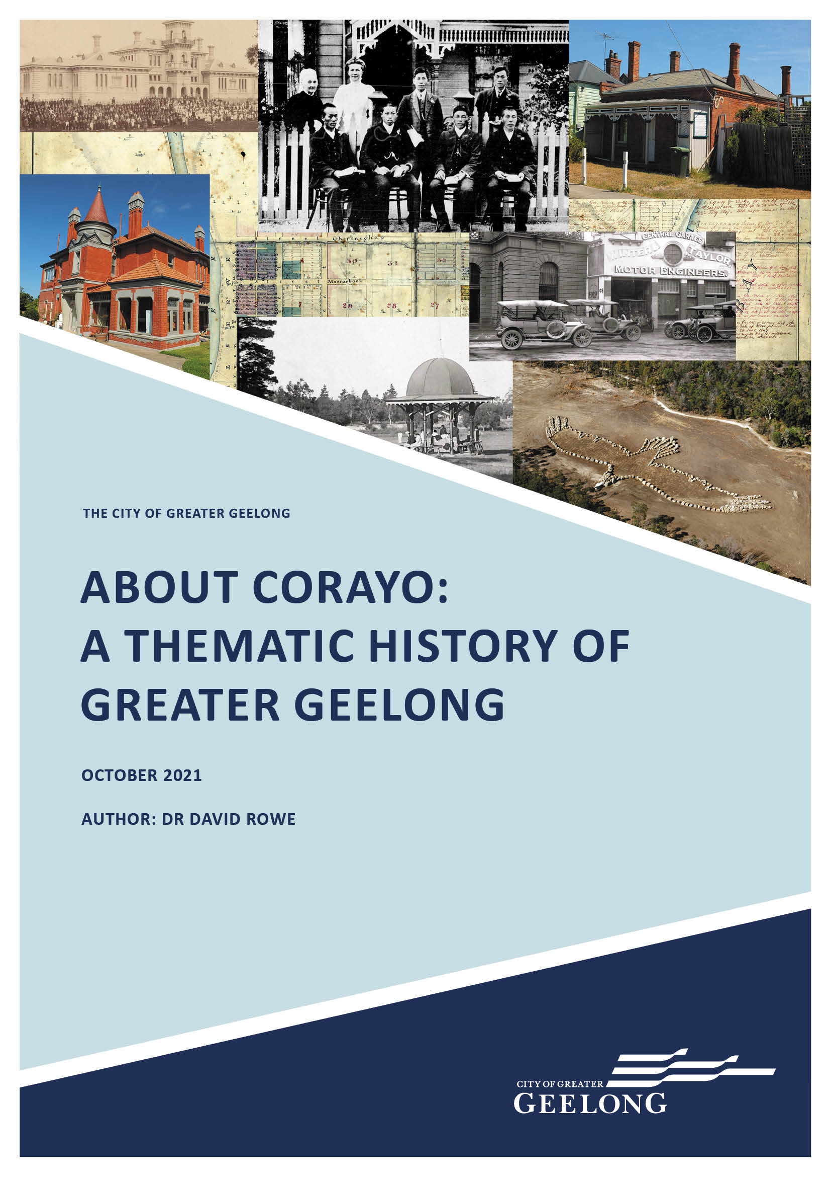

COMMISSIONED & FUNDED BY THE CITY OF GREATER GEELONG

PROJECT TEAM
Author: Dr David Rowe,
Authentic Heritage Services Pty Ltd, Geelong.
Historical Research: Dr David Rowe and Pam Jennings, Authentic Heritage Services Pty Ltd, Geelong.
Peer Review: Wendy Jacobs,
Architect and Heritage Consultant, Ballarat.

COPYRIGHT
City of Greater Geelong, Geelong, Victoria, 2021
This work is licensed under a Creative Commons Attribution Non Commercial 4.0 International licence. You are free to re-
use the work under that licence, on the condition that you credit Dr David Rowe as the author. The licence does not apply to
any Wadawurrung content, images, photographs or branding, including the City of Greater Geelong logo. To view a copy of this licences visit https://creativecommons.org/licenses/by- nc/4.0/
All rights reserved. Except as permitted under the Australian Copyright Act 1968 and subsequent amendments, no part of this work may be reproduced, stored in a retrieval system, communicated or transmitted in any form or by any means without prior written permission.
The moral rights of the author have been asserted. Authentic Heritage Services Pty Ltd has a perpetual license to use this material.
The moral and cultural rights of the Wadawurrung Traditional Owners Aboriginal Corporation have been asserted. No part of this work relating to the history of the Wadawurrung may be reproduced, stored in a retrieval system, communicated
or transmitted in any form or by any means without prior written permission from Wadawurrung in addition to the City of Greater Geelong.
Every reasonable effort has been made to ensure that permission has been granted for use of material in this work. If you believe that your rights have been infringed, please contact Planning Strategy, City of Greater Geelong.
ISBN: 978-0-6483576-3-6 ACKNOWLEDGEMENT
The study team and the City of Greater Geelong acknowledge
the Traditional Owners of the lands and waters, the Wadawurrung, and recognises their continuing connection to their Country. Respect is paid to Elders past, present and emerging.
WARNING
Aboriginal and Torres Strait Islanders should be aware that this work contains quotes from earlier publications
by non-Indigenous people that may be confronting and may be considered inappropriate today.
Aboriginal and Torres Strait Islander readers should also be aware that this work contains names, details and photographs of people who have since passed away. Wadawurrung has approved the use of the photographs depicting Indigenous people in this work.

Cover illustrations:
Clockwise (left to right):
Flinders National School, Geelong, c.1880 (National Gallery of Victoria).
Mrs Eliza Freeman, Miss Mary Freeman & Chinese students
outside Glenmore , 155 McKillop St, 1910 (News of the Week 17 November 1910).
St. Elmo , 127 Elizabeth St, 2019 (David Rowe).

H.W.H. Smythe, Plan of the Town of Geelong, 1838 (Public Record Office Victoria).
Winter and Taylor s Central Garage, Malop St, Geelong, c.1925 (Davies collection, Lorraine Huddle).
Andrew Rogers, Bunjil geoglyph, You Yangs, 2006 Cricket match in Eastern Park, 1930 (Holmes collection). Kirrewur Court , Newtown, 2017 (David Rowe).

CONTENTS

INTRODUCTION 5
THEME 1
SHAPING THE ENVIRONMENT OF GREATER GEELONG
  - Introduction 10
  - Existing Natural Environment 10
  - Native Fauna & Flora 33
  - Living with Natural Processes 43
  - Appreciating & Protecting 51
Natural Wonders

THEME 2

PEOPLING GREATER GEELONG
  - Introduction 65
  - Living on Wadawurrung Country 67
  - European Exploration & Surveys 72
  - Initial European Colonisation following 74
Terra Nullius
  - Dispossession of Wadawurrung Country 81
  - The Wadawurrung & Other Aboriginal 96
& Torres Strait Islander People in Greater Geelong to the 21st Century
  - Immigration to Greater Geelong: 101
19th Century
  - Immigration to Greater Geelong: 110
20th Century
  - Chinese, Malay & Indian Workers in 112
Greater Geelong
  - Italian Immigrants 122
  - Japanese Immigrants 125
  - Postwar (post 1945) Immigration 130
  - Closer & Soldier Settlement 139
  - Settlement Strategy 2018 159

THEME 3

TRANSPORT & COMMUNICATIONS
  - Introduction 175
  - Wadawurrung Routes 176
  - Roads Around Greater Geelong 177
  - Railway Network in Greater Geelong 248
  - Shipping 282
  - Aviation 309
  - Postal & Telegraph Services 315
  - Newspaper Production 336
  - Wireless Radios 339

THEME 4

TRANSFORMING & MANAGING LAND & NATURAL RESOURCES
  - Introduction 362
  - Farming & Agriculture 363
  - Timber Industry 407
  - Stone Quarrying 409
  - Lime Burning 428
  - Brick Making 434
  - Gold Mining 446
  - Water Supply & Sewerage 451

THEME 5

BUILDING GREATER GEELONG’S INDUSTRIES & WORKFORCE
  - Introduction 487
  - Wadawurrung By-errs 488
  - Industrial Sector 488
  - Trade Sector 545
  - Commercial Sector 587
  - Financial Sector 603
  - Insurance Sector 613
  - Legal Sector 616
  - Hospitality Sector 619
  - Utilities Sector 633

THEME 6

BUILDING THE SHIRE
  - Introduction 655
  - The Wadawurrung: Clan Estates & 656
Building on Country
  - Geelong the Regional City 659
  - Geelong: The Sleepy Hollow 1860-1900 675
  - Geelong: A Period of Progress 1900-2000 683

  - From Manufacturing to Health, Educational 691
& Insurance Service Sectors:
Geelong in the Early 21st Century
  - Suburban Communities 693
  - Other Suburbs & Settlements 752

THEME 7

GOVERNING IN GREATER GEELONG
  - Local Government 854
  - The Wadawurrung: The First Local 854
Government in Greater Geelong
  - Evolution of European Local Government 855
in Greater Geelong
  - Founding of Colonial & State Governments in
Victoria: Associations with Greater Geelong 911
  - Law & Order in Greater Geelong 912
  - Governing the Waterways 931
  - Defending Greater Geelong 936
  - Managing the Roads 948
  - Regulating Building & Town Planning
in Greater Geelong 949

THEME 8

BUILDING COMMUNITY LIFE
  - Introduction 978
  - Spiritual Life 979
  - Education 1010
  - Health & Welfare 1051
  - Community Organisations 1096
  - Commemoration 1118

THEME 9

SHAPING CULTURAL & CREATIVE LIFE
  - Introduction 1169
  - Sport 1172
  - Recreation 1210
  - Clever & Creative Geelong 1255

BIBLIOGRAPHY & APPENDICES
BIBLIOGRAPHY 1347
APPENDICES 1417
Appendix 1.1 1417
Geological Survey Maps of Victoria
Appendix 1.2 1423
Census of Indigenous Plants of the Geelong District in 1897
Appendix 3.1 1429
List of Carriage, Coach & Wagon Builders,
Bicycle Shop Proprietors & Engineers, Motor Mechanics & Engineers, & Motor Garage Proprietors
Appendix 3.2 1444
Victorian Railways Department Guards & Gatekeepers on Geelong Lines
Appendix 3.3 1446
Post Offices in Greater Geelong
Appendix 3.4 1449
Geelong & District Newspapers
Appendix 4.1 1451
Schedule of Vineyards Inspected 1878
Appendix 4.2 1453
Novel Industries Applications Section 45, Land Act 1862
Appendix 4.3 1455
List of Quarries in the 1850s in the Geelong Town Council Rate Books
Appendix 4.4 1456
Chilwell Gold Mining Company Shareholders
Appendix 5.1 1459
Lists of Employment Sectors
Appendix 6.1 1543
List of Architects & Tradespeople in Electoral Roll 1856
Appendix 7.1 1554
List of Mayors & Presidents of Municipalities now comprising Greater Geelong
Appendix 8.1 1569
List of Schools in the Greater Geelong Area
Appendix 8.2 1572
Health (Lists of Private Hospitals, Doctors, Matrons & Dentists)
Appendix 8.3 1581
War-Related Street Commemorations
Appendix 9.1 1584
Geelong Industrial & Juvenile Exhibition 1879-1880: Official List of Awards

INTRODUCTION

The City of Greater Geelong commissioned Authentic Heritage Services Pty Ltd in February 2018 to undertake a thematic history of the City of Greater Geelong
municipality. This work has been researched and authored by Dr David Rowe, with research assistance by Pam Jennings. It has been peer-reviewed by Wendy Jacobs, Architect and Heritage Consultant.

The word Corayo used in the title of this Thematic History is one of several derivations of the term known today as Corio, meaning salt water or sandy to the Wadawurrung. In the early years of European colonisation, the name of the town
of Geelong was interchanged, being called Geelong or various versions of Corio.
The purpose of the thematic history has been to connect the past through existing physical evidence; provide a background to significant aspects of cultural history no longer physically present; and to give greater recognition to some sections of the community and historical events and associations that have been previously marginalised, or where limited analysis has been given (either as a consequence of cultural norms in earlier periods of history or for other reasons). While thematic histories of parts of Greater Geelong have previously been
prepared, they have concentrated on earlier municipalities prior to Council amalgamations, and an overall thematic analysis has therefore been disjointed. This thematic history aims
to give a broad, meaningful appreciation of Greater Geelong that accounts for its history and heritage
in a consistent manner.
The thematic history is based on Victoria s Framework of Historical Themes published by the Heritage Council of Victoria in February 2010 but tailored to accord with the specific history and themes within the City of Greater Geelong. Victoria s Framework of Historical Themes has also been augmented
by the Aboriginal and Shared Heritage Themes prepared for the Heritage Council of Victoria and the Victorian Aboriginal Heritage Council.
The thematic history:
Outlines the key historic themes relevant to the City of Greater Geelong.
Gives an overview of the history of the Wadawurrung, the Traditional Owners of City of Greater Geelong Country, in each of the relevant themes, as a measure of reconciling Wadawurrung and European histories. The historical analysis of the Wadawurrung has been carried out following The Guidelines for Ethical Research in
Australian Indigenous Studies published by the Australian Institute of Aboriginal and Torres Strait Islander Studies (2nd edition, 2012) (now superseded by the Code of Ethics for Aboriginal and Torres Strait Islander Research, and A Guide to applying the AIATISIS Code of Ethics for
Aboriginal and Torres Strait Islander Research, Australian Institute of Aboriginal and Torres Strait Islander Studies, 2020), in consultation with the Registered Aboriginal Party, Wadawurrung Traditional Owners Aboriginal Corporation. Consequently, the analysis provided has been confined for cultural reasons on the advice of Wadawurrung.
Provides information about some of the key places of cultural heritage significance in the municipality under the relevant historic themes. These themes are illustrated with photographs, maps and plans
where possible.
Gives a social history of individuals and events that have made important contributions to community life, including (but not limited to) great recognition of the contributions of the Wadawurrung, the role and contributions of women, and emigrants (including the contributions made by
later non-British arrivals to Greater Geelong). As well as providing an appreciation of these significant sectors of the City s cultural life, the social history gives a basis for ongoing heritage assessment and interpretation.
Provides a context for comparative analysis of heritage places included as heritage overlays in the Greater Geelong Planning Scheme and/or in the Victorian Heritage Register and Victorian Heritage Inventory.
This thematic history does not replicate W.H. Brownhill s epic work, The History of Geelong and Corio Bay (1955) with Postscript by Ian Wynd (1990), republished by The Geelong Advertiser. While several of the historical events and individuals noted in the work of Brownhill and Wynd are also covered in this thematic history, the concentration is
on the physical manifestation of Greater Geelong s evolution and development. This is given through discussion of its environment, urban expansion (town planning), transformation through land processes (quarrying, mining and farming), building of workforces (industries, commerce and trade)
and cities, suburbs and towns, governance, community organisations and associations, and sport and recreation.

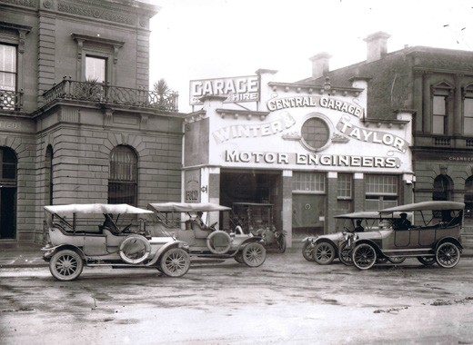
It is recognised that this thematic history is considerably more substantial than usual practice. Advancements in digital technology have led to a plethora of historic and rare documents (such as maps, letters, photographs, and newspapers) now being readily available. Coupled with more sophisticated catalogues in various repositories, the vast extent of primary research material now available identified inaccuracies in a number of previous histories
and heritage studies. This project has attempted to correct previous historical errors and further contribute to Greater Geelong s historical discourse. The voluminous nature of this work has also been due (in part) to: a concerted effort to recognise the importance of the Wadawurrung peoples in
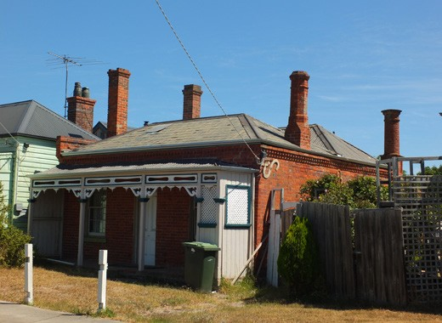
Greater Geelong history; the diverse geography, topography, natural and built environment, and cultural associations within the municipality; the contextually large number of heritage overlays applied to heritage places in Greater Geelong (the municipality having the largest number of individual heritage overlays in Victoria); analyses of the physical legacies associated with local people and/or cultural groups (including the impacts these legacies have had on community life); and additional research undertaken to highlight the clever and creative history in Greater Geelong, which recently culminated in its designation as a UNESCO City of Design.

ACKNOWLEDGMENTS
We are indebited to Jani Chalmers, Senior Strategic Planner, City of Greater Geelong and project manager of this project, for her patience, flexibility and assistance.
Particular appreciation is given to the Wadawurrung Traditional Owners Aboriginal Corporation, particularly Corrina Eccles (Cultural Education Co-ordinator) and Paul Davis (Executive Officer), and to Melinda Kennedy and Tammy Gilson, for their careful and considered advice.
Special acknowledgment is given to Mark Beasley, Manager, and Melody McDonald, Archives and Administration Officer, Geelong Heritage Centre Collection and Services, Geelong Regional Libraries, for making available the vast and valuable collection of photographs and maps, and for freely copying and providing high quality images that have enhanced this history.
We posthumously acknowledge the extensive research and investigations by the late Mrs Lou Lane relating to Wadawurrung history in Greater Geelong, and the support and friendship provided to the author on this subject.

NUMEROUS OTHER INDIVIDUALS AND ORGANISATIONS HAVE LENT THEIR SUPPORT FOR THIS PROJECT, EITHER THROUGH THE PROVISION OF PHOTOGRAPHS AND OTHER INFORMATION,
OR PROVIDING PERMISSION FOR THE USE OF MATERIAL. THEY INCLUDE:

Kevin Krastins, Community Development Officer – Aboriginal Healthy Communities, City of Greater Geelong.
Padraic Fisher, Director, National Wool Museum. Jennifer Bantow, OAM, historian, Geelong.
Dr Luke Keogh, Senior Curator, National Wool Museum.
Reg Abrahams, Wathaurong Aboriginal Co-operative, North Geelong.
Mark Edwards, Manager, Wathaurong Glass, North Geelong.
The late Frank Costa, AO (Costa family history).
Thiru Naidoo, Brand & Digital Content Manager, Viva Energy Australia Pty Ltd, Melbourne.
Geoff Laurenson, Archivist & Briony Pemberton, Library Technician, Fisher Library, Geelong Grammar School.
Lisa Sullivan, Senior Curator & Veronica Filmer, Collections Manager & Registrar, Geelong Gallery.
Brad Duncan, archaeologist.
Clive Tilsley, Fullers Bookshop, Hobart, Tasmania. Andrew Rogers, sculptor.
Graeme Butler, Heritage Architect.
Scotia Ashley, Reference Librarian, Pictures & Manuscripts Branch, National Library of Australia.
Cat Stanley, Senior Archival Officer, Queensland State Office, National Archives of Australia.
Access Services Team, Public Record Office Victoria, North Melbourne.
Richard Jefferson, Executive Director, Land Registry Services, Deputy Registrar of Titles, Land Use Victoria, Department of Environment, Land, Water & Planning.
Pete Diggins, Pete Diggins Publishing, Tasmania.
Eloise Iacono, Community Relations Adviser, Barwon Water.
Cliff Cummin, Kerry Cardell & Robert Baker (Comunn na Feinne history).
Sigourney Jacks, Documentation Officer, Digitisation Project, National Gallery of Victoria, Melbourne.
Peter Harvey, Senior Maritime Archaeologist, Heritage Victoria.
Elizabeth Kraus, historian. Lorraine Phelan, historian.

Norman Houghton, Archivist, Geelong Club. Noel Murphy, journalist.
Margaret & Ron Morphy, Merchiston Hall , Geelong.
Dr Geoff Russell, former Communications Manager, City of Greater Geelong.
Christine Hughes, Little River. Martin Klabbers, Barwon Heads. Sue Jones, Little River.
Susie Zada, historian, South Geelong.
Gwen Threlfall, Mount Duneed History Group.
Dr Helen Doyle, Senior Heritage Consultant, Context Pty Ltd.
Kate Kenny, Marketing & Administration Coordinator, The Bellarine Railway.
Rod Charles, cycle historian.
Marco Laudani & Kevin Bates, Australian Historic Telephone Society.
Dr Peter Mansfield, OAM, historian, Geelong. Kevin O Reilly, aviation historian.
Pam Sell (McIlldowie family history).
Dale Kent, Records Manager, Quality & Compliance, The Gordon TAFE.
Josef Lebovic, Josef Lebovic Gallery, Kensington, NSW.
Fiona Love, Bellarine Secondary College & Bellarine Landcare Group Nursey Coordinator, Drysdale.
Lorraine Huddle, Heritage Intelligence Pty Ltd.
Kristen Thornton & Maria Shanahan, Special Collections Librarians, Special Collections, Deakin University Library.
Michael Menzies, railway historian.
Con Lannan, Archivist, The Geelong College.
Karen Ware, Stawell (original subdivision plan of Sparrovale Farm, Charlemont).
Liz Coles, Secretary, Geelong Central Netball Association.
Marcus Wong, Rail Geelong website.
Jim Robinson, Managing Director, E.P. Robinson Pty Ltd, Riversdale Mill Wool Scourers & Carbonisers.
Sherryn Batters (Grigg family history). Fay Towney (Irwin family history).
Larissa Scanlon, Regional Manager, South West, VLine. John Flatt (Fyansford history).
Bill Votsaris, Geelong (historic photograph of former Thacker Printers building, Ryrie Street).
Peter Watts (Nantes family history).
Dennis Meek, Secretary, Ambulance Historical Society. Greg Newman (gun emplacement, Ocean Grove).
Lewis Strating, GIS Planning Officer, City of Greater Geelong.
Bridie Flynn, State Library of Victoria.
Sally Northfield, James Northfield Heritage Art Trust. Colin Cook, Eclipse Creek, Beremboke.
John Stewart, Torquay (Stewart family history & photographs).
Hon. Colin Brooks, MP., Speaker of the Legislative Assembly, Parliament of Victoria.
Debra Reeves, Kate Murray, Stefanie Tardif & Brittany Turner, Parliament of Victoria.
Natasha Williams, Marketing Communications Assistant, Royal Australian Mint, Canberra.
Miles Pierce.
Engineering Heritage Australia.
Lorraine Stokes, OAM, historian, Portarlington.

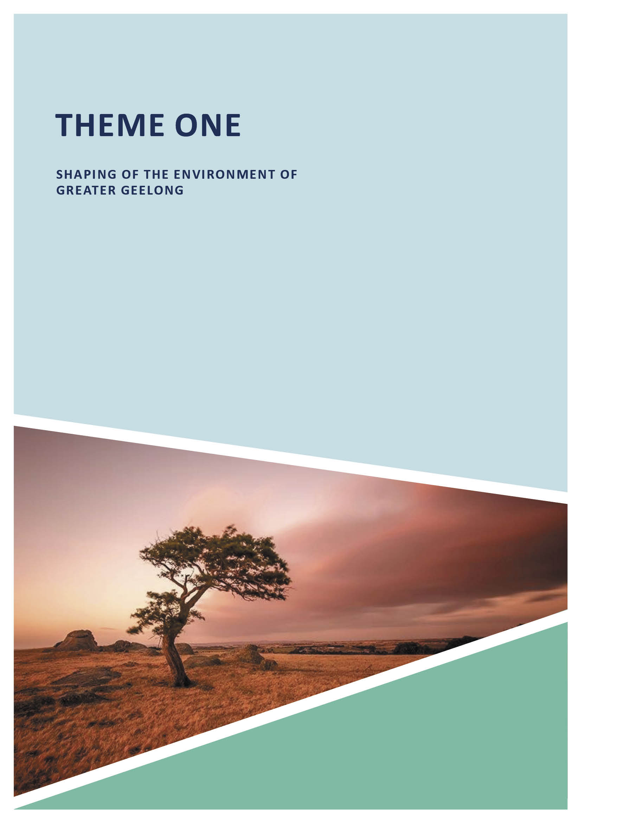
ABOUT CORAYO: A THEMATIC HISTORY OF GREATER GEELONG 9

INTRODUCTION
The natural environment of the City of Greater Geelong is diverse and takes in rural and coastal landscapes.
For thousands of years and continuing, it has deep connections with the Traditional Owners, the Wadawurrung. This theme gives an understanding of the geology and native flora and flora through the eyes of 19th and early 20th century European pastoralists, writers and the geologists, including Richard Daintree (geologist to the Geological Survey or Victoria) and
Sir Charles Belcher (local ornithologist), to give an historical context for the local environment (and changes to it). Sites of geological and environmental significance are outlined.
The formations of both the Geelong Field Naturalists Club and the Victorian Acclimatisation Society in the 19th century and their divergent outlooks and values of the local landscape and biodiversity are also given.
Given its location, geology, topography and environment, Greater Geelong has experienced numerous natural processes and disasters, including droughts, bushfires, floods, wind storms, snow and earthquakes and tremors prior to European colonisation. The theme explores the dramatic affects these natural processes have had on the environment and its people.
The theme concludes by giving an overview of the diversity and importance of the native landscapes within Greater Geelong through case studies on several significant sites identified for their ecological and environmental values. Where relevant, an historical context for these significant natural sites is provided.

EXISTING NATURAL ENVIRONMENT

BOUNDARIES OF THE GREATER GEELONG AREA, POPULATION AND TOPOGRAPHY
The City of Greater Geelong is an area of 1247 km2 and takes in urban, suburban, coastal and rural areas1 (Figure 1.01).
The Geelong City is especially characterised for its northern waterfront to Corio Bay, with views to the You Yangs and Anakie and Brisbane Ranges to the north-west, the picturesque Bellarine Peninsula with ocean and bay coastlines, the undulating landscape of the Barrabool Hills to Mount Duneed, and the marine settings of Breamlea, Barwon Heads, and Ocean Grove. The northern boundary of the municipality
is largely the Little River (except for parts of Balliang and Staughton Vale), and takes in the south-east portion of the Brisbane Ranges. Much of the western boundary is Sutherlands Creek, the southern portion of the western boundary takes in the eastern parts of Stonehaven and Barrabool, and also includes Waurn Ponds. The southern
boundary is primarily Mount Duneed Road, Mount Duneed, along with coastline to Bass Strait. The eastern portion of Greater Geelong is the Bellarine Peninsula, extending as far south-east as Fellows Road, Point Lonsdale, as well as the shores of Swan Bay, Indented Head, and Portarlington, and
all of the shoreline of Corio Bay. Punctuating the southern and south-eastern portion of Greater Geelong is the Barwon River, which intersects with the Moorabool River at Fyansford, enters Lake Connewarre before meeting Bass Strait to the south-east. Other water courses comprise further natural
features, including Armstrong Creek and Thomson Creek to the south and south-east respectively, and the Waurn Ponds Creek that extends as far north as the Belmont Common to as far south- west as Waurn Ponds.
In 2018, Greater Geelong had a population of 244,000, and was Victoria s second-largest city (outside Melbourne) and the State s largest provincial city.

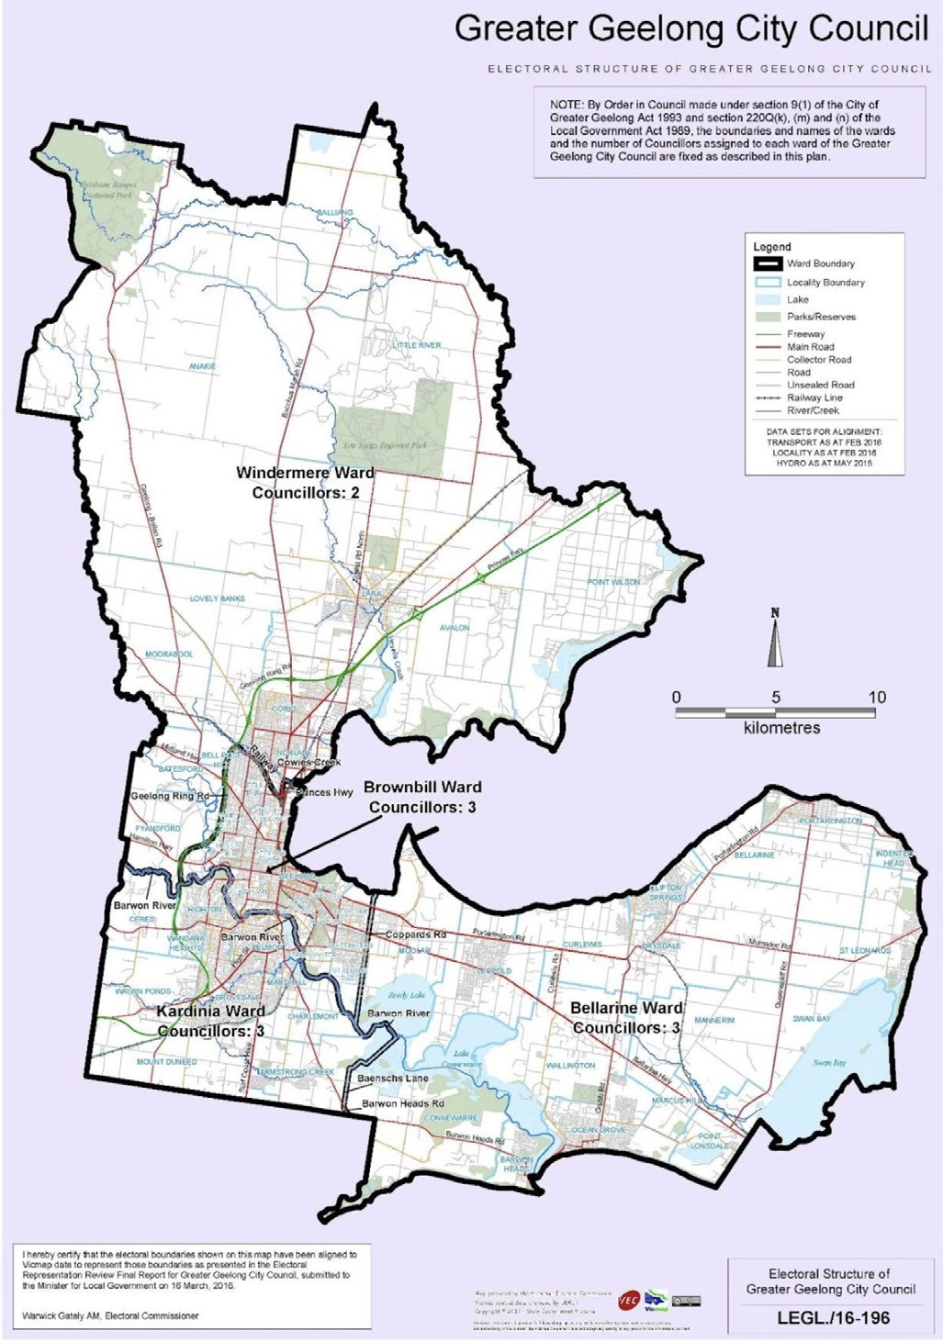
Figure 1.01: Map of the Greater Geelong City Council. Source: Victorian Electoral Commission, Vicmap spatial data, 2017. Creative Commons copyright.

GEOLOGY
The geology of the Geelong area was recognised as early as 1838 when lime burning began on the western side of
Limeburners Point (see Theme 4 for further details)3. While this interest was purely for lime production, by 1841 the Geelong Advertiser highlighted the need for further investigations into the geology of the area. It reported on the discovery of fossil remains in the south bank of the Barwon River where the lime kilns have lately been made .4 Presumed to be the bones of an herbivorous animal and supposed to be a species of wombat, the report also gave a description of the geology of the area, the rock being soft, friable, and very irregular in its texture, approaching to pure chalk near the surface, interspersed with shells, small fragments of ironstone, and stems of a marine plant .5 The report concluded by stating that:
Geology is a science which has not hitherto met with due attention in the colony, and we should be glad to see it taken up by some competent person. There is a wide and varied field for development in the neighbourhood of Corio [Geelong].6
In 1855, James Bonwick, eminent teacher, author and historian whose most persistent interests were geology and anthropology,7 gave one of the earliest overviews
of the geology of the Geelong area (with assistance of others):
Geelong is surrounded by a field of basalt, which covers a marine limestone, forming cliffs by the Bay side.
Mr. Orlebar noticed a freshwater limestone in its vicinity, and speaks of a basalt conglomerate, cemented by lime containing fossil shells. A yellow and a white sandstone occur near the town. Portarlington, at the entrance of Geelong harbor, is on a magnesian limestone, which, with some interruption, extended up to the granite Station Peak [of the You Yangs], and averages, according to Mr. Skene, half a mile in width. Brisbane Range, the source of Little River, is of slate, skirting Station Peak. Boulders of trap strew the limestone shore at the mouth of the Barwon
[at Barwon Heads] The Anaki [sic.] Hills are volcanic;
an imperfect crater may be seen. Mount Moriac is of basalt; and Coloite [Colite], at the entrance of Lake Connewarre,
of recent limestone. Mr Skene thus sums up the geology of Grant country:- Auriferous schists, 54 square miles;
slate, 220; granite, 32; lime, 19; sandstone, 35; basalt 1340.8

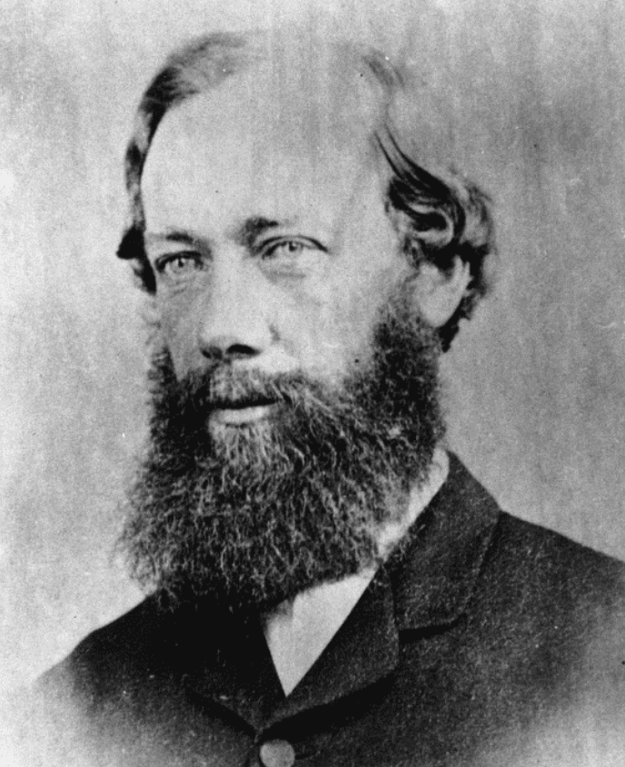

Figure 1.02: Richard Daintree, n.d. Source: Record no. 21218993750002061, State Library of Queensland

It was from 1861 when the most detailed geological survey of the Greater Geelong region was carried out by Field Geologist, Richard Daintree (1832-1878) (Figure 1.02) for the office of Geological Survey of Victoria.9 This office had been established in 1852 with the appointment of Alfred Selwyn
(1824-1902) as Geological Surveyor for Victoria. Daintree was the son of Richard Daintree (farmer) and Elizabeth Daintree, of Hemingford Abbots, Huntingdonshire, England.10 Richard junior was educated at Christ s College, Cambridge, in 1851 and left only after a year due to ill-health.11 He came to the Victorian goldfields in 1852 and not having any success,
he accepted an appointment in February 1854 as assistant geologist to his friend, Alfred Selwyn, in the Victorian Geological Survey.12 He remained there until 1856 when he returned to England to study assaying and metallurgy at the Royal School of Mines Laboratory.13 In January 1859, Daintree re-joined the office of the Geological Survey of Victoria and it was from this time when he pioneered the use of photography in fieldwork.14

In 1864, Daintree left the Geological Survey to take up pastoral properties in North Queensland.15 There, he took up prospecting and continued his photographic explorations.
From 1868 until 1870, he was appointed geologist in

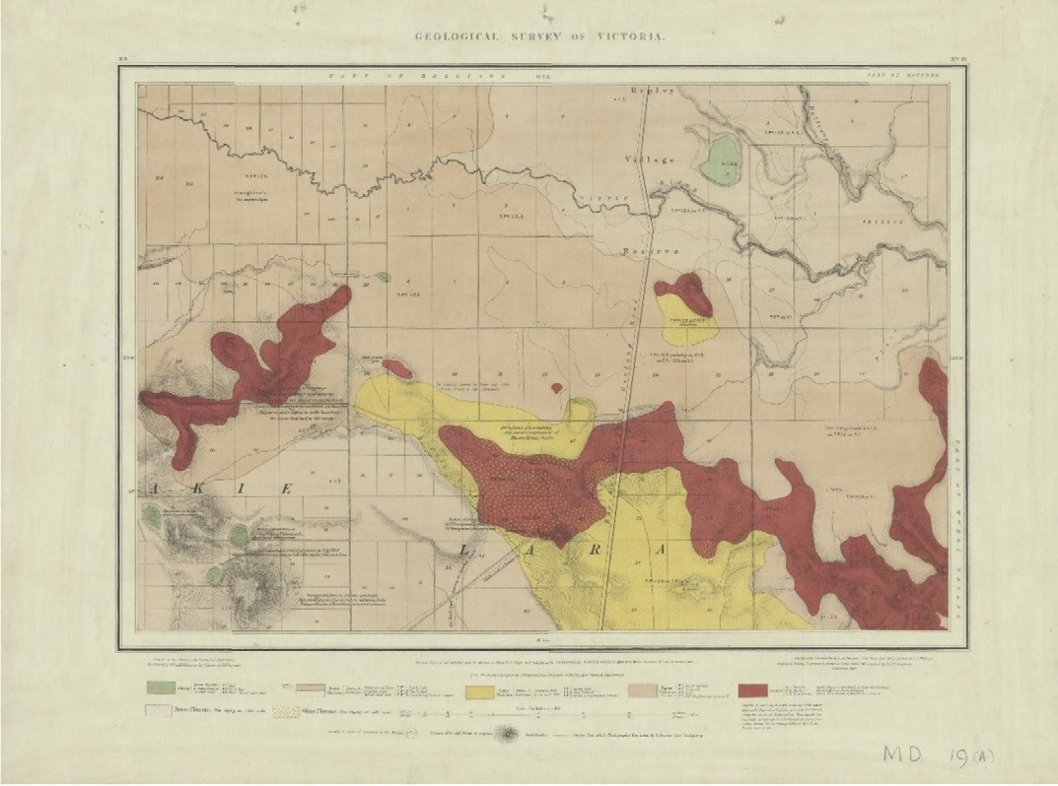
Figure 1.03: R. Daintree, Geological Survey of Victoria Map MD19: Anakie, Lara, Balliang, Mouyhong, Wurdi Youang, geologically surveyed 1861, published 1863. See Appendix 1.1 for larger version. Source: VPRS 8168/P5 item MD, record 19A, Public Record Office Victoria.

charge of the northern division of the Geological Survey in Queensland.16 His collection of photographs and specimens formed the basis of Queensland s contribution to the Exhibition of Art and Industry in London (much of the collection was
lost when the ship enroute to London was wrecked).17 In 1872 in London, Daintree was appointed Agent-General to Queensland, a position he held until ill-health forced his
retirement in 1876.18 A number of places and natural features have been named in Daintree s honour in North Queensland, including the town of Daintree, Daintree National Park, Daintree River, Daintree Rainforest and the Daintree Reef.19
In Greater Geelong, Daintree s meticulous surveys of 1861 were translated into detailed Geological maps published in 186320 (Figures 1.03-07). Daintree carried out specific
surveying of every gully, valley, hill, and other topographical feature in the Greater Geelong area before geological details based on outcrops, road cuttings, queries, and mines.

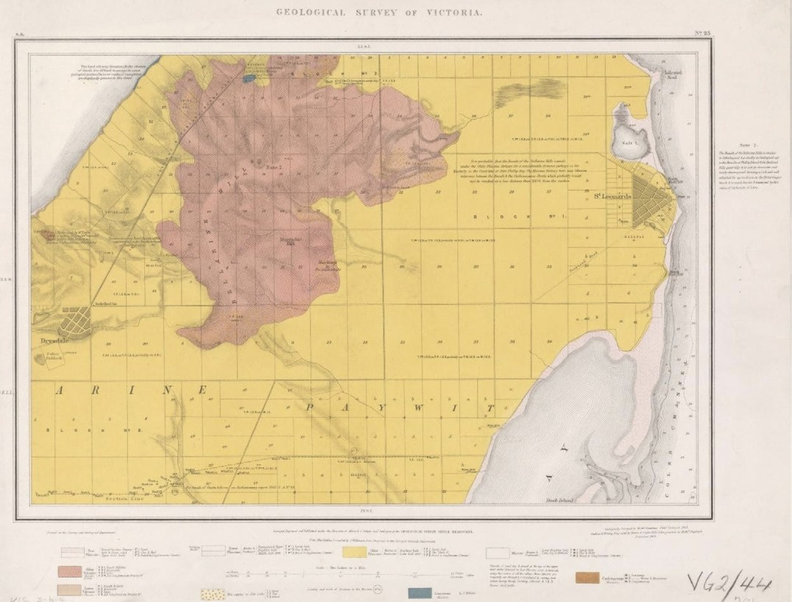
Figure 1.04: R. Daintree, Geological Survey of Victoria, Geological Survey of Victoria, quarter sheet 23NE [Part Bellarine, Part Paywit], geologically surveyed 1861, published 1863. Source: Bib ID 4315334, National Library of Australia.

Daintree s maps therefore included the volcanics that formed part of the Victorian volcanic plain that extends as far west as South Australia, including Mounts Duneed, Moriac, Anakie (including the Three Sisters), and an elevated part of the Bellarine Peninsula. The previous volcanic activity shaped the local topography and water courses. These were also mapped by Daintree, the most noticeable geological and topographical non-volcanic landmark being the You Yangs at Lara, which Trevor Pescott in The You Yangs Range described as follows:
The You Yangs were never volcanic, the granite having been formed by the solidification of molten rock or magma deep beneath the surface of the ground. That magma may have moved into ancient, long extinct volcanic vents that remained from earlier ages is possible, although for much of the Cambrian period (500 million years ago) and into the Silurian (450 million years ago), Victoria was beneath a deep sea.
But volcanoes have had a marked impact on the You Yangs range, for lava from their eruptions has helped shape the nature of the land around the granite outcrops
… Basaltic lava also flowed from (the Mt Anakie and Three Sisters volcanoes), covering land to the east and
south, pushing Hovells Creek eastward against the granite deposits of the You Yangs.21
Extending throughout Greater Geelong and flowing between the volcanic plain and the Barrabool Hills and the Otway Plain, the course of the Barwon River was governed by lava flows from Mount Pollock and other volcanoes, and traverses the basalt barrier known as Buckleys
Falls, Fyansford.22

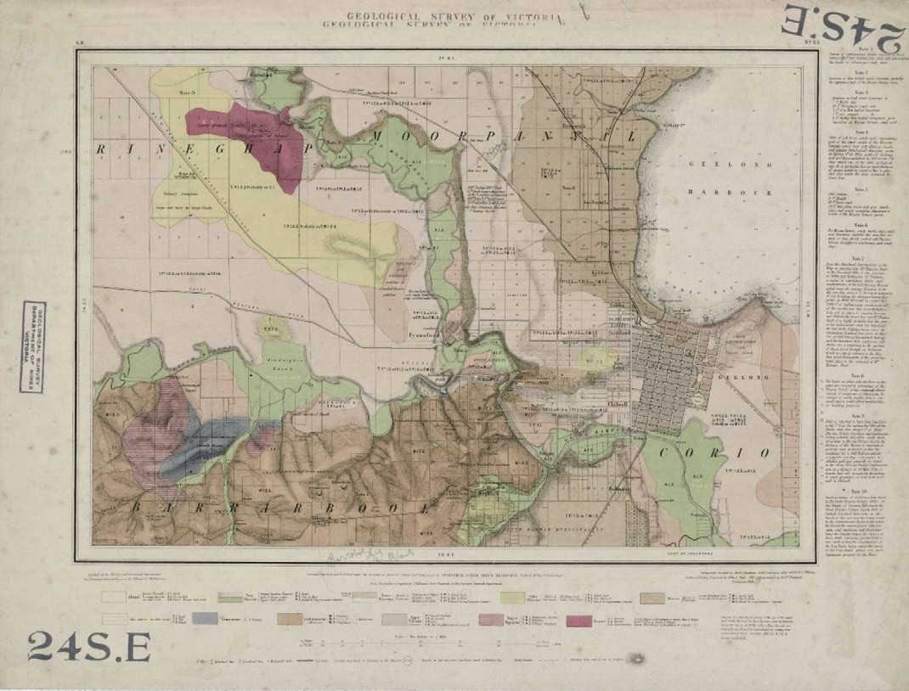
Figure 1.05: R. Daintree, Geological Survey of Victoria Map 24 SE: Gheringhap, Moorpanyal, Barrabool, Corio, geologically surveyed 1861, published 1863. Source: Earth Resources online http://earthresources.vic.gov.au/ data/assets/image/0003/1125588/9_24se_2879x2190_big.jpg

Daintree s surveys were the basis of his Report on the Geology of the District from Bacchus Marsh to Bass s Straits, published in 1863. This report gave a geological overview of his findings, and within the Greater Geelong area it included the following:
Pliocene Tertiary Epoch [11,700 - 2.3 million years ago] No.2 [Tertiaries resting on the most recent lava flows] is best represented (in the district included in this report) in the sections at Queenscliff and Point Lonsdale.
At Mount Colite [Barwon Heads], the western entrance to the River Barwon, one hundred and twenty feet
of irregularly bedded sand rock is seen resting on lava; this lava is the extreme eastern extension of the Mount Duneed flow.

Two thin beds of limestone traverse this section. On the sea-coast patches of white earthy limestone are the usual accompaniment of beds of this age. The Heads lime is all obtained from such deposits.
Where such patches of limestone are abundant, the soil is generally well adapted for agriculture; but, as a rule, poor sandy soil may be expected where these rocks are shown on the geological charts to occupy the surface. The deposits of freshwater limestone at Limeburners Point, Geelong, and at the Duck Ponds, appear to have taken place just after the close of the volcanic period, and
before the subsidence of the land to receive the sea which deposited the Queenscliff beds.

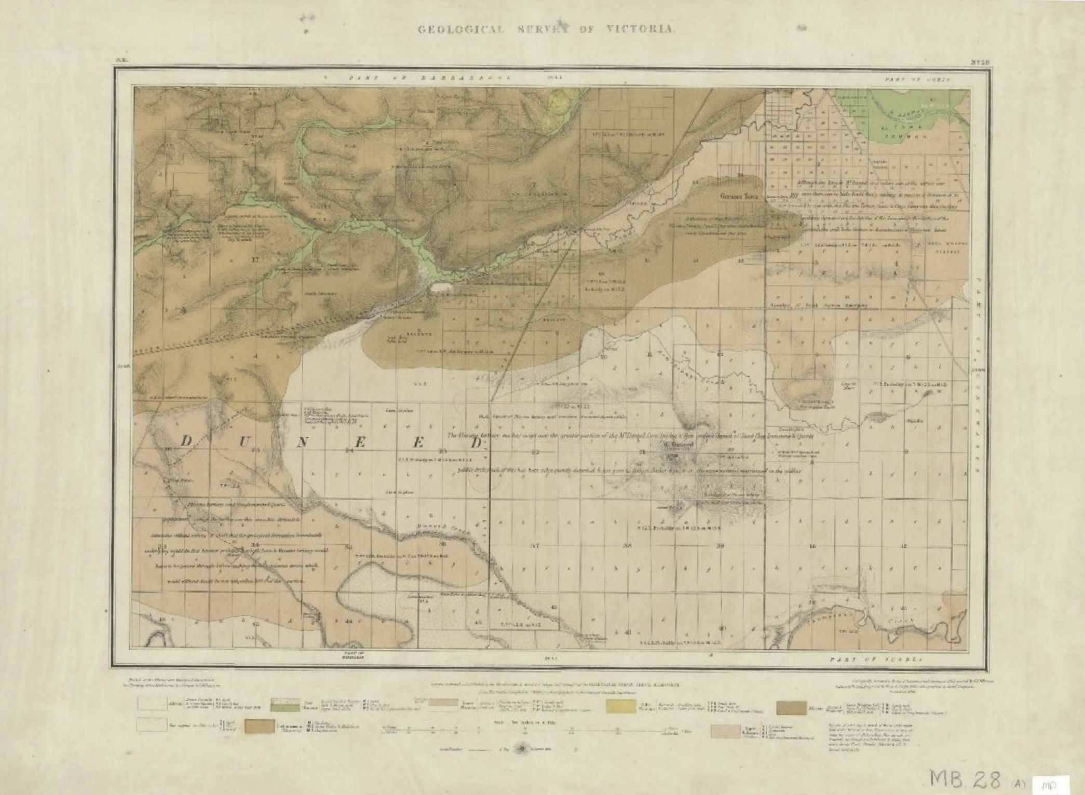

Figure 1.06: R. Daintree, Geological Survey of Victoria Map MD28A: Barrarbool, Duneed, geologically surveyed 1861, published 1863. Source: VPRS 8168/P5 item MD, record 28A, Public Record Office Victoria.

At the margin of the small lake [at Limeburner s Point], the limestone is much contaminated with earthy matter, and it is in hollows in this portion of it that boulders of crystalline limestone (the Sienna Marble of Geelong) have been formed by precipitation; but I have always been of opinion that these boulders will not be found out of the action of
sea water, and that no marble quarry is indicated by their presence.
Nos. 3, 3a. - Pliocene Tertiary Lavas
These lavas differ little in mineral composition from each other, but are divided stratigraphically by a
sand or clay drift (2a [tertiaries deposited during volcanic period]) over a considerable portion of the Werribee Plains.
At the Anakies, evidence exists of two distinct periods of eruption. It is indeed probably that the lava flow, 3a,

of that part of the Werribee Plains under discussion, was submarine and prior to the raising above water of No. 4 [tertiaries underlying lava].
That the intermediate drift, No. 2a, was deposited during a temporary lull in the volcanic forces, and in a troubled sea little adapted for the existence of organic life (no fossils having yet been found in this sedimentary deposit). That a renewal of the volcanic eruption again covered the
bed of the sea with the lava flow, No. 3, on the cessation of which, sedimentary deposit No. 2 was accumulated. Many changes of level, no doubt, took place during this period, forming island of No.3a, round which No. 3 flowed. Such a case, I have no doubt, is exemplified in Bald Hill, six miles south of Bacchus Marsh. The intermediate drift may be only local.

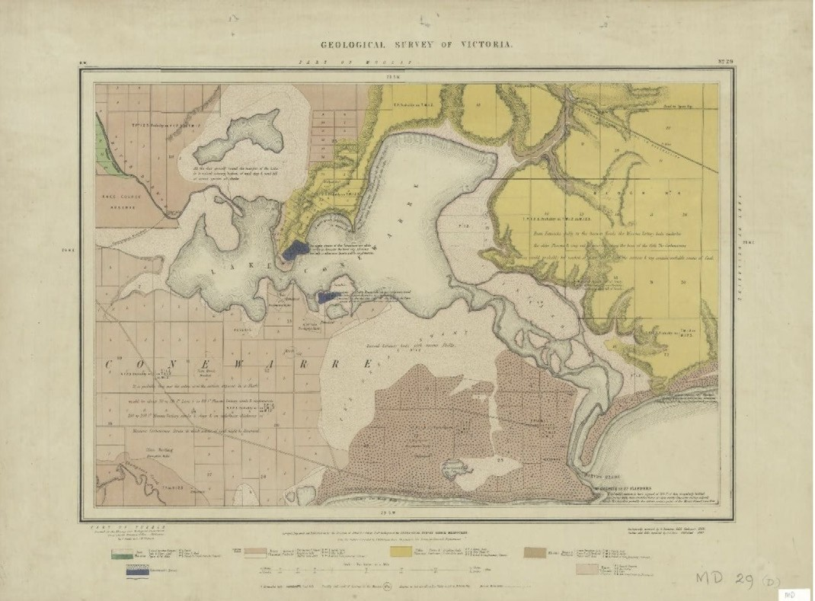

Figure 1.07: R. Daintree, Geological Survey of Victoria Map MD29D: Conewarre, Moolap, Bellarine, Puebla, geologically surveyed 1861, published 1863. Source: VPRS 8168/P5 item MD, record 29D, Public Record Office Victoria.

The upper lava flow may have frequently overlapped the lower, and vice versa.
… In the volcanic ash, on the flanks of the centre Anakie, boulders of granite are imbedded from the size of a marble up to six tons weight conclusive evidence of the strength of the volcanic forces.
No.4 Pliocene Tertiary Epoch
The series of strata included in this subdivision of the Pliocene tertiary group, and underlying the lavas of that period, extend from the sea-coast to the northern boundary of the area included in this report. At the bluff, on the
east side of the Barwon Heads, a thickness of eighty feet of these strata rest on limestone of the miocene tertiary period.

In the immediate neighbourhood of Geelong, they are very thin, gradually thickening in a northerly direction.
Miocene Tertiary Epoch [23-5.3 million years ago]
Nos. 5 and 5a are represented by limestones, calcareous sandstones, sand calcareous clays, and extend along the coast line embraced in this report from Queenscliff to Point Addis.
From Queenscliff to the eastern entrance of the Barwon, they are covered up by Pliocene tertiary sands.
They were reached at 200 feet from the surface in the Queenscliff bore, and crop out at the base of the cliff on the east side of the Barwon Heads.

From Mount Colite, the western entrance of the Barwon Heads, to the mouth of Thompson s or Bream Creek, at one time lava (probably the eastern extension of the Mount Duneed flow), at another the Queenscliff sand beds, hide them from view.
On the west side of Bream Creek, they are represented by
a very compact argillaceous limestone, which has hydraulic properties, and if carefully burnt makes per se a very
good cement.
Halfway between Point Addis and Jan Juc, are cliffs of sand, black with carbonaceous matter, and containing a large percentage of iron pyrites. In these cliffs, a
remarkable instance of the preservation of fossils occurs.
All the large embedded shells are entirely decomposed, and where their casts remain, they are imperfectly rendered in iron pyrites, whilst minute foraminifera, abundant in the rocks, are preserved intact.
These Miocene beds, without doubt, extend under the whole district from Jan Juc Cliffs to Geelong, but are covered up now by Pliocene tertiary sands, and again by lava over the greater of this area, as shown on the geological maps.
Upper Miocene limestone strata are well developed up the Moorabool River between Fyans and Batesford.
Thick beds of comminuted corals will be found about two miles above Fyansford, free from siliceous impurity, but the quantity of contained salt would be a drawback to their use for building purposes.
The siliceous limestone of Fenwick s Gully, on the Queenscliff road [Wallington], used for road metal, is, however, the typical rock of the upper Miocene series.
The greatest elevation at which these Miocene tertiaries are met with in this district, is on the Barrabool Hills, the upper beds of which were burned for lime about two years ago.
No. 6 Basalts and Amygdaloids on which Miocene Tertiary Strata are Known to Rest
The Bellerine [sic.] and great part of the Pentland Hills are composed of this variety of rock. It differs much in appearance from the Pliocene tertiary lavas in lithological character and associated minerals, but the result of the
few analyses lead to the conclusion that this is the result of decomposition, and that originally it had nearly the same structure and composition as the Pliocene tertiary lavas.
Wherever basalt of this geological age occurs in the colony, it forms a soil of the richest character for agriculture. This appears to be due to the amount of easily decomposed carbonate of lime and magnesia in the rock, and the soluble form of the silica. It also retains a very large amount of

moisture apart from its water of constitution, which would in a season of drought be much in its favour.
I could quite understand the practical remarks of
Mr. Williamson, of the Bellerine [sic.] Hills, that the best manure for such land is to plough a little deeper
every year.
No. 7 Mesozoic Carbonaceous Epoch [252 66 million years ago]
These rocks without doubt underlie the district embraced in the parishes of Jan Juc, Paraparap, Puebla, Duneed, Barrabool, Moolap, Connewarre, Bellarine, Paywit. They crop at the surface only at the Barrabool Hills and at Portarlington, being covered by varying thicknesses of tertiary rocks and lava over the remainder.
Their northern extension under the Werribee Plains is uncertain, but the granite of the You Yangs [Figure 1.08], extending as it does in a horseshoe form from Station Peak westward to the Anakies and down Sutherland s Creek to the Dog Rocks, backed by the Steiglitz Ranges, effectually cuts them off in this direction.
In the Bellarine district, these rocks have been bored through to a depth of nearly four thousand feet in a sequence of bores without finding any workable seam of coal.
At Geelong an easterly dip obtains from Noble street, Chilwell, to McCann s quarry, on the Barrabool Hills, exposing a thickness of three thousand feet of alternating sandstones and shales, the probable equivalents of those bored through at Bellarine. On the Barrabool Hills bands of siliceous limestone are interstratified with the shales and sandstones.
The same thing occurs in rocks of the same geological age in the valley of the Wannon and in the Cape Patterson district The commercial products from rocks of this are
coal and freestone / McCann and Holdworth s quarries on the Barrabool Hills supply freestone to the district; but here, as everywhere in the series, joints running in all directions through the stone cause a large among of spoil , and a difficulty in raising large sound blocks.
In section XXV, parish of Barrabool, on the hills, a remarkable conglomerate is interstratified with the sandstones and shales. It is formed of a mixture of
pebbles of slate, granite, greenstone, and quartz rock, with occasional pebbles of quartz. The slate pebbles contain distinct impressions of graptolites.
The similarity of the greenstone and granite pebbles to the rocks above Pollocksford and west of Belperroud s vineyard [Barrabool] is presumptive evidence that these

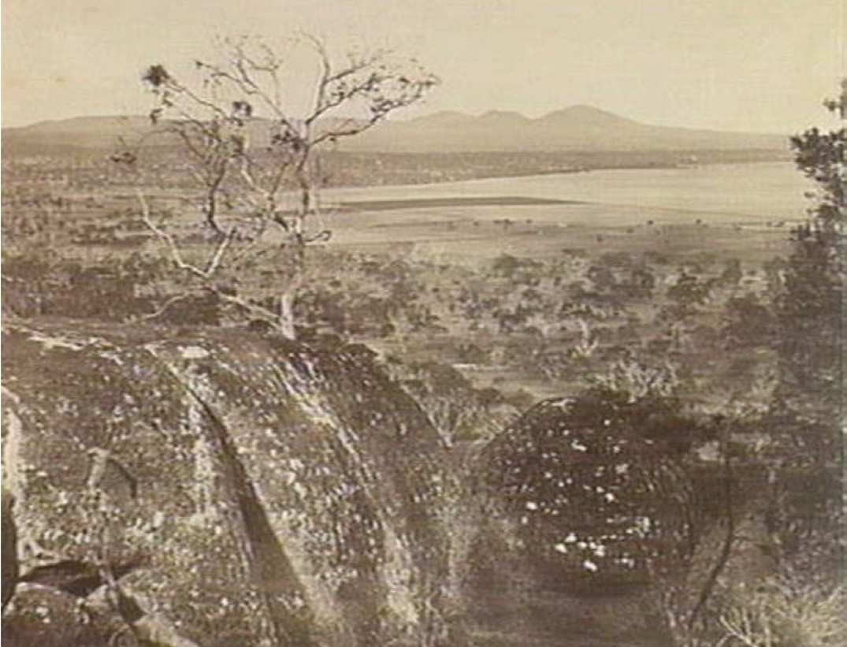
Figure 1.08: R. Daintree, View to the You Yangs, possibly from the Bellarine Hills, c.1861. Source: accession H2929 State Library of Victoria.

rocks are older than the coal group, in far, form their base. To the greenstones of Quarter Sheet 24SE [Figure 1.09]
I would wish to draw the attention of sculptors and workers in ornamental stone, since, though hard to work, it takes
a beautiful polish, and the play of color is little inferior to verd Antique. A polished specimen was sent to the late Geelong Exhibition, with locality attached, and as it could be obtained in any quantity, it seems a more legitimate speculation for a company than the few boulders of Sienna marble on the beach of Corio Bay.23

Geological specimens collected during Daintree s Geological Survey were noted in his Field Book in 1861,24 and several specimens were illustrated in photographs as part of Daintree s ground-breaking illustrative explorations. Along the Barwon River at Fyansford and Newtown and Chilwell, for example,
he listed the basalt formations at the quarries on the Barwon River near Fyansford, and photographed basalt deposits at the junction of the Barwon and Moorabool Rivers (Figures 1.10-12). A specimen was supplied to the Public Museum in Melbourne in 1861.

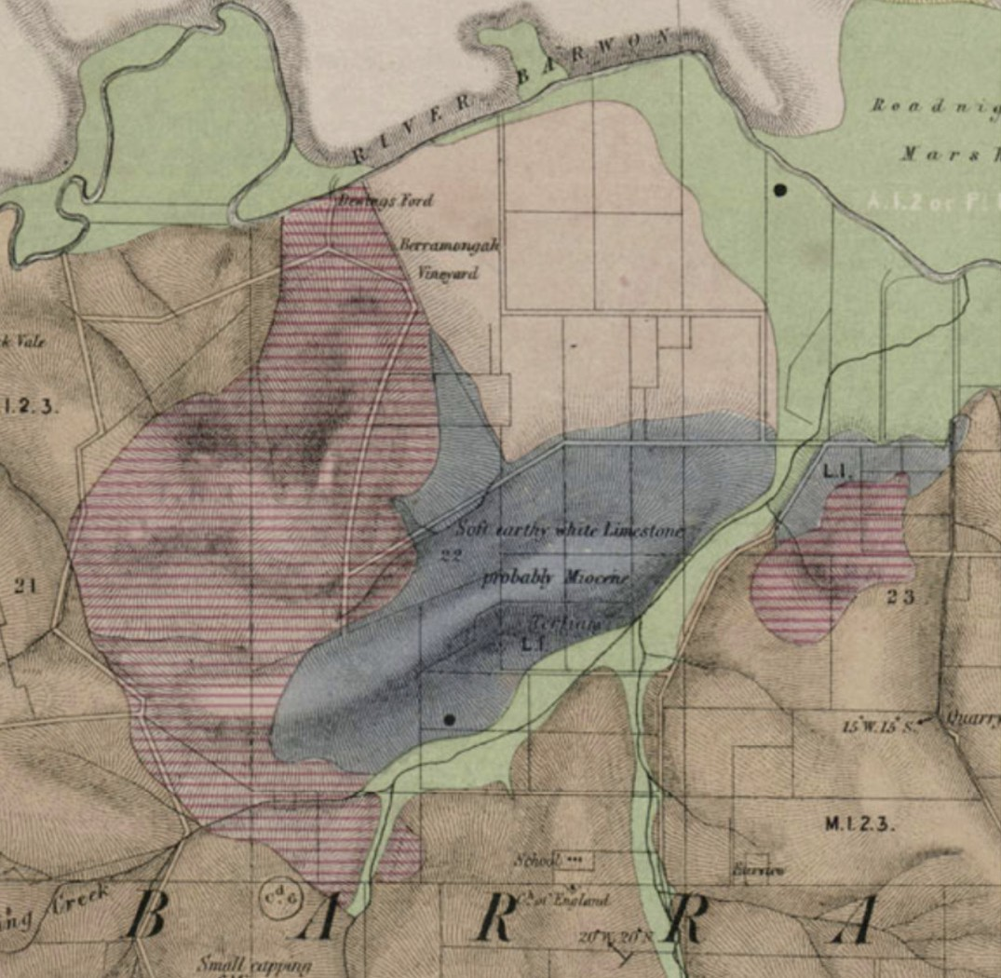

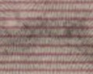
The areas of greenstone in the Barrabool Hills.
Figure 1.09: R. Daintree, Part Geological Survey of Victoria Map 24 SE: Gheringhap, Moorpanyal, Barrabool, Corio, geologically surveyed 1861, published 1863. Source: Earth Resources online http://earthresources.vic.gov.au/ data/assets/image/0003/1125588/9_24se_2879x2190_big.jpg

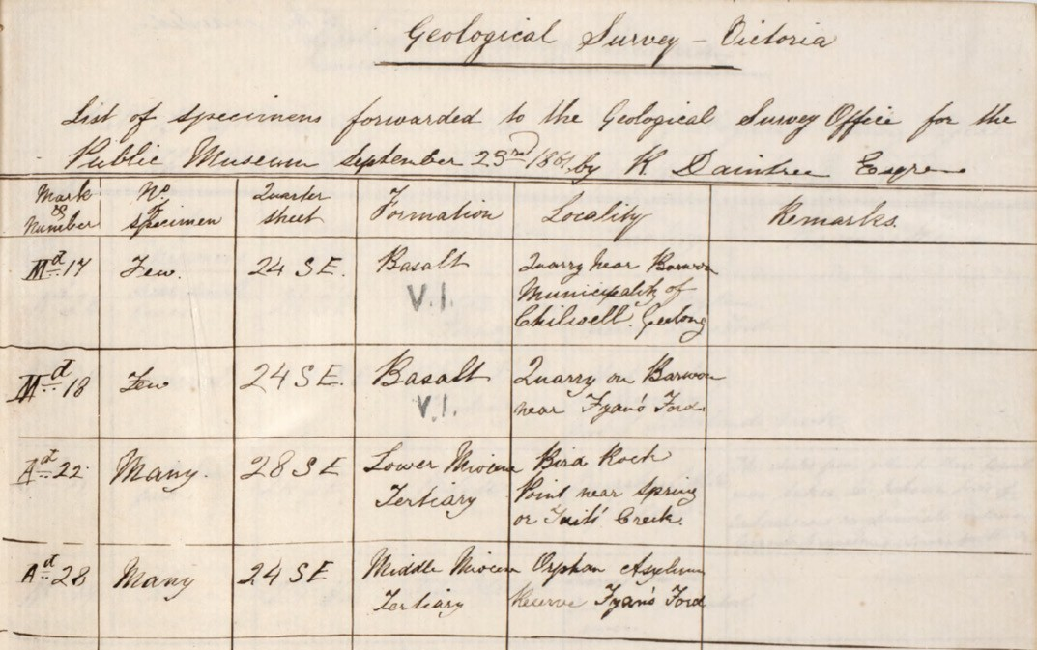

Figure 1.10: R. Daintree, Extract of Field Book, 1861-62, VPRS 11904/P1, item 1, Public Record Office Victoria.
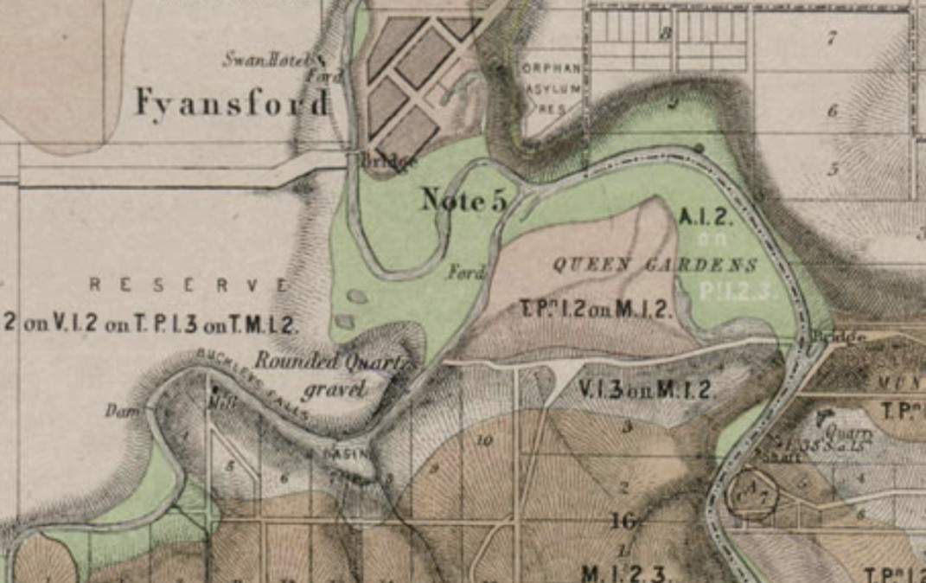
Figure 1.11: R. Daintree, Geological Survey of Victoria Map 24 SE: Gheringhap, Moorpanyal, Barrabool, Corio, geologically surveyed 1861, published 1863, showing Barwon River at and near Fyansford, and quarries. Source: Earth Resources online http://earthresources.vic.gov.au/_data/assets/image/0003/1125588/9_24se_2879x2190_big.jpg

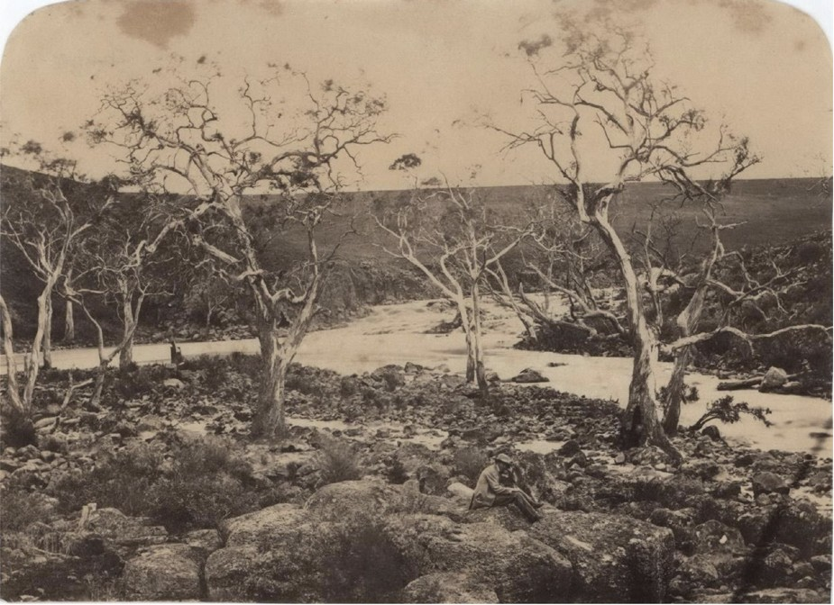
Figure 1.12: R. Daintree, Barwon River, near Geelong, c.1861. Source: Item no. CL 172/8, Josef Lebovic Gallery, Sydney.

Another specimen was supplied of granite from the Granite Rocks on Staughton s Run near the Anakies in 1862 (Figures 1.13-15).
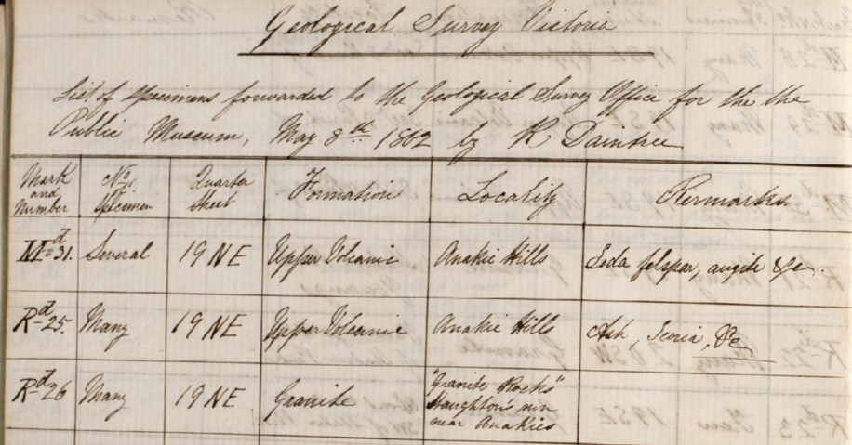
Figure 1.13: R. Daintree, Extract of Field Book, 1861-62, VPRS 11904/P1, item 1, Public Record Office Victoria.

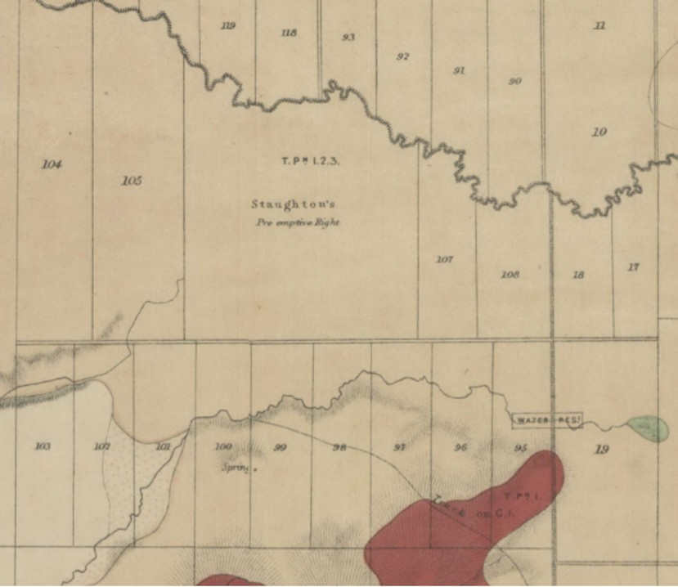
Figure 1.14: R. Daintree, Geological Survey of Victoria Map MD19: Anakie, Lara, Balliang, Mouyhong, Wurdi Youang, geologically surveyed 1861, published 1863, showing Staughton s Run near the Anakies and Brisbane Ranges. Source: VPRS 8168/P5 item MD, record 19A, Public Record Office Victoria.

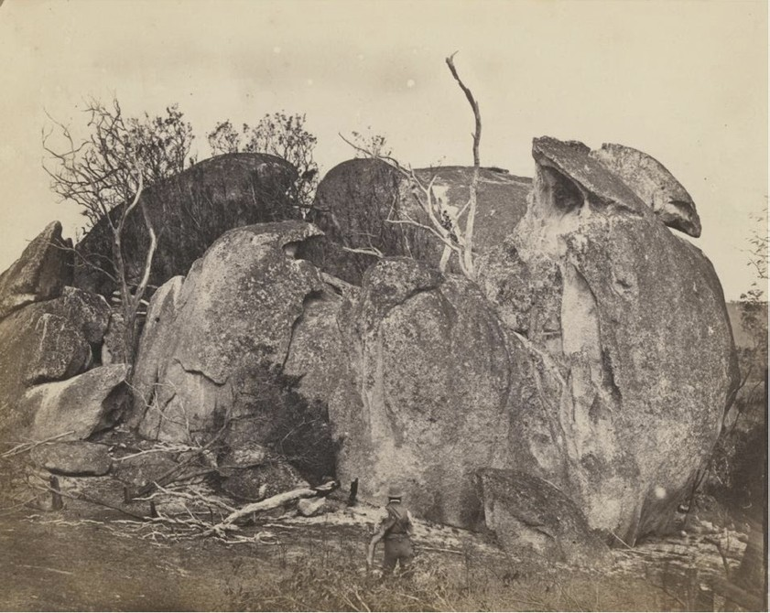
Figure 1.15: R. Daintree, Brisbane Ranges, Anakies, Staughton s Station, c.1861. Source: accession H141706, State Library of Victoria.

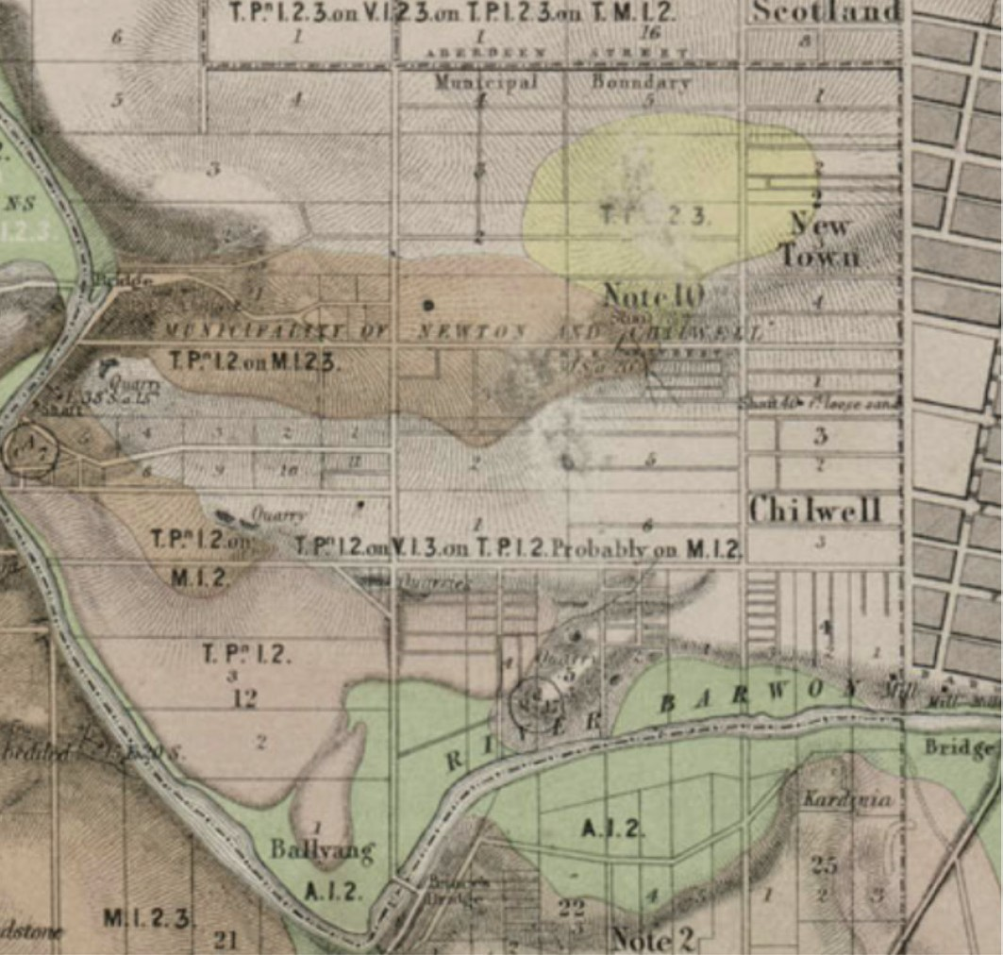
Figure 1.16: R. Daintree, Geological Survey of Victoria Map 24 SE: Gherineghap, Moorpanyal, Barrarbool, Corio, geologically surveyed 1861, published 1863, showing Newtown and location of Note 10 . Source: Earth Resources online http://earthresources.vic.gov.au/_data/assets/
image/0003/1125588/9_24se_2879x2190_big.jpg

Daintree s Quarter Sheet 24 SE (Note 10) (Figure 1.16) also noted the presence of gold at Newtown and Chilwell, and potentially at the Dog Rocks:
Small quantities of Gold have been found in the Old Pliocene Tertiary drifts on the flanks of Newtown Hill, also in the Newer Pliocene Tertiary Quartz drift of Chilwell flat which there rests on the Basalt in the one case the bottom
would be the Carbonaceous Rocks; in the other the Basalt; the nearest known Silurian slates and sandstones with Quartz Reefs being the Steiglitz Ranges; the chance of these drifts containing payable Gold is very small indeed; the Conglomerate of the Dog Rocks being nearer the source of the Gold should afford even more legitimate prospect for the Miner.25

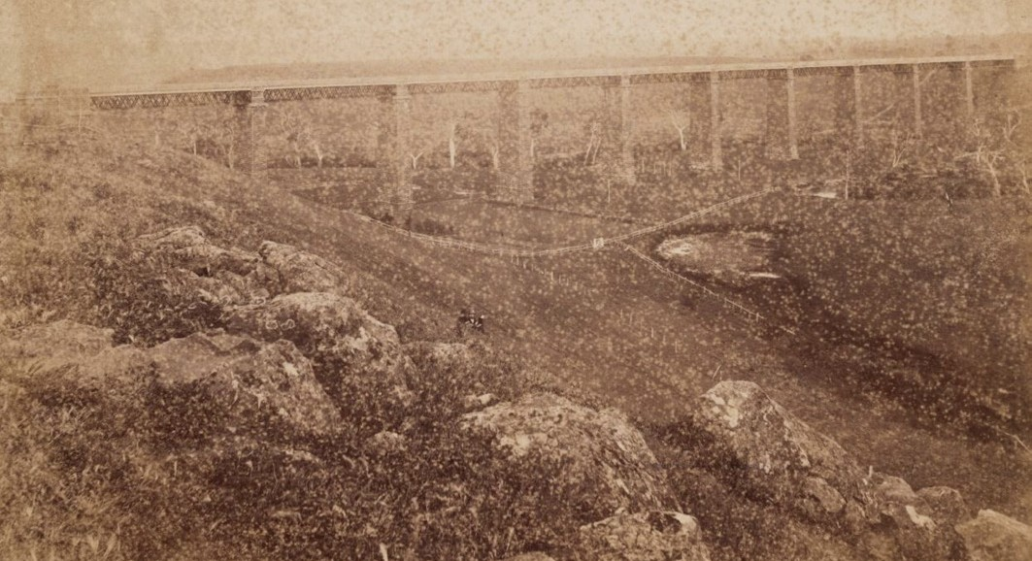
Figure 1.17: C. Nettleton, Moorabool Viaduct showing cliff faces, c.1875. Source: accession H84.79/1, State Library of Victoria.

See Theme 4 for further details on goldmining in Greater Geelong.
Today, Agriculture Victoria (a department of the Victorian Government) has listed the geological and geomorphological sites of significance in the Greater Geelong area (based on work by the geologist, Neville Rosengren). In particular, it has identified sites of State significance. These include:

GEELONG NORTH SHORE – FYANSFORD CLAY, (SITE BF2)²⁶
Located off The Esplanade, North Shore, the 6-10m coastal cliffs expose a section of the Fyansford Formation overlain by the Moorabool Viaduct Sand. This major exposure of the Fyansford Clay also provides a clear example of a facies variation of the formation.

BATESFORD QUARRY – BATESFORD LIMESTONE (SITE BF4)²⁷
Extensive and clear sections of Batesford limestone, Fyansford Formation and Newer Basalt are exposed at the quarry. It is the site of the major exposure of two of the formations recognised in the Tertiary transgressive regressive sequence in the Geelong-Maude area, being a type section, major fossil site and shows the nature of the contact between the formations and the Newer Volcanics.

MOORABOOL RIVER, BATESFORD - TERTIARY SECTIONS (SITE BF5)²⁸
This site has state significance for the best accessible exposure of the three major Tertiary formations of the Geelong area and is the only locality where a true unconformity has been observed between the Fyansford Formation and the Moorabool Viaduct Sand.

MOORABOOL VIADUCT (SITE BF7)²⁹
Accessed from Hill Road (on private land), the valley slopes of the Moorabool River, adjacent to the viaduct, are comprised of exposures of white and red stained sands and calcareous sandstone overlain by lava flows (Figure 1.17). It is ‘the type locality of a formation which is widespread in the Geelong district and along the lower Moorabool River.

LIMEBURNERS BAY ESTUARY (SITE LA4)³⁰
Situated along the esplanade of Shell Road, Lara, the site has state significance for the following reasons:
Limeburners Bay is a classical funnel-shaped compound estuary, with a broad lagoon partly enclosed by a barrier spit and a drowned river valley forming the narrow upper estuarine sector. Many features typical of larger estuarine systems are found in close proximity, such as active cliffs, marginal bluffs, active and relict spits, mangrove and salt marsh zones, and terraces and other deposits suggestive of higher sea levels. The site is an outstanding
one to demonstrate many physiographic, hydrological and ecological features of estuaries and coastal lagoons and provides the opportunity for studies in tidal circulation, salinity variation and the dynamics of spit growth.

HOVELLS CREEK – MID-HOLOCENE SEA LEVEL SITE (SITE LA3)³¹
Situated off the Princes Highway Service Road at Lara, the site is one of a small number of Holocene shell deposits on the Victorian coast giving an indication of mid-Holocene sea
level some metres above the present sea level. This is realised in the limestone surface on which the marine shells rest has been bored by the marine mollusc Venerupis, and paired shells occur in place in the burrows.

OTHER GEOLOGICAL SITES OF SIGNIFICANCE
Three geological sites of regional significance have also been identified at Lovely Banks (Lovely Banks Monocline, site Bf1), Lara limestone (La2), Point Lillias and Bird Rock Lava coastline at Lara (site La5) and the Granite and Epidorite at Dog Rocks (site Bf6) (Figure 1.18). Of the latter, the News of the Week
in 1911 claimed that for the geologist, the Dog Rocks offer a peep at the oldest formation on the continent. 32 Today, it is known to be one of only two Cambrian outcrops in the area and is equivalent to the oldest rocks known in Victoria. 33
It includes outcrops of boulders of the pink, coarsely porphyritic Dog Rocks Granite which once stood as islands in the Miocene age sea that deposited the Batesford Limestone. 34 A portion of the Dog Rocks is identified as HO370 in the Greater Geelong Planning Scheme.

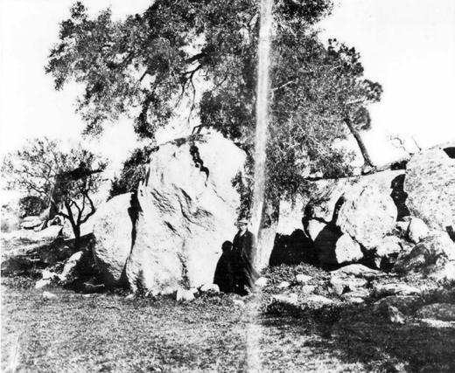
Figure 1.18: The Dog Rocks, 1911. Source: News of the Week, 7 December 1911, GRS 2121, Geelong Heritage Centre collection.
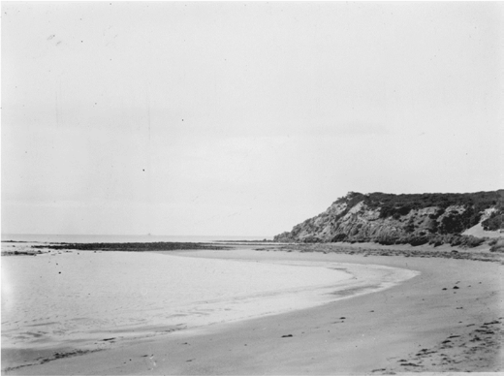
Figure 1.19: M.J. Daniel, The Bluff, Barwon Heads, 1898. Source: accession 92.200/96, State Library of Victoria.

Other geological sites in Greater Geelong have been identified for their local or other significance. The rotational slump beside the Moorabool River near Chaucer and Sladen Streets, Hamlyn Heights, has local significance for its good natural exposure of Moorabool Viaduct sand overlying the Fyansford Formation.
At Barwon Heads, the Bluff is a remnant of the Nepean Bay Bar aeolian calcarenite overlying the basalt of the Mount Duneed lava flow (Figure 1.19). It has significance in demonstrating the outlet of the Barwon River drainage system.
Historically, the You Yangs has attracted the attention of many geologists, field naturalists, artists and photographers. Of the latter, the monolithic granite outcrops of the You Yangs Range formed the scene of many romantic images published in the 19th century. Several images were included in the Illustrated Australian News in the 1880s (Figure 1.20). They were described in 1888 in Victoria and Its Metropolis as follows:
The [Geelong] district consists for the most part of extensive open plains, diversified with rolling downs and not very lofty hills and plateaus. The principal exceptions are the Barrabool hills, a range which lies to the S.W. of Geelong, and is mostly taken up for farming purposes, and the Anakies, or familiarly, the You Yangs, consisting of the Anyaghe Youang (meaning twin hills) and the Wurdi Youang (big hill). The southern termination of the group is the Wurdi Youang (Station Peak), the culminating peak, which attains an altitude of 1154 feet. This peak is detached,
and has a base of something like a square mile in extent, beside which the greatest of the Egyptian pyramids would seem a pigmy. The Wurdi-Youang consists of coarse- grained granite, with large crystals of feldspar, susceptible of high polish, and deposits of kaolin have been found on the flanks of the mountain. At the base of this range are enormous masses of granite. One huge rock at the western extremity is supposed to be 1000 feet in circumference and about 100 feet in height. At a rough estimate it must contain 4,000,000 cubic feet and weigh about 300,000 tons.38

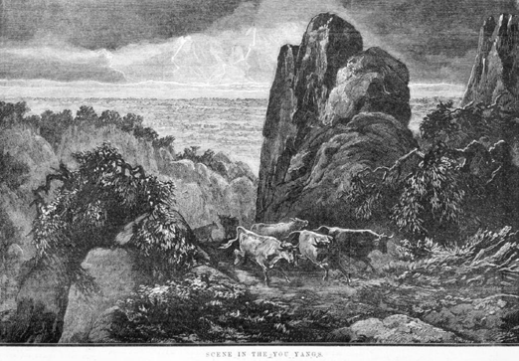
Figure 1.20: Scene in the You Yangs , Illustrated Australian News, 2 September 1885, David Syme & Co. Source: accession IAN02.09/85/141, State Library of Victoria.

KEY FEATURES OF THE NATURAL ENVIRONMENT: 19TH & EARLY 20TH CENTURY PERCEPTIONS
It was the key features of the natural environment of Wadawurrung Country where the first European impressions of the Greater Geelong area were gained from the beginning of the 19th century. In 1802, the explorer, Matthew Flinders was impressed by the vast extent of Corio Bay and from the elevated peaks of the You Yangs he observed the low, grassy plains lightly covered with wood.39 A physical record of the coastal fringes was also recorded by Charles Grimes in his survey of the Port Phillip Region (Figure 2.06). He described
the northern elevated area of the Bellarine Peninsula as having gentle rising hills of good land thinly wooded with low and decayed timber. 40 Swamps were recorded south of Point Henry, while the high cliffs in the locations of the Geelong
city waterfront and North Geelong were noted as being hilly and good soil and to the start of hilly and very bad ground respectively.41 In the Corio, Lara and Avalon areas, Grimes stated that the land was swamp in general near the Shore, grassy plains back to the foot of the Mountains [You Yangs], the soil very bad and stony, no Timber. 42
A more detailed description of the Greater Geelong environment prior to European colonisation was given by John Helder Wedge in 1835. It was at this time when the British surveyor resident in Tasmania visited John Batman s encampment at Indented Head (St. Leonards) as he was a member of the Port Phillip Association that took up land for
pastoral purposes at this time (see Theme 2 for further details). Mapping the Geelong region, his written description of Greater

Geelong provided a revealing insight into the landscape at this time:
The peninsula of Indented Head first attracted my attention. Its extent is about 100,000 acres. It is bounded on the west by the Barwon, a river discovered by myself, which empties into Bass strait a few miles to the westward of Indented Head, and in its course passes within about three miles of the western extremity of Port Phillip. The eastern part of this peninsula, for about four or five miles from the margin of the Port, is a low and flat surface, the soil being light and sandy, and well covered with grass, thinly wooded with the honeysuckle, sheoak, mimosa, and eucalyptus. The land then swells into low tiers, and alternates with beautiful hill and dale. On these hills the soil is of finer quality, and the grass more luxuriant than the plains. The hills gradually trend to the westward in gentle undulations and terminate at the Barwon, in some places in steep banks, varying
in height from 30ft. to 60ft. It is a great drawback to the availability of the peninsula that the River Barwon is subject to the tides, and is, consequently, salt up to where it is joined by another river, about three miles from the western extremity of the Port, otherwise it would be one of the finest situations for sheep farming I have ever met with.
On the peninsula there are many small waterholes, which afford the natives a supply of water At the junction of the rivers above alluded to, the one coming from the north- west is called the Yaloak by the natives, the other coming from the westward I have named the Byron, into which, about 10 or 12 miles up, another stream falls, which I have named the Leigh. These rivers pass through very extensive open plains much further than the eye can reach About 15 miles, in a south-west direction, from the junction of
the Byron with the Yaloak, is a lake, called by the natives Modewarrie, the intermediate country being grassy hills (called by the natives Barrabool), of moderate elevation, thinly covered with she-oak trees; and around the lake an undulating grassy country, thinly timbered, extends to the westward.
The country between the river coming from the northward and the western extremity of the Port, and from 20 to 40 miles inland, is open, and partakes more of the nature of downs. The whole is thickly covered with light growth of grass, the soil being, in general, stiff and shallow. About midway there is a river falling into the Port, which comes from the north west About Station Mount [Station Peak, You Yangs] (called by the natives Villamanta), the

country is wooded, with this exception, and here and there along the shore of the Port, and along the course of the river just mentioned, the plains are quite open, as much so as the heaths of Cambridgeshire 43
The Geelong township established in 1838 (see Theme 6)
- afforded a unique bay frontage dominated by limestone cliffs (Figure 1.21) with uninterrupted views across Corio Bay to the You Yangs. The elevated, open, and sloping land of the township reserve was covered with green turf without shrubbery or trees.44 According to Samuel Mosman in reminiscing about Geelong during his residency in 1840, the area between the township and Point Henry (to the east) was dominated by tall kangaroo grass to the height of three or four feet’ so that it ‘presented the aspect of corn fields.’45 In
the Breamlea area, the coastal dunes were clothed in Coastal Spinifex, which apparently had been translated from the Wadawurrung term, Ka: Raaf
Several of the geographical, topographical and landscape features of the Greater Geelong area were further mapped following European colonisation. A.J. Skene s Map of the Geelong District in 1845, for example, showed the coastlines, waterways and most of the mounts (although Mount Duneed had been overlooked) (Figure 7.01). A Map of the Town
and Suburbs of Geelong in 1850 by Garrard and Shaw (local architects and surveyors) (Figure 7.02) gave hints of the natural landscape through the depictions of elevated
land areas, open grasslands, rivers and creeks, lagoons and lakes and coastlines. On the Bellarine Peninsula, it showed the expanse of Lake Connewarre and the nearby marshes (including those to north-west known today as Reedy Lakes), salt lake at Barwon Heads (Lake Murtnaghurt), Swan Bay, salt lagoon at Indented Head, the heaths, scrub oaks and honey suckle of the Curlewis and Wallington area, and low land area to the north-west of Portarlington timbered with she-oaks .
To the north, Limeburners Creek was illustrated as was Duck Ponds entering the creek. To the west, the winding water courses of the Barwon and Moorabool Rivers were portrayed, the Barrabool Hills depicted above the southern banks of
the Barwon.
Further descriptions were given on the natural landscape and topographical features in the late 19th and early 20th centuries. In 1893, A.J. Campbell described the Greater Geelong landscape in The Tourists Guide to Geelong and Southern Watering Places giving further awareness of the environment peculiar to the local area through European eyes:

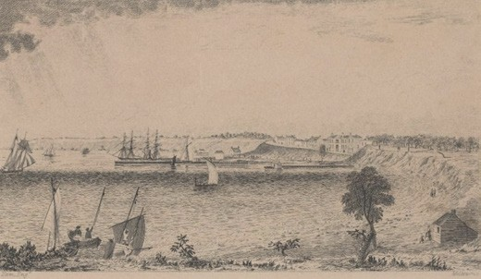
Figure 1.21: Ham, Corio Bay (from Western Beach) looking towards the Geelong township, c.1850. Source: accession H2110, State Library of Victoria.

Geelong:
The picturesque town of Geelong occupies a commanding position on the prettiest part of the Western coast line,
and is built upon sloping country, affording excellent natural drainage facilities to Corio Bay on the north side, and to the ever-flowing Barwon River on the south side. It is one of the healthiest towns in Victoria, a fact which is being steadily recognised by persons seeking temporary and permanent residence by the sea-side. It
is 45 miles from Melbourne Corio Bay is a land-locked sheet of water, affording excellent anchorage ground
for shipping, and it offers a most attractive and healthful means of enjoyment for those fond of aquatic exercise from Melbourne. The country between the metropolis and Geelong is perfectly level, the railway passing principally through grazing lands, crosses the Werribee River and the Little River, and affording to travellers by the land route
a capital view of the beautiful partially wooded You Yang hills as the trains rush onward to the ancient, quiet and prosperous town. The approach by water is a decidedly pleasing one, the lovely stretch of white shelly and sandy beach along the eastern or Point Henry coast, the black rocks, and the bold picturesque bluffs on the north and west, present charming views to those travelling by the bay steamers from Melbourne or Portarlington.

Lake Connewarre:
I have wondered how it is that the banks of the lake have not been peopled with a larger number of summer
residences. It possesses in an eminent degree what busy men ought to covert, entire seclusion. Its banks (at least on the western side) have been so disposed with green knolls, bays and promontories, as to give splendid opportunity for that most delightful of all recreations, embellishing the face of nature with its own magnificent productions. The placid bosom of the lake, on which are mirrored the braided clouds and the azure sky, with the bow of heaven arching its sometimes by day, and the golden pathway of the moon crossing it sometimes at night, affords a spectacle often changing, but always beautiful. For those who want gun exercise, there are rabbits enough and an occasional hare upon the land, and a teal or black duck, and the majestic swan upon the water. For those who love boating, a pleasanter and safer watercourse can nowhere be found.
Barwon Heads:
Barwon Heads proper is marked on the maps as
Point Flinders, and it is also known as Mount Colite. The Bluff itself is one of the most conspicuous objects on our whole coast-line, and is easily seen from a great distance seaward, in every direction. The township is laid out on the lake side of the peninsula From the eastern side of Mount Colite the finest view possible of Port Phillip Heads, and the entrance between Point Lonsdale and Nepean, is obtained, and is as extensive as it is varied, and on a clear day well repays the visitor.
Ocean Grove:
It is situated on the coast-line, where the waters of the Southern Ocean, the River Barwon, and Lake Connewarre meet, boldly facing Bass Straits and the Southern Ocean. From its altitude of one hundred feet above the sea level the view is at once beautiful and extensive. In front is a limitless expanse of angry billows showing their silvery crests, on a blue tinted glassy surface revealed by an occasional ridge of spray according to the weather that prevails; on the left, looking seaward seven miles distant, are Queenscliff, Point Lonsdale, and Point Nepean,
the white-winged messengers of commerce, and the palatial steam liners of the Orient and Peninsular and Oriental Company, as they pass in and out of Port Phillip being in full view. On the right are Point Flinders, with the Barwon Heads settlement under its shelter, and the
extensive coast line extending past Spring Creek and Lorne to Cape Otway; while the proximity of Lake Connewarre with its extensive sheet of water at high tide, which immediately skirts the Grove on the west side, adds to the beauty of the scene.

St. Leonards
No visitor to Portarlington should miss the short drive of six miles to St. Leonards. On approaching the village there is passed on the right a large pool, or salt lake, as it is called by the residents, forming the centre of a considerable swampy morass. … St. Leonards is essentially a fishing village A pleasant walk may be taken by continuing southward along the shore, which here begins to grow more rocky and indented as it trends towards Queenscliff and the Heads.
Portarlington
This picturesque spot is the first port of call for Melbourne and Geelong steamers. It lies on the northernmost point of the Indented Heads, the town rises sharply from
the sea-shore, reaching to the summit of a slope, from which a fine view is obtained of the opposite shore of the bay, with the three remarkable hills called the You Yangs as a centre-piece. Fronting the beautiful beach are numberless shady nooks and sloping hills. A broad fringe of bright sand runs for many miles in both directions, and pedestrians will find a stroll to Clifton Springs on the west, or St. Leonards on the east, well worth the exertion.
Drysdale
The township of Drysdale, situated in the centre of the Bellarine Shire, about seven miles from Portarlington, and 12 miles from Geelong, although at present little known outside the immediate district, is a place of considerable interest both from a resident s and a tourist s point of view.
The scenery around Drysdale is of exceptional beauty, and from two or three elevations, notably Levien s Hill, Ryan s Hill, and Grass Tree Hill, a view can be obtained comprising Geelong, Queenscliff, the You Yangs, and Mount Macedon, Port Phillip, Corio Bay, The Rip, and
the wide ocean. On the Grass Tree Hill there is a curious natural formation known as The Basin. It is supposed to be the crater of an extinct volcano, and contains a largely quantity of water, which has never failed even in seasons of excessive drought 46

Another landscape within the Greater Geelong region that became a focus for European interest was the Dog Rocks at Batesford (Figure 1.22). It reputedly took its name from being a place of resort for all the wild native dogs in the district. 47 The area (as well as parts of Ceres and the You Yangs) was also important to the Wadawurrung people as its greenstone was a much-valued commercial commodity.48 In 1905, the Dog Rocks was visited by the Geelong Field Naturalists for the purpose of studying the fauna and flora, as well as the geological features of this interesting spot. 49 The Geelong Advertiser emphasised the importance of the greenstone to the Wadawurrung, as well as outlining other flora and fauna specific to the area.50

CLIFTON SPRINGS
Within Greater Geelong, two mineral springs were
re-discovered by Europeans which became important tourist attractions in the 19th and early 20th centuries (see Theme
9). In January 1871 at Clifton Springs, the Geelong Advertiser
reported on what are supposed to be valuable minerals water springs that were discovered on Mr Bates property at Bellarine (see Theme 6). 51 By March 1871, seven mineral springs at been opened on Bates property.52 The interest in these natural springs was their apparent medicinal benefits, the Geelong Advertiser giving the following explanation in April 1871:
For a long time past the existence of a number of mineral springs on the beach, near Drysdale, has been known to the residents of that locality, but until lately they attracted but little attention. A few months ago, Mr. Levien, M.P., and another gentleman having obtained a lease of the ground on which they are situated, set to work to utilise the waters. Seven springs, some of which contain magnesia, others magnesia and iron, and another sulphur, have been opened up, and the dell in which they are situated being
a beautiful spot and ease of access, the Clifton Springs, as they have been named, have become quite a favourite place of resort. The waters have, it is said, been found very efficacious in cases of rheumatism, gout, and other complaints, to which flesh is heir, and should they really provide as valuable as they are believed to be, it is the intention of the proprietors to build a large establishment for the accommodation of invalids and visitors.53

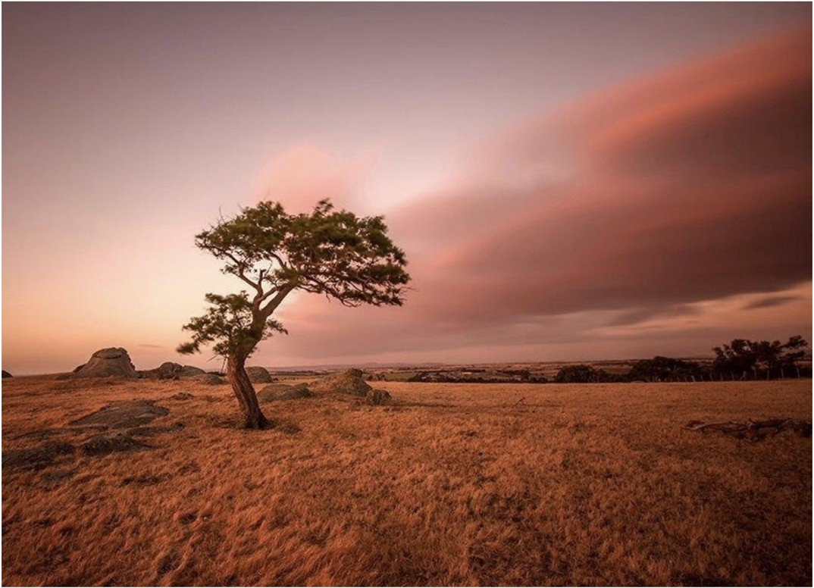
Figure 1.22: Dog Rocks. Source: City of Greater Geelong.

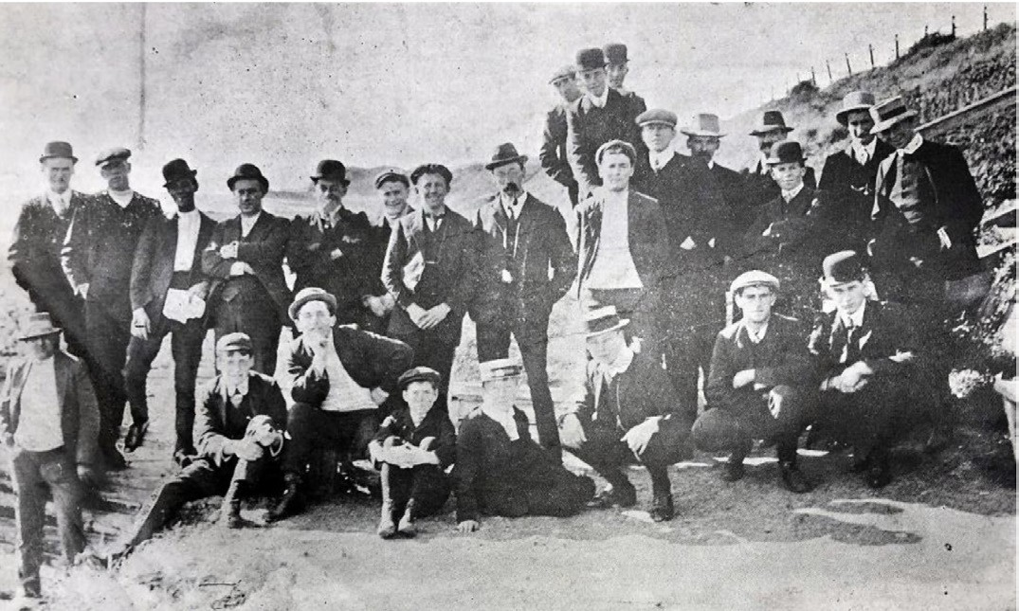
Figure 1.23: N. Bevan, Group at Springs on Sunday Morning , Eastern Beach, 1911. Source: News of the Week, 10 August 1911, p.16, GRS 2121/3, Geelong Heritage Centre collection.

EASTERN BEACH
In 1884, the Geelong Advertiser reported on a mineral spring on the beach below the Botanical Reserve, near Garden-street at Eastern Beach. The newspaper called for the fencing off and conservation of the springs.54 Three years later in 1887, Donald McAndrew made application for a license to lease three acres on the eastern beach, erect buildings and tap the mineral springs.55 McAndrew s proposal appears not to have eventuated, but by 1894 a large number of persons had daily
visited the minerals to sample the waters and were found to be of excellent and healthful qualities 56 (Figure 1.23).
By 1934, following the redevelopment of Eastern Beach as Geelong s marine playground (see Theme 9), the mineral springs were thought to be the cause of serious subsidence of approximately 60 feet by 40 feet (and a depth of several feet) at the rear of the men s dressing shed following heavy December rains.57

WESTERN BEACH
In 1935, during the construction of a stonewall along the cliffs at Western Beach, a mineral spring was discovered. The Geelong West Council took a sample of the water for analysis to determine its quality58 but nothing seems to have been developed to promote the spring.

NATIVE FAUNA AND FLORA

GEELONG FIELD NATURALISTS’ CLUB
European colonisation of the Greater Geelong area from the mid-1830s brought about an interest to study the novel
natural environments of the new land.59 In 1846, the Geelong Mechanics Institute was established.60 Although this was not a scientific or natural history organisation, a ‘School of Science’ was formed at the Mechanics Institute in 1871 and its members included several people that would take a leading role in the formation of the Geelong Field Naturalists Club in 1880.61
John Bracebridge Wilson (1828-1895), Headmaster of the Geelong Church of England Grammar School (Theme 8), was elected the first President.62 The inaugural Honorary Secretary was George Frederic Link (1843-1900), Headmaster of the Flinders National School and local scientist.63 He published the scope and objects of the club in the Geelong Advertiser in June 1880:
The object is the study of Natural History in all of its branches, and it is called a field club because field excursions are made from time to time on Saturday afternoon. The members walk or drive to the rendezvous, and set about the collection of specimens, some botanising, some in search of fossils, others of insects, etc. At a certain time they reassemble and compare notes before returning homewards. Then in a few days, time is held an evening meeting, when the results of the excursion are narrated and specimens exhibited, etc. In this way all the suitable localities in the neighbourhood of Geelong are explored in turn and the members become familiar with such places as Buckley s Falls, the Dog Rocks [Figure
1.24], the Waurn Ponds, Spring Creek, &c. The subscription has been fixed at the nominal rate of five shillings
per annum.64
In 1888 with the opening of the Gordon Technical College, the Geelong Field Naturalists Club relocated to a room at the new college.65 Three years later in 1891, the first issue of the Club s quarterly journal, The Geelong Naturalist, was published.66 This journal soon gained a reputation for its scientific prowess, giving local information on Geelong’s natural history and ornithology, as well as details on Club
meetings and excursions.67 The last issue was in 1898 although it was republished as a second series from 1904.68 The Gordon Technical College also published The Wombat journal from 1895 which gave information on photography, art and science.69

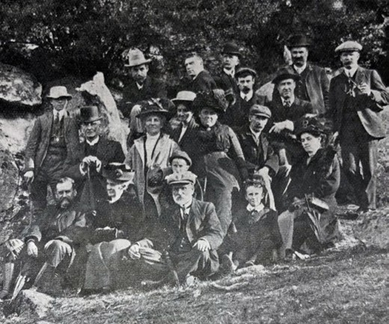
Figure 1.24: G. Moss, Nature Study Excursion to Dog Rocks by the Geelong Field Naturalists Club, 1911.Source: News of the Week, 17 August 1911, p.16, GRS 2121/3, Geelong Heritage Centre collection.

The Gordon Science Club was formed in 1896 and in 1899 it amalgamated with the Geelong Field Naturalists Club.70 Severely impacted by World War One, the Geelong Field
Naturalists Club was revived in the 1920s but absorbed into the Gordon Kelvin Club in 1932.71 It was not until 1961 when the Geelong Field Naturalists Club was re-established, with Trevor Pescott as its President.72

FOSSILS
Several depictions of pre-historic fauna were given by Richard Daintree during his geological survey of Geelong in 1861-62, and in numerous newspaper articles and publications. In 1875, during the construction of the foundation of a new railway bridge, a quantity of bones were found in the ancient bed of the Duck Ponds Creek , 15 feet below the surface.73 They were reported to be of some extinct animal of gigantic size , the bones and teeth being those of the great extinct kangaroo, Micropus Titan. 74 Similarly at Western Beach in 1879, fossils were found in the cliff faces of huge animals. 75

NATIVE FAUNA
Much of the native fauna in Greater Geelong has disappeared since the mid-19th century as a consequence of European colonisation through loss of habitat and, in the case of the kangaroo, through culling (as it was seen as vermin and a destroyer of European farmland) and as a commodity for market. In 1802, the explorer Matthew Flinders noted the presence of emus as he traversed the open grassy plain from Corio Bay to the You Yangs.76 By 1853 Captain Foster Fyans, Police Magistrate, lamented the loss of emus and kangaroos in the immediate locality of Greater Geelong not for their value as part of the local natural wildlife but for the loss of game for hunting. He also commented on the other native wildlife in a letter to Governor Charles La Trobe:
Emus and kangaroos on our arrival [in 1837] were plentiful in all parts of the district; also bustards in large flocks from ten to thirty or forty, or perhaps more. The bustards are now scarce, and only met with in distant places. The kangaroo and emu are nearly extinct in the district; the country is almost void of game. Quails in years gone by were plentiful, but I think are fast disappearing; snipe we have in the season, but not in the same abundance as in other countries; we have also the painted snipe, the same
bird that is met with in all parts of India; black ducks, large, and a delicacy; also various small ducks, and wood ducks &c,; the bronzewing pigeon, a fine game bird, fully equal to an English partridge; black swans useless and ugly; snakes of many descriptions, and some exceedingly bold
more so than I have known them in India. The longest snake I have met did not exceed six feet.77
The decline in native fauna (and flora) was also widely recognised by others in the early 1850s. In 1852, W. Westgarth in The Edinburgh New Philosophical Journal was particularly revealing in summarising the negative impacts of European grazing on native plants and animals:
The supply of most other descriptions of their [the Aborigines ] food has been either diminished or entirely taken away by the occupation of their country; the kangaroo, for example, and various other animals and birds; and
the supply of gum has also been much decreased, in consequence of the extensive exportation of mimosa bark.78
In 1866, the Geelong Advertiser also noted the decline in native animals. The loss of kangaroos was (in part) a consequence of the construction of kangaroo battues (double enclosures surrounded by log fences from which the kangaroos are directed and trapped).79 Similar to Fyans report 13 years earlier, some native animals were in decline, while other fauna, particularly water fowl, continued to survive in larger numbers:
The open season for game will begin next month. Our lakes are darked with the protected wild progeny of the swan,

barren geese, wild duck, teal, and widgeon. The rivers swarm with them, and the creeks and tributaries abound with game. The wild turkey or bustard are seen in numbers, and the confiding, melancholy native companion has returned
to his native haunts along the sedge, and the reedy swamps of the lakes. Quail seem to have migrated. Snipe have
not shown well, and plover have not been so numerous as hitherto. The emu is becoming rare in these parts, but to the westward, on some of the rich greasy stations, kangaroos roam in vast herds of thousands in a flock,
and when a battue is called they are killed by the hundred. Parties have gone into the bush to kill them, simply to cure them for the small portion available for hams, which have been vended into the market as an everyday commodity at about one-third the price of ordinary hams. Our chief saltwater fish are schnapper, pike, whiting, gar fish, mullet,
barracouta, rock cod, flounders, and a viviparous fish called flat-head. The ray family are represented by skate, and a larger sort, some of them from twelve to fourteen feet long, armed with a fearful spike on the back. Cray fish may be got in any quantity, and of all sizes. The oyster beds have been pillaged and destroyed by fishermen in a measure, while on the Western Port side some marine animals have completed the destruction by boring through the shells of the bivalve and destroyed it. In our creeks and estuaries shrimps
are plentiful, and at the junction of the fresh water flush at favourable times any quantity of bream will repay the angler. Our rivers and creeks present little variety of fish and a species of grayling at the shallow ripples and in the babbling streams under the waterfalls; these, and plenty of eels, constitute the only river fish worth speaking of. The rivers were never overstocked with fish, but ever since they were made the depositor for the offscouring of the goldfields the scanty supply has sensibly decreased.80
An early detailed publication on Australian Birds was published by Archibald James Campbell in 1900 entitled Nests and Eggs of Australian Birds. Some local bird life was documented in this publication, including a reference to Mallee fowl that had been resident in the Brisbane Ranges in 1887 but likely to have been extinct from the area in 1900.81
The most comprehensive early publication on local bird life was Sir Charles Frederic Belcher s The Birds of the District of Geelong in 1914. Belcher (1876-1970) was born in Geelong, the son of George Frederick Belcher82 (see Theme 7). Charles Belcher was a close student of birds all his life. 83 It began when he was a boy living at Merchiston Hall in Garden
Street opposite the Geelong Botanic Gardens and Eastern Park, and at Allanvale , Leopold, where he had access to the Bellarine Peninsula and the Connewarre Lakes.84 Studying Law at the University of Melbourne, he was admitted to the bar in Melbourne in 1902.85 However, his passion was the natural environment and particularly birds. A member of the

Geelong Naturalists Club and founding member of the Royal Australasian Ornithologist Union and the Bird Observers Club in Melbourne in the very early 20th century, 86 he identified 244 species of birds in the Geelong area.87 He commented on the contextually larger number of birds as follows:
No other Victorian countryside with which I am acquainted presents so diversified a physical aspect or such a consequential variety of birds of different orders. There are the plains of the west and north for the Crow, Hawks, and Quails; the Barwon, Moorabool, and Leigh Rivers whose bushy margins shelter countless of the commoner small birds; the open waters, reedy swamps, and mud- flats attracting Waterfowl in numbers to the vicinity of Connewarre; and, lastly, the Otway Forest, which, with the messmate bush adjoining it on the east, is the home of some of the rarest and most interesting birds in Australia.88
Belcher identified two species of bird highly significant to the Wadawurrung peoples: the wedge-tailed eagle and the crow. The wedge-tailed eagle represents Bundjil (see Themes 2 & 9). Belcher gave the following description of the wedge-tailed eagle (Uroaetus audax audax)
(Figure 1.25):
Seeing that our Australian bird is appreciably larger than the lordly Golden Eagle of Europe, one cannot help regretting that it should ever have received the belittling name of Eagle-hawk.
In spite of its suffering the fate of all raptorial birds at the hands of the average country gunner, inspired with the belief that Eagles work enormous havoc among flocks, the Eagle is still occasionally seen in this part of the State, approaching the town itself at certain periods of high winds. It is not more than ten years, I think, since one was shot near the Geelong Football Ground [Corio Oval, Eastern Park].
Riding one evening from Anglesea to Airey s Inlet, I had just reached the summit of the barren, wind- swept ridge known as Mount Misery, when, from a low clump of gums beneath me, there sailed out on the storm-darkened air a really glorious Eagle. I have never seen such a large one: his great spread of tawny wing stood out clear against the background of the barren ranges across the valley. As he swept farther and farther west into the angry-looking clouds piled about the sunset, I could not but feel the real majesty of the Eagle, who indeed is king of all fowls in the air.
He still builds his eyrie in the giant ironbarks of that forest. In October 1912, we heard of seven nests altogether in the neighbourhood of Anglesea as having been inhabited from time to time in the few years preceding. Two of these we examined, one at Scrubby Creek and the other at Bull s Well; the former had not been in use for two seasons, but

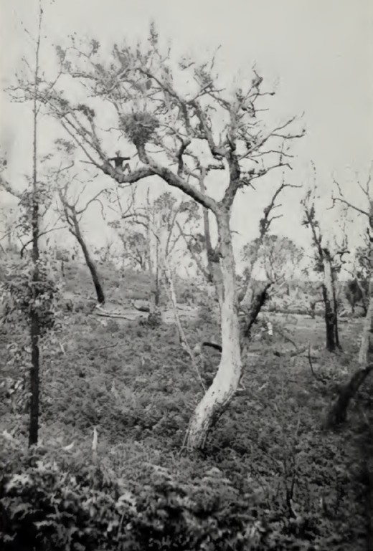
Figure 1.25: Hugh Riordan, Nest of the Wedge-Tailed Eagle in Ironbark, Bull s Well, Anglesea, c.1914. Source: C.F. Belcher, The Birds of the District of Geelong, 1914.

the birds were still resorting to the latter, evidently only as a camping-place or perhaps larder, for they lay much earlier, in July and August.
Another rather more distant breeding-place is the Werribee Gorge, and again the country about Parwan; but I think the Eagles we sometimes see about Geelong all come from the south. A high wind seems to start them on their travels, and they will, under its influence, go greater distances from their usual base.
It is not sufficiently established that Eagles do very much harm among flocks at ordinary times; in droughts and with weak sheep they probably do. I have heard of Eagles which had a nest of young in a paddock where two thousand ewes with lambs at foot were depasturing, yet the birds fed themselves and their young upon rabbits alone.
It is said that Eagles will amuse themselves, when well fed, by taking bits of stick up into the air, letting them drop and catching them again before they reach the ground, and go

on at this for an hour or more; also that they drive hares and rabbits from cover by dropping sticks and the like from above, until the animal rushes out. I have not seen either of these things, but there is very good authority for their truth, which, if proved, illustrates the very great degree of intelligence possessed by this our noblest bird of prey. 89
Waa the Crow (another Wadawurrung deity) (Theme 2) (Figure 1.26) was described by Belcher as follows:
I am aware that I should follow the scientific authorities and call this bird the Raven; but as I believe that this bird is quite as similar to the English Crow as it is to the English
Raven, and as, out of possibly one million people in Victoria who know the bird by sight, nine hundred and ninety-nine thousand nine hundred would call it a Crow, I have decided to bow to the weight of popular usage.
I want to make this clear. There is another, a different, sort of Crow in Northern Victoria which, to the best of my belief, never comes south of the Dividing Range, and if it should occasionally do so, has certainly never reached
the Geelong district. Now, the ways in which, if you should happen to visit the Wimmera or the Goulburn Valley or other parts of the Northern Plain, you may, if you care to, distinguish this other Crow are these: it is smaller, and
it has an appalling cry, like the shrill despairing cry of a child, in place of the good deep waa-aa of our larger southern Crow.
The confusing thing is that they have the larger Crow in the north too, and in some parts it is the commoner bird; but we never get the smaller Crow near Geelong.
The Crow is a bird of the wide plain and not of forest country, and in the Geelong district is very plentiful on the plains north of the Barrabool Hills which merge into the Western District country, as also it is about the Werribee, Little River, and Lara; but on the east
(Queenscliff) side of the town it is a rare bird, while in the southern forest it is never seen in the spring and summer. Only occasionally is the forest visited by bands travelling about in the autumn and early winter.
It is really a beautiful bird, in spite of the prejudice again it, and makes an amusing garden pet, being very vain and fond of having someone to watch its antics.
The Crow nests earlier than any other bird in the district, taking the whole number of individuals and comparing them with those of any other species. It has only one brood, and the enormous majority of pairs nests in the month of August. Of very early nesting Mr. Allen Noble sent me a note from Wurrook, Rokewood, on June 3rd,
1912. That autumn had been dry. For some time prior to the date of his letter Mr. Noble had seen a Crow carrying sticks and sheep s wool to a windmill in a paddock where ewes

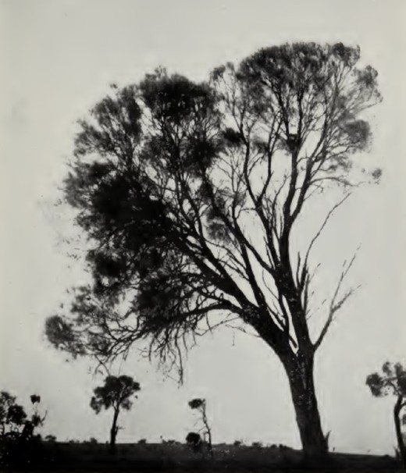
Figure 1.26: Hugh Riordan, She-Oak tree with Crow s nest, on plains near Gnarwarre. Source: C.F. Belcher, The Birds of the District of Geelong, 1914.
were lambing, and by June 2nd the nest was completed on the windmill platform and one egg laid. The nest was afterwards blown down.
The nest is a wide and deep structure of heaving sticks of she-oak or gum, lined with a thick pad of wool, cow-hair, or rabbit s fur. On the plains it is generally built in a she-oak tree, and is then often visible for a considerable distance, particularly when fixed in the top fork of some central branch of the tree, just a little below the leaves. Sometimes it is within 8 or 10 feet of the ground. Nearer the hills the nest is built in an almost inaccessible position in a redgum.
The nest is sometimes added to and used in a second season.
The eggs are three, four, or five in number, slightly larger than a Magpie s, but in comparison wider at the shoulder and tapering more to a point. The ground colour is bluish green, which is spotted all over except right on the smaller end with spots, streaks, and irregular-shaped markings of dark green, reddish, and brown, with usually one or two small spots or streaks
of jet-black.90

NATIVE FLORA
Some of the earliest records of native flora in the
Greater Geelong were from European pastoralists who gave an indication of the importance of some grasses and roots to the local Wadawurrung peoples. Other flora has later been found to have been a significant part of Wadawurrung culture.
In 1836, Joseph Gellibrand noted on his visit to the Bellarine Hills, the hill and dale , thinly timber land with very rich soil and that the kangaroo grass was up to my middle, and with a thick bottom.91 Kangaroo grass (Themeda triandra) was also common in most other parts of Greater Geelong.92 To the Wadawurrung peoples, kangaroo grass was occasionally burnt ‘to flush out small animals for food and to create fresh green grass to encourage kangaroos , and to help regenerate small plants like Yam Daisies and native orchids. 93 In 1853,
George Armytage of The Hermitage in Newtown, noted the dependence on the root called murnong (Yam Daisy -
Microceris lanceolata) (Figure 1.27) as part of the staple diet of the Wadawurrung (see Themes 2 & 4 for further details).94 It was also at this time when W. Westgarth wrote in The Edinburgh New Philosophical Journal that the murnong was a small root of nutritious character, having a leaf like that of a parsnip. 95 As early as 1852, sheep and cattle grazing was reported to be greatly reducing the growth of
the murrnong root although some Europeans quashed these findings claiming that the Aborigines ‘can readily find it out, even without the guidance of the flower.’96 Once common on the Bellarine Peninsula, it is now a rare species.97
Seeds are procured from Horsham and germinated at the Bellarine Landcare Nursery at Drysdale given that there are no indigenous Murnong growing locally.98
Another key element of the environment of the Wadawurrung were River Red Gum (Eucalyptus camaldulensis) trees.
Known to the Indigenous as Yarrayne,99 they provided navigational and dietary support, and were used for medicinal remedies (see Theme 8). River Red Gums lined the rivers and creeks and formed part of traditional Aboriginal trails (see Theme 3). Dooliebeal Reserve at Mount Duneed represents one particular location important to the Wadawurrung, a
marshy place (derived from Tooli) with River Red Gum ( Beal ) (see Themes 2 and 6 for further details).
In 1897, George Henry Adcock (1860-1931), member of the Geelong Field Naturalists Club, and son of Edward Adcock and nephew of Thomas Adcock of Kardinia Nursey, Highton (where George learnt all aspects of gardening and horticulture)100
(see Theme 4), published a Census of Indigenous Plants of the Geelong District in the Club s The Geelong Naturalist Journal. His list amounted to around 500 plants, including 14 acacias, six eucalypts, 33 orchids and one grevillea
(see Appendix 1.2).101

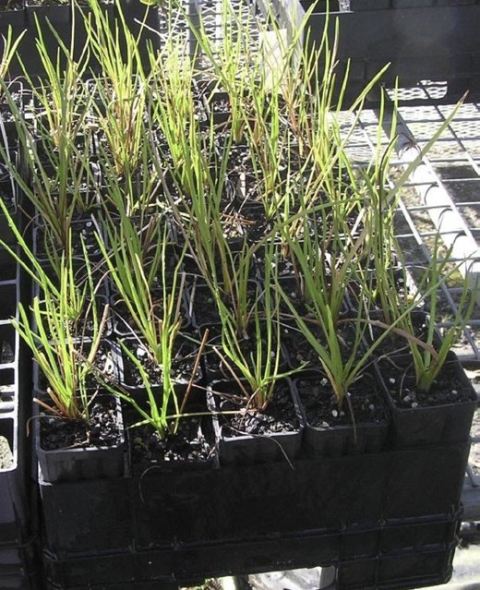
Figure 1.27: Murnong (Microceris lanceolata), Bellarine Landcare Nursery, Drysdale, 2019. Source: Pam Jennings.

VICTORIAN ACCLIMATISATION SOCIETY
In addition to colonisation and European pastorage, the decline in native flora and fauna in the Geelong area throughout
the 19th and early 20th centuries was due to an imperialist attitude towards the local ecology. The establishment of the Victorian Acclimatisation Society in 1861 brought about the introduction of exotic plants for commercial, medicinal and botanical reasons, including fruit and ornament trees and shrubs, hedges and flowers.102 Equally if not more damaging on the local ecology of the broader area was the introduction of the wild rabbits in 1859 by Thomas Austin at Barwon Park,
Winchelsea.103 His rabbits multiplied and spread across the land, infiltrating native ecology with devastating consequences. Ironically in 1909, the Victorian Government Botanist, Alfred Ewart, claimed that rabbits assisted in the reduction of noxious weeds that had been introduced in earlier years:
Rabbits act in much the same way as freely wandering sheep in favouring weeds at the expense of more nutritious vegetation, although when pressed by hunger they are much more all-devouring.104
It was also in 1909 when Ewart noted that the Silene cucubalus, a herb that was native of Europe, Asia and Africa - introduced by Europeans in the 19th century and which was easily recognised by its white flower and bladderlike calyx’, appeared to have become a troublesome weed in the Geelong district. 105

INDIGENOUS FLORA IN THE GREATER GEELONG REGION TODAY
Today, detailed descriptions of the indigenous flora in different parts of the area have been published online by the City of Greater Geelong. Based on information from the Victorian Department of Environment, Land, Water and Planning, Geelong Indigenous Nursery and particularly David Perry and Mark Trengove, the main indigenous species are given as part of 19 zones106 (Figure 1.28).
An overview of each of these zones is as follows:

Eastern Bellarine Plains (Zone 1)
Zone 1 (Indented Head, St. Leonards and Murradoc areas) consists of recent alluvial loam soils of moderate fertility, which are gently sloping and well drained. The average rainfall is 62 centimetres.
This area was once predominantly an open woodland community that also included an understorey made up of various shrubs and grasses. Dominant tree species of Manna Gum and Drooping Sheoke grew alongside other species including River Red Gum, Yellow Gum and
Cherry Ballart.

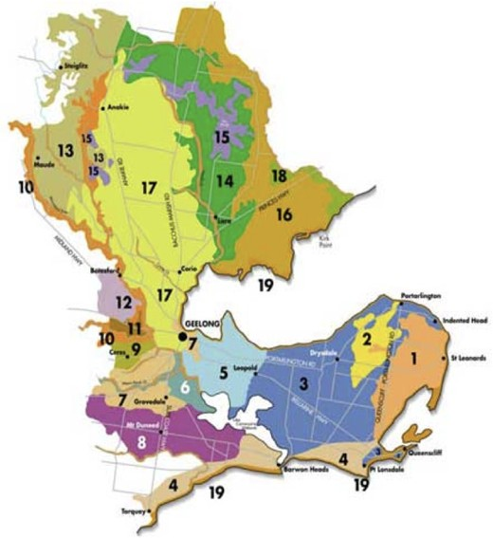

Figure 1.28: Regional Map of the City of Greater Geelong showing zones for indigenous vegetation. Source: City of Greater Geelong, Geelong Australia online at https://www.geelongaustralia.com.au/indigenousplants/article/ item/8ce589e1bce0fe8.aspx

Shrubs such as Hop Goodenia and Silver Banksia formed most of the taller understorey community. Smaller species included Kangaroo Grass, Common Everlasting and Black Anther
Flax- lily.
In sandy areas understorey species of Hop Bitter-pea, Prickly Tea-tree and Varnish Wattle were found, while in damper areas Tussock Grass grew. Creek lines were characterised by dense stands of River Red Gum and Blackwood.

Mount Bellarine Volcanic soils (Zone 2)
Zone 2 (Mount Bellarine and Scotchmans Hill areas) is made up of older volcanic clay loams on gentle slopes, which are poorly drained. The average rainfall is 62 centimetres.
This area was once predominantly all open grassy woodland with an understorey made up of various shrubs and grasses. Tree species including the Drooping Sheoke grew with other species such as Blackwood and Cherry Ballart.
Shrub species including Kangaroo Apple, Silver Banksia and Sweet Bursaria occasionally occurred. Kangaroo Grass dominated the ground flora.

In riparian and damper areas, Hop Goodenia, Shrub Everlasting and Tussock Grass grew. Creek lines were characterised by stands of River Red Gum and Blackwood. Grasslands were present in patches across most of the inland area.

Central Bellarine Hills (Zone 3)
Zone 3 (Portarlington, Clifton Springs, Drysdale, Mannerim, Marcus Hill, Wallington, Leopold, Curlewis, Point Lonsdale and Queenscliff areas) is a complex mix of soil types, including, clays, sands and gravels on gently sloping hills with poor
to moderate fertility and which are poor to well drained. The average rainfall is 55 - 60 centimetres.
This area was predominantly a woodland community with a highly diverse shrub and grass understorey. Tree species
would have included Manna Gum and Drooping Sheoke with populations of Moonah and Yellow Gum.
Common shrub species were Silver Banksia, Sweet Bursaria and Smooth Parrot-pea.
Kangaroo Grass was present in patches across most of
the inland area while Tussock Grass grew along the region s watercourses.
The central area of the Bellarine Hills and parts of Queenscliff and Point Lonsdale have large areas of poor sandy soils which are remnants of old dunes.
Heathlands dominated by Dwarf Sheoke, Prickly Tea- tree, Heath Tea-tree and Austral Grasstree occurred on these areas.
Areas of grassland would have also occurred in the areas of richer soil in this zone

Lower Rear Dune Communities (Zone 4)
Zone 4 (Torquay to Point Lonsdale lower rear dune areas) Consists of flat, moderately fertile alluvial loam soils, poor to well drained with some saline areas. The average rainfall is 60 - 62 centimetres.
This area was predominantly a woodland community. Dominant tree species included Coast Manna Gum, Moonah and Drooping Sheoke with an understorey of Coast Beard- heath.
Woodlands give way to sedgeland and saltmarsh vegetation on the fringes of wetlands.
Areas of grassland dominated by Kangaroo Grass occurred in drier sites. Common Tussock Grass was found along fresh watercourses whereas Blue Tussock Grass would have been present in more saline areas.
Species such as the Rare Bitter-bush and Coast Bitterbush may have once been common in this zone but now only grow in isolated patches.

Moolap Plains (Zone 5)
Zone 5 (Moolap, Point Henry, Whittington, Newcomb and Limeburners Point) consists of moderately fertile alluvial loam soils with some sands, gravels and clays. It is mostly flat with poor to moderate drainage. The average rainfall is 50 - 55 centimetres.
This area was once predominantly an open woodland community that also included an understorey of various shrubs and grasses. Dominant tree species such as the River Red Gum, Swamp Gum and Drooping Sheoke grew alongside other species including Blackwood, Cherry Ballart and Golden Wattle.
Shrub species of Sticky Boobialla, Sweet Bursaria and Silver Banksia formed most of the middle storey. The ground
storey was dominated by Kangaroo Grass, associated species included Grey Parrot-pea, Smooth Parrot-pea and Flax-lily.
In riparian and damper areas, Golden Spray, Sweet Bursaria and Hop Goodenia grew while Common Tussock Grass dominated the ground storey.

Marshall Plains and Waurn Ponds Flats (Zone 6)
Zone 6 (Marshall plains and Waurn Ponds flats areas) consists of moderately fertile alluvial loam soils with some sands, gravels and clays. It is mostly flat with poor to moderate drainage. The average rainfall is 55 - 60 centimetres.
This area was characterised by a grassy woodland community dominated by either River Red Gum or Yellow Gum. In wetter areas, River Red Gum was dominant while the Drooping Sheoke preferred drier sites.
Common understorey species included Wattle species, Sweet Bursaria, Shrub Violet and scattered populations of Silver Banksia and Giant Hop-bush.
Kangaroo Grass would have been common through much of the drier areas. Tussock Grass was present in low lying wetter areas and along watercourses. Species only found in the Waurn Ponds area include Hop Wattle, Prickley Moses and Prickly Tea-tree.

Limestone Plains and Hills (Zone 7)
Zone 7 (Geelong, Grovedale and Waurn Ponds limestone plains and hills areas) consists of moderately fertile loam soils on limestone. It is gently sloping to flat with some escarpments and gullies and poor to moderate drainage. The average rainfall is 55 - 60 centimetres.
This area was characterised by a woodland community dominated by Drooping Sheoke, Yellow Gum and Swamp Gum, with a shrubby and grassy understorey. Understorey species included a variety of Wattle species, Silver Banksia and scattered Boobialla.

Kangaroo Grass would have been commonly found growing among Eucalypt (Yellow Gum and Swamp Gum) and Sheoke species through much of the drier areas. Tussock Grass grew among the other Eucalypt species (River Red Gum and Manna Gum) on low lying wetter areas and along watercourses.

Basalt flows (Zone 8)
Zone 8 (Mount Duneed and surrounding basalt flows) consists of fertile clay to clay loam soils with basalt rock usually present. It includes hills and plains that are mostly poorly drained. The average rainfall is 55 - 62 centimetres.
This area was characterised by grassy woodland with areas of open grassland. Common tree species on the plains included Drooping Sheoke, Swamp Gum, Blackwood and River Red Gum. Yellow Gums were present in isolated populations over the Mount Duneed basalt flow. Understorey species were predominantly Wattles.
Areas of grassland included Kangaroo Grass on the plains and drier sites and Tussock Grass along watercourses.
The volcanic cone of Mount Duneed had a different vegetation structure than the surrounding basalt plains, with certain species, possibly Manna Gum, only occurring in these areas. This landform not only restricts many species from the surrounding area but also provides suitable conditions for others.

Barrabool Hills (Zone 9)
Zone 9 (Barrabool Hills) consists of moderately fertile sandy loam soils on tertiary alluvial (sandstone) deposits. The gently sloping hills, some escarpments and gullies are mostly well drained. The average rainfall is 55 - 60 centimetres.
This area was characterised by a Drooping Sheoke woodland with a grassy and/or a heathy understorey largely made up of Wattle species, Silver Banksia and
Sweet Bursaria.
Along the ridges and slopes Drooping Sheoke, Moonah, Cherry Ballart and Lightwood dominated the landscape while along the drainage lines Blackwood, River Red Gum, Swamp Gum and Manna Gum grew.
Along the drier sandy gully sides, species such as Manna Gum, Shrub Violet and Sweet Bursaria were found.
Unfortunately many of this area s tree species have been cleared. White Cypress-pine, Yellow Gum and Swamp Gum can no longer be found.
Shrub species restricted to the drier areas included Kangaroo Apple, Silver Banksia, Sweet Bursaria and Giant Hop-bush. Along the lower slopes and drainage lines Silver Wattle, Hemp- bush, Prickly Tea-tree and Tangled Lignum grew.

Throughout the hills, Kangaroo Grass was present over the upper and mid slope areas. Tussock Grass would have dominated lower, wetter and south-facing slopes.

Barwon and Moorabool valleys, rivers and major creeks (Zone 10)
Zone 10 (the valleys rivers and major creeks of the Barwon and Moorabool areas) consists of a variety of geological types including limestone, basalt, gravel and clay; drainage
patterns vary with soil types. Vegetation distribution is generally dependant on niches eg dry north facing escarpments, sheltered gullies and river edges. The average rainfall is 45 - 65 centimetres.
The riparian vegetation of the Barwon and Moorabool Rivers and major creeks was characterised by River Red Gum, Blackwood and Swamp Gum. Understorey plants such as Silver Wattle, Woolly Tea-tree and Prickly Currant Bush were also found in these moist environments.
The Barwon River had drier valley slopes that were dominated by Drooping Sheoke with a prominent Wattle understorey of Lightwood, Black Wattle, Hedge Wattle and Golden Wattle.
The banks of the Moorabool River carried woodland with a predominantly grassy understorey.
Yellow Gum and Drooping Sheoke were the dominant trees over much of the plateau. The indigenous grasses were Kangaroo Grass which was widespread and Tussock Grass which was found in the wetter areas.

Stonehaven, Fyansford and Western Basalt Plains (Zone 11)
Zone 11 (Stonehaven, Fyansford and the Western Basalt Plains) consists of fertile clay to clay loam soils with basalt rock usually present. It includes hills, plains and stony rises that are mostly poorly drained. The average rainfall is 45 - 60 centimetres.
The Stonehaven, Fyansford and Western Basalt Plains would have been low open woodland consisting mainly of Drooping Sheoke, Swamp Gum and Blackwood while the Western Plains were predominantly grassland.
Stands of denser vegetation would have been found along rivers, creeks and drainage lines. Here River Red Gum, Silver Wattle,
River Bottlebrush and Tea-tree species would be found.
On the drier slopes Cherry Ballart, Sweet Bursaria and Sheoke species would be found growing amongst Berry Saltbush, Silver Banksia and Wattle species. Species once found in the area but are now no longer present include the Golden Spray.

Batesford, Granitic and Tertiary Sands (Zone 12)
Zone 12 (granitic and tertiary sands of Batesford) consists
of poor to moderately fertile soils including sands, gravels and clays that are prone to erosion. The gently sloping hills to flats include gullies and are mostly moderately drained. The average rainfall is 50 - 55 centimetres.
This area was characterised by open woodland dominated by River Red Gum, Manna Gum and Drooping Sheoke.
The predominantly grassy understorey also consisted of shrubby and heathy species.
Dog Rocks (Batesford) and the surrounding granitic sands area is rockier and has less topsoil and consequently, Sheoke and Wattle species were more common.
Cherry Ballart and isolated patches of Yellow Gum were prominent on drier areas while watercourses were lined with Blackwood, River Red Gum and various Tea-tree species.
Many shrub species such as the Dogwood, Drooping Cassinia, Silver Banksia and Parrot-pea were restricted to well drained areas.
Kangaroo Grass was the dominant grass species with other groundcover species including Spreading Eutaxia, Common Everlasting and Common Correa being restricted to the drier areas.

Meredith and Steiglitz indigenous (Zone 13)
Zone 13 consists of mostly Ordovician geology with poor fertility soils including shale, slate, siltstone and sandstone. The gently sloping to steep hills include gullies and escarpments and are prone to erosion. The average rainfall is 60 - 65 centimetres.
The nearby Brisbane Ranges National Park is a good indication of the area s indigenous species. The woodlands of Red Stringybark, Messmate Stringybark, Broadleaf Peppermint
and Red Ironbark are examples of the main tree species that once grew in much of this area. Woodlands of Manna Gum and Swamp Gum were also common. The open woodland in the area now have a relatively open understorey due to the grazing by stock over many years.
Groundcover species such as Tussock Grass, Kangaroo Grass and Common Everlasting as well as smaller shrubs such as Dusty Miller, Large-leaf Bush-pea and Prickly Geebung are examples of plants that made up the understorey.
For a more comprehensive list of indigenous plants in the Meredith-Steiglitz area refer to the Brisbane Ranges National Park Plant List available from Parks Victoria.

Colluvial Plains and You Yangs Plains (Zone 14)
Zone 14 (You Yangs and east of the Brisbane Ranges) consists of gently sloping hills to flats including gullies with a complex mix of sedimentary soils which include poor fertility non- marine gravels, sands and clays which are prone to erosion and moderately fertile marine (limestone) deposits with poor to moderate drainage. The average rainfall is 42 - 50 centimetres.
The area northeast of the You Yangs was grassy open woodland with grassland dominating on the drier sites.
South of the You Yangs the vegetation would have been an open woodland characterised by Drooping Sheoke, Grey Box and Yellow Gum with occasional stands of Bulloke. Swamps in seasonally wet depressions were common throughout the
area and were dominated by River Red Gum, Blackwood and Tangled Lignum.
The north-west of the You Yangs was an open woodland intermixed with grasslands of Kangaroo Grass on the drier sites and Tussock Grass along watercourses and wetter areas.
There are many plant species that were once present in these areas but today are no longer found. These include the White Cypress-pine.

You Yangs Granite (Zone 15)
Zone 15 (You Yangs granite area) consists of poor fertility coarse sandy soils with rock and granite outcrops. Steep to gently sloping hills prone to erosion. The average rainfall is 42 - 50 centimetres.
The information for this zone comes from records of vegetation in the You Yangs Regional Park.
Originally this area had a high diversity of species, many of which are now absent or depleted. Examples of species that are now absent from this area include Silver Banksia and Rosemary Grevillea.
On the granitic outwash fan surrounding the You Yangs, seasonal swamps in broad depressions occur. These
areas have a distinct vegetation community consisting of River Red Gum, Prickly Tea-tree, Golden Spray and
Rough Paperbark.
On the drier ridges and upper slopes trees include Red Stringybark, Red Ironbark and Moonah. Examples of shrub species were Kangaroo Apple, Rock Correa and a variety of Wattle species.

Werribee Plains (Zone 16)
Zone 16 consists of fertile clay to clay loam soils with basalt rock usually present. It includes hills, plains and stony rises that are mostly poorly drained. The average rainfall is 40 - 45 centimetres.
The southern half of this zone was a dry open grassland with few trees and shrubs. Indigenous grasses in this zone consisted mainly of Kangaroo Grass, Wallaby Grass, Spear Grass and Red-leg Grass.
Tussock Grass grasslands occur in the wetter areas and drainage depressions.
Buloke and Grey Box occurred sporadically across the north of the zone with River Red Gum along the watercourses (for example: Lollypop Creek).
River Red Gum and/or Tangled Lignum typically dominate the remaining swamps in this zone that have not been drained.

Anakie East, Lovely Banks and the Corio Basalt Plains (Zone 17)
Zone 17 consists of fertile clay to clay loam soils with basalt rock usually present. It includes hills, plains and stony rises that are mostly poorly drained. The average rainfall is 45 - 55 centimetres.
This area was once predominantly an open woodland community that also included treeless grasslands and occasional shrubs. Dominant tree species including the Buloke and Drooping Sheoke grew alongside other species such as Grey Box and Red Box on better drained slopes and crests.
On the wetter areas Blackwood, River Red Gum and
Yellow Box trees were found. Tree and shrub species such as the Black Wattle, Sweet Bursaria and Silver Banksia formed most of the middle storey.
Smaller species included Shrub Violet, Kangaroo Apple and Common Everlasting.
Sadly, many species of shrubs that occurred in this area are no longer found. Some of these species are the Silver Banksia and Varnish Wattle.

Werribee plains, rivers and watercourses (Zone 18)
Zone 18 (Werribee plains, rivers and watercourses areas) consists of moderate to highly fertile sandy loam, with some silt and clay soils. Mostly flat and well drained it includes some escarpments and areas of erosion. Some areas are saline. The average rainfall is 40 - 45 centimetres.
This zone applies to all the major watercourses across the Werribee Plains zones (for example: the Werribee and Little River, Skeleton and Lollypop Creeks).

The vegetation on the escarpments of the major watercourses was originally more diverse than what now occurs. Tree species included Blackwood, Drooping Sheoke, Lightwood and River Red Gum.
Rock Correa and Shrub Violet were shrub species restricted to these drier areas.
Tree species such as Blue Box and River Red Gum and shrub species including Woolly Tea-tree, Silver Wattle and River Bottlebrush may have occurred near permanent water.
Tussock Grass occurred along the edges of watercourses.

Coastal indigenous Areas (Zone 19)
Zone 19 consists of a variety of formations including dunes, cliffs and estuaries with the coastal processes having exposed a variety of geological types including clay, basalt, limestone etc. Vegetation distribution is to a large extent due to localised physical influences exerted by the sea, for example: salt laden winds. The average rainfall is 40 - 65 centimetres.
From Torquay to Point Lonsdale, typical dune communities of Climbing Lignum, Coast Wattle, White Correa, Coast Tea-tree, Coast Beard-heath, Coast Daisy-bush, Coast Everlasting, Cushion Bush and Dune Thistle are found along many parts of the seafront reserves.
From Point Lonsdale east around the Bay to Indented Head, scrub and woodlands occurred on sandy soils. Common tree and shrub species are Coast Daisy-bush, Coast Tea-tree, Boobialla, Coast Wirilda, Moonah, Coast Wattle and Coast Beard-heath. Drooping Sheoke is common along the cliff tops particularly on the Corio Bay side of the Bellarine Peninsula.
Generally the vegetation of the western coastline of Port Phillip Bay (St Leonards to Kirk Point) is dominated by salt tolerant species. The relatively flat topography and saline soils supports extensive saltmarshes and saline swamps and lagoons.
From Indented Head to Kirk Point, marsh grasses including Australian Salt Grass and Coast Spear-grass dominate.
Associated with the salt marshes are saline swamps supporting Sea Rush and Chaffy Sawsedge sedgelands.
On the seaward edges of the salt marshes, on the beach and within the influence of high tides grows a community of Hairy Spinifex and Grey Saltbush. There are often large areas of Bower Spinach and Seaberry Saltbush along this section of the coast.

LIVING WITH NATURAL PROCESSES
Due its rural and semi-rural situation, the Greater Geelong area has experienced a number of natural hardships.
Since European colonisation, these natural processes some of which had devastating consequences on the environment, its inhabitants and commerce have been recorded. They have included droughts, bushfires, floods, wind storms and earth tremors.

DROUGHTS
Throughout the 19th and 20th centuries, all parts of the City of Greater Geelong have witnessed several droughts. The region is the driest in south Victoria, with a cause for drought
being due (in part) to the Otway Ranges rain shadow, whereby topography and physics causes desaturation.107 South westerly winds bring rain to the elevated Otway Ranges,
with rainfall decreasing in the lee of the Otways (at Greater Geelong).108 Similarly, the north westerly winds that bring rain to the Great Dividing Range decrease to the south and east.109
One of the earliest recorded droughts was between 1838 and 1841. In 1839, the Port Phillip Gazette gave the following report on stock losses and delays in building in Geelong as a consequence of the drought:
The distressing drought which we have had for the last year still continues, and stock of all kinds have suffered much. As yet there is no appearance of building in the township, and most of the Settlers seem resolved to move to the westward of the Glenelg 110
In 1851, the Geelong Advertiser reported on the long drought and the serious anticipations consequent thereupon :
The squatter, the agriculturist, the merchant, the shopkeeper, town and country will be involved in its ulterior effects, immediately by the rise in provisions, and prospectively in our exports Yesterday was a repetition of Black Thursday bushfires’ in “petto.” Geelong was hidden from view, enveloped in clouds of driving dust, that swept with more than corporative authority through every thoroughfare. The hot wind and its sandy auxiliary, reigned supreme during the greater part of the day. Having done all
the mischief it could it ceased, leaving ribs of dust and sand every where, and drifts at every angle, nook and cranny, threatening to make Geelong a second Pompeia.111
In 1869 due to a lack of a reliable water supply the grazing of cattle and sheep grazing and the growing of crops were halted with devastating consequences in the Lara area The Bacchus Marsh Express reported on instructions
of the Corio Shire Council to burn or bury all carcases found with many of the cattle having died of starvation. 112

Squatters and farmers looked to sell or temporarily relocate their stock, as reported in The Bacchus Marsh Express:
The Geelong correspondent of the Argus remarks that the drought of the present season is in some districts unprecedented. This is especially the case in the Duck Ponds and Little River districts; there is no grass left, and
no water. The holders of stock are either disposing of them, or sending them to more favourable quarters. Mobs of from 50 to 100 cattle have been drafted almost daily from those districts for some time past, being purchased from small holders at from 20s. to 30s. each. In this emergency, a meeting of farmers was held at the Little River on Tuesday evening, to devise means to remedy the evil. It was resolved to appoint a deputation to proceed to the Cape Otway ranges to ascertain if land could there be found for grazing; the object being, if the search was successful, to apply to the Commissioner for a license to depasture, and to draft the cattle thither in charge of a herd, rather than dispose of them at the ruling prices. Mr. Armytage has drafted some 7,000 sheep to Winchelsea, and Mr. Bullivant a like number, it is said, to Westernport. On Mr. Chirnside s estate on the Werribee there is nothing left but a few head of cattle and horses, the large flocks of sheep having
been drafted off.113
Droughts also brought about effects on wildlife and vegetation. In 1865, the Leader described the strange congregation of birds in the Waurn Chain of Ponds, many of them strangers
to this district , while opossums along the creek were in such large numbers not seen for several years.114 Daniel Bunce, Curator of the Geelong Botanic Gardens, also lamented at this time the chasms caused to the soil by loss of rain, together with a list of plants that had withstood the drought.115 His list included a range of pine species,116 which by the drought of 1898 were described as numerous brown objects looking
as if fire had passed among them’ for the rows of pines that flanked the railway line between Werribee and Geelong.117 Mature trees in Johnstone Park and the Geelong Botanic Gardens, along with indigenous vegetation, also succumbed to the ravages of this drought.118

BUSHFIRES
Often a consequence of drought was bushfires. The forested areas and grasslands in the Greater Geelong region provided fuel for fires with devastating consequences. One of the earliest reported since European colonisation was in late 1840, when for over 2 weeks the country around the Geelong township was ‘in a state of almost continual conflagration’, with the fires advancing ‘into the very centre of the township, between the northern and southern portions (see Theme 6 for details on the Geelong township grid).119 According to the Port Phillip Gazette and Melbourne Advertiser, the local fires were considered very different to those in New South Wales:
In the open pasture land of the district, the fire marches along the grass at the rate of two or three miles a day, in a column of perhaps several miles front, and only a few inches deep, devouring all the feed in its course, but in general sparing the green shrubs and trees. It has been only through great exertion that some settlers have been
enabled to preserve a few acres of grass on their stations. In some cases the fire can be beaten out with green boughs.120
For these fires, the Port Phillip Gazette and Melbourne Advertiser blamed the Wadawurrung. Afforded the derogatory term, Swings (rioters),121 the importance of fire as part
of the integrated management of the environment by the Wadawurrung was lost on the European reporter, the ignorance to this longstanding traditional cultural practice and retaliation to the unauthorised occupation of Country - being crystallised in the following:
These Swings have it in their power to burn up the whole country, whenever such may be their will and pleasure.
Now, we cannot see any great difference between burning a man s house about his ears, and burning all the grass off his station; for although the injury will be repaired by time, still the immediate loss and inconvenience are very great.122
In 1848, other extensive fires occurred in the Geelong region. It included a raging bushfire along the line of the Anakie Youang and a major grass fire at Indented Head where
feed for miles round had been entirely consumed. 123
The most widespread and devastating bushfire of the 19th century was the Black Thursday bushfire that swept across Victoria on 6 February 1851. The following day, the Geelong Advertiser gave an account of the devastation:

In its most literal sense, meaning, and acceptation, the oldest inhabitant of Geelong does not recollect such
a day as yesterday, Thursday. It surpassed all previous experience of hot winds and sandy whirlwinds. The morning was bright and balmy, and the breeze from the bay was grateful to those who sought its restorative influence. But about half-past seven o clock in the morning a sudden change occurred. The north-west horizon was seen to be suddenly obscured, and presently a dense and lofty cloud of dust was observed to move bodily downwards to-wards Geelong, borne on the wings of the hot blast, which struck on the sense with a feeling of sudden and overpowering suffocation. The appearance of the moving mass of sand, or rather fine dust, which filled apparently the whole space between earth and sky, was very similar to the descriptions given by travellers of the sandy and hot whirlwinds which sweep across the deserts of Arabia, or rather those which occur on the great Desert of Sahara, in the north of Africa, and which are stated occasionally to bury whole caravans of men, camels and baggage. To quote, though with a very different application, the words of Macbeth, we can truly say, that so fair and foul a day we have never seen. A hot sun, piercing even the dense sand-fog; a hot blast which howled all day, bringing with it clouds of penetrating dust; a dry atmosphere, exhausting the animal frame, prostrating bodily and enervating mental vigour - these were only some of the characteristics of our Black Thursday . As a natural consequence, nearly all business was suspended in Geelong, for all who could escape from the necessity
of going abroad felt that it would be indeed a work of
supererogation, if not of want on martyrdom, to brave so pelting and pitiless a blast, which yesterday brought literally hot and heavy on all exposed to it. The thermometer before nine o clock rose to 102 in the shade, unattached; at two o clock it stood at 114 in the shade, attached. But the most lamentable feature of this Black Thursday has been the great destruction of property by extensive
bush fires.124
Other articles gave more details on the destruction to property, stock and loss of lives were reported in the Geelong Advertiser:
The morning was bright and balmy and the breeze from the Bay was pleasing to those who sought its restorative influence. But at about half-past 7 o’clock in the morning, a sudden change occurred. The north-western horizon was seen to be suddenly obscured and presently a dense and lofty cloud of dust moved bodily downwards towards Geelong, born on the wings of a hot blast, which struck the senses with a feeling of sudden and overpowering suffocation.

The fire appeared to have come from the Buninyong area and with little or no communications, little advance warning or defence could be prepared. As the fire swept through the Otway Ranges, settlers of the tiny settlement at Apollo Bay, escaped into the sea.
James Bowman, Leonard HOPPER, John BARROWS, Stephen HOPPER had been helping to extinguish a fire which had destroyed the hay stacks of Mr LEIGH,
Mrs THOMAS and Mrs WILSON. The men had used a track to escape the fire but James did not make it out. A search found his body along the track.
James BOWMAN Aged 32; Labourer, Barrabool Hills, employed by Mr RUSSELL
Mrs Jane Anne HOPPER, the wife of Leonard, saw the fire coming up the hill. She gave all her children to Mrs Sarah Hartop to take care of them while she pulled the things out of her house. Someone called for water and Sarah ran for it, leaving Jane in charge of the children. Jane had wanted to go instead of Sarah as she was more able, but Sarah said the baby would be more quieter with Jane. Baby Phoebe HARTOP, aged 16 months died.
Leonard & Stephen Hopper, farmers of the Barrabool Hills, and along with others were burning stubble along the side of ploughing with the view to cutting off the bush fire that was raging towards them.
The wind shifted unfavourably and brought the flames closer to them. They knew their efforts were useless so each man ran from the flames. Stephen took a different direction to the others and was overtaken by the flames and burnt to death. (aged 34, farmer, native of Devonshire)
About five minutes later after the men had all run, Leonard, John BURROWS (a labourer of the Barrabool Hills), and George JAMIESON passed by the dead body. At first they did not recognise him but then Leonard realised it was his brother. It is ironic that in Jan. 1854 Leonard HOPPER found himself in the police court concerning an arson charge.125
In the 20th century, Lara witnessed its most disastrous bushfire on 9 January 1969 (Figure 1.29). The devastation was considerable, with 18 lives lost, 43 homes burnt, 8,000 stock killed and over 12,000 hectares of farmland effected, as outlined by Peter Begg:
The holocaust, which at the time was coined the Black Wednesday fires”, left an indelible impression on the people of Lara, which only now is starting to fade after 21 years.
The town’s agony had its origins in the previous day. A fire started on Bacchus Marsh Road on the Tuesday, wiping out hundreds of hectares of grassland on the Wooloomanata

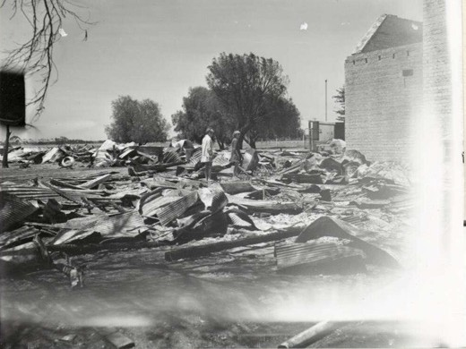

Figure 1.29: K. Felloes, Two girls wander among the ruins of their school library at Lara East, which was destroyed in the bushfire, Australian News & Information Bureau, 1969. Source: Bib ID 4589309, National Library of Australia.

sheep station. But, while firemen and volunteers working through the night appeared to have contained the fire, the hot north-westerly wind the following morning rekindled the flames. This time, the fire was heading straight for Lara, and at 9 am, as the township was preparing to evacuate, the wind was gusting to 120 km/h. At first it was hoped
that the wall of fire would miss Lara, but a wind change sent it tearing through the Lara Lake area. By 11 am, it was burning on a number of fronts before jumping the Princes Highway and continuing towards Port Phillip Bay. More than 500 men fought the blaze, but there was little they could do. Apart from houses, the Lara Lake State
School, the Church of England Holy Trinity Church, a Caltex service station on Princes Highway, and part of the Geelong and Cressy Trading Co s bulk grain storage depot
were destroyed.126
Across Victoria, assistance was given to the Lara residents. An overview is provided in From Duck Ponds to Lara:
As a stunned township counted its losses, the spotlight shone onto Lara. Relief agencies began sending supplies and a public appeal was launched to help the homeless. Farms from around the state sent emergency fodder for stock and the local Red Cross Group was inundated with donations of clothing, bedding and goods to help those who had fled without the chance to save any possessions. Many victims of the fire later said that the only good that came from the fire was the kindness of strangers who helped them as they struggled to cope.127
Another bushfire in 1985 destroyed 80 per cent of the You Yangs Regional Park.128

FLOODS
The water courses of the Barwon and Moorabool Rivers, and creeks in the Greater Geelong area have also caused havoc on property and livestock since European colonisation. A number of floods were recorded in the Geelong region in the early 1840s. While the scale of the flooded Barwon River in 1842 had not been known before ,129 it was surpassed by the flood which occurred on 20 May 1852. It was recalled by Captain Foster Fyans a year later:
At Geelong the Barwon River rose about twelve feet higher than the highest flood experienced since my arrival in 1837, destroying a vast deal of property, and carrying the bridge away on the Barwon River, Geelong, and also several others.130
At Batesford, the valley was flooded on either side of the Moorabool River with residents having to seek refuge on the house tops of those dwellings that were not sub-merged. 131 At Newtown, Foster Fyans residence, Balyang was submerged, with Captain Fyans having to climb into the stable-loft to avoid being drowned. 132 Beyond the wreck of the bridge over the Barwon at Belmont high trees that here and there formerly diversified the scenery, could only be recognised by a glimpse of their topmost branches. 133
The year 1870 brought about the wettest season in living European memory.134 The rapid rise in the level of the Barwon River caught some locals by surprise. Mr. Searl, caretaker of Queens Park, Highton, had barely time to get his wife wrapped up in a blanket and placed in a comparatively safe position in
a wattle tree. 135 Destruction along the Barwon included the loss of the Queens Bridge near Queens Park and the Prince Albert Bridge at Newtown, Chinese market garden at Belmont (which supplied must of the local produce for Geelong), recently-constructed boat sheds (stocked with boats) of the Barwon Rowing Club at South Geelong (the boat sheds carried downstream for 45-55 metres), and crops and vineyards at Connewarre and Batesford.136
Further floods caused damage in September 1880.
The township of Batesford was submerged and the bluestone flour mill erected by James Hope in 1859 near the Dog Rocks, was washed away (the last remnants disappearing following the flood of 1995).137 In July 1891, almost unprecedent rainfall over five days witnessed the swelling of the Barwon River not seen since 1880.138
In suburban Geelong West, a rain deluge caused the flooding of the Western Gully in March 1911, submerging Coquette,
Thomas and parts of Gertrude Streets, and inundating many homes139 (Figures 1.30-31 The natural gully had been
converted into an open, bluestone and brick masonry channel in 1891.140 The channel was later altered into an enclosed drain to mitigate flood impacts.

In the 20th century, major floods in June 1952 devastated the Barwon Heads township and surrounding area, being
considerably worse than a flood of the previous year.141 Although hundreds of people worked on the levee to the north of the township, ‘the flood were just too much.’142 The main street,
Hitchcock Avenue, was inundated (Figure 1.32) and all buildings including the Anglican Church - submerged up to 600 mm.143
Other major buildings were also flooded including the fire station, police station, public hall and cool store.144 Homes in nearby streets, including the Geelong Road, Noble Street and Thorn Street, Punt Road and parts of Bridge Road and
Golf Links Road, were inundated.145 Around 500 people were left homeless, with scores billeted in the Lobster Pot building at the Barwon Heads Park and the Barwon Heads Golf Club
House.146 Mrs F. Haworth saved her washing machine by setting it on the kitchen table above the flood waters. She moved it
to an outhouse at the Barwon Heads Hotel once floodwaters subsided and began ‘filling one clothes line after another with the township s washing. 147 The Victorian State Relief Committee also sent a six ton truck laden with mattresses, pillows, blankets, clothing and household utensils which were distributed by
Mrs Bartrop, wife of the local Police Constable, with additional items supplied by the Red Cross and Salvation Army.148 The flood at Barwon Heads had a more broader impact on Victoria. Voting for the legislative council elections on 21 June 1952 had to be postponed at Barwon Heads for 6 days, delaying
the announcement of the final state of the poll.149
The seriousness of the flood at Barwon Heads in 1952 the second in 10 months - led to the construction of a
flood prevention levee bank in 1953.150 Instigated by South Barwon Shire Councillor, Charles Stanley Thomas Plummer (1904-1967), the levee was built of earth to a height of 2.7 metres at the northern end of the town.151 While much-needed to alleviate future flood damage, the £7900 cost of the levee bank was controversial, with four times the number of rate payers voting against it in poll.152 This was not because the levee was considered valuable to the residents of Barwon Heads, but because it was built from funds reallocated from the reconstruction of roads and bridges elsewhere in the municipality.153 Residents at Ocean Grove, in the Shire of Bellarine, were also concerned with the construction of the levee, fearing that the bank would divert floodwater ‘more than ever to the Ocean Grove side. 154 Despite this, the levee bank was completed and named after Charles Plummer.155
Further significant flooding events were experienced in
the second half of the 20th century in other parts of Greater Geelong. A flash flood from Hovells Creek (usually an ephemeral stream) occurred in 1973 causing considerable damage to property and farms at Lara.156 Water flowed into 15 homes in the Flinders Avenue area.157 In Saintfield Street, nearly half a metre of water surrounded the newly-built homes, although only one of the houses was flooded.158

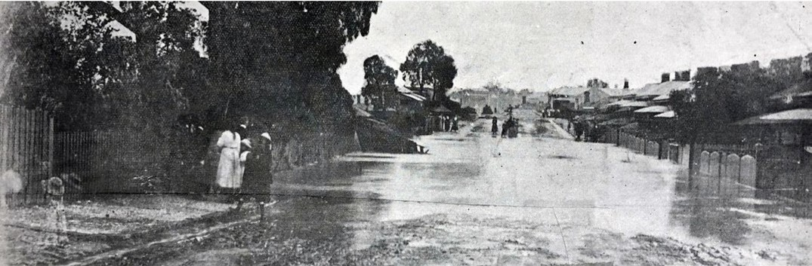
Figure 1.30: Coquette Street looking north towards Autumn Street, showing the open drain (Western Gully) in flood, 1911. Source: News of the Week, 16 March 1911, GRS 2121/3, Geelong Heritage Centre collection.

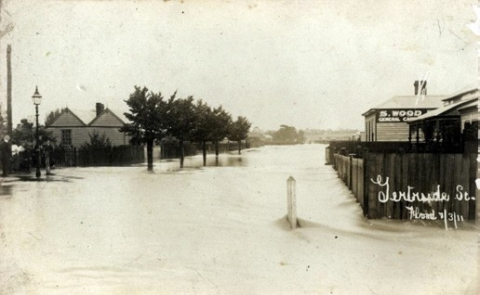

Figure 1.31: Gertrude Street looking west from the intersection with Thomas Street, showing floodwaters from the nearby open drain (Western Gully) on 7 March 1911. Source: GRS 2009/00307, Geelong Heritage Centre collection.

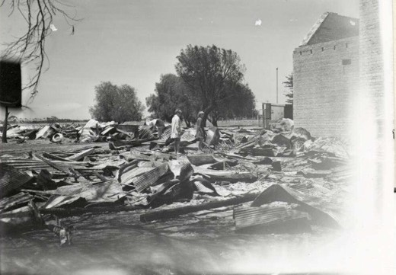
Figure 1.32: Hitchcock Avenue, Barwon Heads, in flood, 1952. Source: J. Pescott, South Barwon 1857-1985, p.164.

STORM DAMAGE
Given its exposure to the coast and southern locality from the Great Dividing Range, the Geelong region has experienced damage from storms. One of the earliest significant storm events since European colonisation was in December 1853, when a hurricane caused damage and loss of life.159 Along with the destruction of the United Presbyterian Church under construction in McKillop Street,160 the Geelong Advertiser and Intelligencer gave the following grave report:
DREADFUL OCCURRENCES - Every hour that passes adds to the melancholy tidings of the effects of the hurricane on Monday afternoon. Captain White, of the Lochnagar, was bathing at the beach in the vicinity of the slaughter-houses, just as the storm came on. He was
in very delicate health, and, it is supposed, the sudden violence of the hail storm was too much for his frame, as he sank to rise no more alive. The unfortunate gentleman s clothes were found on the beach opposite to where he
was bathing. The body was found yesterday evening. A boat belonging to the Alfred, was proceeding across the Bay and capsized in the gale, and one seaman lost.
A fine boy belonging to Sergeant Sefton, of the Geelong police force, was run over by a dray, and death produced instantaneously. The violence of the storm, or rather whirl- wind, seem to have been chiefly expended on the south side and suburbs of the town. Several houses in Chilwell have been unroofed, fences and trees blown down in all directions, and hardly a person residing in that populous village but what has been a sufferer by
the hurricane.161

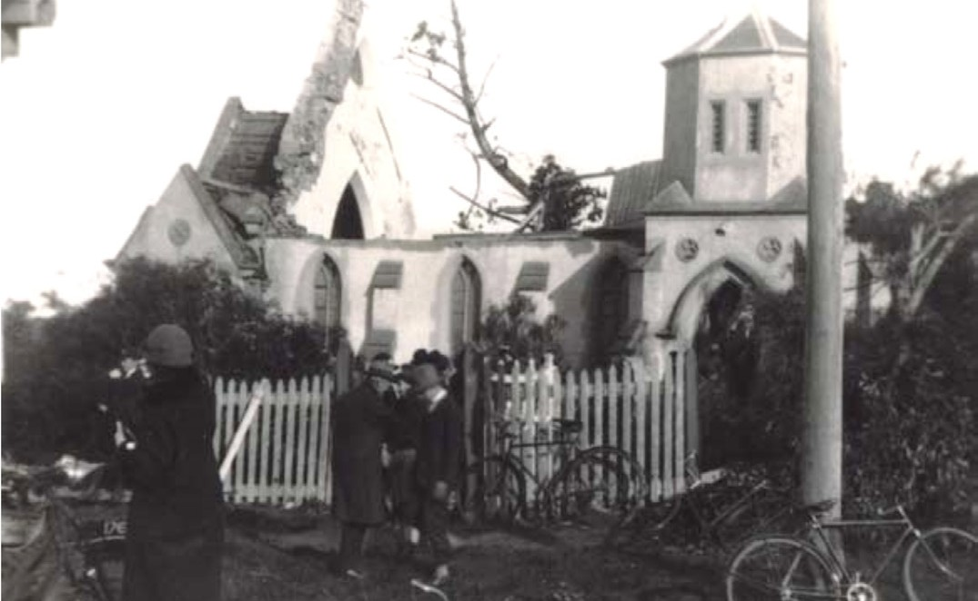
Figure 1.33: Substantially damaged St. John s Anglican Church, Highton, following tornado, 1926. Source: GRS 2009/04670, Geelong Heritage Centre collection.

Parts of Geelong also experienced the effects of an equally damaging tornado in 1926. An ominous black bank of clouds rose from beyond Highton and arrived over the Highton, Belmont and parts of Marshalltown with a roar leaving behind desolation and death.162 A small boy, Norman Munyard, aged 6 of Francis Street, Belmont, was killed.163 Seven other people in Belmont were injured. The St. John s Church of England (Figure 1.33), and the Methodist Church in Highton which had stood for over half a century, were destroyed, along with the Recreation Hall, Temperance Hall and two houses in Highton, and seven houses in Belmont.164 This included a new house under construction in Colac Road by O Connell and Sumpter.165 Damaged in the storm was the Kindergarten Hall in Highton, 11 houses in Highton and Belmont,166 and George Gardiner and Co. s Tannery at Marshalltown.167

SNOW
The earliest known snow event was in 1849 when the Geelong Advertiser reported on a fall of snow, which lasted nearly half an hour. 168 Other snow events were recorded in 1868 and 1872, the latter according to the Geelong Advertiser being widespread:
During the past few days the severity of the weather in this part of the colony has been quite exceptional. On Friday and Saturday the cold was intense, and in various parts of the district showers of sleet and snow fell, reminding people of a British midwinter. On Friday night the inclemency of
the weather seemed to reach a culminating point. Showers of rain, sleet, and hail fell at intervals, and in low lying situations, the ground previously well saturated, was literally deluged. Towards morning, all along the plains westward of the town there was a heavy fall of snow, and as the sun rose, the inhabitants of the Werribee, Duck Ponds, Leigh Road, and generally throughout the Bannockburn district, beheld a scene such as they had rarely, and many of them never witnessed before. The whole of the flats were covered with a hard, white crust, and the hills in the vicinity displaying the green foliage of trees, in striking contrast with their snowy caps, presented the most picturesque appearance they have ever worn. The You Yangs were arrayed in white, while the Anakies showed a brilliant cap
of snow. At Bell-Post Hill, just beyond the town boundaries, the ground was covered with snowy flakes, and early risers in the neighbourhood were able, when so inclined,
to indulge in a game of snow-ball.169
In the 20th century, records of notable snow events were given in 1901, 1905, 1920 and 1946.170

EARTHQUAKES AND EARTH TREMORS
Earth tremors were felt in the Geelong region before European colonisation. In 1837, an elderly member of the Bengalat balug clan of the Wadawurrung, Murridunnuck, had explained to David Fisher that earth tremors had been experienced long, long ago. 171 It was in 1837 during the first visit to Geelong of the Governor of the Colony of New South Wales, Sir Richard Bourke, when the district was visited by an earthquake, the shock of which was felt all over the district. 172
Further reports of earthquakes at Little River in 1862 and throughout the Geelong area in 1867 were published in the Geelong Advertiser.173 Of the latter, the newspaper gave a detailed description:
At about 31 minutes past 5 o clock on Saturday morning sleepers were awakened and those whose avocations

called them to be up and doing at that early hour frightened by a dull rumbling sound which appeared to be travelling from WSW to ENE ; as it approached the town the noise increased, and when the earthquake was passing under it, it appeared as if an express train was travelling in a tunnel a few yards underground, or that nine or ten heavy waggons were passing close by the door. In many places the houses rocked to and fro, doors were violently closed, windows rattled, brooms flew about, crockery was smashed—in fact everything appeared to be turning topsy-turvy. From what we can learn the earthquake was felt all over the colony, or at any rate over a great portion of it. It was felt to our own knowledge at Queenscliff, Germantown, Belmont, Bates- ford; Murgheboluc, Smythesdale, Melbourne and Ballarat, but at none of these places, so far as we can learn, has it done any serious amount of injury; on the contrary, after
it was all over many of those who heard it were anxious to relate some amusing incident connected therewith. It appears that it was felt as much, if not more, on the water than it was on the land. For instance, Captain Sansom, of the barque India, now in Corio Bay, says that he was suddenly awakened by a noise as if another vessel had run into his; there were three distinct bumps, and then it
appeared that the vessel was sheering off. Alarmed by the noise he immediately got up, and was pleased to find that no such serious accident had occurred as he apprehended. By a letter which appears in another column, our readers will be able to judge what the sensation was like at Belmont, the house of the gentleman alluded to being situated on a hill—we say on a hill, because nearly every one we have met with agrees that the shock was more violent on low lands. At Germantown it was very severe. We might fill the paper were we to recite all the incidents that occurred, suffice it, therefore, if we give a few. Dr Forster Shaw’s little boy was lying in a bed placed north and south, when he was turned right over. One of our runners fell down in the office, and another who was delivering papers in Kildare, suddenly measured his length on the ground. Frightened, he got up and ran into the house of a Mrs Fanning, who also met with a fall. It is stated that at Batesford a gentleman had a loaded gun suspended in his room. This was shaken down, and striking the hammer the piece exploded. luckily, without inflicting injury on any person. The people residing in the National Hotel were dreadfully frightened, more so than they would have been under ordinary circumstances, the foundations of the hotel having recently been altered
to allow of the building of Mr Hudson s new premises ad
joining, they very naturally thought the whole structure was coming down. In conclusion we might relate a ludicrous incident. A well-known Boniface residing not a hundred

miles from West Geelong, was awakened by his wife telling him that somebody had broken into the house. He heard a noise, he says, just as if the thief was falling down stairs. Wait a bit, he said to his better-half, and listen, doubtless wishing to give the rogue, a chance of escape, and so save himself from shame. He then armed with a blunderbuss (i.e. Brown Bess) and bayonet, went on a reconnaissance, and doubtless was relieved on finding the coast clear. [Since writing the above, we learn that the shock was very severe at the Indented Heads and Barwon Heads, on both sides of the river.
Mr Ellery, the government astronomer, gives the following account of the earth-quake:—” A smart shock of earthquake was felt here this morning, and, according to the notices I have received, it appears to have been general over the colony; but it seems to have been most severe at the coast stations. I was awake at the time, and felt the shock at 5h. 31m. 30sec. It was ac-companied
by a rumbling noise like that of a passing carriage, and the direction of wave from about W.S.W. to E.N.E. As our magnetic instruments are now dismounted, pending the reconstruction of the magnetic house, I am not able to ascertain whether they were affected at the time. The shock was felt by Mr Welhelm, of the Botanical Museum at his house at South Yarra, who carefully noted the time, and, having compared his watch with the Observatory
clock this morning, he finds the time to be the same as that given above. From Queenscliff, the master of the telegraph station reports as follows:— Earthquake occurred here
at 5.30 a.m. lasting from five to seven seconds; vibration distinctly felt, and movable articles seen to vibrate; noise like the rolling of heavy carriages. Spoke to Geelong station few moments afterwards, and Geelong reports having felt

the same sensation at 5 h. 30 min. Directions appeared about E to W. Mr Foy, the keeper of the lighthouse, says that he felt the shock at 5h. 30 min.; both towers of the lighthouses vibrated considerably, but more especially the lower.174
The largest earthquakes in Victoria were felt in 1885, 1922 and 1965.175 During the tremor of 1922, a local jeweller exclaimed that everything rocked so effectively that he felt that his end was coming. 176 In the Geelong region, the largest earthquake was in 1977, although later earthquakes were felt across Geelong in 2013 and in November 2018.177

APPRECIATING AND PROTECTING LOCAL
NATURAL WONDERS

AVALON WETLANDS¹⁷⁸
Situated on a coastal expanse on the northern shores of Corio Bay adjacent to Limeburners Bay, the Avalon Wetlands (Figure 1.34) have regional, state, national and international significance for their inland swamps and lake, intertidal zones and estuarine areas providing breeding and feeding habitat to numerous bird species (including threatened species such as the Orange-Bellied Parrot, Little Tern, Fairy Tern, Freckled Duck, Pacific Gull, Painted Snipe, Lewin’s Rail, Brolga, Cape
Barren Goose, White-Bellied Sea Eagle, Australian Bitton, Blue Billed Duck and Ballion s Crake). There are over 85 waterbird species, and the wetlands are home to the notable Altona skipper Butterfly.

BARWON BLUFF MARINE SANCTUARY, BARWON HEADS¹⁷⁹
The Barwon Bluff Marine Sanctuary at Barwon Heads is one of 13 Marine National Parks and 11 smaller Marine Sanctuaries that provide representative examples of Victoria s diverse, distinctive and amazing marine environment. It is comprised of a rock platform at the base of the bluff that extends offshore for approximately 400 metres to the east and south. The landmark of the sanctuary is the bluff of Mount Colite, being the remains of an old dune formed on top of the lava flow from nearby Mount Duneed. This lava flow is also reflected in the composition of the reef which hosts a diversity of marine life, particularly in the intertidal areas.

BASIN RESERVE, 60 BASIN ROAD, DRYSDALE¹⁸⁰
Known from the 19th century as Grass Tree Hill, the natural formation of The Basin (Figure 1.35) was claimed in 1893 to be the crater of an old volcano (see earlier subsection), the reserve is an important refuge for native plants and animals. It features Coastal Manna Gums, the small raised ground around the base being scattered with Black She-oak and Austral Grasstrees. There is also the regionally significant Nodding Green Hood Orchid. The Basin Reserve hosts the Red Rumped Parrot, together with the Grey Butcher Bird and
Wrens. The wetland is ephemeral and in the winter and spring it hosts numerous waterbirds and frogs.

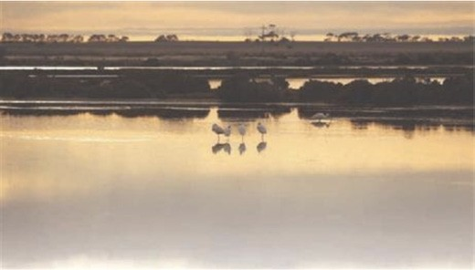
Figure 1.34: Avalon Wetland. Source: Avalon Wetland Wanderings 1 , information brochure, City of Greater Geelong.

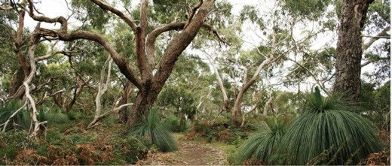
Figure 1.35: Basin Reserve, Drysdale. Source: City of Greater Geelong, Geelong Australia online at https://www.geelongaustralia. com.au/parks/item/basin.aspx

BREAMLEA WETLANDS, BREAMLEA¹⁸¹
The Breamlea Wetlands (Figure 1.36) were an important summer location of the Beangalat balug clan of the Wadawurrung, and later a camping place of William Buckley which he called Karraaf . The area has a unique saltmarsh and estuarine environment associated with Thomson s Creek, giving opportunities for fish breeding and habitat for wading birds. The open dune system has coastal grass and shrubland vegetation providing habitat to numerous birds, including the endangered Hooded Plover.

BEGOLA WETLANDS, OCEAN GROVE¹⁸²
Part of a natural drainage system behind the coast sand dunes, the freshwater wetland (Figure 1.37) is replenished by stormwater runoff from the adjacent residential area. Earlier known as the Collendina Lagoon, the site was also mapped for its raised beach and estuary bed by Richard Daintree in the
Geological Survey of Victoria in 1861 (Figure 1.07). The Begola Wetlands are home to migratory Latham s Snipe in summer, several species of frogs (including the Southern Brown Tree Frog, Spotted Marsh Frog, Common Eastern Froglet and the

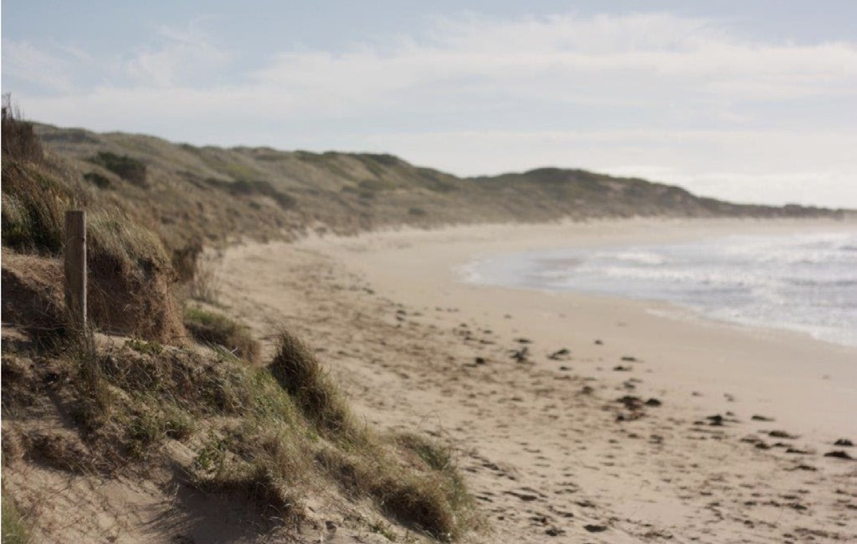
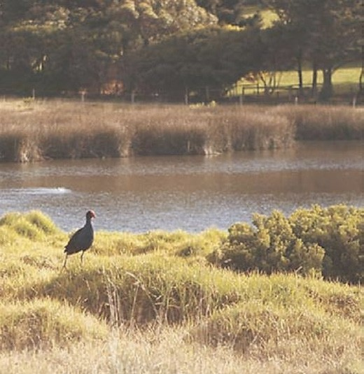
Figure 1.36: Breamlea foreshore adjoining wetland. Source: Breamlea Wetland Wanderings 10 , information brochure, City of Greater Geelong.
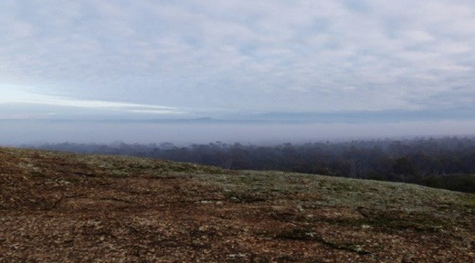
Figure 1.38: Brisbane Ranges, Anakie. Source: Brisbane Ranges National Park, City of Greater Geelong.

Figure 1.37: Begola Wetlands, Ocean Grove. Source: Begola Wetlands Wanderings 8 , information brochure, City of Greater Geelong. Brisbane Ranges National Park, Anakie

Banjo Frog) and numerous birds (including Pacific Duck, Wood Duck, Black Swan, Purple Swamphen, Dusky Moorhen, Australian Grebe and White Faced Heron).

BRISBANE RANGES NATIONAL PARK, ANAKIE¹⁸³
The elevated and undulating landscape of the Brisbane Ranges National Park, punctuated by valleys and gorges, and characterised by eucalypts (Figure 1.38), was the Country of the Wadawurrung prior to European colonisation (see Themes 2 and 6). Despite the landscape being exploited due to its natural resources through mining, quarrying, and deforestation (see Theme 4), it is the location of 619 native plant species, comprising approximately one fifth of Victoria’s native
flora. Rare species include the Brisbane Ranges Grevillea (found only along the Rowsley Fault), Velvet Daisy bush and Golden Grevillea. The Brisbane Ranges National Park is also sanctuary to kangaroos, wallabies, echidnas, possums and gliders, and 170 species of native birds including the Yellow- tufted Honeyeater and the White-throated Nightjar (which is nocturnally active). The natural and environmental significance of the Brisbane Range was first officially recognised in 1973 when a portion was gazetted as a National Park. This Park was extended in 1975, creating an area of 7,470 hectares.

DOG ROCKS FLORA AND FAUNA SANCTUARY, BATESFORD
The Dog Rocks Flora and Fauna Sanctuary on the top of a hill to the west of Batesford (Figure 1.39) was established by George Frederic Belcher when he acquired the land and built Lilydale Homestead , a four-roomed timber weatherboard dwelling in 1854.184 It was from this time when members of the Belcher family recognised the geological, ecological, botanical and scientific significance of the site. George Belcher’s son was Charles Belcher, (see earlier subsection for biographic details) and with his father, he opened the property to the Geelong Field Naturalists Club as one of two key locations
of study (the other being Buckley s Falls).185 At a visit to the Dog Rocks in August 1911, Charles Belcher:
assured members that as long as the Dog Rocks were in their [Belcher family s] possession it would be kept in its natural primitive state for the preservation of its fauna and flora which nature had so bountifully given, and that members of the club would at all times have a cordial welcome at Lilydale.186

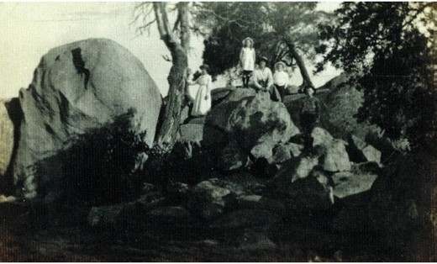
Figure 1.39: Dog Rocks, Batesford, c.1920. Source: GRS 2009/5119 b, Geelong Heritage Centre collection.

The preservation of the sanctuary by the Belcher family continues to the current day, the area now important for the conservation of disappearing native flora and fauna. The sanctuary includes an outcrop of Devonian granite.
It is characterised by rare local native vegetation including Chocolate Lily, Rock Correa and Yellow Gum. The sanctuary also hosts a notable concentration of bird life including Tawny Frogmouth, Sacred Kingfisher and the Nankeen Kestrel, together with a variety of mammals and reptiles including echidnas, koalas, kangaroos and the Tree Dragon and Blue- Tongue lizards.187

JERRINGOT WETLANDS, BELMONT¹⁸⁸
The Jerringot Wetlands (Figure 1.40) was originally a series of billabongs where the Waurn Chain of Ponds entered the
Barwon River at Belmont. It was an important location for food and gathering of the Wadawurrung, including the place of the migratory Latham s Snipe (see Theme 2 for further details).
A freshwater marsh that consists of two main wetlands, it is home to several frog species (including the endangered Growling Grass Frog), over 120 species of birds (including internationally significant water birds including Latham’s
Snipe, Australian Shoveler, Hardhead, Ballioon s Crake, Cattle Egret, Sharp-tailed Sandpiper, Caspian Tern, Greg Egret and the cattle Egret). There are 12 species of plants of regional significance, including the rare Common Nardoow and Water Plantain. The wetland is also habitat for the Australian Mudfish (one of only six locations in Victoria) as well as the Common Galaxias, Spotted Galaxias and the Shortfinned Eel.

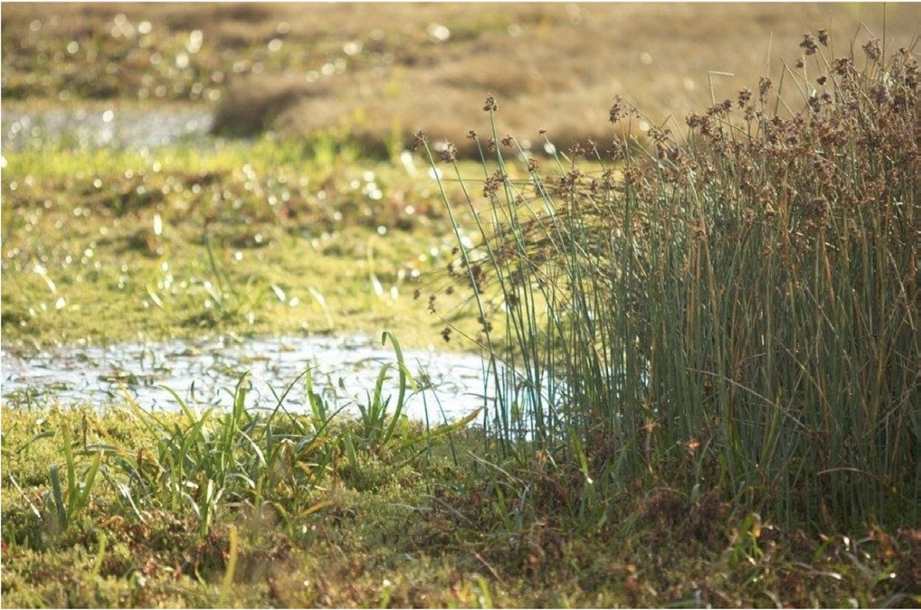
Figure 1.40: Jerringot Wetlands, Belmont. Source: City of Greater Geelong.

LAKE CONNEWARRE COMPLEX, BARWON HEADS, MOOLAP, LEOPOLD, OCEAN GROVE
& WALLINGTON
The Lake Connewarre Complex, including Lake Connewarre (Figure 1.41) and Reedy Lakes, was a major seasonal food source for the Wadawurrung (see Theme 2). Following European colonisation, the Lake Connewarre Complex became a prized location for both game hunting and conservation.
The passing of the first Game Act in 1862 by the Victorian Colonial Government brought with it tensions between hunters and conservationists. This was exacerbated (in part) when fishing nets were prohibited in Lake Connewarre in 1863 in
an effort to sustain the local marine life.189 An early insight into the longstanding tensions was given by A Wildfowler in the Geelong Advertiser in 1873 in an article entitled Big Guns and Wild-Fowling: Habits of the Wild Fowl and Statistics :
In entering on this subject I believe I shall be enabled to shew that there are no grounds of alarm or fear of their being exterminated and if Mr Kerferd will only try the experiment he will find the birds are not so anxious to be
exterminated as he imagines, and if there is any barbarity attending it he will find it to be an attempting to get a shot at them in crawling up to the next in mud after them. The whole fault is in the shooting season being delayed so late as the 20th December. The birds have vastly increased during the last 8 or 10 years not account of any protection afforded by the Game Laws, but through the decrease
of the native and the birds having been driven across the Murry to breed where they are out of the reach of molestation and in consequence have now become as migratory as any wildfowl in Europe … The first shooting season after the passing of the first Game Act in 1862 was the worst commencement ever known, many of the wildfowlers did not kill a single duck the first day, and in 1865 in consequence of the long drought in the interior
the commencement of the shooting season that year was the best ever experienced simply because there was no inducement for the birds to return as usual and they made a longer stay here.190

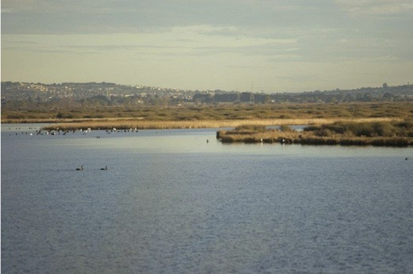
Figure 1.41: Lake Connewarre Complex. Source: City of Greater Geelong.
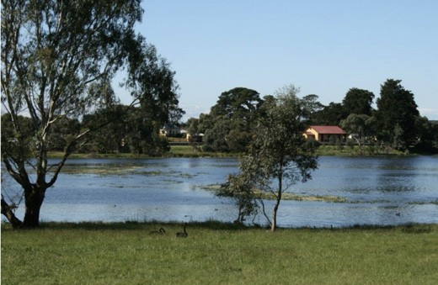
Figure 1.42: Lake Lorne, Drysdale. Source: City of Greater Geelong.
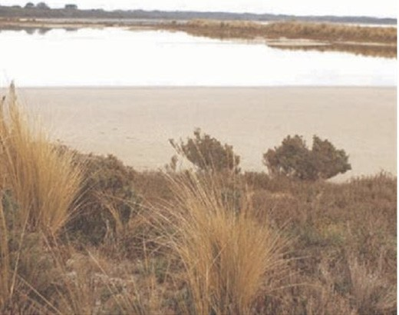
Figure 1.43: Lake Victoria, Point Lonsdale. Source: City of Greater Geelong.

In 1975, Lake Connewarre was gazetted as a State Wildlife Reserve.191 In 1983, the Lake Connewarre State Game Reserve was declared a ‘wetland of international significance’ by
the Victorian Government under the Ramsar convention.192 It became a State Game Reserve in 1984.193
Today, the Lake Connewarre State Game Reserve is one of the most significant and largest wetland areas in Victoria.194
It has a variety of swamps, marshes, lakes and river areas that provide for a diverse range of habitat for wildlife. The Lake Connewarre Complex includes rare native flora, including an Australian Salt-grass grassland and Silky Watsonia herbland. The site is a significant waterbird breeding site and feeding ground, and supports migratory birds and several resident species. Around 149 avian species have been recorded in the reserve which regularly supports 10,000 ducks and swans, chestnut teal, straw-necked Ibis, Yellow-billed Spoonbills and the endangered Orange-bellied Parrot.

LAKE LORNE, DRYSDALE¹⁹⁵
Situated on Crown Land to the south of the Drysdale Township, Lake Lorne (Figure 1.42) was originally a waterhole associated with McLeods waterholes (see later subsection).196 This
natural water supply was dammed in 1871 with a raised bank formed to create a reservoir.197 In 1872, it was designated a lake and took the name Lake Lorne,198 with a central island having been created. Today, Lake Lorne is approximately 12 hectares. There is a diversity of aquatic vegetation providing food for several waterfowl including Black Swans,
Coots, Purple Swampheads and Blue-Billed Ducks. The trees on the island are an important roosting location for Little Black Cormorant, Egrets, Australian White Ibis and Straw-necked Ibis. The muddy lake shores provide habitat for wader bird species. The extensive grassed areas are planted with Red Gums and Swamp Gums.

LAKE VICTORIA, POINT LONSDALE¹⁹⁹
Situated to the west of Point Lonsdale, Lake Victoria
(Figure 1.43) is a shallow sub-coastal lagoon associated with the Swan Bay wetlands systems. It hosts salt tolerant plant communities, and Moonah and the threatened Melaleuca Lanceolate on the southern lakeshore. There are 81 bird species that inhabit Lake Victoria, including Waterfowl, Waders, Pelicans, Cormorants, Herons, Egrets, Ibis, Spoonbills, Crakes and Rails. The site is of international significance for the
globally-endangered Orange-Bellied Parrot, and for Red-Necked Stints and Banded Stints.

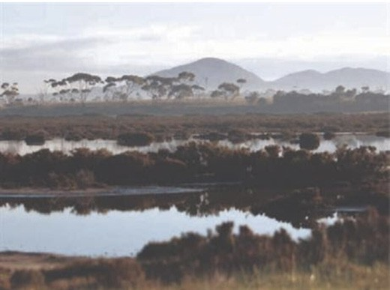
Figure 1.44: Limeburners Bay Wetland, Avalon.
Limeburners Bay Wetland Wanderings 2 , information brochure, City of Greater Geelong.

LIMEBURNERS LAGOON, AVALON²⁰⁰
Located on the northern shore of Corio Bay at the entrance to Hovells Creek, Limeburners Bay is a broad and sandy estuarine inlet (Figure 1.44). Important feeding and roosting environments exist in the shorelines and sandy spits for a range of birdlife (including the Fairy Tern, the rare Lewins Rail and potentially the Orange-Bellied Parrot), while the flora
includes relatively intact stands of Shrubby Glasswort, Beaded Glasswort and Chaffy Saw-Sedge, with White Mangrove lining the shores of Hovells Creek.

MCLEODS WATERHOLES, DRYSDALE²⁰¹
The location of the place of corroborees and rejoicing by the Bengalat balug clan of the Wadawurrung (see Theme 6), the water reserve (Figure 1.45) was first called Sproat’s waterholes following European colonisation before being renamed McLeod s waterholes, possibly after Dr Angus McLeod,
M.D. and pastoralist at Portarlington (see Theme 6). Today, McLeods Waterholes is a Crown Land reserve that comprises two natural freshwater lakes within a 14-hectare reserve.
The upper lake supports a diverse population of waterbirds including Blue-Billed duck and Freckled Duck, the lake being especially important as a refuge and feeding site for the
Blue-Billed Duck. The lower lake provides a drought refuge
for waterbirds and from hunting during the open season. There are extensive grassed areas and stands of remnant indigenous vegetation, including River Red gum, Swamp gum, Blackwood and Manna gum trees.

MURTNAGHURT SWAMP, BARWON HEADS²⁰²
The Murtnaghurt Lagoon at Barwon Heads forms part of the Barwon River Estuary and Lake Connewarre, a significant western portion of the Lagoon forming part of the Lake Connewarre State game Reserve. Over 20,000 waterbirds inhabit the site, including migratory wading birds, seabirds and waterfowl (such as Lewin s Rail, Hooded Plover, Great Egret, Little Egret, Fairy Tern, Caspian Tern, Swamp Skink, Yellow Sedge-skipper, Pied Cormorant, Pacific Gull, Royal Spoonbill, Whiskered Tern, Glossy Grass Skink, Little Egret and the Orange- bellied Parrot). The Lagoon supports one of the largest and best surviving coastal dry saltmarsh areas in Victoria.

OCEAN GROVE NATURE RESERVE, OCEAN GROVE
The Ocean Grove Nature Reserve, Grubb Road, Ocean Grove, comprises 143-hectares and represents the last remaining stands of native woodland on the Bellarine Peninsula.203
The character, flora and fauna of the reserve reflects the appearance of the area prior to European colonisation.
In 1854, William Harding first took up the Crown freehold of allotments 19 and 20 of Section 4 in the Parish of Bellarine.204 The northern portion of the Ocean Grove Nature Reserve comprises the northern portion of the original subdivision.
The land seems to have immediately been transferred to William Hudson (1805-1859) at this time as he is known to have established a station there in early 1854.205 The station was named Woodville , as in 1856 Hudson s address was given in the Electoral Roll as Woodville Road, Bellarine.206 Hudson also owned a salt lake at Paywit (St. Leonards) and by 1856-57 he also owned property in Belmont.207 It was there where he died in 1859.208 His properties were bequeathed to his wife, Jane Eleanor Hudson (nee Ryder) (1836-1920).209 She married John Cuthbertson (c.1839-1923) in 1860 and by 1864 they were resident at the four roomed timber dwelling, Woodville , Ocean Grove.210
The Woodville property remained under the ownership of members of the Cuthbertson family until the early 1960s. Two of the younger daughters, Florence and Beatrice, requested that the property remained undeveloped and in its natural state.211 In 1962, Cr Ranald McAllister, Mayor of Geelong
and Victorian Government representatives, called a public meeting with the aim of forming a committee to purchase the Cuthbertson property.212 The Geelong Field Naturalists Club and particularly its President, Jack Wheeler, was instrumental in formulating a plan to purchase the area and set it aside as a reserve.213 Locally known as Cuthbertson s Paddock, the Geelong Field Naturalists Club had a longstanding interest with the site as a location for bird watching and botany, given

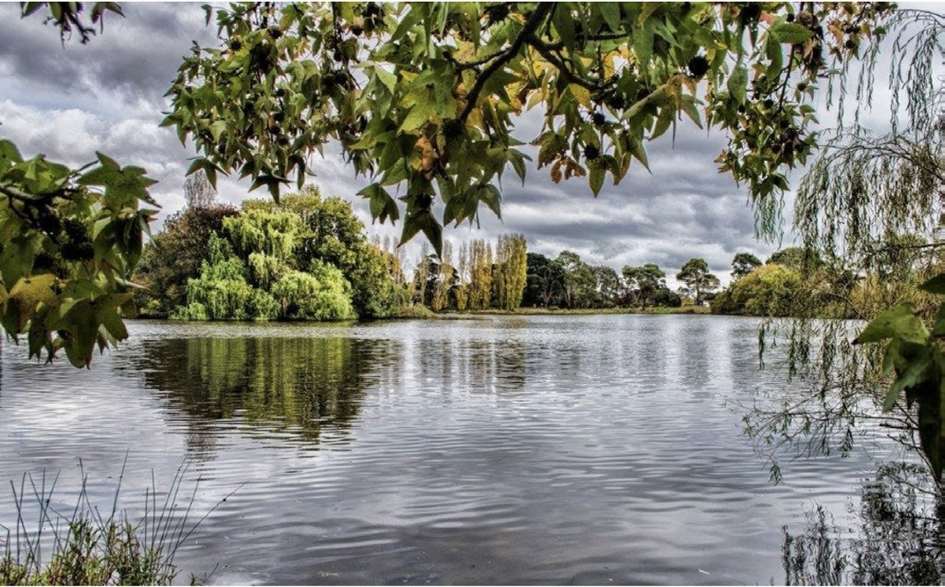
Figure 1.45: McLeods Waterholes, Drysdale. Source: City of Greater Geelong.

the unspoiled state of the native environment.214 While there was not sufficient land acquired to qualify as a national park, over 68 hectares (comprising the north-west portion of the original ‘Woodville’ property) were officially reserved and gazetted as a public park in 1968, with access from Grubb Road.215 It included a Grass Tree stand which was home to Bandicoots, Sugar Gliders, Spiny Anteaters, Phascogale, Bats, Dunnarts, transient Koalas and several Tree Dragons, Blue-tongued lizards and other reptiles.216 There were over 100 species of birds, including Bush Thicknees, Whistlers, Robins, Cuckoos, Flycatchers, Wrens, Finches and nesting Wedge- tailed eagles.217 The park was opened to the public in 1971.218
It was extended in 1974 when an additional 63 hectares were gazetted as a Nature Park and Environment study Centre.219
Today, in addition to the only significant remnant indigenous eucalypt woodland on the Bellarine Peninsula (with Austral grasstrees, coastal manna gums, drooping sheoaks and the endangered Bellarine form of yellow gum, blue sheoaks, black wattles, golden wattles, prickly hedge wattles, coastal tea-trees and silver banksias), the Ocean Grove Nature Reserve is home to wildflowers (including lilies and 22 types of orchids).220

POINT HENRY WILDLIFE SANCTUARY AND MOOLAP WETLANDS PARK²²¹
Situated to the south-east of the point at Point Henry with a frontage to the outer harbour, the area now comprising the Point Henry Wildlife Sanctuary was earliest known as an important location of gathering shell fish by the Wadawurrung peoples (see Theme 6). Today, the foreshore (Figure 1.46) and the neighbouring Moolap Wetlands Park (comprising the former saltworks established by Richard Cheetham in 1888 see Theme 4) provide habitat for numerous migratory waterbirds, several being of international significance. They include the sharp-tailed Sandpiper, Greenshank, Latham s Snipe, Red- necked Avocet, Fairy Tern, Orange-bellied Parrot and the
Marsh Sandpiper. The vegetation of high significance includes the Coastal Dune Shrubland, submerged Herbfields and Coastal Saltmarsh. In 2018, the former saltworks site was proposed to be rehabilitated into a wetland for birds, with facilities for bird- watching by international visitors.

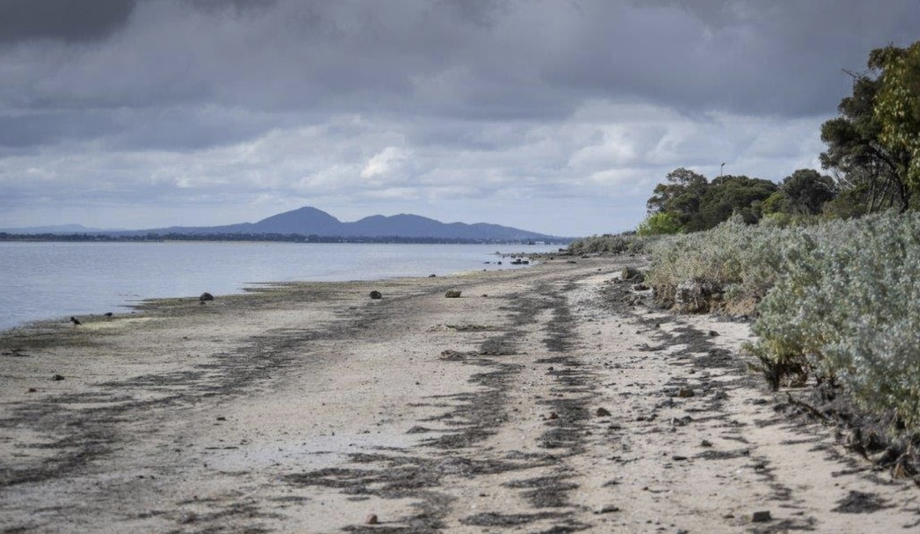
Figure 1.46: Point Henry, Moolap. Source: City of Greater Geelong.

YOU YANGS REGIONAL PARK
The You Yangs Regional Park is a significant site of the Wadawurrung, both as a landscape and as a place of settlement (see Theme 6 for further details). Since Matthew Flinders surmounted Mount Villamanta (now Flinders Peak) in 1802 (see Theme 2), the You Yangs have been recognised as an important landscape, both for its scenic and natural value. Yet, in 1861, land at the You Yangs was set aside as the United Farmers Common of Little River and Duck Ponds for
the grazing of stock.222 As early as 1867, 5000 acres at the You Yangs were reserved under the 62nd section of the Land 1862 for the preservation of timber. 223 This brought to an end the felling of live trees for wood carting which was met with disdain by some locals224 (see Theme 4 for further details). Debate on the different uses and challenges for the preservation of the natural environment of the You Yangs continued in the ensuing years. In 1915, Dr Frederick Moreton (later inaugural President of the Geelong Town Planning Association see Theme 7) suggested that the perennial spring at the You Yangs reserve should be fenced in and looked after to ensure a pure supply
of water for picnic parties. 225 His calls for the preservation
of the You Yangs reserve as a native sanctuary were realised following the passing of the Victorian Game Act of 1915226 (Figure 1.47).
In 1926, Dr Moreton s gave an address at the Legacy Luncheon, entitled Man and His Relation to Trees.
He advocated the slogan propagate trees; plant trees; preserve trees. In relation to the You Yangs he declared:
Take our You Yangs ... There was a time, earlier Geelong residents would tell them, when the You Yangs were well wooded. At the present time there are very few trees there. To destroy a tree was to destroy a national asset; further than that it would destroy something that was necessarily and inseparably bound to the life of mankind. Climate, rainfall, and scenic beauty were all dependent upon the welfare of trees. Destroy trees and away would go the beauty of the locality and the fertility of the area.
It had been declared that if birds were destroyed, in about 12 years there would be no animal or man living in that particular country, for the birds destroyed the insects, man s natural enemies. The same argument could be
applied to trees with equal force, since upon trees devolved to a large extent the preservation of bird life.227
Moreton s passionate pleas for the tree planting at the
You Yangs lead to the initiation of a scheme by the Geelong Town Planning Association, in association with the Forestry Commission. Wattles were proposed to be planted, tree species that already formed part of the Forestry Commission s

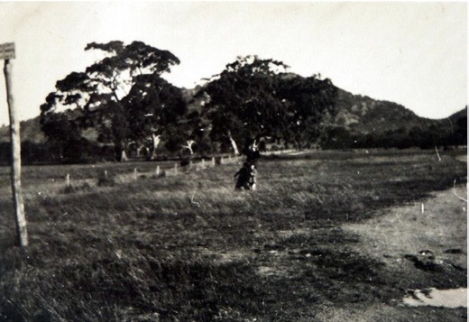
Figure 1.47: T.T. Holmes, Native Game Sanctuary Flinders [Peak] at back , c.1925. Source: Holmes collection, Authentic Heritage Services Pty Ltd.

reserve at the You Yangs.228 This began a process of acknowledging and sustaining the natural significance of the You Yangs for locals and the wider public.
This acknowledgement was formalised in 1958 when it was declared a Scenic Reserve as a place of natural beauty and interest. 229 In 1965, it was formally known
as The You Yangs Forest Park (the area of the Forest Park
was extended in 1981).230 This official status for the You Yangs was changed in 1992 when 1960 hectares were set aside and declared as the You Yangs Regional Park.231
Today, while the granite outcrops continue to comprise the most notable and dominant natural landmark in the Greater Geelong area, the You Yangs Regional Park is also known
for its diversity of plant species.232 Along the lower slopes are tall eucalypts (manna gum, yellow gum and river red gum), the more elevated granite peaks being adorned with blue gum and sparse undergrowth (including snowing mint bush and drooping cassinia). This native flora is supplemented by red box, grey box, yellow box, red ironbark, cherry ballart, silver and black wattle and drooping she oak. There are 30 species of orchid in the park, including the endangered brittle
greenhood orchid. The You Yangs Regional Park is also home to native fauna including eastern grey kangaroos, echidnas, swamp wallabies, sugar gliders, bushtail and ringtail possums, lizards and koalas, together with 200 bird species including tawny frogmouths, white-naped, white-plumbed, New Holland and brown-headed honeyeaters, kookaburras, white-winged choughs, crested shrike-tits, eastern rosellas, crimson rosellas, purple-crowned lorikeets, sulphur-crested cockatoos, eastern yellow robins, jacky winters and scarlet robins.

ENDNOTES

- City of Greater Geelong Annual Report 2016-17, p.4.
- About the Greater Geelong Municipality , Geelong Australia online at https://www.geelongaustralia.com.au/geelong/article/item/8cfd80b9c889f66. aspx
- M. Johns, Charles La Trobe and the Geelong Keys , Victorian Historical Journal, vol. 85, issue 2, December 2014, p.256.
- Geelong Advertiser, 22 May 1841, p.2.
- Ibid.
- Ibid.
- G. Featherstone, Bonwick, James (1817-1906) , Australian Dictionary of Biography, National Centre of Biography, Australian National University, http:// adb.anu.edu.au/biography/bonwick-james-3022/text4229, published first in hardcopy, 1969, accessed online 2 December 2018.
- The Argus, 19 October 1855, p.6.
- D.F. Branagan & K.A. Townley, Selwyn, Alfred Richard (1824-1902) , Australian Dictionary of Biography, op.cit., published first in hardcopy, 1976, accessed online 2 December 2018.
- Ibid., G.C. Bolton, ‘Daintree, Richard (1832-1878)’, published first in hardcopy 1972, accessed online 21 November 2018.
- Ibid.
- Ibid.
- Ibid.
- Ibid.
- Ibid.
- Ibid.
- Ibid.
- Ibid.
- Richard Daintree , Wikipedia online at https://en.wikipedia.org/wiki/Richard_Daintree
- The maps formed part of a larger map series known as quarter sheets, the formatting and method having been directed by Alfred Sewlyn.
- T. Pescott, The You Yangs Range, Yaugher Print, Belmont, 1995, p.10.
- T. Pescott, Birds and Botanists: A Field Naturalist s History of Geelong,
Trevor Pescott, Belmont, 2017, pp.7-8.
- R. Daintree, Report on the Geology of the District from Bacchus Marsh to Bass s Straits, Geological Survey of Victoria, Melbourne, 1863.
- R. Daintree, Field Book, 1861-62, VPRS 11904/P1, item 1, Public Record Office Victoria (PROV).
- R. Daintree, Geological Survey of Victoria Map No. 24 S.E., Country of Grant, surveyed under the direction of Alfred R.C. Selwyn, Government Geologist, Frederick McCoy, palaeontologist, outline & writing engraved by John L. Ross, lithographed by Richard Shepherd, National Library of Australia (NLA).
- Agriculture Victoria, ‘Geological and Geomorphological Sites of Significance Geelong , Victorian Resources online at http://vro.agriculture.vic.gov.au/
dpi/vro/portregn.nsf/pages/werribee_gg_significance_bf2, sourcing J.M. Bowler, Tertiary Stratigraphy and Sedimentation in the Geelong/Maude Area, Victoria , Proceedings of the Royal Society of Victoria, vol. 67, 1963, pp.69- 137.
- Ibid., sourcing T.S. Hall & G.B. Pritchard, Notes on the lower Tertiaries of the southern portion of the Moorabool Valley in Proceedings of the Royal Society of Victoria, vol. 4, 1892, T.S. Hall & G.B. Pritchard, Geology of the
Lower Moorabool , Proceedings of the Royal Society of Victoria, vol. 7, 1897,
F.A Singleton, The Tertiary geology of Australia , Proceedings of the Royal Society of Victoria, vol. 53, 1941 &
Bowler, op.cit.
- Bowler, op.cit.
- Agriculture Victoria, op.cit., sourcing Hall & Pritchard, Geology of the Lower Moorabool , op.cit., J.F. Mulder, Newer Pliocene Strata on the Moorabool River , Proceedings of the Royal Society of Victoria, vol. 14, 1902, Singleton, op.cit. & Bowler, op.cit.
- Ibid., sourcing M.M. Barwon & D.M. Calder, 1976, K.N. Bell, Recent Foraminifera from Limeburners Bay, Victorian Naturalist, vol. 96, 1978, pp.133-136 & M.J. Farrell, Studies on the ecology of Victorian mangrove and saltmarsh communities’, Fisheries & Wildlife Division file, Dept. Conservation & Natural Resources, Warrnambool, 1973.
- Ibid., sourcing E.D. Gill, Emerged Marine Shell Beds near Geelong, Victoria , Victorian Naturalist, vol. 89, 1972, pp.315-319, H.E. Wilkinson, The Duck Ponds Fossil Marsupial Fauna, Hovell s Creek, Lara, Victoria , Memoirs of Museum Victoria, Museums Victoria, vol. 33, 1972, pp. 41-46.
- News of the Week, 7 December 1911.
- Gill, op.cit., Wilson, op.cit. & A. Coulson, Notes on the relationship of Epidorite and the Granite at Barrabool Hills and Dog Rocks near Geelong, Victoria , Proceedings of the Royal Society of Victoria, vol. 42, 1930, pp. 99-109 & D. Spencer-Jones, Explanatory notes on the Geelong 1:63,360 Geological Map, Geological Survey, Melbourne, 1970, SLV.
- Ibid.
- Ibid.
- R. Dahlaus, Geological Setting of The Bluff/Mt Colite, Point Flinders , Dahlaus Environmental Geology Pty Ltd, Buninyong, at Barwon Heads online http:// www.barwonheads.net/town/geology.htm
- Ibid.
- A. Sutherland, Victoria and Its Metropolis Past and Present, McCarron Bird & Co., Melbourne, 1888, CD edn., Archive CD Books Australia Pty Ltd, 2006, p.146.
- W.R. Brownhill & I. Wynd, The History of Geelong and Corio Bay with postscript 1955-1990, The Geelong Advertiser, Geelong, 1990.
- C. Grimes, Map of Port Phillip, 1803, showing the Greater Geelong portion, lithographed at the Department of Lands and Survey by T. Slater, 1879: Melbourne, State Library of Victoria (SLV).
- Ibid.
- Ibid.
- J.H. Wedge, Colony of Victoria, Description of the Country Around Port Phillip , article 28, reprinted in The Mercury (Hobart, Tasmania),
22 January 1935, p.8.
- S. Mossman, Geelong in 1840 , Geelong Advertiser, 19 December 1879, p.3.
- Ibid.
- A.J. Campbell, The Tourists Guide to Geelong and the Southern Watering Places on the Bay and Coast and Popular Holiday Resorts, M.L. Hutchinson, Melbourne, 1893, p.20, 22, 32, 40, 49, 50 & 53.
- Geelong Advertiser, 19 December 1879, p.2.
- L. Lane, Aboriginal Stone Artifacts (Geelong & District: The Nature of Stone Artifacts Notes for lecturettes to the Archaeological Society, Wollongong, 1967 With additional notes on Rock-types of Geelong & District and Illustrations of Stone Flake-tools Geelong & District , manuscript no. 46, 1991, pp.19-20, Special Collections, Deakin
University Library.
- Geelong Advertiser, 14 November 1905, p.4.
- Ibid.
- Ibid., 2 January 1871, p.2. 52 Ibid., 10 March 1871, p.2. 53 Ibid., 22 April 1871, p.2
- Ibid., 22 February 1884, p.2
- Ibid., 3 September 1887, p.3. 56 Ibid., 9 March 1895, p.2.

57 | The Age, 28 February 1934, p.16. | 96 | Ibid.
58 | The Argus, 23 October 1935, p.12. | 97 | Bellarine Landcare Group Monthly Newsletter, April 2018 at

59 Pescott, Birds & Botanists, op.cit., p.150. 60 Ibid., p.121.
- Ibid.
- Ibid. & Geelong Advertiser, 9 June 1880, p.2.
- R. Hill, Link, George Frederic (1843-1900) , Geelong Biographical Register, Geelong Historical Society, December 1997.
- Geelong Advertiser, 23 June 1990, p.3.
- Pescott, op.cit., p.155. 66 Ibid., p.156.
67 Ibid.
68 Ibid., p.162.
69 Ibid.
70 Ibid., p.163.
71 Ibid., pp.169-170.
 |  | 2 July 2000 at
72 Ibid., p.172. |  | http://geelongweatherservices.com.au/why-is-geelong-so-dry/
73 The Argus, 3 September 1875, p.l6. | 108 | Ibid.
74 Ibid. | 109 | Ibid.
75 R.C.Q., Visitors Illustrated Guide to Geelong, with a Brief Description of | 110 | Port Phillip Gazette, 17 April 1839, p.2.

http://www.bellarinelandcare.org.au/index.php/newsletters/oldnewsletters/ listid-1/mailid-165-newsletter-april-18
- Fiona Love, Bellarine Secondary College & Bellarine Landcare Group Nursery Coordinator, Drysdale, to Pam Jennings, 27 August 2019.
- L. Lane, Bunjil: Dowang: Un , manuscript no. 35, 1991, p.2, Special Collections, Deakin University Library.
- Pescott, op.cit., p.98.
- Ibid.
- The Australasian, 8 May 1868, p.25.
- Geelong Advertiser, 27 November 1866, p.2.
- A.J. Ewart, The Weeds, Poison Plants, and Naturalized Aliens of Victoria, J. Kemp, Government Printer, Melbourne, 1909, p.3.
105 Ibid., p.19.
- Indigenous plants of the Geelong Region , op.cit.
- L. Small, Why is Geelong So Dry? , Geelong Weather Services online,

Lorne, Henry Franks, Geelong, 1879, p.12, 20.
- Pescott, op.cit., p.68.
- C. Fyans to C. La Trobe, 22 August 1853 in S. Bride (ed.), Letters from Victorian Pioneers, Trustees of the Public Library by Robert S. Brain, Government Printer, Melbourne, 1898, pp. 124-125.
- W. Westgarth, On the Condition and Prospects of the Aborigines in Australia , in The Edinburgh Philosophical Journal, vol. 53, 1852, p.231.
- Geelong Advertiser, 28 September 1867, p.3.
- Ibid., 27 November 1866, p.2.
- A.J. Campbell, Nests and Eggs of Australian Birds: including the geographical distribution of the species and popular observations thereon, Archibald James Campbell, printed by Pawson & Brailsford, Sheffield, 1900.
- J.G.H. White, Belcher, Sir Charles Frederic (1870-1970 , Geelong Biographical Register, op.cit., September 1999. Belcher was knighted in 1931.
- Geelong Advertiser, 26 September 1914, p.7.
- White, op.cit.
- Ibid.
- Australasian, 10 November 1900, p.35 & White, op.cit.
- C. Belcher, The Birds of the District of Geelong, Australia, With Fifty Photographs by Hugh Riordan and Others, W.J. Griffiths,
Geelong, 1914, p.ix.
- Ibid.
89 Ibid., pp.152-154
90 Ibid., pp.366-368.
91 J.T. Gellibrand, Memorandum of a Trip to Port Phillip, 1836 in Bride, op.cit.,

- Geelong Advertiser, 22 April 1851, p.2.
- Bacchus Marsh Express newspaper, 10 January 1869.
- Ibid., 9 January 1869.
- The Leader, 29 April 1865, p.9.
- Geelong Advertiser, 9 April 1865, p.3.
- Ibid.
- Australasian, 28 May 1898, p.13.
- Ibid.
- Port Phillip Patriot & Melbourne Advertiser, 24 December 1840, p.3.
- Ibid.
- This term appears to have been borrowed from, the widespread uprising in 1830 by agricultural workers in southern and eastern England which became known as the Swing Riots, where the workers destroyed workhouses, barns and ricks by setting them alight. See Swing Riots , Wikipedia online at https://en.wikipedia.org/wiki/Swing_Riots See also Themes 4 and 7 for details on European arrivals to Greater Geelong associated with the Swing Riots.
- Port Phillip Patriot & Melbourne Advertiser, op.cit.
- Geelong Advertiser, 29 April 1848.
- Ibid., 7 February 1851, p.2.
- Ibid., 6 February 1851.
- P. Begg (comp.), Lara s Black Wednesday , Geelong The First 150 Years, The Geelong Advertiser Pty Ltd, Geelong 1990.
- M. Budd, C. Delaney, J. Grainger (eds.), From Duck Ponds to Lara: A Collection of Memories, Lara Heritage Festival Inc., Lara, 2004, p.95.
- You Yangs Regional Park , visitor guide, Parks Victoria online, n.d., at https://

p.290.
- See Indigenous plants of the Geelong Region , City of Greater Geelong,
parkweb.vic.gov.au/ guide.pdf
data/assets/pdf_file/0019/315631/You-Yangs-RP-visitor-

Geelong Australia online at https://www.geelongaustralia.com.au/indigenousplants/article/ item/8ce589e1bce0fe8.aspx
- Pescott, op.cit., p.113.
- Geelong Advertiser, 1 August 1842, p.2.
- Fyans, op.cit., p.119.
- Geelong Advertiser & Intelligencer, 24 May 1852, p.2.
- Geelong Advertiser, 10 September 1870, p.3.
94 | G. Armytage, Hermitage, to C. La Trobe, 6 October 1853, in Bride, op.cit., pp.
 | 141-142. | 133 | Ibid.
95 | Westgarth, op.cit. | 134 | Ibid.

- Ibid.
- Ibid.
- Ibid., 14 September 1880, p.3 & I. Wynd, Environmental History , vol.2 in D. Rowe & L. Huddle, Greater Geelong Outer Areas Heritage study , stage 2, prepared for the City of Greater Geelong, 1998-2000, p.11.
- Geelong Advertiser, 14 July 1891, p.3.
- News of the Week, 16 March 1911.
- D. Rowe & W. Jacobs, Ashby Heritage Review, prepared for the City of Greater Geelong, vol. 1, 2010, p. 207.
- The Argus, 19 June 1952, p.16.
- Ibid.
- D. Rowe & L. Huddle, Greater Geelong Outer Areas Heritage Study , op.cit.
- J. Pescott, South Barwon 1857-1985, City of South Barwon, Belmont, 1985, p.154.
- Ibid.
- The Argus, op.cit. & The Age, 26 June 1952, p.5.
- Ibid.
- Ibid.
- Pescott, South Barwon, op.cit.
150 See the Argus, 9 September 1952, p.7, 11 May 1953, p.9, 20 May 1953, p.22 & the Herald, 21 May 1953, p.14. See also P.F.B. Alsop, The Construction of
Plummer Bank at Barwon Heads , manuscript, 1996, Geelong Heritage Centre.
151 Argus, 11 May 1953, p.9.
- The Age, 18 August 1953, p.3.
- Ibid.
154 Herald, 21 May 1953, p.4.
- The Argus, 17 June 1953, p.7.
- D. Rowe, Lara Heritage Review Thematic History , vol. 2, prepared for the City of Greater Geelong, 2013 (revised 2016).
- Ibid.
- Ibid.
- Geelong Advertiser & Intelligencer, 21 December 1853, p.4.
- Brownhill & Wynd, op.cit., p.600.
- Geelong Advertiser & Intelligencer, op.cit.
- Geelong Advertiser, 23 July 1926, p.1.
- Ibid.
- Ibid.
- Ibid.
- Ibid.
- Ibid.
- Ibid., 1 September 1849, p.2.
169 Ibid., 12 August 1872, p.2.
- Ballarat Star, 29 July 1901, p.2, 26 September 1905, p.1, Geelong Advertiser, 1 March 1920, p.3 & The Argus, 2 June 1946, p.3.
- D. Fisher, Roslin , Geelong, to C. La Trobe, 21 September 1852 in Bride,
op.cit., p.16.
- Ibid.
- Geelong Advertiser, 5 July 1862, p.2 & 27 August 1867, p.2.
- Ibid.
- List of Earthquakes in Australia , Wikipedia online, https://en.wikipedia.org/wiki/List_of_earthquakes_in_Australia
- Geelong Advertiser, 12 April 1922, p.6.

- Ibid., 23 November 2018.
- Information taken from Avalon Wetland Wanderings 1 , information brochure, City of Greater Geelong.
- Barwon Bluff Marine Sanctuary , Park Notes, Parks Victoria, December 2003.
- Basin Reserve , City of Greater Geelong, Geelong Australia online at https:// www.geelongaustralia.com.au/parks/item/basin.aspx
- Information taken from Breamlea Wetland Wanderings 10 , information brochure, City of Greater Geelong.
- Information taken from Begola Wetlands Wanderings 8 , information brochure, City of Greater Geelong.
- Information taken from S. Boland, The History of the Brisbane Ranges National Park , B.A. thesis, Monash University, 1992, p.4, 9 & Brisbane Ranges National Park , visitor guide, Parks Victoria, October 2017.
- A. Willingham, Geelong Region Historic Buildings and Objects Study, Geelong Regional Commission, 1986, vol. 1, sheet 9.
- Pescott, Birds and Botanists, op.cit., pp.184-185.
- Geelong Advertiser, 26 august 1911, p.4.
- About Dog Rocks Flora & Fauna Sanctuary , Dog Rocks Flora & Fauna Sanctuary online, 2017 at http://www.dogrockssanctuary.org/
- Information taken from Jerringot wetland Wanderings 11 , information brochure, City of Greater Geelong.
- Victoria Government Gazette, 9 January 1863, p.65.
- Geelong Advertiser, 16 August 1873, p.4.
- Victoria Government Gazette, 31 October 1984, p.3984.
- Lake Connewarre State Game Reserve , Park Notes, Parks Victoria, December 2010.
- Victoria Government Gazette, op.cit.
- Information on existing flora and fauna taken from ‘Lake Connewarre Wetland Wanderings 9 , information brochure, City of Greater Geelong.
- Information on existing flora and fauna taken from ‘Lake Lorne Wetland Wanderings 4 , information brochure, City of Greater Geelong unless otherwise referenced.
- Geelong Advertiser, 3 March 1870, p.2 & 4 April 1871, p.2.
- Ibid.
198 Ibid., 13 June 1871, p.2, 6 July 1871, p.2 & 7 November 1872, p.2.
- Information on existing flora and fauna taken from ‘Lake Victoria Wetland Wanderings 7 , information brochure, City of Greater Geelong.
- Information on existing flora and fauna taken from ‘Limeburners Bay Wetland Wanderings 2 , information brochure, City of Greater Geelong.
- Information on existing flora and fauna taken from ‘McLeods Waterholes Wetland Wanderings 5 , information brochure, City of Greater Geelong.
- Information from Ecology Australia, Murtnaghurt Lagoon, Barwon Heads, Flora and Fauna Assessment , prepared for Save Barwon Heads Alliance, 2008, pp.1-2.
- Ocean Grove Nature Reserve, Park Notes, Parks Victoria, February 2012.
- See Plan of the Parish of Bellarine, sheet 2, VPRS 16171/P1 PROV.
- Hudson was reported as being a resident with a station at Barwon Heads (which Ocean Grove was earlier known as) in April 1854 when his discovered the wreck of the schooner, Columbine. See Geelong Advertiser & Intelligencer, 3 April 1854, p.6. In 1855, William Harding went insolvent and Hudson was reported to have owed Harding £209/18/8, which further supports the claim that Hudson acquired the land from Harding at a very early time. See Geelong Advertiser,
24 May 1855.
- Electoral Roll, South Grant Division, Queenscliff subdivision, 1856.
- Ibid. & Geelong Town Council Rate Book, 1856-57, Geelong Heritage Centre collection.

- Victorian Births Deaths & Marriages Indexes online, Department of Justice, Melbourne.
- W. Hudson, Probate Administration files, 1859, VPSR 28/P0 Unit 26, item 2/844, PROV.
- Bellarine Shire Rate Book, entry 785, 1864, Geelong Heritage Centre collection. There were numerous death and memorial notices in the Geelong Advertiser and The Argus newspapers in the early 20th century that gave Woodville (and not Woodlands ) as the name of the Cuthbertson family property. See for example The Argus, 2 February 1917, p.15, 24 January 1920, p.57, 2 December 1938, p.10 & Geelong Advertiser, 15 June 1923, p.1.
- L. Willey (with research by P. Jennings), historical notes used as a basis for a publication entitled the History of the Ocean Grove Nature Reserve, Friends of the Ocean Grove Nature Reserve, 2014-15, Bellarine Historical Society collection.
- Ibid.
- Ibid.
- Ibid.
- See annotations on the Bellarine Parish Plan, op.cit.
- Willey, op.cit.
- Ibid.
- Ibid.
- Bellarine Parish Plan, op.cit.
- Ocean Grove Nature Reserve , op.cit & Ocean Grove Nature Reserve Wikipedia online at https://en.wikipedia.org/wiki/Ocean_Grove_Nature_ Reserve#cite_ref%E2%80%90PV_1%E2%80%900
- Information on existing flora and fauna taken from ‘Point Henry Wetland Wanderings 3 , information brochure, City of Greater Geelong & G. Cooper, Cheers as Moolap salt site set aside for birds, Geelong Indy, 6 September 2018.
- The common was established in 1861 and gazetted in 1863 see Rowe, Lara Heritage Review Thematic History , op.cit., p.23.
- Geelong Advertiser, 20 August 1867, p.3.
- Bacchus Marsh Express, 6 March 1869.
- Geelong Advertiser, 16 April 1915, p.3.
- Game Act, Parliament of Victoria, 1915 at http://www.austlii.edu.au/au/legis/ vic/hist_act/ga191543.pdf In 1927, a man was fined for having a gun in the You Yangs Reserve which the Geelong Advertiser reported had been made a sanctuary under the Game Act 1915. See Geelong Advertiser, 28 September 1927, p.8.
227 Ibid., 22 April 1926, p.5.
- Ibid., 29 February 1928, p.4.
- Victoria Government Gazette, 24 September 1958, p.3166. 230 Ibid., 12 May 1965, p.1556, 27 May 1981, p.1688.
231 Ibid., 12 August 1992, p.2212.
232 You Yangs Regional Park , visitor guide, op.cit.

