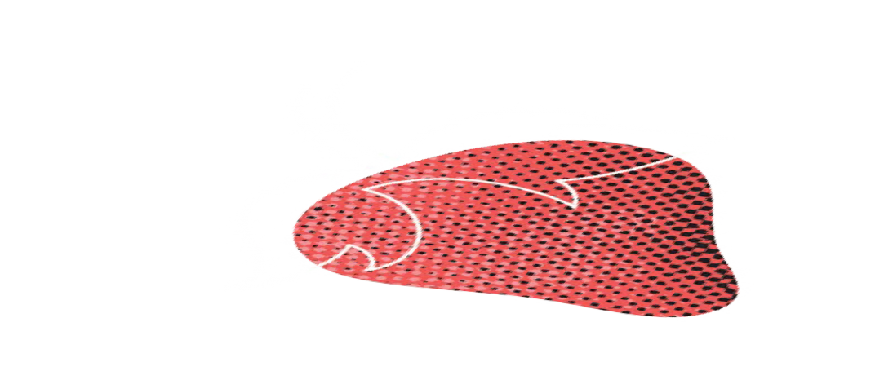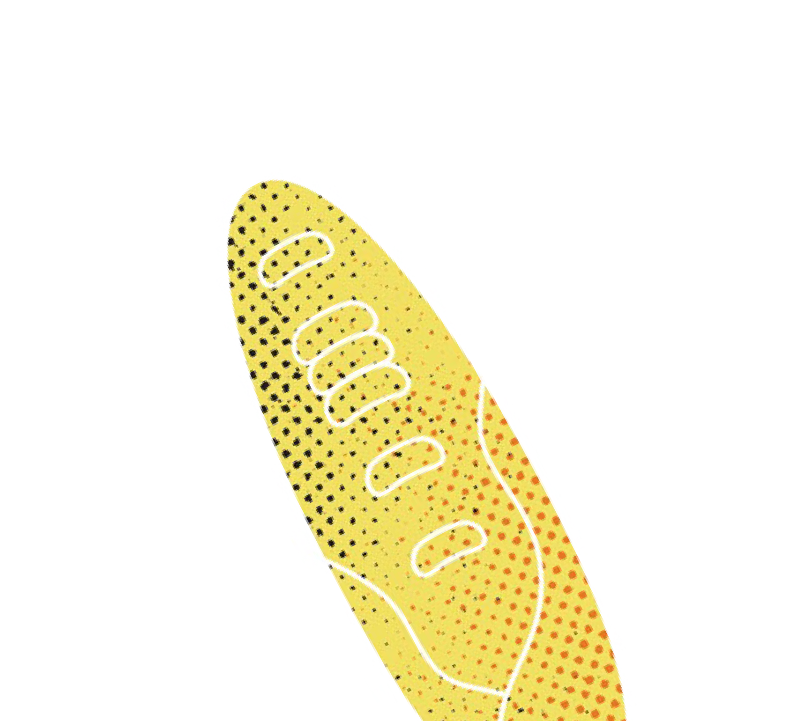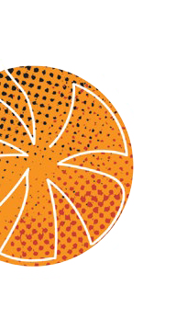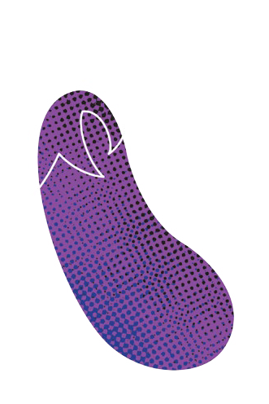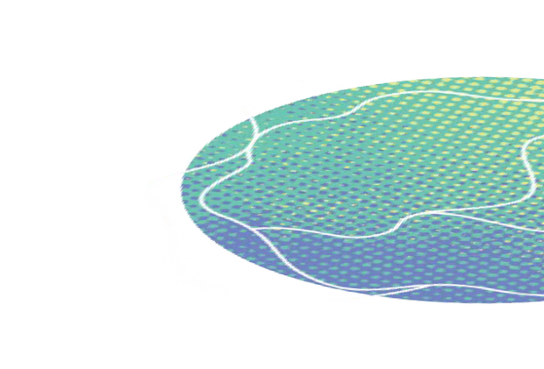

Healthy eating for every life stage

CONTENTS
Deputy Mayor’s Message 3
HEALTHY EATING PATTERNS 4
Eat a variety of healthy foods 5
Choose water every day 12
Be physically active 13
HEALTHY EATING SKILLS 14
Plan what you eat 15
Select healthy ingredients 18
Prepare healthy meals 19
HEALTHY EATING HABITS 22
Eat together 23
Enjoy traditional foods 24
Reduce food waste 25
LEARN MORE 26

Acknowledgement of Country
We Acknowledge the Wadawurrung People as the Traditional Owners of the Land, Waterways and Skies .
We pay our respects to their Elders, past and present We Acknowledge all Aboriginal and Torres Strait
Islander people who are part of our Greater Geelong community today .

DEPUTY MAYOR’S MESSAGE


A healthy community is one where everyone has the opportunity to experience their best possible health and wellbeing .
While there are many factors that influence health and wellbeing overall, healthy eating plays a central role for every individual .
Through our four-year strategic document, Our Community Plan 2021-25, the council is making it a strategic focus to foster a healthy, caring and inclusive community .
We want to promote and support behaviours that will help people maintain a healthy weight and avoid chronic disease .
This will require ongoing effort to make it easier for our community to gain access to affordable, culturally appropriate, safe and healthy food options .
This booklet is a key action in the first year of Our Community Plan, as we strive to achieve our strategic aims .
It contains evidence-based information and practical advice to help Greater Geelong residents understand and meet their food and nutrition needs throughout their lives .
It has been developed in line with key national guidelines, food literacy research, and the World Health Organisation and Food and Agriculture Organisation of the United Nations’ definition of healthy and sustainable diets .
We hope you will find it useful, and wish you every success on the path to a healthy and happy lifestyle.

COUNCILLOR TRENT SULLIVAN
Deputy Mayor, City of Greater Geelong

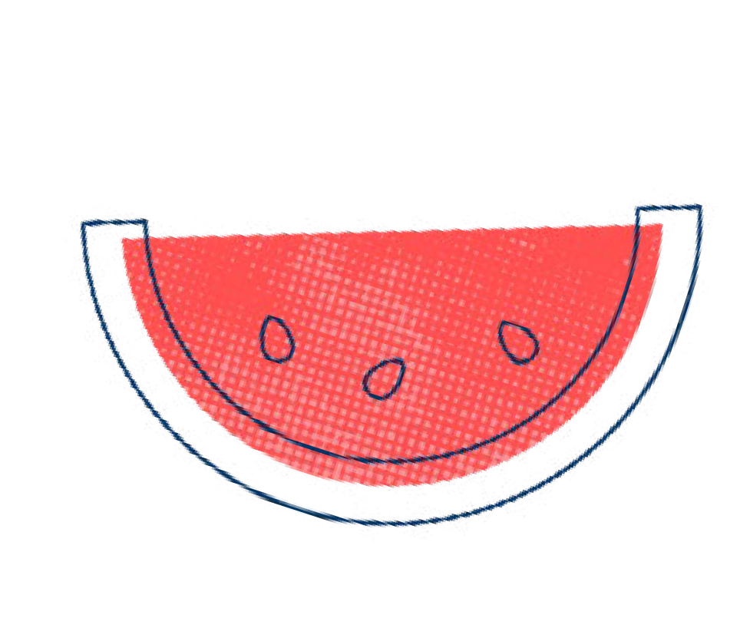

2 3

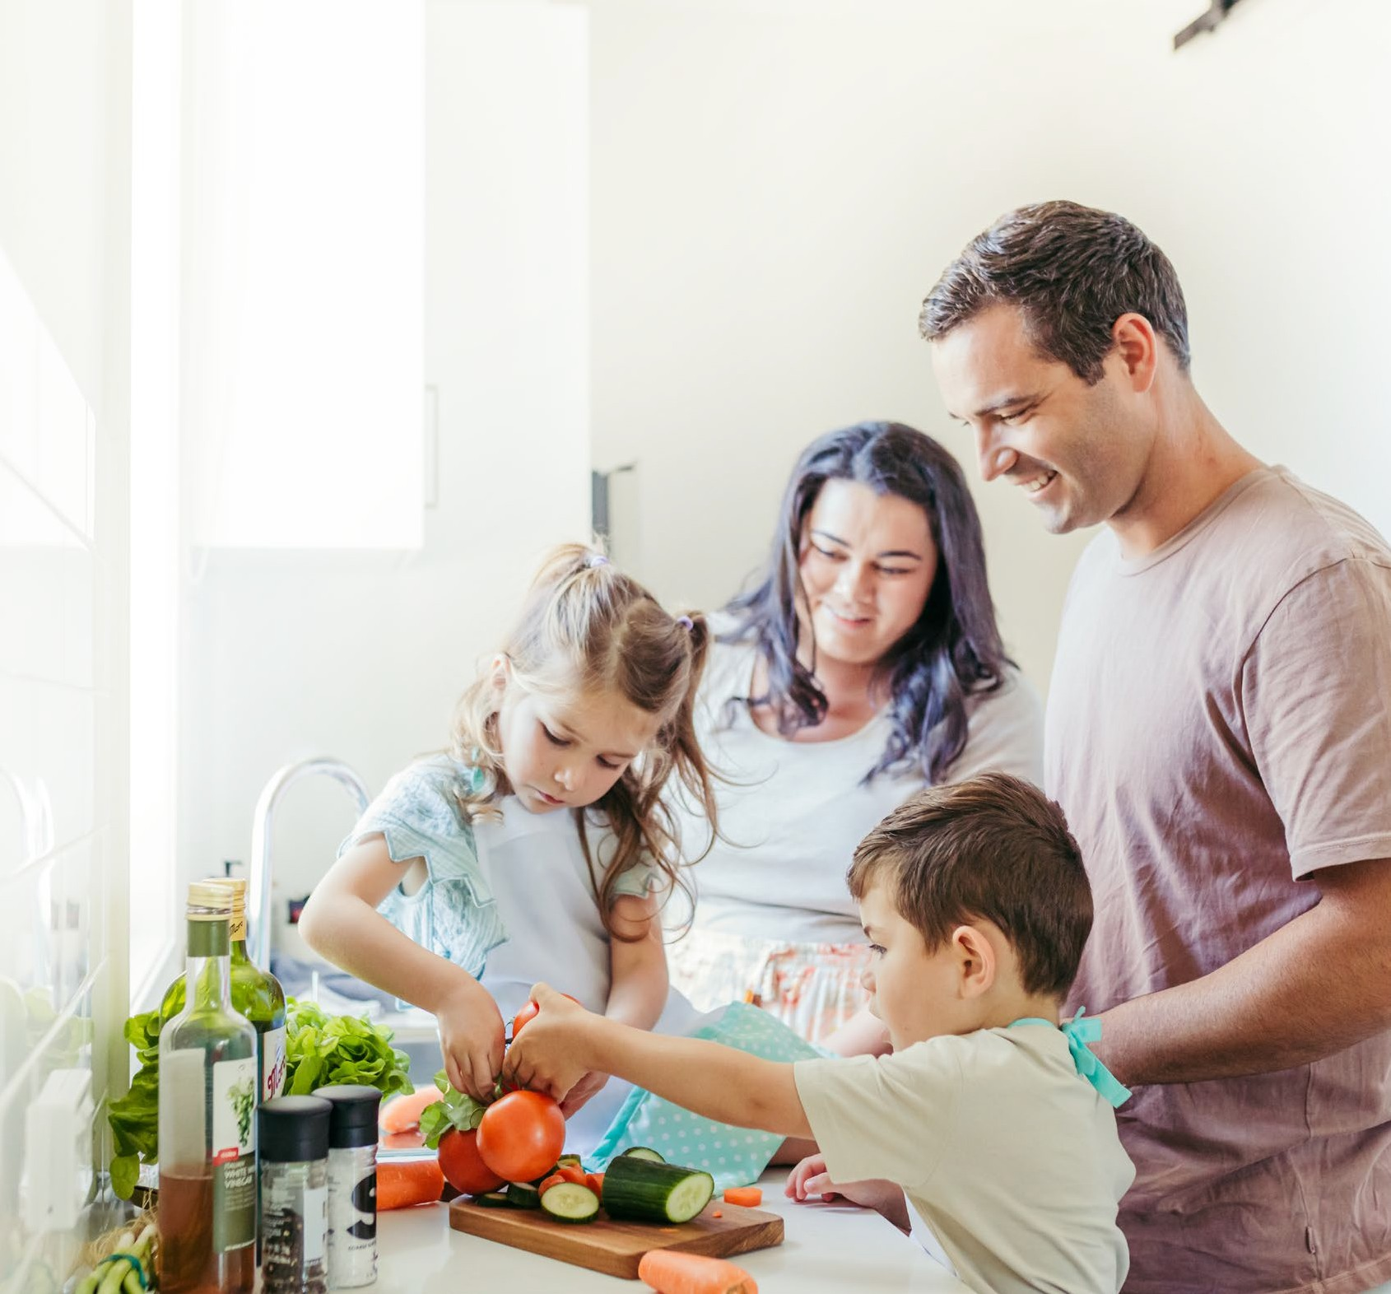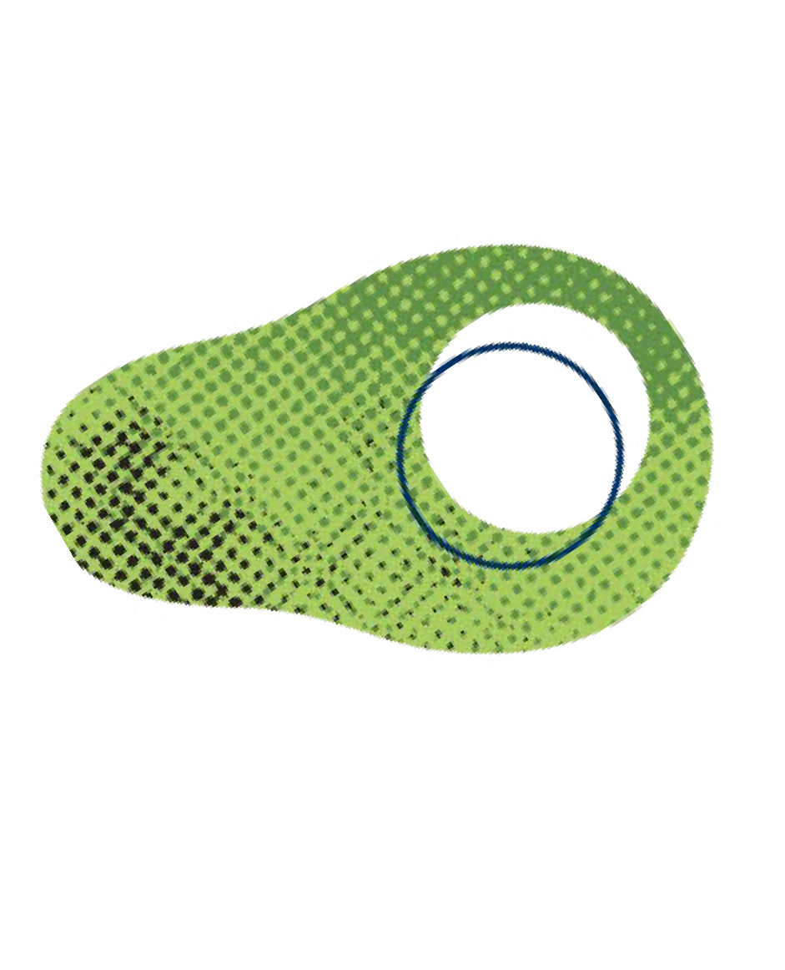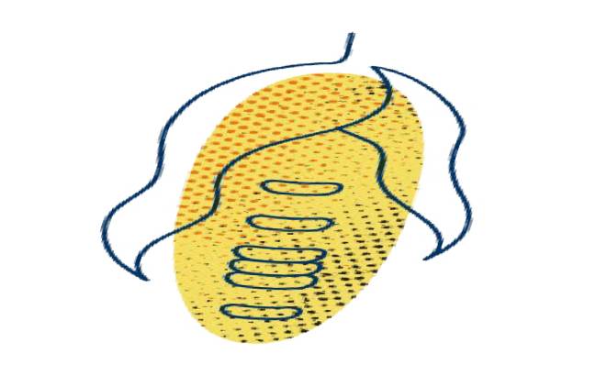HEALTHY EATING PATTERNS

EAT A VARIETY OF

HEALTHY FOODS
Your eating pattern is what you eat and drink most regularly . It can include foods that reflect your culture, taste, budget and lifestyle .

In a healthy eating pattern, all of the foods and drinks work together to help you:
Feel good Be active
Maintain your health

5
4

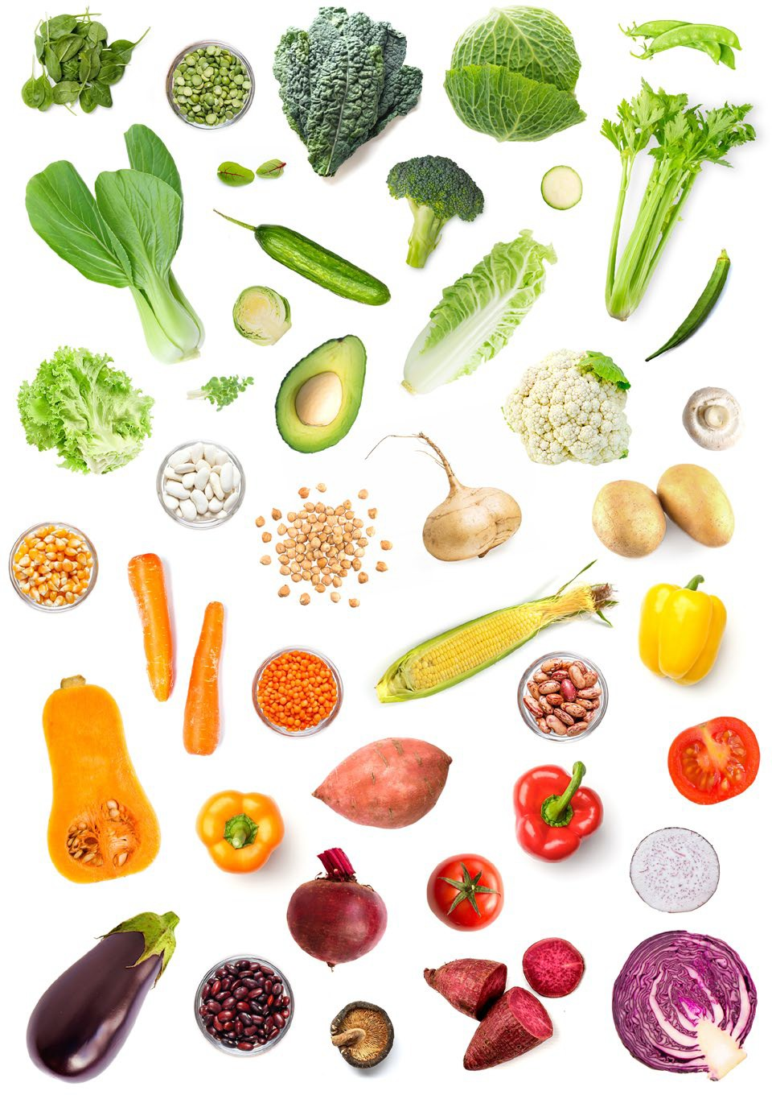
Vegetables & Legumes

Fruit

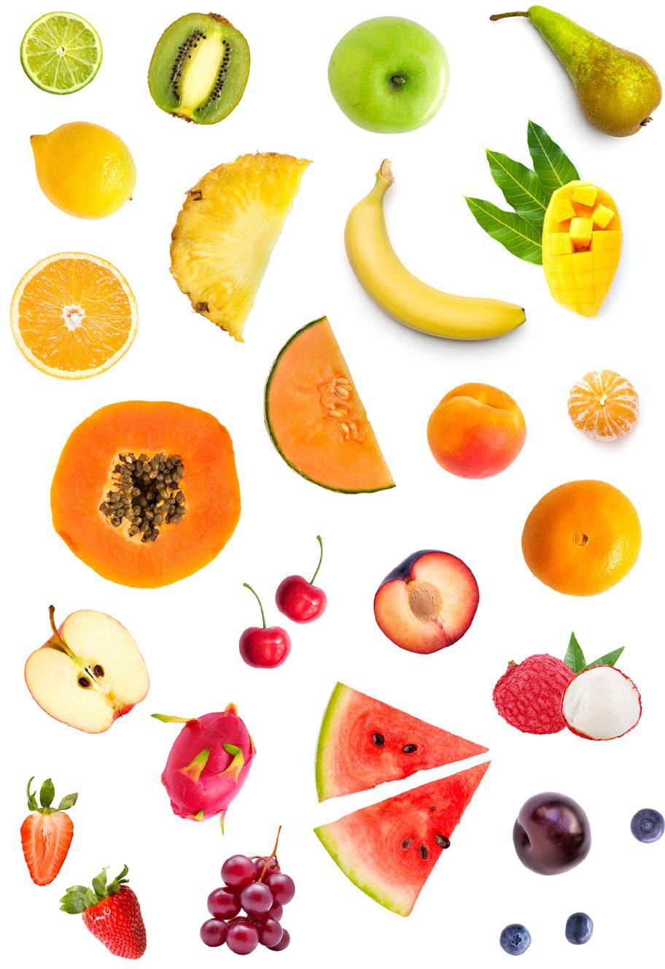

6 7

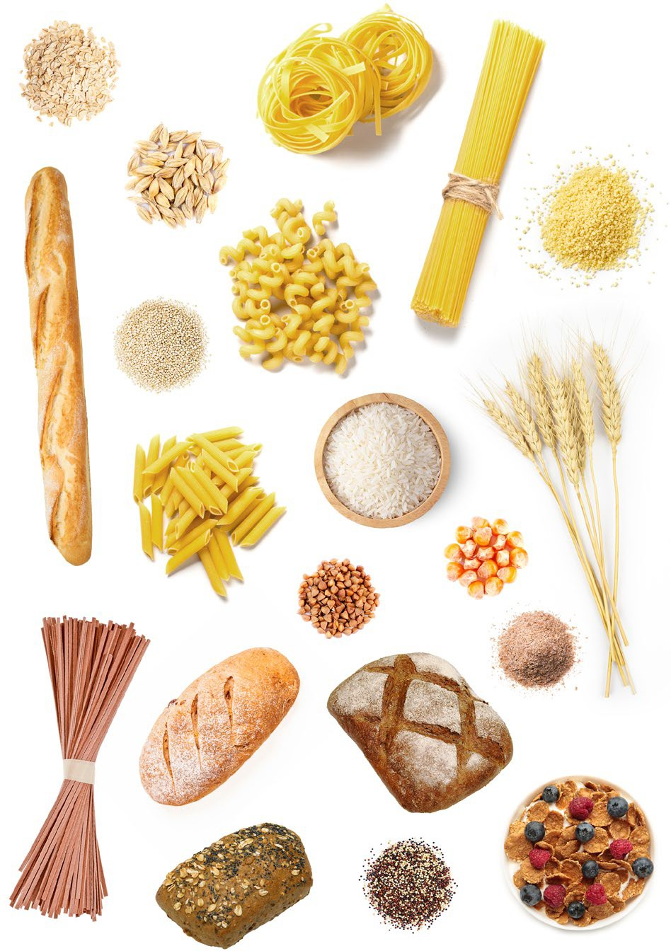
Grains

Meat & Dairy

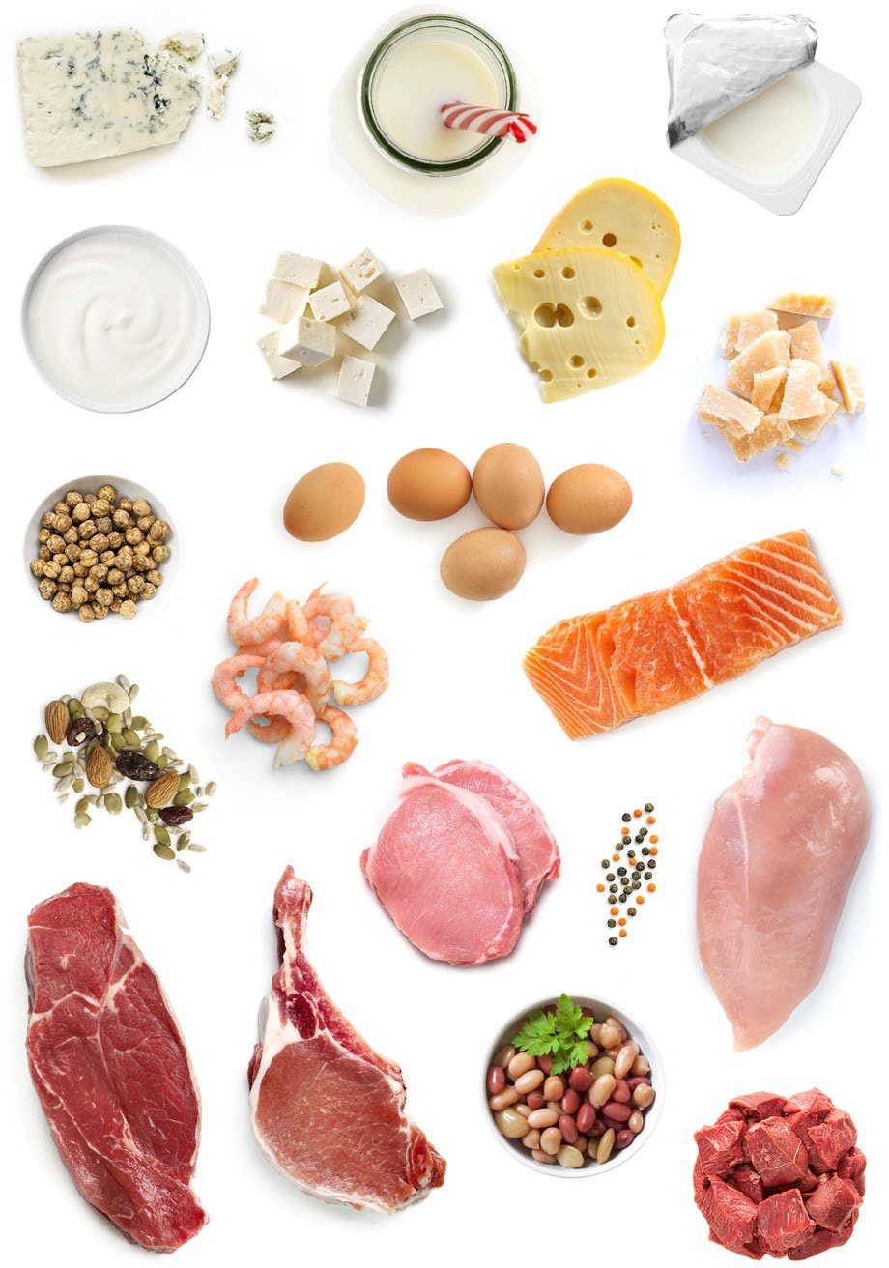

8 9

HOW MANY SERVES DO YOU NEED EACH DAY?



HOW MUCH IS A SERVE?

A serve is a way of measuring food.
You need different amounts of food from each food group to give your body the nutrients it needs . You can estimate a serve of different foods by using your hands:

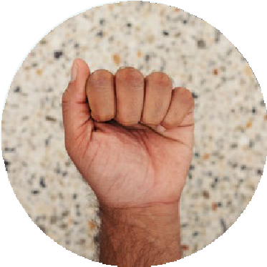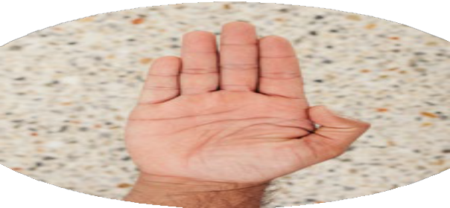

Whole fist
 |  |  |  | 
Babies & Toddlers
0–12 months | Breastmilk, or commercial infant formula, is the main food until around 6 months old .
1–3 years | 2 – 3 | ½ – 1 | 4 | 1 | 1 – 1½
Children
4–8 years | 4½ | 1½ | 4 | 1½ | 1½ – 2
9–11 years | 5 | 2 | 4 – 5 | 2½ | 2½ – 3
Teenagers
12–13 years | 5 – 5½ | 2 | 5 – 6 | 2½ | 3½
14–18 years | 5 – 5½ | 2 | 7 | 2½ | 3½
Pregnancy | 5 | 2 | 8 | 3½ | 2½ – 3½
Breastfeeding | 5½ | 2 | 9 | 2½ | 4
Adults
19–50 years | 5 – 6 | 2 | 6 | 2½ – 3 | 2½
Pregnancy | 5 | 2 | 8½ | 3½ | 2½
Breastfeeding | 7½ | 2 | 9 | 2½ | 2½
Older Adults
51–70 years | 5 – 5½ | 2 | 4 (Women)  6 (Men) | 2 – 2½ | 4 (Women) 2½ (Men)
70+ years | 5 | 2 | 3 (Women) 4½ (Men) | 2 – 2½ | 3½ – 4

Useful for estimating:
- Non-starchy vegetables
- Legumes
- Fruit
- 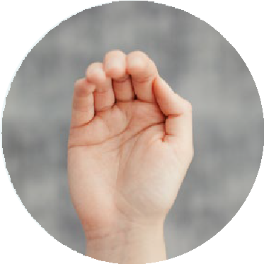Milk and yoghurt

Cupped palm
Useful for estimating:
- Dried fruit
- Nuts

10

Half fist
Useful for estimating:
- Starchy vegetables
- Rice, pasta and cereal
- Tofu

Thumb
Useful for estimating:
- Cheese

Palm
Useful for estimating:
- Bread
- Meat, poultry and fish

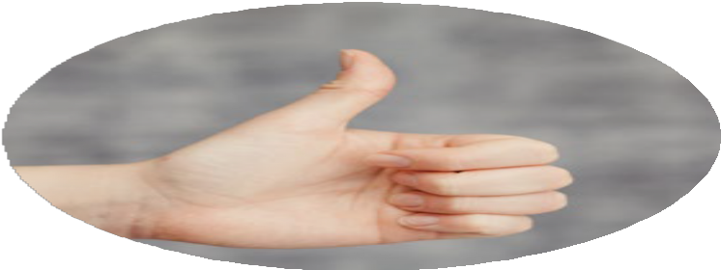

Tip of thumb
Useful for estimating:
- Oil
- Margarine

11

CHOOSE WATER EVERY DAY
Your body needs water to perform most of its functions . Tap water is the best choice .

Swapping sugary drinks like juice, cordial and soft drinks for tap water helps you:
Maintain a
healthy weight
Prevent chronic
diseases
Have healthy
teeth

BE PHYSICALLY ACTIVE
Physical activity includes exercise, as well as other movements you make as part of working, playing or relaxing .

Together with a healthy eating pattern, regular physical activity helps you:

Maintain a
Have strong
healthy weight
muscles and
Feel good and
bones
sleep well

How much water do you need each day?
Babies | Start to give your baby water in a sippy cup from 6 months old . If your baby is having infant formula, give them water that has been boiled and cooled on hot days before 6 months old . | Adults
Toddlers |  | Older Adults
Children |  | Pregnancy
Teenagers |  | Breastfeeding

How much physical activity do you need?

Be careful with alcohol
To reduce the risk of harm from alcohol-related disease or injury, adults should drink no more than 10 standard drinks a week and no more than 4 standard drinks on any one day . Not drinking alcohol is the safest option if you are pregnant or breastfeeding .
Babies 30 minutes tummy time

per day
AT HOME

Try balancing or stretching while watching TV or brushing your teeth

Cleaning counts as part of daily physical activity

Gardening is a good way to be physically active
AT SCHOOL

Physical activity can improve children’s concentration

Safe biking and walking routes to school benefit children and the environment.

Organised sports and playground games give children opportunities to move
AT WORK

Physical activity at work increases productivity

Get o public transport a few stops before your destination

Use the stairs, not the elevators
Toddlers

3 hours play per day
Children 60 minutes per day
Teenagers 60 minutes per day
Adults 2 ½ hours per week
Older Adults 30 minutes most days
Pregnancy 2 ½ hours per week


A standard drink = 10 grams of alcohol
Wine
100ml glass
Sparkling
100ml glass
Spirit
30ml nip (shot glass)
Cider
285ml glass (pot)
Beer
(Full Strength)
285ml glass (pot)
Beer (Light) 425ml glass (schooner)
SCREEN TIME & SITTING DOWN
Limit screentime and break up periods of sitting by doing lunges, star jumps or walking around.



12 13

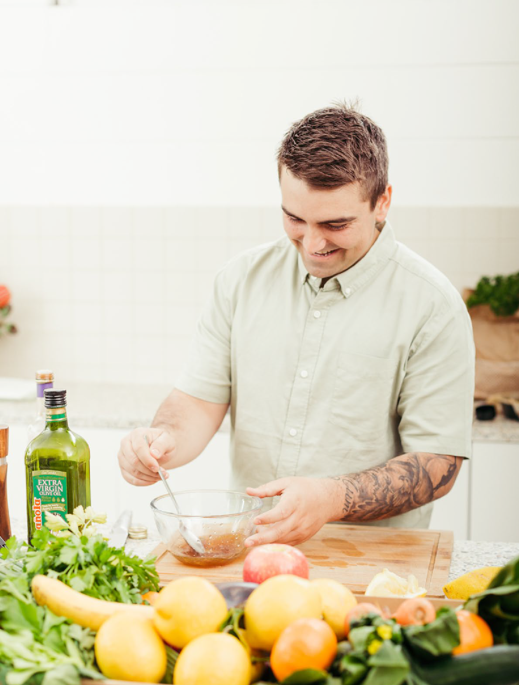PLAN WHAT YOU EAT
EATING
HEALTHY
SKILLS
Meal planning involves thinking ahead and planning what you’ll eat for the week, buying the ingredients in advance and preparing the food when it suits you .

Planning your meals helps you:
Cook more
often
Save time and
money
Reduce food
waste

HOW TO PLAN A BALANCED MEAL
Breakfast
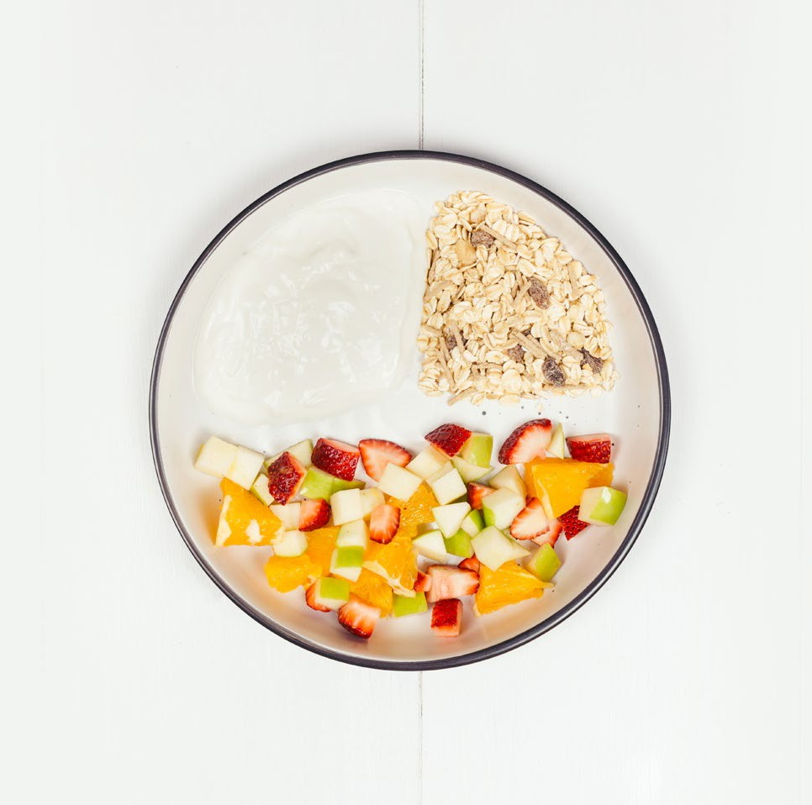
¼
Lean meat, dairy or alternatives
Grains
¼
½
Vegetables and fruit

15
14

Lunch Dinner
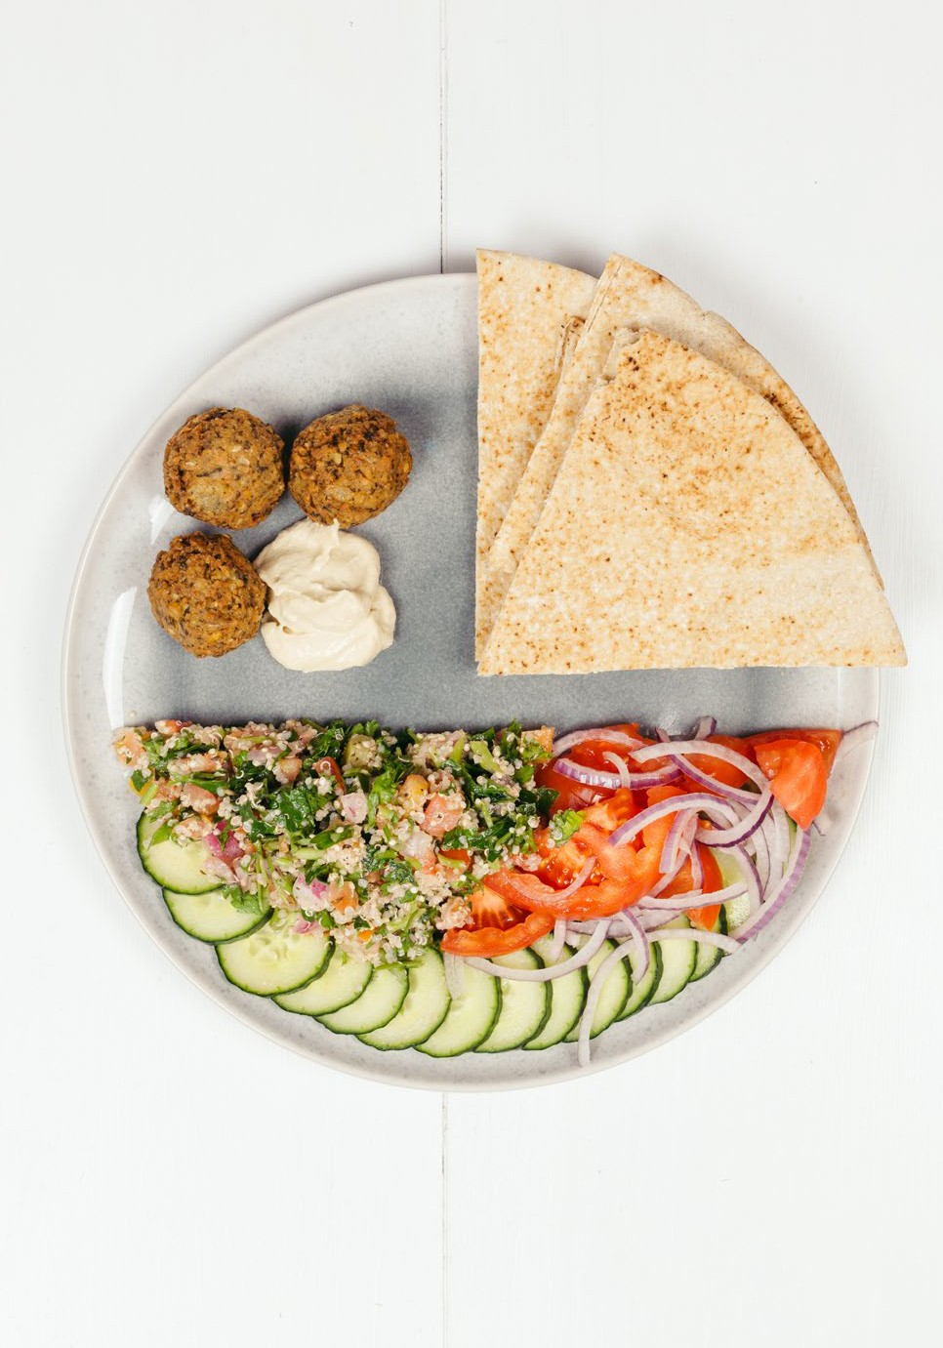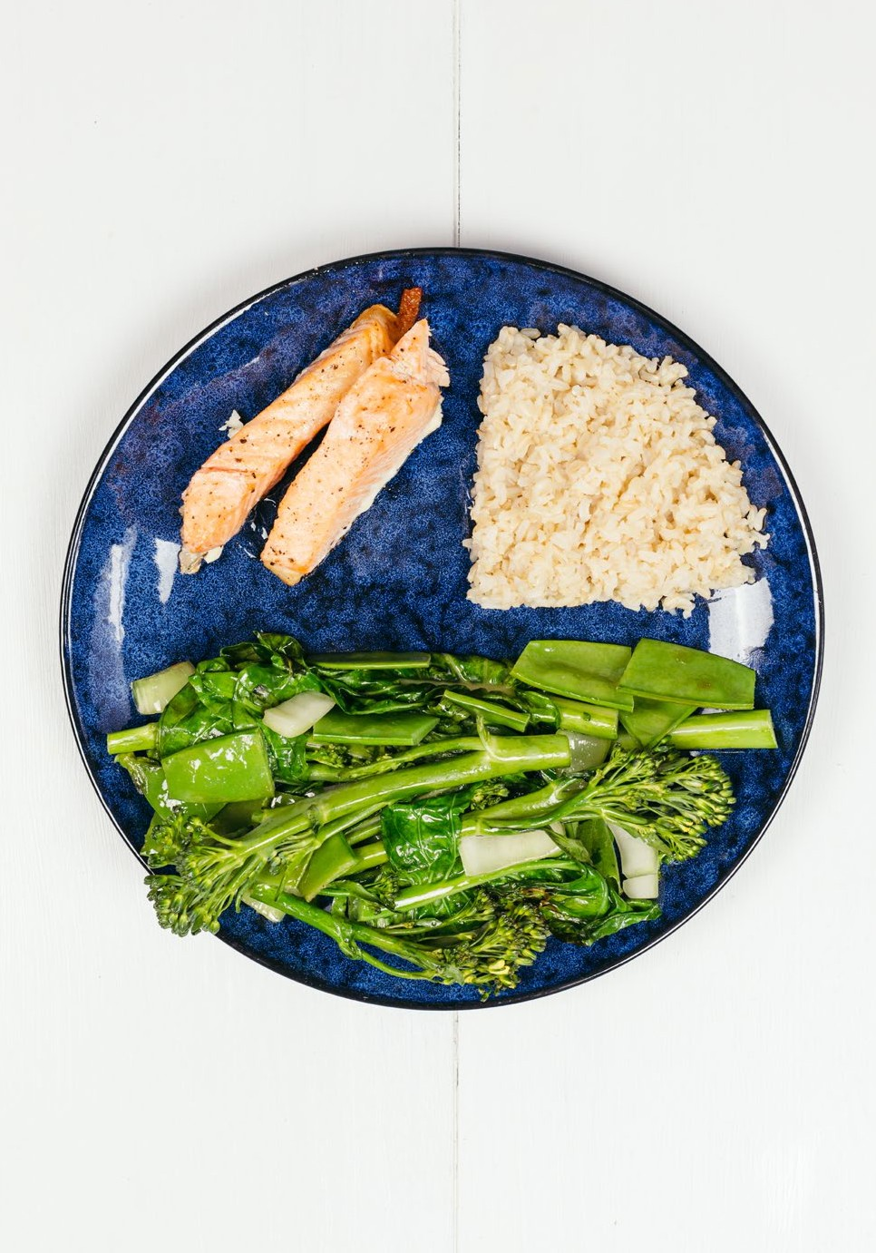
¼
Lean meat, dairy or alternatives
Grains
¼
½
Vegetables and fruit
¼
Lean meat, dairy or alternatives
Grains
¼
½
Vegetables and fruit

16 17

SELECT HEALTHY INGREDIENTS
Packaged foods are convenient and can make healthy eating more affordable . Look for options that have little or no added:

PREPARE HEALTHY MEALS
Cooking at home doesn’t have to be complicated and is an enjoyable way to spend time with others .

Cooking more often helps you:

Salt Sugar Saturated fat
Try new foods Learn new skills Save money

Healthy staples
A few small changes can make your favourite dishes healthier and reduce your risk of chronic diseases .

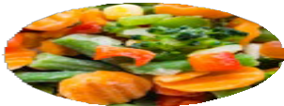 | Frozen vegetables  - Frozen vegetables are just as nutritious as fresh .  - Add frozen vegetables to a stir fry, curry or soup . | 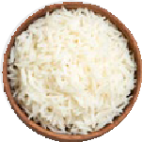 | Pre-cooked rice  - A convenient alternative to cooking rice when you’re short on time .  - Look for Basmati or brown varieties without added flavourings.
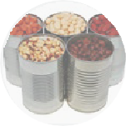 | Canned beans and legumes  - Canned beans are an affordable source of protein and fibre.  - Add bean mix to salads, chickpeas to curries or lentils to lean mince dishes . | 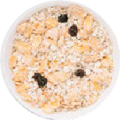 | Rolled oats  - Enjoy as porridge for breakfast or add to smoothies and muffins.  - Choose traditional over quick or instant varieties .
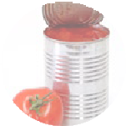 | Canned tomatoes  - Canned tomatoes can form the base for many easy recipes .  - Look for options with no added salt . | 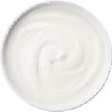 | Yoghurt  - Yoghurt is a great snack or addition to fruit and muesli .  - Choose reduced-fat options like Greek or natural yoghurt .
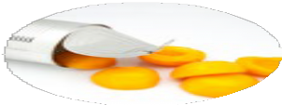 | Canned fruit  - Canned fruit is an easy option when fresh varieties are not in season .  - Choose varieties canned in juice instead of syrup and drain it off . | 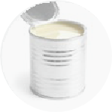 | Evaporated milk  - Light evaporated milk is a great alternative to cream and coconut milk .  - Use it in pasta, risotto and curry .
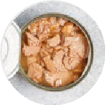 | Canned salmon or tuna  - Canned fish has a long shelf life and is an easy addition to many recipes .  - Choose varieties canned in springwater . | 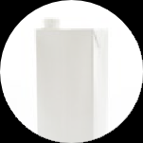 | Long-life or UHT milk  - Light UHT milk is just as good for you as fresh .

Foundation recipes
Foundation recipes are useful for making quick, easy and affordable meals . They can also be transformed into new dishes by adding extra ingredients . This adds variety to bulk meals if you are cooking for one .

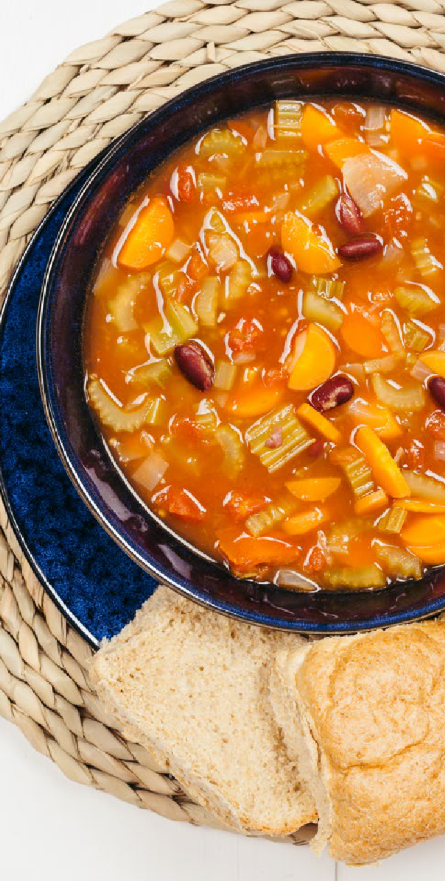
Basic Soup

Ingredients (serves 4)
- 1 tablespoon olive oil
- 1 teaspoon minced garlic
- 1 brown onion, diced
- 4 celery stalks, chopped
- 2 carrots, chopped
- 1 can reduced-salt tomatoes
- 1 can reduced-salt beans, drained and rinsed
- 1 litre reduced-salt stock

Steps
1 . Heat the oil in a large saucepan . Add the garlic and onion, cook until translucent .
2 . Add the celery and carrots, cook until tender . Pour in the tomatoes, beans and stock .
3 . Bring to the boil, then reduce the heat .
Cover and simmer for 30 minutes .

Mexican bean soup – Cook the onions with one teaspoon each of cumin and paprika . Shred any leftover roast meat and add to the basic recipe . Heat through . Serve with lime, coriander and reduced-fat sour cream .

Adapted from HEAS (2016)

18 19

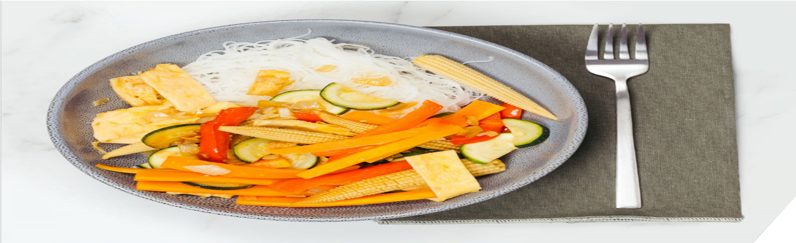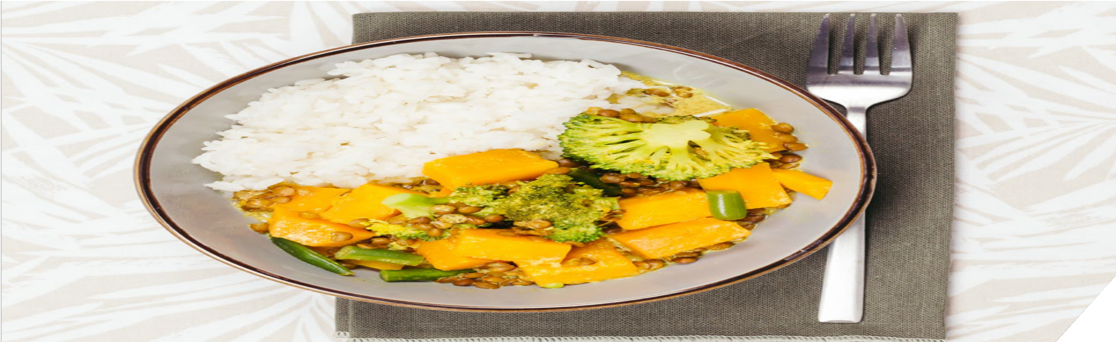

Basic Stir Fry

Ingredients (serves 4)
- 4 eggs
- 1 tablespoon sesame oil
- 1 brown onion, sliced
- 1 teaspoon minced garlic
- 1 teaspoon crushed ginger
- 1 carrot, sliced
- 1 red capsicum, sliced
- 1 zucchini, sliced
- 1 can reduced-salt baby corn, drained and rinsed
- 1 tablespoon reduced-salt soy sauce

Steps
1 . Beat the eggs with a fork and pour into a hot wok or pan . Cook to form a thin omelette, then set aside .
2 . Heat the oil . Add the onion, garlic and ginger .
Stir fry until translucent . Add the vegetables and soy sauce . Stir fry until tender .
3 . Cut the cooked egg into strips . Add to the pan and stir fry for 2 to 3 minutes to heat through .

Pork and cashew stir fry – Add 350g of cooked pork strips to the basic recipe, replacing the eggs . Heat through . Top with 1/3 cup of chopped unsalted cashews and serve with rice noodles .

Adapted from HEAS (2016)

Basic Curry

Ingredients (serves 4)
- 1 tablespoon olive oil
- ½ butternut pumpkin, peeled and diced
- 1 teaspoon minced garlic
- 1 teaspoon crushed ginger
- 2 teaspoons curry powder
- 2 cups reduced-salt stock
- 1 can reduced-salt lentils
- 1 cup green beans, chopped
- 1 broccoli, chopped
- 1 can reduced-fat coconut flavoured evaporated milk

Steps
1 . Heat the oil in a wok or pan . Add the pumpkin, garlic, ginger and curry powder, stir for 2 minutes .
2 . Pour in the stock and lentils, gently simmer for 5 minutes . Add the remaining vegetables, continue simmering until tender .
3 . Stir in the evaporated milk and gently heat through . Take care not to boil the milk .

Thai green curry – Use 1 tablespoon of green curry paste, instead of curry powder . Add 300g of cooked diced chicken, replacing the lentils . Heat through . Top with lime juice and serve with rice .

Adapted from HEAS (2016)


21
20

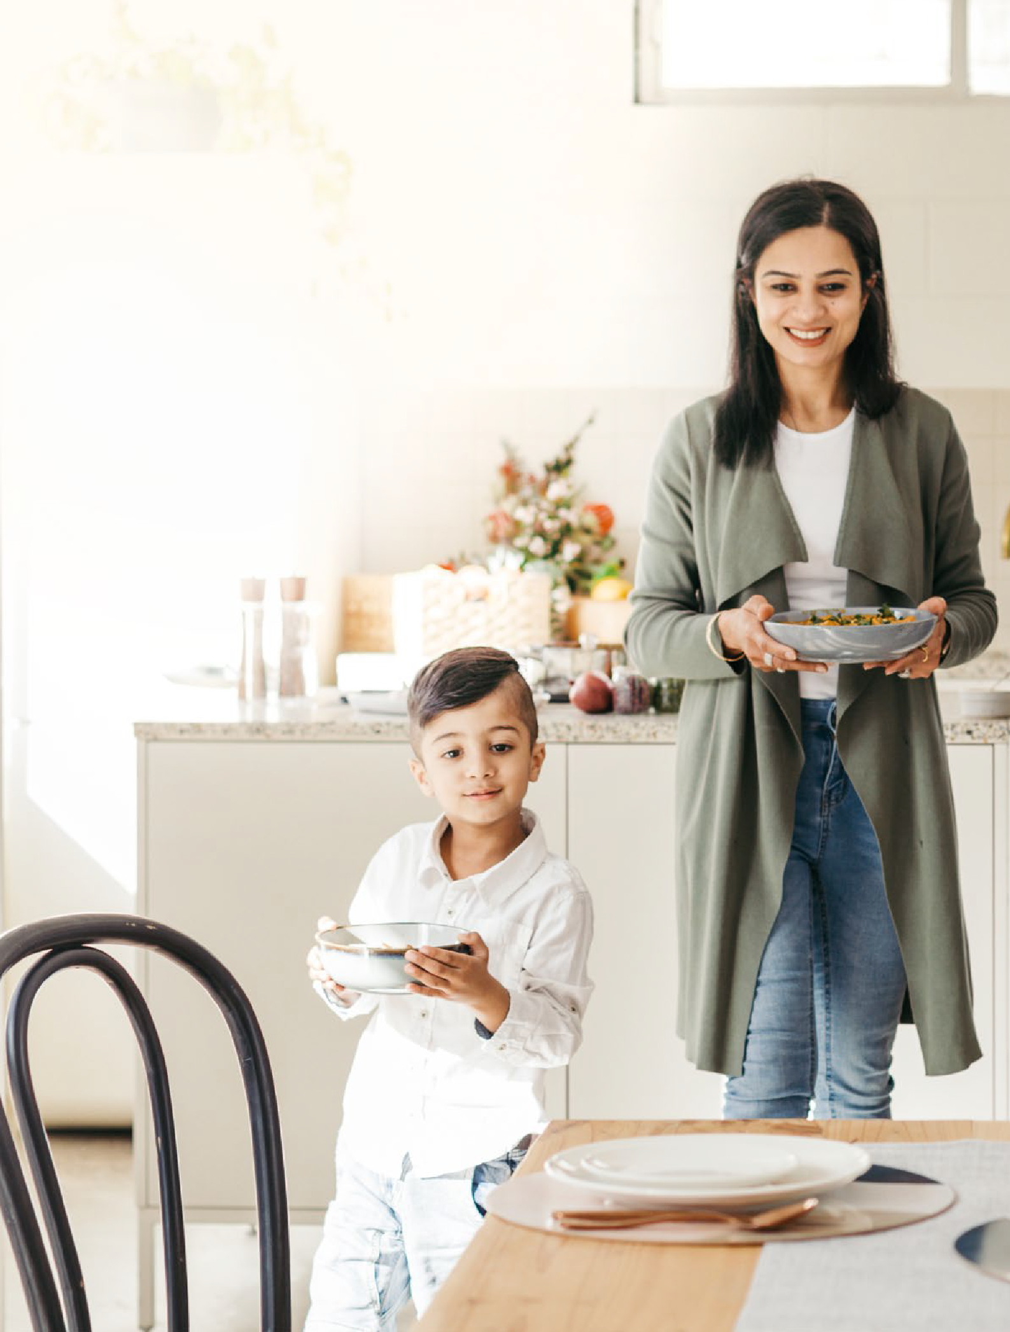EAT TOGETHER
HEALTHY
HABITS
EATING
Sharing meals is a fun and enjoyable activity . If you live alone, consider eating together with family, friends, neighbours and colleagues, or join a community kitchen .

Eating together helps you:
Try new foods
Create stronger
bonds
Learn new skills
and manners

How to create positive mealtimes
22

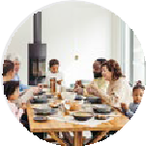 | Minimise distractions  - Turn off the TV . Put phones and tablets away .  - Sit down together while eating . | 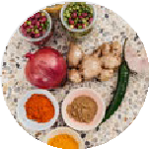 | Parents provide, kids decide  - Provide a range of foods with different colours, flavours and textures .  - Encourage everyone to try all the foods offered .  - Let children and young people decide when they’re full .
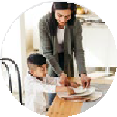 | Set the scene  - Use table cloths, placemats or candles to make mealtimes more special .  - Let children decide how to set the table or, if they’re a bit older, pick the music . | 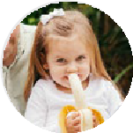 | Expect some mess  - Let babies hold finger foods and spoons to try and feed themselves .  - Young children can eat with their fingers if they are learning to use utensils .  - Encourage children to serve, pass and pour food and drinks .
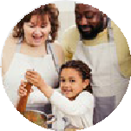 | Be a role model  - Include babies in mealtimes as soon as they start eating solids .  - If possible, eat the same meals and snacks as children .  - Talk positively about food . Avoid discussing personal food likes or dislikes . | 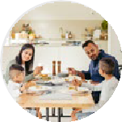 | Start a conversation  - Discuss upcoming plans and what’s happening .  - Tell stories about earlier times in your lives .  - Use real-world events to talk to children about topics that are important to your family .

23

REDUCE FOOD WASTE
The types of foods you buy and eat, and how you use and get rid of those foods, has an impact on the environment .
Buying less food and using what you have helps you:
Save money
Preserve natural
Reduce
resources
greenhouse gas
emissions

ENJOY TRADITIONAL FOODS
Including traditional foods in your eating patterns can improve your skills and knowledge, create a sense of community, and teach you about different cultures .

You can celebrate your culture and food traditions by:
Growing, sourcing and preparing foods in traditional ways
Shopping for ingredients to make traditional foods
Attending multicultural community events.

How to reduce food waste

IN THE COMMUNITY AT HOME
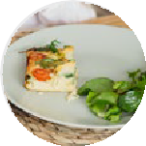 | Smaller portions  Share large portions at restaurants, or order an entrée size . | 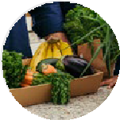 | Organise the fridge and pantry  When you put new food into your fridge, move older items up to the front and tuck the new ones in the back .  Use up fresh produce first.
 | Shop smart  Plan your meals, check what you have at home before you shop, and only buy as much as you need . | 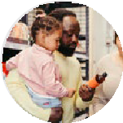 | Read the label  ‘Use by’ means food can be eaten safely up until this date .  ‘Best before’ means the quality of food is higher before this date, but is generally still safe to eat after .
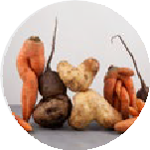 | Buy ‘ugly’ produce  Imperfect fruits and vegetables are just as good for you and can be cheaper . | 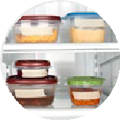 | Save leftovers  Save leftovers for other meals or use them to create new dishes .
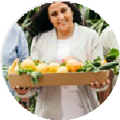 | Donate  If you have too much of something, share or swap it with neighbours and friends . | 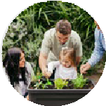 | Compost  Compost your scraps in your garden or at local community gardens .

SOURCE: Sustainability Victoria 2021 & WHO 2016

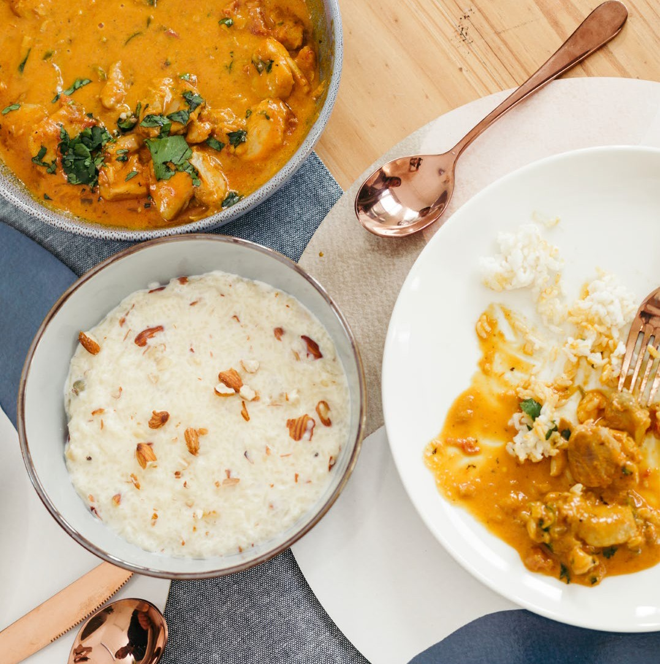

24 25

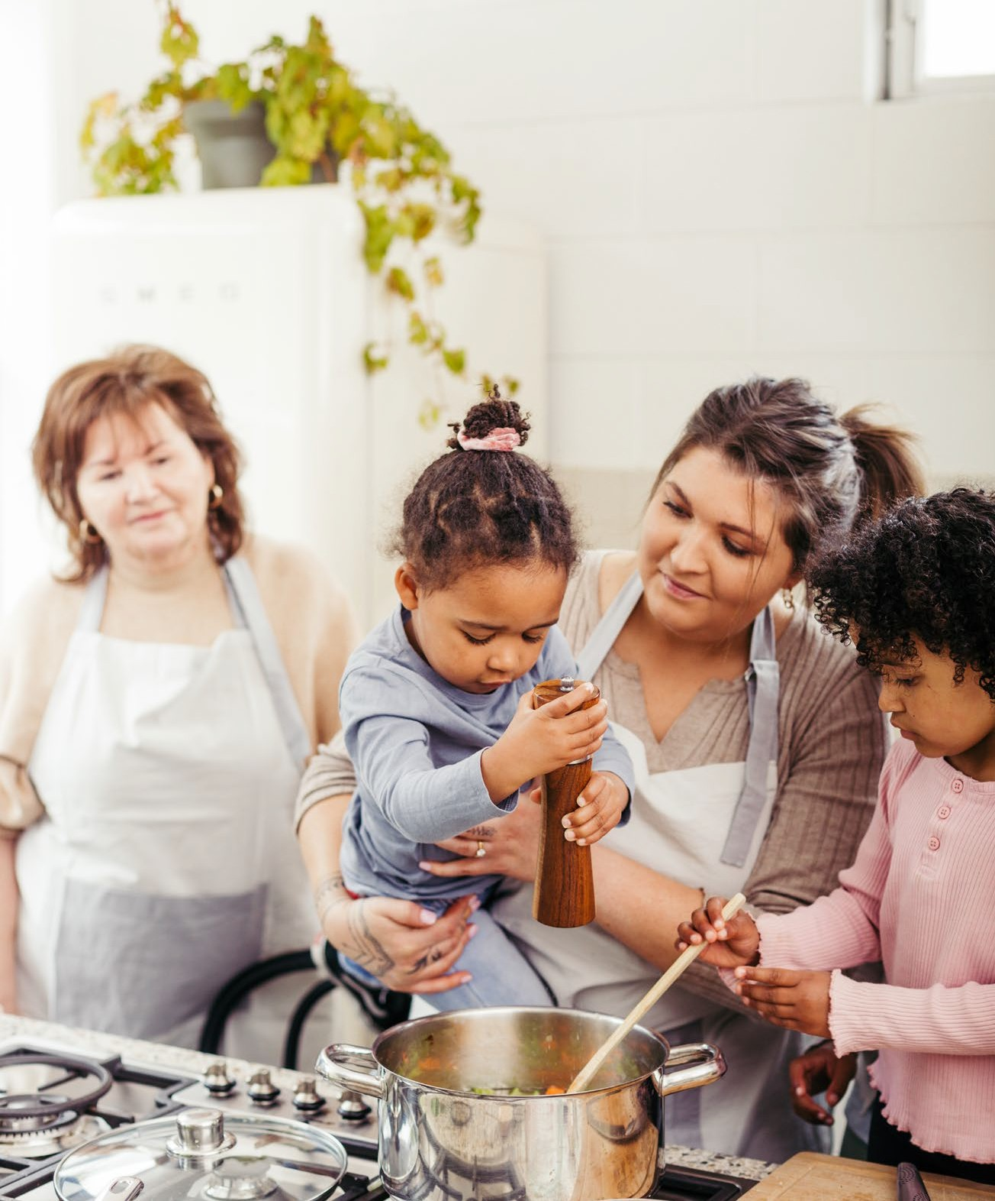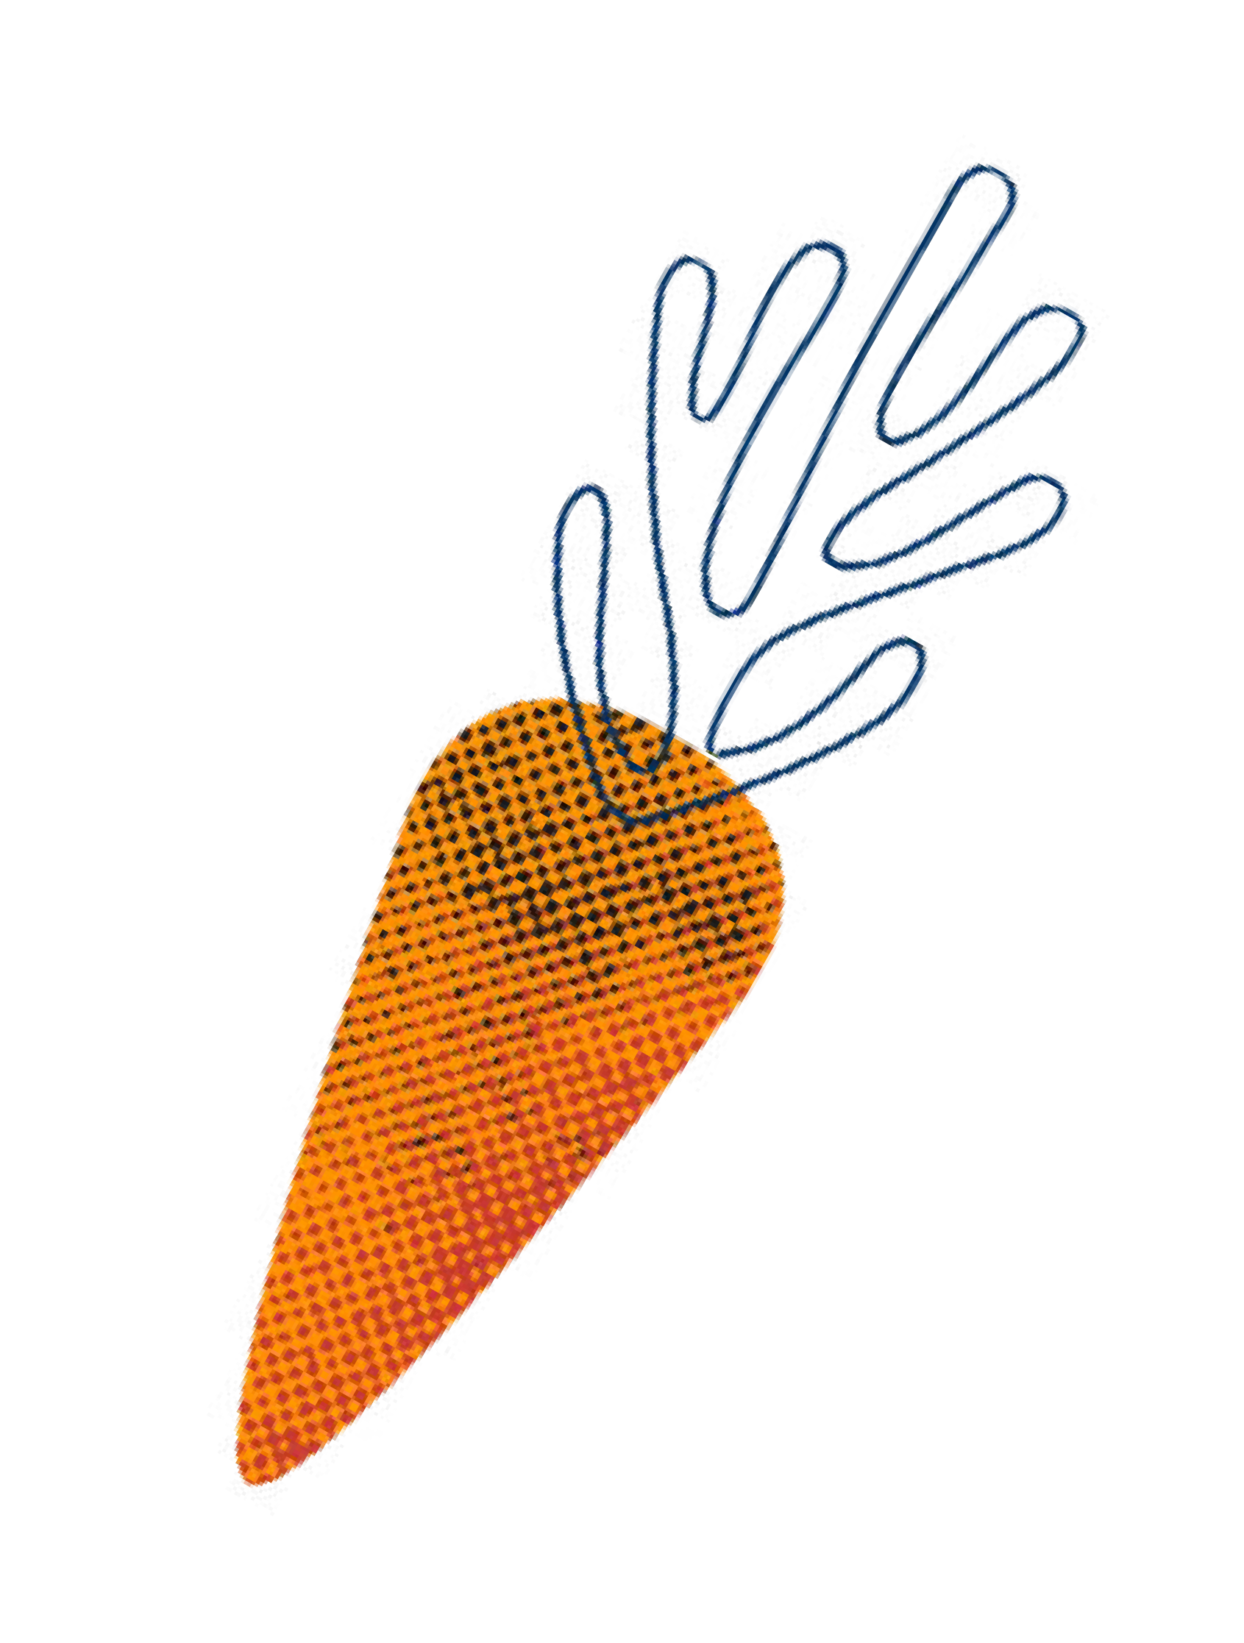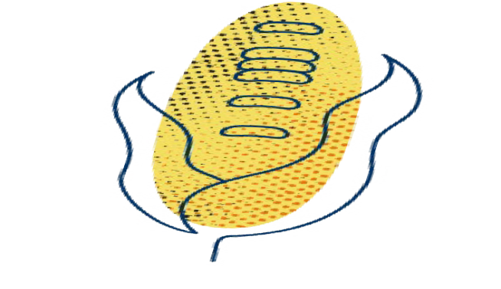LEARN MORE

Resources
For more information, visit:

Eat Well, Live Well – City of Greater Geelong
www .geelongaustralia .com .au/eatwell

Eat for Health
www .eatforhealth .gov .au

Nutrition Australia
www .nutritionaustralia .org .au

Better Health Channel
www .betterhealth .vic .gov .au

Victorian Aboriginal Community Controlled Health Organisation Inc .
www .vaccho .org .au/wd/nutrition

Health Translations
www .healthtranslations .vic .gov .au

Need more help? Ask your doctor or a local health service for advice on your individual needs .

References
The following references informed this guide:
Department of Health (2021) Physical activity guidelines for all Australians . www .health .gov .au/ health-topics/physical-activity-and-exercise (accessed on 25 August 2021) .
National Health and Medical Research Council (2020) Australian guidelines to Reduce Health Risks from Drinking Alcohol . Canberra: National Health and Medical Research Council .
National Health and Medical Research Council (2013) Australian Dietary Guidelines . Canberra: National Health and Medical Research Council .
National Health and Medical Research Council (2013) Australian Guide to Healthy Eating . Canberra: National Health and Medical Research Council .
National Health and Medical Research Council (2013) Infant Feeding Guidelines . Canberra: National Health and Medical Research Council .
National Health and Medical Research Council (2013) Nutrient Reference Values for Australia and New Zealand . Canberra: National Health and Medical Research Council .

26
27

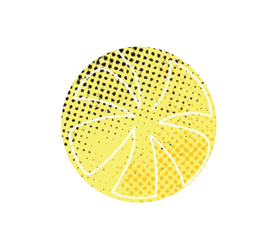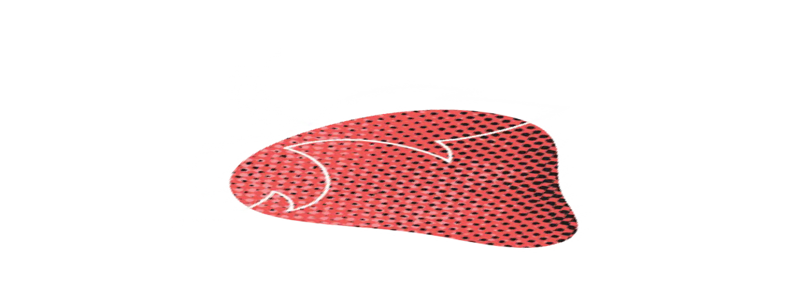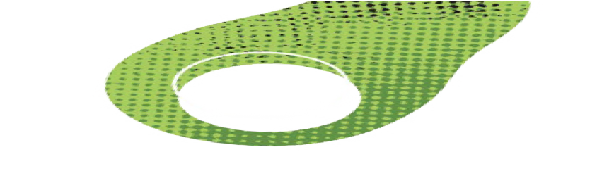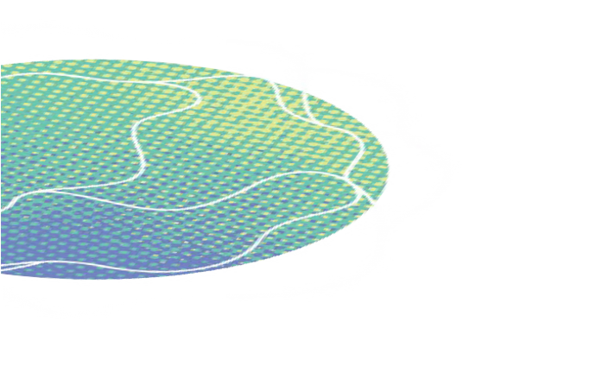

CITY OF GREATER GEELONG
Wadawurrung Country PO Box 104
Geelong VIC 3220
P: 5272 5272
E: contactus@geelongcity.vic.gov.au www.geelongaustralia.com.au

© City of Greater Geelong 2021

LATEST NEWS:
 @CityofGreaterGeelong @GreaterGeelong

 @CityofGreaterGeelong CityofGreaterGeelong

