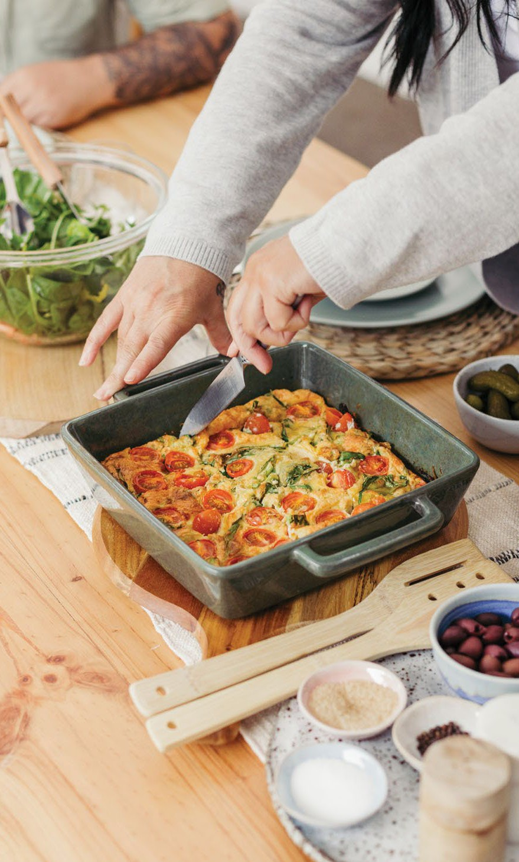
SPINACH, TOMATO & FETA FRITTATA

Ingredients
- Cooking spray
- 4 eggs
- ½ cup milk
- ¼ cup self-raising flour
- ½ cup reduced-fat cheese, grated
- ½ cup reduced-fat feta cheese, crumbled
- 2 spring onions, chopped
- 1 cup baby spinach
- Handful of cherry tomatoes, halved

Instructions

- Preheat the oven to 200°C. Lightly grease a baking dish with the cooking spray.
- Whisk the eggs and milk in a large bowl. Mix in the flour, cheese, spring onions and spinach.
- Pour the mixture evenly into the baking dish. Top with cherry tomatoes and bake for
30 minutes.
- Serve with crusty wholegrain bread and salad. Store in an airtight container in the fridge for 2 days.

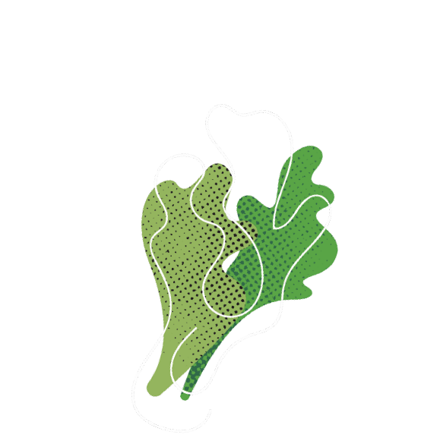
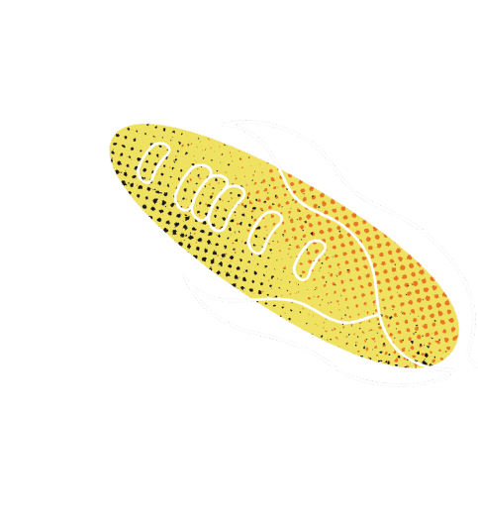
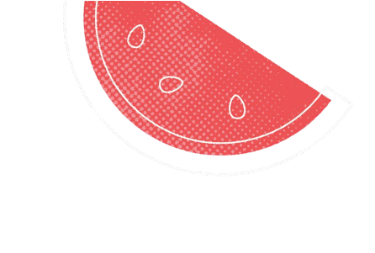


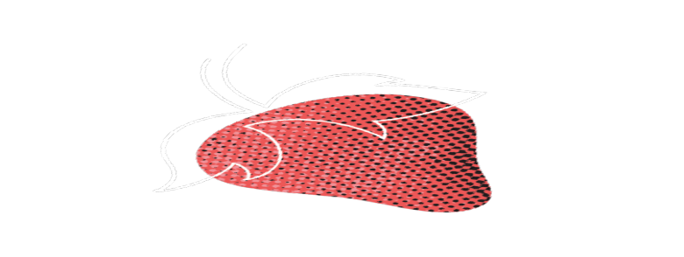



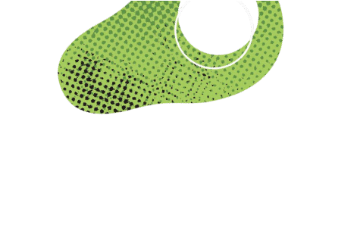















Healthy eating for every life stage
Find meal plans, recipes and more at geelongaustralia.com.au/eatwell

