

EASTERN PARK AND GEELONG BOTANIC GARDENS
Strategic Plan - Master Plan
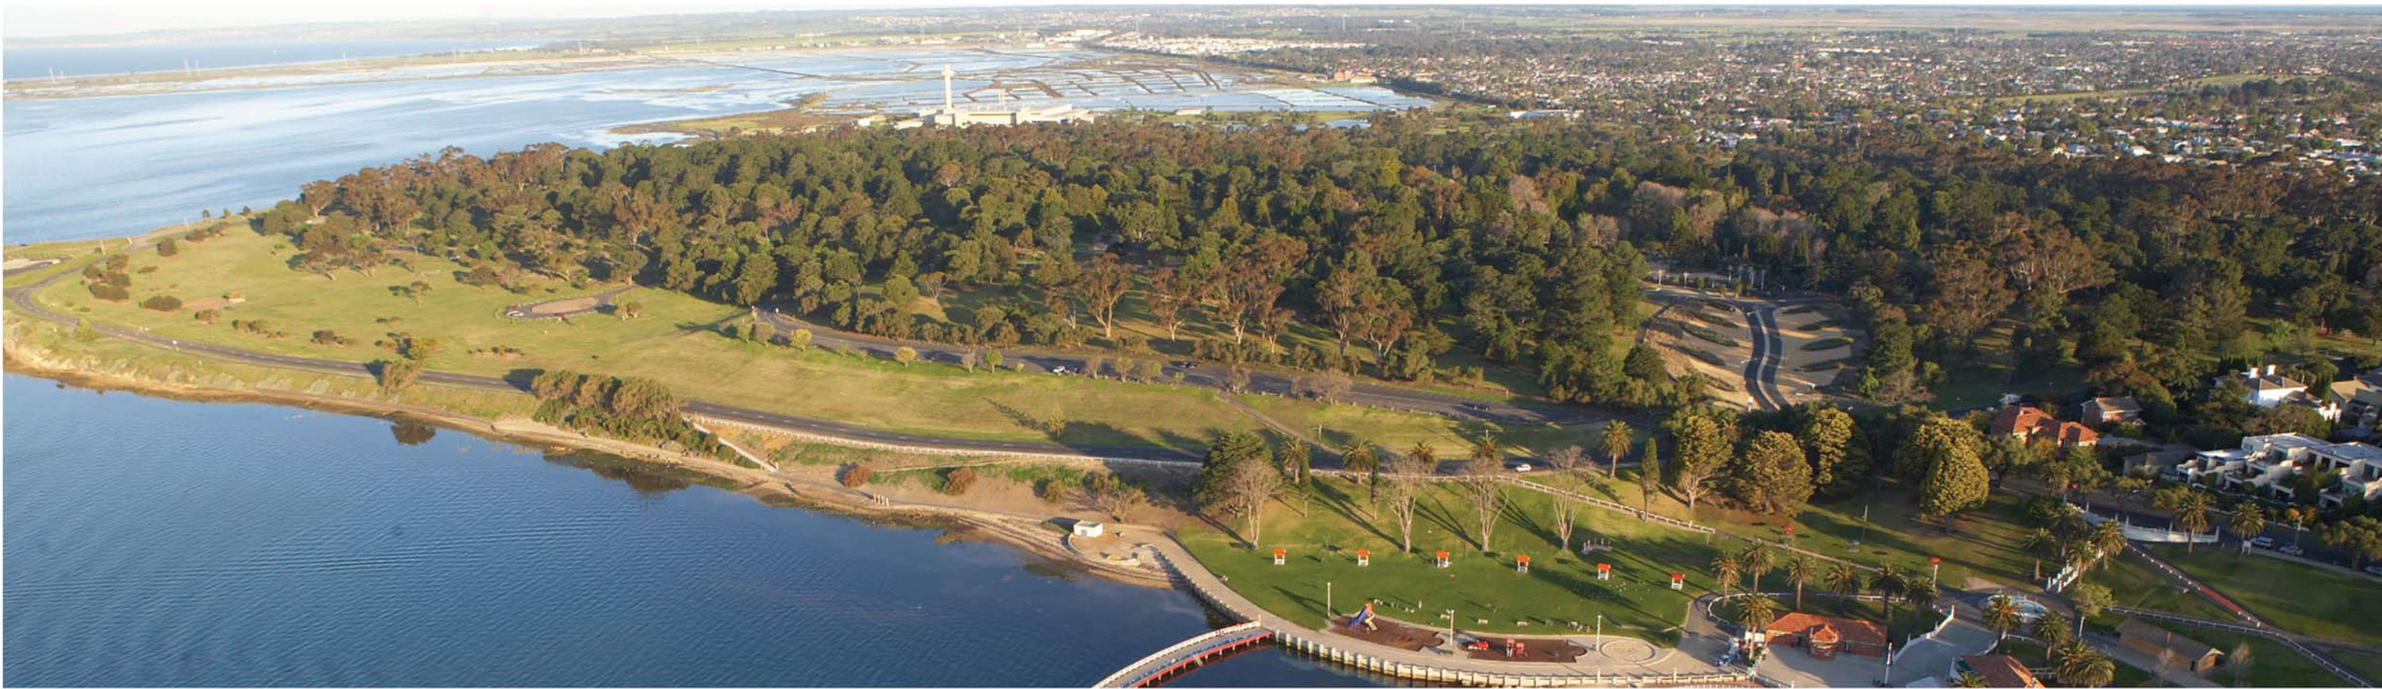
January 2008

WWW.GEELONGAUSTRALIA.COM.AU
CITY OF GREATER
GEELONG

Table of Contents
- Introduction 4
  - Background 4
  - Aims & Objectives 5
1.2.1 | Aim | 5
1.2.2 | Objectives | 5

  - Study Area 5
  - Key Tasks 5
  - Project Management 6
 |  | 1.5.1 | Project Control Group | 6
 |  | 1.5.2 | Project Working Group | 6
 |  | 1.5.3 | Stakeholder Reference Group | 6
 |  | 1.5.4 | Project Manager | 6
 |  | 1.5.5 | Project Team | 6
2 | History |  |  | 7
 | 2.1 | History |  | 7
 | 2.2 | Landscape Elements |  | 7
 | 2.3 | Signiﬁcance |  | 7
3 | Analysis |  |  | 8
 | 3.1 Physical Landscape |  |  | 8
 | 3.1.1 Landscape & Environment – Eastern Park |  |  | 8
 | 3.1.2 Landscape & Environment – Geelong Botanic Gardens |  |  | 10
 | 3.1.3 Landscape Character |  |  | 12
 | 3.2 Land Use & Activity |  |  | 14
 | 3.2.1 Land Use & Activity – Eastern Park |  |  | 14
 | 3.3 Access & Movement |  |  | 16
 | 3.3.1 Access & Movement – Eastern Park |  |  | 16
 | 3.3.2 Access & Movement – Geelong Botanic Gardens |  |  | 18
 | 3.4 Leisure & Recreation |  |  | 20
 | 3.4.1 Leisure Strengths |  |  | 20
4 | Consultation |  |  | 21
5 | Issues |  |  | 22
 | 5.1 Landscape |  |  | 22

  - Trees 22
  - Heritage 22
  - Archaeology 22
  - Recreation 22
  - Events 23
  - Access 23
  - Sustainability 24
  - Wildlife 24
  - Education 24
  - Existing Buildings 24
  - Infrastructure 25
  - Possible Future Developments 25
  - Other Current Studies / Policies 25
- Opportunities for Enhancing Leisure Experiences 27
  - A dedicated hierarchy of paths for cycling and walking 28
  - Reinforcing the leisure value of the Geelong Botanic Gardens 28
  - Existing visitor activity groups and their facilities 29
- Vision Statement 30
- Principles 31
- The Master Plan 32
- Actions 34
  - Pedestrian Movement 34
    - Action 1 – ‘The Compelling Link’ 34
    - Action 2 – An accessible and legible pedestrian network 35
    - Action 3 – A well connected park 36
    - Action 4 – An integrated Geelong Botanic Gardens 37
    - Action 5 – A ‘shared’ Eastern Park Circuit 38
  - Vehicle Movement 39
    - Action 6 – Reconﬁgured Golf Club and Convention
Centre access 39
    - Action 7 – Removal of vehicles from Adams Court 40
    - Action 8 – Intersection improvements 41
    - Action 9 – Eastern Park Circuit 42
    - Action 10 – Formalised car parking 43
    - Action 11 – New shared path 44
  - Landscape 45
    - Action 12 – The Pinetum 45
    - Action 13 – The Australian Landscape 46
    - Action 14 – Strategic Direction for the Geelong
Botanic Garden 47
    - Action 15 – New Botanic Garden Collection 48
    - Action 16 – Screening the Depot 49
    - Action 17 – The Avenues 50
    - Action 18 – The Flying Foxes 51
    - Action 19 – The Foreshore 52
    - Action 20 – The Wetland 53
  - Attractions & Facilities 54
    - Action 21 – Eastern Park Horticultural Complex 54
    - Action 22 – The Walter Conservatory 55
    - Action 23 – The Superintendent’s Residence 56
    - Action 24 – Sculpture Park 57
    - Action 25 – The Sports Fields 58
    - Action 26 – Geelong Mineral Springs Bath House 59
    - Action 27 – The Amphitheatre 60
    - Action 28 – Integration of existing attractions 61
    - Action 29 – Heritage buildings and structures 62
    - Action 30 – Amenities 63
    - Action 31 – Botanic Gardens perimeter fence 64
    - Action 32 – Golf Course improvements 65
- Implementation Strategy 66
  - Opinion of Probable Cost and Project Prioritisation 66
  - Establishment of Strategic Implementation Group 70
    - Strategic Implementation Group & Project Manager 70

Appendices (in separate volume)
Appendix A Summary of survey results Appendix B Street and park furniture style guide
Appendix C Detailed Master Plan concept designs

Introduction
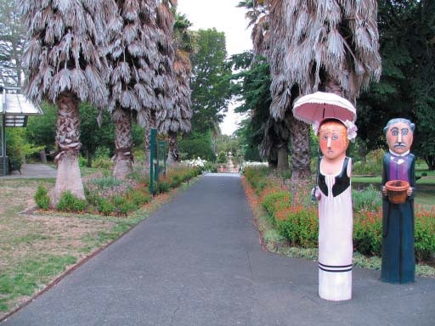
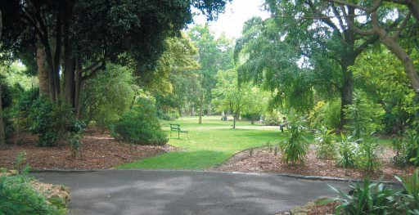
Eastern Park is Geelong’s premier regional park. It draws visitors from across the country due to its facilities, attractions and events of national and international signiﬁcance. It is located within central Geelong, adjacent to Eastern Beach and the Geelong Waterfront and has frontage onto Corio Bay. The park has an array of active and passive uses. Eastern Park is home to the Geelong Botanic Gardens, which is recognised as a key regional Botanic Garden and is a destination within its own right. The Gardens were extended in 2002 to create a new 21st Century Garden, and has become a signiﬁcant drawcard for the park. Critical to this plan is to recognise the interdependency of the Botanic Gardens to the surrounding parkland.
Following the development of a Master Plan for the park in 1995, Eastern Park has been subject to a number of development proposals given its size, location and array of uses. These demands need to be examined in an integrated planning process and thus it is timely that a revised plan for the park, that builds on previous work, is developed.

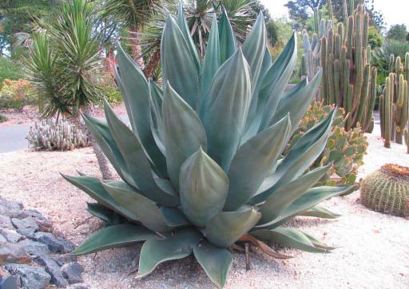
Background
In 1851, the Government set aside approximately 81 hectares of land to the east of the Geelong township for the purposes of a Botanic Gardens. Initially the whole of Eastern Park was referred to as the Botanic Gardens, the apparent intention being to develop a signiﬁcant portion of the reserve to a high degree of cultivation. Over time the nursery area of the Gardens became the focal point for cultivation and became known as the Geelong Botanic Gardens. The balance of the parkland remained and was referred to as Eastern Park given its location east of the town centre.
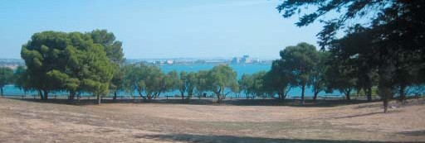
The parkland today is used for a variety of recreational, environmental, educational, research, botanical and horticultural activities and includes key components such as the Geelong Botanic Gardens, the Eastern Park Bowling Club and Croquet Club, a golf course, several playing ﬁelds, the Play Space and the Limeburners Point Boat Ramp. The park includes the heritage listed Lime Kilns and is adjacent to the heritage listed Eastern Beach. Eastern Park and the Geelong Botanic Gardens are included on the Victorian Heritage Register.
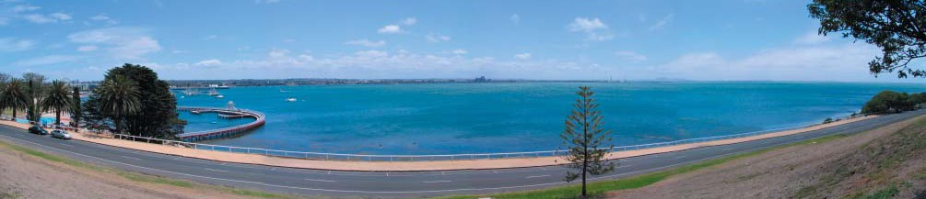
A Conservation, Management and Master Plan for the Geelong Botanic Gardens and Eastern Park was developed in 1995. Since that time much has changed in relation to the context in which the park is positioned. The $30 million redevelopment of the Geelong Waterfront has attracted more visitors and events to the City centre. The Master Plan identiﬁed the need for the Geelong Botanic Gardens to facilitate the true roles and functions of a botanic garden with respect to collections management, scientiﬁc research, conservation, education, interpretation and display. Signiﬁcant advances have been made in each of these key areas. There is no doubt that the most signiﬁcant project implemented from the 1995 recommendations was the opening of the 21st Century Garden in September 2002. This project delivered Stage One of the Gardens Master Plan and through this project the Gardens were given a renewed emphasis, greater exposure and an enhanced public proﬁle which has led to a signiﬁcant increase in visitor numbers.
In 2006 the Geelong Play Space was opened in Eastern Park, adjacent to the Botanic Gardens. The Play Space provides facilities for children of all abilities in a unique play environment. It covers approximately 3,000 square metres and has over 3,000 plants. It is estimated that it will attract 200,000 visitors per year.
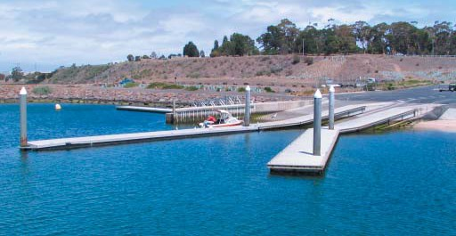
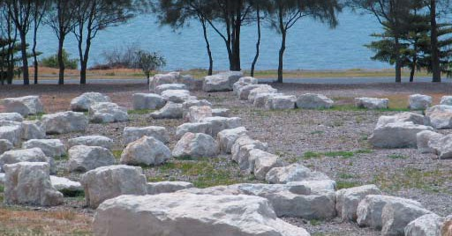
2006 also saw the installation of a large land earth sculpture, known as a geoglyph at Eastern Park. Created by internationally renowned sculptor Andrew Rogers it is considered a signiﬁcant addition to the City’s cultural tourism attractions.
Added to the above signiﬁcant developments the park hosts a range of national and international cycling competitions and other local community events. An Events Precinct Feasibility Study undertaken in 2005 has examined the potential to create an area within Eastern Park to enable it to accommodate a greater number of events. The recommendations of this report are considered in this planning process.
Together, these developments have increased the pressure on park infrastructure to cope with higher usage levels. Importantly, the park is also surrounded by residential areas and as such has a critical role as a local community park. This Eastern Park and Geelong Botanic Gardens planning process provides a planned way forward to guide future park usage, conservation and improvements to provide for a higher level of amenity and user experience.

Aims & Objectives

Aim
To develop a strategic plan for Eastern Park and the Geelong Botanic Gardens which provides guidance on conservation, management, and the landscape and built form. This includes a long-term vision for the park, looking out 50 years, together with a 10 year action plan.
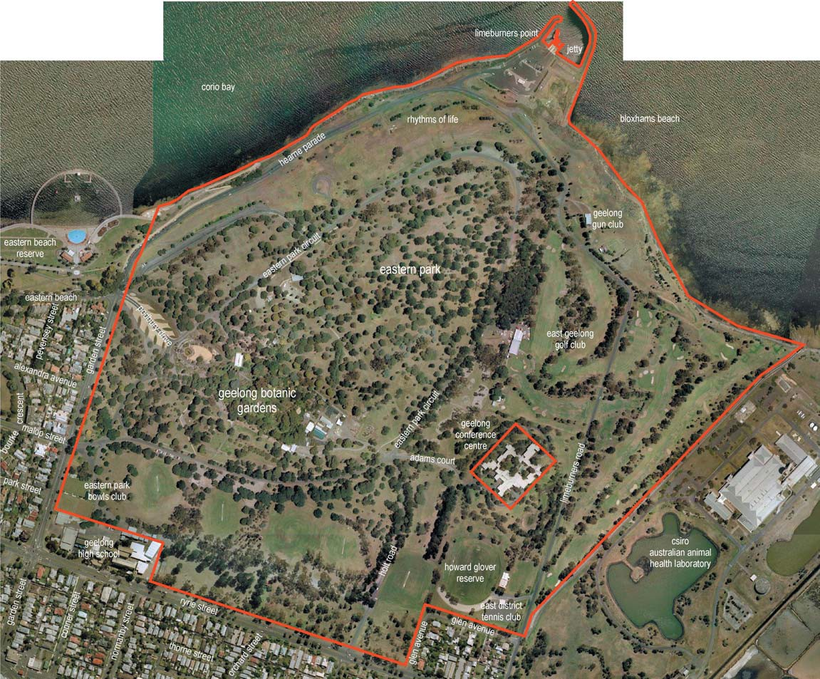
It is recommended that the plan be reviewed every ﬁve years to monitor its progress with respect to implementation, and also to make adjustments as required to cater for unforseen future events.

Objectives
      - Protect and enhance the park’s status as a high quality inner urban park environment with critical links to Central Geelong, Eastern Beach and the Waterfront.
      - Engage the community to provide advice and input into the conservation, management and amenity of the park and gardens.
      - Balance the needs of various active and passive user groups with the landscape and environmental values of the park.
      - Understand and enhance the capacity of the park and gardens to cater for and respond to current and future uses and needs.
      - Provide for better and safer vehicle and pedestrian movement within the park environs and improved links to surrounding destinations.
      - Consider and make recommendations on the appropriateness of key development proposals including the Mineral Springs Bath House, Events Precinct and Walter Conservatory Café.
      - Consider the role of a modern Regional Botanic Gardens in conservation, research, education, and the related infrastructure and management issues.

Study Area
The study area is bounded by Ryrie St to the south (excluding the residential area bordered by Glen Ave and the Geelong High School), Garden St to the west, the sea wall/high water mark to the north (including the Limeburners Point Boat Ramp) and the boundary of the Animal Health Laboratory to the east.
This study area is not identical to that used for the 1995 plan. However, the expanded study area includes all the public land within the Eastern Park precinct and is designed to address some of the key issues confronting the park.
The study area does not include the Geelong Conference Centre that is located in Eastern Park as it is private land. Although this land and the Geelong High School site are not within the study area, their interface and relationship with the park is still an important consideration in this planning exercise. Similarly the relationship and interface with surrounding residential areas and Eastern Beach are critical considerations.

Key Tasks
The Eastern Park and Geelong Botanic Gardens Strategic Plan comprises 3 key tasks;
Heritage Conservation Assessment – assessing the cultural signiﬁcance of Eastern Park and the Geelong Botanic Gardens.
Master Plan – providing a costed, prioritised and staged master plan for both landscape and built infrastructure, considering environmentally sustainable design and being guided by the Heritage Conservation Assessment.
Management Plan – addressing key management issues including trafﬁc, events usage, wildlife, assets, risk and a heritage conservation policy.

Project Management
Three project groups have assisted in providing high level, technical and community input into the planning process. The composition of these is outlined brieﬂy below.

Project Control Group
The Project Control Group (PCG) provides high level direction on key issues, approves draft and ﬁnal reports and allows Council project staff and the Lead Consultant to advise on the progress of the project. This group includes three Councillors from the City of Greater Geelong (Ward Councillor, Parks & Gardens Portfolio Holder and Planning Portfolio Holder), two General Managers from the City of Greater Geelong, the State Member for Geelong, the Geelong Environment Council, Friends of the Geelong Botanic Gardens and high level representation from the Wathaurong Aboriginal Cooperative. Heritage Victoria and the Department of Sustainability were invited to participate but were unable to send representation.

Project Working Group
The Project Working Group (PWG) provides technical advice on the project, ensures all relevant technical issues are considered, guides the work of specialist consultants and general direction setting.
The PWG consists of Council representatives from Recreation & Open Space, Parks Maintenance, Geelong Botanic Gardens (current and former Directors), Marketing & Events, Environment, Engineering, Major Projects and Strategic Planning.

Stakeholder Reference Group
The Stakeholder Reference Group provides an opportunity for key stakeholders (those not already engaged in the above two groups) to have input into the development of the Plan. This group participated in a separate forum/ workshop during the development of the plan, providing opportunities for these key stakeholders to access information and brieﬁngs on the planning process.
The Stakeholder Reference Group includes representatives from the Geelong High School, East Geelong Golf Club, Eastern Park Bowls Club, Eastern Park Croquet Club, Geelong Conference Centre, Geelong Major Events, Geelong Cross Country Club, various other sporting groups, Geelong Police, Geelong Field Naturalists, Geelong Botanic Gardens Meeting Room User Group, Gordon Institute of TAFE, Barwon Disability Resource Council, and boating groups.

Project Manager
The Council’s Project Manager and key contact is Ricky Bell, Co-ordinator Recreation & Open Space, assisted by Liz Wood, Projects Ofﬁcer, Recreation & Open Space.

Project Team
The project team comprised the following specialist consultants:
Hansen Partnership – Project Management & Landscape Architecture
      - Steve Schutt (Director)
      - Nelson Gomes (Landscape Architect)
John Patrick Landscape Architects – Heritage Assessment & Landscape Architecture
      - John Patrick (Director)
      - Lorraine Nadebaum (Landscape Architect)

SMEC – Engineering
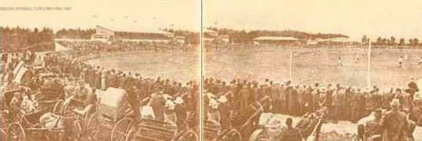
      - Alison Stone (Director)
      - Hakan Girgin (Transport Engineer)
      - Rinske Poulier (Senior Environmental Scientist)
      - Bradley Tucker (Environmental Scientist)
@ Leisure – Recreation & Open Space Planning
      - Sally Jeavons (Director)
      - Samantha Beveridge (Open Space Planner)
Greenwood Consulting - Arboriculture
      - Roger Greenwood (Director)
      - Sarah Preistley (Arborist)
Practical Archaeology – Archaeology
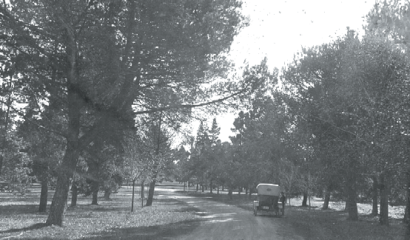
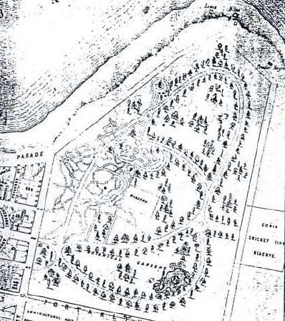
      - Fiona Weaver (Archaeologist)

History
The Heritage Conservation Assessment of Eastern Park and Geelong Botanic Gardens has been prepared by John Patrick Landscape Architects. The purpose of the Heritage Conservation Assessment is to provide an updated assessment of the cultural heritage signiﬁcance of the park and gardens and their landscaping elements. The assessment is intended to provide the basis for developing conservation management policies, which in turn will support and guide development of a master plan.

History
In assessing the heritage signiﬁcance of Eastern Park and Geelong Botanic Garden the Heritage Conservation Assessment has replicated the history compiled by Georgina Whitehead as part of the 1995 Conservation and Management Plan prepared by Chris Dance Land Design Pty Ltd. Where additional information has become available it has been integrated into the acknowledged history narrative.

Landscape Elements
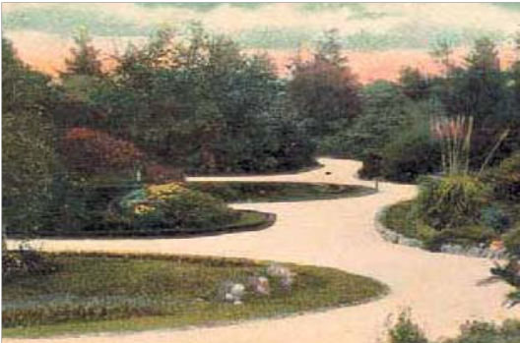
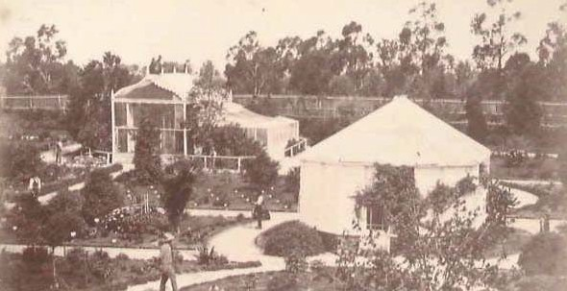
The Heritage Conservation Assessment includes a physical survey of the landscape elements of Eastern Park and Geelong Botanic Gardens. The survey is based on an examination of the available documentary evidence and on a physical survey of the site. The objective of the survey is to establish, as far as possible the nature and intactness of the original and early layouts, structures and plantings, and to describe the various modiﬁcations which have occurred up to the present day, and by doing so, determine those elements which are original or signiﬁcant.

Signiﬁcance
As a key component of the Heritage Conservation Assessment, the cultural heritage signiﬁcance of Eastern Park and Geelong Botanic Gardens has been assessed for the values set out in the Burra Charter Guidelines as established by the Australian National Committee of the International Council of Monuments and Sites (Australia ICOMOS) on 14th April 1984 and revised on 23rd April 1988.
The Burra Charter deﬁnes cultural signiﬁcance as aesthetic, historic, scientiﬁc or social value for past present or future generations.

Analysis

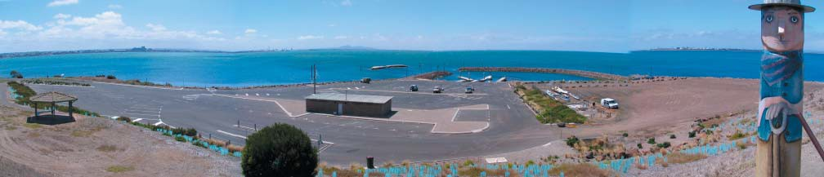
Physical Landscape
The physical analysis of Eastern Park and the Geelong Botanic Gardens has focused on the key areas of landscape & environment, land use & activity and landscape character. The outcomes of the physical analysis become valuable inputs into the master planning process.

Landscape & Environment – Eastern Park
The analysis of the physical landscape and environment of Eastern Park and the Geelong Botanic Gardens has identiﬁed a number of key elements, brieﬂy described as follows, and identiﬁed in the accompanying landscape & environment analysis diagrams.
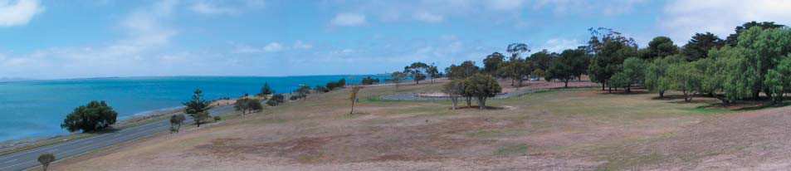
Topography
      - There is a prominent ridge line running in a north-easterly direction from the Malop Street entry towards Limeburner’s Point, which effectively divides the park into two broad precincts; one with an outlook to Corio Bay and the other which is larger but more ‘contained’, with an orientation towards the residential areas of East Geelong.
      - There is a low point in the vicinity of the existing Number 4 Oval.
      - The majority of the site is gently sloping, with the exception of the coastal fringe in the vicinity of Eastern Beach and to the east of Limeburner’s Point, which is signiﬁcantly steeper.
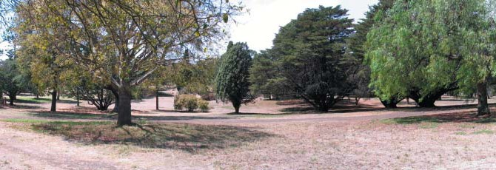
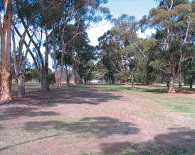
Vegetation
      - The landscape of Eastern Park has heritage signiﬁcance as a designed landscape of a woodland park. The woodland plantings reﬂect the eras of plantings by the early curators, Raddenbury and Bunce, as described in detail in the Heritage Conservation Assessment. A number of the key circulation routes within the park, including Eastern Park Circuit, Holt Road and Adams Court, are demarcated by avenue tree planting which is of primary heritage signiﬁcance.
      - The Eastern Park landscape has scientiﬁc signiﬁcance with regard to its plant collection, both in terms of individual specimens listed on the State’s Signﬁcant Tree Register and importantly as a Pinetum (an area planted with both pine and conifer trees) containing many species and variations in plant form rare in cultivation.
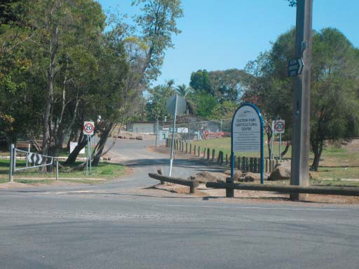
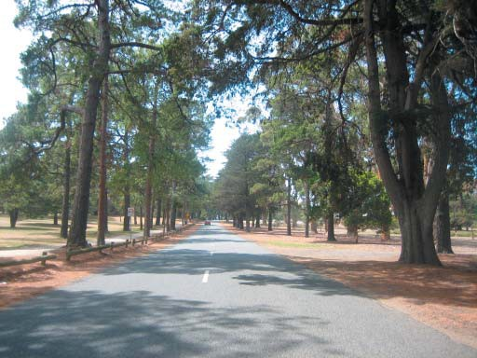
      - The dominant tree species within the park is Pinus radiata (Monterey Pine), which accounts for over 15% of the total tree population. Other species which are extensively planted within the park include Eucalyptus cladocalyx (Sugar Gum), Eucalyptus camaldulensis (Red Gum), Cuppressus macrocarpa (Monterey Cypress), Casuarina cunninghamiana (Drooping She Ook), Pinus pinea (Stone Pine) and Pinus canariensis (Canary Island Pine). Together these species comprise over 45% of the total tree population.
      - There is little if any remnant indigenous vegetation within the park.
      - The Pinus radiata plantation immediately north of the East Geelong Golf Club clubhouse provides habitat for a colony of Grey-Headed Flying Foxes.
      - Approximately 50% of the existing trees within the park have a useful life expectancy of less than 15 years.
Views
      - There are panoramic views across Corio Bay from the northern parts of the park, particularly north of Eastern Park Circuit in areas where tree cover is sparse.
      - There are panoramic views towards Point Henry from elevated areas of the park east of Limeburner’s Point, including the land presently occupied by the Geelong Gun Club.
      - The Geelong Botanic Gardens Depot presents a poor visual interface to the park, which requires screening and/or other amelioration measures.
      - Geelong High School presents an abrupt visual interface to the park, which is in the process of being improved with additional appropriate screen planting.


hansen
eastern park and geelong
botanic gardens strategic plan

landscape and environment
-

legend
waterbodies

panoramic views ---4\

filtered views ---4\

revealed views

geelong botanic gardens

publicly accessible
open space

undeveloped open space

sports fields •

visual screens WM tree avenues C:)
poor visual \A A.AA flying fox habitat
Y V
interfaces YY \ ' '

presence
buildings I

contours at 5 ft toilets
(1.524 m)
intervals
D
shelters 0
playgrounds 0
barbeques 0

roads/
/

service roads
pedestrian path/s
high points *

ridge lines
##
##
--#

steep slopes WM
drainage lines .._

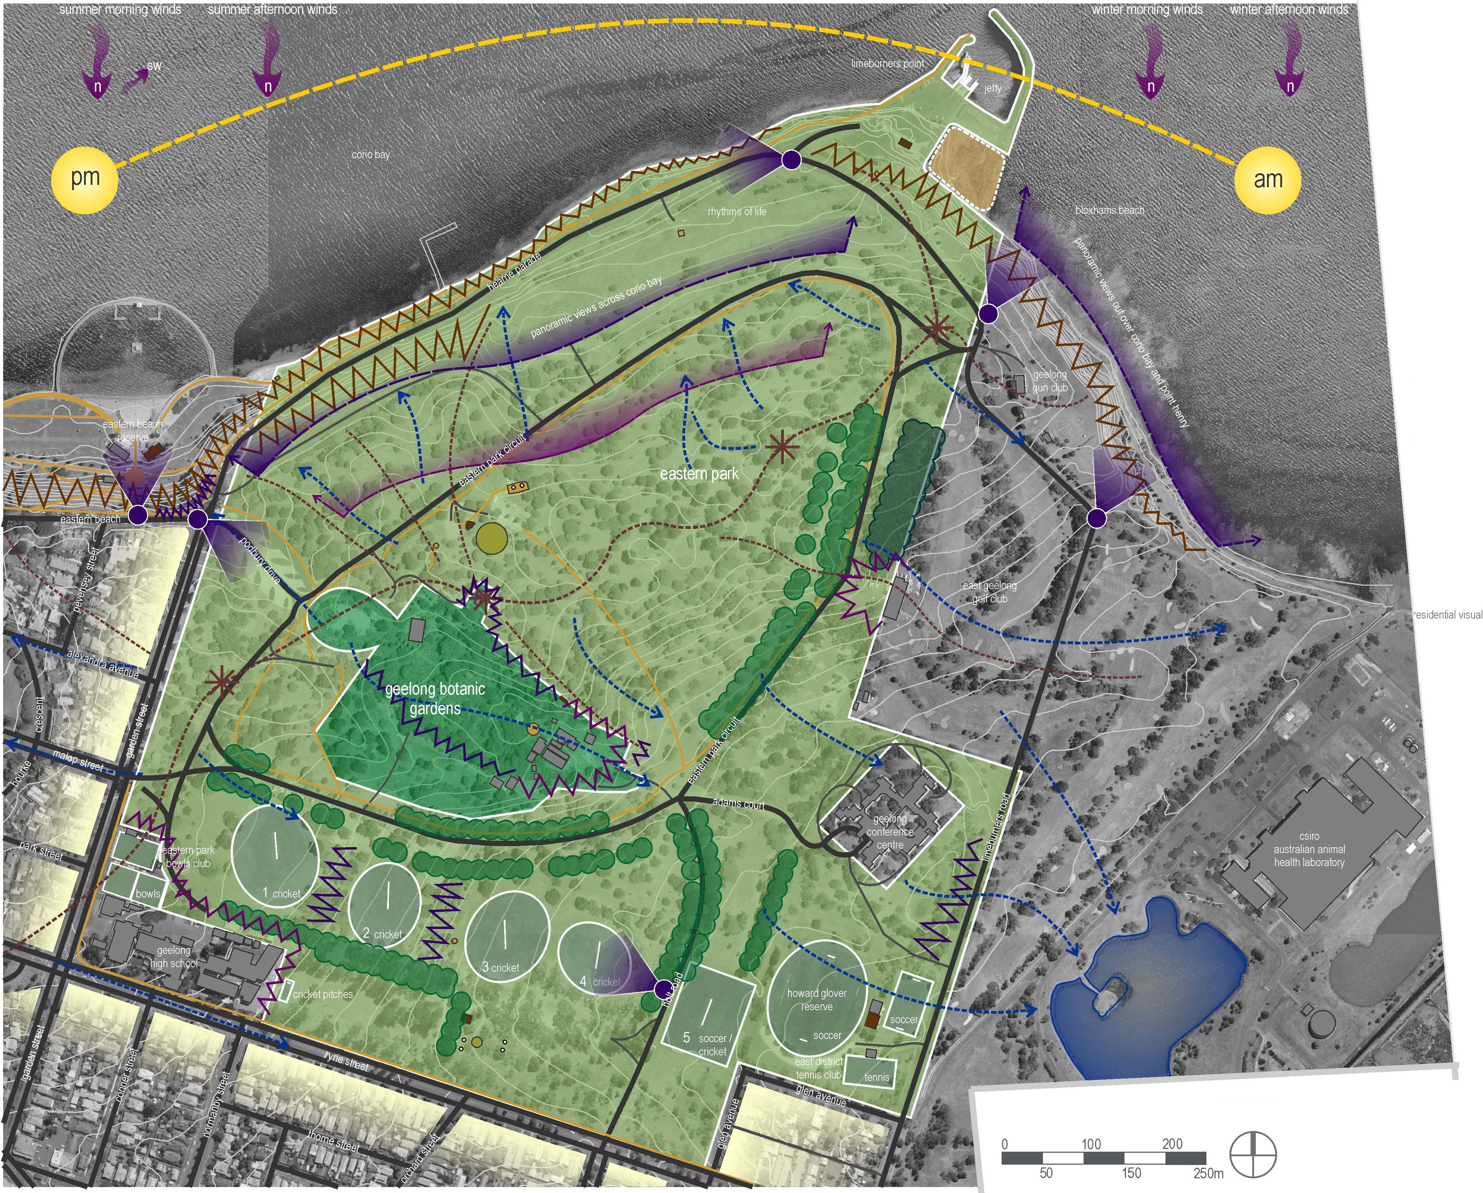

Project Ref: Dwg No.: Scale: Date: Revision:

06.438
LCD-001 1:5000@A3
19.2.07
A

hansen partnership pty ltd melbourne I sydney I vietnam level 8 136 exhibition st
melbourne vie 3000
t 61 3 9654 8844 f 61 3 9654 8088
e info@hansen-online.com.au
w hansen-online.com.au

Landscape & Environment – Geelong Botanic Gardens
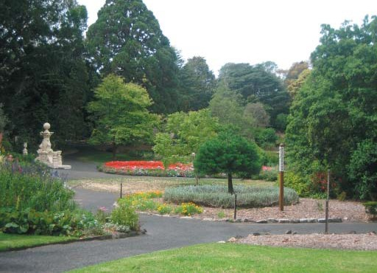
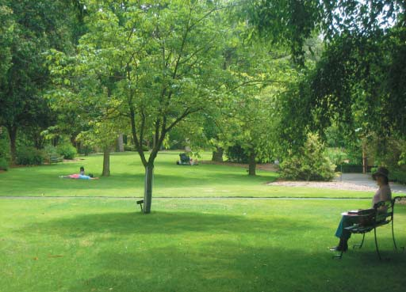
Topography
      - The Geelong Botanic Gardens are located within a well deﬁned gully, falling towards the Nursery and Depot precinct at the south-eastern end.
      - The Superintendent’s residence is located on a local high point.
Vegetation
      - The Geelong Botanic Gardens is scientiﬁcally signiﬁcant both in terms of its wide range of scientiﬁc plant collections and high number of individual tree specimens listed on the State’s Signiﬁcant Tree Register.
      - As a landscape, the Geelong Botanic Gardens represents different eras of development by its curators, from the scientiﬁc or systemic approach to presenting a plant collection, a gardenesque approach to plantings, picturesque approach and more recently a contemporary and sustainable design approach to present local ﬂora.
Views
      - The extent of tall canopy vegetation within the Gardens creates a sense of visual enclosure.
      - Some views out into the broader Eastern Park landscape are available on the southern side of the Gardens.
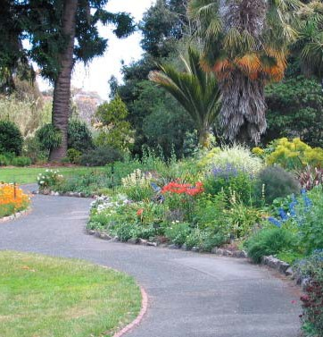
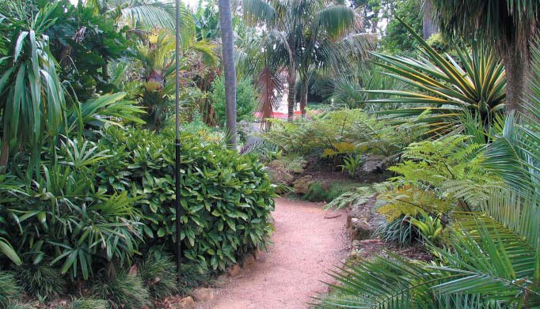
      - The visual interface between the Gardens, the Nursery and the Depot is poorly resolved. Opportunities to provide better visual integration of the Nursery, whilst at the same time screening undesirable views of the Depot, should be encouraged.
      - The 21st Century Garden is prominently designed and located to provide a visible presence for the Gardens within the broader context of Eastern Park. Conversely, the elevated nature of the 21st Century Garden also provides opportunities for views to Corio Bay, providing a sense of legibility in the broader landscape context.

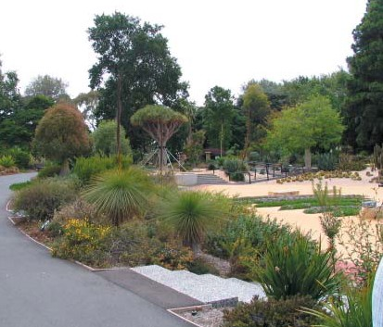
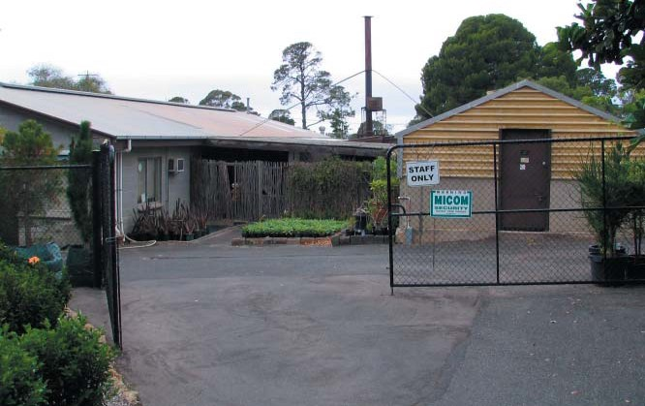


hansen
eastern park and geelong botanic gardens
strategic plan

botanic gardens landscape and environment

legend
linear view's ',...._ framing vegetation
(- ...
buildings I
primary heritage significance Q
as identified withinthe W
2007 conservation and

visual foc,us \ visual awareness
of surrounding park
...'_\ ,
management plan
contributory heritage
significance (i)
as identified within the
2007 conservation and
management plan

........................
poor visual \A AJ..A
interfaces Y V V V \
D
contours at 5 ft
(1.524 m)
intervals

toilets ,,

shelters O
fountains Q
seats 0

road/ service road1/
open law11
. .,;
fencing /
;
*
pedestrian path

high points
.. #

ridge lines .,,'


open views

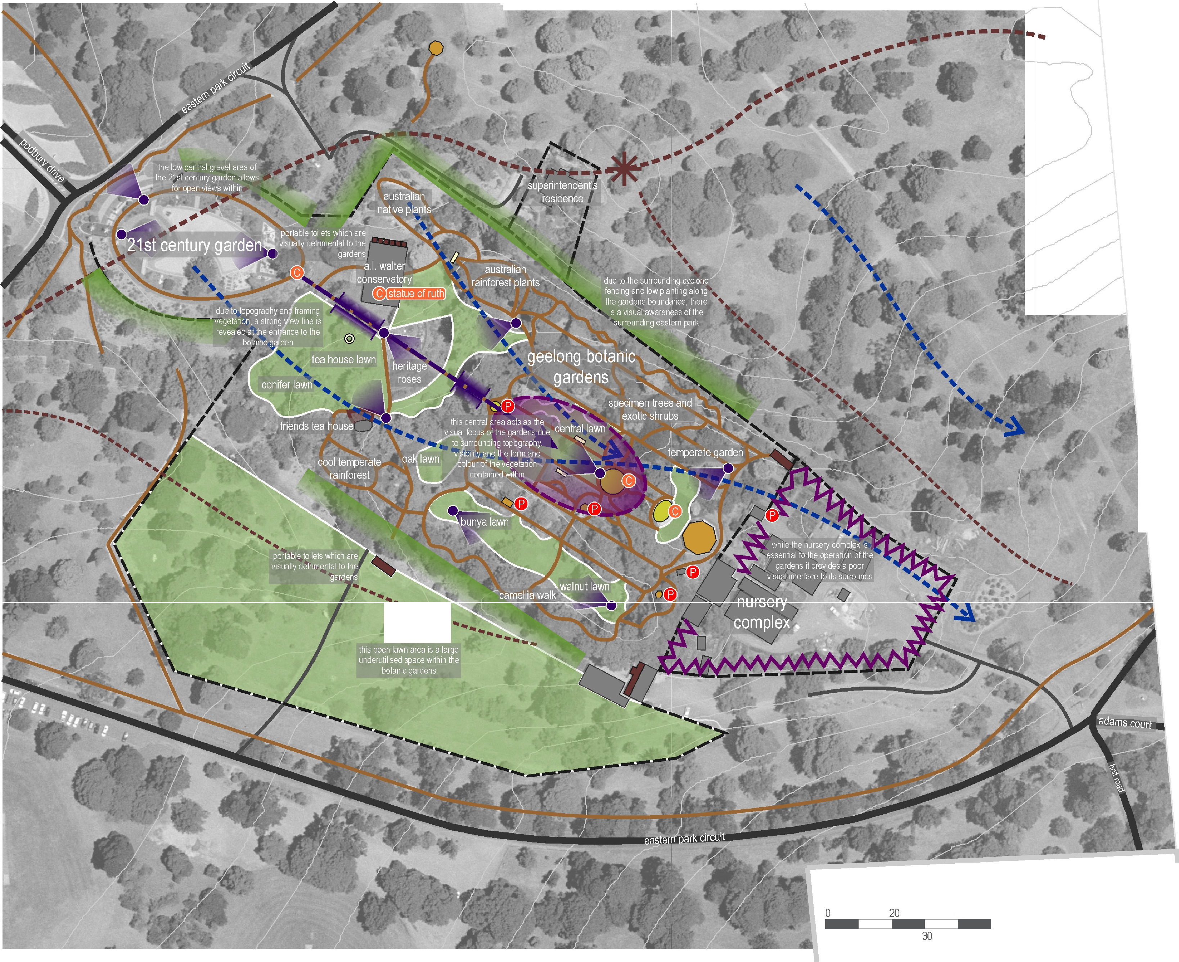

40
10 50m
Project Ref: 06.438
Dwg No.: LCD-005
E9
Scale: 1:1500@A3
Date: 11.9.07
Revision: C
hansen partnership pty ltd melbourne I sydney I vietnam level 8 136 exhibition st
melbourne vie 3000
t 61 3 9654 8844 f 61 3 9654 8088
e info@hansen-online.com.au
w hansen-online.com.au

Landscape Character
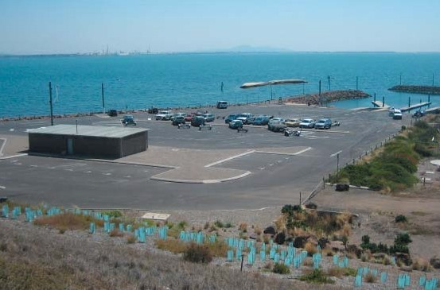
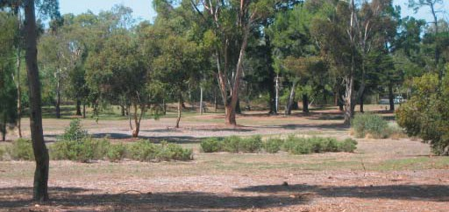
The analysis of the physical landscape and environment of Eastern Park and the Geelong Botanic Gardens has identiﬁed a series of character precincts, brieﬂy described as follows, and identiﬁed in the accompanying landscape character precinct diagram.
      - Boating precinct – comprising the Limeburner’s Point boat ramps and associated infrastructure, this precinct has excellent access and visual connections to Corio Bay, yet its overall amenity is poor, being dominated by large areas of car parking, poorly landscaped landﬁll areas, an unsightly amenities building and degraded shoreline and escarpment, with extensive erosion and weed infestation.
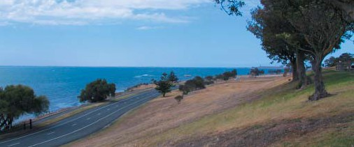
      - Corio Bay Slopes – comprising the predominantly open, sparsely vegetated slopes between Eastern Park Circuit and Hearne Parade, which offer extensive views across Corio Bay, but are presently under-utilised for recreational activities. This precinct includes a number of car parks with a primary orientation to the views of Corio Bay. Other than the car parks and the Geoglpyh sculpture, there is limited infrastructure or attractions.
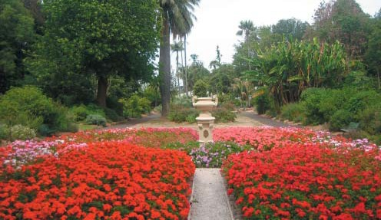
      - The Pinetum – comprising the area loosely bounded by Eastern Park Circuit, and encompassing the prominent ridge line which runs through the park to Limeburner’s Point. The Pinetum is planted as an informal woodland with more formal featuring of specimens through avenues which bordered the original carriageways and design features such as circles. This precinct has ﬁltered views to Corio Bay and includes a number of important attractions including Play Space and a major picnic shelter. Facilities and car parking are well provided but very poorly integrated.
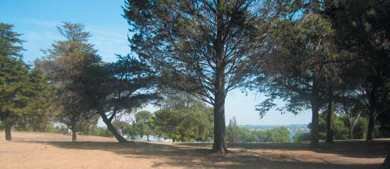
      - Central Slopes – comprising the informal woodland area east of the Geelong Botanic Gardens and south-east of Eastern Park Circuit, incorporating park areas adjacent to the Geelong Conference Centre. This area has an open woodland character and is well-contained from a visual perspective, with mainly internal vistas. Pathways are well-worn but informal in nature, and the informal, ﬂexible character of this precinct is favoured by dog walkers.
      - Geelong Botanic Gardens – comprising the designated Botanic Gardens area within the perimeter fence. The Gardens reﬂect a contemporary landscape in the 21st Century Garden with strong design features and a sustainable approach to plant selection. The 21st Century Garden provides a clear sense of arrival to the Geelong Botanic Gardens. The rest of the Gardens typify a traditional Botanic Garden landscape which reﬂects a number of landscape styles. The Gardens function as a primary visitor attraction in their own right, and are important for their scientiﬁc, historic, social, cultural, educational and botanical signiﬁcance.
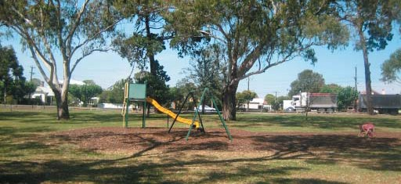
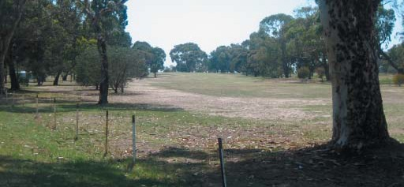
      - Urban Interface – comprising two separate zones within Eastern Park, one with a frontage to Garden Street and the other with a frontage to Ryrie Street. These precincts have a similar character to the internal areas of the park in terms of canopy tree cover and open grassed surfaces, however their position at the edges of the park results in them having a ‘buffer’ character, providing a landscape transition from an urban setting to a parklands character. The Ryrie Street interface area is also well-utilised as a picnic area, with associated facilities.
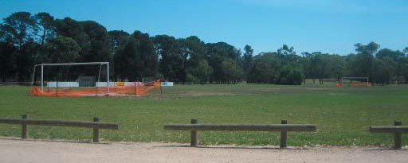
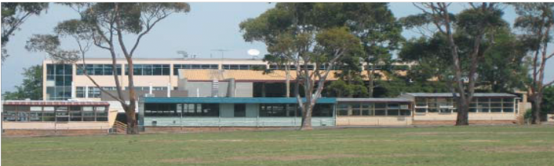
      - Sports ﬁelds – comprising the open sports ﬁelds running generally east-west from near the original Malop Street entry to the Howard Glover Reserve, adjacent to Limeburner’s Road. This precinct is largely utilitarian in nature, being laid out as a series of sports ﬁelds, with fringing scattered trees providing the transition to the more heavily vegetated landscape of the broader park setting. The ovals are presently constrained by their small size, excessive cross fall, and in the case of Number 4 Oval, poor drainage. The sports ﬁelds are well served by parking areas to both the north and south, and are utilised by both Geelong High School, the Western Victorian Soccer Association (for Howard Glover Reserve) and as overﬂow grounds for a range of local lower grade and junior sporting competitions.
      - Golf Course – comprising the East Geelong Golf Course, and forming the eastern edge of the park and the study area. Tree cover within the golf course continues the character of the rest of the park, albeit with a higher proportion of native vegetation. This tree cover is broken up by the open expanses of the fairways. The golf course contributes strongly to ‘borrowed views’ to the east from within the park, both in creating a sense of expansiveness and providing a landscape buffer between Eastern Park and the CSIRO complex to the east.

hansen
eastern park and geelong
botanic gardens strategic plan

landscape character
precincts
-

boating precinct
defined by
        - flat low lying
- devoid of vegetation
- isolated from rest of park
  - panoramic bay views

corio bay slopes
defined by
- sloping topography towards the bay
- openness withlittle canopy vegetation
  - panoramic views

pinetum
defined by
- mature wooded canopy vegetation
  - formal tree avenues
- filtered views towards the bay

central slopes
defined by
- mature wooded canopy vegetation
-
  - internal vistas

botanic gardens
defined by
- isolated from park context
-
- diversity of vegetation types,
sizes and form

urban interface
defined by
  - mature wooded canopy
vegetation
- visual intrusion of adjacent
residential areas
  - constant vehicular noise
sports fields
defined by
    - expansive open la\lJ!ls
-
    - framing mature canopy
vegetation

high school
defined by
      - numerous built forms between 1 and 3 storeys
  - limited canopy vegetation

golf course
defined by
  - east sloping topography
    - open linear lawns
- linear vegetation belts

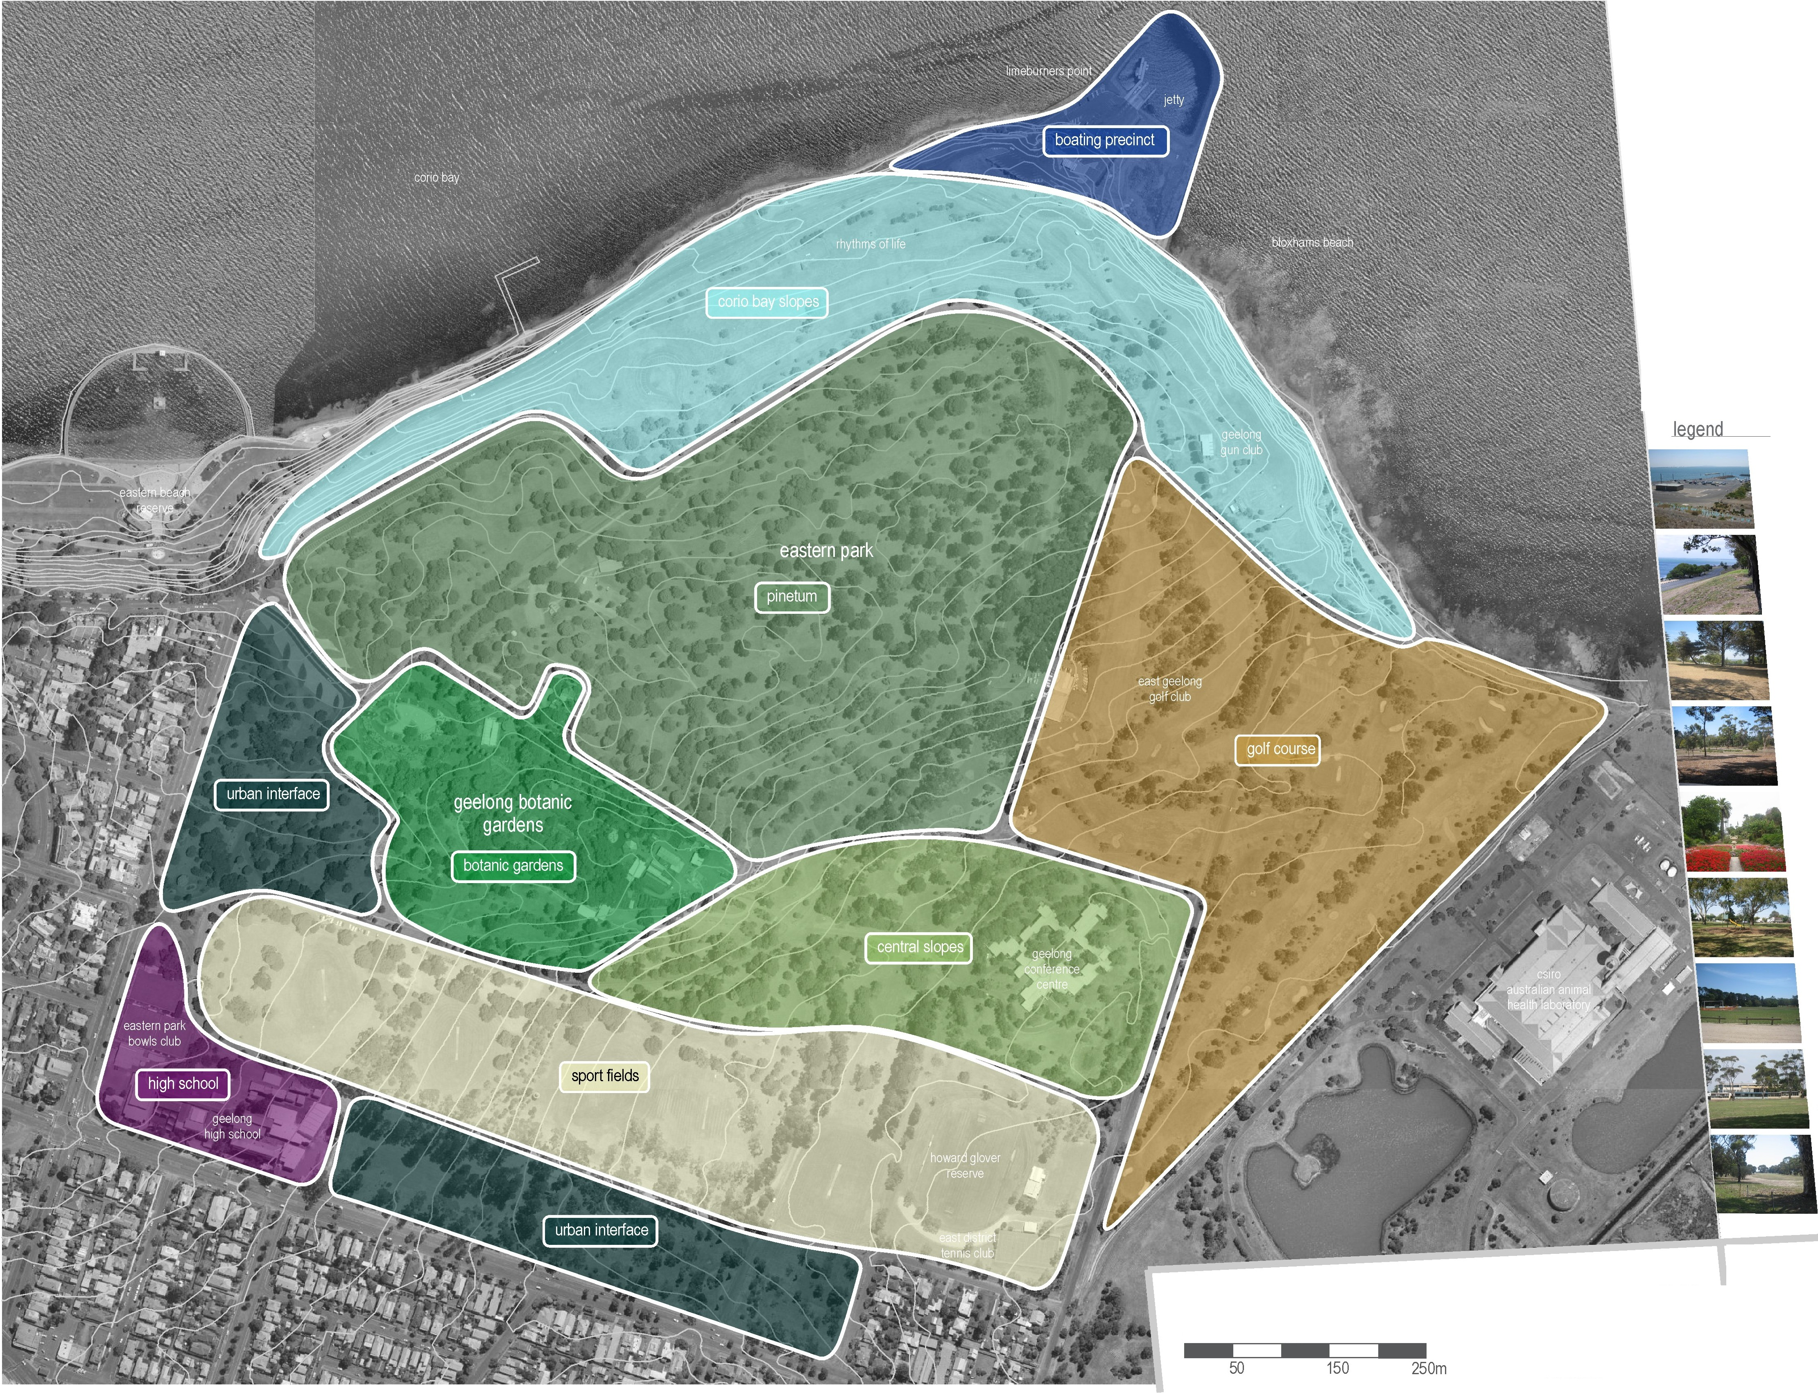

0 100 200
50 150

250m
Project Ref: 06.438
Dwg No.: LCD-004
EB
Scale: 1:5000@A3
Date: 31.7.07
Revision: B
hansen partnership pty ltd melbourne I sydney I vietnam level 8 136 exhibition st
melbourne vie 3000
t 61 3 9654 8844 f 61 3 9654 8088
e info@hansen-online.com.au
w hansen-online.com.au

Land Use & Activity

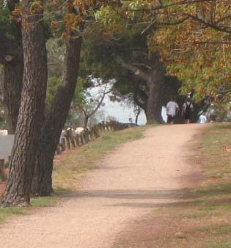
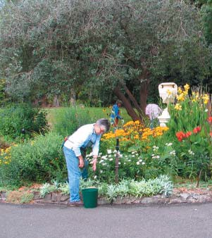
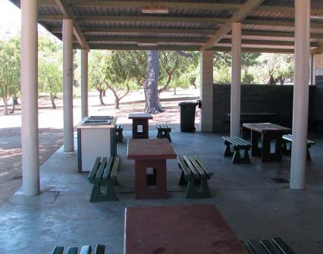
Land Use & Activity – Eastern Park
The analysis of land use and activity in Eastern Park and the Geelong Botanic Gardens has identiﬁed a number of key elements, brieﬂy described as follows, and identiﬁed in the accompanying land use and activity analysis diagram.
Land use
      - There are a number of ‘single activity’ land uses within Eastern Park, with varying levels of infrastructure associated with them.
      - A number of recreational land uses within Eastern Park, such as the Bowls Club, Croquet Club and Tennis Club, are speciﬁcally structured for that use and are not publicly accessible. The integration of these facilities with the broader Eastern Park landscape is limited by both their structure and their club-oriented set up.
      - East Geelong Golf Club, the Geelong Gun Club and the Geelong Conference Centre are the largest single-focus land uses within Eastern Park.
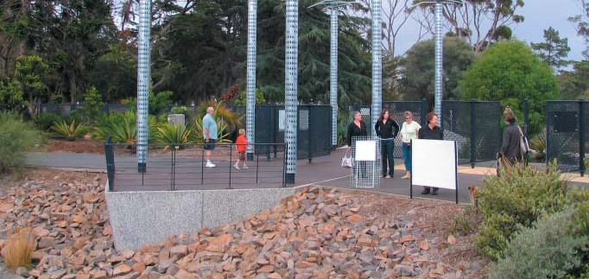
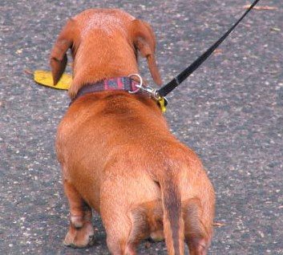
Activity
      - Activities within Eastern Park and the Geelong Botanic Gardens include both structured and unstructured activity, passive and active recreation, activities which take advantage of the facilities within the park and those which take advantage of the park’s location and proximity to central Geelong and Corio Bay.
      - Substantial areas of Eastern Park, particularly the central area inside Eastern Park Circuit (but excluding the Geelong Botanic Gardens) are favoured for informal activities such as dog walking.
      - The Corio Bay Slopes are under-utilised and have the potential to accommodate increased recreational activity.

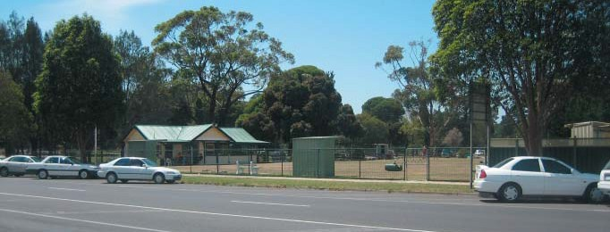
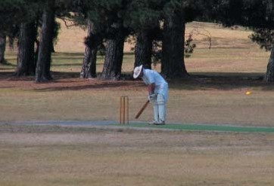
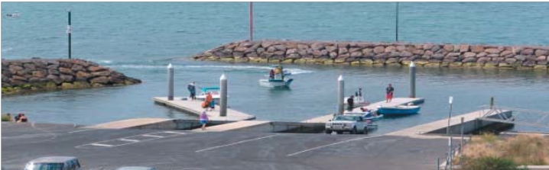
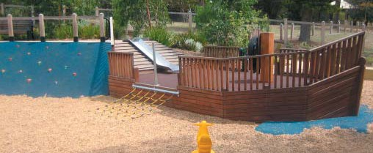


hansen

eastern park and geelong
botanic gardens strategic plan
land use and activity

legend - land use
D
eastern park bowls club
D

geelong high
school csiro laboratory
residential

geelong botanic gardens

public park
□
D
□

jetty geelong gun club
D

eastern beach
reserve
east geelong
golf club geelong conference centre
D

legend - activty
0
diverse recreation
0

swimming

running/ walking0 picnic/ playground


viewing botanic garden0
boating 
sportO


conference shooting0
golf  studen0t
lawnbowls0

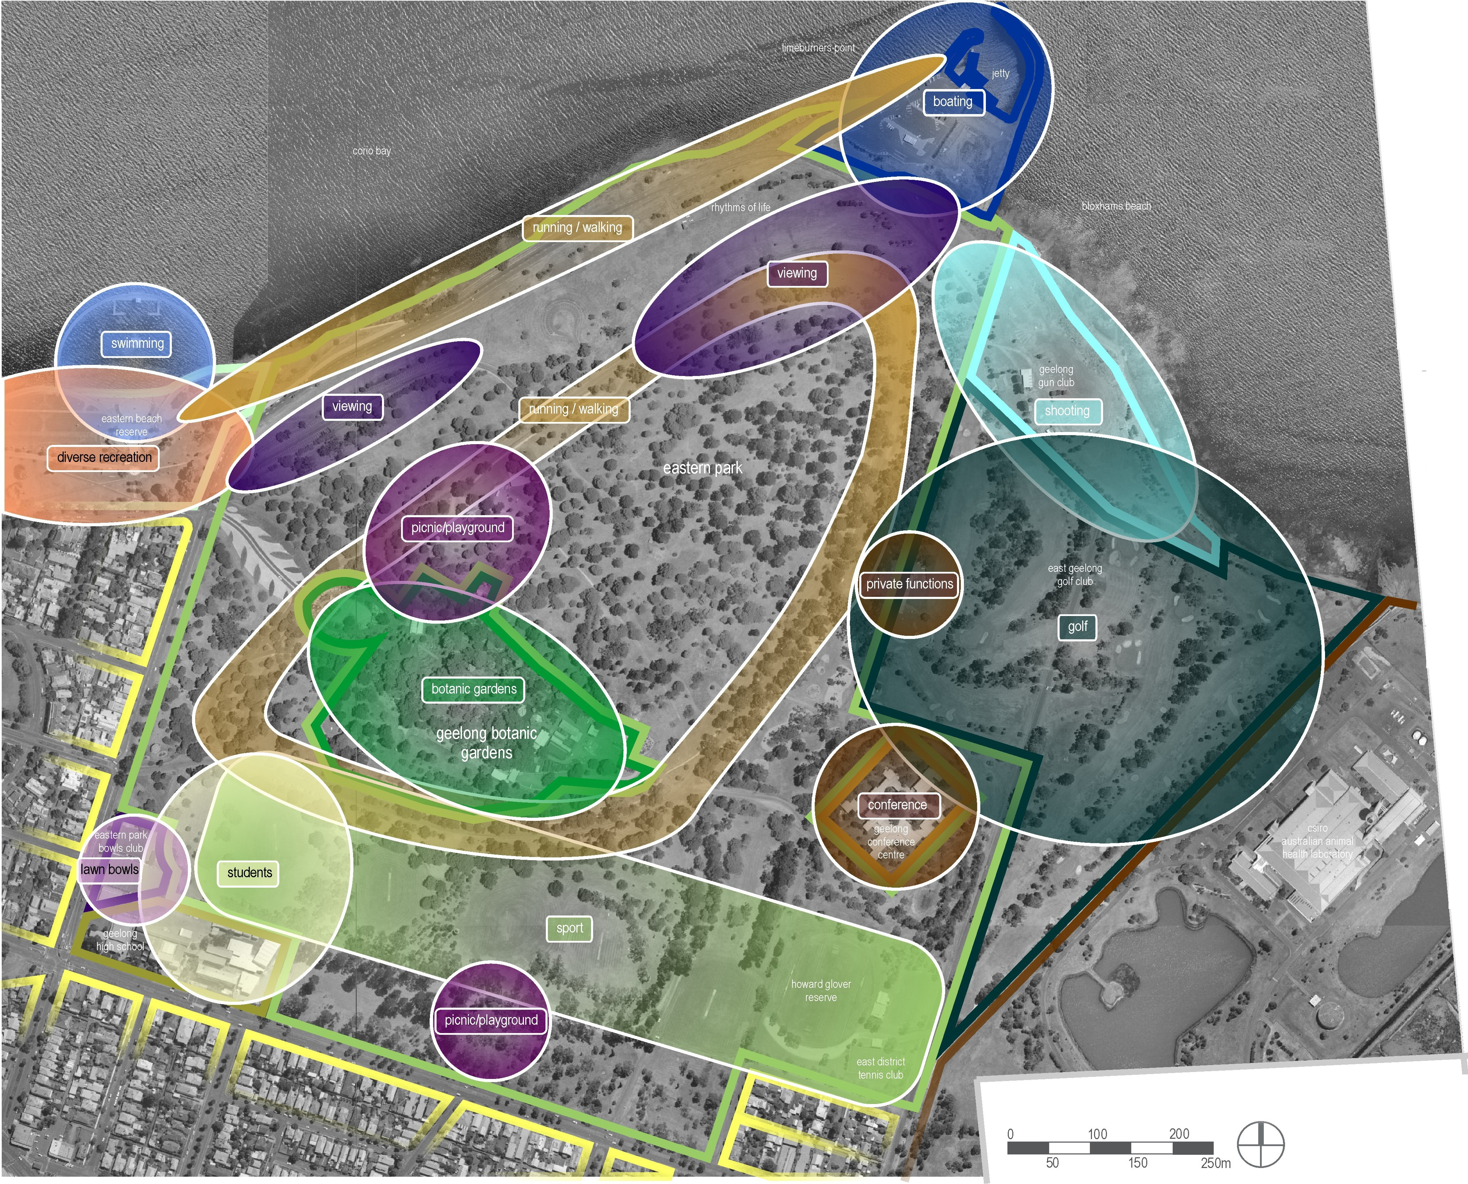

Project Ref: Dwg No.: Scale: Date: Revision:

06.438
LCD-003 1:5000@A3
27.2.07
A

hansen partnership pty ltd melbourne I sydney I vietnam level 8 136 exhibition st
melbourne vie 3000
t 61 3 9654 8844 f 61 3 9654 8088
e info@hansen-online.com.au
w hansen-online.com.au

Access & Movement

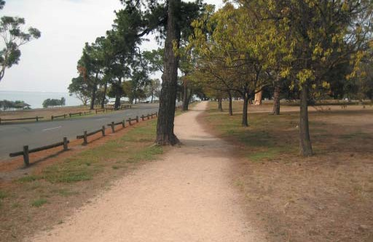
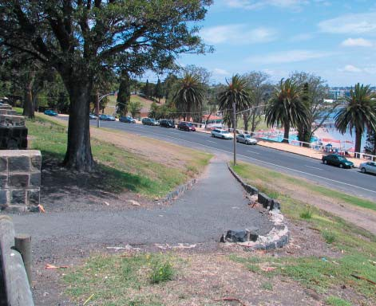
Access & Movement – Eastern Park
The analysis of access and movement in Eastern Park and the Geelong Botanic Gardens has identiﬁed a number of key elements, brieﬂy described as follows, and identiﬁed in the accompanying access and movement analysis diagrams.
Pedestrian & bicycle access
      - In general, pedestrians and cyclists are poorly provided for in Eastern Park.
      - Access into the park from surrounding residential and other recreational precincts is difﬁcult, with very few pedestrian crossings.
      - The pathway network within the park is poorly connected, has limited signage and in some cases requires upgrade to meet appropriate standards.
      - Connections to broader recreational trails, such as the Bay Trail and the Bellarine Rail Trail, are poorly resolved.
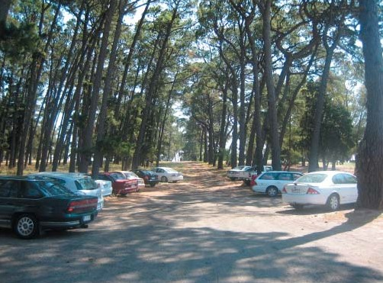
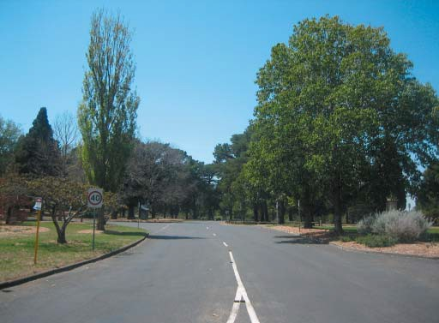
      - The critical pedestrian connection between Eastern Park and Eastern Beach is unresolved, and is made difﬁcult by the topographical constraints of the escarpment which separates these two areas.
Vehicle access
      - Vehicle access within Eastern Park is largely unconstrained. Some areas of the park have vehicular barriers, whilst others do not, which makes the barriers ineffective.
      - Roads within the park are extensively used by through trafﬁc, rather than by trafﬁc associated with recreational use of the park. Anecdotal evidence suggests that up to 75% of vehicular movements within the park are generated by through trafﬁc.
      - Hearne Parade and Limeburner’s Road are part of a designated ‘tourist route’.
      - Intersection treatments to improve legibility, functionality and safety are required at a number of intersections, both within the park and at major entry points.
      - The vehicular circulation network within the park is poorly signed, and includes extensive undeﬁned areas of unsealed car parking and a number of informal tracks.
      - Existing car parking areas on the north side of the park appear to be extensively used for viewing Corio Bay.
Other access considerations
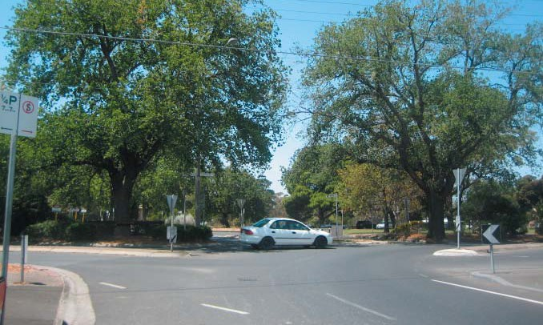
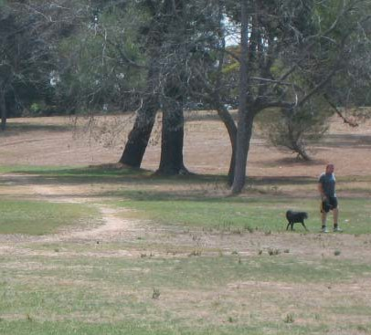
      - Compliance with the Disability Discrimination Act 1992 (DDA) is very poor within Eastern Park, with regard to the provision, alignment, gradient, materials and condition of the existing access network.
      - Signage for both way-ﬁnding and interpretation is very poorly provided.

possible pedestrian links
O inviting pedestrian connection between eastern beach reserve and botanic garden entry
@ pedestrian crossing point linking pedestrian paths across
hearne parade

@) crossing point across ryrie street connecting residential area to the park
crossing point across ryrie street connecting residential area to the inner pedestrian circuit around the park

@ pedestrian crossing point across hearne parade linking to m connecting residential area to the inner pedestrian circuit

linear car park
Q promoting and strengthening use of the linear car park for garden visitors by providing clear direct access
Ci) promoting linear car park as over flow parking for picnic area/ playspace visitors
Ci) creating a clear visible link between picnic/ playspace area and possible side entrance to botanic gardens
fj formalise link through centre of eastern park inviting users to enjoy the inner qualities of the park
C, strong pedestrian connection between malop street and formal entrance of park
around the park
connection between inner pedestrian circuit around the park and the coastal path along hearne parade
pedestrian path to provide access and interpretation of the lime kilns east of limeburners point
@l pedestrian linkages to create stronger connections between the water and the existing pedestrian path

hansen
eastern park and geelong
botanic gardens strategic plan

pedestrian movement

legend
contours at 5 ft (1.524 m) intervals
D buildings I
toilets ff
shelters O
playgrounds Q

barbeques 0
roads/ service roads /
sealed car parks I• I

unsealed car parks concrete pedestrian paths asphalt pedestrian paths gravel pedestrian paths informal pedestrian paths
sri chinmoy peace mile path
geelong waterfront bollard trail designated informal pedestrian Q
crossing points
possible pedestrian linkages ¢0-
0

formal entrance points

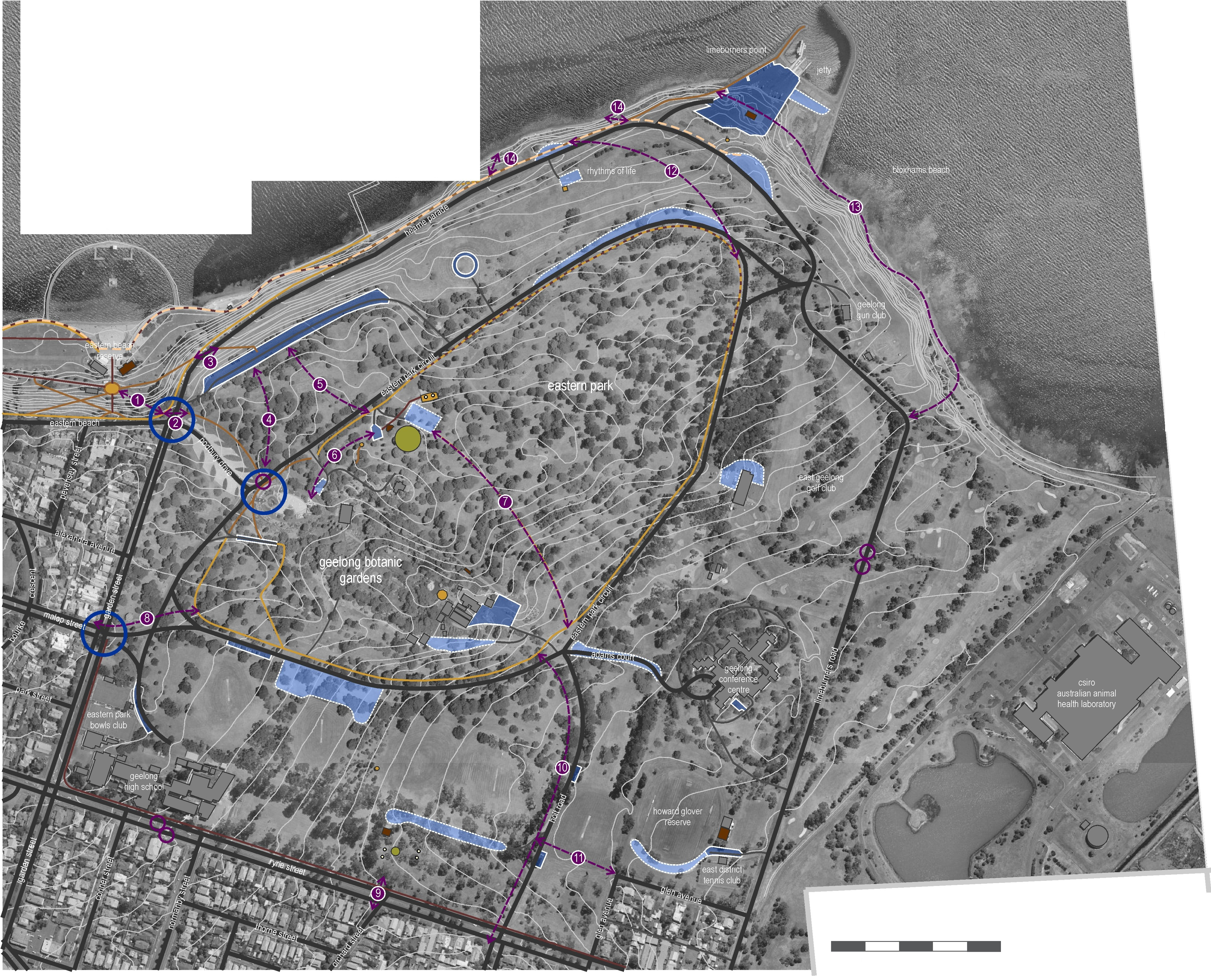

0 100 200
50 150

250m
Project Ref: 06.438
Dwg No.: LCD-002
EB
Scale: 1:5000@A3
Date: 11.9.07
Revision: C
hansen partnership pty ltd melbourne I sydney I vietnam level 8 136 exhibition st
melbourne vie 3000
t 61 3 9654 8844 f 61 3 9654 8088
e info@hansen-online.com.au
w hansen-online.com.au

Access & Movement – Geelong Botanic Gardens
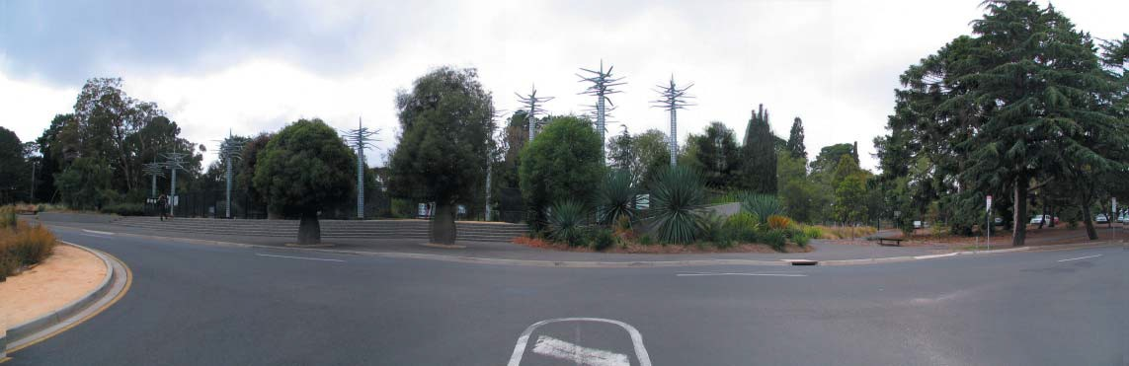
Pedestrian and bicycle access
      - Pedestrian access to the Geelong Botanic Gardens is constrained in that it is only available through a single entry point at the western end of the 21st Century Garden. This impacts upon the ability of the Gardens to integrate with the broader Eastern Park area, and results in unauthorised access via the depot to the Gardens proper.
      - Pedestrian access within the Gardens is well provided via a series of pathways, many of which have heritage signiﬁcance as being representative of the original layout.
      - Pedestrian access to the Community Meeting Rooms is convoluted and poorly sign-posted, either from within the Gardens or from the existing unsealed car park adjacent to the Administration Building.
      - There is very poor provision of pathway connections from existing parking areas to the existing entry to the Gardens.
Vehicular access
      - Access for service vehicles is provided via the Depot entry gate at the eastern end of the Gardens. A number of other gates around the perimeter fence provide service vehicle access.
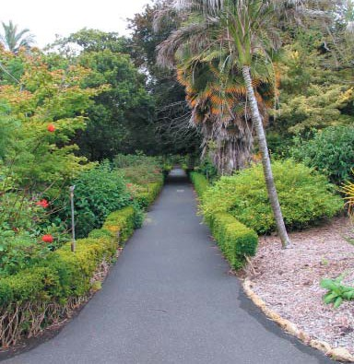
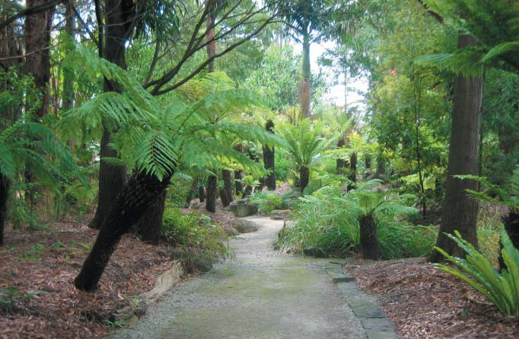
      - Access for vehicles associated with the Community Meeting Rooms is via the Depot entry road and an unsealed parking area. This access is poorly deﬁned and could be substantially improved.
Other access considerations
      - DDA compliance is poor within the Geelong Botanic Gardens, with regard to the provision, alignment, gradient, materials and condition of the existing access network.
      - Access for delivery of temporary infrastructure associated with events such as weddings and other cultural events held in the Gardens is limited.
      - Access to the Community Meeting Rooms is heavily constrained during road cycling events in Eastern Park due to their location ‘inside’ Eastern Park Circuit, where these events are often held.

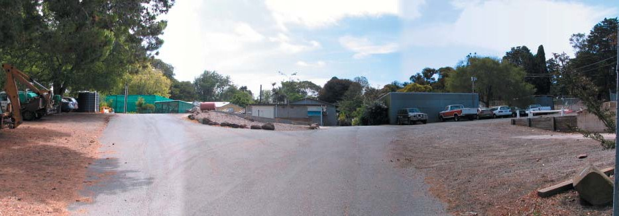


hansen
eastern park and geelong
botanic gardens strategic plan

botanic gardens pedestrian movement

legend
basalt flagstone / buildings I pedestrian paths /
/ primary heritage
asphalt pedestrian / significance
paths as identified within the 4)
/ 2007 conservation and
gravel pedestrian / management plan
paths contributory heritage pedestrian ,,•• significance (i) movement ,•• as identified within the
,,' 2007 conservation and
desire line •
management plan
pedestrian crossing points
0 toilets
possible ..-

pedestrian ¢/
linkages
formal entrance points
shelters 0
fountains 0
0

service seats 0
0
entrance

points
contours at 5 ft
(1.524 m)
intervals
roads/

service roads/
D
sealed car parks I• I

unsealed car parks restricted area

outdoor dining area

open lawn

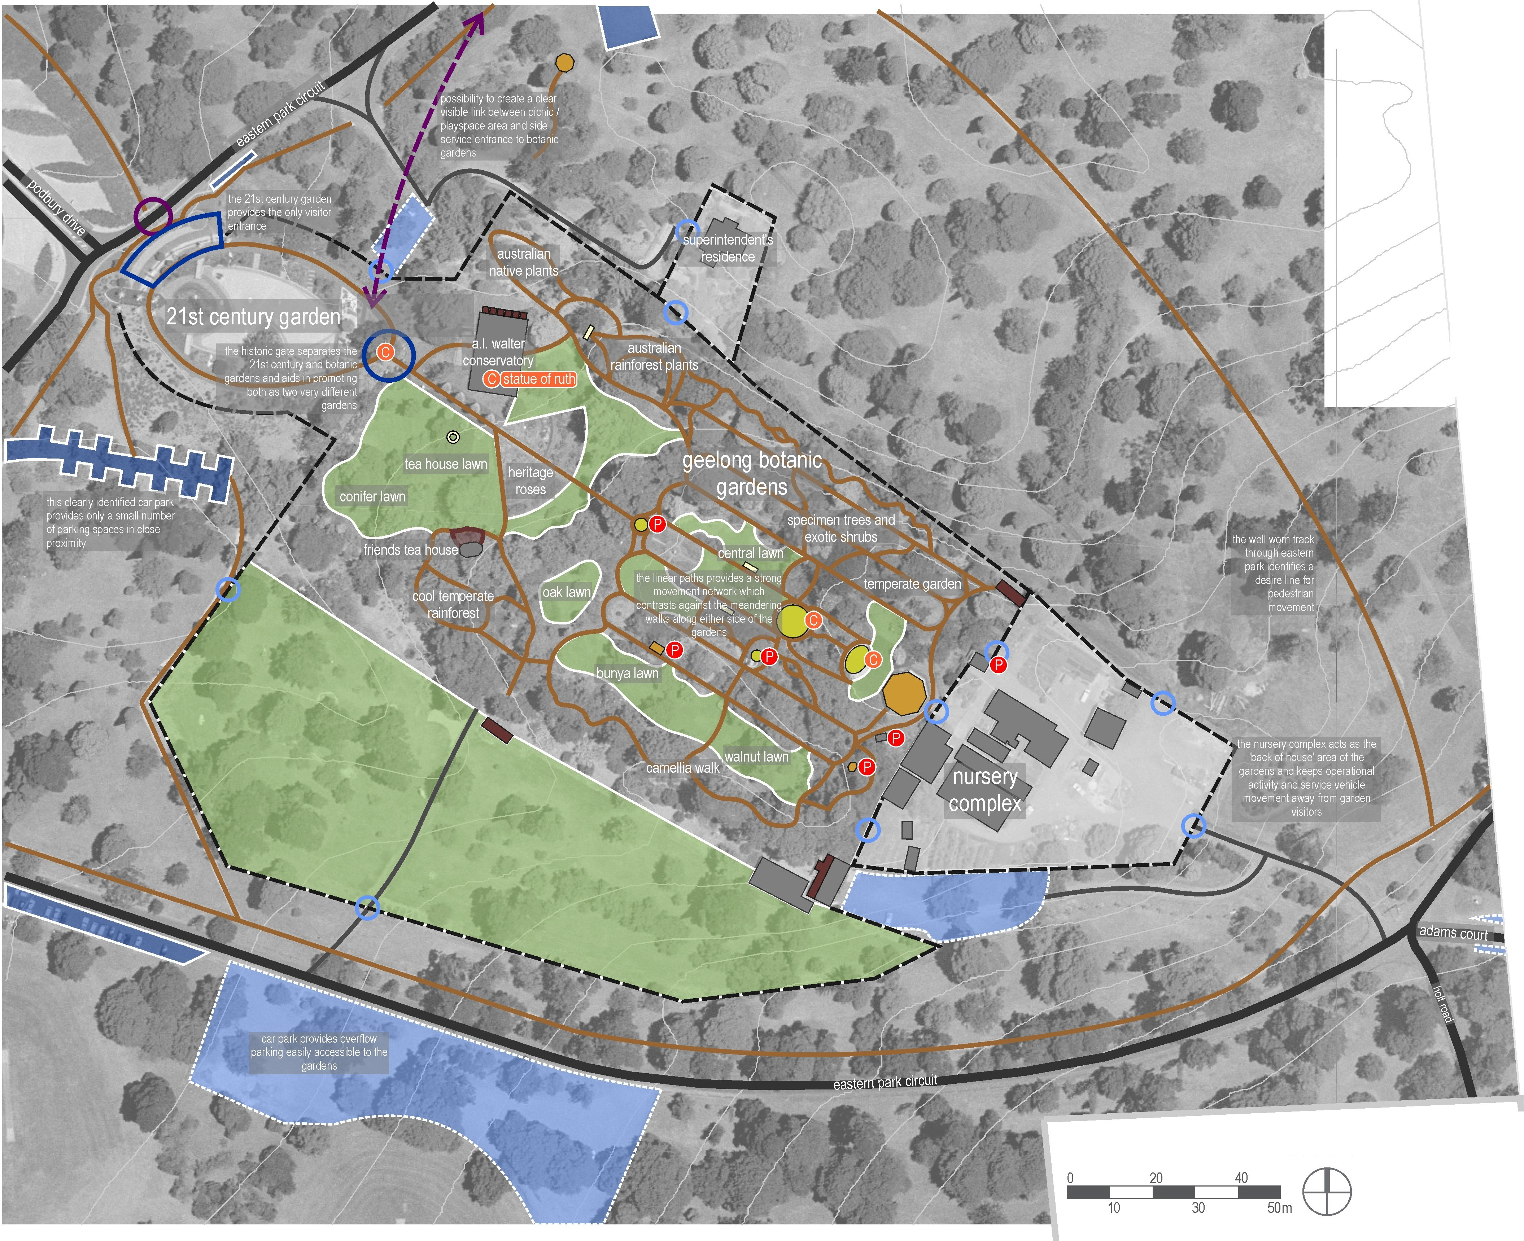

Project Ref: Dwg No.: Scale: Date: Revision:

06.438
LCD-006 1:1500@A3
11.9.07
C
hansen partnership pty ltd melbourne I sydney I vietnam level 8 136 exhibition st
melbourne vie 3000
t 61 3 9654 8844 f 61 3 9654 8088
e info@hansen-online.com.au
w hansen-online.com.au

Leisure & Recreation

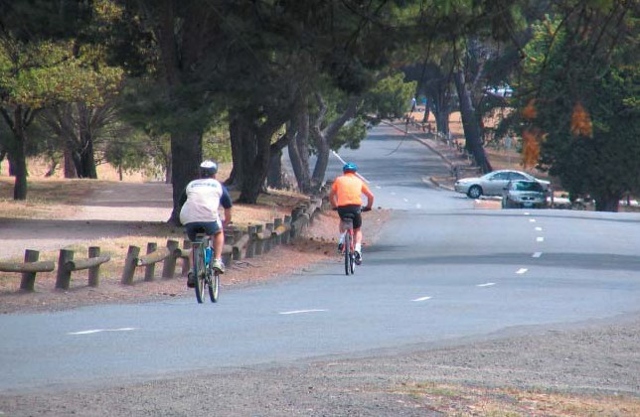
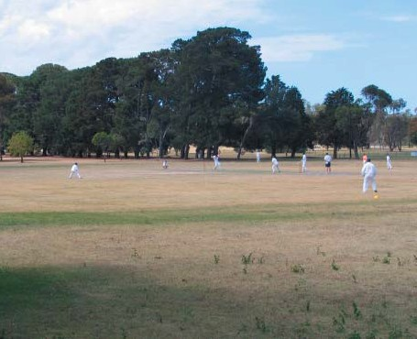
Leisure Strengths
Competitive strengths
From a leisure perspective the size of Eastern Park and the size of the treed area, sports ﬁelds, and north facing public parkland land abutting the foreshore underpin its signiﬁcance. The park’s large green and treed nature, its relationship with water, and ability to provide off-road activity for physical activity and sport are the competitive strengths that should be the focus of future design and development.
      - It offers the longest circuit trail opportunities away from heavy trafﬁc for running and cycle training close to central Geelong
      - It provides one of the best uninterrupted views across the bay
      - It offers a welcome respite and contrast to the foreshore and CBD. It offers contrast to the urban intensive and facility-focused development along the foreshore.
      - It offers an expansive and informal parkland setting in close proximity to the city centre
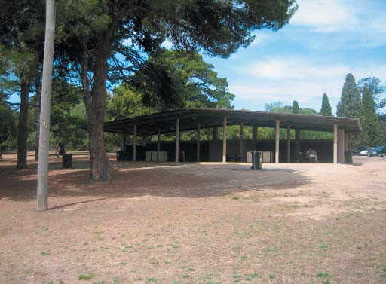
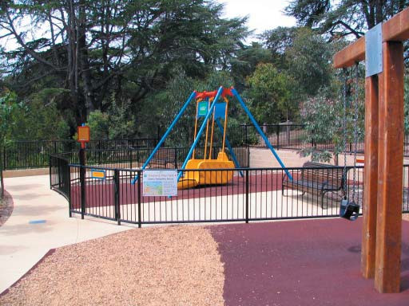
A principle in future plans should therefore be to ensure new uses are dependant on these core assets, and any development should retain and promote the natural environment and water aspect. Whilst these may need to be supported with structures, any new uses should not predominately be built and paved, as this may detract from the parks competitive strengths. Where possible Eastern Park should not duplicate activities and experiences available in other locations within Geelong.
Leisure activity zones
In any replanting the nature of the relationship between vegetation and leisure use should be enhanced. Sports ﬁelds could have trees around their boundaries but not too close so as to limit the set out of speciﬁc ﬁelds of play or so as to impact on the nature of the turf etc.
The open woodland with relative rough natural character is a key aspect of the park’s popularity as a dog exercising area.
Paths could be better deﬁned, and have increased amenity if they supported a row of trees either side.
Picnic areas could have some protection, high quality furniture, ground cover and landscape amenity, with trees providing for shade, play value and character.
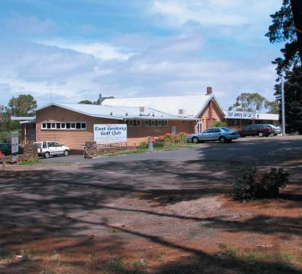
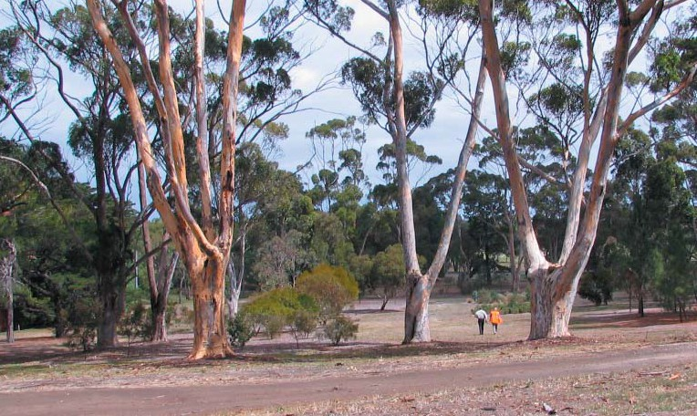
Each of these areas would also become more accessible to the user groups they serve.
The key leisure activity nodes would be best supported by logical and convenient support infrastructure (rather than these being more dispersed across the park) as well as good way ﬁnding and interpretative signage. Upgrading support facilities such as picnic facilities, paths, vehicle barriers, tables and seats; and the rationalisation of vehicle movements and parking to serve these nodes; is also considered a leisure planning priority.

Consultation
As a regional park, Eastern Park has a catchment much broader than its immediate surrounds. It therefore has many stakeholders and interested parties that need to be engaged and consulted throughout the process. In preparing this plan, the project team has sought to implement innovative community engagement and consultation mechanisms that help ensure a broad cross section of the community has the opportunity to input into and be kept informed of the planning process. In brief, the program of consultation undertaken is outlined as follows:
Project Launch
Held in February 2007, this public event was held in the Meeting Rooms of the Geelong Botanic Gardens to introduce the project and outline the project methodology and conﬁrm timelines and key deadlines.
Listening Posts
In late March 2007, the project team spent time in Eastern Park, and at other popular locations in and around Central Geelong, including the Geelong Waterfront and Bay City Plaza, to listen to the views, opinions, hopes and wishes for the future of Eastern Park and the Geelong Botanic Gardens.
Issues & Visioning Workshop
In early April 2007, the project team facilitated a workshop event with invited stakeholders, representative of the broad range of community, sporting and recreation groups which use and value Eastern Park and the Geelong Botanic Gardens. The intent of the workshop was to identify and record – from the perspective of the park’s users – the major issues which the master plan should consider, and to begin to imagine a vision for the future of Eastern Park and the Geelong Botanic Gardens.
Project Webpage
A webpage for the Strategic Plan was established within the City of Greater Geelong website in March 2007. This page provides an overview of the project, progress reports and also draft copies of the Strategy Plan when it was made available for public review. The page has recieved 2195 hits between its opening and the end of August.
Survey Questionnaire
Throughout March and April, a survey questionnaire was publicly advertised and distributed throughout Council’s various Customer Service Centres, and posted on-line on Council’s website, to capture the opinions, ideas and suggestions of the broader community, who may not have been able to attend the more structured consultation events. The response to this method of consultation was good, with over 300 responses received.
Project Control Group and Project Working Group Meetings
At regular intervals throughout the project, the project team has consulted with the Project Working Group and the Project Control Group.

Issues
A summary of the key issues identiﬁed through the analysis and consultation phases of the project is provided below. This summary is not intended as an exhaustive list, however it does provide an objective review of the wide range of issues identiﬁed for consideration in preparing the master plan.

Landscape
- Protection and enhancement of panoramic views across Corio Bay is important.
- There is a lack of visual connectivity between Eastern Park and Eastern Beach.
- The amenity of the coastal fringe would be improved by removing weeds and litter.
- The perimeter fence to the Geelong Botanic Gardens is visually unappealing.
- The Geelong Botanic Gardens Depot is visually unappealing.
- The tree avenues are important visual reminders of the heritage of Eastern Park.
- The Geoglyph sculpture is poorly integrated and requires improved interpretive signage.

Trees
- The health, structure and Useful Life Expectancy (ULE) of many trees within the park is very poor.
- Over 50% of existing trees within Eastern Park will need to be removed within the next 15 years.
- There are 39 trees within Eastern Park and the Geelong Botanic Gardens, most of which are located within the Gardens, which are on the National Trust Signiﬁcant Trees Register.

Heritage
- Eastern Park, Geelong Botanic Gardens and the adjacent foreshore in the vicinity of Limeburner’s Point are of historical, scientiﬁc (botanical and zoological), and aesthetic signiﬁcance to the State of Victoria.
- In addition, the East Geelong Golf Club, Howard Glover Reserve and Eastern Park Bowls Club are of social signiﬁcance to the City of Greater Geelong.
- Eastern Park and the Geelong Botanic Gardens contain numerous elements of primary and contributory signiﬁcance, as identiﬁed and described in the Heritage Conservation Assessment. The conservation of these elements is a critical consideration in the future management of the park.

Archaeology
- Four Aboriginal archaeological sites that have been recorded within the study area.
- Due to their proximity to Corio Bay, Eastern Park and the Geelong Botanic Gardens are sensitive archaeological sites which could possibly contain valuable sub-surface archaeological material.
- The recent introduction of the Aboriginal Heritage Act 2006 requires that a Cultural Heritage Management Plan be prepared for certain types of development or activities located in sensitive areas before works can commence.

Recreation
- Limeburners Road bisects the East Geelong Golf Club,and golfers are required to hit across the road on two of the nine holes.
- The provision of picnic facilities, barbecues, toilets and associated infrastructure is limited in areas of high demand, and the location of such infrastructure could be better integrated with other facilities.
- Vehicle movement conﬂicts with the peaceful contemplative leisure experiences in the park.
- The running track along Eastern Park Circuit is incomplete and is does not connect well with any pathways external to the park.

- The sports grounds are constrained by their relatively small size, signiﬁcant cross-fall and lack of shelters for participants and spectators. The No. 4 Oval is further constrained by its poor drainage.
- The activities undertaken by the Geelong Gun Club have impacts including noise disturbance, safety, and litter from clay targets.
- There are no clear directions for dog users regarding on / off leash areas and waste disposal.
- There is a focus on motorised water recreation within Corio Bay, and the Limeburners Point precinct is the primary activity hub for this form of recreation. As such it is a regionally-signiﬁcant recreational facility.

Events
- There is a desire by the community to stage more events within the park.
- New uses need to be dependant on the core assets of Eastern Park.
- Eastern Park supports a number of cross-country events and running clubs, which are important to retain.
- Concerts, triathlons, and cycle events are some of the organised activities which currently take place within the park.
- Some events which take place within the park require closing the internal vehicular roads. This prohibits vehicular access for users to facilities such as Limeburners Point boat ramp, Geelong Botanic Gardens and also the Geelong Botanic Gardens meeting rooms.
- Fires need to be managed within the park, especially in association with community events.

Access
- No accessible (safe or convenient) path of travel is available from Geelong CBD or Eastern Beach into Eastern Park.
- The Bay trail is not continuous and the adjacent Eastern Park foreshore is inaccessible.
- Access to the foreshore east of Limeburners Point is constrained by the presence of the Geelong Gun Club.
- With the exception of Podbury Drive, the major entrance points into the park are not clearly identiﬁed as such.
- Other than around Eastern Park Circuit, the Sri Chinmoy Peace Mile path and alongside Hearne Parade, there are no constructed pathways within the park.
- The Eastern Park Circuit running track is discontinuous in the vicinity of the 21st Century Garden and the Play Space.
- The Geelong Botanic Gardens is poorly integrated with Eastern Park, given that there is only one point of entry to the Gardens for visitors.
- Car parking servicing the Geelong Botanical Gardens is some distance from the entry and lacks clearly deﬁned and accessible pedestrian paths linking these.
- Parking throughout Eastern Park in general lacks safe convenient spaces for the elderly and people with disabilities in close proximity to destinations.
- Private vehicles are observed speeding throughout the park and also using the internal roads as a short cut, bringing in unnecessary vehicle numbers.
- Eastern Park is poorly serviced by public transport.
- The lack of formal pedestrian crossings on Ryrie Street and Garden Street segregates adjacent residential neighbourhoods from the park.

Sustainability
- There are no water harvesting or storage systems within Eastern Park, although both the Geelong Botanic Gardens and the East Geelong Golf Club have infrastructure in place to reduce water requirements for irrigation, or are planning to do so. The Geelong Botanic Gardens has installed a weather track irrigation control system which will reduce water usage in the Gardens by 4.5 megalitres per year. The East Geelong Golf Club has plans to harvest storm water from their club house roof, and from the existing open storm water drain along their eastern boundary, and use this water for irrigation.
- The Gun Club land and adjacent foreshore and sea bed is littered with bullet cartridges and clay targets as a result of the activities of the Gun Club and its remediation is a critical consideration with respect to environmental sustainability.
- Public toilets provide an opportunity for sustainable waste practices.
- New lighting infrastructure provides the opportunity to incorporate solar powered street and path lighting.

Wildlife
- Retention of the ﬂying fox colony in its present location will require the provision of replacement roosting opportunities given the poor condition and short useful life expectancy of the existing trees.
- Maintenance and enhancement of roosting trees for the Flying Foxes in their existing location is important to minimise the risk of the Flying Foxes relocating to trees within the Botanic Gardens and thus damaging the signiﬁcant plant collection.
- The ﬂying foxes are an attraction in their own right and as such new facilities and interpretive information is required to manage visitors who are coming to Eastern Park to view the colony.
- Overﬂow car parking associated with the East Geelong Golf Club encroaches within the treed area which is occupied by the ﬂying fox colony.
- The existing pine trees within Eastern Park are important for a number of native bird populations, including the Yellow Tailed Black Cockatoo and Gang Gangs.
- Numerous other fauna species, including possums, reptiles and numerous native bird species, live in Eastern Park and the Geelong Botanic Gardens, and consideration of their habitat requirements is required to ensure their ongoing viability within the park.

Education
- Interpretation of the social stories, plant collections and sustainable gardening in the Geelong Botanic Gardens is limited for those visitors not participating in formal programs.
- The demand for and scope of education programs at the Geelong Botanic Gardens is limited by a lack of facilities.
- Visitors may not appreciate the signiﬁcance of the various elements within both Eastern Park and the Geelong Botanic Gardens due to the lack of visitor interpretation.

Existing Buildings
- Public toilets within Howard Glover Reserve are locked, making them unavailable when adjacent grounds are used by local sporting clubs.
- The meeting rooms within the Geelong Botanic Gardens are insufﬁcient for the high demand of use by community groups.
- The current public toilets within the Geelong Botanic Gardens are temporary and have been in the Gardens for a number of years.

Infrastructure
- Car parking facilities are generally informal and undeﬁned. Parking often occurs wherever there is space in close proximity to facilities.
- Car parks are generally unsealed, resulting in incidences of poorly identiﬁed layout, non-conforming disabled spaces, uncontrolled ‘overﬂow’ into parkland, excessive dust, ongoing maintenance requirements and poor environmental conditions, particularly relating to run-off.
- Directional signage within the park is ineffective, for both vehicles and pedestrians.
- Vehicular intersections within the park are poorly sign-posted and hence confusing for motorists, cyclists and pedestrians.
- Many paths, road crossings and facilities are not DDA compliant.
- Coordination between the locations of key leisure activity nodes and logical and convenient infrastructure is generally poor.
- Picnic facilities are generally in poor condition and do not satisfy demand during peak times.
- Seating and shelter is required around the sporting ovals.
- Open ﬁre BBQ’s near Ryrie Street present a ﬁre risk and are generally unsightly.
- Lighting is minimal throughout the park.

Possible Future Developments
- The Corio Bay foreshore – within Eastern Park – is one of a number of potential sites within central Geelong for the establishment of the Geelong Mineral Springs Bath House.
- A proposal for the redevelopment of the Walter Conservatory within the Geelong Botanic Gardens as a ‘Café Restaurant’ has been prepared on behalf of the Friends of the Geelong Botanic Gardens.

Other Current Studies / Policies
- The Walter Conservatory Café Restaurant Proposal recommends redevelopment of the existing Walter Conservatory building within the Botanic Gardens into a high quality café restaurant and kiosk with associated public amenities.
- Walking More Walking Safely Final Report identiﬁed Eastern Park as a Grade One walking trail, where Grade One entails:
  - Surface is sealed or granitic and in excellent condition,
  - Seating at regular intervals,
  - Shelter structure provided at midway points of walks,
  - Signage includes: map, identiﬁcation of 50-60 minute circuits, level of difﬁculty, wheelchair accessibility, availability of drinking water, toilets and shelter.
  - Distance markers embedded on track.
- Study of Open Space Networks recommends:
  - Initiating a program to minimise conﬂicts between cyclists, pedestrians and other foreshore users on coastal trails.
  - Development of new trails as off-road trails and where this can be achieved, to develop them as wildlife corridors.

- Corio Bay Coastal Action Plan includes the following objectives for Central Geelong, including the shoreline of Eastern Park:
  - To continue to improve water quality.
  - To improve infrastructure for recreation and tourism users.
  - To ensure the marine ecosystem is protected.
  - To improve the degraded quality of the Limeburner’s Point area.
  - To improve public access along the foreshore in a safe environment.
  - To manage water based recreation for the beneﬁt of all users.
  - To review and develop consistent standards for leasing and licensing foreshore users.
  - To investigate the proposed development of the mineral springs.
- Corio Bay Coastal Action Plan includes the following speciﬁc objectives for the shoreline of Eastern Park:
  - Promote and improve facilities for informal recreation with proposed extensions to the path network.
  - Relocate the Gun Club as a means of reinstating public access to the Corio Bay foreshore.
  - Promote opportunities for interpretation of cultural sites such as the Mineral Springs and Lime Kilns.
- Events Precinct Feasibility and Concept Plan notes:
  - Trafﬁc issues in the business district are generated by events within the foreshore, therefore it is important to accommodate more events at Eastern Park.
  - Eastern Park is well suited to hosting motor sports, cycling, running and triathlon events and could feasibly develop a designated car / motorcycle event area there.
  - There is potential to use an oval as a heliport during events.
  - There is the opportunity to develop an Interpretation Centre or Visitor Information booth.
- Events Precinct Feasibility and Concept Plan recommends:
  - Establishing additional infrastructure at Eastern Park to support the staging of selected major, regional, local and community events and relieve pressure from the waterfront.
  - Adapting Hearne Parade to accommodate motor sport events and additional parking.
  - Construct a boardwalk between Eastern Park and Eastern Beach.
  - Upgrading the foreshore to allow deep-water access.
  - Upgrading existing car park facilities.
- Events Precinct Feasibility and Concept Plan found that a single multi purpose dedicated ‘event precinct’ was not desired by the community, with a preference to individual siting of events based on intended activity, audience and setting.
- Events Precinct Feasibility and Concept Plan suggests that due to the popularity of staging events on the Waterfront there is an opportunity to develop a high-level event precinct plan for both the Waterfront and Eastern Park.
- Events Precinct Feasibility and Concept Plan recommends upgrading the existing granitic sand running track.

Opportunities for Enhancing Leisure Experiences
There are a number of opportunities to enhance the leisure value of Eastern Park. These relate to upgrading existing facilities; strengthening the relationship between or promoting other uses; and potentially relocating some facilities and rationalising roadways.
The key opportunities to enhance the value of leisure experiences in the park are summarised in the following points.
- Protect and interpret ﬂying fox habitat.
- Provide an accessible path of travel, and running and cycling link from Eastern Beach and the Geelong CBD into the park.
- Bench, revegetate and design paths to promote scenic quality, viewing of events and picnicking.
- Enable future access to the foreshore and provide a link trail to facilitate this and promote the Lime Kilns.
- Retain major sports precinct with all existing grounds, and over time allow for the reconﬁguration of playing ﬁelds to maximise their ﬂexibility and function.
- Investigate the possibility of the water bodies in CSIRO land for watering sports facilities and parkland, and as an edge for a scenic route for the connection of the Bay Trail to the Rail Trail.
- Provide a series of circuit paths of varying hierarchy and distance for running, wheeling and cycling (this could include using one sealed road way circuit as a criterium circuit and the use of the main circuit for events).
- Redeﬁne the boundaries of the Play Space to facilitate better access to adjacent facilities, including the Geelong Botanic Gardens Superintendent’s Residence, the large picnic shelter, Eastern Park Circuit and adjacent car parking areas.
- Develop components of the Mineral Springs proposal in conjunction with existing water play opportunities at Eastern Beach (as it is more suited to the social, water and high volume activity node already provided there).
- Utilise the vacant land at Limeburners Point to improve the visual amenity of the area.
- Redeﬁne and improve the boundary fencing to the Geelong Botanic Gardens, and importantly make provision for additional entry points such that opportunities are provided to access the Gardens as part of a broader recreational experience, rather than just as a destination in itself.
- Replant senescing vegetation in the park to reinforce separate key character areas that reﬂect different leisure activities and support these uses. For example:
  - Strengthen the existing pinetum to enhance the association of this area with the Geelong Botanic Gardens. Also establish paths and play areas here to take advantage of the unique setting.
  - Retain open woodland areas for dog walking.
  - Densely plant appropriate vegetation to support and assist interpretation of habitat.
  - Frame paths with trees on either side.
- Use interpretative signage to promote natural and cultural values, enhance visitor experiences, and facilitate more efﬁcient visitor movement throughout the park
- Redevelop the Walter Conservatory with provision for a café area which facilitates access to the Geelong Botanic Gardens from Eastern Park.
- Consider future use of the superintendent’s residence as an education centre to take advantage of its proximity to both the Geelong Botanic Gardens and the Play Space, to support the further development of the Gardens’ education program.
- Introduce additional areas of native vegetation to complement existing patches, to provide for habitat corridors and refuges for native species.

A dedicated hierarchy of paths for cycling and walking
Cycling, walking (including dog walking) and running are core activities for the park. These need to be deﬁned and managed as off road trails - as a key priority.
A key opportunity for the park is to deﬁne a series of circuits of both sealed and unsealed paths to facilitate these activities. The logical routes are already deﬁned. Gaps in routes need to be addressed, as do entry points from central Geelong and Eastern Beach. The Bay Trail could be extended along the foreshore and a connection made through the park to the Rail Trail. It would be beneﬁcial to address some constraints to pedestrian and cycle movement, including conﬂicts with vehicles and the gradient of paths.

Reinforcing the leisure value of the Geelong Botanic Gardens
The Geelong Botanic Gardens (aside from its value from a botanic perspective) could be described as the anchor leisure- use in the park. This is primarily because the gardens are unique in the Geelong region. The age and signiﬁcance of the botanic collection provides a cultural and leisure destination, while the high quality landscape setting provides a backdrop for a range of social, artistic and contemplative leisure experiences. These are of increasing signiﬁcance to an aging population, which in itself will require further consideration of existing limitations on equitable access, partly due to the heritage status and inherent landscape character and form.
The 21st Century Garden provides a valuable contribution to both leisure and educational experiences, particularly with regard to the level of community interest generated by ongoing needs within the broader community to consider and adopt water sensitive gardening practices.
The Gardens also provide a valuable ‘educational leisure’ experience, in an active manner through the formal education program for schools, which is delivered by a qualiﬁed teacher, through the provision of guided walks and events and in a passive manner through the provision of plant labelling signage and information sheets, and also in the role the Gardens play in displaying and educating people about sustainable gardening principles.
Opportunities exist to further enhance the garden’s value as a leisure resource, and to broaden its appeal as a leisure destination. To do this, the following features of the Geelong Botanic Garden need to be addressed:
- the perimeter fencing / edge treatment could be improved to reﬂect the importance of the Gardens and to enable better access from Eastern Park;
- the views to the nursery from within the Gardens should be encouraged as an educational opportunity for visitors to understand the role of a nursery in developing and conserving plant collections;
- the development of a horticultural complex to adequately meet the needs of the community who base their leisure activities at the Gardens;
- the quality and accessibility of visitor facilities (eg toilets, catering) could be improved to enhance leisure experiences and encourage longer stays; and
- pathways connecting existing and possible future car parking areas to the Gardens entry points need to be legible and accessible for all visitors.

Existing visitor activity groups and their facilities
The site inspections identiﬁed eight key facility types, and their associated users, that currently exist in the Park. These include:
- Sports clubs and playing ﬁeld users.
- Social/family picnic and play facilities, and their users.
- Education and conference facilities, and their users.
- Arts, heritage and horticultural facilities, and their users.
- Water based recreation users (users of Limeburners boat ramp and car park).
- Roads and their motorised users (pleasure drivers, local short-cut trafﬁc, events, and users of speciﬁc park facilities).
- Casual exercise and ﬁtness trail users (walkers, dog walkers, runners and cyclists).
- Neighbouring facilities, and their users.

Vision Statement
Eastern Park and the Geelong Botanic Gardens is an expansive urban parkland which accommodates a diverse range of recreational, botanical, historical, cultural, educational and environmental assets, in a spectacular waterfront setting on Corio Bay.
The recreational assets of Eastern Park and the Geelong Botanic Gardens will provide for a diversity of active and passive recreational pursuits.
The botanical importance of the Geelong Botanic Gardens will be celebrated, with the Gardens providing a place for plants and people, discovery and learning, ideas and innovation, community engagement and pride, conservation and the environment and quiet contemplation.
The historical signiﬁcance of the park will be recognised, protected and embraced through improved interpretation and integration of the park’s historic features.
The cultural value of the park will be enhanced through a greater emphasis on arts and culture. Public art – both permanent and ephemeral - will become a prominent feature of the park, and outdoor performances in the park will be a regular ﬁxture on Geelong’s cultural calendar.
The environmental assets of the park will be protected and allowed to thrive as a result of careful management which recognises their importance in maintaining an ecologically viable urban parkland landscape.
In essence, Eastern Park and the Geelong Botanic Gardens will become the pre-eminent parkland within the Greater Geelong region, and will be as much a part of the identity and day-to-day life of the Geelong community as, Eastern Beach, Corio Bay, the Barwon River and the Geelong Waterfront. It will be Geelong’s hub of recreational, botanical, historical, cultural, educational and environmental pursuits.

Principles
The master plan has been developed on the basis of an agreed set of fundamental design principles, outlined below.
- Protect and emphasise the role and reputation of Eastern Park and the Geelong Botanic Gardens as the premier parkland within the City of Greater Geelong supporting the needs of the local community and visitors.
- Protect and enhance the role of the Geelong Botanic Gardens in managing and maintaining plant collections for the purposes of conservation, education, research and display.
- Improve connections – both physical and visual - to and through Eastern Park and the Geelong Botanic Gardens.
- Respect, reﬂect and interpret the heritage signiﬁcance of Eastern Park and the Geelong Botanic Gardens.
- Protect and enhance the landscape character of the park as an informal, open woodland environment with a frontage to – and expansive views across – Corio Bay.
- Maintain and enhance the range of sustainable recreational opportunities and landscape settings within Eastern Park and the Geelong Botanic Gardens.
- Increase the range and frequency of appropriate events in Eastern Park and the Geelong Botanic Gardens and provide the necessary infrastructure to facilitate them.
- Protect and conserve signiﬁcant vegetation and fauna, including the conservation of habitat upon which signiﬁcant fauna species rely for food or shelter.
- Recognise the contribution to the character of Eastern Park and the Geelong Botanic Gardens made by the park’s trees, and protect this through the implementation of a planned removal and replacement of failed or inappropriate trees.
- Improve the environmental sustainability of Eastern Park and the Geelong Botanic Gardens and encourage opportunities for the park to contribute to improving the overall environmental condition of Geelong.
- Establish a robust, practical and identiﬁable suite of park signage, furniture, lighting and other visible infrastructure to enhance amenity, character and usability.
- Ensure appropriate opportunities are provided within Eastern Park and the Geelong Botanic Gardens for the promotion of a diverse program of arts and culture.
- Facilitate the limited development of appropriate commercial facilities within Eastern Park where it can be demonstrated that such facilities would result in a net beneﬁt to the park and its users and would not compromise any of the principles listed above.

The Master Plan
The Master Plan for Eastern Park and the Geelong Botanic Gardens – together with the Heritage Conservation Assessment and the Management Plan – comprises the Strategic Plan to guide the conservation, use, development and management of Eastern Park and the Geelong Botanic Gardens.
The Master Plan comprises a series of key actions, under the headings of pedestrian movement, vehicle movement, landscape, attractions and facilities. Some of the actions relate to speciﬁc areas within the park, whereas others are more general and relate to elements or activities which can be found throughout the park.
The actions have been developed as the building blocks of the master plan, and represent the processes by which identiﬁed issues are addressed and agreed principles are implemented.
The actions may be interpreted as ‘discrete projects’, which Council can progressively implement across the life of the plan. The prioritisation of these projects is elaborated within the Implementation Strategy chapter of this report.
It is importance to note that all future developments mentioned within the Master Plan are subject to seperate design processes and are shown in an indicative manner only.
A brief description of the design intent and vision for each of the actions is outlined below, and is intended to be read in conjunction with the Master Plan drawing accompanying this report.

corio bay

bloxhams beach

master plan actions
pedestrian movement
continuation of the bay trail along the shore, providing the "compelling link" between eastern beach and eastern park

create a legible and accessible pedestrian network tl'Toughout the park

create a well connected park through formal and safe crossing points and bus stops

creation of multiple entry points to the botanic garden, improvingits integration with the surrounding park

closLre of the inner lane of eastern park circlit between the malop street entry and the circular car park and its conversion to a shared path

vehicular movement
new vehicular access route to the golf coLrse and convention centre
from limeburners road
close off adams court to velicular traffic

traffic management, including the creation of roundabouts at garden street/ podbury drive intersection and the malop street/ eastern park circuit intersection along with traffic barriers

one way vehicular traffic in an articlockwise direction on eastern park circuit between the malop street entry and circular car park

formalisation of roads and car parking throughout the park creation of a new shared path
■hanseIn


eastern park and geelong
botanic gardens strategic plan landscape master plan

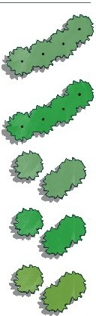
legend
native tree avenues

exotic tree avenues

native trees

exotic trees

botanic garden trees

native grassland vegetation

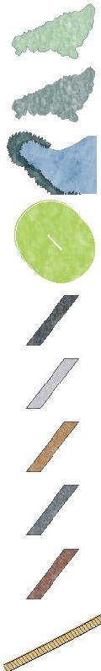
native coastal vegetation

low scale ornamental vegetation

wetland with native vegetation

sports fields

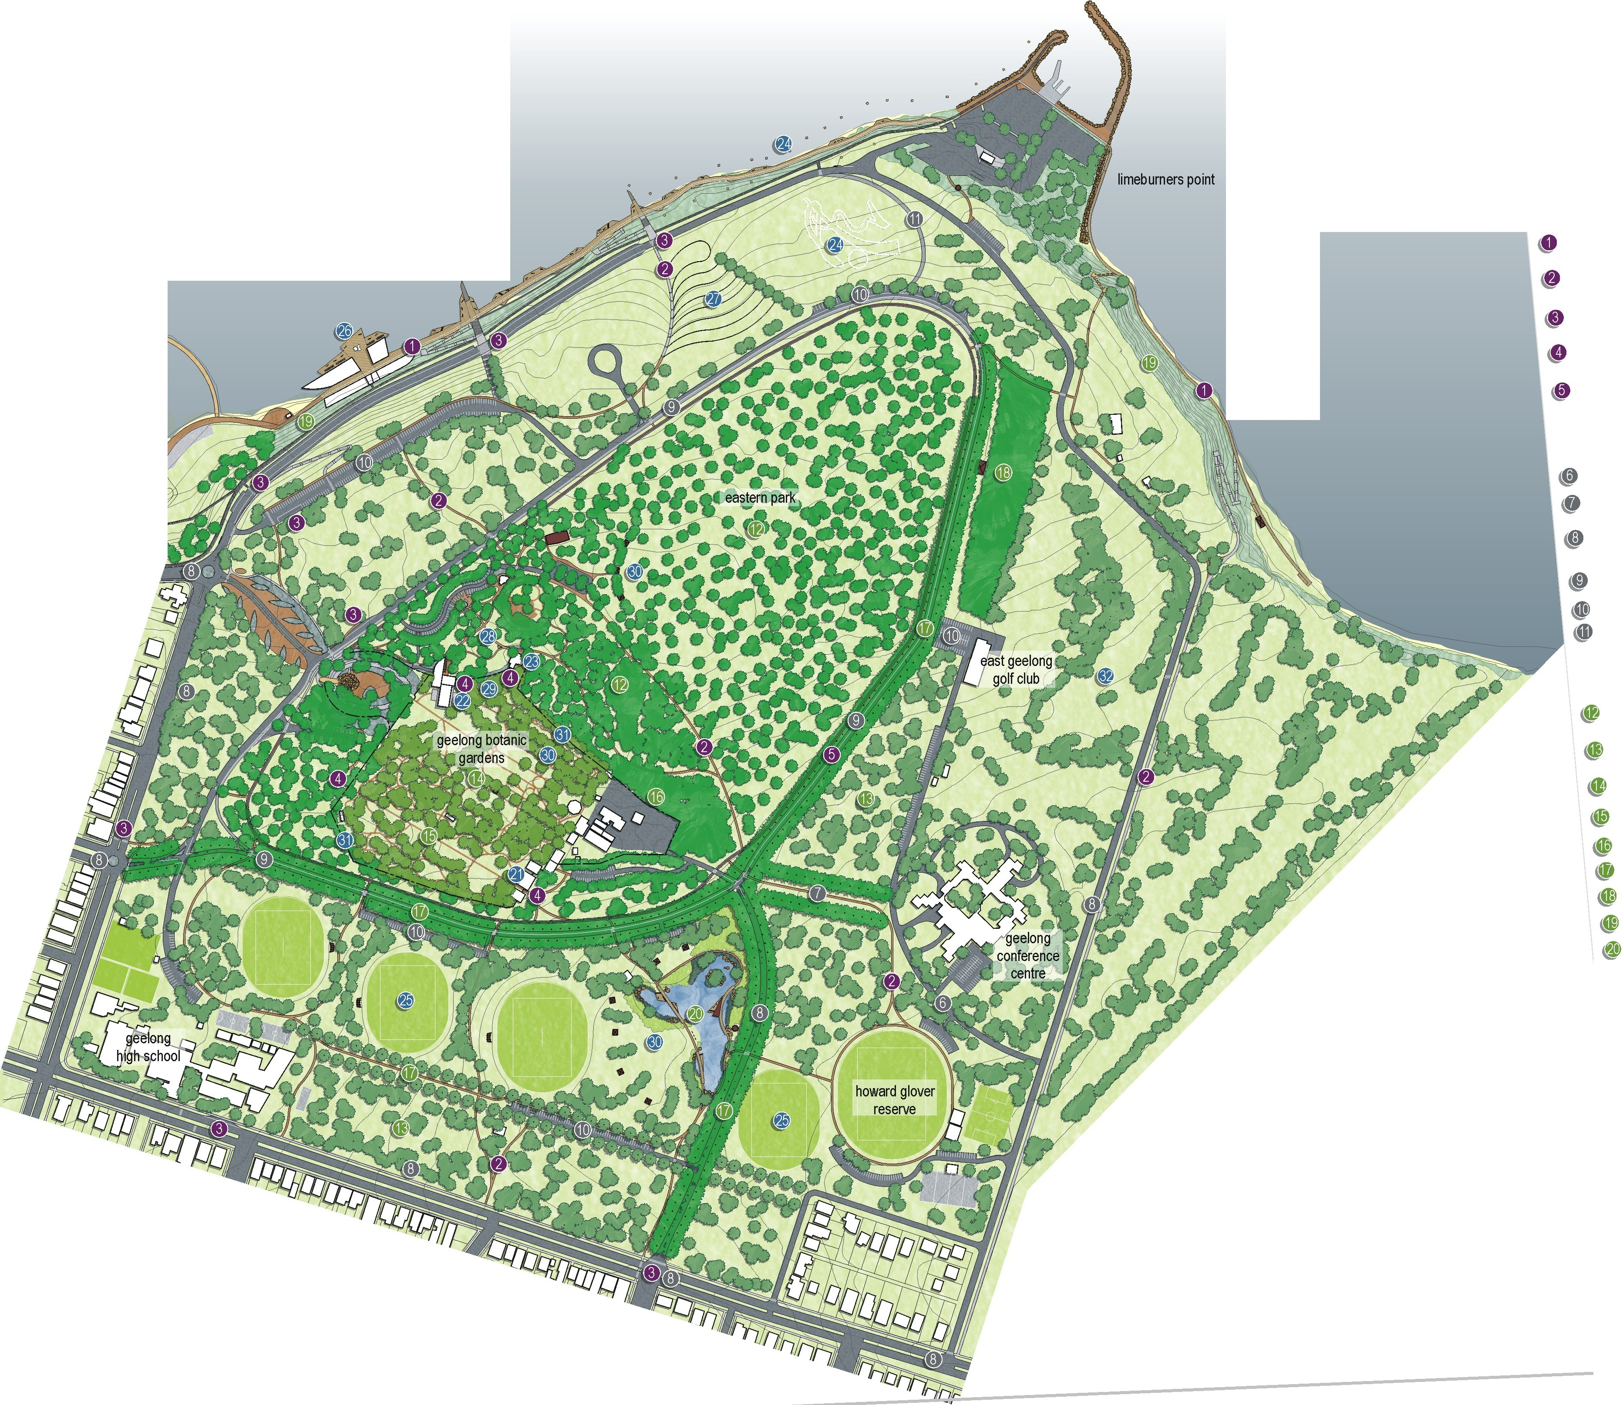
landscape
central eastern park to be recognised as a pinetum with irtemal pedestrian circulation routes, interpretive signage and a connection to the botanic gardens
sLrrounding parkland to be dominated with native plantings to create an australian landscape character

establishmert of a strategic direction for the management and development of the geelong botaric gardens' landscape

new collections within the botanic gardens

screening vegetation surrounding the depot area witlin the botanic gardens
staged restoration of significant tree avenues restoration of (J"ey headed flying fox habitat rehabilitation of foreshore vegetation
creation of a wetland with associated grasslands

facilities
creation of the eastern park horticultLral complex
@ : i :n :!he waiter conservatory into a visitor centre/outdoor cafe/
\I) conversion of the superintendents residence to an educational facility creation of a scUpture park
@ improvements to sports ovals and provision of new seating and shelters creation of the geelong mineral springs bath house
t/! n ::iv t :tng of the topography to createa space to host
0

redevelopment to irtegrate the picnic area, botanic gardens and proposed surrounding facilities to create a nodal point within the park

retention and conservation of heritage buildings and structures

amenity improvements and creation of a new picnic/ passive recreation area
new fencing treatment around the botanic gardens to pronounce its presence within the park
e realignment of holes to improve geelong golf course
asphalt pedestrian paths

concrete pedestrian paths
gravel pedestrian paths main pedestrian circlit
asphalt path

main pedestrian circlit
gravel path timber boardwalk
cycling lanes /
roads I
pedestrian crossing I
car parks i
buildings 0
shelters

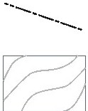
new formal fence
treatment

contours at 5 ft
(1.53m intervals)

0 -0 00
- - -
00 m 100m
Project Ref 06.438
EB
Dwg No.: LCD-007
Scale: 1:2000@A0
Date: 22.12.07
Revision: G

hansen partnership ply ltd
melboume I sydney Ivielnam level 8 136 exhibition st
melbourne vie 3000
t 61 3 9654 8844 I 61 3 9654 8088
e info@hansen-online.com.au
w hansen-online.com.au

Actions

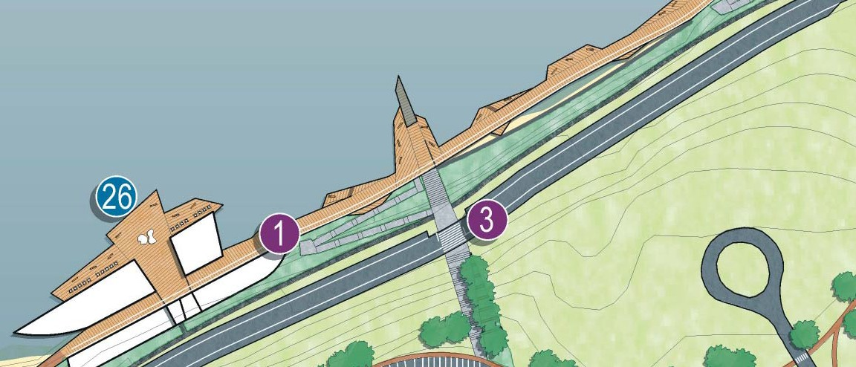
Pedestrian Movement

Action 1 – ‘The Compelling Link’
Action 1 involves the establishment of a broad waterfront promenade along the Corio Bay foreshore of Eastern Park, as a means of creating the “compelling link” between Eastern Beach and Eastern Park. The promenade is envisaged as a lively pedestrian thoroughfare, generously proportioned to allow for a comfortable progression from the existing promenade of the Geelong Waterfront and Eastern Beach.
The promenade will comprise a broad walkway, with opportunities for direct engagement with the waters of Corio Bay through the provision of ﬁshing platforms, landings, seating areas and other elements designed to encourage an appreciation of (and interaction with) Corio Bay.
The promenade will be integrally connected with the future Mineral Springs complex, and will eventually allow for unimpeded access along the foreshore of Corio Bay from Rippleside Park to Limeburner’s Point, encompassing Western Beach, Geelong Waterfront and Eastern Beach.
The promenade is intended to provide both a functional means of pedestrian and bicycle access to Eastern Park, as well as a lively public space, of sufﬁcient width to allow for activities such as weekend market stalls, buskers, art exhibitions and triathlons.
The promenade will become the new ‘front entry’ to Eastern Park.
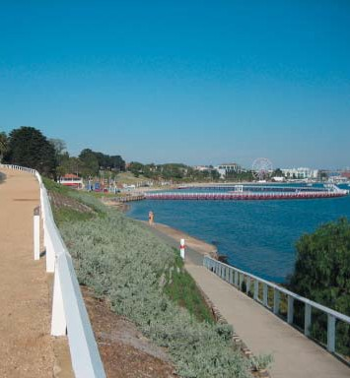
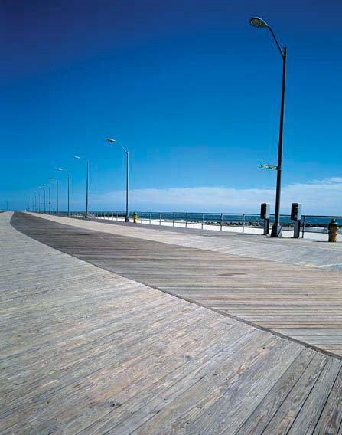
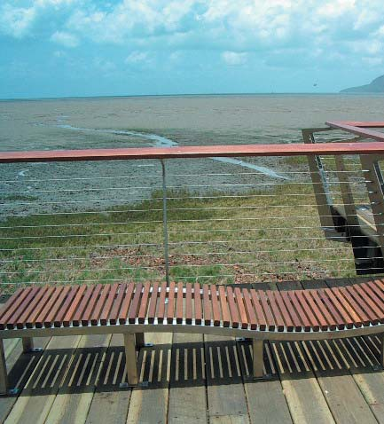
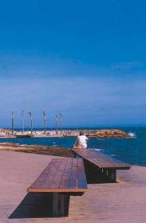
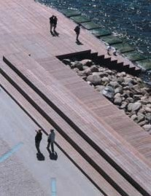
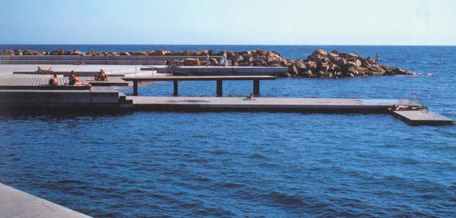

Action 2 – An accessible and legible pedestrian network
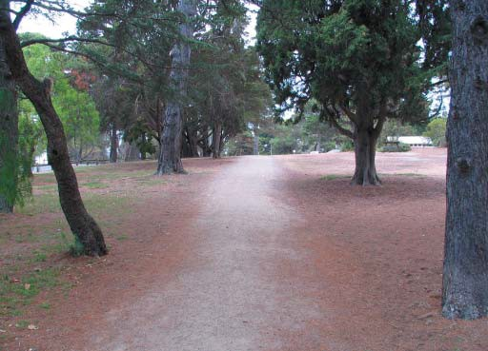
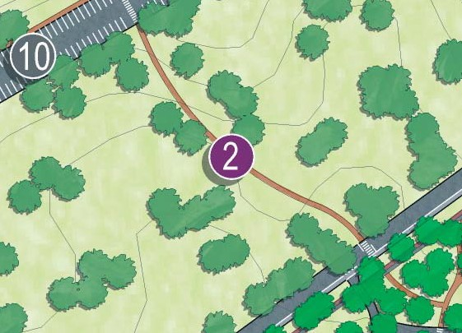
Action 2 involves the formalisation and improvement of the existing pedestrian network within Eastern Park, such that it facilitates access for pedestrians (both able and access-impaired) and cyclists, to minimum acceptable standards for both functionality and amenity.
Improving access to the attractions and facilities within the park will facilitate increased patronage of these which in turn will increase the popularity of the park as a key recreational destination in Geelong. Improvements will comprise formalisation of well-worn tracks, improved connections between car parking areas and the activities they service, provision of DDA-compliant routes to improve access for park users, delineation of speciﬁc routes for runners, cyclists and pedestrians, and the provision of a park-wide signage system, encompassing both way-ﬁnding and interpretive signage.
Whilst this action applies across the park, speciﬁc areas where improvements are envisaged include new connections from the Corio Bay foreshore, new connections between the ‘tail-light alley’ car park and the Botanic Gardens, establishment of formalised access to the foreshore east of Limeburner’s Point and the reconﬁguration of Eastern Park Circuit to provide separate loop trails for joggers, cyclists and general pedestrians.

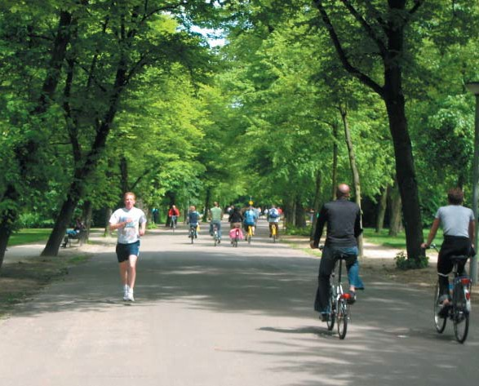
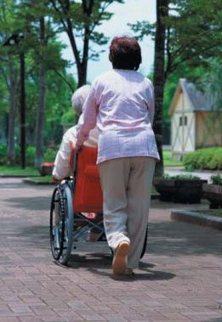

Action 3 – A well connected park
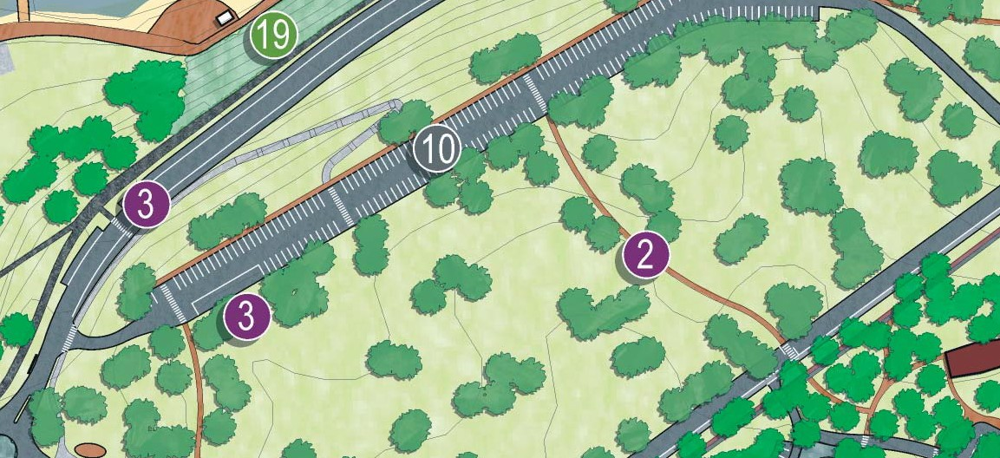
Action 3 involves the establishment of designated pedestrian crossings on Ryrie Street, Garden Street and Hearne Parade, such that the ability of residents and visitors to access the park safely on foot is provided. Also included within this action is the provision of safe, designated bus drop off / on points to increase the accessibility of the park from surrounding areas.
New pedestrian crossings are suggested along Ryrie Street, on Garden Street and on Hearne Parade.
Designated bus drop off / on points within the park are suggested within Eastern Park Circuit, in close proximity to the 21st Century Garden entrance and within the Tail Light Alley car park. A new bus stop is also recommended on Ryrie Street in front of the Geelong High School. This stop will allow Eastern Park to be readily accessible from the Geelong Train Station, through the bus routes which travel along Ryrie Street.

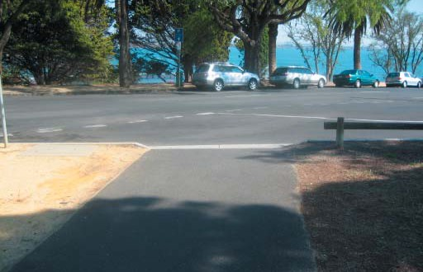
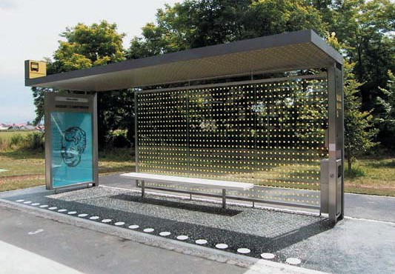
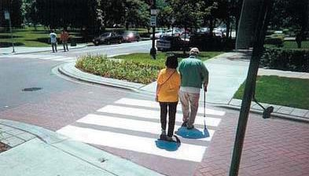
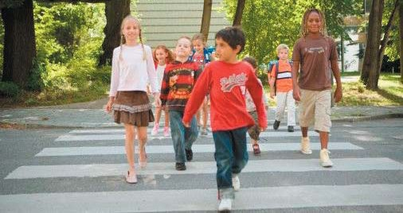

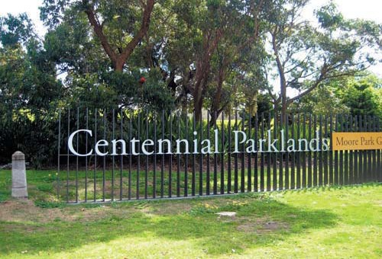
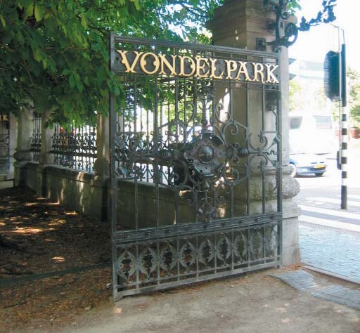
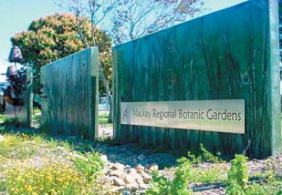

Action 4 – An integrated Geelong Botanic Gardens
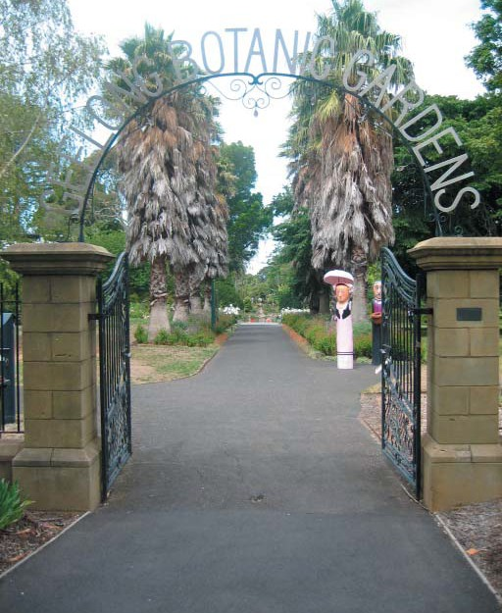
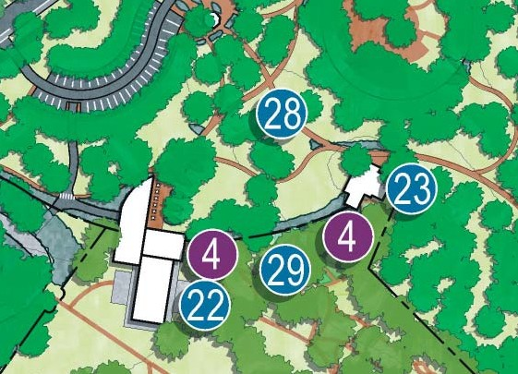
Action 4 involves the establishment of new entry points to the Geelong Botanic Gardens, to facilitate improved access from the broader Eastern Park. Up to 4 new entry points are envisaged, described as follows.
Redevelopment of the existing Walter Conservatory (described in more detail in Action 20) provides an opportunity to establish a new entry point. Redevelopment of the existing Superintendent’s Residence (described in more detail in Action 21) provides an opportunity to establish a new entry point. Consolidation and improvement of the Eastern Park Horticultural Complex (described in more detail in Action 19) provides an opportunity to establish a new entry point. A further entry point is proposed near the south-west corner of the Botanic Gardens, to be implemented as part of the development of new plant collections and associated pathways in this presently under-utilised part of the Gardens.

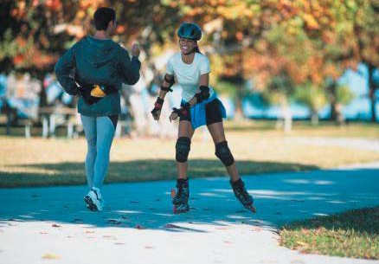
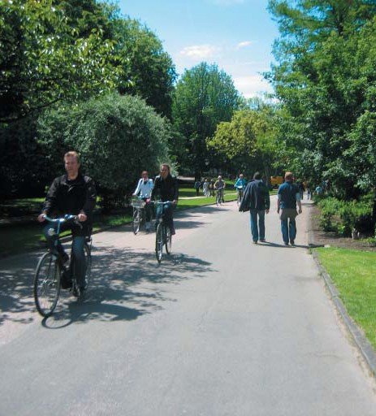
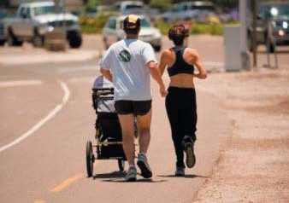

Action 5 – A ‘shared’ Eastern Park Circuit
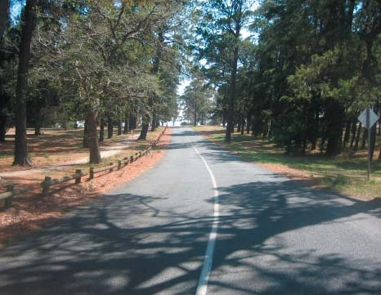
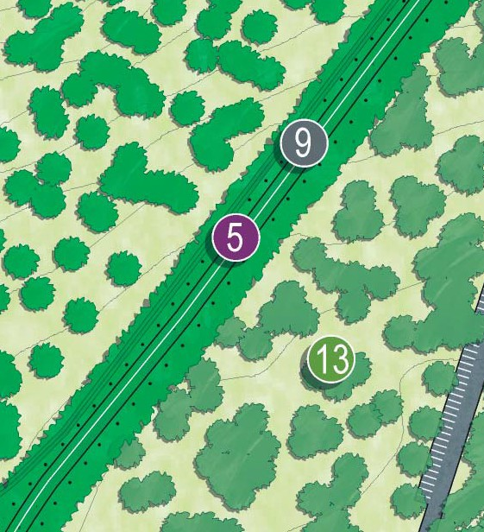
Action 5 is to be considered in conjunction with Action 9, involving the transformation of Eastern Park Circuit into a one- way vehicular route for much of its length. In doing so, the width of pavement required for vehicles can be substantially reduced, with the balance thus being available for non-motorised movement.
Action 5 envisages this remaining pavement being utilised as a continuous bicycle loop, with clear lane marking and signage to separate it from vehicular trafﬁc. Connections with the broader path network would allow the loop to function either as a stand-alone route for recreational cyclists or as part of a broader circuit for training purposes.

Vehicle Movement

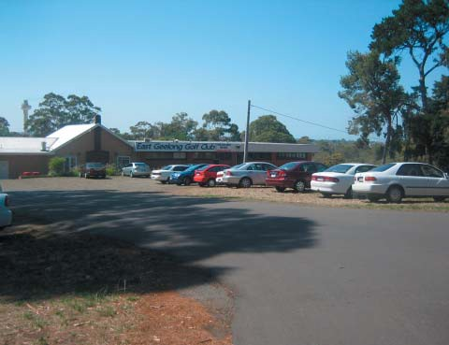
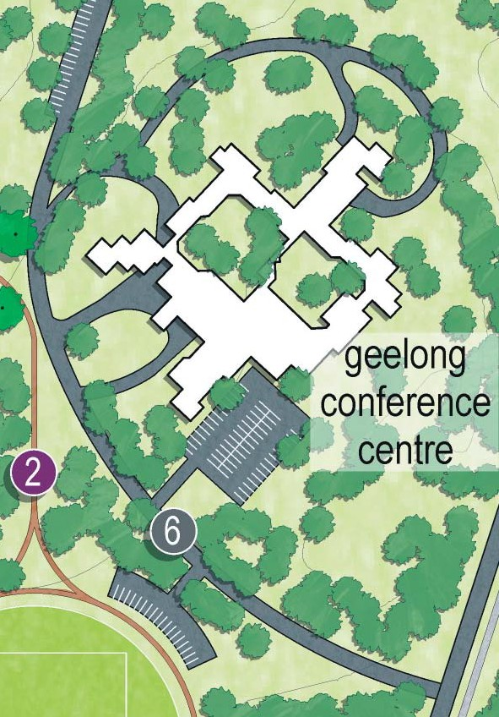
Action 6 – Reconﬁgured Golf Club and Convention Centre Access
Action 6 involves the reconﬁguration of vehicular access to both the East Geelong Golf Club and the Geelong Conference Centre, via a new direct road connection from Limeburner’s Road. This road would facilitate more direct access to both attractions, as well as importantly reducing the need for vehicles to traverse internal areas of the park, including Holt Road and Eastern Park Circuit.
Provision is made for the formalisation of ‘overﬂow’ parking for both attractions, and opportunities exist for the implementation of shared parking arrangements. Such a measure would alleviate the existing arrangement of ad-hoc overﬂow parking which has a tendency to ‘colonise’ park areas which would otherwise be available for recreational use. This would also allow for the removal of parking from within the treed area occupied by the Flying Fox colony, to the north of the clubhouse.
This reconﬁgured access would also allow for the complete closure of Eastern Park Circuit (if necessary for major events) without impeding access to either the Golf Club or the Conference Centre. Additional nose in car parking adjacent to Howard Glover Reserve can also be provided.

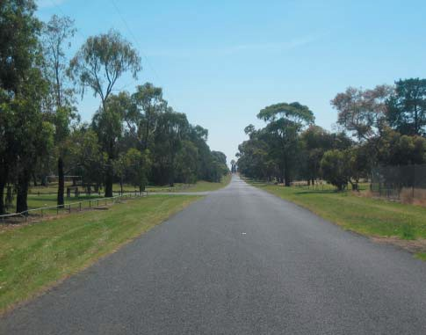
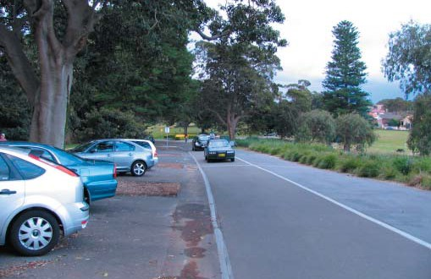
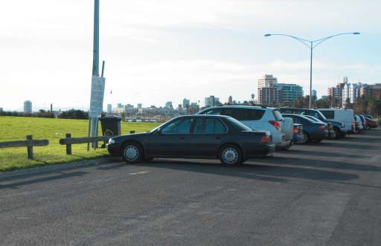

Action 7 – Removal of vehicles from Adams Court
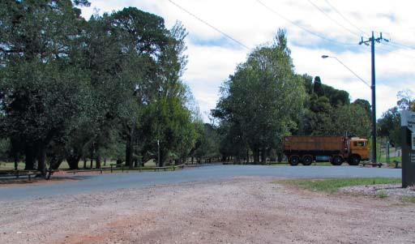
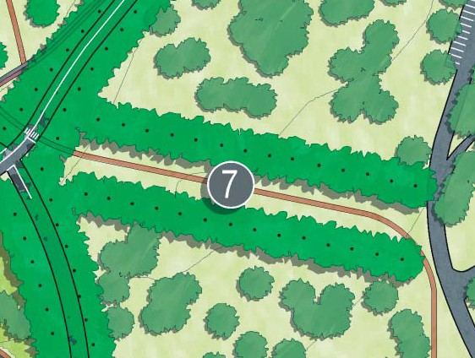
Action 7 involves the removal of vehicular trafﬁc from Adams Court, which would be made possible through the implementation of Action 6. As the original carriageway approach to the Corio Oval, the alignment of Adams Court and its associated avenue plantings have primary heritage signiﬁcance, however in its present conﬁguration this signiﬁcance appears somewhat diluted, with Adams Court appearing as little more than the entry to the Conference Centre. It is also constrained in its present form by overﬂow parking from the Conference Centre spreading along its length.
With vehicles removed, the opportunity exists to establish a formal pathway access along the route and to reinterpret the importance of this treed avenue as a reminder of its former role as the primary access route to the Corio Oval, the original home of the Geelong Football Club. This opportunity could be further developed in the form of a commemorative trail, with interpretive material provided to highlight the signiﬁcance of the former Corio Oval as both the original home of the Geelong Football Club and as a base for troops during the Second World War.

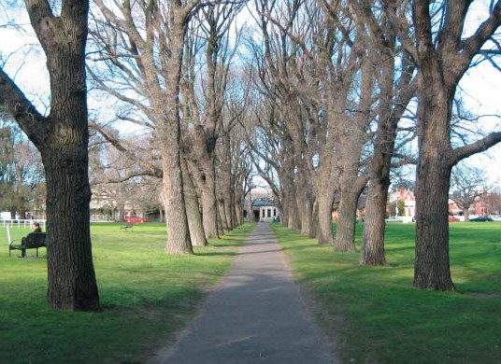
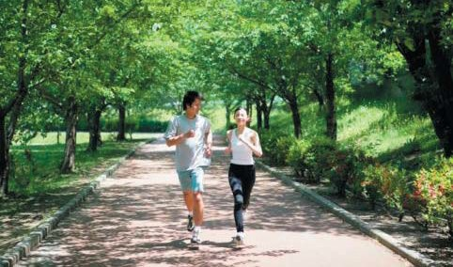

Action 8 – Trafﬁc management
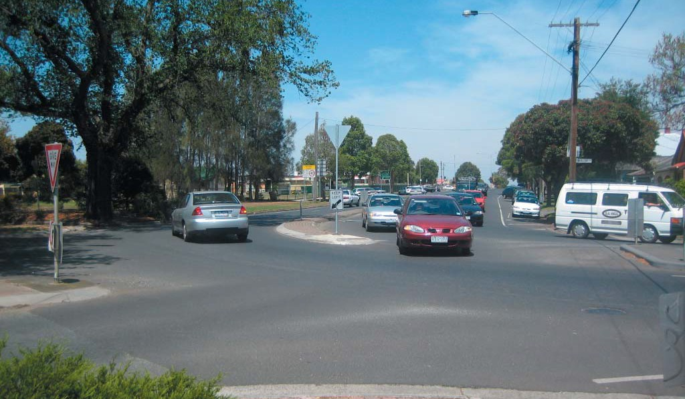
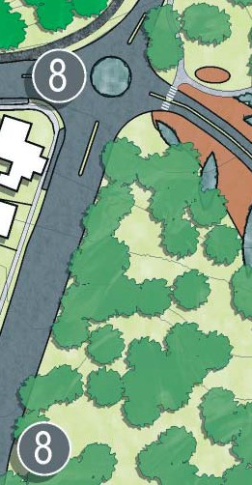
Action 8 involves the reconﬁguration of the four intersections on the west and south sides of Eastern Park, which provide vehicular entry into the park, along with the establishment of trafﬁc barriers.
The Garden Street / Malop Street intersection incorporates the location of the original main entry to Eastern Park. The importance of this entry has been eroded over time through the implementation of trafﬁc control measures within the intersection.
The proposed reconﬁguration would establish a new roundabout, with associated landscape treatments to physically and visually re-establish the importance of this primary park entry. In consideration of existing plans to reduce trafﬁc volumes on Garden Street, the opportunity exists to re-establish the ‘front gates’ to Eastern Park on the axis of Geelong’s main street, and in doing so reinforce Eastern Park’s position as Geelong’s premier park.
Since the creation of the 21st Century Garden and Podbury Drive, the Garden Street / Eastern Beach / Hearne Parade
/ Podbury Drive intersection has become the new main entry to Eastern Park, however in its present conﬁguration it is poorly resolved, confusing and uninviting, particularly for pedestrians. The proposed reconﬁguration will simplify this intersection and improve its legibility, such that it functions better and becomes a more attractive entry.
Improvements to the Limeburners Road / Ryrie Street intersection can be made through the creation of a median break and right turn slip lane for trafﬁc travelling east along Ryrie Street. Such an intersection treatment will improve accessibility to the Conference Centre, Golf Club and Limeburners Point.
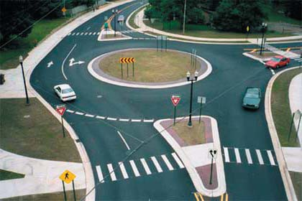
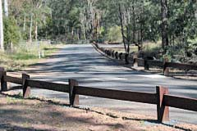
A right turn slip lane is also recommended along Ryrie Street to access Holt Road, improving the safety of this intersection by providing a refuge for turning trafﬁc. As Ryrie Street is under the jurisdiction of VicRoads, any proposed trafﬁc reconﬁguration along this street will require VicRoads approval.
In order to control vehicular movement and parking throughout Eastern Park, trafﬁc barriers are proposed along Holt Road, Limeburners Road, Ryrie Street and Garden Street.

Action 9 – Eastern Park Circuit
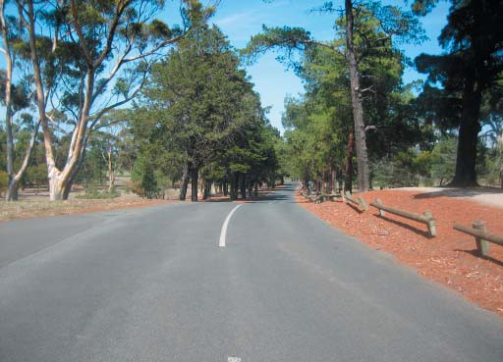
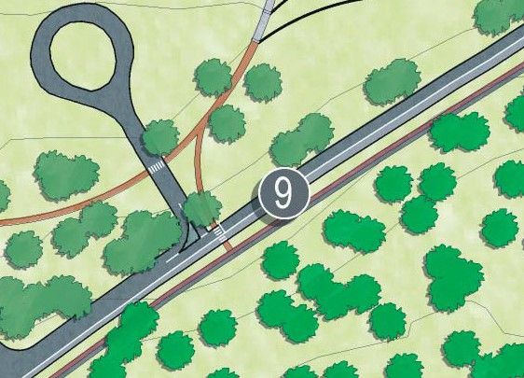
As referred to in the description of Action 5, Action 9 involves the transformation of Eastern Park Circuit to a one-way route for vehicles for much of its length, in the spirit of its primary heritage signiﬁcance as the original carriageway network of the park. The manner in which this is achieved is by reducing the width of the vehicular pavement between the Malop Street Entry and the circular lookout car park, and allowing one-way movement in an anti-clockwise direction only. As described in Action 5, the balance of the existing road pavement could be converted to a bicycle path. From the lookout car park to the Malop Street entry, Eastern Park Circuit would remain in its current 2-way conﬁguration, as required to maintain access to existing attractions and their associated parking areas on the inside of the Circuit.
In conjunction with the transformation to one-way, it is envisaged that the maximum allowable vehicle speed be reduced to 40 kilometres an hour, such that the potential for conﬂict with pedestrians and other recreational users is signiﬁcantly reduced.
Importantly, the proposed transformation of Eastern Park Circuit as described would not impede access to either the Botanic Gardens Depot, Eastern Park Horticultural Complex or any other attractions within Eastern Park which currently are accessed by vehicles.
In collaboration with this, the internal pedestrian loop of Eastern Park is to be upgraded. The current gravel running track will be improved along with the construction of a new asphalt path, providing easy., uninterrupted movement for people with wheelchairs or prams to experience the park.
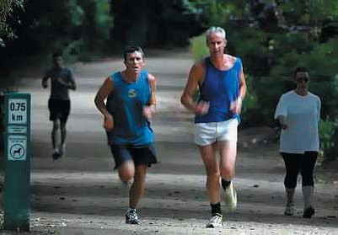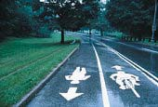
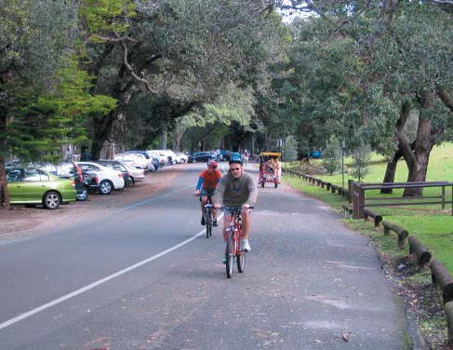
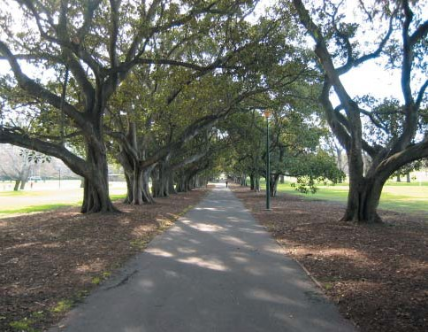

Action 10 – Formalised car parking
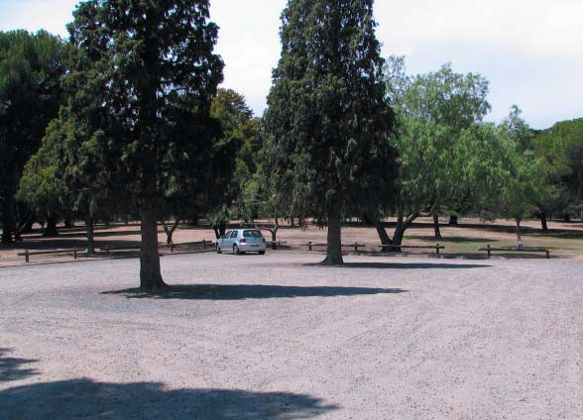
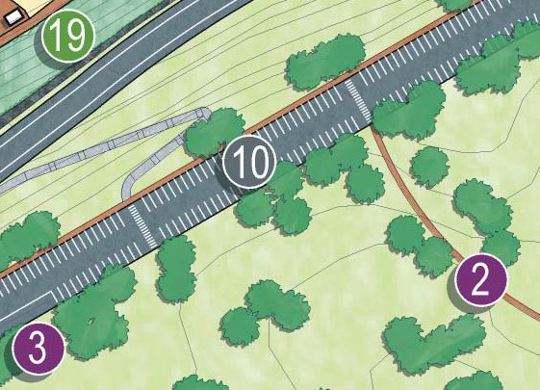
Action 10 involves the formalisation of the car parking network of the park, which at present is largely informal in nature, often comprising undeﬁned and unsealed expanses, with nothing to delineate parking bays or entry points. This informal parking layout is highly inefﬁcient, and results in substantially greater areas of car park than are actually required.
Through the implementation of Action 10 on an incremental basis, existing areas of car park could gradually be returned to parkland, resulting in a net increase in landscape available available for recreational use and enjoyment with no net loss of available parking spaces. Sealing of car parks is also desirable, for both amenity and environmental considerations, resulting in reduced dust and an opportunity to incorporate water sensitive urban design measures.

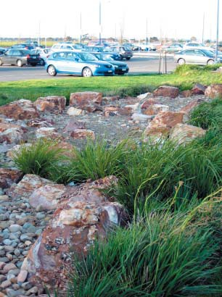
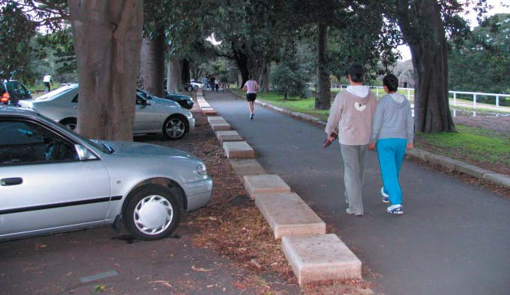

Action 11 – New shared pathway
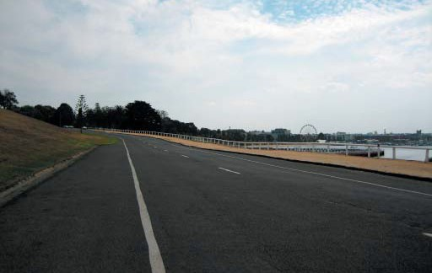
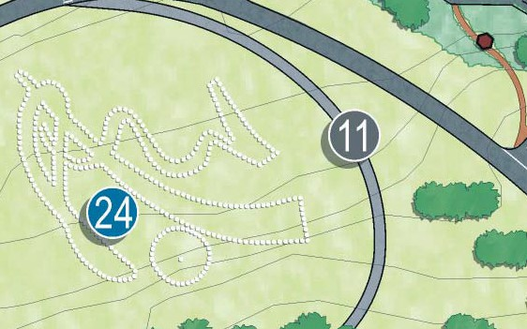
Action 11 involves the creation of a new shared pathway to the east of the Geoglyph, between Eastern Park Circuit and Hearne Parade. The intention of this pathway is to provide improved opportunities for viewing and interpretation of the Geoglyph and to facilitate the establishment of a Criterium Circuit for organised bicycle races, utilising Hearne Parade, Podbury Drive and Eastern Park Circuit. This Cirterium Circuit is to travel in an anticlockwise direction and is
1.8 kilometres in length.
Removable bollards located at both ends of Hearne Parade can be implemented as a means of trafﬁc control during criterium events. In this manner the Criterium Circuit is able to function without any impediment to vehicular trafﬁc accessing the Limeburners Point boat launching facilities, East Geelong Golf Club, Geelong Conference Centre, Eastern Park Horticultural Complex, the sports ovals or picnic areas in the southern park areas. It is important to note that the the housing of the bollards will be required to provide a safe ﬂat surface suitable for racing, when the bollards have been removed.

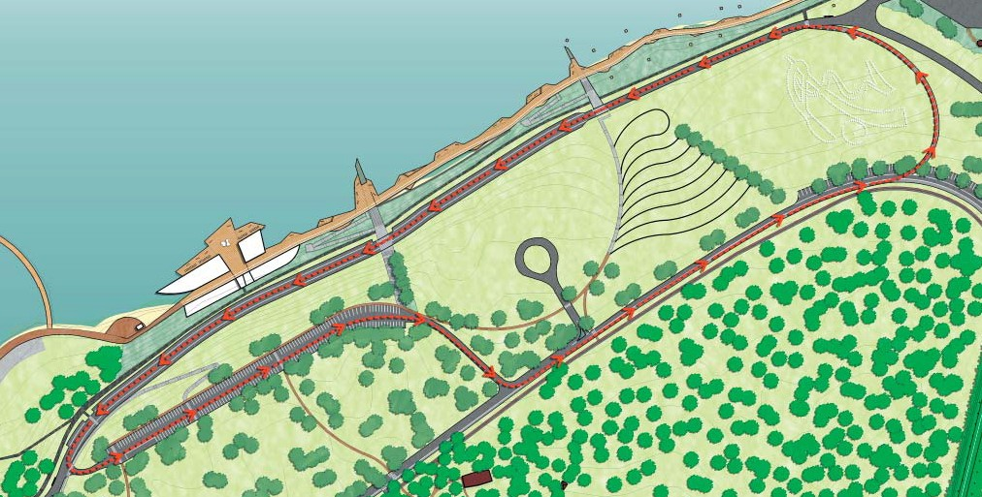
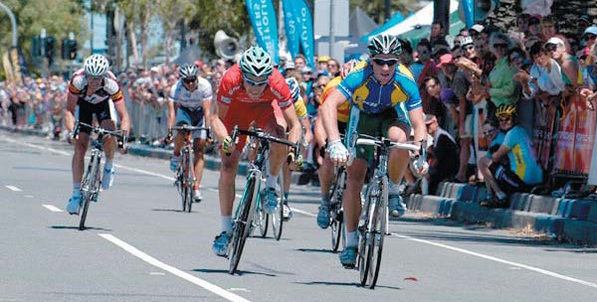
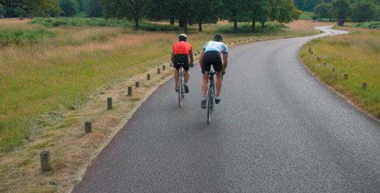


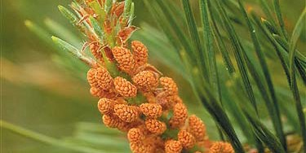
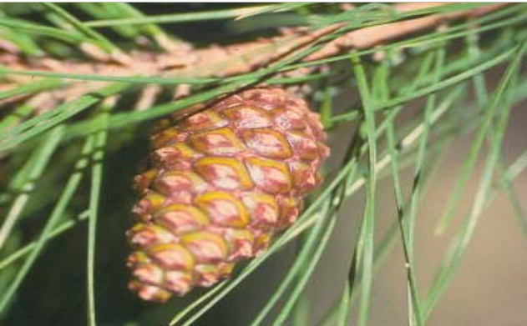

Landscape

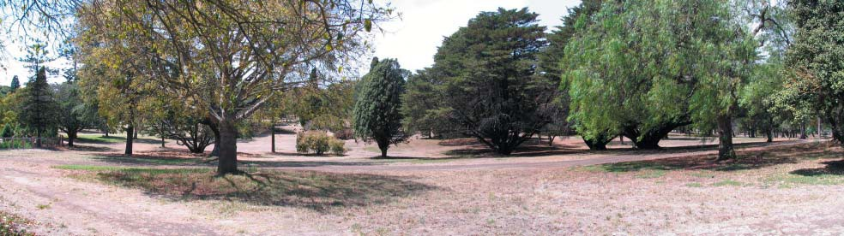
Action 12 – The Pinetum
Action 12 involves the recognition, re-establishment and reinforcement of the signiﬁcance of Eastern Park’s role as a pinetum. It envisages the management of the tree population within the area inside Eastern Park Circuit as a pinetum, with ongoing replacement planting of appropriate species, in close consultation with the Geelong Botanic Gardens management team.
The open woodland character of this area of the park will be retained, and replacement planting will be done in a manner which from an amenity perspective retains this character, whilst also maintaining both a heritage and a botanical contribution through carefully planned selection and layout of new tree planting. Integral to this is the implementation of appropriate interpretive material, such that visitors and park users are able to properly comprehend the multi-faceted value of this element of the Eastern Park landscape.
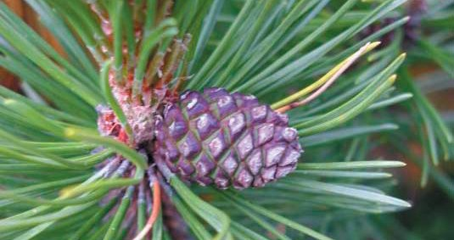
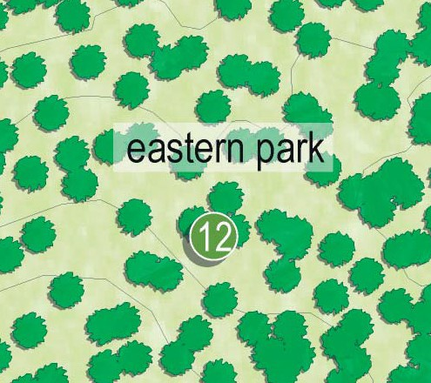
The area closest to the Geelong Botanical Gardens, and adjacent to the Superintendent’s Residence, would be developed with appropriate pathways, signage and interpretive information. A circuitous network of paths would provide visitor access around and through the Pinetum. In deference to the original pathway layout of Eastern Park, an opportunity exists to construct these pathways from crushed shells, or as an alternative, a contemporary interpretation of this material. Close consultation with Botanic Gardens management is imperative in the implementation of this action.

Action 13 – The Australian Landscape
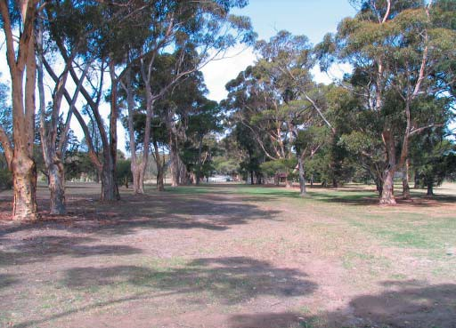
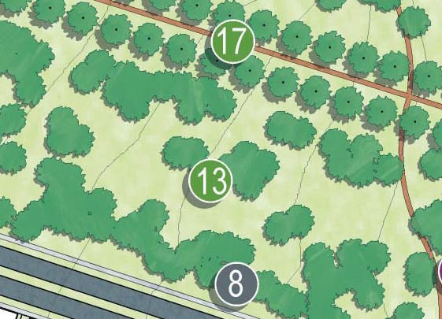
Inspired by the Sugar Gum avenues and the scattered River Red Gums, Action 13 envisages the gradual transformation of the broad landscape belt between Eastern Park Circuit and the park’s edges into a landscape with a more predominant Australian native character. Whilst ensuring the protection and retention of signiﬁcant exotic specimens, the intent of this action is to promote the use of native canopy trees for replacement planting, whilst retaining the existing functionality of these spaces for recreational use. The remnant grasslands are to be maintained as an important element in Eastern Park and maintenance regimes must be tailored to ensure their protection.
The intention is not to attempt to recreate a natural, indigenous landscape across the park, but rather to celebrate Australian trees in a similar manner to which the Pinetum celebrates exotic (and particularly Pinus) trees.
The trees of Eastern Park are integral to heritage, visual landscape and plant collections associated with the original purpose of the Botanic Gardens. The tree assessment within the Management Plan document highlights the signiﬁcant decline in the health and vigour of trees and if both the plant collection and the landscape are to be perpetuated for future generations, then action needs to be taken as a matter of priority.
This action will take two forms. Responsive
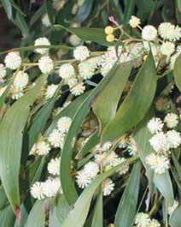
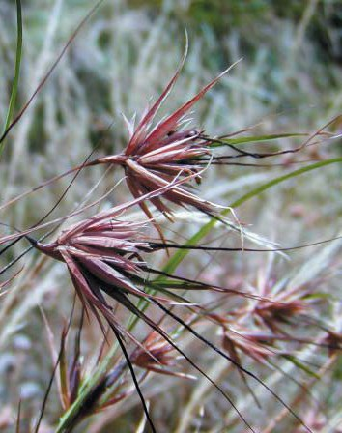
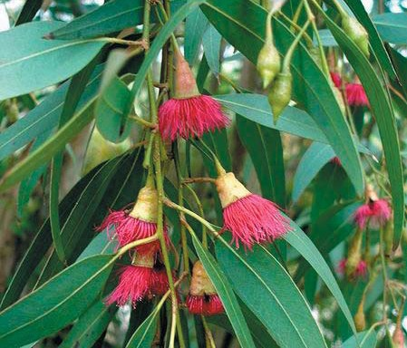
      - Ongoing issues of tree health will require the pruning or removal of trees through inspection and maintenance regimes already in place. Many of these trees are recorded in the assessment but it must be understood that the assessment report is a snapshot in time and there are other factors including storms, drought and disease which may result in different outcomes.
Planned
      - To ensure that in 50 years and beyond the community can still experience the landscape of Eastern Park, considerable planning needs to be undertaken to ensure the tree landscape is rejuvenated. The active management plan of the Pinetum plant collection and the staged replacement of avenue trees and zonal plantings will change the landscape in the short term but this foresight will result in the perpetuation of a signiﬁcant heritage landscape.

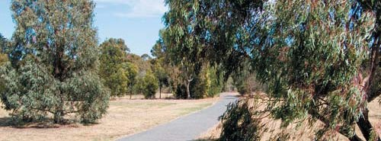

Action 14 – Strategic Direction for the Geelong Botanic Gardens
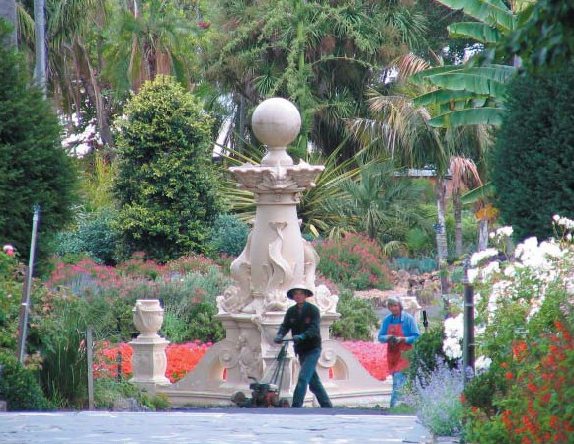
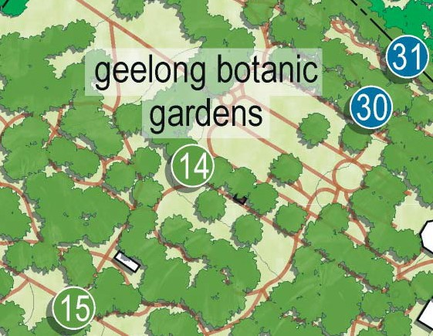
Action 14 involves the establishment of a clear direction for the management and development of the Geelong Botanic Gardens landscape and the manner in which it achieves the Gardens’ stated role for the community.
The Geelong Botanic Gardens’ primary role is to hold plant collections for the purposes of conservation, education, research and display. Its secondary role is a public garden as a place for plants and people, discovery and learning, ideas and innovation, community engagement and pride, conservation and the environment, and quiet contemplation. To fully achieve this role a detailed garden management plan is to be developed which focuses on:
      - The management of the Gardens’ heritage and contemporary landscapes to ensure its integrity as a signiﬁcant Botanical Garden is maintained and enhanced into the future.
      - The management and development of the Gardens important plant collections through the development and implementation of a Collections Policy and associated Collection Management Plans. The development and management of scientiﬁc collections with appropriate rigour as supported by a plant database and map and an accessions policy. The development and management of themed collections in partnership with special interest groups, Ornamental Plants Conservation Association of Australia registered collections and private collectors.
      - The management and renewal of the gardens signiﬁcant tree collection through the development of a Succession Planting Plan to address the issue of a senescing tree population.
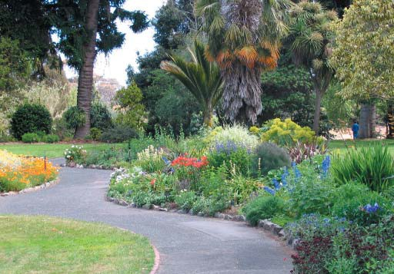
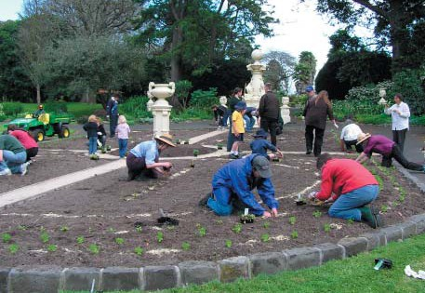
      - The provision of visitor facilities and programs to enhance the visitor experience which is delivered by community events and infrastructure to support visitor activities. Delivery of this action needs to respect the role and values of the gardens and be guided by appropriate policy and management guidelines including style guidelines, heritage policy, event guidelines and be based on sustainable principles.
      - The role of the nursery in supporting the development of the gardens and Eastern Park’s botanic collections and those of other regional botanic gardens, improving the accessibility of selected plant material to the public through the Growing Friends, providing an educational opportunity for botanic gardens staff and students and assisting with planting programs for public open space by the provision of advice and facilitating the sourcing of material through local commercial nurseries.
      - The role of the garden in education and research through public programs, providing opportunities for research and work experience for students of horticulture and other relevant disciplines, providing facilities for groups focusing on horticulture and the environment to meet, partnerships with educational providers such as the Gordon TAFE Horticultural program, scientiﬁc research partners and the development of a interpretation plan for the gardens to enhance the visitors learning experience.

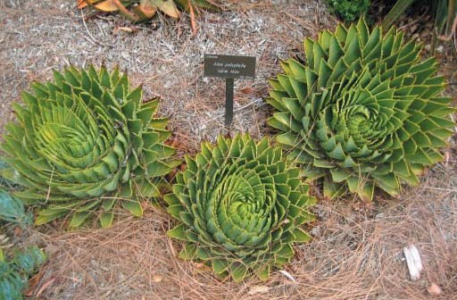
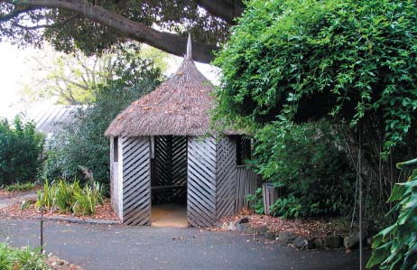

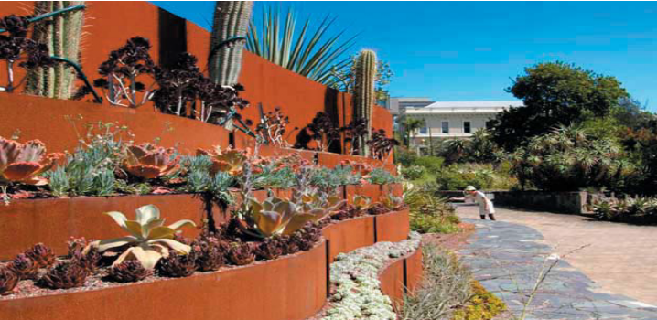
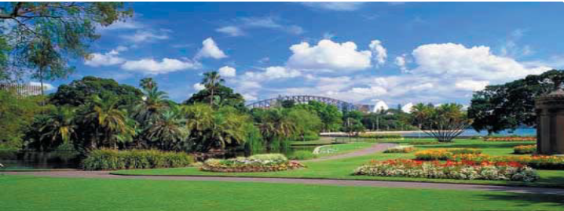

Action 15 – New Botanic Gardens Collections
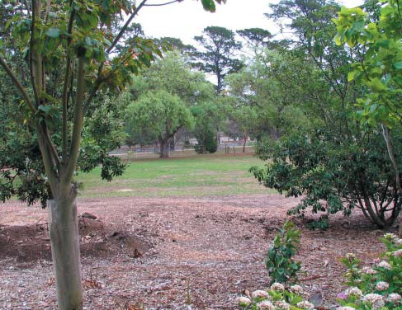
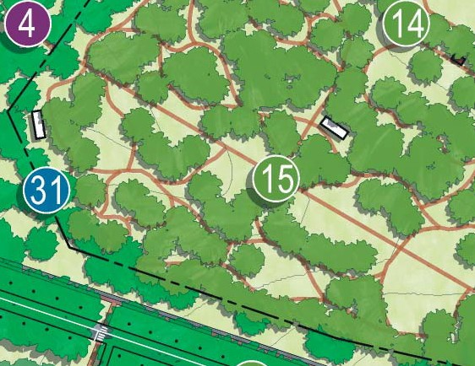
Action 15 involves the establishment of a designed landscape to house plant collections within the presently under- utilised and undesigned southern area of the Botanic Gardens locally referred to as ‘the annexe’. The development of further collections reﬂects the need to continue to develop the Gardens primary role in holding plant collections for the purposes of conservation, education, research and display along with the very real need for the Gardens’ plant collections to respond to current and future issues including a senescing plant collection, water availability and climate change.
The development of plant collections will be guided by the clear directions and principles set by a ‘Living Plant Collections Plan for the Geelong Botanic Gardens’ which is currently documented in draft form and requires ﬁnalisation. This plan sets the scene for the gardens scientiﬁc collection through a vision statement and a focus on themes for the plant collections.
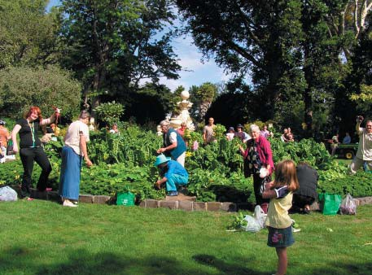
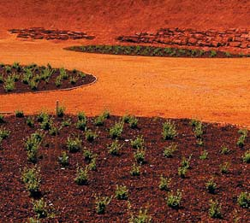
In practical terms a collections plan enables an objective view of how plants achieve the role of the garden and how this relates to other Victorian Botanic Gardens and their collections. It is underpinned by a set of principles which guide the implementation of collection themes and provides valuable guidance for both the development of collection management plans and assists with the assessment of offers of plant material or requests for the development of new collections or temporary displays.

Action 16 – Screening the Depot
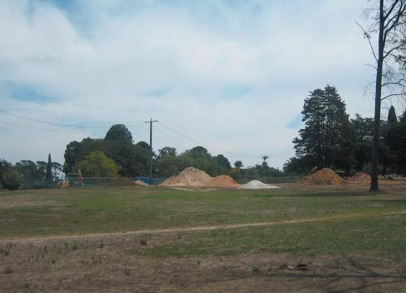
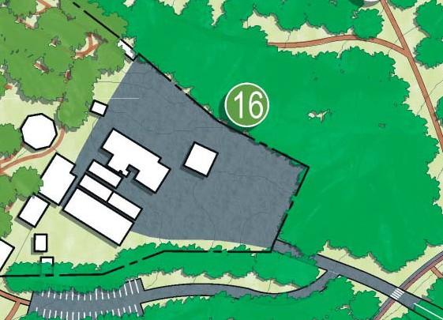
Action 16 involves the provision of formal storage for landscape materials to ensure that materials are not stored in the park proper, and screening vegetation to the perimeter of the Botanic Gardens Depot, such that the level of visual intrusion it imposes on Eastern Park can be mitigated. Screening vegetation should be planted in a style to reﬂect the existing character of Eastern Park and is an opportunity to enhance the Pinetum with suitable conifer species which may need to be supplemented in the short term with faster growing plants. This screening effect can be further enhanced through the addition of brush screening to the existing Depot fencing.
While the Botanic Gardens Depot is of importance to the operations and maintenance of both the Geelong Botanic Gardens and Eastern Park, it is recommended that there be no further expansion to the Depot footprint. The continuing functional needs of the Botanical Gardens operations are to be met with appropriate infrastructre that does not pose a visual impact on Eastern Park.

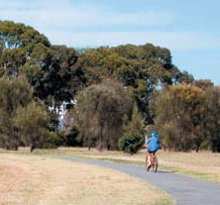
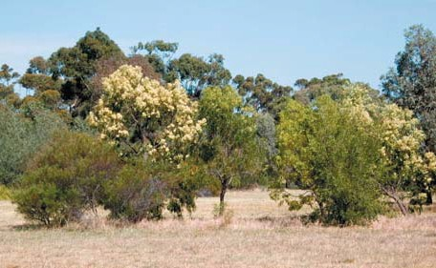

Action 17 – The Avenues
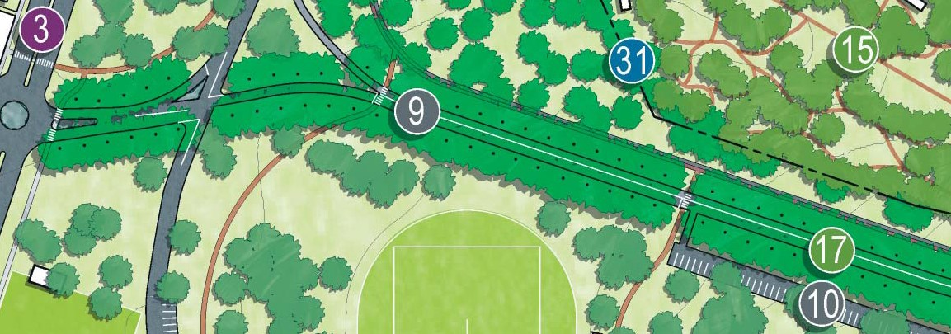
Action 17 involves the staged restoration of the heritage signiﬁcant tree avenues, which include Eastern Park Circuit, Holt Road and Adams Court. The detail with regard to this action is elaborated in the Management Plan.

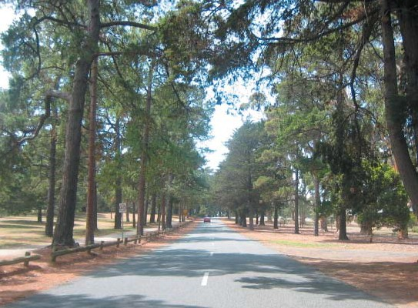
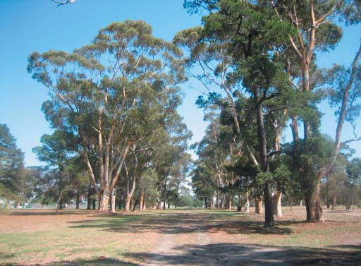
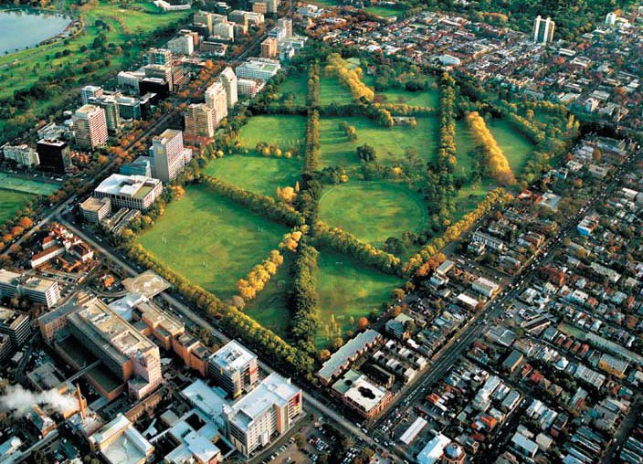
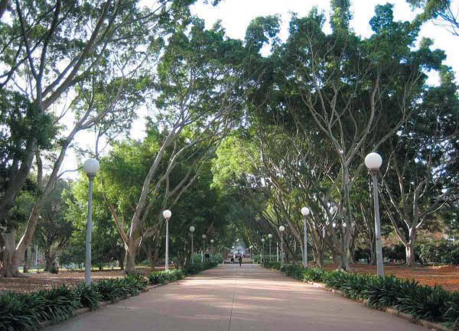

Action 18 – The Flying Foxes
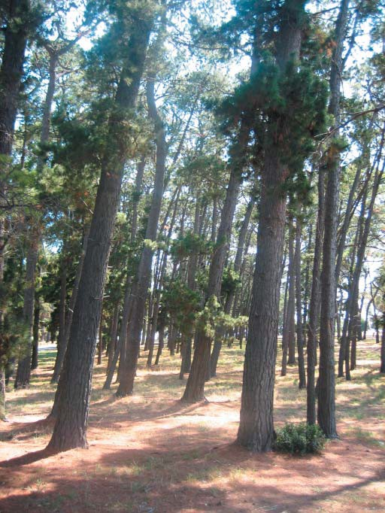
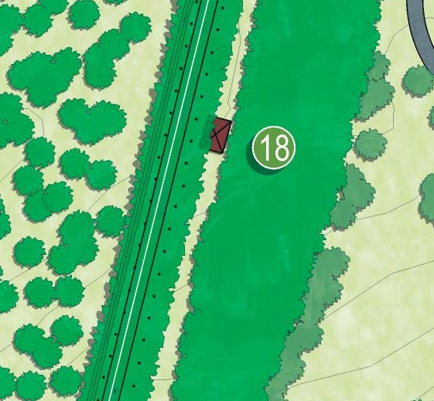
Action 18 involves measures designed to ensure that the Grey-headed Flying Fox colony is retained within Eastern Park, as an important contribution to the park’s signiﬁcance. It envisages the revegetation and slight expansion of the existing roosting site, which presently comprises Pinus radiata trees in very poor condition and with useful life expectancies of less than 25 years. While these trees are senescing, they are to be retained to ensure the continuing success of the roosting site, while new trees are planted.
The new roosting site is to be established immediately west and north of the existing location, and will comprise new plantings of both Pinus radiata and Acacia dealbata, to ensure rapid growth and to allow for gradual relocation of the animals without undue disturbance. Opportunities for the establishment of artiﬁcial roosting structures should also be explored, as has been the case with the larger ﬂying fox colony at Yarra Bend.
The new roosting site will be complemented by appropriate viewing areas and interpretive information such that park users and visitors are better able to appreciate the colony and understand its uniqueness as the southern-most colony of Grey-headed Flying Foxes in the world. Removal of ad-hoc parking at the base of the existing trees, in conjunction with the establishment of a new parking area south of the East Geelong Golf Club clubhouse, will further improve the amenity of the precinct and reduce the incidence of disturbance to the roosting ﬂying foxes.

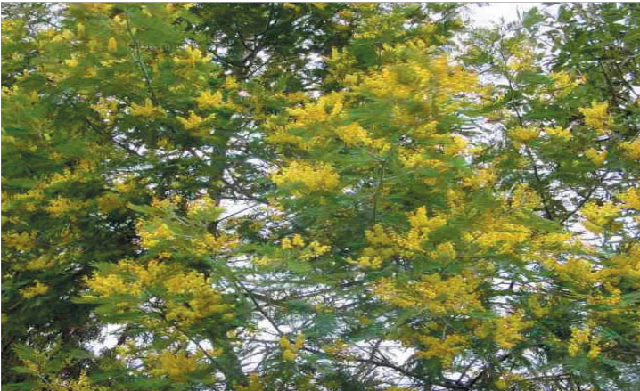
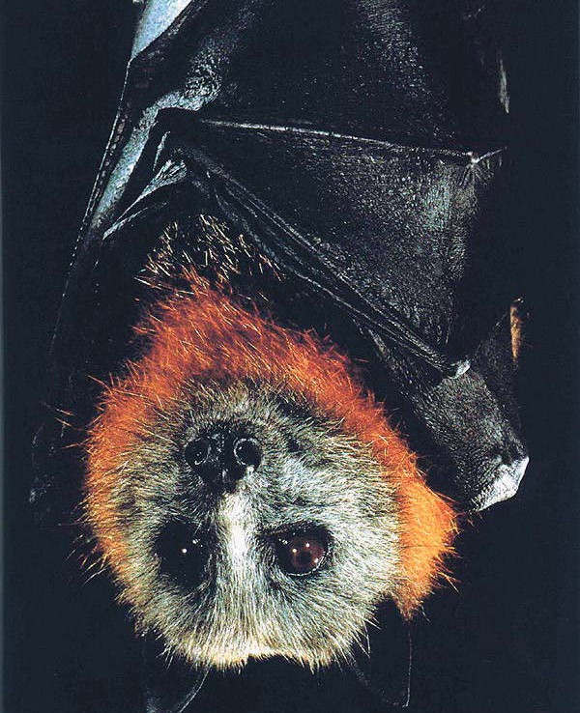

Action 19 – The Foreshore
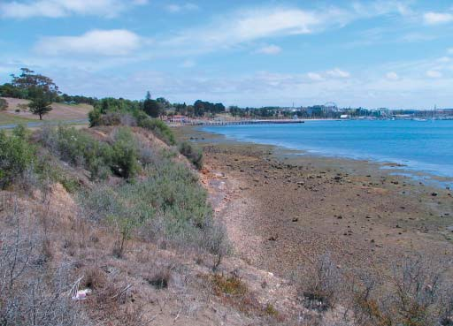
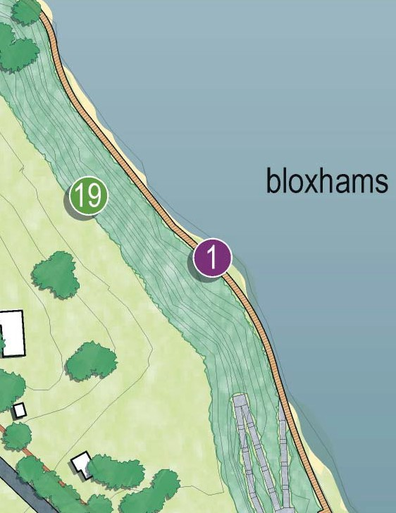
Action 19 involves the comprehensive rehabilitation of the degraded Corio Bay shoreline and associated remediation of Bloxham’s Beach and abutting shoreline, along with weed removal and the re-establishment of indigenous coastal ﬂora along the entire foreshore. The existing landﬁll area and adjacent escarpment south of the Limeburners Point car park will be re-planted as a coastal woodland, with Casuarinas and Banskias to stabilise the embankment. This planting, along with new canopy vegetation within the car park will ameliorate the poor visual appearance of this area when viewed from Hearne Parade and the northern slopes of the park in general. It is hoped that the re-establishment of coastal vegetation will lead to improved marine habitats along the tidal fringe.
Improvements to the environmental condition of the foreshore will be complemented by improved access by the provision of new boardwalk walkway structure as a continuation of the Bay Trail. This boardwalk will be located close to the shoreline to allow visitors to experience the natural, cultural and historical features of the area, including the historic lime kilns, which have primary heritage signiﬁcance. The provision of appropriate interpretive material and associated seating and shelters will ensure that visitors are able to develop a full appreciation of the signiﬁcance of this part of Eastern Park. A combination of ramp and stair connections will ensure the provision of equitable access for all users – including bicycles – between the foreshore and Limeburners Road at the top of the escarpment.

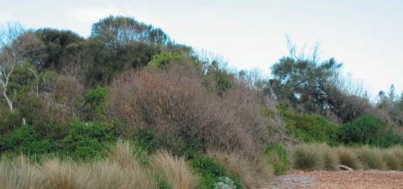
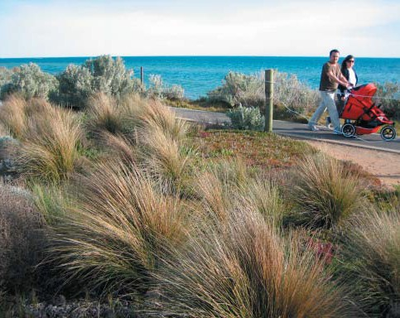
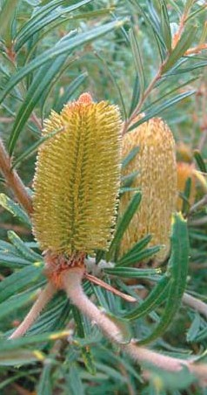
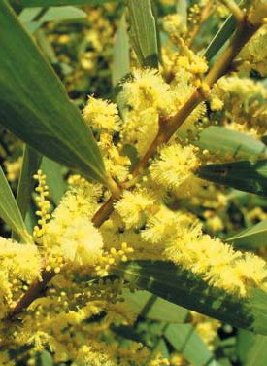

Action 20 – The Wetland
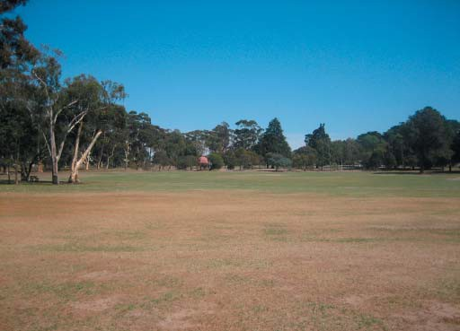
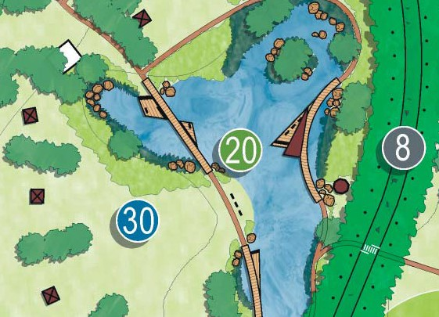
Action 20 involves the creation of a constructed ‘natural’ wetland in the low-lying area of Eastern Park south-west of the intersection of Holt Road and Eastern Park Circuit. The Conservation Analysis has identiﬁed this area as most likely originally consisting of an ephemeral wetland, which was transformed into an ornamental lake by Daniel Bunce in the 1860’s, and subsequently ﬁlled in 1929.
This action envisages the reinterpretation of the original landscape of this part of the park, as a wetland with associated indigenous vegetation. The wetland will be fed by an existing piped drain which collects much of the stormwater from East Geelong, which is presently deposited into the open drain which runs along the eastern boundary of the golf course. The intention is for this new wetland to capture and treat this storm water – consistent with the principles of ‘water sensitive urban design’ – before allowing it to return to the open drain and hence be deposited to Corio Bay with an improved quality. Effectively this action provides an opportunity for Eastern Park to contribute to the health of Corio Bay. Opportunities may also be available for the re-use of collected stormwater for supplementary irrigation of the adjacent sports ﬁelds.
Due to the large number of mosquitoes within the park and public complaints regarding them, the detailed design of the wetland will need to incorporate ‘water sensitive urban design’ guidelines which speciﬁcally reduce the risk of high mosquito numbers. These measures include:
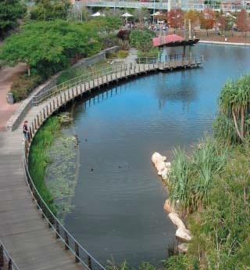
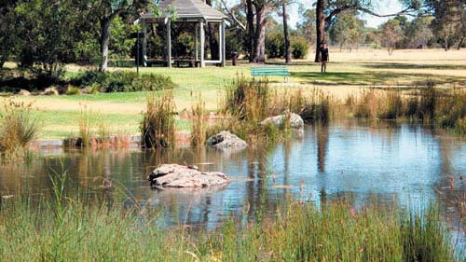
      - Providing areas for mosquito predators.
      - Maintain natural water level ﬂuctuations which disturb mosquito breading cycles.
      - Providing sufﬁcient gross pollutant control so that human-derived litter does not provide breeding habitat.
These guidelines will ensure that mosquitoes do not compromise the environmental and recreational opportunities which the wetlands present.
Opportunities exist for recreational interaction with the wetland landscape, through the provision of a new picnic area and associated facilities, along with a network of boardwalks allowing for interaction and appreciation of the plants and animals which will inhabit this area. Interpretive treatments should be incorporated to ensure an educational role is provided, and input should be sought from the Geelong Botanic Gardens management with respect to plant species selection and placement.
It should be noted that the creation of the wetlands is expected to be a longer term action and is subject to reduced demand for a sporting ﬁeld in this location. The site is used as an overﬂow ground for clubs based at other locations. Currently, due to the extended drought experienced in the region, the site has been utilised to accommodate additional sporting ﬁxtures. The wetlands implementation would proceed once demand for the existing sporting ﬁeld was no longer apparent.
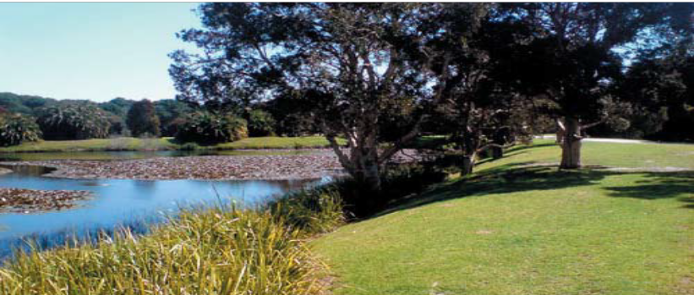
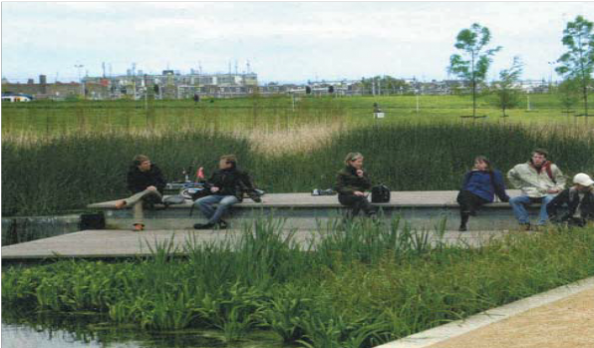

Attractions and Facilities

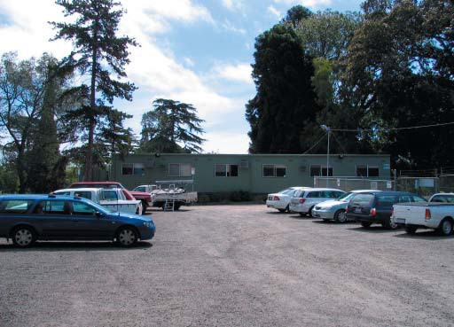
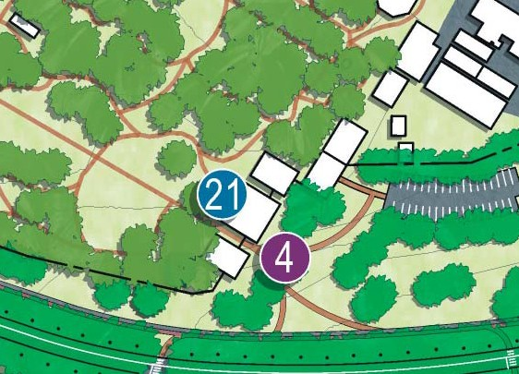
Action 21 – Eastern Park Horticultural Complex
Action 21 involves the recognition and enhancement of the role played by the various community groups associated with the Geelong Botanic Gardens, through the establishment of the Eastern Park Horticultural Complex. The role of the complex is to provide a hub for horticultural and environmental learning and endeavour, which includes both formalised groups and the broader community through the provision of facilities for activities which support the role of the Botanic Gardens as a place for:
      - Plants and people.
      - Discovery and learning.
      - Ideas and innovation.
      - Community engagement and pride.
      - Conservation and the environment.
      - Quiet contemplation.
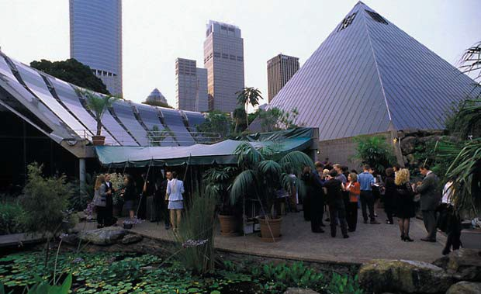
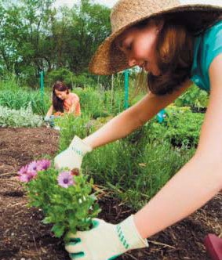
The complex would have as its genesis the existing meeting rooms, library and other facilities, with the intention that these are consolidated into an integrated complex with an appropriate interface to the Botanic Gardens and to Eastern Park. Importantly, this complex houses not just the various community groups but also the Eastern Park and Geelong Botanic Gardens management staff.

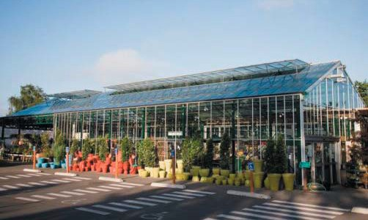
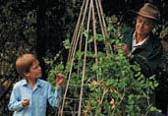

Action 22 – The Walter Conservatory
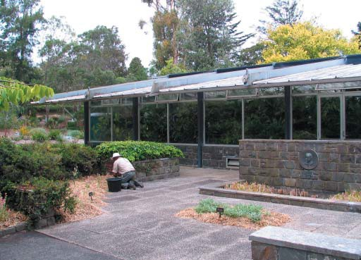
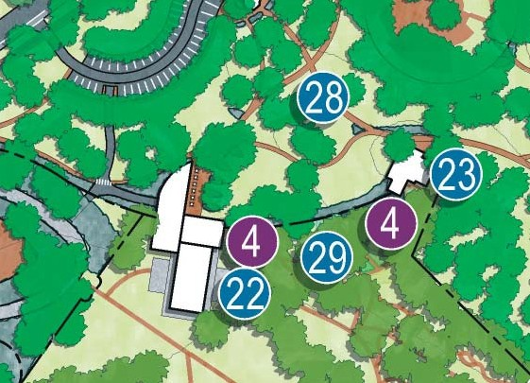
Action 22 involves the transformation of the Walter Conservatory into a restaurant, café and function space, with an address and openings to both the Geelong Botanic Gardens and Eastern Park, through the realignment of the Gardens perimeter fence and reconﬁguration of the existing building. It is envisaged that the ideal conﬁguration would comprise a café/restaurant at the northern end, allowing for a presentation and access to Eastern Park and the establishment of a vibrant open terrace with a northerly aspect and appropriate connections to other attractions in close proximity, including the Superintendent’s residence and the Play Space, along with reconﬁgured parking areas which could serve all these attractions. In this conﬁguration the activity levels typically associated with such a facility could be buffered from the quieter internal space of the Botanic Gardens by the function space, comprising the existing body of the building.
Such a conﬁguration would allow for evening functions which could utilise the adjacent open grassed areas of the Gardens, when these would not disturb regular daytime visitors. It would also facilitate a new entry into the Botanic Gardens.
The role of this facility should also include the provision of visitor information, as it will become not only a social meeting place but a ‘capture point’ for visitors to the Gardens. The Gardens currently lack a formal focus for visitor interpretation. The presence of customer service staff, at a ‘front desk’ facility, would enhance the visitor experience and the ability to access current and future programs.
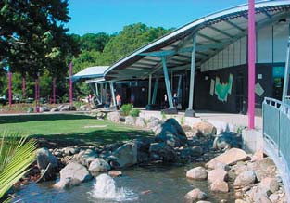
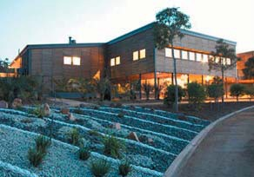
It is envisaged that the transformation described above has the potential for architectural excellence, and in facilitating such a development all efforts should be explored to ensure that the design quality of the outcome is sufﬁciently complementary to the amenity and signiﬁcance of its setting.
The intention of this action is that once established, the Walter Conservatory will supersede the function of the present ‘Friends Teahouse’, thereby providing an opportunity to reconsider the future of this building.
The current collections housed within the conservatory can be relocated into the existing nursery glasshouses. These glasshouses could then be improved and to provide for public access to view the collections contained within.

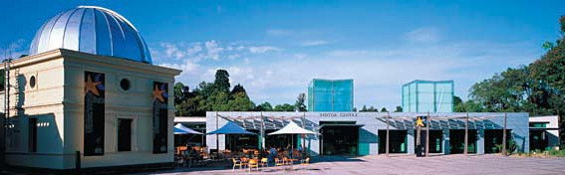

Action 23 – The Superintendent’s Residence
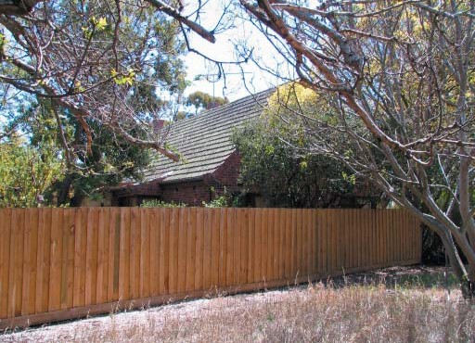
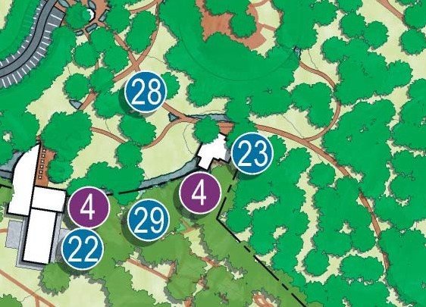
Action 23 involves the re-use of the existing Superintendent’s residence and associated garden, which is of contributory heritage signiﬁcance to Eastern Park, as an educational facility within the umbrella of the Geelong Botanic Gardens. Such a facility could provide the venue for shared programs between the Gardens and the Gordon TAFE, as well as providing a venue for community education programs, open days and similar activities. These education programs already exist, yet at present they are compromised by the lack of suitable teaching spaces and facilities to store educational equipment.
The garden could similarly be utilised for educational purposes, in a similar role to that played by the house in the Royal Botanic Gardens in Melbourne. Display gardens could be developed with a teaching focus. The building can also be retained or re-ﬁtted as temporary accommodation for visiting specialists and experts.
In this manner the heritage signiﬁcance of the building can be honoured not through dealing with the building as a static monument, but rather through ensuring its continued role as a key component of the educational contribution provided by the Geelong Botanic Gardens.
Similarly to what is envisaged for the Walter Conservatory, re-use of the Superintendent’s residence also provides the opportunity for the establishment of another entry to the Gardens.

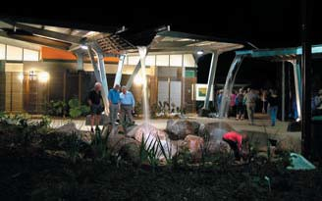
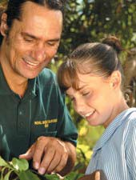
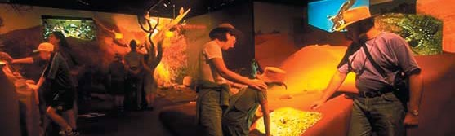

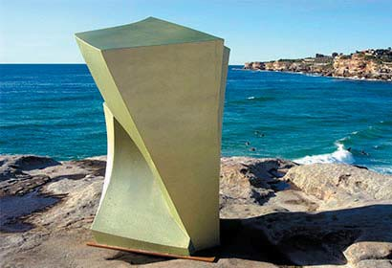
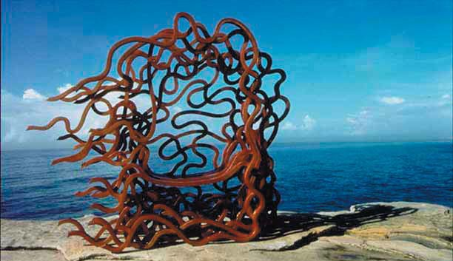
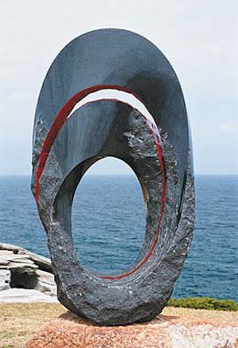
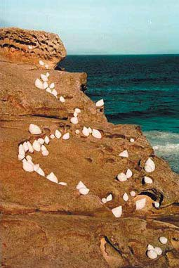
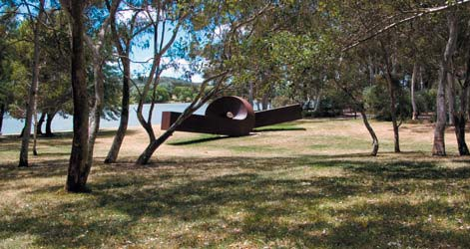

Action 24 – Sculpture Park
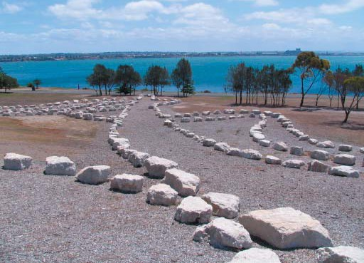
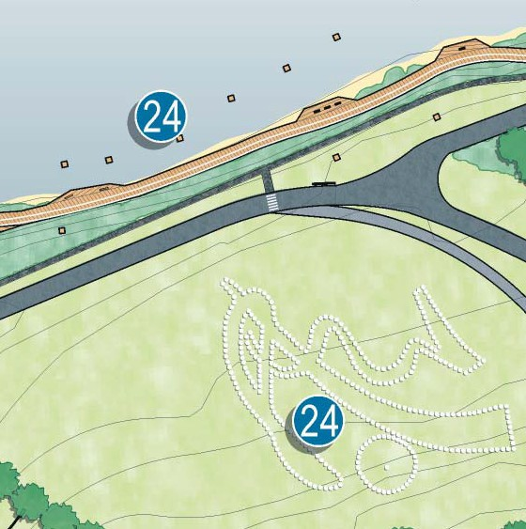
Action 24 involves the establishment of an improved setting for the Andrew Rogers Geoglyph, and provides an opportunity for this existing sculpture to form the ‘anchor’ for the establishment of a new waterfront sculpture park. The sculpture park is envisaged as providing settings for both permanent and temporary installations, spread across the existing open slopes as well as integrating with the Bay Trail coastal boardwalk. The sculpture park should be developed in concert with the establishment of an ongoing managed program of events for public art, to ensure that it evolves as an integrated element of the park, and the broader program for public art throughout Geelong and the region.

Action 25 – The Sports Fields
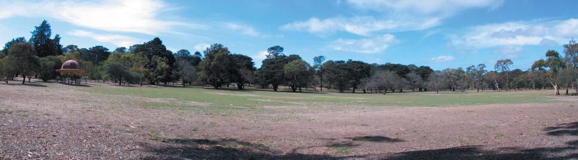
Action 25 involves the reconﬁguration and improvement of the existing sports ﬁelds to the south of Eastern Park Circuit, which are at present constrained by their size and substantial cross fall. In concert with the establishment of the wetland landscape, the ovals would be regraded such that the cross fall was removed to the minimum required for good drainage. In doing so, the ovals will become a series of ‘benches’, with the spaces between regraded as gentle sloping grassed areas, perfectly suited for spectator use. In this manner each of Ovals 1 to 3 could be increased in size and provided with unobtrusive shelters to facilitate improved comfort for both spectators and competitors. Opportunities to irrigate the ovals utilising water stored in the wetland may provide a further environmental beneﬁt, as well as improving the usability of the ovals. Further improvement to the usability of the ovals could be achieved through the replacement of the existing turf grasses with warm season turf grasses.

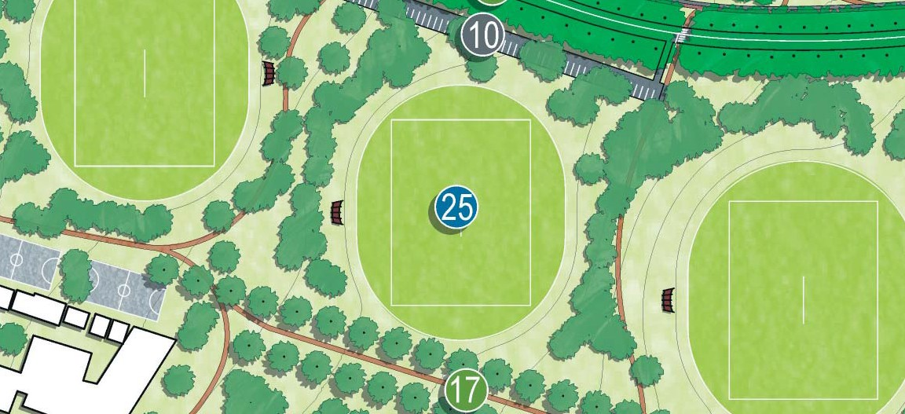
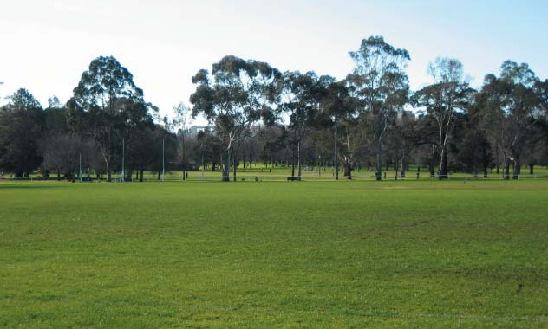
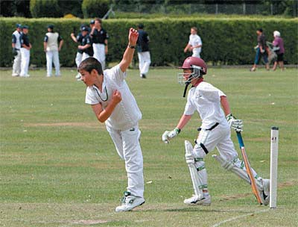

Action 26 – Geelong Mineral Springs Bath House
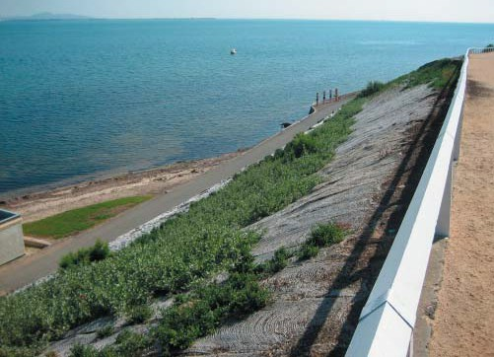
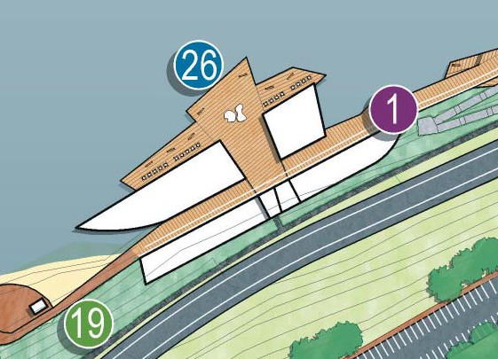
Action 26 involves the designation of the original mineral springs as the preferred location for the proposed Geelong Mineral Springs Bath House. The beneﬁts envisaged by locating the development in this position include the opportunity to interpret the heritage signiﬁcance of the original mineral springs, to contribute to the establishment of the ‘compelling link’ referred to in Action 1, the northern orientation, waterfront aspect and an increased patronage and proﬁle for Eastern Park.

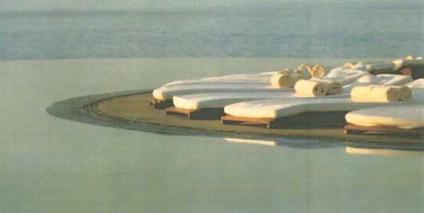
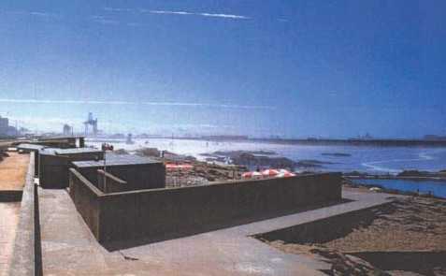

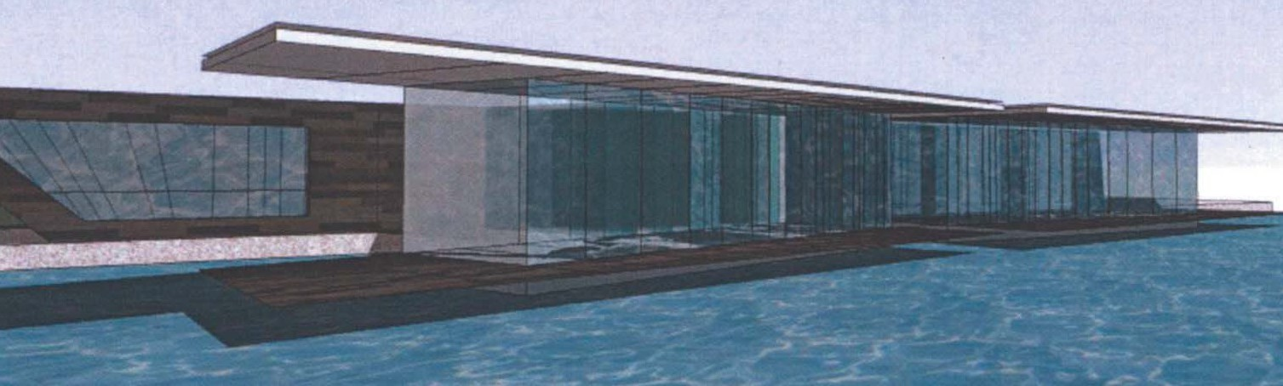

Action 27 – The Amphitheatre
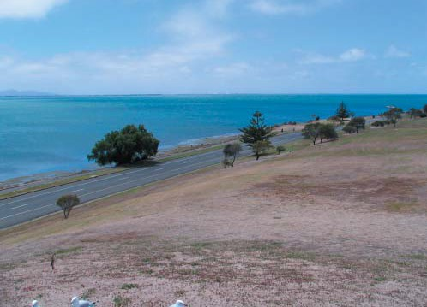
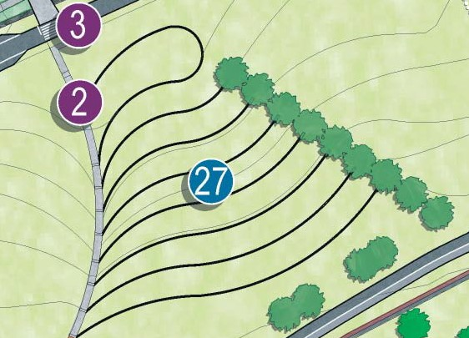
Action 27 involves the creation of an outdoor amphitheatre on the northern slopes facing Corio Bay, through a gentle reconﬁguration of the existing topography, coupled with the provision of the minimum level of infrastructure required to ensure that such a facility is able to operate. The form of the amphitheatre should reﬂect and respect the existing form of the land, and would comprise a series of grassed steps, deﬁned by low stone retaining walls.
It should be noted that the amphitheatre is to be implemented in stages, with the stage area, service access and lower retaining walls constructed ﬁrst. As use and popularity increase, the amphitheatre can be extended to allow it to cater for larger events and audiences.

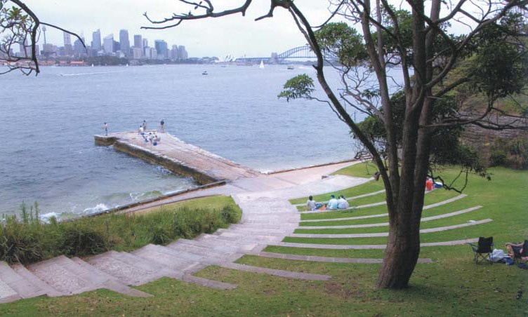
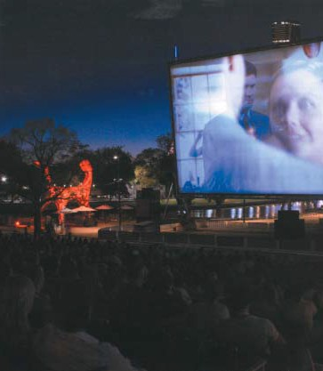
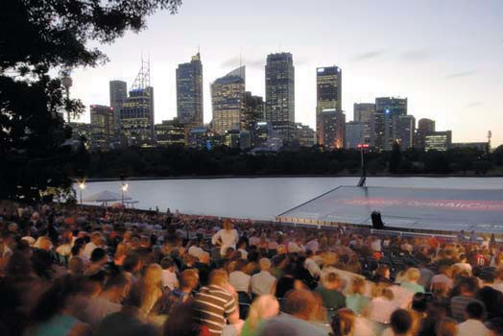
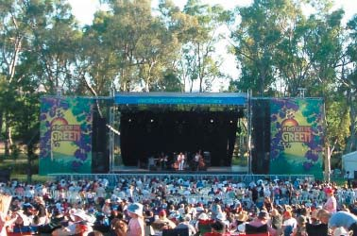

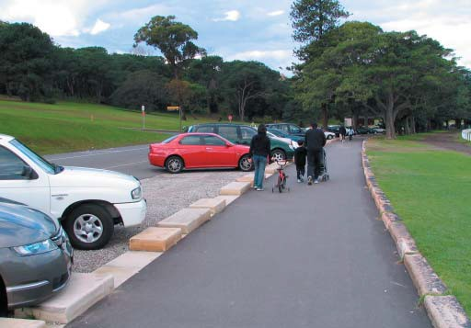
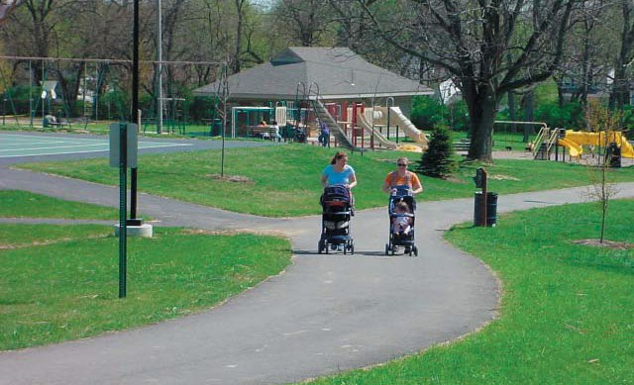
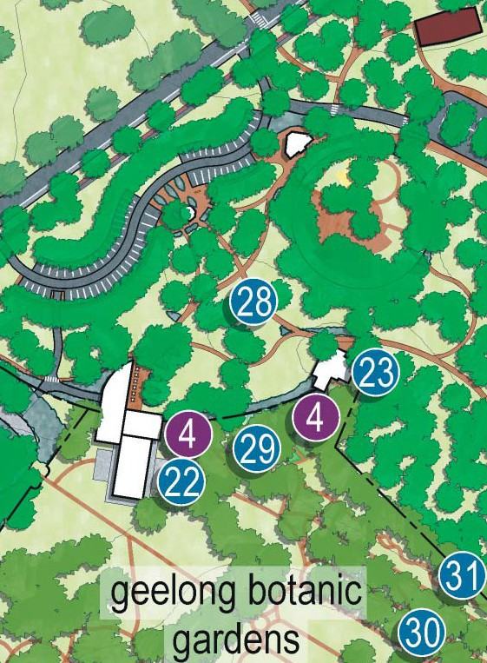

Action 28 – Integration of existing attractions
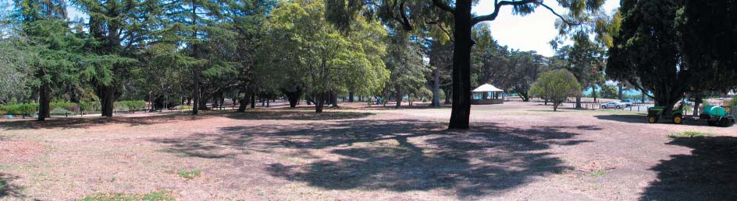
Action 28 involves the provision of improved integration of attractions, such as the area within which the Play Space, Botanic Gardens, Water Conservatory and Superintendent’s Residence are located. Through the reconﬁguration of disparate parking areas and the provision of new pedestrian access routes, there are opportunities to enhance the amenity, functionality and popularity of all these elements of the park. Also, as the Tail Light Alley car park is in close proximity to this area it can accommodate for overﬂow parking for these facilities.

Action 29 – Heritage buildings and structures
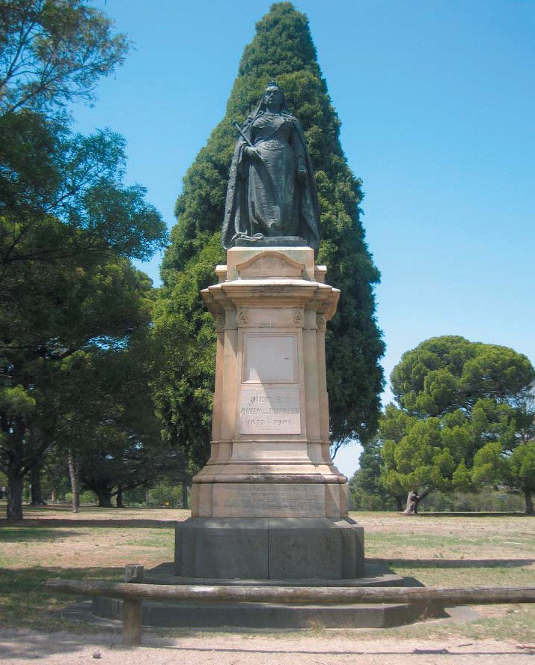
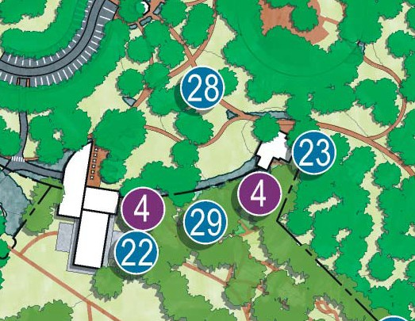
Action 29 involves the ongoing retention and conservation of the numerous buildings and structures within both the Geelong Botanic Gardens and Eastern Park which have been identiﬁed in the Heritage Conservation Assessment as being of either primary or contributory signiﬁcance. The manner in which these buildings and structures are managed is described in detail in the Conservation Policy which forms part of the Eastern Park and Geelong Botanic Gardens Heritage Conservation Assessment, which is a companion document to this Master Plan.

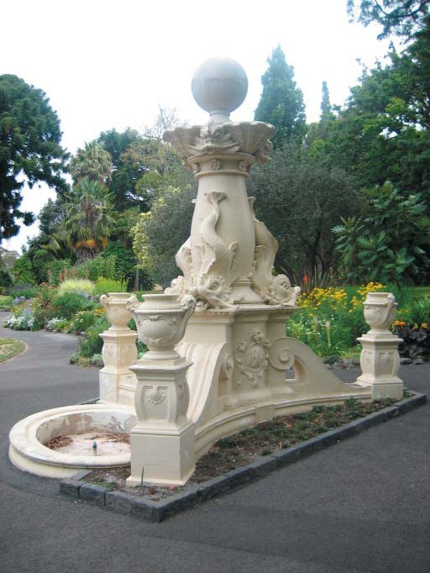
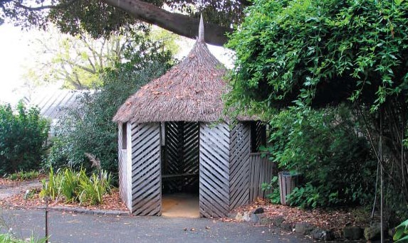

Action 30 – Amenities
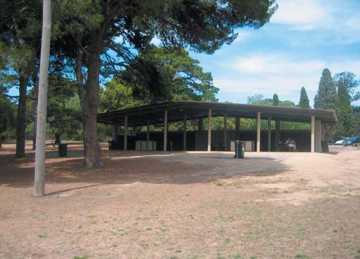
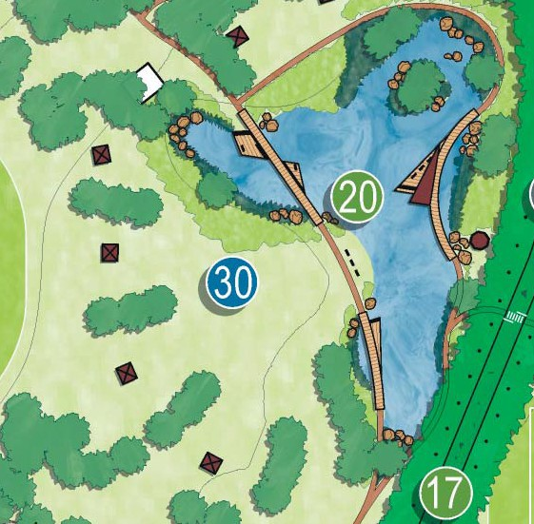
Action 30 involves the establishment of new picnic areas – and the improvement of existing ones – through ensuring that all picnic areas are provided with appropriate levels of infrastructure, including seating, shelter, electric barbecues, rubbish bins, drinking fountains and toilet facilities.
Also of note is the requirement of new toilet blocks within the Geelong Botanical Gardens, to suitably cater for visitors numbers and replace the current portable toilets.
This action is to be implemented in collaboration with the Street and Park Furniture Style Guide which is an appendix to this report. This guide identiﬁes a suite of suitable park infrastructure to adequately respond to the needs of the park, while creating a consistent theme throughout.

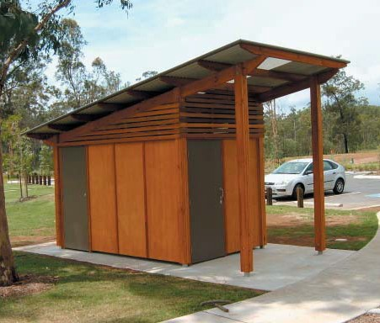
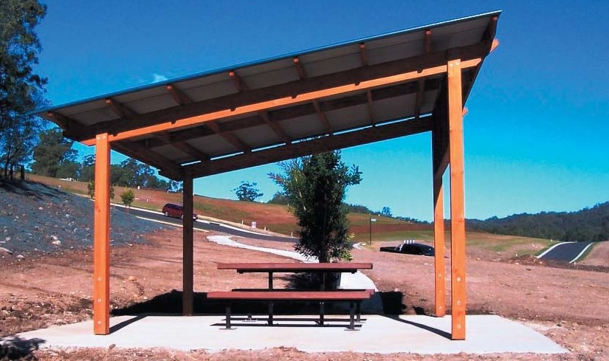
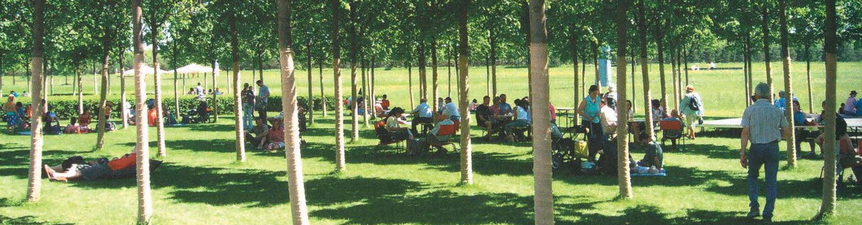

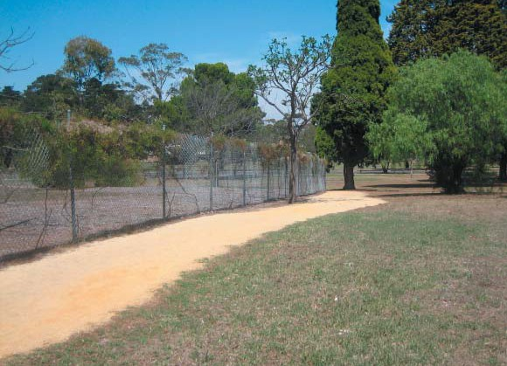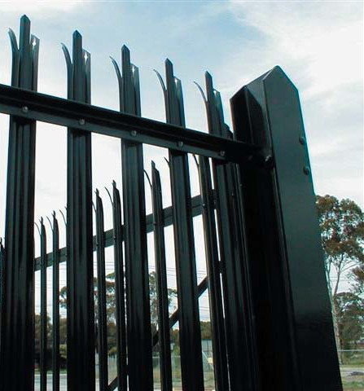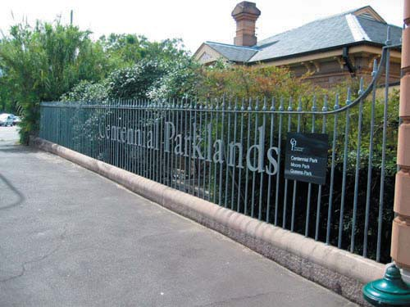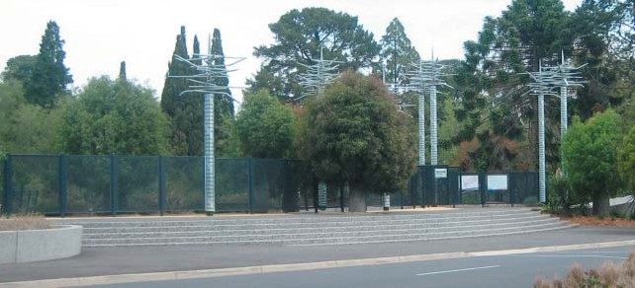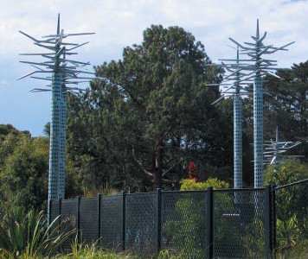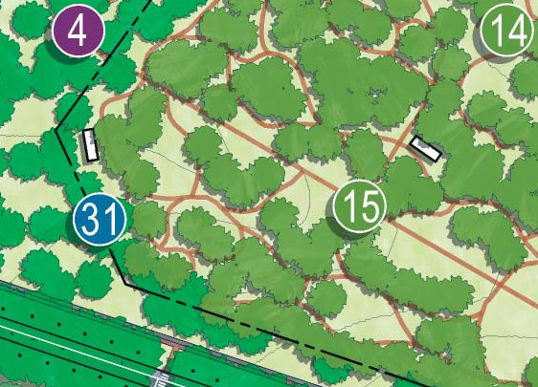

Action 31 – Botanic Gardens Perimeter Fence
Action 31 involves the replacement of the existing cyclone wire mesh fence with a new metal palisade fence to emphasise the importance of the Geelong Botanic Gardens within the context of both Eastern Park and the City of Geelong.

Action 32 – Golf Course improvements
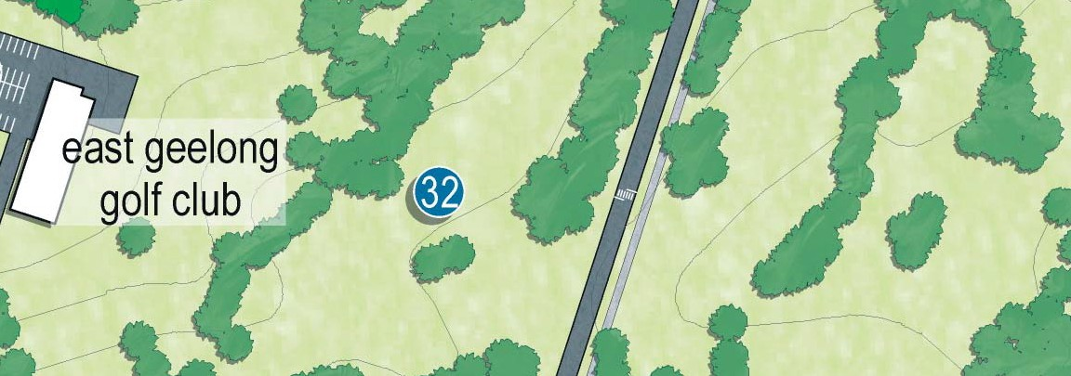
Action 32 intends to realign the holes which are disected by Limeburners Road.
Currently golfers are required to drive the ball over Limeburners road, which is an undesirable situation for both golfer and the golf club. This action proposes to realign the affected holes, so that they no longer run accross the road. The realignment will incorporate existing vegetation along with providing an opportunity to establish new plantings. This will improve the attractiveness of the course, while creating a better playing experience for golfers.

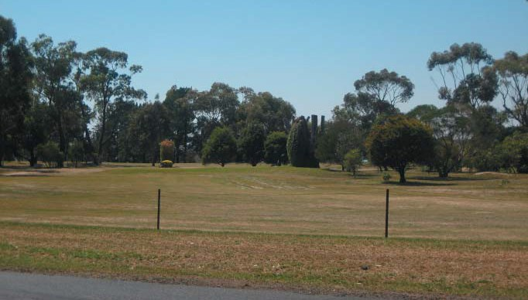


Implementation Strategy

Opinion of Probable Cost and Project Prioritisation

Action Number | Associated tasks | Quantity | Unit | Rate | Amount | Timeframe | Dependent Actions | Potential Funding Source
Pedestrian Movement
Action 1 - "The Compelling Link" | Construction of timber boardwalk | 8300 | m2 | $750.00 | $6,225,000.00
 | Construction of concrete access ramp (2.0 metres wide) with balustrade | 220 | lin m | $740.00 | $162,800.00
 | Construction of concrete stairs (9.0 metres wide) with balustrade | 13 | m/rise | $17,500.00 | $227,500.00
 | Construction of concrete landings | 240 | m2 | $70.00 | $16,800.00
 | Construction of concrete paths (1.2 metres wide) | 140 | lin m | $85.00 | $11,900.00
 | Construction of timber access ramp (2.0 metres wide) with balustrade | 210 | lin m | $1,600.00 | $336,000.00
 | Construction of timber stairs (2.0 metres wide) with balustrade | 15 | m/rise | $4,800.00 | $72,000.00
 | Installation of seating (25 metre spacings) | 52 | no. | $1,500.00 | $78,000.00
 | Installation of rubbish bin (50 metre spacings) | 26 | no. | $5,000.00 | $130,000.00
 | Installation of water fountain (200 metre spacings) | 7 | no. | $8,100.00 | $56,700.00
 | Installation of way finding signage (200 metre spacings) | 7 | no. | $1,500.00 | $10,500.00 |  |  | Department of Infrastructure, Boating Safety and Facilities
 | Installation of boulevard lighting (25 metre spacings) | 52 | no. | $3,000.00 | $156,000.00 |  |  | Department of Transport and Regional Services Regional Partnership
 |  |  |  | Total | $7,483,200.00 | Medium Term | Action 26 | Department of Communications, Information Technology and the Arts
Action 2 - Accessible and legible pedestrian network | Improvements to existing gravel paths (1.2 metres wide) | 350 | lin m | $75.00 | $26,250.00
 | Improvements to existing asphalt paths (1.2 metres wide) | 1050 | lin m | $85.00 | $89,250.00
 | Construction of gravel paths (1.2 metres wide) | 5000 | lin m | $75.00 | $375,000.00
 | Construction of main pedestrian circuit - gravel (1.5 metres wide) | 2200 | lin m | $85.00 | $187,000.00
 | Construction of main pedestrian circuit - asphalt (1.5 metres wide) | 2200 | lin m | $95.00 | $209,000.00
 | Construction of concrete access ramp (2.0 metres wide) with balustrade | 100 | lin m | $740.00 | $74,000.00
 | Construction of internal pedestrian crossing | 17 | no. | $5,000.00 | $85,000.00
 | Installation of way finding signage | 35 | no. | $1,500.00 | $52,500.00 |  |  | Sport and Recreation Victoria (SRV)
 |  |  |  | Total | $1,098,000.00 | Short - Medium Term | Action 4 | VicRoads
Action 3 - A well connected park | Construction of signalised pedestrian crossing | 1 | no. | $100,000.00 | $100,000.00
 | Construction of pedestrian crossing | 4 | no. | $5,000.00 | $20,000.00
 |  |  |  | Total | $120,000.00 | Short Term | Action 3 | VicRoads
Action 4 - An integrated Geelong Botanic Gardens | Refer to Actions 22, 23 and 28
Action 5 - A 'shared' Eastern Park Circuit | Refer to Action 9
Vehicular Movement
Action 6 - Reconfigured Golf Club and Convention Centre access | Construction of asphalt road (6 metres wide) | 500 | lin m | $230.00 | $115,000.00
 | Construction of asphalt car parking | 2300 | m2 | $65.00 | $149,500.00
 | Timber traffic barrier (post and rail) | 780 | lin m | $55.00 | $42,900.00
 |  |  |  | Total | $307,400.00 | Medium Term | Action 7 | VicRoads
Action 7 - Removal of vehicles from Adams Court | Removal of existing asphalt road (4 metres wide) | 165 | lin m | $200.00 | $33,000.00
 | Reinstatement of previous parkland | 470 | m2 | $10.00 | $4,700.00
 | Construction of gravel path (1.2 metres wide) | 160 | lin m | $75.00 | $12,000.00
 |  |  |  | Total | $49,700.00 | Medium Term | Action 6
Action 8 - Intersection improvements and traffic management | Construction of traffic roundabout | 2 | no. | $500,000.00 | $1,000,000.00
 | Timber traffic barrier (post and rail) (Holt Road - both lanes) | 900 | lin m | $55.00 | $49,500.00
 | Timber traffic barrier (post and rail) (Limeburners Road - inner lane) | 1350 | lin m | $55.00 | $74,250.00
 | Timber traffic barrier (post and rail) (Ryrie Street - inner lane) | 550 | lin m | $55.00 | $30,250.00
 | Timber traffic barrier (post and rail) (Garden Street - inner lane) | 350 | lin m | $55.00 | $19,250.00
 |  |  |  | Total | $1,173,250.00 | Medium Term |  | VicRoads
Action 9 - Eastern Park Circuit | Resurfacing of existing asphalt road (6 metres wide) | 1750 | lin m | $230.00 | $402,500.00
 | Timber traffic barrier (post and rail) (Eastern Park Circuit - inner lane) | 3050 | lin m | $55.00 | $167,750.00
 |  |  |  | Total | $570,250.00 | Short Term
Action 10 - Formalised car parking | Improvements to existing car parks | 14500 | m2 | $65.00 | $942,500.00
 | Reinstatement of previous parkland | 5000 | m2 | $10.00 | $50,000.00
 |  |  |  | Total | $992,500.00 | Short - Medium Term
Action 11 - New shared path | Insatllation of removable bollards | 10 | no. | $600.00 | $6,000.00
 | Construction of asphalt cylce lane (3 metres wide) | 600 | m2 | $205.00 | $123,000.00 |  |  | Sport and Recreation Victoria (SRV)
 |  |  |  | Total | $129,000.00 | Medium Term | Action 9 | VicRoads

Action Number | Associated tasks | Quantity | Unit | Rate | Amount | Timeframe | Dependent Actions | Potential Funding Source
Landscape
Action 12 - The Pinetum | Removal of existing senescing trees | 348 | no. | $1,204.00 | $418,992.00
 | Pruning works to existing trees | 308 | no. | $643.00 | $198,044.00 |  |  | Environment and Nature Grants
 | Planting of replacement trees | 2116 | no. | $200.00 | $423,200.00 |  |  | Community plantings
 |  |  |  | Total | $1,040,236.00 | Short - Long Term |  | Public Private Partnerships
Action 13 - The Australian landscape | Removal of existing senescing trees | 409 | no. | $1,204.00 | $492,436.00
 | Pruning works to existing trees | 362 | no. | $643.00 | $232,766.00 |  |  | Environment and Nature Grants
 | Planting of replacement trees | 2482 | no. | $200.00 | $496,400.00 |  |  | Community plantings
 |  |  |  | Total | $1,221,602.00 | Short - Long Term |  | Public Private Partnerships
Action 14 - Strategic direction for the Geelong Botanic Garden | Creation of a Garden Management Plan | 1 | no. | $50,000.00 | $50,000.00
 |  |  |  | Total | $50,000.00 | Short Term
Action 15 - New Botanic Gardens Collections | Creation of new display gardens | 19,000 | m2 | $100.00 | $1,900,000.00
 | Construction of new toilets | 2 | no. | $45,000.00 | $90,000.00
 | Construction of asphalt paths (1.2 metres wide) | 1600 | lin m | $84.00 | $134,400.00
 | Installation of seating | 20 | no. | $1,500.00 | $30,000.00
 | Installation of rubbish bin | 10 | no. | $5,000.00 | $50,000.00 |  |  | Department of Sustainability and Environment
 | Installation of water fountain | 4 | no. | $8,100.00 | $32,400.00 |  |  | Environment and Nature Grants
 | Installation of interpretive signage | 10 | no. | $1,500.00 | $15,000.00 |  |  | Community plantings
 |  |  |  | Total | $2,251,800.00 | Medium Term |  | Public Private Partnerships
Action 16 - Screening the depo | Planting of screening vegetetation | 200 | lin m | $100.00 | $20,000.00
 |  |  |  | Total | $20,000.00 | Short Term |  | Community plantings
Action 17 - The Avenues | Existing senescing tree removal (Refer to Action 12) |  |  |  |  |  |  | Environment and Nature Grants
 | Staged planting of tree avenues | 520 | no. | 200 | $104,000.00 |  |  | Community plantings
 |  |  |  | Total | $104,000.00 | Short - Medium Term |  | Public Private Partnerships
Action 18 - The Flying Foxes | Existing senescing tree removal | 200 | no. | $1,204.00 | $240,800.00 |  |  | Department of Sustainability and Environment
 | Planting of habitat trees  Instrallation of artificial roosting structures | 400 | no.  no. | $200.00  TBC  Total | $80,000.00  $320,800.00 | Short Term |  | Environment and Nature Grants Community plantings  Public Private Partnerships
 |  |  |  |  |  |  |  | Department of Sustainability
Action 19 - The Foreshore | Weed removal and installation of tubestock planting | 32500 | m2 | $30.00 | $975,000.00 |  |  | Environment and Nature Grants
 |  |  |  | Total | $975,000.00 | Medium Term | Action 1 and 26 | Community plantings
 |  |  |  |  |  |  |  | Public Private Partnerships
Action 20 - The Wetland | Earthworks and grading | 7000 | m3 | $10.00 | $70,000.00
 | Pipe from existing tormwater system to supply wetland (including excavation) | 390 | lin m | $810.00 | $315,900.00
 | Junction pit | 2 | no. | $1,000.00 | $2,000.00
 | Concrete headwall | 1 | no. | $1,000.00 | $1,000.00
 | Outlet pit | 2 | no. | $1,000.00 | $2,000.00 |  |  | Department of Sustainability
 | Planting of new vegetation | 8000 | m2 | $50.00 | $400,000.00 |  |  | Environment and Nature Grants
 | Construction of timber boardwalk | 180 | m2 | $500.00 | $90,000.00 |  |  | Community plantings
 |  |  |  | Total | $880,900.00 | Long Term |  | Public Private Partnerships
Actractions and Facilities
Action 21 - Eastern Park Horticultural Complex | Creation of complex buildings | 1 | no. | TBC  Total | TBC | Medium Term
Action 22 - The Walter Conservatory (including public toilet access) | Refurbishment of Walter Conservatory | 1 | no. | $330,000.00 | $330,000.00
 | Building extension including opperational equiptment | 1 | no. | $1,250,000.00 | $1,250,000.00
 | External hard works | 300 | m2 | $100.00 | $30,000.00
 | External landscape works | 100 | m2 | $40.00 | $4,000.00
 |  |  |  | Total | $1,614,000.00 | Short Term | Action 23 and 28 | Public Private Partnerships
Action 23 - The Superintendents Residence | Retrofit residence as educational centre | 1 | no. | $500,000.00 | $500,000.00
 | Creation of an educational garden | 750 | m2 | $100.00 | $75,000.00 |  |  | Education and Training Grants
 |  |  |  | Total | $575,000.00 | Medium Term | Action 22 and 28 | Gordon TAFE
Action 24 - Sculpture Park | Floating timber platforms to hold sculptures | 20 | no. | $1,000.00 | $20,000.00 |  |  | Department of Communications, Information Technology and the Arts (DOCITA
 | Installation of interpretive signage | 10 | no. | $1,500.00 | $15,000.00 |  |  | Philanthropic Trusts
 |  |  |  | Total | $35,000.00 | Medium Term |  | Culture and Heritage Grants
Action 25 - The Sports fields | Earthworks and grading | 43500 | m3 | $10.00 | $435,000.00
 | Installation of warm season grasses | 43500 | m2 | $10.00 | $435,000.00
 | Construction of shelters | 3 | no. | $8,000.00 | $24,000.00
 |  |  |  | Total | $894,000.00 | Long Term | Action 20 and 30 | Sports and Recreation Victoria

Action Number | Associated tasks | Quantity | Unit | Rate | Amount | Timeframe | Dependent Actions | Potential Funding Source
Action 26 - Geelong Mineral Springs Bath House Creation of Bath House Buildings m2 TBC
 |  |  |  | Total | TBC | Medum Term | Action 1 | Public Private Partnerships
Action 27 - The Amphitheatre | Earthworks and grading | 16500 | m3 | $10.00 | $165,000.00
 | Installation of warm season grasses | 16500 | m2 | $10.00 | $165,000.00
 | Construction of retaining walls | 650 | lin m | $80.00 | $52,000.00
 | Construction of concrete paths (2 metres wide | 150 | lin m | $140.00 | $21,000.00
 |  |  |  | Total | $403,000.00 | Short Term |  | Department of Transport and Regional Services (DOTARS)
Action 28 - Integration of existing facilities | Creation of new asphalt car parking | 2100 | m2 | $65.00 | $136,500.00
 | Construction of gravel paths (1.2 metres wide) | 1600 | lin m | $75.00 | $120,000.00
 | Creation of new entrance gate to Play Space | 1 | no. | $10,000.00 | $10,000.00
 | Installation of seating | 5 | no. | $1,500.00 | $7,500.00
 | Installation of way finding signage | 10 | no. | $1,500.00 | $15,000.00
 | Installation of boulevard lighting | 5 | no. | $3,000.00 | $15,000.00
 | External landscape works | 200 | m2 | $40.00 | $8,000.00
 |  |  |  | Total | $312,000.00 | Medium Term | Action 22 and 23 | VicRoads
Action 29 - Heritage structures | Maintenance of existing heritage structures | 1 | no. | TBC  Total | TBC | Short - Long Term |  | Heritage Victoria Grants Culture and Heritage Grants
Action 30 - Amenities | Construction of new picnic shelters | 9 | no. | $8,000.00 | $72,000.00
 | Construction of new toilets | 3 | no. | $45,000.00 | $135,000.00
 | Construction of asphalt car park | 900 | m2 | $60.00 | $54,000.00
 | Installation of seating | 15 | no. | $1,500.00 | $22,500.00
 | Installation of picnic tables with benches | 18 | no. | $5,400.00 | $97,200.00
 | Installation of rubbish bin | 25 | no. | $5,000.00 | $125,000.00
 | Installation of water fountain | 10 | no. | $8,100.00 | $81,000.00
 | Installation of way finding signage | 20 | no. | $1,500.00 | $30,000.00
 |  |  |  | Total | $616,700.00 | Medium - Long Term | Action 20
Action 31 - Botanic Gardens perimeter fence | Removal of existing fence | 870 | lin m | $50.00 | $43,500.00
 | Construction of perimeter fence | 870 | lin m | $560.00 | $487,200.00
 |  |  |  | Total | $530,700.00 | Medium Term

Action 32 - Golf Course improvements Realignment of holes 1 no. $750,000.00
Total $750,000.00 Long Term

Total $24,518,038.00

Other Potential Funding Sources
Regional Partnerships Program
Commemoration of Historic Events and Famous Persons in Aid Program National Heritage Investment Incentive
Regional Infrastructure Development Fund Creating Better Places Urban Improvement Grants Cycling Promotion Fund
Bendigo Bank

Note: Actions 4 and 5 have been omitted from costings as their assoicated tasks have been included in other actions. Note: Total figures are not inclusive of GST
Note: Timeframes have beed defined as follows.
Short Term - actions to be achieved in 1-5 years.
Medium Term - actions to be achieved within 5-10 years.
Long Term - Actions to be achieved within 10-20 years

Note: Dependent Actions identify actions whose commencement is to be aligned with other actions.
Note: This Opinion of Probable Cost should not be interpreted as a Cost Estimate or Bill of Quantities. It has been prepared in accordance and to the level of deta of the Landscape Master Plan LCD-007 and is indicative only. Further detailed cost estimates are required prior to the commencement of any Actions and associated tasks.

Note: It is advisable to allow for a 20% contingency when determing budgets for actions

Total $7,554,388.00
Short Term Action Costings
Action | Amount
Action 2 - Accessible and legible pedestrian network | $1,098,000.00
Action 3 - A well connected park | $120,000.00
Action 9 - Eastern Park Circuit | $570,250.00
Action 10 - Formalised car parking | $992,500.00
Action 12 - The Pinetum | $1,040,236.00
Action 13 - The Australian landscape | $1,221,602.00
Action 14 - Strategic direction for the Geelong Botanic Garden | $50,000.00
Action 16 - Screening the depo | $20,000.00
Action 17 - The Avenues | $104,000.00
Action 18 - The Flying Foxes | $320,800.00
Action 22 - The Walter Conservatory (including public toilet access | $1,614,000.00
Action 27 - The Amphitheatre | $403,000.00
Action 29 - Heritage structures | TBC

Medium Term Action Costings
Action | Amount
Action 1 - "The Compelling Link" | $7,483,200.00
Action 6 - Reconfigured Golf Club and Convention Centre acces | $307,400.00
Action 7 - Removal of vehicles from Adams Court | $49,700.00
Action 8 - Intersection improvements and traffic managemen | $1,173,250.00
Action 11 - Criterium circuit | $129,000.00
Action 15 - New Botanic Gardens Collections | $2,251,800.00
Action 19 - The Foreshore | $975,000.00
Action 21 - Eastern Park Horticultural Complex | TBC
Action 23 - The Superintendents Residence | $575,000.00
Action 24 - Sculpture Park | $35,000.00
Action 26 - Geelong Mineral Springs Bath House | TBC
Action 28 - Integration of existing facilities | $312,000.00
Action 30 - New picnic areas | $616,700.00
Action 31 - Botanic Gardens perimeter fence | $530,700.00
Total $14,438,750.00

Long Term Actions Costings
Action Amount
Action 20 - The Wetland $880,900.00
Action 25 - The Sports fields $894,000.00
Action 32 - Golf Course improvements $750,000.00
Total $2,524,900.00

Note: Actions 4 and 5 have been omitted from costings as their assoicated tasks have been included in other actions.

Establishment of Strategic Implementation Group

Strategic Implementation Group & Project Manager
It is recommended that an autonomous body be established to oversee the implementation of the thirty-two Actions recommended within the Master Plan. The Project Control Group and the Project Working Group for this project have recommended that this body be referred to as the Strategic Implementation Group. This group should comprise individuals with the necessary experience, capacity and connections to ensure that implementation of the Master Plan occurs in a timely and coordinated manner.
The composition of the Strategic Implementation Group should comprise a number of City of Greater Geelong Councillors as well as individuals drawn from various segments across the Geelong community. This may include, but should not be limited to, representatives of the arts, environment, education, commerce, sport, cultural and indigenous groups. The Strategic Implementation Group should not be limited to City of Greater Geelong representatives only, nor should it be considered as a stakeholder reference group. Its members should be able to oversee the implementation of the master plan in a strategic fashion.
The City of Greater Geelong should develop the terms of reference for the operation of the Strategic Implementation Group.
The City of Greater Geelong should appoint a project manager whose primary responsibility will be to manage the implementation of the Master Plan. The project manager will be Council’s ﬁrst point of contact with the Strategic Implementation Group.
Existing management and maintenance operations within Eastern Park and the Geelong Botanic Gardens will continue to be the responsibility of existing Council departments. Part of the project manager’s role will be to liaise with these departments to ensure that the implementation of master plan recommendations is coordinated with existing management and maintenance practices.

