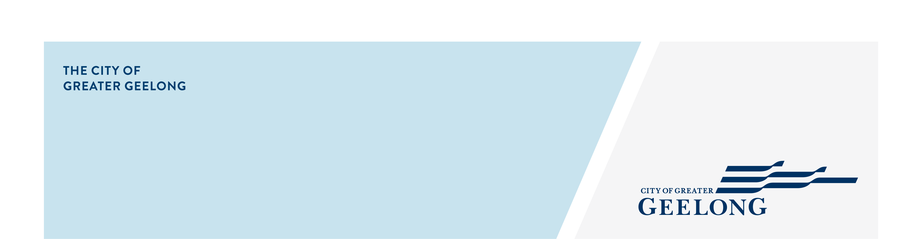
Request for an
additional bin(s)
service
terms and conditions

General terms and conditions

- A maximum of one additional garbage bin, recycling bin or green waste bin is available for each eligible household.
- The bin(s) will be delivered to the property once your application has been assessed and approved.
- Your application may take up to 10 working days to be processed and delivered.
- You must maintain the bin in a sound and clean condition, suitable for collection.
- You must only dispose of approved materials in each bin.
- Cancellations must be received by 30 June to avoid the rateable property being charged for the bin in the next financial year. No refunds will be issued.
- All bins including additional bin(s) are registered to each rated property and are not transferable between properties at any time.
- All bins remain the property of the City of Greater Geelong at all times.

Property owner terms and conditions

- The initial annual or half year fee for an additional bin will be charged to your credit card upon completion of this form.
- For future financial years, the annual fee for the additional bin(s) will automatically be included on the Rates, Valuation and Charges notice for the property.
- Additional bin fees are reviewed annually in line with City budget requirements.

Medical terms and conditions

- As the customer requesting this service, someone at the property must have a medical condition requiring disposal of waste that is beyond the capacity of the regular bin service.
- To receive the service free of charge, you must provide a medical certificate as proof, with annual updates for as long as the bins are required.
- This arrangement may be reassessed after 12 months, and previous approval does not guarantee future approvals.

Authorised agent terms and conditions
- As an agent you have permission to authorise charges on behalf of the owner, and you have made both the owner and the tenant aware of this application.
- As an agent you have made the owner aware that they will be charged for the additional bin on their rates notice in the following year, unless they have cancelled the service and bin has been returned by 30th of June.
A

Privacy Statement

We will comply with the Information Privacy and Health Privacy Principles as set out in the Privacy and Data Protection Act 2014 and Health Records Act 2001. For more information, search for ‘privacy’ on our website.

