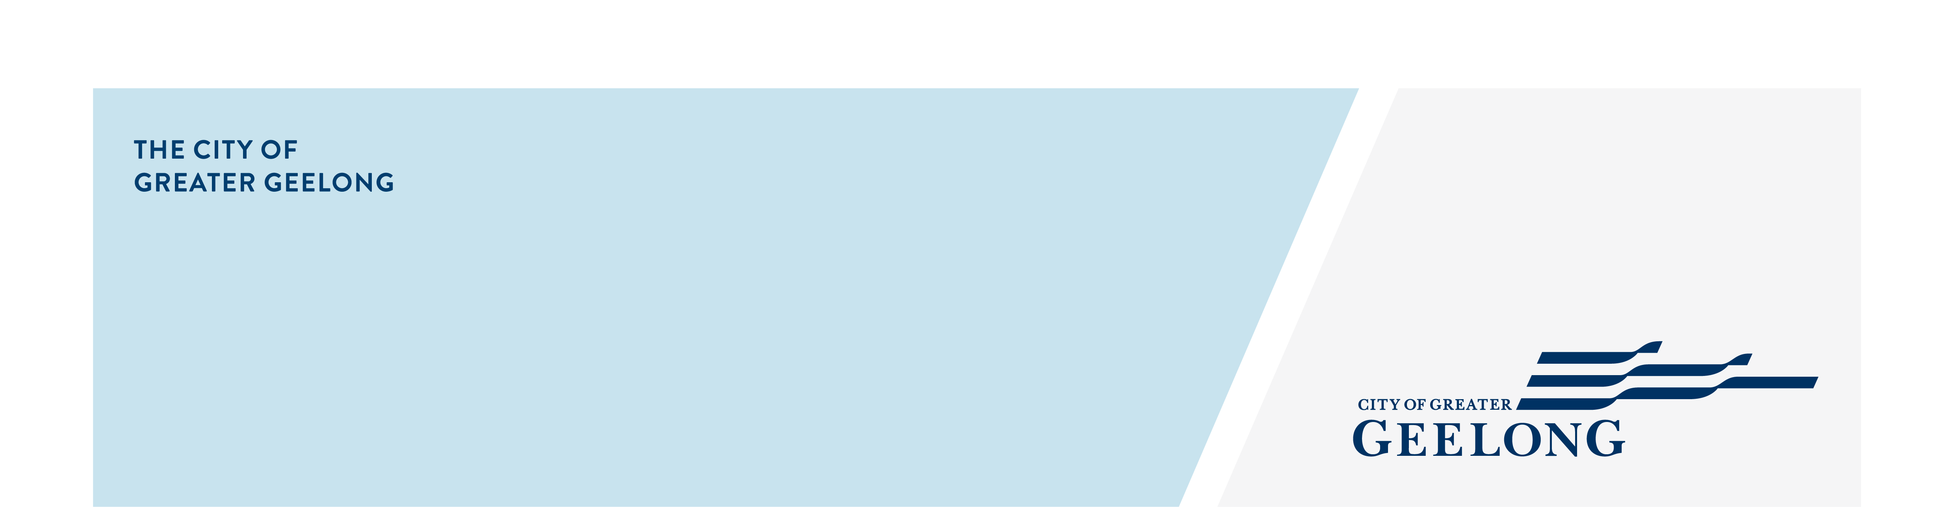
how to get a copy of title

A copy of title must be submitted with every planning application made to Council – even if you may think Council already has a copy of title., or you recently submitted an application at the same site.

When submitting your planning application, ensure that:

- The copy of title is less than 60 days old
- You provide a plan of subdivision along with the copy of title
- Ensure that the title and plan of subdivision cover all of the land your planning application is on and that the dimensions match (i.e. sometimes one site is made up of multiple titles – we require all of those titles).
- You provide a copy of any covenants or section 173 agreements that are listed on the title (under 'Encumbrances, Caveats and Notices').
- Ensure that the owner details you enter into the application form match exactly.

To obtain a copy of title, plan of subdivision, covenants or section 173 agreements, follow these steps:

- Head to https://www.landata.vic.gov.au/

- Scroll down to 'Title and Property Information' and then select 'Title and Property Certificates'.

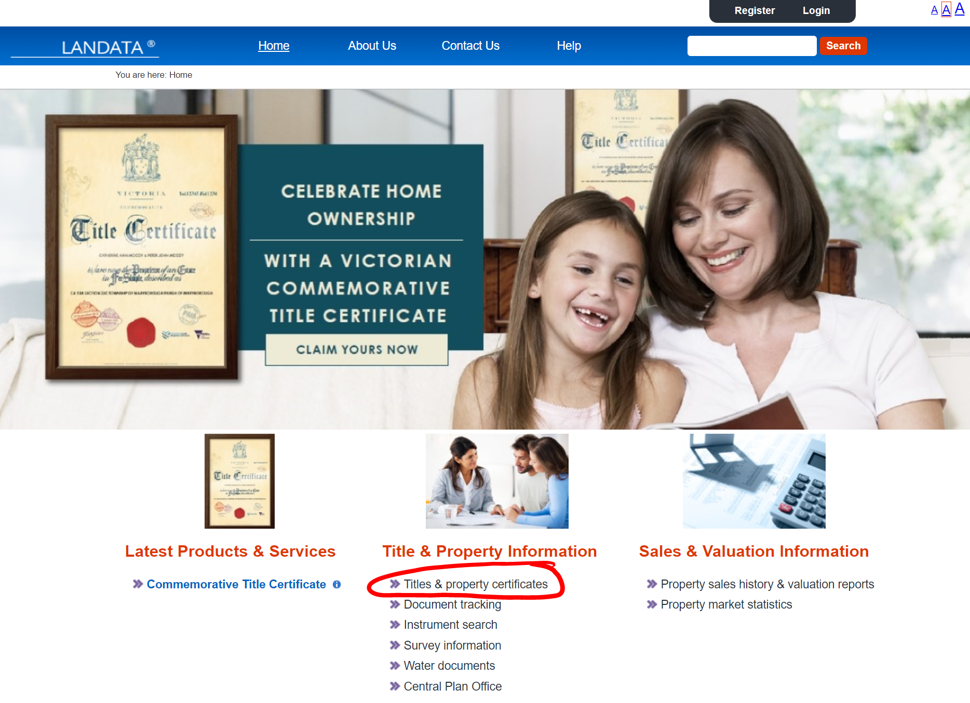

- From there, you can search for the property (step 1 of 5)

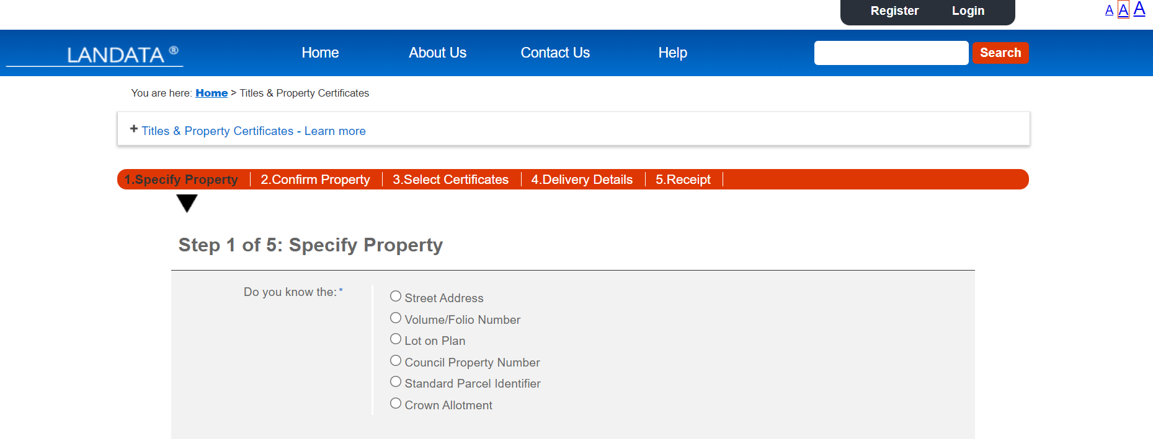

- Then confirm that you have found the property details (step 2 of 5)

- On the next page, you will need to select the certificates you wish to purchase (step 3 of 5). Generally, you will need 'registered search statement' and 'copy of plan'. You may also need 'instrument search' to get a copy of the covenants and section 173 agreements – note, not all sites will have a covenant or section 173 agreement. Once selected, click through to the next screen.

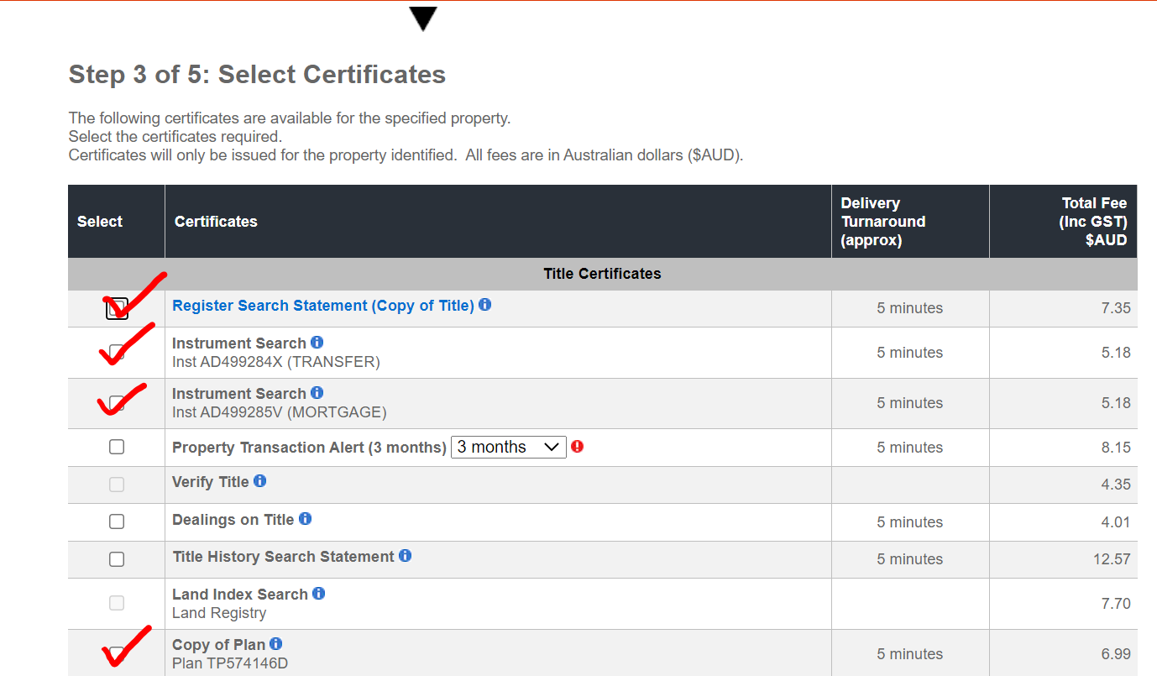

- From here, you will have to log in or register. Then you will be able to purchase the title information and it should be emailed to you, shortly after purchasing.

