BROADHECTARE RESIDENTIAL LAND
SUPPLY & DEMAND ASSESSMENT

City of Greater Geelong

April 2022
Final

Spatial Economics

21/04/2022
Final Version 1.0
Spatial Economics Pty Ltd
ABN: 56 134 066 783
www.spatialeconomics.com.au info@spatialeconomics.com.au

CONTENTS
EXECUTIVE SUMMARY 5
1.0 Introduction 7
1.1 Context 7
1.2 Purpose 7
2.0 Approach & Scope 8
3.0 Population Growth Scenario 12
3.1 Aspirational Growth Scenario – A Review 12
4.0 Recent Residential Development Activity 17
4.1. Residential Building Approvals 17
4.1.1 Residential Building Approvals - Geelong 18
4.2 Residential Broadhectare Lot Construction 18
4.2.1 Broadhectare Lot Construction – Diversity 20
4.3 Vacant Residential Lot Sales Pricing 22
5.0 Residential Land Supply 24
5.1 Undeveloped Broadhectare Land Stocks 24
6.0 Adequacy of Land Stocks 40
6.1 Years of Supply – City of Greater Geelong 40

LIST OF GRAPHS
Graph 1: Percentage Change in Residential Building Approval Activity by Regional Municipal Areas, 2019/20 to 2020/21
Graph 2: Residential Building Approvals by Type – City of Greater Gelong, 2001 to 2021
Graph 3: Share of Residential Broadhectare Lot Construction Activity by Location
Graph 4: Broadhectare Lot Construction Size Distribution – Geelong
Graph 5: Median Lot Size (sqm) – Broadhectare Lot Construction, Geelong
Graph 6: Greater Geelong Residential Land Sales (monthly)
LIST OF TABLES
Table 1: Estimated Resident Population, City of Greater Geelong
Table 2: Broadhectare Lot/Dwelling Growth Scenario
Table 3: Average Annual Broadhectare Lot Construction Activity, July 2017 to March 2022
Table 4: Estimated Undeveloped Residential Broadhectare Lot Capacity, March 2022
LIST OF MAPS
Map 1: Geelong Region and Sub-Regions
Map 2: Bellarine Peninsula and Sub-Regions/Townships
Map 3: Residential Land Supply– Northern Growth Area (Lara)
Map 4: Residential Land Supply– Northern Growth Area (Lovely Banks)
Map 5: Residential Land Supply– Geelong Urban (North)
Map 6: Residential Land Supply– Western Growth Area
Map 7: Residential Land Supply– Geelong Urban (South)
Map 8: Residential Land Supply– Armstrong Creek Growth Area
Map 9: Residential Land Supply– Clifton Springs/Drysdale
Map 10: Residential Land Supply– Indented Head
Map 11: Residential Land Supply– Ocean Grove
Map 12: Residential Land Supply– Point Lonsdale
Map 13: Residential Land Supply– Portarlington
Map 14: Residential Land Supply– St Leonards
Map 15: Residential Land Supply– Leopold

EXECUTIVE SUMMARY
The following report provides a detailed assessment of the historic, current and future assessment of broadhectare residential land supply and demand across the municipal area of Geelong.
Population Growth
Population growth has increased on an average annual basis of 2.4% or nearly 6,000 persons per annum from 2016 to 2021. The estimated population in Geelong in 2021 was 269,500.
In 2021, the resident population growth rate declined to 1.8%.
Caution is highlighted, as they are based on the 2016 census and updated using Medicare data. However, Covid and the vaccination program have compromised the reliability of Medicare data in estimating resident populations. The population estimates will be reviewed on the release of the 2021 Population and Housing Census
Growth Scenario – Demand for Broadhectare Lands
Future dwelling requirements are based on the planning growth scenario of a 2.5% population growth rate.
Due to the significant and all-time high volumes of residential greenfield land pre-sales, Spatial Economics have assumed that from March 2022 to the end of the calendar year of 2023, continued levels of peak construction activity will continue at approximately 3,500 greenfield lots per annum.
From January 2024, the 2.5% population growth scenario is applied to estimate the total dwelling requirements for the City of Greater Geelong.
As measured from 2022 to 2036, it is estimated that there will be a dwelling requirement within broadhectare lands of approximately 47,640.
Residential Development Activity
Residential Building Approvals
As measured over the two previous financial years, residential building approval activity has significantly increased across regional Victoria, increasing by 51% (from 12, 300 approvals to 18,540). In comparison, metropolitan Melbourne over the same time period increased by 3%.
Residential building approval has significantly increased across virtually all regional municipalities. Geelong has illustrated significant growth in building approval activity, increasing by 50%, from 3,107 approvals to 4,656 in 2020/21.
Residential Lot Construction
From July 2017 to March 2022, there was on an average annual basis 2,950 broadhectare lots constructed. Significant increases in construction activity were experienced in 2020/21 at 3,160 lots. For the financial year to date (March 2021/22) there has been 2,650 residential broadhectare lots constructed.
Residential lot construction activity as measured over the last 4.75 financial years was primarily concentrated within the Armstrong Creek Growth Area at 47% of all lot construction activity or nearly 1,400 lots per annum.
Of the remaining significant lot construction activity:
- 13% was located in Urban Geelong (average of 376 lots per annum);
- 9% was located in Lara (average of 252 lots per annum);
- 8% was located in Ocean Grove (average of 248 lots per annum);
- 8% was located in Drysdale/Clifton Springs (average of 237 lots per annum); and
- 8% was located in St Leonards (average of 229 per annum).
Of the broadhectare lot construction activity since July2017 to March 2022:
- 15% were compact (sized less than 300 sqm);
- 54% were suburban (sized 300 to 500 sqm);
- 30% were large suburban (500 to 1,000 sqm); and
- 1% low density suburban (over 1,000 sqm).
The median lot size of broadhectare constructed lots has steadily declined over-time, from 646 sqm in 2008 to 446 sqm in 2021. The median lot size constructed in 2021/22 (ytd March) has significantly declined to 352 sqm. This is primarily due to the significant increase in construction of lots sized less than 300 sqm.
In 2021/22 (ytd March), 41% or nearly 1,100 lots constructed were sized less than 300 sqm compared to 15% since July 2017.
Broadhectare Land Stocks
As at March 2022, there was an undeveloped residential lot capacity within zoned broadhectare sites of approximately 25,000 across the municipal area of Geelong. Of this zoned undeveloped broadhectare land stock, 6,100 lots have preliminary subdivision approval.
In addition to the zoned land stocks, there are approximately 4,200 hectares of land (with an estimated yield of 45,300 dwellings) identified for potential future broadhectare residential development across the municipal area. The bulk of this supply (88%) is located in the Northern and Western Growth areas of Geelong.
Adequacy of Land Stocks
Years Supply – Broadhectare
In total there is approximately 22 years supply of undeveloped (zoned and unzoned) residential broadhectare land stocks across the municipal area of Geelong. Of this supply, there is approximately 8 years of zoned residential broadhectare lands.
The incidence of land fragmentation within the Armstrong Creek Growth Area represents approximately 8 months of supply. It is considered that over-time, these fragmented land parcels will be developed.
Spatial Economics consider that maintaining a minimum of ten years supply of zoned broadhectare land stocks is optimum. This allows sufficient zoned land stocks to: a) respond to sustained/and or rapid increases in demand levels; b) foster industry competition and multiple development fronts; and c) absorb land development issues such as land fragmentation, ownership/development intention issues.

1.0 Introduction

1.1 Context
The following report is a greenfield residential land supply and demand assessment for the municipal area of Geelong.
The assessment includes:
- the identification of historical and current residential lot construction activity by location;
- identification of all zoned and unzoned broadhectare residential land supply stocks including estimates of lot yields on a project by project basis;
- presentation of potential future demand scenarios; and
- estimation of the years of supply of undeveloped broadhectare residential land stocks.
The assessment provides a robust and transparent assessment of the supply and demand for greenfield residential land across Geelong. The assessment will facilitate informed decision making in terms of the existing and future broadhectare residential land supply requirements.
In addition, the information will be of assistance to other related planning processes such as infrastructure and service planning.

1.2 Purpose
The monitoring of land supply is a key tool to assist in the management and development of growth across the municipal area of Geelong. The primary purpose of monitoring residential land supply is to improve the management of urban growth by ensuring that council, public utilities, government and the development industry have access to up-to-date and accurate information on residential land availability, development trends, new growth fronts, and their implications for planning and infrastructure investment.
The following report provides accurate, consistent and updated intelligence on residential land supply, demand and consumption. This in turn assists decision-makers in:
- maintaining an adequate supply of residential land for future housing purposes;
- providing information to underpin strategic planning in urban centres;
- linking land use with infrastructure and service planning and provision;
- taking early action to address potential land supply shortfalls and infrastructure constraints; and
- contributing to the containment of public sector costs by the planned, coordinated provision of infrastructure to service the staged release of land for urban development.

2.0 Approach & Scope
The following provides a brief outline of the major methodologies and approach in the assessment of recent residential lot construction, residential land supply areas, dwelling demand scenarios and determination of assessing adequacy of residential land stocks.
The methodology that Spatial Economics has employed for this project is based on the simple premise of matching the supply type with demand. This methodology assesses recent construction and future supply using the same criteria with the supply type definitions based on outcomes and on a lot by lot basis rather than administrative boundaries.
The methodology used by Spatial Economics is consistent with other State Government methodologies around Australia, including the Victorian State Governments Regional Urban Development Program.

Future Dwelling Requirements
Future dwelling requirements are based on the planning growth scenario of a 2.5% population growth rate. Spatial Economics have calculated the dwelling requirements based on an estimated dwelling stock in 2021 (revised upon release of the Australian Bureau of Statistics Population and Housing Census in July 2022).
Due to the significant and all-time high volumes of residential greenfield land pre-sales, Spatial Economics have assumed that from March 2022 to the end of the calendar year 2023 continued levels of peak construction activity will continue at approximately 3,500 greenfield lots per annum.
From January 2024, the 2.5% population growth scenario is applied to estimate the total dwelling requirements for the City of Greater Geelong.
The assumption of 75% of all dwelling requirements will be sourced from greenfield lands is still assumed.

Broadhectare Land Supply Definitions
Is defined as residential development on greenfield sites (sites that have not been used previously for urban development purposes or previously subdivided for normal/urban density development) and typically located on/or near the urban fringe.

Geography
The following custom geographic areas are utilised for the land supply assessment (see Maps 1 and 2).
Region: Two broad regions are utilised namely: 1) the Bellarine Peninsula; and 2) Geelong.
Sub-region: The subregions are combination of 1) townships located in the Bellarine Peninsula; and 2) growth areas and the established urban area of Geelong/urban fringe for the Geelong Region.

Residential Lot Construction
Residential lot construction has been determined via the assessment of the residential cadastre and the application of this cadastre to previously undeveloped greenfield lands.
A constructed lot is defined by the year of construction and the finalisation of certificate of title.
Lot construction is only captured if it is for residential purposes.
Construction activity has been assessed on an annual financial year basis from July 2006 to March 2022.

Lot Yields
Lot yields on a site basis has been undertaken for only undeveloped broadhectare lands.
In establishing the lot yield for each individual land parcel, the following information was used: incidence and location of native vegetation, zoning, natural features such as creeks, escarpments, floodways, localised current/recent market yields, ability to be sewered, existing studies such as structure plans.
In addition to site specific issues, ‘standard’ land development take-outs are employed, including local and regional. The amount/proportion of such take-outs are dependent on the land parcel i.e., a 1ha site will have less take-outs than say a 50ha site. Further intelligence and verification are sourced from the local land development industry and Council officers.

Years of Supply
With the amount of supply and demand estimated, adequacy is described in years of supply. For example, it can be stated that there are X years of supply based on projected demand within a given geographic area.
In assessing the number of years of broadhectare residential land supply, only a component of the total projected demand is apportioned to estimate future demand. The remainder is apportioned for future demand of other forms of residential supply such as dispersed infill and rural residential.
Map 1: Geelong Region and Sub-Regions
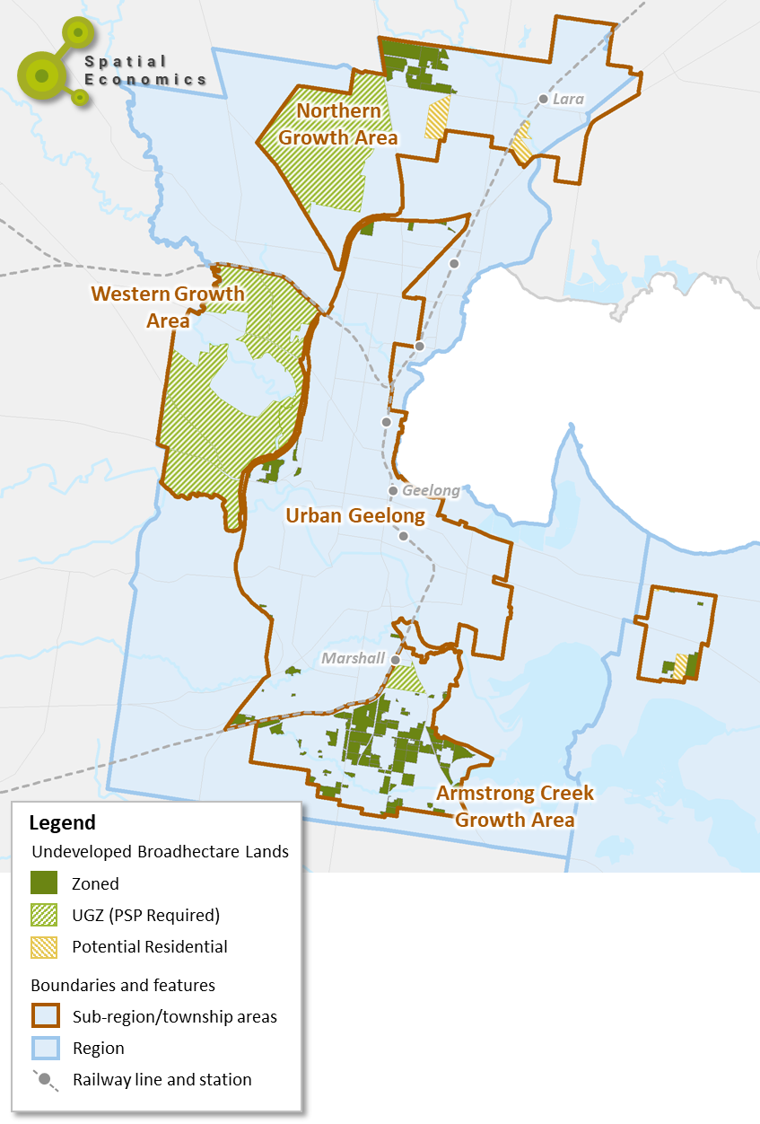

Map 2: Bellarine Peninsula and Sub-Regions/Townships
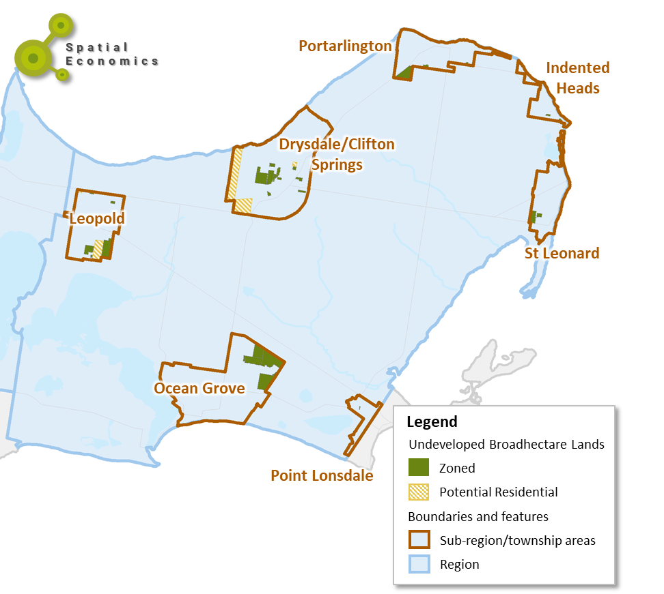

3.0 Population Growth Scenario
The 2021 census has only recently been undertaken and won’t be published until mid-2022. Consequently, we are now near the end of the five yearly inter-censal cycle when population estimates are most reliant on changes in Medicare registrations rather than census counts. The population estimates for 2017 onwards will be revised in mid-2022 once the 2021 census data become available.
The Geelong Settlement Strategy adopted a 2.5% population growth rate scenario for the municipal area of Geelong for the purpose of long-term settlement planning. The Settlement Strategy was drafted in 2018 and adopted by Council in 2020.
In recent years since the drafting of the Settlement Strategy there has been significant changes in population estimates and more recently residential development activity. The most recent population estimates indicate a population increase of 1.8%. Whilst, for the same period, residential building approval activity has reached historic highs of approximately 4.700.
With such significant change over the last two years in Geelong, Spatial Economics have undertaken a review of the assumed population growth scenario of 2.5% per annum.

3.1 Aspirational Growth Scenario – A Review
Is the 2.5% population growth ‘Aspirational Scenario’ for Greater Geelong still an appropriate projection to use?
Latest population trends
It is appropriate to question the continued use of this projection given that the population growth rate (as estimated by the ABS) of Greater Geelong has dropped below 2.5% for the last two years. The following table shows the annual growth rates since 2016 and the sources of Greater Geelong’s population growth.
Table 1: Estimated Resident Population, City of Greater Geelong
 | Natural Increase | Net Internal Migration | Net Overseas Migration | Total | Annual Rate
2016-17 | 984 | 3,329 | 1,886 | 6,199 | 2.6%
2017-18 | 947 | 3,663 | 1,891 | 6,501 | 2.6%
2018-19 | 1,009 | 3,798 | 1,904 | 6,709 | 2.7%
2019-20 | 849 | 3,601 | 1,395 | 5,845 | 2.3%
2020-21 | 907 | 4,305 | -487 | 4,725 | 1.8%
Source: Australian Bureau of Statistics
This table shows the following:
- Population growth, whether measured in absolute terms or as an annual rate of growth, has fallen over the last two years.
- The principal reason for this loss has been the reduction in net oversea migration, which, in the last financial year, became negative. The reason for this change is of course due the impacts of Covid19 travel restrictions and lockdowns on the flows of international migrants, particularly backpackers and students. Victoria’s migration loss in 2020-2021 was -56,100, 54,400 of which came from Melbourne. Deakin University’s overseas student loss affected Geelong.
- The downturn in net overseas migration to Greater Geelong was partially offset by greater gains from internal migration. During 2020-2021 Melbourne lost heavily to both regional Victoria and interstate. Greater Geelong’s probably lost population to interstate but this was more than compensated for by greater net gains from Melbourne.
- A note of caution: All these statistics are from the latest ABS estimates. They are still based on the 2016 census and updated using Medicare data. However, Covid and the vaccination program have compromised the reliability of Medicare data in estimating resident populations.
Projections currently used by Commonwealth and State Governments
Commonwealth and State Government agree that the assumptions made in pre Covid projections are still valid.
There are four relevant projections currently in use by Commonwealth and State Governments:
- Victoria in Future 2019 published by DELWP in 2019. These were prepared prior to Covid and have not been updated. They are the only Government projections for regions and local government areas.
- State Government budget projections, published in May 2021. These make a four-year projection for Victoria and assume that by 2023/24 population growth rates return to pre-Covid levels.
- The Commonwealth Treasury’s Centre for Population makes ten year projections for capital cities and rest of states (eg Greater Melbourne and Regional Victoria). It too assumes that population growth rates quickly return to pre Covid levels. Its last publication was December 2021. It projects that, by 2029, Melbourne’s population will surpass Sydney’s.
- The Commonwealth Government Intergeneration Report published in June 2021 makes a 40 year projection for Australia and also assumes growth quickly returns to pre-Covid levels.
There is agreement across Government that Covid is a dent in long term growth. That dent does reduce the size of projected populations because projections start from a lower base in 2023/24 had Covid not happened. But Covid has not resulted in changes to long term population growth assumptions.
Is there a need to update population projections for Greater Geelong?
The short answer is no or at least not yet!
The 2021 census is published in July 2022 which will give us a final resident population for 30th June 2021. It may be higher or lower than the preliminary 2021 estimate published last week (29th March).
That is the base number for new projections. At present there is no case for reviewing the assumptions behind the projections.
The census will contain updated data on internal migration trends, household formation and dwelling occupancies. The full set of data should be available in October 2022. That is the time to critically review projections and the assumptions behind them.
The case made to support a growth rate of between 2% and 3% with a middle point 2.5% growth rate remains:
- Victoria is expected to grow strongly underpinned by overseas migration; and
- Geelong is expected to grow strongly owing to (a) its strong and diverse economy, (b) its proximity to a burgeoning Melbourne population, particularly Melbourne’s western suburbs and (c) its physical and environmental attributes.

Dwelling Projections
Future dwelling requirements are based on the planning growth scenario of a 2.5% population growth rate. Spatial Economics have calculated the dwelling requirements based on an estimated dwelling stock in 2021 (to be revised upon release of the Australian Bureau of Statistics Population and Housing Census in July 2022).
Due to the significant and all-time high volumes of residential greenfield land pre-sales, Spatial Economics have assumed that from March 2022 to the end of the calendar year of 2023, continued levels of peak construction activity will continue at approximately 3,500 greenfield lots per annum.
From January 2024, the 2.5% population growth scenario is applied to estimate the total dwelling requirements for the City of Greater Geelong.
The assumption of 75% of all dwelling requirements will be sourced from greenfield lands is still assumed.
Table 2: Broadhectare Lot/Dwelling Growth Scenario
 | 2022 to 26 | 2026 to 31 | 2031 to 36 | 2036 to 41
Average Annual Dwelling Requirement | 3,191 | 2,919 | 3,335 | 3,810
Total Dwelling Requirement | 12,765 | 14,594 | 16,673 | 19,049
Source: Spatial Economics
An important note for users
Data on population growth is subject to changes. At the current stage of the census cycle, we are most vulnerable to adjustments which can quickly alter population trends and the population projections which are based on such trends. When 2021 census data is published in July 2022, population estimates between 2017 and 2021 will be revised. These can be significant and change one’s understanding about the extent and source of population growth.
The Estimated Resident Population or ERP is the official population figure most used by government. It is used to determine allocation of funding of Local and State Government by the Commonwealth Government. It is also used to determine the distribution of electorates. Population projections made by the ABS, the DELWP and by consultants use the ERP.
The ERPs are used for a wide range of planning purposes – financial, land use, education, health, transport etc.
The ERP is published by the ABS, quarterly for States and Territories and annually for regions, Local Government Areas and for State and Territories. . The annual estimate is for the 30th June, the end of the financial year. The finest geographical level for which ERPs are published is the SA2. There are 461 SA2s in Victoria.
The ERP is based on census counts. The five yearly census is undertaken in early August. ABS then backdates the population estimate to the previous 30th June. This is done in a number of steps:
- It takes the usual resident population as recorded in the census. This excludes census night visitors but includes people who were elsewhere in Australia on census night and allocates them ‘back home’.
- It includes the ABS’s estimate of the census undercount (ie people missed by the census)
- It takes out people born between 30th June and census night but includes people who died between 30th June and census night
- It includes people who were overseas at the time of the census but who normally live in Australia and allocates them to the place where they normally live. Nationally this can amount to several hundred thousand people, although will be a lot less in 2021 than in 2016 owing to Covid.
The ABS then updates ERPs each year relying on births and deaths data and Medicare data.
The latest ‘preliminary’ population estimate for Geelong was for 30th June 2021, which was published in March 2022. But this estimate will still be based on the 2016 census. With the publication of the 2021 census next July, the ABS will publish ‘final’ ERPs for each year from 2017 to 2021.
The revisions to population estimates following a census can be significant. Following the 2016 census the 2016 ERP for Victoria was revised upwards by over 100,000, resulting in changed trends and changed prospects for future growth across Victoria.
In March 2022, we are currently in the most vulnerable part of the five yearly cycle. The current 2021 estimate are subject to change. No one knows whether estimates will be revised upwards to downwards or the extent of these changes.
The census also provides important information about the characteristics and sources of population growth and household formation. It is the kicking off point for updating our understanding of the dynamics of population change and the way that population organises itself into households that consume housing. Consequently, it is the trigger for updating projections.
As of March 2022, the best advice to users is to (a) be aware of these issues, (b) keep a watching brief on revisions and, (c) be prepared to adjust business models once 2021 census data becomes available and projections are revised.
The Commonwealth and State Governments’ views on the impact of Covid:
In December 2020 the Commonwealth Government's Centre for Population published a preliminary view on the impacts of COVID:
“The impact of COVID-19 is expected to be long lasting. Australia’s population is expected to be smaller and older than projected prior to the onset of the pandemic.
Australia’s population is estimated to be around 4 per cent smaller (1.1 million fewer people) by 30 June 2031 than it would have been in the absence of COVID-19. The population will also be older as a result of reduced net overseas migration and fewer births. Despite COVID-19, Australia’s population is still growing and is expected to reach 28 million during 2028–29, three years later than estimated in the absence of COVID-19.
COVID-19 is projected to slow population growth across all geographic areas analysed, with the duration and magnitude linked to the importance of net overseas migration to different parts of the country.
Capital cities are projected to bear the heaviest impacts, with total population across capital cities estimated to be around 5 per cent lower by 30 June 2031 than in the absence of COVID-19. By contrast, population outside the capital cities is estimated to be around 2 per cent smaller than it would otherwise have been.
The number of people migrating interstate is projected to fall by 12 per cent in 2020–21. This would be the largest year-on-year drop in interstate migration in 40 years and would lead to the lowest rate of interstate migration as a proportion of the population on record.
Melbourne is projected to overtake Sydney to become Australia’s largest city in 2026–27, with a population of 6.2 million by 2030–31, compared to 6.0 million in Sydney.”
In summary, Covid makes a dent in ongoing population growth from which it will take a long time to recover.
In June 2021, the Commonwealth Treasury published its update of the intergenerational report. One notable feature was the lower 40 year population growth projections. Even if, optimistically, Australia (and the World) can quickly recover from the Covid with life and the economy returning to ‘pre COVID normal’, that population dent will endure into the future.
In May 2021, the Victorian Treasury published its budget papers which included a four year forecast of population growth which accounted for the impact of Covid:
The Victorian Treasury’s short term forecasts
Year | Forecast population growth rate, Victoria
2020/21 | 0%
2021/22 | 0.3%
2022/23 | 1.2%
2023/24 | 1.7%
2024/25 | 1.7%
Source: Budget Paper no. 2, page 22, Victorian Treasury, May 21
The Victorian Treasury view mirrors that of the Commonwealth Government: that Covid produces a two-three year dent in population growth. By 2023/24 Victoria population growth is forecast to return to its pre-Covid projections rate i.e. that used in Victoria in Future 2019.

Summary

The Geelong Settlement Strategy adopted a 2.5% population growth rate scenario for the municipal area of Geelong for the purpose of long-term settlement planning. The most recent population estimates indicate a population increase of 1.8%. Whilst, for the same period, residential building approval activity has reached historic highs of approximately 4.700.

Is there a need to update population projections for Greater Geelong?

The case made to support a growth rate of between 2% and 3% with a middle point 2.5% growth rate remains:

Victoria is expected to grow strongly underpinned by overseas migration; and

Geelong is expected to grow strongly owing to (a) its strong and diverse economy, (b) its proximity to a burgeoning Melbourne population, particularly Melbourne’s western suburbs and (c) its physical and environmental attributes.

It would be prudent in light of the forthcoming release later in 2022 of the Australian Bureau of Statistics: Population and Housing Census to undertake a detailed review of the 2.5% population growth scenario.

4.0 Recent Residential Development Activity
Section 4 of this report details recent residential broadhectare lot construction activity, residential broadhectare lot sales and an overview of residential building approval activity. Broadhectare residential lot construction activity is detailed from July 2006 to March 2022.

4.1. Residential Building Approvals
Building Approval Activity in Context
The Building Approval statistics collected by the ABS for Victoria for the financial year 2020/2021 reveal several interesting trends brought on by the Covid19 pandemic. For Victoria, building approvals have increased from 60,000 to 67,600 over the year to July 2021, a substantial increase of 12.7%.
As measured over the two financial years, residential building approval activity has significantly increased across regional Victoria, increasing by 51% (from 12, 300 approvals to 18,540). In comparison, metropolitan Melbourne over the same time period increased by 3%.
As a share of total activity, regional Victoria has jumped from 20% of all new dwellings to 28% in one year. The share going to regional Victoria peaked around 2006 and declined until around 2017. The share for regional Victoria had been rising in the last few years in part because of the rise of Geelong before the spike brought on by the pandemic
Residential building approval has significantly increased across virtually all regional municipalities.
Geelong has illustrated significant growth in building approval activity, increasing by 50%, from 3,107 approvals to 4,656 in 2020/21.
Graph 1: Percentage Change in Residential Building Approval Activity by Regional Municipal Areas, 2019/20 to 2020/21
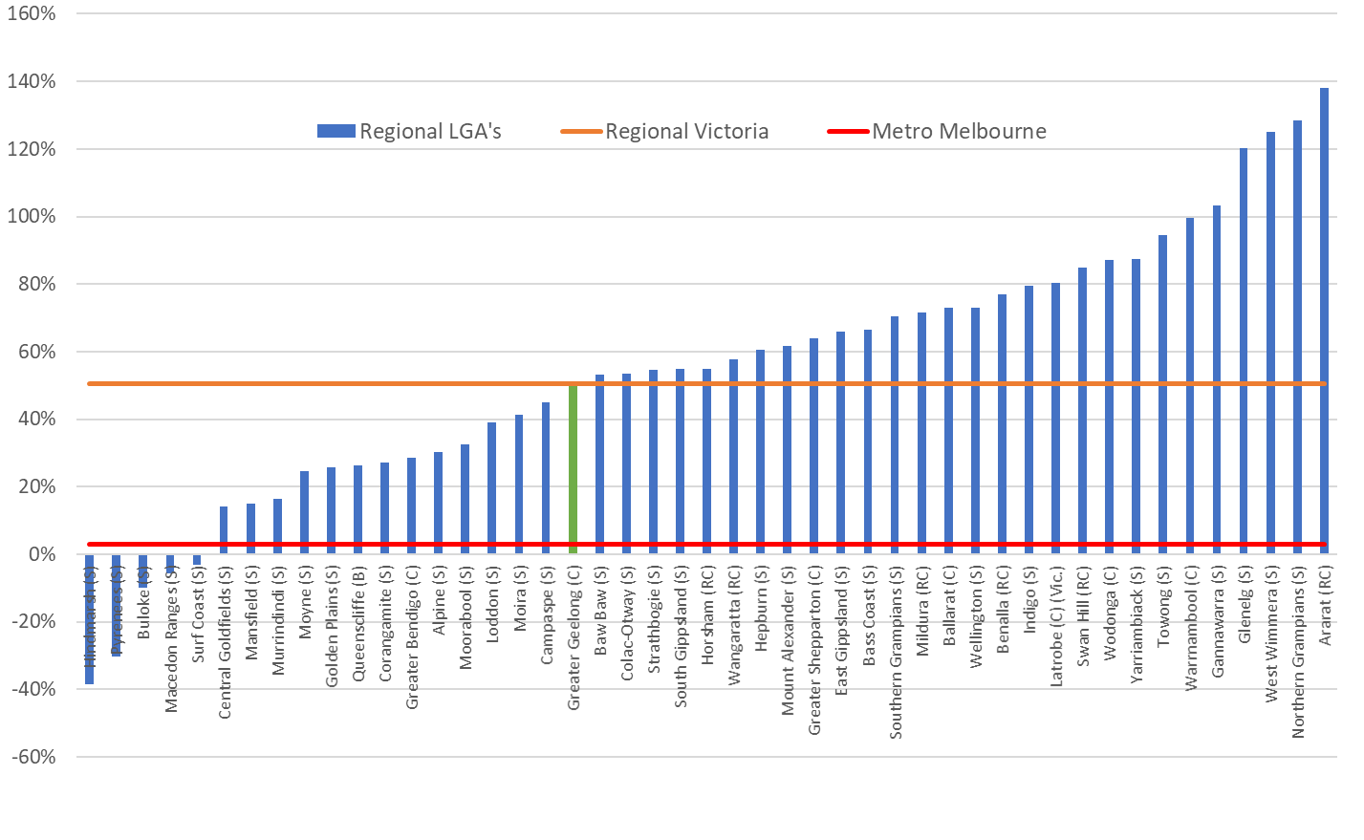
Source: Australian Bureau of Statistics
The large increase in demand for housing across regional Victoria will put significant pressure on local economies to be able to deliver the housing stock. The sharp hike in residential building activity will put additional pressures on supply chains, sourcing labour and associated civil works requirements.
The pandemic and the subsequent work from home phenomenon is having significant impacts on the residential construction industry. With presales in greenfield estates extending out further than ever before, sometimes into multiple years’ worth of supply, there will be a backlog of construction requirements.

4.1.1 Residential Building Approvals - Geelong
As measured from 2001/02 to 2020/21, residential building approvals within the City of Greater Geelong averaged 2,330 per annum. Of which, 87% were for separate dwellings whilst 13% were for medium density housing.
Graph 2 illustrates sustained trend in the continual volume growth of residential building approval activity since 2009. Between 2009 and 2013, the annual number of residential buildings approvals averaged around 2,000 per annum, increasing to around 2,600 from 2013 to 2017 and increasing to an average of 3,260 from 2017 to 2020.
There was a peak of approximately 4,660 residential building approvals in the financial year of 2020/21. For the financial year to date (January 2022) there was 2,340 approvals, it is likely that building approval activity for 2021/22 will remain at the previous year’s peak activity levels.
Graph 2: Residential Building Approvals by Type – City of Greater Gelong, 2001 to 2021
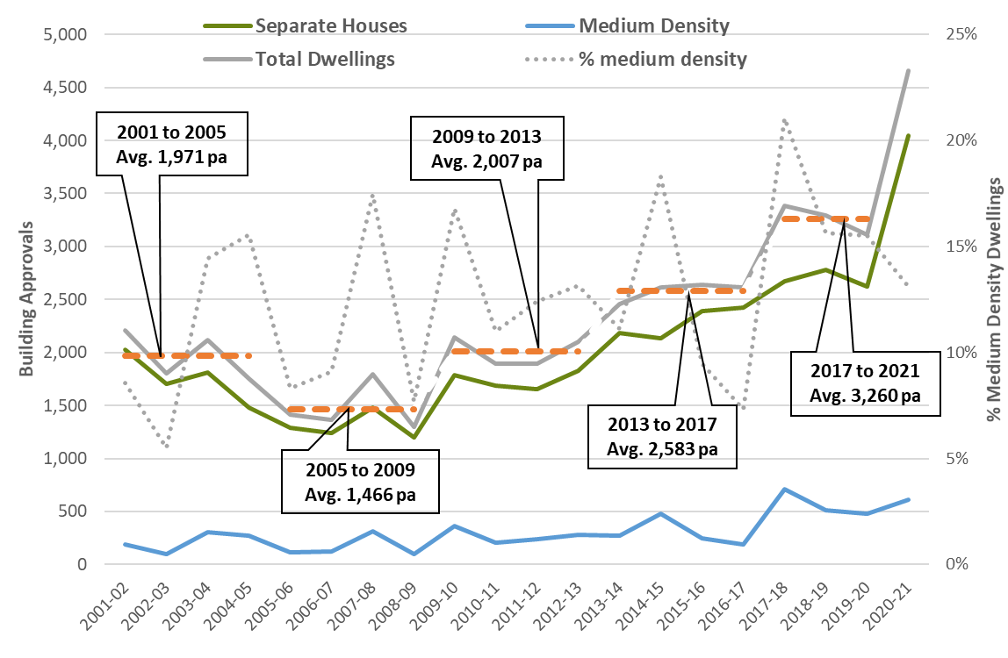
Source: Australian Bureau of Statistics

4.2 Residential Broadhectare Lot Construction
Analysis has been undertaken to determine, on a lot by lot basis, the location and quantum of broadhectare residential lot construction activity across Geelong by financial year from 2006 to March 2022.
From July 2017 to March 2022, there was on an average annual basis 2,950 broadhectare lots constructed. Significant increases in construction activity were experienced in 2020/21 at 3,160 lots. For the financial year to date (March 2021/22) there has been 2,650 residential broadhectare lots constructed.
Residential lot construction activity as measured over the last 4.75 financial years was primarily concentrated within the Armstrong Creek Growth Area at 47% of all lot construction activity or nearly 1,400 lots per annum.
Of the remaining significant lot construction activity:
- 13% was located in Urban Geelong (average of 376 lots per annum);
- 9% was located in Lara (average of 252 lots per annum);
- 8% was located in Ocean Grove (average of 248 lots per annum);
- 8% was located in Drysdale/Clifton Springs (average of 237 lots per annum); and
- 8% was located in St Leonards (average of 229 per annum).
Table 3: Average Annual Broadhectare Lot Construction Activity, July 2017 to March 2022
 | Average Lot Production
Ocean Grove | 248
Drysdale/Clifton Springs | 237
St Leonards | 229
Point Lonsdale | 108
Leopold | 39
Portarlington | 29
Indented Heads | 20
Connewarre | 19
Moolap | 13
Bellarine Peninsula | 942
Armstrong Creek | 1,383
Urban Geelong | 376
Northern Growth Area | 252
Geelong | 2,011
CoGG | 2,953
Source: Spatial Economics Pty Ltd
Note: North Growth Area includes the locality of Lara
In recent years, the contribution of residential broadhectare lot construction activity in Armstrong Creek has significantly increased. In 2017/18 there was 990 lots constructed, steadily increasing to nearly 1,700 in 2020/21. For the financial year to date of 2021/22 (March) there was nearly 1,400 lots constructed.
Graph 3 below illustrates the proportional share of residential broadhectare lot construction activity over-time by ‘region’ within the City of Greater Geelong. In 2012, nearly 70% of all broadhectare lot construction activity was located in the Bellarine Peninsula, this steadily declined (share) with the release of the Armstrong Creek Growth Area. As at July 2021, 23% of lot construction activity was located in the Bellarine Peninsula.
It is highlighted that although the share of lot construction activity has declined over time in the Bellarine Peninsula, since July 2017 the volume of construction activity has remained relatively constant at around 940 lots per annum.
The bulk of the increase in lot construction activity has been located within the Armstrong Creek Growth Area. Illustrating importance of a significantly size growth area with multiple industry players and development fronts of that can readily respond to rapid increases in demand levels.
Graph 3: Share of Residential Broadhectare Lot Construction Activity by Location
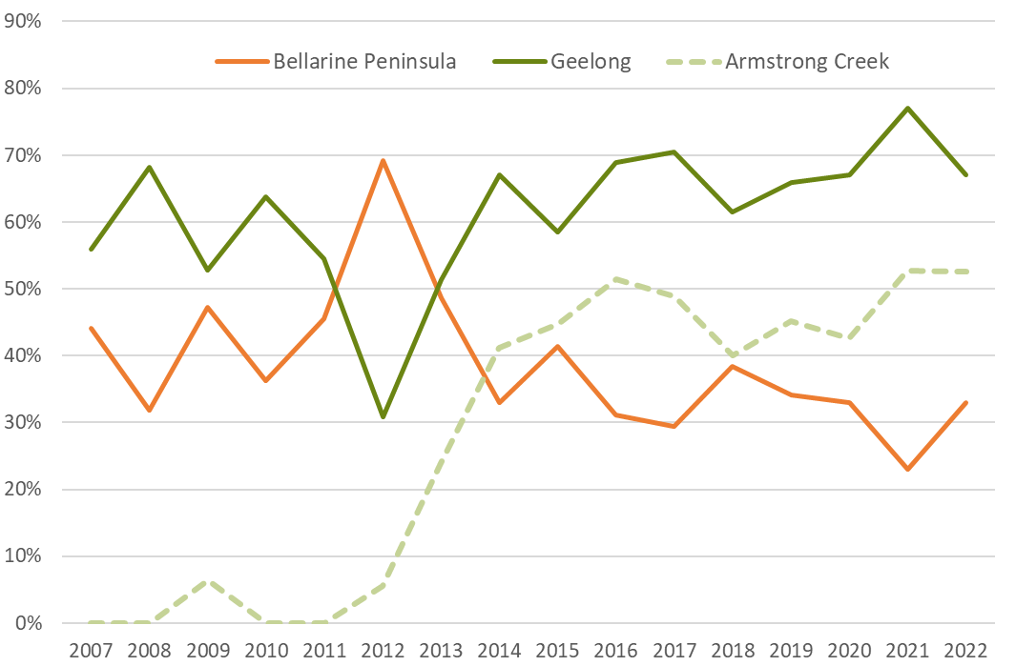
Source: Spatial Economics Pty Ltd
Note
- 2022 measured as at March 2022
- Armstrong Creek residential broadhectare lot construction activity is included within the Geelong total development activity

4.2.1 Broadhectare Lot Construction – Diversity
Lots constructed from broadhectare supply sources across the City of Greater Geelong has steadily been declining in size over-time. In the current financial year, the rate of decline has been significant.
Of the broadhectare lot construction activity since July2017 to March 2022:
- 15% were compact (sized less than 300 sqm);
- 54% were suburban (sized 300 to 500 sqm);
- 30% were large suburban (500 to 1,000 sqm); and
- 1% low density suburban (over 1,000 sqm).
Graphs 4 and 5 below illustrate both the median size and diversity of broadhectare residential lot construction.
The median lot size of broadhectare constructed lots has steadily declined over-time, from 646 sqm in 2008 to 446 sqm in 2021. The median lot size constructed in 2021/22 (ytd March) has significantly declined to 352 sqm. This is primarily due to the significant increase in construction of lots sized less than 300 sqm.
In 2021/22 (ytd March), 41% or nearly 1,100 lots constructed were sized less than 300 sqm compared to 15% since July 2017.

Graph 4: Broadhectare Lot Construction Size Distribution – Geelong
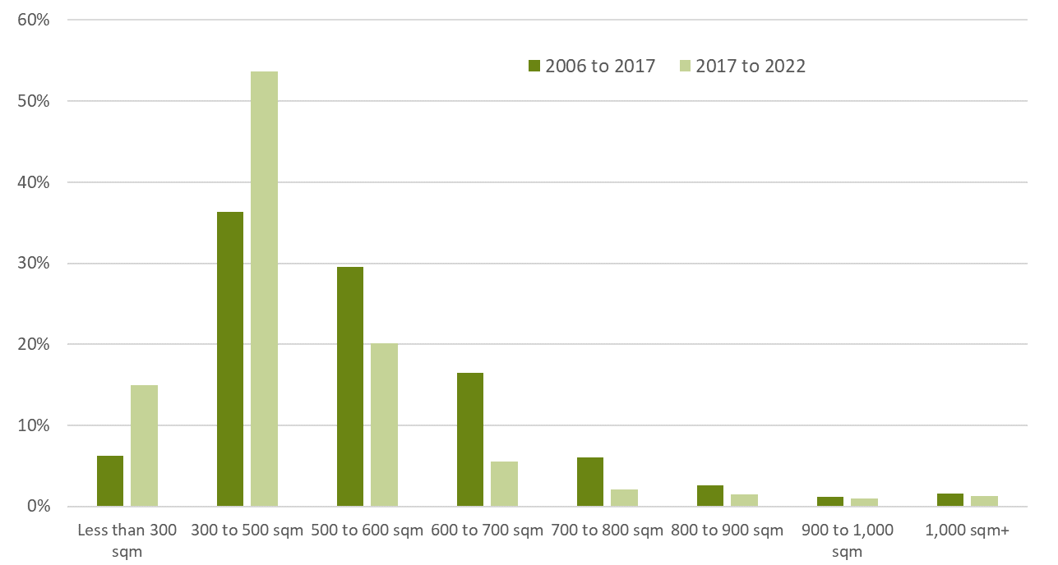
Source: Spatial Economics Pty Ltd
Graph 5: Median Lot Size (sqm) – Broadhectare Lot Construction, Geelong
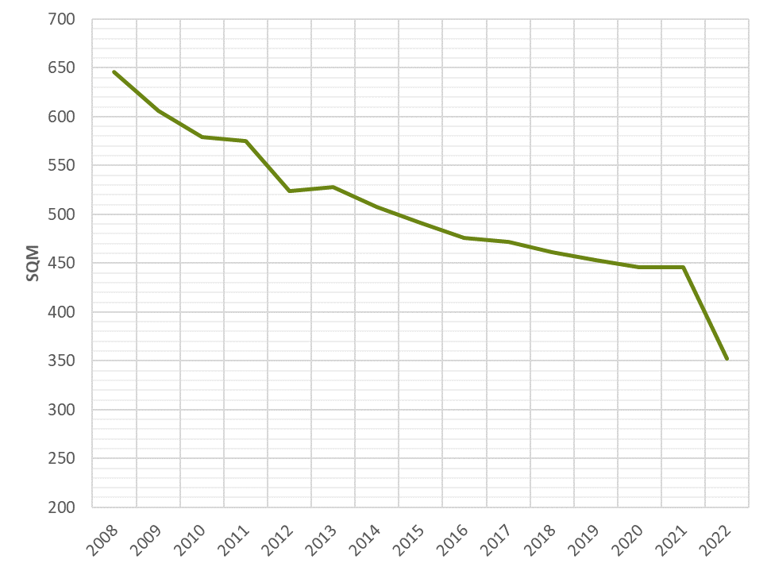
Source: Spatial Economics Pty Ltd
Note: 2022 as at March2022

4.3 Vacant Residential Lot Sales Pricing
The sales value and volume of vacant residential lots is a prime outcome indicator of the ‘state of the land supply’ market. It is a simple measure that captures both supply and demand dynamics.
Graph 6 below illustrates the monthly sales of residential land from 2011 to 2022. It graphically illustrates the significant surge in residential land sales beginning broadly in 2020 and continuing to surge into the calendar year of 2021.
Graph 6: Greater Geelong Residential Land Sales (monthly)
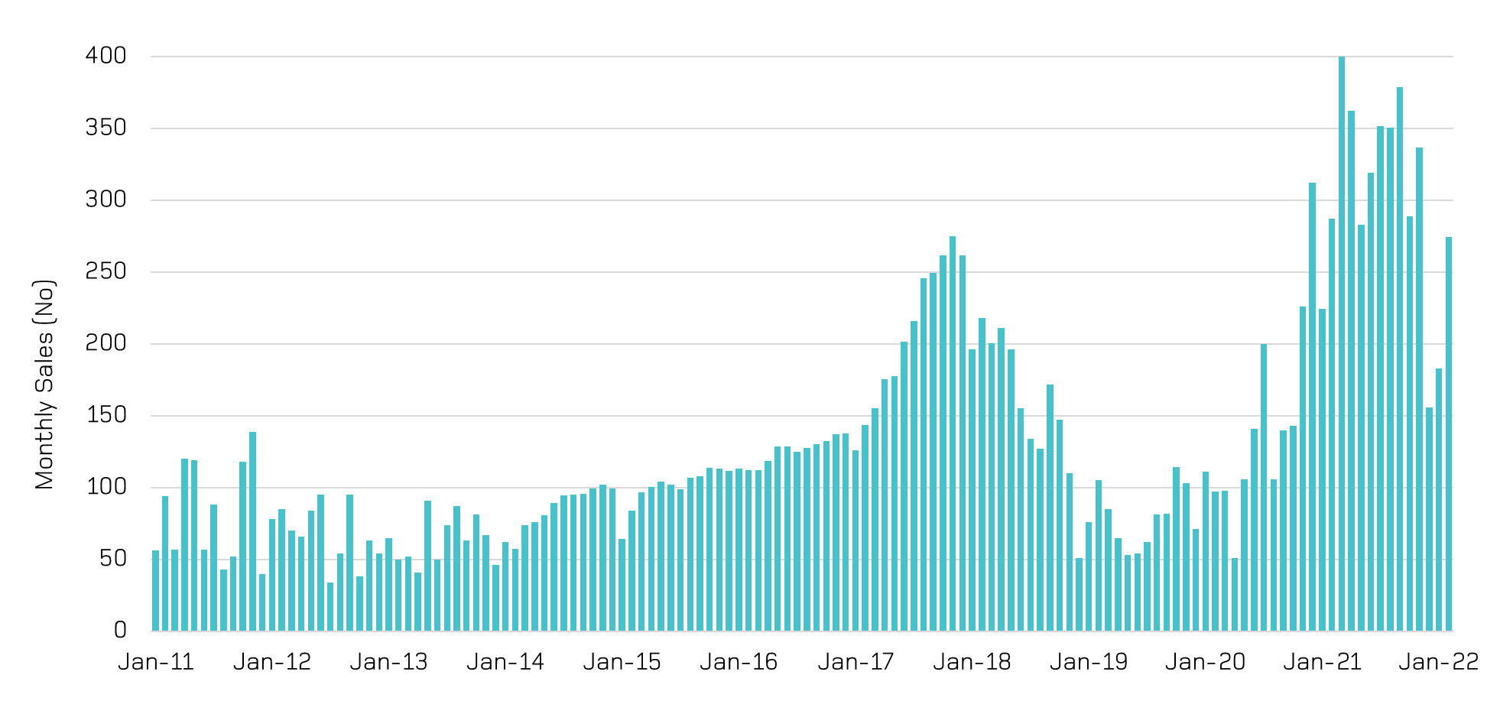
Source: Oliver Hume Research
It is estimated that in the calendar year of 2019 there was 950 land sales, increasing by 82% in the following calendar year to approximately 1,750 sales. In 2021 it is estimated that there were approximately 3,800 residential land sales, representing a 120% increase in lands sales activity from the previous year.
The recent volumes of residential land sales are at historical highs for the municipal area of Geelong.
Consistent feedback from the industry consultation indicated that in the recent couple of years it has been taking around 18 months from sale to delivery of the lot. Historically it was quoted at being around 12 months, an increase of 6 months.
Information supplied to Spatial Economics via the industry consultation illustrated significant residential land sales price increases. As measured from the 4th quarter 2020 to the 4th quarter 2021 the median sales value of a broadhectare residential vacant lot in the Armstrong Creek Growth area increased by 25% to around $342,500.

Summary

Geelong is experiencing a sustained growth in residential development activity. In particular, residential development activity has reached peak levels in 2020/21 in terms of residential building approvals, broadhectare subdivision, preliminary subdivision approval and residential land sales.

The bulk of the increase in broadhectare land development activity is located in the Armstrong Creek Growth Area. Whereas other broadhectare supply locations have remained relatively constant and/or declining in the share of residential development activity.

The median lot size of broadhectare constructed lots has steadily declined over-time, from 646 sqm in 2008 to 446 sqm in 2021. The median lot size constructed in 2021/22 (ytd March) has significantly declined to 352 sqm. This is primarily due to the significant increase in construction of lots sized less than 300 sqm. The significant decline in the median lot size is a direct response of the development industry to maintain affordable pricing points.

In the context of rapidly increasing residential development activity, the sales value of vacant broadhectare lots has substantial increased. It has been reported that the median sales value in the Armstrong Creek Growth Area has increased by 25% in 2021.

5.0 Residential Land Supply
Section 5.0 of the report details the stock (measured in lots) of broadhectare residential land supply across the municipal area of Geelong as at March 2022.

5.1 Undeveloped Broadhectare Land Stocks
As at March 2022, there was an undeveloped residential lot capacity within zoned broadhectare sites of approximately 25,000 across the municipal area of Geelong. Of this zoned undeveloped broadhectare land stock, 6,100 lots have preliminary subdivision approval.
It is highlighted that the volume of broadhectare lots with preliminary subdivision approval is at an all-time historic high for the municipal area of Geelong. Preliminary subdivision approval is a prime indicator of future short term lot construction activity. Based on industry feedback and analysis undertaken by Spatial Economics it is estimated that of this lot stock with preliminary subdivision approval, between 80 to 85% have been pre-sold.
Of the total zoned lot potential, 79% (19,700 lots) is located in the Geelong Region, the remaining 5,245 lots in the Bellarine Peninsula.
Of the zoned undeveloped residential broadhectare lands located in the Bellarine Peninsula, the majority (43% or 2,272 lots) is l0cated in Ocean Grove and 1,043 lots located in Drysdale/Clifton Springs.
Within the Geelong Region, the stock of zoned undeveloped residential lands is concentrated within the Armstrong Creek Growth Area with 13,900 lots. There are significant stocks within the locality of Lara (located within the Northern Growth Area) with 3,765 lots and around 2,000 lots within Urban Geelong.
Analysis has been undertaken in conjunction with Council planning officers to identify the location and expected lot yield of currently unzoned residential land stocks. Sites for future residential development are identified within various Council strategy planning documents. Structure planning, and rezoning processes are required before residential development can proceed on such sites.
There are approximately 4,200 hectares of land (with an estimated yield of 45,300 dwellings) identified for potential future broadhectare residential development across the municipal area. Of this lot potential, 3,860 hectares (or 42,000 lots) is zoned Urban Growth (UGZ) and requires an approved Precinct Structure Plan before urban development can proceed.
Of the future identified sites that are zoned UGZ, these include:
- Western Growth Area – estimated lot/dwelling potential of 23,000;
- Northern Growth Area – estimated lot dwelling/potential of 17,000; and
- Armstrong Creek Growth Area (Marshall Precinct Structure Plan area) - estimated lot dwelling/potential of 1,980.
Of the future identified sites that planned for normal urban density development with a significant expected development yield, include:
- Drysdale/Clifton Springs – estimated lot/dwelling potential of 1,300. The site is approximately 98 hectares in size and is currently zoned Farming (FZ). It is bounded by McDermott Road to the west, Tivoli/Greenvale Drive to the east and the Bellarine Rail Trail to the south. The site is part of the Jetty Road Growth Area Structure Plan area.
- Drysdale/Clifton Springs – estimated lot/dwelling potential of 750. The site is approximately 55 hectares in size and is currently zoned Rural Living (RLZ). It is bounded by Tivoli Drive to the west, the Bellarine Rail Trail to the north, Portarlington Road to the south and Jetty Road to the east. The site is part of the Jetty Road Growth Area Structure Plan area.
- Leopold – estimated lot/dwelling potential of 458 lots. The site is approximately 38 hectares in size and is currently zoned Farming (FZ). The site is located on 73-155 Ash Road Leopold and is currently subject to a rezoning proposal - Amendment C391.
- Lara - estimated lot/dwelling potential of 415 lots. . The site is approximately 93 hectares in size and is currently zoned Farming (FZ), it is located in the Northern Growth Area of Geelong. It is bounded by Elcho Road to the north, Gibbons Road to the south, O’Hallorans Road to the east and the Elcho Parl Gold Course to the west.
- Lara - estimated lot/dwelling potential of 300 lots. The site is approximately 61 hectares in size and is currently zoned Farming (FZ), it is located in the Northern Growth Area of Geelong. It is bounded by the Geelong/Melbourne rail line to the north/west, the Princess Freeway to the south/east and subdivided housing and Hovells Creek to the north/east.
Maps 3 to 15 illustrates the location/distribution of undeveloped residential broadhectare land stocks across selected urban centres (zoned and unzoned).
Table 4 identifies the lot yield of zoned and unzoned broadhectare land stocks by urban centre/sub-region.
Table 4: Estimated Undeveloped Residential Broadhectare Lot Capacity, March 2022
 | Zoned | Preliminary Approval | UGZ (PSP Required) | Potential Residential (unzoned) | Total
Barwon Heads | 28 |  |  |  | 28
Drysdale/Clifton Springs | 1,012 | 31 |  | 2,100 | 3,143
Indented Heads | 46 | 26 |  |  | 72
Leopold | 645 | 107 |  | 501 | 1,253
Ocean Grove | 2,030 | 242 |  |  | 2,272
Point Lonsdale | 24 | 177 |  |  | 201
Portarlington | 300 |  |  |  | 300
St Leonards | 260 | 317 |  |  | 577
Bellarine Peninsula | 4,345 | 900 |  | 2,601 | 7,846
Armstrong Creek Growth Area | 9,901 | 4,001 | 1,980 |  | 15,882
Northern Growth Area | 2,765 | 1,000 | 17,000 | 715 | 21,480
Urban Geelong | 1,809 | 202 |  |  | 2,011
Western Growth Area |  |  | 23,000 |  | 23,000
Geelong | 14,475 | 5,203 | 41,980 | 715 | 62,373
CoGG | 18,820 | 6,103 | 41,980 | 3,316 | 70,219
Source: Spatial Economics Pty Ltd
Land Fragmentation
It was highlighted to Spatial Economics through the land development industry consultation process that land fragmentation within the Armstrong Creek Growth Area is a potential issue in terms of land release timing. Industry stakeholders agreed that land identified as being heavily fragmented will be developed over the course of time. However, the issue highlighted was the uncertainty of the timing and scale of land development outcomes. This revolved around the ‘assembly’ of the fragmented land parcels.
Spatial Economics have assessed the issue of land parcel fragmentation in the Armstrong Creek Growth Area with input from the industry consultation process. It is estimated that land parcels that are identified as fragmented within the Armstrong Creek Growth Area equate to a lot potential yield of 1,985.

Summary

As at March 2022, there was an undeveloped residential lot capacity within zoned broadhectare sites of approximately 25,000 across the municipal area of Geelong. Of this zoned undeveloped broadhectare land stock, 6,100 lots have preliminary subdivision approval.

Spatial Economics have assessed the issue of land parcel fragmentation in the Armstrong Creek Growth Area with input from the industry consultation process. It is estimated that land parcels that are identified as fragmented within the Armstrong Creek Growth Area equate to a lot potential yield of 1,985

Industry stakeholders agreed that land identified as being heavily fragmented will be developed over the course of time. However, the issue highlighted was the uncertainty of the timing and scale of land development outcomes.

In addition to the zoned land stocks, there are approximately 4,200 hectares of land (with an estimated yield of 45,300 dwellings) identified for potential future broadhectare residential development across the municipal area. The bulk of this supply (88%) is located in the Northern and Western Growth areas of Geelong.

Map 3: Residential Land Supply– Northern Growth Area (Lara)
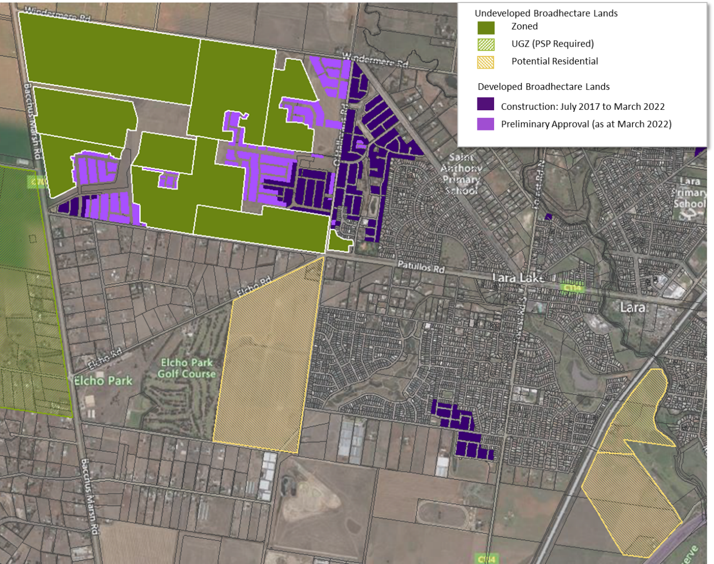

Map 4: Residential Land Supply– Northern Growth Area (Lovely Banks)
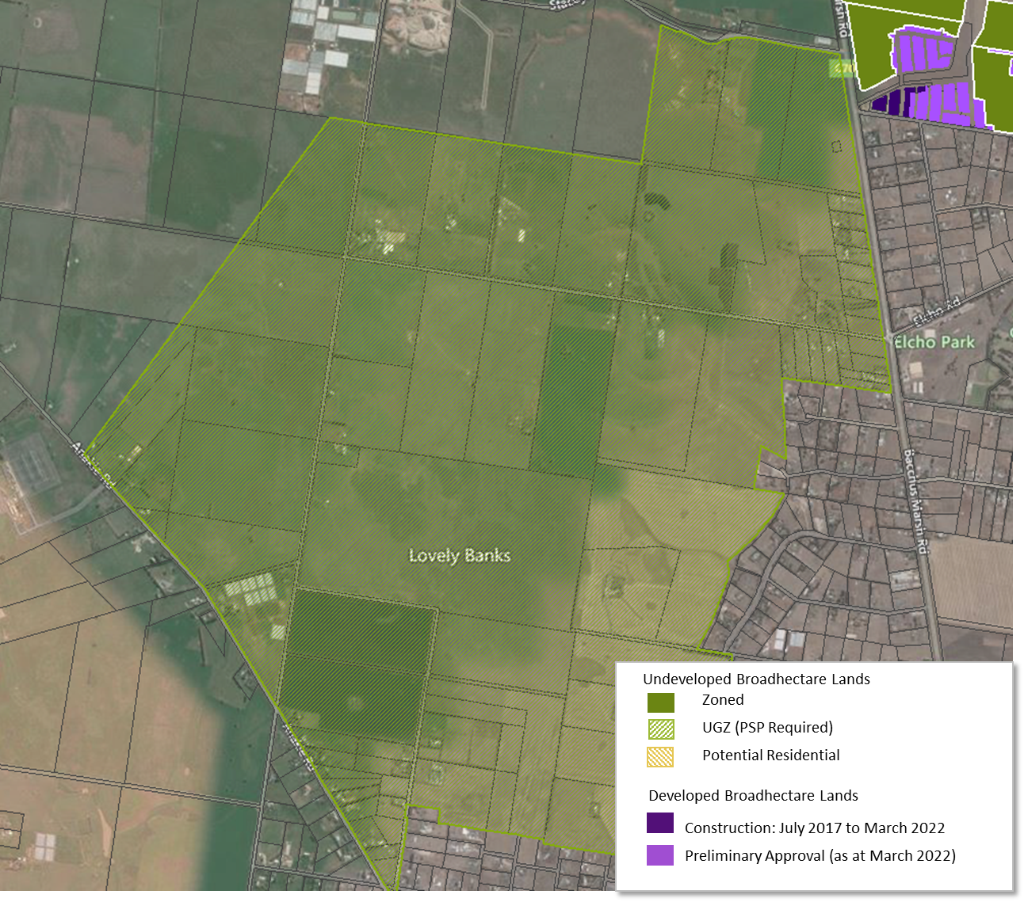

Map 5: Residential Land Supply– Geelong Urban (North)
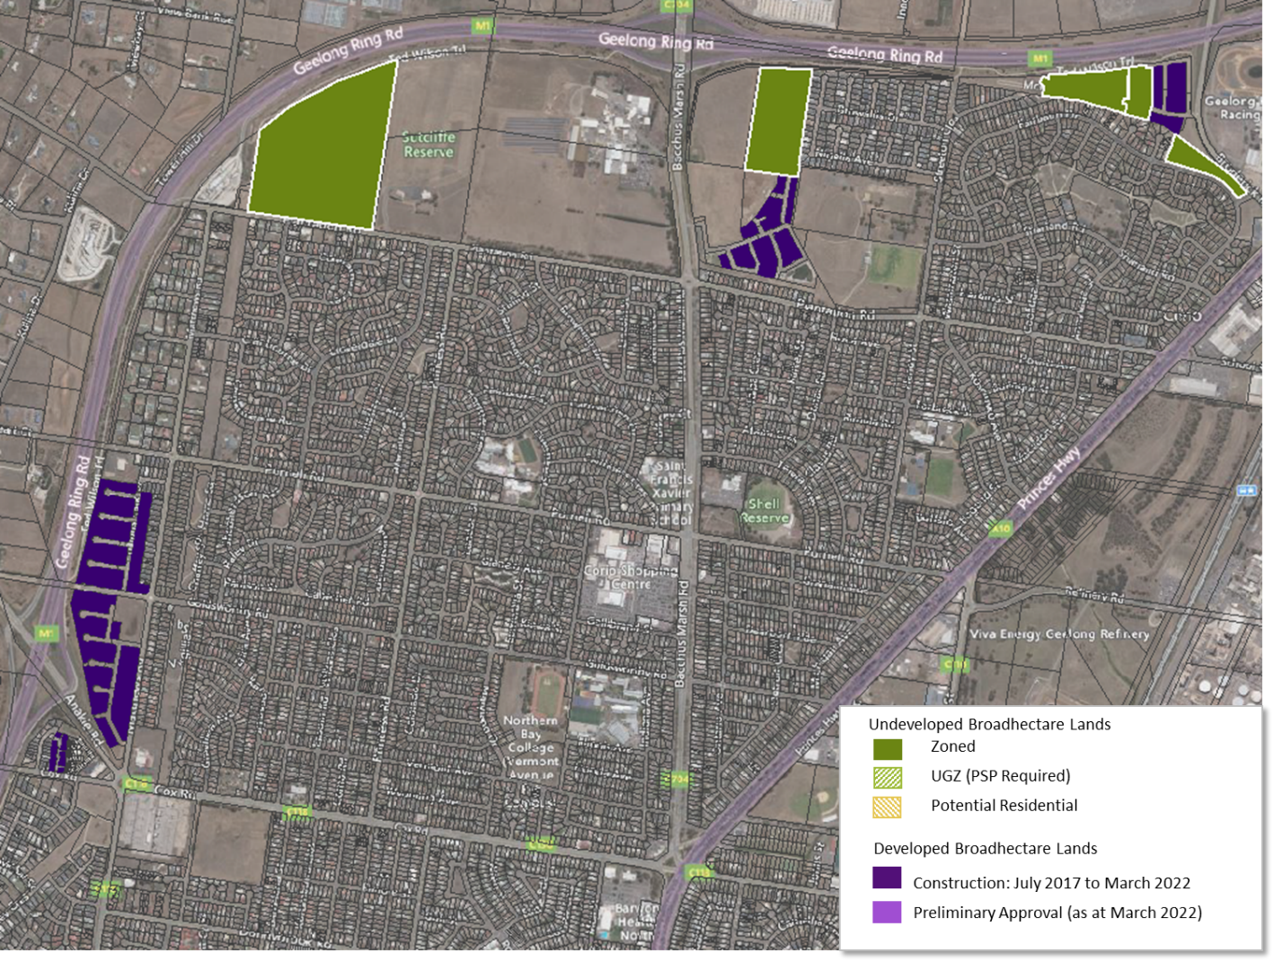

Map 6: Residential Land Supply– Western Growth Area
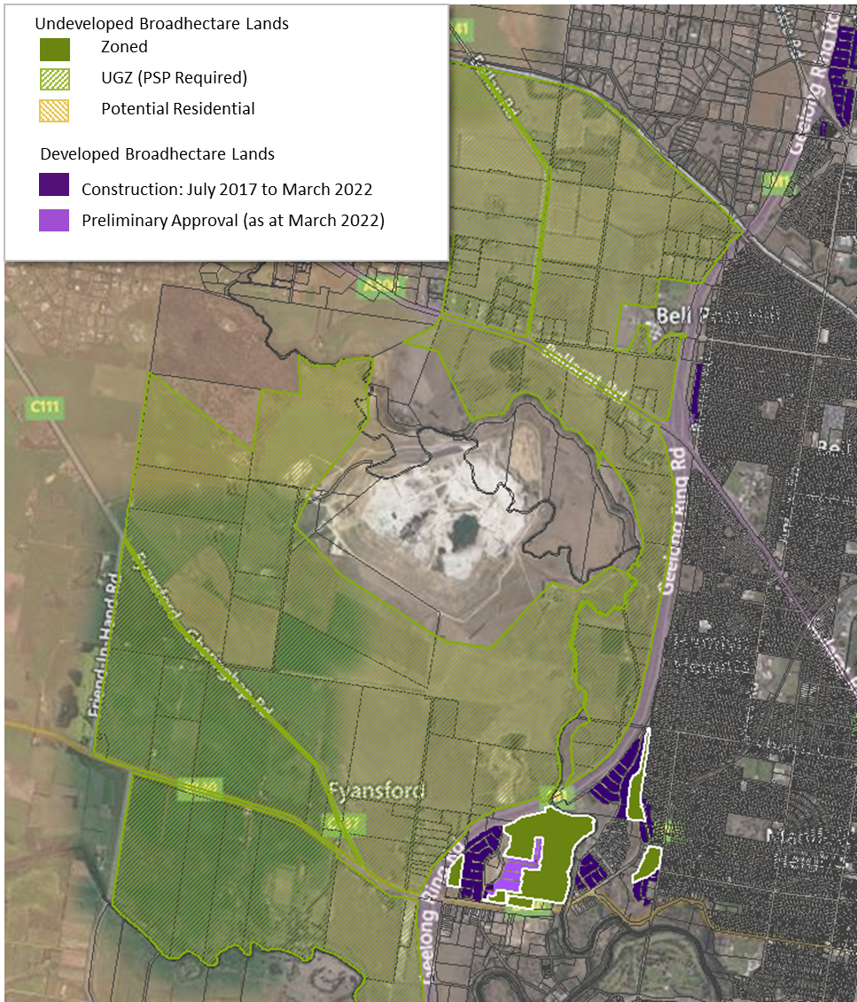

Map 7: Residential Land Supply– Geelong Urban (South)
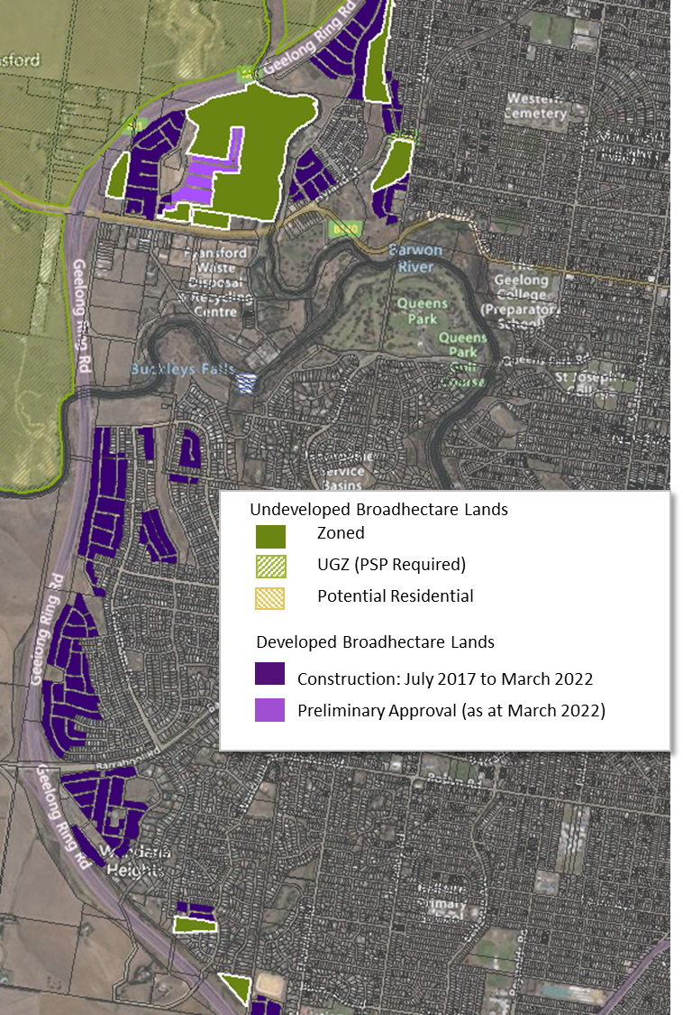

Map 8: Residential Land Supply– Armstrong Creek Growth Area
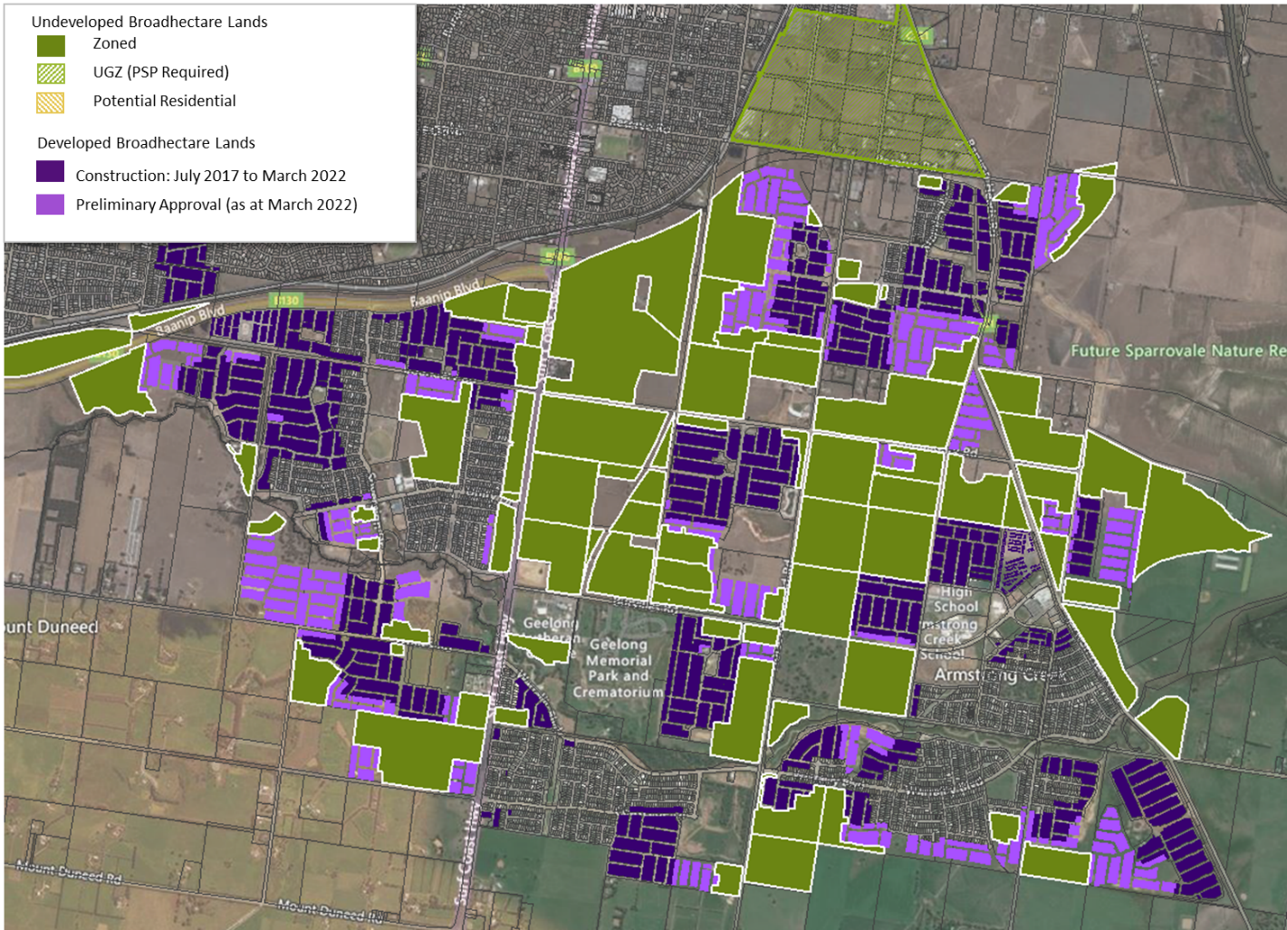

Map 9: Residential Land Supply– Clifton Springs/Drysdale
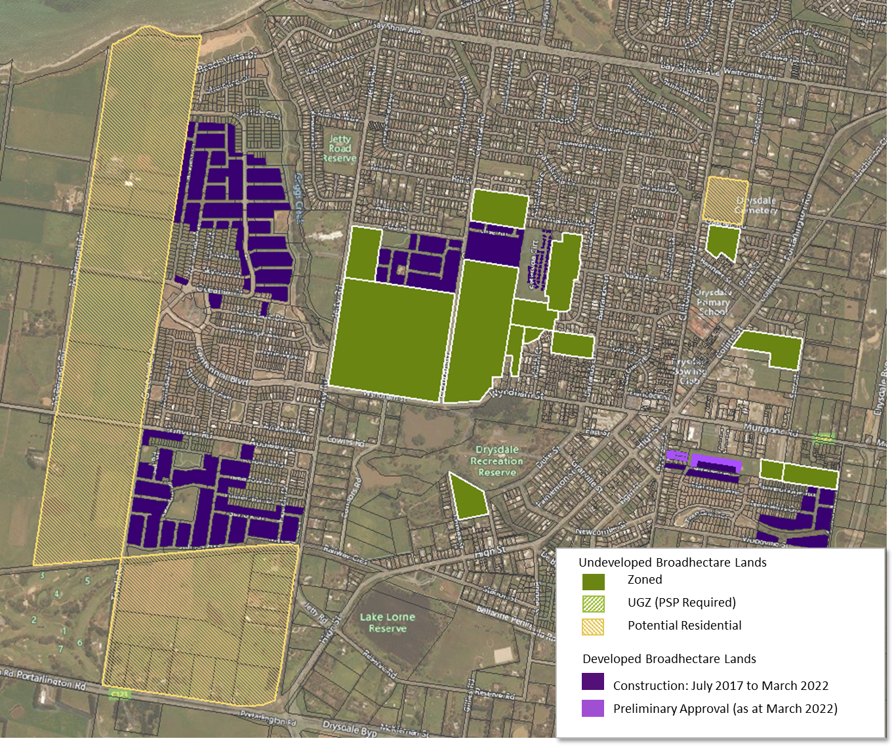
Map 10: Residential Land Supply– Indented Head
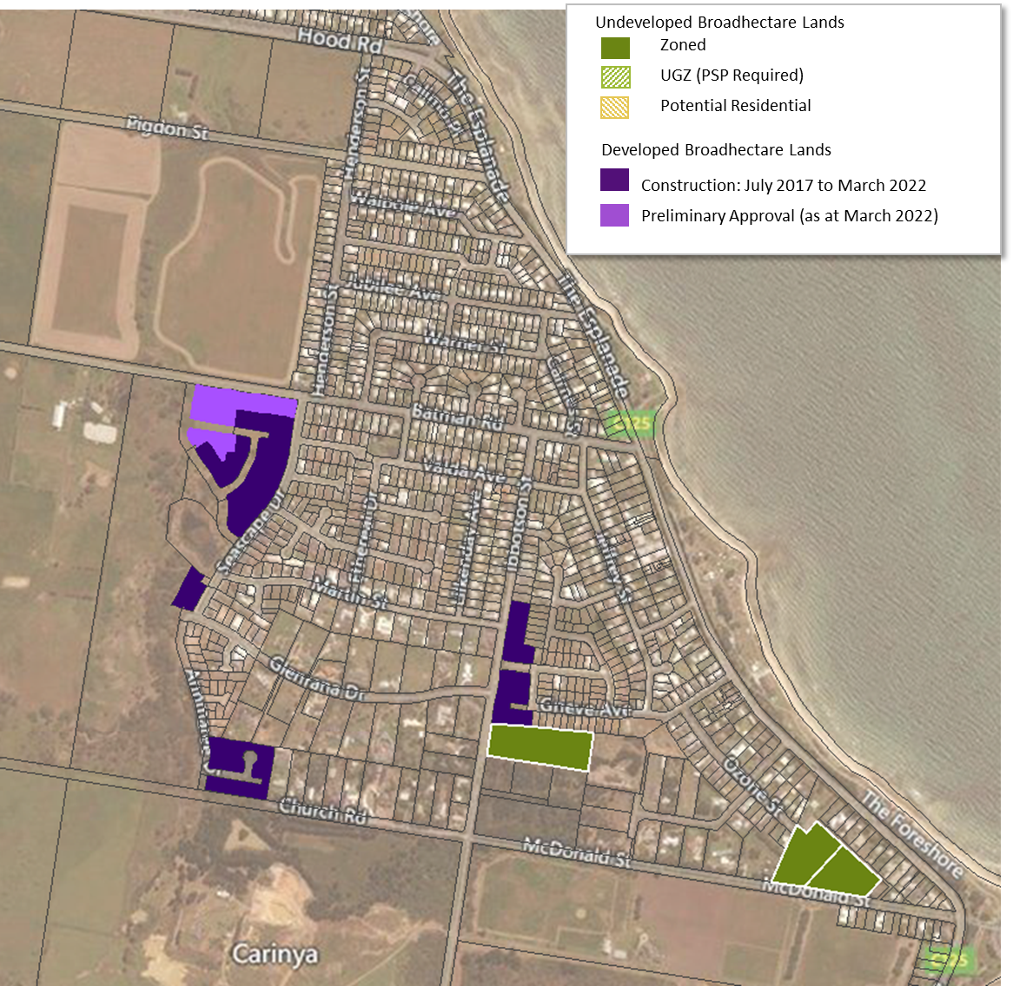

Map 11: Residential Land Supply– Ocean Grove
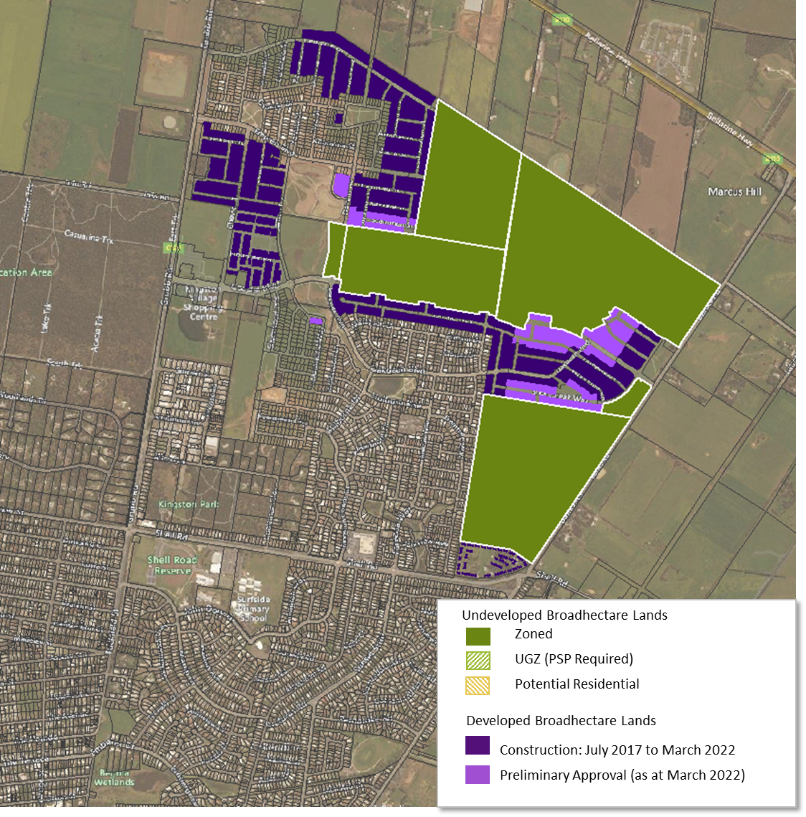

Map 12: Residential Land Supply– Point Lonsdale
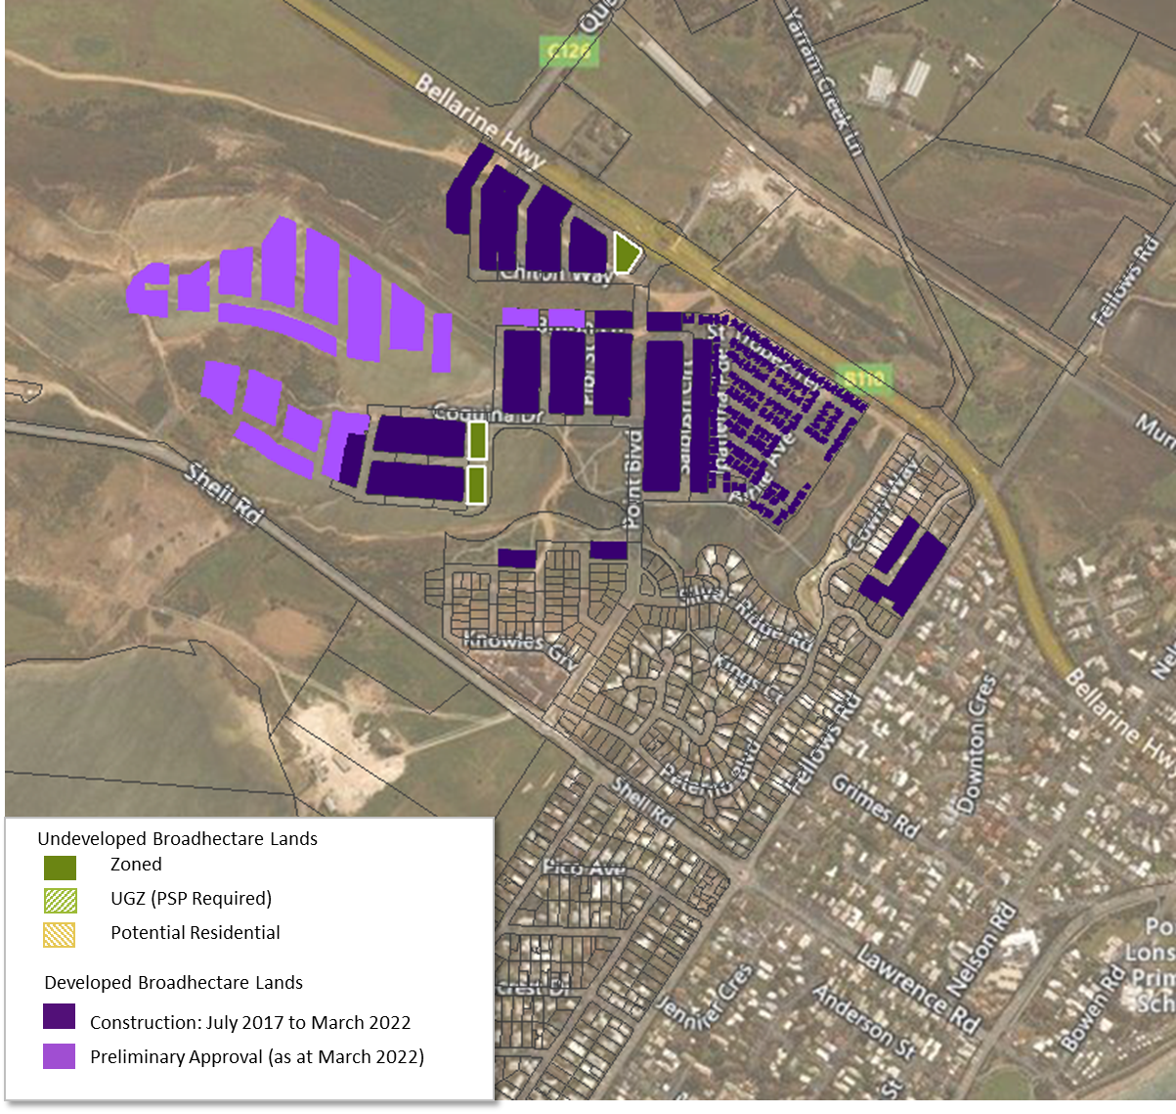

Map 13: Residential Land Supply– Portarlington
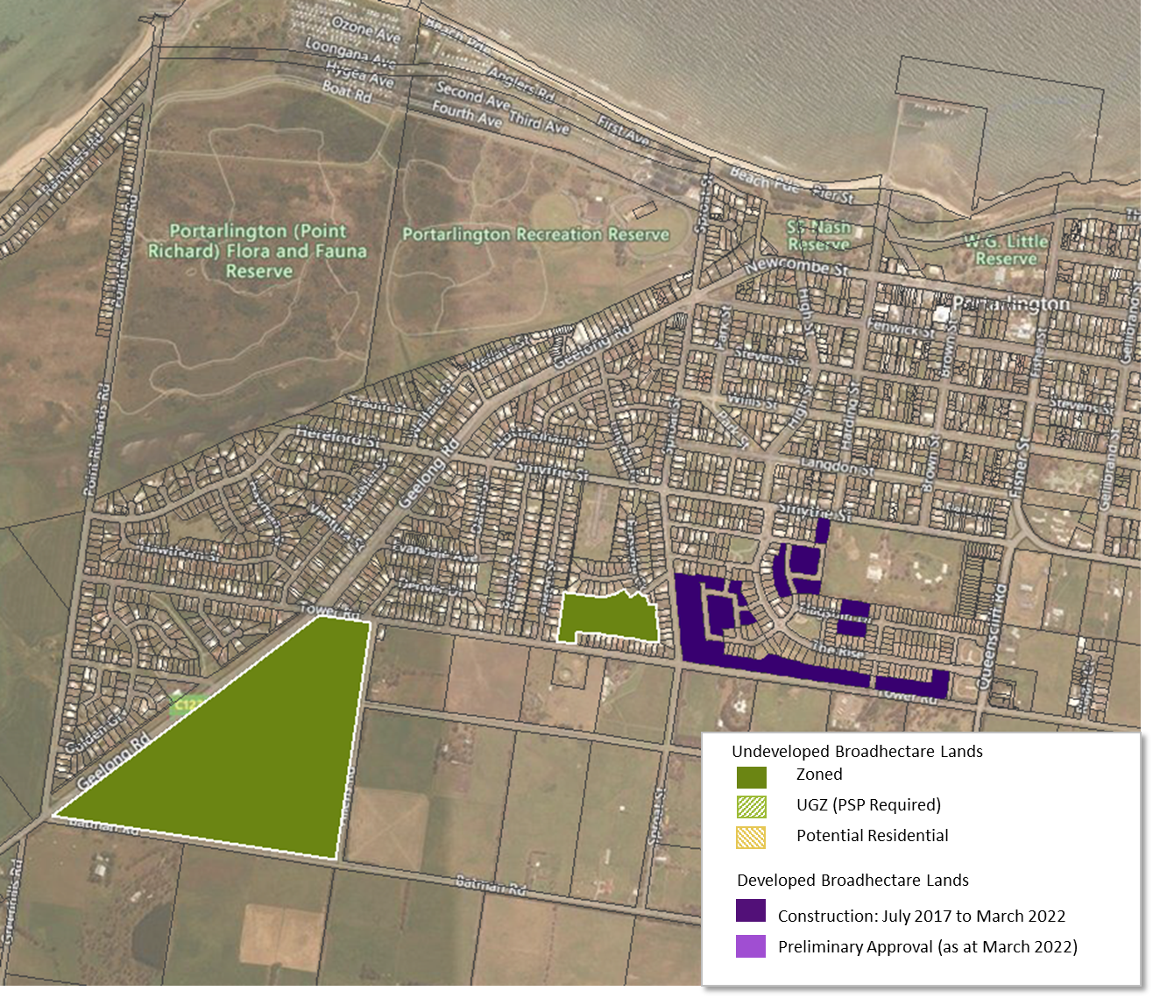

Map 14: Residential Land Supply– St Leonards
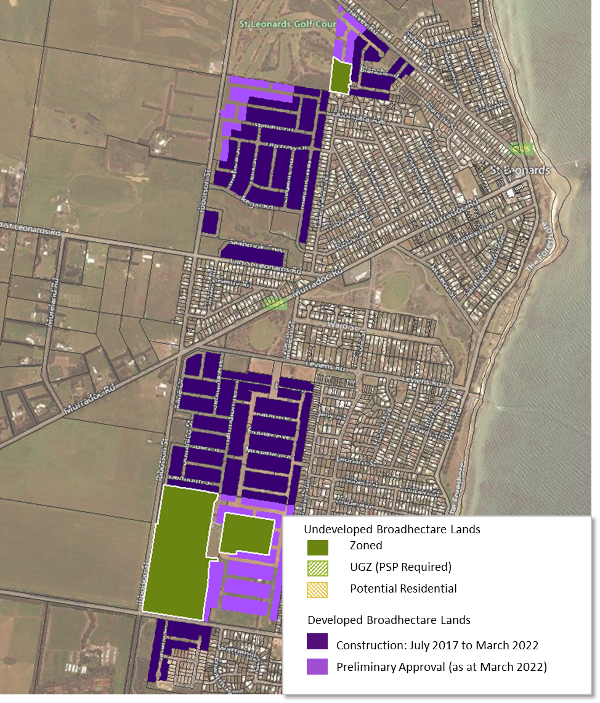

Map 15: Residential Land Supply– Leopold
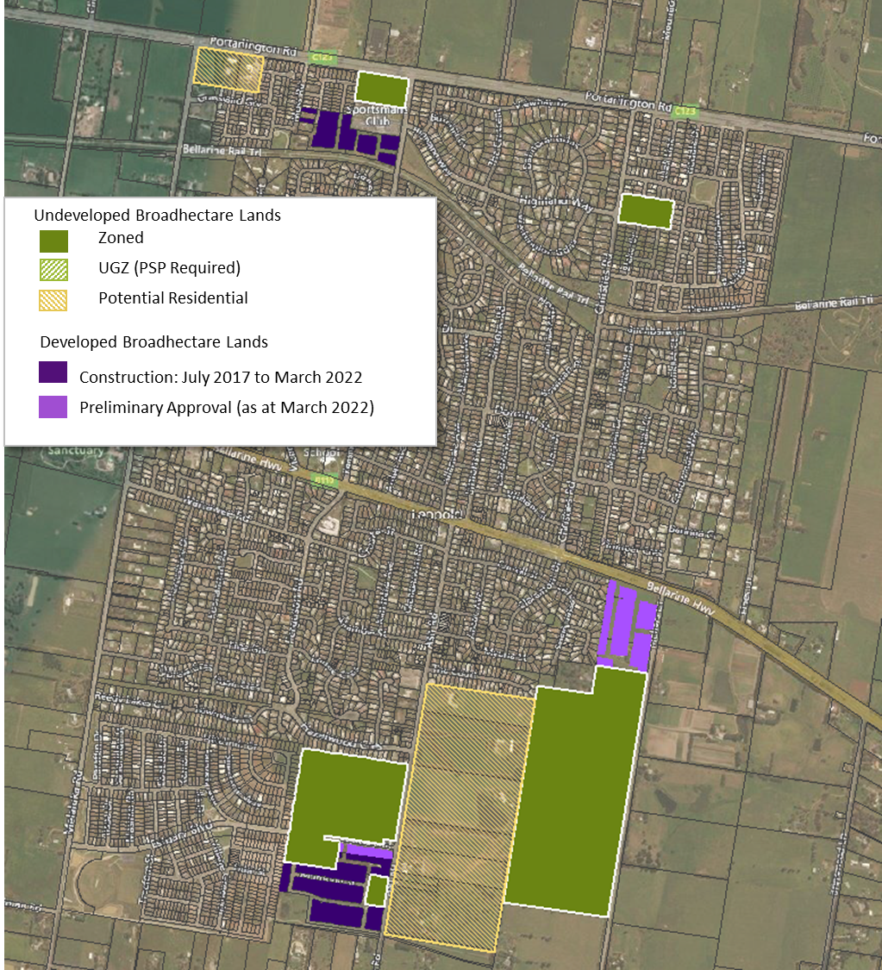

6.0 Adequacy of Land Stocks
With the amount of supply and demand estimated, it is possible to describe the results in years of supply (a simple and understandable measure). For example, it can be stated that there are X years of supply based on projected demand within a given housing market and by supply type.
This succinct way of describing adequacy is standard across most State Governments in Australia and incorporates a wealth of information into a single figure. A series of adequacy numbers can be provided to reflect differing demand scenarios.
It is also possible to describe adequacy in a qualitative sense but with both the private and public sector familiar to this methodology, it seems appropriate to adopt the above approach.
Years of supply can also be linked to trigger points relating to the need for additional land and more importantly triggering specific strategic land use planning responses. The adequacy of broadhectare residential land supply sources is calculated as a residual taking into account the state of the other supply types.
Analysis has been undertaken to estimate the years of broadhectare residential land stocks for the municipal area of Geelong – this is outlined below.

6.1 Years of Supply – City of Greater Geelong
The years of supply is not only dependent on the projected number of dwellings in total, the share of total dwellings within broadhectare supply areas but also the timely realisation of the identified supply opportunities. Therefore, caution is highlighted in the interpretation of the years of broadhectare land supply, as a major assumption is that the identified supply is realised in a development timing setting.
In terms of zoned undeveloped broadhectare land stocks there is approximately 8 years of supply across the municipal area of Geelong. If the land parcels identified as fragmented in Armstrong Creek is discounted from the supply side, the years of supply would be reduced by approximately 8 months.
In terms of unzoned broadhectare residential land stocks there is approximately an additional 14 years of supply across the municipal area of Geelong. It is assumed ant fragmented land parcels over this development horizon will be available for development.
In total there is approximately 22 years supply of undeveloped (zoned and unzoned) residential broadhectare land stocks across the municipal area of Geelong.

Summary

In total there is approximately 22 years supply of undeveloped (zoned and unzoned) residential broadhectare land stocks across the municipal area of Geelong. Of this supply, there is approximately 8 years supply of zoned residential broadhectare lands.

The incidence of land fragmentation within the Armstrong Creek Growth Area represents approximately 8 months of supply. It is considered that over-time, these fragmented land parcels will be developed.

Spatial Economics consider that maintaining a minimum of ten years supply of zoned broadhectare land stocks is optimum. This allows sufficient zoned land stocks to: a) respond to sustained/and or rapid increases in demand levels; b) foster industry competition and multiple development fronts; and c) absorb land development issues such as land fragmentation, ownership/development intention issues.

Sales price data supplied by Oliver Hume Research and Core Projects

