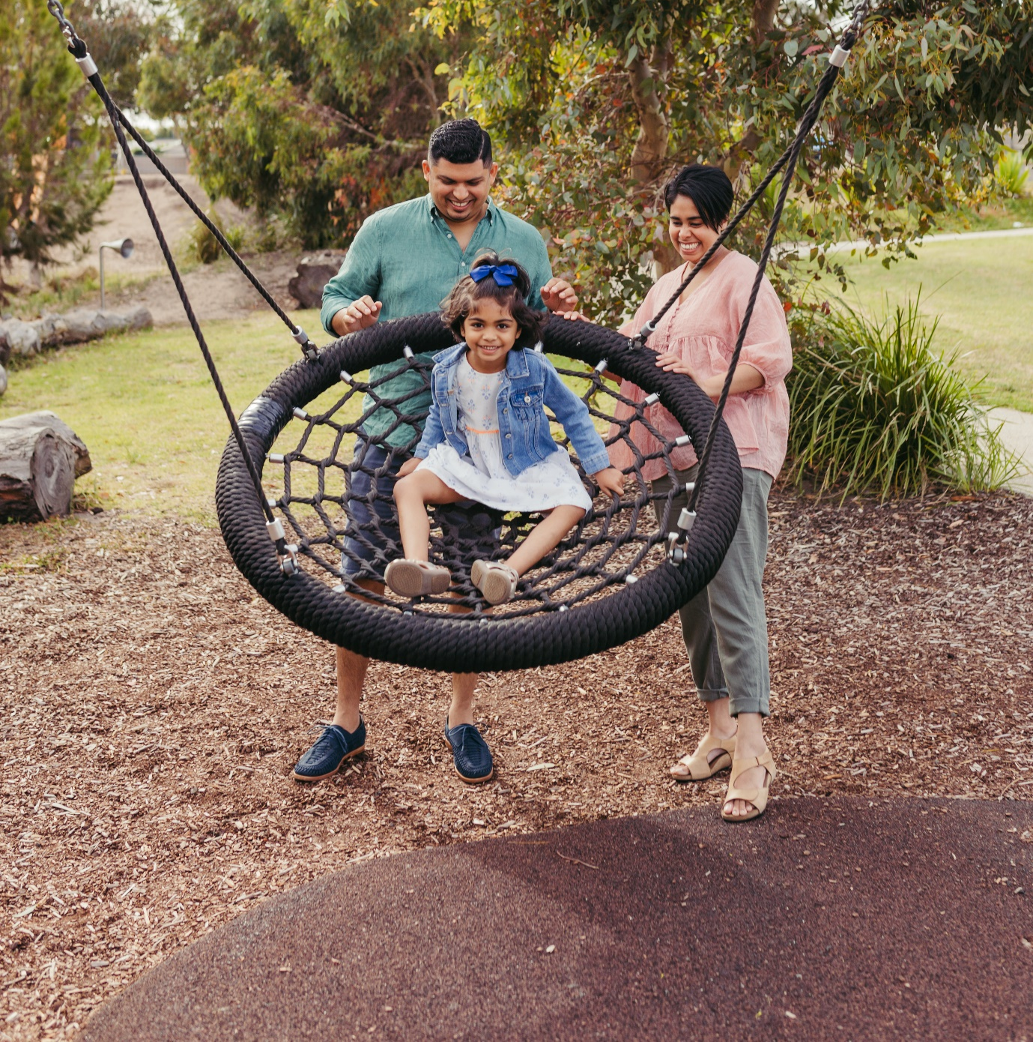


THE CITY OF
GREATER GEELONG

our community
PLAN 2021–25
QUARTERLY REPORT

JUNE 2023

INTRODUCTION

At the City of Greater Geelong, we are committed to working together for a thriving community. Our Community Plan 2021‒25 outlines how the City working towards the 30-year community vision to make Greater Geelong a clever and creative city-region.
The plan tells the community what the councillors are aiming to achieve during their four-year term and guides how we allocate resources so we can deliver infrastructure, services and programs to the community to ensure the social, economic and environmental sustainability of our region.
The four strategic directions we’ve chosen to guide us are:
- Healthy, caring and inclusive community
- Sustainable growth and environment
- Strong local economy
- High-performing Council and organisation.
As well as the strategic directions, the plan also outlines:
- Desired outcomes ‒ the future state we’re aiming for in four years and
- Four-year priorities ‒ the priorities we’ll focus on to help achieve our desired outcomes
For the first time we have integrated the Council Plan and Municipal Public Health and Wellbeing plan – so that the health and wellbeing of our community is central to everything we do.
The Plan identifies five health and wellbeing priorities which are:
- Tackling climate change and its impact on health
- Increasing healthy eating
- Increasing active living
- Demonstrating and promoting gender equity practices
- Improving mental wellbeing and social connection

Our Community Plan 2021‒25 is supported by an annual action plan and budget which highlight the projects, initiatives and programs that will take place within the financial year to address our four-year priorities.
This quarterly report was developed to provide a transparent update of our performance in delivering the annual action plan.
Actions that support the health and wellbeing priorities have been identified with the relevant health and wellbeing icon:
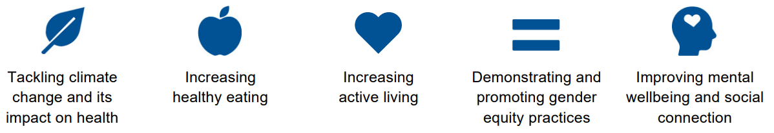

We committed to 64 actions in our Annual Action Plan this year.
STATUS UPDATE
At the end of June 2023:
- one was ‘on track’
- 45 were ‘complete’
- five were ‘on hold’
    - Increase the amount of social housing by evaluating Council owned land available for development
    - Develop a new Open Space Policy and Strategy to facilitate equitable access to open space across the municipality
    - Finalise the City of Greater Geelong 10-year Economic Development Plan to guide and foster economic growth opportunities for the City
    - Identify innovative cleantech solutions through Procurement for Innovation projects
    - Develop an impact evaluation framework to monitor the contribution of investment in social infrastructure to community health and wellbeing
- one was ‘not started’
    - Develop a formal and centralised health, safety and wellbeing audit program
- five were ‘not proceeding’
    - Partner with Wathaurong Aboriginal Co-operative for local actions around Closing The Gap, an initiative which aims to achieve health and life expectation equality for Australia’s Aboriginal and Torres Strait Islander peoples
    - Commence planning for a new residential strategy for Central Geelong
    - Commence development of a draft Integrated Transport Plan
    - Construct the Building Better Bike Connections Southern Link Stage 2
    - Launch a major annual live music program in support of day and night economic activation

- two were ‘off track’
    - Prepare the Creamery Road and Elcho Road East precinct structure plan and development contributions plans including environmentally sustainable design initiatives
    - Develop a 10-year Biodiversity Strategy
- five were ‘ongoing’
    - Update Council's Healthy Food Policy
    - Finalise the new Access and Inclusion Action Plan which outlines actions the City will take to reduce discrimination and promote inclusion of people with disabilities
    - Commence construction of a new inclusive play space at Rippleside Park
    - Deliver Geelong Design Week 2023 showcasing local designers, creatives and innovators and celebrate Geelong's global recognition as Australia's only UNESCO Creative City of Design
    - Build a new website to make information and services more convenient and efficient for our community

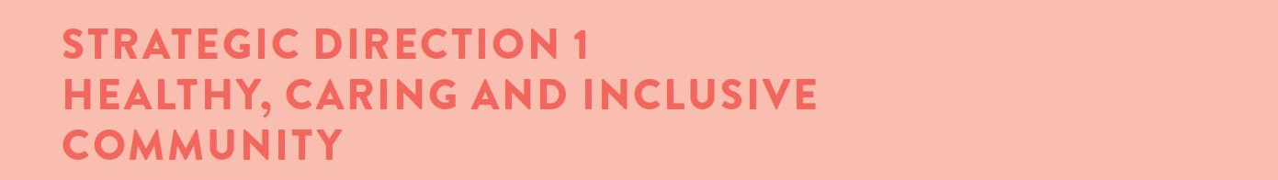

Desired outcomes
- Our community feels welcome, safe and connected
- Our community has equitable access to health and social services, information and infrastructure
- Healthy behaviours and environments are promoted, supported and accessible

Four-year priorities
  - Help our community, recreation groups and volunteers to prosper and grow
  - Deliver health and community initiatives that are culturally sensitive and accessible across all life stages
  - Foster and embrace community connectedness
  - Demonstrate and promote gender equity practices
  - Foster an inclusive community culture
  - Facilitate social and affordable housing in Greater Geelong
  - Provide access to places, spaces and services where and when people need them the most
  - Strengthen relationships and partnerships with the Aboriginal and Torres Strait Islander communities in Greater Geelong
  - Support the City’s cultural and creative life, history and heritage
  - Provide facilities that foster and facilitate positive health and wellbeing outcomes
  - Respond to the findings of the Royal Commissions into aged care and mental health

Four-year priority | 2022–23 actions | Progress comment | Status
1.2.1 | Implement the Municipal Early Years Plan 2022–25   | Our Executive Leadership Team endorsed the draft Municipal Early Years Plan 2022–25 report and it is now being shared with key stakeholders across our community. The plan assists with ensuring our services provide targeted support for those families and children who need it most. | Complete
1.2.2 | Undertake a review of the Livewell Program to ensure it is sustainable and meets the health and wellbeing needs of people aged over 55 | Following a review of the Livewell Program, we identified service delivery changes that we believe will still meet the community's needs, but also recognise operational efficiencies and consistency in offering across the network. We are now working through staff impacts and next steps for consultation with the aim to implement changes by September 2023. | Complete
1.2.3 | Update Council's Healthy Food Policy   | We worked with the Institute for Physical Activity and Nutrition (Deakin University) to develop a discussion paper to inform the review and update of the City's Food Policy. The paper considers legislative environments, and barriers and enablers to implementation of the current policy and identifies opportunities for council owned facilities and settings and broader opportunities for a healthy and sustainable food systems strategy in the future. We established an internal food policy working group. A policy has been drafted with engagement to occur in the 2023-24 financial year. | Ongoing
1.3.1 | Develop an annual action plan for the Vital Communities project | We developed a draft Vital Communities Annual Action Plan 2023–2024 which outlines key initiatives to help address challenges faced by some of our most socio-economically disadvantaged communities. | Complete
1.3.2 | Identify the key safety concerns of the community and articulate the City's role in facilitating a safe Geelong community   | The Community Safety Framework which articulates the City’s role in facilitating a safe Geelong community, was adopted by Council in December 2022 and shared internally with key stakeholders. A community safety forum, coordinated by Victoria Police, was held in February and concentrated on the Geelong CBD. | Complete
1.4.1 | Develop an annual Ba-gurrk Gender Equity Framework action plan, incorporating actions from the Gender COVID-19 research | We completed internal engagement as well as external stakeholder sessions including our Health and Wellbeing partners and members from the Women In Community Life Advisory Committee. The annual action plan is progressing and needs to be finalised. The City launched its inaugural Gender Equality Action Plan on 19 September 2022. We developed this plan in response to the Gender Equality Act 2020 to promote and foster intersectional gender equity and inclusion at the City. | Complete
1.4.2 | Commence detailed design of gender-neutral facilities at the Leopold Tennis Club | We have completed design work and expect the construction tender to be awarded in July 2023. | Complete
1.5.1 | Finalise the new Access and Inclusion Action Plan which outlines actions the City will take to reduce discrimination and promote inclusion of people with disabilities | We finalised the development of the new Access and Inclusion Plan which aims to encourage, recognise and promote the elimination of disability discrimination, recognise the rights of people with disability and ensure residents with disability are fully included in community life. We appointed a consultant to assist with the engagement component of the plan. Following an extension from the Minister, the new Access and Inclusion Plan is due for delivery in April 2024. | Ongoing
1.5.2 | Develop an annual Multicultural Action Plan which will guide how the City plans for and supports our multicultural community | We developed a draft Multicultural Action Plan 2023–2024 which outlines the key initiatives to support our multicultural communities who can experience unique barriers to participation including access to information, cultural differences, racism, discrimination, and exclusion. | Complete
1.5.3 | Commence construction of a new inclusive play space at Rippleside Park* | We secured project funding and contracts are being finalised for the detailed design of the all-accessibility play space at Rippleside Park. Construction will commence in early 2024. | Ongoing
1.6.1 | Increase the amount of social housing by evaluating Council owned land available for development | We undertook community engagement on three potential sites for social housing on Council owned land. We also continued to work with both private developers and Homes Victoria to increase the supply of social housing in Geelong on land not owned by the City. Negotiations with private developers and Homes Victoria are ongoing. | On hold
1.7.1 | Complete a feasibility study for a program that makes recommendations on how to deliver a safe and inclusive space for young people within central Geelong | We completed the feasibility study which recommends that the City investigate opportunities for a youth hub in the central business district. We are also in discussions with state government regarding a facility that acts as a safe space for young people from the LGBTQIA+ community. | Complete
1.7.2 | Expand our Drop-In Feeding support service (0-3 months of age) to include the Bellarine | We implemented a newly established drop-in feeding support service at Bop Bop Karong (Barwon Heads). This provides ongoing support to parents and carers in meeting the nutritional requirements of their babies and improving parent/carer confidence and wellbeing. | Complete
1.8.1 | Commence working with community on the next Innovate Reconciliation Action Plan | Work is underway on the development of the City's Innovate Reconciliation Action Plan (RAP). Actions to date include:  - the City registered with Reconciliation Australia to develop the plan  - an internal RAP Reference Group with First Nations membership established  - draft Terms of Reference developed  - planning for community engagement to support the development of the plan  Our Kilangitj Advisory Committee will be briefed on progress of the plan at their next meeting in August 2023. Additionally, delivery of the Innovate RAP will be a key action for the City as part of Our Community Plan Annual Action Plan 2023–24. | Complete
1.8.2 | Deliver a training and education program in partnership with Wadawurrung Traditional Owners Aboriginal Corporation with a focus on tourism development and cultural awareness strengthening cultural tourism in the region | We provided support to the Wadawurrung Traditional Owners Aboriginal Corporation to:  - secure funding for a cultural tourism feasibility study and appoint an Arts and Tourism project officer  - attend the Indigenous Australian Tourism Conference  - develop localised, authentic Aboriginal tourism products and experiences  - develop trade ready products with a pilot being delivered during the upcoming cruise season.  We conducted cultural education activities including site tours and a Wadawurrung Education Workshop. The focus of the workshop was to foster education and inspiration. 50 people from the local tourism industry attended. We shared the National Wool Museum and the On The Land - Our Story Retold exhibition story, demonstrating to the local tourism industry a successful collaboration story between Wadawurrung Traditional Owners Aboriginal Corporation and visitor experiences. | Complete
1.8.3 | Partner with Wathaurong Aboriginal Co-operative for local actions around Closing The Gap, an initiative which aims to achieve health and life expectation equality for Australia's Aboriginal and Torres Strait Islander peoples | We met with representatives from the Wathaurong Aboriginal Co-operative and as requested this action has been removed from the Reconciliation Action Plan (RAP). The deliverables will be included in the RAP moving forward but not as part of any Close the Gap initiative. The City actively supports the Wathaurong Aboriginal Cooperative, and other the Aboriginal Health programs and services through the development of family and community initiatives to address access and participation issues for First Nation people across City services facilities and programs. | Not proceeding
1.9.1 | Collaborate with Wadawurrung Traditional Owners to conserve, digitise and interpret artworks and artefacts of regional importance from across Council's arts and heritage collections | We continued to collaborate on First Nations projects including:  • BLUESTONE: 150 Years of Dennys Lascelles Woolstore at the National Wool Museum which has been extended to 1 August 2023  • Creation of a mural as part of the Labuan Square redevelopment with YOOKAPA, a First Nations creative program, Wadawurrung Traditional Owner Nikki Mckenzie, First Nations artist Norm Stanley, First Nations students at the Kitjarra Centre (The Gordon), and local community in Norlane. The mural was completed in March 2023.  • the NBN Nodes project - commissioned works by Norm Stanley and Jenna Oldaker. Artwork installed June 2023  • continued collaboration with artist Deanne Gilson to install ceremonial cloaks on a rotating display in core galleries at the National Wool Museum.  • #YourMuseumGeelong, an engagement on the 30 year vision for the National Wool Museum. A report of findings and framework for a business case and future programming – including embedding First Nations at core of program, is due in July 2023.  • We the Makers Sustainable Fashion Prize exhibition opened 2 June – showcasing work of Prize Finalist Jasmine-Skye Marinos and her Kaweerr Koorran Dress. Judging Panel included renowned artist and Bidjara man - Dr. Christian Thompson AO.  • Working with Wadawurrung Traditional Owners and Koori Heritage Trust in identifying provenance of First Nations heritage items in the City’s collection. | Complete
1.10.1 | Commence construction of the Northern Aquatic and Community Hub* | We progressed construction on the Northern Aquatic Community Hub which when complete, will provide state of the art health and fitness facilities for residents in the north and surrounding areas. Pool shells were completed. Tiling and fit out works are underway. | Complete
1.10.2 | Enhance the City Safe Camera Network (CCTV) across priority neighbourhoods and suburbs | We upgraded existing cameras throughout the municipality. They are now operational through a centralised platform. The City's CCTV policy was reviewed by the policy review committee in March 2023 and new Victoria Police memorandum of understanding is currently being finalised. | Complete
1.10.3 | Complete final concept Stage 2 design of the North Bellarine Aquatic Centre* | Council endorsed the proposal for design and delivery of Stage 2 in November 2022 and was successful in attaining $40 million in funding commitments from both the Federal and State governments. We are in the final stages of consulting with our community advisory panel and expect to have a recommendation on the final concept Stage 2 design to Council in August/September 2023.  A facility concept was endorsed by all members of the Community Advisory Panel on 6 July 2023. A councillor briefing and recommendation for endorsement is now scheduled for July 2023 with the federal funding agreement to be finalised on 9 August 2023. | Complete
1.11.1 | Prepare Council to make an informed decision about its future in the delivery of in home and community care (under 65s) and aged care (over 65s) services | In November 2022, Council was briefed on the federal government’s new Support at Home program for future delivery of in-home and community care including the Aged Care Reforms and Royal Commission outcomes and Australian Government response. In the budget the federal government has delayed the commencement of the program until 1 July 2025, although assessment changes will take place from 1 July 2024. More detailed information and further modelling is required to determine the impacts on Council’s current service delivery and to inform next steps. Once further information including financial modelling is known, the timelines will be updated. | On track

LINKS TO THE CLEVER CREATIVE VISION
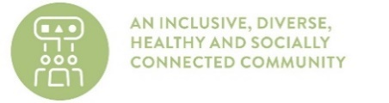 | 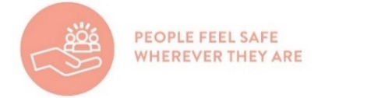 | 

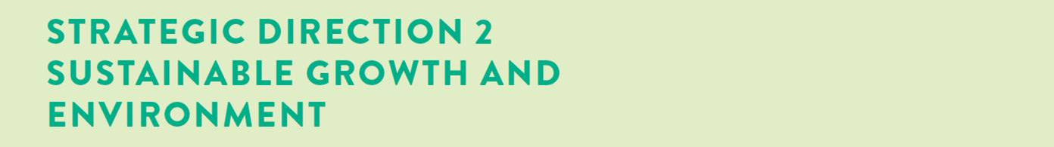

Desired outcomes
- We are delivering our vision for sustainable growth across the municipality
- We have a choice of housing and lifestyles to meet the diverse needs of our community
- There are connected transport networks throughout the region that support liveability and prosperity
- Greater Geelong has quality, vibrant public spaces
- We are leading a reduction in community emissions and are increasing the City’s resilience to climate change impacts
- We protect and restore our natural environment
- We minimise waste with good design and manage effective recovery of resources

Four-year priorities
  - Meet the housing needs of our future community
  - Meet existing and future transport needs
  - Create engaging places and spaces
  - Deliver best practice Environmentally Sustainable Design principles and vibrant neighbourhoods
  - Achieve carbon neutral in all City-managed operations by 2025 and manage our climate change risks
  - Support our community and region to reduce emissions and build resilience to climate change
  - Reduce the impact of waste
  - Support greater indigenous biodiversity

Four-year priority | 2022–23 actions | Progress comment | Status
2.1.1 | Commence planning for a new residential strategy for Central Geelong | Although the City commenced detailed scoping and preparation of a brief for consultancy services, this program will no longer be delivered. New external funding opportunities will be investigated during 2023–24. | Not proceeding
2.2.1 | Commence development of a draft Integrated Transport Plan* | Whilst the City commenced development of the draft Integrated Transport Plan, this plan is no longer proceeding. New external funding opportunities will be investigated during 2023–24. | Not proceeding
2.2.2 | Construct the Building Better Bike Connections Southern Link Stage 2 | At its November 2022 meeting, Council resolved not to award the construction tender for the southern link of the Building Better Bike Connections project between Central Geelong and Waurn Ponds based on community feedback and trader concerns about the suitability of High Street as part of the route. Council also requested the Chief Executive Officer to instigate a strategic review of the Principal Bicycle Network. | Not proceeding
2.3.1 | Develop a new Open Space Policy and Strategy to facilitate equitable access to open space across the municipality | Our existing Social Infrastructure Policy meets the requirement of an Open Space Policy. The Open Space Strategy project is currently on hold due to project resources. | On hold
2.4.1 | Prepare the Creamery Road and Elcho Road East precinct structure plan and development contributions plans including environmentally sustainable design initiatives | The draft precinct structure plan for Elcho Road will go to consultation with government agencies in late 2023 due to delays with the drainage network design. Engagement on the Creamery Road development contributions plan has concluded and changes to the future urban structure and infrastructure designs are currently being prepared. | Off track
2.4.2 | Review the local planning policy framework in the Greater Geelong Planning Scheme to implement key strategies into the planning scheme | We completed an inception meeting and scoping with consultants. A review of local policy, zones and overlay schedules is currently ongoing and a consultant’s report is due end of July 2023. We completed all scheduled works for 2022–23 as planned. | Complete
2.4.3 | Engage key stakeholders in setting a future vision and direction ways to connect building occupants to the natural environment (biophilic design principles) and how to embed this in planning and urban design   | We completed a draft business case and conducted co-design workshops in collaboration with Deakin University. A final report has been provided to Council and the project is now complete. | Complete
2.5.1 | Develop a plan to transition to low emissions light fleet vehicles | We currently have 6 electric passenger vehicles and 6 electric vans as part of our fleet with another 27 electric vehicles on order. New charging stations were installed at our depots and Wurriki Nyal. Our aspirational target is to transition our light vehicles fleet to EV by the end of 2025. | Complete
2.5.2 | Commence implementation of the new Sustainable Building Policy | We reviewed our Sustainable Building Policy and have noted an opportunity for improved alignment with the long-term asset management plan. We will commence implementation in late 2023. | Complete
2.5.3 | Undertake an assessment of City owned gas using infrastructure to support a transition to gas-free operations | We completed a detailed design process to support the replacement of all gas infrastructure at the Kardinia Pool. We also completed facility audits and a feasibility report to inform future plans to transition another 20 City facilities from gas to electric infrastructure. | Complete
2.6.1 | Develop a community campaign to raise awareness of the region’s climate risks, impacts and responses | We hosted a Net Zero Forum consisting of a two-day event to share knowledge and collaborate efforts to work towards the City’s adopted Net Zero by 2035 community target. The event featured informative workshops and presentations on a wide range of topics related to sustainability and achieving net zero, including electric vehicle preparedness, localised carbon offsets, finance options to improve building efficiencies, greener superannuation options as well as updates on actions within the Council endorsed, Climate Change Response Plan. The forum fostered collaboration among attendees, allowing them to exchange ideas, share success stories, and form partnerships.  Climate Change Thinking eLearning Modules, designed to promote a greater awareness and understanding of the City’s climate change response, are being trialed and updated with content for different audiences including school aged children. | Complete
2.6.2 | Prepare a discussion paper to increase understanding of the health impacts of climate change and the health co-benefits of mitigation and adaptation strategies | We defined the scope of our role in climate change adaptation and mitigation strategies through theory of change workshops with internal stakeholders. Research that addresses the health impacts of climate change and mitigation strategies was undertaken. A discussion paper has been developed identifying the health impacts of climate change and the health co-benefits of mitigation and adaptation strategies. Recommendations will be finalised in partnership with internal departments next financial year. | Complete
2.6.3 | Upgrade to LED street lighting with smart control technology* | Approximately 14,000 existing residential streetlights were converted to LED's and additional compliance upgrades completed. Replacement of main roads lighting has commenced with approximately 1300 lights converted (out of approx. 5000). Supply chain issues with smart control cells has delayed the installation program with main roads lighting now expected to be complete by mid-2024 and decorative lighting 25% complete by June 2024. | Complete
2.7.1 | Collaborate with Barwon Water and G21 councils to develop the Regional Renewable Organics Network facility to process the City's organic waste | We continued to participate in a joint steering committee alongside Barwon Water and other regional councils. Barwon Water are continuing to undertake the functional design stage of the project. The Regional Renewable Organics Network will be operational in mid-2025. | Complete
2.7.2 | Collaborate with metro Melbourne councils to deliver the Best Waste Practices in Multi Unit Dwellings project to improve recycling in multi-unit developments | The trial for the Best Waste and Recycling Practices in Multi Unit Dwellings project is complete. We continued to work with metro Melbourne councils to improve recycling behaviour based on the project learnings. | Complete
2.8.1 | Implement the Sparrovale Master Plan phase 1* | We implemented all Sparrovale Master Plan Phase 1 projects and are now moving to Phase 2. The plan outlines improvements in drainage infrastructure, natural environmental and recreational facilities over the next 20 years, encouraging people to connect with nature. Automated sensors installed by Deakin University indicate that the diversion of water away from the Ramsar wetlands in summer is operating effectively in line with the draft Sparrovale Wetlands Operating Rules. | Complete
2.8.2 | Develop a 10-year Biodiversity Strategy | A draft community engagement report has been prepared and draft State of Nature Reports are being reviewed.  It is anticipated that an internal project briefing and workshop to develop actions will be complete by December 2023 to enable preparation of a draft plan. | Off track
2.8.3 | Develop the Southeast Bellarine Coastal Strategy | Our Southeast Bellarine Coast (4W-Collendina) Coastal and Marine Management Plan 2022–2032 was adopted by Council at its October 2022 meeting. | Complete

LINKS TO THE CLEVER CREATIVE VISION
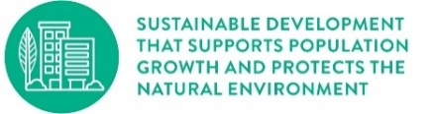 | 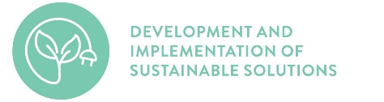 | 

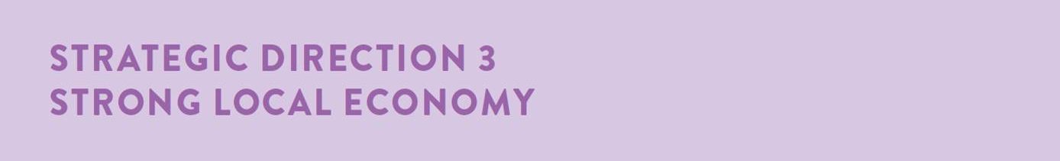

Desired outcomes
- We have a global, national and local reputation as a place to do business – especially in our key sectors
- We have a diversified, future-focused and sustainable economy to drive employment and support growth
- We are an influential Council that builds effective private and public partnerships, taking the lead role in advocating for future investment

Four-year priorities
  - Attract and facilitate public and private investment
  - Promote and leverage the competitive strengths and attractiveness of our region, globally, nationally and locally
  - Support entrepreneurs, start-ups, innovation, research and digital connectivity
  - Attract businesses with a carbon neutral and circular economy focus
  - Support local business resilience and recovery from the impacts of the COVID-19 pandemic
  - Attract, retain and enable participation in the workforce to meet industry needs
  - Address high levels of unemployment in targeted areas of our region
  - Promote our region as a trial location for innovation and new technologies

Four-year priority | 2022–23 actions | Progress comment | Status
3.1.1 | Finalise the City of Greater Geelong 10-year Economic Development Plan to guide and foster economic growth opportunities for the City | In December 2022, Council decided to defer development of a draft 10-year Economic Development Plan until the appointment of a new Chief Executive Officer. The plan, once developed, will guide our priorities our priorities to support and grow the economy and help create a sustainable, prosperous future for our community. | On hold
3.1.2 | Facilitate employment precinct land development to maintain a diversity of employment areas | The Southwest Employment Land review is complete and will go to Council in late 2023 to coincide with the long term boundary review. The Victorian Planning Authority are leading the Greater Avalon Employment Precinct structure plan. We entered a memorandum of understanding with landowners in the Armstrong Creek North East Industrial Precinct to review the precinct structure plan and development contributions plan. | Complete
3.2.1 | Deliver Geelong Design Week 2023 showcasing local designers, creatives and innovators and celebrate Geelong's global recognition as Australia's only UNESCO Creative City of Design | We developed a draft program for Geelong Design Week which is scheduled to take place from 19-29 October 2023. | Ongoing
3.2.2 | Develop and implement Business Events Geelong marketing program to represent, showcase and promote the region as a business events destination | We successfully launched the Business Events Attraction campaign in late September 2022. Highlights of the campaign included:  - 54 conferences attracted to region  - 4,798 conference delegates  - 12,581 delegate days  - $3.4m estimated economic benefit. | Complete
3.3.1 | Deliver the Fibre in the North project to enable a high-speed optical fibre network, providing community facilities and public spaces with access to ultra-high-speed internet | We completed fibre works for the northern suburbs and 50 per cent of the fibre works in the Bellarine. The Cultural Heritage Management Plan for Stage 2, Curlewis to Drysdale, is nearing completion with civil works scheduled to commence later in 2023. This project will provide several council operated community facilities, public Wi-Fi and safe city assets with access to ultra-high-speed internet. | Complete
3.3.2 | Deliver free public Wi-Fi and enhanced broadband to address gaps in digital access and affordability (Geelong Smarter Suburbs)* | We completed all scheduled works for 2022–23 as planned. Remaining works are on track (final 10 nodes) and will be scheduled to be completed in 2023–24. | Complete
3.4.1 | Commence delivery of demonstration projects to stimulate demand for Cleantech and Circular Economy solutions | The three projects funded through the Cleantech and Circular Economy Grants remain on track. Geelong Climate Launchpad 2023 commenced a competition for innovators and entrepreneurs with cleantech and circular economy ideas. Delivered in partnership with Climate-KIC Australia, Climate Launchpad provides training, mentoring and pitching opportunities at a state, national and global level to help participants grow their concept into a sustainable business.  The Climate-KIC projects will be present at the NEXUS Cleantech Innovation Festival on the 11 August 2023. | Complete
3.5.1 | Launch a major annual live music program in support of day and night economic activation | Following the success of the pilot Surround Sounds Music Festival in 2022, a four-year vision, Surround Sounds Festival 2023–2027 was developed. The vision aimed to develop and grow the festival leading up to the Commonwealth Games Cultural Program in 2026.  The festival will not be held in 2023. Instead, we will focus on the planning and development of a professional and substantial music and arts festival across the municipality in the first half of 2024. | Not proceeding
3.6.1 | Implement the Regional Industry Sector Employment (RISE) program that supports employment pathways to address Geelong’s disadvantaged areas | We continued to deliver the RISE program with 15 participants graduating in November 2022 and 13 participants graduating in February 2023. The RISE program aims to increase access and reduce barriers to employment opportunities, with some graduates achieving full-time work and apprenticeships in construction, and some participants pursuing other employment options or educational pathways. This program will no longer be delivered by Council and is not included in the 2023–24 budget. We are currently working with a collective of community organisations regarding transfer of the program information and knowledge assets. | Complete
3.8.1 | Identify innovative cleantech solutions through Procurement for Innovation projects | We completed draft specification and expression of interest documentation. The project is currently on hold pending decision by internal senior leadership. | On hold
3.8.2 | Undertake a review of the City’s digital 3D model and develop a roadmap for ongoing management and enhancement to support a Geelong Digital Twin | Digital Twin Victoria, a digital replica of the state, launched in early September 2022. Following a review of the Geelong 3D model, Council successfully obtained funding from the state government's Digital Planning grant program for an updated 3D model for activity centres across the municipality. | Complete

LINKS TO THE CLEVER CREATIVE VISION
 | 
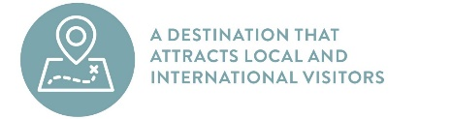

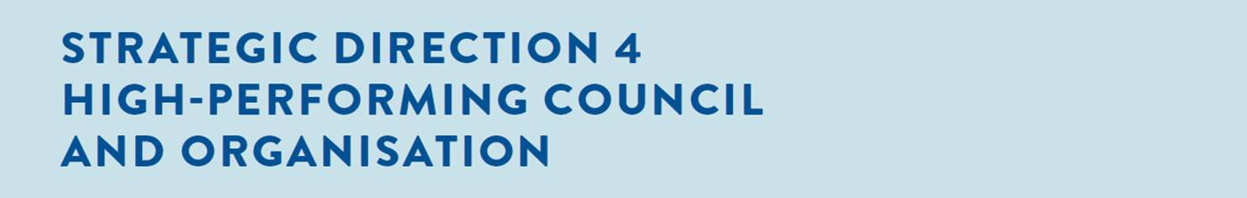

Desired outcomes
- Our services are accessible and meet the diverse needs of our community
- We are acknowledged and recognised as a leading council and organisation
- We have a healthy, safe, inclusive and diverse culture
- We are a financially sustainable and resilient organisation

Four-year priorities
  - Enable a customer-focused approach that delivers efficient and responsive service
  - Communicate and engage effectively with our community to understand their needs and advocate on their behalf
  - Foster excellence and equity in planning for our growing region
  - Continue to strengthen our workforce capabilities and culture
  - Create a more efficient and effective organisation
  - Develop a digital core of brilliant basic technology that supports better ways of working
  - Ensure that our employees are safe at work
  - Focus on economic, social and environmental sustainability

Four-year priority | 2022–23 actions | Progress comment | Status
4.1.1 | Build a new website to make information and services more convenient and efficient for our community | We continued work on our new website which is on track for delivery by July 2023. The new website will support the community in their interactions with the City. | Ongoing
4.1.2 | Protect the City's digital landscape against cyber security threats by establishing a Risk Management Framework and overarching Cyber Policy* | We established an Information Security Management Systems (ISMS) which uses a systematic approach to managing security-based outcomes against the organisation risk framework and a set of policy and procedures that are documented, implemented, and maintained.  Our Cyber Security Strategy continues to be implemented, with greater focus on risk and compliance management, including reporting and decision making through the appropriate governance structures. Appropriate policies and a risk management framework have now been established. | Complete
4.1.3 | Provide the community with an online portal to lodge valuation objections | We provided the community with an online portal to lodge 2022‒23 valuation objections as part of the standard Department of Environment, Land, Water and Planning platform. We received 321 valuation objections that are currently being reviewed by the City’s external valuer. | Complete
4.2.1 | Ensure Council’s Priority Projects are current, communicated to key stakeholders and decision makers and ensure active community engagement in the delivery of these projects | Preparation work for the revision of the Council’s Our Priority Projects document is underway following the endorsement of the 2023–24 Council Budget. All 2022 state election commitments for projects in Greater Geelong were confirmed in the 2023–24 state budget. The government relations team is working with MPs and departments, while planning teams are working with clubs/community stakeholders to secure funding agreements.  We are actively seeking grant opportunities and aligning funding with priority projects, particularly those projects with government funding commitments which are on hold until affordability is found. Communication with local MPs and both levels of government regarding budgetary restraints has been a focus to ensure transparency and demonstrate our commitment to stakeholder engagement.  We hosted funding partners and community stakeholders at key milestone events across numerous projects this quarter including the opening of new facilities at Lara Recreation Reserve and Shell Reserve, Boronggook Drysdale Library, and the commencement of the Beacon Point Shared Trail.  Mayor Trent Sullivan and Executive Director Bryce Prosser progressed the City’s advocacy with the federal government during a visit to Canberra for the Australian Local Government Association’s annual conference. The visit provided an opportunity to present key priority projects to our national decision makers and key bureaucrats. | Complete
4.3.1 | Develop an impact evaluation framework to monitor the contribution of investment in social infrastructure to community health and wellbeing | Development of an Impact Evaluation Framework for Social Infrastructure has progressed and will be completed concurrent to the development of the Generation 2: Social Infrastructure Plan (anticipated to commence in late 2023). | On hold
4.3.2 | Implement the City’s approach to deliver integrated strategic planning and reporting activities for the municipality (Integrated Municipal Planning Framework) | We developed a planning development model and planning catalogue with the view of creating a formal document hierarchy and framework for document development. We designed a process for integrating the way we develop Major Municipal Strategies and Plans (MMSP) at the City. Implementation has commenced by way of changing meeting rhythms and partnering with internal stakeholders to enhance quality of strategies and plans. | Complete
4.4.1 | Deliver new leadership and culture development programs, coaching and performance improvement, learning resources and events | We continued to deliver leadership and culture development initiatives including:  - business planning masterclasses run on the Social Equity Framework and Gender+ Impact Assessments (GIA+) ​  - the LinkedIn Learning pilot program, that will now be an ongoing offering available to all employees. The program, designed to help build technical and leadership capabilities, offers a valuable personal development opportunity for employees looking for growth beyond their current role​  - the Leading Better Together frontline leader program continued. At 30 June, 39 of our scheduled 44 sessions have been run and the program will conclude in August. An evaluation will be completed following the conclusion of the program  - targeted development for people leaders beginning with Emotional Intelligence assessments and debriefs held across six half day sessions and 29 individual coaching sessions​  - a quarterly Working Better Together event to be held on 20 April 2023 with a focus to support leaders on “Leading through Change”​  - gender equality training for key policy owners and subject matter experts within the organisation​  - a dedicated Learning and Development internal webpage was published showcasing the training and development opportunities available to all employees, including the learning calendar.  - Walk and Talk Cultural Heritage tours with Wadawurrung Traditional Owners commenced and are scheduled monthly, aligned with induction and available to all employees. | Complete
4.5.1 | Develop the City’s approach to addressing customer requests and queries | Our tiered customer service model, which involves multiple tiers of escalating customer service support, was approved and the implementation phase commenced. We will be rolling this out an area at a time and making improvements as we go. | Complete
4.5.2 | Complete Target Operating Models for Enterprise Program Management Office, Municipal Planning, and Customer and Community | As part of our Future Ways of Working Program, we completed the Enterprise Program Management Target Operating Model which will help ensure that we are spending money on the right things at the right time, and that the work is delivered to plan and budget. Both the Municipal Planning and Customer and Community Target Operating Models are completed and being implemented. | Complete
4.5.3 | Develop the City’s approach for reviewing the delivery of services | We developed a central, consolidated service catalogue that outlines the services that the City provides. In addition, a service review roadmap was endorsed by the Executive Leadership Team and will be considered by Council. A review of the City's services, designed to identify potential service delivery improvements, commenced in February 2023. | Complete
4.6.1 | Continue upgrading and modernising the City’s digital capabilities | Initiatives delivered to support the upgrade and modernisation of our digital capabilities included:  • a technical review leading to financial reporting and analytics capability improvements  • progressing recruitment for Enterprise architecture, IT Security Risk & Compliance, Digital & Data and IT Operations roles.  • high-level discussion on incorporating technology and security governance in the overarching enterprise governance models.  • establishment of performance reporting dashboard for IT operational and security metrics.  Redevelopment of the City's website was delayed slightly to ensure smooth transition to operation with planned go-live July 2023 (refer to action 4.1.1) | Complete
4.7.1 | Develop a formal and centralised health, safety and wellbeing audit program | We undertook work within individual divisions to develop suitable assurance programs. Work commenced on a review of requirements in preparation to tender for a new overall health, safety and wellbeing reporting and risk management software solution. | Not started
4.8.1 | Review and update the Long-term Financial Plan 2021–31 | Our Long-term Financial Plan 2021–31 was reviewed and updated as part of the 2023–24 budget process. | Complete
4.8.2 | Develop a partnerships model that supports the organisation to develop stronger and effective relationships with community and key stakeholders | A partnership engagement framework was developed and endorsed by the Executive Leadership Team. Through continued work, changes are occurring in line with this framework, to gain greater visibility into what partnerships activities we conduct, our role and the value of these activities to ensure alignment with our business model. | Complete

