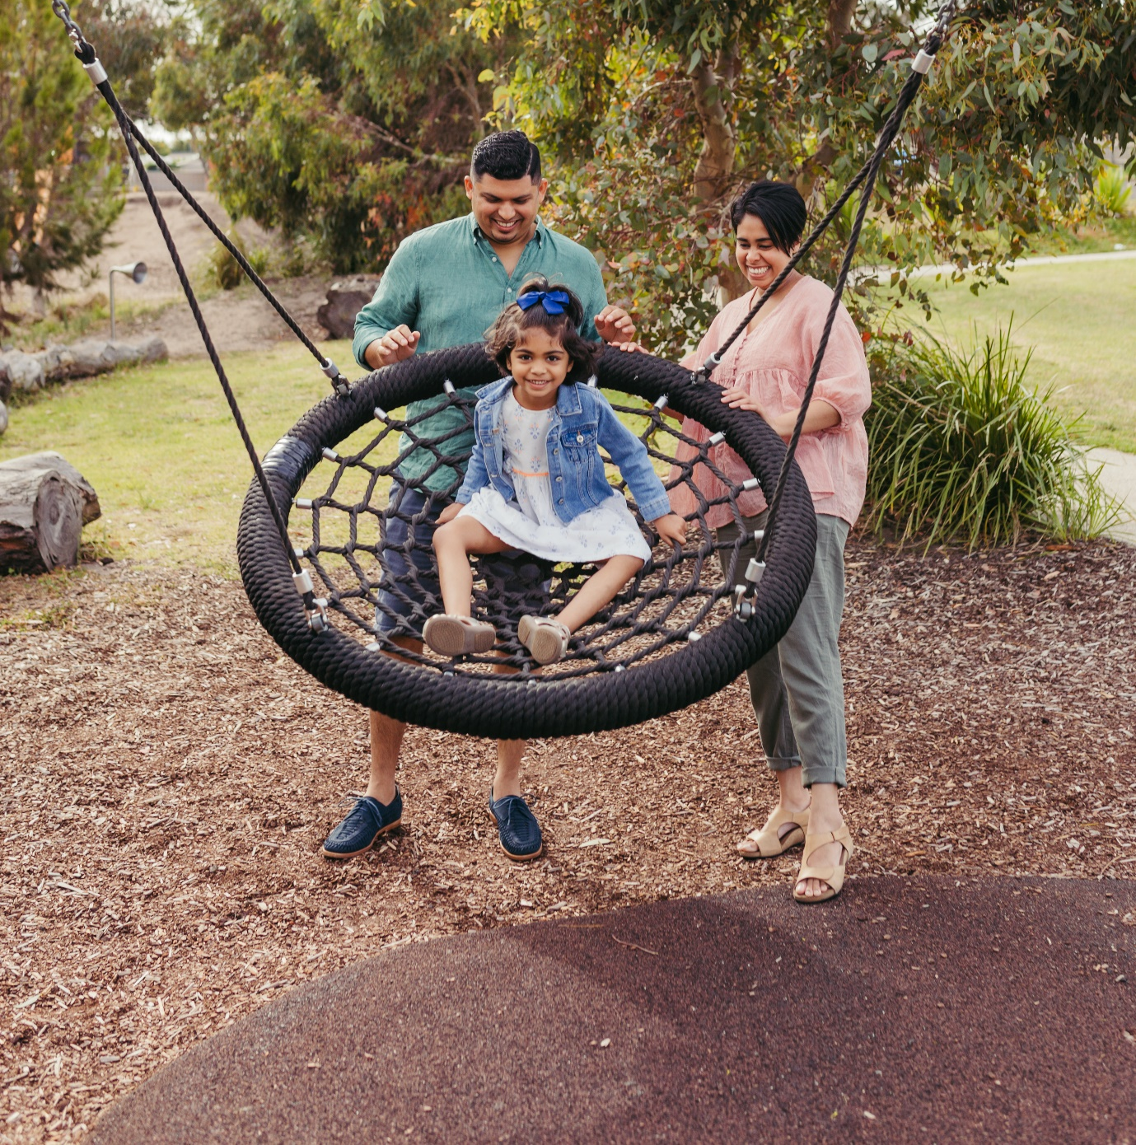


THE CITY OF
GREATER GEELONG

our community
PLAN 2021–25
QUARTERLY REPORT

september 2022

INTRODUCTION

Our Community Plan 2021‒25 outlines how we are working towards the 30-year community vision to make Greater Geelong a clever and creative city-region.
The plan tells the community what the councillors are aiming to achieve during their four-year term and guides how we allocate resources so we can deliver infrastructure, services and programs to the community to ensure the social, economic and environmental sustainability of our region.
The four strategic directions we’ve chosen to guide us are:
- Healthy, caring and inclusive community
- Sustainable growth and environment
- Strong local economy
- High-performing Council and organisation.
As well as the strategic directions, the plan also outlines:
- Desired outcomes ‒ the future state we’re aiming for in four years and
- Four-year priorities ‒ the priorities we’ll focus on to help achieve our desired outcomes
For the first time we have integrated the Council Plan and Municipal Public Health and Wellbeing plan – so that the health and wellbeing of our community is central to everything we do.
Our Community Plan 2021‒25 is supported by an annual action plan and budget which highlight the projects, initiatives and programs that will take place within the financial year to address our four-year priorities.
This quarterly report was developed to meet our commitment to transparent reporting by providing an update of our performance in delivering the annual action plan.
Actions that support the health and wellbeing priorities have been identified with the relevant health and wellbeing icon:
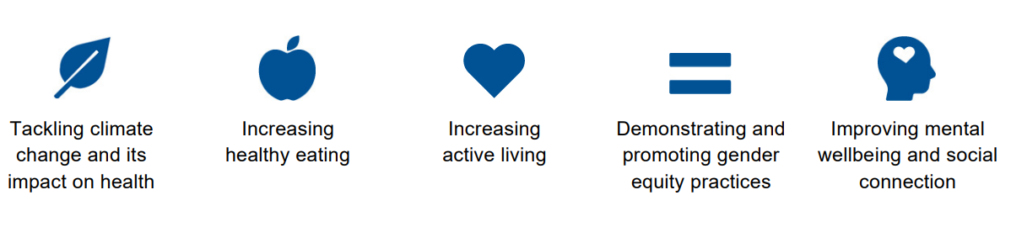

The annual action plan also includes major initiatives identified in the 2022‒23 budget.

STATUS UPDATE

We committed to 64 actions in our Annual Action Plan this year.
At the end of September 2022:
- 57 were ‘on track’
- three were ‘complete’
    - Complete a feasibility study for a program that makes recommendations on how to deliver a safe and inclusive space for young people within central Geelong
    - Develop and implement Business Events Geelong marketing program to represent, showcase and promote the region as a business events destination
    - Provide the community with an online portal to lodge valuation objections
- two were ‘not started’
    - Commence planning for a new residential strategy for Central Geelong
    - Develop a formal and centralised health, safety and wellbeing audit program
- two were ‘needs improvement’
    - Partner with Wathaurong Aboriginal Co-operative for local actions around Closing The Gap, an initiative which aims to achieve health and life expectation equality for Australia's Aboriginal and Torres Strait Islander peoples
    - Review the local planning policy framework in the Greater Geelong Planning Scheme to implement key strategies into the planning scheme
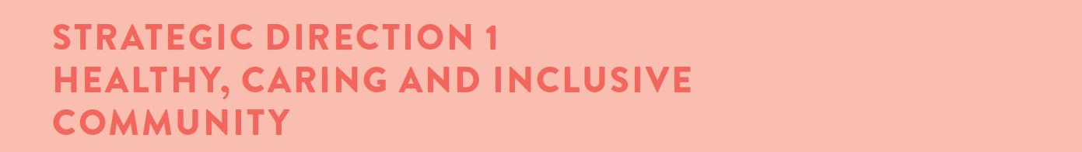
Desired outcomes
- Our community feels welcome, safe and connected
- Our community has equitable access to health and social services, information and infrastructure
- Healthy behaviours and environments are promoted, supported and accessible
Four-year priorities
  - Help our community, recreation groups and volunteers to prosper and grow
  - Deliver health and community initiatives that are culturally sensitive and accessible across all life stages
  - Foster and embrace community connectedness
  - Demonstrate and promote gender equity practices
  - Foster an inclusive community culture
  - Facilitate social and affordable housing in Greater Geelong
  - Provide access to places, spaces and services where and when people need them the most
  - Strengthen relationships and partnerships with the Aboriginal and Torres Strait Islander communities in Greater Geelong
  - Support the City’s cultural and creative life, history and heritage
  - Provide facilities that foster and facilitate positive health and wellbeing outcomes
  - Respond to the findings of the Royal Commissions into aged care and mental health

Four-year priority | 2022-23 actions | Progress comment | Status
1.2.1 | Implement the Municipal Early Years Plan 2022-25   | We engaged the community on our draft Municipal Early Years Plan 2022-25 in August/September 2022 which is currently being implemented. The plan assists with ensuring social equity across the municipality and ensures our services provide targeted support for those families and children who need it most. | On track
1.2.2 | Undertake a review of the Livewell Program to ensure it is sustainable and meets the health and wellbeing needs of people aged over 55   | We commenced the discovery phase of the Live Well Program review. Once completed, we will be able to determine the viability of the program, whether it is meeting the needs of the community and what changes may be needed in the delivery of the program. The discovery phase is due to be completed by the end of October 2022. | On track
1.2.3 | Update Council's Healthy Food Policy | We are working with the Institute for Physical Activity and Nutrition (Deakin University) to develop a discussion paper to inform the review and update of the City's Food Policy. Using a desktop review and stakeholder interviews to inform its development, the paper will consider legislative environments, and barriers and enablers to implementation of the current policy and identify opportunities for Council owned facilities and settings and broader opportunities for a healthy and sustainable food systems strategy in the future. A desktop review of evidence is complete and following ethics approval, internal stakeholder interviews will be conducted. | On track
1.3.1 | Develop an annual action plan for the Vital Communities project | Our Vital Communities research project provides a contemporary look at the challenges faced by some of our most socio-economically disadvantaged communities. We developed an annual action plan with internal partners and external stakeholders which outlines key activities under the five domains of Vital Communities - Housing, Employment, Education, Liveability and Health and Wellbeing. | On track
1.3.2 | Identify the key safety concerns of the community and articulate the City's role in facilitating a safe Geelong community   | Council approved the draft Community Safety Framework 2022‒26 for community engagement at its September 2022 meeting. Feedback will be considered, and the final framework presented to Council in early 2023 for adoption. | On track
1.4.1 | Develop an annual  Ba-gurrk Gender Equity Framework action plan, incorporating actions from the Gender COVID-19 research | We anticipate a draft action plan will be complete in early November 2022, with internal engagement to occur November / December 2022, followed by external engagement. | On track
1.4.2 | Commence detailed design of gender neutral facilities at the Leopold Tennis Club | We commenced detailed design of the gender-neutral facilities and are seeking funding assistance from Sport and Recreation Victoria to assist the redevelopment of the Leopold Tennis Club. | On track
1.5.1 | Finalise the new Access and Inclusion Action Plan which outlines actions the City will take to reduce discrimination and promote inclusion of people with disabilities | We commenced planning the development of the new Access and Inclusion Plan which aims to encourage, recognise and promote the elimination of disability discrimination and recognition of the rights of people with disability, ensuring residents with disability are fully included in community life. | On track
1.5.2 | Develop an annual Multicultural Action Plan which will guide how the City plans for and supports our multicultural community | We commenced discussions with the Multicultural Advisory Committee on the development of the next action plan. Deliberative engagement with key stakeholders is set to commence in October 2022 prior to it going out to community engagement. The plan guides how we plan for and support our multicultural community as we recognise that many people from multicultural backgrounds can experience unique barriers to participation including access to information, cultural differences, racism, discrimination, and exclusion. | On track
1.5.3 | Commence construction of a new inclusive play space at Rippleside Park (Major budget initiative) | We completed final engagement on detailed designs for the all-accessibility play space at Rippleside Park and commenced preparing for the tender process expected to proceed in early 2023. | On track
1.6.1 | Increase the amount of social housing by evaluating Council owned land available for development | We will commence community engagement on the three potential Council owned sites identified for social housing in early 2023. Council continues to work with both private developers and Homes Victoria to increase the supply of social housing in Geelong. | On track
1.7.1 | Complete a feasibility study for a program that makes recommendations on how to deliver a safe and inclusive space for young people within central Geelong | We completed the feasibility study which recommends that council investigate opportunities for a youth hub in the central business district. We are also in discussions with state government regarding a facility that acts as a safe space for young people from the LGBTQIA+ community. | Complete
1.7.2 | Expand our Drop-In Feeding support service (0-3 months of age) to include the Bellarine | We provide a drop-in feeding support session from Bop Bop Karong (Barwon Heads) once a week to support parents and carers in meeting the nutritional requirements of their babies and improve parent/carer confidence and wellbeing. | On track
1.8.1 | Commence working with community on the next Innovate Reconciliation Action Plan | We held discussions with Kilangitj Aboriginal Advisory Committee about the development of the next Reconciliation Action Plan - Innovate. While this work will commence in early 2023, pre-planning and project planning will commence before the end of the year. Council endorsed the implementation of the Reflect Reconciliation Action Plan in June 2022. | On track
1.8.2 | Deliver a training and education program in partnership with Wadawurrung Traditional Owners Aboriginal Corporation with a focus on tourism development and cultural awareness strengthening cultural tourism in the region | We completed actions including:  - supporting Wadawurrung Traditional Owners Aboriginal Corporation to secure funding for a cultural tourism feasibility study and appoint an Arts and Tourism project officer  - attending the Indigenous Australian Tourism Conference alongside Wadawurrung Traditional Owners Aboriginal Corporation staff  - continuing to work with Wadawurrung Traditional Owners Aboriginal Corporation in the development of localised, authentic aboriginal tourism product and experiences  - 65 tourism businesses enrolled to furthering knowledge and understanding of Wadawurrung People and culture via cultural site guided learning and a half-day education/collaboration workshop. | On track
1.8.3 | Partner with Wathaurong Aboriginal Co-operative for local actions around Closing The Gap, an initiative which aims to achieve health and life expectation equality for Australia's Aboriginal and Torres Strait Islander peoples | We met with representatives from the Wathaurong Aboriginal Co-operative about local actions around Closing the Gap, however, a partnership agreement is yet to be developed. It is likely that this work will commence in earnest in 2023. Closing the Gap aims to close the health and life expectancy gap within a generation between Aboriginal and Torres Strait Islander people and non-indigenous Australians. | Needs improvement
1.9.1 | Collaborate with Wadawurrung Traditional Owners to conserve, digitise and interpret artworks and artefacts of regional importance from across Council's arts and heritage collections | We continued to collaborate on projects including two exhibitions occurring at the National Wool Museum (NWM):  - BLUESTONE: 150 Years of Dennys Lascelles Woolstore exhibition which includes a video with Uncle Bryon Powell about the land the building sits on, waterway and the Johnston Park billabong  - Wadawurrung Dja: Awakening Country, an exhibition of paintings and ten ceremonial cloaks by Deanne Gilson  Both exhibitions have been digitised for virtual exhibition in October and November 2022 respectively.  We are also consolidating Council's Art and Heritage collection which has involved several hundred works being moved to the NWM for cataloguing and conservation. This includes a limited number of works by First Nations artists that will be available online by the end of 2022. | On track
1.10.1 | Commence construction of the Northern Aquatic and Community Hub (Major budget initiative) | We are progressing construction of the Northern Aquatic Community Hub, which is currently 20 per cent complete. The Northern Aquatic and Community Hub will directly contribute to the health and well-being of residents in the north and surrounding areas by providing state of the art health and fitness facilities. | On track
1.10.2 | Enhance the City Safe Camera Network (CCTV) across priority neighbourhoods and suburbs | We will expand the safe camera network with the installation of two additional cameras at Hearne Parade, East Geelong and are currently in negotiations with Barwon Coast regarding new cameras at Ocean Grove.  The City’s CCTV policy will be considered by the Policy Review Committee 5 October 2022. | On track
1.10.3 | Complete final concept Stage 2 design of the North Bellarine Aquatic (Major budget initiative Centre) | We are awaiting confirmation of further federal government funding for the delivery of a 50-meter indoor pool as part of Stage 2 of the North Bellarine Aquatic Centre. This is expected to be finalised following the state government election on 27 November 2022. Community engagement will then be undertaken to inform the development of options and concept plans for Stage 2. | On track
1.11.1 | Prepare Council to make an informed decision about its future in the delivery of in home and community care (under 65s) and aged care (over 65s) services | Council will be briefed on the federal governments new Support at Home program for future delivery of in-home and community care in November 2022. | On track

LINKS TO THE CLEVER CREATIVE VISION
 | 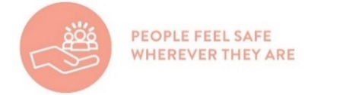 | 

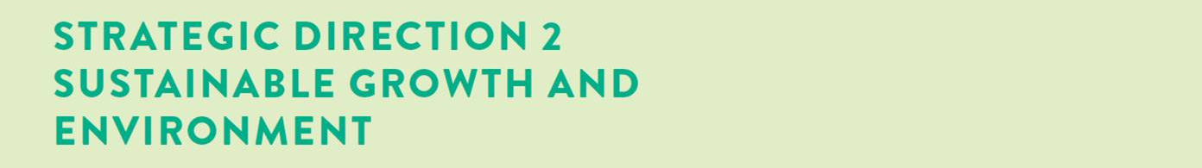
Desired outcomes
- We are delivering our vision for sustainable growth across the municipality
- We have a choice of housing and lifestyles to meet the diverse needs of our community
- There are connected transport networks throughout the region that support liveability and prosperity
- Greater Geelong has quality, vibrant public spaces
- We are leading a reduction in community emissions and are increasing the City’s resilience to climate change impacts
- We protect and restore our natural environment
- We minimise waste with good design and manage effective recovery of resources
Four-year priorities
  - Meet the housing needs of our future community
  - Meet existing and future transport needs
  - Create engaging places and spaces
  - Deliver best practice Environmentally Sustainable Design principles and vibrant neighbourhoods
  - Achieve carbon neutral in all City-managed operations by 2025 and manage our climate change risks
  - Support our community and region to reduce emissions and build resilience to climate change
  - Reduce the impact of waste
  - Support greater indigenous biodiversity

Four-year priority | 2022-23 actions | Progress comment | Status
2.1.1 | Commence planning for a new residential strategy for Central Geelong | We are currently awaiting confirmation of state government funding which will be announced in November 2022. | Not started
2.2.1 | Commence development of a draft Integrated Transport Plan (Major budget initiative ) | We commenced development of the draft Integrated Transport Plan and are currently preparing a project scope and brief for technical work. | On track
2.2.2 | Construct the Building Better Bike Connections Southern Link Stage 2 | We completed construction works for Stage 1 of the Southern Link from Malop Street to the Barwon River. Council will consider the Stage 2 tender award later in 2022. The Building Better Bike Connections project provides routes that are designed to be used by cyclists of a wide range of ages and abilities to safely ride to destinations like shopping areas and key employment precincts. | On track
2.3.1 | Develop a new Open Space Policy and Strategy to facilitate equitable access to open space across the municipality | We prepared a draft Open Space Policy which will be considered by the City's Policy Review Committee in October 2022. Stakeholder engagement on the draft will take place prior to it being considered by Council in March 2023. | On track
2.4.1 | Prepare the Creamery Road and Elcho Road East precinct structure plan and development contributions plans including environmentally sustainable design initiatives   | We completed agency and landowner engagement on the Creamery Road Precinct Structure Plan (PSP). The draft future urban structure plan for Elcho Road is being prepared for engagement with landowners in November 2022. Council will consider the PSP at its March 2023 meeting and the Elcho Road PSP at its October 2023 meeting. | On track
2.4.2 | Review the local planning policy framework in the Greater Geelong Planning Scheme to implement key strategies into the planning scheme | We are securing additional consulting input to meet project timelines. | Needs improvement
2.4.3 | Engage key stakeholders in setting a future vision and direction ways to connect building occupants to the natural environment (biophilic design principles) and how to embed this in planning and urban design | We completed a draft business case and are now collaborating with Deakin University to develop co-design workshops due to take place in November 2022. | On track
2.5.1 | Develop a plan to transition to low emissions light fleet vehicles | We developed a statement of work to go to market for a third party to develop a low emissions light vehicle plan. We also:  - used Department of Environment, Land, Water and Planning funding to procure six charging units for installation at the Corio and Belmont depots  - now have seven vehicle bays available in Wurriki Nyal with vehicle charging capabilities  - are developing a capital spend program to procure up to 20 light vehicles in 2022‒23 to replace the current fleet  - are seeking funding from the Australian Renewable Energy Agency, a federal government agency, to support the conversion of up to 20 light commercial vehicles to electric over the next 18 months. | On track
2.5.2 | Commence implementation of the new Sustainable Building Policy | We reviewed our Sustainable Building Policy. It is now being considered by the City’s Policy Review Committee. | On track
2.5.3 | Undertake an assessment of City owned gas using infrastructure to support a transition to gas-free operations | We completed an assessment of gas infrastructure at the Kardinia Pool. Assessments at 20 other City facilities are currently underway. | On track
2.6.1 | Develop a community campaign to raise awareness of the region’s climate risks, impacts and responses | Through the City’s Climate Change Partnerships Grants program, we are working with community groups and co-developed projects to develop a community campaign that raises further awareness about the impacts, risks and responses to climate change. To best deliver and execute this campaign, two projects that reflect the City’s need to reduce emissions quickly across the residential and commercial sectors, while ensuring we capture a broader and new audience, will be selected.  Additionally, we are planning a Net Zero Forum to be held in 2023 and are co-developing Climate Change Thinking eLearning modules with Deakin’s School of Education. These innovative programs coupled with the climate change partnership grant projects are building the foundations for continued campaign success and knowledge building that improves Greater Geelong’s climate change understanding. | On track
2.6.2 | Prepare a discussion paper to increase understanding of the health impacts of climate change and the health co-benefits of mitigation and adaptation strategies | We defined the scope of our role in climate change adaptation and mitigation strategies through theory of change workshops with internal stakeholders. Research and consultation with subject matter experts will be conducted to develop a discussion paper. | On track
2.6.3 | Upgrade to LED street lighting with smart control technology (Major budget initiative) | Stage 2 of the street light changeover on main roads commenced in June 2022, with completion expected by June 2023. Stage 3, which involves the remaining decorative lighting, will be completed in 2023. | On track
2.7.1 | Collaborate with Barwon Water and G21 councils to develop the Regional Renewable Organics Network facility to process the City's organic waste | Along with Barwon Water and other regional councils, we are participating in joint steering committee to guide the next steps in the project. Functional design phase of the project is underway. | On track
2.7.2 | Collaborate with metro Melbourne councils to deliver the Best Waste Practices in Multi Unit Dwellings project to improve recycling in multi-unit developments | We completed the tender process to engage a contractor to deliver the work. Six multi-unit developments in Geelong have been nominated to participate in the project to improve recycling behaviour. | On track
2.8.1 | Implement the Sparrovale Master Plan phase 1 (Major budget initiative) | The plan outlines improvements in drainage infrastructure, natural environmental and recreational facilities over the next 20 years. Revegetation works as well as pest plant and animal control are currently underway. | On track
2.8.2 | Develop a 10-year Biodiversity Strategy | The City established a Biodiversity Strategy Technical Advisory Group. Community engagement on the draft biodiversity strategy will commence at an environmental volunteers networking and social event co-hosted by the City and the Geelong Field Naturalists Club on 23 October 2022. | On track
2.8.3 | Develop the Southeast Bellarine Coastal Strategy | We conducted extensive community and stakeholder engagement to inform the development of the Southeast Bellarine Coastal Strategy which will be considered for endorsement by Council at its meeting in October 2022. | On track
LINKS TO THE CLEVER CREATIVE VISION
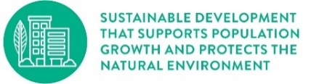 | 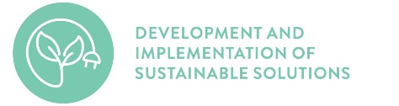 | 

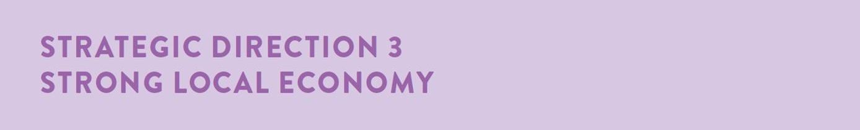
Desired outcomes
- We have a global, national and local reputation as a place to do business – especially in our key sectors
- We have a diversified, future-focused and sustainable economy to drive employment and support growth
- We are an influential Council that builds effective private and public partnerships, taking the lead role in advocating for future investment
Four-year priorities
  - Attract and facilitate public and private investment
  - Promote and leverage the competitive strengths and attractiveness of our region, globally, nationally and locally
  - Support entrepreneurs, start-ups, innovation, research and digital connectivity
  - Attract businesses with a carbon neutral and circular economy focus
  - Support local business resilience and recovery from the impacts of the COVID-19 pandemic
  - Attract, retain and enable participation in the workforce to meet industry needs
  - Address high levels of unemployment in targeted areas of our region
  - Promote our region as a trial location for innovation and new technologies

Four-year priority | 2022-23 actions | Progress comment | Status
3.1.1 | Finalise the City of Greater Geelong 10-year Economic Development Plan to guide and foster economic growth opportunities for the City | Council will consider endorsing the draft Economic Development Plan for community engagement at its meeting in December 2022. The 10-year Economic Development Plan identifies our priorities to support and grow the economy to ensure economic prosperity. It focusses on jobs, education, business capacity, industry growth, liveability, and sustainability to support the health and wellbeing of our community. | On track
3.1.2 | Facilitate employment precinct land development to maintain a diversity of employment areas | We are undertaking the southwest employment land review. The Greater Avalon Employment Precinct structure plan is being prepared by the Victorian Planning Authority. | On track
3.2.1 | Deliver Geelong Design Week 2023 showcasing local designers, creatives and innovators and celebrate Geelong's global recognition as Australia's only UNESCO Creative City of Design | Geelong Design Week will take place 19-29 October 2023. We will be seeking Expressions of Interest from local businesses, individuals and organisations to host events in March 2023. | On track
3.2.2 | Develop and implement Business Events Geelong marketing program to represent, showcase and promote the region as a business events destination | We successfully launched the Business Events Attraction campaign in late September 2022. The campaign window for confirming business events closed as of 30 June 2022.  Highlights of the campaign include:  - 54 conferences attracted to region  - 4,798 conference delegates  - 12,581 delegate days  - $3.4m estimated economic benefit | Complete
3.3.1 | Deliver the Fibre in the North project to enable a high-speed optical fibre network, providing community facilities and public spaces with access to ultra-high-speed internet | We completed fibre works in north suburbs with final link going underneath rail lines north of Kardinia Park. Installation of Bellarine fibre trail commenced 14 September 2022 and is expected to be complete by the end of 2022. This project will provide community facilities and public spaces with access to ultra-high-speed internet. | On track
3.3.2 | Deliver free public Wi-Fi and enhanced broadband to address gaps in digital access and affordability - Geelong Smarter Suburbs (Major budget initiative) | This program aims to address gaps in digital access and affordability also offering business grade high speed internet in the underserviced northern suburbs. We successfully launched Smarter Suburbs Program Stage 1 on 19 September 2022. Stage 2, which includes the delivery of 30 smart nodes equipped with free public Wi-Fi, is progressing as expected. | On track
3.4.1 | Commence delivery of demonstration projects to stimulate demand for Cleantech and Circular Economy solutions | We funded three projects to the value of $50,000 through the Cleantech & Circular Economy Grants. Projects will commence in October 2022. | On track
3.5.1 | Launch a major annual live music program in support of day and night economic activation | Following a full evaluation of the inaugural 2022 event, we developed a project brief to outsource the delivery of Surround Sounds 2023. As done previously, we will continue to focus our attention on inclusion by developing a program that addresses known barriers to participation and creates diverse representation and experiences. | On track
3.6.1 | Implement the Regional Industry Sector Employment (RISE) program that supports employment pathways to address Geelong’s disadvantaged areas | We delivered the August/September RISE program. The next program will commence 11 October 2022 with 15 participants. The RISE program aims to increase access and reduce barriers to employment opportunities, with some graduates achieving full-time work and apprenticeships in construction, and some participants pursuing other employment options or educational pathways. | On track
3.8.1 | Identify innovative cleantech solutions through Procurement for Innovation projects | We commenced work on a circular economy project and are currently preparing a statement of need, draft specification and criteria for tender. | On track
3.8.2 | Undertake a review of the City’s digital 3D model and develop a roadmap for ongoing management and enhancement to support a Geelong Digital Twin | We signed a digital data sharing agreement with the Department of Environment, Land, Water and Planning.  Digital Twin Victoria, a digital replica of the state, launched in early September 2022. Work commenced on training modules for City employees. The Geelong Data Exchange has been reconfigured to integrate with Digital Twin Victoria | On track

LINKS TO THE CLEVER CREATIVE VISION
 | 



Desired outcomes
- Our services are accessible and meet the diverse needs of our community
- We are acknowledged and recognised as a leading council and organisation
- We have a healthy, safe, inclusive and diverse culture
- We are a financially sustainable and resilient organisation
Four-year priorities
  - Enable a customer-focused approach that delivers efficient and responsive service
  - Communicate and engage effectively with our community to understand their needs and advocate on their behalf
  - Foster excellence and equity in planning for our growing region
  - Continue to strengthen our workplace capabilities and culture
  - Create a more efficient and effective organisation
  - Develop a digital core of brilliant basics technology that supports better ways of working
  - Ensure that our employees are safe at work
  - Focus on economic, social and environmental sustainability

Four-year priority | 2022-23 actions | Progress comment | Status
4.1.1 | Build a new website to make information and services more convenient and efficient for our community | We commenced work on our new website which is expected to be ready by June 2023. The new website will support the community in their interactions with the city. | On track
4.1.2 | Protect the City's digital landscape against cyber security threats by establishing a Risk Management Framework and overarching Cyber Policy (Major budget initiative) | We drafted an Information Security Management System document which identifies the use of our corporate risk framework to manage enterprise cyber security. We will now look to form an oversight body to manage the implementation of the Cyber Strategy. | On track
4.1.3 | Provide the community with an online portal to lodge valuation objections | We provided the community with an online portal to lodge 2022‒23 valuation objections as part of the standard Department of Environment, Land, Water and Planning platform. | Complete
4.2.1 | Ensure Council’s Priority Projects are current, communicated to key stakeholders and decision makers and ensure active community engagement in the delivery of these projects | We completed a revision of the Council’s Our Priority Projects document in July 2022 to reflect project progress, costing updates, and opportunities for the staged delivery of master plans and key projects. The revised document was circulated to more than 50 key stakeholders and additional information and briefings offered to MPs, Ministers and local stakeholders and advocacy partners. We ensured strong advocacy on behalf of our community in the lead-up to the 2022 Victorian Government Election via weekly community engagement updates for local MPs, briefings with MPs and state election candidates, and participation in regional delegations to Canberra and Spring Street. | On track
4.3.1 | Develop an impact evaluation framework to monitor the contribution of investment in social infrastructure to community health and wellbeing | We commenced a review of the social infrastructure planning community benefit and prioritisation tool. We will be preparing a draft valuation framework in preparation for the 2023‒24 budget process. | On track
4.3.2 | Implement the City’s approach to deliver integrated strategic planning and reporting activities for the municipality (Integrated Municipal Planning Framework) | We developed a planning development model and planning catalogue with the view of creating a formal document hierarchy and framework for document development. Next steps are to undertake pilots to test and refine the model prior to rollout across the organisation. | On track
4.4.1 | Deliver new leadership and culture development programs, coaching and performance improvement, learning resources and events | We continued to deliver leadership and culture development initiatives including:  - newly procured leadership development program  - quarterly leadership and culture development events  - people leader development on workplace flexibility  - a new Gender Equality Action Plan launched in September and implementation group established  - gender equality training for key policy owners and subject matter experts within the organisation | On track
4.5.1 | Develop the City’s approach to addressing customer requests and queries | We are developing a streamlined customer service model through engagement across the organisation and with key external stakeholders, to build out the future state approach for managing customer requests and queries in the future. With the high-level model designed, our focus is now shifting to planning the implementation of the tiered model to deliver a fast, efficient, easy customer service experience where customers know where they are at in the process, and they have confidence in the City’s ability to manage their matter effectively. | On track
4.5.2 | Complete Target Operating Models for Enterprise Program Management Office, Municipal Planning, and Customer and Community | Our Future Ways of Working program aims to enhance how we work together and design our organisation for the future. We are doing this to create a place that serves our growing community in the best possible way. As part of this process, we progressed the implementation of an agreed Target Operating Model for the organisation through delivery of the following key activities:  - defining a target operating model for an Enterprise Program Management Office. Focus is now on the roadmap for implementing new ways of working and ensuring we have the right capabilities in the organisation to bring this operating model to life.  - progressing target operating models for how we complete planning for the municipality and for our major touch points with our community, customers and other internal and external parties. These will be finalised prior to the end of 2022. Further work in the new year can then focus on defining the roadmap for achieving those target operating models. | On track
4.5.3 | Develop the City's approach for reviewing the delivery of services | We developed a draft catalogue of services the city provides to allow us to better understand our services and make informed analysis on what provides the best value to the city. Following finalisation of the catalogue in late 2022, we will develop the roadmap of services to be reviewed. | On track
4.6.1 | Continue upgrading and modernising the City’s digital capabilities | Initiatives underway to upgrade and modernise our digital capabilities include:  - redevelopment of our new website and internal intranet  - introduction of office-based technologies at Wurriki Nyal to enable hybrid working with training and engagement to increase the value and adoption  - M365 improvements and establishing opportunities to utilise M365 features  - a technical review of the Business Systems Refresh project | On track
4.7.1 | Develop a formal and centralised health, safety and wellbeing audit program | Work on developing a formal and centralised health, safety and wellbeing audit program is currently on hold pending a review of the Business Systems Refresh project. | Not started
4.8.1 | Review and update the Long-term Financial Plan 2021-31 | Our Long-term Financial Plan 2021-31 will be updated in October 2022. This review will be an ongoing annual process. | On track
4.8.2 | Develop a partnerships model that supports the organisation to develop stronger and effective relationships with community and key stakeholders | A partnership engagement framework was developed and endorsed by the Executive Leadership Team. Next steps will be to map existing partnerships across the organisation. | On track

