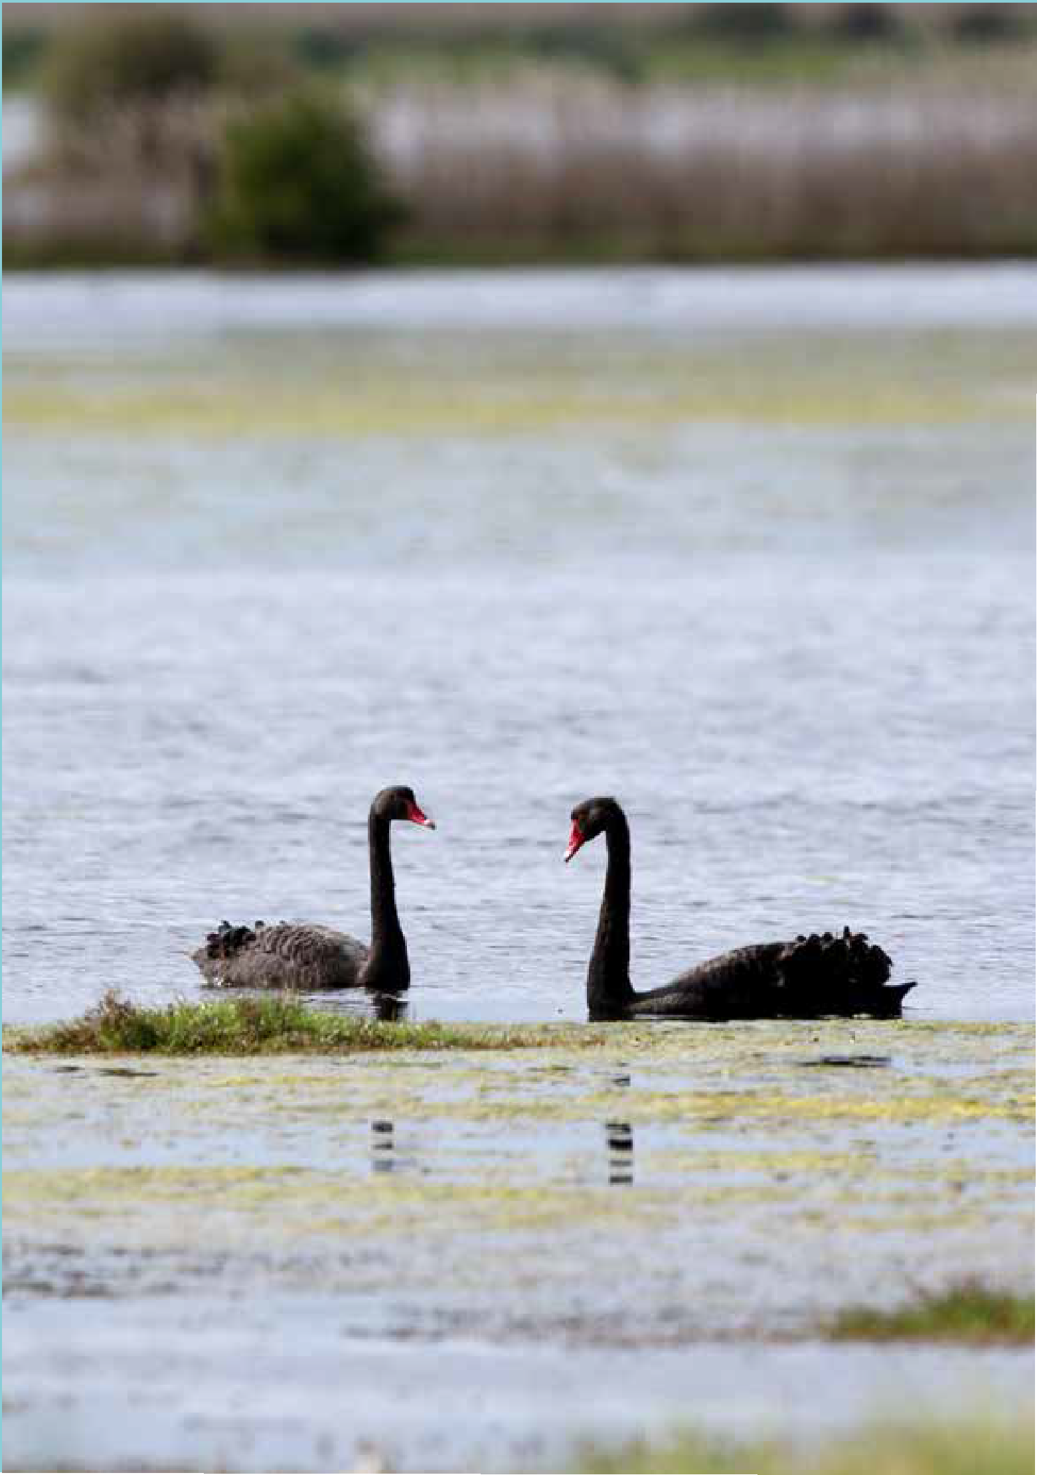THE CITY OF
GREATER GEELONG

SUSTAINABILITY PERFORMANCE REPORT
2022



2. SUSTAINABILITY PERFORMANCE REPORT | 2022

Table of contents 3
Executive summary 4
Performance overview 4
Mayor and CEO message 6
Our Sustainability Advisory Committee 7
Introduction 8
Our commitment to sustainability 8
What guides sustainability in our organisation? 9
Background to the report 9
Protecting the environment 10
Objectives 12
Measures of success 12
Objective 1.1: Acknowledge the changing 14
climate is a global emergency and take appropriate local action
Objective 1.2: Support the Community and 16
the City to reduce carbon emissions and promote active transport
Objective 1.3: Support the Community and 18
the City to reduce waste
Objective 1.4: Protect our biodiversity and 20
ecosystems through effective natural
resource management
Objective 2.5: Harness community knowledge 40 to drive sustainable change
Spotlight on the Social Equity 42
Framework 2022–25
Responsible and transparent business 44
Objectives 44
Measures of success 46
Objective 3.1: Position the organisation to 47
better achieve our sustainability objectives
Objective 3.2: Embed sustainability into our 50
decision-making and look for innovative solutions
Objective 3.3: Understand and be guided by 52
the needs and expectations of our community
Objective 3.4: Pursue ambitious sustainability 53
targets and report our progress publicly
New objective: A strong local economy 54
with job opportunities for all
Spotlight on the Geelong Digitial Twin Project 55
End notes 56
Glossary 57
Appendix 1 – Our data 59
Our people 59
Occupational health and safety 60

Objective 1.5: Create cleaner, greener community spaces | 22 | Appendix 2 – Global Reporting Initiative Index | 62
Objective 1.6: Ensure our land use planning | 24
and built environment reflects sustainable
practice |  | Cover: Sparrovale Wetlands
Spotlight on sustainable design in planning | 26
Community wellbeing and social equity | 28
Objectives | 28
Measures of success | 30
Objective 2.1: Lead and support education for | 31
business and community to encourage |  | Opposite: Corio, Dr Jenny Murray-Jones
sustainable practice |  | We Acknowledge the Wadawurrung People as
Objective 2.2: Encourage and support | 33 | the Traditional Owners of the Land, Waterways
local, sustainable food production |  | and Skies. We pay our respects to their
Objective 2.3: Ensure equitable access and 34  inclusion to City services and facilities  Objective 2.4: Work with others to achieve 38  sustainable outcomes for our community |  | Elders, past and present. We Acknowledge all Aboriginal and Torres Strait Islander people who are part of our Greater Geelong community today.

EXECUTIVE SUMMARY

The Sustainability Framework 2020 and
Sustainability Framework Action Plan 2020– 22 were adopted by Council in July 2020.
This report provides a progress update on sustainability targets (where data is available), as well as actions listed in the action plan. We are also reporting on a selection of Global Reporting Initiative (GRI) indicators (where data is available), so we can track our performance against similar organisations over time (see Appendix 1).

PERFORMANCE OVERVIEW
Of the 66 actions within the Sustainability Framework Action Plan 2020–22, at 30 June 2022 the majority were either on track (31, 47 per cent) or complete (30, 45 per cent). Three actions were off-track. Two actions had not started (3 per cent) - see Figure 1.
Based on past trend data (where available), the following trends were noted as of 31 December 2022 (see Table 1):
- ten indicators are currently trending toward success
- seven indicators are trending away from success
- two indicators only had baseline data
- four indicators did not have data available.

On track (31) 47%
Off track (3) 5%
Not started (2) 3%
Complete (30) 45%

Figure 1 - Progress of Sustainability Framework Action Plan 2020–22 (to 30 June 2022)

Table 1 - Progress of sustainability indicators

KEY PRIORITY AREA INDICATOR STATUS

Protecting our environment
City-managed operations emissions Hectares of natural habitat protected and restored
Percentage kerbside garbage, recyclables and green organics diverted
from landfill

Community wellbeing
and social equity

Responsible and transparent business
Journeys to work using active transport
Community emissions New trees planted in Greater Geelong as part of the one million trees
initiative

Waste to landfill from City office buildings
Percentage of water used in the City sourced from alternative water sources Percentage of water used by the municipality sourced from alternative
water sources
Perception of safety Digital inclusion score Self-rated health of residents Percentage of social housing supply Workforce participation rate Geelong suburbs in the bottom 20 per cent of the Socio-Economic Indexes
for Areas (SEIFA)

City employee work-related fatalities

Consideration of financial, social, community engagement and
environmental implications in council reports

Greater Geelong ranking in the Global Innovation Cities Index Expenditure by visitors to the city-region per annum Number of major events in Geelong supported Diversity of businesses within Greater Geelong Number of mega events supported (exclusive World Championship or
similar)

Percentage of new and reviewed City plans, strategies and policies considering sustainability impacts and risks

On track Off track Not yet available Only baseline data available

MAYOR AND CEO MESSAGE

On behalf of the Council and our administration, we are pleased to present the City of Greater Geelong’s Sustainability Performance Report 2022.

The Greater Geelong region is an incredible place to live and work and has an exciting, healthy, and thriving future. We have a population of more than 269,500, but forecasts predict that over the next 15 years, 390,000 people will call Greater Geelong home.
So, we know that as larger numbers of people decide to move to this part of the world, we must continue to have the future sustainability of our region in mind.
This includes economic sustainability, social sustainability, and environmental sustainability.
We have introduced several major long-term initiatives that are helping to create a more sustainable community.
This report outlines our achievements in this space, which we are proud to highlight.
Our Council and organisation are at the beginning of a long journey when it comes to sustainability but of the 66 actions within our Sustainability Framework Action Plan 2020–22, the majority are either on track or complete.
Our operational CO2-emissions decreased by 29 per cent over the past 12 months, and we entered into a
ten-year contract with the Victorian Energy Collaboration which sources renewable electricity from a Victorian wind farm near Mortlake.
We also established new corporate carbon emissions target of net zero emissions by 2025, and to have 100 per cent renewable electricity supply used for all City- owned and operated buildings and streetlights by 2025.
Our community has played a vital role in shaping the direction of our sustainability work so far, and we are grateful for their continued passion and input.

It was pleasing to further increase the City’s support by establishing the Climate Partnership Grants, which provide co-design and financial support for community

Councillor Trent Sullivan
Mayor
City of Greater Geelong

led projects and activities that help achieve net zero community emissions and increase resilience to climate change impacts.
We know that we have set ambitious targets for ourselves to achieve and this report reveals we are making positive progress.
We also to continue to take an integrated approach to addressing social and economic inequity using a range of policies, planning and programs, and by investing significantly in community infrastructure and facilities.
As leaders we know that we must be prudent when it
comes to issues that affect our local economy.
This is why we continue to advocate for projects that support strategic business and industry development, and coordinate industry experts to investigate further opportunities for Greater Geelong.
We would like to take this opportunity to acknowledge the members of our Sustainability Advisory Committee who have volunteered their time and considerable expertise as we push to further improve our operations in this area.
The City of Greater Geelong Council and organisation are proud to be acknowledged leaders in the sustainability sector and remain highly motivated to continue guiding our region towards the ‘clever and creative’ vision we are determined to achieve.

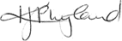


Kaarina Phyland
Acting CEO
City of Greater Geelong

OUR SUSTAINABILITY ADVISORY
COMMITTEE

To help us progress our ambitious sustainability agenda, we continued to draw on our community’s passion and considerable knowledge through our Sustainability Advisory Committee.
The committee, who come from a wide range of professional backgrounds, has been tasked with putting an economic, environmental and social sustainability lens over the City’s strategic work.
To date, they have advised us on a range of key strategic initiatives including development of our Climate Change Response Plan 2021– 30, Social Equity Framework 2022–25, draft Economic Development Plan 2021–31 and draft Biodiversity Strategy, now known as Plan for Nature.
We would like to thank each of the committee members for sharing their expertise and providing insights and feedback to guide our decision-making. The time and energy they’ve put into the committee meetings over the past 12 months is valued and much appreciated.
We would also like to acknowledge the contribution of out-going members Annie Woollard and Wayne Pales and welcome new committee member Helen Hodgkins.
We are committed to the long-term sustainability of our region. The passion of our Sustainability Advisory
Committee will ensure that we continue to move towards securing a sustainable future for generations to come.


Councillor Stephanie Asher
Chair
Sustainability Advisory Committee

Councillor Belinda Moloney

Deputy Chair
Sustainability Advisory Committee

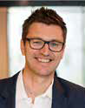
Joe Calafiore Karen Campbell Emma Connan Sally Harper Brad Keating Wayne Pales

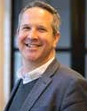



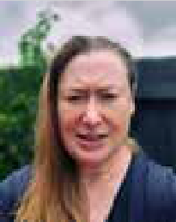
Simon Reeves David Spear Jane Stanley Sanja Van Huet Annie Woollard Helen Hodgkins

INTRODUCTION

There are many ways to define sustainability. To the City, sustainability refers to a continual way of thinking and acting that achieves optimal outcomes for people, the environment, and the economy – both now and into the future
Our goal is to incorporate sustainable thinking into every aspect of our business to address some of the long- term challenges facing our community, including climate change, population growth, demands for community infrastructure and social inequity. This report provides an overview of what we are doing to address key social, environmental, and economic indicators at an organisational and municipal level.

OUR COMMITMENT TO SUSTAINABILITY
A sustainable community is one that manages its natural, human, and financial resources to meet current needs, while ensuring that adequate resources are available for future generations. Our Sustainability Framework 2020 commits our organisation to take action across three key priority areas (see Figure 2):
- protecting the environment
- community wellbeing and social equity
- responsible and transparent business.
Beneath each key priority area is a set of objectives that were chosen using a materiality process conducted in 2019 (see Figure 3).
As a form of topic mapping, the materiality establishes what should be included in a framework or strategy.
We applied a set of filters to rank each topic by the significance of its economic, environmental and social impacts, and its influence on the decisions of stakeholders. This was then refined with community feedback.
As Figure 3 shows, the framework has a strong emphasis on environmental sustainability. This is because most stakeholders involved in the process at the time were focused on climate change action.
The 66 sustainability actions that make up the action plan are divided as follows:
- protecting the environment – 24 actions
- community wellbeing and social equity – 22 actions
- responsible and transparent business – 20 actions.

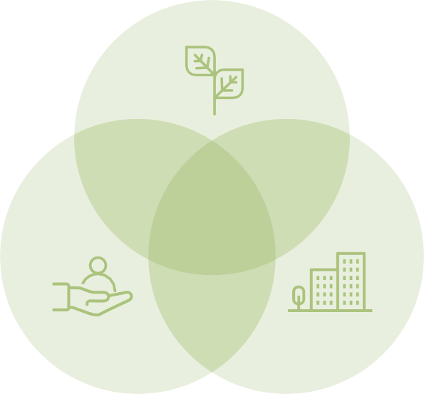Figure 2: The Sustainability Framework 2020 key priority areas

SUSTAINABLE OUTCOMES
now and into the future
e
t
b
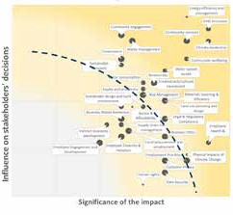
Figure 3: Materiality matrix 2019

WHAT GUIDES SUSTAINABILITY IN OUR ORGANISATION?

SUSTAINABILITY AND THE LOCAL ECONOMY
'A strong local economy with job opportunities for all’ was identified as one of the community’s top priorities in the community engagement process we conducted to inform our joint council and municipal public health and wellbeing plan – Our Community Plan 2021–25.
This engagement was conducted in December 2020, a time when our community was continuing to grapple with the impacts of the COVID–19 pandemic, and we felt it was a clear sign of
the changed conditions our community was experiencing. We therefore decided to include this aspect of sustainability from the outset of our performance tracking.
Our activities are guided by the community-led clever and creative vision: ‘By 2047, Greater Geelong will be internationally recognised as a clever and creative city- region that is forward looking, enterprising and cares for its people and environment.’
The following elements are currently guiding our sustainability response:
- Our Community Plan 2021–25
- Sustainability Framework 2020
- Sustainability Framework Action Plan 2020–22
- Sustainability Policy
- Key strategies including our Environment Strategy 2020–30, Climate Change Response Plan 2021–30, Waste and Resource Recovery Strategy 2020–30, our Organisation Strategy, our Social Equity Framework 2022–25 and our 10-year Financial Plan.
As our organisational approach matures, we will develop a more structured and coordinated way of addressing sustainability that will create lasting impacts on all of our services, projects and plans.
Critical to achieving our aims will be our Sustainability Advisory Committee. First appointed in March 2021, this group of experienced and passionate community
members and industry representatives will help guide us by running a sustainability lens over our planning and decision-making.

BACKGROUND TO THE REPORT
Our Sustainability Framework 2020 and Sustainability Framework Action Plan 2020–22 were endorsed by Council in July 2020. In June 2021, Council endorsed our sustainability performance indicators and targets to help us track our performance across the three key
priority areas and include measures relevant to our local economy (see box inset).
This collective of documents meet the requirements outlined in Section 9(2)(c) of the Local Government Act 2020, which states that councils must ‘promote the
economic, social and environmental sustainability of the municipal district, including mitigation and planning for climate change risks’.
The City remains committed to sustainability of the environment, lifestyle and economy of our growing region. A new Sustainability Strategy is under development.

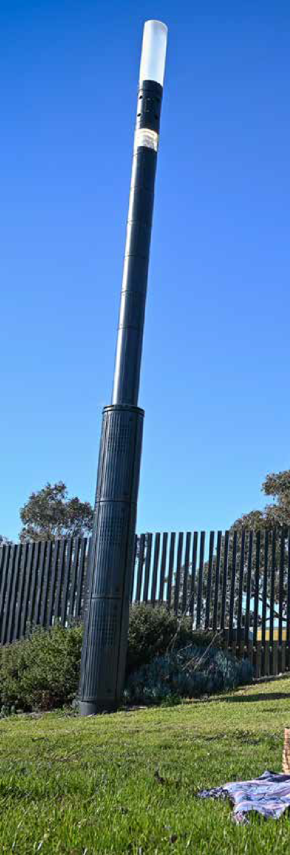
Smart street poles (smart nodes) are being installed throughout the region to replace outdated, cluttered and
disconnected infrastructure.

PROTECTING THE ENVIRONMENT

At the local level, protecting our environment means addressing global challenges, such
as climate change and waste management, while also managing local challenges, such as increasing population growth and threats to local biodiversity.
It is vital that we manage the impacts of population growth, while maintaining what people love about living in this region – both now and into the future. Our
Environment Strategy 2020–30, endorsed by Council in August 2020, is the foundational plan we are using to guide our overall response in this area.
As we have been working to address environmental issues for several decades, we are already performing well in several targeted areas.

SUSTAINABILITY FRAMEWORK OBJECTIVES
  - Acknowledge the changing climate is a global emergency and take appropriate local action.
  - Support the community and the City to reduce carbon emissions and promote active transport.
  - Support the community and the City to reduce waste.
  - Protect our biodiversity and ecosystems through
effective natural resource management.
  - Create cleaner, greener community spaces.
  - Ensure our land-use planning and built
environment reflects sustainable practice.

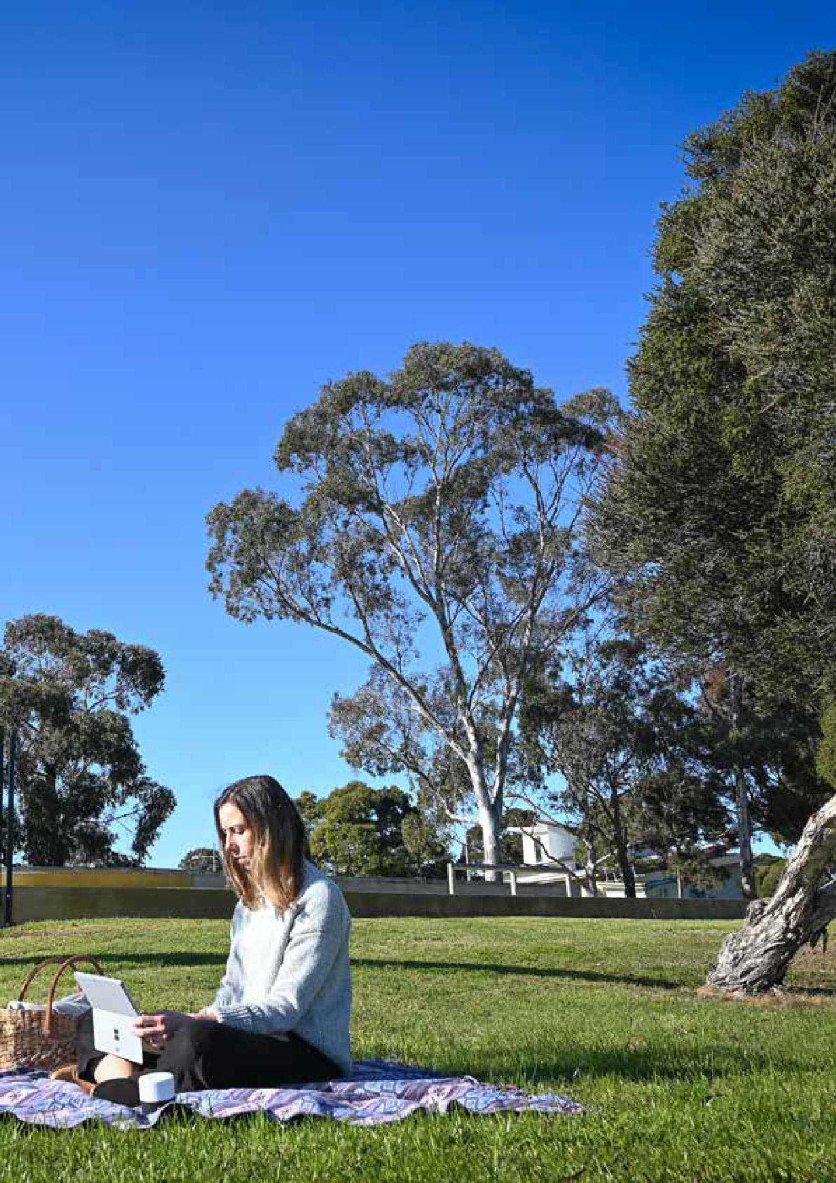

11.

MEASURES OF SUCCESS

TARGETS | DATA | COMMENT | STATUS
All City-managed operations to be carbon neutral by 20251 | 23,057 tonnes CO2-e (2021–22)*  32,630 tonnes CO2-e (2020–21)  34,429 tonnes CO2-e (2019–20) | Our operational CO2-emissions decreased by 29 per cent over the past 12 months. We signed up to the Victorian Energy Collaboration which sources renewable electricity for a number of Victorian councils. This contract came into full effect from 1 July 2021.  We now generate zero emissions through our electricity usage. Annual emissions have also decreased with the capture and use of methane from landfill, building efficiency improvements, and  onsite renewable energy from solar photovoltaic (PV) generation and increasing use of hybrid and low emission vehicles.
 | 40,313 tonnes CO2-e (2018–19)
 | 41,868 tonnes CO2-e (2017–18)
 | 46,619 tonnes CO2-e (2016–17)
 | *Provisional figure as bill estimations will continue to come in over coming months
Achieve net zero community emissions by 20352 | 3,452,000 CO2e (2020–2021)9  3,592,000 CO2e (2019–2020)9 | Our community emissions target was endorsed by Council in November 2021 as part of our Climate Change Response Plan 2021–30.
 | 3,670,000 CO2e (2018–2019)9 | Total community emission have decreased over the  previous three financial years.
50% of journeys to work in the municipality are made by public  transport, walking, or cycling³ | 4.6% journeys (2021)  - 2.0% - public transport  - 2.6% - rode a bike or walked 8.75% journeys (2016)  - 5.3% – public transport  - 3.45% – rode a bike or walked | Method of travel to work relates specifically to the journey to work on the morning of Census Day. The 2021 Census occurred during COVID-19 lockdowns when many occupations were required to work from home if possible, and some industries were closed, so people did not go to work. For this reason, these categories may have increased, with corresponding declines in other methods of travel.
100% of garbage, | 52.96% (2021–22) | While Greater Geelong performed better than the
recyclables and  green organics | 53.87% (2020–21) | statewide average (47.82 per cent) in 2021–22, the  region’s diversion percentage decreased compared to
collected from | 55.73% (2019–20) | the previous financial year.
kerbside bins to be diverted from landfill by 2030† | 54% (2018–19)  55% (2017–18) | While favourable weather conditions have increased green waste tonnages in recent years, this change has been tempered by residents living in new subdivisions,
 | 56.32% (2016–17) | whose smaller lot sizes produce less green waste.
 |  | However, our growing population is also increasing
 |  | our green organics and waste tonnage overall. Green
 |  | organics diverted from landfill is processed into compost
 |  | for use on local farms and reserves.
 |  | Recycling tonnage has decreased due to changes in
 |  | product stream, with newspapers and glass content
 |  | replaced by lighter PET plastic and aluminium containers.
Zero waste to landfill from City office buildings by 2030† | Not yet available | Waste and recycling data from Wurriki Nyal will start being collected from 1 January 2023. The following waste systems have been installed at Wurriki Nyal  - general waste, paper, cardboard, mixed recycling, organics bins, e-waste, batteries, polystyrene.
* CO2-e = metric tonnes carbon dioxide equivalent
† New target

On track Off track Not yet available

TARGETS | DATA | COMMENT | STATUS
Protect and restore an additional 1,000 hectares of natural habitat by 20304 | 1,335.790 ha (2021–22)  1,380.803 ha (2020–21)  1,275.703 ha (2019–20) | There was a decrease of 45 hectares of natural habitat managed by the City in 2021–22. Natural habitat on City land had grown to 1,434.01 hectares, however  we handed over Breamlea Flora and Fauna Reserve (98.22 hectares) to Barwon Coast to manage in April 2022.
 |  | Planning to retain and protect more than 108 ha of additional hectares of natural habitat is underway in the Northern and Western Growth Areas.
20% of all water used | 9.8% (2021–22) | As most of the recycled water is used for agriculture or
in the municipality  is sourced from | 10.2% (2020–21) | horticulture, a higher-than-average rainfall in 2020–21  resulted in less demand for recycled water.
alternative water | 11.0% (2019–20)
sources by 20306 | 10.0% (2018–19)
 | 8.5% (2017–18)
 | 9.4% (2016–17)
20% of all water used by the City is sourced from alternative water sources by 2030† | Not yet available | A means of measuring this indicator is yet to be developed.
Plant one million new trees in Greater Geelong by 20304 | Not yet available | Community feedback to inform the development of the One Million Trees Plan was sought from 9 August – 4 September 2022. In the second stage of consultation, scheduled for early 2023, we will share the draft plan with the community for feedback.
* CO2-e = metric tonnes carbon dioxide equivalent
† New target

On track Off track Not yet available

OBJECTIVE 1.1: ACKNOWLEDGE THE CHANGING CLIMATE IS A

KEY DATA SNAPSHOT
- Community emission sources for 2020–21 include: electricity – 66 per cent; transport – 16 per cent; gas – 9 per cent; waste – 3 per cent; and agriculture – 1 per cent9
- 51 per cent – proportion of respondents very concerned / quite concerned about climate change7
GLOBAL EMERGENCY AND TAKE APPROPRIATE LOCAL ACTION
We all need to do our part to reduce emissions and prepare for climate change, as the region’s exposure to climate risk is increasing. Unless we can urgently reduce emissions to zero and draw down the carbon already in the atmosphere, the climate risks we face will increase.
As an organisation, our aim is to lead the community towards becoming a zero-emissions, climate-change- ready city and region. However, we will only be able to achieve this through a coordinated and collective community response.

Progress of supporting actions

ACTION PROGRESS COMMENT STATUS

    - Recognise, communicate and address the local impacts of the global climate emergency and reconsider the need to declare a local climate emergency.
    - Prepare the 2021–25 Municipal Health and Wellbeing Plan to include the health impacts from climate change and improve the health and wellbeing of our community.
    - Adopt and implement the 2020–30 Environment Strategy to protect our environmental assets and address significant environmental challenges and impacts.
Council adopted the Climate Change Response Plan 2021–30
in November 2021. The plan seeks to improve the region’s response to climate change risks, reduce regional emissions and respond to the global climate emergency.
We integrated our municipal public health and wellbeing plan into Our Community Plan 2021–25. This plan identifies climate
change and its impacts on health as one of the five health and wellbeing priorities we will be focusing on over the next four years.
After adopting the plan in September 2020, we’ve already implemented the following actions:
- developing a climate change response plan
- switching our small and large City-owned buildings over to green power
- adopting the Sparrovale Ngubitj yoorree Wetlands Master Plan
- installing an additional 100kw of solar panels at Leisurelink Aquatic and Recreation Centre
- planning for all new electric (no gas) infrastructure to be powered by renewable energy at Northern Aquatic and Community Hub and North Bellarine Aquatic and Leisure Centre
- partnering with Geelong Sustainability to deliver Sustainable House Day online, All Electric Households program and 100% Clean Bellarine Relectrify Business program
We also established new corporate carbon emissions targets. These are all City-managed operations to be net zero emissions by 2025, and 100 per cent renewable electricity supply used for all City-owned and operated buildings and streetlights by 2025.

Complete

ACTION PROGRESS COMMENT STATUS

    - Adopt and implement a Climate Change Response Plan that consolidates and renews the City’s adaptation and mitigation programs. This plan will replace the Climate Change Adaptation Strategy
and outline our climate risks and adaptation actions.
    - Monitor the risks brought by climate change and its effects to the Greater Geelong region.
Council adopted the Climate Change Response Plan 2021–30
in November 2021. The plan provides a roadmap for the City to support the region to reduce emissions (mitigation), minimise climate change impacts (adaptation), and facilitate new opportunities and partnerships with community that will address the global climate emergency. A key feature of the plan is a new target of net zero community emissions by 2035.

Our Climate Change Response Plan 2021–30 is intended to guide our climate response until 2030, however it will be
reviewed in 2024. This review will help us reflect on priorities, review progress towards targets and take advantage of newly identified opportunities.
We have implemented a program to monitor climate change risk in partnership with Deakin University, G21 councils & specialist consultants. This includes monitoring of climate change coastal impacts, freshwater hydrology and urban heat island effects.

Other achievements
  - We took our commitment to climate-change action to a global level, by joining 17 other Australian councils in the United Nations’ Cities Race to Zero Climate Action Campaign. This involved signing a pledge recognising a global climate emergency, agreeing to achieve net zero emissions by 2050 and committing to reporting annually on the actions that the City is taking to reduce and adapt to the impacts of climate change.
  - We established the Climate Partnership Grants for co-designed, community led projects and activities that support the community to achieve net zero community emissions and increase resilience to climate change impacts. The inaugural round of grants with a total pool of $100,000 opened June 2022 with two projects securing funding: Geelong Sustainability All Electric Households program and 100% Clean Bellarine Relectrify Business program.
  - We supported 14 applications in the first round of the Environmental Sustainability Community Grant Program with projects which included water tank installation, community waste education and energy efficiency audits.
  - We completed the Dell Eco Reef at Clifton Springs with innovative 3D printed reef module technology, to assist in reducing erosion and future impacts of sea level rise.

Challenges
- Climate change is not solely an environmental issue. It has implications for every aspect of how we live
- our social systems, economic systems and the natural systems upon which we all depend. We need to act quickly, decisively and collaboratively to make a difference.
- A municipal response to climate change requires both collective and individual action at all levels. The
Climate Change Response Plan 2021–30 sets out the City’s role in reducing emissions and managing the impacts of climate change and the role of business, community organisations and residents. Challenges to action include a lack of resources, the significance of the task ahead and widely diverging views in the community about the need for action on climate change.

Next steps
- We need to continue to provide leadership and increased support for collaborative, municipal wide action to reduce carbon emissions, better resource recovery mechanisms, protecting and restoring our natural environment and building resilience to climate impacts such as temperature rise, sea level rise and extreme weather events.
- We must work actively with our partners to pursue public and private sector resourcing and funding for the actions contained within the Climate Change Response Plan 2021–30 that require additional resources.

Complete

OBJECTIVE 1.2: SUPPORT THE COMMUNITY AND THE CITY TO REDUCE CARBON EMISSIONS AND PROMOTE ACTIVE TRANSPORT
With a growing population and expanding areas of urban development, emissions from transport are expected

KEY DATA SNAPSHOT
- 19 per cent – contribution of transport to total community emissions (2019–20)9
- 0.03 million trips – total number of trips by public transport originating within Geelong Local Government Area on an average weekday in 2018 (3.83% of all trips)10
- 62.6 per cent – percentage of people who travelled to work in a private car on Census Day 2021 in the City of Greater Geelong. A further 2.0 per cent took public transport, 2.6 per cent rode a bike or walked and 18.7 per cent worked at home (Census occurred during COVID-19 lockdowns for large parts of Australia)³
to increase unless we make significant changes to our
transport systems.
To reduce our current transport emissions footprint, we must change the way we move around our communities. It will take significant commitment and investment from a range of different stakeholders for us to identify, develop and creative viable alternatives. This includes planning neighbourhoods to further support this outcome.
While active transport is used for only a small percentage of journeys to work currently, our aim is to increase this to 50 per cent.

Progress of supporting actions
ACTION PROGRESS COMMENT STATUS

    - Renew and implement the City’s Zero Carbon Emission Strategy to inform the Climate Change Response Plan and prepare a
roadmap for the region to become zero carbon by 2047.

    - Adopt an Integrated Transport Strategy for better integration between modes of transport and support sustainable transport choices.
    - Deliver the Better Bike Connections Project to encourage active transport and reduce emissions.

    - Implement the Shared Trails Master Plan to encourage active transport and reduce emissions.
We consolidated our Zero Carbon Emissions Strategy 2017–2020, Community Zero Carbon Action Plan and Climate Change
Adaptation Strategy as part of the newly developed Climate Change Response Plan 2021–30.
As part of the new plan, we have brought forward the zero emissions target to 2035.
We delayed the development of an Integrated Transport Plan pending project resources.

We completed construction works for Stage 1 of the Southern Link from Malop Street to the Barwon River. In addition, Council approved the tender process for Stage 2 in March 2022 with detailed design continuing. Across April/May, we engaged with more than 260 people on the completed sections and Stage 2. Council will consider the Stage 2 tender award later in 2022. The Building Better Bike Connections project provides routes that are designed to be used by cyclists of a wide range of ages and abilities to safely ride to destinations like shopping areas and key employment precincts.
We delivered three major shared trail projects in East Geelong, Corio and Barwon Heads to improve connections and access for our community. We also completed feasibility studies for the four Shared Trails Masterplan priority connections: Ocean Grove to Point Lonsdale, Ocean Grove to Drysdale, Drysdale to Portarlington,
and Lara to You Yangs. The results of the feasibility work and project updates were provided to Councillor Shared Trails Portfolio
Committee in June 2022.

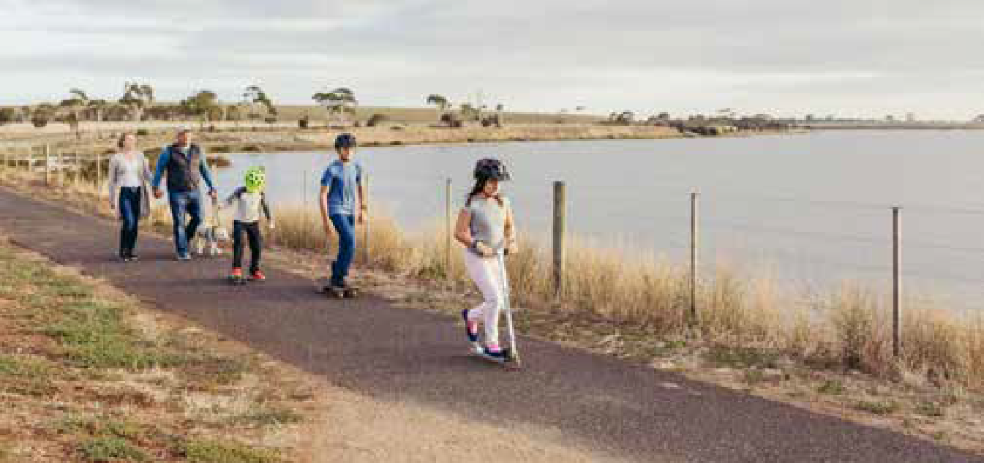

Other achievements
  - Since 2021, bike paths increased 6 km, shared paths increased 12 km and footpaths increased 27 km, a total increase of 45 km in the path network.
  - We provided funding to the Geelong Sustainability Group’s 100% Electric Vehicle project which aims to enable people to experience zero emissions driving and discover the environmental/health benefits.
  - We completed Stage 1 of the upgrade to LED street lighting with the changeover of approximately 13,000 residential streetlights and installation of 130 new lights. We commenced Stage 2, the street light changeover on roads with higher traffic volumes (main roads) in June 2022 with completion expected by February 2023. The changeover will reduce energy consumption and save more than 8,000 tonnes of carbon emissions each year as well as making our streets and public spaces safer through higher quality and better directed lighting.
  - We installed electric vehicle charging stations at our Corio, Belmont and Drysdale Depots to support our transition to a zero-emission light vehicle fleet.
  - We secured $120,000 funding from the Australian Renewable Energy Agency to install electric vehicle charging stations at North Bellarine Aquatic Centre and and Leisurelink Aquatic and Recreation Centre.
  - We converted gas from the Drysdale landfill into electricity equivalent to powering 1,500 homes each year.
  - We are transitioning the City’s light fleet vehicles to zero emissions by 2027 and have added to our existing EV vehicles with an additional order of 30 new EV passenger vehicles in 2022–23.

Challenges
- Transport is expected to remain a significant source of emissions for the foreseeable future given the region’s strong car dependence, expanding urban footprint and the lack of, or convenient public transport for many population centres.
- Our opportunity to influence transport is limited to supporting a community transition to zero emission transport modes, supporting locally sources goods and services, improving active travel routes and advocating for better public transport.
- Existing transport data sources, such as the ongoing Victorian Integrated Survey of Travel and Activity and the ABS Journey to Work data, come out with limited frequency, making it hard to detect whether network changes are having a positive impact to travel behaviour.
- Our public transport network is in need of major investment to encourage people to make more sustainable travel choices, improving the liveability and economic competitiveness of our region.

Next steps
- Engage with key stakeholders in the development of the draft Integrated Transport Plan to improve integration of all modes of transport, including active transport.
- Continue to advocate to state and federal government for improved public transport, active travel networks and infrastructure.

OBJECTIVE 1.3: SUPPORT THE COMMUNITY AND THE CITY TO REDUCE WASTE
Our local community is projected to generate 58,000 tonnes of household waste by 2026.4

KEY DATA SNAPSHOT
- $18.6 million – total expenditure on diverting
waste from landfill8
- 34 per cent – proportion of food waste material in the average Geelong household’s rubbish bin4
- 57,414 tonnes – residual waste we collected
and sent to landfill in 2021–20228
- 1,470 – number of public place bins maintained by the City8
As an organisation, managing waste and resource recovery is our core business. However, we are only one player in a complex system. As such, a lot of what shapes our waste management is determined by forces outside our control.
In April 2020, Council adopted the Waste and Resource Recovery Strategy 2020–30, which sets a vision designed to help the Greater Geelong community to manage waste and resources in a way that minimises impacts on the environment, in particular by establishing a circular economy. It also sets the goals, actions and targets we need to help us get there.

Progress of supporting actions
ACTION PROGRESS COMMENT STATUS

    - Implement the City’s Waste and Resource Recovery Strategy 2020– 30 to reduce waste and encourage reuse and recycling.

    - Introduce waste-wise programs to reduce office waste and support recycling habits for the City’s worksites.

    - Reduce paper usage and storage of unused items through the Clever Together Project: a two-pronged approach including the physical removal of paper and junk items, and the introduction of technology.

    - Continue to work with Sustainability Victoria and advocate to state government for a Container Deposit Scheme and other end-use solutions.
Key actions we implemented include:
- commencing a household food organic collection trial in Lara (started in November 2021)
- partnering with Barwon Water, G21 councils and Wyndham City Council to develop a regional organics processing facility
- securing funding from the state government to plan for a regional Waste and Resource Recovery Hub and transfer station
- implemented modern cloth nappy program for residents
- established two food organics composting units at our organic processing centre.
We were unable to roll-out planned initiatives due to COVID-19 restrictions, which have impacted this program. The move to Wurriki
Nyal mid-2022 will provide an opportunity to progress actions to meet this target. When operational the building will perform to a NABERS 6-star waste rating. This is the highest rating that supports diverting 74 percent of waste from landfill.
We continued to prepare for the move to the City’s new civic precinct Wurriki Nyal, with planning complete and infrastructure in place to enable reduction in storage, paper, stationery and more. An example of this was repurposing Christmas decorations for use by the local neighbourhood houses and establishing an organisation- wide stationary swap to encourage better inter-department sharing of excess stationary.
We continued to liaise with Sustainability Victoria and the new
Recycling Victoria when they come into effect 1 July 2022. We provided feedback on the guidelines of the proposed container deposit scheme, which will encourage the community to collect and return empty containers to a network of refund points instead of
sending them to general waste.

Other achievements
  - We were finalists in the Waste and Litter category of the Premier's Sustainability Awards 2022 for intensive bin inspection program to cut contamination in kerbside recycling bins.
  - We continued the trial household food organics collection which commenced in Lara on 5 November 2021. The trial, which will run for 12 months, aims to reduce the amount of food waste going to landfill and helping to reduce greenhouse gas emissions, odour, and leachate production. After evaluating the trial, we aim to roll out the service municipal-wide in 2024. The trial is collecting 3.6 tonnes of food waste each week, this equates to 4.2kg per participating household. Between November 2021 and June 2022, 125 tonnes were collected and diverted from landfill⁸.
  - We trialled the use of recycled building materials, tyres and plastics in road construction projects including at Maple Place, Waurn Ponds where 366 tonnes of fine crushed rock were reused and 150,000 plastic bags were diverted from landfill.
  - We launched a home composting program in March 2022, providing subsidised compost bins and worm farms through our project partner, Wormlovers, as well as a free online home composting workshop. This program will help divert food waste from going to landfill and compliments our food organics collection trial being run in Lara.
  - We sold approximately 6,900 tonnes of high-quality compost processed from food and garden organics material to commercial outlets.
  - We are a funding partner of the Caring for Our Bays program, implemented by the Bellarine Catchment Network. The program aims to lift the profile and appreciation of Corio Bay and the Bellarine shoreline of Port Phillip Bay, raising awareness of litter and its impact, and reducing the amount of litter that enters the waterways.
  - Disposable nappies account for eight per cent of Geelong’s total household rubbish. To help raise awareness and divert waste from landfill, the Modern Cloth Reusable Nappies Program was run between March and April 2022. Nine workshops were run under the program with 350 people attending. Participants received a free reusable nappy pack to help save money and reduce waste going to landfill.
  - We have increased compliance monitoring of the construction industry’s management of waste on building sites by proactively patrolling development areas, with a focus on managing loose Styrofoam (waffle pods), littering and non-compliance. The City is the first municipality in the state to secure the ability to issue infringements for breaches under the new Environment Protection Act, which provides

more enforcement opportunities and has increased the value of the fines it has been able to issue for breaches.
- We launched a compliance campaign and worked with developers to prevent waste from escaping building sites.

Challenges
- Our growing population will increase the quantity of household waste, putting pressure on our existing services and waste infrastructure. Reducing the amount of waste our community generates will require significant and sustained behaviour change by governments, businesses and households working together.
- Even with a well-functioning circular economy, where resource recovery is at its highest level, we will continue to generate waste. This will include products that cannot, or should not, be recycled or reused for public health or other reasons (for example, clinical waste and asbestos).

Next steps
- The food organics trial in Lara has been extended to 30 June 2023. This will enable the collection of additional data and the installation of infrastructure prior to the rollout of a municipal wide service anticipated to begin in 2025.
- The food organics trial has also been extended to the City’s new headquarters Wurriki Nyal prior to the future rollout to community facilities such as libraries.
- We will continue to work with key partners to improve
regional infrastructure to divert material from landfill.

OBJECTIVE 1.4: PROTECT OUR BIODIVERSITY AND ECOSYSTEMS THROUGH EFFECTIVE NATURAL RESOURCE MANAGEMENT
As a significant land manager in the region, and the responsible authority for administering the Greater Geelong Planning Scheme, we are directly responsible for protecting natural species and habitats, controlling pest plants and animals, and supporting biodiversity in public reserves, waterways, and streetscapes. We also have a role to play in educating, supporting, and partnering with our community and other land managers to protect and enhance our region’s biodiversity.
KEY DATA SNAPSHOT
- 133 kilometres of coastline, indigenous vegetation and flora and fauna of state, federal and international significance4
- 100+ – the number of City-managed nature reserves4
- 678,777kl – the City’s potable water use for 2021–226
- 3,124kl – the City’s recycled water use (Class A) for 2021–226
In 2021–22, we were the second biggest user of water (recycled and potable) supplied by Barwon Water.¹¹ Our region is growing and long-term trends pointing
to a hotter, drier climate with less rainfall predicted for catchments and reservoirs. As a first step in addressing this whole-of-community challenge, we have committed our organisation to a target of sourcing 20 per cent of all water from alternative water sources by 2030.

Progress of supporting actions

ACTION PROGRESS COMMENT STATUS

    - Review and update the City’s Biodiversity Strategy to protect and enhance our network of conservation reserves and indigenous plants.
    - Protect internationally important wetlands through the continued implementation of the Sparrovale Wetlands Master Plan.
We continued to prepare the State of Nature report to inform our new biodiversity strategy and provide benchmark information to enable changes to be assessed over time. Expected completion date for the biodiversity strategy is late 2023.

Council adopted the Sparrovale Ngubitj yoorree Wetlands Master Plan at the July 2021 Council meeting. This plan outlines improvements in drainage infrastructure, natural environmental and recreational facilities over the next
20 years. We commenced implementation of master plan actions including:

- small scale revegetation
- shed asbestos check and structural assessment
- completion of levee condition assessment and maintenance manual
- drafted a Fire Preparedness Plan
- weed management
- rubbish removal
- community guided tours
- monitoring and surveys of birds, native vegetation offset sites, automated water levels and salinity.

    - Implement the Stormwater Services Strategy 2020–30 to guide investment in
stormwater management based on community values and objectives.
Council endorsed our Stormwater Services Strategy 2020–30 in June 2020 and actions are advancing.
As part of this strategy, we worked in partnership with Barwon Water to help progress Regional Integrated Water Management projects.
We have reviewed the Flood Management Plan 2013 and the Stormwater Quality Plan 2015, which will be replaced by the Flood Management Plan 2021, the Waterways Management Strategy 2021, and the Integrated Water Management Plan 2023 shortly.
Flood management studies for Ocean Grove, Hovells Creek and Cowies Creek catchments commenced to inform growth area planning and future improvement projects in these areas.

ACTION PROGRESS COMMENT STATUS

    - Deliver a regional Integrated Water Management Strategy with key stakeholders including Barwon Water and Corangamite Catchment Management Authority.
We are working with the Department Environment, Land, Water and Planning
(DELWP) to finalise the Integrated Water Management Collaboration Framework with an expected completion of October 2022. Following the commencement of temporary position in January 2022, work began on the delivery of a stakeholder meeting to move forward the Collaboration
Framework. We recognise that to successfully continue this work beyond the current DELWP funding arrangement, we need to further advocate for the temporary position to become a permanent position beyond 2022.

Other achievements
  - We were finalists in the Thriving Environment category of the Premier's Sustainability Awards 2022 for revitalising the Sparrovale-Nubitj yoorree Reserve.
  - We commenced construction of a new treatment wetland in the Lara Lakelands Reserve. The new wetland will improve the water quality of urban stormwater before it enters the existing wetland and travels further downstream into the Hovells Creek system, delivering a healthier wetland and waterway ecosystem for a range of birdlife.
  - We provided funding to the Koala Clancy Foundation to support the transformation of a bare 10-hectare paddock in Balliang into a Grey Box woodland, creating a climate change-refuge to help protect threatened koalas, birds and flying foxes.
  - Our Restoring Rural Landscapes Program continued to provide direction for our pest plant and animal control programs on City managed reserves and roadsides. Some highlights include:
› rabbit control activities on 19 reserves and two roadsides where extreme rabbit activity was present, to protect the significant native vegetation
› expanding the roadside serrated tussock control to inspect and treat over 295 roadsides and the woody weed control program to inspect and treat over 333 roads.
  - We sought community feedback on the draft master plan for the Blue Waters Lake Reserve in Ocean Grove which aims to protect the reserve’s ecological and cultural values and further public use of the area.
  - We assessed over 700 development applications and ensured native vegetation was enhanced and protected and impacts were minimised and offset.
  - In October 2021, we held our fourth Aussie Backyard Bird Count with Birdlife and our community. Over 960 people completed the count in 2021 up from

550 people in our first year, and an increase of last year’s 900 people. Over 75,838 individual birds were counted, with 199 different bird species observed, an increase of 18 species observed from last year.

Challenges
- Our native vegetation, habitat and biodiversity are under extreme pressure from threats associated with climate change, pest plants and animals, population growth and changes to land use in both rural and urban areas.
- Aside from some large areas secured in conservation reserves, such as the Ramsar Wetlands and coastal reserves, most biodiversity sites that provide habitat for wildlife are small, fragmented and isolated.
- We do not currently have an established methodology that can help us track alternative water sources as a percentage of the total water we use.

Next steps
- We are working with key stakeholders including Barwon Water and Department Environment, Land, Water and Planning (DELWP) to deliver a regional Integrated Water Management Plan by June 2023.
- Our Stormwater Services Strategy 2020–30 and supporting plans will help shape broader regional aspirations.
- We will continue to seek community feedback to inform the development of the new biodiversity strategy, Plan for Nature.
- We are preparing the Northern and Western Geelong Growth Areas Biodiversity Conservation Strategy and Strategic Assessment under the Environment Protection and Biodiversity Conservation Act.

Off track

OBJECTIVE 1.5: CREATE CLEANER, GREENER COMMUNITY SPACES

KEY DATA SNAPSHOT
- 156,393 - number of street and park trees maintained in 2021–228
- 14 per cent – the current suburban tree canopy cover8
- 2,459 ha, 495 sites – size and number of open space sites managed (January 2022)8
- Top ten vulnerable suburbs impacted by heatwaves in 2020 include Wandana Heights, St Albans Park, Marshall, Point Lonsdale, Newcomb, Barwon Heads, Highton, Clifton Springs, Portarlington and Whittington12
Without a determined effort, our increasingly urbanised spaces have the potential to become hot, dry, and barren landscapes at greater risk of the urban heat island effect.
To combat this, we need to establish more green urban community spaces and nature-based green-blue
infrastructure solutions. This sort of infrastructure refers to natural and built assets within urban landscapes which are living (green) – such as trees, gardens, nature strips, parks and open spaces – or which manage water
(blue) – such as stormwater, drains, wetlands, ponds and waterways.

Progress of supporting actions
ACTION PROGRESS COMMENT STATUS

    - Plant more trees
through the Urban Forest Strategy and create opportunities for community planting.

    - Establish more
nature-based infrastructure that increases urban amenity, reduces urban heat and connects people to nature.
In 2021–22 we planted a total of 2,522 trees (1,877 street and 645 park trees) and removed 2,209 resulting in a net gain of 313 trees. We also planted 4,000 tubestock along the Ted Wilson Trail.
We collaborated with the Rotary Club, Ocean Grove to plant 100 trees to commemorate 100 years of Rotary. As these trees grow and mature over the next five to 15 years, they will provide canopy cover and shade.
The trees will form the future of Geelong’s Urban Forest, shading our streets and parks, cooling and beautifying our municipality and encouraging people to be more active.
We undertook work to establishing nature-based infrastructure to address coastal erosion and remediate landslides, while maintaining and improving
coastal amenity including:
- working at Ramblers Foreshore to address erosion by applying integrated nature-based solutions
- installation of an artificial reef at The Dell, Clifton Springs
- significant landslide remediation along the Clifton Springs coast and
Eastern Park near the Limeburners Point Boat Harbour
We also delivered a new nature-based playground at Goldsworthy Reserve in Corio and adopted the Sparrovale Ngubitj yoorree Wetlands Master Plan, a 20- year plan to open a large new wetlands park for nature-based activities.

Other achievements
  - We shared data on the more than 165,000 trees we manage in our parks, reserves and streets via the new Urban Forest Dashboard. The dashboard features a map of Greater Geelong that allows the
user to zoom in on any city-managed tree to view its species, age, health and size.
  - We facilitated the development of 33 hectares of new public open space reserves across 30 sites within new subdivisions and including new play spaces at Anchorage and the Grange Estates in Armstrong Creek and an upgrade of Drewan Park in Wandana Heights.
  - We commenced further restoration works on the former South Geelong Landfill, following the Council’s adoption of a landscape plan for a key area of the site in October 2021. The project will focus on developing stormwater capture and storage capacity and revegetating the site.
  - We sought community feedback on our One Million Trees Plan, which aims to create a sustainable, liveable, more resilient Geelong by planting more trees over the next 10+ years.
  - We delivered several playground upgrades as part of a $559,722 Playground Development Program.
  - We commenced analysis of the City’s open space network.

Challenges
  - As our municipality becomes more urbanised, the environment will become dominated by hard surfaces – roads, footpaths, gutters, buildings and roofs. These surfaces absorb heat, contributing to the urban heat island effect, and repelling water, which has implications for our stormwater systems.
  - Although we’ve increased our street and park planting programs, we are not anticipating an increase in urban tree canopy for the next 10 years. This is partially due to the time it takes for plants to mature, but also because of rapid urban growth. As urban
tree canopy includes public and private land, bigger houses on smaller blocks limit space to retain and plant canopy trees on private land. We’re working with the community and developers to address this. Additionally, we need to investigate the need for increased protection of significant privately owned trees in the landscape.

Next steps
- We will increase the use of landscape planning permit conditions to achieve community space greening outcomes.
- We have completed updating urban heat vulnerability assessments to inform priority community space greening projects. These assessments will be used to assist in the development of an urban ecology plan to increase the amenity of our community spaces and reduce urban heat risk.
- We will continue the planning and delivery of our One Million Trees Project with community engagement commencing in August 2022.
- We will update our existing Open Space Strategy to establish goals that will enhance our community reserves.
- We completed an initial economic business case to further investigate the concept of Geelong as a biophilic city. Deakin University will provide
recommendations to inform a report for consideration by council prior to community engagement in 2023.
- We are proactively seeking out opportunities to partner with research agencies to identify effective mitigation and adaptation strategies (e.g greening of schools and urban spaces with Institute for Physical Activity and Nutrition Deakin University and the Australian Research Council).

OBJECTIVE 1.6: ENSURE OUR LAND USE PLANNING AND BUILT ENVIRONMENT REFLECTS SUSTAINABLE PRACTICE
As Victoria’s second largest city, Geelong’s proximity to Melbourne, its strong employment growth, affordable housing, and balanced lifestyle, has seen the population grow from 239,529 to 270,776 people over the last five years.13 Managing population growth, while maintaining what people love about living in this region, will be an ongoing challenge for our organisation.

KEY DATA SNAPSHOT
- 396,388 – forecast population of Greater Geelong in 204114
- 177,550- the forecast number of dwellings in City of Greater Geelong in 2041, up from 120,587 in 202114
- 1,716 – number of planning permit applications received 2021–228
- 21 per cent – new housing construction conducted within existing urban areas of Geelong37
Environmentally Sustainable Design plans is one way we will continue to address this challenge, alongside setting best-practice standards for new buildings, renovations and retrofitting, and maintenance and minor works. The other key to managing population growth will be maintaining a settlement boundary that preserves key environmental features, such as green breaks and landscapes between towns.

Progress of supporting actions
ACTION PROGRESS COMMENT STATUS

    - Develop best practice
Environmentally Sustainable Design Action Plans for all precincts within the Northern and Western Growth Areas.

    - Set best practice standards in the City’s Sustainable Building Policy for new buildings, renovations and retrofitting and maintenance and minor works.
    - Continue to implement the 20- year Settlement Strategy so housing supply meets the needs of the growing population within settlement boundaries.
    - Monitor the implementation of the Environmentally Sustainable
Design policy for new developments and strengthen the breadth of the application of the policy over time.
    - Ensure areas identified for
more intensive housing development deliver best practice Environmentally Sustainable Design (ESD) principles and vibrant neighbourhoods.
We commissioned Deakin University to develop best practice Environmentally Sustainable Design Action Plans for the
first two precincts in the Northern and Western Geelong Growth Areas. We completed consultation on the sustainable development initiatives with landowners and government agencies in June 2022.
We reviewed our Sustainable Building Policy, and the final draft is going to the Policy Review Committee meeting in July/August 2022.

The Settlement Strategy was included in the Greater Geelong Planning Scheme in May 2021. Consultation on the long-term boundary has been completed.

We completed 455 Environmentally Sustainable Design (ESD) referrals in the 2021–22 financial year. In June 2022, Council authorised the City to enter into Stage 2 of the Elevating the ESD Targets planning project.

We joined the Council Alliance for Sustainable Built Environment and other Victorian councils on a joint research project that aims to elevate ESD targets for new development in areas such as energy, water and urban greening. Council has committed to proceed to the planning scheme amendment stage with other councils via the Municipal Association of Victoria to strengthen our Environmentally Sustainable Design standards.

On track

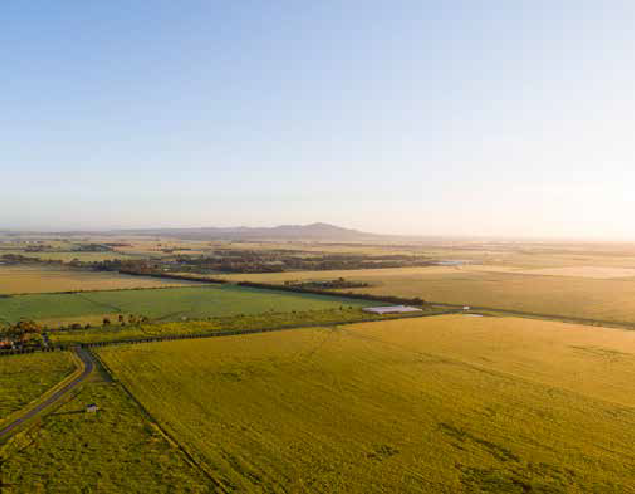

Managing population growth, while maintaining what people love about living in this region, will be an ongoing challenge for our organisation.

Other achievements
  - Council voted to join stage two of the Elevating Environmentally Sustainable Development (ESD) Targets planning policy project.
  - In 2021–22, our environmental planning team undertook 794 environmental planning referral assessments and our waste services team assessed over 200 referrals. These assessments provided clear input into avoiding and minimising environmental impacts during development and/or land use change and required environmental improvements in many instances including waterway restoration and creation of new conservation reserves⁸.
  - We also undertook 455 Ecological Sustainable Development (ESD) planning assessments for new developments ensuring a range of buildings in Geelong are built to high sustainability standards including reduced emissions, water use and increased urban greening outcomes8.

Challenges
- It will be critical that the new developments being built to accommodate the growing population are designed as efficiently as possible to reduce climate change impacts, including emissions reduction and water efficiency.
- Statewide standards for buildings and subdivision design limit the opportunity for us to create regulations for performance of a higher standard.

Next steps
- We will improve and expand on existing Environmentally Sustainable Design planning controls.
- We will continue to work with the state government to translate findings from the Deakin University research from the Digital Twin and Environmentally Sustainable Design action plans into the first precinct structure plans.
- We will use community feedback to inform the finalisation of a long-term settlement boundary for urban Geelong.

SPOTLIGHT ON SUSTAINABLE DESIGN IN PLANNING

The Dell Beach is at Clifton Springs on the Bellarine Peninsula approximately 20km east of Geelong.
The Dell is an amphitheatre formed by a historic landslide and is a popular destination for the local community and visitors to the region for walking, picnicking, swimming and beach play.
Swirling currents and shifting sands have forced us to work hard to minimise coastal erosion, maintain safe access to the beach and stabilise the towering cliffs. The Dell wave attenuator project consists of a series of modular reef units that are placed together to form a permeable barrier designed to reduce the height and energy of waves.
Forty-six sculptural wave units help shellfish restoration by creating an artificial reef, allowing oysters, mussels and other native species to thrive.
Beachgoers and local school groups will be able to wade
around the Dell Eco Reef when it sits above the water line at low tide, or snorkel among the marine life at high tide.
Designed and manufactured by Alex Goad from Reef Design Lab, the undulating units also provide a much- needed wave break, reducing wave energy and sand erosion. The curved nature of the modules provides shallow overhangs with no sharp edges that could lead to injury. They have safe aperture sizes that minimise the possibility of arms or legs becoming wedged.
The modules provide structural habitat and opportunities for a variety of marine communities to colonise.
This is the second artificial reef the City has established, the former being the Ramblers Foreshore Reef, which has performed above and beyond expectations with the beach being stabilised and beach broadened by over 40 metres.

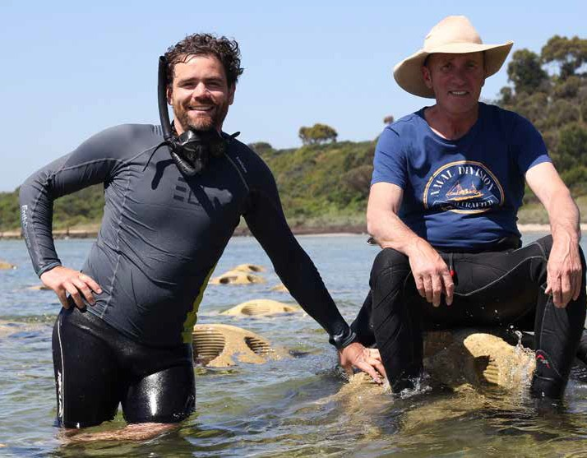
Alex Goad, Designer/ fabricator (L) and Ralph Roob Senior Environmental
Engineer (R) on Reef module

26. SUSTAINABILITY PERFORMANCE REPORT | 2022

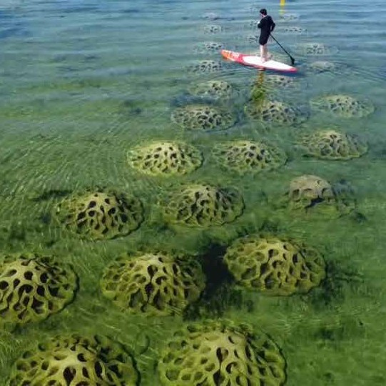

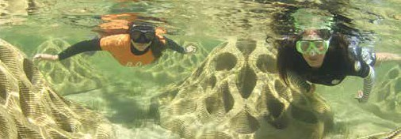

27.

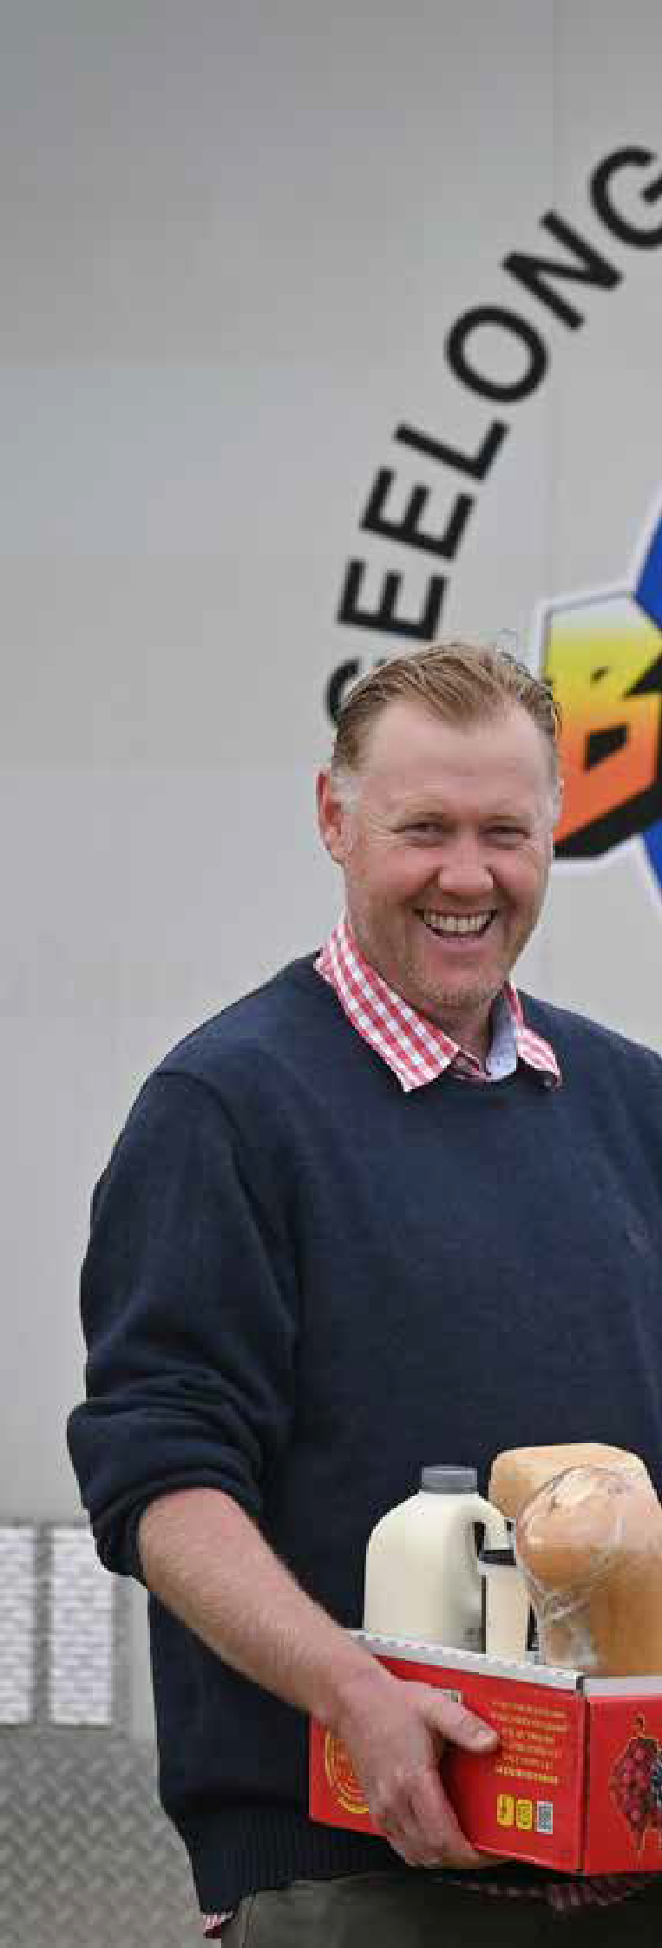
Co-Founder of Bay Leaf Community Kitchen, Martin Rowan with Volunteer Coordinator
Helen Lazzaro.

COMMUNITY
WELLBEING AND SOCIAL EQUITY

A healthy community is one where everyone has the opportunity to experience their best possible health and wellbeing.
There are many factors that influence community wellbeing including employment, income, gender, race/ ethnicity, Aboriginality, access to nutritious food, services, facilities and transport, education, housing, and freedom from violence and discrimination. Given the significant challenges our community has experienced throughout the COVID-19 pandemic, it is more important than
ever that we focus on creating an environment where everyone feels supported, welcome and valued for their unique contribution.
Social sustainability is about expanding opportunities to create a more inclusive community, empowering community members and fostering a more resilient and prosperous society. It cannot be achieved without
addressing equity, a concept based on human rights and fairness that involves recognising the different needs, life experiences, levels of power and access to decision making of all people and seeking new ways to rectify imbalances, creating equitable outcomes for all.

SUSTAINABILITY FRAMEWORK OBJECTIVES
  - Lead and support education for business and community to encourage sustainable practice
  - Encourage and support local, sustainable food production
  - Ensure equitable access and inclusion to City services and facilities
  - Work with others to achieve sustainable outcomes for our community
  - Harness community knowledge to drive sustainable change

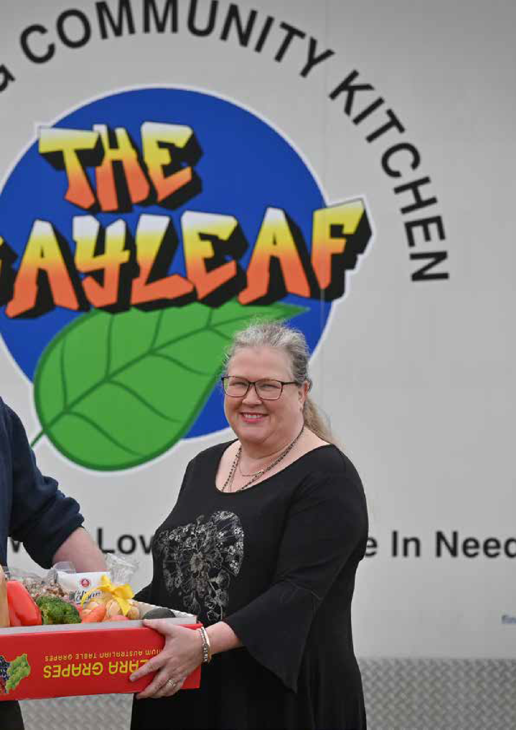

›

29.

MEASURES OF SUCCESS

TARGETS | DATA | COMMENT | STATUS
Over 50 per cent of residents reporting their health as very good or excellent7 | 54% (2021)  59% (2017) | Less of our adult community is self-rating their health as very good or excellent than in 2017. However, this result is still higher than the last reported Victorian average (39 per cent).16
95 per cent of residents | 61% (2021) | The proportion of residents who always feel safe in the area
agree that they feel  safe in the area where | 54% (2017) | they live increased 7 points.7
they live15
Australian Digital | 69 (2021) | The Australian Digital Inclusion Index uses survey data to
Inclusion Index (ADII)  score greater than 7015 | 63 (2020) | measure digital inclusion across three dimensions of Access,  Affordability and Digital Ability. In comparison. the Victorian
 | 67.2 (2019) | state average ADII score in 2021 was 72 and the national
 | 60.3 (2018) | average 71.1.
 | 58.7 (2017) | Note: 2021 and 2020 ADII results are not directly comparable  to previously reported Index results due to updated data
 |  | collection methodology.
 |  | As the sample size < 150, it is recommended to exercise
 |  | caution in interpretation.
Increase the supply of social housing from the current 3 per cent to 7 per cent by 2031; and 10 per cent by 20413 | 3.1% (2021)  3.6% (2016) | While the supply of social housing in Greater Geelong in 2016 was 3.6 per cent, implementation of the Social Housing Plan 2020–41 commenced in 2021.  The share of social housing in the community is not keeping pace with the overall growth in dwellings.
Greater Geelong’s workforce participation rate is higher than the Victorian average3 | 1.7 points below the state average (2021)  2.6 points below the state average (2016) | Greater Geelong workforce participation rate is 60.7 per cent. The Victorian average is 62.4 per cent.
No Greater Geelong | 13 Greater Geelong | An update is pending the Australian Bureau of Statistics
suburbs in the bottom | state suburbs are in the | Census of Population and Housing 2021 results which will be
20 per cent of the | bottom 20 per cent of the | released in stages from June 2022 to mid–2023.
Socio-Economic | Index of Relative Socio-
Indexes for Areas | economic Disadvantage
(SEIFA)³ | (2016)

On track Off track Only baseline data available

OBJECTIVE 2.1: LEAD AND SUPPORT EDUCATION FOR BUSINESS AND COMMUNITY TO ENCOURAGE SUSTAINABLE PRACTICE
When considering how to address some of the more significant sustainability challenges of our time, there is only so much any individual, group and organisation acting alone can achieve. To make a lasting and significant impact, we need collective action, as well as individual responses, at all scales.

KEY DATA SNAPSHOT
69 – index score for perceived importance of business and community development18

Progress of supporting actions
ACTION PROGRESS COMMENT STATUS

    - Use the City’s
exhibitions, art, collections and programs to educate and inspire the community to live more sustainably.

    - Lead the transition
to a green economy with tailored support for local businesses and community with a focus on supporting innovation.
We funded the Nature Stewards program, run by Outdoors Victoria in Geelong, to educate people with an interest in the environment and encourage them to become volunteers. The Greater Geelong program now has 59 alumni.
We also promoted our switch to renewable energy power supply to residents, supported community groups to promote the use of electric vehicles and install rooftop solar, and continued our community waste and recycling education activities.
The Potato Shed presented Journey on Wadawurrung Country, an exhibition to build stronger awareness of cultural knowledge, heritage and respect for country and Wadawurrung Traditional Owners.
We implemented the following actions:
- funded four Cleantech demonstration projects (Capricorn Power, Deakin University, Focus Pty Ltd and Geelong Sustainability Group Inc) which addressed stockpiled landfill, household energy use, community solar production and renewable energy
- implemented procurement for innovation training for City employees
- provided grants for product development projects
- funding for Regional Innovation for a Circular Economy (RICE) to subsidise local businesses participation in a Circular Economy Business Growth Program, delivered by Runway
- provision of eight Geelong start-ups with access to a mentoring program
- research into a self-funding model and establishing Geelong as a Cleantech Centre of Excellence
- development of an e-learning training course, so practitioners in other organisations can learn how to apply the Procurement for Innovation method
- commenced a second Procurement for Innovation project for the design and construction of surface level road infrastructure products that adhere to circular economy principles.

On track Complete

Other achievements
  - We provided funding to support Geelong Sustainability to deliver a series of showcase events to educate our community about circular economy principles and inspire them to adopt new behaviours.
  - We continue to monitor contamination rates in kerbside recycling and organics bins through our regular kerbside bin inspection program. Each week approximately 6,000 bins are inspected through our bin audit program. Bins containing non-recyclable materials have an education sticker placed on the bin. About 95 per cent of residents who receive an education sticker subsequently reduce contamination in their bins.
  - We hosted Geelong Design Week 2022 in March, which attracted 6,343 participants⁵. Sustainability (human, social, economic, environmental or ecological) was one of the programs eight themes.
  - We partnered with Geelong Sustainability to deliver Sustainable House Day 2021 online. It was estimated that 1,125 people attended seminars designed to raise resident awareness of energy, waste and resource efficient practices and provide access to
the region’s most unique and inspiring sustainable homes²³.
  - We confirmed support for locally based innovators and entrepreneurs to access an innovative mentoring program, Geelong ClimateLaunchpad 2023. Eight innovators and entrepreneurs (as individuals or teams) will be supported to participate for free. The program is facilitated by Climate-KIC Australia. Structured as a competition, ClimateLaunchpad provides training, mentoring and pitching opportunities at a state, national and global level to help participants grow their concept into a sustainable business. Support is provided to early-stage start- ups in the cleantech, circular economy, ag-tech, environmental or climate impact fields.
  - Our Community Investment and Support Fund

release the Cleantech and Circular Economy Grants. A total grant pool of $50,000 was available to support businesses to establish proof of concept for cleantech technologies and circular economy solutions.
- We launched a brand new education program at the Geelong Botanic Gardens for primary school students aimed at fostering and building connections between people, plants and nature.
- We supported a collaboration between Runway and the Regional Innovation for a Circular Economy (RICE) to assist local businesses in Creative Industries, Tourism and Cleantech, to build resilience and find new growth opportunities.

Challenges
- The lack of collaboration between individual businesses minimises the collective impact of change. Government organisations and business alliances are well placed to help address this.
- Many small businesses are still recovering from the impacts of COVID and, as such, sustainability is less of a priority.

Next steps
- We will continue leading the transition to a green economy with tailored support for local businesses and community, and a focus on supporting innovation.
- Expand the new education program at the Geelong Botanic Gardens to include kindergarten programs.

OBJECTIVE 2.2: ENCOURAGE AND SUPPORT LOCAL, SUSTAINABLE FOOD PRODUCTION
The most visible and obvious way that local governments support local food production is by supporting community gardens and home-grown food, including nature strips. We value these important community spaces that allow people to come together and produce food and learn practical skills that support sustainability, while also learning about healthy living. The regions food transport emissions can also be reduced by sourcing locally grown food.
KEY DATA SNAPSHOT
- 2.16 million – estimated meals provided by the region’s current food assistance system every year19
- 13 – number of community gardens in Greater Geelong20
- 46 per cent – percentage of respondents eating the recommended daily serves of fruit – two serves7
- 15 per cent – proportion of respondents eating the recommended daily serves of vegetables – at least five serves7
- 12 per cent - proportion of respondents that had to rely on a restricted range of low-cost unhealthy food during the COVID-19 pandemic because they ran out of money7
- Food security identified as one of 14 priority areas that must be addressed to alleviate location disadvantage in Greater Geelong21
The role of growing local food to reduce emissions and the potential for community gardening to support better social outcomes was identified through community engagement on the development of the Sustainability Framework Action Plan 2020–22.
However, we also have an important leadership role to play in strengthening the resilience of the regions
food system, while supporting the right of all community members to access sufficient, safe, and nutritious food that meets their cultural and dietary needs.

Progress of supporting actions
ACTION PROGRESS COMMENT STATUS

2.2.1 Adopt and implement a Food Policy to improve health and wellbeing of the community through local food production and sustainable systems.

Other achievements
We commenced work to refresh our existing Food Policy. However, with the development of the Sustainability Framework and Action Plan, initial
work was suspended. We will rescope this action in the next financial
year (subject to funding).

climate change and the loss of fertile agricultural land
due to continued population growth. The affordability of

  - We provided funding to the Geelong Food Relief Centre to reduce food insecurity.
  - We provided funding through our Community Grants program to support the following community projects:
› Springdale Community Garden purchase powered gardening equipment and build Bokashi garden beds to assist community garden members to grow produce for donation to the local Drysdale Food Bank
› Geelong West Community Garden Group develop a strategic plan for the upgrade of their facilities
› Bay Leaf Community Kitchen install solar panels to power the new kitchen and reduce running costs
› Barwon Oil Barons (auspiced by South Barwon Community Centre) to provide access for community members to pick locally grown olives to be processed into olive oil.

Challenges
  - Geelong’s food system faces some challenges. The way many of us eat is undermining our health. Some people in the region don’t have enough nutritious food, and food production in the region faces increasing pressures from
healthy food choices has also reduced with the recent rises in inflation. We need to make it easier to source and afford healthier food options and educate people about nutrition²¹.
- Foodbank estimates there is a need for 2.48 million meals per year, meaning there is a shortfall of around 350,000 meals. Given the significant growth in Greater Geelong’s population, forecasts suggest the shortfall could climb as high as 1 million meals a year by 2031 if the current system remains unchanged22.

Next steps
- We have updated the nature strip guidelines and anticipate seeking community feedback in the second half of 2023.
- We developed a discussion paper with the Institute for Physical Activity and Nutrition (Deakin University) to inform the review and update of the City's Food Policy. We will now review recommendations provided and scope potential future work for the City.

Off track

OBJECTIVE 2.3: ENSURE EQUITABLE ACCESS AND INCLUSION TO CITY

KEY DATA SNAPSHOT
- 865+ – the number of indoor and outdoor community places and spaces, we provide and maintain for the community25
- Community support services for the elderly, disadvantaged and family support were services rated the highest for importance by respondents18
- Accessibility (which includes access for all people, affordability, equity, integration, safety and amenity) is a universal concern of our community25
SERVICES AND FACILITIES
Fair and equitable access to our services and facilities is a key principle of our work, regardless of gender, age, background, location, and abilities.
As Greater Geelong’s population grows, we need to invest in community infrastructure and services in ways that are clear, fair, equitable, and based on evidence of need and insights from our community. This will help us maintain access to places, spaces, and services where and when people need them the most.

Progress of supporting actions

ACTION PROGRESS COMMENT STATUS

    - Take an integrated approach to address social and economic inequity using policy, planning
and programs, including the Vital Communities program.

    - Conduct regular reviews
of the City’s services to ensure they meet existing and emerging community needs.

    - Improve the delivery of
services to the community by increasing the focus on social equity in the City’s Service Planning Program.

    - Improve the short-and-
long-term safety, health and wellbeing of women through delivery of the Ba-gurrk Gender Equity Framework and Action Plan.
We supported the Regional Industry Sector Employment (RISE) program and Job’s Victoria Advocates, along with other Vital Communities initiatives, to encourage job readiness and support employment opportunities.
Also as part of Vital Communities, we supported Deakin University research into social disadvantage in key locations and the local impacts of the pandemic. The final report, Strategies for Alleviating Locational Disadvantage in Geelong, was noted by Council in June 2021. A stakeholder workshop with community-based organisations was held on 24 February 2022 to inform the development of an action plan in 2022–23.
We completed the second year of our service planning program. The data was used to inform Our Community Plan 2021–25 and the Future Ways of
Working program.
We finalised our annual business planning process and service planning is
now integrated into this annual process.
We held workshops with members from Council's advisory committees, our Clever Creative vision partners, and employees to inform the development of the Social Equity Framework 2022–25. The framework outlines our approach with a common set of principles and sets out the outcomes
that will guide how we engage and support our community to be able to participate, be included and have the opportunity to live a healthy and fulfilling life. We sought feedback on the framework across February 2022 with 13 submissions received and considered. Council adopted the framework in May 2022. We are currently developing an action plan to monitor and gauge the implementation of the framework.
While we were unable to complete all planned actions due to COVID-19 restrictions, we:
- completed the state government’s gender equity pilot program
- finalised research into gender impacts of COVID-19
- held the International Women's Day event and awards that was an overwhelming success in March 2022.

On track Complete

ACTION PROGRESS COMMENT STATUS

    - Work towards reconciliation within the City and
community through the implementation of the City’s first Reconciliation Action Plan (Reflect).

    - Improve access to buildings, roads, footpaths, employment opportunities and community events for people living with a disability through the Access and Inclusion Plan.
We evaluated the Reflect Reconciliation Action Plan May 2020–May
2021 with a report provided to Reconciliation Australia outlining the key milestones and responding to questions raised.
Council re-engaged the consultants who facilitated this plan to undertake a review process with Councillors, key stakeholders, and members of the Kilangigj Aboriginal Advisory Committee. A review of the Reflect
Reconciliation Action Plan was presented to Council at the June meeting. Of the 50 actions, 24 were completed, 19 in progress and 7 actions will be addressed in the next stage of the Reconciliation Action Plan framework.
Some of the key actions which have been implemented include engagement with Wadawurrung Traditional Owners Aboriginal Corporation as part of
the development of Wurriki Nyal, the award-winning NAIDOC 2020 week, online cultural heritage locations and digital projections as part of National Reconciliation Week.
Our Access and Inclusion Plan sets out how we will work towards full equality for people with disability to participate and be included in our broader community. The plan has four key priority areas: Access, Inclusion and Participation, Employment and Inclusive Attitudes, each with specific actions to consider ways of improving access to buildings, roads, footpaths, employment opportunities, community events and community perceptions.
Actions delivered in 2021–22 included:
  - ensuring all new public toilets are Disability Discrimination Act (DDA) compliant
  - a review of the accessibility of the Moorabool Street public toilets
  - increased visibility of swipe card access points at our Corio Street site
  - construction of
› four new kerb ramps and replaced or upgraded a further four
› three new Disabled Parking Bays
› five new raised road crossings
  - installed 30 raised wombat crossings in Norlane and South Geelong
  - an updated Events Planning Guide with current advice and guidance for event organisers on improving access and inclusion at events
  - planning to install the Marveloo at the Geelong Show in October 2022
  - a Management Deed for the Mobi Chairs and a Request for Proposal for community agencies to optimise chair use in the community
  - the City’s new Inclusion Roadmap which outlines our approach to embedding inclusion through organisational culture, capability and people practices, as well as our processes, policies and ways of delivering service to our community
  - the MY STORY Project, an opportunity for people who have a lived experience of disability or mental health challenges to develop their story telling skills through a 12-week mentorship program
  - conducted a Recruitment Review, with the aim of identifying any unintended barriers that may prevent people with a disability from being recruited at the City
  - commenced planning for the Geelong Awards for People with a Disability and International Day for People with Disability events to be held in December 2022.

ACTION PROGRESS COMMENT STATUS

    - Shape a healthy future
for residents over 55 with the development and implementation of the Positive Ageing Strategy.

    - Implement the Social
Housing Plan in partnership with the Department of Health and Human Services to increase social and affordable housing options.

    - Implement the Multicultural Action Plan 2018–2022 in partnership with the Multicultural Action Plan Advisory Committee and other key stakeholders.

    - Design and implement the Mental Health Action Plan based on a series of pilot projects across a range
of business areas that promote positive mental health outcomes.
Council adopted the Respected, Connected and Thriving – Positive Ageing Strategy 2021–2047 on 28 September 2021.
This long-term strategy outlines several priorities that support healthy and happy ageing for people over 55 years of age in Greater Geelong.
We held several community stakeholder workshops to help co-design an action plan from the Positive Ageing Strategy. The Positive Ageing Strategy 2022–2025 Action Plan was finalised which outlines our co-design approach and the activities that we, along with our partners, will undertake to working towards a more age-friendly City.
We recruited two positions dedicated to social housing and established an Affordable Social Housing Advisory Committee, which met for the first time in February 2021.
Council established a Geelong Social and Affordable Housing Trust in April 2021. We also worked with the state government to implement the Big Housing Build social housing program.
In April 2022, we conducted a community engagement process around three Council owned sites that could be used for social housing. Over 700 submissions were received for this proposal and Council is determining the next steps for this program of work.
We supported a number of initiatives in the Multicultural Action Plan 2018–2022 including:
- a resource promoting equal opportunities for culturally and linguistically diverse community members
- a swimming program for international students
- resources and workshops to help culturally and linguistically diverse communities apply for grants
- a campaign highlighting stories of Geelong-based refugees
- a Safety at Work forum for key stakeholders around the rights of migrant workers in the workplace
- ongoing support for the Multicultural Action Plan Advisory Committee
- a video resource developed by people from refugee backgrounds focussing on mental health and wellbeing
- a campaign highlighting stories of Geelong-based refugees during Refugee Week.
- In March 2022, we recruited a new Social Equity Policy Officer –
Multicultural.
Our Mental Health Action Plan transitioned into the Supporting Community
Mental Health and Wellbeing Project. The findings from this project were used to draft the supporting resources. This project was not extended due to COVID-19.

ACTION PROGRESS COMMENT STATUS

    - Prepare for the Gender
Equality bill which will provide positive and significant opportunities for the City to address gender inequalities.

    - Design and implement
the Arts and Cultural Strategy which celebrates our community’s diverse experiences, connection to place, our stories and our clever and creative future.
The Gender Equality Act 2020, which aims to improve workplace gender equality in Victorian public sector, universities and local councils,
commenced on 31 March 2021. After participating in the Victorian Government's Gender Equity Implementation pilot in 2020, we established an ongoing program of work in this area, completing initiatives including:
- submission of a workplace gender audit (1 December 2021) and Gender Equality Action Plan 2022–2025 (31 March 2022)
- establishment of a regional cohort of representatives from defined entities to undertake accredited gender equity training to ensure we increase our capabilities and gender expertise across our workforce
We are continuing to focus on developing employee capability and rollout gender+ impact assessments in accordance with our organisations Target Operating Model and Inclusion Roadmap.
Following a community engagement process, that received input from more than 890 individual community and industry representatives, our Arts and
Cultural Strategy 2021–2031 was endorsed by Council on 26 October 2021 and implementation has commenced.

Other achievements
  - Our Gender Equality Action Plan 2022–2025 was approved by the Commission for Gender Equality in the Public Sector in July 2022. The plan aims to
improve gender equality across our workforce and the ways in which we design and implement our policies, programs and services.
  - In line with the recommendations put forward by the Youth Council, we undertook a feasibility study to inform decision making regarding the future development of designated youth spaces.
  - We engaged the community to inform the development of the draft Portarlington Community Infrastructure Scoping Study to understand the existing and future demand for community facilities, programs and services in Portarlington.
  - We reviewed and updated the Events Planning Guide with current advice and guidance for event organisers on improving access and inclusion at events.

Challenges
  - Engagement with our community shows that people are aware of the challenges our organisation is facing in terms of maintaining, upgrading and replacing existing facilities, while balancing the need to build new facilities to respond to growth and changing policy directions.
  - Across Greater Geelong, there is significant disparity
between more advantaged and less advantaged suburbs, with three suburbs considered being amongst the ‘most disadvantaged’ in Victoria³.

Next steps
- We will develop an action plan to monitor and gauge the implementation of the Social Equity Framework 2022–25.
- We will continue supporting the Vital Communities Program.
- We are continuing to focus on developing employee capability and rollout gender+ impact assessments in accordance with our organisations Target Operating Model and Inclusion Roadmap.
- We will continue to implement the Positive Ageing Strategy 2022–25 Action Plan.
- We will continue to regularly review our services to check they’re meeting existing and emerging community needs.
- We will continue to implement the Social Housing Plan 2020–41.

OBJECTIVE 2.4: WORK WITH OTHERS TO ACHIEVE SUSTAINABLE OUTCOMES FOR OUR COMMUNITY
KEY DATA SNAPSHOT
- 20 per cent – proportion adults reporting high / very high psychological distress7
- 17,000– projected households needed for social housing by 20411177
- 67% - proportion of respondents undertook adequate physical activity to meet national guideline7
- 70% - proportion of respondents very highly satisfied (23%) or highly satisfied (47%) with feeling part of their community7
- 2.57 per cent – the 12-month average unemployment rate to JSuenpete2m0b2e2rf2o0r 2G1efeolrong SGAe4elognegogSraAp4hgiceolegvrealp26hic level25
As part of our municipal public health and wellbeing response, we selected five key priority areas of focus for the duration of Our Community Plan 2021–25: tackling climate change and its impact on health; increasing healthy eating; increasing active living; demonstrating and promoting gender equity practices and improving mental wellbeing and social connection.
The complex nature of these issues means that partnerships will be key to creating any sort of significant or long-lasting impact.

Progress of supporting actions

ACTION PROGRESS COMMENT STATUS

    - Work in partnership with community groups, businesses, and other organisations to promote and educate about sustainable practices.

    - Address local industry skills shortages and create employment opportunities through the delivery of the Regional Industry Sector Employment (RISE) program.

    - Engage with other councils through the G21 and Barwon Greenhouse Alliances to achieve regional sustainability outcomes.
We partnered to deliver several projects:
- participated in Barwon Regional Partnerships network, as part of COVID-19 recovery
- co-funded the ‘100 dwellings feasibility study’ with Homes Victoria to identify whether surplus City-owned land is suitable for social housing
- conducted Crime Prevention Through Environmental Design (CPTED) audits of a range of parks and open spaces, as part of the Working for Victoria program
- provided funding support to Active Geelong, a collaborative project that brings together leading businesses, doctors, researchers and individuals to address physical activity in the Geelong region.
The RISE program aims to increase access and reduce barriers to employment opportunities, with some graduates achieving full-time work
and apprenticeships in construction, and some participants pursuing other employment options or educational pathways.
Since the program inception in 2018, 175 participants commenced the program and 136 participants graduated from the program. Of those who completed the program 65 have entered apprenticeships, 22 have commenced other jobs and 17 have returned to further education. The
majority of participants (57 per cent) came from targeted postcodes while 37 per cent are from diverse backgrounds.
In August 2021, Council endorsed a motion for the City to become a founding member of the newly established Barwon South West Climate
Alliance, a formal partnership between councils and other agencies to work together on joint projects, share knowledge and gain benefits from becoming a part of the larger cohort of regional climate alliances in Victoria.

ACTION PROGRESS COMMENT STATUS

    - Use the City’s new corporate affairs team to better advocate to other levels of government for funding and services.

    - Continue to lead the implementation of the clever and creative vision and identify how the group will partner with others to deliver municipality-wide emissions reduction.
Council developed its Priority Projects document that focuses on key advocacy projects for the upcoming budget and election cycles. The document was distributed to local MPs and Victorian and Australian ministers. In the 2020–21 financial year, we were successful in securing over $36 million in funding from various government funding streams. We continued discussions with candidates for the 2022 Federal Election on the City's priority projects.
Our Vision Partner Group continues to work towards its measures of success relating to municipality-wide emissions reduction and will actively participate in the upcoming Net Zero Forum. New ways to capture insights and share data relating to emissions targets across
the Vision Partner Group are being designed to uplift capability across enterprises.

Other achievements
  - We continued development of the Economic Development Plan 2021–31.
  - We partnered with local organisations to deliver a number of initiatives that encourage the community to recognise that very age counts. These include: the STREETFACE See Me, Respect Me campaign, in which large-scale posters of older people from the Geelong region have been installed at key venues around the region, including libraries, the Civic
centre car park, Leisure Link and the Grovedale Hub; developing elder abuse videos to be translated into multiple languages, and encouraging the community to 'Take the Pledge' to prevent elder abuse online along with the City's Councillors and CEO.
  - We developed an action plan from the social research project provided by Deakin University’s HOME Research Hub – Strategies for Alleviating Locational Disadvantage in Geelong. The plan outlines 51 key actions under the five domains of Vital Communities
- Housing, Employment, Education, Liveability and Health and Wellbeing.

Challenges
- It is difficult to maintain access to affordable and social housing for all, especially for women and older women experiencing housing insecurity. A forum was held in February 2022 and brought together service providers and all levels of government to discuss and identify tangible options address the lack of housing options for women.
- The community is experiencing ongoing impacts of the COVID-19 pandemic, especially in relation to social isolation and connection to community.
- As we only have a limited influence on the food systems that influence dietary choices, we need to come up with creative solutions that will make it
easier to source and afford heathier food options in
partnership with a range of agencies and sectors.

Next steps
- We will continue to advocate to other levels of government for funding and services.
- We will share knowledge and gain benefits from becoming a part of the Barwon South West Climate Alliance.
- We will continue to lead the implementation of the community's 30-year clever and creative vision, in partnership with our Vision partners.
- We will continue to address local industry skills shortages and create employment opportunities through the delivery of the RISE program, which will continue to June 2023.

OBJECTIVE 2.5: HARNESS COMMUNITY
KEY DATA SNAPSHOT
- 24 – number of successful applications for Environmental Sustainability grants in 2021–2224
KNOWLEDGE TO DRIVE SUSTAINABLE CHANGE
We believe it is critical that the decisions which shape the region’s liveability and prosperity are informed and influenced by the people who live, work, visit or do business in the region.
One way that we harness community knowledge is by engaging with people likely to be affected by, or interested in, our planning and decision-making in a way that recognises the many barriers likely to impact those we seek to consult.
We also rely heavily on our many advisory committees, who provide us with advice based on their own expertise and lived experience to improve our decision-making and focus our work in the areas it is most needed.

Progress of supporting actions

ACTION PROGRESS COMMENT STATUS

    - Support community generated ideas and projects for sustainable practice and
education through the City’s grants program, including the Environmental Sustainability Grants.

    - Identify and work with members of our community with specialist technical and local knowledge through advisory committees to strengthen decision making.
We allocated Environmental Sustainability Grants in 2021–22 worth a total of $149,000 (over two rounds worth $105,562
$43,530 respectively).
Council endorsed the guidelines for the 2022–23 Climate Action Partnership Grants in May 2022. The inaugural round of grants opened June 2022. We expect funding decisions will be presented to Council for endorsement December 2022.
We have 11 advisory committees providing community insights, lived experience and ongoing feedback to guide our decision making.

Other achievements
  - Council endorsed the Social Equity Framework 2022–25 which is designed to provides a common set of principles that will support every member of our community to participate fully, be included, and live a healthy and fulfilling life in Greater Geelong.
  - We recognised four local projects promoting environmental sustainability, biodiversity and protection of the environment as part of the 2022 Green Achiever Awards. The Bellarine Rail Trail Environmental Restoration, the Geelong Community Solar Program, the Barwon South-West Community Power Hub and Geelong Sustainability’s Geelong Circular Living Show were all named as huge contributors in several sustainability fields.
  - We funded the first ever project as part of the First Nations Cultural Heritage Grants program. The successful application, to restore an Aboriginal mural within the Old Geelong Gaol, was determined by an independent grants panel.

Challenges
- The current municipal response to climate change is fragmented, reflecting the organic growth of interest and activism. There is overwhelming support for
a more coordinated approach to better integrate
collective efforts and achieve greater scales of action.

Next steps
- We will continue working with members of our community with specialist expertise and local knowledge through advisory committees.
- We will continue supporting community-generated ideas and projects for sustainable practice and education through our grants program.

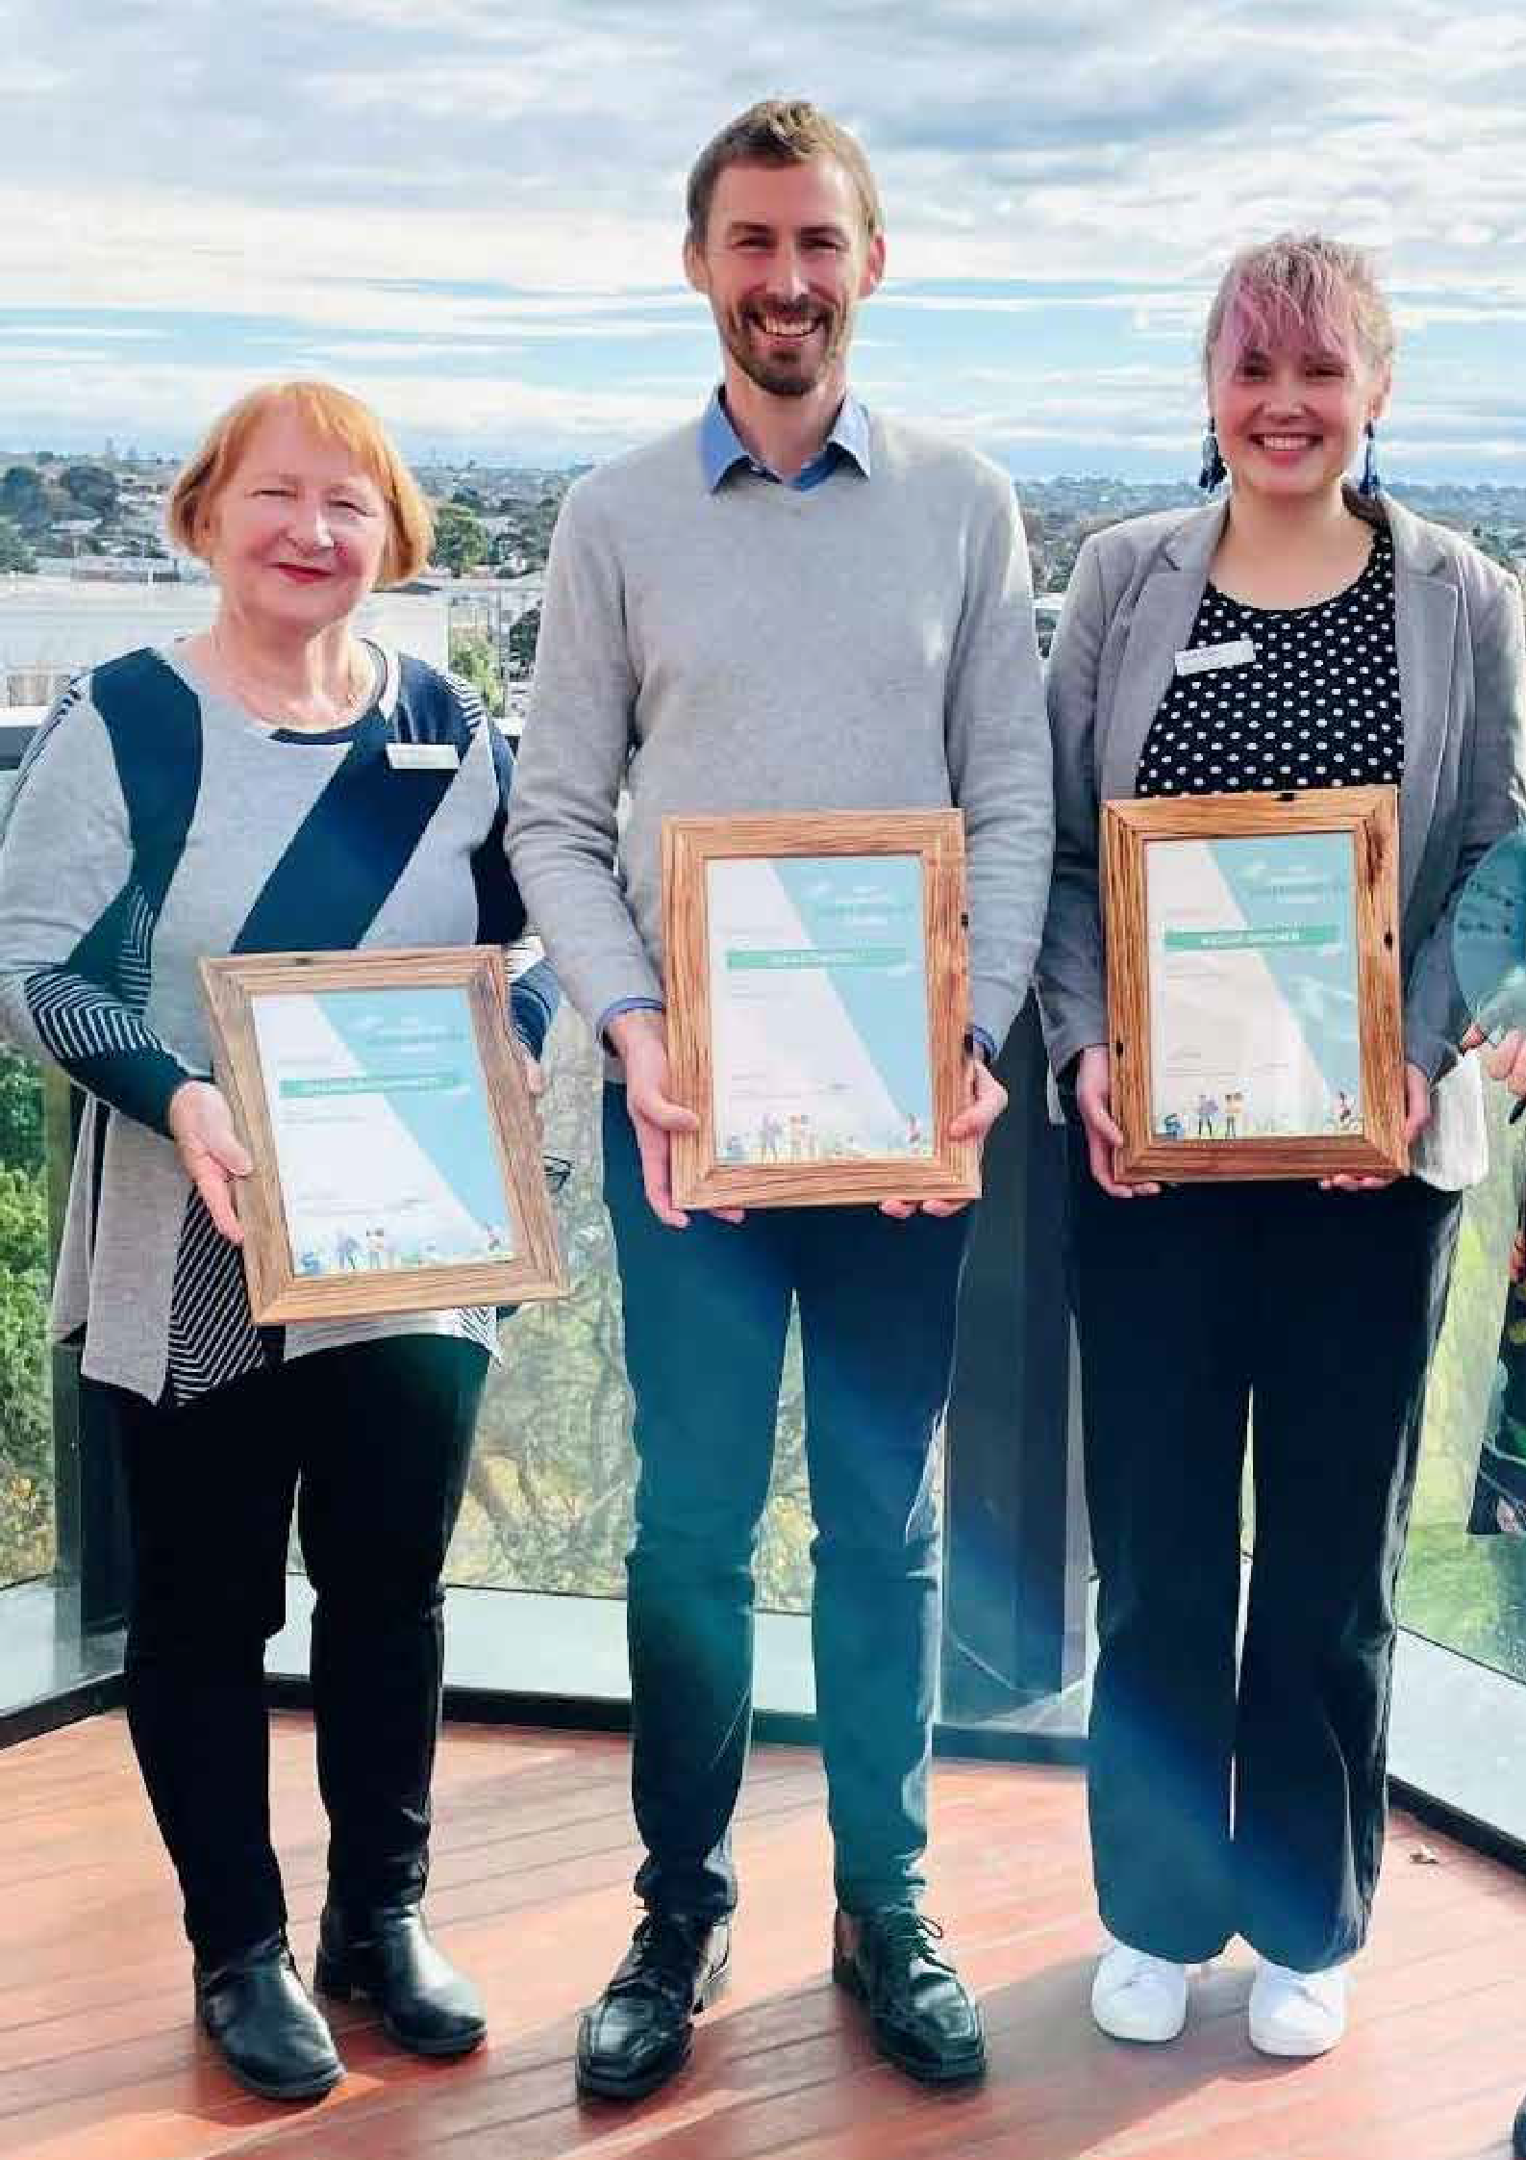

2022 Community Green Achiever Award winners, Vicki Perrett, Dan Cowdell and Emilie Flynn.

41.

SPOTLIGHT ON THE SOCIAL EQUITY FRAMEWORK 2022–25

The Social Equity Framework 2022-25 provides a common set of principles to help us make sure everyone in our community has the support they need to lead a healthy life and be included and participate fully.
EMPOWERMENT
Supporting everyone to make meaningful choices and have a say in decisions that affect them.
INCLUSION
Creating opportunities where everyone feels safe, supported and like they belong, regardless of their social identities, characteristics or circumstances.
PARTICIPATION
Assisting everyone to be involved in social, community and economic opportunities.
VOICE
Creating safe spaces for everyone to speak up and genuinely listen to their individual and collective needs.
ACCESS
Reducing physical and social barriers from places, spaces, resources and opportunities for everyone.
Distributing resources and facilitating fair processes and outcomes for everyone.
FAIRNESS
SOCIAL EQUITY ENABLERS
The framework will guide how we work with the community to:
- improve equity in how people access services and places
- improve health and wellbeing, and
- drive lasting change.
By taking an equity approach, we will consider the barriers, experiences and levels of influence held by different groups, to allow everyone in our community access to the same opportunities.
The Framework was developed to build upon our Social Equity Principles, adopted in 2017.
Through this process we identified six social equity
enablers (the components of an equitable society).
We also identified 10 priority populations (shown in Figure 4 below) for whom barriers are more frequently experienced, recognising that people and families can, and do, belong to many intersecting social groups, in turn influencing their experiences.
We are building on existing equity work within the City (for example our Multicultural Action Plan, Reconciliation Action Plan, Vital Communities Project, Positive Ageing Strategy, Gender Equity Framework, Social Housing Plan and Social Infrastructure Plan). We are working with various teams to consider how equity can be reflected
in the continuous improvement of our services, polices, projects and internal business processes. In the coming year, the focus will grow to maximise employee capability in identifying and responding to equity needs in our work.


Rural and peri-rural
Aboriginal and Torres Strait Islander Peoples
Socio-economic disadvantage
People with disability
Women
LGBTIQA+
Older persons
Refugees and asylum seekers
Culturally and linguistically diverse communities
Young people

Figure 4: Intersectionality and priority groups

42. SUSTAINABILITY PERFORMANCE REPORT | 2022

3562 (1.3%)
PEOPLE IDENTIFY AS ABORIGINAL OR TORRES STRAIT ISLANDER

17,726 (6.5%)
OF PEOPLE NEED ASSISTANCE DUE TO AGE OR DISABILITY

11.7%
SPEAK A LANGUAGE OTHER THAN ENGLISH AT HOME
2,026 REFUGEE
CLIENTS WERE SUPPORTED BY DIVERSITAT (NOW CULTURA) IN THE 5 YEARS TO 2020 IN GREATER GEELONG
140 PER 10,000 WOMEN ARE VICTIMS OF FAMILY VIOLENCE

5%
OF ADULTS IDENTIFY AS BEING LGBTIQA+

11.9%
OF THE POPULATION IS MADE UP OF YOUNG PEOPLE (15–24 YEARS)

31.5%
OF THE POPULATION IS MADE UP OF OLDER PEOPLE (55+ YEARS)

14.9%
OF ALL UNEMPLOYED PERSONS LIVE IN CORIO- NORLANE

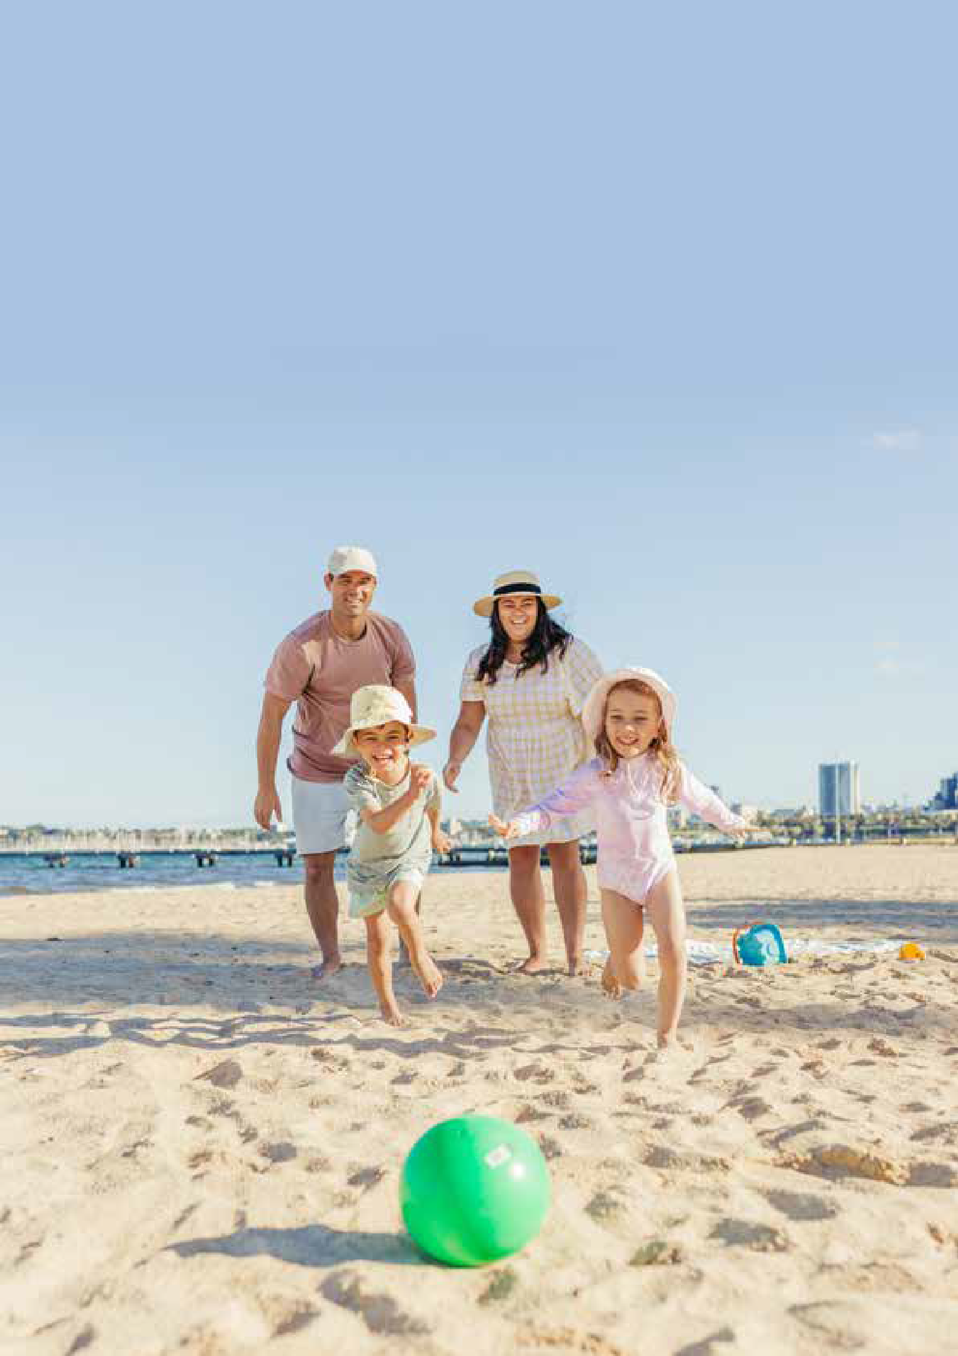

43.



RESPONSIBLE AND TRANSPARENT
BUSINESS

To be a responsible and transparent business, we will act with integrity, accountability, and transparency and view all decision making through a sustainability lens.
Sustainability is a complex and multi-faceted challenge. We therefore must work to embed it as a foundational principle that guides our organisation, so that all employees have a clear and shared understanding about what it means and how they can apply it.
For us to achieve economic sustainability as an organisation, our current operations and our way of life have to adapt. We need to be more efficient in our use of available resources, find new ways to harness currently underused resources and reduce our consumption
in the process. We also need to consider all facets of sustainability in our investment decisions.

A strong local economy with job opportunities for all
The impacts of the pandemic, combined with recent community engagement, have driven us to expand the scope of this key priority area to encompass the local economy as an important sustainability consideration for our work. Although this was not mentioned in the original Sustainability Framework 2020, we have included relevant indicators in our performance tracking process.

OBJECTIVES
  - Position the organisation to better achieve our sustainability objectives
  - Embed sustainability into our decision-making and look for innovative solutions
  - Understand and be guided by the needs and expectations of our community
  - Pursue ambitious sustainability targets and report our progress publicly

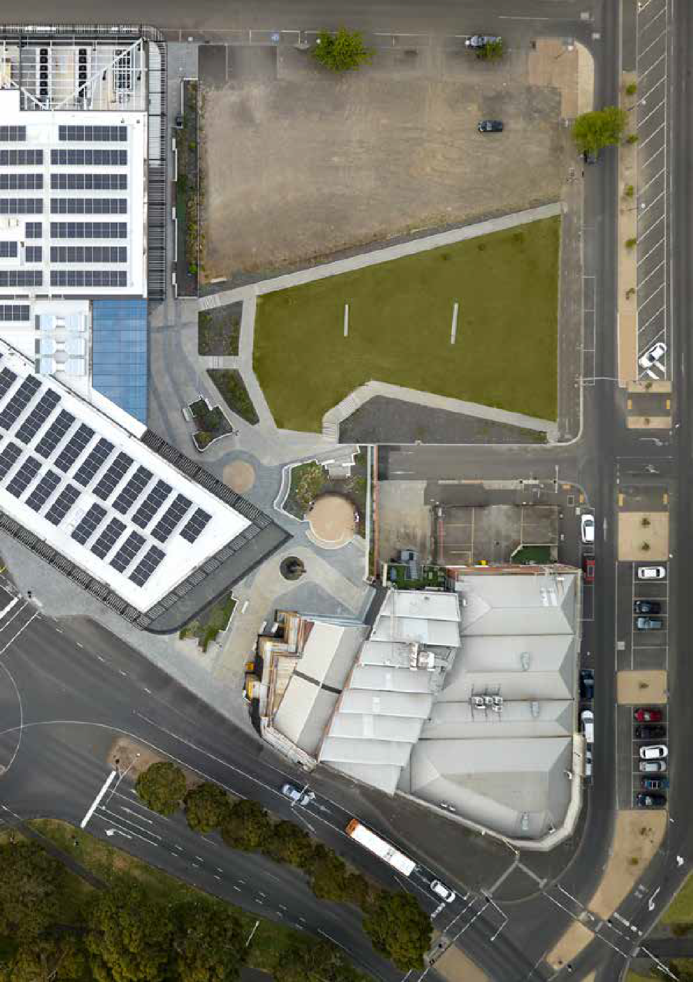

45.

MEASURES OF SUCCESS

TARGETS | DATA | COMMENT | STATUS
Zero City employee work- related fatalities8 | 0 (2021–22)  0 (2020–21)  0 (2019–20)  0 (2018–19)  0 (2017–18) | We are committed to ensuring all employees work safely. This includes providing a safe workplace and maintaining safe systems of work and management procedures.
100 per cent of new and reviewed City plans, strategies and policies consider sustainability impacts and risks by 2022† | Not yet available | A means of measuring this indicator is yet to be developed.
Greater Geelong rated in the top 200 of the Global Innovation Cities Index27 | 322 (2021)  313 (2019)  326 (2018) | Geelong is classified as a NODE city i.e., globally competitive with competitive performance across many innovation segments. Global rankings of other Australian NODE locations include Adelaide (100), Gold Coast (160), Newcastle (212), Wollongong (233), Hobart (254), Ballarat (393) and Bendigo (398). No report was made available in 2020. The 2022 index will be finalised and released in mid to late January 2023.
Expenditure by visitors to the city-region increases by  3.8 per cent per annum28 | $876 million (Apr 21 to Mar 22)  $580 million (Apr 20 to Mar 21)  $1.1 billion (Apr 19 to Mar 20)  $1.1 billion (Apr 18 to Mar 19)  $936 million (Apr 17 to Mar 18) | Spend has reached $876 million, surpassing 2021 levels. 8.7% of all visitors to regional Victoria are coming to Geelong and The Bellarine. Interstate visitation is back to 2019 levels at around 14% of total visitors.
Support the hosting of 12 major events in Geelong every year29 | 13 (2021–22)  7 (2020–21)*  14 (2019–20)*  25 (2018–19)  20 (2017–18) | The 13 major events supported via Geelong Major Events stimulated economic activity estimated at $24.8 million.
An increase in the diversity of businesses within Greater Geelong30 | Industry Diversity Index (modified Herfindahl index):  Geelong 53 (2016) | Industry Diversity Index measures industry diversity based on percentage of jobs by industry within LGA relative to that of the Victorian economy. Lower index value signifies higher industry diversity, higher value signifies higher industry specialisation.  An update is pending the Australian Bureau of Statistics Census of Population and Housing 2021 results which will be released in stages from Jun 2022 to mid–2023.
Successfully host a mega event (exclusive World Championship or similar) every decade | T20 Cricket World Cup (October 2022) | Geelong hosted the T20 Cricket World Cup at Kardinia Park Stadium in October 2022. This event was bid for and procured via the Geelong Major Events committee. The event was originally scheduled for October 2020, however, was postponed due to COVID-19.
100 per cent of Council reports include consideration of financial, social, community engagement and environmental implications from 2021† | 100% | Overarching principles from Section 9(2)(c) Local Government Act 2020 specifically referencing the promotion of economic, social and environmental sustainability prompted changes to our council report template and associated guidance material.
† New target
* Events postponed or cancelled due to COVID 19 restrictions.
On track Off track Not yet available Only baseline data available

OBJECTIVE 3.1: POSITION THE ORGANISATION TO BETTER ACHIEVE OUR SUSTAINABILITY OBJECTIVES
Over the next three years, our Future Ways of Working Program will enhance how we work together and design our organisation for the future. We are doing this to create a place that serves our growing community in the best possible way.

KEY DATA SNAPSHOT
76 per cent – overall sustainable enagement score for City employees31
This process includes establishing a target operating model, introducing a leadership and capability framework and better aligning our strategic planning processes.

Progress of supporting actions

ACTION PROGRESS COMMENT STATUS

    - Adopt and implement the Sustainability Policy, which integrates sustainable thinking as a key principle within the City.

    - Establish and implement a Public Transparency Policy to increase public confidence in Council decision making and planning.
    - Build a positive and inspiring workplace culture at the City though the delivery of the Working Better Together program.
Council adopted the Sustainability Policy at its meeting on 2 February 2021. The policy outlines the key principles we will apply
to create a culture of sustainable decision-making while supporting the delivery of the Sustainability Framework 2020 and Sustainability Framework Action Plan 2020–22.
Our Public Transparency Policy was adopted on 1 September 2020.

We launched a range of initiatives to support the delivery of our Working Better Together program including:
- Leadership Capability Framework
- Leadership Development Program
- employee opinion survey, Better Together Survey, in April 2022
- learning and development course offerings
- new and refreshed Learning Hub platform design with process improvements to increase digital enrolments and engagement
- culture forums for all people leaders in November 2021 and May 2022.
We believe that by leading inclusively we can embrace and value diversity and create a culture where people can speak up about risks, health and wellbeing, and safety issues. A positive and healthy work climate will in turn foster higher employee satisfaction, where employees feel empowered in their job and produce better outcomes for the organisation and community.

On track Complete

ACTION PROGRESS COMMENT STATUS

    - Keep City employees safe and well with the development and implementation of an
organisational Health, Safety and Wellbeing Plan.

    - Review and update management and employment policies to reflect the importance of sustainability to the organisation.

    - Implement a new compliance framework to increase accountability within the City.
    - Continue to lead Geelong’s UNESCO City of Design Designation and implement actions that support the UN Sustainable Development Goals with a focus on sustainable and liveable communities.

    - Implement a new risk
management and reporting software solution to manage risks and enable integrated reporting.
We provided ongoing employee communications and campaigns promoting physical and mental health, and safety in the workplace including:
- Kind people are our kind of people (new occupational violence and aggression marketing campaign)
- Take 5 (safety in the workplace)
- RUOK Day
- World Gratitude Day
- Get on Track health challenge
- Movember
- Local Government Blood Challenge
- online yoga
- flu vaccinations for all employees and their families.
We will expand platforms to communicate with the implementation of new intranet and digital screens in depots.
We have continued to review our suite of policies. With new hires joining the team in July 2022, we anticipate the remaining
outstanding policies will be reviewed, updated and rolled out in the second half of 2022. This includes the modernisation and overhaul of the Transition to Retirement policy as well as policies that require
review following the implementation of the new Enterprise Agreement in March 2022.
Our Accountability Framework is complete and has been implemented in the organisation via our annual business planning
cycle.
We continued to promote and deliver projects in support of the design designation including:
- attending the virtual UNESCO Annual General Meeting in July 2021
- hosting the 2021 UNESCO Cities of Design Subnetwork Meeting in October 2021. More than 30 international cities participated with over 1000 people joining in the three-day online event
- leading the Victorian Creative City Network and the submission to the Victorian Government which secured funding to support UNESCO through the Victorian Creative Strategy
- launching the City of Design guiding principles following extensive input from key stakeholders
- assessing applications to the City of Design Network and making recommendations to UNESCO
- submitting our first four-year monitoring report to UNESCO, Geelong: Australia’s Creative City of Design Our Monitoring Report 2017–2021
- coordinating over 70 events as part of Geelong Design Week 2022
We launched new Occupational Health and Safety reporting software in May 2021. We have implemented Enterprise Risk Management,
Incident & Hazard Management and Claims & Injury Management.

On track

ACTION PROGRESS COMMENT STATUS

    - Maintain and implement the 10- year financial plan and continue to ensure other long-term organisational plans are fed into the financial plan.
    - Update and maintain the four- year strategic resource plan and enable delivery of the four-year Council Plan.
We developed a Long-term Financial Plan, as required by the Local Government Act 2020. The plan was adopted by Council 26 October
2021 and will be refined over time.

We completed our first foundational strategic plan, as per Local Government Act 2020 requirements. Progress has been made with the Full time Equivalent (FTE) management process, a key deliverable of the foundational workforce plan, and tool for
strategic workforce planning has been developed and rolled out to the business to effectively manage FTE. The rest of the Strategic Workforce Planning Framework is under development and to be to be rolled out to sample business areas by 30 June 2023. The key risk factor in rolling out Strategic Workforce Planning framework
is the overall organisation readiness in line with the undergoing transformation initiatives.

Other achievements
  - We implemented a digital equity project that has seen mobile phones rolled out to all construction unit field staff, connecting them to the City’s network and allowing us to start automating many manual paper- based processes and most importantly help keep our employees safe and engaged.
  - The Procurement for Innovation age-defying bridges project was recognised in four categories in the Institute of Public Works Engineering Australasia (IPWEA) Victoria Awards 2022: Environmental Sustainability (winner), Excellence in Public Works (winner), Excellence in Innovation Regional (winner) and Excellence in Asset Management (commendation). The project was also a Finalist in the National Economic Development Australia Awards for Excellence 2021 – sustainability initiatives category; and a Finalist in the Premier's Sustainability Awards 2021 in the Industry Leader – Climate Action category.
  - The City embarked on a second Procurement for Innovation project in 2019, looking to apply circular economy principles to road infrastructure products. During 2020 and 2021 we conducted the market engagement phase of the process; working with suppliers to create their innovative responses to this need. The tender will be released in 2023.
  - We have developed an e-learning training course to help others apply the Procurement for Innovation method in their organisations. The training course is suitable for procurement practitioners, specifiers, budget holders, finance staff, senior managers and leaders, and anyone responsible for engaging with
and understanding markets and suppliers. There are
five eLearning modules that cover: the Principles of Procurement for Innovation, Identification of an

Unmet Need, Market Engagement, Procurement for Innovation Procurement Process, and Contract & Supplier Management. The eLearning modules have been shared with public sector procurement practitioners throughout Australia and the UNESCO City of Design network, including Curitiba (Brazil), Montreal (Canada) and Kortrijk (Belgium).
- Our Sustainable Buildings Policy, which applies to all City-owned buildings, is currently under review. When updated, it will support minimum waste performance ratings for new and existing buildings.
- We have improved and upgraded our data capture systems at the North Geelong Resource Recovery Centre to capture data more effectively.

Challenges
- We must adapt to accommodate the cost increases related to our COVID-19 response, advancing technologies, organisational change and ageing assets. This means working and refining our approach so we can keep delivering services, programs and infrastructure to our communities in a way that is sustainable and equitable.

Next steps
- We will continue finding new ways to improve community satisfaction with our overall direction, as well as lobbying on behalf of the community.
- We will continue to review and update management and employment policies to reflect the importance of sustainability to the organisation.
- We will continue looking for new ways to benefit from
our UNESCO designation.

OBJECTIVE 3.2: EMBED SUSTAINABILITY INTO OUR DECISION-MAKING AND LOOK FOR INNOVATIVE SOLUTIONS
We are committed to integrating sustainable thinking as a key principle that is considered in every form of business, when making decisions, writing strategies, plans and policies, managing risks and allocating resources. This will help us to find long-term solutions to the many challenges we face.
KEY DATA SNAPSHOT
80 – the index score for perceived importance of decisions made in the interest of the community18

Progress of supporting actions

ACTION PROGRESS COMMENT STATUS

    - Develop and implement a Strategic Documents Policy and Strategic Planning Framework for improved efficiency and alignment.

    - Develop and implement a Data Governance and Management Strategy to better understand and manage information and to support evidence-based decision making.
    - Review the City’s Investment Policy and look for opportunities to align it with the Sustainability Framework and Policy.
    - Establish an Enterprise Project Management Office (EPMO) that will prioritise projects that provide value for money, meet community needs and support a healthy natural environment.
    - Use the City’s updated Procurement Policy to support local business and innovation and consider better social and environmental outcomes.
    - Use the Smart Cities Program to adopt better technology options for the City and within the community.
We adopted the Strategic Planning Framework and are working on a new organisation-wide process for developing strategic
documents. This process aims to improve consistency, integration and accountability across all our planning processes, and will be underpinned by the strategic documents policy in the longer term.
We developed the Major Municipal Strategy and Plans (MMSP) framework, an organisation-wide process for developing strategic documents. This significant operational model change is intended to improve process efficiency and quality of plans.
Our Data Management Strategy was completed in March 2020. A Data Management program was approved in August 2020 and a position
recruited to establish a Data Services Hub. We also established a Data Governance Committee, which will continue to evolve as the organisation matures its data practices.
We are currently reviewing the Investment Policy, to consider the Sustainability Framework and Policy when making investment decisions. It is anticipated that the updated document will be considered for adoption by Council in late 2022.
We appointed an EPMO Manager and started development of the Target Operating Model with high level design approved and detailed
design activities underway. Key supporting roles will be established in 2022 as part of these activities.

We implemented a new procurement policy in January 2022. A social procurement framework is still being formulated to include
sustainability for presentation to Council July 2022.

We continued work to deliver the Smarter Suburbs (Stage 1) project including three Tower and sixteen Smart Nodes that integrate innovative technologies (smart lighting, WiFi, 5G, CCTV, USB charging, video analytics) with existing public infrastructure. We continued installation of a high-speed fibre network from Corio to Geelong CBD to Drysdale (plus Kardinia Park extension) to provide community facilities, businesses and public spaces with access to high-speed internet.

On track Off track Complete

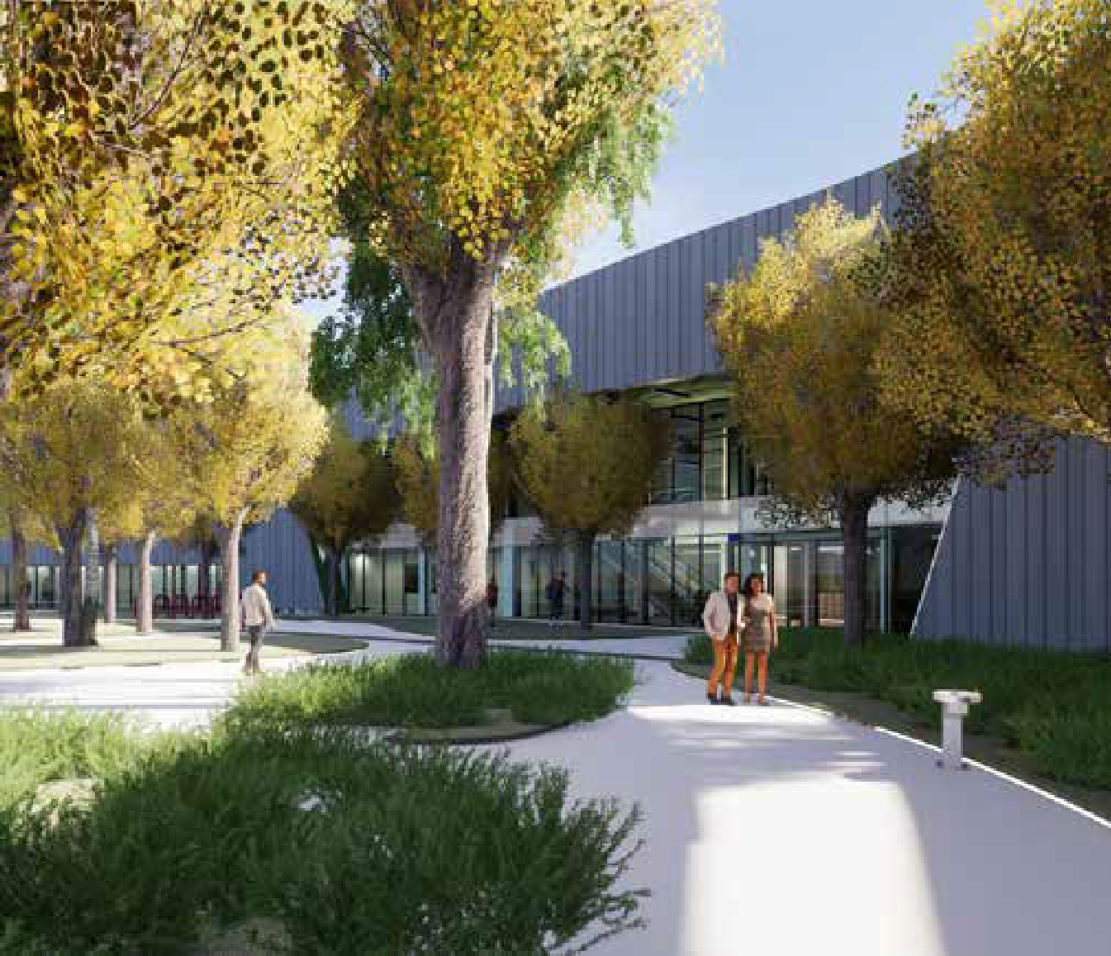
Artist imprression of the new he new
Northern Aquatic and
Community Hub

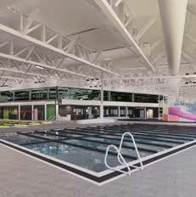
Other achievements
  - We will realise an estimated $150,000 per year in operational savings and cut annual emissions by about 1,700 tonnes by investing in electric infrastructure run by renewable energy in the new Northern Aquatic and Community Hub.

Challenges
  - There is a gap in our sustainability aspirations and the data we are currently able to collect to inform our progress.

Next steps
  - Continue to progress a social procurement framework.
  - Continue to improve consistency, integration and accountability across all our planning processes.

OBJECTIVE 3.3: UNDERSTAND AND BE GUIDED BY THE NEEDS AND EXPECTATIONS OF OUR COMMUNITY

We understand the power of authentic community engagement and the role it plays in building greater trust and confidence in local democracy. When acted on in good faith, it also leads to better outcomes for our organisation and the community.
The environment – in particular climate change – as well as social and economic sustainability are topics of keen community interest. We know this from the engagement process we conducted to inform Our Community Plan 2021–25, as well as other key strategies.

Progress of supporting actions

KEY DATA SNAPSHOT
73 – index score for perceived importance of community consultation and engagement18

Due to the scope of the sustainability challenge, the community looks to us for strong leadership in this area. At the same time, the community wishes to be able to provide feedback and input into council decision making to help guide us all to a sustainable future.

ACTION PROGRESS COMMENT STATUS

    - Renew the City’s Engagement Policy and Framework, which strengthens the connection with the community.
    - Create and promote more opportunities for public participation, which support better decision making and the implementation of the Sustainability Framework and Action Plan.
Council adopted a new Community Engagement Policy which outlines its commitment to best-practice engagement at its
meeting on 23 February 2021. We provided initiatives including:
- accessibility upgrades to our online engagement platform, Have Your Say
- information for community that is easy to understand, and providing a greater link to Our Community Plan 2021–25
- a new easily accessed hub on our online engagement platform, Have Your Say to work with the community on all flood studies across the region
- over 60 engagement projects which included a focus on environment and sustainability
- information for community that is easy to understand on topics and engagements that are of interest.

Other achievements
  - We engaged with the community on 222 projects and had 212,025 unique visits to our Have Your Say
engagement webpage up from 63,449 unique visits in 2020–2132.
  - Our quarterly e-newsletter for sharing engagement projects, seeking feedback and sharing results is being distributed to 4,927* community members who have signed up to the Have Your Say platform (*current number as at 9 January 2023)

Challenges
  - Overall satisfaction with our performance for decisions made in the interest of the community was down 3 index points to 56 in 202218.
  - Overall satisfaction with our performance in community consultation and engagement decreased 3 index points to 54 in 2218.

On track Complete

Next steps
- We will continue to seek specialist advice provided by our advisory committees on community and Council priorities.
- We will conduct further campaigns to promote the Have Your Say platform to increase membership numbers, visitation and contributions.

OBJECTIVE 3.4: PURSUE AMBITIOUS SUSTAINABILITY TARGETS AND REPORT OUR PROGRESS PUBLICLY
This document reports on a series of ambitious sustainability targets that our Council endorsed in June 2021. Our goal is to annually report on these targets, as well as a select range of Global Reporting Initiative (GRI) indicators.

KEY DATA SNAPSHOT
- Our recommended waste reduction targets (diversion from landfill) and community carbon emissions now exceed current state and federal targets33
- We reduced the City’s operational carbon emission by 29 per cent in 2021–22.
We will refine these targets over the next three years as
we respond to new data opportunities and new research.
In the future, we also aim to expand our reporting so that it will align with the United Nations Sustainable Development Goals (SDGs).

Progress of supporting actions

ACTION PROGRESS COMMENT STATUS

    - Report our sustainability performance against the Global Reporting Initiative (GRI) Standards and in alignment with the Sustainable Development Goals.

    - Evaluate the effectiveness of
our sustainability reporting and continuously improve our reporting practice.
Council endorsed sustainability indicators including selected GRI indicators in June 2021.
We prepared the first Sustainability Performance Report
to provide an update on our sustainability target progress (where data is available), as well as a summary of some of the key actions we’ve implemented as part of the Sustainability Framework Action Plan 2020–22 (to 31 December 2021).
We presented the Sustainability Performance Report 2021 acknowledging we do not yet have all the data we require.
We need to evolve our reporting processes and systems to enable us to better track and report our performance and aim to improve on this in subsequent years.

Other achievements
  - We presented the Sustainability Performance Report 2021.

Challenges
  - We are at the beginning of a long journey with regards to sustainability and have set ambitious targets in response to community feedback that will take time and hard work to achieve.

Next steps
- We need to evolve our reporting processes and systems to enable us to better track and report our performance.
- As our organisational approach matures, we will develop more structured, restorative and coordinated methods of addressing sustainability that will create lasting impacts on all our services, projects and plans.

On track

NEW OBJECTIVE: A STRONG LOCAL ECONOMY WITH JOB OPPORTUNITIES FOR ALL

To stay competitive in a globalised economic environment, we must collaborate with stakeholders to market Greater Geelong’s competitive strengths, support local business and advocate for the infrastructure and services we need to attract investment and stimulate economic growth.

Achievements
  - We hosted a series of five free community workshops, funded via the Victorian Government’s Regional Recovery program. The sessions were held across three evenings and attracted 40-60 registrations per session.
  - We provided funding support to Regional Innovation for a Circular Economy Inc (RICE) to deliver a circular economy innovation showcase of businesses working in the circular economy to build support by generating demand, recognition, and potential investment.
  - We continued development of the Economic Development Plan 2021–31, which will identify our priorities to support and grow the economy to ensure economic prosperity.
  - We partnered with the state government and Geelong Manufacturing Council to deliver the Cleantech Innovations Geelong business support program. The program created and maintained 650 jobs (directly and indirectly), helped over 2,000 people develop cleantech and circular economy skills, increased sales of cleantech and circular economy products by over $18 million.

Challenges
  - We need to continue supporting local businesses and promote investment opportunities to drive economic growth in Greater Geelong during COVID recovery and beyond.
  - Transitioning from a take-make-waste economy to a circular economy is going to take a collaborative
approach between all levels of government, industry and across the City.

Next steps

KEY DATA SNAPSHOT
- 120,017 – number of jobs located in the City of Greater Geelong in 202134
- 2.5 per cent - the 12-month average unemployment rate to June 2022 for Geelong,
1.6 percentage points lower than the Victorian unemployment rate of 4.1 per cent26
- $15.4 million – Greater Geelong’s Gross Regional Product in 202134
- 19,604 – number of registered businesses35
- 24 – Tourism Sentiment Index as of 30 June 202228
- $876 million – visitor expenditure 2021–2228
- 24:1 – return on investment of Geelong major events 2021–2229
- We will finalise the Economic Development Plan
2021–31.
- We will support local businesses in developing climate mitigation and adaptation programs, technologies and solutions.
- We must continue to lead the way on matters that affect the local economy, advocate for projects that support strategic business and industry development, and coordinate industry experts to investigate opportunities for Greater Geelong.

SPOTLIGHT ON THE GEELONG DIGITIAL TWIN PROJECT

A digital twin is a digital replica of a physical environment, used to visualise and analyse the layout, functionality, and performance of a physical space, such as buildings, infrastructure, and urban environments in a virtual setting. They can be used to optimise the use of space, predict and mitigate potential problems, and simulate scenarios to inform decision-making.
The Victorian Government is investing in spatial innovation and digital twin technology, to build a state- wide platform, Digital Twin Victoria. This platform brings together 2D, 3D and live data in a single online location. It revolutionises the ways in which cities plan
and manage the built and natural environment, whereby supporting sustainability targets and goals.
Through our Smart City Office, we have been working with the Victorian Government to continue refining and enhancing our regional digital twin to support a data- driven future.
The Geelong Digital Twin will enable us to meet our sustainability goals in several sector-leading ways, including:
- Identifying inefficiencies by analysing the energy
consumption of infrastructure
- finding ways to reduce energy use
- optimising the use of resources such as water, raw materials, and transportation
- modelling reductions in carbon emissions and other environmental impacts after different interventions; and
- using real-time data and analysis to help Geelong- based organisations to make more informed decisions about their operations.
These types of smart city tools are a valuable resource for our community and will support us to achieve our clever and creative community vision for a smart and sustainable City of Greater Geelong.

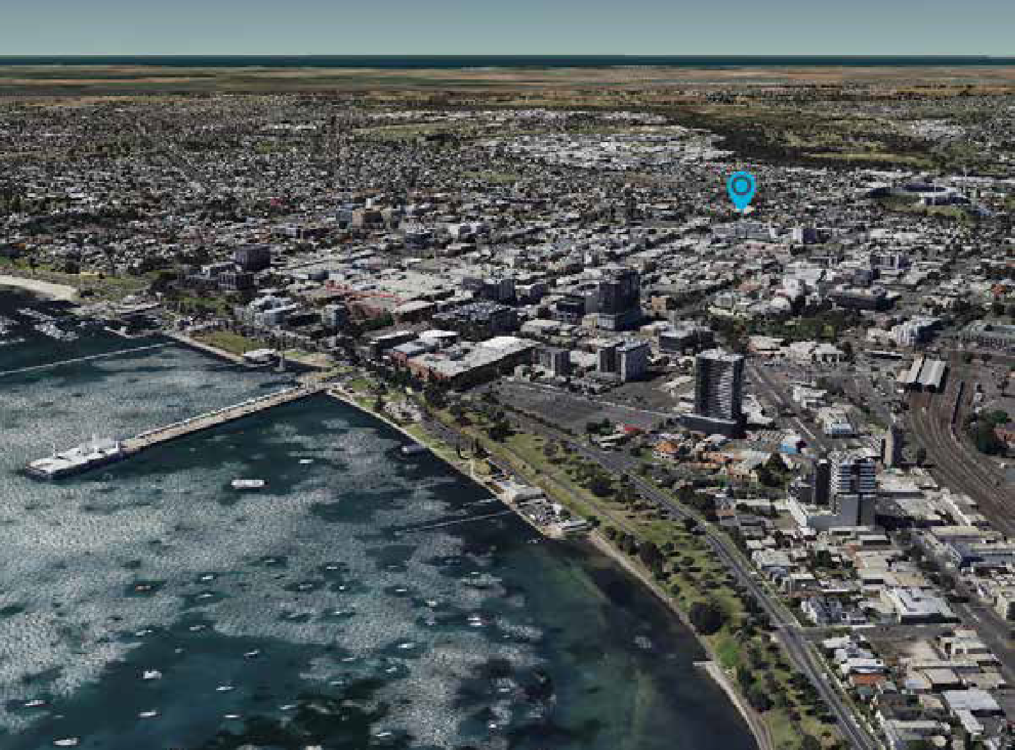

55.

END NOTES

- City of Greater Geelong emissions detail data https://www.azility.com
- City of Greater Geelong Climate Change Response Plan 2021–30
- Australian Bureau of Statistics Census of Population and Housing 2016 & 2021
- City of Greater Geelong Environment Strategy 2020–30
- Geelong Design Week website https://www. geelongcityofdesign.com.au/geelong-design-week/
- Barwon Water
- 2021 Geelong Preventative Health Survey
- City of Greater Geelong
- Snapshot Climate – Australian Emissions Profile develop by Beyond Zero Emissions and Ironbark Sustainability (accessed January 2023) https:// snapshotclimate.com.au/locality/municipality/ australia/victoria/greater-geelong/2020/fy
- Victorian Integrated Survey of Travel & Activity – VISTA 2018
- Barwon Water Annual Report 2021–2022
- The City of Greater Geelong Municipal Public Health and Wellbeing Plan 2021–25 Strategic Context
- Australian Bureau of Statistics, Regional Population Growth, Australia (3218.0). Compiled and presented in profile.id by .id (informed decisions)
- Population and household forecasts, 2021 to 2041, prepared by .id (informed decisions), January 2023
- Australian Digital Inclusion Index Report 2021
- 2018 Victorian Population Health Survey
- City of Greater Geelong Social Housing Plan 2020–41
- 2022 Local Government Community Satisfaction Survey
- City of Greater Geelong media release, Council commits to landmark food relief agreement (May 2020)
- City of Greater Geelong Community Directory December 2020
- Our Vital Communities Project
- City of Greater Geelong media release, New hub
to expand food relief efforts (3 June 2021)
- Geelong Sustainability October Newsletter 2021
- 2021 City of Greater Geelong Community Grants program
- City of Greater Geelong Social Infrastructure Plan Generation One 2020–2023
- Geelong Stats Centre (www.geelongaustralia. com.au/business/statistics) using ABS labour force data. (SA4 area includes the City of Greater Geelong, Borough of Queenscliffe, Surf Coast Shire and the majority of the Golden Plains Shire)
- Innovation Cities TM Index, 2thinknow
- Tourism Greater Geelong and The Bellarine
- Geelong Major Events
- Regional Development Victoria – Information Portal, Regional Snapshot
- City of Greater Geelong Better Together Survey 2022
- City of Greater Geelong Have Your Say Geelong site, January 2021 to October 2021
- Recycling Victoria A new economy February 2020, Victoria’s Climate Change Strategy (May 2021), Australia’s Long-term Emissions Reduction Plan: A whole-of-economy Plan to achieve net zero emissions by 2050
- Geelong Economic Profile (www.economy.id.com.
au/geelong), NIEIR 2021.
- Australian Bureau of Statistics, Counts of Australian Businesses, including Entries and Exits, 2016 to 2020

GLOSSARY

Adaptation – the process of adjusting to actual or expected climate change and its effects.
Barwon South West Climate Alliance – a collaboration of councils, water authorities and land management agencies across the Barwon South West region in Victoria.
Biodiversity – the variety of living organisms, the genetic differences between them and the communities and ecosystems in which they occur.
Biodiversity site – somewhere that retains native vegetation – such as a patch of woodland, bush, native grassland, saltmarsh, coastal dune or a waterbody – that provides habitat for wildlife.
Carbon emissions – refers to all greenhouse gases (see definition below).
Carbon neutral – means an organisation, product or service has been proven to have reduced its emissions where possible and compensated for the remainder by
investing in carbon offsets to be ‘net
zero’ carbon emissions.
Carbon offset – is the form recognition of process that removes greenhouse gas emissions from the atmosphere and can be traded.
Circular economy – refers to an economic model that continues to reuse, re-purpose and recycle resources.
Cleantech – any process, product, or service that reduces negative environmental impacts through significant energy efficiency improvements, the sustainable use of resources, or environmental protection activities.
Climate change – the phenomenon of changing weather patterns caused by the overall warming of the planet due to greenhouse gas emissions.
CO2-e – carbon dioxide equivalent.
EV – electric vehicle.
Environmentally Sustainable Design – aims to reduce the impact of construction and building use on the natural environment.
G21 – the formal alliance of government, business and community organisations working together to improve the lives of people within the Geelong region across five municipalities including: Colac Otway, Golden Plains, Greater Geelong, Queenscliff and Surf Coast.
Global Reporting Initiative (GRI) framework – the GRI reporting framework consists of universal standards and topic standards that organisations can use to prepare and report information that showcases significant sustainability impacts.
Green-blue infrastructure – refers to the natural and built assets within urban landscapes which are living (green) and which manage water (blue).
Greenhouse gases – atmospheric gases responsible for causing global warming and climate change. The six Kyoto Protocol classes of greenhouse gases are carbon dioxide (CO2), methane (CH4), nitrous oxide (N2O), hydrofluorocarbons (HFCs), per- fluorocarbons (PFCs) and sulphur hexafluoride (SF6).
Green economy – is a clean, environmentally friendly economy that promotes health, wealth, and well-being.
Green power – electricity that is generated using low- impact, fully renewable energy sources that result in the lowest burden to the environment.
Integrated water management – water cycle systems including natural, built and services aspects, such as waterways, wetlands and floodplains, drainage and stormwater, drinking water and sewerage, as well as water’s interfaces with the land in public open spaces.
Mitigation – also referred to as emissions reduction, mitigation is any human intervention or activity that reduces the sources or enhances the sinks of greenhouse gases.
Net zero emissions – achieving a balance between emissions produced (sources) and emissions
taken out of the atmosphere (sinks).
Northern and Western Growth Areas (NWGGA) – is the largest urban growth project in regional Victoria, comprising 5,367 hectares with the potential to accommodate 110,000 new Geelong residents.
Renewable energy – energy that comes from a source or processes that are constantly replenished, such as solar, wind and hydro (water).
Resilience – the capacity of something (ecosystems, people, groups and organisations) to adapt, survive and continue to function and thrive despite stresses and shocks.
Sustainability Advisory Committee – established in 2021, the committee is made up of 12 members
with expertise in environmental management, social and community planning and financial analysis.
Sustainable Development Goals (SDGs) – 17 goals that all United Nations Member States have agreed to work towards to end poverty, protect the planet, and ensure that by 2030 all people enjoy peace and prosperity.
UNESCO – United Nations Educational, Scientific and Cultural Organization, a specialised agency of the United Nations (UN) aimed at promoting world peace and security through international cooperation
in education, arts, sciences, and culture.
Urban Heat Island Effect – the way built-up areas have a greater capacity to absorb, hold and emit the sun’s heat, compared to rural areas.

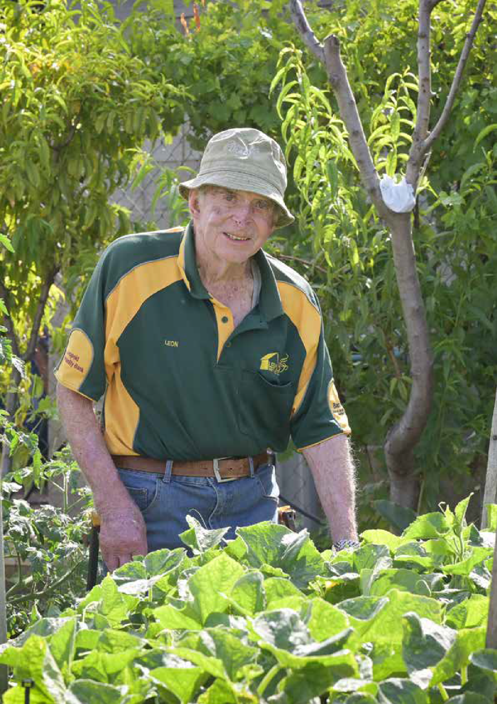

- SUSTAINABILITY PERFORMANCE REPORT | 2022

APPENDIX 1 – OUR DATA

OUR PEOPLE
We are proud to be an inclusive and flexible organisation that is one of the largest employers in the region. We currently
employ a total of 2,814 people – equivalent to 1,756.27 full-time employees*.
Our turnover† in 2021–22 was 17.3 per cent – up from 10.4 per cent the previous year.
EMPLOYEE TYPE – GENDER
CEO
CITY PLANNING
AND ECONOMY CITY SERVICES
COMMUNITY CUSTOMER AND STRATEGY, LIFE CORPORATE PEOPLE AND
SERVICES PERFORMANCE

Full Time – W | 20.9 | 113 | 99.4 | 252.7 | 68.5 | 58.9
Full Time – M | 9.1 | 111.7 | 404.1 | 66.5 | 73.4 | 21
Full Time – X | 0 | 0 | 0 | 0 | 0 | 0
Part Time – W | 1.5 | 46.7 | 32.5 | 268.3 | 24.2 | 6.7
Part Time – M | 0 | 15.5 | 13.6 | 22 | 2.5 | 0.1
Part Time – X | 0 | 0 | 0 | 0 | 0 | 0
Casual – W | 0 | 4.1 | 0.3 | 66 | 1.3 | 4.4
Casual – M | 0 | 3.3 | 3.6 | 24.8 | 0.2 | 0.4
Casual – X | 0 | 0 | 0 | 0 | 0 | 0
Total‡ | 31.5 | 294.3 | 553.5 | 700.6 | 170.1 | 91.5
Legend: W = Women, M = Men, X = persons of self-described gender
* As at 30 June 2022
† Excludes casual employees
‡ Total includes 0.1 FTE (Casual) of self-described gender

Table I: Total full-time equivalent employees by directorate, employment condition and gender in 2021–22

AS AT 30 JUNE 2021 CITY SERVICES COMMUNITY LIFE  DIRECTORATE DIRECTORATE |  |  | CUSTOMER & CORPORATE SERVICES DIRECTORATE | STRATEGY, PEOPLE  & PERFORMANCE TOTAL DIRECTORATE
Aboriginal | 3 | 11 | 1 | 1 | 16
Torres Strait Islander | - | - | - | - | -
Both | - | 2 | 1 | - | 3
Total | 3 | 13 | 2 | 1 | 19
Table II: Diversity of employees by the number of Aboriginal and Torres Strait Islander people employed at the City
No Aboriginal and Torres Strait Islander employees in CEO’s Office or City Planning and Economy Directorate.

EMPLOYEE % OF INDIVIDUALS WITHIN % OF INDIVIDUALS WITHIN % OF INDIVIDUALS WITHIN % OF INDIVIDUALS WITHIN DEMOGRAPHIC THE ORGANISATION’S SENIOR LEADERSHIP MIDDLE LEADERSHIP FRONTLINE
GOVERNANCE BODIES
Gender
Female | 36.36 | 50.00 | 45.19 | 66.61
Male | 63.64 | 50.00 | 54.81 | 33.35
Age Group
Under 30 | 36.36 | 0.00 | 7.04 | 21.47
30–50 | 63.64 | 52.50 | 52.22 | 39.26
50 and over | 0.00 | 47.50 | 40.74 | 39.26
Aboriginal and Torres Strait Islander | 0.00 | 0.00 | 0.52 | 0.72

Table III: Diversity of governance bodies by gender, age, and relevant minority or vulnerable groups, including the number of Aboriginal and Torres Strait Islander people employed at the City

EMPLOYEES
TEAM MEMBER NEW HIRES
RATE OF NEW EMPLOYEE HIRES DURING THE REPORTING PERIOD
TEAM MEMBER TURNOVERS
RATE OF EMPLOYEE TURNOVER DURING THE REPORTING PERIOD

Gender | Total | 518 | - | 522 | -
 | Female | 342 | 0.1230 | 341 | 0.1226†
 | Male | 176 | 0.0633 | 180 | 0.0647
Age Group | Under 30 | 191 | 0.0687 | 90 | 0.0403
 | 30–50 | 215 | 0.0773 | 141 | 0.0719
 | 50 and Over | 112 | 0.0403 | 140 | 0.0755
- Headcount, as opposed to FTE is used for all indicators across Disclosure 401-1.
† Turnover rate overall for all genders across the organisation was slightly higher than the previous financial
year, however remained with expected range. The split of turnover between females and males here cannot be commented on in great detail as this is the first year of completing this measure and previous year's data doesn't exist for comparison.

Table IV: Number and rate of employee hires and turnover, by age group, gender and region
For all indicators across Disclosure 401-1, all Employment Types including Casual have been included as there is no directive to do otherwise. Agency staff are not included. For indicators that ask for the rate, the denominator used across Disclosure 401-1 is 2743.5 which is the average of:
  - City's headcount at 1 July 2021 and,
  - City's headcount at 30 June 2022.

 |  |  | EMPLOYEES
 |  | EMPLOYEES THAT | THAT RETURNED | RETURN TO WORK
 |  | RETURNED TO WORK | TO WORK AFTER | AND RETENTION
PARENTAL LEAVE ENTITLED TO | TOOK PARENTAL | IN THE REPORTING | PARENTAL LEAVE | RATES OF
PARENTAL LEAVE | LEAVE | PERIOD AFTER | ENDED THAT WERE | EMPLOYEES THAT
 |  | PARENTAL LEAVE | STILL EMPLOYED 12 | TOOK PARENTAL
 |  | ENDED | MONTHS AFTER THEIR | LEAVE
 |  |  | RETURN TO WORK
Female 1167* | 58† | 58‡ | 48§ | 0.828#
Male 690** 22†† 22‡‡ 18§§ 0.818##

Table V: Parental leave by gender
- The number of female permanent and fixed term staff who have reached 12 months continuous service.
† Includes both paid and unpaid maternity leave that commenced in FY 2020–21.
‡ Includes both paid and unpaid maternity leave that ended in 2021–22. It is noted that this number (and the one for males) is the same as that at the corresponding measure in b. This is a coincidence.
§ Count of females with maternity leave that ended in 2020–21 and were still employed in 2021–22.
# Of the 58 female employees who returned to work following maternity leave in 2020–21, 48 remained employed as of 30 June 2022. This is a retention rate of 82.8 per cent.
** The number of male permanent and fixed term staff who have 12 months or more service.
†† Count of staff with paternity leave that commenced in 2020–21.
‡‡ Count of staff with paternity leave that ended in 2021–22.
§§ Count of males with paternity leave that ended in 2020–21 and were still employed in 2021–22.
## Of the 22 male employees who returned to work following paternity leave in 2020–21, 18 remained employed as of 30 June 2022. This is a retention rate of 81.8 per cent.

OCCUPATIONAL HEALTH AND SAFETY

Lost Time Injury Freqency Rate
35
30
25
20
15
10
5
0
Total Recordable Injury Frequcy Rate
40
35
30
25
20
15
10
5
0

LTIFR
TFIFR

Figure 5: Work–related injuries (Lost Time Injury and Total Recordable Injury Frequency Rates) July 2021–June 2022

APPENDIX 2 – GLOBAL REPORTING
INITIATIVE INDEX

The Global Reporting Initiative (GRI) is a network-based organisation that has developed the world’s most widely used sustainability reporting framework.
This framework sets out the principles and indicators that organisations can use to measure and report their economic, environmental and social performance. It increases accountability and enhances transparency as it relates to sustainable development.
The City of Greater Geelong has reported the information cited in this GRI content index for the period 1 July 2021 to 30 June 2022 with reference to the GRI Standards.
REFERENCE OR RESPONSE
GRI DISCLOSURE
GLOBAL REPORTING INITIATIVE CONTENT INDEX
GRI Disclosure 102-2: Name of the organisation City of Greater Geelong

GRI Disclosure 102-2: Activities, brands, products and services
Refer to https://geelongaustralia.com.au/council/default.aspx

GRI Disclosure 102-3: Location of headquarters Refer to back cover of this report

GRI Disclosure 102-4: Location of operations Our Community Plan 2021–25, 'Our Region' section GRI Disclosure 102-6: Markets served Refer to back cover of this report

GRI Disclosure 102-8: Information on employees and other workers
GRI Disclosure 102-14: Statement from senior decision-maker
GRI Disclosure 102-46: Defining report content and
topic Boundaries
'Our Data' section of this report

'Mayor and CEO Message’ section of this report

Sustainability Framework 2020

GRI Disclosure 102-50: Reporting period This page

GRI Disclosure 102-52: Reporting cycle Annual

GRI Disclosure 102-53: Contact point for questions regarding the report
GRI Disclosure 102-54: Claims of reporting in accordance with the GRI Standards
Refer to back cover of this report This page

GRI Disclosure 102-55: GRI content index This table

GRI Disclosure 201-1: Direct economic value generated and distributed on an accrual’s basis
GRI Disclosure 201-2: Financial implications and other risks and opportunities due to climate change
GRI Disclosure 203-1: Infrastructure investments and services supported
GRI Disclosure 203-2: Significant positive and negative indirect economic impacts on stakeholders and the economy
GRI Disclosure 204-1: Proportion of spending on local suppliers
Not available Not available Not available Not available

We have been unable to capture the local spend for the 2021–22 period, as reporting from the new Oracle Fusion is still not fully functional to extract this data. Tracking of Local spend for period 1 July 2021 to 28 February 2022 was 44.1%

REFERENCE OR RESPONSE
GRI DISCLOSURE
GLOBAL REPORTING INITIATIVE CONTENT INDEX

GRI Disclosure 205-1: Total number and percentage of operations assessed for risks related to corruption, and the significant risks identified

GRI Disclosure 304-3: Size and location of all habitat areas protected / restored
GRI Disclosure 304-4: Total number of IUCN Red List species and national conservation list species with habitats in areas affected by the operations of the organisation
GRI Disclosure 305-1: Gross direct (Scope1) GHG emissions in metric tons of CO2 equivalent
GRI Disclosure 306-2: Actions taken to prevent waste generation in the organisation’s own activities and upstream and downstream in its value chain

GRI Disclosure 308-1: Percentage of new suppliers that were screened using environmental criteria
GRI Disclosure 401-1: Number and rate of employee hires and turnover, by age group, gender and region
All activities where a risk of corruption exist are subject to cyclical monitoring of the risk level thanks to the review of the control environment and its effectiveness in preventing corruption. The four risks of fraud and corruption assessed across the City’s activities are all rated at a Medium risk level. They have mitigation plans in place to bring them to their target risk rating of Low
'Protecting The Environment’ section of this report

Not available - will need to assess as part of the development of the biodiversity strategy

'Protecting The Environment’ section of this report

The City has developed a comprehensive waste and resource recovery system at Wurriki Nyal our new office. The system includes garbage, organic and mixed recycling bins at each kitchen and large communal spaces as well as e-waste facilities. Organic waste will be processed into our compost at our Lara Organics Composting facility before being used on local reserves and parks.
New suppliers are not screened using environmental criteria unless they are
part of a tender process. This is specifically a criterion in the tender process.
'Our Data' section of this report – Table 4

GRI Disclosure 401-3: Parental leave by gender 'Our Data' section of this report – Table 5

GRI Disclosure 403-9: Work-related injuries (Lost Time Injury and Total Recordable Injury frequency rates)
'Our Data' section of this report – Figure 4

GRI Disclosure 403-10: Work-related ill health Not available

GRI Disclosure 404-1: Average hours of training per year per employee

Refer to Training and Compliance Policy

GRI Disclosure 404-2: Programs for upgrading employee skills and transition assistance programs

Building on the significant work to date, the following large-scale initiatives
within the Working Better Together (WBT) program include:
- In 2021–22 we continued to embed our Leadership Capability Framework (LCF) that is aligned with the Future Ways of Working (FWoW) project horizons that steer all new and centralised training efforts for the workforce. Initial focus been on embedding it into the City’s people processes with talent acquisition and leadership development
- The City’s leadership development programs continued to evolve. We developed an end-to-end leadership program (that includes co-designed leader journeys) and will be delivered by the leadership tier: Executive Leadership Team (ELT), Senior Leadership Tea (SLT), Joint Co-ordinators Group (JCG) and Front-Line Leaders. In line with the City’s strategic priorities and the LCF, the program focus will be on “our people are our greatest asset.”
- A new training and compliance policy and framework was introduced in 2022 to establish an effective system of governance for how the City manages workforce compliance training

REFERENCE OR RESPONSE
GRI DISCLOSURE
GLOBAL REPORTING INITIATIVE CONTENT INDEX

(Continued)
GRI Disclosure 404-2: Programs for upgrading employee skills and transition assistance programs

GRI Disclosure 405-1: Diversity of governance bodies and employees by gender, age, and relevant minority or vulnerable groups, including the number of Aboriginal and Torres Strait Islander people employed at the City
GRI Disclosure 406-1: Incidents of discrimination and corrective actions taken
GRI Disclosure 411-1: Incidents of violations involving rights of indigenous peoples and corrective actions taken
GRI Disclosure 413-1: Percentage of operations with implemented local community engagement, impact assessments, and/or development programs
GRI Disclosure 414-1: Percentage of new suppliers that were screene¬d using social criteria

GRI Disclosure 416-1: Percentage of significant product and service categories for which health and safety impacts are assessed for improvement
GRI Disclosure 418-1: Total number of substantiated complaints received concerning breaches of customer privacy
- A quarterly WBT leadership forum is held for all leaders, each quarter focusing on a different topic. Earlier this year, 86 leaders attended a forum focused on ‘Future Flex’ that aimed to support leaders to transition their teams to a hybrid work environment, and 119 leaders attended the forum that focused on results of a recent employee opinion survey.
- The City’s Inclusion and Diversity Roadmap was launched in 2021. Implementation of horizon 1 of the plan included cultural awareness training for Councillors and the ELT to support inclusive leadership and decision making for Aboriginal and Torres Strait Islander peoples. In addition, foundation level Unconscious Bias and Inclusion training was launched to all people leaders at a WBT event in November 2021. In addition, six new online courses focusing on inclusion and diversity were added to the City’s Learning Management System (LMS) and made available to all employees
- Approximately $35,000 in study assistance was provided for employees undertaking tertiary education, and 1,036 hours approved of study leave
- Added 43 new courses to the LMS, a combination of online and face to face training. Topics included Personal Productivity, Email Management, Occupational Violence and Aggression, Microsoft Office, Mental Health and Managing Stress.
Transition to retirement is mentioned in our Enterprise Agreement at cl.5.8.1 and is a clause that is going to be redeveloped as part of the current negotiations. We
also negotiate exits including Employee Termination Payment on an ad-hoc basis when the situation indicates there is a risk related to the termination / employee exit, these can, and do, include access to Outplacement Services where appropriate. Where an employee is made redundant their redundancy pay is made up of an amount calculated based on their years of service, and all notice payments take age into account with an additional week of pay where the employee is over 45 years old, they also receive access to Outplacement Services where they elect to participate in them, and an additional lump sum payment.
'Our Data' section of this report – Table 4

Not available

Not available

Not available

There were 94 tenders registered in 2021-22. Only those companies engaged through these processes would be screened under the social criteria which forms part of the tender process.
Not available

Not available

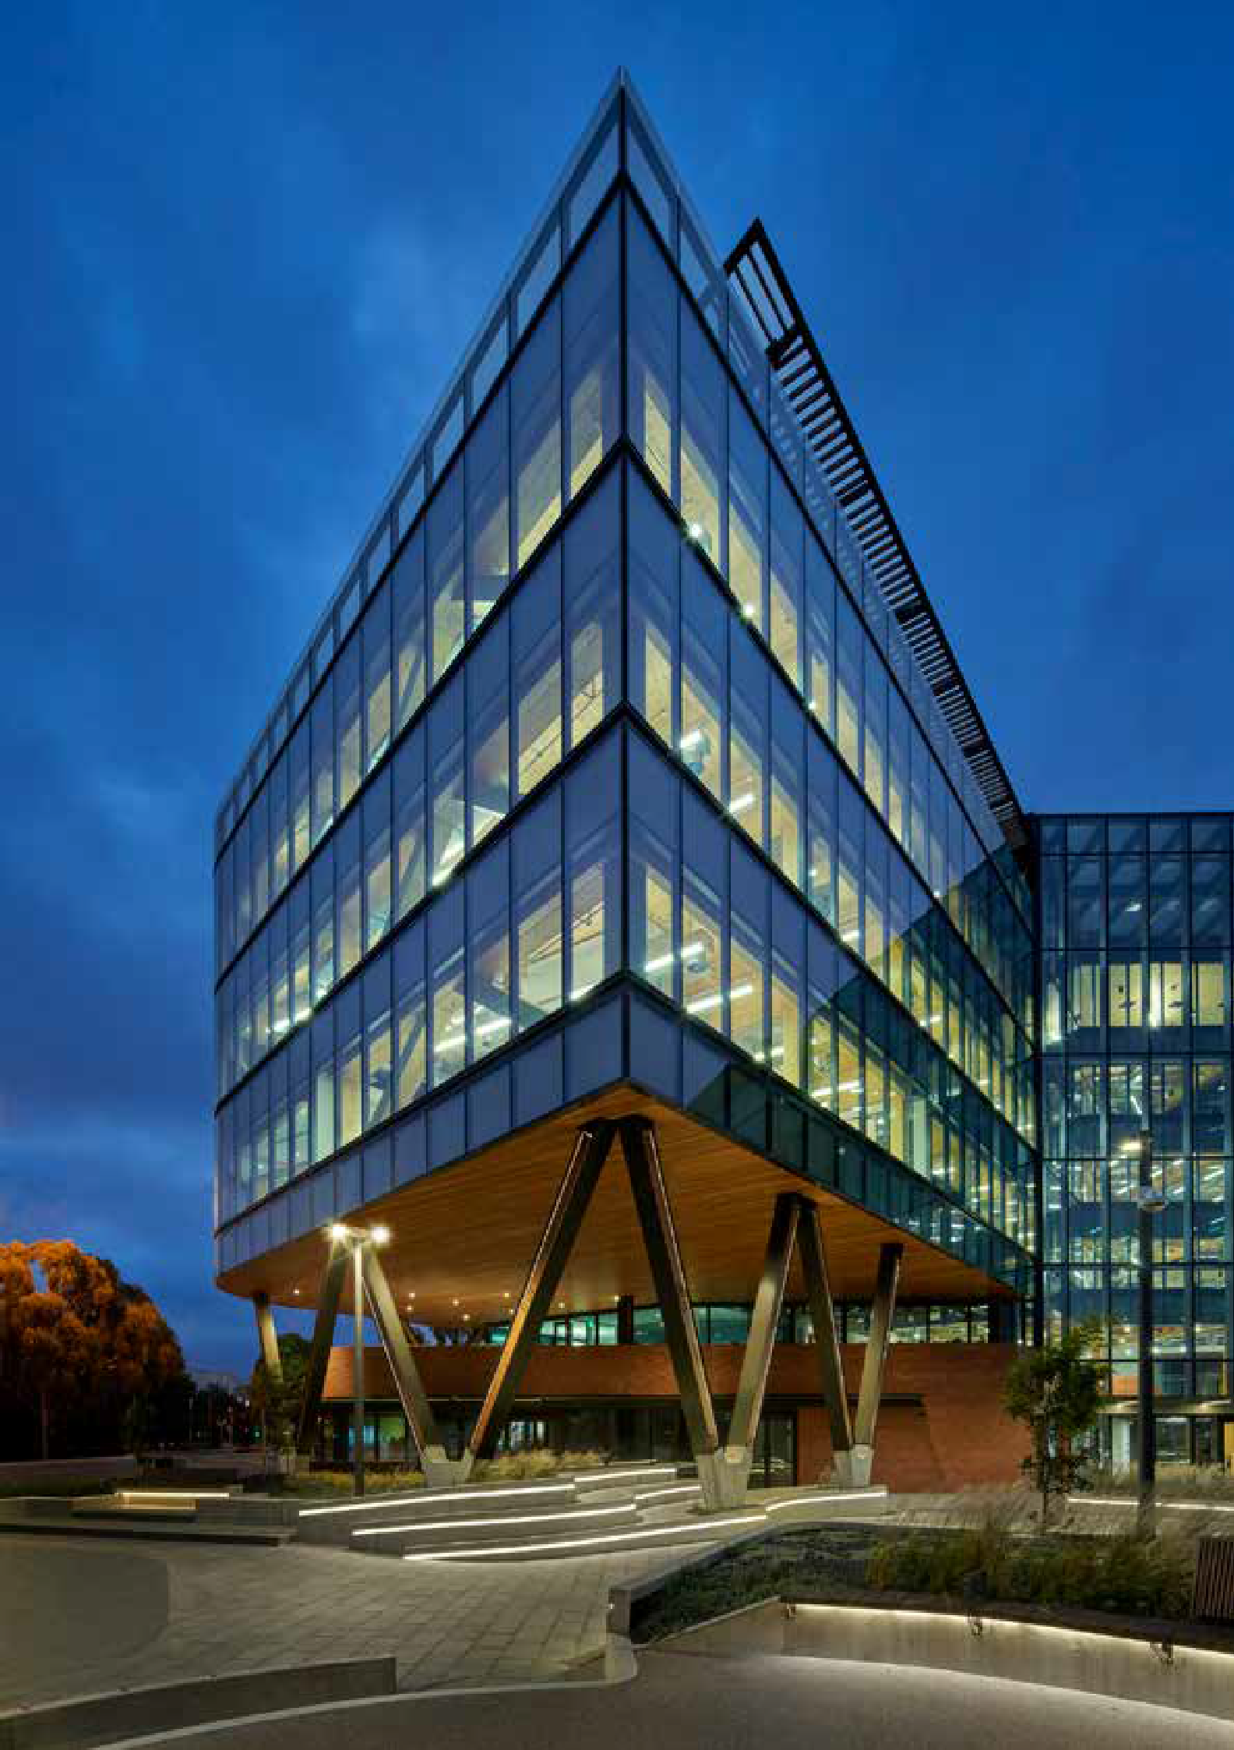

65.



CITY OF GREATER GEELONG WADAWURRUNG COUNTRY PO Box 104
Geelong VIC 3220
P: 5272 5272
E: contactus@geelongcity.vic.gov.au www.geelongaustralia.com.au

© City of Greater Geelong 2023

LATEST NEWS:

@CityofGreaterGeelong

@GreaterGeelong

@CityofGreaterGeelong

CityofGreaterGeelong

