Vital Communities Liveability Findings Summary
Extracts from Vital Communities: Strategies for Alleviating Locational Disadvantage in Geelong, 2021
Contents
Background 1
Determining strategies and responses 10
Recommendations relating to the liveability domain. 14

Background
- Project Aims
The Vital Communities project was established in October 2019 to enhance the City of Greater Geelong’s coordination, planning, and leadership of integrated social and economic development, and to increase social equity and prosperity for communities in Corio, Norlane, and Whittington. The project aims to enhance residents’ quality of life and neighbourhood liveability by improving community outcomes across five “Practice Domains”:
- Education
- Employment
- Housing
- Liveability, and
- Health and Wellbeing.
Below is a summary of content relating to liveability.
Note: all table, figure and page numbers refer to those in the full report.
- Statistical Profile: Corio, Norlane and Whittington in 2020
Liveability
For the purposes of this study, the “Liveability” Practice Domain is used to capture a range of important local features and characteristics not already captured by the other four domains. Liveability thus includes the following: public open space, transport, walkability, accessibility, sustainability, safety, digital inclusion, arts and cultural organisations and venues, other local amenities (shops, eateries, community facilities, public events, leisure options, significant places), social infrastructure, and intangible community assets (social networks, social capital, community knowledge, sense of belonging, place attachment). Here we discuss some key liveability issues that emerged in the research conducted for this section of the report.
Mobility
While there are bus services operating in the three localities, a heavy rail line that passes through Corio and Norlane (on its way to Melbourne and the Geelong CBD), many prior studies and interviews have confirmed that personal mobility is a big issue in these communities. At the human scale, there is scope to build on past initiatives to improve neighbourhood walkability and expand active transport options in the three localities.
ABS data also highlights the significant proportion of residents who lack access to a vehicle: 10 percent in Corio, 18 percent in Norlane, and 14.5 percent in Whittington. Despite this fact, the Corio-Norlane Structure Plan (2012) noted that “Given the spread-out nature of the area and distance to services…the car will continue to dominate as the necessary mode of transport for a majority of residents” (City of Greater Geelong Department of Planning and Community Development, 2012, p. 24). The plan goes on to recommend redesigning major intersections and installing additional ramps to encourage industry and port traffic to bypass residential areas. To improve mobility in these areas, the plan identifies the need for “a public transport network which meets the needs of residents”. This goal was to be achieved by “increasing bus accessibility, frequency and connectivity”, especially from east to west.
However, it is not clear whether these planned actions occurred. Past interviews with Northern Futures clients who live in Corio and Norlane confirm the very real problems the poor bus service and lack of access to a vehicle presents for jobseekers (Johnson, 2012). For many people, just getting a driver’s licence and being able to buy and maintain a car were huge barriers to both employment prospects and active participation in their communities. As the research literature shows, transport disadvantage exacerbates other forms of social and economic exclusion (Delbosc & Currie, 2011). Concrete actions to improve public transport, residential mobility, and neighbourhood walkability should be built into any coordinated effort to address systemic disadvantage in Geelong’s northern suburbs.

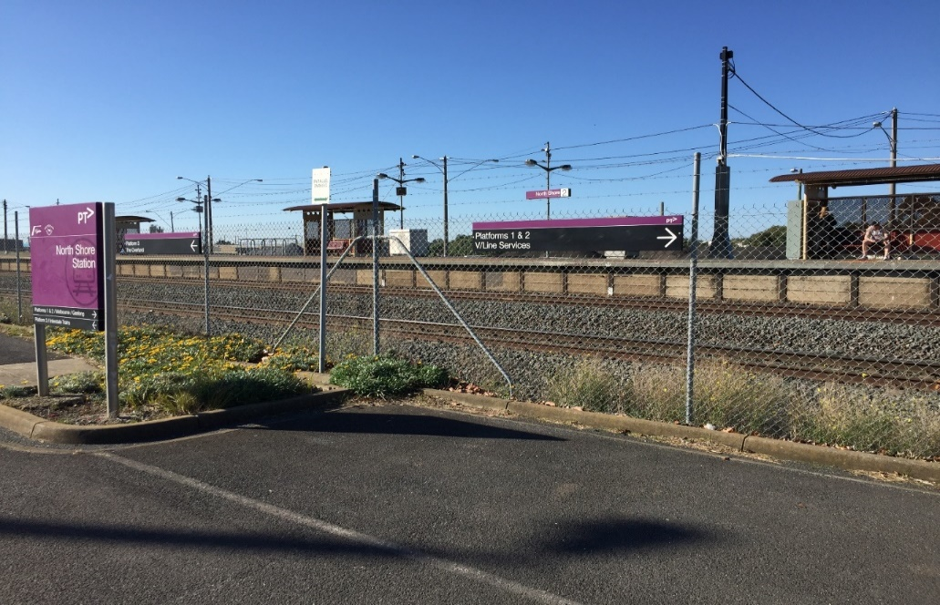
Figure 7.7: North Geelong Station (Photo: Louise Johnson, June 2020)
The Corio-Norlane Structure Plan (City of Greater Geelong Department of Planning and Community Development, 2012) also observed that the North Shore and Corio rail services “suffer from low patronage [and] poor passenger amenity and lack integration with their surrounding area”. The plan then recommends upgrading the North Geelong station. A recent photograph of this station suggests this planned upgrade and integration did not occur (see Figure 7.7, above). It is not clear how many local residents use the relatively infrequent intercity train as a commuter service.
Local Shops and Retail
The Corio–Norlane Structure Plan (City of Greater Geelong Department of Planning and Community Development, 2012) noted the existence of 19 shopping centres across these two suburbs, before suggesting that of those 19, only the Bell Post Hill shopping centre “works”. The plan recommending priority action to: “Improve the role, function and presentation of local shopping centres”, especially Labuan Square (see Figure 7.9). It also recommended that the Corio Shopping Village become a much larger centre, somehow connecting to a tree-lined boulevard on Bacchus Marsh Road and a redeveloped Waterworld precinct. This has not occurred, as the Waterworld precinct is now a major health hub, and Bacchus Marsh Road remains a formidable arterial barrier. As one Norlane resident observed: “This plan involved great consultation but then it was ignored!” (Resident conversation 16.2.21).
As Figures 7.8 and 7.9 show (below), the quality of local shopping strips is very low. Locally, COVID-19 has highlighted a need for more walkable neighbourhoods, more inclusive public spaces, and more accessible services and facilities, especially quality food shops (see Section 8). Across these two suburbs, this presents both a planning challenge and a commercial one: how to rationalise and boost some key neighbourhood shopping precincts. This could be done as part of an initiative engaging local communities and groups – for example, an array of ethnic restaurants in Labuan Square, building on local culinary and business skills within local refugee and cultural communities. This could be readily advertised on nearby Melbourne Road. Local shopping strips could be revitalised based on local needs, engaging residents in the process, and as part of a venture to decentralise services and improve access; the successful relocation of many health services to the Corio Shopping Centre precinct shows this is possible. There is also scope to investigate whether a major supermarket could be accommodated.
Whittington presents a different problem. There are virtually no local shops besides those along the Bellarine Highway, which lie outside the suburb boundary. The third photo below (Figure 7.10) shows a rare local outlet, the HomeStart shopfront in Apollo Place, run by Encompass Community Services. HomeStart upcycles and recycles donated goods, trains and employs local people, and provides low-income residents with free or discounted furniture and homewares to furnish their homes. Besides an adjacent op shop (also run by Encounter) and a fast-food place, Whittington lacks retail or food outlets.
Across all three localities, there is a need to investigate how a good mix of retail, food, and service outlets might be fostered in local shopping strips, and these areas made more attractive, productive, and welcoming for the community.
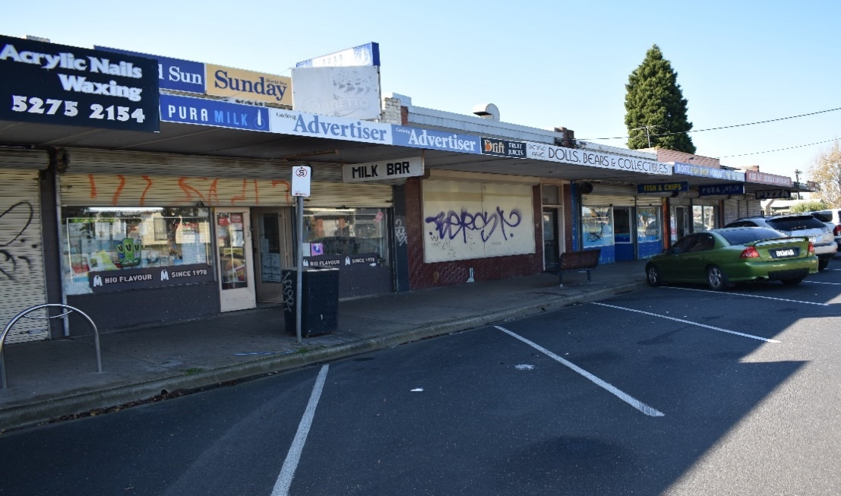
Figure 7.8: Rose Street Shops, Norlane (Photo: Louise Johnson, June 2020)

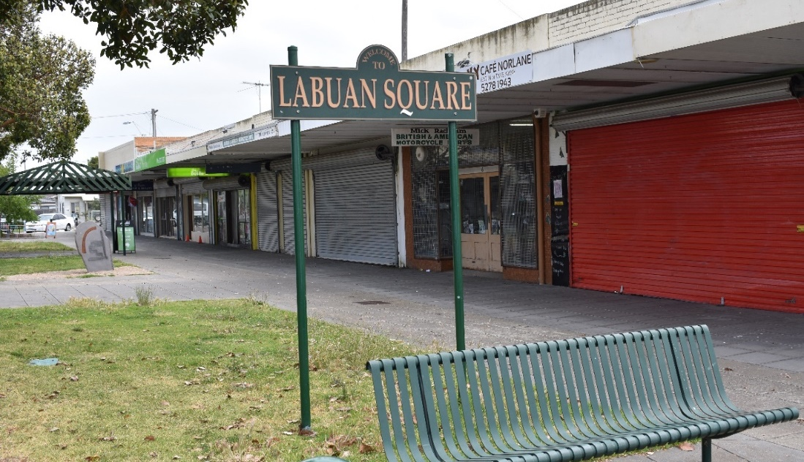
Figure 7.9: Labuan Square, Norlane (Photo: Louise Johnson, June 2020)
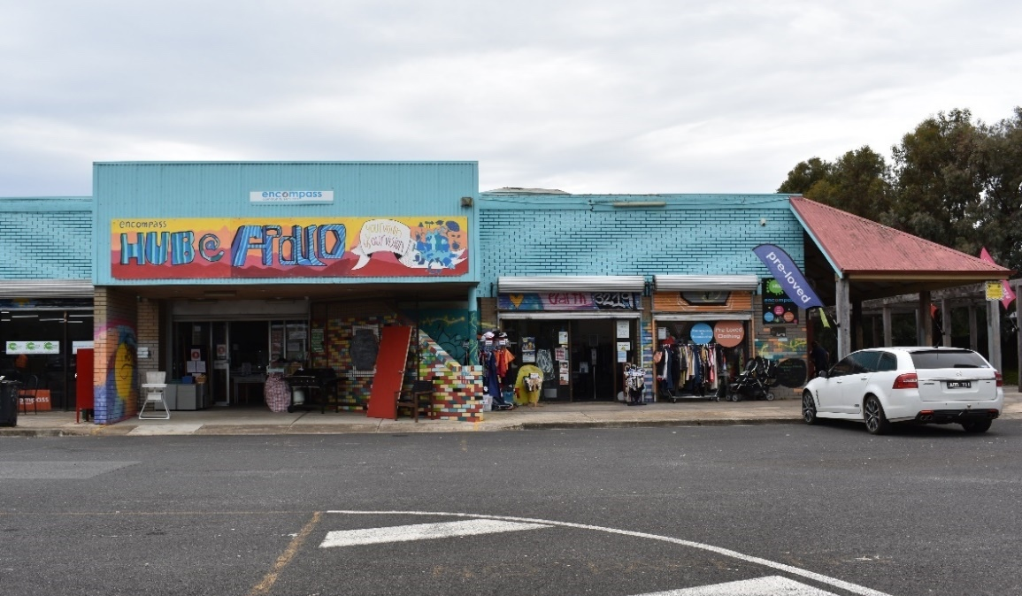
Figure 7.10: Whittington (Photo: Louise Johnson, February 2021)
Open Space
Across Geelong, 44 percent of the population live within 400 metres of public open space that measures more than 1.5 half-acres. Looking at our three localities of focus, on the face of it there seems to be an abundance of parks, open space, playgrounds, and outdoor sports facilities in Corio and Norlane; these include (but are not limited to) Corio Community Park, Stead Park, Corio Community Reserve, and Shell Reserve, all in Corio; and the Fountain of Friendship Park, Evans Reserve, Windsor Park, and Norlane Skate Park in Norlane. There is also the adjacent green space of Cowies Creek and Seagull Paddock. Open space is more limited in Whittington, but includes Whittington Link, St Albans Reserve, other smaller reserves and playgrounds, and the Bellarine Rail Trail on the suburb’s northern border.
There have been both past actions and recent plans to upgrade public open spaces in these areas, in particular lighting improvements and toilet facilities (as noted in the City’s Social Infrastructure Plan). However, as an earlier investigation into Corio-Norlane found, many of the parks are not considered safe by residents, a sprinkling of local pocket parks are not necessarily well used, and there is a need for greater connectivity and safety. Our consultations (see Section 8 (full report)) confirmed these earlier observations, with a perceived lack of welcoming, accessible and attractive open and green space in the three localities, and scope to further upgrade and extend existing options.
Social Infrastructure
The City of Greater Geelong Social Infrastructure Plan (2020–2023) sets out plans for considerable investment into the three areas under consideration. In Corio there are planned refurbishments of existing park facilities (toilets in Stead Park, skatepark, floodlights); the redevelopment of key community facilities (Norlane Community Centre, Corio Library); and the implementation of plans for Osborne House and fOrT Youth Centre in North Geelong. However, a key initiative has not been fully funded: the NACH (Northern Aquatic and Community Hub, formerly Northern ARC), which is to replace Waterworld, and includes an aquatic, health, and leisure facility, plus community and meeting spaces.
Under this plan, there is little social infrastructure proposed for Norlane, beyond the extension of the Leisuretime Centre and Purnell Road Early Learning Centre. Whittington’s St Albans Reserve receives floodlights and Thomson Reserve will have gender-neutral change rooms, along with change facilities for Ervin Reserve and Howard Glover Reserve. However larger community centres and projects – such as the proposed Whittington Community Hub and Aldershot Master Plan – remain open for “investigation” and further “design work”. The only other major investment involves boosting cycling track linkages to other parts of the city.
Based on available information, there appears to be limited new investment in community infrastructure for early years, youth, arts and culture, indoor sport, and recreation in these areas. However, a more detailed audit of existing and nearby facilities, along with benchmarking standards and canvassing local needs, would be necessary to confirm this initial judgement. The future residential growth area of Lovely Banks, part of the City’s North Western corridor development, will no doubt be accompanied by an inflow of new, quality infrastructure. However, the limited mobility of residents in Corio, Norlane, and Whittington, and their expressed need for greater local services, may limit the value of this new development for these communities, with the possible exception of new retail outlets.
Existing local organisations are already surveying their catchments to assess need. At the end of 2019, the Whittington-based Bellarine Living and Learning Centre (BLLC) commissioned a Community Engagement Project Report to “develop a better understanding of what the Whittington community wants from its neighbourhood centre”. This study used an array of methods, from coffee mornings to phone interviews, online surveys, and contact with other key local organisations (sports and recreation clubs, Encompass, Men’s Sheds and Churches).
Based on input from 52 community members and eight stakeholders, the report confirmed the value of BLLC, especially its food bank, but also its open and inclusive approach and the opportunities it created for socialising. The report authors suggested BLLC did need to identify and work with people who were “falling through the cracks” – described as “the new poor”, residents aged 40–60 “who don’t know where to go to get help and no one looks after them”. The report also recommended a name change for the organisation – to address historic stigma around Whittington – and an upgrade of the BLLC facility, as “it looks austere, utilitarian, like a prison” (see Figure 7.11).
The report also suggested that the centre consider offering additional activities, facilities, and programs. Ideas included exercise/Zumba classes, a youth space, a men’s “fix-it” shed, a traffic course, a coffee shop, job-ready and computer courses, food and nutrition activities, and a course on “how to make ends meet – making pocket money into household savings” Bellarine LLC, 2019). In short, the report identified many other options that the BLLC, and perhaps other organisations in the three localities, could offer residents in relation to leisure, educational, and social activities.
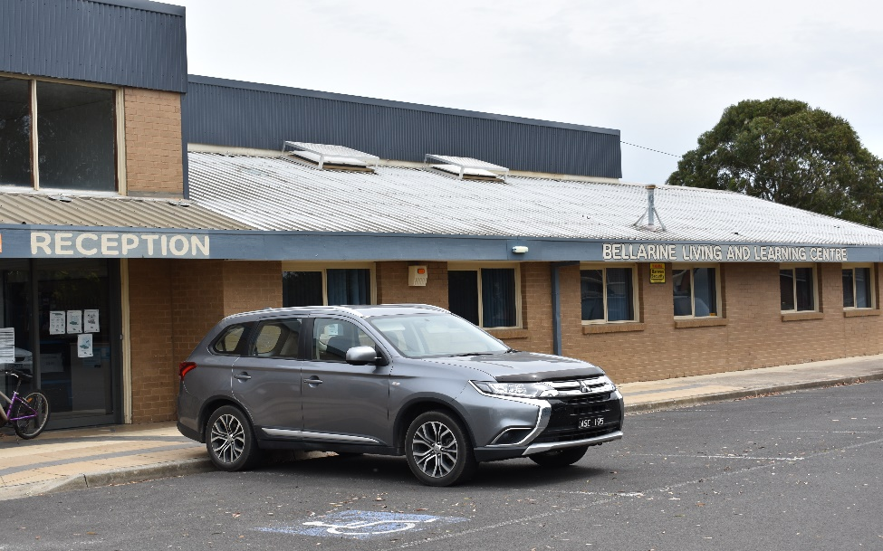
Figure 7.11: Bellarine Living and Learning Centre, Whittington
(Photo: Louise Johnson, February 2021)
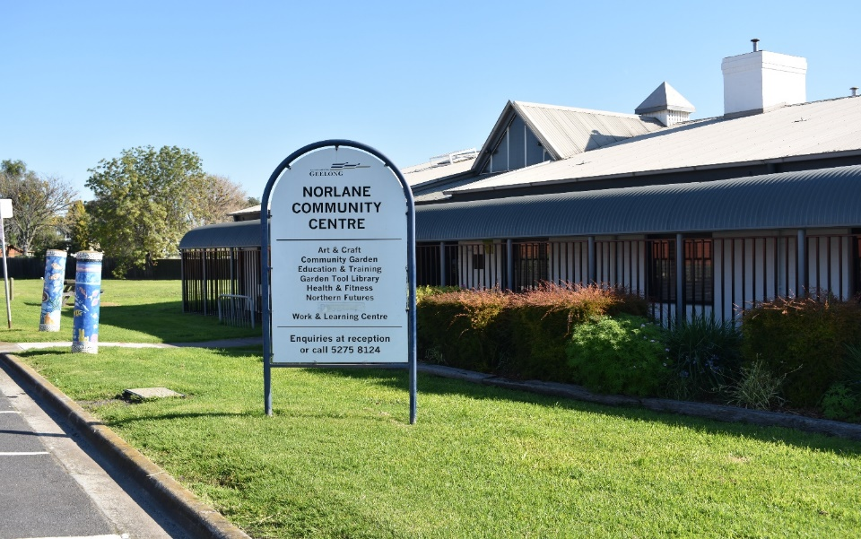
Figure 7.12: Norlane Community Centre, Norlane (Photo: Louise Johnson, June 2020)
Crime and Safety
Safety is a very real concern for residents in the three localities of focus. It readily emerges in any community-based forum seeking feedback on local issues. The data confirms this, offering a snapshot of the range of criminal activity occurring in these suburbs, and underlining the challenges faced by people living in – and policing – these areas. Local burglary and drug trafficking rates are extraordinary (around twice Victoria’s rates). But the most dramatic figures relate to domestic violence and associated crimes, such as breaching a Family Violence Order. Alarmingly, these figures range from twice to five times the Victorian rates. Domestic violence is clearly a problem that demands serious intervention in all three localities. For the women and children affected, these disturbing figures are not merely a symptom of localised disadvantage, but pose a very real threat to wellbeing, health, and potentially life.
Offence | Corio-Norlane (3214) |  | Whittington (*3219) |  | Victoria
(All rates are per/100,000 >>) | Number | Rate | Number | Rate | Rate
Burglary/Break and enter | 344 | 1417.39 | 246 | 1260.31 | 655.25
Motor vehicle theft | 122 | 502.68 | 97 | 496.95 | 324.04
Drug dealing/Trafficking | 38 | 156.57 | 28 | 143.45 | 80.67
Family violence: Serious assault | 145 | 597.45 | 49 | 259.04 | 124.98
FV: Threatening behaviour | 63 | 259.58 | 31 | 158.82 | 67.05
Breach Family Violence Order | 491 | 2023.07 | 259 | 1326.91 | 753.44
Common assault | 85 | 350.23 | 33 | 169.07 | 174.44
Aggravated robbery | 16 | 65.93 | 17 | 87.09 | 54.00
Table 7.14: Criminal Activity in Key Localities, 2020 (Source: Frederikson, 2018)
(*The 3219 postcode includes St Albans Park, Thomson, Geelong East, Newcomb, and Whittington)
- What are the determinants and factors that influence liveability?
As noted in the Methodology and Scope section of this report, “liveability” is a loosely defined concept, used as an umbrella term for a range of different indicators (Hermann & Lewis, 2017: 10). It often refers to features of the local built environment, but liveability can also include social elements of a community or neighbourhood (Hermann & Lewis, 2017: 11; Kaal, 2011).

Liveability indicators are particularly useful for enhancing the connection between urban planning and public health (Lowe et al., 2015). However, the relative importance of these indicators/factors is debated. Lowe et al. listed the number of relevant papers in a large-scale 2015 literature review (see Table 3.8, below) that mention relevant indicators. Here:
It is evident that a broad range of factors shape the liveability of a particular location. Crime and safety, transport, housing, and employment and income were the four most frequently mentioned indicators, and are all fundamental to health and wellbeing… However, it is difficult to determine the relative contribution of each policy area to liveability based solely on the frequency with which indicators are mentioned. Some indicators may be more relevant to particular contexts (Lowe et al., 2015, p. 8)
From both Lowe’s review and our own, the determinants of liveability and health are clearly closely related – and, as Lowe points out, both are also closely related to the determinants of sustainability.
Badland and colleagues directly explored the liveability indicators that might be used to measure the social determinants of health in Australia. Their study:
yielded 11 distinct domains considered to be important components of liveability, and likely to contribute to health and wellbeing through the social determinants of health pathway. The domains were: natural environment; crime and safety; education; employment and income; health and social services; housing; leisure and culture; local food and other goods; public open space; transport and social cohesion and local democracy (Badland et al: (2014).
Of the 82 articles in our review that focused on the factors and social determinants of inequality, only seven are focused on Liveability, or connect the domain of Liveability to other domains. Table 3.8 (below) below indicates the following factors identified in these studies as impacting liveability for low-income communities. In common with the literature, crime and safety, access to affordable housing, residential mobility and access to transport stand out as key factors impacting liveability outcomes.

Context Category | Determinant | Factor | # Articles  Identifying Factor
Economic | Economy | Energy Affordability | 1 | 1
Health | Healthcare & Social Services | Access to Healthcare | 1 | 2
Health | Healthcare & Social Services | Access to Services | 1 | 2
Health | Personal Health Status | Physical Activity Level | 1 | 1
Social | Behaviours | Personal Behaviours | 1 | 1
Social | Crime & Safety | Crime | 3 | 8
Social | Crime & Safety | Neighbourhood Safety | 5 | 8
Social | Employment  & Work | Access to Employment | 1 | 2
Social | Employment  & Work | Employment | 1 | 2
Social | Housing | Housing (access to Affordable Housing) | 7 | 7
Social | Social networks, Support &  Exclusion | Quality of Social & Familial Networks | 2 | 4
Social | Social networks, Support &  Exclusion | Social Cohesion | 1 | 4
Social | Social networks, Support &  Exclusion | Discrimination | 1 | 4
Social | Socio-demographics | Area (Neighbourhood) Effects | 1 | 1
Social | Socioeconomic position | Education Level | 1 | 6
Social | Socioeconomic position | Residential Mobility | 5 | 6
Urban Environment | Housing | Housing Quality | 1 | 1
Urban Environment | Neighbourhood Accessibility | Access to Facilities/Amenities | 2 | 6
Urban Environment | Neighbourhood Accessibility | Access to Transport | 4 | 6
Urban Environment | Neighbourhood Accessibility | Food (Access to Affordable & Good Quality) | 1 | 6
Urban Environment | Physical Environment | Physical Environment | 1 | 1
Table 3.9: Liveability: Social, Economic, Health, And Urban Environment Determinants

Determining strategies and responses
- What makes place-based interventions effective at addressing these social and economic factors and improve community outcomes, both within Australia and globally?
Drawing on the research that informed the Case Studies (see Appendix 1), we identify some key tendencies of effective place-based interventions. These programs often:
- have a multi-pronged focus, involving cross-sector collaboration, and spanning more than one Practice Domain
- support and empower community members to play an active role in identifying issues, solving problems, and shaping and evaluating programs
- are based on sound community engagement strategies, including co-design methods, that are genuinely participatory, respectful, empowering, and inclusive
- recognise, build on, and celebrate existing community assets, strengths, knowledge, and skills
- are overseen by a highly capable lead agency with strong local connections
- involve effective partnerships, sound governance, and relationships of trust
- are adequately funded and resourced, with generous timeframes and workable evaluation methods
- enable holistic thinking and program flexibility
- are connected to broader socioeconomic contexts, including local, regional, and national policy.
- What are the key federal and state policies, programs, and funding initiatives that target liveability to improve community outcomes?
Practice  Domain | Policy Name and Purpose | Relevance to Geelong, Corio, Norlane, Whittington
International | UNESCO City of Design. Designated in October 2017, Geelong is one of 466 members and one of 38 Cities of Design, with comparable cities being Dundee (Scotland) and Detroit (USA). UNESCO Creative Cities Network (UCCN). The City of Design designation is about using creativity and innovation to build more sustainable, resilient, and inclusive communities. It fits perfectly with Geelong’s 30-year, community-led vision to be internationally recognised as a Clever and Creative City–region. | Under this designation the City of Greater Geelong has a commitment and an officer to bring better design to urban development and local communities.
Federal | City Deal: Formal agreements across all three levels of government to develop “place-based” partnerships to stimulate growth, employment, and urban renewal; $382.48 million over 10 years.  National Cities Performance Framework: Geelong is included. This framework measures performance on jobs and skills, housing, infrastructure, liveability, innovation, and planning. Data dashboard here. Regional databases on economic growth, household wealth, educational qualifications, occupations, income, and social capital here.  Roads to Recovery Program: Supports road maintenance to enable safety, social, and economic outcomes. Geelong to receive $10.9 million over life of project.  Regional Rail Revival Package: $10 million for Geelong Rail Line Upgrade (planned Armstrong Creek corridor extension).  National Urban Policy: Aims to facilitate supply of appropriate mixed-income housing, support affordable living, improve accessibility of movement around cities, and support community wellbeing.  Creating Places for People: An Urban Design Protocol for Australian Cities: Set of principles for urban design, aligned closely with universal design.  Our Regions Rising: Policy Hack Summary 2019: Conference attendees were invited to participate in a “hack session” to problem-solve some major issues facing regional Australia. Key emergent themes: 1) Investing in “soft” infrastructure (e.g., human capital, liveability), 2) Governments and regions working together, 3) Empowering regions through flexible and place-based policy, and 4) Shifting the narrative from the current country/city binary.  Regions 2030: Unlocking Opportunity: Industry Growth Centre in Geelong cited as an exemplar of regional jobs development. Provides an overview of the national vision for regional development. | Nothing specific for three localities, but involves improvements to Central Geelong that may impact residents.  Provides citywide data on these domains but can’t drill down to specific areas.  Geelong Youth Activity Precinct won 2010 Australia Award for Urban Design.
Victorian | Regional Development Partnerships via Regional Development (RDP) Victoria: Aims to enable local communities to develop initiatives to meet their challenges and opportunities. Local RDP: Barwon Regional Partnership. Seeks to achieve outcomes in transport connectivity, liveability, climate change, business and innovation, equity and wellbeing, education and tourism.  Urban Design Charter: Set of 11 principles to make cities and towns more liveable. Supported by Urban Design Guidelines.  Regional Community Leadership Program: Capacity-building program to develop leaders from local communities, auspiced by Regional Development Victoria.  Regional Growth Plan – G21: Overview of growth in the Geelong region, auspiced by Victorian State Government.  2020/2021 Victoria State Budget: A range of funding announced for Geelong, including building works, supporting tourism, Great Ocean Road revitalisation, subsidies and incentives under the Jobs for Victoria initiative, transition to clean energy, digital futures, agricultural development, post-pandemic business recovery, and building skills.  Victoria in Future 2019: Includes population projections for all regions of Victoria.  Barwon-South Western Region Community Profile: Provides region’s overall statistics, 2015 (most liveability areas). | Development of School and Family Community Hubs in Whittington, based on Doveton Model; construction of Northern ARC Health and Wellbeing Hub in Corio (proposed but not funded, now known as NACH Northern Aquatic and Community Hub); Regional Digital Plan.  Geelong projected to grow by over 100,000 people by 2036, Surf Coast and Moorabool at even faster rates.
Greater Geelong | Neighbourhood Renewal Program (NRP) (2003–2010): Multi-pronged State Government program to revitalise public housing, open spaces, schools, and health services in localities across Victoria, including Corio and Norlane.  Social Infrastructure Plan (SIP) for the City of Greater Geelong: Corio and Norlane projects: new public toilets; upgrade key community centres, Corio Library, Northern Aquatic & Community Hub, Whittington Reserve; extend cycle network. Community Hub: investigate consolidating facilities and new multi-use intergenerational centre; Aldershot masterplan design; expand Splashdown Aquatic Centre and Norlane Purnell Road Early Years Centre.  Redevelopment of Spruhan Avenue Hub: Funded by the City ($40,000) and a Percy Baxter Foundation grant ($240,000). Five-bedroom home contributing to the Norlane Community Initiatives Hub: residents live on site and work with community members to offer neighbourhood hospitality, care, and programs.  Northern Geelong Growth Area Plan: Includes extensive plans for social infrastructure including a cultural hub, two community centres, two neighbourhood centres, two integrated children’s centres, two maternal and child health centres, two kindergartens, five daycare centres, one health and wellbeing centre, eight primary schools, two secondary schools, one policy and justice centre, and one emergency service hub.  Clever and Creative Geelong Project: Engaged local manufacturing companies to deliver a range of services to the community, thereby encouraging growth in digital services. Supported by the Smart Cities and Suburbs program from the Federal Government’s Department of Infrastructure.  G21 Geelong Region Plan: Strategic framework and vision looking towards 2050 and addressing environment, settlement, land use, community cohesion, and the economy.  Norlane Community Initiatives: Grassroots local organisation.  Specific plans to engage with issues around disability, multicultural populations, Aboriginal Geelong, new technologies, public art, domestic violence, and urban planning are considered in detail in Part B of this report. | NRP: included Corio and Norlane. See Section 5.  Outlined at left.  Includes plans for urban regeneration of Corio, Norlane, and Whittington; Corio/Norlane Structure Plan Project; water and sewer upgrades between Corio and Lara, targeting infill and high-density options.  Relevant primarily to new growth corridors rather than the three areas  General strategic planning document for City of Greater Geelong  Concerned with whole G21 area but includes a commitment to addressing disadvantage. Area- and group- specific plans are highly relevant (see Part B).
COVID 19 | 2020/2021 Victorian State Budget: A range of funding for Geelong, including building works, tourism support, Great Ocean Road revitalisation, subsidies and incentives under the Jobs for Victoria initiative, transition to clean energy, digital futures, agricultural development, building skills, and business recovery post pandemic.
- What liveability policy gaps could be addressed to help improve community outcomes?
- Prioritise provision of basic social infrastructure.
- Increase safety and prevent domestic violence.
- Grow pride of place via community arts projects and events, greening neighbourhoods and improving public spaces, and sharing heritage through storytelling and public artworks.
- What are the key liveability issues to be addressed in a COVID-19 impact assessment?
- Reduced access to local gathering spaces, parks and shops, walkable neighbourhoods, local arts and culture. The future design of environments will require greater co-design with communities.

- How have “disadvantaged” communities in Geelong dealt with the pandemic in relation to liveability?
Existing or entrenched issues for the three communities were amplified or compounded by the challenges of the pandemic. The history of the communities was also acknowledged to be an important contextual factor, including both the recent past and longer-term trends such as demographic changes.
Significant liveability issues included digital exclusion, and limited access to quality, safe public spaces (including agencies, retail, green spaces, and outdoor facilities), and to public transport because transit facilities were perceived as a high-risk setting for COVID-19 transmission.
- What factors relating to liveability supported local economic resilience and social cohesion?
Some positive outcomes during the pandemic were reported across all five Practice Domains, some of which reflected community responses to the challenges and negative impacts described above. The overarching theme was the community’s ability to leverage pre-existing economic and social resilience, developed from years of experience with disadvantage.
Looking at Liveability, the shift of many community activities online provided opportunities for digitally engaged residents to access online arts and cultural events, education and training, and fitness support. Young people also made an important contribution to community life, for example doing grocery shopping for vulnerable residents at greater risk of illness from COVID-19.
- What interventions worked best, and what other approaches could have enhanced residents’ experience?
Local community workers stressed that the approach taken to developing any new initiatives is of equal if not greater importance than the initiatives themselves. Our informants advised that successful approaches need to build trust, identify and build on existing local strengths, support community confidence and empowerment, recognise and support the community’s ability to design solutions to problems, provide appropriate funding, plan for long-term delivery and evaluation, support collaboration (across organisations, sectors, levels of government), and take a holistic view.

Recommendations relating to the liveability domain.
Note: Some recommendations relate to multiple domains and will be included in more than one summary. Recommendation reference numbers and case study page numbers refer to the full report.
3.1 Program Extension Initiative: Identify and Extend Successful Programs
Our research into the three localities and consultations with key workers identified a range of highly effective existing programs and promising approaches. Rather than attempting to implement new programs from scratch, it is strongly recommended that an audit of existing programs be conducted, with a view to supporting and extending those that are effective, mapping potential overlaps, and identifying possible partnerships and lead agencies to develop future initiatives. There is also some scope to build upon or leverage existing government policies and plans. While this list is only a starting point, we have identified the following candidates (listed by Practice Domain):
- Liveability: Revisit and refresh the Corio-Norlane Structure Plan (especially around revitalising local retail strips, railway station renewal, street safety, and neighbourhood greening). Replicate a similar consultation and planning exercise for Whittington. Review existing social infrastructure in these suburbs and identify and address important gaps. Explore potential collaborations between existing community centres to build capacity.
3.3 Local Training and Employment Initiative
All three localities have high unemployment, some of which is intergenerational. While the pandemic temporarily boosted some prevalent local job sectors – aged care, cleaning, transport, logistics – and prompted some expansion into health, unemployment is now surging again.
The Local Training and Employment Initiative addresses a dual need: to support and extend existing training and employment programs (see Recommendation 1); and to explore and expand new local work opportunities. Specific needs and activities include:
- Train and employ residents in local neighbourhood regeneration, social infrastructure, placemaking, community centre, digital inclusion, and food security programs. Connect to State Government social procurement policy.
- Mobilise local skills via arts, cooking, gardening, cycling, music, carpentry, and craft programs.
- Develop local leadership programs (in partnership with schools and G21).
- Further explore local employment expansion options, such as construction, health, aged and disability care, as sectors where more locals can be trained and employed.
- More active outreach to long-term unemployed people to engage them into existing programs, or custom-design programs to meet their needs.
- Revitalise old industrial precincts and retail strips as employment hubs.
- Capitalise on the projected residential growth in the city’s North West corridor, primarily the increase in construction employment possibilities.
- Explore and tap into relevant funding opportunities (such as the new Jobs Victoria Fund).
Relevant Case Studies: GROW, Geelong (p.61); Whittington Works, Geelong (p.60); Neighbourhood Renewal Program, Victoria (p.66); Sustainable South Bronx Project, New York (p.73); Oslo Living Lab, Norway (Rooftop Garden + Circular Business Model) (p.82); We Design For Life, Kolding, Denmark (RE:USE circular economy project) (p.83).
3.5 Placemaking Initiative
Having ready access to quality communal spaces can benefit health and wellbeing, reduce social isolation, help counter place-based stigma, and foster community pride. COVID-19 highlighted a shortage of welcoming, accessible public and open spaces in all three localities. It also underlined the importance of neighbourhood shopping strips, many of which are run-down or boarded up.
The Placemaking Initiative aims to co-create more inclusive, safe, high-quality shared places where residents can gather, exercise, play, and interact. This includes extending and improving parks and green spaces (such as Cowie Creek, Seagull Paddock, and the St Helens area); upgrading streetscapes and outdoor facilities; enhancing neighbourhood walkability and connectivity; improving active transport infrastructure (walking trails, bike paths); fixing unsafe or problematic spaces; and revitalising local retail strips, especially Labuan Square, Rose Street, and Whittington shops, ensuring a good tenant mix (retailers, decent food outlets, community services, social enterprises).
Residents could be trained and employed to co-design and undertake placemaking projects, with local artists engaged to enliven streetscapes. Tactical urbanism could be used to test options with the community. Community events and outdoor activities could be held in revamped sites.
Relevant Case Studies: Streets Ahead, Victoria (p.64); Best Babies Zone, USA (Design Sprints) (p.71); Sustainable South Bronx Project, New York (p.73); Detroit City of Design Contest (p.74); Festival of Neighbourhoods, Canada (p.75); The Broomhill Project, Glasgow, Scotland (p.76); My Community Matters, UK (community walkabouts) (p.77); Skip Garden and Kitchen + Story Garden, London (p.78); Nourishing Landscapes, France (p.81); Oslo Living Lab, Norway (tactical urbanism projects) (p.82).
3.7 Arts and Community Events Initiative
COVID-19 reportedly increased social isolation, stress, and anxiety increased across the three localities. Residents in these neighbourhoods have limited access to the creative arts, local entertainment and culture options, and inclusive communal spaces. Along with the erosion of social connections during the pandemic, they also face enduring place-based stigma.
Arts-based projects can help rebuild community ties, foster social inclusion, and support healing after traumatic events. The Arts and Community Events Initiative aims to bring people together, mobilise creativity, build pride in place, and create more vibrant neighbourhoods. In celebrating and showcasing the community’s strengths, it also seeks to counter place-stigma.
Residents should be supported to co-design and execute arts-based projects and community pride events, drawing on local expertise and talents (music, visual arts, dance, theatre, writing, cooking, craft). Options include public artworks, neighbourhood festivals, live music, food-focused events, local photography projects, nature-based art activities, and community markets. Local heritage – Indigenous, multicultural, industrial, natural, public housing – could be celebrated via storytelling projects, heritage walks, and public artworks. Venues could be upgraded or existing spaces.
Relevant Case Studies: TBA North, Geelong (Children’s Choir) (p.59); Fawkner Commons/Fair Share Fare (DIY Knowledge Share) (p.63); Shutterbugs + I Heart Maryborough, Victoria (p.67); Ten Ideas Three Ventures, Melbourne (The Culture Party) (p.65); The Broomhill Project, Glasgow (p.76); Skip Garden and Kitchen + Story Garden, London, UK (MAKE Workshops) (p.78), We Design for Life, Denmark (p.83).
3.10 Accessibility and Inclusion Initiative
Our final recommended initiative seeks to embed an active commitment to social equity across all program areas. There is a clear need to provide communities in Corio, Norlane, and Whittington with more equitable opportunities for social inclusion, economic participation, employment, education, and housing, along with access to community and social infrastructure that meets the needs and aspirations of all residents. This applies across all 14 priority areas and all 10 proposed initiatives, and is consistent with the recommendations of the Accessible and Inclusive Geelong Feasibility Study (Tucker et. al. 2018).
Mobility barriers and transport equity were identified issues, with a need to improve both local public transport and active transport options. Residents who wish to own and drive cars also need support to obtain drivers’ licenses. Inequitable access to education was also highlighted, with support requested for local schools to link with key community organisations – such as Wadawurrung Elders, Wathaurong Aboriginal Co-operative, and Diversitat – to develop more culturally appropriate programs to engage ATSI and CALD students, while also supporting these students with transport to their schools.
Specific actions for the Accessibility and Inclusion Initiative include:
- In line with Recommendation 1, adopt inclusive co-research and co-design approaches for development, implementation, and evaluation of all local initiatives and programs.
- Embed principles of Universal Design into the implementation of all actions.
- Ensure all residents have equitable access to social infrastructure, built environment improvements, quality public space, affordable and appropriate housing, dedicated services, public transport options, and employment opportunities.
- Prioritise attitudinal change towards inclusion, equity, and access.
- Adopt social inclusion as a core value for Corio, Norlane, and Whittington.
Relevant Case Studies: Afghan Girls Bike Skills Workshops, Bendigo (p.62); Australian Indigenous Mentoring Experience (AIME) (p.70); Streets Ahead, Victoria (p.64); Best Babies Zone, USA (East Oakland Innovators) (p.71); My Community Matters, UK (p.77); Oslo Living Lab, Norway (p.82); We Dundee, Scotland (p.80); We Design For Life, Kolding, Denmark (p.83).

