Appendix 3: Community Data - Updated
Unless otherwise stated, data contained in this section was extracted from 2021 ABS Census data.
Key Population  group | First Nations peoples
Facts and Stats –  Geelong population | 3562 people (1.3%) in Greater Geelong identify as being Aboriginal or Torres Strait Islander (2021 ABS Census).
Why a focus on First  Nations peoples? | We support the right of Aboriginal and Torres Strait Islander Peoples to experience the full range of choice, opportunity, and influence in their lives. We acknowledge that historically, government legislation and practices enforced on Aboriginal and Torres Strait Islander Peoples have contributed to many being unable to realise their full potential. These policies have left lasting inter-generational impacts. Various pieces of government legislation and policies have contributed to dispossession of land, racism, social and emotional wellbeing issues, culture loss, family fragmentation, unemployment, poor housing, low literacy and numeracy rates, alcohol and substance misuse and poverty.  City of Greater Geelong Reflect Reconciliation Action Plan has been developed around four key deliverable themes including Relationships, Respect, Opportunities and Governance. It is based on priorities and aspirations identified through consultation with Traditional Owners, the local Aboriginal and Torres Strait Islander Community and input from the Working Group members.  Our Reflect Reconciliation Action Plan builds on advancing a positive relationship between Aboriginal and Torres Strait Islander Peoples and non-Indigenous people, demonstrating respect and self-determination for local Aboriginal and Torres Strait Islander Peoples ensuring equality of opportunity and access in all dealings with the community.  We aim to celebrate and promote Greater Geelong’s Aboriginal heritage, culture and achievements through funded events, our dedicated First Nations Heritage Grants program, and other targeted initiatives.
Want to know more? | List of City of Greater Geelong resources, policies and initiatives that support this objective:  - Reflect Reconciliation Action Plan  - Kilangitj Aboriginal Advisory Committee  - Aboriginal sites and venues, NAIDOC week  - First Nations Cultural Heritage Grant Program  - First Nations Woman In Community Life Award

Key Population group | Multicultural (Culturally and Linguistically Diverse) communities
Facts and Stats –  Geelong population | Countries with the highest number of people arriving to Geelong between 2016 and 2021:  - India (+2,539)  - Philippines (+612)  - United Kingdom (+537)  - China (+528)  - Pakistan (+336) (2021 ABS Census)  11.7% of Greater Geelong adults speak a language other than English at home. Top 3 languages:  - Mandarin (0.8%)  - Punjabi (0.8%)  - Italian (0.8%)  - Croatian (0.8%)  - Filipino (0.7%) (profile.id 2022)  4,432 people (1.6%) who spoke a language other than English at home reported difficulty speaking English (profile.id, 2022).  English remains the top reported ancestry (38.4%), followed by Australian (35.7%), Irish (12.9%), Scottish (11.6%), and Italian (4.5%) (profile.id, 2022).The City of Greater Geelong has the highest proportion of people born overseas (17.7%) in the G21 region (profile.id, 2022). Greater Geelong has the highest number of permanent migrants across the three migration streams (Family, Skilled, and Humanitarian) in the G21 region. (Department of Home Affairs, 2023).
Why a focus on Multicultural? | We are committed to respecting and celebrating the cultural, linguistic, and religious diversity in our community. We recognise that our multicultural communities face unique barriers to participation, including lack of accessible information, cultural differences, racism, and exclusion. The City strives to create inclusive services, places and programs that responds to the community’s needs. We value richness that multicultural communities bring to the social and economic fabric of our region.
Want to know more? | List of City of Greater Geelong resources, policies and initiatives that support this objective:  - Our Community Plan 2021- 2025  - Multicultural Action Plan 2018 - 2022  - Reducing Racism – Community Reporting Tool  - Multicultural resources

Key Population group | Refugee and Asylum Seeker communities
Key Population group | Refugee and Asylum Seeker communities
Facts and Stats –  Geelong population | Between 2017 and 2022, there were 1,207 Humanitarian arrivals into Greater Geelong. The top nationalities in this period were:  - Iraq (276),  - Afghanistan (248),  - Myanmar (244)  - Syria (223) (Cultura, 2022).  In March 2022, 2.5% of all asylum seekers in Victoria who arrived by boat reside in Greater Geelong. This has increased from 2.4% in 2020 (Department of Immigration and Border Protection, 2022).
Why a focus on  Refugees and Asylum  Seekers? | We acknowledge that our refugee and asylum seeker communities face unique and complex challenges. These include possible experiences of persecution, violence, conflict, detainment, distance, and lack of communication with families, visa insecurities, trauma and ongoing mental health issues, financial difficulties and lack of work opportunities. These challenges are in addition to linguistic and cultural barriers. We are committed to working with partner agencies to support our refugee and asylum seeker communities and ensure they are included, welcomed, and valued in the Greater Geelong community.
Want to know more? | List of City of Greater Geelong resources, policies and initiatives that support this objective:  - Our Community Plan 2021- 2025  - Multicultural Action Plan 2018 - 2022  - Reducing Racism – Community Reporting Tool  - Multicultural resources

Key Population group | People with disability
Facts and Stats – Geelong population | In 2021, 17,726 people (or 6.5% of the population) in City of Greater Geelong reported needing help in their day-to-day lives due to disability. The reported need for assistance due to a severe or profound disability is higher for Greater Geelong females (6.9%) than males (6.2%). The need for assistance increases with age (2021 ABS Census).  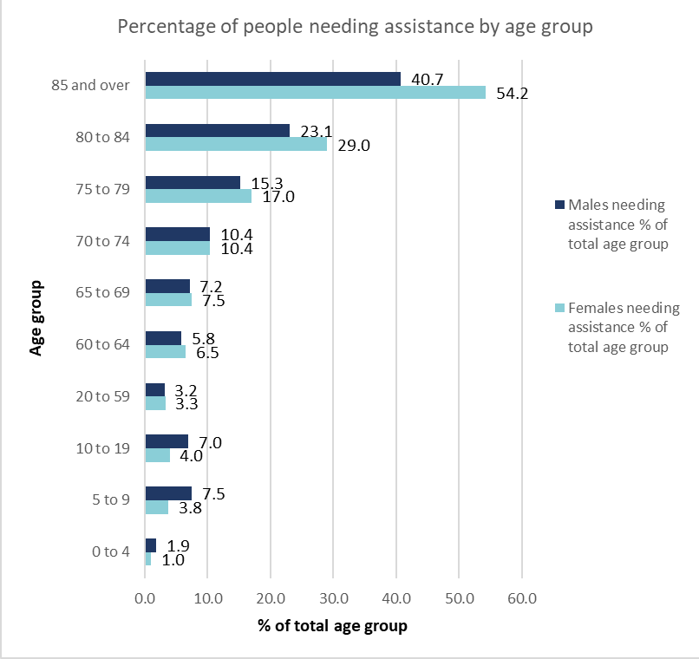  In addition to those who require assistance with daily living, there are many people with a disability (including sensory, physical, intellectual, and behavioural conditions) that do not need assistance. In total, the Australian Institute of Health and Welfare reports that 1 in 6 (18%) people in Australia have a disability. Another 22% of people in Australia have a long-term health condition (ABS 2019a).  Population  - 54,985 people with disability in Greater Geelong or 22.1% of our population.  - Disability prevalence is similar for women (22.2%) and men (22.0%).  - The number of people with disability increases with age: 54.5% of people aged 65+ have a disability.  Day to day living  - 17,726 people reported needing help in their day-to-day lives due to disability.  - More than 1 in 4 people with disability had difficulty with access to buildings and facilities.  Carers  - 30,115 people (aged 15+) are providing unpaid care to people with disability, long term illness or aged care.  - 61.5% of carers are female. Almost half (49.6%) of all carers also have a disability.  All statistics relate to the Greater Geelong community, sourced from the Survey of Disability, Ageing and Carers 2018⁴, except for the carers statistics which are sourced from the Census 2021⁷. Updated data for the Survey of Disability, Ageing and Carers is expected to be released in June 2024.
Why a focus on people with a disability? | We value including an individual’s unique experience and understanding of their disability to create opportunities for access and equal participation. We recognise the need to reduce barriers for people with disability. These may be created by structures, attitudes, and practices and limit opportunities for community members to fully participate. In addition, we recognise that built, social and policy environments can inhibit full participation. We are committed to supporting and improving access and choice for people with a disability.
Want to know more? | List of City of Greater Geelong resources, policies and initiatives that support this objective:  - Our Community Plan 2021- 2025  - Access and Inclusion Plan 2018-2022  - Wheelchair Accessible Taxis  - Geelong Awards for People with a Disability  - Disabled Parking Permits

Key Population group | Women
Facts and Stats – Geelong population | In 2022, the victim reports of family violence incidents were higher for women than men in Greater Geelong (131.26 and 40.58. per 10,000 people, respectively) and Victoria (113.8 and 39.1) per 10,000 people, respectively) (Victorian Women’s Health Atlas 2022). The 2022-23 Victorian Family Violence database (from crime stats Victoria) released on Wednesday, December 6, 2023, found the number of family violence offences had risen by 3.2 per cent from the last financial year (Geelong Independent, Friday 8th December 2023). Attitudes towards domestic violence can influence perpetration and reporting behaviours. People with low support for gender equality are more likely to hold violence-supportive attitudes.
Why a focus on women? | We recognise the power imbalances that exist for different genders, and the impact that this inequity can have on the safety, health and wellbeing, and economic life of women and gender diverse people. It is evident that gender equality is crucial to ending violence against women and children.  We have collected qualitative data that illustrates the wide and complex range of impacts on women and gender diverse people caused by the COVID-19 pandemic, including how gender stereotypes and gendered roles were exacerbated. Negative experiences were heightened when there was more than one pre-existing challenge, such as lack of affordable housing, family violence, mental illness, disability, limited English language or limited mobility.  Gender equity is a governance, community and organisational issue. To achieve authentic gender equity, we must eliminate barriers and acknowledge and celebrate the crucial role that women and girls play in our economy and our community, and the importance of working together to create an equitable future for all.  As of 31 March 2021, we are obligated under the state government Gender Equality Act 2020 to ensure that gender equity is embedded in all policies, processes and services, enabling an intersectional approach to the way the organisation does business.
Want to know more? | List of Geelong resources, policies and initiatives that support this objective:  - Ba-gurrk: A Gender Equity Framework for the City of Greater Geelong  - Women in Community Life Advisory Committee  - Gender COVID-19 Impact Analysis Report and action plan  - Geelong Australia Family Violence, Gender and Culturally diverse support services. Gender information and resources  - Women’s Health & Wellbeing Barwon South-West  - Sexual Assault Family Violence Centre  - InTouch Multicultural Family Violence Service  - Women with Disabilities – our Place

Key Population group | LGBTIQA+ communities
Facts and Stats – Geelong population | 5% of Greater Geelong adults identify as being lesbian, gay, bisexual, transgender, intersex, queer (LGBTQ+)* compared to 5.7% for Victoria (VAHI 2020).  *VAHI 2020 refers to LGBTQ+ rather than LGBTIQA+ as used by the City. LGBTIQA+ includes lesbian, gay, bisexual, transgender and gender diverse, asexual, and intersex people.
Why a focus on LGBTIQ+? | The City works to ensure that the strength and diversity of lesbian, gay, bisexual, transgender and gender diverse, asexual, and intersex people (LGBTIQA+) are valued, celebrated and affirmed. It recognises that the LGBTIQA+ community face barriers to participation including, vilification, exclusion, lack of safety, poor mental health and health and wellbeing outcomes.  The City is committed to working with the LGBTIQA+ community to build a safer and more inclusive community, which benefits from the contributions of all community members.
Want to know more? | List of City of Greater Geelong resources, policies and initiatives that support this objective:  - Ba-gurrk: A Gender Equity Framework for the City of Greater Geelong  - The GASP Project  - Gender COVID-19 Impact Analysis Report and action plan  - Geelong Australia Family Violence, Gender and Culturally diverse support services. Gender information and resources

Key Population group | Young People
Facts and Stats – Geelong population | Young people (15-24 years) make up 11.9% of the total population of the City of Greater Geelong (32,291) (2021). The number of young people is expected to increase by 56.6% between 2016 and 2041 (from approximately 32,000 to 50,000).  In 2021, the local areas with the greatest proportion of young people were Waurn Ponds (28.5%); Lovely Banks - Batesford – Moorabool (15.7%); and Corio (15.5%).  Areas projected to have a significant growth in the number of young people between 2021 and 2041 include Lovely Banks – Batesford - Moorabool (+5427), Armstrong Creek (+5,419); Marshall - Charlemont (+4,781), Mount Duneed (+3,501) andBell Post Hill (+2,779).
Why a focus on Young People? | The City recognises that young people make up a significant percentage of Geelong’s society and are impacted by decisions made on their behalf. The City recognises that young people face many challenges in regards to health and wellbeing, inclusion, access, voice, social isolation, mental health, vaping and safety.  It works with young people to understand their aspirations and needs and to shape a future and livelihood that considers them and is sustainable and prosperous for them.
Want to know more? | List of City of Greater Geelong resources, policies and initiatives that support this objective:  - City of Greater Geelong- Young People  - Youth Council  - Youth Strategy  - Youth Spaces  - The fOrT

Key Population group | People 55 and over
Facts and Stats – Geelong population | People 55 and over comprise a significant proportion of the total population of the City of Greater Geelong (CoGG). In 2021, people aged 55 years and over comprised 31.5% of the population of the City of Greater Geelong. The number of people aged 55 and over is expected to increase by 68% between 2016 and 2041 (from approximately 72,000 to 120,000).  In 2021, the local areas with the greatest proportion of residents aged 55+ years were Portarlington (61.7%); St Leonards - Indented Head (53.6%); Rural Bellarine Peninsula (48.7%) and Drysdale - Bellarine (45.7%). Areas projected to have a significant growth in the number of residents aged 55+ years between 2021 and 2041 include Armstrong Creek (+4,554; Mount Duneed (+3,205) Ocean Grove (+2,753); and Marshall - Charlemont (+2,659) and Lovely Banks – Batesford - Moorabool (+2,271).
Why a focus on people 55 and over | Everyone experiences ageing differently depending on biological, environmental, geographic, cultural and health factors; access to resources and support; and the inclusiveness of local environments. Targeted interventions are often required to address age specific barriers to ensure safe and equitable access to services, infrastructure, and community amenity. These experiences can also be shaped by economic and social drivers such as where you live, employment background and housing stability.  Poverty is a real risk for people over 55 who are displaced from the workforce. Ageism often means they find it difficult to return to the workforce, relying on job seeker payments until they are eligible for the age pension at 67 years. This can lead to long-term experiences of poverty. Women are particularly at risk. They are often employed in a casualised workforce with low job security and little to no superannuation. Women 55 and over are the fastest growing cohort of people experiencing homelessness.  People as they age want to feel welcomed, respected and connected to other people in their community, including through intergenerational connections, neighbours, and social groups. However, for some the experience of isolation has resulted in feelings of loneliness and segregation. Those from culturally and linguistically diverse populations are particularly at risk. The health impacts of this include increased risk of physical and mental health conditions such as heart disease, depression, and cognitive decline.
Want to know more? | List of City of Greater Geelong resources, policies and initiatives that support this objective:  - Respected, connected and thriving - Positive Ageing Strategy 2021-47  - Access and Inclusion Plan 2018-2022  - Social Infrastructure Plan 2020-2023  - Social Housing Plan 2020-2041  - Sustainability Framework  - Reflect Reconciliation Action Plan  - Social Equity Principles  - Multicultural Action Plan 2018 - 2022  - Community Engagement Policy  - Ba-gurrk: A Gender Equity Framework for the City of Greater Geelong
More again | External to City of Greater Geelong  - What’s Age got to do with it.  - Squalor and neglect: time to regulate Victoria’s hidden shame

Key Population group | Socio- economic disadvantage
Facts and Stats – Geelong population | Norlane, Whittington and Corio  Areas with highest relative disadvantage (IRSD 2021 index are: Norlane (757), Whittington (817), Corio (823), Breakwater (899), Thomson (925), Newcomb (928), Bell Park (944) and North Geelong (951). All these areas are in the bottom 20% of scores for relative disadvantage in Australia.(ABS Census 2021, SEIFA).  Unemployed people in Corio-Norlane represent 27% of all unemployed persons across Greater Geelong (Jobs and Skills Australia, Small Area Labour Markets, June Quarter 2023).  Over the last 10 years the unemployment rate of Corio-Norlane has been on average, 10.5 percentage points higher than Greater Geelong. The gap peaked in 2018 at 14.5 percentage points yet since that time it’s halved to a difference of 6.9 points (Jobs and Skills Australia, June quarter 2023).  22.3% (Whittington), 20.6% (Norlane), 14.8% (Corio) of young people (15-24 years) are disengaged with employment and education (Greater Geelong: 8.2%) (ABS Census 2021)  Socio-economic disadvantage is not confined to certain suburbs and there are others across Greater Geelong affected, for example:  - 10.8% of households are experiencing housing stress, and 33% of rental households are in rental stress. More details can be found here: Housing Stress | City of Greater Geelong | housing monitor (id.com.au)  - 8,160 people receive JobSeeker or Youth Allowance (other) (Department of Social Services, December 2023). More detailed information here: DSS JobSeeker Payment and Youth Allowance recipients – monthly profile | Datasets | data.gov.au - beta
Why a focus on Socio- economic disadvantage - Vital Communities in the 3 suburbs (Norlane, Corio, Whittington)? | The suburbs of Norlane, Whittington and Corio experience higher levels of socio-economic disadvantage compared to Greater Geelong as a whole. Of note:  - These suburbs all ranked in the 1st and 2ndpercentiles respectively for relative disadvantage (SEIFA) making them among the most disadvantaged areas in Victoria.  - The Dropping off the Edge Report (2021) suggests that Corio and Norlane are two of the most disadvantaged areas in Australia.  - In most key indicators (employment, education, housing and health and wellbeing) these suburbs rank poorly. There are also environmental issues with liveability including mobility and transport, neighbourhood activity centres, open space and social infrastructure, as well as crime and safety.  The challenges residents face are multi-faceted and influenced by structural inequalities that have a community-level impact. They are also mirrored in other areas of Australia, where outer-urban localities reliant on the manufacturing industry have become increasingly vulnerable as manufacturing has declined. Whilst Greater Geelong as a municipality has experienced significant change and challenges, the negative impacts have been unevenly felt in Norlane, Corio and Whittington. Because the outcomes for residents in those localities are so dependent on environmental and structural factors, additional effort and place-based strategies are required to support those communities to reach their potential.
Want to know more? | List of City of Greater Geelong resources, policies and initiatives that support this objective:  - Vital Communities Project - Strategies for Alleviating Locational Disadvantage in Geelong (2021)  - Social Housing Plan 2020-2041  - Corio-Norlane Structure Plan (2012)

Please note that this information was accurate at the time of collection which was in February 2023. This information is continually changing as there are new humanitarian arrivals settling in Greater Geelong every month and these numbers do not reflect the number of people from refugee background living in Greater Geelong who have arrived in Australia before 2017.

