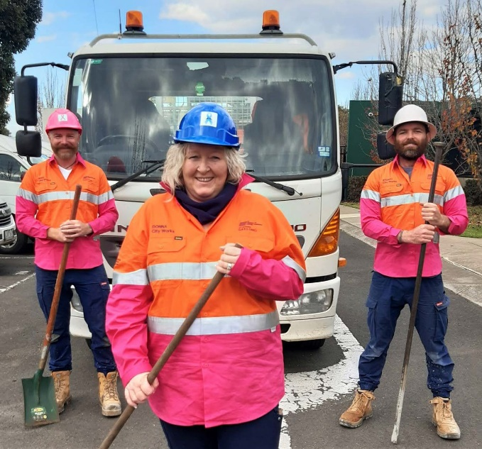
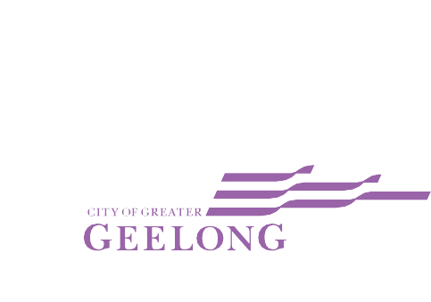

CITY OF GREATER GEELONG

GENDER EQUALITY
ACTION PLAN – SUMMARY
We have put together this summary to briefly explain our Gender Equality Action Plan and what we aim to achieve between now and 2025. To read the full plan, visit geelongaustralia.vic.gov.au

WHAT IS GENDER EQUALITY?

To talk about gender equality, we firstly need to understand some key concepts:

Gender – refers to the roles, responsibilities, expressions and identities of girls, women, boys, men and gender diverse people. It potentially can, and frequently does, influence how people perceive themselves and each other, how they act and interact, and the distribution of power and resources in society.
Gender identity – is not confined to a binary - girl/woman, boy/man - nor does it always stay the same; it exists along a continuum and can change over time for each person. It does not have to be rigidly assigned by someone’s sex assigned at birth.
Gender stereotypes – fixed and narrow ideas and beliefs about how people of different gender identities and gender expressions should behave.
Gender equality – refers to an environment where individuals are not defined by limited ideas connected to sex, gender identity and gender expression. Instead, they can freely express who they are and what they have to give to the world.
While the plan is mostly about how we aim to positively influence gender equality in our workforce, it is impossible to make lasting change without addressing society-wide barriers to equality including gendered stereotypes and norms, and inequities across industries.

HOW DID WE GET HERE?
While we have created this plan to meet the requirements of Victoria’s Gender Equality Act 2020, it builds on work we have been doing for many years (see Figure 1 below). While we’ve made a lot of progress, there is still a lot to do.

Gender equity initiatives over time
2011
Women’s Charter adopted
2015
Annual International Women’s Day Awards established
2018
Social Equity Principles adopted in service planning
2016
Workplace Gender Equity Audit conducted and recommendations adopted
2019
Ba-gurrk Gender Equity Framework adopted by Council
2021
Development of GEAP and GIA Implementation
2013
Women in Community Life Advisory to Council established
2012
Women in Local Democracy (WiLD) established and auspiced by Council
2020
Gender Equality Act Implementation Pilot
2017
Family Violence Action Leadership Group established

HOW WE DEVELOPED THE PLAN
To inform our plan, we surveyed 770 employees, conducted a workforce audit and spoke to important stakeholders. What we learned shaped the plan and helped us identify our priorities.
Following is some of the key information we uncovered:

Who we are today
Our workforce is made up of:
Women | 64%
Men | 36%
Self described | 0.04%

Workforce employment status
Women employed full time | 50%
Women employed part time | 91%
Women employed casual | 86%
Men employed full time | 50%
Men employed part time | 9%
Men employed casual | 14%

Gender Pay Gap
Median base salary | 2.1%
Median total remuneration | 4%

Employees who agree there is a positive culture within the organisation
Women who agree | 52%
Men who agree | 28%
Those who disagree | 20%

We identified the following areas where we are performing well:
- equal representation of women and men in senior leadership roles
- willingness to fix problems
- our employees feel positive about diversity
- our employees feel positive that our organisation promotes gender equality
- our employees believe we have embraced flexible ways of working.

Most of the areas we identified as needing improvement related to data collection, as it is difficult to act without a complete picture of our workforce. The identified areas we need to improve data collection include:
- workforce diversity
- growth, learning and development
- accessibility and inclusion
- workplace flexibility
- digital inclusion.

OUR PLAN OF ACTION
Guided by our community’s clever and creative vision, we plan to:
- find better ways for men, women and gender diverse people to challenge gender stereotypes in the way they work and the jobs they do
- find better ways to measure the diversity of our workforce
- support more women and gender non-binary people to get involved in local elections
- work actively to deliver pay parity across our organisation by 2048
- make sure our organisation is free of sexual harassment, bullying and harassment
- become an Employer of Choice that provides a safe environment where men, women, and gender non-binary people of all backgrounds can thrive
- make sure that all our employees feel supported and have the agency to better incorporate flexible working
- arrangements that suit their lives and career goals
- continue to advocate for and work with other community leaders and organisations to achieve intersectional gender equality across our region.

By achieving gender equality and creating an inclusive culture that embraces diversity we will better serve our community and achieve our vision.
FIND OUT MORE
For more information about the targets, indicators, objectives and initiatives contained within the plan, visit geelongaustralia.com.au

