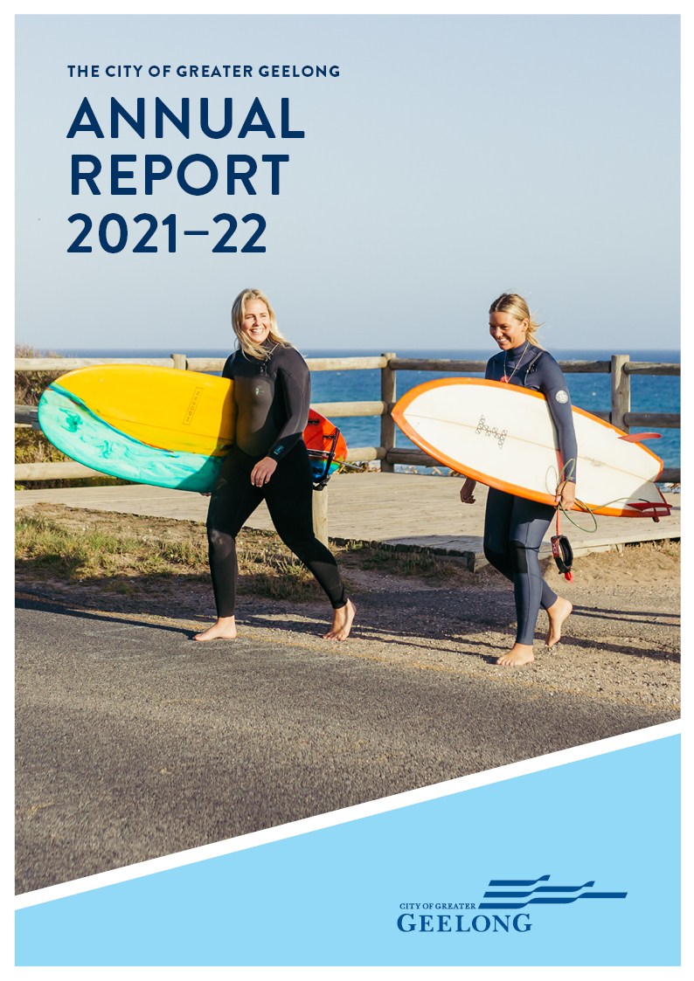

CONTENTS
MAYOR AND CEO MESSAGE 4
INTRODUCTION 6
OUR CITY 6
EMPLOYMENT AND ECONOMY 7
OUR PURPOSE, VALUES AND STRATEGIC DIRECTIONS 8
THE YEAR IN REVIEW 9
FAST FACTS 9
OUR COMMUNITY PLAN HIGHLIGHTS FOR 2021‒22 10
OVERVIEW OF FINANCIAL PERFORMANCE 13
KEY CAPITAL PROJECTS 18
OUR COMMITMENT TO SUSTAINABILITY 19
OUR COMMITMENT TO HEALTH AND WELLBEING 20
COMMUNITY ENGAGEMENT 26
CHALLENGES IMPACTING OUR SERVICES 27
OUR COVID-19 RESPONSE 28
OUR COUNCIL AND ORGANISATION 29
OUR COUNCIL 29
OUR COUNCILLORS 29
OUR ORGANISATION 33
OUR LEADERSHIP TEAM 33
OUR ORGANISATIONAL STRUCTURE 34
OUR PEOPLE 35
EQUAL EMPLOYMENT OPPORTUNITY – AN INCLUSIVE AND DIVERSE WORKPLACE 36
OCCUPATIONAL HEALTH AND SAFETY 37
HOW WE PLAN 38
OUR PERFORMANCE 39
STRATEGIC DIRECTION 1: HEALTHY, CARING AND INCLUSIVE COMMUNITY 40
STRATEGIC DIRECTION 2: SUSTAINABLE GROWTH AND ENVIRONMENT 58
STRATEGIC DIRECTION 3: STRONG LOCAL ECONOMY 72
STRATEGIC DIRECTION 4: HIGH-PERFORMING COUNCIL AND ORGANISATION 80
GOVERNANCE 92
COUNCIL INFORMATION 92
AUDIT AND RISK COMMITTEE 100
GOVERNANCE AND MANAGEMENT CHECKLIST 101
DOMESTIC ANIMAL MANAGEMENT PLAN UPDATE 105
ACCESS AND INCLUSION PLAN UPDATE 106
DEVELOPMENT CONTRIBUTIONS PLAN (DCP) PROGRESS REPORT 109
PERFORMANCE STATEMENT 117
ANNUAL FINANCIAL REPORT FOR THE YEAR ENDING 30 JUNE 2022 133
CONTACT US 135

We Acknowledge the Wadawurrung People as the Traditional Owners of the Land, Waterways and Skies. We pay our respects to their Elders, past and present. We Acknowledge all Aboriginal and Torres Strait Islander people who are part of our Greater Geelong community today.

MAYOR AND CEO MESSAGE
It gives us great pleasure to present the City of Greater Geelong’s Annual Report for the year ending 30 June 2022.
This was the first year within our four-year Our Community Plan 2021‒25, and we have focused on supporting our community by working towards the strategic priorities identified in that document.
In response to strong population increases and the forecast that these will continue, we have taken action to protect the environment and make sure our region’s growth is sustainable.
The adoption of our Climate Change Response Plan 2021–30 in November 2021 saw us set ambitious targets of net zero emissions for our operations by 2025, and net zero community emissions by 2035.
Encouragingly, figures indicate that our carbon emissions dropped by 29 per cent this financial year alone, driven by our switch to renewable energy for all of our electricity use.
In an effort to reduce the volume of household waste being sent to landfill, we started a trial food waste collection service in Lara. It’s our intention that this service will be rolled out region-wide in the coming years.
We also continued to trial the use of innovative products made from recycled materials in road reconstruction projects and completed stage one of Victoria’s largest streetlight upgrade program – switching around 13,000 of our streetlights to energy efficient LEDs.
These clever and creative initiatives, along with several others, saw us earn the Keep Victoria Beautiful 2021 Sustainable City Award.
Our strategic focus on achieving a healthy, caring and inclusive community resulted in the investment of $195.7 million into capital projects, building and renewing vital places and spaces such as playgrounds, sporting facilities, community hubs and swimming pools.
Major builds underway during the 2021‒22 financial year include the Northern Aquatic and Community Hub – our $61.6 million redevelopment of Waterworld and Centenary Hall in Norlane.
Construction also started on both the North Bellarine Aquatic Centre in Drysdale and the new Drysdale Library, while we completed a new community shed in Mount Duneed, the Barwon Heads Arts and Community Hub, and sporting facility upgrades at multiple reserves across the region.
We thank the state and federal governments for partnering with us in funding many of these vitally important facilities.
A momentous moment early in the financial year was Reconciliation Australia’s endorsement of our Council’s first Reconciliation Action Plan, which was developed in close collaboration with the Wadawurrung Traditional Owners and other Aboriginal and Torres Strait Islander members of our community.
From an economic standpoint, our immediate focus was on providing targeted support to assist the recovery of local businesses and community groups from the impacts of COVID-19 restrictions.
A detailed account of our broader COVID-19 response during 2021‒22 can be found within this report.
We have also finalised a number of important strategies that will help drive our progress in the years to come, including a new Arts and Cultural Strategy 2021‒31, and a Positive Ageing Strategy 2021‒47. The latter aims to ensure our region’s older people are healthy, feel empowered and are respected.
Thank you to all councillors and City of Greater Geelong employees for your contribution towards our progress during the past financial year.

We particularly acknowledge the leadership of former Mayor Stephanie Asher, as well as Deputy Mayor Trent Sullivan, who performed mayoral duties during this reporting period.
And most importantly, thank you to the passionate Greater Geelong community, which continues to motivate and inspire us to serve this wonderful region to the best of our ability.

Councillor Peter Murrihy Kaarina Phyland
Mayor Acting Chief Executive Officer

This report has been prepared in accordance with the relevant requirements of the Local Government Act 2020.

INTRODUCTION
We are committed to becoming the clever and creative city-region our community described when we asked them to form a long-term vision for the region in 2017.
The City of Greater Geelong Annual Report 2021–22 provides our community with a comprehensive account of our progress over the past year as we strive to move closer to that goal.
This Annual Report contains information about Council’s operations and performance from 1 July 2021 to 30 June 2022 and meets all our obligations under Section 98 of the Local Government Act 2020.

OUR CITY
With a population of over 270,000 people, the City of Greater Geelong is Victoria’s largest regional municipality. Located 75 kilometres south-west of Melbourne, the municipality covers an area of 1,252 square kilometres, comprising suburban, coastal and country areas.
Greater Geelong is bounded by the Moorabool Shire in the north, Wyndham City Council and the Borough of Queenscliffe in the east, Surf Coast Shire and Golden Plains Shire in the west, and Bass Strait to the south.
Key natural features of the region include Corio Bay, the Bellarine Peninsula, the Barwon River, the You Yangs Regional Park, wetlands, coastline, parklands and wildlife sanctuaries.

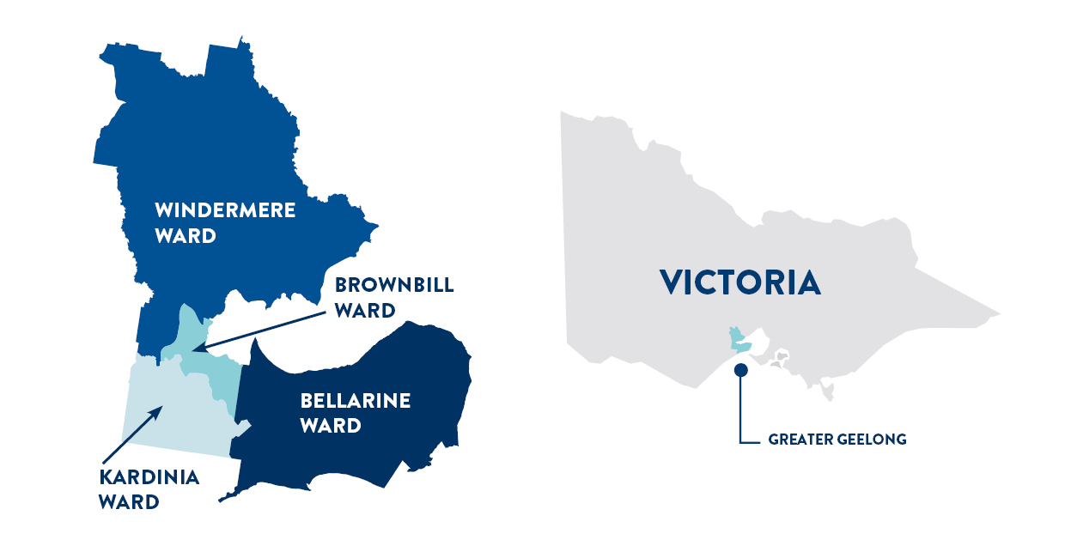

EMPLOYMENT AND ECONOMY
In recent years Greater Geelong has experienced some of the strongest economic growth in Australia. The city has had the highest growth across all three major economic indicators of Gross Regional Product (GRP), jobs and employed residents compared to similar regions and cities across Australia. Greater Geelong has an estimated GRP of $15.42 billion, approximately 120,000 local jobs¹ and 19,604 businesses.
Local labour market conditions are strong with unemployment at historic lows of 2.5 per cent, 1.7 points lower than the Victorian rate and 1.9 points lower than the national rate². Job advertisements and demand for labour are at record highs, with 10,500 new jobs advertised in the June 2022 quarter.
The industries that provide the most jobs in Greater Geelong are:
- healthcare and social assistance
- retail trade
- construction
- education and training
- public administration and safety
- manufacturing.
The City's local job market is primarily focused on the provision of household services such as health, retail, and education. In 2020−21, 41 per cent of local employment was in these three industries¹. Construction is the third largest employer with an 11 per cent share of employment¹, driven by strong residential development and infrastructure investment. Public administration and safety and manufacturing are fifth and sixth largest with both sectors having an 8 per cent job share¹. The manufacturing sector's contribution to economic value is forecast to increase as the sector goes through a transition into higher-value industries and becomes more productive. Sectors driving growth in Greater Geelong include advanced manufacturing, clean technologies and circular economy, research and innovation, service-based industries, creative industries and the visitor economy.
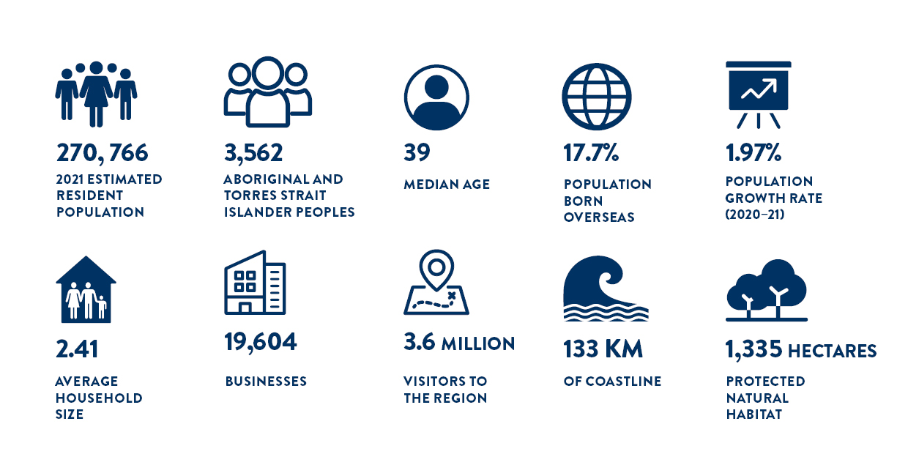

OUR PURPOSE, VALUES AND STRATEGIC DIRECTIONS
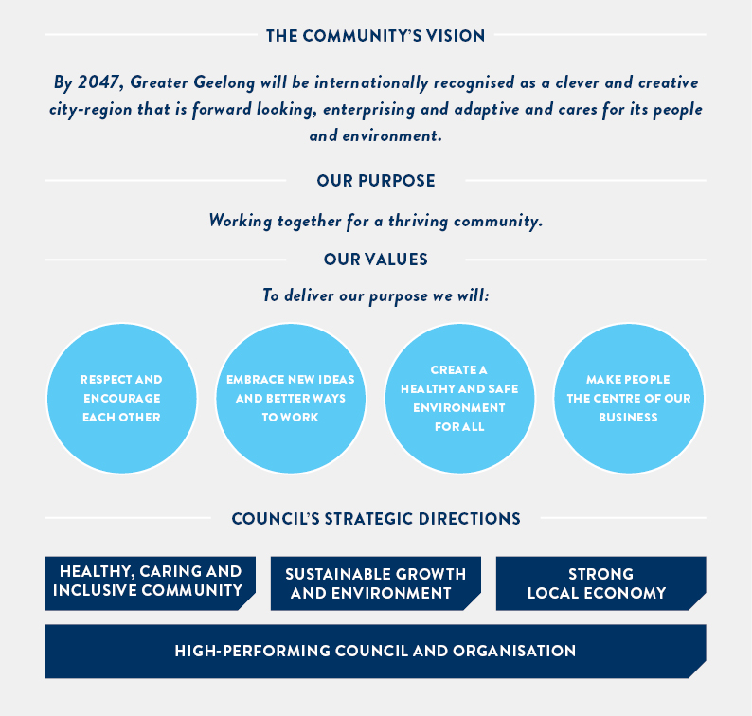

THE YEAR IN REVIEW

FAST FACTS
We deliver a wide range of infrastructure, services and programs to the Greater Geelong community. In 2021–22, this included:
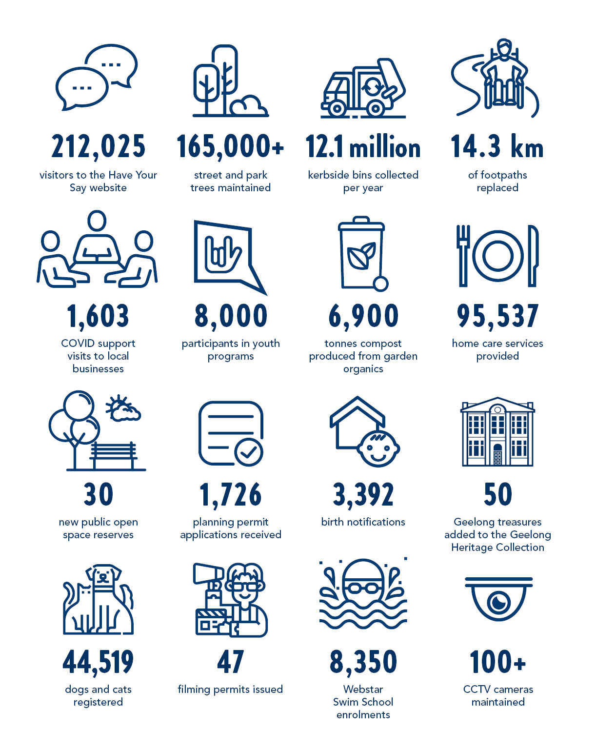

OUR COMMUNITY PLAN HIGHLIGHTS FOR 2021‒22
In 2021‒22, we committed to deliver 85 actions to support the achievement of our four-year priorities within Our Community Plan 2021‒25.
More detailed information on progress against the Annual Action Plan 2021‒22 is outlined in the ‘Our Performance’ section of this report commencing on page 38.

Overall progress
Of the 85 actions, 60 per cent (51) were complete,
and a further 20 per cent (17) are on track.

Major budget initiatives
Of the 85 actions, 12 are major initiatives identified in the 2021‒22 budget. Of these, 50 per cent (6) are completed and a further 41.7 per cent (5) are on track.

FIGURE 1: Our Community Plan Annual Action Plan progress for 2021–22

STRATEGIC DIRECTION |  | ANNUAL ACTION PLAN ACHIEVEMENTS
Healthy, caring and inclusive community |  | - Council adopted the Social Equity Framework 2022‒25 to ensure fair and equitable access to all the City’s services and facilities  - We successfully advocated for state and federal government funding for construction of the Northern Aquatic and Community Hub  - We established Our First Nations Cultural Heritage Grant program to fund the identification, conservation and promotion of Aboriginal heritage places  - We continued to deliver the Social Housing Plan 2020‒41, engaging with the community on proposed Council owned sites to deliver more social and affordable housing dwellings  - We commenced construction of the Armstrong Creek West Community Hub which will provide access to a wide variety of family, early years and community services
Sustainable growth and environment |  | - Council adopted the Climate Change Response Plan 2021–30, a roadmap for collaborative action in response to climate change issues and associated impacts on our region  - We implemented the Armstrong Creek Land Acquisition Program to enable the creation of active open space, drainage and road infrastructure  - We delivered three major shared trail projects in East Geelong, Corio and Barwon Heads and completed feasibility studies for four priority connections (Ocean Grove to Point Lonsdale, Ocean Grove to Drysdale, Drysdale to Portarlington, and Lara to the You Yangs)  - Council adopted the Gordon Avenue and Heritage Core Precincts in the Final Pakington Street (Geelong West) and Gordon Avenue Urban Design Framework  - We conducted a trial household food organics collection which aims to reduce the amount of food waste going to landfill and cut greenhouse gas emissions  - Council adopted the Sparrovale Ngubitj yoorree Wetlands Master Plan  - We completed Stage 1 of the upgrade to LED street lighting with the changeover of residential streetlights and commenced Stage 2, the street light changeover on roads with higher traffic volumes (main roads)
Strong local economy |  | - Council adopted the Arts and Cultural Strategy 2021–2031 which, over the next ten years, aims to strengthen and grow arts and cultural activities in Geelong  - We commenced work on providing publicly accessible urban space around the site of the proposed Geelong Convention and Exhibition Centre  - We commenced work on developing a 10-year Economic Development Plan  - We partnered with the Vision Partner Group to deliver the region's new place brand, ‘Greater Geelong, Greater Australian Stories’  - We supported circular economy initiatives through the Cleantech Innovations Geelong program  - We implemented a second hour of free parking in 2P parking zones in Central Geelong  - We developed a Smart City Innovation Blueprint to build a culture of innovation at the City to support smart technology adoption and data-driven decision-making
High-performing Council and organisation |  | - We reported on our progress towards achieving our Sustainability Framework 2020 targets and actions through our Sustainability Performance Report 2021  - We implemented a new complaints policy as part of our Customer Experience Strategy  - We improved accessibility and inclusivity of our Have Your Say community engagement page, through the addition of new tools and increased functionality  - We facilitated programs aimed at connecting young people to local decision-making including the Youth Council, Councillor Connect Mentoring Program and Youth on Board  - We successfully recruited for the position of Aboriginal Employment and Engagement Officer to build relationships and support the delivery of key workplace initiatives  - We progressed construction of Wurriki Nyal, our new civic precinct, consolidating our corporate operations into a single, energy-efficient building, as well as creating an accessible and welcoming co-designed public space  - We implemented an expanded Occupational Health and Safety incident management system

OVERVIEW OF FINANCIAL PERFORMANCE
This is a summary of our financial results for 2021–22.
For full details, please refer to the Annual Financial Report on page 131.
- Surplus of $141.4 million – consistent with the prior year result
- $567.0 million revenue, with 48.4 per cent coming from rates and charges
- $425.5 million expenditure – 41.4 per cent employee costs and 32.1 per cent materials and services
- $4.1 billion in net assets – $994.3 million increase on the previous year, including a $852.9 million asset revaluation increment.
- $195.7 million capital expenditure – 47.4 per cent relating to land and buildings, 21.6 per cent for roads, footpaths, bike paths and drainage and 16.3 per cent to parks, open space and streetscapes.
Comprehensive Income Statement
The comprehensive income statement shows how much we earned during the 2021–22 financial year. It details where we received our income and how it was spent.
Net Result
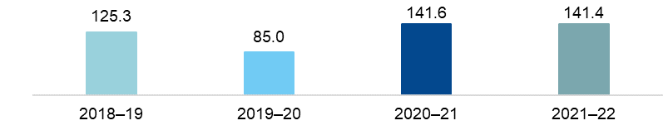
FIGURE 2: Net result 2018–19 to 2021–22 ($m)
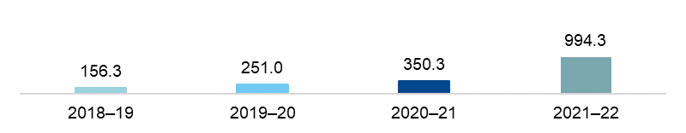
Total Comprehensive Results
FIGURE 3: Total comprehensive results 2018–19 to 2021–22 ($m)
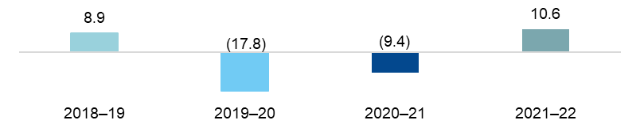
Recurrent Operating Results
FIGURE 4: Recurrent operating results 2018–19 to 2021–22 ($m)

The net result – that is, income minus expenditure – is shown in Figure 2.
This result can largely be attributed to:
- rates and charges increasing by $17.0 million due to a wider property base and increases in the general waste charge
- user fees increasing by $8.9 million as services recovered from the COVID-19 pandemic
- grants increasing by $6.5 million, largely from the federal government assistance grant
- materials and services costs increasing by $18.4m to reflect inflationary and contractual changes and services returning from the COVID-19 pandemic
- employee costs increasing by $4.5 million.
The total comprehensive result accounts for items that will not be classified to surplus or deficit in future periods. In this case, it is the net asset revaluation of land, buildings and infrastructure which, in 2021–22, was an increment of $852.9 million.
The total surplus includes an operating recurrent surplus of $10.6 million ($9.4 million deficit in 2020–21) and a non-recurrent surplus of $130.8 million ($151.0 million in 2020–21). The non-recurrent result includes gifted assets of $79.3 million ($98.3 million in 2020‒21).
Our 4-year budget forecasts surpluses over the next four years, including a $187.9 million surplus in 2022–23. This is a critical part of our financial sustainability strategy, as it gives us the capacity to maintain our services and renew our community assets.
Balance Sheet
The balance sheet shows what we own (assets), what we owe (liabilities) and our net worth (equity).
Assets
Our assets are primarily made up of:
- cash and cash equivalents of $100.5 million – used to cover our short-term commitments including long-service leave and debt obligations and provide funds for capital works that have been carried over
- property, plant and equipment worth $4.2 billion – an increase of $1,005.2 million on the previous year.
These asset types make up 94.9 per cent of our total assets.
Total Assets
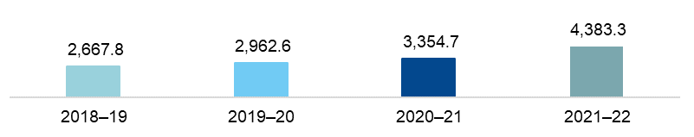
FIGURE 5: Total assets 2018–19 to 2021–22 ($m)
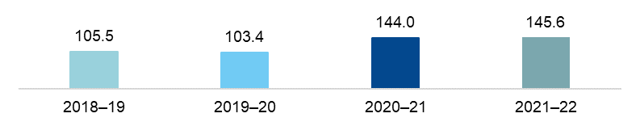
Investments
FIGURE 6: Investments 2018–19 to 2021–22 ($m)
Capital Program
We deliver an extensive capital works program – renewing, upgrading and building assets to meet community need.
As Figure 7 shows, our capital works expenditure in 2021‒22 was $195.7 million. This included:
- $147.3 million on new assets (75.3 per cent)
- $36.4 million on renewal works (18.6 per cent)
- $12.0 million on upgrade works (6.1 per cent).
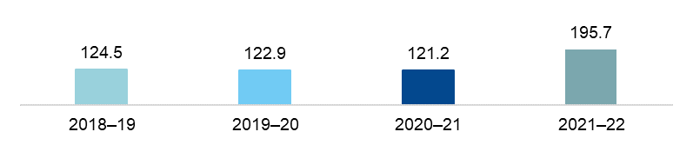
FIGURE 7: Capital works expenditure 2018–19 to 2021–22 ($m)
The main categories of expenditure were:
- $92.8 million on land and buildings
- $24.8 million on roads
- $32.0 million on parks, open space and streetscapes
- $10.6 million on plant and equipment
- $7.5 million on drainage
- $9.9 million on foot and bike paths
- $11.4 million on recreational, leisure and community facilities
- $6.7 million on other assets.

Liabilities
Our liabilities include future commitments to suppliers, employees (for leave entitlements), loans and costs associated with providing landfill.
Total Liabilities
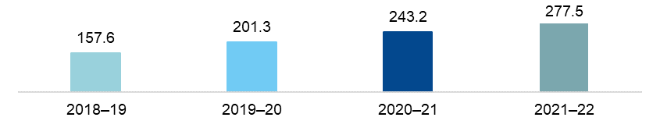
As Figure 8 shows, total liabilities were $277.5 million, an increase of 14.1 per cent on the 2020–21 balance. This increase is due to new loans financing our civic precinct project and other key community projects and grants received in advance.
FIGURE 8: Total liabilities 2018–19 to 2021–22 ($m)
Loans
Our loan balance equates to 50.5 per cent of total liabilities, which is slightly higher than 2020–21 (48.1 per cent).
The overall increase in our loan balance of $23.0 million is due to $32.3 million in new loans, offset by $9.3 million of debt paid off during the year.
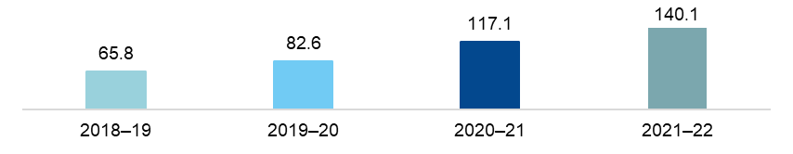
FIGURE 9: Loans from 2018–19 to 2021–22 ($m)
Debt Commitment
The debt commitment ratio shows the percentage of rates required to meet loan repayments for the following 12 months.
Figure 10 shows that a low percentage of rates are being used to service loans and we have ample capacity to meet our debt repayments.
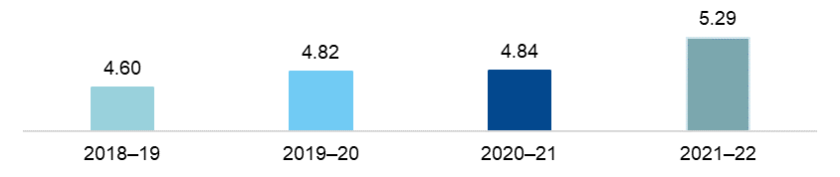
FIGURE 10: Debt commitment percentage 2018–19 to 2021–22 (%)

Ratepayer Equity
Ratepayer equity is represented by our net worth – that is what we own ($4,383.3 million) minus what we owe ($277.5 million).
As Figure 11 shows, ratepayer equity as at 30 June 2022 was $4,105.8 million – a 32.0 per cent increase on the previous year. This is due to continued growth of our fixed asset base – that is, property, plant and equipment – and the impact of land building and infrastructure revaluations.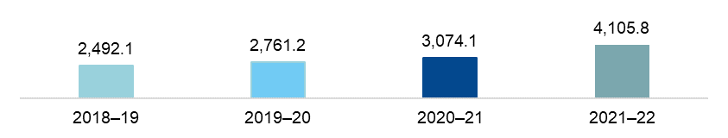
FIGURE 11: Ratepayer equity 2018–19 to 2021–22 ($m)

KEY CAPITAL PROJECTS
We deliver an extensive capital works program each year to create infrastructure for our community.
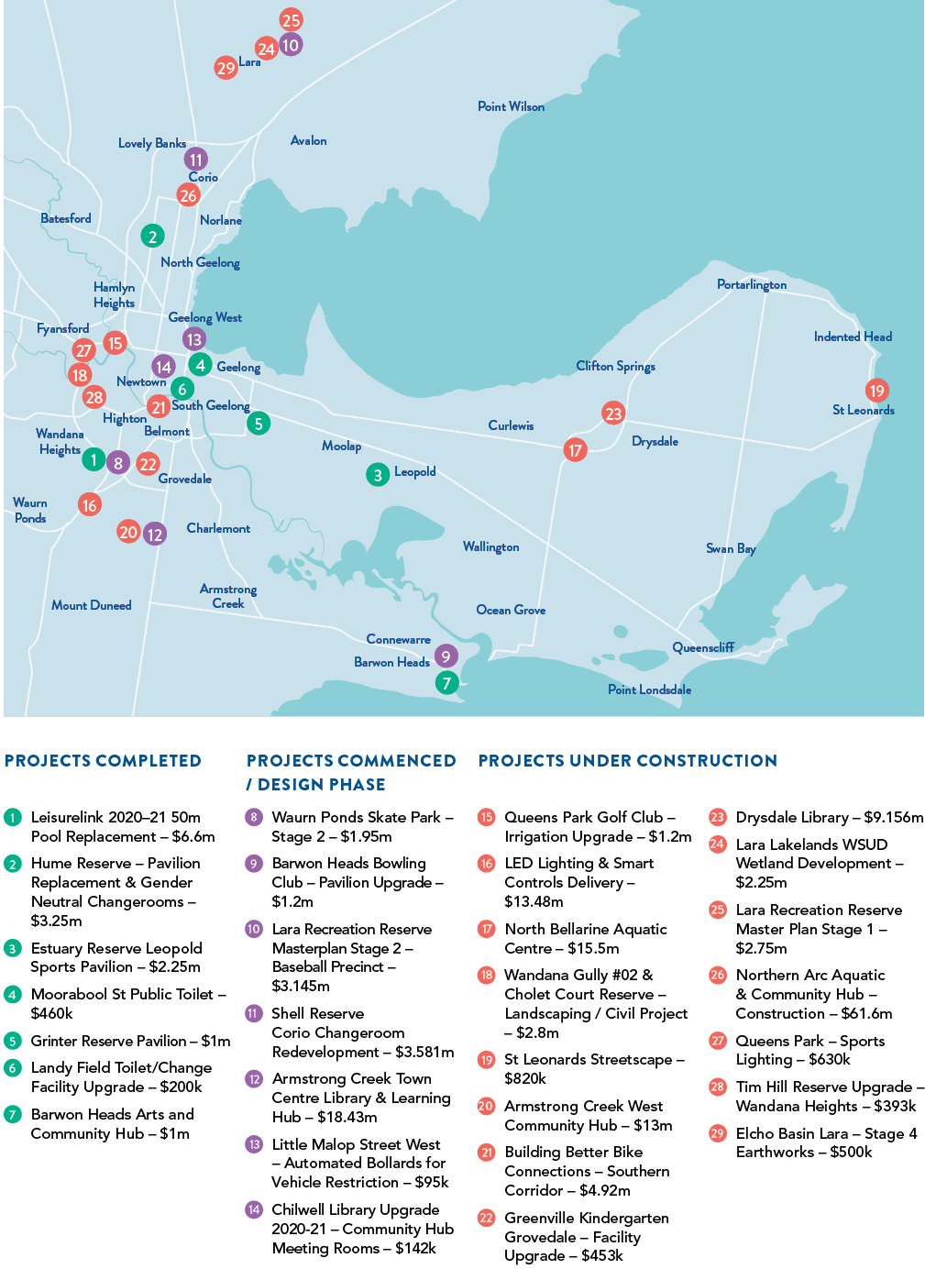
FIGURE 12: Key Capital Projects 2021–22

OUR COMMITMENT TO SUSTAINABILITY
Sustainability is a key theme of Our Community Plan 2021‒25 and a strong focus of the community’s 30-year clever and creative vision.
Sustainability refers to a continual way of thinking that focuses on the best outcomes for our community, environment and the economy, now and in the future. Our goal is to incorporate sustainable thinking into every aspect of our business to address some of the long-term challenges facing our community, including climate change, population growth, demands for community infrastructure and social inequity.
In July 2020, Council adopted the Sustainability Framework 2020 committing the City to take action across three key priority areas of sustainability: protecting our environment, community wellbeing and social equity, and responsible and transparent business.
The framework is implemented through the delivery of short, medium and long-term initiatives within the Sustainability Framework Action Plan 2020‒22 and tracked over time against an endorsed set of sustainability indicators and targets.
In March 2021, we released the Sustainability Performance Report 2021, allowing the community to track the City’s progress. The report shows that of the 66 actions being implemented, almost 90 per cent were on track or complete by the end of 2021. Five actions were deemed ‘off-track’, with three directly impacted by the COVID-19 pandemic.
Highlights included:
- reducing the City’s operational carbon emission by a further five per cent in the year to 30 June 2021, a reduction of 30 per cent in the past four years
- increasing the area of natural habitat under the management of the City by 105.1 hectares to 1380.8 hectares
- starting a household food organic collection trial in Lara and partnering with Barwon Water and other councils to create a regional organics processing facility
- providing $1.0 million to help the Geelong Food Relief Centre open a large-scale emergency food hub in North Geelong
- introducing the first fully electric vehicles to our fleet, with plans to add another four electric vans and two electric commercial ride-on mowers in 2022.
A copy of the report can be viewed at www.geelongaustralia.com.au.
Our Sustainability Advisory Committee provides a sustainability lens on the City’s strategic work including the development of our Climate Change Response Plan 2021–30, Social Equity Framework 2022–25, draft Economic Development Plan and draft Biodiversity Strategy.
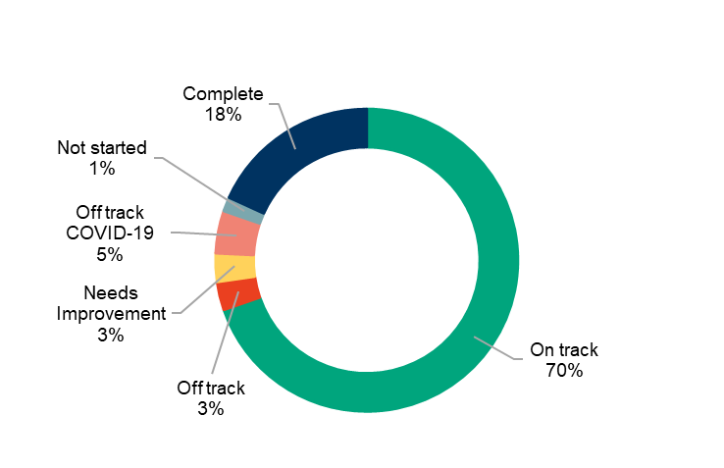
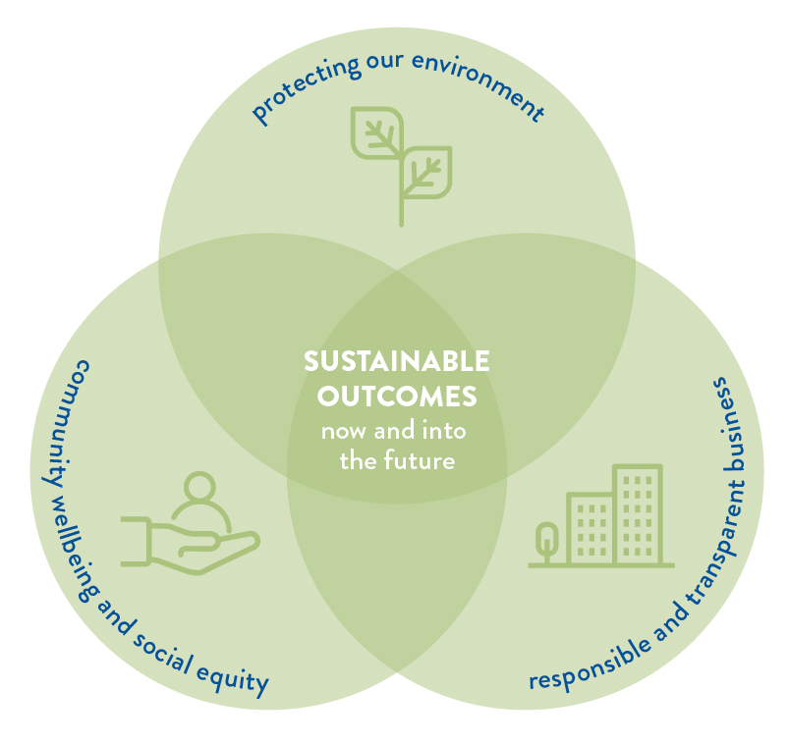
We are at the beginning of a long journey with regards to sustainability and have set ambitious targets in response to community feedback that will take time and hard work to achieve. As our organisational approach matures, we will develop more structured, restorative and coordinated methods of addressing sustainability that will create lasting impacts on all our services, projects and plans.
FIGURE 13: Progress of Sustainability Framework Action Plan FIGURE 14: Sustainability Framework 2020 Key
2020‒22 (to 31 December 2021) Priority Areas

OUR COMMITMENT TO HEALTH AND WELLBEING
The health and wellbeing of our community is central to everything we do.
Under the Victorian Public Health and Wellbeing Act 2008, councils are required to prepare a four-year municipal public health and wellbeing plan, identifying goals for creating a local community where people can experience their best possible health and wellbeing. Acknowledging that health and wellbeing is everyone’s business, we incorporated our municipal public health and wellbeing plan into our council plan to create Our Community Plan 2021‒25.
Our health and wellbeing priority areas
There are five health and wellbeing priority areas we’ll be focussing on over the next four years. We formed these priorities after a thofchallengrough review of the policy context, identifying health challenges and engaging with the community and key stakeholders:

 |  |  |  | 
Tackling climate change and its impact on health | Increasing  healthy eating | Increasing  active living | Demonstrating and promoting gender equity practices | Improving mental wellbeing and social connection
Working with our partners
We have formed a network of health and wellbeing partner organisations to identify opportunities for collaboration in the five health and wellbeing priority areas.
A partnership survey identified the following principles to guide our future work together:
- network to share data and information
- collaborate on projects
- advocate on joint health and wellbeing priorities.
Over the coming years, we will work with current partners and explore new partnerships guided by community needs, organisational priorities, business planning and funding opportunities.

Our health and wellbeing indicators
A set of 19 indicators in Our Community Plan 2021–25 help track the health and wellbeing of our community and gauge progress made towards the priority areas: 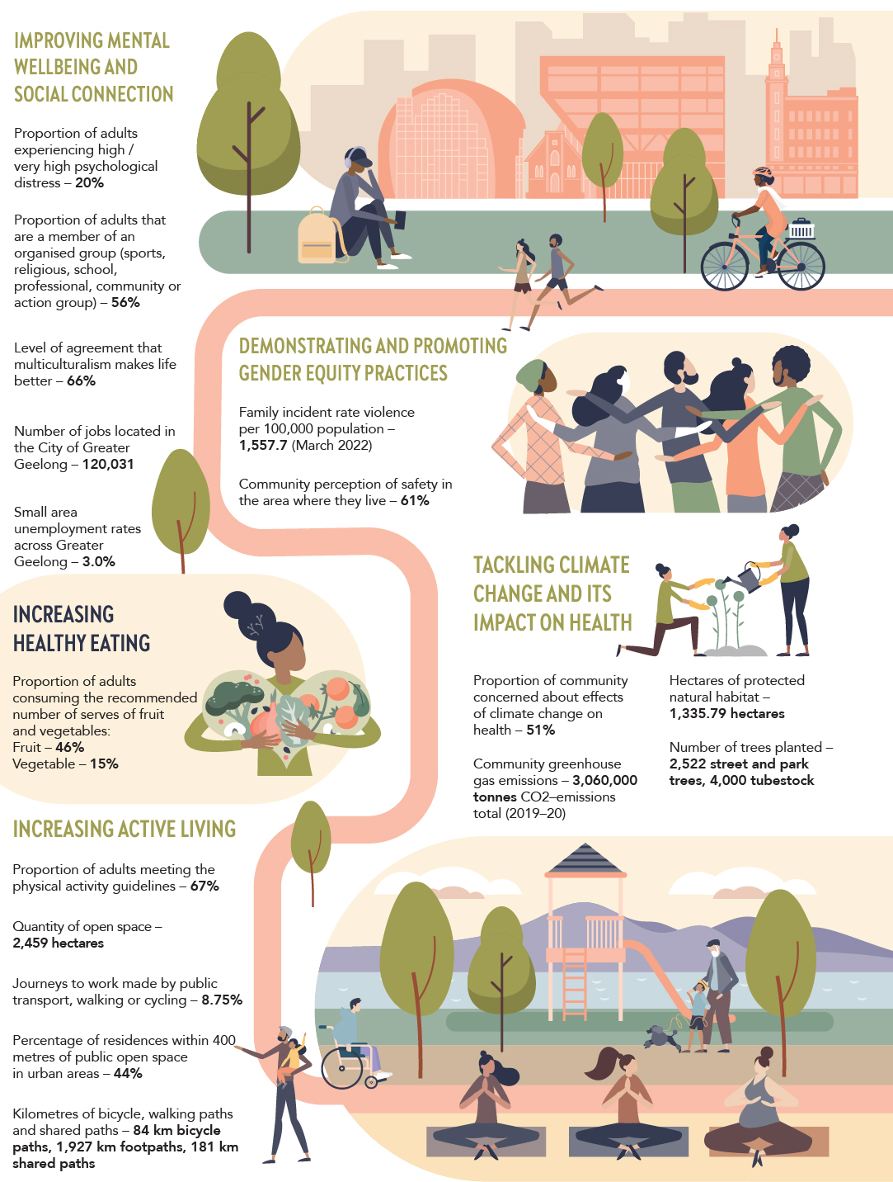

Our health and wellbeing evaluation framework
We are currently developing a Theory of Change for each of the health and wellbeing priority areas. Combined with tracking the above indicators, the Theory of Change supports monitoring and evaluation of the health and wellbeing priorities. In 2022‒23, we will undertake further work to develop a monitoring, evaluation and learning framework.
Key actions to support health and wellbeing
The following highlights some of the key actions for each health and wellbeing priority from Our Community Plan 2021‒25. More information on these and other actions supporting health and wellbeing is outlined in the ‘Our Performance’ section of this report commencing on page 38. We have also included some other achievements to demonstrate the breadth of the City’s work in each of the priority areas.
Health Priority 1: Tackling climate change and its impact on health
KEY ACTIONS AND RELATED STRATEGIC DIRECTION | STRATEGIC DIRECTION | PAGE
Plant more trees through the Urban Forest Strategy and create opportunities for community planting | 2 | 63
Outline how the City will support the community and business to reduce the risks that climate change poses to community health and wellbeing and infrastructure through the Climate Change Response Plan | 2 | 65
Implement a pilot food waste collection service for residents | 2 | 66
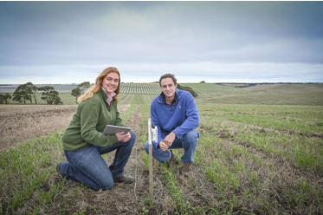
Other achievements
Tracking the weather together
We are working with the community to improve the accuracy of local weather data through the Weather Together Project. In an effort to monitor changes in real time, residents have volunteered to host weather sensors at their home or workplace to record temperature and humidity in different parts of the city where climate can vary significantly. These real-time observations will help us to better understand climate variations across Greater Geelong and make more informed decisions about how we manage heat in the city. Data is also available to view on the Geelong Data Exchange, www.geelongdataexchange.com.au.
Claire Koch and Oscar Phillip from Marcus Oldham Farm Management College, utilising an IoT (Internet of Things) sensor.

Health Priority 2: Increasing healthy eating
KEY ACTIONS | STRATEGIC DIRECTION | PAGE
Develop a nutrition toolkit for infants to older adults including a focus on First Nations and culturally and linguistically diverse communities | 1 | 42
Partner with G21 to implement the G21 Healthy Eating and Active Living (HEAL) priority 2021‒25 Regional Plan | 1 | 42
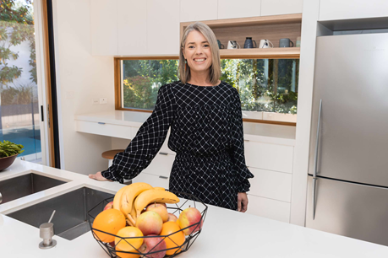
Other achievements
Mel Bald, The Passionate Nutritionist

Building healthy eating habits
As part of the City’s Eat Well Live Well campaign, and in partnership with Geelong Regional Library Corporation, our community had the opportunity to attend free information sessions to learn key tips on meal planning and preparation with Mel Bald, The Passionate Nutritionist.
The sessions were held in Waurn Ponds, Corio and Leopold, and aimed at saving time, money and stress with ideas on how to create a healthy recipe bank and apps to make meal preparation easier.

Health Priority 3: Increasing active living
KEY ACTIONS | STRATEGIC DIRECTION | PAGE
Deliver programs and services that improve health and wellbeing outcomes across all life stages in our leisure services | 1 | 43
Continue to advocate for funding to deliver the Northern Aquatic and Community Hub | 1 | 47
Progress the design and construction of the Northern Bellarine Aquatic Centre | 1 | 49
Complete improvement works and address trail and network gaps as identified by the Shared Trails Masterplan | 2 | 62
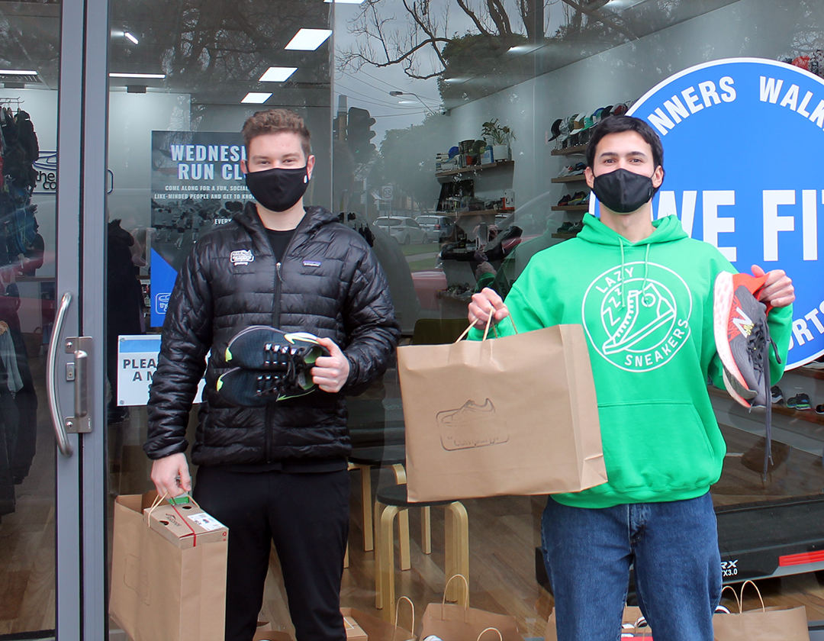
Other achievements
Jaques Verstraten, The Running Company Geelong and Thewin Robertson, City student intern and Lazy Sneakers ambassador pictured with the donated sneakers.
Partnering to support aspiring athletes to reach their potential
In a world-first international collaboration, we worked with New Zealand-based company, Lazy Sneakers, to bring the Sneaker Bank Project to our region. Our community were encouraged to donate pre-loved or new sneakers to our Leisuretime Sports Precinct in Norlane. To help kick-start the initiative, local business The Running Company Geelong donated 40 pairs of near-new runners. Shoes in suitable condition were donated to those in need to encourage sports participation.

Health Priority 4: Demonstrating and promoting gender equity practices
KEY ACTIONS | STRATEGIC DIRECTION | PAGE
Partner with key stakeholders and community safety networks to develop a community safety framework | 1 | 43
Partner with Women's Health and Wellbeing Barwon South West and G21 to develop the G21 Respect 2040 plan that will provide a shared vision to address gender equity and the prevention of violence against women | 1 | 44
Implement the Gender Impact Analysis tool across a range of community focused services | 1 | 44
Explore a range of opportunities to embed the City's social equity principles across a range of community focused services | 1 | 45
Implement recommendations from the Vital Communities Social Research Project and Gender COVID Impact Analysis | 1 | 46
Other achievements
Celebrating the contributions and leadership roles of local women
Each year, the City celebrates local women and their achievements through the Women in Community Life Awards. The 2022 awards were held on Thursday 10 March 2022 and featured special guest, ABC journalist Annabel Crabb. The awards recognised the extraordinary contributions of 22 women who lead in neighbourhoods, clubs, business or challenge the status quo of gender equity and human rights. The award categories were: First Nations Women, Climate Action – Disaster and Resilience, Disability Rights, Education, Human Rights, Leadership in Times of Crisis, Leadership in Women’s Health.
Strengthening the representation of women artists in street art
Through the $150,000 Geelong Women’s Street Art Project, we commissioned 19 female street artists to create murals throughout Central Geelong. The murals add vibrancy and colour to our city centre, and increase the representation of women in street art. Two of the artists, Manda Lane and Kerrie Poliness worked with our local community, offering workshops in paste-up art and large-scale chalk, respectively. The project was launched Saturday 14 May 2022 and featured an artist-lead guided tour of the work. Several artists were on hand to talk about their work including Manda Lane, Jasmine Mainbridge, Geelong Illustrators and Kaff-iene.
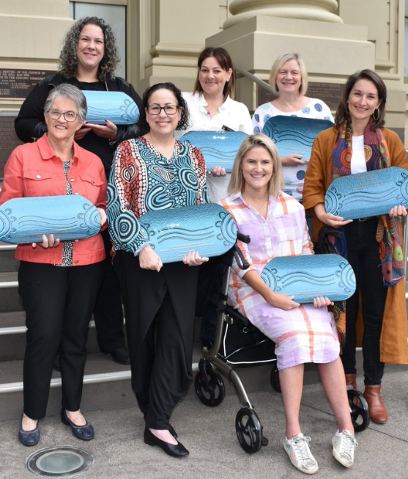
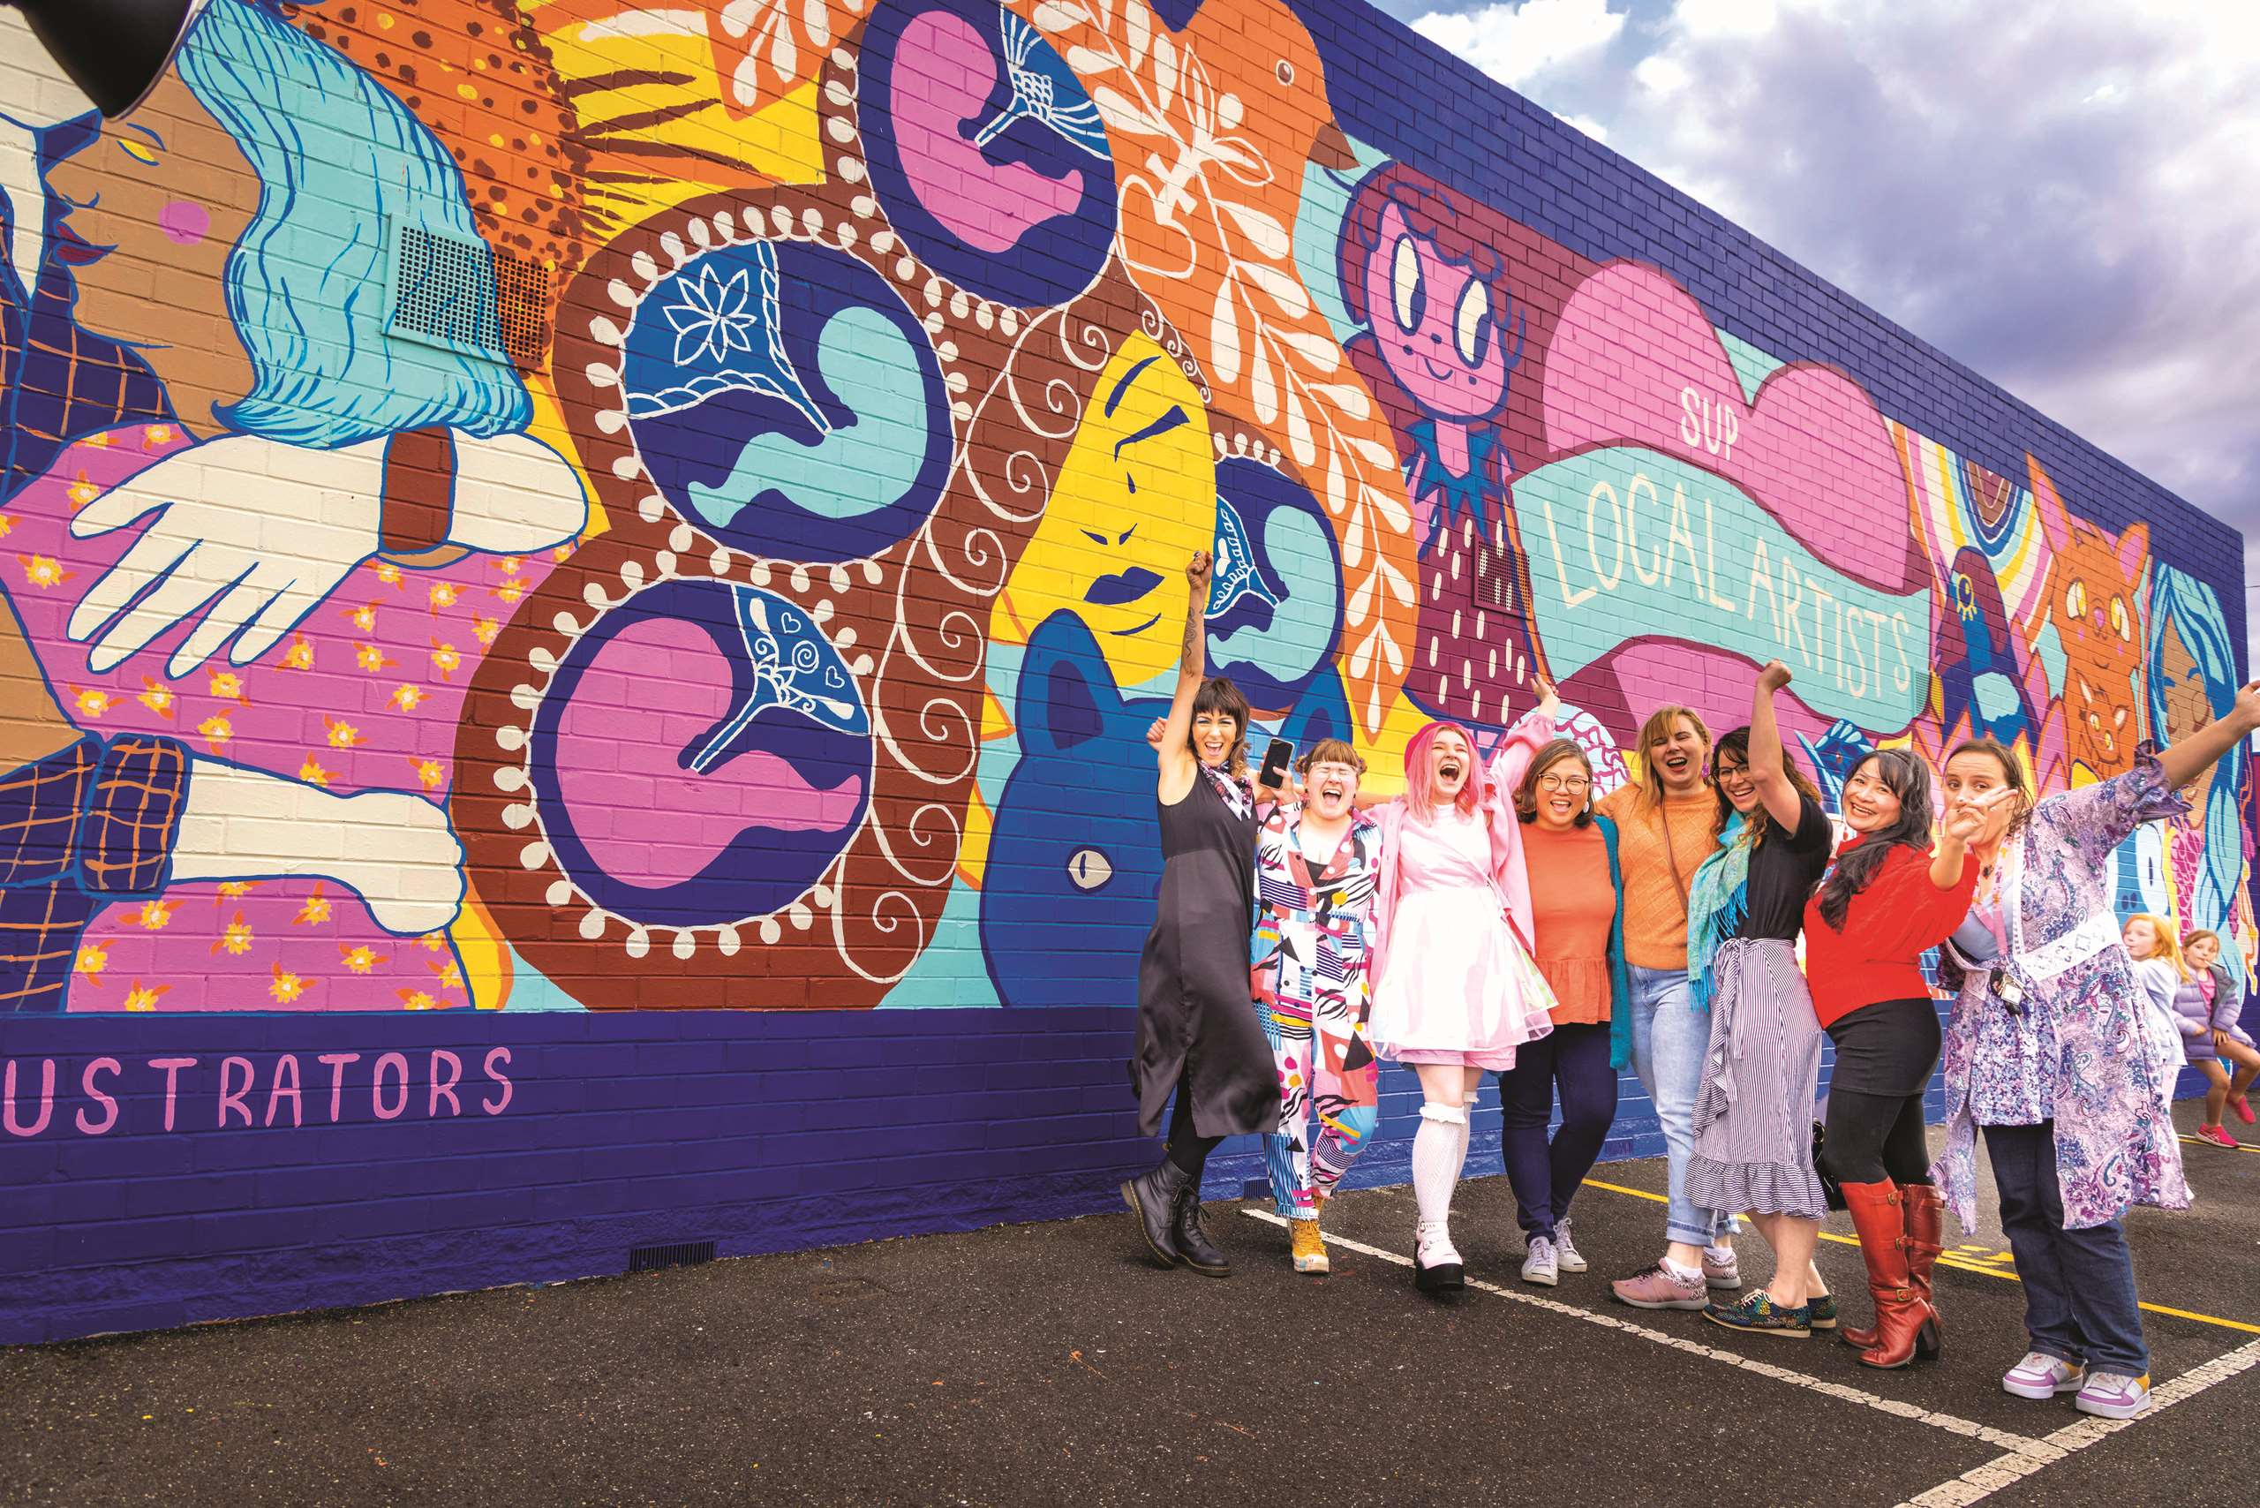
2022 Women in Community Life Award winners Meagan Howell, Leah Irving, Fiona Threlfall, Noreen Nicholson, Renee Owen, Leah Alstin and Dr Bianca Forrester.
Geelong Illustrators Street Art artists in front of their commissioned work ‘Support Local Artists’ L-R Rachel Bishop, Clare Holder, Sam Harvey, Cecilia Cabalquinto, Alison O’Connor, Terri Pollock, Benett Hernandez, Belinda Bellavista.

Health Priority 5: Improving mental wellbeing and social connections
KEY ACTIONS | STRATEGIC DIRECTION | PAGE
Develop opportunities for community groups, clubs and volunteers that builds capacity and capability in governance, leadership and sustainability | 1 | 42
Adopt and implement the City’s first Positive Ageing Strategy and co-design an action plan with the community | 1 | 43
Implement the City’s Social Housing Plan 2020‒41 | 1 | 46
Evaluate and report on the Reflect Reconciliation Action Plan and commence development of the Innovate Reconciliation Action Plan | 1 | 47
Prepare a First Nations Cultural Heritage Grant program to fund the identification, conservation and promotion of Aboriginal heritage places | 1 | 48
Implement actions from the Vital Communities (including Regional Industry Sector Employment) program that support employment pathways to address Geelong’s disadvantaged areas | 3 | 77
Other achievements
Outlining our approach to social equity
Council adopted the Social Equity Framework 2022‒25 to ensure everyone in our community has the support they need to have a healthy life, be included, and participate fully. The framework aims to ensure fair and equitable access to all the City’s services and facilities, regardless of gender, age, background and ability. It will guide how we work with our community to improve health and wellbeing and drive lasting change. The framework outlines six key ‘social equity enablers’: fairness, access, voice, participation, inclusion and empowerment.
Design to encourage lifelong learning, social connection and a sense of community
We unveiled the concept designs for the new Armstrong Creek Library and Community Hub, one of several community facilities we are developing in response to the current and future needs of local children, families and residents within the Armstrong Creek Growth Area.
The design reflects our community’s vision of a state-of-the-art, environmentally sensitive, technologically enabled library and community space, that caters to the diverse needs of the growing local community, while celebrating Wadawurrung culture with a ‘Living Water’ design narrative. The Wadawurrung narrative illuminates the library as a gathering place for all of Armstrong Creek’s residents and First Nations Peoples to connect, socialise, learn and thrive.
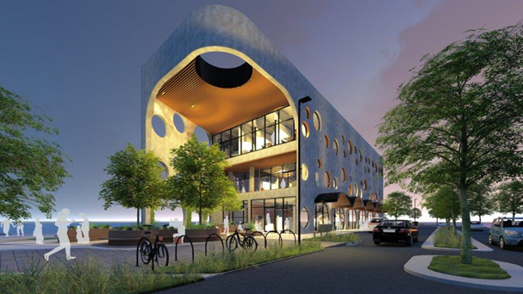
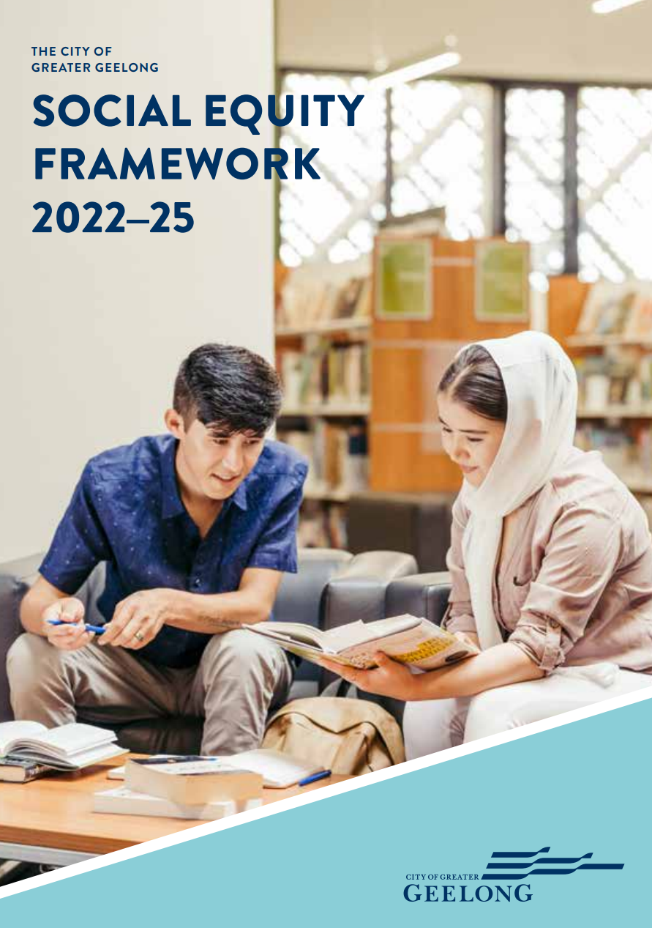
Concept design for the Armstrong Creek Library and Community Hub
The City worked with its partners and the community to develop a Social Equity Framework

COMMUNITY ENGAGEMENT
Engaging with our community ensures that Council listens and make decisions based on our community’s lived experience and in line our with community’s views and values.
Under the guidance of the Local Government Act 2020, community engagement at the City during 2021‒22 made significant advancements including:
Delivering deliberative engagement
Deliberative engagement is a tailored process that ensures a representation of participants who reflect our community are brought together into the engagement process and closer to the decision-makers than other forms of engagement.
Deliberative practices allow for a representative group to deliberate on an issue in depth, over time, before coming to an informed consensus or decision
Deliberative engagement methods this year have included advisory committees, workshops, community panels, reference groups and focus groups.
- improved accessibility and inclusivity of our online Have Your Say platform through the addition of new tools (translate and page reader options) and functionality (the ability for our community to share individual pages with their networks and on social media)
- initiatives to better utilise our Advisory Committees, some of whom represent the interests of historically harder-to-reach communities and can provide expertise to help Council make informed decisions
- more deliberate and timely engagement with Wadawurrung Traditional Owners and Aboriginal and Torres Strait Islander Peoples
- conducted more deliberative engagement projects with our community including our Long-term Financial Plan 2021‒31, Asset Management Plan, Social Equity Framework 2022‒25 and Climate Change Response Plan 2021‒30
- delivery of hybrid engagements (online and face to face) providing greater choice
- development of a resource to assist the City in making engagement activities more accessible, safe and comfortable for residents with support needs.
Our Engagement Principles
We delivered engagement activities under our five engagement principles in the design, delivery and reporting of all engagement activities:
- A community engagement process must have a clearly defined objective
- Participants taking part in a community engagement must have access to objective, relevant and timely information to inform their participation
- Participants taking part in a community engagement must be representative of the persons and groups affected by the matter that is the subject of community engagement
- Participants taking part in community engagement are entitled to reasonable support to enable meaningful and informed engagement
- Participants taking part in community engagement are informed of the ways in which the community engagement process will influence Council decision-making

Advisory Committees
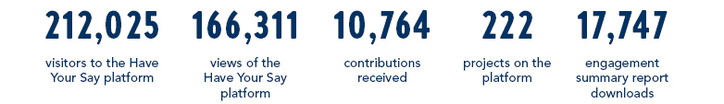
Our advisory committees enable community members to provide community insights, share lived experience and ongoing feedback to guide our decision-making. We would like to thank each of the committee members for the time, enthusiasm, ideas and energy they’ve put into the committee meetings over the past 12 months.

CHALLENGES IMPACTING OUR SERVICES
CHALLENGE | WHAT IT MEANS FOR US | HOW WE NEED TO RESPOND
Pandemic response and management | We must continue to deliver essential services and provide support to address the social and economic impacts of ongoing government restrictions caused by COVID-19. | Due to the ever-changing landscape of the COVID-19 pandemic, we need to continue to be flexible, agile and responsive in our approach to the needs of our community. We must also manage the impacts on our employees and long-term operational sustainability.
Technology | Rapidly advancing technology shifts the world in which we work. | We need the skills and know-how to cost efficiently adopt cost-effective modern technology, allowing us to better meet our community’s expectations.
Environmental sustainability and climate change | As part of a growing global focus on climate and environmental sustainability, our community expects us to show leadership in both policy and work practices. | We must work with our community and stakeholders towards zero carbon emissions, better resource recovery mechanisms, protecting and restoring our natural environment and building resilience to climate impacts such as temperature rise, sea level rise and extreme weather events.
Social inequity | Some members of our community are the most at risk of social exclusion in Victoria, with the impacts of COVID-19 magnifying these risks and impacts. | We must apply a social equity lens to all our policies, programs and services to create better opportunities for all. Our responses must be deliberate, driven by data and evidence-based.
High growth | Timing and sequencing of services and infrastructure in growth areas is a challenge as Geelong and surrounding local government areas experiencing unprecedented population growth. | We need a ‘whole-of-organisation’ effort to service, plan and deliver infrastructure for growth corridors and areas impacted by infill development. This must be balanced against maintaining service delivery in established areas. We also need to continue advocating to state and federal governments to secure the investment required to deliver infrastructure essential to maintain the liveability of our region.
Growing community and customer expectations | Our community is seeking greater input into local decision-making, as well as more responsive customer services. | While we prepare for our changing future, we must also manage our community’s evolving and growing expectations of the services we currently deliver, as well as those we will deliver in the future.
Growing pressure on financial sustainability | Cost increases, including those associated with our COVID-19 response, will have longer-term implications for our budget. | We need to operate on a sustainable financial model and continuously improve the efficiency of our services.
Organisational change | We must learn to adapt to a changing work environment and culture, taking on new work practices and digital modernisation. | We need to align our culture with strategy, so people can be productive and engaged, while upgrading their skills to deliver quality services.
Balancing our asset investment | As Greater Geelong’s population grows, it is becoming increasingly difficult to get our asset investment mix right. | We need to achieve optimal investment in maintaining, renewing, replacing, enhancing and disposing of assets.

OUR COVID-19 RESPONSE
The impacts of COVID-19 provided ongoing challenges to the organisation and the Greater Geelong community in 2021–22. We focused on delivering targeted and far-reaching responses to the pandemic, aimed at accelerating our region’s recovery.
According to the 2022 Local Government Community Satisfaction Survey, our COVID-19 response was well received by our community, with results significantly higher than the statewide and Regional Centres Council averages.
How we supported our community to navigate the pandemic and rebound from its impacts in 2021–22
Following multiple support packages worth a total of $16.9 million in the 2019‒20 and 2020‒21 financial years, Council approved further support measures in November 2021.
The seventh support package, with a combined value of $2.04 million, provided:
- Free CBD on-street parking in two-hour metered zones for the month of December 2021
- Fee and rent relief for sporting and community tenants in City facilities, through to March 2022
- Grants worth a combined $590,000 to assist community groups and the arts, culture and heritage sectors in their recovery from the pandemic
- $200,000 for media and marketing campaigns to encourage more domestic tourists to the region including the It’s Your Backyard and Visiting Friends and Relatives initiatives
- Extension of the outdoor dining permit applications, approvals and waiver of permit fees program
- Assistance from the Victorian Government to extend the popular street activations and roving performer program
- The expansion of the April 2020 COVID-19 Financial Hardship Policy to assist a wider range of our community impacted by events including loss of employment, adverse family circumstances or natural disasters.
Other ways we supported our community in 2021‒22
- We commissioned research into the effects of the pandemic on women and gender diverse people in Greater Geelong, which led to a Gender COVID-19 Impact Analysis Report and an action plan to improve wellbeing, economic and social outcomes for these community members
- We continued to deliver the Working for Victoria program, supporting jobs during the pandemic
- We worked with Barwon Health to develop and promote a COVID-19 vaccination program to our community
- We worked with Diversitat to develop and create COVID-19 information sheets for culturally and linguistically diverse communities
- With financial support from the Federal Government, we worked with Volunteering Geelong to introduce a free bus service for those in our community seeking COVID-19 vaccination
- We continued to adhere to all Victorian Government health directives in our facilities, which operated under COVID-Safe plans, maximising the safety of our employees and visitors
- We provided essential services to a number of vulnerable older clients with COVID-19, suspected COVID-19 or influenza throughout their period of illness.

OUR COUNCIL AND ORGANISATION
Like all local governments, the City of Greater Geelong is made up of two interdependent parts – the Council and the organisation. Collectively, we work together to serve our community.
The Council set the strategic direction for the municipality and make decisions on behalf of the community they’ve been elected to represent. The organisation oversees the day-to-day delivery of all services and functions, guided by the Council, state and federal legislation and various funding agreements.

OUR COUNCIL
Our council provides leadership for the good governance of the municipality and the local community. This means:
- considering the diverse needs of the local community in decision-making
- establishing strategic objectives and monitoring achievements
- managing resources in a responsible and accountable manner
- advocating local community needs to other communities and governments
- giving everyone the opportunity to participate in the democratic process and decision-making that shapes our community.

OUR COUNCILLORS
Our community elected its Council for a four-year term on 24 October 2020.
The Councillors work together to set the strategic direction for the municipality, which influences policy, service standards and performance across the organisation.
The municipality is divided into four, multiple-councillor wards (see Figure 15):
- Bellarine Ward: three councillors
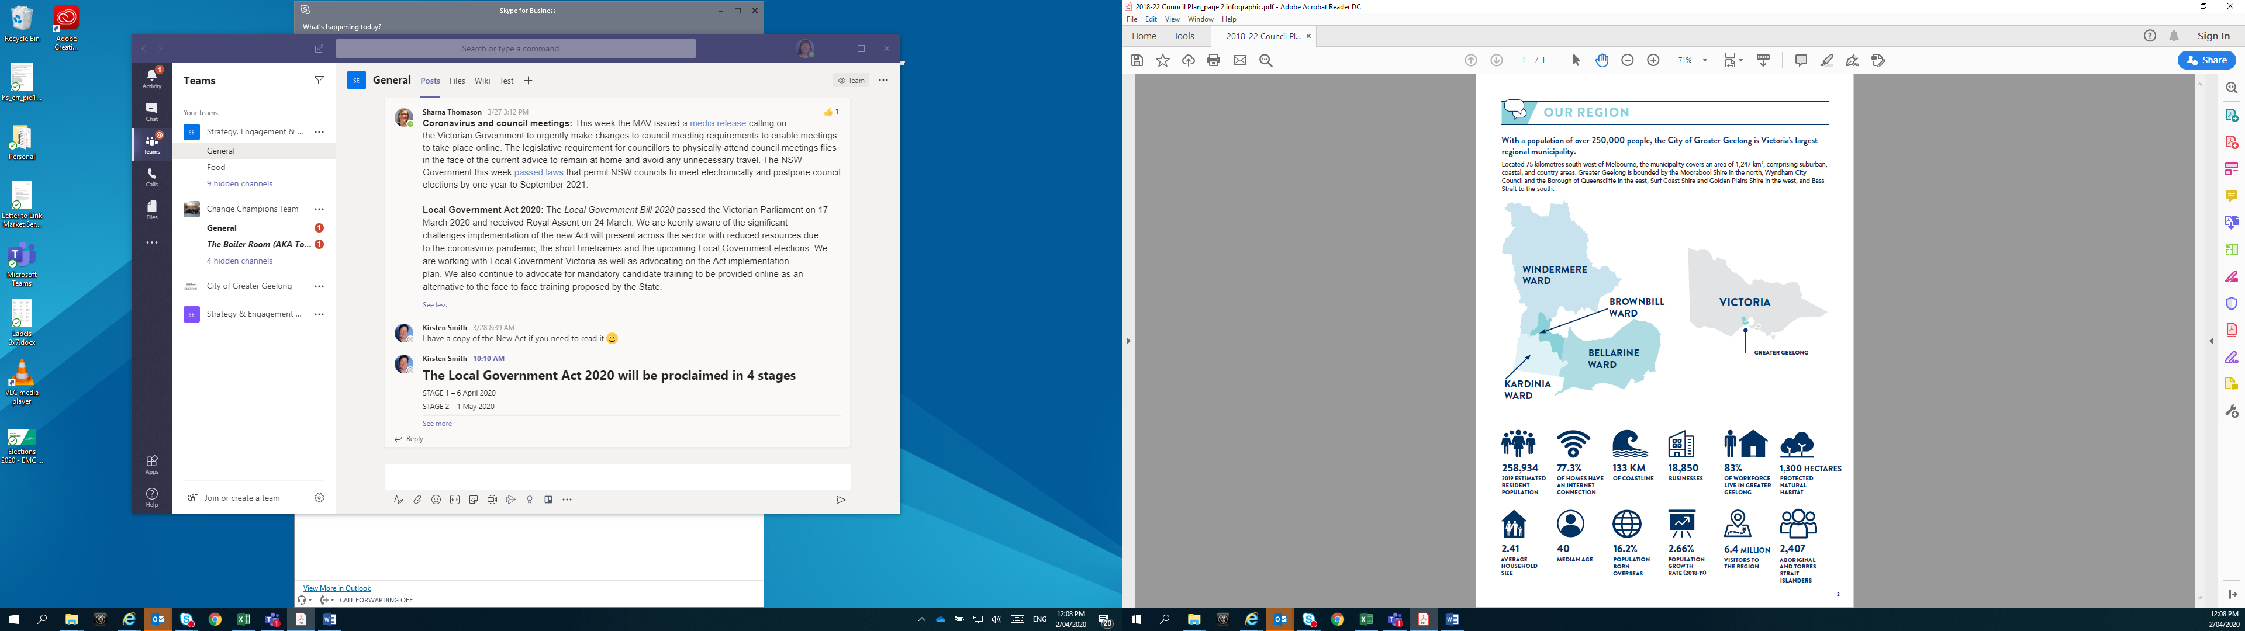
- Brownbill Ward: three councillors
- Kardinia Ward: three councillors
- Windermere Ward: two councillors.

FIGURE 15: Ward map of the City of Greater Geelong

In 2021–22, Council included the following elected representatives:
- Cr Stephanie Asher stood down as Mayor of Greater Geelong City Council on 15 June 2022
- Cr Peter Murrihy was elected Mayor at a special meeting on 17 June 2022.
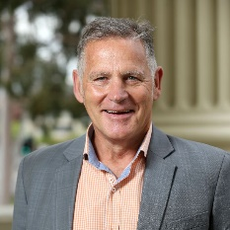 |  | Cr Peter Murrihy  Mayor  Brownbill Ward | 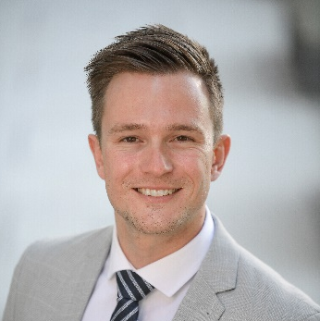 |  | Cr Trent Sullivan  Deputy Mayor  Bellarine Ward
Portfolios:  - Arts, Live Entertainment & Hospitality  - Economic Development (Chair)  - Heritage (Chair)  - Leisure & Recreation (Chair)  - Tourism  - Innovative Solutions (Chair)  Committees:  - CEO Employment and Remuneration Committee (Chair)  - Audit and Risk Committee (Chair)  - G21 Geelong Region Alliance (Chair)  - Regional Capitals Australia  - Regional Cities Victoria  - Geelong Major Events  - Geelong Heritage Advisory Committee (Chair)  - G21 Pillar – Economic Development  - G21 Pillar – Sports and Recreation |  |  | Portfolios:  - Creative Communities & Culture (Chair)  - Major Events  - Tourism (Chair)  Committees:  - Bellarine Multi Arts Facility (Potato Shed) (Chair)  - CEO Employment and Remuneration Committee  - Geelong Major Events  - Geelong Art Gallery  - Geelong Regional Library Corporation  - G21 Pillar – Arts, Heritage and Culture  - Regional Cities Victoria  - Tourism Greater Geelong and The Bellarine Inc
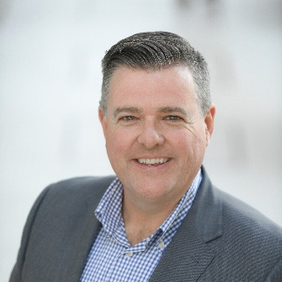 | Cr Anthony Aitken  Windermere Ward |  | 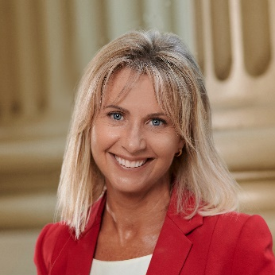 | Cr Stephanie Asher  Bellarine Ward
Portfolios:  - City Works, Parks & Gardens (Chair)  - Citizenship & Community Engagement (Chair)  - Finance (Chair)  - Social Housing  - Volunteering & Disability (Chair)  - Osbourne House  Committees:  - Access & Advisory (Chair)  - Affordable Social Housing Advisory Committee  - CEO Employment and Remuneration Committee |  |  | Portfolios:  - Finance  - Sustainability Performance (Chair)  Committees:  - Sustainable Advisory Committee (Chair)
 | Cr Kylie Grzybek  Windermere Ward |  | 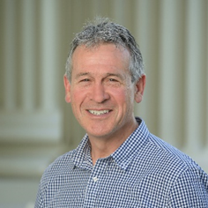 | Cr Bruce Harwood  Kardinia Ward
Portfolios:  - Arts, Live Entertainment & Hospitality  - Statutory & Strategic Priorities (Chair)  - Shared Trails  Committees:  - Audit and Risk Committee  - CEO Employment and Remuneration Committee  - G21 Pillar – Planning and Services  - Planning Committee (Chair)  - Municipal Association of Victoria  - Submissions Review Panel (Chair) |  |  | Portfolios:  - Economic Development  - Statutory & Strategic Priorities  - Sport  - Transport (Chair)  Committees:  - Barwon South West Waste and Resource Recovery Group Committee Forum  - G21 Pillar – Transport  - Planning Committee  - Submissions Review Panel
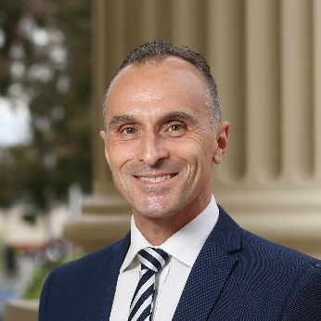 | Cr Eddy Kontelj  Brownbill Ward |  |  | Cr Sarah Mansfield  Brownbill Ward
Portfolios:  - Arts, Live Entertainment & Hospitality (Chair)  - Osbourne House (Chair)  - Veteran Affairs (Chair)  Committees:  - Geelong Major Events |  |  | Portfolios:  - Aboriginal Affairs  - Climate Change Action  - Circular Economy (Waste Management)  - Community Health & Aged Care (Chair)  - Diversity, Inclusion & LGBTIQ+ (Chair)  - Innovative Solutions  - Social Housing (Chair)  - Transport  Committees:  - Affordable Social Housing Advisory Committee (Chair)  - Ageing-Well Advisory Committee (Chair)  - Geelong Regional Library Corporation  - G21 Pillar – Health and Wellbeing

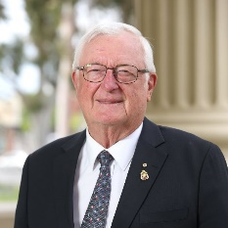 | Cr Jim Mason AM  Bellarine Ward | 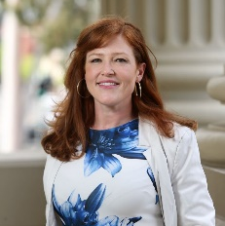 | Cr Belinda Moloney  Kardinia Ward
Portfolios:  - Aboriginal Affairs (Chair)  - Citizenship & Community Engagement  - Creative Communities & Culture  - Diversity, Inclusion & LGBTIQ+  - Environment (Chair)  - Leisure & Recreation  - Multicultural Affairs (Chair)  - Rural & Coastal (Chair)  - Shared Trails (Chair)  Committees:  - Association of Bayside Municipalities  - Australian Coastal Councils Association  - CEO Employment and Remuneration Committee  - Geelong-Queenscliff Coastal Adaptation Program  - Geelong Regional Library Corporation  - G21 Pillar –Education and Training  - Kilangiti (formally Karreenga) Aboriginal Advisory Committee (Chair)  - Multicultural Action Plan Committee (Chair)  - Rural and Peri-Urban Advisory Committee (Chair) |  | Portfolios:  - Climate Change Action (Chair)  - Circular Economy (Waste Management) (Chair)  - City Works, Parks & Gardens  - Community Health & Aged Care  - Environment  - Heritage  - Multicultural Affairs  - Rural & Coastal  - Sustainability Performance  - Volunteering and Disability  Committees:  - CEO Employment and Remuneration Committee  - Geelong Heritage Advisory Committee  - G21 Pillar – Education and Training  - Rural and Peri-Urban Advisory Committee  - Sustainable Advisory Committee  - Women in Community Life Advisory Committee (Chair)
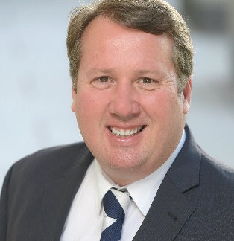 | Cr Ron Nelson  Kardinia Ward
Portfolios:
- Major Events (Chair)
- Sport (Chair)
- Veterans Affairs
Committees:
- Geelong Major Events (Chair)
- Geelong Regional Library Corporation
- G21 Pillar – Sports and Recreation

OUR ORGANISATION
We are an inclusive and flexible organisation and one of the largest employers in the region. We are responsible for:
- providing support and professional expertise to assist the Council in developing policies and making decisions
- engaging with the local community and significant stakeholders to make sure Council decisions are in line with community expectations
- delivering services and programs that benefit the whole community, such as waste management and roads
- delivering services and programs for specific communities, such as maternal child health and youth services
- enforcing legislation that has a local community impact, such as food safety and planning legislation
- building and maintaining infrastructure, such as local roads and community hubs
- protecting our natural environment, while supporting sustainable development
- supporting economic development that will benefit the whole community
- helping our community to plan for, and recover from, natural disasters and other emergencies

OUR LEADERSHIP TEAM
We are led by the Chief Executive Officer, who operates under the delegation of the elected Council and is responsible for our overall management and performance.
Our Executive Leadership Team, consisting of five directors and the Chief Executive, are responsible for implementing council decisions and delivering sustainable and effective services, activities and infrastructure to the community.
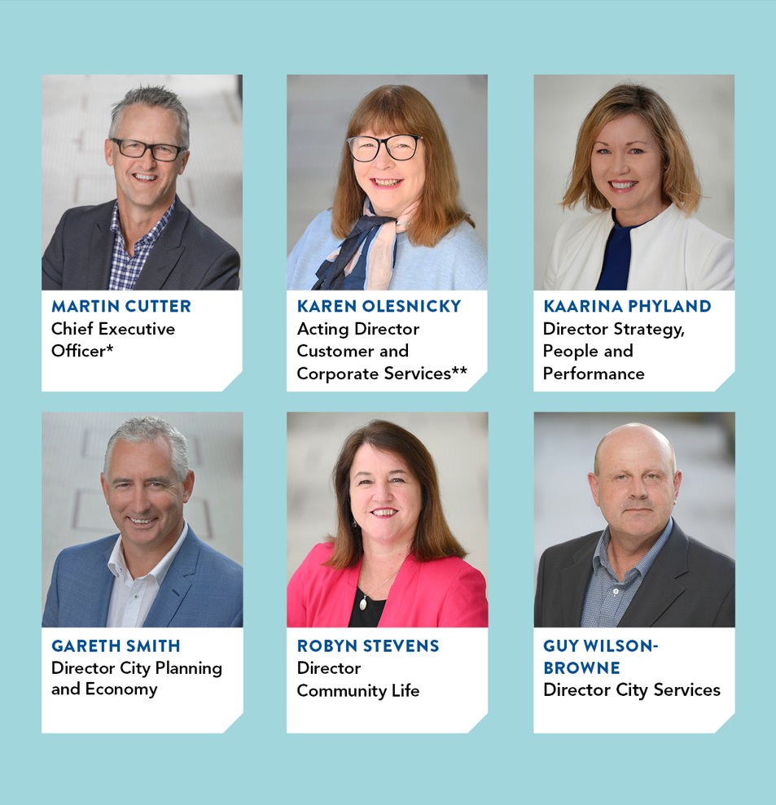
* Martin Cutter held the position of Chief Executive Officer to 2 September 2022
** Michael Dugina held the position of Director Customer and Corporate Services to 24 June 2022
FIGURE 16: Our leadership team as at 30 June 2022

OUR ORGANISATIONAL STRUCTURE
Our organisation is structured around five directorates that work together to deliver a range of services, activities and infrastructure.
FIGURE 17: Our organisational structure as at 30 June 2022

OUR PEOPLE
We are proud to be an inclusive and flexible organisation that is one of the largest employers in the region.
We currently employ a total of 2,814 people – equivalent to 1,756.27 full-time employees.
Our turnover in 2021–22 was 17.3 per cent – up from 10.4 per cent the previous year.
TABLE 1: Total full-time equivalent employees by directorate, employment condition and gender in 2021–22
EMPLOYEE TYPE –GENDER | CHIEF EXECUTIVE | CITY PLANNING AND ECONOMY | CITY SERVICES | COMMUNITY LIFE | CUSTOMER AND CORPORATE SERVICES | STRATEGY, PEOPLE AND PERFORMANCE
Full Time – W | 20.9 | 113 | 99.4 | 252.7 | 68.5 | 58.9
Full Time – M | 9.1 | 111.7 | 404.1 | 66.5 | 73.4 | 21
Full Time – X | 0 | 0 | 0 | 0 | 0 | 0
Part Time – W | 1.5 | 46.7 | 32.5 | 268.3 | 24.2 | 6.7
Part Time – M | 0 | 15.5 | 13.6 | 22 | 2.5 | 0.1
Part Time – X | 0 | 0 | 0 | 0 | 0 | 0
Casual – W | 0 | 4.1 | 0.3 | 66 | 1.3 | 4.4
Casual – M | 0 | 3.3 | 3.6 | 24.8 | 0.2 | 0.4
Casual – X | 0 | 0 | 0 | 0 | 0 | 0
Total | 31.5 | 294.3 | 553.5 | 700.6 | 170.1 | 91.5
Legend: W = Women, M = Men, X = persons of self-described gender
TABLE 2: Total headcount of employees by employment classification and gender in 2021–22
EMPLOMENT CLASSIFICATION | WOMEN | MEN | PERSONS OF SELF-DESCRIBED GENDER | TOTAL
Band 1 | 100 | 82 |  | 182
Band 2 | 244 | 49 |  | 293
Band 3 | 394 | 359 | 1 | 754
Band 4 | 168 | 92 |  | 260
Band 5 | 215 | 100 |  | 315
Band 6 | 154 | 94 |  | 248
Band 7 | 121 | 131 |  | 252
Band 8 | 59 | 60 |  | 119
Early Childhood Educators & Teachers | 294 | 8 |  | 302
Maternal & Child Health Nurses | 53 |  |  | 53
Senior Officer | 29 | 28 |  | 57
Total | 1,831 | 1,003 | 1 | 2,835

EQUAL EMPLOYMENT OPPORTUNITY – AN INCLUSIVE AND DIVERSE WORKPLACE
We believe that our people are our greatest asset. We are committed to creating an inclusive and fair organisation that encourages our employees to do their best work.
In July 2021, we conducted our first Workplace Gender Audit in accordance with our legislative obligations outlined in the Gender Equality Act 2020. The audit included an employee survey and analysis of our employee data including gender, age, status, access to flexible working arrangements, and workplace experiences. The feedback from employees and the data analysis were key in informing the development of our first Gender Equality Action Plan (GEAP). The plan’s initiatives are aligned with our Inclusion and Diversity Roadmap horizons.
Our audit report was submitted to the Commission for Gender Equality in the Public Sector on 1 December 2021. Our GEAP was endorsed by our Executive Leadership Team in December 2021 and submitted on 31 March 2022. Key foundational activities including governance, reporting and capacity building are well underway.
We successfully recruited for the position of Aboriginal Employment and Engagement Officer to build relationships and support the delivery of key workplace initiatives.
We also became members of The Australian Network on Disability and reviewed our recruitment practices through a disability lens, identifying exciting opportunities to improve our practices.
We continue to report against our organisation’s sustainability indicators and targets in accordance with several Global Reporting Initiative indicators relevant to equal opportunity employment, including parental leave by gender, incidents of discrimination and workforce representation and diversity.
Other plans we are using to further improve diversity and inclusion in our workplace include:
- Gender Equality Action Plan 2022‒25
- Reflect Reconciliation Action Plan, May 2020 – May 2021
- Sustainability Framework 2020
- Social Equity Framework 2022‒25

OCCUPATIONAL HEALTH AND SAFETY
Health and safety matters to us.
Our safety management system, CitySafe, gives us the tools and processes we need to address employee, contractor and community health and safety. Due to the continuing pandemic restrictions in 2021, we were unable to offer alternative duties to injured employees as part of the return-to-work process. This led to an increase in the lost time injury frequency rate.
TABLE 3: Occupational health and safety performance in 2021–22
 | LOST TIME INJURY FREQUENCY RATE |  | TOTAL RECORDABLE INJURY FREQUENCY RATE |  | HIGH POTENTIAL INCIDENT FREQUENCY RATE
2020–21 Results | 21.4 |  | 24.9 |  | 2.9
2021–22 Targets | 15 |  | 14 |  | 1
2021–22 Results | 26.5 |  | 34.9 |  | 0.0
2021–22 Variation | +55% | X | +85% | X | -200% | 
COVID-19 response
Several coronavirus working groups and sub-committees, overseen by the Crisis Management Team, guided activities to help our employees, volunteers, services and community respond to the impact of the virus on our region. We have transitioned to COVID normal, and from crisis to business as usual. COVIDsafe plans and protocols remain in place and will be continually monitored.
Contractor and volunteer safety
In 2021, we expanded the functionality of LinkSafe (contractor induction management) to include volunteer and event inductions. This will be further expanded to include visitor check in when we move to our new civic precinct, Wurriki Nyal.
Injury Management
Risk funding has been secured from workers compensation provider EML to target body stressing injuries. This is the largest cause of injury at the City. Over the next few months, work will now progress on project plan and implementation.
Psychological Support
An Occupational Violence and Aggression (OVA) Policy and Framework has been implemented. The OVA public campaign ‘kind people are our kind of people’ is currently running throughput the Geelong Region.
Our Welfare Contact Officer (WCO) program continued during the 2021‒22 financial year. In 2020, more than 35 of our employees, whose roles were impacted by necessary facilities closures, underwent expediated training to become a WCO. Our WCOs offer confidential social and emotional support and connect fellow employees with relevant resources. They continue to actively reach out to employees.

HOW WE PLAN
We have developed an integrated, long-term and transparent approach to planning, monitoring and performance reporting, aligned with the clever and creative vision.
The Local Government Act 2020 requires all councils to prepare the following documents:
- Community Vision
- Council Plan
- Financial Plan
- Asset Plan
- Budget
- Revenue and Rating Plan
- Annual Report
- Workforce Plan.
Our Integrated Strategic Planning and Reporting Framework (represented in Figure 18) demonstrates the relationship between these key planning and reporting documents. The framework helps us set goals, make decisions, prioritise our workload, allocate resources, monitor how we’re going and adapt to changing circumstances that might challenge our progress.
In 2021, we introduced an internal organisation strategy and business planning cycle to guide our budget and business planning for 2022‒23. This process will continue to develop and enhance our strategic decision-making around priorities, performance and resource allocation
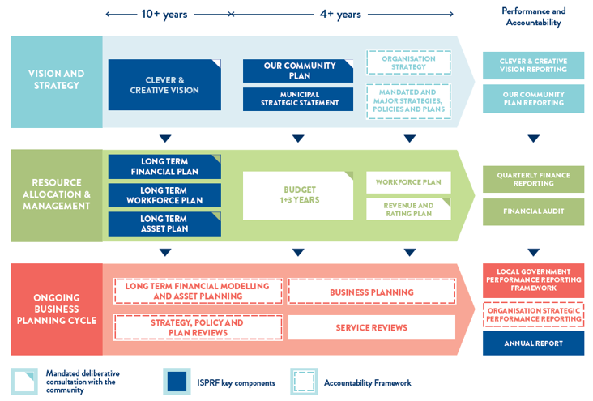

FIGURE 18: Our Integrated Strategic Planning and Reporting Framework (ISPRF)

OUR PERFORMANCE

Our Community Plan 2021‒25 outlines how we are working towards the 30-year community vision to make Greater Geelong a clever and creative city-region.
The plan tells the community what the councillors are aiming to achieve during their four-year term, and guides how we allocate resources so we can deliver infrastructure, services and programs to the community to ensure the social, economic and environmental sustainability of our region.
The four strategic directions we’ve chosen to guide us are:
- Healthy, caring and inclusive community
- Sustainable growth and environment
- Strong local economy
- High-performing Council and organisation.
As well as the strategic directions, the plan also outlines:
- Desired outcomes ‒ the future state we’re aiming for in four years
- Four-year priorities ‒ the priorities we’ll focus on to help achieve our desired outcomes
- Indicators ‒ how we will monitor our progress.
Our Community Plan 2021‒25 is supported by an annual action plan and budget which highlight the projects, initiatives and programs that will take place within the financial year to address our four-year priorities.
The following provides an end-of-year overview of our performance in delivering the Annual Action Plan 2021‒22 and how we are tracking against the indicators. It also highlights achievements and results for the prescribed service performance indicators as set out in the Local Government Performance Reporting Framework.
Actions that support the health and wellbeing priorities have been identified with the relevant health and wellbeing icon:

Tackling climate change and its impact on health | Increasing  healthy eating | Increasing  active living | Demonstrating and promoting gender equity practices | Improving mental wellbeing and social connection

STRATEGIC DIRECTION 1: HEALTHY, CARING AND INCLUSIVE COMMUNITY
LINKS TO THE CLEVER CREATIVE VISION
 | 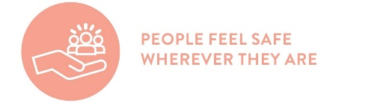 | 
Desired outcomes
- Our community feels welcome, safe and connected
- Our community has equitable access to health and social services, information and infrastructure
- Healthy behaviours and environments are promoted, supported and accessible
Four-year priorities
1.1 Help our community, recreation groups and volunteers to prosper and grow
1.2 Deliver health and community initiatives that are culturally sensitive and accessible across all life stages
1.3 Foster and embrace community connectedness
1.4 Demonstrate and promote gender equity practices
1.5 Foster an inclusive community culture
1.6 Facilitate social and affordable housing in Greater Geelong
1.7 Provide access to places, spaces and services where and when people need them the most
1.8 Strengthen relationships and partnerships with the Aboriginal and Torres Strait Islander communities in Greater Geelong
1.9 Support the City’s cultural and creative life, history and heritage
1.10 Provide facilities that foster and facilitate positive health and wellbeing outcomes
1.11 Respond to the findings of the Royal Commissions into aged care and mental health
PROGRESS REPORT
Indicators
Municipal Indicators | Data at 30 June 2022 | Progress comments
Proportion of adults experiencing high / very high psychological distress  Source: City of Greater Geelong Preventative Health Survey | 20% (2021)  10.3% (2017) | There was an increase in the proportion of our adult community experiencing high / very high psychological distress since 2017.
Proportion of adults meeting the physical activity guidelines  Source: City of Greater Geelong Preventative Health Survey | 67% (2021)  41% (2017) | More of our adult community is reporting that they are sufficiently physically active than in 2017.
Proportion of adults consuming the recommended number of serves of fruit and vegetables  Source: City of Greater Geelong Preventative Health Survey | Fruit – 46% (2021)  Fruit – 53% (2017)  Vegetable – 15% (2021) Vegetable 10% (2017) | There was an increase in the proportion of our adult community consuming the recommended serves of vegetables and a decrease in the proportion consuming the recommended serves of fruit since 2017.
Family incident rate per 100,000 population for Greater Geelong  Source: Crime Statistics Agency website www.crimestatistics.vic.gov.au | 1,557.7 (March 2022)  1,595.9 (March 2021) | For the year ending March 2022, the family incident rate for Greater Geelong was higher compared to the Victorian rate (1,360.4).
Community perception of safety in the area where they live  Source: City of Greater Geelong Preventative Health Survey | 61% (2021)  54% (2017) | More of our adult community is feeling safe where they live than in 2017.
Level of agreement that multiculturalism makes life better (definitely or sometimes)  Source: City of Greater Geelong Preventative Health Survey | 66% (2021) | This result comprised 48% definitely and 18% sometimes.  This is a new strategic indicator and therefore no prior year data is available.
Proportion of community concerned about effects of climate change on health (very or quite concerned)  Source: City of Greater Geelong Preventative Health Survey | 51% (2021) | This result comprised 28% very concerned and 23% quite concerned.  This is a new strategic indicator and therefore no prior year data is available.
Proportion of adults that are a member of an organised group (sports, religious, school, professional, community or action group)  Source: City of Greater Geelong Preventative Health Survey | 56% (2021) | This result consisted 28% members of a sports group.  This is a new strategic indicator and therefore no prior year data is available.

City of Greater Geelong Indicators | Data at 30 June 2022 | Progress comments
Community satisfaction with support services  Source: Local Government Community Satisfaction Survey | Family – 64 (2022)  Family – 66 (2021)  Elderly – 63 (2022)  Elderly – 65 (2021)  Disadvantaged – 61 (2022)  Disadvantaged – 62 (2021) | Our result for Family Support was lower compared to the Regional Centres average (67) while Elderly Support was lower compared to the statewide average (67).
Community satisfaction with recreational facilities  Source: Local Government Community Satisfaction Survey | 72 (2022)  75 (2021) | While satisfaction decreased in 2022, our performance continued to be well regarded by the community and was among our highest rated services. Our result was also higher than the statewide average (69).
Level of agreement that Council infrastructure is equitable (fair access to facilities that are needed across the municipality including healthy, safe and inclusive places and spaces)  Source: Local Government Community Satisfaction Survey | 56% (2022) | This is a new strategic indicator and therefore no prior year data is available.  Comparison to statewide and Regional Centres average is unavailable.
Level of agreement that Council infrastructure is accessible (for all abilities, affordable and easy for people to get to).  Source: Local Government Community Satisfaction Survey | 63% (2022) | This is a new strategic indicator and therefore no prior year data is available.  Comparison to statewide and Regional Centres average is unavailable.
Number of key community infrastructure projects completed  Source: City of Greater Geelong | 86.5% (2022)  84% (2021) | In 2021‒22 we delivered a further three key infrastructure projects: Drysdale Town Centre – Community Facilities, the Grovedale Men's Shed and the Regional Indoor Sports & Events Centre – Feasibility Study.  We have delivered 32 of the 37 key community infrastructure projects identified for delivery by 2022.
Community satisfaction with community and cultural activities  Source: Local Government Community Satisfaction Survey | 64 (2022)  65 (2021) | Our result was comparable to both statewide and Regional Centres average (65 respectively).

Annual Action Plan 2021‒22
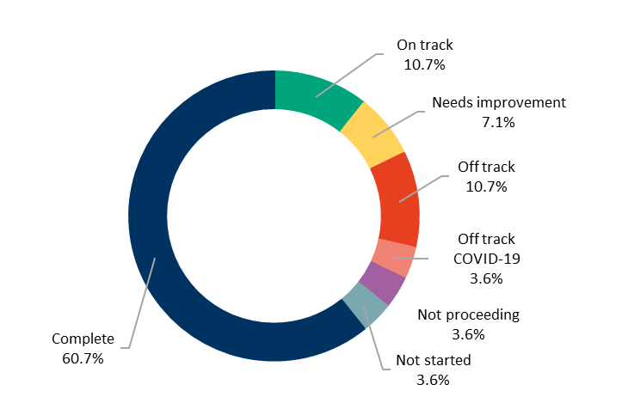
We committed to 28 actions which demonstrate how we are addressing our four-year priorities under Healthy, Caring and Inclusive community.
At the end of June 2022:
- 17 were ‘complete’
- three were ‘on track’
- two were ‘needs improvement’
- three were ‘off track’
- one was ‘off track COVID-19’
- one was ‘not started’
- one was ‘not proceeding’.

Four-year priority | 2021–22 actions | Progress comment | Status
1.1 Help our community, recreation groups and volunteers to prosper and grow | Develop opportunities for community, groups, clubs and volunteers that builds capacity and capability in governance, leadership and sustainability. | Development opportunities were created, including:  - an alternative online Community Leadership Program for 2022  - onboarding the Grovedale Neighbourhood House community steering group.  Community groups and organisations were supported through initiatives including:  - the Community Agents of Sustainability (CAOS) network  - hosting community grant information sessions and workshops  - publishing a free quarterly Community Training Calendar  - hosting and coordinating the Geelong Pre-employment Professionals Network  - gathering data on the use of, and challenges for, sports and recreation clubs across the municipality to assist with future planning  - implementation of Community Garden Assessment Guidelines for local communities to establish and manage a community garden on City owned and/or managed land.  - providing one-on-one support meetings and expanding online content to build understanding of our Community Infrastructure Grants Program  - moving our Sports Club User Guide online  - distributing the monthly Sports Club Noticeboard newsletter. | ü
1.2 Deliver health and community initiatives that are culturally sensitive and accessible across all life stages | Develop a nutrition toolkit for infants to older adults including a focus on First Nations and culturally and linguistically diverse communities. | In October 2021, we released a free nutrition toolkit, Eat Well Live Well-Healthy Eating for Every Life Stage, with information and practical advice to help community members develop healthy and sustainable eating patterns, habits, and skills at home. In March 2022, we launched a version of the toolkit translated into several languages. This project is now complete with a final report provided to the Department of Families, Fairness and Housing. | ü
 | Partner with G21 to implement the G21 Healthy Eating and Active Living (HEAL) priority 2021–2025 Regional Plan. | We worked with G21 to review and update the Healthier Eating and Active Living (HEAL) Orientation Guide – G21 Region Planning and Action 2017–2021. With changes with the G21 Primary Care Partnership program, responsibility for this program is now transitioning to Barwon Health. We will continue to work to progress our healthy eating and active living agenda to support our community to make healthy lifestyle changes to improve health and wellbeing. There have been a number of projects completed as a result of the HEAL work including the free Eat Well Live Well nutrition toolkit, the Choose Water campaign (for healthy eating) and supporting Women's Health Week (for active living). | ü
 | Adopt and implement the City’s first Positive Ageing Strategy and co-design an action plan with the community. | On 28 September 2021, Council adopted the Respected, Connected and Thriving – Positive Ageing Strategy 2021–2047. This long-term strategy outlines several priorities that support healthy and happy ageing for people over 55 years of age in Greater Geelong. Workshops with internal stakeholders, service organisations and community members were held in May to co-design the action plan which is currently being drafted and will be published on the City’s website by end July 2022.
 | Deliver programs and services that improve health and wellbeing outcomes across all life stages in our leisure services. | Wellness opportunities for our community were provided through the delivery of programs and activities, ensuring our leisure and recreation facilities remained agile during COVID-19 restrictions. This included:  - recreational programming  - general membership  - learn to swim, lap swimming  - active adults  - outdoor and indoor exercise.  Social media was utilised to engage and deliver updates; provide virtual training; and monthly e-newsletters to members presenting children activities, water safety, recipes, and health and fitness tips to all members of the community.  In addition, we continued to upskill our leisure and recreation employees’ qualifications in First Aid, lifeguarding and CPR.  The easing of COVID-19 restrictions saw the full resumption of programs with family-fun days delivered in January-February 2022. | ü
 | Develop the Municipal Early Years Plan 2022–2025 to support the wellbeing and development of children and families. | We consulted with families and stakeholders to inform the development of the draft Municipal Early Years Plan 2022–2025. This draft plan aligns our efforts to support the health and wellbeing of children in our municipality, and influence and improve their educational and developmental outcomes.  We received feedback on the outgoing Municipal Early Years Plan 2018–2022 and will now be seeking community and stakeholder feedback on the draft Municipal Early Years Plan 2022–2025. The draft plan will then be considered by council in August/September 2022.
1.3 Foster and embrace community connectedness | Partner with key stakeholders and community safety networks to develop a community safety framework. | Our community safety framework supports the achievement of a community that feels welcome, safe, and connected. We sought feedback on the framework with over 120 submissions received and these are currently being considered. It is intended that the draft framework will be ready for Council adoption in August 2022. | 
 | Partner with the Victorian Equal Opportunity and Human Rights Commission to deliver the Reducing Racism Project in response to the increase in racism towards our culturally and linguistically diverse communities through the COVID-19 pandemic. | We are not proceeding with Phase 2 of the Reducing Racism Project due to resourcing issues. The purpose of this project was to raise awareness about the prevalence and seriousness of racism, discrimination, and vilification in our society and drive down the rising experiences of racism through campaigns, education, and awareness raising. Phase 2 of the project, raising awareness training, was due to take place in 2021 but was placed on hold due to COVID-19 restrictions. Our community can currently access information and report racism via the City’s website. | NP
1.4 Demonstrate and promote gender equity practices | Partner with Women's Health and Wellbeing Barwon South West and G21 to develop the G21 Respect 2040 plan that will provide a shared vision to address gender equity and the prevention of violence against women. | We partnered with Women's Health and Wellbeing Barwon South West and G21 to develop the G21 Respect 2040 plan aimed at reducing violence against women through primary prevention initiatives. Workshops were held to develop common language and identify the range of organisational responses and responsibilities. We also held a partners and stakeholders forum in December 2021 to identify collaborative actions that can prevent violence against women before it occurs. This resulted in identifying some key strategies and actions to promote messages and implement prevention strategies. G21 partners identified two actions for 2022–23; collaborating on the 16 days of activism campaign against gender-based violence and participating in an intersectionality workshop. | ü
 | Implement the Gender Impact Analysis tool across a range of community focused services. | We established a dedicated project to increase gender equality in the workplace and appointed a role to help develop our first Gender Equality Action Plan (GEAP). The GEAP will build on our strategy for diversity and inclusion, and commitment to build a healthy and inclusive culture.  We successfully submitted our Workplace Gender Audit and GEAP, inclusive of a Gender Impact Analysis (GIA) tool, to the Gender Equality Commission for the Public Sector (December 2021 and March 2022 respectively).  The Plan was deemed compliant by the commission in June 2022.  Gender analysis will allow us to identify opportunities and new, inclusive ways of doing business to support our community. We recognise that power imbalance of gender and the impact that this inequality has on safety, health, wellbeing, and economic life of gender diverse people. It is also evident that gender inequality is crucial to ending violence against women and children. | ü
1.5 Foster an inclusive community culture | Implement and report on the fourth year of the Access and Inclusion Action Plan 2018–22 to inform new direction priorities. | Our Access and Inclusion Action Plan 2018–22 aims to improve outcomes for members of our community who otherwise may face inequity in accessing community facilities or activities. The final report has been put on hold pending approval to extend the current plan. We need to understand the full impact of the New Disability Bill that will come from the Disability Royal Commission and are also awaiting the City's integrated planning work to be completed. | 
 | Implement an inclusive events tool that promotes inclusive practices for people with a lived experience of a disability and considers all ages, abilities and backgrounds. | We developed an Inclusive Events tool so that the events we deliver consider the needs of people with access challenges. The tool was trialled and assessed via an internal pilot program as our ability to trial the tool more broadly was significantly impacted by COVID-19 restrictions. It is now ready for implementation and promotion for 2023 major events. | 
 | Explore a range of opportunities to embed the City's social equity principles across a range of community focused services. | We held workshops with members from Council's Advisory Committees, our Clever Creative vision partners, and employees to inform the development of the Social Equity Framework 2022‒25. The framework outlines our approach with a common set of principles and sets out the outcomes that will guide how we engage and support our community to be able to participate, be included and have the opportunity to live a healthy and fulfilling life.  We sought feedback on the framework across February 2022 with 13 submissions received and considered. Council adopted the framework in May 2022. We are currently developing an action plan to monitor and gauge the implementation of the framework. | ü
 | Review the Multicultural Action Plan 2018–2022 in partnership with the Multicultural Advisory Committee and key stakeholders. | Our planned review of the Multicultural Action Plan 2018–2022 has been delayed due to resourcing issues. This plan guides how we plan for and support our multicultural community as we recognise that many people from multicultural backgrounds can experience unique barriers to participation including access to information, cultural differences, racism, discrimination, and exclusion. Given these barriers can lead to poorer health and wellbeing outcomes, we strive to foster inclusive cultural practices and learn from the community voice as much as possible.  It is anticipated that we will commence work to refresh and update the action plan with members of the Multicultural Action Plan Advisory Committee in the second half of 2022. | Not started
1.6 Facilitate social and affordable housing in Greater Geelong | Implement the City's Social Housing Plan 2020–41 (Major budget initiative) | Council endorsed the Social Housing Plan 2020–41 in February 2020 and since that time a range of actions were implemented.  In addition, we partnered with Homes Victoria, to fund the One Hundred Dwellings feasibility study to identify Council owned land suitable for the delivery of social and affordable housing dwellings. We sought community feedback on three proposed sites identified in Corio, Belmont and Bell Post Hill and received over 700 submissions.  We also held four meetings with members of the recently formed Social and Affordable Housing Advisory Committee to gain feedback on a range of discussion points, including the state government's draft Ten-Year Social and Affordable Housing Strategy for Victoria and involvement in and the establishment of a Geelong Affordable Housing Trust.
1.7 Provide access to places, spaces and services where and when people need them the most | Develop agreed policy and standards to guide the delivery of all social infrastructure in a manner consistent with our social equity and sustainability principles. | We designed the process for delivery of the Our Community Places, Spaces and Services – A Social Infrastructure Plan for the City of Greater Geelong Generation One: 2020 – 2023. We revised timelines for the delivery of Generation 2 of the Social Infrastructure Plan and anticipate it will go to council for endorsement in December 2022.  As part of Generation 2, a series of new standards were developed to address social equity and sustainability principles and used to inform the deliberative engagement process for the Asset Management Strategy in November 2021. | ü
 | Implement recommendations from the Vital Communities Social Research Project and Gender COVID Impact Analysis. | Our Vital Communities research project provides a contemporary look at the challenges faced by some of our most socio-economically disadvantaged communities. It also has recommendations on how the City can assist in bridging the gaps around key determinants of health including employment, education, housing, and access to services. Council noted the Vital Communities – Strategies for Alleviating Locational Disadvantage in Geelong in June 2021.  Specific recommendations underway from this program include:  - implementation of the Regional Industry Sector Employment program  - implementation of the One Hundred Dwellings feasibility study for social housing  - establishment of an Advisory Committee that supports the development of the Northern Aquatic and Community Hub  - concept planning for the Whittington Family & Community Centre  - re-development of Labuan Square, Norlane.  Actions implemented as a result of the Gender COVID impact analysis include:  - development of an integrated communication plan linked to safe at home family violence information is currently underway  - completion and publication of the YourGround safety in public space project  - report and specialist forum in February 2022 regarding access to emergency and crisis accommodation for women  - commencement of mapping of free Wi-Fi across the municipality for public access. | ü
 | Continue to advocate for funding to deliver the Northern Aquatic and Community Hub. | We successfully advocated for state and federal government funding for construction of the Northern Aquatic and Community Hub. In addition to Council’s funding commitment of $44.84 million, we received $8.5 million in the 2021–22 Budget and $8.26 million through the Australian Government Local Roads and Community Infrastructure Fund.  The Northern Aquatic and Community Hub will directly contribute to the health and well-being of residents in the north and surrounding areas by providing state of the art health and fitness facilities, with a projected preventative health benefit of over $111 million over the first 10 years of operation. We commenced construction in February 2022 and will continue to seek further state and federal funding opportunities to support delivery of this facility. | ü
1.8 Strengthen relationships and partnerships with the Aboriginal and Torres Strait Islander communities in Greater Geelong | Evaluate and report on the Reflect Reconciliation Action Plan and commence development of the Innovate Reconciliation Action Plan. | We commenced evaluation of the Reflect Reconciliation Action Plan May 2020–May 2021 with a report provided to Reconciliation Australia outlining the key milestones and responding to questions raised.  Council re-engaged the consultants who facilitated this plan to undertake a review process with Councillors, key stakeholders, and members of the Kilangigj Aboriginal Advisory Committee. A review of the Reflect Reconciliation Action Plan was presented to Council at the June meeting. Of the 50 actions, 24 were completed, 19 in progress and 7 actions will be addressed in the next stage of the Reconciliation Action Plan framework. Some of the key actions which have been implemented include engagement with Wadawurrung Traditional Owners Aboriginal Corporation as part of the development of Wurriki Nyal, the award-winning NAIDOC 2020 week, online cultural heritage locations and digital projections as part of National Reconciliation Week. | ü
 | Partner with Wathaurong Aboriginal Co-operative to review the Closing the Gap agreement and targets. | We are involved in the implementation of the Best Start initiative that supports families and caregivers to provide the best possible environment, experience and care for children from birth to age eight. Our Best Start facilitator co-brokers the Best Start Partnership meetings with Aboriginal Best Start facilitators to plan, deliver and monitor evidence-based strategies that deliver positive outcomes for children.  Closing the Gap aims to close the health and life expectancy gap within a generation between Aboriginal and Torres Strait Islander people and non-indigenous Australians. This program is ongoing, relying on a strong partnership between the City and members from the Wathaurong Aboriginal Cooperative with whom we are meeting to finalise local targets.  Unfortunately, due to resourcing changes, a partnership agreement has not progressed, however, the interest remains to be further explored with the Wathaurong Aboriginal co-operative. It is likely that this action will be reviewed for action in the next financial year.
1.9 Support the City’s cultural and creative life, history and heritage | Progress business cases for the improvement and transformation of three of the City's cultural venues - the Potato Shed, National Wool Museum and Geelong Gallery. | We are working on business cases to extend, expand and reinvigorate three of our cultural facilities to meet the current and future needs of our community. These facilities contribute to improved health and wellbeing by providing our community with accessible places and spaces to participate, connect, learn, be inspired, and contribute to the cultural life of the city. Actions on these three business cases include:  - completion of the business case for the expansion of the Geelong Gallery  - seeking state government partnership support and ministerial support for the Potato Shed - Bellarine Arts Centre Redevelopment business case  - completion of the National Wool Museum Vision and Business Plan for consideration by council in July 2022. Once endorsed, we will then seek partnership funding for a business case from state government in 2022‒23. | ü
 | Prepare a First Nations Cultural Heritage Grant program to fund the identification, conservation and promotion of Aboriginal heritage places. | Our First Nations Cultural Heritage Grant program was developed in collaboration with Wadawurrung Traditional Owners Aboriginal Corporation. It provides funding for projects that recognise, restore, protect and preserve Aboriginal cultural heritage across Greater Geelong.  Council adopted this program in November 2021 and we completed our first round of the 2021–22 First Nations Cultural Heritage Grant program, awarding $60,000 to the Geelong Gaol Museum to research the provenance of Aboriginal art work that currently resides in the Gaol.  We commenced a second round of grants in June 2022. | ü
1.10 Provide facilities that foster and facilitate positive health and wellbeing outcomes | Progress the design and construction of the Armstrong Creek West Child and Community Hub. (Major budget initiative) | The building design for the Armstrong Creek West Child and Community Hub was completed in September 2021 and the construction tender awarded in December 2021. Works commenced onsite in January 2022. We are halfway through construction with an expected completion date of early 2023. This facility will provide additional kindergarten places and facilities for maternal and child health services to support the health and wellbeing of children in this local community during the important early life stages. | ü
 | Progress the design and construction of the Northern Bellarine Aquatic Centre. (Major budget initiative) | The Northern Bellarine Aquatic Centre design was completed in September 2021 with the construction tender awarded in December 2021. We have commenced construction with an expected completion date of late 2023. When completed, this facility will address an identified inequity in the provision of aquatic facilities that support community participation in aquatic recreation activities and increase participation in physical activities to improve health and wellbeing. | ü
 | Review and update the Social Infrastructure Plan, with particular regard to the needs of young people and early years services. | We commenced identifying opportunities to improve access to safe, adaptable spaces that enhance social connections for youth across the municipality. Upon further consultation with the Youth Council, we completed the draft youth and early network plans which will form part of the Social Infrastructure Plan Generation 2, anticipated to go to council for endorsement in December 2022.
 | Upgrade an existing fenced dog park located at Stead Park, Corio and deliver a new fenced dog park located in Rennie Street, Lara. | We upgraded and opened the Stead Park dog park in July 2021. In addition, we completed construction of a new fenced dog park in Lara in December 2021.  The provision of fenced dog parks across the municipality provides an opportunity for dog socialisation and acts as a place of local connection for dog owners. | ü
1.11 Respond to the findings of the Royal Commissions into aged care and mental health | Provide a briefing on the impact of Federal government response to the findings of the Aged Care Royal Commission and next steps for the role of local government. | We provided details to Council on 5 September 2018 about our aged care services and the national aged care reform agenda. We then updated Council on 14 September 2021 on the outcome of The Royal Commission into Aged Care Quality and Safety, the federal government's response, and potential impact on our services.  Given the ambiguity about the form and function of future services in some areas, Council agreed to our recommendation to monitor advice about service changes and provide a further update in June 2022. However, federal government is now developing a new Support at Home Program which we will monitor and brief Council in November 2022.
 | Provide a briefing on the impact of state government response to the findings of the Mental Health Royal Commission and next steps for the role of local government. | We provided a Councillor briefing note to Councillors in March 2022 on this matter.  Improving mental health and social connection is one of our key health and wellbeing priorities and addressing the ongoing impact of the COVID-19 pandemic continues to be a focus area. The Royal Commission into Mental Health provides recommendations on strategies to promote social connection, inclusion and community participation. | ü

Other achievements
- Council adopted a new road safety strategy, Vision Zero Geelong: Safe Local Travel 2022‒27, which seeks to elimate deaths and serious injuries on Greater Geelong roads by 2050
- Council endorsed the Gender COVID-19 Impact Analysis Report and the 2021‒2022 short term action plan
- The National Wool Museum won numerous awards, including the Australian Museums and Galleries Association Victoria medium museums/galleries award for the On the Land: Our Story Retold exhibition
- We partnered with Community Care Chemist to support people ‘sleeping rough’ in the municipality by providing care packs containing essential personal care items
- We supported the STREETFACE See Me, Respect Me campaign aimed at challenging age discrimination
- We marked National Reconciliation Week with arts projections on City Hall and the release of a video about National Sorry Day and the legacy of the Stolen Generations in Greater Geelong and Wadawurrung Country more broadly
- We delivered the inaugural Surround Sounds Geelong and the Bellarine Music Festival, attracting audiences of 14,251 and employing 840 artists, in 35 participating venues
- We delivered playground upgrade projects worth $559,722 as part of the playground development program
- We engaged with the community in the development of the Domestic Animal Management Plan 2022‒2025, which was adopted by Council in November 2021
- We delivered new and upgraded sporting and community facilities including:
  - Barwon Heads Arts & Community Hub
  - Leisurelink 50 metre pool replacement
  - Thomson Reserve change facility
  - Shell Reserve netball courts and cricket nets
  - Hume Reserve, Estuary Reserve and Grinter Reserve pavillions
- We invested more than $4.9 million in Community Grants program in 2021‒22
- We launched the Geelong Preventative Health Survey Dashboard via the City’s Geelong Data Exchange – an online platform providing access to data the City collects
- We supported the Aboriginal Maternal and Child Health Initiative through secondment of a Community Child Health Co-ordinator to Wathaurong Co-operative Women and Child Program
- We carried out more than $500,000 in restoration works to Osborne House and stables, including underpinning and stabilisation of the stable walls, façade repairs and painting
- We completed construction of the Mt Duneed Community Shed, a purpose-built space for people of all ages and interest and new home to the Mount Duneed Men’s Shed
- We were highly commended in the National Safety Awards of Excellence for Best Communication of Safety Message. The project was about getting a young persons perspective on Occupation Health and Safety and how it impacts on their working and personal life.
Local Government Performance Reporting Indicators
To help measure performance across all Victorian councils in a transparent and accountable way, we report to Local Government Victoria on the following mandatory indicators:
SERVICE/INDICATOR/MEASURE | RESULTS |  |  |  | COMMENT
SERVICE/INDICATOR/MEASURE | 2019 | 2020 | 2021 | 2022 | COMMENT
Animal Management
Timeliness  AM1 Time taken to action animal management requests  [Number of days between receipt and first response action for all animal management requests / Number of animal management requests] | 1.00 | 1.00 | 1.00 | 1.21 | Over 85 per cent of animal management requests were actioned in one day. Due to COVID-19 restrictions, our cat trapping service was suspended, resulting in an increase to the average response time.
Service standard  AM2 Animals reclaimed  [Number of animals reclaimed / Number of animals collected] x100 | 18.65% | 23.92% | 25.49% | 24.07% | Before they are impounded, we make every effort to reunite registered cats and dogs with their owners.
Service standard  AM5 Animals rehomed  [Number of animals rehomed / Number of animals collected] x100 | New in 2020 | 59.61% | 61.27% | 62.37% | We actively seek to rehome unclaimed animals by advertising them for adoption on websites and via social media platforms.
Service cost  AM6 Cost of animal management service per population  [Direct cost of the animal management service / Population] | New in 2020 | $13.48 | $8.75 | $9.35 | Our service cost increased in 2021‒22, reflective of a return to pre-COVID rates of animal impoundments and prosecutions, and previously vacant positions now being filled.
Health and safety  AM7 Animal management prosecutions  [Number of successful animal management prosecutions / Number of animal management prosecutions] x100 | New in 2020 | 100.00% | 100.00% | 100.00% | We continue to successfully prosecute all matters brought before the court, with three animal management court cases in 2021‒22.
Aquatic Facilities
Service standard  AF2 Health inspections of aquatic facilities  [Number of authorised officer inspections of Council aquatic facilities / Number of Council aquatic facilities] | 1.00 | 1.00 | 1.00 | 1.00 | Pandemic restrictions reduced pool inspections of our six pools to one visit per pool.
Utilisation  AF6 Utilisation of aquatic facilities  [Number of visits to aquatic facilities / Population] | 8.82 | 6.53 | 3.32 | 4.73 | In 2021‒22, the easing of pandemic restrictions saw an increase in the use of our facilities by our community.
Service cost  AF7 Cost of aquatic facilities  [Direct cost of the aquatic facilities less income received / Number of visits to aquatic facilities] | New in 2020 | $3.01 | $7.53 | $5.83 | In 2021‒22, the easing of pandemic restrictions resulted in an increase in the use of our facilities by our community. Overall, costs have not signifcantly increased, reducing the cost-per-visit.
Food Safety
Timeliness  FS1 Time taken to action food complaints  [Number of days between receipt and first response action for all food complaints / Number of food complaints] | 1.78 | 1.64 | 1.43 | 1.46 | Of the 193 food complaints we received in 2021, 78 per cent were actioned within one day.
Service standard  FS2 Food safety assessments  [Number of registered class 1 food premises and class 2 food premises that receive an annual food safety assessment in accordance with the Food Act (Vic) 1984 / Number of registered class 1 food premises and class 2 food premises that require an annual food safety assessment in accordance with the Food Act (Vic) 1984] x100 | 99.94% | 98.27% | 35.84% | 52.17% | While COVID-19 restrictions, businesses not operating, and significant staff shortages continued to affect our ability to complete food safety assessments, we did increase the number of assessments completed from the previous year.
Service cost  FS3 Cost of food safety service  [Direct cost of the food safety service / Number of food premises registered or notified in accordance with the Food Act (Vic) 1984] | $517.04 | $532.42 | $469.45 | $522.07 | Following the easing of COVID-19 restrictions, a return to more field operations resulted in increased spending on goods and materials for regulating our food businesses. The increase in costs brings the costs closer to what they were pre-COVID-19.
Health and safety  FS4 Critical and major non-compliance outcome notifications  [Number of critical non-compliance outcome notifications and major non-compliance notifications about a food premises followed up / Number of critical non-compliance outcome notifications and major non-compliance notifications about a food premises] x100 | 99.32% | 98.19% | 95.45% | 100% | A strong focus on following up all major and critical non-compliances and easing of COVID-19 restrictions resulted in all follow-ups being completed during 2021.
Libraries
Utilisation  LB1 Physical library collection usage  [Number of physical library collection item loans / Number of physical library collection items] | 5.96 | 4.45 | 3.52 | 4.38 | Geelong Regional Library Corporation branches were closed for 43 days. Upon reopening, strict density limits were enforced, affecting borrowings. A Click & Collect online ordering service was offered to our community. A delivery service was also offered to our more vulnerable community members. The easing of restrictions saw an increase of the number of active borrowers, however numbers were down on pre-pandemic figures.  Note: From 2019‒20, this indicator measures the performance of physical library items as a subset of the wider library collection, so past results are not comparable.
Resource standard  LB2 Recently purchased library collection  [Number of library collection items purchased in the last 5 years / Number of library collection items] x100 | 74.08% | 73.18% | 63.31% | 66.02% | The Geelong Library and Heritage Centre is now over five years old and, even though we purchase new items each year, this impacts the overall result.
Participation  LB4 Active library borrowers in the municipality  [The sum of the number of active library borrowers in the last 3 financial years / The sum of the population in the last 3 financial years] x100 | 18.20% | 17.57% | 15.70% | 13.98% | Geelong Regional Library Corporation branches were closed for 43 days. Upon reopening, strict density limits were enforced, affecting borrowings. During lock-down, a Click & Collect online ordering service was offered to our community to increase loans of library items. A delivery service was also offered to our more vulnerable community members. The easing of restrictions saw an increase in the number of active borrowers, however numbers were down on pre-pandemic figures.  Note: The definition of this indicator changed in 2019‒20 and now averages the past three years data, so past results are not comparable.
Service cost  LB5 Cost of library service per population  [Direct cost of the library service / Population] | New in 2020 | $37.00 | $36.88 | $37.71 | Over the past three years, our service cost has remained consistent.  Note: the measure replaces the previous Cost of library service indicator, which was based on number of visits rather than population.  Result for 2022 is interim only as data has not been verified by Victorian Auditor General’s Office.
Maternal and Child Health (MCH)
Service standard  MC2 Infant enrolments in the MCH service  [Number of infants enrolled in the MCH service / Number of birth notifications received] x100 | 98.89% | 101.12% | 101.01% | 100.86% | Over the past four years, enrolments in our Maternal and Child Health service have kept pace with increased birth rates.
Service cost  MC3 Cost of the MCH service  [Cost of the MCH service / Hours worked by MCH nurses] | $80.35 | $80.18 | $80.66 | $80.73 | Slight increases are due to annual labour costs, othwerise our results remain consistent.
Participation  MC4 Participation in the MCH service  [Number of children who attend the MCH service at least once (in a year) / Number of children enrolled in the MCH service] x100 | 73.17% | 73.14% | 72.56% | 74.40% | The increase in participation rates reflects a return to pre-pandemic Maternal Child and Health service delivery.
Participation  MC5 Participation in the MCH service by Aboriginal children  [Number of Aboriginal children who attend the MCH service at least once (in the year) / Number of Aboriginal children enrolled in the MCH service] x100 | 63.39% | 76.37% | 77.47% | 72.02% | From January 2022, the local Aboriginal Co-operative Maternal Child and Health Service began using their own database to record service participation. Families have a choice to attend either the Aboriginal Maternal and Child Health Service or the City's Maternal and Child Health Service.
Satisfaction  MC6 Participation in 4-week Key Age and Stage visit  [Number of 4-week key age and stage visits / Number of birth notifications received] x100 | New in 2020 | 93.77% | 94.37% | 94.02% | Participation data indicates that COVID-19 restrictions did not prevent families from engaging with the comprehensive 4-week Key Age and Stage visit.
As part of the ongoing review and improvement of reporting, Local Government Victoria retired the following indicators:
RETIRED  SERVICE/INDICATOR/MEASURE | RESULTS 2019 | RESULTS 2020 | RESULTS 2021 | RESULTS 2022 | MATERIAL VARIATIONS AND COMMENTS
Animal Management
Service cost  Cost of animal management service  [Direct cost of the animal management service / Number of registered animals] | $66.26 | Retired in 2020 | Retired in 2020 | Retired in 2020 | As of 1 July 2019, this indicator was replaced by Cost of animal management service per population.
Health and safety  Animal management prosecutions  [Number of successful animal management prosecutions] | 19 | Retired in 2020 | Retired in 2020 | Retired in 2020 | As of 1 July 2019, this indicator was replaced by an amended Animal management prosecution measure that is a proportion rather than a number.
Aquatic Facilities
Health and safety  Reportable safety incidents at aquatic facilities  [Number of WorkSafe reportable aquatic facility safety incidents] | 18 | Retired in 2020 | Retired in 2020 | Retired in 2020 | As of 1 July 2019, councils are no longer required to report on this indicator.
Service cost  Cost of indoor aquatic facilities  [Direct cost of indoor aquatic facilities less income received / Number of visits to indoor aquatic facilities] | $0.69 | Retired in 2020 | Retired in 2020 | Retired in 2020 | As of 1 July 2019, Cost of indoor aquatic facilities and Cost of outdoor aquatic facilities have been merged into one measure.
Service cost  Cost of outdoor aquatic facilities  [Direct cost of outdoor aquatic facilities less income received / Number of visits to outdoor aquatic facilities] | $6.21 | Retired in 2020 | Retired in 2020 | Retired in 2020 | As of 1 July 2019, Cost of indoor aquatic facilities and Cost of outdoor aquatic facilities have been merged into one measure.
Libraries
Service cost  Cost of library service  [Direct cost of the library service / Number of visits] | $5.49 | Retired in 2020 | Retired in 2020 | Retired in 2020 | As of 1 July 2019, this indicator was replaced by an amended Cost of library service per population measure.
Maternal and Child Health (MCH)
Participation  Participation in first MCH home visit  [Number of first MCH home visits / Number of birth notifications received] x100 | 96.84% | Retired in  2020 | Retired in  2020 | Retired in  2020 | As of 1 July 2019, this indicator was replaced by Participation in 4-week Key Age and Stage visit.

STRATEGIC DIRECTION 2: SUSTAINABLE GROWTH AND ENVIRONMENT
LINKS TO THE CLEVER CREATIVE VISION
 |  | 
Desired outcomes
- We are delivering our vision for sustainable growth across the municipality
- We have a choice of housing and lifestyles to meet the diverse needs of our community
- There are connected transport networks throughout the region that support liveability and prosperity
- Greater Geelong has quality, vibrant public spaces
- We are leading a reduction in community emissions and are increasing the City’s resilience to climate change impacts
- We protect and restore our natural environment
- We minimise waste with good design and manage effective recovery of resources
Four-year priorities
2.1 Meet the housing needs of our future community
2.2 Meet existing and future transport needs
2.3 Create engaging places and spaces
2.4 Deliver best practice Environmentally Sustainable Design principles and vibrant neighbourhoods
2.5 Achieve carbon neutral in all City-managed operations by 2025 and manage our climate change risks
2.6 Support our community and region to reduce emissions and build resilience to climate change
2.7 Reduce the impact of waste
2.8 Support greater indigenous biodiversity

PROGRESS REPORT
Indicators
Municipal Indicators | Result at 30 June 2022 | Progress comments
Residential land supply  Source: City of Greater Geelong | 22 years (April 2022)  24 years (March 2021) | There is a range of development fronts and housing choices for new and existing residents to meet their diverse housing needs.
Employment land supply  Source: City of Greater Geelong | 26 years (June 2022)  27 years (June 2020) | There continues to be sufficient long-term industrial land supply.
Diversity of housing supply  Source: Australian Bureau of Statistics Census of Population and Housing 2021. | 13.90% (2021)  15.10% (2020) | There was a significant decline in the share of housing growth occurring in established areas. This type of development is typically smaller-medium density housing.
Journeys to work made by public transport, walking or cycling  Source: Australian Bureau of Statistics Census of Population and Housing 2016 | 8.75% journeys (2016) | This result comprised 5.3% public transport and 3.45% bike or walked.  This data will be updated once results from the Australian Bureau of Statistics Census of Population and Housing 2021 are released.
Percentage of residences within 400 metres of public open space in urban areas  Source: The Australian Urban Observatory Liveability Report for Geelong | 44% (2020) | This is a new strategic indicator and therefore no prior year data is available.
Community greenhouse gas emissions  Source: Beyond Zero Emissions and Ironbark Sustainability, Snapshot – community climate tool (accessed 29 August 2022) | 3,060,000 tonnes CO2–emissions total (2019‒20) 3,101,000 tonnes CO2–emissions total (2018‒19) | Updated data will be available late 2022.
Diversion of waste from landfill  Source: Local Government Performance Reporting Framework 2021‒22 | 52.96% (2021–22)  53.87% (2020–21) | Slight decreases in the tonnage of recycling and garden organics and an increase in waste due to population growth have resulted in less waste diverted from landfill.

City of Greater Geelong Indicators | Data at 30 June 2022 | Progress comments
Community satisfaction with planning for population growth  Source: Local Government Community Satisfaction Survey | 52 (2022)  54 (2021) | Our result was comparable to the statewide average but lower compared to other Regional Centres.
Percentage housing construction within existing urban areas  Source: City of Greater Geelong and Barwon Water | 21% (2021)  32% (2020) | There was a significant decline in the number and share of housing growth occurring in established areas this year. Half as many infill housing dwellings were constructed this year compared to the year before.
Kilometres of bicycle, walking paths and shared paths  Source: City of Greater Geelong | 84 km bike paths (2022)  78 km bike paths (2021)  1,927 km footpaths (2022) 1,900 km footpaths (2021)  181 km shared paths (2022) 169 km shared paths (2021) | Since 2021, bike paths increased 6 km, shared paths increased 12 km and footpaths increased 27 km, a total increase of 45 km in the path network.
Community satisfaction with local streets and footpaths  Source: Local Government Community Satisfaction Survey | 59 (2022)  60 (2021) | Our result was comparable to both statewide and Regional Centres averages (57 and 59 respectively).
Community satisfaction with sealed local roads  Source: Local Government Community Satisfaction Survey | 57 (2022)  62 (2021) | Satisfaction decreased in 2022. Despite this, Geelong rated higher compared to the statewide average and other Regional Centres (53 and 54 respectively).
Quantity of open space (civic, community parks, sports reserves and heritage open space)  Source: City of Greater Geelong | 2,459.00 hectares - 495 sites (January 2022)  2,146.79 hectares - 495 sites (January 2021) | There was an approximately 300 hectare increase primarily attributed to the acquisition of Sparrovale Wetlands for development as drainage infrastructure to service the Armstrong Creek Growth Area.
Community satisfaction with appearance of public areas (includes local parks, gardens, reserves and nature strips)  Source: Local Government Community Satisfaction Survey | 70 (2022)  71 (2021) | Our performance continued to be well regarded by our community with appearance of public areas among our highest rated services.  Our result was comparable with the statewide average (71) but was lower compared to other Regional Centres (73).
Greenhouse gas emissions generated by City-managed operations  Source: Azility | 23,057 tonnes CO2-emissions (2021−22)*  32,630 tonnes CO2-emissions (2020–21)  34,429 tonnes CO2-emissions (2019–20)  *Provisional figure as bill estimations will continue to come in over coming months | Our operational CO2-emissions decreased by 29 per cent over the past 12 months. We signed up to the Victorian Energy Collaboration which sources renewable electricity for a number of Victorian councils. This contract came into full effect from 1 July 2021. We now generate zero emissions through our electricity usage.  Annual emissions have also decreased with the capture and use of methane from landfill, building efficiency improvements, and onsite renewable energy from solar photovoltaic (PV) generation and increasing use of hybrid and low emission vehicles.
Hectares of protected natural habitat  Source: City of Greater Geelong | 1335.79 hectares (June 2022) 1,380.80 hectares (June 2021) | There was a decrease of 45 hectares of natural habitat managed by the City in 2021–22. Natural habitat on City land had grown to 1,434.01 hectares, however we handed over Breamlea Flora and Fauna Reserve (98.22 hectares) to Barwon Coast to manage in April 2022.
Number of trees planted  Source: City of Greater Geelong | 2,522 street and park trees 4,000 tubestock | In 2021‒22 we planted a total of 2,522 trees (1,877 street and 645 park trees) and removed 2,209 resulting in a net gain of 313 trees. We also planted 4,000 tubestock along the Ted Wilson trail.
Community satisfaction with waste management  Source: Local Government Community Satisfaction Survey | 70 (2022)  69 (2021) | Our performance continued to be well regarded by our community with waste management among our highest rated services.  Our result was comparable to both the statewide and Regional Centres averages (68 respectively).

Annual Action Plan 2021‒22
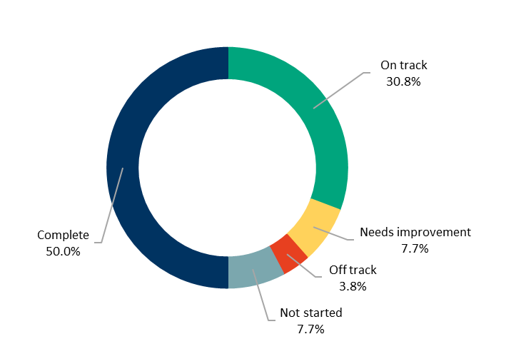
We committed to 26 actions which demonstrate how we are addressing our four-year priorities under Sustainable Growth and Environment:
At the end of June 2022:
- 13 were ‘complete’
- eight were ‘on track’
- two were ‘needs improvement’
- one was ‘off track’
- two were ‘not started’.

Four-year priorities | 2021–22 actions | Progress comment | Status
2.1 Meet the housing needs of our future community | Prepare the Elcho Road East and Creamery Road Precinct Structure Plans. | We presented a draft future urban structure for the Creamery Road Precinct Structure Plan to landowners. Agency and landowner consultation on the Creamery Road Precinct Structure Plan concluded on 10 June 2022. The Elcho Road East Precinct Structure Plan will progress in parallel with the strategic impact assessment for matters of national environmental significance.
 | Adopt an updated Heritage Strategy 2017–2021. | We plan to undertake an update of the Heritage Strategy 2017–2021 in the second half of 2022. | Not started
 | Deliver program of Structure Plans and Urban Design Frameworks to facilitate housing supply. | Council adopted the Gordon Avenue and Heritage Core Precincts in the Final Pakington Street (Geelong West) and Gordon Avenue Urban Design Framework in December 2021. We will undertake further community consultation on the Pakington Street North Precinct in late 2022. In addition, we concluded consultation on the interim final South Geelong Urban Design Framework. Further work is being undertaken on heritage properties to inform the final framework. These projects will assist to facilitate a range of different housing types to meet community needs. | ü
 | Finalise a long-term settlement boundary for urban Geelong. | We prepared a background report and discussion paper in relation to a long-term settlement boundary. Essential field work was delayed due to COVID-19 restrictions. We sought community feedback on the discussion paper which concluded in late May. Submissions will used to determine if further work is required on the long-term boundary. | 
2.2 Meet existing and future transport needs | Complete improvement works and address trail and network gaps as identified by the Shared Trails Masterplan. (Major budget initiative) | Council approved the governance framework for the delivery of our Shared Trails Masterplan adopted in March 2020. The masterplan encourages recreational activity and connections between locations and townships, promoting active living.  We delivered three major shared trail projects in East Geelong, Corio and Barwon Heads to improve connections and access for our community. We also completed feasibility studies for the four Shared Trails Masterplan priority connections: Ocean Grove to Point Lonsdale, Ocean Grove to Drysdale, Drysdale to Portarlington, and Lara to You Yangs. The results of the feasibility work and project updates were provided to Councillor Shared Trails Portfolio Committee in June 2022. | ü
 | Build the Better Bike Connections - Southern Link stages 1 and 2 to link Waurn Ponds to Central Geelong. | We completed construction works for Stage 1 of the Southern Link from Malop Street to the Barwon River. In addition, Council approved the tender process for Stage 2 in March 2022 with detailed design continuing. Across April/May, we engaged with more than 260 people on the completed sections and Stage 2. Council will consider the Stage 2 tender award later in 2022. The Building Better Bike Connections project provides routes that are designed to be used by cyclists of a wide range of ages and abilities to safely ride to destinations like shopping areas and key employment precincts
 | Engage with key stakeholders in the development of the draft Integrated Transport Plan, to improve integration of all modes of transport including active transport. | We delayed the development of an Integrated Transport Plan pending project resources. | Not started
 | Adopt the Central Geelong Parking Strategy. | We completed a draft Central Geelong Parking Strategy, reviewed by the Central Geelong Business Reference Group in April 2022, and by Councillors in May 2022. The draft strategy will be considered by Council in late 2022.
 | Implement the Armstrong Creek Land Acquisition Program. (Major budget initiative) | We implemented the Armstrong Creek Land Acquisition Program for the current year. A total of 10 properties (or part thereof) were acquired with one acquisition still in progress. Planning for the next stage of required land acquisitions will be undertaken in 2022‒23. The acquired land will create active open space, drainage, or road infrastructure. | ü
2.3 Create engaging places and spaces | Commission new public art assets to develop the City's outdoor collection. | We continued to commission new public art assets to develop the City's outdoor collection including:  - Geelong Women’s Street Art Project, a series of street murals by 19 female artists to celebrate International Women’s Day 2022 and promote gender equity by encouraging female artists to contribute to our cultural life  - relocatable public art to activate public spaces across the municipality. We launched ‘I AM’, a relocatable sculpture, providing an opportunity to raise awareness and celebrate members of the community who have a lived experience with disability  - engaging three Wadawurrung artists in the design of artwork for our new civic building, Wurriki Nyal  - completing restoration of the Belcher Drinking Fountain in April 2022  - seeking expressions of interest for commissions for the Drysdale Library, Chilwell Library and Labuan Square redevelopment  - public art projections by artists living in Barwon, Marngoneet and Karreenga correctional facilities celebrating First Nation's Peoples culture and heritage during National Reconciliation Week 2022  - consulting with the Osborne Park Association on the redevelopment of fountain and memorials  - reviewing options to acknowledge Gerry Smith, the first Mayor of the newly amalgamated City of Greater Geelong  - developing interpretive options for the Bills Cement Horse Trough Lara. | ü
 | Plant more trees through the Urban Forest Strategy and create opportunities for community planting. | We planted 2,248 street and park trees in areas with the highest need and low canopy cover. We collaborated with the Rotary Club, Ocean Grove to plant 100 trees to commemorate 100 years of Rotary. As these trees grow and mature over the next five to 15 years, they will provide canopy cover and shade. Tree planting is suspended during the warmer months and this time is used to water, mulch, and care for our young trees, as well as plan for our 2022 planting season.  Providing water and arboriculture care to young trees in their first few years, particularly in hot months, helps them establish well and grow into healthy mature canopy trees. The trees will form the future of Geelong’s Urban Forest, shading our streets and parks, cooling and beautifying our municipality and encouraging people to be more active.
 | Work with the Department of Environment, Land, Water and Planning to deliver the Central Geelong Framework Plan. | We provided evidence to a public hearing for the Central Geelong Framework Plan in September 2021. The Central Geelong Framework Plan Advisory Committee submitted its report to the Minister for Planning in December 2021. A decision on this matter is expected by the end of 2022. | ü
 | Continue construction of the Green Spine project between Gheringhap and Moorabool Streets, on the north side. | We partnered with the state government to progress construction of Geelong’s Green Spine, aimed at supporting Central Geelong to be a liveable, walkable, and bicycle-friendly city. As the site is recognised as being significant to the Traditional Owners of Geelong, a key outcome was for enhanced cultural respect and recognition of the continuing culture of the Wadawurrung. Work on the north side of Malop Street between Gheringhap Street and Moorabool Street is completed. | ü
2.4 Deliver best practice Environmentally Sustainable Design principles and vibrant neighbourhoods | Develop best practice Environmentally Sustainable Design Action Plans for the first two precincts in the Northern and Western Geelong Growth Areas. | We commissioned Deakin University to develop best practice Environmentally Sustainable Design Action Plans for the first two precincts in the Northern and Western Geelong Growth Areas. We completed consultation on the sustainable development initiatives with landowners and government agencies in June 2022.
 | Review the City’s Sustainable Building Policy to ensure best practice standards for new buildings, renovations and retrofitting, and maintenance and minor works. | We reviewed our Sustainable Building Policy which guides organisational practices to manage the social, environmental, and financial aspects of our buildings. The final draft will be considered by the Policy Review Committee in July/August 2022 and will subsequently be considered by Council.
 | Review the Environmentally Sustainable Design Local Planning Policy for new developments for opportunities to strengthen the breadth of the application of the policy. | We joined the Council Alliance for Sustainable Built Environment (CASBE) and other Victorian Councils on a joint research project, Elevating ESD Targets, which aims to elevate Environmentally Sustainable Development (ESD) targets for new development. At its meeting in June, Council authorised the City to enter into Stage 2 of the project which involves the planning scheme amendment process to implement the findings and recommendations from Stage one. | ü
2.5 Achieve carbon neutral in all City-managed operations by 2025 and manage our climate change risks | Identify actions to achieve the City’s emissions reduction targets and manage climate-related risks through development of the Climate Change Response Plan. | Council adopted the Climate Change Response Plan 2021–30 in November 2021. This plan provides a roadmap for the City to support the region to reduce emissions, minimise climate change impacts and facilitate new opportunities and partnerships with community in relation to the global climate emergency. A key feature of this plan is the new community target of zero net emissions by 2035. | ü
2.6 Support our community and region to reduce emissions and build resilience to climate change | Outline how the City will support the community and business to reduce the risks that climate change poses to community health and wellbeing and infrastructure through the Climate Change Response Plan. | Our Climate Change Response Plan 2021–30 recognises the importance of equity, access and inclusion as key priority areas contributing to the long-term sustainability of our community. The actions contained within this plan aim to improve social equity, including reducing climate change impacts, and increasing access to affordable clean/low emission sourced energy. | ü
 | Design a framework for the community climate action strategic partnerships funding. | As part of the development of the Climate Change Response Plan 2021–30, we committed to an innovative new funding model to support climate action delivered by community volunteers and not-for-profit groups.  Council endorsed the guidelines for the 2022‒23 Climate Action Partnership Grants in May 2022. The inaugural round of grants opened June 2022. We expect funding decisions will be presented to Council for endorsement December 2022. | ü
 | Upgrade to LED street lighting with smart control technology. (Major budget initiative) | We completed Stage 1 of the upgrade to LED street lighting with the changeover of approximately 13,000 residential streetlights and installation of 130 new lights. Stage 2 of the street light changeover on roads with higher traffic volumes (main roads) commenced in June 2022, with completion expected by February 2023. Stage 3 which involves the remaining decorative lighting will be completed in 2023. The changeover will reduce energy consumption and save more than 8,000 tonnes of carbon emissions each year as well as making our streets and public spaces safer through higher quality and better directed lighting.
 | Deliver a regional Integrated Water Management Strategy with key stakeholders including Barwon Water and Corangamite Catchment Management Authority. | The Department of Environment, Land, Water and Planning funded a joint City and Barwon Water resource. The resource will support the development of an inter-agency storm water harvesting protocol, a storm water quality treatment offsets scheme and an Integrated Water Management Plan for the City. Work is ongoing in alignment with the Integrated Water Management Policy, expected to be completed October 2022.  A consultant has been onboarded and is currently developing an Offset Scheme Framework with an estimated completion of Q1 2023. Work related to the Collaboration Framework is underway with current state roles and responsibilities being tracked and documented with the future state work gaining momentum next quarter. To align with the more clear project requirements based on a now completed consultant tender, the Project Manager has been extended an additional 3 months till January to oversee the completion of all deliverables. Integrated water management reduces use of potable water, improves water quality in our creeks and ocean and creates greener open spaces for fauna, flora, and passive recreation.
2.7 Reduce the impact of waste | Implement a pilot food waste collection service for residents. | We commenced a trial household food organics collection on 5 November 2021, with an aim to reduce the amount of food waste going to landfill and helping to reduce greenhouse gas emissions, odour, and leachate production. The trial is a key action from our Climate Change Response Plan 2021–30 and Waste and Resource Recovery Strategy 2020–2030 and will run for 12 months. After evaluating the trial, we aim to roll out the service municipal-wide in 2024. The initial trial was successful, with high bin presentation rates, low contamination and 25 tonnes of material diverted from landfill. | ü
 | Collaborate with Barwon Water, G21 councils and Wyndham City Council to develop an organic waste processing facility to support the circular economy. | We are partnering with Barwon Water, G21 Councils and Wyndham City Council to explore opportunities for a regional organics processing facility. Council signed a Waste Supply Agreement with Barwon Water to supply the regional organics facility with organic waste from the City's kerbside collection. It is anticipated that the Regional Renewable Organics Network will convert 40,000 tonnes of organic waste each year into 8,000 tonnes of high-value, nutrient-rich soil enhancers to support local agriculture. It will also convert gas produced by the organic matter into renewable electricity. | ü
2.8 Support greater indigenous biodiversity | Adopt a Biodiversity Strategy to protect and restore the natural environment. | We appointed a consultant to assist in the development of a Biodiversity Strategy and conduct consultation with key stakeholders. We are continuing to work on the State of Nature report, the background document for the Biodiversity Strategy, due for completion later 2022. Spending time in nature and open space has strong links to improved health and wellbeing. The strategy will include actions to improve access to nature.
 | Adopt and commence implementation of a masterplan to protect and restore the Sparrovale Wetlands Reserve. | Council adopted the Sparrovale Ngubitj yoorree Wetlands Master Plan in July 2021. The plan outlines improvements in drainage infrastructure, natural environmental and recreational facilities over the next 20 years. As part of this plan there are access walking trails to allow engagement with nature for improved mental and physical health.  We commenced implementation of master plan actions including:  - small scale revegetation  - shed asbestos check and structural assessment  - completion of levee condition assessment and maintenance manual  - drafted a Fire Preparedness Plan  - weed management  - rubbish removal  - community guided tours  - monitoring and surveys of birds, native vegetation offset sites, automated water levels and salinity. | ü
 | Work with the Federal and State Governments to deliver the Biodiversity Conservation Strategy for the Northern and Western Geelong Growth Areas. | We worked with the state and federal governments on an overarching Biodiversity Conservation Strategy for the Northern and Western Geelong Growth Areas which will protect or offset areas of biodiversity significance. Actions completed to date include:  - project scoping  - initial community and government stakeholder engagement  - state and federal government planning approval agreements developed  - funding secured.  We are also developing a structured decision-making process to help determine the functional layout of the growth area.  Local biodiversity assets are critical to our health, wellbeing, and prosperity, providing clean air and water, productive soils, natural pest control, pollution and flood mitigation and carbon sequestration.

Other achievements
- Our two world first, 100-year maintenance free bridges in Seagull Paddock, North Geelong, were recognised with three awards and a commendation at the Institute of Public Works Engineers Australasia Victorian Division awards
- We installed electric vehicle charging stations at our Corio, Belmont and Drysdale Depots to support our transition to a zero-emission light vehicle fleet
- We trialled the use of recycled building materials, tyres and plastics in road construction projects including at Maple Place, Waurn Ponds where 366 tonnes of fine crushed rock was reused and 150,000 plastic bags were diverted from landfill
- We won the ‘Sustainable City of the Year’, ‘Energy Award’ (for Zero Carbon Buildings Program), ‘Environment Award’ (for the Ramblers Reef Foreshore Project) and ‘Waste Award’ (for the recycled roads project) as part of the 2021 Keep Victoria Beautiful Awards. Our Bella Wiyn Birralee Family Centre was highly commended by the judges for its Sustainability Champions of Tomorrow program
- We provided $149,092 in funding to support 24 community environmental sustainability projects
- We established the Community Green Achiever Awards to recognise and celebrate community-led actions that promote sustainability, support biodiversity and protect our environment
- We partnered with Outdoors Victoria to present the third annual Nature Stewards program which allows people to discover more about their local native plants and animals and learn ways to care for the natural places where wildlife lives
- We launched a home composting program, providing subsidised compost bins and worm farms through our project partner, Wormlovers, as well as a free online home composting workshop
- We secured $120,000 funding from the Australian Renewable Energy Agency to install electric vehicle charging stations at Barwon Valley Activity Centre and Leisurelink Aquatic and Recreation Centre
- We developed a new Urban Forest dashboard to improve data-driven decision-making and increase our ability to plan, monitor, predict and manage the local environment
- We worked with the Department of Environment, Land, Water and Planning to prepare and release the draft Southeast Bellarine Coast (4W-Collendina) Coastal and Marine Management Plan for community feedback
- We adopted the Portarlington Recreation Reserve Master Plan, that outlines the refurbishment of the existing main football and cricket pavilion, the extension of the tennis and netball pavilions and improved passive recreation spaces
- We partnered with the Australian Government and Barwon Water to deliver a new pedestrian and cycling path on Scenic Road in Highton.
Local Government Performance Reporting Indicators
To help measure performance across all Victorian councils in a transparent and accountable way, we report to Local Government Victoria on the following mandatory indicators:
SERVICE/INDICATOR/MEASURE | RESULTS |  |  |  | COMMENTS
SERVICE/INDICATOR/MEASURE | 2019 | 2020 | 2021 | 2022 | COMMENTS
Roads
Satisfaction of use  R1 Sealed local road requests  [Number of sealed local road requests / Kilometres of sealed local roads] x100 | 45.70 | 85.86 | 79.21 | 106.53 | After two years of limited use, the request for repairs to sealed roads increased.
Condition  R2 Sealed local roads maintained to condition standards  [Number of kilometres of sealed local roads below the renewal intervention level set by Council / Kilometres of sealed local roads] x100 | 95.30% | 91.86% | 95.26% | 94.76% | The decrease in condition rating is the result of changes to new road rating condition reporting.
Service cost  R3 Cost of sealed local road reconstruction  [Direct cost of sealed local road reconstruction / Square metres of sealed local roads reconstructed] | $177.83 | $201.39 | $124.09 | $186.13 | In 2021‒22, our road reconstruction program consisted of mainly larger scale projects, with few smaller scale projects, enabling us to keep costs relatively low.
Service cost  R4 Cost of sealed local road resealing  [Direct cost of sealed local road resealing / Square metres of sealed local roads resealed] | $16.45 | $18.23 | $18.94 | $23.11 | The increased service cost reflects the change in reporting procedures, using actual figures from our assets database.
Satisfaction  R5 Satisfaction with sealed local roads  [Community satisfaction rating out of 100 with how council has performed on the condition of sealed local roads] | 54 | 60 | 62 | 57 | Community satisfaction with sealed roads has decreased in line with the significant increase in the number of requests received. Inclement weather and the impact of the pandemic and flu season has resulted in a shortage of available resources, significantly reducing the City’s ability to respond to maintenance issues. Response times to maintenance issues are still aligned to the Road Management Plan. Whilst lower than the last two years, results are above the statewide and Regional Centres average.
Waste Collection
Satisfaction  WC1 Kerbside bin collection requests  [Number of kerbside garbage and recycling bin collection requests / Number of kerbside bin collection households] x1,000 | 256.80 | 256.85 | 276.30 | 280.64 | The installation of our new customer service portal, designed to provide an improved customer experience, has resulted in an increase of service requests.
Service standard  WC2 Kerbside collection bins missed  [Number of kerbside garbage and recycling collection bins missed / Number of scheduled kerbside garbage and recycling collection bin lifts] x10,000 | 9.71 | 12.14 | 12.28 | 10.89 | We continue to work with our contractor to reduce the number of missed bin collections.
Service cost  WC3 Cost of kerbside garbage bin collection service  [Direct cost of the kerbside garbage bin collection service / Number of kerbside garbage collection bins] | $104.98 | $115.38 | $108.89 | $133.19 | In 2021‒22, the increased cost of service was largely driven by an increase in state government landfill levy charges.
Service cost  WC4 Cost of kerbside recyclables collection service  [Direct cost of the kerbside recyclables bin collection service / Number of kerbside recyclables collection bins] | $37.58 | $57.40 | $60.85 | $59.32 | The reduction in value of sorted materials on the world market increased the cost of recycling sorting. A waste levy increase was added on the contaminated components of recycled materials.
Waste diversion  WC5 Kerbside collection waste diverted from landfill  [Weight of recyclables and green organics collected from kerbside bins / Weight of garbage, recyclables and green organics collected from kerbside bins] x100 | 54.00% | 55.73% | 53.87% | 52.96% | Since 2018, green waste and recycling as a ratio has been consistent. Green waste tonnages, affected by rainfall patterns and smaller subdivisions producing less green waste, have decreased. The thinner profile of glass, PET plastics and aluminium containers contributed to the reduction in recyling tonnage. Waste tonnage continues to increase due to population growth in new subdivisions.

STRATEGIC DIRECTION 3: STRONG LOCAL ECONOMY
LINKS TO THE CLEVER CREATIVE VISION
 | 

DESIRED OUTCOMES
- We have a global, national and local reputation as a place to do business – especially in our key sectors
- We have a diversified, future-focused and sustainable economy to drive employment and support growth
- We are an influential Council that builds effective private and public partnerships, taking the lead role in advocating for future investment
Four-year priorities
3.1 Attract and facilitate public and private investment
3.2 Promote and leverage the competitive strengths and attractiveness of our region, globally, nationally and locally
3.3 Support entrepreneurs, start-ups, innovation, research and digital connectivity
3.4 Attract businesses with a carbon neutral and circular economy focus
3.5 Support local business resilience and recovery from the impacts of the COVID-19 pandemic
3.6 Attract, retain and enable participation in the workforce to meet industry needs
3.7 Address high levels of unemployment in targeted areas of our region
3.8 Promote our region as a trial location for innovation and new technologies
PROGRESS REPORT
Indicators
Municipal Indicators | Result at 30 June 2022 | Progress comments
Number of jobs located in the City of Greater Geelong  Source: .id and National Institute of Economic and Industry Research (NIEIR) | 120,031 (2020‒21)  118,765 (2019‒20) | In 2020‒21 there were an estimated 1,266 jobs created in Greater Geelong. 2021‒22 update expected early 2023.
Small area* unemployment rates across Greater Geelong  *Belmont, Corio-Norlane, Geelong, Geelong West-Hamlyn Heights, Grovedale, Highton, Lara, Leopold, Newcomb-Moolap, Newtown, North Geelong-Bell Park, Clifton Springs, Ocean Grove-Barwon Heads, Portarlington and Point Lonsdale-Queenscliff  Source: National Skills Commission | 3.0% (March quarter 2022)  4.6% (March quarter 2021) | The unemployment rate is at historic lows in 2022. June quarter 2022 data will be available in September 2022.
Gross Regional Product (GRP)  Source: National Institute of Economic and Industry Research (NIEIR) 2021. Compiled and presented in economy.id by .id (informed decisions) | $15.4 billion (2020‒21)  $15 billion (2019‒20) | GRP increased by $400 million in 2020‒21.
Value of non‒residential building approvals in City of Greater Geelong  Source: City of Greater Geelong Building Services | $1.2 billion (2021‒22)  $603.2 million (2020‒21) | 2021‒22 commercial building approvals doubled with major construction activity underway on the Spirit of Tasmania development, Geelong Arts Centre expansion, Geelong Quarter, Quest Geelong Central, The McKellar Centre, GMHBA expansion, civic precinct and prison precinct.
Number of businesses  Source: Australian Bureau of Statistics, Counts of Australian Businesses, including Entries and Exits, 2016 to 2021 | 19,604 (2020‒21)  18,532 (2019‒20) | In 2020‒21 there were an additional 1,072 businesses.
Tourism Sentiment Index (TSI)  Source: Destination Think | 24 (June 2022)  22 (June 2021) | Geelong and the Bellarine is ranked 93 on the global scale. With a Sentiment Score of 24, our region outperformed all three benchmarks at the global, national and state levels. Our top three most-loved assets are festivals/events/concerts, beaches and dining.  The global ranking score is a brand new metric for the TSI program which only started in the 2021‒22 financial year.
Investment in Geelong  Source: Cordell by CoreLogic | 137 projects valued at $13.9 billion (June 2022)  139 projects valued at $11.5 billion (June 2021) | The value of major investment projects increased by $2.4 billion in the year to June 2022.
Visitor expenditure  Source: Tourism Research Australia’s National Visitor Survey | $876 million (June 2022)  $637 million (June 2021) | For the first time in two years, our region has experienced positive growth across all visitation metrics with visitation up 13 per cent, nights up 18 per cent and spend up 51 per cent.

City of Greater Geelong Indicators | Result at 30 June 2022 | Progress comments
Community satisfaction with business and community development  Source: Local Government Community Satisfaction Survey | 59 (2022)  64 (2021) | While satisfaction decreased in 2022, performance was comparable to both statewide and Regional Centre averages (58 respectively).
Return on investment of Geelong major events  Source: Geelong Major Events Committee Annual Report | 24:1 (2021‒22)  28:1 (2020‒21) | The 13 major events supported via Geelong Major Events stimulated economic activity estimated at $24.8 million.

Annual Action Plan 2021‒22
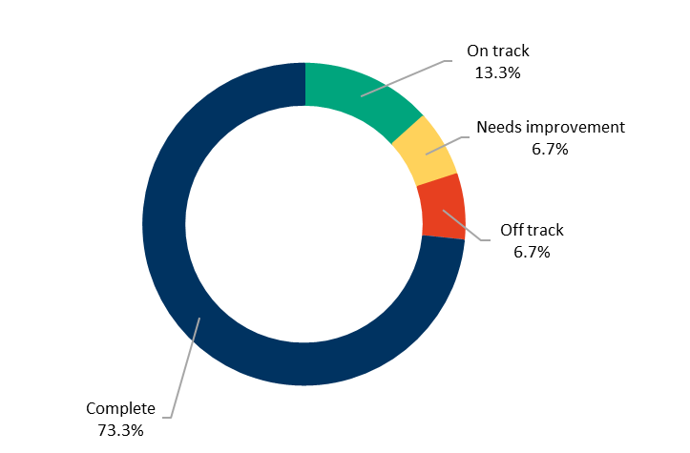
We committed to 15 actions which demonstrate how we are addressing our four-year priorities under Strong Local Economy.
At the end of June 2022:
- eleven were ‘complete’
- two were ‘on track’
- one was ‘needs improvement’
- one was ‘off track’.

Four-year priorities | 2021–22 actions | Progress comment | Status
3.1 Attract and facilitate public and private investment | Develop and implement an advocacy plan for major infrastructure investment with our stakeholders. | Council developed its priority project document identifying key advocacy projects needed to drive our region’s recovery from COVID-19, protect our highly valued liveability, and deliver essential transport, community, tourist and cultural infrastructure.  We are updating the document to highlight our advocacy work in the lead up to the state election. This is expected to be completed by the end of July 2022. | ü
 | Ensure there is diversity of employment land to meet forecast growth and attract investment. | We are working with Wyndham City Council, our community, and the state government to set the future direction for land use and development between Lara and Werribee with the development of the Avalon Corridor Strategy. The strategy seeks to maintain a ‘green break’ between Greater Geelong (Lara) and metropolitan Melbourne (Werribee) to protect significant cultural, landscape and biodiversity values and safeguard important infrastructure and assets. It also establishes a high-level framework plan to guide land use decision-making in the Avalon Corridor. The Victorian Planning Authority are progressing with the Avalon Employment Precinct.
3.2 Promote and leverage the competitive strengths and attractiveness of our region, globally, nationally and locally | Develop the City's 10-Year Economic Development Plan to support the ongoing socio-economic prosperity of the region. | We confirmed the project scope, background paper, economic profile, appointed a consultant and completed the first round of consultations. A discussion paper is being finalised capturing the feedback from this process. The 10-year Economic Development Plan identifies our priorities to support and grow the economy to ensure economic prosperity. It focusses on jobs, education, business capacity, industry growth, liveability and sustainability to support the health and wellbeing of our community.
 | Lead Geelong’s UNESCO City of Design Designation and implement actions that support our commitment to the UNESCO's Creative Cities Network. | We continue to promote and deliver projects in support of the UNESCO City of Design designation including:  - attending the virtual UNESCO Annual General Meeting in July 2021  - hosting the three-day online 2021 UNESCO Cities of Design Subnetwork Meeting in October 2021  - delivering the City of Design guiding principles with extensive input from key stakeholders  - assessing applications to the City of Design Network and making recommendations to UNESCO  - submitting our first four-year monitoring report to UNESCO, Geelong: Australia’s Creative City of Design Our Monitoring Report 2017‒2021  - coordinating over 70 events as part of Geelong Design Week 2022  - launching our Geelong City of Design Guiding Principles  - leading the Victorian Creative Cities Network and securing funding through the Creative State 2025 strategy coordinating the CODE Souvenir initiative that promotes local designers and artists. | ü
 | Implement the Geelong Major Events Strategy to ensure Geelong is positively recognised globally for hosting accessible and inclusive major events of an international standard. | Council noted the Geelong Major Events (GME) Annual Report 2020–21 in August 2021.  We resumed major events in 2022, following two years of cancellations and postponements due to the COVID-19 pandemic. Thirteen GME supported major events were staged between 1 July 2021 and 30 June 2022 including: the Archie 100 @ Geelong Gallery, Festival of Sails and the Geelong Revival Motoring Festival. | ü
 | Adopt and commence implementation of the Arts and Cultural Strategy to support our creative industries. | Council adopted the Arts and Cultural Strategy 2021–2031 and endorsed the Arts and Cultural Strategy Overview 2021–2025 in October 2021. The strategy aims to support a more sustainable and thriving region through investing in arts and culture, supporting creative communities, and helping the creative industries to recover from the impacts of COVID-19.  We have begun to implement the strategy by:  - launching Surround Sounds Geelong and the Bellarine Music Festival March 2022. The Festival attracted audiences of 14, 251, featured 840 artists across 35 venues  - supporting professional development workshops for artists, delivered by by Jump Leads / Arts Action  - partnering with Indirect Object and our northern community to open the North Geelong Community Lantern Trail across Norlane, Rosewall and Cloverdale Community Centres  - supporting the VACANTCity project led by Deakin University with artist lab workshops at Creative Geelong  - hosting major exhibitions and public programs at the National Wool Museum including 'Geelong Nature Forum', ‘Necessity’, 'Alphabet Bird Project' and ‘Wadawurrung Dja: Awakening Country’  - expanding the content of the National Quilt Register and Geelong Heritage Collections  - completing the Naval and Maritime Collection audit and adding it to the digital database  - supporting the Open Studios program held during Geelong Design Week 2022  - supporting the Sweethearts Foundation Sweetfest Festival, May 2022, Lt Malop Precinct  - Expanding the new outdoor space, planning for a community garden and addressing access issues at the Potato Shed  - supporting the Journey on Wadawurrung Country installation at the Potato Shed  - reviewing and aligning the Arts & Culture Community Grants Program with the priorities and objectives of the Arts and Cultural Strategy 2021–2031. | ü
 | Adopt a tourism destination masterplan focused on a ten-year planning horizon to update the Tourism Development Plan in partnership with the Tourism industry (Tourism Greater Geelong and the Bellarine). | In March 2022, Tourism Greater Geelong & the Bellarine (TGGB) secured funding from the Victorian Government to develop a 10-year destination masterplan. With commencement of the masterplan development subject to state government funding, engagement with local regional business networks and our community is now complete, with the final masterplan due 30 November 2022.
 | Provide publicly accessible external urban space around the site of the proposed Geelong Convention and Exhibition Centre which is safe, attractive and designed considering the needs of people of all ages, abilities and backgrounds. (Major budget initiative) | In March 2022, TGGB gave an industry briefing to the Victorian Government outlining planning for, and design of, the Geelong Convention and Exhibtion Centre.  Early exploratory work includes geotechnical investigations to prepare the site for construction and work on streetscape masterplan encompassing Gherhinghap Street.  We worked with Development Victoria to develop design principles for EOI and Request for Proposal documents.
 | Partner with the Vision Partners to develop and implement a place brand for the region. | We partnered with the Vison Partner Group to develop, test, and endorse place branding for our region. The new place brand, ‘Greater Geelong, Greater Australian Stories’ was launched on 2 June. A six-month strategic marketing campaign is now underway. | ü
3.3 Support entrepreneurs, start-ups, innovation, research and digital connectivity | Implement the Smart Cities Framework to support the City's objectives in business support innovation, research and digital connectivity and consideration of community connectivity, particularly in the northern suburbs. | Our Smarter Suburbs project will deliver an enhanced Broadband trial and expansion of the free public Wi-Fi to improve digital connectivity in our northern suburbs. This was delayed in part due to COVID-19 disruptions to the building and construction industry and is on track to be completed in 2022. We entered into a contract with not-for-profit organisation, AARNet, to install and utilise a high-speed optical fibre network to provide community facilities and public spaces with access to ultra-high-speed internet. All Stage 1 Northern suburbs Smart Nodes were installed with Wi-Fi expected to be activated by late July 2022. The project supports better community health outcomes by helping to lessen the digital divide and associated social and economic disadvantages. | ü
3.4 Attract businesses with a carbon neutral and circular economy focus | Develop and implement business programs to support the circular economy in partnership with state government. | We supported circular economy initiatives through Cleantech Innovations Geelong (a partnership program of the City, the Geelong Manufacturing Council, and the state government), including:  - provision of a grant to Regional Innovation for a Circular Economy (RICE) which allowed RICE to subsidise local businesses to participate in a Circular Economy Business Growth Program, delivered by Runway  - provision of eight Geelong start-ups with access to a mentoring program  - research into a self-funding model and establishing Geelong as a Cleantech Centre of Excellence  - developing an e-learning training course, so practitioners in other organisations can learn how to apply the Procurement for Innovation method  - a second Procurement for Innovation project for the design and construction of surface level road infrastructure products that adhere to circular economy principles. | ü
3.5 Support local business resilience and recovery from the impacts of the COVID-19 pandemic | Deliver support programs to our business community to assist recovery and adapt to the effects of the COVID-19 pandemic. | We supported our business community through several initiatives including:  - promoting the professional advice vouchers for small businesses  - providing access to the Geelong Business Support COVID-19 website  - visiting more than 1,600 small businesses to support them with COVID-19 compliance requirements including more than 90 food registration refunds  - providing a dedicated Business Concierge service as a single point of contact for businesses  - delivering the Geelong Small Business Festival in August 2021 with over 700 participants at 42 events and planning for the 2022 event  - conducting 170 business support surveys across industries hardest hit by COVID-19, including hospitality, retail, and health and beauty  - delivering the first Business Victoria training workshop for 2022. | ü
 | Implement second hour free parking in 2P parking zones in central Geelong. (Major budget initiative) | We implemented a second hour of free parking in 2P parking zones in Central Geelong in July 2021 with parking meters reprogrammed to support the changes, a media campaign and street decals updated. | ü
3.7 Address high levels of unemployment in targeted areas of our region | Implement actions from the Vital Communities (including Regional Industry Sector Employment) program that support employment pathways to address Geelong’s disadvantaged areas. | The Regional Industry Sector Employment (RISE) program aims to increase access and reduce barriers to employment opportunities, with some graduates achieving full-time work and apprenticeships in construction, and some participants pursuing other employment options or educational pathways.  Since the program inception in 2018, 175 participants commenced the program and 136 participants graduated from the program. Of those who completed the program 65 have entered apprenticeships, 22 have commenced other jobs and 17 have returned to further education. The majority of participants (57 per cent) came from targeted postcodes while 37 per cent are from diverse backgrounds. | ü
3.8 Promote our region as a trial location for innovation and new technologies | Develop a structured program and process to enable innovative ideas and solutions, for Council consideration and action. | We developed a Smart City Innovation Blueprint in addition to the Smart City Strategic Framework, adopted in March 2021. The blueprint aims to build a culture of innovation at the City to support smart technology adoption and data-driven decision-making. The implementation plan continues to be rolled out, and the supporting draft Innovation Blueprint remains a focus. | ü

Other achievements
- Geelong was announced as one of four regional hubs hosting 2026 Commonwealth Games events, alongside Bendigo, Ballarat and Gippsland
- The Bellarine and Geelong took out the 25th and 69th places respectively in Leading Places: The 100 Most Loved Destinations Around the World for 2021, released by the Tourism Sentiment Index
- We distributed $399,726 as part of the COVID-19 Arts, Culture and Heritage Recovery Grants to support local arts, cultural and heritage practicitioners and businesses adversely impacted by COVID-19
- We celebrated local design and creativity during Geelong Design Week 2022 which attracted over 6,000 participants
- We installed 19 Smart Nodes including three Tower Nodes as part of Smarter Suburbs Program
- We secured 54 business events delivering over $3.5 million in economic benefit to the region
- We held the Geelong Small Business Festival, providing low-cost and free events designed to connect, inspire, grow and support our local business community
- We entered into a Memorandum of Understanding with Changwon City South Korea, with a focus on trade, education and cultural exchange
- We presented the Tastes of Central Geelong festival, showcasing Central Geelong cafes, bars and restaurants through dining events, guided food tours, masterclasses and demonstrations
- Council endorsed a business case to investigate the delivery of a Regional Livestock and Rural Information Exchange Hub and Truck Wash in Greater Geelong.

STRATEGIC DIRECTION 4: HIGH-PERFORMING COUNCIL AND ORGANISATION

DESIRED OUTCOMES
- Our services are accessible and meet the diverse needs of our community
- We are acknowledged and recognised as a leading council and organisation
- We have a healthy, safe, inclusive and diverse culture
- We are a financially sustainable and resilient organisation
Four-year priorities
4.1 Enable a customer-focused approach that delivers efficient and responsive service
4.2 Communicate and engage effectively with our community to understand their needs and advocate on their behalf
4.3 Deliver on our community’s most important needs for infrastructure and services
4.4 Continue to strengthen our workplace culture
4.5 Create a more efficient and effective organisation
4.6 Ensure that our employees are safe at work
4.7 Focus on financial sustainability
Progress report
Indicators
City of Greater Geelong Indicators | Data at 30 June 2022 | Progress comments
Customer complaints resolution completed within 30 days  Source: City of Greater Geelong | 85% (April‒June 2022) | This result is for resolution of phone and online complaints captured through our corporate system (Pathway) and does not include complaints captured via other processes.
Community satisfaction with customer service  Source: Local Government Community Satisfaction Survey | 72 (2022)  77 (2021) | While satisfaction decreased in 2022, our performance continued to be well regarded by the community with customer service among our highest rated services. Geelong’s performance was also higher than the statewide average (68).
Community satisfaction with informing the community  Source: Local Government Community Satisfaction Survey | 58 (2022)  60 (2021) | Our result was comparable with both statewide and Regional Centres averages (59 and 58 respectively).
Community satisfaction with consultation and engagement  Source: Local Government Community Satisfaction Survey | 54 (2022)  57 (2021) | Satisfaction decreased from 2021, the rating consistent with historical results. Our result was comparable with both statewide and Regional Centres averages (54 respectively).
Community satisfaction with overall council direction  Source: Local Government Community Satisfaction Survey | 52 (2022)  56 (2021) | Satisfaction decreased in 2022. Despite this, performance was comparable to the statewide and Regional Centres averages (50 and 52 respectively).
Community satisfaction with overall performance  Source: Local Government Community Satisfaction Survey | 63 (2022)  63 (2021) | Our result was significantly higher than both statewide and Regional Centres averages (59 respectively).
Community satisfaction with advocacy on behalf of the community  Source: Local Government Community Satisfaction Survey | 55 (2022)  57 (2021) | Our result was comparable with both statewide and Regional Centres averages (53 and 55 respectively).
Lost Time Injury Frequency Rate (LTIFR) and Total Recordable Injury Frequency Rate (TRIFR)  Source: City of Greater Geelong | 26.5 LTIFR (June 2022)  21.4 LTIFR (June 2021)  34.9 TRIFR (June 2022)  24.9 TRIFR (June 2021) | The June 2022 results are up significantly from June 2021 with the LTIFR up 23.7 per cent (up 5.1) and the TRIFR up 42 per cent (up 10.3).  During 2021‒22, body stressing accounted for 56 per cent of Total Recordable Injuries followed by falls accounting for 9 per cent.
Gender breakdown of City employees  Source: City of Greater Geelong | 64.32% – female (June 2022)  64.12% – female (June 2021)  35.64% – male (June 2022)  35.85% – male (June 2021)  0.04% – self-described gender (June 2022)  0.04% – self-described gender (June 2021) | Gender breakdown of City employees remains consistent from 2021. In addition to the result, we have 50.9 per cent female and 49.1 per cent male in leadership roles.
Number of Aboriginal and Torres Strait Islander people employed at the City  Source: City of Greater Geelong | 19 (June 2022)  14 (June 2021) | We appointed an Aboriginal Employment and Engagement Officer and have a commitment to increasing Aboriginal and Torres Strait Islander people employed at the City.
Employee satisfaction and engagement  Source: City of Greater Geelong Better Together Survey | Satisfaction – 59% (2022) Satisfaction – 63% (2020)  Engagement – 53% (2022) Engagement – 52% (2020) | From 2022, the employee opinion survey will report on employee satisfaction using a new 'Sustainable Engagement' score which has proven linkages to key performance outcomes. The City achieved a score of 76% for Sustainable Engagement in June 2022.
Recurrent surplus / deficit  Source: City of Greater Geelong | $10.63 million (2021‒22) | We achieved a recurrent surplus of $10.63 million against a budget deficit of $8.065 million. The favourable result is largely due an increase in federal and state government grants, reduced salary and depreciation costs and one-off prior year adjustments.
Funds from sale of assets  Source: City of Greater Geelong | $12.8 million (2021‒22) | Asset sales were below the target of $35.4 million as key asset sales were deferred to the 2022‒23 financial year.
Cost recovery of services and revenue growth from new sources (fees and charges)  Source: City of Greater Geelong | $9.4 million (2021‒22) | An increase in the ‘rates and charges’ revenue stream was caused by an approximate 4,300 increase in rateable properties, as well as supplementary valuations.
Efficiency target  Source: City of Greater Geelong | $2.965 million (2021‒22) | Efficiency targets set in the budget have been achieved.
Asset renewal gap and upgrade ratio  Source: City of Greater Geelong | 68.9% (2021‒22)  51.9% (2020‒21) | The value of expenditure on asset renewal, compared to depreciation, increased in 2021‒22 as a result of continual investment in asset renewal.
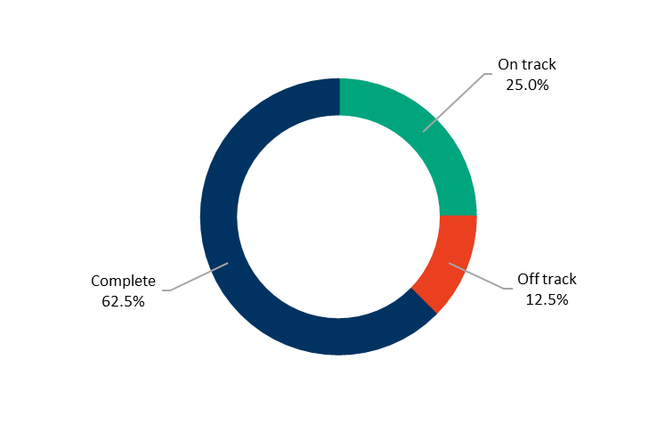
Annual Action Plan 2021‒22
We committed to 16 actions which demonstrate how we are addressing our four-year priorities under High-Performing Council
and Organisation.
At the end of June 2022:
- ten were ‘complete’
- four were ‘on track’
- two were ‘off track’.

Four-year priorities | 2021–22 actions | Progress comment | Status
4.1 Enable a customer-focused approach that delivers efficient and responsive service | Implement the City's Customer Experience Strategy. | Our Customer Experience Strategy has activities underway that include:  - establishment of customer first vision  - adoption by the Executive Leadership Team of the Customer Access Plan  - improvements in service redesign  - development of a corporate Complaints Policy  - implementation of Phases 1 and 2 of our Customer Relationship Management system and commencement of Phase 3  - establishment of a corporate customer reporting and measurement framework  - reviewing the City’s website to make information and services more convenient and efficient for those who prefer to self-service  - preparing for the service experience at Wurriki Nyal  - quarterly voice of the customer surveys to measure customer satisfaction levels  - commencing work on a streamlined customer service model to provide an improved customer experience, high quality outcomes and allowing customers to engage with the City via their preferred contact method.
 | Implement the City's Digital Modernisation Project to improve our digital capability. (Major budget initiative) | We progressed the review and refresh of our IT business systems, to modernise and streamline our processes by introducing updated tools and technology.  We completed Phase 1 and 2 and commenced Phase 3 of the Customer Relationship Management project to improve how we deliver services by boosting accessibility and connectivity to our customers and the wider community via our online platforms.  The first phase of our improvements to the finance systems is nearing completion, with further testing and refinements underway. Phase 2 is on hold as we work through the complexities of the project. Human Capital Management is due to occur in the second half of 2022. These improvements to our digital capability will improve how we deliver services, and accessibility and connectivity to our customers and the wider community.
4.2 Communicate and engage effectively with our community to understand their needs and advocate on their behalf | Implement the City's Community Engagement Policy with a focus on hard to reach communities. | We made improvements to the accessibility of our Have Your Say community engagement page on our website including:  - adding translate and page reader options  - ensuring pages are easy to understand and use plain English  - the sharing of individual pages to networks, including via social media  We also:  - developed a series of Have Your Say postcards in eight languages  - supported safe and accessible community engagement during COVID-19 restrictions, including providing greater online engagement options and the use of QR codes to promote engagements and reach more targeted and impacted community members  - implemented initiatives to better utilise the City’s Advisory Committees, some of whom represent the interests of historically harder to reach communities and can provide expertise to help council make its decisions  - released the Community Engagement Impact Report 2022 detailing highlights and key statistics.  Being heard and engaged in decision-making empowers members of our community to contribute to the future direction of the places where they live, play and work. | ü
 | Continue to embed Youth Council and the Councillor Connect Mentoring Program as an opportunity for the voice of Geelong’s youth to be considered in decision-making of the Council. | We facilitated programs including the Youth Council, Councillor Connect Mentoring Program and Youth on Board, aimed at connecting young people to local decision-making. These programs create processes, skills, confidence, and opportunities for all young people to influence local decision-making across Council.  Our Youth Council 2022, comprising 12 young people aged 12–17 years from across the municipality, commenced in February 2022.  The Youth Council attended YMCA Advocacy Training in March 2022 and Victorian LGA training in April 2022.  Youth on Board have six young people who have completed relevant training, four organisations committed to the program, two matches completed and young people participating on Boards of Management, connecting young people to local decision-making. | ü
4.3 Deliver on our community’s most important needs for infrastructure and services | Advocate on behalf of the community to secure funding and policy change to deliver on key / priority infrastructure and services. | We are undertaking a first revision of Council's Priority Projects document. The document is an important part of our advocacy plan to secure funding for key projects needed to drive our region’s recovery from COVID-19 and deliver essential infrastructure. We advocated for these projects as part of the federal election campaign and are now moving our focus to the state election at the end of 2022. | ü
 | Divest surplus assets to invest in the development and renewal of community infrastructure.  y | We sold our industrial land within the Geelong Ring Road Employment Precinct (GREP) with the exception of one site on which a redevelopment project has commenced.  Other properties considered for sale will be subject to community engagement in accordance with the Local Government Act 2020 and addressed within the 2022–23 budget process.  The sale of surplus assets will assist in providing additional budget capacity to support funding availability to renew community infrastructure. Community infrastructure makes a key contribution to liveability and facilitating social connections that are important for better health and wellbeing outcomes. | ü
 | Review the City’s services to ensure they meet existing and emerging community needs in line with our organisational strategy. | We are developing a service review approach framework and roadmap, for reviewing and evaluating the performance, cost and value of our services. This allows us to assess and benchmark that our services are being delivered efficiently and delivering optimal value to our community. Part of this review aims to ensure we make organisation-wide decisions on our role in delivering different services and that we identify optimal timings for maintenance, renewals and upgrades throughout a service’s lifecycle.  Some of our services have material impact on the health and wellbeing of our community members, and therefore will be reviewed accordingly so that we continue to provide these critical services to our community.
4.4 Continue to strengthen our workplace culture | Implement the Diversity and Inclusion Roadmap with the City's social equity principles embedded. | We completed the following actions as part of the Diversity and Inclusion Roadmap implementation:  - launched the new Unconscious Bias e-learning training  - conducted a new Gender Audit  - implemented new Gender Impact Assessments  - developed the Gender Equality Action Plan 2022–25  - embedded social equity principles as part of the new Inclusion and Diversity roadmap. | ü
4.4 Continue to strengthen our workplace culture | Transform our workplace culture through delivery of our Working Better Together program. | We launched a range of initiatives to support the delivery of our Working Better Together program including:  - Leadership Capability Framework  - Leadership Development Program  - employee opinion survey, Better Together Survey, in April 2022  - learning and development course offerings  - new and refreshed Learning Hub platform design with process improvements to increase digital enrolments and engagement  - culture forums for all people leaders in November 2021 and May 2022.  We believe that by leading inclusively we can embrace and value diversity and create a culture where people can speak up about risks, health and wellbeing, and safety issues. A positive and healthy work climate will in turn foster higher employee satisfaction, where employees feel empowered in their job and produce better outcomes for the organisation and community. | ü
4.4 Continue to strengthen our workplace culture | Implement a campaign for employees aimed at increasing awareness and uptake of volunteering in the local community. | We ran an internal campaign to increase visibility of volunteering as an option for employees under our Enterprise Agreement. Community volunteering provides many benefits to both the mental and physical health of our employees. It also strengthens our fundamental connection with our community that broadens our perspectives and helps us understand the value and needs of the Greater Geelong community today and into the future. | ü
4.5 Create a more efficient and effective organisation | Deliver the City's new civic precinct, Wurriki Nyal. (Major budget initiative) | We continued construction activities on the City’s new civic precinct, Wurriki Nyal. Fit out works commenced included lighting, joinery, internal walls, and internal glazing. In addition, landscaping works commenced, and all brickwork was completed. Works on Wurriki Nyal are progressing well and the building and landscaping is expected to be completed in July 2022. Employees are expected to move into the building in stages from mid-August 2022.
 | Deliver the City's Future Ways of Working program. | - Our Future Ways of Working program aims to enhance how we work together and design our organisation for the future. We are doing this to create a place that serves our growing community in the best possible way. As part of this process, we progressed the implementation of an agreed Target Operating Model. This included several activities:  - business planning cycle process, incorporating new tools and templates  - strategy and business plans to guide our work over the next one to four years to deliver our strategic priorities  - individual performance planning  - design of the City's workforce plan to guide how we proactively build a capable and diverse workforce  - an accountability framework that incorporates alignment of organisational priorities and key performance indicators  - the City’s structural change process mapping to support effective consultation and efficient practices  - a new Mayor and Councillor support structure to improve the experience of support received and build our capability  - a foundational workforce plan was finalised and submitted in December 2021  - building a stronger strategy function to integrate Council's strategies and plans and maximise the City's commercials and partnerships  - driving the creation of a streamlined customer service model providing an improved customer experience, high quality outcomes and allowing customers to engage with the City via their preferred contact method  - ensuring we effectively translate the Clever and Creative Vision and Our Community Plan, in an integrated way, into operational, service delivery  - establishing an Enterprise Program Management Office that ensures we are effectively delivering on our community plan.
 | Implement the City's Sustainability Framework to create a culture of sustainable practice in our organisation. (Major budget initiative) | We continued to implement the Sustainability Framework across the City. Sustainability is an ongoing priority for the City and has formed a strong part of our 2022–23 business planning process.  We engaged the Sustainability Advisory Committee on the development of key strategic documents to ensure a strong sustainability lens including:  - Climate Change Response Plan 2021–30  - Social Equity Framework 2022–25  - draft Economic Development Plan  - draft Biodiversity Strategy.  In March 2022, Council noted the Sustainability Performance Report 2021 which provides progress updates on sustainability targets as well as actions listed in the Sustainability Framework Action Plan 2020–22. | ü
4.6 Ensure that our employees are safe at work | Deliver the City's organisation wide risk register. | We designed, configured, and launched our new enterprise risk software to capture and manage our strategic and operational risks. We conducted internal training and will continue to assess, record, and monitor operational organisation risks to improve our risk reporting. | ü
 | Increase employee engagement and communication messages on physical and mental health, and safety in the workplace. | We provided various ongoing communications, campaigns and education opportunities promoting physical and mental health, and safety in the workplace including:  - Kind people are our kind of people (new occupational violence and aggression marketing campaign)  - Take 5 (safety in the workplace)  - RUOK Day  - World Gratitude Day  - Get on Track health challenge  - Movember  - Local Government Blood Challenge  - online yoga  - Flu vaccinations for all employees and their families.  We also implemented an expanded Occupational Health and Safety incident management system and an internal welfare contact officer program, accessible to all employees. | ü
4.7 Focus on financial sustainability | Deliver on efficiency targets and identify areas for investment in sustainable cost savings considering total cost of ownership. | Our 2021–22 budget incorporated several programs of work expected to deliver ongoing cost efficiencies. We continually monitor our monthly financial results to assess the performance of these programs and to identify any further potential cost savings. Our current operating costs are tracking favourable to budget.
Other achievements
- Council adopted the Long-term Financial Plan 2021‒31
- We engaged with the community to seek their views on the draft Asset Plan 2022‒32 which outlines how our assets will be managed and maintained over the next 10 years
- We updated our Procurement Policy, encouraging procurement of local goods, works and services and support local businesses and traditionally disadvantaged groups.
- We held the organisation's inaugural Strategy Week where we explored issues relevant to the future of our region, showcased key work delivering on our priorities and developed a shared understanding of future priorities
- Supported the delivery of the inaugural Workplace Gender Audit by providing pivotal employee data.

Local Government Performance Reporting Indicators
To help measure performance across all Victorian councils in a transparent and accountable way, we report to Local Government Victoria on the following mandatory indicators:
SERVICE/INDICATOR/MEASURE | RESULTS |  |  |  |  |  |  | COMMENTS
SERVICE/INDICATOR/MEASURE | 2019 |  | 2020 |  | 2021 | 2022 |  | COMMENTS
Governance
Transparency  G1 Council decisions made at meetings closed to the public  [Number of council resolutions made at ordinary or special meetings of council, or at meetings of a special committee consisting only of councillors, closed to the public / Number of council resolutions made at ordinary or special meetings of council, or at meetings of a special committee consisting only of councillors] x100 | 8.39% | 9.03% |  | 8.03% |  |  | 6.55% | In line with the City's Public Transparency Policy, there has been a significant decrease in decisions made at closed meetings.
Consultation and engagement  G2 Satisfaction with community consultation and engagement  [Community satisfaction rating out of 100 with how council has performed on community consultation and engagement] | 55 | 53 |  | 57 |  |  | 54 | While our community satisfaction score decreased three index points, the score was consistent with previous results. We continue to focus on the delivery of hybrid engagements (online and face-to-face), improving accessibility to our online engagement platform, and provide reasonable support to reduce barriers to participation.
Attendance  G3 Councillor attendance at council meetings  [The sum of the number of councillors who attended each ordinary and special council meeting / (Number of ordinary and special council meetings) × (Number of councillors elected at the last council general election)] x100 | 96.36% | 93.45% |  | 96.97% |  |  | 98.70% | In line with the Local Government Better Practice Guide - Annual Report Performance Reporting Indicator Guide (2021-22 & 2022-2023), councillors on an approved leave of absence are counted as having attended a council meeting. There were two recorded apologies for the financial year 2021-22.
Service cost  G4 Cost of governance  [Direct cost of the governance service / Number of councillors elected at the last council general election] | $48,135.89 | $44,582.64 |  | $45,711.91 |  |  | $47,697.36 | The marginal increase in the cost of delivering council's governance service this financial year is driven by the increase in councillor allowances per the new determination issued from the Victorian Independent Renumeration Tribunal.
Satisfaction  G5 Satisfaction with council decisions  [Community satisfaction rating out of 100 with how council has performed in making decisions in the interest of the community] | 55 | 56 |  | 59 |  |  | 56 | While our community satisfaction score decreased three index points, the score was consistent with previous results. We continue to improve the quality of information and analysis to best support Councillor decision-making.
Statutory Planning
Timeliness  SP1 Time taken to decide planning applications  [The median number of days between receipt of a planning application and a decision on the application] | 84.00 | 83.00 |  | 78.00 |  |  | 80.00 | The average median days for decisions has generally been at the same number for the past years.
Service standard  SP2 Planning applications decided within required time frames  [Number of planning application decisions made within 60 days for regular permits and 10 days for VicSmart permits / Number of planning application decisions made] x100 | 68.50% | 69.39% |  | 80.90% |  |  | 78.70% | Reduced staffing capacity due to the impact of COVID-19 and staff shortages resulted in a decrease in the proportion of planning applications processed within statutory timeframes.
Service cost  SP3 Cost of statutory planning service  [Direct cost of the statutory planning service / Number of planning applications received] | $2,415.62 | $2,453.48 |  | $2,304.98 |  |  | $2,260.19 | The cost of the service is lower than the previous financial years.
Decision making  SP4 Council planning decisions upheld at VCAT  [Number of VCAT decisions that did not set aside council's decision in relation to a planning application / Number of VCAT decisions in relation to planning applications] x100 | 64.00% | 54.17% |  | 71.79% |  |  | 72.41% | In the 2021‒22 financial year, VCAT supported 21 of our 29 planning decisions.

GOVERNANCE

COUNCIL INFORMATION
The role of council
The Local Government Act 2020 (the Act) requires all councils to provide good governance in its municipal district for the benefit and wellbeing of the community.
Good governance includes giving effect to the overarching governance principles:
- Council decisions are to be made and actions taken in accordance with the relevant law
- priority is to be given to achieving the best outcomes for the municipal community, including future generations
- the economic, social and environmental sustainability of the municipal district, including mitigation and planning for climate change risks, is to be promoted
- the municipal community is to be engaged in strategic planning and strategic decision-making
- innovation and continuous improvement is to be pursued
- collaboration with other Councils and Governments and statutory bodies is to be sought
- the ongoing financial viability of the Council is to be ensured
- regional, state and national plans and policies are to be taken into account in strategic planning and decision-making and
- the transparency of Council decisions, actions and information is to be ensured.
In giving effect to the overarching governance principles, a Council must take into account the following supporting principles:
- the community engagement principles
- the public transparency principles
- the strategic planning principles
- the financial management principles and
- the service performance principles.

Local Government Act 2020
The final stage of the Local Government Act 2020 was rolled out and implemented by 30 June 2022. Key activities / deliverables in 2021‒22 included:
- Adoption of the community-led 30-vision Greater Geelong: A Clever and Creative Future 2nd Edition
- Delivery of Annual Report
- Adoption of the Long-term Financial Plan 2021‒31
- Review of Delegations
- Review of Staff Code of Conduct
- Adoption of Complaints Policy
- Adoption of Chief Executive Officer Employment and Remuneration Policy
- Adoption of Procurement Policy
- Adoption of Foundational Workforce Plan 2021‒25
- Adoption of Talent Acquisition Policy
- Adoption of Asset Plan 2022‒32.
Council Meetings
The Governance Rules describe the way Council will conduct meetings and make decisions.
In response to COVID-19 restrictions, no off-site meetings were held during 2021‒2022. Seven meetings were conducted virtually, with the first hybrid model Council meeting being conducted November 23, 2021. The hybrid model offered a mix of in person attendance and virtual attendance.
TABLE 4: Council meetings in 2021–22
Meeting type | Number held | Held at
Council Meetings | 12 | - Seven meetings conducted virtually  - Five meetings at City Hall (30 Gheringhap Street, Geelong), including hybrid attendance
Meetings not fixed by Council | 2 | - 14 September 2021 – virtual meeting to consider the Annual Report  2020‒21 and draft Long-term Financial Plan 2021‒31  - 17 June 2022 – in person meeting at City Hall for election of the Mayor

TABLE 5: Councillor attendance for 2021–22
Councillor | Leave of  Absence * | Apology | Council Meeting Attendance
Cr Anthony Aitken | - | - | 14
Cr Stephanie Asher | 7 | 1 | 13
Cr Kylie Grzybek | - | - | 14
Cr Bruce Harwood | 1 | - | 14
Cr Eddy Kontelj | 1 | - | 14
Cr Sarah Mansfield | 1 | - | 14
Cr Jim Mason | 1 | - | 14
Cr Belinda Moloney | - | - | 14
Cr Peter Murrihy (Mayor) | 1 | - | 14
Cr Ron Nelson | 1 | 1 | 13
Cr Trent Sullivan (Deputy Mayor) | - | - | 14
*In line with the Local Government Better Practice Guide, Annual Report Performance Reporting Indicator Guide 2021‒2022 & 2022‒2023, a councillor is counted as having attended a council meeting where a councillor is on an approved leave of absence.

Delegated Committees
TABLE 6: s 63 Delegated Committees in 2021–22
Committee |  | Purpose and Appointment
Geelong Major Events Delegated Committee |  | Appointed under s 63 of the Act  To coordinate how we attract, assist and fund events.
Bellarine Multi-Arts Facility (Potato Shed) Community Asset Committee |  | Appointed under s 65 of the Act  To support the long-term management and promotion of the Potato Shed.
Planning Committee |  | Appointed under s 63 of the Act  To consider and determine planning permit applications that have been called in by a councillor.
The Instrument of Delegation appointing the Chief Executive Officer Employment and Remuneration Committee under s 63 of the Act was revoked by Council on 28 June 2022.

Code of conduct
In accordance with the Local Government Act 2020, all councils are required to develop and approve a Councillor Code of Conduct. The Local Government (Governance and Integrity) Regulations 2020 prescribe the five standards of conduct that must be observed by every Councillor:
- treatment of others
- performing the role of a Councillor
- compliance with good governance measures
- councillor must not discredit or mislead Council or public
- standards do not limit robust political debate.
Councillor allowances
All councillors are entitled to an allowance while performing their duty.
Under section 39 of the Act, allowances are set by a Determination of the Victorian Independent Remuneration Tribunal. On 7 March 2022, in accordance with section 23A of the Victorian Independent Remuneration Tribunal and Improving Parliamentary Standards Act 2019 (Vic) (VIRTIPS Act), the Tribunal made the Allowance payable to Mayors, Deputy Mayors and Councillors (Victoria) Determination No. 01/2022.
The Determination applies to all Mayors, Deputy Mayors and Councillors (Council members) in all Victorian Councils. The Tribunal determined the City of Greater Geelong as a Category 3 Council.
The Determination takes effect from 18 December 2021.
TABLE 7: Current annual allowance from 18 December 2021 – 17 December 2022

Councillor | Allowance $
Cr Anthony Aitken | 35,972
Cr Stephanie Asher | 35,972
Cr Kylie Grzybek | 35,972
Cr Bruce Harwood | 35,972
Cr Eddy Kontelj | 35,972
Cr Sarah Mansfield | 35,972
Cr Jim Mason | 35,972
Cr Belinda Moloney | 35,972
Cr Peter Murrihy (Mayor) | 119,316
Cr Ron Nelson | 35,972
Cr Trent Sullivan (Deputy Mayor) | 59,658

Councillor expenses
Councillors must be reimbursed for expenses incurred while performing their duties. Council has adopted a policy to determine what will be reimbursed, as well as other resources, facilities and support needed to help the mayor and councillors discharge their duties.
TABLE 8: Details of reimbursements and expenses paid in 2021–22
COUNCILLOR EXPENDITURE – JUNE 2022 |  |  |  |  |  |  | COUNCILLOR TRAINING  $ |  | TOTAL  $
NAME | TRAVEL  $ | PROFESSIONAL DEVELOPMENT  $ | EXPENSES TO SUPPORT THE PERFORMANCE OF THE ROLE  $ |  |  |  |  |  | TOTAL  $
Cr Anthony Aitken | - | - | 454 |  |  |  | 646 |  | 1,099
Cr Stephanie Asher | 8,634 | (2,127) | 815 |  |  |  | 646 |  | 7,967
Cr Kylie Grzybek | - | (1,469) | 641 |  |  |  | 646 |  | (182)
Cr Bruce Harwood | - | - | 545 |  |  |  | 646 |  | 1,191
Cr Eddy Kontelj | - | - | 760 |  |  |  | 646 |  | 1,405
Cr Sarah Mansfield | - | - | 601 |  |  |  | 646 |  | 1,247
Cr Jim Mason | 3,335 | - | 825 |  |  |  | 646 |  | 4,806
Cr Belinda Moloney | - | (1,469) | 314 |  |  | 646 |  | (509)
Cr Peter Murrihy | 309 | - | 634 |  |  |  | 646 |  | 1,589
Cr Ron Nelson | 407 | - | 1,220 |  |  |  | 646 |  | 2,273
Cr Trent Sullivan | 9,479 | - | 895 |  |  |  | 646 |  | 11,020
Total Councillor Expenses | 22,164 | (5,065) | 7,703 |  |  |  | 7,103 |  | 31,906

Public Transparency Policy
This policy describes the ways in which Council information is to be made publicly available and give effect to the public transparency principles prescribed in section 58 of the Act.
What information will be publicly available?
Under the Act (and, in some cases the Local Government Act 1989), certain information must be made publicly available, namely:
- Register of Delegations made by Council
- Council and Delegated Committees Meeting Minutes
- Local Laws and any documents incorporated
- Council Plan
- Strategic Resource Plan
- Budget
- Annual Report
- Councillor Code of Conduct
- Procurement Policy
- Register of interests
- Reappointment of CEO without advertisement
- Differential Rates
- Summary of Campaign Donation Returns.
The following information will also be made publicly available to ensure the community is informed, and can benefit from, access to information regarding Council’s functions and operations:
- All adopted Council policies, plans and strategies
- Governance Rules
- Composition, Terms of Reference, Agendas and Minutes of Council Meetings, Committees and Groups
- Code of Conduct for Council Staff
- Register of Delegations made by the CEO
- Register of Authorised Officers
- Register of Interstate and Overseas Travel by Councillors and Staff
- Register of Land Leases entered into by Council
- Register of Donations and Grants made by Council
- Register of Contracts Awarded by Council
- Details of any Council Land proposed for Sale or Exchange.
Under various other Acts administered by Council, the following information will be made publicly available:
- Register of Planning Permits
- Register of Planning Applications on Advertising
- Copy of Planning Permits and Endorsed Plans (by application, charges will apply)
- Register of Building Permits, Occupancy Permits and Temporary Approvals

- Copies of Building Permits, plans and documentation (by application, charges will apply)
- Register of Animal Registrations
- Register of Public Roads
- FOI Part II Statement.
How can information be accessed?
The Freedom of Information Act 1982 (FOI Act) gives you the right to apply for access to documents held by the City. The City is committed to, where possible, proactive and informal release of information in accordance with the Freedom of Information Professional Standards issued by the Victorian Information Commissioner.
A list of available information is provided in the Part II Statement (Statement) published on the City’s website in accordance the FOI Act. This Statement requires government agencies and local councils to publish a number of statements designed to assist members of the public in accessing the information it holds.
Information privacy
We are committed to protecting people's right to privacy and the responsible and fair handling of personal information, consistent with the Privacy and Data Protection Act (Vic) 2014 and Health Records Act (Vic) 2001.
Our policies set out our requirements for the managing and handling of personal information. The policies are public documents which are available on request, or via our website.
Freedom of Information
In accordance with section 7(4AA)(a) and 7(4AA)(b) of the FOI Act, we are required to publish certain statements in the annual report or separately, such as on our website, concerning our functions and information available. We have chosen to publish the statements separately, however the following summarises the application and operation of the FOI Act.
Access to documents may be obtained through written request to the Freedom of Information Officer, as detailed in section 17 of the FOI Act and in summary as follows:
- it should be in writing
- it should identify the document being requested as clearly as possible
- it should be accompanied by the appropriate application fee (the fee may be waived in certain circumstances).
Requests for documents in our possession should be addressed to the Freedom of Information Officer. Requests can also be lodged online, or by email.
Access charges may also apply once documents have been processed and a decision on access has been made –for example, photocopying, and search and retrieval charges.
Further information regarding freedom of information can be found at www.foi.vic.gov.au and on our website.
Public interest disclosure procedures
In accordance with section 69 of the Public Interest Disclosures Act 2012 (the Act), our website at www.geelongaustralia.com.au provides information about making a public interest disclosure.
The Act aims to ensure openness and accountability in government by encouraging people to disclose improper conduct within the public sector and provide protection for people who make disclosures.
There were no disclosures notified to the Independent Broad-based Anti-Corruption Commission under section 21(2) during 2021–22.
Contracts
During the year we extended a services agreement for the operations of the Breamlea Caravan Park without undertaking the relevant public processes in accordance with section 186 of the Local Government Act 1989. This is a reportable breach of the Act and was reported to the Local Government Inspectorate on 29 July 2021.
During the year one Ministerial exemption was granted in July 2021 to the Geelong Disability Group, to operate and maintain the Geelong Resource Recovery Centre, to the value of $700,000. This was an interim arrangement while the tender was finalised (section 186(5)(c) of the 1989 Act).
No other contracts valued at $150,000 or more for goods and services, or $200,000 or more for works, were entered into without engaging in a competitive process.
Food Act Ministerial directions
In accordance with section 7E of the Food Act (Vic) 1984, we are required to publish a summary of any Ministerial Directions received during the financial year in our annual report, however we did not receive any in 2021–22.
Road Management Act Ministerial direction
In accordance with section 22 of the Road Management Act (Vic) 2004, a council must publish a copy or summary of any Ministerial direction in its annual report. No such ministerial directions were received during the financial year.
Charter of Human Rights and Responsibilities
In June 2006, the Victorian Parliament passed the Charter of Human Rights and Responsibilities Act (Vic) 2006 (the Charter). The Charter came into effect on 1 January 2008.
The Charter enshrines civil and political rights, and some cultural rights, into Victorian law, while promoting and protecting principles of freedom, respect, equality and dignity.
We consider the 20 human rights established by the Charter when delivering our services, developing our policies or implementing our plans.
Local Laws
The following local laws remain current.
Neighbourhood Amenity Local Law 2014
This local law regulates activities of people and provides standards and conditions for specified activities to protect people in, or the environment of, the municipal district. The local law aims to achieve the following objectives that align with our overall objectives and strategies:
- to secure community safety
- to protect public assets
- to enhance neighbourhood amenity.
Council Meeting Procedures Local Law 2017
This local law regulates the use of the Common Seal and offence provisions relating to the conduct of Council and Delegated Committee meetings.

AUDIT AND RISK COMMITTEE
Our Audit and Risk Committee provides structured, systematic oversight of Council’s governance, assurance, risk management and internal control practices.
This oversight mechanism also helps maintain the integrity of these practices. The Committee:
- is comprised of five members, three independent members, the Mayor and one Councillor
- holds at least four regular meetings per annum plus one to consider the annual financial accounts
- reports its minutes to Council.
TABLE 9: Audit and Risk Committee
Audit and Risk Committee Member Attendance | Number of meetings attended
Ms Lisa Tripodi (independent member – chair) | 5
Mr Geoff Harry (independent member) | 5
Mr John Watson (independent member) | 5
Cr Stephanie Asher (Councillor member - Mayor) | 1
Cr Trent Sullivan (Councillor delegate - Deputy Mayor) | 3
Cr Kylie Grzybek (Councillor member) | 5
Cr Peter Murrihy (Councillor member delegate) | 2
Audit
Audit is an independent function that assesses the effectiveness of internal controls and governance processes. Internal audit is focused on processes and controls and the internal audit services are outsourced to a professional and qualified third-party. External audit provides an independent examination of the financial and performance statements prepared by the organisation. The Victorian Auditor-General’s Office provides the City’s external audit service.
Risk Management
Risk management is an important function that helps us meet the expectations of our many stakeholders and provide quality services to our community. It allows decision-makers to be better informed, more decisive and more confident in achieving our specified outcomes and objectives.
The objectives of our risk management program are to:
- provide a structured and consistent approach to identifying, rating, mitigating, managing and monitoring risks
- assist decision-makers to weigh risks against potential opportunities
- create an environment where employees understand and assume responsibility for managing risks and controls
- provide relevant and timely information using a clear reporting structure.

GOVERNANCE AND MANAGEMENT CHECKLIST
The following are the results in the prescribed form of council’s assessment against the prescribed governance and management checklist, as at 30 June 2022.
GOVERNANCE AND MANAGEMENT ITEMS |  |  | ASSESSMENT
GC1 | Community engagement policy  (policy under section 55 of the Act outlining Council's commitment to engaging with the community on matters of public interest) |  | Adopted in accordance with section 55 of the Act  Date of adoption: 23 February 2021
GC2 | Community engagement guidelines (guidelines to assist staff to determine when and how to engage with the community) |  | Guidelines  Date of commencement of current guidelines: 18 May 2021
GC3 | Financial Plan  (plan under section 91 of the Act outlining the financial and non-financial resources required for at least the next 10 financial years) |  | Adopted in accordance with section 91 of the Act  Date of adoption: 26 October 2021
GC4 | Asset Plan  (plan under section 92 of the Act setting out the asset maintenance and renewal needs for key infrastructure asset classes for at least the next 10 years) |  | Adopted in accordance with section 92 of the Act  Date of adoption: 28 June 2022
GC5 | Revenue and Rating Plan  (plan under section 93 of the Act setting out the rating structure of Council to levy rates and charges) |  | Adopted in accordance with section 93 of the Act  Date of adoption: 28 June 2022
GC6 | Annual budget  (plan under section 94 of the Act setting out the services to be provided and initiatives to be undertaken during the budget year and the funding and other resources required) |  | Adopted in accordance with section 94 of the Act  Date of adoption: 28 June 2022
GC7 | Risk policy  (policy outlining Council's commitment and approach to minimising the risks to Council's operations) |  | Policy  Date of commencement of current policy: 20 November 2019
GC8 | Fraud policy  (policy outlining Council's commitment and approach to minimising the risk of fraud) |  | Policy  Date of commencement of current policy: 17 February 2021
GC9 | Municipal emergency management plan  (plan under section 20 of the Emergency Management Act 1986 for emergency prevention, response and recovery) |  | Prepared and maintained in accordance with section 60ADB of the Emergency Management Act 2013  Date of preparation: 16 December 2019  Currently under review for alignment with the Emergency Management Legislation Amendment Act 2018. Part of the amendment moves responsibility for preparing and maintaining the Municipal Emergency Management Plan from a Council responsibility to the Municipal Emergency Management Planning Committee responsibility.  Review must be completed by 16 December 2022.
GC10 | Procurement policy  (policy under section 108 of the Act outlining the principles, processes and procedures that will apply to the purchase of goods and services by the Council) |  | Adopted in accordance with section 108 of the Act  Date of adoption: 14 December 2021
GC11 | Business continuity plan  (plan setting out the actions that will be undertaken to ensure that key services continue to operate in the event of a disaster) |  | Plan  Date of commencement of current plan: 16 May 2011  Updated in the 2020–21 financial year to include a revised business impact assessment that identifies critical activities and formalises resource dependencies.  Both the business continuity framework and policy were approved by our Executive Leadership Team.
GC12 | Disaster recovery plan  (plan setting out the actions that will be undertaken to recover and restore business capability in the event of a disaster) |  | Plan  Date of commencement of current plan: 1 July 2020  We have an IT disaster recovery management procedure which is due for review by 1 July 2024.
GC13 | Risk management framework  (framework outlining Council's approach to managing risks to the Council's operations) |  | Framework  Date of commencement of current framework: 21 October 2021
GC14 | Audit and Risk Committee  (see sections 53 and 54 of the Act) |  | Established in accordance with section 53 of the Act  Date of establishment: 1 September 2020
GC15 | Internal audit  (independent accounting professionals engaged by the Council to provide analyses and recommendations aimed at improving Council's governance, risk and management controls) |  | Engaged  Date of engagement of current provider: 4 November 2021
GC16 | Performance reporting framework  (a set of indicators measuring financial and non-financial performance, including the performance indicators referred to in section 98 of the Act) |  | Framework  Date of adoption of current framework: 20 May 2020  We will review and update the current framework in 2022‒23 in line with the Local Government Act 2020 and Local Government (Planning and Reporting) Regulations 2020.
GC17 | Council Plan report  (report reviewing the performance of the Council against the Council Plan, including the results in relation to the strategic indicators, for the first six months of the financial year) |  | Report  Date of report: 22 March 2022  We provide quarterly reports on the progress of our council plan and annually on the progress of the strategic indicators as per section 98 of Local Government Act 2020.
GC18 | Quarterly budget reports  (quarterly reports to Council under section 97 of the Act, comparing actual and budgeted results and an explanation of any material variations) |  | Reports presented to the Council in accordance with section 97(1) of the Act  Dates reports presented: 23 November 2021, 22 February 2022 and 24 May 2022
GC19 | Risk reports  (six-monthly reports of strategic risks to Council's operations, their likelihood and consequences of occurring and risk minimisation strategies) |  | Reports  Dates of reports: 4 August 2021, 17 November 2021, 2 March 2022 and 8 June 2022  We report to the Executive Leadership Team and Audit and Risk Committee quarterly on the strategic risks profile, including risk rating and minimisation strategies.
GC20 | Performance reporting  (six-monthly reports of indicators measuring financial and non-financial performance, including the performance indicators referred to in section 98 of the Act) |  | Report  Dates of reports: 26 October 2021 and 22 February 2022  We report annually against a performance reporting framework, referred to in section 98 of Local Government Act 2020, and produce quarterly financial reports.
GC21 | Annual report  (annual report under sections 98 and 99 of the Act containing a report of operations and audited financial and performance statements) |  | Presented at a meeting of the Council in accordance with section 100 of the Act  Date of presentation: 26 October 2021
GC22 | Councillor Code of Conduct  (Code under section 139 of the Act setting out the standards of conduct to be followed by Councillors and other matters) |  | Reviewed and adopted in accordance with section 139 of the Act  Date reviewed and adopted: 23 February 2021
GC23 | Delegations  (documents setting out the powers, duties and functions of Council and the Chief Executive Officer that have been delegated to members of staff, in accordance with sections 11 and 47 of the Act) |  | Reviewed in accordance with section 11(7) of the Act and a register kept in accordance with sections 11(8) and 47(7) of the Act  Date of review under section 11(7): reviewed 26 April 2022  Date of review under section 47(7) CEO to Staff: 31 March 2022
GC24 | Meeting procedures  (Governance Rules under section 60 of the Act governing the conduct of meetings of Council and delegated committees) |  | Governance Rules adopted in accordance with section 60 of the Act  Date Governance Rules adopted: 1 September 2020

CERTIFICATION OF THE GOVERNANCE AND MANAGEMENT CHECKLIST
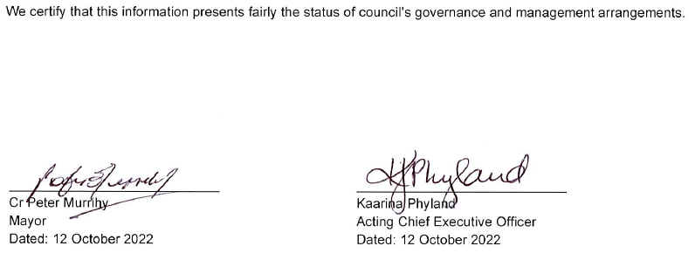

DOMESTIC ANIMAL MANAGEMENT PLAN UPDATE
We have a legal obligation under the Domestic Animals Act (Vic) 1994 to prepare a four-year plan outlining how we will manage dogs and cats within our municipal boundaries and evaluate progress of the plan in our annual report.
Geelong has one of the largest dog and cat populations of any Victorian municipality, with 34,287 registered dogs and 10,232 registered cats. The Domestic Animal Management Plan identifies how Council will:
- help pets, pet owners and the general community to live together
- protect the environment and local wildlife from the negative impacts of dogs and cats
- balance the needs of those who own pets with those who do not
- address animal management welfare and legal issues
- promote responsible pet ownership
- improve the experience of animal ownership.
The plan not only outlines the City’s role in animal management, but is also intended to have an educational focus, encouraging and teaching community members that it’s every owner’s responsibility to take care of their pets.
Council adopted the Domestic Animal Management Plan 2022–25 on 23 November 2021.
Activities we’ve undertaken in the last 12 months in support of the plan include:
- engaged with the community in the review of our Dog Controls in Public Places Policy and in the development of the Domestic Animal Management Plan 2022–25
- completed the July 2021 cat desexing program
- opened two new off leash dog parks in Belmont and Lara and promoted dog parks and their intended use
- attended career sessions with local schools to promote tertiary education pathways into animal management
- enrolled an animal management officer into Certificate III in Dog Behaviour and Training to support responsible pet education in the community
- partnered with local support service to deliver responsible pet ownership information sessions to our culturally and linguistically diverse communities, including translating brochures and materials
- undertook a review of our Emergency Animal Welfare Management Plan
- trained animal management employees in the management of animals in emergency including working in an emergency relief centre
- updated our animal registration form to an online application and payment platform and commenced work to move from paper forms to digital for impounding of animals at the Geelong Animal Welfare Society (GAWS)
- transferred our dog walking maps to an interactive google maps platform on the City’s website
- reviewed our safety equipment for animal management employees and fleet
- purchased safety lighting and scrolling variable messaging signs for our animal management fleet
- continued with branding of animal management fleet, aligning messaging on the rear of all vehicles to reflect key ‘on leash’ messaging
- undertook a Code of Practice audit of GAWS and commenced facility upgrades
- reviewed use of noise monitoring devices in barking dog investigations resulting in an increased number of devices
- collected, recorded and analysed dog attack and service request data to improve our service
- successfully secured funding for two additional animal management officers
- supported the second year of the dog control order trial on Barwon Coast Committee of Management land.

ACCESS AND INCLUSION PLAN UPDATE
We have a legal obligation under the Disability Act (Vic) 2006 to produce a disability action plan and evaluate its progress in the annual report.
Our Access and Inclusion Action Plan 2018–22 was endorsed by Council in November 2018. The action plan is based on four key areas and contains 37 goals, with 49 measures.
TABLE 10: Key projects undertaken in 2021–22
KEY AREA | NUMBER OF PROJECTS UNDERTAKEN |  | EXAMPLES OF 2021–22 ACTIONS
Participation  Promoting inclusion and participation in the community of persons with a disability. | 24 |  | - Reviewed and updated the Events Planning Guide with current advice and guidance for event organisers on improving access and inclusion at events  - Commenced planning to install the Marveloo at the Geelong Show in October 2022  - Facilitated six meetings of the City’s Access and Inclusion Advisory Committee with a quorum in attendance. Members have a lived experience of disability and advise us on our strategies and policies, activities, projects and facility upgrades  - Engaged Access and Inclusion Advisory Committee members in 18 consultations including the Wurriki Nyal development, Rippleside Inclusive Play Space and the Green Spine Project  - Developed:  - a Management Deed for the Mobi Chairs and a Request for Proposal for community agencies to optimise chair use in the community  - the Coastal Accessibility Community Engagement Survey to identify how people with disabilities and mobility restrictions currently access coastal areas and what would make coastal sites more accessible  - Provided an online peer support group for parents and carers of children with diagnosed or episodic Autism Spectrum Disorder (32 sessions)  - Promoted and delivered the Sport4All Program, designed to help sporting clubs and schools become more accessible and inclusive to people with disability
ACCESS  Reducing barriers in accessing goods, services and facilities | 32 |  | - Developed:  - an Internal register for Changing Places and listed on national public toilet register  - a report on the number of, and total funding for grants awarded to the community that promote inclusion  - Maintained the Mobility Directory live on the City’s website, with 728 businesses listed  - Planned community engagement to determine how people with a disability find out about business accessibility and whether the City’s Mobility Directory is useful  - Ensured all new public toilets are Disability Discrimination Act (DDA) compliant  - Undertook:  - a review of the accessibility of the Moorabool Street public toilets  - a soft launch to the tourism industry of the Destination Accessible Toolkit  - increased visibility of swipe card access points at our Corio Street site  - Constructed:  - four new kerb ramps and replaced or upgraded a further four  - three new Disabled Parking Bays  - five new raised road crossings  - Installed 30 raised wombat crossings in Norlane and South Geelong
EMPLOYMENT  Reducing barriers to obtaining and maintaining employment. | 3 |  | - Implemented a new e-learning module for valuing difference (Unconcious Bias training)  - Launched the new Inclusion Roadmap in August which outlines our approach to embedding inclusion through organisational culture, capability and people practices, as well as our processes, policies and ways of delivering service to our community  - Conducted a Recruitment Review, with the aim of identifying any unintended barriers that may prevent people with a disability from being recruited at the City
INCLUSIVE ATTITUDES & PRACTICES  Achieving tangible changes in attitudes and practices that discriminate against persons with a disability. | 8 |  | - Launched “I AM”, an interactive sculpture celebrating people in our community with a lived experience of disability  - Increased the City’s Engagement Champions group to over 50 members to help improve the way we engage with our community  - Attended nine of eleven monthly stakeholder meetings of the Having a Say Conference Reference Group  - Partnered to deliver the 2021 My Story project, celebrating International Day of People with a Disability  - over 250 people with a lived experience of disability or mental health challenges engaged with mentors in ‘story writing’ workshops over a 12 week period  - participants came from a broad range of backgrounds and abilities, aged between 15 to 83 years  - Delivered the 2021 Geelong Awards for People with a Disability across the award categories of Employment, Achievement, Leadership and Advocacy, and Volunteering  - Celebrated Inclusion Week by  - promoting a program of free events in the lead up to International Day of People with Disability  - partnering with Geelong Library and Nelson Park School to feature the artwork of students participating in the My Story Project  - Developing an inclusive image library, to ensure the City’s promotion of activities and events represents our community members who live with disability

DEVELOPMENT CONTRIBUTIONS PLAN (DCP) PROGRESS REPORT
In accordance with sections 46GM and 46QM of the Planning and Environment Act 1987, we must prepare and give a report to the Minister for Planning on infrastructure (not applicable to us) and development contributions including levies and works-in-kind that is published in our annual report.
Development contributions are payments or works-in-kind towards the provision of infrastructure made by the proponent of a new development.
For 2021‒22, the following information about infrastructure and development contributions has been disclosed.
Development contributions
TABLE 11: Total DCP levies received in 2021–22
DCP NAME | YEAR  APPROVED | LEVIES RECEIVED IN 2021–22  FINANCIAL YEAR  ($)
DCP01 Armstrong Creek North East Industrial | 2010 | 0.00
DCP02 Jetty Road Urban Growth Area Stage 1 | 2012 | 97,029.15
DCP03 Armstrong Creek East Precinct | 2012 | 7,483,029.15
DCP04 Armstrong Creek West Precinct | 2013 | 8,365,832.25
DCP05 Armstrong Creek Horseshoe Bend Precinct | 2014 | 8,132,986.25
DCP06 Armstrong Creek Town Centre Precinct | 2014 | 0.00
DCP07 Lara West Urban Growth Area | 2014 | 2,650,904.55
DCP08 Central Rd Drysdale | 2022 | 0.00

TABLE 12: DCP land, works, services or facilities accepted in-kind in 2021–22
DCP NAME  (YEAR APPROVED) | PROJECT ID | PROJECT DESCRIPTION | ITEM PURPOSE | PROJECT VALUE  ($)
DCP03 Armstrong Creek East Precinct 2012 | DI_LA_4 | Land acquisition for the Regional active open space reserve | Land | 19,019.85
DCP03 Armstrong Creek East Precinct 2012 | DI_TR_1 | Off-road shared trail network | Trails | 85,147.68
DCP05 Armstrong Creek Horseshoe Bend Precinct 2014 | DI_RD_11 | Intersection - Horseshoe Bend Road and New Burvilles Road | Roads | 37,721.68
DCP05 Armstrong Creek Horseshoe Bend Precinct 2014 | DI_OS_6 | Play Ground Equipment - Regional Park | Open Space | 582,361.11
DCP05 Armstrong Creek Horseshoe Bend Precinct 2014 | DI_TR_1 | Shared Path Network - Off Road | Trails | 100,215.78
DCP06 Armstrong Creek Town Centre Precinct 2014 | DI_LA_7 | Wetland / Retarding basin - South Western (Land) | Land | 502,860.00
DCP04 Armstrong Creek West Precinct 2013 | DI_LA_10 | Drainage Works - Sedimentation Basin (property 22) - Land | Land | 1,236,000.00
DCP04 Armstrong Creek West Precinct 2013 | DI_DR_07 | Drainage Works - Wetland retarding Basins (WLRB1) - construction | Drainage | 2,988,203.95
DCP07 Lara West Urban Growth Area 2014 | DI_P_1 | PSP/DCP Preparation | Other | 1,014,342.95
Total |  |  |  | 6,565,873.00

TABLE 13: Total DCP contributions received and expended to date (for DCPs approved after 1 June 2016)
DCP NAME  (YEAR APPROVED) | TOTAL LEVIES  RECEIVED  ($) | TOTAL LEVIES  EXPENDED  ($) | TOTAL WORKS-IN-KIND ACCEPTED  ($) | TOTAL DCP CONTRIBUTIONS RECEIVED (LEVIES AND WORKS-IN-KIND)  ($)
DCP08 Central Rd Drysdale 2022 | 0.00 | 757,473.00 | 0.00
 |  | 757,473.00 |  | 0.00
TABLE 14: Land, works, services or facilities delivered in 2021–22 from DCP levies collected
PROJECT DESCRIPTION | PROJECT ID | DCP NAME  (YEAR APPROVED) | DCP FUND EXPENDED  ($) | WORKS-IN-KIND ACCEPTED  ($) | COUNCIL’S CONTRIBUTION  ($) | OTHER CONTRIBUTIONS  ($) | TOTAL PROJECT EXPENDITURE  ($) | PERCENTAGE OF ITEM DELIVERED  (%)
Jetty Road Childrens & Community Hub DCP | C002 | DCP02 Jetty Road Urban Growth Area Stage 1 2012 | 51,776 |  |  |  | 51,776 | 0.94
Drysdale Library | C003 | DCP02 Jetty Road Urban Growth Area Stage 1 2012 | 2,324,804 |  |  |  | 2,324,804 | 41.49
Lara Early Years Library and Community Hub | CI_C_1 | DCP07 Lara West Urban Growth Area 2014 | 33,135 |  |  |  | 33,135 | 2.19
Armstrong Creek Town Centre Library & Learning Hub | CI_CF_1 | DCP06 Armstrong Creek Town Centre Precinct 2014 | 644,720 |  |  | 1,500,000 | 644,720 | 40.87
Armstrong Creek West Community Hub | DI_C_1 | DCP04 Armstrong Creek West Precinct 2013 | 4,161,229 |  |  | 1,125,000 | 4,161,229 | 27.09
Patullos Rd East - Road Widening | DI_DO_7 | DCP07 Lara West Urban Growth Area 2014 | 100,877 |  |  |  | 100,877 | 4.28
Sparrovale Wetlands Construction | DI_DR_12 | DCP05 Armstrong Creek Horseshoe Bend Precinct 2014 | 13,466 |  |  |  | 13,466 | 0.76
Sparrovale Wetlands Project Implementation | DI_DR_13 | DCP05 Armstrong Creek Horseshoe Bend Precinct 2014 | 209,757 |  |  |  | 209,757 | 3.41
Jetty Road Basin - Land (Ultimate) | DI_LA_04 | DCP08 Central Rd Drysdale 2022 | 757,473 |  |  |  | 757,473 | 100.00
Land Acquisition - Horseshoe bend Road Section 3 (Boundary Road - Catholic school northern limit ) | DI_LA_06 | DCP05 Armstrong Creek Horseshoe Bend Precinct 2014 | 595,414 |  |  |  | 595,414 | 81.79
Land Acquisition - Horseshoe bend Road Section 3 (Catholic school northern limit - Geelong Ring Road) | DI_LA_07 | DCP05 Armstrong Creek Horseshoe Bend Precinct 2014 | 1,143,978 |  |  |  | 1,143,978 | 58.24
Drainage Works - Reserve Road Retarding Basin - Land | DI_LA_14 | DCP05 Armstrong Creek Horseshoe Bend Precinct 2014 | 1,516,436 |  |  |  | 1,516,436 | 44.53
Drainage Works - Barwon Heads Road South Retarding Basin - Land | DI_LA_17 | DCP05 Armstrong Creek Horseshoe Bend Precinct 2014 | 19,414 |  |  |  | 19,414 | 0.96
Drainage Works - Barwon Heads Road to Harriot Road - Land | DI_LA_18 | DCP05 Armstrong Creek Horseshoe Bend Precinct 2014 | 1,595,854 |  |  |  | 1,595,854 | 58.48
Sparrovale Wetlands - Land (1 - 87 Grove Road, Armstrong Creek) | DI_LA_22 | DCP05 Armstrong Creek Horseshoe Bend Precinct 2014 | 6,084 |  |  |  | 6,084 | 0.28
Land Acquisition - Boundary Road - 412 Torquay Road Armstrong Creek (Property 1) | DI_LA_3a | DCP06 Armstrong Creek Town Centre Precinct 2014 | 322,707 |  |  |  | 322,707 | 100.00
Land Acquisition - Boundary Road - 350-360 Boundary Road Armstrong Creek (Property 2) | DI_LA_3b | DCP06 Armstrong Creek Town Centre Precinct 2014 | 9,707 |  |  |  | 9,707 | 3.37
Land Acquisition - Boundary Road (Surf coast Highway to Barwarre Road) - 412 Torquay Road | DI_LA_9a | DCP05 Armstrong Creek Horseshoe Bend Precinct 2014 | 322,707 |  |  |  | 322,707 | 80.68
Land Acquisition - Boundary Road (Surf coast Highway to Barwarre Road) - 350-360 Boundary Road | DI_LA_9b | DCP05 Armstrong Creek Horseshoe Bend Precinct 2014 | 9,707 |  |  |  | 9,707 | 2.33
Intersection - GRR-4c and Connector (west of Airport Road) | DI_RO_01 | DCP04 Armstrong Creek West Precinct 2013 | 2,987 |  |  |  | 2,987 | 0.20
Land acquisition for the Regional active open space reserve | DI_LA_4 | DCP03 Armstrong Creek East Precinct 2012 |  | 19,020 |  |  | 19,020 | 1.15
Off-road shared trail network | DI_TR_1 | DCP03 Armstrong Creek East Precinct 2012 |  | 85,148 |  |  | 85,148 | 1.67
Intersection - Horseshoe Bend Road and New Burvilles Road | DI_RD_11 | DCP05 Armstrong Creek Horseshoe Bend Precinct 2014 |  | 37,722 |  |  | 37,722 | 2.00
Play Ground Equipment - Regional Park | DI_OS_6 | DCP05 Armstrong Creek Horseshoe Bend Precinct 2014 |  | 582,361 |  |  | 582,361 | 100.00
Shared Path Network - Off Road | DI_TR_1 | DCP05 Armstrong Creek Horseshoe Bend Precinct 2014 |  | 100,216 |  |  | 100,216 | 1.94
Wetland / Retarding basin - South Western (Land) | DI_LA_7 | DCP06 Armstrong Creek Town Centre Precinct 2014 |  | 502,860 |  |  | 502,860 | 17.00
Drainage Works - Sedimentation Basin (property 22) - Land | DI_LA_10 | DCP04 Armstrong Creek West Precinct 2013 |  | 1,236,000 |  |  | 1,236,000 | 79.85
Drainage Works - Wetland retarding Basins (WLRB1) - construction | DI_DR_07 | DCP04 Armstrong Creek West Precinct 2013 |  | 2,988,204 |  |  | 2,988,204 | 100.00
PSP/DCP Preparation | DI_P_1 | DCP07 Lara West Urban Growth Area 2014 |  | 1,014,343 |  |  | 1,014,343 | 64.75
 |  |  | 13,842,232 | 6,565,874 | 0 | 2,625,000 | 20,408,106

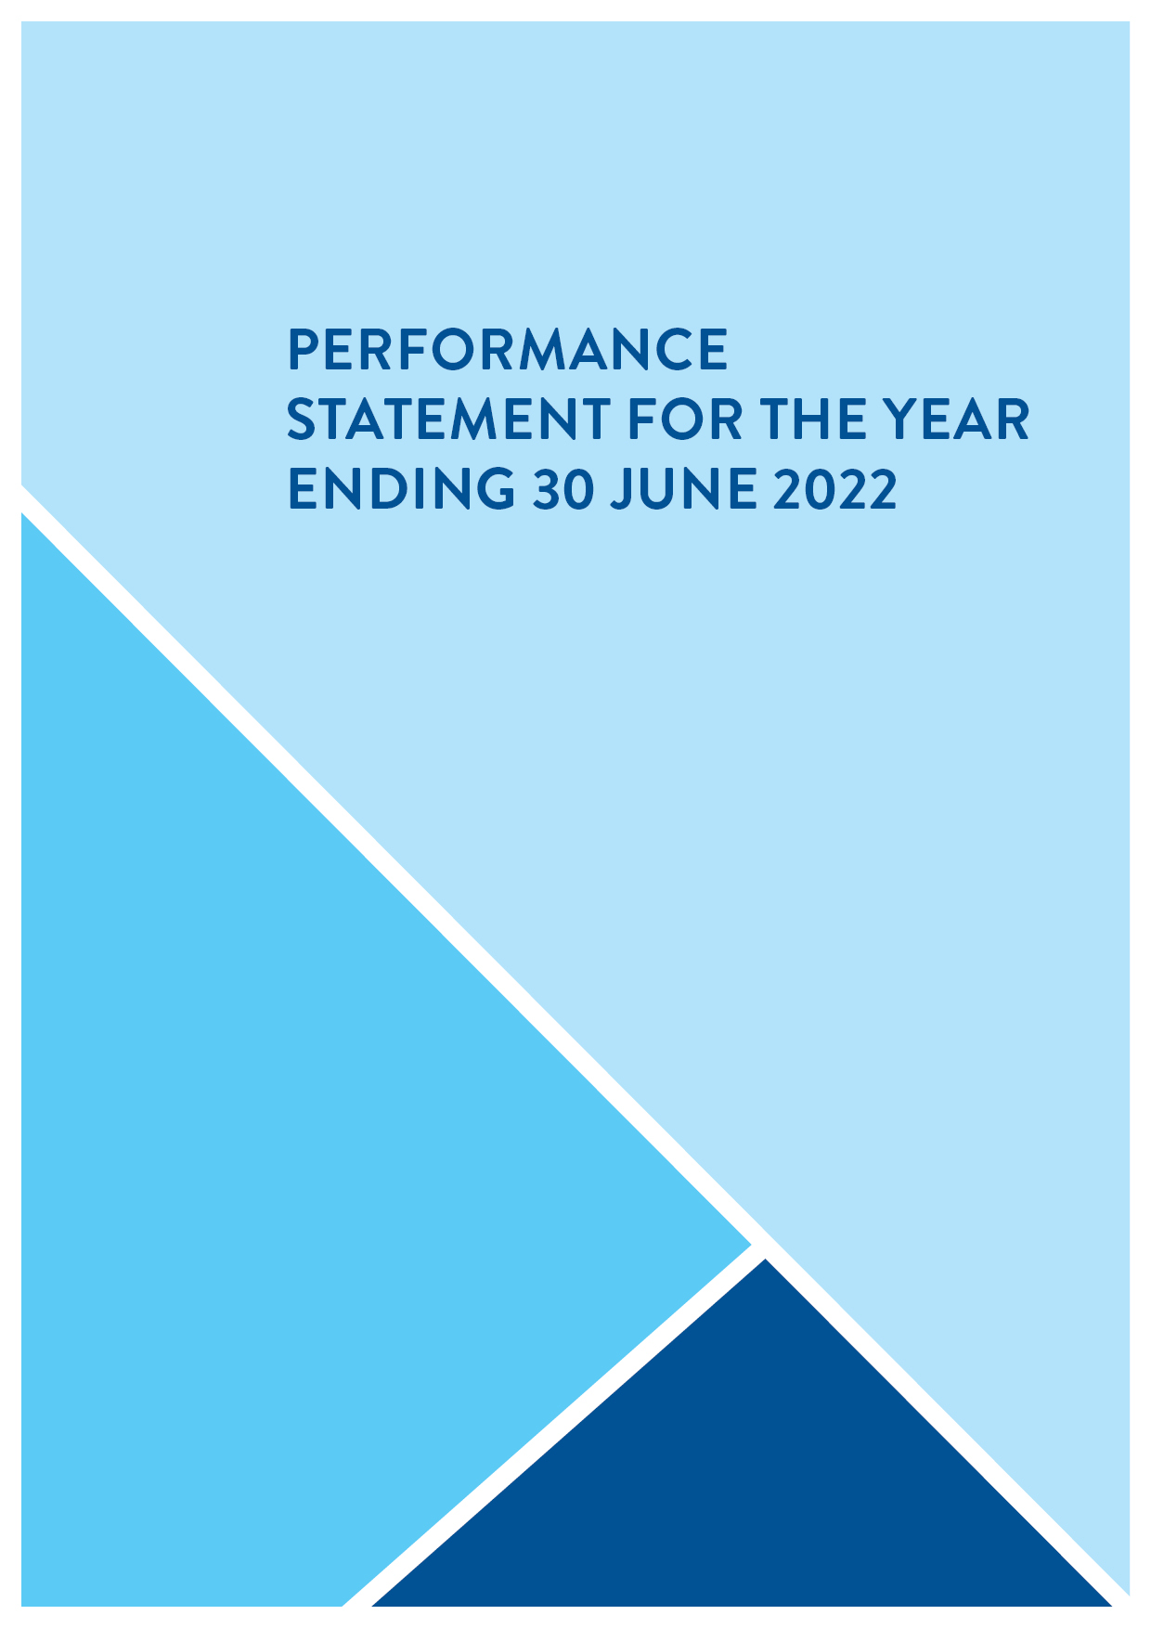

THE GREATER GEELONG CITY COUNCIL
PERFORMANCE STATEMENT
For the year ended 30 June 2022

PERFORMANCE STATEMENT
For the year ended 30 June 2022
Description of municipality
The City of Greater Geelong municipality is located 75 kilometres south west of Melbourne and is Victoria’s largest regional municipality, covering an area of 1,252 square kilometres. The municipality has a population of over 270,000 people, which is expected to increase to more than 393,000 by 2041 – growth of over 45 per cent.
Comprising suburban, coastal and country areas, Greater Geelong is bounded by the Moorabool Shire in the north, Wyndham City Council and the Borough of Queenscliffe in the east, Surf Coast Shire and Golden Plains Shire in the west, and Bass Strait to the south. Key natural features of the region include Corio Bay, the Bellarine Peninsula, the Barwon River, the You Yangs Regional Park, wetlands, coastline, parklands and wildlife sanctuaries.
Greater Geelong’s economy has performed exceptionally well in recent years, recording the highest growth in Australia compared to similar large cities and regions. Greater Geelong has an estimated Gross Regional Product of $15.42 billion, 120,031 local jobs¹¹ and 19,604 businesses.
Local labour market conditions are strong with unemployment at historic lows of 2.5 per cent, 1.7 points lower than the Victorian rate and 1.9 points lower than Australia¹². Job advertisements and demand for labour are at record highs, with 10,500 new jobs advertised in the June 2022 quarter.
Overview the year ended 30 June 2022
Due to the ever-changing landscape of the COVID-19 pandemic, we continued to be flexible, agile and responsive in our approach to the needs of our community. The relative easing of restrictions saw a return to services for our community in line with the Victorian Government directives.
We continued to support local residents and in particular, local businesses, adopting a seventh COVID support package worth just over $2.0 million in November 2021. The latest package included business support, support for the arts, culture and heritage sector, financial relief, and health and wellbeing support. Our ongoing response to the pandemic continues to be well-regarded by the community, rating higher than the Victorian average, according to the 2022 Local Government Community Satisfaction Survey.
As part of the 2021‒22 budget, Council also committed to a record $209 million capital works program for the renewal of ageing assets and construction of new facilities to help drive the region’s ongoing recovery from the pandemic and meet the needs of a growing population. During 2021‒22 we delivered over $195 million on capital projects, towards our budget commitment.
Despite the challenges presented by lockdowns, most of our services – including waste and recycling, road maintenance and community services – continued, although some services had to be modified to comply with restrictions. Where COVID-19 impacts have been noted as affecting the indicators in this report, explanatory notes have been provided.
We also continued to progress construction of Wurriki Nyal, our new civic precinct, which will consolidate our city-based office locations into a single, energy-efficient building, as well as creating an accessible and welcoming public space. Works are progressing well, and the building and landscaping is expected to be completed in July 2022. Employees are expected to move into the building in stages from mid-August 2022.

Other information
Basis for preparation
Council is required to prepare and include a performance statement within its annual report. The performance statement includes the results of the prescribed sustainable capacity, service performance, and financial performance indicators and measures, together with a description of the municipal district and an explanation of material variations in the results. This statement has been prepared to meet the requirements of the Local Government Act 2020 and Local Government (Planning and Reporting) Regulations 2020.
Where applicable, the results in the performance statement have been prepared on accounting bases consistent with those reported in the Financial Statements. The other results are based on information drawn from our information systems, or from third parties, such as the Australian Bureau of Statistics (ABS). In preparing this statement, we utilised March 2022 data published by the ABS.
The performance statement presents the actual results for the current year and for the prescribed financial performance indicators and measures, the results forecast by the council’s strategic resource plan. The Local Government (Planning and Reporting) Regulations 2020 requires explanation of any material variations in the results contained in the performance statement. Council applied a materiality threshold to all indicators and provided commentary for all indicators regardless of whether the variance was considered to be material.
The forecast figures included in the performance statement are those adopted by council in its annual budget on 28 June 2022. The annual budget includes estimates based on key assumptions about the future that were relevant at the time of adoption and aimed at achieving sustainability over the long-term. Detailed information on the actual financial results is contained in the General Purpose Financial Statements. The annual budget and long-term financial plan are available on the City’s website or on request.

SUSTAINABLE CAPACITY INDICATORS
For the year ended 30 June 2022
INDICATOR/MEASURE |  | RESULTS |  |  |  | COMMENTS
 |  | 2019 | 2020 | 2021 | 2022 | COMMENTS
Population
C1 | Expenses per head of population  [Total expenses / Population] | $1,439.94 | $1,554.22 | $1,504.49 | $1,578.97 | The easing of COVID-19 restrictions increased expenditure in the 2021‒22 financial year. In addition, overall cost increases impacted the delivery of key services.
C2 | Infrastructure per head of population  [Value of infrastructure / Population] | $7,080.74 | $7,955.62 | $8,596.71 | $11,311.66 | The value of infrastructure assets has increased largely due to higher asset revaluations across our infrastructure, land and building assets.
C3 | Population density per length of road  [Population / Kilometres of local roads] | 111.85 | 112.28 | 112.57 | 114.13 | While we add to our local road network every year to meet the needs of our growing population, in 2021‒22 the increase in length of local roads was slower than the increase in population.
Own-source revenue
C4 | Own-source revenue per head of population  [Own source revenue / Population] | $1,258.73 | $1,202.83 | $1,197.71 | $1,290.16 | As COVID-19 restrictions eased, 'own sourced' revenue increased during the 2021‒22 financial year.
Recurrent grants
C5 | Recurrent grants per head of population  [Recurrent grants / Population] | $236.45 | $229.83 | $239.27 | $291.32 | The increase in 2021‒22 is a result of receiving 75 per cent of the 2022‒23 Financial Assistance Grant, 25 per cent higher than the expected 50 per cent received in previous years. We received additional COVID-19 government funding for family services in 2021‒22.
Disadvantage
C6 | Relative Socio-Economic Disadvantage  [Index of Relative Socio-Economic Disadvantage by decile] | 6 | 6 | 6 | 6 | Greater Geelong's Relative Socio-Economic Disadvantage Index from the 2016 Census was in the sixth decile within Victoria. The first decile indicates the most disadvantaged and the tenth decile indicates the least disadvantaged.  We acknowledge there are areas experiencing significant disadvantage and others with low disadvantage within the municipality.  New results will be available in 2023.
Workforce turnover
C7 | Percentage of staff turnover  [Number of permanent staff resignations and terminations / Average number of permanent staff for the financial year] x100 | 8.76% | 8.94% | 11.08% | 15.77% | Our turnover rate has increased over the last two years in line with the national turnover trend. In 2021‒22, employees leaving the City cited 'career change' as the main reason for departure. We also experienced an uptick in retirements as employees bring forward their planned retirement likely due to reasons related to the pandemic.
Definitions
‘Adjusted underlying revenue’ means total income other than:
(a) non-recurrent grants used to fund capital expenditure; and
(b) non-monetary asset contributions; and
(c) contributions to fund capital expenditure from sources other than those referred to above
‘Infrastructure’ means non-current property, plant and equipment excluding land
‘Local road’ means a sealed or unsealed road for which the council is the responsible road authority under the Road Management Act 2004
‘Population’ means the resident population estimated by council
‘Own-source revenue’ means adjusted underlying revenue other than revenue that is not under the control of council (including government grants)
‘Relative socio-economic disadvantage’, in relation to a municipality, means the relative socio-economic disadvantage, expressed as a decile for the relevant financial year, of the area in which the municipality is located according to the Index of Relative Socio-Economic Disadvantage (Catalogue Number 2033.0.55.001) of SEIFA
‘SEIFA’ means the Socio-Economic Indexes for Areas published from time to time by the Australian Bureau of Statistics on its website
‘Unrestricted cash’ means all cash and cash equivalents other than restricted cash
SERVICE PERFORMANCE INDICATORS
For the year ended 30 June 2022
SERVICE/INDICATOR/MEASURE |  | RESULTS |  |  |  |  |  |  | COMMENTS
 |  | 2019 |  | 2020 |  | 2021 |  | 2022 | COMMENTS
Aquatic Facilities
AF6 | Utilisation  Utilisation of aquatic facilities  [Number of visits to aquatic facilities / Population] | 8.82 | 6.53 |  | 3.32 |  | 4.73 |  | In 2021‒22, the easing of pandemic restrictions saw an increase in the use of our facilities by our community.
Animal Management
AM7 | Health and safety  Animal management prosecutions  [Number of successful animal management prosecutions / Number of animal management prosecutions] x100 | New in 2020 | 100% |  | 100% |  | 100% |  | We continue to successfully prosecute all matters brought before the court, with three animal management court cases in 2021‒22.
Food Safety
FS4 | Health and safety  Critical and major non-compliance outcome notifications  [Number of critical non-compliance outcome notifications and major non-compliance notifications about a food premises followed up / Number of critical non-compliance outcome notifications and major non-compliance notifications about a food premises] x100 | 99.32% | 98.19% |  | 95.45% |  | 100% |  | A strong focus on following up all major and critical non-compliances and easing of COVID-19 restrictions resulted in all follow-ups being completed during 2021.
Governance
G5 | Satisfaction  Satisfaction with council decisions  [Community satisfaction rating out of 100 with how council has performed in making decisions in the interest of the community] | 55 | 56 |  | 59 |  | 56 |  | While our community satisfaction score decreased three index points, the score was consistent with previous results. We continue to improve the quality of information and analysis to best support Councillor decision-making.
Libraries
LB4 | Participation  Active library members  [The sum of the number of active library borrowers in the last 3 financial years / The sum of the population in the last 3 financial years] x100 | 18.20% | 17.57% |  | 15.70% |  | 13.98% |  | Geelong Regional Library Corporation branches were closed for 43 days. Upon reopening, strict density limits were enforced, affecting borrowings. During lock-down, a Click & Collect online ordering service was offered to our community to increase loans of library items. A delivery service was also offered to our more vulnerable community members. The easing of restrictions saw an increase in the number of active borrowers, however numbers were down on pre-pandemic figures.  Note: The definition of this indicator changed in 2019‒20 and now averages the past three years data, so past results are not comparable.
Maternal and Child Health (MCH)
MC4 | Participation  Participation in the MCH service  [Number of children who attend the MCH service at least once (in the year) / Number of children enrolled in the MCH service] x100 | 73.17% | 73.14% |  | 72.56% |  | 74.40% |  | The increase in participation rates reflects a return to pre-pandemic Maternal Child and Health service delivery.
MC5 | Participation  Participation in the MCH service by Aboriginal children  [Number of Aboriginal children who attend the MCH service at least once (in the year) / Number of Aboriginal children enrolled in the MCH service] x100 | 63.39% | 76.37% |  | 77.47% |  | 72.02% |  | From January 2022, the local Aboriginal Co-operative Maternal Child and Health Service began using their own database to record service participation. Families have a choice to attend either the Aboriginal Maternal and Child Health Service or the City's Maternal and Child Health Service.
Roads
R5 | Satisfaction  Satisfaction with sealed local roads  [Community satisfaction rating out of 100 with how council has performed on the condition of sealed local roads] | 54 | 60 |  | 62 |  | 57 |  | Community satisfaction with sealed roads has decreased in line with the significant increase in the number of requests received. Inclement weather and the impact of the pandemic and flu season has resulted in a shortage of available resources, significantly reducing the City’s ability to respond to maintenance issues. Response times to maintenance issues are still aligned to the Road Management Plan. Whilst lower than the last two years, results are above the statewide and Regional Centres average.
Statutory Planning
SP4 | Decision-making  Council planning decisions upheld at VCAT  [Number of VCAT decisions that did not set aside council's decision in relation to a planning application / Number of VCAT decisions in relation to planning applications] x100 | 64.00% | 54.17% |  | 71.79% |  | 72.41% |  | In the 2021‒2022 financial year, VCAT supported 21 of our 29 planning decisions.
Waste Collection
WC5 | Waste diversion  Kerbside collection waste diverted from landfill  [Weight of recyclables and green organics collected from kerbside bins / Weight of garbage, recyclables and green organics collected from kerbside bins] x100 | 54.00% |  | 55.73% |  | 53.87% |  | 52.96% | Since 2018, green waste and recycling as a ratio has been consistent. Green waste tonnages, affected by rainfall patterns and smaller subdivisions producing less green waste, have decreased. The thinner profile of glass, PET plastics and aluminium containers contributed to the reduction in recycling tonnage. Waste tonnage continues to increase due to population growth in new subdivisions.

As part of the ongoing review and improvement of reporting, Local Government Victoria retired the following indicator:
RETIRED  SERVICE/INDICATOR/MEASURE |  | RESULTS |  |  |  | COMMENTS
 |  | 2019 | 2020 | 2021 | 2022 | COMMENTS
Animal Management
AM4 | Health and safety  Animal management prosecutions  [Number of successful animal management prosecutions] | 19 | Retired in 2020 | Retired in 2020 | Retired in 2020 | As of 1 July 2019, this indicator was replaced by the amended Animal management prosecution measure AM7.

Definitions
‘Aboriginal child’ means a child who is an Aboriginal person
‘Aboriginal person’ has the same meaning as in the Aboriginal Heritage Act 2006
‘Active library borrower’ means a member of a library who has borrowed a book from the library
‘Annual report’ means an annual report prepared by a council under section 98 of the Act
‘Class 1 food premises’ means food premises, within the meaning of the Food Act 1984, that have been declared as class 1 food premises under section 19C of that Act
‘Class 2 food premises’ means food premises, within the meaning of the Food Act 1984, that have been declared as class 2 food premises under section 19C of that Act
‘Critical non-compliance outcome notification’ means a notification received by council under section 19N(3) or (4) of the Food Act 1984, or advice given to council by an authorised officer under that Act, of a deficiency that poses an immediate serious threat to public health
‘Food premises’ has the same meaning as in the Food Act 1984
‘Local road’ means a sealed or unsealed road for which the council is the responsible road authority under the Road Management Act 2004
‘Major non-compliance outcome notification’ means a notification received by a council under section 19N(3) or (4) of the Food Act 1984, or advice given to council by an authorised officer under that Act, or a deficiency that does not pose an immediate serious threat to public health but may do so if no remedial action is taken
‘MCH’ means the Maternal and Child Health Service provided by a council to support the health and development of children within the municipality from birth until school age
‘Population’ means the resident population estimated by council
FINANCIAL PERFORMANCE INDICATORS
For the year ended 30 June 2022
DIMENSION/INDICATOR/MEASURE |  | RESULTS |  |  |  | FORECASTS |  |  |  | MATERIAL VARIATIONS  AND COMMENTS
 |  | 2019 | 2020 | 2021 | 2022 | 2023 | 2024 | 2025 | 2026 | MATERIAL VARIATIONS  AND COMMENTS
Efficiency
E2 | Expenditure level  Expenses per property assessment  [Total expenses / Number of property assessments] | $2,952.67 | $3,193.97 | $3,088.94 | $3,199.59 | $3,188.65 | $3,294.52 | $3,387.76 | $3,465.26 | As COVID-19 restrictions ease, the cost of providing our services has increased per property assessment. It is predicted that an increase in expenses will be partially offset by growth in the number of property assessments.
E4 | Revenue level  Average rate per property  [Total rate revenue / Number of property assessments] | New in 2020 | $1,602.56 | $1,639.93 | $1,661.65 | $1,704.46 | $1,778.10 | $1,844.38 | $1,911.84 | The average rate per property is forecast to grow in line with the forecast annual rate cap allowance.
Liquidity
L1 | Working capital  Current assets compared to current liabilities  [Current assets / Current liabilities] x100 | 155.09% | 112.69% | 140.29% | 148.04% | 219.74% | 209.58% | 184.42% | 184.37% | High cash levels have contributed to the City's strong liquidity levels. Our strong financial position is forecast to increase from 2023, as spending on capital works programs reduce.
L2 | Unrestricted cash  Unrestricted cash compared to current liabilities  [Unrestricted cash / Current liabilities] x100 | 118.83% | 75.68% | 97.96% | 48.08% | 198.83% | 189.17% | 165.60% | 164.31% | There was an overall decrease in 2021‒22, due to short-term liabilities increasing at a greater rate than levels of unrestricted cash. We forecast an increase to unrestricted cash in the coming years.  Note: The prior year and forecast figures include investment as part of unrestricted cash, whereas the 2021‒22 results exclude investment figures to be in line with the guidelines.
Obligations
O2 | Loans and borrowings  Loans and borrowings compared to rates  [Interest bearing loans and borrowings / Rate revenue] x100 | 28.83% | 34.31% | 45.94% | 51.85% | 69.51% | 68.22% | 62.88% | 59.34% | In 2021‒22, loan values increased to fund part of the Wurriki Nyal construction. Borrowings are forecast to increase, to fund large capital projects including the Northern Aquatic and Community Hub. Our loan levels remain within forecast borrowing limits.
O3 | Loans and borrowings  Loans and borrowings repayments compared to rates  [Interest and principal repayments on interest bearing loans and borrowings / Rate revenue] x100 | 4.70% | 4.34% | 5.29% | 4.46% | 4.96% | 6.48% | 6.62% | 8.75% | There was a decline in the ratio in 2021‒22 due to the timing of loan repayments. Loan repayments are projected to increase as borrowings are used to fund large capital projects.
O4 | Indebtedness  Non-current liabilities compared to own source revenue  [Non-current liabilities / Own source revenue] x100 | 23.93% | 30.10% | 39.46% | 41.81% | 51.99% | 48.89% | 44.64% | 43.68% | The increase in the ratio is a result of loans secured, contributing to the construction of Wurriki Nyal. We forecast further loan increases to other large capital projects.
O5 | Asset renewal and upgrade  Asset renewal and upgrade expense compared to depreciation  [Asset renewal and asset upgrade expenditure / Asset depreciation] x100 | New in 2020 | 67.30% | 57.65% | 68.94% | 83.27% | 77.12% | 67.14% | 68.72% | There will be a forecast percentage increase as we commit to invest in renewal of our City assets.
Operating Position
OP1 | Adjusted underlying result  Adjusted underlying surplus (or deficit)  [Adjusted underlying surplus (or deficit) / Adjusted underlying revenue] x100 | 5.38% | -3.42% | 5.61% | 9.33% | 13.47% | 9.24% | 7.32% | 5.44% | The 2021‒22 operating result increased due to grant revenue and other one-off adjustments. Our forecast is for an on-going surplus.
Stability
S1 | Rates concentration  Rates compared to adjusted underlying revenue  [Rate revenue / Adjusted underlying revenue] x100 | 59.50% | 61.87% | 60.37% | 57.58% | 57.12% | 60.50% | 62.32% | 64.43% | In 2021‒22, the ratio dropped due to increased grant income and higher fees and charges.
S2 | Rates effort  Rates compared to property values  [Rate revenue / Capital improved value of rateable properties in the municipality] x100 | 0.36% | 0.33% | 0.33% | 0.33% | 0.34% | 0.35% | 0.37% | 0.38% | Rates revenue and Capital Improved Value increases are forecast to remain stable.

As part of the ongoing review and improvement of reporting, Local Government Victoria retired the following indicators:
RETIRED  DIMENSION/INDICATOR/MEASURE |  | RESULTS |  |  |  | MATERIAL VARIATIONS AND COMMENTS
 |  | 2019 | 2020 | 2021 | 2022 | MATERIAL VARIATIONS AND COMMENTS
Efficiency
E1 | Revenue level  Average residential rate per residential property assessment  [Residential rate revenue / Number of residential property assessments] | $1,585.94 | Retired in 2020 | Retired in 2020 | Retired in 2020 | As of 1 July 2019, this measure was replaced by E4.
Obligations
O1 | Asset renewal  Asset renewal compared to depreciation  [Asset renewal expense / Asset depreciation] x100] | 50.36% | Retired in 2020 | Retired in 2020 | Retired in 2020 | As of 1 July 2019, this measure was replaced by O5.
Definitions
‘Adjusted underlying revenue means total income other than:
(a) non-recurrent grants used to fund capital expenditure and
(b) non-monetary asset contributions and
(c) contributions to fund capital expenditure from sources other than those referred to above
‘Adjusted underlying surplus (or deficit)’ means adjusted underlying revenue less total expenditure
‘Asset renewal expenditure’ means expenditure on an existing asset or on replacing an existing asset that returns the service capability of the asset to its original capability
‘Current assets’ has the same meaning as in the AAS
‘Current liabilities’ has the same meaning as in the AAS
‘Non-current assets’ means all assets other than current assets
‘Non-current liabilities’ means all liabilities other than current liabilities
‘Non-recurrent grant’ means a grant obtained on the condition that it be expended in a specified manner, and is not expected to be received again during the period covered by a council's strategic resource plan
‘Own-source revenue’ means adjusted underlying revenue other than revenue that is not under the control of council (including government grants)
‘Population’ means the resident population estimated by council
‘Rate revenue’ means revenue from general rates, municipal charges, service rates and service charges
‘Recurrent grant’ means a grant other than a non-recurrent grant
‘Residential rates’ means revenue from general rates, municipal charges, service rates and service charges levied on residential properties
‘Restricted cash’ means cash and cash equivalents, within the meaning of the AAS, that are not available for use other than for a purpose for which it is restricted, and includes cash to be used to fund capital works expenditure from the previous financial year
‘Unrestricted cash’ means all cash and cash equivalents other than restricted cash

Certification of the Performance Statement
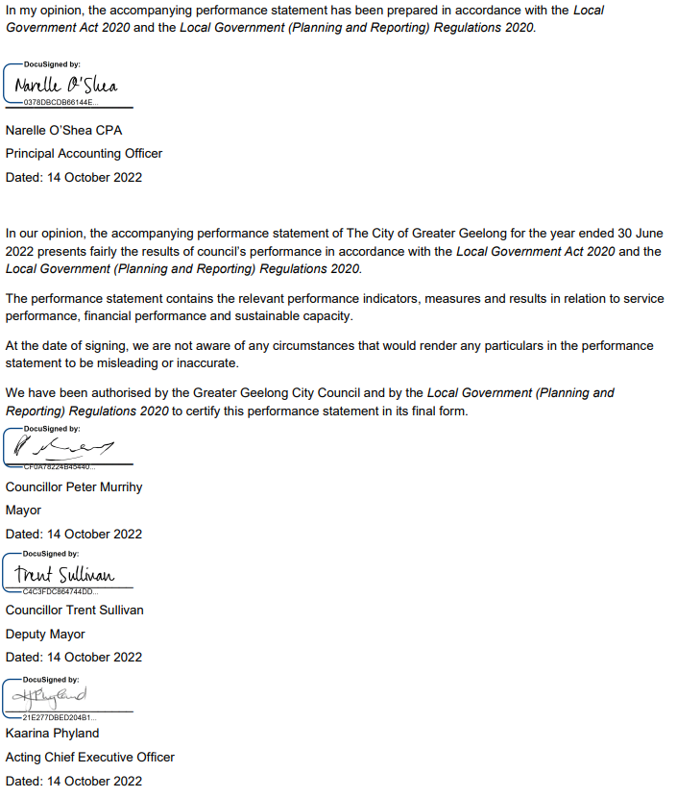

Independent auditor’s report of the Performance Statement 2021–22
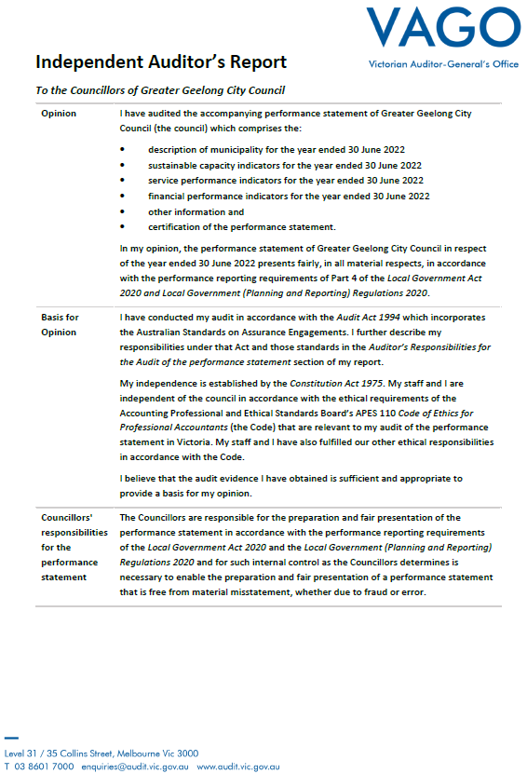
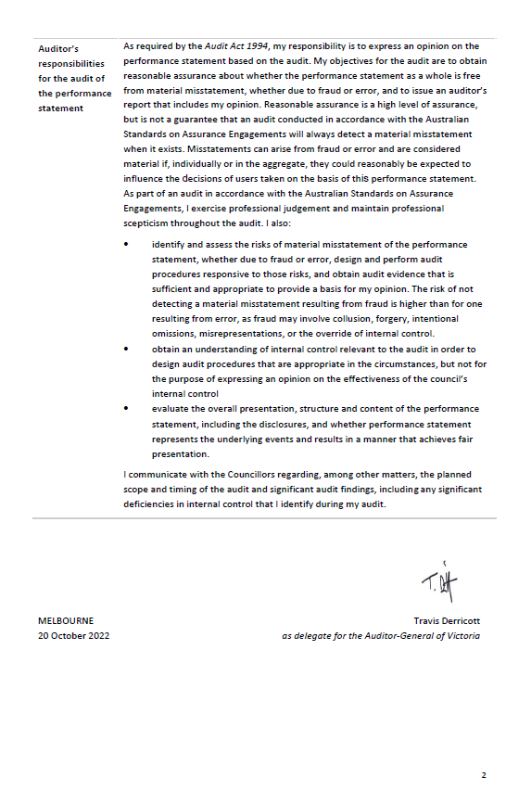

ANNUAL FINANCIAL REPORT FOR THE YEAR ENDING 30 JUNE 2022
Understanding the Financial Report and Financial Statements
Our Financial Report and Performance Statement are prepared in accordance with the Australian Accounting Standards, the Local Government Act 2020 and Local Government Victoria’s model accounts.
The Financial Report and Performance Statement are audited by the Victorian Auditor-General’s agent and are approved in principle by both our Audit and Risk Committee and by Council. The reports are then forwarded to the Victorian Auditor-General’s Office for finalisation and an independent opinion.
Financial statements
The financial report consists of five financial statements, explanatory notes supporting the reports and endorsement from the Council and the Victorian Auditor-General.
The five financial statements are:
- a comprehensive income statement
- a balance sheet
- a statement of changes in equity
- a cash flow statement and
- a statement of capital works.
The explanatory notes detail our accounting policies and the make-up of the values contained in the statements.
Comprehensive income statement
The comprehensive income statement measures our performance over the year.
It lists our revenue sources under various income headings, as well as the expenses we incurred during the year. The expenses relate only to the ‘operations’ and do not include the cost associated with the purchase or building of assets. Expenses do include an item for depreciation, which is the value of the assets used up during the year.
Balance sheet
The balance sheet shows the assets we own and what we owe (liabilities) as of 30 June 2022.
The bottom line of the balance sheet is net assets, which is the net worth we have built up over many years.
Our assets and liabilities are separated into current and non-current. Current refers to assets or liabilities that will fall due within the next 12 months (except Long service leave – refer to note 5.5 within the notes to the accounts section of this report).
Statement of changes in equity
The statement of changes in equity summarises the change in value of total ratepayer equity. The value of equity can only change as a result of:
- profit or loss from operations, described as surplus or deficit in the income statement
- use of monies from our reserves
- a change in the value of non-current assets, resulting from a revaluation of these assets.
Cash flow statement
The cash flow statement summarises our cash payments and receipts for the year, as well as our level of cash at the end of the financial year.
Cash in this statement refers to bank deposits and investments that can be quickly converted to cash.
Our cash arises from, and is used in, three main areas:
- Cash flows from operating activities – summarises all income and expenses relating to our operations, including service delivery and maintenance.
- Cash flows from investing activities – relates to capital works payments recorded as assets in the balance sheet, as well as receipts for the sale of assets.
- Cash flows from financing activities – represents repayments of and receipts from loans.
Statement of capital works
This statement provides detail of capital expenditure by asset type and distinguishes renewal, upgrade and new capital expenditure.
Notes to the accounts
The notes to the accounts enable the reader to understand the basis on which the values shown in the accounts are established. The notes also advise if there has been any change to the accounting standards, policy or legislation that has impacted on how the standards were prepared.
Within the five financial statements, there is a ‘note’ column to indicate where the reader should go for additional information. This is particularly useful where there has been a significant change from the previous year’s comparative figure.
Statements by the Principal Accounting Officer, Chief Executive Officer and councillors
The Financial Statements and the Performance Statement require certification under the Local Government Act 2020. The certifications are made by a combination of the Principal Accounting Officer, the Chief Executive Officer and two councillors, on behalf of the Council, as a written undertaking to the statements being correct and not misleading.
Victorian Auditor-General’s report
This document provides a written undertaking of the accuracy, fairness and completeness of the accounts.
The audit report from the Victorian Auditor-General provides an independent view of the statements and advises the reader if there are any issues of concern.

THE GREATER GEELONG CITY COUNCIL
ANNUAL FINANCIAL REPORT
For the year ended 30 June 2022

(See CITY OF GREATER GEELONG ANNUAL REPORT
2021-22 – PART 2 – FINANCIAL REPORT)

CONTACT US

This document contains important information about the City of Greater Geelong. Please contact us if you have any questions or would like to request a hard copy of the report.

You can also view hard copies at our customer service centres and branches of the Geelong Regional Library Corporation. However, please be aware these services may be impacted by COVID-19 restrictions.

City of Greater Geelong
Wadawurrung Country
PO Box 104
Geelong VIC 3220
P: 5272 5272
E: contactus@geelongcity.vic.gov.au
www.geelongaustralia.com.au
@City of Greater Geelong 2022
ISSN: 2209−8828

Latest news:
@CityofGreaterGeelong
@GreaterGeelong
@CityofGreaterGeelong
@CityofGreaterGeelong

Source: National Institute of Economic and Industry Research (NIEIR) ©2021, compiled and presented in economy.id by .id (informed decisions)
Source: Australian Bureau of Statistics
Source: National Skills Commission
As at 30 June 2022
Excludes casual employees
Total includes 0.3 FTE of self-described gender
Mayor June 2020 – June 2022
Elected Mayor 17 June 2022
Deputy Mayor June 2020 – June 2022, performing Mayoral duties January – June 2022
Source: Population and household forecasts, 2016 to 2041, prepared by .id (informed decisions), May 2019
Source: National Institute of Economic and Industry Research (NIEIR) ©2021, compiled and presented in economy.id by .id (informed decisions)
Source: Australian Bureau of Statistics
Source: National Skills Commission

