
Residential Precinct

Structure Plan

Program
introduction
The decision on which PSPs are to commence next needs to be made by the end of 2022 to meet Geelong’s land supply demand. This will enable the roll out of an ongoing program of work following the initial PSPs heading into the planning scheme amendment stage. Bringing on additional PSPs in a staged manner will allow for effective transition of resources to commence new PSPs.
background
To maintain required lot supply and accommodate a growth rate of 2.5 per cent, the City needs to develop a program on the next set of PSPs to commence in mid-2023. The release of these lots should be carefully managed along with managing the resulting infrastructure delivery and regulatory approvals.
The City’s adopted Settlement Strategy and the state policies in the Greater Geelong Planning Scheme provide guidance and criteria on assessment of the direction of growth. Clause 11.02-2L of the Greater Geelong Planning Scheme provides guidance on the release of this major growth front.
The strategies are:
- Ensure Precinct Structure Plans are generally in accordance with the Northern and Western Geelong Growth Areas Framework Plan map forming part of this clause.
- Support development that is sequenced generally in accordance with the Development Sequencing Northern Geelong Growth Area Map or the Development Sequencing Western Geelong Growth Area Map forming part of this clause.
An assessment against criteria related to sustainable community design and development trends and financial implications were undertaken in parallel with landholder consultation.
LAnd Supply
To achieve at least 10 years land supply by 2025, there is a need for more than one PSP to be included in the PSP Program 2023. If done sequentially, one PSP would only deliver approximately 3800 to 4000 dwellings as anticipated in the NWGGA Framework Plan. This would not deliver enough supply to accommodate the City’s current targets.
Commencing three PSPs in 2023 would take the City’s land supply to approximately 13 years in 2025.

submissions summary
As part of this process, the City sent letters to all medium-term precinct landholders in NWGGA and Moolap inviting them to submit proposals responding to the Settlement Strategy selection criteria and the NWGGA Framework Plan vision and aspirations.
The Table below shows an overview of the submissions received.
Following the evaluation of these submissions against the selection criteria, the City organised pitching sessions wherein the shortlisted landholders were given the opportunity to present their vision, innovations and delivery plans to a panel of council officers.
The City evaluated the landholder’s vision and ideas against the existing natural conditions and the Clever and Creative aspirations of the City.
Assessment
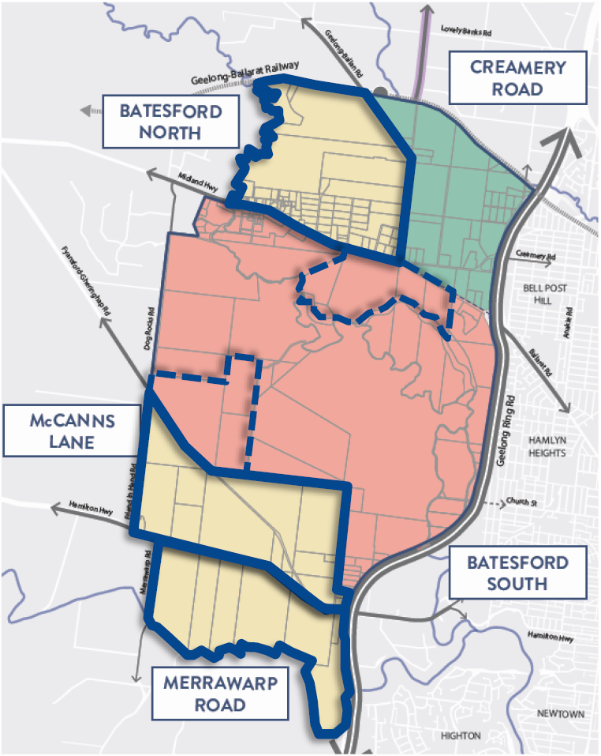
The Settlement Strategy and Planning Scheme strategies have informed the consultative process undertaken and assessment of the proposals. The outcomes of the assessment are expressed as opportunities and constraints for each PSP. Developer submissions have been considered in the assessment of each PSP.
western geelong growth areas (WGGA)
Submissions in WGGA include:
- Batesford North
- McCanns Lane
- Merrawarp Road
- Batesford South (355 – 370 Church Street and 70 & 80 Thoona Lane)
- Batesford South – as extensions to McCanns Lane and Batesford North
Before considering which PSP should come onto the program in 2023 the boundary changes sought were considered.

Boundary changes
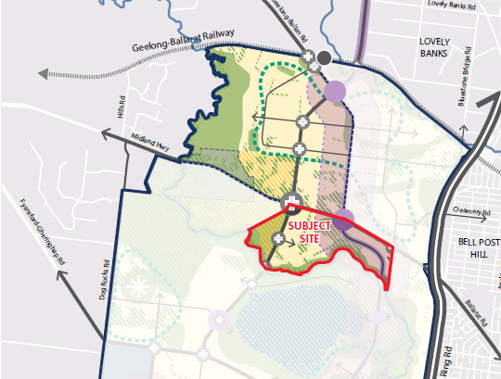
Extension of Batesford North
PSP area | 134 Ha
Yield estimate | 1,328 Dwellings
Population estimate | 3,719 Residents

OPPORTUNITIES | CONSTRAINTS
- Gentle topography that can offer diverse housing and infrastructure product.  - Create a bigger catchment for Batesford North for the provision of commercial and community infrastructure. | - Isolation of the community as it is separated from the Batesford North precinct by Midland Highway and will have no commercial or community infrastructure.  - An isolated part of the Moorabool River to be considered. A master plan of the Moorabool River in its current alignment is premature without consideration of the land to the south.  - Infrastructure design and costing for Batesford South bridges would be required. No funding secured for north south bridges.  - Will reduce the developable land in Batesford South PSP.
This extension is not supported to be included in the Batesford North PSP.

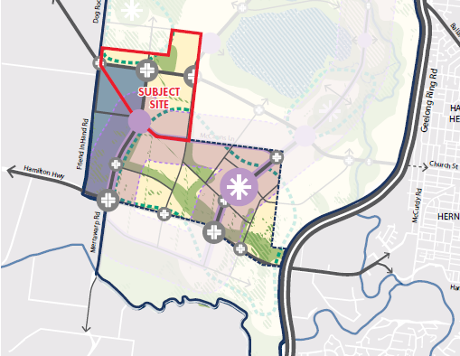
Extension to McCanns Lane
PSP area | 155 Ha
Yield estimate | 1,614 Dwellings
Population estimate | 4,519 Residents

OPPORTUNITIES | CONSTRAINTS
- Bigger catchment for the McCanns Lane PSP for commercial and community infrastructure.  - Ability to plan the employment area as one rather than two precincts.  - Can align PSP boundary with drainage catchment | - Opening of another development front that is not contiguous with earlier commenced PSP.  - Identification of the drainage asset and its catchment is required.  - Main access to the precinct is from Hamilton Highway. Work on the Church Street bridge feasibility and east west traffic solution needs a significant amount of time to progress.  - No funding pathway for the north-south and east-west arterial and public transport connections at this time.  - Will reduce the developable land in Batesford South PSP.
Upon reviewing the proposed extension, it is considered that a more logical boundary is the proposed future alignment of the arterial road in Batesford South. This will still provide the opportunity to plan the employment land as one and not impacting on the future catchment of the activity centre. At commencement of the PSP, the final boundary will be determined, having regard for drainage catchments.
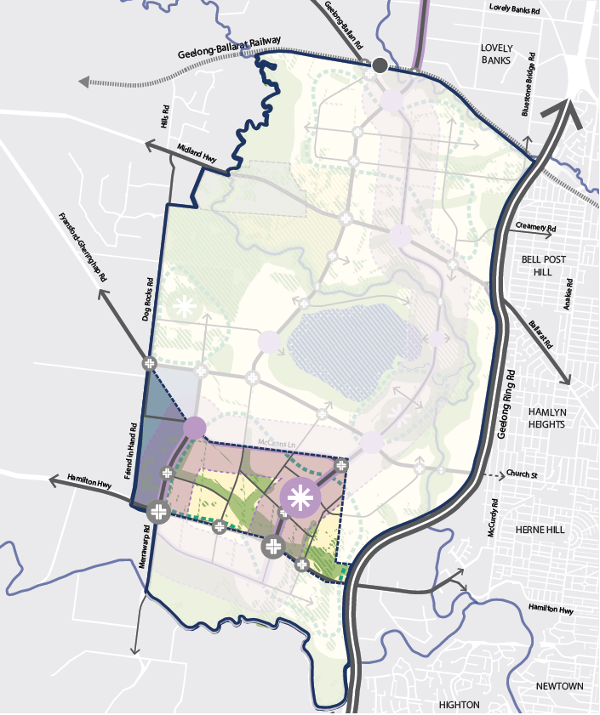
Support an amendment to the McCann’s Lane Precinct boundary generally accordance with Figure 1.

Figure 1 Amendment to McCanns Lane Precinct

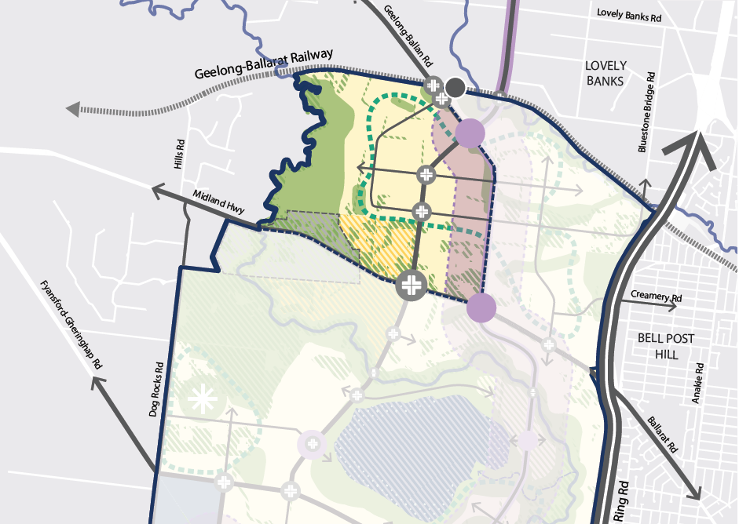
Precinct structure plans
Batesford North
PSP area | 430 Ha
Non-Developable area | 99 Ha
Non-Developable area percentage | 23%
Yield estimate | 3,799 Dwellings
Population estimate | 10,638 Residents

OPPORTUNITIES | CONSTRAINTS
- Batesford North PSP sits to the west of Creamery Road PSP that is currently underway. Development of Batesford North PSP would result in an orderly planning of the precincts heading west. Services can be continued from adjacent Creamery Road PSP.  - Batesford North presents an opportunity to extend the Clever and Creative Corridor from Creamery Road and is advantageous from an access and connectivity perspective.  - Initial planning for the duplication of the Midland Highway is underway.  - The ability to develop the Moorabool River Master Plan with Golden Plains Shire to achieve a good and consistent outcome for the communities in both areas.  - Possibility to bring a government secondary school and indoor stadium in the precinct.  - Landholders in this precinct have given commitment to deliver a master planned community with sufficient scale and are willing to explore a wide variety of innovations and sustainability measures with the City during the preparation of the precinct structure plan. | - A large area of the escarpment to the western boundary of the precinct creates some constraints in land use planning.  - No commitment for a station on the Geelong-Ballan Railway.
The precinct presents significant opportunities. This precinct is supported to be included in the PSP Program in 2023.

McCanns Lane with extension
PSP area | 460 Ha
Yield estimate | 3,668 Dwellings
Population estimate | 10,271 Residents

OPPORTUNITIES | CONSTRAINTS
- PSP includes a variety of land uses including an employment area and a sub-regional activity centre.  - Establishment of the Clever and Creative corridor in the south.  - Landholder led initial technical reports for the precinct are available.  - Landholders in this area have provided support to the Clever and Creative Vision of the City to explore innovations with the City during the preparation of the PSP. | - Opening of another development front that is not contiguous with earlier commenced PSP.  - Main access to the precinct is from Hamilton Highway. Work on the Church Street bridge feasibility and east west traffic solution needs a significant amount of time to progress.  - No funding pathway for the north-south and east-west arterial and public transport connections at this time.
This precinct is supported to be included in the PSP Program in 2025/26 subject to:
- A funding pathway for the north-south and east-west arterial and public transport connections.
- Concept design and costing for the major transport infrastructure being prepared (North south bridges and Church Street connection).

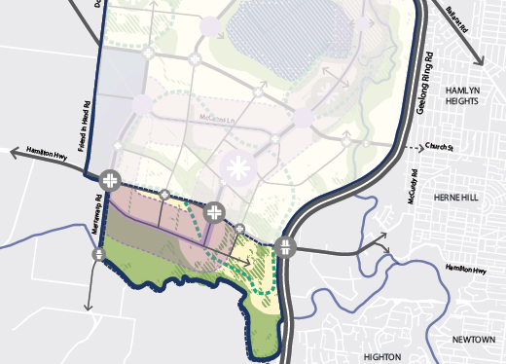
Merrawarp PSP
PSP area | 375 Ha
Non-Developable area | 194 Ha
Non-Developable area percentage | 52%
Yield estimate | 2,306 Dwellings
Population estimate | 6,456 Residents

OPPORTUNITIES | CONSTRAINTS
- Relatively small with a majority of residential land use.  - Landholders in this area are willing to explore opportunities in innovation and diversity of housing typologies with the City.  - Commencement of a master plan for the Barwon River and educational facility. | - Main access to the precinct is from Hamilton Highway. Work on the Church Street bridge feasibility and east west traffic solution needs a significant amount of time to progress.  - No funding pathway for the north-south and east-west arterial and public transport connections at this time.  - The PSP does not include commercial or community infrastructure and will need to depend on the Herne Hill and Geelong West communities until McCanns Lane is developed.  - Scale of the PSP is relatively small for commercial, educational and community infrastructure.
This precinct is supported to be included in the 2025/26 PSP Program subject to:
- A funding pathway for the north-south and east-west arterial and public transport connections.
- Concept design and costing for the major transport infrastructure being prepared (North south bridges and Church Street connection).

Other submissions

There have also been submissions for 355-370 Church Street and 70 & 80 Thoona Lane for Batesford South, which is identified as a long-term precinct. These properties are standalone and do not have any connection to the medium-term precincts in consideration. It is not recommended to include them in the PSP Program. It will be included in the planning of Batesford South.
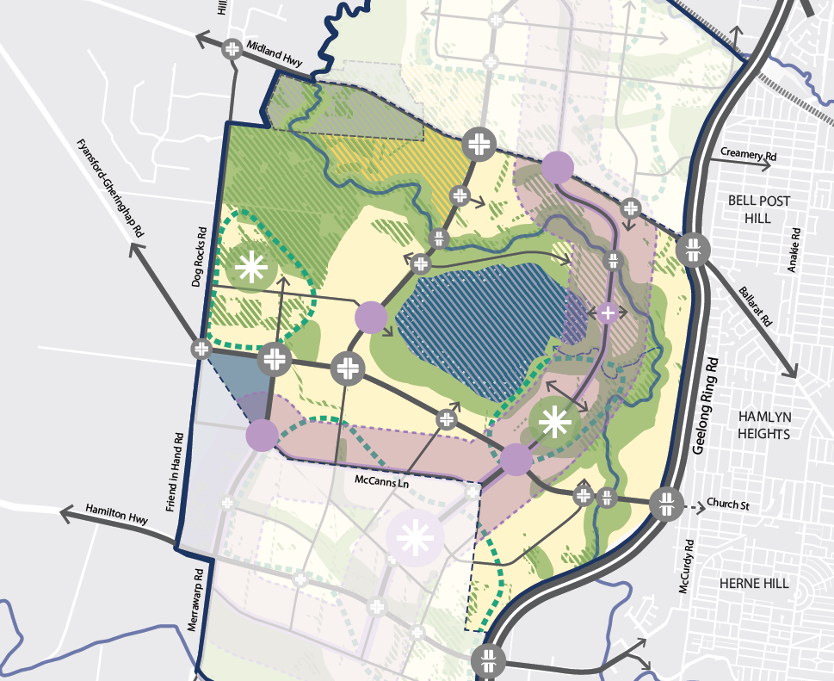

355-370 Church Street, Fyansford 70 & 80 Thoona Lane, Fyansford

Recommendations
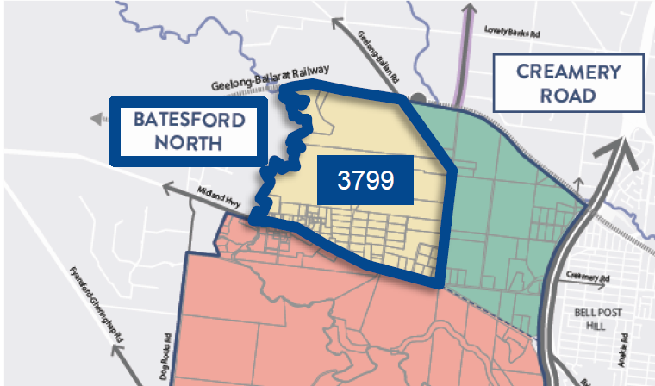
Include Batesford North in the 2023/24 Program
PSP area | 430 Ha
Non-Developable area | 99 Ha
Non-Developable area percentage | 23%
Yield estimate | 3,799 Dwellings
Population estimate | 10,638 Residents

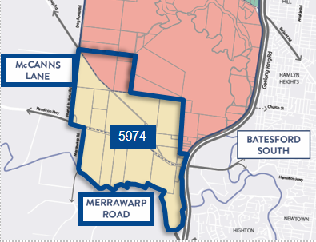
Include McCanns Lane and Merrawarp in the 2024/25 Program with an adjustment to the precinct boundary as shown in Figure 1. Commencing development in this precinct is subject to:
- A funding pathway for the north-south and east-west arterial and public transport connections.
- Concept design and costing for the major transport infrastructure being prepared (north south bridges and Church Street connection).

PSP area | 835 Ha
Non-Developable area | 272 Ha
Non-Developable area percentage | 32%
Yield estimate | 5,974 Dwellings
Population estimate | 16,727 Residents

Northern geelong growth areas (NGGA)
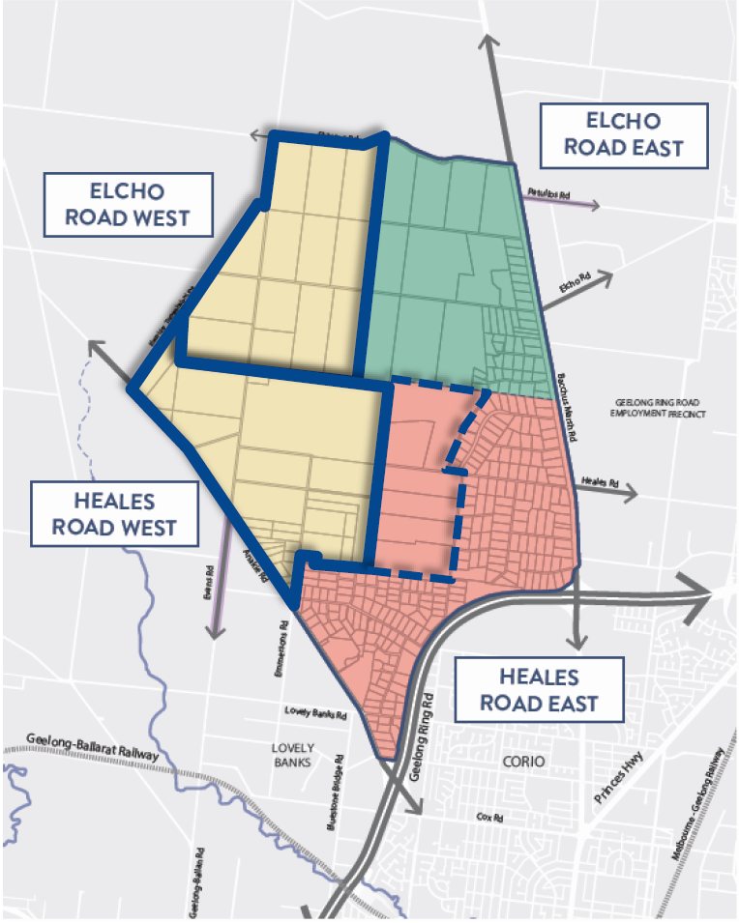
.
Submissions in NGGA include:
- Elcho Road West
- Heales Road West
- Heales Road East – 345 Bacchus Marsh Road
- Heales Road West – 980 Anakie Road
- Boundary change to Heales Road West

Boundary changes
Heales Road West
The extension to the boundary encroaching on Heales Road East has been considered and is not supported. The proposed extension is a significant decrease to the net developable area of Heales Road East. The precinct is comprised of fragmented land holdings and will likely take time to develop without an active landholder. Adjustments to the boundary will be considered to ensure a good planning outcome for the Clever and Creative Corridor and activity centre.

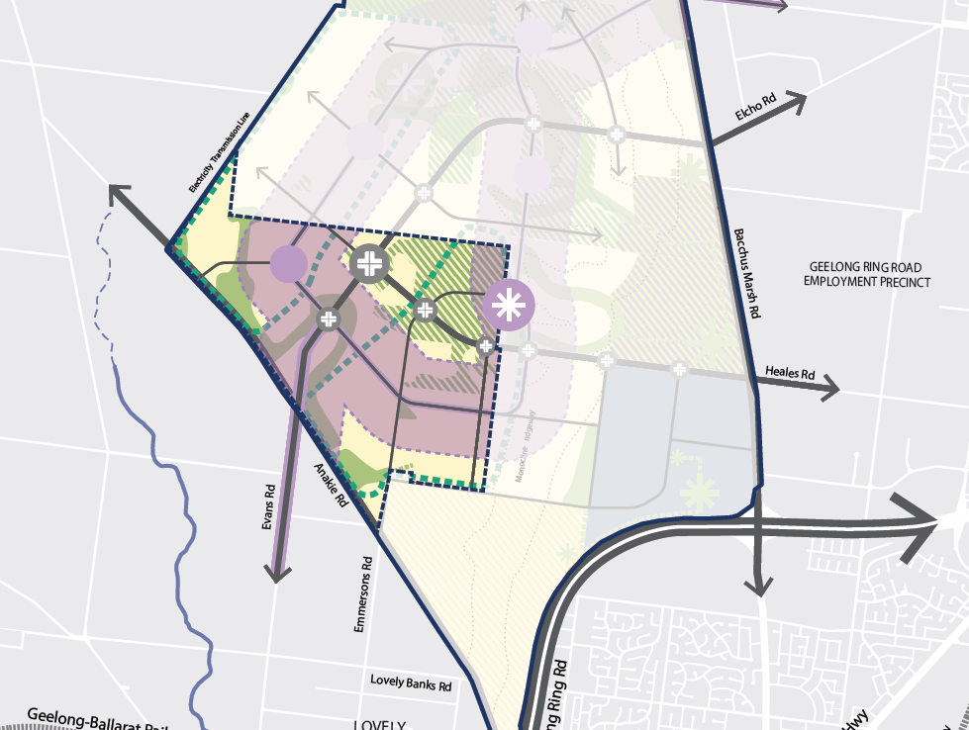
980 Anakie Road, Lovely Banks
980 Anakie Road is on the western boundary of Heales Road West and is mostly zoned Farm Zone. Proposals considered are land that is already zoned for urban growth. There will be no rezoning as part of this process.

Precinct structure plans
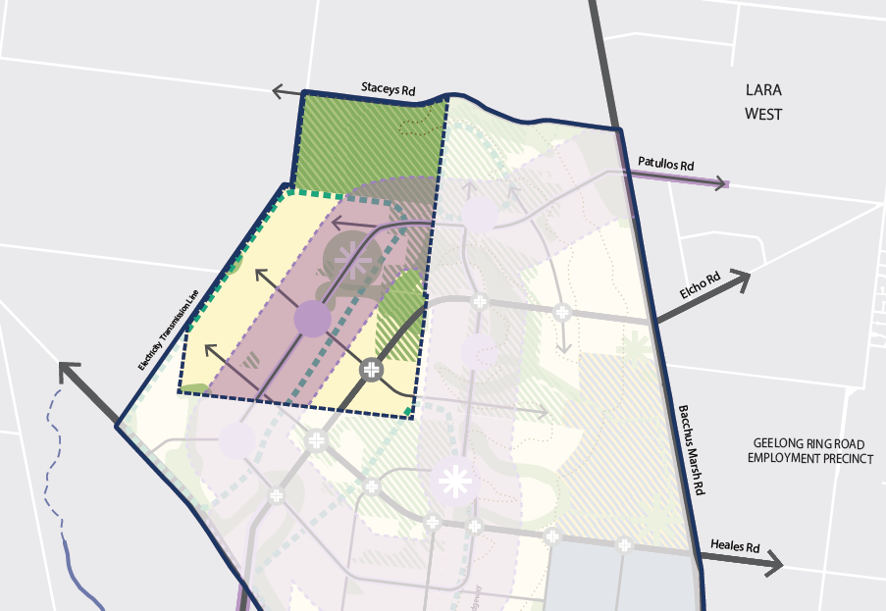
Elcho Road West
PSP area | 437 Ha
Non-Developable area | 127 Ha
Non-Developable area percentage | 29%
Yield estimate | 3,939 Dwellings
Population estimate | 11,031 Residents

OPPORTUNITIES | CONSTRAINTS
- Logical continuation of development from the Elcho Road East PSP.  - Services and infrastructure can be continued from the Elcho Road East PSP.  - Ability to deliver biodiversity outcomes for the Northern Geelong Growth Areas.  - Developers are committed to work with the City to achieve the actions in the Framework Plan. | - The Lara Energetic Materials Manufacturing Plant requires a buffer that covers part of the PSP.  - Upgraded intersections will be to the east rather than west on Anakie Road, may lead to increase use of Anakie Road ahead of upgrades.
The precinct presents significant opportunities. This precinct is supported to be included in the PSP Program in 2023.

Heales Road West
PSP area | 467 Ha
Non-Developable area | 61 Ha
Non-Developable area percentage | 13%
Yield estimate | 5,174 Dwellings
Population estimate | 14,488 Residents

OPPORTUNITIES | CONSTRAINTS
- Significant scale and size precinct.  - Can create access from Elcho Road East and Heales Road West through to Anakie Road.  - Developers are committed to work with the City to achieve the actions in the Framework Plan. | - Not connected to Elcho Road East which can potentially provide community and commercial services support.  - No connection to the Clever and Creative Corridor from Elcho Road East PSP.
This precinct is not supported to be included in the PSP Program in 2023 on its own.

Other submissions

345 Bacchus Marsh Road is in Heales Road East which is a long-term precinct. These properties are standalone and do not have any connection to the medium-term precincts in consideration. It is not recommended to include them in the PSP Program. It will be included in the planning of Heales Road West.

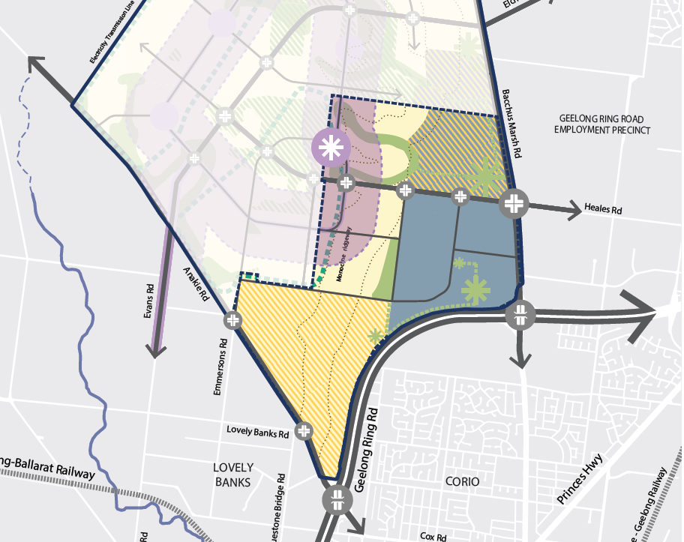
345 Bacchus Marsh Road, Lara
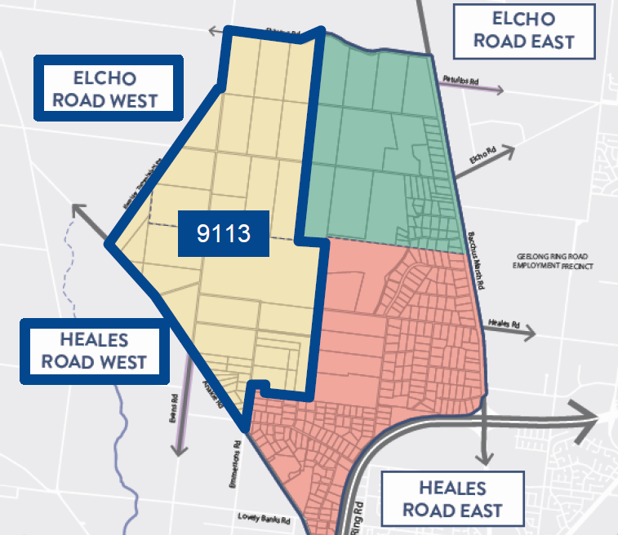
Recommendation
Include Elcho Road West and Heales Road West as a single PSP in the PSP Program 2023
PSP area | 904 Ha
Non-Developable area | 188 Ha
Non-Developable area percentage | 21%
Yield estimate | 9,113 Dwellings
Population estimate | 25,519 Residents

In addition to the opportunities and constraints identified above combining these PSPs delivers:
- Optimises the PSP preparation process, efficiently manage the funding and delivery of key infrastructure by means of having common large landholders across both PSPs.
- Ability to deliver biodiversity outcomes for both precincts.
- Catchment increases to 9,113 dwellings which will allow for more community infrastructure, transport infrastructure and commercial services.
- Land supply target to be achieved by 2025 with combined precincts anticipated dwellings to become 9,113.
- Ability to develop integrated and contiguous communities.
- Developers are committed to work with the City to achieve the actions in the Framework Plan.
A combined PSP delivers a larger PSP and additional development fronts than anticipated by the Framework Plan. The PSP preparation process will ensure that the appropriate timing and staging is addressed. The larger PSP is comparable to other PSPs delivered across the state.

Moolap Coastal Framework
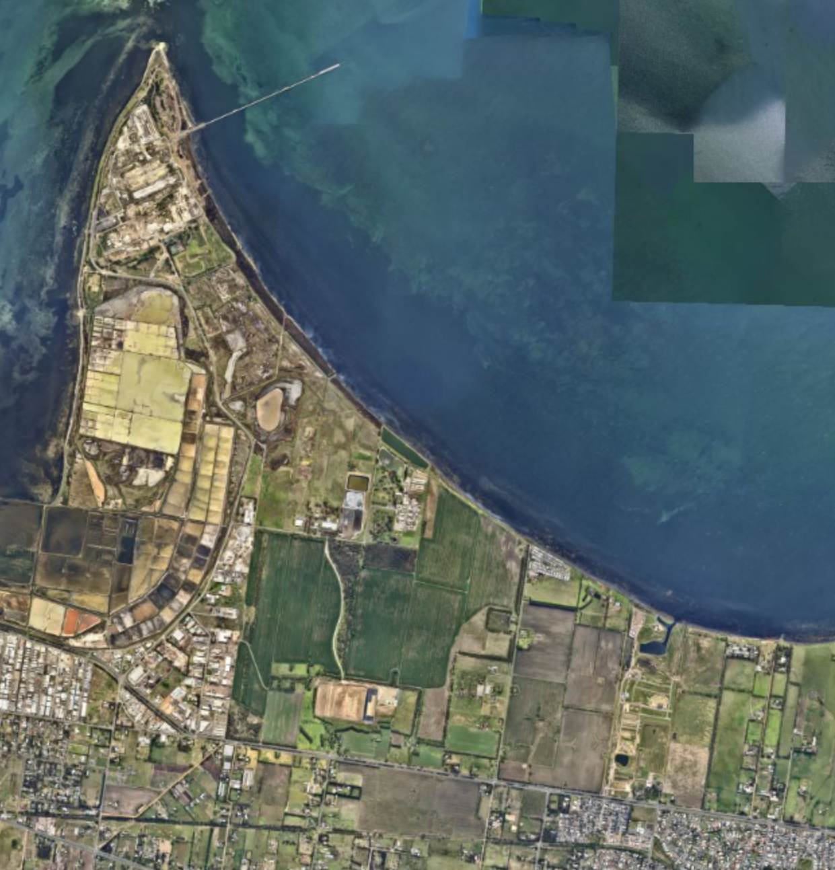
Dow Chemicals Site and a 2km buffer around it.
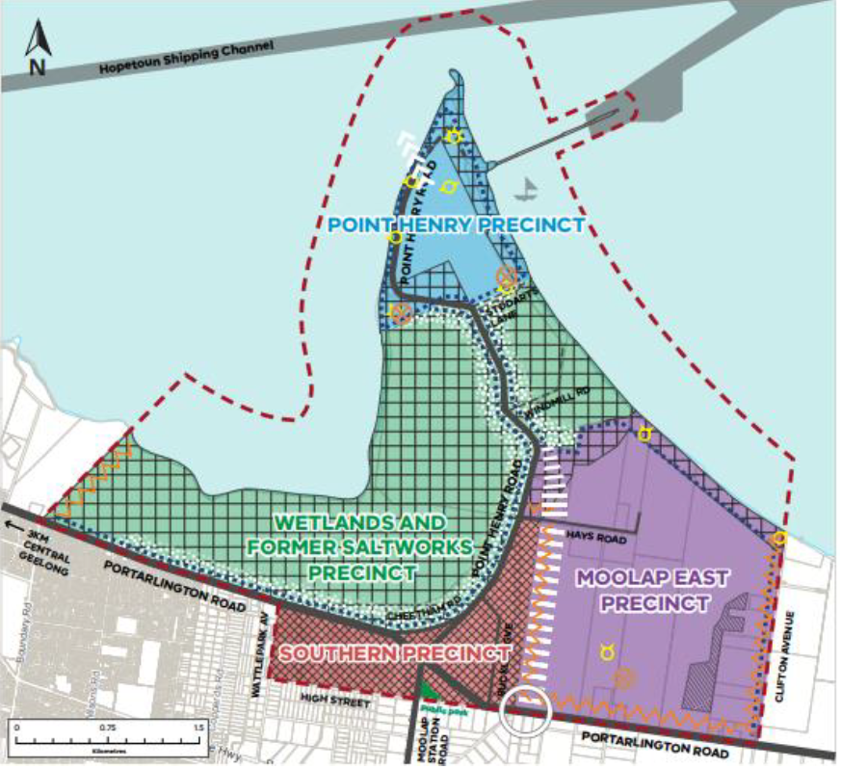
The residential areas nominated within the Moolap Coastal Strategic Framework Plan is in the Point Henry Precinct and the Moolap East Precinct. Although this area has a unique location and the landholders are more than willing to facilitate development, there is still the requirement of a 2km buffer from Dow Chemicals that will prohibit the full development of the area. As shown in the map above, at this point only the area outside the buffer can be developed as residential and will not contribute significantly to Geelong’s land supply.

This precinct is not recommended to be included in the PSP Program at this time.

Agency Consultation
The City consulted with relevant government agencies through the process. These include DELWP, VPA, Barwon Water, DoT, CCMA and Golden Plains Shire Council. All agencies are largely supportive of our recommendations. VPA and DoT have not provided written advice but discussions have been had as part of the consultation. Golden Plains Shire and CCMA are supportive as they are looking to prioritise the Moorabool River master plan work.
A few key concerns raised by them are listed below.
- DoT – forward planning for transport infrastructure.
- Barwon Water – PSP Program is in line with servicing timing.
- CCMA – resourcing and strategic timeline implications and the impact on the Moorabool River. The timing of the Batesford North PSP scheduled to begin in June 2023 will come after the development of the Kitjarra-dja-bul Bullarto langi-ut Master Plan and likely after the master plan for the Moorabool River Reserve at Batesford. Engagement will be required during the Batesford North PSP planning.

Third Party Funding Agreements
These PSPs to be funded by third party agreements with landholders to include technical reports, resourcing, amendment fees, advisory committee fees, preparation of the PSP and DCP and legal expenses.
role of the city in preparation of the PSPs
The City is currently delivering three PSPs: Creamery Road, Elcho Road East and Marshall PSP. The City has the opportunity to provide detailed guidance for the design and development of Geelong’s new neighbourhoods.
The NWGGA Framework Plan actions include new elements in a PSP that have not been tested in any other PSP including those that the VPA prepared. Some of these are: zero carbon development, social housing contributions and the Clever and Creative Corridor. The City has also embarked on growth area scale strategies that will be implemented via the PSPs in NWGGA including an Integrated Management Plan, Geelong Growth Areas Transport Infrastructure Strategy and Part 10 approvals with a Strategic Impact Assessment and Plan. All of these strategies are in response to the adopted NWGGA Framework Plan actions.
As the City progresses with the Creamery Road and Elcho Road East PSPs, the City has built a team with significant local knowledge and experience to lead the planning of the growth areas. Officers are also working with the VPA in delivering the first two PSPs and will continue to do so for the PSPs to follow. It is important that the City maintains its leadership role, knowledge base and the ability to engage with Councillors and stakeholders at an early stage of the delivery of a PSP.
On 28 October 2022, the Hon Lizzie Blandthorn MP, Minister for Planning, advised the City of her support for the council’s request for a streamlined planning approval pathway for the implementation of the NWGGA Framework Plan, including the appointment of a NWGGA Standing Advisory Committee to assist in the consideration of proposed draft planning scheme amendments, proposed draft PSPs, public submissions, and other referred related planning matters. This streamlined planning process involves the Minister for Planning undertaking the formal ‘Planning Authority’ role to prepare, adopt and approve the final planning scheme amendments and PSPs. However, the City maintains overall responsibility in the initial preparation of the PSPs, and the coordinated delivery of PSPs.

summary of recommendations
The proposals have been assessed against the criteria in the Settlement Strategy and planning scheme. It was also important to look at the nuances of each precinct and include the consideration of more specific elements such as movement and access, catchments for infrastructure and the ability to deliver land supply in a timely manner.
To achieve at least 10 years land supply, more than one PSP was considered to commence in 2023. This can be achieved by commencing Batesford North, Elcho Road West and Heales Road West which will deliver approximately 12,900 dwellings. Batesford North is the logical next PSP in the Western Growth Area and there are efficiencies in planning Elcho Road West and Heales Road West as one.
The McCanns Lane PSP with a change to the boundary and Merrawarp should commence in 2025. This will allow two years to resolve the funding pathway for the north-south and east-west arterial and public transport connections as well as the concept design and costing for the north south bridges and Church Street connection.
PSP Program 2023/24
PSP | Biodiversity Survey | Commencement of PSP | PSP Approved
Batesford North  Elcho Road West  Heales Road West | Completed | Mid-2023 | Mid-2026
PSP Program 2025/26
PSP | Biodiversity Survey | Commencement of PSP | PSP Approved
McCanns Lane (with extension)  Merrawarp | Spring 2024 | Mid-2025 | Mid-2028

