

South West Employment Land Review

Prepared for City of Greater Geelong

Draft report (confidential):
December 2022



Contents

  - Introduction 4
  - Context and Purpose 4
  - Scope and Land Uses 4
  - Report Structure 5
  - Study Area in Context 6
  - Major Employment Precincts in Geelong 6
  - Transport Context 9
  - Transport 9
  - Roads 9
  - Rail 9
  - Bus 11
  - Ports 11
  - Airports 12
  - Study Area Linkages 12
  - Policy and Research Context 13
  - Overview 13
  - G21 Regional Growth Plan 13
  - Greater Geelong Planning Scheme 14
  - Research Reports 16
  - Economic Context 17
  - Economic Context Themes 17
  - Population and Dwellings 19
  - Industry Structure Trends 21
  - Unemployment 23
  - Market Research 25
  - Overview 25
  - Market Context 25
  - Investment Activity 26
  - Sales Transactions Overview 38
  - Employment Land Supply and Demand 40
  - Overview 40
  - Supply Analysis 40
  - Substitutability and Specialisation 42
  - Need in South West Geelong 42
  - Overview of Need and Timing 44
  - Estimated Job Generation 45
  - Views of Stakeholders 46
  - Overview 46
  - Stakeholder Views 46
  - Documents Relating To South West Geelong Precincts 50
  - Waurn Ponds Strategic Extractive Resource Assessment 54
  - Study Area Precincts 56
  - Overview 56
  - Major Transport Linkages 56
  - 2026 Commonwealth Game 56
  - Extractive Industry at Boral Land 56
  - Precinct Features 57
  - Options for Consideration 60
  - Recap of Need and Timing 60
  - Potential Investigation Area and Development Cells 60
  - Employment Land Options for Consideration 61
  - Recommendations 69
Appendix A: Sales Data 71
Appendix B: Employment Precinct Profiles 80



INTRODUCTION

Context and Purpose
The City of Greater Geelong accommodates a significant amount of land zoned for employment uses (defined here as industrial and related commercial zones). South west Geelong - which includes the suburbs of Armstrong Creek, Waurn Ponds and Marshall - has existing industrial zoned land at Marshall (called North East Industrial Precinct) and a future employment precinct called Western Industrial Precinct. The area to the west of Armstrong Creek (Boral land) accommodates an extractive industry area which has recently ceased mining and is being considered for mixed-use employment development by the land owner.
The primary land owner of the proposed Western Industrial Precinct is seeking diversification of land use including residential and accommodation uses and non-industrial commercial uses.
Boral also proposes a change to land use on some of its land holdings from extractive industry to a mix of employment, residential and tourism uses.
In this context, the City of Greater Geelong commissioned this report to provide information on the state of the employment land sector in south west Geelong so as to inform land use planning decisions for the area. A specific focus is to review employment land requirements for:
    - Boral quarry site (Boral land), which is 1,030 hectares (ha) of Special use Zone 7 (SUZ7) land for Earth and Energy Resources Industry (this allows industrial uses, leisure and recreation and place of assembly activities)
    - Armstrong Creek Western Industrial Precinct (WIP), which is a proposed 140 ha industrial area nominated for general and local industrial uses targeting 7,350 jobs.
This review considers those precincts in the context of the overall property market and seeks to identify options for amount of land needed by type over a nominal 20+ year period having regard to potential business type by sub-area and associated lot size guidance and urban design guidance in terms of road hierarchy, layout and other transport connections. The review takes into account attributes of land including topography, transport linkages and potential buffer requirements.

Scope and Land Uses
The focus of this study is employment land in south west Geelong (urban area) and land that is predominantly used for industrial or commercial uses but not focusing on activity centres. The primary zones within the scope of the report are:
    - Industrial 1, 2 and 3 zones (generally for manufacturing, logistics, service industry and associated commercial uses)

    - Commercial 2 zone (generally for office, industry and large format retail)
    - Special use zones that have an employment role.
Figure 1: Employment Land Focus Area - Boral And WIP Sites
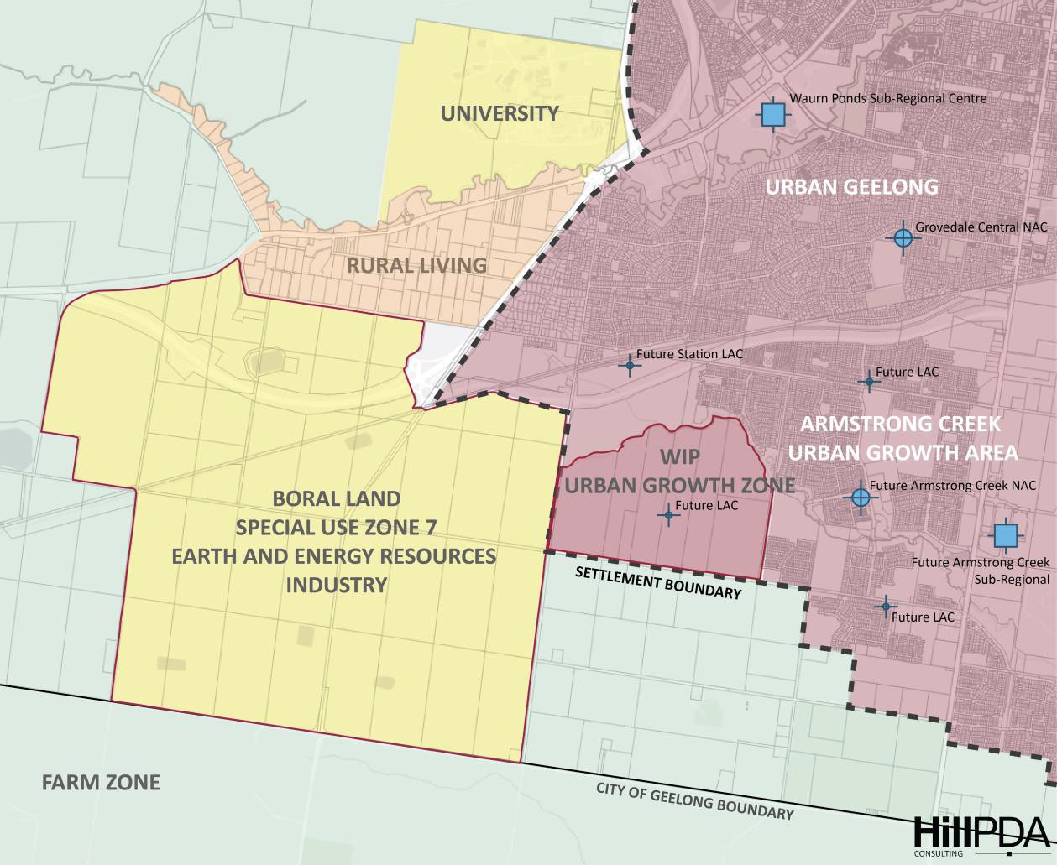

Report Structure
This report is structured as follows.
    - Section 2: Study area in context
    - Section 3: Transport context
    - Section 4: Policy and research context
    - Section 5: Economic context
    - Section 6: Market research
    - Section 7: Employment land supply and demand
    - Section 8: Views of stakeholders
    - Section 9: Study area precincts
    - Section 10: Options for consideration.

STUDY AREA IN CONTEXT

Major Employment Precincts in Geelong

Geelong has a number of diverse employment precincts (existing and planned). The following figure and table provide an overview of employment land in Geelong.
Figure 2: Strategic Context
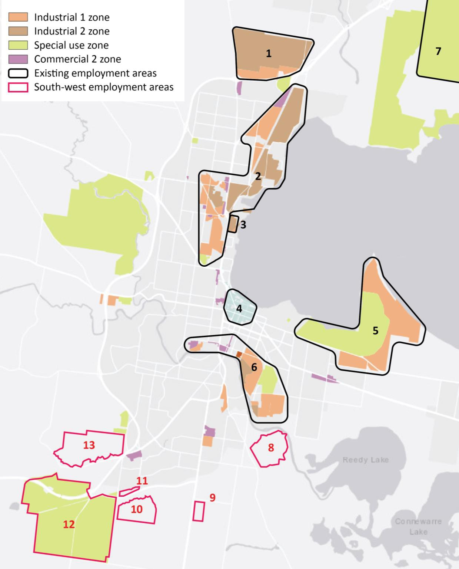

Table 1: List of Major Employment Precincts in Geelong

ID | Precinct name | Key land uses
1 | Geelong Ring Road Employment Precinct (GREP) (Corio / Lara) | A large proportion of the GREP is for heavier industry uses (Industrial 2 Zone) that require substantial amenity buffers for safe operations. The remaining area provides for manufacturing, storage and goods distribution land uses (Industrial 1 Zone).  491 ha of gross land area (approx.) for industrial and related business uses.
2 | Geelong North/Geelong Port | Logistics, manufacturing, storage and distribution of goods requiring access to key export markets. Also includes population/ servicing industrial activities in Geelong North.  According to data on geelongport.com.au, GeelongPort is a major driver of Victoria’s economy, managing over $7 billion of trade and supporting more than 1,800 jobs across the state. As  Victoria’s second largest port, GeelongPort handles close to 12 million tonnes of cargo and more than 600 vessel visits each year.  778 ha of gross land area (approx.) for industrial and related business uses. Total site is 1,755 ha gross.
3 | Pivot City Innovation Precinct (North Geelong) | Technology precinct of approximately 30 hectares within which an 11 hectare site is called Pivot City, which accommodates 50,000 sqm of workspaces for over 50 organisations with more than 1,000 on-site employees (pivotcity.com.au).  30 ha of gross land area (approx.) for industrial and related commercial uses.
4 | Central Geelong | The primary activity centre for the region. Primary retail, hospitality, commercial, civic, community services and cultural centre. Includes a key education and study precinct (Deakin University Waterfront Campus, the Gordon TAFE City Campus and Geelong Tech School) and the region’s major University Hospital and St John of God Hospital.  354 ha of gross land area (approx.) for CBD uses.
5 | Moolap Industrial Area | Population-servicing industrial uses with saltworks and decommissioned refinery along the bay. Also includes the Alcoa/Point Henry land which is identified for rezoning and redevelopment as outlined under the Moolap Coastal Strategic Framework Plan.  399 ha of gross land area (approx.) for industrial and related commercial uses.
6 | South Geelong/Breakwater | Mixed employment precinct with a focus on population-servicing industrial uses.  246 ha of gross land area (approx.) for industrial and related commercial uses.

ID | Precinct name | Key land uses
7 | Avalon Employment Precinct | Planned to be developed into a freight hub and business park. Designed to support Geelong and western Melbourne logistics functions as part of the draft Avalon Corridor Strategy. The draft strategy establishes a high-level framework plan to guide land use decision making in the Avalon Corridor, such as the location and extent of future development.  780 ha of gross land area (approx.) for proposed industrial and related commercial uses.
8 | North East Industrial Precinct (Armstrong Creek) | One of the two designated employment precincts within the Armstrong Creek Growth Area. Designated as a local precinct serving primarily future residents in southern Geelong and Armstrong Creek.  The Precinct Structure Plan was approved in 2010 although development yet to commence.  95 ha of gross land area (approx.) for industrial and related commercial uses.
9 | Armstrong Creek Town Centre | Major Activity Centre of Armstrong Creek Growth Area, likely to accommodate a sub-regional retail centre and associated office and community uses.  93 ha of gross land area (approx.) for planned major activity centre.
10 | Western Industrial Precinct (WIP) | Land subject to review in this report. Designated as an employment precinct within Armstrong Creek. The precinct structure planning process has not commenced.  158 ha of gross land area (approx.) for planned industrial and related commercial uses. Note: in some documents this is quoted as 140 ha of gross land area (approx.).
11 | Waurn Ponds Train Station Precinct | Planned for transit oriented development with a small retail/commercial node and a variety of residential uses. The precinct structure planning process has commenced but is not complete.  Proposed small-scale activity centre within residential development.
12 | Boral site | Land subject to review in this report. Former quarry site is being remediated and owner has proposed a mixed use employment precinct within parts of the land.  1,040 ha of gross land area (approx.) with concept for an industrial and related commercial precinct on part of the site.
13 | Geelong Future Economy Precinct (Waurn Ponds) | The Geelong Future Economy Precinct is an innovation precinct aimed at commercialising research through public and private partnerships.  Part of 543 ha university campus.

TRANSPORT CONTEXT

Transport
The City of Greater Geelong has strong links with Victoria’s wider transport networks and it is a major Victorian transport hub (see figure below). The Integrated Comprehensive Transport Plan (2015) provided a high level summary of the City of Greater Geelong transport network.

Roads
Geelong’s main road link to the wider region is the Princes Freeway (M1), which links the Geelong road network to Melbourne and western Victoria. Many of the region’s highways converge in Geelong, including:
    - Princes Highway
    - Geelong-Bacchus Marsh Road
    - Midland Highway
    - Hamilton Highway
    - Surf Coast Highway
    - Bellarine Highway.
All these regional level highways link with the M1 (Geelong Ring Road), providing through access to Melbourne. Geelong is also the gateway to the Great Ocean Road.
The G21 Regional Growth Plan identifies a number of matters for review:
    - Increasing congestion on the M1 corridor arising from continued urban growth is a constraint on travel between Geelong and Melbourne, especially during peak periods.
    - Growth to the south of Geelong and on the Bellarine Peninsula will increase pressure on the existing road network in these areas.
    - East-west routes containing freight traffic within the Geelong CBD are in conflict with high pedestrian volumes.
    - The rural road network plays an important role in the region’s economy, providing links
between the farm gate and market.

Rail
Geelong is linked by passenger rail to Melbourne and Warrnambool.
Passenger services are provided by V/Line trains through the municipality’s eight stations.
Geelong also lies on the standard gauge network providing the main rail link between Melbourne and South Australia, Western Australia and the Northern Territory, with additional links to the Mallee grain lines. This rail link is used mostly by freight services, although it also carries some passenger services linking from Melbourne to Adelaide.

Figure 3: Transport Network
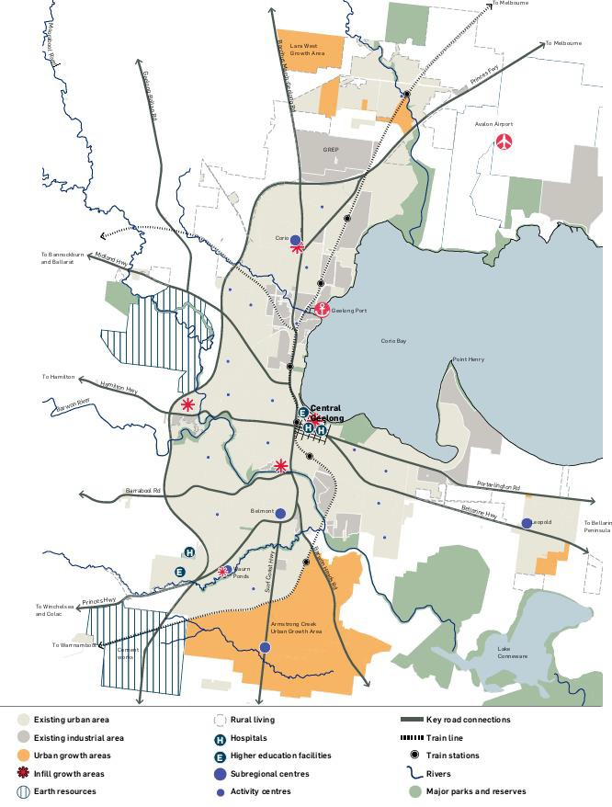
Source: G21 Regional Growth Plan

The G21 Regional Growth Plan states that there are gaps in the broad and standard gauge freight network, limited peak passenger rail services to Melbourne, capacity issues within the Geelong-Armstrong creek corridor (with a single line tunnel and stabling yard location) and issues with the extent of bus network coverage and its frequency.
The rail line to Waurn Ponds Station is currently being duplicated, which will increase service capacity. The state government states that South Geelong to Waurn Ponds Duplication project is underway to enable more services and improved reliability on the Geelong Line. The project will deliver the critical upgrades needed between South Geelong and Waurn Ponds to enable five train services per hour during the peaks and three per hour between the peaks for Marshall and Waurn Ponds stations¹.
The Regional Rail Link project, along with the investigation of a rail connection to Avalon Airport, will enable significant network improvements, support growth and drive economic activity. Further opportunities could be explored for the rail revival of passenger services to Ballarat and stabling yard relocation to support growth.

Bus
Timetabled local bus services provide 1,198 services each weekday across 30 routes operating throughout the City of Greater Geelong metropolitan region and the Bellarine Peninsula.
The majority of bus routes provide access to the central area of Geelong terminating at the Moorabool Street bus interchange, with some providing links between towns within the region. The Moorabool Street bus interchange operates as a CBD terminus for Geelong bus routes and also provides for transfer opportunities between these bus routes.
The bus interchange at Geelong Railway Station provides a transfer opportunity between Geelong town bus routes and regional V/Line coach and train services.
The 2022/23 Victorian State Budget provided funding for service uplifts for bus routes in the growth areas of Torquay and Armstrong Creek. The state government is looking to upgrade the local bus network to connect growth areas in Torquay and Armstrong Creek to key destinations including to rail services and to Geelong².

Ports
The City of Greater Geelong is home to Victoria’s second largest port, after the Port of Melbourne. The Geelong Port mainly exports raw materials including petroleum products, bulk grain and woodchips. The Port handles around 12 million tonnes of cargo and more than 600 vessel visits each year. The Port operates over 90 hectares of land and comprising of 15 berths over two primary precincts, Corio Quay and Lascelles.

¹ bigbuild.vic.gov.au/projects/geelong-line-upgrade/projects/geelong-line-duplication
² engage.vic.gov.au/ArmstrongCreekandTorquay

Geelong became the Victorian port for the Spirit of Tasmania ferry service in 2022, at Spirit of Tasmania Quay.

Airports
Avalon Airport is a commercial aviation aerodrome situated on 1,753 hectares, 15 kilometres north east of Geelong. The airport provides domestic passenger and freight services.
The Avalon Airport Master Plan (2015) provides direction for the future development of the airport and sets out the development objectives for the airport, together with concepts for individual precincts. The timing and form of development will be influenced by a multitude of factors. The masterplan includes the following:
    - The expansion of the existing domestic terminal to accommodate international operations (up to 10,000 square metres)
    - The provision to construct a new international terminal
    - The establishment of airfreight terminals
    - The provision to lengthen the existing runway to up to 4,000 metres
    - The development of residential hotels
    - The development of the site to accommodate retail, commercial and industrial uses
    - The continuation of the Australian International Airshow until at least 2025
    - The reservation of the rail reservation both and provision for the establishment of a rail
    - The provision for recreational and sporting facilities.
A dedicated airfreight facility is planned near the Eastern Apron to facilitate the transfer of freight to and from the road and any future rail network.
Victoria - The Freight State: The Victorian Freight and Logistics Plan acknowledges Avalon Airport as having the potential to become the preferred gateway for freight into Victoria due to its “excellent land transport connections, land availability and accessibility for high value regional produce exports to the Asian markets.”

Study Area Linkages
Boral land is adjacent to and traversed by three major regional transport linkages: Geelong Ring Road, Princes Highway and the rail line (see Figure 3 above).
The Western Industrial Precinct is accessed by the secondary road network and has no direct interface with major regional transport linkages.

POLICY AND RESEARCH CONTEXT

Overview
This section provides a summary of policy and research documents that are of relevance to employment land in the south west Geelong.

G21 Regional Growth Plan
The G21 Regional Growth Plan provides a strategic planning framework for the Greater Geelong region. The G21 Regional Growth Plan covers the municipalities of City of Greater Geelong, Colac Otway Shire, Surf Coast Shire, Borough of Queenscliffe and the southern portion of Golden Plains Shire.
The vision for the G21 region is as Australia’s most desirable destination for living, visiting, working and investing and being renowned for its vibrant cohesive community, exceptional physical environment and vigorous economy. Principles to achieve the vision are:
    - Optimise infrastructure and consolidate
    - Diversity, knowledge and innovation
    - Unique and connected communities
    - Protect, restore and enhance our unique environment
    - Food, water and energy security
    - Live, work and participate locally
    - Build our economy
    - Accessible transport choices
    - Balanced, consistent and collaborative approach.
To build the G21 region’s economy, a broad range of employment options will support the
development of a resilient and robust economy.
Economic and employment growth in the region is expected to focus on existing core infrastructure strengths and vocational opportunities, including the following sectors:
    - Education, research and health with a focus on Deakin University and primary health providers
    - Services, freight and logistics based around Geelong Port, Avalon Airport and the Geelong Ring Road Employment Precinct
    - Agriculture and food processing
    - Advanced manufacturing
    - Tourism
    - The emerging low carbon/sustainability sector.

Future directions and initiatives include:
    - Strengthen and protect existing and planned employment areas including tourism precincts and district town activity centres
    - Identify new employment nodes, including a new Education, Health and Research Hub at Deakin University, a long term potential employment hub at Waurn Ponds South
(subject to further investigation). The Blue Circle, Waurn Ponds employment node (Boral) is identified as a long-term investigation area.
Industrial land supply information indicates that the majority of the G21 region’s industrial land stocks are located in Geelong. There are a variety of existing zoned industrial precincts and a significant future (unzoned) industrial supply identified to meet future needs. Within urban Geelong, existing and planned supply levels are healthy for the medium to longer term.
Across the G21 region, approximately 77% of vacant industrial land has historically been consumed in the City of Greater Geelong.
A significant proportion of Greater Geelong’s vacant supply lies in fringe developing precincts
including Heales Road and Armstrong Creek.
There is a need to avoid oversupply of active growth fronts so as not to adversely impact economies of scale.
Land supply should be regularly monitored to respond to changes in population and housing growth.
A new Education, Health and Research Hub at Deakin University and a long-term potential employment hub at the Boral site are subject to further investigation.

Greater Geelong Planning Scheme
The Greater Geelong Planning Scheme and incorporated documents include the following directions of relevance to this report.
Armstrong Creek:
    - The economic plan is to create an economic and employment structure that complements the broader Geelong region while providing employment areas, business opportunities and local jobs.
    - The overall concept is for an economic plan that strives to deliver one job for every household in a range of activity centres, employment areas and within residential areas.

    - The indicative job mix was envisaged as follows:
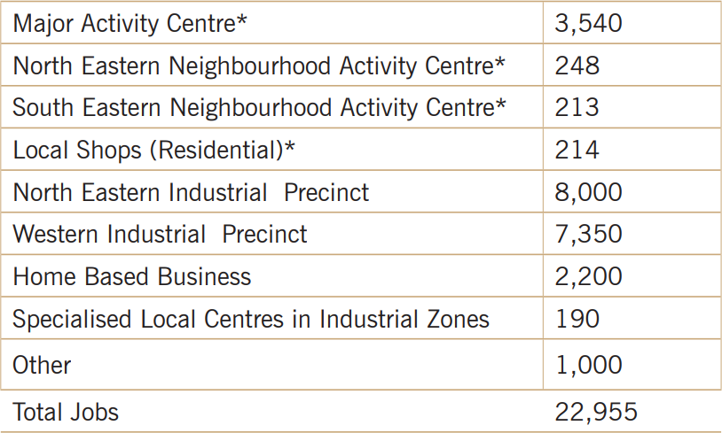
Western Industrial Precinct (WIP):
    - The plan identifies the WIP as a key future employment area for Geelong. It is expected to be developed across 140 hectares and host approximately 7,350 jobs. The job mix is
anticipated to primarily comprise managerial, professional, technical, trades, transport and labouring jobs.
North East Industrial Precinct (NEIP):
    - The primary role of the NEIP is to be the home of businesses that serve the regional population and business base with light industry and trade supplies. This area can expect
to hold approximately 8,000 jobs. The proposed job mix will be focused on technical, trades, transport and labouring jobs.
Boral land:
    - The Boral site is zoned Special Use Zone Schedule 7 ‘earth and energy resources industry’.
The objectives of the zone are:
      - To recognise or provide for the use and development of land for earth and energy resources industry.
      - To encourage interim use of the land compatible with the use and development of nearby land.
      - To encourage land management practice and rehabilitation that minimises adverse impact on the use and development of nearby land.
    - The range of uses permitted on the Boral site includes some employment uses, however some intensive uses may require an amendment to the planning scheme.

Research Reports
Geelong Economic Profile (Informed Decisions for City of Greater Geelong, 2021)
This is an economic development advisory report that provides a high-level statement that employment floorspace in Geelong should increase as population growth continues.
The report found that over last decade, Greater Geelong experienced a significant increase in service sector jobs, especially in Geelong CBD. This trend is potentially likely to continue into the future and will require more commercial floorspace that meets modern amenity demands to accommodate the increasing service jobs.
Industrial Land Supply Report (City of Greater Geelong, 2018)
This report provides an update to 2015 land supply estimates. The report used the land consumption method to identify future demand. The report states:
    - In total, there is approximately 21 years industrial zoned land across the municipality of Greater Geelong based on the average annual rate of land consumption in the period 2015 to 2018 excluding Avalon SUZ and the Western Employment Precinct. In terms of
future (unzoned) industrial land stocks it is estimated that there is 7 years of additional supply.
    - There is a current shortfall of industrial land to meet local servicing requirements in Lara and Ocean Grove. There are planned employment precincts in both of these areas but they are currently not available to the market, leading to a shortage of immediate supply.
    - In order to meet ongoing demand, additional land supply is proposed for northern Geelong and south west Geelong.
    - A confirmed plan for employment generating uses is required for the south west Geelong region having regard to Deakin University, Armstrong Creek precincts and Boral land.
Armstrong Creek Growth Area – Employment Forecast Review Final Report (SGS Economics and Planning for City of Greater Geelong, July 2018)
The purpose of the report was to undertake an employment forecast review for the Armstrong Creek Growth Area and to articulate the assumptions that underpinned the employment forecasts for the plan in 2008, and to update these assumptions and recommendations.
The report found that the amount of land allocated for long term employment in the WIP is
‘about right’ with an estimated 180 ha required to accommodate 9,100 jobs over time.
The SGS report utilises a metropolitan Melbourne-based set of ratios to inform employment area jobs and projections. The types of employment uses are nominated as local, district-level activities and strategic economic activities. The report provides a recommendation that a further review of the employment land should be conducted in 10 years’ time.

ECONOMIC CONTEXT

Economic Context Themes
This section provides a summary of the key factors influencing the development of employment land in Victoria and Greater Geelong. These trends are incrementally shifting the type and amount of zoned employment land required and changing how existing employment land is used.
Within this context, the City of Greater Geelong seeks to expand the services, knowledge, innovation and advanced manufacturing sectors of the economy. This aligns with a long term structural shift in the economy away from traditional heavy industry to a more diversified services and knowledge based economy.



Globalisation and the free movement of people, goods and services has increased competition and has resulted in a decline in the proportion of jobs within manufacturing in Australia. | The introduction of automated technology is reducing job density of employment land and creating the need for upskilling of the workforce. | Sectors involved in logistics such as transport, storage and wholesale trade have become significant drivers of industrial land demand. These sectors tend to have low employment densities.
Manufacturing growth has been focused in advanced manufacturing, where use of new technologies support competitive production.  Growth sectors may include those that draw on domestic advantages like agricultural and mineral goods and environmental attributes. | Many high tech modern industrial sectors are low- impact and compatible with other employment generating uses, including large-format retailing and standalone office. Some required dedicated and specialises buildings and precincts. | The proximity of employment precincts to key transport routes has emerged as a key priority for industrial occupiers. This stems from transport costs typically comprising a large share of operational cost, compared to rental cost.



Health care and social assistance are among Geelong’s biggest and  fastest growing sectors. The Central Geelong Medical Health Cluster is the spatial focus for this sector.  As an example, Epworth Geelong has grown from 350 employees to 1,100 to meet growing demand. | Education is Geelong’s fifth largest industry and has grown strongly in recent years. Deakin University is a key anchor for high tech businesses as part of the Geelong Future Economy Precinct. | The economic development strategy seeks to expand the services, knowledge, innovation and advanced manufacturing sectors. This aligns with a long term structural shift in the economy away from traditional heavy industry to a more diversified services and knowledge based economy.
Population-servicing industrial uses - such as automotive, construction and trade supplies - are important to support the local economy. These firms tend to occupy small-scale factoryettes and main road based commercial precincts.  According to the City of Greater Geelong, there are more than 19,000 small businesses in Greater Geelong that account for 97% of all businesses. They generates around $7 billion or 30% of the total annual revenue in Greater Geelong. | Activity centres accommodate a mix of commercial, civic and retail uses and higher density housing. High amenity employment precincts (such as PivotCity) are emerging as new types of employment precinct. | Major port and airport assets linked to major road and rail networks support regional-scale logistics and related industries. The Avalon Airport precinct is planned to accommodate a major industrial, commercial and business park. Lara and Corio industrial precincts provides a pipeline for short and medium term employment land in the north.

Population and Dwellings
The City of Greater Geelong had an estimated population of 271,057 as at 2021 (Australian Bureau of Statistics). The population has grown by approximately 87,500 over the past 20 years at a rate of 1.97% per annum.
The latest available forecast data suggests the population may continue to grow at a similar rate and increase by 124,300 over the next 20 years to reach 393,300 by 2041. Dwelling growth rates are similar to population on an annual average change basis (i.e. around 2% per annum). Greater Geelong had 81,100 dwellings in 2001, 119,700 dwellings in 2021 and is expected to have 176,700 dwellings in 2041.
Figure 4: Population Trends and Projections, Greater Geelong, 2001-2041
450,000
393,216
400,000
361,014
350,000
330,428
298,716
300,000
268,984
239,531
250,000
215,837
200,000
183,530
201,495
150,000
161,978 176,622
133,643 148,103
88,142
95,753
106,568 119,659
100,000
81,091
50,000
0
2001 2006 2011 2016 2021 2026 2031 2036 2041
Population
Dwellings
Source: Derived from forecast.id online for City of Greater Geelong, May 2019
Note: These population forecasts were undertaken in 2019 prior to the COVID-19 pandemic. Future updates may change the data.

The City of Greater Geelong has developed a range of population growth scenarios in the Geelong Settlement Strategy, which provides alternative scenarios for growth. The figures are given in annual average change terms for 2016 and 2036. This provides a rate of up to 3.2% per annum for the purposes of sensitivity testing in planning projects.
Table 2: Population Growth Scenarios

Scenario A | Scenario B | Scenario C | Scenario D | Scenario F
Long term historic | Current/official | Strong growth | G21 aspirational | Growth surge
1.5% | 1.7% | 2.2% | 2.7% | 3.2%
Source: Spatial Economics, November 2017 in Geelong Settlement Strategy

A breakdown of the forecast.id population projections by small areas is provided in the map below, which highlights the south west Geelong area (around Armstrong Creek) as a growth node.
Figure 5: Dwelling Forecast by VIFSA Small Area, 2016-2041
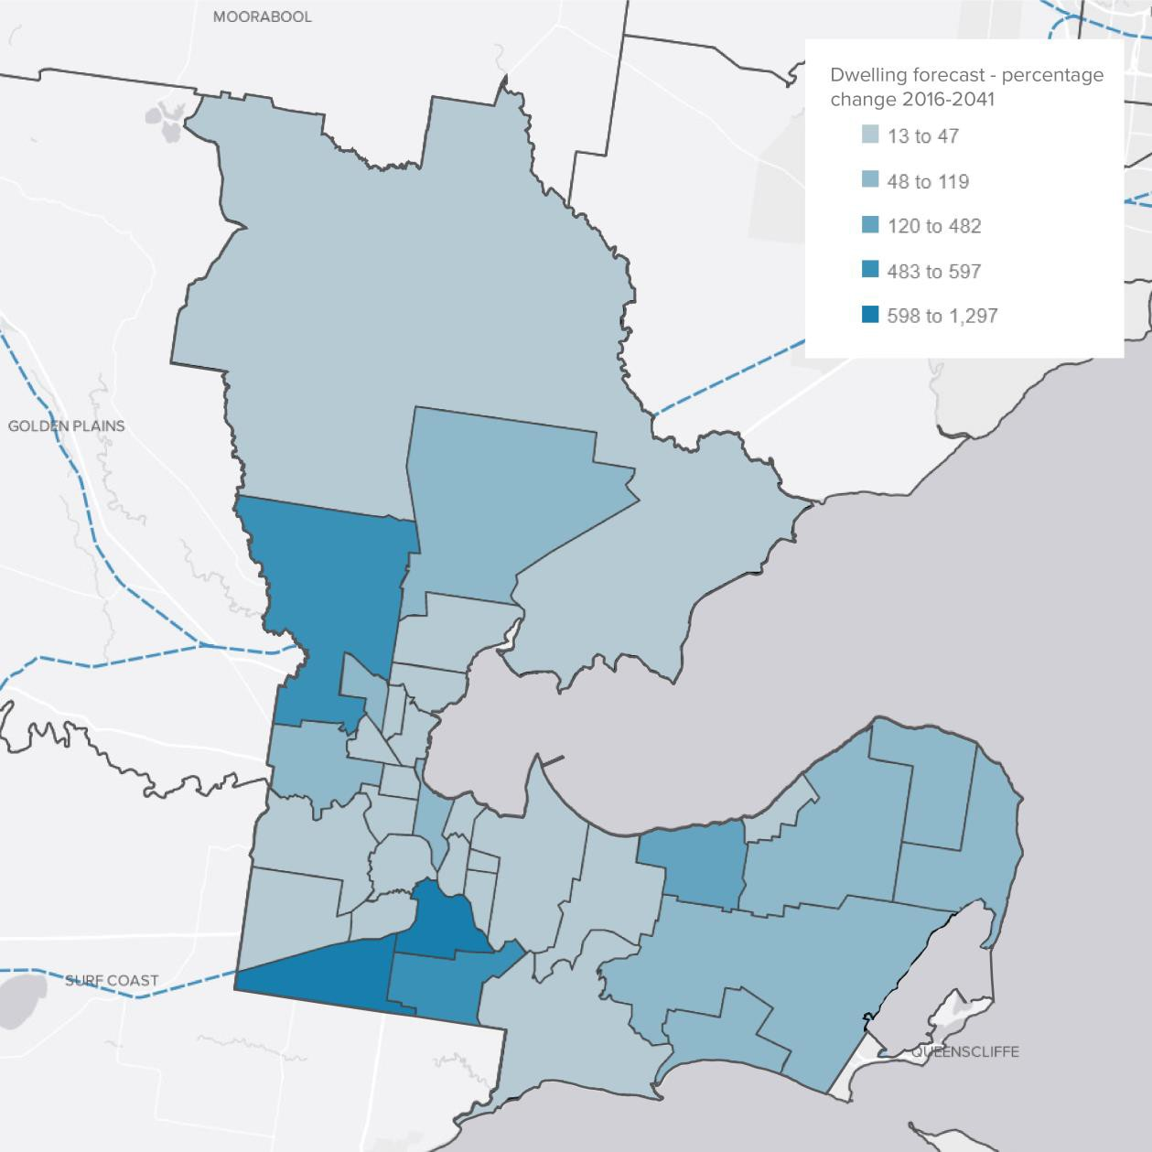
Source: forecast.id, dated 2019

Industry Structure Trends
The following table and figure show the ABS Census count of jobs within the City of Greater Geelong by industry sector between 2001 and 2021 at five year intervals. Total population is also shown.
Overall, the industry of employment data provides a very positive picture of the Greater Geelong economy. Highlights of the data are:
    - The overall growth in jobs has consistently outpaced population growth, particularly in the five years to 2021 (4.4% p.a. versus 2.5% p.a.).
    - The structural shift in the economy that led to job losses in manufacturing over 20 years has now stabilised (i.e. no net growth or decline in the five years to 20201). The decline in the early part of the data period relates primarily to closure of heavy industries such
as Ford Motor Company and Point Henry aluminium smelter.
    - The industrial land using wholesale trade sector boomed in the five years to 2021 at 9.3%
p.a. growth. Transport, postal and warehousing has consistently grown over the past two decades.
    - Strong economic and population growth is reflected in significant growth in the construction sector (9.8% p.a.) and to a lesser extent utilities.
    - The structural economic shift towards service sectors is reflected in the data. Overall, service sectors have grown above population growth rates over 20 years and at a high 4.2% p.a. over the five years to 2021.
    - The highest growth service sectors in the five years to 2021 have been population-driven sectors like health care and social assistance and public administration and safety, and business services like professional, scientific and technical services and financial and
insurance services.
    - The retail trade sector has been relatively sluggish for an extended period of time due to historic high rates of retail provision and industry-wide pressures on the sector from online and e-commerce formats. Jobs growth in the sector remains below population
growth.
For this employment land review, the implications include:
    - Growth in logistics activity, which is strategically planned to be primarily located in the northern Geelong region and the Avalon Airport precinct
    - Growth in service sectors, which support commercial office developments of various formats in activity centres and business parks
    - Growth in businesses that serve and support population catchments, like light industry, trade supplied and related commercial uses.

Table 3: Jobs by Industry Sector and Population, Greater Geelong, 2001-2021

Sector / Year | 2001 | 2006 | 2011 | 2016 | 2021 | 5 year change p.a. | 10  year change p.a. | 20  year change p.a.
Primary Industry
 | Agriculture, Forestry and Fishing | 887 | 738 | 670 | 954 | 1,086 | 2.6% | 4.9% | 1.0%
 | Mining | 73 | 94 | 106 | 142 | 176 | 4.4% | 5.2% | 4.5%
 | Sub-Total | 960 | 832 | 776 | 1,096 | 1,262 | 2.9% | 5.0% | 1.4%
Core Industrial Land Sectors
 | Manufacturing | 12,235 | 11,924 | 10,155 | 7,558 | 7,542 | 0.0% | -2.9% | -2.4%
 | Wholesale Trade | 2,804 | 2,562 | 2,357 | 2,002 | 3,124 | 9.3% | 2.9% | 0.5%
 | Transport, Postal and Warehousing | 2,117 | 2,822 | 2,765 | 3,305 | 3,850 | 3.1% | 3.4% | 3.0%
Sub-Total |  | 17,156 | 17,308 | 15,277 | 12,865 | 14,516 | 2.4% | -0.5% | -0.8%
Utilities and Construction
Electricity, Gas, Water and Waste Services |  | 481 | 702 | 911 | 1,210 | 1,443 | 3.6% | 4.7% | 5.6%
 | Construction | 3,670 | 4,777 | 5,327 | 7,101 | 11,329 | 9.8% | 7.8% | 5.8%
Sub-Total |  | 4,151 | 5,479 | 6,238 | 8,311 | 12,772 | 9.0% | 7.4% | 5.8%
Service Sectors
Retail Trade |  | 12,686 | 11,384 | 11,354 | 12,851 | 13,730 | 1.3% | 1.9% | 0.4%
 | Accommodation and Food Services | 3,211 | 5,005 | 5,440 | 7,303 | 8,636 | 3.4% | 4.7% | 5.1%
 | Information Media and Telecommunications | 802 | 980 | 830 | 853 | 803 | -1.2% | -0.3% | 0.0%
 | Financial and Insurance Services | 1,399 | 1,584 | 2,358 | 2,580 | 3,158 | 4.1% | 3.0% | 4.2%
 | Rental, Hiring and Real Estate Services | 829 | 1,008 | 1,090 | 1,264 | 1,382 | 1.8% | 2.4% | 2.6%
 | Professional, Scientific and Technical Services | 2,877 | 3,496 | 3,954 | 4,973 | 6,619 | 5.9% | 5.3% | 4.3%
 | Administrative and Support Services | 1,759 | 2,138 | 1,868 | 2,357 | 2,760 | 3.2% | 4.0% | 2.3%
 | Public Administration and Safety | 1,860 | 3,692 | 4,093 | 5,248 | 6,960 | 5.8% | 5.5% | 6.8%
 | Education and Training | 6,284 | 7,331 | 8,481 | 10,302 | 12,404 | 3.8% | 3.9% | 3.5%
 | Health Care and Social Assistance | 8,454 | 10,005 | 12,587 | 16,428 | 22,818 | 6.8% | 6.1% | 5.1%
 | Arts and Recreation Services | 1,418 | 1,006 | 1,187 | 1,511 | 1,638 | 1.6% | 3.3% | 0.7%
 | Other Services | 2,462 | 2,931 | 3,040 | 3,556 | 4,208 | 3.4% | 3.3% | 2.7%
 | Sub-Total | 44,041 | 50,560 | 56,282 | 69,226 | 85,116 | 4.2% | 4.2% | 3.3%
Other
 | Inadequately described/Not stated | 459 | 465 | 586 | 3,569 | 4,226 | 3.4% | 21.8% | 11.7%
Total Jobs |  | 66,767 | 74,644 | 79,159 | 95,057 | 117,909 | 4.4% | 4.1% | 2.9%
Population |  | 186,889 | 201,495 | 215,837 | 239,529 | 270,776 | 2.5% | 2.3% | 1.9%
Source:
Jobs data: ABS Census 2001 - 2021, Working Population Profile, Place of Work; 2001 modified to fit categories on a best fit basis Population data: Estimated Residents Population for 2006 to 2021; Usual Resident Population for 2001

Figure 6: Jobs by Industry Sector and Population, Greater Geelong, 2001-2021
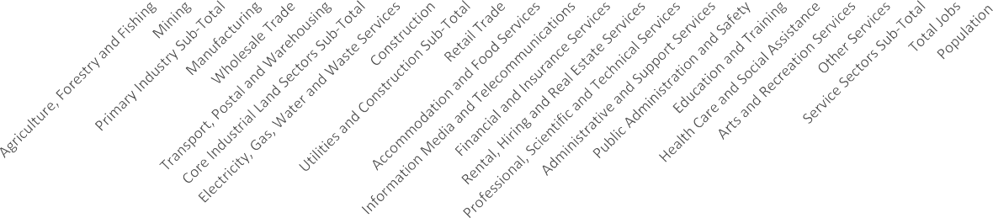
12.0%

10.0%

8.0%

6.0%

4.0%

2.0%

0.0%

-2.0%

-4.0%
5 year change p.a.
10 year change p.a.
20 year change p.a.
Source:
Jobs data: ABS Census 2001 - 2021, Working Population Profile, Place of Work; 2001 modified to fit categories on a best fit basis Population data: Estimated Residents Population for 2006 to 2021; Usual Resident Population for 2001

Unemployment
The unemployment rate in Geelong is at an historic low, which indicates a strong level of employment and business activity.
The 12-month average unemployment rate to December 2021 was 2.4% in Geelong, a decrease of 0.1 percentage points from the previous month and 2.1 points lower than the same time a year earlier.
The 12-month average unemployment rate to December 2021 for Geelong was 2.7 points lower than the Victorian unemployment rate (5.1%) and 2.9 points lower than the Australian unemployment rate (5.3%).

Figure 7: Geelong Unemployment Trend
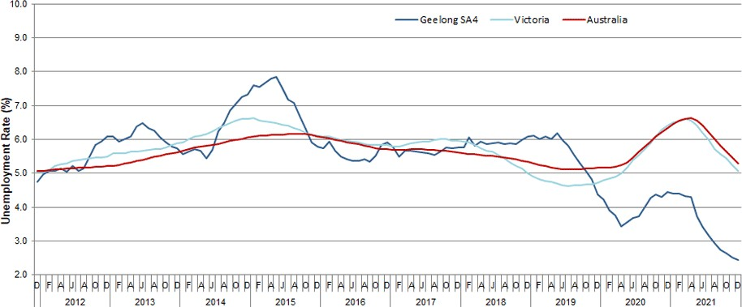
Source: City of Greater Geelong

MARKET RESEARCH

Overview
This section provides market research information for the industrial and related commercial property market in Geelong. The focus of the information is:
    - Overview of the industrial market in Victoria
    - Investment activity trends in Geelong
    - Sales transaction trends.

Market Context
The industrial market in Victoria has gone through a period of high demand leading to rapidly increasing prices for industrial land over the past three years.
Drivers have included rapid growth in logistics in part driven by a boom in online retail and eCommerce (boosted by COVID-19 restrictions on in-person shopping during 2020 and 2021) and the ongoing consolidation of Victoria as the nation’s leading logistics hub.
Long term population growth (albeit with a pause during the pandemic) and high levels of residential and non-residential construction have also supported industrial sector. The sector has also been supported by ongoing investment from institutional investors. Zoned land supply is being taken-up and developed at a record pace.
A shift of people out of parts of Melbourne to lifestyle locations and regional areas during the pandemic has facilitated increased demand in the Geelong region, which is benefitting from population driven growth and due to its proximity to the nation’s biggest industrial hub.
The following graphic by CBRE summarises trends in industrial land take-up and floorspace absorption to 2021 in metropolitan Melbourne. This provides evidence of strong demand for industrial land in recent years. The data shows an upward trend over the past decade in terms of land and floorspace take up by businesses, particularly in the state’s most significant industrial precincts (called SSIP).

Figure 8: CBRE Assessment of Industrial Land Take-up and Floorspace Absorption
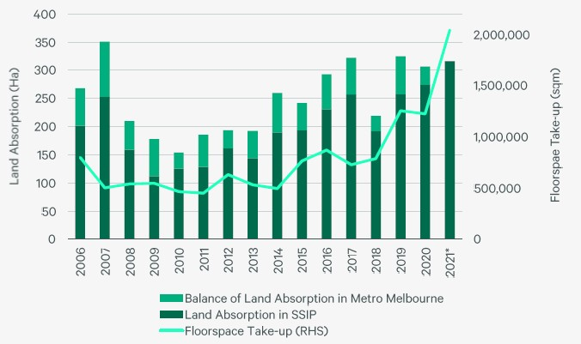
Source: CBRE & Urban Development Program

Investment Activity
Investment data indicates significant industrial investment activity in the Geelong region.
There were approximately 350 projects identified across Greater Geelong from the past 5-10 years according to the Cordell Connect data base. This includes refurbishment/additions.
A summary of the projects by their year of first reporting is shown below. The table below indicates a boom in construction activity from 2016-2019. There are still some projects from the late 2010s with development approval.

Figure 9: Project Status as of May-22 by Year First Reported

Abandoned/deferred Commenced Possible Firm

2022

2021

2020

2019

2018

2017

2016

2015

2014

2013

2012

2011

2009

2008

2002

2001

0 10 20 30 40 50 60 70

Source: CoreLogic Cordell Connect, 2022

Below is the number and total value of projects by their project status in more detail. Key findings are as follows:
- On average there were 44 industrial projects submitted per year between 2015-2020, including 76% new developments, 20% additions and 4% renovations.
- Around 40% of projects submitted have commenced/completed construction – over 2015-2020 this represents around 19 projects per year valued on average $37m per year.
- There are around 143 projects that are possible or highly likely to go ahead.
- There are a small number of projects that were first reported in 2015 that are in the planning stages.
- The South Geelong Breakwater areas had the greatest number of projects submitted over the data period however the estimated value of the projects were comparatively

low – indicating they were mostly smaller scale factoryette developments and additions.
- The Geelong Port/North Geelong industrial area had a large volume of warehouse and factoryette development activity.
- Some high monetary value projects are occurring in the outer north of Geelong, such as the defence manufacturing hub, a waste to energy plant and ongoing development expansion of the Barwon Prison Precinct..
- An application to develop a 56 ha site homemaker’s centre in Armstrong Creek has
received development approval but the site has been listed for sale.
- The Armstrong Creek North East Industrial Precinct is yet to activate industrial and related investment.
Table 4: Projects by Project Status

Project status | Number of projects | Total estimated value
Building application | 2 | $2,800,000
Building approval | 23 | $34,765,000
Completed | 152 | $262,315,000
Construction | 9 | $19,790,000
Contract let | 1 | $200,000
Development application | 43 | $437,150,000
Development approval | 93 | $144,005,000
Development/town planning application refused | 2 | $800,000
Early planning | 3 | $350,000,000
More than half way through but not yet completed | 1 | $9,000,000
No tender accepted tenders to be recalled | 2 | $695,000
Site acquisition | 2 | $1,002,000,000
Site Preparation in Progress | 2 | $10,300,000
Sketch plans | 2 | $190,000,000
Subdivision application | 1 | $1,000,000
Tenders called/regns advertised | 8 | $138,450,000
Tenders/submn of props for design construct | 1 | $1,000,000
Tenders/submn of props for development | 1 | $500,000

Project status | Number of projects | Total estimated value
Total | 348 | $2,604,770,000

Source: CoreLogic Cordell Connect, 2022

A breakdown of all the projects by employment precinct is provided below.
Table 5: Projects by Location

Precinct | Number of projects | Total estimated value of projects
Geelong Ring Road Employment Precinct (GREP) (Corio / Lara) | 62 | $664,640,000
Geelong Port/ North Geelong Industrial Area | 70 | $217,570,000
Central Geelong | 17 | $154,475,000
Moolap Industrial Area | 28 | $27,305,000
South Geelong Breakwater Industrial Area | 76 | $88,265,000
Avalon Employment Precinct | 6 | $1,060,600,000
North East Industrial Precinct (Armstrong Creek) | 2 | $60,750,000
Other precincts | 87 | $331,165,000
Total | 348 | $2,273,605,000
Source: CoreLogic Cordell Connect, 2022

The following figure and case studies provides a guide to the type of investment occurring and the location of investment.
Figure 10: Recent Industrial Projects
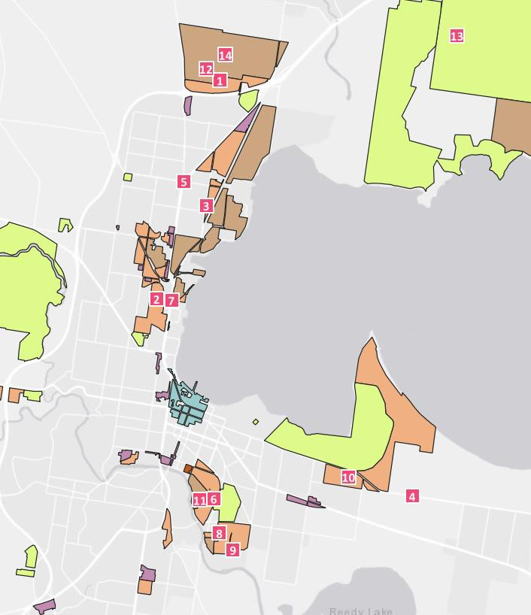

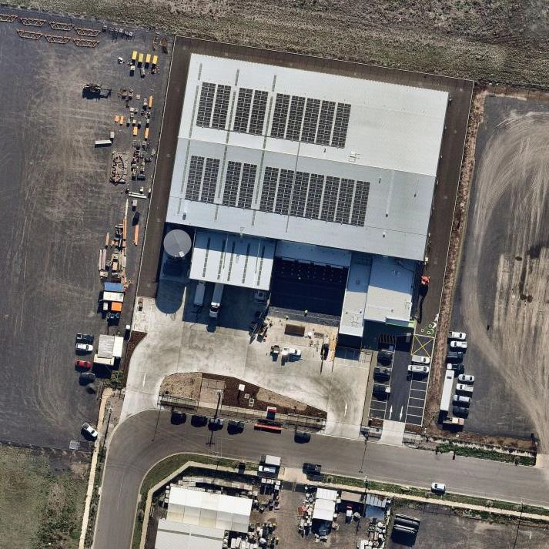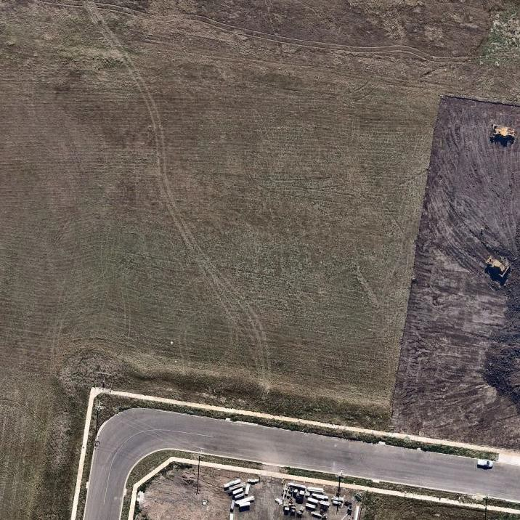1

 | Employment area  GREP | Project description  Single-storey warehouse with 454sqm ancillary office | Estimated value  $9,000,000 | Estimated commence  30/07/2021 | Project status Complete
2 | 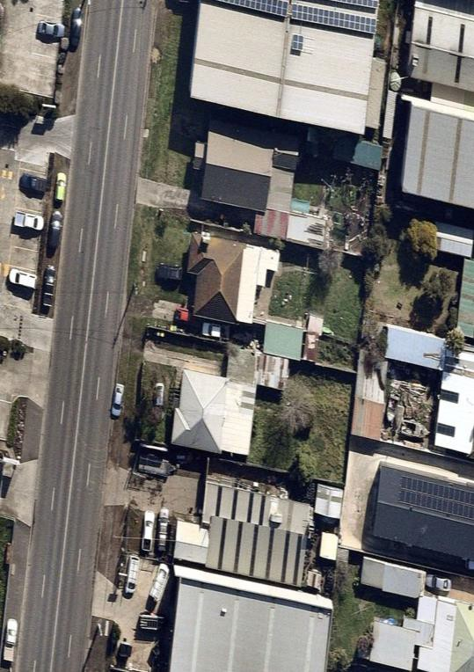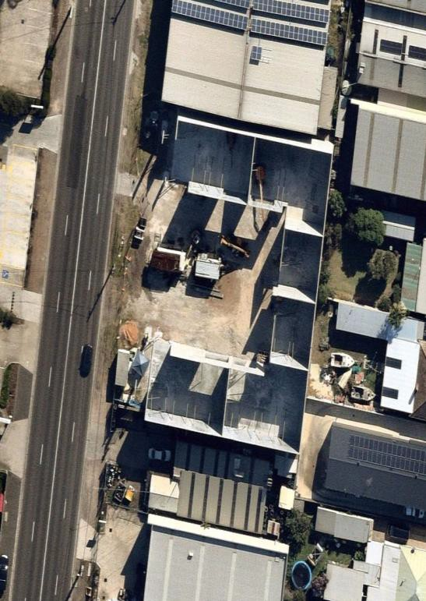
 | Employment area  Geelong North | Project description  6 warehouses with car parking and landscaping | Estimated value  $300,000 | Estimated commence  22/09/2021 | Project status  Commenced - construction in progress

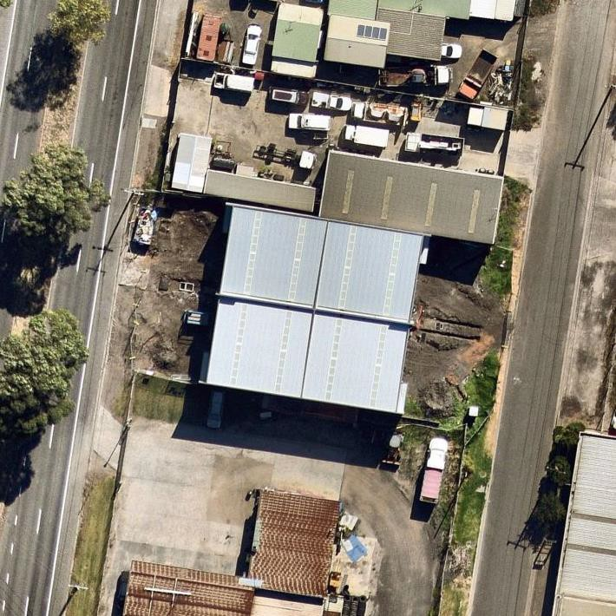
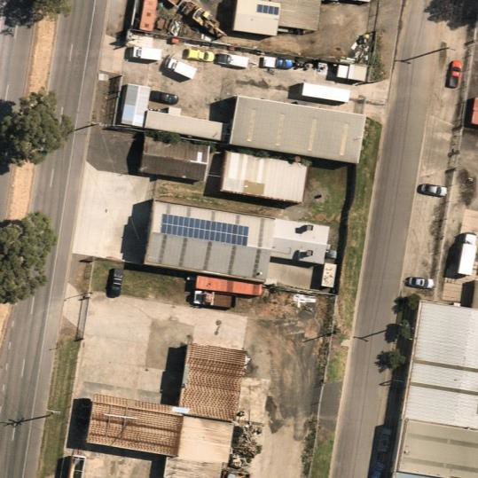
3

 | Employment area  Geelong Port | Project description  4 warehouses with car parking and landscaping | Estimated value  $1,000,000 | Estimated commence  21/10/2021 | Project status  Commenced - construction in progress builder & building surveyor named
4 | 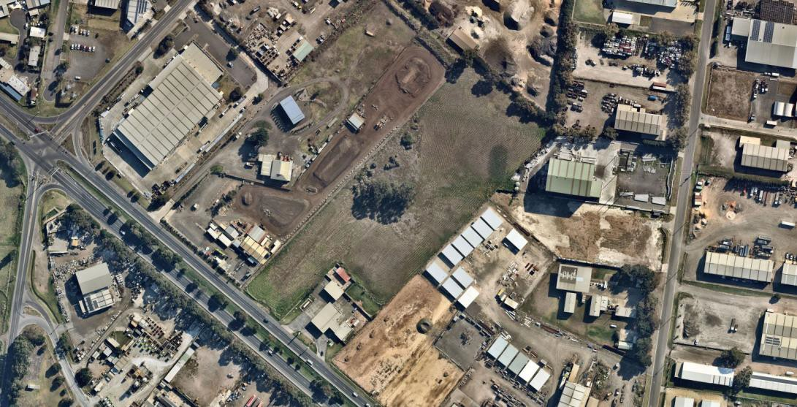
 | Employment area  Moolap | Project description  10 warehouses with car parking and landscaping | Estimated value  $1,500,000 | Estimated commence  9/02/2022 | Project status  Abandoned - town planning application withdrawn

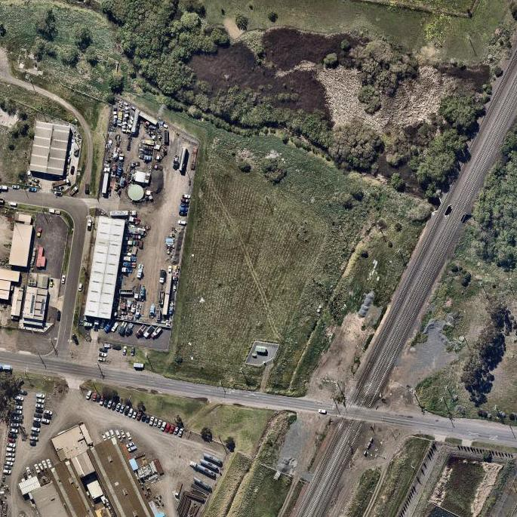
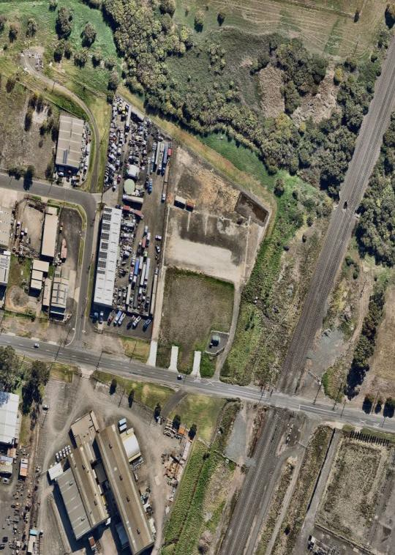
5

 | Employment area  Geelong Port | Project description  Construction of a truck depot including ancillary offices. Associated car parking and landscaping. | Estimated value  $800,000 | Estimated commence  22/02/2022 | Project status  Abandoned - site for sale with town planning approval marketing agent named
6 | 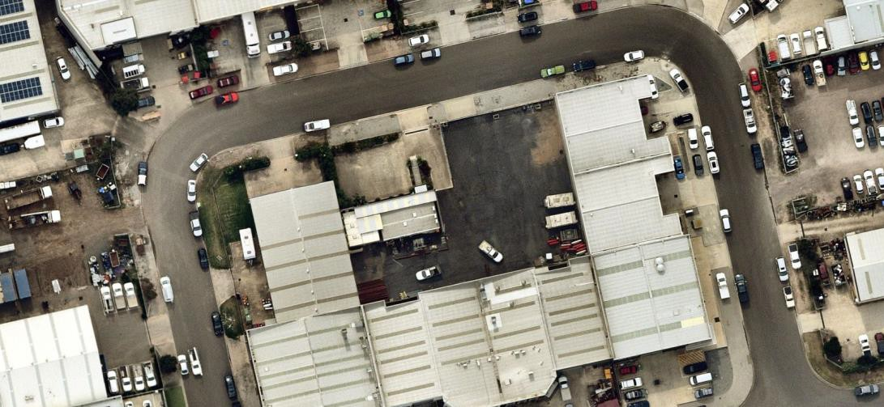
 | Employment area  South Geelong Breakwater | Project description  2 warehouses with car parking and landscaping | Estimated value  $400,000 | Estimated commence  23/12/2021 | Project status  Deferred - working drawings completed

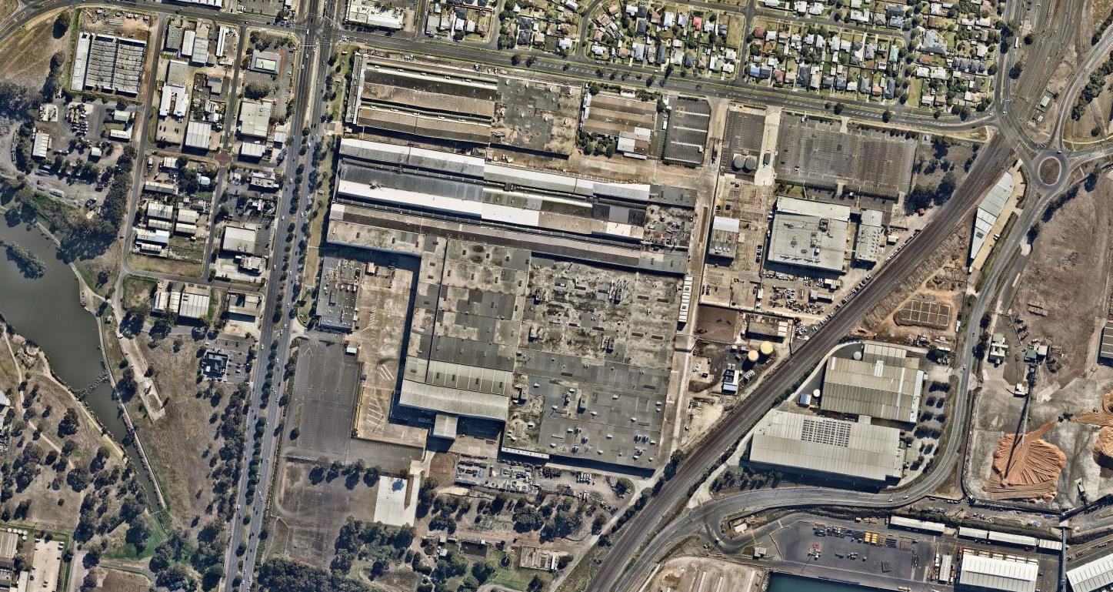
7

 | Employment area  Geelong Port | Project description  Proposed subdivision & retrofit of former Ford manufacturing site to accommodate new manufacturing & innovative tech tenants. | Estimated value  $20,000,000 | Estimated commence  18/05/2020 | Project status  Possible - pre lease commitment marketing in progress, marketing agent named
8 | 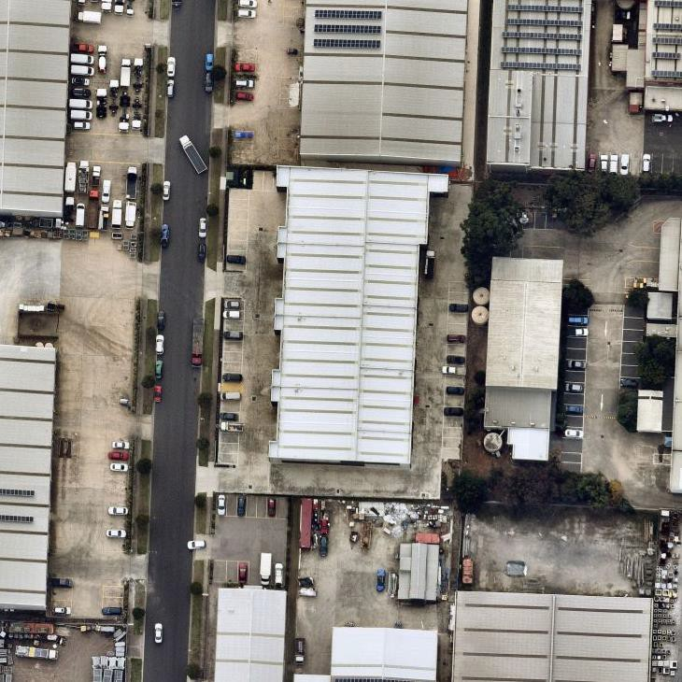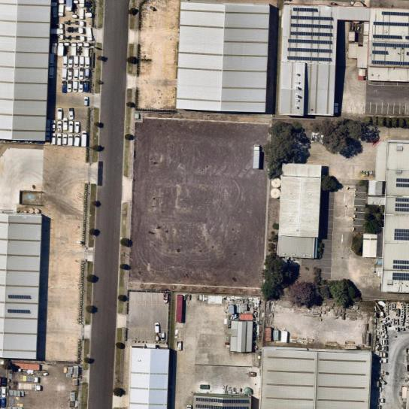
 | Employment area  South Geelong Breakwater | Project description  14 warehouses with car parking and landscaping | Estimated value  $1,500,000 | Estimated commence  12/08/2021 | Project status Completed

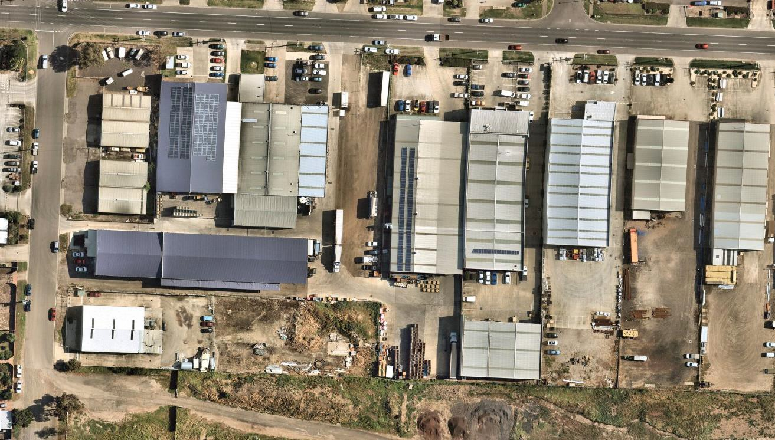
9

 | Employment area  South Geelong Breakwater | Project description  4 warehouses with car parking and landscaping | Estimated value  $1,000,000 | Estimated commence  28/04/2021 | Project status  Abandoned - project abandoned
10 | 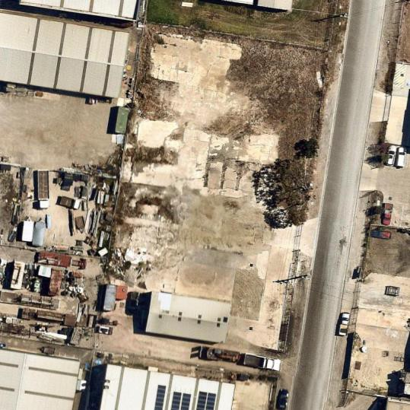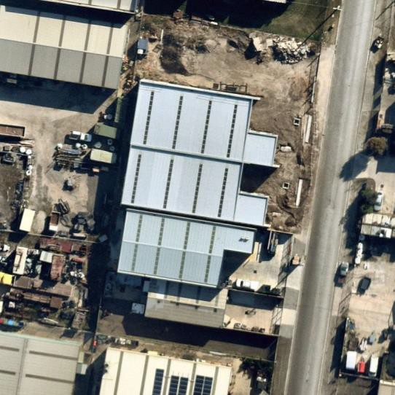
 | Employment area  Moolap | Project description  Construction of a warehouse & office. Associated car parking & landscaping. | Estimated value  $800,000 | Estimated commence  1/08/2020 | Project status  Commenced - construction in progress by undisclosed builder

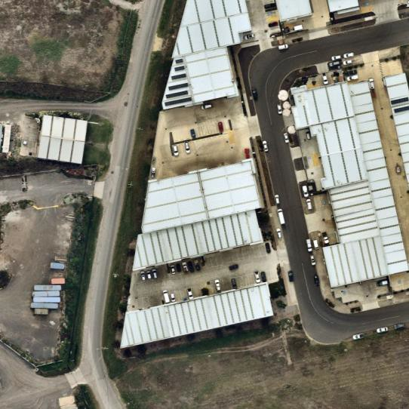
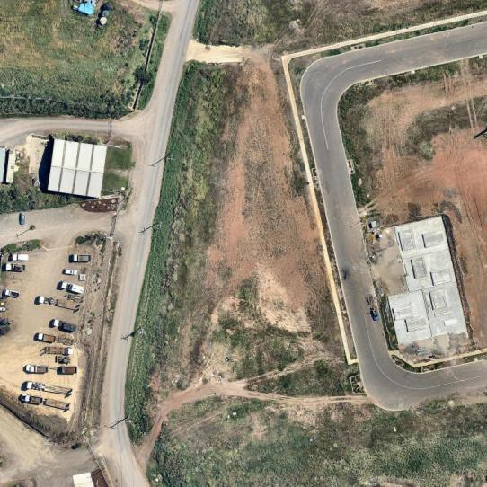
11

 | Employment area  South Geelong Breakwater | Project description  7 warehouses with car parking and landscaping | Estimated value  $1,500,000 | Estimated commence  21/10/2019 | Project status Completed
12 | 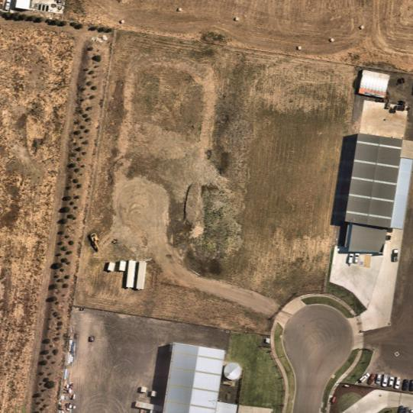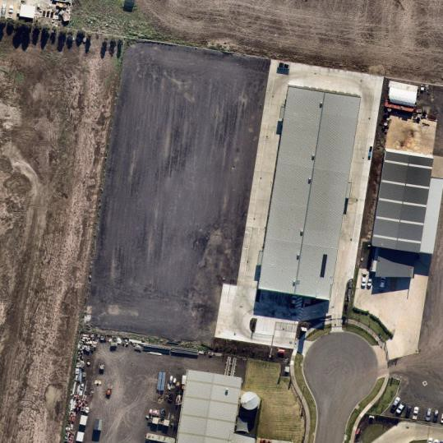
 | Employment area  GREP | Project description  Construction of a new storage facility. | Estimated value  $4,500,000 | Estimated commence  16/03/2021 | Project status Completed

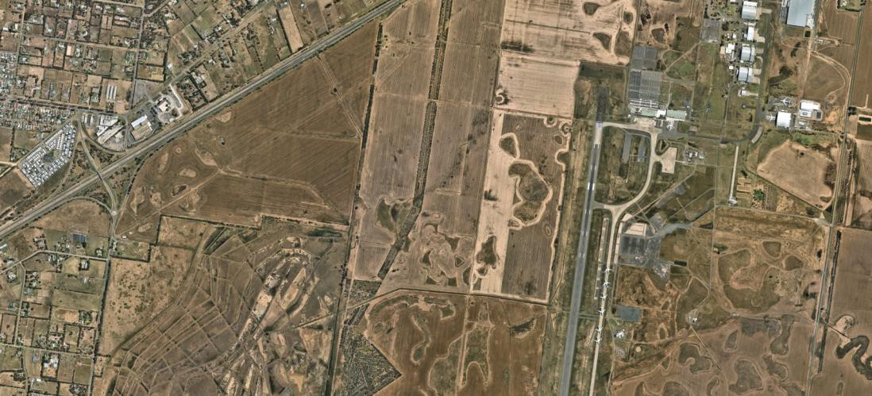
13

 | Employment area  Avalon | Project description  Construction of the Hanwha Armoured Vehicle Centre of Excellence (32,000sq m) for manufacture of vehicles for the Australian Army | Estimated value  $170,000,000 | Estimated commence  27/06/2022 | Project status  Possible - site announced design in progress construction expected soon
14 | 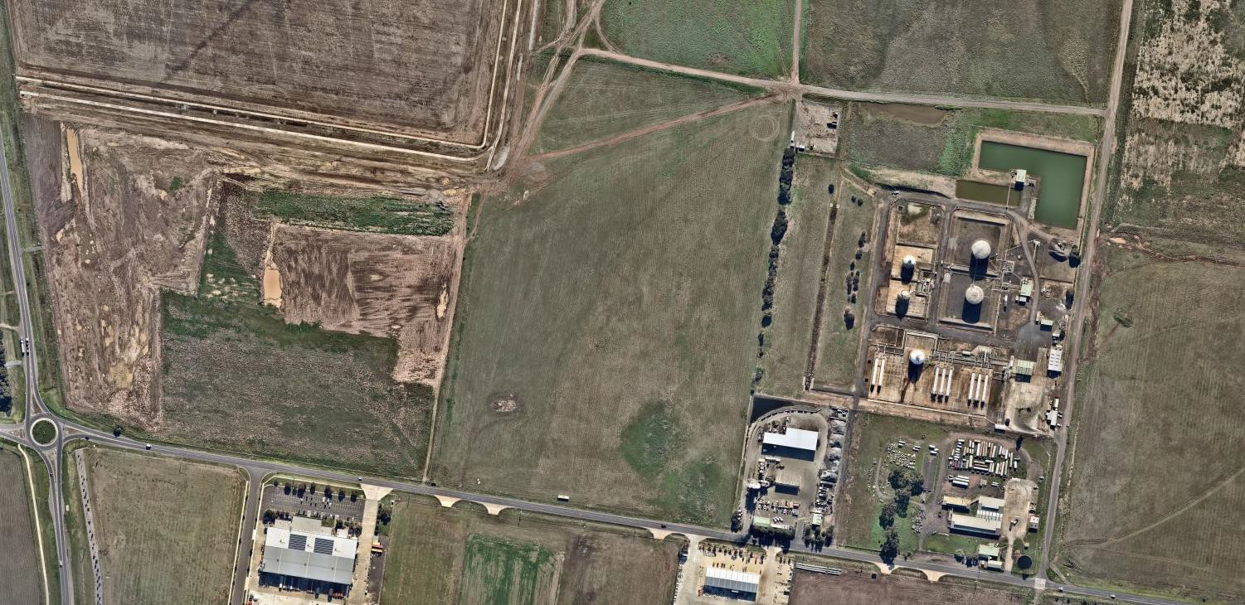
 | Employment area  GREP | Project description  Construction of a single storey reclaimed asphalt plant to include 2 storey office/workshop building, production plant, storage and parking. | Estimated value  $500,000 | Estimated commence  5/01/2023 | Project status  Possible - town planning application submitted

Sales Transactions Overview
The table on the following page provides a snapshot of the property sales across Greater Geelong on industrial zoned land.
There were around 100 transactions reported in the employment precincts of Greater Geelong between January 2021 and May 2021. This indicates around 6 or 7 sales per month during this period which reflects a robust industrial property market.
Around one quarter of the transactions were englobo land sales. A summary of these transactions is shown in the table below. A full list of the transactions is provided in Appendix A.
Key findings are as follows:
    - Greater Geelong employment land prices are in the vicinity of $230 to $350/sqm, which is similar to parts of western Melbourne.
    - In the major existing employment precincts, most sales transactions are for improved land; that is, properties that have warehouses or factories on site.
    - The Geelong Ring Road Employment Precinct (GREP) provides short to medium term large lot development opportunities on land with a lower price per square metre.
    - South Geelong Breakwater is the closest industrial area to large residential catchments in Geelong and has the highest land price. It is capturing factoryette development which intensifies uses on site. It is nearing full development.
    - The Avalon Employment Precinct has the capacity to be a regionally significant employment area.
    - The Armstrong Creek NEIP has not seen industrial development yet however there has been some transactions with land prices reflecting future industrial uses. It is expected that the NEIP will host medium to long term local industrial needs for Geelong’s south-
west.
    - The Armstrong Creek Town Centre is under development. The 20.6 ha Coles site transacted for $55,600,000. The activity centre could host office uses in the medium to long term.

Table 6: Greater Geelong Employment Land Property Transactions Summary (Jan-21 to May-22)

Precinct name | Number of transactions | Average property sale price ($/sqm) | Property sale price range ($/sqm of land area) | Englobo land price average ($/sqm) | Land area (sqm)
Geelong Ring Road Employment Precinct (GREP) (Corio / Lara) | 6 | $176 | $23 - $329 | $230 | 5,000 – 263,100
Geelong Port/ North Geelong Industrial Area | 20 | $990 | $315 - $2,443 | $336 | 200 – 7,700
Pivot City Innovation Precinct (North Geelong) | NA | NA |  | NA | NA
Central Geelong | 21 | $4,286 | $400 - $13,356 | $2,731 | 100 – 3,000
Moolap Industrial Area | 21 | $465 | $73 – 1,925 | $328 | 500 – 34,000
South Geelong Breakwater Industrial Area | 22 | $1,561 | $23 - $6,197 | $350 | 100 – 30,500
Avalon Employment Precinct | 2 | $4 | $1 - $7 | $4 | 334,100 – 8,431,100
North East Industrial Precinct (Armstrong Creek) | 2 | $154 | $136 - $172 | $154 | 22,000 – 92,500
Armstrong Creek Town Centre | 1 | $2,699 | $2,699 | $2,699 | 20,600
Western Industrial Precinct (WIP) | 7* | $23 | $6 - $44 | $23 | 163,600 – 305,300
*Seven sales over the past ten years. Purchased by development firms with price reflecting long term development opportunity.
Source: CoreLogic RP Data, 2022

EMPLOYMENT LAND SUPPLY AND DEMAND

Overview
This section provides data on land supply and demand in Greater Geelong and makes an assessment of future need for the population of south west Geelong.

Supply Analysis
The table overleaf provides land supply information by precinct. The data is primarily based
on Greater Geelong’s Land Supply Report.
This shows that Greater Geelong has a potential existing and future employment land supply of 4,622 ha, noted as 3,014 ha as unavailable or occupied land and 1,608 ha as supply or potentially developable land.
Available data trends indicate a take-up rate of approximately 23 hectares per annum.
Based on the above supply figure and assuming the take up trend continues in the future, Greater Geelong has 70 years of employment land supply.
Current INZ1, INZ2 and INZ3 Zoned Land
If future areas are excluded - that is Avalon Airport land, North East Industrial Precinct and Western Industrial Precinct - the municipality has 2,614 ha of zoned employment land, of which 307 ha may be available for development.
On this basis, the municipality has approximately 13 years of zoned land supply.
Future Areas with Firm Proposals
Both Avalon Airport and the North East Industrial Precinct have firm development proposals for employment uses.
When these two precincts are included in the supply analysis, Greater Geelong has 4,464 ha of employment land of which 1,450 ha may be available for development.
On this basis, the municipality has approximately 63 years of zoned land supply.
While the Greater Geelong municipality has a significant zoned land supply overall, further consideration is required on the suitability for different employment land uses and sub-area and whether sufficient supply of various sized lots is available for industry.

Table 7: Employment Land Supply (Gross Hectares)

Industrial area | IN1Z |  |  | IN2Z |  |  | IN3Z |  |  | PZ |  |  | SUZ11 |  |  | UGZ |  |  | Total zoned stocks
 | Unavailable | Supply | Land area vacancy rate % | Unavailable | Supply | Land area vacancy rate % | Unavailable | Supply | Land area vacancy rate % | Unavailable | Supply | Land area vacancy rate % | Unavailable | Supply | Land area vacancy rate % | Unavailable | Supply | Land area vacancy rate % | Unavailable | Supply | Land area vacancy rate %
Armstrong Creek NEIP |  |  |  |  |  |  |  |  |  |  |  |  |  |  |  | 2 | 93 | 98% | 2 | 93 | 98%
Armstrong Creek WIP |  |  |  |  |  |  |  |  |  |  |  |  |  |  |  | 0 | 158 | 100% | 0 | 158 | 100%
Avalon Airport |  |  |  |  |  |  |  |  |  |  |  |  | 705 | 1050 | 60% |  |  |  | 705 | 1050 | 60%
Geelong Central | 258 | 15 | 5% | 402 | 9 | 2% |  |  |  |  |  |  |  |  |  |  |  |  | 660 | 24 | 4%
Geelong Port |  |  |  |  |  |  |  |  |  | 86 | 8 | 9% |  |  |  |  |  |  | 86 | 8 | 9%
Geelong South | 194 | 18 | 8% | 31 | 3 | 9% | 4 | 0 | 0% |  |  |  |  |  |  |  |  |  | 229 | 21 | 8%
GREP | 50 | 26 | 34% | 229 | 185 | 45% |  |  |  |  |  |  |  |  |  |  |  |  | 279 | 211 | 43%
Lara | 1 | 0 | 0% |  |  |  | 12 | 1 | 8% |  |  |  |  |  |  |  |  |  | 13 | 1 | 7%
Moolap | 369 | 30 | 8% |  |  |  |  |  |  |  |  |  |  |  |  |  |  |  | 369 | 30 | 8%
Ocean Grove | 9 | 0 | 0% |  |  |  | 0 | 8 | 100% |  |  |  |  |  |  |  |  |  | 9 | 8 | 47%
Point Wilson |  |  |  | 660 | 0 | 0% |  |  |  |  |  |  |  |  |  |  |  |  | 660 | 0 | 0%
Portarlington | 2 | 4 | 62% |  |  |  |  |  |  |  |  |  |  |  |  |  |  |  | 2 | 4 | 62%
Total 2022 |  |  |  |  |  |  |  |  |  |  |  |  |  |  |  |  |  |  | 3,014 | 1,608 | 35%
Total 2018 |  |  |  |  |  |  |  |  |  |  |  |  |  |  |  |  |  |  | 2,919 | 1,680 | 37%
Source: City of Greater Geelong Land Supply Report; HillPDA

Substitutability and Specialisation
Whilst there is a significant amount of substitutability between many employment precincts, there are differences between them based on location attributes, zoning and planning controls, buffer requirements, infrastructure connections, lot size, built form character, precinct amenity and customers serviced by the businesses.
Industrial precincts can be summarised as:
    - Heavy industry zone (significant supply in northern region of Geelong)
    - Large lot industrial precinct (significant supply in northern region of Geelong)
    - General industrial area (supply across municipality)
    - Small lot factoryette precinct (supply across municipality)
    - Mixed use commercial and industrial precinct (supply across municipality)
    - Business park (limited supply in Geelong; some emerging clusters in north on former manufacturing land)
    - Technology park (Deakin Future Economy Precinct).
The planned role of employment land in the south west Geelong sub-region is to meet local and sub-regional needs for a growing population.
Higher order and large lot industry would continue to be focused in the north.
Deakin University has existing and potential future land stocks to accommodate technology park uses associated with university research and development. This area is different from general employment land because land and buildings are provided by the university and leased to businesses that have a relationship with the university.

Need in South West Geelong
The method adopted to assess local and sub-regional employment land needs is to review utilisation of industrial land relative to population, and apply a selected land need rate to the projected future population of the Geelong south west sub-region.
The table below shows utilised (occupied) industrial land relative to population for Greater Geelong and for metropolitan Melbourne. The metropolitan Melbourne data is available for what is called here ‘higher order’ uses and ‘local / sub-regional’ uses.
Higher order is defined as State Significant Industrial Precincts (SSIPs), and local /sub-regional is defined as all other occupied industrial land excluding SSIPs.
This approach provides a guide to current conditions and historic trends. Greater Geelong’s rate of 86 sqm of occupied industrial land per person is in part based on its manufacturing history. The future is likely to be different as the economy continues to change, although significant growth is expected in the logistics sector.

The metropolitan Melbourne rate of 41 sqm of occupied industrial land per person reflects the structure of a diversified economy and significant additions and deletions to industrial land supply over the past two decades.
It is the view here that the local / sub-regional metropolitan rate provides a sound guide to potential future need in south-west Geelong, which is primarily a residential based growth area.
Table 8: Occupied Industrial Land to Population Ratios

Scenario | Description | Occupied Industrial Land (Ha) | Estimated Population at Data Point | Square Metres of Occupied Industrial Land Per  Person
Greater Geelong (2021) Total Industrial | Geelong Historic Rate | 2,307 | 268,984 | 86
Greater Melbourne (2018) Total Industrial | Metro Melbourne Historic Rate | 19,843 | 4,870,000 | 41
SSIP in Greater Melbourne (2018) | Higher Order Metro Melbourne Rate | 10,343 | 4,870,000 | 21
Greater Melbourne (2018) Industrial  Excluding SSIP | Local / Sub-Regional Metro Melbourne Rate | 9,500 | 4,870,000 | 20
Source: HillPDA derived from: Greater Geelong Land Supply Report 2018; Department of Environment, Land, Water and Planning, Urban Development Program – Melbourne Metropolitan Industrial; ABS Estimated Resident Population; forecast .id 2018
Note: SSIP = State Significant Industrial Precincts as defined in Plan Melbourne 2017-2050.

The table below shows all of the ratios applied to the south west region of Geelong from 2021 to 2041 and a future total population of 125,600 for some point beyond 2041. This higher population scenario includes full development of Armstrong Creek. South west Geelong is defined as (using forecast .id areas):
- Armstrong Creek
- Grovedale
- Highton - Wandana Heights - Ceres
- Marshall - Charlemont
- Mount Duneed
- Waurn Ponds.
The recommended local / sub-regional rate provides a planning guide for approximately 245 hectares of employment land by 2051 of net developable area.

Table 9: Scenarios of Industrial Land Need in South West Geelong (Hectares)

Year | South West Sub-Region Population | Geelong Historic Rate | Metro Melbourne Historic Rate | Higher Order Metro Melbourne Rate | Local / Sub- Regional Metro Melbourne Rate
SQM / Person |  | 86 | 41 | 21 | 20
2021 | 62,400 | 535 | 254 | 133 | 122
2026 | 78,794 | 676 | 321 | 167 | 154
2031 | 92,531 | 794 | 377 | 197 | 181
2036 | 102,359 | 878 | 417 | 217 | 200
2041 | 109,580 | 940 | 446 | 233 | 214
Assumed 2051 Scenario* | 125,586 | 1,077 | 512 | 267 | 245
Source: HillPDA derived from: Greater Geelong Land Supply Report 2018; Department of Environment, Land, Water and Planning, Urban Development Program – Melbourne Metropolitan Industrial; ABS Estimated Resident Population; forecast .id 2018
*2036-2041 rate (1.37% p.a.) applied to 2051

Overview of Need and Timing
The table below provides a summary of assessed long term employment land needs in south west Geelong that fits within the overall economic plan for the city as a whole.
It is assessed that approximately 245 net developable hectares of employment land is needed to meet needs by 2051. This refers to industrial and related commercial land not including core activity centre land, which is separate and in addition to this estimate.
The North East Industrial Precinct is being established to meet part of this need. It is estimated the precinct has 95 ha of gross land and 76 ha of net developable land (using an 80% efficiency ratio assumption). This precinct could be fully developed somewhere between the years 2030 and 2038.
It would be prudent to activate additional employment land in approximately five years’ time, preferably by 2027. The additional land area need (i.e. total need minus existing supply) is rounded to 170 hectares (net developable area).
Table 10: Overview of Employment Land Need and Timing

Area | Gross / Net Hectares (at 80%) | Estimated Commencement | Estimated Completion
North East Industrial Precinct | 95 / 76 | Current | 2030 to 2038
Additional South West Employment Land | 211 / 169 | 2027 | 2051
Total South West Geelong Target | 306 / 245 | - | -

Estimated Job Generation
The figure below shows indicative jobs per hectare by major land use group in a suburban context. This data relates to net developable area, which includes lots used for business purposes and local roads and open space.
Overall, for mixed commercial and industrial precincts - such as Commercial 2 zoned areas or general industrial areas in established settings - a typical job yield is 30 jobs per hectare.
The job yield can vary widely depending on the land use mix and industry sector mix. If a greater share of development is commercial office based, the job yield will be greater. If the share is more focused on industrial logistics activities, the job yield will be lower.
Assuming some of the land in south west Geelong is used for business park purposes in addition to industrial activities of various types, an aspirational job target is assessed to be 60 jobs per hectare overall.
That is, for 254 hectares of net developable employment land, the estimated job yield is:
    - Typical mix of uses: 7,350 jobs at 30 jobs per hectare
    - Aspirational jobs target: 14,700 jobs at 60 jobs per hectare.
Figure 11: Indicative Jobs Per Hectare (NDA) in Suburban Context by Land Use
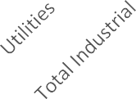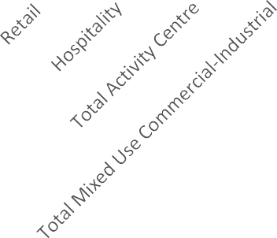
300
250
200
150
100
50
0
285
115
90
110
50
50
12.5
25
25
30
Source: HillPDA

Appendix B shows a sample of four modern employment precincts and provides an estimate of their job yield and business mix. The cases are: Scoresby: 8,100 jobs on 165 ha at 48 jobs/ha; Ravenhall: 10,200 jobs on 223 ha at 45 jobs/ha; Epping: 13,200 jobs on 374 ha at 35 jobs/ha; and Dandenong South (LOGIS): 3,800 jobs on 142 ha at 26 jobs/ha.

VIEWS OF STAKEHOLDERS

Overview
This section provides:
    - A summary of preliminary opinions provided by selected property industry, government and land owner stakeholders regarding employment land in Geelong and the south west employment precincts
    - A summary of proposals prepared by primary land owners of the Western Industrial Precinct, Boral land and North East Industrial Precinct regarding potential future investment aspirations and issues.

Stakeholder Views
Land holders and their representatives were consulted as well as government agencies and business leaders. The contacts were selected in collaboration with the City of Greater Geelong.
The stakeholders who provided preliminary opinions for this report are as follows:
    - Colliers
    - Barwon Water
    - Gartland Property
    - Committee for Geelong
    - Regional Development Victoria
    - Geelong Manufacturing Council
    - WIP Landowners and representatives
    - Boral Landowners and representatives
    - NEIP Landowners and representatives
    - Deakin University Geelong Future Employment Precinct. The main themes of the consultation are as follows.
Geelong Industrial Market
    - A consensus among stakeholders is that industrial land in Geelong is at historically high demand – the cost of industrial land has doubled in recent years, the number of sales enquiries is high, and properties sell quickly.
    - Smaller factoryette developments under 350sqm have made up a large portion of recent developments because they are a more profitable way to undertake industrial subdivision and development projects.
    - Some participants indicated that there is not one particular area with demand greater than others – there are interested potential land users across Geelong.
    - Some participants highlighted interest from businesses in the Avalon employment area due to the large potential lot sizes and proximity to airport/ports/rail/road.

    - There were mixed and unclear opinions on how and where regional employment uses in Geelong should be located. Some stakeholders mentioned Avalon, the WIP, or Geelong CBD.
    - Some key industrial land users are seeking direction on where the next major industrial precinct beyond GREP will be located. For similar reasons, stakeholders were interested in an LGA-wide strategic perspective on employment land.
Demand Sectors
    - Industrial land is the leading commercial property sector at the current time.
    - Most demand is for small sites, such as 250 sqm to 500 sqm, is strong. Warehouse sites of 1,000 sqm closer to the centre are also required. Demand also exists for 1,000 sqm to 2,500 sqm sites. One hectare sites are also popular.
    - Demand for larger sites, such as five hectares, is more limited.
Supply Issues
    - Limited supply of industrial land leads to a high price point and limited choice for businesses.
    - Some land holdings that are zoned and have infrastructure are not being developed or not offered for sale, or only available for leasing, which can limit business appeal.
    - Some existing industrial sites have development constrains. This means that actual useable supply is less than reported supply.
    - There is a need to active new supply of industrial land in the Geelong region.
    - Geelong generally has a limited amount of property suited for advanced manufacturing firms. Most industrial property tends to be in warehousing or small scale factoryettes. A precinct that accommodates advanced manufacturers is required to support the
economy’s growth and evolution. The precinct would need flat land, access to quality roads and public transport to connect to skilled workers, and specific infrastructure and amenity features such as high load electricity supply and buildings that have purpose- built design elements.
Location
    - The demand context presents an opportunity for the strategic development of new employment precincts in the south west region of Geelong.
    - Armstrong Creek will likely suit some businesses, such as those that serve the local south west region.
    - NEIP has an advantage over the WIP due to its proximity to central Geelong. Both precincts require road access to support investment.
    - Avalon has a significant amount of interest and opportunity.
    - Most demand for industry is focused on northern Geelong at the current time.
    - Avalon has a significant amount of interest and opportunity.

Infrastructure
    - The south west precincts require enabling infrastructure to be delivered, particularly major road connections.
    - Major infrastructure upgrades include Barwon Heads Road duplication, Bellarine Link, duplication of the tunnel to south Geelong and a train station at Avalon.
    - The G21 region needs an integrated transport strategy and significant investment to support population and economic growth that is occurring.
Sectors
    - Sectors that are seeking industrial property at the current time include warehousing, large format retail, trade supplies and large scale manufacturing needing greater than 4,000 sqm or greater than five hectares in some cases.
    - Growth sectors could include social service and caring economy activities, sustainable growth and environment sectors, advanced manufacturing, tourism, and population driven sectors.
    - The northern Geelong precincts will accommodate larger scale industry and warehouse and logistics functions for the region.
    - Larger land holdings are needed if Geelong is to attract larger firms in advanced manufacturing for example.
Armstrong Creek and Waurn Ponds Planning
    - The basis for planning the Western Industrial Precinct as an industrial node has changed since the Armstrong Creek growth area plan was prepared. The Western Industrial Precinct was in part predicated on being a buffer between future residential areas and
an active quarry, which has now ceased extractive operations. It is understood that quarry will not resume extraction. However, the basis for an employment role has not changed. The target of one job per household in the growth area remains in place.
    - Industrial land uses in the Western Industrial Precinct would benefit from direct access to a major road connection to the Surf Coast, Geelong or the Geelong Ring Road. The level of road infrastructure currently planned for the WIP is not adequate for large format industrial uses.
    - One participant reiterated that the development of Armstrong Creek from the outset was meant to host a proportionate amount of employment land as compared to residential, and that has not occurred.
    - The Armstrong Creek corridor is a unique and high quality environment that has had significant rehabilitation and upgrade investment made. Industrial development will not maximise this locational opportunity.
    - Planning for the North East Industrial Precinct is advancing. The precinct requires public investment to support activation. A key issue is investment in the Bellarine Link project, which is needed to connect and activate the precinct.

    - Real estate agents indicated that industrial land in the North East Industrial Precinct would sell easily on the market due to the latent demand, and its location in proximity to residential areas.
    - Larger industrial land users such as heavy industry or large manufacturing are less interested in the North East Industrial Precinct due to access and land constraints.
    - North East Industrial Precinct stakeholders do not want significant direct competition being enabled in competing employment areas that perform the same role, before it has had a chance to establish.
    - Since the Armstrong Creek growth area plan was prepared, the Boral site has identified opportunities to develop land for a range of employment and tourism uses. This would capitalise on provision of existing road, rail and utility infrastructure within the precinct.
    - Boral sees its proposed employment uses performing a regional function whereas the WIP and North East Industrial Precinct would be more locally focussed.
Future Economy Precinct
    - The Geelong Future Economy Precinct is located at Deakin University’s Waurn Ponds
Campus.
    - The precinct is positioned to be a centre of world-leading research and innovation, with a focus on commercialising research in partnership with industry. Sectors of focus
include advanced manufacturing, materials, energy, sustainability, technology, health and high-value agricultural activities.
    - The precinct is part of a 543 ha campus site. The precinct intends to showcase leadership in sustainable infrastructure design via low energy and water use technology in its built form.
    - The precinct is differentiated from the general property market offering as it accommodates businesses that meet criteria including working the university in nominated fields of research and commercialisation.
    - The land and buildings are owned and constructed by the university and leased to businesses.
    - Typical business floorspace sizes are generally less than 1,000 sqm, with a small selection larger.
    - A challenge is lack of supply of business space firms can ‘graduate into’ as they grow bigger and need more space. This is a role precincts in the vicinity of the Future Economy Precinct could potentially perform.
    - The Future Economy Precinct may have approximately 10 years supply of space available within its existing footprint. However, a greenfield area that would require rezoning may be activated for development in the future.

Documents Relating To South West Geelong Precincts
A summary of proposals prepared by primary land owners of the Western Industrial Precinct, Boral land and North East Industrial Precinct regarding potential future investment aspirations and issues is provided below.

Redefining the Armstrong Creek WIP Submission (Urbis for Warralily, 2021 and 2022)
According to the 2008 Urban Growth Plan, the WIP is identified to become a future high amenity business park, primarily to accommodate advanced manufacturing firms. The preliminary job target for the WIP was set at 7,300 jobs.
This Urbis paper provides a case for alternative land use planning concept for the WIP. The submission is accompanied by the WIP Armstrong Creek Economic and Market Assessment (Urbis for Warralily, 2021). This report provides a market assessment for the uptake of land across Geelong and the likely uptake of the WIP. The report states that:
‘… it will likely be many years before substantial demand for industrial land could emerge in Armstrong Creek. Such demand would also be catered to at NEIP first, given its status as an approved precinct.’ (p 19)
The report provides an estimate of industrial land take-up, supply and years’ supply, estimated as 16 years supply if excluding future Avalon Airport employment land from the analysis and 34 years if Avalon land is included.
The conclusions of the report are as follows.
‘The WIP is not considered a suitable location for large format industrial uses, due to unfavourable site attributes and competition from other better located precincts, such as GREP and Geelong Central (North Geelong).
While there would likely be some demand for small format industrial uses from the local market, the competition from precincts serving a similar purpose is nonetheless high; recent market activities also suggest such demand has been limited, with no recorded development activity south of the Barwon River (the NEIP was approved more than a decade ago and the precinct remains largely vacant).
On the other hand, our analysis of industrial precinct land use requirement also suggests that the 140 ha of land would be way too big for small format industrial uses, as such precincts typically only need up to 40 ha of land.
With traditional industrial uses generating low job densities, there is little chance that the original jobs target could be achieved …
The answer is not to provide more land to get job estimates higher – the market will dictate that the WIP will not support a major industrial precinct, while a small industrial offer would only consume a limited land area. Setting aside too much land will just see that land sit vacant over the long-term. Vacant land does not support jobs.

There might be an opportunity to meet the jobs target by providing a differentiated offer targeting the more niche market, such as the high-tech sectors, which could deliver higher job density.
In summary, a smaller, more compact employment area targeting higher employment density would appear a more appropriate development outcome for the future Western Industrial Precinct.’
The submission states the entirety of the WIP is not required as employment zoned land to meet employment targets and not all the land is suitable for employment uses due to topography and being on the creek corridor. A smaller area but higher job density precinct should be explored in planning, as shown in the figure below. The bulk of the area would be primarily residential.
Figure 12: Concept for Revised WIP Employment Area
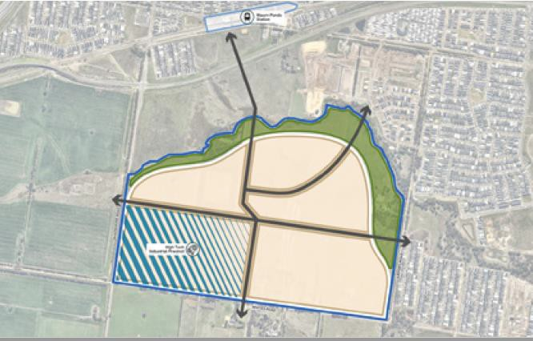
Source: Urbis for Warralily, November 2021

Boral Former Quarry Employment Strategy (MacroPlan et al for Boral, 2021)
MacroPlan, Grimshaw and CJ Arms have undertaken high level strategic planning for the Boral site. The site area of the Boral owned land is 1,035 ha.
The vision for the site is to leverage the site’s topography and existing and future infrastructure connections for a mix of employment, adventure and environmentally distinct uses.

Some of the uses are consistent with the permitted uses of the Special Use Zone Schedule 7, however others are not and would require rezoning.
Figure 13: Boral’s Indicative Land Uses
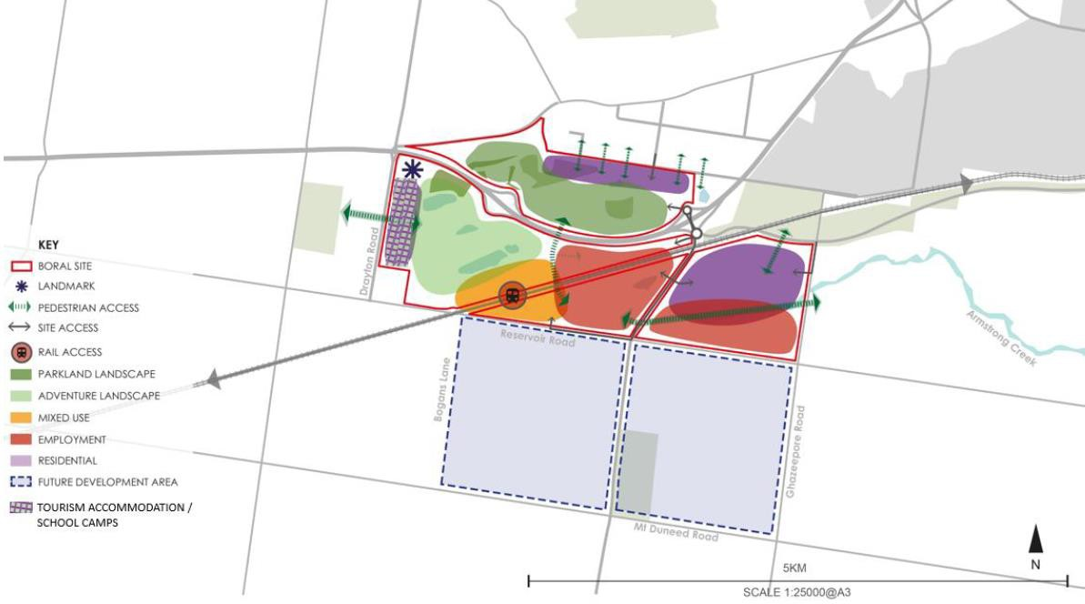
Source: MacroPlan for Boral, 2021

Boral Waurn Ponds: South West Geelong Employment Study Submission to City of Greater Geelong Council (MacroPlan for Boral, August 2022)
This submission builds on previous work by MacroPlan for Boral regarding future opportunities for Boral’s 1,030 ha Waurn Ponds property. The submission states the site could be developed into a regionally significant employment & tourism precinct that could support approximately 3,000 to 5,000 jobs.
The following contextual points regarding the Boral site are made in the submission:
- Large sections of Boral’s property have undergone remediation and rehabilitation
works and Boral is seeking to cater for future urban development.
- Boral’s Waurn Ponds property comprises significant existing infrastructure, power, water, gas and direct access to freeways and major roads.
- The site is located on a passenger rail line with the potential for a future railway station on site with train stabling facilities being constructed on land to the west of Boral’s property.
- Waurn Ponds South, which includes the western portion of Boral’s land was identified
in G21 Regional Plan (2013) as forming part of a future employment precinct.
The following contextual points regarding the context for employment land are made in the submission:

- There has been a long term shift away from manufacturing towards services industries in Geelong and elsewhere.
- There is estimated to be less than 15 years of available zoned industrial land in Greater Geelong.
- Greater Geelong has no dedicated business parks.
- The supply of employment land in Geelong’s south west region is significantly
constrained .
- Other employment areas in south west Geelong will most likely cater for local employment needs and Deakin University will most likely service research and technology activities.
The following planning and development concepts are nominated for the Boral site:
- Industrial Precinct / Modern Business Park Concept 250 ha (gross), comprising:
  - 140 ha (gross) of industrial uses, warehouses and offices supporting many employment opportunities across a wide range of industries such as construction, advanced manufacturing, transport and logistics, warehousing and wholesale, innovation and technology, and business services
  - 110 ha (gross) of transit oriented activity / mixed use with commercial office, retail
/ convenience / tourism uses, marketplace / worker accommodation.
- Tourism Gateway / Regional Parkland & Open Space 125 ha (gross)
- The northern and central precincts totalling approximately 375 ha (gross) can support development in the short term.

North East Industrial Precinct (NEIP) - Ongoing Assessment (Urbis for Re-Grow Finance Pty Ltd, August 2022)
This letter states that ongoing assessment of the employment land in Geelong is required in the context of increased population growth, new industrial land supply and emerging development proposals.
Re-Grow Finance Pty Ltd has control of the site previously known Keystone Business Park and seeks to develop employment uses at the site consistent with planning directions. The latter makes four points:
‘1. We strongly support the existing mix of land uses proposed in the gazetted NEIP Precinct Structure Plan (PSP), noting the general capacity of the site to deliver opportunities for highly-accessible, large-format retail along the duplicated Barwon Heads Road frontage, as well as much-needed areas for light industrial and trade services.
- To ensure that the NEIP’s development is hastened and comprehensive, we strongly oppose the identification of additional land in Geelong’ south-west (e.g., the Boral Waurn Ponds site) to cater for the mix of land uses already proposed in the NEIP on the basis that it will dilute the current demand for this type of employment land.

- We reiterate the importance of the Bellarine Link project, both the current planning area between the Surf Coast Highway and Barwon Heads Road and the future planning area to connect the road to Portarlington Road. We request that renewed commitment from the Victorian Government to the future delivery of Bellarine Link (in full) is highlighted as a recommendation of the report.
- We are committed to unlocking development in the NEIP as soon as possible and seek support from Council for a fast-tracked and streamlined planning process, including serious consideration of Ministerial amendment pathways and concurrent planning permit processes to deliver this outcome.’

Waurn Ponds Strategic Extractive Resource Assessment
The land owned by Boral is subject to an Extractive Industry Interest Area designation by the Department of Environment, Land, Water and Planning.
The Extractive Industry Interest Area designation is applied to land that has been identified as being likely to contain stone resources of sufficient quantity and quality to support a commercial extractive industry operation.
The purpose of Extractive Industry Interest Areas are to:
    - Provide a basis for the long term protection of stone resources from sterilisation by other land uses
    - Provide a basis for ensuring the long term availability of stone resources for use by the community and at minimal detriment to the environment
    - Assist in considering extractive industry values in long term strategic planning
    - Ensure that planning or responsible authorities consult with all relevant agencies about land use proposals which may impact on the reduction of stone resources within these areas
    - Create an awareness that extractive industry is a possible land use in these areas. Extractive Industry Interest Areas do not:
    - Provide statutory protection for stone resources
    - Allow extractive industry as-of-right, unless specified in a planning scheme
    - Imply that future extractive industry will be confined to these areas
    - Preclude the use and development of land for other purposes, or
    - Provide direction regarding approval of specific extractive industry projects. Department of Environment, Land, Water and Planning has undertaken an assessment of Boral land and has concluded that the limestone resources located north of Whites Road are
no longer strategic extractive resource supplies.
Further assessment of the strategic importance of the southern portion of the work authority and adjacent land are recommended before making a final determination whether to maintain this site as an Extractive Industry Interest Area.

DELWP are currently developing a Strategic Extractive Resources Roadmap which will identify priority areas to help secure long-term supply of quarry materials to meet growing demand. There are 12 priority areas for investigation, and Greater Geelong is one of them.
Under the current scenario and any future scenario where the southern portion of the Boral land is subject to an Extractive Industry Interest Area, development on the land would require consultation with the Secretary of the Department administering the Extractive Industries Development Act 1995 and would unlikely be permitted to host urban uses.
Under these scenarios, development in the Boral land to the north of Whites Road would require consideration of buffer requirements and land use suitability given the southern portion’s potential future use as a quarry.
If the entirety of the Boral land were released from the Extractive Industry Interest Area, a range of land use options could be explored.
Figure 14: Assessment of Boral Land
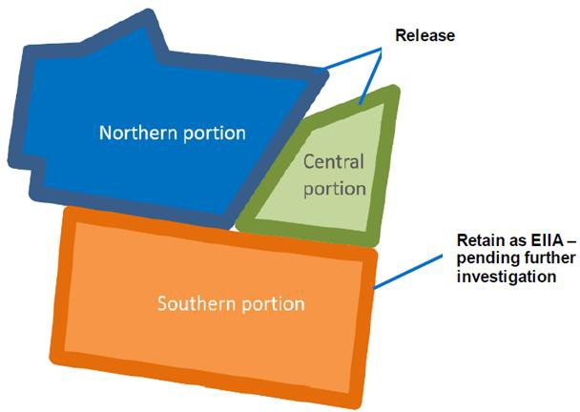

Source: State of Victoria, 2021

STUDY AREA PRECINCTS

Overview
This section of the report provides information on study area features after contextual matters to do with transport, the 2026 Commonwealth Games and extractive industry are introduced.

Major Transport Linkages
Boral land has is adjacent to or traversed by three major regional transport linkages: Geelong Ring Road, Princes Highway and the rail line.
The Western Industrial Precinct is accessed by the secondary road network and has no direct interface with major regional transport linkages.

2026 Commonwealth Game
The state government has nominated areas near the study area precincts - in Waurn Ponds and Armstrong Creek - for major investment relating to the 2026 Commonwealth Games. The plan includes:
    - An athletes’ village at the Waurn Ponds Station Precinct to accommodate approximately
2,500 people
    - An artistic gymnastics and weightlifting venue in Waurn Ponds, to be converted into multi-sport courts, a dance studio, and a regional-level gymnastics centre after the games
    - An aquatics centre in Armstrong Creek, to be converted into a community pool with multi-purpose courts and open space after the games.
These projects will be catalysts for other residential and business investment in the area.

Extractive Industry at Boral Land
Boral land located north of Whites Road/Reservoir Road is no longer assessed as a strategic extractive resource area and can be considered for alternative land uses.
The Boral land parcels south of Whites Road/Reservoir Road will be subject to further assessment in the future.
Development of land north of Whites Road/Reservoir Road will require consideration of buffer requirements and land use suitability given the southern portion’s potential future is yet to be determined.

Precinct Features
Notable features of the Western Industrial Precinct are:
    - The precinct is within a rapidly growing residential catchment in Armstrong Creek, near the Waurn Ponds Train Station precinct
    - Armstrong Creek is a significant natural environment corridor along the precinct’s
northern boundary
    - The precinct is part of Mount Duneed terrain, falling from south to north
    - The precinct is served by arterial and local roads; it is not directly accessible by primary roads in the region
    - Boral land immediately to west has been released from an extractive industry designation; this impacts the potential buffer role the precinct was once intended to perform between Boral land and sensitive land uses
    - Boral land south of Whites Road/Reservoir Road may continue to have a buffer impact on the precinct; this is yet to be determined
    - All environmental and site constraints have not been identified in this report.
Boral land has four sub-areas north of Whites Road/Reservoir Road: north of freeway, between freeway and rail line, between rail line and Anglesea Road and east of Anglesea Road.
Notable features of Boral land north of Whites Road/Reservoir Road are:
    - Direct access to the freeway and railway lines, including potential future train station investigation
    - Vehicular connections across the freeway and railway line already exist
    - Existing provision of utilities to the site
    - Relatively hilly terrain to the west of the area and relatively flat towards the east
    - Central and western portions have been subject to extractive industry and require remediation and / or redevelopment
    - Significant landscape overlay in the north- western portion
    - Native vegetation clusters in north
    - Creek corridor through precinct
    - Potential topographic / environmental constraints - unknown development capacity
    - All environmental and site constraints have not been identified in this report.
The portion of Boral land south of Whites Road/Reservoir Road is not considered in detail in this report due to it being subject to future investigation for extractive industry or other uses.

Figure 15: Study Area Features
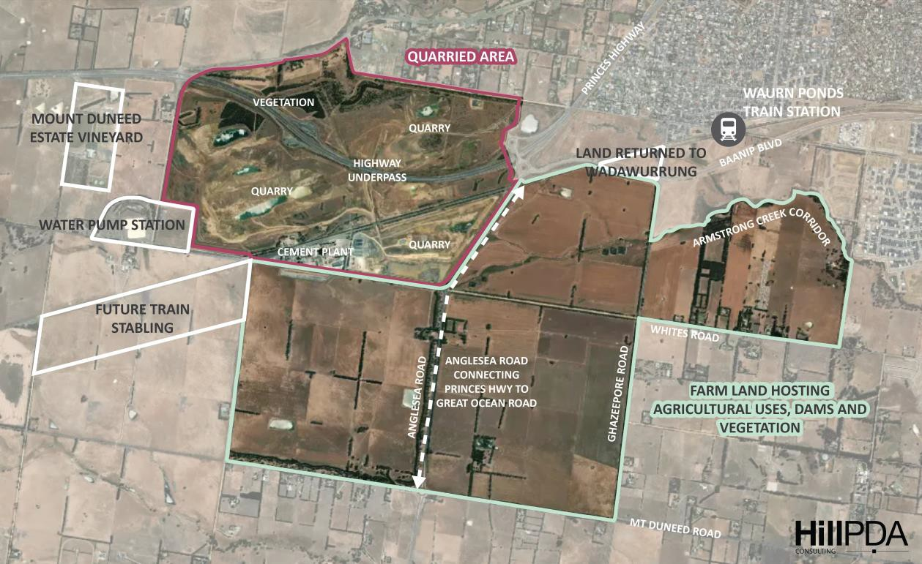

Figure 16: Major Transport Features
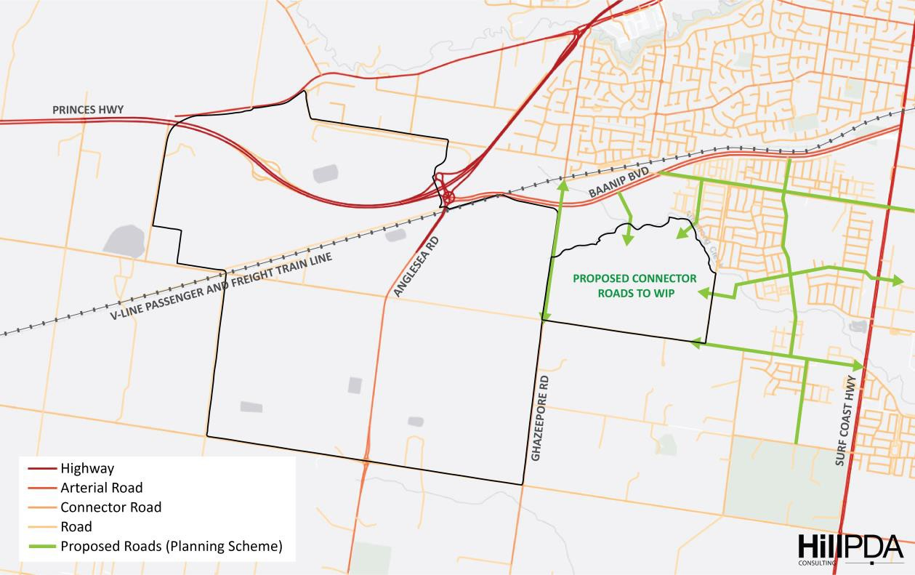

Figure 17: Planning Scheme Overlays
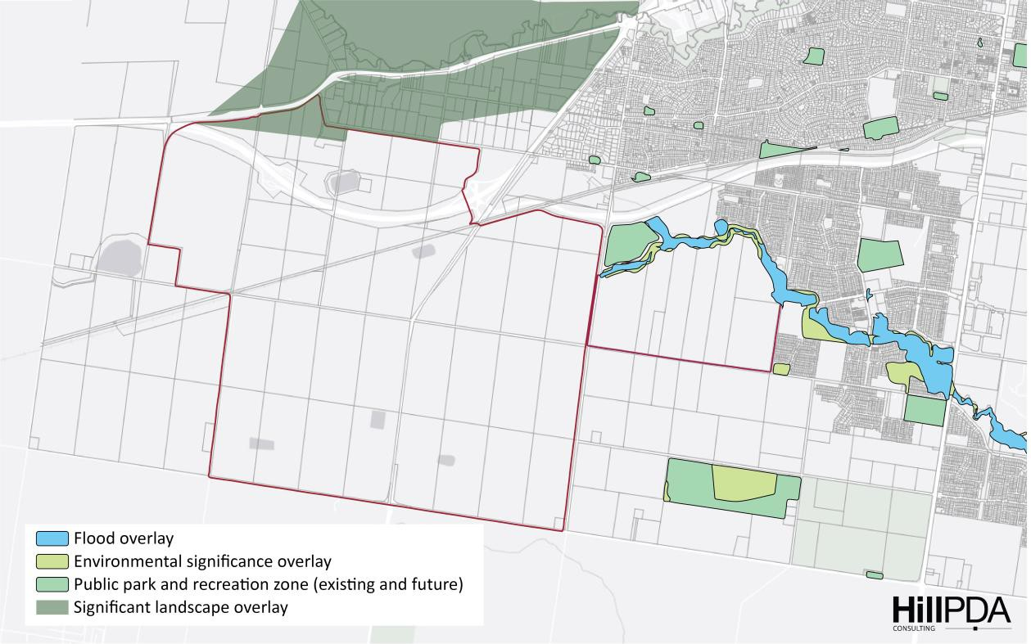

Figure 18: Topography
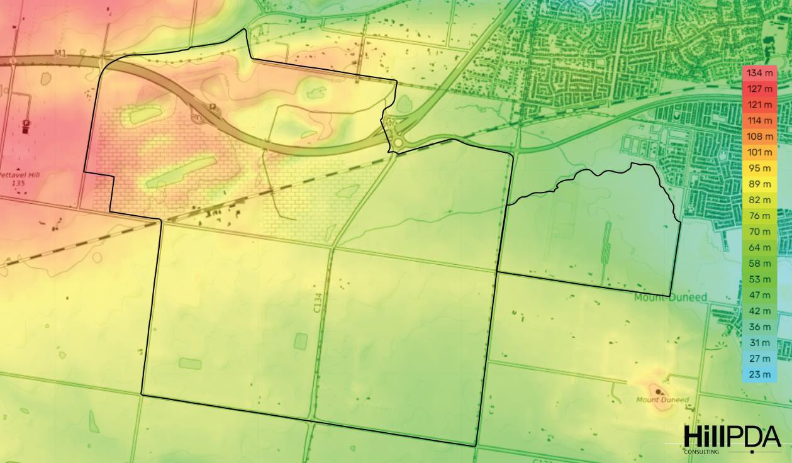

OPTIONS FOR CONSIDERATION

Recap of Need and Timing
It is assessed that a target provision of approximately 245 hectares of employment land (net developable area) be established for the south west Geelong region for a 2051 time horizon (in addition to activity centre land).
This means that approximately 170 hectares of additional employment land is needed in south west Geelong by 2051, in addition to the North East Industrial Precinct, which is estimated to provide approximately 76 hectares.
The job yield of the assessed need of 245 hectares is estimated to be between 7,350 to 14,700 jobs, depending on the ultimate land use and business mix.
Activation of the additional employment land is recommended for approximately 2027. The North East Industrial Precinct is currently in the planning and development process.

Potential Investigation Area and Development Cells
The following figure shows the employment land investigation area and potential development cells that have been identified for consideration. A number of options are presented in the following pages.
Figure 19: Investigation Area and Development Cells
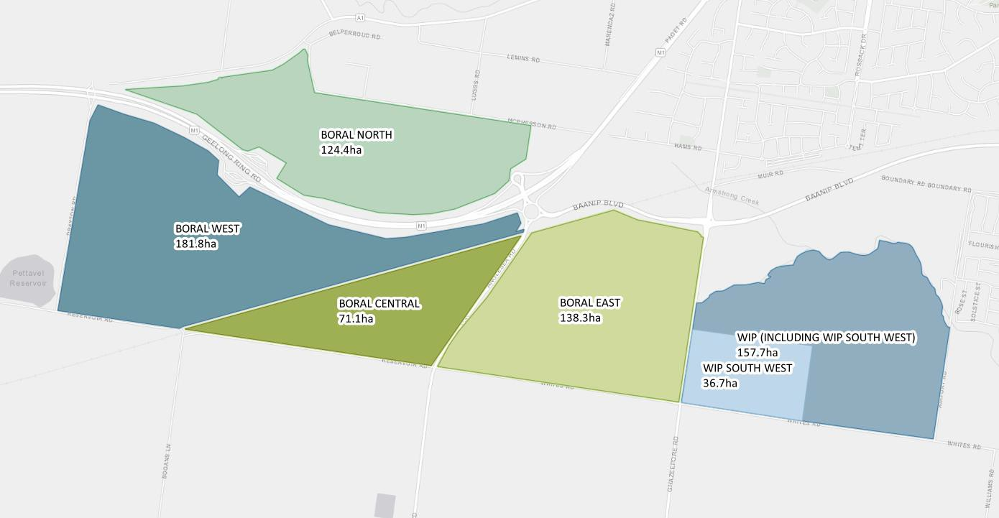

Table 11: Land Area Estimates: Potential Development Cells

Development cell | Estimated gross area (ha) | Estimated net developable area assuming 80% developability (ha)
Boral North | 124.4 | 99.5
Boral West | 181.8 | 145.4
Boral Central | 71.1 | 56.9
Boral East | 138.3 | 110.6
Western Industrial Precinct | 157.7 | 126.1
Western Industrial Precinct South West | 36.7 | 29.4
The Western Industrial Precinct is currently nominated as a future employment area in the Greater Geelong Planning Scheme. Any proposal to change this designation will first require verification that an alternative option can be delivered from a land use planning, environmental and infrastructure perspective.
The Western Industrial Precinct alone cannot fully deliver employment land needs as estimated in this report. More land needs to be found for a 2051 outlook period.
Between the Western Industrial Precinct and Boral land, adequate employment land can be provided.
A flexible approach can be applied across the study area to explore how employment land can be delivered across the potential development cells.
The delivery of employment land in the study area is a priority given a growing population and policy to provide jobs under the Armstrong Creek Framework Plan.
Employment land must be able to be delivered in the short-medium term. While the North East Industrial Precinct is underway, more land will be needed to be provided to address demand in the next five years.
The Boral land offers a variety of options for employment land. Given the assessed need, it must be demonstrated the land considered for employment use is free of major constraints and can be delivered to market in a timely manner. Significant remediation requirements may impact delivery timeframes.

Employment Land Options for Consideration
The following table nominates options for consideration. Images of the options are presented in the pages that follow.

Table 12: Employment Land Supply Options for Consideration

Option name | Estimated gross area (ha) | Estimated net developable area (ha) | Maximises access to major road(s) | Potential direct access to rail | Potential buffer role for Boral south* | Other comments
Western Industrial Precinct | 157.6 | 126.1 | ✗ | ✗ | ✓ | - Basis for industrial designation has changed  - Land owner seeks alternative plan  - Does not offer direct major road or rail access  - Has limited potential buffer role should Boral south be activated for quarrying  - Does not fully meet estimated employment land need
Western Industrial Precinct South West and Boral East | 175 | 140 | ✓ | ✓ | ✓✓ | - Partly consistent with land owner concept  - Does not fully capitalise on rail based potential  - Provides partial buffer to Boral south should that be needed  - Does not fully meet estimated employment land need
Boral Central and Boral East | 209.4 | 167.5 | ✓✓ | ✓✓ | ✓✓✓ | - Partly consistent with land owner concept  - Does not fully capitalise on rail based potential  - Provides best buffer to Boral south should that be needed  - Provides land to meet estimated need
Boral North and Boral Central | 195.5 | 156.4 | ✓✓✓ | ✓ | ✓ | - Partly consistent with land owner concept  - Does not fully capitalise on rail based potential  - Provides most land to meet estimated need
Boral West (Portion), Boral Central and Boral East (Portion) | 169.6 | 135.7 | ✓✓ | ✓✓✓ | ✓✓✓ | - Consistent with land owner concept  - Provides rail and road based employment precinct options  - Does not fully meet estimated employment land need
Boral North (Portion), Boral West (Portion), Boral Central and Boral East (Portion) | 246.5 | 197.2 | ✓✓✓ | ✓✓✓ | ✓✓✓ | - Partly consistent with land owner concept  - Provides rail and road based employment precinct options  - Provides more land than estimated need
* South of Whites Road/Reservoir Road

Western Industrial Precinct
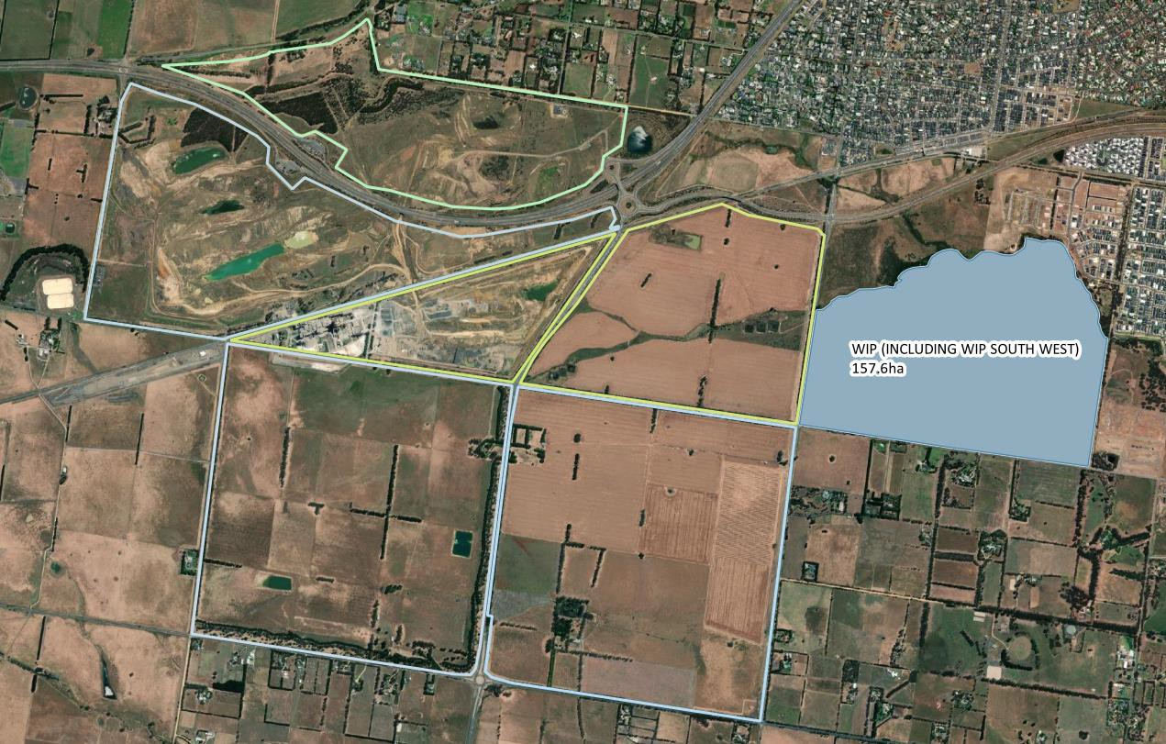
Total area: 157.6ha

Western Industrial Precinct South West and Boral East
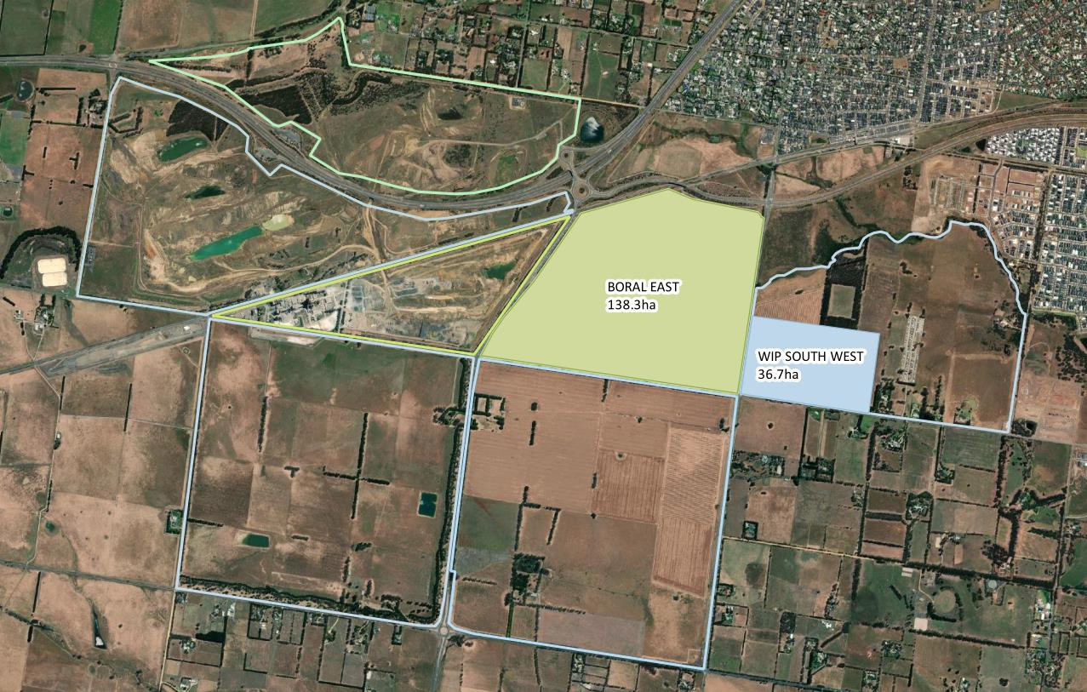
Total area: 175ha

Boral Central and Boral East
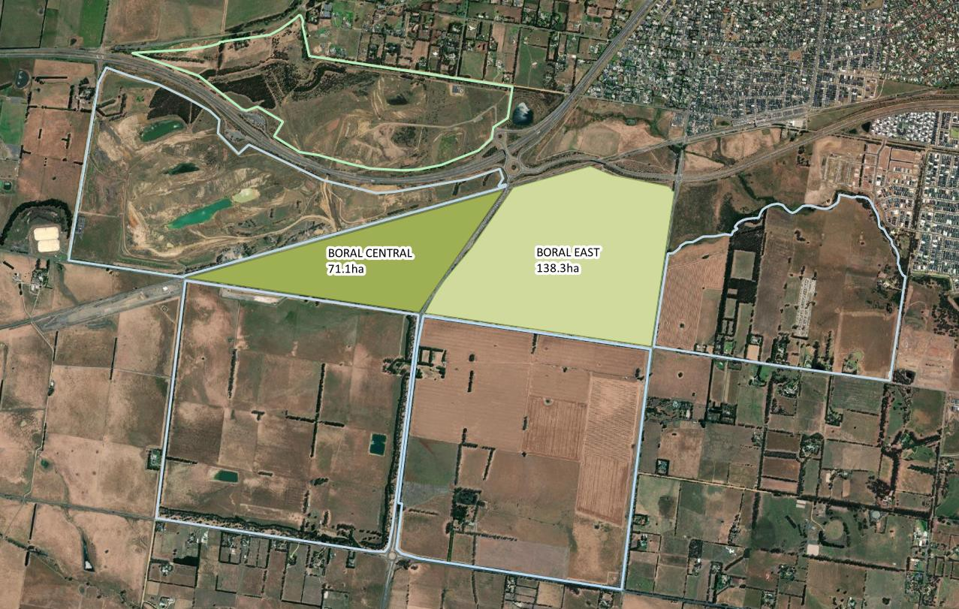
Total area: 209.4ha

Boral North and Boral Central
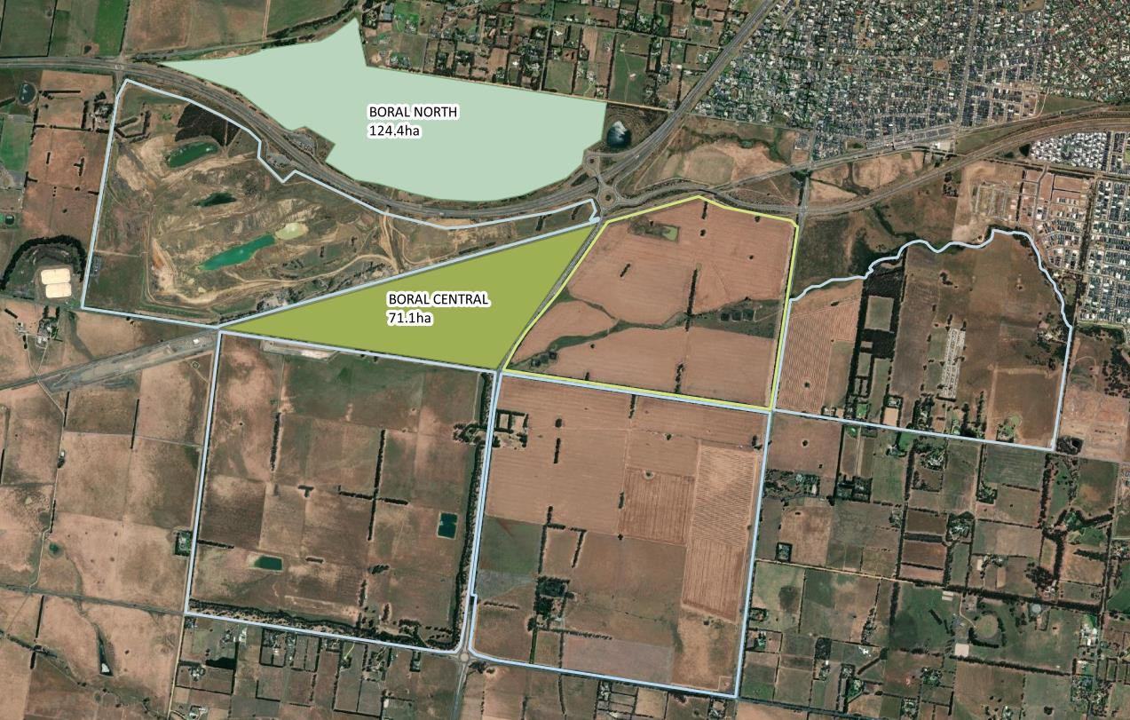
Total area: 195.5ha

Boral West (Portion), Boral Central and Boral East (Portion)
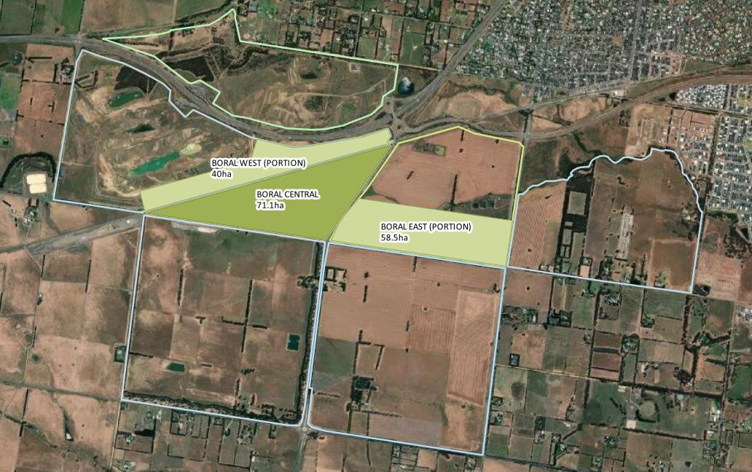
Total area: 169.6ha

Boral North (Portion), Boral West (Portion), Boral Central and Boral East (Portion)
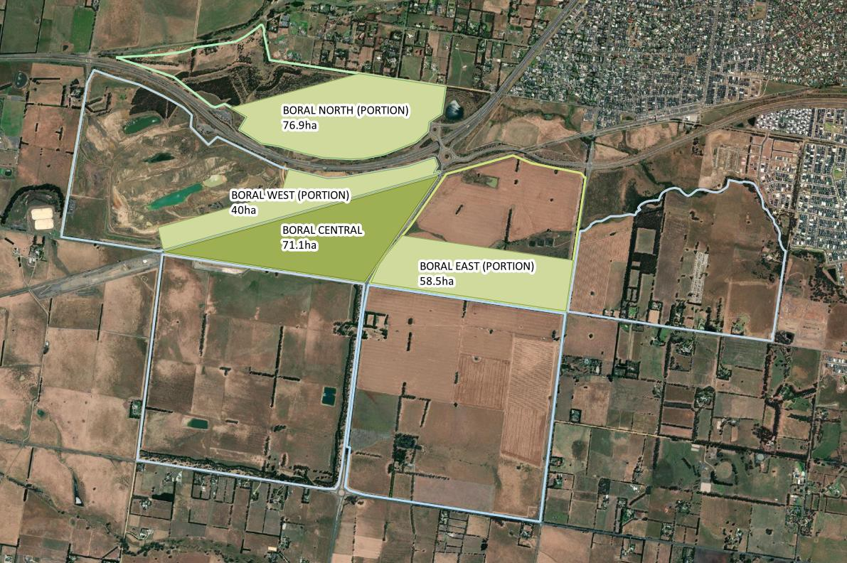

Recommendations
It is recommended that:
    - The Western Industrial Precinct and Boral land be defined as one ‘investigation precinct’.
    - The City of Greater Geelong work with land stakeholders to explore and test an employment land option that delivers approximately 170 hectares of employment land (net developable area). Activation of the additional employment land is recommended
for approximately 2027.
    - An aspirational job target of up to 60 jobs per hectare overall be proposed for the 'investigation precinct', noting the original employment target for Armstrong Creek was one job per household.
    - The 'investigation precinct' should focus on meeting local and sub-regional needs.
      - A range of lot sizes is needed to meet demand from 250 sqm from up to 1 ha.
      - The 'investigation precinct' should meet the existing market demand for warehousing, large format retail and trade supplies and growth sectors such as social service and caring economy activities, sustainable growth and environment sectors and advanced manufacturing.
      - Consideration should be given to large format manufacturing with needs of 4,000 sqm to five hectares.
    - Once short-medium term employment land is catered for, and Council is satisfied it can realistically be delivered to the market in a timely manner, other land uses can be considered.
    - To determine appropriate land uses across the precinct, considerations should include:
    - Connections back to the existing or planned urban areas
      - Maximise proximity to arterial roads
      - Maximise proximity to the train station and rail corridor
      - Opportunities to enhance the Armstrong Creek open space corridor
      - Optimise access to regional open space
      - Provision of an attractive western entrance to Geelong
      - Opportunities to build on the existence and history of the quarry site including any limitations posed by site remediation
      - Maximise elevated positions and attractive view lines
      - Have regard to Wadawurrung living cultural heritage
      - Consider interfaces with existing and planned uses
      - Address site remediation and contaminated land issues
      - Consider a ‘value capture’ contribution if land is rezoned to a higher value in the investigation area. The contribution could be calculated as a share of the land value uplift generated by a planning change, with the proceeds invested in local community facilities and / or open space.



APPENDICES

APPENDIX A: SALES DATA

Table 13: Employment Lands Property Sales (Jan-21 to May-22)
Street Address | Suburb | Precinct | Land Size | Building Area |  | Sale Price | Land Sale Price ($/sqm) | GFA Sale Price ($/sqm) | Sale Date | Land Use 1 | Zoning
84 Heales Road | Lara | GREP | 6,072 |  |  | $2,000,000 | $329 |  | 22/11/2021 | General Purpose Factory | Industrial 2 Zone
220 Heales Road | Lara | GREP | 263,092 | - |  | $6,000,000 | $23 |  | 16/04/2021 | Open Area Storage | Industrial 2 Zone
185-205 Obriens Road | Corio | GREP | 29,670 | - |  | $4,200,000 | $142 |  | 28/10/2021 | Industrial Dev Site | Industrial 2 Zone
330 Forest Road South | Corio | GREP | 11,584 | - |  | $2,300,000 | $199 |  | 18/06/2021 | General Purpose Factory | Industrial 2 Zone
45-55 Obriens Road | Corio | GREP | 113,096 | - |  | $36,000,000 | $318 |  | 30/03/2021 | General Purpose Factory | Industrial 2 Zone
124-128 Broderick Road | Corio | GREP | 5,027 | 1,650 |  | $220,000 | $44 | $133 | 18/02/2022 | General Purpose Factory | Industrial 1 Zone
1C Seaforth Street | North Shore | Geelong Port | 696 | 190 |  | $520,000 | $747 | $2,737 | 31/03/2022 | General Purpose Factory | Industrial 2 Zone
5-7 Seaforth Street | North Shore | Geelong Port | 1,041 | 685 |  | $1,300,000 | $1,249 | $1,898 | 26/11/2021 | General Purpose Factory | Industrial 2 Zone
24-26 Seaside Parade | North Shore | Geelong Port | 1,378 | - |  | $770,000 | $559 |  | 13/10/2021 | General Purpose Factory | Industrial 2 Zone
18 Walchs Road | North Shore | Geelong Port | 661 | 661 |  | $207,900 | $315 | $315 | 4/02/2021 | Industrial Dev Site | Industrial 2 Zone

-

-
Street Address | Suburb | Precinct | Land Size | Building Area |  | Sale Price | Land Sale Price ($/sqm) | GFA Sale Price ($/sqm) | Sale Date | Land Use 1 | Zoning
11 Foch Street | North Shore | Geelong Port | 645 |  |  | $290,000 | $450 |  | 4/01/2021 | General Purpose Warehouse | Industrial 2 Zone
10-12 Donga Road | North Geelong | Geelong Port | 2,476 | 149 |  | $980,000 | $396 | $6,577 | 11/01/2021 | General Purpose Factory | Industrial 2 Zone
83 Douro Street | North Geelong | Geelong Port | 535 | - |  | $190,000 | $355 |  | 21/06/2021 | General Purpose Factory | Industrial 1 Zone
117-119 Douro Street | North Geelong | Geelong Port | 1,226 | 149 |  | $600,000 | $489 | $4,027 | 11/06/2021 | General Purpose Warehouse | Industrial 1 Zone
257 Melbourne Road | North Geelong | Geelong Port | 3,000 | 500 |  | $1,550,000 | $517 | $3,100 | 25/02/2021 | Vehicle Sales Centre | Industrial 2 Zone
104-106 Mornington Street | North Geelong | Geelong Port | 1,349 | - |  | $600,000 | $445 |  | 11/06/2021 | General Purpose Warehouse | Industrial 1 Zone
20-22 Rodney Road | North Geelong | Geelong Port | 1,298 | - |  | $1,500,000 | $1,156 |  | 8/12/2021 | General Purpose Warehouse | Industrial 1 Zone
20 Roseneath Street | North Geelong | Geelong Port | 747 | 121 |  | $1,825,000 | $2,443 | $15,083 | 23/12/2021 | Mixed Use Occupation | Industrial 1 Zone
15-17 Saunders Street | North Geelong | Geelong Port | 1,176 | 789 |  | $1,650,000 | $1,403 | $2,091 | 16/11/2021 | General Purpose Factory | Industrial 2 Zone
7/6-8 Shepherd Court | North Geelong | Geelong Port | 427 | 422 |  | $935,000 | $2,190 | $2,216 | 24/03/2021 | General Purpose Factory | Industrial 1 Zone
35 Separation Street | North Geelong | Geelong Port | 7,695 | 7,694 |  | $2,750,000 | $357 | $357 | 16/07/2021 | Ground Level Parking | Commercial 2 Zone
7 Slevin Street | North Geelong | Geelong Port | 363 | - |  | $630,000 | $1,736 |  | 25/08/2021 | General Purpose Factory | Industrial 1 Zone

Street Address | Suburb | Precinct | Land Size | Building Area | Sale Price | Land Sale Price ($/sqm) | GFA Sale Price ($/sqm) | Sale Date | Land Use 1 | Zoning
137-139 Victoria Street | North Geelong | Geelong Port | 2,430 | 2,400 | $1,402,500 | $577 | $584 | 13/04/2021 | Fuel Outlet/Garage/Se rvice Station | Industrial 1 Zone
8/156 Victoria Street | North Geelong | Geelong Port | 214 | 205 | $450,000 | $2,103 | $2,195 | 12/11/2021 | General Purpose Warehouse | Industrial 1 Zone
62-66 Cowie Street | North Geelong | Geelong Port | 4,873 | - | $3,100,000 | $636 |  | 7/04/2021 | General Purpose Factory | Industrial 2 Zone
1/156 Victoria Street | North Geelong | Geelong Port | 208 | 202 | $350,000 | $1,683 | $1,733 | 15/03/2021 | General Purpose Factory | Industrial 1 Zone
16 Wood Street | South Geelong | South Geelong | 1,018 | - | $2,000,000 | $1,965 |  | 25/01/2022 | General Purpose Factory | Industrial 1 Zone
7 Haworth Court | Breakwater | South Geelong | 3,524 | - | $1,250,000 | $355 |  | 7/04/2021 | General Purpose Warehouse | Industrial 1 Zone
8 Haworth Court | Breakwater | South Geelong | 3,624 | 130 | $1,250,000 | $345 | $9,615 | 7/04/2021 | Industrial Dev Site | Industrial 1 Zone
9 Haworth Court | Breakwater | South Geelong | 1,293 | 678 | $1,250,000 | $967 | $1,844 | 7/04/2021 | General Purpose Warehouse | Industrial 1 Zone
78-108 Gravel Pits Road | South Geelong | South Geelong | 30,454 | - | $705,000 | $23 |  | 15/03/2021 | Open Area Storage | Industrial 1 Zone
7/5 Bridge Street | Newtown | South Geelong | 101 | 78 | $495,000 | $4,901 | $6,346 | 3/06/2021 | Warehouse/Show room | Commercial 2 Zone
11/5 Bridge Street | Newtown | South Geelong | 71 | 70 | $440,000 | $6,197 | $6,286 | 28/07/2021 | Warehouse/Show room | Commercial 2 Zone
13/5 Bridge Street | Newtown | South Geelong | 77 | 77 | $400,000 | $5,195 | $5,195 | 10/08/2021 | Warehouse/Show room | Commercial 2 Zone

Street Address | Suburb | Precinct | Land Size | Building Area | Sale Price | Land Sale Price ($/sqm) | GFA Sale Price ($/sqm) | Sale Date | Land Use 1 | Zoning
26 Rutland Street | Newtown | South Geelong | 417 | 348 | $1,750,000 | $4,197 | $5,029 | 5/08/2021 | General Purpose Warehouse | Industrial 1 Zone
32-35 Industrial Place | Breakwater | South Geelong | 1,589 | 947 | $1,975,000 | $1,243 | $2,086 | 13/07/2021 | General Purpose Warehouse | Industrial 1 Zone
28 Lambert Avenue | Newtown | South Geelong | 554 | 130 | $275,000 | $496 | $2,115 | 14/12/2021 | General Purpose Factory | Commercial 2 Zone
30 Lambert Avenue | Newtown | South Geelong | 551 | 230 | $800,000 | $1,452 | $3,478 | 23/04/2021 | General Purpose Warehouse | Commercial 2 Zone
80 Barwon Terrace | South Geelong | South Geelong | 3,264 | 3,390 | $2,576,000 | $789 | $760 | 15/01/2021 | General Purpose Factory | Industrial 2 Zone
9 Birkett Place | South Geelong | South Geelong | 1,040 | - | $1,450,000 | $1,394 |  | 8/04/2021 | General Purpose Warehouse | Industrial 1 Zone
1 Crown Street | South Geelong | South Geelong | 11,292 | - | $5,400,000 | $478 |  | 16/09/2021 | Major Indoor Sports Complex | Industrial 1 Zone
20 Dowsett Street | South Geelong | South Geelong | 1,198 | - | $1,200,000 | $1,002 |  | 19/10/2021 | General Purpose Factory | Industrial 1 Zone
143 Fyans Street | South Geelong | South Geelong | 1,500 | - | $2,530,000 | $1,687 |  | 12/11/2021 | General Purpose Factory | Industrial 1 Zone
32-34 Gravel Pits Road | South Geelong | South Geelong | 7,793 | - | $875,000 | $112 |  | 23/02/2021 | General Purpose Factory | Industrial 2 Zone
35 Gravel Pits Road | South Geelong | South Geelong | 20,345 | - | $785,000 | $39 |  | 15/03/2021 | General Purpose Factory | Industrial 1 Zone
36-38 Gravel Pits Road | South Geelong | South Geelong | 5,907 | - | $235,000 | $40 |  | 15/03/2021 | General Purpose Factory | Industrial 2 Zone

Street Address | Suburb | Precinct | Land Size | Building Area |  | Sale Price | Land Sale Price ($/sqm) | GFA Sale Price ($/sqm) | Sale Date | Land Use 1 | Zoning
44-76 Gravel Pits Road | South Geelong | South Geelong | 19,682 |  |  | $635,000 | $32 |  | 20/10/2021 | General Purpose Factory | Industrial 2 Zone
14 Hede Street | South Geelong | South Geelong | 868 | 682 |  | $1,250,000 | $1,440 | $1,833 | 2/07/2021 | General Purpose Warehouse | Industrial 1 Zone
40 Main Street | Armstrong Creek | Armstrong Creek MAC | 20,600 | - |  | $55,600,000 | $2,699 |  | 1/07/2021 | Vacant land | Urban Growth Zone
300 Whites Road | Armstrong Creek | WIP | 305,300 | - |  | $5,600,000 | $18 |  | 1/06/2019 | Vacant land | Urban Growth Zone
280-290 Whites Road | Armstrong Creek | WIP | 165,100 | - |  | $5,040,000 | $31 |  | 1/07/2019 | Vacant land | Urban Growth Zone
260 Whites Road | Armstrong Creek | WIP | 212,100 | - |  | $3,500,000 | $17 |  | 1/06/2019 | Vacant land | Urban Growth Zone
250 Whites Road | Armstrong Creek | WIP | 216,900 | - |  | $3,150,000 | $15 |  | 1/09/2015 | Vacant land | Urban Growth Zone
210 Whites Road | Armstrong Creek | WIP | 223,300 | - |  | $1,312,000 | $6 |  | 1/03/2004 | Vacant land | Urban Growth Zone
190 Whites Road | Armstrong Creek | WIP | 245,300 | - |  | $7,200,000 | $29 |  | 1/06/2019 | Vacant land | Urban Growth Zone
100 Airport Road | Armstrong Creek | WIP | 163,600 | - |  | $7,150,000 | $44 |  | 1/09/2019 | Vacant land | Urban Growth Zone
255-275 Avalon Road  Avalon VIC 3212 | Avalon | Avalon | 8,431,100 | - |  | $5,000,000 | $1 |  | 1/06/2021 | Vacant land | Special use zone
285 Avalon Road  Avalon VIC 3212 | Avalon | Avalon | 334,100 | - |  | $2,310,000 | $7 |  | 1/09/2020 | Vacant land | Special use zone

Street Address | Suburb | Precinct | Land Size | Building Area |  | Sale Price | Land Sale Price ($/sqm) | GFA Sale Price ($/sqm) | Sale Date | Land Use 1 | Zoning
283-289 Bellarine Highway | Moolap | Moolap | 9,579 |  |  | $1,300,000 | $136 |  | 1/02/2022 | Display Yard | Rural Living Zone
291 Bellarine Highway | Moolap | Moolap | 7,266 | - |  | $1,600,000 | $220 |  | 1/02/2022 | Display Yard | Rural Living Zone
42 Grandview Parade | Moolap | Moolap | 614 | 328 |  | $622,051 | $1,013 | $1,896 | 1/07/2021 | General Purpose Warehouse | Industrial 1 Zone
13 Nobility Street | Moolap | Moolap | 1,888 | - |  | $740,000 | $392 |  | 13/04/2021 | General Purpose Factory | Industrial 1 Zone
35 Sun Street | Moolap | Moolap | 808 | 420 |  | $980,000 | $1,213 | $2,333 | 28/09/2021 | Warehouse/Offic e | Industrial 1 Zone
281-289 Bellarine Highway | Moolap | Moolap | 9,579 | - |  | $1,300,000 | $136 |  | 1/02/2022 | Display Yard | Rural Living Zone
31-33 Buckley Grove | Moolap | Moolap | 7,643 | 7,647 |  | $2,250,000 | $294 | $294 | 29/10/2021 | Concrete Batching Plant | Industrial 1 Zone
61-65 Buckley Grove | Moolap | Moolap | 6,070 | 288 |  | $900,000 | $148 | $3,125 | 8/01/2021 | General Purpose Factory | Industrial 1 Zone
1 Coppards Road | Moolap | Moolap | 6,420 | - |  | $1,950,000 | $304 |  | 15/11/2021 | Crematorium/Fun eral Services | Low Density Residential Zone - Schedule 1
57 Essex Street | Moolap | Moolap | 516 | - |  | $250,000 | $484 |  | 12/06/2021 | Industrial Dev Site | Industrial 1 Zone
212 Portarlington Road | Moolap | Moolap | 4,065 | - |  | $445,000 | $109 |  | 9/08/2021 | Vacant Res Rural  / Rural Lifestyle | Low Density Residential Zone - Schedule 1
395 Portarlington Road | Moolap | Moolap | 9,081 | 1,300 |  | $2,200,000 | $242 | $1,692 | 2/12/2021 | General Purpose Factory | Industrial 1 Zone

Street Address | Suburb | Precinct | Land Size | Building Area | Sale Price | Land Sale Price ($/sqm) | GFA Sale Price ($/sqm) | Sale Date | Land Use 1 | Zoning
38 Essex Street | Moolap | Moolap | 629 | 175 | $305,000 | $485 | $1,743 | 10/02/2021 | General Purpose Factory | Industrial 1 Zone
39-55 Moon Street | Moolap | Moolap | 7,167 | - | $1,200,000 | $167 |  | 4/06/2021 | General Purpose Warehouse | Industrial 1 Zone
37 Nobility Street | Moolap | Moolap | 629 | 189 | $385,000 | $612 | $2,037 | 17/05/2021 | General Purpose Factory | Industrial 1 Zone
21 Point Henry Road | Moolap | Moolap | 1,278 | 315 | $1,600,000 | $1,252 | $5,079 | 21/10/2021 | General Purpose Factory | Industrial 1 Zone
32-40 Point Henry Road | Moolap | Moolap | 34,075 | - | $3,050,000 | $90 |  | 1/02/2022 | Open Area Storage | Industrial 1 Zone
42 Sun Street | Moolap | Moolap | 657 | - | $1,265,000 | $1,925 |  | 14/09/2021 | General Purpose Warehouse | Industrial 1 Zone
20 Wattlepark Avenue | Moolap | Moolap | 633 | - | $220,000 | $348 |  | 24/05/2021 | General Purpose Factory | Industrial 1 Zone
11-19 Wills Crescent | Moolap | Moolap | 8,211 | - | $600,000 | $73 |  | 23/02/2021 | Open Area Storage | Industrial 1 Zone
142-150 Woods Road | Moolap | Moolap | 8,162 | - | $955,000 | $117 |  | 26/06/2021 | Mixed Use Occupation | Farming Zone
184 Bellerine Street | Geelong | VIC | 146 | 106 | $605,000 | $4,144 | $5,708 | 6/03/2021 | Office Premises | General Residential Zone - Schedule 1
79B Carr Street | Geelong | VIC | 133 | - | $322,500 | $2,425 |  | 13/01/2021 | Vacant Residential Dwelling Site/Surveyed Lot
83 Carr Street | Geelong | VIC | 134 | - | $322,500 | $2,407 |  | 31/12/2021 | Vacant Residential

-
Street Address | Suburb | Precinct | Land Size | Building Area |  | Sale Price | Land Sale Price ($/sqm) | GFA Sale Price ($/sqm) | Sale Date | Land Use 1 | Zoning
Dwelling Site/Surveyed Lot
4/1-3 Clare Street | Geelong | VIC | 394 |  |  | $1,332,500 | $3,382 |  | 19/06/2021 | Single Strata Unit/Villa Unit/Townhouse | Activity Centre Zone - Schedule 1
8 Forrest Street | Geelong | VIC | 150 | - |  | $395,000 | $2,633 |  | 31/03/2021 | Vacant Residential Dwelling Site/Surveyed Lot
18 Forrest Street | Geelong | VIC | 131 | - |  | $465,500 | $3,553 |  | 20/01/2022 | Vacant Residential Dwelling Site/Surveyed Lot
2/23-31 Gheringhap Street | Geelong | VIC | 1,005 | 90 |  | $401,500 | $400 | $4,461 | 24/11/2021 | Shopping Centre | Activity Centre Zone - Schedule 1
43 Gheringhap Street | Geelong | VIC | 73 | 65 |  | $975,000 | $13,356 | $15,000 | 23/04/2021 | Office Premises | Activity Centre Zone - Schedule 1
36 Little Myers Street | Geelong | VIC | 1,039 | 106 |  | $2,860,000 | $2,753 | $26,981 | 3/09/2021 | Office Premises | Mixed Use Zone
15 Little Ryrie Street | Geelong | VIC | 601 | 650 |  | $2,910,000 | $4,842 | $4,477 | 31/03/2021 | Office Premises | Activity Centre Zone - Schedule 1
16 Little Ryrie Street | Geelong | VIC | 1,827 | 1,130 |  | $5,300,000 | $2,901 | $4,690 | 9/06/2021 | Day Care Centre for Children | Activity Centre Zone - Schedule 1
112 McKillop Street | Geelong | VIC | 464 | 190 |  | $945,000 | $2,037 | $4,974 | 31/01/2022 | Detached Dwelling | General Residential Zone - Schedule 1
1 McLarty Place | Geelong | VIC | 73 | 73 |  | $550,000 | $7,534 | $7,534 | 6/12/2021 | Shopping Centre | Activity Centre Zone - Schedule 1

-
Street Address | Suburb | Precinct | Land Size | Building Area |  | Sale Price | Land Sale Price ($/sqm) | GFA Sale Price ($/sqm) | Sale Date | Land Use 1 | Zoning
12 Merchant Place | Geelong | VIC | 136 |  |  | $358,500 | $2,636 |  | 31/03/2021 | Vacant Residential Dwelling Site/Surveyed Lot
130 Moorabool Street | Geelong | VIC | 232 | 840 |  | $1,600,000 | $6,897 | $1,905 | 3/03/2021 | Office Premises | Activity Centre Zone - Schedule 1
2 Powell Place | Geelong | VIC | 172 | 350 |  | $500,000 | $2,907 | $1,429 | 3/10/2021 | Mixed Use Occupation | Activity Centre Zone - Schedule 1
153-155 Ryrie Street | Geelong | VIC | 181 | 40 |  | $1,155,000 | $6,381 | $28,875 | 6/02/2021 | Shopping Centre | Activity Centre Zone - Schedule 1
194-204 Ryrie Street | Geelong | VIC | 2,916 | 4,701 |  | $19,775,000 | $6,782 | $4,207 | 23/12/2021 | Cinema Complex | Activity Centre Zone - Schedule 1
77-79 Swanston Street | Geelong | VIC | 921 | 220 |  | $2,596,000 | $2,819 | $11,800 | 15/10/2021 | Health Surgery | General Residential Zone - Schedule 2
61 Yarra Street | Geelong | VIC | 543 | - |  | $2,150,000 | $3,959 |  | 1/04/2021 | Office Premises | Activity Centre Zone - Schedule 1
95 Yarra Street | Geelong | VIC | 186 | 122 |  | $979,000 | $5,263 | $8,025 | 5/03/2022 | Office Premises | Activity Centre Zone - Schedule 1

Source: CoreLogic RP Data, 2022

APPENDIX B: EMPLOYMENT PRECINCT PROFILES

SCORESBY
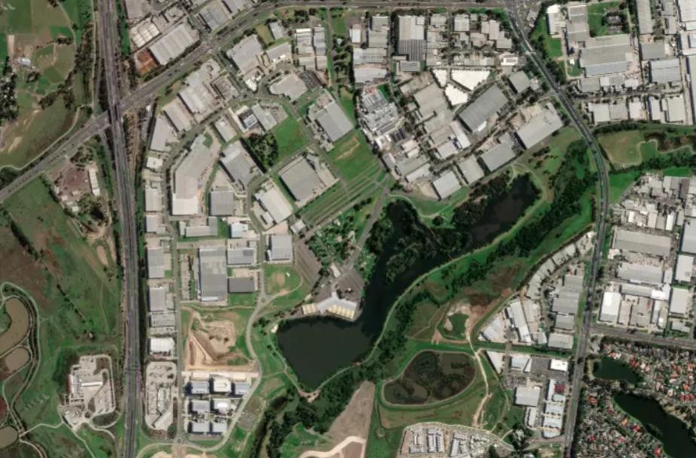

Land area | Zoning | Total number of jobs | Number of jobs per hectare
165ha | C2Z | 8,060 | 48 jobs/ha
Lot sizes | Number of lots | Top 5 local industries | Number of jobs
0-500sqm | 69 | Wholesale Trade | 1,650
501-2,000sqm | 7 | Manufacturing | 1,300
2,001-5,000sqm | 14 | Professional, Scientific and Technical Services | 834
5001sqm+ | 35 | Retail Trade | 605
Total | 125 | Financial and Insurance Services | 598
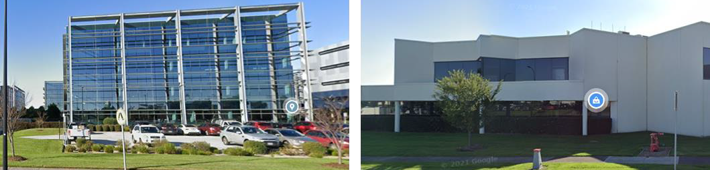

RAVENHALL
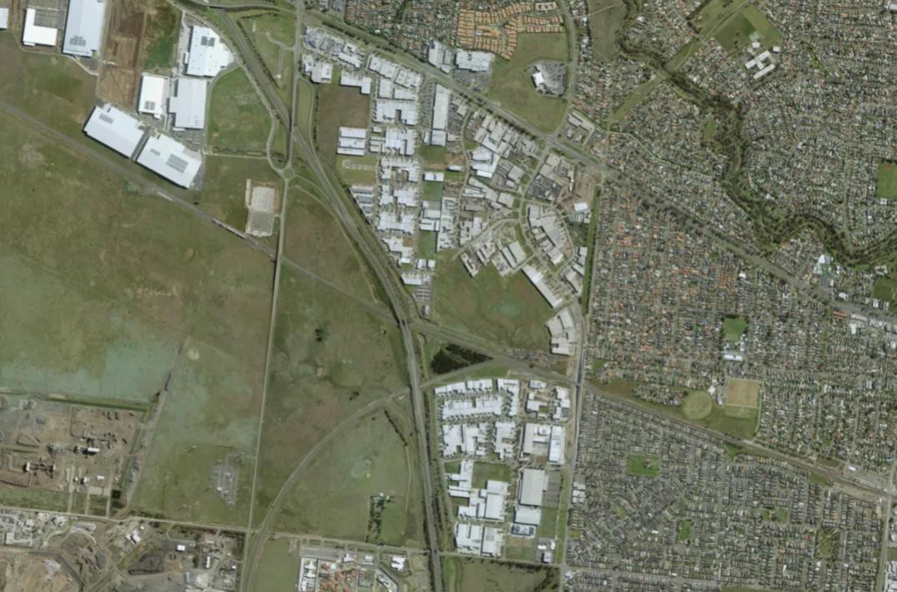

Land area | Zoning | Total number of jobs | Number of jobs per hectare
223ha | IN3Z, C2Z | 10,198 | 45 jobs/ha
Lot sizes | Number of lots | Top 5 local industries | Number of jobs
0-500sqm | 1276 | Construction | 2,249
501-2,000sqm | 482 | Retail Trade | 1,320
2,001-5,000sqm | 162 | Wholesale Trade | 1,111
5001sqm | 122 | Other Services | 799
Total | 2042 | Transport, Postal and | 763
Warehousing
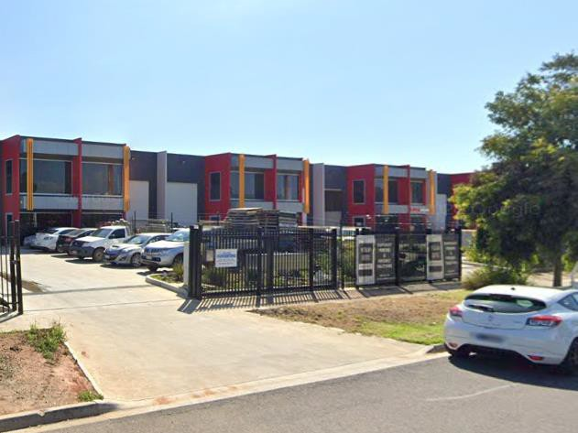
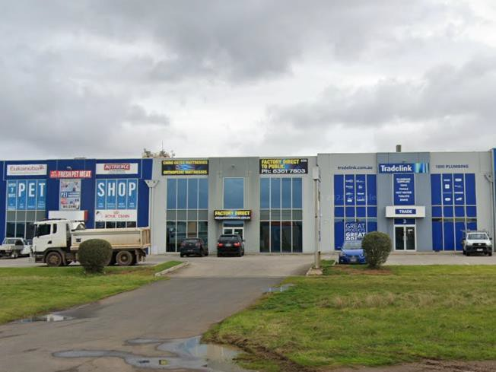

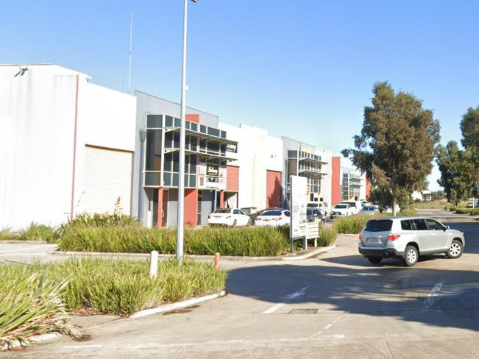
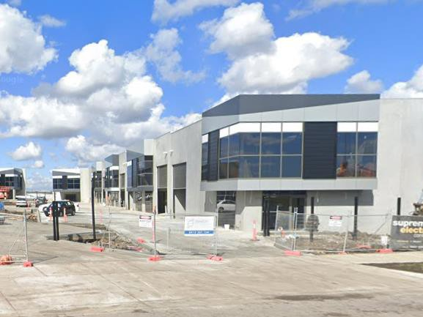

EPPING
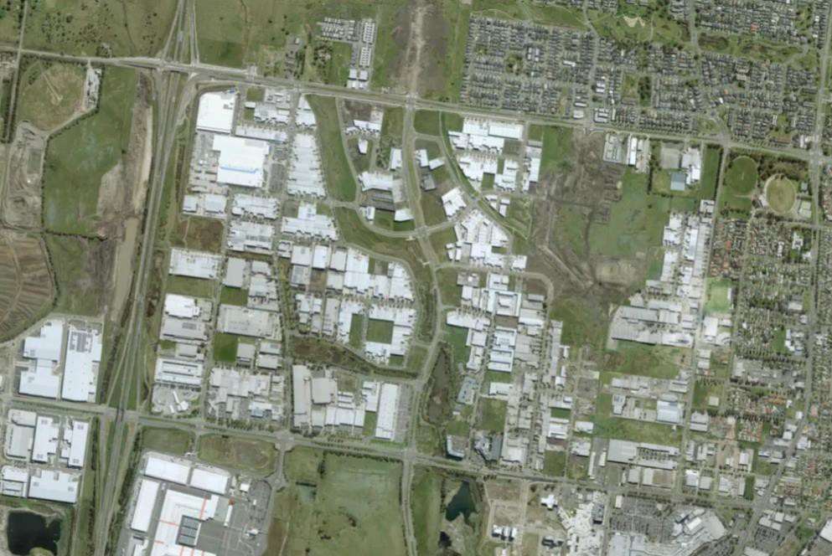

Land area | Zoning | Total number of jobs | Number of jobs per hectare
374ha | IN1Z, CDZ, ACZ | 13,212 | 35 jobs/ha
Lot sizes | Number of lots | Top 5 local industries | Number of jobs
0-500sqm | 1,445 | Manufacturing | 2,987
501-2,000sqm | 454 | Construction | 2,502
2,001-5,000sqm | 305 | Transport, Postal and Warehousing | 1,185
5001sqm+ | 160 | Retail Trade | 1,166
Total | 2,364 | Inadequately described | 1,073

DANDENONG SOUTH (LOGIS)
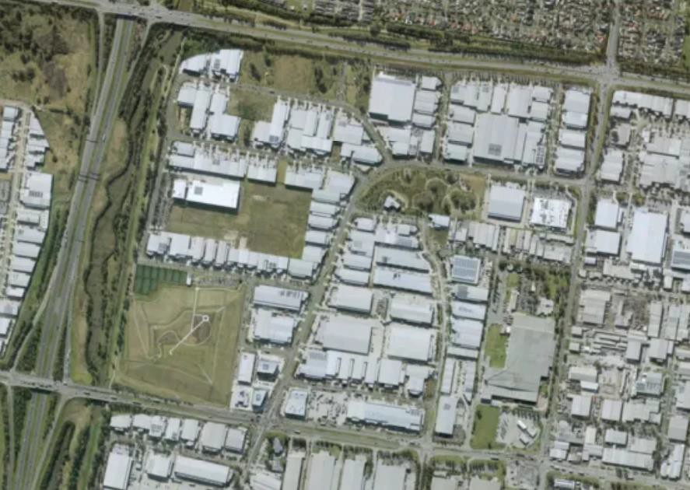

Land area | Zoning | Total number of jobs | Number of jobs per hectare
142ha | IN1Z, IN3Z | 3,816 | 26 jobs/ha
Lot sizes | Number of lots | Top 5 local industries | Number of jobs
0-500sqm | 324 | Manufacturing | 1,028
501-2,000sqm | 46 | Construction | 548
2,001-5,000sqm | 101 | Wholesale Trade | 478
5001sqm+ | 61 | Inadequately described | 353
Total | 532 | Transport, Postal and | 330
Warehousing
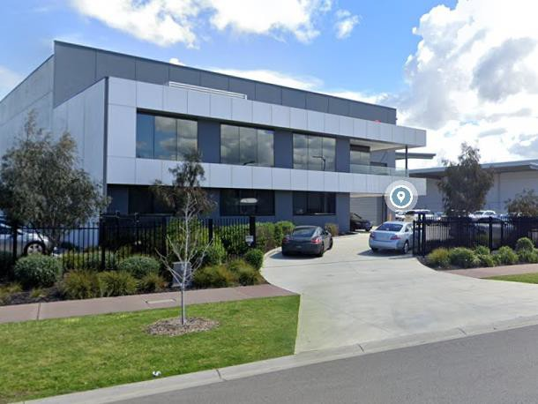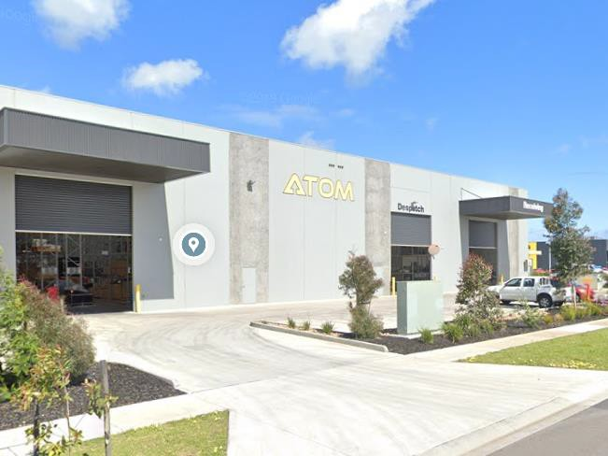

Disclaimer

- This report is for the confidential use only of the party to whom it is addressed ("Client") for the specific purposes to which it refers and has been based on, and takes into account, the Client’s specific instructions. It is not intended to be relied on by any third party who, subject to paragraph 3, must make their own enquiries in relation to the issues with which this report deals.
- HillPDA makes no representations as to the appropriateness, accuracy or completeness of this report for the purpose of any party other than the Client ("Recipient"). HillPDA disclaims all liability to any Recipient for any loss, error or other consequence which may arise as a result of the Recipient acting, relying upon or using the whole or part of this report's contents.
- This report must not be disclosed to any Recipient or reproduced in whole or in part, for any purpose not directly connected to the project for which HillPDA was engaged to prepare the report, without the prior written approval of HillPDA. In the event that a Recipient wishes to rely upon this report, the Recipient must inform HillPDA who may, in its sole discretion and on specified terms, provide its consent.
- This report and its attached appendices are based on estimates, assumptions and information provided by the Client or sourced and referenced from external sources by HillPDA. While we endeavour to check these estimates, assumptions and information, no warranty is given in relation to their reliability, feasibility, accuracy or reasonableness. HillPDA presents these estimates and assumptions as a basis for the Client’s interpretation and analysis. With respect to forecasts, HillPDA does not present them as results that will actually be achieved. HillPDA relies upon the interpretation of the Client to judge for itself the likelihood of whether these projections can be achieved or not.
- Due care has been taken to prepare the attached financial models from available information at the time of writing, however no responsibility can be or is accepted for errors or inaccuracies that may have occurred either with the programming or the resultant financial projections and their assumptions.
- This report does not constitute a valuation of any property or interest in property. In preparing this report HillPDA has relied upon information concerning the subject property and/or proposed development provided by the Client and HillPDA has not independently verified this information except where noted in this report.
- In relation to any valuation which is undertaken for a Managed Investment Scheme (as defined by the Managed Investments Act 1998) or for any lender that is subject to the provisions of the Managed Investments Act, the following clause applies:
This valuation is prepared on the assumption that the lender or addressee as referred to in this valuation report (and no other) may rely on the valuation for mortgage finance purposes and the lender has complied with its own lending guidelines as well as prudent finance industry lending practices, and has considered all prudent aspects of credit risk for any potential borrower, including the borrower’s ability to service and repay any mortgage loan. Further, the valuation is prepared on the assumption that the lender is providing mortgage financing at a conservative and prudent loan to value ratio.
- HillPDA makes no representations or warranties of any kind, about the accuracy, reliability, completeness, suitability or fitness in relation to maps generated by HillPDA or contained within this report.

Liability limited by a scheme approved under the Professional Standards Legislation

.





SYDNEY
Level 3, 234 George Street
Sydney NSW 2000
GPO Box 2748 Sydney NSW 2001
t: +61 2 9252 8777
f: +61 2 9252 6077
e: sydney@hillpda.com

MELBOURNE
Suite 114, 838 Collins Street
Docklands VIC 3008
t: +61 3 9629 1842
f: +61 3 9629 6315
e: melbourne@hillpda.com

WWW.HILLPDA.COM

