ST LEONARDS LAKE
AND

CHARLES MCCARTHY RESERVE
FACILITY DEVELOPMENT PLAN

SEPTEMBER 2022

This page has been intentionally left blank

Contents

- Introduction 4
  - What is a facility Development Plan? 4
  - Objectives 4
WE ACKNOWLEDGE THE WADAWURRUNG PEOPLE AS THE TRADITIONAL OWNERS OF THE LAND, WATERWAYS AND SKIES. WE PAY OUR RESPECTS TO THEIR ELDERS, PAST AND PRESENT. WE ACKNOWLEDGE ALL ABORIGINAL AND TORRES STRAIT ISLANDER PEOPLE WHO ARE PART OF OUR GREATER GEELONG COMMUNITY TODAY.

ABOUT THIS DOCUMENT
The Facility Development Plan has been prepared by @leisure Planners on behalf of the City of Greater Geelong.

This project was funded via the City of Greater Geelong’s Community Grants program (2021/2022) and developed in conjunction with the St Leonards Cricket Club, Bellarine Sharks Soccer Club and the St Leonards Men’s Shed.

The Plan aims to provide an evidence base and strategic justification for the improvement to St Leonards Lake Reserve and Charles McCarthy Reserve to ensure its viability and suitability as a local level community sporting venue into the future.

All illustrative plans, perspectives and imagery contained within this report are indicative to illustrate conceptual ideas only and are subject to further resolution, consultation, detailed design, and approvals.
  - Review summary 5
  - The sites and facilities zoneing 6
  - Context 9
- Population and demographic profile 11
  - Demographic factors influencing the demand for sport 11
- Demand and user groups 12
  - Existing and projected participation 12
- Vision now and the next 10 years 14
- Lake Reserve use and site review 15
- Charles McCarthy Reserve use and site review 21
- Issues and opportunities 25
- Key action areas 27
  - Infrastructure design brief 27
- Concept plans 30
  - St Leonards Lake and Charles
McCarthy Reserves 30
  - St Leonards Lake Reserve pavilion 35
- Cost estimates 39
- Potential funding and partnerships 44
- Appendices 46
Appendix 1. User group consultation 46
Appendix 2. Document review 53

Introduction

WHAT IS A FACILITY DEVELOPMENT PLAN?
A Facility Development Plan is a blueprint for the future development.
A Facility Development Plan is an agreed direction by the landowner/manager and users about the best way to further develop a site or a facility. The Plan based on the current demand and condition of facilities and follows the completion of a Master Plan.
In the Greater City of Geelong, consultation for a Facility Development Plan is held directly with the key stakeholders and the Project Control Group.
There is no broader community consultation as this has been conducted during the Master Plan preparation. A Facility Development Plan does not require endorsement from Council, as this occurred at the Master Plan stage.
The Facility Development Plan confirms key recommendations from the earlier Master Plan and progresses to more detailed design in preparation for funding applications for key components.

OBJECTIVES
The objectives of developing this Facility Development Plan are to:
- Produce a Facility Development Plan that:
  - provides clear direction for the design, development and infrastructure needs at St Leonards Lake Reserve and Charles McCarthy Reserve.
  - commensurate with the relevant industry standards and service levels of a multi-purpose community level sport and recreation facility.
  - are realistic and within resource constraints.
- Develop a user friendly and illustrative document that aligns with Council’s 30-year Vision, Council Plan, Social Infrastructure Plan Generation One: 2020-23 and to ensure it meets the long-term development aspirations of the tenant clubs and the City of Greater Geelong.
- Consider the emerging needs and expectations of the community, the exponential growth in female sports participation, legislative financial constraints, growing population and changing demographics to ensure better outcomes for the site and the community, now and into the future.

- Identify and recommend strategies to improve the function and amenity of associated facilities that can be used by multiple community groups and clubs, and for various types of activities ensuring community facilities can be flexibly used and sustainably managed, responding to the community’s needs as they change over time.
- Where possible consolidate built facilities to defined precincts and minimise the visual impact of any infrastructure developments throughout the Reserves.
- Protect and enhance any social, environmental and heritage values of the Reserves and ensure the appearance and character of the Reserves is preserved or improved.
- Ensure that any inherent risks currently associated with the active and passive use of the Reserves are identified and resolved. Ensure Crime Prevention Through Environmental Design (CPTED) principles are considered and represented.
- Resolve any vehicular circulation, parking, access and/or egress issues within the Reserves and ensure views and access into and out of the sites will not impact on neighbouring residences or businesses.
- Ensure that Environmentally Sustainable Design practices (including recommendations about any existing vegetation within the Reserves) and Universal Design principles are considered and represented.
- Encourage open dialogue between the City and key stakeholders, including state and regional sporting associations, user groups and the local and wider community.
- In consultation with relevant City officers, provide a suggested implementation program of works including identifying immediate requirements; include a thorough analysis of recommendations taking into consideration whole of life costs and legacy implications of proposed improvements.
- Provide cost estimates (based on rates and quantities determined by a Quantity Surveyor) for each component of the Facility Development Plan and identify available funding sources and/or other community infrastructure funding opportunities.

REVIEW SUMMARY
The diagram below summarises the documents that influence the development of sports facilities in the City of Greater Geelong.

Key plans and documents that influence the provision of sports facilities in St Leonards.
- Sport 2030 – National Sport Plan
- Sport Australia Corporate Plan 2018-2022
National • The Future of Australian Sport
- Australian Sports – The Pathway To Success
- State of Australian Cities Report
State | - Active Victoria Strategic Framework For Sport and Recreation 2017-  2021  - Victorian Public Health and Wellbeing Plan 2019-2023 | - Victoria Infrastructure 2021  - Disability Inclusion Action Plan 2019-2022 |  | - Built Environment Climate Adaption Action Plan  2022-2026 |  | - Facility Guides. Football Victoria  - Community Cricket Facility Guidelines. Cricket Australia 2015
Regional | - G21 Regional Growth Plan  - G21 Sports Development Plan  - Geelong Region Alliance G21 Regional Soccer Strategy 2012- 2019  - Region Alliance G21 and Cricket Victoria Barwon Regional Cricket Strategy 2019
Municipal | City of Greater Geelong  - Our Community Plan 2021-25  - Municipal Public Health and Wellbeing Plan 2018-2021
 | - Community Facilities Strategy 2017 |  |  |  | - Open Space Network Report 2020-2023  - Fair Play Strategy August 2017  - Environment Strategy 2020-30  - St Leonard’s Structure Plan 2015
 | - Outdoor Sport and Recreation Network Report  - Social infrastructure Plan 2020-2023  - Sustainable Communities - Infrastructure Development Guidelines  - June 2016 |  | - Sport, Leisure, and Recreation Needs Study- Background Report 2017  - Play Strategy part one 2012-21  - Physical Activity Strategy Draft 2014-2017
Local | - St Leonard’s Lake and Charles McCarthy Recreation Reserve Master Plan City of Greater Geelong  - Bellarine Peninsula Seniors Activity Hub Feasibility Study 2021

A summary of key documents related to this Strategy can be found in Appendix 2.

THE SITES
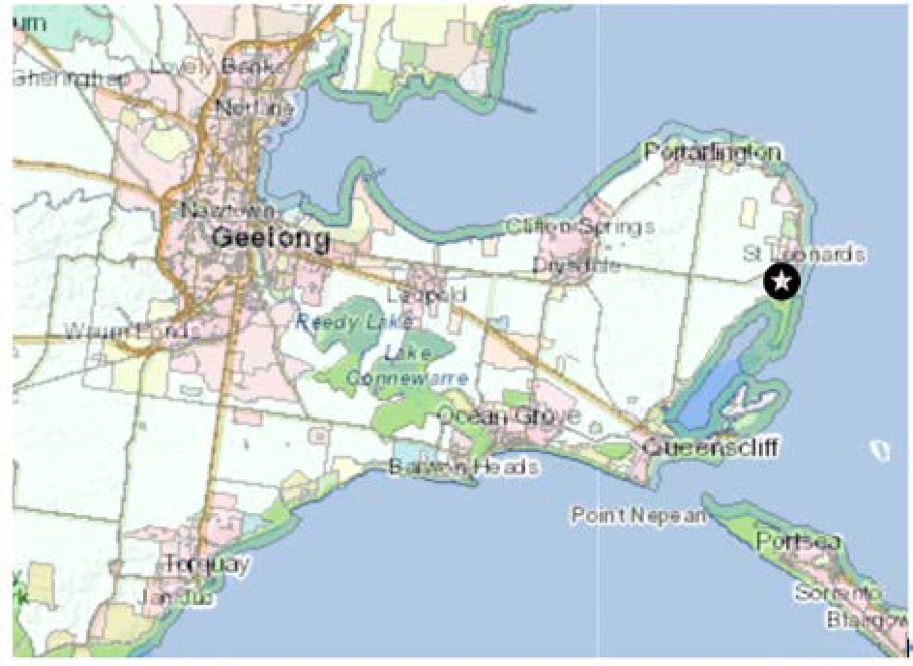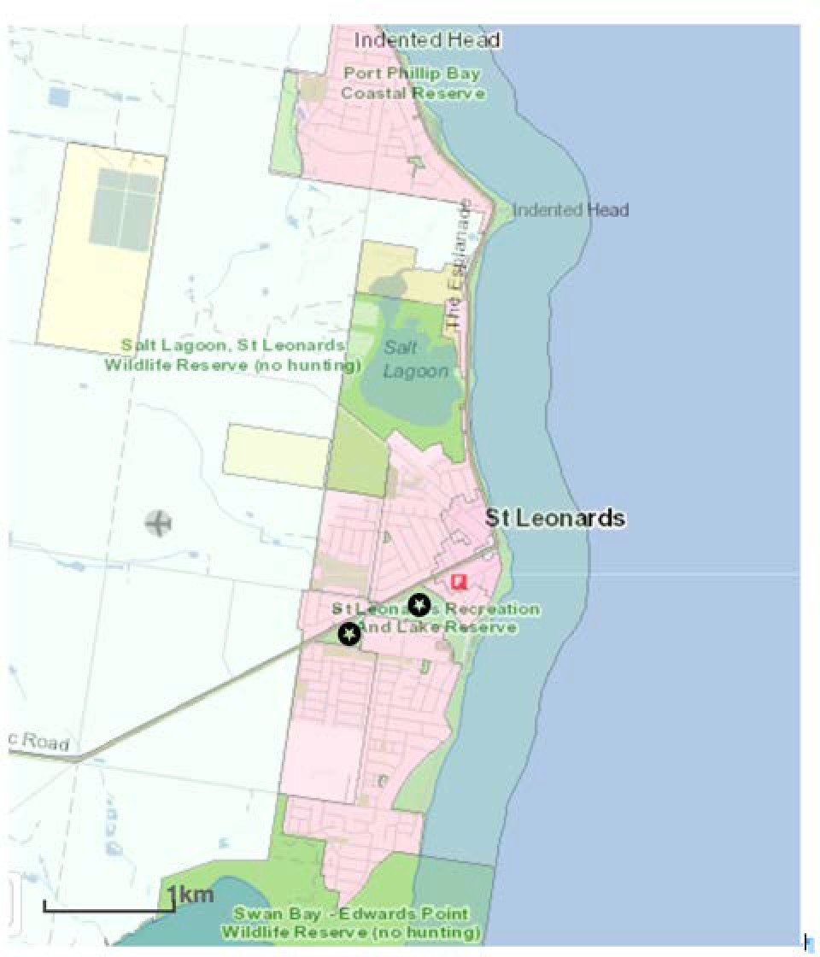The location of the two sites is shown on the following context and location maps.

Figure 1. Context and location maps St Leonards, Victoria
St Leonards Lake Reserve
St Leonards Lake Reserve is located at 1286 – 1308 Murradoc Road, St Leonards, Victoria. The image below shows an aerial photo of this site (Google Earth).
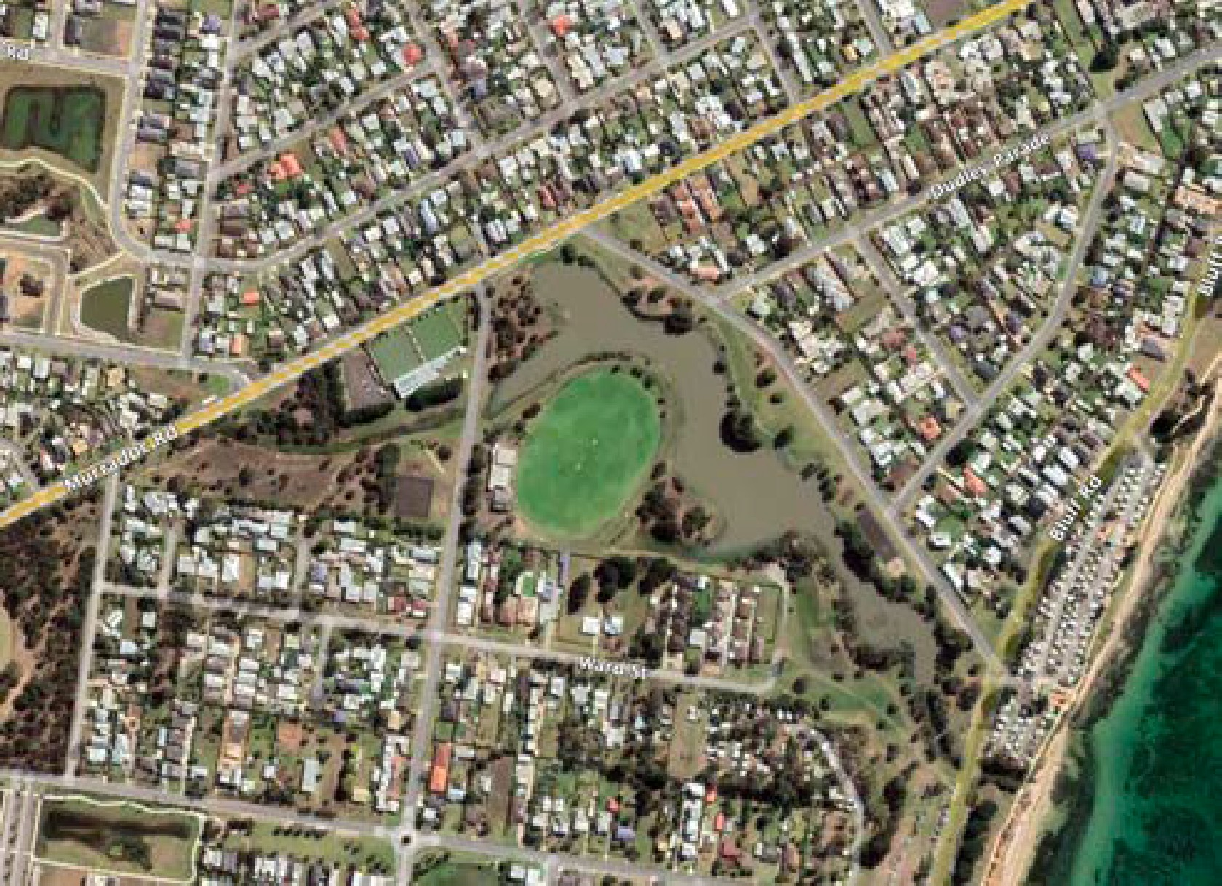
Figure 2: St Leonards Reserve, St Leonards, Victoria

The Reserve is approximately 8 hectares, and the Department, Environment, Land, Water and Planning (DELWP) own the land.
The Reserve is categorised as ‘Community 3’ and the pavilion is graded as ‘standard’ in the City of Greater Geelong Fair Play Strategy, 2017. However, irrigation has been installed at the ground since 2017.
Residential properties are located on the southern boundary of the Reserve on Ward Street.

Facilities
The Reserve’s recreation facilities comprise a single oval with a hard cricket wicket, cricket practice nets, as netball court and half basketball court, social facilities for cricket, soccer and men’s shed. There is a walking trail and a playground, public toilets, and open space to the eastern end of the Reserve including a small rotunda.
The sports pavilion, hall and Men’s Shed extension are owned by the City of Greater Geelong.
The pavilion and change rooms and the ground is used by the St Leonards Cricket Club during the summer season and Bellarine Sharks AFC Soccer Club in the winter season. The St Leonards Men’s Shed use the pavilion all year round. The Community Hall has regular bookings from two community groups that also use the adjacent kitchen.

Zoning
The two reserves adjoin at Murradoc /Saint Leonards Road, and both are zoned as Public Park and Recreation Zone (PPRZ) in the Greater Geelong Planning Scheme.

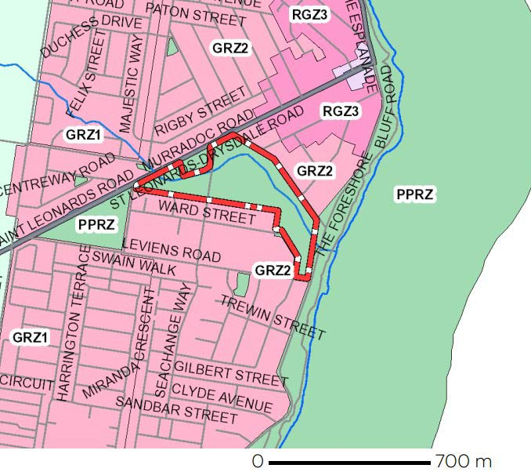
Figure 3: Planning zones neighbouring Lake Reserve

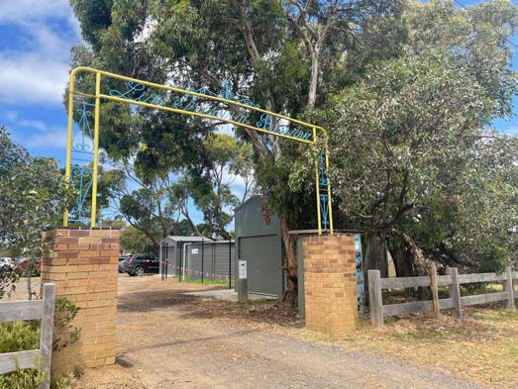
The area around the oval in the Lake Reserve is Land Subject to Inundation Overlay. See image below.
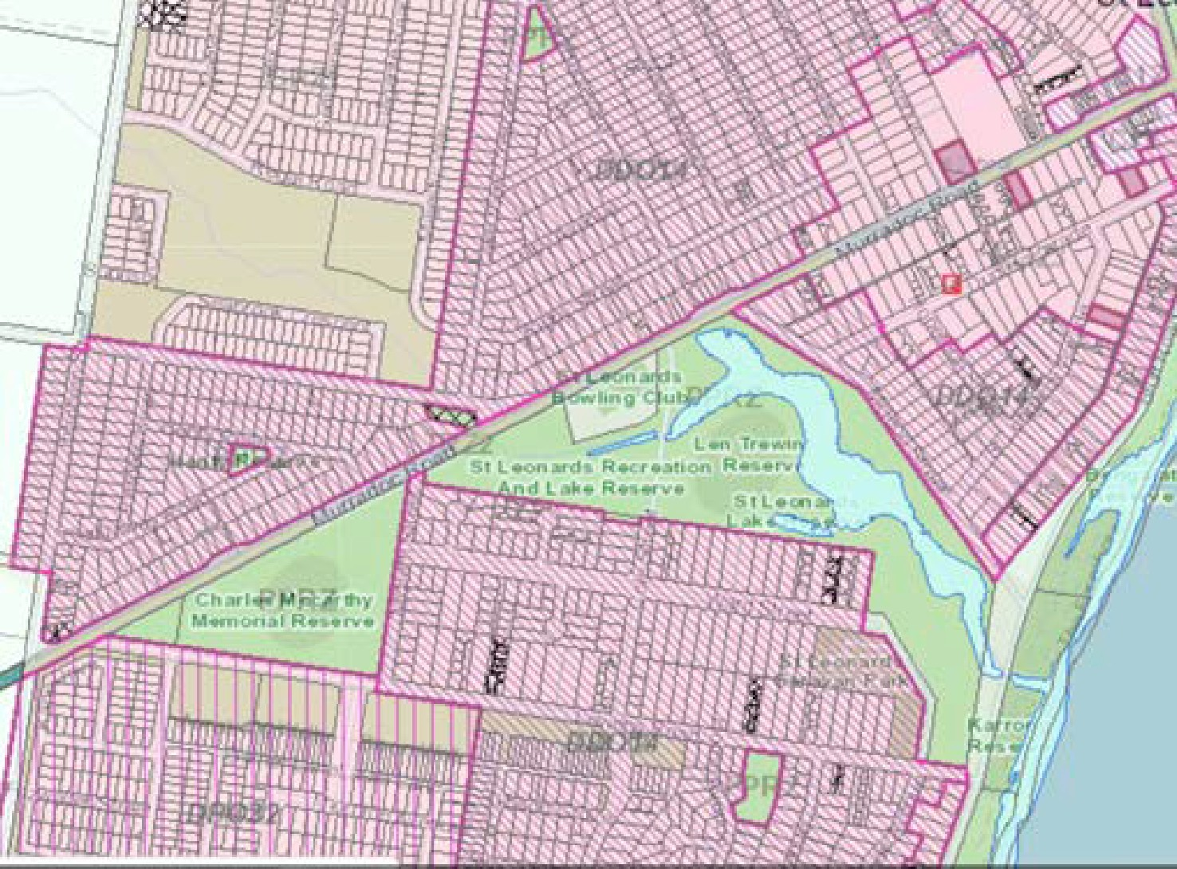
Figure 4 Planning overlays over the Reserves
Land immediately to the north, south and west is zoned General Residential (GRZ1, GRZ2).
The land is also an area of aboriginal cultural heritage sensitivity.

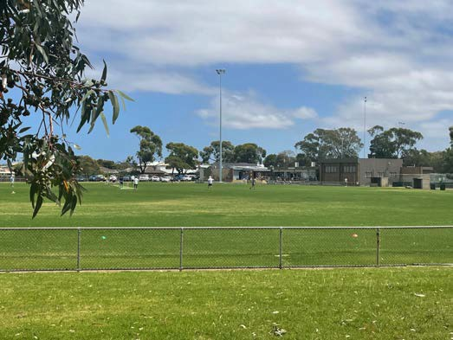

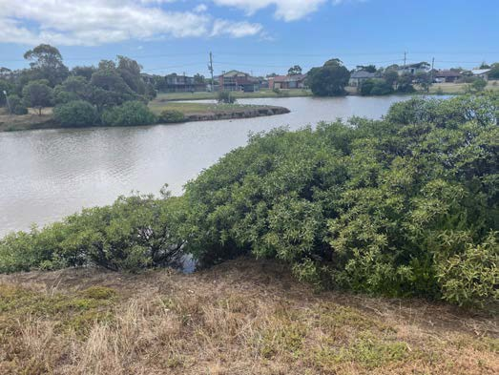

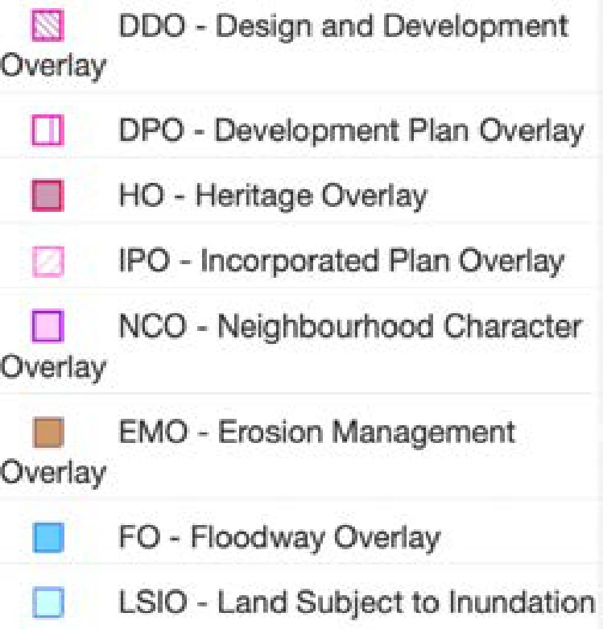

The Charles McCarthy Reserve
The Charles McCarthy Reserve is located at 1202 – 1240 Murradoc Road, St Leonards, Victoria.
The Charles McCarthy Reserve is a Community 3 level Reserve and provides active open space and a small number of functions for the community.
The Reserve is approximately 4.7 hectares and is located on Department, Environment, Land, Water & Planning (DELWP) Land owned land.
An image of the reserve is provided below.
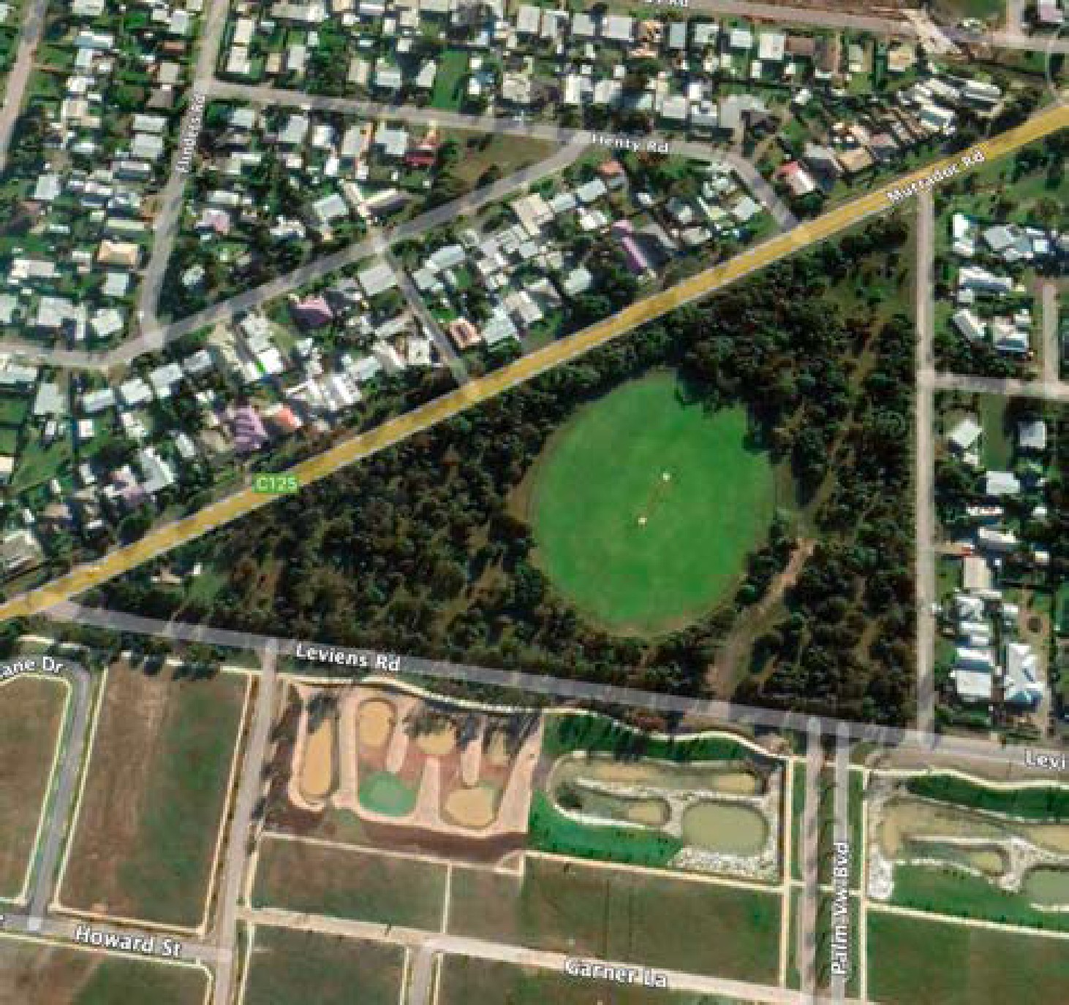
Figure 5. Charles McCarthy Reserve, St Leonards, Victoria

Zoning
Charles McCarthy Reserve is zoned as Public Park and Recreation (PPRZ).
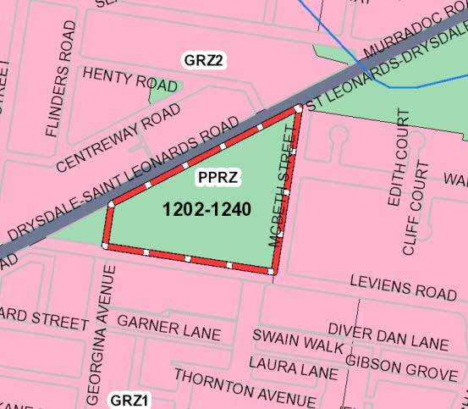
Figure 6: Charles McCarthy Reserve, Planning Scheme Zones
Land immediately to the north, south and east of the Reserve is zoned General Residential (GRZ1, GRZ2). No planning overlays apply to the Reserve.
Residential properties are located north of the Reserve on Murradoc Road, east on McBeth St. south on Leviens Road.

Facilities
The Reserve comprises a single oval with AFL goals and with a central synthetic hard cricket wicket. It is surrounded by reasonably high-quality remnant vegetation, particularly ground layer species.
Southwest of the Reserve on the corner of Leviens and Murradoc Road is a Scout Hall that is used for monthly District meetings for Scouts and some camping activities, but the organisation does not currently have an active Scouts program based at St Leonards.
The scout facility has a toilet block. The toilet block is used by the cricketers from time to time.
There are no social facilities or structures of note on the site.
The Reserve is used on an irregular basis for AFL football training by the Portarlington Football Club, as a low-grade cricket ground by St Leonards Cricket Club in summer, and as a preseason training venue for Bellarine Sharks AFC Soccer Club.

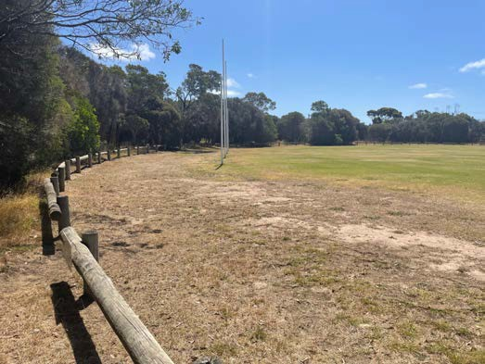

CONTEXT

Indigenous history
The Wadawurrung People are the traditional owners of the land and waters that incorporates the existing Reserves. The St Leonards area was inhabited by the Bengalat balug (Clan).
The township was formerly known as St Leonards-on- the-Bay, first established as a village reserve in 1850.
Council completed a Cultural Heritage Management Plan as part of the St Leonards Lake and Charles McCarthy Reserve Master Plan in 2011.

European history
Explorer Matthew Flinders landed in the area in 1802 and named the whole peninsula Indented Head. The first known European to live in the area was William Buckley, who was befriended by a clan of the Wathaurong Tribe in 1804. William Buckley lived with the Wathaurong Tribe for more than thirty years, before coming across John Batman’s encampment in 1835, in St Leonards.1
John Batman had sailed from Launceston and anchored in Port Phillip Bay off St Leonards in search of pastoral country. After anchoring off St Leonards, John Batman continued his voyage onto the Yarra River.
The area was settled by people believed to be of Chinese origin around the 1840’s.2
The development of St Leonards began as a source of firewood for Melbourne by George Ward Cole in 1855.

Structure Plan vision
The 2015 Structure Plan sets out a vision for the township as follows:
“St Leonards will continue its role as a coastal village providing for sustainable growth of residential land and commercial uses in a way which respects and enhances its coastal setting, rural and environmental landscape values.”

Role of the township
St Leonard’s primary role has traditionally been as a seaside holiday village, serving a small permanent population.
The town is not identified as a growth location within Council’s Urban Growth or Rural Residential Strategies for residential or rural residential development, nor as a location for extensive commercial or business activity.

¹ St Leonards Structure Plan 2015
The sensitive coastal, environmental, and rural setting of the township and associated State and Local Planning Policies preclude extensive township growth, while local services and facilities are limited to those which provide for daily needs and requirements.
Principles as set out in the structure plans include:
- To protect the unique character of St Leonards as a small coastal village located within a sensitive environmental and significant landscape setting.
- To maintain a compact urban form and avoid linear sprawl along the coast.
The Structure Plan 2015 (see image below) shows the extent of residential areas around St. Leonards and the two growth areas currently under development.
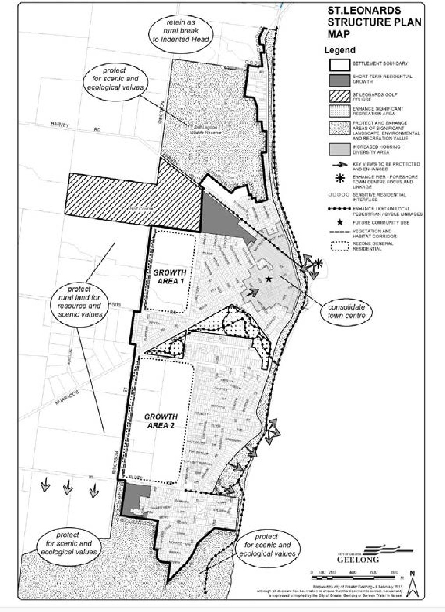
Figure 7. St Leonards Structure Plan 2015

² Intown.com.au/stleonards

Relationship to adjacent land uses
The following image shows the Planning Scheme zones and overlays in vicinity of the two ovals, including the two growth areas under development.
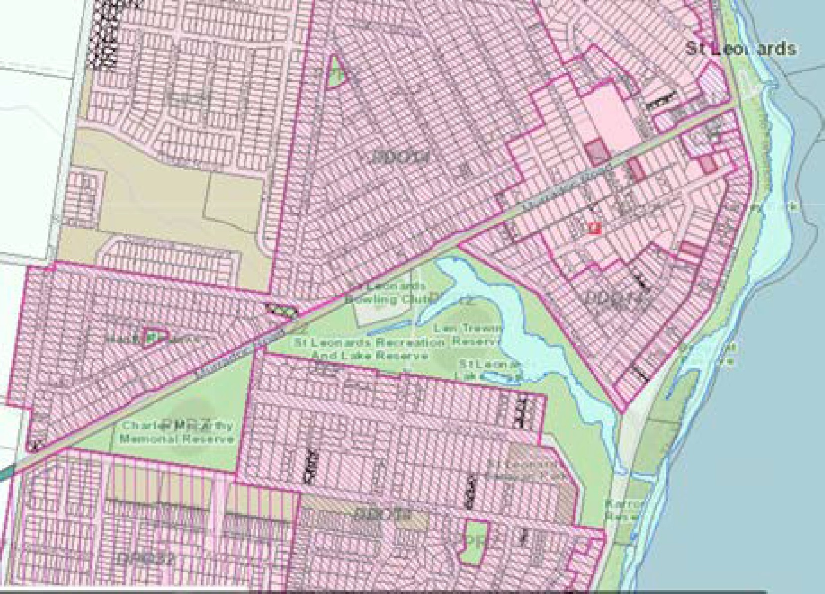
Figure 8. Planning scheme zones and overlays over land adjacent to the Charles McCarthy Reserve

Directly to the south a new residential area is developing. The land immediately abutting the Reserve south of the road there are three drainage reserves.
This area and the residential area to the north are the only two growth areas around St Leonards. Neither of these developments provide for sport or active recreation.
Stormwater from the township drains towards either the Salt Lake or St Leonards Lake.
No new drainage outlets to the Bay are currently permitted and any new development will be required to drain to existing catchments.

Infrastructure
The release of residential land within St Leonards will place additional pressure on existing community and sporting infrastructure and community services, particularly drainage.
To the north of the Reserve a large drainage reserve on the south of the development area has a series of designated retarding basins for flood management. See image below.

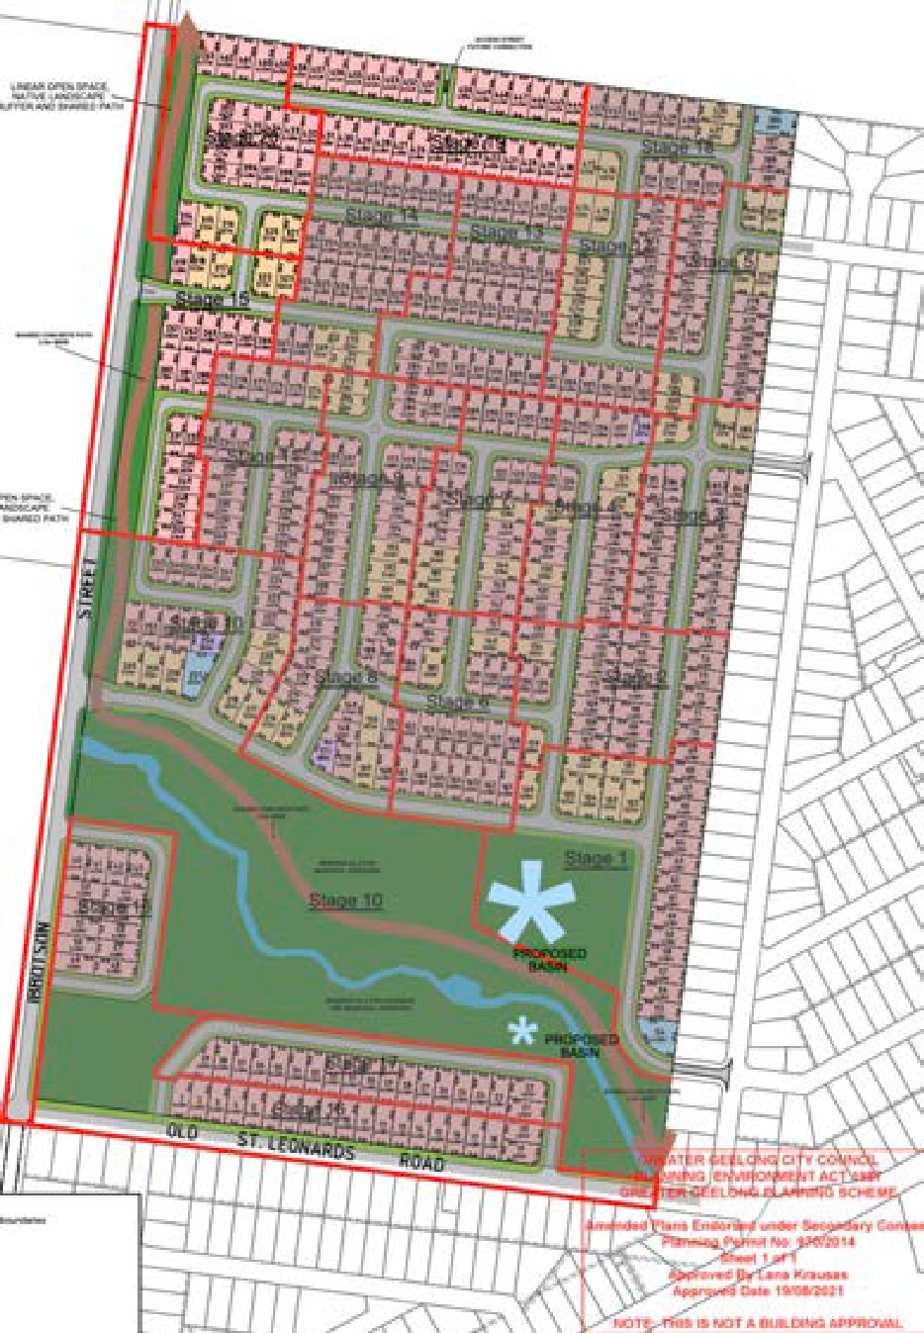
Figure 9. Subdivision plan for the land north of the ovals

The two new residential areas do not include any public open space or sports facilities to serve the additional residents other than drainage reserves.
The green space in the drainage reserves on the south side of the Leviens Road opposite the Reserve appears out of character.
These drainage reserves in the new residential areas adjoin both ovals and provide some opportunities for further vegetation, the potential movement of wildlife and importantly if developed appropriately; opportunities for additional people to walk and travel off-road to these sporting facilities.

Population and demographic profile

DEMOGRAPHIC FACTORS INFLUENCING THE DEMAND FOR SPORT
The key demographic factors that influence the demand for sport and recreation activities are population size, age, gender, income, education, cultural background, disability, and location of residence, in addition to the availability of facilities.

Population growth and age profile
The 2022 population estimate for St Leonards- Indented Head is 4,197. The population is forecast to grow to 6,122 by 2041. Population growth between 2022-41 is projected to be 45.88%.
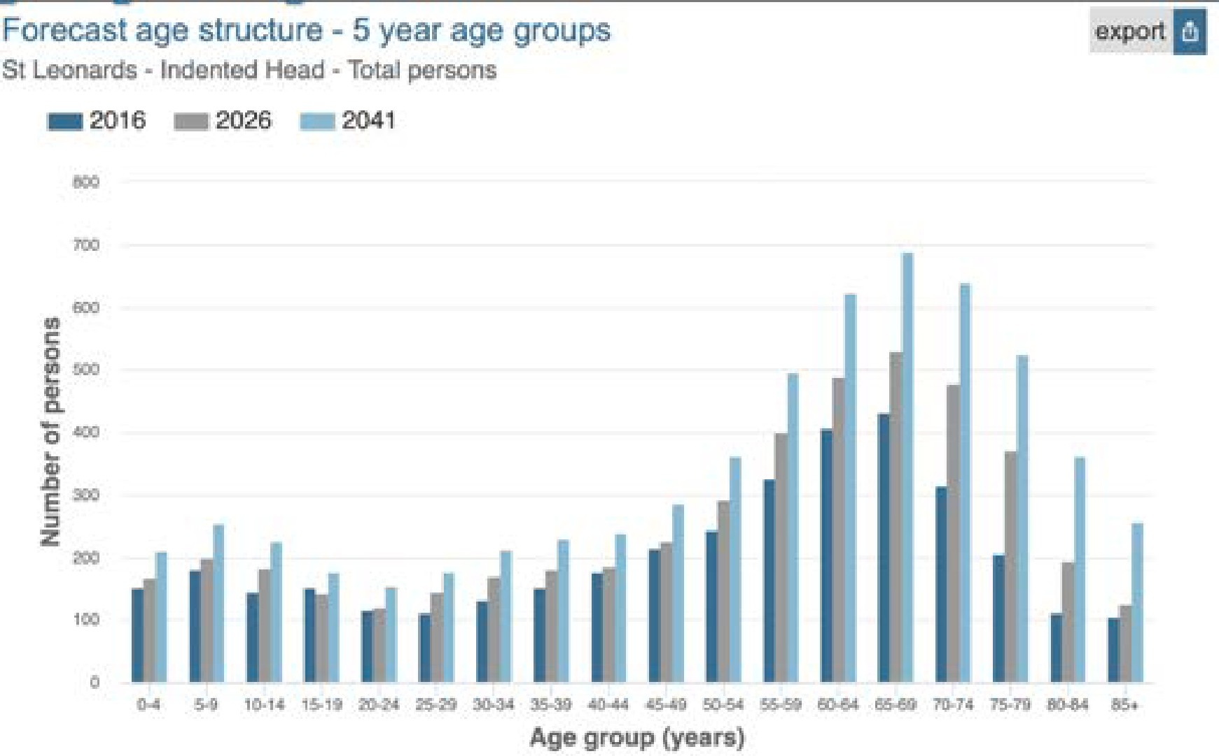
The following chart shows the projected population by 5-year age groups for 2026 and 2041, compared to 2016.

Figure 10. Forecast age structure for St Leonards and Indented Head in 5-year cohorts

The largest service age group of St Leonards/Indented Head residents is empty nesters and retirees (50 to 59 years).
Although most service age groups are increasing in numbers as the population grows, it is anticipated that St Leonards/Indented Head will trend towards an aging population.

³ ibid
Analysis of the service age groups of St Leonards – Indented Head in 2016 compared to City of Greater Geelong shows that there was a lower proportion of people in the younger age groups (0 to 17 years) and a higher proportion of people in the older age groups (60+ years).3
The median age for St Leonards is 56 compared to the City of Greater Geelong which is 40 years. The average for rural and regional Victoria is 43.4
Between 2016 and 2026, the age structure forecasts for St Leonards – Indented Head indicate a 14.6% increase in population under working age, a 45.7% increase in population of retirement age, and a 15.7% increase in population of working age.

Propensity to play sport
The demographic profile of St Leonards-Indented Head suggests that there is a relatively high propensity for residents to play sport, due to:
- The number of children - some 620 children projected under 15 years by 2041 population and over 1470 people between 15 years and 50 years.
- A relatively small proportion of residents who speak another language or were born overseas from a non-English speaking background. In 2016 the most common non-English-speaking language at home was Greek (80) and Italian (52).
- In 2016, 7.7% of residents needed assistance in their day to day lives due to age or disability compared to 6% in Regional Victoria and the City of Greater Geelong.
- The St Leonards - Indented Head index of social disadvantage is 962.3. This is at the lower end of localities in the City of Greater Geelong and below the average for Victoria (1,010) and Regional Victoria (977).
In addition to the sports opportunities provided at the two Reserves, there are opportunities to enhance the use of the Reserve for the large number of older adults in St Leonards.
A better network of trails around the McCarthy Reserves perimeter connecting to the other Reserves and to the two residential development areas would encourage a wider range of age groups to be active and reach the Reserves on foot or by bicycle.

⁴ 2016 Census Quickstats: St Leonards

Demand and user group

EXISTING AND PROJECTED

PARTICIPATION
The number of estimated participants in cricket and soccer-football based on club data has been compared using AusPlay participation rates and applied to the population forecasts 5 for 2022 and 2032, and in the table below. The data shows that adult cricket participation in St Leonards of 74, is below the average State organised participation rate applied to St Leonards, projecting 140 adult participants in cricket.
The Club did not enter junior teams in the 2021/22 season.
AusPlay data suggest there are potentially 27 children likely to play cricket in St Leonards in 2022 and 30 by 2032. There could potentially be a total of 169 people playing cricket in St Leonards by 2032 based on current participation rates.
Soccer-football participation in St Leonards is slightly above the State organised participation rate.
Soccer-football members are projected to grow from 159 to 194 in the next 10 years at the Bellarine Soccer Club.
Figure 11. Existing and projected sport participants from clubs at Lake Reserve and Charles McCarthy Reserve

Current and future participation | Cricket (Outdoor) | Soccer - football
Club members 2022 | 74 | 159
Projected club members/ participants 2032 | 90 | 194
Projected participation based on State organised* 2022 | 140 | 152
Projected participation based on State organised* 2032 | 169 | 183

⁵ AusPlay is a national population survey of adults aged 15 or over and children 0-14 about their participation in sport and physical activity. Each year 20,000 adults aged 15 or over complete the survey.
Note: Projected participation based on AusPlay state organised participation is activity formally organise by a club, association, school, or other type of organisation.
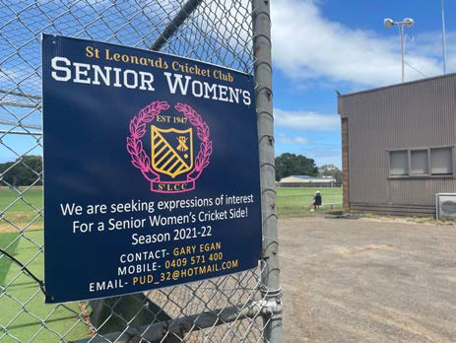

Apart from providing information about their own participation, parents/guardians of children under the age of 15, are asked about the physical activities undertaken by one of their children.

Bellarine Sharks Soccer Club
- The Bellarine Sharks Soccer Club use the Lake Reserve from April to September each year. They have junior, senior and veterans’ teams.
- The Club anticipates having Walking Football, Mixed & All Abilities teams in the next 2 seasons.
- There are approximately 160 participating at the Club.
- The Club trains at Charles McCarthy Reserve pre- season in February and March.

Figure 12. Breakdown of current participants and teams for Bellarine Sharks Soccer Club (March 2022)

Programs | Female No.s | Female teams | Male No.s | Male teams | Mixed
Masters |  |  | 15 | 1
Senior men’s |  |  | 24 | 1
Senior women’s | 20 | 1
Juniors | 24 | 1 | 12 | 5 | 1
Development program | 32 |  | 32 |  | 6

St Leonards Cricket Club
The St Leonards Cricket Club use the Lake Reserve and McCarthy Reserve from October to March each year. They have 3 senior men’s and a senior woman’s team. The 3rd XI play home games at McCarthy Reserve.
The woman’s team was established at the commencement of the 2021/22 season.
The Club anticipates having two junior teams next season and an additional women’s team.
The Club has grown form 1 senior men’s team in 2015 with 12-13 players to four senior teams in 2021/22.

Figure 13. Current participants and teams; St Leonards Cricket Club

St Leonards Men’s Shed
The St Leonards Men’s Shed currently have 38 members with 12 -16 members attending attend each session. The shed has capacity for 16 people.
Members reside mainly in St Leonards, Indented Head, Port Arlington and Ocean Grove.

Figure 6. St Leonards Men’s Shed memberships 2017-22

Year | Men’s Shed membership
2021/22 | 38
2020/21 | 39
2019/20 | 36
2018/19 | 38
2017/18 | 33

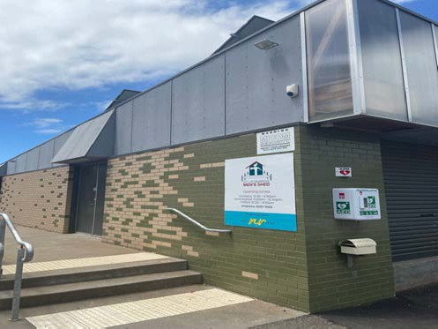

Programs | Female No.s | Female teams | Male No.s | Male teams
Senior | 14 | 1 | 60 | 3
Juniors | 0 | 0 | 0 | 0

Vision now and the next 10 years

The vision for each reserve is as follows.

LAKE RESERVE
    - To be further developed as an important community sports ground and function as a central hub for community sport and recreation in St Leonards.
    - To maintain in balance: facilities that serve people from a broad range of age groups and abilities, unorganised and club competition sport, and recreation, and natural elements that provide shelter and shade, restorative values, habitat, and high-quality landscape amenity.
    - To be environmentally sustainable in relation to building and ground management, playing and traffic surfaces and asset development.
    - To provide a key hub off the walking trails linking Charles McCarthy Reserve, the Lake Reserve, and the St Leonards residents.

CHARLES MCCARTHY RESERVE
    - To be further developed as an important overflow community sports ground for existing clubs based at Lake Reserve in the short term,
    - To maintain in balance: facilities that serve people from a broad range of age groups and abilities, unorganised and club competition sport, and recreation, and natural elements that provide shelter and shade, restorative values and habitat and high-quality landscape amenity.
    - To be environmentally sustainable in relation to building and ground management, playing and traffic surfaces and asset development.
    - To maintain and protect areas of indigenous fauna within Reserve.

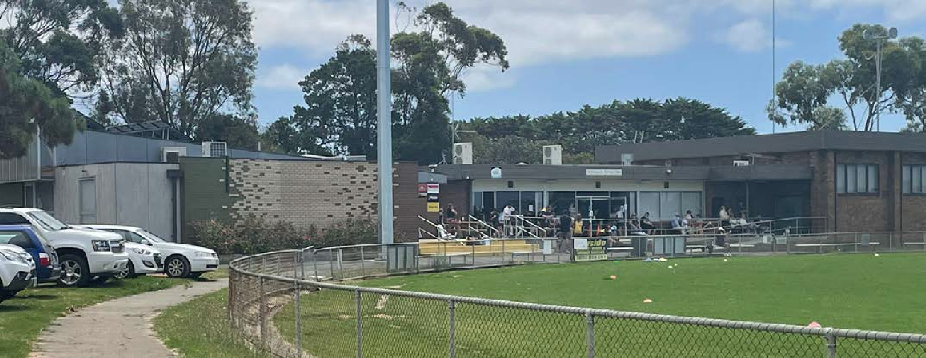

Lake Reserve use and site analysis

CURRENT USAGE AND OCCUPANCY
The oval is used 5 days a week in summer and 7 days a week in winter. The table below shows the bookings for summer and winter by tenant clubs at Lake Reserve.
The tables below show the summer (October 1 – March 31) and winter (April 1 – September 30) bookings for the Reserve by St Leonards Cricket Club and Bellarine Soccer Club.
Figure 7. Summer Usage (October 1st – March 31st) Lake Reserve
Asset booked | Monday | Tuesday | Wednesday Thursday | Friday | Saturday | Sunday
Oval | - | St Leonards CC  Seniors 5.30- 7.30pm | St Leonards St Leonards CC CC  Juniors .30- Seniors  6.00pm 5.30-7.30pm | - | St Leonards CC Seniors 1.00- 6.00pm | St Leonards CC Women’s 1.00- 6.00pm  Bellarine Soccer Club Veterans 10- 6.00pm (Dec – Feb)
Pavilion | - | St Leonards CC  5.30-7.30pm | St Leonards St Leonards CC CC  4.30-6.00pm 5.30-7.30pm | - | St Leonards CC 12.00-9.30pm | St Leonards CC Women’s 1.00- 6.00pm
Cricket nets | - | St Leonards CC  5.30-7.30pm | St Leonards St Leonards CC CC  4.30-6.00pm 5.30-7.30pm | - | St Leonards CC 1.00-6.00pm | -

* Soccer Club train from February on the oval 6.00-8.00 pm Tuesday /Wednesday/Thursday. Figure 16. Winter Usage for St Leonards Lake Reserve (April 1st – September 30th)

Asset booked | Monday | Tuesday | Wednesday | Thursday | Friday | Saturday | Sunday
Oval | Bellarine Soccer Club Juniors 3.30-  6.00pm | Bellarine Soccer Club Juniors 3.30- 6.00pm  Seniors 6.00- 8.00pm | Bellarine Soccer Club Development program/U9s 3.30-6.00pm  Seniors 5.30- 8.30pm | Bellarine Soccer Club Juniors 3.30- 6.00pm  Seniors 6.00- 8.00pm | Bellarine Soccer Club Juniors 3.30- 6.00pm | Bellarine Soccer Club  Seniors/Junior s  10.00am-  5.00pm | Bellarine Soccer Club  Seniors/Junio rs  9.00am-  5.00pm
Pavilion | Bellarine Soccer Club Juniors 3.30-  6.00pm | Bellarine Soccer Club Juniors 3.30- 6.00pm  Seniors 6.00- 8.00pm | Bellarine Soccer Club Juniors 3.30- 6.00pm  Seniors 6.00- 8.00pm | Bellarine Soccer Club Juniors 3.30- 6.00pm  Seniors 6.00- 8.00pm | Bellarine Soccer Club Juniors 3.30- 6.00pm | Bellarine Soccer Club  10.00am-  5.00pm | Bellarine Soccer Club  9.00am-  5.00pm

ASSET CONDITION AND REVIEW
The following table provides images and commentary around the key facilities at St Leonards Lake Reserve.
Figure 17. Key assets at St Leonards Lake Reserve and observation notes of current condition and functionality

1 | Oval
 | 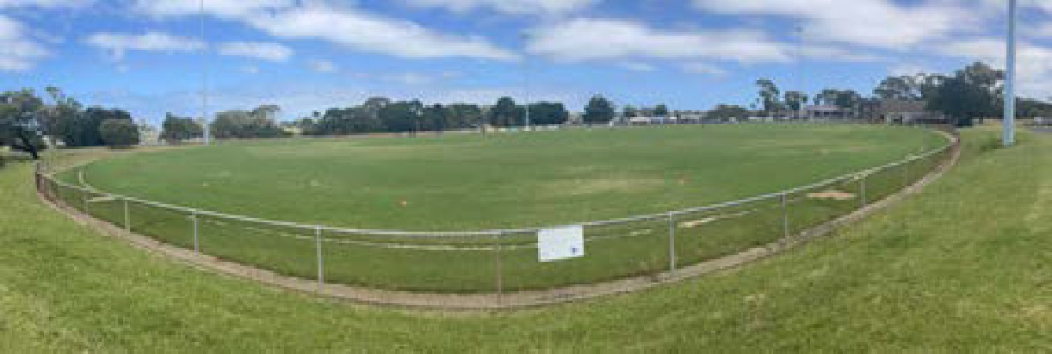 |  | - The oval is approximately 164m long x 113m wide with a synthetic cricket wicket in the middle.  - Turf quality and density in good condition, at time of inspection.  - No formal drainage installed but rarely waterlogged according to user groups. Paved guttering removes water from around fence line. The ground slopes away from the centre wicket to the oval edge.  - An inground sprinkler system is in place and provides good coverage. A surface upgrade and irrigation system were recently installed at a cost of $170,000.  - A mesh wire fence encircles the ground preventing dogs onto the oval.  - There are 2 players boxes on the west wing that are no longer utilised.
2 | - Community rooms
 | 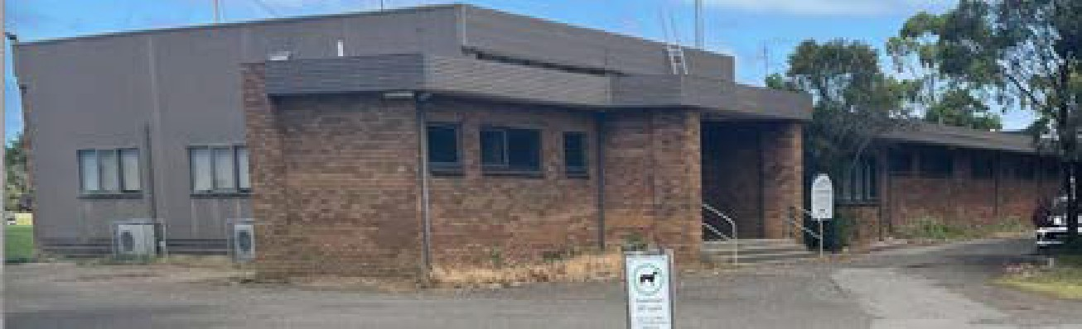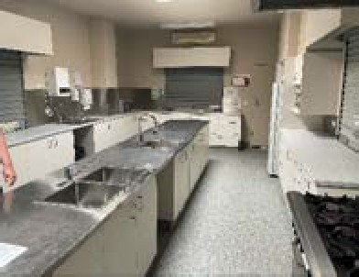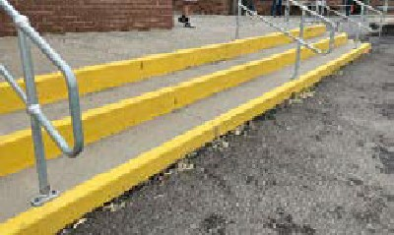 |  | - The community rooms were designed initially for the purposes of a local AFL team that was based at the Reserve. The building includes 2 change rooms, umpires’ room, showers, storage and a commercial kitchen that serves both the community room and community hall.  - There are no accessible toilets available in the community  rooms. There is one that serves the hall.  - The community hall has its own toilets. The hall is designed to expand to the west. There are no views from the hall to the oval.  - The kitchen is in reasonable order and hosts some community groups but does not directly service the club social space. The two sports clubs book the kitchen separately through Council for functions as required.  - There is no designated kitchen/bar storage area for the club social space.
3 | Men’s Shed and Change rooms
 | 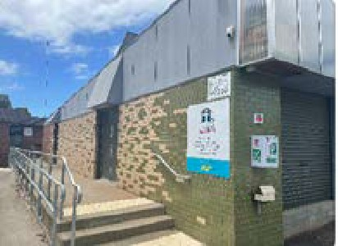 | 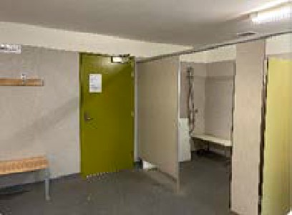 | - The Men’s Shed and sports changerooms were built recently.  - The change rooms are small but serviceable for current use. They meet Football Victoria minimum requirements for local/community competition standards for juniors and seniors.  - There is an accessible toilet available for public use but not well signed.  - There is an internal door that connects a change room with the Men’s Shed that causes supervision concerns for the soccer club and does not meet current child safe practices for the two sports clubs.  - The size of the Men’s Shed is restricting participation at the Men’s Shed.  - Its location restricts future expansion of change rooms, if required as the clubs grow.

Figure 17. Key assets at St Leonards Lake Reserve and observation notes of current condition and functionality (cont’d)

4 | Cricket nets
 | 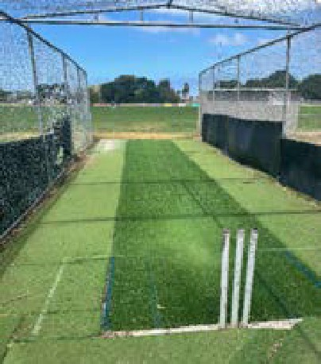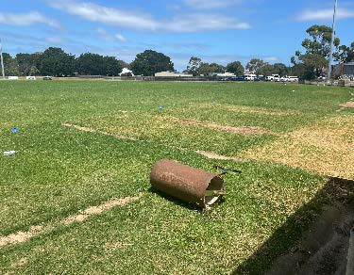 |  | - Two synthetic grass nets located on the ovel edge with grass run ups off the oval.  - Wire netting is in poor condition.  - Net direction running east-west is not preferred based on Cricket Victoria’s Community Cricket Facility Guidelines.
5 | Oval lighting
 | 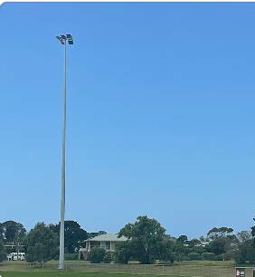 | 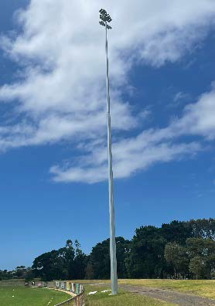 | - Four light towers were installed in 2021 for soccer-football training.  - Possibility of upgrading lighting further to host fixtures for  night competition.  - Provides source of power around the oval.
6 | Internal road and paths
 | 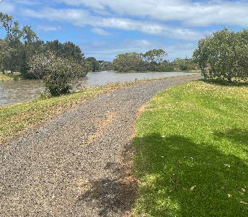 | 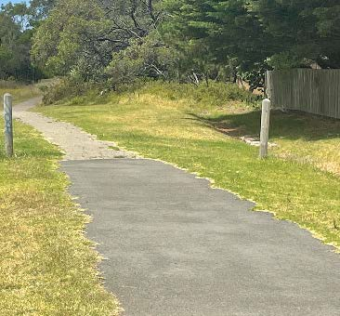 | - An internal gravel road encircles the oval.  - Walking trails link the Reserve to residents to the south and north and lead to the front and rear of the community rooms.  - No consistent surface, loose surfaces, way finding and some refinements in alignment beneficial to minimise conflict as well as broader connections to new residential areas.
7 | Storage
 | 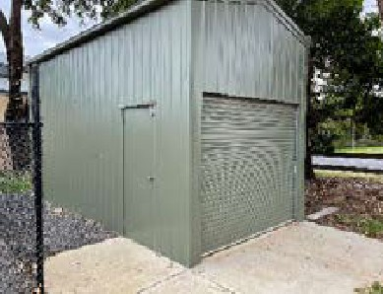 | 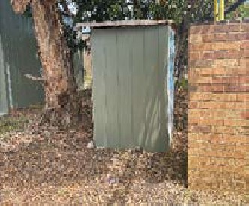 | - Additional storage sheds have been built on the Reserve and acquired for use by the Men’s Shed.  - The men’s group store materials in the ticket box at the  Reserve entry.  - Both soccer and cricket clubs require more storage space and are using garage space of committee members to house equipment.
8 | Parking
 | 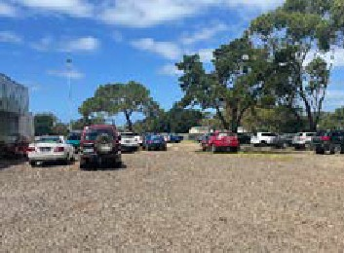 | 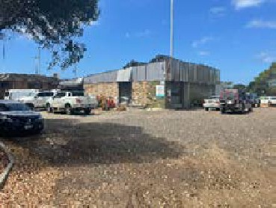 | - There is no formal parking on the Reserve leading cars to park in an ad hoc manner.  - Parking around the oval is possible but cars get stuck in winter reversing up the slope from the fence to the access road on the west side of the oval.

Figure 17. Key assets at St Leonards Lake Reserve and observation notes of current condition and functionality (cont’d)

9 | Vehicle entry/exit
 | 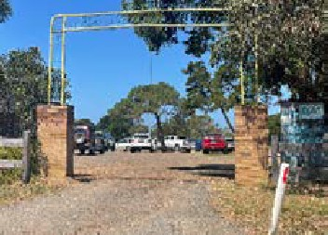 | 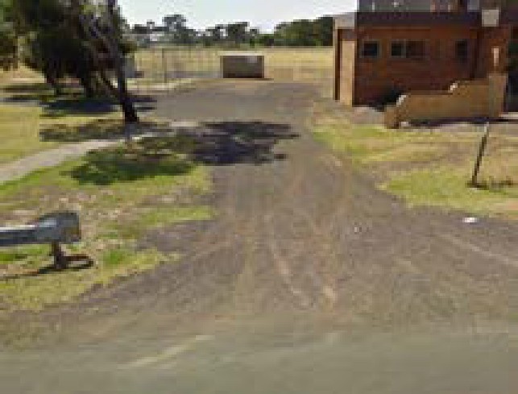 | - There are two vehicle entry/exits to the Reserve. One has a more formal entry with brick pillars and wrought iron signage over the entry.  - Neither entry is well signed or offer a sense of ‘arrival’ to the precinct.
10 | Vegetation
 | 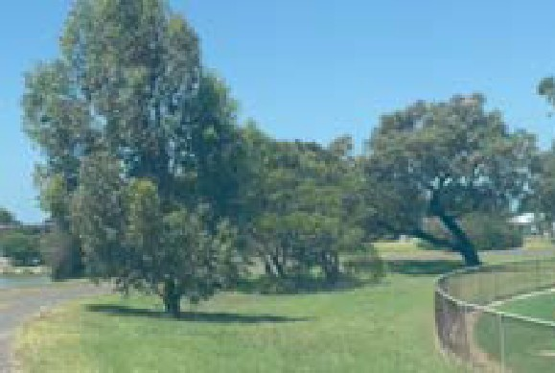 | 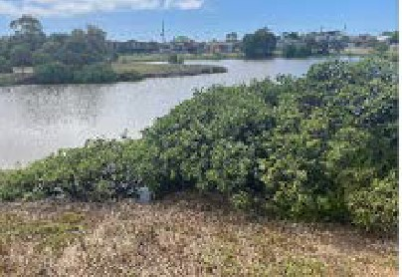 | - Key area of vegetation – both canopy trees and understorey/grass.  - Some damage by vehicles and pedestrians as  entries/ car parks and paths not clearly defined and vegetation not protected from compaction etc.  - Specimen trees for shade etc may be warranted  also.  - Great diversity along Lake foreshore for appreciation and biodiversity value and cleaning of runoff.

CRIME PREVENTION THROUGH ENVIRONMENTAL DESIGN (CPTED)

There is very limited natural surveillance into Lake Reserve other than along Cole Street on the west side of the Reserve.
Low trees and shrubs partially reduce views into the car park and buildings from Cole Street.
The Lake wraps around the north and east of the Reserve, while residential housing backs on to the Reserve at the south. The Reserve is lightly treed.
Walking trails bring people through the Reserve from several points. Walking tracks encourage access through the Reserve from the southeast through to the northwest. Lighting is not prevalent along the walking tracks.
There are two vehicle entries in and out of the Reserve on Cole Street. There is no clear entry or exit signage.
Vehicle entries are not lit. Pedestrians have easy access via paved walkways into the Reserve.
Lighting to the oval for soccer-football training in winter offers significant lighting across the Reserve when in use.
With regular bookings on the oval via cricket and soccer clubs, community use of the social rooms, along with daytime use of the Men’s Shed, the Reserve is relatively active.
External lighting is prevalent on buildings.
There is no housing close to the Reserve facing into the Reserve.
Community surveillance would be encouraged with the upgrading and extension of the perimeter trail connecting the two reserves and the new housing areas in the north and south.

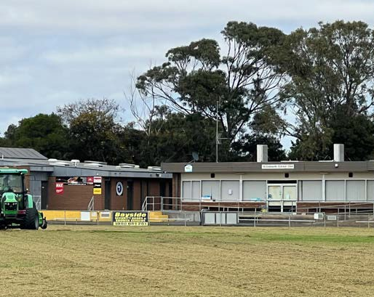

POTENTIAL SITE CONSTRAINTS
The main site constraints at The Lake Reserve are as follows:
    - No room for a second cricket oval/soccer pitch
    - Limited car parking space around amenities and established trees
    - Lack of room around the oval and to expand the field and facilities due to housing at south end of oval and the lake to the north and east
    - Potential conflict between dog owners and sport groups/activities
    - Lack of storage space for user groups
    - Close proximity of the pavilion to the oval
    - Stairs from oval into the old pavilion are not accessible
    - Community room change rooms not suitable for female use or accessible
    - Poor functionality of kitchen and bar for clubs use as it does not serve directly into social space
    - Hall toilets are not accessible
    - The lack of structural integrity of pavilion if a second level was added
    - Design of changerooms and noncontrolled access from Men’s Shed
    - Drainage issues in the community hall and changerooms
    - The placement of the kitchen separating the hall and social space
    - Cricket balls getting ‘lost’ in lake at north end of oval
    - Community and sport use of the integrated are not compatible.

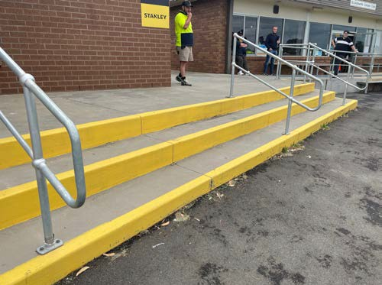

Charles McCarthy Reserve use and site analysis

CURRENT USAGE AND OCCUPANCY
The oval is used 5 days a week in summer and 7 days a week in winter. The table below shows the bookings for summer and winter by tenant clubs at Charles McCarthy Reserve.
The table below shows the summer (October 1 – March 31) and winter (April 1 – September 30) bookings for the Reserve by St Leonards Cricket Club and Bellarine Soccer Club. Winter usage of Charles McCarthy Reserve is limited by the lack of oval lighting for training purposes.

Figure 18. Summer Usage (October 1st – March 31st) for Charles McCarthy Reserve

Asset Monday Tuesday booked |  |  | Wednesday | Thursday Friday Saturday Sunday
Oval Bellarine Soccer Club Juniors 4.00-  6.30pm Feb- March | Bellarine Soccer Club Juniors 4.00- 6.30pm Feb- March  Seniors 6.00- 8.00pm Feb- March |  | Bellarine Soccer Club Juniors 4.00- 6.30pm Feb- March  Seniors 6.00- 8.00pm Feb- March | Bellarine Soccer Club Juniors 4.00- 6.30pm Feb- March  Seniors 6.00-8.00pm  Feb- March | Bellarine St Leonards No  Soccer Cricket Club competitions Club scheduled  Juniors 4.00-  6.30pm Feb- March
Figure 19. Winter Usage (April 1st – Sept 31st) for Charles McCarthy Reserve
Asset Monday Tuesday booked |  |  | Wednesday | Thursday | Friday Saturday Sunday
Oval _ |  | _ | _ | _ | _ | No soccer competitions scheduled | Bellarine Soccer Club. Every second week

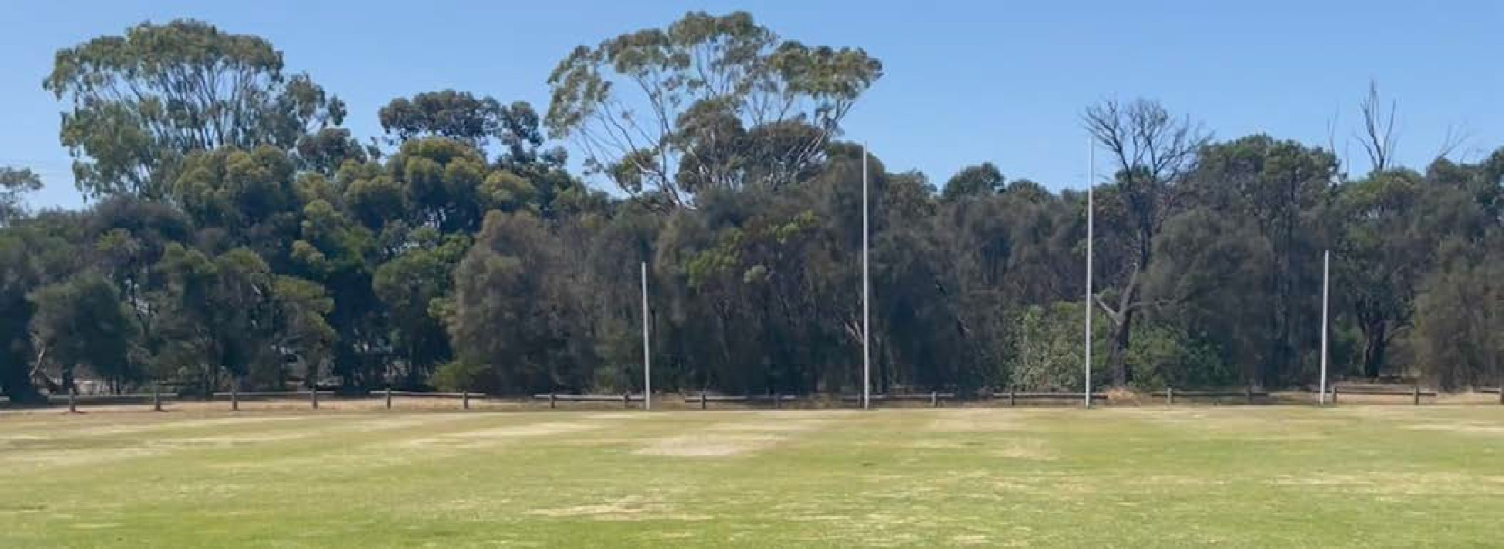

6.2. ASSET CONDITION COMPLIANCE AND VEGETATION
The following table provides images and commentary around the key facilities at Charles McCarthy Reserve.

Figure 20. Key assets at Charles McCarthy Reserve and observation notes of current condition and functionality

1 | Oval
 | 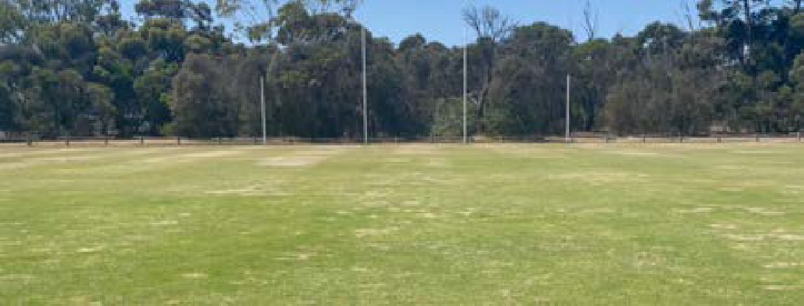 |  | - The oval is approximately 140m long x 110m wide with AFL goal posts at either end, with a synthetic cricket wicket in the middle. All are in good condition. The oval surface is in relatively good condition with a coverage of couch grass, except around the edges of the ground.  - No formal drainage or irrigation is present.  - There is no oval lighting available for training.
2 | Oval boundary
 | 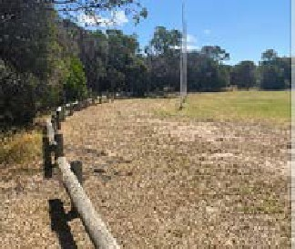 | 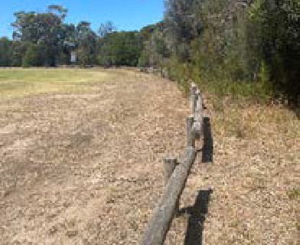 | - A low pine log barrier encircles the ground allowing relatively easy access onto the oval. However, the bollards do not retain balls within the field of play.  - There is no buffer or space around the oval for walking.  - The proximity of vegetation presents some constraints in terms of turf growth and overshadowing.
3 | Dogs
 | 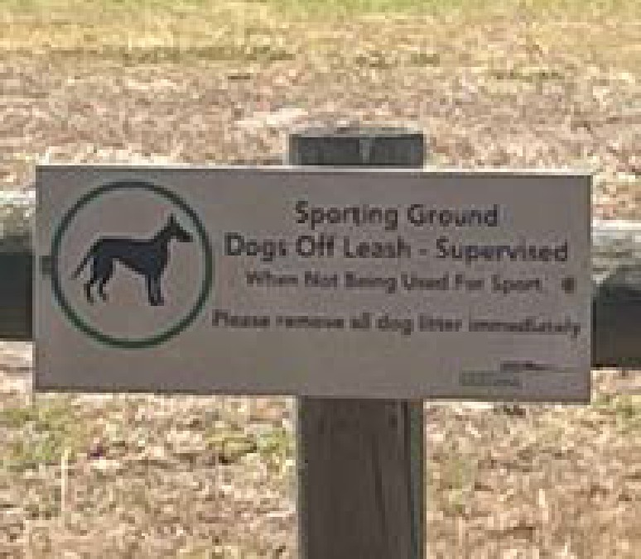 | 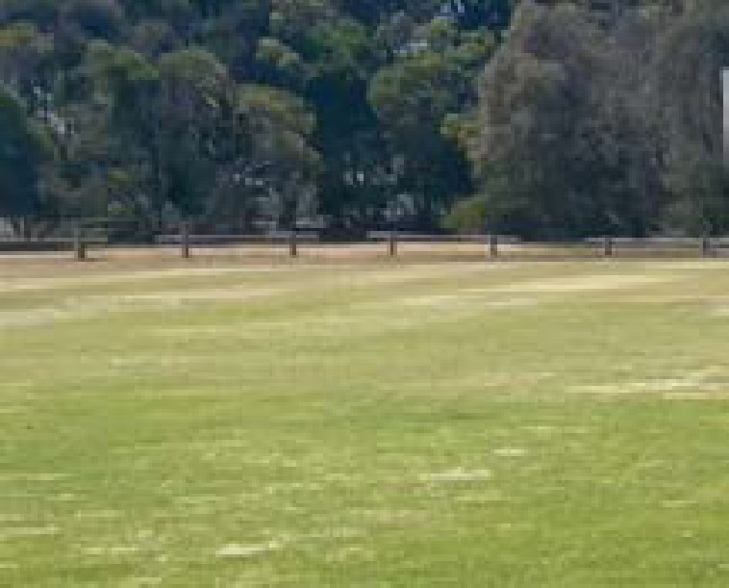 | - The Reserve is a dog off-leash area, when sport is not in play.
4 | Scoreboard
 | 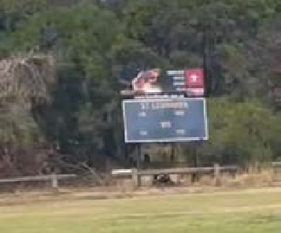 | 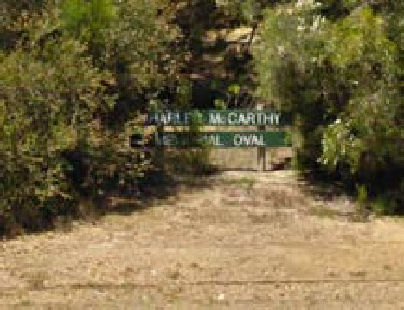 | - A small manual football scoreboard is located on the south side of the oval. It is in poor condition.

Figure 20. Key assets at Charles McCarthy Reserve and observation notes of current condition and functionality (cont’d)

5 | Entry/exit
 | 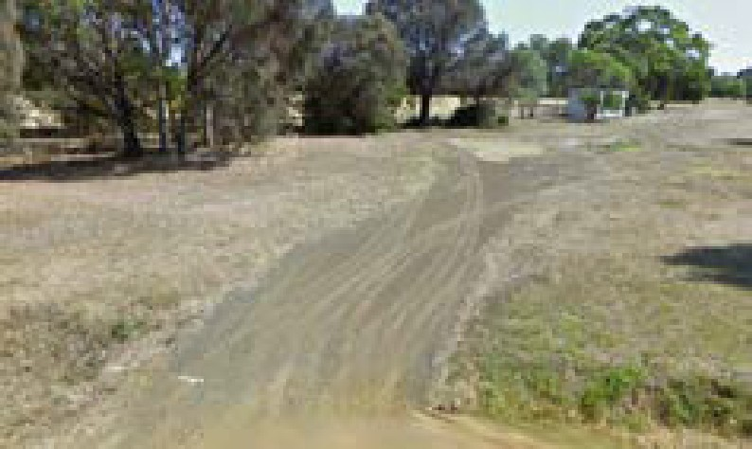 | 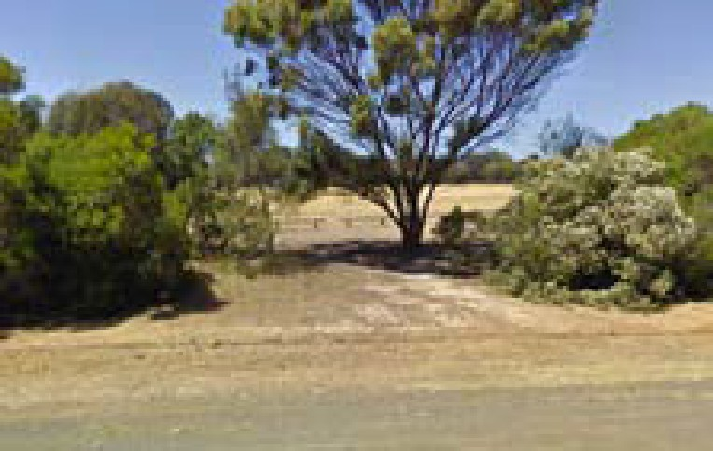 | - There is one narrow entry/exit off Leviens Road to the Reserve.  - There are no formal or informal roads or paths.  - An old entry point off Murradoc Road is still visible next to the Reserve sign.  - The compaction by vehicles without being contained may impact on the quality of the vegetation.  - There is not designated car park.
6 | Vegetation
 | 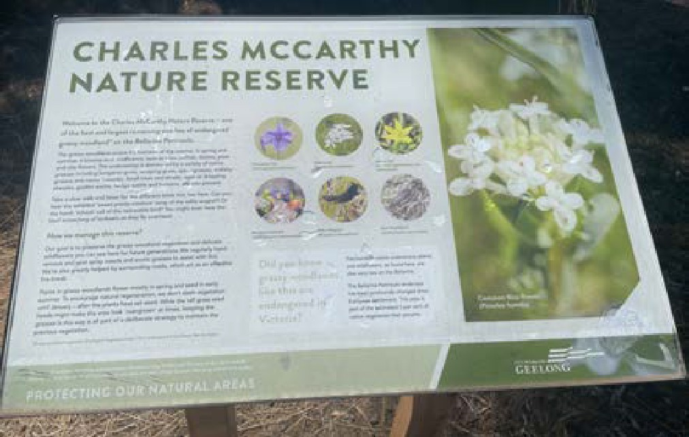 |  | - COGG information signage notes that the Reserve has one of the best and largest remaining patches of endangered woodland on the Bellarine Peninsula with 61 indigenous species.  - The oval is surrounded by a mix of native trees planted since 2005. (See Google aerial image below).  - Vehicle and pedestrian tracks are evident that may be causing damage and compaction etc.,
 | 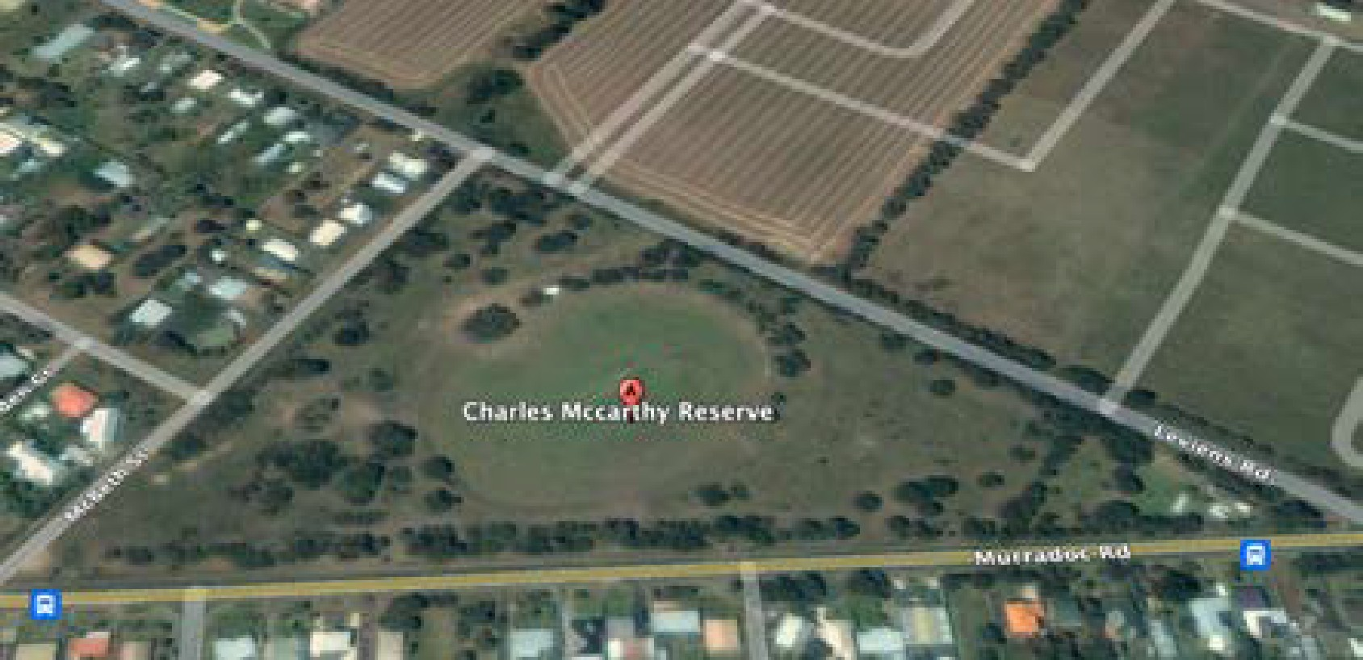  Top: Google Earth image from November 2005  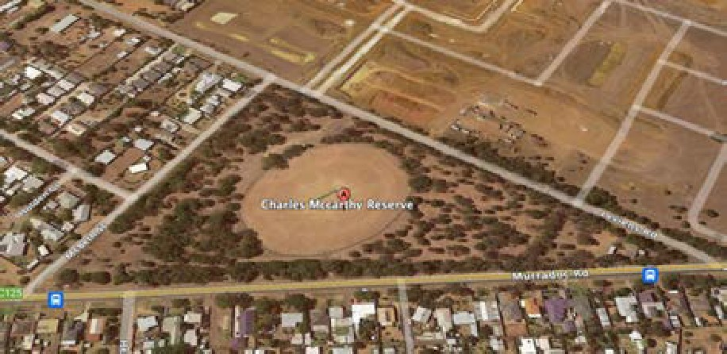  Google Earth image from January 2019 |  | - The encroachment of vegetation may compromise the size and shape of the oval, and impact on turf quality and density.  - As a sport reserve it will be necessary to ensure the planted vegetation can be managed around a car park and support facilities required to facilitate sport.  - A connecting trail will also need to be provided around this reserve pending a biodiversity assessment.
 | 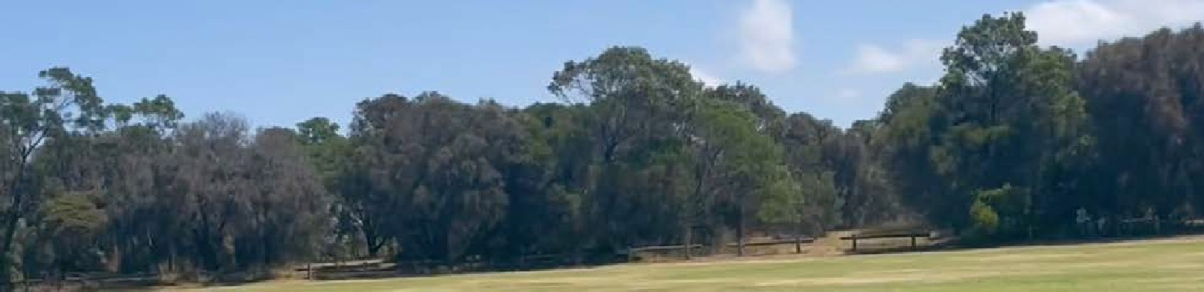

6.3 CRIME PREVENTION THROUGH ENVIRONMENTAL DESIGN (CPTED)

There is no natural surveillance into Charles McCarthy Reserve as it has small to medium size shrubs and trees around all boundaries and throughout the Reserve.
The recommendations of the previous master plan was to open views up the road.
At present there are no buildings on the Reserve. Residential housing overlooks the Reserve along Murradoc Road and to a lesser extent along McBeth Street to the west.
The Reserve is heavily treed. There are no walking trails in or around the Reserve and limited vehicle access into the Reserve with one entry/exit off Leviens Road.
There is no lighting in the Reserve or at the Road entry. The oval is not lit.
There is no clear entry or exit signage.
The oval has not been frequently booked in the past but is now used for cricket on weekends and soccer pre- season training in summer and junior soccer some weekends in winter. Community use appears to be limited with some dog walking likely.
With an increasing population and sporting use, a shared perimeter trail would enhance community surveillance and encourage people to walk or ride the site.

6.4 CHARLES MCCARTHY RESERVE - POTENTIAL SITE CONSTRAINTS
- There is a lack of connectivity to Lake Reserve and neighbouring residences
- Substantial planting since the last master plan has not enabled the path system to be developed that connects this reserve with other open spaces
- Planting of Indigenous grass species on Reserve prevent facility development for sport and provide challenges as a nature reserve when additional residential areas have been developed.
- As a single sports field, it is less sustainable and therefore the development of this site should be planned in conjunction with facilities at St Leonards Lake Reserve
- There is a lack of amenities for sport groups specifically change rooms, toilets and shelter, and designated car park
- The preferred area for development of supporting infrastructure on west side of the oval is heavily treed
- Vegetation encroaches onto the playing surface will impede turf growth and safe use of the oval
- There is potential conflict between dog owners and sport groups
- The preferred entry point from Murradoc Road is planted out with shrubs/trees/grasses
- There is poor visibility into the site
- There is a lack of services on site – electricity, water, and sewerage
The development of sporting facilities at the Charles McCarthy Reserve to meet the growing demand for St Leonards residents needs to be balanced against the unique grasslands and biodiversity found at the Reserve.
It is likely that development approval would not be provided for additional sports facilities required in the long term i.e., two senior soccer-football pitches, either side of the existing cricket wicket, with player change, social facilities and car parking.
Facility development guidelines for cricket and soccer- football recommend that such facilities are located on the west/northwest side of the field to maximise views for spectator, players and team staff. This location at McCarthy Reserve, with an entry of Murradoc Road, is likely to a have significant environmental impact.
Therefore, the proposed development at McCarthy Reserve in line with the 2011 Masterplan is to provide a small change, toilet and shade structure on the southeast side of the Reserve with carparking and entry of Leviens Road.
With no other suitable open space within the St Leonards township boundary, Council may need to purchase land to meet the future demand for sporting fields at St Leonards in the long term.
It is recommended that planning for future sports fields in St Leonards commences immediately.

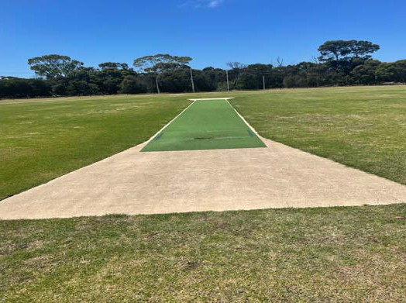

Issues and opportunities

LAKE RESERVE SWOT ANALYSIS
The following table outlines the strengths, weaknesses, opportunities and threats for the St Leonards Lake Reserve.

Figure 21. SWOT analysis for Lake Reserve St Leonards based on site visit and stakeholder interviews
Strengths | Weakness | Opportunities | Challenges
- Lake setting  - New oval lighting for soccer/football training  - Dome shape oval assists drainage  - Location in middle of residential area  - Walking trail (2.15 km) around Lake and oval connecting residents to Reserve  - Men’s Shed heating/cooling is good  - Oval wire mesh fence protecting oval from off-lead dogs and some wildlife  - Pavilion ideally located on southwest side of field  - Irrigation system on oval  - The Reserve is part of a wider open space corridor connecting the new residential areas that do not have sporting open space, the lake, and the foreshore | - Multiple Council Departments administering the Community Hall, sports club pavilion, change rooms and Men’s Shed, although all are connected  - Lack of room to extend building footprint without impacting car parking and general lack of car park space  - Pavilion design – social space too small and conflict between sports and other users  - Lack of sealed road and parking  - Condition and direction of cricket nets does not meet current standards  - Lack of storage facilities  - Pavilion design – social space too small  - Senior soccer/football pitch overlays existing hard wicket on oval  - No land for a second oval or soccer pitch to support clubs at one location  - Lacks public toilets that meet key sports guidelines  - Limited space around the oval for additional infrastructure | - Improve pavilion facilities to suit current demand, be female friendly and include people of all abilities  - Improve access to car parking, oval, and pavilion  - Increase number of players that are catered for by clubs  - Improve wayfinding signage  - Redesign cricket nets to meet cricket guidelines and cater for demands of growing club  - Develop parking along Cole Street and consider closure on match days  - Increase specimen trees for shade  - Consider that the two sports groups become the Committee of Management for the pavilion and community hall, to manage existing and future bookings and use of the hall and kitchen  - Create an improved and continuous of road trail connecting the two Reserves and facilities in the precinct with the new residential development, north and south and the coastal reserve.  - Create better connectivity between the Reserves and neighbouring sports and recreation facilities encourage residents to see the precinct as a whole | - Decrease in player participation due to lack of or poor facilities  - Potential for flood inundation during heavy rain  - Conflict with pedestrians/dog walkers and balls from sports  - Increased road congestion and risk to pedestrians due to through-road and limited space for off-road car park  - Up to 9 soccer/football teams training and playing on field each week in winter, reduces surface quality

CHARLES MCCARTHY RESERVE SWOT ANALYSIS
The following table outlines the strengths, weaknesses, opportunities and threats for the Charles McCarthy Reserve.

Figure 22. SWOT analysis for Charles McCarthy Reserve St Leonards based on site visit and stakeholder interviews
Strengths | Weakness | Opportunities | Challenges
- Shade and shelter provide by trees/shrubs  - Location on main road to St Leonards  - High level of biodiversity within Reserve and a range of indigenous flora  - Exceeds minimum size for Community Club cricket (50m from centre of pitch)  - Connected to the Lake Reserve and wider precinct | - Lack of support infrastructure for sports – (soccer, cricket, AFL) No change rooms, storage, toilets, lights, irrigation, or dedicated car park  - No formal access road for vehicles  - Lack of a perimeter trails connecting to residential estates and the Lake Reserve  - Lack amenities for non-sports users of Reserve e.g., drinking fountains, paths shelter, lighting  - Public toilets at scout hall some 250m from oval and not visible to oval  - No internal barriers to restrict vehicle movement throughout Reserve  - Further development of Reserve will require a number of permits and approvals to be obtained due to range of plant species in Reserve  - Senior soccer/football pitch overlays existing hard wicket on oval | - Grow participation in soccer and cricket by developing infrastructure  - Improve connectively and integration between the Reserves and new residential areas, and extend opportunities currently available  - Introduce wayfinding signage  - Improve and formalise entry/exit from Reserve  - Develop 2 football/soccer pitches – one on either side of cricket pitch to meet growing demand  - Opportunity to meet increasing population’s demand for sports and allow existing club to grow  - Integrated development with the scouts  - Improve protected areas / biodiversity in key areas similar to Moonah trees in Village Park, Barwon Heads. Separating environment from recreation | - Reduction of space for grasslands and indigenous flora  - Restriction on development of local clubs if facilities are not provided  - Unrestricted access through the Reserve leading to vegetation damage by vehicles  - Vegetation encroaching on the playing area and limiting the use and quality of the sports reserve  - Develop sporting infrastructure to meet growing demand while protecting native grasses

Key action areas

INFRASTRUCTURE DESIGN BRIEF
The key components for the Facility Development Plan at Lake Reserve are listed below:
Figure 23. The following key components for Lake Reserve
Component | Size | Notes
1. Three fully enclosed cricket nets | 36.3m x  10.8m | - Cricket training nets should have a north-south orientation, or a maximum of 30 degrees east or west of north.6 Consider potential adjustment to internal road.  - Locate as close as practical to car parking and pavilion/storage.  - Power to be accessible to nets for bowling machine
2. Formalise car parking around pavilion and Men’s Shed |  | - To be considered with review of vehicle entry/exit, drop off/pick up and existing pedestrian walking trails
3. Ambulance access point
4. Electronic scoreboard |  | - To be located on east side and shared with soccer and cricket clubs
5. Upgrade of walking trails and extension to connect to other reserves, facilities in the precinct and new residential areas | Min 2.5 m wide | - Approx. 2km in length
6. Signage |  | - Reserve road signage and internal signage to assist walkers/joggers using walking tracks
7. Expansion of Men’s Shed | Approx. 40 sqm | - If minimum parking requirements can be met for sports
8. Parking along Cole Street |  | - Between car entry/exit points
9. Oval cricket sight screens | 2
10. Upgrade of second road entry
11. Increase oval spectator seating |  | - Bench seating on oval perimeter
12. Consider barrier at north end of oval to prevent balls going into Lake | 3m high fence

6 Community Cricket Facilities Guidelines. Cricket Australia. 2015

Component | Size | Notes
13. Bollards to separate pedestrians and vehicles at south end of oval and near car park | 120m approx..
14. Additional tree plantings | #60
15. Pavilion that includes complaint and accessible toilets, social rooms, club storage & improved access for cricket and football/soccer
(See following components)
16. Covered area for spectators | 80-100 sqm (approx. standing room for up to 200 people) | - Football Facility Guides (Community)  - Cricket Guidelines (Club-Home) – Raised by 500-1000mm over playing field. Include external seating.
17. Kitchen/kiosk | 20 sqm | - Football Facility Guides (Community) 20sqm  - Cricket Guidelines (Club-Home) 10-15sqm. Include sink
18. Kitchen store | 8 sqm | - Cricket Guidelines (Club-Home) 8sqm
19. First aid | 10 sqm | - Football Facility Guides (Community)  - Cricket Guidelines (Club-Home)
20. Cleaners | 5 sqm | - Football Facility Guides (Community)  - Cricket Guidelines (Club-Home) 5sqm
21. Internal store | 2x20 sqm | - Football Facility Guides (Community) 15sqm.  - Cricket Guidelines (Club-Home) 30sqm
22. External store | 30 sqm | - Cricket Guidelines (Club-Home)
23. Social facilities | 100-150 sqm | - Cricket Guidelines (Club-Home) 100-150 sqm  - Views to playing field
24. Meeting/Admin | 15 sqm | - Cricket Guidelines (Club-Home) - optional
25. Public M/F toilets | 2x20 sqm | - Football Facility Guides (Community) 2x20sqm  - Cricket Guidelines (Club-Home) 2x15 sqm. Accessible 5.5sqm
26. Publicly accessible toilet | 7 sqm | - Football Facility Guideline 7sqm  - Cricket Guidelines (Club-Home) 5.5 sqm  - Access to Premises Standard
27. Cleaners store. Include drainage and hot and cold water |  | - Cricket Guidelines (Club-Home)
28. Bin storage | 5 sqm

The key components for the Facility Development Plan at McCarthy Reserve are listed below:
Figure 24. The following key components for McCarthy Reserve
Component | Size | Notes
1. Formalise entry/exit to Reserve and access road to facilities from Leviens Road
2. Formalise car parking to support change rooms |  | - To be considered with improvement of vehicle entry/exit and potential development of pedestrian walking trails.
3. Ambulance access point
4. Change room that includes all gender change facilities for cricket and football/soccer | 235-240sqm | - Ideally the facilities would be located on the western or north/western side of the field however the likely environmental impact prevents this and a southeast location is preferred.
5. Barriers to protect vegetation from vehicles at key areas |  | - Areas to be confirmed following assessment
6. Extend playing surface to accommodate 2 senior soccer- football pitches either side of wicket | Local and Community. Senior - 96-105 m x 60-68 m
7. Extend walking trails around Reserve | 500 m approx.
Change room requirements
8. Change rooms | 2 x 30sqm | - Football - Community senior and junior min.  - Cricket (Club satellite) 2 x 20-30sqm
9. Player shower/toilets | 2 x 15-20sqm | - Cricket (Club satellite) 2 x 15-20sqm
10. Accessible toilets | 2 x 10sqm. Accessible 5.5sqm | - Cricket (Club satellite)
11. Umpires/officials | 15sqm | - Cricket (Club satellite) Inc shower and toilet
12. First aid | 10 sqm | - Cricket (Club satellite
13. Storage | 15sqm
14. Spectator shelter | 80sqm
15. Bin storage | 5sqm
TOTAL | 235-240sqm | - Stage 1 – minimum requirement

Concept plans

ST LEONARDS LAKE AND CHARLES MCCARTHY RESERVES
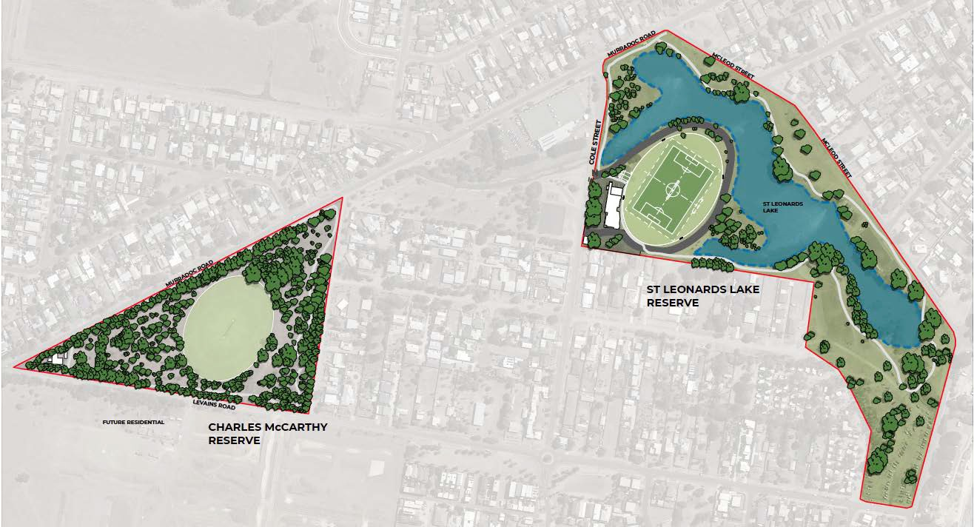
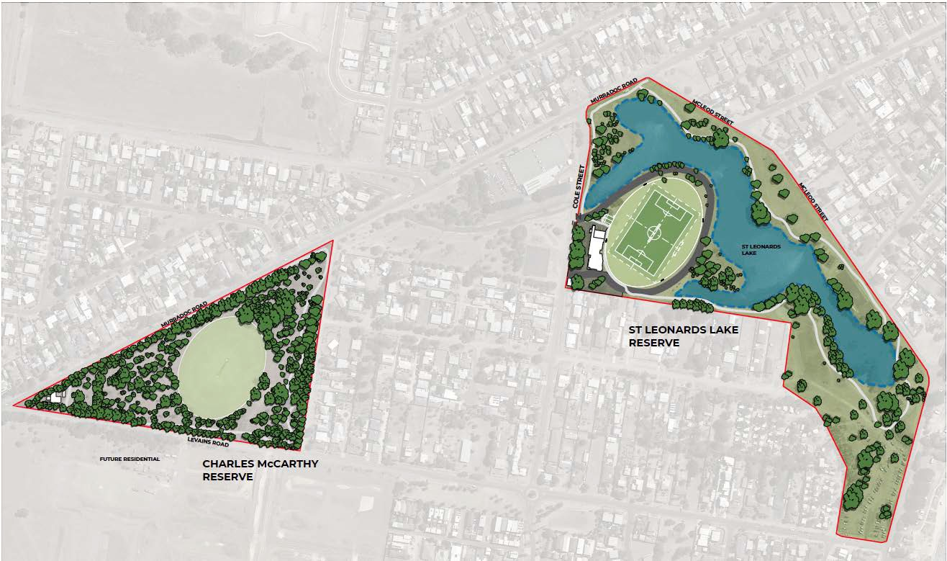
Figure 25. St Leonards Lake and Charles McCarthy Reserves – Existing site plan

30

Figure 26. St Leonards Lake Reserve – Existing site plan
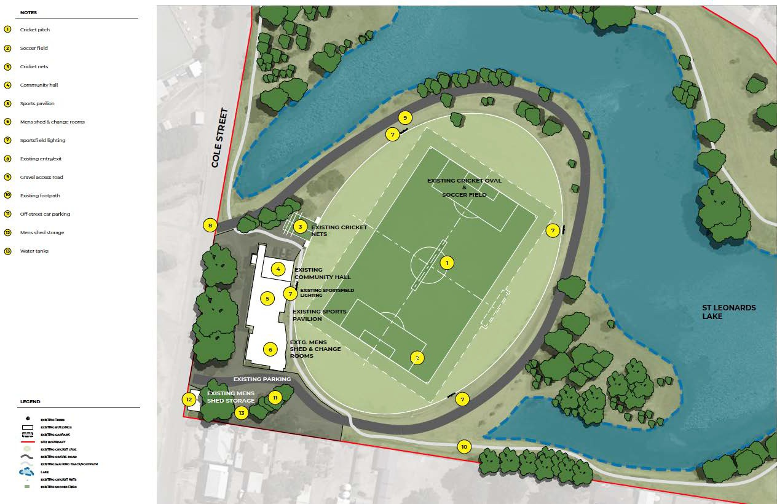

Figure 27. St Leonards Lake Reserve - Proposed facility development plan
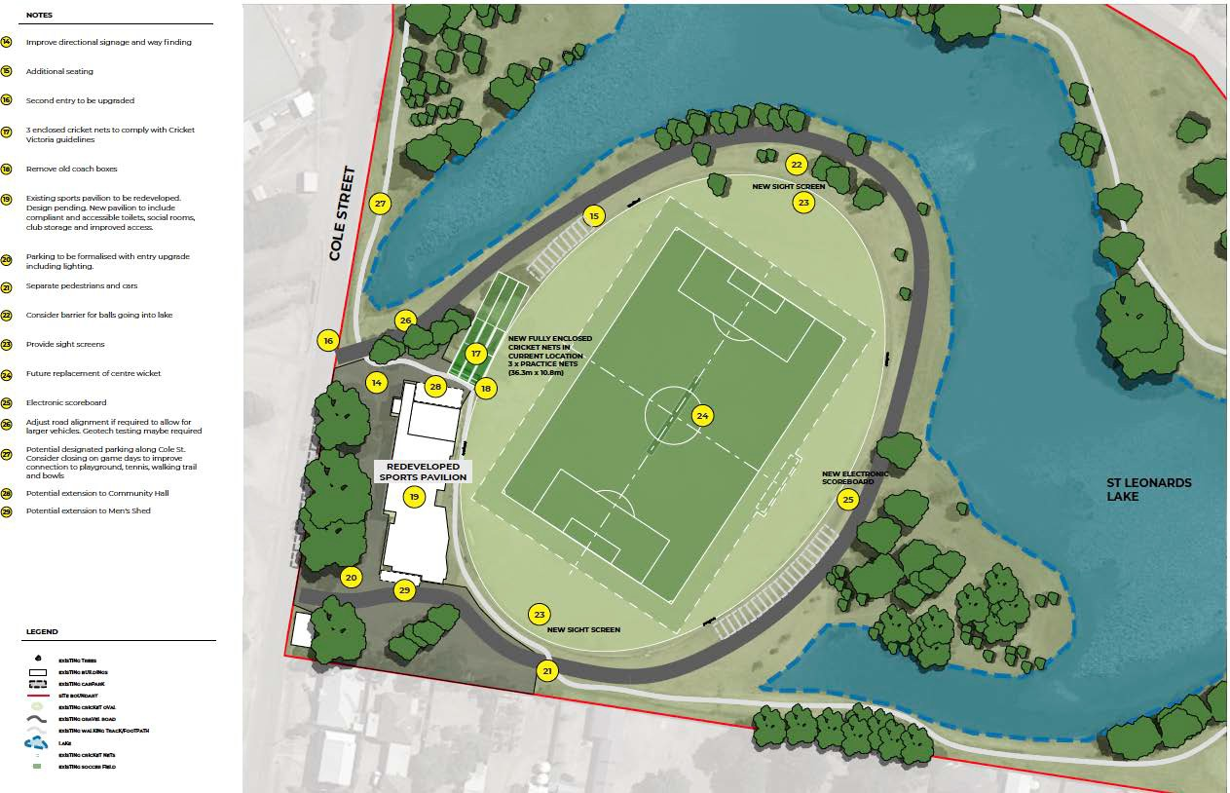

Figure 28. Charles McCarthy Reserve – Existing site plan
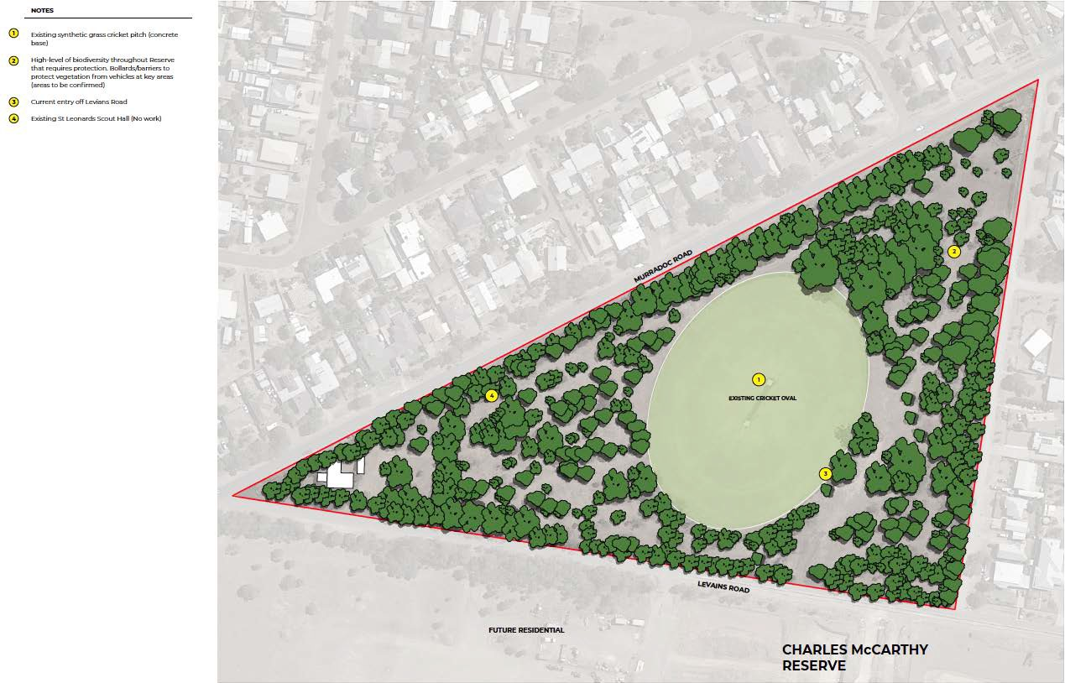

Figure 29. Charles McCarthy Reserve -Facility development plan
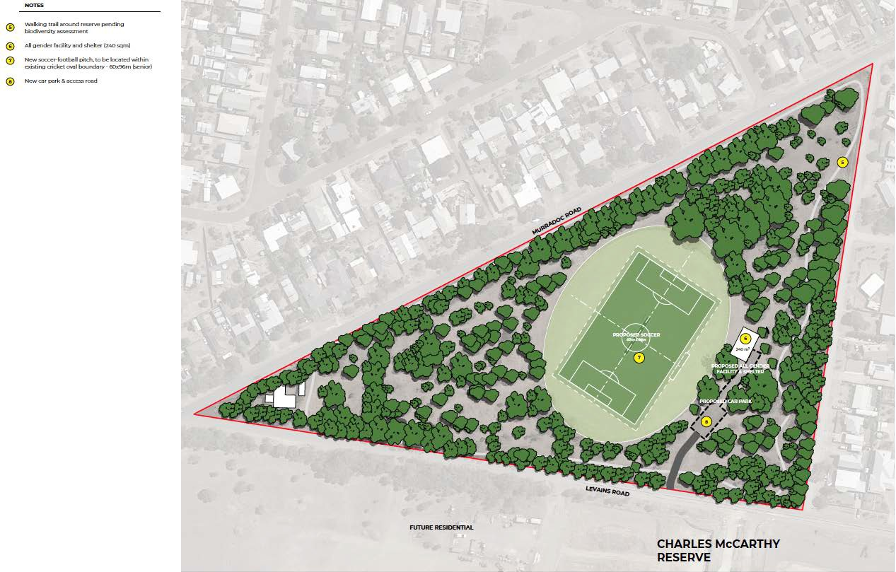

ST LEONARDS LAKE RESERVE PAVILION/COMMUNITY CENTRE
Figure 30. St Leonards Lake Reserve - Existing pavilion/community centre
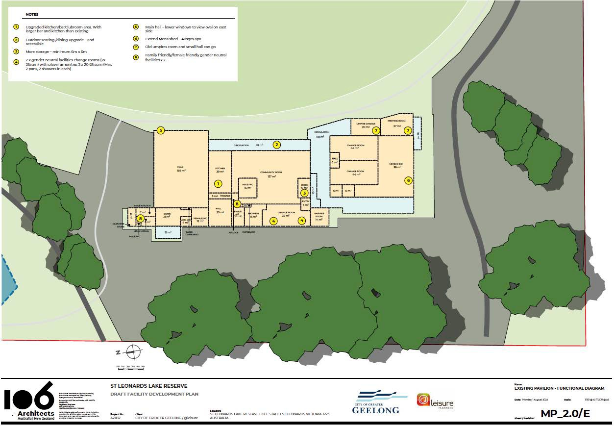

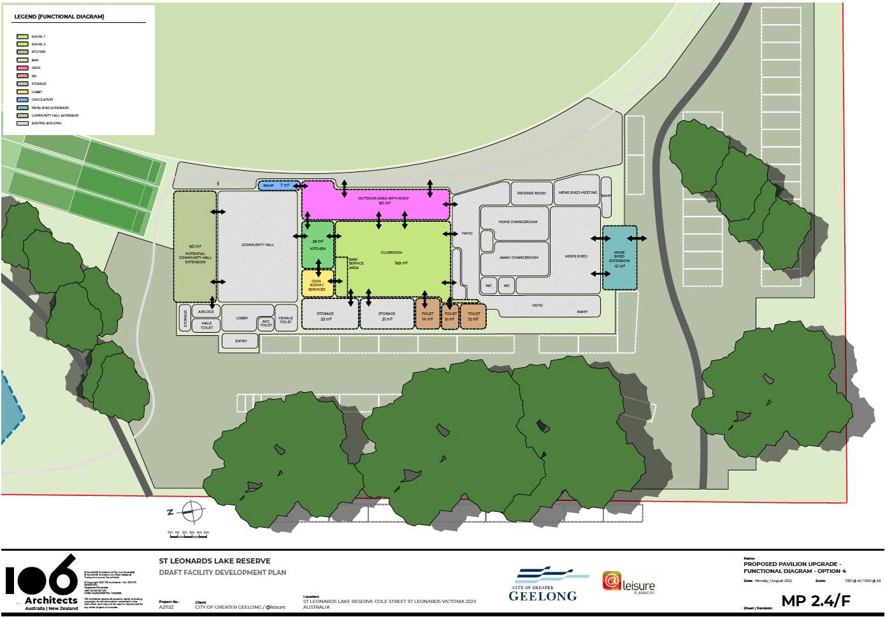
Figure 31. St Leonards Lake Reserve - Pavilion proposed upgrade, preferred option (4) functional relationship diagram

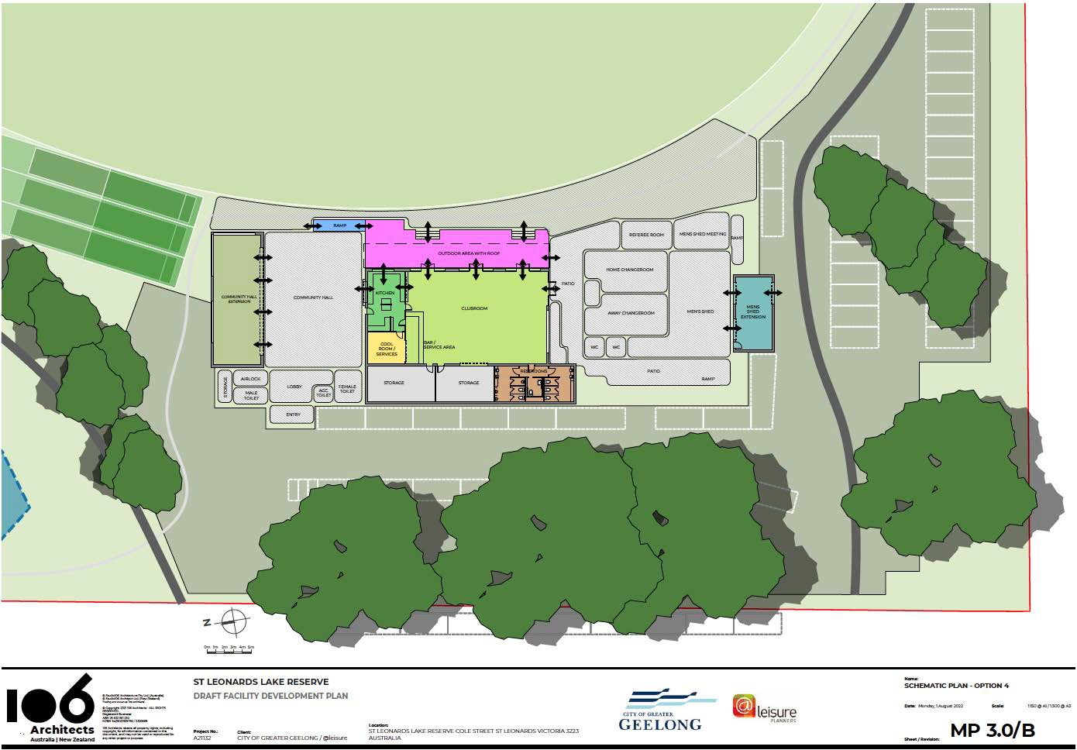
Figure 32. St Leonards Lake Reserve - Pavilion proposed upgrade, preferred option (4) schematic diagram

Other pavilion options considered
A number of adoptions for the expansion for the pavilion were considered. These are shown below.
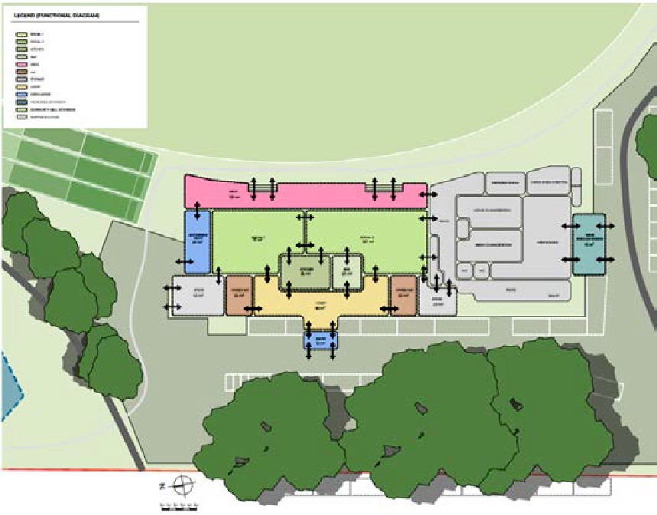
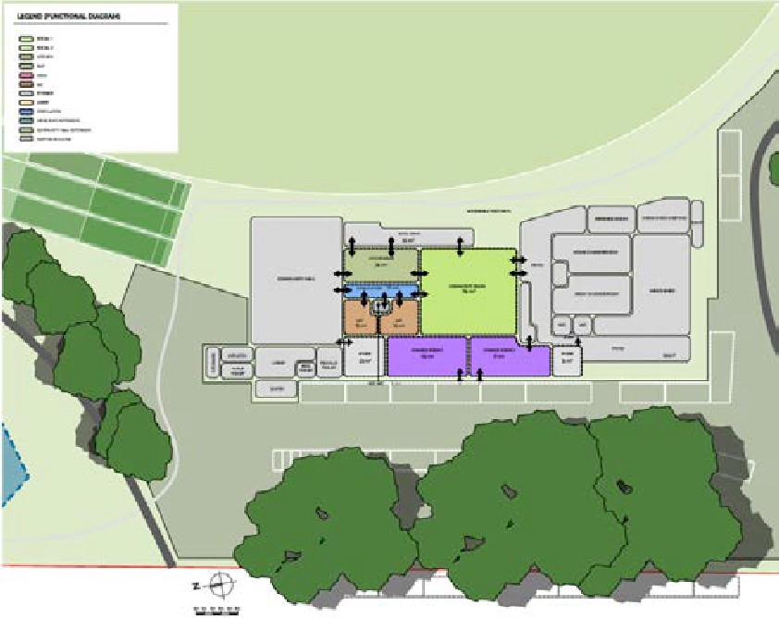
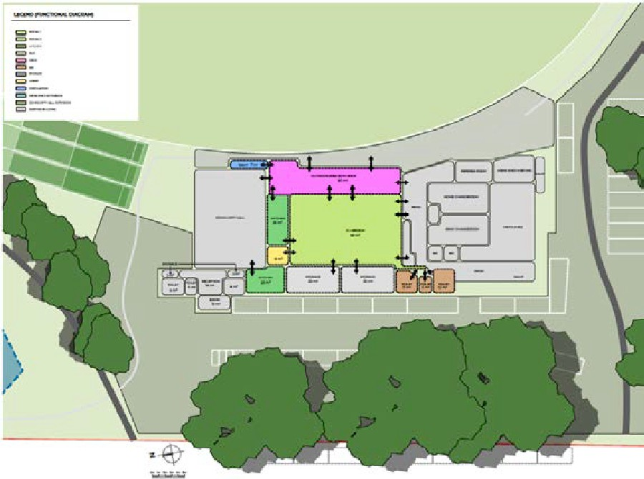
Option 1 Option 2
Option 3

Cost estimates

The cost plan prepared by Turner and Townsend Pty Ltd is provided below.

ST LEONARDS LAKE RESERVE FACILITY DEVELOPMENT PLAN - INDICATIVE COSTS
Date: 13/07/2022
Component | Area | Rate | St Leonards Lake Reserve Costs | Community Centre Costs
 | m2 | $/m2 | $ | $
Building Works
Repurpose existing spaces
Ramp | 7.32 | $ 2,000 | $ 14,640 | $ 14,640
Outdoor covered area | 88.67 | $ 2,400 | $ 212,808 | $ 212,808
Kitchen | 28.54 | $ 2,400 | $ 68,496 | $ 68,496
- EO for kitchen equipment | Allow |  | $ 65,000 | $ 65,000
Cool room | 8.56 | $ 4,500 | $ 38,520 | $ 38,520
Services | 6.51 | $ 2,400 | $ 15,624 | $ 15,624
Storage | 64.14 | $ 2,400 | $ 153,936 | $ 153,936
Clubroom | 166.7 | $ 1,500 | $ 250,050 | $ 250,050
Toilets | 26.07 | $ 3,000 | $ 78,210 | $ 78,210
Accessible toilet | 8.11 | $ 4,500 | $ 36,495 | $ 36,495
Allowance for structural works to existing building
-Assumes existing structure is suitable for reuse |  |  | Excluded | Excluded
Allow for demolition of existing pavilion fit out | 300.52 | $ 200 | $ 60,104 | $ 60,104
Allow for asbestos removal | PROV |  | $ 50,000 | $ 50,000
 | SUM
Allow for signage | Allow |  | $10,000 | $10,000
Total Building Works | 397 |  | $ 1,053,883 | $ 1,053,883
External Works and Services | Allow Allow  Allow Allow  Allow  PROV SUM  Allow 1,500  Allow Allow  2km x  2.5m wide Allow  Allow | $ 200
Site Preparation |  | $ 200 | $ 10,000 | $ 10,000
- incl. demolition for outdoor area and ramp |  | $ 200
Allowance for removal / demolition as required |  | $ 200 | $ 15,000
incl. demolition of 2 no. coach boxes |  | $ 200
Earthworks |  | $ 200 | $ 40,000 | $ 15,000
Allowance for 3 no. fully enclosed cricket nets |  | $ 200 | $ 350,000
(36.3m x 10.8m) incl. provision of power |  | $ 200
- Extra for tress planting offset |  | $ 200 | $ 22,000
Cricket sight screens (2no.) |  | $ 200 | $ 60,000
Replace synthetic grass on cricket wicket |  | $ 200 | $ 20,000
Formalise parking area around pavilion |  | $ 200 | $ 300,000
Allow to upgrade second entry |  | $ 200 | $ 40,000
Allowance for new electronic scoreboard 130m |  | $ 200 | $ 100,000
electrical connection |  | $ 200
Upgrade and extension of walking trails (granitic |  | $ 200 | $ 325,000
sand) |  | $ 200
Allow for pedestrian / road intersection treatment |  | $ 200 | $ 50,000
Allowance for directional signage (3 locations) |  | $ 200 | $ 10,000

Function | Area | Rate | Lake Reserve Costs | Community Centre Costs
Parking along Cole St (between the two Reserve | Allow |  | $ 50,000
entries)
Allow to adjust existing road to suit siting of new | Allow |  | $ 108,000
cricket nets
Allowance for new bench seating (68 No) | Allow |  | $ 170,000
New barrier to northern end to prevent balls | Allow |  | $ 51,600
going into lake (allow 3m high fence)
Separation of pedestrian and vehicles via | Allow |  | $ 42,000
bollards for 120m
Allow for additional native tree planting | 60 No. |  | $ 60,000
(advanced trees)
Allowance for landscaping works | Allow |  | $ 100,000
Allowance for minor external services incl | Allow |  | $ 150,000 | $ 100,000
Stormwater
Total External Works & Services | 397 |  | $ 2,073,600 | $ 125,000
Sub Total | 397 |  | $ 3,127,483 | $ 1,178,883
ESD initiatives | Allow  Allow 24mths  Allow 12mths | 3%  10%  12%  10% pa | $ 93,824 | $ 35,366
Design Contingency | Allow  Allow 24mths  Allow 12mths | 3%  10%  12%  10% pa | $ 313,000 | $ 118,000
Preliminaries & Margin | Allow  Allow 24mths  Allow 12mths | 3%  10%  12%  10% pa | $ 376,000 | $ 142,000
Cost Escalation to tender | Allow  Allow 24mths  Allow 12mths | 3%  10%  12%  10% pa | $ 207,447 | $ 84,705
Cost Escalation during construction | Allow  Allow 24mths  Allow 12mths | 3%  10%  12%  10% pa | $ 263,946 | $ 99,512
Construction Cost |  |  | $ 4,956,315 | $ 1,868,611
Construction Contingency |  | 10% | $ 496,000 | $ 187,000
Professional Fee Allowance [Excl PM] |  | 11% | $ 600,000 | $ 227,000
Authority Fees & Charges | Allow |  | $ 100,000 | $ 38,000
Fixtures, Fittings and Equipment | Allow |  | $ 40,000 | $ 40,000
Audio Visual/ Active IT Equipment Allowance | Allow |  | Excluded | Excluded
Client / Council Costs | 2% |  | $ 123,846 | $ 47,212
Project Contingency |  | 10% | $ 631,616 | $ 240,782
Sub Total |  |  | $ 1,991,462 | $ 779,995
Project Total (excluding GST) |  |  | $ 6,947,777 | $ 2,648,606

MENS SHED OPTION - INDICATIVE COSTS

Component |  | Area | Rate | Mens Shed Extension Costs
 |  | m2 | $/m2 | $
Extension of men's shed |  | 40  Allow Allow Allow  Allow | $ 4,000 | $ 160,000
Demolition / connection to existing building |  | 40  Allow Allow Allow  Allow | $ 4,000 | $ 50,000
Site preparation / earthworks |  | 40  Allow Allow Allow  Allow | $ 4,000 | $ 50,000
Allowance for landscaping works |  | 40  Allow Allow Allow  Allow | $ 4,000 | $ 50,000
Allowance for minor external services incl. stormwater |  | 40  Allow Allow Allow  Allow | $ 4,000 | $ 75,000
 | Subtotal | Allow  Allow 24mths  Allow 12mths | 3%  10%  12%  10% pa | $ 385,000
ESD initiatives |  | Allow  Allow 24mths  Allow 12mths | 3%  10%  12%  10% pa | $ 11,550
Design Contingency |  | Allow  Allow 24mths  Allow 12mths | 3%  10%  12%  10% pa | $ 39,000
Preliminaries & Margin |  | Allow  Allow 24mths  Allow 12mths | 3%  10%  12%  10% pa | $ 47,000
Cost Escalation to tender |  | Allow  Allow 24mths  Allow 12mths | 3%  10%  12%  10% pa | $ 48,255
Cost Escalation during Construction |  | Allow  Allow 24mths  Allow 12mths | 3%  10%  12%  10% pa | $ 29,858
Construction Cost |  |  |  | $ 560,663
Construction Contingency |  |  | 10% | $ 57,000
Professional Fee Allowance [Excl PM] |  |  | 11% | $ 68,000
Authority Fees & Charges |  | Allow |  | $ 6,000
Fixtures, Fittings and Equipment |  | Allow |  | $ 30,000
Audio Visual/ Active IT Equipment Allowance |  | Excluded |  | Excluded
Clients / Council Costs |  | 2% |  | $ 14,433
Project Contingency |  |  | 10% | $ 73,610
Sub Total |  |  |  | $ 249,043
Project Total (excluding GST) |  |  |  | $ 809,706
Exclusions:
We have expressly not taken into account the impact of the Covid 19 pandemic (or any other matter coming to our attention after the date of this report) and accordingly have excluded from this report any implications in relation to programme, costs, supply shortages, performance of parties due to shortages of labour and the inability to travel due to global and national travel restrictions, etc. Turner & Townsend accepts no liability for any loss or damage which arises as a result of such matters or any reliance on this report which assumes such matters have been taken into account.
- GST • Cost Escalation beyond June 2023
- Upgrade or provision of authority services • Works to adjoining streets infrastructure external to the site
- Land and finance costs • Public Art
- Adverse soil conditions incl. excavation in rock, • Asbestos & other hazardous materials removal contaminated soil, soft spot
- Diversion / relocation of existing inground • Stormwater on site retention / detention system services
- Relocation / Decanting / Temporary Accom • Planning permit fees
- Works to existing Hall and Mens Shed portions • Locality costs and site constraints of the Pavilion
- Works to Lake or Reserve not in immediate
vicinity of the Pavilion and oval
- Separation of pedestrian and vehicles via bollards for 120m | Note: Exclusions within cost plan

CHARLES MCCARTHY RESERVE FACILITY DEVELOPMENT PLAN - INDICATIVE COSTS

Components | Area | Rate | McCarthy Reserve Costs
 | m2 | $/m2 | $
Building Works
Change room incl. all gender change
Change rooms | 60 | $ 3,000 | $ 180,000
Shower / toilets | 35 | $ 3,600 | $ 126,000
Accessible toilets | 20 | $ 5,000 | $ 100,000
Umpires/officials | 15 | $ 3,600 | $ 54,000
First aid | 10 | $ 3,000 | $ 30,000
Storage | 15 | $ 2,400 | $ 36,000
Spectator shelter | 80 | $ 2,000 | $ 160,000
Bin storage | 5 | $ 2,000 | $ 10,000
Future stage - Community room above change rooms
(incl. lift, community room, toilets, kitchen, bar, cool | 180 |  | EXCLUDED
rooms and admin)
No allowance for future proofing change room pavilion |  |  | EXCLUDED
Allowance for piled foundations | Allow |  | $ 72,000
Allow for signage | Allow |  | $ 10,000
Total Building Works | 240 |  | $ 778,000
External Works & Services | Allow  Allow 900  Allow  Allow Allow Allow  Allow | $ 200
Site preparation - Excl. demolition, general overall site | Allow  Allow 900  Allow  Allow Allow Allow  Allow | $ 200 | 10,000
prep only | Allow  Allow 900  Allow  Allow Allow Allow  Allow | $ 200
Earthworks | Allow  Allow 900  Allow  Allow Allow Allow  Allow | $ 200 | $ 39,900
Formalise entry/ exit to Reserve and access road to | Allow  Allow 900  Allow  Allow Allow Allow  Allow | $ 200 | $ 50,000
facilities from Leviens Rd | Allow  Allow 900  Allow  Allow Allow Allow  Allow | $ 200
Formalise car parking to support change rooms | Allow  Allow 900  Allow  Allow Allow Allow  Allow | $ 200 | $ 180,000
Allowance for barriers to protect vegetation from | Allow  Allow 900  Allow  Allow Allow Allow  Allow | $ 200 | $ 52,500
vehicles at key areas (150m) | Allow  Allow 900  Allow  Allow Allow Allow  Allow | $ 200
Extension of walking trails - granitic sand (1km) | Allow  Allow 900  Allow  Allow Allow Allow  Allow | $ 200 | $ 162,500
Allowance for signage | Allow  Allow 900  Allow  Allow Allow Allow  Allow | $ 200 | $ 10,000
Allowance for landscaping works | Allow  Allow 900  Allow  Allow Allow Allow  Allow | $ 200 | $ 150,000
Allowance for External Services incl Stormwater | Allow  Allow 900  Allow  Allow Allow Allow  Allow | $ 200 | $ 250,000
Total External Works & Services | 240 |  | $ 250,000
Sub Total | 240 |  | $ 1,028,000
ESD initiatives | Allow  Allow 24mths  Allow  12mths | 3%  10%  12%  10% pa | $ 30,840
Design Contingency | Allow  Allow 24mths  Allow  12mths | 3%  10%  12%  10% pa | $ 103,000
Preliminaries & Margin | Allow  Allow 24mths  Allow  12mths | 3%  10%  12%  10% pa | $ 124,000
Cost Escalation to tender | Allow  Allow 24mths  Allow  12mths | 3%  10%  12%  10% pa | $ 257,168
Cost Escalation during construction | Allow  Allow 24mths  Allow  12mths | 3%  10%  12%  10% pa | $ 86,794
Construction Cost |  |  | $ 1,543,008

Components (cont’d) | Area |  | Rate | McCarthy Reserve Costs
 | m2 |  | $/m2 | $
Construction Contingency |  |  | 10% |  | $ 155,000
Professional Fee Allowance [Incl PM] |  |  | 11% |  | $ 187,000
Authority Fees & Charges |  | Allow |  |  | $ 21,000
Fixtures, Fittings and Equipment |  | Allow |  |  | $ 40,000
Audio Visual/ Active IT Equipment |  | Allow |  |  | EXCLUDED
Client / Council Costs |  | 2% |  |  | $ 38,920
Project Contingency |  |  |  |  | $ 25,000
 |  |  | 10% |  | $ 198,493
Sub Total |  |  |  | $ 640,413
Project Total (excluding GST) |  |  |  | $ 2,183,421
Exclusions:
We have expressly not considered the impact of the COVID- 19 pandemic (or any other matter coming to our attention after the date of this report) and accordingly have excluded from this report any implications in relation to programme, costs, supply shortages, performance of parties due to shortages of labour and the inability to travel due to global and national travel restrictions, etc. Turner & Townsend accepts no liability for any loss or damage which arises as a result of such matters or any reliance on this report which assumes such matters have been considered.
•
•

•
GST
Upgrade or provision of authority services infrastructure external to the site
Land and finance costs
Adverse soil conditions incl. excavation in rock, contaminated soil, soft spot
Diversion / relocation of existing inground services
- Cost Escalation beyond June 2023
- Works to adjoining streets
•
•
•
•

•
•
•
•
•
Relocation / Decanting / Temporary Accom New sports fields and lighting
New safety lighting to trails
Works to Reserve not in immediate vicinity of the Pavilion and oval
Public Art
Asbestos & other hazardous materials removal
Stormwater on site retention / detention system
- Planning permit fees
- Locality costs and site constraints
•
Note: Exclusions within cost plan

Potential funding and partnerships

Funding for the Lake Reserve and McCarthy Reserve Development Plan is likely to come from a range of sources including grants from the State and Federal government, Council’s budget and/or Council loans.
There will also be opportunities for commercial partnerships where contributions may be made to certain components.
Other types of funding arrangements relate to land development – either negotiated agreements or open space contributions during subdivision, funding new facilities through the sale of old facilities or redeveloping sites on the portion of a site in conjunction with the development of office or residential accommodation.
These land development opportunities may be particularly relevant as no sporting or recreational space appears to have been provided in the two new neighbouring residential developments.
Each development may lend itself to specific opportunities related to objectives, vision, timing, but also availability of resources and opportunities for colocation.
The following table provides some examples of different funding sources.
Figure 33. Examples of funding sources for sports reserve facility developments
Type of Funding Source | Example
Community Cricket Program | - Grant program through the Victorian Department of Jobs, Precincts and Regions for $13.5 million in 2022 with individual grants up to $200,000  - Eligible projects include cricket training nets/facilities that are publicly accessible and may be multi-sport, pavilion/clubroom developments with female friendly changerooms, ground upgrades that increase capacity or safety, irrigation and drainage upgrades that improve capacity, inclusion or safety, sports lighting that enables new programming, improves capacity, inclusion or safety. Requests for replacement of lighting with LED lights are not eligible unless part of a new lighting installation.
World Game Facilities Fund | - The World Game Facilities Fund is a $20 million Victorian Government funding program that assists local football (soccer) clubs and organisations to upgrade existing or develop new facilities across metropolitan Melbourne and regional Victoria.  - Eligible projects include building new or redeveloping change rooms and pavilions to increase capacity, inclusion and safety, building new or redeveloping sports fields to increase capacity and safety, projects that result in energy or water efficiency, with a direct impact on participation, such as warm season grass conversions, sports lighting that improves facility capacity and participant safety, requests for replacement of lighting with LED lights are not eligible unless part of a new lighting installation.
Club contributions | - St Marys Sporting Club, Geelong, pavilion upgrade was funded via a Club infrastructure account built up over 10 years, private donors, tax deductible donations via the Australian Sports Foundation fund, and the Victorian Government
Developer or open space contributions following subdivision | - Typically, 5% of value of land from subdivision under the Subdivision Act, or cash in lieu can be taken if land isn’t and applied to recreation and open space development in the local area for example.  - Section 173 agreements contributions or other negotiated agreement and contributions. This opportunity may have been missed as development already proceeding in the residential developments adjacent, although only drainage land seems to be provided.  - Splash Aquatic centre (Craigieburn) funded through open space contributions, state and federal grants  - Highpoint Shopping Centre made a contribution to adjacent sports and aquatic development, negotiated to allow a road to be built in the park, to create a street address for shops.

Type of Funding Source | Example
Philanthropic Trusts / Foundation Grants etc. | - Australian Sports Foundation, and multiple specific ones for specific things.  - E.g. Scanlon Foundation, North Melbourne Football Club and City of Melbourne- development of the Huddle and the indoor Recreation Centre.
Land sales/ swaps | - Hornsby PCYC development will be offset by $12.5 million from sale proceeds of the George Street site, plus Hornsby Shire Council ($2.85 million contribution towards building plus full outside landscaping) and Rotary ($35,000 for youth hub fit out).
Community enterprises/ clubs | - Mingara Recreation Club formed by local residents – funded Mingara Aquatic Centre and Regional Athletics Centre- funded through gaming with some assistance from the state government.  - Collingwood Basketball Association obtained grants from Dept of Education, Dept Sport and Recreation and Multicultural Victoria for an indoor sports centre at Collingwood College.  - The Kangaroo Flat Community Enterprise (KFCE) lobbied for and contributed capital Gurri Wanyarra Wellbeing Centre at Kangaroo Flat.
Federal grants | - Examples include “Building Better Regions” for regionally significant community infrastructure. The nature and focus of these grants may change regularly.
Sport and Recreation Vic - State grants | - Annual grants include major and minor capital works grant programs. These are typically released annually and have different focuses.
Community Sports Infrastructure Loans Scheme | - Provides low interest government guaranteed loans of up to $10 million to local government with subsidised interest rates of 50% up to 2.5%. The East Keilor Leisure Centre redevelopment was supported by a $10 million dollar loan.  - Alternatively, Council makes their own loan arrangements for the required portion of capital and pay the service fee as negotiated.
Geelong Community Grants | - The City offers a wide variety of grants to support the Greater Geelong community.  - www.geelongaustralia.com.au/grants/default.aspx

Open space contributions taken from the adjacent residential development should be investigated as no community sports facilities are provided in those developments, and the open space in the vicinity is encumbered – for drainage purposes.
The most likely options at this point are Federal funding opportunities through grants such as the Building Better Regions Fund and State grants such as Community Sports Infrastructure Stimulus Program and the Local Sports Infrastructure Fund. The grants are typically cyclic and rounds of funding are open for short periods of time that suit those that have “shovel ready projects”, master plans, feasibility studies or business cases ready to support applications.

Appendices

APPENDIX 1. USER GROUP CONSULTATION NOTES

Bellarine Sharks Soccer Club

Specifically, what components of the Reserve does your group currently use?

St Leonards Lake Reserve
  - Clubrooms, hall, kitchen, bar, storeroom, toilets, changerooms, public toilets, cleaning room, referee room, pitch/oval, parking and lighting, plus other facilities in the Lake Reserve precinct including playground across the road.

Charles McCarthy Reserve
  - Oval

Pre COVID, what has been the trend in these numbers in the past 3 full seasons? Provide data if available
Numbers have been increasing steadily prior to Covid interrupting the 2019 season. Numbers increased in 2020 (2 teams) and 2021.
In 2019 the Club had two under 7 teams, three under 9 teams, one under 11, 1 under 12 and 2 senior teams.

Do you anticipate additional people will use your services / facilities in the next 5-10 years?
We are growing each year and with the growth in the area we anticipate the team sizes and number of teams to grow rapidly over the next 5-10 years.
  - We will need 3 grounds in 10 years
  - In 5-6 years’, time we expect 400-500 members. Currently – 144 players plus family, volunteers.
  - Over 1000 people per day came when soccer rounds were scheduled at one ground.
  - Registration day in 2021 included about 200 attendees.

If additional people are expected, what will you require to meet these demands for the next 10 years?

St Leonards Lake Reserve
  - Upgraded kitchen/bar/clubroom area
  - Outdoor seating and outdoor dining
  - Need more storage – additional storage required would be minimum 6m x 6m
  - Possibly another pitch
  - Greater lighting Lux. Training level 150lux? New lighting recently installed however stronger lighting is now required due to night games been scheduled by FFV. Games currently schedule at other grounds on Sunday or Friday nights. Not attractive for spectators. Require about 300 Lux for games. Cricket use for training some nights.
  - Family Friendly/Female friendly/gender neutral facilities
  - Internet within the clubrooms
  - More parking. Currently players and spectators park around oval, across road and down road. Cars get stuck in winter from cricket nets along
  - Electronic Scoreboard/Video Board Ideally on opposite side to pavilion.
  - Men’s shed want more storage

Charles McCarthy Reserve
  - Family friendly/female friendly gender-neutral change rooms
  - Shade
  - Storage
  - Parking
  - Seating
  - Public toilets

Thinking about the existing facility/s you use, do they meet your current organisation's needs? (Location, oval size/surface, centre wicket, social facilities - functionality, size, netball court, 1/2 basketball court, men’s shed - size/storage/heating/cooling, public toilets, car park, security lighting)

No, they do not.

If no, what is required to improve them?
  - Drainage around pavilion is lacking/non-existent
  - More storage is required. Use people’s houses for storage year round
  - Upgrading both the men’s and women’s toilets within the clubrooms
  - Kitchen/Bar is non-compliant and needs upgrading with modern facilities
  - Internet/Wi-Fi is required to help facilitate upgrades to social facilities and POS systems. Currently paid for by sponsor
  - More security lighting is required outside
  - Light weight doors on the public toilets with more regular cleaning
  - New, portable dugout shelters for players
  - Scoreboard that can be used by both cricket and soccer clubs
  - More room within the clubrooms to allow for more social events
  - The fence around the oval needs to be removed near the clubrooms to allow for easier access on and off the field
  - Speaker system both inside and outside would be a nice touch
  - New doors on the clubrooms that fulfils disability access requirements
  - Removal of internal door in the Home changeroom to fulfil our Child Safe Commitments
  - Security System/Cameras to upgrade safety for volunteers and staff who arrive early in the day or leave late at night.
  - Cater for 60 kids after training plus parents. Commercial kitchen in Hall is ok.
  - Bar – no space for more than 2 people. Post senior games – minimum of 70/80 people. If senior women’s and men’s at’ same time, then that number doubles.
  - Location is excellent but can cause some issues with parking on game days with multiple teams playing.

What are the main issues you face in running a sustainable and viable organisation as well as maintaining the service you provide to the community?
  - Getting volunteers
  - People finding the Reserve is an issue
  - Disagreements with other community groups (not cricket club) about the facilities and what they are used for.

Thinking about the Reserve, what improvements could be made that would improve its appearance or character? (Shade, paths, seating, trees, parking, bins etc)
  - New bins and a few more of them
  - More seating around the pitch
  - Clean up out the front with the trees and garden bed
  - Add angle parking along the front with flower beds or drought tolerant gardens.
  - Redo the entrance signs and add curb/channelling out the front.
  - More visible signage from Cole St and Murradoc Rd
  - Proper car parking

In your opinion, are there any assets on the Reserve that are no longer useful or serving their original purpose?
  - Player dugouts
  - Fencing in front of club rooms
  - Many other areas not serving their original purpose due to storage issues or disagreements with other groups (not cricket club)
  - Ticket box at entry

Do you have any further comments or suggestions you would like to make?
  - With CFA having a new station built, it would provide the Men’s Shed with a bigger space & allow both us and the cricket club to have more storage space by utilising the old men’s shed portion of the pavilion and their shed.
  - Some dog walkers believe space is there’s
  - Directional signage to ground – worse than other places in Geelong
  - Tidy up entry
  - Don’t cover cricket wicket

St Leonards Cricket Club

Specifically, what components of the Reserve does your group currently use?
  - Oval
  - Nets
  - Change rooms
  - Hall on occasions
  - Not Men’s shed

How regularly and at what times do you use the facility?
August – March
Tuesday and Thursday- Men’s training. 5.30 – 7.30pm Saturdays -1.00 - 6.00pm Men’s
Sundays - 1.00 - 6.00pm Women’s Wednesday – Juniors - U11, U13
20/20 Comp possibly Thursdays in future

If additional people are expected, what will you require to meet these demands for the next 10 years?
  - Improve bar, social facilities and storage,
  - Main hall – windows face oval. 12 foot high. Make viewing area by lowing windows
  - Hall - extend to northern boundary.
  - Clubs room bar needs 5-10k of improvements. Health and safety upgrade.
  - Shower block is used as a storeroom.
  - Can expand by 20/30% space
  - Storage – line marking machines etc goes to people’s houses over winter.
  - Old committee room in Hall could be converted to storage
  - Sight screens like Wallington CC
  - Nets behind sight screens x 3 nets fully enclosed
  - 3rd oval

Hall not practical or not big enough, with 3 sides up 50-60 people are present on a weekly basis. Extension would make it workable.
End of season functions could include between 80-100 people. Club needs to pay $200 to hire other venues plus liquor licence .

Thinking about the existing facility/s you use, do they meet your current organisation's needs? (Location, social facilities - functionality, size, men’s shed - size/storage/heating/cooling, public toilets, car park, security lighting)
No, however location is ok. Heating/cooling ok

If no, what is required to improve them?

St Leonards Lake Reserve
  - Social facilities – need to cater for approx. 60 people weeks to week and 80 - 100 for functions
  - Doors at front of social space open on to balcony – require sliding doors to be more functional
  - Main hall – windows face oval. 12 foot high. Make viewing area by lowing windows
  - Concreate steps at front of building extend to fence line and remove fence line
  - Car park limited. Consider moving car park entry
  - Include gates on wings to get balls re fencing

Charles McCarthy Reserve
  - Shed storage, water, power, sewage.
  - Requires to be next/near to Scouts facilities so club can use toilet block nearby.

Thinking about the Reserve generally, what improvements could be made that would improve its appearance or character? (Shade, paths, seating, trees, parking, bins etc)
  - New fencing for oval approved by Council but not installed.
  - Ideally picket fence - e.g., Anglesea Cricket Club
  - Main entry – iron arch not prominent. Keep arch and upgrade. Possibly move entry to improve parking and traffic flow.
  - Reconfigure so that walking paths do not lead people to front of pavilion. Consider path that separates cars and pedestrians and away from errant cricket balls

In your opinion, are there any assets on the Reserve that are no longer useful or serving their original purpose?
  - Coaches’ boxes (AFL)
  - Ticket box at entry

Do you have any further comments or suggestions you’d like to make?
  - Ridge on northern side of oval between lake to stop balls going into lake 2-3 foot high. Ball goes in once a game
  - Lighting not required now for cricket but maybe in future
  - Current oval lighting 100 lux. Cricket did not benefit from 100 lux. Twilight cricket game would require 250 lux. Light towers in wrong location for cricket so light upgrade to existing towers would not be of assistance.

Men’s Shed

Specifically, what components of the Reserve does your group currently use?
Men’s Shed building and storage shed/garage –for timber storage

How regularly and at what times do you use the facility?
  - 3 times a week.
  - Monday and Friday afternoons 12.30pm – 4.30pm. Can go to 5.30pm
  - Wednesday mornings 9.30am - 12.30pm
  - May add times with more people.
  - Maybe Tuesday and Thursday afternoon in future. Would consult members
  - Incorporated body. 9 on committee. Meet monthly

What numbers of participants do you generally have in each session and how many overall?
  - Currently 38 members – 12 /16 attend per day which is maximum that can fit in shed safely
  - Typical annual membership is mid to high 30s
  - Started with 22 in October 2021. 38 by December 2021
  - Last year - 2020/21 - 39
  - 2019/20 - 36
  - 2018/19 - 38
  - 2017/18 - 33
  - Clifton Springs nearest venue
  - Cover postcode – 3223/4
  - Members from St Leonards, Indented Head, Port Arlington, 2 from Ocean Grove

Pre COVID, what has been the trend in these numbers in the past 3 years? Provide data if available
  - Trend upwards
  - Covid meant some have stayed away.
  - Expect mid 40s participants coming this year.
  - Green garage on site was built by Men’s Shed for storage. Due to space restrictions, 3-4 men are working in garage on project for Port Arlington Pony Club as there is no room in current facility

Do you anticipate additional people will use your services / facilities in the next 5-10 years?
  - Lifestyle village at St Leonards will be the largest in Victoria. New housing estates bringing new participants
  - St Leonards is third smallest in Barwon region.
  - Men’s Shed membership can be over 100. For example, Bright membership in 100’s, Beechworth also large, Colac – 5 times shed size of St Leonards. Clifton Springs has 3 sheds.
  - Membership dictated by shed size to a large degree.
  - Need to double floor space to what group has now as a minimum.
  - Workshop just under 100 sqm

If additional people are expected, what will you require to meet these demands for the next 10 years?
  - Additional floor space. Open for 7 years and have reached capacity
  - All equipment is owned by men’s shed

Thinking about the existing facility/s you use, do they meet your current organisation's needs? (Location, social facilities - functionality, size, men’s shed - size/storage/heating/cooling, public toilets, car park, security lighting)
  - Have air conditioning in workshop. Heating and lighting are good.
  - Security is fine
  - Shared toilet with sports club
  - Car park goes to mud in winter. Stones laid each summer.

Thinking about the Reserve generally, what improvements could be made that would improve its appearance or character? (Shade, paths, seating, trees, parking, bins etc)
  - Oval is only placed to exercise dogs but is fenced
  - Maybe seating

In your opinion, are there any assets on the Reserve that are no longer useful or serving their original purpose?
  - Nothing from our point of view
  - Ticket box is kept for storage by Men’s Shed

Do you have any further comments or suggestions you’d like to make?
  - Tennis courts as possible further space to expand in future.
  - Building could extend 4-5 metres south to other access door

  - 3 benches in workshop – 7 per bench. Some safety concerns with current space. No space to walk around machines for emergency access

Scouts

Charles McCarthy Reserve
The Scouts property was not part of the Brief for this facility development plan however sporting groups have said they use the scout toilet block when using Charles McCarthy Reserve.
The following points were noted by the Scouts Victoria Property Manager and the District Commissioner:
  - District scout group meet monthly in hall
  - The Hall is used for leadership courses and as an activity base for camps etc
  - Scouts are not active in St Leonards. The nearest scout group is Drysdale with approximately 50 youth members
  - Scouts Victoria have a monthly tenancy with DEWLP
  - Scouts Victoria want to keep the property for a future scout group – The area has potential as the population grows
  - A potential childcare facility for St. Leonards has been discussed with Council and the Scouts at the site

APPENDIX 2. DOCUMENT REVIEW
The following documents have been reviewed in relation to the future development of the St Leonards Lake Reserve and the Charles McCarthy Reserve.

The St Leonards Lake and Charles McCarthy Recreation Reserve Master Plan. October 2021

The following table outlines actions and priorities that were listed in the 2011 Master Plan. (Only those actions applicable directly to Lake and McCarthy Reserves are listed below)
Figure 34. Action plan update from 2011 Master Plan
Action | Priority | Comments | Completed
- Provide off-road pedestrian path | High | Not continuous and could be expanded | Completed at Lake Reserve - not at Charles McCarthy
- Install stand alone, sleeve insert soccer goals | High | Current goals can fall and cause injury. | Completed
- Use of synthetic grass for run ups (with rubber fill) | High | Based on concrete slab ($8640) and synthetic grass ($2880) | Completed
- Shared pathways to be constructed according to existing funding and design | High | Development of walking trail through and around the reserves | TBC
- Install seats beside path (5) | High | Cater for walkers | No
- Main Pavilion Development | High | Provides new change rooms and area for dedicated use as men’s shed workshop | Completed
- Phase 1 - Main Pavilion Development | Medium | Allows for an internal design that provides access to a range of spaces for all user groups | No
- Phase 2 - Improve circulation; reconfigure entrance etc. |  |  | No
- Formalise vehicle entry and car park, provide identification signage at Charles McCarthy Oval | Medium | Assumes asphalt finish - crushed rock could be an interim measure whilst usage is still minimal | No
- Remove woody weeds from Charles McCarthy Reserve. Open breaks in Roadside vegetation to permit views from Murradoc Rd | Medium | Provides views into the oval and more effective surveillance/security | No
- Formalise car park and landscape with indigenous vegetation (investigate WSUD options such as Rain gardens). Construct separated shared path link to bridge crossing | Medium | Improve amenity, safety, and environmental sensitivity of car park area | No
- Enhance entry points and paths with thematic interpretive and way finding signage, distance markers and doggy bag dispensers/bins | Medium | Use of way finding signage to navigate visitors through the Reserve | No

Action | Priority | Comments | Completed
- Levelling of pitch surrounds and use of synthetic grass  - cover to eliminate “drop off” point between pitch and surrounds | Medium | Includes 5 hours with bobcat, reseeding, and purchase of synthetic matting | Completed
- Development of Main Pavilion Phase 3- Community room, Umpires Change and Bar | Medium | Provides community function space and umpire change rooms | No
- Investigate creation of wetlands for habitat and water quality improvement to create east-west habitat link | Medium |  | TBC
- Link new shared path to proposed / existing footpaths. | Medium | Connects residential areas to walking paths in Reserve | Completed at lake Reserve - not at Charles McCarthy
- Provide identification signage for Charles McCarthy Oval facing Murradoc Road | Medium | Provides for recognition of the area as a public reserve and open space | No
- Replace existing hut with new visitor facilities adjacent to large Eucalypt, gravel and seating under, and formalised car park.  - Consider toilet as part of the overall mix of facilities | Medium | Provide extra facilities for spectators and users of Charles McCarthy Oval | No
- Install sports lighting to minimum training standard | Medium | Minimum standard only to improve conditions for night training for soccer | Completed
- Plant indigenous trees including River Red Gums to perimeter of open grass areas | Lower | Create continuity and provide additional vegetation corridor for native birds and fauna. | TBC
- Install veranda at entry and facing oval | Lower | Provide for new entry spill out area and for comfort of spectators viewing sport | Completed
- Create connection into Reserve from town centre (retail) footpath required along Murradoc Road | Lower | No cost provided as outside scope of master plan | TBC
- Replace existing furniture undertake indigenous mass habitat planting and consider bird hide facility.  - Provide interpretive signage regarding bird health and feeding | Lower | Needs support from community to obtain potential funding | TBC
- Provide shelter, table and seats at rest nodes (2) | Lower |  | TBC

Action | Priority | Comments | Completed
- Undertake mass indigenous planting over time, by community groups | Lower | Provision of natural vegetation corridor through Reserve | TBC
- Install barrier fencing along Leviens/Bluff Rd intersection to permit angle parking and prevent/control parking within Reserve | Lower | Provide for parking but control parking area | TBC

City of Greater Geelong Community Plan 2021-2025

The City of Geelong Council Plan sets out 4 strategic directions for the four years of the Plan. Each strategic directions includes 4-year priorities. The Strategic Directions and 4-year priorities that apply to the Development Plan for the Lake Reserve and McCarthy Reserve, St Leonards are:

Healthy, caring, and inclusive community
Four-year priorities include:
  - Help our community, recreation groups and volunteers to prosper and grow
  - Foster and embrace community connectedness
  - Demonstrate and promote gender equity practices
  - Provide access to places, spaces and services where and when people need them the most
  - Provide facilities that foster and facilitate positive health and wellbeing outcomes

Sustainable growth and environment
Four-year priorities include:
  - Create engaging places and spaces
  - Deliver best-practice Environmentally Sustainable Design principles and vibrant neighbourhoods
  - Achieve carbon neutral in all City-managed operations by 2025 and manage our climate change risks
  - Support greater indigenous biodiversity

Strong local economy
Four-year priorities include:
  - Attract and facilitate public and private investment
  - Promote and leverage the competitive strengths and attractiveness of our region, globally, nationally and locally

High-performing council and organisation
Four-year priorities include:
  - Communicate and engage effectively with our community to understand their needs and advocate on their behalf
  - Deliver on our community's most important needs for infrastructure and services
  - Focus on financial sustainability

The Municipal Public Health and Well Being Plan 2018-2021

The Health and Well Being 2018-2021 identified the following goals:
  - Supporting Social Connection to Improve Mental Health.
  - Increasing Participation in Physical Activity.
  - Improving Access to Safe and Healthy Local Environments, Services and Food.
  - Increasing Community Safety and Preventing Violence and Injury.
  - Key challenges noted in the Plan that relate to the Development Plan for the St Leonard Reserves include:
  - Less than half the population report their health status as good or very good.
  - 49% are classified as obese or pre-obese (based on the definition in the Victorian Population Health Survey which uses body mass index as the measure).
  - Over half of Greater Geelong adults do not meet the physical activity guidelines.
  - 32% of Greater Geelong adults have anxiety or depression which is higher than the level for Victoria.
  - 10% report very high/high psychological distress.

G21 Regional Growth Plan
G21 is the formal alliance of government, business and community organisations working together to improve the lives of people within the Geelong region across its five member municipalities – Colac Otway, Golden Plains, Greater Geelong, Queenscliff, and Surf Coast.
The G21 Regional Growth Plan manages the region’s land use and development pressures to 2050 by identifying opportunities for future residential and employment growth and the critical infrastructure required to support an anticipated 500,000 population.
The plan establishes a framework for strategic land use and settlement planning to promote a self-sustaining region that supports a stronger and more robust economy and attracts a diverse community. It is recognised in Clause 11.01-1R of the State Planning Policy Framework.

City of Greater Geelong Fair Play Strategy. August 2017
The Fair Play Strategy was developed to provide a system for Council to guide the level of subsidy (fees and charges) for the use of Council owned and managed community outdoor recreation facilities.
The Strategy notes that the City of Greater Geelong currently own, manage and maintain over 1,700 hectares of open space and $85 million worth of sport and recreation facilities and assets, that are utilised by approximately 300 clubs and community groups.
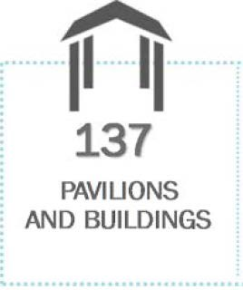
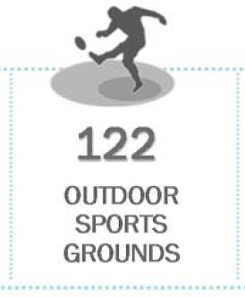
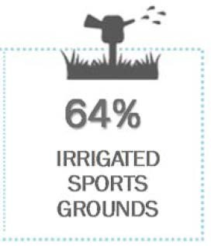
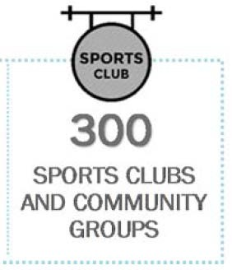
State of Play – snapshot summary

Council provides a hierarchy of facilities with varying maintenance regimes. Fees and charges will reflect the maintenance related to the level/standard of provision.
The classifications of sportsgrounds and facilities are consistent with the City of Greater Geelong Sustainable Communities Infrastructure Development Guidelines (October 2010).

Hierarchy of grounds
Pavilion and ground include most ‘standard’ provision items and some ‘non-standard’ items.
Facility classification – Community 3 - although now meets Community 2 standards ‘sub regional’ and ‘district’.

Facility hierarchy
The following hierarchy will be used for planning purposes relating to reserves and open spaces as the basis for future facility classifications
Figure 35. Table Facility Classifications and Scope of Provision

Classification | Description
National | National competition and significant national and state level events.
Regional | Municipal wide and can also provide for surrounding municipalities.
Sub-regional | Part of municipality that cover numerous townships / suburbs.
District | Whole township / suburb as a key facility for a community.
Local / Neighbourhood | Providing for communities usually within walking distance.

Standard of provision
The Fair Play Strategy identifies standard provisions for sporting facilities, components and supporting infrastructure.
Standard and non-standard provision components are outlined in the table following.
Non-standard provision components will be deemed a higher standard of facility provision and will be the responsibility of the club or community group to fund and maintain.
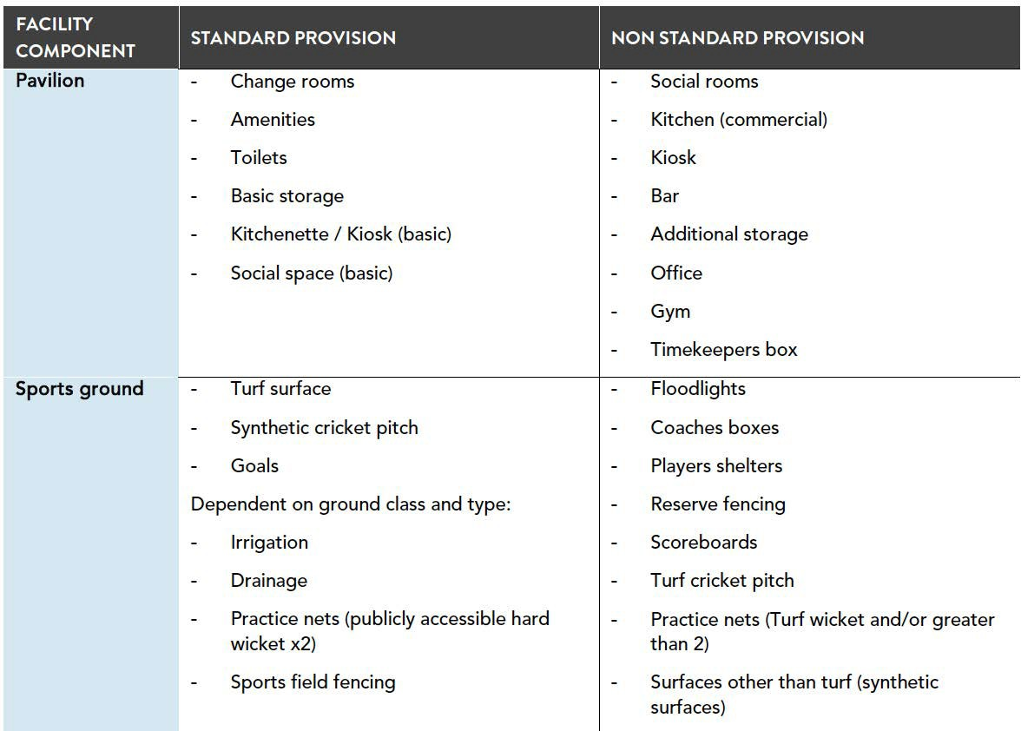

Sports field classification
Facilities are assigned to their relevant classification.
A surface rating is assigned dependent on level of service required for the level of competition and standard of facility provision.
The table following shows the hierarchy and criteria that are applicable at the various levels of facility classification.
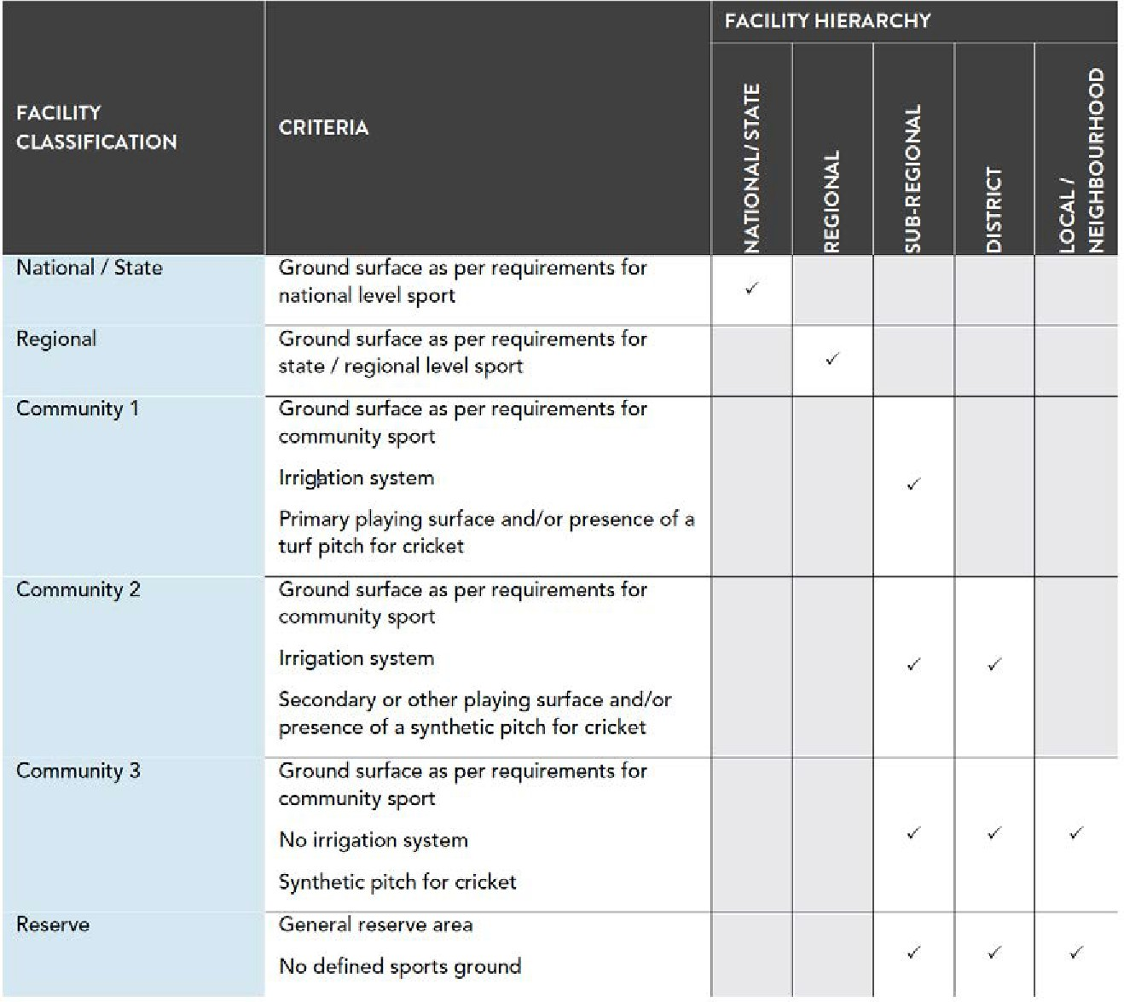
The Reserve grade classification for both St Leonards Reserves is Community 3. However, St Leonards Lake Reserve has had irrigation installed since 2017.

Pavilion Classification
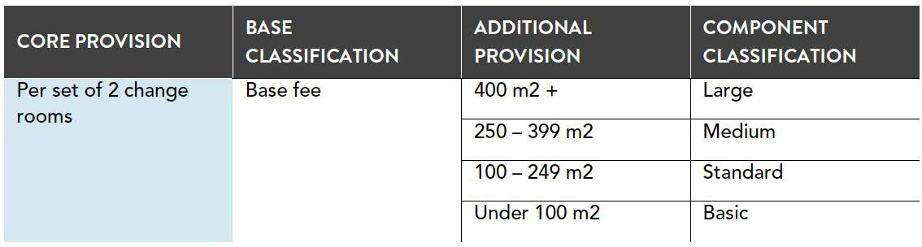
The pavilion grading at St Leonards Lake Reserve is ‘standard’.

Football Facility Guides (Summary) - Building Development Guide, Football Lighting, Construction and Management – Natural Turf Pitched Guide, Field Dimensions. Football Victoria
Figure 36. Facility guideline summary from Football Victoria
Natural turf playing surface | Required field size (length and width) | Run out: goal line and sideline | Associated structures to the field | Lighting Lux. | Other / Club room / spectators / social / Canteen | Toilet, Change rooms / referee | Gradient/ fall across playing surface  /Orientation | Car parking  / access
The Playing Surface must be even and flat with a complete coverage of grass. Either natural grass or FIFA approved artificial grass pitches may be used.  For natural turf pitches, the height of the grass may not exceed 30mm  for competition play | Length  NPL - 100-105m x 60-68m  Local and Community. Senior - 96-105m x 60-68m  Junior - 90-105m x 50-68m  Preferred 105 x 68m | Minimum buffer zone 3m to any structure/peri meter fence. 5m on Technical Side to allow for Team Benches. | Covered players race, no less than 2.2m (high) x 2m(w), from change rooms to playing field. (NPL only)  A pathway for players between the dressing rooms and the field of play is clearly visible and defined.  Pitch perimeter fence must be constructed of substantial material (i.e., cyclone wire) at least 1m high.  Goal posts must not exceed 12cm  Two covered team benches or equivalent seating with adequate seating for 9 people on each bench.  A technical area must be marked for each team on opposite side of the halfway line, on the same side of the field.  Permanent and fixed scoreboard. | NPL and NPL 2  - 200 lux for competition. 100 lux for practice match and training. All other competitions 100 lux minimum | Preferably, the pavilion is to be located on the western or south/western side of the pitch, with covered spectator areas between the building and the pitch.  Where multiple pitches are proposed (refer to functional relationship diagram under Section 4.0), the pavilion may be located between the two pitches and running in a north- south direction, with the main pitch preferably to the east of the pavilion  Multipurpose/social room - site dependent  Kitchen Kiosk – site dependent | Change rooms NPL Min 4 change per pitch (min 35sqm each).  Community senior and junior 2 x 25sqm.  Officials 20sqm.  Player amenities – NPL 4no. @ 25sqm (min. 3 pans, 3 showers in each)  Community senior and junior  Player amenities Officials NPL 12sqm (Dedicated toilet and shower required - 2 pans, 2 showers)  Community senior and junior  Dedicated amenities not required. Can be shared use with public DWC.  Public Toilet blocks. NPL 45sqm. Community 20sqm.  Public disabled 7sqm  (no more than 100m from ground).  First aid room. NPL 10sqm. Senior – no minimum. Junior  - Screened off area, no dedicated area required | Max. gradient 1% of the pitch.  Ideally playing pitches are to be orientated to be within 10 to 15 degrees of the north-south axis in order to reduce glare associated with players looking directly into the sun | Close proximity with pavilion and include drop off point and ambulance access. DDA compliant size. Lighting all hours
Cricket pitches of any type will not be permitted in the Competitions, but they may be allowed under exceptional circumstances in grassroots competitions, |  |  |  |  | A fully functional Public Address (PA) system must be provided  Covered viewing area NPL 500 people seated (300sqm). Preferred tiered seating.  Community senior 80-100sqm (approx. standing room for up to 200 people
 |  |  |  |  | Junior
All lines must be of the same width - not exceed 12cm. |  |  |  |  | 25-50sqm  Media viewing and Broadcast/filming – NPL only
Line markings must not harm users or damage grasses. |  |  |  |  | 15sqm each

Community Cricket Facilities Guidelines. Cricket Australia. 2015
Figure 37. Facility guideline summary from Cricket Australia
Pitch size | Required field size | Run out: | Associated structures to the field | Lighting Lux. | Other / Club room  / spectators / social / Canteen | Toilet Change rooms | Gradient/ fall across playing surface  /Orientation | Car parking / access
Synthetic pitch - The dimensions of a synthetic cricket pitch should be in the range of 25.0m to 28.0m long and 2.4m to  2.8m wide  The dimensions of a turf pitch are 20.12m long (from stump to stump), plus a minimum of  1.22m behind the stumps to accommodate the return crease and bowler approach area. The width of a turf pitch is 3.05m wide. | Open Age (Community Club) Minimum 50m  Recommended 60m from centre of pitch | Where multiple playing fields are provided within the one playing area, a minimum 2m buffer between boundaries is recommended | Ground fencing  For a Club (home) or Club (satellite) cricket ground a cyclone mesh wire fence at either 900mm, 1050mm or 1200mm around the playing field is desirable.  A minimum 60m2 space is recommended for a Club (home) turf cricket pitch ground and 80m2 for a Premier/Regional level facility. A 30m2 curator storage facility is desirable at a Club (satellite) ground if it’s a turf pitch venue.  Ensure the scoreboard is placed in a location that provides optimal visibility for spectators and players and if electronic (LED) consider the impacts of afternoon sun glare on its readability. | International, national – Centre square Av 750 lux.  Outfield 500 lux.  Regional, local -  Centre square Av 500 lux.  Outfield 300 lux.  Training -  Centre square Av 300 lux.  Outfield 200 lux. | Social community or multipurpose room  Premier/Regional 150sqm  Club - home 100-150sqm Club – satellite 80sqm  Kitchen and kiosk incl. store  Premier/Regional 33sqm  Club - home 23-33sqm Club – satellite 20sqm  Admin – all levels - 15sqm | Change rooms Premier/Regional  30-45sqm x 2 Club - home 20-30sqm x 2 Club – satellite 20-30sqm x 2 Amenities 25sqm x 2 Club - home 20-25sqm x 2 Club – satellite 15-20sqm x 2  Umpires Room inc. shower toilet  All levels – 15sqm | Ideally, cricket playing fields should fall in all directions from the centre pitch area, but failing this, they should have a single-phase slope of 1% in any convenient direction.  The slope of a turf pitch should not exceed 1% and follow the slope pattern of the oval.  It is recommended that cricket grounds and pitches are orientated in a north- south direction to minimise the effect of a setting sun on players, with a suggested optimum orientation of 10-15 degrees east of north.  Cricket training nets should have a north-south orientation, or a maximum of 30 degrees east or west of north | Change rooms Premier/Regional  50 spaces minimum  Club - home  40 spaces minimum  Club – satellite  30 spaces minimum
Source: Community Cricket Facilities Guidelines. Guidance Note 9. Support Infrastructure. September 2015

This page has been intentionally left blank

62

CITY OF GREATER GEELONG
WADAWURRUNG COUNTRY
PO Box 104, GeelongVIC 3220
P: 52725272
E: contactus(.@geelongcity.vic.gov.au www.geelongaustralia.com.au

CUSTOMER SERVICE CENTRE
100 Brougham Street
Geelong VIC 3220 8.00am - 5.00pm

LATEST NEWS:
(f) (.@CityofGreaterGeelong
@ (.@GreaterGeelong
@ (.@CityofGreaterGeelong
@ CityofGreaterGeelong

CITYOFGREATER
GEELONG

