FACILITY DEVELOPMENT PLAN:
WINDSOR PARK
-
REPORT

JULY 2022

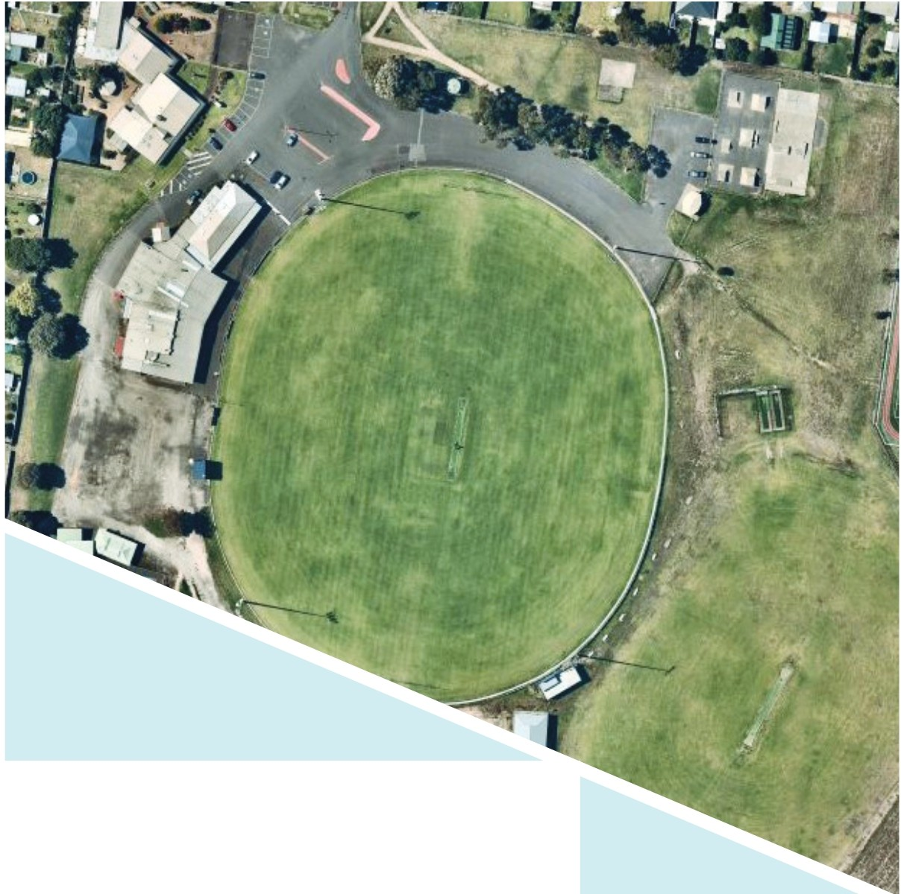
.,,,.
-=:=
CITYOFGR£ATER=
GEELONG
::.·-

WE ACKNOWLEDGE THE TRADITIONAL CUSTODIANS OF THE LAND, THE WADAWURRUNG PEOPLE OF THE KULIN NATIONS. WE PAY OUR RESPECTS TO
THEIR ELDERS PAST AND PRESENT AND ACKNOWLEDGE ALL ABORIGINAL AND TORRES STRAIT ISLANDER PEOPLE WHO ARE PART OF THE GREATER GEELONG COMMUNITY TODAY.



ABOUT THIS DOCUMENT

The Facility Development Plan has been prepared by insideEDGE Sport & Leisure Planning on behalf of the City of Greater Geelong. This project was funded via the City of Greater Geelong's Community Infrastructure Grants program (2021/22) and developed in conjunction with North Shore Football and Netball Club, North Shore Cricket Club and Norlane Community Centre. This Plan aims to provide an evidence base and strategic justification for the improvement to Windsor Park to ensure its viability and suitability as a local level community sporting venue into the future.

CONTENTS

OVERVIEW AND PROJECT DRIVERS 4
FUTURE VISION AND FOCUS AREAS 5
STRATEGIC OVERVIEW 6
ECONOMIC AND SOCIAL VALUE OF SPORT 8
COMMUNITY PROFILE 9
FACILITY DEVELOPMENT PLAN 11
The site 12
About North Shore Seagulls 13
Community programs and initiatives 14
Existing facilities 15
Guiding principles 16
The Plan 17
Investment opportunities 20
A perfect partnership 21
Implementation 22
APPENDICES 24
Quantity Survey 25
Existing condition report 26
Facility audit summary 31
Participation 32
Sport facility use 34

OVERVIEW & PROJECT DRIVERS

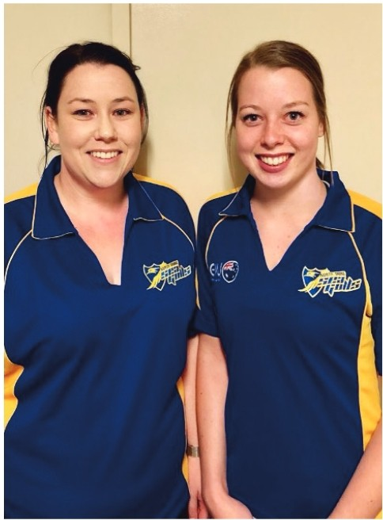
Windsor Park is an integral piece of community infrastructure for Geelong's northern suburbs, in particular Norlane-North Shore. Over the years, the Windsor Park precinct has had minor improvements, however now needs a consolidated plan and vision for its future improvement.
Windsor Park is located in one of Geelong's highest areas of socio-economic disadvantage. As a result, enhancing this asset will help to ensure that equal access to facilities and opportunities is provided.
Equality in access is just one of the principles underpinning the Plan at Windsor Park. The Facility Development Plan also aims to connect and align all infrastructure recommendations to the objectives of both the City and tenanting sporting clubs, as well as potential future investment partners.

Other key project drivers underpinning the need for the Facility Development Plan include:


MORE GENDER NEUTRAL INFRASTRUCTURE

MORE MULTI PURPOSE AND FLEXIBLE SPACES

INCREASING COMMUNITY PARTICIPATION IN SPORT AND ACTIVE RECREATION
"Enhancing infrastructure for both active and passive recreation at Windsor Park will ensure that the community of Geelong's northern suburbs have equal opportunity to improve their health, wellbeing and social connection"

FUTURE VISION & FOCUS AREAS

VISION: That Windsor Park is a central hub for community sport, recreation and activities in Geelong's north. A place where any person of any gender, culture or ability can feel welcome, and where social connections and life long friends can be made.

Achieving this vision will be assisted via the Facility Development Plan through these key infrastructure priorities:


IMPROVING NETBALL CHANGE ROOMS
The netball change rooms at Windsor Park are undersized and do not meet recommended requirements outlined by Netball Victoria. In addition, there are no
netball umpire change rooms or amenities.


COMMUNITY INFRASTRUCTURE RENEWAL
Infrastructure including the skate park and playground are well utilised however are heading towards the end of their useful life. A consolidated approach to renewal will ensure infrastructure is fit for purpose for Geelong's northern suburban community.


INCREASING PARTICIPATION OUTCOMES
Improving facilities at Windsor Park aims to broaden opportunities for participation in organised sport, informal recreation and other community activities. In addition, enhanced infrastructure aims to increase visitation to the reserve and create connectedness between tenanting clubs, the community, adjacent schools and community centre.
IMPROVED FUNCTIONALITY OF THE SOCIAL SPACES IN MAIN PAVILION

The function/social spaces within the main pavilion are of good size however have not been updated in some time. This sees some areas being underutilised as well as not being properly compliant with expectations for people with limited mobility. An enhanced space will also provide more flexibility for broader community use and opportunities for tenanting clubs to undertake fundraising activities. Cosmetic and minor functional upgrades of the existing football/
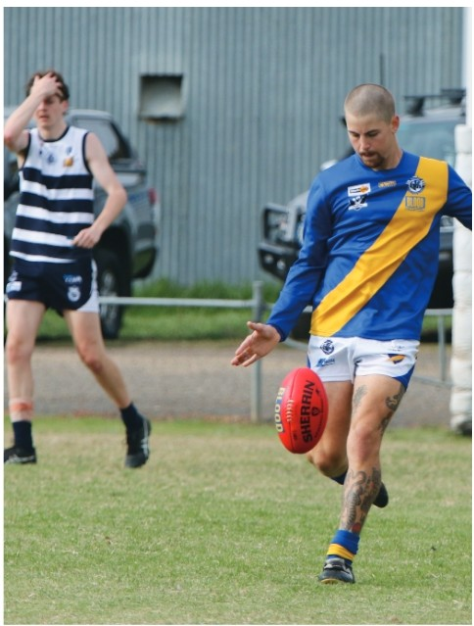
cricket change rooms is also required to ensure these areas continue to provide a welcoming environment for users.

STRATEGIC OVERVIEW

The following provides a high level overview of strategic documents which guide and support the Facility Development Plan.

CITY OF GREATER GEELONG

Our Community Plan 2021-2025

Social lnfrastructre Plan
CITY OF GREATER GEELONG
Generation One 2020-2023

and Recreation Report
Social lnfrastructre Plan Outdoor Sport
CITY OF GREATER GEELONG
Investment Policy
Social lnfrastructre Plan
CITY OF GREATER GEELONG

SUPPORTING STRATEGIC DOCUMENTATION

AFL VICTORIA

Growing the Heartland Strategy

NETBALL VICTORIA

Statewide Facilities Strategy

CRICKET VICTORIA

2017-2022 The Journey ahead for Victorian Cricket

G21 & AFL BARWON TOWARDS 2030: STRATEGY

G21 & CRICKET VICTORIA REGIONAL CRICKET STRATEGY

CLUB STRATEGIC PLAN

r---------------------

WINDSOR PARK I:.
FACILITY 1

DEVELOPMENT PLAN
- J
,,,'

SPORT FACILITY STRATEGIES, FRAMEWORKS AND GUIDELINES
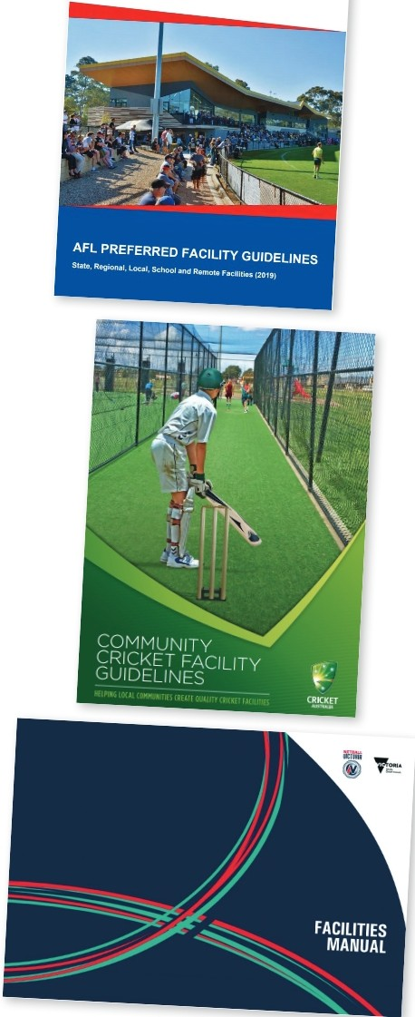
To support local, state and federal strategic planning, many peak sporting bodies have developed resources to help guide sustainable facility development and delivery. Across the many sports represented at Windsor Park, each one offers guidelines that outline minimum preferred standards for infrastructure provision.
Common priorities and principles identified within these documents include:
Gender neutral amenities: Providing facilities that are welcoming, inclusive, accessible and encourage use by people of all-genders.
Multi-purpose facilities: Providing facilities that offer opportunities for multiple users and a variety of uses to generate greater community benefit and asset utilisation.
Growing venue capacity: Increasing the quality and capacity of existing facilities through innovative
approaches (e.g. LED lighting, synthetic surfaces) that create more programming opportunities.
Universal access: Ensuring community facilities are accessible to people regardless of their age, ability or cultural background.
Planning for growth and demand: Investment and prioritisation of facilities and infrastructure upgrades where greatest need and demand is demonstrated.
Partnerships and collaborative investment: Enhancing and maintaining relationships between all levels of government, industry partners and sport to promote collaborative investment into facility development.

ECONOMIC AND SOCIAL VALUE OF SPORT

THE VALUE OF COMMUNITY FOOTBALL
In 2015, AFL Victoria and Latrobe University undertook research to determine the social value of a typical community football club.
The study found that for every $1 spent on a community football club, there was at least $4.40 return in social value.

Qualitative benefits included:
Increased social connectedness, inclusion and networking.
Increased level of trust in others. Reduced anti-social behaviour. Community pride.

•

The strongest benefits were found to be delivered in the areas of mental health, physical health, personal well being and education. Others benefits included social inclusion, civic pride, empowerment, social connectedness, regional population stability and cultural integration.

$1$4.40


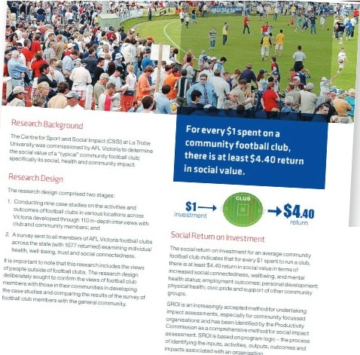- .J<. •

C&1ri fu, Sp:.irtcirk SOI odl I·
. LATROBE
UNJVE .SITY

VICTORIA
Value of a Community Football Club

SPENT ON COMMUNITY FOOTBALL
RETURN IN SOCIAL VALUE

THE VALUE OF COMMUNITY SPORT &
ACTIVE RECREATION
Sport and Recreation Victoria commissioned a report by KPMG in 2020 to highlight the value of community sport and recreation infrastructure. The report looked at the economic, health and social benefits that accrue to individuals, community and society via the construction and operation of sport and recreation facilities and the activities that are conducted within.
The report found the following benefits contributed annually to Victoria through community sport and recreation included:
$2.1 billion dollars in economic benefits - including increased economic activity and event related tourism.
$2.3 billion dollars in health benefits - including reduced risk of chronic disease and improved mental health and wellbeing.
$2.6 billion in social benefits - including human capital uplift, volunteering benefits and green space benefits.

COMMUNITY PROFILE



1111

9

Norlane-North Shore population 2022
+ 9

Increase in number of persons living in Norlane­ North Shore 2031 to 2041
6

Increase in number of persons living in Norlane­ North Shore 2031 to 2041

NORLANE-NORTH SHORE POPULATION FORECAST
Norlane-North Shore is a small geographic area located in the north of the City of Greater Geelong's municipality, approximately 8km from the CBD. It is traditionally an industrial and residential suburb in proximity to Corio Bay.
Norlane-North Shore was established predominately as a suburb for blue-collar workers, most noteworthy for the Ford factory and Shell Oil refinery. Now, Norlane­ North Shore offers affordable housing accompanied by shopping and leisure facilities and a select number of primary and secondary schools.

In 2022, Norlane-North Shore has a population of 9,614 and is forecasted to grow to 10,105 by 2031 and 10,912 in 2041. As demonstrated in Chart 1 below, the trendlines over the next 10 and 20 years remain consistent in terms of the estimated population
projections within each age cohort. Over the next 10-20 years, the largest proportion of people living in Norlane­ North Shore will be aged between 20 - 34, accounting for approximately 22% of the total population. Chart 2 outlines the total number of males and females residing in Norlane-North Shore in 2022, 2031 and 2041. As detailed, more females are forecasted to reside in the area than males.

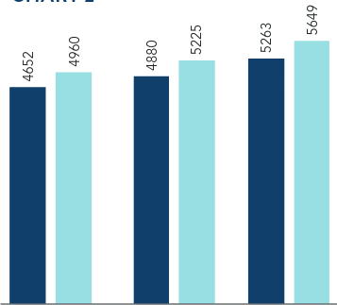
CHART 1 CHART2

900
800
700
600
500
400
300
200
100
0
-2022 2031 -2041


2022 2031 2041
- Male Female

SEIFA INDEX
The Socio-Economic Indexes for Areas (SEIFA) measures the relative level of disadvantage and/or advantage based on a range of Census characteristics. The SEIFA index is measured through a range of indicators including levels of unemployment, income, education levels, access to internet etc. Within the City of Greater Geelong, the Norlane-North Shore area recorded
the highest level of disadvantage of any suburb. It is particularly disadvantaged and is considered within Victoria's highest concentration of disadvantaged neighbourhoods, being in the bottom 2% of the index.

POPULATION DIVERSITY AND EHTNICITY
In 2016, 22.2% of people in Norlane-North Shore were born overseas, slightly higher than the average of 16.2% across the rest of the municipality. Of those people, Norlane-North Shore had a larger proportion of people born in Croatia, Serbia/Montenegro, North Macedonia, Afghanistan, Philippines and Pakistan than the broader municipality. The changing demographic profile presents both challenge and opportunities for sporting clubs at Windsor Park.

CHART 3

Germany

Pakistan

India

New Zealand

Philippines

Afghanistan

North Macedonia

Serbia/Montenegro (fmr Ugoslavia)

Croatia

United Kingdom
City of Greater Geelong
- Nortane - North Shore
Source: Australia Bureau of Statistics

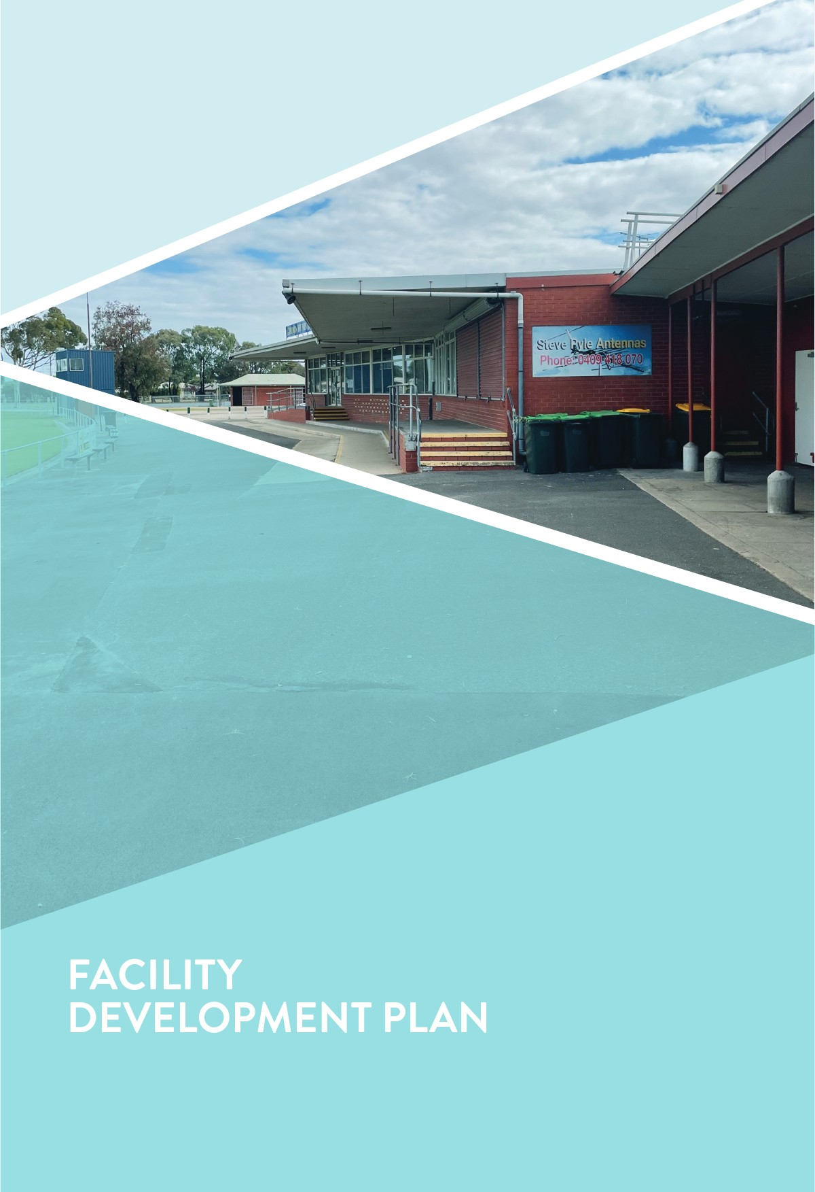

THE SITE

Windsor Park is located in the heart of North Shore and offers a variety of both active and passive recreation opportunities for the community.

LOCATION
Windsor Park is a centrally located reserve in Geelong's northern suburbs. It is a stones throw from the main highway, Corio Village Shopping Centre and the soon to be constructed Northern Aquatic Recreation and Community Hub. It is bordered by residential housing on its northern, western and southern boundaries, and Northern Bay College's Tallis St Campus to its east.
St Thomas Aquinas Primary School is also close by, approximately 400m from Windsor Park's entrance.

SITE CONTEXT
The Reserve is owned and managed by the City of Greater Geelong and is zoned Public Park and Recreation Zone (PPRZ) under the City's planning
scheme. Windsor Park is somewhat unique in that it has significant sporting infrastructure as well as community and recreational elements, including Norlane Community Centre, skate park and community garden.
FACILITY COMPONENTS
Senior size AFl/cricket playing
(approx. 166m x 145m) with synthetic centre wicket and floodlights
- Junior sized AFL and cricket oval
- Two netball courts with acrylic surface and floodlights
- Synthetic hard wicket cricket practice nets
- Community sporting pavilion with change rooms for football/cricket/netball players and umpires
- Additional small netball pavilion
- Change rooms for second oval
- Community playground
- BBQ, shelter and public toilets
- Skate park
- Community Centre
- Community Garden
- Car parking - both formal and informal

USER GROUPS
North Shore Football and Netball Club
- North Shore Cricket Club
- Norlane Community Centre

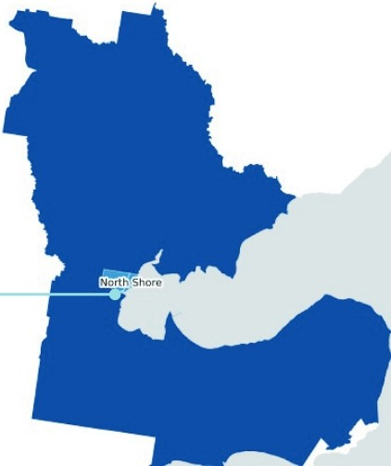
Windsor Park

ABOUT NORTH SHORE SEAGULLS

Established in 1927, North Shore 'Seagulls' Football Club was one of the inaugural teams within the Geelong & District Football League. In 1965 the Club was promoted to division one in the GDFL and then joined the Geelong Football League during its inception in 1979 and proceeded to win six consecutive premierships from 1995 to 2000.
Since this time, North Shore has experienced both the highs and lows of being a community sporting club and hashad to work tirelessly over the past several years to reinstate the Club as a true competitor within the GFL, and to create buzz and excitement once again. 2022 saw an additional 40 Auskick participants thanks to North Shore's partnership with Corio Football Netball Club (see overleaf) and their creation of the Northern Stars Auskick program.
The netball arm of the Club was integrated when the football-netball contingent of the GFLestablished in 2000. Netball hasalso experienced some fluctuation over recent years, however is hopeful to reintroduce itself back into competition. In 2022 the Netball Club will participate in social games in an effort to foster engagement and comradery and to translate this into formalised competition in 2023.

The Cricket Club are on a similar trajectory having seen growth since their recommencement and the interruption of the COVID-19 pandemic. The Club has a clear objective to increase the number of junior and female players.
Combined with the Facility Development Plan to facilitate infrastructure improvements, the Club is supported by clear purpose and values.
Statement of purpose

'The Club will always endeavour to provide for the health, welfare and well being of its players, spectators and supporters'
This purpose aims to be achieve by promoting and development the following objectives:
A sense of social and community values
- An environment to nurture the physical and mental development of our youth
- Respect for officials, opposition players and supporters
- The virtues of fair and disciplined play
- Equal opportunities for everyone



1111

?

North Shore football, cricket and netball participants in 2021
+

Forecasted additional participants by 2026

Additional Auskick participants from 2020 to 2021

COMMUNITY PROGRAMS AND INITIATIVES

PARTICIPATION BOOST
North Shore Football and Netball Club is involved in a variety of participation initiatives to assist in
strengthening participation from grassroots through to senior levels. In the years leading up to the COVID-19 pandemic, the Club saw a decline in junior participation which was attributed somewhat to the lower socio­ economic status of the area as well as changes in the ethnicity profile of the suburb, seeing more demand for sports outside of what is offered at Windsor Park. In response to this the Club has undertaken a number of approaches to address this, including:
AFL & School Partnership to bring kids back into football - North Shore are partnering with the AFL (see article extract below), Corio Football Netball Club and local schools in piloting a new program to
generate interest in football, particularly in areas of high unemployment and ethnicity changes. In its infancy, this program is earmarked to by resourced by the AFL and connect kids directly with the Club, providing them with vouchers for uniforms, low or no fee membership and transport.
North Shore Working Group - this group includes representatives from all three levels of government and aims to take steps in advocating and facilitating improvements to Windsor Park to support future club
sustainability. This group hasbeen meeting regularly over the past three years and has been tasked in supporting the delivery of this Plan as well as the AFL & School Partnership initiative mentioned previously.
Norlane Community Centre - the Centre is situated at Windsor Park and is a not for profit organisation that assists people to connect, learn and contribute to the
community through a variety of low or no cost activities. The Centre welcomes all people, regardless of age, ability, gender, gender identity, race, religion or sexual orientation. In 2022, the Centre offers activities including arts and crafts, Tai Chi, gardening and digital technology amongst other services such as book and food swaps and a community kitchen.
Northern Stars - the Northern Stars is a new junior sporting joint venture for girls and boys initiated by North Shore and Corio Football Clubs commencing this year. The Northern Stars have Auskick, U/1O's, U/12's and U/14's teams in 2022 and growth projections show there will be full participation by 2024. This includes teams in all age groups including U/18's and an all female team. This is an exciting venture that is designed to provide the opportunity for all juniors and females who want to play football in the North. This section will share training sessions, games and functions between the facilities at North Shore and Corio.

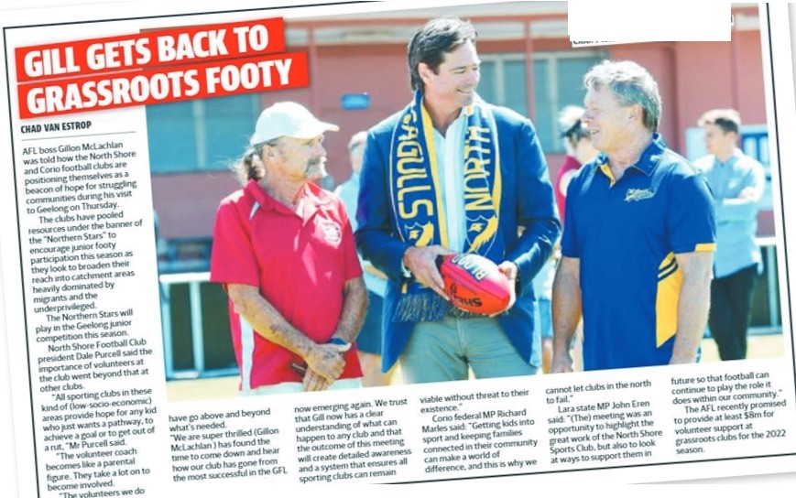
"'" Pan\lclt•e-&tto.nmomconosc,or,s fQOU,,111
AflCEOQianMCUCfllilnm, wn!o
Nortn snor•
ClUt).Pk1ll".-,OM(ISfflflh
ID dub &

EXISTING FACILITIES

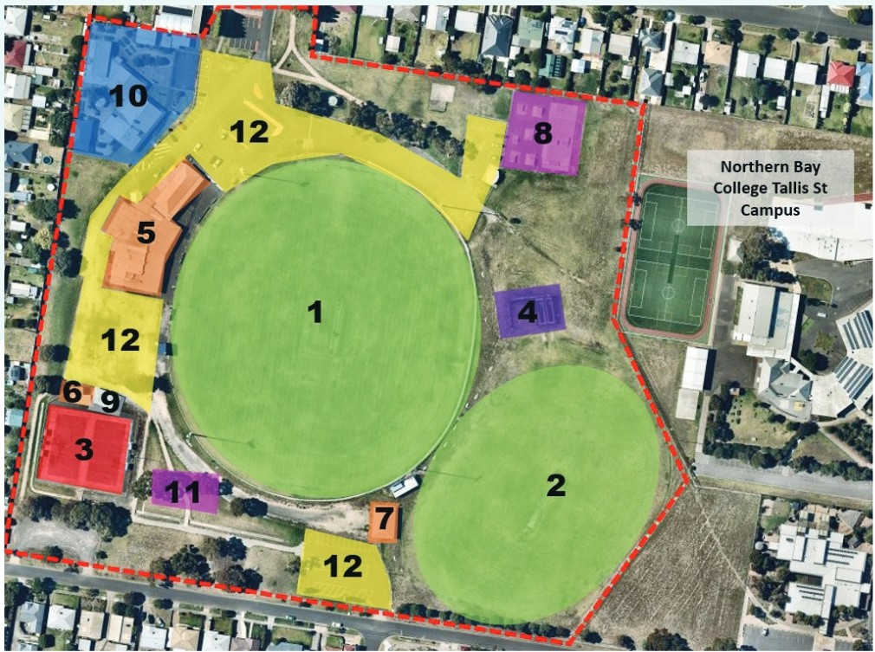

SPORTING INFRASTRUCTURE
- Oval 1
- Oval 2
- Netball Courts
- Crickets Practice Nets
- Football/cricket/netball pavilion
- Netball match day pavilion
- Oval 2 pavilion
COMMUNITY INFRASTRUCTURE
- Skate Park
- Public Toilets
- Norlane Community Centre
- Playground/BBQ/Shelter
- Car Parks

GUIDING PRINCIPLES

The following principles have underpinned the Facility Development Plan and its recommendations. These principles align with the strategic documentation reviewed as part of the project, as well as the goals of a range of potential investment partners and peak sporting bodies.


EQUITY
Providing quality facilities across Geelong ensures equity throughout the network. It also guarantees that venues in lower socio-economic areas are able to offer infrastructure to the community that provides them with the same experience as any other area within the municipality. Equitable access to modern facilities will see venues being more universally suitable for any person of any ability.


INCLUSION AND DIVERSITY
Improving Windsor Park will assist in driving outcomes in inclusion and diversity through greater usage by all genders and cultures, particularly for the growing, diverse North Shore/Norlane population. To assist with the sporting clubs future sustainability bridging the gap in facility provision and creating more welcoming environments will assist tenanting user groups and their respective sports/activities to break down participation barriers and drive community engagement initiatives and outcomes.


MULTI USE
Offering broader community access and opportunities to be more physically active, outside of sport alone, is one of the key guiding principles. Identifying ways to encourage community involvement, including multi use of facilities, has been considered throughout. Improving spaces and offering a range of activity options, for a broader age cohort, will activate the reserve, improve community health outcomes and provide opportunities for user groups to engage with their community.


DELIVERABLE AND ACHIEVABLE
The Facility Development Plan aims to provide recommendations which are achievable with the assistance of multiple funding partners and stakeholders. To ensure the Plan's agility, several revenue streams including local funding programs, club investment and state funding initiatives have been identified to assist implementation.

THE PLAN

Site Plan

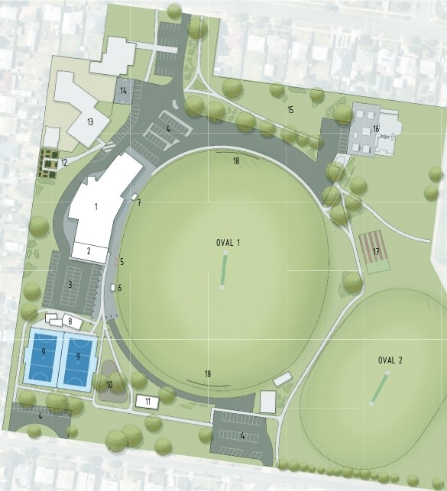
LE | 6EIID
1 | (X6fllljPA'IIUDII
l | KNPAvt.IOIIEXn.llSD.I
3 | fffiNAl.£Ul (ARPA;« 'IIITKSEA!.E!I stRfA{I. tl:\11' «N:11:TE
 | PEil:STii!:ANPATliWrtliSlPARATl6 80UAADS
t | 05i1M:iCARS>
 | EXJS.flMj PU.'l'ERSSita.Tt:R TOe DOtOUSlfD
6 | EIIJS.TIM5CDMHE5801C/?l.AYERSSHllTER
i | KN '"''AY COADfS BOX/PU.'fiJIS StfLTHI
B | UPfiU[I( EXIS111i6 PU _( TDLITT ASPB1:cou11:1.
 | nnc.u. OCiU.lt
9 | COODER RESUIFA□llli IETIU.LL001.RfS A'<J ll'PIWVE 5?-CRf5
 | l.l(ilHN: (Ir RWJ;t:111 (CWSTEIIT VITH tll8All YICTORLI,
 | Gua:UM:S
13 | UPfiUD( P\.,lY(jnflO TD A I.JliI RfPl.A{DtOO 'l'l'A CDUllrl'S
 | nnc.u.PiCGtL't wt0 ru:
 | UPfiUD{SHAO:/PICN[ STRUOLRI
 | rom,Ol111Jl\lrt GA}IIIOI SPAU
13 | EXJS.flllj(IJttllN!TYCOORf
'II, | COODERUP6:i.ADffOSURFA1ECNEKISTllili tH;:it.U.
 | IUSKETSA.Ll CllURT. ASPUTOf UP6=1.AD[ '111-CGtlS, 1!6U,_LSJifUY
 | FUmNG 01i1Sl11U. TO lR,UICMSr;;t[tt AD.0Of PUY
15 | ltffiRlf TD D?.fll'SPAil:
'IS | COOIER 1111011lR)ATf TDSUH PA 111nu;um fl.EN:IITS
 | TlfAI' A : Silla.IFD.:i. 51'.00WIS WHEi!I CU'tl.llJ I\ECESSITil.iES
fJ | UPfiUD( CRCK:T PRilCTICt MITT TO AFUUTY COitPU.IH" ll'Tlf
 | CiilltxET AUSTULIAW!l:UliES'lrl'flfDEl'lo\llDIIE:CfiSITATE:s
ll | IINl16UIIEITl!ljl3flltilJ:60ALS


MASTERPl.AN FACILITIESDEVELOPMENT PLAN WINDSORPARK

Firn SK03





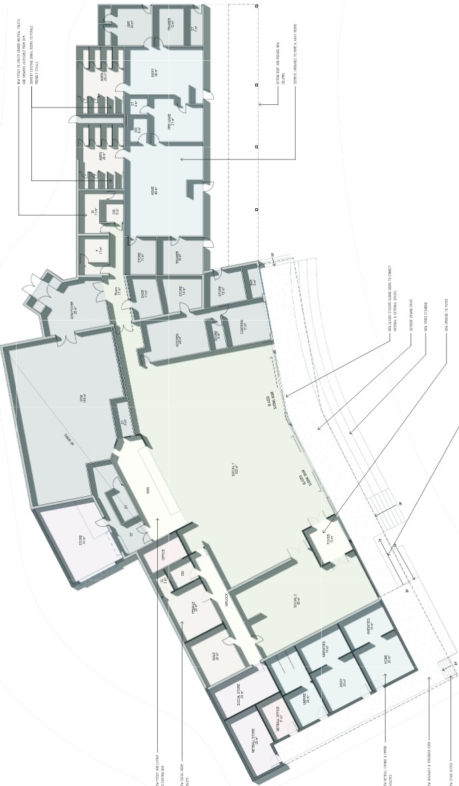Building Concept Plan



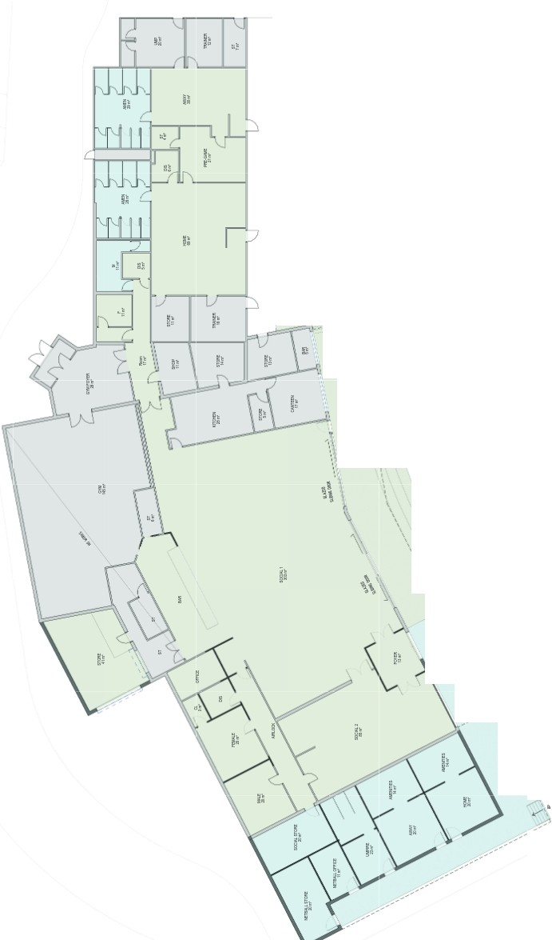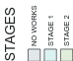
r
:'
:
''
:
'
:
''
'
'
:'
'
:
'
:' '
:
' '
!
''
''
!
''
!
!
!
!
1
i i
!
i
''
i
:'
l
:
:'
I -\ ti,
..
'
\
\
\
\
\\/!I
\\
.\\

INVESTMENT OPPORTUNITIES

It has been recognised throughout this report that a collaborative approach to investment is re<iuired to achieve recommendations. Opportunities for partnerships via dub, local, state and other community sources should be explored. At the time of writing this report, the below funding programs and opportunities that align with recommendations are available and outlined below.

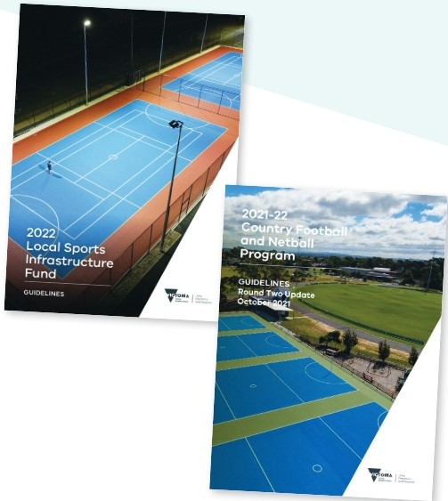
City of Greater Geelong's Community Infrastructure Grants Program
This program aims to support funding for the planning and delivery of capital works projects within the City of Greater Geelong. This includes grants available for amounts up to $350,000.

Sport & Recreation Victoria Local Sports
Infrastructure Fund
This Fund aims to provide a range of grant opportunities across funding streams including Female Friendly Facilities (up to $1,000,000), Community Sports Lighting (up to $250,000), Community Facilities (up to $300,000) and Planning (up to $50,000).

Sport & Recreation Victoria Community
Cricket Program
This Program aims to support cricket participation in Victoria through high-quality and welcoming facilities. The objectives of this program aim to be achieved through providing funding for projects such as upgrading of existing and construction of practice facilities, club room developments, playing field upgrades and sports lighting initiatives. Up to $100,000 in grant funding is available.

Sport & Recreation Victoria Country Football &
Netball Program
This fund aims enhance participation opportunities in football and netball through improved playing surfaces, gender-neutral player and umpire change facilities and sports lighting upgrades. Up to $200,000 is available through this program.

Club fundraising
Clubs tenanting Windsor Park may have opportunities to fundraise to support the delivery of the identified infrastructure upgrades. Where applicable, clubs should be encouraged to create a sinking fund that helps support the implementation of the Facility Development Plan, and to support Council in their pursuits to leverage both internal and external funds.

Council's budget process
Each year Council prepares a budget which provides funding for the delivery of community services, programs, and infrastructure in line with its respective Council Plan. There are opportunities for items identified within the Facility Development Plan to be delivered via this process.

Council's cyclical budgets
Council has cyclical budgets for the maintenance and renewal of minor infrastructure items. A small number of recommendations within the Facility Development Plan could be considered within relevant cyclical programs.

Victorian government elections
The upcoming 2022 state elections may also offer opportunities to leverage contributions to the projects outlined within this report.

A PERFECT PARTNERSHIP

The Windsor Park redevelopment will support and enhance opportunities for all clubs, the adjacent schools and community centre as well as those living within the surrounding community.

COMMUNITY OUTCOMES SPORT OUTCOMES

0 Greater opportunities for participation in active recreation through a new skate park, multi­ purpose courts, expanded community garden and
improved play spaces.
0 Greater usage by the adjacent Northern Bay College and neighbouring St Thomas Aquinas
School and their pupils (who see 24-35% speaking another language other than English at home
and rank largely in the bottom quarter of socio­ educational disadvantage (between 70-80% compared to the average Australian distribution of 25%)).

- Increased social cohesion through quality facilities that drive visitation and opportunities for the community to connect with each other and into the tenanting user groups.
0 Growth and equal opportunities for netball participants through providing facilities that meet modern standards and recommended guidelines.
0 Improved programming outcomes through facility enhancement that provide greater opportunities to encourage more participation.

- Increased social connection through providing a functional and cosmetic update to the club
rooms which will see better ability to host club and community events in modern facilities.
0 Safer and more accessible facilities through improved connections between sporting infrastructure and change rooms, and more
amenable areas for spectators.

"Building our senior and junior netball teams from quite literally, the ground up again is nothing short of a challenge. Not only are we rebuilding our netball section of the North Shore Football and Netball Club but we are also bridging the (physical) gap between our teams to be able to be a whole club again. The possibilities are endless with the new proposed developments for our Club but more so for our community.
What we are going to be able to offer to our community once completed, is nothing short of amazing and we will once again, have the ability to bring sport back into the lives of children, teenagers, adults and their families in a big way."
- Edwina Wilkens, Netball Coordinator, North Shore Football Netball Club

"The football sections (Senior and Junior) at North Shore are emerging again and we have not had any major infrastructure development for some 30 years. These enhancements are well overdue and will really assist the club to grow bigger and faster and when completed give our community the best of facilities available in the district. There are exciting times ahead."
- Dale Purcell, President North Shore Football Netball Club "The North Shore Cricket Club support and are excited by the proposed plans. These changes will provide an opportunity to enhance user experience and entice players and families to the Club. In turn, this will increase participation and further grow local cricket in our community including female and junior teams."
- Courtney Smith-Parker, Secretary North Shore Cricket Club

IMPLEMENTATION

To assist with implementation, key infrastructure recommendations have been prioritised in partnership with stakeholders. Their alignment to the Plan's guiding principles and costs associated are outlined below. Note that information regarding infrastructure items not listed below can be found within the site plan on page 17 and within the Quantity Survey.
Note that all costs listed below are base-line estimates and do not include site preparation, construction contingencies, escalation costs, staging considerations or take into account any latent site conditions. Please refer to the detailed Quantity Survey relevant to this project which makes allowances for these inclusions.

PRIORITY 01 - NETBALL PLAYER AND UMPIRE CHANGE FACILITIES

DESCRIPTION COST FUNDING OPPORTUNITIES FOR DELIVERY

Provide all gender, universally designed change facilities for netball players and umpires as per plans provided.

$674,000
SRV Country Football & Netball Program* SRV Local Sports Infrastructure Fund* (*require Council contributions)

PRIORITY 02 - FEMALE FRIENDLY FOOTBALL/CRICKET CHANGE ROOMS

DESCRIPTION COST FUNDING OPPORTUNITIES FOR DELIVERY

Convert existing urinals in change room areas into lockable, pan toilets. Undertake cosmetic enhancements to change rooms to create a more modern and welcoming facility.

$242,000
CoGG Community Infrastructure Grants SRV Country Football & Netball Program* SRV Local Sports Infrastructure Fund* (*require Council contributions)

PRIORITY 03 - MAIN PAVILION IMPROVEMENTS

DESCRIPTION COST FUNDING OPPORTUNITIES FOR DELIVERY

Undertake works to the main pavilion including creation of spectator area and seating, refurbishment of toilets in the social rooms and upgrade to the existing facade.

$1.17m
CoGG Community Infrastructure Grants SRV Country Football & Netball Program* SRV Local Sports Infrastructure Fund* (*require Council contributions)

PRIORITY 04 - CRICKET PRACTICE NETS

DESCRIPTION COST FUNDING OPPORTUNITIES FOR DELIVERY

Create new cricket practice nets that comply with Cricket Australia's facility guidelines for a local level venue when demand necessitates.

$400,000
SRV Community Cricket Program (requires Council contribution)
Council's budget process

PRIORITY 05 - OPEN SPACE IMPROVEMENTS

DESCRIPTION COST FUNDING OPPORTUNITIES FOR DELIVERY

Undertake minor updates to the skate/scoot park, resurface existing basketball court, extend community garden and provide additional tree planting.

CoGG Community Infrastructure Grants
$420,000
Council's budget process

PRIORITY 06 - ANCILLARY SPORTING INFRASTRUCTRE IMPROVEMENTS

DESCRIPTION COST FUNDING OPPORTUNITIES FOR DELIVERY

Complete other sporting infrastructure improvements including behind goal netting, improved netball court lighting and coaches box/players bench.

$175,000
CoGG Community Infrastructure Grants Council's budget process
Club fundraising

PRIORITY 07 - CAR PARKING AND PEDESTRIANS

DESCRIPTION COST FUNDING OPPORTUNITIES FOR DELIVERY

Improve car parking and pedestrian path network throughout site

$382,000
CoGG Community Infrastructure Grants Council's budget process
Club fundraising

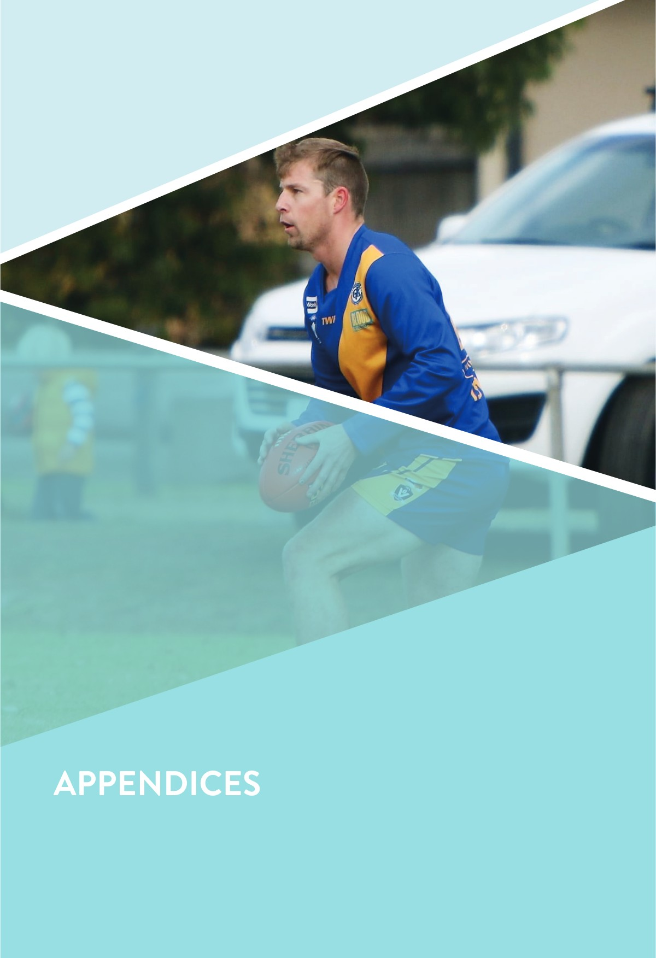

QUANTITY SURVEY

GEELONG
2 Hampton St.
Newtown VIC 3220
03 5222 2562
ABN 31 609 499 965



Ref 22171-cplA 29 June, 2022
zinc
HELBOURNE
Suite 3/ Level 1, 428 Spencer St,
West Helbourne VIC 3003 03 9052 3212
info@zinccm.com.au

COST MANAGEMENT

insideEOGE Sport & Leisure Planning
G22, 72 Hargrave Avenue ESSENOON FIELDS VIC 3041

Via email Attention

zoe@ieslp.com.au Ms. Zoe Sells

Dear Zoe,

Windsor Park Facilities Development Master Plan Cost Plan No. 1 (Rev. A)

We have prepared revised Cost Plan No. 1 for the above project based on the documentation provided and our discussions.

Cost Summary
The cost plan can be summarised as follows:
 | Cost ($)
Building Works | $1.887,000
External Works and Services | $2,172,000
Sub-Total ( excl. GST): | $4,059,000
ESO Initiatives | Excluded
Contingencies and Cost Escalation | $1,789,000
Non-Construction Costs | $721,000
TOTAL ENO COST (excl. GST): | $6,569,000


Please refer to the attached cost plan for further information and scope of works included. All costs are reported exclusive of GST.

Documentation

The cost plan is based on Master Plan design documentation and has been prepared using the following:
- Architectural - drawings prepared by Four18 Architecture dated 3 June, 2022 Correspondence from insideEOGE Sport & Leisure Planning received up 29 June, 2022

zinccm.com.au

EXISTING CONDITION REPORT

Existing facilities at Windsor Park along with their condition and suitability were assessed as part of the Facility Development Plan. Key infrastructure items and associated issues and opportunities are identified below.

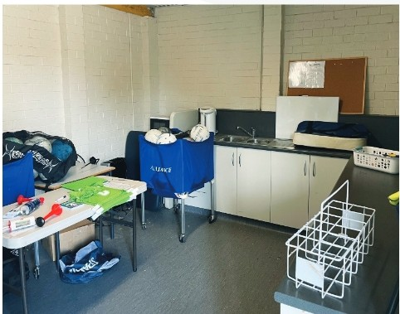
NETBALL CHANGE ROOMS
Description: Windsor Park has two separate areas for netball use. This includes a single change room within the main football/cricket pavilion as well as a designated facility court side.
Issue: Neither facility aligns with Netball Victoria's recommendations. At present there are size deficiencies, particularly around player change areas and amenities as well as a lack of umpire change facilities.
Opportunity: Explore suitable opportunities to provide netball with facilities that align with recommended standards. Consider how the existing facilities can
be redeveloped to accommodate requirements and incorporated into the main club room building.

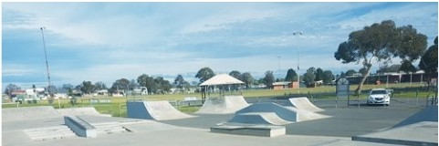SKATE PARK
.....
..
Description: The skate park is located in the north­ eastern corner of the reserve and consists of two sections: a park style skate area to the west, and a concrete plaza area to the east. The skate park appears to be well utilised by the community.
Issue: An audit of skate facilities across the municipality undertaken by the City in 2020 included several recommendations. The facility was given an overall ranking of 'poor' within the audit. This ranking indicated that the facility shows significant issues and that it has an expected lifespan of 5 years or less in current condition.
Opportunity: Consider the redevelopment of the skate park to include an updated facility that is more multi­ purpose in nature and could adequately cater for skate, scoot, bmx etc. Consider the best position of a future facility in the context of the broader reserve and other possible complementary infrastructure.

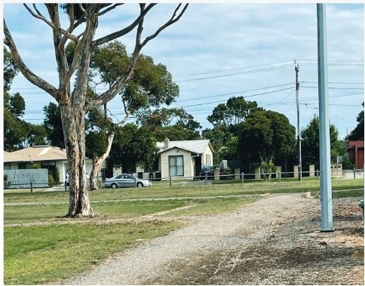
PATH NETWORKS AND LANDSCAPING
Description: At present, there is a path network beginning at the reserve's entrance on Rose Ave, which connects to the existing skate park. Another path network begins at the netball courts, and travels east to the car park but no further. Limited tree canopy is
apparent within certain pockets of the reserve, consisting of Eucalypt varieties of varying ages.
Issue: The path networks are ill-defined, lack connection and (in some areas), intersect with car parks. In addition, landscaping throughout the site and tree canopy is limited, and could be vastly improved to provide greener spaces and a more pleasing aesthetic.
Opportunity: Recommend improved path networks throughout the Plan which delineate areas for pedestrians and cars, provide connectivity, and facilitate more frequent and safer pedestrian activity.

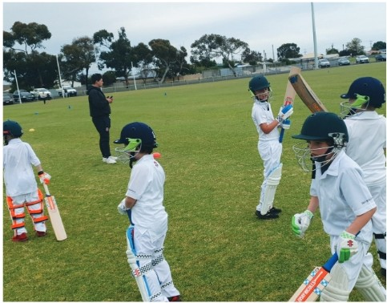
CRICKET PRACTICE NETS
Description: The cricket practice nets are located to the north of Oval 2. They consist of two hard wicket bowling lanes and a turf area which would be suitable for 4-6 lanes. The facility measures approximately 23m x 13m, and is un-roofed.
Issue: A number of compliance issues exist within the current cricket practice facility. Namely, the hard wicket bowling run ups are not formalised and do not meet the recommended minimum standards in terms of provision and dimensions. The turf practice area is no longer required due to the Club no longer participating in turf competition.
Opportunity: Investigate the development of a new cricket practice facility that complies with Cricket Australia guidelines for a local club facility.

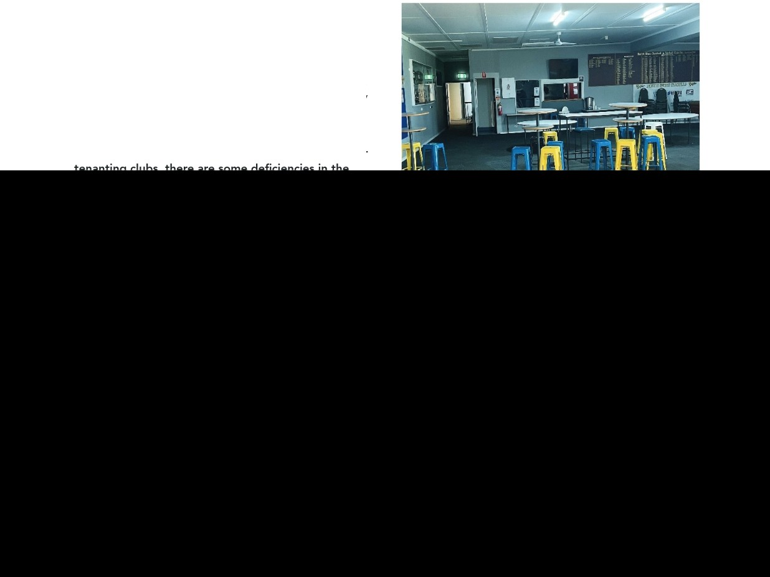

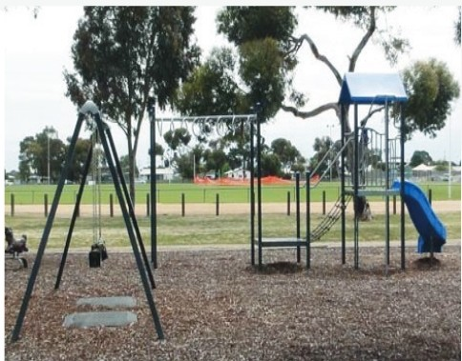
PLAYGROUND
Description: The playground at Windsor Park is a basic local level facility with combination unit and swing. It has some seating and shade.
Issue: The playground is in poor condition and due to be upgraded within the City's cyclical program.
Opportunity: In conjunction with scheduled upgrades to the playground, consideration should be given tto its most appropriate location and proximity to other infrastructure such as the picnic rotunda and netball
courts or the skate/scoot park. There is also opportunity to consider the inclusion of more play infrastructure for older age children such as 3 on 3 basketball courts, futsal courts etc.

CLUB ROOMS
Description: There are two social rooms within the football/cricket pavilion, with the main room measuring approximately 286m2 and the secondary room measuring 84m2. There is a bar area in each room and a commercial kitchen with a servery in the main area. They are complimented with change facilities for football and cricket.
Issue: Whilst social rooms provide adequate space for

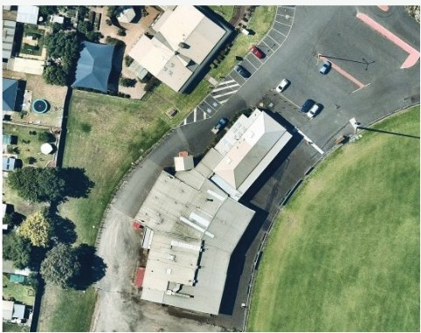
CAR PARKING/VEHICLES/ PEDESTRIANS
Description: Car parking, as per the existing conditions map on page 15, is plentiful and located in several zones across the reserve. These are both sealed and unsealed areas.
Issue: Whilst improvement works have been undertaken in the car park immediately off Rose Ave, there is still a number of areas that are very ad-hoc and lack proper organisation, management and safety, particularly in shared car and pedestrian zones.
Opportunity: There remains opportunity to improve the organisation of car parking throughout the site via
works which will address formalising unsealed areas, line marking of parking bays and the installation of traffic management devices including those which provide pedestrians with right of way.

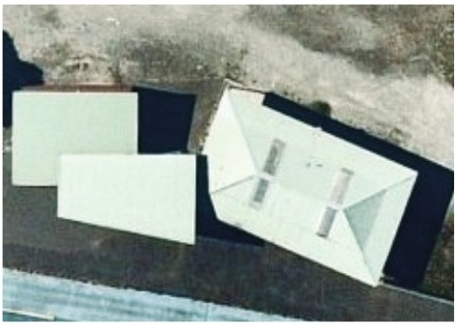
PUBLIC TOILETS
Description: A public toilet block services the reserve and is located next to the netball courts. There are 3 pans in the women's and two pans and a urinals in the men's. The toilets are in proximity to the rotunda and playground.
Issue: The public toilets are in moderate condition and due to be upgraded within the City's cyclical program
Opportunity: Upgrades to the public toilets are required to ensure that amenities are modern, safe and welcoming. The toilets will continue to service the play and picnic facilities as well as for spectators on game days.

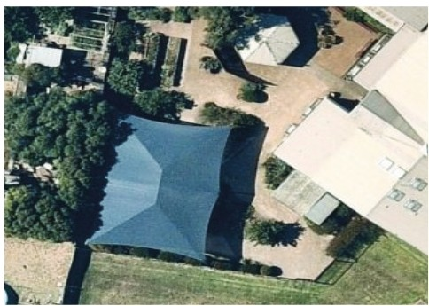
COMMUNITY GARDEN
Description: The Norlane Community Centre is located in the north-western corner of Windsor Park and offers
courses and activities for the community at low to no cost. These activities extend to art, exercise, cooking, computer literacy and gardening. The centre presently has an active community garden within its footprint.
Issue: Due to its popularity and to support broader usage and programming, an extension to the community garden is required.
Opportunity: Extend community garden footprint.

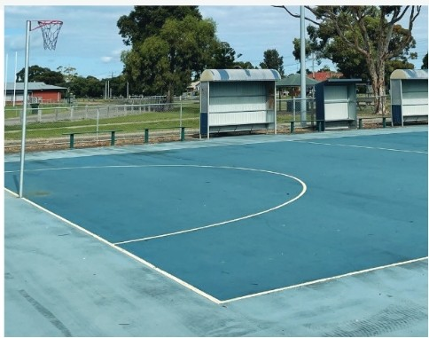
NETBALL COURTS
Description: There are two acrylic surfaced netball courts at Windsor Park, supported by players shelters and sports lighting.
Issue: The acrylic surface is aged and there is a construction join between the two courts. There is a slight deficiency in the run off between the two
courts when compared to the requirements outlined by Netball Victoria. Sports lighting is of unknown condition.
Opportunity: Consider resurfacing the two courts and improving sports lighting (if required) commensurate with the City's and Netball Victoria's recommended standard. Ensure future court measurements align with current guidelines.

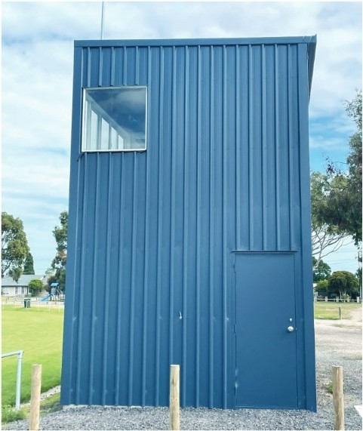
OTHER SPORTING INFRASTRUCTURE
Description: There is an array of additional sporting infrastructure at Windsor Park, most of which is in serviceable condition. There is an additional club pavilion located in proximity to Oval 2, which is primarily used for juniors and cricket on game day. In addition, a variety of structures including scoreboard, coaches box and players shelters exist around the perimeter of Oval 1.
Issue: Most supporting infrastructure is in reasonable condition. The outdated brick player shelters/benches require removal.
Opportunity: Continue to maintain infrastructure so it remains fit for purpose. Consider providing a new away coaches box and behind goal netting on Oval 1.

FACILITY AUDIT SUMMARY


In addition to the key observations, issues and opportunities identified on the previouspages, an assessment of the facilities at Windsor Park was undertaken using insideEDGE's Sports Facility Auditor Program and the preferred infrastructure guidelines of AFL, Cricket and Netball. The below table identifies where the facility meets current expectations (green), where some gaps exist however intervention isnot essential (orange) and where major shortfalls (red) exist.
........

CLUB ROOMS SUMMARY
Greater  than 45m² 4 |  |  | Lockable cubicle  Lockable cubicle | Pan toilets and one urinal  Pan toilets and one urinal | Yes | Yes
 | Less than 45m2 | 4 | Lockable cubicle  Lockable cubicle | Pan toilets and one urinal  Pan toilets and one urinal | Yes | No
N/A

Yes
Greater  than 20m² |  |  | Lockable Pan toilets Yes cubicle |  |  | N/A  Yes
NIA >200m² N/A N/A Pan toilets Yes |  |  |  |  |  | N/A  Yes

Football/ Cricket Home Change Room

Football/ Cricket Away Change Room

Football/ Cricket Umpire Change Room
Ill

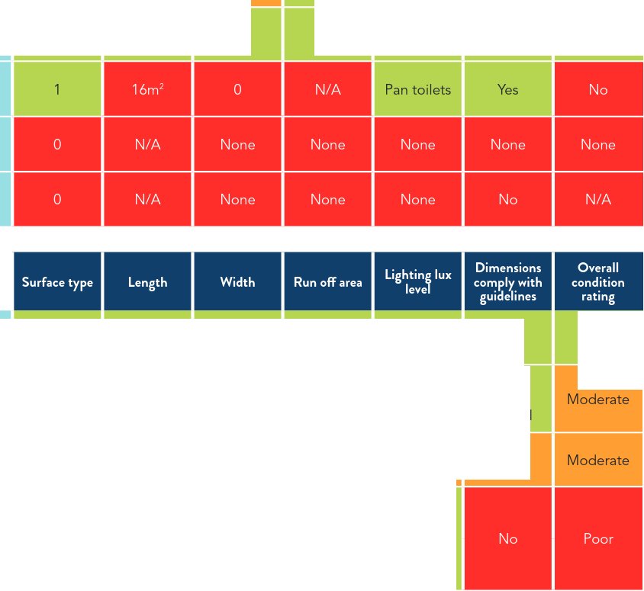
Club Social Rooms

Netball Home Change Room

Netball Away
Change Room

Netball Umpire Change Room
FIELD OF PLAY
SUMMARY
Oval 1
Cool season turf
167m
145m
2m
100 lux
Yes
Good
Oval 2
Cool season turf
126m
89m
2m
None
Yes for junior football
Netball Courts
Synthetic
30.6m
15.3
3m
Unsure
Mostly
Cricket Practice
Nets
Synthetic
& Turf
Turf- 13.Sm
Turf- 12.Sm
Synthetic nets do not have formalised run ups
NIA
----
Synth- 4.3m
-

PARTICIPATION

AUSPLAY CURRENT AND PAST PARTICIPATION

AusPlay, the Australian sport and physical activity participation survey, outlines popular activities by Local Government Authority (LGA) for both sport and active recreation. As identified below, amongst the top 8 sporting club participation activities, all sports at Windsor Park are represented.
Further, the top recreational activities within the City of Greater Geelong are listed. As the Facility Development Plan for Windsor Park has identified opportunities
for improvement for both passive and active uses, its important to understand the community's activity
preferences to ensure the Plan responds accordingly.

Top Sporting Activities
- AFL
- Golf
- Netball
- Basketball
- Soccer
- Tennis
- Cricket
- Bowls

Top Recreation Activities
- Walking
- Fitness/Gym
- Swimming
- Running/Athletics
- Cycling

  - Football Netball ■Cricket

Sporting participation at Windsor Park has seen some fluctuation over the past four seasons, due to challenges in attracting junior players as well as COVID-19. Clubs
at North Shore however have recently reengaged and attracted new participants across all age cohorts by taking a proactive approach, in partnership with key stakeholders, to increase participation. In 2022, North Shore footballers are off to a great start, with healthy numbers and early on-field success. Participation initiatives outlined within this report aim to contribute to the future sustainability of all sporting codes, combined with infrastructure improvements, to reach their desired strategic objectives both on andoff the field.

FUTURE PARTICIPATION FORECAST
A future participation forecast has been provided below. This forecast is based on achieving some of the strategic participation initiatives outlined in addition to facility upgrades identified in this report. Combined, these opportunities will be significant contributors to growing participation into the future. As indicated, netball participation is expected to increase, particularly if supported by the new change room facilities. Football and cricket are also expected to see steady participation increases in future years which is based on infrastructure
enhancement as well as on-field success in senior grades as well as grassroots and junior team development.

275

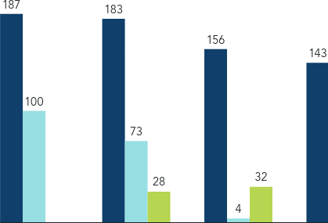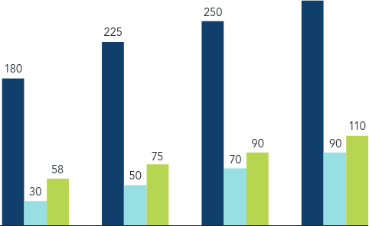
43
12
2018 2019 2020 2021 2024 2026 2028 2030

AFL PARTICIPATION CATCHMENT
The AFL has detailed participation data including the residential postcode of players for each club. This data enables the mapping of a club's catchment and to understand their
effectiveness in attracting local players, as well any reach it may have across the municipality. The top three suburbs that North Shore Football Club attracted its participants from in 2021 were:
- Corio
- Norlane
- Lovely Banks

The below heat map shows North Shore Football Club's players residential locations in 2021. As demonstrated, the vast majority of players resided in the immediate Corio and Norlane area. This is reminiscent of most local clubs and demonstrates a healthy distribution and catchment. These suburbs will need to be continually targeted to draw local participation from into the future to ensure the Club's sustainability and viability.

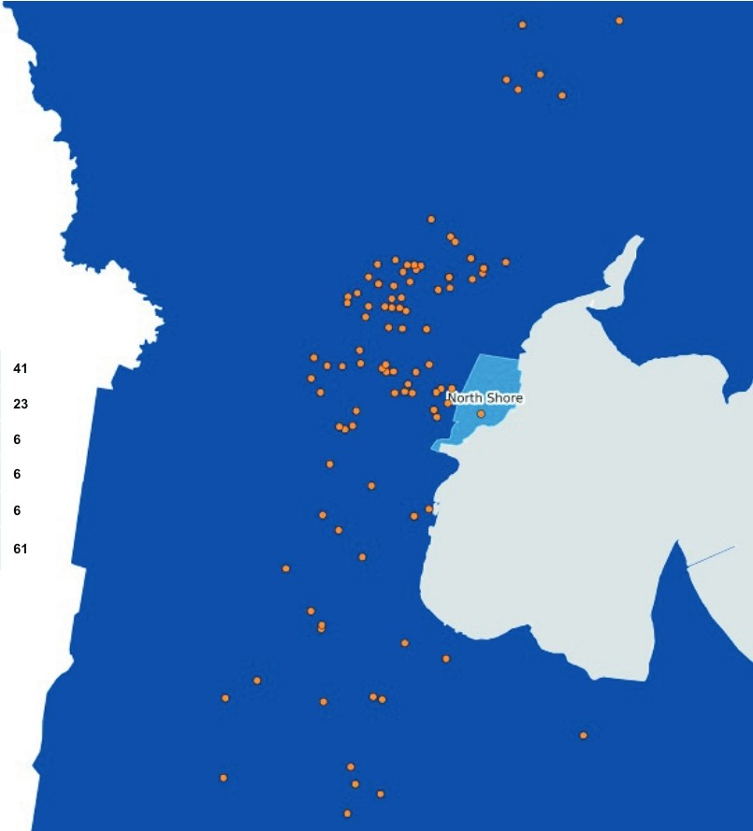
Corio Norlane Lovely Banks Newtown Torquay
Other

SPORT FACILITY USE

Current and expected future use of sporting facilities at Windsor Park is outlined below. Most noteworthy is the additional use of netball change rooms following upgrades. The improvements will provide greater
opportunities for existing players, and assist in being an attractor for future participants. The social rooms are also expected to see significant additional use as they move towards more modern standards, including more flexible spaces for community activities. Upgrades to cricket nets will see a facility that is mostly unusable in its current condition, upgraded into a multi-purpose facility that an
be used for training as well as other activities if desired such as futsal. Offering more multi-use of this facility will likely result in increased overall usage as it will be readily accessed outside of sport alone.

FACILITY COMPONENT CURRENT AND FUTURE USAGE (HOURS PER WEEK)

35
- Current Future

30

25

20

15

10

5

0

Netball Change Rooms Netball Courts Ovals Social Rooms Cricket Practice Nets

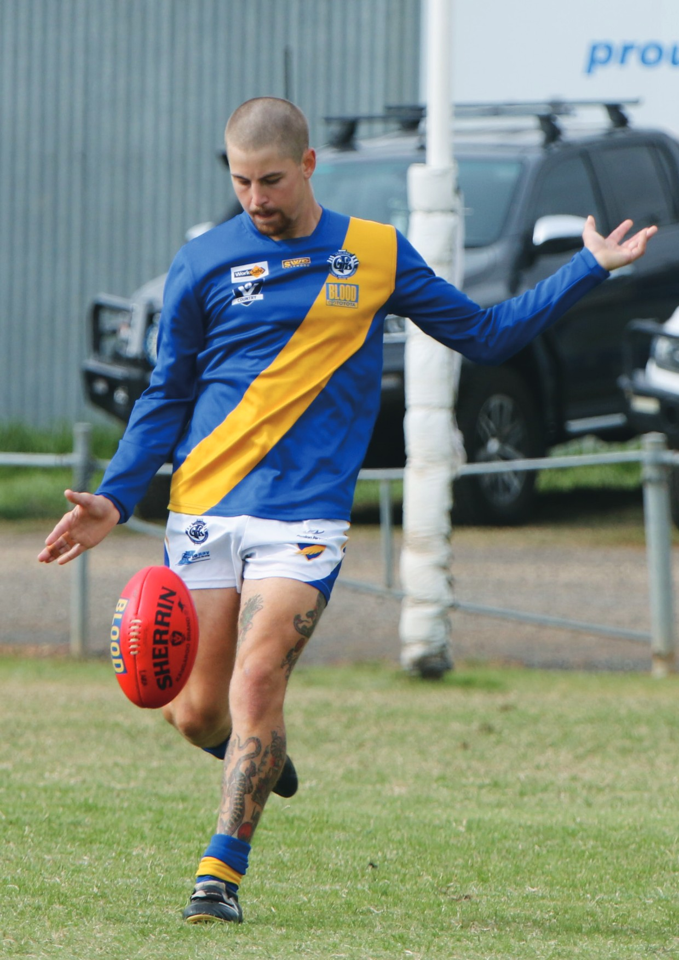

CITY OF GREATER GEELONG
PO Box 104
Geelong VIC 3220
P: 5272 5272
E:contactus(@geelongcity.vic.gov.au www.geelongaustralia.com.au

CUSTOMER SERVICE CENTRE
100 Brougham Street
Geelong VIC 3220
8.00am - 5.00pm

© City of Greater Geelong 2022

LATEST NEWS:
(!) (a)CityofGreaterGeelong
@ (a)GreaterGeelong
@ (a)CityofGreaterGeelong
@ CityofGreaterGeelong

CITYOFCRrATER
GEELONG

,,,.

