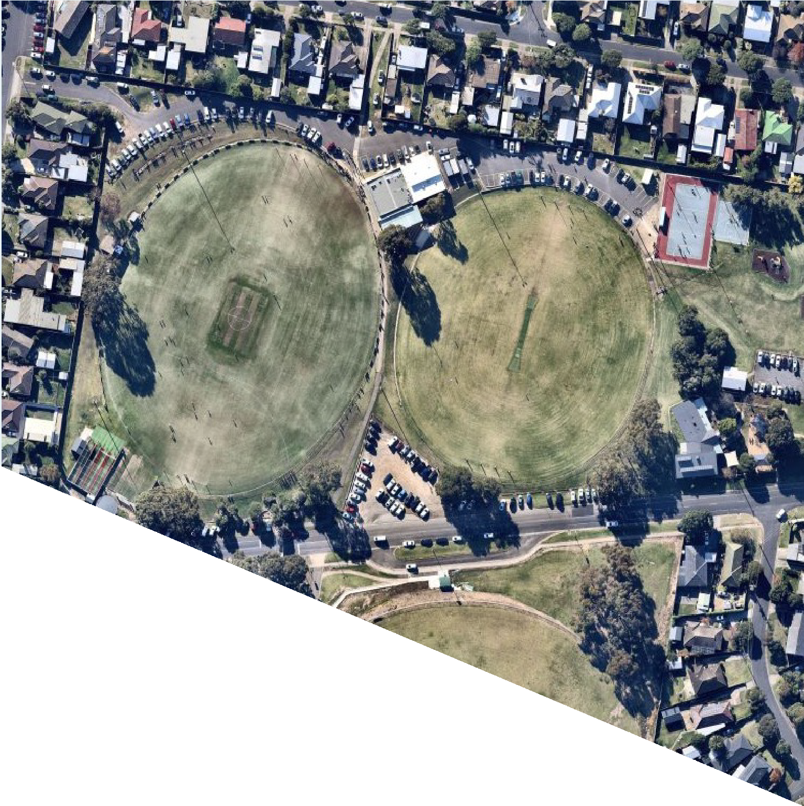

FACILITY
DEVELOPMENT PLAN: WINTER RESERVE
REPORT

DECEMBER 2021

WE ACKNOWLEDGE THE
TRADITIONAL CUSTODIANS OF
THE LAND, THE WADAWURRUNG PEOPLE OF THE KULIN NATIONS. WE PAY OUR RESPECTS TO
THEIR ELDERS PAST AND
PRESENT AND ACKNOWLEDGE ALL ABORIGINAL AND TORRES STRAIT ISLANDER PEOPLE WHO ARE PART OF THE GREATER
GEELONG COMMUNITY TODAY.



THIS DOCUMENT
The Facility Development Plan has been prepared by insideEDGE Sport & Leisure Planning on behalf of the City of Greater Geelong. This project was funded via the City of Greater Geelong’s Community Infrastructure Grants program (2020/21) and developed in conjunction with Belmont Lions Sports Club and East Belmont Cricket Club. This Plan aims to provide an evidence base and strategic justification for the improvement
to Winter Reserve to ensure its viability and suitability as a local level community sporting venue into the future.

CONTENTS

OVERVIEW 4
KEY FINDINGS & RECOMMENDATIONS 6
STRATEGIC OVERVIEW 8
COMMUNITY PROFILE 14
ABOUT WINTER RESERVE 16
The Site
Existing Facilities Facility Use
About the Clubs Participation
Community Programs and Initiatives
FACILITY DEVELOPMENT PLAN 28
Guiding Principles The Plan
Investment Opportunities Implementation
Project Benefits
Stakeholder Support
APPENDICES 38

3.

OVERVIEW

A Facility Development Plan for Winter Reserve has been commissioned via the City of Greater Geelong in partnership with the Belmont Lions Sports Club and East
Belmont Cricket Club. This project has been funded via the City’s 2020/21 Community Infrastructure Grants Program.
The Plan aims to provide a consolidated approach, in collaboration with key user groups and stakeholders, to improve infrastructure at Winter Reserve over the next 10 years. Presently, the Reserve has a number of identified gaps in facilities that, if addressed, will help facilitate, foster and retain participation. It will also ensure the venue is comparable to other like facilities within the region.
Winter Reserve is currently host to healthy participation in football, netball and cricket, and has seen stable growth over the past four seasons. The facility is located on the periphery of Geelong’s urban growth boundary, which is expected to see an additional 55,000 - 65,000 people at completion who will reside within proximity to the Reserve.
The key infrastructure gaps that exist at Winter Reserve include:
- No netball player or umpire change facilities
- Single netball court
- Limited kitchen facilities
- Gaps in other supporting infrastructure including storage, scoreboard and goal netting.
This report discusses in further detail the implications and opportunities in addressing this shortfall, and provides plans, cost estimates and highlights a partnership approach to investment and delivery.

“Improving sporting and community infrastructure at Winter Reserve will address core facility gaps and support participation outcomes for people of all genders, abilities and backgrounds”

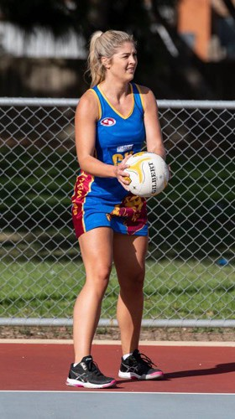

Belmont Lions Sports Club - netball player

4.

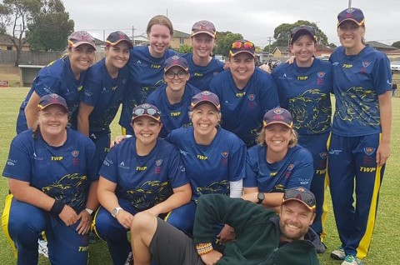
East Belmont Cricket Club – women’s senior team

PROJECT METHODOLOGY

STAGE 1: SITE INSPECTIONS AND STAKEHOLDER ENGAGEMENT
Conduct site inspections and assessments of the Reserve and its facilities with Council, tenanting Clubs, planners and architects. Undertake an information gathering exercise and engagement with key stakeholders regarding needs and aspirations.

Review relevant participation and demographic information. Undertake and analyse facility audit information collected to understand gaps in facility provision and site utilisation, challenges and opportunities.
STAGE 2: DEMOGRAPHIC AND STRATEGIC REVIEW, PARTICIPATION AND FACILITY AUDIT ANALYSIS

STAGE 3: CONCEPT PLANS AND STAKEHOLDER ENGAGEMENT
Develop site and building concept plans that respond to identified need and align to the strategic directions of potential future funding partners and
community sport guidelines. Undertake further engagement with stakeholders, including peak sporting bodies, to provide feedback on draft plans.

STAGE 4: DRAFT AND FINAL FACILITY DEVELOPMENT PLAN
Produce Draft and Final Facility Development Plan and report including recommendations which highlight future upgrades and prioritised improvements along with plans, costings and implementation strategies.

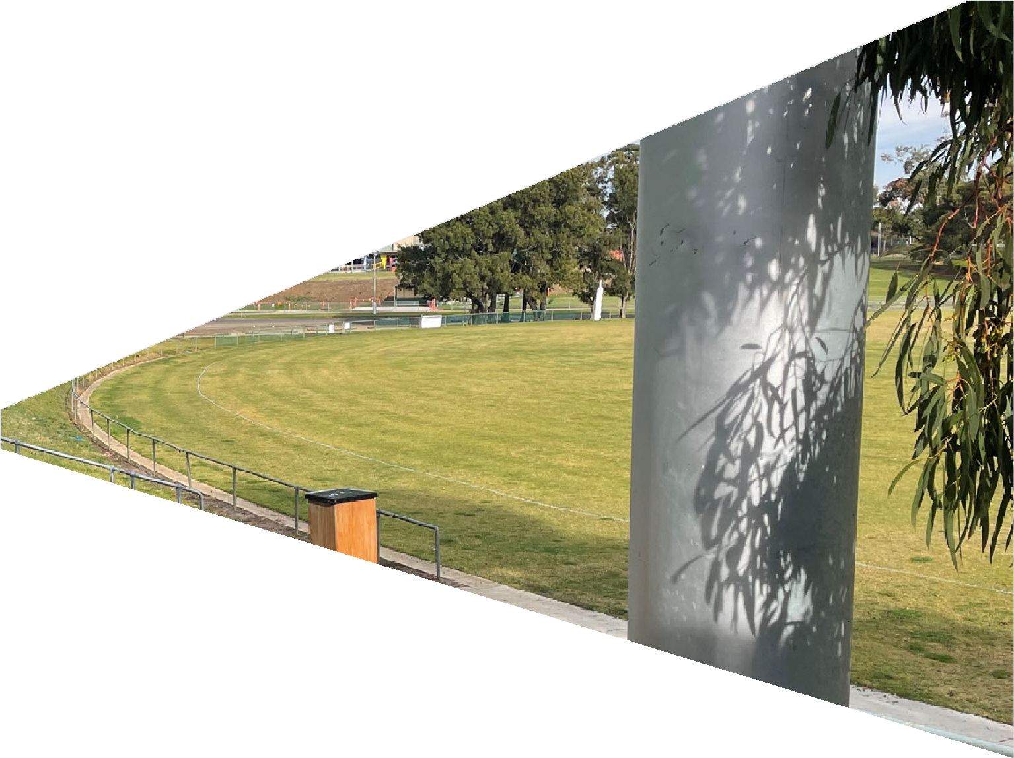

KEY FINDINGS & RECOMMENDATIONS

THERE IS HEALTHY
SPORTING PARTICIPATION AT WINTER RESERVE
Participation in sport at Winter Reserve is increasing. Over the past number of seasons, football and cricket have experienced growth in participation, particularly within junior and female playing groups, whilst netball has mostly retained its participant base. All clubs have a strategic plan to continue to drive participation outcomes moving forward, and the delivery of the Facility Development Plan will support this.

THERE ARE GAPS IN CORE INFRASTRUCTURE
Winter Reserve does not presently have change rooms for netball participants including players and umpires. In addition, only one netball court is provided (with a preference for two). Other facility gaps include limited kitchen space, poor pedestrian and vehicle movement, limited car parking and lack of supporting infrastructure including score board, behind goal netting and storage.

FACILITY IMPROVEMENTS WILL HAVE BIG IMPACTS

Presently, netball participants are having to get changed in cars or having to travel directly to and from the venue without access to showers and toilets. This presents a significant barrier to participation and sees the Club having to compete for players against venues with more appropriate infrastructure. Supplying change rooms for
netball participants will see players have a comfortable and welcoming environment with the necessary infrastructure to meet the expectations of the modern game.

INFRASTRUCTURE
RECOMMENDATIONS ARE SUPPORTED BY ROBUST
STRATEGIC PLANNING AT CLUB LEVEL
Tenanting Clubs at Winter Reserve see the Facility Development Plan as a mechanism to help them reach one of their key identified strategic goals, being facility improvements. Other key focus areas include increasing participation (for females, multicultural and
disadvantaged communities and all abilities), as well as improved financial viability, greater volunteer retention and increasing strategic commercial partnerships.

IMPROVING INFRASTRUCTURE AT WINTER RESERVE WILL
ENSURE THE VENUE IS ON PAR WITH OTHER LIKE LOCAL FACILITIES
For tenanting sporting clubs having access to facilities which are comparable to other local venues is important to attract and retain participants, particularly women and girls. To reach their anticipated participation projections, adequate modern amenities need to be made available.

IMPROVING COMMUNITY ACCESS, GENDER EQUITY AND DIVERSITY IS AT THE FOREFRONT OF THE PLAN
Underpinning the development of the Plan are the principles of improving community access to the facility as well as enhancing opportunities for all genders and cultures. Belmont Lions has strong connections with the Indigenous community and encouraging participation, equitable access, universal design and broader community involvement support each of the Plan’s recommendations.

INVESTMENT AND DELIVERY WILL REQUIRE SUPPORT FROM
PARTNERS AND STAKEHOLDERS
The Facility Development Plan has provided recommendations which are achievable with the assistance of multiple funding partners and stakeholders. To ensure the Plan’s agility, several revenue streams including local funding programs, club investment and state funding initiatives have been identified.

7.

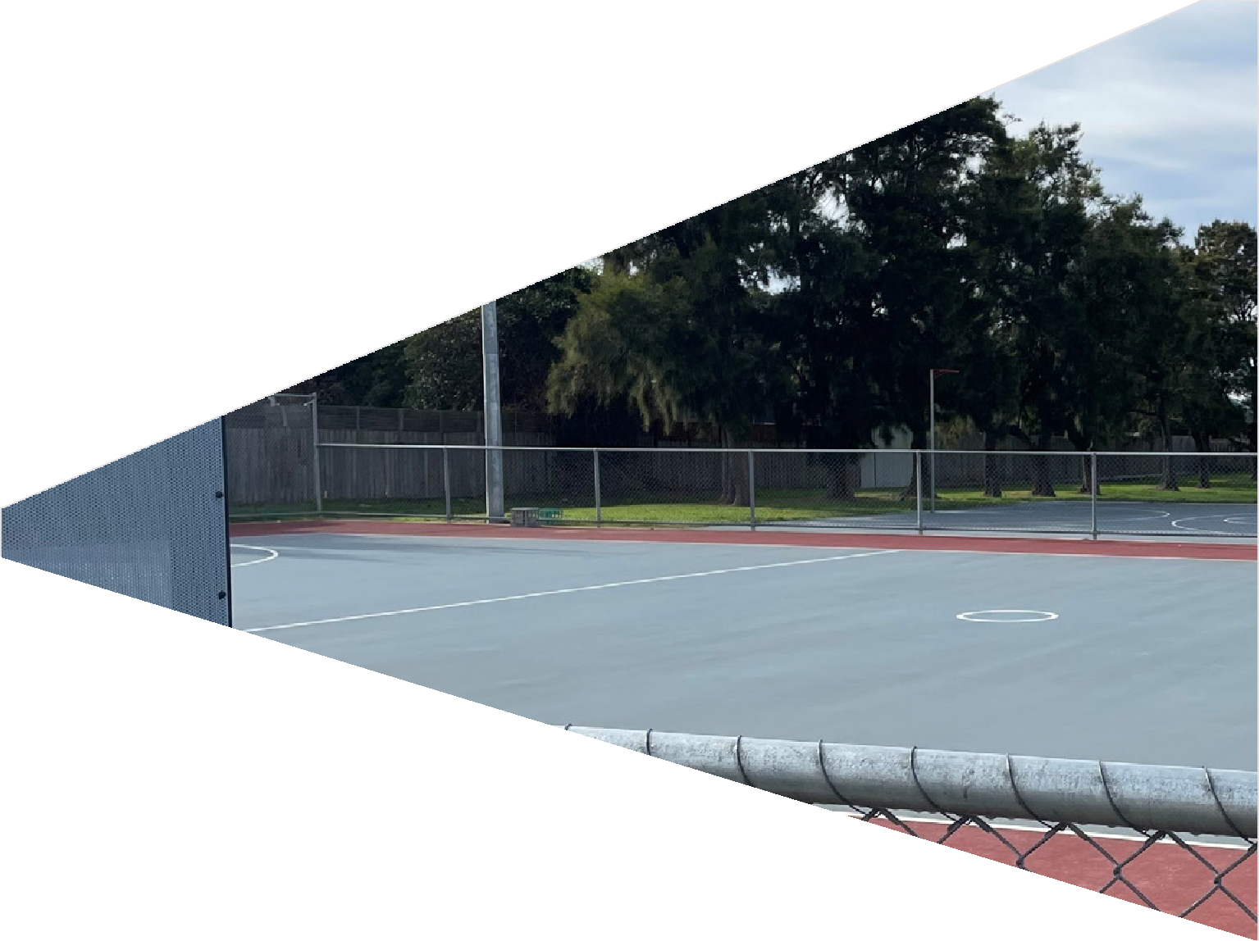

STRATEGIC OVERVIEW

8.

The following provides a high level overview of strategic documents which guide and support the Facility Development Plan. Further detailed summaries of these documents can be found in the Appendices section of this report.
KEY STRATEGIC DOCUMENTATION
CITY OF GREATER GEELONG
Council Plan 2018-2022
CITY OF GREATER GEELONG
Social Infrastructure Plan Generation One 2020-2023
CITY OF GREATER GEELONG
Social Infrastructure Plan - Outdoor Sport And Recreation Report
CITY OF GREATER GEELONG
Social Infrastructure Plan Investment Policy

SUPPORTING STRATEGIC DOCUMENTATION

AFL Victoria’s Growing the Heartland Strategy

Netball Victoria Statewide Facilities Strategy
Cricket Victoria: 2017-2022 The Journey Ahead
for Victorian Cricket

G21 & AFL Barwon Towards 2030: Strategy

G21 & Cricket Victoria Regional Cricket Strategy

Club Strategic Plan

Winter Reserve Facility Development Plan

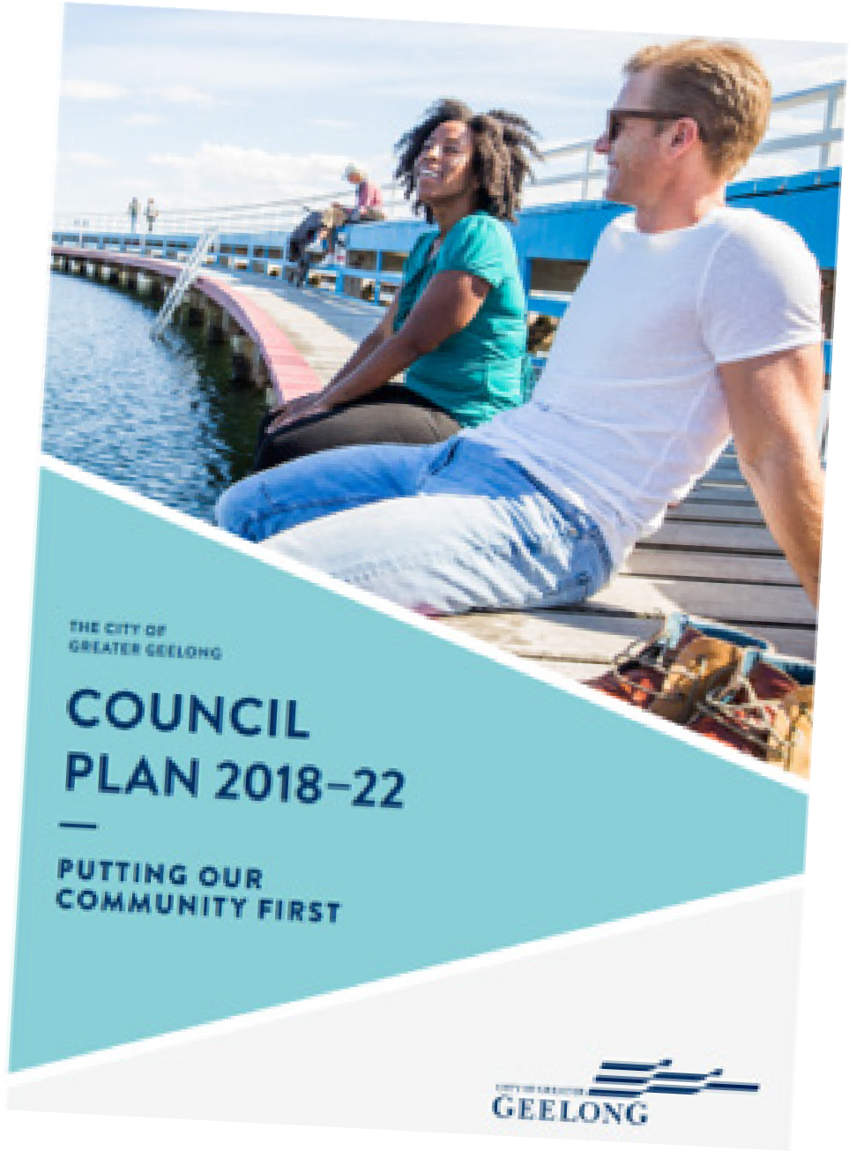

ACTIVE VICTORIA: A STRATEGIC FRAMEWORK FOR SPORT AND
RECREATION IN VICTORIA 2017-21
The Victorian Government’s Strategy outlines its vision and action plan for sport and recreation participation and facilities across the State. The Strategy identifies that a strong and connected sport and active recreation system helps make Victorians healthier, creates economic growth and jobs, builds community cohesion and contributes to liveability. The key goals for the Strategy, and how they relate to the Feasibility Study, include:
More active – an increased proportion of Victorians regularly participating in sport and active recreation.
Robust, sustainable and affordable – a system that addresses the different demands, contributors and structure of sport and active recreation and maximises connection across the system.
Collaborative – well-planned and connected investment that maximises participation and health, economic, community and liveability benefits.

CITY OF GREATER GEELONG: COUNCIL PLAN 2018-22
The Council Plan sets the framework for how the City of Greater Geelong wants to achieve its many strategic
priorities, services and programs to its community. Those which most closely align to this project include:
Informed social infrastructure and planning – including supporting the growth of local sporting facilities and delivering accessible community infrastructure based on need.
A more inclusive and diverse community – including promoting gender equity and diversity in sport and leisure facilities.

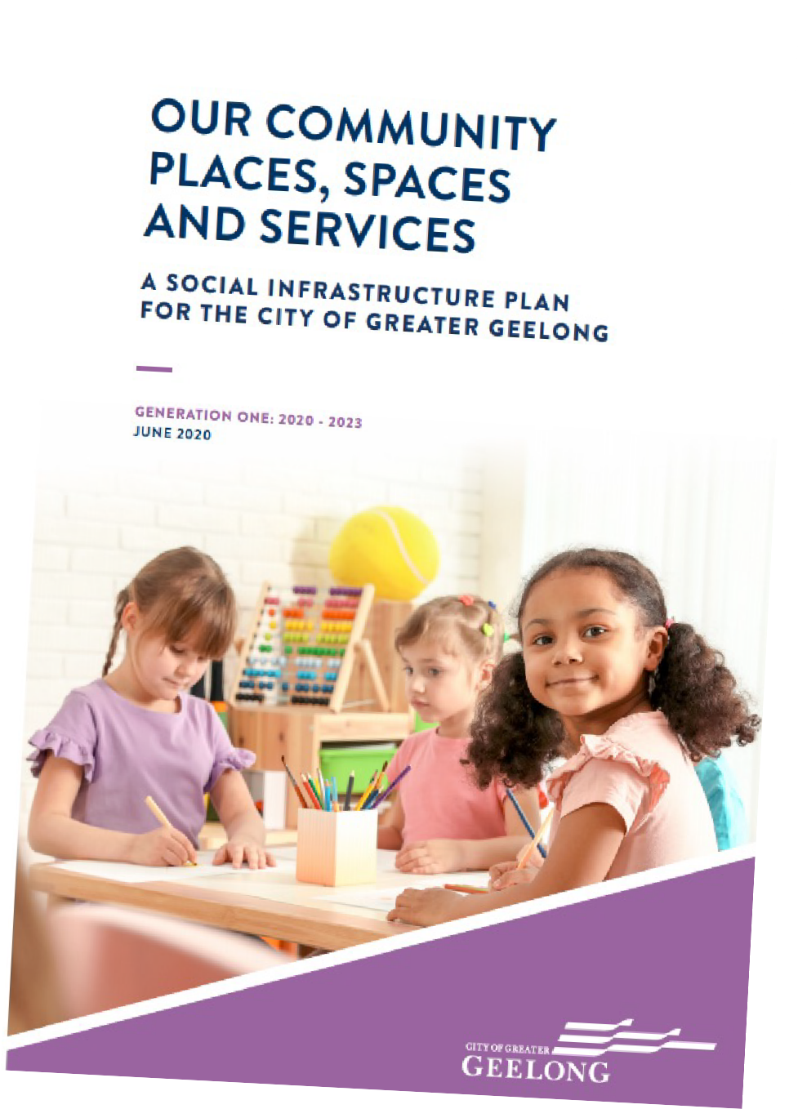

CITY OF GREATER GEELONG:
MUNICIPAL PUBLIC HEALTH AND WELLBEING PLAN 2018-2021
The Municipal Health and Wellbeing Plan is required to be developed by Local Government Authorities under the Victorian Public Health and Wellbeing Act 2008.
The Plan outlines how the City intends to ensure the enhancement of community wellbeing outcomes through a number of initiatives including programs, activities, environments and services. A key goal identified includes “Increasing Participation in Physical Activity” and assist in placing communities at the centre of collaborative efforts to improve health and wellbeing.

CITY OF GREATER GEELONG: SOCIAL INFRASTUCTURE PLAN AND THE
OUTDOOR SPORT AND RECREATION NETWORK REPORT (2020-2023)
The City’s Social Infrastructure Plan (SIP) sets the framework for how community infrastructure will be structured and invested in over the next 3 years based on community need and trends. More specifically to the project is the SIP’s Outdoor Sport and Recreation Network Report, which identifies that the City needs to broaden its planning to consider the diversity in activity types and preferences of the community. The Report indicates that building capacity through existing and future facilities that can be used by multiple groups and clubs will ensure facilities are flexible and sustainable.

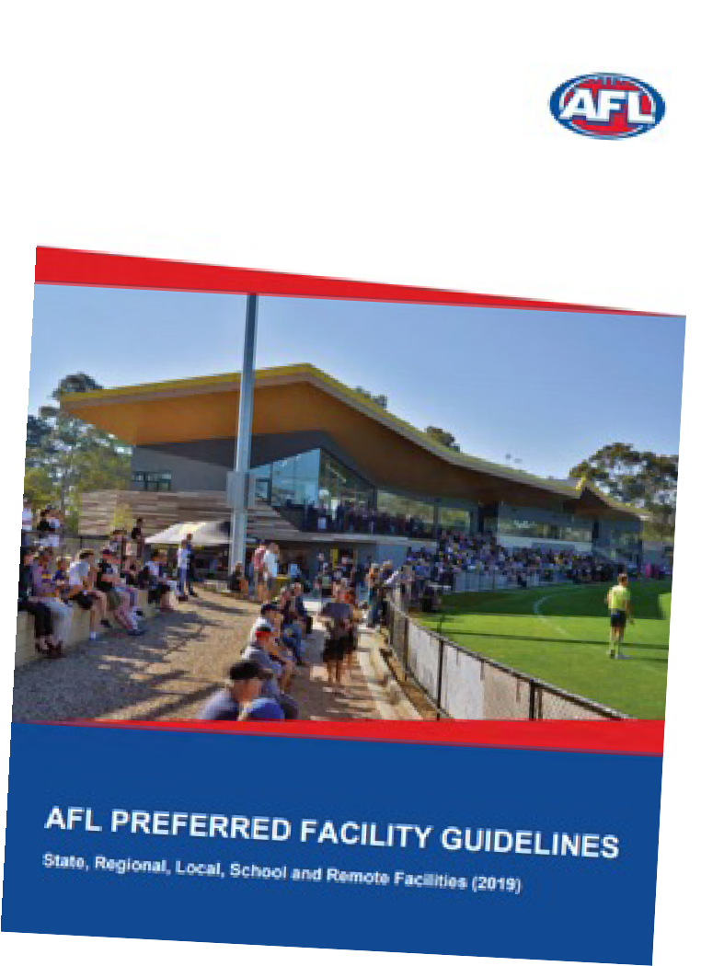

SPORT FACILITY STRATEGIES,
FRAMEWORKS AND GUIDELINES
To support local, state and federal strategic planning, many peak sporting bodies have developed resources to help guide sustainable facility development and delivery. Across the many sports represented at Winter Reserve, each one offers guidelines that outline minimum preferred standards for infrastructure provision.
Common priorities and principles identified within these documents include:

Gender neutral amenities
Providing facilities that are welcoming, inclusive, accessible and encourage use by people of all-genders.

Multi-purpose facilities
Providing facilities that offer opportunities for multiple users and a variety of uses to generate greater community benefit and asset utilisation.

Growing venue capacity
Increasing the quality and capacity of existing facilities through innovative approaches (e.g. LED lighting, synthetic surfaces) that create more programming opportunities.

Universal access
Ensuring community facilities are accessible to people regardless of their age, ability or cultural background.

Planning for growth and demand
Investment and prioritisation of facilities and infrastructure upgrades where greatest need and demand is demonstrated.
Partnerships and collaborative investment Enhancing and maintaining relationships between all levels of government, industry partners and sport to promote collaborative investment into facility development.

ECONOMIC AND SOCIAL VALUE OF SPORT

THE VALUE OF
COMMUNITY FOOTBALL
In 2015, AFL Victoria and Latrobe University undertook research to determine the social value of a typical community football club.
The study found that for every $1 spent on a community football club, there was at least $4.40 return in social value.
The strongest benefits were found to be delivered in the areas of mental health, physical health, personal well being and education. Others benefits included social inclusion, civic pride, empowerment, social connectedness, regional population stability and cultural integration.

$1 $4.40

SPENT ON COMMUNITY FOOTBALL
RETURN IN SOCIAL VALUE

THE VALUE OF COMMUNITY SPORT & ACTIVE RECREATION
Sport and Recreation Victoria commissioned a report by KPMG in 2020 to highlight the value of community sport and recreation infrastructure. The report looked at the economic, health and social benefits that accrue to individuals, community and society via the construction and operation of sport and recreation facilities and the activities that are conducted within.
The report found the following benefits contributed annually to Victoria through community sport and recreation:
- $2.1 billion dollars in economic benefits – including increased economic activity and event related tourism.
- $2.3 billion dollars in health benefits – including reduced risk of chronic disease and improved mental health and wellbeing.
- $2.6 billion in social benefits – including human capital uplift, volunteering and green space benefits.
Qualitative benefits included:
- Increased social connectedness, inclusion and networking.
- Increased level of trust in others.
- Reduced anti-social behaviour.
- Community pride.



COMMUNITY PROFILE

12.

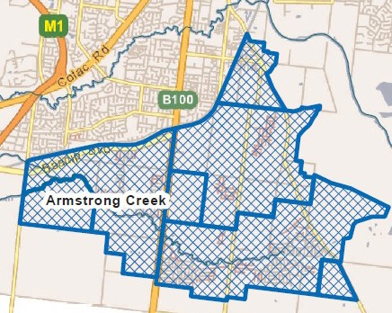POPULATION & DEMOGRAPHICS

15,165
BELMONT
POPULATION IN 2021

+1,242

INCREASE IN NUMBER OF PERSONS LIVING IN BELMONT 2021 TO 2031
*SOURCE FORECAST.ID

+17.2%
OVERALL INCREASE IN BELMONT
POPULATION TO 2041

BELMONT & GREATER GEELONG’S POPULATION FORECAST
The City of Greater Geelong has an estimated population of 268,984 in 2021*. This is expected to grow to 324,292 in 2030 and 386,891 in 2040, primarily due to several growth areas to the south and north-west of the municipality. This is an average annual change of approximately 2%. The City is described as the most populous municipality in regional Victoria.
The suburb of Belmont, where Winter Reserve is located, is a well established, much sought after location due to its proximity to the CBD and its offerings of good public transport connections and lifestyle. Located south of the Barwon River, Belmont is adjacent to the burgeoning Armstrong Creek growth area which will see an additional 70,000 residential population at completion. As a long standing suburb of Geelong, Belmont population forecasts are expected to increase, however this is relative to the existing number of persons.
Forecasts for Belmont indicate an overall percentage increase of 17.22% from 2021 to 2041, which equates to an additional 1,242 persons by 2031 and 1,369 to 2041. 53% of people currently living in Belmont are aged under 39 years, indicating that the suburb is likely popular for young families.

GROWTH AREAS
The Armstrong Creek-Marshall-Charlemont growth area within the City of Greater Geelong is expected to see the total number of persons between 2020-30 increasing 243%, or a difference of 30,237 persons. As mentioned, Winter Reserve is located close to the growth area (as per adjacent map) and it is likely that opportunities to broaden the catchment area of the clubs will increase as the population of Armstrong Creek grows. See further
information on the current participation catchment of the Belmont Lions Sports Club on page 25 of this report.

Winter Reserve

DEMOGRAPHIC INFLUENCES ON PARTICIPATION
Changes in age cohorts for people aged 5-39 in Belmont (considered the key market for organised sport) will see an increase of 6.2% from 2021 to 2031.
Overall, the trend line for all age cohorts in Belmont from 2021 to 2031 will be steady, with people aged under 39 comprising the highest number of persons.
It will be important for clubs at Winter Reserve to target these people as part of their attraction and retention strategies for players. Neighbouring suburbs, including those on the periphery of growth areas, will also be critical.

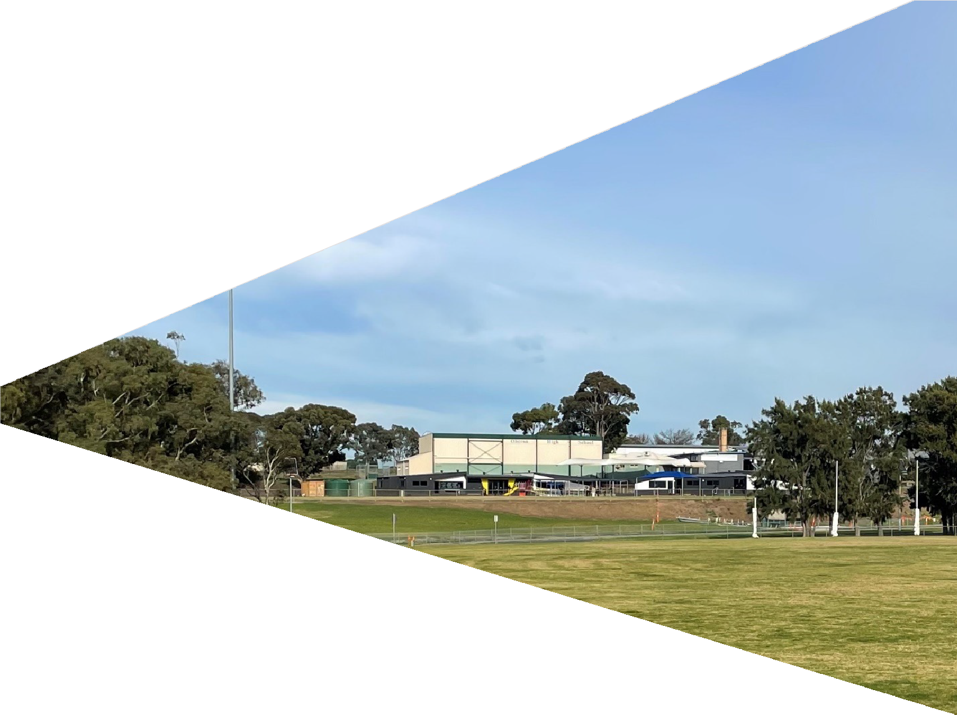

ABOUT
WINTER RESERVE

124..

THE SITE

WINTER RESERVE IS A LOCAL COMMUNITY SPORTING VENUE IN BELMONT, ONE OF GEELONG’S MOST POPULAR SUBURBS.

LOCATION
Winter Reserve is located south of the municipality, approximately 6km from the Geelong CBD. Winter Reserve is surrounded by residential housing to its northern, eastern and western boundaries and Oberon South Primary School to the south.

SITE CONTEXT
The Reserve is owned and managed by the City of Greater Geelong and is zoned Public Park and Recreation Zone (PPRZ) under the City’s planning
scheme. The site is mostly landlocked due to residential housing and main roads along its boundaries. The site also has some areas of undulation, particularly in the north-east corner. Future infrastructure recommendations will need to be considered within these constraints.

FACILITY COMPONENTS
- Floodlit senior size AFL and cricket playing field (floodlighting upgrade currently funded and due to commence 2021)
- Main oval with turf cricket wicket table
- Junior sized AFL oval and second cricket playing field with synthetic wicket and floodlights
- Netball court with acrylic surface and floodlights
- Community sporting pavilion with change rooms for football/cricket players and football/cricket umpires
- Community playground
- Warm up netball area/basketball half court
- Sealed internal roadway
- Car parking – both sealed and unsealed

USER GROUPS
- Belmont Lions Sports Club (football and netball)
- East Belmont Cricket Club

CITY OF GREATER GEELONG

WINTER RESERVE

Main thoroughfare and entrance

Main car park

Oval 1

Club Rooms

Oval 2

Netball court

Warm up/basketball half court

Playground

Turf centre wicket

Synthetic centre wicket

Ancillary car park

Cricket practice nets

Ancillary car park

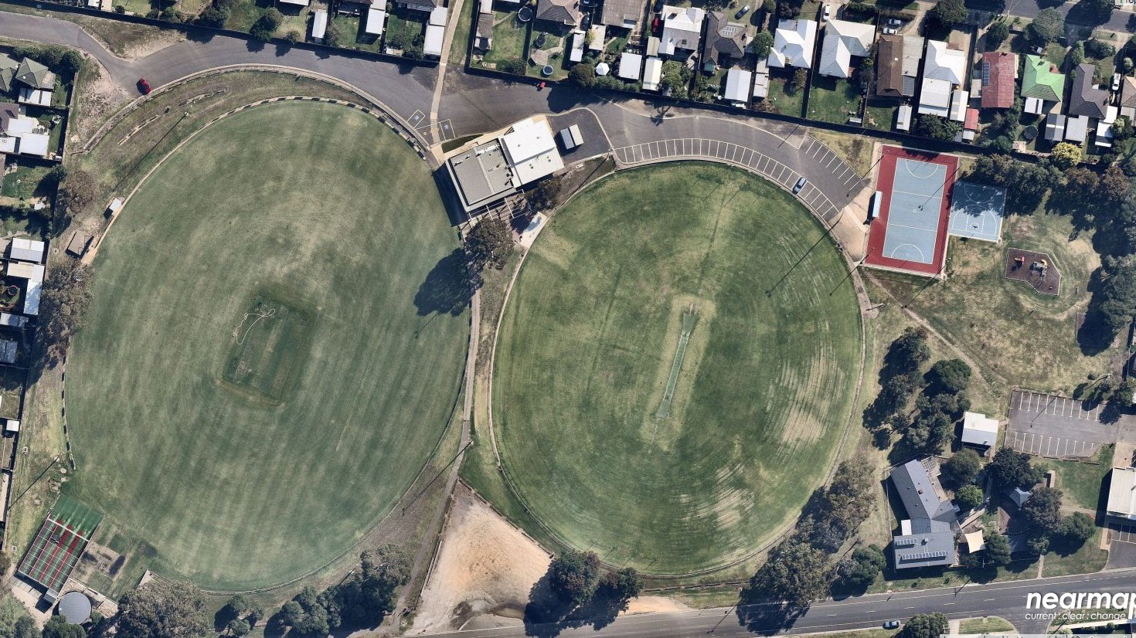

EXISTING FACILITIES
12.14.

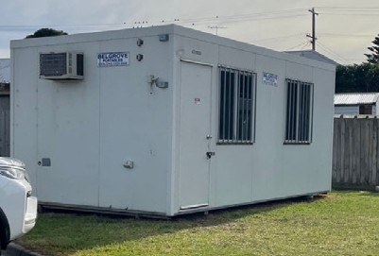Existing facilities at Winter Reserve including their condition and suitability were audited and assessed as part of the Facility Development Plan. Key infrastructure items and associated issues and opportunities are identified below.

NETBALL CHANGE ROOMS
Description: There are no designated change rooms at Winter Reserve for netball participants or netball umpires/officials. There is also no designated court side facilities suitable for spectators.
Issue: A temporary site hut (pictured) is presently utilised to house equipment and assist in performing administration
functions. The hut is not universally accessible nor compliant with preferred facility guidelines.
Opportunity: Providing netball player and umpire change facilities that are appropriate for all-gender use and offer improved connections to the main pavilion will facilitate broader inclusion, health and social outcomes.

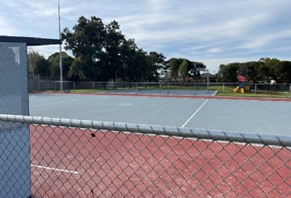
NETBALL COURTS
Description: There is a single netball court at Winter Reserve which has an acrylic surface and floodlighting to 100 lux. The court has compliant dimensions and a player/coaches box on its western side.
Issue: Whilst the existing court is in good condition with quality lighting, the provision of a single court only limits participation opportunities and the programmability of the venue. Netball Victoria’s Facilities Manual identifies that a minimum number of two floodlight courts for football-netball clubs is preferred.
Opportunity: Investigate opportunities to include a second floodlight court to assist in attracting and retaining participants, and ensure its comparability to other football-netball clubs within the region.

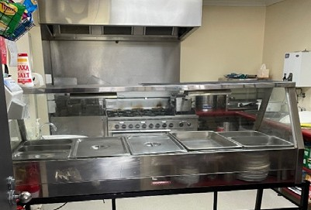
KITCHEN FACILITIES
Description: The existing kitchen facilities at Winter Reserve located within the main club room pavilion, do not meet the needs of the club or preferred sporting facility guidelines.
Issue: The kitchen is undersized and presents limitations to the types and quantities of food that can be prepared and sold.
As a result, this inhibits the clubs’ abilities to raise revenue to support operations.
Opportunity: Review existing footprint of the kitchen area and consider reconfiguration to allow for it to be expanded. As per AFL Preferred Facility Guidelines, a minimum of 20m2 is required.

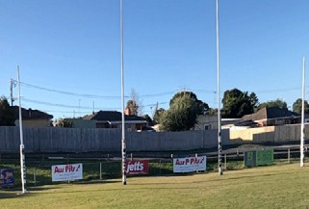NORTHERN END OF OVAL 1
Description: Football goals at the northern end of Oval 1 are located in very close proximity to residential houses (as pictured).
Issue: Footballs are constantly being accidentally kicked over the fence of adjoining properties causing annoyance to residents, increasing volunteer burden to retrieve them, and resulting in game time being extended.
Opportunity: Consider providing behind goal netting to prevent errant balls from entering neighbouring properties.

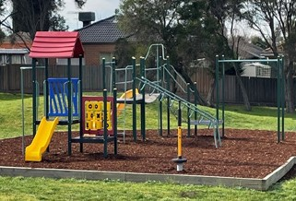
PLAYGROUND AND ACTIVE RECREATION FACILITIES
Description: There is an existing local level playground and a netball warm up/half-court basketball court located in the north-east corner of the Reserve.
Issue: The location of these facilities may see them underutilised by the community. There is opportunity to upgrade this space so that it is more integrated with the broader Reserve and provides play opportunities for a wider range of age groups.
Opportunity: Consider if there is a more appropriate location for the playground and half court and improve its connections with the rest of the Reserve and ancillary facilities including car parking.

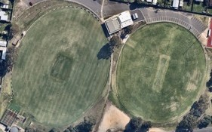
CAR PARKING/VEHICLES/PEDESTRIANS
Description: There is presently a lack of pedestrian connections throughout the Reserve. There is also a safety concern with informal, ad-hoc car parking which presents issues, particularly on game days.
Issue: A lack of defined car parking and pedestrian networks throughout the Reserve present a hazard across the site, particularly at peak times.
Opportunity: Improve vehicle and pedestrian movement throughout the site, noting that some limitations, particularly regarding availability of parking, will persist. Consider how improvements to parking, including those to the south and east, can assist in alleviating these issues.

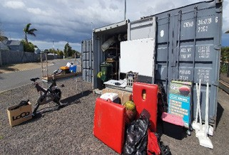
STORAGE
Description: A small amount of storage space exists within the main pavilion however is primarily serviced by two shipping containers located at the eastern end of the home and away football/cricket change rooms.
Issue: Utilising shipping containers, particularly for frequently accessed items presents operational as well as safety issues.
Opportunity: Incorporate significant storage space within the proposed pavilion extension which caters for all three sports adequately and provides a more efficient and functional space for users and reduces volunteer burden.

In addition to the key observations, issues and opportunities identified on the previous pages, an assessment of the facilities at Winter Reserve was undertaken using insideEDGE’s Sports Facility Auditor Tool and the preferred infrastructure guidelines of AFL, Cricket and Netball. The below table identifies where the facility meets current expectations (green) and where shortfalls (red) exist.
As demonstrated below, the largest gaps are in the netball facilities on account that the amenities do not meet the required recommendations by Netball Victoria. In addition, shortfalls in storage in both the football/cricket change rooms and social rooms are present.
WINTER RESERVE – FACILITY AUDIT SUMMARY

 | Number of change rooms | Room size | Number of showers | Shower type | Toilet type | Accessible Entry | Storage
Football/ Cricket Home Change Room | 1 | Greater than 45m2 | 4 | Lockable cubicle | Pan toilets | Yes | No
Football/ Cricket Away Change Room | 1 | Greater than 45m2 | 4 | Lockable cubicle | Pan toilets | Yes | N/A
Football/ Cricket Umpire Change Room | 1 | Greater than 20m2 | 2 | Lockable cubicle | Pan toilets | Yes | N/A
Club Social Rooms | N/A | 100-149m2 | N/A | N/A | Pan toilets | Yes | No
Netball Home Change Room | 0 | N/A | None | None | None | No | No
Netball Away Change Room | 0 | N/A | None | None | None | No | N/A
Netball Umpire Change Room | 0 | N/A | None | None | None | No | N/A

FACILITY USE
Current use of facilities at Winter Reserve is outlined below. At present, football facilities are used over 27 hours per week, netball 15 hours per week and cricket 25 hours per week. It is anticipated that should facility upgrades be realised, as per the Facility Development Plan, combined with population growth and a strategic vision to grow participation, usage of the facility will increase. It is anticipated that infrastructure improvements will enable clubs to
grow their traditional participant base, as well as also offer more opportunities to deliver flexible formats of the game, and drive broader initiatives, programs and outcomes.

40
Current Future
HOURS OF USE PER WEEK
35
30
25
20
15
10
5
0
Football Netball Cricket

40
Current Future

35
HOURS OF USE PER WEEK

30
25

20

15

10
5

0
Netball Change Rooms

Netball Courts Ovals Social Rooms

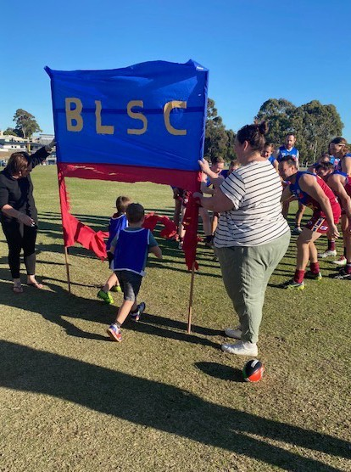ABOUT BELMONT LIONS SPORTS CLUB

Belmont Lions Sports Club (BLSC) has a long history within the community, dating back to 1965. The Club provides football and netball for all ages ranging from grassroots programs including Auskick and NetSetGO through to juniors and seniors.
Over recent years, the Club has undertaken significant changes through a collaborative push to improve its inclusivity through a healthy, welcoming and thriving sporting environment.

CLUB VISION
The BLSC Vision is to be recognised as a leader in community football and netball, through the delivery of an inviting environment based on unity and continual improvement.

CLUB VALUES
- Tolerance – listen and be open mined, be empathetic
- Respect – give it as you would want it received
- Action – be empowered, be courageous, be ambitious
- Inclusion – we are strong when working as one
- Diversity – celebrate the differences in each other

CLUB OBJECTIVES
To achieve their Vision, the Club has set out with some clear directives, these include:
- Ensuring that BLSC is inclusive of all people.
- The provision of welcoming and safe opportunities for children, youth and adults to participate relevant to their skill level and ambitions.
- Instilling greater cultural awareness and a sense of community connection and belonging.
- Higher player and volunteer retention rates through providing a safe and supportive environment.
- On field success including opportunities for finals and premierships across several age groups in both football and netball.

To meet the vision and objectives identified, BLSC has identified a range of requirements including:
- New club facilities.
- Improved financial position.
- Increased volunteerism, a more even workload for the Executive and improved succession planning.

ABOUT EAST BELMONT CRICKET CLUB

The East Belmont Cricket Club (EBCC) has long been known as a strong and successful club in the region. It has a history of healthy participation which has increased in recent years particularly in female cricket.
With substantial growth in the Club, including senior male and female sides and junior male and female sides, this growth is forecast to continue. At this point in time, the 2021/22 season is forecast to have the highest participation rate, by a significant margin, in the Club’s history.
In 2019, EBCC saw 9 female players which increased to 52 female players in 2021, which made up two senior women’s teams and one junior team. All three teams experienced huge success, seeing finals and grand final representation in their inaugural seasons. A number
of players, both male and female, were selected for representative squads and a number of senior players recognised in the league best and fairest awards. In 2021/22 the club expects to field 3 senior and 2 junior female sides.

Although the club has achieved considerable on-field success over an extended period of time its focus
on providing participation opportunities has been constrained by the lack of facilities available at Winter Reserve. This has somewhat been addressed in recent years with the establishment of new training facilities on Oval 1 and the provision of new change rooms through federal, state and local government funding. EBCC has also made significant cash contributions to these works. Despite the recent facility upgrades along with a coinciding increase in EBCC participation, the venue still falls well short of many of the venues within proximity and this continues to constrain the Club’s
growth potential. This shortfall was identified by the Club at a series of Strategy Workshops held in recent years
at which time it established a list of imperatives that needed to be achieved over the following 10 years for the Club to survive and thrive



PARTICIPATION

All tenanting clubs at Winter Reserve have aspirations to increase participation rates over the next 10 years.
As demonstrated in the charts below, and using available

FEMALE PARTICIPATION ONLY
90 84
80

participation data, BLSC has demonstrated growth in football over the past four seasons. Netball experienced a spike in participation in 2017, however has remained steady since this time. Cricket has experienced significant participation growth, particularly from 2019 to 2021. This is largely due to a collaborative effort in promoting and expanding its female and junior programs.
Participation figures for the 2021 football and netball season have not yet been finalised and note 2020 figures are not included due to COVID-19.
70
60
50
40
30
20
10 4
10

67

2016
70 69

52

14 16
8 7 7

2017 2018 2019 2021
Football Netball Cricket

CURRENT PARTICIPATION
300

250

200

150

100

50

0
2016 2017 2018 2019 2021
Football Netball Cricket

FUTURE PARTICIPATION FORECAST
A future participation forecast has been provided below. This forecast is based on achieving some of the strategic initiatives outlined previously in addition to the upgrade to its facilities at Winter Reserve, as identified in this report. Combined, these opportunities are seen as significant contributors to growing participation into the future. As below, football’s growth is expected to increasewith up to an additional 5 female football teams expected within the next 3-4 years. The most impact is expected however to be seen within netball, due to the inclusion of the change rooms and the second netball court they desperately require.
282
259
264
217
180
165
177
84
67
70
69
400
342
342
352
320 320
295 297
275
160
138
105
72
350
 | % change football | % change netball | % change cricket
2016 | - | - | -
2017 | +20.5% | +25.4% | -
2018 | +19.4% | -16.6% | -
2019 | +2% | -1.41% | +7.2%
2021 | TBA  following season conclusion | TBA  following season conclusion | +59%

300
250
200
150
100
50
0

2022 2024 2026 2028
Football Netball Cricket

 | % change football | % change netball | % change cricket
2022 | - | - | -
2024 | +8% | +46% | +8.5%
2026 | +8% | +31.4% | +6.9%
2028 | +6.8% | +16% | +3%

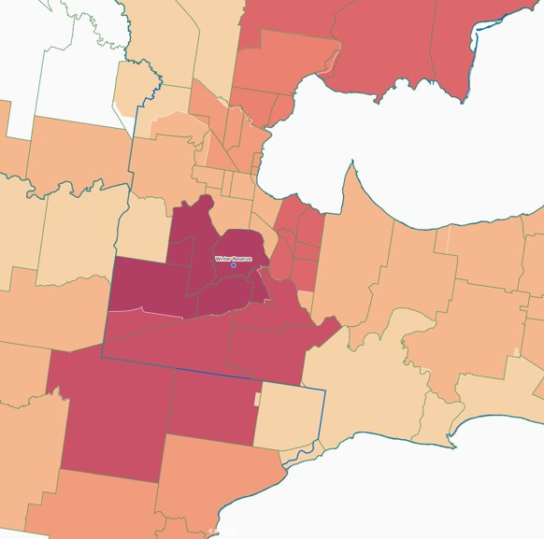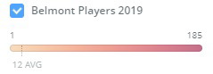Winter Reserve
Winter Reserve is currently host to many participants residing within Geelong’s key growth suburbs. This participant base is expected to increase significantly in line with population projections

AFL PARTICIPATION CATCHMENT
The AFL has detailed participation data including the residential postcode of players. The above heat map demonstrates where Belmont Lions Sports Club football participants resided in 2019. As demonstrated, the
vast majority of players are from the Belmont/Highton/ Grovedale/Waurn Ponds areas. The importance of drawing from a local catchment is essential to the health and prosperity of local clubs, and Belmont Lions is no exception. It should be noted that the second highest number of participants reside in the Armstrong Creek,
Mt Duneed, Charlemont areas which are expected to see exponential residential growth. There is a high probability that participant numbers from these
postcodes will increase as population increases. Note that due to the COVID-19 pandemic and its interruption

to sport, 2019 participation data has been utilised as it is more reflective of a regular football season.

Belmont, Highton, Grovedale, Waurn Ponds | 185
Armstrong Creek, Mt Duneed, Charlemont | 18
Lara | 11
Newcomb, East Geelong, Breakwater | 11
Corio, Norlane | 7
all other suburbs | 31

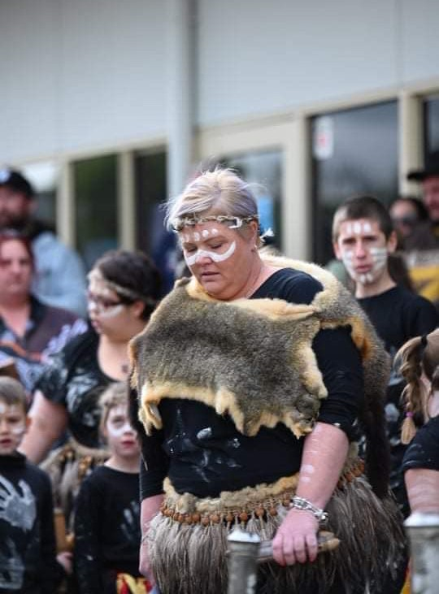COMMUNITY PROGRAMS AND INITIATIVES

WAUTHAURONG ABORIGINAL COOPERATIVE
Belmont Lions Sports Club has a long partnership with the Wathaurong Aboriginal Co-operative, spanning across 30 years. This includes the celebration of many Indigenous players both within the Club and across the competition, including hosting an annual Welcome to Country event and NAIDOC week celebrations. In 2021, BLSC and Wathaurong delivered their annual Indigenous Round which included smoking ceremony, flag raising, art display, Welcome to Country and cultural activities for children (see images adjacent). In addition, BLSC football and netball teams wore uniforms designed by local Indigenous artists and Traditional Owners.

THE GOLDEN LIONS
The Golden Lions are a dedicated group within the Belmont Lions Sports Club made up of past players, officials and members who assist junior footballers and netballers through tireless fundraising efforts. The benefits are focused on facilitating access to participation for children no matter their socio-economic status. Fundraising efforts include social events such as BBQ and pie nights
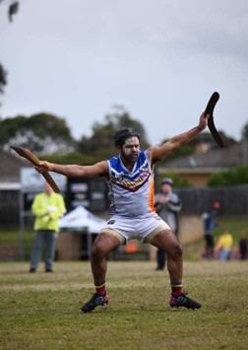
to assist families with membership (needs assessed) costs and playing equipment such as boots, shorts, and socks.

AUSKICK PROGRAM SUBSIDY AND JUNIOR SUPPORT
BLSC has a fund to support junior programs, which helps pay for capital items such as uniforms and training/ coaching equipment which, in turn, keeps junior fees as low as possible. All junior program memberships include umpires fees, insurance and uniforms. Junior membership cost are currently $130 per season which is low compared to other local clubs and very low compared to other junior sports programs. EBCC also currently provide
free junior membership to selected families to assist in alleviating the costs associated to participate.

FREE FEMALE CRICKET
EBCC has recently been able to harness and grow their female participant base significantly. As part of this, the Club has incentivised participation by making the first year of membership free for all females. EBCC also supports junior participation by maintaining one of the lowest junior membership fees in the region of $80 per junior or $140 junior family membership (2 or more junior siblings).

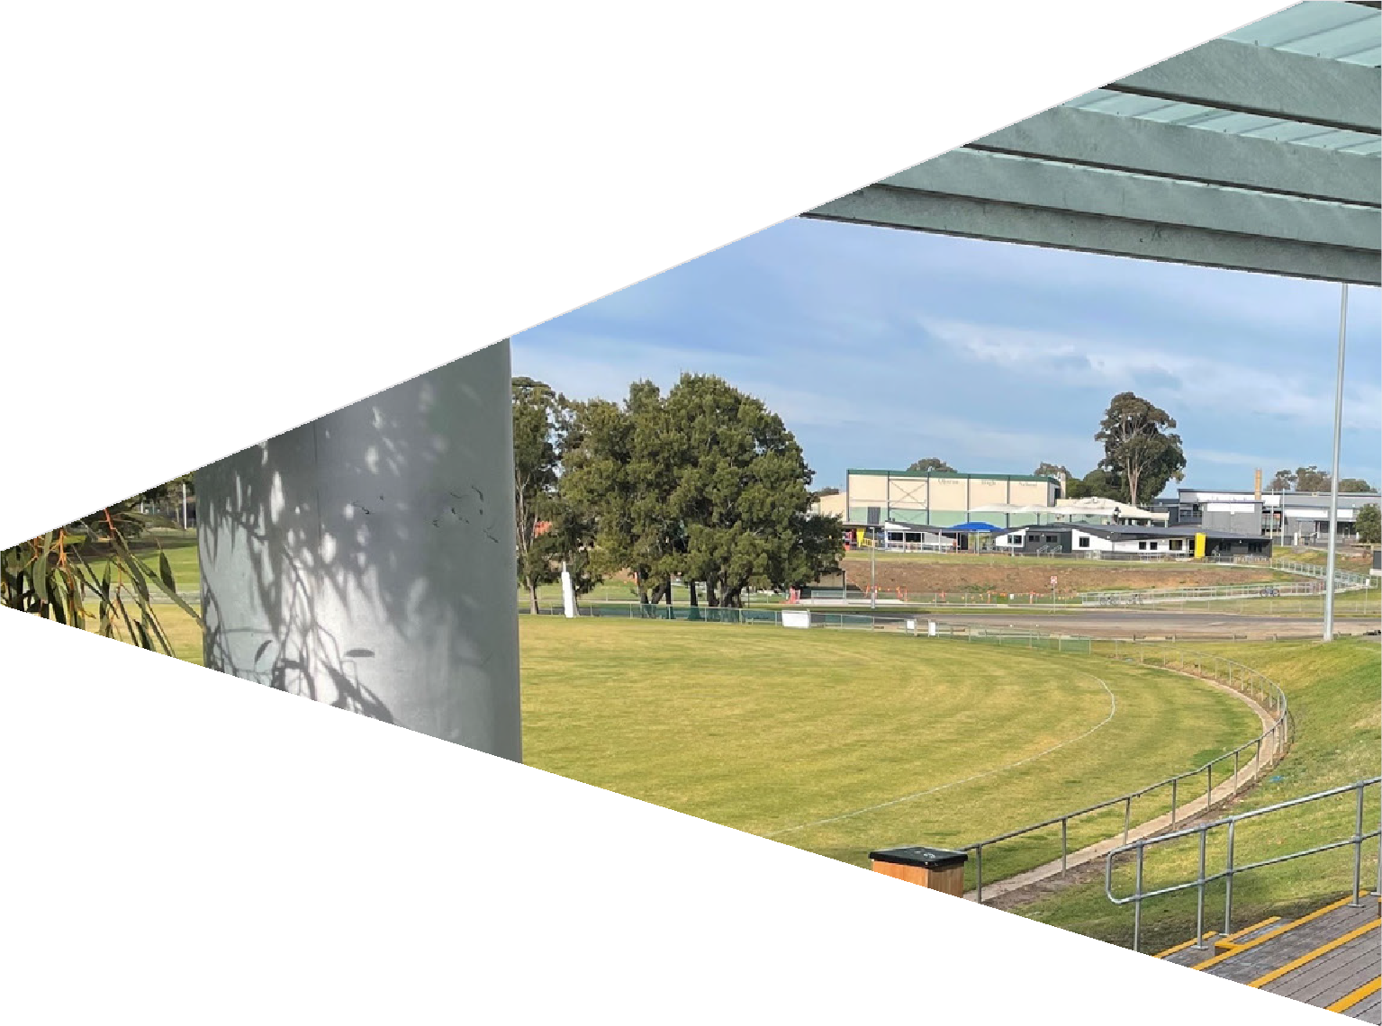

FACILITY DEVELOPMENT PLAN

1246.. 25.

GUIDING PRINCIPLES

The following principles have underpinned the Facility Development Plan and its recommendations. These principles align with the strategic documentation reviewed as part of the project, as well as the goals of a range of potential investment partners and peak sporting bodies.

GENDER EQUITY
Ensuring that facilities cater for all genders is a key focus and principle of the Facility Development Plan. Providing opportunities to participate irrespective of gender identity will ensure equitable outcomes. It is recognised that sport can be a vehicle for change and that it can empower women and those who are gender diverse. Bridging the gap in facility provision and creating more welcoming environments will assist tenanting clubs and their respective sports to break down participation barriers.

UNIVERSAL ACCESS
The upgrade to infrastructure at Winter Reserve will be based around universal design and access principles which sees any person of any ability, age, background or culture being able to successfully utilise the facility.

COMMUNITY INCLUSION
Offering broader community access outside of sport alone is one of the key guiding principles. Identifying ways to encourage broader community involvement, including multi use of facilities, has been considered throughout. The upgrade to Winter Reserve aims to enhance social cohesion and contribute to a more vibrant Belmont community.

PARTICIPATION AND PROGRAMMING
The ultimate outcome is that recommendations increase participation and programming opportunities for the sports identified. Increasing, retaining and attracting new players, officials and volunteers will enable clubs to drive participation for all genders and age groups, and to deliver more programming opportunities, including grassroots, entry level and flexible formats.

29.

LEGEND
- NEW SCOREBOARD FOR OVAL 1
- NEW TIMEKEEPERS BOX
- CONNECTING PATHWAYS
- EXISTING CRICKET NETS
- UNDERCOVER SPECTATOR AREA
- NEW NETTING BEHIND NORTH GOALS
- EXISTING PAVILION
- NEW NETBALL FACILITY UPGRADE
17 9 ANCILLARY CAR PARK UPGRADE
- MAIN CAR PARK
- NEW NETBALL SPECTATOR SHELTER
- EXISTING NETBALL COURT

- NEW NETBALL COURT
- RELOCATED BASKETBALL HALF COURT
- RELOCATED PLAYGROUND
- ANCILLARY CAR PARK
- ENTRY SIGNAGE
- SEATING
- EXISTING PLAYER SHELTER
- NEW PLAYER SHELTER
- NEW NETTING BEHIND SOUTH GOALS
- EXISTING TURF CRICKET NETS
- EXISTING CRICKET SHED
- NEW ACCESS GATE TO OVAL
COURT LIGHTING - MIN 100 LUX

3 6
5 8
24 7
10 3
L

EX.L
11

L

19 12 L

2 13 20 18
EX.L

OVAL 1 OVAL 2

L
18 L 14
3

FLOODLIGHTS ON OVAL LIGHTING UPGRADE IN PROGRESS
FLOODLIGHTS ON OVAL 15
FUTURE UPGRADE TO 100LUX SYSTEM
SURFACE UPGRADES AND IMPROVEMENTS INCLUDING DRAINAGE

1 16

3
23 4
9
22 21

17

WINTER RESERVE SITE PLAN GLYN STREET, BELMONT CITY OF GREATER GEELONG

FOUR18.COM.AU

2 Wrriightt Pllace Geellong

DATE: JOB NO: SCALE:

29/10/2021
G17023
As indicated

@A1

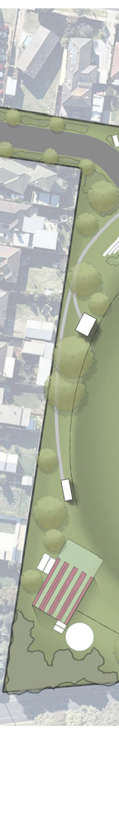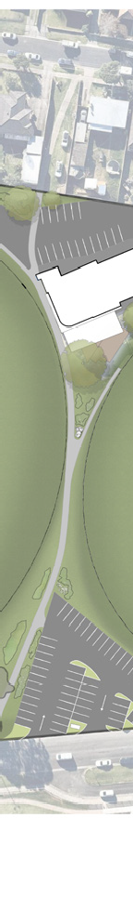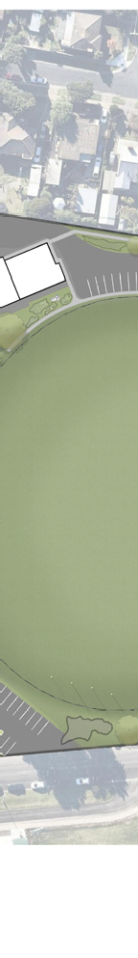
SITE PLAN
30.
FILE: R:\Projects & Proposals\G21019 Winter Reserve Concept\7.0 Architectural Drawings\Winter Reserve Concept.rvt

Note: This drawings is copyright. Unauthorized use of this design is prohibited and may only be reproduced with the express written consent of the architects.
NORTH
iinffo@ffourr18..com..au
PO Box 748 geellong 3220
T:: 03 5222 5944 F:: 5222 5049
DRAWING NO:
SK02

CAGED STORAGE PARTITIONS. CAGE LAYOUT TO FUTURE DESIGN

DEMOLISH EXISTING KERB TO ALLOW FOR NEW EXTENSION

NEW SECTION OF KERB TO SUIT NEW EXTENSION. MIN 1000mm OFFSET FROM WALLS FOR PEDESTRIAN ACCESS

NEW PEDESTRIAN CROSSING OVER ROADWAY

ADDITIONAL WIDTH OF EXISTING ROADWAY TO ALLOW FOR RELOCATED KERB

PEDESTRIAN FOOTPATH TO NETBALL COURTS

CORNER WINDOW TO CRICKET SCORERS

CRICKET SCORERS
6 m²

DRY STORE
6 m²

NEW SECTION OF CONCRETE FOOTPATH

NEW SHUTTER AND OPENINGS FOR KIOSK SERVERIES

KITCHEN/KIOSK
29 m²

OFFICE
1000
12 m²

NEW ACCESS DOOR TO KITCHEN

STORE
60 m²

NETBALL OFFICE
10 m²

NEW VERANDAH EXTENSION

FIRST AID
10 m²

NEW SHUTTER & OPENING TO BAR
NEW STACKING DOORS FOR BAR ACCESS TO DECK

SOCIAL
133 m²

BAR
21 m²

COOL ROOM

HOME
34 m²

AWAY
34 m²

UMPIRE
25 m²

DRAIN

OPERABLE WALL BETWEEN HOME AND AWAY

NEW CAFE BLINDS TO ALFRESCO AREA

PAVILION EXTENSION GLYN STREET, BELMONT
CITY OF GREATER GEELONG

FOUR18.COM.AU

2 Wrriightt Pllace Geellong

DATE: JOB NO: SCALE:

29/10/2021
G17023 1 : 100

@A1

FILE: R:\Projects & Proposals\G21019 Winter Reserve Concept\7.0 Architectural Drawings\Winter Reserve Concept.rvt

Note: This drawings is copyright. Unauthorized use of this design is prohibited and may only be reproduced with the express written consent of the architects.

NORTH
iinffo@ffourr18..com..au

PO Box 748 geellong 3220
T:: 03 5222 5944 F:: 5222 5049
DRAWING NO:
SK01


BUILDING CONCEPT PLAN
31.

INVESTMENT OPPORTUNITIES

It has been recognised throughout this report that a collaborative approach to investment is required to achieve recommendations. Opportunities for partnerships via club, local, state and other community sources should be explored. At the time of writing this report, the below funding programs and opportunities are available and align with recommendations.

City of Greater Geelong’s Community Infrastructure Grants Program
This program aims to support funding for the planning and delivery of capital works projects for community groups within the City of Greater Geelong. This includes grants available for amounts up to $350,000.

Sport & Recreation Victoria Local Sports Infrastructure Fund*
This Fund aims to provide a range of grant opportunities across funding streams including Female Friendly Facilities (up to $500,000), Community Sports Lighting (up to $250,000) and Scoreboards and Fixed Equipment (up to $25,000).

Sport & Recreation Victoria Community Cricket Program*
This Program aims to support cricket participation in Victoria through high-quality and welcoming facilities. The objectives of this program aim to be achieved through providing funding for projects such as upgrading of existing and construction of practice facilities, club room developments, playing field upgrades and sports lighting initiatives. Up to $100,000 in grant funding is available.

Sport & Recreation Victoria Country Football & Netball Program*
This fund aims to enhance participation opportunities in football and netball through improved playing surfaces, gender-neutral player and umpire change facilities and sports lighting upgrades. Up to $150,000 is available through this program.

Club fundraising
Clubs tenanting Winter Reserve may have opportunities to fundraise to support the delivery of the identified infrastructure upgrades. Where applicable, clubs should be encouraged to create a sinking fund that helps support the implementation of the Facility Development Plan,
and to support Council in their pursuits to leverage both internal and external funds. At the time of writing this

report both Clubs at Winter Reserve have infrastructure sinking funds to support delivery.

Council’s budget process
Each year Council prepares a budget which provides funding for the delivery of community services, programs, and infrastructure in line with its respective Council Plan. There are opportunities for items identified within the Facility Development Plan to be considered via this process.

Council’s cyclical budgets
Council has cyclical budgets for the maintenance and renewal of minor infrastructure items. A small number of recommendations within the Facility Development Plan could be considered within relevant cyclical programs.

Other funding programs
On occasion the Victorian Government, via Sport & Recreation Victoria, releases additional funding programs which run over a shorter timeframe. In 2020-21 SRV released a Community Sports Infrastructure Stimulus program which was aimed to provide investment into recreation facilities following the COVID-19 pandemic.
Initiatives such as this offer other opportunities for funding.

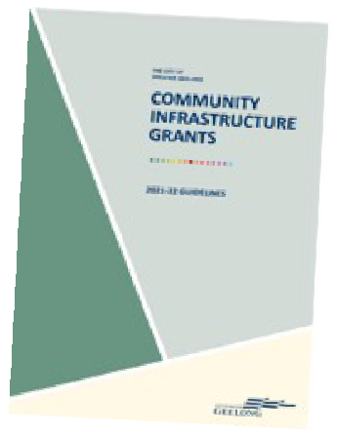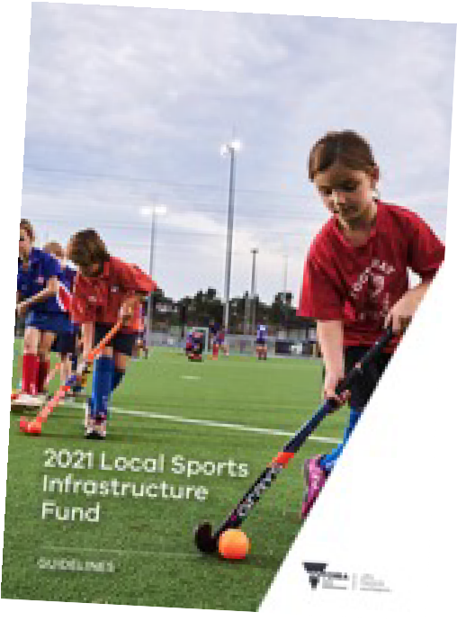
*These programs require Council’s to apply directly to Sport and Recreation Victoria on behalf of sporting clubs. The City of Greater Geelong considers and prioritises applications in line with the funding criteria and to existing policies and strategies

IMPLEMENTATION

To assist with implementation, key infrastructure recommendations have been prioritised in partnership with stakeholders. Their alignment to the Plan’s guiding principles and costs associated are outlined below. Note that information regarding infrastructure items not listed below can be found within the site plan on page 30 and within the attached Quantity Survey.

PRIORITY 01 - PAVILION UPGRADES INCLUDING NETBALL CHANGE ROOMS, STORAGE, KITCHEN AND SOCIAL ROOM ENHANCEMENTS

Description | Cost | Alignment to FDP Principles | Funding opportunities for delivery
Provide all gender, universally designed change facilities for netball players and umpires as per plans provided. As part of this development, also provide storage for all user groups. Opportunity to consider the inclusion of a small gym space within the storage area given the floor plan will be flexible in nature. In addition, enhance and  relocate the kitchen so that it has a larger footprint and has greater functionality. Undertake minor improvements to the social room area to allow for greater integration with outdoor areas. | $1.7m* |  | Council’s budget process  SRV Country Football & Netball Program*  SRV Local Sports Infrastructure Fund*  *Both require Council contributions
PRIORITY 02 - BEHIND GOAL NETTING

Description | Cost | Alignment to FDP Principles | Funding opportunities for delivery
Behind goal netting to northern and southern ends of Oval 1 to prevent errant balls from entering neighbouring properties, improving safety for residents, players and officials. | $40,000 |  | CoGG Community Infrastructure Grants  Club fundraising
PRIORITY 03 - SECOND NETBALL COURT + COMMUNITY PLAYGROUND

Description | Cost | Alignment to FDP Principles | Funding opportunities for delivery
Construction of second netball court as well as spectator and players shelter as per Plan to provide greater participation opportunities and align with other like local facilities. As  a result of second netball court construction, relocate the existing half-basketball court and community playground as per Plan. Integrate these play components so that it appeals to a broader age range, from children through to youth. | $475,000* |  | SRV Country Football & Netball Program*  Council’s budget process  *Both require Council contributions

*May not include design and cost contingencies and other allowances. Refer to associated Quantity Survey attached to this report. Items highlighted within this table are those which are considered critical to be achieved. Actual cost to achieve the entirety of upgrades identified at Winter Reserve is approximately $5.06M.

PRIORITY 04 – VEHICLE AND PEDESTRIANS
PRIORITY 05 – ELECTRONIC SCOREBOARD

Description | Cost | Alignment to FDP Principles | Funding opportunities for delivery
Improve vehicle and pedestrian movement throughout the site. Main priorities include formalising path between main club rooms and netball courts as well as the southern car park. | $526,000* |  | Council’s budget process

Description | Cost | Alignment to FDP Principles | Funding opportunities for delivery
Provision of electronic scoreboard to contribute to overall quality of facility, as per others in the region, and offer greater opportunities for sponsorship engagement. | Funded |  | CoGG Community Infrastructure Grants  Club fundraising Other local sources

*May not include design and cost contingencies and other allowances. Refer to associated Quantity Survey attached to this report. Items highlighted within this table are those which are considered critical to be achieved. Actual cost to achieve the entirety of upgrades identified at Winter Reserve is approximately $5.06M.

PROJECT BENEFITS

GROWTH AND EQUAL OPPORTUNITIES FOR NETBALL PARTICIPANTS
1
through providing facilities that support players - including change rooms, amenities and umpire facilities.

IMPROVED CAPACITY FOR FOOTBALL AND CRICKET PLAYERS
2
through enhancing facilities that will make Winter Reserve comparable to other local venues in the region.

IMPROVED PROGRAMMING OUTCOMES
3
through facility enhancement that give clubs greater flexibility in how they deliver the various formats of the
game, and creates space for the initiation and delivery of modified formats across all ages and genders.

ENHANCED FACILITY OPERATIONS AND REDUCED VOLUNTEER BURDEN
4
by improving the quality and capacity of facilities, creating a more streamlined operation.

SAFER AND MORE ACCESSIBLE FACILITIES
5
by increasing the connectivity and quality of the Reserve and its facilities to provide greater feelings of safety and
inclusion for people of all abilities.

broad range of future needs both for the Club and the community we support”
Club, particularly for netballers. The Facility Development Plan will help us address a
“We have an immediate focus to improve female friendly change facilities at the
– Mark Edwards, President, Belmont Lions Sports Club

- Tom Scannell, President, East Belmont Cricket Club
“For the East Belmont Cricket Club to reach its potential, achieve its goals and fulfill
supporting infrastructure we require.”
the needs and establishing an achievable funding strategy to deliver the additional
volunteers. The Facility Development Plan will be the cornerstone to identifying
levels can be achieved when better amenities are available for participants and
facility improvements at Winter Reserve have proven that increased participation
its purpose it is essential that the facilities at Winter Reserve continue to match
those that are available at other sporting reserves within the Geelong region. Recent

STAKEHOLDER SUPPORT

17 November 2021

To whom it may concern

The Geelong and District Football League fully supports the Belmont Lions FNC in their endeavours to develop and upgrade the facilities at Winters Reserve

The Club has made significant progress recently, including seeing an influx of netball players which currently do not have adequate facilities they require.

The League and its member clubs consider that redevelopment of additional netball change rooms essential to facilitate a welcoming and inclusive environment to support female participation...
.

In addition, the construction of a second netball court will allow the Leagues netball competition to continue to expand by creating additional capacity for participation and programming
.

We look forward to seeing the redevelopment of Winterl Reserve and that its progress is considered favourable to support both football and netball into the future

Alan Moore Secretary
Geelong and District Football League



19 November 2021

Ms Zoe Sells
InsideEDGE Sport and Leisure Planning 417 Barkly Street
West Footscray VIC 3012

Dear Zoe,
Re: Infrastructure Development – Winter Reserve, Belmont

Netball Victoria is pleased to support the City of Greater Geelong and the Belmont Lions Football Netball Club for identifying the need to provide suitable facilities at Winter Reserve.

The Belmont Lions Football Netball Club play within the Geelong & District Football League and have netball teams playing in both the junior and senior competition. The development of the second netball court with lighting, will give the club a much stronger opportunity to grow participation and attract new players to the club. It will also help the club facilitate and schedule both training needs and game day
requirements.

In addition, the project will provide a much-needed netball change facility at the reserve. Currently, there are no facilities dedicated to netball, and NV applauds this development. NV will work with the Council and the Club to ensure they are being provided with compliant and safe facilities.

Netball Victoria congratulates the City of Greater Geelong and is supportive of the above project. NV has been able to provide feedback to Council on the initial concept designs for the project and looks forward to working together to ensure the project meets compliant netball requirements, and improved outcomes for the netball community and the overall sporting community.

If you have any questions or would like to discuss the project in more detail, please contact me on 0439 308 211 or at tania.lund@netballvic.com.au

Yours sincerely,

Tania Lund
Western Region Manager Netball Victoria

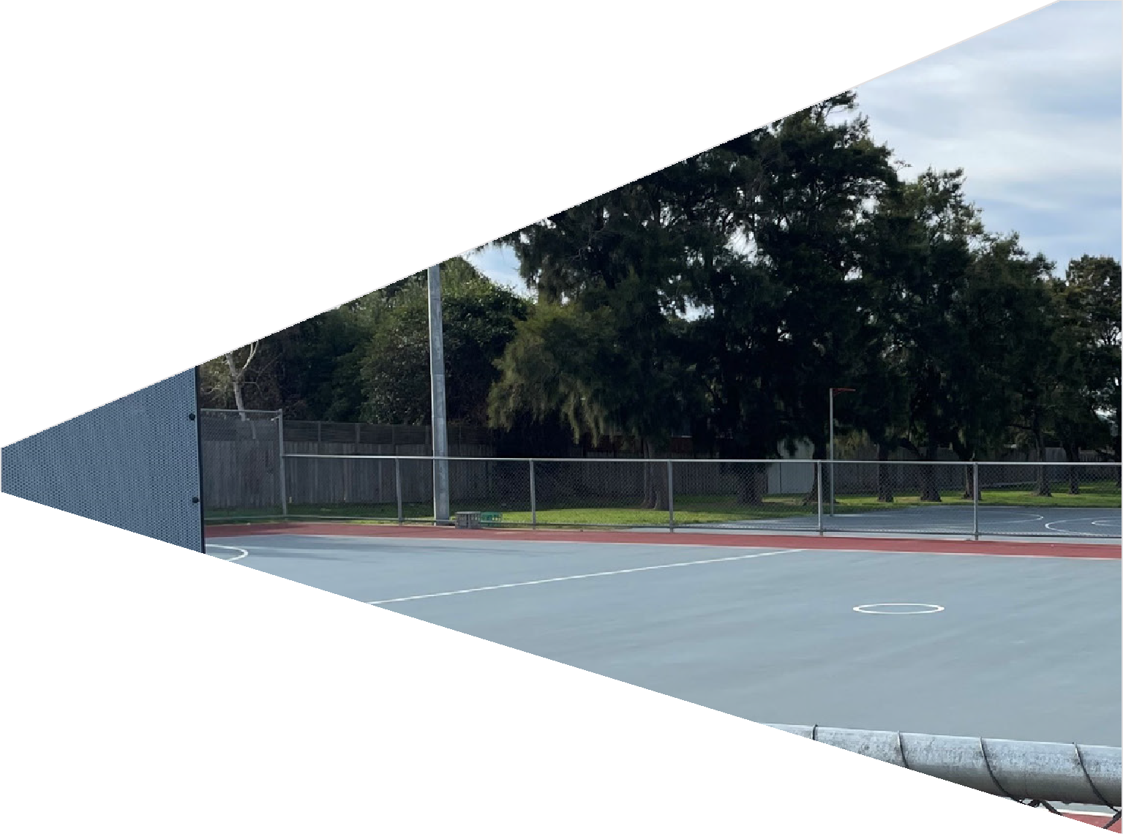

APPENDICES

33.

QUANTITY SURVEY

GEELONG
2 Hampt on St , Newt own VI C 3220 03 5222 2562
ABN 31 600 499 965
MELBOURNE
Suite 3/ Level 1, 420 Spencer St , West Melbourne VI C 3003
03 9052 3212
info@zinccm.com.au



Ref 21346-cp1B

13 December, 2021

insideEDGE Sport & Leisure Planning Whit ten Oval, 417 Barkly St reet WEST FOOTSCRAY VI C 3012

Via email zoe@ieslp.com.au At tent ion Ms. Zoe Sells Dear Zoe,
Wint er Reserve Pavilion & Sit e Works
Cost Plan No. 1B

We have prepared revised Cost Plan No. 1 for the above project based on the documentation provided and our discussions.

Cost Summary
The cost plan can be summarised as follows:

 | Building Works ( $) | Sit e Works ( $) | Tot al ( $)
Building Works | $1,004,000 | N/ A | $1,004,000
Ext ernal Works and Services | $333,000 | $2,660,000 | $2,993,000
Sub-Tot al ( excl. GST) : | $1,337,000 | $2,660,000 | $3,997,000
ESD I nitiatives | $13,000 | EXCLUDED | $13,000
Cont ingencies and Cost  Escalat ion | $199,000 | $390,000 | $589,000
Non-Const ruction Cost s | $154,000 | $306,000 | $460,000
TOTAL END COST ( excl. GST) : | $1,703,000 | $3,356,000 | $5,059,000

Please refer to the at tached cost plan for further informat ion and scope of works included. All costs are reported exclusive of GST.

Document at ion
The cost plan is based on Concept Design document ation and has been prepared using the following:
- Architect ural drawings prepared by FOUR18 Architecture dat ed 29 Oct ober, 2021
- Net ball Court drawing prepared by Sport Eng dated 23 July, 2021
- Correspondence from insideEDGE Sport & Leisure Planning received up to 13 December, 2021

zinccm.com.au

SPORTENG WINTER RESERVE NETBALL COURT DESIGN
40.
30.5m
3.1m

831m²(APPROX.)

132m²(APPROX.)


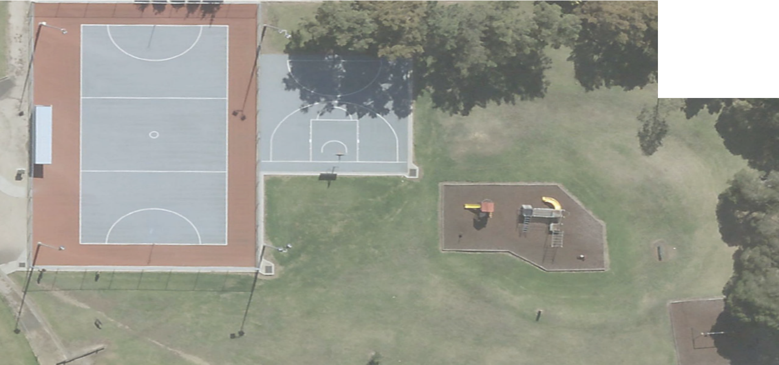 PROJECT: WINTER RESERVE
LEGEND:

1.35m WIDE SINGLE GATE SPORTS LIGHT TOWER

GRATED INLET PIT
PROPOSED LIGHT UPGRADE
3.0m HIGH CHAIN MESH FENCE ON 0.2m WIDE CONCRETE EDGESTRIP.
3.0m HIGH CHAIN MESH FENCE

1.05m HIGH CHAIN MESH FENCE
PROPOSED FSL 700mm ABOVE EXISTING SURFACE. BATTER DOWN TO EXISTING AT MAX 1:20 FALL
CONCRETE NETBALL COURT

CONCRETE FOOTPATH
PROPOSED LIGHT UPGRADE
PLAYERS SHELTERS / OFFICIALS AREA
1.05m HIGH CHAIN MESH FENCE ON
0.2m WIDE CONCRETE EDGESTRIP.
0.6m CONCRETE SPOON DRAIN
EXISTING CONTOURS (TYP.)
PROPOSED EXTENT OF BATTER
NETBALL CONCRETE COURT
(30.5m x 15.25)
PLAYERS AND UMPIRES SHELTERS
REMOVE EXISTING LIGHT
RETAIN EXISTING GRATED INLET PROPOSED LIGHT UPGRADE
NETBALL GOAL POSTS (TYP.).
PROPOSED LIGHT UPGRADE
CONNECT NEW INLET PIT TO EXISTING STORMWATER NETWORK

PEDESTRIAN ACCESS GATE (TYP.)
PROPOSED FSL 1700mm ABOVE EXISTING SURFACE. BATTER DOWN TO EXISTING AT MAX 1:20 FALL
PROPOSED GRATED INLET PIT
2m 0.6m
3.8m
15.3m
3.1m
1.6m
PROPOSED FSL 1000mm ABOVE EXISTING SURFACE. BATTER DOWN TO EXISTING AT MAX 1:20 FALL
3.1m
2m

PROJECT NO: | 10883-00 | SKETCH TITLE: GENERAL ARRANGEMENT PLAN | SKETCH NO: | SE_10883_SKT001_A | REV: | B | DATE: | 23/07/21 | DRAWN BY: | FWS | SCALE: | 1:100 | @ A1

© SPORTENG

LOCAL PLANNING CONTEXT

On page 9, the supporting strategic documents which align to this Plan are identified. This includes key City of Greater Geelong strategies which will have the greatest influence on this report. A more detailed summary of each is provided below.

CITY OF GREATER GEELONG COUNCIL PLAN 2018-2022
The Council Plan 2018-22 outlines how the City will work towards making Greater Geelong a clever and creative city-region. It guides the City of Greater Geelong’s resources to deliver infrastructure, services and programs to the community in a sustainable way. The City’s Council Plan outlines 11 strategic goals towards achieving its priorities which align with available resources to deliver infrastructure, services, and programs to the community in a sustainable way.
The Council Plan includes key focus areas which will be considered within the development of this project,
including: 1) Informed social infrastructure and planning – through providing more quality spaces that support active lifestyles as well as supporting the growth of localised sporting facilities 2) A more inclusive and diverse community through promoting gender equity
and diversity in sporting facilities and improving access to facilities for people of all abilities.

CITY OF GREATER GEELONG
SOCIAL INFRASTRUCTURE PLAN: GENERATION ONE 2020-2023
This document sets the strategic drivers for decision making and prioritisation in relation to the planning, development, and investment of social infrastructure in the City of Greater Geelong. The Plan aims to ensure that future investment decisions in community infrastructure and services is clear, fair, equitable and based on evidence of need and insights from the Geelong community.
Five (5) directions for the strategic development of outdoor community sporting facilities are identified in the Plan, including the investment in infrastructure that improves the quality, functionality and carrying capacity of venues and the activation of facilities to increase participation and maximise use.

CITY OF GREATER GEELONG SOCIAL INFRASTUCTURE PLANNING &
INVESTMENT POLICY 2020
This Policy also supports the City of Greater Geelong’s Social Infrastructure Plan: Generation One and aims
to provide further clarification in the prioritisation of investment into community assets. The Policy aims to guide fair and equitable decisions and to provide the community with a clear understanding of the City’s role in investment and how decisions are made.
The Policy and its principles, which include community engagement, evidence based decision making, service delivery where it’s most needed and fair and equitable decisions which align with Council’s strategic priorities will be fundamental pillars in the development of the plan. Understanding future demand projections, equity in
facility access and provision levels will contribute to robust decision making and investment.

CITY OF GREATER GEELONG
PO Box 104
Geelong VIC 3220
P: 5272 5272
E: contactus(a)geelongcity.vic.gov.au www.geelongaustralia.com.au

CUSTOMER SERVICE CENTRE
100 Brougham Street
Geelong VIC 3220 8.00am - 5.00pm

© City of Greater Geelong 2021

LATEST NEWS:
(D (a)CityofGreaterGeelong
@ (a)GreaterGeelong
@ (a)CityofGreaterGeelong
@ CityofGreaterGeelong

CITYOF GREATER
GEELONG

