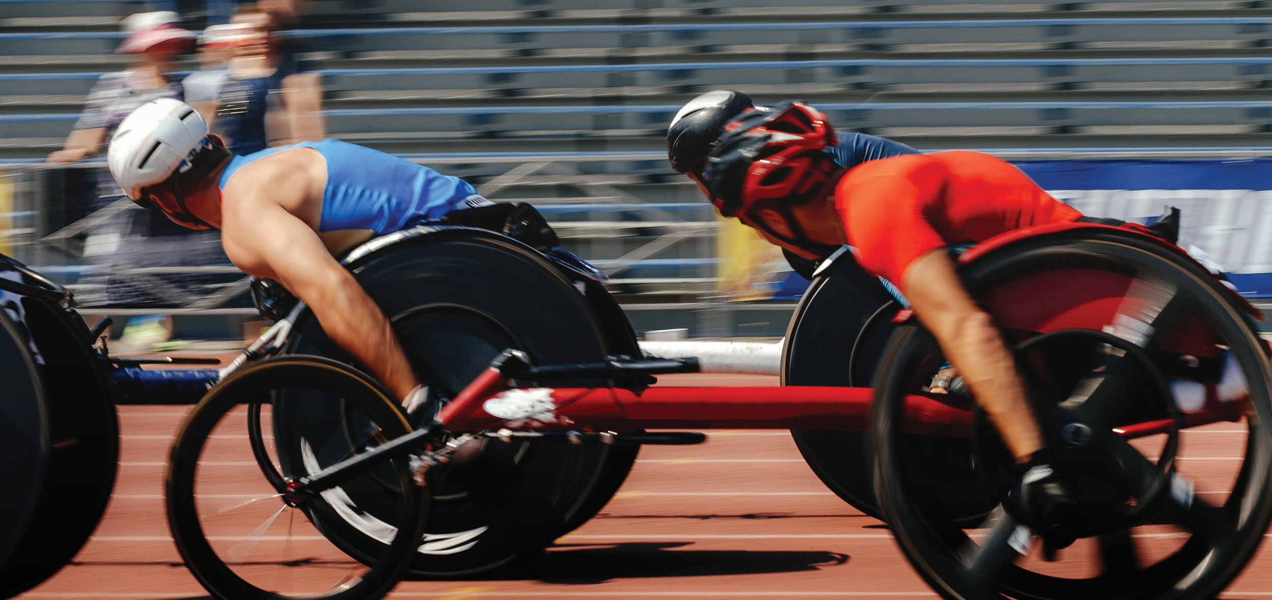JOHN LANDY ATHLETICS FIELD
FACILITY IMPROVEMENT PLAN - SUMMARY



APRIL 2022
Prepared by Otium Planning Group Pty Ltd www.otiumplanning.com.au

THE PROJECT

The facility:
THE JOHN LANDY ATHLETICS FIELD IS GEELONG’S REGIONAL ATHLETICS FACILITY SERVICING THE GREATER GEELONG AND BARWON SOUTHWEST REGION


Enhances and builds on Geelong’s host city reputation

Attracts regional and state athletics championships that showcases the region outside the municipality to prospective domestic visitors and in turn generates social, tourism and economic benefits

Integrates and supports athletic performance pathways

Attracts a high (and increasing) participation whilst profiling the sport in the region

Fosters partnerships, improves the capacity, capability and cohesion across athletics stakeholders (local clubs, regional association, state and national bodies) together with Local and State Government

Planning Process
The John Landy Athletics Field is the City of Greater Geelong’s premier regional athletics facility. It is a national standard synthetic track. However, the facilities have reached an age and condition where renewal is now required.
The City of Greater Geelong is also experiencing rapid growth. The population will grow from 258,834 (ERP 2019) to 393,216 by 2041 (.idcom-
munity), almost double the current population (49% growth). The demand for access to athletics facilities will continue to grow on the back of this growth, particularly in the urban growth corridor of Greater Geelong.
It is for these reasons a review into the future use and role of John Landy Athletics Field was needed. The City of Greater Geelong engaged Otium Planning Group to prepare a Facility De- velopment Plan for John Landy Athletics Field.
The Facility Improvement Plan has identified short, medium and long-term facility improve- ments required to service the athletics needs in the Geelong and Barwon Southwest Region. The Plan has also determined an appropriate management model for the facility.
The study included the following phases:
ISSUES AND
- Strategic investigation to determine the future service level of the reserve. This includ- ed a strategic review, demand assessment and trends and benchmarking analysis.
- Site and facilities review that considered the condition and compliance of existing facilities with athletics facility standards and contem- porary sports facility design principles and standards.
REPORT
- Engagement process with key stakeholders to discuss current use, issues and future needs.
- Issues and Options Report that summarises the key findings from market research, facility review and engagement tasks and includes a Functional Design Components Schedule.
- A concept design for the pavilion and an illustrative landscape plan for reserve improvements. The improvements have been costed by an independent Quantity Surveyor.
- A Report that summarises the key challenges and development options for John Landy Athletics Field together with an implementa- tion plan and funding strategy for improve- ments.
To deliver the above phases of the project, the key tasks for the project are outlined below.
BACKGROUND RESEARCH

SITE AND FACILITIES REVIEW

STAKEHOLDER ENGAGEMENT
OPTIONS REPORT

CONCEPT DEVELOPMENT
The project has involved an extensive consultation process with relevant Council departments, key stakeholders including Geelong Little Athletics Centre and Geelong Athletics, School Sports Victoria, peak athletics bodies including Little Athletics Victoria and Athletics Victoria and relevant Government departments.
A detailed Facility Improvement Plan report now supports the project. This Summary report provides a summary of key findings.

WHY DO WE NEED A FACILITY DEVELOPMENT PLAN?

The John Landy Athletics Field is very well used seven days a week by the two key tenants being Geelong Athletics Inc and Geelong Little Athletics Centre Inc, by schools for school carnivals and
PE athletics classes, by private coaches and by community for casual recreational running. The facility also hosts state level athletics championships.
There were 280 members of clubs affiliated to Geelong Athletics Inc and 625 members of clubs affiliated to Geelong Little Athletics Centre Inc in 2019/20, and over 80 schools in the Greater Gee- long area that use the facility. The venue attracts over 230 bookings each year! Clubs have advised of an increase in membership in 2021/22.
The use of the facility shows one that is operat- ing at near capacity. The population growth will result in an increasing demand for organised athletics member participation and certainly
an increase in recreational running at athletics facilities. If the current participation rates are maintained, the Geelong Athletics Inc and Geelong Little Athletics Centre Inc will grow from 905 athletes in 2019 to 1,374 athletes in 2041. An additional 469 athletes. There will also be a growing demand for use by schools.
All key stakeholders including Athletics Victoria, Little Athletics Victoria and School Sports Victoria, the catchment analysis and post code analysis

of Geelong Athletics Inc and Geelong Little Athletics Centre Inc affiliate club memberships show the John Landy Athletics Field providing a regional / state athletics facility.
The Facility Improvement Plan responds to the IAAF Technical Track and Field Facilities Manual (1 November 2019) requirements of a regional / state athletics facility. The Technical Assessment conducted by SportENG Engineers identified the following issues with the design and condition of the athletics track to meet this standard:
- The throwing vector for the hammer throw circle (cage) is in direct conflict with the current long jump and triple jump pits and runway
- The shotput landing segment interface with the Javelin runway
- The synthetic track will require renewal in the short term
- Sand landing pits run way requires extending to achieve World Athletics dimensions
- Javelin throwing vector clash with pole vault facility
- Front straight track requires extending to achieve 17m run off distrances for all lanes
- The lighting will require renewal in the medium term
Other key issues identified through the site analysis, benchmarking analysis and stakeholder engagement include:

- There are multiple buildings on site that don’t meet contemporary sports facility design standards including responding to universal design principles and female friendly guide- lines
- The facility attracts high use by schools in the Greater Geelong area. These schools have on average 200 and 300 students participating for each event with some schools having over 700 students participate in school athletics carnivals. There is insufficient seating and shade to provide for these events. This seating requirement is a mandatory require- ment to host State Little Athletics Champion- ships and AV Shield and would support the annual Steigen Spectacular Athletics Meet.

Growing population in Greater Geelong leading to an increased athletics participation demand

There are safety concerns and asset renewal requirements for the athletics track and field
- The Barwon Sports Academy is seeking a home for a gym and group fitness activity space to accommodate strength and conditioning training for 10 to 15 athletes each session (12 sessions each week).

Opportunity to optimises use, returns a sustainable operational performance and deliver a social and economic benefit to the region
- Recreation areas including playground area, fitness station, seating and shade and
pathways require renewal and improvement. These works will improve use and disability access.
- Photo finish building and camera tower and PA system require renewal.

JOHN LANDY ATHLETICS FIELD

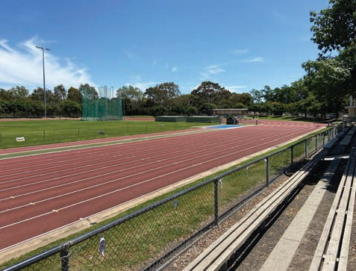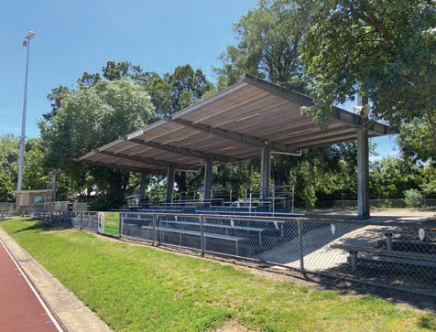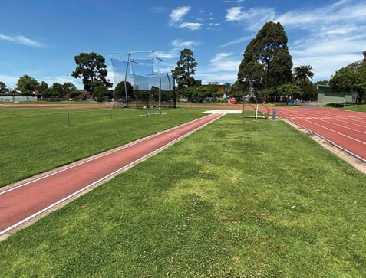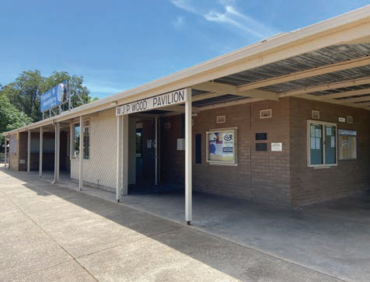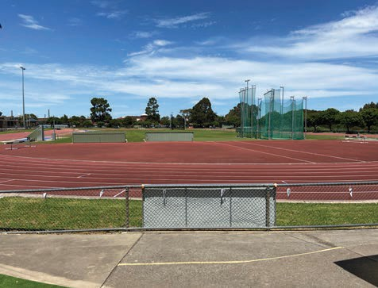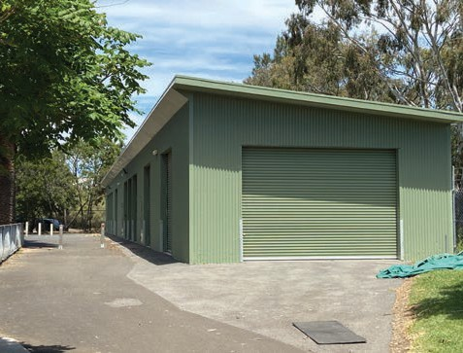

WHAT DID WE HEAR FROM STAKEHOLDERS?

A number of interviews and workshops were conducted with key stakeholder groups and peak sporting bodies to gain an understanding of the current participation and usage trends and the strategic priorities for athletics within the Greater Geelong Region.
The following list of stakeholders were interviewed:
- Geelong Little Athletics Centre
- Geelong Athletics
- Barwon Sports Academy
- School Sports Victoria
- Little Athletics Victoria
- Athletics Victoria
- Sport and Recreation Victoria
- Tourism Geelong
- Deakin University
- City of Greater Geelong departments includ- ing across traffic and engineering, strategic and statutory planning, Community and recreation and arborist
- Advice was obtained from other stakehold- ers including the Corangamite Catchment Management Authority

What we heard?
All key stakeholder support John Landy Athletics Field maintaining its regional / state athletics facility role in Greater Geelong and Barwon Southwest region.
 | 
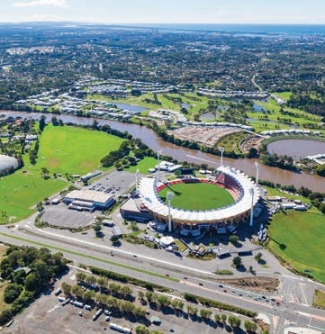 | 

The facility is very well used by the two key tenants being Geelong Athletics Inc and Geelong Little Athletics Centre Inc, by schools and by community. The facility also hosts state level athletics championships. The Facility Improve- ment Plan will need to respond to regional
/ state athletics facility standards and major participation / spectator event requirements.
Athletics Victoria and Little Athletics Victoria support John Landy Athletics Field as the regional / state athletics facility and a new ‘local’ athletics facility in the Armstrong Urban Growth Area. This new venue will take pressure off the John Landy Athletics Field but also support the 55,000 to 65,000 new residents and a growing Surf Coast Shire population.
The Barwon Sports Academy has a strong relationship with the athletics club and the strategic link of the academy with the regional athletics facility through providing a gym and group fitness activity space is well received.

Peak Sporting Bodies highlighted the following benefits of John Landy Athletics Field that sup- port it being the regional / state athletics facility for the Barwon Southwest region:
- Central location with access to public and active transport options
- Inviting place that athletes enjoy competing at
- Located within a sports precinct that has rowing clubs and Kardinia Park Stadium
- Quality standard track that meets require- ments for regional / state level events
- Ancestral home of athletics and little athletics in Geelong
- Easily accessible by schools
- Geelong Athletics Inc and Geelong Little Athletics Centre are some of the best run clubs in Victoria. They have strong mem- berships and will continue to be based at John Landy Athletics Field due to the above factors.
All key stakeholders were open to investigating management options for John Landy Athletics Field together with the employment of a Centre Manager to oversee bookings, pack up and set up of equipment, maintenance and improve- ments, manage relationships with key stakehold- er groups and promote use of the venue.
Key facility improvements identified by key stakeholders include:
- A new modern pavilion that consolidates all functions into one facility including competi- tion office, public toilets, change rooms, canteen / kiosk, social and community room, meeting room and uniform store. Consider a single point of entry for the facility
- Barwon Sports Academy seek a small gym and group fitness space to support their high performance program.
- Renewal of the athletics track and development of an asset renewal and maintenance plan
- Review design of track and field layout needs to address conflict areas and maintain regional / state level standard. Consider relocation of jumping pits and runway and a warm-up track
- Provision of a 60m warm up track with on tracker activities
- Improve recreation areas with a new play- ground and fitness station
- Increase shade and seating. Specifically, at the start and finish areas of track where there is cuing, associated with a new modern pavilion and provision lakeside of the track. Over 300 covered seats should be provided to support athletics and school events
- Improve disability access around the pe- rimeter of the track and buildings. Consider increasing concourse areas. This has been an important consideration for COVID Safe Plans for athletics return to play
- Renew the photo finish building and camera tower that is too small and has no direct access. The location of the building and tower is dictated by the finish line
- Upgrade the PA system. The current system is archaic, there are black spots around the track. This system requires replacement.
.

WHAT IS PROPOSED?


The Facility Improvement Plan has been informed by a range of design considerations and inputs including strategic planning, engineering and arborist advice and from the Project Reference Group that included Geelong Athletics, Geelong Little Athletics Centre, Athletics Victoria and Little Athletics Victoria.
The Facility Improvement Plan recommends the following improvements and complete track and field compliance upgrades. These are illustrated by a supporting site layout plan and pavilion concept plan:
- Renew the athletics track and complete the track and field compliance upgrades (noted on plan).
- Relocate the long and triple jump pits and runway outside the running track
- Realign hammer throw cage
- New 3 lane x 60m warmup track with “smart grass” area along the length of the track to enable relocation of “on Tracker activities” and allow for circulation space.
- Develop a new modern pavilion that consolidates all functions into one facility including competition office, change rooms, canteen / kiosk, social and community room, meeting room and uniform store.
- New gym and group fitness activity space for Barwon Sports Academy

- Renew and upgrade the photo finish building and camera tower
- Renew and upgrade the PA system
- Improve recreation areas with a new fitness / play space
- Refurbish public toilets
- Increase shade and seating. Specifically, at the start and finish areas of track and
associated with a new modern pavilion and provision lakeside of the track. Provide a minimum of 300 covered seats
- Improve disability access around the perimeter of the track and buildings including increasing concourse areas.

INDICATIVE LOCATION OF EXISTING VIC ROADS ELEVATED SERVICE BOX TO BE RELOCATED.

LEGEND:
LEGEND:

THROW VECTORS

WA TRACK FULL DEPTH PAVEMENT PROFILE

WA TRACK SYNTHETIC SURFACE PROFILE

SAND LANDING PIT RECLAIMED NATURAL TURF SYNTHETIC GRASS PLAYGROUND SOFTFALL ASPHALT PAVEMENT LANDSCAPE AREA (BY OTHERS) KERB AND CHANNEL
VARIABLE HEIGHT RETAINING RW WALL
1.05m HIGH FENCE F1 SHADE STRUCTURE
FORMAL SEATING AREA (INDICATIVE)

PROPERTY BOUNDARY, INDICATIVE

NOTES:

1. FACILITY HERITAGE SITES TO BE RECOGN OF THE REDEVELOPMENT WORKS.

60m SPRINT WARM-UP TRACK
3№ LANES WITH ON-TRACKER ACTIVITIES

TREE TO BE RETAINED AND PROTECTED (TYP.).

MATCH INTO EXISTING.

EXTEND CAR PARKING.

THROW VECTORS

WA TRACK FULL DEPTH PAVEMENT PROFILE

WA TRACK SYNTHETIC SURFACE PROFILE

SAND LANDING PIT

3.46m CLEARANCE FROM EXTENT OF PAVILION AT PINCH POINT.

SERVICE VEHICLE ACCESS TO PAVILION.

NEW PEDESTRIAN ENTRANCE AND PLAZA AREA

MATCH INTO EXISTING.

RECLAIMED NATURAL TURF SYNTHETIC GRASS PLAYGROUND SOFTFALL ASPHALT PAVEMENT

17m

UPGRADE FINISH LINE TIMING AND CAMERA TOWER, TWO LEVEL FACILITY TO MEET

SPECTATOR SEATING TO SEAT 300 PEOPLE (MIN.) (REFER TO WARREN AND MAHONEY'S DRAWINGS FOR DETAILS).
100m 10m 3m

NEW PAVILION
REFER TO WARREN AND MAHONEY'S DRAWINGS FOR DETAILS

UPGRADED FITNESS STATION/ PLAY AREA TO INTERFACE WITH NEW PAVILION.
LANDSCAPE AREA (BY OTHERS) KERB AND CHANNEL
VARIABLE HEIGHT RETAINING WALL

RW RW

FRONT STRAIGHT TRACK EXTENSION TO ACHIEVE 17m RUNOFF DISTANCE FOR ALL LANES. REALIGN SPOON DRAIN AND RETAINING WALL.
CURRENT TECHNOLOGY STANDARDS AND UPGRADE TO LIGHTING.

POLE C
RW
LJ/ TJ MARSHALLING AREA.

B
9.55m

2m
11m
3.13m (MIN.) CIRCULATION SPACE BETWEEN LJ/ TJ AND GRANDSTAND.

LONG/ TRIPLE JUMP FACILITY

POLE D

NEW FENCE

EXTENT OF CAR PARK AREA. MATCH
F1 RW
F1+RW

EXISTING PUBLIC TOILETS TO BE REFURBISHED.

NEW VEHICLE EXIT POINT.

1.05m HIGH FENCE

SHADE STRUCTURE

FORMAL SEATING AREA (INDICATIVE)

PROPERTY BOUNDARY, INDICATIVE
F1 F1

NATURAL TURF.

B

REINSTATED BOLLARD OUTSIDE 1 m SAFETY CLEARANCE ZONE (TYP.).
PROVIDE SHADE TO FRONT STRAIGHT MARSHALLING AREA (FINISH LINE).
STORAGE
1.5m OFFSET FROM
400m TRACK
13m 40m
84.3m

NATURAL TURF. ADJUST EXISTING IN-FIELD IRRIGATION NETWORK TO SUIT NEW TURF AREA.

SYNTHETIC GRASS.
TO MATCH INTO EXISTING.

B

RETAIN EXISTING SHOT PUT FACILITIES
STORAGE
INTO EXISTING.

PROVIDE SHADE TO FRONT STRAIGHT MARSHALLING AREA (STARTING LINE).
NOTES:
1. FACILITY HERITAGE SITES TO BE RECOGNISED AS PART OF THE REDEVELOPMENT WORKS.

INFORMAL SHADED VIEWING AREA.

REALIGN JAVELIN RUNWAY TO AVOID THROWING VECTOR CLASH WITH POLEVAULT FACILITY.

OFFSET TREE PLANTING.

REALIGN JAVELIN RUNWAY TO AVOID THROWING VECTOR CLASH WITH POLEVAULT FACILITY.

EXTEND SAND LANDING PIT TO ACHIEVE WORLD ATHLETICS DIMESIONS.

POLEVAULT

EXISTING FENCE (INDICATIVE LOCATION).

EXTEND SAND LANDING PIT TO ACHIEVE WORLD ATHLETICS DIMENSIONS.

RE-ALIGN COMBINED THROW CAGE TO AVOID THROWING VECTOR CLASH WITH 400m TRACK.

2.75m

EXTEND CARPARK.

EXISTING VEHICLE ENTRY/ EXIT POINT (INDICATIVE LOCATION).

INSTALL NEW POLE VAULT TAKE OFF BOXES.

STORAGE

9m

PROTECT AND RETAIN TREE.

13mm THICK. 25

13mm (MIN.) WA APPROVED SYNTHETIC SURFACE SYSTEM.

POLE B

13mm
THICK. 25

IMPROVED SPECTATOR SEATING. EXISTING BENCH SEATS TO BE RETAINED AND RELOCATED ON-SITE.

13mm (MIN.) WA APPROVED SYNTHETIC SURFACE SYSTEM.

RELOCATE FENCE OUTSIDE POLE A
1m CLEARANCE ZONE.

HYDROSEED COUCH.

7mm NOM. SIZE DENSE GRADED ASPHALT. PRIMER.
EXISTING ASPHALT.
25
d/2
7mm NOM. SIZE DENSE GRADED ASPHALT. PRIMER.

RECLAIMED TOPSOIL.
150

N 25°

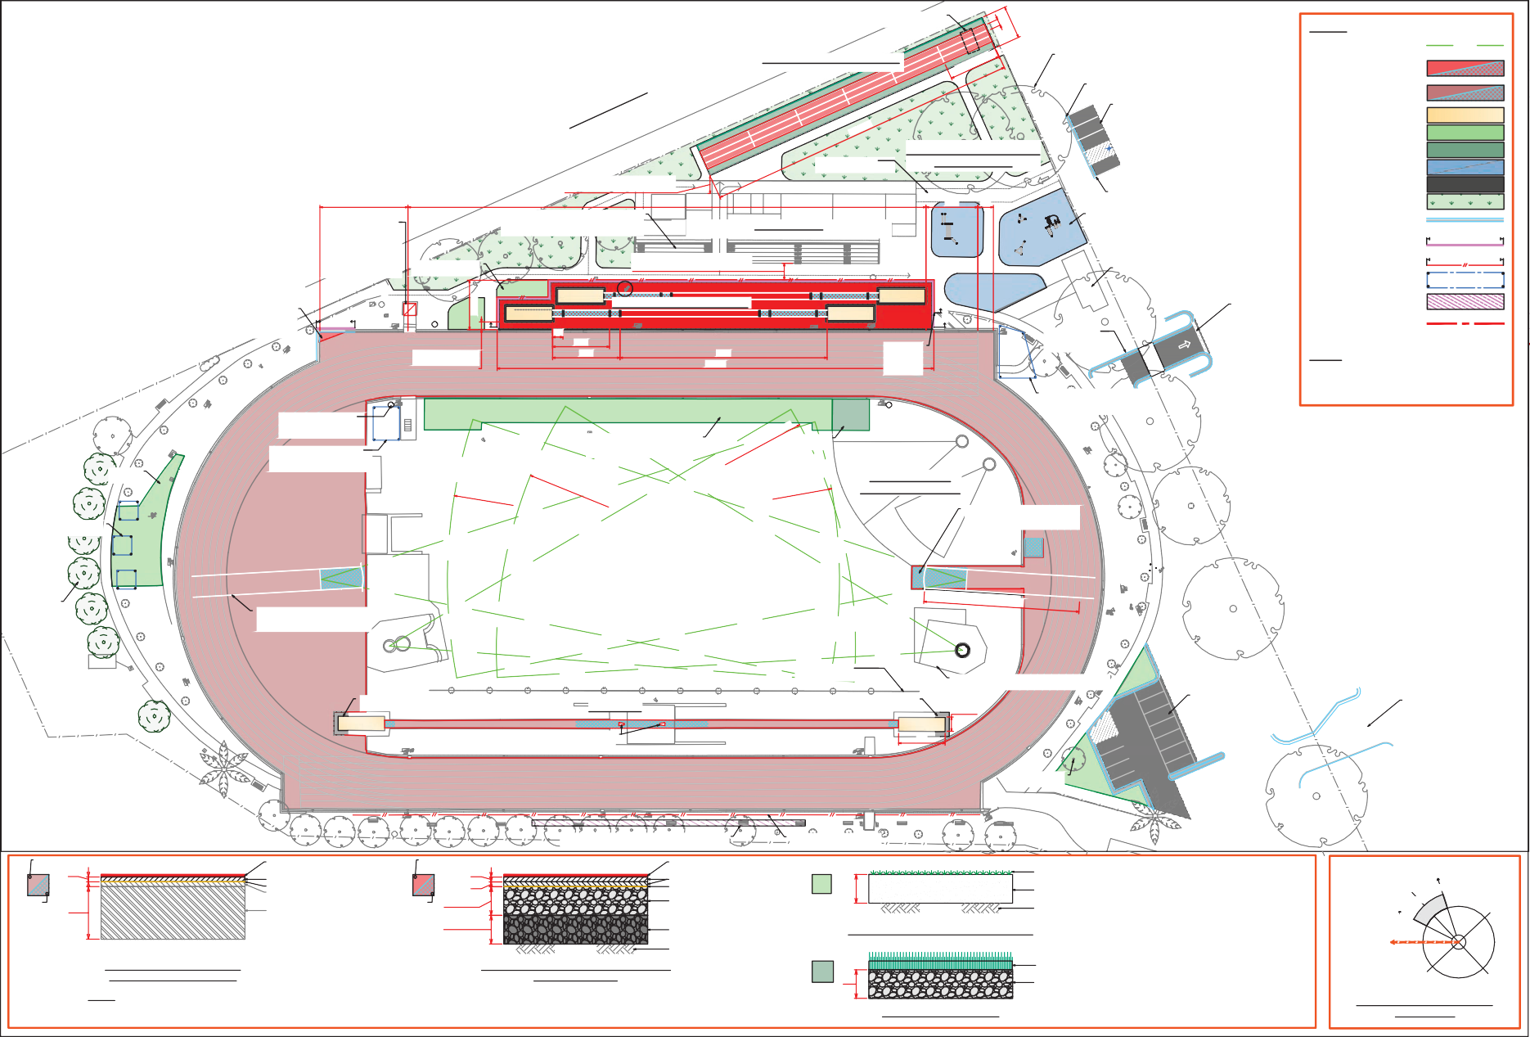
20mm THICK.

d

WORLD ATHLETICS (WA) TRACK SYNTHETIC SURFACE PROFILE
N.T.S.
NOTE:
d DENOTES THICKNESS OF EXISTING PAVEMENT.

EXISTING PAVEMENT.
20mm THICK.
(150 MIN.)

d/2 (150 MIN.)

WORLD ATHLETICS (WA) TRACK FULL DEPTH PAVEMENT PROFILE
N.T.S.
20mm NOM. SIZE CLASS 2 CRUSHED ROCK COMPACTED TO 98% M.M.D.D.

20mm NOM. SIZE CLASS 3 CRUSHED ROCK COMPACTED TO 98% M.M.D.D.
SUBGRADE.

RECLAIMED TOPSOIL/ HYDROSEED PROFILE
N.T.S.

d

SYNTHETIC GRASS PROFILE
N.T.S.

SUBGRADE.

NON-COMPETITION SHORT PILE SYNTHETIC GRASS
20mm NOM. SIZE CLASS 2 CRUSHED ROCK COMPACTED TO 98% M.M.D.D.
360°
340° E

W S

LIMITS OF IDEAL FIELD OF PLAY ORIENTATION

Legend
Legend

AMEN CHAN CIRC GRAN GYMN KIOS LIFT STOR
UNIF

AMENITIES CHANGE ROOM CIRCULATION GRANDSTAND GYMNASIUM KIOSK
LIFT STORAGE
UNIFORM STORE

LANDSCAPING

LANDSCAPING

LANDSCAPING

THROUGH CONNECTION

RAMP DOWN

< LINE OF BUILDING OVER >

TO AMENITIES UNDERCOVER WALKWAY

< LINE OF BUILDING OVER >

LANDSCAPING

RAMP UP

LANDSCAPING

LANDSCAPING

< EXTERNAL CONCOURSE OVER >

plat 05
plat 04
plat 03
plat 02
plat 01

STRETCH / GROUP FITNESS
96 m²

GRANDSTAND

STORAGE
38 m²

GYMNASIUM
96 m²

STORE
4 m²
UNDERPASS
24 m²

FEMALE
13 m²

FIRST AID
10 m²

ACC. WC
9 m²

OFFICIAL'S CHANGE
33 m²

MALE
13 m²

CHANGE ROOM 01
80 m²

< VOID >

GRANDSTAND

CHANGE ROOM 02
80 m²

UNIFORM SHOP
15 m²

LIFT
6 m²

CANTEEN / KIOSK
34 m²

< LINE OF BUILDING OVER >

FORECOURT PLAYGROUND | FITNESS EQIPMENT

EXISTING AMENITIES BLOCK

PIT

PIT

PLAYGROUND

RAMP UP

JUDGES STAND

PIT

LONG JUMP / TRIPLE JUMP FACILITY

PIT

LANDSCAPING

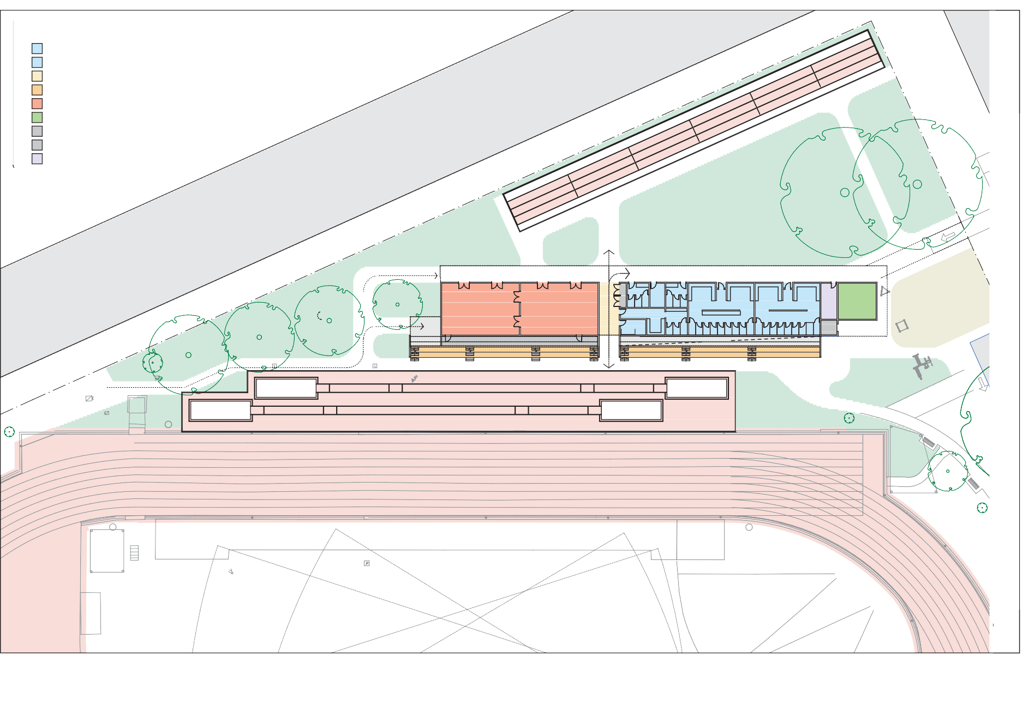
B

LANDSCAPING

ATHLETICS TRACK
FINISHING LINE

B SYNTHETIC GRASS SYNTHETIC GRASS B

JUDGES STAND

NATURAL TURF NATURAL TURF

STORAGE
Do not scal
with Warren

Drawing
—

9

Legend

AMENITIES CIRCULATION CONCOURSE
CONCOURSE / ROOF
FUNCTION SPACE GRANDSTAND KITCHEN
LIFT OFFICE STORAGE

LANDSCAPING
Legend

AMEN CIRCU CONC
CONC ROOF
FUNC GRAN KITCH LIFT OFFIC
STOR

LANDSCAPING

LANDSCAPING

THROUGH CONNECTION UNDER LEVEL 01

RAMP DOWN

LANDSCAPING

EXTERNAL
CONCOURSE / ROOF
69 m²

COMPETITION
MANAGEMENT OFFICE
89 m²

OFFICE
16 m²

OFFICE
16 m²

STORAGE
18 m²

MALE
28 m²

ACC WC
6 m²

FEMALE
28 m²

KITCHEN
41 m²

STORAGE
12 m²

SOCIAL / FUNCTION SPACE
181 m²

FORECOURT PLAYGROUND | FITNESS EQIPMENT

LANDSCAPING

RAMP UP

LANDSCAPING

plat 05
plat 04
plat 03
plat 02
plat 01

EXTERNAL CONCOURSE
210 m²

FOYER
14 m²

LIFT
7 m²

EXISTING AMENITIES BLOCK

UP UP

UP UP UP

UP UP

PIT
LINE OF CANOPY OVER - DASHED IN BLUE
GRANDSTAND
91 m²
THROUGH CONNECTION UNDER LEVEL 01
GRANDSTAND
97 m²
PIT
LINE OF CANOPY OVER - DASHED IN BLUE

PLAYGROUND

RAMP UP

JUDGES STAND

PIT

LONG JUMP / TRIPLE JUMP FACILITY

PIT

LANDSCAPING

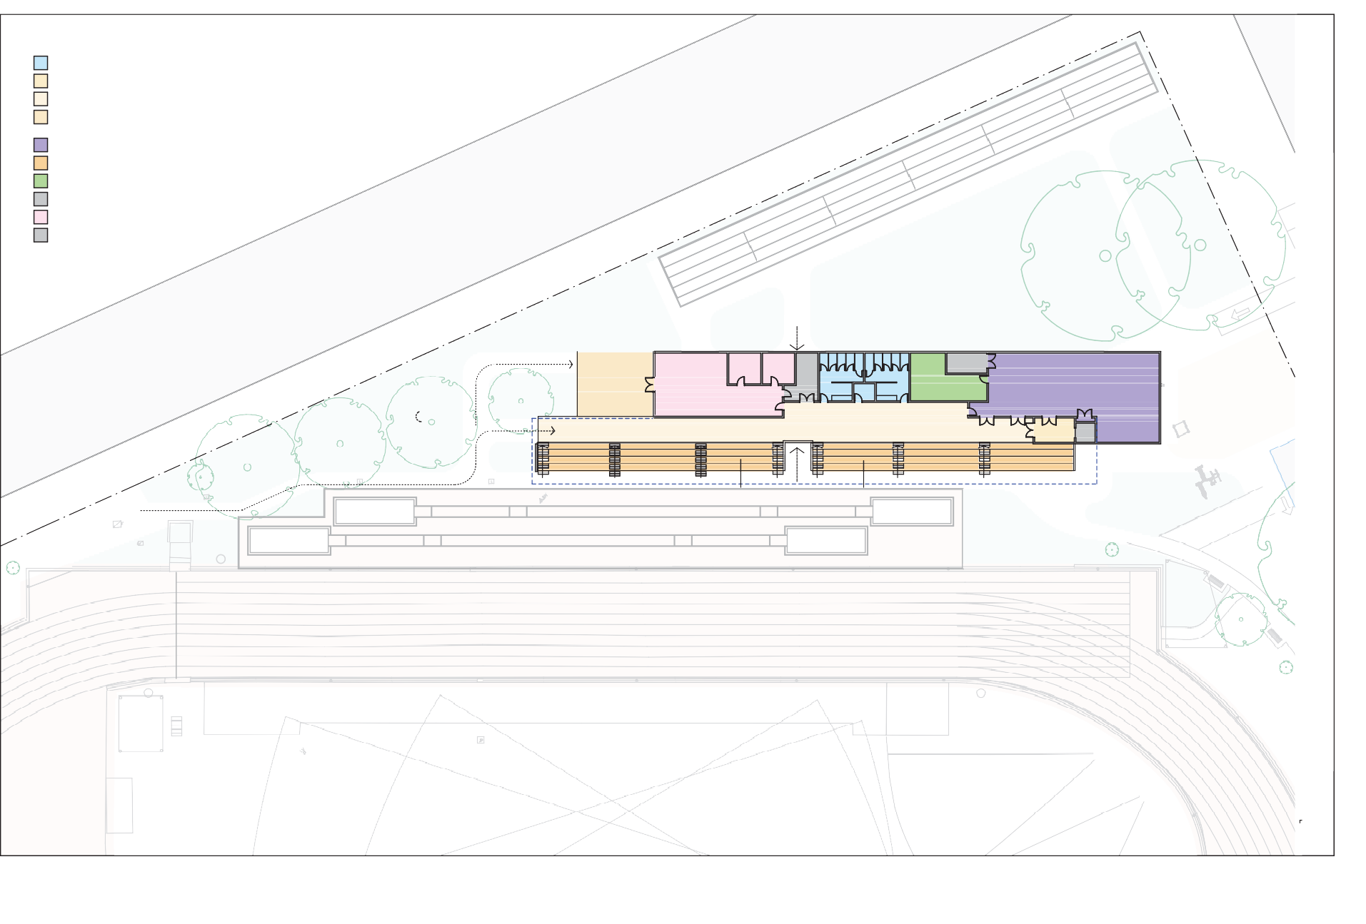
B

LANDSCAPING

ATHLETICS TRACK
FINISHING LINE

B SYNTHETIC GRASS SYNTHETIC GRASS B

JUDGES STAND

NATURAL TURF NATURAL TURF

STORAGE
Do not scal
with Warren

Drawing
—

10

WHAT WILL THE FACILITY COST?

A staged development of improvements is recommended.
The estimated total project cost is $11,050,327

This will involve the following breakdown of costs:
STAGE 1
$7,890,954
New pavilion including gym, group fitness and seating
Relocation of jump pits
Realignment of throwing cages and track compli- ance
Refurbishment of public toilets (complete)
Facility heritage/memo- rial garden relocation/ reinstatement
PA system upgrade (complete)
New car park exit and crossover
STAGE 2
$2,411,482
Renew athletics track New warm up space
New finish line timing, camera facility and cabling
Track lighting upgrade
STAGE 3
$747,891
Soft landscaping including pathways, seating areas and planting
New fitness playspace External signage

New pavilion works including new gym and group fitness room and seating = $4,504,945
- Athletics track improvements = $1,764,034
- Precinct works (including services) = $1,958,347

Total construction cost = $10,264,326
- Other costs (including contingencies, fees and charges = $2,919,000
- Total project cost = $11,050,327

Funding Strategy
There are funding opportunities available for suggested improvements through Sport and Recreation Victoria’s Local Sports Infrastructure Fund. The City of Greater Geelong could also apply for a low interest loan through the Community Sports Infrastructure Loan Scheme.
There is a partnership approach proposed with the Barwon Sports Academy seeking funding towards the gym and group fitness space.



Operational Performance
The regional role, specialised nature of the asset, current high use and programming potential of the John Landy Athletics Field supports a management model that delivers a sustainable business model for the venue. A review of management options recommends an internal management model where Council employs a Centre Management. The Centre Manager role would take on the responsibilities for major tenant agreements and relationships, manage bookings and events, drive programming, organise and oversees maintenance and cleaning and promotes the venue.

Under this model, the facility is expected to operate at a positive annual operating position from year 1 of operation. The 10-year Base Case business projections indicate:
- The facility attendances are expected to gradually increase from 67,250 in year 1 to 68,595 by year 10
- Revenue is expected to increase annually ranging from $90,510 in year one to $114,126 by year 10
- Expenditure is expected to increase annually ranging from $84,940 in year one to $101,708 in year 10
- The facility is expected to operate at a positive annual operating position from year 1. The profit margin is expected to climb from an operating surplus of $5,570 in year 1 to $12,418 in year 10.


HOW WILL IT BE DELIVERED?
To deliver this project, the City of Greater Geelong will establish a Project Governance Framework led by a Project Control Group (PCG) that reports to Council. A Project Working Group would work with the Consultant and Design Team and key stakeholders in the funding advocacy and detailed design stage of the project.
The next stage of the project is to obtain funding and progress de- tailed design of short-term improvements and construction stage.

Geelong Athletics
Geelong Athletics Inc is made up of five senior clubs with a total membership across the clubs of 300 registered athletics. Geelong Athletics compete at John Landy Athletics Field between October and March on Saturday afternoons.
The 300 membership has been maintained for a long time with the biggest club being Chilwell followed by Geelong Guild.
John Landy Athletics Field is open venue 7 days each week. Club members train at any time. It is free for all to train.
The largest increases in membership from athletics clubs in both Geelong Little Athletics and Geelong Athletics are from the Surf Coast and Bellarine areas. This is due to the increasing popu- lations being realised in these areas and the Armstrong Creek Urban Growth Area.

WHAT ARE THE BENEFITS?

John Landy Athletics Field will support regional and state level athletics events and benefit the local senior and little athletics clubs and schools within the Greater Geelong and Barwon Southwest region that use the facility.
Geelong Little Athletics Centre
The Geelong Little Athletics Centre Inc is made up of nine little athletics clubs and 600 registered athletes. 500 compete weekly on Saturday morning from October to March (Summer season).
Cross country training is run in the Winter season.
Geelong Little Athletics Centre holds athletics training and competition for athletes between the ages of 5 and 15 years at John Landy Athletics Field. Competition is held on Saturday mornings from 8.15am
- 12.00pm during Summer season from the end of September to the end of March; and Winter is Cross Country on Sundays from 10.30am - 12.30pm from April to August.
The participant age profile is a bell curve. The largest cohort is U11 and U12 where it increases from five years to 10 years and decreases from 12 years to 16 years. There is an equal number of males and female athletes.
John Landy Athletics Field is open 7 days each week. Training happens every day of the week, de- pending on the upcoming event. Most nights are utilised with up to 50 little athletics participants training between 4pm and 6pm.
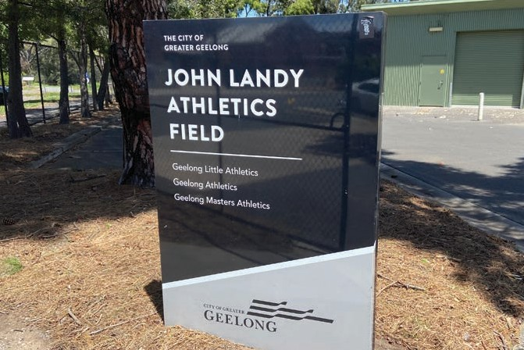
The facility is highly valued by local athletics clubs, schools within Greater Geelong and is a required venue for state athletics events by Little Athletics Victoria and Athletics Victoria.

The John Landy Athletics Field attendances are expected to increase from 67,250 in year 1 to 68,595 by year 10.

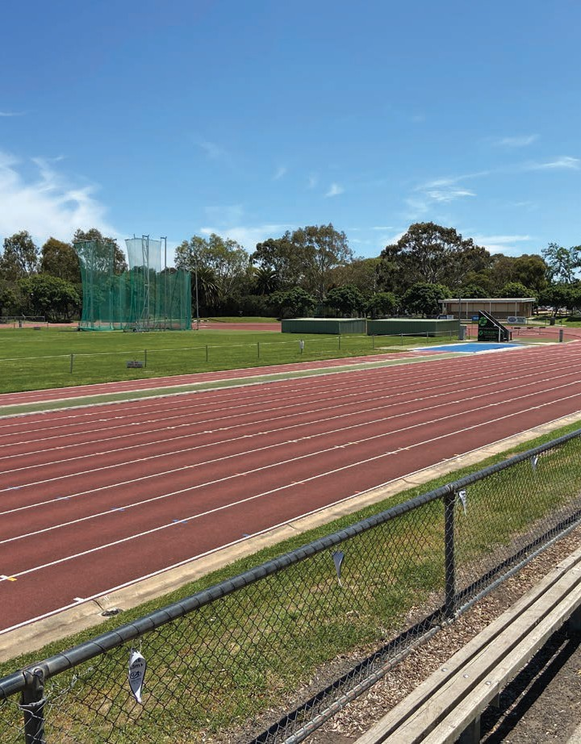
Barwon Sports Academy
The Barwon Sports Academy provides pathways for aspiring athletes in the Barwon Region to reach State and National level teams and competition through providing development pro- grams, sharing information, ideas and experiences.
The proposed new pavilion will include a gym and group fitness activity space for the Barwon Sports Academy to run strength and conditioning training for athletes part of their high per- formance program. The gym will provide a space for 10 to 15 athletes to train at each sched- uled session. There is a strong relationship between the Barwon Sports Academy, the Geelong athletics clubs and other providers of high performance programs in the Barwon Region that will benefit from the space.
Major Athletics Carnivals
Little Athletics Victoria and Athletics Victoria recognise John Landy Athletics Field as only one of three regional athletics venues that is suitable for state athletics events in regional Victoria. The venue hosts state and regional athletics championships including AVSL Shield Championships and Little Athletics State Championships.
The facility is an opportunity to generate social and economic benefits to the Greater Geelong region. The facility siting, functional design and management model proposed optimise the use and maximise these benefits to the region.
School Sports Victoria
School Sports Victoria (SSV) recognise John Landy Athletics Field as a critical and valuable facility to support SSV athletics school carnivals.
The peak periods of use include Term 1 and Term 2 from March to May where about 50 schools (Senior Schools) use this facility; and Term 3 to the start of Term 4 where about 30 schools (Pri- mary Schools) use this facility. The facility is used Monday to Friday during school hours and then training for student athletes outside these times. The facility also supports interschool athletics carnivals.
The catchment area of the facility for school athletics carnivals is primarily within the Greater Geelong area but can also be drawn from the Colac and Surf Coast areas for primary school inter- school athletics carnivals. Some of the schools in Geelong are large with some carnivals hosting 700+ participants. The average size of carnival is between 300 and 500 participants.

The maps below show the regional reach of the Geelong Little Athletics Centre and Geelong Athletics

Geelong Little Athletics Centre Membership by Post Code
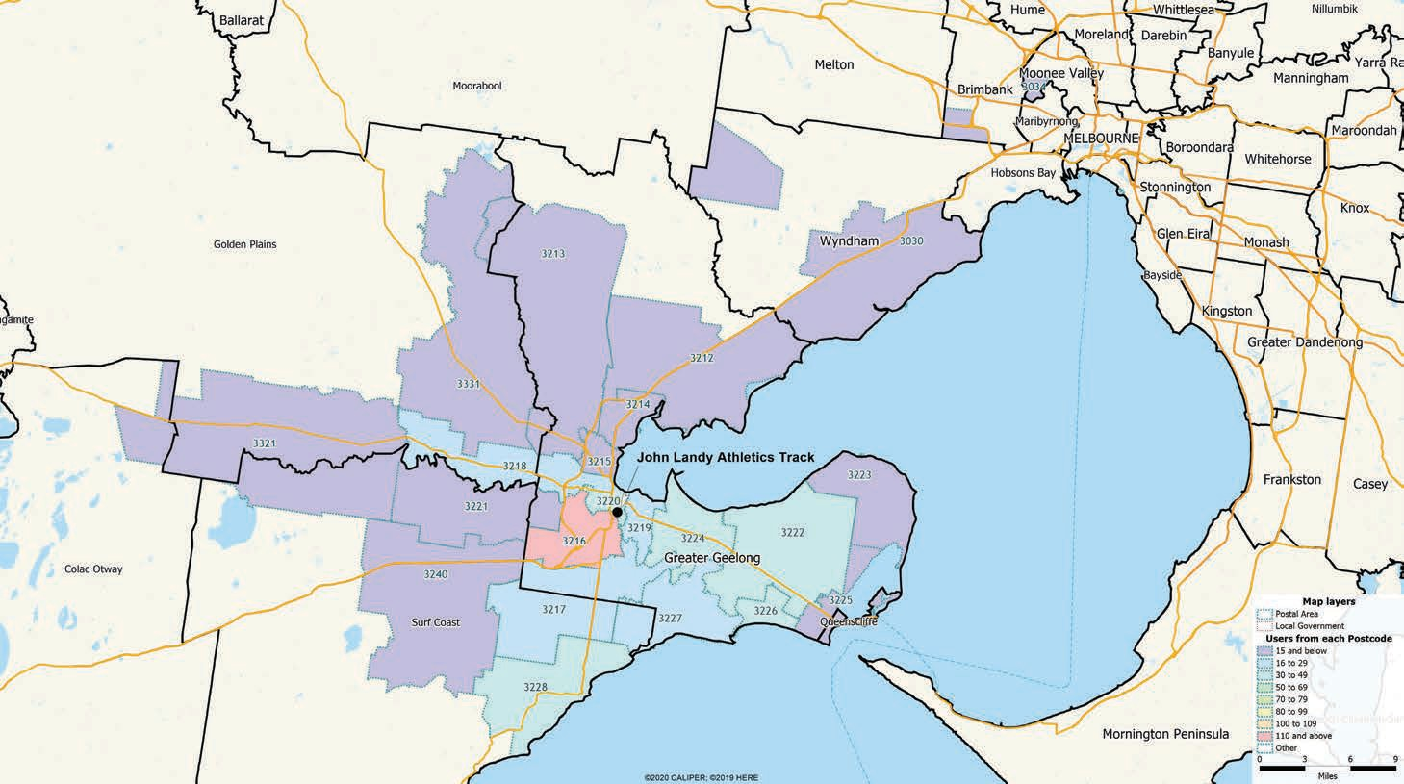

Geelong Athletics Membership by Post Code
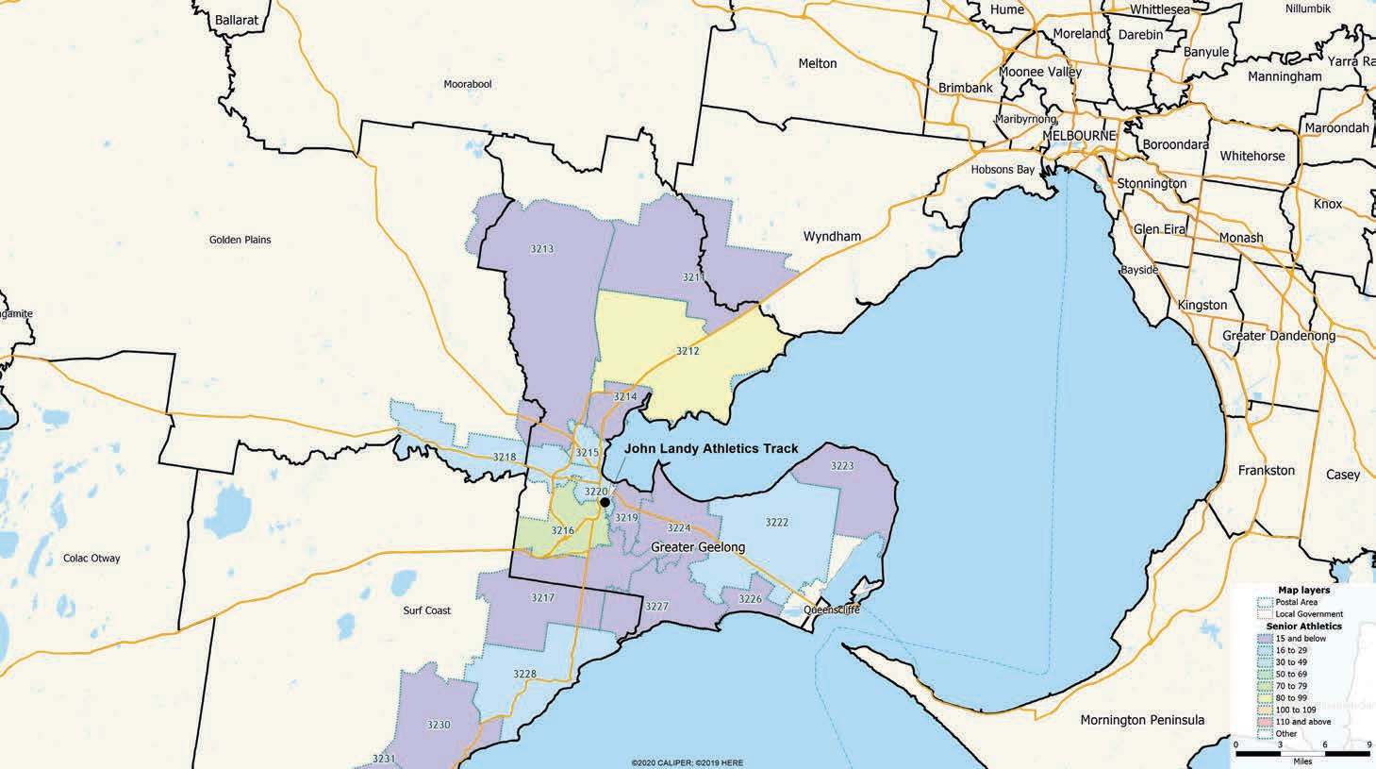




Otium Planning Group Pty Ltd ABN 30 605 962 169 304/91 Murphy Street Richmond Vic 3121
Phone: +61 3 9698 7300 Email: vic@otiumplanning.com.au www.otiumplanning.com.au

