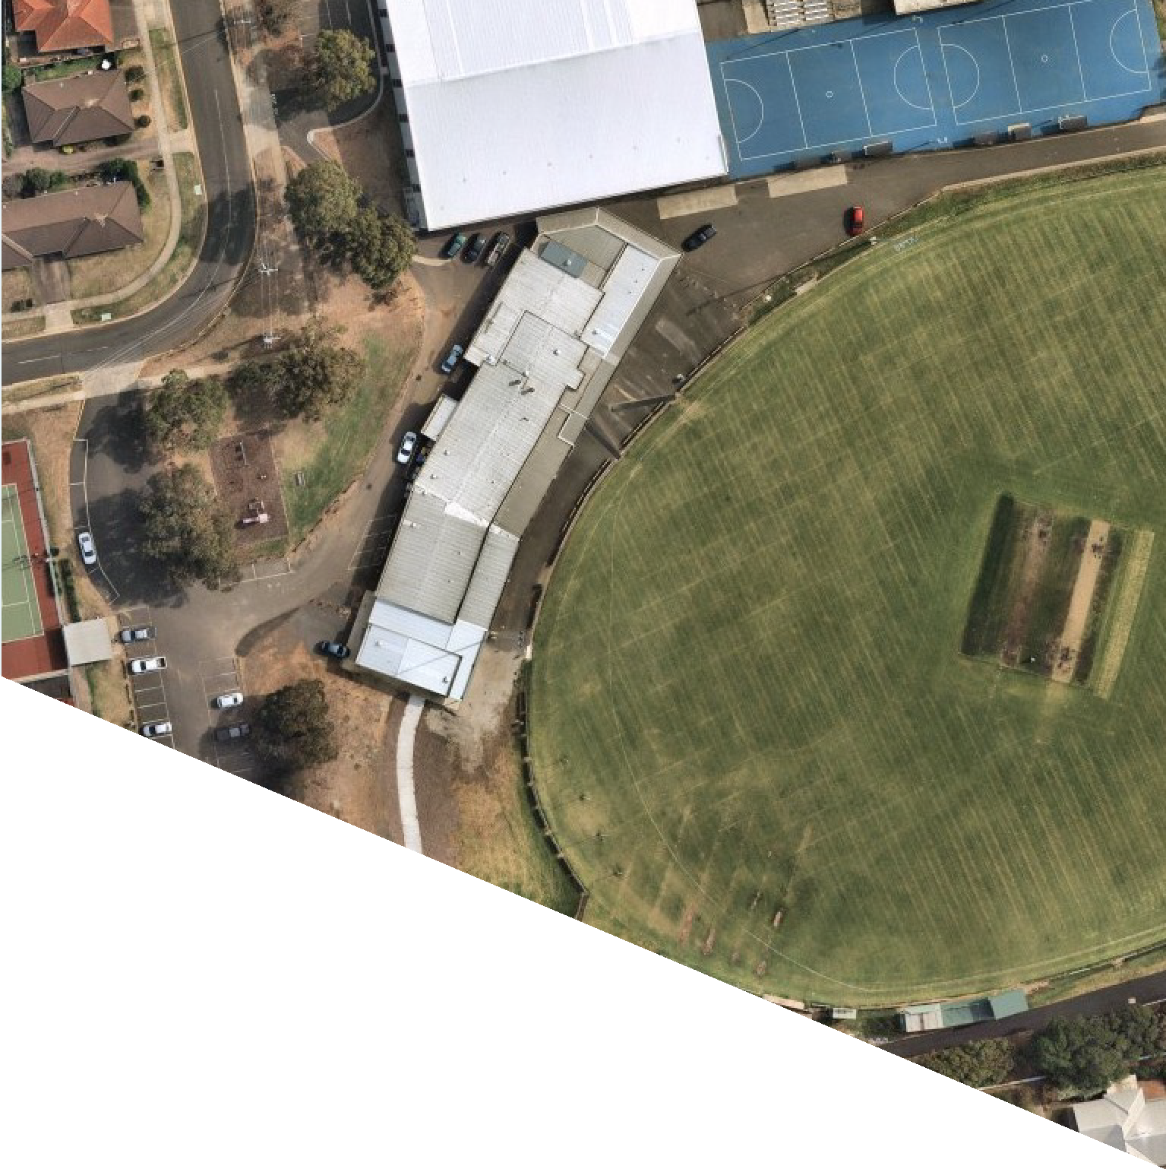

FACILITY
DEVELOPMENT PLAN:
BURDOO RESERVE
REPORT

AUGUST 2022

WE ACKNOWLEDGE THE
WADAWURRUNG PEOPLE AS
THE TRADITIONAL OWNERS OF THE LAND, WATERWAYS AND
SKIES. WE PAY OUR RESPECTS TO THEIR ELDERS, PAST AND PRESENT. WE ACKNOWLEDGE ALL ABORIGINAL AND TORRES
STRAIT ISLANDER PEOPLE WHO ARE PART OF OUR GREATER
GEELONG COMMUNITY TODAY.





ABOUT THIS DOCUMENT
The Facility Development Plan has been prepared by insideEDGE Sport & Leisure Planning on behalf of the City of Greater Geelong. This project was funded via the City of Greater Geelong’s Community Infrastructure Grants program (2021/22) and developed in conjunction with the Grovedale Sports Club, Grovedale Tennis Club and Grovedale College.
This Plan aims to provide an evidence base and strategic justification for the improvement to Burdoo Reserve to ensure its viability and suitability as a local level community sporting venue into the future.

CONTENTS

EXECUTIVE SUMMARY
The Site 5
Overview and Project Drivers 6
Strategic Alignment 7
Facility Development Priorities 10
FACILITIES AND USAGE
Existing Facilities 12
Facility Use 13
Existing Condition Report 14
Participation 18
Community Profile 20
About Grovedale Cricket and Tennis Clubs 22
About Grovedale Football Netball Club 23
FACILITY DEVELOPMENT PLAN
Guiding Principles 25
The Plan 26
Investment Opportunities 28
Implementation 29
A Perfect Partnership 31
APPENDICES
Quantity Survey 33

3.



EXECUTIVE SUMMARY

10.

THE SITE

Burdoo Reserve is located in Grovedale, a well established suburb of Geelong bordered by the City’s newest growth areas.

LOCATION
Burdoo Reserve is one of the most southern suburbs of the City of Greater Geelong and is approximately 9.5km from the CBD. Grovedale is highly accessible via Torquay Rd/Surfcoast Hwy to its east, Pioneer Rd to the north and the Geelong Ring Road to the west.
Burdoo Reserve is in proximity to Geelong’s Armstrong Creek growth area which incorporates the suburbs of Charlemont, Mt Duneed and Armstrong Creek.

SITE CONTEXT
The Reserve is owned and managed by the City of Greater Geelong and is zoned Public Park and Recreation Zone (PPRZ) under the City’s planning scheme. The site shares a northern boundary with Grovedale College,
with the school often using the Reserve as part of their education and sports programs, as well as the club rooms for school exams. The Reserve has residential housing on its eastern and western boundaries as well as a parcel of open space to the south.

FACILITY COMPONENTS
- Floodlit senior size AFL and cricket playing field
- Turf cricket wicket table on main oval
- Junior sized AFL oval and second cricket playing field (on school land)
- Two netball courts with acrylic surface and floodlights (on school land)
- Turf and hard wicket cricket practice nets
- Community sporting pavilion with change rooms for football/cricket/netball players and umpires
- 8 tennis courts and sporting pavilion with change rooms for tennis participants
- Community playground
- Sealed internal roadway
- Car parking – both formal and informal

USER GROUPS
- Grovedale Football and Netball Club
- Grovedale Cricket Club
- Grovedale Tennis Club
- Grovedale College

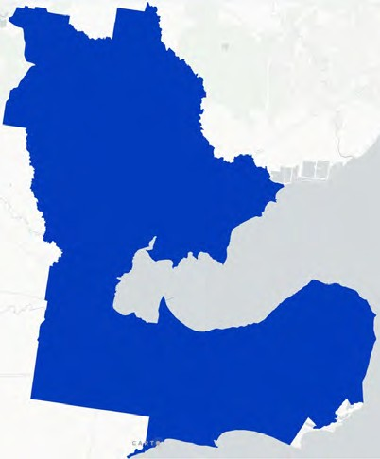
Burdoo Reserve

OVERVIEW & PROJECT DRIVERS

To ensure a coordinated and collaborative approach to future investment, a Facility Development Plan for Burdoo Reserve has been commissioned. This Plan has been funded by the City of Greater Geelong
in partnership with the Grovedale Sports Club (Football and Netball Clubs), Grovedale Cricket Club, Grovedale Tennis Club and Grovedale College. The project has been funded via the City of Greater Geelong’s Community Infrastructure Grants Program with contributions from the Grovedale Sports Club.
The tenanting clubs of Burdoo Reserve have facilitated participation in a variety of sports over the course of many decades. These clubs are the lifeblood of the local township and offer opportunities for all genders to be active through an array of programs and competitions.
Over recent years, Burdoo Reserve and its infrastructure has been incrementally enhanced thanks to funding from a range of local and government partners as well as substantial in-kind contributions from club volunteers. The facility now has a small number of improvements to undertake to ensure it continues to be a functional and modern community asset.

KEY PROJECT DRIVERS
INCREASING PARTICIPATION OPPORTUNITIES FOR A
GROWING COMMUNITY

SEEKING COMPLIANCE OF SPORTING FACILITIES WITH
RECOMMENDED GUIDELINES


CONTINUED PARTNERSHIPS AND JOINT USE OF
INFRASTRUCTURE BETWEEN GOVERNMENT, SPORT AND EDUCATION PROVIDERS

PROJECT METHODOLOGY
The Facility Development Plan has progressed through the following methodology, ensuring a structured approach to its developed and widespread, meaningful stakeholder engagement.
STAGE 1 Site inspections and user group engagement
STAGE 2 Demographic and strategic review, participation and facility audit analysis
STAGE 3 Concept plans and user group and school engagement
STAGE 4 Draft and final facility development plan

“Providing sporting facilities that align with recommended guidelines will ensure more opportunities to host training, competition and participation in a safe environment”

STRATEGIC ALIGNMENT
The following diagram provides a high level overview of strategic documents which guide and support the development of the Facility Development Plan.
CITY OF GREATER GEELONG
Our Community Plan 2021-2025
CITY OF GREATER GEELONG
Social Infrastructure Plan Generation One 2020-2023
CITY OF GREATER GEELONG
Social Infrastructure Plan Outdoor Sport and Recreation Report
CITY OF GREATER GEELONG
Social Infrastructure Plan Investment Policy
SUPPORTING STRATEGIC DOCUMENTATION
AFL VICTORIA
Growing the Heartland Strategy

NETBALL VICTORIA
Statewide Facilities Strategy
CRICKET VICTORIA
The Journey ahead for Victorian Cricket

G21 & AFL BARWON TOWARDS 2030: STRATEGY

G21 & CRICKET VICTORIA REGIONAL CRICKET STRATEGY

CLUB STRATEGIC PLAN

BURDOO RESERVE FACILITY DEVELOPMENT PLAN

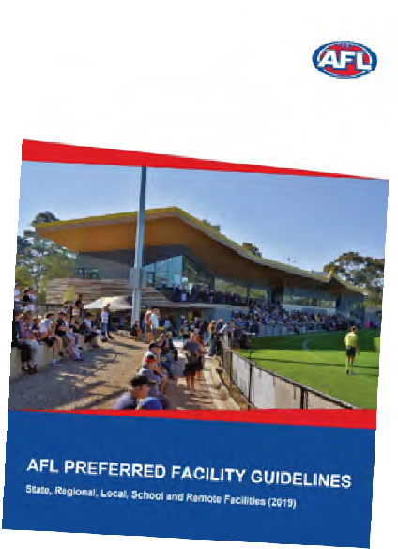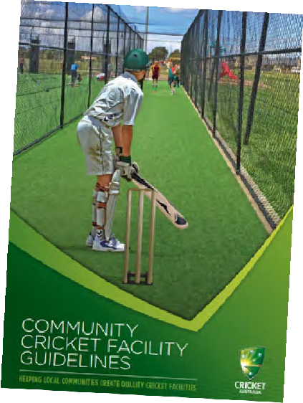

SPORT FACILITY STRATEGIES, FRAMEWORKS AND GUIDELINES
To support local, state and federal strategic planning, many peak sporting bodies have developed resources to help guide sustainable facility development and delivery. Across the many sports represented at Burdoo Reserve, each one offers guidelines that outline minimum preferred standards for infrastructure provision.
Common priorities and principles identified within these documents include:
Gender neutral amenities: Providing facilities that are welcoming, inclusive, accessible and encourage use by people of all-genders.
Multi-purpose facilities: Providing facilities that offer opportunities for multiple users and a variety of uses to generate greater community benefit and asset utilisation.
Growing venue capacity: Increasing the quality and capacity of existing facilities through innovative
approaches (e.g. LED lighting, synthetic surfaces) that create more programming opportunities.
Universal access: Ensuring community facilities are accessible to people regardless of their age, ability or cultural background.
Planning for growth and demand: Investment and prioritisation of facilities and infrastructure upgrades where greatest need and demand is demonstrated.
Partnerships and collaborative investment: Enhancing and maintaining relationships between all levels of government, industry partners and sport to promote collaborative investment into facility development.

ECONOMIC AND SOCIAL VALUE OF SPORT

THE VALUE OF COMMUNITY FOOTBALL
In 2015, AFL Victoria and Latrobe University undertook research to determine the social value of a typical community football club.
The study found that for every $1 spent on a community football club, there was at least $4.40 return in social value.
The strongest benefits were found to be delivered in the areas of mental health, physical health, personal well being and education. Others benefits included social inclusion, civic pride, empowerment, social connectedness, regional population stability and cultural integration.
$1
SPENT ON COMMUNITY FOOTBALL
$4.40
RETURN IN SOCIAL VALUE

THE VALUE OF COMMUNITY SPORT & ACTIVE RECREATION
Sport and Recreation Victoria commissioned a report by KPMG in 2020 to highlight the value of community sport and recreation infrastructure. The report looked at the economic, health and social benefits that accrue to individuals, community and society via the construction and operation of sport and recreation facilities and the activities that are conducted within.
The report found the following benefits contributed annually to Victoria through community sport and recreation included:
- $2.1 billion dollars in economic benefits – including increased economic activity and event related tourism.
- $2.3 billion dollars in health benefits – including reduced risk of chronic disease and improved mental health and wellbeing.
- $2.6 billion in social benefits – including human capital uplift, volunteering benefits and green space benefits.
Qualitative benefits included:
- Increased social connectedness, inclusion and networking.
- Increased level of trust in others.
- Reduced anti-social behaviour.
- Community pride.
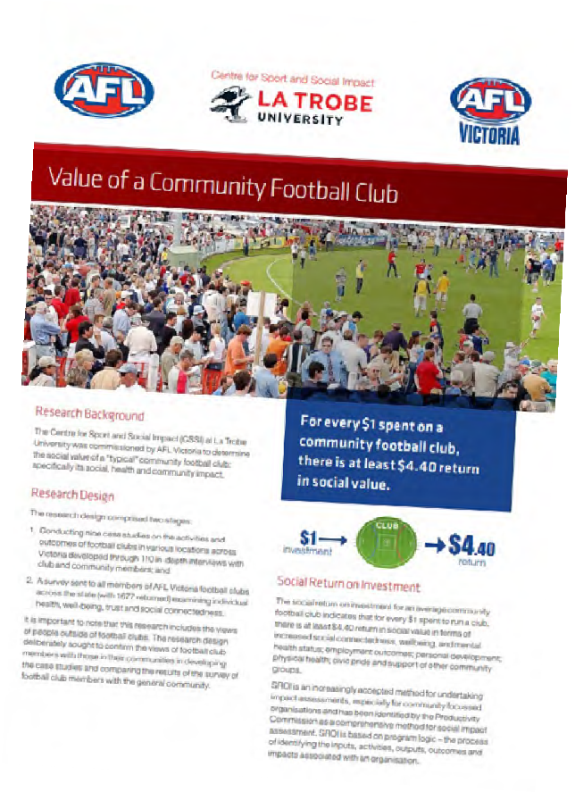

FACILITY DEVELOPMENT PRIORITIES

The Burdoo Reserve Facility Development Plan identifies a number of infrastructure requirements to support the future sustainability and prosperity of community sport. The following priorities have been determined through asset auditing, stakeholder consultation and identified community need.

Key facilities gaps to be addressed through the Facility Development Plan centre around ageing assets, non compliance of infrastructure, under provision, gender inequity and the need to support female participation.
Presently, netball courts are located on the adjacent Grovedale College land however do not comply with Netball Victoria’s requirements. Reconstructing these courts to standard will reduce volunteer burden and ensure the Club are able to play and train safely at the facility. It will also provide a better community asset for the clubs, community and school.
The cricket practice nets are undersized and of poor quality. Redeveloping the cricket nets will provide a compliant, enclosed facility that increases participation, prevents wear and tear on the oval surface and provides a safer environment for players and spectators alike.
The netball change rooms, whilst in acceptable condition, present some deficiencies in size as well as provision. Currently, the away change room does not meet the spatial recommendations outlined in Netball Victoria’s guidelines, and there are no umpire change rooms or amenities. Improved netball change rooms will ensure this facility aligns to guidelines and can support improved gender equity outcomes for netball participants.
Car parking, pedestrian connections and access paths at Burdoo Reserve are limited, lack connection and present a safety issue. More organised vehicle movement
and improved, signposted entrances are required. In addition, other infrastructure improvements, including the resurfacing of tennis courts 5 & 6, behind goal netting, updated public toilets and relocated playground will also improve the quality, functionality and safety of the venue

REDEVELOPED NETBALL COURTS
$492,000

NEW CRICKET NETS
$450,000

IMPROVED NETBALL CHANGE ROOMS
$672,000

SAFER CAR PARKING, CONNECTIONS AND SUPPORTING FACILITIES
$361,000



FACILITIES AND USAGE

9.

EXISTING FACILITIES

- 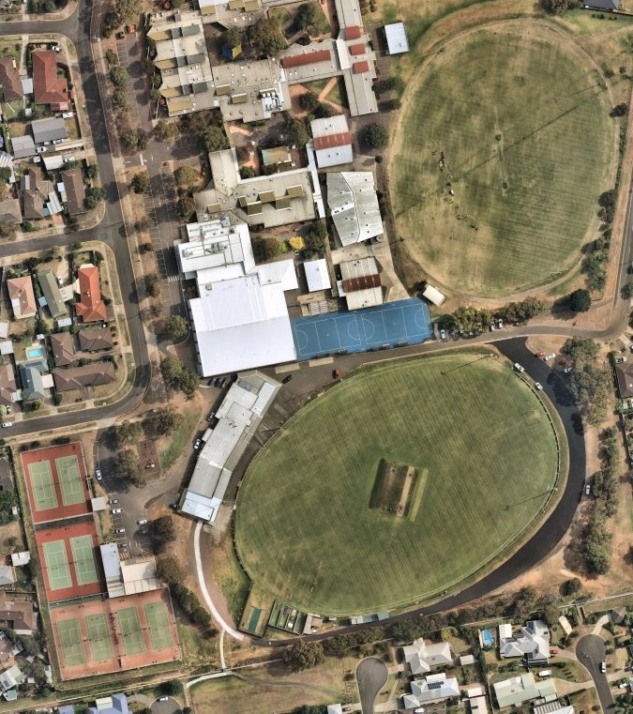Oval 1
- Club Rooms
- Netball court (school land)
- Oval 2 (school land)
- Cricket practice nets
- Tennis courts
- Playground
- Car parks

FACILITY USE
Current use of facilities at Burdoo Reserve is outlined below. At present, netball courts are used approximately 12 hours per week, netball change rooms 10 hours per week and cricket practice nets 8 hours per week. It is anticipated that should facility upgrades be realised as per the Facility Development Plan, combined with population growth and a strategic vision to grow participation, usage of the facility will increase. It is anticipated that infrastructure improvements will enable clubs to grow their traditional participant base, as well as also offer more opportunities to deliver flexible formats of the game, and drive broader initiatives, programs and outcomes.

FACILITY COMPONENT CURRENT AND FUTURE USAGE

35
30 Current Future
30
25
23
20
20
15
14
12
10
8

25

20

15

10

5

0
Netball change rooms

Netball courts

Ovals

Cricket practice nets

Tennis courts

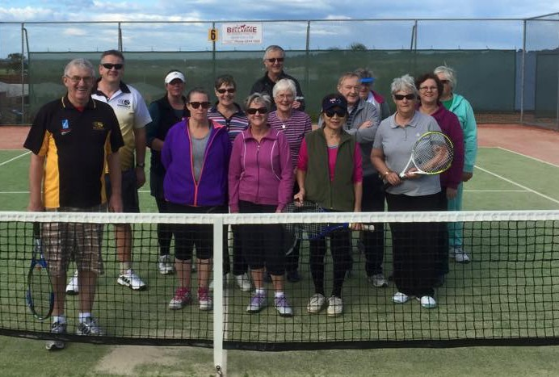

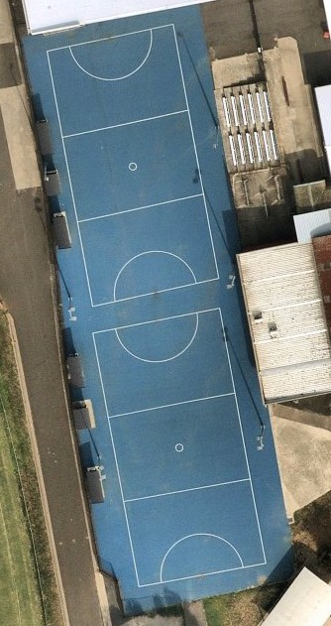EXISTING CONDITION REPORT

Existing facilities at Burdoo Reserve along with their condition and suitability were assessed as part of the Facility Development Plan. Key infrastructure items and associated issues and opportunities are identified below.

NETBALL COURTS
Description: The netball courts at Burdoo Reserve are situated on school land at the adjacent Grovedale College.

Issue: The courts do not align with Netball Victoria guidelines. Whilst the actual playing area is suitable in terms of its dimensions, the run off zones do not due to light poles and players shelters within the required clearance zone of 3.05m. Presently, the Grovedale Football Netball Club seek dispensation from Netball Victoria to host games on these courts, however
this is on a temporary basis only, with a number of additional measures needing to be adhered to in order to ensure play can be conducted safely. These additional measure create significant volunteer burden.
Opportunity: Explore opportunities to redevelop or reconstruct 2 x netball courts with floodlights that are compliant with Netball Victoria guidelines.

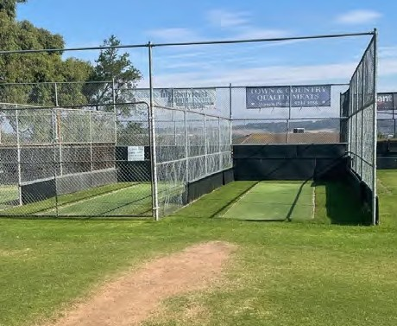
CRICKET PRACTICE NETS
Description: Cricket practice nets at Burdoo Reserve consist of 4 hard wicket lanes and 6 turf lanes.

Issue: Whilst the existing provision is in line, and in some instances in excess, of recommended guidelines by Cricket Australia, the quality of the facility is considered poor. As evidence is the image, the current bowler run ups are situated on the ground, causing wear of the oval and creating a hazard for participants.
Opportunity: Undertake a design process to understand the spatial requirements to redevelop the cricket practice nets in their entirety, with particular consideration given to their position to remove the run-ups from the field of play. Also consider existing storage sheds and whether they can be consolidated where appropriate.

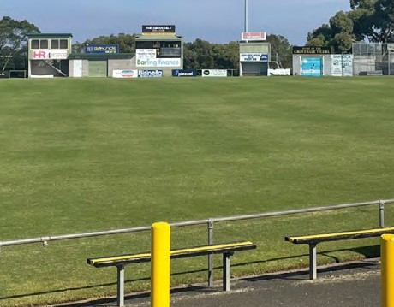OVAL 1 AND SUPPORTING INFRASTRUCTURE
Description: Oval 1 is in very good condition and is the primary playing field for both football and cricket. It measures approximately 169m x 115m and has a centre turf wicket. In addition Oval 1 also has a scoreboard, coaches box and players shelters. Whilst the Oval is slightly more narrow than the preferred 135m, this does not impact its ability to host senior competition.

Issue: Improved storage, scoreboard and behind goal netting would further enhance the functionality of the facility.
Opportunity: Explore the inclusion of minor items such as those mentioned to support football and cricket operations.

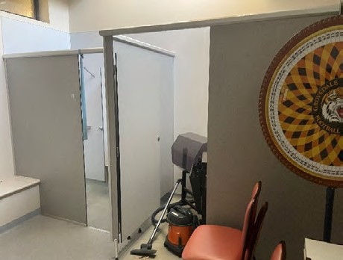
NETBALL CHANGE ROOMS
Description: The current netball amenities are located at the northern end of the main pavilion and consist of home and away change rooms, a multi-purpose room/ meeting area and small storage area.

Issue: The netball change rooms have some deficiencies when compared to the spatial requirements recommended by Netball Victoria. In particular, the away change rooms are slightly undersized and the area is also without a first aid room, umpire change room or administration office. The current storage room is also inadequate, leaving the change areas having to be used for temporary storage of equipment.
Opportunity: Consider a design response which ensures netball is given adequate facility provision.

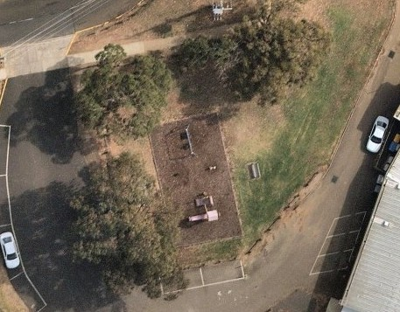PLAYGROUND
Description: The playground at Burdoo Reserve is located at the rear of the main pavilion between the tennis courts and the car park.

Issue: The playground’s location is not in a safe location being positioned in the centre of a car park and a through road.
Opportunity: Consider an alternate location that could offer more opportunities to utilise the play equipment in a safer, more controlled environment. Explore opportunities to increase car parking in this area around existing trees.

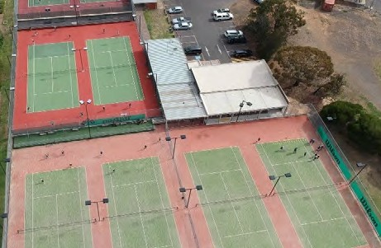

TENNIS COURTS
Description: There are 8 tennis courts at Burdoo Reserve, home to the Grovedale Tennis Club. 4 courts are surfaced with a plexi-pave acrylic material, and
4 are a synthetic grass surface. These courts are also supported with a modern club room facility.
Issue: Whilst tennis is well provided for, courts 5 and 6 show signs of wear and tear and require resurfacing.
Opportunity: Resurface courts 5 and 6 to ensure all playing surfaces are of a consistent high quality.

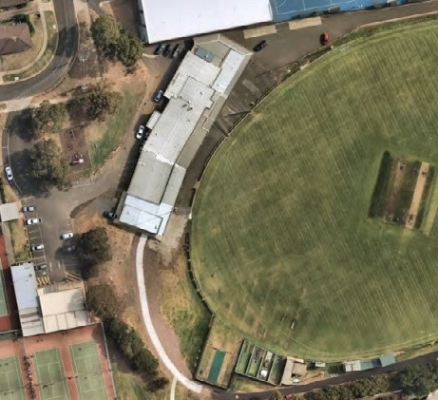
CAR PARKING/VEHICLES/ PEDESTRIANS
Description: Limited space on site presents a lack of car parking and the ad-hoc movement of vehicles and pedestrians. Presently car parking occurs predominately on the eastern and western sides of Oval 1, with a
limited number of spaces directly in front of the pavilion. On game days, traffic spills out onto both Burdoo and Wingarra Drive. A sealed access road runs to the south of Oval 2, however is mostly used to access cricket practice nets and storage sheds.

Issue: Car parking and vehicle movement at Burdoo Reserve will continue to present challenges due to spatial limitations across the site.
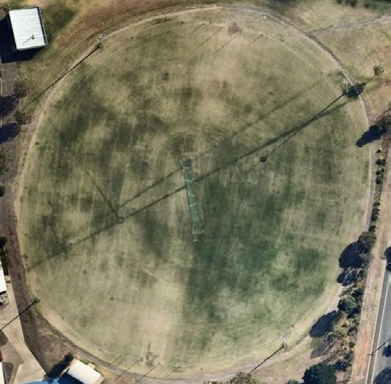
Opportunity: The Facility Development Plan has opportunity to explore any efficiencies in the way cars are distributed and managed across the site, in an attempt to make the Reserve safer, particularly for pedestrians.

OVAL 2
Description: Oval 2 is located to the north of Burdoo Reserve and forms part of the Grovedale College. It measures approximately 138m x 110m and has a synthetic centre cricket wicket, lights and a spectators shelter.

Issue: Connections between Oval 2, the school and Burdoo Reserve are unorganised and there are no safe crossing points for pedestrians and participants, particularly on game days.
Opportunity: Improve pedestrian connectivity between Oval 2 and the broader Burdoo Reserve to make is safer for users.

FACILITY AUDIT SUMMARY
In addition to the key observations, issues and opportunities identified on the previous pages, an assessment of the facilities at Burdoo Reserve was undertaken using insideEDGE’s Sports Facility Auditor Program and the preferred infrastructure guidelines of AFL, Cricket and Netball. The below table identifies where the facility meets current expectations (green), where some gaps exist however intervention is not essential (orange) and where major shortfalls (red) exist.

CLUB ROOMS SUMMARY | Number of change rooms | Room size | Number of showers | Shower type | Toilet type | Accessible Entry | Storage
Football/ Cricket Home Change Room | 1 | Greater than 45m2 | 5 | Lockable cubicle | Pan toilets | Yes | Yes
Football/ Cricket Away Change Room | 1 | Greater than 45m2 | 4 | Lockable cubicle | Pan toilets | Yes | N/A
Football/ Cricket Umpire Change Room | 1 | Greater than 20m2 | 2 | Lockable cubicle | Pan toilets | Yes | N/A
Club Social Rooms | N/A | >200m2 | N/A | N/A | Pan toilets | Yes | Yes
Netball Home Change Room | 1 | 21m2 | 1 | Lockable cubicle | Pan toilets | No | No
Netball Away Change Room | 1 | 14m2 | 1 | Lockable cubicle | Pan toilets | No | N/A
Netball Umpire Change Room | 0 | N/A | None | None | None | No | N/A

FIELD OF PLAY SUMMARY | Surface type | Length | Width | Run off area | Lighting lux level | Dimensions comply with guidelines | Overall condition rating
Oval 1 | Cool season turf | 169m | 115m | 3m | 150 lux | Mostly | Good
Netball Courts | Synthetic | 30.6m | 15.3 | <3m | Unsure | No | Very Poor
Cricket Practice Nets | Synthetic & Turf | Turf – 21m | Turf – 13m | Synthetic nets do not have formalised run ups | N/A | No | Poor
Cricket Practice Nets | Synthetic & Turf | Synth – 12m | Synth – 3.6m

PARTICIPATION AT BURDOO RESERVE

CURRENT AND PAST PARTICIPATION
339
466
364
288
487
344
283
Participation at Burdoo Reserve has remained mostly steady over the past three seasons, particularly considering the challenges presented by COVID-19.
As demonstrated in Chart 3, all four sports have experienced minor
fluctuations from 2018-2021, noting that 2020 has been omitted. At the time of writing this report, early indications
240
in 2022 suggest participation figures are strong at Burdoo Reserve, with a realistic expectation to see participation numbers increase back to pre COVID levels over the next 2-3 seasons (see future participation forecast below).
183
Given the anticipated population growth, particularly Burdoo Reserve’s role in assisting with demand from new growth areas, rebuilding participation to forecasted figures below is likely to be achieved, and succeeded, in years following.

FUTURE PARTICIPATION FORECAST
The future participation forecast in Chart 4 is based on continuing a number of strategic initiatives outlined in this report, particularly in relation to female participation, along with the
infrastructure recommendations outlined. As indicated, all four sports are expected to see increased participation, with each Club anticipating impressive numbers into the future. Facility upgrades
will undoubtedly support netball participation, as current facility limitations prevent growth. Cricket will also benefit from modern, safer practice facilities and tennis with resurfaced courts.
TENNIS
TENNIS

CHART 3

CHART 4
FOOTBALL
538

2018
NETBALL
CRICKET
TENNIS
TENNIS

2024
FOOTBALL
510
NETBALL
180
CRICKET
365

2019
FOOTBALL
NETBALL
170
CRICKET

2026
295
530
FOOTBALL
NETBALL
195
CRICKET
380

2021
FOOTBALL
NETBALL
152
CRICKET
TENNIS

2028
310
550
FOOTBALL
205
NETBALL
390
CRICKET
320
TENNIS

FEMALE PARTICIPATION AT BURDOO RESERVE
Burdoo Reserve is host to a significant number of female participants, which is reflective of the tenanting clubs’ inclusivity and commitment to making participation accessible for girls’ and women. Combined with a number of club led initiatives outlined below, recommendations for improved facilities within this report will assist in driving more female participation through the provision of more welcoming infrastructure.
The Grovedale Cricket Club launched women’s cricket in 2020 and through COVID-19 have been able to retain and grow participation, seeing growth in the junior girls’ age cohort through initiatives such as free come and try days. This has resulted with the Club hosting approximately 30 junior girls’ and 21 senior women’s players in the 2021/2022 season.
Junior girls’ and women’s football has increased from no senior women in 2017 to 26 in 2021.
Junior girls saw approximately 45 players in 2021, a 28.5% increase from the previous year. Disruptions, particularly to senior age cohorts, due to COVID-19 through 2020/21 have interrupted previous growth predictions, however is regaining momentum since play resumed in 2022.

Netball as a predominately popular female sport, particularly in Geelong, has seen stable and strong numbers over the last decade.
Whilst COVID-19 saw a participation hiatus in 2020, numbers rebounded close to previous levels in 2021 and this positive trend continues into 2022. Grovedale Netball presently see approximately 152 netball participants, with junior participants outweighing the number of senior participants two fold.
Female participation in tennis at Burdoo Reserve sees 100 participants over both juniors and seniors. Grovedale Tennis’ successful female participation initiatives, such as Cardio Tennis, All Abilities Tennis, ladies night, midweek competitions and social morning tennis all offer flexible ways for females to be involved.

460
Female participants at Burdoo Reserve in 2021

152
Female netball participants

+88%
Additional female cricket players from 2019-2021

3
Female football teams

120
Female tennis participants

71
Female football participants

COMMUNITY PROFILE

15,486
Grovedale population in 2022

+931
Increase in number of persons living Grovedale 2022 to 2032

+1,244
Increase in number of persons living in Grovedale 2032 to 2041

ABOUT GROVEDALE
- The suburb of Grovedale is located to the south/ south-west of the municipality and is bordered by the Surf Coast Hwy to the east and the Geelong Ring Rd/Colac Road to its west.
- Grovedale was one of the original housing estate developments for the municipality, with
development through the 1960’s through to 1990’s. Prior to the Armstrong Creek and Charlemont growth areas being realised, Grovedale was the most southern suburb on the City of Greater Geelong’s boundary.
- Grovedale is one of Geelong’s largest residential suburbs, with a population in excess of 15,000 in 2022. As a well-established locale, Grovedale is serviced with schools, shopping centres and extensive community facilities all in proximity.
- The City of Greater Geelong has an estimated population of 274,647 in 2022*. This is expected to grow to 330,428 in 2031 and 393,216 in 2041. This is an average annual change of approximately 2% or an overall growth of +22.6% between 2022 to 2032,
and +16.8% between 2032 and 2041.
*source forecast.id

SOUTHERN GROWTH AREAS
- Grovedale shares its eastern and western boundaries with Geelong’s newest growth area, Armstrong Creek, and its suburbs of Charlemont and Mount Duneed (see map below).
- These two suburbs alone will see an overall population increase of 144.6% from 9,657 in 2022 to
23,627 in 2032.
- Whilst these areas will be well provisioned with sporting facilities, there will be some reliance and demand for use of Burdoo Reserve, particularly due to sporting clubs in these new growth suburbs initially focussing on junior sport only.
- 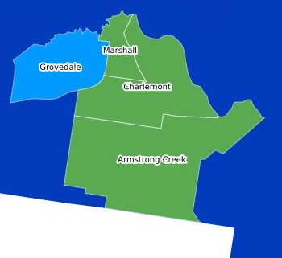At present, Grovedale Sports Club attracts a high number of participants who reside in the growth area suburbs.

Burdoo Reserve

GROVEDALE’S DEMOGRAPHICS
AGE COHORT FORECAST
CHART 1

  - As per Chart 1 adjacent, the 20-24 year old age cohort is forecast to have the most growth and persons aged within this bracket in Grovedale over the next 20 years.
  - There will also be a high representation of people aged 25-29 and 30-34.
  - At the other end of the age spectrum, the 80-84 cohort will experience a sharp rise in 2031 compared to 2022, and the 85+ year old cohort will continue to increase.
  - In terms of the Facility Development Plan, consideration as to how Burdoo Reserve can cater for more passive activity pursuits for older people, particularly around accessible path networks, seating and landscaping will be important.

0-39 AGE COHORT FORECAST
- The participation market for organised sport is generally within the 0-39 age range and Grovedale is expected to see larger growth over the next 10 and 20 years for people aged 20-34.
- As demonstrated within Chart 2 adjacent, there will also be growth in other younger age groups, albeit not as great as the 20-24 cohort.
- These statistics are likely to be attributed to more first home owners and
young families taking up residence in Grovedale, due to its relative housing affordability when compared to other areas of the municipality.
- In terms of the sports tenanting Burdoo Reserve, the ability to offer programs that have a focus on the attraction and retention of more senior level players will be essential, combined with the ever-important grassroots and junior programs.
1400

1200
2022
2031
2041

1000

800

600

400

200

0

CHART 2
1400

1200

1000

800

600

400

200

0

2022 2031 2041

ABOUT GROVEDALE CRICKET CLUB AND GROVEDALE TENNIS CLUB

GROVEDALE CRICKET CLUB
For over 70 years, the Grovedale Cricket Club has aspired to provide fun, encouraging and competitive sporting opportunities to Geelong families and locals. Presently the Club supports men’s, women’s, boys’ and girls’ teams through a range of programs and competitions for a range of abilities. The Club has
a clear aspiration to foster inclusive and supportive environments which translate into on field success across all age groups and genders.
The Club’s 2022-2026 Strategic Plan focuses on five key strategic pillars to achieve its mission of ‘To maintain and grow a holistic model of “best-practice” that is acknowledged and aspired to by the broader sporting community’. These pillars include:
LEADERSHIP. The Club aims to achieve this aspiration strategic plan through positive leadership on and off the field, nurturing talent, skill development and adequate succession planning and training for volunteers.
“ONE TRIBE”. A focus on practices that promote inclusive practices to ensure a diverse range of participants are welcomed to the Club. This includes via social events, celebrations and ongoing commitments to agreed behaviours which positively influence culture.
FINANCIAL STABILITY. To ensure the Club remains and continues its healthy financial position, a number of actions are to be focussed on, including diversification
of income streams, responsible and ethical management and transparent decisions that are made in collaboration with its membership base.
CRICKET DEVELOPMENT. To maintain its position as a competitive and vibrant club, the ongoing development of cricket is critical. In partnership with stakeholders and the sport, the Club aims to further evolve its pathways from grassroots to higher level and representative crickets, as well as mentoring and peer support to transition juniors into senior grades. A focus on junior and female programs is also identified as an ongoing priority.
INFRASTRUCTURE AND ENVIRONMENT. Investment
into infrastructure in partnership with stakeholders is the final pillar for the Club over the next five years. Ensuring infrastructure is fit for purpose and creates environments that promote and drives success. The creation of infrastructure sinking funds for contributions is also identified.

GROVEDALE TENNIS CLUB
Grovedale Tennis Club is one of the largest tennis clubs is Geelong with over 200 members playing in various competition, programs and social formats of the game each week. Grovedale also offers coaching for groups, 1 on 1 and Cardio Tennis sessions.
The Club’s mission statements is to provide the community with an environment that utilises tennis as a means to promote fun, fitness, competition and social interaction from people of all backgrounds, all ages and all abilities.

161
Junior cricket participants
in 2021/22


16
Cricket teams across all age
cohorts in 2021/22


183
Senior cricket participants
in 2021/22

283
Tennis participants in 2021/22


111
Junior tennis participants in
2021/22

ABOUT GROVEDALE FOOTBALL NETBALL CLUB

GROVEDALE ‘TIGERS’ FOOTBALL NETBALL CLUB
Established in 1947, Grovedale Football Club was one of the 12 original clubs competing in the Geelong Football League (GFL). The GFL is often regarded as the highest standard of Australian rules competition in regional Victoria. In 2000, the GFL added netball to the League, which saw the Club update their name to Grovedale Tigers Football Netball Club to reflect this. Since both football and netball’s inception, the Club has seen widespread success both on and off the field, including many players who have come through Grovedale’s
ranks, going on to play at the elite level. The Club offers grassroots programs including Auskick and NetSetGO programs and field teams from U/9’s onwards.
In 2018, the Club entered its first female football team into the inaugural women’s AFL Barwon competition. The Club has since grown their female football contingent with representation in both junior and senior age groups in 2022.
The Club’s Strategic Plan “One Club for Everyone” 2018- 2021 (currently under review) highlights the Club’s core values, which are:
- One Club working together towards a shared vision.
- A Welcoming Place being friendly to everyone we meet.
- Inclusion being accessible, equitable and embracing diversity.
- Integrity insisting on fairness, respect and good sporting behaviour.
- Passion for the love of sport, our competitive spirit, and our community.
- Innovation keeping informed and seizing opportunity to improve.
Key priorities outlined to achieve this vision include:

ONE CLUB FOR EVERYONE
Incorporating juniors, netballers, female football and all abilities players provides the club with new opportunities and calls for a new approach and focus. Roles within the Club will be created and adjusted to facilitate and foster these participants.

FACILITY DEVELOPMENT
To meet the objectives and essence of being an inclusive Club, facility improvements need to occur to ensure Burdoo Reserve is female friendly and accessible to all.

VOLUNTEER RECRUITMENT AND SUPPORT
Attracting and retaining volunteers is a critical priority for the Club as without them they could not operate. The appointment of a volunteer coordinator to assist existing and future volunteers with induction, recruitment and support.

DIVERSIFYING INCOME
Sourcing income and revenue streams which assist the Club in being as sustainable as possible. This will also ensure that participant and social membership fees are affordable.

PARTICIPATION
A holistic approach to participation development through all codes, age groups and abilities will create strong foundations and a healthy and consistent pathways and opportunities. In order to achieve success on-field, the Club has identified that a strong culture, excellence in coaching, mentor programs and equitable and diverse club practices must be at the forefront of all participation activities.

Junior football participants in 2021
250

Increase in junior girls’ football from 2019 to 2021
21.6%

Senior football participants
100


Junior netball participants in 2021
104

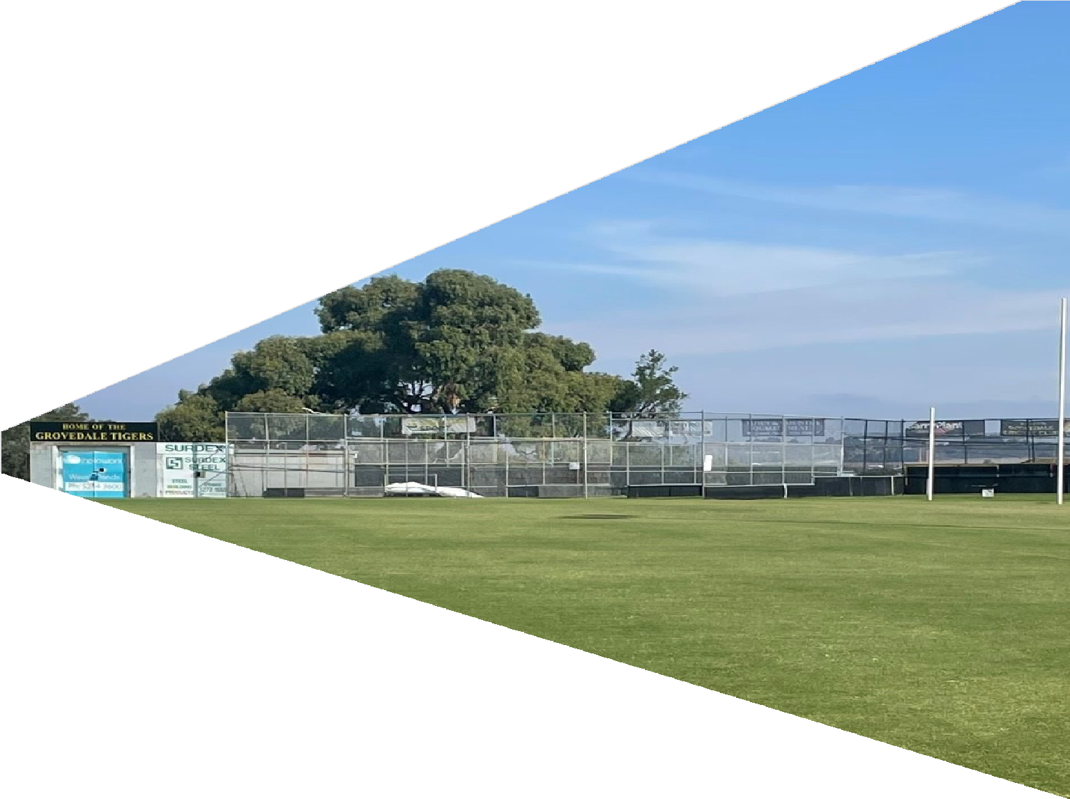

FACILITY DEVELOPMENT PLAN

14.

GUIDING PRINCIPLES

Recommendations within the Facility Development Plan align with the below principles. This has ensured that recommendations are realistic, achievable and meet the identified needs of the Reserve, its user groups and the strategic priorities of potential future investment and facility partners.

INFRASTRUCTURE COMPLIANCE
Aligning sporting infrastructure with recommended guidelines. Making facilities safer and comparable to other like local level venues.
1
2
3
A clear plan for the next decade to ensure that infrastructure meets the needs of its community.

GREATER PARTICIPATION OPPORTUNITIES
Improved spaces to deliver programs, competitions and training to support participation retention, opportunity and prosperity.
4
Facilities to attract participants to compliment club initiatives and foster a healthy sporting environment.
5

ONGOING PARTNERSHIPS IN FACILITIES AND INVESTMENT
Continuing and strengthening partnerships with Grovedale College to encourage joint usage of facilities to support pathways to participation.
6
Leveraging potential investment partners through a range of government, sport and education funding opportunities.
7
Increased utilisation of infrastructure outside of school or sport hours alone.
8

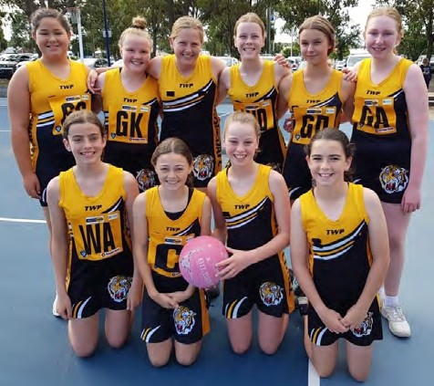
GENDER EQUITY
Modern, welcoming facilities that encourage participation by all genders and age cohorts.
9
Breaking down barriers to participation through
10
encouraging more gender diversity and involvement in all facets of the sporting club environment.

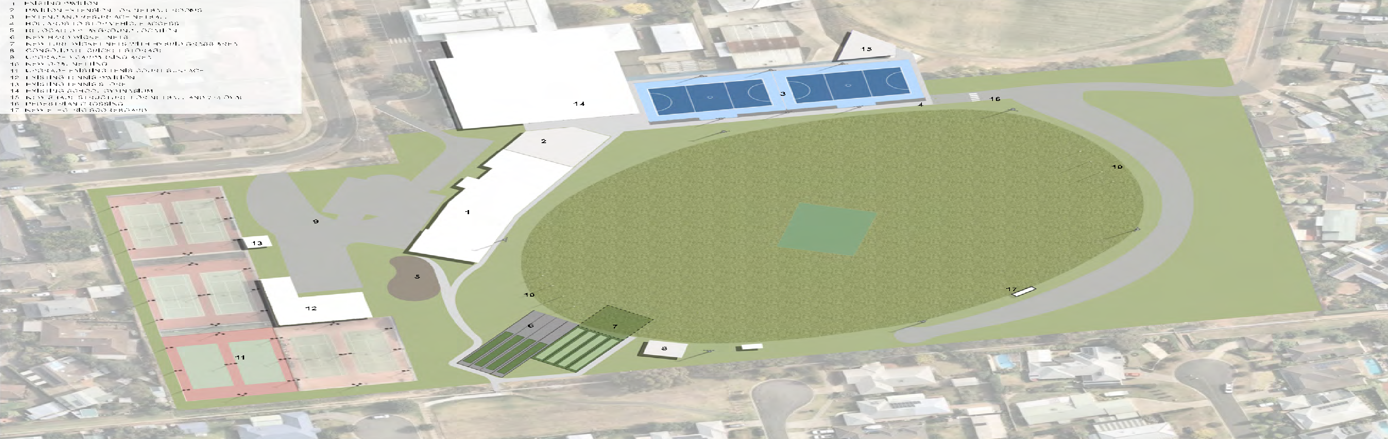
THE PLAN

SITE PLAN

26.

BUILDING PLAN

NEW NETBALL COURTS

SCHOOL GYMNASIUM

FORECOURT

HOME
34 m²

AWAY
34 m²

STORE
25 m²

FIRST AID
11 m²

UMP CHANGE
15 m²

OFFICE
18 m²

NEW PAVING TO LINK NETBALL COURTS, NETBALL FACILITIES AND MAIN SOCIAL ROOMS

NEW ROOF TO EXTEND TO CREATE PROTECTED UNDERCOVER VIEWING AND GATHERING AREA

NEW NETBALL FACILITIES

F
13 m²

UMPIRE
13 m²

GYM
95 m²

M
13 m²

DEMOLISH EXISTING TOILETS AND REPLACE WITH NEW MALE AND FEMALE TOILETS

HOME AMENITIES
42 m²

TRAINER
26 m²

HOME CHANGE
54 m²

DIS WC
4 m²

UPGRADE EXISTING DISABLED TOILET AS REQUIRED TO MAKE COMPLIANT TO NCC AND AS1428

UMPIRE CHANGE
23 m²

OFFICE
15 m²

ENTRY
7 m²

KITCHEN
45 m²

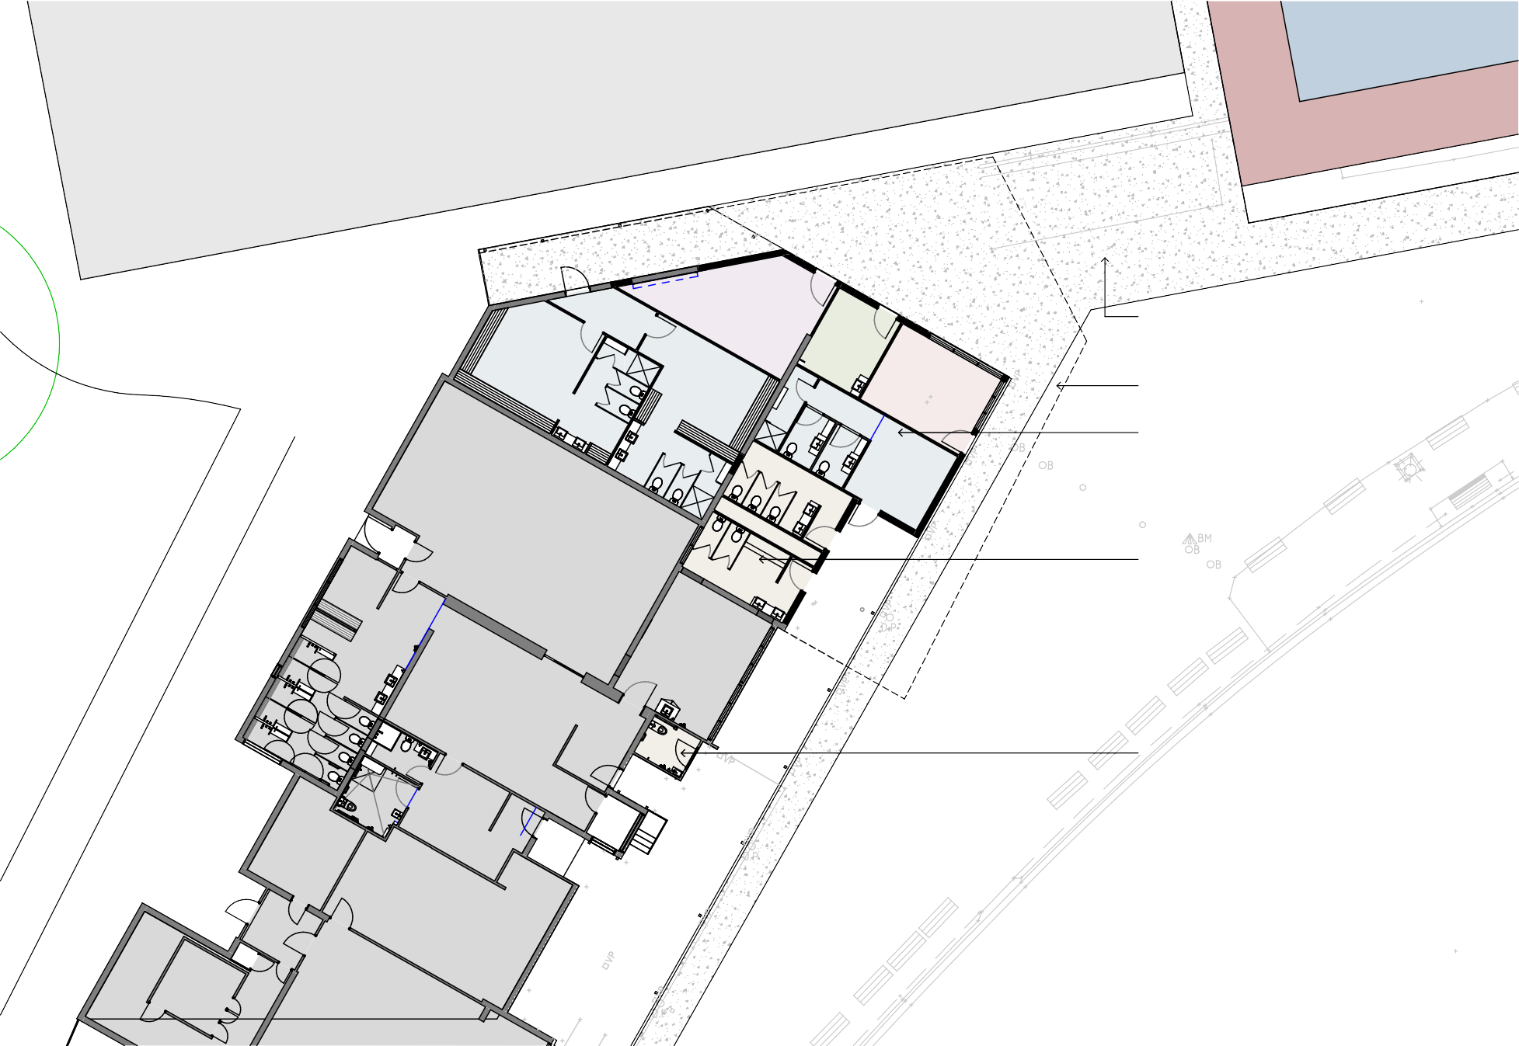

SOCIAL
348 m²

27.

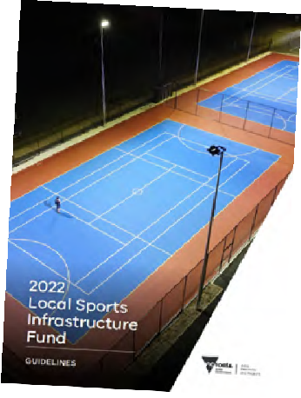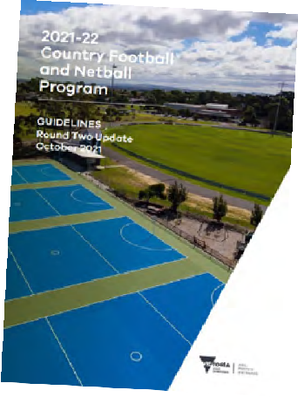INVESTMENT OPPORTUNITIES

To achieve recommendations outlined within this report, a collaborative approach to investment is required. Opportunities for partnerships via club, local, state and other community sources should be explored. At the time of writing this report, the below funding programs and opportunities aligning with recommendations are available and outlined below.

City of Greater Geelong’s Community Infrastructure Grants Program
This program aims to support funding for the planning and delivery of capital works projects within the City of Greater Geelong. This includes grants available for amounts up to $350,000.

Sport & Recreation Victoria Local Sports Infrastructure Fund
This Fund aims to provide a range of grant opportunities across funding streams including Female Friendly Facilities (up to $1,000,000), Community Sports Lighting (up to $250,000), Community Facilities (up to $300,000) and Planning (up to $50,000).

Sport & Recreation Victoria Community Cricket Program
This Program aims to support cricket participation in Victoria through high-quality and welcoming facilities. The objectives of this program aim to be achieved through providing funding for projects such as upgrading of existing and construction of practice facilities, club room developments, playing field upgrades and sports lighting initiatives. Up to $100,000 in grant funding is available.

Sport & Recreation Victoria Country Football & Netball Program
This fund aims enhance participation opportunities in football and netball through improved playing surfaces, gender-neutral player and umpire change facilities and sports lighting upgrades. Up to $200,000 is available through this program.

Club fundraising
Clubs tenanting Burdoo Reserve may have opportunities to fundraise to support the delivery of the identified infrastructure upgrades. Where applicable, clubs should be encouraged to create a sinking fund that helps support the implementation of the Facility Development Plan, and to support Council in their pursuits to leverage both internal and external funds.

Council’s budget process
Each year Council prepares a budget which provides funding for the delivery of community services, programs, and infrastructure in line with its respective Council Plan. There are opportunities for items identified within the Facility Development Plan to be delivered via this process.

Council’s cyclical budgets
Council has cyclical budgets for the maintenance and renewal of minor infrastructure items. A small number of recommendations within the Facility Development Plan could be considered within relevant cyclical programs.

Victorian government elections
The upcoming 2022 state elections may also offer opportunities to leverage contributions to the projects outlined within this report.

IMPLEMENTATION

To assist with implementation, key infrastructure recommendations have been prioritised in partnership with stakeholders. Their alignment to the Plan’s guiding principles and costs associated are outlined below. Note that information regarding infrastructure items not listed below can be found within the site plan on page 26 and within the Quantity Survey.
Note that all costs listed below are base-line estimates and do not include site preparation, construction contingencies, escalation costs, staging considerations or take into account any latent site conditions. Please refer to the detailed Quantity Survey relevant to this project which makes allowances for these inclusions.

PRIORITY 01 - NETBALL COURT REDEVELOPMENT

DESCRIPTION | COST | FUNDING OPPORTUNITIES FOR DELIVERY
Redevelop netball courts in current location to meet compliance standards set by Netball Victoria. Included in these works are the relocation of spectator shelter, road works, pedestrian crossing as well as new players and scorers shelters and floodlights to minimum 100 lux.  Also includes relocation of shelter on second oval. | $492,000 | SRV Country Football & Netball Program* SRV Local Sports Infrastructure Fund* CoGG Community Infrastructure Grants Council’s budget process  (*require Council contributions)
PRIORITY 02 – CRICKET PRACTICE NETS

DESCRIPTION | COST | FUNDING OPPORTUNITIES FOR DELIVERY
Redevelop turf and synthetic wicket practice nets as per the site plan. Fully enclose the hard wicket nets and add a gate to the turf wicket nets, enabling them to be closed off when not in use. Include an area of hybrid grass in front of turf nets where run ups extend onto oval. | $450,000 | CoGG Community Infrastructure Grants SRV Community Cricket Program*  SRV Local Sports Infrastructure Fund* (*require Council contributions)
PRIORITY 03 – NETBALL CHANGE ROOMS AND PUBLIC TOILETS

DESCRIPTION | COST | FUNDING OPPORTUNITIES FOR DELIVERY
Undertake works to the existing netball change rooms and public toilets to improve functionality, accessibility and compliance with preferred facility guidelines. Include new forecourt which connects the building to the netball courts and provides a safe connection for players and spectators. | $672,000 | SRV Country Football & Netball Program* SRV Local Sports Infrastructure Fund* Council’s budget process  (*require Council contributions)

DESCRIPTION | COST | FUNDING OPPORTUNITIES FOR DELIVERY
Improve existing car park via Wingara Drive. Works will result in additional car parks as well as safer vehicle movement.  Relocate existing playground as per site plan. Include wayfinding signage at car park and playground entrances. | $361,000 | Council’s budget process  Council’s cyclical budget programs

PRIORITY 05 – ANCILLARY SPORTING INFRASTRUCTURE IMPROVEMENTS

PRIORITY 04 – CAR PARK UPGRADE AND PLAYGROUND RELOCATION

DESCRIPTION | COST | FUNDING OPPORTUNITIES FOR DELIVERY
Undertake remaining ancillary sporting infrastructure improvements including new oval scoreboard, behind goal netting at both ends of oval and the resurfacing of tennis courts as per site plan. | $224,000 | CoGG Community Infrastructure Grants Council’s budget process  Club fundraising

A PERFECT PARTNERSHIP

SPORT OUTCOMES
- Improved facilities that are safe and compliant through redeveloped netball courts and cricket nets.

- Growth in netball participation through adequate change rooms, umpire facilities and courts that will ensure Grovedale aligns will all other local clubs in Geelong.

- Safer and more accessible facilities with improved pedestrian connections, car movement and parking.

- Increased connection and sport participation through strong school partnerships to provide a pathway from school sport into formal competition.

SCHOOL OUTCOMES
- Improved facilities for the growing Grovedale College, who presently provide for 800+ students and regularly use the netball courts (on school land) as well as the club room facilities and ovals.

- Improved facility usage via the Joint Use Agreement between the College and the City, seeing mutual benefit via improved infrastructure on both education and Council owned land parcels.

- Improved programming outcomes through the provision of more modern facilities that can be utilised by students for a range of sport and learning opportunities.

also provide a safer environment for all participants & spectators. The netball court
for all the tenant clubs. Planned improvements to the Burdoo Reserve precinct will
“The planned improvements will cater for the ever increasing participant numbers
redevelopment & upgrade to the netball rooms will bring them in line with Netball

Victoria’s regulations”.

– Darrell Winter, Secretary - Grovedale Tigers Football Netball Club

“We are at a critical juncture as a Cricket Club and sporting community. With the right investment in infrastructure we can continue to be a genuine community asset, supporting and growing social connections and wellbeing goals”
– Brad Clarke, President - Grovedale Cricket Club

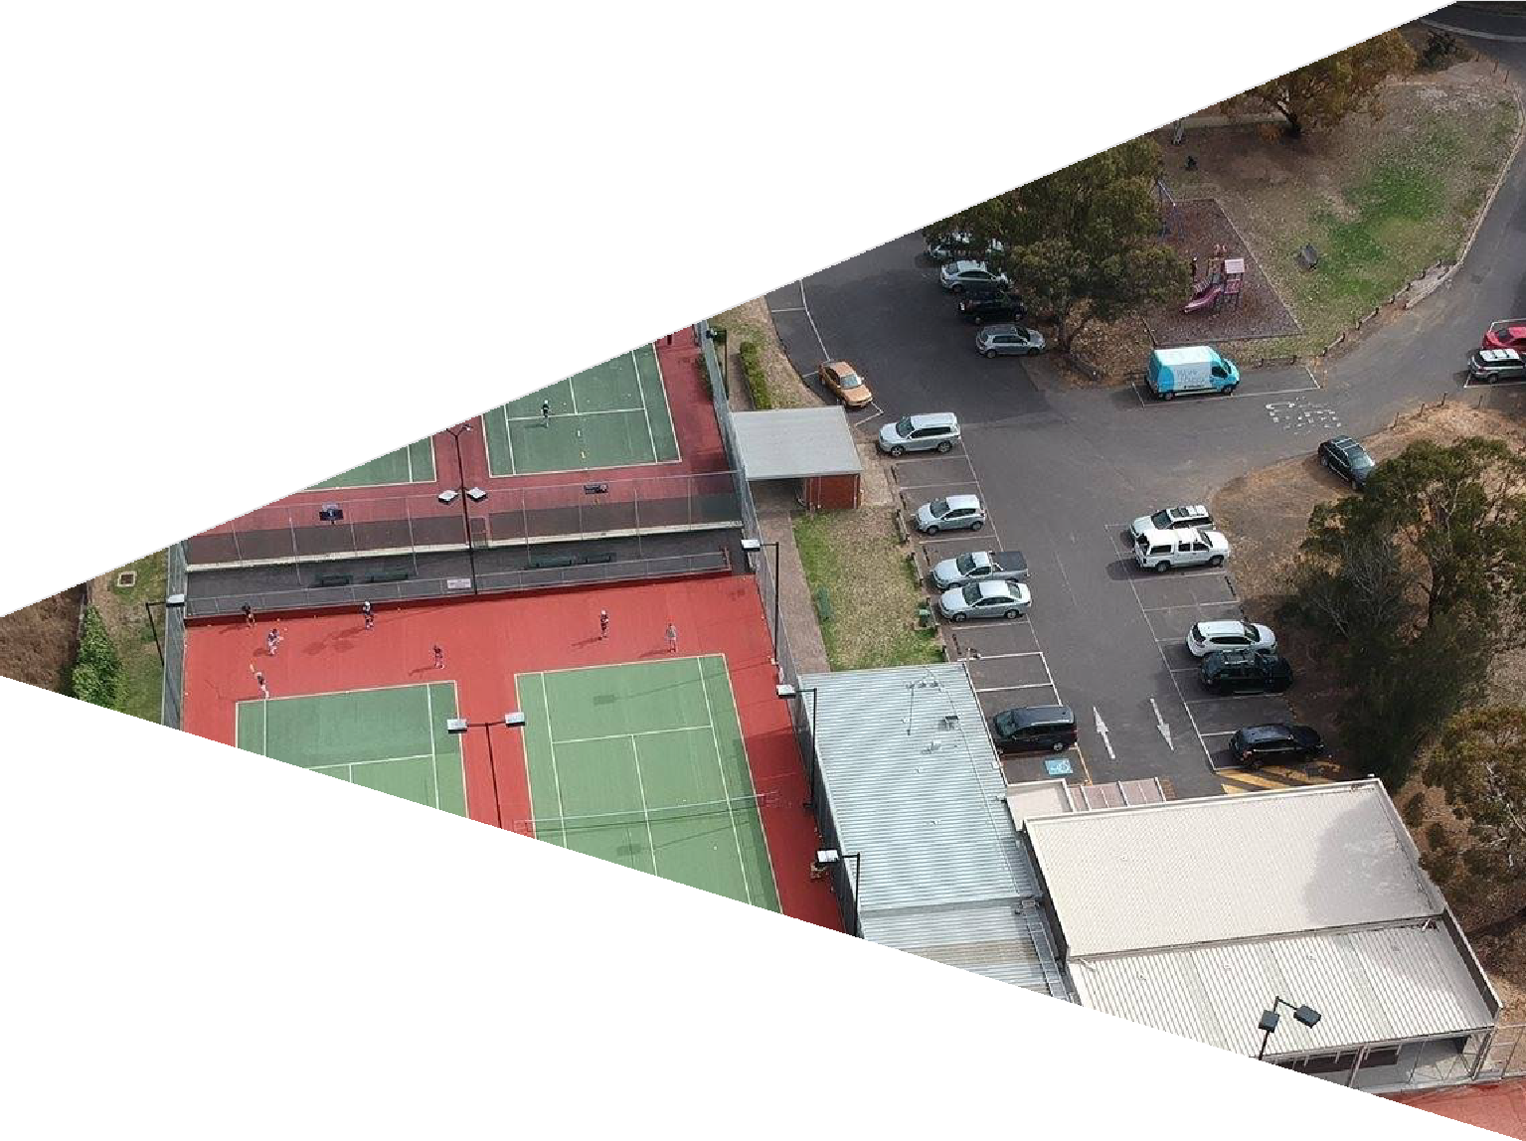

APPENDICES

30.

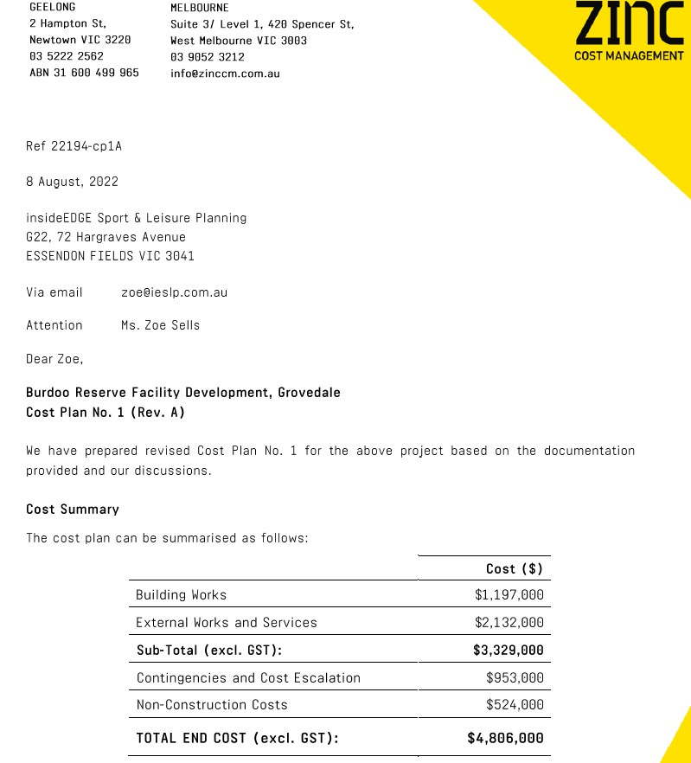QUANTITY SURVEY

33.

CITY OF GREATER GEELONG
PO Box104
Geelong VIC 3220
P: 5272 5272
E: contactus(@geelongcity.vic.gov.au www.geelongaustralia.com.au

CUSTOMER SERVICE CENTRE
100 Brougham Street
Geelong VIC 3220 8.00am - 5.00pm

© City of Greater Geelong 2022

LATEST NEWS:
(D (@CityofGreaterGeelong
@ (@GreaterGeelong
@ (@CityofGreaterGeelong
@ CityofGreaterGeelong

CITY OF GREATER
GEELONG

