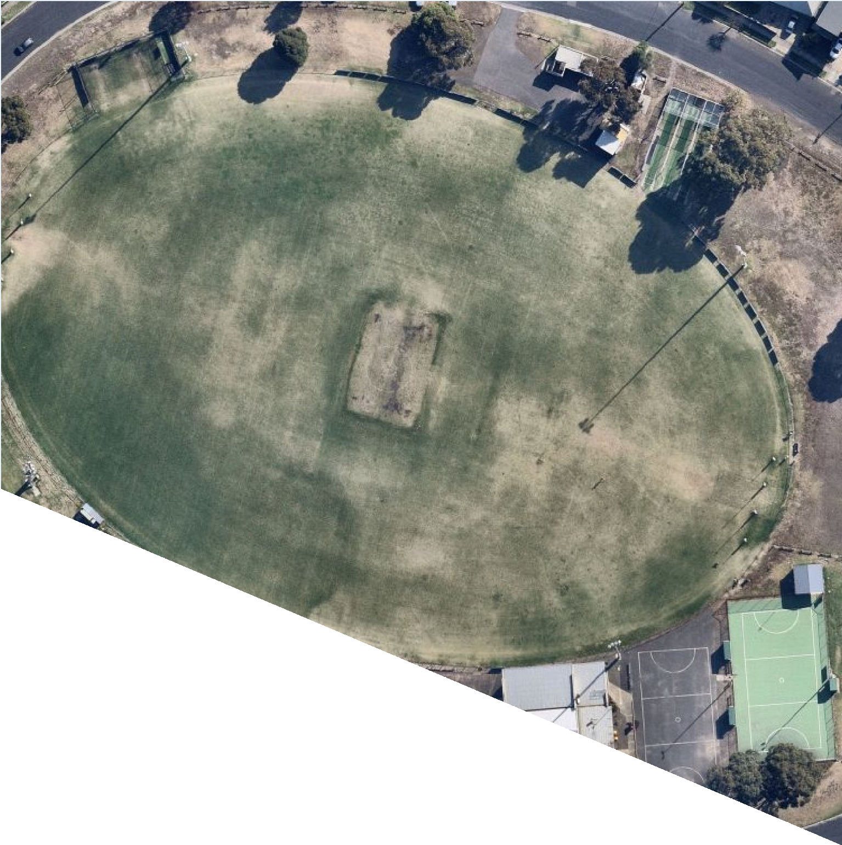

FACILITY
DEVELOPMENT PLAN:
RICHMOND OVAL
REPORT

WE ACKNOWLEDGE THE
WADAWURRUNG PEOPLE AS
THE TRADITIONAL OWNERS OF THE LAND, WATERWAYS AND
SKIES. WE PAY OUR RESPECTS TO THEIR ELDERS, PAST AND PRESENT. WE ACKNOWLEDGE ALL ABORIGINAL AND TORRES
STRAIT ISLANDER PEOPLE WHO ARE PART OF OUR GREATER
GEELONG COMMUNITY TODAY.




ABOUT THIS DOCUMENT
The Facility Development Plan has been prepared by insideEDGE Sport & Leisure Planning on behalf of the City of Greater Geelong. This project was funded via the City of Greater Geelong’s Community Infrastructure Grants program (2020/21) and developed in conjunction with the East Geelong Football and Netball Club and Geelong City Cricket Club. This Plan aims to provide an evidence base and strategic justification for the improvement to Richmond Oval to ensure its viability and suitability as a local level community sporting venue into the future.

All images courtesy of East Geelong Football and Netball Club and Geelong City Cricket Club.

CONTENTS

EXECUTIVE SUMMARY
The Site 5
Overview and Project Drivers 6
Strategic Alignment 7
Facility Development Priorities 8
FACILITIES AND USAGE
Existing Facilities 10
Facility Use 11
Community Programs and Initiatives 12
Existing Conditions 13
Participation 17
Community Profile 20
About the Clubs 22
FACILITY DEVELOPMENT PLAN
Guiding Principles 24
The Plan 25
Investment Opportunities 26
Implementation 27
Project Benefits 29
APPENDICES

3.



EXECUTIVE SUMMARY

10.

THE SITE

Richmond Oval is located on the border of the suburbs of central Geelong and East Geelong, metres from Kardinia Park, the CBD, and well established residential areas.

LOCATION
Richmond Oval is approximately 1km south of Geelong’s CBD and 1km north of the Barwon River. The venue is a single oval facility, bordered by residential housing around its perimeter. The facility is also 1km from South Geelong train station and Geelong’s premier sporting facility, Kardinia Park.

SITE CONTEXT
The Reserve is owned and managed by the City of Greater Geelong and is zoned Public Park and Recreation Zone (PPRZ) under the City’s planning scheme. The reserve offers sporting opportunities as well as a space where people can casually recreate and play.

FACILITY COMPONENTS
- Floodlit senior size AFL and cricket playing field
- Turf cricket wicket table
- One netball court with acrylic surface and floodlights
- One netball practice court with asphalt surface
- Cricket turf practice nets
- Cricket hard wicket practice nets
- Community sporting pavilion with change rooms for football/cricket players and umpires
- Community playground
- Car parking – both formal and informal
- Public toilets

USER GROUPS
- East Geelong Football and Netball Club
- Geelong City Cricket Club


> SEDA College
Richmond Oval

OVERVIEW & PROJECT DRIVERS

Richmond Oval is one of Geelong’s traditional and historical sporting venues within the municipality. The facility is home to the East Geelong Football and Netball Club and the Geelong City Cricket Club. In 2021, these Clubs were host to approximately 600 participants over all ages and genders.
Whilst participation is strong, gaps in facility provision prevent the Clubs from being able to prosper. At present, three main infrastructure shortfalls exist, including:

Non-compliant netball courts
1
Inadequate netball player and umpire change rooms
2
Outdated social and community spaces
3

This report outlines a collaborative approach to addressing these gaps and demonstrates the need and likely outcomes as a result of investment into improvements.
This project has been delivered in collaboration with sporting stakeholders including tenanting clubs, peak sporting bodies, the City of Greater Geelong and
in consultation with relevant guidelines for sporting infrastructure for a local facility.

ENSURING FACILITIES MEET MODERN STANDARDS TO ENCOURAGE PARTICIPATION AND MULTI-USE

PROVISION OF CHANGE FACILITIES TO SUPPORT
GENDER EQUITY OUTCOMES


SUPPORTING COMMUNITY HEALTH OUTCOMES AND SOCIAL CONNECTION
THROUGH SPORT
The Facility Development Plan has been created with the following methodology:
STAGE 1 Site inspections and stakeholder engagement – information gathering and stakeholder consultation.
STAGE 2 Demographic and strategic review, participation and facility audit analysis – review relevant exiting data and future forecasts and understand site utilisations, challenges and opportunities.
STAGE 3 Concept plans and further stakeholder engagement – develop site and building plans that align to investment partners objectives. Undertake further engagement and feedback on plans.
STAGE 4 Produce draft and final facility development plan, highlighting future upgrades and prioritised improvements.

“Enhancing core sporting infrastructure at Richmond Oval will create and sustain participation and ensure tenanting Clubs can provide equal opportunities for both men and women, girls’ and boys”

STRATEGIC ALIGNMENT
The following provides a high level overview of strategic documents which guide and support the Facility Development Plan.
CITY OF GREATER GEELONG
Our Community Plan 2021-2025
CITY OF GREATER GEELONG
Social Infrastructure Plan Generation One 2020-2023
SUPPORTING STRATEGIC DOCUMENTATION
AFL VICTORIA
Growing the Heartland Strategy

NETBALL VICTORIA
Statewide Facilities Strategy
CRICKET VICTORIA
2017-2022 The Journey ahead for Victorian Cricket

G21 & AFL BARWON TOWARDS 2030: STRATEGY

G21 & CRICKET VICTORIA REGIONAL CRICKET STRATEGY

CLUB STRATEGIC PLAN

RICHMOND OVAL FACILITY DEVELOPMENT PLAN

FACILITY DEVELOPMENT PRIORITIES

The Richmond Oval Facility Development Plan identifies a number of infrastructure requirements to support the future sustainability of community sport. The following priorities have been determined through asset auditing, strategic review and stakeholder consultation.

Key facility gaps to be addressed through the plan include providing equal opportunities for all
genders to participate in all sporting codes, facility compliance, functional improvements and supporting female participation.
At present, the existing asphalt practice netball court needs to be decommissioned and the construction of a new, acrylic surfaced court with sports lighting to be undertaken. As part of this project, the existing playground will need to be relocated, however will remain within the reserve’s footprint.
To further support netball participation, upgrades to player and umpire change rooms must also be considered. The current change facility is aged, outdated and sees deficiencies when compared
to recommendations provided by Netball Victoria. Further, improved entrances and sight lines into the netball change area will enhance passive surveillance and feelings of safety, particularly for girls and women.
The social rooms are used extensively by the tenanting clubs as well as during the school term by SEDA College (an independent secondary school). The social rooms require a functional upgrade to improve accessibility and a flexible floor plan to incorporate more multi use opportunities.
Due to site constraints and limited organisation of formalised areas, car parking occurs somewhat
haphazardly across the site. Improving car parking to
streamline vehicle movement, alleviate boggy conditions, damage to the reserve and improve pedestrian safety is required.

NEW NETBALL COURT AND RELOCATED PLAYGROUND
$490,000

NEW PLAYER AND UMPIRE CHANGE ROOMS FOR NETBALL
$728,000

IMPROVED SOCIAL
ROOMS AND SUPPORTING AMENITIES
$1.2M

SAFER CAR PARKING AND VEHICLE MOVEMENT
$385,000


CRICKET PRACTICE NET UPGRADE AND STORAGE
$270,000



FACILITIES AND USAGE

9.

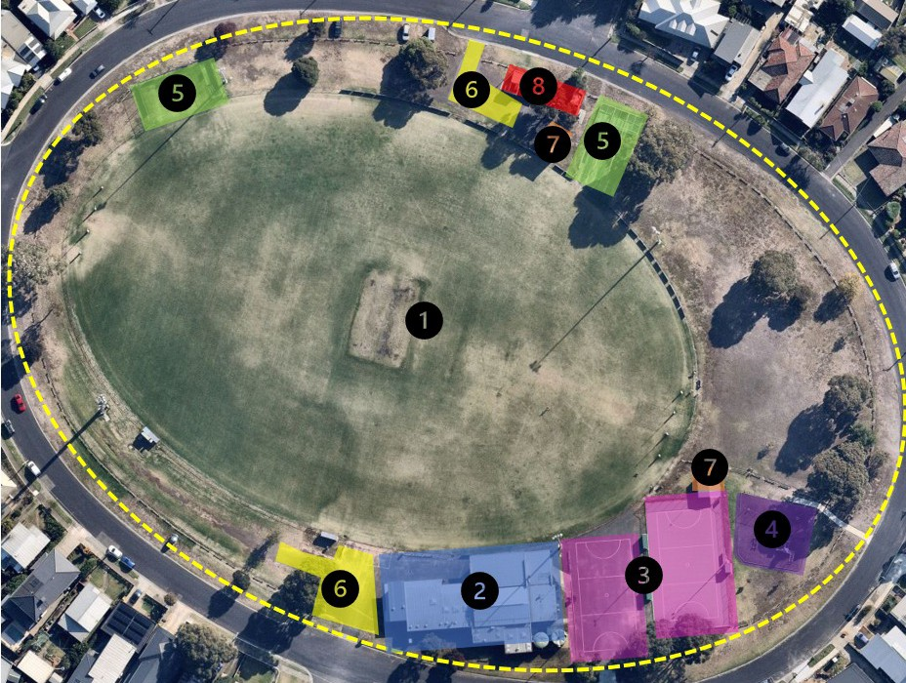EXISTING FACILITIES

- Oval
- Club Rooms
- Netball courts
- Playground
- Cricket practice facilities
- Car parks
- External storage areas
- Public toilets

FACILITY USE
Current use of facilities at Richmond Oval is outlined below. At present, football facilities are used over 22 hours per week, netball courts 12 hours per week, netball change rooms 8 hours per week and social rooms 30 hours per week. It is anticipated that should facility upgrades be realised, as per the Facility Development Plan, combined with population growth and a strategic vision to grow participation, usage of the facility will increase. It is anticipated that infrastructure improvements will enable clubs to grow their traditional participant base, as well as offer more opportunities to deliver flexible formats of the game and drive broader initiatives, programs and outcomes.

OVERALL CURRENT AND FUTURE FACILITY USAGE (HOURS PER WEEK)

45
40
40
Current Future
30
25
22
18
14
14
12 12
10
8 8

35

30

25

20

15

10

5

0
Netball change rooms

Netball courts

Ovals

Social rooms

Hard wicket cricket nets

Turf wicket cricket nets

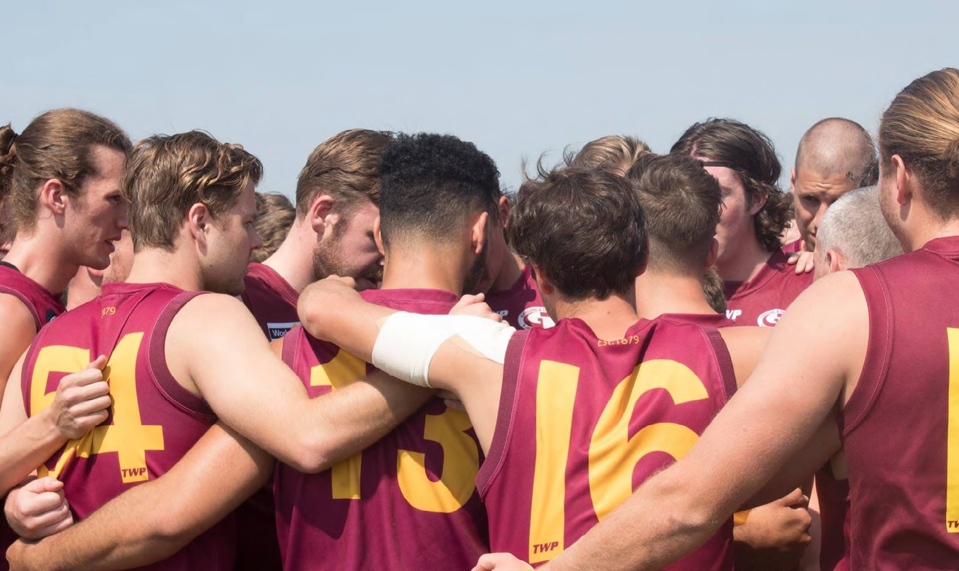

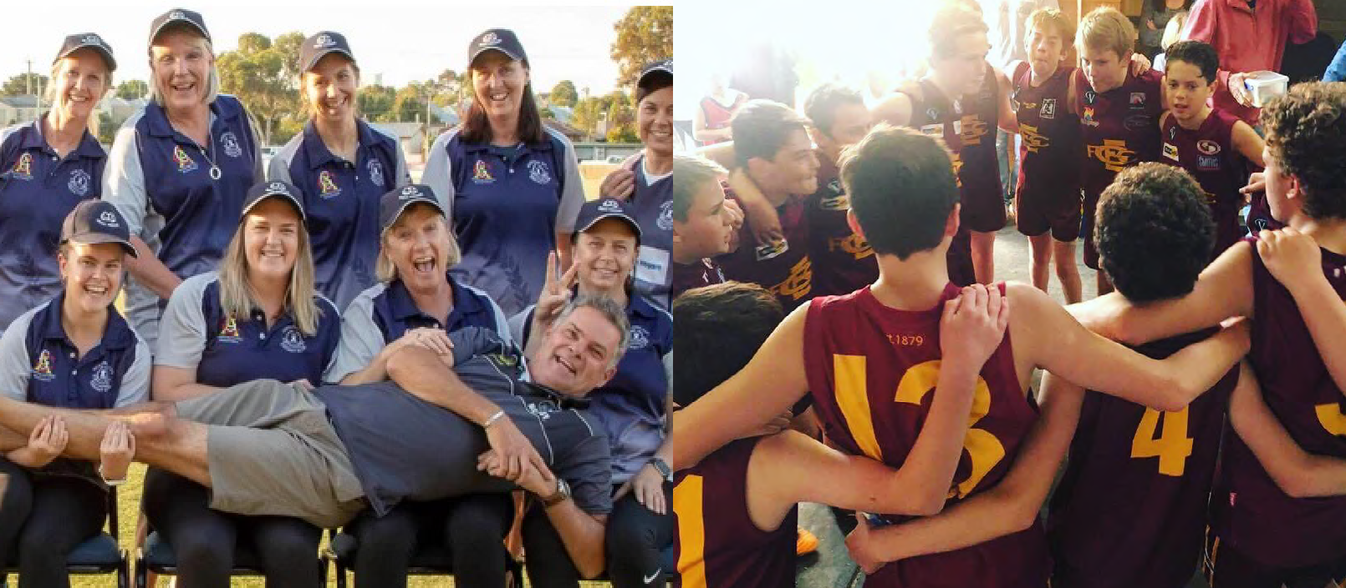
AND INITIATIVES
COMMUNITY PROGRAMS

GIRLS’ AND WOMEN’S CRICKET
Geelong City Cricket Club has fielded girls’ and women’s participation over the past 3 seasons. In 2022, the Club fields one senior women’s team and two junior girls side. The Club has been able to develop their program and are committed to seeing it strive through the following initiatives:
- Creating an inclusive club culture;
- Appointment of a committee member dedicated to female cricket development; and
- Building a pathway for junior girls’ into senior women’s cricket.

JUNIOR SUPPORT
Membership fees for players, and in particularly juniors, are kept low to ensure that costs aren’t a barrier to participation. In the event that fees cannot be paid, East Geelong Football and Netball Club offers further discounts or free membership to junior members to assist in facilitating their involvement.

Auskick and NetSetGO memberships are funded by the GDFNL and EGFNC via a reimbursement program.

SEDA COLLEGE
Throughout the school term, Richmond Oval is utilised by SEDA College as part of a long standing partnership. SEDA College is an independent senior secondary school that develops its curriculum in partnership with industry leaders in sport, recreation, community and trade organisations. SEDA College use the club room facilities as their classroom and also run educational, fitness and training programs on the fields of play. The ongoing benefits to the tenanting clubs of Richmond Oval include opportunities to connect with students and incorporate them into club programs and competition.

DEAKIN UNIVERSITY
East Geelong Football Netball Club also has a close relationship with Deakin University, and offer students undertaking sport science (or similar) degrees gain hands on work experience through the club trainer position.
Further, EGFNC also attracts a number of its senior players from Deakin University, particularly those who are boarding from other regional areas. The Club aims to embrace these players, providing a ‘home away from home’. The Club reports that many end up moving permanently to Geelong, and playing with the Club for the years following.

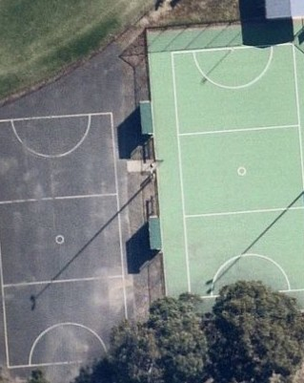EXISTING CONDITIONS

Existing facilities at Richmond Oval along with their condition and suitability were assessed as part of the Facility Development Plan. Key infrastructure items and associated issues and opportunities are identified below.

NETBALL COURTS
Description: There are two netball courts at Richmond Oval, one being a smaller asphalt court and the other an acrylic surfaced court with lights and supporting amenities including player shelters and storage area.

Issue: The asphalt court does not align with Netball Victoria guidelines. Whilst the actual playing area is suitable in terms of its dimensions, the run off zones do not comply are shorter than the recommended 3.05m. In addition, the asphalt court is predominately used as a car park which is not ideal in terms of surface wear and player safety.
Opportunity: Explore opportunities to construct an additional netball court with floodlights that is compliant with Netball Victoria guidelines. This will provide the Club with two compliant courts which is commensurate with recommendations by Netball Victoria for local football/ netball clubs.

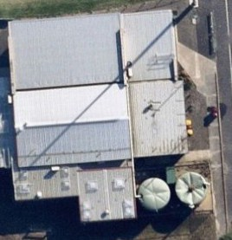NETBALL CHANGE AND UMPIRE ROOMS
Description: There are netball player change rooms in the existing club room facility. There are no netball umpire change rooms.

Issue: Netball player change rooms are undersized and under provisioned for participants when compared with sporting code guidelines. Netball umpire rooms are not provided within the facility. Netball change rooms have a poor entry way and sight lines.
Opportunity: Consider how to best provide new, modern change room facilities for both netball players and umpires that are comparable to other like local venues.

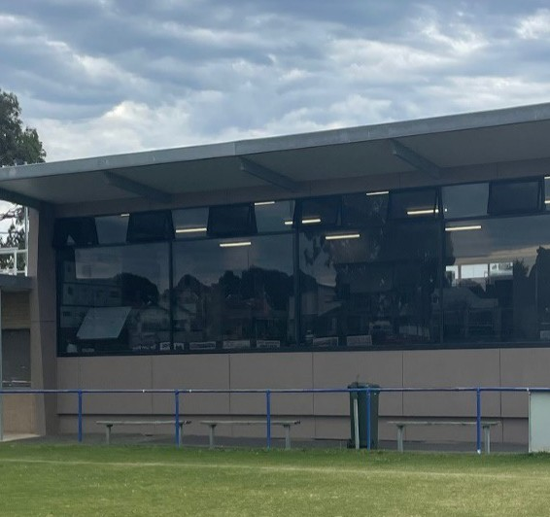CLUB ROOMS
Description: The social rooms are situated across two floor levels (i.e. an upper and lower ground) and are approximately 200m2. Minor upgrades have been performed however the area shows signs of age.
The football/cricket change rooms are of good quality. The present configuration however may present some constraints.

Issue: Whilst the social rooms are of good size, the functionality of the space is limited due to its present layout. The change rooms, particularly the away room, does not align with recommended facility guidelines.
Opportunity: Explore opportunities to improve the social area so that it creates a more usable space for the club to host functions, meetings and for broader community use. Consider a reconfiguration of the existing football/cricket home and away change areas to allow for greater functionality and alignment with recommendations.

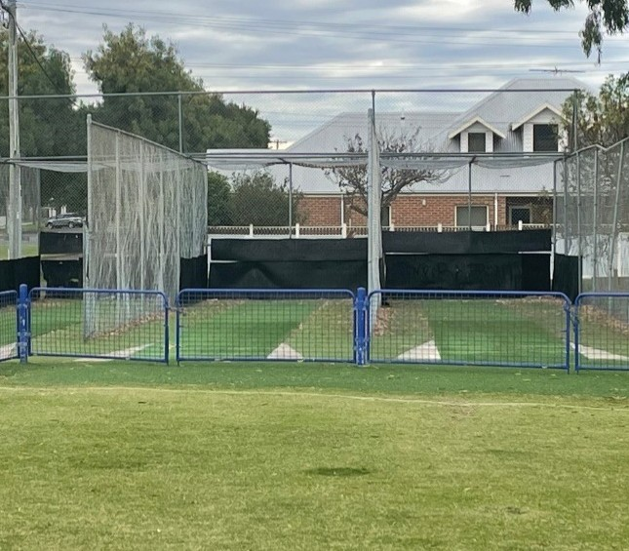
CRICKET PRACTICE NETS AND STORAGE AREAS
Description: The hard wicket (synthetic) cricket nets, scoreboard, storage shed and ancillary shipping containers are located on the north eastern wing of the oval. The hard wicket nets consist of 3 bowling lanes that are partially fenced with run ups partially located on the oval. The turf wickets are located on the western pocket of the oval with run ups also on the oval surface.

Issue: The synthetic nets are in mostly good condition with a small deficiency as the run up area is preferred to be completely situated off the oval surface. The turf wicket nets are also in reasonably good condition with dimensions mostly meeting recommendations.
Again it is preferred that run ups are positioned off the Oval, however spatial limitations at Richmond Oval may prevent this from being achievable. Storage areas, particularly the shipping containers, does not allow for equipment to be stored adequately or safely.
Opportunity: Consider storage solutions to improve functionality of the area. Consider minor improvements to both turf and synthetic wickets to enhance their quality. Consider the addition of another hard wicket bowling lane to existing practice facility if space and demand necessitates.

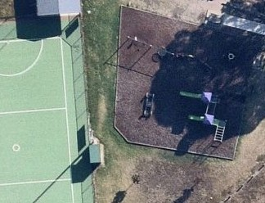

PLAYGROUND
Description: The playground at Richmond Oval appears to be in very good condition consisting of slide sets, rockers etc supported by natural shade.
Issue: There is no apparent issue with the playground however due to potential future netball court construction may need to be relocated. If required, the existing equipment can be re-used to ensure the same level of amenity is provided for the community.
Opportunity: If relocation is required, utlising existing equipment and relocate within the reserve’s footprint.

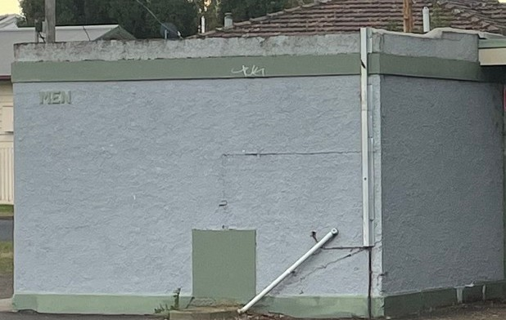
PUBLIC TOILETS
Description: Public toilets are provided on the northern boundary in the proximity to hard wicket cricket practice nets and car park.

Issue: The public toilets are old and do not present in an acceptable manner. They are not suitable for accessible or all gender use.
Opportunity: Upgrade public toilets as part of Council’s cyclical upgrade program.

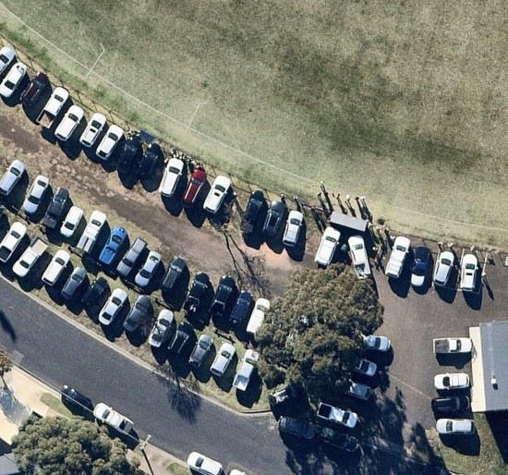
CAR PARKING
Description: There are presently two official car parking areas at Richmond Oval, one which is centered to the west of the main pavilion and one that is associated with the public toilet block on the northern boundary. Overflow parking on game days is generally around the oval’s perimeter.

Issue: Due to site constraints and limited organisation of formalised areas, car parking occurs somewhat haphazardly across the site. Potential safety risks are also apparent with the asphalt netball court doubling as a car parking area when not in use.
Opportunity: Consider a design response that can improve vehicle movement and car parking across the site within the constraints presented. Retain overflow parking areas, move cars off netball courts, and expanding formalised parking areas where appropriate.

N/A

FACILITY AUDIT SUMMARY
In addition to the key observations, issues and opportunities identified on the previous pages, an assessment of the facilities at Richmond Oval was undertaken using insideEDGE’s Sports Facility Auditor Program and the preferred infrastructure guidelines of AFL, Cricket and Netball. The below table identifies where the facility meets current expectations (green), where some gaps exist however intervention is not essential (orange) and where major shortfalls (red) exist.

CLUB ROOMS SUMMARY | Number of change rooms | Room size | Number of showers | Shower type | Toilet type | Accessible Entry | Storage
Football/ Cricket Home Change Room | 1 | Greater than 45m2 | 4 | Lockable cubicle | Pan toilets | Yes | Yes
Football/ Cricket Away Change Room | 1 | Less than 45m2 | 4 | Lockable cubicle | Pan toilets | Yes | N/A
Football/ Cricket Umpire Change Room | 1 | Greater than 20m2 | 2 | Lockable cubicle | Pan toilets | Yes | N/A
Club Social Rooms | N/A | >100m2 | N/A | N/A | Pan toilets | Yes | No
Netball Home Change Room | 1 | Less than 20m2 | 1 | Lockable cubicle | Pan toilet | No | No
Netball Away Change Room | 1 | Less than 20m2 | 1 | Lockable cubicle | Pan toilet | No | N/A
Netball Umpire Change Room | 0 | N/A | N/A | N/A | N/A | N/A | N/A

FIELD OF PLAY SUMMARY | Surface type | Length | Width | Run off area | Lighting lux level | Dimensions comply with guidelines | Overall condition rating
Oval 1 | Warm season grass | 169m | 115m | 3m | 100 lux | Mostly | Good
Netball Court 1 | Synthetic | 30.6m | 15.3 | >3.05 | Unsure | Yes | Good
Netball Court 2 | Asphalt | 30.6m | 15.3 | <1.9m | <50 lux | No | Very Poor
Cricket Nets (hard wicket) | Synthetic | 22.65m | 3.4m | N/A | N/A | Mostly | Good
Cricket Nets (turf wicket) | Turf | 11.25m | 18m | N/A | N/A | Mostly | Good

PARTICIPATION AT RICHMOND OVAL

CURRENT AND PAST PARTICIPATION
Despite the disruptions caused by the COVID-19 pandemic, participation at Richmond Oval has remained strong, and continued to increase in some instances.
As evidenced in Chart 1, participation has increased significantly for football from 2018-2021, primarily attributed to the strength and increase of the Club’s junior program. Netball also has almost doubled their participation figures, seeing an extra 40+ participants in 2022 compared to 2018. Cricket, through it’s diversification and focus towards more female participants, has received a spike of almost 30 players from 2019 to 2022.

FEMALE PARTICIPATION
Female participation across all sporting codes at Richmond Oval has increased dramatically over the past three seasons (excluding 2020 due to COVID-19).
Club led initiatives to foster and harness female participation has resulted in more opportunities for women and girls’ to
be involved and contributed to on-field success, particularly in netball where A grade, U17 and U15 netball sides were premiers in 2022, along with winning the GDFNL Netball Club Championship in Season 2021.

CHART 1

2018 2019 2021 2022
173
FOOTBALL
NETBALL
78
218
FOOTBALL
58
NETBALL
170
CRICKET
297
FOOTBALL
105
NETBALL
170
CRICKET
FOOTBALL
271
121
NETBALL
198
CRICKET

CHART 2
147
101
68

2019 2021 2022

290
215
300
155
230
320
170
245

2024 2026 2028
FUTURE PARTICIPATION FORECAST
The EGFNC, through their 2022-2027 Strategic Plan, has a core focus on participation engagement, growth and retention whilst providing a welcoming, safe and inclusive atmosphere for participants. GCCC also has clear objectives with aspirations to deliver the best junior cricket program in the region. These initiatives combined with the infrastructure recommendations within this report, will undoubtedly have a positive impact on participation, with consistent increases expected across all codes over the next 5+ years.
CHART 3
FOOTBALL
NETBALL
130
CRICKET
FOOTBALL
NETBALL
CRICKET
FOOTBALL
NETBALL
CRICKET



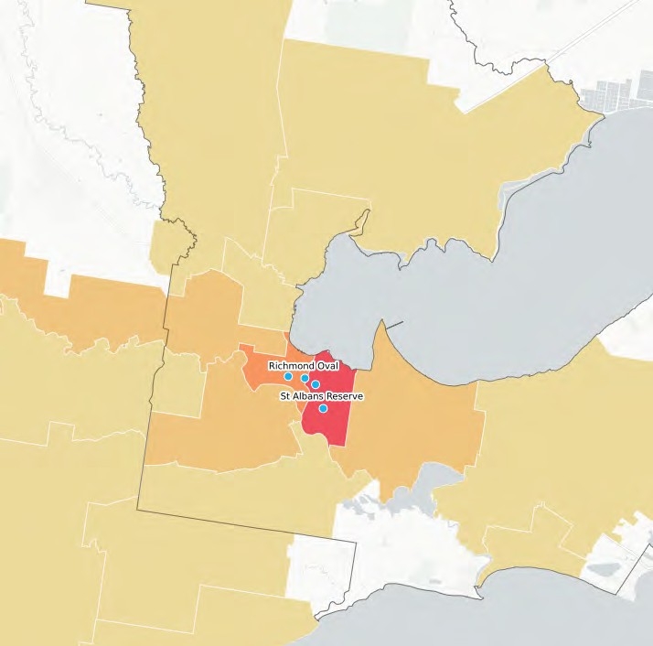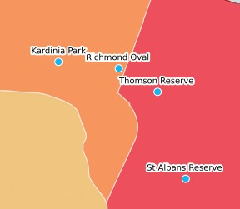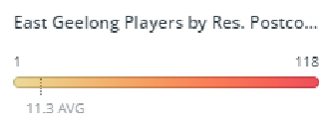

The AFL has detailed participation data including the residential postcode of players for each club. This data enables the mapping of a club’s catchment and to understand their effectiveness in attracting local players, as well any reach it may have across the municipality. Whilst participation at Richmond Oval is strong, as evidence by the chart below, there are several other clubs within proximity that have the same offerings and similar, or better, facility provision.
The below map indicates East Geelong Football Club’s catchment of players and their respective residential postcodes in season 2021. The below heat map shows that the majority of players reside in the immediate Geelong and East Geelong suburbs. The map also demonstrates the concentration of other football-netball clubs within a 4km radius.

COMMUNITY PROFILE
+83.5%
Increase in number of persons living in Geelong & East Geelong 2022 to 2041

12,247
Geelong & East Geelong population in 2022

+2,179
Increase in number of persons living Geelong & East Geelong 2022 to 2031

+5,482
Increase in number of persons living in Geelong & East Geelong 2031 to 2041

ABOUT GEELONG & EAST GEELONG’S POPULATION
- Richmond Oval is located on the boundary of both Geelong & East Geelong and therefore demographics are considered for both suburbs.
- Geelong is bordered by Corio Bay in the north, Princes Fwy to the west and Kardinia Park to the south west.
- The Geelong locale encompasses the CBD which includes major shopping and retail precincts, hospitals, galleries, education and residential housing.
- Geelong is expected to see an additional approx. 2,000 residents by 2031, which according to the City’s Settlement Strategy (2020) will be attributed through a combination of student housing and apartment developments.
- East Geelong is also bordered by Corio Bay in the north as well as the 81 hectare Eastern Park precinct. On the edge of the CBD, East Geelong encompasses mostly residential areas within its moderately sized boundary.
- East Geelong has a small population increase forecast, when compared to central Geelong, with an additional 240 people expected between now and 2031.
- The graphs on page 21 demonstrate the anticipated forecasts by 5 year age cohorts for both Geelong and East Geelong. As demonstrated, Geelong is
set to see a spike in people aged 20-34 to 2041, which is likely attributed to the additional student and apartment housing stock which appeal to this market.
- East Geelong is expected to see a similar spike in the same age cohorts, albeit not as great as Geelong. There will also be a higher number of persons within the 50-64 year old group.

MARKET FOR SPORT
- Clubs tenanting Richmond Oval are likely to source the majority of their participant base from the 3219 & 3220 postcodes. This is evidenced by current residential location of football participants (see page 19).
- The key market for sport is within the 5-39 year old age cohort, and population forecasts for those within East Geelong’s target market are set to increase within this range.
- In particular people aged 20 – 34 will be highly represented within both Geelong & East Geelong, presenting opportunity for the clubs to focus
on programs and strategies that attract this demographic.

GEELONG POPULATION FORECAST BY 5 YEAR AGE COHORT 2022- 2031 -2041

2500

2022 2031

2041

Key market for organised sport

2000

1500

1000

500

0

EAST GEELONG POPULATION FORECAST BY 5 YEAR AGE COHORT 2022- 2031 - 2041

400
2022
2031
2041
Key market for organised sport

350

300

250

200

150

100

50

0

surrounding community for more than 130 years. The Club fields teams across numerous age groups and genders, and in season 2021 were awarded the Geelong
& District Football Netball League Champion Club. In 2022
EGFNC has received the following accolades:
  - Reserves Football Premiers
  - A Grade, U17 and U15 Netball Premiers
  - Seniors and Reserves Football League Best and Fairest
  - Coach and six representatives listed in GDFNL Football
Team of the Year
  - Coach and two representatives listed in GDFNL Netball
Team of the Year
  - U13 Netball League Runner Up Best and Fairest
  - U15 Netball League Runner Up Best and Fairest
The Club has a vision to ‘Be the Geelong and District Football & Netball League’s most welcoming, successful and family friendly club; providing equal opportunities for all to participate in football and netball. Within the Club’s 2022-2027 Strategic Plan, they aim to achieve this vision via the following objectives:
Participation & Inclusion: provide opportunities to grow participation across all ages, genders and abilities in football and netball.
- Sustainability: Excellent administration that demonstrates financial, social and environmental responsibility.
- Engagement: Foster and drive partnerships and communication with current, prospective and former members, stakeholders and sponsors.
- Leadership: Through strong leadership, continually improve club culture and the creation of a welcoming environment that sets us apart from the rest.
- Success: To be respected, competitive and fair in all on field performances, positioning us as one of the GDFNL’s most successful clubs.

GEELONG CITY CRICKET CLUB
The Geelong City Cricket Club strives to be a welcoming and family friendly club. Their vision is ‘To be the club of choice in Geelong, recognised for community, development and success’. The Club fields four senior men’s teams, one senior women’s team, five junior sides
and two junior girls along with the Woolworths Cricket Blast program. The Club has clear priorities over the short term to achieve the following outcomes under these initiatives:
- Senior Cricket – win a championship and achieve promotion to Division 1. Further female cricket participation and development, including a long-term women’s program.
ABOUT THE CLUBS
EAST GEELONG FOOTBALL AND NETBALL CLUB
Established in 1879 as part of the first competitive football competition in Geelong, East Geelong Football and Netball Club has been affiliated with the
- Junior Cricket – be recognised as having the best junior cricket program in the region for all genders.
- Active club community – to have all members, their families and players activity involved in the Club.
- Club operations and facilities – to be recognised as the benchmark club in Geelong for operations and facilities including training facilities and storage to support growth of cricket programs and female participation.

600
Sporting participants at Richmond Oval in 2021

297
Football participants in 2021


105
Netball participants in 2021

124
Grassroots program participants


25
Female cricket participants

2021
GDFNL Champion Club



FACILITY DEVELOPMENT PLAN

23.

GUIDING PRINCIPLES

Recommendations within the Facility Development Plan align with the below principles. This ensures that recommendations are realistic, achievable and meet the identified needs of the reserve, its user groups and the strategic priorities of potential future investment and facility partners.

BUILDING THE CAPACITY OF COMMUNITY SPORT
- Provide facilities that are fit for purpose and enhance the community sport experience.
- Align sporting provision to ensure it is comparable to other recreation reserves within the City and that Richmond Oval is competitive amongst other football-netball-cricket providers within the vicinity.
- Ensure facilities respond to current participation growth and future population forecasts.

HEALTHY SPORTING ENVIRONMENTS
Provide improved spaces to deliver programs, competitions and training to support participation retention, opportunity and prosperity.
4
Deliver facilities that attract participants to compliment club initiatives and foster a healthy sporting environment.
5
Enhance opportunities for all genders, particularly women and girls’, to participate in both traditional and non-traditional sports, through quality facilities and a thriving club culture.
6

COLLABORATIVE PARTNERSHIPS
Ensure recommendations align with the funding priorities of potential investment partners including sport and government.
7
Strengthen use of facilities and partnership with SEDA College to encourage multi-use of the venue outside of regular sport hours.
8

BUILDING PLAN

REPLACE EXISTING WINDOWS. MAKE OPENABLE

EXTEND AND REFURBISH KITCHEN

EXTEND ROOF LINE FOR COVERED VIEWING

REMOVE AND INFILL EXISTING DOOR EXTEND COACHES BOX

UNDERCOVER RAISED VIEWING DECK

SOCIAL VIEWING

UP

KITCHEN
40 m²

AMENITIES

HOME
22 m²

DIS
8 m²

UMPIRES
25 m²

TIME KEEPERS
9 m²

TIMBER DECK

TRAINER

COOL
6 m²

GLASS BALUSTRADE UP

CHAIR LIFT

AMENITIES

AWAY
22 m²

UNDER COVER VIEWING

TRAINERS
11 m²

HOME
75 m²

R

B
C
P

A

O

Y
RI

G
T

H

AWAY
45 m²

STORAGE
7 m²

BAR
14 m²

SOCIAL ROOM
224 m²

STORE
18 m²

FIRST AID
11 m²

UMPIRES
29 m²

HOME SHWR
23 m²

AWAY SHWR
23 m²

STORE
6 m²

ENTRY
47 m²

AIRLOCK
14 m²

PATH

REMOVE EXISTING WALL

NO NEW WORKS TO EXISTING AMENITIES

NEW WALL LOCATION TO PROVIDE AFL COMPLIANT AWAY ROOMS

RETAIN EXISTING BAR AREA

AFL OFFICE
20 m²

NETBALL OFFICE
19 m²

DIS.
5 m²

FEMALE
22 m²

AIR LOCK

MALE
27 m²

EXISTING TANKS TO BE REMOVED AND OR RELOCATED

NEW NETBALL FACILITIES TO NETBALL CAUSTRALIA STANDARDS

CREATE NEW STORAGE AREA

RE-PURPOSE EXISTING TOILETS AS OFFICES

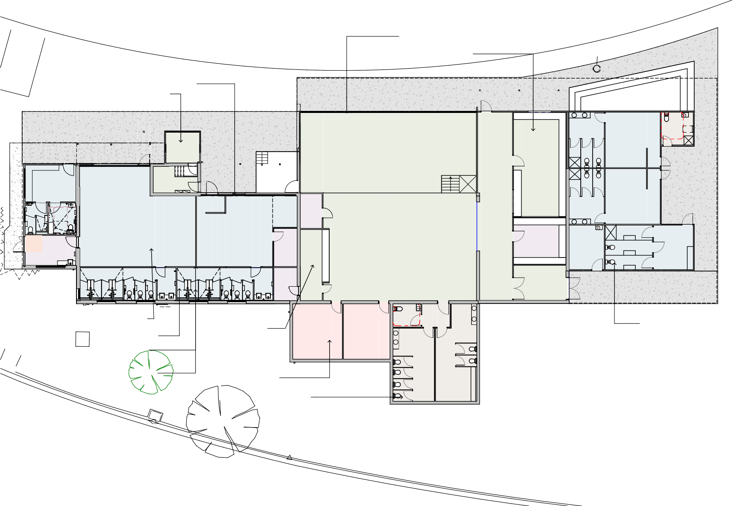

RE-PURPOSE EXISTING STORE ROOMS AS MALE AND FEMALE TOILETS

Note that drainage plans associated with building and/or netball court construction to be identified during detailed design phase. Drainage to connect with storm water system within the reserve.

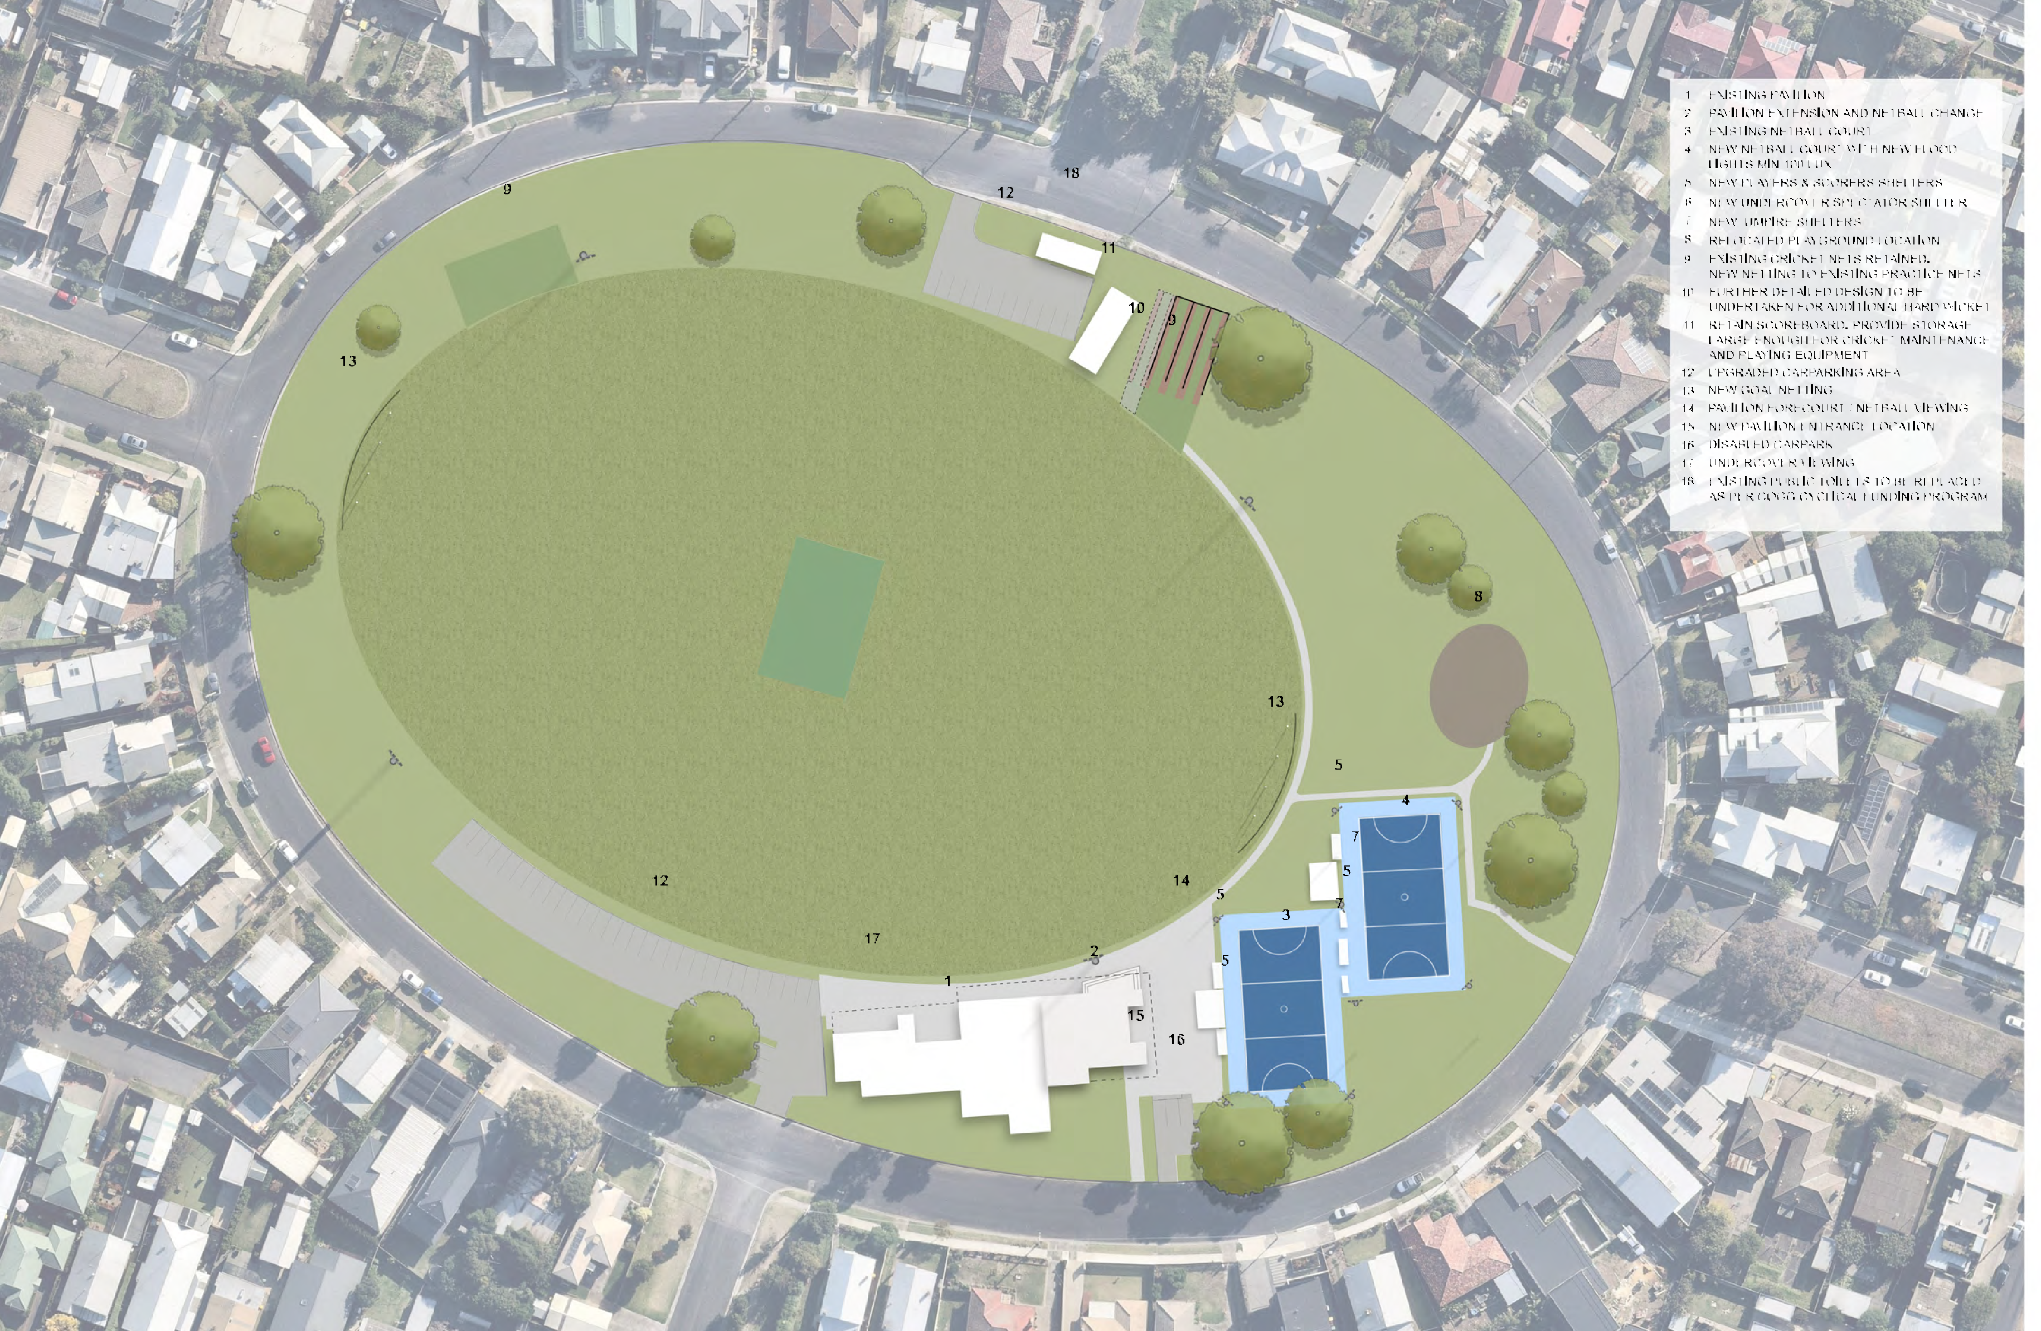SITE PLAN

6

INVESTMENT OPPORTUNITIES

To achieve recommendations outlined within this report, a collaborative approach to investment is required. Opportunities for partnerships via club, local, state and other community sources should be explored. At the time of writing this report, the below funding programs and opportunities aligning with recommendations are available and outlined below.

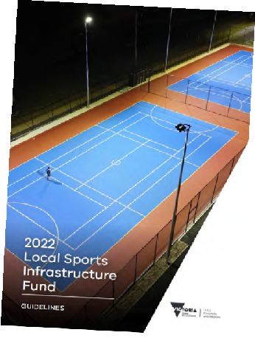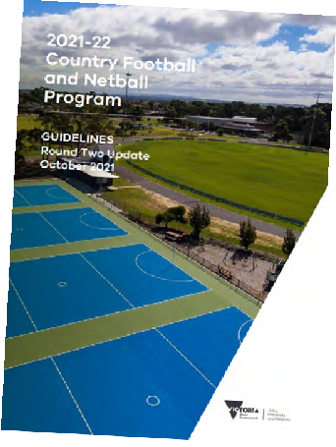City of Greater Geelong’s Community Infrastructure Grants Program
This program aims to support funding for the planning and delivery of capital works projects within the City of Greater Geelong. This includes grants available for amounts up to $350,000.

Sport & Recreation Victoria Local Sports Infrastructure Fund
This Fund aims to provide a range of grant opportunities across funding streams including Female Friendly Facilities (up to $1,000,000), Community Sports Lighting (up to $250,000), Community Facilities (up to $300,000) and Planning (up to $50,000).

Sport & Recreation Victoria Community Cricket Program
This Program aims to support cricket participation in Victoria through high-quality and welcoming facilities. The objectives of this program aim to be achieved through providing funding for projects such as upgrading of existing and construction of practice facilities, club room developments, playing field upgrades and sports lighting initiatives. Up to $100,000 in grant funding is available.

Sport & Recreation Victoria Country Football & Netball Program
This fund aims enhance participation opportunities in football and netball through improved playing surfaces, gender-neutral player and umpire change facilities and sports lighting upgrades. Up to $200,000 is available through this program.

Club fundraising
Clubs tenanting Richmond Oval may have opportunities to fundraise to support the delivery of the identified infrastructure upgrades. Where applicable, clubs should be encouraged to create a sinking fund that helps support the implementation of the Facility Development Plan, and to support Council in their pursuits to leverage both internal and external funds.

Council’s budget process
Each year Council prepares a budget which provides funding for the delivery of community services, programs, and infrastructure in line with its respective Council Plan. There are opportunities for items identified within the Facility Development Plan to be delivered via this process.

Council’s cyclical budgets
Council has cyclical budgets for the maintenance and renewal of minor infrastructure items. A small number of recommendations within the Facility Development Plan could be considered within relevant cyclical programs.

Victorian government elections
The upcoming 2022 state elections may also offer opportunities to leverage contributions to the projects outlined within this report.

IMPLEMENTATION
To assist with implementation, key infrastructure recommendations have been prioritised in partnership with stakeholders. Their alignment to the Plan’s guiding principles and costs associated are outlined below. Note that information regarding infrastructure items not listed below can be found within the site plan on page 26 and within the Quantity Survey.
Note that all costs listed below are base-line estimates and do not include site preparation, construction contingencies, escalation costs, staging considerations or take into account any latent site conditions. Please refer to the detailed Quantity Survey relevant to this project which makes allowances for these inclusions.

PRIORITY 01 - NETBALL COURT REDEVELOPMENT

DESCRIPTION | COST | FUNDING OPPORTUNITIES FOR DELIVERY
To comply with standards set by Netball Victoria, redevelop the asphalt netball court as per designs provided by SportENG (see Appendices section of this report).  Included in these works is the construction of a spectator shelter, as well as new players and scorers shelters and floodlights to 200 lux.  Also includes relocation of existing playground. | $490,000 | SRV Country Football & Netball Program* SRV Local Sports Infrastructure Fund* CoGG Community Infrastructure Grants Council’s budget process  (*require Council contributions)

PRIORITY 02 – NETBALL PLAYER AND UMPIRE CHANGE ROOMS

DESCRIPTION | COST | FUNDING OPPORTUNITIES FOR DELIVERY
As per building concept plans provided in this report, redevelop the existing netball player and umpire rooms so that they comply with Netball Victoria guidelines to improve amenity, safety and passive surveillance.  Included in these works is the pavilion forecourt/netball viewing area. | $728,000 | SRV Country Football & Netball Program* SRV Local Sports Infrastructure Fund* CoGG Community Infrastructure Grants Council’s budget process  (*require Council contributions)
PRIORITY 03 – CLUB ROOM REDEVELOPMENT

DESCRIPTION | COST | FUNDING OPPORTUNITIES FOR DELIVERY
Undertake works to improve the functionality of the existing social rooms and football/ cricket change rooms. Included in these works is the roof/verandah extension, external viewing area and an upgrade to the buildings façade. | $1.2M | SRV Country Football & Netball Program* SRV Local Sports Infrastructure Fund* CoGG Community Infrastructure Grants Council’s budget process  (*require Council contributions)

PRIORITY 04 – CRICKET PRACTICE NET UPGRADE AND STORAGE
PRIORITY 05 – CAR PARK UPGRADE AND ANCILLARY SPORTING INFRASTRUCTRE IMPROVEMENTS

DESCRIPTION | COST | FUNDING OPPORTUNITIES FOR DELIVERY
Replace netting on existing hard wicket practice facility. Provide an additional hard wicket bowling lane (subject to spatial availability and demand).  Provide new storage facility adjacent to hard wicket practice nets. | $270,000 | Council’s budget process  Council’s cyclical budget programs

DESCRIPTION | COST | FUNDING OPPORTUNITIES FOR DELIVERY
Upgrade car park, path network and provide additional landscaping. Provide behind goal netting at each end of oval. | $385,000 | CoGG Community Infrastructure Grants Council’s budget process  Club fundraising

PROJECT BENEFITS

Greater opportunity for increased female participation through the provision of a new netball court and all gender change facilities, specifically for use by netball players and umpires.
1

More capacity for cricket training and streamlined operations for volunteers, through improvements to the synthetic practice nets and associated storage facilities.
2

Enhanced functionality of social and football/cricket change rooms and safer accessibility throughout the site through more flexible, modern spaces and safer pedestrian connections, spectator areas and vehicle movement.
3

"The EGFNC has worked hard over the last 5 years to grow its participant base significantly; particularly in junior football and netball. These increases see more usage of our facilities. Unfortunately the current outdated and non-compliant infrastructure compromises our ability to provide the optimum experience for our members. Upgraded facilities will provide all user groups of Richmond Oval, as well as the SEDA College, improved opportunities to deliver our respective programs”
- Nathan McLaren, Secretary - East Geelong Football and Netball Club

"The growing girls and womens participation has been great for our Club - building greater community involvement and a welcoming environment for anyone who wants to play cricket. With growing participation in our juniors, girls and womens programs our current training facilities and storage are insufficient. Upgraded facilities will enable us to support the development and experience of all our players and volunteers"
- Graeme Beaumont, President - Geelong City Cricket Club



APPENDICES

31.

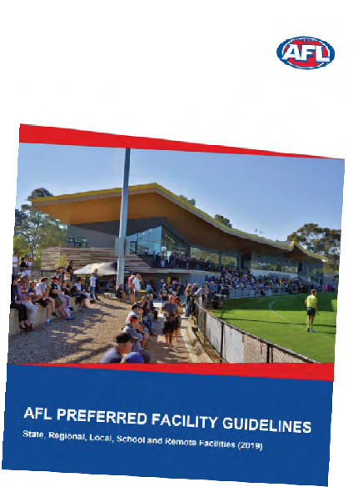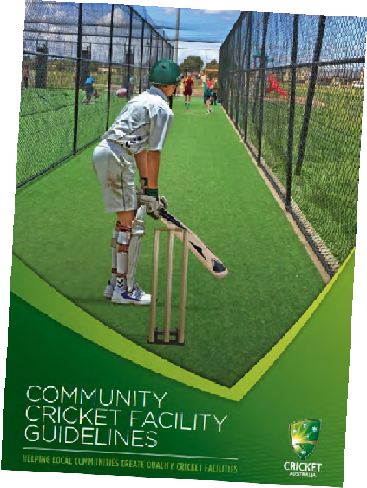SPORT FACILITY STRATEGIES AND GUIDELINES

To support local, state and federal strategic planning, many peak sporting bodies have developed resources to help guide sustainable facility development and delivery. Across the many sports represented at Richmond
Oval, each one offers guidelines that outline minimum preferred standards for infrastructure provision.
Common priorities and principles identified within these documents include:
Gender neutral amenities: Providing facilities that are welcoming, inclusive, accessible and encourage use by people of all-genders.
Multi-purpose facilities: Providing facilities that offer opportunities for multiple users and a variety of uses to generate greater community benefit and asset utilisation.
Growing venue capacity: Increasing the quality and capacity of existing facilities through innovative
approaches (e.g. LED lighting, synthetic surfaces) that create more programming opportunities.
Universal access: Ensuring community facilities are accessible to people regardless of their age, ability or cultural background.
Planning for growth and demand: Investment and prioritisation of facilities and infrastructure upgrades where greatest need and demand is demonstrated.
Partnerships and collaborative investment: Enhancing and maintaining relationships between all levels of government, industry partners and sport to promote collaborative investment into facility development.

ECONOMIC AND SOCIAL VALUE OF SPORT

THE VALUE OF COMMUNITY FOOTBALL
In 2015, AFL Victoria and Latrobe University undertook research to determine the social value of a typical community football club.
The study found that for every $1 spent on a community football club, there was at least $4.40 return in social value.
The strongest benefits were found to be delivered in the areas of mental health, physical health, personal well being and education. Others benefits included social inclusion, civic pride, empowerment, social connectedness, regional population stability and cultural integration.

$1 $4.40
Qualitative benefits included:
- Increased social connectedness, inclusion and networking.
- Increased level of trust in others.
- Reduced anti-social behaviour.
- Community pride.

SPENT ON COMMUNITY FOOTBALL
RETURN IN SOCIAL VALUE

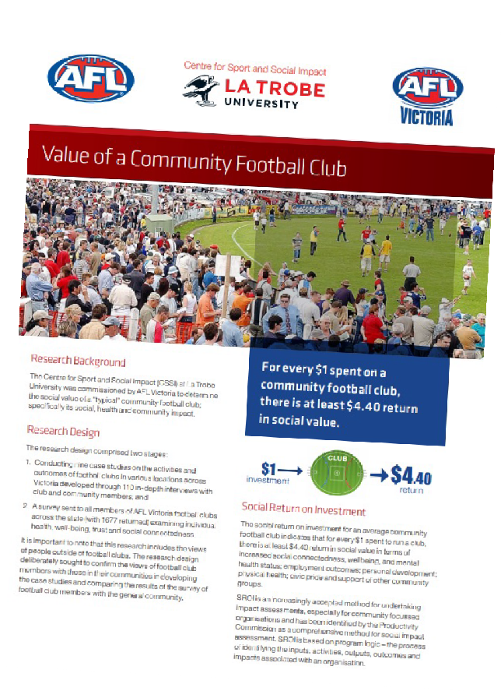

THE VALUE OF COMMUNITY SPORT & ACTIVE RECREATION
Sport and Recreation Victoria commissioned a report by KPMG in 2020 to highlight the value of community sport and recreation infrastructure. The report looked at the economic, health and social benefits that accrue to individuals, community and society via the construction and operation of sport and recreation facilities and the activities that are conducted within.
The report found the following benefits contributed annually to Victoria through community sport and recreation included:
- $2.1 billion dollars in economic benefits – including increased economic activity and event related tourism.
- $2.3 billion dollars in health benefits – including reduced risk of chronic disease and improved mental health and wellbeing.
- $2.6 billion in social benefits – including human capital uplift, volunteering benefits and green space benefits.

QUANTITY SURVEY

•
•

NETBALL COURT DESIGN

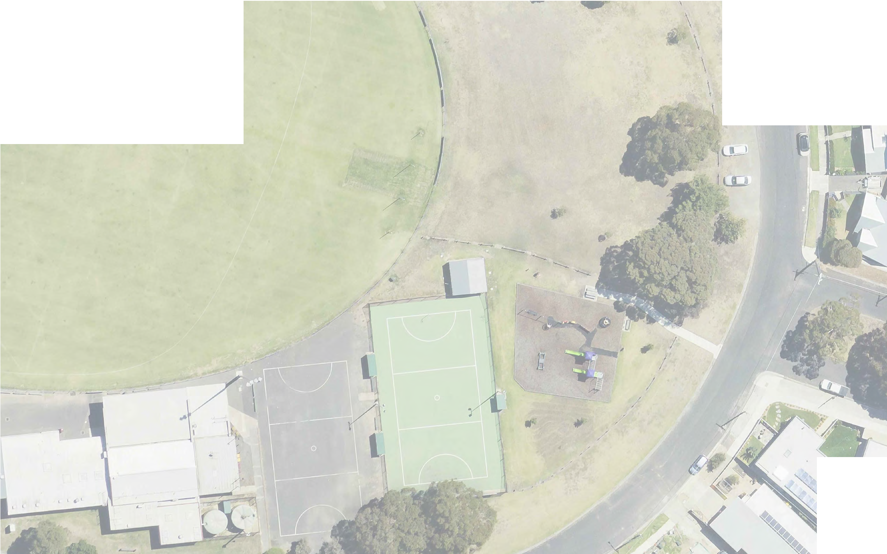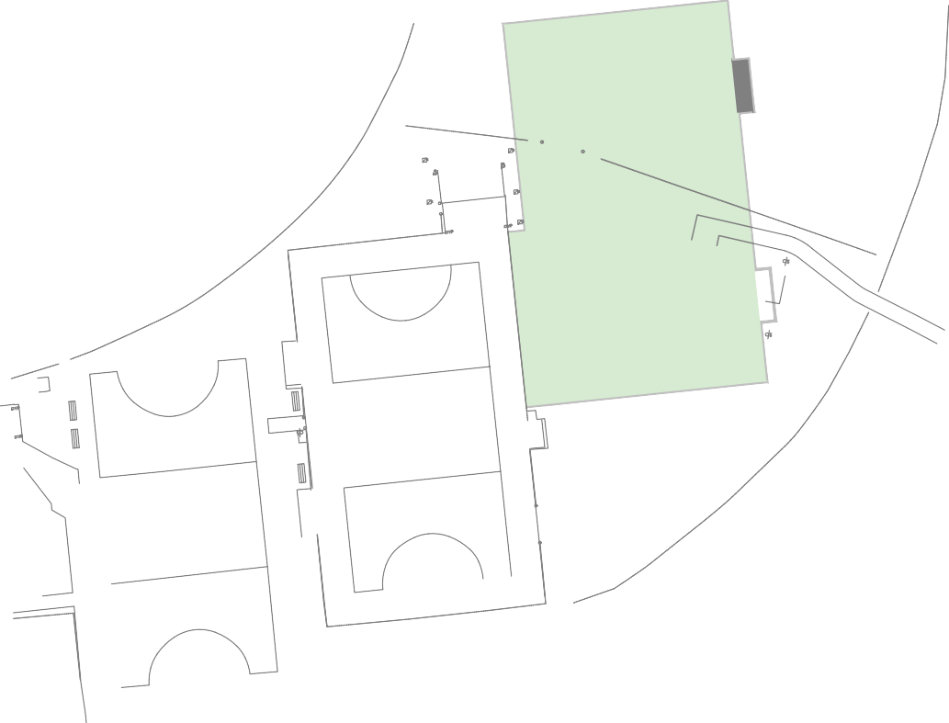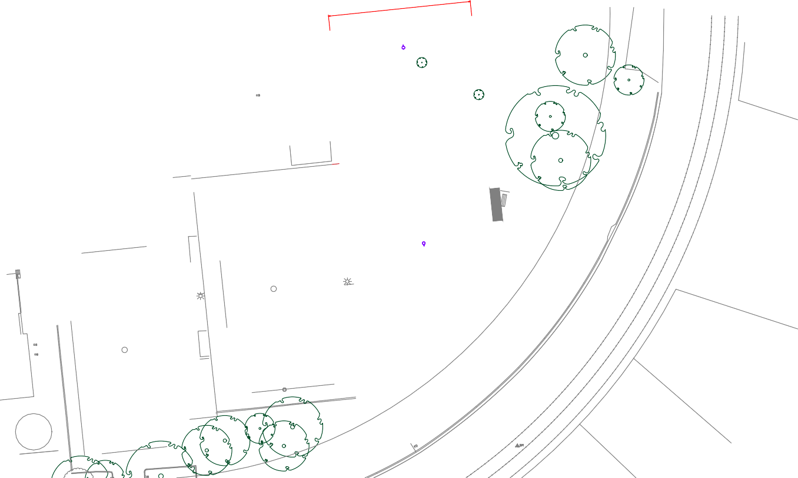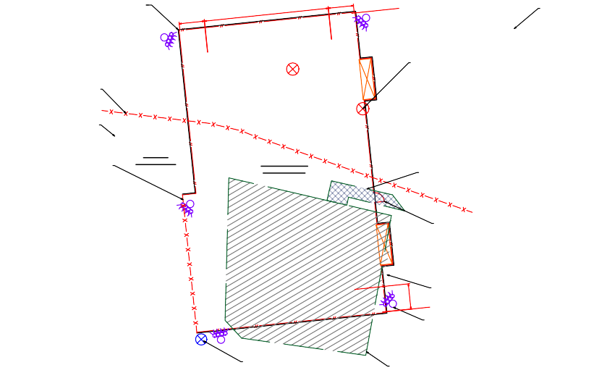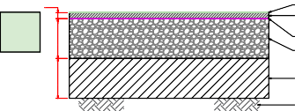LEGEND:
30
ACRYLIC SURFACE.
7mm NOMINAL SIZE DENSE GRADED ASPHALT.
PRIME COAT.
200mm CLASS 2 CRUSHED ROCK.

TYPE A CAPPING LAYER.
SUBGRADE.
NETBALL COURT PAVEMENT PROFILE
N.T.S.
BREAKOUT TREE AND ASSOCIATED ROOT SYSTEM AND DISPOSE OFF-SITE

PROPOSED REMOVAL OF EXISTING LIGHT TOWER

FENCE POSTS, FOOTINGS AND EDGESTRIP TO BE REMOVED AND DISPOSE
200

1.35m WIDER PEDESTRIAN ACCESS GATE SPORTS LIGHT TOWER
200
PLAYERS BENCHES

CONCRETE PAVEMENT TO BE STRIPPED AND DISPOSED OFF-SITE

1.05m HIGH CHAIN MESH FENCE ON
200mm WIDE CONCRETE EDGESTRIP.

PLAYER BENCHES (TYP.).

PROTECT AND RETAIN EXISTING TREES (TYP.).

BREAKOUT TREE AND ASSOCIATED ROOT SYSTEM AND DISPOSE OFF-SITE (TYP.).

BREAK OUT EXISTING TIMBER FENCE AND GATE AND DISPOSE OFF-SITE (TYP.).

EXISTING ELECTRICAL PIT (TYP.).

BREAK OUT EXISTING CHAIN FENCE AND CONCRETE EDGESTRIP AND DISPOSE OFF-SITE (TYP.).

EXISTING STORAGE SHED

ACRYLIC SURFACE NETBALL COURT
(30.5m x 15.25m)

BREAKOUT EXISTING CONCRETE PATH AND DISPOSE OFF-SITE.

1.35m WIDE PEDESTRIAN ACCESS GATE.

PROTECT AND RETAIN EXISTING SIGNAGE (TYP.).

SPORT LIGHT TOWER (TYP.).

PROPOSED REMOVAL OF EXISTING LIGHT TOWER (TYP.).

EXISTING NETBALL COURT

PROPOSED REMOVAL OF EXISTING LIGHT TOWER (TYP.).

EXISTING PLAYGROUND AND EQUIPMENT TO BE RELOCATED (BY OTHERS).

N 340° 360°
T

35°

W E

BM3

S
LIMITS OF IDEAL FIELD OF PLAY ORIENTATION

CITY OF GREATER GEELONG
PO Box 104
Geelong VIC 3220
P: 5272 5272
E: contactus(a)geelongcity.vic.gov.au www.geelongaustralia.com.au

CUSTOMER SERVICE CENTRE
100 Brougham Street
Geelong VIC 3220 8.00am - 5.00pm

© City of Greater Geelong 2022

LATEST NEWS:
(D (a)CityofGreaterGeelong
@ (a)GreaterGeelong
@ (a)CityofGreaterGeelong
@ CityofGreaterGeelong

CITYOF GREATER
GEELONG

