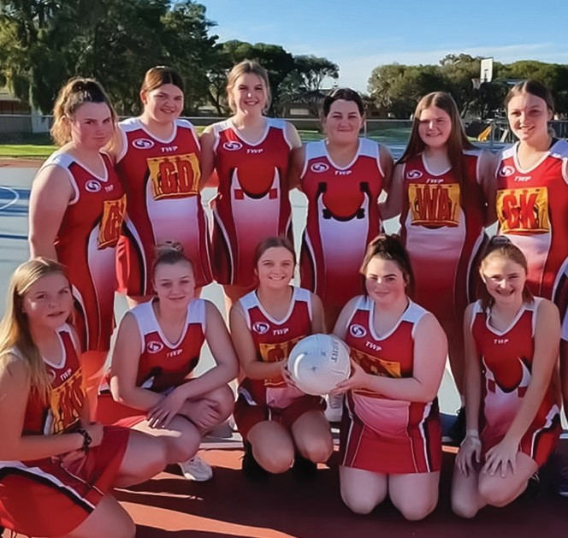

SHELL RESERVE FACILITY DEVELOPMENT PLAN
2020

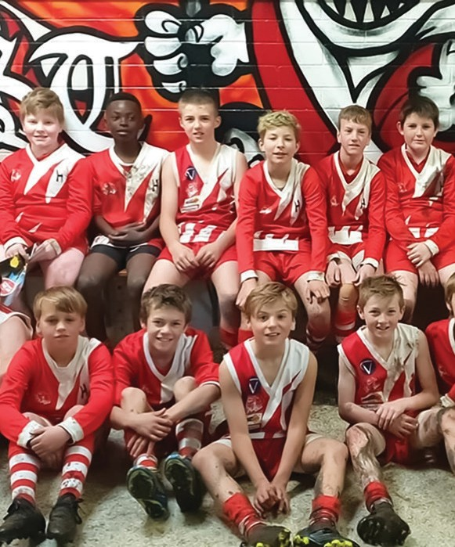

We acknowledge the Wadawurrung People as the Traditional Owners of the Land, Waterways & Skies. We pay our respects to their Elders, past and present. We acknowledge all Aboriginal and Torres Strait Islander
people who are a part of our Greater Geelong community today.



CONTENTS
PROJECT INTRODUCTION
  - INTRODUCTION
  - STRATEGIC CONTEXT
  - LOCATION
PARTICIPATION OVERVIEW
  - CLUB PARTICIPATION OVERVIEW
  - CLUB PARTICIPATION & FACILITY USAGE FORECASTS
  - AFL PARTICIPATION CATCHMENT
  - COMMUNITY PROGRAMS & FEMALE PARTICIPATION
FACILITY SUMMARY
  - AFL FACILITY AUDITS
  - IDENTIFIED FACILITY GAPS – ISSUES & OPPORTUNITIES
FACILITY DEVELOPMENT PLAN
  - PROPOSED BUILDING DEVELOPMENT PLAN
  - BUILDING DEVELOPMENT PLAN - HIGHLIGHTS
  - PROPOSED SITE PLAN
  - SITE PLAN - OVERVIEW
  - IMPLEMENTATION
  - INVESTMENT OPPORTUNITIES
  - PROJECT BENEFITS
  - STAKEHOLDER SUPPORT

ACKNOWLEDGEMENTS

This project was developed and funded by the City of Greater Geelong and AFL Victoria and delivered in collaboration with project consultants insideEDGE Sport & Leisure Planning and JMA Architects.

PROJECT INTRODUCTION

THE PROPOSED REDEVELOPMENT OF SHELL RESERVE AIMS TO CREATE A MODERN, INCLUSIVE AND ACCESSIBLE FACILITY TO SUPPORT COMMUNITY DEVELOPMENT AND PARTICIPATION
OUTCOMES.

Located in Geelong’s northern suburbs, Shell Reserve is home to the Corio Community Sports Club and Corio Cricket Club. The Reserve is an important pillar in the City of Greater Geelong’s recreation facility network and provides opportunities for community participation in sport.
The planned reserve development follows a number of significant community initiatives already being delivered at the site, complementing football, netball and cricket competitions, and supporting all abilities and community health programs.
The upgrade to Shell Reserve will address the evident facility gaps, particularly in relation to change facilities, netball courts and cricket nets. The proposed staged development offers opportunities to deliver integrated facilities that cater to the diverse range of participants.
The Shell Reserve Facility Development Plan provides a strategic framework for the identified infrastructure upgrades, and facilitates a collaborative approach
to investment. Collaboration between the tenant clubs and state and local government will ensure its successful implementation.
A summary of the identified infrastructure priorities includes:
- Football/cricket/netball multi-use change facility development.
- Redevelopment of netball courts including an additional court.
- Redevelopment of cricket practice nets.
- Improved site and vehicle accessways and associated drainage works.
- Installation of shade blinds to front of pavilion clubrooms.

The delivery of the above identified projects will address facility gaps at Shell Reserve. Investment into infrastructure that improves the quality and accessibility of facilities will ensure the prosperity of the Corio Community Sports Club and Corio Cricket Club and provide greater opportunity
for diverse participation outcomes for females, juniors and all-abilities.

PROJECT METHODOLOGY

The Shell Reserve Facility Development Plan has been developed in the following key stages:

  - Site inspection and assessment of the Reserve and its facilities with Council, tenanting Clubs, planners and architects;
  - A review of the key strategic drivers and supporting documents for the development of the Reserve;
  - A review of the current use and future capacity of the site by sporting clubs;
  - A review of current and future participation of tenant sporting clubs;
  - Consultation with the key user groups;
- Identification and assessment of the current site issues, challenges and potential future opportunities;
- The development of recommendations for future upgrades and improvements to infrastructure;
- Development of conceptual site plans, floor plans and costings for proposed improvements (Quantity Surveyor report provided as an attachment to this report); and
- A staged implementation plan to guide proposed recommendations.

ALIGNMENT WITH COUNCIL PLANNING

City of Greater Geelong Council Plan (2018-2022)
The Council Plan outlines 11 strategic priorities that aim to make Greater Geelong a clever and creative city-region.
The Council Plan aims to guide resources to deliver infrastructure, services and programs to the community in a sustainable way. It includes the following key focus areas relevant to the redevelopment of Shell Reserve:
- Informed social infrastructure and planning through providing more quality spaces that support active lifestyles, as well as supporting the growth of localised sporting facilities.
- A more inclusive and diverse community through promoting gender equity and diversity in sporting facilities and improving access to facilities for people of all abilities.

City of Greater Geelong Social Infrastructure Plan (2020)
The Social Infrastructure Plan guides and prioritises investment into community facilities based on equity and evidence. Five (5) directions for the strategic development of outdoor community sporting facilities are identified in the Plan, including the investment in infrastructure that improves the quality, functionality and carrying capacity of venues and the activation of facilities to increase participation and maximise use. The Plan notes the upgrade to change facilities at Shell Reserve as a key future project.

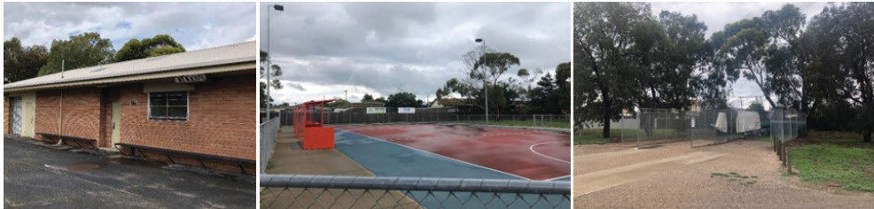

STRATEGIC CONTEXT
THE SHELL RESERVE FACILITY DEVELOPMENT PLAN ALIGNS WITH PEAK SPORTING BODY OBJECTIVES.

AFL VICTORIA ‘GROWING THE
HEARTLAND’ FOOTBALL FACILITIES DEVELOPMENT STRATEGY 2014-2020
The ‘Growing the Heartland’ Strategy identifies facilities as a fundamental component to participation in football. The Strategy indicates that research conducted shows a correlation between the provision of football facilities and participation rates. The importance of providing all-gender or gender-neutral change rooms are integral to ensure that facilities are catering for the diversity of participants attracted to the game.

AFL PREFERRED FACILITY GUIDELINES (2019)
The Guidelines outline the preferred facility requirements for venues which are utilised for community football training and competition. This includes recommendations for change rooms, umpire rooms, storage areas, gymnasiums etc.
The Guidelines are utilised in the AFL National Sports Facility Auditor tool which identifies facility gaps across all community football facilities. Information from this Audit for Shell Reserve can be found on page 17 & 18 of this document.

VICTORIAN CRICKET INFRASTRUCTURE STRATEGY 2018-2028
The Strategy highlights key focus areas including prioritising infrastructure upgrades at venues where female participation is present or forecasted. In addition, the Strategy includes regional summaries, with the Barwon Region identifying that the upgrade to cricket practice facilities is classified as a high priority.

CRICKET AUSTRALIA COMMUNITY
CRICKET FACILITY GUIDELINES 2015
The Guidelines outline the preferred standards for the development or redevelopment of cricketing facilities including change rooms, playing fields, training facilities and supporting infrastructure.

NETBALL VICTORIA FACILITIES MANUAL 2017
Netball Victoria’s Facilities Manual contains technical information on netball courts and associated infrastructure. Recommendations within the manual include standards for the development of new netball courts, change rooms and floodlighting.

A formal, detailed facility provision audit based on provision requirements from the AFL Preferred Facilities Guidelines, Netball Victoria Facilities Manual and the Community Cricket Facility Guidelines has been conducted at Shell Reserve. Audits identified critical gaps in all infrastructure. Within the AFL Audit, the venue only meets 50% of the base criteria for a local level venue.

LOCATION
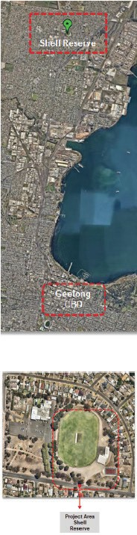
11km north of Geelong’s CBD, Corio is well serviced with shopping centres, parks, education and aquatic facilities all in close proximity. Forecast.id shows the suburb of Corio as having a population of 15,734 in 2020 with an increase of 11.8% projected by 2041.
The SEIFA index indicates that the Corio area is one of significant disadvantage, identifying that residents often have a lower income, lower education attainment, high unemployment or employment in relatively unskilled occupations.
Shell Reserve is centrally located with good public transport connections and passive surveillance through the abutting residential properties. The Reserve plays an important role in contributing to community health through organised sport, informal recreation and children’s play.

Other features of Shell Reserve include:
    - Floodlit senior size AFL and cricket playing field
    - Turf cricket wicket table
    - 1 acrylic netball court
    - 1 cricket practice facility with 3 synthetic practice wickets
    - Community/sporting pavilion and change rooms for cricket/football and netball
    - Community playground
    - Storage sheds for user groups
    - Public toilets
    - Internal roadway including some sealed sections for car parking

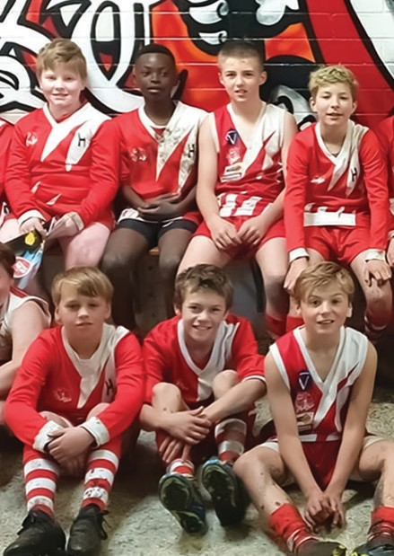

8

CLUB PARTICIPATION OVERVIEW

Shell Reserve is home to three sporting codes across the summer and winter seasons. Key users of the Reserve include Corio Community Sports Club
(Football Club and Netball Club) and the Corio Cricket Club.
Participation in sport at Shell Reserve has experienced some fluctuation over recent years, however it has begun to stablise due to several initiatives, including:
    - New Executive Committees for Football, Netball and Cricket Clubs;
    - New partnerships with other local clubs to drive junior participation programs such as Auskick, junior and female football; and
    - Collaboration with local not-for-profit organisations including Reclink Australia and Bethany Community Support to introduce programs for all-abilities and vulnerable members of the community.

Netball
Of the three sports at Shell Reserve, Netball has experienced the strongest consistent growth over consecutive seasons, thanks to introductory programs and successful junior and senior competitions.
In the 2019 season, Netball fielded senior teams in all grades (from A-D) along with U13, U15 and U17 age groups. The Club also intended to field a U19 side in season 2020. The Club has worked tirelessly in connecting with schools, such as Northern Bay College, and through the Leisuretime Sports Precinct
to target potential participants. This has resulted in the Club experiencing capacity issues, seeing it struggle
to accommodate players. The increased demand for Netball at Shell
Reserve is anticipated to continue. The Club now requires the appropriate supporting infrastructure to enable this positive trend in participation to continue.

Football
The Football Club has recently partnered with neighbouring North Shore Football Club to introduce a junior AFL program that aims to attract more players
to the Club and to the game. Due to several influencing factors, including lower socio-economic status of
the surrounding community and competing sporting priorities, Geelong’s northern suburban football clubs have experienced some difficulty in retaining junior participants. AFL Barwon and representatives throughout the football community are working on
strategic initiatives to address this. Corio Football Club are confident that this collaborative approach, as well as improvements to infrastructure, will go a long way in ensuring that junior participation has a large and stable representation for years to come.

Cricket
The Corio Cricket Club has seen rapid improvement in both on field and off field performance. In season 2019/20, the Club’s three Senior teams saw success,
with the First XI side finishing one game away from the final’s series. Off field, the Club now has a strong and focussed Executive Committee who have been able to drive positive financial change. In Season 2019/20, the Cricket Club made participation free of charge to all junior players. Whilst the Club currently has only a small number of juniors, the continuation of such initiatives is intended to continue as a mechanism to increase their participant base.

CLUB PARTICIPATION & FACILITYUSAGE FORECASTS

Current and future participation projections for Shell Reserve indicate that additional participation and programming opportunities are forecasted should infrastructure upgrades be implemented.
Current usage is restricted due to only one netball court, sub-standard cricket practice net facilities and poor- quality change rooms. The current facilities at Shell Reserve are mostly inadequate when comparing against other like facilities and with relevant sporting code guidelines.
As a result of infrastructure improvements, the following participation changes will be experienced:
    - Growth of netball teams through the provision of an additional netball court and improved player and umpire change rooms;
    - Greater capacity for cricket participation through upgraded change facilities and safe, modern practice nets;
    - Diversification in participation opportunities, including junior and females, through the provision of amenities which will improve the Club’s competitiveness and viability;
    - Better community programming opportunities through accessible and inclusive facilities.
The below table indicates projected participation change as a percentage for all sports as a direct result of infrastructure developments. Graphs 1 and 2 opposite indicate the projected change in weekly number of Reserve participants and average weekly hours of facility use as a result of infrastructure improvements.

Participation projections Football | Netball | Cricket
Current number of participant 165 | 52 | 52
Projected percentage change in  participation as a result of facility +51.5% development | +227% | +98%

AVERAGE WEEKLY NUMBER OF RESERVE PARTICIPANTS

Graph 1

Football
Netball
Current Use Future Use
Cricket

AVERAGE WEEKLY FACILITY USE HOURS

Graph 2

Oval
Netball Courts Cricket Practice
Nets
Current Use Future Use
Change Rooms

AFL PARTICIPATION CATCHMENT
The AFL has detailed participation data available for analysis, including historical information and residential postcodes of registered participants. This data assists in understanding trends across several seasons. Many football clubs across Greater Geelong see participants travelling outside of their residential suburb to play football. That said, it remains important for a Club’s sustainability that most participants reside in and around its home ground. Table 1 shows the membership of Corio Football Club over the past four years (player membership only). Table 2 demonstrates the breakdown of residential postcodes of players in season 2019. The adjacent map visually represents the club catchment data.
Corio Football Club has experienced some fluctuation in participation over the past four years as demonstrated below. These participation figures are mostly consistent when compared to other AFL Clubs in Geelong’s northern suburbs.

Table 1

2016 | 2017 | 2018 | 2019
No. of players 192 | 169 | 197 | 165
Change % - | -12% | +16.6% | -16.2%

Table 2

Players residential suburb | No. of players
Corio | 90
Norlane | 23
Lara | 13
Lovely Banks | 8
Elsewhere - Within Geelong LGA | 26
Elsewhere - Outside Geelong LGA | 5

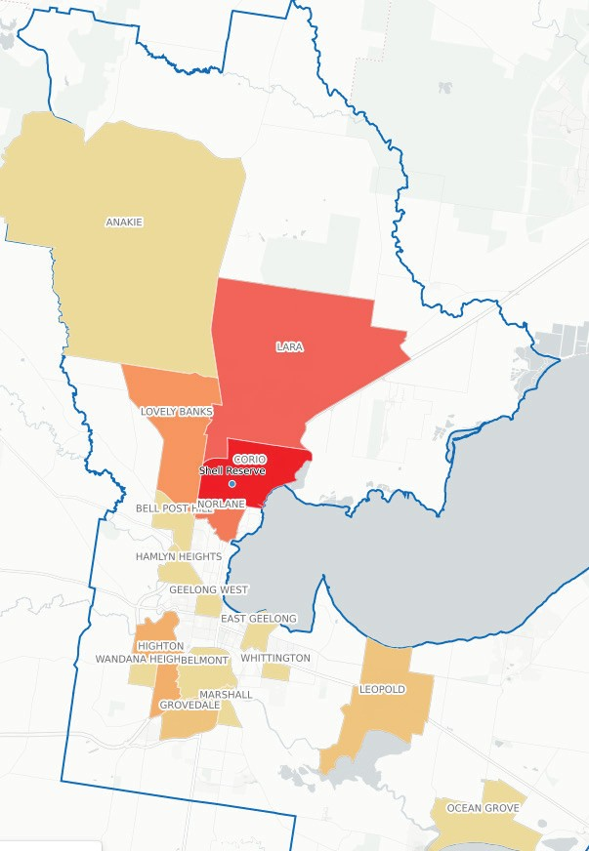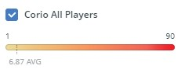

COMMUNITY PROGRAMS AND FEMALE PARTICIPATION
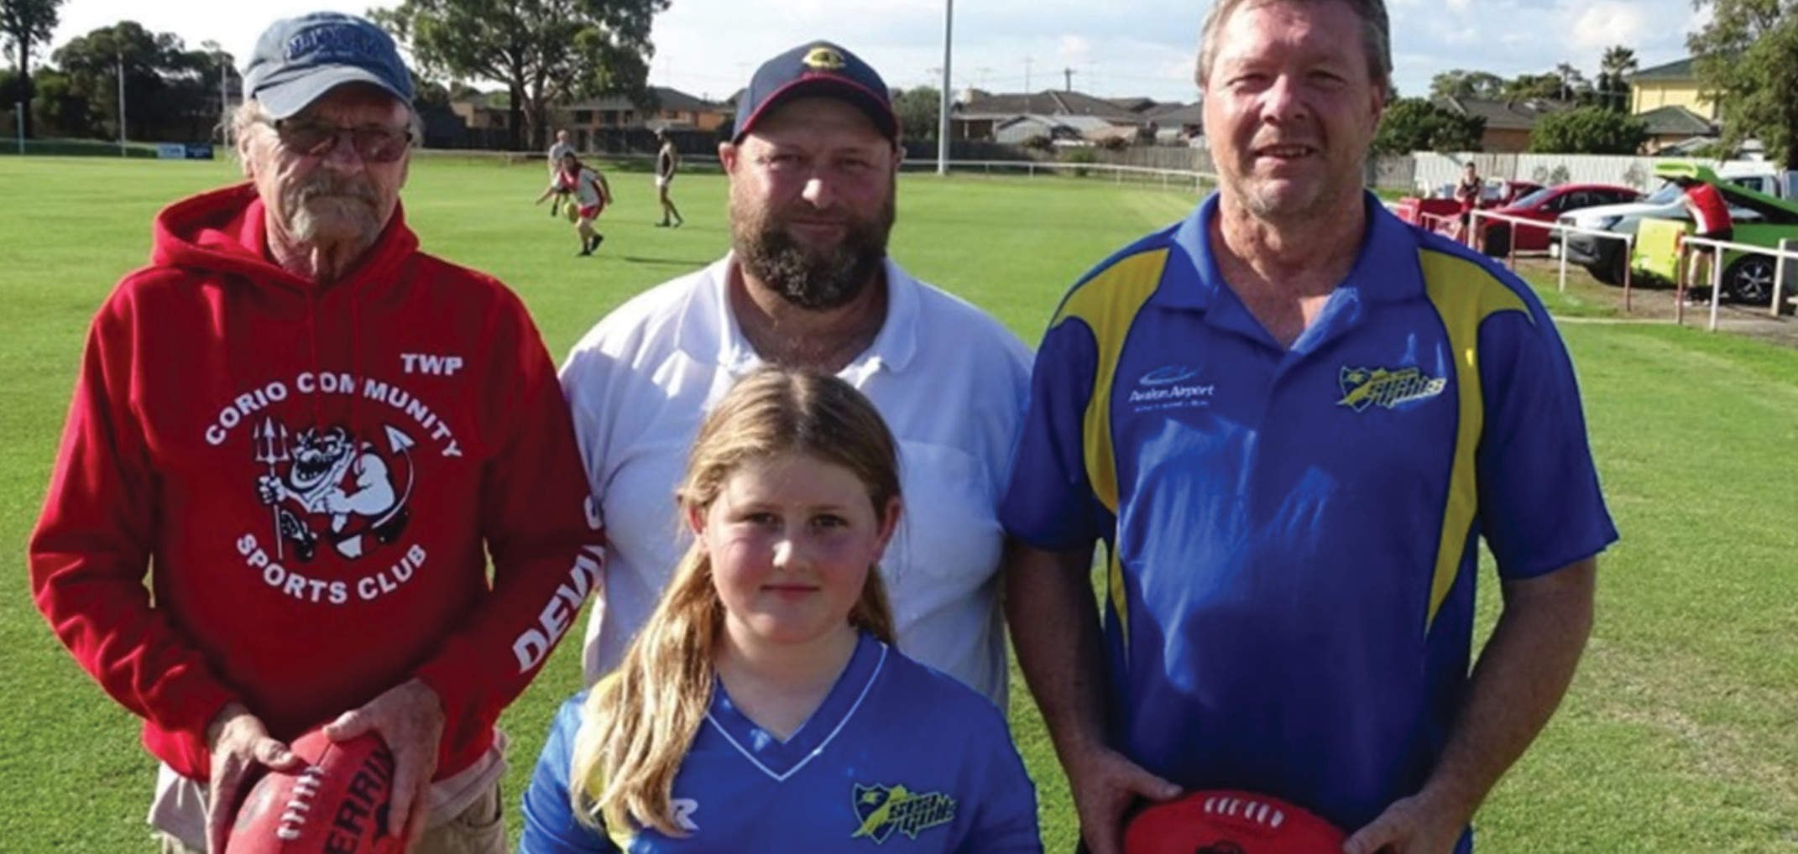
THE CORIO COMMUNITY SPORTS CLUB SUPPORTS A NUMBER OF COMMUNITY INITIATIVES AND PROGRAMS AT SHELL
RESERVE.

COMMUNITY PROGRAMS AT SHELL RESERVE

2020 Goals – Geelong Men’s Health & Wellbeing Program
In partnership with Bethany Community Support and Reclink Australia, this 8-week program has been designed specifically for men and aims to improve their health and wellbeing through physical activity and improved lifestyle choices. A free program for participants, the physical component is based around AFL activities. The Corio Sports Club partners with the provider to ensure that linkages for Club participation are promoted and encouraged following the program’s conclusion.

GenU Cats Reclink Football
Reclink Australia is a not-for-profit sport and recreation provider for disadvantaged Australians. The ‘GenU Cats Reclink Football’ aims to attract people of all ages, abilities and genders through modified AFL rules and focusses on inclusion and wellbeing.
Recently, the ‘GenU Cats Reclink Football Team’ voted Shell Reserve to be their home facility so that a closer relationship with the Club could be fostered. The Club warmly welcomed and accommodated the Team who regularly host games, training sessions and forums at the Reserve.

THE CORIO COMMUNITY SPORTS CLUB SUPPORTS A NUMBER OF COMMUNITY INITIATIVES AND PROGRAMS AT SHELL
RESERVE.

FEMALE PARTICIPATION AT SHELL RESERVE
The Corio Community Sports Club has recently linked with neighbouring North Shore Football Club to facilitate junior football teams, in a collaborative effort to drive girls’ participation through this program.
The aim of the program is to provide opportunities for girls to play in a fun environment and to make friends. Football Clubs within the suburbs of Corio and Norlane have not previously hosted any girl’s or women’s football teams, so this presents a fantastic introduction for more females to participate in sport.
The Corio Netball Club is also experiencing participation growth and is a sport that is predominantly female. The Netball Club looks to increase participation through a range of new initiatives including more junior teams and social competition.

COVID-19
At the time of writing this report the COVID-19 pandemic has caused significant distribution to the sport and recreation industry. It is therefore that the continuation of these programs has temporarily been suspended in- line with Victorian Government directives, however, will resume as soon as practicable.





16

FACILITY SUMMARY
  - AFL FACILITY AUDITS
CHANGE FACILITIES AT SHELL RESERVE ARE RATED AS ‘VERY POOR’ IN AFL’S FACILITY AUDITOR PROGRAM

The provision and condition of all football facilities throughout Geelong including Shell Reserve have been audited by AFL Barwon staff. Audits were carried out in October 2019 using the AFL National Sports Facility Audit tool.
As a sport, the AFL has an ongoing commitment to the Sports Facility Auditor program to collect, update and monitor facility provision, quality and compliance with preferred facility guidelines.
The program provides empirical evidence to effectively plan and support the delivery of facility improvements and development projects.
The program analyses compliance with Australian Standards and AFL Preferred Facilities Guidelines. Audit data then provides a rating for each facility to assist in identifying gaps in provision.
The table on the following page provides a summary of the 2019 audit information for Shell Reserve. The colour coded boxes in the table indicate where the facility meets (green) or does not meet (red) the AFL’s Preferred Facility Guidelines (2019).
As indicated in the table, the home and away change rooms meet the preferred provision of lockable shower cubicles and pan toilets however the overall condition is rated as ‘very poor’ (i.e. significant quality issues identified – requires immediate attention). In addition, both the away change room and the umpire change room do not meet the minimum size requirements. The umpire change facility has open showers which is also not consistent with gender neutral guidelines. The netball facility lacks an umpire change room which is a requirement in the Netball Victoria Facilities Manual for a football/netball league venue. The away netball change room is also slightly smaller than recommendations.
Other findings include some discrepancies in accessible entryways around the reserve and into the building. Where accessible entrances are provided (e.g. netball room entry) the condition is poor and requires attention.
The overall playing field/oval condition indicates that it is in moderate condition. It would be expected that auditing at different points during the year would result in a varied response to this question. The oval drainage is also identified as requiring improvement. Investment to improve drainage at Shell Reserve has been noted as a priority within this report.
The oval dimensions (165m x 118m) do not meet preferred standards as the width of the field is approximately 17m shorter than recommendations. That said however, the preferred dimensions within the Guidelines are noted as being ‘ideal’ for ‘new’ playing fields. Therefore no recommendation to increase the oval size is identified within this report.

FACILITY SUMMARY
SHELL RESERVE – 2019 AFL FACILITY AUDIT SUMMARY

 | No. of change rooms | Room size | Number of showers | Shower type | Toilet type | Accessible Entry | Overall condition rating
AFL Home Change Room | 1 | Greater than 45m2 | 197 | Lockable cubicle | Pan toilets | No | Very poor
AFL Away Change Room | 1 | Less than 45m2 | +16.6% | Lockable cubicle | Pan toilets | No | Very poor
AFL Umpire Change Room | 1 | Less than 45m2 | 197 | Open | Pan toilets | No | Very poor
Club Social Rooms | N/A | 100-149m2 | N/A | N/A | N/A | No | Good condition
Netball Home Change Room | 1 | 25m2 | 197 | Lockable cubicle | Pan toilets | No | Good condition
Netball Away Change Room | 1 | 19m2 | +16.6% | Lockable cubicle | Pan toilets | No | Good condition
Netball Umpire Change Room | 0 | N/A | N/A | N/A | N/A | N/A | N/A
 | Measurement | Irrigation | Turf Type | Drainage | Centre wicket | Floodlighting | Overall condition rating
Playing Field/ Oval | 165m x 118m | Automatic irrigation system | Warm season grass | Drainage functional but requires improvement | Turf wicket well maintained | 98 lux | Moderate (considerable wear but still playable)
 |  |  |  |  |  | Overall facility percentage rating | 50%

IDENTIFIED FACILITY
GAPS – ISSUES & OPPORTUNITIES
THERE ARE A NUMBER OF FACILITY GAPS EVIDENT AT SHELL
RESERVE. IDENTIFYING AND ADDRESSING THESE SHORTFALLS WILL PROVIDE A BETTER FACILITY FOR SPORTING CLUBS AND THE BROADER COMMUNITY.

CHANGE ROOM FACILITIES

ISSUES
    - There is extensive cracking in the change room facilities at Shell Reserve with significant movement evident.
    - The concrete slab which houses the first aid/ trainer’s room also has visible cracks suggesting movement is occurring.
    - The external ramp to the Netball change rooms is cracking and appears to be moving independently of the building.
    - There is currently no storage facility in the social rooms.
    - The home change rooms are approximately 55m2, which align with AFL Preferred Facility Guidelines, however their condition is very poor.
    - The away change rooms are less than 25m2, which do not align with AFL Preferred Facility Guidelines. The condition is also very poor.
    - The home and away amenities meet AFL Preferred Facility Guidelines however only partially meet gender-neutral standards with a urinal being present in each. The condition of the amenities is very poor.
    - The umpire rooms are small and do not adequately cater for all gender use.
    - There are currently no Netball umpire change rooms within the facility, which is a requirement in Netball Victoria’s Facilities Manual.

OPPORTUNITIES
    - Redevelop the entire change room facility to cater for Football, Cricket and Netball in accordance with relevant sporting code guidelines.
    - The redevelopment will ensure the facility caters for all-gender player and umpire use and is welcoming and inclusive.

CRICKET PARCTICE FACILITIES

ISSUES
- Safety issues are of significant concern with the current cricket practice facilities. Presently, the bowling run-ups are located within the car park.
- The current practice facility does not comply with Cricket Australia Facility Guidelines for orientation, presently facing in an east-westerly direction.
- The Cricket Australia Facility Guidelines note that cricket practice nets should be carefully located if not enclosed to minimise the risk of injury to a
person or damage to property. The current facility at Shell Reserve is not enclosed nor in a safe location.
- The current practice facility is aged and past its useful life.

OPPORTUNITIES
- Redevelop the cricket practice facility so that it is in a more practical location and correctly orientated rendering it safe for both players and users of the reserve. .

SPECTATOR SHADE

ISSUES
- There is limited spectator shade at Shell Reserve, particularly in summer months.
- Cricket scoring proves difficult due to the lack of shade and orientation of the pavilion (faces directly into the western sun).

OPPORTUNITIES

- Providing additional spectator shading including shade blinds to the front of the pavilion would assist in alleviating this issue.

3.2 IDENTIFIED FACILITY
GAPS – ISSUES & OPPORTUNITIES

CAR AND PEDESTRIAN CONNECTIONS

ISSUES
- There is no sealed or formalised car parking at the Reserve.
- There is no clear, compliant pedestrian crossing or access throughout the Reserve.
- Vehicle circulation throughout the Reserve requires organisation to improve traffic flow and pedestrian safety.

OPPORTUNITIES
- Improvements to car and vehicle movements and access throughout the site including crossings, roadways and car parks is required

NETBALL COURT

ISSUES
- Shell Reserve only has a single netball court.
- This does not align with Netball Victoria guidelines that recommends two courts for local football- netball clubs to cater for training and competition activities.
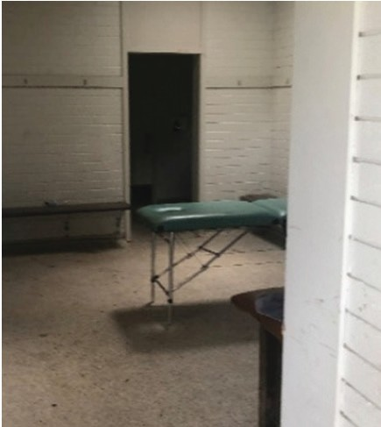
- It also does not align with the standard two-court provision of other local football-netball clubs across Geelong.
- This limits participation and programming opportunities.

OPPORTUNITIES
- Construct an additional (floodlit) netball court to increase participation, programming and to align with other local facilities

OTHER ITEMS

ISSUES
- The Football Club would like to increase oval sports lighting capacity to enable night games to be played at the reserve.
- The ticket box at the front of the Reserve requires replacement.
- The public toilet block in the south-west corner of the Reserve is outdated and requires replacement.
- Areas of the Reserve are low lying and subject to flooding.
- Oval perimeter fence requires replacement.

OPPORTUNITIES

- Explore opportunity to increase sports lighting lux level to enable greater participation opportunities.
- Replacement of old or outdated infrastructure should be completed. Consider incorporating a public toilet as part of the change room redevelopment.
- Address drainage in areas prone to flooding as part of the Facility Development Plan.

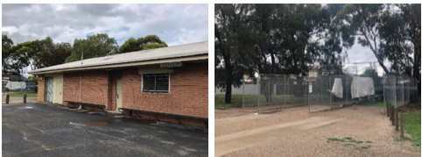


21

FACILITY DEVELOPMENT PLAN

THE SHELL RESERVE FACILITY DEVELOPMENT PLAN AIMS TO:

  - Redevelop football, cricket and netball change facilities to meet modern, accessible and all gender standards.
  - Provide a second floodlit netball court to facilitate greater participation and to deliver provision in line with other local facilities across the municipality.
  - Redevelop the cricket practice net facility to support participation and address safety concerns.
  - Improve car and pedestrian connections to improve safety and the poor condition of roadways.
  - Provide shade for volunteers during the summer months, particularly for cricket activities.

4.1 PROPOSED BUILDING DEVELOPMENT PLAN

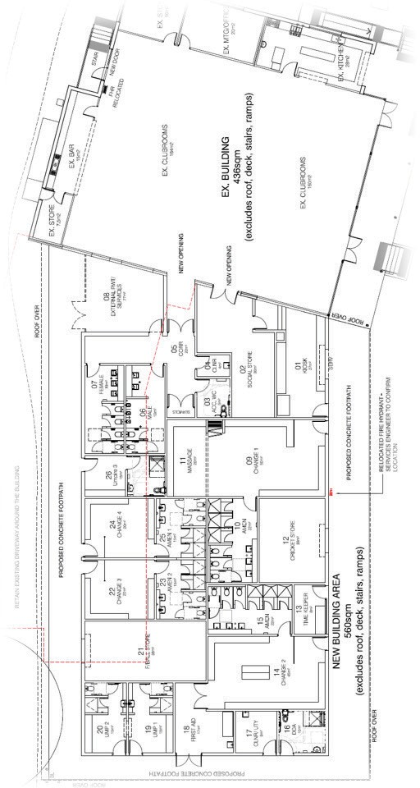

FACILITY SUMMARY
3.1 AFL FACILITY AUDITS
As per the proposed building concept plans on page 20, key areas of development have been highlighted within the diagram opposite. These include:
- New football and cricket change room facilities including gender neutral amenities, new cricket storage area and timekeeper room. The proposed cricket store room is located in very close proximity to the oval and at ground level for ease of access for heavy equipment. The proposed change room development meets the recommended provision requirements for both AFL and Cricket.
- New netball change rooms including gender neutral amenities and accessible netball umpire change room. The netball change facilities are positioned to ensure they are within close proximity of the netball courts.
- New gender neutral umpire change rooms, primarily for use by football and cricket umpires however use by netball umpires is also encouraged.
- New accessible toilet for use by players, umpires as well as the general public and spectators. The centralised location of the toilet will ensure ease of access and for use by any person of any abilitywithin this report.

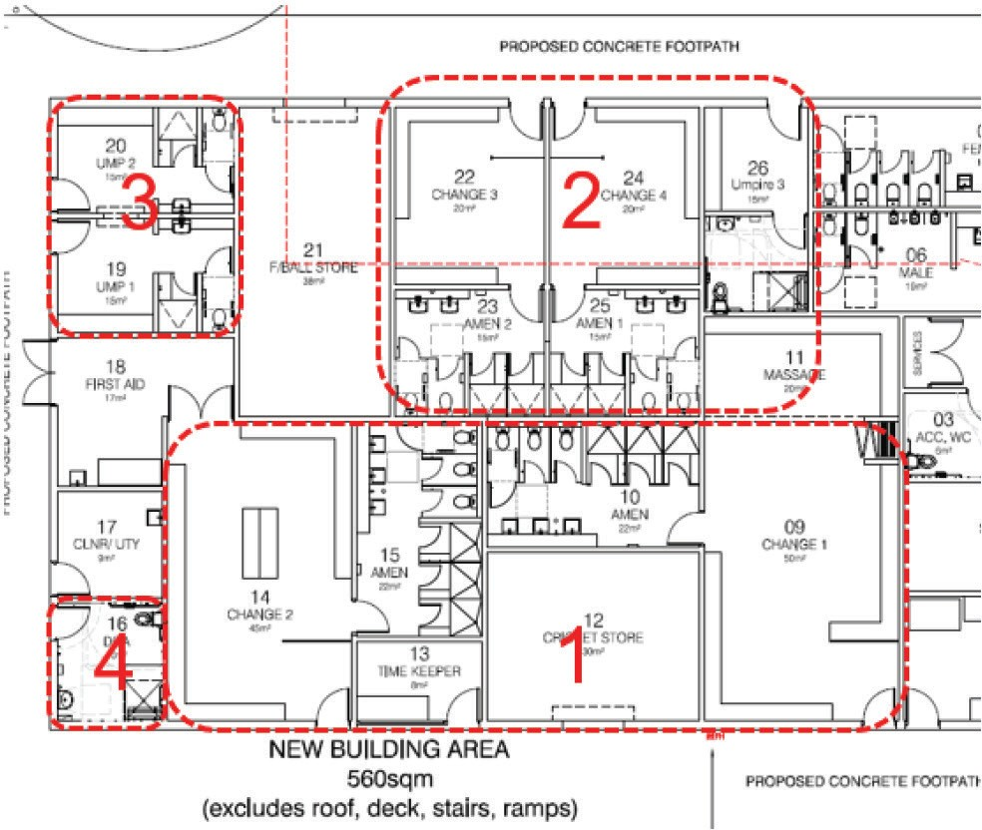

PROPOSED SITE PLAN
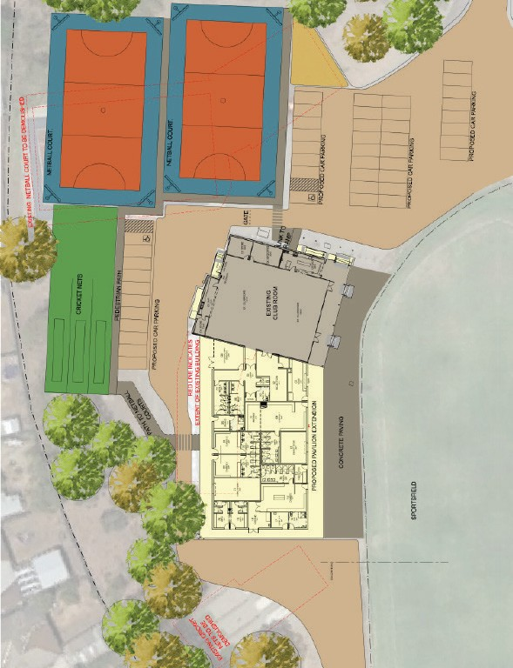

  - SITE PLAN - OVERVIEW
As per the proposed building concept plans on page 20, key areas of development have been highlighted within the diagram opposite. These include:
- New football and cricket change room facilities including gender neutral amenities, new cricket storage area and timekeeper room. The proposed cricket store room is located in very close proximity to the oval and at ground level for ease of access for heavy equipment. The proposed change room development meets the recommended provision requirements for both AFL and Cricket.
- New netball change rooms including gender neutral amenities and accessible netball umpire change room. The netball change facilities are positioned to ensure they are within close proximity of the netball courts.
- New gender neutral umpire change rooms, primarily for use by football and cricket umpires however use by netball umpires is also encouraged.
- New accessible toilet for use by players, umpires as well as the general public and spectators. The centralised location of the toilet will ensure ease of access and for use by any person of any abilitywithin this report.

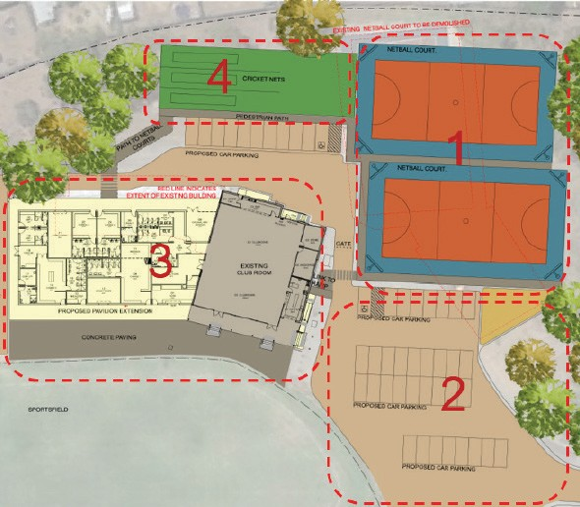

IMPLEMENTATION
A STAGED APPROACH TO THE DELIVERY OF THE SHELL
RESERVE FACILITY DEVELOPMENT PLAN INCLUDING THE
DELIVERY OF CRITCAL INFRASTRUCUTRE COMPONENTS WILL SEE BROAD PARTICIPATION AND COMMUNITY BENEFITS.
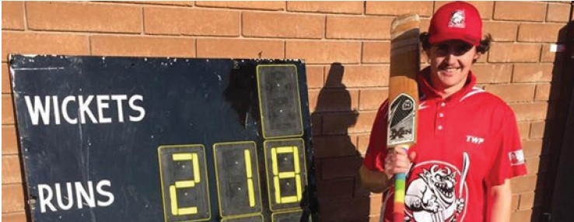

FUNDING
The below table provides the estimated cost of implementation of the Shell Reserve Facility Development Plan, based on current designs:

Priority Project | Estimated cost | 
1. Redevelopment of change facilities (as per the building development plan on page 20 of this document) | $3,250,000 | -
2. Redevelopment of cricket practice net facility | $975,000 | $975,000
3. Second netball court construction | $10,000 | -
4. Outdoor blind installation for spectator shade | $379,000 | -
5. Improved ancillary infrastructure including carparking, accessible pedestrian connections and oval perimeter fence | 26 | -
Total estimated project cost | $4,615,000 | $975,000

INVESTMENT OPPORTUNITIES
TO ENABLE THE IMPLEMENTATION OF THE SHELL RESERVE
FACILITY DEVELOPMENT PLAN, A COLLABORATIVE APPROACH TO INVESTMENT AND PROJECT DELIVERY IS REQUIRED.

A hybrid approach to funding is recommended through various streams including local, state and federal initiatives. Some grant funding programs will require club contributions, either via in-kind or cash, to maximise project benefits. The following investment opportunities below are current at the time of writing this report.

SPORT & RECREATION VICTORIA

Local Sports Infrastructure Fund
This program offers grants across five funding streams, those relevant to this project include:
- Female Friendly Facilities – funding of up to
$500,000 for change rooms, lighting, field and court developments
- Community Facilities – funding of up to $250,000 for playgrounds, lighting, fields and multi-sport court developments

Community Cricket Program
Offers grants for cricket specific infrastructure projects, including:
- Change rooms, wickets/pitches, ovals and training nets – up to $100,000.

Country Football and Netball Program
Offers grants of up to $100,000 for facility development in rural, regional and outer metro locations, specifically for:
- Player and umpire all gender change facilities
- Upgrading playing fields
- Upgrading netball facilities
- Upgrading oval floodlighting

Community Sports Infrastructure Stimulus Program
As a result of the disruption to community sport caused by the COVID-19 pandemic, the Victorian Government has announced a $68M program to fast track shovel ready sporting infrastructure projects. The program aims to provide a stimulus to the local economy and
to improve participation, diversity and inclusion opportunities in disadvantaged and underrepresented groups.
Applications for funding between $1M and $10M is available for eligible projects including:
- New sports fields, sports courts and surfaces that increase capacity or improve safety
- Pavilions including change rooms for participants that are female friendly and accessible

CITY OF GREATER GEELONG

Community Investment and Support Fund
(note: Fund currently suspended due to COVID-19)
This program offers grants for planning and infrastructure projects which can demonstrate benefits to the community inline with Council’s objectives as per the Council Plan.
- Planning Grant – funding of up to $50,000 available for costs associated with planning and feasibility activities for future infrastructure projects.
- Capital Works Grant – funding of up to $350,000 to assist with the cost of shovel-ready community infrastructure projects.
Infrastructure projects that may be eligible for funding include:
- Accessibility improvements to community infrastructure
- Unisex change facilities
- Sports lighting
- Multipurpose training facilities

PROJECT BENEFITS
THE REDEVELOPMENT OF SHELL RESERVE WILL SEE
OUTCOMES IN BOTH FORMAL AND INFORMAL RECREATION.


he implementation of the Shell Reserve Facility Development Plan will see many benefits, including:
    - Increased participation in all football, cricket and netball including juniors, females and all abilities.
    - Modern and accessible facilities that are welcoming, flexible and cater for the diverse current and future participant base.
    - Equitability in facility provision across Geelong, particularly for lower-socio economic areas.
    - Upgraded facilities providing more opportunity for community programming and partnerships in both formal and informal sport and recreation.

“The redevelopment of Shell Reserve will provide the Club with modern facilities that will enable us to compete against other sporting organisations in our region. Our aim is to achieve increased participation that will enable our Club to continue to grow for many years to come”.
– Kevin Hayes, Secretary, Corio Cricket Club.

“Over the past two seasons netball numbers have increased dramatically to the point that we have had to turn people away. Currently all netball teams are full and having only one court restricts our usage and capacity. An additional court will allow us to host concurrent training, develop additional teams and offer alternate participation opportunities such
as social competitions. In addition, improved change facilities will allow us to host more female participation, particularly in football, and ensure that our facilities are meeting the expectations of the modern game”.
– Gregory Ince, President, Corio Community Sports Club.

STAKEHOLDER SUPPORT


GEELONG CRICKET ASSOCIATION

The redevelopment of Shell Reserve, Corio has the full endorsement of the Geelong Cricket Association (GCA) to support participation outcomes and to enhance the safety of all players and participants. Recently, the Corio Cricket Club has improved its performance both on and off the field and will continue to do so should modern, accessible facilities be made available. The GCA Strategic Plan which is nearing finalisation includes strong goals for increasing playing options and choices to grow participation, implementing plans for enhanced accessibility and inclusion, and building the capacity and sustainability of GCA cricket. The provision of adequate change facilities will support the Club and contribute to achieving these goals, ensuring its sustainability into
the future. The upgrade and relocation of the cricket nets will improve provision and safety for players and provide a fully compliant facility that meets the expectations of the modern game.
The GCA congratulates the Corio Cricket Club, Corio Community Sporting Club and the City of Greater Geelong in this collaborative approach to the improvement of Shell Reserve.

Rob Vines President
Geelong Cricket Association
GEELONG & DISTRICT FOOTBALL
NETBALL LEAGUE
TThe Geelong and District Football Netball League fully supports the Corio Community Sports Club in their endeavours to upgrade facilities at Shell Reserve. The Club has made significant progress recently, seeing an influx of netball players which currently do not have the facilities they require. The construction of a second netball court will allow the League’s netball competition to continue to expand by creating additional capacity for participation and programming.
In addition, the League and its member clubs consider that the redevelopment of change rooms is essential to facilitate a welcoming and inclusive environment. The inclusion of gender neutral change facilities at Shell Reserve will greatly assist the Club in its initiatives to develop female football participation.
We look forward to seeing the redevelopment of Shell Reserve and that its progress is considered favourably to support both football and netball into the future.
Alan Moore Secretary
Geelong & District Football Netball League

CONTACT US

CORIO COMMUNITY SPORTS CLUB

Gregory Ince President
P: 0431 337 871
E: incemagic@aol.com

CORIO CRICKET CLUB

Kevin Hayes Secretary
P: 0422 569 063
E: coriocricketclub@gmail.com

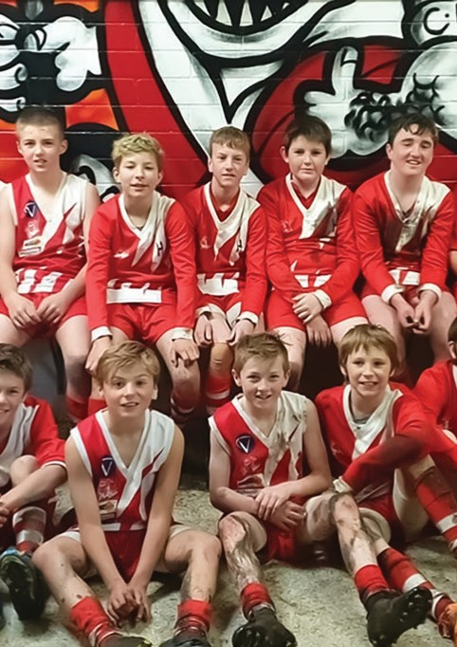
30
facebook.com/coriocommunitysportsclub

facebook.com/coriocricketclub



CITY OF GREATER GEELONG
WADAWURRUNG COUNTRY PO Box 104
Geelong VIC 3220
P: 5272 5272
E: contactus@geelongcity.vic.gov.au www.geelongaustralia.com.au

CUSTOMER SERVICE CENTRE
Wurriki Nyal, 139-147 Mercer Street, Geelong VIC 3220
8.00am – 5.00pm

© City of Greater Geelong 2020
LATEST NEWS:
@CityofGreaterGeelong @GreaterGeelong @CityofGreaterGeelong CityofGreaterGeelong

