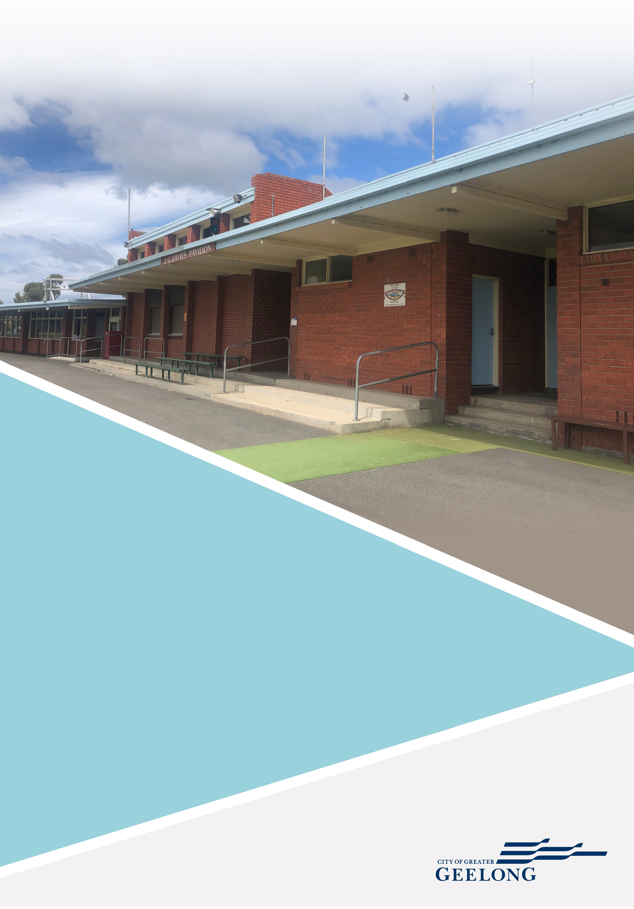

CITY OF GREATER GEELONG

GRINTER RESERVE
FACILITY DEVELOPMENT PLAN

FINAL REPORT APRIL 2021



We acknowledge the Traditional Custodians of the land, the Wadawurrung People of the Kulin Nations. We pay our respects to their Elders past and present and acknowledge all Aboriginal and Torres Strait Islander people who are part of the Greater Geelong community today.

This report has been prepared by:
insideEDGE Sport & Leisure Pty Ltd 417 Barkly Street
West Footscray VIC 3012 P (03) 9680 6370
E info@ieslp.com.au W ieslp.com.au

Disclaimer: This Report was prepared by an independent consultant in conjunction with the City of Greater Geelong. The Report is a summary of the context, need, engagement methods and recommendations that make up the Grinter Reserve Facility Development Plan. This Report is also subject to further consultation and consideration by the City of Greater Geelong.
Version | Date | Document | Author | Reviewer
1 | 31.03.21 | Draft Report | ZS | JL
2 | 19.04.21 | Final Report | ZS | JL

The contents of this report are approved by the City of Greater Geelong, however, may require revision over time to reflect current council policy.
All illustrative plans, perspectives and imagery contained within this report are indicative artists impressions to illustrate conceptual ideas only and are subject to further resolution, consultation, detailed design, and approvals.

© 2021 City of Greater Geelong and insideEDGE Sport & Leisure Pty Ltd
This document may only be used for the purpose for which it was commissioned and in accordance with the terms of engagement for the commissions.
Unauthorised use of this document in any form whatsoever is prohibited.

CONTENTS

SUMMARY OF RECOMMENDATIONS
Summary of Recommendations 4
SITE CONTEXT
  - Project overview 5
  - Study area 5
  - Project objectives 5
  - Current infrastructure projects 5
  - Site location 5
  - Demographic overview 7
SITE USAGE
  - Sporting club participation 8
  - Sporting participation catchment (AFL) 9
  - Current facility use 10
  - Community sport programs and initiatives 11
EXISTING CONDITIONS
  - Existing conditions summary 12
  - CPTED Audit summary 20
FACILITY DEVELOPMENT PLAN
  - What is proposed 22
  - Facility Development Plan recommendations and
funding opportunities for delivery 24
  - Facility Development Plan Cost Summary 29
STRATEGIC SUPPORT FOR DEVELOPMENT
  - Strategic context/literature review 30
  - Stakeholder engagement summary 33
NEXT STEPS
  - Next steps 35
APPENDICES 36

SUMMARY OF RECOMMENDATIONS

 |  |  | 
Improving infrastructure and amenities at Grinter Reserve will enhance opportunities for increased social connection and access for the community. | Improving the core attributes of the main cricket/football pavilion, including player and umpire change rooms, will assist in providing amenities that can support greater diversity in participation. | Grinter Reserve has strong sports participation across several codes and requires updated infrastructure to support this. For cricketers, this includes a new cricket practice net facility. | Opportunities to improve passive surveillance, increase activation and enhance feelings of safety for users has underpinned all recommendations within the Plan.
 |  |  | 
Increasing the accessibility and amenity of existing play and recreational infrastructure, including skate ramp and play space, will add value and improve visitor experience. | Enhancing Reserve entry points, improving wayfinding signage and creating better pedestrian pathways and connections will encourage greater use. | Providing additional tree canopy and landscaping will enhance the existing amenity of the Reserve, improve aesthetic and contribute to a greener parkland. | Enhancing the BMX area including core pavilion amenities, entry ways, user interface and track improvements will increase opportunities for participation and hosting of higher level events.
 |  |  | 
Netball facility opportunities include upgrades to sports lighting should training standard not be met as well as providing a warm up space for participants. | Increased car parking and improvements to vehicle movement throughout the Reserve is recommended to enhance functionality and safety. | Providing shelter for players and spectators where there is a gap in provision will enhance amenity and provide protection from inclement weather. | Consolidating old infrastructure, including public toilets once their end of life is reached, will discourage antisocial behaviour.  Opportunities to replace or relocate infrastructure where it is most needed should be  explored.

SITE CONTEXT

PROJECT OVERVIEW 1.4 CURRENT INFRASTRUCTURE PROJECTS

The City of Greater Geelong has commissioned a Facility Development Plan for Grinter Reserve to provide a consolidated and collaborative approach to the improvement of infrastructure. The Plan aims to provide clear direction to ensure that the venue offers modern, inclusive and safe facilities for the community.

STUDY AREA
The project study area for the Grinter Reserve Facility Development Plan is identified in ‘Map 1’ on the following page. The study area includes both ovals, netball courts, BMX track and pavilions as well as the playground, skate ramp and public toilets.
Splashdown Leisure Centre, community garden, wetlands, pony
At the time of writing this report, investment has been confirmed for the delivery of the following infrastructure projects at Grinter Reserve:
    - Upgrade to sports lighting on Oval 1 (completed in 2021)
    - Football/cricket pavilion change room refurbishment (to be completed in 2021/22)

SITE LOCATION
Land Tenure: Grinter Reserve is a 15-hectare allotment owned and managed by the City of Greater Geelong. As designated public land, it is provided to the community for a range of uses including recreation, cultural, conservation and government services.

club and men’s shed are all excluded from scope. Zoning: Grinter Reserve is zoned Public Park and Recreation
Zone (PPRZ) under the Geelong Planning Scheme which

PROJECT OBJECTIVES
Through engagement with Council, tenanting sporting clubs, peak sporting bodies and onsite inspections and audits, the following project objectives were identified for the Plan:
    - Provide an informed, consolidated and collaborative approach to infrastructure development that meets the needs of user groups as well as those of the City of Greater Geelong.
    - Make recommendations for the Reserve’s improvement that is commensurate with Council’s strategic objectives including financial, social and environmental responsibilities.
    - Generate recommendations that create greater opportunities for participation and ensure that these opportunities can be afforded to all members of the community.
    - Understand the broader opportunities to improve various aspects of the Reserve including sporting and passive recreation infrastructure, connectivity, vehicle and pedestrian
encourages enhancement and use of the land in support of appropriate recreation activities.

A property report for the Reserve generated through the Victorian Government’s Department of Environment, Land, Water and Planning (DELWP) website identified that the Reserve is within a bushfire prone area.
Regional Setting: The Reserve is located 6km from Geelong’s CBD and 20km from the Bellarine Peninsula.
Local Setting: Grinter Reserve is a multi-faceted activity precinct consisting of sports ovals, BMX track, netball courts, cricket nets, community garden, men’s shed, pony club and wetland area. The Reserve is also home to Splashdown Leisure Centre which includes a 25m indoor pool, sauna, spa and associated facilities.
Uses: The study area is primarily use for organised sporting activities and is home to several tenanting clubs, all with active memberships, including:

access and safety. • Newcomb Football & Netball Club

    - Understand the emerging need and future demand for the facility and be considered in aligning opportunities to potential investment partners.
    - Understand improvement opportunities that enhance user
    - Newcomb & District Cricket Club
    - Geelong BMX Club

Other more informal uses of the Reserve include:

experience, sentiment, and sense of place. • Walking, jogging and dog walking
      - Informal play (playground and open space areas)
      - Skateboarding and scooting (skate ramp)
      - Enjoyment of open space areas

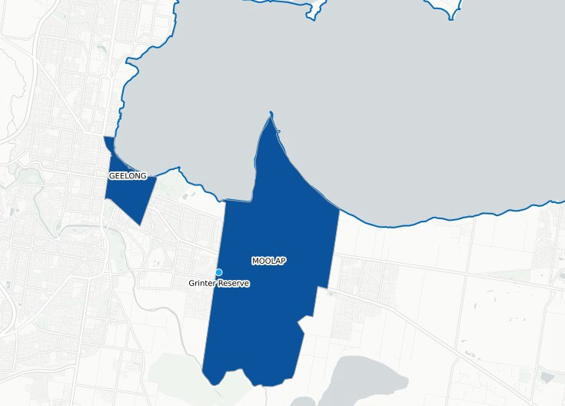
Map 2: Contextual location map of Geelong CBD, Moolap and Grinter Reserve
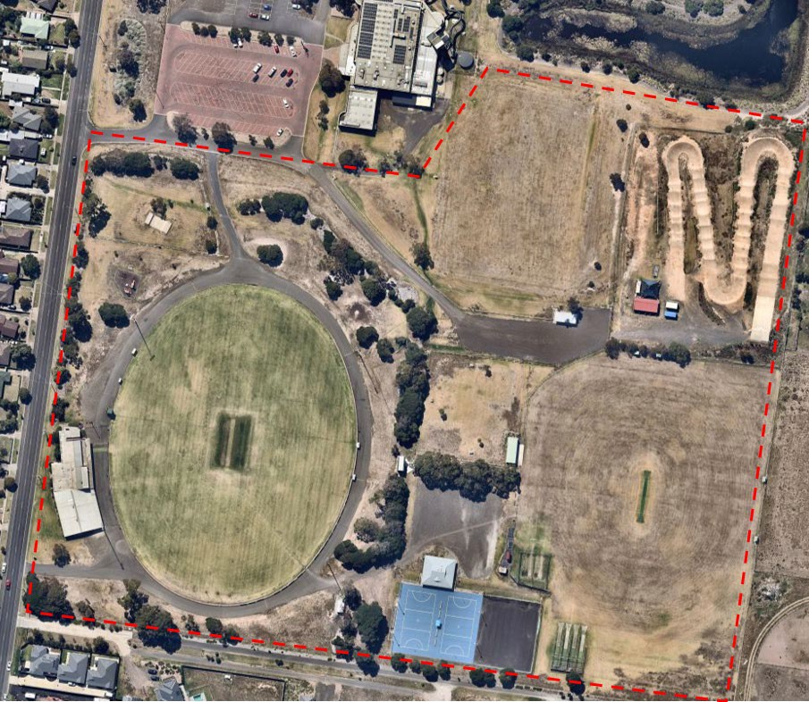
Map 1: Grinter Reserve – study area

DEMOGRAPHIC OVERVIEW

 | 6,500  Persons living in Newcomb-Moolap in 2020
 | 7,095  Persons living in Newcomb-Moolap in 2030
 | 8.65%  Overall change in population from 2020- 2030

The City of Greater Geelong has an average anticipated growth rate from 2020-2030 of 2.1%, which is higher than that of metropolitan Melbourne.
The City of Greater Geelong has an estimated population of 263,280 in 2020*. This is expected to grow to 324,289 in 2030 and 386,890 in 2040, primarily due to several growth areas to the south and north-west of the municipality.
Population estimates and forecasts within this report have been obtained through Forecast.id. Forecast.id incorporates the suburbs of both Moolap and Newcomb within the same profile. It is therefore that demographic analysis considers both suburbs and will be referred to as ‘Newcomb-Moolap’ throughout.
Newcomb-Moolap is positioned only a stone’s throw away from Geelong’s CBD with Corio Bay to the north and Reedy Lake to the south of the suburb’s boundary. It is also bordered by Leopold to the east and East Geelong, Whittington, and St Albans Park to its west. Newcomb-Moolap is approximately 38 square kilometres in size, and in 2020 its population is approximately 6,500 persons.
It is expected that by 2030, the population of Newcomb-Moolap will increase to 7,095 persons, indicating an overall change of 8.65%, or an average annual change of 0.53%.
According to the Socio-Economic Indexes for Areas (SEIFA), the City of Greater Geelong receives a total score of 994, which sees it rank in the mid-range when compared to all other Victoria LGAs. The SEIFA index score for suburbs within the City range from significant advantage (scoring 1,092) to significant disadvantage (scoring 731). The suburb of Newcomb-Moolap receives a SEIFA index score of 933, indicating that it is one of disadvantage. Presently, Newcomb- Moolap ranks in the lower percentile for disadvantaged suburbs within the municipality.
The Victorian Government’s Change and Disadvantage in Regional Victoria: an overview (2011) identifies neighbouring Whittington as number seven in the 100 most disadvantaged localities in regional Victoria. Disadvantage, as described within the report, occurs when an individual, family or community is deprived of resources or opportunities enjoyed by other Victorians that underpin social and economic wellbeing.
Disadvantaged people and communities lack either material resources (income, housing, services, transport), skills/knowledge/resources (education, health) or social capital
resources (social participation, inclusion).

LOCAL DEMOGRAPHIC INFLUENCES ON PARTICIPATION
      - In 2030, the majority of persons living in Newcomb-Moolap will be aged 20-39 years.
      - The 75+ age cohort however will experience the greatest growth between 2020 and 2030, increasing by an additional 162 persons. This increase is however relative to the current number of people aged within this cohort in 2020, which is significantly lower number than other age brackets.
      - The 5 to 19 year old age group will see an additional 100 persons to 2030, or an overall change of 10.5%.
      - 20-39 year old cohort will see approximately 80 additional people in 2030, whilst the 40-59 age cohort is set to experience a decline of over 200 people.
      - The 60-74 year old age cohort will see anticipated growth – from 1,153 persons in 2020 to 1,201 persons in 2030, equating to a change of 4.1%
      - It is forecasted that there will be an additional 178 persons living in Newcomb-Moolap in 2030 within the 5-39 age demographic which is considered the key market for organised sport.
      - Noting the above dot point and utilising the 2019 participant catchment map on page 9, it is evident that several participants of the football club are travelling from neighbouring suburbs to participate, including St Albans Park and Whittington. Forecast.id indicates that these suburbs are expected to have an additional 3,447 persons in 2030 within the 5-39 age cohort. Whilst not all persons within this age cohort will be captured in organised sport and/or by the Newcomb Power Football Club, it does provide a significant additional pool of prospective participants.
      - Whilst engaging the 5-39 age cohort is crucial to the future prosperity of the Club, as demonstrated within Section 2 of this report, there are several other clubs located within proximity to Grinter Reserve, who will likely compete for this same group of people. Whilst the identification of infrastructure improvements to retain and attract future participants will be discussed throughout this report and the Facility Development Plan, all user groups will need to strive to continue to maintain and enhance their operational capacity, program offerings, club culture and inclusivity to ensure they remain competitive.
      - The increasing number of persons aged 75+ residing in Newcomb-Moolap in 2030 will likely present a greater demand for activities and infrastructure that are suitable for older people. Whilst the number of persons in this age cohort in 2030 remains low compared with other cohorts (i.e. 962 persons in 2030 as opposed to 1,891 persons aged 20-39). Opportunities for improved walking, cycling and nature appreciation will offer a broader spectrum of activities for older adults to be involved in.

SITE USAGE

SPORTING CLUB PARTICIPATION

To assist in identifying current and future demand for sport, an overview of participation for sporting user groups occupying facilities within the study area is provided below. Note that due to the COVID-19 pandemic which has seen the hiatus of most organised sport, participation data from 2020 has not been included.

2019 SPORTING CLUB PARTICIPATION SUMMARY
CLUB | TOTAL | MALE | FEMALE | MALE JUNIOR | FEMALE JUNIOR
NEWCOMB FOOTBALL NETBALL CLUB (FOOTBALL) | 336 | 274 | 62 | 196 | 59
NEWCOMB FOOTBALL NETBALL CLUB (NETBALL) | 93 | - | 52 | - | 41
NEWCOMB & DISTRICT CRICKET CLUB | 90 | 75 | 15 | 15 | 5
GEELONG BMX CLUB | 111 | 88 | 23 | 44 | 11
AFL MASTERS | 135 | 135 | - | - | -
TOTALS | 765 | 572 | 152 | 255 | 116

A further breakdown of participation and trends in each sport over the past four seasons (2016-2019) is provided below.

AFL PARTICIPATION |  |  |  |  |  | BMX PARTICIPATION
 | 2016 | 2017 | 2018 | 2019 |  |  | 2016 | 2017 | 2018 | 2019
No of players | 219 | 230 | 286 | 336 |  | No of players | - | 78 | 81 | 111
Change % | - | +5.0% | +24.3% | +17.5% |  | Change % | - | - | +3.8% | +37%

NETBALL PARTICIPATION
 | 2016 | 2017 | 2018 | 2019

No of players | 111 | 102 | 116 | 93
Change % | - | -8.1% | +13.7% | -19.8%

The above tables indicate that most sports tenanting Grinter Reserve have four
CRICKET PARTICIPATION
 | 2016 | 2017 | 2018 | 2019
No of players | 95 | 85 | 80 | 90
Change % | - | -10.5% | -5.9% | +12.5%
experienced growth in participation over the past

years/seasons. The steadiest growth is in AFL which has trended positively across all four seasons. Netball and cricket have experienced some fluctuation, however as detailed throughout this section of the report, both are offering several initiatives in 2021 to assist in driving participation. Monitoring of ongoing participation trends should be undertaken moving forward, particularly for netball and cricket. BMX participation was available from 2017 onwards and has seen growth to 2019.

SPORTING PARTICIPATION CATCHMENT (AFL)
Grinter Reserve is located in an area that is well serviced by public transport, retail and community service facilities. This includes several other recreation reserves within proximity.
Like venues within a 5km radius of Grinter Reserve, include:
    - Ervin Reserve – 2.3km (two ovals – AFL junior size equivalent)
    - St Albans Reserve – 2.6km (one oval)
    - Thomson Reserve – 4.3km (two ovals)
    - Richmond Crescent Oval – 4.8km (one oval)
The AFL has provided detailed participant data, which includes the residential postcodes of players. This information helps to understand club catchment area, as well as the distance travelled to play. With respect to the Newcomb Power Football Club, the below heat map indicates the suburbs where its players (based on 2019 data) reside. As mentioned previously, several sporting clubs are based at neighbouring reserves, in particular, Ervin, St Albans and Thomson Reserve who attract players from a similar catchment area. As demonstrated in the heat map below Grinter Reserve, and more pointedly Newcomb Football Club, attract players that mostly reside in and around the immediate neighbouring suburbs.

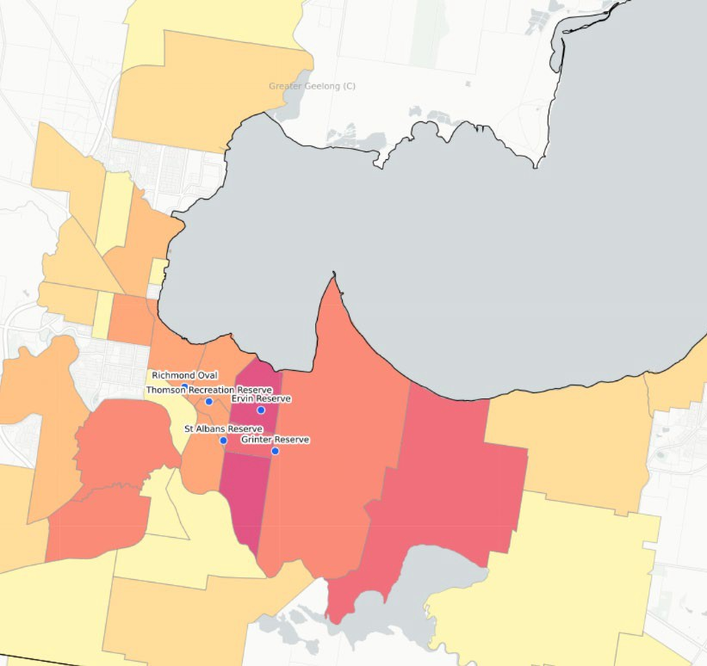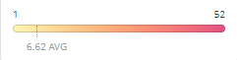
Map 3: Newcomb Power Football Club – catchment area heat map

The top player suburbs/catchment area of Newcomb Power Football Club are:

NEWCOMB POWER FOOTBALL CLUB

ST ALBANS PARK | 52
NEWCOMB | 50
WHITTINGTON | 42
LEOPOLD | 40
GROVEDALE | 14
MOOLAP | 13
BELMONT | 12
As expected, most players reside within close proximity of Grinter Reserve, and these suburbs will continue to be important for the club to target to 2030.

CURRENT FACILITY USE
An overview of the weekly use of Grinter Reserve by its tenanting sporting clubs is provided below. The hours included are for both training and competition. Combined, these groups utilise the venue for approximately 90 hours per week. Informal community use would also add significant hours to this total.

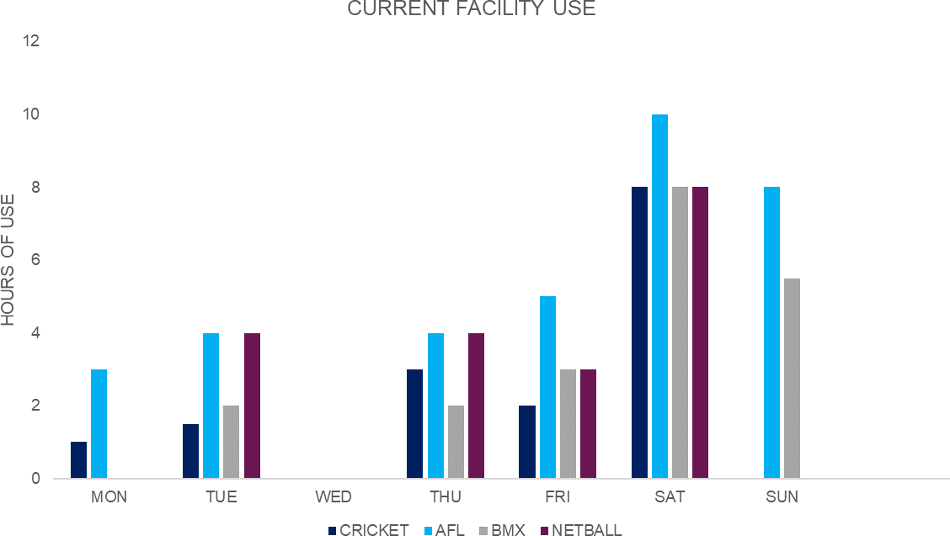

COMMUNITY SPORT PROGRAMS AND INITIATIVES

“Our club offers a free cricket package to entice junior sport within the community and area, and our vision is to expand numbers and participation levels into further age groups for both males and females” – Damian Lynch, President, Newcomb & District Cricket Club
The sporting clubs at Grinter Reserve offer a range of initiatives to support participation. Located in a lower socio-economic area, all clubs understand that driving participation and opening opportunities for participants, particularly juniors, is an ongoing achievement. Football, cricket, netball, and BMX clubs all provide a range of entry level programs which are aimed to be accessible to a broad range of participants, these include:
- Free junior cricket participation.
- Partnerships and connections with local schools to provide linkages and opportunities to ‘come and try’.
- A pathway for female cricketers.
- Free AFL participant fees should junior participants experience financial hardship.
- Introductory programs for under 5 year old BMX participants.
- Reviving the NetSetGO program in 2021.
- A strong Master’s AFL team who utilise the Reserve for training. This format of football is aimed at people over the age of 35.

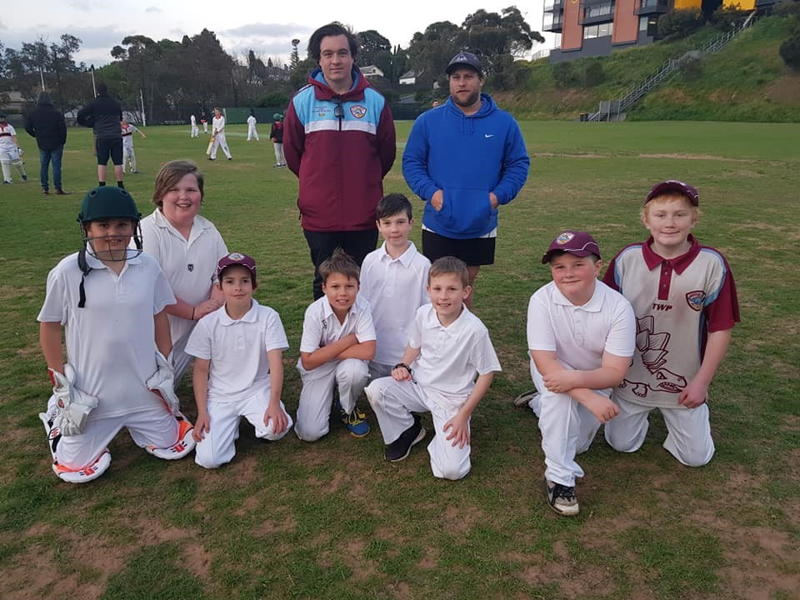
Image 2: Newcomb & District Cricket Club – junior players. Image courtesy of Newcomb & District Cricket Club

EXISTING CONDITIONS

EXISTING CONDITIONS SUMMARY
The existing conditions summary provides an overview of observations obtained through onsite audits and inspections (November 2020) of the facilities at Grinter Reserve by the project team. This summary includes the identification of preliminary issues and opportunities of each key infrastructure component.

FOOTBALL/CRICKET PAVILION OVAL 1
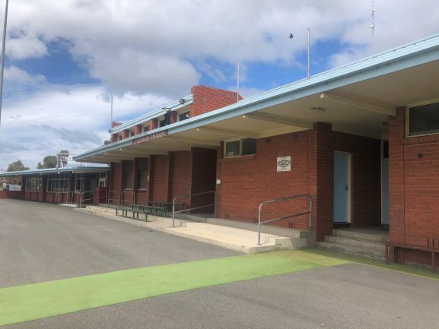
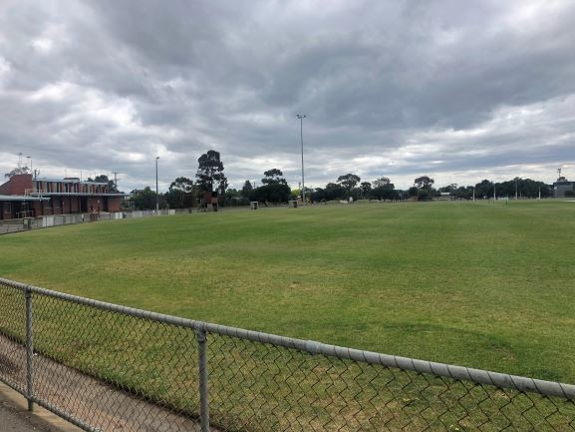
Asset age: Circa 1980 Description: Oval 1 at Grinter Reserve is considered the main

Building description: The building is single level and consists of steel frame and double brick with concrete slab floor.
Building condition: Mostly in good structural condition. Some signs of cracking in foundations in area of external public toilets.
DDA compliance: Non-compliant in access to the building and
oval for the venue. It consists of a sand based, warm season grass turf profile, turf centre wicket and spoon drain around the perimeter.
Ancillary infrastructure to support Oval 1 includes coaches’ boxes, timekeepers’ box, automatic irrigation, boundary fence and sports lighting of around 50 lux.

spaces such as toilets, showers etc. Issue: On inspection, the Oval surface appears to be in very

Sporting code compliance: The home and away change rooms are large, however the finishes are poor/dated. The amenities associated are not suitable for all genders. The umpire facilities are undersized and do not align with recommended guidelines. They also do not provide for all
good condition. It should be noted however that the inspection occurred following the hiatus of the 2020 AFL season due to COVID-19. It is therefore anticipated that there may be some variation in condition following a regular home and away football season.

gender use. The main issue on Oval 1 is the sports lighting, which is not

Supporting attributes to core amenities including first aid, storage and trainers/strapping rooms are either not provided or are of a poor standard.
Opportunity: Overall the building is relatively large for a local pavilion and in mostly sound condition. The immediate need focusses around the change rooms and amenities and the lack of gender neutral compliance.
considered adequate to facilitate night training and competition.
The goal netting at the southern end of Oval 1 appears to be past its useful life.
Opportunity: Sports lighting on Oval 1 has received investment to be upgraded with works programmed to begin early 2021 (note these works have now been completed). This will address any deficiencies and create greater opportunities for participation and programming.

CAR PARKING AND VEHICLE MOVEMENT RESERVE ENTRANCE AND FRONTAGES

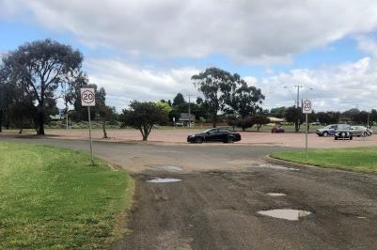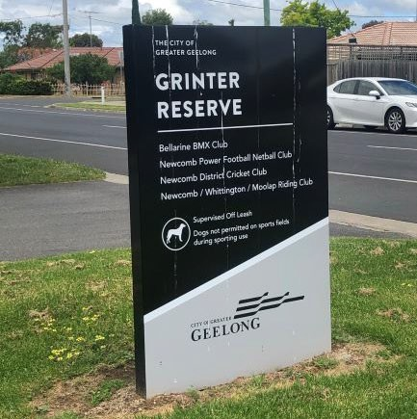

Description: The Reserve is well serviced in terms of access roads for vehicles, ranging from a fully sealed road around the perimeter of Oval 1, to unsealed roads which are in a varying degree of condition.
Issues: There is limited formalised car parking near the main pavilion, with most cars accessing the building via the Coppards Road entrance closest to Wilashal Place. A small, informal gravel car park presently services the main pavilion which does not provide sufficient parking for game day traffic.
Similarly, if entering from the Splashdown Leisure Centre entrance, parking for the skate ramp, playground and external
Description: The Reserve’s entrance points and frontages primarily face Coppards Road. There are two main entry points in the study area, near Splashdown Leisure Centre as well as Wilashal Place.
Issues: The two entry points described above lack appeal and do not provide enough wayfinding signage or sense of place for users. It is envisaged that the entrance closest to the Leisure Centre should primarily service the BMX track, playground, skate ramp, open space area and public toilet, whilst the entrance closest to Wilashal Place services the main pavilion, both ovals and netball courts.

toilets attached to the main pavilion is limited. The above image is of the current signage at the entrance closest

Gates presently control access to the car park that services the netball pavilion as well as Oval 2. The Oval 2 car park has a
to Wilashal Place. This sign lists all tenanting clubs however does not provide any directions to these facilities.

gravel surface and parking spaces are not defined. The Reserve frontage consists of mostly garden beds and sporadic

Opportunity: There is opportunity to improve car parking throughout the Reserve but particularly around Oval 1, the playground and Oval 2 which likely experience heightened traffic. Vehicle management and the continued ability to close car parks when not in use, i.e. Oval 2/netball car park, will likely still be required to prevent hoon behaviour. A holistic approach should be taken in the preparation of the Facility Development Plan to vehicle movement that improves safety, connectivity and access for cars and pedestrians alike.
tree planting of a variety of species. There are also pockets of wooden post and rail fencing which is aged.
Opportunity: Consider updating the entrances at Grinter Reserve to enable a better visual aspect and aesthetic, along with assisting users to navigate the expansive Reserve. Consider removing or replacing the pockets of post and rail fencing. Consider removing shrubbery along frontages that may impede sightlines into the Reserve and replace with a high canopy tree that is in line with the landscape and character of the area.

CRICKET SHED NETBALL PAVILION
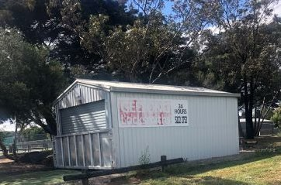
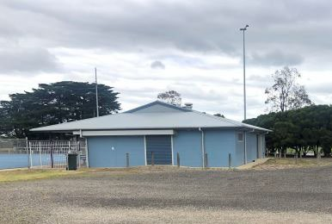

Description: The cricket shed, located within 30 metres of the netball courts and Oval 1 is primarily used to store turf maintenance equipment. This equipment is required for the upkeep of the turf wicket on Oval 1 as well as the turf cricket practice nets on Oval 2. The shed has been reinforced to prevent break ins and vandalism.
Issue: Whilst there is not any immediate issue with the shed, its size sees the cricket club limited in what they are able to store. Access into the shed could also be improved to make it easier for larger machinery to enter and exit safely.
Opportunity: There is opportunity to incorporate the cricket storage shed into the netball pavilion which is located behind the secured car park gate. Should this be achieved then the existing shed may require to be consolidated.
Asset age: Circa 2000
Building description: Constructed from slab on ground, timber frame with truss roof and metal cladding system.
Building condition: Building appears to be in good condition from external observations.
DDA compliance: Access to the building is generally compliant. No access available to determine compliance inside.
Sporting code compliance: Whilst internal access was not available, audits undertaken by the AFL in October 2019 included the netball facilities. As per the Appendices section of this report, this inspection indicated that the current facilities are in excellent condition and fit for netball participation as per the recommended facility guidelines.
Opportunity: It appears that the building currently caters for netball participants at Grinter Reserve adequately. There is opportunity to consider a small extension to the building to incorporate a storage area for the cricket club. This would assist the club in keeping their equipment safe as well as having equipment in closer proximity to the turf cricket practice nets.

NETBALL COURTS CRICKET PRACTICE NETS
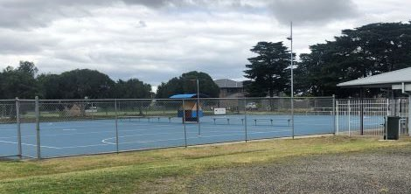
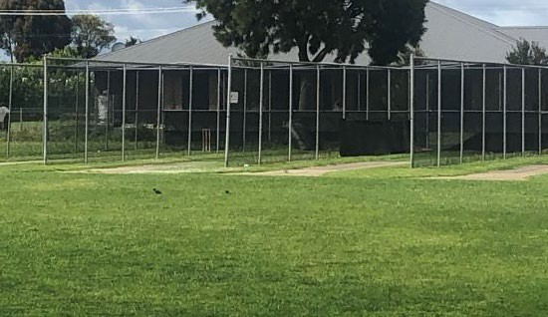

Description: There are two netball courts at Grinter Reserve which consist of an asphalt base and acrylic surface. These courts are compliant with the competition requirements of Netball Victoria. Lighting levels were not assessed as part of the facility inspection. The court is serviced with several player and spectator benches. The two court provision aligns with recommendations for a local netball facility, however it does reach capacity on game days.
Issues: Whilst the courts are compliant in terms of dimensions, they are experiencing cracking and deterioration which should be addressed in the short term. Investigations into the lux levels of court lighting should be undertaken. Where levels are below 100 lux (minimum training standards for netball) consideration of an upgrade should be given.
Opportunity: Address court deterioration either as part of the Facility Development Plan or through the City’s cyclical budget program. Consider the inclusion of a formalised warm up area, potentially on the old asphalt tennis/netball courts adjacent to the main courts. In addition, provide overhead shelter for the player and spectator bench seats presently exposed to the elements. Should lux level readings be below the recommended minimum training standard of 100 lux, undertaking upgrades to meet this standard can be considered.
Description: Grinter Reserve has two cricket practice net facilities both located on Oval 2. The turf practice facility measures approximately 15m x 15m with provision for up to 6 bowling lanes. The turf surface is well maintained by the cricket club. The hard wicket practice nets are approximately 25m x 16m and consist of four bowling lanes. The hard wicket facility is showing signs of age.
Issues: The turf practice net facility aligns with the recommended Cricket Australia facility guidelines in terms of its dimensions. The main issue however is that this facility does not have a roof or netting to prevent errant cricket balls.
The hard wicket facility mostly meets the recommended dimensions for a local level facility, however it does not have a roof to prevent errant balls. The structure of the facility, including its components such as netting, protective rubber and synthetic pitch surface shows high signs of wear and age. The synthetic surface covers only a portion of the run up area, which does not meet recommended guidelines. Finally, the provision of four hard wickets is beyond recommended guidelines which states that three lanes would suffice for a local level venue.
Opportunity: There is opportunity to consolidate both turf and hard wicket practice facilities at Grinter Reserve to create a new, compliant, and modern facility that also meets safety requirements. There is presently ample room available within the vicinity of the existing two practice facilities for the creation of a new facility which will better service the club and encourage greater participation.

OVAL 2 PUBLIC TOILETS

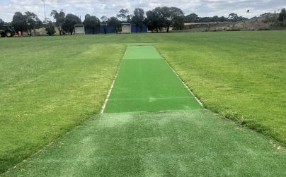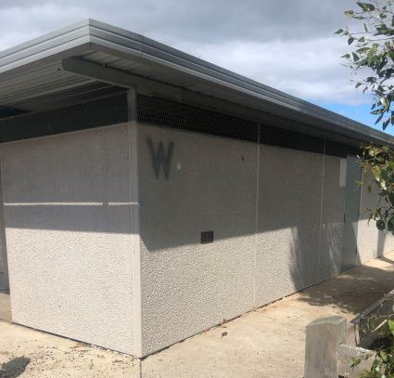

Description: Oval 2 is located to the east of Oval 1 and consists of a cool season turf profile with synthetic centre wicket, coaches’ boxes, and goals at the southern end. The oval is primarily used by both senior and junior cricket as well as junior football. Junior football utilise and set up Oval 2 so that it can cater for multiple fields with removable goals posts suitable for varying junior age groups.
The football club have also constructed a storage shed to support Oval 2 which they plan to expand in the future.
Issues: On inspection the oval appears to be in good condition with well-established grass cover. The centre wicket is also in excellent condition. The oval is not irrigated which would see it become dry in the summer months. There is also a variety of old spectator shelters and softball dugouts which are no longer in use. There is limited shade and spectator shelter that is fit for purpose to service Oval 2.
Opportunity: Consider upgrading the playing surface on Oval 2 through a ground renovation which would facilitate greater participation outcomes, particularly during the summer months. Consolidate the old spectator shelters and dugouts and replace with new amenity that serves as scorers’ area, players shelter and possible inclusion of toilets and storage.
Description: The public toilet block is located to the north-east of the study area closest to the BMX track. It is likely a circa 1970s or 80s construction. There is both women and men’s amenities as well as an accessible toilet.
Issues: The location of the public toilet is towards the rear of the Reserve. During times of limited activity, there is a likelihood that the toilets attract antisocial behaviour. In addition, the accessible toilet would no longer meet modern standards and the fixtures and fittings throughout the toilet block show some wear.
Opportunity: Whilst the toilets remain in a serviceable condition, once their end of life is reached, it is recommended that new provision of toilets is provided in a more suitable location (possibly in the vicinity of Oval 2 or to the main pavilion). Updated toilets would provide a more welcoming environment for the community.

BMX TRACK BMX PAVILION
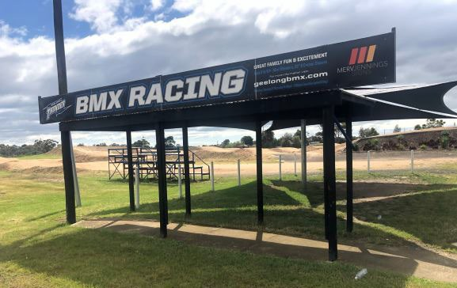
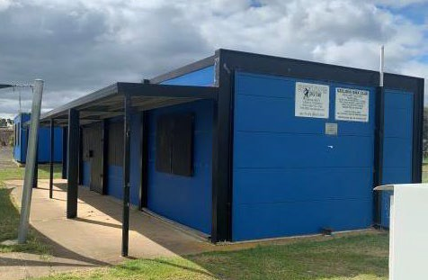

Description: The BMX track consists of a start hill with automatic gate, four straights, three turns/berms and small undercover spectator area. The track has a large perimeter fence with small pedestrian gate. The track surface is maintained by the BMX Club and the surrounds are maintained by the City. The BMX track, when assessed against BMX Australia Track Guidelines (2013) closely aligns with National Championship level standards.
Issues: The BMX track has a high specification and is capable of hosting regional and national events should a number of ancillary supporting attributes be provided.
The pedestrian access gate into the BMX area is not compliant with DDA requirements (does not meet recommended width)
Asset age: Circa 2010
Building description: The building is constructed from an exposed steel portal structure with painted compressed cement sheet cladding, expressed horizontal joints and concrete slab floor. The facility is constructed so that it can be well secured. The facility consists of small kiosk and club room area. A scorers/timekeepers area constructed of shipping containers sits adjacent to the main pavilion.
Building condition: Generally in good condition. Requires painting maintenance.
DDA compliance: Access to the building complies. No access available to determine compliance inside.

and the perimeter fence is not visually appealing. Sporting code compliance: There are no facility guidelines for

Opportunity: Consider the inclusion of the necessary ancillary infrastructure in the Facility Development Plan to allow the venue to host higher level BMX events. These events would be a significant attractor and draw card, not only for the venue, but for the municipality. Potential additional infrastructure provision includes a covered area over the starting hill, bitumen or concrete berms/turns, track lighting and improved spectator
BMX club rooms. The club rooms however do not have toilets or showers, with patrons using the old adjacent public toilets during BMX events. Toilets and showers are considered key supporting infrastructure to facilitate participation and are a minimum standard for most sports. It is understood that toilets were not initially provided to the facility due to sewer connections being unavailable.

area. Opportunity: Whilst the club rooms appear in sound working

Replace and improve the entrance to the facility making the area more aesthetically pleasing and to improve access for people with mobility impairments.
order, the lack of amenities presents an immediate need. Consideration should be given to providing an extension to the existing facility or considering the inclusion of a new modular style building, to provide a minimum of a social area and kiosk, toilets, showers, and storage. Utilities connections would also need to be included as part of this project.

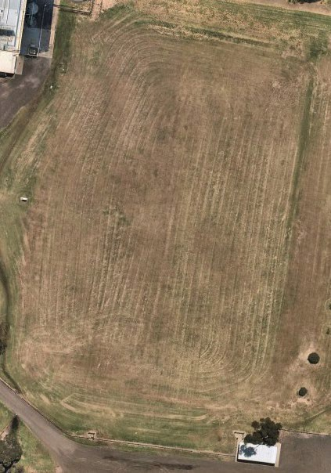
OPEN SPACE AREA TREE CANOPY AND LANDSCAPING
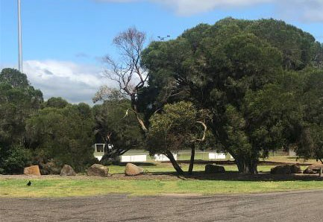

Description: There is a large, unoccupied open space area to the north of the study area, between the BMX track and Splashdown Leisure Centre. The area measures approximately 115m in length by 76 metres in width.
Issues: The area is considered to be underutilised and lacks value. Its location within the Reserve would not lend the area to be conducive with unstructured or informal recreational activities.
Opportunity: There is opportunity to utilise this area for future activities as demand necessitates. This may include, but is not limited to, football, cricket and/or cycling activities such as BMX/pump tracks and mountain bikes. Any future extension to the Splashdown Leisure Centre may also require occupation of the area. A future feasibility study for the open space area should be undertaken to inform the best future use of this space.
Description: Existing tree canopy and landscaping is scattered throughout the Reserve, which is mostly situated along the perimeter of Oval 1 and along the Coppards Rd frontage. The landscaping consists of a variety of low and high canopy tree species along with small shrubbery and strategically placed rocks and garden beds.
Issues: The landscaping and tree canopy coverage throughout the Reserve is predominately surrounding Oval 1. In pockets, shrubbery and low canopy trees impede sight lines across the Reserve. There does not appear to be any consistency or approach to the way trees have been planted.
Opportunity: As identified in the CPTED audit undertaken on page 21, additional landscaping including tree plantings can assist in improving the look and feel of the Reserve, as well as ensuring that visibility and sight lines are maintained or enhanced. Additional tree planting will also contribute to a cooler and greener parkland which is a strategic priority for the City within their Urban Forest and Environment Strategies. The provision of additional shade and tree canopy will provide more amenity for users and contribute to the Reserve’s biodiversity attributes.
The Moolap Plains Indigenous Plant summary notes that the area was once a predominantly open woodland community which included dominant tree species such as River Red Gum, Swap Gum and Drooping Sheoke, several shrub species including Sticky Boobialla, Sweet Bursaria and Silver Banksia were also common. Future landscaping and tree planting at Grinter Reserve should consider the use of indigenous species that are commensurate with the landscape and character of the area.

PLAYGROUND SKATE RAMP
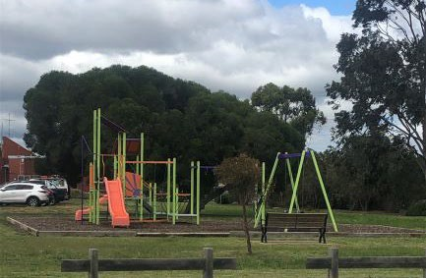
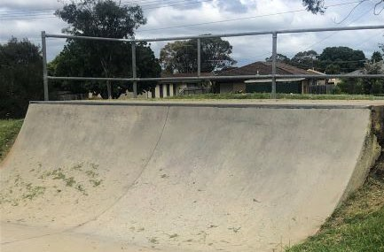

Description: The existing playground at Grinter Reserve is provided as a local level facility suitable for children under the age of 12. The playground is located within close proximity to Oval 1, the main football/cricket pavilion and its external toilets, as well as the skate ramp. It is unfenced, has a soft-fall surface and park bench.
Issues: The playground is in good condition and is maintained and upgraded by the City though its recurrent budget program. The playground however does not have any compliant access paths to its entry point, designated parking or natural shade for children and parents/carers.
Opportunity: Consider if current location for playground is the most ideal position. Consider access to public toilets should a future location be considered. Also consider how complimentary, informal play and/or activities could be incorporated. Include additional landscaping and tree planting to improve amenity.
Description: The skate ramp at Grinter Reserve is located adjacent to the playground area. It consists of a single concrete half-pipe ramp. It is estimated to be constructed between 2001 to early 2005. The ramp would be suitable for beginners to intermediate level scoot and skateboarders.
Issues: The ramp shows some cracks in the concrete surface. There are no pathways to access the ramp and it is location could be improved to encourage greater use and connectivity.
Opportunity: Consider the redevelopment of the skate ramp in a location that is well connected to the playground to create a larger play space which attracts a broader age range of children and provides greater amenity and functionality. A feasibility for the type of skate facility should be undertaken which considers demand for other complimentary activities including pump track, scoot track and skateboarding. Future recommendations for the skate ramp should be referred to a broader strategic skateboarding study.

PEDESTRIAN PATHWAYS BOLLARDS
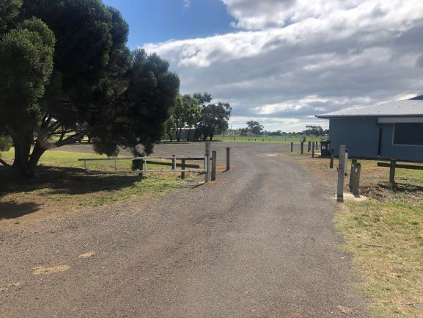
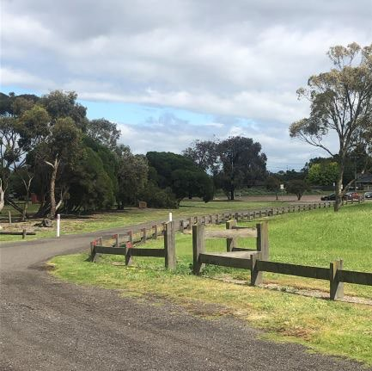

Description: Pedestrian pathways throughout the Reserve are largely shared with vehicles. Shared access roads consist of
Description: There is an array of bollard type fencing throughout the Reserve which ranges in style and condition.

both formalised and informal roads and connections. Issues: Some of the bollarding is aged and is past its useful life. In

Issues: The sharing of roadways with pedestrians, particularly in areas of high traffic movement pose a safety issue. The lack of pedestrian networks also limits the Reserve’s connectivity, walkability, and accessibility.
Opportunity: Consider the best approach to including a pedestrian network throughout the Reserve. As also indicated in the CPTED audit undertaken on page 21, additional opportunities for walking and cycling throughout the Reserve will assist in the activation of the venue and in turn, increase the level of passive surveillance.
some areas, there appears to be excessive bollarding which could be consolidated.
Opportunity: Consider a more consistent approach to fencing throughout the Reserve as part of the Facility Development Plan. Consider using natural barriers such as landscaping and trees where possible to reduce ongoing maintenance obligations associated with physical fencing.

CPTED AUDIT SUMMARY

CRIME PREVENTION THROUGH ENVIRONMENTAL DESIGN (CPTED)
Crime Prevention Through Environmental Design poses the idea that by using knowledge and creativity in the approach to the built environment, that crime can be lessened or prevented. These ideas stem from the concept that where more people are around a public space, then incidents of crime are less likely to occur. The Victorian Government’s Safer Design Guidelines have been developed to help planners and designers apply principles that will improve the safety of the built environment, minimise the opportunity for crime and promote safe, accessible, and liveable places.
The public spaces principles within the design guide framework include:
    - Ensuring all users have convenient and safe access to and through public spaces.
landscaping consists of mulched garden beds with large boulders and rocks placed throughout. The landscaping appears to offer minimal value to the site and to Reserve users and does not provide a clear aesthetic or purpose. There is limited other vegetation of significance throughout the Reserve. The location of trees and the species chosen, at times, impedes on sightlines and vision into the Reserve. Instances of crime and/or antisocial behaviour could be more likely within areas where visibility is limited.

Design response options:
    - Consider planting high canopy trees in strategic locations that provide uninterrupted views of the Reserve.
    - Remove trees and shrubbery that adds little value to the Reserve and which impedes sightlines.
    - Strategically place garden beds and other landscaping which assists in the management of traffic whilst contributing to the natural environment and aesthetic of the Reserve.

    - Achieving and creating vibrant public spaces. Passive Surveillance
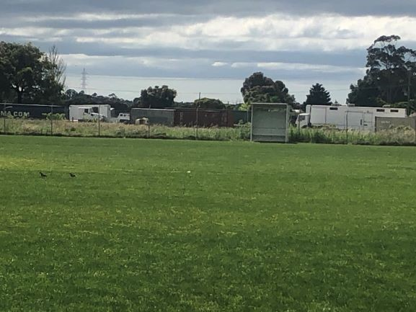
    - Establishing and supporting activity at the edges of public spaces.
    - Ensuring safety and amenity in public spaces.
    - Ensuring comfortable and enjoyable public spaces.
    - Supporting a strong sense of place and local character.
    - Ensuring public spaces are well utilised and maintained.
The CPTED design principles noted above have been considered and incorporated into the recommendations for the Facility Development Plan. Recommendations have also considered the observations and insights obtained through the CPTED audit undertaken by the project team in November 2020.
The November audit was conducted during daylight hours during the week and in conjunction with user groups. A

summary of the observations and opportunities from the audit are outlined below.

OBSERVATIONS

Trees and Landscaping
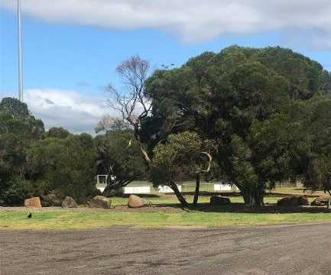
Sample of tree species and landscaping at Grinter Reserve

As discussed within the existing conditions section of this report, the existing trees throughout Grinter Reserve include a variety of low shrubs, clear-trunked trees and higher canopy trees. The
View of eastern boundary from Oval 2 at Grinter Reserve

Due to the expanse of the Reserve, there is a mixture of good and poor passive surveillance. Passive surveillance is described as an environment where people can see and be seen through casual observation. This includes by other park users, passers-by or from nearby properties. On the western and southern boundaries there is good passive surveillance with houses facing onto the Reserve, particularly those from Wilashal Place. There is limited surveillance on the northern and eastern boundaries which face the rear of semi-rural properties. As demonstrated in the image above, the rear of the properties consists of paddocks, livestock and machinery.

Design response options:
    - Any recommendations for future infrastructure development of buildings/club rooms should ensure that entrances are clearly visible and do not provide opportunities for concealment.
    - Ensure that any pathways between buildings have clear sightlines.
    - Consider the development of a pedestrian path network which encourages greater activity and movement throughout the Reserve.
    - Encourage community use and involvement across the entire Reserve precinct and only use fencing as a physical barrier where necessary.

Maintenance Design response options:

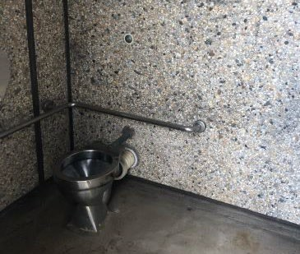 | - Incorporate alternative routes and wayfinding signage for pedestrians and Reserve users.  - Discourage the development of infrastructure that provides any concealment or screening. Consider the use of permeable materials when constructing fencing.  - Provide adequate lighting and clear sight lines for Reserve users.  Activation and Use  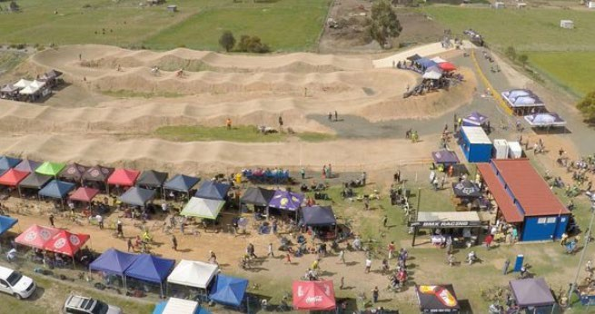
Public accessible toilet at Grinter Reserve
At the time when the audit was undertaken, the Reserve appeared to be well maintained with limited graffiti and/or evidence of vandalism. Whilst some assets are reaching the
end of their useful life, they are mostly kept to a standard that | Aerial image of BMX Club event Photo courtesy Geelong BMX Club

sees them fit for purpose.

Design response options:
- Ensure ongoing upkeep and maintenance of the Reserve to encourage civic pride and a sense of community place.

The Reserve is well utilised, particularly on weeknights and on weekends. Sporting user groups are responsible for hosting most events held at the Reserve. The use of the venue, for sporting as well as community events, assists in the community’s connection, sentiment and sense of ownership over the space and should be encouraged.

Escape and Entrapment Present pedestrian connections throughout the site are mostly ill- defined with limited wayfinding signage, lighting, and accessible
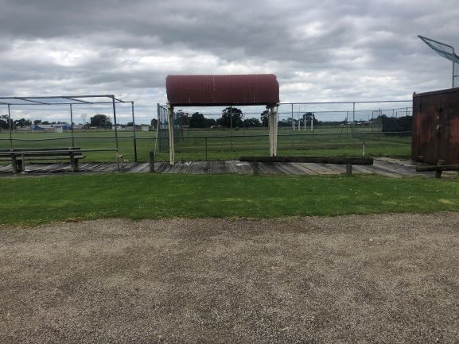 | pathways. To encourage more unstructured use and activat the Reserve for pursuits including walking and cycling, improvements to these areas can be made.  Design response options  - Encourage community use of the Reserve outside of regular sport.  - Support sporting clubs to host more events which contribute to a more vibrant public space.  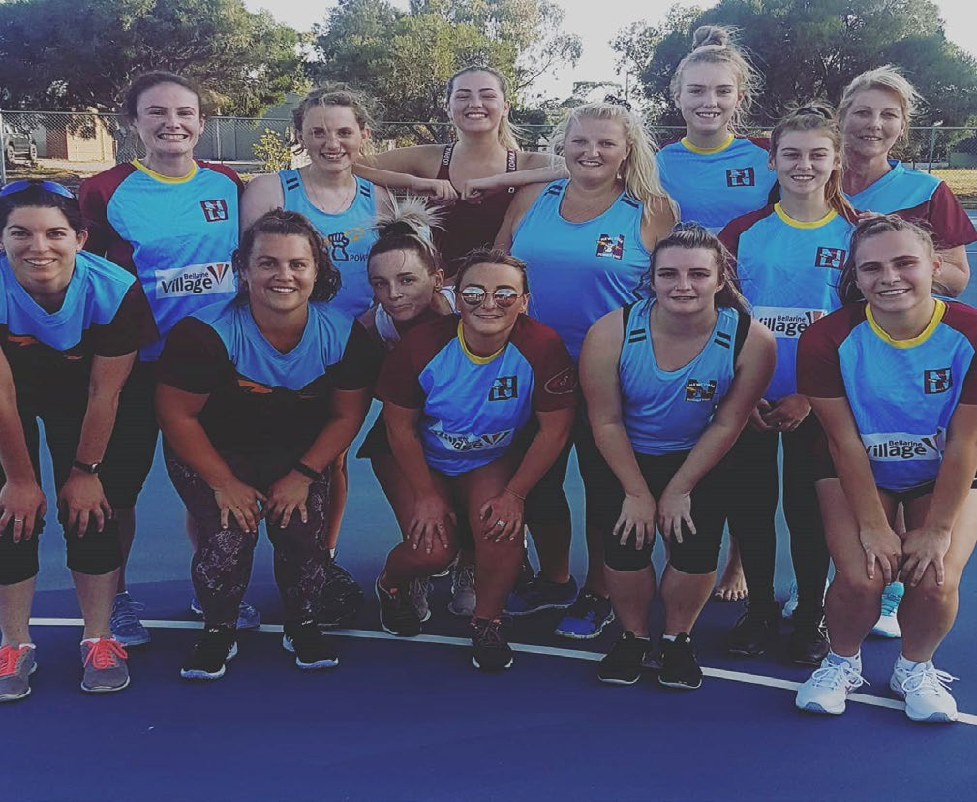
Image of outdated infrastructure at Grinter Reserve

The BMX track area and surrounds lacks passive surveillance and contains pockets where antisocial behaviour could occur out of sight, particularly at night time. On balance however the Reserve is open and areas for entrapment or concealment would be limited.
Updating and consolidating outdated infrastructure, and replacing with more suitable, better positioned assets will create enhanced flow and function of the Reserve.
There is also limited public lighting throughout the Reserve.
 | Newcomb Netball Club players Photo courtesy Newcomb Football Netball Club

ion of

FACILITY DEVELOPMENT PLAN

WHAT IS PROPOSED
Following the undertaking of site inspections, infrastructure audits, CPTED assessments and a review of site context and strategic information, the Facility Development Plan has been realised. The Plan has aimed to incorporate actions that are realistic, achievable and which focus on the delivery of multi-use and participation outcomes as well as community safety, visitation and enjoyment.
Enhancements for the facility include the delivery of gender neutral change rooms, improved core sporting infrastructure, greater connectivity and improved aesthetic, safety and activation of the Reserve.
All recommendations made within the Plan are aligned to the City’s vision and strategic direction, particularly regarding the future provision, management and use of social infrastructure. The improvements to Grinter Reserve are achievable through a staged process of delivery and will rely on multiple funding partners. All recommendations should be delivered collaboratively and in further consultation with key stakeholders, tenanting sports clubs and the community.
The Facility Development Plan aims to enhance the existing features of Grinter Reserve and provide better amenities to ensure it aligns with the standard of other like local venues across the municipality.
The following section provides an overview of recommendations as well opportunities for funding and the costs associated with delivery.
For the purposes of this report, the summary of recommendations has been broken down into individual areas to highlight the outcomes associated with key directions. It does not however constitute the order or priority of implementation.
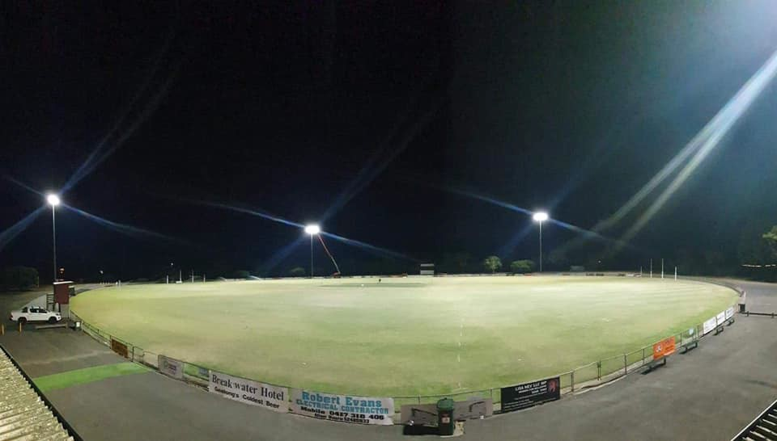

New sports lighting on Oval 1 at Grinter Reserve (completed February 2021)

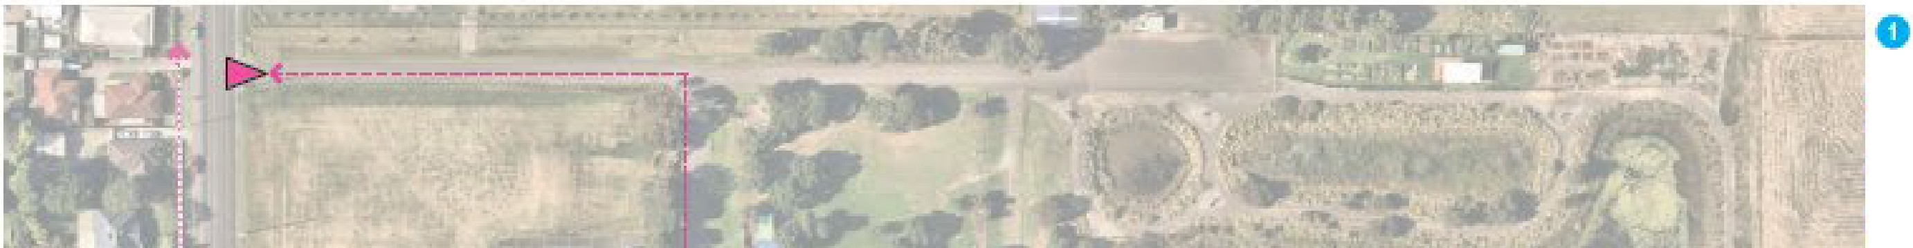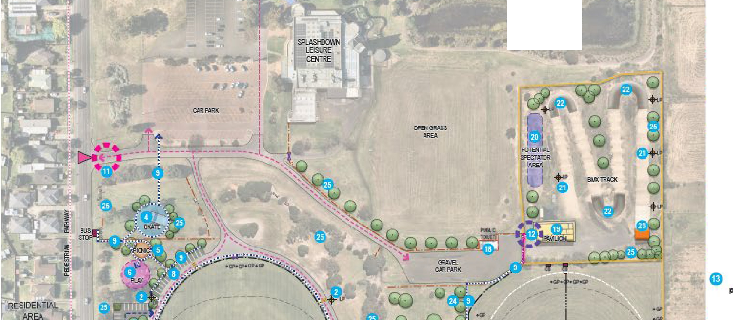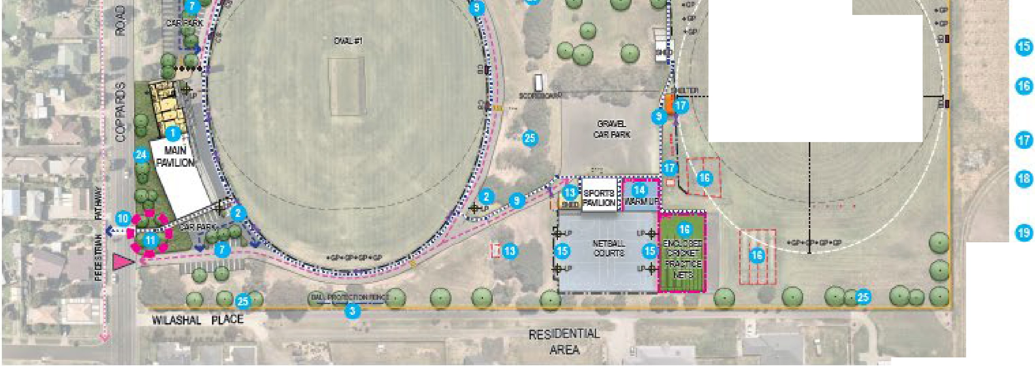EXPLANATORY OlES
de•af!IexlErnsion an ret\'lllliiiOOI1D tl-.e- D:Jr!h af
•
PRECEDENT IMAGES

o:11q:ilied d! ge rooJJ1S andlpliblic Eoilels.
l dertakECoG3 fianBI! r.tls ' ling1 pe:s1D O!/.aJ #1 . COIT'fl Allsi:rali3 gu' r,ies lKJttramir:,g aJU:I 00111P=liliDl'I le,,rel
a
IRe,Plaoeballpd.!!clian le:m:e Eothe s-:116 of 0. i1 (dub m'Ed).

AAJCric!,;s

l'E".JKI
-11.!f•EBT
1F9,Tl!El\_j-'JD El.ISi:'.•
0 Co -def·redevEloJ:ingrlhe-emiing skafe.ram,-pn1nal'l!!W userfrien:lly ska.e lad
suile:11fo,;;i 'bmalierra!lge af ;;ig;es ..t.1:II abilities iffl fne.!Attn N!lllllMM!t:l:lioltions i'I CDGG,'s
131a¥Slrafer,/.
a
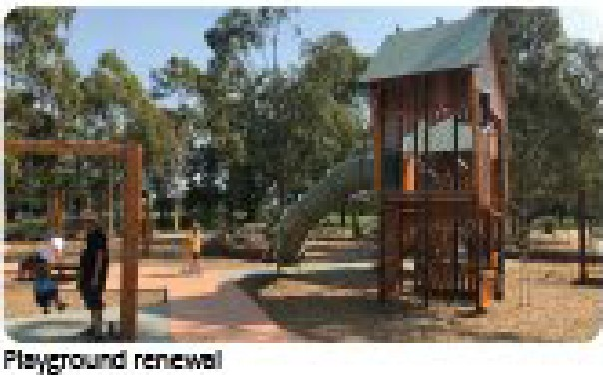
IPl'oode•a e1,1 illlli'c areo1 Yielter ar.d fi,mic.s !JSID sen.'.>l:E! !me pla,:,g= an:lskalE!areii.

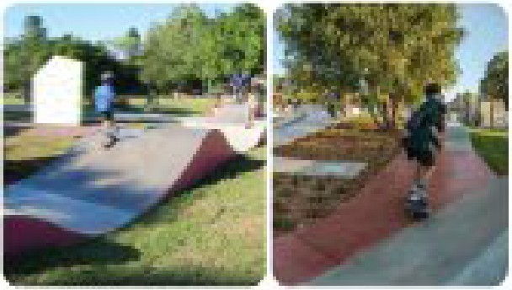Cl 11.lrui:!rtik:efii.lll'E! pla,:,grt1111\1:hE"r1ewal at. en af . usai'ul life unc!B CdGGls C¥Cfical

str-·lil I pwnp=
n:grarmte am!iffl r11e Mlffl the Pay S' !I(.Consider al SllljlpOI'
i'lfrasfrucb.re 'remenfs aid i - oomtecliol\'ls..
0 Forl!Elise!a' pa1kill.g to tlle•l:lllf!hl .and!soutlo! ofit'e p.a,'iilio i'ldlllfmg rooisiDffl of
s:sille parkin.g b,.ys, Cfff free iillll ·landsciifi'rtg.Im the O,ponill!lily Eo
•
i'IOO!JX!rale wafer -e inan e nelemel!l!s ro,freat rll!I .
Form31ise•iili'l!te:licar100:l!Ed i d:Jse p!O)(jrrify ID the• recreation
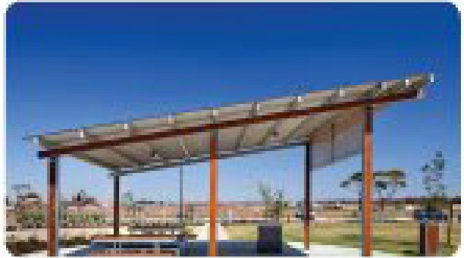
areii.

3.0:il!li(K
D Consider i!Tifllemer:rting a :malIP3lfeslr- piii -, 1!1 '<1 thrwglrnvt !me l'e!il!l'!Je lo
np:rm1e1,1edesfri,1r,1 li!!ks., aooessib ty, awi.'i:ltiDl!Iiili'ld safety:.
I -esli!Jile esfolbli5'tir.,g1o1 nE!'ltl - reS: ·islan (Ill; Co p;ar4s Rnaill ffil OOffllled.i g r;nps to np1'(Jl,1e5,3fety.ill!ldCOlll'IMKI il --eetn the IE!SerL\I!' an.ill
Sllffllll!lling iil'Ba5.

    - 'Esl:iihli!ih lfs:11re re5et'IM!' e poims.wi\n- pm'i'E!d reserJ1B!.l-ayfin.diig ..t.!:11 Iii

r.:lscap- g1-D
pro'i'E!·iilJlle5.Sibilily iiJlli re;:enfalicc:i ' the •.
Firni:c:21fl9!

- •IIP
(EIsl:iihlish a t:le\lip;!deslri:Jn !!ft.I)' ¥.uil si fo!me BMX.l'rdmm\F'f!J\!I!' iillOeSsi ily andl'iisual amenrly:.
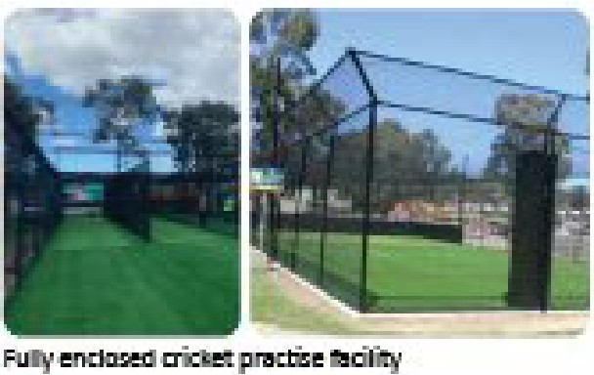
Co.-der N!IIIO'.tng ·fl-le-exislin.g CllCket sned an:11 OOll5Qf 1l . pawioffl to roode i roire 5eClll'ity ;ind oonsoli imrasfrl/Kf.11re_lP'ronde Uliflroiradl E:Jlfrvfo ine•lll!E!lball 0111 the easl!:sid'e of e p;iv.mn_

LfGEND
i
ii;
i
iI , ,11 w.
-------- •11---+!----IMHl.Wtott _

,..
(D

ti
.EeD
Cor&der the ilildu!OOII ol'a lormai5edl netl:liiil warm area easf or enelbaD DI!!
{di.lb nded). Pmrule irq:Rl/ffid pedesl'!iiil\l mt,y to the l'letilalI iJ.(Jl';(rl5. All:emalwe ,
oor.tSic!Ef' a:msdi!ilalior, rlfcrldet siled in, i; ICCiilion.
Assess exi r.!!11:!all s. lig ar.:11grade1D mirirnin l'mmlg :stiiil!IErd of 100
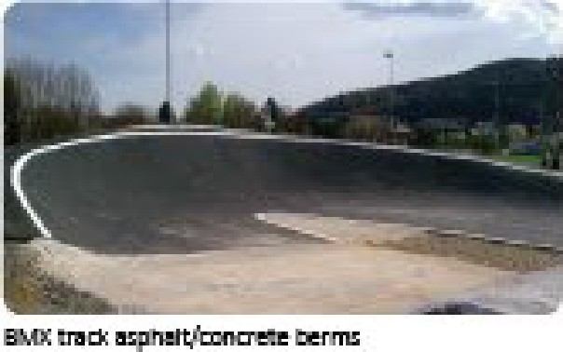
tux: if reqLired.
IRemooe existing sfimdalllffle lll'f aml·synll,£6:: ra rftelsad i:m!llllf&l:e iffl1D a oombiri.ed fwl'f enckiee:11 aichf training facilfy 'l\ · !me ars ofrreit-.m.dantasp!Elt oou.rf:s 1D mJ\pl!ll,!I!' iimeffl)', an:11 iilDw fi:I' pole flt. expansiDl!I of Oral12.
Renare lap:idrklil sh· rs.fdvJollfs andl pJO\i:le a new speefab:lr sl!E'ller aid seali!:!g1
aR!tilto Ovoll#Q.
IRelllll\!E! uhlic tcileiltbl); atUiie,eruil ais LEeful tifeiili'l:Ilicl •lil5I!' i piil'l,ilillr.ls. Oppc,rbmityfo o,en·roile-l!> 1113in, pii'lilion ID illie OOOlllml - CoGG o ke on assooialedl maiirf.!!nam:e resp:ir.1si!
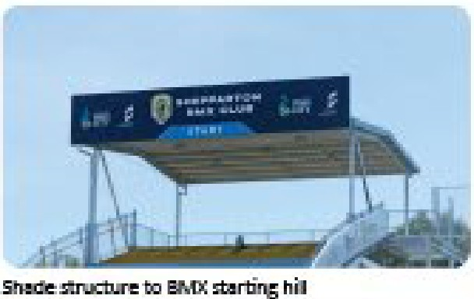
Coft:m!!f•.. g tlle·EWOC pgi.iior, with a ar r style i1Li11m91fo np:rm1e, ame an Slll,pporl flllure•needslb:r hip IE!'i'E!I IBMX: ei.'fflis. hry fuh.lle
e\le!Cflmer. sh:ndlil oonsider o1 social room, follels, sl!D'l\'el'S and kiD'Sl! at a mini=.
Corader e.s'lalilsl'inga f<lrmai5e:II speefab:lr area ot:1 Efev.afed area wesii af ·IBMX
:track. ng'sealing,, ter .and IDDAiJ001pfiar,I aooess (cilli! fwn.ilfed}_
Consider r.:w BMX fr;d; lig :J!l!lb mler Jcr1hi! er le\,el B.\40C ,e,,enfs {cllli! r.ded).
Cor.ader·Olllllslnn::liJ:nl!Iew 001tcr.efe.J l:ilwnel,; berms1D Ellfll'OlM!' liile l:IMX lrolc); fadlit'(
{ nd'ed).


EX5tDJ P.bJl Eri'r)' Purl'.::,
-E·--··· Elm'll!I tJianit.lat'ElliEITt
ed'Eiilllca'!mfemes
Pm,: / i!Ui gs
Cor,ader,eslal:(isJinga 1:1eWOO\'E!N!1hre;;u:i-.-ertl-.e-sfat.i g (ch.i:i r.ded).

B5tnJ Boun!J3Jy.Fenr.es
-+-...

ElisliRJ! Floles
4 Pa:po Pedl!5ml
--- Elis; ng 'l.i'elwn rrt

elfFE!lr.6

Pm,:aseil Gale5
c=]P.,:pc Sll.El1<.fs
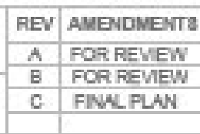c=JPm!JD Aspnal1
...............
,.,.,.,,.llll
Em1DJ mbi!r Ba:niers
aa1 Eli:l:ing tt.nps
- EliSli Giitc!i
c:::J EliSlill!.l tl:lmsTo Be
A C
L A
•-
E"repl:ed IMl{Tr.a LigJlts
c:J P::Jf1D8,;j GiillfEn Beds
••
:1Balar.f!i
!anting ere rra't:eID establish dea sigJ,lf11es irrlD a rnillim the,rE!Si!f'li,-e, an.d
R.
1ll!!e.s
ID nprm!I!' b)Jli fy, shade·olllill amenity in ;,e,IMlh CoGGs.Tree-Mlinagement Policy
Prqa'.Gell'fealllre Entr/ Pants.
an:IUrlliinFD:rest S'.!i31:eg¥,
,,,,.
-a '1 ;>-i ll
st.
GIR:INTER R'E:SERVE FACIUTY DEVELOPMENT PLAN, MOOLAP
FINAL FACILITY DEVELOPMENT PLAN
Ol!AllN
ACiA
I\IO,
ID,![JE
.w
.flCl!ILE
1:11J.t(!Q.rn
1::00:0IIA
M,,,\WiG i'fo.
15.1)2.21 2.0-UfllP1
H.114.2:1
11.03.21
;;):i.112.2:1
1Proode1newlow l&<el pli!llir.,;1iiJlli S1113U 1ree:s of !me m8i!I pai
fronra.ge to i ro,;-e1lis arnenRy.
alor.ig 11,e slreBi

E'XHIJ OViiil J I! Ollurt Fe',::e; 
.
-1'1:
_, - - elf 'l.i'ehK.iJlaJ l.tr'8T£111:
Corsder sefeclnoe remo\i'i:11 of dense sbr\&s. ill rrej:lace•itilh car.tD:P)' uee:s alMIIICM' le\,el

FACILITY DEVELOPMENT PLAN RECOMMENDATIONS AND FUNDING OPPORTUNITIES FOR DELIVERY
The following section provides a summary of the key recommendations within the Facility Development Plan. These recommendations have been summarised under the following headings:

OVAL 1 AND SURROUNDS OVAL 2 AND SURROUNDS BMX AND SURROUNDS PLAYSPACE
A key is included in each summary to provide the reader with a reference back to the proposed Landscape Plan (see previous page). In addition, the theme of each recommendation is represented by an infographic. A summary of these graphics can be found below.

Sporting Infrastructure | Sporting Activities |  | Vehicle Movement and Car Parking | Community Activities | Landscaping | Pedestrians and spectators | Community Safety
 |  |  |  |  |  | 

Within each table of recommendations there is also a list of potential funding opportunities that may be leveraged to assist in delivery. These opportunities have been identified through funding program guidelines and their alignment with recommendations. These opportunities include:

City of Greater Geelong’s Community Infrastructure Grants Program
This program aims to support funding for the planning and delivery of capital works projects within the City of Greater Geelong. This includes grants available for amounts up to $350,000.

Sport & Recreation Victoria Local Sports Infrastructure Fund*
This Fund aims to provide a range of grant opportunities across funding streams including Female Friendly Facilities (up to $500,000), Community Sports Lighting (up to $250,000) and Scoreboards and Fixed Equipment (up to $25,000).

Sport & Recreation Victoria Community Cricket Program*
This Program aims to support cricket participation in Victoria through high-quality and welcoming facilities. The objectives of this program aim to be achieved through providing funding for projects such as upgrading of existing and construction of new cricket practice facilities, club room developments, playing field upgrades and sports lighting initiatives. Up to $100,000 in grant funding is available.

Sport & Recreation Victoria Community Football & Netball Program*
Previously known as the Country Football & Netball Program, this fund aims enhance participation opportunities in football and netball through improved playing surfaces, gender-neutral player and umpire change facilities and sports lighting upgrades. Up to $100,000 is available through this program.

Club fundraising
Clubs tenanting Grinter Reserve may have opportunities to fundraise to support the delivery of the identified infrastructure upgrades. Where applicable, clubs should be encouraged to create a sinking fund that helps support the implementation of the Facility Development Plan, and to support Council in their pursuits to leverage both internal and external funds.

Council’s budget process
Each year Council prepares a budget which provides funding for the delivery of community services, programs, and infrastructure in line with its respective Council Plan. There are opportunities for items identified within the Facility Development Plan to be delivered via this process.

Council’s cyclical budgets
Council has cyclical budgets for the maintenance and renewal of minor infrastructure items. A small number of recommendations within the Facility Development Plan could be considered within relevant cyclical programs.

*Note that these funding programs require Council to apply to Sport & Recreation Victoria on behalf of the Club. Clubs are not eligible to apply directly.

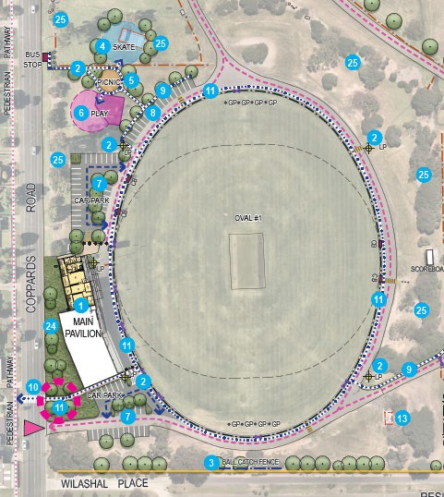
OVAL 1 AND SURROUNDS

The recommendations for Oval 1 and surrounds focuses on the improvement of existing facilities and the completion of infrastructure works that are scheduled or currently underway. The main focus of the area is the upgrade of the main pavilion’s change facilities to ensure they comply with modern day expectations and meet standards that are accessible for players of all genders and abilities.
Building the capacity of the main pavilion as well as the playing field with upgraded sports lighting (now complete) and improved, more functional car parking will provide spectators, participants and visitors with greater amenity and safety.
Entrances and connections are to be enhanced through more formalised pedestrian pathways and crossing points. In addition, improving the Reserve entrances by making them more visually appealing will assist users to navigate around the expansive area.

Landscape  Plan ID | Recommendation | Funding opportunities for  delivery | Key themes
1 | Provide an extension and renovation to the north of the (main) pavilion to incorporate gender neutral change rooms and public toilets. | Council budget process (funding confirmed for 2020/21) | 
2 | Undertake sports lighting upgrades to Oval #1 to comply with AFL guidelines for training and competition standard (i.e. 100 lux minimum). | Council budget process (funding confirmed for 2020/21) project completed | 
3 | Replace ball protection fencing to the South of Oval #1. | Club fundraising
7 | Formalise car parking to the north and south of the pavilion including the provision of accessible parking bays, canopy trees and soft landscaping. Investigate the opportunity to incorporate water sensitive urban design elements to treat stormwater runoff. | Council budget process | 
9 | Consider implementing a formal pedestrian pathway network throughout the Reserve to improve pedestrian links, accessibility, activation, and safety. | Council budget process
10 | Investigate establishing a new pedestrian refuge island on Coppards Road with connecting kerb ramps to improve safety and connections between the Reserve and surrounding areas. | Council budget process Council cyclical budgets
11 | Establish feature Reserve entry points with improved wayfinding signage and soft landscaping to improve accessibility and presentation of the Reserve. | Council budget process Council cyclical budgets | 

25 | Consider selective removal of dense shrubs and replace with canopy trees and low level planting where appropriate. Aim to establish clear sightlines into and within the Reserve and to improve biodiversity, shade and amenity in line with CoGG’s Tree Management Policy and Urban Forest Strategy. | Council budget process Council cyclical budgets

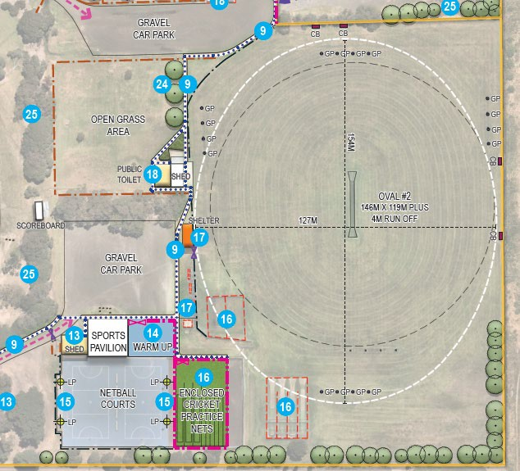
OVAL 2 AND SURROUNDS

The focus of Oval 2 and surrounds is improving the functionality and quality of the area by consolidating infrastructure that is currently in poor condition and replacing with fit for purpose facilities.
The key opportunities for the area include the consolidation of existing cricket practice net infrastructure and the redevelopment of a combined turf/hard wicket training facility that meets recommended facility guidelines for a local level venue. In addition, investigation into the sports lighting levels on the netball court and the provision of a warm up space is recommended.
Supporting considerations for the area include the removal of old spectator shelters and replacing with more adequate amenities. Improved storage opportunities for cricket and entrance to the netball pavilion will further enhance the area.

Landscape  Plan ID | Recommendation | Funding opportunities for  delivery | Key themes
13 | Consider removing the existing cricket shed and consolidating into the netball pavilion to provide improved security and consolidation of infrastructure. Provide improved entry to netball courts of east side of the pavilion. | Club fundraising  City of Greater Geelong Community Infrastructure Grants Program
14 | Consider the inclusion of a formalised netball warm up area east of the netball pavilion. Provide improved pedestrian entry to the netball courts. Alternatively, consider consolidation of cricket shed in this location. | SRV Community Football & Netball Program
15 | Assess existing netball sports lighting and upgrade to minimum training standard of 100 lux if required. | SRV Local Sports Infrastructure Fund  SRV Community Football & Netball Program
16 | Remove existing standalone turf and synthetic practice nets and consolidate into a combined fully enclosed cricket training facility within the area of redundant asphalt courts to improve amenity, safety and to allow for potential future expansion of Oval 2. | SRV Community Cricket Program  City of Greater Geelong Community Infrastructure Grants Program
17 | Remove dilapidated shelters/dugout and provide a new spectator shelter and seating area to Oval #2. | Club fundraising City of Greater Geelong  Community Infrastructure Grants Program | 

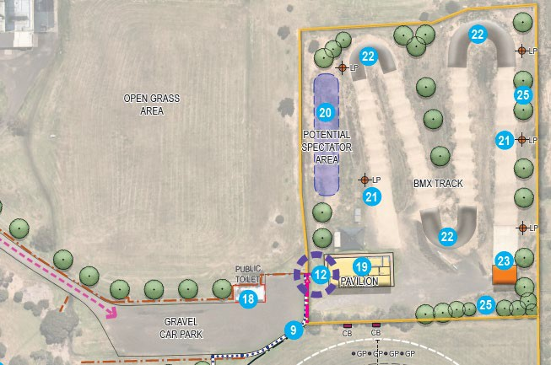
BMX AND SURROUNDS

The BMX area at Grinter Reserve offers substantial opportunity for improvement that will enable a more functional and welcoming community facility and support the Reserve to host higher level events. Considerations within the Facility Development Plan have been developed to address safety, accessibility, and aesthetic components of this area. The proposed improvements to the BMX track and surrounds, in particular the pavilion, recommends the provision of basic amenities, being toilets and showers, that are currently not available.
Improved entrances, interface, and quality of amenities within the BMX area and the broader Reserve will encourage greater visitation and use of the facility and support participation outcomes.

Landscape  Plan ID | Recommendation | Funding opportunities for  delivery | Key themes
12 | Establish a new pedestrian entry with signage to the BMX track to improve accessibility and visual amenity. | Council budget process or consolidate within part of broader area upgrades e.g. track, car park and/or spectator improvements
18 | Remove public toilet block at the end of its useful life and consolidate use into pavilions. Opportunity to open toilets in main pavilion to the community. CoGG to take on associated maintenance responsibilities if required. | Council cyclical budgets | 
19 | Upgrade the BMX pavilion with an expansion or modular style building to improve amenities and support future needs for higher level BMX events. Any future redevelopment should consider a social room and kiosk, toilets and showers at a minimum. | SRV Local Sports Infrastructure Fund  City of Greater Geelong Community Infrastructure Grants Program | 
20 | Establish a formalised spectator area on the elevated area west of the BMX track including seating, shelter and DDA compliant access. | Club fundraising
21 | Consider new BMX track lighting to cater for high level BMX events. | City of Greater Geelong Community Infrastructure Grants Program  Club fundraising
22 | Construct new concrete/bitumen berms to improve the BMX track facility. | City of Greater Geelong Community Infrastructure Grants Program  Club fundraising
23 | Consider establishing a new covered area over the BMX starting hill. | City of Greater Geelong Community Infrastructure Grants Program  Club fundraising

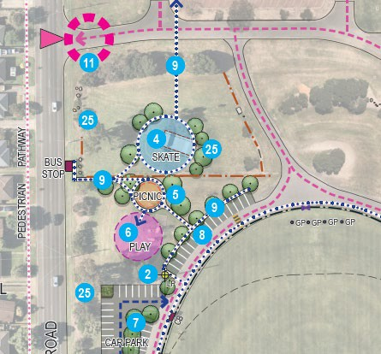
PLAYSPACE

The play space area and its recommendations focus on the improvement of visitor amenity and improving the play experience for users in line with local level facility provision.
Considerations within the Facility Development Plan aim to retain informal play infrastructure that is in adequate condition, and upgrade what is no longer fit for purpose.
Supporting improvements including car parking, connecting pathways, shade and picnic facilities aim to offer relatively low cost solutions that will make the area more amenable and attractive for use by children, youth and families.

Landscape  Plan ID | Recommendation | Funding opportunities for  delivery | Key themes
4 | Consider redeveloping the existing skate ramp into a new user friendly skate facility suited to a broader range of ages and abilities in line with CoGG’s Play Strategy. | Council budget process | 
5 | Provide a new picnic area including shelter and seating to service the playground and skate area. | Council budget process
6 | Undertake future playground renewal at the end of its useful life under CoGG’s cyclical renewal program and in line with COGG’s Play Strategy. Consider all supporting infrastructure requirements and improve connections. | Council cyclical budget
8 | Formalise angled car parking located in close proximity to the community recreation area. | Council budget process

FACILITY DEVELOPMENT PLAN COST SUMMARY
This section provides a summary of the costs associated with the delivery of the Facility Development Plan. These costs have been developed by an independent Quantity Surveyor. The total cost to achieve all items identified in the Landscape Plan (page 23) is
$6,076,000 (ex. GST). Please note that this figure does not include works associated with the main pavilion (item 1) and sports lighting on Oval 1 (item 2) which have been funded.

A comprehensive overview of the costs associated with each recommendation identified in the Landscape Plan can be found in the Quantity Survey prepared by Zinc Cost Management dated 15 April, 2021. The items listed within each table below are those considered to be key within each area only.

OVAL 1 AND SURROUNDS

Landscape  Plan ID | Recommendation | Cost
1 | Provide an extension and renovation to the north of the (main) pavilion to incorporate gender neutral change rooms and public toilets. | Funded
2 | Undertake sports lighting upgrades to Oval #1 to comply with AFL guidelines for training and competition standard (i.e. 100 lux minimum). | Funded
7 | Formalise car parking to the north and south of the pavilion including the provision of accessible parking bays, canopy trees and soft landscaping. Investigate the opportunity to incorporate water sensitive urban design elements to treat stormwater runoff. | $149,000
9 | Consider implementing a formal pedestrian pathway network throughout the Reserve to improve pedestrian links, accessibility, activation, and safety. | $98,000
11 | Establish feature Reserve entry points with improved wayfinding signage and soft landscaping to improve accessibility and presentation of the Reserve. | $100,000
SUB-TOTAL FOR KEY ITEMS LISTED ABOVE |  | $347,000
TOTAL FOR ALL ITEMS IN OVAL 1 & SURROUNDS (including contingencies, allowances & escalation) |  | $1,067,000

OVAL 2 AND SURROUNDS

Landscape  Plan ID | Recommendation | Cost
13 | Consider removing the existing cricket shed and consolidating into the netball pavilion to provide improved security and consolidation of infrastructure. Provide improved entry to netball courts of east side of the pavilion. | $112,000
14 | Consider the inclusion of a formalised netball warm up area east of the netball pavilion. Provide improved pedestrian entry to the netball courts. Alternatively, consider consolidation of cricket shed in this location. | $60,000
16 | Remove existing standalone turf and synthetic practice nets and consolidate into a combined fully enclosed cricket training facility within the area of redundant asphalt courts to improve amenity, safety and to allow for potential future expansion of Oval 2. | $450,000
SUB-TOTAL FOR KEY ITEMS LISTED ABOVE |  | $622,000
TOTAL FOR ALL ITEMS IN OVAL 2 & SURROUNDS (including contingencies, allowances & escalation) |  | $1,228,000

BMX AND SURROUNDS

Landscape  Plan ID | Recommendation | Cost
12 | Establish a new pedestrian entry with signage to the BMX track to improve accessibility and visual amenity. | $20,000
19 | Upgrade the BMX pavilion with an expansion or modular style building to improve amenities and support future needs for higher level BMX events. Any future redevelopment should consider a social room and kiosk, toilets and showers at a minimum. | $1,458,000
21 | Consider new BMX track lighting to cater for high level BMX events. | $125,000
22 | Construct new concrete/bitumen berms to improve the BMX track facility. | $400,000
SUB-TOTAL FOR KEY ITEMS LISTED ABOVE |  | $2,003,000
TOTAL FOR ALL ITEMS IN BMX AND SURROUNDS (including contingencies, allowances & escalation) |  | $3,140,000

PLAYSPACE

Landscape  Plan ID | Recommendation | Cost
4 | Consider redeveloping the existing skate ramp into a new user friendly skate facility suited to a broader range of ages and abilities in line with CoGG’s Play Strategy. | $180,000
5 | Provide a new picnic area including shelter and seating to service the playground and skate area. | $60,000
8 | Formalise angled car parking located in close proximity to the community recreation area. | $28,000
SUB-TOTAL FOR KEY ITEMS LISTED ABOVE |  | $268,000
TOTAL FOR ALL ITEMS IN PLAYSPACE (including contingencies, allowances & escalation) |  | $641,000

GRAND TOTAL (INCLUDING COST ESCALATION + CONTINGENCY + ALLOWANCES) EX. GST

OVAL 1 AND SURROUNDS | $1,067,000
OVAL 2 AND SURROUNDS | $1,228,000
BMX AND SURROUNDS | $3,140,000
PLAYSPACE | $641,000
TOTAL | $6,076,000

STRATEGIC SUPPORT FOR DEVELOPMENT

STRATEGIC CONTEXT/LITERATURE REVIEW
The following pages provide a high-level summary of the documents and key strategic influences which will guide the development of the Grinter Reserve Facility Development Plan.

STATEWIDE STRATEGIC CONTEXT
ACTIVE VICTORIA: A STRATEGIC FRAMEWORK FOR

MUNICIPAL STRATEGIC CONTEXT

CITY OF GREATER GEELONG COUNCIL PLAN 2018-2022

This document provides the overall direction for Council, outlining their responsibilities and commitment to providing services, infrastructure, and opportunities to the community. The Council Plan supports the development of social infrastructure that provides opportunities for participation by a wide range of people, of all ages and abilities.

SPORT AND RECREATION IN VICTORIA 2017-2021 The City’s Council Plan outlines 11 strategic priorities towards
making Greater Geelong a clever and creative city-region. The

This document, developed by the Victorian Government,
aims to provide a consolidated approach to the improvement in participation in sport and recreation from a
Plan aims to guide resources to deliver infrastructure, services, and programs to the community in a sustainable way.

state-wide perspective. Key focus areas which include: 1) Informed social infrastructure
and planning – through providing more quality spaces that

The vision for participation outcomes in sport within the
document are based upon five key areas;
- More active: increased proportion of Victorian’s regularly participating in sport or active recreation.
- More diverse and inclusive: providing opportunities for all to become involved.
- Robust, flexible, sustainable, and affordable: providing flexible and affordable choices for participants.
- Collaborative: well-planned and connected investment that maximises participation and other community benefits.
- Broad-based and connected: A system that addresses the different demands, contributors and structure of sport and active recreation and maximises connections across the system.

REGIONAL STRATEGIC CONTEXT

G21 PHYSICAL ACTIVITY STRATEGY 2014-2017

This document is a region-wide approach to improving opportunities for physical activity and participation in a
support active lifestyles as well as supporting the growth of localised sporting facilities 2) A more inclusive and diverse community through promoting gender equity and diversity in sporting facilities and improving access to facilities for people of all abilities.

CITY OF GREATER GEELONG SOCIAL INFRASTRUCUTRE PLAN (GENERATION ONE) 2020-2023

This document sets the strategic drivers for decision making and prioritisation in relation to the planning, development, and investment of social infrastructure in the City of Greater Geelong.
Five (5) directions for the strategic development of outdoor community sporting facilities are identified in the Plan, including the investment in infrastructure that improves the quality, functionality and carrying capacity of venues and the activation of facilities to increase participation and maximise use. The Oval 1 sports lighting project and main pavilion change room upgrade are listed as priority projects over the next 3 years for Grinter Reserve within the Outdoor Sport and Recreation Network Report.

range of passive and active sports. CITY OF GREATER GEELONG URBAN FOREST

STRATEGY 2015-2025

The G21 Physical Activity Strategy provides an overview of the
importance of physical activity and the way in which the G21 Region can help to create environments to support it. Key actions within the Strategy as they relate to the Facility Development Plan include:
- Work within local sport and active recreation settings to address barriers to participation for vulnerable groups within our community.
- Encourage broader community access to tenanted sport and recreation facilities.
- Ensure that all active sport and recreation settings such as recreation reserve, stadiums, tennis courts are planned, designed, managed, and maintained to be accessible and appropriate to the needs of all user groups.

This document outlines the key actions and tasks associated with increasing the urban tree population throughout the City of Greater Geelong to improve the City’s look, feel and liveability as well as the health of the community.
The City of Greater Geelong’s Urban Forest Strategy has a vision for Geelong to be a ‘cool, green city for the future’. This vision aims to be achieved through the development of healthier and more dynamic urban forests and improved tree canopy in streetscapes, urban growth areas, open space areas and reserves.

CITY OF GREATER GEELONG PLAY STRATEGY 2012-2021 and development priorities. The Strategy highlights critical
actions for cricket participation and growth.Those most relevant

This document provides a strategic approach to the need, role, and function of Geelong’s play spaces to ensure children receive equitable access to quality playgrounds and can also participate in a range of play experiences.
The Play Strategy outlines a range of principles regarding the provision and design of places of play, including:
Improving supporting infrastructure at play spaces. Creating better connections to cycling/walking networks.

SPORT SPECIFIC STRATEGIES

The City of Greater Geelong and the G21 Geelong Region Alliance have several strategic documents that have been developed in conjunction with peak sporting bodies and are relevant to the Grinter Reserve Facility Development Plan. In addition, state-wide strategic sporting documents also provide support and justification.
These include:
      - AFL Victoria ‘Growing the Heartland’ Football Facilities Development Strategy (2014-2020);
to the development of the Facility Development Plan, include:
      - Prioritise and support the upgrade and development of facilities at sites with identified and potential female participation growth.
The Geelong/Barwon region, similarly to AFL, had the highest participation of any Country Region and the Geelong LGA had one of the highest saturations of cricket players to population ratios.
The Strategy highlights a low provision of inclusive, all gender facilities along with 59% of cricket practice nets in the Barwon Region presenting potential safety concerns.

NETBALL VICTORIA STATEWIDE FACILITIES STRATEGY 2019-2022
The Plan outlines how Netball Victoria aims to deliver on their key strategic drivers for the future direction, demand, and investment into netball facilities.
The Strategy indicates that two courts be provided for local outdoor club-based netball competition as well as supporting infrastructure including:

      - Victoria Cricket Infrastructure Strategy (2018-2028); Floodlighting;

      - Netball Victoria Statewide Infrastructure Strategy (2019- 2022);
      - G21 & AFL Barwon Regional Strategy (2015);
      - G21 & Cricket Victoria Barwon Regional Strategy (2019); and
Accessible change rooms and amenities; and Player and officials shelters.
The G21 Region is recorded as having the highest number of participants of any Rural & Regional area in Netball.

      - G21 Regional Tennis Strategy (2015-2025). G21 & AFL BARWON REGIONAL STRATEGY 2015

These documents have been summarised and utilised in the Issues & Opportunities Report to correlate and support future directions and recommendations.

AFL VICTORIA ‘GROWING THE HEARTLAND’ FOOTBALL FACILITIES DEVELOPMENT STRATEGY 2014-2020
The ‘Growing the Heartland’ Strategy aims to provide a planned approach to the provision of infrastructure across the State.
One of the key development pillars of the Strategy is ‘Great Infrastructure’ which includes the objective to ‘advocate for and collaborate in facility development for the network of community
This document provides the principles and framework to support the future development, governance and growth of football and club-based netball throughout the Region. It also investigates issues facing the sport and makes recommendations for both regional and local priorities.
One of the priorities within the document is to ’Increase the quality and functionality of facilities to maximise carrying capacity’ and that investment into facilities to meet minimum requirements will ensure participation growth can be accommodated for.

football leagues, their clubs and schools’. Currently, a 2020 update to the Strategy is underway, which will

The Strategy notes that Geelong is its highest participation region for Country Victoria which, at the time of the Strategy’s development, boasted an additional 5,000+ players than the next highest region.

VICTORIAN CRICKET INFRASTRUCTURE STRATEGY 2018- 2028
This Strategy provides the Victorian cricketing community and its stakeholders with a detailed assessment and analysis of the Victorian cricket facility landscape and identifies future planning
focus on what is changed since 2015, most notably being the significant increase in female participation and the introduction of the AFL Preferred Facility Guidelines and Netball Victoria Facilities Manual.
The 2020 Strategy will continue to focus on infrastructure and enhanced participation opportunities and will utilise the Sports Facility Auditor data as one method to prioritise improvements. As per the Audit findings in the Appendices section of this document, it is likely that the change room facilities and sports lighting at Grinter Reserve will be identified as a priority.

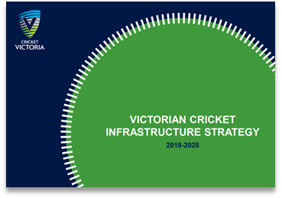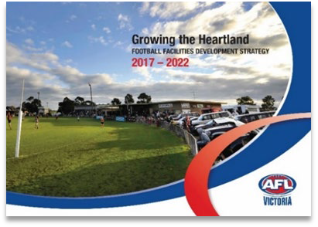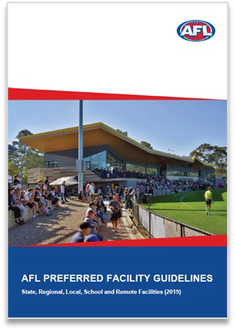G21 & CRICKET VICTORIA BARWON REGIONAL CRICKET STRATEGY 2019
This Strategy investigates issues and opportunities facing cricket both ‘on-field’ (facilities and infrastructure) as well as ‘off- field’ (sport development, increasing participation and partnerships). The key strategic priority within the Strategy is ‘Improved Governance and Cricket Activity Management’ through developing an aligned and collaborative structure to manage cricket. Subsequent priorities include participation growth and facility provision, capacity, and renewal.
In terms of facility development for the Region, the Strategy recommends utilising facility audit data to identify gaps in provision and site-specific renewal programs. Projects that increase carrying capacity, functionality and activation of existing facilities including change room refurbishment should be prioritised.

SPORT SPECIFIC FACILITY GUIDELINES
The inclusion of facilities that are inclusive of all people and gender is imperative to any modern development. For sporting facilities, the rise in female participation has created increased demand for amenities that cater to the diversity of participants attracted to sport. Guiding documentation for the development of gender-neutral facilities in the active sport setting, include:
      - SRV Female Friendly Infrastructure Guide - The Guide aims to provide information on developing facilities which offer more gender equitable environments. This occurs through three main components, including facility planning and design, maximising use and policy that drives change.
      - Sporting Facility Guidelines - Most peak sporting bodies have guidelines relating to facility development that include information in relation to the provision of gender-neutral amenities.
      - AFL Preferred Facility Guidelines 2019 - These Guidelines outline the preferred facility requirements for venues which are utilised for AFL training and competition. The Guidelines are to be used as a key tool during the planning phase of a project to identify the spatial requirements for facilities to support male and female teams, umpires, officials, and the broader AFL community. The Guidelines also provide recommendations for the specification of supporting infrastructure such as floodlights.
      - Netball Victoria Facilities Manual 2017 - Netball Victoria’s Facilities Manual contains technical information on netball courts and associated infrastructure. It is Netball Victoria’s expectation that all new and redeveloped facilities are constructed to meet the standards outlined within the Manual.
      - Cricket Australia Community Cricket Facility Guidelines 2015 - The Cricket Australia Community Cricket Facility Guidelines provides facility planning, development, management, and maintenance information for use by the community, government and national cricket industry partners and stakeholders.

STAKEHOLDER ENGAGEMENT SUMMARY
The development of the Issues & Opportunities Report has been underpinned by a range of consultative activities. The engagement process has provided a well-rounded understanding of the aspirations of the sporting clubs, the City, peak sporting bodies and other stakeholders.
The Project Reference Group consists of representatives from the following organisations:
- Newcomb Football Netball Club
- Newcomb & District Cricket Club
- Geelong BMX Club
The Project Working Group consists of representatives from the City of Greater Geelong, including those from the following
- The Cricket Club had a female club president in 2019 and aim to continue to promote gender equity across the executive ongoing.
- Upgraded lighting to the netball courts and addressing court maintenance issues will improve playing conditions.
- Redevelopment of the cricket practice net facilities will assist in the recruitment of players and make it a safer place to play for both participants and spectators.
- Antisocial and hoon behaviour occurs, at times, within the area and the Reserve, with measures in place including secure gates on Oval 2 car park assisting to alleviate this. Ongoing measures to continue to prevent antisocial behaviour should be considered.
- Better access for emergency vehicles is needed to Oval 2, which could be achieved by making the Oval 2 car park more formalised and organised.

departments: • Tree planting and landscaping rocks assist in keeping
vehicles out of where they are not wanted.

  - Social Planning & Investment
  - Community & Recreation
  - Aquatics & Recreation
In addition, the following additional key stakeholders were contacted to provide input and advice into the development of this report:
  - AFL Barwon
  - Netball Victoria
  - Cricket Victoria
  - Geelong Cricket Association
  - Cycling Australia
  - Victoria Police
A summary of consultation from these groups and organisation’s is provided below.
  - There are lots of people who use the Reserve for dog walking. There is a small amount of use of the skate ramp and the playground is well utilised.
  - Improvements to the BMX track including starting hill cover, bitumen turns, lights and spectator area will allow it to be more competitive against like venues in attracting national events.
  - At present, the BMX Club loses bids to host events to other tracks, including Shepparton, which have a higher specification. The Club believe this is a missed opportunity for the sport including the community flow-on economic impacts that result from hosting high level events and competitions.
  - There are no toilets or showers in the BMX club rooms which is considered a barrier to participation.
  - The BMX Club utilises the public toilets to service its participants and patronage. The Club notes that the public toilets receive a lot of undesirable, antisocial behaviour.

Project Reference Group Project Working Group

  - The main pavilion requires upgrade to ensure it meets the standards of the modern game and assists clubs in remaining competitive and comparative to venues within proximity.
  - Participation in AFL for both females and males is increasing at Grinter Reserve which is placing pressure on existing facilities. The demand for use of Oval 2 is growing, and this oval currently has limited supporting amenity to assist in facilitating participation.
  - Building the capacity of Oval 2 through an improved surface and supporting amenities, including spectator shelter, will assist in facilitating participation.
  - Funding received to upgrade sports lighting on Oval 1 will be welcomed with the project set to be completed before the
  - It is identified that a Facility Development Plan is required for Grinter Reserve to provide a consolidated approach to infrastructure redevelopment.
  - It is recognised that investment into core sporting facility attributes will assist in the development of participation, particularly for diverse groups including females.
  - Core facility attributes are recognised as items which have a direct impact and/or influence on participation.
  - There is a desire for the City to understand the gaps in core facility provision at Grinter Reserve, as well as understand where community facilities, including play spaces and associated infrastructure, may not be meeting expectations.

start of the 2021 home and away football season. • A Facility Development Plan should consider the City’s
strategic position on the investment into community facilities,

  - The Reserve hosts finals for football and cricket, as well as
the grand final for the second and third division of the Geelong Cricket Association. Better facilities will increase
acknowledging that it has many competing priorities for funding.

opportunities to host more events such as this. • Any future recommendations within the Facility Development
Plan should consider alignment to the aspirations and

  - The Cricket Club has a medium-long term vision for women’s
cricket at the Reserve but requires the facilities to support this.
directions of potential funding partners including state and federal government, peak sporting bodies and local sources.
  - Any future recommendations within the Facility Development Plan should consider opportunities for the multi-use of

facilities, and to broader opportunities for community participation outside of sport.

AFL Barwon
  - The change rooms and lighting at Grinter Reserve have been a concern at the venue for several years. Upgrades to the change rooms are required to meet all gender requirements for both players and umpires. The current facilities are below standard to comparative clubs.
  - There is a need for increased capacity on the second oval to assist in facilitating junior participation, particularly as participation has increased within the football club. Preference would be to upgrade irrigation and amenities on Oval 2 followed by lighting.
  - Infrastructure improvements at the Reserve will also assist in creating greater opportunities to play junior finals along with day to day participation and programming activities.
Netball Victoria
  - The netball facilities at Grinter Reserve adequately cater for
  - Providing up to date and modern facilities that are female friendly will go a long way to improving cricket participation at Grinter Reserve. The GCA can demonstrate outcomes in junior and senior men’s and women’s participation as a result of capital expenditure across the region. Many affiliated clubs that have received and delivered infrastructure upgrades through grants programs have experienced considerable participation growth, particularly in female participation.
Cycling Australia
  - Cycling Australia supports the development of infrastructure at Grinter Reserve that results in participation outcomes for BMX. In recent times, the BMX track at Grinter Reserve has not been able to secure larger events, such as State Championships and State Series, due to deficiencies in facilities.
  - Cycling Australia supports upgrades with a priority being track lighting and concreting/bitumen of berms that will lead quickly to additional usage of the facility both by local members and visitors through events. It is anticipated that hosting higher level BMX events at Grinter Reserve would see a positive economic impact for the Geelong region.

the club’s membership and participation numbers. • Providing track lighting will allow for additional club activities

  - The netball facilities at Grinter Reserve are relative to other local netball facilities within the City of Greater Geelong.
  - The Club have relatively stable junior membership numbers however are comparatively lower when measured against neighbouring netball clubs. Senior participation has also remained stable. The netball club have expressed interest in reinvigorating their NetSetGO program in 2021 and offering more opportunities for junior participation. Netball Victoria welcomes this and will provide support where available.
  - Netball Victoria support a redevelopment or resurface of the existing netball courts which are showing signs of deterioration. An assessment of the current netball lighting infrastructure to understand its lux level readings and alignment to current guidelines would also be beneficial to undertake. Netball Victoria would also support exploration into the development of a netball warm up area with goal rings.
  - There is presently high traffic flow and pedestrian activity within the netball area which can cause safety issues. A review of car parking and vehicle movement would create a
outside of daylight savings and formalising the berms will reduce maintenance and volunteer labour which will potentially lead to greater volunteer recruitment and retention.
    - Cycling Australia also supports other infrastructure projects for BMX including a covered area of the starting hill/gate, upgrade to club rooms to provide toilets and showers as well as improved spectator areas.
Victoria Police
Victoria Police were contacted to provide feedback regarding measures that could assist in alleviating antisocial behaviour at Grinter Reserve. The following suggestions were made by Police for consideration within the Facility Development Plan:
    - Installation of CCTV within areas identified as ‘hot spots’ for undesirable behaviour. This includes training club volunteers in understanding how to monitor, record and retrieve footage if required.
    - Building security – bolster security measures through the design process of any new or planned facility upgrades to deter vandalism and break ins.

safer facility for club members, volunteers and visiting teams. • Recommend building tenants/sporting clubs identify items of

Cricket Victoria
Cricket Victoria were contacted to provide input however a response had not been received at the time of writing this report.
Geelong Cricket Association
  - Oval 1 is of a high standard, capable of hosting cricket finals and representative matches. The change rooms and amenities are below standards, are considerably dated and require refresh.
  - Oval 2 would not be of sufficient standard to host finals at present due to the playing surface standard. It also some distance from facilities such as change rooms and toilets.
  - Co-located turf and hard wicket grounds are relatively rare in the GCA and are used as preference for finals matches where games can be played side-by-side. There is opportunity should Oval 2 be upgraded, and the necessary amenities provided, that it would be a candidate as a regular cricket finals venue.
value and take out adequate insurance. Encourage safe banking practices, particularly after large functions or events.
- Increased traffic management devices such as speed humps and boom gates to encourage safer driving and restrict access of vehicles when areas are not in use.

APPENDICES

LIST OF APPENDICES
The following appendices are attached:
  - Main Pavilion – concept plan for change room development
  - BMX Pavilion – concept plan for redevelopment
  - Quantity Survey dated 15 April, 2021

MAIN PAVILION – CONCEPT PLAN FOR CHANGE ROOM REDEVELOPMENT

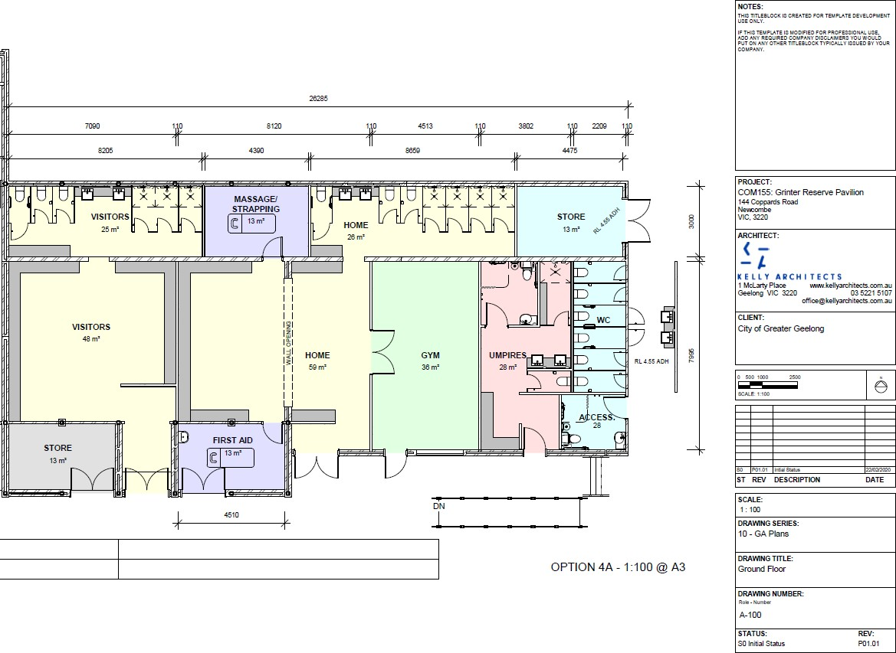

BMX PAVILION - CONCEPT PLAN FOR REDEVELOPMENT
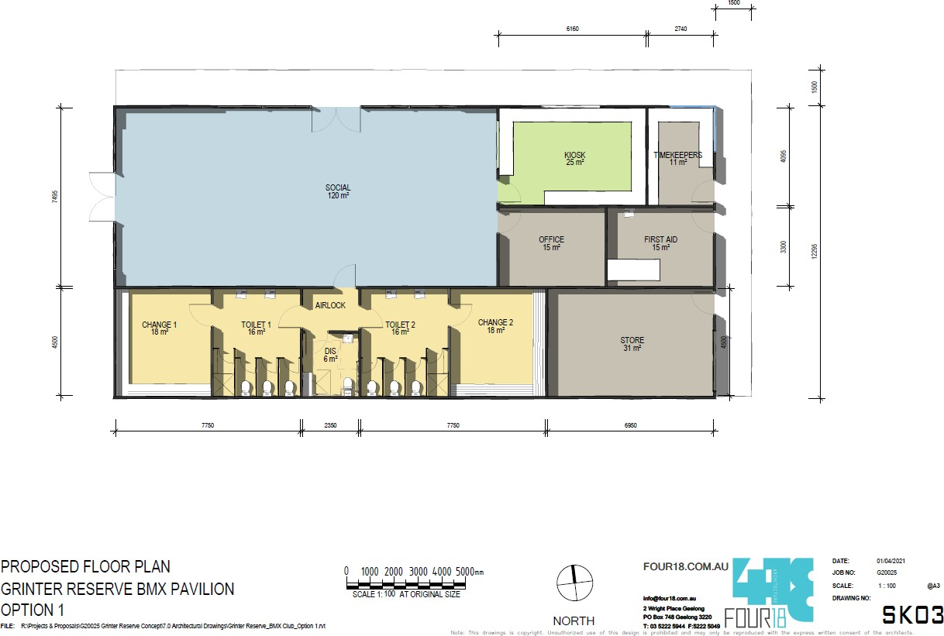

QUANTITY SURVEY – DATED 15 APRIL, 2021
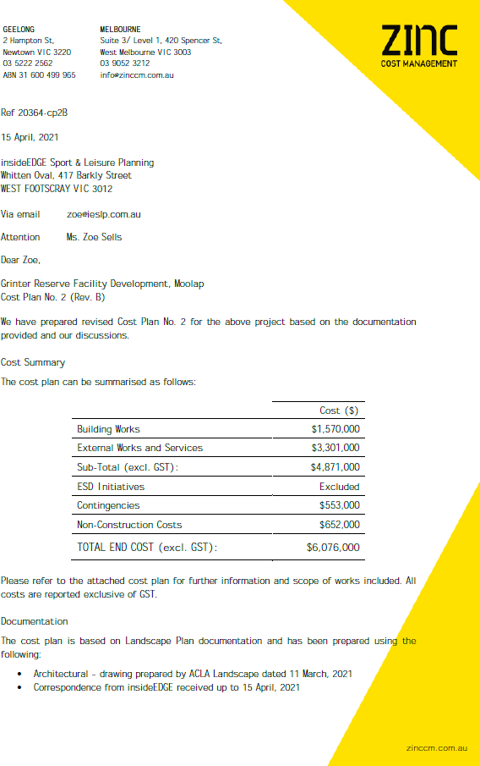


40

CITY OF GREATER GEELONG

PO Box 104

GEELONG VIC 3220

P: 5272 5272

E: contactus@geelongcity.vic.gov.au

www.geelongaustralia.com.au

CUSTOMER SERVICE CENTRE

100 Brougham Street

Geelong VIC 3220

