USING THE Digital twin victoria PLATFORM

  - Training lab series

December 2022

Lesson Four- Shadow Analysis
The recently launched Digital Twin Victoria (DTV) platform was built in partnership with Data61, the digital arm of Australia’s National Science Agency CSIRO as part of the Victorian Government’s $37.4 million program. The Digital Twin Victoria (DTV) platform brings together masses of 2D, 3D and live data into a single online place, open for everyone to use. For further information, questions or issues see the program website.

The City of Greater Geelong has developed a series of lessons to guide new users of the Digital Twin Victoria platform. We have focussed on key capabilities to build understanding and encourage users to start utilising and benefiting from the tool. These lessons have been developed as an internal training tool and circulated to key external partners when requested.

Note the lessons are done in sequence. If starting with Lesson 4, skip to Step 3.

- Use the home button to reset the map (zoom level and aspect).
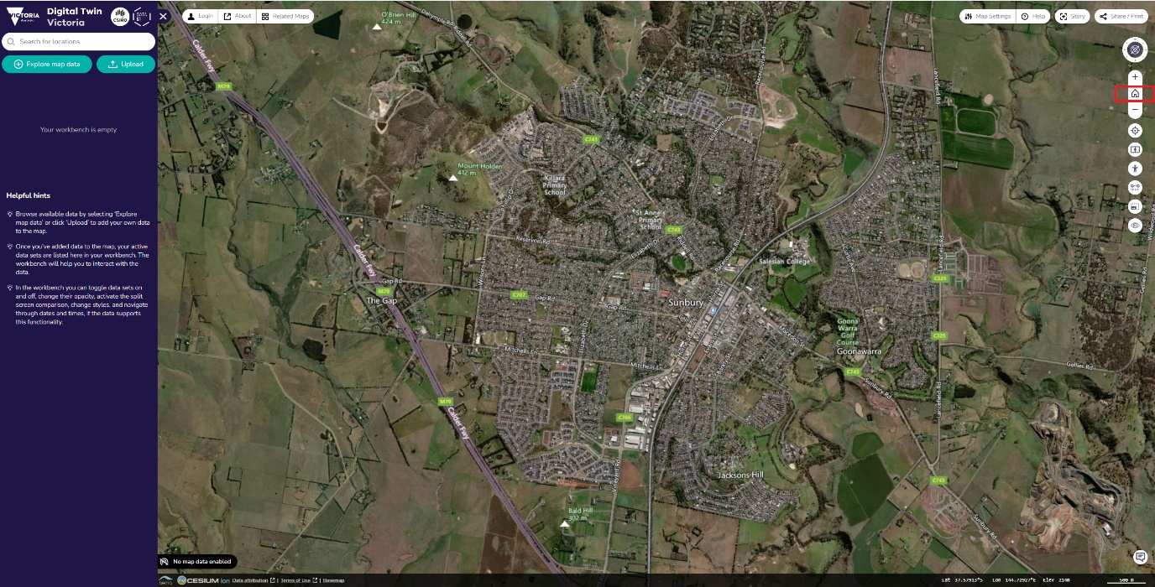

- Click Remove All to clear data from previous session. Alternatively click F5 to refresh.

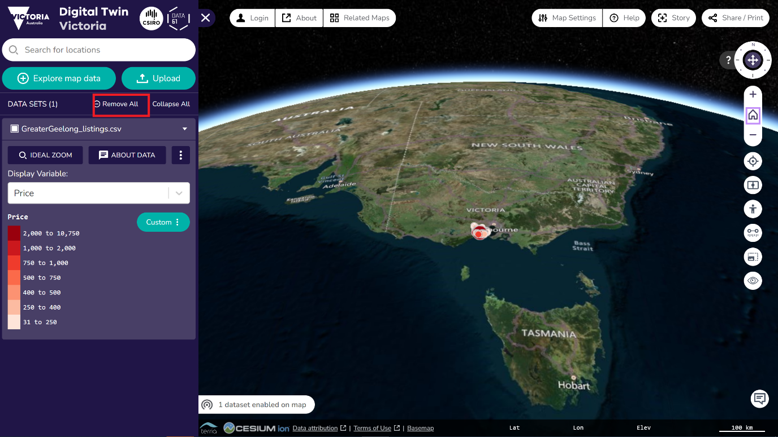

- Click on Explore map data.

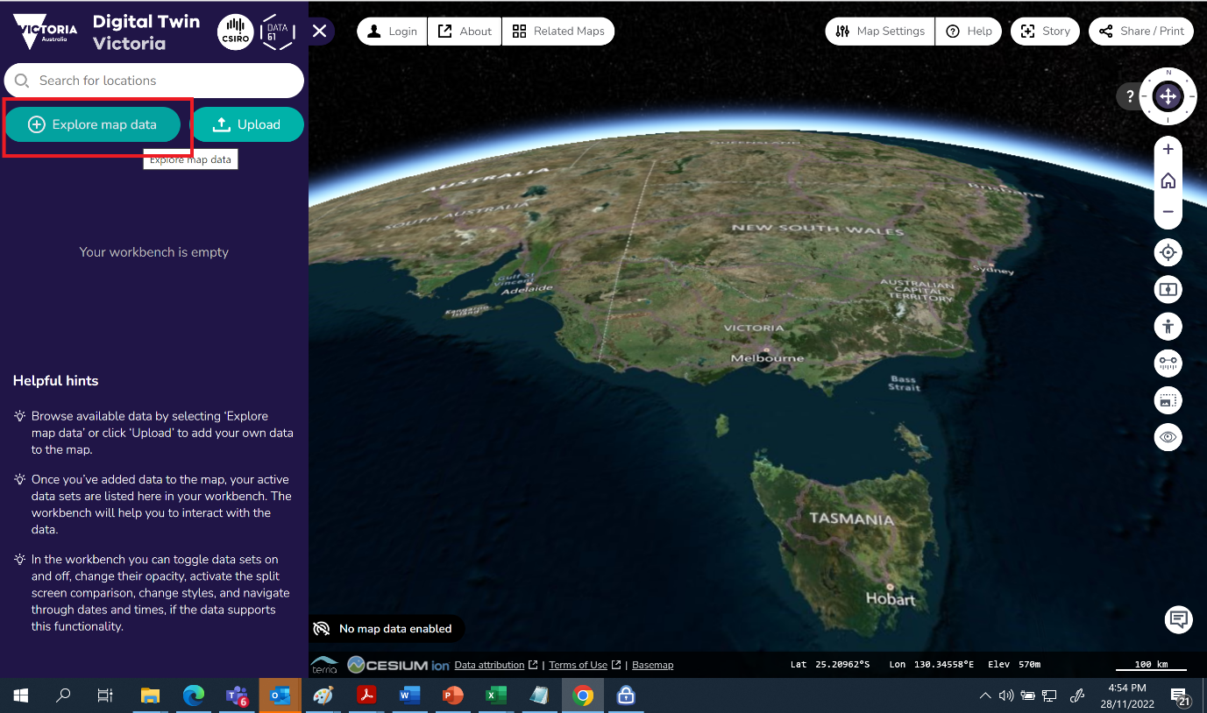

- Locate 3D Imagery, click down arrow, to view entries, hold Ctrl and choose > Great Ocean Road 3D Photomesh. Holding the Ctrl key keeps the Data Catalogue open allowing more data to be added.

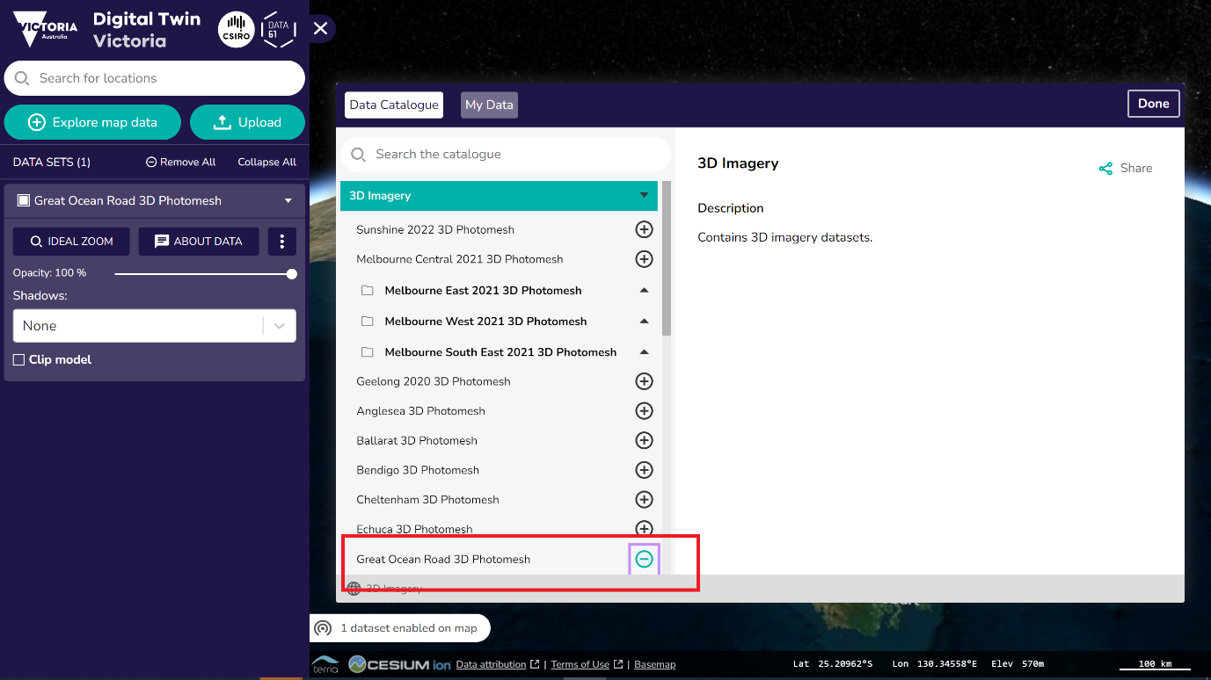

- Next find 3D Building Datasets, click down arrow, to view entries, hold Ctrl and choose > Shepparton 3D Texture Buildings. Alternatively just click the plus sign (+) and the data will be added and Data Catalogue will auto-close.
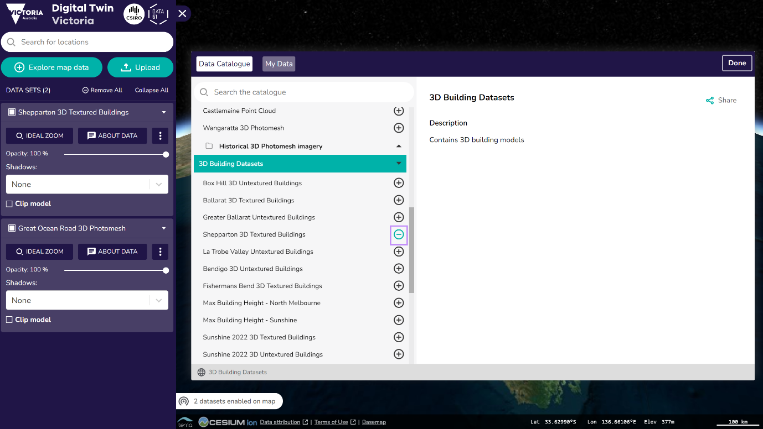
- Click done.

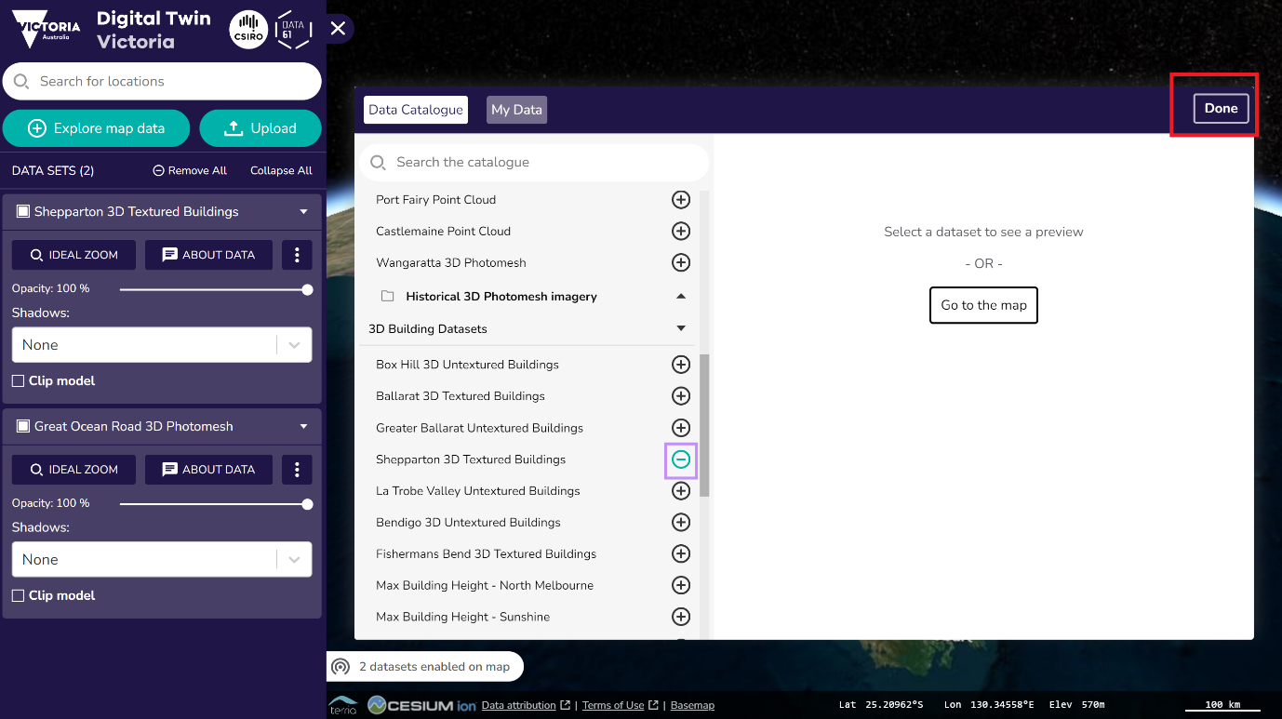

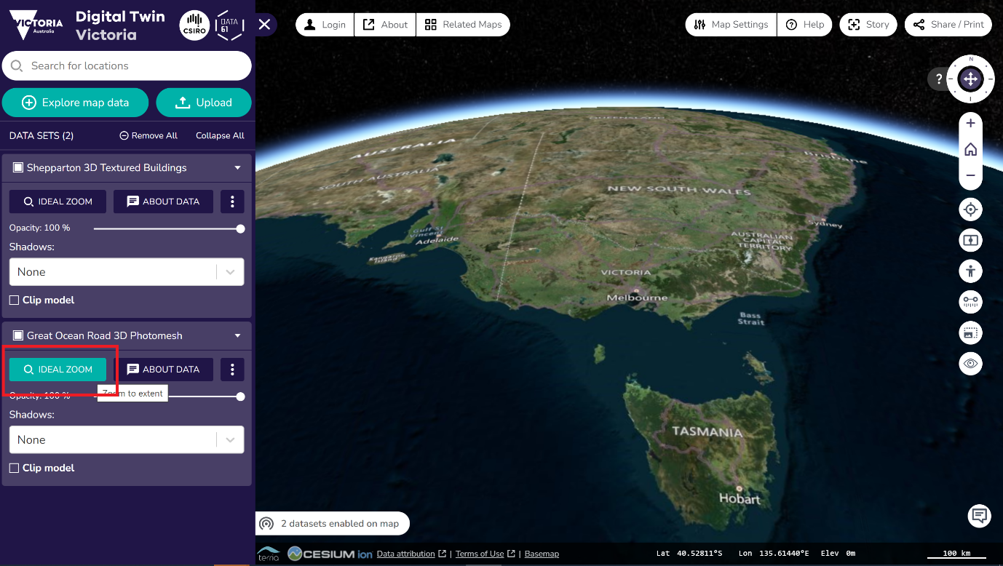
- From the workbench, click Ideal Zoom (on Greater Ocean Road 3D Photomesh).
- Zoom and pan around using some of the previously learned map navigation skills. The load speed can be highly dependent on the internet connection and also the aspect angle (a steeper angle will load quicker).

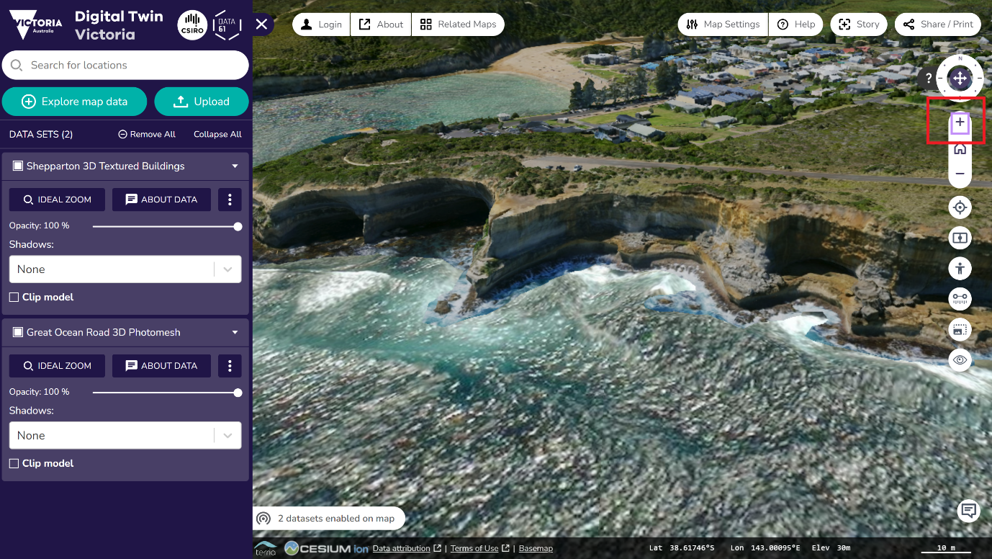

- We will now explore the shadow feature. Click shadows drop down field, choose Cast Only. There will be no shadows created. The reason for this is that this is a photomesh. A photomesh is a single object meaning this capability is not possible. Note that any shadows that you see in the data are captured in the imagery.
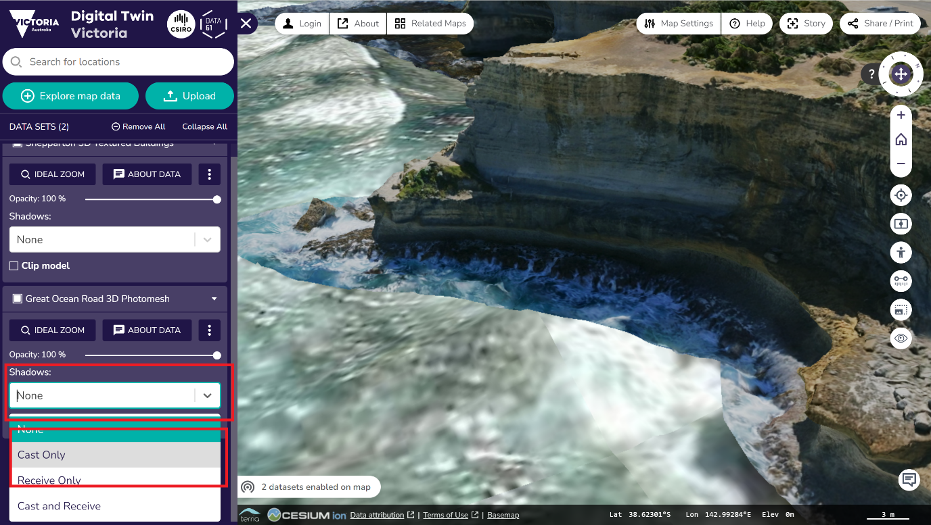
- We will now repeat the process, this time looking at 3D building model data. In the Workbench, under Shepparton 3D Textured Buildings, click Ideal Zoom.
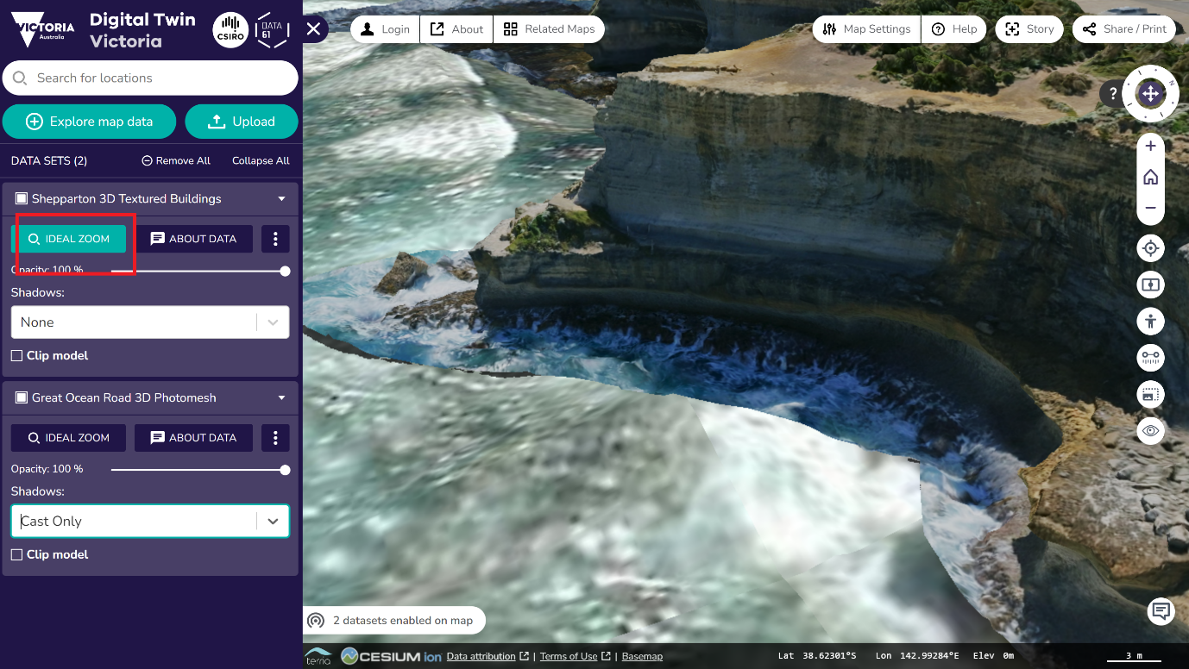

- Click Shadows drop down field, choose Cast Only (the other options can also be selected for the demonstration).

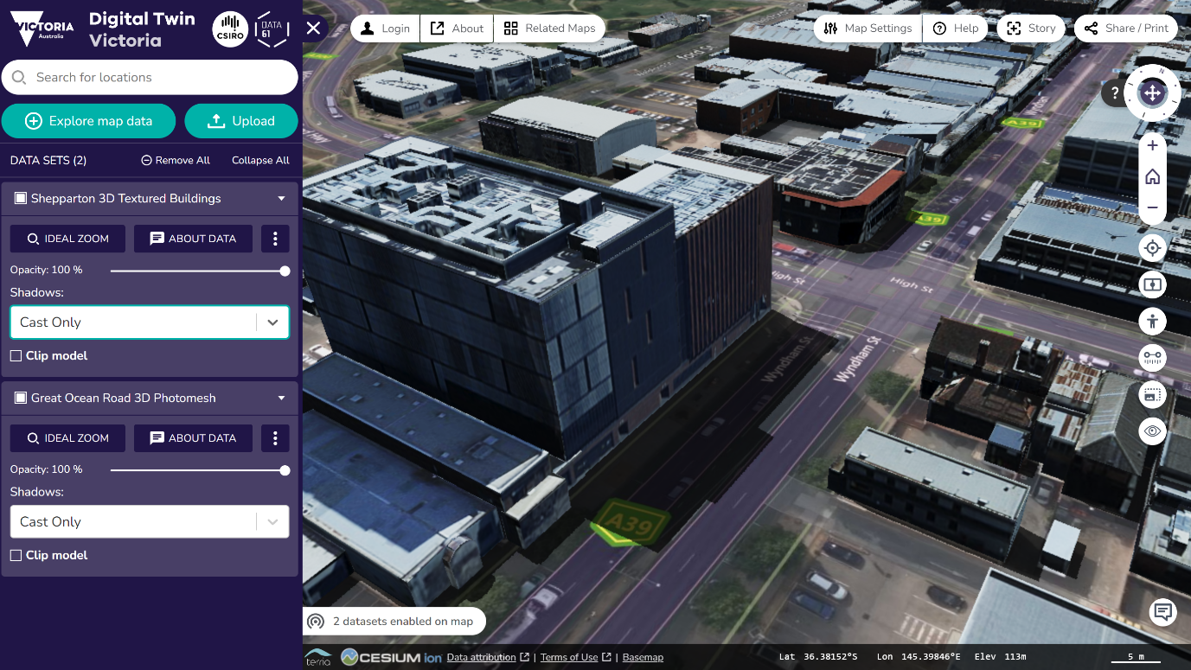

- The map has been updated to show the casting of shadows. The next step will look at displaying shadows depending on the time of day. Choose Map Settings.
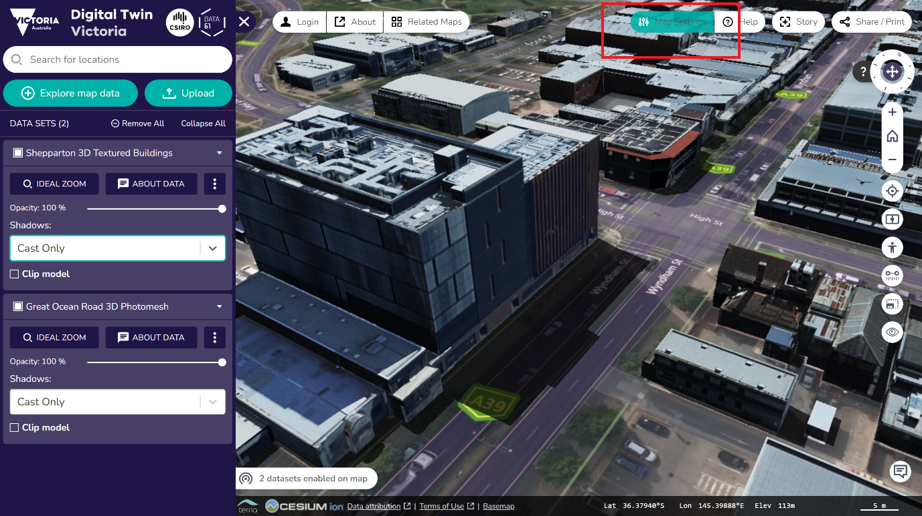

- Click timeline > Always show.

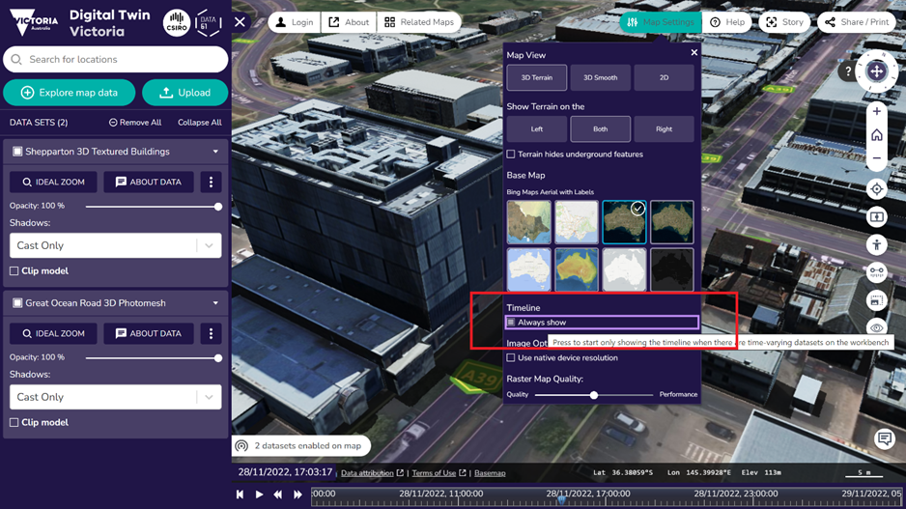

- Close settings.

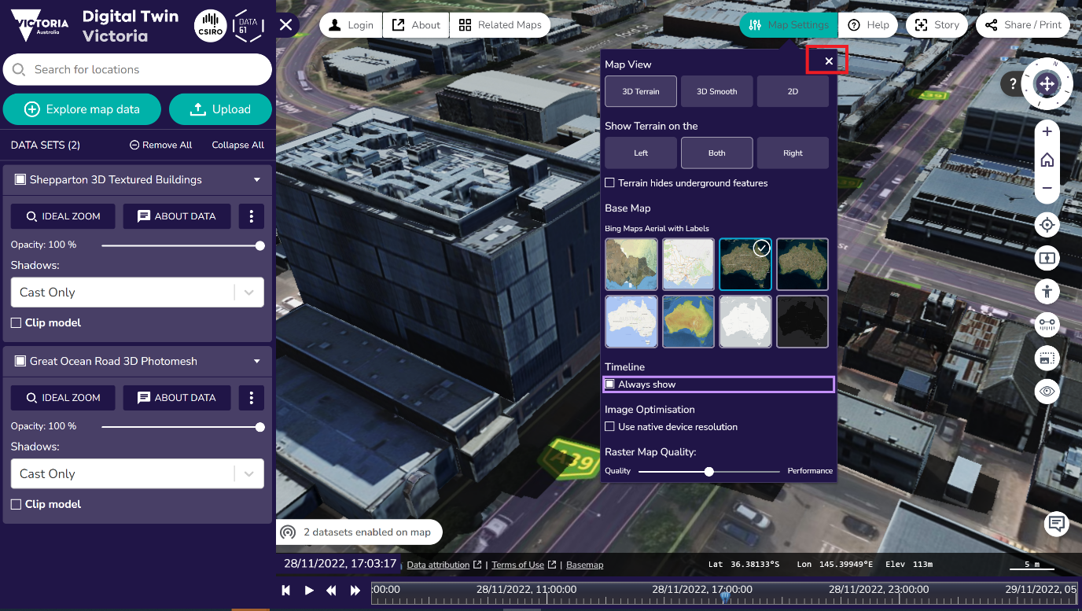

- At the bottom of the window will be a time slider. Left click timer (small blue arrow) and drag to see shadow change depending on the time.

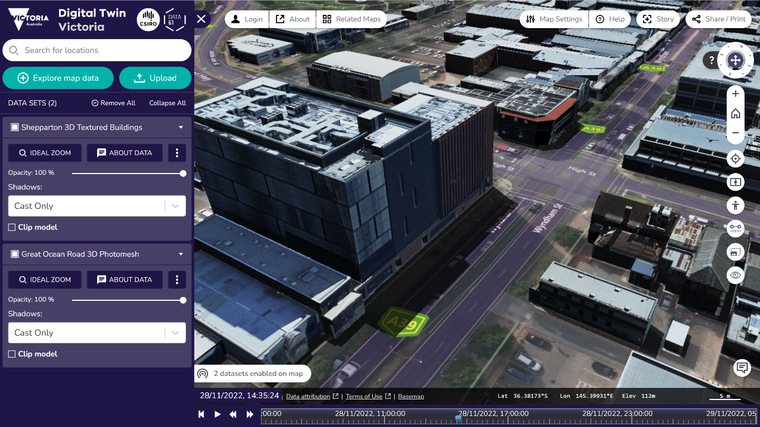

City of Greater Geelong Smart City Office
w: www.geelongaustralia.com.au/smartcity
e: smartcity@geelongcity.vic.gov.au

