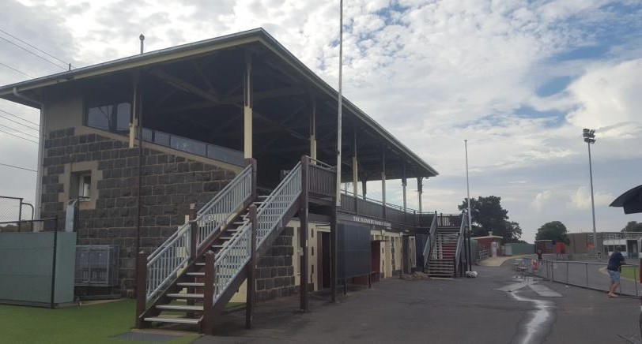


WEST OVAL MASTER PLAN
FINAL REPORT | NOVEMEBER 2018

Prepared for:

CITY OF GREATER GEELONG

Prepared by Project Consultants on conjunction with City of Greater Geelong Project Manager:

LAND DESIGN PARTNERSHIP PTY. LTD
52-54 Rathdowne Street
P.O. Box 1164, Carlton, Victoria 3053 www.landdesign.com.au

CAPIRE CONSULTING PTY LTD
96 Pelham Street,
Carlton Victoria 3053 www.capire.com.au

HASKELL ARCHITECTURE
Level 7, 552 Lonsdale Street

Melbourne Victoria 3000 www.haskell.com.au

Version: May 2018

TABLE OF CONTENTS
 | Page |  | Page
1 ABOUT THIS DOCUMENT | 05 | 4 RECOMMENDATIONS | 52
1.1 | Purpose | 05 | 4.1 | Buildings | 54
1.2 | Definition | 05 | 4.2 | Sports Facilities | 57
1.3 | About This Document | 05 | 4.3 | Vehicle Circulation and Parking | 59
1.4 | Key Drivers | 05 | 4.4 | Pedestrian Spaces | 60

- EXECUTIVE SUMMARY 06
  - | Drivers and Function 06
  - | West Oval Master Plan 06
  - | West Oval 07
  - | Key Issues and Considerations 08
  - | Proposed Recommendations and Infrastructure Components 09
  - | Preliminary Cost Estimates and Funding Strategy 09
  - | Project Area 10
  - | Project Methodology 12
  - | Project Governance 12
- BACKGROUND AND CONTEXT 13
  - | Introduction 13
  - | Policy Considerations 14
  - | Planning Considerations 22
  - | Site Considerations 25
  - | Stakeholder Consultation 45
4.5 | Potential Financial Implications 61
5 NEXT STEPS 62

LIST OF FIGURES

Page
LIST OF APPENDICES

Figure 1 – West Oval, North Geelong, Victoria 10
Figure 2 – Study Area 11
Figure 3 – Zoning 22
Figure 4 – Heritage Overlay 23
Figure 5 – West Oval Buildings and Structures (Existing) 33
Figure 6 – Flowers Family Stand Plan 34
Figure 7 – Main Club Room Facilities Floor Plan 35
Figure 8 – Cycling Club Room Facilities Floor Plan 36
Figure 9 – Bakers Oval Buildings and Structures (Existing) 39
Figure 10 – Bakers Oval Club Room Facilities 40
Figure 11 – West Oval Pedestrian Access and Circulation 41
Figure 12 – West Oval Vehicle Access and Circulation 43
Figure 13 – Key Recommendations Site Plan 53
Figure 14 – Area Schedule – Multipurpose Pavilion 54
Figure 15 – Club and Community Building Floor Plan 55
Appendix 1 – Key Recommendations Site Plan
Appendix 2 – Area Schedule for Club and Community Pavilion
Appendix 3 – Club and Community Building Floor Plan

- ABOUT THIS DOCUMENT
  - PURPOSE
The purpose of this Master Plan is to guide the future development and improvement of West Oval, North Geelong and ensure that the character and functionality of the open space reserve is enhanced.

  - DEFINITION
For the purposes of this report, the term ‘Regional Facility’ relates to the infrastructure guidelines and basic requirements to perform the function of a regional finals and events venue to service the Greater Geelong and G21 region. It does not refer to a Regional Centre which would require greater provision to service broader regional functions such as the sport’s regional administration base and multi-field activity. The Regional Centre for AFL is likely at this point in time to be provided at a future site.

  - ABOUT THIS DOCUMENT
The West Oval Master Plan considers the issues and opportunities as they relate to the development and improvement of West Oval. It brings together the key findings captured throughout the planning and consultation process and provides the necessary context for the reader to better understand the justification behind the proposed design response, prioritisation and approach to implementation.

The following Master Plan aligns with Council’s 30-year vision and ensures that the long-term development aspirations of the tenant clubs, community groups and local residents are taken into consideration. The plan addresses functional issues with the existing landscape with a focus on facility improvement, passive recreation areas which will ultimately encourage increased community use.

The West Oval Master Plan will be made available for community comment through a public exhibition period, before producing a final report.

  - KEY DRIVERS
The City of Greater Geelong provides for a diverse mix of stakeholder groups, infrastructure and services. With the shift in the economic and operating climate, Council will need to critically understand, prioritise and rationalise its infrastructure investment in order to future proof its provision going forward.
Council is currently experiencing an organisation-wide shift in approach to planning and the development of strategic drivers for decision making and prioritisation. Council believes the Greater Geelong community must look beyond the short term to ensure a thriving, inclusive and sustainable future.
In order to create a network of suburbs and towns that make Greater Geelong a desirable place to live, work, invest and visit, there needs to be greater emphasis on improved and sustainable asset planning, investment and delivery.
Council are currently developing the Geelong 2040 Vision project that will address current challenges and highlight future opportunities, recognising what the municipality will look like in 20-30 years. Council recognises that they must better understand and embrace the emerging needs of the community and the challenging environment globally and look at local level influences to ensure better outcomes for everyone now and into the future.
Community health and wellbeing as well as efficient and effective infrastructure provision are key drivers for Council going forward.
The City of Greater Geelong contains a comprehensive network of open space and recreation facilities that are planned within walking distance of homes and workplaces and are linked by a network of trails, walking and cycling paths that contribute to forming a healthy and active community.
Community facilities are focal points for community interaction. They are places where people can build relationships, a community identity and a sense of ownership related to their surroundings. The layout and distribution of these facilities can positively influence sustainable behaviour patterns. Sporting infrastructure provision on public open space needs to be master planned to inform the delivery and development of sporting infrastructure and to enhance opportunities for change and improved wellbeing.

EXECUTIVE SUMMARY
West Oval is a local and regionally significant reserve based in North Geelong. Following adoption of the G21 and AFL Barwon Regional Strategy (2015), the City of Greater Geelong commenced preparation of a Master Plan for West Oval in June 2017.

DRIVERS AND FUNCTION
The G21 AFL Barwon Regional Strategy (endorsed in 2015 by all five G21 Council’s) guides the future planning and development of football and netball across the region. West Oval is reported as being one of the worst facilities in Greater Geelong in terms of overall condition for AFL. At present the facilities and infrastructure at West Oval are ageing and disconnected (spread over 6 dwellings) and, with the exception of the netball pavilion, are in need of renewal to continue to cater for the reserves significant community sport use. West Oval is considered the City’s highest priority for pavilion development.
It is highlighted within the G21 AFL Barwon Regional Strategy (2015) that oval usage at the current finals venue, Kardinia Park, is generally restricted to elite level activities which limits community access and affordability. Since the Victorian State Government takeover of the stadium from the City in 2016, there has been a heightened need for alternate venues to cater for regional level competitions for both men and women. Conversely, the current regional facility provision for outdoor netball at Kardinia Park, retained by the City, meets the current needs and future requirements of this format of the sport.
West Oval is highlighted as one of a network of three facilities to be upgraded to regional level standards within the G21 region (others located in Torquay and Colac). The strategy recognised investment was required at West Oval to provide not only adequate community facilities for tenant user groups but also regional level amenities for the football community, and the wider G21 region.
It is proposed that West Oval is a venue capable of supporting two AFL clubs and hosting the region’s competition finals and events, attracting participation from across the region including the TAC Cup, AFL Barwon football finals. Although West Oval has the potential capacity to cater for VFLW, it would be expected that the highest women’s competition will be afforded the same opportunities as the men to play at GMHBA Stadium.

WEST OVAL MASTER PLAN
The West Oval Master Plan identifies a model for the reserve which ensures fair and equitable access for all users and which could adequately support redevelopment of the facility to a regional level into the future. It identifies the development and improvement needs of West Oval and considers impacts on the function and role of Bakers Oval as potential support venue. Bakers Oval was however, found to not be contingent to the development of West Oval.
West Oval provides for more than 1,050 active participants and is the home of the Geelong West Giants, a club formed from the recent joint venture of Geelong West St Peters Football Netball Club (Red West), which was traditionally based at West Oval, and Geelong West Sporting Club (Blue West), traditionally based at nearby Bakers Oval (a smaller active sports reserve, located in Geelong West).
The joint venture between the two clubs and their size meant that they now play in two different divisions requiring the facility to be used every weekend as opposed to every other weekend like many other clubs. Facility development and improvements proposed are in recognition of the facilities existing capacity and increased use.
The Master Plan aligns with Council’s 30-year vision and will ensure that the long-term development aspirations of the tenant clubs, community groups and local residents are taken into consideration and the character and functionality of the open space reserve is enhanced.

WEST OVAL
West Oval is bordered by residential areas and the total area of the reserve is approximately
3.9 hectares.
West Oval has a mix of active uses including football, cricket and netball. The reserve serves as the home ground for the Geelong West Giants Football and Netball Club (500 football participants and 250 netball participants), Geelong West Cricket Club (71 participants) and Geelong Cycling Club (230 registered members).
In addition, the reserve also includes a neighbourhood scale playground and picnic space and is used extensively for passive recreation. It is a highly valued open space area that is well utilised by the broader community with 96.6% of local residents surveyed had visited the reserve.

SPORTS CLUB MEMBERS


500 MEMBERS


1,050+

These buildings are supplemented by a range of support structures including kiosks and storage sheds.
In 2015, an audit of football and netball facilities conducted by independent consultants during the development of the G21 AFL Barwon Regional Strategy found that West Oval rated in the bottom three of all AFL facilities with a score of 28 points out of a potential 60. Future infrastructure provision identified within the Plan will aim to guide this development. In addition, the upgrade to West Oval will provide economic benefits to the wider community, encourage player pathways and continue to highlight the G21 region as a leader in football.
The anticipated major changes in the function of the reserve will be associated with football, with the ground likely to host regional finals, TAC Cup, VFL W and AFL, leading to a significant increase in spectator visitation at such times, and a requirement to align with AFL regional facility guidelines.
The first step in developing a regional standard of provision at West Oval, as per the G21 AFL Barwon Regional Strategy (2015), was to address shared management arrangements to ensure fair and equitable access for all users. This work was undertaken in 2016 with agreed outcomes including the joint venture of two existing senior football clubs to form the Geelong West Giants. The completion of the management model triggered the subsequent infrastructure

 250 MEMBERS

 71 MEMBERS


230 MEMBERS

TOTAL ACTIVE

PARTICIPANTS

96.6% OF LOCAL RESIDENTS SURVEYED VISIT THE RESERVE
component by way of a Master Plan.

West Oval is Crown Land, with the City of Greater Geelong as land manager. The City of Greater Geelong also assumes maintenance responsibilities.
There are six main buildings located at West Oval:
- Flowers Family Stand
- Geelong West Giants Football and Netball Club social rooms
- Geelong Cycling Clubrooms
- Geelong West Giants Netball Pavilion
- Public Toilets (northern)
- Public Toilets (southern)

KEY ISSUES AND CONSIDERATIONS
A number of key issues and considerations were identified throughout consultation with tenant clubs, members, local residents and other key stakeholders and is summarised below:
- GMHBA Stadium restrictive and costs prohibitive – Use of the current finals venue, GMHBA Stadium (Kardinia Park), is generally restricted to elite level activities which limits community access and affordability. Since the Victorian State Government takeover of the stadium from Council in 2016, there has been a heightened need for alternate venues to cater for regional level competitions for both men and women.
- Existing building size and condition not fit-for-purpose – Given the considerable number of participants and current level of community sporting activity at West Oval, the size and condition of the existing buildings is not suitable or fit-for-purpose and will require an upgrade.
- Strong support through club and member consultation - Most participants saw the benefits of increasing the capacity of West Oval to provide more events. Some saw increased events as offering an asset to the wider community, maximising the utilisation and economic and social benefit for the clubs.
- Parking and traffic management a concern - Most survey respondents are concerned with and want to see parking and traffic management addressed before allowing more regional events. Local residents have requested more information to understand the likely impact increased activities might have on their home.
- Safety and cleanliness is high on the agenda for local residents - Local residents want to see improved lighting and amenities to ensure the environment remains safe and clean.
- Diversity of use is encouraged - The local community desire some diversity in use at the reserve to incorporate a wider range of activities and spaces.
- Netball and cricket regional provision not required at West Oval - current regional provision for netball and cricket at Kardinia Park (regional facility in South Geelong) meets the needs and requirements for these sports.

- Velodrome presents an initial but significant constraint – The velodrome presents a significant constraint upon the development and functioning of the site as it relates to a true a regional AFL venue, compromising playability (i.e. limiting adequate runoffs suitable for VFL standard competition) and compromising spectator viewing and access to the ground. Nevertheless, it is still in use and it is recognised that the relocation of the velodrome will be required but should be retained until this can occur.
- Reserve is subject to two heritage overlays – West Oval is subject to two heritage overlays H0777 and HO 92. Ho777 refers to the Western Grandstand (also known as the Flowers Family Stand) and may have some impact on the adaptive use of the grandstand in the context of a regional facility but presents no obstruction to internal modifications.
- Any development will likely attract same site constraints – Site investigations have revealed some limitations and considerations associated with development (e.g. the need for a two-story dwelling due to limited space, soil contamination and ground stabilisation works). Site considerations have been factored into the plans. It must be noted that any development on the site will likely attract the same constraints and associated costs.

PROPOSED RECOMMENDATIONS AND INFRASTRUCTURE COMPONENTS
The following key areas have been identified for improvement in order for West Oval to function as a regional AFL facility as envisaged by the G21 and AFL Barwon Regional Strategy.
- The provision of a new multiuse club and community building providing facilities and areas aligning with AFL regional facility guidelines;
- The relocation of the existing Geelong Cycling Club velodrome, once a viable alternate location is identified and once redundant, repurposing of the existing velodrome to include tiered spectator seating and slight widening of the oval to provide adequate runoffs;
- The creation of a new entrance from Weddell Rd including the development of a pedestrian plaza;
- The conversion of existing toilet block in to a fit-for-purpose storage facility;
- The provision of additional formalised car parking to provide for enlarged spectator crowds in a regional facility context;
- The retention and protection of the heritage listed grandstand with provision of some internal modifications to improve the overall function and amenity;
- The provision of appropriate supporting infrastructure, such as coaches boxes, interchange areas, as required by AFL regional facility guidelines, as well as enhanced seating opportunities for spectators of all sports, including formalised spectator seating at the netball courts;
- The provision of pedestrian access and circulation which is compliant with relevant Disability Discrimination Act (DDA) access standards and Australian Standard requirements.
In addition, the development of the regional facility at West Oval will provide the incentive for a range of complementary improvements at both West Oval and Bakers Oval which will enhance community use of both facilities.

PRELIMINARY COST ESTIMATES AND FUNDING STRATEGY
Based on the recommendations and concepts outlined in the West Oval Master Plan, the following costs estimates have been identified for the development of West Oval as a regional facility. Final cost estimates will be refined based on more detailed design following further community consultation.
The preliminary estimate for total investment to deliver the West Oval Master Plan is up to
$10M. A new club and community building, including pedestrian access, contingencies and fees represents the major component of the anticipated cost, estimated at $7M. The remaining supporting infrastructure and features make up the remaining $3M of expected works.
It is expected that the delivery of the West Oval Master Plan would be achieved via a funding partnership between the Federal and/or State Government, the AFL, local sporting clubs and the City of Greater Geelong. It is expected that if regional functions are required of West Oval that a substantial contribution be made towards the project by the AFL and/or State Government.

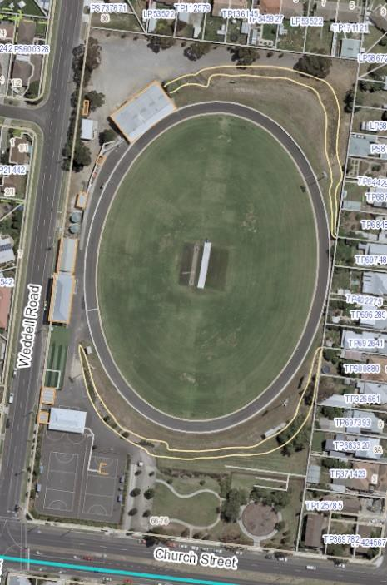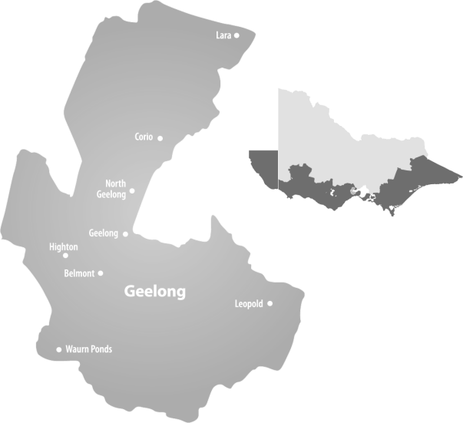PROJECT AREA
WEST OVAL

CITY OF GREATER GEELONG
The City of Greater Geelong is located in south-western Victoria, approximately 75 kilometres south west of Melbourne. The City of Greater Geelong is bounded by Wyndham City to the North and the Borough of Queenscliff in the east, Bass Strait in the south and Surf Coast Shire and Golden Plains Shire in the west.
The City of Greater Geelong is a rural, residential, resort, industrial and commercial area. Geelong is the largest regional city in Victoria and the leading commercial centre for south- western Victoria. The City encompasses a total land area of about 1,250 square kilometres. Over two-thirds of the population live in the urban areas.

WEST OVAL
West Oval is an active sports reserve located at 66-76 Church Street in the suburb of North Geelong, located approximately 3km from Geelong’s CBD. West Oval is a regionally significant reserve and boasts a well-developed oval with a turf wicket, velodrome, playground, club facilities and passive open space.
West Oval is located on Council owned land zoned under the Planning Scheme as a PPRZ – Public Park and Recreation Zone.
An aerial photograph of West Oval and its surrounds is shown in Figure 1.

FIGURE 1: WEST OVAL, NORTH GEELONG

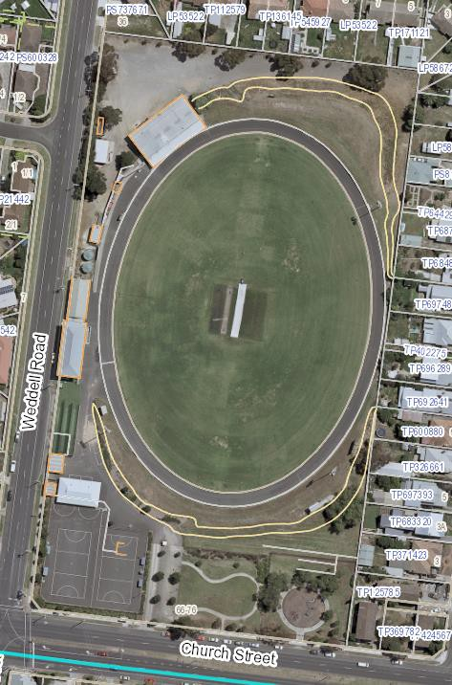
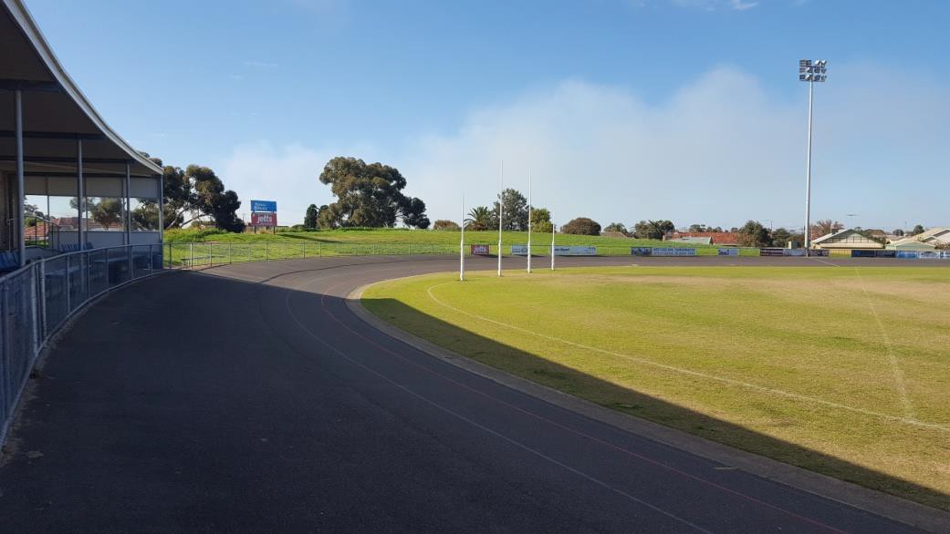
West Oval North-west Pocket
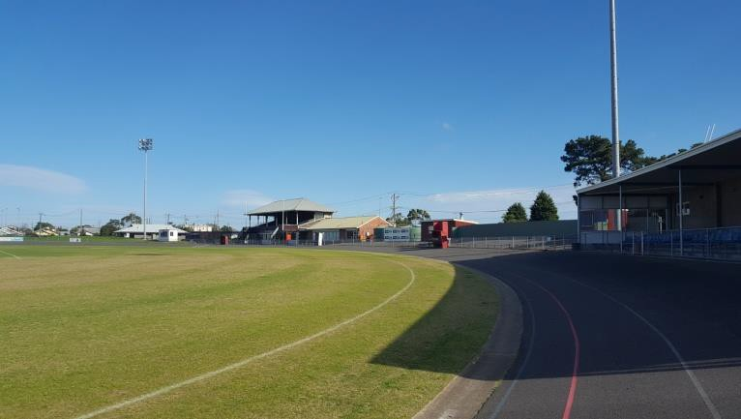
View to Flowers Family Stand

The study area is indicated in Figure 2 on the following page shows the structures, roads, playing fields and passive landscape areas which comprise the reserve.

FIGURE 2: STUDY AREA – WEST OVAL

PROJECT METHODOLOGY
The preparation of the West Oval Master Plan is being undertaken using the following approach:

1 | STAGE 1 – PROJECT ESTABLISHMENT
2 | STAGE 2 – ISSUES AND OPPORTUNITIES
3 | STAGE 3 – DESIGN AND COST PLAN
4 | STAGE 4 – DRAFT MASTER PLAN
5 | STAGE 5 – FINAL MASTER PLAN AND ADVOCACY DCOUMENT


PROJECT GOVERNANCE
To guide the development of the West Oval Master Plan and its engagement activity a Project Governance Structure was established with the following roles and representatives:
KS
KEY STAKEHOLDERS
Role: Role: To be informed and briefed on the progress of the West Oval Master Plan (including tenant club members and broader community).
PRG
PROJECT REFERENCE GROUP
Role: Provide input, direction and feedback into the project at key stages (including representatives from each tenant club).
PWG
PROJECT WORKING GROUP
Role: Provide technical advice and input into the project (including Council officers from various relevant departments).
PCG
PROJECT CONTROL GROUP

Role: Provide high-level strategic direction on key issues, opportunities and approve reports. Also responsible for contract management (including regional / state sporting associations - AFL Barwon, Netball Victoria, Cricket Victoria and Geelong Cricket Association, Council’s Social Planning and Investment department in Community Life Division, management and senior staff). Note: The West Oval Master Plan was developed by independent consultants, Land Design Partnerships.

Note: The Master Plan was developed by independent consultants Land Design Partnerships.

BACKGROUND AND CONTEXT

INTRODUCTION
West Oval is a sports reserve located on the corner of Church St and Weddell Rd, North Geelong and has a mix of active and passive uses. Tenant clubs include two football clubs, cricket club, netball club and cycling club, providing for over 1,050 active participants combined, in addition to broader community use.
The G21 AFL Barwon Regional Strategy (endorsed in 2015 by all five G21 Council’s) guides the future planning and development of football and netball across the region. Within the Strategy, West Oval is reported as being one of the worst facilities in Greater Geelong in terms of overall condition for AFL use. At present the facilities and infrastructure at West Oval are disconnected (spread over 6 dwellings) and, with the exception of the netball pavilion, are in need of renewal to continue to cater for the reserves significant community sport use. West Oval is considered the City’s highest priority for pavilion development.
It is highlighted within the G21 AFL Barwon Regional Strategy (2015) that oval usage at Kardinia Park is generally restricted to elite level activities and is cost prohibitive which limits community access and affordability. Since the Victorian State Government takeover of the stadium from Council in 2016, there has been a heightened need for alternate venues to cater for regional level competitions for both men and women.
West Oval is highlighted within the G21 AFL Barwon Regional Strategy as one of a network of three facilities to be upgraded to regional level facility standards. This is to serve as a dedicated finals and events venue within the G21 region (others are located in Torquay and Colac).
It is proposed that West Oval is a venue capable of supporting two senior football clubs, hosting the region’s competition finals and events and attracting participation from across the region including the TAC Cup, VFL, VFLW and AFL Barwon football finals.

The first step in developing a facility at West Oval with regional functions, as per the G21 AFL Barwon Regional Strategy, was to address shared facility management arrangements to ensure fair and equitable access for all users. This work was undertaken in 2016 with agreed outcomes including the joint venture of two existing senior football clubs to form the Geelong West Giants.
The completion of the management model triggered the subsequent allocation to investigate the infrastructure components required for facility development by way of a Master Plan.
The background assessment as it relates to the West Oval Master Plan comprised a review of the following four foundation areas:

- Policy Context
To understand current State and Local Government policies impacting upon the reserve.

- Planning Context
To understand the planning controls relevant to the reserve.

- Site Context
To understand the existing physical characteristics of the reserve.

- Stakeholder and Community Context
To understand the needs and desires of current reserve users and the surrounding community.

POLICY CONSIDERATIONS
A large number of local and state policies and previous studies have been reviewed in order to inform the Master Plan. A number of strategies and policies have direct relevance to the outcome of this facility plan project. Of particular note are:

State Government Policy related to shared community facilities
One of the key government platforms for the development and management of community facilities (including recreational facilities) is the principle of shared use. The Victorian Government’s policy framework for shared facilities (including recreational facilities) is largely established by two documents: Growing Victoria Together (2005) and A Fairer Victoria (2008).
One of the five broad visions of the Growing Victoria Together policy is ‘Caring Communities’ with the high-level goal of ‘building friendly, confident and safe communities’. One target of this goal is to increase the ‘extent and diversity of participation in community, cultural and recreational organisations’ (Government of Victoria 2005a, pp. 16–17).
Because the key characteristics of sharing include greater community engagement, encouraging diversity in activities, improving access to facilities, and increasing the use of facilities, such sharing could potentially contribute to achieving the goals of Growing Victoria Together.
The Government’s commitment to stronger communities, efficient investment and enhanced asset utilisation is further outlined in the policy A Fairer Victoria.
A Fairer Victoria identifies five key objectives:
      - improving access to universal services (with a focus on improving services for children, young people and older Victorians)
      - reducing barriers to opportunities to participate in economic and social life
      - supporting disadvantaged groups
      - supporting disadvantaged places (in both new and existing communities)
      - making it easier to work with government (by developing new ways of working with communities).

Through the Growing Victoria Together and A Fairer Victoria policies, it is clear that shared facilities is not just a government objective, but is also a means to achieve other, broader social policy objectives (Getting it Together: An Inquiry into the Sharing of Government and Community Facilities September, 2009).
Implementation of State Government policy related to shared facilities is investigated and directed by reports and policies such as Getting it Together: An Inquiry into the Sharing of Government and Community Facilities September (2009) and A Guide to Governing Shared Community Facilities DPCD (2010). These documents outline a clear view as to the benefits and responsibilities of shared facilities and the sharing of facilities as a potential basis for grant funding.
The opportunity to integrate and share the currently separate facilities at West Oval should be guided by these policies.

City of Greater Geelong Policy

Greater Geelong Play Strategy: Part 1 A Great Place to Play (2012 -2021) – City of Greater Geelong
The Greater Geelong Play Strategy outlines a range of principles governing the provision and design of places of play within the City of Greater Geelong.
In response to these principles the strategy identifies a number of strategic opportunities which will be relevant to the development of the West Oval Master Plan, such as:
      - Improve supporting infrastructure at play spaces, such as natural shade, seats and paths.
      - Create better connections to cycling / walking networks.
      - Improve play opportunities throughout the municipality by focussing on developing a diversity of opportunities and creating informal, spontaneous play opportunities throughout the City for people of all ages and abilities as well as programs to encourage play in public spaces.
      - Increase the number of public play spaces to ensure that the majority of residents in the urban area can access a public play space within 400m of their home (approximately a five minute walk).
      - Provide play opportunities for under-serviced age groups (e.g. 0-2 year old’s and young people over 10 years of age).
      - Increase natural play opportunities and loose materials in play spaces.
      - Increase the number of play spaces which offer tactile / sound / sensory experiences.
      - Improve opportunities for people with disabilities to access and use play spaces.

Greater Geelong Cycle Strategy Volume 1 (March 2008), City of Greater Geelong
The strategy’s vision for the future of Geelong includes:
- increasing the network of on and off-road paths and connecting these paths,
- creating a cycle friendly Central Geelong and cycle friendly schools and workplaces throughout the municipality,
- maximising opportunities to increase cycle tourism and attract cyclists to the City.

Geelong Public Health and Wellbeing Plan (2013 – 2017), City of Greater Geelong
The Geelong Health and Wellbeing Plan 2013 – 2017 outlines a range of health and wellbeing priorities and provides an action guide for each priority.
Action Guide 3 – Physical Activity and Active Communities is of most relevance to the West Oval Master Plan and includes objectives that will influence the facility plan including:
- Embed ‘Healthy by Design’ principles in Council planning processes to support active living in existing and future growth areas.
- Review the Open Space Strategy that supports opportunities for physical activity and active living and contributes to the health and wellbeing of the community.
- Develop an active transport plan that provides an ‘integrated accessible network of walking and cycling routes for safe and convenient travel to local destinations and points of interest’ (Healthy by Design).
- Work with local sport and active recreation settings to address barriers to participation by vulnerable groups within our community.

Asset Management Strategy Version 1.09 (May 2016), City of Greater Geelong
The City of Greater Geelong is custodian of approximately $2.2 billion of assets that it provides to facilitate delivery of its services to the community.
The goal of asset management is to meet the required level of service in the most cost- effective way throughout the life cycle of the various assets to provide for existing and future customers.
The objective of the Council Asset Management Strategy is to ensure that Council meets the required level of service, both now and for the future, in the most cost-effective way through the creation, acquisition, maintenance, operation, renewal/disposal of community assets.
The phases through which an asset passes during its life cycle are:
- The identification of need - where the requirement for a new asset is planned for, specified and established;
- The acquisition phase – where the asset is purchased, constructed or otherwise created;
- The operation & maintenance phase – where the asset is used for its intended purpose.
- The renewal phase – where the asset is replaced to its equivalent capacity of performance capability
- The disposal phase – initiated when the economic life of the asset has expired, when its service specification is no longer relevant, or when the need for the service provided by the asset has disappeared

Council infrastructure assets include, but are not limited to;
- Buildings and facilities of various types that provide a focus for services (such as administrative facilities, child care centres, health centres, youth centre, kindergartens, community halls and sports stadiums);
- Parks and recreation facilities, including active and passive recreation areas and sporing centres
- The road & street network;
- Flood protection and stormwater drainage systems;
- Waste management facilities (landfills and waste transfer stations);
- Special high usage precincts such as Waterfront Geelong and the CAA where infrastructure can be at a higher standard than normally used;
- Plant and equipment, including Workshop and Depot facilities;
- Information technology networks (computer & telecommunication systems.

As custodian of these assets, Council is responsible for funding their maintenance and upkeep at a level of service that satisfies both the safety and amenity requirements of the community.
It is therefore contingent upon Council to ensure that there is an appropriate level of funding which enables assets to be maintained to an acceptable standard and balanced against increasing Council’s asset base.
Strategic directions may be implemented whereby the service levels of a particular asset group may be increased or decreased depending on the competing priorities of Council and the expectations of the community.

Asset Management Strategy Objectives
- To provide the service required by our community:
  - by determining service levels required by the community
  - by focussing on outputs and outcomes with a view to continuously improving the match between service requirements and our service delivery
  - by ensuring our assets are appropriately used and maintained

- To optimise the service potential of our assets:
  - through improved management of our existing assets
  - through improved flexibility of our asset base
  - through rigorous planning, evaluation and budgetary processes
  - by using economies of scale for more cost-effective service delivery

- To maximise value for money:
  - by taking account of the full costs of holding, using and disposing of assets throughout their life cycles
  - by ensuring asset management decisions are responsive to performance measurement and monitoring
  - by producing costed options for the delivery of asset services.

- To contribute to economic growth:
  - by appropriate matching of assets to meet service delivery demands
  - by ensuring that all asset management decisions are made within the context of Council’s overall resource allocation and management framework

- To assign responsibility and accountability:
  - by clearly defining ownership and control of assets through asset information systems that meet both government and management decision making requirements
  - by determining and communicating accountability and reporting responsibilities throughout each step of the integrated approach to asset management.

- To promote balance between development and sustainability:
  - by balancing the demand for new assets through the use of non-asset service delivery alternatives where appropriate
  - by making asset decisions that consider and protect the needs of future generations
  - through consideration of asset renewal and rehabilitation options wherever feasible

- To minimise risks to the community and to Council’s financial viability:
  - through the application of risk assessment and reduction strategies
  - by regular condition audits consistent with the criticality of the various asset categories
  - through the delivery of appropriate asset maintenance and renewal programs

Sustainable Communities - Infrastructure Development Guidelines (October 2010), City of Greater Geelong
The Infrastructure Development Guidelines, while directed more to growth areas than established neighbourhoods, do contain a number of objectives and principles which will be relevant to the development of the West Oval Master Plan. These include:

Landscape and Streetscape - Objectives
High quality Streetscape and Landscape development, enhancement and protection shall aim to achieve the following goals:
  - Integration of engineering infrastructure and buildings with the landscape features to create a unified and visually appealing design.
  - Creation of aesthetically pleasing landscape environments, increased community enjoyment of everyday life and a greater sense of meaningful connection between people and the environment.
  - Fulfilment of the recreational and social needs of the wider and evolving community that reflect the values of the surrounding regional community.

Landscape and Streetscape - Principles
Ensure that the planning and design for landscape in Streetscape and Open Space settings is sustainable and follows Councils guidelines and best practice principles, including:
  - Making open space areas contribute to the health of the local community and provide an experience and landscape that creates opportunity for active and passive recreation.
  - Developing a sustainable landscape that is drought tolerant and minimises maintenance requirements.

Sport, Recreation & Open Space - Objectives
The provision of quality and accessible sport, recreation and open space in communities is vital to provide for the long-term recreation and sporting needs of an active and healthy community.
The objectives for the development of sport, recreation and open space are designed to promote ‘sense of place’ and community for people of all ages, providing opportunities to meet and interact in appropriate spaces in suitable ways and times. They can also give character to an area, define landscapes and provide a focus to connect a community.
Sport, recreation and open space should provide popular and responsive active (sport and active recreation) and passive (including walking, sitting, contemplating and picnicking) spaces and landscapes. Spaces should be well designed and create places that are ‘fit-for-purpose’, useable and be located where people want to be. They should maximise active and passive surveillance from adjoining areas and passers-by.
Active recreation spaces and facilities should be designed to facilitate shared use including schools and different community users.

Sport, Recreation & Open Space - Principles
Council endorsed principles as part of its Study of Open Space Networks (Aug 2001) that are applicable to the provision of sport, recreation and open space. These include:
  - Conserving and protecting the natural and cultural environment.
  - Reflecting community needs.
  - Enhancing recreation and tourism opportunities.
  - Improving provision and optimising access.
  - Ensuring diversity of provision.
  - Expanding the network of linkages.
  - Providing for people with disabilities.
  - Implementing site responsive uses.

Environment Management Strategy (2014 – 2017), City of Greater Geelong
The Environment Management Strategy 2014-2017 is a key document for guiding planning, decision-making and activities that impact on the Greater Geelong environment and community. The Strategy shapes future planning and growth and provides a framework and roadmap for navigating future environmental challenges and opportunities.

Domestic Animal Plan (2013 – 2017), City of Greater Geelong
One aim of the Domestic Animal Plan is to offer the Geelong community a fair and balanced environment – where people can enjoy the many public open spaces of Geelong to their fullest extent, regardless of whether they are a pet owner or not.
Under the Domestic Animal Plan policy, residents will have various dedicated Off Leash ‘Supervised’ areas, including some beach locations and most sporting grounds.
An objective arising from this policy which will impact the West Oval Master Plan will be:
- Dogs in Public Places
8.3 Promote the availability of all public general waste bins for the disposal of dog litter using any type of bag. Decals to be put on public waste bins, (refer p26 of the policy).

Other Relevant Policy
A range of other policies and guidelines were reviewed, directly relevant to the West Oval Master Plan, and are summarised below.

G21 Physical Activity Strategy (2014 – 2017), G21 Sport and Recreation Pillar
The main body of the strategy report “provides an overview of the importance of physical activity and the ways in which the G21 region can help to create environments that support physical activity in the community”.
      - The City of Greater Geelong specific action plan within the report has a number of actions which may be embodied within the West Oval Master Plan, including:
      - Develop an active transport plan that provides an ‘integrated accessible network of walking and cycling routes for safe and convenient travel to local destinations and points of interest’ (Healthy by Design).
      - Develop accessible walking and cycling resources to encourage and support participation in safe active travel.
      - Work with local sport and active recreation settings to address barriers to participation by vulnerable groups within our community.
      - Encourage broader community access to tenanted sport and recreation facilities.
      - Ensure that all active sport and recreation settings such as recreation reserves, stadiums, tennis courts and so on are planned, designed, managed and maintained in such a way as to be accessible and appropriate to the needs of all user groups.

Community Cricket Facility Guidelines (Version September 2015), Cricket Australia
Cricket Australia guidelines produced by Cricket Australia are predominantly detailed and specific to cricket facilities, they do make some statements relevant to the preparation of the West Oval Master Plan, such as the following from Guidance Note 6.

Social amenities and cricket ground surrounds
With cricket being a sport played over several hours for juniors and the best part of a day for senior competition, it is important ‘family friendly’ supporting amenities be incorporated into wider cricket facility precinct design.
Supporting facilities, equipment and amenities to be considered when planning a community friendly facility include:
      - Shade and shelter
      - Spectator seating incorporated into the park environment
      - Adequate and accessible car parking
      - Play equipment, skate or BMX park
      - Bicycle racks
      - Shared and connecting pathways or trails
      - Public BBQ
      - Access to food and beverage
      - Public toilet facilities
      - Drinking fountains
      - Tree plantings, garden beds and vegetated areas
      - Landscaped treatments
      - Venue and club signage

Netball Victoria National Facilities Policy (2016), Netball Victoria
Netball Australia’s National Facilities Policy provides netball in Australia with an overarching framework to guide facility planning and development. These guidelines provide very detailed facility design guidance including core and optional components of a facility along with proposed preferred square metre allowances or estimates for these components.
The key objectives of the Policy are to:
      - Support participation growth and sustainability
      - Provide key stakeholders with guidance in facility planning and development
      - Provide a technical manual that can be applied nationally
      - Improve the overall consistency, quality and accessibility of netball facilities
Netball facility planning and development is to be focused on supporting the growth of the sport. In order to do this, facilities will be planned and developed with consideration of the following guiding principles:
      - Strategic need, facility demand and participation growth opportunities
      - Accessibility and inclusion, catering for multiple formats of the sport
      - Maximising utilisation and improved programming
      - Best practice technical and design standards
      - Alignment with the needs of key stakeholders and partners
In the development of the design brief, the following should be incorporated into the overall facility provision on site (including shared infrastructure):
      - Change rooms and umpires change rooms
      - Public toilets (including accessible)
      - Competition / Administration office
      - First Aid room
      - Kiosk / canteen
      - Social area
      - Storage
Other functionality such as kitchens, dedicated function space, meeting rooms, warm-up areas, spectator seating and amenities can be considered on a needs basis.
The Policy does not provide specific guidance on court proximity to amenity provision.

AFL Preferred Facility Guidelines for State, Regional and Local Facilities (August 2012), Cricket Australia

    - Policy Implications and Considerations for the Master Plan

The following policy implications and considerations as they relate to the West Oval Master Plan are summarised below;

      - Reserve and facility function is considered community level provision with capacity to provide some functions of a regional facility
      - Shared use of facilities
      - Broad community use of open space through appropriate facilities and amenities
      - Encouragement of activity and exercise
      - Enhanced tree planting to reduce “urban heat island” impacts
      - Enhanced and diverse play opportunities
      - Encouragement of active transport – walking and cycling
      - Competing priorities and need for investment in like facilities
      - Standard provision of facilities commensurate with levels of service
      - Sustainable and equitable development and maintenance of facilities across the City
      - Design response and recommendations will be subject to Council’s Business Drivers
      - All decisions subject to Council’s overall resource allocation and management framework
The purpose of the preferred facility guidelines is to act as a key tool during used during the planning phase of a project. The document provides relevant guidance, particularly around spatial requirements that can inform concept and/or master plans. While much of the document is detailed and specific as to layout and spatial configuration, the recent Appendix related to Amenities Upgrades for Unisex Use is particularly applicable to the West Oval Master Plan.

Amenities Upgrade for Unisex Use (July 2015)
This document has been developed to provide more detail around what is considered best practice in the design of unisex football change rooms and amenities.
People often think of female change rooms as separate dedicated change facilities. This is not the case, rather it is about transforming the existing amenities to cater for unisex use, removing urinals and open showers and replacing with toilet cubicles and shower cubicles that allow showering and changing in privacy. In other words, great change facilities cater equally well for both genders.

G21 and Barwon Region AFL Strategy (2015), G21 Strategic Pillar and AFL Victoria
The strategy aims to “guide the future planning and development of football and netball delivered through football-netball clubs throughout the G21 and AFL Barwon regions. The strategy addresses infrastructure and sports development needs of both sports, as well as establishes clear priorities for delivery.

The key findings affecting the preparation of the West Oval Master Plan include:

      - Regional level upgrades planned for the region to host elite competition include Spring Creek Reserve in Torquay, West Oval located in Geelong West and Colac Central Reserve in Colac.
      - As a traditional football finals venue, West Oval has ‘limiting aspects and requires facility improvements to better cater for finals requirements’.
      - Strategic Direction 2.5: in order to progress planned facility upgrades, the City of Greater Geelong, AFL Barwon and relevant clubs partner to address shared management arrangements at West Oval and agree on a management model that ensures effective use of the venue for home and away finals purposes.

PLANNING CONSIDERATIONS
West Oval is subject to the requirements of the zones and overlays outlined in the Greater Geelong Planning Scheme. Refer to Figure 3: Zoning.

Municipal Planning Framework
Within the Municipal Planning Framework, the Greater Geelong Planning Scheme encourages the development of open space which is safe, is accessible to communities (particularly through proximity by walking), and which contributes to the diversity of recreational experience available to members of the community.

Zoning

Public Park and Recreation Zone (PPRZ)
West Oval is zoned PPRZ. PPRZ recognises areas of public land that are designated as public park and recreation zone and encourages enhancement of the subject land in support of appropriate recreation uses and activities. It also seeks to protect and conserve areas of significance and provide for commercial areas where appropriate.
Under the zone a permit is required to:
      - Construct a building or construct or carry out works. This does not apply to:
        - Pathways, trails, seating, picnic tables, drinking taps, shelters, barbeques, rubbish bins, security lighting, irrigation, drainage or underground infrastructure.
        - Playground equipment or sporting equipment provided these facilities do not occupy more than 10 square metres of parkland.
        - Navigational beacons and aids.
        - Planting or landscaping.
        - Fencing that is 1 metre or less in height above ground level.
        - A building or works shown in an Incorporated plan which applies to the land.
        - A building or works carried out by or on behalf of a public land manager or Parks Victoria under the Local Government Act 1989, the Reference Areas Act 1978, the National Parks Act 1975, the Fisheries Act 1995, the Wildlife Act 1975, the Forest Act 1958, the Water Industry Act 1994, the Water Act 1989, the Marine Act 1988, the Port of Melbourne Authority Act 1958 or the Crown Land (Reserves) Act 1978.
      - Subdivide land.

FIGURE 3: WEST OVAL ZONING
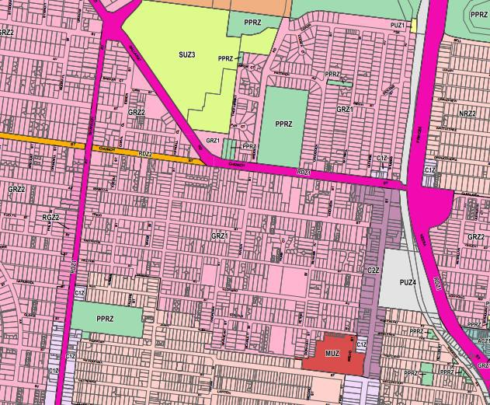
WEST OVAL – PPRZ ZONE

Overlays
West Oval is subject to two heritage overlays – HO 777 and HO 92. Note that HO777 refers to the Western Grandstand, however this is referred to as the Flowers Family Stand throughout this report.

HO777 applies to:
The Western Grandstand West Oval, Weddell Road, Geelong West, to the extent of all the land within 10 metres of the grandstand, excluding the road reservation
Within the schedule to the overlay, specific control is placed upon external paint colours, but there is no control upon internal alterations.

The grandstand is not included in the Victorian Heritage Register, and so is not subject to the requirements of the Heritage Act 2017.

HO92 applies to:
The J.F. Archibald Memorial 66-76 Church Street, Geelong West, to the extent of all the land within 5 metres of the plaque.

Within the schedule to the overlay, specific control is placed upon external paint colours.

The Memorial is not included in the Victorian Heritage Register and so is not subject to the requirements of the Heritage Act 2017.

Bakers Oval is also subject to a heritage overlay – HO 1960 – which applies to the general surroundings of the reserve. The details of the overlay are outlined below.

HO 1960 applies to:
The Milton Heritage Area, generally located south of the alignment of Mowat Street, west of Pakington Street, north of the southern boundary of the Autumn Street road reserve and east of Shannon Avenue, Geelong West.
Within the schedule to the overlay, there appears to be no specific control which would affect the outcomes of the Master Plan.

The Memorial is not included in the Victorian Heritage Register and so is not subject to the requirements of the Heritage Act 2017.

The details of these overlays are outlined below and shown on the below figure

FIGURE 4: WEST OVAL HERITAGE OVERLAY
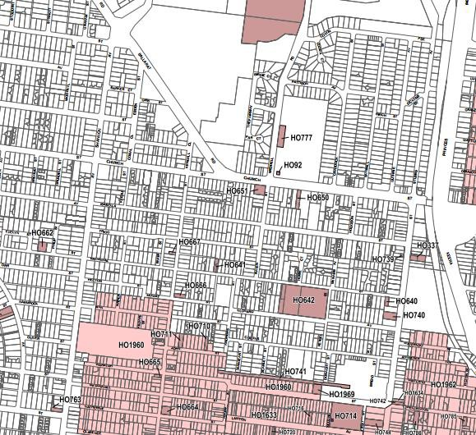

    - Planning Implications and Considerations for the Master Plan
      - The planning context contained within the Greater Geelong Planning Scheme creates no specific issues for the provision of recreation within the reserve, including recreation at a regional level.
      - The planning scheme encourage opportunities to increase the diversity of the recreational experience offered by the reserve.
      - The Heritage Overlay HO777 may have some impact upon the adaptive re-use of the Flowers Family Stand in the context of a regional facility but presents no impediment to internal modifications.
      - The fact that none of the elements included under heritage overlays are included on the Victorian Heritage Register means that no application is required to Heritage Victoria.

SITE CONSIDERATIONS

Location and Setting
    - Location and Setting Implications and Considerations for the Master Plan
      - The immediate residential context of West Oval may be impacted by increased traffic, and particularly parking during a regional level event at the reserve.
      - The presence of the Geelong Saleyards to the north of West Oval may present a potential opportunity for use synergies, particularly related to car parking. Complementing the activity at West Oval should be a consideration in the Master Plan of the Geelong Saleyards site.
      - The residential context and limited building capacity of Bakers Oval (in regard to AFL facility guidelines) suggests an opportunity for a local and neighbourhood use focus at the reserve, perhaps as a junior hub supporting a regional facility at West Oval.
West Oval is located on the north-eastern corner of Weddell Road and Church Street, Geelong North.
The setting of the reserve comprises a range of uses, but is predominantly residential. Other nearby uses include:
      - Geelong Golf Course, located to the west of the site, on the western side of Weddell Road
      - Geelong Saleyards, located approximately 300 – 400m to the north-east of the site, on the western side of Weddell Road. Following a Council resolution to cease operations at this location in 2017, there is opportunity to explore future development opportunities for this site to include overflow, casual parking for West Oval.
      - Drainage Reserve, located 400m to the north of the site and running in an east-west direction to ultimately connect with Rippleside Park and so to Corio Bay.
      - Aged Care, a residential aged care facility located 400m to the north of the site .

Bakers Oval is located on the eastern side of Shannon Avenue, Geelong West.
      - The setting of the reserve is residential, with each of the surrounding streets characterised by standard residential development on blocks of approximately 500 – 700 m2.
      - The development of the regional facility at West Oval will provide the incentive for a range of complementary improvements at both West Oval and Bakers Oval which will enhance community use of both facilities, although
      - The redevelopment of West Oval to a regional scale facility is not contingent on improvements to Bakers Oval.

Overview of Current Facilities OVALS
West Oval contains a single sports oval. The oval is used for cricket and football. The key characteristics of West Oval sporting field are:

      - Aligned in a north-south orientation
      - Approximate playing surface dimensions of 165m x 117m (including run-off areas)
      - Defined by perimeter asphalt velodrome, with no fence between the turf playing surface and the velodrome surface
      - Caters for senior and junior cricket competition and training and senior and junior football competition and training
      - Includes lighting compliant with current Australian Standards for sports lighting for training (100lux)
      - Central 9 pitch turf table for senior cricket competition
      - Has an electronic scoreboard which is of an older style and is likely to be inadequate for regional finals
      - Has relocatable coaches' boxes

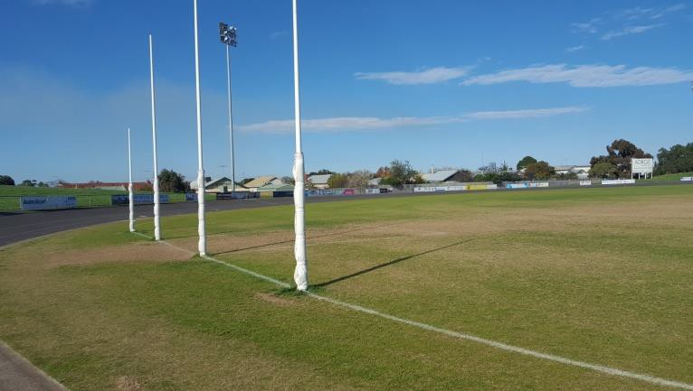
West Oval Northern Goals
View to Flowers Family Stand

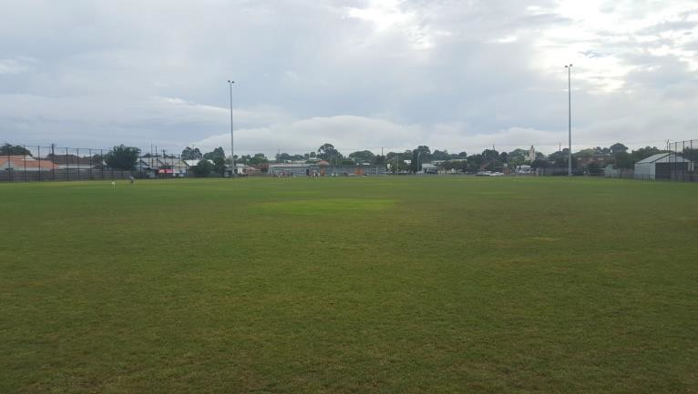
Bakers Oval contains a single sports oval. The oval is used for cricket and football. Key characteristics of the Bakers Oval sport field:
      - Aligned in an east-west orientation, although the cricket pitch is oriented northwest – southeast, across the narrow dimension of the oval.
      - Approximate playing surface dimensions of 165m x 95m (including run-off areas)
      - Defined by perimeter chain mesh fence
      - Caters for Junior Cricket competition and Junior Football competition and training
      - Includes 50lux lighting for training uses
      - Has a single hard (concrete) cricket pitch
      - Has two coaches boxes on the southern wing of the oval
      - Has no spectator amenity or shade apart from the clubrooms

View across Bakers Oval
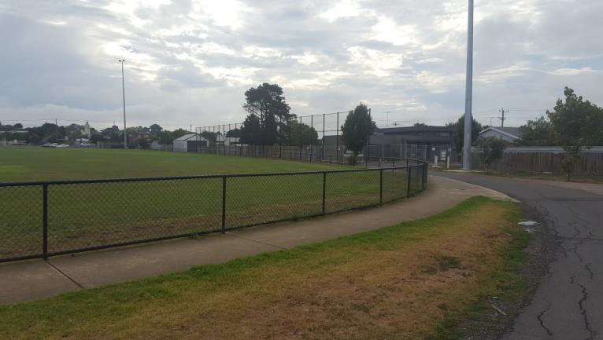
Bakers Oval perimeter path and fence
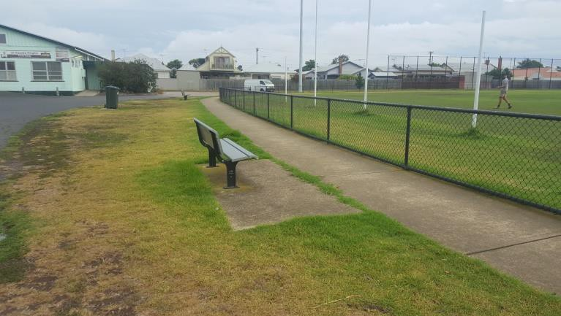
Bakers Oval seating

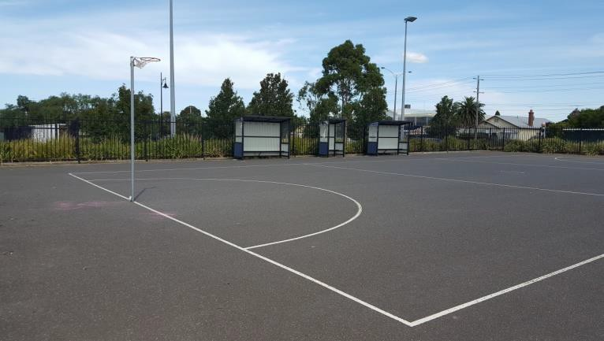
NETBALL COURTS

West Oval contains two netball courts, located on its south eastern corner. The courts have been constructed in the last ten years and have an asphalt playing surface. The courts are used for both training and competition, including finals. Additional terraced seating is temporarily installed to the north of the courts during finals.

Key characteristics of the netball courts:

      - Have a north / south orientation.
      - Have full run-off areas as required by Association regulations.
      - Have lighting that complies with current Australian Standards for netball training lighting.
      - Are contained within an 1800mm high steel picket fence, which is in good condition
      - Have a clubroom building which has been constructed in the last ten years.
      - Have two coaches’ boxes to the edges of both courts.

There are no netball courts at Bakers Oval.

West Oval netball courts
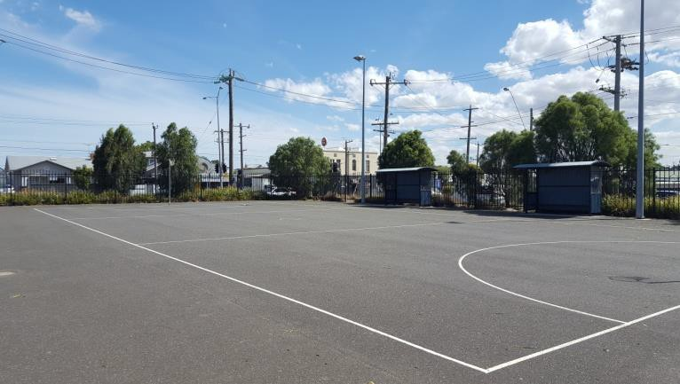
West Oval netball courts
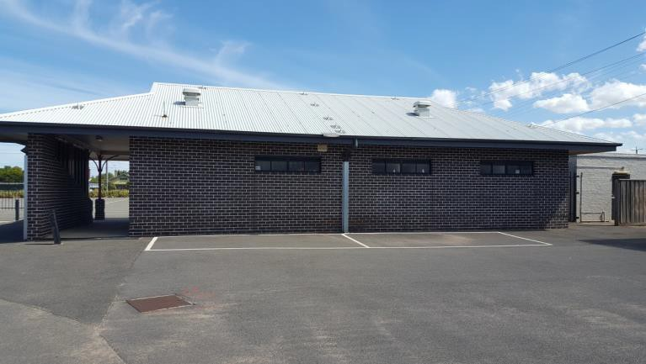
West Oval netball pavilion

VELODROME
The oval at West Oval is surrounded by a perimeter velodrome. The velodrome is used for both training and competition by the Geelong Cycling Club, and also for informal and occasional use by the general public. The velodrome is the only such facility within the City, although other cycling facilities and a cycling clubhouse have been built in at the Belmont Island, Belmont in Geelong.

Key characteristics of the velodrome:
      - Asphalt surface.
      - Approximately 6.5m width.
      - Camber to outer edge of track ranges from 450mm to 1200mm above playing field level.
      - Unfenced on inner edge, leaving no permanent barrier between sports field playing surface and asphalt track.
      - Camber of track influences floor levels of adjacent buildings, with impact upon accessibility to buildings.
      - The width of the track limits the proximity of spectator to the playing field, without the addition of temporary fencing at the edge of the field.

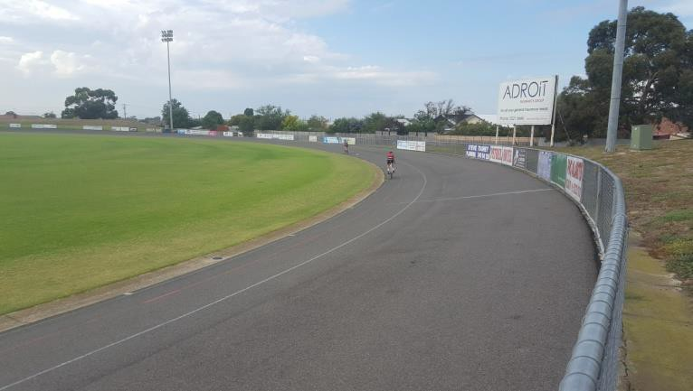
West Oval Velodrome – south east pocket
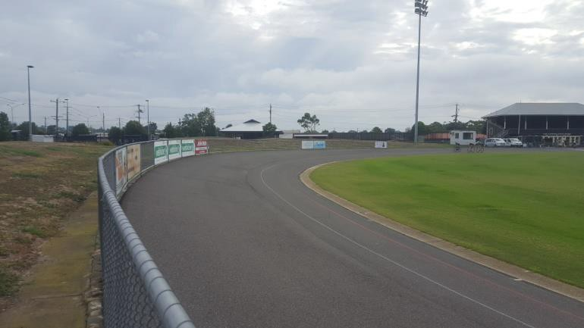
West Oval Velodrome – south east pocket
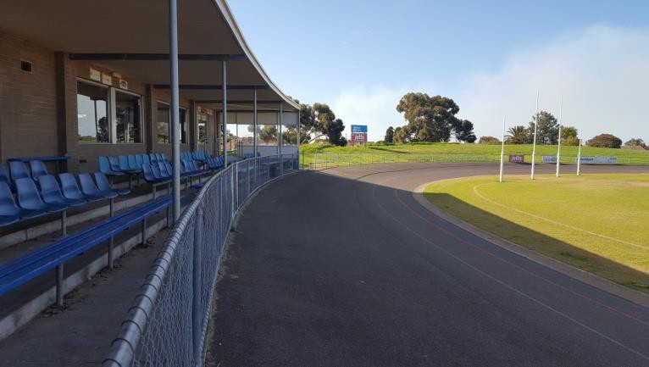
West Oval Velodrome – north west pocket

CRICKET PRACTICE NETS

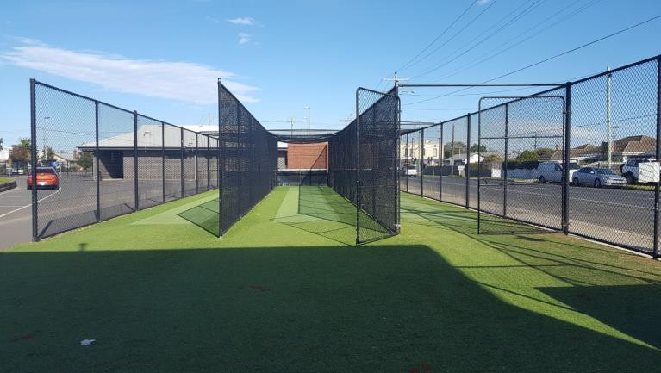
West Oval includes a cricket practice net complex comprising 3 synthetic pitches with “hard” fencing between pitches. There are no turf training nets at West Oval.

Key characteristics of the cricket practice nets:

      - Located on south-western pocket of oval, against Weddell Road boundary.
      - Have 3 synthetic pitches with fixed fencing.
      - Are 24m in length, with 8m additional run-up space, and so are not in accordance with Cricket Australia guidelines.
      - Limited storage for equipment.

Bakers Oval includes an older style cricket practice net complex comprising 2 concrete pitches with a small area of synthetic turf and with “hard” fencing between pitches.

Key characteristics of the cricket practice nets:

      - Located on north-western pocket of the oval.
      - Have 2 synthetic pitches with fixed fencing.
      - Are 12m in length, requiring run-up from the oval surface, which is not in accordance with current Cricket Australia guidelines.
      - No storage area for equipment

West Oval synthetic cricket practice pitches

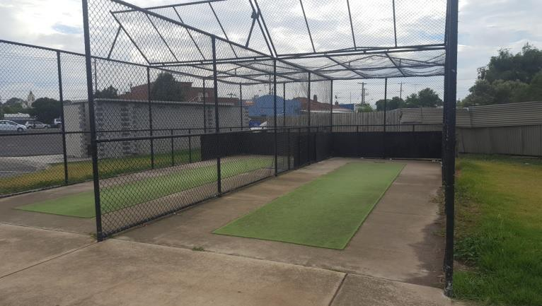
Bakers Oval concrete cricket practice pitches

SCOREBOARD

West Oval has an electronic scoreboard located on the south-eastern pocket of the oval.

COACHES BOXES

      - West Oval has no permanent coaches’ boxes, due to the presence of the cycling velodrome. Relocatable coaches’ boxes are put in place and removed as required. The coaches’ boxes are not compliant in size with the AFL facility guidelines.
      - The oval does not have formal interchange areas or interchange boxes, as required by AFL facility guidelines for regional facilities.
      - Bakers Oval has two simple but permanent coaches' boxes against the south-western pocket of the oval.

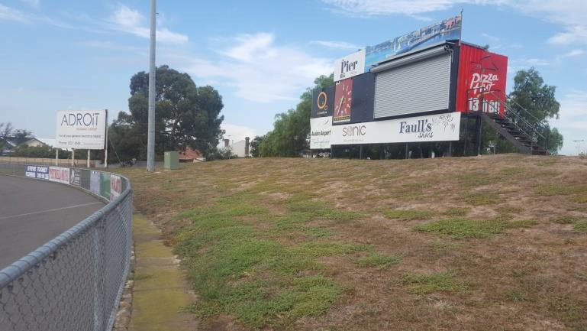
West Oval scoreboard
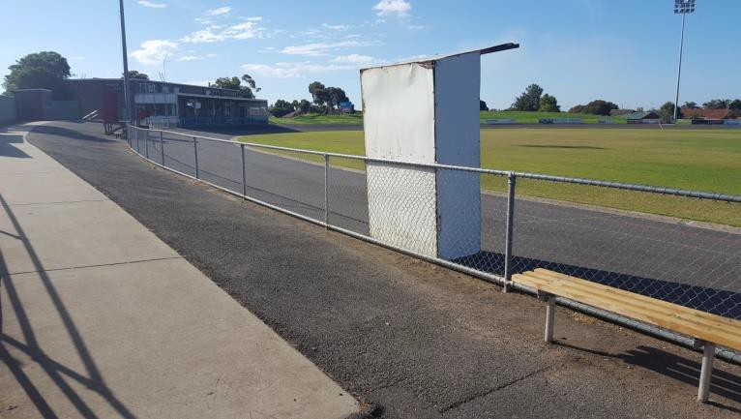
West Oval coaches’ boxes
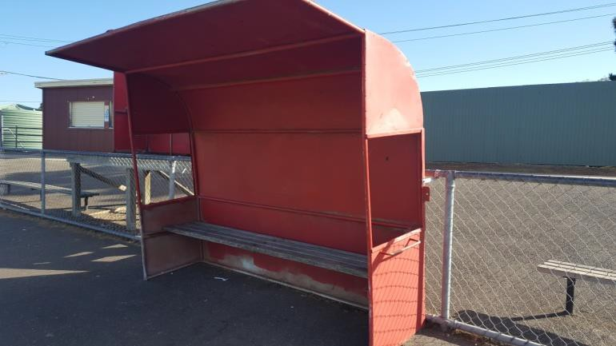
West Oval coaches’ boxes

Sports Facilities Implications and Considerations for the Master Plan
While the formal sports facilities at West Oval, particularly the sports field and turf table surfaces, are generally of high quality for local competition, there will be a requirement to enhance these facilities for regional level use in areas such as:

      - Provision of appropriate oval support facilities including timekeepers’ boxes, coaches boxes and interchange areas aligning with AFL guidelines;
      - Safety for run-off from West Oval. (There is no fence to prevent players from running onto the asphalt velodrome surface);
      - Upgrade of scoreboard to present day standards for high definition broadcast and visibility;
      - Potential reduction of the width of the existing turf table to improve the quality of the AFL playing surface;
While still currently in use, the velodrome presents a constraint to the development of West Oval as a regional AFL facility, by reducing the capacity to host high level football matches. This particularly relates to:

      - Limiting the space available for spectator viewing of games;
      - Constraining the location and floor level of potential adjacent buildings, with
      - Corresponding impacts upon accessibility and building form;
      - Limiting the installation of required support facilities at the edge of the playing fields, such as coaches’ boxes and interchange zones.
At Bakers Oval, sports facilities are generally of an adequate standard for local junior competition and training. With West Oval nominated as a regional facility, Bakers Oval has the potential to act as a junior and community hub in a supplementary and supportive relationship with West Oval.

Provision of future supporting infrastructure to upgrade existing facilities at Bakers Oval may be considered to also enhance its role as community open space, such as additional netball courts and cricket net improvements

Buildings and Structures at West Oval WEST OVAL
There are six main buildings located at West Oval:

      - Flowers Family Stand
      - Geelong West Giants Football and Netball Club social rooms
      - Geelong Cycling Clubrooms
      - Geelong West Giants Netball Pavilion
      - Public Toilets (northern)
      - Public Toilets (southern)

The buildings and structures are located on Figure 5.

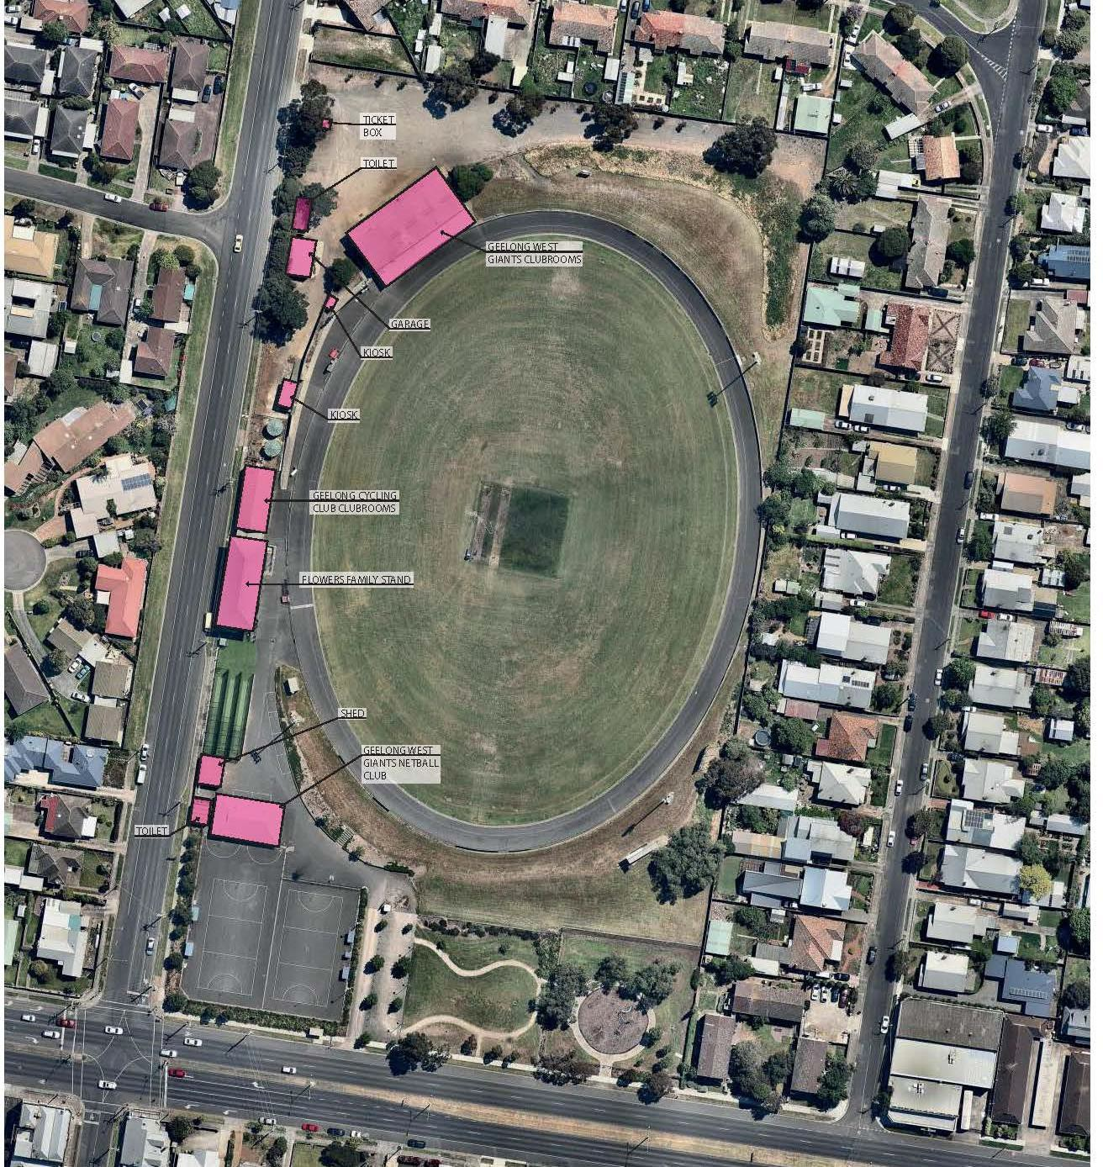

FIGURE 5: WEST OVAL BUILDINGS AND STRUCTURES (EXISTING)

THE FLOWERS FAMILY STAND

The Flowers Family Stand is located on the western boundary of the reserve. The floor plan of the stand is indicated in Figure 6.
Review of the building reveals the following:
      - The shell of the building and the various fixtures are in reasonable physical condition, having been upgraded in 2011.
      - The size and range of spaces provided do not align with the AFL facility guideline recommendations for either a local or a regional level facility.
      - The change rooms may have the potential to operate as overflow facilities to support the operation of West Oval during a multi-team final event but are insufficient as a stand- alone facility.

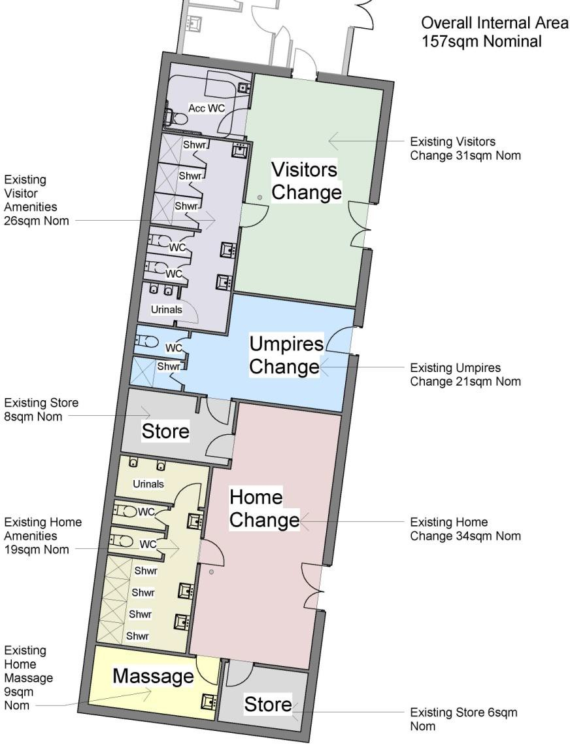
FIGURE 6: FLOWERS FAMILY STAND PLAN (NOT TO SCALE)

MAIN CLUB ROOM FACILITIES

The Club Rooms are located in the north-western corner of the site. The floorplan of the building is indicated in Figure 7.

  - The capacity of the social room is compromised by an operable wall which needs to be closed to provide adequate change room facilities. In this regard neither the change rooms nor the social room areas align with AFL regional level facility guidelines.
  - The fit out of the club rooms needs to be upgraded, requiring new floor finishes, new kitchen and bar fit out; and upgrade of toilets to DDA compliance).
  - The floor level of the existing building, determine by its location in relation to the camber of the adjacent velodrome means that it does not have access which is compliant with DDA and Australian Standards.

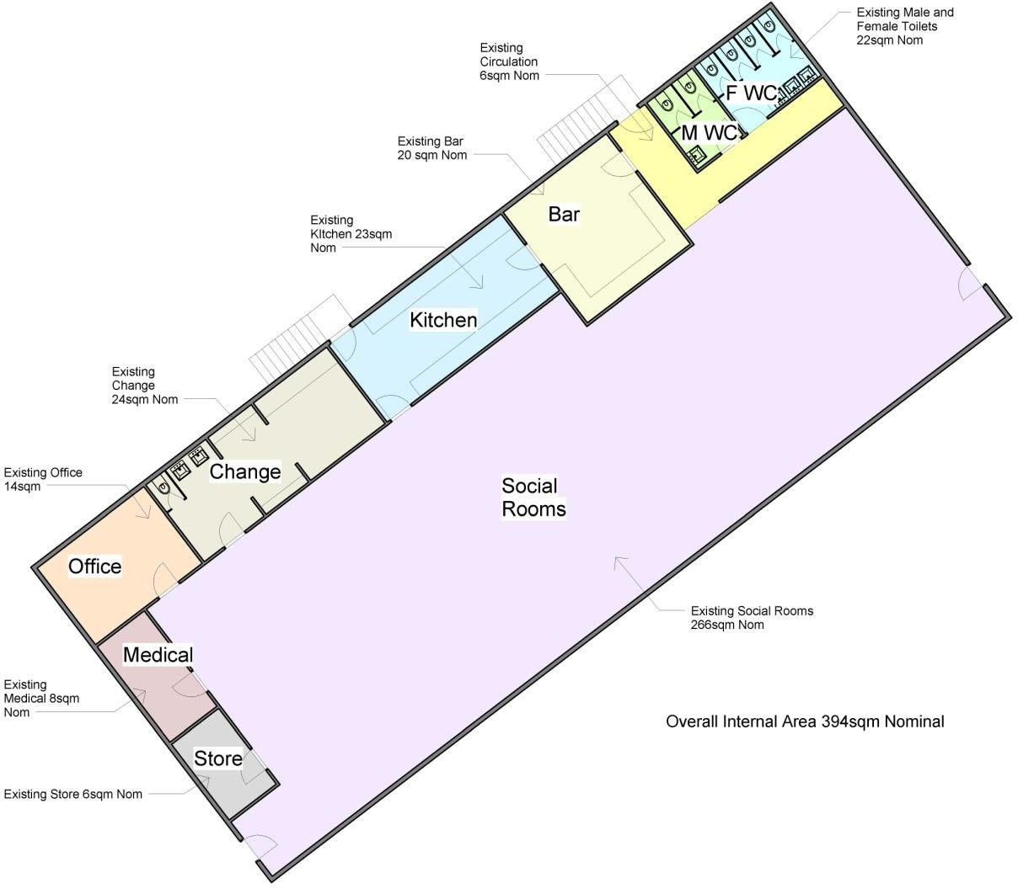

FIGURE 7: MAIN CLUB ROOM FACILITIES FLOOR PLAN (NOT TO SCALE)

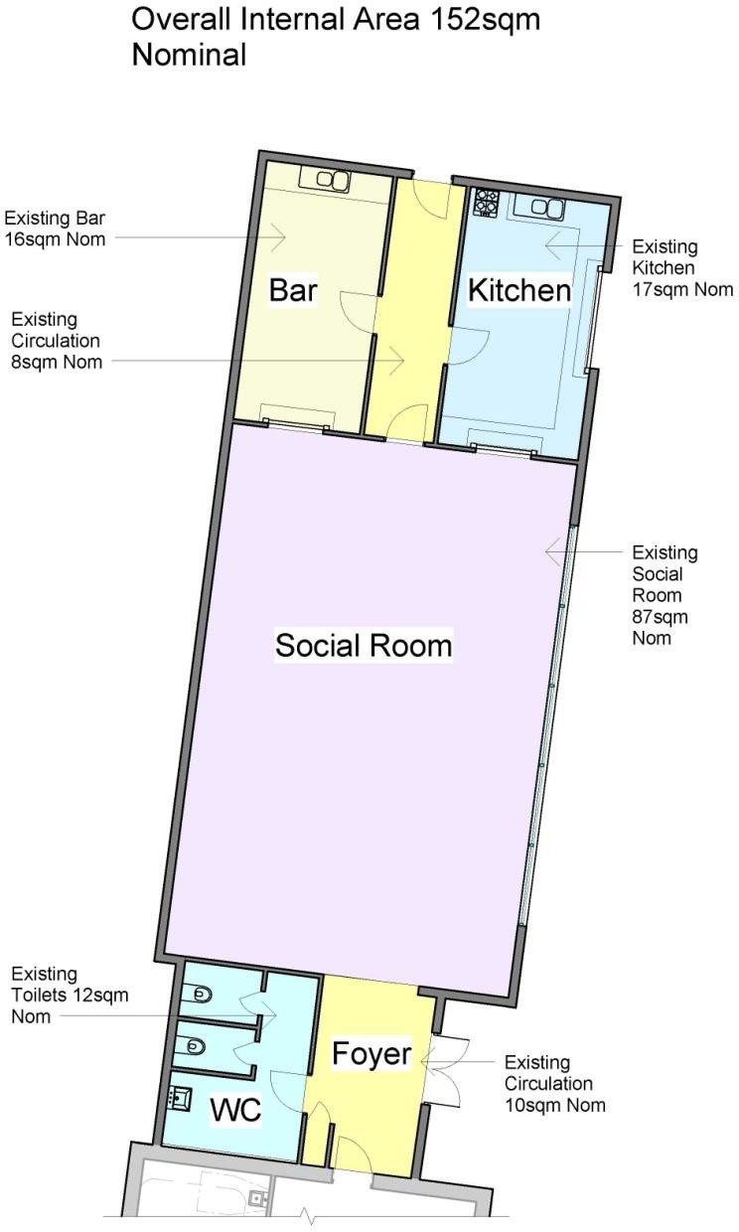
CYCLING CLUB ROOMS

The current floor plan of the Cycling Clubrooms is indicated in Figure 8. Review of the existing cycling clubrooms reveals the following:
  - The character of the building is not complementary to the adjoining Flowers family Stand and provides an uncomfortable contrast in terms of style and material.
  - The fit out is not in a very good condition. Recognising that the Geelong Cycling Club have recently constructed clubrooms at Belmont Island, if the building was to be retained it would require significant upgrade including:
    - Kitchen and bar area reconfigured with new joinery, appliances, new floor, ceiling and wall finishes including painting and new lighting.
    - Social rooms refreshed with new floor finishes, new ceiling and wall paint, new window coverings, new lighting and new furniture. New entry doors would be required.
    - Toilets reconfigured to be DDA or BCA compliant with the correct number of male, female and accessible fixtures.

  - Should the building be retained but not required for club use, it could be used for storage or similar.

FIGURE 8: CYCLING CLUB ROOM FACILITIES FLOOR PLAN (NOT TO SCALE)

NETBALL PAVILION

  - The Netball Pavilion is a relatively recent building. It provides for change room and game day facilities and administration spaces. Both the shell and the fit out of the building are in good condition and area fit for purpose. The development of West Oval as a regional facility should require no change to the building.

STORAGE SHEDS

  - A brick garage / storage shed is located adjacent to the public toilet block. The building is used for club storage sheds. A second garage / storage shed is located near the netball pavilion and is used for storage of ground maintenance equipment. Access to the oval from this building is therefore essential.

PUBLIC TOILETS

  - West Oval contains two existing public toilet blocks, located next to the Netball Pavilion and to the west of the Geelong West Giants Social Room. Both are older facilities which are non-compliant with current DDA or BCA requirements. The block near the netball pavilion is rarely open, apart from game times.
  - There is an opportunity to retain the southern public toilet block to reconfigure and retrofit for the use of storage into the future.
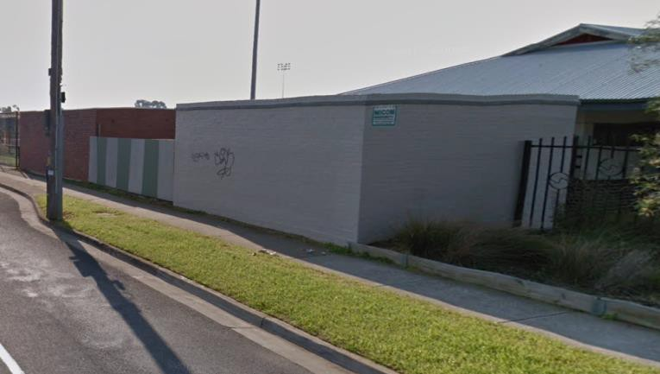
West Oval southern toilets

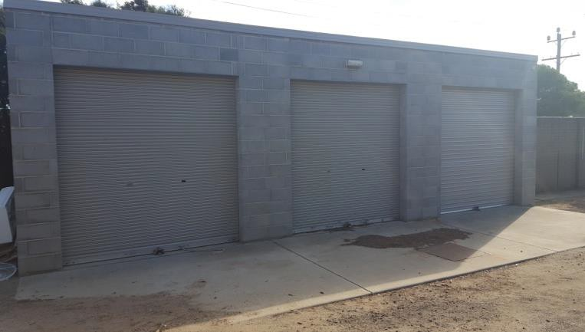
West Oval northern storage shed
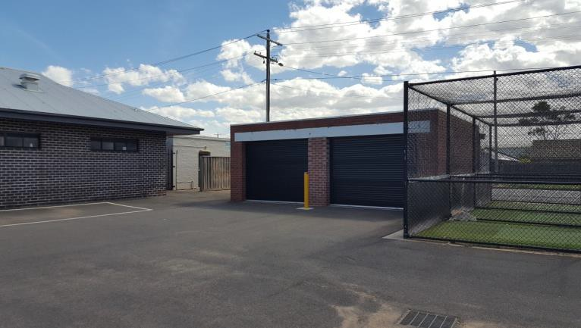
West Oval southern maintenance equipment shed
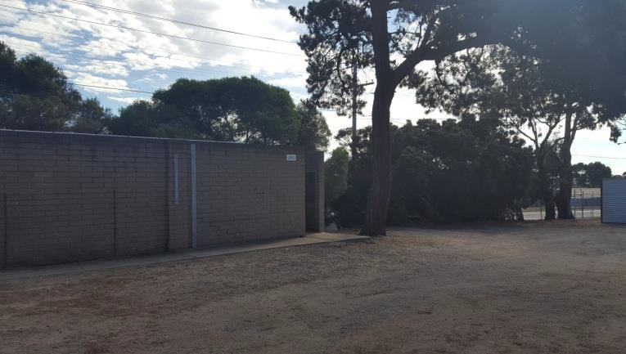
West Oval northern toilets

KIOSKS

Two small kiosks are located between the Geelong West Giants Football and Netball Club social rooms and the Geelong Cycling Clubrooms. These appear to provide for food / beverage and timekeepers functions. The structures, while stable, are not to the standard expected of such current facilities and should be integrated with any new buildings to be constructed on the site in the future.

    - West Oval Issues and Considerations for the Master Plan
      - The existing site layout includes a range of scattered buildings providing for training, change and social room functions, as well as a range of support buildings. A new building would present the opportunity to consolidate the functions of these buildings into a single structure.
      - All current football facilities fall short of the current AFL guidelines for local level facilities, and therefore also for regional level facilities;
      - Existing public toilets do not meet current DDA and BCA requirements;
      - the presence of the velodrome, and the subsequent relationship of the clubroom to it, means that compliant DDA access is not able to be achieved to this building;
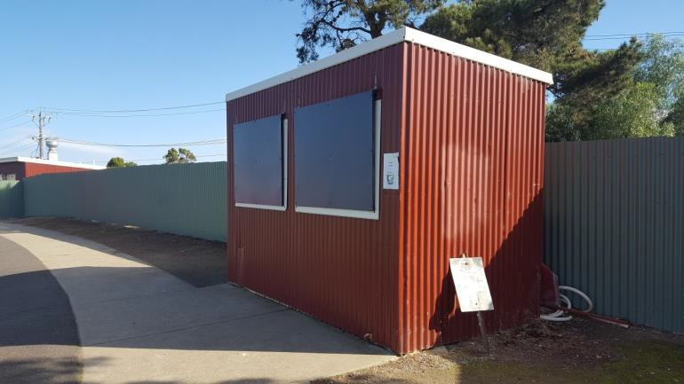
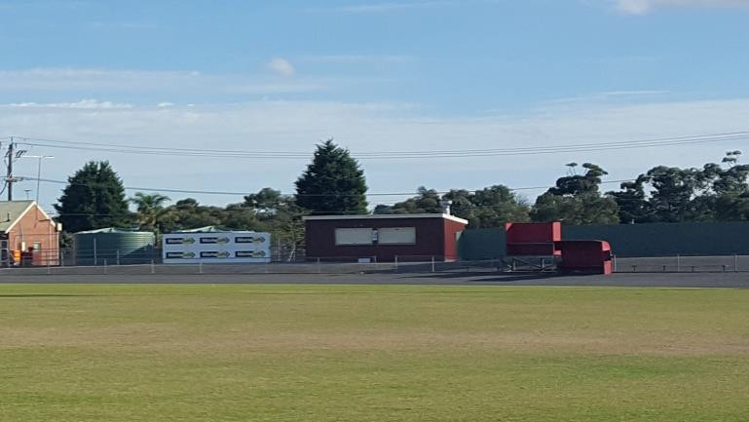

West Oval kiosks

3.3.5 Buildings and Structures at Bakers Oval BAKERS OVAL
There are four main buildings located at Bakers Oval

- Bakers Oval Pavilion
- Public Toilet
- Scout Hall
- Community Building

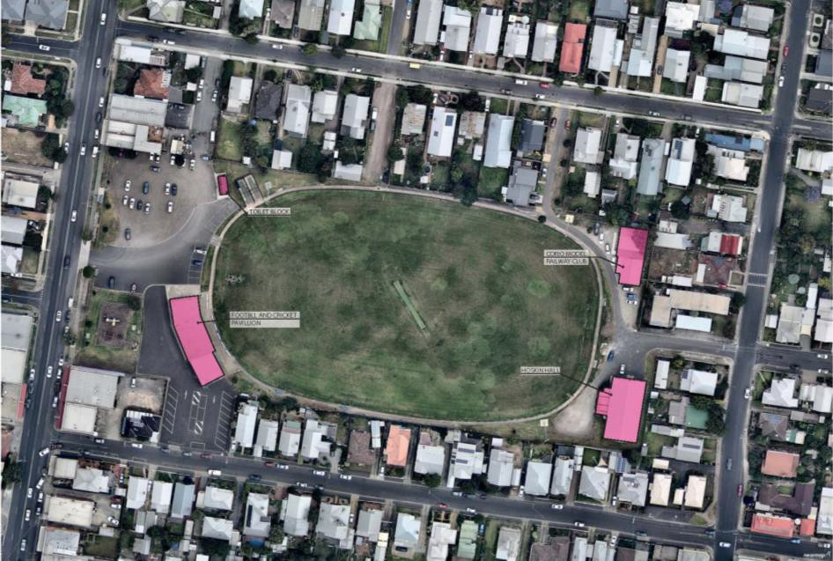

FIGURE 9: BAKERS OVAL BUILDINGS AND STRUCTURES (EXISTING) (NOT TO SCALE)

BAKERS OVAL MAIN CLUB ROOM FACILITIES

Review of the existing Bakers Oval pavilion reveals the following:

- The building is quite old and has not been updated for some time. Nevertheless, its shell is in reasonable physical condition.
- The existing change rooms and amenities do not align with the requirements for a local level facility within the AFL preferred facility guidelines, and do not comply with DDA and BCA requirements.
- Secondary spaces such as first aid and timekeepers’ rooms do not align with the requirements for a local level facility within the AFL preferred facility guidelines.
- The social space aligns with the requirements of a local level facility.
- Umpires’ change rooms are not present.

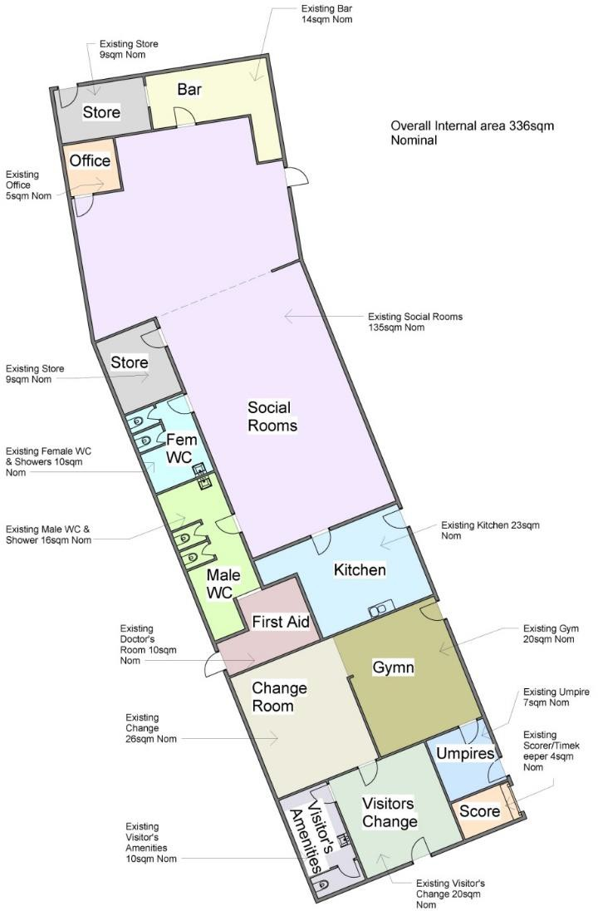

FIGURE 10: BAKERS OVAL CLUB ROOM FACILITIES (NOT TO SCALE)

    - Bakers Oval Issues and Considerations for the Regional Facility Development Plan
      - The current Bakers Oval club rooms can be modified to achieve the requirements of junior training facilities aligning with AFL community facility guidelines, through an addition of approximately 118m2.

Pedestrian Access and Circulation
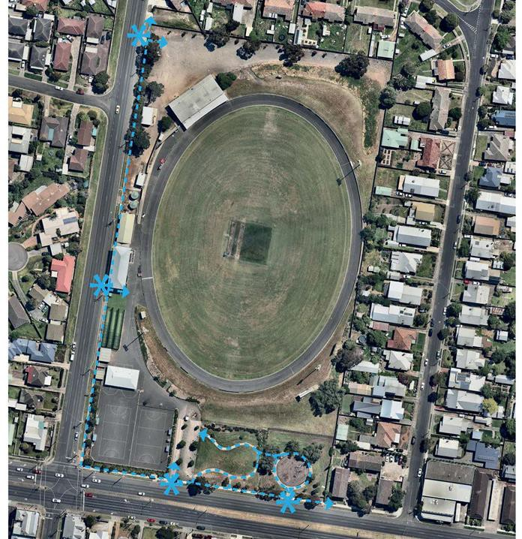
Key points associated with pedestrian movement at West Oval are summarised on Figure 13 below. These points include:

      - Formal pedestrian paths through the reserve are limited to a single path linking the southern car park off Church Street with the playground in the south-eastern corner of the site. Other than this, pedestrians moving across the reserve or between facilities utilise broad areas, either sealed or unsealed, which also serve as roadways and parking areas.
      - Both street frontages (Weddell Road and Church Street) have formal footpaths which connect with reserve entries.
      - The earth form around West Oval means that DDA compliant access to a number of key locations, such as the Geelong West Giants Football and Netball Club Social Rooms, external viewing areas between the Flowers Family Stand and the Social Rooms, and the majority of the edge of the oval, is not available.

FIGURE 11 -WEST OVAL PEDESTRIAN ACCESS AND CIRCULATION (NOT TO SCALE)


3.4.9 Pedestrian Access Issues and Considerations for the Regional Facility Development Plan
- There is limited opportunity to provide a formal pedestrian circulation system at West Oval, due to the size of the reserve and limited space around the main oval, however clear and defined pedestrian paths of travel, where possible, would be of benefit to pedestrian safety and amenity
- The provision of a formal circulation system would also suggest the opportunity for a new primary pedestrian entry into the reserve.

3.4.10 Vehicular Access and Car Parking

3.4.11 Vehicular Access and Car Parking Issues and Considerations for the Master Plan
- Change in the role of the reserve will mean that the existing amount of available parking space will be inadequate for demand.
- Formalisation of car parking to the north of the oval, integrated with drainage, will likely lead to more efficient and effective use of the parking area.
- The opportunity for new parking areas to meet increased demand is limited to and modification of some existing mounding to the north and south of the oval. The extent of this modification and the resultant capacity for parking may depend on the retention or removal of the existing velodrome.
- Additional formal parking in the existing parkland area on Church Street would lead to an unacceptable loss of parkland.
- With limited potential for new parking within the site, consideration of traffic management measures in neighbouring streets will be required on major event days;
- Investigation into off-site parking will need to be considered to cater for demand on major event days. This may include consideration of the Geelong Saleyards and their future use

Key points associated with pedestrian movement at West Oval are summarised on Figure 15 below. These points include:

WEST OVAL

- Formal vehicle access into the reserve occurs at two key points as indicated on Figure 9 – from Church Street, between the netball courts and the playground, and from Weddell Road, at the rear of the existing clubrooms.
- Sealed vehicle access is provided from Church Street. An asphalt roadway leads from this point to the north-western corner of the netball courts where the roadway becomes a broad paved space providing for vehicle and pedestrian circulation as well as limited parking.
- Unsealed access is provided from Weddell Road. This acts as the main vehicle access into the reserve and leads to a broad informal and unsealed parking area which extends to the north of the oval. This area is uneven and poorly drained.
- Car parking space across the reserve is limited. Defined parking on sealed areas accessed from Church Street is provided for 12 - 14.vehciels. Undefined parking in the north of the reserve is provided for approximately 60 -70 vehicles.
- There are no traffic management devices within the reserve, meaning that vehicle movement and parking is largely uncontrolled, allowing vehicles to park in a haphazard fashion, particularly in the north of the reserve.
Key points associated with pedestrian movement at Bakers Oval are summarised on Figure 16 below. These points include:

Consideration of these points leads to a number of issues and opportunities to be addressed in the plan.

FIGURE 12: WEST OVAL VEHICLE ACCESS AND CIRCULATION (NOT TO SCALE)
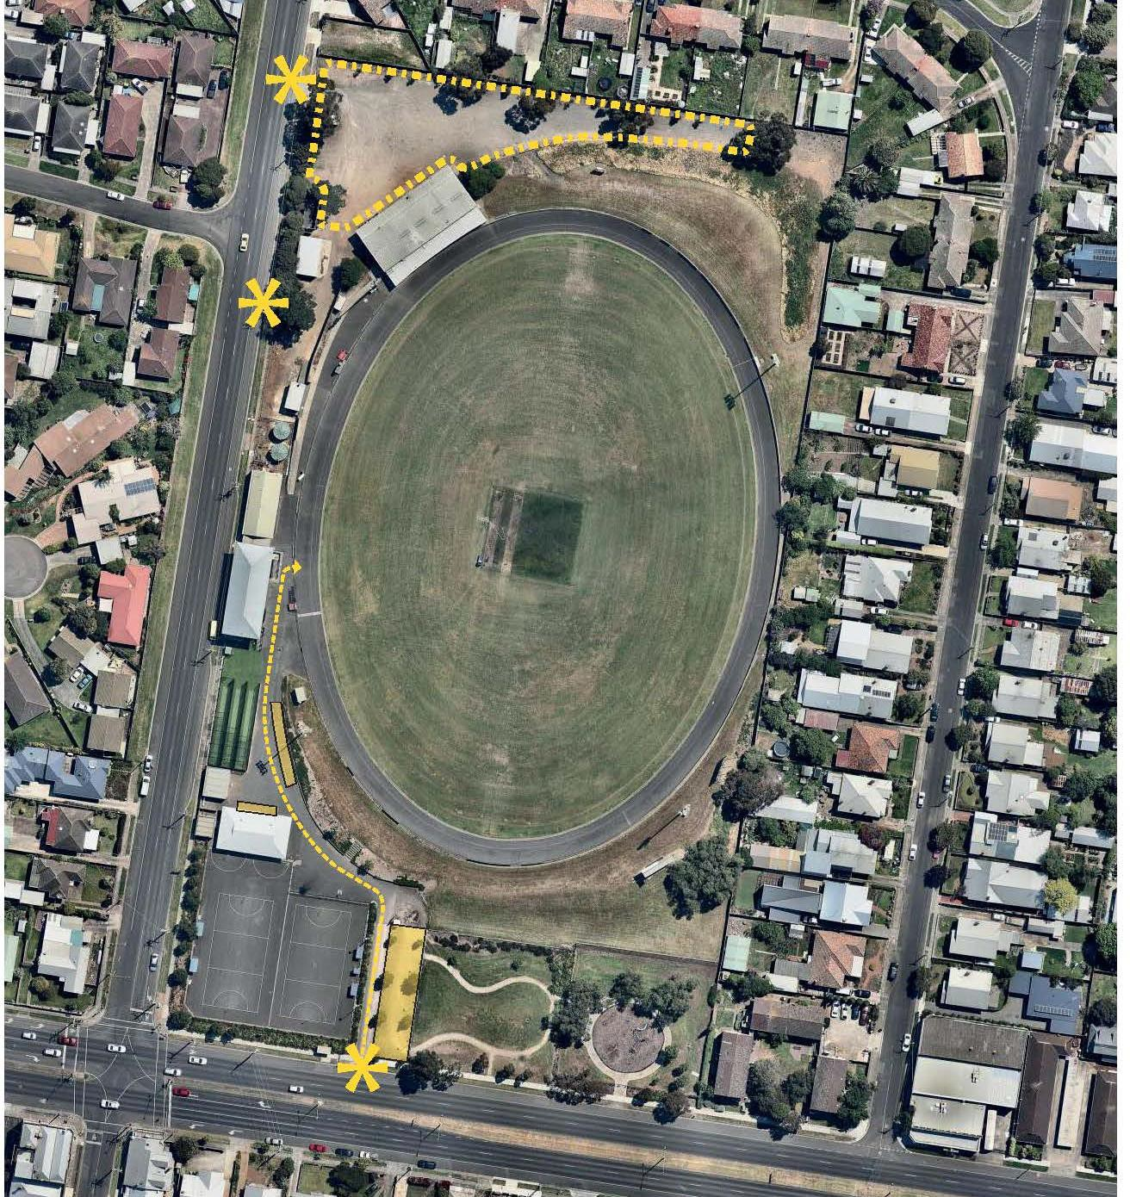

3.4.12 Landscape and Passive Recreation Areas

Key points arising from the review of the existing landscape and passive recreation areas of the reserve are summarised below. These points include:

WEST OVAL
- The reserve has little positive landscape character and amenity. Mature trees are limited to a number of Schinus molle (Peppercorn) which provide shade to the south-eastern playground. Other mature trees consist of a scattering of Eucalyptus spp. across the reserve.
- The southern playground is a pleasant space with seating, barbecues and open grassed “kick-about” area and a well-developed local playground. It provides amenity for the local neighbourhood and visitors to the reserve during sporting events.
- Apart from the playground area, there is no park furniture or amenities, such as seats, drinking fountains, shelters or bicycle racks across the reserve.

3.4.13 Landscape and Passive Recreation Issues and Considerations for the Master Plan
- There is some opportunity to re-define the visual landscape of each reserve in line with City of Greater Geelong strategic directions, given the extent of “soft” areas (such as the southern and northern grass mounds at West Oval) which have little or no existing tree planting.
- The potential to provide enhanced opportunities for passive recreation, outside of sports times, should be explored, in line with the objectives of City of Greater Geelong strategic documents. This would include enhanced opportunities for play, walking, seating, group socialising, picnicking and so on.

STAKEHOLDER CONSULTATION

Engagement Framework
Engagement with community and stakeholders to inform the issues and opportunities discussion paper has included the following tools and activities.

Promotion and Distribution

A postcard was distributed to just under 500 properties near the West Oval on Saturday 21st December 2017.The postcard included information about the project and a weblink to the survey. The survey was open for four-weeks and respondents were encouraged to submit their responses by the middle of January 2018.
 | Objectives | Activity
Engagement tool #1:  Postcard and online survey | The engagement objectives for this project are:  - To inform key stakeholders about the project  - To build an understanding of the general key issues and opportunities for existing club and park user who visit or use the reserve  - To test the opportunities and constraints of the site becoming a regional facility  - To understand where, within the site, improvements can be made. | A link to the online survey will be distributed through existing Council and club networks
Engagement tool #2: Interviews with key stakeholders | - To inform key stakeholders about the project  - To understand the breath of general issues and opportunities of stakeholders to inform the development of the Master Plan  - To build a deeper understanding of the key issues, opportunities and needs of existing clubs operating on the site.  - To understand where, within the site, improvements can be made. | Meetings / interviews will be undertaken by Land Design Partnership.

A copy of the distribution areas is outlined below:

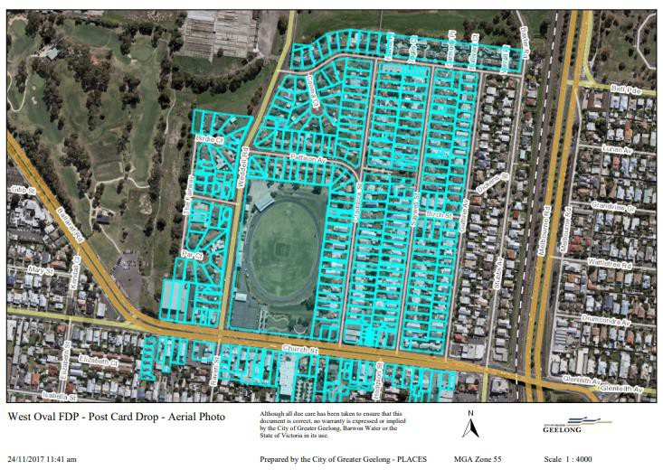

A Summary of Respondents

The survey was completed by 302 respondents.

The following tables outlines key information regarding respondent demographic profile.

Overall Summary

Overall, the survey was completed by 302 people (89 respondents did not complete every question) and there was a strong representation from clubs and sporting groups.
West Oval is popular, and respondents are generally happy with the quality of the park. Most respondents use the park to watch or play sport, exercise or walk their dog.
Completion Rate: | Respondent details | Household types
Complete 213 (70.5%) | Associated with a club-179 (69.1%) | Lone house 26 (10.1%)
Partial - 89 (29.5%) | Within walking distance of park- 88 (34%) | Group household – 24 (9.3%)
Totals: 302 respondents | Visitors- 35 (13.5%) | Couple- 154 (20.2%
 | Other-(8.1%) - detailed review of these peoples suggests most are visitors or people associated with the clubs (umpires) | Family 154 (59.7%)
 |  | Others included single parent and widow.

Most participants visit the park at least once a week with many visiting more regularly.
The fields and oval were the most important features of the park, with the club facilities rating second. The play spaces and walking paths were of least importance, most likely reflecting the strong representation of respondents connected to a club or sporting group.
Respondents valued the local nature of the park, thought it was clean and well maintained and enjoyed the amenity of the green spaces, trees and landscaping. Access to playing or spectating club-based sport was also highly valued.

Improvements
Updating club facilities and improved parking were popular requests for improvements. Other requests included improved amenities and landscaping within the reserve, maintaining the large trees and providing more rubbish bins, toilets, seating, shade, walking paths and lighting.
Age | Dog ownership | Visitation to West Oval
Under 18 years -30 (11.36 %) | No 38% | Yes, have visited 254 (96.6%)
Adults 18-59 years -206 (76.8 %) | Yes 62% | No- never visited - 9 (3.4 %)
Oder 60-84 years- 21 (8.1%)
Frail Aged 85 years – 1 (0.4%)

Some specific recommendations included diversifying the use and activities of the reserve, including an alternative open space to use while sport is being played. Some respondents want to see more non-sport activities in the park too- such as a farmer’s market, music concerts and general community events.
Many respondents saw the opportunities for improved landscaping, improvement to the play areas and the interface with the nearby public housing areas to increase safety and use of the area.
One respondent suggested additional childcare and space for indoor playgroups within the site. There was a comment about the need for more environmental design to be incorporated within the park (Water reuse/solar lighting).

Regional role of the facility
Most respondents acknowledged the economic and community benefits by providing more regional sporting events at the oval.
Overwhelming, most respondents are concerned and want to see parking and traffic management addressed before allowing more regional events to reduce the impact on their neighbourhood amenity. Others want to see improved lighting and local amenities (seating, toilets, shade, lighting) to ensure the environment remains safe and clean.

Summary of Responses

A summary of engagement findings is provided below:

Q: Why do you visit West Oval?
Responses indicate that most people use the reserve for formal sporting activities, walking their dog or local exercise.
The “other” responses predominately included activities relating to “watching or spectating sport”, which reflects the high number of respondents associated with the clubs. Other activities included watching children play sport (with a club or practicing) and bike riding.

Q: How often do you visit the oval?
Responses indicate that most participants visit the park regularly with 65.3% of respondents visiting either once to a few times a week. This suggests that respondents use the park for a range of activities, from watching sport to walking to more informal recreation.

Q: What features do you value most in the park?
The fields and oval were the most important feature of the park, with the club facilities rating second. The play spaces and walking paths were of least importance.

Q: What do you like about the reserve?
The club facilities and spaces are important features. Participants also commented on the love of trees, open space and opportunities for physical activities.

Q: What are your top priorities for the reserve?
Updating club facilities and improved parking were popular responses. The general amenity of the space was also important with many people commenting on the need for improved seating, toilets and paths.
Some specific recommendations included diversifying the use and activities of the precinct and including an alternative space to use while sport is being played. Some respondents want to see more non-sport activities in the park too- such as famers market, music concerts, community events. Others saw the opportunity to improve the play area and landscaping and the design and integration with the nearby public housing development.

Q: What do you see are the benefits of increasing the capacity of West Oval to allow it to host larger, regional sporting events?
Most participants saw the benefits of increasing the capacity of West Oval to provide more regional events. Parking and traffic management a concern and some residents requested more information to understand the likely impact increased activities might have on their home. Some saw increase events as offering an asset to the wider community, maximising the utilisation and economic and social benefit for the clubs.

Q: What limitations/issues would need to be addressed in order to hold larger, regional events at this reserve?
Overwhelming, most respondents are concerned with and want to see parking and traffic management addressed before allowing more regional events. Others want to see improved lighting and amenities to ensure the environment remains safe and clean.

Q: What is missing or what is the main reason you don’t visit the reserve and what would attract you to this park more often?
Only a small proportion of respondents (3 respondents) were people who currently don’t visit the park, resulting in a very small sample size. The responses suggest that the oval is not used because it doesn’t offer the sports people want to participate in. Providing more information about areas suitable for dog walking and access to a reasonably priced gym were other factors that might attract more people to the park in the future.

    - Community / Residents Issues and Considerations for the Master Plan
Key issues and opportunities arising from the community survey are summarised below:
      - Club members were focussed on upgrades to the existing club facilities;
      - Club members were focussed on maintaining or improving the quality of sport facilities, particularly the playing field at West Oval;
      - Provision of adequate car parking with a good quality surface is an important issue;
      - The local community desire some diversity in use at the reserve to incorporate a wider range of activities and spaces;

Tenant Club Interviews

Representatives from tenanting sporting clubs formed the Project Reference Group for the West Oval Master Plan to provide input, direction and feedback. The initial meeting of the Project Reference Group was held in December 2017 to discuss issues and opportunities as presented by the existing site conditions and use, particularly at West Oval. The following summarises the comments provided by each tenant club.

Geelong West Cricket Club (GWCC)

Needs
      - GWCC are comfortable with their access arrangements to the current facility (being the cycling club rooms) over the summer season.
      - Current playing surface at West Oval is in good condition for cricket training and competition
      - Current hard wicket practice nets are in good condition following upgrade however run- up distances do not align with preferred guidelines for cricket facilities

Issues
      - GWCC would like to ensure that if there are multiple users of a new facility, that they would still be able to get equal access to the pavilion, particularly during their summer season.
      - Should the turf playing table be reduced to 6 or 7 wickets rather than the current size, this may have impacts on the level of maintenance that GWCC has to provide in order to achieve the desire playing quality of the wicket(s).

Aspirations
      - If space permits, GWCC would like the provision of turf training nets
      - If space permits, increased run up distance to practice nets to align with Cricket Australia Facility Guidelines.

Geelong West Giants Football Netball Club (Netball) Needs
- Current court provision is not enough for growing membership

Issues
- Current courts are close to capacity in terms of usage

Aspirations
- GWGFNC would like to provision of an additional netball court (or two) if space permits
- If entrance was moved to Weddell Rd, there may be potential to utilize part of current entrance for provision of additional court if feasible
- Possibility to include additional netball court at Bakers Oval if feasible

Geelong West Giants Football Netball Club (GWG) - Football Needs
- The joint venture of the two senior football clubs to form the Geelong West Giants is tracking well with membership steadily increasing
- Due to high numbers of membership, due to both the joint venture and increased new membership (including a high percentage of women), there is pressure on the facility, particularly club rooms, to adequately serve this growth
- Following the joint venture, games are being played at the facility every weekend, as opposed to every other weekend at other venues.
- Bakers Oval is being primarily used for training and for juniors
- Proposed new facility must be compliant for female football

Issues
  - West Oval is seeing greater hours of usage following the joint venture and increased membership and would continue to grow if the regional facility is realized.
  - Increased usage would also need to be managed appropriately to minimize wear on ground
  - Current change facilities at West Oval, particularly within the main club rooms, are outdated, not suitable for females, lacking appropriate accessibility compliance.
  - Club requires suitable change facilities to support growing participation along with existing large participation
  - Current social facility at West Oval is not big enough to cater for current Thursday night meals

Aspirations
  - GWG would like to see Bakers Oval used as a junior hub
  - Given limited size of the existing social facility at West Oval, GWG would like to see this increased with, potentially, flexible change or meeting rooms which could be adapted to increase social space. They also see potential for a terrace to create provide for this via an increased indoor/outdoor space.
  - Gaelic Football also use Bakers Oval. Noted that COGG are currently installing sleeves at West Oval for Gaelic football goals
  - The Flowers Family Stand has good existing change facilities which GWG would like to retain

Geelong Cycling Club (GCC)

Needs
  - GCC currently trains on a Monday night with racing on Wednesday night
  - Current velodrome track is in good condition and connects to the heritage of the reserve
  - Would like to retain usage of velodrome in lieu of a velodrome at Belmont Island Criterium Track or identified suitable site
  - GCC understands that velodrome currently presents obstacles for the development of West Oval as a higher level events venue.

Issues
  - GCC has a long history at West Oval and would not want to forego use of facility if another velodrome option is not available

Aspirations
  - There is an alternate a home for GCC at the Belmont Island Criterium Track and so the need for facilities at West Oval is primarily storage and access to change facilities on training/racing days
  - Should an alternate location for the velodrome be found, GCC would only require the provision of an asphalt surface for the velodrome at that location

    - Tenant Club Issues and Considerations for the Master Plan
Key issues and opportunities arising from tenant club discussions are summarised below:
      - Current change amenities and associated club facilities are outdated, not suitable for females and not consistent with AFL preferred facility guidelines
      - Current facilities at West Oval are not adequate for a growing club which is a result from growing membership and the joint venture of two senior football clubs.
      - It would be desirable to provide cricket training nets which align with Cricket Australia guidelines;
      - The provision of additional netball courts would allow for future growth in membership and activity if feasible, otherwise possibility of additional netball court at Bakers Oval should be explored;
      - Any upgrade of AFL facilities must allow for female usage, particularly in terms of change rooms;
      - Additional social space for Football and Netball Club usage is desirable;
      - The existing Flowers Family Stand change rooms are seen as good despite not aligning with AFL regional facility guidelines;
      - The velodrome is a facility which is currently used and should either be retained or a new facility built elsewhere.

- RECOMMENDATIONS
Review of the Issues and Opportunities summarised above confirms the following key areas where improvements are required in order for West Oval to function as a regional AFL facility as envisaged by the G21 and AFL Barwon Regional Strategy.
- The provision of a new club and community building providing facilities and areas aligning with AFL regional facility guidelines;
- The relocation of the existing Geelong Cycling Club velodrome, once a viable alternate location is identified;
- The provision of additional formalised car parking to provide for enlarged spectator crowds in a regional facility context
- The provision of appropriate supporting infrastructure, such as coaches boxes, interchange areas etc as required by AFL regional facility guidelines, as well as enhanced seating opportunities for spectators of all sports;
- The provision of pedestrian access and circulation which is compliant with relevant DDA and Australian Standard requirements.
In addition, the development of West Oval will provide the impetus for a range of complementary improvements at both West Oval and Bakers Oval which will enhance community use of both facilities.
Design recommendations addressing both built facilities and site works were developed in response to the identified Issues and Opportunities. The development of these recommendations was reviewed and refined by both the Project Reference Group and the Project Control Group prior to finalisation.
Key recommendations are highlighted on Figure 13 and summarised in the sections following.

 FIGURE 13: KEY RECOMMENDATIONS : SITE PLAN (NOT TO SCALE) – REFER APPENDIX 1
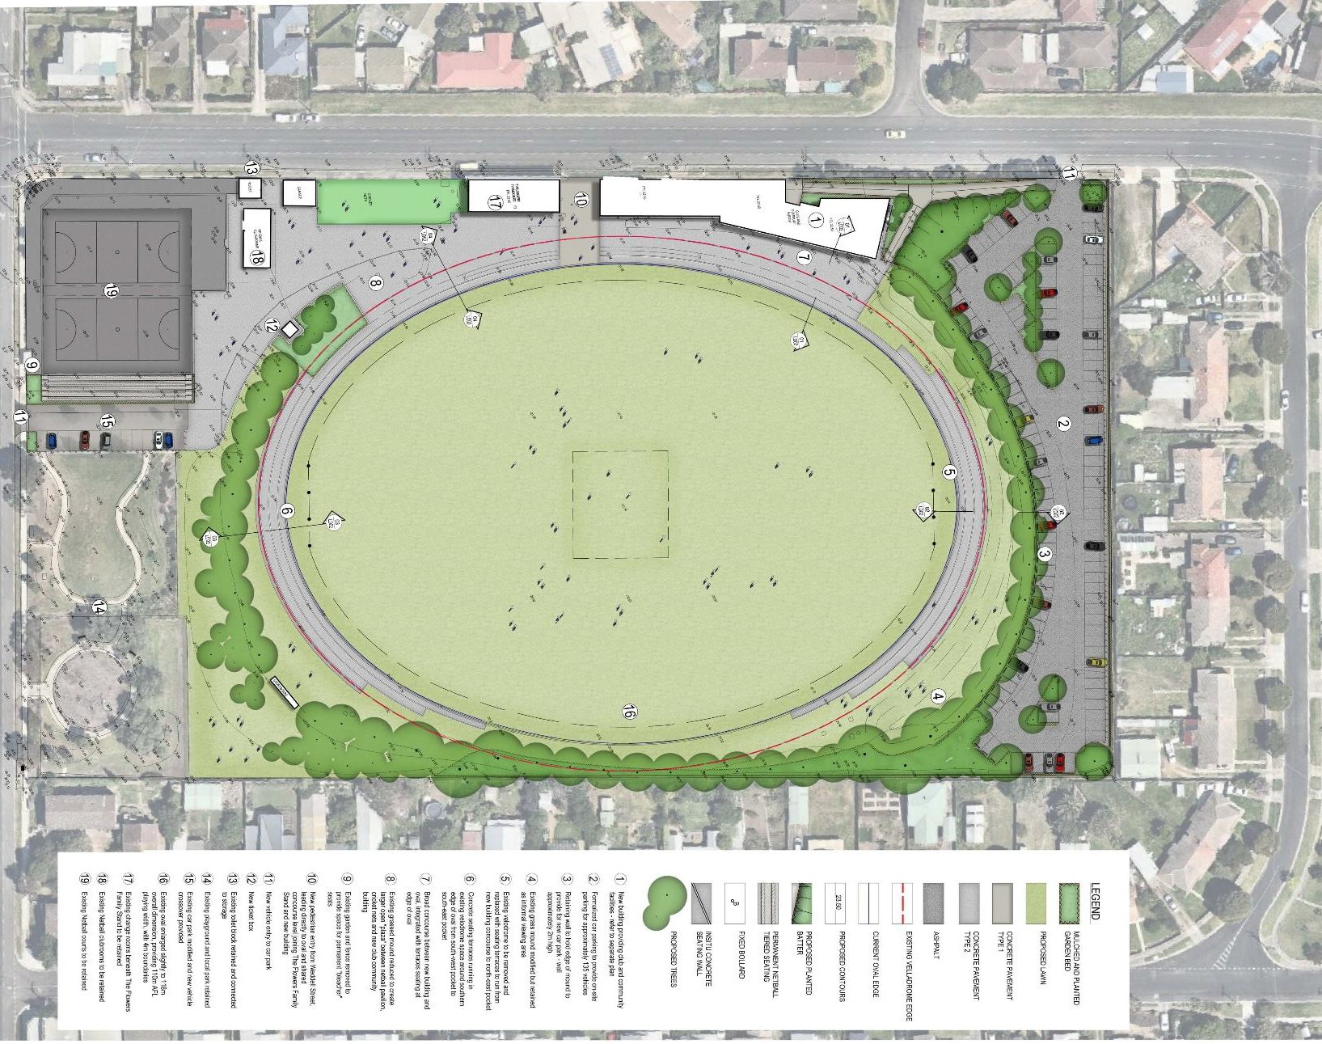

  - BUILDINGS

West Oval - New Club and Community Building

The new club and community building will replace a number of existing buildings which are either redundant or inadequate
These buildings include:
      - Existing Geelong West Giants club rooms
      - Existing Geelong Cycling Club rooms
      - Existing public toilets
      - Existing storage sheds
      - Existing kiosk
In place of these facilities, the new club and community building will be a two-storey facility providing:
      - Home and away change rooms, including accessible change rooms (aligning with AFL regional facility guidelines)
      - Home and away amenities (aligning with AFL regional facility guidelines)
      - Home and away address rooms (aligning with AFL regional facility guidelines)
      - Home and away game day and recovery rooms including strapping / first aid rooms, ice rooms (aligning with AFL regional facility guidelines)
      - Umpires change rooms (aligning with AFL regional facility guidelines)
      - Store rooms (aligning with AFL regional facility guidelines)
      - Social / function room (aligning with AFL regional facility guidelines)
      - Timekeepers room (aligning with AFL regional facility guidelines)
      - Kitchen, bar and kiosk (aligning with AFL regional facility guidelines)
      - Gym, suitable for player and club member use
      - Public toilets, including accessible toilets
      - Community and club meeting room
      - Flexible lobby space suitable for informal functions and meetings

Conceptual floor plans for both levels of the proposed building are shown in figure 14 A schedule of floor area for all rooms is indicated below and attached in Appendix 2.

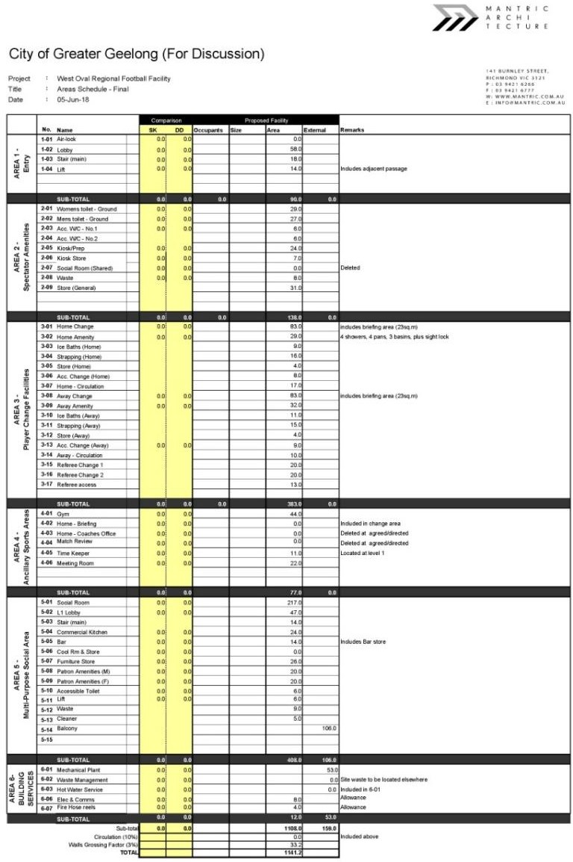
 FIGURE 14: AREA SCHEDULE – MULTIPURPOSE PAVILION – REFER APPENDIX 2

 FIGURE 15: CLUB AND COMMUNITY BUILDING: FLOOR PLAN (NOT TO SCALE) –

Refer to Appendix 3

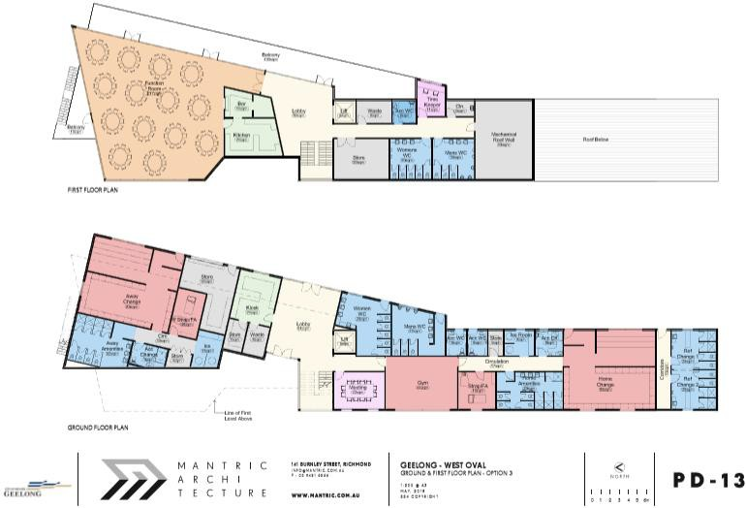

West Oval – Flower Family Stand

The space beneath the Flowers Family Stand currently; houses change rooms which have been recently upgraded in support of the local level of sport which currently occurs at West Oval. However, as summarised in the issues and opportunities above, these rooms do not align with AFL regional facility guidelines, which will instead be provided in the new Club and community building.
The existing change rooms will, however, be retained in their current arrangement as overflow or junior change rooms as required.

West Oval – Geelong West Giants netball clubrooms

The netball clubrooms are of recent construction and do not require renovation as part of the Master Plan.
While building upgrade is not required, the management of the clubroom toilets should be revised to provide open public toilets at appropriate times and during key events.

West Oval – Existing southern toilet block

The southern public toilet block, located on Weddell Street near the netball clubrooms, does not comply with current DDA and BCA requirements and will be upgraded as additional storage for reserve tenants.

4.4.5 Bakers Oval Pavilion

With the development of the club and community building at West Oval as outlined above, all regional facility requirements will be met at West Oval and will not be reliant upon Bakers Oval facilities.
In this regard, the existing Bakers Oval pavilion should be upgraded to provide facilities aligning with AFL community facility guidelines, particularly in relation to the provision of suitable change rooms. The re-design of the existing social space and some ancillary spaces may make this achievable within the current building footprint. This would be a future action and is not required to achieve a suitable regional facility at West Oval.

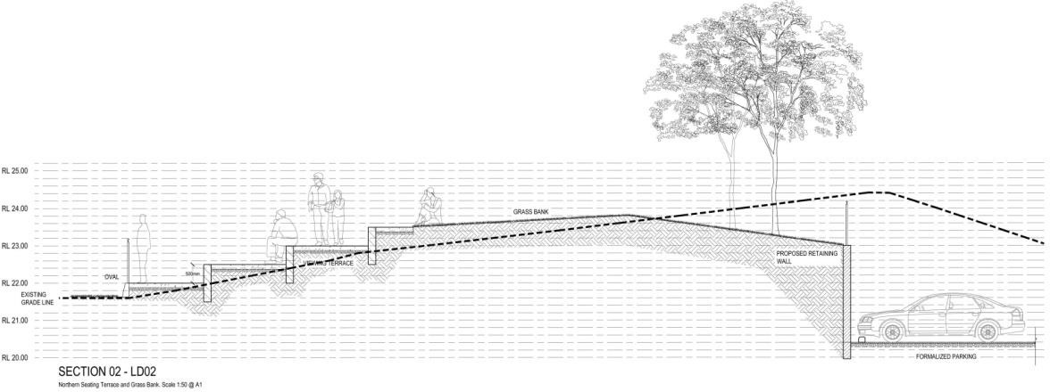
  - SPORTS FACILITIES

West Oval - Velodrome

As identified though the issues and opportunities phase, the velodrome presents a significant constraint upon the development and functioning of the site as a regional AFL venue, compromising play ability and spectator viewing and access from the club and community building to the oval playing surface.
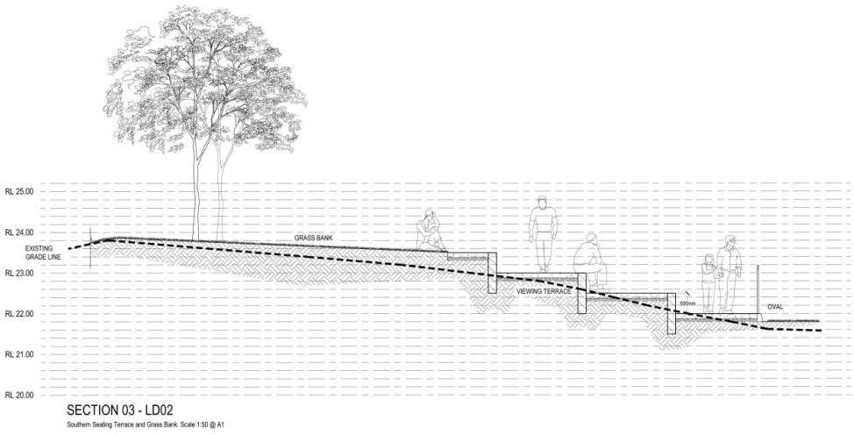
It is recommended therefore, that an alternate location for a new velodrome be identified and that the velodrome be relocated from the site once a suitable alternate location is found and developed, but that it be retained in the short term and the required regional facilities, particularly the club an community building be designed to reflect the current velodrome level and form. The current building floor plan and layout concept reflects these conditions.
Once the velodrome is relocated, it is recommended that that its current width and grade be used to form terraces to increase the seating capacity of the oval. In this way a formal spectator zone will be provided around the perimeter of the oval from the north-east pocket to the south-east pocket. The variable grade of the velodrome will allow for a comparatively flat zone on the west of the oval, in front of the Flowers Family Stand and the new club and community building and increased terraces at either end of the oval.
Sections showing terraces through the reconfigured velodrome space are included below.
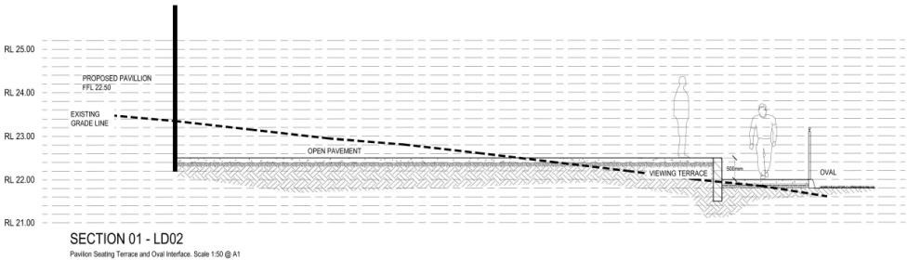
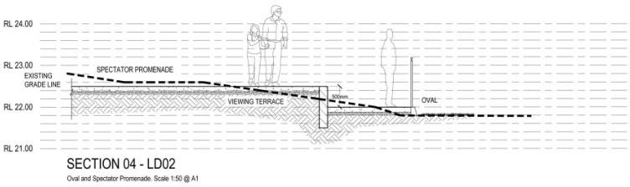

West Oval - Playing Field
With the retention of the velodrome in the short term, the size of the oval will be fixed.
Once the velodrome is relocated and the proposed spectator zone developed, it is recommended that the oval be widened marginally to provide an overall width of 118m, allowing for a 110m wide playing and 4m boundary zones, aligning with AFL regional facility guidelines.

West Oval - Netball Courts
It is recommended that the existing netball courts located in the south-east corner of the West Oval reserve be retained in their current configuration and condition, being compliant with currently required standards.
It is recognised, however, that spectator facilities are inadequate, and that temporary bleacher seating is provided to the north of the eastern court during finals matches. In response it is recommended that the existing driveway and garden bed to the west of the courts be reconfigured to provide for the installation of up to 5 rows of permanent bleacher seating.

West Oval - Support Infrastructure
With the development of West Oval as a regional AFL facility, it is recommended that a range of additional support infrastructure, required to align with AFL regional facility guidelines, be provided.
This infrastructure will include:
      - Two coaches boxes / interchange benches located on the western wing of the playing field, aligning with AFL regional facility guidelines;
      - One interchange steward / officials / umpires box located on the western wing of the playing field, aligning with AFL regional facility guidelines;
      - Oval perimeter fencing, 900mm high black chain mesh, allowing for a minimum 4m run- off zone between playing field boundary and fencing.
      - Upgraded scoreboard for high definition broadcast and enhanced spectator visibility;

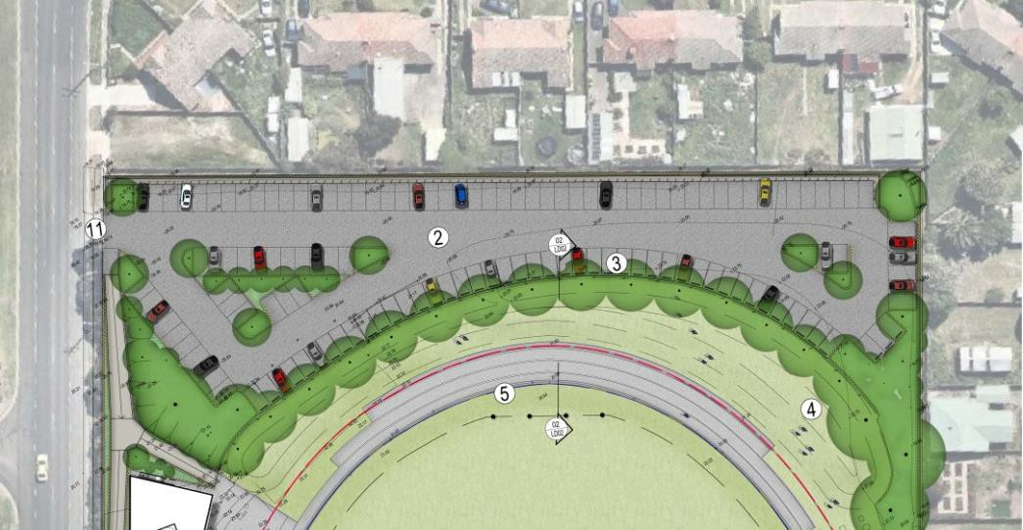
  - VEHICLE CIRCULATION AND PARKING

West Oval – Access
It is recommended that vehicle access at West Oval be limited to two points:
      - Entry from Weddell Road at the existing point near the north-west corner of the site. This will be the primary public access into the main car park.
      - Entry from Church Street relocated slightly to the east from the existing entry point. The existing entry will removed to allow for bleacher seating as described above. This new entry will provide access to the both the existing parkland / playspace, to the netball courts and to the oval for maintenance and management vehicles.

West Oval – Northern Car Park
It is anticipated that spectator crowds visiting West Oval for regional AFL finals, are likely to be in the order of 3,000 – 4,000, and that this level of visitation is likely to occur on 2 -3 occasions per year. It is expected that other regional competitions and events will attract additional events per year.
While it is recognised that the size of the site is insufficient to cater fully for the car parking generated by this level of visitation, it is recommended that the existing car park to the north of the site be expanded and formalised to optimise the site capacity for parking.
The existing car park would be enlarged by excavation into the northern side of the grass mound to the north of the oval, in order to provide a space adequate for two rows of parking and circulation space. The enlarged car park would be asphalt paved and line marked to make most efficient use of the increased space.
Note - Preliminary soil investigations have revealed low levels of soil contamination within the northern and southern mounds, it is anticipated that that rectification works associated with development on these areas will likely attract significant costs.
It is estimated that the existing unsealed car park holds in the order of 60 -70 vehicles. The enlarged and formalised car park is estimated to provide parking for around 135 vehicles.
As noted above, construction of the enlarged car park will require excavation into the northern grassed mounds. This will require removal / disposal of Category C contaminated soil to an approved site in accordance with EPA requirements. The volume of soil to be removed will be subject to detailed design of the car park.

West Oval – Southern Car Park
The existing southern car park of Church Street provides parking for 12 – 14 vehicles. It is recommended to be retained in its current form, with a new driveway as noted above. This car park will continue to primarily provide access for actual users of the reserve and netball players and spectators.
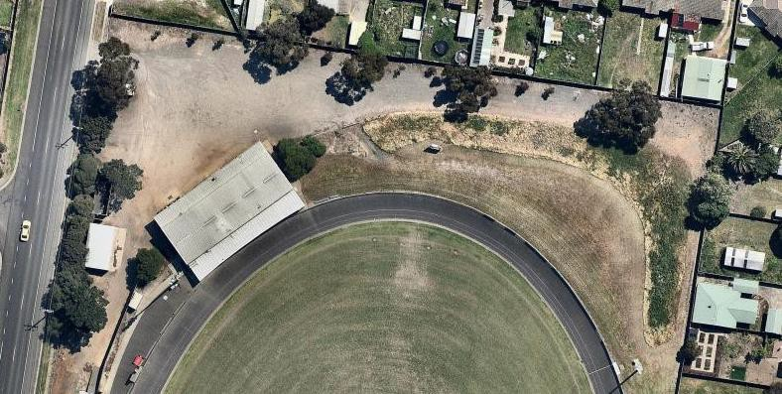

  - PEDESTRIAN SPACES

West Oval - Access
Pedestrian circulation in the context of a regional facility is primarily related to achieving access from the Weddell Road and Church Street frontage and from the enlarged northern car park.
Three pedestrian access points will be provided:
      - From Weddell Road in the north–western corner of the site, combined with the main vehicle entry
      - From Church Street in the south of the site, combined with vehicle entry
      - From Weddell Street between the Flowers Family Stand and the new club and community building, providing a dedicated pedestrian entry into the site, with direct views to the playing oval.

West Oval – Club and Community Building Access
The elevated nature of the proposed club and community building, resulting from meeting the levels of the existing velodrome, will necessitate a long sloping walkway from the northern entry to the new building.
This will be treated as a broad promenade, achieving required grades for all-abilities and providing for movement of groups of people. It will provide access to both eastern and western entry points into the proposed building and will be integrated with appropriate site furniture such as bins and seats. It will be treated as a positive urban element providing introduction into the site, and not simple as a path.

West Oval – Southern Access
Pedestrian access from Church Street will be provided via the same entry point as vehicles, onto a shared driveway. This will lead to the netball pavilion and from there to the broad plaza connecting the Flowers Family Stand and the club and community building.
Control of pedestrians during AFL finals times, where entry to football will be ticketed will be provided adjacent the north-eastern corner of the netball pavilion. A small ticket box and temporary fencing will be provided at this point to direct non-paying netball spectator toward the netball courts and paying football spectators to the north. Permanent fencing will extend from the ticket box to existing fencing along the northern edge of the local parkland to provide a security when required.

West Oval - Pedestrian Plaza
The proposed club and community building will be constructed at a similar floor level to the existing Flowers Family Stand, creating the potential for a single level pedestrian plaza space linking the netball pavilion, the Stand and the new building at a common level.
This will be a board and open space to provide for large groups of spectators, as well as providing the stage for marquees, food vans and temporary installations during key events and finals.
The new entry from Weddell Road will lead directly into this plaza space, and so will be the key point of ticketing for pedestrians.
The netball precinct, including the pavilion and courts, will be better integrated into the plaza, and will have stronger visual and physical connection with the Flowers Family Stand and the club and community building, through modification of existing mounding immediately east of the existing cricket nets.

West Oval – Soft Spaces.
In addition to the pedestrian plaza and the spectator terraces described above, grassed mounds will be retained to both the north and the south priding both for spectator viewing and for passive recreation during non-game days.
The southern local parkland and playspace will be retained as existing providing for both community use and supplementary passive activity during sports times.

POTENTIAL FINANCIAL IMPLICATIONS
Based on the recommendations and concepts outlined in the West Oval Master Plan the following costs estimates have been identified for the development of West Oval as a regional facility. Final cost estimates will be refined based on more detailed design following further community consultation.
- The preliminary estimate for total investment to deliver the West Oval Master Plan is up to $10M. A new club and community building, including pedestrian access, contingencies and fees represents the major component of the anticipated cost, estimated at $7M. The remaining supporting infrastructure and features make up the remaining $3M of expected works.
- An investment of $100K is allocated in Council’s 2018/19 Budget to undertake further detailed design and cost testing of the Plan.
- It is expected that the delivery of the West Oval Master Plan would be achieved via a funding partnership between the federal and state governments, state sporting bodies, local sporting clubs and City of Greater Geelong.

NEXT STEPS
Subject to Council endorsement of the West Oval Master Plan, the next phase of will be to undertake detailed design of the community pavilion through the $100,000 allocated in
Council’s 2018/19 Budget. Further funding for implementation of the Master Plan will be sought through a collaborative approach with Council, state and federal governments, beak bodies and tenanting sporting clubs. No further funding has been allocated at the time of writing this report.

APPENDIX
LIST OF APPENDICES

Appendix 1 – Key Recommendations Site Plan
Appendix 2 – Area Schedule for Club and Community Pavilion
Appendix 3 – Club and Community Building Floor Plan

Appendix 1 – Key Recommendations Site Plan
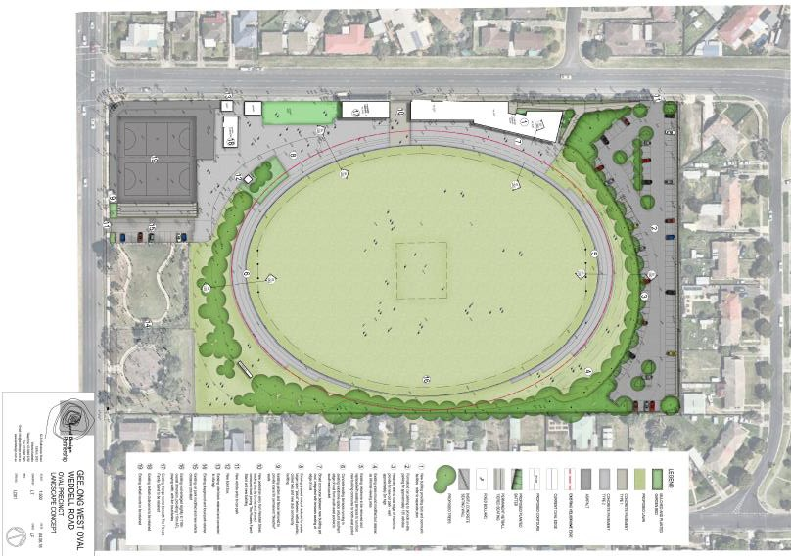

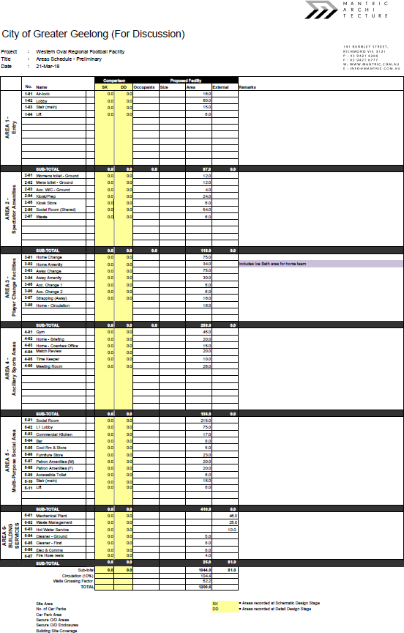
Appendix 2 – Area Schedule for Club and Community Pavilion

Appendix 3 – Club and Community Building Floor Plan

