HOW TO FIT A REUSABLE NAPPY

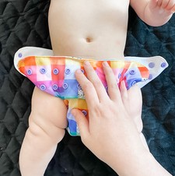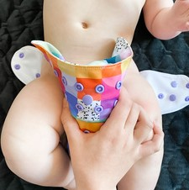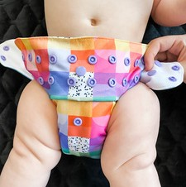

STEP 1
Lay bub on top of the nappy so that the back of the nappy is roughly in line with their belly button.
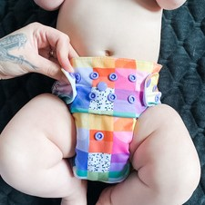

STEP 4
Repeat on other side. (Note: hip snaps are optional for chunkier babies!)
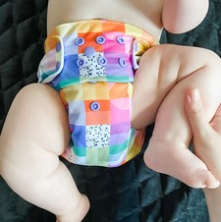

STEP 7
Leg elastics should be tucked into leg crease.

STEP 2
Squeeze the middle of the nappy as you fold it up and tuck the leg elastics into the leg crease
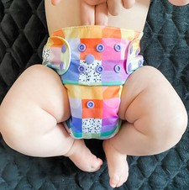

STEP 5
There should be a two finger gap between baby's belly and the top of the nappy.
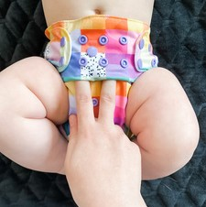

STEP 8
Tuck excess fabric at the rise snaps upwards towards belly button.

STEP 3
Pull the tab snug against the baby and hold in place as you fasten the hip and front snaps.
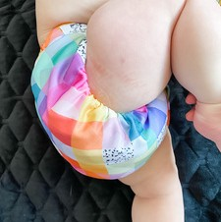

STEP 6

There should be no gaps at the legs. Run a finger around leg elastic to check.

TROUBLESHOOTING

I NEED HELP WITH ... | SOLUTION
Sagging at front | Pull nappy up higher at front, possibly go one rise setting bigger.  Go tighter on waist snaps if allows.
Leg gaps | Adjust to a smaller rise setting.
Sagging at the back | Pull nappy up further at back.  Change nappy more frequently if nappy is full and sagging down.
Leaking out tummy | Add more absorbency to front.
Leaking around legs | Check for leg gaps as above.  Otherwise add more absorbency to groin and/or change more frequently.
Red marks around leg elastics | Ensure leg elastics are tucked right up into leg crease.  Some red marks (sock marks) are normal but if it looks sore, try adding more absorbency, changing more frequently and using a barrier cream.
Teething poos | Poos are more frequent and acidic so change more frequently than usual.  Don't let bub sit in a poo, use a barrier and soothing cream.
For more fit tips and support go to www.clothandcrown.com.au

