Washing Guide

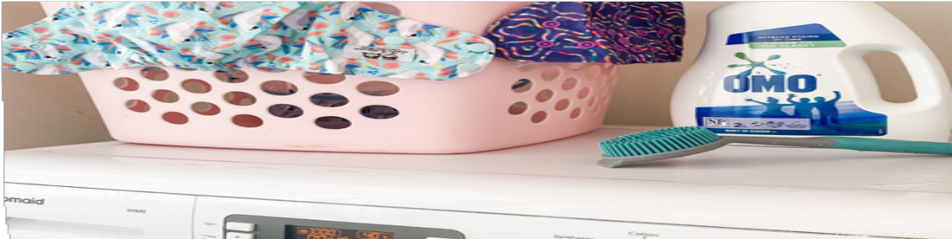1. Prepare
Tip solids into the toilet. Rinse with hot water and scrub any stains with stain remover/soap and a silicone scrub brush. Squeeze out excess liquid and store, uncovered, in a dry pail, ready for prewash

3. Main Wash
When there are enough nappies to fill machine 3/4 full (or alternatively fill out with other laundry such as baby clothes), put the load in for a long and hot wash (approx 60 degrees for 90- 120 minutes)

2. Prewash
Wash nappies in a 40 degree wash for approx 30-45 mins. Return to dry pail till ready for the main wash. Use detergent according to machine instructions. Avoid using bleach and softeners.

4. Dry
Dry nappy shells by hanging on clothes airer. Inserts can either be tumble dried on low heat or hung to dry. Avoid putting shells in direct sunlight.

WASH GUIDE | Pre Wash | Main Wash
Frequency | Daily | Every 2-3 days
Temperature | 40 - 60 degrees | 40 - 60 degrees
Cycle length | 30 - 45 minutes | 90 - 120 minutes
Detergent | Half dose | Full dose
Optional extras | Add booster (eg Napisan) or scrub with stain remover | None required
Load size | Any size | 3/4 full when wet
Purpose | Removes soiling | Cleans the nappy

