The City Of
Greater Geelong

Myers reserve

  - master plan – FINAL report
JULY 2023

We acknowledge the Traditional Custodians of the land, the Wadawurrung People of the Kulin Nations. We pay our respects to their Elders past and present and acknowledge all Aboriginal and Torres Strait Islander people who are part of the Greater Geelong community today.

Disclaimer: This Master Plan Report was prepared by an independent consultant in conjunction with the City of Greater Geelong. The Master Plan Report provides an overview of the context, need and community engagement methods undertaken which have helped to form the Draft Master Plan. This report is also subject to further consultation and consideration by the City.

The contents of this report are approved by the City of Greater Geelong, however, may require revision over time to reflect current council policy.

All illustrative plans, perspectives and imagery contained within this report are indicative artists’ impressions to illustrate conceptual ideas only and are subject to further resolution, consultation, detailed design, and approvals.
All images throughout this document have been credited where required.

The City of Greater Geelong wish to acknowledge contributions to this report made by the Project Reference Group, Project Control Group, Project Working Group, and the greater Geelong community.

© 2023 City of Greater Geelong
This document may only be used for the purpose for which it was commissioned and in accordance with the terms of engagement for the commissions.

Unauthorised use of this document in any form whatsoever is prohibited.

CONTENTS
EXECUTIVE SUMMARY 4
INTRODUCTION 5
1.1 Project Overview 5
1.2 Project Objectives 5
1.3 Project Methodology 5
1.4 Study Area 6
1.5 Facilities and Infrastructure 7
1.6 Master Plan Vision and Development Principles 11
1.6.1 Key Principles 11
1.6.2 Draft Vision 11
STRATEGIC CONTEXT 12
2.1 Literature Review 12
2.1.1 National Strategic Context 12
2.1.2 State-wide Strategic Context 12
2.1.3 Regional Strategic Context 14
2.1.4 Sport-Specific Strategies 15
2.2 Design Trends and Considerations 17
2.2.1 Universal Design 17
2.2.2 CPTED Principles 17
2.2.3 Gender Neutral Facilities 17
2.2.4 Environmentally Sustainable Design 17
2.2.5 Water Sensitive Urban Design 17
2.2.6 Northern and Western Geelong Growth Areas 17
2.3 Analysis of Previous Master Plan 18
2.4 Community Profile 19
2.5 Demographic Analysis 19
EXISTING CONDITIONS & SITE USAGE 21
3.1 Site Usage 21
3.2 Participation 21
3.3 Demand and Capacity Analysis 21
3.4 Existing Conditions 23
3.5 Fit-For-Purpose (FFP) Assessments 25
CONSULTATION SUMMARY 26
4.1 Consultation Overview 26
4.2 General Site Observations 26
4.3 User Groups 26
4.3.1 Australian Rules Football 26
4.3.2 Bowls 27
4.3.3 Cricket 27
4.3.4 Netball 27
4.3.5 Soccer 28
4.3.6 Covenant College 28
4.4 Community Consultation 29
4.4.1 Stage One Consultation Findings 29
4.4.2 Stage Two Consultation Findings 30
4.4.3 From Draft to Final Master Plan 30
4.5 Issues and Opportunities 32
MASTER PLAN 33
5.1 Master Plan Vision and Key Principles 33
5.1.1 Draft Master Plan Vision 33
5.1.2 Draft Key Principles 33
5.2 Master Plan Development 36
5.3 Key Recommendations 36
IMPLEMENTATION AND FUNDING 39
6.1 Cost Estimates 39
6.2 Funding Strategy 39
6.3 Implementation Plan 40
6.4 Council Resolution and Endorsement………………..41

EXECUTIVE SUMMARY
Project Context
The Myers Reserve Draft Master Plan provides an informed, consolidated and long-term approach to future infrastructure development across the site.
The need for the plan has arisen from stakeholders identifying specific constraints within the Reserve and the inability to meet their current and future sporting and recreation needs. Changing population demands, ageing facilities and exponential growth in female sports participation have also highlighted the need to review the 2005 Master Plan which is now more than 15 years old.
Planning Context
Myers Reserve is located within a strategically important planning area of Geelong which is expected to see significant population increases in the future. Bell Post Hill is forecast to see an additional 7,731 residents, a growth rate of 149% between 2021 and 2041.
The current capacity of Myers Reserve to meet the requirements of the existing sporting user groups will become a challenge in the future. The soccer fields and cricket fields are currently at capacity and likely to already be a significant constraint on:
- The ability for user groups to grow/cater for any additional community demand.
- The ability to maintain an appropriate playing surface condition without mandating reductions in weekly activity.
Key Issues
In addition to capacity constraints, the following issues with the broader site were also identified through the extensive consultation and analysis undertaken.
- Lack of adequate drainage infrastructure, which causes flooding across the Reserve and impacts utilisation.
- Poor traffic flow across the site and the location of the site entry causes safety issues.
- The pavilions do not meet modern standards and lack gender-neutral change facilities.
- Netball courts are non-compliant.
- Lack of storage across the site for all sports.
- Asbestos within the soccer pavilion/social rooms.
- The site is prone to vandalism and break-ins due to its location, poor passive surveillance and security.
Master Plan Principles
To address the key issues identified, the following principles were developed to guide the Master Plan approach.
 | Consolidate  Strengthen the heart of the site
 | Integrate  Clarify and integrate the key functional areas
 | Future Proof  Upgrade buildings to be fit-for-purpose and provide additional sporting fields
 | Amenity  Preserve and expand open space areas
 | Safety  Re-locate site entry and improve traffic flow
 | Align  Explore future connections into the Creamery Road Precinct Structure Plan
Master Plan Recommendations
The key recommendations for the Master Plan are outlined below.
- Relocate the site entry and develop a formalised road network to improve safety and traffic flow across the Reserve.
- Relocate the netball courts and install an additional multi-purpose half-court warm-up space for club and community use.
- Relocate bowls, install an additional green and a new pavilion to service the match day needs.
- Re-locate and construct new soccer pavilion to address safety concerns from the asbestos.
- Upgrade the existing cricket/AFL/netball pavilion.
- Re-construct the existing overflow oval into a compliant soccer pitch.
- Construct a new AFL/cricket oval.
- Develop a new district-level play space.

INTRODUCTION

1.1 Project Overview
The City of Greater Geelong engaged SBP Advisory to develop a Master Plan for Myers Reserve.
The Master Plan is a refresh of the 2005 Master Plan and provides a contemporary vision for the Reserve for the next 10 years.
The Plan provides an informed, consolidated and collaborative long-term approach to future infrastructure developments across the Reserve.

1.2 Project Objectives
The Master Plan and its development process were established to achieve the following objectives:
- An understanding of, and alignment with the changing population, demographics, emerging Needs and higher expectations of the community, as well as new/current Council plans and strategies.
- A contemporary and holistic approach to planning for future sport and recreation design including planning for people and place (i.e. gender-neutral provision, positive ageing and access for all abilities).
- Broader consideration of the role of the Reserve within the context of Northern and Western Geelong Growth Areas (NWGGA) planning and future development.
- Clear direction for the development and infrastructure needs at Myers Reserve that are realistic and within resource constraints.

1.3 Project Methodology
Stage 1 – Project Establishment
- Project inception meeting
- PRG and PWG Briefings
- Site inspections
Stage 2 – Site and Needs Analysis
- Audit of facilities
- Review of relevant strategic documents, data and reports
- Analysis of sports participation trends and impact on capacity of Reserve
- Identification of impacts of future population forecasts and demographics on capacity of Myers Reserve
- Development of Fit For Purpose (FFP) assessment framework
Stage 3 – Issues and Opportunities
- Consultation with PRG and PWG
- Community consultation
- Issues & Opportunities Report, including:
  - Strengths, Weaknesses, Opportunities and Challenges (SWOC) analysis
  - FFP assessments & future improvement recommendations
  - Recommendations on potential required land purchases
- PWG, PRG and PCG meetings
Stage 4 – Draft Master Plan
- Preparation of Landscape Plan and pavilion concept designs
- Cost estimates
- PRG, PWG and PCG briefings on Draft Master Plan
- Community consultation on Draft Master Plan
Stage 5 – Final Master Plan
- Preparation of Final Master Plan Report following City feedback process and review of community consultation for Council endorsement

INTRODUCTION

1.4 Study Area
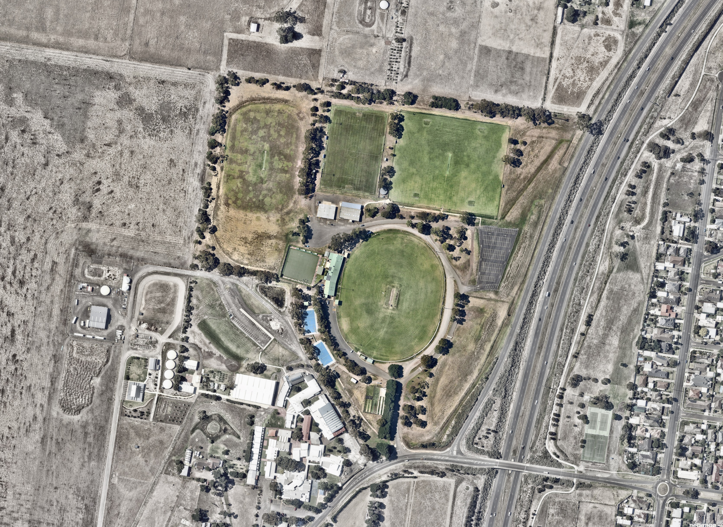

Myers Reserve is situated on Wadawurrung Country, at 125 Creamery Road, Bell Post Hill.
It is a large reserve, with a total area of 16.5 hectares, and is a key asset within the northern suburbs’ sport and recreation network.
The Reserve is located in what was traditionally a rural area, with most of the Reserve zoned as a Public Park and Recreation Zone (PPRZ).
The Reserve is also located within the Northern and Western Geelong Growth Areas (NWGGA) and will be placed under increased pressure and demand as the area develops over the next decade.

INTRODUCTION

Context and Location
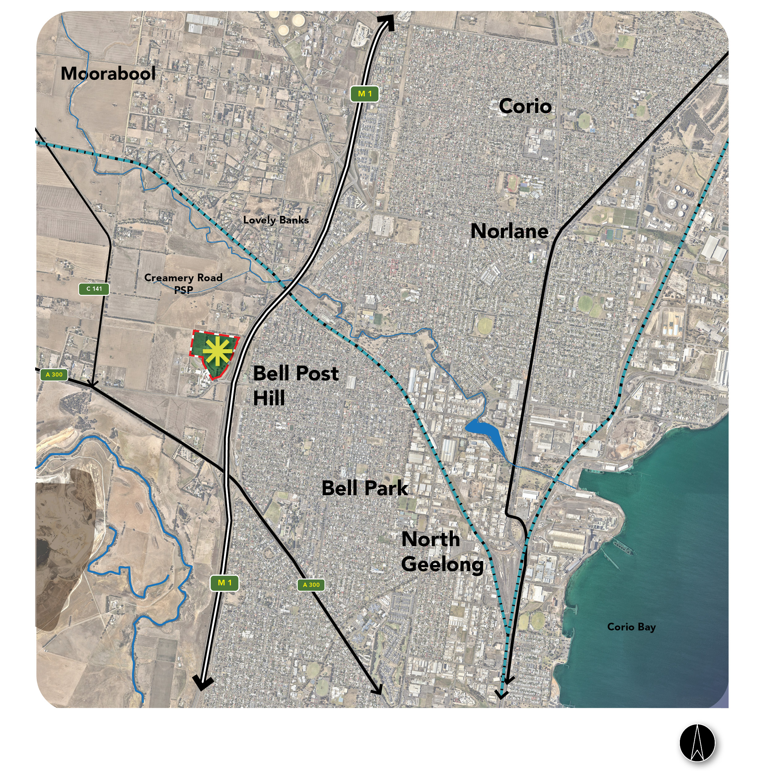

INTRODUCTION

Site Location and Proximity
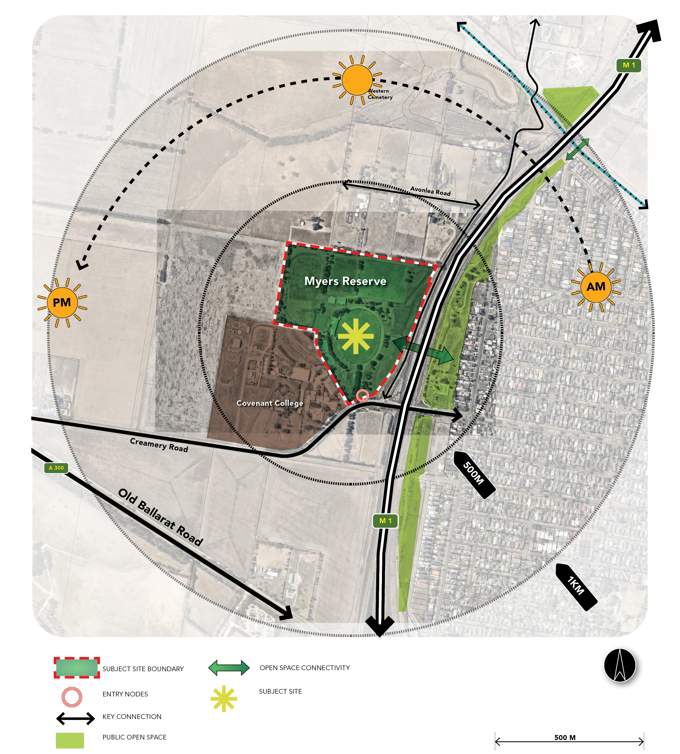

INTRODUCTION

Traffic
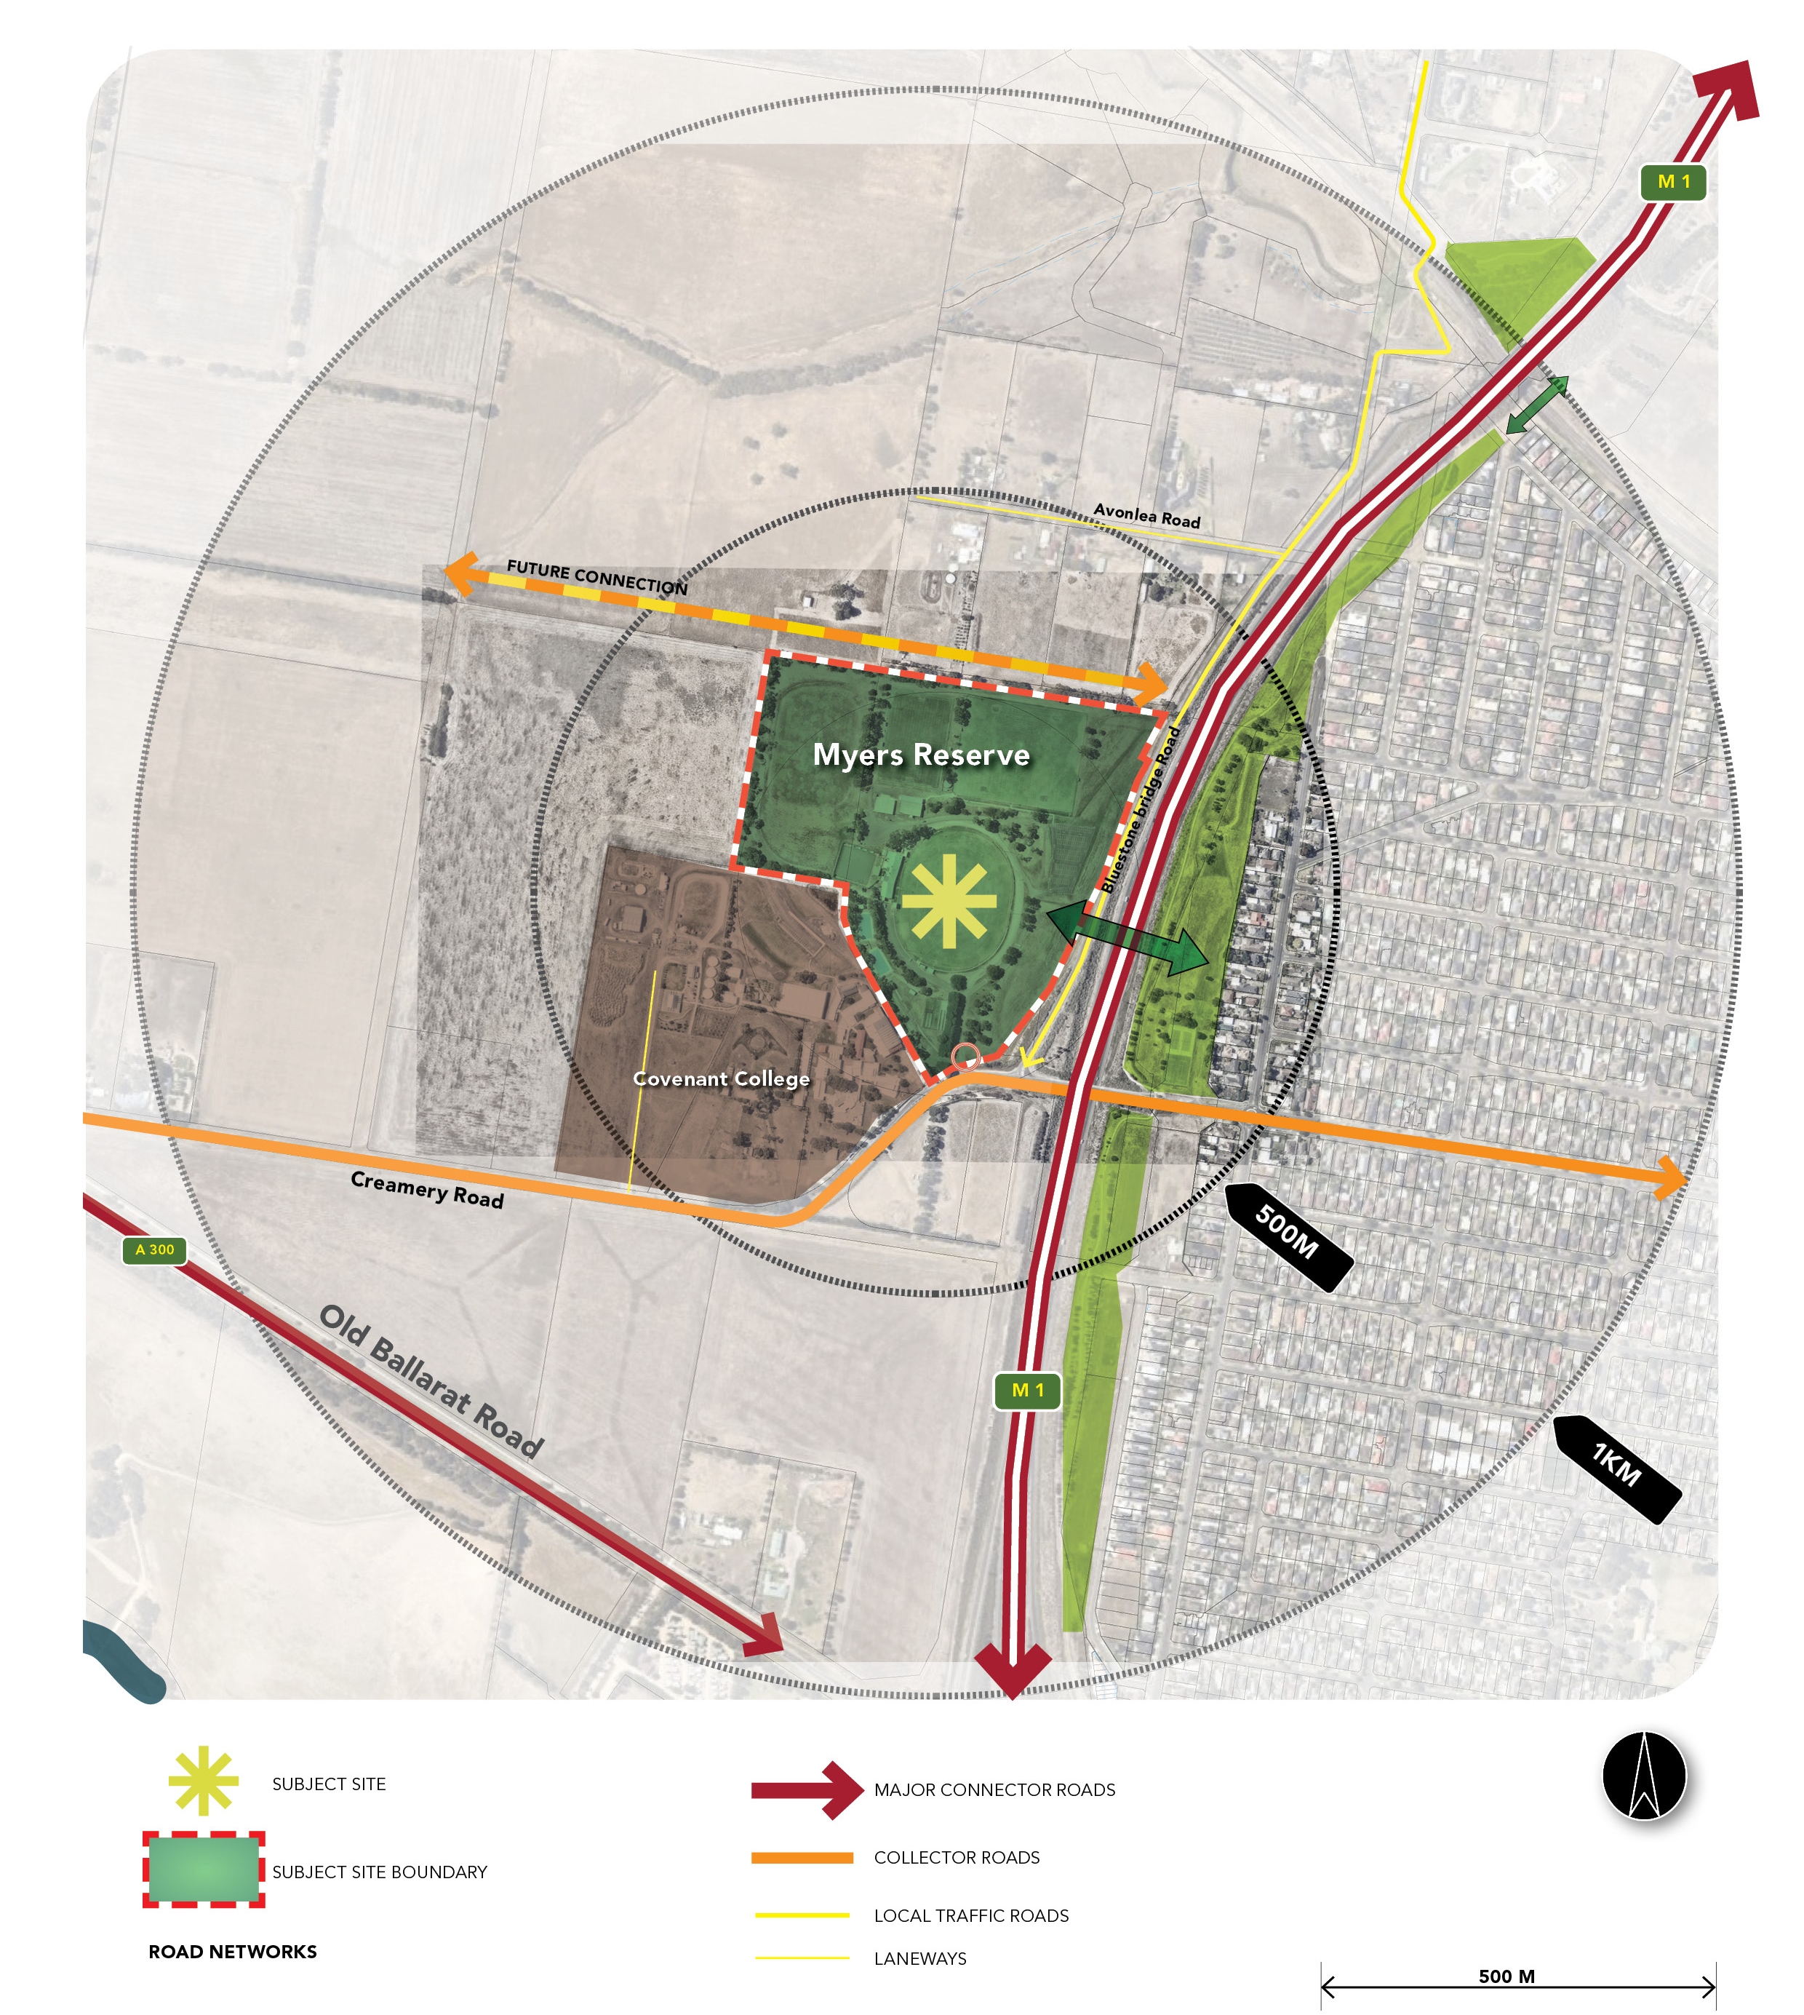

INTRODUCTION

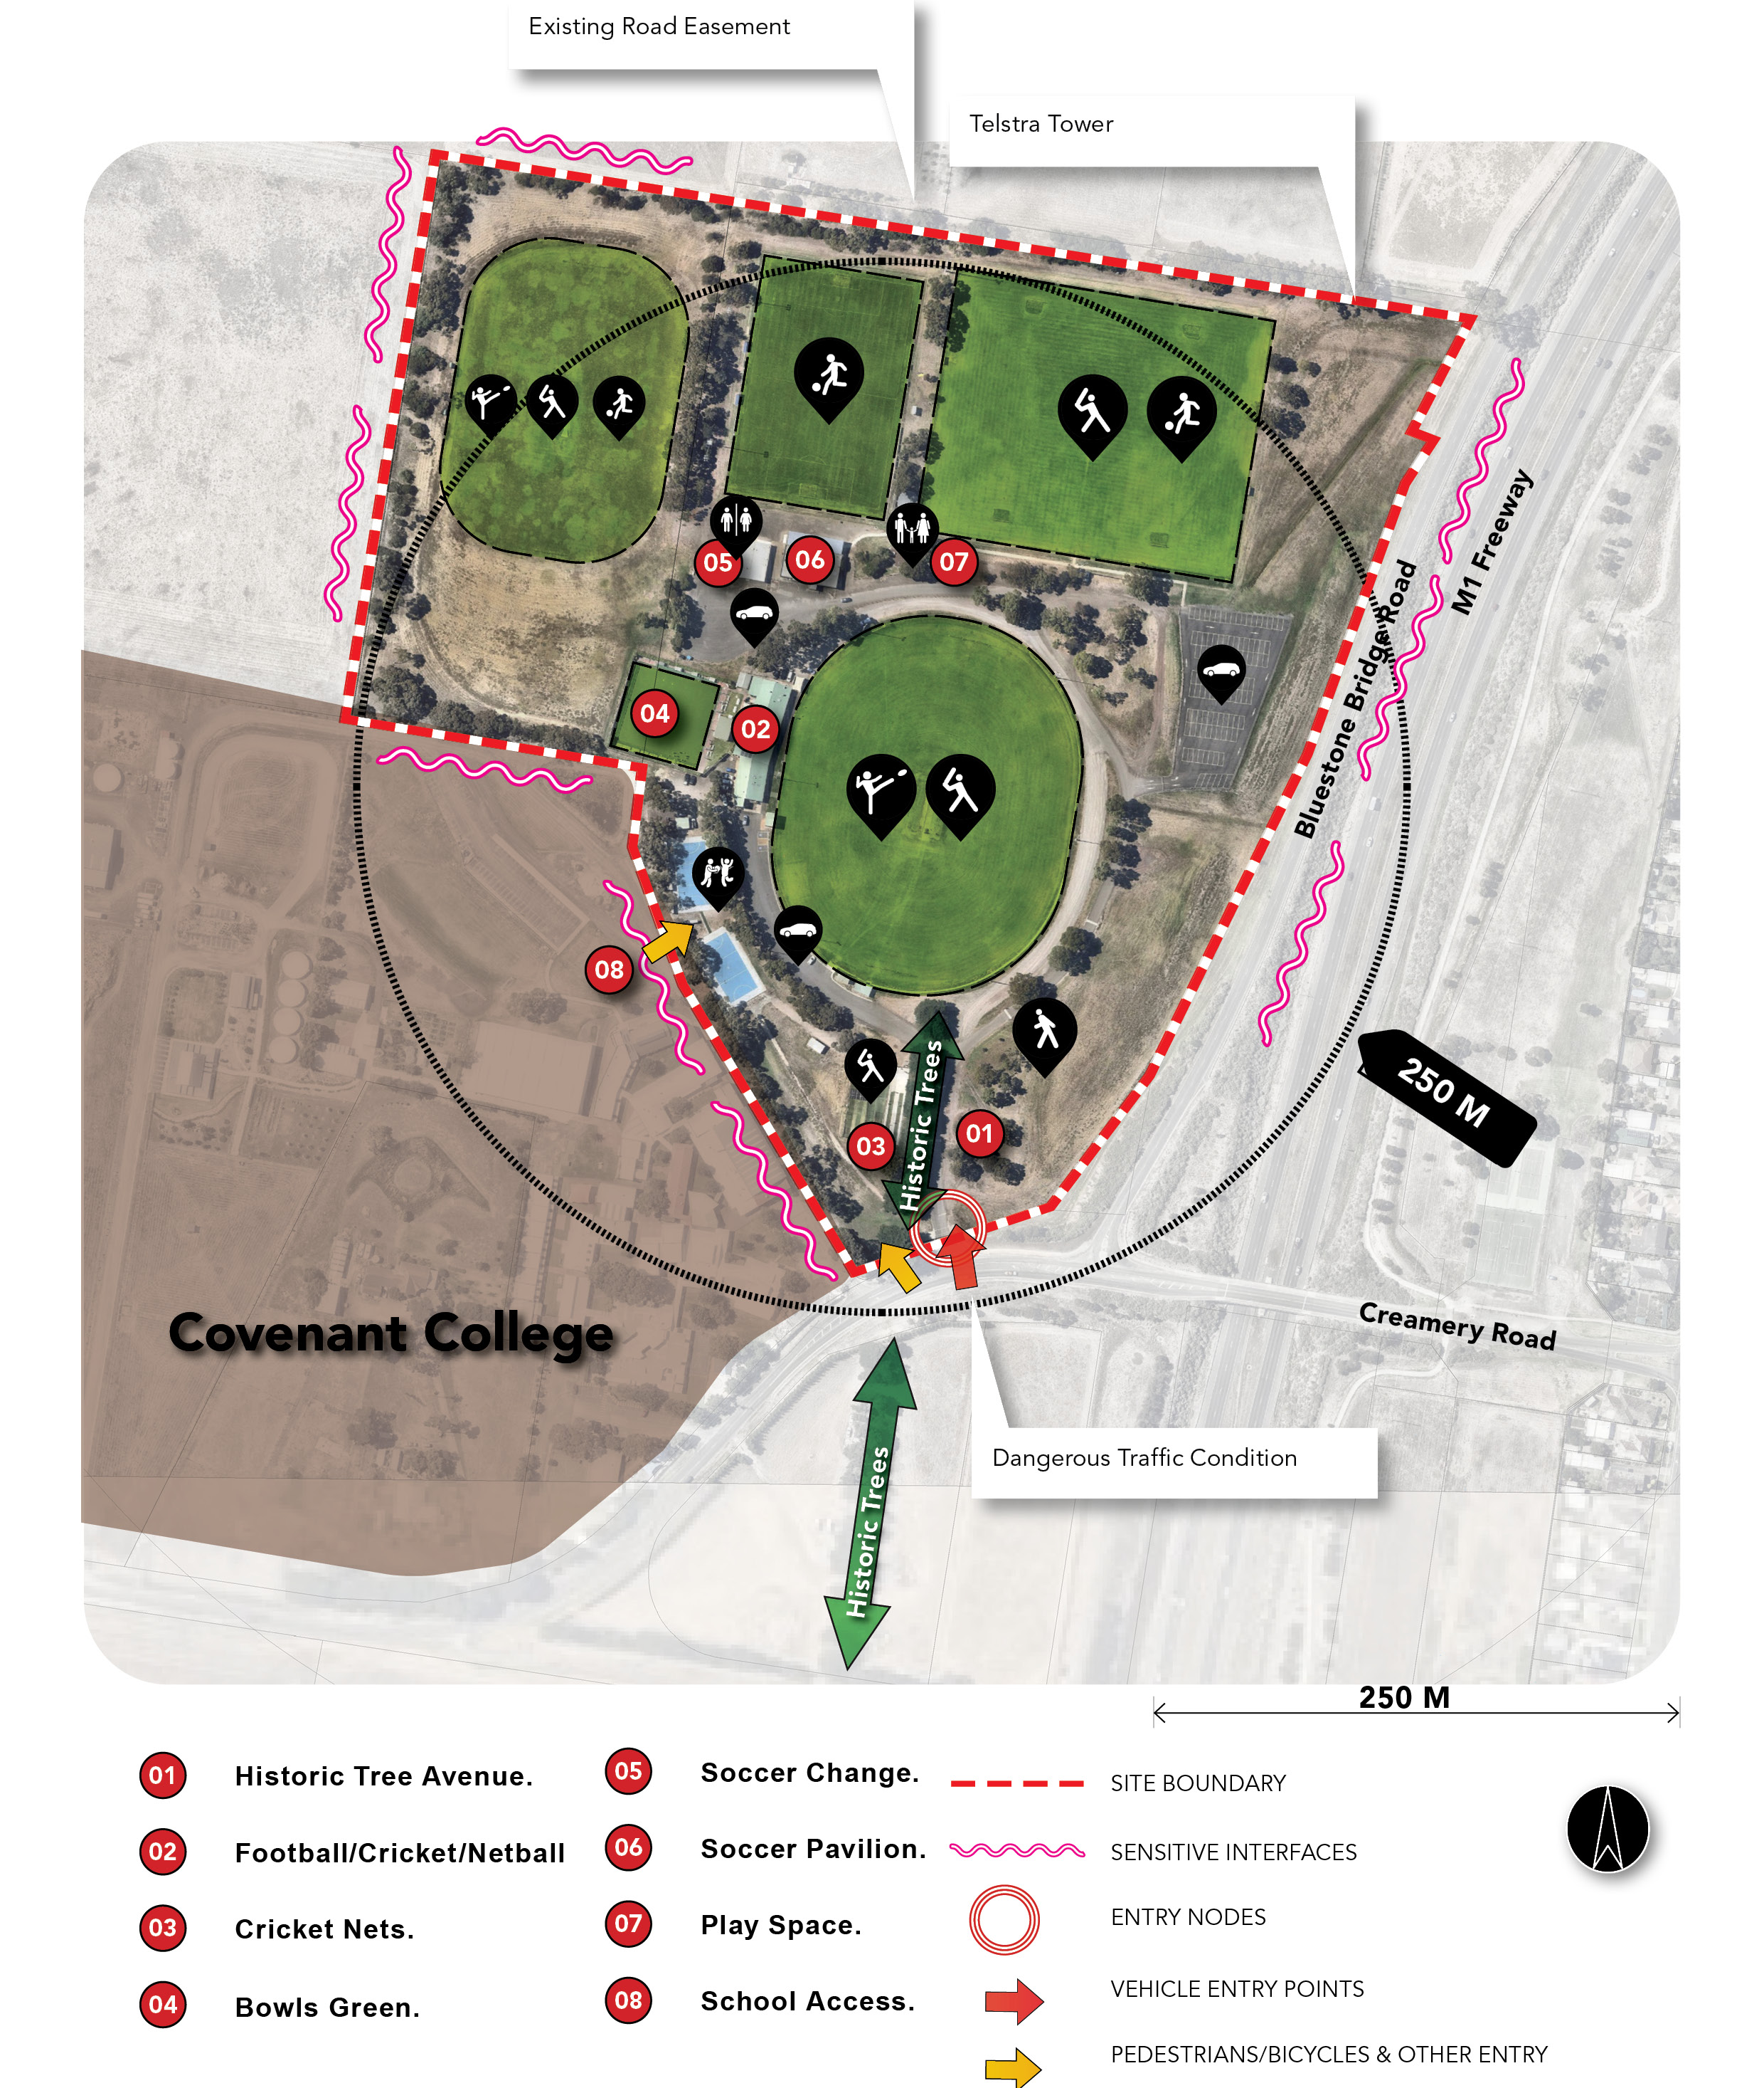
Existing Site

INTRODUCTION

1.5 Facilities and Infrastructure
Myers Reserve comprises the following key infrastructure elements:
- Heritage trees
- 2 x Cricket/Football fields, 2 x Netball courts with shared social rooms/change rooms
- Cricket practice nets
- 1 x Bowls green and social rooms
- 3 x Soccer fields and change rooms
- Soccer social rooms and public toilets
- Play space
- 2 x designated car parking areas
There is also a designated off leash dog area (the open space between the main oval and Bluestone Bridge Road).
Myers Reserve is classified as a Community Level 1 Active Open Space Reserve and provides a variety of functions for the community.
The two playgrounds within the Reserve are also classified as Local Level.

1.6 Master Plan Vision and Development Principles

1.6.1 Key Principles
The following key principles have been drafted to assist in guiding the development of the Master Plan.

Consolidate
Strengthen the heart of the site
Integrate
Clarify and integrate the key functional areas
Future Proof
Upgrade buildings to be fit-for-purpose and provide additional sporting fields
Amenity
Preserve and expand open space areas
Safety
Re-locate site entry and improve traffic flow
Align
Explore future connections into the PSP

1.6.2 Draft Vision

“Myers Reserve is a community destination for sport, leisure and social activities, offering high-quality and fit-for-purpose facilities for the whole community.”

STRATEGIC CONTEXT

2.1 Literature Review
A review of a several background documents and strategies was undertaken to provide a deeper understanding of the key strategic factors that have influenced the development of the Master Plan.

2.1.1 National Strategic Context
Sport Australia – Sport 2030
Sport 2030 is the Australian Sports Commission’s Plan to get Australians to move more and ensure the sports industry in Australia can again be a global leader and grow as a key contributor to our economy.
The Vision for the plan is to be the “most active and healthy sporting nation in the world” with a key focus on enhancing mass participation rather success at the elite level.
The plan has four key strategic pillars
- Participation – Building a More Active Australia: Enabling movement for life, with a focus on early childhood, and those over 65. Sport that is inclusive for all with a focus on the inactive.
- Performance – Achieving Sporting Excellence: Australia is no longer a world leader in high performance – international performance is in decline, and the role of the AIS has evolved. There will be a stronger focus on the mental health and wellbeing of athletes and establishing defined athlete pathways.
- Integrity – Safeguarding the Integrity of Sport: Strengthening anti-doping capabilities, capturing all sports betting in a regulated environment, minimising corruption in administration and improving participant safety and protection.
- Industry – Strengthening Our Sports Industry: Enhancing the governance of national, state and community sport organisations to drive commercial outcomes, reduce reliance on funding and increase autonomy and innovation.
In developing the Master Plan, the focus has been on ensuring the provision of high-quality sporting infrastructure that will facilitate life-long participation in sport and provide an environment for children to practice and progress their skills.

2.1.2 State-wide Strategic Context
Active Victoria 2017-2021
Active Victoria is the Victorian Government’s plan to strengthen the sport and recreation sector, boost participation and ensure every Victorian has the chance to be involved.
The Vision for the strategy is “A strong and connected sport and active recreation system that helps make Victorians healthier, creates economic growth and jobs, builds community cohesion and contributes to our liveability.”
The six strategic directions are outlined below:
- Meeting demand: Increasing capacity of facilities and infrastructure, increasing participation opportunities and innovative options.
- Broader and more inclusive participation: Operational structure of sport and active recreation, addressing racism, discrimination and harassment, increasing the participation of women in sport.
- Additional focus on active recreation: Engagement of health and mental health providers, school-based actions, planning for active recreation infrastructure.
- Build system resilience and capacity: Consistent system-wide data collection and sharing, supporting volunteers, participants and the workforce.
- Connect investment in events, high performance and infrastructure: Diverse events calendar, clear pathways to excellence between high performance and community sport, talent identification programs and athlete development.
- Work together for shared outcomes: Development of agreed priorities, complementary investment and coordinated action.
The Master Plan has been developed in consultation with tenants and user groups to ensure a collaborative approach that improves overall community outcomes.

STRATEGIC CONTEXT

DELWP – Protecting Victoria’s Environment – Biodiversity 2037
Biodiversity 2037 is the Victorian plan to stop the decline of the natural environment, and to implement and enforce practices which improve the overall quality of provision.
The strategy aims to encourage collaboration across government, business, communities, Traditional Owners, Aboriginal Victorians and private land owners to support the vision that “Victoria’s biodiversity is healthy, valued and actively cared for”. The two goals from this strategy are:
- Victorians value nature – Victorians understand that their personal wellbeing and the economic wellbeing of the state are dependent on the health of the natural environment.
- Victoria’s natural environment is healthy – Victoria has functioning plant and animal populations, improved habitats and resilient ecosystems, even under climate change.
These priorities all have a connection to the five influencing principles, which informed the development and implementation of the plan:
- Values – there is importance in the intrinsic value of other life forms and maintaining the connections and relationships between various systems to optimise prosperity across health, wellbeing and economy.
- Living systems – Adapting to the changing environment by protecting biodiversity in natural habitats.
- Sharing and collaborating – Engaging communities in the decision that affect them to align contributions to a common purpose.
- Knowledge – Share and use knowledge from a variety of sources to make sound decisions to fuel effective actions.
- Decision making – Use processes that are fair, transparent and consistent and consider risk and return of all interventions and changes.
One of the key principles of the Master Plan is to preserve and enhance the open space within the Reserve. This will assist in preserving the natural environment and enhance the environmental values of the site.

VicHealth – Physical Activity Strategy 2019-2023
The aim of VicHealth’s Physical Activity is to increase the number of Victorians who are physically active. The goal is to have 300,000 more Victorians engage in physical activity by 2023.
There are three key focus areas in the strategy: Children aged 5-12 years, young people aged 12-17 years and women and girls.
Children aged 5-12 years:
- Support a culture and environment that normalises active travel.
- Create more opportunities for children to play.
- Support the development of physical literacy.
- An active childhood can lay the foundations for an active life.
Young people aged 12-17 years:
- Develop more ways to play sport that are fun, social and local.
- Influence the design and use of public spaces for recreation.
- Support young people to be independently active and meaningfully involved in the design of their activity experiences.
- Physical activity and sport participation drop in adolescence.
Women and girls:
- Create and promote more tailored participation opportunities for women and girls.
- Raise the profile of women’s sport and physical activity and improve attitudes towards gender equality.
- Influence sporting environments to become more inclusive of women and girls
The Myers Reserve Master Plan has been developed with children, young people and women in mind. Recommended upgrades to the sporting pavilions to ensure they are gender-neutral and fit-for-purpose will assist in creating safe and welcoming environments for all. Expanding the sportsfields will enhance the carrying capacity of the Reserve and facilitate greater participation amongst all age brackets.

STRATEGIC CONTEXT

2.1.3 Regional Strategic Context

Social Infrastructure Planning and Investment Policy 2020 - City of Greater Geelong
The Social Infrastructure Planning and Investment Policy (SIP) aims to provide Council with a guide for prioritising investment decisions, as well as the community with a clear understanding of how decisions are made.
Council will plan and invest in infrastructure based on a clear set of principles and objectives to deliver on the commitment of ‘Putting our Community First’. The principles are consistent with all services and include:
- Equitable - Fair access to facilities and services that are needed across the municipality including healthy, safe and inclusive places and spaces.
- Accessible - Can be attained for all abilities and is easy for people to get to.
- Adaptable - Flexible to meet the changing needs of the community and can be used for more than one purpose.
- Integrated - Combined with other services where possible and provides a place for people to come together.
- Sustainable - Environmentally, fiscally, socially and culturally responsible, well designed, effectively managed and usage is optimised now and into the future.
The key principles identified in the SIP have been considered when developing the key principles for the Myers Reserve Master Plan.
Specific actions within the SIP relating to Myers Reserve include:
- Focus on connecting the paths throughout the network.
- Bell Post Hill is also identified as an area with high youth poverty rates, so ensuring the provision of quality sporting and active recreation infrastructure through the delivery of the Myers Reserve Master Plan will play a critical role in enhancing health and well-being outcomes.

Fair Play Strategy 2017- City of Greater Geelong
The Fair Play Strategy outlines the provision of sporting and recreational facilities in the City of Greater Geelong.
The management, maintenance and increasing costs of providing community assets plays a key part in the City’s capacity to meet community obligations, now and into the future.
The Fair Play Strategy provides a more strategic approach to managing its public property and assets, ensuring the local community gets the best value from a broad range of public facilities.
The document highlighted a range of issues and challenges for Council to address:
- Equity and transparency – The previous system of sports facility gradings was not well understood by sporting clubs or community groups. There is disparity and inequity in the provision, quality and access to recreation facilities across the municipality.
- Management of agreements/bookings - Blanket bookings were previously accepted, limiting opportunities for other groups or the community to access facilities. The existing fees and charges system was developed over 20 years ago (last updated in 1995) and does not reflect contemporary practices.
- Levels of service - The system does not reflect the current facility provision and levels of service for maintenance. The level of infrastructure provided at reserves has increased and asset management responsibilities have also increased accordingly.
Council will prioritise the funding of infrastructure that maximises participation, provides opportunities for Geelong residents to be more active and ensures long term sustainability.

STRATEGIC CONTEXT

Urban Forest Strategy 2015-2025 - City of Greater Geelong
The Urban Forest Strategy expands upon the concept of City in a Park (focused on the Geelong CBD), and aims to increase the population of trees across the City of Greater Geelong. This is known as the urban forest.
The strategy outlines an ambitious target of improving Geelong's tree canopy cover from 14% to 25% over a thirty year period. There are four simple objectives to incorporate into the City's day to day operations:
- To green the City: Increase tree planting and associated vegetation in appropriate and prioritised locations
- To cool the City: Increase canopy cover, increase use of smart water sensitive urban design and an increase in landscape permeability
- To engage the City's community and build regional partnerships: More community activities: tree planting, arts and culture activities, use of social media, working with partners to improve and enhance tree planting projects
- To demonstrate best practice urban tree management: Develop a complete set of technical guidelines for urban tree management and offer training and upskilling where needed
The prime opportunities are:
- 45,000 existing vacant nature strips in our streets
- Developing tree lined entrances to our city
- Revegetation of the Greenway, the Ted Wilson Bike Trail alongside the Geelong Ring Road
- Thousands of tree planting locations across Geelong's open space network
- Improving the quality of streetscapes and open space in urban growth areas
- Planting more indigenous trees in wetland reserves and conservation areas
- Rejuvenating and renewing avenues and boulevards in heritage landscapes
Conserving existing trees and identifying areas for new plantings across Myers Reserve will be critical to assist the City in reaching its goal of 25% canopy cover over a thirty year period.

Public Tree Management Council Policy 2022
The Public Tree Management Policy provides the framework for the management of trees within City of Greater Geelong. It establishes when Council will plant, prune or remove a tree and what measures must be undertaken to protect and enhance the tree population.
The policy has been divided into eight key areas:
- Planning
- Tree Planting
- Tree Maintenance
- Tree Protection
- Tree Removal
- Tree Canopy Contribution Requirements
- Tree root interactions with public and private infrastructure
- Native Vegetation and Biodiversity
The following directions within the policy are specifically relevant to Myers Reserve:
The removal of individual street and park trees will only be approved when:
- 5.3.1. Removal is the only option to mitigate a high or extreme risk as determined by a city arborist; or
- 5.3.2. The tree is dead or in decline and unlikely to recover; or
- 5.3.3. The tree is causing damage to infrastructure/property and there is no reasonable option to otherwise resolve the issue; or
- 5.3.4. The tree is affected by development and there is no other design option available.
- 5.3.4.1. If a person wishes to remove a tree an application must be made in writing to the City.
- 5.3.4.2. Removal can only occur if the applicant agrees to pay all costs, including removal and the tree canopy contribution value.
In addition, As part of ongoing sustainability efforts to increase the region’s tree canopy, Council has applied for the City of Greater Geelong to be recognised as a Tree City of the World.

STRATEGIC CONTEXT

2.1.4 Sport-Specific Strategies
Towards 2030 – AFL Barwon
The G21 and AFL Barwon Towards 2030: Strategy aims to guide the future planning and development of football and netball throughout the G21 Region for the next 10 years.
AFL Barwon has experienced significant growth over the last five years with over 23,000 club football and netball participants in 2019. Of these participants, over 2,500 were female footballers, which has seen growth of 424% since 2015. To ensure AFL Barwon is well equipped for the dynamic future of the sport, high-quality and inclusive facilities are at the top of its agenda.
All venues that are used for female football will need to cater for gender-neutral and accessible use and be flexible in design. This includes for all participants of the game such as players, umpires, officials, coaches and spectators.
This is specifically targeted towards venues that presently offer female football with limited infrastructure present, such as Myers Reserve.
The G21 and AFL Barwon Towards 2030 Strategy provides facility provision projections to 2030 for both AFL and netball. The report identifies that by 2030, the City will require an additional sporting facilities to cater for the future population and increased demand for both sports.

Football Victoria State Football Facilities Strategy to 2026
FV’s Facilities Strategy examines both current and projected participation levels between the current organic growth of 1.1% and a potential 5% growth rate, in conjunction with LGA and Australian Bureau of Statistics predicted population growth until 2026.
Based on the predicted growth in both population and participation, FV has also forecast the required number of pitches across Victoria.
The City of Greater Geelong is projected to require 21 additional pitches in 2026 to meet projected participation demand based on a 5% growth rate.

Bowls Victoria Rolling Towards 2030 Strategic Facilities Plan
Bowls Victoria has developed a Strategic Facilities Plan to understand, prioritise and guide the facility development of new and existing bowls clubs over the next 10 years, to enable greater participation and sustainability for the sport of bowls into the future.
There are 18 bowls facilities within the City of Greater Geelong, including one regional facility (City of Geelong Bowls Club), two district and 15 local level facilities. Based on BV’s facility hierarchy, the Bell Post Hill Bowls Club is classified as a local level facility.
Bowls Victoria's Facilities Strategy identifies that the Geelong region has an adequate supply of bowls facilities to meet future demand.

Victorian Cricket Infrastructure Strategy 2018- 2028
Greater Geelong has one of the highest cricket participation rates in the State.
The Cricket Victoria infrastructure Strategy identifies key facility priorities for the Greater Geelong Region, including a more strategic approach to turf pitch provision, delivery and activation of a regional level Cricket and Community Centre and the utilisation of National Facilities Audit data to develop upgrade, renewal and replacement plans for training net facilities and centre synthetic pitches.

STRATEGIC CONTEXT

2.2 Design Trends and Considerations
There are a number of design trends that have influenced the development of the Master Plan to ensure that facilities are safe, accessible and meet the needs of the community and the City of Greater Geelong. These include:

2.2.1 Universal Design
In the context of mater planning, universal design is the design of buildings or spaces so that they can be accessed and used to the greatest extent possible by all people - regardless of their age, size, ability or disability.
Universal design has been considered throughout all aspects of the Master Plan development.

2.2.2 CPTED Principles
The design of buildings and public spaces has an impact on perceptions of safety and security, as well as actual opportunities for crime.
There are four main principles of CPTED that have been considered in the Myers Reserve Master Plan - natural surveillance, access control, territorial reinforcement and space management.

2.2.3 Gender Neutral Facilities
As sport and recreation participation has changed over the last ten years, there are increasing expectations and minimal requirements for sports’ social facilities and pavilions to service all genders. This has been a key focus when developing the Master Plan, so that there is equal provision and access to facilities for all genders.

2.2.4 Environmentally Sustainable Design
Environmentally Sustainable Development (ESD) principles aim to improve the health and comfort of buildings and structures while reducing negative impacts on the environment. The ESD principles will be a particular focus when developing the pavilion concept designs to ensure improved functionality and environmental benefits.

2.2.5 Water Sensitive Urban Design
Water Sensitive Urban Design (WSUD) is the design of buildings and infrastructure to minimise the impact of development on the surrounding environment and waterways.
Given the issues with flooding in the south-west corner of the site, WSUD has been incorporated within the draft Master Plan through the provision of retention basins and sub-surface drainage.

2.2.6 Northern and Western Geelong Growth Areas
Geelong’s long-term population growth needs as part of a clever and creative will be partly addressed through the development of the Northern and Western Geelong Growth Areas Framework Plan.
This plan guides the future land use and development of two large growth areas located in Greater Geelong’s north and west.
The framework plan outlines major land use and development requirements to deliver sustainable new communities that coordinate and sequence essential infrastructure and services.

STRATEGIC CONTEXT

2.3 Analysis of Previous Master Plan
The 2005 Master Plan focused on upgrades to the existing reserve and infrastructure. The surrounding area has changed considerably since the previous plan was developed, and the local context has been a key consideration for the recommendations in the updated draft Master Plan.
Key elements of the 2005 Master Plan that were delivered include:
- Installation of turf cricket practice nets.
- Integrated cricket/soccer pitch (soccer pitches 2 and 3).
- Provision of a centralised playground.
- Installation of a shelter on the northern side of the soccer pavilion.
- Provision of overflow parking (although this has been formalised and asphalted, rather than reinforced grass).
Previous Myers Reserve Master Plan (2005)
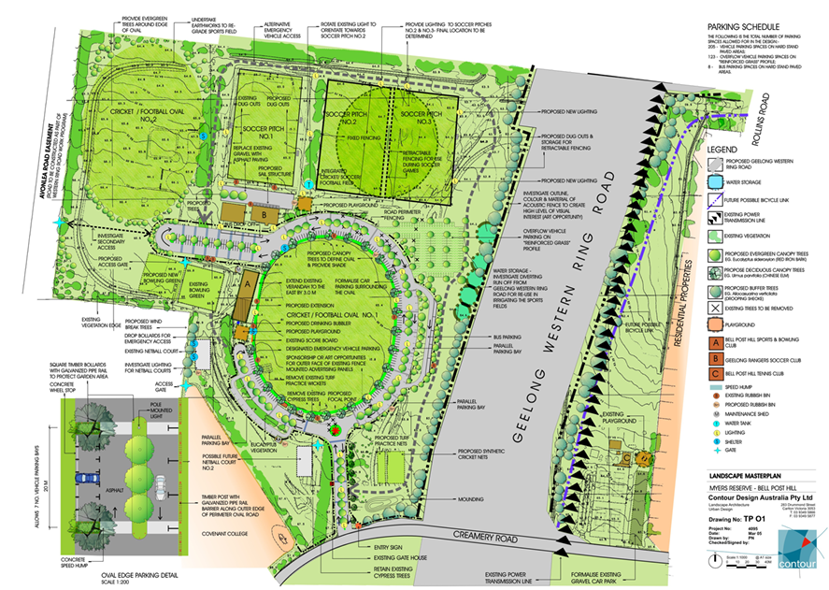

Key elements of the 2005 plan that have been carried through to the current draft Master Plan include:
- The provision of an additional bowls green.
- Investigation of site entry/exit on the western side of the site.
- Enhanced tree plantings along Bluestone Bridge Road to enhance environmental amenity and act as a natural buffer.
- Water storage along Bluestone Bridge Road to address site drainage issues and provide an irrigation source for the sports fields.

STRATEGIC CONTEXT

2.4 Community Profile
Geelong is located 75km south west of Melbourne and is Victoria’s largest regional city.
The municipality covers an area of 1,252 km2, comprising suburban, coastal and country areas.
Greater Geelong is bounded by the Moorabool Shire in the north, Wyndham City Council and the Borough of Queenscliffe in the east, Surf Coast Shire and Golden Plains Shire in the west, and Bass Strait to the south.
In 2021, the City had an estimated population of 269,508 people.

2.5 Demographic Analysis
Between 2021 and 2041, the population for the City of Greater Geelong is forecast to increase by 124,232 persons (46% growth), at an average annual change of 2.3%.
The population estimate for Bell Post Hill in 2021 is 5,182. Bell Post Hill is expected to see an additional 7,731 residents, with growth of 149% between 2021 and 2041.
Key Population Changes:
- At the 2016 Census, the dominant age structure for persons in Bell Post Hill was ages 65 to 69, which accounted for 7.2% of the total population.
- The largest 5 year age group in 2026 is expected to be 25 to 29 years, with a total of 445 persons.
- Given these projected growth rates, the Myers Reserve Master Plan will need to consider the additional demand for sport and recreation infrastructure based on forecast growth in younger age groups.

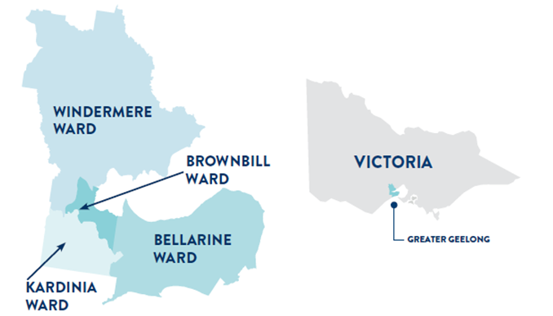

Fast Facts
 | 269,508  Estimated Resident Population (2021)
 | 1.78%  Population Growth Rate (2020-2021)
 | 40 Years  Median Age
 | 2.41  Average Household Size
 | 2,407  Aboriginal and Torres Strait Islander People (2016)
 | 16%  Population Born Overseas (2016 Census)
 | 32.3%  Speak a Language Other Than English at Home
 | 76%  Of dwellings within 400m of Public Open Space

STRATEGIC CONTEXT
Regional context
Area | 2021 | 2026 | 2031 | 2036 | 2041 | Total Change
City of Greater Geelong | 268,984 | 298,716 | 330,428 | 361,014 | 393,216 | 124,232
Armstrong Creek | 9,787 | 16,023 | 22,050 | 24,742 | 25,274 | 15,487
Barwon Heads - Connewarre - Breamlea | 5,074 | 5,237 | 5,452 | 5,722 | 6,029 | 955
Bell Park | 5,788 | 5,934 | 6,016 | 6,224 | 6,459 | 671
Bell Post Hill | 5,182 | 5,651 | 7,876 | 10,454 | 12,913 | 7,731
Belmont | 15,165 | 15,833 | 16,409 | 17,104 | 17,777 | 2,612
Clifton Springs | 8,226 | 8,663 | 9,466 | 9,922 | 10,246 | 2,020
Corio | 15,815 | 16,440 | 16,763 | 17,160 | 17,590 | 1,775
Curlewis | 3,699 | 5,070 | 6,917 | 8,126 | 8,669 | 4,970
Drysdale - Bellarine | 5,708 | 6,191 | 6,859 | 7,476 | 7,989 | 2,281
East Geelong | 4,028 | 4,094 | 4,277 | 4,525 | 4,849 | 821
Geelong - South Geelong - Drumcondra | 8,068 | 9,107 | 10,151 | 12,151 | 15,058 | 6,990
Geelong West - Manifold Heights | 10,287 | 10,474 | 10,751 | 11,266 | 11,925 | 1,638
Grovedale | 15,363 | 15,897 | 16,296 | 16,968 | 17,661 | 2,298
Hamlyn Heights | 6,842 | 7,198 | 7,564 | 8,000 | 8,456 | 1,614
Herne Hill - Fyansford | 4,385 | 4,895 | 5,917 | 6,646 | 6,777 | 2,392
Highton - Wandana Heights - Ceres | 24,008 | 25,666 | 26,045 | 26,678 | 27,135 | 3,127
Lara | 18,250 | 19,315 | 20,797 | 22,126 | 24,551 | 6,301
Leopold | 13,455 | 14,057 | 15,522 | 16,914 | 18,263 | 4,808
Lovely Banks - Batesford - Moorabool | 2,863 | 3,100 | 4,898 | 9,439 | 16,269 | 13,406
Marshall - Charlemont | 4,024 | 6,765 | 9,754 | 13,911 | 18,101 | 14,077
Mount Duneed | 4,201 | 8,970 | 12,653 | 14,265 | 15,544 | 11,343
Newcomb - Moolap | 6,630 | 6,908 | 7,095 | 7,359 | 7,648 | 1,018
Newtown | 10,895 | 11,113 | 11,408 | 11,757 | 13,011 | 2,116
Norlane - North Shore | 9,564 | 9,876 | 10,105 | 10,367 | 10,911 | 1,347
North Geelong - Rippleside | 4,447 | 4,588 | 4,645 | 4,715 | 4,800 | 353
Ocean Grove | 16,633 | 18,230 | 19,447 | 20,335 | 21,316 | 4,683
Portarlington | 4,141 | 4,639 | 5,267 | 5,590 | 5,853 | 1,712
Rural Bellarine Peninsula | 3,645 | 4,581 | 4,822 | 4,789 | 4,752 | 1,107
Rural North | 1,867 | 1,943 | 2,061 | 2,184 | 2,314 | 447
St Albans Park | 5,013 | 5,131 | 5,196 | 5,306 | 5,453 | 440
St Leonards - Indented Head | 4,094 | 4,601 | 5,010 | 5,588 | 6,122 | 2,028
Thomson - Breakwater | 2,822 | 2,990 | 3,089 | 3,195 | 3,310 | 488
Waurn Ponds | 5,017 | 5,473 | 5,733 | 5,795 | 5,865 | 848
Whittington | 3,995 | 4,063 | 4,116 | 4,214 | 4,324 | 329

EXISTING CONDITIONS & SITE USAGE

3.1 Site Usage
Myers Reserve has facilities for Australian Rules football (football), bowls, cricket, soccer and netball. The main user groups are:
- Bell Post Hill Bowls Club
- Bell Post Hill Cricket Club
- Bell Post Hill Football Netball Club
- Geelong Rangers Soccer & Sports Club
- Covenant College

3.2 Participation
The participation data provided from the tenant clubs has been analysed to understand current demand for facilities. The table to the right demonstrates consistent community activation at Myers Reserve, including:
- Overall, participation across all sports (when considered in aggregate), has remained stable.
- Soccer has the largest participant base, with over 400 players in 2021.
- Netball participation has remained stable/consistent over the last five years from 76 in 2017 to 78 in 2021.
- Cricket participation has declined marginally over the last five years from 151 in 2017 to 141 in 2021.
- Australian Rules football participation rates have fluctuated year-on-year, and have seen an increase of 12.5%, from 184 in 2017 to 207 in 2021.
- Bowls participation saw a marginal decline of 12 members in 2021 – but had consistent membership prior to the COVID-19 pandemic.
Interestingly, participation across all sports (when considered in aggregate), has remained stable.

Myers Reserve Sport Participation Trends
Sport | 2017 | 2018 | 2019 | 2020* | 2021* | Total Change
Soccer | 371 | 375 | 420 | 366 | 406 | 9.40%
AFL | 184 | 298 | 237 | 128 | 207 | 12.50%
Cricket | 151 | 125 | 163 | 141 | 141 | -6.60%
Bowls | 97 | 95 | 95 | 93 | 81 | -16.50%
Netball | 76 | 75 | 77 | 74 | 78 | 2.60%
Total | 861 | 871 | 886 | 795 | 863 | 0.20%

*It is important to note that 2020 and 2021 participation numbers were significantly impacted by COVID. Due to the lockdowns enforced by the Victorian Government, sports participation was very limited in these years.
It is positive to see that membership numbers have still bounced back after limited participation opportunities.

3.3 Demand and Capacity Analysis
The key macro trends impacting industry planning for organised sport reinforce the need for flexibility when planning for future community uses.
The capacity of Myers Reserve to meet the requirements of the existing sporting user groups will become a challenge in the immediate future.
Whilst some participation numbers may have declined as result of COVID, the reserve was still at capacity and participation is still considered high usage and additional facilities are required to meet current needs.
The current membership and participation of AFL, Bowls and Netball clubs within Myers Reserve can be accommodated by the current facilities.
The soccer fields and cricket fields are currently at capacity and likely to already be a significant constraint on:
- The ability for these user groups to be able to grow/cater to any additional community demand.
- The ability to maintain an appropriate playing surface condition without mandating reductions in weekly activity.

EXISTING CONDITIONS & SITE USAGE

There are many factors that influence the carrying capacity of sporting and recreation fields, pitches, courts and greens.
These factors include:
- Type of soil and surface;
- Level of drainage and irrigation;
- Amount of use (intensity and duration);
- Quality and regularity of maintenance, rest and rejuvenation works;
- Local climate and conditions;
- Community demand, organised participation rates and population rates.
The following table provides an indicative estimate of the number of team hours of field/court/rink usage for each of the organised sports at Myers Reserve. It shows:
- The soccer fields and cricket fields are currently at capacity.
- Bowls is at moderate/high weekly usage.
- AFL and Netball are currently at low/moderate weekly usage.
General weekly usage of sporting fields/rinks/courts at Myers Reserve

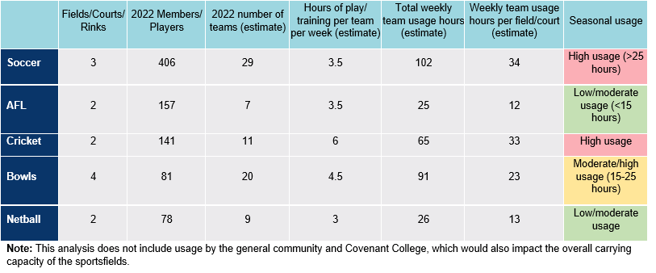

Factors Affecting Sportsground Carrying Capacity
  Soil and sub-surface |   Drainage and Irrigation |   Usage/Wear and Tear
  Maintenance Practices |   Weather and Climate |   Community Demand

Implications for the Master Plan
To ensure the sporting infrastructure at Myers Reserve can facilitate the required carrying capacity and meet the expected future demand, the Master Plan has included the provision of additional playing fields for soccer and cricket.

EXISTING CONDITIONS & SITE USAGE

3.4 Existing Conditions
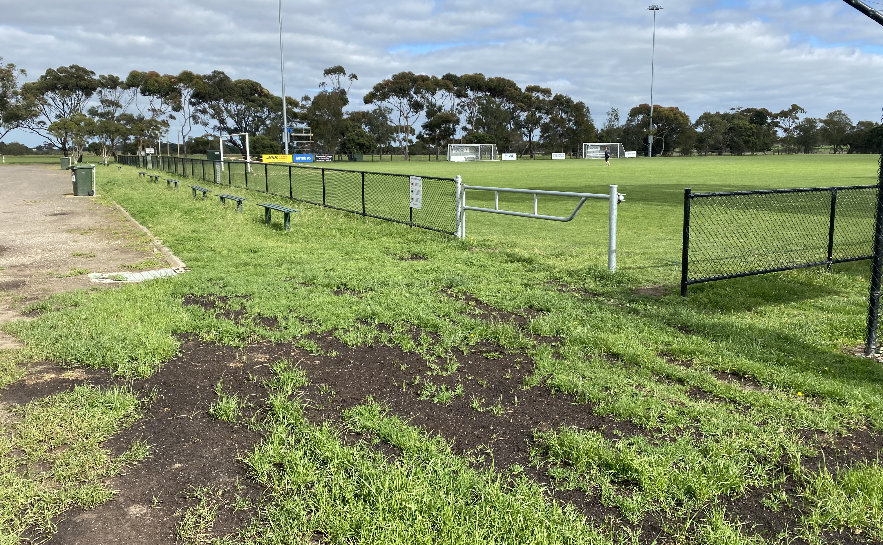
 | 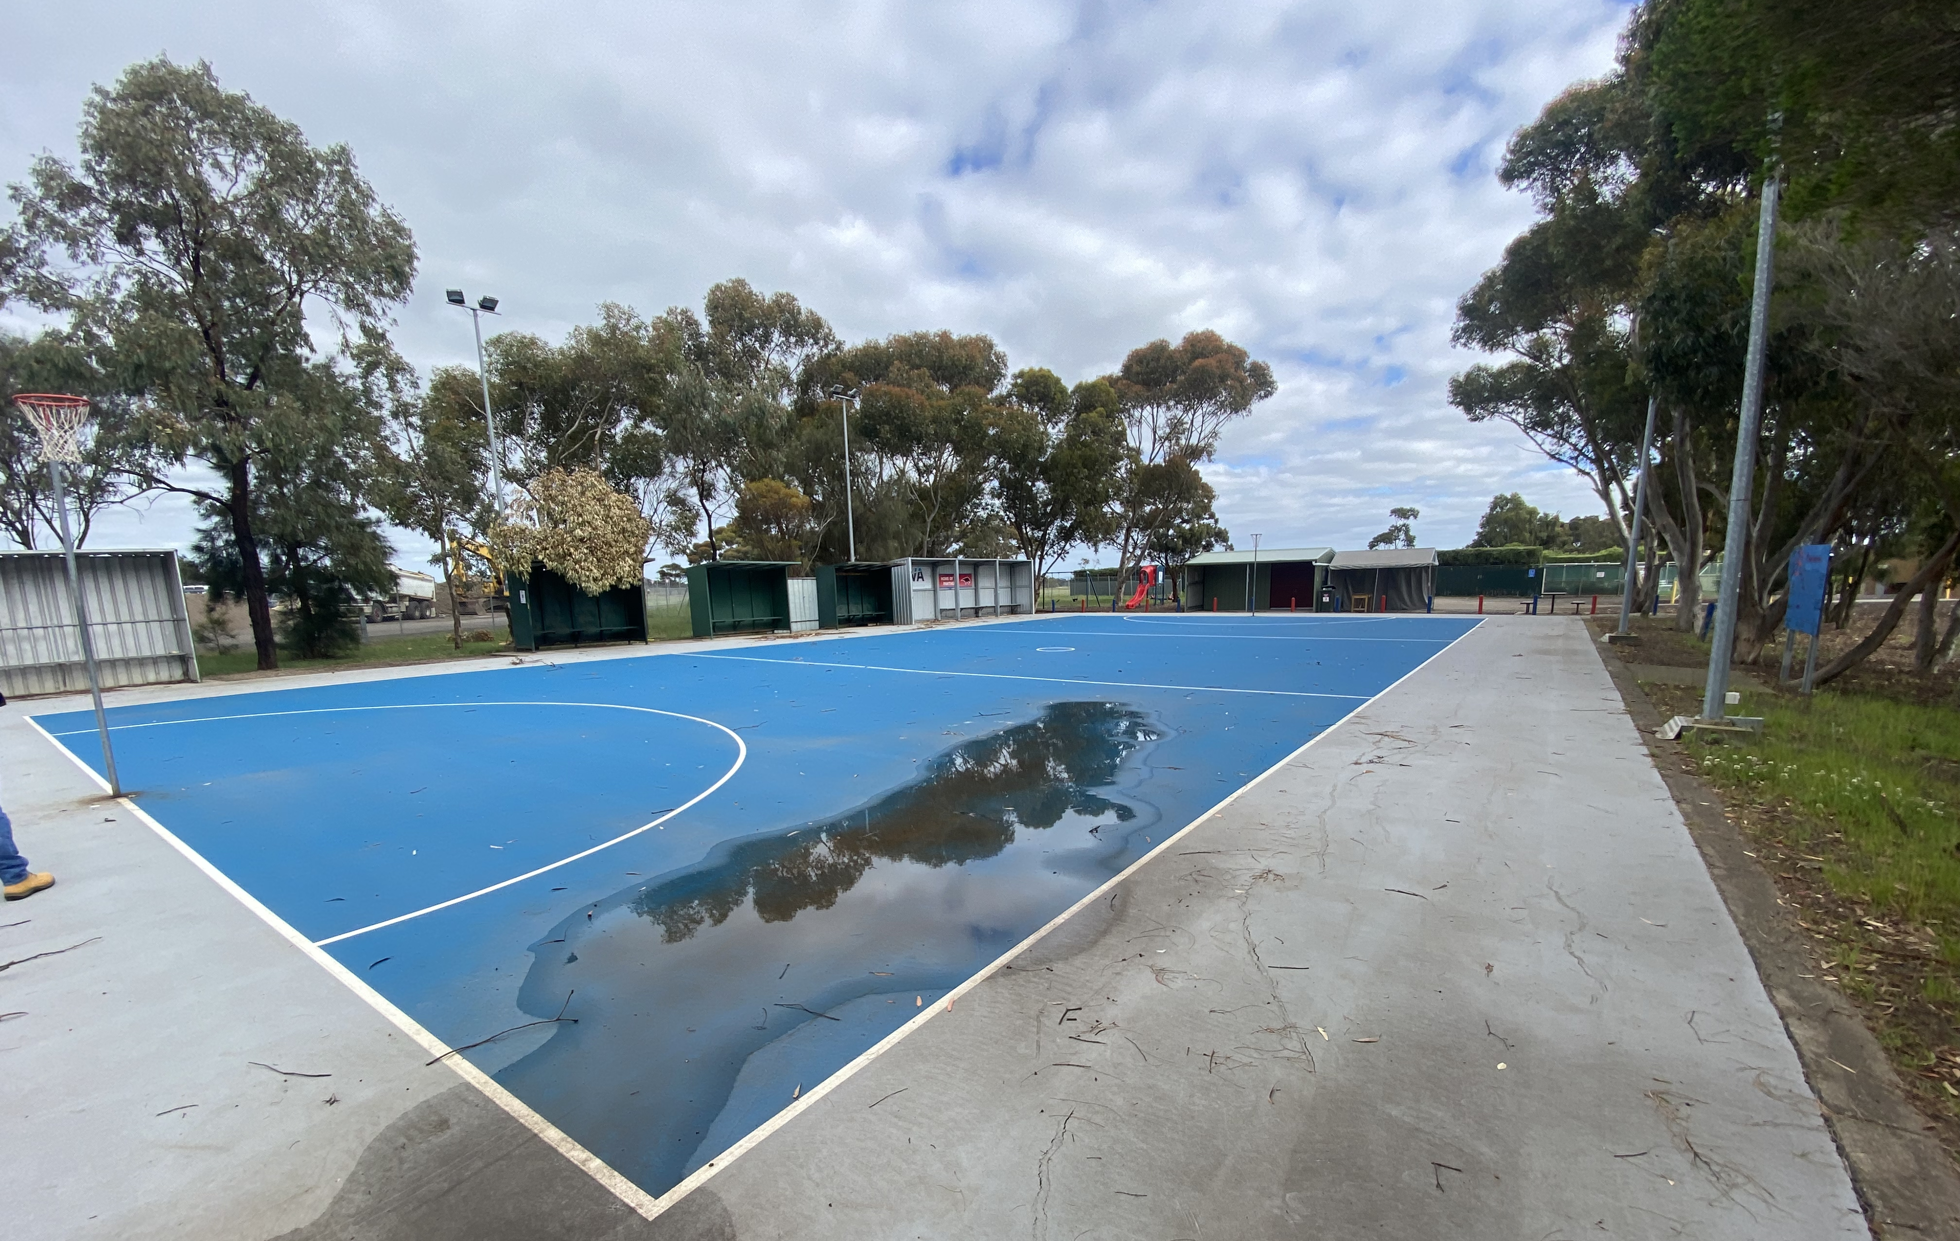
Ovals, Fields and Cricket Nets | Netball and Bowls
- The surface of the main oval is reportedly in poor condition and there is a lack of drainage which impacts the playing surface after periods of rainfall.  - The player shelters surrounding the second and third soccer pitches are outdated and do not meet modern standards and community expectations.  - The cricket nets are in close proximity to the site entrance road. On occasions this causes ball spillage onto the road and through the line of heritage trees.  - Due to the popularity of the site as a dog off-leash area, stakeholders also reported numerous instances of dog poo being found on the playing surfaces of all pitches and ovals, which can cause health and safety concerns. | The netball courts were re-surfaced in 2019 however issues still remain that create considerable problems for the safe playing of games. These issues include:  - The courts do not meet current Netball Victoria Facility Guideline standards.  - There is insufficient circulation space and areas for warming up.  - Uneven surfaces and water ponding/lack of run-off and drainage.  - Proximity of trees causes debris and leaves to fall onto courts.  - Poor condition of shelters and general set out of courts.  - Lack of high quality, dedicated netball amenities and storage.  The existing bowls club is accessed via a small gate at the rear of the football pavilion. Issues relating to the bowls facility are:  - Flooding from adjacent water storage pond.  - Lack of sufficient match-day facilities.  - Poor site location, which creates issues for patrons to access the facility during peak times.  - Lack of dedicated car parking and storage.  - Insufficient number of rinks to host competitions regularly.

EXISTING CONDITIONS & SITE USAGE
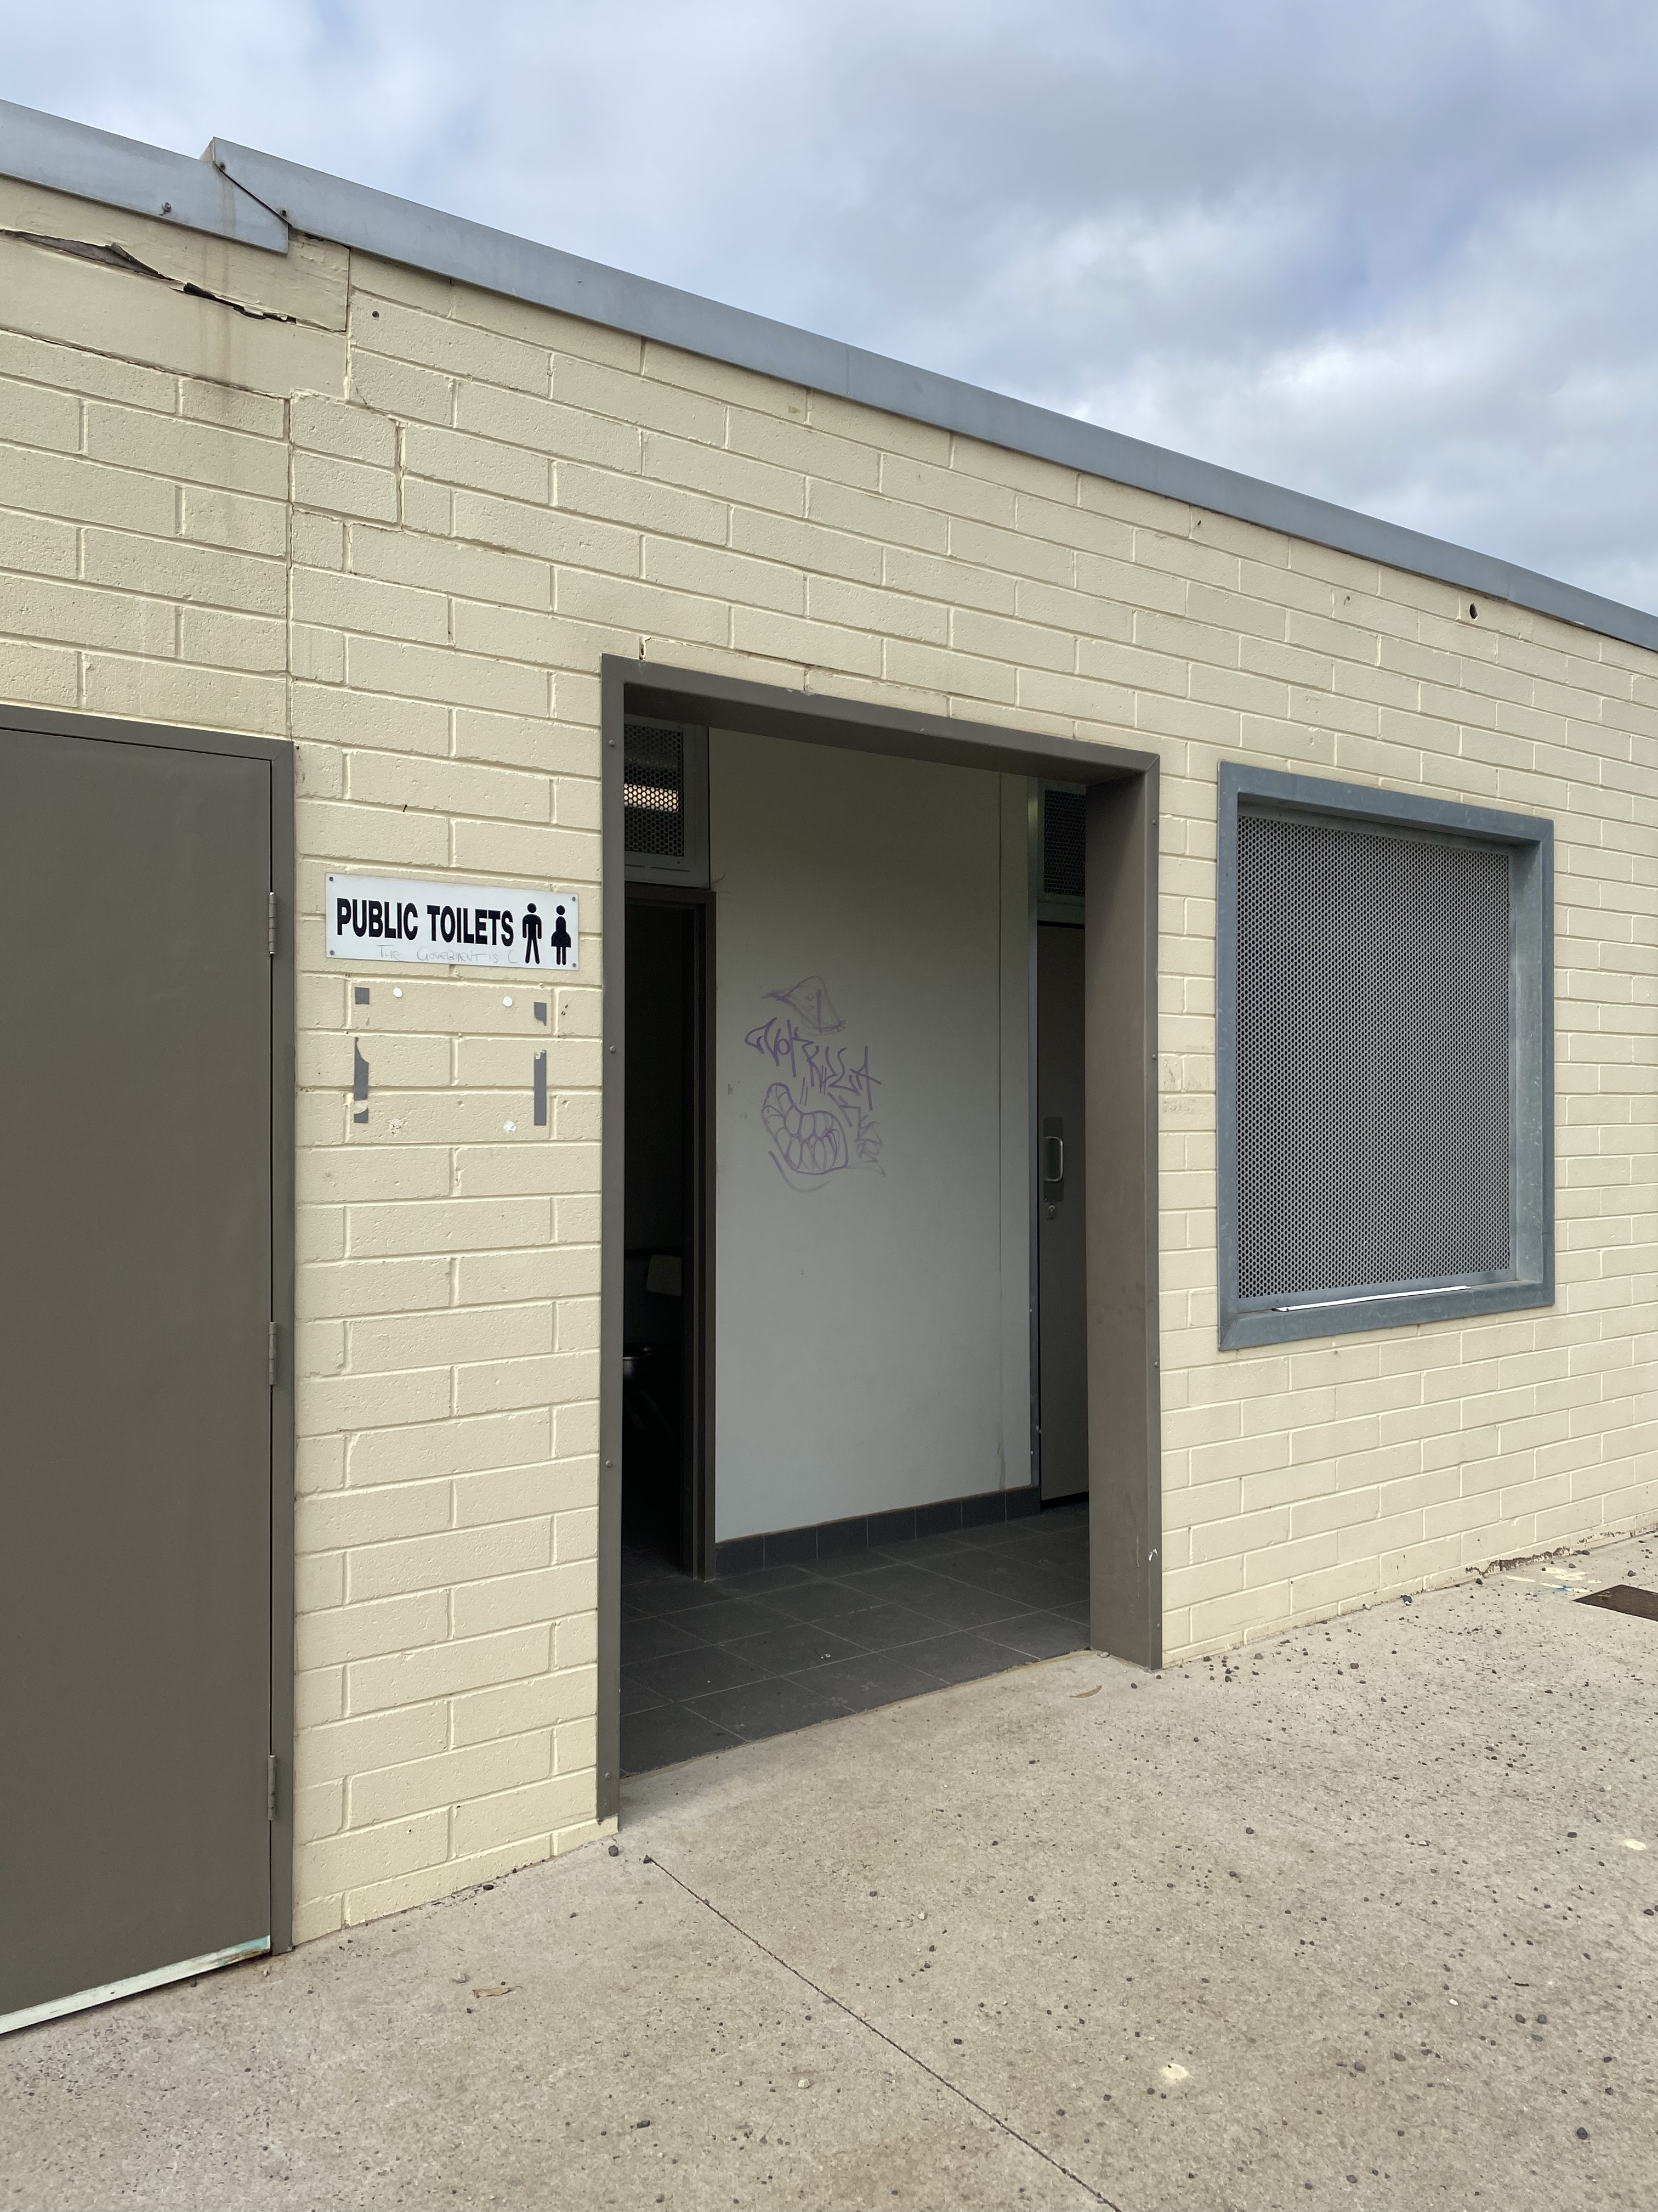
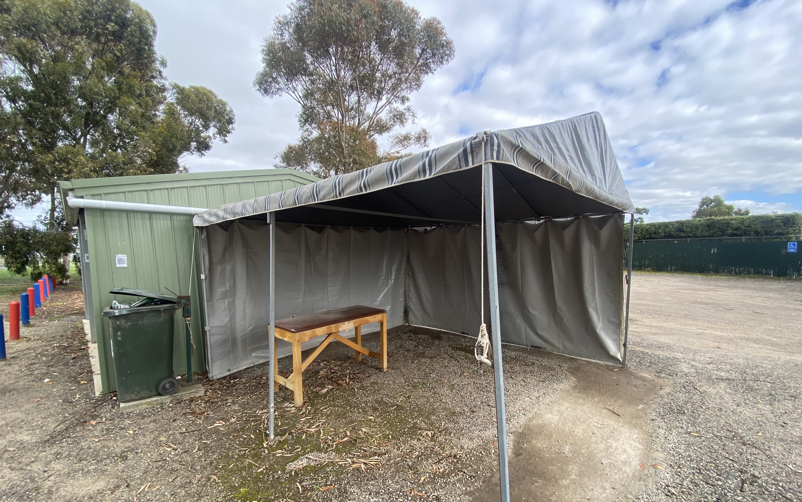
Pavilions and Buildings | Open Space and General Areas
The condition of the buildings and pavilions within the Reserve vary. Most buildings require some form of upgrades, with the cricket/football/netball pavilion being in the best condition.  However, other issues relating to the buildings are:  - The soccer pavilion requires replacement due to its age, asbestos presence and poor condition.  - The soccer change rooms and public toilets are generally of poor quality and in poor condition.  - There is a lack of gender neutral change facilities across all sports pavilions.  - There is no dedicated first-aid area for netball, with a makeshift shelter set-up beside the courts to provide this functionality.  - Each user group reported inadequate storage in the pavilions.  - The functionality of some buildings is compromised based on location.  - There is a lack of undercover outdoor/milling areas.  - Poor accessibility to the soccer social rooms and cricket/football/netball pavilion. | Myers Reserve provides a range of open space areas across the site.  There is a general issue of water drainage that appears to impact facility access and functionality.  There is a high level of formal and informal vehicular activity across the site that creates confusion and leads to some negative impacts on the open space areas.  Other observations made on-site are:  - Dangerous site entry and access due to location, sightlines and poor visibility.  - Informal use of the site as a pick-up and drop-off area for parents with children at the neighbouring school.  - Pooling of water in the play ground and other areas leading to the restricted use of the site.  - Limited linkages, access and connection between facilities and functions.  - Security and vandalism issues due to the location of the Reserve and lack of surrounding passive surveillance.

EXISTING CONDITIONS & SITE USAGE

3.5 Fit-For-Purpose (FFP) Assessments
The Fit-For-Purpose (FFP) assessment framework is an objective management tool to determine if the following facilities are suitable for their intended purposes:
- Soccer change rooms and public toilets
- Soccer social rooms
- Football/cricket/netball social rooms and amenities
- Bowls social rooms and amenities
The FFP Assessment Framework was developed in collaboration with the PWG and used to guide future improvement recommendations.
Each of the buildings were assessed based on the following scoring system.
- Low
- Medium
- High
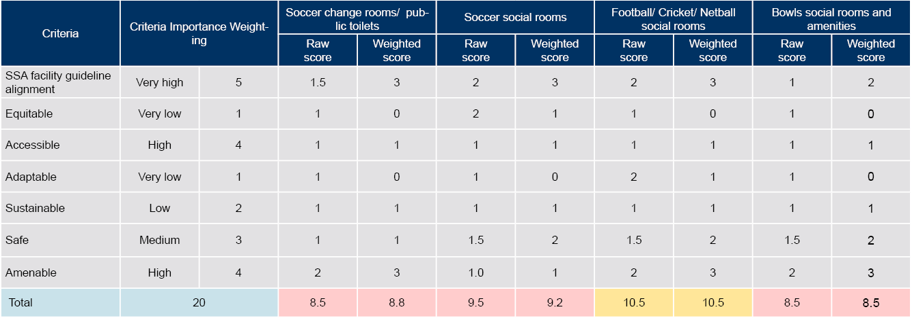

CRITERIA DEFINITIONS
State Sporting Association (SSA) facility guideline alignment: Extent of alignment with the standards required within the facility guidelines of state sports organisations.
Equitable: Extent of alignment with facility hierarchy requirements and meet an agreed standard that ensures there is no over or under servicing the community.
Accessible: Level of access for all abilities, all genders and all ages.
Adaptable: Level of flexibility to meet the changing needs of the community and ability to be used for more than one purpose.
Sustainable: Extent of environmental responsibility and compliance with ESD principles.
Safe: level of compliance as a safe, welcoming and inclusive environment for the community that reduces risk. Extent of alignment with CPTED Principles.
Amenable: The condition of the building in terms of maintenance, safety and community and Council expectations.

The highest total score a building can receive is 20 and the lowest score is 0. The following ranges indicate the meaning of each score:
- 16-20: FFP and meets all requirement
- 11-15: Meets basic expectations, upgrades required
- 0-10: Not FFP
An overview of the assessment for each building is provided below.
As shown, the key priorities for upgrades are the soccer change rooms and social rooms, and the bowls social rooms.

CONSULTATION SUMMARY

4.1 Consultation Overview
The consultation for this project has involved:
- Internal consultations with City officers.
- Interviews with representatives from key user groups, including:
- Bell Post Hill Bowls Club
- Bell Post Hill Cricket Club
- Bell Post Hill Football Netball Club
- Geelong Rangers Soccer & Sports Club
- Covenant College
- An online survey with the local community, which was posted on the City’s Have Your Say page and attracted 594 unique visitors and 106 contributors to the survey.
The key questions asked of respondents were structured to understand current perceptions of the Reserve, the overall quality and condition of infrastructure and amenity, as well as potential gaps and areas for improvement. The key findings from the consultation are outlined over the following pages.

4.2 General Site Observations
The main entry to the site is not in the optimal location and there is a blind spot when vehicles exit the Reserve. This is a significant safety issue.
Traffic flow is also an issue across the site. Cars cause safety issues near the soccer pitches and playground – due to inadequate way-finding signage and circulation.
The site is low-lying, with limited drainage infrastructure, and is proximal to a water retention basin within the school grounds. During heavy rainfall, the site is prone to flooding, with the bowls green and netball courts particularly susceptible to inundation.
Due to the location and open nature of the Reserve, security is an ongoing concern. All stakeholders reported instances of break-ins and vandalism, with some occurring as often as once per week. This has resulted in many of the tenant clubs installing their own security lighting, alarms and surveillance systems to defend against anti-social behaviour.
Stakeholders from all of the tenant sports reported that pavilion facilities are now outdated, not fit-for-purpose and/or in need of upgrades to meet future demand and contemporary community expectations.
The playspace adjacent to the netball courts seems oddly located, and there is an opportunity to re-locate or consolidate it with the other playground to improve sight lines, surveillance, and supervision.
“The entrance is poorly located – on a bend, very dangerous for people coming from the West and turning. It should be re-located, potentially near Bluestone Bridge Road.”

4.3 User Groups

4.3.1 Australian Rules Football
The ovals are in poor condition, due to a lack of drainage infrastructure - which limits the ability to train and play in the winter months.
There is no safety netting behind the goals which causes safety issues related to errant balls.
Traffic management issues around the oval due to the road and location of the entry.
There is a lack of storage space for cricket, AFL and netball within the existing pavilion.
There are not enough change rooms to fit all of the football teams and there are no gender-neutral change facilities.
“In terms of overflow training, improved surfaces and access to the site is important – irrigation and drainage to improve the surface but keep it open to the public would be great.”

CONSULTATION SUMMARY

4.3.2 Bowls
The bowls club is poorly located at the back of the site, which makes entry and access difficult, and also impacts the overall visibility and awareness of the club.
The major issue with the current location is the lack of adequate drainage, which leads to flooding of the car park and pooling of water at the front entry. This causes safety issues and slipping hazards.
The bowls pavilion is quite “basic” and was built by the club using a $100k bereavement donation.
The current green was installed in 2015, and is nearing time for renewal (8-10 year lifespan). With only one green, this can also cause some challenges with competition draws and scheduling - the club can’t host any more than two teams at once.
Parking is almost impossible on Saturday for bowls participants, as there is high demand from cricket.
In an ideal world, the club would like to see two greens provided in a prominent, easily accessible location.
“Break-ins are a regular thing here. There is no security, lighting or locks for the whole of the site. We’ve had confrontations and burnt-out cars. I’ve found syringes when cleaning up the nets. It’s $400 in costs for us every time someone breaks the locks.”

4.3.3 Cricket
The storage and maintenance shed used by the cricket club is not large enough or fit-for-purpose (FFP). The club has been trying to get a ride-on turf roller, but have held off as there is nowhere to store it. In addition, there are some chemicals stored on site, but no access to water or a wash bay. This is a serious safety concern. The bar in the clubhouse is impractical and no longer FFP due to its ‘L’ shape, which also limits storage space. The club would like to see gender-neutral amenities to cater to future participation growth.
“The bar facilities need a major overhaul. After the fire, the club paid for the dance floor and then the football change rooms were built. Brand new toilets and kitchen are working well – next major projects will have to address the bar.”

4.3.4 Netball
There are no fences around the netball courts, which impacts spectators and leads to wayward balls. Lights are non-compliant and do not fully illuminate the whole court area. This makes them unsafe and means they are unusable in the dark.
The run-off on the courts is non-compliant, and the netball stakeholders reported common instances of players and umpires slipping on the gravel while chasing a ball. The gradient on the netball courts is also non-compliant.
The goal posts move constantly and often have to be adjusted mid-game by players and umpires. There are also no water fountains near the netball courts.
The netball club is open to exploring opportunities for relocation and expansion of the courts, along with a half-court area to be used for warm-ups.
There is no dedicated parking for netball which causes issues with access on busy game days.
“It takes one hour to prepare the courts for competition every Saturday. It floods every time it rains - even as little as 2ml of rain can cause big pooling areas around the courts.”

CONSULTATION SUMMARY

4.3.5 Soccer
The key priorities for the Geelong Rangers Soccer Club are pitch space, lighting and change room upgrades.
While the sizes of the existing pitches are compliant, the club is growing and will require at least one additional pitch to meet the future demand it has forecast.
The lighting does not currently meet the FV Facility Guidelines requirements. Currently, there are no female friendly change facilities for soccer participants, and there is not enough change rooms to meet demand on game days.
The soccer pavilion is an asbestos hazard, is not fit-for-purpose and requires an upgrade. The kitchen area is dysfunctional, there are no DDA amenities, no meeting rooms, no gym, no storage, and a lack of toilet facilities.
The play space near the football pitches gets a lot of use and could potentially be expanded.
The player shelters on pitches 2 and 3 require upgrades to meet contemporary standards and expectations.
“Our vision would be to have a world-class pavilion that is fit for purpose and facilities that cater for growth. More pitch space, fully lit to match standard, and better road access and traffic flow across the site.”

4.3.6 Covenant College
Families and staff both use the car park at Myers Reserve and it serves as a key pick-up and drop-off function for families.
Access times and peak periods cause issues with site entry and exit, particularly when turning right from the Reserve.
The school has arrangements with the netball, cricket and football clubs, enabling the clubs to use the school facilities and vice versa.
The biggest issue for the school is related to the water run-off and flooding from the retention basin that is within the school grounds. Most water goes through Myers Reserve and travels across the site.
Security is also a major issue. The school has installed its own safety measures including pro-alarms, CCTV cameras, and perimeter beams. People come through, and jump the fence, as it is very dark on the boundary.
The school would love to improve access to the site for pedestrians and cyclists at Gate 1 – which is closer to the cricket nets where the heritage trees are.
“The surrounding infrastructure is very rural and dated – spoon drains get clogged up, and water pools in front of the school, messes up the car park and bowling green. The site doesn’t have the supporting infrastructure to address the maintenance issues.”

CONSULTATION SUMMARY

4.4 Community Consultation
The overall aim of this consultation was to engage with the community to ensure Myers Reserve remains a welcoming place that meets the needs of the local community. All feedback received has been considered in the development of the draft Master Plan
The City conducted two stages of consultation with the community. The first stage engaged with the community in February-March 2022 to understand how the community use the reserve, what they like and don’t like at Myers Reserve, and what they would like to see in the future.
The second stage of engagement was facilitated over a six week period between 28th October 2022 and 9th December 2023 and focused on gathering feedback on the Draft Master Plan and identifying areas for improvements.

4.4.1 Stage One Consultation Findings
The City ran a four-week online engagement activity to find out more about why Myers Reserve is important to the community.
594 people visited the Have Your say page with 106 community members providing feedback via an online survey or social interactive map.
 | 28 days of engagement
 | 75 posts and votes via the social map
 | 106 people that left feedback
 | 97 surveys completed
 | 19 people following the project

Top Three Reasons to visit the Reserve
- Play Sports
- Socialising
- Dog Walking

Most liked at Myers Reserve
- 50% of the respondents liked the Open Space at Myers Reserve the most.
- 15% of the respondents liked the variety of sports on offer the most.

Top 5 ranked ideas to improve Myers Reserve
- Female Friendly & Accessibility Facilities upgrades
- Sealing the roads & car parks
- More and improved spectator seating
- Additional sports grounds
- Playground upgrade

Top 5 key issues at Myers Reserve
- Sports pavilions are ageing and no longer fit-for-purpose – 58%
- Change rooms are ageing and no longer fit-for-purpose – 50%
- Not enough rest areas/seating options – 30%
- Lack of gender-neutral toilets, change rooms or facilities – 22%
- Facilities are at over-capacity and not able to service current demand – 20%

CONSULTATION SUMMARY
Overarching themes from feedback stage 1
Open Space
The community values the open space at Myers Reserve
Sports Pavilions/Change Rooms
Gender neutral and accessible upgrades
Playgrounds
The playgrounds need upgrades
Seating and Shade
The community would like to see more seating, shade and shelter provided
Sportsgrounds
More sports grounds are required to meet current and future demand

4.4.2 Stage Two Consultation Findings
The purpose of this engagement was to gather an understanding of future requirements and community sentiment about the draft master plan.
903 people visited the Have Your say page with 69 community members providing feedback via an online survey.
44 days of engagement
126 people that contributed feedback
69 online surveys completed
19 people following the project

87%
62%

84%

Support or mostly support the Master Plan
Believe the Master Plan responds to community needs

Total satisfaction
with the Master Plan

Overarching themes from feedback stage 2
  1. New and Upgraded Sporting Facilities | - Provision of more sporting facilities (pitches, courts and ovals) to cater for the growing community  - Upgraded bowls facilities, netball courts, cricket/football/netball pavilion and soccer pavilion  - Re-purposing the underutilised second AFL/cricket oval
2. Supporting Amenities | - Location of the soccer pavilion is not in the preferred position  - Proximity of second AFL/cricket oval to the pavilion seems further to walk
  3. Environmental Protection and Passive Recreation | - Ensuring trees and native vegetation are maintained across the site  - Providing a perimeter walking path  - Option for a nature-themed play space  - Ensuring dogs are allocated to ‘passive’ areas away from sporting fields

CONSULTATION SUMMARY

4.4.3 Changes from Draft to Final Master Plan
The Master Plan will be reviewed and updated with the feedback from the community in mind.
Theme 1. No updates required to the Master Plan based on the positive feedback from Theme 1.
Theme 2. There is concern from the soccer club about the location of the proposed new soccer pavilion.
It has been located to the south of the pitches with a north-facing aspect where the club would prefer it to be positioned between the current show pitch and training pitch to enable viewing across all fields and achieve preferred their west-facing aspect.
Moving the soccer pavilion will require the significant removal of trees which is not aligned with the City’s Tree Management Policy and community aspirations for the Reserve.
With alternative design solutions available, the soccer pavilion will be kept in its current location on the final master plan.
To address the concerns about the proximity of the proposed new oval to the existing pavilion, an additional recommendation has been included to investigate additional amenities and supporting infrastructure when the future demand requires this.
Theme 3. The master plan will consider enhancing areas for passive recreation and ensuring tree plantings are preserved, protected and enhanced with provision of new indigenous plantings.
The final master plan also includes a more specific recommendation to include signage for the off-leash dog area.
The final recommendations also include a reference to indicate the community’s preference for a nature-based play space.

CONSULTATION SUMMARY

4.5 Issues and Opportunities
An analysis was undertaken to document and summarise the key issues and opportunities identified from the research, consultation and assessments/investigations completed.
  Issues |   Opportunities
- Poor drainage infrastructure, which causes flooding across the site and impacts overall utilisation.  - Poor traffic flow across the site and the location of the site entry causes safety issues.  - The site is prone to vandalism and break-ins due to its location, and poor passive surveillance and security.  - Lack of gender-neutral change facilities for football, cricket, netball and soccer.  - Netball courts are non-compliant.  - Lack of storage across the site for all sports.  - Asbestos within the soccer pavilion/social rooms. | - Investigate new site entry, road access and traffic flow across the site.  - Improve access to and circulation across the site for pedestrians and cyclists and integrate pedestrian linkages from Creamery Road PSP.  - Improve the safety, security, lighting and passive surveillance across the site.  - Consolidate the two play spaces into one larger, centralised play space that services the whole site.  - Investigate expanding facilities for cricket, soccer, netball and bowls to support growth in participation.  - Ensure the retention of heritage trees is considered in any potential expansion.  - Explore expansion/upgrade opportunities for the existing pavilions to ensure they are FFP.
“Bell Post Hill is growing and should have many sports included in this large sporting area and should be the best facilities around for everyone to use.”
“The club rooms and change rooms facilities for both football and soccer side of Myers Reserve could do with some upgrades. Some female and disability facilities are much needed.
A fourth pitch in the vacant oval would be great for both clubs.”
“Everything needs to be looked at for functionality. At the moment nothing is working when game day is on”

MASTER PLAN

5.1 Master Plan Vision and Key Principles
In developing the Master Plan for Myers Reserve, the findings from the site analysis, fit-for-purpose assessments and stakeholder consultation has been considered.
The plan has been developed to address the short, medium and long-term development aspirations of the growing community and provide an informed, consolidated and collaborative long-term approach to future infrastructure developments across the Reserve.

5.1.1 Draft Master Plan Vision
“Myers Reserve is a community destination for sport, leisure and social activities, offering high-quality and fit-for-purpose facilities for the whole community.”

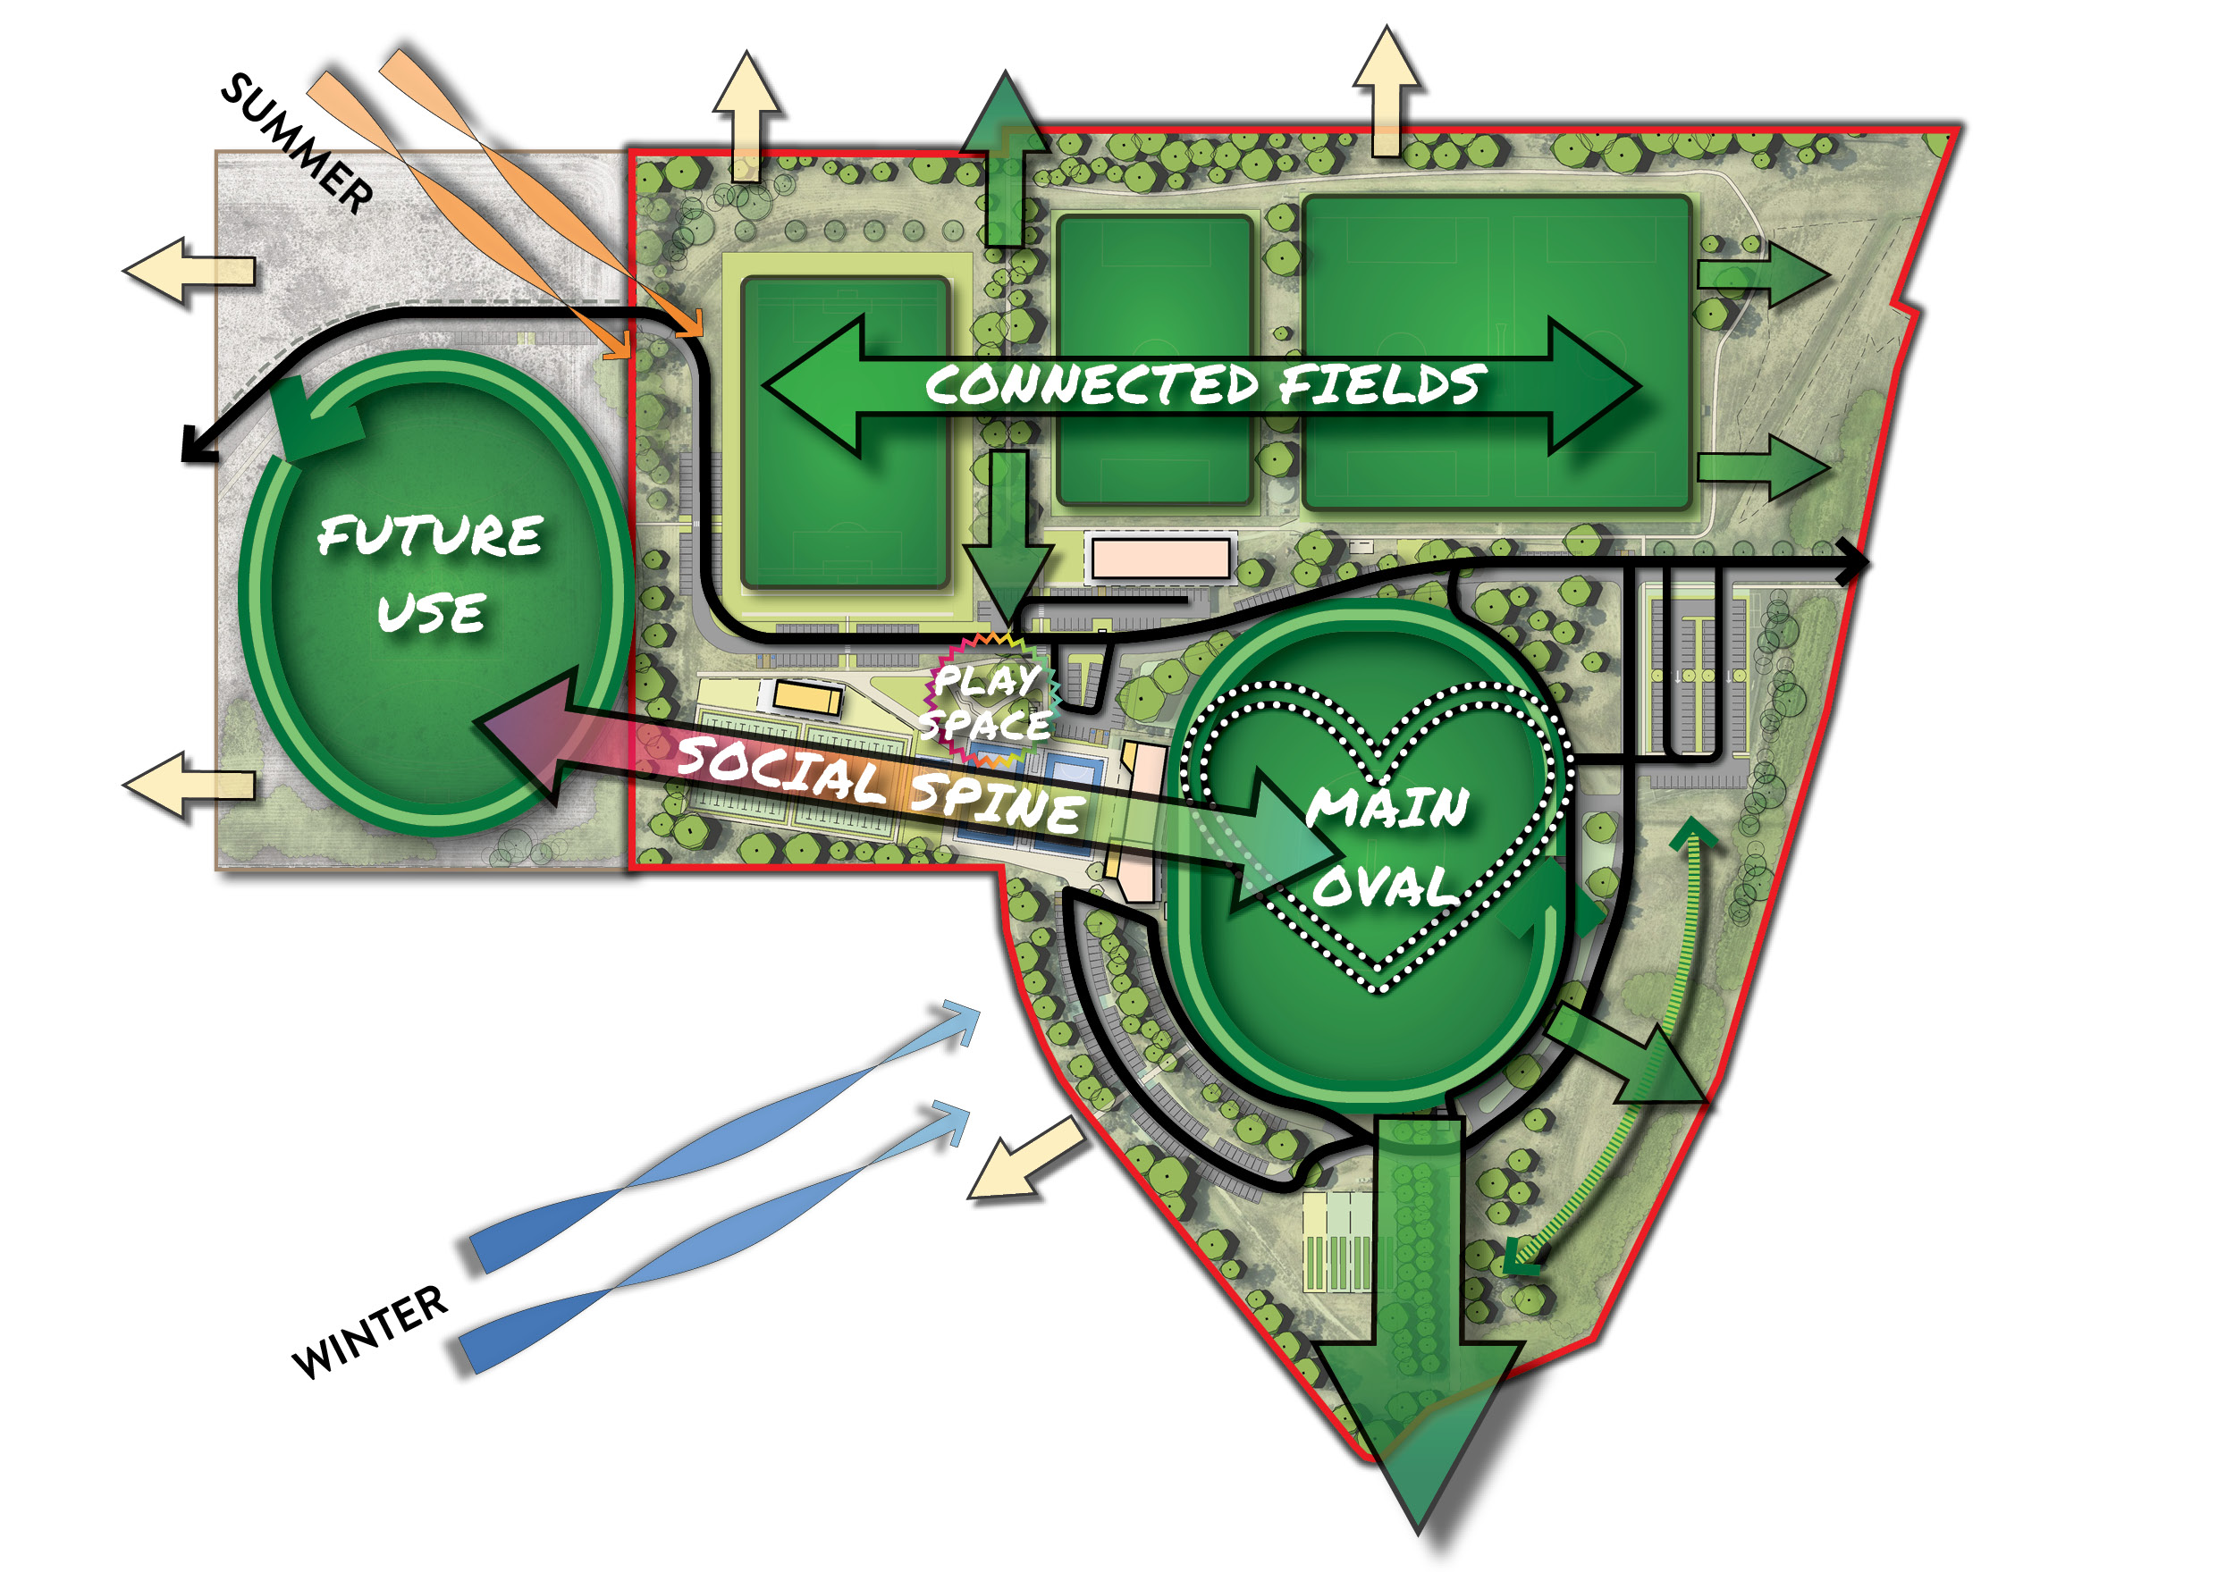

5.1.2 Draft Key Principles
Consolidate
Strengthen the heart of the site
Integrate
Clarify and integrate the key functional areas
Future Proof
Upgrade buildings to be fit-for-purpose and provide additional sporting fields
Amenity
Preserve and expand open space areas
Safety
Re-locate site entry and improve traffic flow
Align
Explore future connections into the PSP

MASTER PLAN

5.2 Master Plan Development
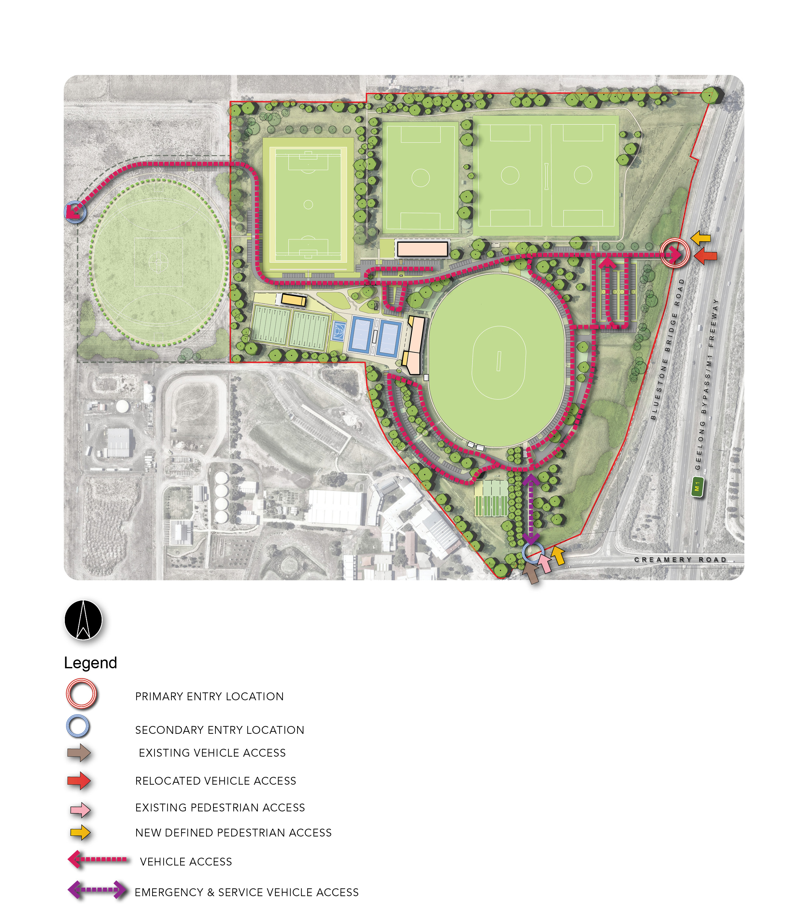
Accessibility and Entry

MASTER PLAN

Connections and Circulation
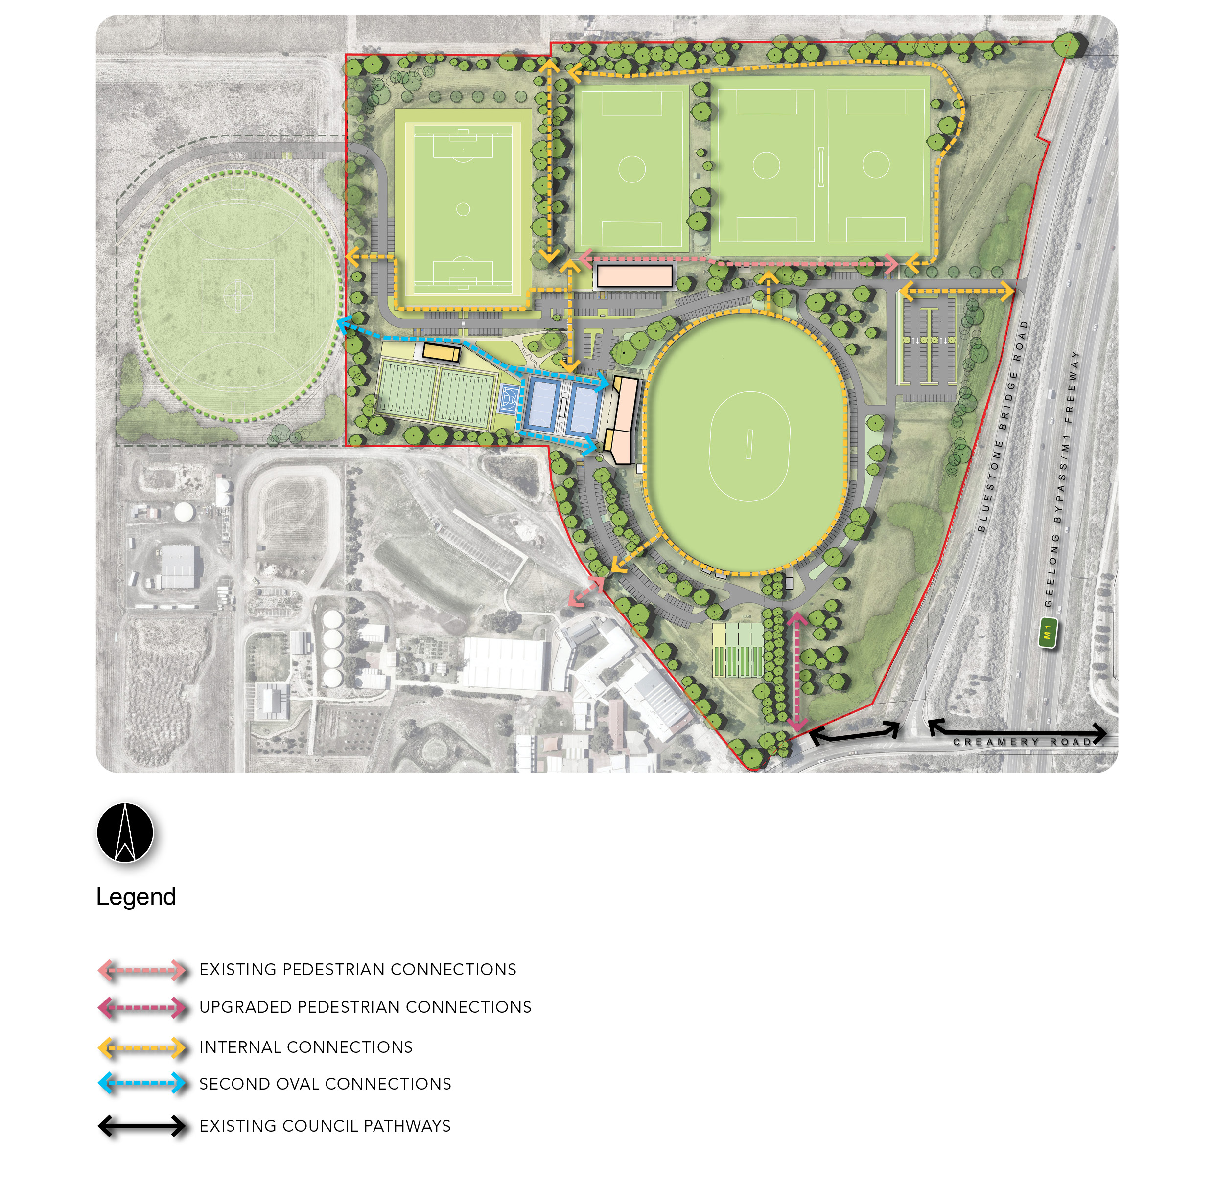

MASTER PLAN

5.3 Key Recommendations
Key Recommendation | Rationale | Key Principle
- Re-locate site entry and access road | - Addresses safety concerns associated with the current entry/exit and provides a logical flow of traffic across the site.
- Relocate bowls facility | - Provides space to install an additional green and upgrade the pavilion  - Delivers FFP facilities and enables flooding issues to be addressed during re-construction.
- Relocate netball courts | - Enables netball courts to be upgraded to address safety and compliance concerns.  - Re-surfaced courts can allow for drainage infrastructure to address flooding issues.  - Installing an additional half-court provides an additional warm-up space that can be utilised for both sporting clubs and the local community.
- Upgrade the existing cricket/football/netball pavilion | - Ensures equitable provision of facilities that are fit-for-purpose, code compliant, gender neutral and meet the needs of all stakeholder groups.
- Construct new soccer pavilion | - Replaces the existing building that is asbestos ridden and no longer fit-for-purpose.  - Enables soccer to establish amenity buildings to service increased demand.
- Construct new soccer pitch | - Re-purposes the existing overflow oval into a compliant soccer pitch.  - Enables soccer to meet current and future demand for participants.
- Electrical infrastructure | - Provides an opportunity to upgrade the electrical substation and underground the overhead lines for improved safety and amenity.
- Construct new AFL/cricket oval | - Enables the site to service future demand due to population growth.
- Construct new district-level play space | - Replaces existing playgrounds at the end of useful life and provides a consolidated play space for the whole community to enjoy.

MASTER PLAN

Key Recommendation | Rationale | Key Principle
- Construct new car park loop | - Improves traffic flow across the reserve and enhances safety by improving pedestrian walkways and crossings.
- Extend existing turf table | - Provides additional practice areas for cricket, in line with Cricket Australia facility guidelines.
- New cricket storage shed | - Improves storage areas for the cricket club to house all maintenance equipment and supplies.
- Southern entry and heritage trees | - Repurposes the existing entry road for shared pathway and potential overflow exiting lane for large gatherings.  - Conserves and protects the existing heritage tree row.
- Field of play lighting | - Provides sports lighting for each field to enable training and competition in the evenings and times with low-light.  - Lighting should be provided to the standard identified in the facility guidelines for each sport: 100 lux for soccer, 100 lux for AFL, 300-500 lux for cricket, 100-200 lux for netball and 100 lux for bowls.
- Formalise spectator parking | - Improves traffic flow through the reserve and enhances safety.
- Retain existing dog off-leash area and provide signage | - Provides an opportunity to use the reserve for unstructured activities (e.g. walking, dog walking, and retains the use of the reserve for off-leash dog exercise).
- Protect existing open space areas | - Aligns with the City’s Urban Forest Strategy and its ambition to be recognised as a Tree City of the World.
- Re-nature and establish new trees | - Provides a vegetation buffer to protect the reserve from the surrounding roads and freeway.
- Retain existing native vegetation | - Protection of existing native vegetation to promote growth.

IMPLEMENTATION AND FUNDING

6.1 Cost Estimates
Indicative costings have been prepared to demonstrate the funding requirements to deliver the Master Plan on the site of the existing reserve.
The proposed western extension has been excluded from the cost plan. The costings for the Myers Reserve Master Plan have been prepared by WT Partnership and verified through a range of inputs including industry benchmarks, case studies, development rates based on specific projects and previous studies completed by Council.
Costs do not include allowances for non-construction costs. Costs are currents as of June 2023 and do not include contingency or cost escalations that need to be applied at the time of funding of these projects. All costs are indicative only and are subject to further investigations and design development.

6.2 Funding Strategy
There are several projects included within the Master Plan with varying priority levels. A range of funding opportunities will need to be considered as each project progresses into planning and detailed design phases.
At the time of writing the following funding opportunities are available to consider as part of the funding mix.
Direct Council Funding
- Council's Cyclical Budgets: Council has cyclical budgets for maintenance and renewal of minor sports infrastructure. A small number of recommendations within the Master Plan could potentially be funded within relevant cyclical budgets.
- Council’s Budget Process: Each year Council prepares a budget providing funding for the delivery of services, programs and infrastructure upgrades and developments. A number of recommendations within the Master Plan could be considered via this process.
- City Community Infrastructure Grants: Grants of up to $50,000 to support costs of planning and feasibility activities for future infrastructure projects or grants of up to $350,000 to assist with costs of ready-to-go community infrastructure projects.

State and Federal Government Grants
- Country Football and Netball Program (SRV): Delivered in partnership with the AFL, AFL Victoria and Netball Victoria, the Country Football and Netball Program provides funding to assist regional football and netball clubs, associations and umpiring organisations to upgrade and develop facilities in rural, regional and outer metropolitan locations.
- The World Game Facilities Fund: A Victorian Government funding program that assists local football (soccer) clubs and organisations to upgrade existing or develop new facilities across metropolitan Melbourne and regional Victoria.
- Local Sports Infrastructure Fund: A state-wide competitive Victorian Government program that provides a range of grant opportunities across five funding streams: Indoor Stadiums/Aquatic Facilities, Female Friendly Facilities, Community Sports Lighting, Community Facilities, and Planning.
State and National Sports Organisation Funds and Grants
- The Australian Cricket Infrastructure Fund (ACIF) will contribute up to $4.65 million in 2022/23 into community facility projects.
- AFL Facilities Fund: In an average year, this fund partners on $50 million worth of projects that benefit nearly 100 community football clubs.
Developer Contributions
- Developer Contributions are a mechanism used to levy new development for contributions to planned infrastructure needed by the future community. A council collects development contribution levies from new development through an approved DCP.

IMPLEMENTATION AND FUNDING

6.3 Implementation Plan

The implementation table outlines the recommendations in the Master Plan including priority order, potential funding opportunities and indicative costs.
- The first phase of implementing the master plan will be based on high-priority improvements which align with the overall vision, objectives and community needs. The existing bowls green will need to be removed first to allow for the relocation of the netball courts adjacent to the Football, Cricket and Netball pavilion as the netball courts are to be located in the area of the current bowls green.
- This will be followed by initiatives to enhance the operational functionality of the site, which will be worked towards collaboratively with key stakeholders and tenant clubs.
Priority | Plan No. | Recommendation/Action | Indicative 2023 Cost Estimates* | Funding Stream
High | 2 | Relocate bowls facility | $4,734,000 | State/Federal government/CoGG
High | 3 | Relocate the netball courts | $2,302,000 | State/Federal government/CoGG
High | 7 | Electrical infrastructure | Excluded | CoGG
High | 5 | Construct new soccer pavilion | $4,981,000 | State/Federal government/CoGG
Medium | 10 | Construct new car park loop | $748,000 | COGG
Medium | 8 | Construct new AFL/Cricket oval | Excluded | Developer contribution
Medium | 6 | Construct new soccer pitch | $4,343,000 | State/Federal government/CoGG
Medium | 1 | Re-locate site entry and access road | $4,381,000 | State/Federal government/CoGG
Medium | 4 | Upgrade existing cricket, football and netball pavilion | 2,366,000 | State/Federal Government/ CoGG/NSO/SSO Grants
Medium | 14 | Field of play lighting | $1,335,000 | State/Federal government/CoGG
Medium | 17 | Protect existing open space areas | $195,000 | CoGG
Low | 11 | Extend existing turf table | $476,000 | NSO/SSO Grants/CoGG
Low | 12 | New cricket storage shed | $320,000 | City Community Infrastructure Fund Grant Program
Low | 9 | Construct new district-level play space | $2,027,000 | State/Federal government/CoGG
Low | 15 | Formalise spectator parking | Included | CoGG
Low | 16 | Retain existing dog off-leash area and provide signage | $660,000 | CoGG
Low | 13 | Southern entry and heritage trees | Included | CoGG
Low | 18 | Re-nature and establish new trees | $2,359,000 | CoGG

*Cost estimates provided by Quantity Surveyor, WT Partnership in June 2023 and do not include allowances for non-construction costs, contingencies or cost escalations.

IMPLEMENTATION AND FUNDING

6.4 Council Resolution and Endorsement

On Tuesday 27 June, an amended resolution as shown below, was endorsed as the final adopted position of Council.

The indicative siting of the new and final location of the soccer pavilion has been indicated on the original landscape plan.

The exact siting of the pavilion and the number of trees, including off-set costs, to be removed to accommodate the development of the soccer pavilion in the new location will be determined throughout future design development.

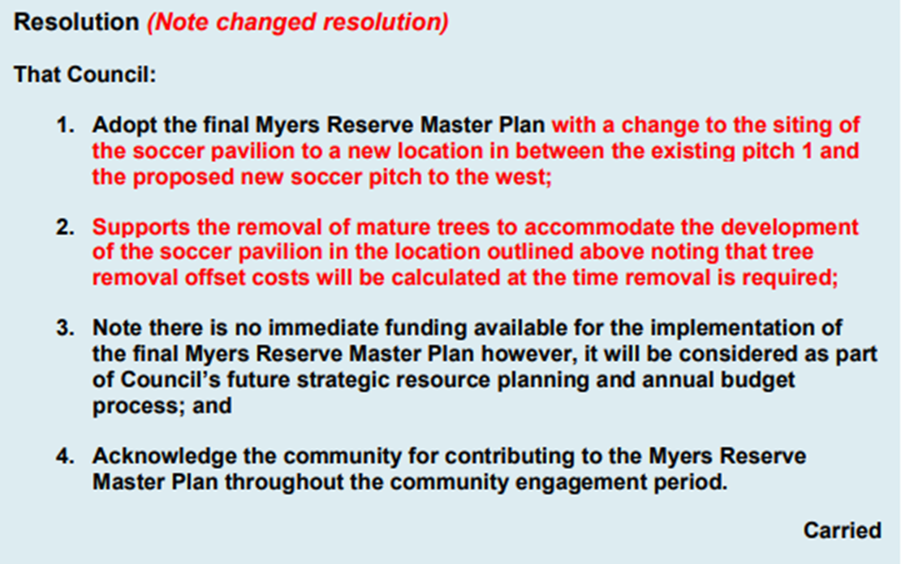

https://mail.google.com/mail/u/0?ui=2&ik=e2cf565206&attid=0.10&permmsgid=msg-f:1771095599752780362&th=1894321076859a4a&view=fimg&fur=ip&sz=s0-l75-ft&attbid=ANGjdJ8lw4c965OiwbyYJ4niA_0F8kXHAxv1ZuJgI9Oe8Ws5dBONWqg0Qpk6zhazUgxlTm1sqZSD9PLgsc2irbRMQ0zWPqkaEf9YjmyevHkCTfQbbs4F-hR3Z1jB4N4&disp=emb

