
heritage information sheet

fences

Prepared by Authentic Heritage Services Pty Ltd
Under Clause 43 (Heritage Overlay) of the Greater Geelong Planning Scheme, a planning permit is required to construct a fence if visible from a street (other than a lane) or public park.
This Information Sheet focuses on front fences. The Heritage Design Guidelines for the various heritage overlay areas in Greater Geelong , and the City of Greater Geelong Heritage and Design Guidelines (all of which are Incorporated Documents in the Planning Scheme), encourage fences to be designed and constructed in a way that is sympathetic to the character of the heritage place.
The following information is provided to give further illustrative guidance on the types of front fences appropriate to the different eras and styles of dwellings. It is provided informally only and does not supersede any of the relevant Incorporated Documents which should be read in conjunction with these sheets.
This Information Sheet sets out the basic architectural styles for properties in Greater Geelong, and the types of front fencing traditional applicable to that style or era.

Definitions

The following gives some basic definitions in relation to the components of fences referred to in this document.

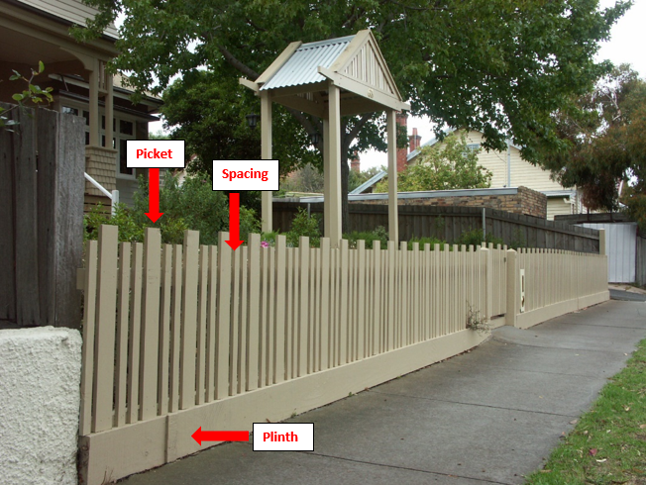
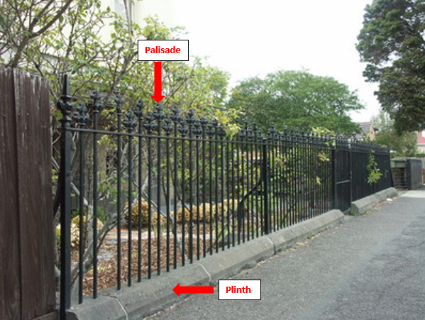
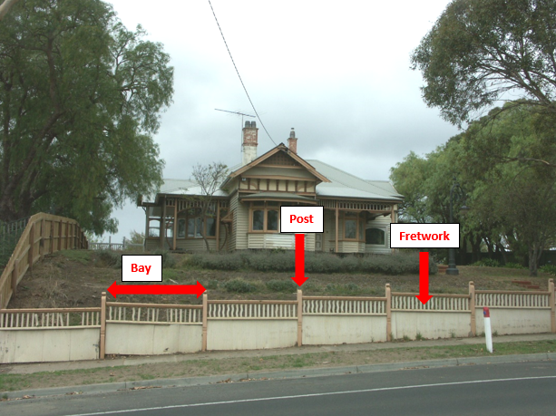
Source: Dr David Rowe.

Early Victorian, Mid Victorian, Late Victorian & Victorian Italianate Styled Dwellings
The prevailing Victorian, Mid Victorian, Late Victorian and Victorian Italianate styled dwellings in Greater Geelong are as follows (key characteristics of these styles can be found in the City of Greater Geelong Heritage and Design Guidelines.
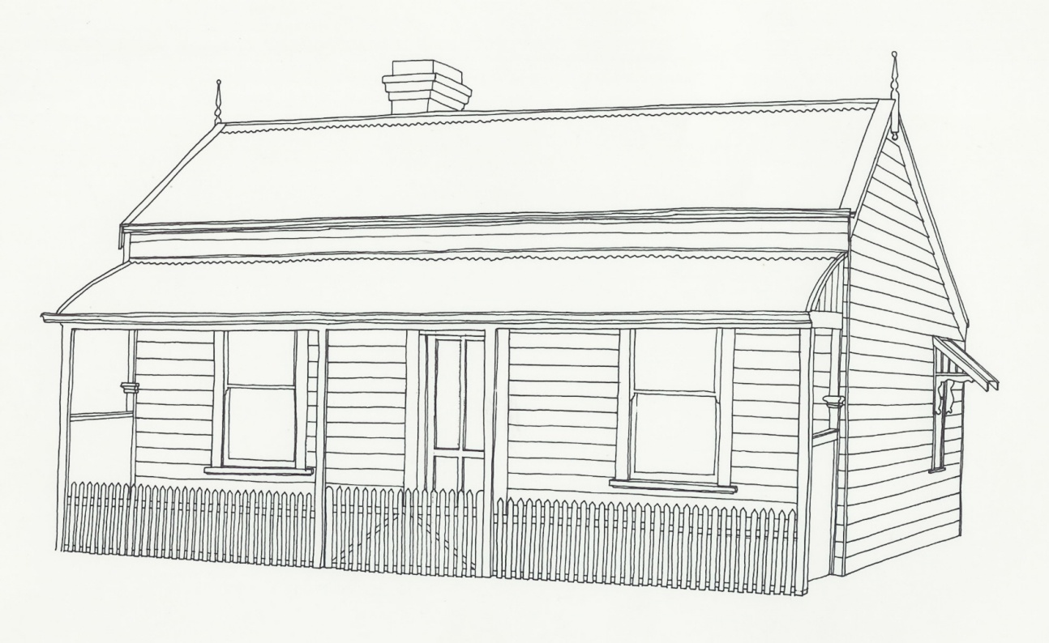 |  | 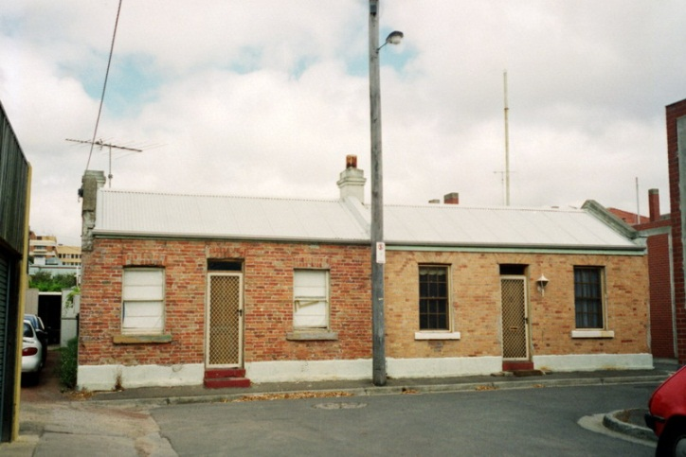
Early Victorian Styled Dwelling.  Source: City of Greater Geelong. |  | Early Victorian Styled Semi-Detached Dwellings
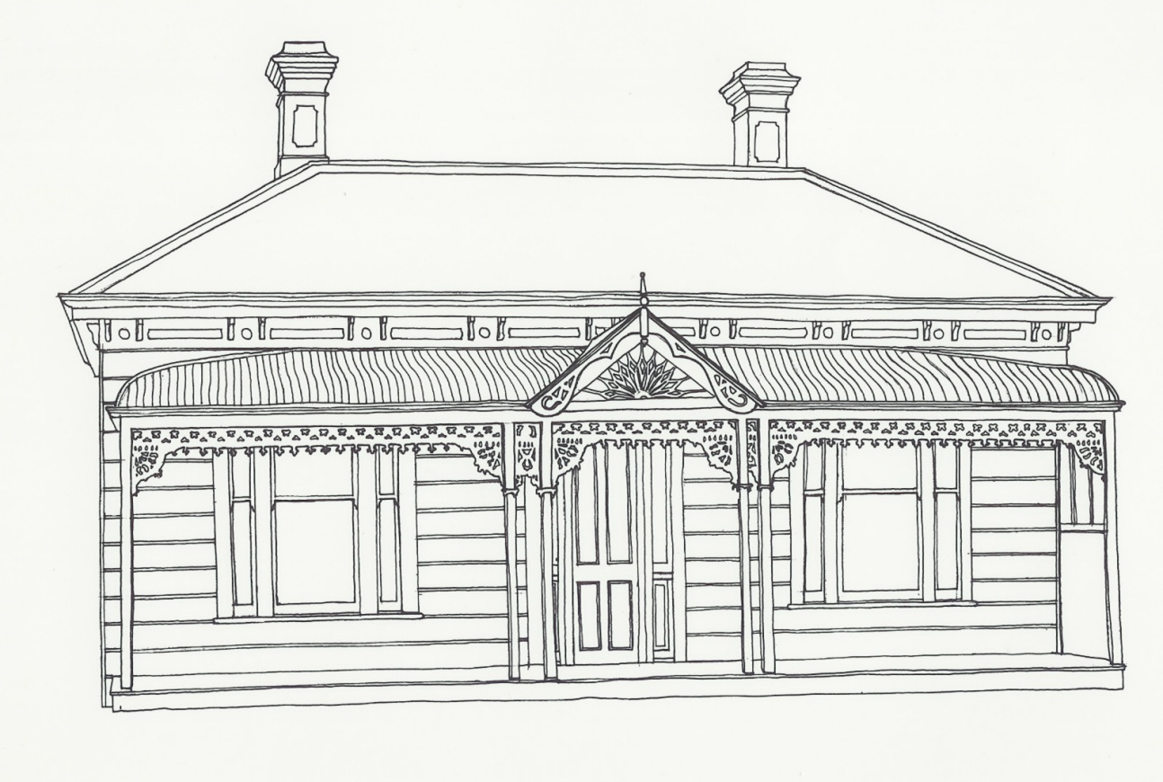 |  | 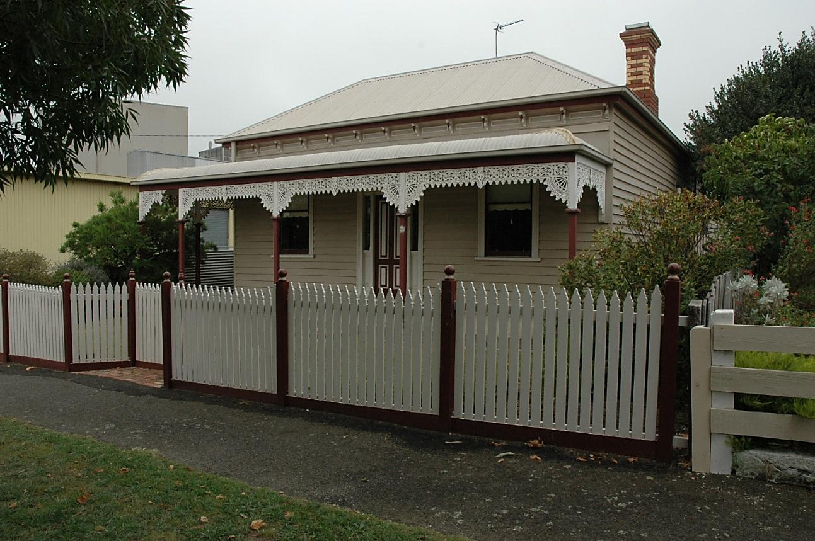
Mid-Late Victorian Styled Timber Dwelling.  Source: City of Greater Geelong. |  | Mid-Late Victorian Styled Timber Dwelling.  Source: Dr David Rowe.
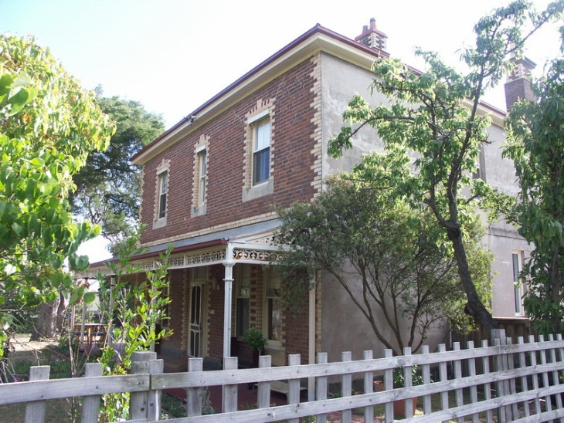 |  | 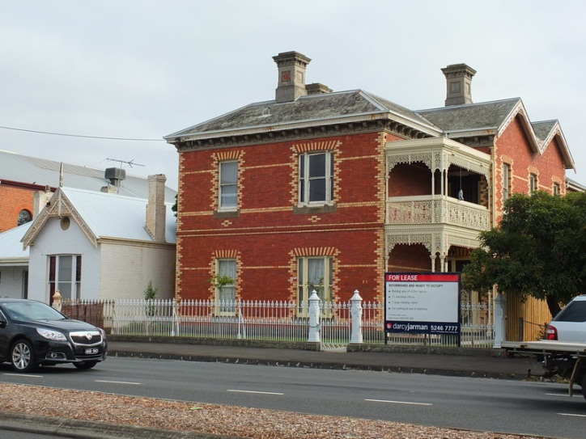
Mid Victorian Styled Brick Dwelling. Source: Dr David Rowe. |  | Late Victorian Styled Brick Dwelling.  Source: Dr David Rowe.
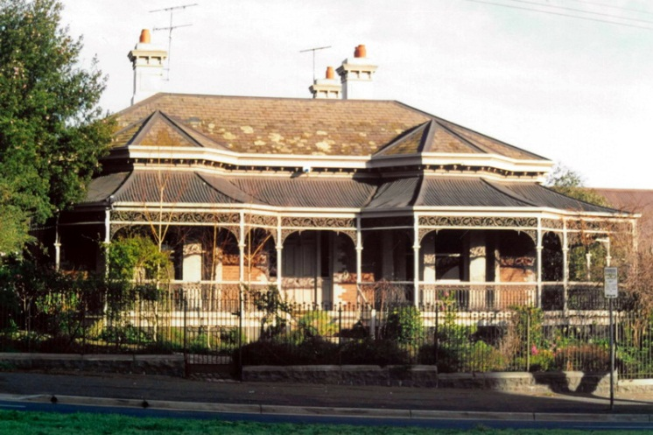 |  | 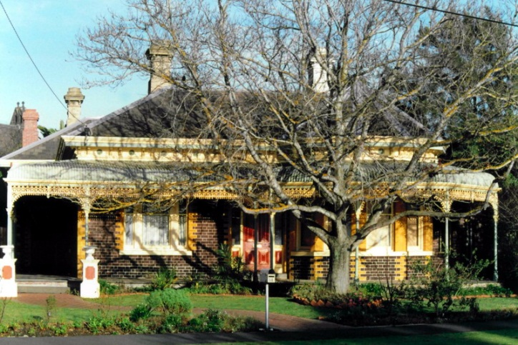
Victorian Italianate Styled Brick Dwelling.  Source: Dr David Rowe. |  | Victorian Italianate Styled Brick Dwelling.  Source: Dr David Rowe.

Fence Types

Pointed Timber Pickets
Pointed timber picket fences are commonly associated with Early, Mid and Late Victorian styled dwellings, built from the mid 19th century until c.1900, although variations in picket fencing continued into the early 20th century. Mid and some late 19th century picket heads were rudimentary, mainly being V-shaped (Figures 1-2) or sometimes flat.
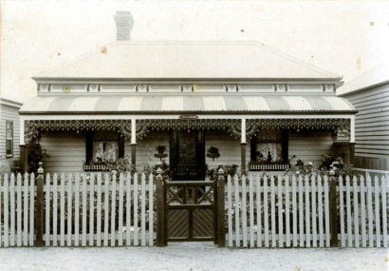 |  | 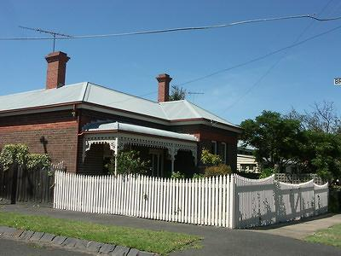
Fig.1: Victorian dwelling with pointed timber picket fence, expressed posts with decorative cappings, and timber gate. Source: Emerald Museum. |  | Fig.2: Late Victorian styled brick dwelling with pointed timber picket fence. Source: Dr David Rowe.

From the 1860s there were a number of more decorative picket heads available. The picket detail design was usually governed by the era of the fence construction as much as the simplicity or elaboration of the dwelling or building.
Spacings between the pickets varied between 25 and 50 mm. Sometimes smaller pickets were added between the primary pickets for additional screening and decoration. Occasionally there are concerns about the potential for vandalism and the pickets being removed.
In these cases, hoop iron can be attached along the front of the pickets (where the pickets are attached to the rails) (Figure 3).
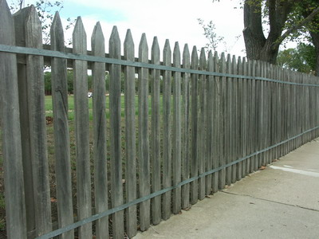
Fig. 3: Unpainted timber picket fence with hoop iron used to reinforce the pickets. Source: Dr David Rowe.

Painting the hoop iron can reduce its visual prominence.
Picket fences were constructed with or without a timber plinth. Where plinths were constructed, they were usually within the range of 140-190 mm in height. Masonry bases are sometimes sought for fence reconstructions and new fences given raised garden beds behind. Any masonry plinths should not be visually dominant and they should be in proportion with the overall fence design (being no more 1-2 courses in height).
Posts were usually expressed (slightly projecting from the fence bays) and sometimes there were less decorative and smaller intermediate posts. The posts were capped in a range of ways depending on the era and elaboration of the fence design: from pointed and rounded cappings, to projecting moulded timber cappings, timber orbs or cast iron cappings.
Gates were either of a picket design similar to the fence bays or different timber designs often with timber base panelling to emphasise the entry point. In most situations, these fences were no higher than 1200-1300 mm.

Cast Iron Palisades
Cast iron palisade fences were common from the 1860s (Figure 4) because iron foundries had been established which gave greater access to this material. These types of fences are mainly associated with substantial masonry (face brick, stone or rendered) mid and late Victorian and Victorian Italianate dwellings. While new cast iron palisade fences are often proposed, the lack of an existing cast iron fence may be an indicator that the original fence was of timber construction. A lack of cast iron palisade fences in the area might further suggest that they were not a traditional feature.
They commonly featured masonry plinths (usually one-two courses high with a smooth finished or rendered capping).
In some cases, substantial cast iron or masonry (stone or rendered) posts were constructed that emphasised gate openings and property corners. They were often crowned with decorative cast iron cappings, orbs or urns.
For the fence bays, there was a range of palisade heads, from simple to more decorative. Sometimes, a particular palisade head was common to an area due to the popularity and/or proximity of the iron foundry.
Gates also matched the design and construction of the fence.
The height of these fences varied, from 1200-1300 mm for modest Victorian dwellings, to approximately 1800 mm for two storey brick dwellings on larger allotments.
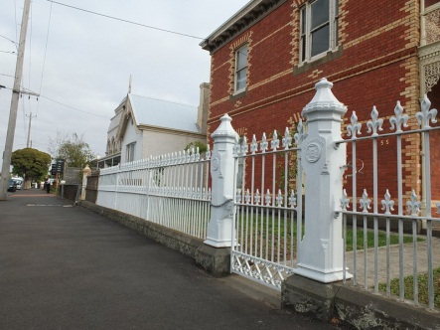
Fig.4: Substantial Late Victorian brick dwelling with iron palisade fence having cast iron piers and bluestone plinths. Source: Dr David Rowe.

Federation & Edwardian Styled Dwellings

Fence Types

Pointed Timber Pickets
Pointed timber picket fences continued to prevail for some Federation and Edwardian dwellings in the very early 20th century. In addition to pointed pickets (Figure 5), rounded (Figure 6) and other picket heads were usually associated with Federation and Edwardian styled dwellings.
Spacings between the pickets varied between 25 and 50 mm. Sometimes smaller pickets were added between the primary pickets for additional screening and decoration.
Picket fences were constructed with or without a timber plinth. Where plinths were constructed, they were usually within the range of 140-190 mm in height. Masonry bases are sometimes sought for fence reconstructions and new fences given raised garden beds behind. Any masonry plinths should not be visually dominant and they should be in proportion with the overall fence design (being no more 1-2 courses in height).
Posts were usually expressed (slightly projecting from the fence bays) and sometimes there were less decorative and smaller intermediate posts. The posts were capped in a range of ways depending on the era and elaboration of the fence design: from pointed and rounded cappings, to projecting moulded timber cappings, timber orbs or cast iron cappings.
Gates were either of a picket design similar to the fence bays or different timber designs often with timber base panelling to emphasise the entry point.
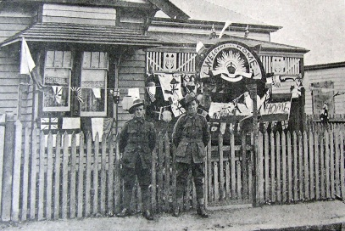 |  | 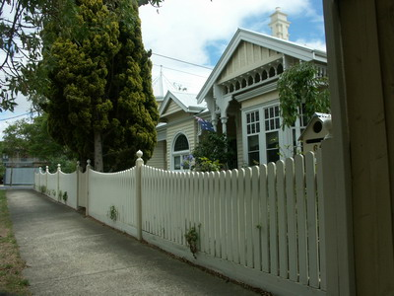
Fig. 5: Edwardian dwelling with pointed timber picket fence.  Source: News of the Week, 1919. |  | Fig. 6: Rounded timber picket fence to a Federation era dwelling. Source: Dr David Rowe.

Flat Timber Pickets
Sometimes associated with Federation and Edwardian styled dwellings are rudimentary versions of flat timber (Figure 7).
Picket spacings were around 25 mm and the pickets tended to be wider for interwar properties. A timber plinth traditionally formed the base to these types of fences, being approximately 140 – 190 mm in height.
Gates often matched the flat timber picket design of the fence, or were of varying timber design or of scrolled metal and wire construction.
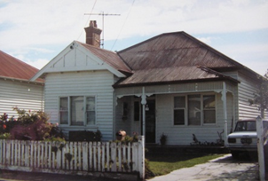
Fig. 7: Flat timber fence to an Edwardian era dwelling.
Source: Dr David Rowe.

Capped Timber Pickets

Picket Fences with Fretwork Cappings
With some Federation and Edwardian styled dwellings timber picket fences were commonly adorned with fretwork cappings (Figure 8). The detailing of the fretwork usually replicated the fretwork of the verandah valance of the dwelling, or was a simplified variation of it.
Timber posts were often expressed with projecting turned or other decorative cappings.
The pickets usually had spacings from at least 25 mm, and timber plinths with a height between 140 and 190 mm.
The gates usually reflected the design of the fence bays, or were a slight variation (either with solid timber panelling or an alternative fretwork design) or of scrolled metal and wire construction.
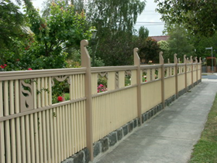
Fig. 8: Detail of Federation era picket fence with fretwork capping. Source: Dr David Rowe.

Picket Fences with Simple Cappings
Like the flat timber picket fence, simply-capped timber picket fences were most common during the Federation and interwar eras (Figure 9). Sometimes, cut-out decorations defined some of the Federation era pickets (this decoration was taken from the verandah valance of the dwelling where applicable).
Timber plinths formed the base construction to a height between 140 and 190 mm. Expressed timber posts projected beyond the timber capping, being finished in a range of designs. With all timber picket fences before World War 2, the pickets were arranged vertically.
Picket spacings were usually around 25 mm.
Gates were usually of similar design and construction as the fence bays, or were a panelled timber gate having an open fretwork upper panel. Sometimes they were of scrolled metal and wire construction.
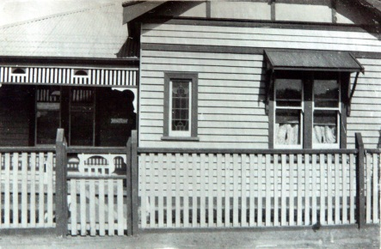
Fig. 9: Edwardian styled dwelling having a timber picket fence with a simple capping, c.1930.
Source: Holmes collection, Authentic Heritage Services P/L.

Ripple Iron and Timber Fretwork
A variation on the capped timber picket fence was the ripple iron and timber fretwork fence that is often associated with Federation era dwellings (Figure 10). The fretwork capping to the fence generally reflected details of the dwelling, such as the verandah valance. The ripple iron provided a solid lower portion to the fence but the overall fence design continued to enable views to the front garden setting.
Gates were either of tubular steel and scrolled metal and wire construction, or timber.
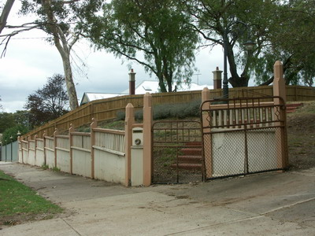
Fig. 10: Detail of Federation era ripple iron and timber fretwork fence, with scrolled metal and wire vehicular and pedestrian gates. Source: Dr David Rowe.

Woven Wire
In 1899, the Cyclone Woven Wire Fence and Gate Company commenced the production of woven wire. For some Federation and Edwardian styled houses, woven wire was used in conjunction with timber posts, rails and plinths (Figure 11), or more substantial masonry piers and plinths (Figure 12), reflecting the design, construction and proportions of the property.
Gates were tubular steel and scrolled metal with woven wire infill.

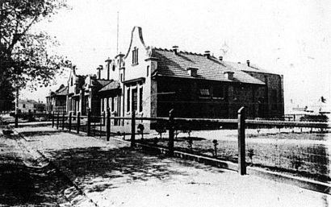 |  | 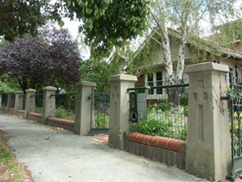
Fig. 11: Capped timber post and woven wire fence.  Source: News of the Week, 1916 |  | Fig. 12: More substantial woven wire fence to large property, with rendered piers and brick plinths.  Source: Dr David Rowe.

Interwar Bungalow Styled Dwellings

Fence Types

Flat Timber Pickets
Some interwar Bungalow styled dwellings traditionally featured wide flat timber picket fences (Figure 13). The picket spacings and construction of a plinth and gate details were similar to the flat timber picket fences built during the Federation era.
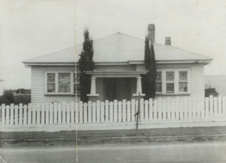
Fig. 13: Flat timber picket fence to an interwar Bungalow styled dwelling. Source: Rowe, Belmont Heritage Areas Report, vol.1, 2007.

Capped Timber Picket
Like some Federation styled dwellings, capped timber picket fences up to a height of 1300 mm were a feature of interwar Bungalow styled dwellings (Figure 14).
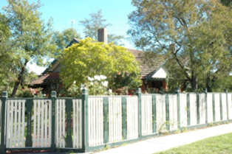
Fig. 14: Capped timber picket fence to an interwar Bungalow styled dwelling. Source: Dr David Rowe.

Woven Wire
The timber post and rail and woven wire fences built towards the later period of Federation styled dwellings were also popular for interwar Bungalow styled dwellings (Figure 15).
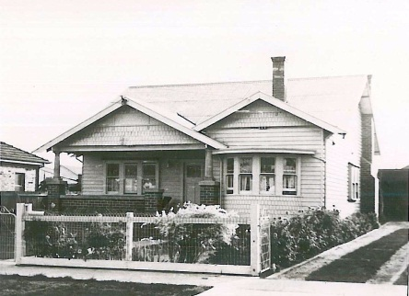
Fig. 15: Timber post & rail & woven wire fence to an interwar Bungalow styled dwelling. Source: City of Greater Geelong.

Chain Mesh
From 1914, chain wire mesh was available. Also known as Cyclone wire, fences with this type of mesh design became popular during the interwar period. They were often capped with timber cappings, with low timber plinths and rudimentary, expressed square timber posts (Figure 16).
Gates were usually of open, geometric steel design
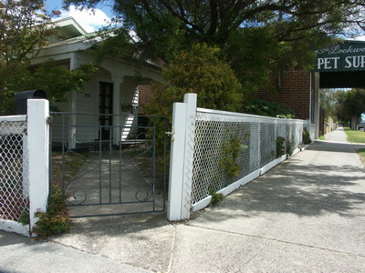
Fig. 16: Interwar Bungalow styled dwelling with a capped timber post and chain mesh front fence having open geometric steel gate. Source: Dr David Rowe.

Low Solid Masonry
Another popular early 20th century fence type, including for some interwar Bungalow styled dwellings, was solid brick fences. These fences still allowed views to the front garden. The designs of solid fences varied depending on whether they were built in the early or later interwar period. Some early interwar era fences reflected the design and construction of the dwelling in some way (such as the balustrade curve of the verandah) (Figure 17).
Gates were often open steel with geometric patterns.
The overall height of these types of fences was usually between 600 & 1000 mm.
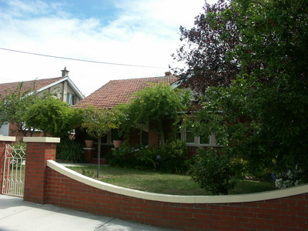
Fig. 17: Interwar solid brick fence, being sufficiently low not to obstruct the view to the front garden. Source: Dr David Rowe.

Modern and Post War Bungalow Styled Dwellings

Fence Types

Low Solid Masonry
Common for Modern and postwar Bungalow styled dwellings were solid brick fences. They were usually simple in design (Figure 18).
Gates were often open steel with geometric patterns.
The overall height of these types of fences was usually between 600 and 1000 mm.
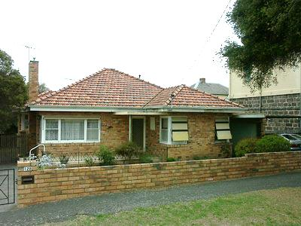
Fig. 18: Low solid brick fence to late interwar dwelling. Source: Dr David Rowe.

Brick Piers with Open Geometric Steel Trussed Panels
A variation on the low late interwar era solid brick fence was a fence with brick piers and plinths and open geometric steel trussed panels (Figure 19).
The gates were often open steel, having geometric patterns that reflected the design of the open steel trussed panels.
These fences usually ranged between 600 and 1000 mm in height.
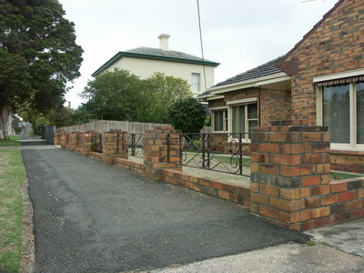
Fig. 19: Low brick fence with open bays with trussed geometric panels. Source: Dr David Rowe.

Horizontal Paling Fences
Horizontal timber paling fences featured as the front boundary to some properties after World War 2 and particularly from the 1950s.
They were usually no higher than 1000 -1200 mm and the palings were set in front of the posts (either timber or tubular steel) (Figure 20).
The spacings between the palings were usually around 25 mm.
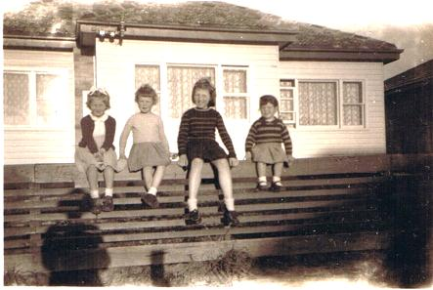
Fig. 20: Horizontal timber paling fence to a postwar Bungalow, 1951
Source: Lorraine Huddle.

No Fencing
Properties of postwar Modern designed after World War 2 and particularly from the 1950s may not have been bound by a front fence. Landscape treatments often formed the main feature to the front setting.

Other Considerations

Fence Heights
For most new fences in heritage areas, as outlined in the Heritage and Design Guidelines, the proposed height should generally be between 1200 and 1300 mm.
For interwar and postwar era solid brick fences and retaining walls, the proposed height should generally be between 600 and 1000 mm.
High solid fences limit social and visual interaction and are not a traditional fence type in most residential heritage areas (Figure 21). No matter how well-articulated these high walls might be designed, they are usually visually intrusive in the streetscape. Arguments are often used that a high solid masonry fence may mitigate traffic noise but this is not the case as noise may penetrate from the sides and reverberate within the front setback. Dense planting (such as hedges) behind front fences may provide some sound isolation, but more effective methods of noise insulation include secondary glazing (or double glazing where windows have no heritage value) and air ventilation systems that limit noise ingress.
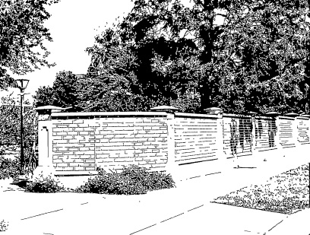
Fig. 21: High brick wall obscuring front of heritage property. Source: Dr David Rowe.

High fences may be valid in contexts where high solid fences form the significance of the heritage place. These places may include early masonry walls to convent, orphanage, religious, prison and industrial sites, for example. Where high and solid fences represent part of the significant setting of the place, a new fence should be no higher than existing fencing, and be a contemporary interpretation to allow a subtle distinction between the old and the new. The new fencing should not separate significant buildings, diminish the setting or obscure significant views from and within the site.

Higher fences may be possible if:
- The heritage place has individual significance and is contextually larger in scale (both in terms of the setting and building sizes), the fence therefore being in proportion to the larger scale.
- The new fence is a reconstruction of an earlier fence based on historical evidence.
- The prevailing traditional fence heights in the streetscape (for places in heritage areas) are higher.

Sloping Sites
Where front fences are proposed for sloping boundaries, they should be stepped (Figure 22) or follow the footpath gradient (Figure 23). Fencing that extends across the frontage at the one level on sloping sites have the potential to create visual dominance as the new fence at the lower end of the site will be much higher.
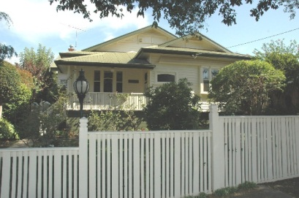 |  | 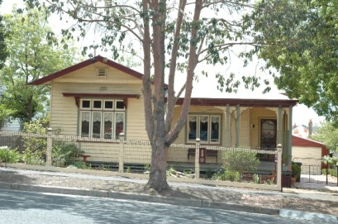
Fig. 22: Fence stepped along slope of boundary.  Source: Dr David Rowe. |  | Fig. 23: Fence following gradient of boundary slope.  Source: Dr David Rowe.

Hedges
From the Federation era, hedges were used to provide greater height and privacy (Figure 24). No planning permit is required to grow a hedge.
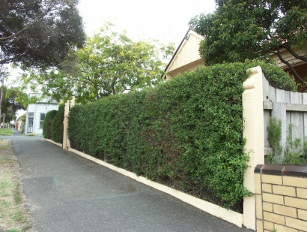
Fig. 24: Hedge forming front boundary. Source: Dr David Rowe.

