
heritage information sheet

external painting

Prepared by Authentic Heritage Services Pty Ltd
The painting of a building has a noticeable impact on its character and appearance as surface finishes often make an important contribution its significance. In many cases, original surfaces survive, including face brickwork, render or painting. Sometimes, maintenance and change has covered the original finish, often encapsulating early finishes. Careful assessment of surface finishes will establish whether the existing surface is original and should be kept, whether the original surface could be revealed, or whether reproduction of an earlier paint scheme would enhance significance.
A planning permit is not required to paint an existing painted surface unless external paint controls apply as identified as part of the heritage overlay for the property in the Schedule to the Heritage Overlay at Clause 43 of the Greater Geelong Planning Scheme (note: a planning permit is required to paint an existing unpainted surface irrespective of whether external paint controls apply).

Paint Removal
Before considering the removal of any paint, it is critical to ensure it the existing paint is not original or part of the significance of the place. Original paint should be retained, even in circumstances where painting over it might be permitted.
For the removal of introduced paint, only approved paint removal poultices that do not damage the surface of the building material should be considered. Sometimes, more than one poultice may be required. Sandblasting should not be used as this process causes irreversible damage.

Painting
Any proposal to paint a building should consider whether the paint type and colours will enhance its character and appearance. It is important to understand whether the existing colour scheme is original or consistent with the architectural style and era of the building.
Proposed paint schemes for those heritage places where external paint controls apply should consider schemes that highlight particular features of the building in a traditional manner through a select colour palette. This is usually to distinguish walls, architraves, window frames and sashes, doors, and verandah and eaves detailing (Figures 1-2).
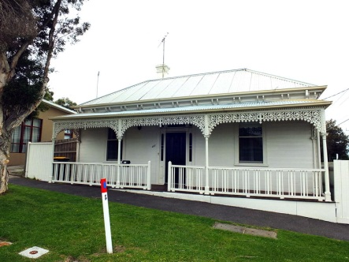 |  | 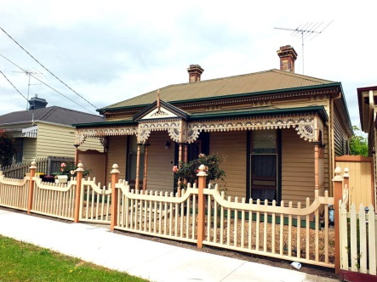
Fig 1: The installation of panels on the front roof face and projecting beyond the roof ridgelines of this Victorian dwelling has had a negative impact on its significance, character and appearance.  Source: Dr David Rowe. |  | Fig 2: While the side (west) roof face locations of these panels are still visible to a street, the visual impact is less considerable than their placement on the front (north) roof face. Dr David Rowe.

To determine an appropriate colour scheme for a heritage building, the following should be considered:
- A paint scrape analysis: this involves scraping back the layers of paint to determine the original paint colour applied. The original paint colour should not be confused with the primer that would have been first applied to the surface.

- Historical evidence: while historical sepia and black and white photographs do not provide earlier colours, they give an indication of the tonal range.

- Common Colour Palette: for each of the different eras of building development there are specific colours common to each era. If there is no historical or physical evidence of the original colour scheme, the colours should ideally be chosen from the palette applicable to the era and style of the building, in conjunction with any available historical photographs where possible, and applying these colours in a traditional manner. A lesser alternative is the selection of sympathetic contemporary colours applied in a traditional way (eg colour contrast between walls and details in a traditional way).

Painting Previously Unpainted Surfaces
The painting of previously unpainted surfaces should be avoided, unless evidence is provided that the surface was originally painted. Usually, these unpainted surfaces are brick or stone walls and chimneys, together with masonry verandah piers as part of interwar era dwellings.

Painting Over Rendered Surfaces
The painting over previously unpainted rendered surfaces should be avoided as this will have the potential to diminish the significance, character and appearance of the place.
For proposals to paint existing painted rendered surfaces, acrylic resin paints should be avoided. The resins in these paints have poor vapour permeability and once applied, they have a thick film. This can lead to moisture being trapped in the wall or salt-laden moisture accumulation, causing damage to the render and the wall. Silicate-based paints, which still allow for vapour permeability, should be considered.

