
heritage information sheet

solar energy systems

Prepared by Authentic Heritage Services Pty Ltd
Under a heritage overlay, a solar energy system (solar panels) has the potential to impact a heritage place due to the visual dominance of the system, notwithstanding the important environmental benefits it might bring.
A planning permit is required for the construction and installation of a solar energy facility where it will be visible from a street (other than a lane) or a public park, and if solar energy system controls apply to the heritage overlay identified for the heritage place.
The construction and installation of photovoltaic and other solar panels for electricity and hot water services require careful consideration of their placement to ensure that the significance, character and appearance of the heritage place (whether an individually significant dwelling or a contributory or non-contributory dwelling in a heritage area) is not adversely affected. Damage to existing significant roof fabric should also be avoided.

Front Roof Faces
More contentious proposals are those that involve the installation of panels on front roof faces with northern orientations (Figure 1). These north roof faces provide the optimum opportunity for solar power generation. However, for significant heritage dwellings and dwellings in heritage areas, solar panels are not traditional roofscape features and they have the potential to adversely affect the character of the heritage place. Placements on front roofs should be avoided where possible and all other alternatives explored.
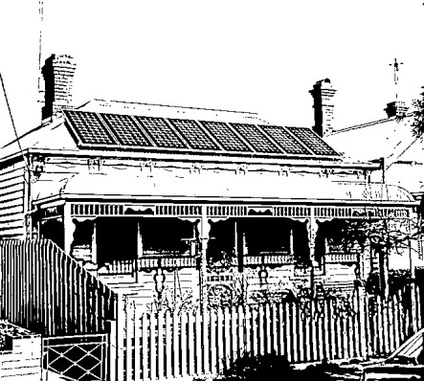
Fig 1: The installation of panels on the front roof face and projecting beyond the roof ridgelines of this Victorian dwelling has had a negative impact on its significance, character and appearance. Source: Dr David Rowe.

Side Roof Faces
Side roof faces - even where there may be some public view - may be an acceptable alternative. Depending on the orientation and design of the roof and potential for shade from neighbouring buildings and vegetation, installations on side roof faces may result in in only minor power losses. In these situations, the panels should be recessive from the front as much as possible and framed by existing roof ridgelines (Figure 2). Additional panel installations (to compensate for the loss of power generation from a north roof face) might be acceptable where they are less visible to the public.

General
Solar panel installations should not involve structural change to the roof and the panels should be installed flush to the roof face. The panels should also be framed by existing roof ridgelines (the panels not extending beyond the ridgelines).
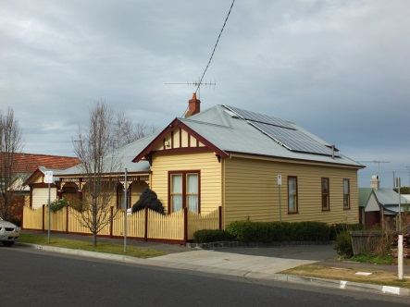
Fig. 2: While the side (west) roof face locations of these panels are still visible to a street, the visual impact is less considerable than their placement on the front (north) roof face. Source: Dr David Rowe.

In situations where alternative locations on the roof of the dwelling might not be possible, installations on outbuildings such as rear garages and sheds should be considered (Figure 3).
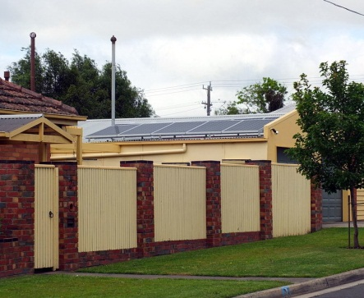
Fig. 3: The placement of solar panels on the north roof face of the rear garage - while still visible to a street - has greatly reduced the visual impacts compared to a location on the front roof of the dwelling where there was also potential to damage the roof tiles. Source: Dr David Rowe.

Where the heritage dwelling has a high level of significance or where the panel installation would physically damage the roof cladding, the construction of freestanding panels in rear yards or where they are recessive in location may be an acceptable alternative (Figure 4).
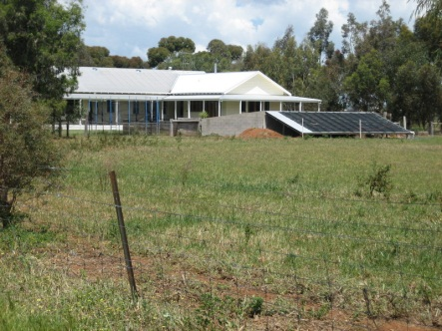
Fig.4: This freestanding solar energy facility on a rural property is screened from the main frontage of the dwelling, thereby reducing visual impacts.
Source: Jennifer Bantow.

