
heritage information sheet

REPAIRS

Prepared by Authentic Heritage Services Pty Ltd
Under Clause 43.0-1 of the Planning Scheme, a planning permit is not required for works, repairs and routine maintenance that do not change the appearance of the heritage place, if the proposal is carried out to the same details, specifications and materials as existing. Routine maintenance constitutes the change to particular elements or parts of a building to improve its condition and maintain its appearance. Permit exempt repairs and routine maintenance are minor in extent.

Basis of Assessment
A planning permit is required for more substantial repairs and maintenance, where the external appearance of the heritage building will change. This also includes the repairs that will enhance the character of a building. In most cases, advice from Council’s Heritage Advisor and other specialist consultants and tradespeople may be important to ensure a successful repair outcome. This advice should precede a planning permit application. The application will require documentation of all repairs and extent of works.
An assessment of an application for substantial repairs will need to consider the following:
- Any applicable heritage study and statement of significance for the place (as outlined in Clause 43 of the Planning Scheme).
- Whether the works have been undertaken in accordance with the accepted conservation standards of the Australia ICOMOS Burra Charter (as outlined in Clause 15.03-1S of the Planning Scheme).
- Whether the demolition, removal or external alteration will adversely affect the significance of the heritage place (as outlined in Clause 43 of the Planning Scheme).
- Whether the proposed works will adversely affect the significance, character or appearance of the heritage place (as outlined in Clause 43 of the Planning Scheme).
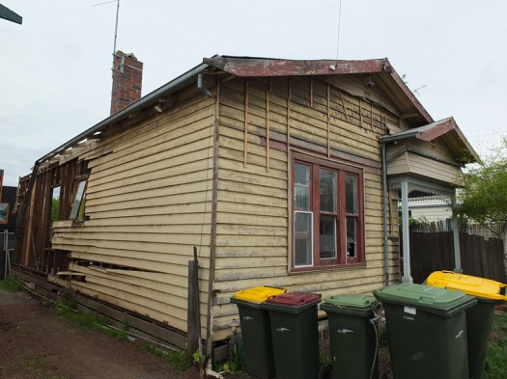 |  | 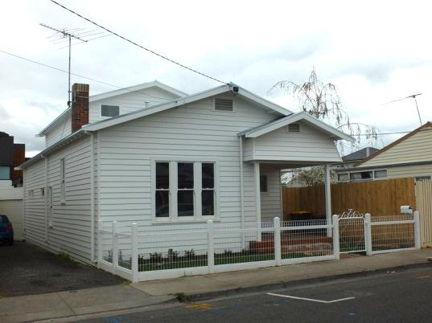
Dwelling before and after repairs. Source: Dr David Rowe.

Basic Principles
Where change is being considered as part of repairs and maintenance, it is important that a proper understanding of the significant fabric is first gained. For an individually significant place or a contributory place in a heritage area, this fabric should be identified in the statement of significance in the heritage study.
Understanding what constitutes significant fabric of the place will be critical to the success of a planning permit application, as both these issues should influence the extent and methods of repairs and maintenance.
In some cases, a building might be suffering from structural or cosmetic defects by virtue of its age, methods of construction or past use, but may still provide adequate service. Repairs and maintenance should therefore be based on the heritage principle of “replacing as much as necessary but as little as possible.” Wholesale replacement of building fabric should be avoided when the fabric is in good condition. In cases where sisalation (a building membrane used to minimize draughts) and insulation may be required to improve the building’s energy performance under the Building Code of Australia, for example, the exterior cladding should be carefully removed and then reinstated after the sisalation and insulation is installed. New cladding should only replace fabric in poor condition or damaged materials.

Understanding Significant Fabric & Basic Repair Principles

Floors
The restumping of timber floors requires no planning permit where no change is proposed to the exterior of the building. Restumping is a routine process. As part of the restumping process, it is important that adequate subfloor ventilation is maintained to keep adequate air flow beneath the building. Ensure that existing subfloor ventilation openings are not submerged by garden beds, ground build up and debris, and that the ground around the building is graded away from the walls to prevent water ponding and moisture ingress beneath the building.

Roofs
Generally, where existing original or significant roof cladding requires complete replacement, a permit is required. In these instances, the proposed cladding should match the existing in appearance and construction.

Matters for Consideration

Slate Roofs
Before complete replacement is considered, the condition of the existing slate should be clarified. Salvaged slate should be reinstated in addition to replacement slates where necessary. These slates (and where complete replacement is necessary), the new slate should match existing in profile, colour, texture and finish. The battening and nailing system as well as the proposed materials for flashings and valleys should be documented as part of the application. Traditionally, lead flashings were used. The use of lead flashing today can pose occupational, health and safety concerns, particularly where rainwater is collected for drinking purposes. In most situations, galvanised steel flashings may be an acceptable alternative.
In some cases, depending on the significance of the heritage place, opportunities might be available to re-clad roof faces hidden to public view with alternative materials to minimise costs, such as inner roof faces to central roof valleys.

Tiled Roofs
If existing terra cotta, concrete, malthoid or other roof tiles cannot be retained or damaged tiles replaced, new tiles should match the existing in profile, size, colour, texture and appearance to retain the significance and appearance of the heritage place. For example, where the existing roof tiles are unglazed, the new tiles should also be unglazed. Any roof ridge decoration in good condition that can be retained should be carefully removed and reinstated once the roof works have been completed. Where the decoration has been damaged or is missing, replacement fabric should be based on historical, physical or comparative evidence. New fabric should not be installed on roofs where it was never intended.

Corrugated Sheet Metal
Where existing galvanised corrugated steel roof cladding requires replacement, it should be replaced in the same material. The standard Z450 sheet has a thinner coating than the double-smelted (thicker-coated) Z600 galvanised steel product.
In marine and other environments where galvanising is less effective, consideration might be given to corrugated Colorbond© sheet cladding.
A more widely available sheet metal roofing product is Zincalume©. It is not generally acceptable on heritage buildings and in heritage areas because it maintains a high degree of reflectivity for a long period. This reflectivity has the potential to create visual dominance in heritage areas.
Galvanised steel and Zincalume© materials should not be used together. This has the potential to cause a galvanic reaction, accelerating the rusting of the galvanised steel material. Circumstances where a galvanic reaction might occur are:
- the installation of Zincalume© roof sheets with galvanised steel roof sheets (where they are physically connected);
- the installation of Zinaclume© flashings and roof valleys with galvanised steel roof sheets; and
- where there will be rainwater run-off from the Zincalume© product to galvanised steel gutters and downpipes.
- As Colorbond© is coated Zincalume©, is also should not be installed on galvanised steel roofs or slate or tiled roofs with galvanised steel flashings, valleys, gutters or downpipes.
For proposed additions attached to buildings with existing Zincalume© roof cladding, the cladding to the addition should match existing unless the entire roof is proposed to be reclad.
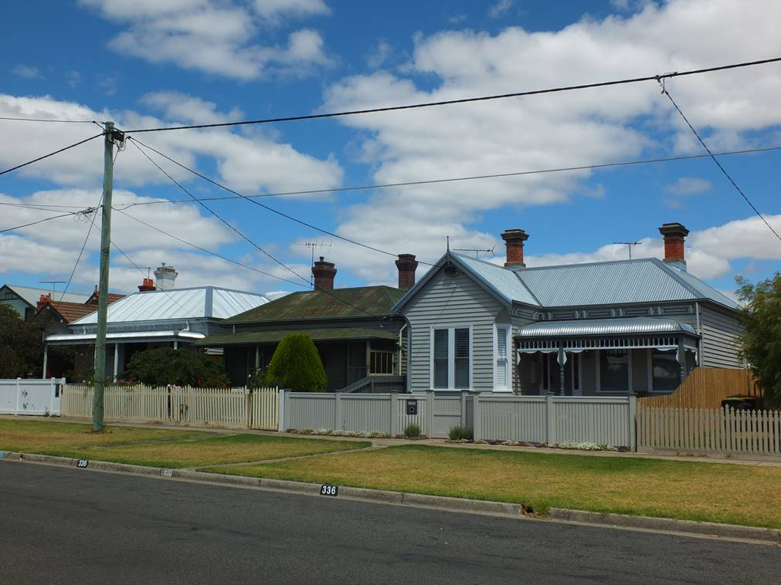
New Zincalume roof cladding (left) and new galvanised steel roof
cladding (right). Source: Dr David Rowe.

Chimneys
Chimneys contribute much to the character and appearance of heritage roof scapes. They are a key feature in identifying the architectural styles and eras of buildings. Chimneys should therefore be retained. Repairs should be in materials to match existing, such as any replacement brickwork and the mortar should be of the same strength (composition/mix), texture and colour as the existing original mortar.
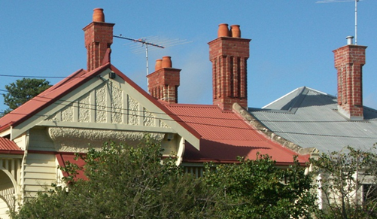
Dwellings with chimneys as a dominant feature. Source: Dr David Rowe.

Matters for Consideration
In circumstances where a significant chimney is structurally unsound and in poor condition, supporting documentation from a suitably-qualified Structural Engineer should accompany any planning permit application (see also Heritage Information Sheet – Demolition). Consideration should be given to reconstructing the external chimney to the same design, materials, profile, height, texture and colour, and in the same location, as the existing original fabric proposed for removal. These details and any internal supporting structure (where the chimney might not be servicing a new fireplace) should also accompany the application.
Difficulties may arise where a proposal is to remove a fireplace in the interior of an individually significant or contributory building where no internal alteration controls apply but where the external chimney represents significant fabric (a contributory element to a heritage place). In these circumstances, the most ideal heritage outcome is the retention of the fireplace and chimney insitu.
Where this may not be possible, opportunities might be available to retain the chimney exterior and support it in the roof space. See the Information Sheet on Demolition for further details.

Flashings Gutters & Downpipes
Original flashings, gutters, downpipes, flues, ventilators and other roof features should be retained and repaired where possible. Where replacement of the fabric is necessary, it should match the original size, profile and location (for example, an ogee profile gutter should be replaced with a gutter with the same ogee profile). Galvanised steel should be first considered where galvanised steel roof cladding is being maintained. For those situations where Colorbond or Zincalume is accepted, the new gutters, downpipes and other associated fabric should be constructed of the same material (unless the downpipe is draining to a water tank and in these instances pvc may need to be employed).

Matters for Consideration
Common gutter profiles to Victorian and Federation era buildings were ogee or half round. These gutters were generally supported by a timber scotia below. For interwar and postwar era buildings, quad or bullnose profiles were most common. Circular downpipes were often used, being 75 mm in diameter for dwellings.
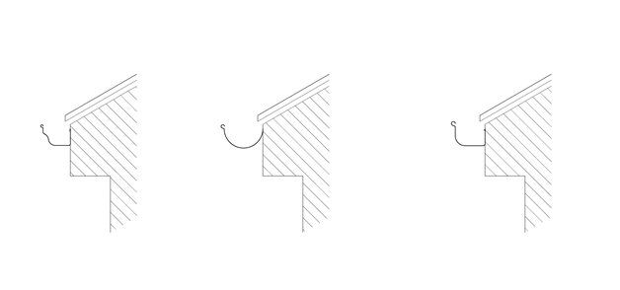
Ogee profile gutter | Half round profile gutter | Quad profile gutter

Whether existing gutters and downpipes are being retained and repaired or completely replaced, they should be connected to sealed drainage to avoid damp build up that can result in damage to floor and wall fabric.

Walls
Walls represent the main structural fabric of a building and they are a principal part of the significance of a heritage building. Repairs and maintenance should therefore respect the existing fabric and match it in materials, texture, profile, colour and quality.

Matters for Consideration
Repairs to a brick wall, for example, should include bricks that closely match existing. For timber weatherboard walls, the profile of the weatherboard should be matched (such as square, rounded or beaded edged) and the damaged portion replaced only. The existing species of timber should also be matched to minimise differential movement.
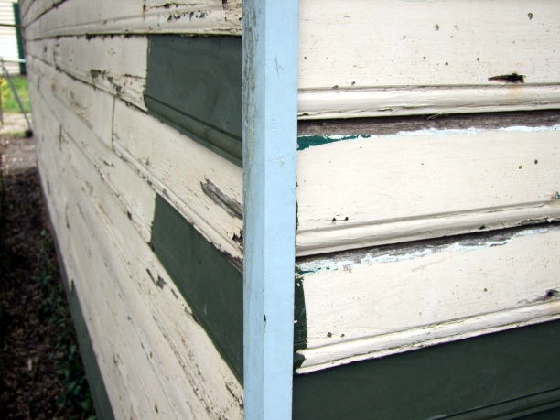
Detail of new weatherboards (dark colour) cut into existing weather wall cladding.
The replacement material is therefore limited to where required only.
Source: Brian Benson.

Render
Repair repairs should be carried out with a render to match the existing original render in strength, texture, colour, pattern and importantly, composition. In some instances for individually significant buildings, the existing render might require laboratory testing to determine is composition.

Matters for Consideration
Repairs to hairline cracks may be repaired by applying a fine scrim coat of render with a sponge. More substantial repairs will require expert advice.
Cement rich and synthetic renders should be avoided as they form a waterproof barrier that prevents any trapped moisture in the wall from evaporating.
Decorative rendered elements to a building should be retained, such as quoinwork, rustication, mouldings, and not rendered over. Other features such as urns, orbs, balustrades and brackets were usually made from a composition of cement, lime and sand, and sometimes they were not rendered or painted. Where decorative features were originally intended to be face stone or brick, they should not be rendered.
Render on original rendered walls should not be removed with the stone or brick left exposed. Apart from diminishing the integrity and appearance of the building, the exposure of the face stone or brickwork has the potential to create damp penetration.

Repointing
New mortar should match the existing original mortar in strength, texture, colour and composition. The mortar joint should match existing.

Matters for Consideration
The mortar joints to a stone or brick wall can be a primary feature and there are a range of traditional types of jointing that might contribute to the character of the building. These include tuck-pointed, beaded, tooled and scribed, struck, double-struck, flush and raised joints. Understanding the type of mortar joint will be important before any repairs are contemplated.
Determining the existing composition of the mortar in the joint to be repaired is also critical. The composition of the mortar determines its strength, elasticity, durability and colour. It is made up of sand, lime and/or cement in varying proportions. Using a hard mortar with a high cement content on most 19th century masonry buildings, for example, has the potential to create structural damage. This is because the new inappropriate mortar will be stronger than the stone or brick, causing any future wall cracks in the stone or brick instead of the traditionally softer mortar joint.

Windows and Doors
Where windows and/or doors contribute to the significance of a heritage place they should be retained and repaired, rather than being completely replaced. Damaged components should be replaced to match existing (such as a frame, sash, glazing bar, hardware and shutters). The replacement timber species should have the same properties as the existing as differential movement between them can cause failure and moisture ingress.
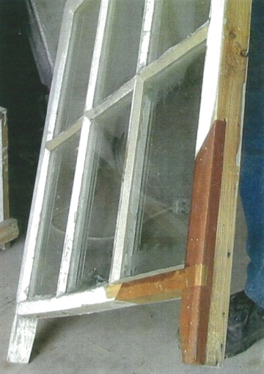
Significant timber framed window repaired
with sections of new timber fabric cut into the frame where it had deteriorated.
Source: Brian Benson, Ballarat.

Matters for Consideration
Preference should be given to secondary glazing significant windows rather than double glazing, especially where the windows are part of an individually significant building or exposed to the public realm on a contributory building. Secondary glazing is the installation of a second window on the interior, without any physical or visual impacts on the existing window exterior. No permit application is required for secondary glazing but a planning permit is required for altering existing windows on the exterior. Double glazing existing significant windows may not be possible
In most cases, the installation of new windows and doors on the principal public facades of individually significant and contributory heritage buildings are unlikely to be suitable in these instances. Existing openings and blocked up openings should be considered in the first instance. For buildings of higher heritage significance, the provision of new openings might be more difficult and specialist advice should be sought prior to making a planning permit application.
Where new door openings may be appropriate, particularly as part of introduced fabric, they should not replicate existing doors unless there is supporting evidence. Streamlined and innovative interpretations of existing window and door details are encouraged.

Decorative Features
Like roof ridge decoration, other architectural decoration that is damaged or in poor condition should be repaired rather than replaced. Where replacement might be the only option, the new fabric should match existing in design, profile, materials, colour and general appearance. Historical and physical evidence should form the basis of missing fabric and decoration should not be considered where it was never originally intended.

Verandahs
Damaged elements to a significant verandah should be replaced to match existing in materials, profile, design, construction and colour. This might involve the replacement of part of a verandah element only, such as a rotted base to a timber post.
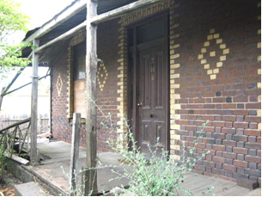 |  | 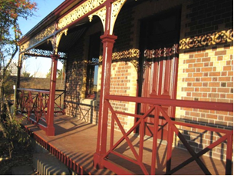
Victorian front verandah in disrepair.  Remnant fabric in good condition was retained and used as a basis for reconstruction. Source: Jennifer Bantow. |  | Reconstructed Victorian verandah.  The remnant verandah detailing provided clues for the design of the missing cast iron elements, as the surviving detailing was typical of the work of a local 19th century architect. More intact verandahs known to have been designed by the architect were used to guide the design and detail of missing fabric. Source: Jennifer Bantow.

New verandah valances, brackets and other features not applicable to the elaboration, architectural style, materials and construction of the building should be avoided.
Repairing rather than completely replacing an existing significant timber verandah floor should be considered in the first instance.

Matters for Consideration
Often, verandah floors will not be identified in a statement of significance and yet that form a key part of the front appearance of a building. In some instances, the boards may have rotted at the ends where they overhang at the front. These rotted ends could be removed only and new boards of the same, timber, profile, size and joint could be cut in as replacements.
Where a timber verandah floor is being replaced or reinstated, the timber species, board orientation, jointing method and overhang at the front will need to be documented. A harder timber species may be more appropriate for verandahs, given the high volumes of traffic and potential for high point loads that may cause indentations. Commonly, tongue and groove joints were used, with the boards laid directly onto timber bearers. In some cases, the boards were laid parallel with the building’s wall plane, but boards perpendicular to the wall plane were most common. Large overhangs should be avoided.
Where the verandah floor is tiled, missing tiles should be replaced to match existing as close as possible. Damaged tiles should be retained and re-set. Grouting should match existing original grout in strength, texture, colour and composition. The substrate upon which the tiles are laid should match the original.

References
Cleaning Masonry, Technical Leaflet, Heritage Victoria for the Heritage Council of Victoria, Melbourne, 2001.
Corrugated Roofing, Technical Leaflet, Heritage Victoria for the Heritage Council of Victoria, Melbourne, 2001.
Documenting Maintenance and Repair Works, Technical Leaflet, Heritage Victoria for the Heritage Council of Victoria, Melbourne, 2001.
Ellsmore, D., Achieving high quality building conservation outcomes: A basic guide for local government and heritage building owners, Technical Leaflet, Department of Planning & Community Development, Melbourne, 2009.
Evans, I., Caring for Old Houses, The Flannel Flower Press, Mullumbimby, 1998.
Guidelines for the Assessment of Heritage Planning Applications, draft, Heritage Victoria, 2000.
Lardner, H., Caring for Historic Buildings: Guidelines for Alterations and Additions to Historic Buildings, Historic Buildings Council, Melbourne, 1993.
Lewis, M. (ed.)., Victorian Stucco, Technical Guide, Heritage Council of Victoria, Melbourne, 2011.
Metalwork, Technical Leaflet, Heritage Victoria for the Heritage Council of Victoria, n.d.
Timber Repairs, Technical Leaflet, Department of Planning & Community Development, Melbourne, 2008.
Repair of Tongue and Groove Floorboards, Department of Planning & Community Development, Melbourne, 2008.
Slating, Tiling and Roof Plumbing, Technical Leaflet, Heritage Victoria for the Heritage Council of Victoria, n.d.
Young, D., Salt attack and rising damp: A guide to salt damp in historic and older buildings, Technical Guide, Heritage Council of NSW, Heritage Victoria, South Australian Dept. for Environment and Heritage, Adelaide City Council, and David Young, 2008.
Young, D. & Long, E., Repointing Mortar Joints – Some Important Points, Technical Note, revised edition., Heritage Victoria, Heritage Office NSW., Department of Planning, and the Heritage Branch of the South Australian Department for Environmental and Heritage, 2007.
What house is that? A Guide to Victoria’s Housing Styles, 3rd edition., Heritage Council of Victoria, Melbourne, 2011.
Wood Preservation, Technical Leaflet, Heritage Victoria for the Heritage Council of Victoria, Melbourne, 2001.

