
heritage information sheet

infill development

Prepared by Authentic Heritage Services Pty Ltd
A planning permit is required to construct a new building (infill) in a heritage overlay. This new work needs to meet the relevant purpose of the heritage overlay at Clause 43.01 of the Greater Geelong Planning Scheme Planning Scheme) which is:
- To implement the Municipal Planning Strategy and the Planning Policy Framework.
- To conserve and enhance heritage places of natural or cultural significance.
- To conserve and enhande those elements which contribute to the significance of heritage places.
- To ensure that development does not adversely affect the significance of heritage places.
The Planning Scheme has a comprehensive suite of Heritage Design Guidelines as Incorporated Documents for each heritage area identified in the Schedule to the Heritage Overlay. Further detailed information is given in the City of Greater Geelong Heritage and Design Guidelines. The following gives additional illustrated guidance for some of the design options available and these should be read in conjunction with the relevant Incorporated Documents.

Basis of Assessment
The assessment of new buildings in heritage overlays is based primarily on the streetscape and neighbourhood context of the subject site, and particularly the significance, character and appearance of the place (whether an individual property or a heritage area). Therefore, the design of the new work cannot be considered in isolation as the heritage place comprises the setting and significant building stock surrounding it. This is how an application will be assessed. The design of infill development should therefore be an evidence-based approach (eg what is occurring in the street) and should consider:
- The heritage significance of the place and what constitutes its specific physical heritage values.
- Setbacks of neighbouring buildings (front and side).
- Form, massing, bulk, eaves overhangs and height (roof height and eaves heights).
- Materials and finishes.
- Window proportions and locations.
- Architectural detailing.
- Verandahs.
- Placement, scale, form and construction of carports and garages.
- Front fences.
The extent to which new buildings may be based partly on the past but also on architectural creativity will depend on the specific context of a heritage area. There are a number of design approaches to contemporary and innovative interpretation.

Replication Infill
As outlined in the Australia ICOMOS Burra Charter, imitation should usually be avoided. Reconstruction is valid if a portion of a building or part of a row of buildings is missing, but generally, where there is a row of detached buildings (even if similar in appearance), complete replication should be avoided.

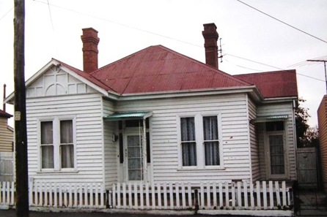 |  | 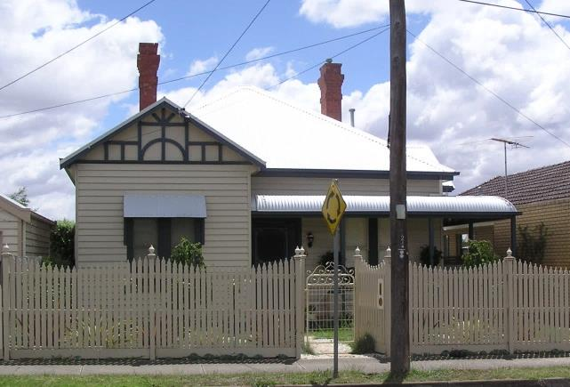
Edwardian dwelling, Geelong West, with missing return verandah and window hood 1986. Source: Honman, Huddle & Aitken, City of Geelong West Urban Conservation Study. |  | Restored Edwardian dwelling, Geelong West, with reconstructed return verandah and window hood over front window. This represents appropriate replication from a heritage perspective. Source: Dr David Rowe.

Conservative Interpretation Infill
Most of the heritage Incorporated Documents promote infill development that has a streamlined resemblance to the prevailing significant heritage buildings neighbouring the subject site. This is by adopting similar forms, heights, compositions, proportions, setbacks, textures and construction materials. While the product may not necessarily be architecturally inspiring in a creative sense, it is often a literal expression of the Planning Scheme requirements, providing a nostalgic integration into the streetscape.
This approach is particularly relevant where:
- The streetscape is similar (including architectural forms, scales, heights, materials, finishes, setbacks and front fences).
- The streetscape is highly intact.
Conservative interpretation infill design is appropriate as an expression of local heritage guidelines, and where the design quality and articulation of architectural elements and details is respectful, without replicating significant fabric.

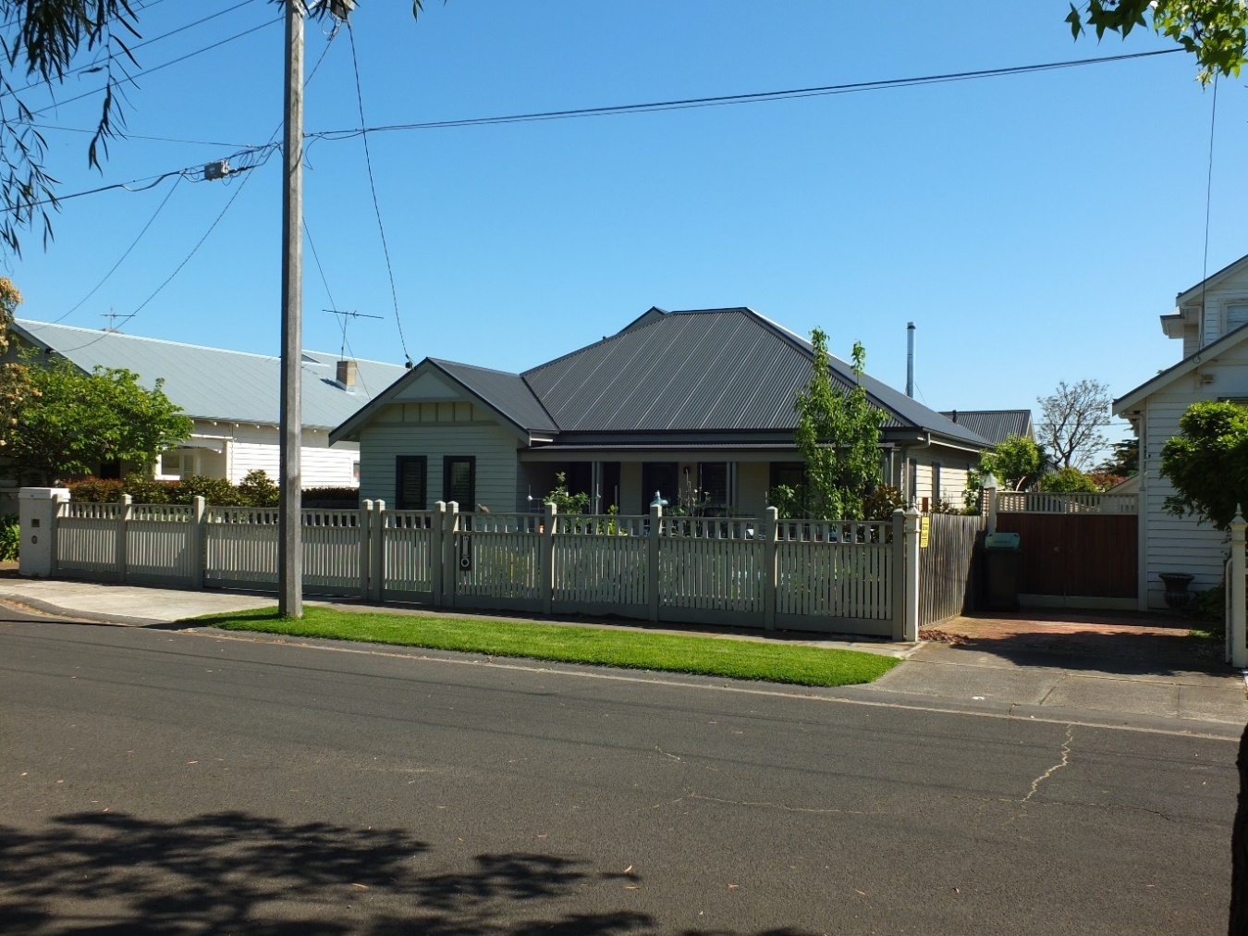 |  | 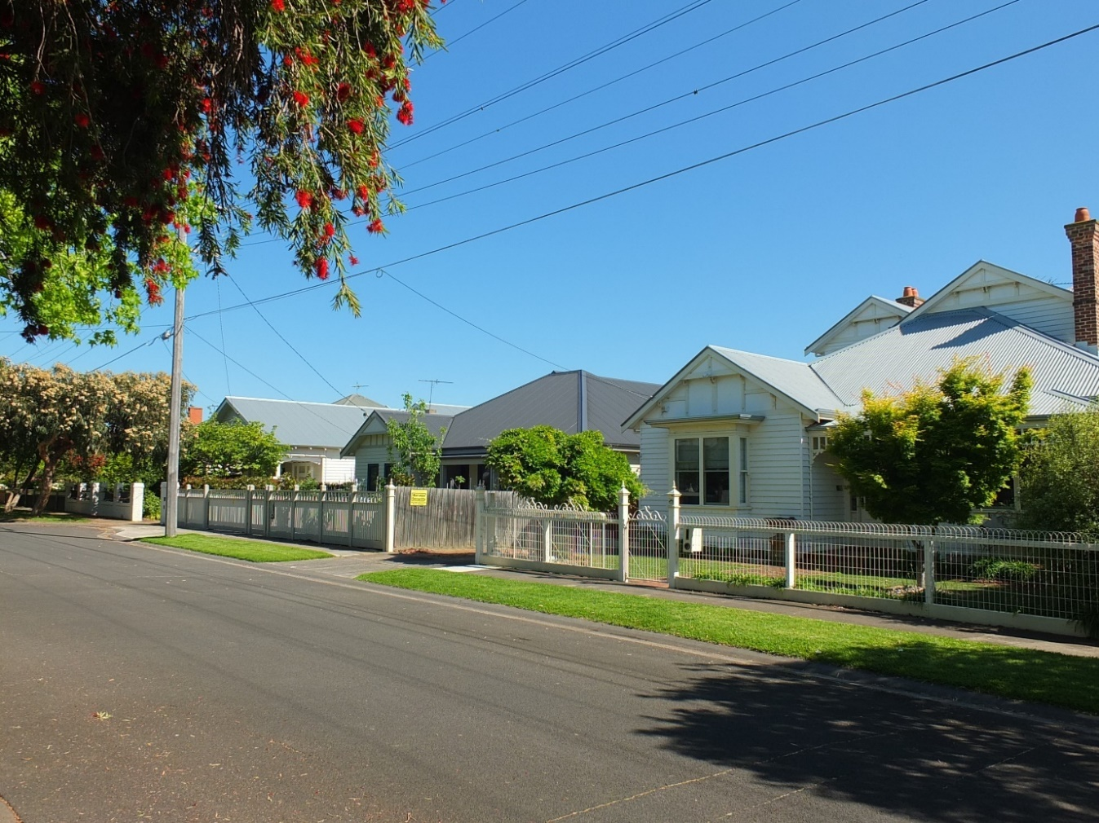
Conservative Infill Example. Source: Dr David Rowe. |  | Streetscape Context – Conservative Infill Example.  Source: Dr David Rowe
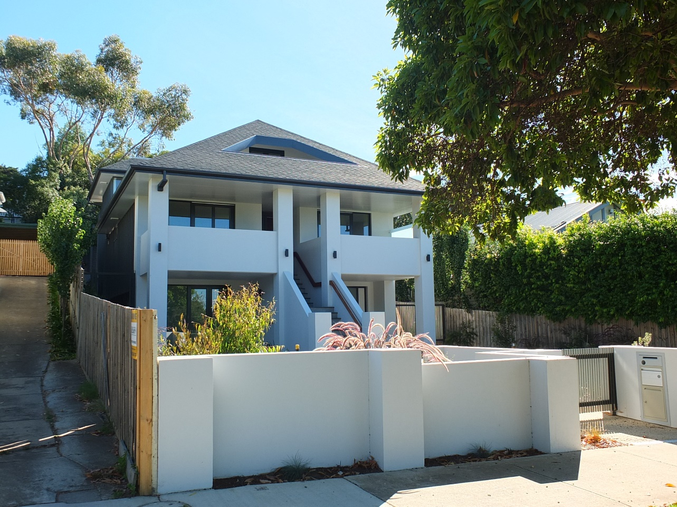 |  | 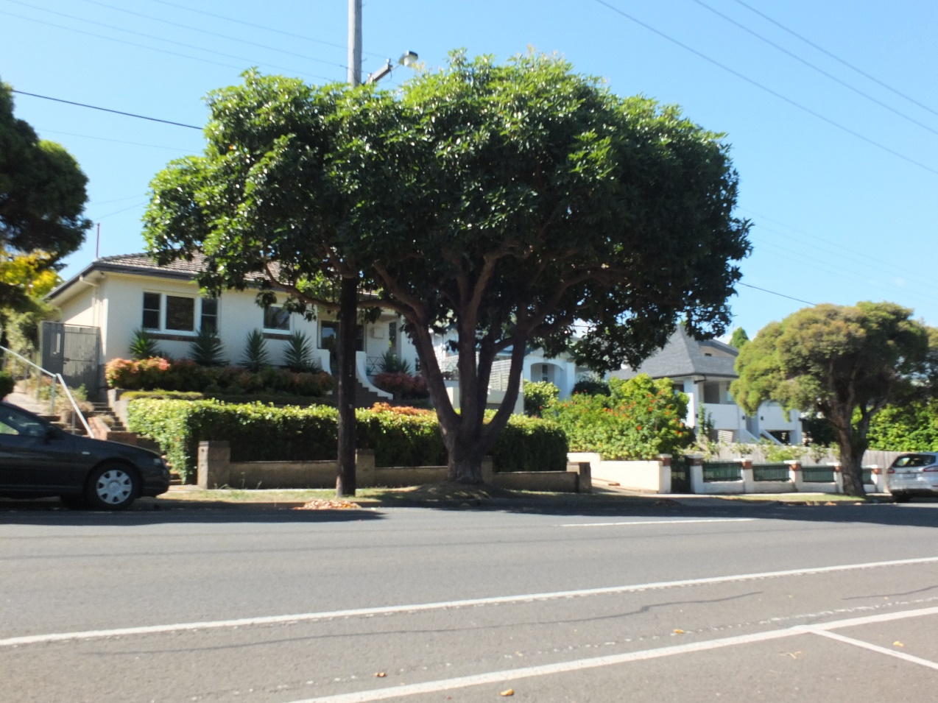
Conservative Infill Example. Source: Dr David Rowe |  | Streetscape Context – Conservative Interpretation Infill.  Source: Dr David Rowe

Creative Interpretation Infill
The more creative examples of a contemporary interpretation are where the new work is clearly individually distinctive and yet it integrates into the streetscape in an innovative way. With this approach, often the principal roof form (or much of the principal roof form), roof and wall heights, eaves overhangs and roof and wall materials have been drawn from the prevailing surrounding heritage dwellings. These characteristics are combined with secondary “atypical” design elements and fenestration to provide a respectful outcome. Because the design integrates with some of the key characteristics of the streetscape and presents no visual prominence, it is considered to be a successful outcome within the parameters of local heritage design guidelines.
Therefore, in the streetscape context (if the heights, principal form, setbacks and materials have respected the neighbouring significant fabric), this type of approach may be valid, particularly where there is a diversity of building forms, heights, styles and materials in the streetscape and heritage area.

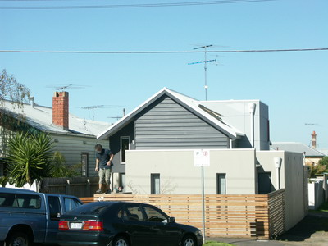  Creative Infill Example. Source: Dr David Rowe |  | 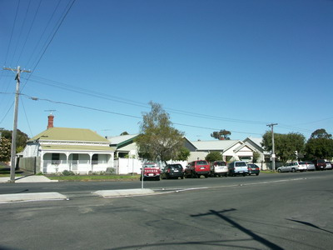  Streetscape Context - Creative Infill Example (circled). Source: Dr David Rowe.
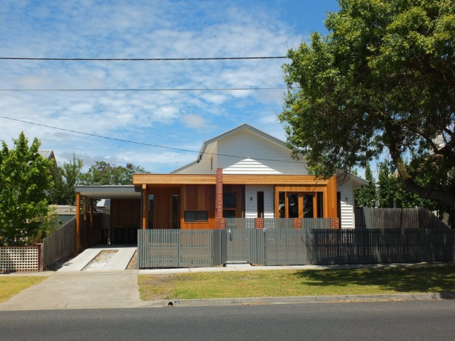  Creative Infill Example. Source: Dr David Rowe. |  | 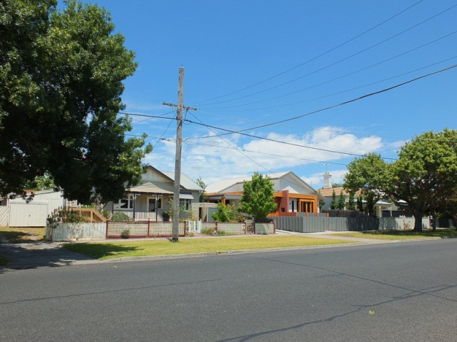  Streetscape Context: Creative Infill Example.  Source: Dr David Rowe
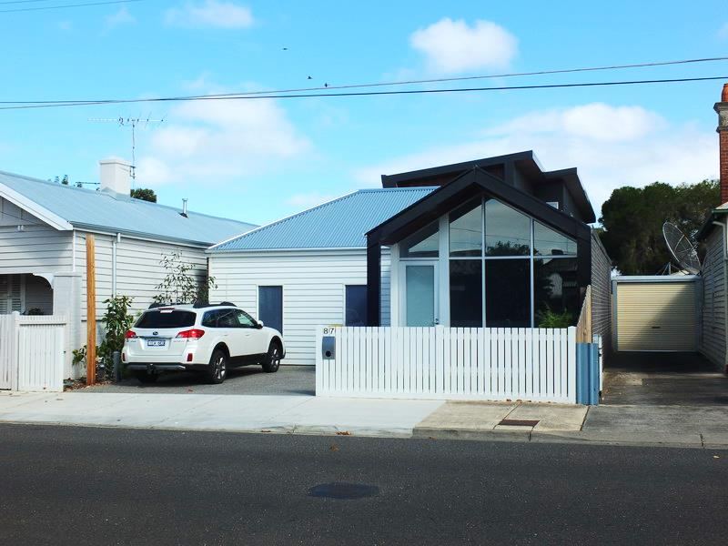 |  | 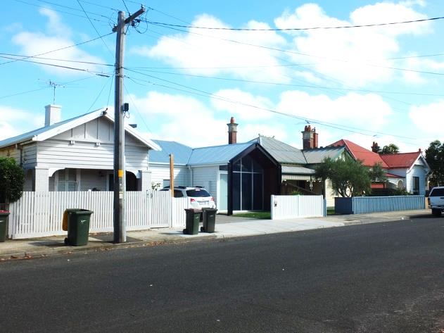
Creative Infill Example. Source: Dr David Rowe |  | Streetscape Context: Creative Infill Example.  Source: Dr David Rowe

Independent Infill
Independent infill is where, apart from scale and setbacks, it is completely independent of those characteristics that comprise the architectural significance of the heritage area. There is no obvious integration between the old and the new. Within the parameters of local heritage design guidelines, independent infill might be successful where the streetscape has very little or no integrity, or where it will not have any adverse affect on the significance of the heritage area. Independent infill opportunities are therefore often limited, and mostly to locations in a lane or cul de sac, or where the significance of the heritage area is not determined by specified architectural form. Ultimately, new work does not have to be in keeping with the character and appearance of the heritage place (a consideration of the heritage overlay) if no adverse affect on its significance will result (a purpose of the heritage overlay).
An adverse affect on the significance of a heritage area often results where the form, scale, setbacks and/or materials create visual prominence and are not secondary elements as part of a design that has greater regard to the significance of a heritage streetscape. New design and construction trends undermine the purpose of the heritage overlay. This includes standing seam profile Colorbond Monument roof and wall cladding, often employed as a ‘wrap-around’ concept (with both the roofs and walls being of the same material with an absence of eaves). Even in diverse heritage streetscapes, a common traditional characteristic is a clear distinction between roof and wall construction, separated by eaves, gutters or parapets.
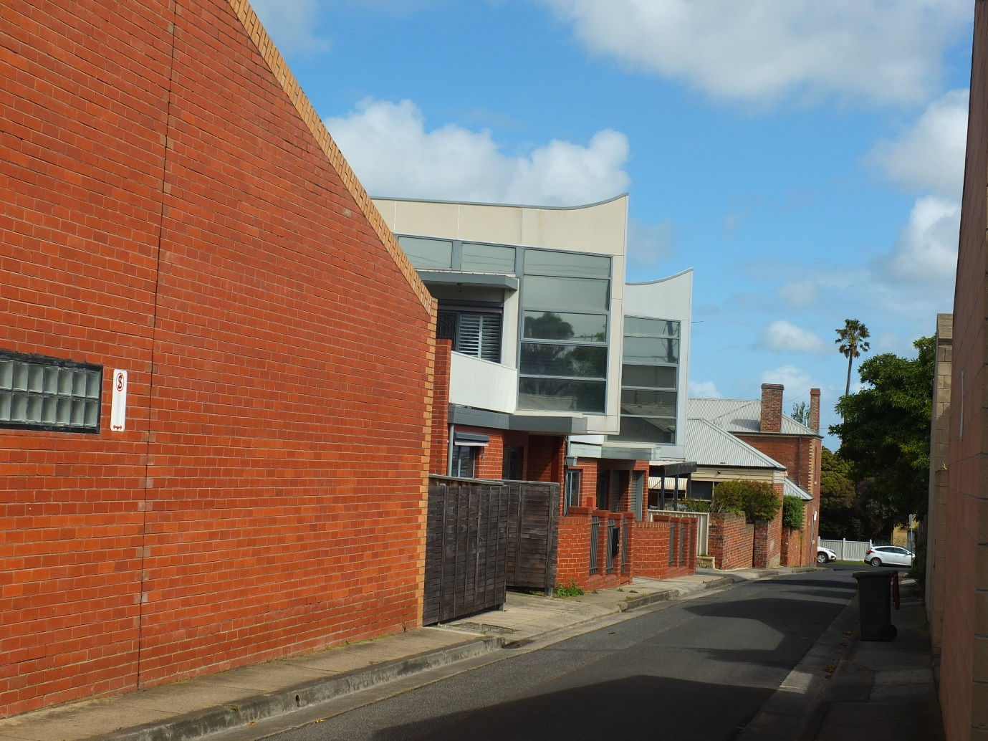
Two storey dwellings (Independent Infill) in a side lane of no heritage integrity that connects to principal streets. The new dwellings are independent in design to the prevailing heritage character of the area, but their location and context have ensured no adverse affect on the significance of the place. Source: Dr David Rowe.
 | 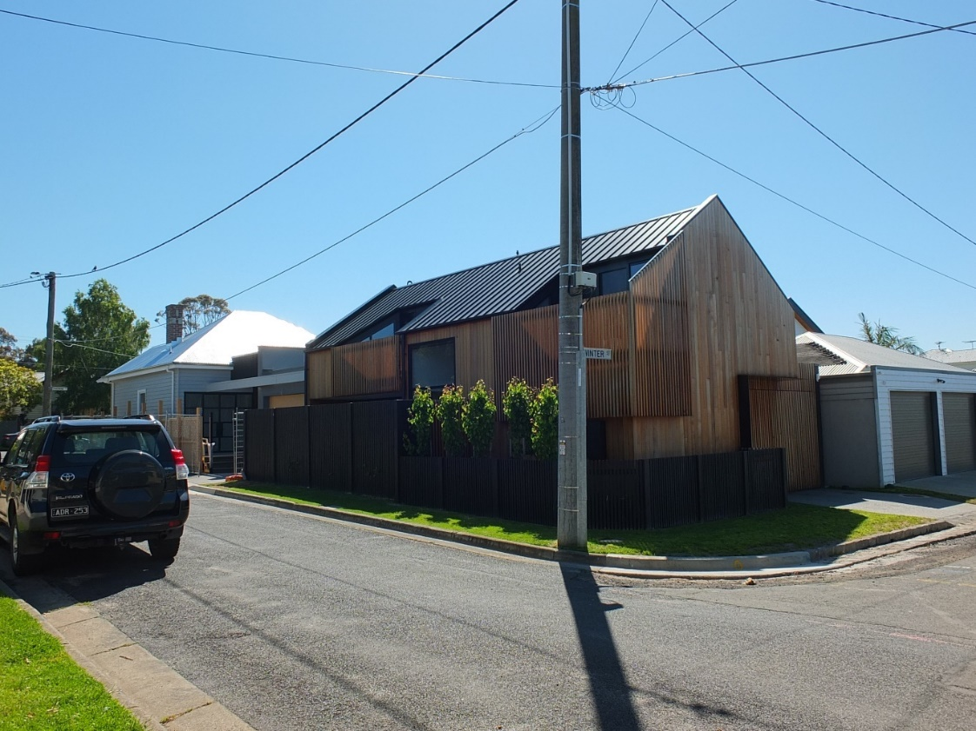 |  | 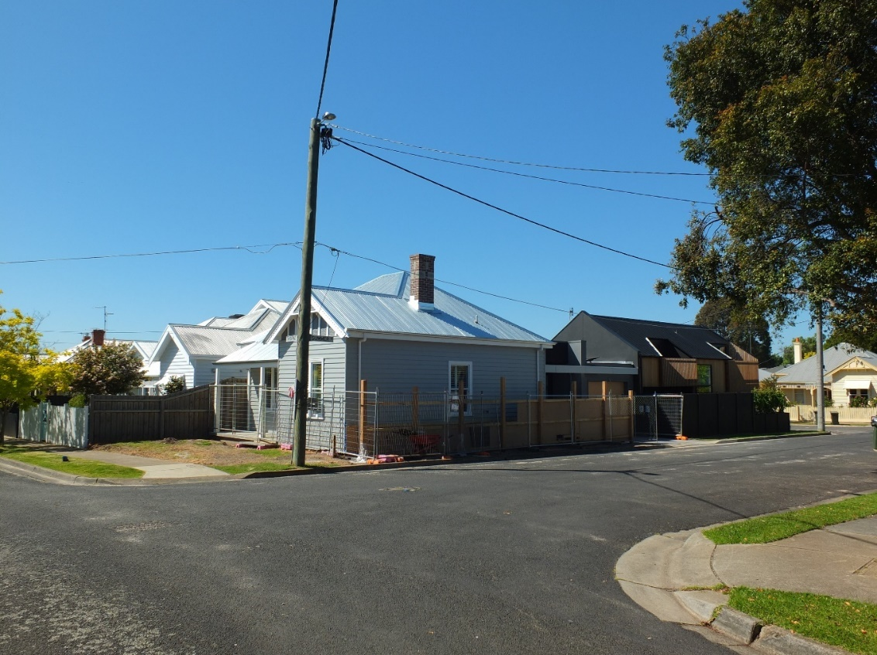
 | ‘Independently-designed’ infill dwelling at the rear of a significant Edwardian dwelling on a corner Site adjacent to introduced garaging. Source: Dr David Rowe |  | Significant Edwardian dwelling showing the new dwelling (Independent Infill) behind. Source: Dr David Rowe

An adverse affect is a negative impact on the heritage place. The term adverse affect is used in the Planning Scheme, particularly in the Design Guidelines at Clause 43.01-8.

