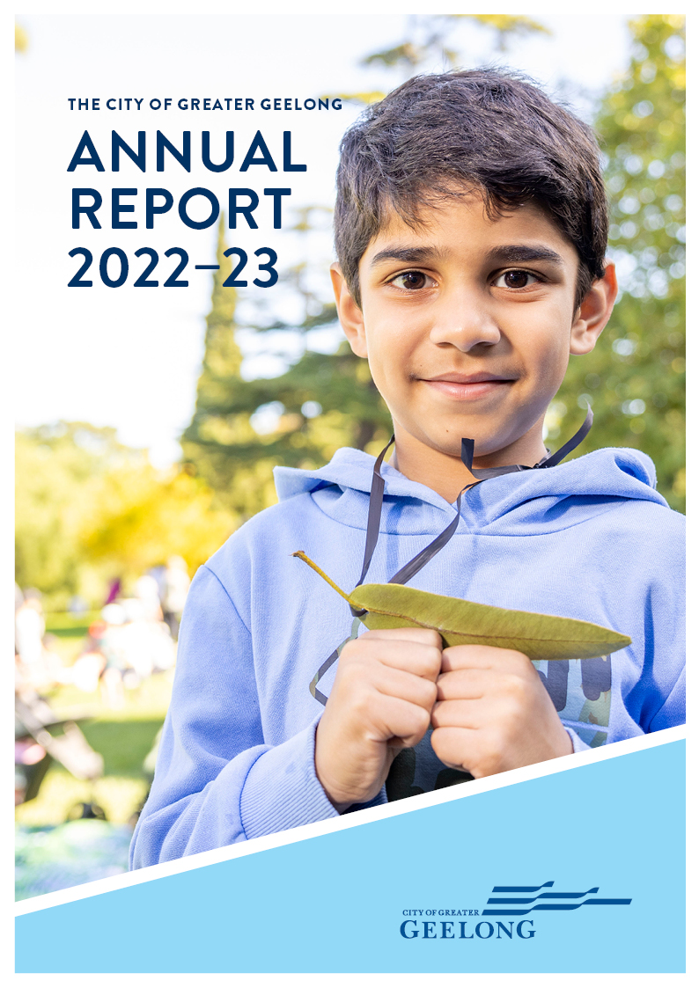

CONTENTS
MAYOR AND CEO MESSAGE 4
INTRODUCTION 5
OUR PURPOSE, VALUES AND STRATEGIC DIRECTIONS 8
THE YEAR IN REVIEW 9
OUR COMMUNITY PLAN 9
OVERVIEW OF FINANCIAL PERFORMANCE 10
KEY CAPITAL PROJECTS 15
OUR COMMITMENT TO SUSTAINABILITY 16
OUR COMMITMENT TO HEALTH AND WELLBEING 18
COMMUNITY ENGAGEMENT 30
GRANTS PROGRAM 33
CHALLENGES IMPACTING OUR SERVICES 35
OUR COUNCIL AND ORGANISATION 37
OUR COUNCIL 37
OUR COUNCILLORS 37
OUR ORGANISATION 42
OUR LEADERSHIP TEAM 44
OUR ORGANISATIONAL STRUCTURE 45
OUR PEOPLE 46
EQUAL EMPLOYMENT OPPORTUNITY – AN INCLUSIVE AND DIVERSE WORKPLACE 48
OCCUPATIONAL HEALTH AND SAFETY 49
HOW WE PLAN 50
OUR PERFORMANCE 2022–23 51
STRATEGIC DIRECTION 1: HEALTHY, CARING AND INCLUSIVE COMMUNITY 52
STRATEGIC DIRECTION 2: SUSTAINABLE GROWTH AND ENVIRONMENT 65
STRATEGIC DIRECTION 3: STRONG LOCAL ECONOMY 76
STRATEGIC DIRECTION 4: HIGH-PERFORMING COUNCIL AND ORGANISATION 82
GOVERNANCE 90
COUNCIL INFORMATION 90
AUDIT AND RISK COMMITTEE 99
GOVERNANCE AND MANAGEMENT CHECKLIST 100
DOMESTIC ANIMAL MANAGEMENT PLAN UPDATE 104
ACCESS AND INCLUSION PLAN UPDATE 106
DEVELOPMENT CONTRIBUTIONS PLAN (DCP) PROGRESS REPORT 108
PERFORMANCE STATEMENT 115
ANNUAL FINANCIAL REPORT FOR THE YEAR ENDING 30 JUNE 2023 130
CONTACT US 132

We Acknowledge the Wadawurrung People as the Traditional Owners of the Land, Waterways and Skies. We pay our respects to their Elders, past, present and emerging. We Acknowledge all Aboriginal and Torres Strait Islander people who are part of our Greater Geelong community today.

MAYOR AND CEO MESSAGE
We are pleased to present the City of Greater Geelong’s Annual Report for the year ending 30 June 2023.
In an environment where all governments are grappling with rapidly rising costs, there is no doubt it has been a challenging year in a financial sense.
While we’ve had to work hard to deliver a break-even result, we’ve done so without compromising our commitment to serving our community through a wide range of essential services and facilities that only local councils can provide.
The Geelong region is experiencing a major transition as our strong population growth continues and our local economy expands and diversifies with remarkable success.
Our aim is to support this transition and ensure we take advantage of the many exciting opportunities it presents, while making decisions in the best interests of the community we serve.
As we all strive towards our 30-year vision for a ‘clever and creative’ city-region, our aim is to set the City of Greater Geelong up for an economically, environmentally and socially sustainable future.
The pages of this annual report are rich with examples of how we are working towards those goals, and we encourage you to read the report in full.
Our capital works program delivered investment totalling $174 million for the financial year, providing new and upgraded community facilities and assets vital for a healthy and connected community.
We have made important strides toward ongoing environmental sustainability, continuing our rollout of energy efficient LED streetlights across the region, and reducing our overall carbon emissions.
As each of our major projects have unfolded, we have sought always to engage with the community. A total of 97,788 people visited our online Have Your Say platform, in addition to face-to-face engagement across the region.
Internally, we have significantly advanced our Future Ways of Working program, making a series of structural changes aimed at allowing us to operate in a more effective and efficient way long into the future.
All of our councillors and employees value the opportunity to serve the wonderful Greater Geelong community and take this responsibility seriously. As Mayor and CEO, we thank them for their contribution during the year, and most importantly, we thank everyone in the community for your passion and dedication to seeing Greater Geelong thrive.

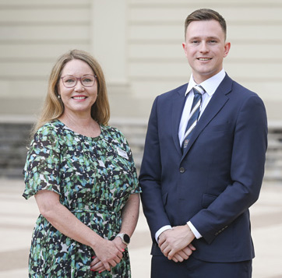
Kaarina Phyland – Acting Chief Executive Officer and Cr Trent Sullivan – Mayor
This report has been prepared in accordance with the relevant requirements of the Local Government Act 2020.

INTRODUCTION
At the City of Greater Geelong, we are committed to working together for a thriving community.
The City of Greater Geelong Annual Report 2022–23 provides our community with a comprehensive account of our performance from 1 July 2022 to 30 June 2023.

Our City
The City of Greater Geelong is the second-largest city in Victoria. Located 75 kilometres south-west of Melbourne, the municipality covers an area of 1,252 square kilometres, comprising suburban, coastal and country areas.
Greater Geelong is bounded by the Moorabool Shire in the north, Wyndham City Council and the Borough of Queenscliffe in the east, Surf Coast Shire and Golden Plains Shire in the west, and Bass Strait to the south.
Geelong is on Wadawurrung Country. Wadawurrung Country covers over 10,000 square kilometres, from the Great Dividing Range in the north, to the coast in the south, from the Werribee River in the east, and to Aireys Inlet in the west, including Geelong and Ballarat.

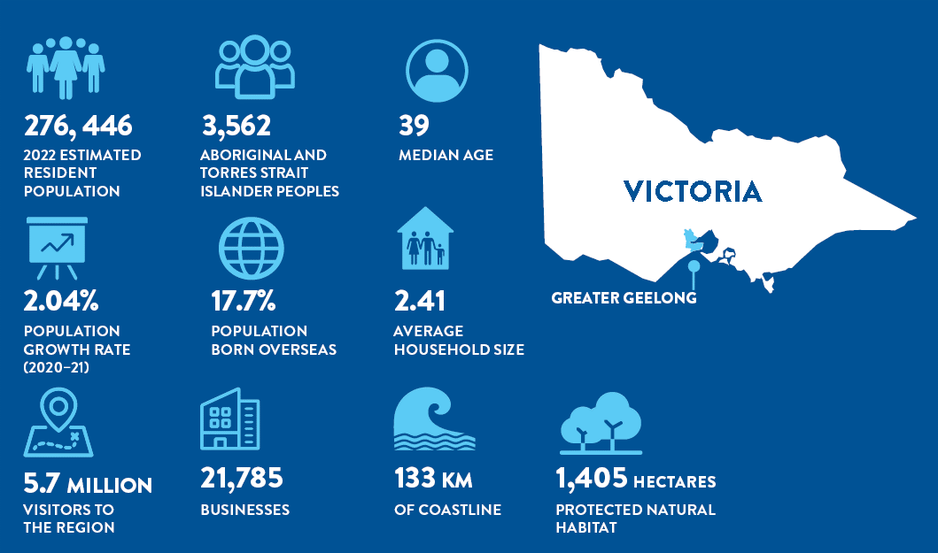

Our People
Outside of metropolitan Melbourne, our municipality is the most populated region in Victoria, with an estimated resident population of 276,116 as of 30 June 20220F.
Over the past decade, the population of Geelong has experienced significant growth in the western and eastern corridors. Population is forecast to grow to 396,388 by 20411F.
The size and demographic profile of our region continues to shift and change. Our population is ageing. Residents over 65 years of age has increased by 22.8 per cent between 2016‒2021. Conversely, over the past 10 years, birth rates have increased significantly, with the population of young children expected to continue to increase2F.
Our culturally and linguistically diverse communities also continue to increase. A total of 17.7 per cent of our total population were born overseas¹. Migration has been key to the development of our region and today, we have new arrivals from countries such as Afghanistan, Iran, Iraq, South Sudan, Congo and Myanmar. International students are also an important part of our rich multicultural fabric.
As a city, we strive to create inclusion, respect and a sense of belonging. Our aim is to have a range of social, economic and cultural initiatives to support connection, participation, innovation and creativity for people, groups and networks to encourage meaningful engagement in our local civic life.
Across our region, there is significant disparity between more advantaged and less advantaged suburbs. The 2021 Socio-Economic Index for Areas (SEIFA) Index3F identifies some of Geelong’s suburbs as being amongst the most disadvantaged in Victoria. Despite the many strengths of these diverse communities, this locational disadvantage is a long-term and severe problem affecting the lives of many residents in the City of Greater Geelong.

Our Environment
Our region features a diverse mix of urban, rural and coastal environments, with large areas dedicated to recreation and conservation reserves. As well as supporting remnant indigenous vegetation, the landscapes are home to a diverse range of flora and fauna, including many protected species of international, national, state or regional significance. Our waterways include the Barwon and Moorabool River systems, natural and modified lakes, small creeks and 133 kilometres of coastline. Among the 11,630 hectares of wetlands in Greater Geelong, there are significant areas of habitat designated in the Ramsar Convention on Wetlands of International Importance.
Our natural environment, however, is under pressure from a range of local challenges such as land clearing, weeds and pest animals through to the global challenges of climate change, population growth and waste generation.

Our Economy
We have experienced the fastest employment growth of all large regional cities in Australia. There are an estimated 135,562 local jobs¹, with 12,100 new jobs created in the year to June 2022. The largest job increases were in healthcare and social assistance (+3,932); construction (+1,603); and professional, scientific and technical services (+1,423). The number of employed residents grew by 6.3 per cent in the year ending June 2022 reaching 140,336 people4F. The jobs to workers ratio providing more employment opportunities for our residents.
The number of registered businesses in Greater Geelong increased by 2,172 in 2021–22, taking the total to 21,785 businesses5F. The construction industry has the largest number of businesses, with 22.2 per cent of registered businesses, followed by professional, scientific and technical services (11.3 per cent) and rental, hiring and real estate services (10.4 per cent - includes property operators).
The twelve-month average unemployment rate to March 2023 was 2.7 per cent, an all-time low and 1.0 percentage point lower than Victoria6F. Demand for labour is strong with over 10,800 job vacancies advertised in the June 2023 quarter, 2.4 per cent higher than the same quarter in 20227F.
We had an estimated Gross Regional Product (GRP) of $17.6 billion² in the year ending June 2022. This is an increase of 10.3 per cent on 2021 and double the rate of growth compared to Victoria. The largest contributors to GRP are; healthcare and social assistance ($2.2 billion); construction ($2.1 billion); and manufacturing ($1.2 billion).
Investment continued to climb in 2022–23 with major projects totalling $16.9 billion planned, underway and recently completed across our region. Investment in roads and transport ($6.6 billion); public buildings and utilities ($2.1 billion); industrial and commercial projects ($1.7 billion); medical and allied health projects ($1.5 billion); and residential buildings ($1.3 billion) reflects our rapidly growing population and strong investor confidence8F.
Our economy has evolved, with developments in advanced manufacturing, research and innovation, professional services, creative industries, major events and the visitor economy. Our economic resilience, and its capacity to successfully transition to a sustainable base after economic disruption, has led us to be recognised as one of the most resilient regions in Australia, on par with the metropolitan regions of Greater Sydney, Melbourne, and Perth9F.
There is a growing focus on economic growth aligned with environmental and social sustainability. Over the last decade, local businesses, new industry and start-ups have shifted focus towards new emerging markets such as the cleantech sector. We have been working to increase the circular economy, resulting in the development of new businesses focused on waste reduction and recycling, such as composting facilities, food waste processing and recycling centres.
We have worked to create more inclusive and equitable communities, with initiatives aimed at reducing inequality and promoting social cohesion. The Regional Industry Sector Employment program (RISE) is a collaborative program that connects young job seekers from disadvantaged backgrounds and those disengaged from school, with construction industry employment opportunities through training, recruitment, mentoring and support. We facilitated the program from 2018–2023.

OUR PURPOSE, VALUES AND STRATEGIC DIRECTIONS
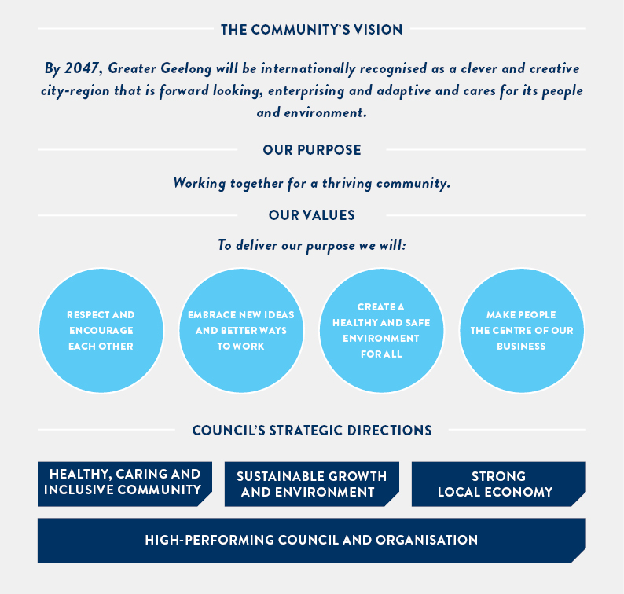

THE YEAR IN REVIEW

OUR COMMUNITY PLAN
In 2022‒23, we committed to deliver 64 actions to support the achievement of our four-year priorities within Our Community Plan 2021‒25.
As the year progressed, budget constraints and the need to maximise the impact of our limited resources, meant that we needed to reprioritise our pipeline of activities. As a result, the decision was made to not proceed with some initiatives and put others on hold until funding or partnership opportunities were identified.
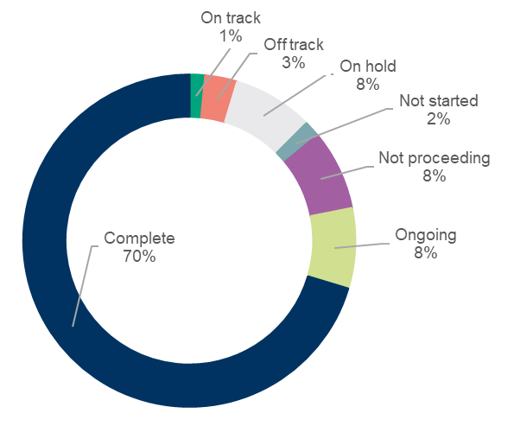
Detailed information on our progress against the Our Community Plan 2021‒25 Annual Action Plan 2022‒23 can be found in ‘Our Community Plan 2021−25 Progress Reports’ on geelongaustralia.com.au.

Overall progress
Of the 64 actions, 70 per cent (45) were complete,
and a further 8 per cent (5) are ongoing.

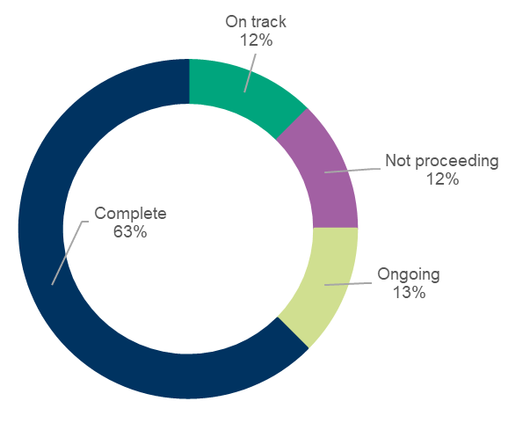
Major budget initiatives
Of the 64 actions, eight are major initiatives identified in the 2022‒23 budget. Of these, 63 per cent (five) are completed and a further 13 per cent (one) are ongoing.

FIGURE 1: Our Community Plan 2021–25 - Annual Action Plan progress for 2022–23

OVERVIEW OF FINANCIAL PERFORMANCE
This is a summary of our financial results for 2022–23.
For full details, please refer to the Annual Financial Report on page 132.
- Surplus of $154.6 million – consistent with the prior year result.
- $619.2 million revenue, with 46.2 per cent coming from rates and charges.
- $464.5 million expenditure – 40.3 per cent employee costs and 33.7 per cent materials and services
- $4.6 billion in net assets – $368.2 million increase on the restated previous year, including a $218.9 million asset revaluation increment.
- $174.2 million capital expenditure – 54.1 per cent relating to land and buildings, 20.3 per cent for roads, footpaths, bike paths and drainage.
Comprehensive Income Statement
The comprehensive income statement shows how much we earned during the 2022–23 financial year. It details where we received our income and how it was spent.
Net Result
FIGURE 2: Net result 2019–20 to 2022–23 ($m)
Total Comprehensive Results
FIGURE 3: Total comprehensive results 2019–20 to 2022–23 ($m)
Recurrent Operating Results
FIGURE 4: Recurrent operating results 2019–19 to 2022–23 ($m)

The net result – that is, income minus expenditure – is shown in Figure 2.

This result can largely be attributed to:
- rates and charges increasing by $11.5 million due to a wider property base and increases in the general waste charge.
- user fees increasing by $10.2 million as services reflect to pre COVID levels.
- grants increasing by $3.7 million, largely from the federal government assistance grant.
- materials and services costs increasing by $20.3 million to reflect inflationary and contractual changes.
- employee costs increasing by $11.1 million.
The total comprehensive result accounts for items that will not be classified to surplus or deficit in future periods. In this case, it is the net asset revaluation of land, buildings and infrastructure which, in 2022–23, was an increment of $218.9 million.
The total surplus includes an operating recurrent surplus of $4.7 million ($10.6 million surplus in 2021–22) and a non-recurrent surplus of $149.9 million ($174 million in 2021–22). The non-recurrent result includes gifted assets of $91.8 million ($122.5 million in 2021‒22).
Budget surpluses are forecast over the next four years, including a $135.4 million surplus in 2023–24. This is a critical part of our financial sustainability strategy, as it gives us the capacity to maintain our services and renew our community assets.
Balance Sheet
The balance sheet shows what we own (assets), what we owe (liabilities) and our net worth (equity).
Assets
Our assets are primarily made up of:
- cash and cash equivalents of $87.2 million – used to cover our short-term commitments including long-service leave and debt obligations and provide funds for capital works that have been carried over.
- property, plant and equipment and infrastructure worth $4.7 billion – an increase of $368.2 million on the previous year.
These asset types make up 97.4 per cent of our total assets.
Total Assets

FIGURE 5: Total assets 2019–20 to 2022–23 ($m)
Investments
FIGURE 6: Investments 2019–20 to 2022–23 ($m)
Capital Program
We deliver an extensive capital works program – renewing, upgrading and building assets to meet community need.
As Figure 7 shows, our capital works expenditure in 2022‒23 was $174.2 million. This included:
- $122.0 million on new assets (70.0 per cent)
- $43.9 million on renewal works (25.2 per cent)
- $8.3 million on upgrade works (4.8 per cent).
FIGURE 7: Capital works expenditure 2019–20 to 2022–23 ($m)
The main categories of expenditure were:
- $94.3 million on land and buildings
- $20.9 million on roads
- $2.8 million on parks, open space and streetscapes
- $10.9 million on plant and equipment
- $6.1 million on drainage
- $8.2 million on footpaths and bike paths
- $15.6 million on recreational, leisure and community facilities
- $15.2 million on other assets.

Liabilities
Our liabilities include future commitments to suppliers, employees (for leave entitlements), loans and costs associated with providing landfill.
Total Liabilities
As Figure 8 shows, total liabilities were $266.6 million, a decrease of 3.9 per cent on the 2021–22 balance. This decrease is due to the repayment of borrowings offset by increase in lease liabilities.
FIGURE 8: Total liabilities 2019–20 to 2022–23 ($m)
Loans
Our loan balance equates to 47.7 per cent of total liabilities, which is slightly lower than 2021–22 (50.5 per cent).
The overall decrease in our loan balance of $13.0 million is due to no new loans taken in 2022−23.
FIGURE 9: Loans from 2019–20 to 2022–23 ($m)
Debt Commitment
The debt commitment ratio shows the percentage of rates required to meet loan repayments for the following 12 months.
Figure 10 shows that a low percentage of rates are being used to service loans and we have capacity to meet our debt repayments.

FIGURE 10: Debt commitment percentage 2019–20 to 2022–23 (%)

Ratepayer Equity
Ratepayer equity is represented by our net worth – that is what we own ($4,917.1 million) minus what we owe ($266.6 million).
As Figure 11 shows, ratepayer equity as at 30 June 2023 was $4,650.6 million – an 8.7 per cent increase on the previous year. This is due to continued growth of our fixed asset base – that is, property, plant and equipment and infrastructure and revaluation of these asset groups.

FIGURE 11: Ratepayer equity 2019–20 to 2022–23 ($m)

KEY CAPITAL PROJECTS
We deliver an extensive capital works program each year to create infrastructure for our community.
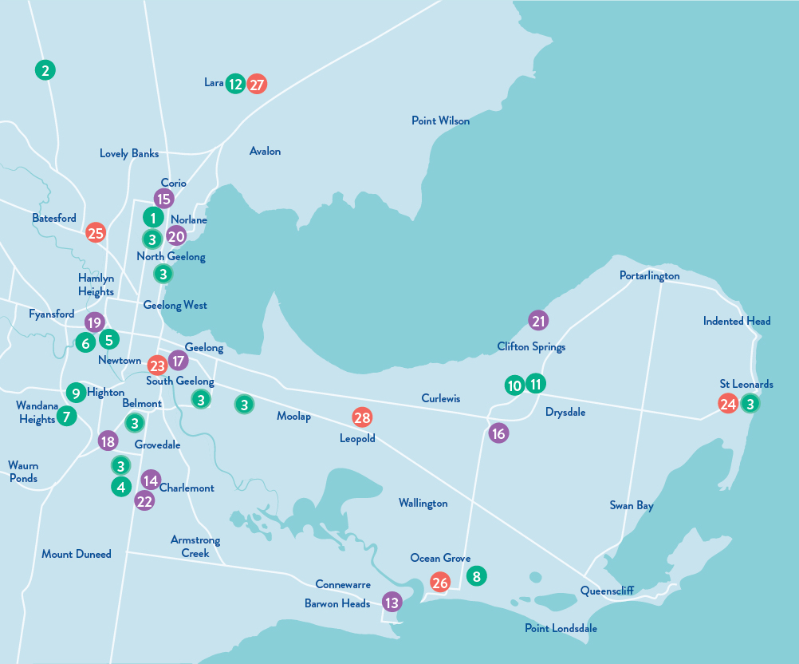FIGURE 12: Key Capital Projects 2022–23
PROJECTS COMPLETED  - Shell Reserve changeroom development - Corio Community Sports Club - $3.581M  - Anakie Social Room Redevelopment - $2.85M  - Sports Lights Program - $2.0M  - Grinter Reserve – Newcomb  - St Albans Recreation Reserve – Thomson  - Osborne Park – North Geelong  - Evans Reserve – Norlane  - St Leonards Lake Reserve – St Leonards  - Winter Reserve – Belmont  - Burdoo Reserve – Grovedale  - Poa Banyul Community Hub, Mt Duneed - $13.0M  - Queens Park Sports Lighting Upgrade - $750,000  - Queens Park Golf Safety Net - $300,000  - Wandana Gully 2 Landscaping Works - $3.0M  - Ocean Grove Football Netball Club Facility Upgrades - $500,000  - Tim Hill Reserve Upgrades - $400,000  - Boronggook Drysdale Library - $9.156M  - Drysdale Town Square & Park Upgrade - $1.3M  - Lara Recreation Reserve Master Plan Stage 1 - $2.75M | PROJECTS UNDER CONSTRUCTION  - Barwon Heads Bowling Club Pavilion Upgrade - $1.2M  - Biyal-a Armstrong Creek Library - $21.864M  - Northern Aquatic & Community Hub - $65.0M  - North Bellarine Aquatic Centre - $15.5M  - LED Lighting & Smart Controls (throughout City of Greater Geelong) - $13.48M  - Waurn Ponds Skate Park – Stage 2 - $1.95M  - Queens Park Golf Club Irrigation Upgrade - $1.2M  - Labaun Square Streetscape (including public toilet replacement) - $691,000  - Beacon Point Reserve Shared Trail - $540,000  - Bus shelter design & construct program - $500,000 (11 bus shelters across Geelong) | PROJECTS COMMENCED - DESIGN PHASE  - Landy Field Pavilion Redevelopment - $6.0M  - St Leonards Skate Park Redevelopment - $670,000  - Bell Park Sport and Recreation Club Changeroom Upgrade - $1.95M  - Ocean Grove Principal Pedestrian Network - $6.5M  - Lara Recreation Reserve Master Plan Stage 2 – Baseball Precinct - $5.545M  - Leopold Tennis Club Pavilion - $1.72M

OUR COMMITMENT TO SUSTAINABILITY
Sustainability is a key theme of Our Community Plan 2021‒25 and a strong focus of our community’s 30-year clever and creative vision.
Sustainability refers to a continual way of thinking that focuses on the best outcomes for our community, environment and the economy, now and in the future. Our goal is to incorporate sustainable thinking into every aspect of our business to address some of the long-term challenges facing our community, including climate change, population growth, demands for community infrastructure and social inequity.
Our Sustainability Framework 2020 commits us to take action across three key priority areas of sustainability: protecting our environment; community wellbeing and social equity; and responsible and transparent business.
The framework is implemented through the delivery of short, medium and long-term initiatives within the Sustainability Framework Action Plan 2020‒22 and is tracked over time against an endorsed set of sustainability indicators and targets.
In March 2023 we released our second sustainability performance report, providing an update on progress against the action plan, indicators and targets. The report shows that of the 66 actions being implemented, the majority were either on-track (47 per cent) or complete (45 per cent) at the end of June 2022.
Highlights of the report included:
- Reduction of our operational carbon emissions by 29 per cent over the previous 12 months. After signing a 10-year contract to source renewable energy, our electricity usage generates zero emissions.
- Delivery of three major shared trail projects in East Geelong, Corio and Barwon Heads to improve connections and access for our community.
- Establishment of Climate Partnership Grants, which provide co-design and financial support for community-led projects and activities that help achieve net zero emissions.
- Endorsement of our Social Equity Framework 2022–25, designed to provide a common set of principles that will support every member of our community to participate fully, be included, and live a healthy and fulfilling life in our region.
- Completion of Stage 1 of the upgrade to LED street lighting with the changeover of approximately 13,000 residential streetlights and installation of 130 new lights. Once complete, the changeover will reduce energy consumption and save more than 8,000 tonnes of carbon emissions each year as well as making our streets and public spaces safer through higher quality and better directed lighting.
- Support for 13 major events in our region, which stimulated local economic activity, estimated at a combined $24.8 million.
A copy of the report, Sustainability Performance Report 2022, can be viewed at www.geelongaustralia.com.au.
Our Sustainability Advisory Committee provide an economic, environmental and social sustainability lens on our strategic work. We would like to thank each of the committee members for sharing their passion, expertise and providing insights and feedback to guide our decision-making. The time and energy they put into the committee meetings is valued and much appreciated.
As our organisational approach to sustainability matures, we are now looking to shift to a more structured and coordinated way of undertaking sustainability-related initiatives, measuring the impact by developing a sustainability strategy.
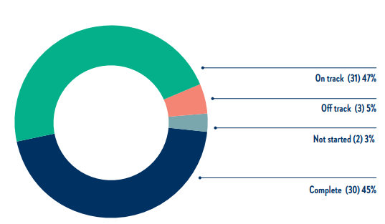
FIGURE 13: Progress of Sustainability Framework Action Plan 2020‒22 (to 30 June 2022)

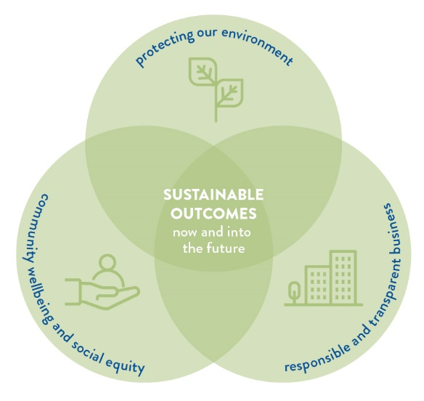
FIGURE 14: Sustainability Framework 2020 Key Priority Areas

OUR COMMITMENT TO HEALTH AND WELLBEING
The health and wellbeing of our community is central to everything we do.
Under the Victorian Public Health and Wellbeing Act 2008, councils are required to prepare a four-year Municipal Public Health and Wellbeing Plan (the Plan) within 12 months of every Council election. The Plan identifies goals for creating a local community where people can experience their best possible health and wellbeing. Acknowledging that health and wellbeing is everyone’s business, we incorporated our Municipal Public Health and Wellbeing Plan into our council plan to create Our Community Plan 2021‒25.
Our health and wellbeing priority areas
There are five health and wellbeing priority areas we have been focussing on since this plan began. We formed these priorities following a review of the policy context and local health data and engaging with the community and key stakeholders to identify health needs and challenges.
 |  |  |  | 
Tackling climate change and its impact on health | Increasing  healthy eating | Increasing  active living | Demonstrating and promoting gender equity practices | Improving mental wellbeing and social connection
Working with our partners
We have formed the Health and Wellbeing Partners Network to enable a partnership approach to health and wellbeing. Since its inception, the network has met three times.
Terms of reference have been established and working together is guided by the following principles:
- network to share data and information
- collaborate on key projects
- advocate on joint health and wellbeing priorities
- innovate by piloting new initiatives
- capture evidence through research.
Guided by evidence of community needs, organisational priorities, business planning and funding opportunities, we will work with existing partners and explore new partnerships over the coming years.

Our health and wellbeing evaluation framework
We have worked with consultants to develop Theories of Change (ToC) for each of the five health and wellbeing priorities. ToC describe how change happens, showing the causal relationships between activities, short-and long-term outcomes, leading to the ultimate impact. They help to build a shared understanding of what we are trying to achieve.
The figure below shows how the five health and wellbeing priorities contribute to the ultimate outcome of Our Community Plan – to increase community health and wellbeing.
Work is currently underway to translate the ToC into a Monitoring, Evaluation and Learning Framework with associated tools and resources for our employees to undertake evaluation.

FIGURE 15: Theories of Change

Our health and wellbeing indicators
A set of 19 population level indicators in Our Community Plan 2021–25 help track the health and wellbeing of our community. Our work, along with the work of our partners and other organisations, contribute to progress in the five priority areas:
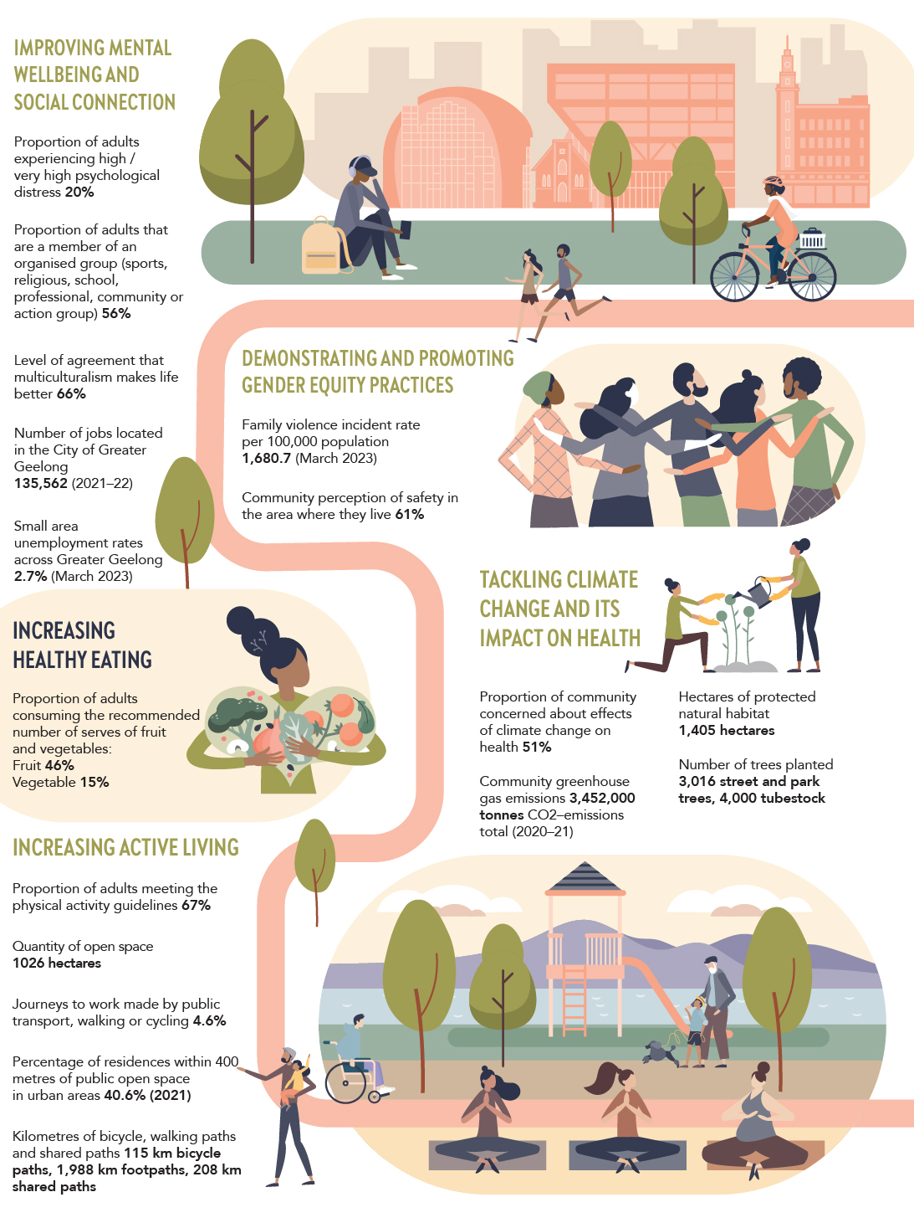
Key actions to support health and wellbeing
In 2022‒23, we committed to deliver 40 actions to support the achievement of our five health and wellbeing priorities within Our Community Plan 2021–25 - Annual Action Plan 2022–23:
Of the 40 actions, 65 per cent (26) were complete and a further 10 per cent (four) were ongoing.
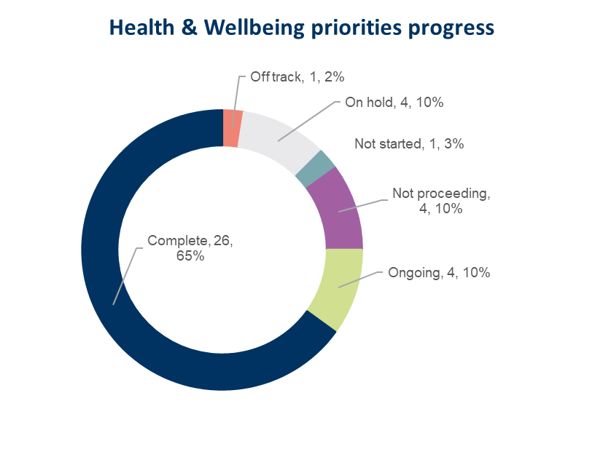
FIGURE 16: Progress of actions in Our Community Plan 2021–25 Annual Action Plan 2022–23 supporting Health and Wellbeing priorities

The following tables highlight some of these key actions for each health and wellbeing priority area. For more detailed information on these and other actions, please refer to the Our Community Plan 2021−2025 − Quarterly Report - June 2023.

Health and Wellbeing Priority 1: Tackling climate change and its impact on health
KEY ACTIONS | STRATEGIC DIRECTION | STATUS | COMMENT
2.5.1 Develop a plan to transition to low emissions light fleet vehicles | 2 | Complete | Improving air quality by reducing emissions from burning fossil fuels and other sources, provides many opportunities for improving public health and wellbeing. We invested in more electric vehicles and charging technology, as part of our commitment to achieving a net-zero light fleet by 2027. We currently have 12 electric vehicles with another 27 electric vehicles on order. New charging stations were installed at our depots and Wurriki Nyal.
2.6.1 Develop a community campaign to raise awareness of the region’s climate risks, impacts and responses | 2 | Complete | Raising awareness about the impacts of climate change is an important precursor to behavioural change. Many individuals, organisations and businesses in our community are already working hard to improve climate outcomes. We provide support and facilitate collaboration to increase the collective impact of each contribution. We held a two-day Net Zero Forum in May 2023 to share knowledge and collaborate efforts to work towards the community target of net zero emissions by 2035.  Additionally, Climate Change Thinking eLearning Modules designed to promote a greater awareness and understanding of our climate change response, are being trialled and updated with content for different audiences including school aged children.
2.6.2 Prepare a discussion paper to increase understanding of the health impacts of climate change and the health co-benefits of mitigation and adaptation strategies | 2 | Complete | Understanding the health impacts of climate change and the health co-benefits of mitigation and adaptation strategies will help us apply a health lens to our work.  In 2022–23, we defined the scope of our role in climate change adaptation and mitigation strategies through theory of change workshops with internal stakeholders. A discussion paper was developed identifying the health impacts of climate change and the health co-benefits of mitigation and adaptation strategies. Recommendations will be finalised in partnership with internal departments next financial year.
Other achievements
New funding for climate change action
Our inaugural round of Climate Change Partnership Grants was awarded in 2022 to kickstart climate action undertaken by community groups. The purpose of the Climate Change Partnership Grants is for our community to achieve net zero community emissions and increase resilience to climate change impacts through a coordinated and collective response.
The first partnership grant of $50,000 was awarded to 100% Clean Bellarine for a pilot program to promote renewable energy to around 50 commercial and industrial businesses in Ocean Grove. The second grant, also for $50,000, was awarded to Geelong Sustainability for an All-Electric Homes program. The program is designed to not only educate residents about the benefits of an all-electric, zero-emissions home, but also support them to make the switch through a participant-only discount purchasing program. This program is expected to launch in August 2023.

Health and Wellbeing Priority 2: Increasing healthy eating
KEY ACTIONS | STRATEGIC DIRECTION | STATUS | COMMENT
1.2.1 Implement the Municipal Early Years Plan 2022–25 | 1 | Complete | The Municipal Early Years Plan assists with ensuring our services provide targeted support for those families and children who need it most. It also supports increasing active living and improving mental wellbeing and social connection. The draft Municipal Early Years Plan 2022–25 was endorsed and is now being shared with key stakeholders across our community.
1.2.3 Update Council's Healthy Food Policy | 1 | Ongoing | An updated healthy food policy will facilitate the provision of healthy food options in Council owned and operated facilities and settings. We worked with Deakin University to develop a discussion paper, established an internal food policy working group and drafted a policy for engagement in 2023–24.
1.7.2 Expand our Drop-In Feeding support service (0-3 months of age) to include the Bellarine | 1 | Complete | Recognising that good nutrition in the early years provides the foundation for healthy eating for life, we implemented a drop-in feeding support service at Bop Bop Karong (Barwon Heads). The service will provide ongoing support to parents and carers in meeting the nutritional requirements of their babies and improve parent/carer confidence and wellbeing.

Other achievements
Increasing access to nutritious food for some of our community’s most vulnerable members
The Feed Me Right project, run by Meli's Youth Services Team, aims to increase access to healthy food and improve health education for young people aged 16-25 experiencing homelessness, through the delivery of interactive cooking classes and the development of food start-up packages for young people entering accommodation. The initiative received an $6,500 grant as part of our 2022–23 Healthy and Connected Community Grants program.
We also continued to provide ongoing funding and support to the Geelong Food Relief Centre, assisting those in need of emergency and supplementary food supplies and provided 8,400 meals to young people facing food insecurity in the northern suburbs.
Supporting schools to have an impact on health within their communities
We provided funding to three schools: Whittington Primary School, St Catherine of Siena Catholic Primary School and St Francis Xavier Primary School, to implement projects as part of the Healthy and Sustainable Schools initiative. The initiative was designed to support education settings to improve the health and wellbeing of not only students, but the whole school community by providing incentives to primary schools to develop health and wellbeing initiatives focusing on healthy eating and / or climate and environmental sustainability. Schools were approached by invitation and focused on areas where health and wellbeing outcomes needed more improvement when compared to other areas of the municipality.

Health and Wellbeing Priority 3: Increasing active living
KEY ACTIONS | STRATEGIC DIRECTION | STATUS | COMMENT
1.2.2 Undertake a review of the Livewell Program to ensure it is sustainable and meets the health and wellbeing needs of people aged over 55 | 1 | Complete | LiveWell is a specialised strength and wellbeing program for leisure centre members aged over 55 years, or for those with a pre-existing medical condition. In 2022–23, we undertook a review of the program and identified service delivery changes that will still meet our community’s needs, but also recognise operational efficiencies and consistency in offering across the network. We aim to implement changes by September 2023.
1.3.2 Identify the key safety concerns of the community and articulate the City’s role in facilitating a safe Geelong community | 1 | Complete | Feeling safe in public spaces encourages active living, promotes gender equity and leads to improved social connection. The Community Safety Framework 2022−26, adopted by Council in December 2022, articulates our role in facilitating a safe Geelong community. The framework has incorporated a gender lens to ensure our work in this space is inclusive of the specific safety needs of women, girls, and gender diverse communities.  Additionally, a community safety forum, coordinated by Victoria Police, was held in February 2023, and concentrated on central Geelong.
1.5.3 Commence construction of a new inclusive play space at Rippleside Park | 1 | Ongoing | Inclusive play spaces enable children and families of all abilities to increase their physical activity and boost mental wellbeing. We secured project funding for the detailed design of an all-accessibility play space at Rippleside Park, with construction to commence in 2024.
1.10.1 Commence construction of the Northern Aquatic and Community Hub (NACH) | 1 | Complete | Provision of state-of-the-art community and health and fitness facilities will directly contribute to the health and wellbeing of residents in the surrounding areas.  We progressed construction on the Northern Aquatic Community Hub with pool shells completed and tiling and fit out works underway.  We also endorsed the proposed design and delivery of Stage 2 of the North Bellarine Aquatic Centre in Drysdale in November 2022 and $40 million in funding commitments from both the federal and state governments was secured. We are in the final stages in consulting with our community advisory panel and expect to have a recommendation on the final concept Stage 2 design to Council in August/September 2023.
1.10.3 Complete final concept Stage 2 design of the North Bellarine Aquatic Centre | 1 | On track

Other achievements
Enhancing sport and recreation services and facilities across our City
With our fast-growing population, evaluating the use of recreational facilities and levels of participation will assist us to effectively plan for our future recreational needs and better support organisations and sport into the future. In August 2022, local sporting clubs were invited to participate in an inaugural Sport and Recreation Census, providing data about the use of our recreation facilities and levels of participation. We received 145 responses which will be used to help us understand the constraints on pavilions and reserves, sport and recreation trends, how people are using facilities or reserves and to identify gaps and opportunities to support our strategic planning.
Improved movement thanks to shared path connections and crossings
As part of our Shared Trails Masterplan, which aims to create a connected network of trails across the region, shared path connections have been improved in East Geelong, Lara and Corio.
The new Boundary Road shared path helps residents in the eastern suburbs to travel from the Bellarine Rail Trail through to Eastern Gardens. The path is linked to the wider trail network, connecting the Barwon River Trail, Bellarine Rail Trail, Eastern Gardens, Waterfront and the Bay Trail. In addition, the Boundary Road path features a new type of crossing called a Shared User Path (SUP) crossing. The crossing gives cyclists and pedestrians right of way over motorists with the added benefit of allowing cyclists to cross without having to get off their bikes.
Shared trail users around Lara will benefit from the development of Stage 2 of the Hovells Creek shared path, running between Flinders Avenue and Curletts Road. This installation creates a continuous link from Station Lake Road to Windermere Road, Lara.
The region’s most recent addition is the Bacchus Marsh Road shared user path running between Purnell Road and the Abattoir, including an upgrade of the carpark at St Francis Xavier Primary School.
Building awareness around disability inclusion
The Sport4All program aims to increase the confidence and capability of clubs and schools to welcome and include people with disability in every aspect of their sporting operation, from playing, coaching, officiating, spectating or volunteering. Since becoming one of the first local governments to partner with the federally funded program in 2021, 273 community organisations (clubs, schools, leisure centres) have engaged with Sport4All.
Demonstrating the need for disability inclusion, 44 per cent of total sports clubs and 21 per cent of total schools engaged with by our Inclusion Coach (who is also a person with disability), have committed to the Sports4All program with an estimated reach of approximately 45,000 members, students, and people in the sporting community.
Some of this year’s highlights include:
- Drysdale Sports Precinct – Community facilities upgrades and identification of accessibility barriers.
- Geelong West Giants – Established an all-abilities football and netball program in collaboration with Leisure Networks. The club also plans to include a sensory zone at their club facility to improve the venue’s accessibility.
- Iona College – Worked with year level coordinators to establish inclusive education pathways for students across years 9 and 10, including an inclusive sports day for year 9 students and an elective subject for year 10 students called Active and Able as part of the school curriculum.
- Geelong United Basketball established an all-abilities junior and senior program. The coach is a person with a disability.
- Created a Sport4All information page and an Inclusive Sports Hub on our website.

Health and Wellbeing Priority 4: Demonstrating and promoting gender equity practices
KEY ACTIONS | STRATEGIC DIRECTION | STATUS | COMMENT
1.4.1 Develop an annual Ba-gurrk Gender Equity Framework action plan, incorporating actions from the Gender COVID-19 research | 1 | Complete | Gender equity is fundamental to preventing violence against women in the community. We completed internal engagement as well as external stakeholder sessions, including members from the Women In Community Life Advisory Committee. The annual action plan is progressing. In response to the Gender Equity Act 2020, we launched our inaugural Gender Equality Action Plan 2022−25 on 19 September 2022, to promote and foster intersectional gender equity and inclusion at the City.
1.4.2 Commence detailed design of gender-neutral facilities at the Leopold Tennis Club | 1 | Complete | Provision of gender-neutral facilities in sporting clubs will help encourage the participation of all genders in physical activity. We completed design work for gender-neutral facilities at the Leopold Tennis Club, with the construction tender expected to be awarded in July 2023.

Other achievements
Strengthening support for our LGBTQIA community
Council strengthened its commitment to better support and engage with the Lesbian, Gay, Bisexual, Transgender, Queer, Intersex and Asexual (LGBTQIA+) community by establishing a new LGBTQIA+ Advisory Committee. Despite increased acceptance and visibility, the region’s proud and vibrant rainbow community still faces disadvantage, such as discrimination, stigma, poor mental health and violence.
The establishment of the committee presents an opportunity for the Council to engage more strongly with community members as it builds a safer and more inclusive region. The committee will provide advice and recommendations to Council on issues and barriers that affect this priority group and their families, and how to address them. Members will promote and advocate for equality and social inclusion of the LGBTQIA+ community.
The new committee adds to our range of support initiatives, such as the Gender and Sexuality Project for young people, employee training, and IDAHOBIT and Wear It Purple Day events. The advisory committee will give invaluable insights into the impacts of Council policies, plans and services on the LGBTQIA+ community.

Celebrating the contributions and leadership roles of local women
As part of our work to progress gender equality and inclusion, we celebrate local women and their achievements through the annual Women in Community Life Awards. The 2023 awards were held on 8 March, International Women’s Day, which this year had a global theme of ‘Cracking the Code: Innovation for a Gender Equal Future’. Over 200 attendees heard special keynote speaker Ally Watson OAM, founder and CEO of Code Like a Girl, provide her unique and refreshing insights and research on gender diversity within the technology industry, providing a thought-provoking and action-inspiring presentation.
The event recognised the extraordinary contributions of 23 nominated women who lead in neighbourhoods, clubs, business or challenge the status quo of gender equity and human rights. The seven award categories were: First Nations Women, Climate Action, Disability Rights, Education, Human Rights, Leadership in Women's Health, Innovation for a Gender Equal Future.

Health and Wellbeing Priority 5: Improving mental wellbeing and social connection
KEY ACTIONS | STRATEGIC DIRECTION | STATUS | COMMENT
1.3.1 Develop an annual action plan for the Vital Communities project | 1 | Complete | With access to education, income and employment among the key social determinants of health, people experiencing socio-economic disadvantage can also experience limited health and wellbeing outcomes. The goal of our Vital Communities project is to improve our coordination and planning to address disadvantage through greater social inclusion and increased workforce participation. We developed a draft Vital Communities Annual Action Plan 2023–2024 outlining key initiatives to help address challenges faced by some of our most socio-economically disadvantaged communities.
1.5.1 Finalise the new Access and Inclusion Action Plan which outlines actions the City will take to reduce discrimination and promote inclusion of people with disabilities | 1 | Ongoing | The Access and Inclusion Plan aims to encourage, recognise, and promote the elimination of disability discrimination, recognise the rights of people with disability and ensure residents with disability are fully included in community life. Following an extension from the Minister, the new Access and Inclusion Plan is due for delivery in April 2024.
1.5.2 Develop an annual Multicultural Action Plan which will guide how the City plans for and supports our multicultural community | 1 | Complete | Our Multicultural Action Plan provides direction for us to think, plan and deliver for the needs of our culturally and linguistically diverse population who can experience unique barriers to participation including access to information, cultural differences, racism, discrimination, and exclusion. We have developed a draft Multicultural Action Plan 2023–2024 to deliver projects and programs to support the needs of our community.
1.7.1 Complete a feasibility study for a program that makes recommendations on how to deliver a safe and inclusive space for young people within central Geelong | 1 | Complete | Safe and inclusive spaces encourage feelings of belonging and social connection. Following a recommendation from our Youth Council, we completed a feasibility study which recommends that we investigate opportunities for a youth hub in the central Geelong. We are also in discussions with state government regarding a facility that acts as a safe space for young people from the LGBTQIA+ community.
1.8.1 Commence working with community on the next Innovate Reconciliation Action Plan | 1 | Complete | Reconciliation is fundamental to improved health and wellbeing of Aboriginal and Torres Strait Islander peoples. Work is underway on the development of our Innovate Reconciliation Action Plan (RAP). Our Kilangitj Advisory Committee will be briefed on progress of the plan at their next meeting.
2.8.1 Implement the Sparrovale Master Plan phase 1 | 2 | Complete | Getting outdoors and connecting in nature can promote improved mental health and wellbeing. Creation of the Sparrovale-Ngubitj yoorree Wetlands, a 500-hectare nature reserve, is underway with Phase 1 of the master plan complete, and Phase 2 commenced.
3.3.1 Deliver the Fibre in the North project to enable a high-speed optical fibre network, providing community facilities and public spaces with access to ultra-high-speed internet | 3 | Complete | We completed fibre works for the northern suburbs and 50 per cent of the fibre works in the Bellarine, several council operated community facilities, public Wi-Fi and safe city assets have been transitioned onto this secure ultra-high-speed internet.  We also completed scheduled works to deliver free public Wi-Fi and enhanced broadband for 2022–23. Remaining works are on track (final 10 smart nodes) and will be scheduled to be completed in 2023–24.
3.3.2 Deliver free public Wi-Fi and enhanced broadband to address gaps in digital access and affordability (Geelong Smarter Suburbs) | 3 | Complete
3.5.1 Launch a major annual live music program in support of day and night economic activation | 3 | Not progressing | Participation in the arts is linked to improved health and wellbeing by providing opportunities for community connection, economic opportunities, personal expression and improved mental health. Following the success of the pilot Surround Sounds Music Festival in 2022, a four-year vision, Surround Sounds Festival 2023–2027 was developed. The festival will not be held in 2023. Instead, we will focus on the planning and development of a professional and substantial music and arts festival across the municipality in the first half of 2024.
3.6.1 Implement the Regional Industry Sector Employment (RISE) program that supports employment pathways to address Geelong’s disadvantaged areas | 3 | Complete | Access to employment is a key social determinant of health and wellbeing. We continued to deliver the RISE program with 28 participants graduating 2022–23. The program aims to increase access and reduce barriers to employment opportunities, with some graduates achieving full-time work and apprenticeships in construction, and some participants pursuing other employment options or educational pathways. While the program will no longer be delivered by the City in 2023–24, we are currently working with a collective of community organisations regarding transfer of the program information and knowledge assets.
4.2.1 Ensure Council’s Priority Projects are current, communicated to key stakeholders and decision makers and ensure active community engagement in the delivery of these projects | 4 | Complete | Managing population growth, while maintaining and investing in what people love about living our region, is a key priority for the City. We identified the priority projects needed to protect our highly valued liveability and deliver essential infrastructure. While we have already committed significant resources to these projects, they require further government partnership and investment, now and in the future. We are also revising Council’s Our Priority Projects document following the endorsement of the 2023–24 council budget, and are working with state MPs and departments, and external stakeholders to secure funding agreements for state election commitments. We are actively seeking funding opportunities for priority projects, particularly those projects with government funding commitments that are on hold until funded. Communication with local MPs and state and federal government regarding budgetary restraints has been a focus to ensure transparency and demonstrate our commitment to stakeholder engagement.
4.8.2 Develop a partnerships model that supports the organisation to develop stronger and effective relationships with community and key stakeholders | 4 | Complete | Collaborating with partner organisations is integral to achieving positive health outcomes for our community. A partnership engagement framework was developed and endorsed by our Executive Leadership Team. Through continued work, changes are occurring in line with this framework, to gain greater visibility into what partnership activities we conduct, our role and the value of these activities to ensure alignment with our business model.
Other achievements
Our community’s shared journey towards reconciliation
In May 2023, we invited our community to participate in ‘The Heart – A Shared Journey’, a local forum discussing the Uluru Statement from the Heart at Wurriki Nyal – Wadawurrung words, meaning 'a place to gather and speak'. Council reaffirmed its commitment to the Uluru Statement from the Heart in May 2023, having first expressed its support in March 2021, via a letter to the Prime Minister.
The forum was supported by our Kilangitj Aboriginal Advisory Committee and featured Wadawurrung Traditional Owners, First Nations community elders and representatives from Reconciliation Victoria. The event allowed our community to come together, share stories and talk about our community’s shared journey towards reconciliation, and how we can all walk together into the future. Discussions were led by a First Nations circle of leadership that represented many First Nations and Languages from across Australia.
A place of gathering and connection
In April 2023, we opened the $9.15 million Boronggook Drysdale Library. Boronggook (pronounced Bo-rong-gook), meaning 'turf', is the traditional Wadawurrung name for the area, which was a place of gathering and connection.
The state-of-the-art library and community space features a green roof, the first of its kind in our region. The roof features 4,300 plants (including 18 different native species) providing habitat for birds, bees, and butterflies. As part of our Public Art Program, we commissioned artist Sanné Mestrom to create ‘The Secret,’ a curved public artwork of a woman reclining in the grass that becomes both a place of refuge and interaction for the community.

COMMUNITY ENGAGEMENT
Engaging with our community ensures that Council listens and makes decisions based on community lived experience and in line with our community views and values.
Over the past twelve months, we improved our community engagement practice. This includes advancements to enable more meaningful conversations with our local residents such as:
- Improving accessibility and inclusivity of our online Have Your Say platform through:
- Providing translated information on every Have Your Say project page.
- Translating promotional material into 10 languages.
- Conducting face to face (in person) engagements
- Holding regular community roadshows including Royal Geelong Show, Wurriki Nyal Open Day and Corio Neighbourhood Conversation.
- Increasing deliberative engagement methods including advisory committees, community panels and reference groups. Some examples of deliberative projects include: Asset Management Plan, Positive Aging Strategy Action Plan, A Conversation about 26 January, and North Bellarine Aquatic Centre Community Advisory Panel.
- Improving engagement with First Nations people, for example: A Conversation about 26 January, Biyal-a Armstrong Creek Library, Poa Banyul Community Hub, Labuan Square redevelopment, Boronggook Drysdale Library.
- Launching a Join Us campaign encouraging our community to sign up to the Have Your Say platform to share their ideas and opinions on projects that matter to them.
As we continue to recover from COVID-19, we have moved from a dependence on online engagement, to a hybrid approach of face-to-face and online engagement. Our future approach will be to engage face-to-face as much as possible.

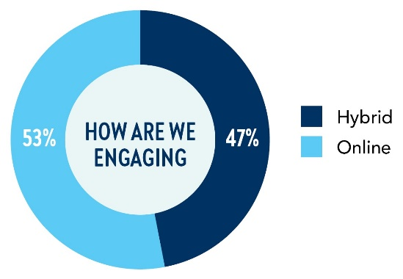
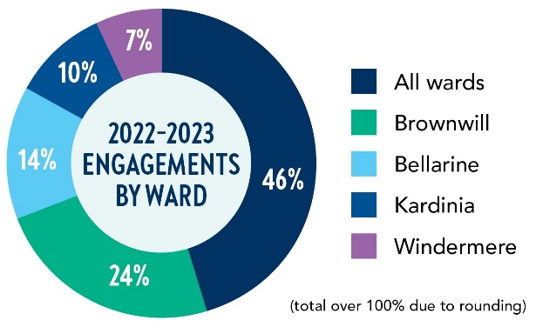
Monitoring and Reporting
We are committed to monitoring our processes, information sharing and decision making to understand the overall level of success of our engagements. Some measures of our success include:
97,788 | 255,249 | 22,128 | 57 | 6,105
visitors to the Have Your Say platform | views of the Have Your Say platform | contributions received | projects on the Have Your Say platform | registered members on the Have Your Say platform
The top Have Your Say pages visited:
- Our 2023–24 Budget, Revenue and Rating Plan (10,383 visits)
- Proposed Dog Orders (6,123 visits)
- Market Square Masterplan (5,159 visits)
- Geelong Waterfront Masterplan (4,326 visits)

SUCCESSFUL PROJECTS

Community feedback influenced over 50 projects that delivered a range of improvements and deliverables. Examples include:
Avalon Corridor Strategy
Objective:
To introduce the draft Avalon Corridor Strategy to the community, test whether input from the first round of consultation in 2021 had been adequately incorporated in the draft strategy, gain feedback on overall directions and guiding principles and gain an understanding of any specific issues or concerns.
The final plan will guide land-use decision making in the Avalon Corridor, such as the location and extent of future development.
Positive outcome from engagement:
The City realised we couldn’t undertake this planning alone. This led to a collaborative partnership between the City of Greater Geelong and Wyndham City Council.
We engaged with a broad range of residents, developers, landowners, environmentalists, farmers, government, services and utilities, transport, peak bodies, tourism and recreation organisations which elicited a number of common themes identified between the first and second consultation period. These include agricultural land capability, including a green break, regional biodiversity, significant projects, Avalon Airport, employment and development, transport, townships, Lara and Little River, tourism and connection opportunities, landscape amenity and character.
Labuan Square
Objective:
To engage with the local community to inform the development of a public realm landscape design plan to guide and prioritise investment in the treasured local place.
Positive outcome from engagement:
We partnered with Norlane Community Initiatives to talk with the local community about what they valued about Labuan Square and what they would like improved.
Stakeholders and the community loved the natural environment, shops and the opportunity to meet friends and socialise. The community prioritised a sustainable landscape, access to nature, play experiences and public art for the redevelopment along with safety infrastructure, public WiFi and improved lighting.
Community priorities were then incorporated into the landscape design and construction was completed in June 2023. This upgrade was made possible through a collaborative effort between council, the state government, Wadawurrung Traditional Owners Corporation, Norlane Community Initiatives and dedicated individuals who shared a vision for a more vibrant and inclusive public space

A Conversation about 26 January
Objective:
To listen to and seek feedback from the Greater Geelong community about 26 January, celebrated as Australia Day.
Positive outcome from engagement:
The Conversation about 26 January, is the most comprehensive we have ever undertaken on this topic and identified the diversity of views about Australia’s national day. The unique engagement was delivered over a six-month period (from May to November 2022) with Stage One devoted to hearing from First Nations Peoples, before broadening out to hear from the whole community in Stage Two.
A series of Yarn Ups, forums, conversations and meetings were held with community, organisations, community groups and event organisers from across the region, along with a survey.
We received 957 survey responses, 447 responses from First Nations Peoples (equivalent to 12.5% of the First Nations' community) and 510 responses were from the broader community. This is the largest number of contributions we have ever experienced from the First Nations community on any issue.
Engagement feedback showed all First Nations respondents (100 per cent) wanted a change to the way the day is commemorated. Across the broader community, 68 per cent of survey respondents said change was needed with suggestions including greater cultural acknowledgment, cultural events, increased inclusion of First Nations Peoples art, music and culture. 32 per cent of the broader community opposed changes to the day.
Recommendations to guide our future approach to activities and commemorations held on 26 January were endorsed by Council in May 2023.
Positive Ageing 2022–25 Action Plan
Objective:
To bring the Positive Ageing Strategy 2021–47 to life by asking the community to co-design the actions needed to make Greater Geelong a more age friendly place to be. Codesign invited the community to be active participants in the design process to ensure the action plan was truly meaningful to the residents of Greater Geelong
Positive outcome from engagement:
The co-design process began by capturing community stories through conversations. Over 240 community members over the age of 55 years participated and were then invited to take part in the design process.
Thirty community members chose to continue their involvement and attended a design forum. This forum brought together a diverse group of stakeholders including local agencies and City employees, providing an opportunity for community representatives to develop a deeper understanding of the issues raised in phase one, thus enriching the outputs, strengthening relationships, and paving the way for future collaboration.
Some of the key issues raised for action were access to transport, age friendly infrastructure, social connections, digital literacy, safety and promoting ways older people can live at home for longer.

GRANTS PROGRAM
In 2022–23, our Community Grants Program provided $4,457,167 to assist the community, arts, events, cultural, sporting, recreation, heritage, and environmental sustainability sectors.
Funding ranged from small grants of $500 to assist grassroots activities, through to $350,000 to help shovel-ready community infrastructure projects. For further grants information visit our website www.geelongaustralia.com.au
TABLE 1: Community Grants Program allocations 2022–23
GRANT NAME | WHAT IS FUNDED | 2022–23
GRANT NAME | WHAT IS FUNDED | GRANT BUDGET | NUMBER OF APPLICATIONS FUNDED | TOTAL FUNDING ALLOCATED
Arts Projects | Support to deliver arts projects in the City of Greater Geelong. | $220,000 | 22 | $202,760
Artists & Creatives Professional Development | Travel, accommodation, fees, incidentals and in some circumstances, remuneration. | $220,000 | 9 | $17,240
Arts Projects Quick Response | Support urgent arts, culture and heritage projects whose timelines prevent the applicant from applying to Arts Projects. | $220,000 | nil
Children’s Week | Small grants to facilitate events held during Children’s Week. | $10,000 | 19 | $8,840
Christmas in the Community | Small grants to provide greater equity and inclusion for festive celebrations across the municipality. | $40,000 | 9 | $32,110
Cleantech & Circular Economy | Projects that demonstrate clean technology and circular economy solutions. | $50,000 | 3 | $50,000
Climate Change Partnership Grants | Funding for projects and activities that will be carried out over a period of one to two financial years. | $100,000 | 2 | $100,000
Community Events | Operating expense to run safe, moderate sized, public events that provide economic and community benefits to our region. | $200,000 | 36 | $187,000
Community Events Quick Response | Support for moderate sized events which bring our region economic benefits. | $200,000 | 4 | $20,640
Community Infrastructure | Planning for Capital Works - Costs associated with facility development planning, concept designs and detailed designs for future infrastructure projects. | $3,000,000 | 36 | $3,000,000
Community Infrastructure | Capital Works - To assist with cost of ready to go community infrastructure projects. Not applicable for the purchase of land. | $3,000,000 | 36 | $3,000,000
Environmental Sustainability | Capital Works - Small environmental capital works (for example water tanks, solar panels). | $150,000 | 21 | $134,173
Environmental Sustainability | Projects - Delivery of responsive environmental sustainability projects, programs and community activities. | $150,000 | 21 | $134,173
Environmental Sustainability | Equipment - To assist with cost of small equipment purchases that help community groups to deliver services and programs. | $150,000 | 21 | $134,173
First Nations Cultural Heritage | Projects that recognise, restore, protect and preserve both tangible and intangible Aboriginal Cultural Heritage. | $100,000 | 2 | $52,200
Geelong Heritage | Conservation Works - Building or streetscape projects that are visible to the public and focus on presentation to a street or public space and have an identified historic value. | $100,000 | 7 | $100,575
Geelong Heritage | Planning - Feasibility and investigation projects to provide technical, planning, project scoping advice for future restoration projects. | $100,000 | 7 | $100,575
Healthy & Connected Communities | Projects - Projects, programs, activities, forums or events, and equipment necessary to deliver activities (up to $10,000) that improve health and wellbeing, build community capacity and benefit the broader community. | $263,000 | 76 | $262,946
Healthy & Connected Communities | Equipment - To assist with cost of small equipment purchases (up to $2,000) that help community groups: deliver services and programs, improve health and safety outcomes or improve resources that support volunteer groups. | $263,000 | 76 | $262,946
Healthy & Sustainable Schools | School based projects relating to health priority areas of healthy eating or climate action and/or environmental sustainability. | $15,000 | 3 | $15,000
Neighbourhood Houses | Partnership with Neighbourhood Houses for operating costs and community development projects. | $182,500 | 21 | $169,763
Neighbourhood Houses – Christmas in the Community | Support for Christmas celebrations across our municipality. | $80,000 | 9 | $80,000
Positive Ageing | Support community hosted events and experiences. This grant replaces the Geelong Seniors Festival Grants. | $24,000 | 33 | $23,920

CHALLENGES IMPACTING OUR SERVICES
The following are some of the key challenges impacting our services. To address these challenges, we may need to invest in new infrastructure, adopt modern technologies or practices, work with partners and stakeholders to achieve shared objectives and regularly review and adapt our service delivery to meet the changing needs of the community.
CHALLENGE | WHAT IT MEANS FOR US | HOW WE NEED TO RESPOND
Growing pressure on financial sustainability | We operate within budget constraints, limiting our ability to invest in new services and infrastructure. | We need to consider a range of strategies to maintain essential services and programs, while managing costs. This may include finding cost savings through efficiency measures, exploring alternative funding sources, or generating revenue through strategic commercial opportunities.
Digital divide | The digital divide can limit access to services for some of our residents, particularly those who lack the technology or digital skills to access online services. | We need to address the digital divide and advocate that all residents have access to digital services. Suggestions include providing digital literacy programs, making digital services more accessible and user-friendly and partnering with community organisations to reach to those who may be digitally excluded.
Climate change | Climate change poses a significant challenge, including increased risks of flooding, bushfires, and extreme weather events, which can impact the provision of services and infrastructure. | We need to take a comprehensive and proactive approach to climate change adaptation and mitigation. Strategies include the promotion of renewable energy, sustainable transport, protecting and restoring our natural environment, the development of flood-resistant infrastructure, heatwave and flooding plans.
Social and economic inequity | Across our region, there is significant disparity between more advantaged and less advantaged suburbs. This can lead to issues such as social isolation, poor health outcomes, and reduced access to services. | In collaboration with our residents, support agencies, and community advocates in the locations more affected by disadvantage, we must address priority areas such as digital exclusion, disengagement from school, unemployment, Indigenous health and wellbeing, food security, access to health services, mental health and wellbeing, domestic violence, housing stress, homelessness and social isolation, to create better opportunities for all.
Population growth | Our population is expected to continue to grow, which places greater demand on our services, particularly in areas such as healthcare, education, and public transportation. | We need to take a holistic approach that involves a range of strategies. For instance, ensure that our infrastructure and services keep pace with population growth, focus on sustainable urban planning and development, ensure affordable housing, and community engagement is also key to responding to population growth.
Changing community needs | As our population grows and changes, there is a need to continuously reassess and adapt services to meet the evolving needs of the community. There may be increased demand for certain services, which can place a strain on existing resources and infrastructure. | As the needs and preferences of our community change over time, we must adapt our services to meet these changing needs, to ensure services remain relevant, accessible, and effective for our community. We may need to consider issues such as socio-economic status, geographic location, and cultural diversity, and to develop strategies to address any inequities or barriers that may exist.
Organisational change | Organisational change can be a challenge for any organisation. Implementing changes to processes and systems can be complex and time-consuming, particularly in a large organisation with multiple departments and stakeholders. | We need to address organisational challenges through a strategic and a people-centred approach, to effectively navigate through periods of transition and enhance the overall organisational effectiveness and our performance. Organisational change can bring benefits such as increased innovation, improved decision-making and better alignment with community needs.
Infrastructure and maintenance | Our infrastructure requires ongoing maintenance and upgrades to ensure it can meet the needs of a growing population. Given budget constraints, this requires significant investment, which can be a challenge for us to manage. | We need to prioritise infrastructure upgrades, develop a maintenance plan, use technology to improve maintenance, involve the community and seek external funding such as grants or partnerships to help fund infrastructure and maintenance. This is so we can ensure our infrastructure is safe, reliable and able to support the needs of our growing population.

OUR COUNCIL AND ORGANISATION

Like all local governments, the City of Greater Geelong is made up of two interdependent parts – the Council and the organisation (the City). Collectively, we work together to serve our community.
The Council sets the strategic direction for the municipality and makes decisions on behalf of the community it has been elected to represent. The organisation oversees the day-to-day delivery of all services and functions, guided by the Council, state and federal legislation and various funding agreements.

OUR COUNCIL
Our council provides leadership for the good governance of the municipality and the local community.
This means:
- considering the diverse needs of the local community in decision-making
- establishing strategic objectives and monitoring achievements
- managing resources in a responsible and accountable manner
- advocating local community needs to other communities and governments
- giving everyone the opportunity to participate in the democratic process and decision-making that shapes our community.

OUR COUNCILLORS
The Councillors work together to set the strategic direction for the municipality, which influences policy, service standards and performance across the organisation.
The municipality is divided into four, multiple-councillor wards (see Figure 17):
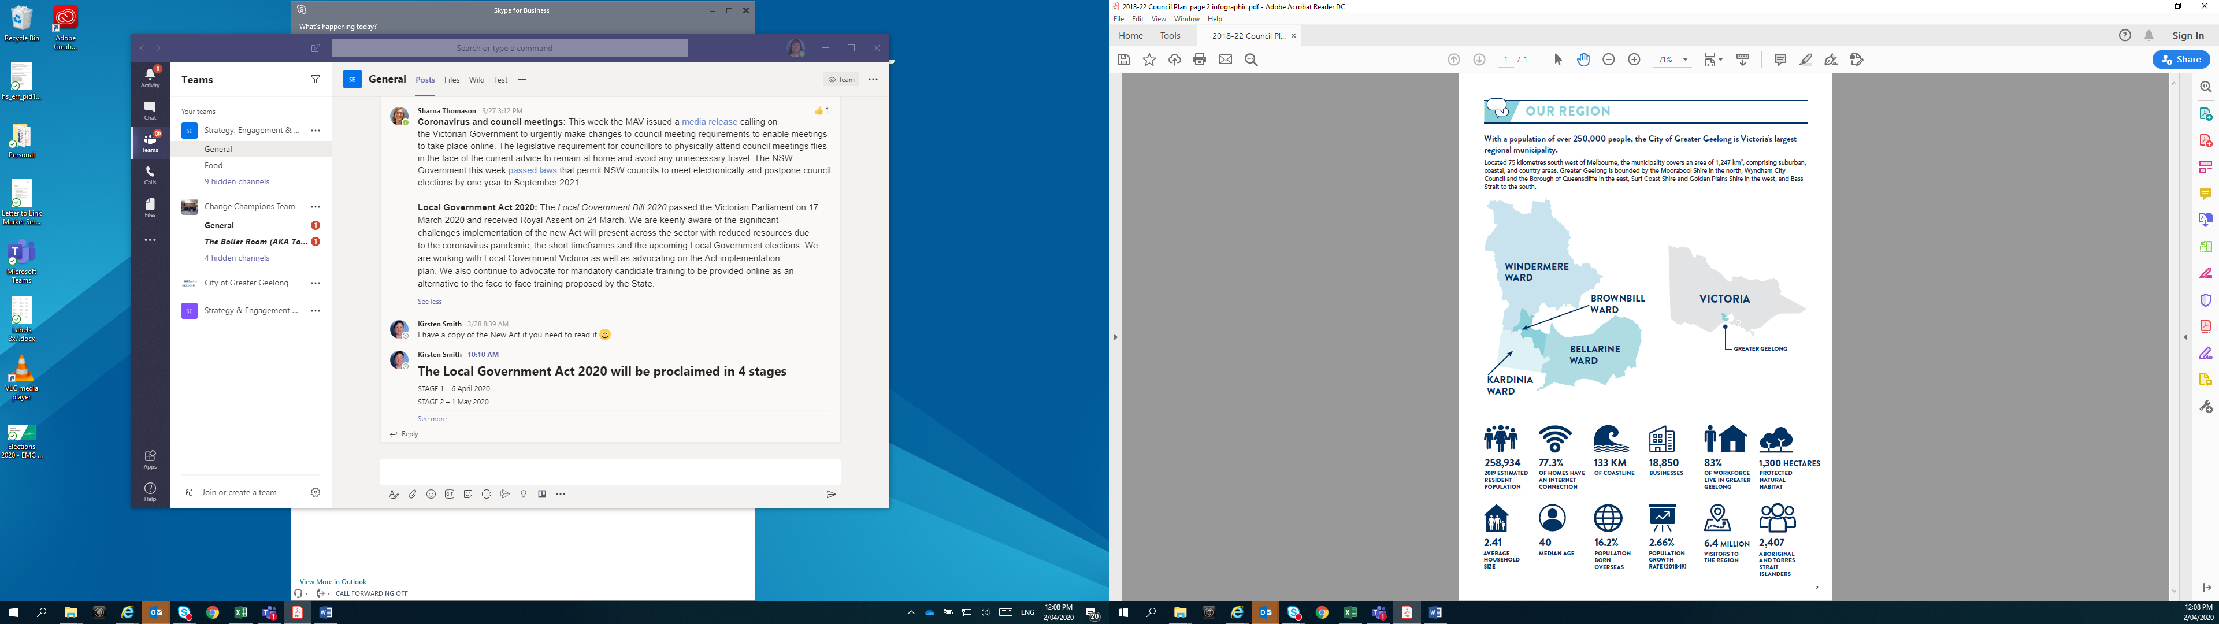
- Bellarine Ward: three councillors
- Brownbill Ward: three councillors
- Kardinia Ward: three councillors
- Windermere Ward: two councillors.

FIGURE 17: Ward map of the City of Greater Geelong
In 2022–23, Council included the following elected representatives:
- Cr Peter Murrihy held the position of Mayor of Greater Geelong City Council from 17 June 2022 until the election of Cr Trent Sullivan, Mayor on 8 November 2022.
- Cr Anthony Aitken was elected Deputy Mayor at a special Council meeting on 8 November 2022.
- Cr Melissa Cadwell was elected as Councillor for the Brownbill Ward on 23 January 2023 as a result of the extraordinary vacancy created by the election of Cr Sarah Mansfield to Victorian Parliament.
- Cr Sarah Hathway was elected as Councillor for the Windermere Ward on 28 June 2023 as a result of the extraordinary vacancy created by the resignation of Cr Kylie Grzybek on 29 May 2023.

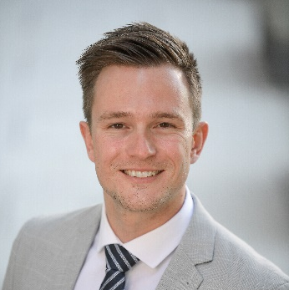 | Cr Trent Sullivan  Mayor  Bellarine Ward | 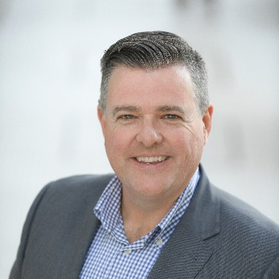 | Cr Anthony Aitken  Deputy Mayor  Windermere Ward
Portfolios:  - Aboriginal and Torres Strait Islander (ATSI) Partnerships (Chair)  - Commonwealth Games (Chair)  Committees:  - Kilangiti (formerly Karreenga) Aboriginal Advisory Committee (Chair)  - Planning Committee  - Audit and Risk Committee  - CEO Employment and Remuneration Committee  - Geelong Regional Library Corporation  - Regional Capitals Victoria  - Regional Capitals Australia  - Submissions Review Panel  - Tourism Greater Geelong and The Bellarine Inc  - G21 Geelong Region Alliance |  | Portfolios:  - Strong Local Economy (Chair)  - Aboriginal and Torres Strait Islander (ATSI) Partnerships (Deputy Chair)  - Commonwealth Games (Deputy Chair)  - High Performing Council (Deputy Chair)  Committees:  - CEO Employment and Remuneration Committee  - Geelong Major Events Delegated Committee  - Geelong Regional Library Corporation  - Planning Committee  - Regional Cities Victoria  - Rural and Peri-Urban Advisory Committee  - Submissions Review Panel  - Access and Inclusion Advisory Committee

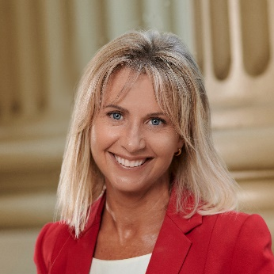 | Cr Stephanie Asher  Bellarine Ward | 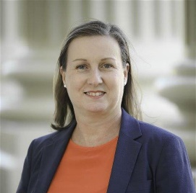 | Cr Melissa Cadwell  Brownbill Ward
Portfolios:  - Veteran Affairs (Chair)  - Active Spaces (Deputy Chair)  Committees:  - CEO Employment and Remuneration Committee  - Planning Committee  - Submissions Review Panel |  | Portfolios:  - Creativity and Culture (Chair)  - City Planning and Heritage (Deputy Chair)  Committees:  - Women in Community Life Advisory Committee (Chair)  - CEO Employment and Remuneration Committee  - G21 Pillar – Cultural and Economic Development  - G21 Managing Growth Advisory Group  - Geelong Art Gallery  - Geelong Heritage Advisory Committee  - Geelong Major Events Delegated Committee  - Geelong Regional Library Corporation  - Planning Committee  - Submissions Review Panel
 | Cr Sarah Hathway  Windermere Ward | 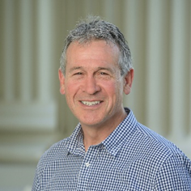 | Cr Bruce Harwood  Kardinia Ward
Committees:  - Planning Committee  - Submissions Review Panel |  | Portfolios:  - High Performing Council (Chair)  - Environment and Circular Economy (Deputy Chair)  Committees:  - Submissions Review Panel (Chair)  - G21 Pillar - Sustainability  - Planning Committee  - Sustainability Advisory Committee
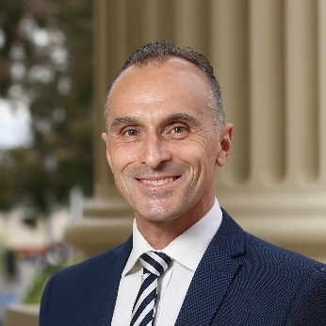 | Cr Eddy Kontelj  Brownbill Ward | 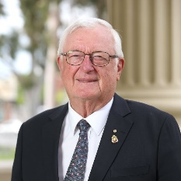 | Cr Jim Mason AM  Bellarine Ward
Portfolios:  - Active Spaces (Chair)  - City Transport (Deputy Chair)  Committees:  - Planning Committee  - Submissions Review Panel |  | Portfolios:  - City Planning and Heritage (Chair)  - Strong Local Economy (Deputy Chair)  Committees:  - Bellarine Arts Centre (Potato Shed) Community Asset Committee (Chair)  - Geelong Heritage Advisory Committee (Chair)  - LGBTQIA+ Advisory Committee (Chair)  - Planning Committee (Chair)  - Rural and Peri-Urban Advisory Committee (Chair)  - Association of Bayside Municipalities  - CEO Employment and Remuneration Committee  - G21 Managing Growth Advisory Group  - Geelong Major Events Delegated Committee  - Submissions Review Panel
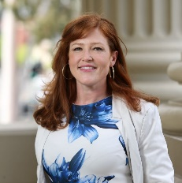 | Cr Belinda Moloney  Kardinia Ward | 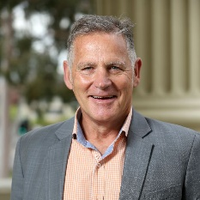 | Cr Peter Murrihy  Brownbill Ward
Portfolios:  - Multicultural Geelong (Chair)  - Inclusion and Care (Deputy Chair)  Committees:  - Ageing-Well Advisory Committee (Chair)  - Association of Bayside Municipalities  - Geelong Regional Library Corporation  - Multicultural Action Plan Committee  - Municipal Association of Victoria  - Planning Committee  - Submissions Review Panel |  | Portfolios:  - Environment and Circular Economy (Chair)  - Creativity and Culture (Deputy Chair)  Committees:  - Sustainability Advisory Committee (Chair)  - G21 Pillar - Health and Wellbeing  - G21 Pillar - Sustainability  - Planning Committee  - Submissions Review Panel
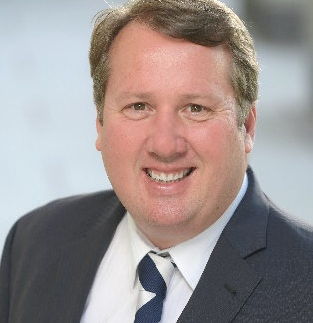 | Cr Ron Nelson  Kardinia Ward
Portfolios:
- City Transport (Chair)
- Veteran Affairs (Deputy Chair)
Committees:
- Audit and Risk Committee
- Geelong Major Events Designated Committee
- Planning Committee
- Submissions Review Panel

OUR ORGANISATION
We are an inclusive and flexible organisation and one of the largest employers in the region. We are responsible for:
- providing support and professional expertise to assist Council in developing policies and making decisions
- engaging with the local community and significant stakeholders to make sure Council decisions are in line with community expectations
- delivering services and programs that benefit the whole community, such as waste management and roads
- delivering services and programs for specific communities, such as maternal child health and youth services
- enforcing legislation that has a local community impact, such as food safety and planning legislation
- building and maintaining infrastructure, such as local roads and community hubs
- protecting our natural environment, while supporting sustainable development
- supporting economic development that will benefit the whole community
- helping our community to plan for, and recover from, natural disasters and other emergencies.
Changes to our organisation in 2022–23
Since 2020, we have been undertaking an organisation design project, driven by our people, to transform how we work together for a thriving community.
Over the past two and a half years the Future Ways of Working Program has undertaken detailed research and engagement to design our ideal future state (called a Target Operating Model).
Future Ways of Working is a CEO-sponsored foundational program established to improve our performance in five key areas:
- decision-making
- accountability
- structure
- ways of working
- capabilities.
We are doing this so that we can become an efficient, effective and financially sustainable organisation that better delivers on the needs of our customers and our employees.
By working better together, we’re creating a healthy, safe environment where we respect and encourage each other, embrace new ideas, better ways to work, and truly make people the centre of our business.
In April 2023, we undertook several foundational structure changes, to align the organisation to our future state Target Operating Model.
The refocusing for our five Directorates represents us prioritising the five things we need to be great at to deliver on our strategy:
- City Planning and Economy has been renamed Planning and Design to create integrated, collaborative, prioritised planning working to common goals, with the right voices heard at the right times.
- Community Life has been renamed Community Service Delivery to deliver the highest value services, in the best way, where there is the greatest need.
- City Services has been renamed City Infrastructure to ensure we have clear roles and responsibilities for ensuring great assets, and the right capacity to manage them.
- Customer and Corporate Services has been renamed Customer, Community and Economy to deliver simple and easy customer experience with extraordinary understanding of customer wants and needs.
- Strategy, People and Performance has been renamed Strategy, Governance and Corporate to build strategic enterprise-wide functions to lead, govern and enable the entire organisation to thrive.
These changes ensure each Directorate has a discrete and clear role to play in how we deliver for our community. Several reporting line and team changes took place to get the right teams working together in common ways.
By creating clear focus and accountability, and natural dependencies and points of collaboration between Directorates, we’re becoming a high-performing organisation, giving our people space to thrive, and making our organisation easier to navigate for our community.
With this foundational work completed, the organisation has now moved into a period of organisation-led continuous improvement to design new ways of working and deliver on the benefits of our new ways of working.
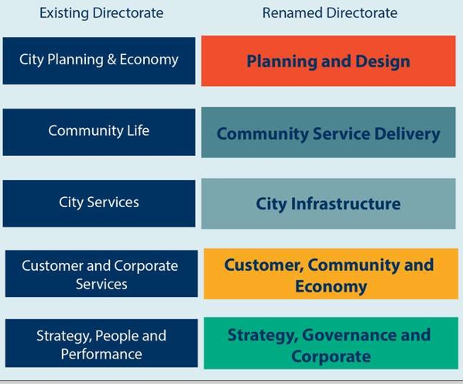

OUR LEADERSHIP TEAM
We are led by the Chief Executive Officer, who operates under the delegation of the elected Council and is responsible for our overall management and performance.
Our Executive Leadership Team, consisting of five Executive Directors and the Chief Executive Officer, are responsible for implementing council decisions and delivering sustainable and effective services, activities and infrastructure to the community. The position of Executive Director Strategy, People and Performance position was vacant at 30 June 2023.

KAARINA PHYLAND  ACTING CHIEF EXECUTIVE OFFICER* | DAVID GREAVES  ACTING EXECUTIVE DIRECTOR CITY INFRASTRUCTURE** | BRYCE PROSSER  ACTING EXECUTIVE DIRECTOR CUSTOMER, COMMUNITY AND ECONOMY
GARETH SMITH  EXECUTIVE DIRECTOR PLANNING & DESIGN | ROBYN STEVENS  EXECUTIVE DIRECTOR COMMUNITY SERVICE DELIVERY
*Martin Cutter held the position of Chief Executive Officer to 2 September 2022
Kaarina Phyland held the position of Acting Chief Executive Officer from 2 September 2022
**Guy Wilson held the position of Director City Services from 1 July 2022 to 3 February 2023
*** Kaarina Phyland held the position of Director Strategy, People and Performance until 2 September 2022

FIGURE 17: Our leadership team as at 30 June 2023

OUR ORGANISATIONAL STRUCTURE
Our organisation is structured around five directorates that work together to deliver a range of services, activities and infrastructure.
FIGURE 18: Our organisational structure as at 30 June 2023

OUR PEOPLE
We are proud to be an inclusive and flexible organisation that is one of the largest employers in the region.
We currently employ a total of 2,877 people, equivalent to 1,809.8 full-time employees10F.
Our turnover11F in 2022–23 was 16.9 per cent, down from 17.3 per cent the previous year.

TABLE 2: Total full-time equivalent employees by directorate, employment condition and gender in 2022–23
EMPLOYEE TYPE –GENDER | CHIEF EXECUTIVE | CITY INFRASTRUCTURE | COMMUNITY SERVICE DELIVERY | CUSTOMER, COMMUNITY & ECONOMY | PLANNING & DESIGN | STRATEGY, GOVERNANCE & CORPORATE
Full Time – W | 1 | 71.3 | 262.1 | 68.6 | 68.1 | 119.8
Full Time – M | 0 | 379.1 | 81.4 | 22.5 | 63.4 | 111.3
Full Time – X | 0 | 0 | 0 | 0 | 0 | 0
Part Time – W | 0 | 12.2 | 290.5 | 26.6 | 11.9 | 24.4
Part Time – M | 0 | 1.4 | 36.4 | 0 | 0.8 | 4.9
Part Time – X | 0 | 0 | 0 | 0 | 0 | 0
Casual – W | 0 | 1.9 | 91.5 | 4 | 1.6 | 5.3
Casual – M | 0 | 5.2 | 39.2 | 0.9 | 0 | 0.2
Casual – X | 0 | 0 | 0 | 0 | 0 | 0
Total12F | 1.0 | 471.1 | 803.4 | 122.6 | 145.8 | 265.9
Legend: W = Women, M = Men, X = persons of self-described gender

TABLE 3: Total headcount of employees by employment classification and gender in 2022–23
EMPLOMENT CLASSIFICATION | WOMEN | MEN | PERSONS OF SELF-DESCRIBED GENDER | TOTAL
Band 1 | 104 | 85 |  | 189
Band 2 | 222 | 51 |  | 273
Band 3 | 413 | 357 | 3 | 773
Band 4 | 154 | 81 |  | 235
Band 5 | 239 | 95 | 1 | 335
Band 6 | 171 | 93 |  | 264
Band 7 | 119 | 140 |  | 259
Band 8 | 58 | 53 |  | 111
Band not applicable | 376 | 6 | 1 | 383
Senior Officer | 34 | 21 |  | 55
Total | 1,890 | 982 | 5 | 2,877

EQUAL EMPLOYMENT OPPORTUNITY – AN INCLUSIVE AND DIVERSE WORKPLACE
We believe that our people are our greatest asset. We are committed to creating an inclusive and fair organisation that encourages our employees to do their best work.
In 2020 we were one of 10 councils funded by the Victorian Government to apply a gender lens across our work. A key obligation under the Gender Equality Act is the development of the Gender Equity Action Plan. We have begun to apply a gender lens across all areas, including:
- launching our Gender Equality Action Plan 2022–25 (GEAP) September 2022 at Wurriki Nyal. The Commissioner for Gender Equality in the Public Sector, Dr Niki Vincent, spoke at the launch, outlining how a GEAP can provide a guide to develop, implement and monitor actions that support all members of our community.
- preparing the Workplace Gender Audit for the progress report due in February 2024.
- continuing integration of Gender+ Impact Assessments in our business planning processes.
- partnering with RMIT University and other employers across our region to deliver an accredited Gender Equality Course, to build capability for Gender+ Impact Assessments across the organisation.
- registering with Reconciliation Australia for the development of the Innovate Reconciliation Action Plan (RAP) following community engagement on the 26 January
- our First Nations Employment and Engagement Officer developing relationships, and supporting the delivery of key workplace initiatives, including First Nations Identified Traineeships, through an agreement with AFL SportsReady.
- participating on the Geelong Aboriginal Employment Taskforce (GAET). Our inductees and existing employees have the opportunity to attend Walk and Talk Cultural Heritage Tours with Wadawurrung Traditional Owners to develop understanding of Cultural Heritage and History, and to support our employees to work with cultural respect with community.
- commencing work on the development of the Access and Inclusion Action Plan 2024–2028. The plan will identify actions to remove barriers to employment for people with a disability and to continue to build an inclusive workplace.
Other plans we are using to further improve diversity and inclusion in our workplace include:
- Sustainability Framework 2020
- Social Equity Framework 2022‒25

OCCUPATIONAL HEALTH AND SAFETY
Health and safety matters to us.
Our safety management system, CitySafe, continues to be the source of information on Health, Safety and Wellbeing matters. With the removal of pandemic restrictions, normal business operations have returned. While both the lost time injury and the total recordable injury frequency rates have fallen, they remain higher than target. There is an increased focus on high potential incidents, and all are formally investigated so that learnings can be identified, and corrective actions implemented.
TABLE 4: Occupational health and safety performance in 2022–23
 | LOST TIME INJURY FREQUENCY RATE |  | TOTAL RECORDABLE INJURY FREQUENCY RATE |  | HIGH POTENTIAL INCIDENT FREQUENCY RATE
2020–21 Results | 21.4 |  | 24.9 |  | 2.9
2021–22 Targets | 15 |  | 14 |  | 1
2021–22 Results | 26.5 |  | 34.9 |  | 0.0
2022–23 Results* | 22.3 |  | 29.4 |  | 2.23
2022–23 Variation | -15.85% |  | -15.76% |  | +223% | X
*As at June 2023
Wurriki Nyal
The move to our new administration building Wurriki Nyal was completed in 2022, and as part of the process, more than 500 workstation assessments were conducted. Ongoing reviews are also conducted as required including lighting assessments of workstation areas.
Contractor and volunteer safety
In 2021, we expanded the functionality of LinkSafe (contractor induction management) to include volunteer and event inductions. This was further expanded to include visitor check in when we moved to Wurriki Nyal.
Psychological Safety
New regulations on the requirement to manage Psychological Safety in the workplace commenced in 2023. In preparation, we established a Psychological Safety Working Group. The working group has commenced development of a framework and road map to comply with the new requirements. The new regulations ensure we provide a psychologically safe workplace for our employees.
Fitness For Work
A Fitness for Work Policy was drafted in 2022 and has been through extensive consultation via our Occupational Health and Safety (OHS) Committees, site meetings, toolbox talks, drop-in sessions, routine management meetings and Employee Collaborative Committee meetings. The policy has been refined and will be reviewed via the Policy Review Committee before release and roll out. This is in line with ensuring the safety and wellbeing of our employees.
Health Safety and Wellbeing Capability
A City-wide OHS Maturity Assessment was completed in late 2022 and a detailed action plan developed which is now being implemented across the City. In addition, a Health Safety and Wellbeing component has been integrated into the leadership development training program, ’Leading Better Together’, which focuses on uplifting the understanding and awareness around OHS accountability and responsibility for people leaders.

HOW WE PLAN
We have developed an integrated, long-term and transparent approach to planning, monitoring and performance reporting, aligned with our clever and creative vision.
The Local Government Act 2020 requires all councils to prepare the following documents:
- Community Vision
- Council Plan
- Financial Plan
- Asset Plan
- Budget
- Revenue and Rating Plan
- Annual Report
- Workforce Plan.
Our Integrated Strategic Planning and Reporting Framework (represented in Figure 19) demonstrates the relationship between these key planning and reporting documents. The framework helps us set goals, make decisions, prioritise our workload, allocate resources, monitor progress and adapt to changing circumstances that might challenge our progress.
In 2021, we incorporated our Municipal Public Health and Wellbeing Plan into our Council Plan to create Our Community Plan 2021‒25.
We also introduced an internal organisation strategy and business planning cycle to guide our budget and business planning for 2022‒23. This process will continue to develop and enhance our strategic decision-making around priorities, performance and resource allocation.

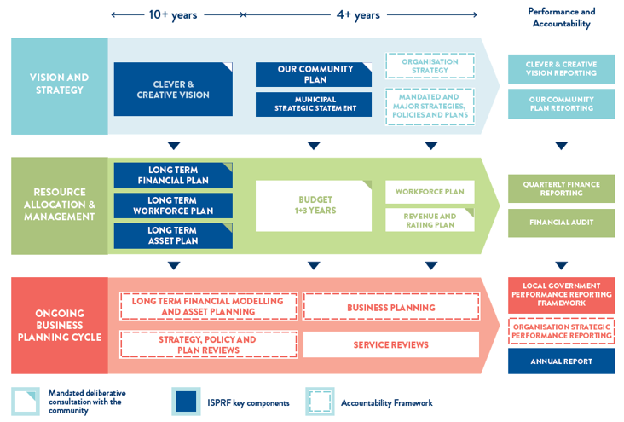

FIGURE 19: Our Integrated Strategic Planning and Reporting Framework (ISPRF)

OUR PERFORMANCE 2022–23

Our Community Plan 2021‒25 outlines how we are working towards the 30-year community vision to make Greater Geelong a clever and creative city-region.
The plan tells our community what councillors are aiming to achieve during their four-year terms. It guides us on how we allocate resources, so we can deliver infrastructure, services and programs to our community to ensure the social, economic and environmental sustainability of our region.
The four strategic directions we have chosen to guide us are:
- healthy, caring and inclusive community
- sustainable growth and environment
- strong local economy
- high-performing Council and organisation.
As well as the strategic directions, the plan also outlines:
- desired outcomes ‒ the future state we’re aiming for in four years
- four-year priorities ‒ the priorities we’ll focus on to help achieve our desired outcomes
- indicators ‒ how we will monitor our progress.
Our Community Plan 2021‒25 is supported by an annual action plan and budget, highlighting the projects, initiatives and programs that will take place within the financial year to address our four-year priorities.
The following provides a high-level overview of our performance in delivering the 2022–23 annual action plan, and how we are tracking against the indicators. It also highlights other achievements supporting our strategic priorities as well as results for the prescribed service performance indicators as set out in the Local Government Performance Reporting Framework (LGPRF).
For more detailed information on the progress of the annual action plan, refer to the quarterly reports on our website (www.geelongaustralia.com.au).

STRATEGIC DIRECTION 1: HEALTHY, CARING AND INCLUSIVE COMMUNITY

4,895 bookings across community halls totalling 18,155 hours | 201,000 of home care provided to vulnerable residents
246 community bus bookings transporting approximately 2,734 passengers | 52,752 visitors to National Wool Museum
137 sports pavilions and buildings maintained | 150+ objects added to our Art & Heritage Collection.
16,000 attendees at youth programs | 1,451 first time parenting groups
10,556 swim goggles sold | 1.8 million visits to our leisure facilities, a 58 per cent increase from 2021–22
6,154 hours of enhanced Maternal and Child Health service delivered | 3,227 assessments to provide services supporting older residents to live at home
44,079 dogs and cats registered | 25,000 people attended the Grand Final Parade held in September 2022

LINKS TO THE CLEVER CREATIVE VISION
 | 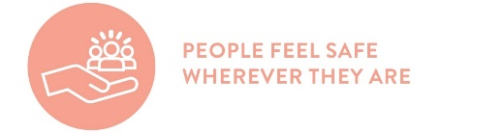 | 
Desired outcomes
- Our community feels welcome, safe and connected
- Our community has equitable access to health and social services, information and infrastructure
- Healthy behaviours and environments are promoted, supported and accessible
Four-year priorities
1.1 Help our community, recreation groups and volunteers to prosper and grow
1.2 Deliver health and community initiatives that are culturally sensitive and accessible across all life stages
1.3 Foster and embrace community connectedness
1.4 Demonstrate and promote gender equity practices
1.5 Foster an inclusive community culture
1.6 Facilitate social and affordable housing in Greater Geelong
1.7 Provide access to places, spaces and services where, and when, people need them the most
1.8 Strengthen relationships and partnerships with the Aboriginal and Torres Strait Islander communities in Greater Geelong
1.9 Support our cultural and creative life, history and heritage
1.10 Provide facilities that foster and facilitate positive health and wellbeing outcomes
1.11 Respond to the findings of the Royal Commissions into aged care and mental health
Supports health and wellbeing

PROGRESS REPORT
Indicators
Municipal Indicators |  | RESULT at 30 June 2023 | Progress comments
Proportion of adults experiencing high / very high psychological distress  Source: City of Greater Geelong Preventative Health Survey | 20% (2021)  10.3% (2017) |  | There was an increase in the proportion of our adult community experiencing high / very high psychological distress since 2017. Next survey due in 2024‒25.
Proportion of adults meeting the physical activity guidelines  Source: City of Greater Geelong Preventative Health Survey |  | 67% (2021)  41% (2017) | More of our adult community is reporting that they are sufficiently physically active than in 2017. Next survey due in 2024‒25.
Proportion of adults consuming the recommended number of serves of fruit and vegetables  Source: City of Greater Geelong Preventative Health Survey |  | Fruit  46% (2021)  53% (2017)  Vegetable  15% (2021)  10% (2017) | Since 2017, there was an increase in the proportion of our adult community consuming the recommended serves of vegetables and a decrease in the proportion consuming the recommended serves of fruit. Next survey due in 2024‒25.
Family violence incident rate per 100,000 population for Greater Geelong  Source: Crime Statistics Agency website www.crimestatistics.vic.gov.au |  | 1,680.7 (March 2023)  1,557.7 (March 2022)  1,595.9 (March 2021) | For the year ending March 2023, the family incident rate for Greater Geelong was higher compared to the Victorian rate (1,377.7).
Community perception of safety in the area where they live  Source: City of Greater Geelong Preventative Health Survey |  | 61% (2021)  54% (2017) | More of our adult community is feeling safe where they live than in 2017. Next survey due in 2024‒25.
Level of agreement that multiculturalism makes life better (definitely or sometimes)  Source: City of Greater Geelong Preventative Health Survey |  | 66% (2021) | This result comprised 48% definitely and 18% sometimes. Next survey due in 2024‒25.
Proportion of community concerned about effects of climate change on health (very or quite concerned)  Source: City of Greater Geelong Preventative Health Survey |  | 51% (2021) | This result comprised 28% very concerned and 23% quite concerned. Next survey due in 2024‒25.
Proportion of adults that are a member of an organised group (sports, religious, school, professional, community or action group)  Source: City of Greater Geelong Preventative Health Survey |  | 56% (2021) | This result consisted of 28% members of a sports group. Next survey due in 2024‒25.

City of Greater Geelong Indicators |  | RESULT at 30 June 2023 |  | Progress comments
Community satisfaction with support services  Source: Local Government Community Satisfaction Survey | Family  62 (2023) 64 (2022)  66 (2021)  Elderly  60 (2023) 63 (2022)  65 (2021)  Disadvantaged  58 (2023) 61 (2022)  62 (2021) |  | Family Support and Disadvantaged Support services were comparable to both the statewide (63, 59) and Regional Centres (64, 58) averages.  Elderly Support was comparable to Regional Centres (61) but lower compared to the statewide average (63).
Community satisfaction with recreational facilities  Source: Local Government Community Satisfaction Survey | 69 (2023)  72 (2022)  75 (2021) |  | While satisfaction decreased in 2023, our performance continued to be well regarded by the community and was among our highest rated services. Our result was also comparable to both the statewide (68) and Regional Centres averages (69).
Level of agreement that Council infrastructure is equitable (fair access to facilities that are needed across the municipality including healthy, safe and inclusive places and spaces)  Source: Local Government Community Satisfaction Survey | 44% (2023)  55% (2022) |  | There was a decrease in the proportion of people who agreed or strongly agreed with the statement that Council infrastructure is equitable. Comparison to statewide and Regional Centres average is unavailable.
Level of agreement that Council infrastructure is accessible (for all abilities, affordable and easy for people to get to).  Source: Local Government Community Satisfaction Survey | 56% (2023)  63% (2022) |  | There was a decrease in the proportion of people who agreed or strongly agreed with the statement that Council infrastructure is accessible. Comparison to statewide and Regional Centres average is unavailable.
Number of key community infrastructure projects completed  Source: City of Greater Geelong | 89.2% (2023)  86.5% (2022)  84% (2021) |  | We have delivered 33 of the 37 key community infrastructure projects identified for delivery by 2022.
Community satisfaction with community and cultural activities  Source: Local Government Community Satisfaction Survey | 66 (2023)  64 (2022)  65 (2021) |  | Our result was comparable to both statewide and Regional Centres average (66 respectively).

Annual Action Plan 2022‒23
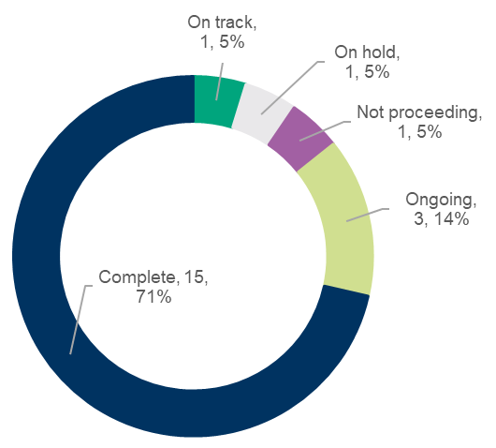
We committed to 21 actions, which demonstrate how we are addressing our four-year priorities under Healthy, Caring and inclusive community.
At the end of June 2023:
- 15 were ‘complete’
- one was ‘on track’
- one was ‘on hold’
- one was ‘not proceeding’
- three were ‘ongoing’

Major Budget Initiatives
Initiative | Northern Aquatic and Community Hub​
Action 2022−23 | Commence construction of the Northern Aquatic and Community Hub​
Status | Complete
Comment | We progressed construction on the Northern Aquatic Community Hub which, when complete, will provide state of the art health and fitness facilities for residents in the north and surrounding areas. Pool shells were completed. Tiling and fit out works are underway.

Initiative | North Bellarine Aquatic Centre
Action 2022−23 | Complete final concept Stage 2 design of the North Bellarine Aquatic Centre​
Status | Complete
Comment | Council endorsed the proposal for design and delivery of Stage 2 in November 2022 and was successful in attaining $40 million in funding commitments from both the Federal and State governments. We are in the final stages of consulting with our community advisory panel and expect to have a recommendation on the final concept Stage 2 design to Council in August/September 2023.

Initiative | Rippleside Park inclusive play space
Action 2022−23 | Commence construction of a new inclusive play space at Rippleside Park
Status | Complete
Comment | Project funding was secured, and contracts are being finalised for the detailed design of the all-accessibility play space at Rippleside Park. Construction will commence in 2024.

Other achievements in 2022‒23 included:
- Engaging with the Wadawarrung Traditional Owners Aboriginal Corporation in the naming of our new facilities, Barongarook Drysdale Library, Biyal-a Armstrong Creek Library and Poa Banyul Community Hub (Mount Duneed), recognising our region’s history, and celebrate our First Nations community.
- Collaborating with the Wadawarrung Traditional Owners Aboriginal Corporation, Wathaurong Aboriginal Co-operative and NBN Co. to showcase artwork by local First Nations people on NBN boxes at Marshall Reserve, Marshall.
- Promoting the importance of movement to maintain good physical and mental health as part of the Active Geelong Showcase, held at WorkSafe, highlighting various healthy initiatives available in Geelong.
- Endorsing changes to the way we will mark 26 January in 2024 and beyond, including supporting formalised First Nations Peoples acknowledgement and cultural events on the day, re-scheduling citizenship ceremonies, and ceasing to refer to 26 January as Australia Day in all communications, instead referring to the day as 26 January.
- Launching our 2023 Community Leadership Program as part of our commitment to developing skilled and passionate leaders across the region.
- Strengthening our commitment to better support and engage with the Lesbian, Gay, Bisexual, Transgender, Queer, Intersex and Asexual (LGBTQIA+) community by establishing an inaugural advisory committee to guide Council on issues that affect people who identify as part of Geelong’s LGBTQIA+ community.
- Developed Youth Communities of Practice – a network to provide a central point for schools and youth-focused organisations in the Geelong region to network, information share and partner in the development of innovative initiatives responding to emerging needs. The LGBTIQA+ Stand Out Community of Practice Hub is now LIVE.
- Developed the Rainbow Youth Advisory Group
- Celebrating the 17th annual Geelong Children’s Week in October 2022 with more than 30 events.
- Launching our Gender Equality Action Plan 2022−25 in September 2022 aimed at improving outcomes for women and gender diverse people. The plan relates to our internal processes, and the way we create policies and deliver programs and services to our community.
- Commencing work on the COVID-19 Youth Impact Report, a research project, to better understand the ongoing impacts the pandemic is having on young people in our region.
- Demonstrating our commitment to stamping out gender-based violence by supporting the 16 Days of Activism, an international campaign commencing 25 November 2022, the International Day for the Elimination of Violence Against Women.
- Supporting Kaleidoscope art installation, a 700-square metre, light-filled maze of moving prisms, mirrors, glass and steel created by artist Keith Courtney and manufactured in Geelong.
- Completing a renovation and safety upgrade to the historic Osborne House and stables in North Geelong, marking the first step in a planned major redevelopment of the site.
- Working with Wadawarrung Traditional Owners Aboriginal Corporation, to conserve and move a culturally significant scarred tree to Wurriki Nyal, to stand at the heart of Greater Geelong’s new Civic Precinct.
- Contributing in-kind and funding support to renew coastal and marine assets including an upgrade of the Rippleside Jetty, a refurbishment of the Ocean Grove Boat Ramp to improve the functionality of the piles and pontoon, and a detailed dredging plan (draft) for the Clifton Springs Boat Harbour.
- Delivering new and upgraded sporting and community facilities including:
  - new turf and hard-wicket training nets at South Barwon Cricket Club
  - an accessible and gender-neutral pavilion at Lara Recreation Reserve
  - lighting installations at seven sporting reserves: Evans Reserve, St Albans Recreation Reserve, Osborne Park, St Leonards Lake Reserve, Grinter Reserve, Winter Reserve and Burdoo Reserve
  - gender-neutral and accessible facilities at Shell Reserve.
- Working alongside young people from the fOrT Youth Centre to deliver the SKAART Community Festival in April 2023.
- Celebrating This Girl Can Week (12-18 September 2022) with our Swim Sport and Leisure centres offering a range of free ‘come and try’ fitness sessions, including Beginners Strength, Beginners Pilates, Beginners Circuit and Beginners Yoga.
- Hosting the Geelong Youth Awards, celebrating young people aged 12-25 years who are making a difference in leadership, cultural awareness, community work, sport, arts, music and youth development.
- Facilitating three grant writing workshops to support professional development for artists.
- Working together with other agencies as part of the Greater Geelong Municipal Emergency Management Planning Committee to deliver a new Municipal Emergency Management Plan, that details actions that need to be taken immediately before, during and after an emergency.
- Increasing capacity for more programs to be held by Geelong West Neighbourhood House and Geelong Rainbow Inc.
- Launching the 10th annual Nature Play Week launch event for Victoria at the Botanic Gardens in Eastern Park Geelong with over 2,224 families in attendance.
- Introducing Sunshine Circles across Early Years Services and Supported Playgroup to support emotional and social development of children.
- Successfully obtaining Landcare Grants to promote sustainability in early childhood education and care at the Leopold Family Centre and Whittington Family Centre.
- Completing a business case for the expansion of the Potato Shed - Bellarine Arts Centre. Once endorsed, we will then seek partnership funding for redevelopment.
- Delivering Refugee Week activities, working alongside young people from the Multicultural Drop In.
- Engaging with 193 active learner drivers through the L2P (Learner to Probationary) program who achieved 50 probationary licences and completed 101 mentor matches. Funding for the L2P program has been extended for a further 12 months and is in its 13th year of delivery. It currently has 98 volunteer mentors and 120 learners.
- Commissioning Wadawurrung Dja: Awakening Country − a major exhibition of paintings and ten ceremonial cloaks by Wadawurrung artist Deanne Gilson. The cloaks are nationally significant commission and acquisition of contemporary women's business.
- 20 major conservation projects completed on public art and heritage collection objects and over 250 research inquiries addressed.

Awards and recognition
- Our teams at Splashdown, Waterworld, Leisurelink and the Bellarine Aquatic and Sports Centre were accredited with Life Saving Victoria (LSV)’s Platinum Pool award in recognition of our facilities providing outstanding levels of safety. Our teams had to undertake a rigorous series of assessments to achieve this status, ensuring LSVs criteria was met.
- We are proud to have had six leisure and recreation team members nominated as part of the annual Aquatics and Recreation Victoria (ARV) Industry Gala Awards in June 2023: Sarah Reichenbach, Peta Hardiman, Kristy Wilson, Dylan McInnes, Emily Farlow and Fiona Thomas. Congratulations to all and especially Sarah Reichenbach, Waterworld Aquatics Coordinator, who was ‘highly commended’ for the Duty Manager Award.
- Our Youth on Board program received a high commendation in the Excellence in Community Partnerships Initiative category at this year's LGPro Awards for Excellence. The program, which sees young people between the ages of 18-25 years mentored in good governance by organisations, was developed as a partnership to our Youth Council, to ensure a youth voice is supported, developed, heard and validated in planning and decision-making in local organisations throughout our region.
- The National Family Day Care Association Regional Educator of the Year was awarded to Jacqui Sesito from Geelong Family Day Care.
- Our Grovedale Child and Family Centre, Leopold Child and Family Centre and Norlane Family Centre were all awarded an Exceeding National Quality Standard rating as part of the National Quality Standards assessment process.
- Our Community and Recreation team secured two nominations in the Parks and Leisure Australia (PLA) VIC/TAS 2023 Regional Awards of Excellence for the Lara Tennis Netball Facility (Community Facility of the Year) and the Portarlington Recreation Reserve (for Strategic Master Planning Award).

Local Government Performance Reporting Indicators
To help measure performance across all Victorian councils in a transparent and accountable way, we report to Local Government Victoria on the following mandatory indicators:
SERVICE/INDICATOR/MEASURE | RESULTS |  |  |  |  | COMMENT
SERVICE/INDICATOR/MEASURE | 2020 | 2021 | 2022 | 2023 |  | COMMENT
Animal Management
Timeliness  AM1 Time taken to action animal management requests  [Number of days between receipt and first response action for all animal management requests / Number of animal management requests] | 1.00 | 1.00 | 1.21 | 1.26 | Over 89 per cent of animal management requests were actioned in 24 hours/one day. The animal management industry is challenged by capacity issues resulting in certain services (such as nuisance cats) being suspended and resulting in longer response times.
Service standard  AM2 Animals reclaimed  [Number of animals reclaimed / Number of animals collected] x100 | 23.92% | 25.49% | 24.07% | 24.75% | Before the animals are impounded, we make every effort to reunite registered cats and dogs with their owners.
Service standard  AM5 Animals rehomed  [Number of animals rehomed / Number of animals collected] x100 | 59.61% | 61.27% | 62.37% | 48.05% | We actively seek to rehome unclaimed animals by advertising them for adoption on websites and via social media platforms. With the increase of cost of living pressures and post-COVID (people returning to work) rehoming animals has been challenging this year. When excluding animal reclaimed from the total collected, we have rehomed 63 per cent of those animals able to be rehomed.
Service cost  AM6 Cost of animal management service per population  [Direct cost of the animal management service / Population] | $13.48 | $8.75 | $9.35 | $14.05 | There has been an increase in this result due to significant rise in costs related to Council's Pound Services Contract.
Health and safety  AM7 Animal management prosecutions  [Number of successful animal management prosecutions / Number of animal management prosecutions] x100 | 100.00% | 100.00% | 100.00% | 100.00% | We continued to successfully prosecute all matters brought before the court, with four animal management prosecutions in 2022−23.
Aquatic Facilities
Service standard  AF2 Health inspections of aquatic facilities  [Number of authorised officer inspections of Council aquatic facilities / Number of Council aquatic facilities] | 1.00 | 1.00 | 1.00 | 1.00 | All six of the City's pools have been inspected with outcome’s being a satisfactory result.
Utilisation  AF6 Utilisation of aquatic facilities  [Number of visits to aquatic facilities / Population] | 6.53 | 3.32 | 4.73 | 7.21 | The City's leisure centres have continued to build a strong recovery in program growth and in-turn participation from COVID-19 impacts due to increased consumer confidence in public safety and service continuation.
Service cost  AF7 Cost of aquatic facilities  [Direct cost of the aquatic facilities less income received / Number of visits to aquatic facilities] | $3.01 | $7.53 | $5.83 | $3.31 | The City's leisure centres have continued to build a strong recovery from COVID-19 impacts. Increased utilisation of facilities has resulted in strong program growth, a subsequent increase in revenue and a reduced overall cost of aquatic facilities.
Food Safety
Timeliness  FS1 Time taken to action food complaints  [Number of days between receipt and first response action for all food complaints / Number of food complaints] | 1.64 | 1.43 | 1.46 | 1.45 | Of the 64 food complaints received in 2022, 79.7 per cent were actioned within one day of receipt.
Service standard  FS2 Food safety assessments  [Number of registered class 1 food premises and class 2 food premises that receive an annual food safety assessment in accordance with the Food Act (Vic) 1984 / Number of registered class 1 food premises and class 2 food premises that require an annual food safety assessment in accordance with the Food Act (Vic) 1984] x100 | 98.27% | 35.84% | 52.17% | 59.91% | Employee turnover has again created difficulties achieving inspection targets but we have prioritised undertaking food safety assessments over other areas of work.
Service cost  FS3 Cost of food safety service  [Direct cost of the food safety service / Number of food premises registered or notified in accordance with the Food Act (Vic) 1984] | $532.42 | $469.45 | $522.07 | $502.09 | We have attempted to keep the cost of the food safety service at a similar level to the previous years.
Health and safety  FS4 Critical and major non-compliance outcome notifications  [Number of critical non-compliance outcome notifications and major non-compliance notifications about a food premises followed up / Number of critical non-compliance outcome notifications and major non-compliance notifications about a food premises] x100 | 98.19% | 95.45% | 100% | 90.76% | Employee turnover and difficulties recruiting during an industry-wide shortage of qualified officers has impeded our ability to meet program targets in 2022. We will continue to provide a prioritised response to critical and major non-compliance notifications.
Libraries
Utilisation  LB1 Physical library collection usage  [Number of physical library collection item loans / Number of physical library collection items] | 4.45 | 3.52 | 4.38 | 4.57 | There were no major COVID-19 closures or outside factors during 2022−23 to impact this indicator, showing a return to normal usage of the collection.
Resource standard  LB2 Recently purchased library collection  [Number of library collection items purchased in the last 5 years / Number of library collection items] x100 | 73.18% | 63.31% | 66.02% | 69.09% | The results for 2022−23 indicate that we looking to build up our collection investment levels gradually over time.
Participation  LB4 Active library borrowers in the municipality  [The sum of the number of active library borrowers in the last 3 financial years / The sum of the population in the last 3 financial years] x100 | 17.57% | 15.70% | 13.98% | 13.41% | There were no major COVID-19 closures or outside factors during 2022−23 to impact this indicator, however, numbers were down on pre-pandemic figures. The indicator measures activity as loans of library collection items. It does not capture other library activity such as children and youth programs, digital literacy programs and literary events, the use of public internet computers, using facilities such as meeting rooms or study areas, or using services such as Wi-Fi, or in library use of collections, which are increasing year on year.
Service cost  LB5 Cost of library service per population  [Direct cost of the library service / Population] | $37.00 | $36.88 | $37.71 | $39.14 | This year saw the opening of a new, much larger Drysdale library to replace the older and smaller library, which has lead to increase in operational expenditure. This figure includes the costs associated with running 13 libraries in this local government area, so the actual cost of each library service per population is $3.01.
Maternal and Child Health (MCH)
Service standard  MC2 Infant enrolments in the MCH service  [Number of infants enrolled in the MCH service / Number of birth notifications received] x100 | 101.12% | 101.01% | 100.86% | 99.15% | Over the past four years, enrolments in our Maternal and Child Health service have remained relatively consistent.
Service cost  MC3 Cost of the MCH service  [Cost of the MCH service / Hours worked by MCH nurses] | $80.18 | $80.66 | $80.73 | $80.46 | The cost of providing the MCH service remained relatively consistent with the previous three years, with only a slight decrease in 2022−23.
Participation  MC4 Participation in the MCH service  [Number of children who attend the MCH service at least once (in a year) / Number of children enrolled in the MCH service] x100 | 73.14% | 72.56% | 74.40% | 73.61% | While participation in our MCH service has decreased slightly, rates are relatively consistent with previous year's results.
Participation  MC5 Participation in the MCH service by Aboriginal children  [Number of Aboriginal children who attend the MCH service at least once (in the year) / Number of Aboriginal children enrolled in the MCH service] x100 | 76.37% | 77.47% | 72.02% | 71.62% | There were 222 Aboriginal children enrolled in the City’s MCH service, of which 159 attended at least once in the year. Participation levels of Aboriginal children in our MCH service is not expected to increase as a result of families having the choice to attend either the Aboriginal MCH service or the City's MCH service since January 2022.
Satisfaction  MC6 Participation in 4-week Key Age and Stage visit  [Number of 4-week key age and stage visits / Number of birth notifications received] x100 | 93.77% | 94.37% | 94.02% | 94.26% | A high number of families continued to engage in 4-week Key Age and Stage visit delivered by our MCH services.

STRATEGIC DIRECTION 2: SUSTAINABLE GROWTH AND ENVIRONMENT

1,795 public place bins maintained | 240 tonnes of compost supplied to community gardens and not-for-profits
6,068 sealed road potholes repaired | 400 playground spaces managed
15 waterway and wetlands reserves managed | 10,214 mattresses collected
475 Environmentally Sustainable Development planning applications assessed | $1,337 million worth of works permits issued
776 school students attended the Botanic Garden’s Education Program | 12 new electric vehicles added to the City’s fleet
7,062 requests for tree services | 1,556 planning permit applications received
3.25 km of new shared paths constructed | 49 km of roads resurfaced
11.8 km of footpath renewed/replaced | 369 City managed roads treated for noxious and environmental weeds including woody weed

LINKS TO THE CLEVER CREATIVE VISION
 |  | 
Desired outcomes
- Delivering our vision for sustainable growth across the municipality
- A choice of housing and lifestyles to meet the diverse needs of our community
- Connected transport networks throughout that support liveability and prosperity
- Quality, vibrant public spaces
- Leading a reduction in community emissions and are increasing our resilience to climate change impacts
- Protect and restore our natural environment
- Minimise waste with good design and manage effective recovery of resources
Four-year priorities
2.1 Meet the housing needs of our future community
2.2 Meet existing and future transport needs
2.3 Create engaging places and spaces
2.4 Deliver best practice Environmentally Sustainable Design principles and vibrant neighbourhoods
2.5 Achieve carbon neutral in all City-managed operations by 2025 and manage our climate change risks
2.6 Support our community and region to reduce emissions and build resilience to climate change
2.7 Reduce the impact of waste
2.8 Support greater indigenous biodiversity
Supports health and wellbeing

PROGRESS REPORT
Indicators
Municipal Indicators | Result at 30 June 2023 | Progress comments
Residential land supply  Source: City of Greater Geelong | 21 years (April 2023)  22 years (April 2022)  24 years (March 2021) | There is a range of development fronts and housing choices for new and existing residents to meet their diverse housing needs. Priority in the short term is increasing zoned supply.
Employment land supply  Source: City of Greater Geelong | 25 years (June 2023)  26 years (June 2022)  27 years (June 2020) | There continues to be sufficient long-term industrial land supply. Priority in the short term is increasing zoned supply.
Diversity of housing supply  Source: Australian Bureau of Statistics Census of Population and Housing 2021. | 13.90% (2021)  15.10% (2020) | There was a significant decline in the share of housing growth in established areas in 2021. This type of development is typically smaller-medium density housing. No new data available.
Journeys to work made by public transport, walking or cycling  Source: Australian Bureau of Statistics Census of Population and Housing 2016 | 4.6% journeys (2021)  8.75% journeys (2016) | In 2021, this result comprised 2.0% public transport and 2.6% rode a bike or walked.  Method of travel to work relates specifically to the journey to work on the morning of Census Day. The 2021 Census occurred during COVID-19 lockdowns when many occupations were required to work from home, if possible, and some industries were closed, so people did not go to work. For this reason, these categories may have increased, with corresponding declines in other methods of travel.
Percentage of residences within 400 metres of public open space in urban areas  Source: The Australian Urban Observatory Liveability Report for Geelong | 40.6% (2021)  44% (2020)  30.8% (2018) | There have been substantial improvements in the methodology used to calculate public open space (POS) since 2018. This has resulted in changes to POS calculations together with some likely changes that have occurred over the 3-year period. Work is underway on a 2018–2021 change over time result.
Community greenhouse gas emissions  Source: Beyond Zero Emissions and Ironbark Sustainability, Snapshot – community climate tool (accessed 30 June 2023) | 3,452,000 tonnes CO2–emissions total (2020‒21)  3,592,000 tonnes CO2–emissions total (2019‒20)  3,670,000 tonnes CO2–emissions total (2018‒19) | Updated data will be available late 2023.
Diversion of waste from landfill  Source: Local Government Performance Reporting Framework 2021‒22 | 53.21% (2022‒23)  52.96% (2021–22)  53.87% (2020–21) | There was a slight increase in diversion rate as favourable weather conditions have increased green waste tonnages.

City of Greater Geelong Indicators | RESULT at 30 June 2023 | Progress comments
Community satisfaction with planning for population growth  Source: Local Government Community Satisfaction Survey | 49 (2023)  52 (2022)  54 (2021) | Our result was comparable to the statewide average (48) but lower compared to other Regional Centres (56).
Percentage housing construction within existing urban areas  Source: City of Greater Geelong and Barwon Water | 24% (2023)  21% (2021)  32% (2020) | Greenfield construction continues to be the main contributor to growth in Geelong’s housing supply.
Kilometres (km) of bicycle, walking paths and shared paths  Source: City of Greater Geelong | 115 km bike paths (2023)  84 km bike paths (2022)  78 km bike paths (2021)  1,988 km footpaths (2023)  1,927 km footpaths (2022)  1,900 km footpaths (2021)  208 km shared paths (2023)  181 km shared paths (2022)  169 km shared paths (2021) | Since 2022, bike paths increased 31 km, shared paths increased 27 km and footpaths increased 61 km, a total increase of 119 km in the path network.
Community satisfaction with local streets and footpaths  Source: Local Government Community Satisfaction Survey | 52 (2023)  59 (2022)  60 (2021) | While our result decreased in 2023, results were comparable to both statewide and Regional Centres averages (52 and 53 respectively).
Community satisfaction with sealed local roads  Source: Local Government Community Satisfaction Survey | 53 (2023)  57 (2022)  62 (2021) | While satisfaction decreased in 2023, we rated significantly higher compared to the statewide average and other Regional Centres (48 and 49 respectively).
Quantity of open space (civic, community parks, sports reserves and heritage open space)  Source: City of Greater Geelong | 1026.497 hectares – 485 sites (June 2023)  2,459.00 hectares – 495 sites (January 2022)  2,146.79 hectares – 495 sites (January 2021) | The decrease in hectares in 2023 is a result of conservation/nature reserves sites being reclassified and no longer reported as open space.
Community satisfaction with appearance of public areas (includes local parks, gardens, reserves and nature strips)  Source: Local Government Community Satisfaction Survey | 66 (2023)  70 (2022)  71 (2021) | Our result which decreased significantly, was comparable to statewide (67) but lower than Regional Centres (71).
Greenhouse gas emissions generated by City-managed operations  Source: Azility | 23,895 tonnes CO2-emissions (2022−23)*  23,057 tonnes CO2-emissions (2021−22)  32,630 tonnes CO2-emissions (2020–21)  34,429 tonnes CO2-emissions (2019–20)  *Provisional figure as bill estimations will continue to come in over coming months | Regional population growth is contributing to higher volumes of waste going to landfill and an increase in waste emissions.  Corporate natural gas emission figures have remained stable over the past 12 months.  Our fleet emissions are reducing as we integrate lower and zero emission vehicles into our fleet.
Hectares (ha) of protected natural habitat  Source: City of Greater Geelong | 1,405 ha (June 2023)  1,335.79 ha (June 2022)  1,380.80 ha (June 2021) | There was an increase of 69.21 hectares of natural habitat managed by us in 2022–23.
Number of trees planted  Source: City of Greater Geelong | 3,016 street and park trees 4,000 tubestock | In 2022‒23 we planted a total of 3,016 trees (2,590 street and 426 park trees) and removed 1,343 trees resulting in a net gain of 1,771 trees. We also planted 4,000 tubestock.
Community satisfaction with waste management  Source: Local Government Community Satisfaction Survey | 70 (2023)  70 (2022)  69 (2021) | Our performance continued to be well regarded by our community with waste management among our highest rated services.  Our result was significantly higher than both the statewide and Regional Centres averages (66 and 67 respectively).

Annual Action Plan 2022‒23
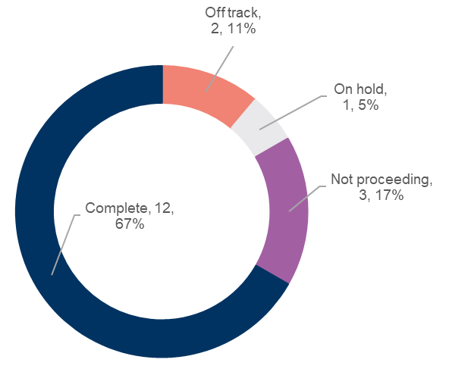
We committed to 18 actions which demonstrate how we are addressing our four-year priorities under Sustainable Growth and Environment.
At the end of June 2023:
- 12 were ‘complete’
- two were ‘off track’
- one was ‘on hold’
- three were ‘not proceeding’.

Major Budget Initiatives
Initiative | Sparrovale Wetlands Masterplan Stage 1
Action 2022−23 | Implement the Sparrovale Wetlands Masterplan Stage 1
Status | Complete
Comment | We implemented all Sparrovale Master Plan Phase 1 projects and are now moving to Phase 2. The plan outlines improvements in drainage infrastructure, natural environmental and recreational facilities over the next 20 years, encouraging people to connect with nature. Automated sensors installed by Deakin University indicate that the diversion of water away from the Ramsar wetlands in summer is operating effectively in line with the draft Sparrovale Wetlands Operating Rules. ​

Initiative | Integrated Transport Plan
Action 2022−23 | Commence development of a draft Integrated Transport Plan​
Status | Not proceeding
Comment | Whilst we commenced development of the draft Integrated Transport Plan, this plan is no longer proceeding. New external funding opportunities will be investigated during 2023–24.

Initiative | LED street lighting and smart control technology
Action 2022−23 | Upgrade to LED street lighting with smart control technology
Status | Complete
Comment | Approximately 14,000 existing residential streetlights were converted to LEDs and additional compliance upgrades completed. Replacement of main roads lighting has commenced with approximately 1,300 lights converted (out of approx. 5,000). Supply chain issues with smart control cells has delayed the installation program with main roads lighting now expected to be complete by mid-2024 and decorative lighting 25% complete by June 2024. ​

Other achievements in 2022‒23 included:
- Partnering with our community to plant an estimated 2,500 trees along the Ted Wilson Trail to celebrate National Tree Day 2022.
- Adopting a plan to transform the Geelong Saleyards, Gateways Support Services site and other adjoining undeveloped land in North Geelong to provide diverse forms of housing for up to 1,300 residents.
- Continuing to expand our serrated tussock control program to treat 303 City managed roads in 2022−23, an increase of 203 roads since 2019.
- Boosting the capacity of our Anakie Organics Processing Facility to help divert up to 1,200 tonnes of food waste from landfill each year.
- Continuing the food waste collection trial involving 1,500 households in Lara. During the trial period, 280 tonnes of food waste have been diverted from landfill.
- Working on a new shared trail at Beacon Point in Clifton Springs commenced, providing more opportunities for active travel.
- Holding two community compost giveaway days (September 2022 and May 2023). Residents collected free samples of high-quality compost made from the contents of green waste bins.
- Securing a grant to install 12 more EV charging stations at our depots, bringing the total number to 22.
- Celebrating Nature Month by hosting a range of activities across September and November 2022 focussing on rivers, wetlands and nature reserves.
- Developing the Indented Head Woodland Nature Reserve Master Plan in collaboration with the Indented Head Community Association, Indented Head Community Group − Voice and the Wadawurrung Traditional Owners Aboriginal Corporation.
- Submitting the Southeast Bellarine Coast (4W-Collendina) Coastal and Marine Management Plan, a new 10-year strategy to enhance a key stretch of marine and coastal environments on the Bellarine Peninsula.
- Installing 20 microbat and pardalote (small, brightly coloured Australian native bird) roosting boxes donated by the Hoffman Walk Committee, Lara Lions Club and Lara High School.
- Launching a brand-new education program at the Geelong Botanic Gardens for primary school students aimed at fostering and building connections between people, plants and nature.
- Relaunching the Modern Cloth Reusable Nappies Subsidy Program in partnership with Cloth and Crown, offering subsidised re-useable nappy packs.
- Upgrading lighting along the Bob McGovan Path from the Geelong Waterfront to the Western Beach Boat Club at Rippleside Park, with new poles and energy efficient LED lights.
- Endorsing a program for 2023–24 that maps out the delivery of Precinct Structure Plans for the Northern and Western Geelong Growth Areas which will eventually be home to around 110,000 residents.
- Developing the Avalon Corridor Strategy in partnership with Wyndham City Council and in collaboration with the Victorian Department of Environment, Land, Water and Planning. The strategy sets out how 30,000 hectares of land between Geelong and Melbourne should be used, to guide planning decisions to 2050 for individual sites and the surrounding region.
- Approving the Public Tree Management Policy which ensures the management of trees within our region improves our urban forest, enhances canopy cover and builds connections with native vegetation.
- Creating low maintenance roundabout landscapes in Waurn Ponds, utilising materials including recycled red brick, compost from our recycling facility, salvaged railway sleepers, recycled bitumen, rubber recycled from old tyres and recycled tree mulch from our tree crew.
- Undertaking ecological burning in Lara using the Cool Burn method, a small scale and slow-moving burn which has been used by First Nations Peoples for over 60,000 years to manage land, plants and animals. Native grasslands around Lara are found on the Victorian Volcanic Plains Grassland and are listed as endangered with less than five per cent of this vegetation left compared with pre-European settlement.
- Holding our fifth Aussie Backyard Bird Count with Birdlife Australia and our community. A total of 897 observers participated, submitting 1,573 counts.
- Implementing the City’s Rabbit Control Plan 2021−2026 and fulfilled our pest plant and animal control legal responsibilities as part of our Restoring Rural Landscapes Program.
Awards and recognition
- Our Sparrovale-Ngubitj yoorree Wetlands project was a finalist in the Thriving Environment category at the 2022 Premier’s Sustainability Awards.
- Our Parks and Gardens team was recognised for their work in keeping our city green with Geelong being named as a Tree City of the World in 2022. The program is an initiative of the United Nations and the Arbor Day Foundation to recognise cities committed to ensuring that their urban forests and trees are properly maintained, sustainably managed and celebrated.
- We were a finalist in the Keep Australia Beautiful Victoria – 2022 Sustainable Cities Awards.
- We commissioned a thematic history of our region which was awarded the Judges Special Prize in the Victorian Community History Awards in October 2022.
- We were a finalist in two Industry Leader Awards categories: Waste and Litter Reduction and the Thriving Environment, as part of the Premier's Sustainability Awards 2022.
- We were recognised alongside Barwon Health, Barwon Water, Golden Plains Shire Council, Surf Coast Shire Council, Colac Otway and Borough of Queenscliffe, with a Climate Change Impact and Adaptation Award at the IPAA (Institute of Public Administration Australia) Victoria Leadership Awards for our collaborative work on three initiatives: the Barwon Renewable Energy Project, the Colac Renewable Organics Network and the Regional Renewable Organics Network.
- Our Subdivisions team won the Regional Subdivision Officer Team 2023 awarded by Consulting Surveyors Victoria as part of the annual conference of Consulting Surveyors Victoria in March 2023.
Local Government Performance Reporting Indicators
To help measure performance across all Victorian councils in a transparent and accountable way, we report to Local Government Victoria on the following mandatory indicators:
SERVICE/INDICATOR/MEASURE | RESULTS |  |  |  |  |  |  |  |  |  |  | COMMENTS
SERVICE/INDICATOR/MEASURE | 2020 |  | 2021 |  |  | 2022 |  |  | 2023
Roads
Satisfaction of use  R1 Sealed local road requests  [Number of sealed local road requests / Kilometres of sealed local roads] x100 | 85.86 |  |  |  | 79.21 |  |  | 106.53 |  |  | 167.24 |  |  | The number of sealed local road requests has increased significantly although the overall condition of the road network has improved. The increase in customer requests has been largely driven by flooding events and inclement weather conditions experienced in late 2022.
Condition  R2 Sealed local roads maintained to condition standards  [Number of kilometres of sealed local roads below the renewal intervention level set by Council / Kilometres of sealed local roads] x100 | 91.86% |  |  |  | 95.26% |  |  | 94.76% |  |  | 95.59% |  |  | Proportion of roads maintained to condition standards increased slightly due to the dedicated program of road renewal.
Service cost  R3 Cost of sealed local road reconstruction  [Direct cost of sealed local road reconstruction / Square metres of sealed local roads reconstructed] | $201.39 |  |  |  | $124.09 |  |  | $186.13 |  |  | $150.43 |  |  | Works included in this calculation vary in terms of treatment type and scale, resulting in inherent variability in cost across reporting periods. In 2022−23, several projects enabled greater economies of scale due to the type of work and road geometry.
Service cost  R4 Cost of sealed local road resealing  [Direct cost of sealed local road resealing / Square metres of sealed local roads resealed] | $18.23 |  |  |  | $18.94 |  |  | $23.11 |  |  | $22.39 |  |  | The cost of local road resealing remained relatively consistent with the previous year.
Satisfaction  R5 Satisfaction with sealed local roads  [Community satisfaction rating out of 100 with how council has performed on the condition of sealed local roads] | 60 |  |  |  | 62 |  |  | 57 |  |  | 53 |  |  | The decline in satisfaction is most likely due to multiple extreme rains event across the municipality which resulted in a significant increase in sealed road defects and delayed rectification. Despite this, Geelong still performed significantly better than both statewide and Regional Centres averages which also declined.
Waste Collection
Satisfaction  WC1 Kerbside bin collection requests  [Number of kerbside garbage and recycling bin collection requests / Number of kerbside bin collection households] x1,000 |  | 256.85 |  | 276.30 |  |  | 280.64 |  |  | 238.84 |  |  | The new customer service portal helped breakdown generic customer requests into more specific waste categories, which resulted in reduced customer requests.
Service standard  WC2 Kerbside collection bins missed  [Number of kerbside garbage and recycling collection bins missed / Number of scheduled kerbside garbage and recycling collection bin lifts] x10,000 |  | 12.14 |  | 12.28 |  |  | 10.89 |  |  | 12.05 |  |  | We continue to work with our contractor to reduce the number of missed bin collections.
Service cost  WC3 Cost of kerbside garbage bin collection service  [Direct cost of the kerbside garbage bin collection service / Number of kerbside garbage collection bins] |  | $115.38 |  | $108.89 |  |  | $133.19 |  |  | $141.33 |  |  | In 2022−23, the increased cost of service was largely driven by an increase in state government landfill levy charges.
Service cost  WC4 Cost of kerbside recyclables collection service  [Direct cost of the kerbside recyclables bin collection service / Number of kerbside recyclables collection bins] |  | $57.40 |  | $60.85 |  |  | $59.32 |  |  | $71.33 |  |  | The reduction in value of sorted materials on the world market increased the cost of recycling sorting. A waste levy increase was added on the contaminated components of recycled materials.
Waste diversion  WC5 Kerbside collection waste diverted from landfill  [Weight of recyclables and green organics collected from kerbside bins / Weight of garbage, recyclables and green organics collected from kerbside bins] x100 |  | 55.73% |  | 53.87% |  |  | 52.96% |  |  | 53.21% |  |  | A marginal increase in waste diversion occurred in 2022−23 largely due to improvement in recycling processing. Waste tonnage continues to increase due to population growth in new subdivisions.

STRATEGIC DIRECTION 3: STRONG LOCAL ECONOMY

1,574 participants in the 2022 Small Business Festival | 400 businesses supported by our Business Concierge service
9 participants supported to participate in the Geelong Climate Launchpad 2023 competition | 28 graduates of the Regional Industry Sector Employment program
250,000 visitors to the AVALON 2023 Australian International Airshow and Aerospace & Defence Exposition. | 80 volunteers delivering services at the Visitor Information Centres across the region
7 cruise ships welcomed to the region in the season sailing from Geelong Port | 11,740 unique visitors accessed free public Wi-Fi
66 kilometres of internet fibre owned by the city and shared through agreements with others. | 8 trade shows attended to promote Geelong and the Bellarine to travel trade and planners
6,343 participants in Geelong Design Week 2022 | $3.4 million estimated economic benefit​ from the Business Events Attraction campaign

LINKS TO THE CLEVER CREATIVE VISION
 | 

DESIRED OUTCOMES
- We have a global, national and local reputation as a place to do business, especially in our key sectors
- We have a diversified, future-focused and sustainable economy to drive employment and support growth
- We are an influential Council that builds effective private and public partnerships, taking the lead role in advocating for future investment
Four-year priorities
3.1 Attract and facilitate public and private investment
3.2 Promote and leverage the competitive strengths and attractiveness of our region, globally, nationally and locally
3.3 Support entrepreneurs, start-ups, innovation, research and digital connectivity
3.4 Attract businesses with a carbon neutral and circular economy focus
3.5 Support local business resilience and recovery from the impacts of the COVID-19 pandemic
3.6 Attract, retain and enable participation in the workforce to meet industry needs
3.7 Address high levels of unemployment in targeted areas of our region
  - Promote our region as a trial location for innovation and new technologies
Supports health and wellbeing

PROGRESS REPORT
Indicators
Municipal Indicators | Result at 30 June 2023 |  | Progress comments
Number of jobs located in the City of Greater Geelong  Source: .id and National Institute of Economic and Industry Research (NIEIR) |  | 135,562 (2021‒22)  123,462 (2020‒21)  118,765 (2019‒20) |  | In 2021‒22 there were an estimated 12,100 jobs created in our region. The 2022‒23 data will be available in early 2024.
City of Greater Geelong unemployment rate  Source: Jobs and Skills Australia, Small Area Labour Markets. |  | 2.7% (March quarter 2023)  2.8% (June quarter 2022)  4.2% (June quarter 2021) |  | Unemployment rate dropped 0.1 points to a historic low.
Gross Regional Product (GRP)  Source: National Institute of Economic and Industry Research (NIEIR) 2021. Compiled and presented in economy.id by .id (informed decisions) |  | $17.6 billion (2021‒22)  $15.9 billion (2020‒21)  $15 billion (2019‒20) |  | GRP increased by $1.7 billion in 2021‒22.
Value of non‒residential building approvals in City of Greater Geelong  Source: City of Greater Geelong Building Services |  | $977.1 million (2022–23)  $1.2 billion (2021‒22)  $603.2 million (2020‒21) |  | The value of non-residential building approvals decreased by 19% in 2022–23 yet was 62% higher than 2020–21. Some of the larger approvals included the new South Geelong train station; industrial and manufacturing facilities at Avalon; Armstrong Creek Library and Community Hub; final stages of the Geelong Quarter accommodation and apartments; Geelong Arts Centre redevelopment; and GMHBA Stadium expansion.
Number of businesses  Source: Australian Bureau of Statistics, Counts of Australian Businesses, including Entries and Exits, 2016 to 2021 |  | 21,785 (2021‒22)  19,613 (2020‒21)  18,532 (2019‒20) |  | In 2021‒22 there were an additional 2,172 businesses.
Tourism Sentiment Index (TSI)  Source: Destination Think |  | 24.1 (March 2023)  24 (June 2022)  22 (June 2021) |  | Greater Geelong and the Bellarine had a Tourism Sentiment Score® of 24.1. This places Greater Geelong and the Bellarine amongst the top destinations in the world with a global rank of #145.  The top contributors to Greater Geelong and the Bellarine's overall performance were: Restaurants & Dining (40%); Accommodation (13%); and Beaches (7%). In the March quarter, Restaurants & Dining in Greater Geelong and the Bellarine ranked in the top 50% of destinations in the world.
Investment in Geelong  Source: Cordell by CoreLogic |  | 157 projects valued at $16.9 billion (June 2023)  137 projects valued at $13.9 billion (June 2022)  139 projects valued at $11.5 billion (June 2021) |  | The number and value of major investment projects increased by $3.0 billion in the year to June 2023.
Visitor expenditure  Source: Tourism Research Australia’s National Visitor Survey |  | $1.6 billion (Mar 2022 to Mar 2023)  $1.3 billion (Aug 2021 to Sep 2022)  $876 million (June 2022)  $637 million (June 2021) |  | Tourism spend is up on pre-pandemic levels at $1.6 billion (+33% from 2019); however, there are other economic factors at play in that figure. Importantly, domestic visitor nights are up 12%, meaning visitors are extending their stays for longer. This reflects how our region is maturing with compelling new attractions, growth in contemporary accommodation and a developing reputation for delivering quality visitor experiences.

City of Greater Geelong Indicators | Result at 30 June 2023 | Progress comments
Community satisfaction with business and community development  Source: Local Government Community Satisfaction Survey | 59 (2023)  59 (2022)  64 (2021) | Satisfaction with performance remained unchanged from 2022 and was comparable to both statewide and Regional Centre averages (57 respectively).
Return on investment of Geelong major events  Source: Geelong Major Events Committee Annual Report | 50:1 (2022‒23)  24:1 (2021‒22)  28:1 (2020‒21) | The 18 major events supported via Geelong Major Events had an economic impact estimated at $81.3 million.

Annual Action Plan 2022‒23
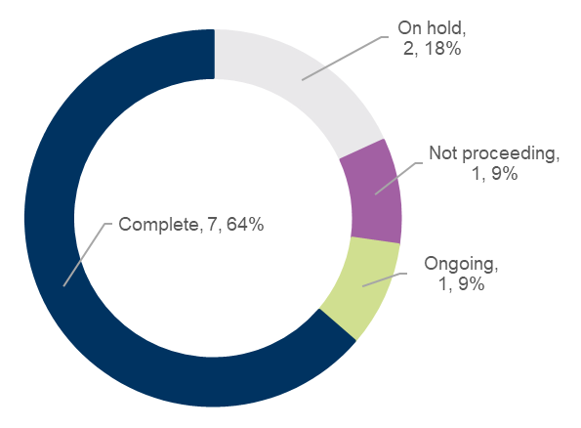
We committed to 11 actions which demonstrate how we are addressing our four-year priorities under Strong Local Economy.
At the end of June 2023:
- seven were ‘complete’
- two were ‘on hold’
- one was ‘not proceeding’
- one was ‘ongoing’.

Major Budget Initiatives
Initiative | Free public Wi-Fi and enhanced broadband
Action 2022−23 | Deliver free public Wi-Fi and enhanced broadband to address gaps in digital access and affordability (Geelong Smarter Suburbs)
Status | Complete
Comment | We completed all scheduled works for 2022−23 as planned. Remaining works are on track and will be scheduled to be completed in 2023–24.​

Other achievements in 2022‒23 included:
- Hosting the UNESCO Creative Cities of Design (COD) Subnetwork meeting with 27 delegates from 17 cities attending from across the globe, and a further 11 cities joining in virtually, in March 2023.
- Continuing to support local businesses through a range of workshops, free advice, initiatives and funding opportunities including our annual Small Business Festival; monthly one-on-one mentoring sessions and our Business Concierge service.
- Presenting Tastes of Central Geelong, showcasing central Geelong cafes, bars and restaurants through dining events, guided food tours, masterclasses and demonstrations.
- Endorsing an investigation into the delivery of a Regional Livestock and Rural Information Exchange Hub and truck wash for the region.
- Providing funding to local businesses for circular economy projects including home and business electrification, using agricultural waste in asphalt and glass as a concrete base, as part of our community grants program.
- Joining forces with The Gordon (Workforce Australia Local Jobs, Skilling the Bay) to host the Apprenticeship and Traineeship Support Forum aimed at maximising apprenticeship and traineeship participation, increasing retention rates, and assisting in meeting labour shortages in the region by providing employment opportunities.
- Hosting smart technology and urban innovation specialists as part of the Australian Smart Communities Association - Smart Community Showcase Tour, an opportunity to share best practice knowledge on the responsible use of emerging technologies and showcasing our initiatives including intelligent precincts and places, smart infrastructure and innovative technologies.
- Linking climate sensors installed in trees at the Geelong Botanic Gardens to automated sprinklers to help cool down grey-headed flying foxes during dangerous summer heat waves.
- Developing a Partnership with Deakin University and Australia’s Academic and Research Network (AARNet) to deliver high-speed internet to community, education, and research facilities on the Bellarine.
- Completing the Dell Eco Reef at Clifton Springs with innovative 3D printed reef module technology, to assist in reducing erosion and future impacts of sea level rise.
- Partnering with Deakin University and Hanwha Defence Australia to showcase our region’s defence industry capability to the world at the AVALON 2023 Australian International Airshow Aerospace & Defence Exposition.
- Providing over 270 street performances and 40 unique pop-up activations across central Geelong and the Waterfront as part of the Central Geelong Street Vibrancy program.
- Providing free multimedia window displays in Little Malop Central and working with local businesses to offer ‘Kick On in Geelong’ discounts aimed at encouraging people to spend more time in central Geelong after visiting the Kaleidoscope art installation in Johnstone Park.
- Engaging people living and working in Geelong, as well as visitors from Melbourne and surrounds, to help us plan a refresh of the Geelong Waterfront.
- Welcoming a record breaking 93,000 people who took to the streets of central Geelong to celebrate music, art, culture and community as part of White Night Geelong 2022.
- Delivering 11 public events as part of the Love Central Geelong marketing program which encourages people to visit central Geelong.
- The National Wool Museum team is partnering with Deakin University’s Strategic Research Centre in Education, Research for Educational Impact (REDI) to evaluate the Department of Education Strategic Partnerships Program funded Hands on History program.
- 25 volunteers provided more than 5,000 hours of service and six student / intern placements joined the National Wool Museum team to work in collections and support learning programs.
- Supporting local makers, creatives, emerging and professional artists and students of art and design by hosting the third May’d Festival in central Geelong.

Awards and recognition
- We were named a Smart21 Community of 2023 by the global network Intelligent Community Forum (ICF). We were the only Victorian city to be named in the list and one of just three Australian cities. Geelong was named as a Top7 Smart Community for the region’s Smart Cities efforts at the conclusion of the global network’s hybrid live-online conference based in Durham Region, Ontario, Canada.
- We were recognised at the World Smart City Expo in Korea, winning the International Smart City of the Year award alongside Barcelona City. The award is recognition of joint efforts between Council, the private sector, the education sector and other levels of government, to create a more liveable, sustainable and thriving greater Geelong.
- Our Tourism team took home Gold (Tourism Education and Training) and Bronze (Tourism Marketing and Campaigns) awards at the 2022 Victorian Tourism Awards.

STRATEGIC DIRECTION 4: HIGH-PERFORMING COUNCIL AND ORGANISATION

162,826 calls made to Customer Service Centres | 500+ workstation assessments completed as part of the move to Wurriki Nyal
87 new learn to swim instructors completed training | 22,704 employee timesheets processed
5 new online learning modules to build capability in recruitment and hosting student placements | 46,420 visitors to customer service centres
444 health appointments for early intervention to prevent workplace injuries | 8,974 number of property information requests
72 projects shared on the Have Your Say website | 37,583 contact us emails handled by Customer Service Centres

DESIRED OUTCOMES
- Our services are accessible and meet the diverse needs of our community
- We are acknowledged and recognised as a leading council and organisation
- We have a healthy, safe, inclusive and diverse culture
- We are a financially sustainable and resilient organisation
Four-year priorities
4.1 Enable a customer-focused approach that delivers efficient and responsive service
4.2 Communicate and engage effectively with our community to understand their needs and advocate on their behalf
4.3 Deliver on our community’s most important needs for infrastructure and services
4.4 Continue to strengthen our workplace culture
4.5 Create a more efficient and effective organisation
4.6 Ensure that our employees are safe at work
4.7 Focus on financial sustainability
Supports health and wellbeing

PROGRESS REPORT
Indicators
City of Greater Geelong Indicators |  | RESULT at 30 June 2023 | Progress comments
Customer complaints resolution completed within 30 days  Source: City of Greater Geelong | 87% (2022‒23)  85% (April‒June 2022) |  | We have improved the online information and online form. The result has been a decline in complaints, as our customers were reporting issues in the incorrect portal, for example missed bin collection. We created dashboards to help manage and resolve complaints in a more efficient manner while having a view of the incoming and outstanding complaints.
Community satisfaction with customer service  Source: Local Government Community Satisfaction Survey | 73 (2023)  72 (2022)  77 (2021) |  | Our performance in satisfaction continued to be well regarded by our community with customer service among our highest rated services. Our performance was significantly higher than both the statewide (67) and Regional Centres average (68).
Community satisfaction with informing the community  Source: Local Government Community Satisfaction Survey | 56 (2023)  58 (2022)  60 (2021) |  | Our result was comparable with both statewide and Regional Centres averages (57 and 55 respectively).
Community satisfaction with consultation and engagement  Source: Local Government Community Satisfaction Survey | 52 (2023)  54 (2022)  57 (2021) |  | Satisfaction was consistent with historical results and comparable with both statewide and Regional Centres averages (52 and 50 respectively).
Community satisfaction with overall council direction  Source: Local Government Community Satisfaction Survey | 49 (2023)  52 (2022)  56 (2021) |  | Satisfaction was comparable to the Regional Centres average (47) but was significantly higher than statewide (46).
Community satisfaction with overall performance  Source: Local Government Community Satisfaction Survey | 58 (2023)  63 (2022)  63 (2021) |  | Our result decreased significantly but was comparable with both statewide and Regional Centres averages (56 respectively).
Community satisfaction with advocacy on behalf of the community  Source: Local Government Community Satisfaction Survey | 50 (2023)  55 (2022)  57 (2021) |  | Our result decreased significantly but was comparable with both statewide and Regional Centres averages (51 and 52 respectively).
Lost Time Injury Frequency Rate (LTIFR) and Total Recordable Injury Frequency Rate (TRIFR)  Source: City of Greater Geelong | 22.3 LTIFR (June 2023)  26.5 LTIFR (June 2022)  21.4 LTIFR (June 2021)  29.4 TRIFR (June 2023)  34.9 TRIFR (June 2022)  24.9 TRIFR (June 2021) |  | Over the financial year, our LTIFR and TRIFR both decreased significantly, with the LTIFR down 16.7% (down 4.5) and the TRIFR down 17% (down 5.8) from the July 2022 result.  During 2022‒23, Body Stressing injuries were the largest overall category impacting these results with 59% of Total Recordable Injuries. ‘Body Stressing ‒ Muscular stress with no objects being handled’ was the biggest single contributor with 21% of TRIs.
Gender breakdown of City employees  Source: City of Greater Geelong | Female  65.69% (June 2023)  64.32% (June 2022)  64.12% (June 2021)  Male  34.13% (June 2023)  35.64% (June 2022)  35.85% (June 2021)  Self-described gender  0.17% (June 2023)  0.04% (June 2022)  0.04% (June 2021) |  | Gender breakdown of our employees remains consistent from 2022.
Number of Aboriginal and Torres Strait Islander people employed at the City  Source: City of Greater Geelong | 20 (June 2023)  19 (June 2022)  14 (June 2021) |  | We recruit, develop and retain First Nations people as an integral part of our commitment to inclusiveness, engagement and to be an employer of choice for Aboriginal and Torres Strait Islander people.
Employee satisfaction and engagement  Source: City of Greater Geelong Better Together Survey | Satisfaction  59% (2022)  63% (2020)  Engagement  53% (2022)  52% (2020) |  | Our employee opinion survey on employee satisfaction and engagement was not conducted in 2023. The next survey will be conducted in 2024.
Recurrent surplus / deficit  Source: City of Greater Geelong | $4.7 million (2022‒23)  $10.63 million (2021‒22) |  | We achieved a recurrent surplus of $4.7 million against a budget surplus of $0.107 million. Favourable result largely due receiving 100% of the federal assistance grant in 2022−23 instead of the budgeted 75% and saving measures implemented during the second half of the financial year generating $6.2 million to net operating results.
Funds from sale of assets  Source: City of Greater Geelong | $31.1 million (2022‒23)  $12.8 million (2021‒22) |  | Two of the City’s assets held for sale, Civic Centre Carpark and Belmont bowling lanes were sold favourable to budget, with further asset sales deferred to 2023−24.
Cost recovery of services and revenue growth from new sources (fees and charges)  Source: City of Greater Geelong | $9.9 million (2022‒23)  $9.4 million (2021‒22) |  | An increase in the rates revenue stream was due to increase of 2,800 rateable properties and supplementary rates during 2022−23.
Efficiency target  Source: City of Greater Geelong | $3.98 million (2022‒23)  $2.965 million (2021‒22) |  | Efficiency embedded into the budget in materials and services were not realised due to current economic conditions.
Asset renewal gap and upgrade ratio  Source: City of Greater Geelong | 61.8% (2022‒23)  68.9% (2021‒22)  51.9% (2020‒21) |  | A strong focus from council to investing in asset renewal has seen the ratio maintained in 2022−23 and will continue to increase in the forthcoming years.

Annual Action Plan 2022‒23
We committed to 14 actions which demonstrate how we are addressing our four-year priorities under High-Performing Council and Organisation.
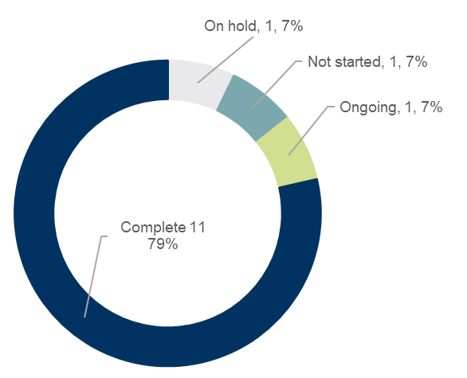
At the end of June 2023:
- 11 were ‘complete’
- one was ‘on hold’
- one was ‘not started’.
- one was ‘ongoing’

Major budget initiatives
Initiative | Cyber security
Action 2022−23 | Protect the City's digital landscape against cyber security threats by establishing a Risk Management Framework and overarching Cyber Policy
Status | Complete
Comment | We established an Information Security Management Systems (ISMS) which uses a systematic approach to managing security-based outcomes against the organisation risk framework and a set of policy and procedures that are documented, implemented, and maintained. ​  Our Cyber Security Strategy continues to be implemented, with greater focus on risk and compliance management, including reporting and decision making through the appropriate governance structures. Appropriate policies and a risk management framework have now been established.​
Other achievements in 2022‒23 included:
- On 18 February 2023 we hosted the Wurriki Nyal Open Day of our new Civic Precinct for our community members to explore and learn about the cultural and sustainability features.
- Implementing a new engagement process aimed at giving our community a greater voice on the future of the Pakington North Precinct.
- Petitioning Prime Minister Anthony Albanese and senior government leaders at the Australian Local Government Association’s National General Assembly in Canberra, about important local issues and the ways the federal government could invest in our region including infrastructure, road maintenance, rail upgrades and flood mitigation, and the financial challenges being faced by local governments.
- Welcoming the 2023 Youth Council and farewelled our 2022 Youth Council. Our Youth Council provided 13 pieces of advice across 2022−23 to Council on matters of importance for young people.
- Holding our internal Business Planning Week in June 2023, providing leaders with the support, tools and information needed to develop a focused and efficient business plan.
- Selling Civic Car Park in Gheringhap Street to fund the delivery of new and upgraded assets across our municipality.
- Adopting the Public Transparency Policy in September 2022, outlining the way in which Council information is made publicly available and gives effect to the public transparency principles prescribed in the Local Government Act 2020.
- Adopting the Governance Rules and Public Question and Submission Time Policy in August 2022.
- Establishing a Community Advisory Panel to help identify several design options for the second stage of the North Bellarine Aquatic Centre in Drysdale.
- Visiting neighbourhoods to discuss topics that matter to our community, provide information on Council projects, and hear community ideas as part of our Neighbourhood Conversations program.
- Publishing our second annual Community Engagement Impact Report from April 2022 to March 2023, outlining the impacts and achievements delivered as part of our Community Engagement Policy.
- Successfully incorporating nine city buildings into Wurriki Nyal as part of the Big Tidy Project. A total of 9,006 kilograms of office stationery and supplies were donated to schools, community groups and charities.
- Receiving a grant from Department of Transport and Planning for our Planning at its Best − Digital Project to increase the ability for customers to lodge planning permit applications online.
- Continuing to encourage individuals to undertake a Building Surveying career. A number of employees have upskilled to obtain registration with the Victorian Building Authority. This has improved the overall skillset of the team.
- Registering over 7,000 swimming pools and/or spas. Registration enables Council to commence a program of reminders to pool / spa owners to ensure that they undertake the legislated compliance checks on their swimming pool and / or spa barriers.
- Hosting two interns through Australian Network on Disability Stepping into Summer Internship Program.
- Adopting the National Wool Museum 30-year vision.
- Receiving over 800 submissions as part of the #YourMuseumGeelong community and stakeholder engagement.
- Adopting the Art & Heritage Collections Policy.
Awards and recognition
- We were recognized as a finalist in the 2023 Australian Financial Review BOSS Most Innovative Companies (Government, Not for Profit and Academic Category).

Local Government Performance Reporting Indicators
To help measure performance across all Victorian councils in a transparent and accountable way, we report to Local Government Victoria on the following mandatory indicators:
SERVICE/INDICATOR/MEASURE | RESULTS |  |  |  |  | COMMENTS
SERVICE/INDICATOR/MEASURE | 2020 | 2021 | 2022 |  | 2023
Governance
Transparency  G1 Council decisions made at meetings closed to the public  [Number of council resolutions made at ordinary or special meetings of council, or at meetings of a special committee consisting only of councillors, closed to the public / Number of council resolutions made at ordinary or special meetings of council, or at meetings of a special committee consisting only of councillors] x100 | 9.03% | 8.03% |  | 6.55% | 14.41% | The increase in meetings closed to the public can be attributed to the recruitment of the Chief Executive Officer.
Consultation and engagement  G2 Satisfaction with community consultation and engagement  [Community satisfaction rating out of 100 with how council has performed on community consultation and engagement] | 53 | 57 |  | 54 | 52 | Scores for the City's community consultation and engagement performance remained steady (no significant change) while scores for statewide and Regional Centres averages decreased significantly.
Attendance  G3 Councillor attendance at council meetings  [The sum of the number of councillors who attended each ordinary and special council meeting / (Number of ordinary and special council meetings) × (Number of councillors elected at the last council general election)] x100 | 93.45% | 96.97% |  | 98.70% | 90.40% | A number of meetings not fixed by Council occurred during the year which impacted Councillor's ability to attend meetings at short notice. Two extraordinary vacancies occurred which directly effected the calculation of this measure.
Service cost  G4 Cost of governance  [Direct cost of the governance service / Number of councillors elected at the last council general election] | $44,582.64 | $45,711.91 |  | $47,697.36 | $60,073.35 | The increase in the cost of delivering council’s governance service this financial year is mainly attributable to the CEO recruitment process, as well as a marginal increase in Councillor allowances, per the new determination issued from the Victorian Independent Renumeration Tribunal.
Satisfaction  G5 Satisfaction with council decisions  [Community satisfaction rating out of 100 with how council has performed in making decisions in the interest of the community] | 56 | 59 |  | 56 | 52 | While Geelong’s performance score for decisions in the interest of the community decreased, it remains comparable with the statewide and Regional Centres results which also declined.
Statutory Planning
Timeliness  SP1 Time taken to decide planning applications  [The median number of days between receipt of a planning application and a decision on the application] | 83.00 | 78.00 |  | 80.00 | 91.00 | The complexity in planning applications and the recurring employee shortages has resulted in an increase in the median processing days.
Service standard  SP2 Planning applications decided within required time frames  [Number of planning application decisions made within 60 days for regular permits and 10 days for VicSmart permits / Number of planning application decisions made] x100 | 69.39% | 80.90% |  | 78.70% | 75.05% | The percentage of applications determined within the timeframe is consistent with previous years.
Service cost  SP3 Cost of statutory planning service  [Direct cost of the statutory planning service / Number of planning applications received] | $2,453.48 | $2,304.98 |  | $2,260.19 | $3,250.96 | The cost of service fee increase relates to a decrease reduction of the number of applications and an increase in legal and consultant spend due to lengthy VCAT hearings in the last financial year.
Decision making  SP4 Council planning decisions upheld at VCAT  [Number of VCAT decisions that did not set aside council's decision in relation to a planning application / Number of VCAT decisions in relation to planning applications] x100 | 54.17% | 71.79% |  | 72.41% | 64.00% | The majority of Council planning decisions (16 out of 25) continue to be upheld at VCAT. While the figure is slightly down from the previous two years, the result will continue to be variable due to the number and types of applications considered by VCAT.

GOVERNANCE

COUNCIL INFORMATION
The role of council
The Local Government Act 2020 (the Act) requires all councils to provide good governance in its municipal district for the benefit and wellbeing of the community.
Good governance includes giving effect to the overarching governance principles:
- Council decisions are to be made and actions taken in accordance with the relevant law
- priority is to be given to achieving the best outcomes for the municipal community, including future generations
- the economic, social and environmental sustainability of the municipal district, including mitigation and planning for climate change risks, is to be promoted
- the municipal community is to be engaged in strategic planning and strategic decision-making
- innovation and continuous improvement is to be pursued
- collaboration with other councils and governments and statutory bodies is to be sought
- the ongoing financial viability of the Council is to be ensured
- regional, state and national plans and policies are to be considered in strategic planning and decision-making
- the transparency of Council decisions, actions and information is to be ensured.
In giving effect to the overarching governance principles, a Council must consider the following supporting principles:
- the community engagement principles
- the public transparency principles
- the strategic planning principles
- the financial management principles
- the service performance principles.

Council Meetings
The Governance Rules describe the way Council will conduct meetings and make decisions.
TABLE 5: Council meetings in 2022–23
Meeting type | Number held | Held at
Council Meetings | 12 | 8 meetings conducted at City Hall  4 meetings conducted offsite
Meetings not fixed by Council | 6 | Meetings were held to consider Confidential matters and the Annual Report

TABLE 6: Councillor attendance for 2022–23
Councillor | Leave of  Absence * | Apology | Council Meeting Attendance
Cr Anthony Aitken (Deputy Mayor from 8 November 2022) | - | 1 | 17
Cr Stephanie Asher | 1 | 3 | 15
Cr Kylie Grzybek (resigned 29 May 2023) | 2 | 1 | 15
Cr Bruce Harwood | 1 | - | 18
Cr Eddy Kontelj | 1 | 5 | 13
Cr Sarah Mansfield (resigned 14 December 2022) | 3 | 1 | 9
Cr Jim Mason | - | - | 18
Cr Belinda Moloney | 1 | 2 | 16
Cr Peter Murrihy | 1 | - | 18
Cr Ron Nelson | - | 4 | 14
Cr Trent Sullivan (Mayor from 8 November 2022) | - | - | 18
Cr Melissa Cadwell (Oath of Affirmation 23 January 2023) | - | - | 8

*In line with the Local Government Better Practice Guide, Annual Report Performance Reporting Indicator Guide 2021‒2022 & 2022‒2023, a councillor is counted as having attended a council meeting where a councillor is on an approved leave of absence.
Cr Sarah Hathway was elected as a councillor for the Windermere Ward following the last council meeting for 2022–23 held on 27 June 2023.

Delegated Committees
TABLE 7: s 63 Delegated Committees in 2022–23
Committee |  | Purpose and Appointment
Geelong Major Events Delegated Committee |  | Appointed under section 63 of the Act  To coordinate how we attract, assist and fund events.
Bellarine Arts Centre (Potato Shed) Community Asset Committee |  | Appointed under section 65 of the Act  To support the long-term management and promotion of the Potato Shed - Bellarine Arts Centre.
Planning Committee |  | Appointed under section 63 of the Act  To consider and determine planning permit applications that have been called in by a councillor.

Code of conduct
In accordance with the Local Government Act 2020, all councils are required to develop and approve a Councillor Code of Conduct. The Local Government (Governance and Integrity) Regulations 2020 prescribe the five standards of conduct that must be observed by every Councillor:
- treatment of others
- performing the role of a Councillor
- compliance with good governance measures
- councillor must not discredit or mislead Council or public
- standards do not limit robust political debate.
Councillor allowances
All councillors are entitled to an allowance while performing their duty.
Under section 39 of the Act, allowances are set by a Determination of the Victorian Independent Remuneration Tribunal. On 7 March 2022, in accordance with section 23A of the Victorian Independent Remuneration Tribunal and Improving Parliamentary Standards Act 2019 (Vic) (VIRTIPS Act), the Tribunal made the Allowance payable to Mayors, Deputy Mayors and Councillors (Victoria) Determination No. 01/2022.
The Determination applies to all Mayors, Deputy Mayors and Councillors (Council members) in all Victorian Councils. The Tribunal determined the City of Greater Geelong as a Category 3 Council.
The Determination took effect from 18 December 2021.
TABLE 8: Current annual allowance from 1 July 2022 – 30 June 2023
 | Allowance ($)
 | 1 JULY 2022 – 17 December 2022 | 18 December 2022 – 30 JUne 2023
Councillor | 35,793 | 37,010
Deputy Mayor | 59,658 | 61,315
Mayor | 119,316 | 122,630

Councillor expenses
Councillors must be reimbursed for expenses incurred while performing their duties. Council has adopted a policy to determine what will be reimbursed, as well as other resources, facilities and support needed to help the mayor and councillors discharge their duties.
TABLE 9: Details of reimbursements and expenses paid in 2022–23
COUNCILLOR EXPENDITURE
JULY 2022 – JUNE 2023
NAME | TRAVEL $ | PROFESSIONAL DEVELOPMENT $ | EXPENSES TO SUPPORT THE PERFORMANCE OF THE ROLE  $ | ALLOWANCES  $ | GRAND TOTAL $
Cr Anthony Aitken | - | - | 1,074 | 50,747 | 51,821
Cr Stephanie Asher | 1,611 | - | 859 | 35,052 | 37,522
Cr Kylie Grzybek | - | - | 1,295 | 31,641 | 32,936
Cr Bruce Harwood | 279 | - | 751 | 34,954 | 35,984
Cr Eddy Kontelj | - | - | 1,484 | 34,954 | 36,438
Cr Sarah Mansfield | - | - | 346 | 11,016 | 11,361
Cr Jim Mason | 5,228 | - | 1,156 | 34,954 | 41,338
Cr Peter Murrihy | 6,469 | - | 1,635 | 64,242 | 72,346
Cr Ron Nelson | 1,143 | - | 1,364 | 34,954 | 37,461
Cr Trent Sullivan | 24,619 | 1,249 | 1,560 | 95,883 | 123,311
Cr Belinda Moloney | - | - | 811 | 34,954 | 35,765
Cr Melissa Cadwell | - | 1,400 | 2,660 | 16,560 | 20,620
Total Councillor Expenses | 39,349 | 2,649 | 14,995 | 479,911 | 536,904

Public Transparency Policy
This policy describes the ways in which Council information is to be made publicly available and give effect to the public transparency principles prescribed in section 58 of the Act.
What information will be publicly available?
Under the Act (and, in some cases the Local Government Act 1989), certain information must be made publicly available, namely:
- Register of Delegations made by Council
- Council and Delegated Committees meeting minutes
- Local Laws and any documents incorporated
- Council Plan
- Strategic Resource Plan
- Budget
- Annual Report
- Councillor Code of Conduct
- Procurement Policy
- Register of interests
- Reappointment of Chief Executive Officer (CEO) without advertisement
- Differential Rates
- Summary of Campaign Donation Returns.
The following information will also be made publicly available to ensure our community is informed, and can benefit from, access to information regarding Council’s functions and operations:
- All adopted Council policies, plans and strategies
- Governance Rules
- Composition, Terms of Reference, Agendas and Minutes of Council Meetings, Committees and Groups
- Code of Conduct for Council employees
- Register of Delegations made by the CEO
- Register of Authorised Officers
- Register of Interstate and Overseas Travel by Councillors and employees
- Register of Land Leases entered into by Council
- Register of Donations and Grants made by Council
- Register of Contracts Awarded by Council
- Details of any Council Land proposed for Sale or Exchange.

Under various other Acts administered by Council, the following information will be made publicly available:
- Register of Planning Permits
- Register of Planning Applications on Advertising
- Copy of Planning Permits and Endorsed Plans (by application, charges will apply)
- Register of Building Permits, Occupancy Permits and Temporary Approvals
- Copies of Building Permits, plans and documentation (by application, charges will apply)
- Register of Animal Registrations
- Register of Public Roads
- FOI Part II Statement.
How can information be accessed?
The Freedom of Information Act 1982 (FOI Act) gives you the right to apply for access to documents held by the City. We are committed to, where possible, proactive and informal release of information in accordance with the Freedom of Information Professional Standards issued by the Victorian Information Commissioner.
A list of available information is provided in the Part II Statement (Statement) published on our website in accordance the FOI Act. This Statement requires government agencies and local councils to publish a number of statements designed to assist members of the public in accessing the information it holds.
Information privacy
We are committed to protecting people's right to privacy and the responsible and fair handling of personal information, consistent with the Privacy and Data Protection Act (Vic) 2014 and Health Records Act (Vic) 2001.
Our policies set out our requirements for the managing and handling of personal information. The policies are public documents which are available on request, or via our website.
Freedom of Information
In accordance with section 7(4AA)(a) and 7(4AA)(b) of the FOI Act, we are required to publish certain statements in the annual report or separately, such as on our website, concerning our functions and information available. We have chosen to publish the statements separately; however, the following summarises the application and operation of the FOI Act.
Access to documents may be obtained through written request to the Freedom of Information Officer, as detailed in section 17 of the FOI Act and in summary as follows:
- it should be in writing
- it should identify the document being requested as clearly as possible
- it should be accompanied by the appropriate application fee (the fee may be waived in certain circumstances).
Requests for documents in our possession should be addressed to the Freedom of Information Officer. Requests can also be lodged online, or by email.
Access charges may also apply once documents have been processed and a decision on access has been made, for example, photocopying, and search and retrieval charges.
Further information regarding freedom of information can be found at www.ovic.vic.gov.au/freedom-of-information/and on our website.

Public interest disclosure procedures
In accordance with section 69 of the Public Interest Disclosures Act 2012 (the Act), our website at www.geelongaustralia.com.au provides information about making a public interest disclosure.
The Act aims to ensure openness and accountability in government by encouraging people to disclose improper conduct within the public sector and provide protection for people who make disclosures.
There were two disclosures notified to the Independent Broad-based Anti-Corruption Commission under section 21(2) during 2022–23.
Contracts
During 2022–23, the following contracts entered into by Council were valued above the contract value at which the Council must invite a tender or seek an expression of interest under its Procurement Policy;
TABLE 10: List of contracts entered into by Council valued above the contract value at which the Council must invite a tender or seek an expression of interest under its Procurement Policy
Contract No: | Contract Title | Contract No: | Contract Title
C2200004 | Barwon Heads Bowling Club Pavilion - Design and Construct | C2300014 | Rabbit Control
C2200005 | Norlane Bowling Club Synthetic Green Construction | C2300016 | Annual Supply of Bituminous Spray Sealing Works
C2200015 | Supply & Delivery of Pool Chemicals | C2300020 | Provision of Urban Design Advice on Planning Applications
C2200047 | Provision of Pest and Wildlife Control Services | C2300021 | Additional Contractors for Collection & Recycling of Mattresses
C2200049 | Armstrong Creek Town Centre Library - Construction | C2300025 | Birnam Court - Belmont – Special Rate Charge Upgrade
C2200055 | Leisure & Recreation Services system upgrade | C2300026 | Limeburners Point Boating Facility Upgrade Stage 1 – Construction of a Non-Powered Craft Access Ramp and Car Park
C2200058 | Municipal Waste & Green Organics Haulage Services | C2300029 | Surfcoast Highway and Boundary Road Intersection East Leg - Design Services
C2200059 | Website Redevelopment | C2300030 | Avalon Boat Ramp Upgrade
C2200060 | Ocean Grove Pontoon Construction | C2300033 | Peacock Avenue Footbridge - Design and Construct Tender
C2200062 | Cleaning Services for Family and Child Services Centres | C2300034 | 2022/2023 City of Greater Geelong Drainage Relining and Replacement Program
C2200065 | Consultant Services Heritage | C2300035 | Drainage Condition Data Capture
C2200073 | Supply & Delivery of Road Signs | C2300038 | 2022 Dust Suppression Program
C2200074 | Barwon South West Waste and Resource Recovery  Group: Collection and Recycling of E-waste from Council Facilities | C2300040 | 2022−23 Playground Redevelopment Program
C2200075 | Development of the Market Square Masterplan | C2300041 | Cleaning Services for Major Buildings
C2200076 | Security Guard Services for Wurriki Nyal | C2300042 | King Lloyd Reserve Pavilion Extension - Construction
C2200077 | City of Greater Geelong - Early Years Planning Review | C2300043 | Provision of Professional Services: Engineering Advice
C2200078 | Anakie Reserve Social Room Upgrade | C2300044 | Bus Shelter Program - Design and Construct
C2200080 | Linemarking Services | C2300054 | Design & Construct - Lara Recreation Reserve AFL & Baseball Pavilion
C2200082 | EPMO - DM Review | C2300056 | Bay Trail Revitalisation
Contract No: | Contract Title | Contract No: | Contract Title
C2200084 | Christmas Decorations: Install, Dismantle and Storage | C2300058 | Bellarine Arts Centre - Potato Shed Business Case
C2200085 | Floating Christmas Tree - Tree Lighting and Music Services | C2300060 | Work Cover and Injury Management - Consultancy Services
C2200087 | Request for Recruitment Services | C2300062 | Portarlington Football & Netball Club Pavilion Upgrade - Design Services
C2200088 | Little Malop Street automated bollard project - Construction Services | C2300065 | Apex Ave/Allitt Ave Belmont Emergency Stormwater Works
C2200089 | Clifton Springs Boat Harbour Dredging Plan | C2300066 | Lara Recreation Reserve - Precinct services package
C2200090 | Hire of Windrow Turning and Screening for Green Organics Processing | C2300072 | Provision of Painting Services
C2200092 | Farrars Road, Lara - Pavement Stabilisation Works | C2300075 | Annual Gutter Cleaning of Facilities - Readvertised
C2200093 | Destination Charging Across Victoria Electric Vehicle Charger Station Procurement | C2300080 | Supply & Delivery of Agricultural Chemicals
C2200096 | Sports Lighting Audit | C2300081 | NWGGA Bridge Design and Apportionment
C2300002 | Aquatic Centre Boiler Repairs, Maintenance & Servicing | C2300083 | Saunders St Sediment Basin & Wetlands Renewal, North Geelong
C2300004 | 2023 Calendar - Printing and Packaging | C2300084 | Melaluka Rd Leopold Open Drain Rehabilitation
C2300005 | WSUD Routine Maintenance | C2300085 | Collendina Drain Renewal & Retaining Wall, Ocean Grove
C2300007 | Bell Park Sports Club Changerooms Redevelopment | C2300088 | Elcho Reserve Toilet/Shower Replacement
C2300008 | Hardsurface Program Leopold Tennis Court Repairs/Resurfacing | C2300089 | Provision of Traffic Management and Spotter Services
C2300009 | Lara Golf Club Water Supply Feasibility Study | C2300096 | Supply and Install Cardboard Compactor at Geelong Resource Recovery Centre
C2300010 | Community Update - Printing Services | C2300097 | St Leonards Skate Park - Construction Works
C2300011 | City of Greater Geelong Guardrail Program - FY 2022/23 | C2300102 | St Stephens Tennis/Croquet Club Disability Access
C2300012 | Drysdale Townsquare and Park Upgrade | C2300103 | Avalon Corridor Integrated Water Management (IWM) Strategy

In addition, the following contracts are those that met the criteria for competitive processes but were signed off as exempt (sole source):
TABLE 11: Contracts that met the criteria for competitive processes but were signed off as exempt (sole source)
Contract No: | Description
C2300003 | Daily media monitoring and monthly media analysis
C2100222 | Creamery Road Precinct Structure Plan - Transport Concept Designs

Food Act Ministerial directions
In accordance with section 7E of the Food Act (Vic) 1984, we are required to publish a summary of any Ministerial Directions received during the financial year in our annual report, however we did not receive any in 2021–22.
Road Management Act Ministerial direction
In accordance with section 22 of the Road Management Act (Vic) 2004, a council must publish a copy or summary of any Ministerial direction in its annual report. No such ministerial directions were received during the financial year.
Charter of Human Rights and Responsibilities
In June 2006, the Victorian Parliament passed the Charter of Human Rights and Responsibilities Act (Vic) 2006 (the Charter). The Charter came into effect on 1 January 2008.
The Charter enshrines civil and political rights, and some cultural rights, into Victorian law, while promoting and protecting principles of freedom, respect, equality and dignity.
We consider the 20 human rights established by the Charter when delivering our services, developing our policies, or implementing our plans.
Local Laws
The following local laws remain current.
Neighbourhood Amenity Local Law 2014
This local law regulates activities of people and provides standards and conditions for specified activities to protect people in, or the environment of, the municipal district. The local law aims to achieve the following objectives that align with our overall objectives and strategies:
- to secure community safety
- to protect public assets
- to enhance neighbourhood amenity.
Council Meeting Procedures Local Law 2017
This local law regulates the use of the Common Seal and offence provisions relating to the conduct of Council and Delegated Committee meetings.

AUDIT AND RISK COMMITTEE
Our Audit and Risk Committee provides structured, systematic oversight of Council’s governance, assurance, risk management and internal control practices.
This oversight mechanism also helps maintain the integrity of these practices.
The Committee:
- is comprised of five members, three independent members, the Mayor and one Councillor
- holds at least four regular meetings per annum, plus one to consider the draft annual financial accounts
- reports its minutes to Council.
TABLE 12: Audit and Risk Committee attendance 2022–23
Audit and Risk Committee Member Attendance | Number of meetings attended
Ms Lisa Tripodi (independent member – chair) | 5
Mr Geoff Harry (independent member – until October 2022) | 2
Mr John Watson (independent member) | 5
Mr Mick Jaensch (independent member – since December 2022) | 3
Cr Peter Murrihy (Mayor – until November 2022) | 2
Cr Kylie Grzybek (Councillor member until February 2023) | 0
Cr Trent Sullivan (Mayor – since November 2022) | 3
Cr Ron Nelson (Councillor member – since February 2023) | 1
Audit
Audit is an independent function that assesses the effectiveness of internal controls and governance processes. Internal audit is focused on processes and controls and the internal audit services are outsourced to a third-party. External audit provides an independent examination of the financial and performance statements prepared by the organisation. The Victorian Auditor-General’s Office provides our external audit service.
Risk Management
Risk management is an internal function that helps us meet the expectations of our many stakeholders and provide quality services to our community. It allows decision-makers to be better informed, decisive, and confident in achieving our specified outcomes and objectives.
The objectives of our risk management program are to:
- provide a structured and consistent approach to identifying, rating, mitigating, managing, and monitoring risks
- assist decision-makers to weigh risks against potential opportunities
- create an environment where employees understand and assume responsibility for managing risks and controls
- provide relevant and timely information using a clear reporting structure.

GOVERNANCE AND MANAGEMENT CHECKLIST
The following are the results in the prescribed form of council’s assessment against the prescribed governance and management checklist, as at 30 June 2022.
GOVERNANCE AND MANAGEMENT ITEMS |  |  | ASSESSMENT
GC1 | Community engagement policy  (policy under section 55 of the Act outlining Council's commitment to engaging with the community on matters of public interest) |  | Adopted in accordance with section 55 of the Act  Date of adoption: 23 February 2021
GC2 | Community engagement guidelines (guidelines to assist employees to determine when and how to engage with the community) |  | Guidelines  Date of commencement of current guidelines: 18 May 2021  Quarterly reviews conducted in 2022.
GC3 | Financial Plan  (plan under section 91 of the Act outlining the financial and non-financial resources required for at least the next 10 financial years) |  | Adopted in accordance with section 91 of the Act  Date of adoption: 26 October 2021
GC4 | Asset Plan  (plan under section 92 of the Act setting out the asset maintenance and renewal needs for key infrastructure asset classes for at least the next 10 years) |  | Adopted in accordance with section 92 of the Act  Date of adoption: 28 June 2022
GC5 | Revenue and Rating Plan  (plan under section 93 of the Act setting out the rating structure of Council to levy rates and charges) |  | Adopted in accordance with section 93 of the Act  Date of adoption: 27 June 2023
GC6 | Annual budget  (plan under section 94 of the Act setting out the services to be provided and initiatives to be undertaken during the budget year and the funding and other resources required) |  | Adopted in accordance with section 94 of the Act  Date of adoption: 27 June 2023
GC7 | Risk policy  (policy outlining council's commitment and approach to minimising the risks to council operations) |  | Policy  Date of commencement of current policy: 20 November 2019
GC8 | Fraud policy  (policy outlining Council's commitment and approach to minimising the risk of fraud) |  | Policy  Date of commencement of current policy: 17 February 2021  We will review the policy in 2023‒24 as part of our overall risk management framework.
GC9 | Municipal emergency management plan  (plan under section 60ADB of the Emergency Management Act 2013 for emergency mitigation, response and recovery) |  | Plan  Endorsed by the Regional Emergency Management Planning Committee in April 2023.  The Greater Geelong Municipal Emergency Management Plan (MEMP) was reviewed and updated by the Municipal Emergency Management Planning Committee in 2022 to align with the new integrated arrangements for emergency management planning in Victoria, outlined in the Emergency Management Legislation Amendment Act 2018.
GC10 | Procurement policy  (policy under section 108 of the Act outlining the principles, processes and procedures that will apply to the purchase of goods and services by the Council) |  | Adopted in accordance with section 108 of the Act  Date of adoption: 1 January 2022
GC11 | Business continuity plan  (plan setting out the actions that will be undertaken to ensure that key services continue to operate in the event of a disaster) |  | Plans  Date of commencement of current plan: 16 May 2011  Business impact assessment updated in 2022–23 to identify critical activities and resources dependencies and aligned with the revised organisation structure.
GC12 | Disaster recovery plan  (plan setting out the actions that will be undertaken to recover and restore business capability in the event of a disaster) |  | Plan  Date of commencement of current plan: 1 July 2020  We have an IT disaster recovery management procedure which is due for review by 1 July 2024.
GC13 | Risk management framework  (framework outlining council's approach to managing risks to the council operations) |  | Framework  Date of commencement of current framework: 21 October 2021
GC14 | Audit and Risk Committee  (see sections 53 and 54 of the Act) |  | Established in accordance with section 53 of the Act  Date of establishment: 1 September 2020
GC15 | Internal audit  (independent accounting professionals engaged by the Council to provide analyses and recommendations aimed at improving Council's governance, risk and management controls) |  | Engaged  Date of engagement of current provider: 4 November 2021
GC16 | Performance reporting framework  (a set of indicators measuring financial and non-financial performance, including the performance indicators referred to in section 98 of the Act) |  | Framework  Date of adoption of current framework: 20 May 2020  We reviewed and updated the framework in 2022‒23 in line with the Local Government Act 2020 and Local Government (Planning and Reporting) Regulations 2020.
GC17 | Council Plan report  (report reviewing the performance of the council against the Council Plan, including the results in relation to the strategic indicators, for the first six months of the financial year) |  | Report  Date of report: 13 December 2022, 28 March 2023, 27 June 2023  We provide quarterly reports on the progress of our council plan including a six-monthly update on the progress of the strategic indicators as per section 98 of Local Government Act 2020.
GC18 | Financial reporting  (quarterly statements to the Council under section 97(1) of the Local Government Act 2020, comparing actual and budgeted results and an explanation of any material variations) |  | Reports presented to Council in accordance with section 97(1) of the Act  Dates reports presented: 22 November 2022, 28 February 2023 and 23 May 2023
GC19 | Risk reports  (six-monthly reports of strategic risks to council’s operations, their likelihood and consequences of occurring and risk minimisation strategies) |  | Reports  Dates of reports: 24 August 2022, 7 December 2022, 7 March 2023 and 7 June 2023  We report to the Executive Leadership Team and Audit and Risk Committee quarterly on the strategic risks profile, including risk rating and minimisation strategies.
GC20 | Performance reporting  (six-monthly reports of indicators measuring financial and non-financial performance, including the performance indicators referred to in section 98 of the Act) |  | Report  Dates of reports: 25 October 2022 and 28 February 2023  We report every six months on financial performance indicators and annually against non-financial performance indicators referred to in section 98 of Local Government Act 2020.
GC21 | Annual report  (annual report under sections 98 and 99 of the Act containing a report of operations and audited financial and performance statements) |  | Presented at a meeting of the Council in accordance with section 100 of the Act  Date of presentation: 25 October 2022
GC22 | Councillor Code of Conduct  (Code under section 139 of the Act setting out the standards of conduct to be followed by Councillors and other matters) |  | Reviewed and adopted in accordance with section 139 of the Act  Date reviewed and adopted: 23 February 2021
GC23 | Delegations  (documents setting out the powers, duties and functions of Council and the Chief Executive Officer that have been delegated to employees, in accordance with sections 11 and 47 of the Act) |  | Reviewed in accordance with section 11(7) of the Act and a register kept in accordance with sections 11(8) and 47(7) of the Act  Date of review under section 11(7): reviewed 28 March 2023  Date of review under section 47(7) CEO to Employees: 28 October 2022
GC24 | Meeting procedures  (Governance Rules under section 60 of the Act governing the conduct of meetings of Council and delegated committees) |  | Governance Rules adopted in accordance with section 60 of the Act  Date Governance Rules adopted: 23 August 2022

CERTIFICATION OF THE GOVERNANCE AND MANAGEMENT CHECKLIST
We certify that this information presents fairly the status of council’s governance and management arrangements.
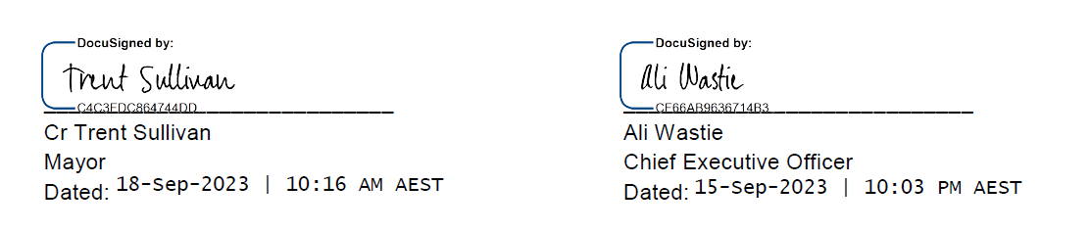

DOMESTIC ANIMAL MANAGEMENT PLAN UPDATE
We have a legal obligation under the Domestic Animals Act (Vic) 1994 to prepare a four-year plan outlining how we will manage dogs and cats within our municipal boundaries and evaluate the progress of our plan in our annual report.
We have one of the largest dog and cat populations of any Victorian municipality, with 34,017 registered dogs and 10,062 registered cats. The Domestic Animal Management Plan (DAMP) identifies how Council will:
- help pets, pet owners and the general community to live together
- protect the environment and local wildlife from the negative impacts of dogs and cats
- balance the needs of those who own pets with those who do not
- address animal management welfare and legal issues
- promote responsible pet ownership
- improve the experience of animal ownership.
The plan not only outlines our role in animal management, but is also intended to have an educational focus, encouraging and teaching community members that it is every owner’s responsibility to take care of their pets.
Council adopted the Domestic Animal Management Plan 2022–25 on 23 November 2021. Activities we have undertaken in the last 12 months in support of the plan include:
- Two stages of community engagement to inform a review of our Dog Controls in Public Places Policy; stage one to gather community sentiment on current orders and conditions, and stage two to exhibit draft orders for community feedback.
- Community engagement on Cat Curfew Review, based on feedback heard through our DAMP 2022–2025 consultations.
- Completed the July 2022 cat desexing program.
- Committed to the development of a new dog park at Aldershot Reserve in St Albans Park, while continuing to scope an appropriate site on the Bellarine Peninsula (development paused due do budget re-prioritisation in 2023–24). Funding election commitment received from the state government for the development of a dog park in Armstrong Creek; site and scope of park to be confirmed.
- Attended career sessions with local schools to promote tertiary education pathways into animal management.
- Completed an audit of all printed and online educational materials regarding pet ownership in our region and commenced a redesign of all marketing collateral to ensure up to date, best practice information is readily available through all customer service centres and via our website.
- Undertook a review of and endorsed our new Emergency Animal Welfare Management Plan.
- Participated in skill development activities to ensure capacity and capability of our Animal Management team members to support residents and their pets during and following emergencies. Team members joined the Building Resources and Capacity for Emergencies (BRACE) Team to undertake training including Introduction to Emergency Management, Working in an Emergency Relief Centre, and Introduction to Psychological First Aid (Personal Support).
- Update to a digital platform for the impounding of animals at Geelong Animal Welfare Society (GAWS).
- Created an interactive dog walking map on our website to allow for the most up-to-date and informative relay of dog accessibility information to our community. These replace outdated, single-location dog order maps.
- Discontinued the Park Your Pet App.
- Reviewed our safety equipment for animal management employees and fleet.
- Purchased and installed safety lighting and variable scrolling messaging signs for our animal management fleet.
- Branded our animal management fleet, aligning messaging on the rear of all vehicles to reflect key ‘on leash’ messaging.
- Secured a Kubota off-road vehicle, complete with Animal Management branding, to allow more visible and time-efficient patrolling of trails and beach areas.
- Created a Patrol Survey for our employees to complete upon conclusion of each patrol. This allows for the collection of data regarding patrol lengths, frequency, locations, issuing of penalties types of offences identified to improve our reporting capabilities.
- Scoped works for facility upgrades at GAWS.
- Reviewed use of noise monitoring devices in barking dog investigations, leading to an increased number of devices utilised.
- Created an online barking dog reporting process.
- Recruited two additional animal management officers.
- Supported the second year of trial dog orders on Barwon Coast Committee of Management (BCCM) land and finalised ongoing orders in partnership with BCCM.
- Used a Cat Mascot costume at community events, to garner greater public engagement and interest, whilst also equalling representation of the domestic animal breeds we serve.
- Commenced the development of Dogs Must Be On Leash Throughout Greater Geelong, Unless Otherwise Signed marketing campaign to re-educate the community of dog control expectations. Messaging will be shared through multiple media channels.
- Attended animal related and City run community events to promote responsible pet ownership.
- Participation of our Senior Animal Management employees in POCTA (Prevention of Cruelty to Animals) training to broaden knowledge and understand welfare legislation.
- Participation of Animal Management employees in early career expos facilitated by the City to promote employment pathways.
- Continued development of relationships with community-based organisations for the welfare of animals in crisis situations.
- Ensured the continued delivery of pound services through partnership with GAWS.

ACCESS AND INCLUSION PLAN UPDATE
We have a legal obligation under the Disability Act (Vic) 2006 to produce a disability action plan and evaluate its progress in the annual report.
Our Access and Inclusion Action Plan 2018–22 was endorsed by Council in November 2018. The action plan is based on four key areas and contains 37 goals, with 49 measures.
TABLE 13: Key projects undertaken in 2022–23
KEY AREA | NUMBER OF PROJECTS UNDERTAKEN | EXAMPLES OF 2022–23 ACTIONS
PARTICIPATION  Promoting inclusion and participation in the community of persons with a disability. | 29 | Provided the Marveloo, a mobile accessible changing places facility, for use at the Geelong Show in October 2022 and the Ability Fest in March 2023.  Facilitated six meetings of our Access and Inclusion Advisory Committee with a quorum in attendance. Members have a lived experience of disability and advise us on our strategies and policies, activities, projects and facility upgrades.  Engaged Access and Inclusion Advisory Committee members in 11 consultations including the Social Procurement Framework development, Building Better Bicycle Connections project and the redevelopment of the W.J.P Wood Pavilion at Landy Field.  Promoted a further 12 consultation opportunities to the Access and Inclusion Advisory Committee members.  Provided an online peer support group for parents and carers of children with confirmed, or suspected, autism spectrum disorder.  Promoted and delivered the Sport4All Program, designed to help sporting clubs and schools become more accessible and inclusive to people with disability.  Engaged people living with disability were on the community advisory panel for the Northern Bellarine Aquatic Centre Stage 2.
ACCESS  Reducing barriers in accessing goods, services and facilities | 30 | Conducted a review into Changing Places facilities, with recommendations for placement of future Changing Places investment.  Engaged our community to determine how people with a disability find out about business accessibility and whether they find our Mobility Directory useful.  Built Disability Discrimination Act compliant toilets at Seagull Paddock, Milton Street, Shell Reserve, Evans Reserve and West Geelong.  Launched the Destination Accessible toolkit.  Completed 4,063 home modifications to enable improved external access (for example ramps, grab rails) to enable a client to mobilise safely.  Invested in kerb improvements and kerb ramps.  Finalised the Central Geelong Accessibility Improvement Project with the upgrade of existing disabled parking bays on Yarra Street (north of Malop Street) to include access ramps, improved line marking and signage.  Collaborated with Department of Transport to provide footpath connections to 11 bus stops across Geelong.
EMPLOYMENT  Reducing barriers to obtaining and maintaining employment. | 1 | Obtained advice from the Australian Network on Disability to inform the inclusion of Workplace Adjustment (reasonable adjustment) principles into policy and detailed Workplace Adjustment guidelines that will be developed.
INCLUSIVE ATTITUDES & PRACTICES  Achieving tangible changes in attitudes and practices that discriminate against persons with a disability. | 7 | Supported the Having a Say Conference by facilitating approval of a loading zone and providing bollards.  Delivered an International Day of People with Disability event at Wurriki Nyal which included:  the launch of the Two of Us project, a photography exhibition that shone a light on people with disability and mental health challenges and a special companion in their lives, capturing the mutually beneficial nature of these relationships.  presentation of the 2022 Geelong Awards for People with Disability. Award categories included Achievement, Volunteering and Leadership and Advocacy.  Provided a submission to the Victorian Government in response to the Exposure Draft related to the review of the Disability Act 2006.  Finalised our inclusive image library, to ensure our promotion of activities and events appropriately represents our community members who live with disability.  Commenced the development of the Access and Inclusion Plan 2024–28.

DEVELOPMENT CONTRIBUTIONS PLAN (DCP) PROGRESS REPORT
In accordance with sections 46GM and 46QM of the Planning and Environment Act 1987, we must prepare and give a report to the Minister for Planning on infrastructure (not applicable to us) and development contributions including levies and works-in-kind that is published in our annual report.
Development contributions are payments or works-in-kind towards the provision of infrastructure made by the proponent of a new development.
For 2022–23, the following information about infrastructure and development contributions has been disclosed.
Development contributions
TABLE 14: Total DCP levies received in 2022–23
DCP NAME | YEAR  APPROVED | LEVIES RECEIVED IN 2022–23  FINANCIAL YEAR  ($)
DCP01 Armstrong Creek North East Industrial | 2010 | $0.00
DCP02 Jetty Road Urban Growth Area Stage 1 | 2012 | $0.00
DCP03 Armstrong Creek East Precinct | 2012 | $3,784,170.70
DCP04 Armstrong Creek West Precinct | 2013 | $4,579,427.85
DCP05 Armstrong Creek Horseshoe Bend Precinct | 2014 | $6,173,772.15
DCP06 Armstrong Creek Town Centre Precinct | 2014 | $0.00
DCP07 Lara West Urban Growth Area | 2014 | $3,741,336.25
DCP08 Central Rd Drysdale | 2022 | $0.00
 |  | $18,278,706.95

TABLE 15: DCP land, works, services or facilities accepted in-kind in 2022–23
DCP name and year approved | Project ID | Project description | Item purpose | Project value ($)
DCP06 Armstrong Creek Town Centre Precinct 2014 | DI_LA_2a | Land Acquisition Burville Road−Surf Coast Highway to eastern boundary of ACTC (Property 7) | Land | $1,755,900.00
DCP06 Armstrong Creek Town Centre Precinct 2014 | DI_LA_7 | Wetland. Retarding basin−South Western (Land) | Land | $2,599,560.00
DCP05 Armstrong Creek Horseshoe Bend Precinct 2014 | DI_TR_1 | Shared Path Network−Off Road | Trails | $236,790.00
DCP07 Lara West Urban Growth Area 2014 | DI_RO_3 | Intersection - Bacchus Marsh Road−Patullos Road | Intersection | $789,146.83
DCP03 Armstrong Creek East Precinct 2012 | DI_DR_3 | Armstrong Creek Drainage and Waterway Improvement Works − Section 3 (Horseshoe Bend Road to Surf Coast Highway) | Drainage | $2,497,620.94
DCP05 Armstrong Creek Horseshoe Bend Precinct 2014 | DI_OS_6 | Playground Equipment − Regional Park | Open Space | $582,361.11
DCP06 Armstrong Creek Town Centre Precinct 2014 | DI_RO_09 | Access Reinstatement Works − Lutheran School | Roads | $61,095.24
DCP06 Armstrong Creek Town Centre Precinct 2014 | DI_RO_04 | Intersection − Surf Coast Highway and New Burvilles Road | Intersection | $1,142,420.89
DCP05 Armstrong Creek Horseshoe Bend Precinct 2014 | DI_DR_01b | Drainage Works − Boundary Road Pipeline to the crossing of the Transit Corridor − Construction of Pipeline | Drainage | $154,262.42
DCP05 Armstrong Creek Horseshoe Bend Precinct 2014 | DI_DR_03 | Drainage Works − Reserve Road Retarding Basin to Barwon Heads Road Retarding Basin − Construction of pipeline | Drainage | $2,705,740.24
DCP05 Armstrong Creek Horseshoe Bend Precinct 2014 | DI_TR_1 | Shared Path Network − Off Road | Trails | $104,961.85
DCP04 Armstrong Creek West Precinct 2013 | DI_RO_08 | Intersection − Surf Coast Highway and Feehans Road | Roads | $796,136.74
DCP03 Armstrong Creek East Precinct 2012 | DI_TR_1 | Off Road shared trail network | Trails | $39,112.15
DCP05 Armstrong Creek Horseshoe Bend Precinct 2014 | DI_TR_1 | Shared Path Network − Off Road | Trails | $29,598.75
Total |  |  |  | $13,494,707.16

TABLE 16: Total DCP contributions received and expended to date (for DCPs approved after 1 June 2016)
DCP NAME  (YEAR APPROVED) | TOTAL LEVIES  RECEIVED  ($) | TOTAL LEVIES  EXPENDED  ($) | TOTAL WORKS-IN-KIND ACCEPTED  ($) | TOTAL DCP CONTRIBUTIONS RECEIVED (LEVIES AND WORKS-IN-KIND)  ($)
DCP08 Central Road Drysdale 2022 | 0.00 | $1,256,196.00 | 0.00
 |  | $1,256,196.00 |  | 0.00

TABLE 17: Land, works, services or facilities delivered in 2022–23 from DCP levies collected
Project description | Project ID |  | DCP name and year approved | DCP fund expended ($) | Works-in-kind accepted ($) | Council's contribution ($) | Other contributions ($) | Total project expenditure ($) | Percentage of item delivered
Community Complex NAC − Construction | DI_C_1 |  | DCP04 Armstrong Creek West Precinct | $8,422,611.35 |  |  |  | $8,422,611.35 | 72.11%
Drainage Works Barwon Heads Road to Harriot Road − Land | DI_LA_18 |  | DCP05 Armstrong Creek Horseshoe Bend Precinct | $22,081.00 |  |  |  | $22,081.00 | 0.81%
Drainage Works Reserve Road Retarding Basin − Land | DI_LA_14 |  | DCP05 Armstrong Creek Horseshoe Bend Precinct | $17,642.00 |  |  |  | $17,642.00 | 0.52%
Intersection GRR-4c and Connector (west of Airport Road) | DI_RO_01 |  | DCP04 Armstrong Creek West Precinct | $38,408.09 |  |  |  | $38,408.09 | 0.50%
Intersection − Reserve Road / Horseshoe Bend Road / Drews Road | DI_RD_02 |  | DCP05 Armstrong Creek Horseshoe Bend Precinct | $2,600.00 |  |  |  | $2,600.00 | 0.03%
Intersection − Surf Coast Highway and Boundary Road | DI_RO_01 |  | DCP06 Armstrong Creek Town Centre Precinct | $2,500.00 |  |  |  | $2,500.00 | 0.22%
Land Acquisition − Boundary Road − 350-360 Boundary Road, Armstrong Creek (Property 2) | DI_LA_3b |  | DCP06 Armstrong Creek Town Centre Precinct | $339,761.00 |  |  |  | $339,761.00 | 97.22%
Land Acquisition − Boundary Road (Surf Coast Highway to Barwarre Road) − 350-360 Boundary Road | DI_LA_09b |  | DCP05 Armstrong Creek Horseshoe Bend Precinct | $339,761.00 |  |  |  | $339,761.00 | 52.45%
Land Acquisition − Burville Road − Surf Coast Highway to eastern boundary of ACTC (Property 7) |  | DI_LA_2a | DCP06 Armstrong Creek Town Centre Precinct |  |  | $877,950.00 |  | $877,950.00 | 100.00%
Land Acquisition − Horseshoe Bend Road Section 3 (Boundary Road − Catholic school northern limit) |  | DI_LA_06 | DCP05 Armstrong Creek Horseshoe Bend Precinct | $79,184.00 |  |  |  | $79,184.00 | 10.88%
Land Acquisition − Horseshoe Bend Road Section 3 (Catholic school northern limit − Geelong Ring Road) |  | DI_LA_07 | DCP05 Armstrong Creek Horseshoe Bend Precinct | $13,309.00 |  |  |  | $13,309.00 | 0.80%
Library – Construction |  | CI_C_1 | DCP07 Lara West Urban Growth Area | $36,800.00 |  |  |  | $36,800.00 | 2.08%
Library − Construction (contribution) |  | CI_CF_1 | DCP06 Armstrong Creek Town Centre Precinct | $6,066,214.06 |  |  |  | $6,066,214.06 | 114.34%
Patullos Road (east) − road widening |  | DI_RO_7 | DCP07 Lara West Urban Growth Area | $125,475.20 |  |  |  | $125,475.20 | 2.75%
Regional Community and Learning Hub |  | CI_CF_01 | DCP08 Central Rd Drysdale | $498,723.00 |  |  |  | $498,723.00 | 45.01%
Regional Community and Learning Hub |  | C003 | DCP02 Jetty Road Urban Growth Area Stage 1 | $1,472,050.48 |  | $4,905,472.54 |  | $6,377,523.02 | 100.00%
Sparrovale Wetlands − Land (1 − 87 Grove Road, Armstrong Creek) |  | DI_LA_22 | DCP05 Armstrong Creek Horseshoe Bend Precinct | $55,320.46 |  |  |  | $55,320.46 | 2.56%
Sparrovale Wetlands − Land (109 - 215 Sparrovale Road, Charlemont) |  | DI_LA_23 | DCP05 Armstrong Creek Horseshoe Bend Precinct | $61,776.50 |  |  |  | $61,776.50 | 0.74%
Sparrovale Wetlands − Management Plan | DI_DR_13 |  | DCP05 Armstrong Creek Horseshoe Bend Precinct | $169,451.12 |  |  |  | $169,451.12 | 2.62%
Land Acquisition − Burvilles Road − Surf Coast Highway to eastern boundary of ACTC (Property 7) | DI_LA_2a |  | DCP06 Armstrong Creek Town Centre Precinct |  | $1,755,900.00 |  |  | $1,755,900.00 | 100.00%
Wetland / Retarding basin − South Western (Land) | DI_LA_7 |  | DCP06 Armstrong Creek Town Centre Precinct |  | $2,599,560.00 |  |  | $2,599,560.00 | 83.00%
Shared Path Network − Off Road | DI_TR_1 |  | DCP05 Armstrong Creek Horseshoe Bend Precinct |  | $236,790.00 |  |  | $236,790.00 | 4.56%
Intersection − Bacchus Marsh Road / Patullos Road | DI_RO_3 |  | DCP07 Lara West Urban Growth Area |  | $789,146.83 |  |  | $789,146.83 | 100.00%
Armstrong Creek Drainage and Waterway Improvement Works − Section 3 (Horseshoe Bend Road to Surf Coast Highway) | DI_DR_3 |  | DCP03 Armstrong Creek East Precinct |  | $2,497,620.94 |  |  | $2,497,620.94 | 24.71%
Playground Equipment − Regional Park | DI_OS_6 |  | DCP05 Armstrong Creek Horseshoe Bend Precinct |  | $582,361.11 |  |  | $582,361.11 | 100.00%
Access Reinstatement Works − Lutheran School | DI_RO_09 |  | DCP06 Armstrong Creek Town Centre Precinct |  | $61,095.24 |  |  | $61,095.24 | 100.00%
Intersection − Surf Coast Highway and Burvilles Road | DI_RO_04 |  | DCP06 Armstrong Creek Town Centre Precinct |  | $1,142,420.89 |  |  | $1,142,420.89 | 33.00%
Drainage Works − Boundary Road Pipeline to the crossing of the Transit Corridor − Construction of Pipeline | DI_DR_01b |  | DCP05 Armstrong Creek Horseshoe Bend Precinct |  | $154,262.42 |  |  | $154,262.42 | 8.00%
Drainage Works − Reserve Road Retarding Basin to Barwon Heads Road Retarding Basin − Construction of pipeline | DI_DR_03 |  | DCP05 Armstrong Creek Horseshoe Bend Precinct |  | $2,705,740.24 |  |  | $2,705,740.24 | 41.51%
Shared Path Network − Off Road | DI_TR_1 |  | DCP05 Armstrong Creek Horseshoe Bend Precinct |  | $104,961.85 |  |  | $104,961.85 | 1.90%
Intersection − Surf Coast Highway and Feehans Road | DI_RO_08 |  | DCP04 Armstrong Creek West Precinct |  | $796,136.74 |  |  | $796,136.74 | 46.00%
Off Road shared trail network | DI_TR_1 |  | DCP03 Armstrong Creek East Precinct |  | $39,112.15 |  |  | $39,112.15 | 0.72%
Shared Path Network − Off Road | DI_TR_1 |  | DCP05 Armstrong Creek Horseshoe Bend Precinct |  | $29,598.75 |  |  | $29,598.75 | 0.57%
Total |  |  |  | $17,763,668.26 | $13,494,707.16 | $5,783,422.54 | $0.00 | $37,041,797.96


THE GREATER GEELONG CITY COUNCIL
PERFORMANCE STATEMENT
For the year ended 30 June 2023

PERFORMANCE STATEMENT
For the year ended 30 June 2023
Description of municipality
The City of Greater Geelong, Victoria’s largest regional municipality, is located 75 kilometres southwest of Melbourne and is bounded by the Moorabool Shire in the northwest, Wyndham City Council to the north and the Borough of Queenscliffe in the east, Surf Coast Shire and Golden Plains Shire in the west, and Bass Strait to the south.
Covering an area of 1,252 square kilometres, the City of Greater Geelong comprises suburban, coastal and rural areas from the plains of Lara in the north to the rolling hills of Waurn Ponds to the south, Corio Bay to the east and the Barrabool Hills to the west. With over 276,000 people, the population is forecast to grow to more than 396,000 by 2041 – an increase of over 40 per cent13F.
Key natural features of the region include Corio Bay, the Bellarine Peninsula, the Barwon River, the You Yangs Regional Park, wetlands, coastline, parklands and wildlife sanctuaries. Geelong is also the gateway to the world-renowned coastline of south-west Victoria via the Great Ocean Road.
Greater Geelong’s economy has performed exceptionally well in recent years, recording the highest growth in Australia compared to similar large cities and regions. Greater Geelong has an estimated Gross Regional Product of $17.6 billion14F, 135,562 local jobs¹¹ and 21,785 businesses15F.
The twelve-month average unemployment rate to March 2023 was 2.7 per cent, an all-time low and 1.0 percentage point lower than Victoria ⁷. Demand for labour is strong with over 10,800 job vacancies advertised in the June 2023 quarter, 2.4 per cent higher than the same quarter in 202216F.
Overview the year ended 30 June 2023
Supporting capital works projects and progressively increasing spending on existing assets were key features of the Council’s 2022−23 budget, which prioritised strong investment in community-focused initiatives and delivering a sustainable financial position.
Council committed to a $206.5 million capital works program to encourage further private investment and deliver the infrastructure that the region’s growing population needs. During 2022−23, we delivered over $174 million on capital projects, including the Borongook Drysdale Library and the Poa Banyul Community Hub.
We also completed construction of Wurriki Nyal, our new civic precinct, which has consolidated our city-based office locations into a single, energy-efficient building, as well as creating an accessible and welcoming public space.
Significant funding for environmental sustainability led initiatives included investing in renewable energy to power the Northern Aquatic and Community Hub, progressing the conversion of our street lighting to LED and associated smart control technology, renewing open spaces and continuing the development of the 550 hectare Sparrovale Wetlands site.
Other information
Basis for preparation
Council is required to prepare and include a performance statement within its annual report. The performance statement includes the results of the prescribed sustainable capacity, service performance, and financial performance indicators and measures, together with a description of the municipal district and an explanation of material variations in the results. This statement has been prepared to meet the requirements of the Local Government Act 2020 and Local Government (Planning and Reporting) Regulations 2020.
Where applicable, the results in the performance statement have been prepared on accounting bases consistent with those reported in the Financial Statements. The other results are based on information drawn from our information systems, or from third parties, such as the Australian Bureau of Statistics (ABS).
The performance statement presents the actual results for the current year and for the prescribed financial performance indicators and measures, the results forecast by the council’s strategic resource plan. The Local Government (Planning and Reporting) Regulations 2020 requires explanation of any material variations in the results contained in the performance statement. Council applied a materiality threshold to all indicators and provided commentary for all indicators regardless of whether the variance was considered to be material.
The forecast figures included in the performance statement are those adopted by Council in its annual budget on 28 June 2022. The annual budget includes estimates based on key assumptions about the future that were relevant at the time of adoption and aimed at achieving sustainability over the long-term. Detailed information on the actual financial results is contained in the General Purpose Financial Statements. The annual budget and long-term financial plan are available on the City’s website or on request.

SUSTAINABLE CAPACITY INDICATORS
For the year ended 30 June 2023
INDICATOR/MEASURE |  | RESULTS |  |  |  | COMMENTS
 |  | 2020 | 2021 | 2022 | 2023 | COMMENTS
Population
C1 | Expenses per head of population  [Total expenses / Population] | $1,554.22 | $1,504.49 | $1,578.97 | $1,682.45 | As the last of COVID-19 restrictions were removed, operations returned to normal and with rapidly increasing inflation overall resulted in overall cost increase to service provided.
C2 | Infrastructure per head of population  [Value of infrastructure / Population] | $7,955.62 | $8,596.71 | $11,311.66 | $12,719.94 | The value of infrastructure assets has increased largely due to growth in subdivision assets and completion of new construction such as the Boronggook Drysdale Library and Wurriki Nyal Civic Precinct.
C3 | Population density per length of road  [Population / Kilometres of local roads] | 112.28 | 112.57 | 114.13 | 116.46 | While we add to our local road network every year to meet the needs of growing population, in 2022−23 the increase in length of local roads was slower than the increase in population.
Own-source revenue
C4 | Own-source revenue per head of population  [Own source revenue / Population] | $1,202.83 | $1,197.71 | $1,290.16 | $1,407.78 | Operations returning to pre COVID-19 service levels, increased 'own sourced' revenue for FY2022−23.
Recurrent grants
C5 | Recurrent grants per head of population  [Recurrent grants / Population] | $229.83 | $239.27 | $291.32 | $289.54 | The increase in 2022−23 is due to receiving 100 per cent of the FY2023−24 Financial Assistance Grant, higher than budget assumptions. Council exceeded expectation with Home Care packages and increased grant for three year-old kindergarten.
Disadvantage
C6 | Relative Socio-Economic Disadvantage  [Index of Relative Socio-Economic Disadvantage by decile] | 6.00 | 6.00 | 6.00 | 6.00 | Greater Geelong's Relative Socio-Economic Disadvantage Index from the 2021 Census was in the sixth decile. The first decile indicates the most disadvantaged and the tenth decile indicates the least disadvantaged. We acknowledge that there are areas experiencing significant disadvantage and others with low disadvantage within the municipality.
Workforce turnover
C7 | Percentage of staff turnover  [Number of permanent staff resignations and terminations / Average number of permanent staff for the financial year] x100 | 8.94% | 11.08% | 15.77% | 14.73% | Our turnover was lower in FY2022−23 compared to FY2021−22. The number of employee departures appears to be stabilising compared to levels during and directly after the pandemic. The City's turnover rate remains well below the local government area average.
Definitions
‘Adjusted underlying revenue’ means total income other than:
(a) non-recurrent grants used to fund capital expenditure; and
(b) non-monetary asset contributions; and
(c) contributions to fund capital expenditure from sources other than those referred to above
‘Infrastructure’ means non-current property, plant and equipment excluding land
‘Local road’ means a sealed or unsealed road for which the council is the responsible road authority under the Road Management Act 2004
‘Population’ means the resident population estimated by council
‘Own-source revenue’ means adjusted underlying revenue other than revenue that is not under the control of council (including government grants)
‘Relative socio-economic disadvantage’, in relation to a municipality, means the relative socio-economic disadvantage, expressed as a decile for the relevant financial year, of the area in which the municipality is located according to the Index of Relative Socio-Economic Disadvantage (Catalogue Number 2033.0.55.001) of SEIFA
‘SEIFA’ means the Socio-Economic Indexes for Areas published from time to time by the Australian Bureau of Statistics on its website
‘Unrestricted cash’ means all cash and cash equivalents other than restricted cash
SERVICE PERFORMANCE INDICATORS
For the year ended 30 June 2023
SERVICE/INDICATOR/MEASURE |  | RESULTS |  |  |  |  |  |  | COMMENTS
 |  | 2020 |  | 2021 |  | 2022 |  | 2023 | COMMENTS
Aquatic Facilities
AF6 | Utilisation  Utilisation of aquatic facilities  [Number of visits to aquatic facilities / Population] | 6.53 | 3.32 |  | 4.73 |  | 7.21 |  | The City's leisure centres have continued to build a strong recovery in program growth and in-turn participation from COVID-19 impacts due to increased consumer confidence in public safety and service continuation.
AM7 | Health and safety  Animal management prosecutions  [Number of successful animal management prosecutions / Number of animal management prosecutions] x100 | 100.00% | 100.00% |  | 100.00% |  | 100.00% |  | We continued to successfully prosecute all matters brought before the court, with four animal management prosecutions in 2022–23.
Food Safety
FS4 | Health and safety  Critical and major non-compliance outcome notifications  [Number of critical non-compliance outcome notifications and major non-compliance notifications about a food premises followed up / Number of critical non-compliance outcome notifications and major non-compliance notifications about a food premises] x100 | 98.19% | 95.45% |  | 100.00% |  | 90.76% |  | Employee turnover and difficulties recruiting during an industry-wide shortage of qualified officers has impeded our ability to meet program targets in 2022. We will continue to provide a prioritised response to critical and major non-compliance notifications.
Governance
G5 | Satisfaction  Satisfaction with council decisions  [Community satisfaction rating out of 100 with how council has performed in making decisions in the interest of the community] | 56.00 | 59.00 |  | 56.00 |  | 52.00 |  | While Geelong’s performance score for decisions in the interest of the community decreased, it remains comparable with the statewide and Regional Centres results which also declined.
Libraries
LB4 | Participation  Active library members  [The sum of the number of active library borrowers in the last 3 financial years / The sum of the population in the last 3 financial years] x100 | 17.57% | 15.70% |  | 13.98% |  | 13.41% |  | There were no major COVID-19 closures or outside factors during 2022–23 to impact this indicator, however, numbers were down on pre-pandemic figures.  The indicator measures activity as loans of library collection items. It does not capture other library activity such as children and youth programs, digital literacy programs and literary events, the use of public internet computers, using facilities such as meeting rooms or study areas, or using services such as Wi-Fi, or in library use of collections, which are increasing year on year.
Maternal and Child Health (MCH)
MC4 | Participation  Participation in the MCH service  [Number of children who attend the MCH service at least once (in the year) / Number of children enrolled in the MCH service] x100 | 73.14% | 72.56% |  | 74.40% |  | 73.61% |  | While participation in our MCH service has decreased slightly, rates are relatively consistent with previous year's results.
MC5 | Participation  Participation in the MCH service by Aboriginal children  [Number of Aboriginal children who attend the MCH service at least once (in the year) / Number of Aboriginal children enrolled in the MCH service] x100 | 76.37% | 77.47% |  | 72.02% |  | 71.62% |  | There were 222 Aboriginal children enrolled in the City’s MCH service, of which 159 attended at least once in the year. Participation levels of Aboriginal children in our MCH service is not expected to increase as a result of families having the choice to attend either the Aboriginal MCH service or the City's MCH service since January 2022.
Roads
R5 | Satisfaction  Satisfaction with sealed local roads  [Community satisfaction rating out of 100 with how council has performed on the condition of sealed local roads] | 60.00 | 62.00 |  | 57.00 |  | 53.00 |  | The decline in satisfaction is most likely due to multiple extreme rains event across the municipality which resulted in a significant increase in sealed road defects and delayed rectification. Despite this, Geelong still performed significantly better than both statewide and Regional Centres averages which also declined.
Statutory Planning
SP4 | Decision-making  Council planning decisions upheld at VCAT  [Number of VCAT decisions that did not set aside council's decision in relation to a planning application / Number of VCAT decisions in relation to planning applications] x100 | 54.17% | 71.79% |  | 72.41% |  | 64.00% |  | The majority of Council planning decisions (16 out of 25) continue to be upheld at VCAT. While the figure is slightly down from the previous two years, the result will continue to be variable due to the number and types of applications considered by VCAT.
Waste Collection
WC5 | Waste diversion  Kerbside collection waste diverted from landfill  [Weight of recyclables and green organics collected from kerbside bins / Weight of garbage, recyclables and green organics collected from kerbside bins] x100 | 55.73% |  | 53.87% |  | 52.96% |  | 53.21% | A marginal increase in waste diversion occurred in 2022−23 largely due to improvement in recycling processing. Waste tonnage continues to increase due to population growth in new subdivisions.
Definitions
‘Aboriginal child’ means a child who is an Aboriginal person
‘Aboriginal person’ has the same meaning as in the Aboriginal Heritage Act 2006
‘Active library borrower’ means a member of a library who has borrowed a book from the library
‘Annual report’ means an annual report prepared by a council under section 98 of the Act
‘Class 1 food premises’ means food premises, within the meaning of the Food Act 1984, that have been declared as class 1 food premises under section 19C of that Act
‘Class 2 food premises’ means food premises, within the meaning of the Food Act 1984, that have been declared as class 2 food premises under section 19C of that Act
‘Critical non-compliance outcome notification’ means a notification received by council under section 19N(3) or (4) of the Food Act 1984, or advice given to council by an authorised officer under that Act, of a deficiency that poses an immediate serious threat to public health
‘Food premises’ has the same meaning as in the Food Act 1984
‘Local road’ means a sealed or unsealed road for which the council is the responsible road authority under the Road Management Act 2004
‘Major non-compliance outcome notification’ means a notification received by a council under section 19N(3) or (4) of the Food Act 1984, or advice given to council by an authorised officer under that Act, or a deficiency that does not pose an immediate serious threat to public health but may do so if no remedial action is taken
‘MCH’ means the Maternal and Child Health Service provided by a council to support the health and development of children within the municipality from birth until school age
‘Population’ means the resident population estimated by council

FINANCIAL PERFORMANCE INDICATORS
For the year ended 30 June 2023
DIMENSION/INDICATOR/MEASURE |  | RESULTS |  |  |  | FORECASTS |  |  |  | MATERIAL VARIATIONS  AND COMMENTS
 |  | 2020 | 2021 | 2022 | 2023 | 2024 | 2025 | 2026 | 2027 | MATERIAL VARIATIONS  AND COMMENTS
Efficiency
E2 | Expenditure level  Expenses per property assessment  [Total expenses / Number of property assessments] | $3,193.97 | $3,088.94 | $3,199.59 | $3,339.68 | $3,254.90 | $3,335.53 | $3,449.33 | $3,549.65 | As the last of COVID-19 restrictions were removed, operations returned to normal and with rapidly increasing inflation, the cost of providing services has increased significantly. It is possible the increase will be partially offset by growth in the number of rateable properties.
E4 | Revenue level  Average rate per property  [Total rate revenue / Number of property assessments] | $1,602.56 | $1,639.93 | $1,661.65 | $1,660.37 | $1,736.99 | $1,816.25 | $1,900.32 | $1,975.75 | The average rate per property is likely to grow in line with the forecast annual rate cap allowance.
Liquidity
L1 | Working capital  Current assets compared to current liabilities  [Current assets / Current liabilities] x100 | 112.69% | 140.29% | 148.04% | 134.85% | 136.17% | 141.10% | 125.43% | 142.32% | To support the City's requirement for strong liquidity, it holds more than $100million in cash and cash equivalents (term deposits). The City's financial position is forecast to be maintained at its current level through FY2023 into FY2024, as investment on capital works program reduces in line with resource availability and broader affordability requirement.
L2 | Unrestricted cash  Unrestricted cash compared to current liabilities  [Unrestricted cash / Current liabilities] x100 | 75.68% | 97.96% | 48.08% | 33.34% | 68.62% | 80.00% | 69.99% | 80.53% | There was an overall decline in FY2022−23, due to an increase in short-term liabilities compared to unrestricted cash. An increase to unrestricted cash is forecast in the coming years.
Obligations
O2 | Loans and borrowings  Loans and borrowings compared to rates  [Interest bearing loans and borrowings / Rate revenue] x100 | 34.31% | 45.94% | 51.85% | 44.41% | 59.26% | 55.38% | 52.66% | 46.65% | In FY2021−22 loans increased to fund the Wurriki Nyal Civic Precinct construction and other large capital projects, including the Northern Aquatic and Community Hub, the Boronggook Drysdale Library, Northern Bellarine Aquatic Centre, and the Biyal-a Armstrong Creek Library. Loan levels remain within forecast. Borrowings stabilised during FY2022−23 as less debt was required. The rate of borrowing has slowed as these projects are completed and/or are funded via grants.
O3 | Loans and borrowings  Loans and borrowings repayments compared to rates  [Interest and principal repayments on interest bearing loans and borrowings / Rate revenue] x100 | 4.34% | 5.29% | 4.46% | 5.39% | 7.27% | 7.11% | 9.46% | 6.73% | Loans and interest repayments are likely to increase as borrowings are used to fund capital projects (noted above) and increasing interest impact on debt.
O4 | Indebtedness  Non-current liabilities compared to own source revenue  [Non-current liabilities / Own source revenue] x100 | 30.10% | 39.46% | 41.81% | 35.72% | 48.63% | 45.33% | 41.43% | 38.67% | The change in the ratio is a result of debt required slowing during FY2022−23 as projects complete and/or were funded via grants. Borrowings for FY2024 are forecast to increase by $70million to fund the forecast capital project program.
O5 | Asset renewal and upgrade  Asset renewal and upgrade expense compared to depreciation  [Asset renewal and asset upgrade expenditure / Asset depreciation] x100 | 67.30% | 57.65% | 68.94% | 65.72% | 77.94% | 69.30% | 65.80% | 60.40% | This is likely to improve in FY2024 as Council commit to invest in renewal of our City assets.
Operating Position
OP1 | Adjusted underlying result  Adjusted underlying surplus (or deficit)  [Adjusted underlying surplus (or deficit) / Adjusted underlying revenue] x100 | -3.42% | 5.61% | 9.33% | 8.33% | 0.18% | 1.62% | 0.88% | 0.97% | The 2022−23 operating result increased due to grant revenue received early and higher than anticipated, as well as other savings measures implemented in Q3 FY2022−23. FY2023−24 forecast is for a surplus but requires significant savings to be delivered.
S1 | Rates concentration  Rates compared to adjusted underlying revenue  [Rate revenue / Adjusted underlying revenue] x100 | 61.87% | 60.37% | 57.58% | 56.45% | 66.26% | 66.63% | 67.93% | 68.56% | In 2022−23, the ratio dropped due to increased grant income and higher fees and charges. Rates revenue is likely to remain stable.
S2 | Rates effort  Rates compared to property values  [Rate revenue / Capital improved value of rateable properties in the municipality] x100 | 0.33% | 0.33% | 0.33% | 0.27% | 0.28% | 0.30% | 0.31% | 0.32% | Rates revenue and Capital Improved Value increases are likely to remain stable.
Definitions
‘Adjusted underlying revenue means total income other than:
(a) non-recurrent grants used to fund capital expenditure and
(b) non-monetary asset contributions and
(c) contributions to fund capital expenditure from sources other than those referred to above
‘Adjusted underlying surplus (or deficit)’ means adjusted underlying revenue less total expenditure
‘Asset renewal expenditure’ means expenditure on an existing asset or on replacing an existing asset that returns the service capability of the asset to its original capability
‘Current assets’ has the same meaning as in the AAS
‘Current liabilities’ has the same meaning as in the AAS
‘Non-current assets’ means all assets other than current assets
‘Non-current liabilities’ means all liabilities other than current liabilities
‘Non-recurrent grant’ means a grant obtained on the condition that it be expended in a specified manner, and is not expected to be received again during the period covered by a council's strategic resource plan
‘Own-source revenue’ means adjusted underlying revenue other than revenue that is not under the control of council (including government grants)
‘Population’ means the resident population estimated by council
‘Rate revenue’ means revenue from general rates, municipal charges, service rates and service charges
‘Recurrent grant’ means a grant other than a non-recurrent grant
‘Residential rates’ means revenue from general rates, municipal charges, service rates and service charges levied on residential properties
‘Restricted cash’ means cash and cash equivalents, within the meaning of the AAS, that are not available for use other than for a purpose for which it is restricted, and includes cash to be used to fund capital works expenditure from the previous financial year
‘Unrestricted cash’ means all cash and cash equivalents other than restricted cash

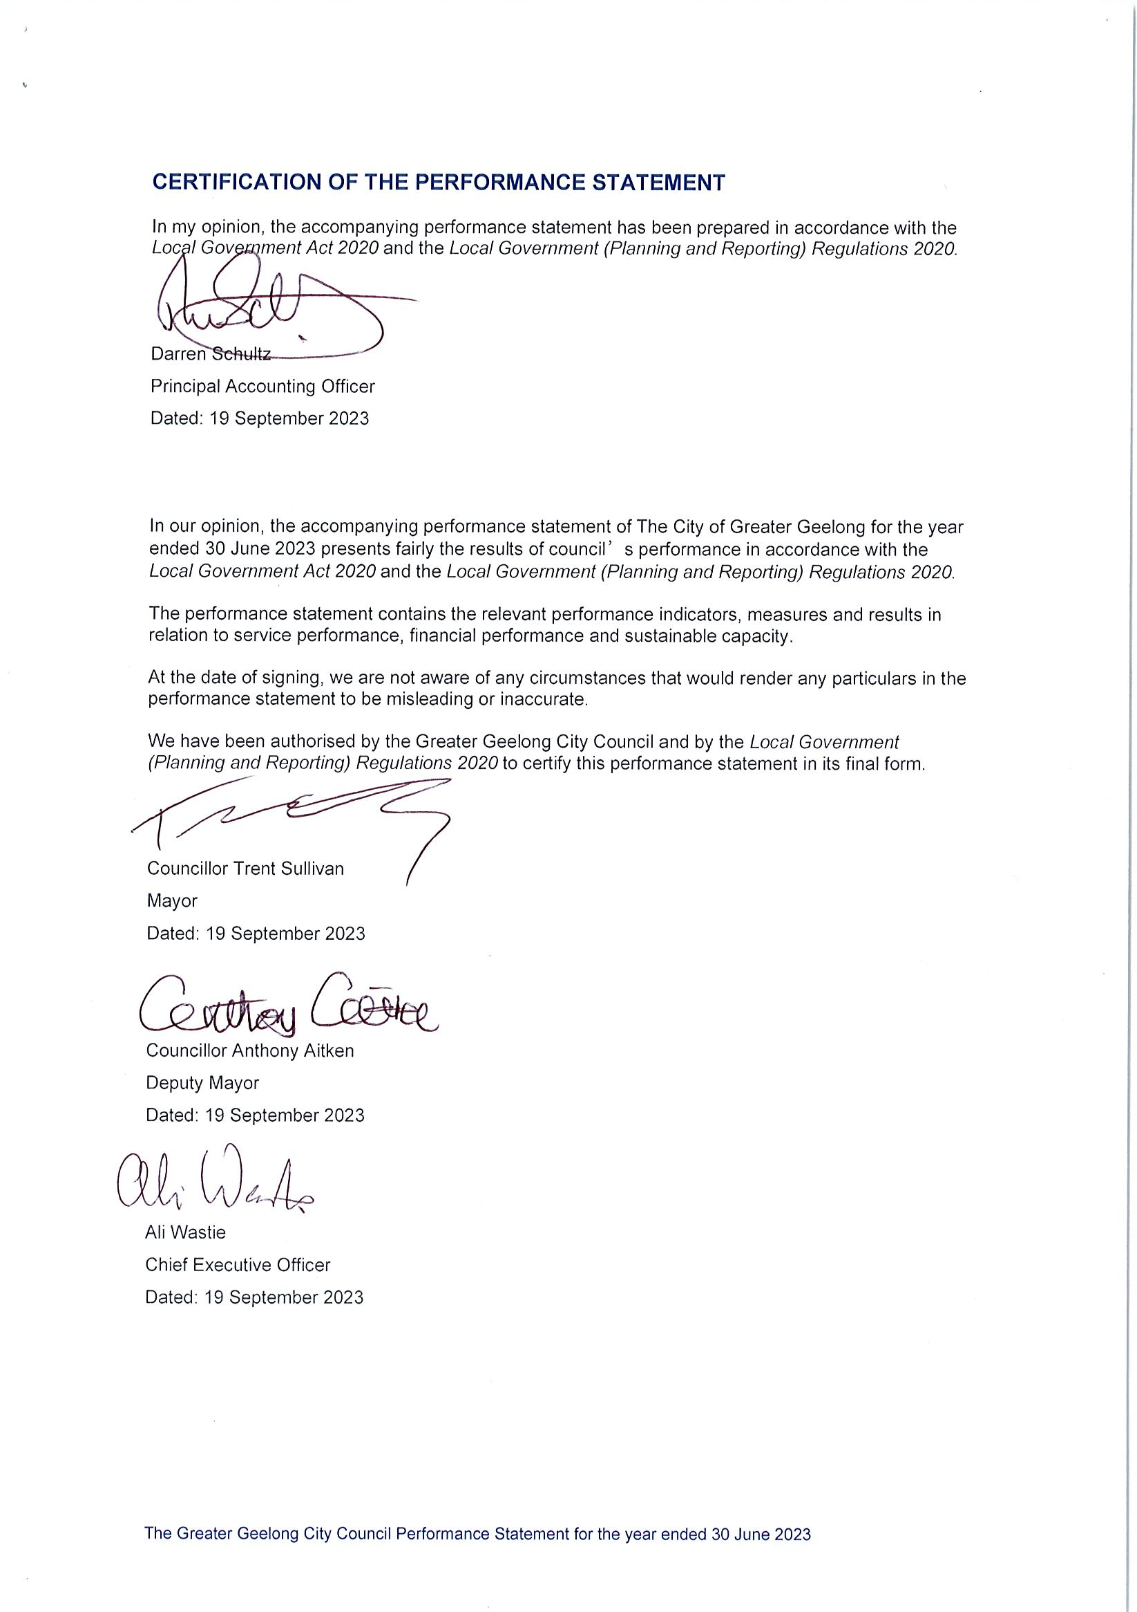
CERTIFICATION OF PERFORMANCE REPORT INSERT HERE
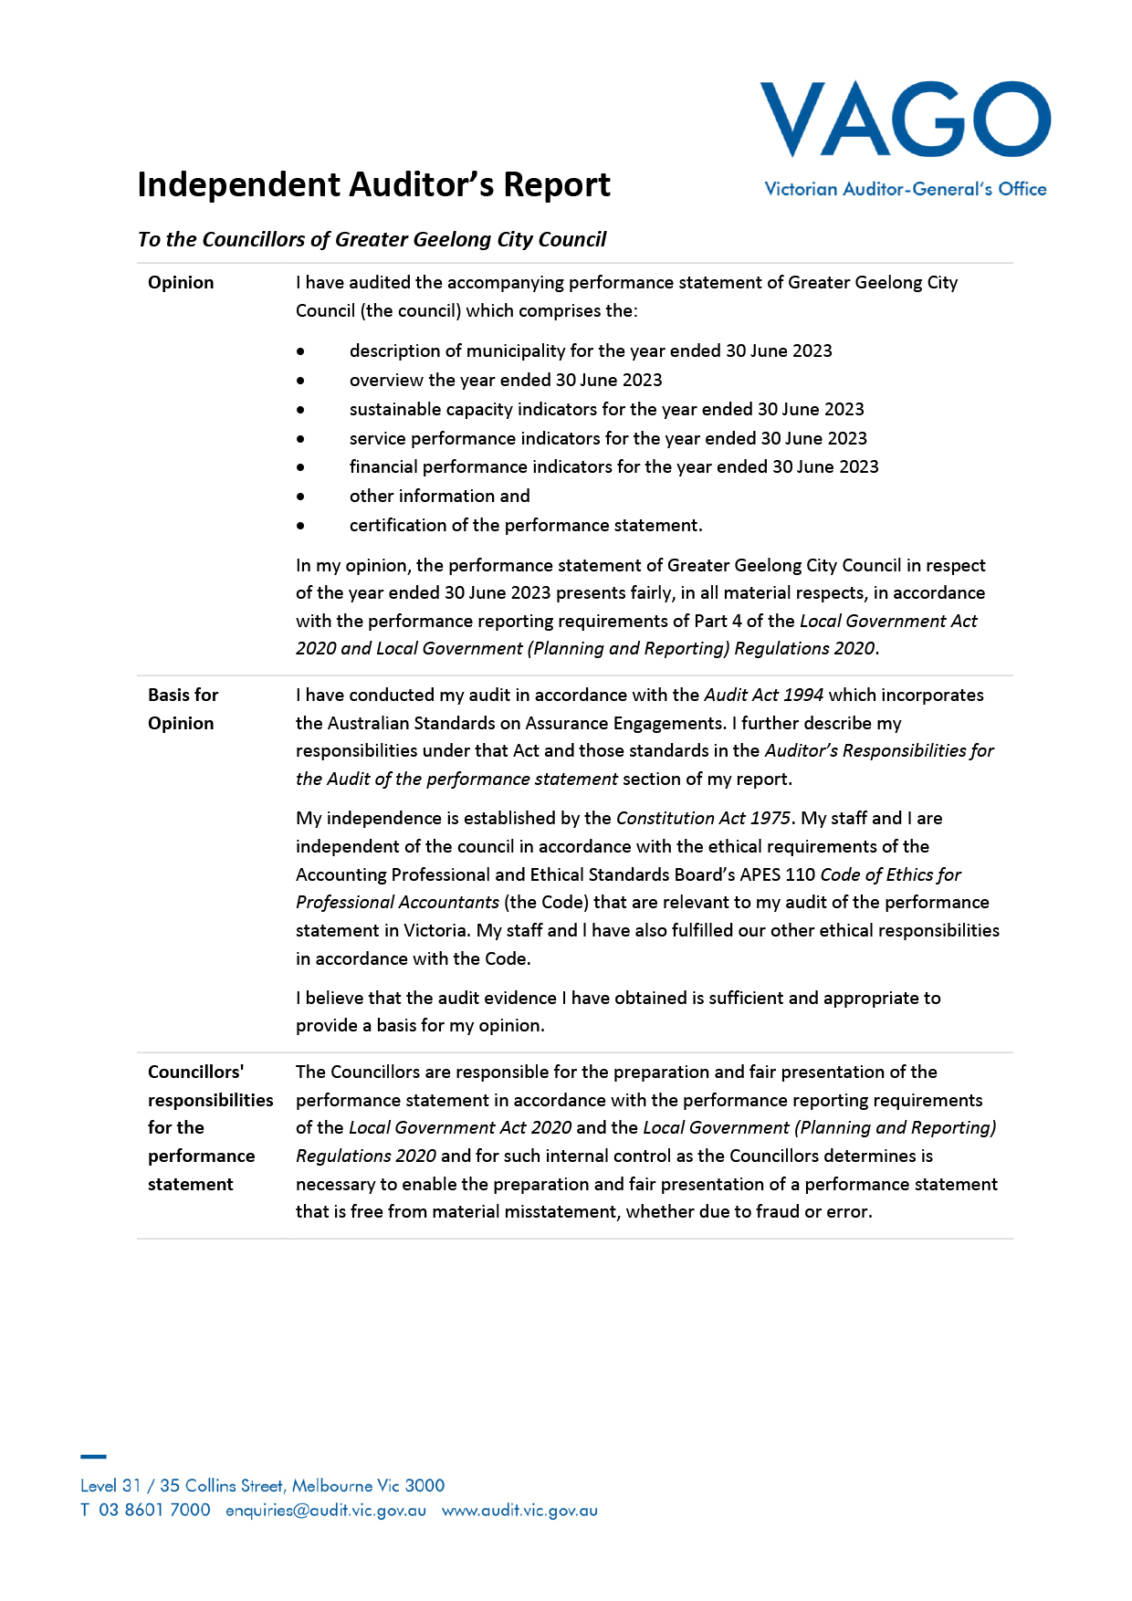
PERFORMANCE STATEMENT vago AUDITOR REPORT INSERT HERE

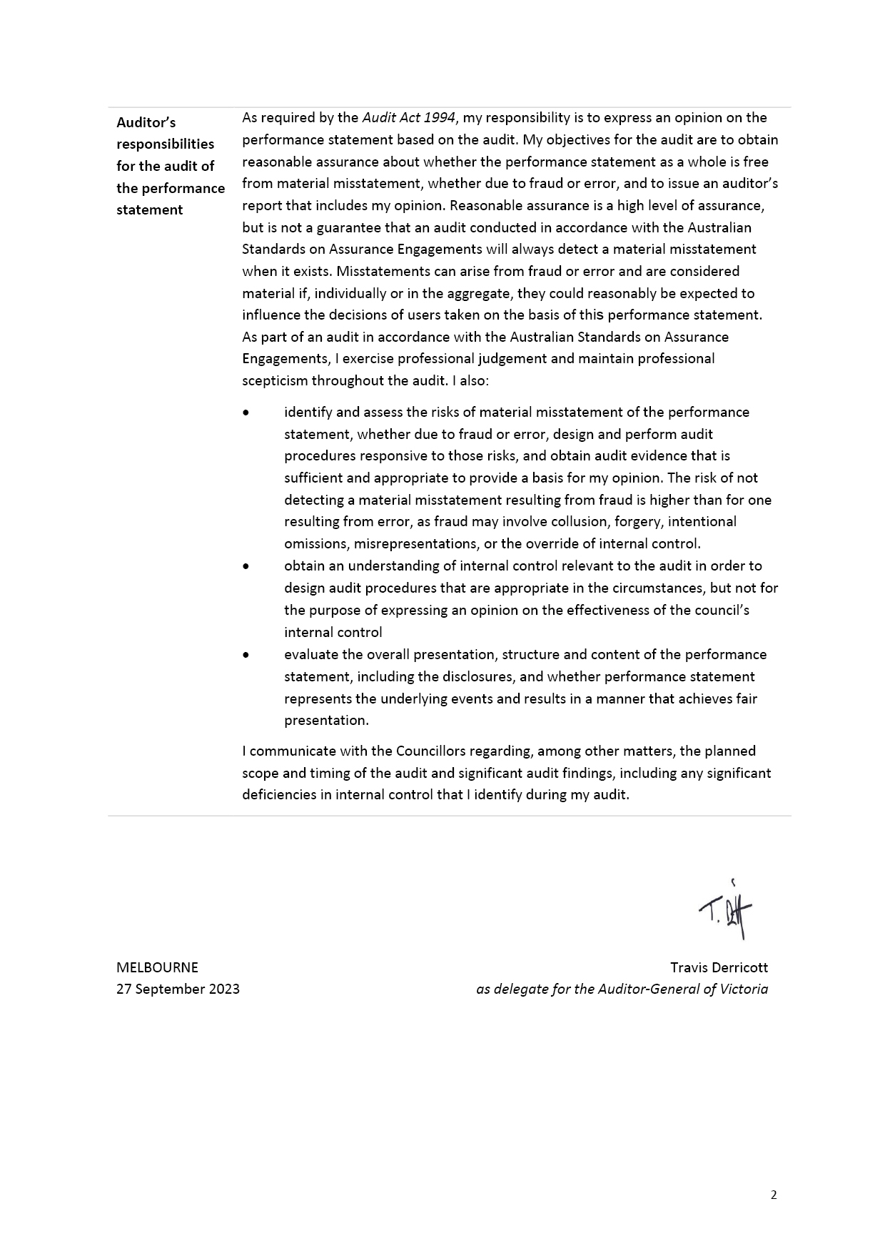

ANNUAL FINANCIAL REPORT FOR THE YEAR ENDING 30 JUNE 2023

Understanding the Financial Report and Financial Statements
Our Financial Report and Performance Statement are prepared in accordance with the Australian Accounting Standards, the Local Government Act 2020 and Local Government Victoria’s model accounts.
The Financial Report and Performance Statement are audited by the Victorian Auditor-General’s agent and are approved in principle by both our Audit and Risk Committee and by Council. The reports are then forwarded to the Victorian Auditor-General’s Office for finalisation and an independent opinion.
Financial statements
The financial report consists of five financial statements, explanatory notes supporting the reports and endorsement from the Council and the Victorian Auditor-General.
The five financial statements are:
- a comprehensive income statement
- a balance sheet
- a statement of changes in equity
- a cash flow statement
- a statement of capital works.
The explanatory notes detail our accounting policies and the make-up of the values contained in the statements.
Comprehensive income statement
The comprehensive income statement measures our performance over the year.
It lists our revenue sources under various income headings, as well as the expenses we incurred during the year. The expenses relate only to the ‘operations’ and do not include the cost associated with the purchase or building of assets. Expenses do include an item for depreciation, which is the value of the assets used up during the year.
Balance sheet
The balance sheet shows the assets we own and what we owe (liabilities) as of 30 June 2023.
The bottom line of the balance sheet is net assets, which is the net worth we have built up over many years.
Our assets and liabilities are separated into current and non-current. Current refers to assets or liabilities that will fall due within the next 12 months (except Long service leave – refer to note 5.5 within the notes to the accounts section of this report).
Statement of changes in equity
The statement of changes in equity summarises the change in value of total ratepayer equity. The value of equity can only change as a result of:
- profit or loss from operations, described as surplus or deficit in the income statement
- use of monies from our reserves
- a change in the value of non-current assets, resulting from a revaluation of these assets.
Cash flow statement
The cash flow statement summarises our cash payments and receipts for the year, as well as our level of cash at the end of the financial year.
Cash in this statement refers to bank deposits and investments that can be quickly converted to cash.
Our cash arises from, and is used in, three main areas:
- cash flows from operating activities – summarises all income and expenses relating to our operations, including service delivery and maintenance
- cash flows from investing activities – relates to capital works payments recorded as assets in the balance sheet, as well as receipts for the sale of assets
- cash flows from financing activities – represents repayments of and receipts from loans.
Statement of capital works
This statement provides detail of capital expenditure by asset type and distinguishes renewal, upgrade and new capital expenditure.
Notes to the accounts
The notes to the accounts enable the reader to understand the basis on which the values shown in the accounts are established. The notes also advise if there has been any change to the accounting standards, policy or legislation that has impacted on how the standards were prepared.
Within the five financial statements, there is a ‘note’ column to indicate where the reader should go for additional information. This is particularly useful where there has been a significant change from the previous year’s comparative figure.
Statements by the Principal Accounting Officer, Chief Executive Officer and councillors
The Financial Statements and the Performance Statement require certification under the Local Government Act 2020. The certifications are made by a combination of the Principal Accounting Officer, the Chief Executive Officer and two councillors, on behalf of the Council, as a written undertaking to the statements being correct and not misleading.
Victorian Auditor-General’s report
This document provides a written undertaking of the accuracy, fairness and completeness of the accounts.
The audit report from the Victorian Auditor-General provides an independent view of the statements and advises the reader if there are any issues of concern.

CONTACT US

This document contains important information about the City of Greater Geelong. Please contact us if you have any questions or would like to request a hard copy of the report.

City of Greater Geelong
Wadawurrung Country
PO Box 104
Geelong VIC 3220
P: 5272 5272
E: contactus@geelongcity.vic.gov.au
www.geelongaustralia.com.au
Latest news:
@CityofGreaterGeelong
@GreaterGeelong
@CityofGreaterGeelong
@CityofGreaterGeelong

THE GREATER GEELONG CITY COUNCIL
ANNUAL FINANCIAL REPORT
For the year ended 30 June 2023

Source: Australian Bureau of Statistics, Regional Population Growth, Australia (3218.0). Compiled and presented in profile.id by .id (informed decisions).
Source: Population and household forecasts, 2021 to 2041, prepared by .id (informed decisions), January 2023.
Source: REMPLAN community profile Greater Geelong
Source: Australian Bureau of Statistics, Census of Population and Housing 2021.
Source: National Institute of Economic and Industry Research (NIEIR) 2023. Compiled and presented in economy.id by .id (informed decisions).
Source: Australian Bureau of Statistics, Counts of Australian Businesses, including Entries and Exits, 2022.
Source: Jobs and Skills Australia, Small Area Labour Markets, March Quarter 2023.
Source: Jobs and Skills Australia - Internet Vacancy Index - Regional Data.
Source: City of Greater Geelong Major Projects (geelongdataexchange.com.au). Cordell by CoreLogic (May 2023).
Source: Productivity Commission, 2017 as referenced in Resilient Geelong: Reasons for success and challenges for a post-COVID-19 future, Research paper prepared for the Committee for Geelong, November 2020 by Dr Louise C. Johnson, Dr Meg Mundell & Rebecca Bartel.
As at 30 June 2023
Excludes casual employees
Total includes 2.3 Full-Time equivalent of self-described gender
Source: Population and household forecasts, 2021 to 2041, prepared by .id (informed decisions), January 2023.
Source: National Institute of Economic and Industry Research (NIEIR) ©2021, compiled and presented in economy.id by .id (informed decisions)
Source: Australian Bureau of Statistics
Source: National Skills Commission

